Cerulean Warbler Full Annual Cycle Ecology:
Filling in Critical Knowledge Gaps

A Dissertation Presented for the
Doctor of Philosophy
Degree
The University of Tennessee, Knoxville

Douglas William Raybuck
December 2021

ACKNOWLEDGEMENTS
I am extremely grateful to the numerous people who have supported me throughout this research and for fostering and enabling my passion for studying avian ecology and allowing me to devote my time and energy toward improving conservation efforts for declining wildlife species. First, I want to thank my advisor, David Buehler, for his tremendous support. Dave has always been quick to provide excellent advice and feedback, and as any problems arose during field work or data analysis, his positive attitude, constructive feedback, and suggestions of potential solutions always made me feel confident moving forward with my best effort. I also want to thank my committee members, Than Boves, Jeffery Larkin, and Patrick Keyser for their immensely helpful feedback throughout my field research planning and implementation, data analysis, and writing efforts. This exceptional committee was deeply involved with laying the foundation for this research before I arrived at the University of Tennessee, and with helping me to expand upon it over the past five years. I want to especially thank Than for introducing me to and instilling a passion for working with Cerulean Warblers when I was a field assistant on his dissertation project in 2009 and 2010, and later as my primary advisor and mentor for my M.S. research at Arkansas State University.
I also want to thank the numerous collaborators I’ve worked with including Scott Stoleson, Lesley Bulluck, Kate Slankard, Sharon Petzinger, Greg George, Laura Kearns, and Nick Bayly among others that helped with research design, field logistics, and data collection efforts. This field research took place in two countries and 10 U.S. states, and I also could not have done it without the many hard-working and excellent field assistants including Emily Hockman, Cody Allen, Evan Buck, Yuly Caycedo, Whitney Atkinson, Adrian Pinzon, Joe Youtz, Kyle Carlson, Jacob Wessels, Morgan Slevin, Em Donahue, Guatam Apte, Dana Heikkila, Liam Nassib, and Ryan Klutz.
Last, but not least, I want to thank my parents, Ken and Karen Raybuck, my brothers Tim and Tyler, and my entire extended family for providing me with and sharing my love for wildlife and the natural world. I have also been fortunate to have had instruction from excellent teachers throughout my entire span of education as well as great mentors from my field research positions that preceded my graduate education. And especially, I want to thank my wonderful wife Leslie Raybuck Malland, for her patience and support through the 9 busy field seasons (many of which were from long-distance) and for putting up with me when I get lost in rabbit-hole data analysis and writing frenzies.
This opportunity has been incredibly fulfilling and special, and I hope to return soon to visit Santa María, Caryville, the Allegheny and Daniel Boone National Forests, the Buffalo River, Vinton Furnace State Forest, and elsewhere I have visited for this research to see the wonderful people, scenery, and wildlife (and hopefully some ceruleans that we banded, especially Moe VIII) once again. Cerulean Warblers truly know how to select for some wonderful places throughout the Western Hemisphere and I look forward to seeing more.

ABSTRACT

Cerulean Warblers (Setophaga cerulea) are a declining migratory bird species of conservation concern that breed in mature hardwood forests of eastern North America and spend the stationary non-breeding period in the tropical Andes of South America. To reverse their >50-year population decline, a full annual cycle conservation strategy is needed. However, several important knowledge gaps have limited our understanding of this species’ full annual cycle ecology, including migration ecology, response to forest management on the breeding grounds, and basic ecology during the stationary non-breeding period in Andean forests. From geolocator data, we found a moderate pattern of migratory connectivity in which the majority of the core Appalachian breeding population spends the ~6-month stationary non-breeding season in Colombia/Venezuela, while most of the birds from the Ozarks and Great Lakes regions travel to Ecuador/Peru. We documented a pattern of multiple extended migratory stopovers events in Central America, which highlights the importance of forest conservation in this migratory bottleneck. On the breeding grounds, eastern hardwood forests have greatly changed in structure and composition due to centuries of anthropogenic disturbances. Even-aged secondary forests with less natural disturbance have replaced forests with natural heterogeneous canopy structure required by this species. While recent forest management strategies designed to emulate natural disturbances have temporarily increased cerulean densities, we found that increases were ephemeral. Experimental plot densities were generally similar with or even lower than pre-harvest conditions following 13–14-years of post-harvest growth. In the Andes, vast and ongoing deforestation has resulted in widespread habitat loss and fragmentation of montane forests, where ceruleans spend approximately half of their annual cycle. We estimated stationary non-breeding home ranges, documented high density, low detectability, a male-biased sex ratio, a tendency to take part in mixed-species flocks with ~3 ceruleans per flock, and relatively high interannual survival compared with apparent weekly survival in mature secondary forest. Our findings help to address critical knowledge gaps and can be used to inform a better and more targeted full-annual cycle conservation approach for ceruleans throughout their extensive range.

TABLE OF CONTENTS
ACKNOWLEDGEMENTS ii
ABSTRACT iv
TABLE OF CONTENTS vi
LIST OF TABLES viii
LIST OF FIGURES ix
INTRODUCTION 1
LITERATURE CITED 5
CHAPTER 1: CERULEAN WARBLERS EXHIBIT PARALLEL MIGRATION PATTERN AND MULTIPLE MIGRATORY STOPOVERS WITHIN THE CENTRAL AMERICAN ISTHMUS 7
ABSTRACT 8
INTRODUCTION 9
METHODS 15
Field methods 15
Geolocation analysis 16
RESULTS 22
Resightings and recaptures 22
Data recovery 23
Geolocation analysis 23
DISCUSSION 27
Conservation implications 34
ACKNOWLEDGEMENTS 34
LITERATURE CITED 36
APPENDIX 45
CHAPTER 2: ASSESSING THE EFFECTS OF FOREST MANAGEMENT ON CERULEAN WARBLER BREEDING HABITAT 52
ABSTRACT 53
INTRODUCTION 55
METHODS 58
Temporal avian responses 59
Temporal vegetation responses 60
Relationship between cerulean density and vegetation structure 61
RESULTS 62
Temporal avian responses 62
Temporal vegetation responses 63
Relationship between cerulean density and vegetation structure 64
DISCUSSION 64
ACKNOWLEDGEMENTS 73
LITERATURE CITED 74
APPENDIX 78
CHAPTER 3: EXPLORING THE SPATIAL USE AND NON-BREEDING ECOLOGY OF CERULEAN WARBLERS IN SECONDARY FOREST OF THE COLOMBIAN ANDES 87
ABSTRACT 88
INTRODUCTION 90
METHODS 95
RESULTS 100
DISCUSSION 104
ACKNOWLEDGEMENTS 112
LITERATURE CITED 114
APPENDIX 119
CONCLUSIONS 128
VITA 132

LIST OF TABLES

Table 1.1. Study locations and number of birds captured and re-sighted in 2014-2018 field seasons. …………………………………………………………….……………………45
Table 1.2. Estimated locations of stationary non-breeding locations in the tropical Andes Mountains for each of 26 recovered and functioning geolocators. ….…………….…….46
Table 1.3. Estimated timing of arrivals and departures for both capture locations on the breeding grounds and for stationary non-breeding grounds in the tropical Andes. ……….………47
Table 2.1. Number of territories per 10 hectares of four target species at each treatment intensity for the Kentucky, Tennessee, and Ohio sites combined ...………………………………78
Table 2.2. Vegetation structure comparisons between 2010 (4 years post-harvest) and 2019 (13 years post-harvest) across three study sites ……………………………..…………...….79
Table 2.3. Best-supported models of vegetation structure predictors on Cerulean Warbler territory densities surveyed from 2005–2010 and 2019–2020 at 3 study sites in Kentucky, Ohio, and Tennessee……………………………………………………………………..80
Table 3.1. Netting effort and numbers of captured, tagged, and re-sighted Cerulean Warblers over three field seasons at the Almenara near Santa María, Boyacá, Colombia. ….…..123
Table 3.2. Summary table of median home range size estimates (in ha) with numbers of locations and tracking duration (days) for each radio-tracked Cerulean Warbler over the 2017–2019 field seasons. ..…………………...……………………………………………….124
Table 3.3. Species composition of 97 flock observations in mature secondary forest at the Almenara near Santa María, Boyacá, Colombia. ………………………………………126

LIST OF FIGURES
Figure 1.1. Geolocator deployment locations throughout the Cerulean Warbler’s (A) North American breeding range and (B) South American stationery non-breeding range. ……48
Figure 1.2. Breeding (A) and stationary non-breeding regions (B) and their centroids used to calculate distance matrices to estimate migratory connectivity (MC). ………………………….49
Figure 1.3. Migratory connectivity pattern of male Cerulean Warblers. …………….………….50
Figure 1.4. Stopover strategies by representative birds captured in 4 different breeding regions. ……………………………………………………………………………………………………51
Figure 2.1. Heavy treatment plot in the North Cumberland WMA in Tennessee, USA...……....81
Figure 2.2. Mean Cerulean Warbler territory density estimates with standard error at various treatment intensities at study sites in Kentucky, Ohio, and Tennessee. ………………...82
Figure 2.3. Added variable plots from the best-supported linear multiple regression model explaining variation in Cerulean Warbler territory density related with vegetation structure predictors……………………………………………………………………….83
Figure 2.4. Mean and standard error of Cerulean Warbler density estimates at the Daniel Boone National Forest study site in Kentucky across 2005–2006 pre-harvest, 2007–2010 early post-harvest, and 2019–2020 latter post-harvest time periods. . .………………………..84
Figure 2.5. Mean and standard error of Cerulean Warbler density estimates at the Vinton Experimental State Forest study site in Ohio across 2005–2006 pre-harvest, 2007–2010 early post-harvest, and 2019–2020 latter post-harvest time periods. ...………………….85
Figure 2.6. Mean and standard error of Cerulean Warbler density estimates at the North Cumberland Wildlife Management Area site in Tennessee across 2005–2006 pre-harvest, 2007–2010 early post-harvest, and 2019–2020 latter post-harvest time periods. ..…..…86
Figure 3.1. The typically dense understory and midstory in humid montane forests in the Andes makes it difficult to reliably re-sight canopy-dwelling birds such as Cerulean Warblers. …………………………………………………………………………………………..119
Figure 3.2. Approximate outline of La Almenara study site near Santa María, Boyacá, Colombia. ………………………………………………….………………………………………120
Figure 3.3. Overlapping 95% KDE home range estimates of 13 male Cerulean Warblers radio-tracked in Nov-Dec 2019 within mature secondary forest at the Almenara near Santa María, Boyacá, Colombia… …….………………... ……………………………..……121
Figure 3.4. Adult male Cerulean Warblers (n = 5) had smaller home ranges than immature males (n = 19) at La Almenara study site near Santa María, Boyacá, Colombia, 2017-2019. .122

INTRODUCTION
As the global human population grows and expands, environmental conditions continue to be anthropogenically changed throughout the world as natural resources are consumed or altered, affecting countless wildlife species. Populations of numerous species have exhibited sustained and ongoing declines due to a myriad of factors that include the loss, fragmentation, and altered structure and composition of their habitats. Migratory birds are especially susceptible to degraded habitat conditions, as the potential for exposure to negative conditions exists in all regions used throughout their annual cycles. Negative consequences can be lethal during any portion of their lives and can also be cumulative across their migration cycles. That is, not only can these anthropogenically-driven factors affect population growth rates through direct impacts (e.g., reduction in fecundity or survival), but carry-over effects from one period of the annual cycle can indirectly affect a species’ chances of successful reproduction or survival in subsequent annual cycle periods (Marra and Holmes 2001, Newton 2006, Hostetler et al. 2015). Thus, full annual cycle ecology studies and conservation strategies have been increasingly suggested, explored, and applied in recent years with intent to stop or reverse population declines of imperiled migratory species. However, for most of these species, important knowledge gaps regarding their full annual cycle ecology remain within all or some periods of their annual cycles.
The Cerulean Warbler (Setophaga cerulea) is a long-distance Nearctic-Neotropical migratory songbird that has globally plummeted in population over the past half-century (Sauer et al. 2020) and is considered a species of conservation concern by numerous organizations (e.g., U.S. Fish and Wildlife Service 2008, BirdLife International 2022). However, over the past two decades, populations trajectories throughout their eastern North American breeding range appear to vary locally— from continuing sharp declines to apparent stabilization and even to instances of recent increases (Sauer et al. 2020). Meanwhile, vast and ongoing deforestation (spatially varying in intensity) has resulted in widespread habitat loss and fragmentation of montane forests across ceruleans’ stationary nonbreeding grounds in the northern Andes of South America (Myers et al. 2000, Armenteras and Villareal 2003, Etter et al. 2006), where Cerulean Warblers spend approximately half of their annual cycle (Buehler et al. 2020). Furthermore, exposure to habitat loss and degradation at potentially critical migratory stopover areas (e.g., refueling areas used prior to crossing the Gulf of Mexico) may be especially amplified in Central America due to a geographical bottleneck effect for the millions of Nearctic-Neotropical migrants that compete for resources during migration (Bayly et al. 2017). Linking individual breeding and non-breeding populations and identifying locations, durations, and frequencies of stopovers between stationary periods were not possible until recently for small passerines. Thanks to recent advances in miniaturized tracking technology (e.g., light-level geolocators), we are now able to track individual Cerulean Warbler locations throughout their entire annual migration cycle to address these critical knowledge gaps regarding their migration strategies and their migratory connectivity.
Furthermore, hardwood forests across the eastern North American breeding range have greatly changed due to historic forestry practices, with even-aged secondary forests with fewer natural disturbances replacing historical old-growth conditions and more heterogeneous canopy (e.g., stands containing large trees and numerous canopy gaps) preferred by Cerulean Warblers (Boves et al. 2013a, Wood et al. 2013). While forest management strategies designed to create conditions comparable with naturally disturbed forests have been shown to temporarily increase Cerulean Warbler densities, there is some evidence that these anthropogenic disturbances could provide differing resource availability or predation pressure than natural conditions and may potentially result in ecological traps (Boves et al. 2013b). Furthermore, the resulting structural change following forest management efforts may create ephemerally attractive or enhanced breeding conditions for this species for an unknown period of time before reverting to habitat quality similar with or potentially worse than pre-management conditions. Despite these potential concerns, Cerulean Warblers’ territory density responses following forest management efforts designed and applied with goals to enhance ceruleans’ (and other species’) breeding habitat have not been monitored beyond the initial 1–4 years following partial timber harvests. Longer-term monitoring is needed due to the inherent nature that such stands change dramatically in structure throughout the stand regrowth process.
Several other important knowledge gaps regarding the full annual cycle ecology of Cerulean Warblers involve the stationary non-breeding period in the Andes. Although some efforts have been made in recent years to learn more about Cerulean Warbler ecology in the Andes, there have been far fewer studies in this region compared with the North America breeding grounds. Most of the few Cerulean Warbler studies in the Andes have been conducted in relatively open-canopied agroforestry plantations, while studies within natural mature forests are especially lacking. Recent miniaturization of VHF radio-tags presents an opportunity to quantify home ranges, estimate visual detectability of individuals, and improve upon survival and abundance estimates for Cerulean Warblers in their dense, humid premontane forest habitat.
This research aims to address many of the remaining knowledge gaps that are of major importance to informing conservation efforts for Cerulean Warblers over their full annual cycle. In Chapter 1, I addressed the lack of information regarding the migration ecology and migratory connectivity patterns for this species through a range-wide light-level geolocator project. In Chapter 2, I investigated potential changes in breeding density following a 13–14 years of forest regrowth in forest management plots that were harvested in 2006. These experimental plots were designed to emulate natural disturbances and potentially enhance Cerulean Warbler habitat and were last surveyed in 2010. I also examined how selected metrics of forest vegetation structure related to territory densities. And lastly, in Chapter 3, I explored various aspects of Cerulean Warblers’ stationary non-breeding ecology including home ranges, survival, density, detectability, age and sex ratios, and flock composition in a mature secondary forest within the core of the stationary nonbreeding range in the Colombian Andes.

LITERATURE CITED
Armenteras, D., and H. Villareal (2003). Andean forest fragmentation and the representativeness of protected natural areas in the eastern Andes, Colombia. Biological Conservation 113:245–25.

Bayly, N. J., K. V. Rosenberg, W. E. Easton, C. Gómez, J. Carlisle, D. N. Ewert, A. Drake, and L. Goodrich (2017). Major stopover regions and migratory bottlenecks for Nearctic-Neotropical landbirds within the Neotropics: a review. Bird Conservation International:1–26.

BirdLife International (2022). Species factsheet: Setophaga cerulea. Downloaded from http://www.birdlife.org on 19/01/2022.
Boves, T. J., D. A. Buehler, J. Sheehan, P. B. Wood, A. D. Rodewald, J. L. Larkin, P. D. Keyser, F. L. Newell, A. Evans, G. A. George, and T. B. Wigley (2013). Spatial variation in breeding habitat selection by Cerulean Warblers (Setophaga cerulea) throughout the Appalachian Mountains. Auk 130:46–59.

Boves, T. J., D. A. Buehler, J. Sheehan, P. B. Wood, A. D. Rodewald, J. L. Larkin, P. D. Keyser, F. L. Newell, G. A. George, M. H. Bakermans, et al. (2013). Emulating natural disturbances for declining late-successional species: a case study of the consequences for Cerulean Warblers (Setophaga cerulea). PLOS ONE 8:e52107.

Buehler, D. A., P. B. Hamel, and T. Boves (2020). Cerulean Warbler (Setophaga cerulea), version 1.0. In Birds of the World (A. F. Poole, Editor). Cornell Lab of Ornithology, Ithaca, NY, USA. https://doi.org/10.2173/bow.cerwar.01.
Etter, A., C. McAlpine, K. Wilson, S. Phinn, and H. Possingham (2006). Regional patterns of agricultural land use and deforestation in Colombia. Agriculture, Ecosystems and Environment 114:369–386.
Hostetler, J. A., T. S. Sillett, and P. P. Marra (2015). Full-annual-cycle population models for migratory birds. Auk 132:433–449.
Marra, P. P., and R. T. H. Holmes (2001). Consequences of dominance-mediated habitat segregation in American Redstarts during the nonbreeding season. Auk 118:92–104.
Myers, N., R. A. Mittermeier, C. G. Mittermeier, G. A. B. da Fonseca, and J. Kent (2000). Biodiversity hotspots for conservation priorities. Nature 403:853–862.
Newton, I. (2006). Can conditions experienced during migration limit the population levels of birds? Journal of Ornithology 147:146–166.
Sauer, J. R., W. A. Link, and J. E. Hines (2020). The North American Breeding Bird Survey, Analysis Results 1966 - 2019: U.S. Geological Survey data release, USGS Patuxent Wildlife Research Center, Laurel, MD. https://doi.org/10.5066/P96A7675
Wood, P.B., J. Sheehan, P. Keyser, D. Buehler, J. Larkin, A. Rodewald, S. Stoleson, T.B. Wigley, J. Mizel, T. Boves, G. George, M. Bakermans, T. Beachy, A. Evans, M. McDermott, F. Newell, K. Perkins, and M. White (2013). Management guidelines for enhancing Cerulean Warbler breeding habitat in Appalachian hardwood forests. American Bird Conservancy. The Plains, Virginia.

CHAPTER 1: CERULEAN WARBLERS EXHIBIT PARALLEL MIGRATION PATTERN AND MULTIPLE MIGRATORY STOPOVERS WITHIN THE CENTRAL AMERICAN ISTHMUS

ABSTRACT

The Cerulean Warbler (Setophaga cerulea) is a declining Nearctic-Neotropical migratory species of conservation concern. Implementing full annual cycle conservation strategies to facilitate recovery has been difficult because we know little about the migratory period or degree of migratory connectivity between North American breeding and South American non-breeding regions. Between 2014-2017, we deployed geolocators on 282 males at 14 study sites throughout the species’ range with the objectives of a) evaluating the strength of connectivity between breeding and non-breeding regions; b) identifying approximate routes and stopover regions, and c) documenting migration phenology. We retrieved migration data from 26 birds and most (14/15; 93%) Appalachian-breeders spent the stationary, non-breeding period in the Colombian/Venezuelan Andes, whereas most (5/7; 71%) Ozark-breeders spent the stationary, non-breeding period in Peru/Ecuador. During spring migration, over a 26 d ± 1.2 (SE) period, birds (n = 23) staged at multiple stopover locations between Panama and southern Mexico. The two migratory periods were approximately equal in duration: 38 ± 2 d (SE) in fall and 42 d ± 2 (SE) in spring. Based on the observed connectivity pattern, conservation of Appalachian breeding populations should focus on forest conservation and restoration in premontane/lower montane forests of Colombia and Venezuela, whereas Ozark breeding population conservation should focus forest conservation and restoration efforts in Ecuador and Peru. Additionally, conservation of forests used by Cerulean Warblers during stopover periods throughout Central America and southern Mexico, in southeastern United States coastal areas, and in the Mississippi Alluvial Valley will likely benefit this species of conservation concern.

INTRODUCTION
Migratory birds face numerous challenges throughout their annual cycle that can affect their survival and reproductive success. More than 60% of Nearctic-Neotropical migrant species have declining populations over the past several decades (Rappole and McDonald 1994, Lloyd-Evans and Atwood 2004, Rosenberg et al. 2019). These declines are generally attributed to cumulative effects encountered across the full annual cycle and may reflect effects of habitat loss and degradation, changing climate and weather patterns, pollution and environmental contaminants, collisions with human-made structures, and the introduction of exotic predators, competitors, and diseases (Loss et al. 2012, Rosenberg et al. 2019). To address these population declines, researchers have established large collaborative partnerships across species’ ranges and utilize tracking technology (McKinnon and Love 2018) to understand the spatial (e.g., location and home range estimates; patterns of migratory connectivity) and temporal (e.g., migration phenology) dynamics across the full annual cycle of migratory birds. Information obtained from these tracking studies, in addition to data on population trends, densities, habitat use, and demographic rates during both migratory and stationary breeding/non-breeding periods, allow for development of effective conservation plans for migratory species. The largest data gaps for most of these declining species continue to be basic information on migration, putatively the most dangerous portion of the annual cycle (Sillett et al. 2002, Rockwell et al. 2017), and from the stationary non-breeding period (Marra et al. 2015).
The Cerulean Warbler (Setophaga cerulea; hereinafter ‘ceruleans’), a charismatic songbird that is considered a species of conservation concern by numerous organizations and wildlife agencies (e.g., U.S. Fish and Wildlife Service 2008, COSEWIC 2010, Kreitinger et al. 2013, BirdLife International 2022) is among the most sharply declining of the long-distance Nearctic-Neotropical migratory species. Ceruleans breed in mature hardwood forests of eastern North America and spend their stationary non-breeding period (from Sep/Oct through Mar/Apr), in the Andes mountains of South America in primary and secondary humid montane forests, as well as in agroforestry and silvopastoral systems (Colorado et al. 2012, Buehler et al. 2020). Over the past five decades, ceruleans have experienced one of the steepest (>2% per year; Sauer et al. 2020) rates of population decline among North American breeding bird species. Factors thought to be contributing to these population declines are the cumulative effects of anthropogenic changes encountered during the breeding, migratory, and stationary non-breeding periods (Buehler et al. 2020). Without information on the degree of migratory connectivity between breeding and non-breeding populations, as well as the presence and location of migratory stopover sites, we do not know how important and variable these anthropogenic factors are throughout the annual cycle of ceruleans. Globally, the species is considered near threatened and a primary conservation goal is to increase populations from the current estimate of ~570,000 individuals to mid-21st century population levels of >2 million (Rosenberg et al. 2016, BirdLife International 2022, Buehler et al. 2020). However, to achieve this goal will require greater understanding of the species’ degree of migratory connectivity and the limiting factors throughout the full annual cycle. Only then can conservationists develop targeted actions across time and space.
Perhaps in part due to conservation actions in recent decades, the range-wide rate of cerulean population decline has lessened over the past 20 years. However, some breeding populations/regions are still exhibiting steep declines (Sauer et al. 2020), and it is unclear why this regional variation exists. An example of this variation occurs in the Appalachian region alone. Over the past two decades in Pennsylvania and Ohio, the species has declined sharply at -4.3%/y and -3.2%/y, respectively (Sauer et al. 2020). Meanwhile, the population in the Appalachian Mountains Bird Conservation Region (which harbors ~80% of the global breeding population; Wood et al. 2013, Bird Studies Canada and NABCI 2014) has remained essentially stable–(0.6%/y from 2000–2019; 95% CI -2.2% to 1.1%; Sauer et al. 2020), while numbers along the Pennsylvania/New Jersey border have apparently increased (G. A. George unpublished data). The Appalachian Mountains are a high priority region for conservation of this species, and currently millions of dollars are being spent throughout the region to enhance breeding habitat by increasing forest canopy heterogeneity and creating canopy gaps that are favored by the species (Migratory Bird Joint Ventures 2015). Learning more about geographic connectivity exhibited by Appalachian ceruleans across the full annual cycle has the potential to improve upon conservation actions targeting this population. If all or most Appalachian birds spend the non-breeding season in a similar region, unfavorable conditions on the breeding grounds in some regions (e.g., Pennsylvania and Ohio) may be likely drivers of continuing declines. Conversely, if birds that breed in Pennsylvania and Ohio overwinter in a separate non-breeding region than birds from areas where breeding populations are stable (e. g., Tennessee, West Virginia, New Jersey, and Kentucky), conservation efforts within specific regions of the Andes used by declining populations should be prioritized. In total, a better understanding of the cerulean’s full annual cycle across populations will allow for more targeted, effective conservation actions across their range.
On the non-breeding grounds, conversion of forests to other land uses has resulted in widespread loss and fragmentation of habitat across Central American and Andean regions of South America where Cerulean Warblers spend over half of each year (citation). The greatest forest loss in South America has been within the mid-elevational range favored by ceruleans (Myers et al. 2000, Armenteras and Villareal 2003, Etter et al. 2006, Colorado et al. 2012, Buehler et al. 2020). Although pre-montane and montane forest loss and degradation has been widespread, the rate of deforestation has varied geographically and cerulean population trends within the Andes are unknown due to a lack of long-term monitoring. Thus, the species may be more adversely affected by habitat loss and degradation in some regions than others (e.g., greater overall rates of deforestation in Colombia and Ecuador compared with Venezuela and Peru; Armenteras et al. 2017). Furthermore, the effects of the El Nino Southern Oscillation on Neotropical precipitation, and thereby insect prey availability, vary regionally and may differentially affect Cerulean Warbler population-level survival directly and reproductive success through carryover effects (Sillett et al. 2002, Manz et al. 2016, Rockwell et al. 2017, Wunderle and Arendt 2017). Therefore, identifying patterns and the strength of migratory connectivity between breeding and non-breeding populations (Webster et al. 2002, Taylor and Norris 2010, Marra et al. 2011) is a prerequisite to effective conservation planning for this species.
The conservation benefits of understanding the degree of migratory connectivity are well documented from studies of a variety of birds, including closely related species. Geolocator data has provided strong evidence that most Golden-winged Warblers (Vermivora chrysoptera) from the relatively stable Great Lakes breeding population spend the stationary non-breeding season in Central America, while birds from the drastically declining Appalachian population migrate to the Colombian and Venezuelan Andes (Kramer et al. 2018, Bennett et al. 2019). Therefore, identification and conservation of Andean Golden-winged Warbler habitat has become a priority of those working to address population declines throughout the Appalachian region. Such strong migratory connectivity was also documented in Ovenbirds (Seiurus aurocapilla; Hallworth et al. 2015). In contrast to these examples of strong migratory connectivity, weak migratory connectivity is apparently more common (Finch et al. 2017). For example, Canada (Cardellina canadensis; Roberto-Charron et al. 2020) and Prothonotary Warblers (Protonotaria citrea; Tonra et al. 2019) exhibit weak migratory connectivity; birds throughout their widespread breeding distributions tend to concentrate in a relatively small non-breeding region in northern Colombia (Prothonotary Warblers) or the Colombian and Venezuelan Andes (Canada Warblers). Thus, in these cases, conservation efforts implemented in these concentrated non-breeding areas would presumably benefit breeding populations across the entire breeding range.
Another major knowledge gap for many migratory bird species involves the migratory periods, during which much of the annual mortality occurs (Sillett et al. 2002) and which may have a significant influence on population trend (Newton 2006, Rushing et al. 2017). Many avian migrants spend the bulk of migration at stopover sites, with stopover periods ranging from hours to weeks between migratory flights (Bayly et al. 2017). Habitat quality in stopover areas can affect fat accumulation rates and body condition at departure and thus affect potential flight distances to the next stopover, migratory timing, probability of survival, and likelihood of future reproductive success (Cohen et al. 2017, Bayly et al. 2019, Cano et al. 2020). Stopover habitat within the isthmus of Central America may be especially important due to a geographical ‘bottleneck’ where billions of Neactic-Neotropical migrants must compete for resources among themselves and with resident birds (Colorado and Rodewald 2015a, Bayly et al. 2017, Albert et al. 2020, Powell et al. 2021). Habitat loss and degradation in this region may be especially detrimental due its position adjacent to Gulf of Mexico, Caribbean Sea, and Pacific Ocean migratory barriers. However, the relative availability of quality stopover habitat as a limiting factor for cerulean populations is largely unknown and even the prevalence of and need for stopover in Central America has been questioned (Welton et al. 2012, Buehler et al. 2020). While most passerines that migrate between North and South America cross the Gulf of Mexico (Cooke 1905) and pause to refuel in southern Mexico and Central America (e.g., Canada Warblers and Red-eyed Vireos; Callo et al. 2013, Roberto-Charron et al. 2020), some migrants take a more direct but potentially riskier route across the Caribbean Sea with or without stopovers in the Greater Antilles (e.g., Blackpoll Warbler; Setophaga striata; Connecticut Warbler, Oporornis agilis; and Gray-cheeked Thrush; Catharus minimus; DeLuca et al. 2015, Gómez et al. 2017, McKinnon et al. 2017).
Finally, information about the phenology of migration, the timing of departures, arrivals, and stopovers, is important to better understand selective pressures encountered during these birds’ bi-annual journeys. For instance, birds that use a time-minimization migration strategy of rapid refueling rates and fewer/shorter stopovers may be more likely to perish en route and may be more sensitive to stopover habitat quality compared with birds that use a slower, energy-minimization migration strategy of longer/more frequent stopovers (Alerstam and Lindström 1990, Rushing et al. 2017, Bennett et al. 2019a). However, a time-minimization strategy provides the benefit of increased likelihood of securing high-quality territories upon arrival which can lead to increased probability of breeding success (Alerstam and Lindström 1990, Morrison et al. 2019), or increased survival and condition during the non-breeding season (Johnson et al. 2006). In general, a time-minimization strategy is more commonly utilized in spring and an energy-minimization strategy is more common in fall (Nilsson et al. 2013, Schmaljohann 2018).
To help fill these critical knowledge gaps regarding the Cerulean Warbler full annual cycle ecology, we deployed miniaturized light-level geolocators on birds across the breeding range and within the center of the non-breeding range to: (a) evaluate the pattern and strength of connectivity between breeding and non-breeding regions, (b) identify approximate routes and stopover regions used during migration, and (c) document migration phenology. A greater understanding of Cerulean Warblers’ full annual cycle has the potential to enhance the effectiveness of conservation planning by: (1) enabling regionally linked international conservation partnerships, (2) identifying priority regions used during migration in need of further research and habitat enhancement and protections, and (3) informing future full-annual cycle population models.

METHODS

Field methods
We selected 12 study areas spaced strategically across the Cerulean Warbler’s breeding range within the United States and two study areas within the center of the Andean non-breeding range in Colombia (Table 1.1 and Fig. 1.1). On the breeding grounds, ceruleans were initially captured using mist nets and audio playback of songs and calls in May and June (period in which they usually occupy established territories) in 2014, 2015, and 2017. On the stationary non-breeding grounds in Colombia, we captured and deployed geolocators on male ceruleans from mid-February through mid-March 2017. We did not target or deploy geolocators on females because resighting and recapture were too difficult for reliable retrieval of their geolocators.
Shortly after extraction from mist nets, we weighed individuals to the nearest 0.01 g using a digital scale, measured wing chord length to the nearest 0.5 mm with a wing ruler, and determined age as second year (SY) or after-second year (ASY) based on molt limits and plumage characteristics (Pyle 1997). We marked each bird with a unique combination of 1–3 plastic color bands and a U. S. Geological Survey numbered aluminum band to allow for visual identification of individuals during resighting attempts. Across the breeding and non-breeding sites, we deployed 282 geolocators (257 during breeding seasons and 25 during non-breeding) –159 Biotrack, Ltd. model ML6340 units (0.45 g including harness) and 123 Migrate Technology, Ltd. model Intigeo-Intigeo-P30Z11-7 units (0.42 g including harness) with an approximately even mix of the two models across sites. We attached the geolocators using leg-loop harnesses (Rappole and Tipton 1991) made from Stretch Magic (Pepperell Braiding Company, Pepperell, Massachusetts, USA) beading material. At all breeding sites except New Jersey, we also captured and color-banded 177 ceruleans that were pre-selected prior to capture as control birds to allow for return rate comparisons with the geolocator-tagged birds.
During each recapture season (in the year after geolocator deployments), we searched for every color-marked bird (control or geolocator, with equal effort) on at least three occasions, beginning when there were multiple birds established at the breeding sites (late April to mid-May depending on location-specific phenology) and beginning in November at the non-breeding sites. We searched a 500-m radius centered on the original capture location, attempting to identify color bands on all males encountered. In 2018, after finding two color-marked birds beyond the 500-m search radius early in the breeding season, we expanded this search protocol with additional opportunistic searching throughout the study areas (often following trails, roads, and ridges), attempting to check every singing male encountered in a 2-km radius for color bands. The supplemental search effort varied by site based on available search personnel and the relative density of ceruleans.

Geolocation analysis
We determined geographic locations using the threshold method of estimating twilights and the principle that geographic coordinates can be estimated based on known solar noon and day length patterns across Earth’s annual cycle (Hill and Braun 2001, Ekstrom 2004). We defined twilights using the function ‘preprocessLight’ in the TwGeos package (Wotherspoon et al. 2016) in Program R (R Core Team 2019) to obtain the times the recorded light intensity surpassed (sunrise) or fell below (sunset) an arbitrary light threshold value of 0.8 (Lisovski et al. 2018) each day. Outliers of twilight estimates ($μ$= 3.5 ± 0.7 SE per bird; likely caused by shading events such as a storm at dusk/dawn), were either automatically edited (i.e., moved to center of neighboring twilights during stationary periods) or deleted (when variation in neighboring twilights exceeded the 15-minute threshold) from the analysis using the function ‘twilightEdit’ in TwGeos with settings at window = 4 neighboring twilights, outlier.mins = 35 minute threshold, and stationary.mins = 15 minutes as a threshold for stationary period variation.
We performed “in-habitat calibrations” (Lisovski et al. 2020), beginning the day after geolocator deployment (deployment dates ranged from 4 May- 11 June; median deployment date 18 May) and ending 30 June to obtain twilight error (the difference between expected unshaded zenith angle at the capture location and the median zenith angle associated with the light-level data) distributions that account for variation in weather and local vegetation and terrain conditions. We extended the calibration period to 4 July for three of the northern-most birds that were captured in June to allow for at least a month of calibration for each bird. We are confident that these birds remained close to their capture location throughout the calibration period because visual inspection of the recorded light data revealed no abrupt shifts in twilight times during these periods and twilight errors followed a log-normal distribution, with the largest twilight errors being uncommon and numbering no more than 20-40 minutes. We calculated zenith angles (the angle from the sun to a point directly above the bird) for each twilight with calibration period data in the R package Solar/Satellite Geolocation for Animal Tracking (SGAT; Wotherspoon and Sumner 2014).
To optimize accuracy and precision of location estimates, we constructed models incorporating the twilight error distribution calculated on the breeding grounds (described above), and a flight speed distribution behavioral model as priors to Markov Chain Monte Carlo (MCMC) simulations in SGAT (Sumner et al. 2009, Lisovski et al. 2020). We used a gamma flight speed distribution (shape = 0.7, scale = 0.08, maximum flight speed = 60 km/h; Pennycuick et al. 2013, Lisovski et al. 2016, Cooper et al. 2017) because most migratory passerines spend the majority of their time at stationary locations between relatively short periods of migratory movements (Schmaljohann et al. 2017).
Solar zenith angles calculated from geolocator data at breeding locations can differ from those at non-breeding locations based on a combination of differences of geographic position, variable topography (e.g., ridgetops or valleys in mountainous regions) and variable vegetative cover. Varying zenith angles, in turn, can greatly affect latitudinal estimates (Lisovski et al. 2012, McKinnon et al. 2013). To assess potential error related to varying zenith angles, we calculated zenith angles at three different locations, timespans, and canopy cover conditions in Cerulean Warbler non-breeding habitat in Colombia using light data from stationary geolocators that we mounted on trees at mid-canopy height. Measured zenith angles in Colombia were 90.15-92.21 degrees, ~2º lower than average of measured breeding zenith angles. Based on our exploratory analysis, a difference of -2 degrees in the zenith angle used to determine location estimates resulted in latitudinal shifts of up to 600 km southward during Nov-Feb, though longitudinal estimates were nearly unaffected. Therefore, to minimize the latitudinal error associated with unknown vegetation cover and topography during the stationary non-breeding period, we performed Hill-Ekstrom calibrations for each bird to calculate zenith angles for the stationary non-breeding periods following methodology of Lisovski et al. (2020). This method optimizes the winter zenith angle by choosing the angle for which latitudinal variation in location estimates for stationary periods is minimized and thus provides more accurate positional estimates (Lisovski and Hahn 2012). Our models incorporated the median zenith angle calibrated on the breeding grounds (93.5 ± 0.6 SD) through the fall equinox and the Hill-Ekstrom-calibrated stationary non-breeding zenith angle (92.3 ± 0.8 SD) for estimating locations between the fall and spring equinox. For spring migration, we used an average of breeding and stationary non-breeding zeniths (Cooper et al. 2017, Bennett et al. 2019a). To improve convergence, we set the models’ tolerance levels to ignore latitudinal estimation during the equinox periods (equinox dates ± 14 d), when latitudinal estimates are highly variable and inaccurate (Ekstrom 2004, Lisovski et al. 2012), and we did not interpret latitudinal estimates during these periods. Following final model construction, we ran three separate chains of 60,000 MCMC iterations for burn-in and tuning, followed by three chains of 20,000 iterations to derive posterior location estimates (and to visually confirm model convergence).
We used resulting locations from 01 Nov through 14 Feb to estimate stationary non-breeding locations because location estimates were most reliable during this time-period. We did not detect sustained location shifts over this period, although potential small-scale movements (e.g., <150 km) would not generally be detectable and would not be reliably differentiated from shifts in shading conditions that would affect light data. We quantified the strength of migratory connectivity between breeding and Andean stationary non-breeding locations by calculating two correlation coefficients; 1) the commonly used Mantel correlation (r_{M}); and 2) MC, a similar measure that reduces bias by accounting for uneven sampling throughout a species’ range in which relative abundance varies (Cohen et al. 2018, Vickers et al. 2021). Both quantifications were obtained using the R package MigConnectivity (Hostetler et al. 2016) following methods described in Cohen et al. (2018). The correlation coefficient values range from -1 (non-breeding locations of birds that are close together correspond with breeding locations far apart) to 1 (distances between birds are the same among breeding and non-breeding locations resulting in “strong” migratory connectivity; Cooper et al. 2018). Values close to zero are considered “weak” connectivity. Although not needed for the r_{M} estimation, to calculate MC we spatially aggregated breeding sites into 4 distinct breeding regions: 1) northwestern (Wisconsin and Michigan), 2) southwestern (Arkansas and Missouri), 3) southeastern (Tennessee, Virginia, Kentucky, and Ohio), and 4) northeastern (Pennsylvania and New Jersey; Fig. 1.3A); and we defined 3 non-breeding regions based on topography: 1) Venezuela and the Colombian eastern cordillera, 2) the Colombian central and western cordilleras and Ecuador, and 3) the Peruvian Andes (Fig. 1.2). We then incorporated relative abundance estimates calculated by averaging the state-level relative abundance estimates obtained from the North American Breeding Bird Survey (NABBS; Sauer et al. 2020) for each breeding region. Bias and covariance matrices of location estimates for each bird, also incorporated into the MC model, were calculated over the calibration period on the breeding grounds and the model was run with 10,000 bootstrap simulations.
Because both spring and fall migration periods overlapped the equinox periods, we were unable to generate complete migration routes. We defined multi-day stopovers as periods >2 d (Bennett et al. 2019a), during which median location estimates did not differ by greater than our migration thresholds of 2 degrees longitude or 4 degrees latitude. Based on these criteria, the geolocator-defined stopovers are coarse scale in resolution; individual birds potentially made smaller-scale movements (up to ~220 km E-W or ~440 km N-S) within geolocator-defined stopover areas. Because we used longitudinal movements to differentiate stopovers during the equinox periods, we may have missed some N-S movements during these periods. As such, our stopover estimates maximize estimated durations and minimize estimated frequency of stopovers. We used longitude to generalize stopover locations during the spring equinox period due to the northeast-southwest orientation of Central America, which leads to marked shifts in longitude as birds migrate through the region. We were also able to use latitude to assign at least one stopover per bird in Central America after the equinox period (i.e., after 02 April). We assumed that all spring stopovers during the spring equinox (prior to post-equinox Central American stopovers) were either in Central or South America. Alternative routes from South America across the Caribbean Sea with stopovers in the West Indies prior to further stopovers in Central America) were deemed implausible because ceruleans have rarely been observed in the West Indies (eBird 2021). When the IQR (most likely locations) of a Central American stopover did not overlap with land but was closer to Central America than other landmasses, we adjusted the zenith over the time-period the bird was in Central America by increments of 0.1 until the most likely locations overlapped with land (final Central American zeniths 93.6 ± 0.7 SD). We did not analyze fall stopovers because most birds crossed the Gulf of Mexico during the equinox period and relying solely on longitude would not differentiate between location estimates in the United States vs. Central America.
To estimate migration chronology for each bird, we inspected twice-daily modeled location estimates and considered the initiation of migration (from both breeding grounds and from stationary non-breeding periods) to be the first of ten consecutive twilight locations (five consecutive days) for which the location estimates differed by at least two degrees in longitude (~170–222 km) or by at least 4 degrees in latitude (~444 km) from the capture location or from the median stationary non-breeding period location. These thresholds were chosen based on our interquartile ranges (IQR) of winter location estimates (see Table 1.2), similar with thresholds used by Kramer et al. (2018) in a Golden-winged Warbler geolocator/migration study. The end of spring and fall migration periods were similarly determined by the first of ten or more twilight events in succession that fell within both two degrees longitude and 4 degrees latitude from the capture location or the median overwintering location. For initiation or cessation of migration events, latitudinal estimates were ignored over the equinox periods and migratory events were defined solely by changes in longitude. We recorded the date of spring arrival along the U.S. coast as the first spring date the IQR of location estimates overlapped with the United States. Final locations and some spring stopovers for birds with full spring migration tracks (n = 18) tended to be centered north (~300 km) of the recapture locations, potentially due to less than full spring leaf out or tag aging, so we adjusted all post-U.S.-arrival zenith angles in increments and re-ran the models until final position estimates aligned with final capture locations (final U.S. zeniths 94.4 ± 0.4 SD).

RESULTS

Resightings and recaptures
Across all years (2014–2018), return rates were relatively low (see Table 1.1 for breakdown by study site), and did not differ between geolocator-tagged birds (13.6%, n = 257) and control birds (16.4%, n = 177, χ2 = 0.44, P = 0.51). In total, we recaptured 34/36 resighted birds with geolocators, 30 of which were recaptured using nets on 4-8 m extension poles, along with audio playback of male vocalizations. Four recaptures were in 15-20 m high canopy nets (following Stoleson et al. 2016) because the birds did not come down from the forest canopy when we first attempted to recapture them. One of the geolocator-tagged birds no longer had its geolocator upon recapture. Because it is unknown when the geolocator fell off, this bird was censored from return rate comparisons. In Colombia, we only resighted one of the 25 geolocator-tagged birds during the 2017-2018 season. This bird was reliably found near its original capture location for the first 10 d of resighting efforts, during which time we attempted to recapture the bird most mornings but were unsuccessful and the bird was not seen after 10 d. A different geolocator-tagged individual was recaptured in 2019 but had lost its geolocator. Thus 2/25 (8%) of Colombian-deployed geolocators were re-sighted or recaptured, but no light-level data were obtained.

Data recovery
Of the 33 recovered geolocators, there were 7 device failures (no recorded migration data, all Biotrack units). We recovered 1–5 functioning geolocators from each study site on the breeding grounds, and the data from these 26 geolocators (Table 1.2) provided at least 7 months of data, which included fall migration and enough data extending into the temperate winter season to estimate stationary non-breeding periods in the Andes. Sixteen geolocators recorded data over the entire annual cycle, and 23 recorded partial spring migrations.

Geolocation analysis

Patterns and strength of migratory connectivity
All 26 birds spent the stationary non-breeding period (arrived in Sep–Oct and departed in Mar) in the northern tropical Andes region (Fig. 1.3 and Tables 1.2 and 1.3). The IQR of location estimates for each bird overlapped, or fell within ~100 km, of Cerulean Warbler locations recorded in eBird (2021) during the winter months and within the known elevational range used by the species (600-2000 m; Barker et al. 2006, Colorado et al. 2012). The 26 males exhibited a moderate degree (Hallworth et al. 2015, Finch et al. 2017) of migratory connectivity (MC = 0.36 ± 0.16 SE, rM = 0.31 ± 0.14) and exhibited a trend of parallel migration (Marra et al. 2018) between breeding locations and Andean non-breeding locations (Fig. 1.3). There was little variation in migratory connectivity when only considering birds captured at different parts of the Appalachian Region (rM = 0.08 ± 0.12): median overwintering location estimates of all 7 birds captured at the northeastern sites (Pennsylvania and New Jersey) and 6 of 7 southeastern (Tennessee, Kentucky, Virginia, and Ohio) birds were in the northeastern portion of Andean non-breeding grounds in Colombia (Central and Eastern Cordilleras) or the Mérida Mountains of Venezuela. The one exception to this eastern-nonbreeding tendency was a bird captured in Kentucky whose stationary non-breeding period estimates were centered in Ecuador. The 3 birds captured in Michigan (a longitudinally central study site) had longitudinally variable stationary non-breeding destinations (Ecuador, Colombia, and Venezuela). Most (6/8) of the westernmost-breeding (Ozark and Wisconsin) birds spent the stationary non-breeding season in the western portion of the Andean range of Peru or Ecuador, while one overwintered in the Central Cordillera of Colombia and one in the Eastern Cordillera in Colombia or the Venezuelan Mérida Mountains. All 4 birds that spent the stationary non-breeding season in Peru bred in the Ozark region (i.e., in Arkansas and Missouri in the southwest of the breeding range). Birds with stationary non-breeding locations centered in Ecuador tended to be westerly or central breeders (one from Kentucky, one from Missouri, one from Michigan, and one from Wisconsin). Sixteen of eighteen Colombian and Venezuelan birds bred in the eastern two-thirds of the breeding range, with the two exceptions breeding in the Ozark region.

Migration routes and stopovers
All 26 birds appear to have passed through portions of Central America during fall migration (based on longitude; number of stopovers inestimable), and all 19 birds with spring data available made 2–5 multi-day stopovers in Central America during spring migration and 3–9 stopovers in total (Fig. 1.4). Most birds crossed the Gulf of Mexico during each documented migration (both spring and fall), with two possible exceptions. One was a bird that bred in Ohio and took a fall migratory route through Texas and may have migrated south along the coastline from Texas into Mexico (3 consecutive twilight locations were centered west of the Gulf of Mexico in late September). Another bird, captured in New Jersey, took a mostly coastal route in spring with successive stopovers centered in Veracruz, Mexico, and south Texas. The IQR of 17/19 of initial spring Central American stopovers overlapped with Panama (Fig. 1.4), and at least one stopover overlapped with Costa Rica (17/19 birds), Nicaragua (19/19 birds), Honduras (18/19 birds), Guatemala (15/19 birds), Belize (10/19 birds), and southern Mexico (16/19 birds). Most (18/19) birds departed from Guatemala, Belize, or southern Mexico prior to crossing the Gulf of Mexico, and just one appeared to have departed from Honduras for its gulf crossing.
Spring arrivals in the United States ranged from Texas to the Florida panhandle but with a tendency (18/20 birds) to arrive west of their eventual breeding location. The spring arrival location IQR of 12/19 birds was in Texas or western Louisiana, while just one bird’s IQR overlapped with Florida. All 7 southwestern-breeding (Ozark) birds arrived in Texas or Louisiana, 3 northwestern (Great Lakes region) birds arrived between Texas and Mississippi, 5 northeastern (Pennsylvania and New Jersey) birds arrived between Texas and Alabama, and 4 southeastern (Tennessee to southeast Ohio) birds arrived between Texas and the Florida panhandle. Upon arrival in the U.S., 6/7 southwestern birds, 2/3 northwestern birds, 3/5 northeastern birds, and 3/4 southeastern birds exhibited initial stopovers with IQR overlapping with (indicating possible stopovers in) the gulf coastal plain, while the remaining 5 birds appear to have bypassed this region. Only one of the 19 birds forwent a U.S. spring stopover and travelled from southern Mexico to its southern Missouri breeding site in 2 d. Stopovers in the lower Mississippi Alluvial Valley (MAV) region (extending between southern Illinois and southern Louisiana/Mississippi) were common for eastern-breeding birds (8/9 birds including all 5 northeastern birds), and 1 of 3 northwestern birds also stopped in the MAV region. Some northeastern birds (3/5) exhibited a final stopover IQR that overlapped with the Ohio River valley before returning to the breeding site, while the other two northeastern birds travelled from the Ohio and Mississippi confluence region to their breeding sites without a stopover.

Migratory phenology
Initiation of fall migration occurred between 05 Aug and 18 Sep with a median departure date of 24 Aug (Table 1.4). Estimated arrivals on the stationary non-breeding grounds varied from 18 Sep to 21 Oct with a median arrival date of 27 Sep. Fall migration duration varied from 23 d to 65 d with a mean of 38 d ± 2 (SE). Departure from the stationary non-breeding grounds in the Andes varied from 27 Feb–12 Apr with a median departure date of 19 Mar. Arrivals on the breeding grounds varied from 15 Apr–14 May with a median arrival date of 02 May, with later arrivals generally occurring at more northerly breeding sites. The median spring arrival date at the most southerly breeding sites (AR, MO, and TN) was 07 Apr, at the mid-latitude sites (KY, VA, and OH) was 27 Apr, and at the northernmost sites (WI, MI, PA, and NJ) was 05 May. Birds destined for more northerly breeding sites tended to depart the Andean non-breeding locations slightly later (median = 21 Mar) than those destined for mid-latitude (median = 19 Mar) and southerly (median = 14 Mar) breeding sites. Duration of spring migration was similar with that of fall migration, ranging from 32 d to 59 d with a mean of 42 d ± 2 (SE). Over half of time spent during spring migration (26 d ± 1 SE) occurred from Panama to southern Mexico and all birds made multiple (at least 2–5) stopovers of 6.5 d ± 0.4 (SE).

DISCUSSION
We found that Cerulean Warblers exhibit a moderate degree of migratory connectivity with a parallel migration pattern (i.e., longitudinal conservatism) between breeding and Andean stationary non-breeding locations (Fig. 1.3). All geolocator-tagged birds spent several weeks during spring migration in Central America and southern Mexico and made multiple stopovers as they migrated through this narrow geographic region prior to crossing the Gulf of Mexico. This information is crucial to addressing cerulean full life cycle conservation efforts as it links specific breeding populations with stationary non-breeding populations and documents the importance of Central America and southern Mexico for significant migration stopover use by ceruleans.
The parallel migration pattern we observed is consistent with the findings from several stable-hydrogen isotope studies of parulids including Cerulean Warblers (Jones et al. 2008), Wilson’s Warblers (Cardellina pusilla; Clegg et al. 2003), American Redstarts (Setophaga ruticella; Norris et al. 2006), and Canada Warblers (González-Prieto et al. 2017). However, Delancey et al. (2020) found that 3 geolocator-tagged Cerulean Warblers captured at a single study site in the longitudinal center of the breeding range (Indiana) exhibited a high degree of dispersion on the Andean non-breeding grounds, as did our equally small sample of 3 birds from the longitudinal center of the range (Michigan). Taken together, it appears that the parallel migration pattern is strongest for eastern/Appalachian- and western-breeding- (i.e., Ozark and Mississippi Valley) ceruleans.
Jones et al. (2008) correlated cerulean NABBS regional trend estimates with strength of migratory connectivity based on stable isotope analysis, where breeding populations exhibiting the strongest connectivity tended to experience the most dramatic declines. Although we do not have an adequate sample size to assess strength of connectivity at a smaller (e.g., state-level) geographic scale, our data suggest the strongest connectivity occurred with the eastern/Appalachian portion of the breeding range, with 13 of 14 birds in this region (PA, NJ, OH, TN, KY, and VA) overwintering in Colombia and Venezuela. According to 1966–2019 NABBS yearly trend estimates (Sauer et al. 2020), Cerulean Warblers have declined at -2.0% per year (95% CI -2.8% to -1.1%) in the Appalachian region but the rate of decline has slowed to -0.6% per year (-2.2% to 1.1%) since 2000. The high degree of variation in population trends at the state level over the past two decades within the Appalachians (e.g., -4.3%; 95% CI -6.8% to -1.8%) per year in Pennsylvania (n = 69) and +0.7% (95% CI -1.4% to +3.1%) per year in neighboring West Virginia; n = 53), in combination with a strong tendency for Appalachian birds to spend the non-breeding season in the same region, implies that limiting factors on the breeding grounds may be at least partially responsible for some observed population declines. These factors could include a lack of heterogeneity of forest structure (including an abundance of canopy gaps), variation in nest productivity or fledgling survival, or could potentially reflect regional declines in insect prey (e.g., Lepidopteran larva) abundance.
The Colombian and Venezuelan Andes, where most of our tagged Appalachian-breeding ceruleans overwintered, may also represent the most severely impacted portion of the Andean non-breeding grounds and thus the highest priority South American region for cerulean conservation. Kramer et al. (2018) also observed strong connectivity between the steeply declining Appalachian Golden-winged Warbler population and the Colombian/Venezuelan region of the Andes. Similarly, Wilson et al. (2018) linked the most severe declines of Canada Warblers (i.e., the eastern part of their breeding range) with the eastern portions of their Andean non-breeding range in the eastern slopes of the northern Andes in Colombia. The Colombian Andes experienced a ~60% loss of forest cover through 2000, largely due to increasing human population growth since the 1950’s and conversion of forests to agricultural land use (Armenteras et al. 2011, Rodríguez Eraso et al. 2013). The overall loss of forest cover in the Andes is expected to continue, although the rate of forest loss may be lessening in some regions. The net loss of forests at >1000 m elevation where ceruleans occur has slowed or reversed in parts of the cerulean non-breeding range (e.g., portions of the Colombian highlands), whereas net deforestation of the tropical lowlands (<1000 m elevation) continues unabated (Armenteras et al. 2017). Aide et al. (2012) reported recent net gains in moist forest cover (2001–2010) in Colombia and Venezuela, whereas Peru and Ecuador have exhibited net losses. The stabilization of Appalachian cerulean populations in recent decades may reflect stabilization of forest availability in the Colombian/Venezuelan Andes, as the effects of this limiting factor may be lessening. Given that Cerulean Warblers co-occur in tropical Andean forests with (Appalachian) Golden-winged Warblers, Canada Warblers, and numerous other migratory and resident species of concern, conservation and reforestation projects throughout the region remain important goals for Nearctic-Neotropical bird conservation.
We documented that adult male ceruleans made several multi-day stopovers during their long-distance migrations in Central America, where deforestation has accelerated in recent decades (Aide et al. 2012). This route through Central America prior to or after crossing the Gulf of Mexico is used by several other Setophaga species that migrate between the northern Andes and eastern North America, including Blackburnian Warblers (Setophaga fusca), and some American Redstarts, whose flight ranges based on fuel loads at northern Colombian stopovers has been estimated at <1800 km (Cano et al. 2020). Wing chord lengths and body mass distributions of male ceruleans overlap with and are on average slightly shorter-winged and lighter than male Blackburnian Warblers and are on average longer-winged and heavier than American Redstarts (Pyle 1997, Buehler et al. 2020, Morse 2020, Sherry et al. 2020). If ceruleans have a similar flight range as these congeners, direct flight between South and North America and a trans-Caribbean flight between South America and the Greater Antilles may be maladaptive. As opposed to a more direct route through the Caribbean and Gulf of Mexico, the Central American route allows birds to lessen their risk by taking advantage of prevailing easterly tailwinds and shorter Caribbean crossings or an overland route to Central America during spring migration (La Sorte et al. 2016, Cano et al. 2020). Although we did not deploy geolocators on females or hatch-year birds, we expect that they would be less likely to make longer flights between stopovers than adult males, as they generally have shorter wing chords (Pyle 1997, Buehler et al. 2020).
From a conservation standpoint, the prolonged durations spent within the geographic bottleneck of Central America may result in high competition for food resources among migrating birds in a region with an increasing amount of forest loss and degradation. Based on our geolocator data, Ceruleans’ spring stopovers occurred in all Central American countries, although there are no eBird records in El Salvador (eBird 2021). Although we were unable to isolate fall migration stopovers due to an equinox effect, iprolonged stopovers in Central America in fall may also be common (e. g., 12 radio-tagged individuals stopped from 3–16 days in Costa Rica in September 2021, Bayly et al. 2021). Additional survey efforts and stopover studies during the fall (late Aug-Sep) and spring (Mar-Apr) migration periods in Central America and southern Mexico are warranted to improve our understanding of stopover habitat and to identify high-use stopover areas for conservation.
Additionally, conservation of hardwood forests in the U.S. Gulf Coast region provides important stopover habitat for ceruleans and other Nearctic-Neotropical migrant species as they prepare for (in fall) or recover from (in spring) energy-depleting and dangerous trans-Gulf crossings (Newton 2006, Lafleur et al. 2016). This is especially true in years or periods in which weather conditions are less favorable for migration. Although at least 5/19 birds from our study may have overshot the coastal region in spring, most of our tagged birds appeared to stopover near the coast for two or more days. Stopover use of the U.S. Gulf Coast region may also be common during fall migration, as ceruleans are well-documented along the coast from Texas to Florida (eBird 2021). Furthermore, many (75%) of the northern- and eastern-breeding birds in our study stopped for several days in the Lower Mississippi Alluvial Valley region during spring migration. Due to widespread conversion of bottomland hardwood forests to agricultural land uses throughout this region, breeding Cerulean Warblers have gone from historically ‘numerous’ to very few in recent decades (Hamel 2000). Restoration of bottomland hardwood forests in this region (Moore and Kerlinger 1987, Twedt and Loesch 1999) presents another opportunity to improve Cerulean Warbler stopover habitat as well as potential breeding habitat for this species and others.
The timing and duration of the migratory period should have significant survival and carry-over reproduction effects, such that timing and duration should be optimized to maximize fitness. The majority of long-distance migrant passerine species may utilize a time-minimizing strategy in spring that enables birds to arrive on their breeding territory in a timely manner and employ a slower, energy-minimizing strategy during fall migration that lowers risk of depleting their energy stores between stopovers (Nilsson et al. 2013, Rushing et al. 2017, Schmaljohann 2018, Bennett et al. 2019a). Our estimates of ceruleans’ spring migration durations (42 d ± 2 SE) were comparable with that of other small passerines that overwinter in northern South America, although the literature for such species is sparse. For example, Kramer et al. (2017) reported average spring migration durations of 46 d for Pennsylvania-breeding (n = 2) and 36 d for Tennessee-breeding (n = 7) Golden-winged Warblers that overwintered in Venezuela/Colombia and Callo et al. (2013) reported 45.9 ± 4.6 d spring migrations of Pennsylvania-breeding Red-eyed Vireos (n = 10) that overwintered in the Amazonian and Orinoco basins of northwestern South America. However, these spring migration durations may represent only a moderate level of time-minimization because some species, including congeneric Blackpoll Warblers, complete their spring migrations (22 d average between Vermont/Nova Scotia and Venezuela, n =3; DeLuca et al. 2015) in about half the time by utilizing fewer stopovers and a more direct trans-Atlantic/trans-Caribbean route.
Surprisingly, durations of fall migration of Cerulean Warblers (38 d ± 2) in our study were on average similar with spring migration durations, whereas a prolonged, energy-minimizing fall migration strategy for other Neactric-Neotropical migrants has been documented with a few exceptions (Blackpoll Warblers, 19 d average, n = 5; DeLuca et al. 2015, Schmaljohann 2018). Examples of parulid individuals that exhibited a slower, energy-minimizing strategy between North and South America include two Pennsylvania-breeding Golden-winged Warblers (64 d average; 39% increase over spring migration durations) and 7 Tennessee breeders (59 d average; 64% increase over spring migration durations, Kramer et al. 2017), and a Canada Warbler that had a “considerably shorter” spring migration compared with fall (Roberto-Charron et al. 2020). Veeries (Catharus fuscescens) and Swainson’s Thrush (Catharus ustulatus) also appear to spend substantially more time migrating between North and South America in fall compared with spring (Heckscher et al. 2011, Delmore et al. 2012). Importantly, we found that both spring and fall migration durations were extensive (~ 3 months of the year spent migrating), variable in duration, and affected by frequency and duration of multiple stopovers (which may be influenced by habitat quality, Cano et al. 2020). Further research into fuel load deposition and relation to habitat quality at stopovers is warranted, as it is unknown whether stopover conditions may be a limiting factor of ceruleans’ migration strategy.
The relatively early and fast fall migrations of adult male Cerulean Warblers suggest that a timely arrival at non-breeding locations in the Andes may also be important, implying a potential competitive advantage for obtaining high-quality territories within a limited availability of high-quality habitat in the Andes. It is unknown whether females or immatures of this species arrive as early as adult males, but dominant individuals (i.e., adult males) of some species (e.g., Golden-winged Warblers and American Redstarts) tend to occupy different and perhaps higher-quality non-breeding habitats and may engage in competitive exclusion behavior in high-quality territories (Marra and Holmes 2001, Bennett 2018, Bennett et al. 2019b). Such sexual habitat segregation, and perhaps added incentive for early arrival, may also occur with ceruleans in the Andes, as females may be more common in more open and fragmented habitat such as shade-coffee and pasture/forest edges compared with male-dominated populations within mature, contiguous forest (N. Bayly and D. Raybuck unpublished data, Bakermans et al. 2009).

Conservation implications
Based on our research, the core Appalachian-breeding population of Cerulean Warblers largely overwinters in Colombia (Central and Eastern Cordilleras) and Venezuela (Mérida Mountains), Focused conservation efforts in these regions, therefore, may benefit the largest number of Cerulean Warblers. Not only does Colombia appear to support the greatest number of Cerulean Warblers during the stationary, non-breeding period, , its location adjoining Panama establishes Colombia as an important stopover region for birds migrating to or from other Andean countries. Efforts to reverse the decline of western-breeding populations of Cerulean Warblers on the stationary non-breeding grounds should focus conservation efforts in Peru, Ecuador, and western Colombia. Just as importantly, our research supports a growing consensus that more research and conservation efforts are needed not only in the tropical Andes but also throughout the Central American isthmus (reviewed in Bayly et al. 2017), where Cerulean Warblers and hundreds of other migratory species spend critical weeks of the year during migration and must compete with billions of other birds for food as they refuel prior to or after a Gulf of Mexico crossing. Thus, preventing and reversing stopover habitat loss in Central America should be important conservation goals.

ACKNOWLEDGEMENTS

This collaborative project has been made possible through the contributions of numerous organizations. We are grateful for the funding contributions provided by the U.S. Fish and Wildlife Service (USFWS) Division of Migratory Birds, Pennsylvania Game Commission, American Bird Conservancy, New Jersey Audubon, Conserve Wildlife Foundation of New Jersey, New Jersey Endangered and Nongame Species Program, USDA Forest Service Northern Research Station, Environment and Climate Change Canada, Delaware Valley University, The Nature Conservancy, Virginia Society of Ornithology, Virginia Department of Game and Inland Fisheries, University of Kentucky, Daniel Boone National Forest, Kentucky Department of Fish and Wildlife Resources, USFWS State Wildlife Grant program, Ohio Bird Conservation Initiative/ODNR-Division of Wildlife, Tennessee Wildlife Resources Agency, University of Tennessee, Michigan Audubon, Arkansas Science and Technology Authority, and Arkansas Space Grant Consortium. We are also very thankful for the dedicated efforts of all who have assisted with field work. We captured, handled, and marked all birds under all necessary federal and state permits, following University of Tennessee Institutional Animal Care and Use Committee Protocol No. 0561-0720.

LITERATURE CITED

Aide, T. M., M. L. Clark, H. R. Grau, D. López-Carr, M. A. Levy, D. Redo, M. Bonilla-Moheno, G. Riner, M. J. Andrade-Nuñez, and M. Muñiz (2012). Deforestation and reforestation of Latin America and the Caribbean (2001 – 2010). Biotropica 1:1–10.
Albert, S., J. D. Wolfe, J. Kellerman, T. Sherry, B. J. M. Stutchbury, N. J. Bayly, and A. Ruiz-Sánchez (2020). Habitat ecology of Nearctic–Neotropical migratory landbirds on the non-breeding grounds. The Condor 122:1–18.
Alerstam, T., and A. Lindström (1990). Optimal bird migration: The relative importance of time, energy, and safety. In Bird Migration (E. Gwinner, Editor). Springer, Heidelberg, Berlin, Germany:331–351.
Armenteras, D., and H. Villareal (2003). Andean forest fragmentation and the representativeness of protected natural areas in the eastern Andes, Colombia. Biological Conservation 113:245–256.
Armenteras, D., N. Rodríguez, J. Retana, and M. Morales (2011). Understanding deforestation in montane and lowland forests of the Colombian Andes. Regional Environmental Change 11:693–705.
Armenteras, D., J. M. Espelta, N. Rodríguez, and J. Retana (2017). Deforestation dynamics and drivers in different forest types in Latin America: Three decades of studies (1980–2010). Global Environmental Change 46:139–147.
Bakermans, M. H., A. C. Vitz, A. D. Rodewald, and C. G. Rengifo (2009). Migratory songbird use of shade coffee in the Venezuelan Andes with implications for conservation of cerulean warbler. Biological Conservation 142:2476–2483.
Barker, S., S. Benítez, J. Baldy, D. Cisneros Heredia, G. Colorado Zuluaga, F. Cuesta, I. Davidson, D. Díaz, A. Ganzenmueller, S. García, M. K. Girvan, et al. (2006). Modeling the South American Range of the Cerulean Warbler. ESRI International User Conference Papers: 1–38.
Bayly, N. J., K. V. Rosenberg, W. E. Easton, C. Gómez, J. Carlisle, D. N. Ewert, A. Drake, and L. Goodrich (2017). Major stopover regions and migratory bottlenecks for Nearctic-Neotropical landbirds within the Neotropics: A review. Bird Conservation International:1–26.
Bayly, N. J., K. V Rosenberg, C. Gómez, and K. A. Hobson (2019). Habitat choice shapes the spring stopover behaviour of a Nearctic ‑ Neotropical migratory songbird. Journal of Ornithology 160:377–388.
Bayly, N., Y. Caicedo, E. Carman, and M. P. Angulo-Irola (2021). Workshop: Advanced techniques for studying migratory birds. Technical Report NFP16. SELVA, Bogota, District of Colombia.
Bennett, R. E. (2018). Nonbreeding ecology and conservation of migratory landbirds with a focus on the Golden-winged Warbler (Vermivora chrysoptera). Doctoral Dissertation, Cornell University, Ithaca, NY.
Bennett, R. E., A. D. Rodewald, K. V Rosenberg, R. Chandler, L. Chavarria-Duriaux, J. A. Gerwin, D. I. King, and J. L. Larkin (2019a). Drivers of variation in migration behavior for a linked population of long-distance migratory passerine. Auk:1–8.
Bennett, R. E., A. D. Rodewald, and K. V. Rosenberg (2019b). Overlooked sexual segregation of habitats exposes female migratory landbirds to threats. Biological Conservation 240:108266.
BirdLife International (2022). Species factsheet: Setophaga cerulea. Downloaded from http://www.birdlife.org on 19/01/2022.
Bird Studies Canada and NABCI (2014). Bird Conservation Regions. Published by Bird Studies Canada on behalf of the North American Bird Conservation Initiative. Accessed from https://www.birdscanada.org/bird-science/nabci-bird-conservation-regions on 14 Oct 2020.
Buehler, D. A., P. B. Hamel, and T. Boves (2020). Cerulean Warbler (Setophaga cerulea), version 1.0. In Birds of the World (A. F. Poole, Editor). Cornell Lab of Ornithology, Ithaca, NY, USA. https://doi.org/10.2173/bow.cerwar.01
Cano, N., N. J. Bayly, and S. Wilson (2020). Is there more than one way to cross the Caribbean Sea? Migratory strategies of Nearctic‐Neotropical landbirds departing from northern Colombia. Journal of Avian Biology. 51:1–12.
Callo, P. A., E. S. Morton, and B. J. M. Stutchbury (2013). Prolonged spring migration in the Red-eyed Vireo (Vireo olivaceus). Auk 130:240–246.
Clegg, S. M., J. F. Kelly, M. Kimura, and T. B. Smith (2003). Combining genetic markers and stable isotopes to reveal population connectivity and migration patterns in a Neotropical migrant, Wilson’s warbler (Wilsonia pusilla). Molecular Ecology 12:819–830.
Cohen, E. B., W. C. Barrow, J. J. Buler, J. L. Deppe, A. Farnsworth, P. P. Marra, S. R. McWilliams, D. W. Mehlman, R. R. Wilson, M. S. Woodrey, and F. R. Moore (2017). How do en route events around the Gulf of Mexico influence migratory landbird populations? The Condor 119:327–343.
Cohen, E. B., J. A. Hostetler, M. T. Hallworth, C. S. Rushing, T. S. Sillett, and P. P. Marra (2018). Quantifying the strength of migratory connectivity. Methods in Ecology and Evolution 9:513–524.
Colorado, G. J., P. B. Hamel, A. D. Rodewald, and D. Mehlman (2012). Advancing our understanding of the non-breeding distribution of Cerulean Warbler (Setophaga cerulea) in the Andes. Ornitología Neotropical 23:307–315.
Colorado, G. J., and A. D. Rodewald (2015). Assembly patterns of mixed-species avian flocks in the Andes. Journal of Animal Ecology 84:386–395.
Cooke, W. W. (1905). Routes of bird migration. Auk 22:1–11.
Cooper, N. W., M. T. Hallworth, and P. P. Marra (2017). Light-level geolocation reveals wintering distribution, migration routes, and primary stopover locations of an endangered long-distance migratory songbird. Journal of Avian Biology 48:209–219.
Cooper, N. W., D. N. Ewert, K. R. Hall, S. M. Rockwell, D. Currie, J. M. Wunderle, Jr., J. D. White, and P. P. Marra (2018). Resighting data reveal weak connectivity from wintering to breeding grounds in a range-restricted and endangered long-distance migratory passerine. Avian Conservation and Ecology 1–11.
COSEWIC (2010). COSEWIC Committee on the Status of Endangered Wildlife in Canada, Ottawa. COSEWIC assessment and status report on the Cerulean Warbler Dendroica cerulea in Canada. [online] https://www.canada.ca/en/environment-climate-change/services/species-risk-public-registry/cosewic-assessments-status-reports/cerulean-warbler-2010.html.
Delancey, C. D., K. Islam, G. R. Kramer, G. J. Macdonald, and A. R. Sharp (2020). Geolocators reveal migration routes, stopover sites, and nonbreeding dispersion in a population of Cerulean Warblers. Animal Migration 7:19–26.
Delmore, K. E., J. W. Fox, and D. E. Irwin (2012). Dramatic intraspecific differences in migratory routes, stopover sites and wintering areas, revealed using light-level geolocators. Proceedings of the Royal Society of London, Series B 279:4582–9.
DeLuca, W. V, B. K. Woodworth, C. C. Rimmer, P. P. Marra, P. D. Taylor, K. P. McFarland, S. a Mackenzie, and D. R. Norris (2015). Transoceanic migration by a 12 g songbird. Biology Letters 11:1–4.
eBird. (2021). eBird: An online database of bird distribution and abundance [web application]. eBird, Cornell Lab of Ornithology, Ithaca, New York. Accessed from http://www.ebird.org on 8 Nov., 2021.
Ekstrom, P. P. (2004). An advance in geolocation by light. Memoirs of the National Institute of Polar Research, Special Issue 58:210–226.
Etter, A., C. McAlpine, K. Wilson, S. Phinn, and H. Possingham (2006). Regional patterns of agricultural land use and deforestation in Colombia. Agriculture, Ecosystems and Environment 114:369–386.
Fink, D., T. Auer, A. Johnston, M. Strimas-Mackey, O. Robinson, S. Ligocki, W. Hochachka, C. Wood, I. Davies, M. Iliff, L. Seitz (2020). eBird Status and Trends, Data Version 2019; Released 2020. Cornell Lab of Ornithology, Ithaca, New York. https://doi.org/10.2173/ebirdst.2019.
Finch, T., S. J. Butler, A. M. A. Franco, and W. Cresswell (2017). Low migratory connectivity is common in long-distance migrant birds. Journal of Animal Ecology 86:662–673.
Gómez, C., N. J. Bayly, D. R. Norris, S. A. Mackenzie, K. V. Rosenberg, P. D. Taylor, K. A. Hobson, and C. D. Cadena (2017). Fuel loads acquired at a stopover site influence the pace of intercontinental migration in a boreal songbird. Scientific Reports 7:3405.
González-Prieto, A. M., N. J. Bayly, G. J. Colorado, and K. A. Hobson (2017). Topography of the Andes Mountains shapes the wintering distribution of a migratory bird. Diversity and Distributions 23:118–129.
Hallworth, M. T., T. S. Sillett, S. L. Van Wilgenburg, K. A. Hobson, and P. P. Marra (2015). Migratory connectivity of a neotropical migratory songbird revealed by archival light-level geolocators. Ecological Applications 25:336–347.
Hamel, P. B. (2000). Cerulean Warbler status assessment. U.S. Fish and Wildlife Service, Minneapolis, Minnesota, USA.
Heckscher, C. M., S. M. Taylor, J. W. Fox, and V. Afanasyev (2011). Veery (Catharus fuscescens) wintering locations, migratory connectivity, and a revision of its winter range using geolocator technology. Auk 128:531–542.
Hill, R. D., and M. J. Braun (2001). Geolocation by light level—the next step: Latitude. Electronic Tagging and Tracking in Marine Fisheries:315–330.
Hostetler, J. A., M. T. Hallworth, C. S. Rushing, and E. B. Cohen (2016). MigConnectivity: estimate strength of migratory connectivity for migratory animals. R package version 0.3.1. [online] https://github.com/SMBC-NZP/MigConnectivity
Johnson, M. D., T. W. Sherry, R. T. Holmes, and P. P. Marra (2006). Assessing habitat quality for a migratory songbird wintering in natural and agricultural habitats. Conservation Biology 20:1433–1444.
Jones, J., D. R, Norris, M. K. Girvan, J. J. Barg, T. K. Kyser, and R. J. Robertson (2008). Migratory connectivity and rate of population decline in a vulnerable songbird. The Condor 110:538–544.
Kramer G.R., H. M. Streby, S. M. Peterson, J. A. Lehman, D. A. Buehler, P. B. Wood, D. J. Mcneil, J. L. Larkin, and D. E. Andersen (2017). Non-breeding isolation and population-specific migration patterns among three populations of Golden-winged Warblers. The Condor 119:108–121.
Kramer, G. R., D. E. Andersen, D. A. Buehler, P. B. Wood, S. M. Peterson, J. A. Lehman, K. R. Aldinger, L. P. Bulluck, S. Harding, J. A. Jones, J. P. Loegering, et al. (2018). Population trends in Vermivora warblers are linked to strong migratory connectivity. Proceedings of the National Academy of Sciences 115:1–9.
Kreitinger, K., Y. Steele, and A. Paulios, editors. (2013). The Wisconsin all-bird conservation plan, version 2.0. Wisconsin Bird Conservation Initiative. Wisconsin Department of Natural Resources, Madison, Wisconsin, USA.
Lafleur, J. M., J. J. Buler, and F. R. Moore (2016). Geographic position and landscape composition explain regional patterns of migrating landbird distributions during spring stopover along the northern coast of the Gulf of Mexico. Landscape Ecology 31:1697–1709.
Larkin, J. L., D. Raybuck, A. Roth, L. Chavarría-Duriaux, G. Duriaux, M. Siles, and C. Smalling (2017). Geolocators reveal migratory connectivity between wintering and breeding areas of Golden-winged Warblers. Journal of Field Ornithology 88:288–298.
La Sorte, F. A., D. Fink, W. M. Hochachka, and S. Kelling (2016). Convergence of broad-scale migration strategies in terrestrial birds. Proceedings of the Royal Society B: Biological Sciences 283.
Lisovski, S., and S. Hahn (2012). GeoLight - processing and analysing light-based geolocator data in R. Methods in Ecology and Evolution 3:1055–1059.
Lisovski, S., C. M. Hewson, R. H. G. Klaassen, F. Korner-Nievergelt, M. W. Kristensen, and S. Hahn (2012). Geolocation by light: Accuracy and precision affected by environmental factors. Methods in Ecology and Evolution 3:603–612.
Lisovski, S., K. Gosbell, M. Christie, B. J. Hoye, M. Klaassen, I. D. Stewart, A. J. Taysom, and C. Minton (2016). Movement patterns of Sanderling (Calidris alba) in the East Asian-Australasian Flyway and a comparison of methods for identification of crucial areas for conservation. Emu 116:168–177.
Lisovski, S., H. Schmaljohann, E. S. Bridge, S. Bauer, A. Farnsworth, S. A. Gauthreaux, S. Hahn, M. T. Hallworth, C. M. Hewson, J. F. Kelly, F. Liechti, P. P. Marra, E. Rakhimberdiev, J. D. Ross, N. E. Seavy, M. D. Sumner, C. M. Taylor, D. W. Winkler, S. J. Wotherspoon, and M. B. Wunder (2018). Inherent limits of light-level geolocation may lead to over-interpretation. Current Biology 28:R99–R100.
Lisovski, S., S. Bauer, M. Briedis, S. C. Davidson, K. L. Dhanjal-Adams, M. T. Hallworth, J. Karagicheva, C. M. Meier, B. Merkel, J. Ouwehand, L. Pedersen, et al. (2020). Light-level geolocator analyses: A user’s guide. Journal of Animal Ecology 89:221–236.
Lloyd-Evans, A. T. L., and J. L. Atwood (2004). 32 Years of changes in passerine numbers during spring and fall migrations in coastal Massachusetts. The Wilson Bulletin 116:1–16.
Loss, S. R., T. Will, and P. P. Marra (2012). Direct human-caused mortality of birds: Improving quantification of magnitude and assessment of population impact. Frontiers in Ecology and the Environment 10:357–364.
Manz, B., W. Buytaert, Z. Zulkafli, W. Lavado, B. Willems, L. A. Robles, and J. P. Rodríguez-Sánchez (2016). High-resolution satellite-gauge merged precipitation climatologies of the tropical Andes. Journal of Geophysical Research 121:1190–1207.
Marra, P. P., and R. T. H. Holmes (2001). Consequences of dominance-mediated habitat segregation in American Redstarts during the nonbreeding season. Auk 118:92–104.
Marra, P. P., D. Hunter, and A. M. Perrault (2011). Migratory connectivity and the conservation of migratory animals. Environmental Law 41:317–354.
Marra, P. P., E. B. Cohen, S. R. Loss, J. E. Rutter, and C. M. Tonra (2015). A call for full annual cycle research in animal ecology. Biology Letters 11:2015.0552.
Marra, P. P., E. Cohen, A. L. Harrison, C. E. Studds, and M. Webster (2018). Migratory Connectivity. Encyclopedia of Animal Behavior. 2nd Edition:1–12.
McKinnon, E. A., C. Q. Stanley, K. C. Fraser, M. M. MacPherson, G. Casbourn, P. P. Marra, C. E. Studds, N. Diggs, and B. J. M. Stutchbury (2013). Estimating geolocator accuracy for a migratory songbird using live ground-truthing in tropical forest. Animal Migration 1:31–38.
McKinnon, E. A., C. Artuso, and O. P. Love (2017). The mystery of the missing warbler. Ecology 98:1970–1972.
McKinnon, E. A., and O. P. Love (2018). Ten years tracking the migrations of small landbirds: Lessons learned in the golden age of bio-logging. Auk 135:834–856.
Migratory Bird Joint Ventures (2015). AMJV partnership receives $8 million RCPP award to enhance Cerulean habitat. https://mbjv.org/amjv-partnership-receives-8-million-rcpp-award-enhance-cerulean-habitat/
Moore, F., and P. Kerlinger (1987). Stopover and fat deposition by North American wood-warblers (Parulinae) following spring migration over the Gulf of Mexico. Oecologia 74:47–54.
Morrison, C. A., J. A. Alves, T. G. Gunnarsson, B. Þórisson, and J. A. Gill (2019). Why do earlier-arriving migratory birds have better breeding success? Ecology and Evolution 9:8856–8864.
Morse, D. H. (2020). Blackburnian Warbler (Setophaga fusca), version 1.0. In Birds of the World (A. F. Poole, Editor). Cornell Lab of Ornithology, Ithaca, New York, USA. https://doi.org/10.2173/bow.bkbwar.01
Myers, N., R. A. Mittermeier, C. G. Mittermeier, G. A. B. da Fonseca, and J. Kent (2000). Biodiversity hotspots for conservation priorities. Nature 403:853–862.
Newton, I. (2006). Can conditions experienced during migration limit the population levels of birds? Journal of Ornithology 147:146–166.
Nilsson, C., R. H. G. Klaassen, and T. Alerstam (2013). Differences in speed and duration of bird migration between spring and autumn. American Naturalist 181:837–845.
Norris, D. R., P. P. Marra, G. J. Bowen, L. M. Ratcliffe, J. A. Royle, and T. K. Kyser (2006). Migratory connectivity of a widely distributed songbird, the American Redstart (Setophaga ruticilla). Ornithological Monographs 61:14–28
Pennycuick, C. J., S. Åkesson, and A. Hedenström (2013). Air speeds of migrating birds observed by ornithodolite and compared with predictions from flight theory. Journal of the Royal Society, Interface/the Royal Society 10:20130419.
Powell, L. L., E. M. Ames, J. R. Wright, J. Matthiopoulos, and P. P. Marra (2021). Interspecific competition between resident and wintering birds: Experimental evidence and consequences of coexistence. Ecology 102:1–11.
Pyle, P. (1997). Identification Guide to North American Birds, Part I: Columbidae to Ploceidae. Slate Creek Press, Bolinas, California, USA.
Rappole, J. H., and A. R. Tipton (1991). New harness design for attachment of radio transmitters to small passerines. Journal of Field Ornithology 62:335–337.
Rappole, J. H., and M. V. McDonald (1994). Cause and effect in population declines of migratory birds. Auk 111:652–660.
R Core Team (2019). R: A language and environment for statistical computing. R Foundation for Statistical Computing, Vienna, Austria. https://www.R-project.org/
Roberto-Charron, A., J. Kennedy, L. Reitsma, J. A. Tremblay, R. Krikun, K. A. Hobson, J. Ibarzabal, and K. C. Fraser (2020). Widely distributed breeding populations of Canada warbler (Cardellina canadensis) converge on migration through Central America. BMC Zoology 5:1–14.
Rockwell, S. M., J. M. Wunderle, T. S. Sillett, C. I. Bocetti, D. N. Ewert, D. Currie, J. D. White, and P. P. Marra (2017). Seasonal survival estimation for a long-distance migratory bird and the influence of winter precipitation. Oecologia 183:715–726.
Rodríguez Eraso, N., D. Armenteras-Pascual, and J. R. Alumbreros (2013). Land use and land cover change in the Colombian Andes: Dynamics and future scenarios. Journal of Land Use Science 8:154–174.
Rosenberg, K. V., A. M. Dokter, P. J. Blancher, J. R. Sauer, A. C. Smith, P. A. Smith, J. C. Stanton, A. Panjabi, L. Helft, M. Parr, and P. P. Marra (2019). Decline of the North American avifauna. Science 366:120–124.
Rushing, C. S., J. A. Hostetler, T. S. Sillett, P. P. Marra, J. A. Rotenberg, and T. B. Ryder (2017). Spatial and temporal drivers of avian population dynamics across the annual cycle. Ecology 98:2837–2850.
Sauer, J. R., W. A. Link, and J. E. Hines (2020). The North American Breeding Bird Survey, Analysis Results 1966 - 2019: U.S. Geological Survey data release, USGS Patuxent Wildlife Research Center, Laurel, Maryland, USA. https://doi.org/10.5066/P96A7675
Schmaljohann, H., S. Lisovski, and F. Bairlein (2017). Flexible reaction norms to environmental variables along the migration route and the significance of stopover duration for total speed of migration in a songbird migrant. Frontiers in Zoology 14:1–16.
Schmaljohann, H. (2018). Proximate mechanisms affecting seasonal differences in migration speed of avian species. Scientific Reports 8:1–10.
Sherry, T. W., R. T. Holmes, P. Pyle, and M. A. Patten (2020). American Redstart (Setophaga ruticilla), version 1.0. In Birds of the World (P. G. Rodewald, Editor). Cornell Lab of Ornithology, Ithaca, New York, USA. https://doi.org/10.2173/bow.amered.01
Sillett, T. S., R. T. Holmes, T. Scott, and T. Holmes (2002). Variation in survivorship of a migratory songbird throughout its annual cycle. Journal of Animal Ecology 71:296–308.
Stoleson, S., L. Ordiway, E. H. Thomas, and D. Watts (2016). A mobile target-netting technique for canopy birds. North American Bird Bander 41:57–61.
Sumner, M. D., S. J. Wotherspoon, and M. A. Hindell (2009). Bayesian estimation of animal movement from archival and satellite tags. PLoS ONE 4:19–22.
Taylor, C. M., and D. R. Norris (2010). Population dynamics in migratory networks. Theoretical Ecology 3:65–73.
Tonra, C. M., M. T. Hallworth, T. J. Boves, J. Reese, L. P. Bulluck, M. Johnson, C. Viverette, K. Percy, E. M. Ames, A. Matthews, M. C. Slevin, R. R. Wilson, and E. I. Johnson (2019). Concentration of a widespread breeding population in a few critically important nonbreeding areas: Migratory connectivity in the Prothonotary Warbler. Condor 121:1–15.
Twedt, D. J., and C. R. Loesch (1999). Forest area and distribution in the Mississippi alluvial valley: Implications for breeding bird conservation. Journal of Biogeography 26:1215-1224.
U.S. Fish and Wildlife Service (2008). Birds of Conservation Concern 2008. United States
Department of Interior, Fish and Wildlife Service, Division of Migratory Bird Management, Arlington, Virginia. http://www.fws.gov/migratorybirds/

Vickers, S. H., A. M. A. Franco, and J. J. Gilroy (2021). Sensitivity of migratory connectivity estimates to spatial sampling design. Movement Ecology 9:1–12.

Webster, M. S., P. P. Marra, S. M. Haig, S. Bensch, and R. T. Holmes (2002). Links between worlds: Unraveling migratory connectivity. Trends in Ecology and Evolution 17:76–83.
Welton, M. J., D. L. Anderson, G. J. Colorado, P. B. Hamel, and D. Calderón-R. (2012). Spring migration stopover by Cerulean Warblers in northern middle America. Ornitologia Neotropical 23:289–305.
Wood, P.B., J. Sheehan, P. Keyser, D. Buehler, J. Larkin, A. Rodewald, S. Stoleson, T.B. Wigley, J. Mizel, T. Boves, G. George, M. Bakermans, T. Beachy, A. Evans, M. McDermott, F. Newell, K. Perkins, and M. White (2013). Management guidelines for enhancing Cerulean Warbler breeding habitat in Appalachian hardwood forests. American Bird Conservancy. The Plains, Virginia, USA.
Wotherspoon, S., and M. Sumner [online] (2014). SGAT: Solar/Satellite geolocation for animal tracking. R package version 0.1–3. https:// github.com/SWotherspoon/SGAT
Wotherspoon, S., M. Sumner, and S. Lisovski [online] (2016). TwGeos: Basic data processing for light-level geolocation archival tags. R package version 0.0-1. https://github.com/slisovski/TwGeos
Wunderle, J. M., and W. J. Arendt (2017). The plight of migrant birds wintering in the Caribbean: Rainfall effects in the annual cycle. Forests 8:1–12.

APPENDIX
Table 1.1. Study locations and number of birds captured and re-sighted in 2014-2018 field seasons. Due to their proximity with each other, we consider NJ Highlands and High Point State Park to be a single study area. One bird captured and recaptured in Wisconsin that lost its geolocator was removed from this table and from return rate analysis.
Site | State | Lat (˚) | Lon (˚) | Geolocators Deployed |  | Confirmed  Geolocator  Resights |  | Recovered  Geolocator  Data |  | Controls |  | Confirmed Control Resights
Buffalo National River | AR | 36.1 | -92.6 | 17 |  | 3 |  | 2 |  | 20 |  | 5
Eleven Point River - Mark Twain NF | MO | 36.7 | -91.2 | 23 |  | 6 |  | 5 |  | 15 |  | 4
N. Cumberland Mountains WMA | TN | 36.4 | -84.3 | 35 |  | 5 |  | 3 |  | 10 |  | 2
Gathright WMA | VA | 38.0 | -79.9 | 13 |  | 1 |  | 1 |  | 14 |  | 2
Pioneer Weapons WMA | KY | 38.1 | -83.6 | 20 |  | 3 |  | 2 |  | 20 |  | 0
Lake Hope State Park/Vinton & Zaleski SF | OH | 39.3 | -82.3 | 21 |  | 1 |  | 1 |  | 20 |  | 0
Delaware Water Gap | PA | 41.0 | -75.0 | 22 |  | 1 |  | 1 |  | 15 |  | 1
NJ Highlands | NJ | 41.2 | -74.3 | 6 |  | 1 |  | 1 |  | 0 |  | 0
High Point State Park | NJ | 41.3 | -74.7 | 14 |  | 2 |  | 2 |  | 0 |  | 0
State Game Lands No.86/Allegheny NF | PA | 41.8 | -79.3 | 37 |  | 5 |  | 4 |  | 39 |  | 12
Barry State Game Area | MI | 42.6 | -85.4 | 30 |  | 5 |  | 3 |  | 10 |  | 1
Wyalusing State Park and Forest | WI | 43.0 | -91.1 | 19 |  | 3 |  | 1 |  | 14 |  | 2
Jericó and Fredonia, Antioquia, Colombia |  | 5.9 | -75.7 | 12 |  | 1 |  | 0 |  | 0 |  | 0
Santa María, Boyacá, Colombia |  | 4.9 | -73.2 | 13 |  | 1 |  | 0 |  | 0 |  | 0
TOTAL |  |  |  |  | 282 |  | 38 |  | 26 |  | 177 |  | 29

Table 1.2. Estimated locations of stationary non-breeding locations in the tropical Andes Mountains for each of 26 recovered and functioning geolocators. Medians of locations were taken between Nov 01 and Jan 31, a period where all birds were at their ‘overwintering’ areas and location precision was highest. The term ‘stationary’ means that the birds did not move more than ~ ± 1º longitude (~ ± 110 km) or ~ ± 3º latitude (~ 330 km) during this period (precision of estimates varied by bird, see interquartile ranges below), but shorter movements by the birds during this ‘stationary’ period are entirely possible and undetectable with geolocator data in forested environments. BirdID includes the U.S. state abbreviations where the bird was captured, excepting DEWA, which was in Delaware Water Gap in eastern Pennsylvania (PA1-PA4 were captured in western PA).
BirdID | Median location  country | med winter lat | 1st quartile lat | 3rd quartile lat | med winter lon | 1st quartile | 3rd quartile
AR1 | Peru | -14.88 | -12.63 | -10.63 | -75.88 | -74.63 | -73.63
AR2 | Colombia | 5.13 | 7.13 | 9.13 | -73.63 | -72.38 | -71.38
DEWA | Venezuela | 5.13 | 7.88 | 11.13 | -72.38 | -71.13 | -69.63
KY1 | Ecuador | -2.13 | 0.13 | 2.63 | -79.88 | -78.63 | -77.38
KY2 | Venezuela | 7.38 | 10.12 | 12.88 | -73.63 | -72.38 | -71.13
MI1 | Colombia | 4.88 | 7.13 | 9.38 | -73.38 | -72.13 | -70.88
MI2 | Peru | -7.63 | -5.13 | -2.63 | -80.88 | -79.63 | -78.38
MI3 | Colombia | 2.38 | 5.13 | 8.06 | -74.13 | -72.88 | -71.63
MO1 | Peru | -10.63 | -8.38 | -6.13 | -77.38 | -76.13 | -74.88
MO2 | Peru | -7.38 | -5.38 | -3.38 | -80.13 | -79.13 | -78.13
MO3 | Colombia | 3.38 | 5.63 | 7.88 | -76.38 | -75.38 | -74.38
MO4 | Peru | -8.63 | -6.38 | -3.88 | -78.38 | -77.13 | -75.88
MO5 | Peru | -11.13 | -8.88 | -6.38 | -76.88 | -75.63 | -74.38
NJ1 | Colombia | 1.88 | 4.13 | 6.13 | -74.88 | -73.88 | -72.63
NJ2 | Venezuela | 4.38 | 7.63 | 10.13 | -72.38 | -71.13 | -69.88
NJ3 | Venezuela | 6.36 | 8.63 | 11.07 | -71.88 | -70.63 | -69.38
OH1 | Colombia | 4.13 | 6.13 | 8.38 | -74.63 | -73.38 | -72.38
PA1 | Colombia | 0.38 | 2.38 | 4.38 | -75.88 | -74.88 | -73.63
PA2 | Colombia | 1.63 | 3.88 | 5.88 | -74.38 | -73.13 | -71.88
PA3 | Venezuela | 6.63 | 9.38 | 12.13 | -72.38 | -71.13 | -69.88
PA4 | Colombia | 4.63 | 7.13 | 9.88 | -73.63 | -71.88 | -70.13
TN1 | Colombia | 3.38 | 5.63 | 8.13 | -73.38 | -72.13 | -71.13
TN2 | Colombia | 5.88 | 8.13 | 10.63 | -72.63 | -71.13 | -69.88
TN3 | Colombia | 5.88 | 8.38 | 10.87 | -74.13 | -72.88 | -71.63
VA1 | Colombia | 1.88 | 4.63 | 7.63 | -75.63 | -74.38 | -73.13
WI1 | Colombia | -1.13 | 0.88 | 2.88 | -77.63 | -76.38 | -75.38

Table 1.3. Estimated timing of arrivals and departures for both capture locations on the breeding grounds and for stationary non-breeding grounds in the tropical Andes. Arrival and departure dates between 07 Sep through 07 Oct and 05 Mar through 02 April are based solely on longitudinal movements because latitudinal estimates are poor during the equinox periods. N/A values represent geolocators that stopped collecting data prior to a departure or arrival. Stationary non-breeding (NB) countries were designated by medians of location estimates from Nov 01 and Jan 31.
BirdID | Depart breeding | Arrive Stationary NB | Depart Stationary NB | Arrive breeding | Stationary NB Country
AR1 | 12-Aug | 1-Oct – 8-Oct | 27-Feb | 27-Apr | Peru
AR2 | 1-Sep | 24-Sep | 14-Mar | 17-Apr | Colombia
DEWA | 24-Aug | 22-Sep | 14-Mar | N/A | Venezuela
KY1 | 5-Aug | 21-Sep | 14-Mar | N/A | Ecuador
KY2 | 23-Aug | 24-Sep | 19-Mar | 4-May | Venezuela
MI1 | 30-Aug | 29-Sep | 23-Mar | N/A | Colombia
MI2 | 24-Aug | 13-Oct | 15-Mar | N/A | Peru
MI3 | 24-Aug | 27-Sep | 30-Mar | 11-May | Colombia
MO1 | 24-Aug | >16-Sep | 27-Feb | 15-Apr | Peru
MO2 | 6-Sep | 21-Oct | 27-Mar | 4-May | Peru
MO3 | 22-Aug | 25-Sep | 14-Mar | 17-Apr | Colombia
MO4 | 7-Sep | 13-Oct | 8-Mar | 6-May | Peru
MO5 | 16-Aug | 20-Sep – 10-Oct | >16-Mar | 16-Apr | Peru
NJ1 | 21-Aug | 25-Sep | 11-Mar | N/A | Colombia
NJ2 | 23-Aug | 25-Sep | 21-Mar | N/A | Venezuela
NJ3 | 14-Aug | 18-Sep | 19-Mar | 2-May | Venezuela
OH1 | 27-Aug | 19-Oct | 24-Mar | 27-Apr | Colombia
PA1 | 14-Aug | 18-Oct | 29-Mar | 7-May | Colombia
PA2 | 22-Aug | 27-Sep | 19-Mar | 3-May | Colombia
PA3 | 28-Aug | 11-Oct | 25-Mar | 3-May | Venezuela
PA4 | N/A | N/A | N/A | N/A | Colombia
TN1 | 27-Aug | 27-Sep | 9-Mar | N/A | Colombia
TN2 | 28-Aug | 26-Sep | N/A | N/A | Colombia
TN3 | 1-Sep | 20-Oct | N/A (>3/16) | N/A | Colombia
VA1 | 25-Aug | 26-Sep | 20-Mar | 21-Apr | Colombia
WI1 | 20-Aug | 25-Sep – 08 Oct | 12-Apr | 14-May | Colombia

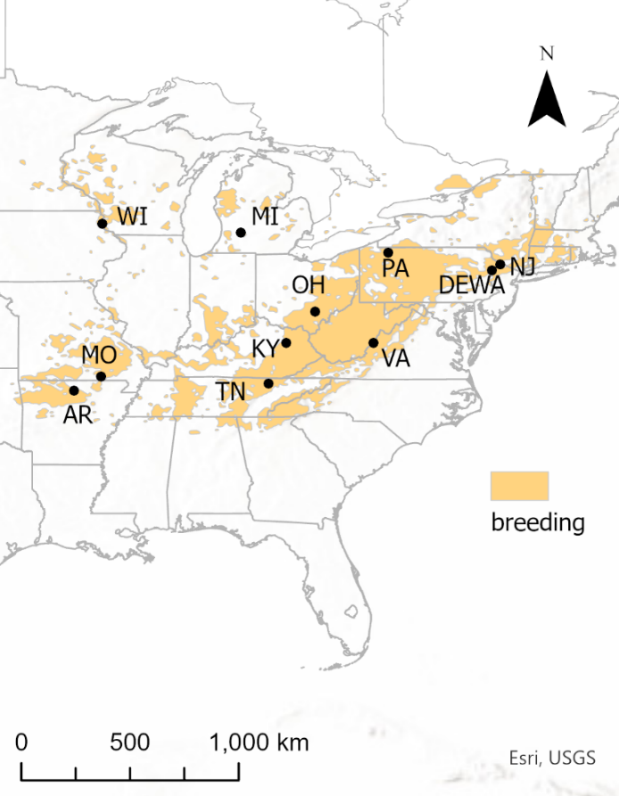
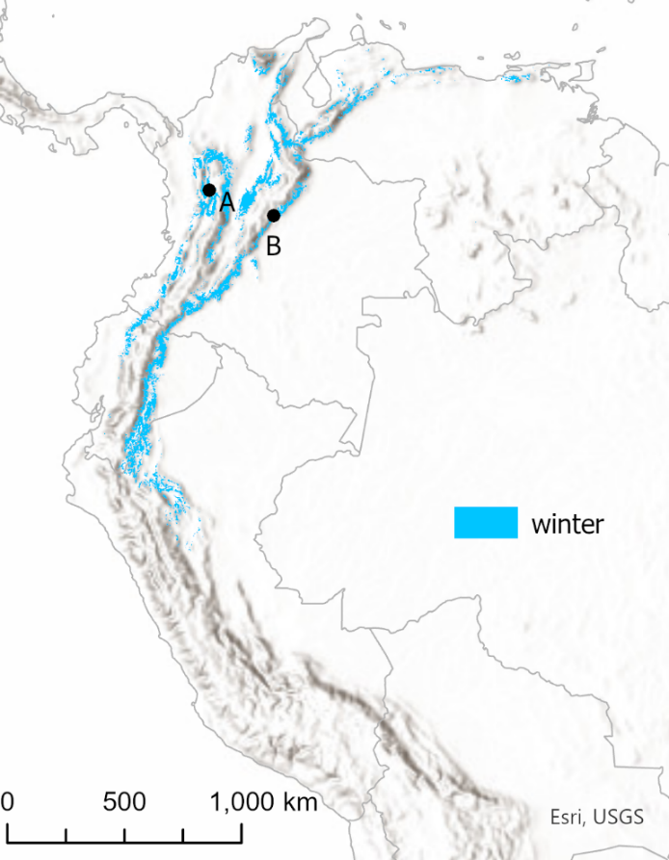

Figure 1.1. Geolocator deployment locations throughout the Cerulean Warbler’s (A) North American breeding range and (B) South American stationery non-breeding range. Modeled range estimates were obtained from eBird Status and Trends Data Products (Fink et al. 2020). We conservatively filtered the modeled non-breeding range to a threshold of at least one expected Cerulean Warbler encounter per km per hour to better represent the core overwintering range.

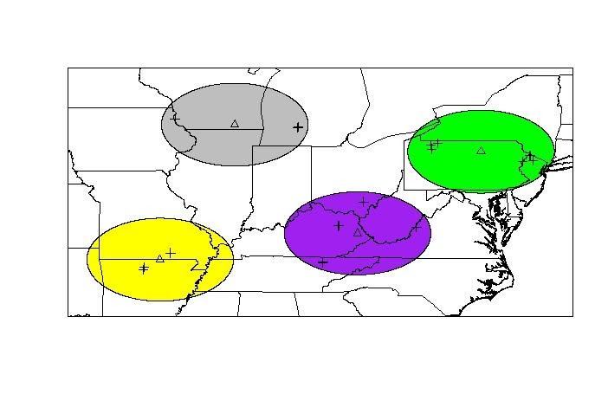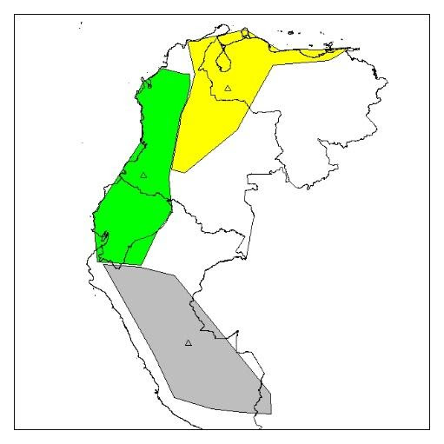
Figure 1.2. Breeding (A) and stationary non-breeding regions (B) and their centroids used to calculate distance matrices to estimate migratory connectivity (MC). MC also incorporates relative abundance at origin (breeding) locations, capture locations of each bird, median stationary non-breeding locations of each bird, and location bias covariance estimates calculated while the birds were still at using their breeding territories.
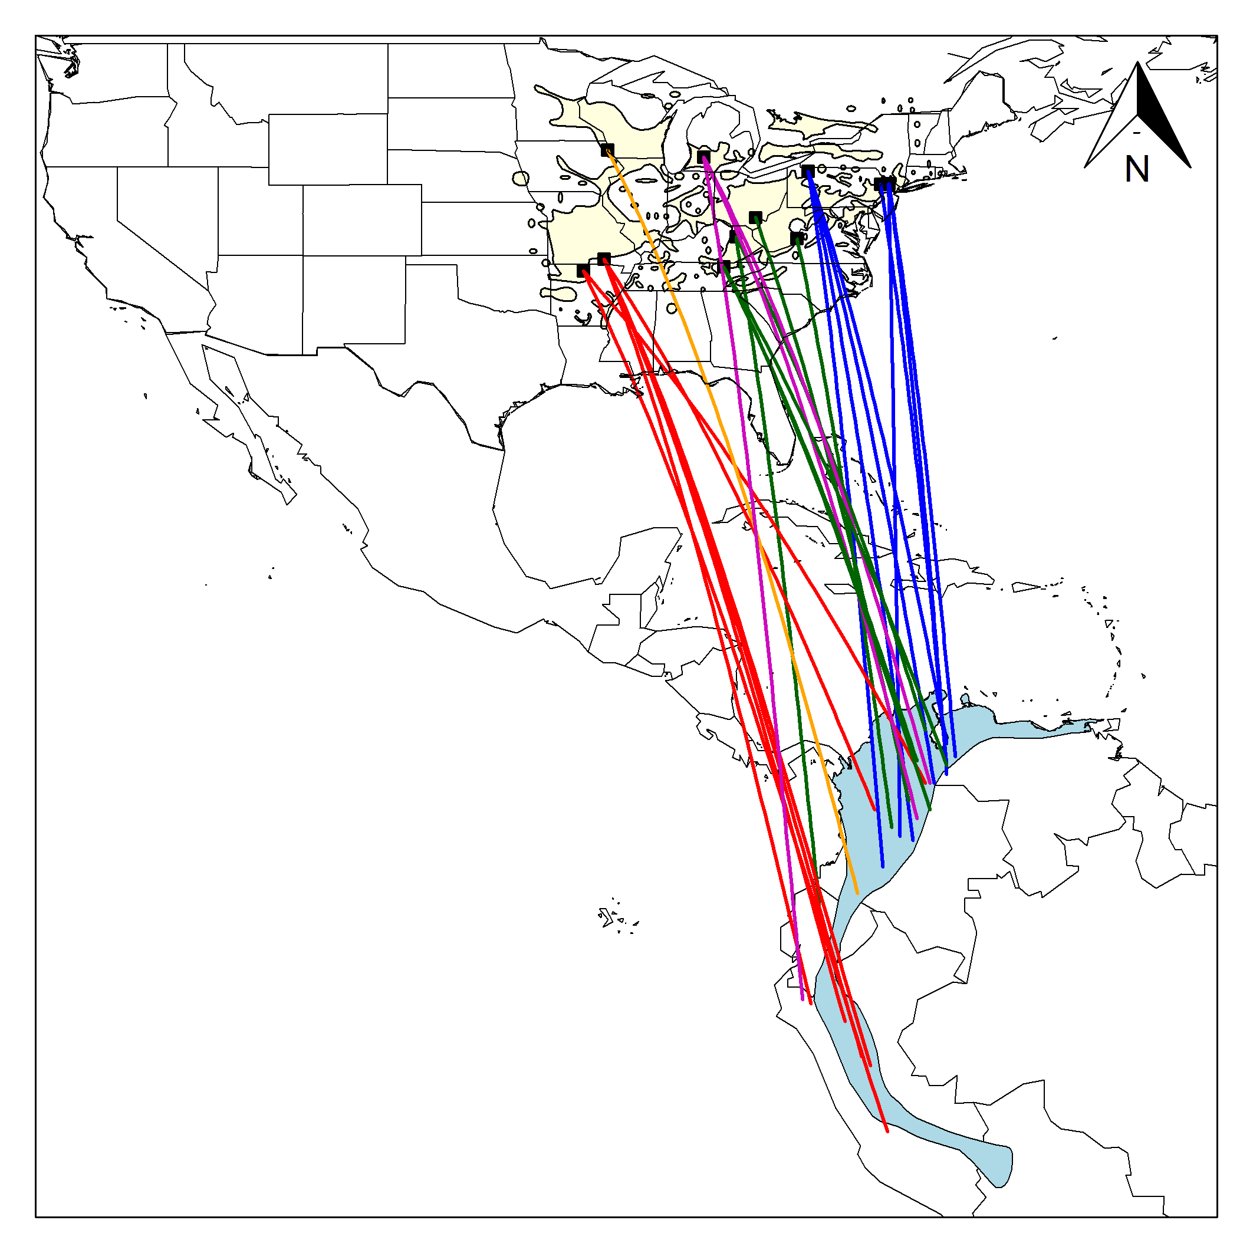
Figure 1.3. Migratory connectivity pattern of male Cerulean Warblers. Lines connect capture locations with median estimated overwintering locations using the shortest great circle routes and do not infer migratory routes as all birds traveled through Central America during migration. Interquartile ranges of overwintering location estimates averaged ± 0.8º longitude (~ ± 84 km) and ± 1.7 º latitude (~ 186 km). Light blue shaded area in South America is the Cerulean Warbler overwintering range shapefile from BirdLife International and NatureServe (2019). Although this shapefile does not include northwestern Ecuador, eBird data show numerous winter observations in this region west of Quito.
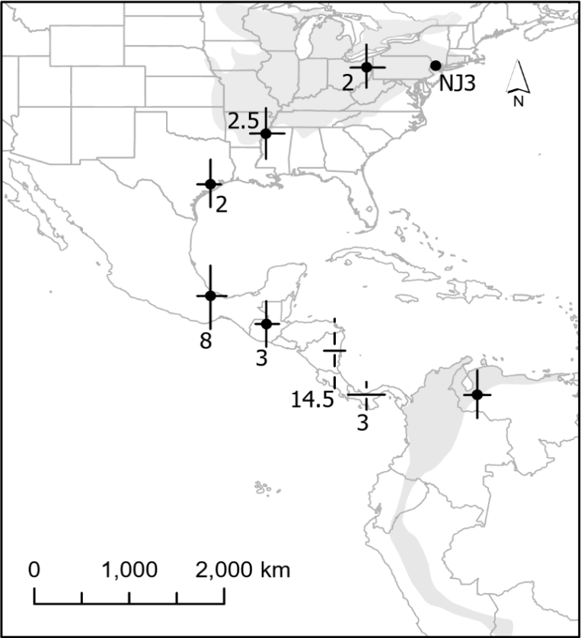
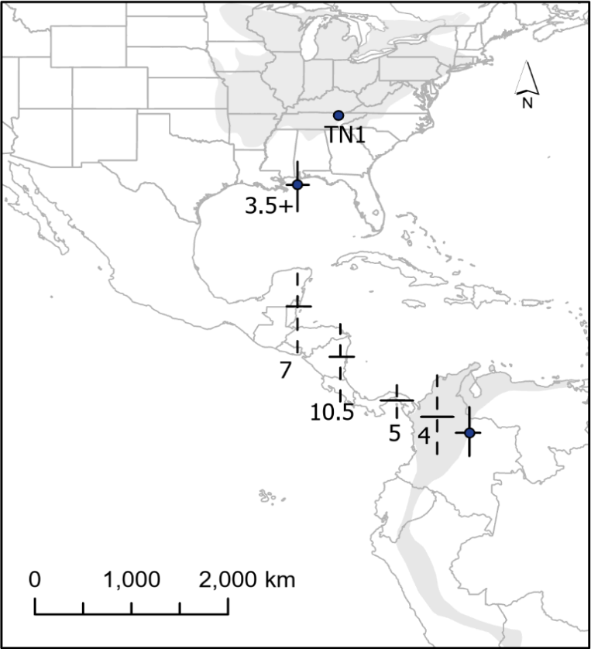
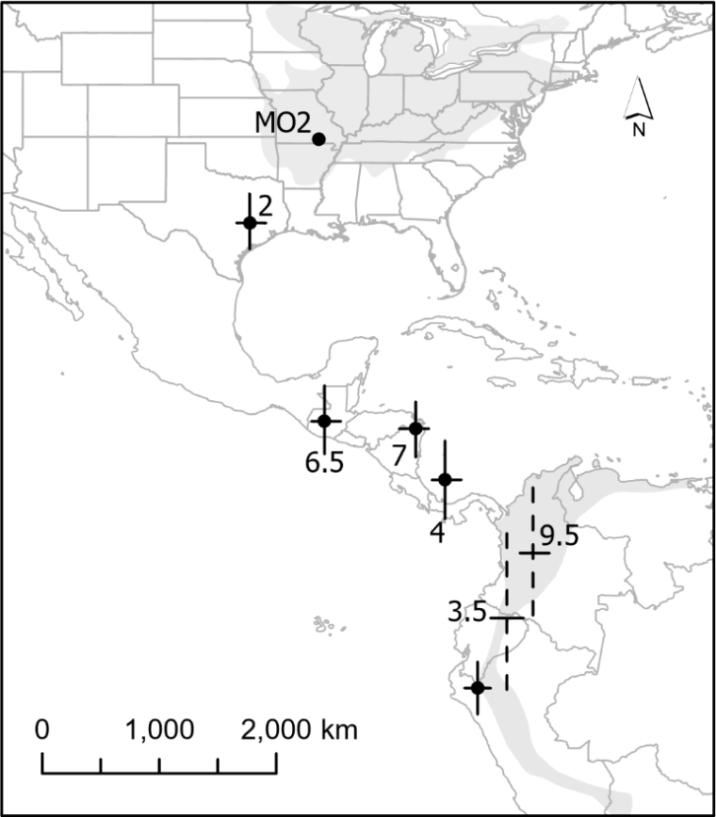
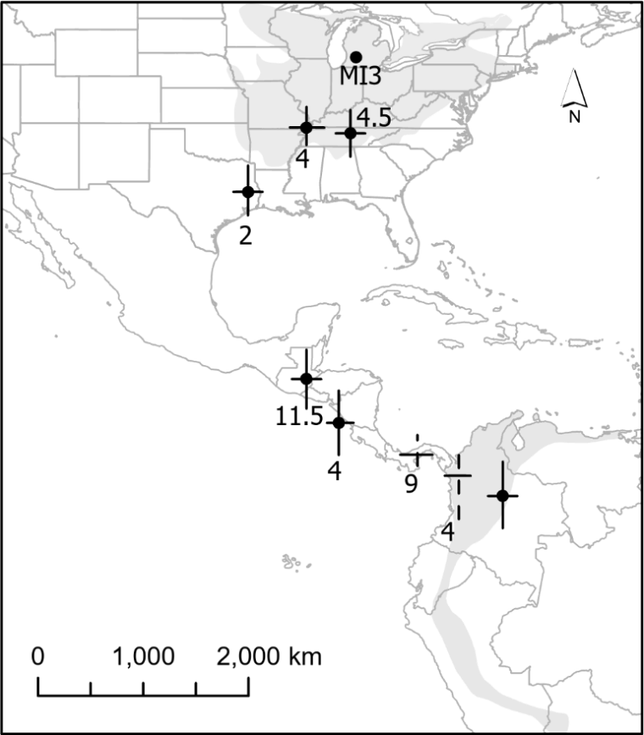
Figure 1.4. Stopover strategies by representative birds captured in 4 different breeding regions. Error bars are interquartile ranges of location estimates and represent a range of most likely locations; corresponding numbers are the stopover durations in days. Dashed lines are stopovers that overlapped within 14 days of the spring equinox and for which latitude was inferred based on land restrictions. Shaded gray polygons represent the approximate breeding and Andean non-breeding ranges of the species. Final recapture locations are labelled with the bird’s ID. The TN1 geolocator stopped recording data during the final U.S. stopover.

CHAPTER 2: ASSESSING THE EFFECTS OF FOREST MANAGEMENT ON CERULEAN WARBLER BREEDING HABITAT

ABSTRACT

During the late 19th and early 20th centuries, widespread clear-cutting of deciduous forests, followed by regeneration and a subsequent lack of natural forest disturbances, has resulted in homogenous, closed-canopy forest structure across much of eastern North America. Forest management prescriptions (including single-tree selection, group selection, and even-aged shelterwood harvests) designed to diversify stand structure are increasingly being recommended and applied with the goal of creating, maintaining, or improving habitat for declining, disturbance-adapted species such as Cerulean Warblers (Setophaga cerulea). Although a few studies have examined short-term (1–4 years post-treatment) responses of Cerulean Warblers to timber harvests and have documented positive short-term effects, longer-term effects are undocumented. To assess longer-term effects, we re-surveyed 12 forest stands (~20-ha study plots) located across three states, that had been managed 13-14 years prior using varying timber harvest intensities that mimicked various natural disturbance regimes. Commercial timber harvest treatments reduced basal area and overstory canopy by 0% (control), ~20% (light), ~40% (intermediate) and ~75% (heavy). The plots had previously been surveyed in 2005-2006 (pre-harvest) and 2007-2010 (post-harvest). In 2019–2020, we followed the same spot-mapping methods as used previously and compared territory density estimates of Cerulean Warblers with previous estimates at each treatment level. We also compared density responses of three other focal species: Hooded Warblers (Setophaga citrina), Scarlet Tanagers (Piranga olivacea), and Ovenbirds (Seiurus aurocapilla). None of these species, including ceruleans, achieved consistent, positive longer-term responses compared with pre-harvest densities when considering the three study sites combined, although site-specific variation (e.g., ceruleans maintained a positive response at 3/9 harvested plots) was observed. Vegetation structure, compared at 4 years post-harvest with 13 years post-harvest, documented increased midstory cover (i.e., the 3–12 m stratum), while overstory structure (i.e., >18 m stratum) and stand basal area were relatively unchanged. Cerulean territory densities were negatively related to midstory cover and stand basal area and positively related to overstory cover. Forest management prescriptions for ceruleans should consider implications for the entire duration of the stand rotation, rather than short-term effects. Prescribed burning or pre-commercial thinning may be effective at maintaining a more open midstory preferred by ceruleans for breeding territories.

INTRODUCTION
Avian abundance in eastern North American forests has undergone a severe decline over the past half century, with an estimated net loss of ~167 million birds and populations of >60% of forest-dwelling species have declined (Rosenberg et al. 2019). These declines have occurred despite a trend of increasing forest cover over the past century following extensive clear-cutting in the late 19th and early 20th centuries (Johnson and Govatski 2013). The decline of some of these species’ populations may be related to the lack of age-class diversity and stand structural complexity in these second-generation forests (Shifley et al. 2014, Grinde et al. 2017). The contemporary lack of structural diversity is largely a reflection of the reduced frequency of natural disturbances such as wind throw of large trees, tree senescence, and fire (Long 2009, Shifley et al. 2014). Due to this homogenization of forest structure, avian species that nest in early forest seral stages are more likely to be in population decline than species that nest in mature forest (Brawn et al. 2001). However, forest disturbances are not only necessary for species considered to be early-successional obligates but may also benefit species that nest in mature forest but use early-successional forests during other life cycle stages. For example, some mature forest dwelling species take advantage of increased cover and seasonally increased amount of food resources in young regenerating stands during the post-fledging period (King et al. 2006, Streby et al. 2011, Chandler et al. 2012). Furthermore, some avian species that breed in mature forests select for territories or nesting sites within or near canopy gaps caused by natural or anthropogenic disturbances (e.g., Hooded Warblers; Setophaga citrina; Chiver et al. 2020, and Cerulean Warblers; Setophaga cerulea; Boves et al. 2013a).
In recent decades, a growing body of forest management efforts have been designed and implemented across North America to emulate natural disturbance regimes (ENDR; Long 2009) intended to increase forest heterogeneity, promote biodiversity across taxa, and improve long-term forest health and productivity (Brawn et al. 2001, Johnson and Govatski 2013). These ENDR strategies can include various partial timber harvest practices such as shelterwood harvests, group selection, crop-tree release, crown thinning, and single-tree selection. However, there is still much to learn regarding wildlife species’ responses to various ENDR silvicultural techniques and how such responses change over time as forest regrowth occurs.
One disturbance-adapted species of conservation concern for which ENDR applications have been used as a habitat management tool is the Cerulean Warbler (hereinafter ‘ceruleans’). Populations of this canopy-dwelling, long-distance Nearctic-Neotropical migrant breed in mature hardwood forests across much of eastern North America and overwinter in the northern Andes of South America (Buehler et al. 2020). Global cerulean populations have declined ~75% over the past half century (Wood et al. 2013, Sauer et al. 2020), with the majority of ceruleans (~80%) currently breeding in the Appalachian Mountains Bird Conservation Region (Wood et al. 2013). Ceruleans typically select breeding territories in areas with relatively steep topography near ridge tops and on upper north- to east-facing slopes in the Appalachian Mountains or in riparian forests along major rivers systems elsewhere. They also typically select for large tracts of mature forest with large-diameter trees and complex overstory structure that includes canopy gaps (Boves et al. 2013a, Nemes and Islam 2017, Buehler et al. 2020, Wessels and Boves 2021). And finally, nests are usually located in the forest canopy; females typically select large diameter trees in areas with more understory cover and less midstory cover and basal area compared with available habitat (Boves et al. 2013a, Buehler et al. 2020). Together, these habitat preferences make ceruleans prime candidates for benefiting from management practices associated with ENDR.
Although a few studies have examined short-term (1–4 years post-treatment) cerulean territory density response following partial timber harvests (e.g., Boves et al. 2013b, Nareff et al. 2019), longer-term responses have not been documented. To understand the short-term (i.e., 1–4 years post-harvest) responses of ceruleans to experimentally manipulated forest structure, the Cooperative Cerulean Warbler Forest Management Project (CWFMP; Boves et al. 2013b, Sheehan et al. 2014) investigated ceruleans’ and other target species’ population density responses to partial timber harvests of varying intensity at 7 study sites throughout the Appalachian region. The CWFMP overall found positive territory density responses at each of three harvest intensities (light, intermediate, and heavy; Boves et al. 2013b), with the greatest increases in stands that were harvested at an intermediate level as shelterwood cuts with residual basal area (RBA) ~16 m²/ha. However, reproductive success was greater in unmanaged control plots compared with partially harvested plots (in the southern region), which could possibly reflect an ecological trap (Boves et al. 2013b). Furthermore, it is unknown if ceruleans favor these harvested plots beyond the initial 4 post-harvest years as stands continue to respond to the disturbances. Thus, long-term monitoring of cerulean densities in managed forests was warranted to allow managers to better understand cerulean response over longer periods to determine whether the increased densities persisted for the life of the stand or were more ephemeral.
The results from the CWFMP and other studies formed a basis for the publication of the “Cerulean Warbler Management Guidelines for Enhancing Breeding Habitat in Appalachian Hardwood Forests” (hereafter “Cerulean Management Guidelines”, Wood et al. 2013), a resource for foresters, biologists, and land managers interested in improving or creating breeding habitat for ceruleans. These guidelines suggested that reducing basal area to ~9–21 m²/ha (40–90 ft²/acre) within mature, fully stocked forest stands where cerulean densities were low would create or enhance nesting habitat. The guidelines have been utilized by land managers of both public and private lands throughout the region.
Our objectives were to compare latter post-harvest (13–14 years post-harvest) cerulean territory densities with pre-harvest and early (1–4 years) post-harvest densities within experimental stands from the CWFMP study. We also compared densities between the same periods for three other common songbird species (each of a different guild) within these plots: Hooded Warblers (Setophaga citrina; understory dwellers that nest in the shrub layer), Ovenbirds (Seiurus aurocapilla; mature forest obligates that nest and forage in the leaf litter), and Scarlet Tanagers (Piranga olivacea; that dwell and nest in the forest canopy). Additionally, we compared measurements of stand basal area (BA) and canopy cover in the understory (0.5–3 m), midstory (3–12 m), and overstory (>18 m) strata as indices of forest structural changes potentially important for cerulean territory establishment between survey periods. Lastly, we explored potential effects of our vegetation structure measurements on cerulean density using linear regression. The results of this study have the potential to inform managers of the effectiveness of various forest management intensities and to provide insight into potential ways to prolong effectiveness of breeding habitat enhancement efforts.

METHODS

Of the original seven study sites from the CWFMP (Boves et al. 2013b), three had remained unaltered by major disturbances (logging or otherwise) since experimental timber harvests were implemented in 2006, so we focused on these three sites for this follow-up study. These sites were located within the North Cumberland Wildlife Management Area (36.356° N, -84.282° W) in Tennessee, the Daniel Boone National Forest in Kentucky (38.069° N, -83.554° W), and Vinton Furnace State Experimental Forest (formerly referred to as the Raccoon Ecological Management Area; 39.192° N, -82.373° W) in Ohio. Each study site was comprised of four plots that consisted of ~10-ha treatments and ~10-ha adjacent, untreated buffers, and we used the same boundaries as defined in the previous study to establish spot-mapping grids. Treatments at each site included a light (~20% of basal area and canopy cover removed; single-tree selection), intermediate (~40% of basal area and canopy cover removed; shelterwood establishment cut), and heavy harvests (~75% of basal area and canopy cover removed; heavy shelterwood establishment cut) as well as an undisturbed control plot (Boves et al. 2013b, Sheehan et al. 2014). Treatments were all implemented in 2006, except the heavy treatment in Kentucky, which was harvested in 2007 after the breeding season (Sheehan et al. 2014). Thus, all 2005-2006 surveys and the 2007 KY heavy treatment survey were “pre-harvest”, and 2007-2010 surveys (except the 2007 KY heavy treatment) were “early post-harvest”. We then conducted the present study during 2019 and 2020, 13-14 years after harvest (“latter post-harvest”).
Although these sites had remained mostly undisturbed since the 2006 treatment implementations, one exception was that in 2017, transmission lines were removed from the Ohio control plot. In this process, some trees were removed for temporary access roads, but a change in canopy cover was not noticeable in satellite imagery.

Temporal avian responses
All plots were surveyed yearly from 2005–2010 for Cerulean Warblers and three other target species of interest (Ovenbirds, Hooded Warblers, and Scarlet Tanagers). We surveyed these plots on 8 visits/plot between 10 May and 09 June in 2019 and 2020, following the same spot-mapping methodology as Boves et al. 2013b. Spot-mapping has been demonstrated to be more accurate as a census of territories than point counts (Bibby et al. 2000, Newell et al. 2013). To reduce the possibility of observer bias affecting results, observers alternated between plots daily, alternated between different starting locations on each plot, and each observer completed ~50% of the surveys for each plot.
We delineated and summed territories in the same manner as previous analyses (Boves et al. 2013b, Newell et al. 2013, Sheehan et al. 2014). To examine territory density responses over time for each treatment intensity, we constructed linear mixed-effect models using the lme4 package in R (Bates et al. 2015) with territory density as a response variable, time period as a dependent variable, and plot ID as a random effect. We considered territory density estimates among time periods to differ at alpha < 0.05. We ran post-hoc Tukey tests when time period was significant to determine which pairs of time periods differed. We repeated this process for Ovenbirds, Hooded Warblers, and Scarlet Tanagers.

Temporal vegetation responses
In June and July 2019, we collected vegetation measurements including BA and percent cover of understory, midstory, and overstory strata following Boves et al. (2013b) to compare post-2010 structural changes. Vegetation plots were sampled at the same locations (n = 10 per treatment at each site) that were sampled in all years from 2005–2010 in Kentucky and Tennessee and at locations sampled in a randomly selected year from 2007–2010 in Ohio. Per Boves et al. (2013b), we measured canopy cover at each vegetation sampling plot using an ocular tube to measure presence or absence of foliage at each vertical stratum at 21 points (5 points in each cardinal direction 2.3 m apart and one at point center). Boves et al. (2013b) initially collected canopy cover data at 7 strata —0.5–1.5 m, 1.5–3 m, 3–6 m, 6–12 m, 12–18 m, 18–24 m, and >24m. We modified this process by measuring percent cover at 3 defined layers: 0.5–3 m (understory), 3–12 m (midstory), and > 18 m (overstory). We calculated correction factors from a subset of 50 vegetation plots using data sheets from 2007 to account for the differing canopy cover estimation methods. Correction factors were calculated as the total of the greater number of hits per vegetation plot among each substratum that composed each of the understory, midstory, and overstory layers (as done by Boves et al. 2013b), divided by the total sum of hits that could have fallen into at least one of the substrata within each layer (as measured in 2019). We applied these correction factors (0.86, 0.83, and 0.95 for the understory, midstory, and overstory layers, respectively) to all 2019 canopy cover measurements.
For vegetation structure comparisons with the early post-harvest period, we compared our latter post-harvest measurements with early post-harvest measurements at the same vegetation plots for each vegetation measure with paired Wilcoxon signed-ranked tests (for Kentucky and Tennessee data) and with unpaired Wilcoxon ranked-sum tests (for Ohio data). These different analyses were used because territory density was not normally distributed over some treatment levels and locations of vegetation sampling points changed each year in Ohio but not in Kentucky and Tennessee.

Relationship between cerulean density and vegetation structure
To examine relationships between vegetation structure on cerulean density, (regardless of time-period), we constructed linear regression models in R (R Core Team 2021). Territory density estimates from each treatment or buffer (for each year surveyed) were treated as the response variable, with predictors being the median value (from the associated time-period) of each vegetation metric within the plot or buffer from which the territory density was calculated. We built and compared models with all combinations of the predictors BA, BA², understory cover, midstory cover, and overstory cover on the territory density response. We compared models using Akaike’s Information Criterion adjusted for small sample size (AICc). From among the best-supported models (ΔAICc ≤ 2; Burnham and Anderson 2002), we considered each predictor for which the 85% CI of its β estimate did not overlap with zero to be informative (Arnold 2010). If a predictor was included in more than one best-supported model, we interpreted the β and 85% CI from the model with the lowest AICc.

RESULTS

Temporal avian responses
Across time periods (pre-, early post-, and latter post-harvest), cerulean densities among light treatment plots (µ = 9.5 ± 0.9 territories/10 ha) did not differ (F_{2,19} = 0.58; P = 0.57; Fig. 2.2 and Table 2.2). However, cerulean densities on intermediate plots differed among time periods (F_{2,19} = 4.11; P = 0.03). Cerulean territory density within intermediate treatments during the latter post-harvest period (µ = 7.3 ± 1.0) territories/ha) declined from the early post-harvest densities (µ = 11.1 ± 1.8 territories/10 ha; t _{2,19} = -2.87; P = 0.03) but did not differ from densities in the pre-harvest period (µ = 9.8 ± 2.5 territories/10 ha; t _{2,19} = -1.62; P = 0.26). Cerulean densities within heavy treatments did not change over time (F _{2,19} = 1.86; P = 0.18), although the mean density at these plots was relatively low (µ = 4.1 ± 1.1 territories/10 ha) compared with controls, buffers, and other treatments (Fig. 2.2 and Table 2.2). Likewise, cerulean territory densities did not differ across time periods at control plots (F_{2,19} = 1.76; P = 0.20) or within the combined unmanaged buffer stands adjacent to treatments (F_{2,82} = 1.94; P = 0.15).
Among the other three species’ responses, Ovenbirds exhibited the most changes in territory density over time (Table 2.2). The decreases in Ovenbird territory densities between pre-harvest and both early and latter post-harvest periods within all treatments were substantial: 15.1 ± 0.8 to 8.2 ± 1.1 and 8.5 ± 1.3 territories/10 ha across light treatments, 13.6 ± 3.6 to 3.3 ± 0.5 and 5.5 ± 0.8 territories/10 ha across intermediate treatments, and 9.2 ± 1.1 to 0.6 ± 0.4 and 2.4 ± 0.7 territories/10 ha across heavy treatments. Hooded Warbler territory density did not differ across time periods at all treatment intensities and control plots (Table 2.2). Scarlet Tanager densities differed among time periods (F_{2,19} = 19.17, P < 0.01) as they declined from 5.2 ± 0.4 territories/10 ha pre-harvest to 2.5 ± 0.5 (early post-harvest) and 1.4 ± 0.3 territories/10 ha (latter post-harvest) within heavy treatments and declined at control plots from 4.5 ± 1.0 territories/10 ha (pre-harvest period) to 2.8 ± 0.1 territories/10 ha during the latter post-harvest period.

Temporal vegetation responses
Structurally, the midstory layer exhibited the largest and most consistent changes between early and latter post-harvest periods across all treatments (Table 2.1). Conversely, overstory cover remained similar at all treatments and study sites. In Kentucky and Tennessee, across heavy treatments, BA increased and midstory cover increased (P < 0.01), while understory cover was relatively unchanged (P = 0.24). Across intermediate treatments, midstory cover increased (P < 0.01) but understory cover (P = 0.46) and BA (P = 0.76) were unchanged between survey periods. Across light treatments, midstory cover increased (P < 0.01), while BA (P = 0.08) and understory cover (P = 0.35) remained unchanged. Across control plots, BA (P = 0.82), midstory cover (P = 0.07), and overstory cover P = 0.40) remained unchanged while understory cover increased (P < 0.01).
In Ohio, vegetation structural changes generally aligned with those in Kentucky and Tennessee but there were a few exceptions. BA (P = 0.70) and understory cover (P = 0.22) remained similar within the heavy treatment and midstory cover increased (P < 0.01). At the intermediate treatment, BA remained similar (P = 0.37) and midstory cover increased (P < 0.01). Unlike the intermediate treatments at the other sites, in Ohio understory cover increased (P < 0.01). At the light treatment plot, midstory cover increased (P < 0.01) and BA did not change (P = 0.52), but unlike the Kentucky and Tennessee sites, understory cover increased (P = 0.01). At the Ohio control plot, BA decreased (P < 0.01), while understory cover P < 0.01) and midstory cover (P < 0.01) both increased and there was no change in overstory cover (P = 0.19).

Relationship between cerulean density and vegetation structure
Across all years, treatments, and buffers, cerulean densities were negatively related with BA (β = -1.8, 85% CI -2.4 to -1.2), negatively related with midstory cover (β = -0.9, 85% CI -1.5 to -0.4), and positively related with overstory cover (β = 3.1, 85% CI 2.5 to 3.8). Although understory cover and quadratic BA were each included in two of the four best-supported models (Table 2.3), they were not included in the most parsimonious of the best-supported models (Midstory + Overstory + BA; Fig. 2.3) and their 85% CI overlapped with zero and thus we consider them as uninformative (Arnold et al. 2010).

DISCUSSION
Forest management to enhance cerulean habitat through the implementation of ENDRs has been predicated on the hypothesis that increasing forest structural complexity will increase the occupancy and relative abundance of ceruleans. The Cerulean Warbler Forest Management Guidelines were developed, and a large regional conservation effort has been implemented based on this hypothesis (e. g., Oliver 2021). Although Boves et al. (2013b) and Nareff et al. (2019) documented positive short-term post-harvest increases in cerulean density in response to ENDR prescriptions, our results demonstrate that those increases may be relatively short-lived. Although there were exceptions among our 12 plots and our sample size was limited, overall, cerulean densities returned to pre-treatment levels (or less) by 13–14 years post-harvest.
Across the treatments that exhibited the greatest short-term cerulean density increases (e.g., the light intensity harvest in OH, the intermediate intensity harvest in KY, and the heavy intensity harvest in TN), positive effects had generally reversed by 13-14 years post-harvest (Fig. 2.2). This reduction in density could be related to several proximate and ultimate factors. First, the density decline could be related to succession of these forest stands. Densities across all plots over all survey periods were negatively related with midstory cover and BA but positively related with overstory cover. While BA and overstory cover did not change significantly over the 14-years post-harvest (excepting the increased BA in KY and TN heavy treatments), midstory cover greatly increased within treatments and thus closure/encroachment of the midstory layer may explain why longer-term densities subsided. Early post-harvest cerulean density increases may have been attributable to increased availability of canopy gaps and associated increases in insect prey density (Blake and Hoppes 1986, Gorham et al. 2002) in residual trees exposed to newly formed canopy gaps (Boves et al. 2013a, Perkins and Wood 2014). But as these stands matured, decreased cerulean densities in the latter post-harvest period may be attributable to an increasingly dense midstory layer (e.g., 70% to 82% mean cover at 13 years post-treatment at our study sites), as males typically select territories where midstory cover is ~45 to 65% and females select nesting locations in areas with reduced midstory cover (Boves et al. 2013a). Because we did not survey our study sites between 2011 and 2018, it is unknown when initial increases began to subside or reverse. Ultimately, it is possible that longer-term declines manifested following years of relatively low nest success within the heavy and intermediate shelterwood harvests (Boves et al. 2013b). Due to a continuing regional population decline (Sauer et al. 2020), there may also have been a consistent negative pressure on territory density over the 15-year study period across all plots that we did not detect at a significant level (Fig. 2.2) at unmanaged control plots and buffers.
Furthermore, we did not find consistent initial (1–4 years) post-harvest increases at our 3 study sites and thus forest managers should not expect all ENDR applications to be successful at attracting ceruleans. Similarly, Oliver (2021) found no differences in cerulean densities in managed (1–4 years post-treatment) vs. unmanaged stands on private lands enrolled in the Cerulean Warbler Appalachian Forestland Enhancement Project in West Virginia. Implementation of successful cerulean prescriptions may be especially challenging in situations affected by some combination of habitat fragmentation, a lack of large-diameter trees often due to a history of high-grading (Ciuzio et al. 2013, Oliver 2021) or lack of tree species favored by ceruleans (Boves et al. 2013a).
Changes in vegetation structure were generally consistent with our expectations based upon forest management literature. Vegetation growth in subcanopy layers was greatest across heavy treatment sites, where ample sunlight was available in larger gaps and thus seedlings and saplings (especially shade-intolerant species) grew rapidly (Phillips and Shure 1990). In heavy treatments in Kentucky and Tennessee, rapidly growing pole-sized stems (including shade-intolerant Liriodendron tulipifera; Fig. 2.1) resulted in increased BA. For intermediate and light treatments, BA did not increase due to ingrowth of smaller stems because of more limited understory light (Perry and Thill 2013, Leak et al. 2014). The decrease in BA we observed at the light treatments in Kentucky and Tennessee may have been attributable to mortality of residual stems due to windthrow or disease. Overstory cover did not measurably change at any of the treatments, implying that overstory canopy gaps created from the single-tree selection and even-aged cuts had not closed at the >18 m stratum over the 13-years since harvests were implemented. Regeneration within newly-formed canopy gaps in each treatment had already advanced to the understory (0.5–3 m) layer by 2010 (4th year post-harvest), which explains the general lack of change at this stratum between 2010 and 2019. However, in 2010 the regeneration had generally not recruited into the midstory (3–12 m) layer but had done so by 13-years post-harvest (Perry and Thill 2013), explaining the substantial midstory increases across all treatments. Increased understory and midstory cover and decreased BA at the Ohio control plot may be explained by the removal of some trees in 2017 when electric transmission lines were removed and temporary access roads cleared, which may in turn explain why we observed a slight increase in cerulean density in 2019–2020 compared with 2006–2010 estimates at this plot (Fig. 2.6). Alternatively, these apparent structural changes may have been an artifact of the unpaired sample design of vegetation plot locations (n = 20 at the control plot and n = 10 per treatment) among years in Ohio.
We observed lower densities of Ovenbirds and Scarlet Tanagers in the latter post-harvest period compared with the preharvest period and similar Hooded Warbler densities across time periods. Similar with our results, Augenfield et al. (2008) observed lower Ovenbird and Scarlet Tanager densities in shelterwoods surveyed at 12-years post-harvest. Contrary to the results of our study, Perry and Thill (2013) found that Hooded Warbler density increased and peaked at 12-years post-harvest in single-tree selection and shelterwood treatments in the Ouachita Mountains. Sheehan et al. (2014) evaluated the early post-harvest density responses of ceruleans and 6 other species at the 7 CWFMP study sites that included the three sites surveyed in our study and found that cerulean density peaked at an intermediate RBA (~16 m²/ha). Ovenbird territory densities decreased substantially with reduced RBA (peak density at ~25 m²/ha), as they are well-known to decrease in abundance during the nesting season in response to forest disturbance because they select for areas with closed canopies, exposed leaf litter, and little understory vegetation (Porneluzi et al. 2020). Hooded Warbler density increased with reduced RBA (peak territory density at ~13 m²/ha RBA after 2–4 years post-harvest), as they benefit from increased understory cover for successful nesting (Howlett and Stutchbury 1996). Scarlet Tanager densities peaked at ~20 m²/ha RBA, and this species has been demonstrated to favor habitat with a high density of large trees and a low density of small trees (Mowbray 2020). As such, in the short-term, a light (e.g., single-tree selection) harvest appeared to benefit ceruleans and Scarlet Tanagers and intermediate-intensity treatments (e.g., shelterwood cuts) may benefit ceruleans and Hooded Warblers, while a lack of forest disturbance benefits nesting Ovenbirds. However, longer-term avian abundance and diversity responses have been demonstrated to be negative after initial positive responses following implementations of shelterwood establishment cuts (Augenfield et al. 2008). Although we found that heavy harvests negatively impacted Scarlet Tanager and Ovenbird territory densities and did not benefit Cerulean or Hooded Warbler density after 13–14 years of regeneration, these species commonly use early seral stages resulting from heavy harvests and clear-cuts during the post-fledging periods (Marshall et al. 2003, King et al. 2006, Streby et al. 2011, Raybuck et al. 2019). Mature forest habitat available for nesting adjacent to the harvests was abundantly available to these species at our study sites, and a mosaic of stand conditions and ages across forested landscapes are likely to improve avian biodiversity (Lindenmayer et al. 2000, Sheehan et al. 2014, Grinde et al. 2017).
Importantly, our results suggest that forest management practices may not be transferrable across space (even within a single eco-region). As described by Boves et al. (2013b) in the short-term, where ceruleans selected for territories with variable BA dependent on landscape-level fragmentation, we also observed regional or site-specific variation among ceruleans’ longer-term territory density responses. In Kentucky, (Fig. 2.4) density at the heavy treatment remained low across all time periods and was reduced at the intermediate treatment across the latter post-harvest period compared with the early post-harvest and pre-harvest periods. However, latter post-harvest density was slightly greater at the light treatment compared with pre-harvest years, while latter post-harvest densities at the control plot and buffers were similar or lower than pre-harvest estimates. These trends indicate that the light harvest was effective in the longer-term, while the intermediate and heavy treatments were not. In Ohio (Fig. 2.5), the heavy treatment also held few territories across all time periods with a potentially negative trend over time. An initial increase at the light treatment in the early post-harvest compared with the pre-harvest period declined to latter post-harvest density that remained above the pre-treatment level. Latter post-harvest density for intermediate treatment was greater than early post-harvest and pre-harvest periods. This pattern contrasts with an apparent decline at control plots and suggests that light and intermediate treatments were effective in Ohio over the 14 post-harvest years. However, in Tennessee (Fig. 2.5), cerulean densities declined, especially in the heavy- and intermediate-intensity harvests despite initial increases in the early post-harvest period. After little change from pre-harvest to early post-harvest periods, the intermediate treatment territory density declined by nearly 50% in the latter post-harvest period. Within the heavy treatment, an initial increase pre-harvest to post-harvest periods reverted to lower densities after 13-14 years post-harvest compared with preharvest years. Thus, ENDR implementations had an ephemerally positive and a longer-term negative effect at the Tennessee study site.
Heavy treatments (e.g., even-aged harvests with < 10 m²/ha RBA) are among the most economically viable forest management options but do not appear to provide long-term benefits for nesting ceruleans or for Hooded Warblers, Ovenbirds, or Scarlet Tanagers without further management. In Tennessee and Kentucky, although the BA following 12 years of regeneration was once again within the Cerulean Warbler Forest Management Guideline’s recommendation of 9–21 m²/ha (40–90 ft²/acre), the BA increase since the early post-harvest period was largely due to the ingrowth of pole timber-sized trees in the midstory. Thus, the stands are not attracting ceruleans compared with pre-harvest conditions because large-diameter trees remain limited, while ingrowth has resulted in a dense midstory layer. Furthermore, for ceruleans and Scarlet Tanagers, nesting habitat no longer exists if residual overstory trees are eventually removed, as the species require large-diameter (i.e., >40 cm dbh, Wood et al. 2013) trees for nesting. However, such heavy cuts, may benefit ceruleans and other species during the post-fledging period (Raybuck et al 2019), and such harvests are clearly beneficial to other wildlife species including early seral specialists.
Light- and intermediate-intensity harvests effectively led to and maintained increased cerulean density from pre-treatment levels to 14 years post-harvest at 2 of 3 and 1 of 3 plots that we surveyed, respectively (Figs. 2.3, 2.4, and 2.5). White oaks (Quercus alba), among the most preferred tree species for nesting and foraging (Buehler et al. 2020), are particularly difficult to regenerate due to competition with faster-growing competitors (Dillaway et al. 2007). Carefully implemented shelterwood or group selection techniques that provide enough sunlight to support white oak regeneration have the potential to improve habitat not only for ceruleans, but also numerous other wildlife species that benefit from white oak mast and/or nest in the understory layer (Newell and Rodewald 2012, Wood et al. 2013). In the longer-term, the effectiveness these light- and intermediate-intensity harvests at attracting ceruleans while also promoting oak regeneration and inhibiting a dense midstory layer could be enhanced with low-frequency prescribed fire applications (e.g., < 2 burns per decade; Brose et al. 1999, Peterson and Reich 2001).
Potential ways to prolong the increases in cerulean density that were documented early post-harvest could include application of periodic prescribed burning, herbicide applications, or pre-commercial understory and midstory removal cuts to revert midstory structure back toward early post-harvest conditions. However, it is important to consider that the strongest responses seemed to be 2-4 years post-harvest (Boves et al. 2013b) after sapling growth had proceeded to a point that could potentially create a buffer layer of protection for fledglings that drop from the upper canopy shortly after leaving the nest (Wood et al. 2013, Raybuck et al. 2019). As such, periodic burning or clearing of the understory, when possible, should be staggered over time and space to best create a landscape matrix that always includes some (adjacent) stands with a woody understory component during the breeding season. Ceruleans tend to move to areas with dense midstory cover during the post-fledging period, a period that may be as important as the nesting period to recruitment (Cox et al. 2014, Raybuck et al. 2019). Many other avian species, including other species of conservation concern (e.g., Golden-winged Warbler; Fiss et al. 2021) also move into habitat with dense subcanopy cover during the post-fledging period. Furthermore, ceruleans, like all disturbance-dependent species, are likely adapted to the ephemeral nature of natural disturbances as evidenced by their tendency to exhibit relatively low interannual territory site fidelity (Girvan et al. 2007, Rogers 2013, Connare et al. 2020). Sustaining long-term increases at specific locations may not be necessary if there is sufficiently available high-quality nesting habitat available across the landscape. Additionally, some sites already have a greater prevalence of natural canopy gaps due to more treefalls and a naturally heterogeneous canopy structure, for example near steep slopes (Barnes et al. 2016) or more windthrow in areas exposed to higher winds (e.g., ridgetops) and may not require artificial disturbances to improve cerulean breeding habitat. Future research and more longer-term monitoring of ceruleans’ responses to forest management efforts is warranted that include other regions and longer time periods to increase our understanding of these dynamics between avian responses to changing forest structure.

ACKNOWLEDGEMENTS

We express sincere gratitude for the numerous contributions and assistance that allowed us to complete this research including support and funding from the Ohio Department of Natural Resources, Daniel Boone National Forest, Tennessee Wildlife Resources Agency, numerous hard-working field assistants who collected data in difficult terrain and conditions, and all graduate students and principal investigators that designed and coordinated efforts for this long-term study.

LITERATURE CITED
Augenfeld, K. H., S. B. Franklin, and D. H. Snyder (2008). Breeding bird communities of upland hardwood forest 12 years after shelterwood logging. Forest Ecology and Management 255:1271–1282.

Barnes, K. W., K. Islam, and S. A. Auer (2016). Integrating LIDAR-derived canopy structure into cerulean warbler habitat models. Journal of Wildlife Management 80:101–116.

Bibby, C. J., Burgess, N. D., Hill, D. A., and S. H. Mustoe (2000). Bird census techniques. Second edition. Academic Press, San Diego, California, USA.

Blake, J. G., and W. G. Hoppes (1986). Influence of resource abundance on use of tree-fall gaps by birds in an isolated woodlot. Auk 103:328–340.

Boves, T. J., D. A. Buehler, J. Sheehan, P. B. Wood, A. D. Rodewald, J. L. Larkin, P. D. Keyser, F. L. Newell, A. Evans, G. A. George, and T. B. Wigley (2013). Spatial variation in breeding habitat selection by Cerulean Warblers (Setophaga cerulea) throughout the Appalachian Mountains. Auk 130:46–59.

Boves, T. J., D. A. Buehler, J. Sheehan, P. B. Wood, A. D. Rodewald, J. L. Larkin, P. D. Keyser, F. L. Newell, G. A. George, M. H. Bakermans, A. Evans, et al. (2013). Emulating natural disturbances for declining late-successional species: a case study of the consequences for Cerulean Warblers (Setophaga cerulea). PLOS ONE 8:e52107.

Brawn, J. D., S. K. Robinson, and F. R. Thompson III (2001). The role of disturbance in the ecology and conservation of birds. Annual Review of Ecology and Systematics 32:251–276.

Buehler, D. A., P. B. Hamel, and T. Boves (2020). Cerulean Warbler (Setophaga cerulea), version 1.0. In Birds of the World (A. F. Poole, Editor). Cornell Lab of Ornithology, Ithaca, NY, USA. https://doi.org/10.2173/bow.cerwar.01

Chandler, C. C., D. I. King, and R. B. Chandler (2012). Do mature forest birds prefer early-successional habitat during the post-fledging period? Forest Ecology and Management 264:1–9.

Chiver, I., L. J. Evans Ogden, and B. J. Stutchbury (2020). Hooded Warbler (Setophaga citrina), version 1.0. In Birds of the World (P. G. Rodewald, Editor). Cornell Lab of Ornithology, Ithaca, NY, USA. https://doi.org/10.2173/bow.hoowar.01

Ciuzio, E., W. L. Hohman, B. Martin, M. D. Smith, S. Stephens, A. M. Strong, and T. VerCauteren (2013). Opportunities and challenges to implementing bird conservation on private lands. Wildlife Society Bulletin 37:267–277.

Connare, B. M., C. D. Delancey, A. R. Sharp, G. J. MacDonald, and K. Islam (2020). Low breeding-site fidelity suggests dispersal of Cerulean Warblers. Northeastern Naturalist 27:669–680.

Cox, W. A., F. R. Thompson, A. S. Cox, and J. Faaborg (2014). Post-fledging survival in passerine birds and the value of post- fledging studies to conservation. The Journal of Wildlife Management 78:183–193.

Dillaway, D. N., J. W. Stringer, and L. K. Rieske (2007). Light availability influences root carbohydrates, and potentially vigor, in white oak advance regeneration. Forest Ecology and Management 250:227–233.

Fiss, C. J., D. J. Mcneil, A. D. Rodewald, D. Heggenstaller, and J. L. Larkin (2021). Cross-scale habitat selection reveals within-stand structural requirements for fledgling Golden-winged Warblers. Avian Conservation & Ecology 16:1–16.

Girvan, M. K., J. Jones, D. R. Norris, J. J. Barg, T. K. Kyser, and R. J. Robertson (2007). Long-distance dispersal patterns of male Cerulean Warblers (Dendroica cerulea) measured by stable-hydrogen isotopes. Avian Conservation and Ecology 2:1–12.

Gorham, L. E., S. L. King, B. D. Keeland, and S. Mopper (2002). Effects of canopy gaps and flooding on homopterans in a bottomland hardwood forest. Wetlands 22:541–549.

Grinde, A. R., G. J. Niemi, B. R. Sturtevant, H. Panci, W. Thogmartin, and P. Wolter (2017). Importance of scale, land cover, and weather on the abundance of bird species in a managed forest. Forest Ecology and Management 405:295–308.

Howlett, J. S., and B. J. Stutchbury (1996). Nest concealment and predation in Hooded Warblers: Experimental removal of nest cover. Auk 113:1–9.

Johnson, C., and D. Govatski (2013). Forests for the People: The story of America’s eastern National Forests. Island Press, Washington D.C, USA:1–394.

Leak, W. B., M. Yamasaki, and R. Holleran (2014). Silvicultural guide for northern hardwoods in the Northeast. USDA Forest Service, Gen. Tech. Rep. NRS-132, Northern Research Station, Newtown Square, Pennsylvania, USA:1-46.

Lindenmayer, D. B., C. R. Margules, and D. B. Botkin (2000). Indicators of biodiversity for ecologically sustainable forest management. Conservation Biology 14:941–950.

Long, J. N. (2009). Emulating natural disturbance regimes as a basis for forest management: A North American view. Forest Ecology and Management 257:1868–1873.

Marshall, M. R., J. A. DeCecco, A. B. Williams, G. A. Gale, and R. J. Cooper (2003). Use of regenerating clearcuts by late-successional bird species and their young during the post-fledging period. Forest Ecology and Management 183:127–135.

Mowbray, T. B. (2020). Scarlet Tanager (Piranga olivacea), version 1.0. In Birds of the World (A. F. Poole and F. B. Gill, Editors). Cornell Lab of Ornithology, Ithaca, NY, USA. https://doi.org/10.2173/bow.scatan.01

Nareff, G. E., P. B. Wood, D. J. Brown, T. Fearer, J. L. Larkin, and W. M. Ford (2019). Cerulean Warbler (Setophaga cerulea) response to operational silviculture in the central Appalachian region. Forest Ecology and Management 448:409–423.

Nemes, C. E., and K. Islam (2017). Breeding season microhabitat use by Cerulean Warbler (Setophaga cerulea) in an experimentally-managed forest. Forest Ecology and Management 387:52–63

Newell, F. L., and A. D. Rodewald (2012). Management for oak regeneration: Short-term effects on the bird community and suitability of shelterwood harvests for canopy songbirds. Journal of Wildlife Management 76:683–693.

Newell, F. L., et al. (2013). Comparison of point counts and territory mapping for detecting effects of forest management on songbirds. Journal of Field Ornithology 84:270–286.

Oliver, L. R. (2021). Evaluating avian occupancy on sites treated with NRCS conservation practices implemented to benefit Cerulean (Setophaga cerulea) and Golden-Winged Warblers (Vermivora chrysoptera) in West Virginia. Graduate Theses, Dissertations, and Problem Reports, 8001. West Virginia University. https://researchrepository.wvu.edu/etd/8001

Perkins, K. A., and P. B. Wood (2014). Selection of forest canopy gaps by male Cerulean Warblers in West Virginia. The Wilson Journal of Ornithology 126:288–297.

Perry, R. W., and R. E. Thill (2013). Long-term responses of disturbance-associated birds after different timber harvests. Forest Ecology and Management 307:274–283.

Peterson, D. W., and P. B. Reich (2001). Prescribed fire in oak savanna: Fire frequency effects on stand structure and dynamics. Ecological Applications 11:914–927.

Phillips, D., and D. Shure (1990). Patch-Size effects on early succession in Southern Appalachian Forests. Ecology 71:204–212.

Porneluzi, P., M. A. Van Horn, and T. M. Donovan (2020). Ovenbird (Seiurus aurocapilla), version 1.0. In Birds of the World (A. F. Poole, Editor). Cornell Lab of Ornithology, Ithaca, NY, USA. https://doi.org/10.2173/bow.ovenbi1.01

Raybuck, D. W., J. L. Larkin, S. H. Stoleson, and T. J. Boves (2019). Radio-tracking reveals insight into survival and dynamic habitat selection of fledgling Cerulean Warblers. The Condor 122:1–15.

R Core Team (2021). R: A language and environment for statistical computing. R Foundation for
Statistical Computing, Vienna, Austria. https://www.R-project.org/

Rogers, C. M. (2013). Minimum annual survival estimates of male Cerulean Warblers (Setophaga cerulea) in Southwestern Michigan. The Wilson Journal of Ornithology 125:370–375.

Rosenberg, K. V., A. M. Dokter, P. J. Blancher, J. R. Sauer, A. C. Smith, P. A. Smith, J. C. Stanton, A. Panjabi, L. Helft, M. Parr, and P. P. Marra (2019). Decline of the North American avifauna. Science 366:120–124.

Sauer, J. R., W. A. Link, and J. E. Hines (2020). The North American Breeding Bird Survey, Analysis Results 1966 - 2019: U.S. Geological Survey data release, USGS Patuxent Wildlife Research Center, Laurel, MD. https://doi.org/10.5066/P96A7675

Sheehan, J., P. B. Wood, D. A. Buehler, P. D. Keyser, J. L. Larkin, A. D. Rodewald, T. B. Wigley, T. J. Boves, G. A. George, M. H. Bakermans, T. A. Beachy, A. Evans, M. E. McDermott, F. L. Newell, K. A. Perkins, and M. White (2014). Avian response to timber harvesting applied experimentally to manage Cerulean Warbler breeding populations. Forest Ecology and Management 321:5–18.

Shifley, S. R., W. K. Moser, D. J. Nowak, P. D. Miles, B. J. Butler, F. X. Aguilar, R. D. DeSantis, and E. J. Greenfield (2014). Five anthropogenic factors that will radically alter forest conditions and management needs in the Northern United States. Forest Science 60:914–925.

Streby, H. M., S. M. Peterson, T. L. McAllister, and D. E. Andersen (2011). Use of early-successional managed northern forest by mature-forest species during the post-fledging period. The Condor 113:817–824.

Wessels, J. L., and T. J. Boves (2021). Cerulean Warblers in the Ozark region: Habitat selection, breeding biology, survival, and space use. Journal of Field Ornithology 0:1–13.

Wood, P.B., J. Sheehan, P. Keyser, D. Buehler, J. Larkin, A. Rodewald, S. Stoleson, T.B. Wigley, J. Mizel, T. Boves, G. George, M. Bakermans, T. Beachy, A. Evans, M. McDermott, F. Newell, K. Perkins, and M. White (2013). Management guidelines for enhancing Cerulean Warbler breeding habitat in Appalachian hardwood forests. American Bird Conservancy. The Plains, Virginia, USA.

APPENDIX
Table 2.1. Number of territories per 10 hectares of four target species at each treatment intensity for the Kentucky, Tennessee, and Ohio sites combined. Cerulean Warblers and Scarlet Tanagers nest in the forest canopy, Hooded Warblers nest in the forest understory, and Ovenbirds nest on the ground and forage in leaf litter. Data was collected over 2 preharvest years, 4 early post-harvest years (beginning in 2007, following 2006 harvests), and 2 latter (13-14-years) post-harvest years. Superscripts denote differing densities based on post-hoc Tukey tests when time period was significant at alpha < 0.05 in linear mixed-effect models.

Cerulean Warbler Density |  |  |  | Hooded Warbler Density
Treatment | Period | Mean | SE | Treatment | Period | Mean | SE
Control | Preharvest | 9 | 0.8 | Control | Preharvest | 4.1 | 1.0
Control | Early Post-harvest | 7.8 | 0.9 | Control | Early Post-harvest | 3.6 | 0.5
Control | Latter Post-harvest | 6.8 | 0.9 | Control | Latter Post-harvest | 5.1 | 1.0
Light | Preharvest | 8.8 | 2.4 | Light | Preharvest | 4.7 | 1.5
Light | Early Post-harvest | 10.0 | 1.3 | Light | Early Post-harvest | 4.9 | 0.6
Light | Latter Post-harvest | 9.0 | 1.8 | Light | Latter Post-harvest | 4.8 | 1.3
Intermediate | Preharvest | 9.8 | 2.5 | Intermediate | Preharvest | 6.6 | 1.7
Intermediate | Early Post-harvest | 11.1^{A} | 1.8 | Intermediate | Early Post-harvest | 7.4 | 1.0
Intermediate | Latter Post-harvest | 7.3^{B} | 1.0 | Intermediate | Latter Post-harvest | 5.7 | 1.3
Heavy | Preharvest | 3.1 | 1.6 | Heavy | Preharvest | 3.1 | 0.9
Heavy | Early Post-harvest | 5.6 | 2.1 | Heavy | Early Post-harvest | 5.3 | 1.4
Heavy | Latter Post-harvest | 2.5 | 1.2 | Heavy | Latter Post-harvest | 3.4 | 1.1
Ovenbird Density |  |  |  | Scarlet Tanager Density
Control | Preharvest | 12.0 | 0.9 | Control | Preharvest | 4.5^{A} | 0.4
Control | Early Post-harvest | 10.0 | 0.7 | Control | Early Post-harvest | 3.6 | 0.3
Control | Latter Post-harvest | 12.1 | 2.1 | Control | Latter Post-harvest | 2.8^{B} | 0.1
Light | Preharvest | 15.1^{A} | 0.8 | Light | Preharvest | 4.3 | 0.7
Light | Early Post-harvest | 8.2^{B} | 1.1 | Light | Early Post-harvest | 3.6 | 0.4
Light | Latter Post-harvest | 8.5^{B} | 1.3 | Light | Latter Post-harvest | 3.1 | 0.2
Intermediate | Preharvest | 13.6^{A} | 3.6 | Intermediate | Preharvest | 3.8 | 0.6
Intermediate | Early Post-harvest | 3.3^{B} | 0.5 | Intermediate | Early Post-harvest | 3.8 | 0.4
Intermediate | Latter Post-harvest | 5.5^{B} | 0.8 | Intermediate | Latter Post-harvest | 2.3 | 0.3
Heavy | Preharvest | 9.2^{A} | 1.1 | Heavy | Preharvest | 5.2^{A} | 0.4
Heavy | Early Post-harvest | 0.6^{B} | 0.4 | Heavy | Early Post-harvest | 2.5^{B} | 0.5
Heavy | Latter Post-harvest | 2.4^{B} | 0.7 | Heavy | Latter Post-harvest | 1.4^{B} | 0.3

Table 2.2. Vegetation structure comparisons between 2010 (4 years post-harvest) and 2019 (13 years post-harvest) across three study sites. Superscripts denote differing (P < 0.05) measurement distributions (based on paired Wilcoxon signed-ranked tests (Kentucky and Tennessee) and unpaired Wilcoxon ranked-sum tests (Ohio).
Stand Basal Area (m²/ha) |  |  |  |  |  | Percent Understory Cover
Treatment | Year | Mean  KY/TN | SE | Mean  OH | SE | Treatment | Year | Mean  KY/TN | SE | Mean  OH | SE
Control | 2010 | 23.4 | 0.9 | 30.3^{A} | 1.4 | Control | 2010 | 24.1^{A} | 2.3 | 30.7^{A} | 1.4
Control | 2019 | 23.7 | 1.4 | 19.5^{B} | 1.1 | Control | 2019 | 34.3^{B} | 3.7 | 59.6^{B} | 4.1
Light | 2010 | 22.4 | 2.3 | 21.7 | 1.1 | Light | 2010 | 30.3 | 5.1 | 23.6^{A} | 5.7
Light | 2019 | 16.4 | 1.2 | 20.7 | 2.3 | Light | 2019 | 38.4 | 5.5 | 58.4^{B} | 6.0
Intermediate | 2010 | 14.4 | 1.6 | 11.9 | 1.7 | Intermediate | 2010 | 59.1 | 7.8 | 13.1^{A} | 4.8
Intermediate | 2019 | 15.8 | 2.1 | 14.4 | 1.3 | Intermediate | 2019 | 68.7 | 3.1 | 77.1^{B} | 3.1
Heavy | 2010 | 8.5^{A} | 1.3 | 4.3 | 2.0 | Heavy | 2010 | 50.8 | 7.6 | 66.3 | 4.2
Heavy | 2019 | 13.3^{B} | 1.0 | 5.2 | 1.3 | Heavy | 2019 | 62.3 | 3.9 | 68.5 | 3.1
Percent Midstory Cover |  |  |  |  |  | Percent Overstory Cover
Control | 2010 | 57.4 | 3.0 | 60.5^{A} | 2.4 | Control | 2010 | 78.8 | 2.7 | 75.5 | 2.4
Control | 2019 | 67.0 | 3.0 | 76.8^{B} | 2.0 | Control | 2019 | 81.0 | 2.6 | 79.2 | 3.7
Light | 2010 | 51.0^{A} | 3.0 | 40.3^{A} | 3.2 | Light | 2010 | 65.3 | 6.9 | 52.0 | 4.8
Light | 2019 | 77.2^{B} | 3.0 | 73.0^{B} | 3.9 | Light | 2019 | 63.4 | 7.9 | 64.3 | 11.2
Intermediate | 2010 | 24.6^{A} | 2.6 | 21.8^{A} | 3.8 | Intermediate | 2010 | 60.8 | 6.2 | 44.7 | 8.2
Intermediate | 2019 | 69.7^{B} | 4.1 | 61.3^{B} | 6.5 | Intermediate | 2019 | 59.0 | 7.2 | 57.8 | 5.9
Heavy | 2010 | 38.6^{A} | 5.0 | 16.9^{A} | 6.8 | Heavy | 2010 | 28.3 | 5.0 | 12.3 | 10.9
Heavy | 2019 | 81.8^{B} | 1.0 | 74.7^{B} | 4.2 | Heavy | 2019 | 20.0 | 3.9 | 7.1 | 3.7
Table 2.3. Best-supported models of vegetation structure predictors on Cerulean Warbler territory densities surveyed from 2005–2010 and 2019–2020 at 3 study sites in Kentucky, Ohio, and Tennessee. Akaike’s information criterion values (adjusted for small sample size; AICc) are reported along with β slopes and 85% CI values for all important habitat variables (85% CI of β slope not overlapping zero). Under = understory cover, Mid = midstory cover, Over = overstory cover, and BA = stand basal area.

Model | AICc | ΔAICc | k |  | Variable | β | 85% CI
Mid + Over+ BA | 992 | 0 | 4 |  | Mid | -0.9 | -1.5 to -0.4
Under + Mid + Over + BA | 992.6 | 0.6 | 5 |  | Over | 3.1 | 2.5 to 3.8
Mid + Over + BA² | 993.6 | 1.6 | 5 |  | BA | -1.8 | -2.4 to -1.2
Under + Mid + Over + BA² | 993.6 | 1.6 | 6
null | 1028.9 | 36.9 | 1

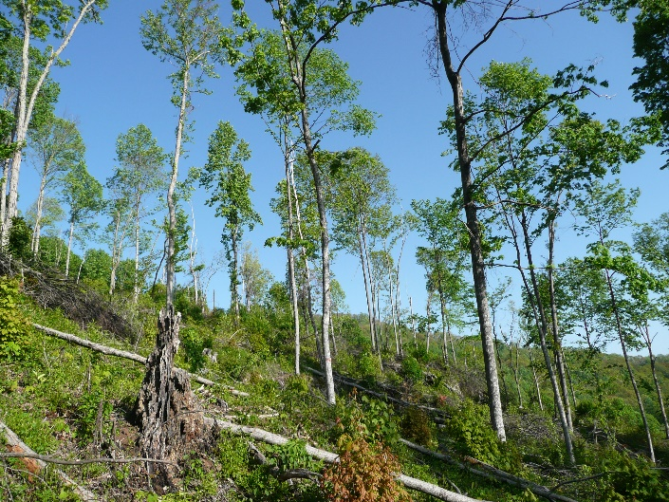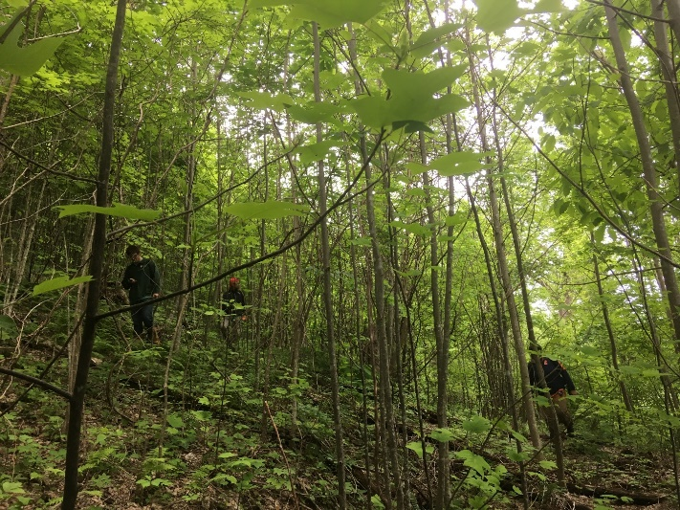

Figure 2.1. Heavy treatment plot in the North Cumberland WMA in Tennessee, USA. These photos, taken in May 2008 (3 years post-harvest; top) and May 2019 (13 years post-harvest; bottom), provide an example of the forest regeneration progression that has resulted in increased canopy cover at the understory (0.5–3 m) and midstory (6–12 m) layers. This stand was harvested in fall of 2006.

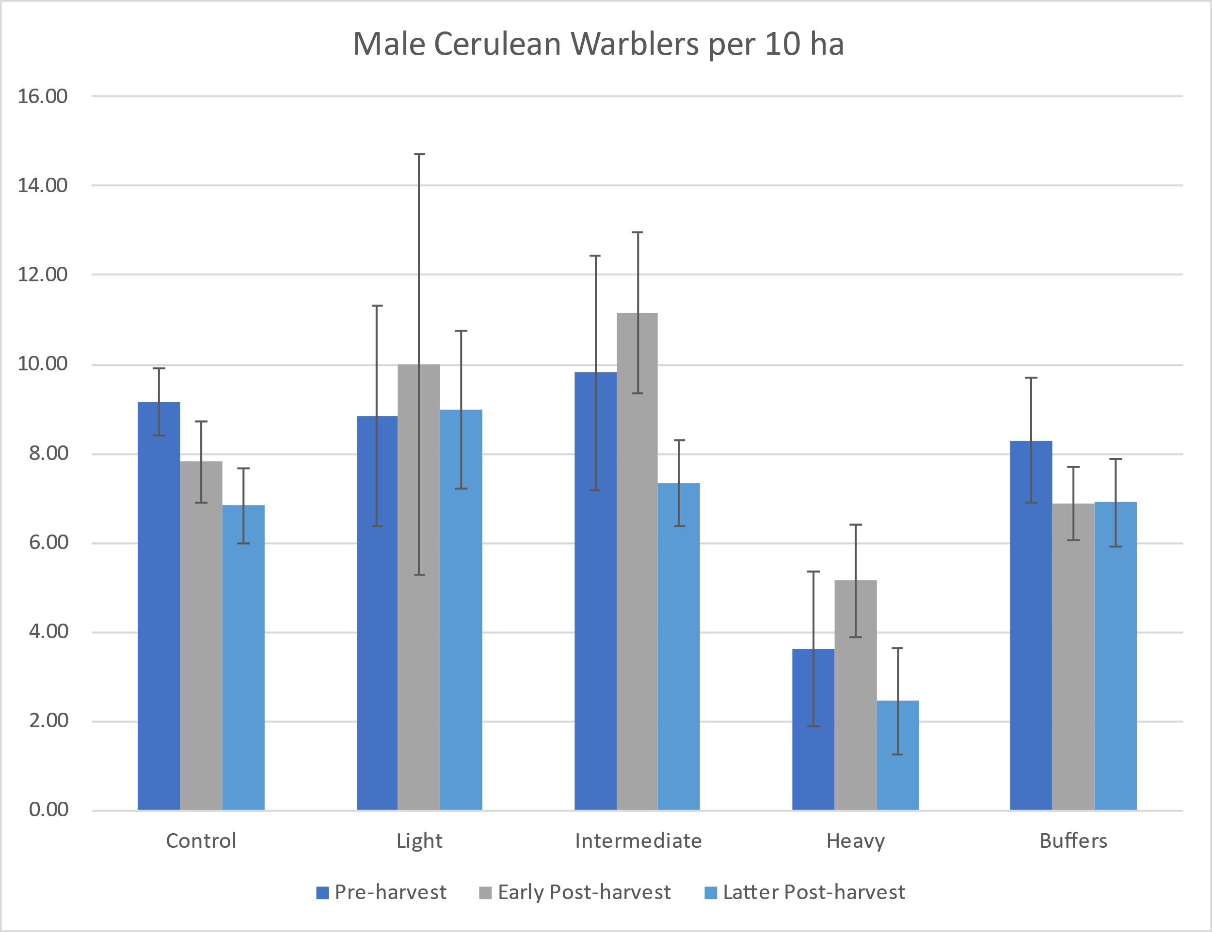
*
*
**

Figure 2.2. Mean Cerulean Warbler territory density estimates with standard error at various treatment intensities at study sites in Kentucky, Ohio, and Tennessee. Control plots (~20 ha) were unmanaged, while canopy cover and stand basal area were reduced at the light, intermediate, and heavy treatments (~10 ha each) by ~20%, ~40%, and ~75%, respectively in fall 2006. Asterisks above territory density estimates for the intermediate treatment plot represent statistically similar (*) and differing (**) densities based on repeated-measures ANOVA and post-hoc Tukey tests with a threshold of P = 0.05. No significant differences were found among time periods at control plots, light treatment plots, heavy treatment plots, or buffers.

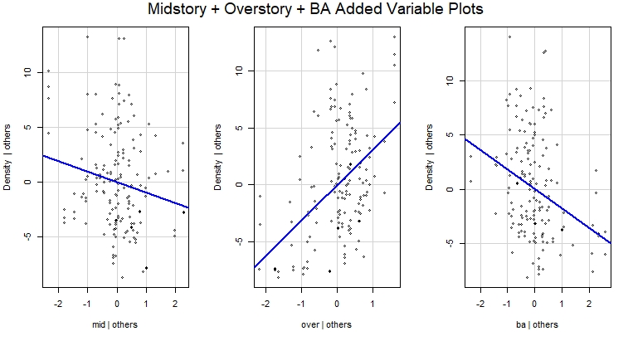

Figure 2.3. Added variable plots from the best-supported linear multiple regression model explaining variation in Cerulean Warbler territory density related with vegetation structure predictors. Each panel represents variation attributed uniquely to midstory cover (mid), overstory cover (over), and stand basal area (ba) while holding other predictor variables constant. This model includes all data from the pre-harvest, early post-harvest, and latter post-harvest periods across all four plots and associated buffers at the Kentucky, Tennessee, and Ohio study sites.

Figure 2.4. Mean and standard error of Cerulean Warbler density estimates at the Daniel Boone National Forest study site in Kentucky across 2005–2006 pre-harvest, 2007–2010 early post-harvest, and 2019–2020 latter post-harvest time periods.

Figure 2.5. Mean and standard error of Cerulean Warbler density estimates at the Vinton Experimental State Forest study site in Ohio across 2005–2006 pre-harvest, 2007–2010 early post-harvest, and 2019–2020 latter post-harvest time periods.

Figure 2.6. Mean and standard error of Cerulean Warbler density estimates at the North Cumberland Wildlife Management Area site in Tennessee across 2005–2006 pre-harvest, 2007–2010 early post-harvest, and 2019–2020 latter post-harvest time periods.

CHAPTER 3: EXPLORING THE SPATIAL USE AND NON-BREEDING ECOLOGY OF CERULEAN WARBLERS IN SECONDARY FOREST OF THE COLOMBIAN ANDES

ABSTRACT
The Cerulean Warbler (Setophaga cerulea) is a declining Nearctic-Neotropical migrant species that spends ~6 months of the year in the biodiverse northern Andes Mountains. This species has been relatively well-studied on the North American breeding grounds over the past two decades. Forest loss and fragmentation in the Andes is likely a contributor to cerulean population decline. However, little is known about their non-breeding ecology, especially within dense, humid Andean forests where the species is difficult to capture and detect. Over three field seasons from 2017––2019 we used radio telemetry to explore various aspects of non-breeding ecology of Cerulean Warblers at a mature secondary forest study site in the Eastern Cordillera of the Colombian Andes. Home ranges often over-lapped spatially and temporally. Home range size was highly variable, and often larger than breeding territories, with adult males (n = 5) using smaller home ranges (median 4.3 ha, range 1.7–8.6 ha) than immatures (n = 19; median 14.3 ha, IQR 14.9 ha, range 2.2–45.2 ha). Ceruleans almost always occurred in mixed-species flocks, with medians of 3 ceruleans, 17 birds, and 12 species per flock. We documented low visual detection probability (p = 35–75% with 1–3 observers) of homed radio-tracked birds and very low encounter probability (p = 0.07) of color-banded birds during line-distance transects. Accounting for poor detection in abundance, density, and survival estimates in Andean forests is required to produce reliable estimates. Based on radio tracking and resighting color-marked birds, we estimated greater apparent annual survival (0.43 ± 0.10) compared with apparent weekly survival (0.89 ± 0.04 SE weekly survival; ~4.3% cumulative survival over a 6-month season). These results imply there was relatively low within-season site fidelity and suggest that some individuals may use large tracts of forest during the stationary non-breeding period. Additionally, we estimated a relatively high abundance (132 ± 41) of ceruleans within ~1 km² area of forest over a 41-d period. Finally, we documented a strong male-biased sex ratio (86%). These results suggest that mature secondary forests can support high numbers of ceruleans, abundance is likely underestimated by distance-based survey methods, and Andean forests appear to offer high-quality habitat for male ceruleans but females appear to either be competitively excluded or lack preference for mature forest in this region. Conservation efforts to conserve mature forests in the Andes will likely benefit ceruleans as well as numerous other species that continue to be affected by deforestation.

INTRODUCTION
The tropical Andes region, extending from Venezuela to Bolivia, supports the greatest biodiversity in the world, hosting ~45,000 plant and nearly 3,400 vertebrate species, including ~1,166 species of birds (over half of which are endemic; Myers et al. 2000). Widespread conversion of forests to agricultural land uses has resulted in a loss of ~75% of forest land cover across this region, with continued conversion expected for the future (Armenteras and Villareal 2003, Etter et al. 2006). The ongoing and severe loss, fragmentation, and degradation of forests in the Andes have likely contributed to population declines of both endemic bird species and Nearctic-Neotropical migrants that spend approximately half of their annual cycle in this region (González-Prieto 2018a, Rosenberg et al. 2019).
Indeed, a growing number of studies (e.g., Rappole et al. 2003, Taylor and Stutchbury 2016, Kramer et al. 2018, Wilson et al. 2018) attribute global or regional breeding population declines of various Nearctic-Neotropical migrant species to the loss, fragmentation, and degradation of forests on the stationary non-breeding grounds, where migrants reside up to ~6 months of the year. Long-distance migrants in general are especially susceptible to population declines and risk of extinction because they require sufficient habitat across a broad geographical scale throughout the annual cycle. However, most long-distance migrants do not have sufficient protected habitat throughout their annual cycle to sustain populations (Runge et al. 2015). The decrease in available, high-quality habitat on the stationary non-breeding grounds has likely contributed to the loss of ~40% of the abundance of Nearctic-Neotropical migrants that overwinter in South America (Rosenberg et al. 2019). Many of the most severely declining species among this group typically concentrate at a narrow mid-elevational range of ~1,000 to 2,000 m within humid premontane forest, a biodiverse life zone that is especially threatened by concentrated anthropogenic activity and is considered priority habitat for conservation (Albert et al. 2020, Céspedes Arias et al. 2021).
One of the severely declining Nearctic-Neotropical migrant species that typically spends about half of its annual cycle in humid premontane forest of the tropical Andes and requires further conservation efforts is the Cerulean Warbler (hereafter ‘ceruleans’; Colorado et al. 2012, Buehler et al. 2020). Limited research and conservation efforts to benefit ceruleans, with the goal of reversing their population declines, have been implemented over the past two decades in parts of their Andean non-breeding range. Several studies (e.g., Jones et al. 2000, Bakermans et al. 2009, Colorado et al. 2012, McDermott and Rodewald 2014) have begun to address ceruleans’ non-breeding ecology and have documented habitat use across a range of conditions, including shade-grown coffee, cacao, and cardamom plantations; silvopastures; and primary and secondary forests. Results of these previous studies have contributed to our knowledge of the non-breeding season ecology of this species, but samples are numerically, spatially, and temporally limited and results may not be universally applicable. For example, Bakermans et al. (2009) estimated within-season and annual survival based on limited mark-resight data (n = 29 ceruleans banded in shade-coffee plantations and 7 inter-annual resightings) and reported greater cerulean density in shade coffee (based on distance-based line transects) compared with apparent density in adjacent forests at a study site in Venezuela. In contrast, G. Colorado (unpublished data), banded 239 Cerulean Warblers in Colombian shade-grown coffee plantations since 2003, but had only 16 inter-seasonal recaptures, suggesting low interannual site fidelity and potentially marginal habitat quality. McDermott and Rodewald (2014) reported greater cerulean abundance in secondary forest and shade-cardamom plantations (both >85% canopy cover) compared with shade-coffee plantations and silvopasture with lesser (~66%) canopy cover. Most studies to date have focused on anthropogenically disturbed agroforestry land uses that may be important for use by Nearctic-Neotropical migrants in regions that have few intact undisturbed forests remaining, but this should not minimize the importance of conservation of primary and secondary forests (Albert et al. 2020, González-Prieto 2018a).
Currently, we are still greatly lacking information regarding cerulean ecology during the stationary, non-breeding period in the Andes, especially in primary and secondary forests. Patterns of space use including home range, territoriality and site fidelity, intraspecific competition, and sex- and age-based habitat use have been largely unassessed. A few studies of the stationary non-breeding ecology of other parulid species in other regions have shown skewed sex or age ratios in various cover types, suggesting that adult males may outcompete females or immature birds for high-quality habitat (e.g., 3 Setophaga species in the Caribbean; Latta and Faaborg 2002, Studds and Marra 2005, Wunderle et al. 2014). Bennett et al. (2019) found a 33% prevalence of documented sexual habitat segregation among Neacrtic-Neotropical migrants of conservation concern and that conservation action plans commonly ignored such segregation. For Golden-winged Warblers (Vermivora chrysoptera), cover types used by females was being lost at a faster rate while cover types used by males was disproportionately targeted for conservation. Thus, it is important to know whether such sex- and age-based habitat segregation exists for ceruleans.
Ceruleans and many other Nearctic-Neotropical migrant species are frequently found in mixed-species flocks that include migrant and resident species. This flocking behavior may benefit individuals by increasing foraging success or reducing predation risk (Sridhar et al. 2009). However, resource limitations and competition may limit these benefits and thus the numbers of ceruleans per flock. Both intra- and interspecific competition (Graves and Gotelli 1993, Powell et al. 2021) appear to contribute to compositional structure of mixed-species flocks across the northern Andes (Colorado and Rodewald 2015a). A better understanding of mixed-species flock behavior and composition may help to better understand population density limitations and habitat quality for species that frequently engage in flocking behavior (McDermott and Rodewald 2014, Bayly et al. 2016, Céspedes and Bayly 2019). While a few studies have examined species composition and behavior of mixed-species flocks that contain ceruleans in the Andes, they were undertaken largely in shade-coffee plantations (Jones et al. 2000) or were undertaken in various land uses including agroforestry plantations and secondary forests but did not focus primarily on flocks containing ceruleans or assess the percentages of ceruleans that take part in flocks in forests (e.g., McDermott et al. 2014, Colorado and Rodewald 2015b).
Territoriality and site fidelity are two other important behaviors that may vary throughout the annual cycle and may vary widely among species during the non-breeding season (Albert et al. 2020). Territorial defense can be energetically costly but can also increase individuals’ foraging efficiency in areas with increased food abundance (Greenberg 1986). Ceruleans and many other Nearctic-Neotropical migrants are highly territorial during the breeding season, but territoriality during the stationary, non-breeding season can vary within and among species. A range of territorial behaviors has been reported, from no territoriality (e.g., foraging together in flocks, and in some cases using multiple overwintering sites) to intermittent bouts of territoriality (e.g., temporary defense of concentrated food sources such as localized insect emergences), to extended defense of discrete habitat patches (Greenberg 1986, Albert et al. 2020, Powell et al. 2021). Ceruleans have been documented to engage in antagonistic interactions in shade-coffee plantations (Colorado et al. 2012) and site fidelity appears to be high in at least some shade-coffee plantations (Bakermans et al. 2009), but the extent of territoriality and site fidelity in primary and secondary forests remain largely unknown for this species. Site fidelity is especially important to understand when interpreting estimates of apparent within-season and annual survival.
Ceruleans do not typically sing during the non-breeding seasons and have soft and generally infrequent calls (Parker III 1994). As such, they are difficult to detect in the dense canopy of mature montane forests (Fig. 3.1), potentially biasing abundance and survival estimates. Cerulean survival estimates during the stationary, non-breeding period could be improved by monitoring radio-tagged individuals (Bakermans et al. 2009). Resighting aided by radio telemetry may also allow for less-biased observations of foraging ecology in mixed-species flocks, habitat use, and characterization of home range space use. Radio telemetry also allows for the spatial quantification of home range sizes and allows for assessment of overlap among adjacent home ranges. This information can be useful for population density estimates and assessing how much area is needed to support a certain number of individuals. Furthermore, smaller home range sizes may indicate higher habitat quality as it suggests that individuals have enough food availability in a smaller area (Smith and Shugart 1987, Ruiz-Sánchez et al. 2017, González-Prieto 2018b, Albert et al. 2020).
Monitoring of radio-tagged individuals also provides an opportunity to quantify visual detectability of individual birds that are known to be in a defined area. Density estimates obtained from distance-based point counts or line-distance transects (Buckland et al. 2001) may be inaccurate and biased low if detection probability g(0) at horizontal distance = 0 from the observer’s location is not 100% (Bächler and Liechti 2007), yet these types of surveys (e.g., Bakermans et al. 2009) provide the only currently published estimates of cerulean density or relative abundance during the stationary, non-breeding period. Thus, it is important to investigate whether such an analysis is biased by a potential violation of the assumption that g(0) < 1 and to estimate detectability at g(0) in dense canopy conditions before such density estimates can be reliably compared and potentially adjusted between more open-canopy habitat (e.g., shade coffee) and closed-canopy forest.
The overall goal of this study was to advance the understanding of Cerulean Warbler ecology during the stationary, non-breeding period, with the hope of better informing the conservation of this species during this important period. The primary objectives of this study were to 1) quantify space use (i.e., home ranges and movements) of ceruleans within mature secondary forests in Colombia and compare home range sizes between sex and age, 2) assess intra- and inter-annual site fidelity, territoriality, and survival, 3) document composition of mixed-species flocks that include ceruleans, 4) estimate abundance and detectability of ceruleans and 5) document sex and age ratios of ceruleans at this forested study site.

METHODS
This study was conducted at the Almenara study site (4.882950° N, 73.253970° W; elevation ~1100–1300 m) on the east slope of the Eastern Cordillera of the Andes near Santa María, Boyacá, Colombia. The Almenara consists of ~ 1 km² of primarily mature, secondary montane humid forest and is bordered by cattle pastures as well as contiguous forest (Fig. 3.2). This protected site supports high avian species diversity (339 species recorded, eBird 2021) and has been relatively undisturbed by humans over the past ~30 years. The Almenara has been identified as a priority site for cerulean conservation by Moreno and Bayly (2014) and is within the core of the cerulean stationary non-breeding season range, linked with the core breeding population in the Appalachians (Chapter 1, Fig. 1.3). Colombia has been identified as the highest priority country for Cerulean Warbler conservation on the wintering grounds (Rosenberg et al. 2016).
Between 05 November and 20 December in 2017, 2018, and 2019, we captured Cerulean Warblers during the morning hours using a series of elevated mist nets on bamboo poles along with audio playback. We determined age (adult or immature) and sex based on plumage (Pyle 1997). We did not observe active feather molt upon captures, but some immature (<1-yr-old) birds began to molt into adult plumage in Dec-Jan. We marked each Cerulean Warbler with a unique color combination of plastic leg bands and outfitted each with a 0.39-g radio transmitter (Blackburn Technology, Nacogdoches, Texas, USA) using elastic material to create leg-loop harnesses (Rappole and Tipton 1991). These transmitters were designed to last ~30 days and had a detection range of ~250–2500 m in forested habitat, depending on topography.
Beginning the day after release of each radio-tagged bird, we obtained multiple locations each day ≥30 min apart to limit spatial autocorrelation. We used portable TR-4 receivers with flexible H-antennae (Telonics, Mesa, Arizona, USA) to obtain locations through a combination of triangulation and homing methods with 1–3 observers. We recorded locations with handheld GPS units (Garmin eTrex 10). On each tracking date, we ensured that each bird was still alive and had not dropped their transmitter by noting variation in transmitter signal strength. When possible, observers were stationed at least 20 degrees apart with relation to the bird, simultaneously recording azimuths while communicating with 2-way radios to triangulate the location of the radio-tagged bird. We rotated the order in which we searched for each radio-tagged bird daily. We also searched visually throughout the study site daily for birds that were not radio-tagged or had non-functioning transmitters.
We estimated both annual apparent survival and weekly apparent within-season survival in Program MARK (White and Burnham 1999) using Cormack-Jolly-Seber models. Weekly survival was monitored for up to 4 (2017), 5 (2018), and 6 (2019) weeks over the 3 field seasons, and each bird was monitored for ≥ 2 weeks (durations varied with capture dates). For both annual and weekly apparent survival analyses, we constructed and compared two survival models (one with and one without age groups) and chose the top model with the lowest Akaike’s Information Criterion score adjusted for small sample size (AICc). If the models were similarly supported with ΔAICc ≤ 2, we interpreted the more parsimonious model (Burnham and Anderson 2002).
To assess site fidelity and to estimate home ranges, we first used the program Location of a Signal (LOAS 2021) to obtain locations using a maximum likelihood estimator with triangulated azimuth sets. We calculated distances between the first location for each bird starting the day after capture (we didn’t include capture locations because audio playback at mist nets may have drawn the individual to the location) and the final location obtained for each bird as an index of within-season site-fidelity. We then calculated home ranges and their areas from minimum convex polygons (MCP) at 50%, and 95%, and 100% levels as well as kernel density estimates (KDE) at 50% and 95% levels in the R package rhr (Signer and Balkenhol 2015). These various estimators allow for direct comparisons with past and future studies that have and likely will continue to use different estimators to calculate home ranges. We considered 50% MCP and KDE estimates as “core” home ranges. We used the least-square cross-validation to estimate bandwidth for kernel density estimates due to its flexibility in estimating home ranges of individuals that exhibited multiple activity centers (Signer and Balkenhol 2015, Bailey and King 2019). We calculated MCP and KDE for all birds for which we had >14 locations (Juarez 2020) over a tracking period of ≥ 3 days (µ = 36 ± 19 SD locations across 20 ± 10 SD days). This 14-location threshold is lower than recommended by some authors for estimating home range area (e.g., >30 locations; Seaman et al. 1999) but we obtained similar home range size estimates for birds with 14–30 locations (median 95% KDE 8.7 ha) compared with those tracked over >30 locations (median 95% KDE 9.2 ha). We compared 95% KDE home range sizes between adult and immature birds with a Mann-Whitney test and considered the groups to be different at alpha < 0.05.
We assessed flock composition (defined as birds within 10 m of the tagged individual or another member of the flock; McDermott and Rodewald 2014) by recording total flock size and counts of both residents and Nearctic-Neotropical migrant flock members associated with marked ceruleans (located via homing or occasionally via opportunistic sighting occassions). Age (HY, AHY, or unknown) and sex of each cerulean in the flock were recorded. The location in which the bird/flock was first located was recorded along with the time the bird/flock was first located. We attempted to follow the radio-tagged bird and associated flock for ≥ 20 min (McDermott and Rodewald 2014) and we recorded the total amount of time the radio-tagged bird was detected visually during observation periods as a measure of detectability. We attempted to obtain an equal number of flock observations per color-banded bird with a maximum of 7 flock composition tallies on separate days per bird. We distributed the observations between morning and afternoon time periods. During flock observations (and throughout other daily activities) we noted instances of intra- and interspecific aggressive behavior (such as attacks/chases) or singing as evidence of territoriality.
During the first two field seasons, we noticed seemingly high correlation between highly vocal and thus highly detectable (i.e., at distances up to ~100 m) Slaty-capped Flycatchers (Leptopogon superciliaris) with the presence of ceruleans that could potentially aid in detectability of ceruleans. Thus, in 2019 we performed species composition surveys for flocks for which presence of ceruleans was initially unknown after audio detections of 23 Slaty-capped Flycatchers (n = 23 surveys) or Tangara sp (n = 5 surveys) to gauge the proportion of mixed-species flocks that contained ceruleans co-occurring with the vocalizations. For these surveys, we recorded the time elapsed before detection of the first cerulean and ensured that surveys were ≥ 250 m apart to minimize pseudo-replication.
Between Nov 24 and January 14 of the final field season, we conducted 39 linear transect surveys that were used to 1) obtain an abundance estimate for ceruleans, 2) estimate detectability of marked ceruleans, and 3) document sex and age ratios. These surveys were completed between the hours of 06:30 and 10:00, with one observer surveying one of four discrete, non-overlapping line transects along the road where each cerulean had been captured. Together, these transects covered the entire ~3 km of road and passed each banded bird’s capture location. Each observer walked slowly (~100 m per 10 min) and stopped at each flock that was encountered for ~5 minutes, recording sex and age (of males) of all ceruleans encountered and recorded color combinations of any banded ceruleans encountered.
We estimated abundance and detectability along line-transect surveys using zero-inflated Poisson log-normal mark resight models (McClintock et al. 2019) in Program MARK. This model type is recommended for partially marked populations when detectability and re-encounter rates are low (e.g., some animals were never resighted), individuals are potentially sighted on multiple occasions within a survey period, and the number of marked individuals during survey periods is unknown (e.g., some proportion could have emigrated or died, and an unknown number returned from previous years; McClintock et al. 2019). These models also allow for incorporation of sightings in which the bird is identified as marked but is not uniquely identified (e.g., incomplete color combination identifications). We built and compared two candidate models: 1) ‘Open Population’, which allows for a variable number of unbanded individuals (U) at the time of each transect survey, unknown probability of a marked individual being alive and not permanently emigrated (w), unknown probability that a marked individual was present (g), and unknown rate of temporary emigration (γ); and 2) ‘Closed Population’, with constant U and no emigration or deaths of marked individuals (w = 1, g = 1, γ = 0) to estimate abundance and detectability in a scenario where all birds remained alive and at the study site over the 51-d survey period. If some ceruleans dispersed from the study site between surveys, the ‘Closed Population’ model reflects the number of ceruleans that used the study area at some point over the 51-d period of surveys, while the ‘Open Population’ model reflects the number of ceruleans present at the site during each transect survey interval.

RESULTS
We captured 39 ceruleans in 48 days of mist-netting efforts over the three field seasons (Table 3.1), with no within-season or between-season recaptures. We deployed transmitters on a total of 31 male (7 adult and 24 immature) and one adult female Cerulean Warbler over the three field seasons. Four additional males were color-banded but did not receive transmitters and a second captured female (which had an engorged tick attached to her face) died prior to release. We did not observe any evidence of mortalities or dropped tags of radio-tracked birds during the tracking periods. However, premature tag failures (9 confirmed failures within 14 d of capture) were frequent (perhaps due to exposure of soldered activation wire leads to dense, leathery vegetation) and limited us to 24 home range estimates (5 adult males and 19 immature males). In addition to the 9 confirmed tag failures, 14 radio-tagged ceruleans were no longer detected (visually or via telemetry) after 10 d post-capture and it is unknown if they dispersed from the search area (~3 km radius) or if their tags also failed prematurely and we failed to detect them despite their continued presence at the study site. In general, the radio-tracked birds exhibited high site fidelity while we were still able to obtain signals. Median distance between the first detection the day after capture and the last detection on the last day detected was 126 m (IQR 136 m). All 5 adults tracked ≥ 4 days (median 25 days) were last detected < 250 m from their capture locations. Of the 20 immatures that were tracked ≥ 4 days (median 17 days), 6 had moved ≥ 250 m (250, 848, 356, 442, 533, and 409 m) between the first and last days of tracking and the furthest detection from a capture location was an immature male that was last detected 4 days after capture and had moved 1.4 km. However, one immature male’s signal was regularly detected for 6 d and was not detected again until days 29–31 post-capture and another immature male was missing from day 9 through day 14 post-tagging but was otherwise regularly found through the end of the field season (24 d post-capture), indicating potential temporary emigration from the site.
Although we were unable to adequately search for birds in the 2020-2021 non-breeding season due to the Covid-19 pandemic and associated lockdowns, our return rates following the first two capture seasons indicated a relatively high degree of interannual site fidelity with 5/9 (56%) of color-banded birds re-sighted in the second field season (3/5 radio-tagged birds and 2/4 that had not been tagged; one radio-tagged bird still had its transmitter). Five of 14 (36%) color-banded birds encountered or banded in the second season returned in the third season (3/11 with radio-tags and 2/3 untagged birds. The top annual survival model did not include age groups (ΔAICc = 2.6) and apparent annual survival was 0.43 ± 0.10 (95% CI 0.25 to 0.64). The apparent within-season survival models with and without age groups were similarly supported (ΔAICc = 1.8). Without considering age (the most parsimonious model), apparent weekly survival for males was 0.89 ± 0.04 SE (95% CI 0.79 to 0.94) with weekly detectability (through a combination of telemetry and resighting) of 0.77 ± 0.05 SE (95% CI 0.65 to 0.85). We did not document any mortalities of radio-tracked birds. Because we only monitored survival of one female that was not encountered after the week of capture, we could not estimate female survival or detectability but the female we tracked was not detected after the second day post-capture.
Estimates of home range size followed nonparametric distributions with high variability (Table 3.2). Median home ranges were 3.6 ha (IQR 5.5 ha, range 0.8–20.6 ha) based on 95% MCP, 6.0 ha (IQR 8.2 ha, range 1.2–37.2 ha) based on 100% MCP, and 9.0 ha (IQR 15.8 ha, range 1.7–45.2 ha) based on 95% KDE. Median core home ranges were 0.8 ha (IQR 1.6 ha, range 0.1–10.5 ha) based on 50% MCP and 1.6 ha (IQR 3.5 ha, range 0.3–9.7 ha) based on 50% KDE. Adult males (median 4.3 ha, IQR 5.1, range 1.7–8.6 ha) had smaller home ranges than immature males (median 14.3 ha, IQR 14.9 ha, range 2.2–45.2 ha; Fig. 3.4) based on 95% KDE (W = 15, P = 0.02). There was a high degree of spatial overlap among home ranges (Fig. 3.3).
All radio-tracked ceruleans regularly took part in mixed species flocks (nearly all observations were associated with mixed-species flocks though occasionally a male was seemingly foraging alone), and we documented 15 Nearctic-Neotropical migrant species and 56 resident species in 97 mixed-species flock observations (Table 3.3). The most common associated Nearctic-Neotropical migrant species included Blackburnian Warblers (Setophaga fusca), Canada Warblers (Cardellina canadensis), American Redstarts (Setophaga ruticella), Summer Tanagers (Piranga rubra), Swainson’s Thrush (Catharus ustulatus), and Black-and-White Warblers (Mniotilta varia), which were present in 75%, 54%, 52%, 48%, 41%, and 29% of flocks, respectively. Of these flock observations, we assessed species composition from 65 flocks that contained ceruleans for which we were able to follow the flock for ≥ 20 min (median duration of 28 min, maximum duration 66 min). These flocks contained a median of 3.0 and a range of 1–9 ceruleans. Males were dominant in occurrence (86% males; n = 148), (14% females; n = 24)) with a nearly 2:1 ratio of immature (63%, n = 93) to adult (37%, n = 54) males. We were unable to reliably differentiate female age by plumage from a typical observation distance. Most flocks (82%) contained multiple ceruleans. Adult males were present in 9 of 12 flocks (75%) that contained just one cerulean while the remaining 3 flocks with only one cerulean contained an immature male. Flocks were comprised by a median of 17 (IQR 9) birds of 12 (IQR 5) species. Resident species were slightly more abundant in both species richness (median 7, IQR 4 species) and abundance (median 9, IQR 6 individuals) per flock compared with Nearctic-Neotropical migrant richness (median 5, IQR 2 species) and abundance (median 7, IQR 5 individuals).
The presence of ceruleans was highly correlated with the presence of Slaty-capped Flycatchers, with 52/65 (80%) of flocks that contained ceruleans also containing Slaty-capped Flycatchers. Similarly, 19/23 (83%) naïve (i.e., cerulean presence unknown) flock composition surveys that were conducted by one observer based on an aural detection of a Slaty-capped Flycatcher resulted in detections of one or more ceruleans. Across naïve flock composition surveys (n = 21) for which duration of time before first cerulean detection was recorded, we first detected ceruleans after a median of 5 min (range 0–28 minutes). During 7 of the 21 surveys, >10 min elapsed before the first cerulean was detected. Visual detectability was also low for individual color-banded ceruleans that were known to be present at a location via homing with telemetry. Across observation periods, which lasted a median of 25 min (range 7–66 min), the radio-tracked individuals were only visually detected in 11 of 31 (35%) occasions with one observer, 9 of 12 (75%) of occasions with two observers, and 7 of 10 (70%) of occasions with 3 observers. These individuals were only visible for 1.2% of 853 total observation minutes with one observer, 2.8% of 273 observation minutes with two observers, and 4.3% of 309 observation minutes with 3 observers. We also observed flocks in silvopasture/edge habitat on three occasions and visually detected the radio-tracked ceruleans on each of these occasions for longer amounts of time than most forest observation periods (individuals visually observed for 26.2% of 72 observation minutes in silvopasture/edge).
Transect surveys supported a strongly male-dominated sex ratio of ceruleans at this study site; 148 of the 172 (86%) cerulean encounters were male, and 93 of the 147 males (63%) for which age was assigned were identified as immature birds. The top model for abundance and detectability estimates for the 8 transect surveys was the ‘Closed Population’ model (ΔAICc = 7.64). Under this model, 132 (95% CI 73 to 237) ceruleans were predicted over the final 4 survey periods when all 26 banded individuals were potentially present, and detectability of banded ceruleans was 0.07. This mean estimate corresponds with an approximate 4:1 unmarked to marked ratio, and throughout our daily field activities over this time-period we roughly estimated a similar ratio. The “Open Population” model predicted cerulean abundance ranging from 11 (95% CI 3 to 37 birds) to 39 (95% CI 11 to 133 birds) among survey intervals and estimated detectability was 0.31.

DISCUSSION
This study represents the first to utilize radio telemetry to explore the non-breeding ecology of Cerulean Warblers in mature secondary forest in the Andes. We estimated home ranges of 24 male ceruleans and found that adults used smaller home ranges than immatures. However, territories/home ranges often overlapped spatially (Fig 3.3) and temporally (i.e., presence of multiple males observed in the same flock). All radio-tracked birds, regardless of age or home range size, regularly took part in mixed-species flocks, often with multiple ceruleans per flock. We also documented low detection probability, even when individuals were known to be in close (i.e., within ~20-m) proximity, which makes abundance, density, and survival estimates especially challenging in Andean forests. We estimated relatively high interannual apparent survival compared with apparent within-season survival, which implies relatively low within-season site fidelity. Furthermore, we estimated a high abundance (132 ± 41) of ceruleans within ~1 km² area of forest, over a 41-d period. Finally, we documented a strongly skewed sex ratio (86%) toward males. Taken together, our findings suggest that mature secondary forests have the potential to support relatively high numbers of non-breeding ceruleans, that abundance may be greatly underestimated by previous surveys, and that mature forests may offer high quality habitat for males (based primarily on our observed relatively high interannual return rates and male-dominated sex ratio, although more study is needed regarding habitat quality) but potentially results in displacement of females or is potentially less preferred by females
Our non-breeding home range estimates (median 6.0 ha, range 1.2–37.2 ha based on 100% MCP, and median 9.0 ha, range 1.7–45.2 ha based on 95% KDE; Table 1) were on average larger than published estimates of territory sizes on the breeding grounds. Breeding territory estimates based on 100% MCP of burst sampling and other territory mapping methods (Buehler et al. 2020) ranged from µ = 0.2 –1.0 ha, with maximum territory size of 2.2 ha, and based on radio telemetry 95% KDE (Carpenter and Wang 2018) were 6.7 ± 0.7 ha (range = 3.8–10.4 ha). Seven of 24 (29%) of the non-breeding home ranges from our study (1.2–2.0 100% MCP) were within ranges of breeding territory sizes that were based on singing males’ MCP, whereas 17 individuals covered much larger areas (median 100% MCP 8.4 ha, range 3.2 to 37.2 ha) over the 3–38 d tracking periods. Perhaps more directly comparable due to the use of radio-telemetry in both studies, 11 of 24 (46%) of our non-breeding 95% KDE home range estimates were larger than the maximum breeding estimates reported by Carpenter and Wang (2018). However, home ranges over the entire ~6-month stationary non-breeding periods were potentially much larger, and though we were unable to confirm within-season emigration events from the study area due to our inability to differentiate emigration from tag failures, at least one bird was on a trajectory to leave the study area as it moved 354 m/day over 4 days before it was no longer detected.
Also using radio telemetry, Pérez (2007) and G. Colorado (unpublished data) found spatial overlap in ceruleans’ stationary non-breeding home ranges in shade-coffee plantations in Antioquia, Colombia with a tendency of multiple (2–7) ceruleans appearing in a flock. These two reports estimated home ranges using 100% MCP for 6 ceruleans (2 adult males, 2 adult females, and 2 immature females). The median shade-coffee home range (5.1 ha) and each of the males’ home ranges (4.0 and 12.2 ha) were within the IQR range of variation for males at our mature forest site (median 6.9 ha, IQR 3.6 to 13.6 ha). More home range estimates are likely needed to adequately compare home range sizes as an index of habitat quality (Smith and Shugart 1987, Ruiz-Sánchez et al. 2017, González-Prieto 2018b, Albert et al. 2020) at forested sites compared with shade-grown coffee plantations.
Ceruleans that remained within smaller-sized territories did not consistently act in a strongly antagonistic manner toward other male ceruleans. Multiple male ceruleans were regularly seen foraging in the same mixed-species flocks without observed prolonged antagonistic interactions (i.e., >20 sec). On several occasions, we observed multiple adult male ceruleans foraging in the same tree without apparent aggression. However, we also observed brief intraspecific or interspecific chases from a tree branch or tree. We did not generally observe cerulean males singing to defend territories, although ceruleans rarely (i.e., 5 occasions) sang in response to audio playback of cerulean song and chip vocalizations. An exception was an immature male that sang in January 2019 (during the dry season) in an exceptionally large mixed-species flock without prompting by audio playback. The majority of ceruleans we captured were with the aid of audio playback of cerulean songs and chips; some individuals responded aggressively to playback while some individuals never approached the speakers and were not captured.
Ceruleans were nearly always found within mixed-species flocks in mature forests in our study, similar with observations in shade-coffee plantations (Jones et al. 2000, Munoz and Colorado 2012). Jones et al. (2000) and Munoz and Colorado (2012) reported that mixed-species flocks contained two ceruleans, on average, in Venezuela (usually 1 male and one female) and in the Central and Western Cordilleras of Colombia (mean 2 ± 2.2, maximum 8 ceruleans). Our observed flocks in forest habitat averaged 3 ceruleans (maximum of 9) per flock despite low detectability and the potential that we underestimated flock sizes and numbers of ceruleans per flock. We documented median species richness of 12 species and a median flock size of 17 individuals in mixed flocks at our study site in November–January. Nearctic-Neotropical migrants comprised medians of 5 species and 7 individuals. McDermott et al. (2014) reported more diverse (21.4 ± 0.9 species) and larger flocks (31.5 ± 1.5 individuals), but with similar numbers of migrants (7.8 ± 0.5 individuals of 5.4 ± 0.2 species) in secondary forest in January and February in Antioquia, Colombia. McDermott et al. (2014) also reported larger and more diverse flocks (compared with our estimates) in shade-coffee and shade-cardamom plantations and in silvopastures. However, in shade coffee plantations in Venezuela, Jones et al. (2000) observed flocks of similar (22 ± 3 individuals and 13 ± 2 species) size and diversity compared with our estimates and Colorado and Rodewald (2015b) observed less species richness in flocks in shade coffee (8.9 ± 1.2 species) and in mature forest (7.4 ± 1.5 species) compared with our estimates. These differences in species richness and abundance may be at least partially attributable to varying degrees of detectability (ceruleans and presumably other species are more easily detectible in agroforestry plantations), but also reflects variation in flock composition within and among land uses across the Andean non-breeding range. The causes of this variation are debatable and likely manifold. Flock size and diversity are likely related to density and diversity across sites, may vary seasonally within sites (e.g., larger flocks during the dry season; Develey and Peres 2000), and likely involve cost-benefit tradeoffs in which larger flocks may provide more safety from predators (and potentially greater foraging efficiency if individuals require less time devoted to looking out for predators). However, larger flocks also may be exposed to increased competition for food resources (Sridhar et al. 2009, Colorado et al. 2015a).
Nearctic-Neotropical migrants were especially abundant at our study site relative to other sites throughout the northern Andes. Colorado (2011) reported that Nearctic-Neotropical migrants comprised only 10% of flock composition across various habitat types in the northern Andes that averaged 15.3 ± 9.3 individuals. Nearctic-Neotropical migrants at our study site (with similarly sized flocks) comprised 45% of the flocks. Among these migrants that flocked with ceruleans, we documented a total of 1–3 individual Golden-winged Warblers and numerous (0.61 per flock) Canada Warblers, two other species of conservation concern. We also observed Bay-breasted Warblers (Setophaga castanea) in 10 flocks with ceruleans at our study site, contrary to speculation by Colorado and Rodewald (2015a) that these two species exhibit competitive exclusion.
Our documented inter-annual return rates (36% and 43% over the first two years) were relatively high compared with return rates at some breeding sites (e.g., 16.4% across 12 study sites, n = 177; see Ch. 1). Bakermans et al. (2009) reported a higher return rate (65% of 20 birds) at a shade-coffee plantation in Venezuela. Our estimate of weekly apparent survival (0.886 ± 0.036 SE) likely greatly underestimates true survival because we were unable to document individual emigration events and account for it in the analysis and we did not document any mortalities of radio-tracked ceruleans. If 0.886 mean weekly survival is extrapolated over the 6-month (26-week; 0.886²⁶) stationary non-breeding season, the cumulative apparent survival estimate is biologically implausible (4.3%). Thus, this low apparent within-season survival estimate must reflect some degree of temporary emigration from the study area because annual return rates were greater than the estimated within season survival. Reduced within-season site fidelity may be related to temporal changes in insect prey availability, which likely decreases during the December-January dry season (Studds and Marra 2007, Develey and Peres 2000). Some ceruleans may have dispersed in search of other food resources. Such apparent movements imply that some ceruleans may require extensive tracts of habitat, possibly to allow for tracking of temporal variability in food resources (Boyle and Conway 2007, Loiselle and Blake 2010). Future studies using transmitters that have sufficient battery life to last throughout the entire stationary non-breeding season will likely lead to more reliable within-season survival estimates for ceruleans in Andean forests. Such radio-tags are now available as coded nanotags (Lotek Wireless, Inc) that can be monitored through a combination of manual tracking and automated stations and may also contribute important migration information through the Motus automated telemetry network (Taylor et al. 2017).
We documented very low visual detectability of radio-tagged ceruleans in mature secondary forest, which has implications for both monitoring and for assessing the relative importance of different cover types that cerulean use. Bakermans et al. (2009) and Céspedes Arias et al. (2021) reported greater cerulean abundance in shade-grown coffee plantations than in mature forests, based on distance-based surveys that assume 100% detectability at g(0). Differences in detectability by cover type could bias the results of distance-based surveys (Bächler and Liechti 2007). To the extent that this assumption is clearly violated for ceruleans during the stationary, non-breeding period, alternative methods that explicitly account for detectability when estimating abundance need to be explored. Alternatives could include double-observer methods (Nichols et al. 2000), mark-resight methods, or potentially applying a detectability correction factor to distance-based estimates. The mark-resight method we utilized to estimate abundance in mature forest with low detectability and low resighting rates could be improved upon by increasing the sample sizes of transect surveys and/or tagged individuals. However, our survey design required a substantial capture effort before surveys were begun (Table 3.1). Although our abundance estimates were not precise, we demonstrated that a relatively small area of mature secondary forest can support a relatively high abundance of ceruleans. Our abundance estimate (132 ± 41 ceruleans within ~1 km² area of forest, over a 41-d period) was intermediate between previous estimates of 251± 63 ceruleans/km² (Bakermans et al. 2009) and 46 ceruleans/km² (Céspedes Arias et al. 2021) in shade-coffee plantations. Although ceruleans appeared to be more abundant than Canada Warblers at our study site (based on flock observations and encounters during transect surveys), Céspedes and Bayly (2017) estimated a similar peak abundance (~125 ± 85) of Canada Warblers at ~1500 m elevation in mature Andean forest but lower abundances in shade-coffee plantations, forest edge, and secondary growth. Estimates of abundance per unit area for ceruleans and other species of conservation concern are critically needed by forest type and land use for conservation planning in South America to enable conservation planners to estimate how much habitat is required to support population recovery goals.
Low detectability can also impact survival studies, such that improvements in detectability can improve accuracy and precision of survival estimates. The high degree of association between ceruleans with vocal and more easily detectable Slaty-capped Flycatchers presents an opportunity to increase cerulean detectability by observing flocks associated with Slaty-capped Flycatchers. However, this strong association does not seem to be present throughout the range of the species as Slaty-capped Flycatchers were not among the 20 most abundant species in flocks sampled throughout the Andes (Colorado 2011). In regions or land use types with fewer Slaty-capped Flycatchers, other vocal (and perhaps nuclear) species present and strongly associated with ceruleans may provide alternative cues that improve cerulean detectability.
The strong male-biased sex ratio at our forested site highlights a need to identify and conserve habitat more heavily used by female ceruleans. Bakermans et al. (2009) reported an even age ratio and a marginally female-biased ratio in shade-coffee in Venezuela and Colorado (2011) reported even sex and age ratios in shade-coffee plantations in Antioquia, Colombia. Likewise, McDermott and Rodewald (2014) reported similar proportions of males and females in secondary forest, silvopastures, and coffee and shade-cardamom plantations in Antioquia. While we did not quantify sex ratios in adjacent, more open-canopy conditions such as pastoral edges, we did observe both females and males outside of our forested study site. We recommend further surveys and investigation into whether land use types that harbor higher ratios of females represent lower habitat quality or if such differences in sex ratio are due to preference (Bennett 2018), sex-based competitive exclusion (Latta and Faaborg 2002, Studds and Marra 2005, Wunderle et al. 2014), or perhaps geographical variation of distributions by sex.
The male-dominated sex ratio and relatively high abundance and annual return rates (compared with breeding grounds estimates; more non-breeding return rates are needed for comparison) that we documented are indicators that mature secondary forest of the Almenara likely represents high quality habitat for ceruleans. Mature forests represent higher quality habitat for Canada Warblers compared with more anthropologically disturbed land use types (Céspedes and Bayly 2019). Additional Nearctic-Neotropical migrant species (e.g., Tennessee Warblers; Oreothlypis peregrina, and Swainson’s Thrush; Catharus ustulatus) that stopover in forests in Colombia attained larger fuel loads at a faster rate than those that stopover in shade coffee plantations and thus are able to migrate further between stopovers (Bayly et al. 2016, 2019). And Swainson’s Thrush that spent the stationary non-breeding season in Colombian forests departed later and migrated faster than those that used shade coffee (González-Prieto 2018b), implying another case in which forests are higher quality. Clearly, conservation of forests in the biodiverse Andes is important as the human population continues to increase and forest loss and fragmentation continues. This need for protection and conservation applies to numerous species, including rare and declining residents as well as Nearctic-Neotropical migrants.

ACKNOWLEDGEMENTS

We express our sincere gratitude to SELVA, the Tennessee Ornithological Society, the Knoxville Chapter of the Tennessee Ornithological Society, the Arkansas Audubon Society, and the United States Fish and Wildlife Service for funding and logistical assistance. We are especially grateful to AES Chivor for the opportunity to work at La Almenara and for our outstanding field assistants and local guides as well as the numerous residents of Santa María that provided their generous support.

LITERATURE CITED
Albert, S., J. D. Wolfe, J. Kellerman, T. Sherry, B. J. M. Stutchbury, N. J. Bayly, and A. Ruiz-Sánchez (2020). Habitat ecology of Nearctic–Neotropical migratory landbirds on the non-breeding grounds. The Condor 122:1–18.

Arango Pérez, A. M. (2007). Estudio del estado de conservación y distribución del ave migratoria amenazada Dendroica cerulea en el suroeste Antioqueño. [State of the conservation and distribution of the threatened Cerulean Warbler in southeast Antioquia]. Report presented to Corporación autónoma regional del centro de Antioquia Corantioquia. Available at https://www.corantioquia.gov.co/ciadoc/FAUNA/AIRNR_CN_7527_2007.pdf.

Armenteras, D., and H. Villareal (2003). Andean forest fragmentation and the representativeness of protected natural areas in the eastern Andes, Colombia. Biological Conservation 113:245–25.

Bächler, E., and F. Liechti (2007). On the importance of g(0) for estimating bird population densities with standard distance-sampling: Implications from a telemetry study and a literature review. Ibis 149:693–700.

Bailey, B. A., and D. I. King (2019). Habitat selection and habitat quality for wintering wood thrushes in a coffee growing region in Honduras. Global Ecology and Conservation. 20:1–10.

Bakermans, M. H., A. C. Vitz, A. D. Rodewald, and C. G. Rengifo (2009). Migratory songbird use of shade coffee in the Venezuelan Andes with implications for conservation of cerulean warbler. Biological Conservation 142:2476–2483.

Bayly, N. J., C. Gómez, K. A. Hobson, and K. V Rosenberg (2016). Prioritizing tropical habitats for long-distance migratory songbirds: an assessment of habitat quality at a stopover site in Colombia. Avian Conservation and Ecology 11:5.

Bayly, N. J., K. V Rosenberg, C. Gómez, and K. A. Hobson (2019). Habitat choice shapes the spring stopover behaviour of a Nearctic-Neotropical migratory songbird. Journal of Ornithology 160:377–388.

Bennett, R. E. (2018). Nonbreeding ecology and conservation of migratory landbirds with a focus on the Golden-winged Warbler (Vermivora chrysoptera). Doctoral Dissertation, Cornell University, Ithaca, NY, USA.

Boyle, W. A., and C. J. Conway (2007). Why migrate? A test of the evolutionary precursor hypothesis. American Naturalist 169:344–359.

Buckland, S.T., D.R. Anderson, K.P. Burnham, J.L. Laake, D.L. Borchers and L. Thomas (2001). Introduction to distance sampling. Oxford University Press, Oxford, UK.

Buehler, D. A., P. B. Hamel, and T. Boves (2020). Cerulean Warbler (Setophaga cerulea), version 1.0. In Birds of the World (A. F. Poole, Editor). Cornell Lab of Ornithology, Ithaca, NY, USA. https://doi.org/10.2173/bow.cerwar.01

Burnham, K. P., and D. R. Anderson (2002). Model Selection and Multimodel Inference: A Practical Information-Theoretic Approach, second edition. Springer-Verlag, New York, NY, USA.

Carpenter, J. P. and Y. Wang (2018). Diurnal space use and nocturnal roost-site selection by male Cerulean Warblers during the breeding season. Journal of Field Ornithology 89:47–63.

Céspedes, L. N., and N. J. Bayly (2019). Over-winter ecology and relative density of Canada Warbler Cardellina canadensis in Colombia: The basis for defining conservation priorities for a sharply declining long-distance migrant. Bird Conservation International 29:232–248.

Céspedes Arias, L. N., S. Wilson, and N. J. Bayly (2021). Community modeling reveals the importance of elevation and land cover in shaping migratory bird abundance in the Andes. Ecological Applications e02481:1–41. doi: 10.1002/eap.2481

Colorado, G. (2011). Birds and mixed-species flocks in the Andes. Dissertation. The Ohio State University, Columbus, Ohio, USA.

Colorado, G. J., P. B. Hamel, A. D. Rodewald, and D. Mehlman (2012). Advancing our understanding of the non-breeding distribution of Cerulean Warbler (Setophaga cerulea) in the Andes. Ornitologia Neotropical. 23:307–315.

Colorado, G. J., and A. D. Rodewald (2015). Assembly patterns of mixed-species avian flocks in the Andes. Journal of Animal Ecology 84:386–395.

Colorado Zuluaga, G. J., and A. D. Rodewald (2015). Response of mixed-species flocks to habitat alteration and deforestation in the Andes. Biological Conservation 188:72–81.

Cooch, E. G., and G. C. White (Editors) (2021). Chapter 4 in Program MARK: A Gentle Introduction. Accessed 14 Nov., 2021 from http://www.phidot.org/software/mark/ docs/book/.

Develey, P. F., and C. A. Peres (2000). Resource seasonality and the structure of mixed species bird flocks in a coastal Atlantic forest of southeastern Brazil. Journal of Tropical Ecology 16:33–53.

eBird (2021). eBird: An online database of bird distribution and abundance [web application]. Cornell Lab of Ornithology, Ithaca, New York. Accessed Nov. 8, 2021 from http://www.ebird.org.

Etter, A., C. McAlpine, K. Wilson, S. Phinn, and H. Possingham (2006). Regional patterns of agricultural land use and deforestation in Colombia. Agriculture, Ecosystems and Environment 114:369–386.

González-Prieto, A. (2018a). Conservation of Nearctic Neotropical migrants : The coffee connection. Avian Conservation and Ecology 13:19.

González-Prieto, A. M. (2018b). The relative importance of native forest and shade-grown coffee plantations for habitat use, individual fitness and migration strategies of overwintering Neotropical migrant songbirds in Colombia. Ph.D. Thesis, College of Graduate and Postdoctoral Studies, Department of Biology. University of Saskatchewan, Saskatoon, Canada.

Graves, G. R., and N. J. Gotelli (1993). Assembly of avian mixed-species flocks in Amazonia. Proceedings of the National Academy of Sciences of the United States of America 90:1388–1391.

Greenberg, R. (1986). Competition in migrant birds in the non-breeding season. Current Ornithology 3:281–307.

Jones, J., P. R. Perazzi, E. H. Carruthers, and R. J. Robertson (2000). Sociality and foraging behavior of the Cerulean Warbler in Venezuelan shade-coffee plantations. The Condor 102:958–962.

Juarez, S. O. V. (2020). Habitat use and the impacts of agricultural land use for wintering Neotropical migrants. Dissertation. Simon Fraser University. Burnaby, British Columbia, Canada.

Kramer, G. R., D. E. Andersen, D. A. Buehler, P. B. Wood, S. M. Peterson, J. A. Lehman, K. R. Aldinger, L. P. Bulluck, S. Harding, J. A. Jones, J. P. Loegering, et al. (2018). Population trends in Vermivora warblers are linked to strong migratory connectivity. Proceedings of the National Academy of Sciences 115:1–9.

Latta, S. C., and J. Faaborg (2002). Demographic and population responses of Cape May Warblers wintering in multiple habitats. Ecology 83:2502–2515.

Location of a Signal (LOAS) (2021). Ecological Software Solutions. Sacrameto, CA, USA. https://www.ecostats.com/LOAS

Loiselle, B. A., and J. G. Blake (2010). Temporal variation in birds and fruits along an elevational gradient in Costa Rica. Ecological Society of America 72:180–193.

McClintock, B. T., G. C. White, and M. A. Pryde (2019). Improved methods for estimating abundance and related demographic parameters from mark-resight data. Biometrics 75:799–809.

McDermott, M. E., and A. D. Rodewald (2014). Conservation value of silvopastures to neotropical migrants in andean forest flocks. Biological Conservation 175:140–147.

Moreno, M.I. and N. J. Bayly (2014). Evaluación de las áreas focales no-reproductivas de la reinita alidorada (Vermivora chrysoptera), la reinita cerúlea (Setophaga cerulea) y la reinita del Canadá (Cardellina canadensis) en Colombia. SELVA: Investigación para la Conservación en el Neotropico, Bogotá D.C., Colombia.

Myers, N., R. A. Mittermeier, C. G. Mittermeier, G. A. B. da Fonseca, and J. Kent (2000). Biodiversity hotspots for conservation priorities. Nature 403:853–862.

Nichols, J. D., J. E. Hines, J. R. Sauer, F. W. Fallon, J. E. Fallon, and P. J. Heglund (2000). A double-observer approach for estimating detection probability and abundance from point counts. Auk 117:393–408.

Parker III, T. A. (1994). Habitat, behavior, and spring migration of Cerulean Warbler in Belize. American Birds 48:70–75.

Powell, L. L., E. M. Ames, J. R. Wright, J. Matthiopoulos, and P. P. Marra (2021). Interspecific competition between resident and wintering birds: Experimental evidence and consequences of coexistence. Ecology 102:1–11.

Pyle, P. (1997). Identification Guide to North American Birds, Part I: Columbidae to Ploceidae. Slate Creek Press, Bolinas, CA, USA.

Rappole, J. H., D. I. King, and J. Diez (2003). Winter-vs. breeding-habitat limitation for an endangered avian migrant. Ecological Applications 13:735–742.

Rosenberg, K. V., A. M. Dokter, P. J. Blancher, J. R. Sauer, A. C. Smith, P. A. Smith, J. C. Stanton, A. Panjabi, L. Helft, M. Parr, and P. P. Marra (2019). Decline of the North American avifauna. Science 366:120–124.

Ruiz-Sánchez, A., K. Renton, and R. Rueda-Hernández (2017). Winter habitat disturbance influences density and territory size of a Neotropical migratory warbler. Journal of Ornithology 158:63–73.

Runge, C. A., J. E. M. Watson, S. H. M. Butchart, J. O. Hanson, H. P. Possingham, and R. A. Fuller (2015). Conservation of migratory birds. Science 350:1255–1258.

Seaman, D. E., J. J. Millspaugh, B. J. Kernohan, G. C. Brundige, K. J. Raedeke, and R. A. Gitzen (1999). Effects of sample size on kernel home range estimates. The Journal of Wildlife Management 63:739.

Signer, J., and N. Balkenhol (2015). Reproducible home ranges (rhr): A new, user-friendly R package for analyses of wildlife telemetry data. Wildlife Society Bulletin 39:358–363. doi: 10.1002/wsb.539

Sridhar, H., G. Beauchamp, and K. Shanker (2009). Why do birds participate in mixed-species foraging flocks? A large-scale synthesis. Animal Behaviour 78:337–347.

Studds, C. E., and P. P. Marra (2005). Nonbreeding habitat occupancy and population processes: An upgrade experiment with a migratory bird. Ecology 86:2380–2385

Taylor, C. M., and B. J. M. Stutchbury (2016). Effects of breeding versus winter habitat loss and fragmentation on the population dynamics of a migratory songbird. Ecological Applications 26:424–437.

Taylor, P. D., T. L. Crewe, S. A. Mackenzie, D. Lepage, Y. Aubry, Z. Crysler, G. Finney, C. G. Francis, D. J. Hamilton, R. L. Holberton, P. H. Loring, et al. (2017). The Motus Wildlife Tracking System: A collaborative research network. Avian Conservation and Ecology 12:n.p.

White, G. C., and K. P. Burnham (1999). Program MARK: Survival estimation from populations of marked animals. Bird Study 46:S120–S139.

Wilson, S., J. F. Saracco, R. Krikun, D. T. T. Flockhart, C. M. Godwin, and K. R. Foster (2018). Drivers of demographic decline across the annual cycle of a threatened migratory bird. Scientific Reports 8:1–11.
Wunderle, J. M., P. K. Lebow, J. D. White, D. Currie, and D. N. Ewert (2014). Sex and age differences in site fidelity, food resource tracking, and body condition of wintering Kirtland’s warblers (Setophaga kirtlandii) in the Bahamas. Ornithological Monographs 80:1–62.

APPENDIX
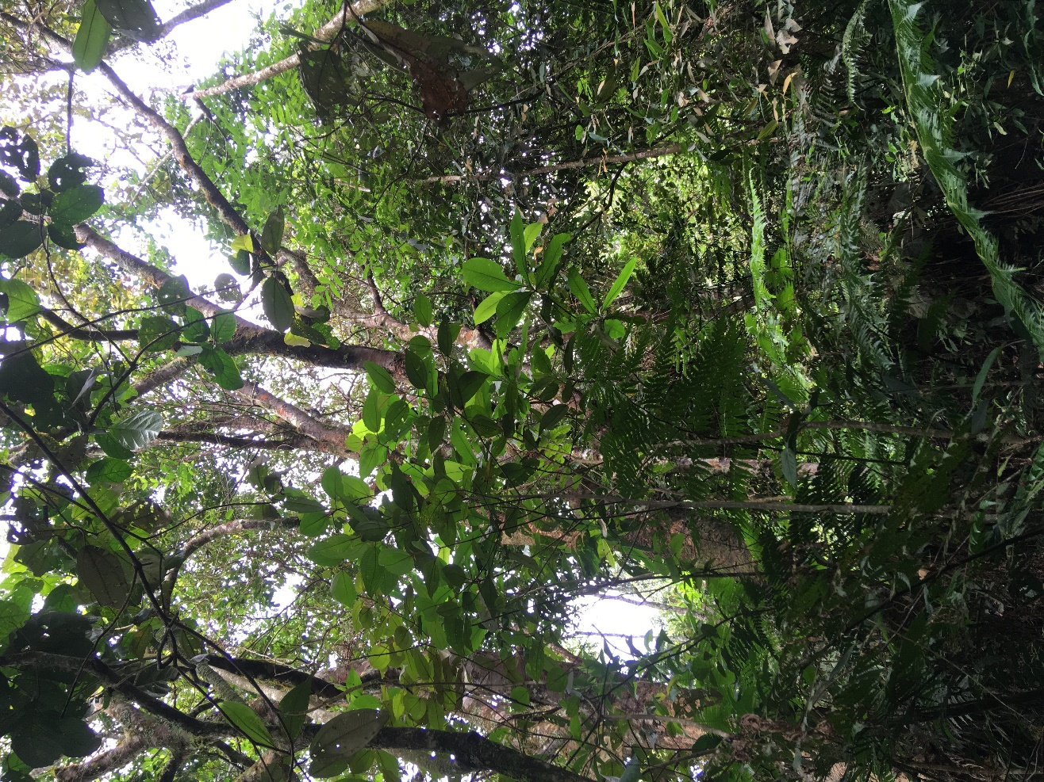

Figure 3.1. The typically dense understory and midstory in humid montane forests in the Andes makes it difficult to reliably re-sight canopy-dwelling birds such as Cerulean Warblers.

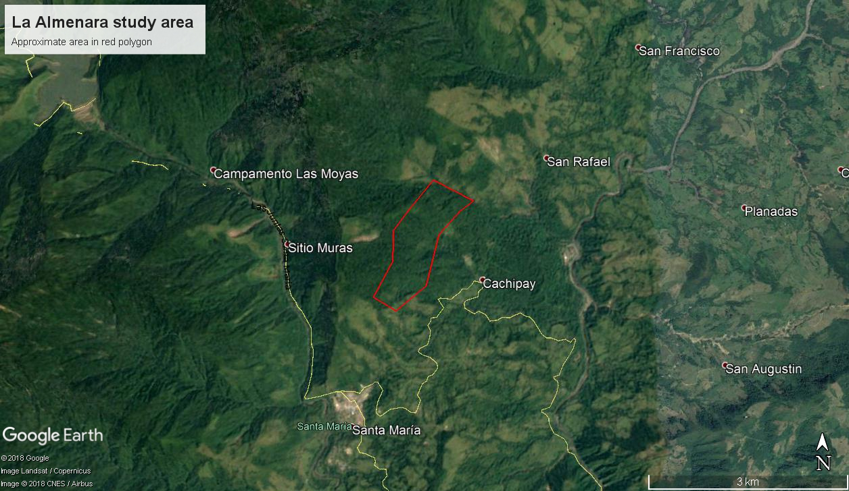

Figure 3.2. Approximate outline of La Almenara study site near Santa María, Boyacá, Colombia. The area constitutes approximately 117 ha and has a dirt access road (not shown) bisecting it approximately lengthwise.

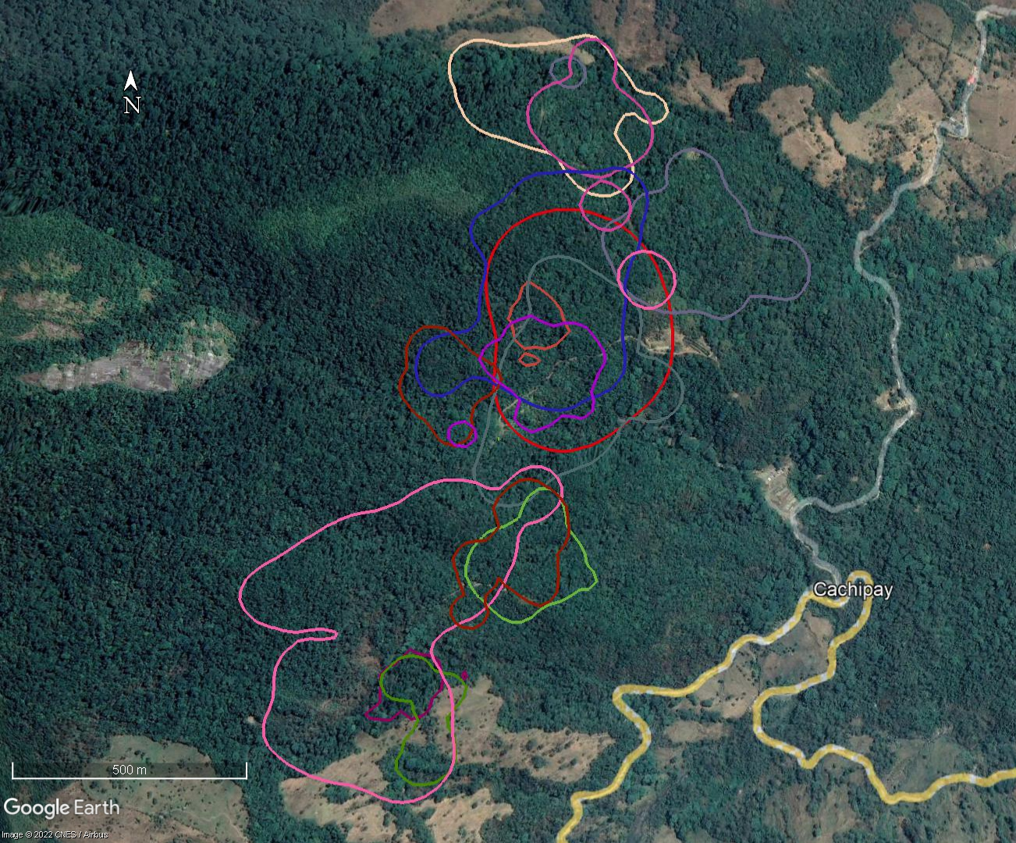
Figure 3.3. Overlapping 95% KDE home range estimates of 13 male Cerulean Warblers radio-tracked in Nov-Dec 2019 within mature secondary forest at the Almenara near Santa María, Boyacá, Colombia.

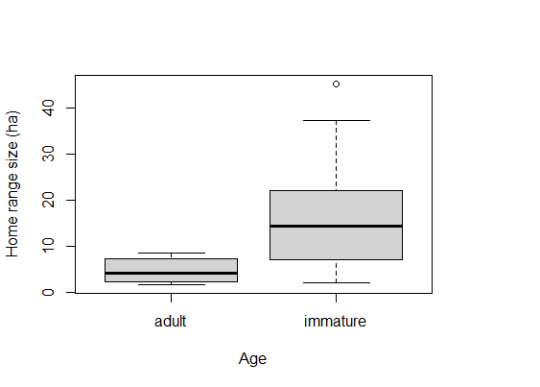
Fig. 3.4. Adult male Cerulean Warblers (n = 5) had smaller home ranges than immature males (n = 19) at La Almenara study site near Santa María, Boyacá, Colombia, 2017-2019. Home range estimates were based on 95% level of kernel density estimates.

Table 3.1. Netting effort and numbers of captured, tagged, and re-sighted Cerulean Warblers over three field seasons at the Almenara near Santa María, Boyacá, Colombia. There were zero within-season or interannual recaptures of Cerulean Warblers. *The lone interannual resight in 2017 was a geolocator-tagged male captured in February 2017 (13 male ceruleans were geoloator-tagged in February and March 2017 for a separate study).
Season | Net days | # Captures | # Radio-tagged | Interannual Resights | Recaptures
Nov-Dec 2017 | 8 | 8 | 5 | *1 | 0
Dec 2018/Jan 2019 | 14 | 10 | 9 | 5 | 0
Nov-Dec 2019 | 26 | 21 | 20 | 5 | 0
Total | 48 | 39 | 34 | 11 | 0

Table 3.2. Summary table of median home range size estimates (in ha) with numbers of locations and tracking duration (days) for each radio-tracked Cerulean Warbler over the 2017–2019 field seasons. To enable direct comparisons with other studies, estimates were generated at 50%, 95%, and 100% levels with minimum convex polygons (MCP) and at 50% and 100% kernel density estimates (KDE).
ID | Locations | Days | Year | Age | Sex | 50% MCP | 95% MCP | 100% MCP | 50% KDE | 95% KDE
T1 | 24 | 26 | 2017 | adult | M | 0.3 | 1.1 | 1.2 | 0.6 | 2.3
T2 | 24 | 26 | 2017 | adult | M | 0.3 | 3.2 | 6.6 | 1.2 | 8.6
T3 | 23 | 24 | 2017 | immature | M | 0.2 | 0.9 | 1.4 | 0.8 | 3.6
T4 | 17 | 18 | 2017 | immature | M | 1.0 | 3.7 | 4.1 | 3.8 | 14.9
T5 | 14 | 10 | 2018 | immature | M | 0.1 | 1.7 | 2.0 | 0.8 | 4.8
T6 | 17 | 5 | 2018 | immature | M | 1.9 | 4.7 | 5.3 | 5.4 | 21.7
T7 | 20 | 14 | 2018 | immature | M | 1.5 | 6.1 | 6.9 | 6.0 | 23.4
T8 | 21 | 5 | 2018 | immature | M | 10.5 | 21.6 | 25.7 | 5.9 | 28.3
T9 | 30 | 21 | 2018 | immature | M | 8.3 | 16.1 | 26.4 | 9.7 | 45.2
T10 | 33 | 20 | 2018 | immature | M | 0.5 | 3.0 | 3.9 | 1.6 | 7.8
T11 | 43 | 22 | 2018 | immature | M | 0.4 | 1.4 | 1.6 | 0.7 | 3.5
T12 | 72 | 30 | 2018 | immature | M | 0.7 | 5.4 | 8.3 | 1.6 | 9.2
T13 | 14 | 3 | 2019 | adult | M | 0.1 | 1.7 | 1.8 | 0.8 | 4.3
T14 | 18 | 7 | 2019 | immature | M | 0.8 | 6.7 | 8.0 | 3.9 | 20.0
T15 | 19 | 7 | 2019 | immature | M | 0.4 | 2.1 | 3.2 | 1.5 | 8.7
T16 | 33 | 14 | 2019 | immature | M | 5.7 | 10.1 | 12.6 | 2.4 | 11.6
T17 | 38 | 36 | 2019 | immature | M | 0.5 | 3.0 | 4.9 | 1.2 | 6.5
T18 | 46 | 19 | 2019 | immature | M | 2.3 | 7.5 | 14.7 | 3.1 | 15.2
T19 | 46 | 19 | 2019 | immature | M | 9.5 | 19.2 | 37.2 | 9.0 | 37.2
T20 | 47 | 24 | 2019 | immature | M | 1.6 | 7.1 | 9.3 | 3.2 | 14.3
T21 | 50 | 17 | 2019 | immature | M | 0.4 | 1.1 | 1.9 | 0.4 | 2.2
T22 | 69 | 38 | 2019 | immature | M | 5.9 | 12.8 | 16.9 | 6.2 | 22.3
T23 | 70 | 30 | 2019 | adult | M | 0.9 | 3.4 | 6.9 | 1.5 | 7.4
T24 | 71 | 37 | 2019 | adult | M | 0.2 | 0.8 | 1.4 | 0.3 | 1.7
Table 3.3. Species composition of 97 flock observations in mature secondary forest at the Almenara near Santa María, Boyacá, Colombia. Bolded species are Nearctic-Neotropical migrants. *Cerulean Warblers were detected prior to the initialization of 64 surveys and **Slaty-capped Flycatchers were detected prior to the initialization of 28 surveys and thus proportions and numbers of individuals per flock are likely inflated compared with other species.
Species | Proportion of flocks | Avg # per flock
Cerulean Warbler (Setophaga cerulea) | 0.94* | 3.10*
Blackburnian Warbler (Setophaga fusca) | 0.75 | 1.45
Canada Warbler (Cardellina canadensis) | 0.54 | 0.61
American Redstart (Setophaga ruticilla) | 0.52 | 0.63
Summer Tanager (Piranga rubra) | 0.48 | 0.63
Swainson's Thrush (Catharus ustulatus) | 0.41 | 0.49
Black-and-white Warbler (Mniotilta varia) | 0.29 | 0.30
Bay-breasted Warbler (Setophaga castanea) | 0.11 | 0.11
Red-eyed Vireo (Vireo olivaceus) | 0.09 | 0.11
Tennessee Warbler (Leiothlypis peregrina) | 0.08 | 0.09
Eastern/Western Wood-Pewee (Contopus virens/sordidulus) | 0.05 | 0.05
Acadian Flycatcher (Empidonax virescens) | 0.03 | 0.03
Golden-winged Warbler (Vermivora chrysoptera) | 0.03 | 0.03
Blackpoll Warbler (Setophaga striata) | 0.01 | 0.01
Rose-breasted Grosbeak (Pheucticus ludovicianus) | 0.01 | 0.02
Slaty-capped Flycatcher (Leptopogon superciliaris) | 0.80** | 1.22**
Speckled Tanager (Ixothraupis guttata) | 0.56 | 1.07
Bay-headed Tanager (Tangara gyrola) | 0.55 | 1.05
Blue-necked Tanager (Stilpnia cyanicollis) | 0.40 | 0.79
Red-headed Barbet (Eubucco bourcierii) | 0.32 | 0.43
Golden-faced Tyrannulet (Zimmerius chrysops) | 0.30 | 0.34
Slate-throated Redstart (Myioborus miniatus) | 0.26 | 0.32
Golden-crowned Warbler (Basileuterus culicivorus) | 0.24 | 0.28
Purple Honeycreeper (Cyanerpes caeruleus) | 0.24 | 0.38
Orange-bellied Euphonia (Euphonia xanthogaster) | 0.21 | 0.39
Dusky-capped Flycatcher (Myiarchus tuberculifer) | 0.20 | 0.21
Bananaquit (Coereba flaveola) | 0.19 | 0.21
Bronze-green Euphonia (Euphonia mesochrysa) | 0.19 | 0.21
White-shouldered Tanager (Loriotus luctuosus) | 0.17 | 0.20
Olive-striped Flycatcher (Mionectes olivaceus) | 0.16 | 0.18
Blue Dacnis (Dacnis cayana) | 0.14 | 0.17
Blue-naped Chlorophonia (Chlorophonia cyanea) | 0.11 | 0.13
Tropical Parula (Setophaga pitiayumi) | 0.10 | 0.10
Wedge-billed Woodcreeper (Glyphorynchus spirurus) | 0.09 | 0.10
Unidentified Flycatcher sp. | 0.07 | 0.10
Squirrel Cuckoo (Piaya cayana) | 0.07 | 0.07
Unidentified Euphonia sp. | 0.06 | 0.08
Cinnamon Becard (Pachyramphus cinnamomeus) | 0.05 | 0.06
Scaled Piculet (Picumnus squamulatus) | 0.05 | 0.05
Streak-headed Woodcreeper (Lepidocolaptes souleyetii) | 0.05 | 0.07
White-crowned Manakin (Pseudopipra pipra) | 0.05 | 0.09
Buff-throated Saltator (Saltator maximus) | 0.04 | 0.04
Gilded Barbet (Capito auratus) | 0.04 | 0.04
Pale-breasted Thrush (Turdus leucomelas) | 0.04 | 0.06
Plain Antvireo (Dysithamnus mentalis) | 0.04 | 0.05
Rufous-breasted Wren (Pheugopedius rutilus) | 0.04 | 0.05
Rufous-browed Peppershrike (Cyclarhis gujanensis) | 0.04 | 0.04
Thick-billed Euphonia (Euphonia laniirostris) | 0.04 | 0.07
Unidentified passerine sp. | 0.04 | 0.04
Boat-billed Flycatcher (Megarynchus pitangua) | 0.03 | 0.03
Brown-capped Vireo (Vireo leucophrys) | 0.03 | 0.03
Golden-crowned Flycatcher (Myiodynastes chrysocephalus) | 0.03 | 0.04
Ochre-bellied Flycatcher (Mionectes oleagineus) | 0.03 | 0.03
Pectoral Sparrow (Arremon taciturnus) | 0.03 | 0.03
Silver-beaked Tanager (Ramphocelus carbo) | 0.03 | 0.04
Golden-winged Manakin (Masius chrysopterus) | 0.02 | 0.02
Green Honeycreeper (Chlorophanes spiza) | 0.02 | 0.02
Palm Tanager (Thraupis palmarum) | 0.02 | 0.02
Spectacled Thrush (Turdus nudigenis) | 0.02 | 0.02
White-winged Tanager (Piranga leucoptera) | 0.02 | 0.03
Yellow-tufted Woodpecker (Melanerpes cruentatus) | 0.02 | 0.03
Andean Solitaire (Myadestes ralloides) | 0.01 | 0.01
Ashy-throated Chlorospingus (Chlorospingus canigularis) | 0.01 | 0.01
Black-billed Thrush (Turdus ignobilis) | 0.01 | 0.01
Blue-gray Tanager (Thraupis episcopus) | 0.01 | 0.01
Crested Spinetail (Cranioleuca subcristata) | 0.01 | 0.01
Unidentified Elaenia sp. | 0.01 | 0.01
Golden-headed Manakin (Ceratopipra erythrocephala) | 0.01 | 0.01
Lined Antshrike (Thamnophilus tenuepunctatus) | 0.01 | 0.01
Plain-brown Woodcreeper (Dendrocincla fuliginosa) | 0.01 | 0.01
Red-billed Scythebill (Campylorhamphus trochilirostris) | 0.01 | 0.01
Red-legged Honeycreeper (Cyanerpes cyaneus) | 0.01 | 0.01
Scale-crested Pygmy-Tyrant (Lophotriccus pileatus) | 0.01 | 0.01
Unidentified Turdus sp. | 0.01 | 0.01
White-necked Thrush (Turdus albicollis) | 0.01 | 0.01
Unidentified woodcreeper sp. | 0.01 | 0.01
Yellow-olive Flycatcher (Tolmomyias sulphurescens) | 0.01 | 0.01

CONCLUSIONS
This dissertation research was undertaken with the goal of addressing critical knowledge gaps pertaining to the full annual cycle ecology of Cerulean Warblers. My results should be useful to organizations and agencies that are developing and implementing conservation efforts in regions used by ceruleans during their annual migration cycles. The highlights of our results include the following conclusions:
- Ceruleans that breed in the eastern portion of their North American range, including the core Appalachian region, tend to spend ~6 months per year at stationary non-breeding sites in the Colombian and Venezuelan Andes, commonly in the Eastern or Central Cordilleras of Colombia or the Mérida Mountains of Venezuela.
- Ceruleans from the western portion of their breeding range tend to spend ~6 months per year in the southwestern portion of the Andean non-breeding range in Peru, Ecuador, or the Western Cordillera of Colombia.
- The migratory periods are substantial in duration (~2.5 months per year in total) and involve multiple extended stopovers throughout Central America lasting in some cases >14 d. Conservation of stopover habitat in Central America and in the United States Gulf Coast region is likely important as the birds must refuel efficiently prior to and after crossing the Gulf of Mexico, and a topographic funnel effect in Central America presents an opportunity to benefit large numbers of migrating ceruleans through conservation efforts. More research is needed to identify (at a finer scale than is possible with our geolocator-based results) and conserve high quality stopover areas.
- Forest management efforts designed and implemented with a goal of enhancing breeding habitat for ceruleans through partial timber harvest practices (e.g., single-tree selection and shelterwood harvest techniques) may not be effective beyond the initial years following harvests.
- Further forest management of managed stands may be required within the 5–13-yr post-harvest period and could potentially include periodic prescribed fire applications or precommercial thinnings that set back closure of the midstory layer and prevent increased stand basal area.
- More studies and monitoring of Cerulean Warbler territory density following forest management efforts are needed throughout the species’ range. Although we found that overall cerulean densities were similar with or lower than preharvest densities following 13–14 years post-harvest across 3 study sites, some (3/9) managed plots maintained increased territory densities at light (~80% RBA) and intermediate (~60% RBA) harvest intensities. None of the three heavy treatments (~25% RBA) resulted in sustained positive density responses.
- Mature secondary forest in the Andean stationary non-breeding grounds can harbor high densities of ceruleans. We estimated (132 ± 41) ceruleans within ~1 km area of mature secondary forest over a 41-d period.
- Home ranges at this site often overlapped adult males (95% KDE: median 4.3 ha, IQR 5.1, range 1.7–8.6 ha) had smaller home ranges than immature males (median 14.3 ha, IQR 14.9 ha, range 2.2–45.2 ha).
- Our mature secondary forest study site was strongly biased toward males (86% males to 14% females) and efforts to determine whether females prefer different land use types or perhaps are more common in other regions are needed.
- All radio-tracked ceruleans in our study were usually associated with mixed-species flocks, for which we documented medians of 3 ceruleans (range 1–9), 7 Nearctic-Neotropical migrants (IQR 5), and 9 (IQR 6) residents. However, flocks were likely larger because detectability was <100%.
- In Colombian forest, we documented low visual detection probability (p = 35–75% with 1–3 observers) of homed radio-tracked birds that were in close-proximity to the observers. These radio-tracked individuals were only visible for 1.2% of 853 total observation minutes with one observer, 2.8% of 273 observation minutes with two observers, and 4.3% of 309 observation minutes with 3 observers. We also observed very low encounter probability (p = 0.07) of color-banded birds during line-distance transects. Abundance and survival estimation methods should account for low detectability and not assume 100% detectability at distance = 0 in dense forest non-breeding habitat as has been done in traditional distance-based surveys.
- Apparent within-season survival at our study site (cumulatively 4.3% over 26 weeks) was relatively low compared with apparent annual survival (43 ± 10%), implying that some birds may have dispersed from the study site (i.e., moved > ~2 km) during the stationary non-breeding period although likely not beyond ~150 km as documented by our geolocator-based results. More non-breeding survival studies are warranted, and our study was hampered by issues with some transmitters prematurely ending their transmission.
I intend to publish each of these chapters in peer-reviewed journals and plan to continue to work with partner organizations to develop and improve full annual cycle conservation efforts for Cerulean Warblers. Conservation efforts implemented to benefit this charismatic species will also benefit numerous other species across taxa in the biodiverse Andean and Central American forests as well as disturbance-adapted, hardwood forest-dwelling species in North America.

VITA
Doug Raybuck grew up on a wooded farm near Frogtown, Pennsylvania, where he and his two brothers quickly developed strong ties with nature through camping, hiking, hunting, fishing, and observing wildlife. He earned his bachelor’s degree in Biology at Clarion University of Pennsylvania, where he focused on aquatic restoration ecology in the Mill Creek and Toby Creek watersheds, which have been severely impacted by acid mine drainage coal-mining activity and by seepage from unplugged gas wells. He then spent several years cycling through various seasonal wildlife ecology field positions involving bat and Allegheny woodrat surveys and telemetry in the mid-Atlantic states, Cerulean Warbler and Golden-cheeked Warbler demographic research in Tennessee and Texas, and marine fisheries observing in the Bering Sea and North Pacific Ocean. He earned his Master of Science degree in Biology at Arkansas State University, where he studied the post-fledging ecology of Cerulean Warblers. After completing his master’s research, he began his pursuit of a Doctor of a Philosophy Degree at the University of Tennessee in the Forestry, Wildlife and Fisheries Department studying under the direction of Dr. David Buehler. His dissertation research focused on the full annual cycle ecology of Cerulean Warblers.

