Emerging Trends in Bus Ridership in the United States

A Dissertation Presented for the

Doctor of Philosophy

Degree

The University of Tennessee, Knoxville

Abubakr Ziedan

December 2022
Copyright © 2022 by Abubakr Ziedan
All rights reserved.

DEDICATION

This dissertation is dedicated to those who were with me throughout my journey, with support and encouragement. To my sweet and loving parents, whose affection love and prayers were with me every day and night. To Roaa, my wife and support who gave everything for me. To the soul of my aunt Suaad who passed away during this journey. To all of my friends for their support and help.

ACKNOWLEDGEMENTS

Before all, my deepest gratitude is to Allah the mighty for guiding me and easing my way throughout my Ph.D. journey. Praise to Allah, who has guided me to this, I would never have been guided to it if Allah had not guided me.

I would first like to thank my advisor Dr. Candace Brakewood for her continuous guidance and for being a great mentor as a person, researcher, and teacher. My sincere gratitude to her.

I would also like to thank my committee members, Dr. Chris Cherry, Dr. Greg Erhardt, and Dr. Luiz Lima, for their valuable input and comments.

I am also thankful for all my co-authors, Dr. Kari Watkins, Wesley Darling, Nitesh Shah, Yi Wen, Ashley Hightower, and Justin Cole. Thanks to my friends and colleagues in the transportation lab, especially Antora, Cassidy, and Jing.

I am also thankful to the Transit-Serving Communities Optimally, Responsively, and Efficiently Center (T-SCORE) university transportation center and the Transit Cooperative Research Program (TCRP) for funding the different studies in this dissertation. I will also extend my gratitude to the Transit Authority of River City (TARC) and WeGo Public Transit for providing data.

Finally, I would like to express my very profound gratitude to my parents, my wife, and my friends for their continuous support and encouragement throughout my years of study. This accomplishment would not have been possible without them. Thank you.

ABSTRACT

Public transit ridership in the United States was declining even before the COVID-19 pandemic. Many different factors affect transit ridership levels, and the recent declines in ridership across the country make it critical to assess which factors are causing declines and which may help to increase ridership. Therefore, this dissertation seeks to quantify the impact of three emerging factors on bus ridership: shared electric scooters (e-scooters), new fare payment technologies and policies, and the COVID-19 pandemic.
This dissertation analyzed the impacts of shared e-scooters on bus ridership. This was investigated at the route level in Louisville, KY, and Nashville, TN, using fixed effects regression. The findings showed that the impacts on bus ridership vary by shared e-scooter trip purpose but the net impact was minimal.
This dissertation also explored the ridership impacts of mobile fare payment applications and fare capping policies using staggered difference-in-difference techniques. The results revealed that mobile fare payment applications did not yield significant ridership gains, but monthly fare capping policies did. Moreover, the impact of monthly fare capping policies was heterogenous, and agencies that adopted monthly fare capping policies for more than one year experienced an average ridership increase ranging from 3.6% to 4.1%.
The last factor considered was the COVID-19 pandemic. This dissertation proposed a multiple mediation framework to untangle the direct and indirect impacts of COVID-19. The direct impact refers to a change in travel behavior (i.e., people stop riding transit because they are sick or fear getting sick), while the indirect impact refers to reduced ridership due to changes in factors like employment. The findings suggest that employment, telework, and population relocation mediated 13% to 38% of bus ridership declines.
This dissertation makes a number of important contributions that include developing a method to estimate the impacts of shared e-scooters on bus ridership using route-level data and applying a staggered difference-in-difference approach to transportation policy analysis that considers heterogeneity in treatment effects. The findings of this dissertation can help inform transit agencies and policymakers as they plan for a post-COVID-19 world.

TABLE OF CONTENTS

CHAPTER I: INTRODUCTION 1
1.1 Background 2
1.2 Research Approach 5
1.3 Contributions 6
1.4 Dissertation Structure 6
CHAPTER II: THE IMPACTS OF SHARED E-SCOOTERS ON BUS RIDERSHIP IN LOUISVILLE 10
2.1 Abstract 11
2.2 Background 11
2.3 Literature Review 12
2.4 Methodology 14
2.4.1 Objective and Research Questions 14
2.4.2 Case Study Background 14
2.4.3 Data 15
2.4.4 Assigning Shared E-Scooter Trips to Transit Routes 19
2.4.5 Summary Statistics 23
2.4.6 Modeling Framework 23
2.5 Results and Discussion 27
2.5.1 Research Questions 1 & 2: Do Shared E-scooters Increase Ridership on both Express and Local Bus Routes? 27
2.5.2 Research Questions 1 & 3: Do Shared E-Scooters Increase Ridership on Express Bus Routes and Decrease Ridership on Local Bus Routes? 28
2.5.3 Discussion and Implications for Practice 29
2.6 Areas for Improvement and Future Research 32
2.7 Conclusions 32
CHAPTER III: COMPLEMENT OR COMPETE? THE EFFECTS OF SHARED ELECTRIC SCOOTERS ON BUS RIDERSHIP 34
3.1 Abstract 35
3.2 Introduction 35
3.3 Literature Review 36
3.4 Background 38
3.4.1 Period of Analysis 38
3.4.2 Transit in Nashville, Tennessee 38
3.4.3 Shared E-scooters in Nashville, Tennessee 40
3.4.4 Data 40
3.5 Methodology 41
3.5.1 Research Design and Hypotheses 41
3.5.2 Summary Statistics 47
3.5.3 Modeling Framework 47
3.6 Results and Discussion 50
3.6.1 Results using Infrastructure-based Measures 50
3.6.2 Results using Trip-based Measures 51
3.6.3 Results using Trip-based Measures Based on Trip Purpose 52
3.6.4 Quantifying the Net Impact of Shared E-scooters on Bus Ridership 55
3.7 Areas for Improvement and Future Research 55
3.8 Conclusions and Policy Recommendations 56
CHAPTER IV: THE APP OR THE CAP? WHICH FARE innovation AFFECTS BUS RIDERSHIP? 58
4.1 Abstract 59
4.2 Introduction 59
4.3 Prior Studies 60
4.3.1 Mobile Fare Payment Applications 60
4.3.2 Fare Capping 60
4.4 Research Questions 62
4.5 Data 62
4.5.1 Outcome Variable 62
4.5.2 Control Variables 62
4.5.3 Treatment Variables 63
4.6 Method 67
4.6.1 Assumptions 67
4.6.2 Group-Time Average Treatment Effects 69
4.7 Results 70
4.7.1 Results for Mobile Fare Payment Applications 70
4.7.2 Results for Daily Fare Capping 71
4.7.3 Results for Monthly Fare Capping 74
4.8 Areas for Improvement and Areas for Future Research 76
4.9 Conclusions and Discussion 76
CHAPTER V: A MULTIPLE MEDIATION ANALYSIS TO UNTANGLE THE IMPACTS OF COVID-19 ON NATIONWIDE BUS RIDERSHIP IN THE UNITED STATES 78
5.1 Abstract 79
5.2 Introduction 79
5.3 Prior Studies 80
5.3.1 Transit Ridership Before the COVID-19 Pandemic 80
5.4 Transit Ridership During the COVID-19 Pandemic 82
5.5 Method 83
5.5.1 Meditation Analysis Background 83
5.6 Mediation analysis for the impact of COVID-19 on bus ridership 87
5.6.1 Research Hypotheses 87
5.6.2 Multiple Mediation Framework 90
5.7 Data 90
5.7.1 Outcome Variable 90
5.7.2 Mediators 91
5.7.3 Independent Variable 93
5.8 Results and Discussion 93
5.9 Areas for Improvement and Areas for Future Research 101
5.10 Conclusions 101
CHAPTER VI: WILL TRANSIT RECOVER? A RETROSPECTIVE STUDY OF NATIONWIDE RIDERSHIP IN THE UNITED STATES DURING THE COVID-19 PANDEMIC 103
6.1 Abstract 104
6.2 Background 104
6.3 Prior Studies 106
6.4 Data 107
6.5 Method 108
6.6 Results 109
6.6.1 Rail Trends 109
6.6.2 Bus Trends 116
6.6.3 Changepoint Analysis 125
6.7 Conclusions 125
6.8 Directions Forward 127
CHAPTER VII: CONCLUSIONS 129
7.1 Main Findings and Concluding Remarks 130
7.2 Future Research 132
REFERENCES 134
APPENDICES 147
VITA 164

LIST OF TABLES

Table ‎1.1: Research Framework and Method 9
Table ‎2.1: Summary Statistics 26
Table ‎2.2: Fixed Effects Regression Results (Models 1–8) 30
Table ‎2.3: Fixed Effects Regression Results (Models 9–12) 31
Table ‎3.1: Summary of Shared E-scooter User Surveys’ Findings 39
Table ‎3.2: Shared E-scooter Trip Purpose in Nashville 48
Table ‎3.3: Summary Statistics 49
Table ‎3.4: Fixed Effects Regression Results for Assessing Hypothesis 1 53
Table ‎3.5: Fixed Effects Regression Results for Assessing Hypotheses 2-3 53
Table ‎3.6: Fixed Effects Regression Results for Assessing Hypotheses 4-5 53
Table ‎3.7: Fixed Effects Regression Results for Assessing Hypothesis 6 54
Table ‎3.8: The Impacts of Shared E-scooters on Bus Ridership by Trip Purpose 54
Table ‎4.1: Data Sources 64
Table ‎4.2: Mobile Fare Payment Application Launch Dates 65
Table ‎4.3: Fare Capping Policy Launch Dates 66
Table ‎4.4: Treatment Effects of the Launch of Fare Payment Applications on Bus Ridership 72
Table ‎4.5: Treatment Effects for the Adoption of Daily Fare Capping Policies 73
Table ‎4.6: Treatment Effects for the Adoption of Monthly Fare Capping Policies 75
Table ‎5.1: Factors Affecting Transit Ridership 81
Table ‎5.2: Mediation Analysis Estimates and Model Fit for March 2020 to July 2020 94
Table ‎5.3: Mediation Analysis Estimates and Model Fit for August 2020 to December 2020 95
Table ‎5.4: Mediation Analysis Estimates and Model Fit for January 2021 to June 2021 96
Table ‎5.5: Mediation Analysis Estimates and Model Fit for July 2021 to December 2021 97
Table ‎5.6: The Standardized Direct, Indirect, and Total Impacts of COVID-19 on Bus Ridership 99
Table ‎6.1: Changepoint Results by Cluster 126

LIST OF FIGURES

Figure ‎1.1: Annual transit ridership in the United States 3
Figure ‎1.2: Factors affecting transit ridership 4
Figure ‎1.3: Research questions 8
Figure ‎2.1: Average daily shared e-scooters trips for Louisville for the period August 2018 to December 2019 16
Figure ‎2.2: Shared e-scooters service area and TARC transit routes 18
Figure ‎2.3: Example of shared e-scooter trips assignment to an express TARC transit route (Route 65 Sellersburg Express) for August 10, 2018 21
Figure ‎2.4: Heatmap of the average daily shared e-scooters complement trip count for each express TARC route for the period August 2018 to December 2019 22
Figure ‎2.5: Example of the shared e-scooter substitute trip count (Route 23 Broadway) for August 10, 2018 24
Figure ‎2.6: Heatmap of average shared e-scooters substitute trip count for each local TARC route for the period August 2018 to December 2019 25
Figure ‎3.1: Example of shared e-scooter device availability for one bus route 43
Figure ‎3.2: Example of the shared e-scooter origin and destination count method for one bus route 45
Figure ‎5.1: Simple mediation model 85
Figure ‎5.2: Multiple meditation model 85
Figure ‎5.3: Average gas price in the United States 89
Figure ‎5.4: Google searches for different modes for the period Jan 2019 to Dec 2021 89
Figure ‎5.5: Mediation analysis for the impact of COVID-19 on bus ridership framework 92
Figure ‎5.6: Direct and indirect impacts of COVID-19 on bus ridership by month for the period March 2020 to December 2021 100
Figure ‎6.1: Annual transit ridership in the United States 105
Figure ‎6.2: Percent decline in ridership, service provision, and productivity for rail 110
Figure ‎6.3: Rail ridership declines for New York and the high op-ex cluster MSAs 112
Figure ‎6.4: Rail ridership declines range for the high op-ex cluster 113
Figure ‎6.5: Rail ridership declines in the mid operational expenses cluster MSAs 114
Figure ‎6.6: Rail ridership declines range for the mid op-ex cluster 115
Figure ‎6.7: Percent decline in ridership, service provision, and productivity for bus 117
Figure ‎6.8. Bus ridership declines in the high operational expenses cluster MSAs 119
Figure ‎6.9: Bus ridership declines range for the high op-ex cluster 120
Figure ‎6.10: Bus ridership decline in the mid operational expenses cluster MSAs 121
Figure ‎6.11: Bus ridership declines range for the mid op-ex cluster 122
Figure ‎6.12: Bus ridership declines in the low operational expenses cluster MSAs 123
Figure ‎6.13: Bus ridership declines range for the low op-ex cluster 124
Figure ‎6.14: Changepoint results of nationwide rail and bus ridership 126
Figure ‎7.1: Main findings 131

CHAPTER I: INTRODUCTION

Background
Public transit in the United States is facing unprecedented challenges following the drastic declines in ridership because of the coronavirus (COVID-19) pandemic. Transit ridership in 2020 reached the lowest level in the last 100 years in the wake of the COVID-19 pandemic as shown in Figure ‎1.1. However, transit ridership in the United States was experiencing declines before the COVID-19 pandemic. A recent study showed that transit ridership declined by about 15% between 2012 and 2018 (Watkins et al., 2021).
These ridership declines concern transit agencies and decision-makers at various government organizations, as decreased transit usage could have serious consequences. Some of these consequences on safety, environmental, and congestion are briefly discussed here. One potential negative consequence of transit ridership declines is related to safety. A prior study found that lower transit ridership levels are associated with higher traffic casualty rates (Litman, 2016). It showed that in cities where the average annual transit use was less than 20 trips per resident, the traffic fatality rate was about double the fatality rate in cities with average annual transit trips of more than 50 trips per resident (Litman, 2016). Another important consequence associated with transit ridership declines is an increase in greenhouse gas (GHG) emissions, which impacts climate change (Crowley, 2000). One prior study showed that the estimated amount of reduced GHG emissions from using transit instead of personal vehicles was 9 million metric tons of carbon dioxide equivalent in 2018 (McGraw et al., 2021). Furthermore, the total amount of GHG saved was estimated as 63 million metric tons of carbon dioxide equivalent, including savings from transportation efficiency and land use efficiency (McGraw et al., 2021). A third major consequence of reduced transit ridership is increased highway delays and congestion. Prior studies showed that terminating transit could lead to about a 47% increase in the average highway delay (Anderson, 2014) and increases in the "average length of the rush period increased as much as 200%" (Lo and Hall, 2006). The increased delays and amount of gas used have considerable economic impacts. The Texas A&M Transportation Institute (TTI) 2012 Urban Mobility Report estimated the savings of public transit in 2011 as 865 million hours of delay and 450 million gallons of fuel (Schrank et al., 2012). These hours of delay and fuel savings are equivalent to 20.8 billion dollars (in 2012 dollars) (Schrank et al., 2012). To avoid these undesirable consequences, transit agencies and policy-makers are actively exploring the factors behind ridership declines and strategies to increase ridership.
The factors that affect transit ridership can be categorized into two categories: traditional and emerging factors, as shown in Figure ‎1.2 (Watkins et al., 2021). The traditional factors include variables such as transit service quantity and quality, transit fare, transit speed, population, employment, income, car ownership, and gas prices (Erhardt et al., 2022; Taylor et al., 2009; Watkins et al., 2021). The second category includes factors that have emerged recently, mainly in the last two decades. These emerging factors include different variables such as telecommuting, gentrification, shared mobility (carsharing, ride-hailing, bikesharing, shared e-scooters), real-time transit information, new fare payment methods, fare discounts or elimination, and microtransit (Erhardt et al., 2021; Watkins et al., 2021). In addition to these traditional and emerging factors, extreme events, such as terrorist attacks and epidemics, could substantially impact transit ridership (Liu et al., 2021). The extent of understanding these different factors' impacts on ridership varies between categories. For example, the impacts of the traditional factors on transit ridership have been extensively explored by prior studies, and their impacts are generally well understood and documented (Boisjoly et al., 2018; Chen et al., 2011; Erhardt et al., 2022; Evans, 2004; McCollom and Pratt, 2004; Taylor et al., 2009; Watkins et al., 2021).

Figure ‎1.1: Annual transit ridership in the United States
[Data Source: (American Public Transportation Association, 2021)]

Figure ‎1.2: Factors affecting transit ridership
Also, the impacts of some of the emerging factors like carshare, bikeshare, ride-haling, and real-time transit information have been explored in recent prior studies (Brakewood et al., 2015; Campbell and Brakewood, 2017; Graehler et al., 2019b; Hall et al., 2018; Shaheen et al., 2009; Sioui et al., 2013). However, other emerging factors are yet to be explored in the literature, such as shared e-scooters and new fare payment methods (Bian et al., 2021; Taylor et al., 2020; Watkins et al., 2021). Moreover, the impact of extreme events such as terrorist attacks and epidemics varies substantially from one event to another (Liu et al., 2021), and as the COVID-19 pandemic is still ongoing, its impacts are largely unknown. Therefore, this research aims to quantify the impacts of some factors that have not been widely discussed in prior studies. Specifically, this research will focus on the ridership impacts of shared e-scooters, new fare technology and policy, and the COVID-19 pandemic since there have been limited studies focused on these factors. Exploring the impacts of these factors on transit ridership will inform transit agencies, government officials, and policymakers as they plan for the future of cities.

Research Approach
This dissertation studies the impact of three emerging factors on bus ridership, and the corresponding research questions are shown in Figure ‎1.3. Different statistical and econometrics methods are used to answer the research questions, as shown in Table ‎1.1. The methods were chosen based on the nature of each factor, the research question, and the available data. Regarding the data, the first three chapters of this dissertation considered pre-COVID-19 ridership data, while the fourth and fifth chapters considered ridership during COVID-19.
Chapters two and three in this dissertation used fixed effect regression to explore the impacts of shared e-scooters on bus ridership at the route level. The fixed effects regression approach was used since it is robust against omitted variables bias (Studenmund, 2016), and it has been successfully applied in several prior ridership studies (Brakewood et al., 2015; Erhardt et al., 2022; Watkins et al., 2021). The route level was selected as the unit of analysis in these two chapters because the results of a prior study that tried to study the impacts of shared e-scooters at the system level were inconclusive (Watkins et al., 2021). In summary, these two chapters used detailed, route-level data in fixed effects regression models.
Chapter four of this dissertation applied a staggered difference-in-difference approach to quantify the impacts of two recent innovations in fare technology and policy (namely, mobile fare payment applications, i.e., “apps” and fare capping, i.e. “caps”) on ridership. This approach was used for two reasons. First, it addresses the staggered nature of the two interventions, with different transit agencies adopting fare payment apps or fare caps at different times. Second, it allows for heterogeneity in the treatment effect among agencies and over time. This aspect is important since ridership might be affected differently at different agencies, or the impact might take time in order for riders to change their behavior. The system level was selected as unit of analysis instead of the route, because transit agencies typically adopt these fare changes at the system level, and all routes would be treated at the same time. Therefore, a route level analysis would not capture the treatment effect.
The fifth and sixth chapters studied ridership during the COVID-19 pandemic. Fixed effect regression models that have been widely adopted to study transit ridership prior to the pandemic may not be applicable during the pandemic since the pandemic greatly affected both ridership and its determinants simultaneously. Therefore, the fourth chapter of this dissertation proposed a multiple mediation approach to untangle the impacts of the COVID-19 pandemic on bus ridership. The sixth chapter conducted an exploratory analysis and change point analysis to understand nationwide ridership recovery trends and provide insights from transit agencies that have begun to recovery. These two chapters were nationwide analyses and conducted at the system level to explore general trends. Also, nationwide analysis allows agencies to compare their performance to their peers. More details are provided in each chapter.

Contributions
This dissertation makes a number of important contributions to the transportation literature and begins to answer several critical questions related to public transit ridership in the United States.
The first contribution of this dissertation is developing a method to estimate the impact of shared e-scooters on bus ridership using route-level bus ridership data. This method assigns shared e-scooters to transit routes based on shared e-scooter trip start and end locations and can capture different potential impacts on bus ridership (both complementing and competing). This method is important since route-level transit ridership data are widely available for transit agencies.
The second contribution is to evaluate shared e-scooter impacts on bus ridership based on e-scooter trip purpose. This allows for a better understanding of the relationship between shared e-scooters and buses, and the results could potentially help to develop more integrated transportation systems.
The third contribution is using the staggered difference-in-difference approach to evaluate a transportation policy and consider heterogeneity in treatment effects. This method is an emerging approach in econometrics that could be applied in many future studies in the field of transportation because many new policies and technologies are adopted by different agencies/cities/states at different times.
The fourth contribution is a framework to explore transit ridership changes in circumstances where traditional methods might not be applicable, such as the COVID-19 pandemic. This framework used multiple mediation analyses to untangle the direct and indirect impacts of COVID-19 on transit ridership. In the context of this study, the direct impact refers to a change in travel behavior (i.e., people stop riding transit because they are sick or fear getting sick), while the indirect impact refers to reduced ridership due to lower employment or increased teleworking.
The fifth contribution of this dissertation is exploring nationwide ridership trends during the early portion of the pandemic as well as more recent recovery trends (until June 2022) by operational clusters (i.e., size of the transit agency) across the United States. This analysis allows transit providers to compare their performance to their peers and learn from agencies that recovered quicker.

Dissertation Structure
This dissertation is structured in a five-paper format. Each chapter investigates the impacts of a specific emerging factor on transit ridership and is under review or has been published in a peer-reviewed journal, as shown below.

- Chapter 2: The impacts of shared e-scooters on bus ridership
  - Peer-reviewed conference paper: presented at the 101st Annual Meeting of the Transportation Research Board, Washington, DC. (2022)
  - Journal Article: published in Transportation Research Part A: Policy and Practice, (2021)
  - Emerging factor: shared e-scooters

- Chapter 3: Complement or compete? The effects of shared electric scooters on bus ridership.
  - Peer-reviewed conference paper: presented at the 100th Annual Meeting of the Transportation Research Board, Washington, DC, (2021).
  - Journal Article: published in Transportation Research Part D: Transport and Environment, (2021).
  - Emerging factor: shared e-scooters

- Chapter 4: The app or the cap? Which fare innovations affects bus ridership?
  - Peer-reviewed conference paper: accepted for presentation at the 102nd Annual Meeting of the Transportation Research Board, Washington, DC (2023).
  - Journal Article: under review
  - Emerging factor: fare technology and policy

- Chapter 5: A multiple mediation analysis to untangle the impacts of COVID-19 on nationwide bus ridership in the United States
  - Journal Article: under review
  - Emerging factor: the COVID-19 pandemic

- Chapter 6: Will transit recover? A retrospective study of nationwide ridership in the United States during the COVID-19 pandemic
  - Peer-reviewed conference paper: accepted for presentation at the 102nd Annual Meeting of the Transportation Research Board, Washington, DC (2023).
  - Journal Article: under review
  - Emerging factor: the COVID-19 pandemic

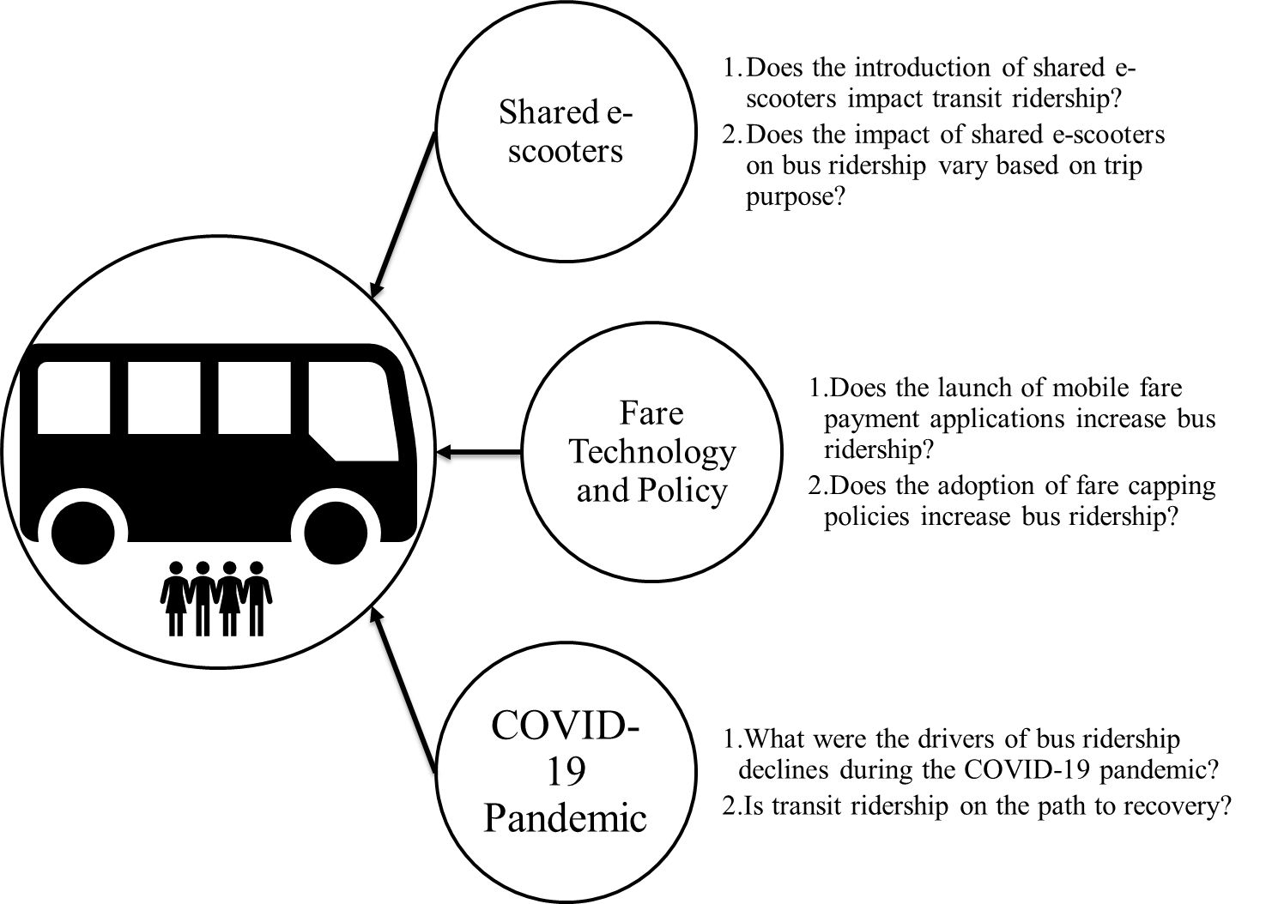
Figure ‎1.3: Research questions

Table ‎1.1: Research Framework and Method
Factor | Shared e-scooters |  | Fare Technology and Policy | COVID-19 Pandemic
Chapter # | Chapter 1 | Chapter 2 | Chapter 3 | Chapter 4 | Chapter 5
Study location | Louisville, KY | Nashville, TN | Largest 50 bus agencies in the United States | Nationwide analysis (220 MSAs) | Nationwide analysis (220 MSAs)
Unit of Analysis | Route level | Route level | Transit Agency | Metropolitan statistical area (MSA) | Metropolitan statistical area (MSA)
Time Unit | Day | Day | Year | Month | Month
Timeline | Feb 2016 to Dec 2019 | Mar 2016 to Jul 2019 | 2011 to 2019 | Mar 2020 to Dec 2021 | Mar 2020 to Jun 2022
Methodology | Fixed effect regression |  | Staggered difference in difference | Mediation analysis | Explanatory analysis and change point analysis

CHAPTER II:
THE IMPACTS OF SHARED E-SCOOTERS ON BUS RIDERSHIP IN LOUISVILLE

A version of this chapter was originally published in Transportation Research Part A: Policy and Practice:

Ziedan, A., Darling, W., Brakewood, C., Erhardt, G., Watkins, K. (2021) The Impacts of Shared E-Scooters on Bus Ridership. Transportation Research Part A: Policy and Practice, 153, pp. 20-34. https://doi.org/10.1016/j.tra.2021.08.019

Author Statement
Abubakr Ziedan: Conceptualization, Methodology, Formal analysis, Writing - Original Draft. Wesley Darling: Software, Visualization, Writing - Original Draft. Candace Brakewood: Conceptualization, Methodology, Writing - Original Draft, Supervision, Funding acquisition. Greg Erhardt: Validation, Writing - Review & Editing, Funding acquisition. Kari Watkins: Writing - Review & Editing, Supervision, Funding acquisition.

Abstract
Shared electric scooters (shared e-scooters) are rapidly growing in popularity across the United States. In 2019, more than 88 million shared e-scooter trips occurred nationwide. However, the impact of this growing mode on transit ridership is still largely unknown and limited to the findings of user surveys. The overarching goal of this study is to conduct an empirical analysis to quantify the impact of shared e-scooters on bus ridership using Louisville, Kentucky, as a case study conducted prior to the COVID-19 pandemic. To assess if shared e-scooters decrease or increase bus ridership, this study evaluated more than half a million shared e-scooters trips, and estimated several daily, weekly, and monthly fixed effects regression models of route level bus ridership. The results of the preferred fixed effect regression models indicate that shared e-scooters do not have a significant impact on local bus ridership. However, the model results suggest that shared e-scooters could potentially complement express bus routes as they serve the first/last mile of a trip, but further research on express routes is recommended. Most critically, the results of this study indicate that shared e-scooters are not one of the primary causes of bus ridership decline in Louisville. This finding is important for cities across the United States as they explore the causes of the recent declines in bus ridership.

Background
Though shared electric motorized scooters (shared e-scooters) have existed in some capacity since the early 2010s, their use in the United States in the past three years has rapidly increased. Riders in the United States took about 38.5 million trips in 2018 alone (NACTO, 2019). This growing trend continued in 2019, as 88.5 million shared e-scooters trips were reported in the United States (NACTO, 2020), a 230% increase. Despite their popularity in nearly every major American city and many other cities around the world, the impacts of shared e-scooters on public transit systems are largely unknown.
Furthermore, the growing popularity of shared e-scooters is happening at a time when transit agencies in the United States are concerned about nationwide transit ridership declines (Taylor et al., 2020; Watkins et al., 2020; Watkins et al., 2021). The timing of these two trends raises the question: do shared e-scooters contribute to these transit ridership declines? Since 2014, transit ridership has experienced continuous declines with bus ridership reaching its lowest level since the 1970s even prior to the COVID-19 pandemic (Watkins et al., 2020; Watkins et al., 2021). These declines could be attributed to different factors such as increased fares, less transit access to jobs, higher car ownership, lower gas prices, and new modes of transportation such as ride-hailing and bikeshare (Campbell and Brakewood, 2017; Taylor et al., 2020; Watkins et al., 2021). However, the impacts of shared e-scooters on transit ridership are still not well understood as they are considered an emerging mode of transportation (Taylor et al., 2020).
Similar to other forms of micromobility, like bikeshare, there are a number of ways that shared e-scooters could potentially impact transit ridership. One notable value proposition frequently promoted by the operators of shared e-scooters is that shared e-scooters can be used as a complement to transit by way of solving the “first mile/last mile problem.” The idea is that shared e-scooters help make transit more accessible to people whose access in the past may have been limited. In this sense, the presence of shared e-scooters may increase transit ridership. On the flip side, given easy access to shared e-scooters, transit riders may substitute their normal transit trip with a shared e-scooter trip, which would lead to a decrease in transit ridership. A third possibility is that shared e-scooter users are riding them for other purposes, such as recreation, that would neither complement nor substitute transit trips and thus have a negligible effect on transit ridership. By identifying the overall effect of shared e-scooters on transit ridership, transit agencies and city officials can more effectively develop policies to incorporate shared e-scooters into their transportation systems. Most prior studies have explored the relationship between transit ridership and shared e-scooters using user surveys (San Francisco Municipal Transportation Agency, 2019; The City of Chicago, 2020). However, to the best of the authors’ knowledge, no prior study has conducted a citywide empirical analysis to quantify the net impacts of shared e-scooters on transit ridership.
This chapter begins with a review of the existing literature on shared e-scooters and their impacts on transit. Next, the methodology used in this study will be detailed. Then, the results, and discussion are presented. Areas for improvement and directions for future research are then discussed. The final section of this paper presents a summary of the conclusions found through this study.

Literature Review
Shared e-scooters are a comparatively new mode of transport; therefore, there is a limited but growing body of research on their use and how they impact other modes. This section provides a review of the prior research on shared e-scooters and their impacts on public transit. The reviewed studies in this section are divided into two groups: the first group of studies explored the trip patterns of shared e-scooters in different cities using trip data, and the second group of studies conducted user surveys to explore the impact of shared e-scooters on transit.
The first group of studies used shared e-scooters trip data to explore usage patterns of shared e-scooters in different cities across the United States, including Indianapolis, IN, Austin, TX, Minneapolis, MN, and Washington, D.C. (Bai and Jiao, 2020; Caspi et al., 2020; Mathew et al., 2019; McKenzie, 2019). The findings of the studies suggest that the purpose of shared e-scooter trips is typically not for commuting; therefore, they might not be substituting for many public transit trips. However, better access to transit is associated with higher shared e-scooter ridership (Bai and Jiao, 2020). A couple of additional recent studies explored the relationship between shared e-scooters and transit. A study in Austin revealed a positive correlation between shared e-scooters and transit in the center of the city but a negative correlation between these modes outside the center of the city (Lu et al., 2021). Another recent study in Indianapolis suggested that one-third of shared e-scooter trips could complement bus service, while another third could compete with the bus (Luo et al., 2021b). The findings of these two studies from Austin and Indianapolis suggest that shared e-scooters’ impacts on transit could be positive or negative. However, these studies did not quantify the net impact of shared e-scooters on transit ridership.
In Louisville, which is the focus of this study, there were two prior studies that explored shared e-scooter usage (Noland, 2019; Reck et al., 2020). Noland (2019) explored the trip patterns of shared e-scooters for the first six months of shared e-scooter operation in Louisville, Kentucky (Noland, 2019). This trip pattern analysis showed that although shared e-scooters are not likely used for commuting, they could be an option for short commutes in the future (Noland, 2019). The other study used spatial regression to explore shared e-scooters trip data in Louisville (Reck et al., 2020). This study showed that schools and bus stops are popular destinations for shared e-scooters trips in Louisville, and the presence of bus stops is associated with higher number of shared e-scooters trips (Reck et al., 2020). It worth noting that the reason numerous prior studies have likely focused on Louisville is the presence of high-quality publicly accessible shared e-scooter trip data. Shared e-scooter trip data are typically not available for public use unless it is mandated by the local government, which is the case in Louisville.
The second group of studies conducted user surveys and explored shared e-scooter impacts on public transit. The findings of these surveys were mixed. The first set of studies suggests that shared e-scooters complement transit. A 2018 research report surveyed over 7000 people in 10 major U.S. cities and found that 70% of the respondents view shared e-scooters as a complement to public transit (Populus, 2018). Also, a NACTO report found that 25% of scooter trips are connections to transit (NACTO, 2019). In line with these two reports, survey results from studies in San Francisco, Chicago, Arlington, Denver, and Baltimore found 34%, 34%, 20%, 9%, and 4% of the respondents in these cities, respectively, used scooters as a connecting mode to/from transit (Baltimore City DOT, 2019; Denver Public Works, 2019; Mobility Lab and Arlington County Commuter Services, 2019; San Francisco Municipal Transportation Agency, 2019; The City of Chicago, 2020). Moreover, 28% of the survey respondents in San Francisco reported that they would not have taken transit if shared e-scooters were not available (San Francisco Municipal Transportation Agency, 2019).
On the other hand, another set of survey-based studies showed that shared e-scooters could substitute for public transit. 15%, 7%, 5%, and 2% of the survey respondents in San Francisco, Denver, Arlington, and Bloomington, respectively, reported that they would have taken transit if shared e-scooters were not available, implying that the scooters were used as a substitute for transit (City of Bloomington, 2019; Denver Public Works, 2019; Mobility Lab and Arlington County Commuter Services, 2019; San Francisco Municipal Transportation Agency, 2019). Furthermore, a survey of Lime riders in San Francisco revealed that 34% of the survey participants would have taken transit if shared e-scooters were not available (Lime, 2018). These findings from user surveys in cities across the United States show that higher percentages of respondents are using shared e-scooters to connect to transit rather than replacing transit. However, these findings are not conclusive about the net impact of shared e-scooters on transit ridership as they do not consider the frequency of shared e-scooters being used to connect to/replace transit. Furthermore, these findings might be impacted by some biases typical of survey methods; for example, non-respondent bias could occur when a survey does not accurately reflect the views of non-participants, which may be different from participants (Sackett, 1979). Also, social desirability is another type of bias that could affect survey findings; in this case, survey participants tend to choose answers that make them look good to the researchers (Choi and Pak, 2005; Sackett, 1979).
In summary, the first group of studies conducted empirical analyses that focused on the trip patterns of shared e-scooters and their spatial and temporal relationship with transit, but they did not quantify the net effect of shared e-scooters on transit. The second group of studies used surveys to explore shared e-scooters impacts on transit, but surveys may suffer from biases and the findings could not identify the net impact of shared e-scooter on transit ridership. Therefore, further study to quantify the citywide impacts of shared e-scooters on transit ridership using empirical analysis techniques is necessary. This study aims to fill this gap in the literature.

Methodology
This section discusses the methodology used for the study. First, the objective and research question are discussed. Then, background information about transit service and shared e-scooter usage in Louisville, Kentucky is presented. Next, transit data, the shared e-scooters variables, and the other variables used in this analysis are described. Then, the method used to assign shared e-scooter trips to transit routes is discussed. This is followed by the summary statistics of variables used in the analysis. Finally, the modeling framework is presented.

Objective and Research Questions
To quantify the impacts of shared e-scooters on bus ridership, this study explored bus (both local and express) ridership in Louisville, Kentucky, for the period February 2016 through December 2019, which is prior to the COVID-19 pandemic in the United States.
Numerous prior studies showed that shared e-scooters are likely to complement transit, as discussed in Section ‎2.3. However, some prior studies also suggested that there could be substitution between the two modes. Therefore, this study will explore both possibilities (complement and substitution) by posing the following three research questions:
- Do shared e-scooters increase ridership on express bus routes? This could happen if shared e-scooters primarily provide first/last mile access to new express bus trips.
- Do shared e-scooters increase ridership on local bus routes? This could be the case if they predominantly provide first/last mile access for new local bus trips.
- Do shared e-scooters decrease ridership on local bus routes? This could occur if current transit riders primarily substitute their transit trips with shared e-scooters trips.
It should be noted that shared e-scooters could not realistically replace express bus trips in Louisville, since express bus trips are typically long and one of the trip ends occurs outside the shared e-scooter service area (shared e-scooters typically operate in a small geographic area in the center of most cities). Thus, this study did not explore the possibility that shared e-scooters could decrease express bus routes ridership.

Case Study Background
As a typical medium-size city in the United States with bus-only transit, Louisville, Kentucky, is an excellent case study for the impact of e-scooters on bus ridership in medium-size cities. There are three key reasons behind selecting Louisville as a case study. First, there were limited changes to the transit system in Louisville during the period of analysis. Second, Louisville is one of a few cities that require shared e-scooter operators to report trips through the Mobility Data Specification (MDS) and makes an anonymized version of those data publicly available (Github, 2020). Last, shared e-scooters are quite popular in Louisville; the number of daily shared e-scooter trips is on a comparable order of magnitude to daily bus ridership, which will be discussed in Section ‎2.4.5.
The rest of this section provides background information about the transit service and usage of shared e-scooters in Louisville.

Transit in Louisville, KY
Louisville, Kentucky, is located on the Indiana-Kentucky border along the Ohio River. The Louisville metropolitan statistical area has a population of approximately 1.3 million people (U.S. Census Bureau, 2020). The Louisville metropolitan area is served by 43 bus routes (15 of them are express bus routes) operated by the Transit Authority of River City (TARC). On an average weekday in 2018, TARC routes had a total ridership of approximately 41,000 unlinked passenger trips (UPT) (The National Transit Database (NTD), 2019).
During the last three years (prior to the COVID-19 pandemic), there were limited service changes to TARC, and the only notable change during the period of shared e-scooters operation being analyzed (August 2018 through December 2019) was the implementation of an automatic fare collection system in January 2019. This automatic fare collection system allows riders to store transit fares on their MyTARC smartcards. The limited changes to the TARC system allow for a research design that isolates the effect of shared e-scooters without worrying about other significant changes affecting the transit system.

Shared e-scooters in Louisville, KY
In August 2018, Bird was the first shared e-scooter operator to launch its service in Louisville, with competitor companies Lime, Bolt, and Spin launching shortly thereafter. The initial launch of each of these companies was limited to 150 vehicles per day by the local government in Louisville with the opportunity to increase the fleet size over time to a maximum of 1,050 vehicles per day per operator (Louisville Metro Public Works and Assets, 2019). The Louisville Metro government also put several policies in place to ensure safety and transparency within the community. These policies included restricting the service area for shared e-scooters to primarily downtown Louisville and its surrounding neighborhoods, incorporating no-park and speed limited zones in areas with heavy pedestrian activity, and distributional requirements to ensure no zone was underserved in the service area. Additionally, the Louisville Metro government required all shared e-scooters operators to make anonymized shared e-scooters trip data freely accessible to the public, which was utilized to carry out the analysis performed in this study (Louisville Metro Public Works and Assets, 2019).
As in many cities nationwide, shared e-scooter usage has grown in Louisville. Figure ‎2.1 presents the average daily ridership of shared e-scooters in Louisville over the period August 2018 through December 2019. It can be noticed that there was a visible increase in the average number of daily trips in the period April 2019 to October 2019; the mild weather is a possible reason for this increase.

Data
The three different datasets used in this analysis are described in this section.

Transit data
The dependent variable explored in this study is bus ridership, measured as weekday unlinked passenger trips per route (UPT). The level of transit service provision per route is one of the major determining factors of transit ridership (Boisjoly et al., 2018; Taylor et al., 2009). Thus, vehicle revenue hours per route (VRH) were used in the study as a measure of transit service provision. These two variables were obtained through a data request from TARC. The geographic locations of bus stops and routes were obtained from a TARC shapefile from the Louisville – Jefferson County open data ArcGIS Hub page (Louisville (LOJIC) Open GeoSpatial Data, 2020).

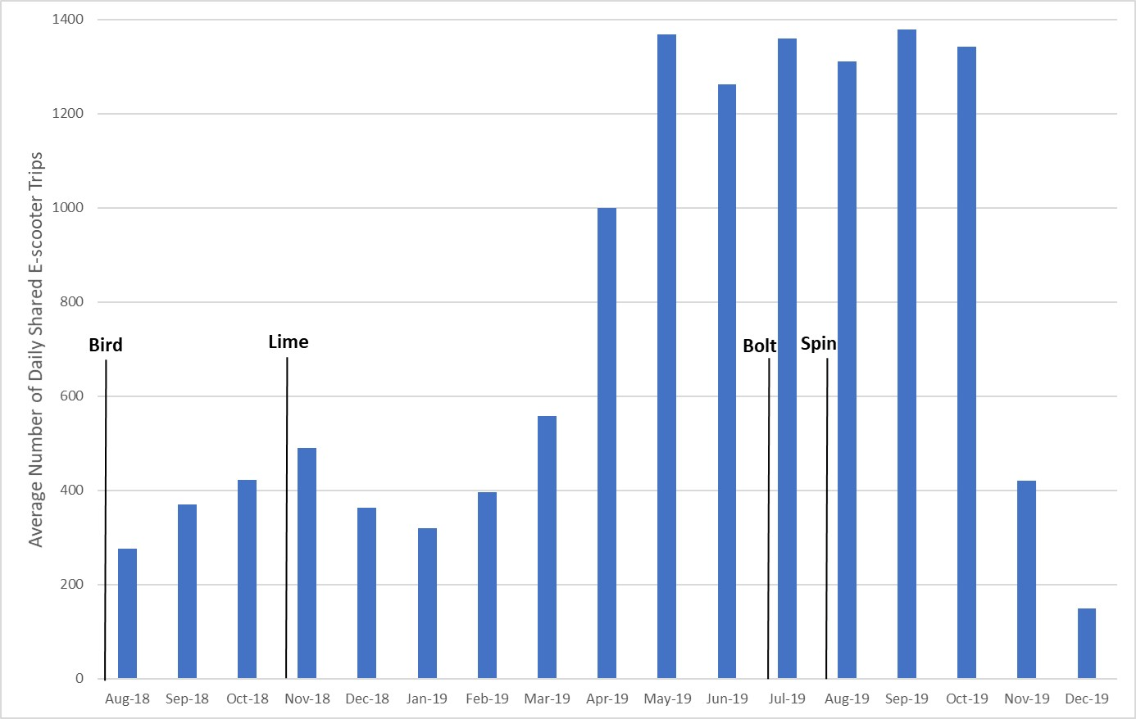
Figure ‎2.1: Average daily shared e-scooters trips for Louisville for the period August 2018 to December 2019

Other changes related to the transit system that could also potentially affect transit ridership, namely the implementation of the MyTARC smart card, were obtained from TARC press releases (Transit Authority of River City, 2018).

Shared e-scooters trip data
Shared e-scooter trip data were acquired from the publicly accessible Louisville Metro open data repository (Louisville Metro Open Data, 2020). The shared e-scooter trip file contained anonymized trip data from four shared e-scooters operators (Bird, Lime, Bolt, Spin) from August 2018 through December 2019. Each shared e-scooter trip contains a unique identifying number, trip start date, end date, time, and the latitude and longitude for the trip origin and destination. In addition, the Louisville Metro open data website has a shapefile for the designated shared e-scooter service area as shown in Figure ‎2.2. Figure ‎2.2 shows the shared e-scooters service area and TARC transit routes.
The shared e-scooter trip data were cleaned by implementing several filters related to trip viability. Shared e-scooter trips were deemed viable if their origin and destination both fell within the shared e-scooter service area and if the trips had a non-negative, non-zero trip duration or distance. Additionally, only trips of less than 80 minutes in duration and between 250 feet and 10 miles in distance were considered. These limits were selected to identify real trips and not data anomalies. Finally, shared e-scooter trips were limited to those with an average speed less than or equal to 15 mph (the maximum speed limit for shared e-scooters in Louisville), as an average speed higher than the maximum could be attributed to the shared e-scooter being activated on an alternate form of transport for rebalancing or other purposes. Of the approximately 501,000 original trips, 113,329 trips were removed due to these constraints, leaving 383,500 shared e-scooter trips. This represents 76.5% of the original shared e-scooter trips. Most of the removed trips (16.2% out of 23.5%) were trips with distance = 0, which may suggest that shared e-scooters were activated, but no trips were taken. Other cleaning criteria such as speed and duration resulted in removing a very small number of trips, ranging between 0.1% to 2.6% each. In the cleaned dataset, the average trip duration was about 14 minutes, and the average trip distance was 1.20 miles. More than 50% of shared scooter trips occurred between the hours of 12:00 and 18:00. Also, about 32% of shared e-scooters trips were taken on Saturday and Sunday, indicating a somewhat higher demand for shared e-scooters during weekends, especially compared to typical transit ridership patterns.
The cleaned shared e-scooter trip dataset and transit route shapefiles were then used to assign the shared e-scooter trips to the different transit routes, the process of which is described in Section ‎2.4.4

Other variables
This study also included other variables that affect transit ridership like population, employment, gender, age, race, and weather. Numerous prior studies have shown that these are some of the key factors that affect transit ridership; therefore, these variables were used to control for changes in the models presented in this paper (Berrebi and Watkins, 2020; Ngo, 2019; Taylor and Fink, 2013; Taylor et al., 2009). The 5-year American Community Survey (ACS) estimates were used to estimate population and employment (combined), race, age, and gender in the route catchment area. To estimate these variables at the route level, a buffer of 0.1 mile was created around bus routes and overlayed with census tracts. Then, census tracts that overlap with each route buffer were apportioned proportionally based on the overlapping area, assuming variables were uniformly distributed in the census tract.
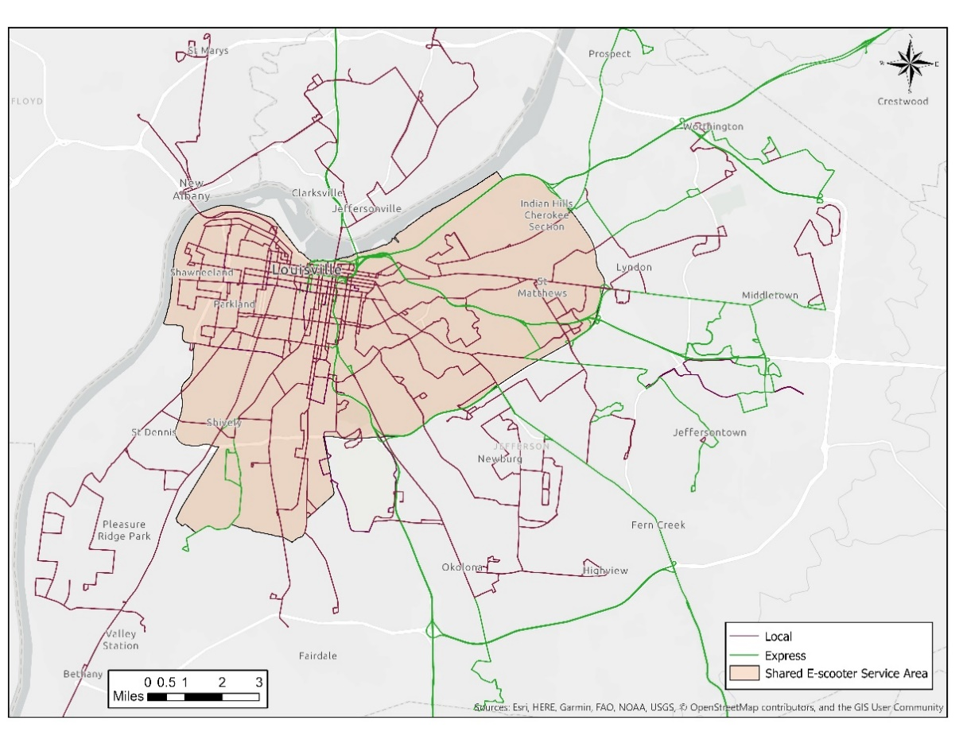
Figure ‎2.2: Shared e-scooters service area and TARC transit routes

Since the ACS estimates provides annual estimates; monthly estimates were generated using linear interpolation. This method has been successfully applied in other recent studies (Berrebi and Watkins, 2020; Diab et al., 2020).
Weather data that include rainfall and snowfall were obtained from National Oceanic and Atmospheric Administration. It should be noted that since there were only two available weather stations in the Louisville area and they were nearby each other, weather variables were defined at the city level. It is also worth noting that the bike-share system in Louisville (LouVelo) started operation in 2017 (Finley, 2017), which will be considered in the modeling approach as discussed in Section ‎0.

Assigning Shared E-Scooter Trips to Transit Routes
This section discusses the method used to assign shared e-scooter trips to transit routes for both local and express routes. First, a transit catchment area of 0.1 mile was defined around each bus route. The transit catchment area was defined as 0.1 mile for two reasons: first, shared e-scooters are dockless, and users could park them near their final destination, which, in this case, would be the bus stop. Second, the 0.1 mile radius of the catchment area reduced the number of trips that were assigned to more than one bus route due to overlapping bus route catchment areas in the downtown area. Then, using this catchment area and shared e-scooter trip origins and destinations, different variables were defined for each bus route using the Geopandas library in Python, as discussed in the remainder of this section.

Shared E-Scooter Trip Assignment to Express Bus Routes
The first research question of this study assesses the possibility that shared e-scooters increase ridership on express bus routes since they could serve as first/last mile connectors. In a complementary relationship between shared e-scooters and express bus routes, a rider could use a shared e-scooter to get to/from bus stops. Therefore, the shared e-scooters complement trip count was defined for express routes only to assess the first research question that shared e-scooters increase ridership on express bus routes.
A shared e-scooter trip was defined as complementary to an express bus route if the shared e-scooter trip origin was located within an express route bus stop catchment area during morning hours, or if the shared e-scooter trip destination was located within the catchment area during evening hours. It was assumed that a commuter exits the express bus downtown in the morning and then could begin a shared e-scooter trip for the last portion of their commute. In the afternoon, a commuter could ride a shared e-scooter from work to the express bus stop for the first portion of their evening commute, and then board the express bus for their trip home. Morning trips correspond to shared e-scooter trips whose start times were between 4:00 and 10:00, while evening trips correspond to shared e-scooter trips whose end times were between 13:00 and 20:00. The morning and evening hours were selected as they correspond to the hours of service for the TARC express bus routes. It should be noted that since express routes do not serve every stop along their path, the 0.1-mile catchment area was created only for the stops that are served by the express route and fall within the shared e-scooter service area.
Figure ‎2.3 presents an example of the shared e-scooter trip assignment method used for one day of trip data (August 10, 2018) for one express bus route (TARC Route 65 Sellersburg Express). The larger map shows the shared e-scooter trip data that falls within the express service time restrictions, as well as the path of the express route. The inset map shows express route stops with their catchment areas, as well as the shared e-scooter trip origins and destinations that fall within them. Six shared e-scooter trips originated within the catchment areas during morning express service hours, and 26 shared e-scooter trips ended within the catchment areas during afternoon/evening express service hours, implying that shared e-scooter trips could potentially complement up to 32 transit trips on this express route on this day.
Figure ‎2.4 shows a heat map of the average shared e-scooters complement trip count for TARC express routes. The average shared e-scooters complement trip count ranged between 40 and 79 trips per day. TARC express routes end with a similar loop in downtown Louisville, and many of the express routes serve the same stops, so the range was similar for most routes. It should be noted that the fact that many express routes serve the same stops is one of the limitations of this research design since the variability between shared e-scooters complement trip count for different express routes is limited.

Shared E-scooter Trips Assignment to Local Bus Routes
This section describes the shared e-scooter trip assignment method to local routes. The two variables defined to explore the complementary relationship between shared e-scooters and local bus routes are discussed first. Then, the variable defined to explore the competitive relationship between shared e-scooters and local bus routes is discussed.
The second research question of this study assesses the possibility that shared e-scooters increase ridership on local bus routes since they could serve as first/last mile connectors. In a complementary relationship between shared e-scooters and local bus routes, a rider could use a shared e-scooter to get to/from bus stops. Therefore, two variables were defined for local routes to assess the second research question. The first variable shared e-scooter first-mile connector trip count was defined as the number of shared e-scooter trips that have destinations within the bus route catchment area. This variable was used to evaluate the possibility that shared e-scooters are used as first-mile connectors from the trip starting point to a local bus stop. The second variable is the shared e-scooters last-mile connector trip count. This variable counts the number of shared e-scooter trips that have origins within a bus route’s catchment area. The assumption is riders could take a shared e-scooter from the bus stop to their final trip destination. This variable was used to evaluate the possibility that shared e-scooters are used as last-mile connectors from a local bus stop to the user’s trip endpoint.
The last variable defined for local routes was the shared e-scooter substitute trip count. This variable was defined to explore the third research question of this study: do shared e-scooters decrease ridership on local bus routes? Local bus routes were selected as the primary transit routes that could be impacted by competitive shared e-scooter usage as the bus stops are located every 0.1-0.25 miles throughout downtown Louisville. This is also the predominant location for shared e-scooter trips, and the majority of the shared e-scooter trips analyzed overlap with the bus routes. A shared e-scooter trip was considered a potential substitute for a transit trip if the trip distance was greater than 0.1 miles and both the shared e-scooter trip origin and destination were located within the catchment area for a specific local bus route. The total count of potential substitutionary shared e-scooter trips was determined for each local bus route for each day of the period of analysis.
Figure ‎2.5 presents an example of the shared e-scooter substitute trip count variable for one day of trip data (August 10, 2018) for one local bus route shown as the blue line (TARC Route 23 Broadway). In Figure ‎2.5, the orange line shows the catchment area for Route 23. The shared e-scooter trip origins are shown as red dots, and the destinations are shown as green dots in the figure. The full extent of the map shows the cleaned shared e-scooter trip origins and destinations in the service area, as well as the transit route catchment area.

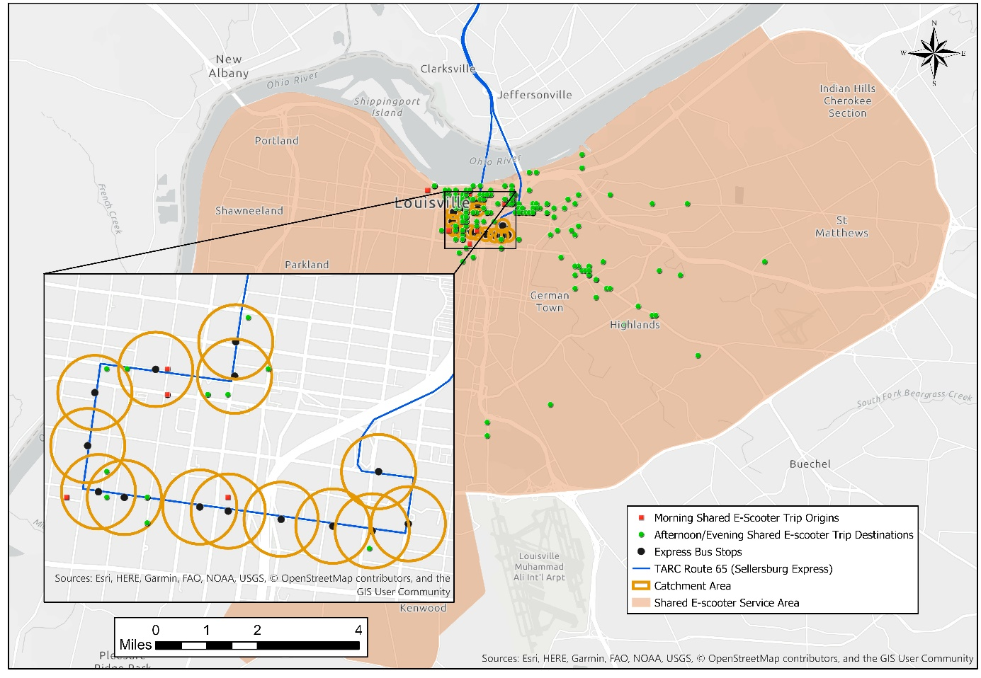
Figure ‎2.3: Example of shared e-scooter trips assignment to an express TARC transit route (Route 65 Sellersburg Express) for August 10, 2018

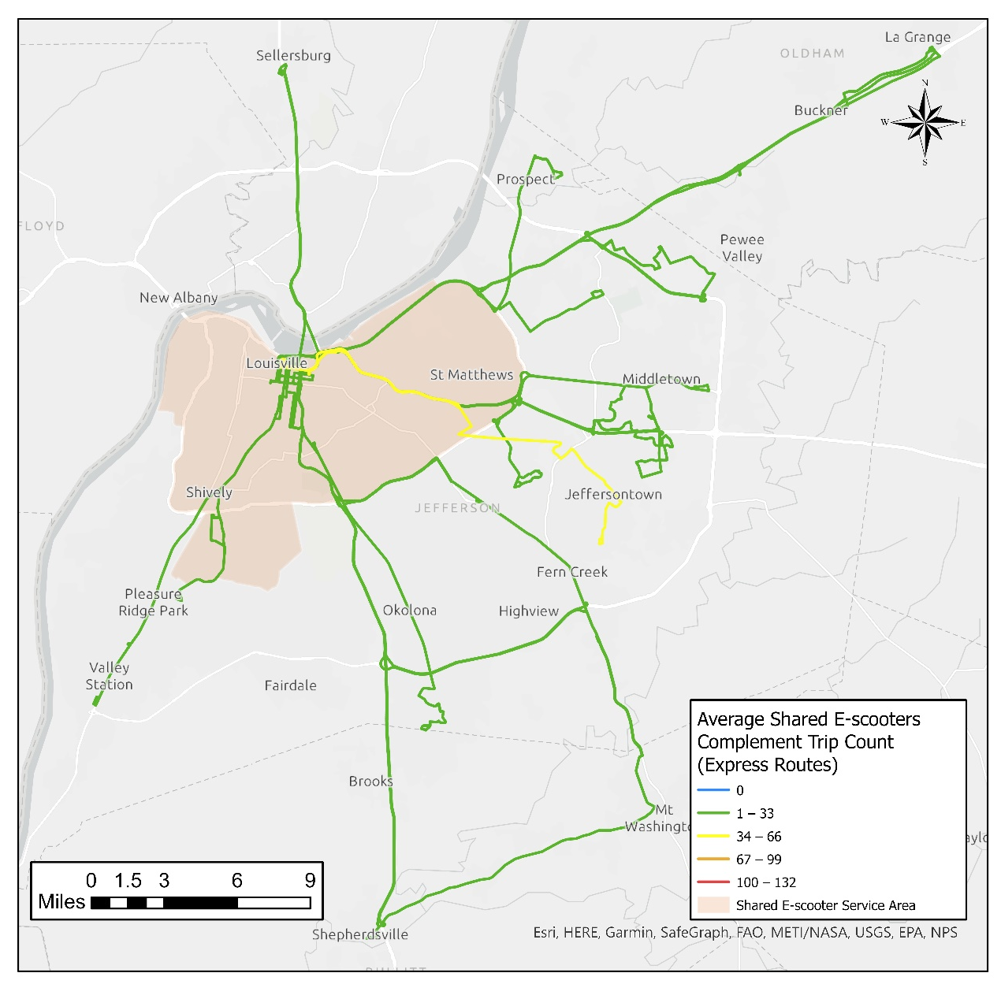
Figure ‎2.4: Heatmap of the average daily shared e-scooters complement trip count for each express TARC route for the period August 2018 to December 2019

The inset map shows the trips that would be counted for this day and route: the origin and destination for these 34 scooter trips (which are shown as “linked” in the inset) are both within the catchment area for the transit route, implying that these scooter trips could have replaced transit trips along this path.
Figure ‎2.6 summarizes the results of the shared e-scooter substitute trip count for local bus routes in the form of a heat map. The different colors in Figure ‎2.6 show the variation in the count of possible shared e-scooters trips along each route. Notably, the blue lines show routes that have no shared e-shared scooter substitute trips within their catchment area. These routes serve as a control group in the regression analysis.

Summary Statistics
Table ‎2.1 presents summary statistics for the different variables. First, the average bus ridership was 899 unlinked passenger trips per day per route, with ridership ranging from 1 to 9,632 unlinked passenger trips per day per route. Second, the average shared e-scooters complement trip count was 68 shared e-scooter trips per day per route, which represents about 7.5% of the average daily bus route ridership. Third, the average shared e-scooters substitute trip count was 44 shared e-scooter trips per day per route, which represents 5% of the average daily bus route ridership. The shared e-scooter first-mile connector trip count and shared e-scooter last-mile connector trip count had similar summary statistics. This is likely due to the fact that shared e-scooters trips in Louisville are typically short trips, and most of them occur downtown.

Modeling Framework
This section discusses the modeling approach used in this analysis. This study evaluated the research questions by estimating several fixed effects regression models of the change in route-level bus ridership as a function of the change in shared e-scooters trips within a catchment area near each route. The study period includes both the period before and after the shared e-scooters were introduced and controls for other important determinants of transit ridership. This basic approach has been successfully applied in the past to study the effect of traveler information on transit ridership and other determinants of changing transit ridership (Brakewood et al., 2015; Graehler et al., 2019a; Iseki and Ali, 2015).
The fixed effects regression equation is shown in Equation 1 (Studenmund, 2016). The dependent variable is bus unlinked passenger trips per route per day. The explanatory variables are vehicle revenue hours, shared e-scooter trip counts, and other external control variables like population and employment, income, and weather.

${⁡y}_{it}= {⁡x}_{it}*β + {α_{i}EF}_{i}+{ρ_{t}TF}_{t}+ε_{it}$ (1)

Where:
  - $y_{it}$: unlinked passenger trips for bus route i during time t (day)
  - $x_{it}$: explanatory variables for bus route i during time t (e.g., shared e-scooter trip counts, vehicle revenue hours, population and employment)
  - ${EF}_{i}$: entity fixed effect dummy, equal 1 for bus route i and 0 otherwise
  - ${TF}_{i}$: time fixed effect dummy, equal 1 for the t^{th} period and 0 otherwise
  - $ε_{it}$: error term
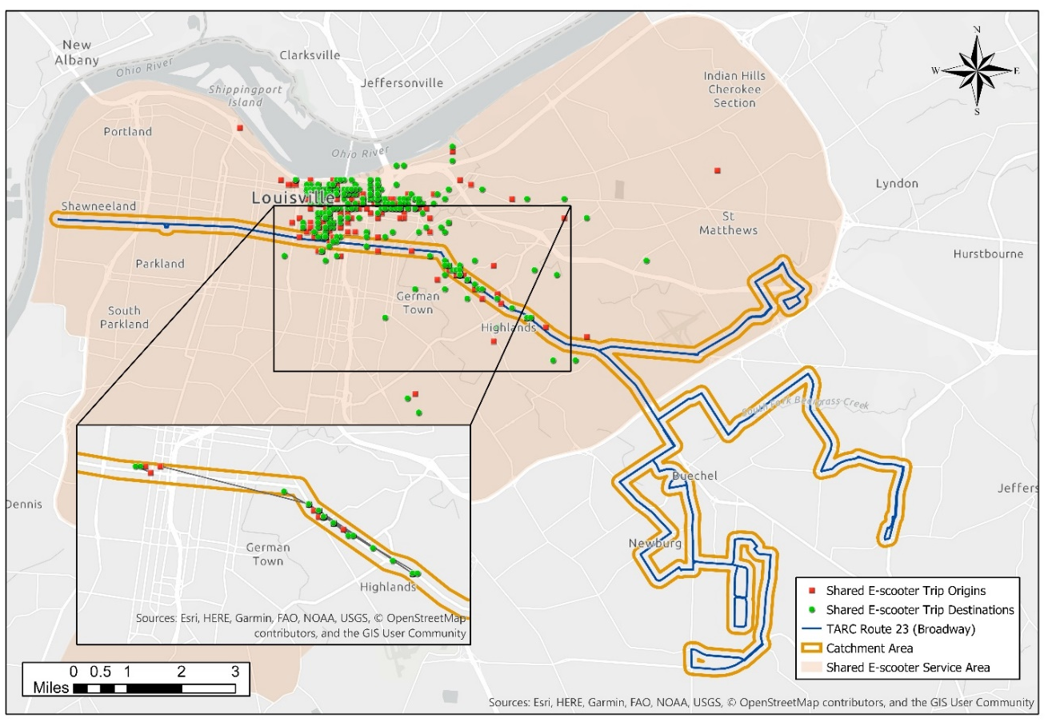
Figure ‎2.5: Example of the shared e-scooter substitute trip count (Route 23 Broadway) for August 10, 2018

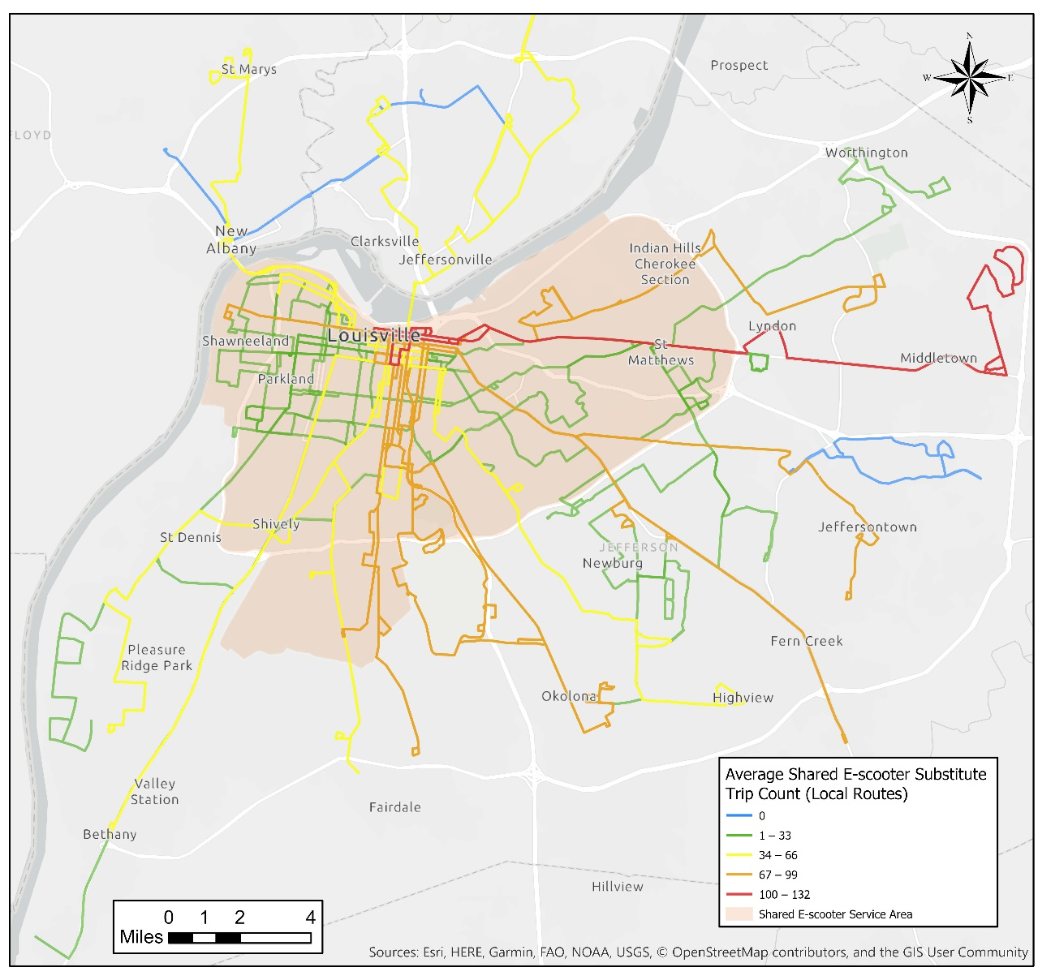
Figure ‎2.6: Heatmap of average shared e-scooters substitute trip count for each local TARC route for the period August 2018 to December 2019

Table ‎2.1: Summary Statistics
 | Variable | Temporal Unit | Min | Max | Median | Mean (Standard Deviation)
Dependent variable | Unlinked passenger trips ª | Daily | 1 | 9,632 | 293 | 899 (1,451)
Transit variables | Bus vehicle revenue hours (VRH) | Daily | 2.5 | 241 | 23 | 40 (60)
Shared e-scooters variables | Shared e-scooters complement trip count (express routes) | Daily | 0 | 276 | 54 | 68 (50)
Shared e-scooters variables | Shared e-scooter first-mile connector trip count (local routes) | Daily | 0 | 877 | 52 | 91 (107)
Shared e-scooters variables | Shared e-scooter last-mile connector trip count (local routes) | Daily | 0 | 894 | 53 | 94 (113)
Shared e-scooters variables | Shared e-scooters substitute trip count (local routes) | Daily | 0 | 607 | 21 | 44 (55)
Other variables | Population + employment | Monthly | 308 | 24882 | 10901 | 10569 (6776)
Other variables | Proportion female (%) | Monthly | 32.25 | 58.03 | 50.44 | 50.30 (3.23)
Other variables | Proportion white (%) | Monthly | 11.18 | 91.55 | 68.60 | 64.10 (15.98)
Other variables | Proportion above 65 years old (%) | Monthly | 2.70 | 20.38 | 13.45 | 13.49 (3.16)
Other variables | Rainfall ^{b} (mm) | Monthly | 0 | 218.69 | 70.90 | 77.97 (47.47)
Other variables | Snowfall ^{b} (mm) | Monthly | 0 | 241.30 | 0.00 | 16.45 (46.12)
ª Trips for a few routes were merged due to combined ridership counts.
^{b} For weather, citywide estimates were used.

This approach allows to model the change in transit ridership as a function of the change in explanatory variables. This focus on the change is important because its known that both transit ridership and shared e-scooter ridership are concentrated in the same areas—downtown and surrounding urban neighborhoods. This means that any cross-sectional regression model would show a high correlation between the two, but that correlation may be driven by the same favorable conditions rather than complementarity. The fixed effect term captures unobserved variables at the route level (such as serving a transit-favorable area), and more directly measures whether routes with a high number of competitive or complementary shared e-scooter trips change ridership at a different rate than other routes.
In addition to bus route fixed effects, this study also uses time fixed effects, which adds a dummy variable for each time period but one (Studenmund, 2016). The time fixed effects control for any unobservable variable at a specific date like special events as well as other systemwide changes like the launch of MyTARC app and the bike share system (Studenmund, 2016). It should also be noted that this study also estimated weekly and monthly models to explore the impacts of shared e-scooters on bus ridership over longer periods.
This study also used the clustered sandwich estimator to estimate cluster-robust standard errors (StataCorp LLC, 2017). The cluster-robust standard errors are robust to heteroskedasticity and serial correlation (StataCorp LLC, 2017; Wooldridge, 2012). This analysis was performed using Stata “xtreg” command.

Results and Discussion
This section discusses the results of this study. This section is divided into three parts. The first part seeks to answer the first and the second research questions: do shared e-scooters increase ridership on local and express bus routes? The second part assesses the first and the third research question: shared e-scooters increase ridership on express routes but decrease ridership on local routes? It should be noted that the third research question is discussed in both parts since the relationship between shared e-scooters and express routes could only be complementary. The final part discusses these results and their implications for practice.

Research Questions 1 & 2: Do Shared E-scooters Increase Ridership on both Express and Local Bus Routes?
Table ‎2.2 shows the results for the first and the second research questions – that do shared e-scooters increase ridership on both local and express bus routes. To answer these questions, different model specifications were estimated, as shown in Table ‎2.2. Models 1 and 2 present the results of the weekday models. Models 3 and 4 show the weekly models, followed by Models 5 and 6, which present the results of the monthly models. The expanded monthly models are presented by Models 7 and 8.
Models 1 and 2 in Table ‎2.2 show the weekday models, which used the daily unlinked passenger trips for Tuesday to Friday as the dependent variable and the VRH, the shared e-scooter counts for local and express routes as explanatory variables. The reason Monday data were excluded from this model is that TARC archives Monday and weekend ridership together. Models 1 and 2 also included route fixed effects and the day fixed effects. The route and the day fixed effects control for other unobservable variables not included in the model.
Model 1 evaluates the hypothesis that shared e-scooters may increase ridership on local bus routes as they serve as last-mile connectors, while Model 2 evaluates the hypothesis that shared e-scooters increase ridership on local bus routes as they serve as first-mile connectors. The results of these models show that both the shared e-scooter last-mile connector trip count and the shared e-scooter first-mile trip connector count are not significant predictors for bus ridership in Louisville, as indicated by the insignificant coefficients (-0.11) and (-0.12) in Models 1 and 2, respectively. This finding suggests that shared e-scooters are not increasing ridership on local bus routes in Louisville. Also, the results of both Models 1 and 2 indicate that bus VRH is a highly significant predictor for bus ridership, as indicated by the significant positive coefficient (33.3). Furthermore, both models show that the shared e-scooter complement trip count is a significant predictor of bus ridership as indicated by the significant positive coefficient (0.55). This coefficient indicates that every ten shared e-scooter trips occurring within the catchment area of an express bus route stop could potentially complement up to 5 express bus trips, holding all else constant. However, this result should be interpreted with caution, as discussed later in this section. Models 3 and 4 show the estimated weekly models with the same specification as the weekday model. This model was estimated since there is a high portion of shared e-scooter trips occurring on Saturdays and Sundays, which might have different impacts on bus ridership. However, the results of Models 3 and 4 are very similar to Models 1 and 2. Models 5 and 6 show monthly models with similar specification as Models 1 and 2. The motivation for the monthly models is daily ridership might have high variation due to different factors; therefore, a monthly model could yield more robust results. The results of Models 5 and 6 are also similar to Models 1 and 2, with a slightly higher estimation of the shared e-scooters complement trip count coefficient.
Models 7 and 8 in Table ‎2.2 include additional variables that affect transit ridership such as population, employment, gender, race, age, and weather. The results of Models 7 and 8 are consistent with Models 1-6; the shared e-scooters complement trip count is a significant predictor for express bus ridership. Models 7 and 8 also show that population and employment, as well as the proportion of females have a positive impact on ridership, which is consistent with prior findings. Models 7 and 8 also show that the proportion of residents above 65 years old have a positive impact on ridership, while the proportion of white residents have a negative impact on bus ridership. While these findings are in line with the results of some recent prior studies (Berrebi and Watkins, 2020; Dill et al., 2013), both variables are insignificant, which is likely due to the small change in these variables during the analysis period. Models 7 and 8 also show that rainfall and snowfall have significant negative impacts on bus ridership, which aligns with findings from prior studies (Brakewood et al., 2015; Ngo, 2019; Owen and Levinson, 2015).
The findings of Models 1-8 suggest that shared e-scooters do not have a significant effect on local bus ridership. They also suggest that e-scooters may increase ridership on express bus routes in Louisville. However, this result should be interpreted with caution. In Louisville, all express routes terminate in the same geographic area near downtown, which resulted in similar counts of shared e-scooter trip counts along all express routes (Figure ‎2.4). These similar counts limit the variability of this variable in the model, which is one of the limitations of this experimental design. Therefore, the relationship between express bus ridership and shared e-scooters requires further study.

Research Questions 1 & 3: Do Shared E-Scooters Increase Ridership on Express Bus Routes and Decrease Ridership on Local Bus Routes?
Table ‎2.3 shows the results of evaluating the first research question, “do shared e-scooters increase ridership on express bus routes?” and the third research question “do shared e-scooters decrease ridership on local bus routes?” To answer these questions, four different model specifications were estimated, as shown in Table ‎2.3. Models 9,10, and 11 used the same explanatory variables to estimate the weekday, weekly, and monthly models, respectively. Model 12 is an expanded version of the monthly model (Model 11), which includes additional explanatory variables such as population and employment, as well as gender, race, and weather. In Table ‎2.3, Model 9 shows VRH is a highly significant predictor for bus ridership, as indicated by the significant positive coefficient (33.3). Model 9 also shows that the shared e-scooter substitute trip count for local bus routes is not a significant predictor for bus ridership. This suggests that shared e-scooters are not decreasing ridership on local bus routes in Louisville. On the other hand, Model 9 indicates that the shared e-scooters complement trip count for express bus routes is a significant predictor for bus ridership, as indicated by the significant positive coefficient (0.61). This finding is consistent with Models 1-8, the findings from which are discussed in the previous section.
Models 10-12 use weekly and monthly bus ridership and shared e-scooter trip counts to evaluate the same research questions. The results of Models 10-12 are consistent with the findings of Model 9 that shared e-scooters are not reducing local bus ridership. Model 12 also shows similar estimates to Models 7 and 8 for population and employment, weather, and other demographic variables, as discussed in in the previous section.

Discussion and Implications for Practice
This study performed an empirical analysis to quantify the net impacts of the shared e-scooters on citywide bus ridership. The results of this study suggest that shared e-scooters do not have a significant impact on local bus ridership in Louisville. This finding could be explained by two factors. First, transit and shared e-scooters are typically used for different purposes. Transit in Louisville is mainly used for work and school; a recent survey indicates that 70% of TARC trips are for work and school (Copic, 2019). However, prior studies of shared e-scooter trip patterns indicated that shared e-scooters might not be used for commuting and are likely used for recreation (Caspi et al., 2020; Noland, 2019).
Furthermore, the difference in trip length between these modes also suggests these two modes are being used for different purposes. The average transit trip length in Louisville is 4.2 mile compared to 1.2 mile for shared e-scooters (NTD Transit Agency Profiles 2020). These different trip characteristics (both purpose and length) suggest that shared e-scooters are not used to replace transit trips in Louisville. Second, transit users in Louisville are typically minorities and have lower household income (Copic, 2019), which is likely different from typical shared e-scooter users, who are likely to be white and have higher household income, as suggested by surveys from other cities (Mobility Lab and Arlington County Commuter Services, 2019; San Francisco Municipal Transportation Agency, 2019). These demographics suggest that transit and shared e-scooters are likely used by different groups of riders, which might limit the interaction of these two modes.
This said, exploring the relationship between shared e-scooters and express bus routes in Louisville does suggest that shared e-scooters could increase ridership on express bus routes as first /last mile connectors. However, as discussed in Section ‎2.5.1, this finding should be interpreted with caution as the relationship between express bus ridership and shared e-scooters requires further study. However, transit agencies and shared e-scooters operators could explore ways to integrate these two modes to offer better service for their users. There are many ways that such an integration could occur, such as developing multimodal trip planning platforms and price bundling.

Table ‎2.2: Fixed Effects Regression Results (Models 1–8)
Dependent variable: unlinked passenger trips per route | (1)  Weekday Model | (2)  Weekday Model | (3)  Weekly Model | (4)  Weekly Model | (5) Monthly Model | (6) Monthly Model | (7) Expanded Monthly Model | (8) Expanded Monthly Model
Vehicle revenue hours (VRH) | 33.30***  (8.36) | 33.30***  (8.33) | 28.80***  (2.88) | 28.80***  (2.88) | 31.00***  (3.02) | 31.00***  (3.03) | 31.50***  (2.82) | 31.50***  (2.82)
Shared e-scooters complement trip count (Express routes) | 0.55**  (0.26) | 0.55**  (0.26) | 0.68**  (0.27) | 0.68**  (0.27) | 0.83***  (0.29) | 0.82***  (0.29) | 0.52*  (0.27) | 0.52*  (0.27)
Shared e-scooter last-mile connector trip count (local routes) | -0.11  (0.22) |  | -0.06  (0.17) |  | -0.13  (0.16) |  | -0.05  (0.17)
Shared e-scooter first-mile connector trip count (local routes) |  | -0.12  (0.22) |  | -0.06  (0.18) |  | -0.14  (0.17) |  | -0.05  (0.18)
Population and employment |  |  |  |  |  |  | 3.33* (1.78) | 3.33* (1.77)
Proportion female (%) |  |  |  |  |  |  | 871*** (269) | 871*** (269)
Proportion white (%) |  |  |  |  |  |  | -70.7 (76.2) | -70.7 (75.8)
Proportion above 65 years (%) |  |  |  |  |  |  | 613 (747) | 613 (746)
Rain fall (mm) |  |  |  |  |  |  | -31.9**  (15.1) | -31.9** (15.2)
Snow fall (mm) |  |  |  |  |  |  | -50.2***  (12.1) | -50.2***  (12.0)
Route fixed effect | Yes | Yes | Yes | Yes | Yes | Yes | Yes | Yes
Time fixed effect | Day | Day | Week | Week | Month | Month | Month | Month
R² | 0.255 | 0.255 | 0.576 | 0.576 | 0.616 | 0.616 | 0.634 | 0.634
N | 33081 | 33081 | 8521 | 8521 | 1968 | 1968 | 1968 | 1968
Clustered robust standard errors are shown in parenthesis. *p<0.10; **p<0.05; ***p<0.01

Table ‎2.3: Fixed Effects Regression Results (Models 9–12)
Dependent variable: unlinked passenger trips per route | (9)  Weekday Model | (10)  Weekly Model | (11)  Monthly Model | (12)  Expanded Monthly Model
Vehicle revenue hours (VRH) | 33.30***  (8.34) | 28.90***  (2.88) | 31.00***  (3.03) | 31.5***  (2.82)
Shared e-scooters complement trip count (Express routes) | 0.61**  (0.27) | 0.61**  (0.24) | 0.86***  (0.29) | 0.53*  (0.27)
Shared e-scooters substitute trip count (Local routes) | -0.07  (0.43) | -0.06  (0.31) | -0.19  (0.30) | -0.06  (0.30)
Population and employment |  |  |  | 3.33*  (1.79)
Proportion female (%) |  |  |  | 871.00***  (266.00)
Proportion white (%) |  |  |  | -70.7  (74.5)
Proportion above 65 years old (%) |  |  |  | 613  (746)
Rain fall (mm) |  |  |  | -31.90**  (14.5)
Snow fall (mm) |  |  |  | -50.20***  (12.00)
Route fixed effect | Yes | Yes | Yes | Yes
Time Fixed Effect | Day | Week | Month | Month
R² | 0.256 | 0.576 | 0.616 | 0.634
N | 33081 | 8521 | 1968 | 1968
Clustered robust standard errors are shown in parenthesis. *p<0.10; **p<0.05; ***p<0.01

Areas for Improvement and Future Research
There are several areas for improvement and future research that emerged from this study. The first area for improvement of this study is related to the experiment design and the process of attributing shared e-scooter trips to specific transit routes. Since many of the TARC transit routes overlap in the downtown area where there is the highest concentration of shared e-scooter trips, some shared e-scooter trips fall within the catchment areas of multiple routes, particularly for express bus routes. This resulted in double-counting some shared e-scooters trips and is why multiple express routes have similar shared e-scooter counts. The second area for improvement is using an infrastructure-based measure to explore the impact of shared e-scooters on transit ridership. This study used shared e-scooter trip data to explore the impact of shared e-scooters on transit ridership. Future studies should use infrastructure-based measures like the availability of shared e-scooter vehicles near bus routes instead of trips. Using an infrastructure-based measure could possibly eliminate the potential endogeneity that that could arise if some shared e-scooter trips were taken as a result of some e-scooter users choosing not to ride the bus because of bus crowdedness. The third area of improvement is to explore the impact of shared e-scooters on transit on weekends. This study did not explicitly explore the impact of shared e-scooters on weekends due to transit data limitations. Shared e-scooters are very popular on weekends while a lower level of transit service is provided on weekends; therefore, shared e-scooters impacts on weekend transit ridership might be different from that of weekdays. Another area for improvement is related to using fixed effects techniques. This study applied fixed effects for all bus routes. This approach is good for the internal validity of the model; however, it limits the external validity of the model (Hill et al., 2020). Future studies, particularly those focused on prediction, might consider different methods to address concerns about external validity.
There are also numerous areas for future research that emerged from this study. The first area is conducting a survey of express routes riders to explore how shared e-scooters are used by the riders of this group of bus routes. This study showed that shared e-scooters might be used by express bus riders as first/last mile connectors; however, a survey of express bus riders is recommended to validate this finding. The second area for future research is exploring the impact of shared e-scooters on transit in other cities with different sized transit system. This study explored only Louisville, which has a relatively small transit system. The third area for future research would be exploring the impact that shared e-scooters have on rail ridership. This is particularly important since the findings of this study suggest that shared e-scooters could complement express bus routes, which are similar to longer trips associated with rail. An additional area for future research is related to Mobility as a Service (MaaS) in Louisville. TARC is now offering multimodal trip planning through their mobile application as a step towards implementing MaaS. Future studies could explore how this multimodal trip planning application affects transit ridership in Louisville. Research into MaaS could also explore how transit and shared e-scooters could be integrated to offer better accessibility for cities.

Conclusions
As shared e-scooters are gaining popularity in the United States, their impacts on transit ridership are still largely unknown. It is possible that shared e-scooters increase transit ridership by solving the first-mile/last-mile problem, or they decrease transit ridership by substituting for transit trips, or some combination of these two occurs. This study conducted an empirical analysis to quantify the impacts of shared e-scooters on bus ridership using Louisville, Kentucky as a case study. This study estimated different fixed effects regression models to evaluate three research questions about the impact of shared e-scooters on bus ridership: First, do shared e-scooters increase ridership on express bus routes? Second, do shared e-scooters increase ridership on local bus routes? Third, do shared e-scooters decrease ridership on local bus routes?
The results of this study indicate that shared e-scooters do not have a significant impact on local bus route ridership. Overall, this implies that shared e-scooters are not one of the reasons for the recent decline of local bus ridership. On the other hand, exploring the relationship between shared e-scooters and express bus routes in Louisville suggests that every ten shared e-scooter trips occurring within the catchment area of an express bus route stop could potentially complement up to 5 express bus trips. This finding suggests that shared e-scooters could increase ridership on express bus routes as they serve as first /last mile connectors; however, this finding should be interpreted with caution, and further research on the relationship between express bus ridership and shared e-scooters is recommended.
The findings of this study indicate that shared e-scooters do not have a negative impact on bus ridership in Louisville and that they could potentially help agencies address first/last mile connections to transit. These findings are important for Louisville and other similar cities across the United States as they help explore the causes of the recent decline in bus ridership nationwide. Additionally, these findings may encourage transit and shared e-scooters operators to explore new ways to integrate these two modes of transport to improve accessibility in the future.

CHAPTER III: COMPLEMENT OR COMPETE? THE EFFECTS OF SHARED ELECTRIC SCOOTERS ON BUS RIDERSHIP

A version of this chapter was originally published in Transportation Research Part D: Transport and Environment:

Ziedan, A., Shah, N. R., Wen, Y., Brakewood, C., Cherry, C. R., & Cole, J. (2021). Complement or compete? The effects of shared electric scooters on bus ridership. Transportation Research Part D: Transport and Environment, 101, 103098.

Author Statement
Abubakr Ziedan: Conceptualization, Data curation, Formal analysis, original draft; Nitesh Shah: Software, Visualization; Original draft; Yi Wen: Conceptualization; Original draft; Candace Brakewood: Conceptualization; Review & Editing, Project administration, Funding acquisition; Christopher Cherry: Validation, Review & Editing, Funding acquisition; Justin Cole: Resources; Review & Editing

Abstract
The rapid onset of shared electric scooters (e-scooters) has raised questions about their effects on other transportation modes, particularly sustainable modes such as transit. Existing literature concerning the impacts of e-scooters on transit ridership showed that e-scooters could both compete or complement transit. However, prior studies did not differentiate by e-scooter trip purpose. This study aims to fill this gap using Nashville, Tennessee, as a case study. The results of modeling more than 1.4 million e-scooter trips suggest that on a typical weekday, utilitarian e-scooter trips are associated with a 0.94% decrease in bus ridership. However, social shared e-scooter trips are associated with weekday bus ridership increases of 0.86%. The net effect of e-scooters on weekday bus ridership is estimated to be -0.08%, which is nearly zero. These findings can help inform city planners as they integrate micromobility into urban transportation systems.

Introduction
The use of shared micromobility devices such as bicycles, electric bicycles (e-bikes), and electric scooters (e-scooters) has flourished in recent years. In 2018 alone, more than 38 million shared e-scooter trips have been recorded in the United States (NACTO, 2019). This number of shared e-scooter trips continued to increase to reach more than 88 million trips in 2019 (NACTO, 2020). The term shared e-scooters refers to an ultra-lightweight, standard width, low-speed electric standing scooters that carry one rider, according to the SAE International J3194 standard (SAE International, 2019). With the rapid emergence of shared e-scooters, there is limited understanding of how this new mobility option affects existing transportation modes such as driving, walking, biking, and transit. This study will focus on exploring their impact on transit ridership.
The impacts of shared e-scooters on transit ridership could be competitive or complimentary. In a competitive relationship, shared e-scooters would substitute transit trips resulting in a decline in transit ridership. In a complementary relationship, shared e-scooters would increase the accessibility of transit by serving as a first- and last-mile connection. Some prior studies have explored the impacts of shared e-scooters on bus ridership in Indianapolis and Louisville (Luo et al., 2021a; Ziedan et al., 2021). However, prior studies have used shared e-scooter trip data to evaluate the impact of shared e-scooters based on the number of trips, trip origins, and/or trip destinations. However, these trip-based measures focused on the demand of shared e-scooters and did not consider shared e-scooters supply, which could be captured by data pertaining to shared e-scooter vehicle locations and will be used in this study as an infrastructure-based measure. Infrastructure-based measures can be used to evaluate current deployment strategies of shared e-scooters to see if they directly impact transit ridership. Infrastructure-based measures can also reduce concerns about endogeneity, as detailed in the literature review section.
Also, the trip-based measures used in prior studies did not differentiate between shared e-scooter trip purpose impacts on transit ridership; this is particularly important because prior surveys have shown that shared e-scooters could both compete and complement transit (Baltimore City DOT, 2019; Portland Bureau of Transportation, 2019; San Francisco Municipal Transportation Agency, 2019; The City of Atlanta 2019; The City of Chicago, 2020). Differentiating between shared e-scooter trips based on purpose could help understand which shared e-scooters trips complement transit and which of them compete with transit
Therefore, this analysis aims to assess the impacts of shared e-scooters on bus ridership using infrastructure-based measures to explore the impact of shared e-scooter supply on bus ridership and to differentiate between the impact of shared e-scooter trips based on their purpose. To the best of the authors’ knowledge, these two concepts have not been evaluated in the prior literature.
The chapter structure is as follows: existing literature on how shared e-scooters affect transit ridership is summarized in the following section. Next, the study background and data description are presented. Then, the research design and modeling framework of this study are detailed in the methodology section and followed by the results and discussion section. Next, areas for improvement and future research directions are provided. The last section of the paper concludes with key findings and provides policy recommendations.

Literature Review
Prior studies used two methodological approaches to assess the impact of shared e-scooters on transit. The first group of studies conducted user surveys and the second group used empirical, econometric methods. This section provides a summary of both types of prior studies, beginning with the results of survey-based studies
The first group of studies was user surveys mostly conducted by municipalities where shared e-scooters operate. Surveys of shared e-scooters users were conducted to explore how riders are using this novel mode of transportation. A summary of the findings of user surveys in different cities around the United States is shown in Table ‎3.1 and discussed briefly below.
The findings of the surveys summarized in Table ‎3.1 reveal that some riders used shared e-scooters to connect to or from transit with different rates in different cities. In San Francisco, for example, 34-39% of survey participants indicated that they use shared e-scooters to connect to transit (Lime, 2018; San Francisco Municipal Transportation Agency, 2019). Furthermore, 28% of shared e-scooter users reported that they would not have used transit without a shared e-scooter as they used shared e-scooter as a connection to transit (San Francisco Municipal Transportation Agency, 2019). A similar percentage was also reported in Chicago, with 34% of the respondents using shared e-scooters to connect to or from transit (The City of Chicago, 2020). However, lower percentages of survey respondents combined shared e-scooters with transit in Arlington County, Denver, Portland, Tucson, and Baltimore, as shown in Table ‎3.1.
Similarly, a study that focused on students’ usage of shared e-scooters at the Virginia Tech campus in Blacksburg, VA, showed that 7% of riders use shared e-scooters to connect to transit (Buehler et al., 2021). On the other hand, the survey results also showed that some shared e-scooter users replaced transit with shared e-scooters. Table ‎3.1 shows that the percentage of respondents who would have taken transit without a shared e-scooter ranged between 2% to 13%. In addition, shared e-scooters could have an influence on travel behavior; for example, some shared e-scooters users stated that they reduced their frequency of transit use. For example, 31% of the survey respondents in Santa Monica (City of Santa Monica, 2019) and 22% of the survey respondents in Chicago reported that they rode transit less after shared e-scooters were introduced in the city (The City of Chicago, 2020).
The findings of these surveys seem to favor the complementary relationship between shared e-scooters and transit, which is suggested by higher percentages of survey respondents reporting that they are using shared e-scooters to connect to transit than replacing transit. However, it should be noted that these user surveys do not typically differentiate between frequent riders and casual riders of these two modes; therefore, the net impact of shared e-scooters on transit ridership cannot be quantified from existing survey-based studies. Furthermore, survey results could also be subjected to different biases like non-respondent bias, recall bias, or social desirability bias, which could impact the results (Catalogue of Bias Collaboration et al., 2017; Choi and Pak, 2005; Sackett, 1979).
The second group of studies used empirical, econometric approaches to examine the relationship between the use of shared e-scooters and transit. Using a negative binomial regression model, Bai and Jiao found that access to transit is positively correlated with shared e-scooter use in Austin and Minneapolis (Bai and Jiao, 2020). Another study in Austin using negative binomial regression models found that the presence of transit stations is associated with an increase in the usage of shared e-scooters (Jiao and Bai, 2020). A study of Louisville found that accessibility to transit, defined as the density of bus stops, also shows a positive correlation with shared e-scooter use (Hosseinzadeh et al., 2021). Using univariate linear regression, Lu et al. found that shared e-scooters trips are positively correlated with transit trips in the city center in Austin but negatively correlated outside of the downtown area (Lu et al., 2021). However, Lu et al. did not estimate and quantify the impact of shared e-scooters on transit ridership. These studies investigated the direct relationship between shared e-scooter use and transit ridership.
The most relevant prior studies were conducted by Luo et al. (Luo et al., 2021a) and Ziedan et al. (Ziedan et al., 2021). Luo et al. conducted spatial-temporal analysis and estimated difference-in-difference models to explore shared e-scooter impacts on transit ridership in Indianapolis (Luo et al., 2021a). Luo et al. concluded that 27% of shared e-scooter trips could compete with transit, while 29% of them could complement transit in Indianapolis. Luo et al. also found that competing transit trips resulted in ridership reduction. Ziedan et al. used fixed-effects regression to explore the impacts of shared e-scooters on bus ridership in Louisville (Ziedan et al., 2021). Ziedan et. al found that shared e-scooters did not have a significant impact on local bus ridership, and but might have a small positive impact on express bus routes ridership in Louisville.
After reviewing these prior studies, two gaps in the literature were identified. First, prior studies from Indianapolis and Louisville used only trip-based measures and did not consider infrastructure-based measures to explore shared e-scooters supply (Luo et al., 2021a; Ziedan et al., 2021). However, trip-based measures could be impacted by endogeneity; as an example, some bus riders could choose to ride shared e-scooters because of bus crowding, as suggested by a prior study that explored the impacts of bikesharing on bus ridership, which is another form of micromobility (Campbell and Brakewood, 2017). Second, prior studies assumed all shared e-scooter trips within the transit service area have the same impact on bus ridership regardless of their trip characteristics (i.e., all shared e-scooter trips will either increase or decrease bus ridership). This assumption allows for analysis of the net impact of shared e-scooters but does not differentiate between shared e-scooter impacts based on trip purpose, which is expected to affect people’s preferences towards using shared e-scooters (Baek et al., 2021). This study aims to fill these two gaps in the literature. This study first evaluates the impacts of shared e-scooters on bus ridership using infrastructure-based measures to explore the impact of shared e-scooter supply on bus ridership. Next, this study differentiates between the impact of shared e-scooter trips based on their purpose as findings from user surveys suggested riders use shared e-scooters for different trip purposes. To achieve this, this study utilized high resolution unaggregated shared e-scooter device and trip datasets and daily route-level bus ridership data, which allow for a detailed exploration of the impact of shared e-scooters on bus ridership in Nashville, Tennessee.

Background
This section provides background information about the period of analysis, transit and shared e-scooter services in Nashville, and the data used to carry out this analysis.

Period of Analysis
This analysis evaluates bus ridership in Nashville, Tennessee, from March 2016 to July 2019 to explore the impacts of shared e-scooters on bus ridership. This study period was selected because no major service changes occurred for the WeGo bus system during this period that could affect the analysis. It is also important to note that this study period is prior to the COVID-19 pandemic in the United States.

Transit in Nashville, Tennessee
WeGo Public Transit (formally known as Nashville Metropolitan Transit Authority) is the regional public transportation provider for the Nashville metropolitan area, which has an estimated population of 1.9 million residents (U.S. Census Bureau: American Community Survey, 2020). WeGo provided about 10 million unlinked passenger trips (UPT) in 2018, with an average of about 32,000 UPT per weekday (NTD Transit Agency Profiles 2020). During the analysis period, the transit system in Nashville consisted of 56 fixed route bus routes that included local bus routes, express service routes, and park-and-ride routes (Open Mobility Data, 2019). For this study, only local bus routes were considered (40 routes). The express bus routes and park-and-ride routes were excluded since these routes have different trip characteristics than shared e-scooters; for example, express route trips are usually long and start in the outlying suburbs, which are outside e-scooter service area. It is worth noting that WeGo raised the bus fare from $1.70 to $2.00 in August 2019 (WeGO Public Transit, 2019b) and did a major service change for their system in September 2019 (WeGO Public Transit, 2019a). However, these two changes are not expected to affect the findings of this study since the period of the analysis ends before these changes (July 2019).

Table ‎3.1: Summary of Shared E-scooter User Surveys’ Findings
Survey Location | Sample Size | Findings about the Impact of Shared E-scooters on Transit
Arlington County, VA  (Mobility Lab, 2019) | 1,066 | - 18% of shared e-scooter users used shared e-scooters primarily to access bus transit  - 3% of shared e-scooter users would have taken bus transit without a shared e-scooter
Atlanta, GA  (The City of Atlanta 2019) | 2,640 | - 2% of survey respondents would have used transit without a shared e-scooter
Baltimore, MD  (Baltimore City DOT, 2019) | 5,283 | - 4% of the respondents are using shared e-scooters as a connecting mode to/from transit
Bloomington, IN  (City of Bloomington) | 56 | - 7% of shared e-scooter users would have taken transit without a shared e-scooter
Chicago, IL  (The City of Chicago, 2020) | 12,446 | - 34% of shared e-scooter users reported connecting to or from transit as a trip purpose  - 10% of shared e-scooter users would have taken bus transit without a shared e-scooter
Denver, CO  (Denver Department of Public Works 2019) ª | 959 shard e-scooter users;  83 e-bike users | - 9% of shared e-scooter users reported using shared e-scooters to connect to or from transit as a top three trip type  - 7% of shared e-scooter and e-bike users would have taken transit without a shared e-scooter
Hoboken, NJ  (The City of Hoboken 2019) | Varies across questions | - 13% of shared e-scooters users would have used transit without a shared e-scooter (N=1,391)  - 72% of survey respondents agreed that shared e-scooters helped connect to transit (N=2,087)
Norfolk, VA  (The City of Norfolk 2020) | Varies across questions | - 3% of survey respondents would have used transit without a shared e-scooter (N=670)  - 7% of survey respondents chose transit stops as one of their destinations of a shared e-scooter trip (sample size unspecified)
San Francisco, CA ^{b}  (Lime, 2018) | Varies across questions | - 39% of shared e-scooter users combined e-scooter with transit (N=600)  - 34% of shared e-scooter users would have used transit without a shared e-scooter (N=617)
San Francisco, CA  (San Francisco Municipal Transportation Agency, 2019) | N.A. | - 11% of shared e-scooter users would replace transit trips with shared e-scooters  - 34% of shared e-scooter users used shared e-scooters to connect to or from transit  - 28% of shared e-scooter users would not have used transit without a shared e-scooter
Santa Monica, CA ª  (City of Santa Monica, 2019) | 3,130 | - 4% of shared e-scooter and e-bike users would have taken transit without a shared e-scooter or e-bike  - 4% of shared e-scooter and e-bike users used transit to access a shared e-scooter
Tucson, AZ  (The City of Tucson, 2020) | 2,074 | - 3% of survey respondents would have used transit without a shared e-scooter  - 5% of e-scooter riders used shared e-scooters to connect to or from transit
Portland, OR  (Portland Bureau of Transportation, 2019) | 3,444 residents;  1,088 visitors | - 10% of resident shared e-scooter users would have taken transit without a shared e-scooter  - 4% of resident shared e-scooter users took transit to access a shared e-scooter  - 18% of visitor shared e-scooter users used a shared e-scooter to access transit  - 4% of visitor shared e-scooter users would have taken transit without a shared e-scooter
ª These surveys include both shared e-scooter and e-bike users
^{b} This survey was performed by the company Lime in San Francisco. It includes only Lime riders

Shared E-scooters in Nashville, Tennessee
In May 2018, the company Bird introduced 100 shared e-scooters in Nashville without permission from the city government, which resulted in a ban for shared e-scooter operations by the city of Nashville. The city of Nashville later launched a shared e-scooters pilot program that regulated e-scooters operations. Several companies were awarded permits to deploy shared e-scooters in specific service areas, mainly around the downtown. From September 2018 to July 2019, seven companies operated shared e-scooters in the city of Nashville. An early report by Walk Bike Nashville indicated that between May 2018 to May 2019, more than 1.8 million shared e-scooter trips took place in the city of Nashville (Walk Bike Nashville, 2019), with approximately 5,000 trips on an average day. This high number of daily e-scooter trips shows that shared e-scooters are popular in Nashville, making it a good case study to explore their impacts on bus ridership.

Data
This study used data from different sources to explore shared e-scooter impacts on bus ridership, as discussed in this section. First, transit data are discussed, followed by shared e-scooter data. Then other variables used as control variables in the models presented later in this study are discussed.

Transit Data
The dependent variable in this study is bus ridership, which is measured as daily unlinked passenger trips per route (UPT). The level of transit service provision per route is one of the key determinants of transit ridership (Taylor et al., 2009). Therefore, vehicle revenue miles per route (VRM) were used in the study as a measure of transit service provision. These two variables were obtained directly from the transit operator WeGo through a data request. The geographic locations of bus stops and routes were obtained from the General Transit Feed Specification (GTFS) for WeGo from the website Open Mobility Data (Open Mobility Data, 2019).

Shared E-Scooter Data
During the analysis period, seven shared e-scooter operators were permitted to provide service in Nashville, Tennessee. Two datasets related to e-scooters were obtained through a data request from the Nashville MPO, which will be referred to as the device availability dataset and the trip summary dataset hereafter.
The device availability dataset included information about each e-scooter when it was in operation. Notably, it contained the latitude and longitude information of each device, and these coordinates were updated every five minutes. This dataset was used to calculate the number of available shared e-scooters in proximity to each bus route, as will be described in section ‎3.5.1.1.
The trip summary dataset included each e-scooter trip start time, end time, trip distance, and trip duration. It also contained disaggregated trip start and trip end GPS locations and the GPS trace of each trip. The shared e-scooter trip summary dataset had 1,438,832 trip records between September 1, 2018, and July 31, 2019. Outlier trip summary records were cleaned using the following criteria:
- Trips with missing values were removed.
- Trips with the same origin and destination GPS location value or zero trip distance calculated from the GPS trace data were removed or with less than three GPS data points were removed.
- Trips that were less than 60 seconds or greater than 120 minutes were removed.
- Trips that have zero distance or longer than ten miles were removed.
- Trips that were shorter than the Euclidean distance were removed. The Euclidean distance is the straight-line distance between trip origin and destination.
- Trips with an average speed higher than 15 MPH were removed, which is the maximum speed for e-scooters in the city of Nashville.
The data cleaning process resulted in removing about 33% of the shared e-scooter trips, leaving 963,503 valid shared e-scooter trips for the following analysis.

Other Data Sources
This study also included other variables that may impact bus ridership like population, employment, and weather (Brakewood et al., 2015; Taylor et al., 2009; Watkins et al., 2021; Zhou et al., 2017). The population data were obtained from the U.S. Census Bureau, which provides citywide annual population estimates. For this analysis, monthly estimates were generated using linear interpolation. The employment data were obtained from the Bureau of Labor Statistics, which provides monthly estimates of employment. The weather data were collected from the National Oceanic and Atmospheric Administration (NOAA). Average temperature and total snowfall per month were used in this study to control for weather impacts on bus ridership.

Methodology
This section presents the methodology used for this analysis. First, the research design and hypotheses are described. Next, summary statistics of the relevant datasets are presented, and this is followed by the modeling framework of this study.

Research Design and Hypotheses
This study used a three-part methodology to assess the impacts of shared e-scooters on bus ridership in Nashville, Tennessee. The first part used an infrastructure-based measure to evaluate the impact of shared e-scooters on bus ridership. The second used trip-based measures and assessed different hypotheses for the primary use of shared e-scooters around transit. The third part also used trip-based measures but assumed shared e-scooters impacts on bus ridership vary based on the e-scooter trip purpose.

Part 1: The Impacts of Shared E-scooters Availability on Bus Ridership
This part of the analysis evaluated the impacts of shared e-scooters on bus ridership using an infrastructure-based measure. The rationale behind using an infrastructure-based measure is that it could eliminate potential endogeneity concerns; for example, some bus riders may choose to ride shared e-scooters because of bus crowding, as suggested by a prior study that explored the impacts of bikesharing on bus ridership, which is another form of micromobility (Campbell and Brakewood, 2017). Furthermore, an infrastructure-based measure could be useful for operators to facilitate planning and operations, such as where to locate shared e-scooter in relation to bus routes. The infrastructure-based measure used in this analysis was the number of shared e-scooters devices available within the bus route catchment area (0.1-mile). This part of the analysis explored the following hypothesis:
H₁: the number of shared e-scooter available within the bus route catchment area affects bus ridership.
A catchment area of 0.1-mile was selected for two reasons. First, shared e-scooters are dockless, meaning that users can ride/park them almost anywhere. Also, a recent study has suggested that 0.1-mile is a reasonable walking distance for riders to access shared e-scooters (Reck et al., 2021). Also, another prior study that explored the impact of free-floating bikesharing (the most similar micromobility mode to shared e-scooters) on transit ridership used a catchment area of 50 meters (0.031 miles) (Ma et al., 2019). Second, the shared e-scooters data (both shared e-scooter availability and trip data) were highly precise and not aggregated. This high precision of the data allowed for detailed exploration of the impacts of shared e-scooters devices/trips on nearby transit routes. It should be noted that some prior studies have used disaggregated e-scooter data with high spatial precision (McKenzie, 2019; Merlin et al., 2021; Younes et al., 2020); however, this type of disaggregated data has not been previously used to study the relationship between e-scooter and transit trips. The prior studies that explored the impact of shared e-scooters on bus ridership in Indianapolis and Louisville used aggregated shared e-scooter trip data (Luo et al., 2021a; Ziedan et al., 2021).
Using this catchment area and shared e-scooter device locations, the number of unique available e-scooter devices was calculated for each bus route for each day using the spatial join of the catchment area and shared e-scooter device location in the “Geopandas” library in Python, as demonstrated in Figure ‎3.1. In Figure ‎3.1, the purple line represents a bus route, the light-yellow area shows the bus catchment area, green e-scooter icons represent shared e-scooter devices within the bus catchment area, and red e-scooter icons represent shared e-scooter devices outside the bus catchment area.

The Impacts of Shared E-scooters Trips on Bus Ridership
Findings of prior surveys showed that some shared e-scooter riders used to connect to transit while others used them to replace transit (San Francisco Municipal Transportation Agency, 2019; The City of Chicago, 2020). However, as those prior findings did not consider the frequency of connecting to/replacing transit, it is not clear if shared e-scooters are mainly used to connect to transit or replace transit rips. Therefore, this part of the analysis assessed four different hypotheses (H₂-H₅) for the primary use of shared e-scooters around transit. Each of these four hypotheses explored a different scenario about the dominant use of shared e-scooters around transit.

Shared e-scooters connect to transit
This section investigated the hypothesis (H₂) that shared e-scooters are primarily used to connect to transit as first mile connectors, assuming users could ride a shared e-scooter from their trip start to a bus stop. Therefore, the number of shared e-scooter trips that ended (trip destination) within the bus route catchment area could increase bus route ridership.
H₂: the number of shared e-scooter trips that ended (trip destination) within the bus route catchment area increases bus ridership.
To evaluate this hypothesis, the variable ‘shared e-scooter destinations’ was defined, which counts the number of shared e-scooter trips with destinations within the local bus route catchment area and origins outside the route catchment area.

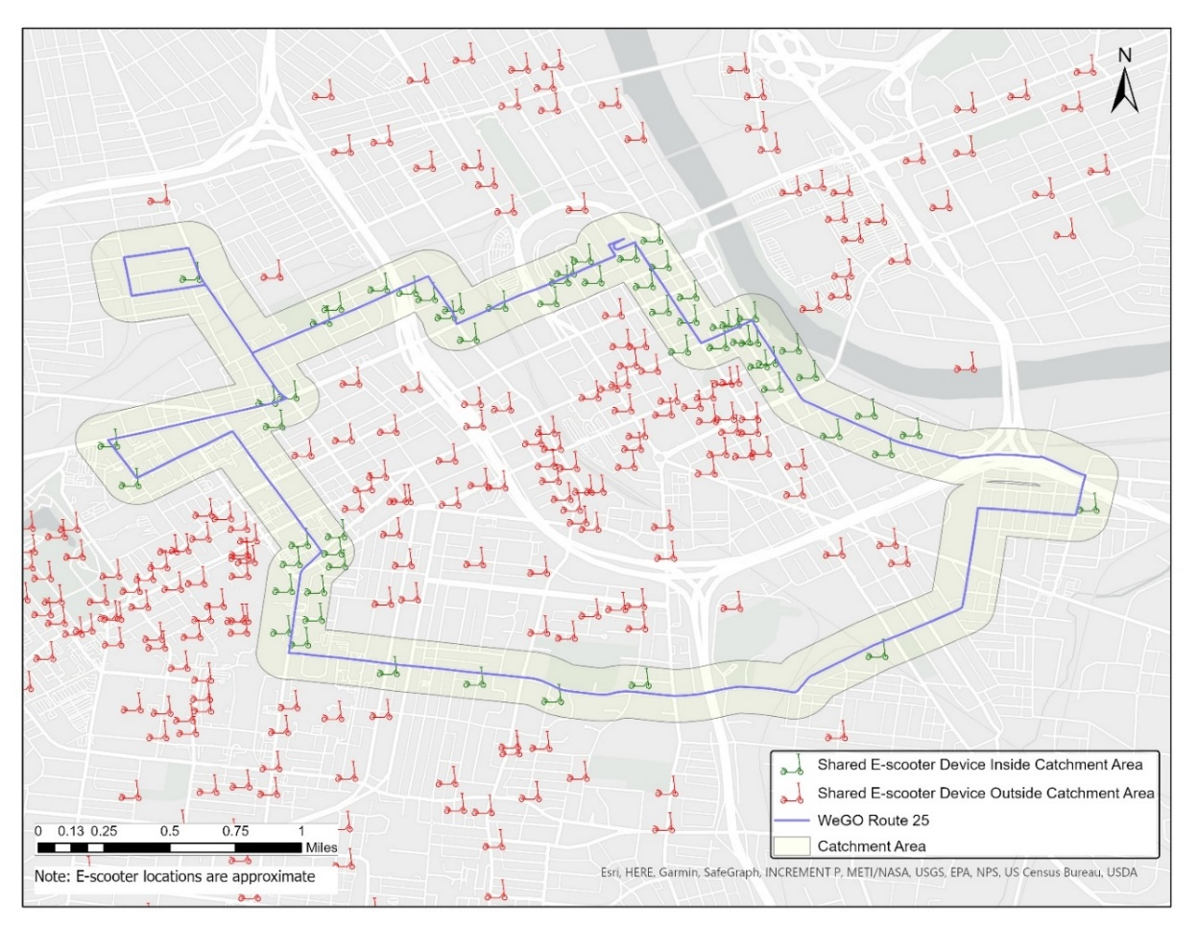
Figure ‎3.1: Example of shared e-scooter device availability for one bus route

Shared E-Scooters Connect from Transit
The section explored the hypothesis that shared e-scooters are primarily used to connect from transit as last mile connectors. This scenario assumes that users could ride a shared e-scooter from a bus stop to their trip endpoint.
H₃: the number of shared e-scooter trips that started (trip origin) within the bus route catchment area increases bus ridership
The variable ‘shared e-scooter origins’ was defined to evaluate this hypothesis, which counts the number of shared e-scooter trips within the local bus route catchment area and destinations outside of the route catchment area.

Shared E-scooters Connect to and from Transit
The section investigated the fourth hypothesis of this study (H₄) that shared e-scooters are primarily used to connect to and from transit as both first and last mile connectors. The assumption for this scenario is users could start the journey by riding a shared e-scooter from their trip starting point to a local bus stop then ride another shared e-scooter from the bus stop to their trip endpoint. Therefore, the number of shared e-scooter trips that started or ended (trip origin or destination) within the bus route catchment area could increase bus route ridership. It should be noted that the fourth hypothesis assesses the possibility that H₂ and H₃ could both happen.
H₄: the number of shared e-scooter trips that started or ended (trip origin or destination) within the bus route catchment area increases bus ridership.
The variable ‘shared e-scooter origin or destination’ was defined to evaluate this hypothesis, which counts the number of shared e-scooter trips with either e-scooter origins or destinations within the local bus route catchment area but not both.

Shared E-scooters Substitute Transit
This section investigated the fifth hypothesis (H₅) that shared e-scooters are primarily used as a substitute for transit trips. The assumption for this scenario is that users take shared e-scooters to replace trips that would have been previously taken by bus.
H₅: the number of shared e-scooter trips that started and ended (trip origin and destination) within the bus route catchment area decreases bus ridership.

To evaluate this hypothesis, the variable ‘shared e-scooter origins and destination’ was defined. This variable counts the number of shared e-scooter trips that have both e-scooter origins and destinations within the local bus route catchment area, as illustrated in Figure ‎3.2. In Figure ‎3.2, the shared e-scooters trip origins are shown as circles, and the destinations are shown as triangles. The red arrows connect each origin-destination pair.

The Impact of Shared E-scooters Trips on Bus Ridership based on Trip Purpose
Section ‎3.5.1.2 explored four different hypotheses about the primary use of shared e-scooters around transit. However, if there is no predominant use, and some shared e-scooters trips increase bus ridership while other trips decrease bus ridership, the net impact might be insignificant.

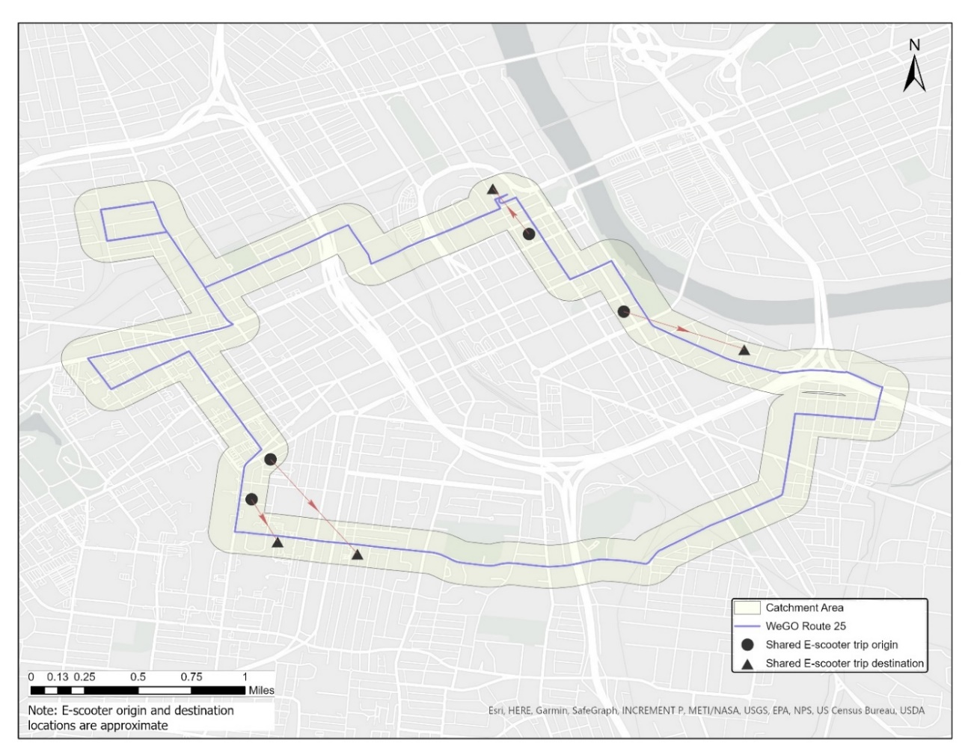
Figure ‎3.2: Example of the shared e-scooter origin and destination count method for one bus route

Therefore, this part of the analysis aims to differentiate between e-scooter trips impacts on transit based on trip purpose, assuming that the impact of shared e-scooter trips on transit ridership varies based on the purpose of the shared e-scooter trip (i.e., some trips could increase ridership while others could decrease ridership). To explore this hypothesis, this study uses the results of a recent study that explored shared e-scooter usage patterns in Nashville using the same shared e-scooter trip dataset (Shah et al., Under Review). Shah et al. used shared e-scooter trip-related variables, such as trip duration, trip distance time of the day, time of the week, average speed, and route directness, as well as other variables like weather, land use, population, and employment density to define shared e-scooter trip purposes in Nashville. Shah et al. applied a combination of Principal Component Analysis (PCA) and K-Means unsupervised machine learning algorithm to identify purpose-grouped e-scooter trips. Shah et al. identified 15 optimum clusters based on the Silhouette score and Davies-Bouldin score and further grouped them into five purpose-oriented clusters based on similarity of trip characteristics, temporal, and spatial patterns (Shah et al., Under Review). The five distinct purpose-grouped clusters are as follows:

  - Daytime short errand;
  - Morning work/school trips;
  - Utilitarian;
  - Social; and
  - Entertainment districts

The key attributes of these five different purposes are shown in Table ‎3.2. Utilitarian trips are mainly weekday trips and are typically longer trips and have a direct route between the origin and destination compared to other purposes. Daytime short errand trips are also weekday trips but are they are short trips during the day that are likely for a purpose like lunch. Morning work/school trips are trips occurring during the morning commute time, mainly at Vanderbilt University and downtown Nashville. It should be noted that morning work/school trips have some similarities to the utilitarian; however, they were considered separately as their start time (7:00 am to 10:00 am) is unique compared to other utilitarian trips (Shah et al.). Social trips are typically completed in the evening and on weekends in areas with restaurants while entertainment districts trips are typically made at night and in areas with live music venues, bars, or other entertainment options.
This section investigates the sixth hypothesis (H₆) that the impacts of shared e-scooters on bus ridership vary based on their purpose. The assumption for this scenario is that shared e-scooters used for different purposes might impact bus ridership differently.
H₆: the impacts of shared e-scooters on transit ridership vary based on the purpose of the shared e-scooter trip.
To evaluate this hypothesis, utilitarian, daytime short errand, social, entertainment districts, and morning work/school e-scooter variables were defined. Each variable counts the number of shared e-scooter trips with shared e-scooter origins and destinations within the local bus route catchment area for a specific purpose. The reason to use both origin and destination is that the classification method used by Shah et al. considered both origins and destinations in defining the trip purpose.

Summary Statistics
This section provides summary statistics for the variables used in this study, as presented in Table ‎3.3. The average daily bus ridership in Nashville is approximately 647 daily unlinked passenger trips (UPT) per route. The average shared e-scooter devices available within each route catchment area is about 178 devices per route per day. This high number of shared e-scooter devices available shows the overlap between the service area of these two modes. Table ‎3.3 also shows that the average number of shared e-scooter trips started (shared e-scooter origins) within each bus route catchment area is about 165 trips per route per day, equivalent to about 25% of the average bus ridership per route. This percentage also confirms that shared e-scooters are highly utilized within the transit service area.
Similarly, the mean number of shared e-scooter trips ended (shared e-scooter destinations) within each bus route catchment area is about 165 trips per route per day. These similar average values of shared e-scooter origins and destinations are likely because many shared e-scooters trips are short. The shared e-scooter origin and destination count has an average of 98 trips per route per day, equivalent to about 15% of the average bus ridership per route; these trips could potentially replace transit trips. Table ‎3.3 also shows that the daily average shared e-scooter trip count based on purpose ranged from 7 trips (utilitarian and morning work/school) to 37 trips (daytime short errand).

Modeling Framework
This section discusses the modeling approach. This study used fixed effects regression to explore the impact of shared e-scooters on bus ridership in Nashville. This modeling approach was used in prior studies to explore the impact of traveler information and transportation network companies (TNCs) on transit ridership (Brakewood et al., 2015; Erhardt et al., 2021). The regression equation is shown in Equation 1 (Studenmund, 2016). In this study, the dependent variable is bus unlinked passenger trips per route per day. The explanatory variables are vehicle revenue miles, shared e-scooter devices/trips, and other external control variables like population, employment, gas price, and weather.

${⁡y}_{it}=$ ${β* x}_{it} + {α_{i}EF}_{i}+{ρ_{t}TF}_{t}+ε_{it}$ (1)

Where:
  - $y_{it}$: unlinked passenger trips for bus route i during time t (day, week, or month)
  - $x_{it}$: explanatory variables for bus route i during time t (e.g., shared e-scooter counts, vehicle revenue miles)
  - ${EF}_{i}$: Entity fixed effect dummy, equal 1 for bus route i and 0 otherwise
  - ${TF}_{i}$: Time fixed effect dummy, equal 1 for the t^{th} period and 0 otherwise
  - $ε_{it}$: error term

This fixed-effect model explores the changes in bus ridership as a function of changes in the explanatory variables. The entity fixed effect term captures unobserved variables at the route level (such as serving a transit-favorable area).

Table ‎3.2: Shared E-scooter Trip Purpose in Nashville
Key Attributes | Shared E-scooter Trip Purpose in Nashville
Key Attributes | Daytime Short Errand | Morning Work/School | Utilitarian | Social | Entertainment Districts
Time and Location ª | Weekday daytime  downtown and Vanderbilt University  short trips on cooler days | Weekday morning  downtown and Vanderbilt University | Weekday  downtown and urban areas | Weekend evening  areas with restaurants | Weekend  entertainment district areas like bars or live music venues
% of Total Shared E-scooters Trips | 29.0 % | 6.9 % | 22.1 % | 25.8 % | 16.2 %
Average Trip Distance (Mile) | 0.71 | 0.68 | 0.86 | 0.68 | 0.67
Average Trip Duration (Min) | 17.13 | 13.07 | 17.36 | 16.53 | 15.07
Average Speed (MPH) | 2.76 | 3.62 | 3.27 | 2.75 | 2.97
Route Directness Ratio ^{b} | 0.49 | 0.60 | 0.64 | 0.52 | 0.57
ª Time and location show the typical values. However, a small portion of trips within each purpose might have different characteristics.
^{b} Route directness ratio represents the ratio between the Euclidean distance and the actual trip distance

Table ‎3.3: Summary Statistics
Category | Variable | Mean | Median | Min | Max | Time/  Geographic  unit
Dependent Variable | Unlinked passenger trips | 647.00 | 430.00 | 1.00 | 4345.00 | Day/  Route
Service Provision | Vehicle revenue miles (VRM) | 389.34 | 313.56 | 26.40 | 1631.62 | Day/  Route
Shared E-Scooters Availability | Shared e-scooter devices available | 178.00 | 130.00 | 0.00 | 849.00 | Day/  Route
Shared E-Scooters Trips  Counts ª | Shared e-scooter origins | 165.00 | 92.00 | 0.00 | 2111.00 | Day/  Route
Shared E-Scooters Trips  Counts ª | Shared e-scooter destinations | 165.00 | 92.00 | 0.00 | 2158.00 | Day/  Route
Shared E-Scooters Trips  Counts ª | Shared e-scooter origins or destinations | 330.00 | 183.00 | 0.00 | 4259.00 | Day/  Route
Shared E-Scooters Trips  Counts ª | Shared e-scooter origin and destination | 98.00 | 39.00 | 0.00 | 1660.00 | Day/  Route
Shared E-Scooters Trips Counts Based on Purpose ª | Utilitarian | 7.00 | 3.00 | 0.00 | 129.00 | Day/  Route
Shared E-Scooters Trips Counts Based on Purpose ª | Daytime short errand | 37.00 | 13.00 | 0.00 | 668.00 | Day/  Route
Shared E-Scooters Trips Counts Based on Purpose ª | Social | 27.00 | 5.00 | 0.00 | 774.00 | Day/  Route
Shared E-Scooters Trips Counts Based on Purpose ª | Entertainment districts | 20.00 | 8.00 | 0.00 | 758.00 | Day/  Route
Shared E-Scooters Trips Counts Based on Purpose ª | Morning work/school | 7.00 | 4.00 | 0.00 | 122.00 | Day/  Route
Other Explanatory Variables | Population ^{b} and employment (in 1000s) | 2900.00 | 2907.00 | 2780.00 | 3012.00 | Month/  City
Other Explanatory Variables | Average temperature (F) | 63.10 | 63.27 | 34.33 | 82.71 | Month/  City
Other Explanatory Variables | Snowfall (inch) | 0.13 | 3.62 | 0.00 | 2.40 | Month/  City
ª These counts reparent shared e-scooter activity around transit but not in the city of Nashville
^{b} Monthly values were generated using linear interpolation

In addition to bus route fixed effects, this study also used time fixed effects, which adds a dummy variable for each time period but one (Studenmund, 2016). The time fixed effect controls for any unobservable variable at a specific date like special events and other changes in the transit system (Studenmund, 2016). This study applied the clustered sandwich estimator to estimate cluster-robust standard errors (StataCorp LLC, 2017). The cluster-robust standard errors were robust to heteroskedasticity and serial correlation (StataCorp LLC, 2017; Wooldridge, 2012). The models were estimates using Stata’s “xtreg” command.

Results and Discussion
This section presents the results of the regression analysis. The results are presented in the same order as discussed in the methodology section. First, the evaluation of the impacts of shared e-scooters on bus ridership using infrastructure-based measures is presented. This is followed by the results of the impacts of shared e-scooters on bus ridership using trip-based measures assuming shared e-scooters trips are mainly used for the same purpose around transit. The last part of the section considers trip-based measures but differentiates the impacts of shared e-scooters on bus ridership based on trip purpose.

Results using Infrastructure-based Measures
Table ‎3.4 shows the results of the assessment of the first hypothesis (H₁) that the number of shared e-scooters available within the bus route catchment area affects bus ridership. Different models were estimated for weekdays and weekends since shared e-scooters usage differs between weekdays and weekends (Shah, 2020).
Model 1 in Table ‎3.4 shows the results of the weekday model, which considers only Monday through Friday. In this model, the weekday unlinked passenger trips serve as the dependent variable. VRM and the number of shared e-scooter devices are the explanatory variables. There are also route fixed effects and day fixed effects, which for other unobservable variables not included in the models. Model 1 shows VRM is a highly significant predictor of bus ridership, as indicated by the significant positive coefficient (0.11). However, this model indicates that the number of shared e-scooter devices available within the route catchment area is not a significant predictor of bus ridership on weekdays, as suggested by the insignificant coefficient (0.04). Similarly, Model 2 in Table ‎3.4 indicates that the number of shared e-scooter devices available within the route catchment area is not a significant predictor of bus ridership on weekends, as suggested by the insignificant coefficient (0.08). These results suggest that how shared e-scooters are currently distributed does not significantly impact bus ridership in Nashville.
This study also aggregated the transit and e-scooter data for each month to evaluate the first hypothesis (H₁), and the results are shown in Model 3 in Table ‎3.4. This monthly model is used to assess the possibility that shared e-scooters may have a cumulative impact on monthly bus ridership. Model 3 controls for other variables like population, employment, and weather that were found to be determinants of transit ridership in previous studies (Brakewood et al., 2015; Tang and Thakuriah, 2012; Taylor et al., 2009; Watkins et al., 2021). Model 3 results were consistent with Models 1 and 2; the number of shared e-scooters devices within the bus catchment areas does not have a significant impact on bus ridership. Model 3 also shows that population and employment have positive but insignificant impacts on bus ridership. On the other hand, the average temperature and snowfall have negative but insignificant impacts on bus ridership. These insignificant impacts are probably because of minimal change in these variables during the analysis period, as indicated by prior findings (Berrebi and Watkins, 2020; Ederer et al., 2019). It should be noted that a weekly model was also estimated, but the results were similar to the monthly model, and therefore the results are not shown. It is also worth noting that two additional catchment areas (0.20 miles and 0.25 miles) were evaluated; however, the results were similar to the 0.1-mile catchment area, and therefore the results are not shown.
It should be noted the period from September 2018 to January 2019 was excluded in these models due to incomplete data. Also, device availability data for one operator was missing for February and March. However, estimating the models for a shorter period with complete data showed similar results to Models 1 to 3; therefore, the additional results are not shown.

Results using Trip-based Measures
This section presents the evaluation of hypotheses (H₂-H₅) for the primary use of shared e-scooters around transit.
To assess the second hypothesis (H₂) that the number of shared e-scooter trips that ended within the bus route catchment area increases bus ridership, Models 4 and 5 were estimated for weekdays and weekends, respectively. Models 4 and 5 in Table ‎3.5 have unlinked passenger trips as the dependent variable. VRM and the shared e-scooter destination count are the explanatory variables. There are also route fixed effects and day fixed effects. Models 4 and 5 in Table ‎3.5 show that VRM is a highly significant explanatory variable for bus ridership, as indicated by the positive coefficients (0.12) and (0.14). However, both models reveal that shared the e-scooter destinations count is not a significant predictor for bus ridership, as indicated by the insignificant coefficients (0.06) and (0.03), respectively. These insignificant coefficients suggest that the number of shared e-scooter trips that ended within the bus route catchment area does not seem to have a significant impact on bus ridership.
A similar approach was followed to evaluate the third hypothesis (H₃) that the number of shared e-scooter trips that started within the bus route catchment area increases bus ridership. Models 6 and 7 were estimated for weekdays and weekends, respectively. Again, Models 6 and 7 in Table ‎3.5 have unlinked passenger trips as the dependent variable. VRM and shared e-scooter origins count are the explanatory variables, and there are also route fixed effects and day fixed effects. The results of both models suggest that the shared e-scooter origins count is not a significant predictor of bus ridership, as indicated by the insignificant coefficients (0.05) and (0.03), respectively. These insignificant coefficients suggest that the number of shared e-scooter trips starting within the bus route catchment area does not have a significant impact on bus ridership.
It is worth noting that a weekly model and a monthly model (similar to Model 3) with additional explanatory variables were estimated to evaluate (H₂) and (H₃). The results of these models were consistent with the findings of weekday and weekend models, and therefore, the results are not shown.
Models 8 and 9 in Table ‎3.6 show the results of the fourth hypothesis (H₄) that the number of shared e-scooter trips that started or ended within the bus route catchment area increases bus ridership. Model 8 shows the number of shared e-scooters that started or ended within the bus route catchment area is not a significant predictor for bus ridership on a weekday, as suggested by the insignificant coefficient (0.03). Model 9 in Table ‎3.6 shows similar results for the weekend model. These findings suggest that the number of shared e-scooter trips that started or ended within the bus route catchment area does not have a significant impact on bus ridership
Models 10 and 11 in Table ‎3.6 show the results of the fifth hypothesis (H₅) that the number of shared e-scooter trips that started and ended within the bus route catchment area decreases bus ridership. Model 10 shows the number of shared e-scooters that started and ended with the bus route catchment area is not a significant predictor of bus ridership on a weekday, as suggested by the insignificant coefficient (0.07). Model 11 in Table ‎3.6 shows similar results for the weekend model. Both models indicate that the number of shared e-scooter trips that started and ended within the bus catchment area is not a significant predictor for bus ridership as indicated by the insignificant coefficients (0.07) and (0.04), respectively. These insignificant coefficients suggest that the number of shared e-scooter trips that started and ended within the bus route catchment area does not have a significant impact on bus ridership in Nashville. Therefore, not all shared e-scooters that started and ended within the bus route catchment area are replacing transit trips.
It is also worth noting that a weekly model and a monthly model (similar to Model 3) were estimated to evaluate (H₄) and (H₅). These model results were consistent with the findings of weekday and weekend models, and therefore, the results are not shown. Also, hypotheses 2-5 were assessed using both 0.20 miles and 0.25 miles catchment areas; however, the results were similar to the 0.10 miles catchment area, and therefore they are not shown.

Results using Trip-based Measures Based on Trip Purpose
The assessment of Hypotheses 2 to 5 of this study suggests that e-scooters have limited, if any, impact on bus ridership in Nashville. However, it should be noted that if shared e-scooters are both being used for connecting to transit for some trips while replacing transit for others, the net impact might be insignificant. Therefore, shared e-scooters impacts on bus ridership are further explored based on their purpose, as discussed in this section.
Model 12 in Table ‎3.7 explores the sixth hypothesis (H₆) that the impacts of shared e-scooters on transit ridership vary based on the purpose of the shared e-scooter trip. Model 12 shows that each shared e-scooter utilitarian trip completed within the bus route catchment area is associated with a decrease of about 0.93 bus trips, as suggested by the significant negative coefficient (-0.93). This finding suggests that some shared e-scooters trips are replacing bus trips on weekdays. On the other hand, Model 12 reveals that the number of social trips completed within the bus catchment area has a small positive impact on bus ridership, as suggested by the significant positive coefficients (0.30). This coefficient suggests that every three social trips completed within the bus route catchment area are associated with an increase of about one bus trip. Model 12 also shows that the number of daytime short errand trips, morning work/school, and entertainment districts trips completed with the bus route catchment area do not have a significant impact on bus ridership. The findings about daytime short errand trips and entertainment districts were expected since daytime short errand trips are typically short trips on cooler days, and the entertainment districts trips are trips likely for purposes other than the typical transit purposes. It was not expected to find morning work/school shared e-scooter trips do not have a significant impact on transit ridership. However, there are two factors that could explain this result. First, most of these trips are starting and ending either in Nashville CBD or the Vanderbilt campus. Second, these trips are typically short trips. These two factors suggest that these trips are more likely to replace walking trips than transit trips.
Model 13 in Table ‎3.7 explores the sixth hypothesis of this study on weekends. The results of Model 13 show that the number of shared e-scooters trips completed within the bus route catchment areas does not significantly impact bus ridership on weekends regardless of their purpose. Model 14 shows the results of the monthly model, which are consistent with the weekday model.

Table ‎3.4: Fixed Effects Regression Results for Assessing Hypothesis 1
Explanatory Variables | - Weekday | - Weekend | - Monthly
Vehicle revenue miles (VRM) | 0.11***  (0.029) | 0.14**  (0.056) | 0.20**  (0.094)
Shared e-scooter devices | 0.04  (0.058) | 0.08  (0.082) | 0.07  (0.076)
Population and employment (in 1000s) |  |  | 35.96  (37.228)
Average temperature (ºF) |  |  | -403.86  (370.015)
Snowfall (inch) |  |  | -249.58  (185.005)
Route fixed effect | Yes
Time fixed effect | Day | Day | Month
R Square | 0.425 | 0.163 | 0.305
Number of observations | 29445 | 8320 | 1384
*p<0.10; **p<0.05; ***p<0.01. Clustered robust standard errors are shown in parenthesis. The cluster variable is the bus route.

Table ‎3.5: Fixed Effects Regression Results for Assessing Hypotheses 2-3
Explanatory Variables | H₂: Shared E-scooters Connect to Transit |  | H₃: Shared E-scooters Connect from Transit
Explanatory Variables | - Weekday | - Weekend | - Weekday | - Weekend
Vehicle revenue miles (VRM) | 0.12***  (0.034) | 0.14***  (0.055) | 0.12***  (0.034) | 0.14**  (0.055)
Shared e-scooters trips count | 0.06  (0.056) | 0.03  (0.049) | 0.05  (0.045) | 0.03  (0.047)
Route fixed effect | Yes
Time fixed effect | Day
R square | 0.424 | 0.163 | 0.424 | 0.163
Number of observations | 34435 | 9738 | 34435 | 9738
*p<0.10; **p<0.05; ***p<0.01. Clustered robust standard errors are shown in parenthesis. The cluster variable is the bus route.

Table ‎3.6: Fixed Effects Regression Results for Assessing Hypotheses 4-5
Explanatory Variables | H₄: Shared E-scooters Connect to and from Transit |  | H₅: Shared E-scooters Substitute Transit Trips
Explanatory Variables | - Weekday | - Weekend | - Weekday | - Weekend
Vehicle revenue miles (VRM) | 0.12***  (0.034) | 0.14***  (0.055) | 0.12***  (0.034) | 0.14***  (0.055)
Shared e-scooters trips count | 0.03  (0.023) | 0.02  (0.025) | 0.07  (0.053) | 0.04  (0.067)
Route fixed effect | Yes
Time fixed effect | Day
R square | 0.425 | 0.163 | 0.425 | 0.164
Number of observations | 34435 | 9738 | 34435 | 9738
*p<0.10; **p<0.05; ***p<0.01. Clustered robust standard errors are shown in parenthesis. The cluster variable is the bus route.

Table ‎3.7: Fixed Effects Regression Results for Assessing Hypothesis 6
Explanatory Variables | - Weekday | - Weekend | - Monthly
Vehicle revenue miles (VRM) | 0.12***  (0.034) | 0.14**  (0.055) | 0.20**  (0.093)
Shared e-scooter utilitarian trips | -0.93*  (0.494) | 0.02  (0.928) | -2.49**  (1.067)
Shared e-scooter daytime short errand trips | 0.12  (0.138) | -0.31  (0.369) | -0.93  (0.573)
Shared e-scooter social trips | 0.30**  (0.114) | 0.29  (0.229) | 1.35**  (0.597)
Shared e-scooter entertainment district trips | -0.15  (0.133) | -0.02  (0.182) | -0.45**  (0.200)
Shared e-scooter morning work/school trips | -0.08  (0.78) | 0.65  (0.694) | 3.10  (2.507)
Population and employment (in 1000s) |  |  | 33.67  (37.59)
Snowfall (inch) |  |  | -373.30*  (196.76)
Average temperature (ºF) |  |  | -376.31  (332.58)
Route fixed effect | Yes
Time fixed effect | Day | Day | Month
R Square | 0.426 | 0.169 | 0.325
Number of observations | 34435 | 9738 | 1618
*p<0.10; **p<0.05; ***p<0.01. Clustered robust standard errors are shown in parenthesis. The cluster variable is the bus route.

Table ‎3.8: The Impacts of Shared E-scooters on Bus Ridership by Trip Purpose
 | Estimated Impact on ridership on a typical Weekday (UPT per weekday) |  | Estimated Impact on a typical Weekday (%)
 | Route | System-wide | System-wide
Shared e-scooter utilitarian trips | -6.4 | -256 | -0.94%
Shared e-scooter social trips | 5.8 | 232 | 0.86%
Net impact | -0.6 | -24 | -0.08%

Model 14 shows the number of shared e-scooters utilitarian trips are associated with a decrease in bus ridership, as suggested significant negative coefficient (-2.49), similar to Model 12. Also, Model 14 shows that the number of social trips completed within the bus catchment area has a significant positive impact on monthly bus ridership, as suggested significant positive coefficient (1.35). These findings are consistent with the weekday model. Model 14 also shows that snowfall has a significant negative impact on bus ridership, which aligns with findings from prior studies (Brakewood et al., 2015; Singhal et al., 2014). However, population and employment and average temperature do not significantly impact ridership. These insignificant impacts are likely due to the minimal change in these variables during the analysis period, as indicated by prior findings (Berrebi and Watkins, 2020; Ederer et al., 2019).

Quantifying the Net Impact of Shared E-scooters on Bus Ridership
The results of ‎3.6.3 showed that utilitarian shared e-scooter trips are associated with a decrease in bus ridership, while social trips are associated with an increase in bus ridership. This section quantifies the impacts of shared e-scooters on bus ridership to estimate their net impacts on bus ridership. The estimated impact on bus ridership on a typical weekday per route was calculated using Equations 2 and 3.

Estimated impact on bus ridership on a typical weekday per route ${UPT}_{r}$ = $\sum_{i=1}^{j}{{(\text{β}}_{i}* \overline{T_{i}}})$ (2)
Estimated systemwide impact on a typical weekday ${UPT}_{s}$ = n * ${UPT}_{r}$ (3)

Where:
${UPT}_{r}$ = The estimated impact on bus ridership on a typical weekday per route.
${UPT}_{s}$ = The estimated systemwide impact on a typical weekday.
${\text{β}}_{i}$ = the estimated impact of the ($i_{th}$) shared e-scooter purpose on bus ridership.
$\overline{T_{i}}$= the average number of trips of the ($i_{th}$) shared e-scooters purpose per bus route on a weekday.
j = the number of significant shared e-scooter trip purposes in the preferred model.
n = the number of routes.

The results of the impact of shared e-scooters on bus ridership are summarized in Table ‎3.8, which indicate that shared e-scooter utilitarian trips are associated with a decrease of about 256 UPT systemwide on a typical weekday in Nashville. This decrease represents about 0.94% of total bus ridership on a typical weekday. On the other hand, social trips are associated with an increase of about 232 UPT, which represents a 0.86% increase. These estimated impacts suggest that shared e-scooters are associated with a net decrease of 24 UPT on a typical weekday. This estimated net impact represents a decrease of only about 0.08% of the bus ridership in Nashville on a typical weekday, which is very minimal.

Areas for Improvement and Future Research
There are some limitations to this study and some areas for future research. Several caveats should be taken into consideration when interpreting the result of the models. First, WeGo operates a radial bus network where most of the routes come to downtown Nashville. This resulted in some of the shared e-scooter trips lying in the catchment area of multiple bus routes and were thus counted multiple times. This could lead to overestimating the impact of shared e-scooters on bus ridership. Second, the relationship between shared e-scooters use and transit in Nashville may not represent other cities in the United States due to differences in the transportation systems and travel behavior; for example, Nashville is a predominantly auto-oriented city with a fairly limited transit service compared to many other American cities with similar population levels. Third, this study does not consider personally owned e-scooters, which may also affect bus ridership and travel behavior in the long run. Fourth, as only daily transit ridership data were available, this study did not explore the impacts of shared e-scooters on bus ridership during different periods of the day. Future studies could explore the relationship between these two modes during different time periods, which may vary from one period to another. Last, it should be noted that while this study used infrastructure-based measures to avoid potential endogeneity concerns, trip-based measures were also used. The trip-based measures might be impacted by endogeneity if some riders chose shared e-scooters because of bus crowdedness, for example. Another source of endogeneity could be the simultaneity (Wooldridge, 2012), which could happen if the demand for shared e-scooters and transit were impacted by some other variables like the availability of car parking.
Future research should explore and study the impacts of shared e-scooter in cities with different city and public transportation characteristics to validate the directionality (positive/negative) and magnitude of the impacts. Additionally, the impacts of shared e-scooters on specific forms of public transportation modes such as heavy rail and light rail can be explored in future research, as most of the cities that shared e-scooters users indicated that are using shared e-scooter to connect to transit have rail systems like San Francisco and Chicago. Another important area for future research is how transit and shared e-scooters operators could integrate these two modes to provide better mobility options for their users. Future research could also consider express routes, particularly in cities with high ridership on express routes, as this study did not explore express bus routes due to low ridership. Last, the impact of the COVID-19 pandemic on the use of these two modes is an important area for future research as our study data precedes the pandemic.

Conclusions and Policy Recommendations
This study performed an empirical analysis to quantify the impacts of the shared e-scooters on bus ridership in Nashville, Tennessee. Fixed effects regression models were estimated to explore six hypotheses about the relationship between bus ridership and shared e-scooters using both infrastructure-based and trip-based measures. The main findings of this analysis are summarized below and followed by some policy recommendations
First, the results of this empirical analysis suggest that the number of shared e-scooters available within bus route catchment area does not have a significant impact on bus ridership. Second, the results of this empirical analysis indicate that the impact of shared e-scooters on bus ridership varies based on the purpose of the trip. The findings of this study suggest that utilitarian shared e-scooter trips are associated with a decrease of 0.94% in bus ridership in Nashville on a typical weekday. On the other hand, shared e-scooter social trips are associated with an increase of 0.86% in bus ridership in Nashville on a typical weekday. These findings suggest that shared e-scooters were associated with a net decrease of about 0.08% of total bus ridership on a typical weekday in Nashville, which is a minimal impact.
The findings of this study suggest that although the use of shared e-scooters increased nationwide at unprecedented rates, they might have a limited impact on bus ridership, or at least the effect is small compared to other macro-level changes in ridership. Furthermore, although this study indicates that some shared e-scooters trips complement buses, most shared e-scooters are being used for other purposes. This shows there is a potential for better integration between these two modes to improve mobility in urban areas. As the results of this study suggest that some shared e-scooters social trips complement transit; transit and shared e-scooter operators could promote the use of these two modes for those social trips. Promoting the use of these two modes could be achieved through offering discounts or advertisements like “do not drink and ride, use transit.” Transit and shared e-scooter operators could also offer integrated trip planning and fare payment to encourage combining both modes in the journey. Also, better placement of shared e-scooters near bus stops could encourage the use of these two modes. The finding of this analysis will inform transit agencies and city planners as they plan for a sustainable future for their cities.

CHAPTER IV: THE APP OR THE CAP? WHICH FARE innovation AFFECTS BUS RIDERSHIP?

Author Statement
Abubakr Ziedan: Conceptualization, Formal analysis, Writing - Original Draft. Ashley Hightower: Data curation, Writing- review & editing Luiz Lima: Conceptualization. Candace Brakewood: Conceptualization, Writing - review & editing, Funding acquisition, Supervision

Abstract
Technology advancements in the last two decades have changed serval aspects of public transit service, particularly related to fares. Transit agencies seek to benefit from these technologies to improve the customer experience by launching mobile fare payment applications (“apps”) and adopting more sophisticated fare policies such as fare capping (“caps”). However, there is a limited understanding of the impacts of these two fare innovations on bus ridership. Therefore, this study seeks to understand the impacts of mobile fare payment applications and fare capping policies (both daily and monthly) on bus ridership. Staggered difference-in-difference techniques were used to evaluate system-level bus ridership for the 50 largest transit agencies in the United States. This approach considers the effect on multiple treated units that adopted apps or caps at different times; it also considers heterogeneity of the treatment effect between treated units and over time. The results suggest that the launch of mobile fare payment applications and the adoption of daily fare capping policies did not have significant impacts on system-level ridership. On the other hand, monthly fare capping policies were associated with significant ridership gains. Transit systems that adopted monthly fare capping policies for more than one year experienced an average increase in annual bus ridership ranging from 3.6% to 4.1%; these results were heterogenous and increased over time. These findings can help to inform transit agencies across the United States as they consider different strategies to increase ridership and reverse recent bus ridership declines. Perhaps most important, the staggered difference-in-difference methodology used in this study could potentially be applied to evaluate a wide range of transportation technology and policy innovations with staggered (gradual) rollouts.

Introduction
In public transit, the availability of mobile fare payment applications is relatively recent, and the number of public transit agencies offering mobile fare payment applications is increasing rapidly. From 2012 to 2019, more than 100 transit agencies in the United States adopted mobile fare payment applications (Brakewood, 2020). Reasons for this include “improving the customer experience, reducing cash handling, and decreasing the cost of fare collection” (Brakewood, 2020). However, the impacts of mobile fare payment applications on transit use and overall ridership levels are still largely unknown and have been identified as an area for future research in prior studies (Bian et al., 2021; Watkins et al., 2021).
The increased availability of mobile fare payment applications and open payment systems has also enabled transit agencies to consider more sophisticated fare policies that would once have been challenging to implement with other methods of fare collection. One noteworthy advancement is fare capping, which is a fare policy in which "The transit agency caps the maximum amount a rider can pay in a given period" (Brakewood, 2020). For example, if a transit agency implements monthly fare capping, a rider would never pay more than the monthly pass value. This concept is also applied for shorter periods of time, like one day or one week. The adoption of fare capping policies has been a growing trend in the transit industry; as of September 2021, at least 21 of the largest 101 agencies in the United States had fare capping policies (Hightower et al., 2022). Since then, many more transit agencies have implemented similar policies (notably New York City's MTA - the largest operator in the country) (MTA, 2022).
One of the primary benefits of fare capping is to promote equity; capping allows low-income riders who cannot afford to make a large upfront payment to benefit from the discounts of period passes. In addition to promoting equity, there are other potential advantages of fare capping. One advantage for transit agencies that has received limited attention in prior studies is the perception of free travel after triggering the fare cap, which may encourage riders to make more transit trips (Chalabianlou et al., 2015). However, it remains unclear whether fare capping results in a significant increase in ridership at the system level and, if it does, what the magnitude of this impact is.
In light of this growing adoption of mobile fare payment applications and fare capping policies, this study aims to evaluate if these two fare innovations significantly impact system-level transit ridership. This is an important question for transit agencies in the United States as they explore different policies to help reverse recent ridership declines, particularly since the COVID-19 pandemic.
This paper begins with a review of the prior studies about fare payment application and fare capping, followed by the research questions. Then, the different data sources used in this study are presented. Next, the staggered difference-in-difference method is described. Then, the results of this analysis are discussed. Finally, conclusions and areas for future research are presented.

Prior Studies
This section discusses relevant prior studies and is divided into two parts. The first section focuses on prior studies about mobile fare payment applications, and the second part reviews prior studies about fare capping. Because these two fare interventions are relatively recent innovations in fare technology and policy, there is limited prior research discussing them.

Mobile Fare Payment Applications
Most prior studies on mobile fare payment applications (apps) conducted surveys of current/potential users to evaluate the benefits from the user perspective. Those prior studies reported many benefits, like the ease of use and time savings (Brakewood et al., 2020; Di Pietro et al., 2015; Ferreira et al., 2017; Fontes et al., 2017). One noteworthy prior study focused on the agency perspective of the benefits of mobile ticketing (e.g., mobile fare payment applications and other forms of payment such as SMS ticketing). This prior study reported that mobile ticketing reduces the cost of fare collection, offers better data, and improves the safety of the working environment (Apanasevic and Markendahl, 2018). These prior studies have revealed different benefits of fare payment applications for users and agencies, but these studies did not explore the impact of fare payment applications on transit ridership, which is still unknown. A recent study that reviewed the benefits of transit smartphone applications has specifically identified the impact of mobile fare payment applications on transit ridership as an area for future research (Bian et al., 2021).

Fare Capping
Fare capping is also a relatively new innovation in the transit industry, with limited understanding of its impacts, particularly in the United States.
Chalabianlou et al. evaluated the benefits of fare capping from the rider perspective in Australia (Chalabianlou et al., 2015). The authors concluded that fare capping benefits for riders include flexibility, cost-savings, and time savings. This prior study also mentioned that fare capping could encourage riders to make more transit trips due to the perception of “free” travel after triggering the fare cap (Chalabianlou et al., 2015); however, it did not specifically evaluate potential changes in transit use.
Chu et al. conducted simulations to explore the change in revenue resulting from implementing daily, weekly, and monthly fare capping policies using the automatic fare collection (AFC) data in Montreal, Canada (Chu et al., 2019). Chu et al. estimated several hypothetical scenarios that considered different fare capping types (daily, weekly, and monthly) with the assumption that transit use (ridership) does not change due to the adoption of fare capping policies. The results suggest that transit agency revenue might increase with the adoption of daily and weekly fare caps, but revenue may decrease due to a monthly fare cap. However, that prior study acknowledged that predicting rider response to fare capping is complex (Chu et al., 2019).
TCRP Synthesis 160 surveyed 35 transit agencies to synthesize several aspects pertaining to fare capping policies, such as transit agency motivations to adopt fare capping policies, impacts on pass structure and pricing, and potential changes to ridership and revenue (Pettine et al., 2022). While the study provided several insights about the aforementioned aspects, the authors concluded that the impacts of fare capping on ridership and revenue is unclear due to the recent implementation by many agencies. Furthermore, the authors specifically recommended these two subjects as areas for future research (Pettine et al., 2022).
In another recent study, Hightower et al. used a multiple case study method to explore the adoption of fare capping policies by transit agencies in the United States and to evaluate the potential rider benefits (Hightower et al., 2022). This prior paper found that at least 21 of the largest 101 agencies in the United States implemented fare capping as of September 2021, and many other agencies are planning or considering adopting fare capping policies soon (Hightower et al., 2022). Hightower et al. also explored some potential benefits of fare capping for riders, but the study did not consider the impact of fare capping on ridership.
Perhaps the most relevant prior reference is by Morrissey and Oke. Morrissey and Oke utilized data from the Pioneer Valley Transit Authority (PVTA) mobile fare payment application to develop a model to forecast expected ridership changes in response to different fare policy changes, one of which was fare capping (Morrissey and Oke, 2022). This study estimated ridership changes for three hypothetical scenarios that included fare capping. Scenario 1 was the adoption of weekly fare capping, Scenario 2 was for monthly fare capping, and Scenario 3 was monthly fare capping in addition to a 10% increase in single-ride fares (Morrissey and Oke, 2022). The authors concluded that implementing weekly or monthly fare capping (Scenarios 1 or 2) would result in a net decrease of 0.2% in ridership, while Scenario 3 would result in a net decrease of 1.8% in ridership (Morrissey and Oke, 2022). The authors explained that this negative net impact on ridership was likely since riders switching from prepaid passes (weekly or monthly passes) to a single ride fare "would experience a non-zero marginal cost with each additional ride until they reach the cap" (Morrissey and Oke, 2022). While this prior study considered the ridership impacts of fare capping, the study used simulation models instead of actual ridership data. Also, this prior study used data from the Pioneer Valley Transit Authority (PVTA), which is a mid-size transit agency that might not be applicable to larger agencies.
This brief review of prior studies showed that while there are some prior studies of mobile fare payment applications and fare capping, no prior study specifically evaluated the impacts of either of these innovations on bus ridership after implementation, which is the focus of this study. Furthermore, the transportation literature has had limited use of the staggered difference in difference method, which is becoming increasingly common in policy evaluation in other disciplines and will be discussed in detail in the subsequent sections (Athey and Imbens, 2022; Callaway and Sant’Anna, 2021).

Research Questions
This study seeks to answer the following research questions:
  - Does the launch of mobile fare payment applications increase bus ridership?
  - Does the adoption of daily fare capping policies increase bus ridership?
  - Does the adoption of monthly fare capping policies increase bus ridership?

To answer these above research questions, this study explores system-level bus ridership for the 50 largest bus agencies in the United States from 2011 through 2019 (before the COVID-19 pandemic). The 50 largest bus agencies were defined as agencies with the highest ridership in 2019 based ridership data obtained from the National Transit Database (NTD) (The National Transit Database (NTD), 2022). It should be noted that transit agencies operating in New York City were excluded from this study since ridership trends in New York City vary substantially from other cities across the nation (Watkins et al., 2021).

Data
This section provides an overview of the data used in this study in three parts. The first part discusses the outcome variable, the second part explains the control variables, and the last part discusses the different treatment variables.

Outcome Variable
This section provides an overview of the data used in this study in three parts. The first part discusses the outcome variable, the second part explains the control variables, and the last part discusses the different treatment variables.

Control Variables
Control variables (covariates) in this study refer to variables that affect bus ridership or determinants of bus ridership. Prior studies of bus ridership have grouped these variables into four categories (Watkins et al., 2021):
- Traditional internal variables: these are factors mostly controlled by the transit agency, like transit service quantity, transit service quality, and fares (Watkins et al., 2021).
- Emerging internal variables: factors that are also controlled by the transit agency, but they have emerged recently; an example is implementing a bus network redesign (Watkins et al., 2021).
- Traditional external variables: these are factors that have traditionally impacted transit ridership, but they are not controlled by the transit agency, such as employment levels and gas prices (Byala et al., 2021).
Emerging external variables: these are factors that are also outside the control of the transit agency, but they have emerged in recent years, such as ridehailing services (e.g., Uber and Lyft) and telecommuting.
Table ‎4.1 shows the different control variables used in this study, as well as the category and the data source for each variable. These control variables were obtained from publicly available sources like the American Community Survey (ACS) 1-year estimates (U.S. Census Bureau: American Community Survey, 2022), the Bureau of Labor Statistics (BLS) (Bureau of Labor Statistics (BLS), 2021), and the Energy Information Administration (Energy Information Administration, 2022). It should be noted that most of these variables are only available on an annual basis; therefore, this study evaluated ridership changes on an annual basis (i.e., time unit of analysis (t) = one year). The summary statistics for the variables used in the study are shown in Table A-1 in the appendix.

Treatment Variables
This study defines three treatment variables; each treatment variable focuses on one of the research questions of this study, as discussed below.

Launch of Mobile Fare Payment Applications
The first treatment variable is the launch of a fare payment application. The launch year of the mobile fare payment application for agencies was defined from data compiled from the TCRP Synthesis 148: Business Models for Mobile Fare Apps (Brakewood, 2020) and publicly available information such as transit agency websites, mobile application developer websites, and public press releases. Table ‎4.2 shows that 22 agencies launched mobile fare payment applications during the study period. NJ TRANSIT and TriMet were the first of these agencies to launch mobile fare payment applications in 2013. Table ‎4.2 also points to the staggered nature of the launch of mobile fare payment applications, as different agencies launched fare apps in different years.
It should be noted that the launch of fare apps is often motivated by improving the customer experience and reducing fare collection costs (Brakewood, 2020) and is not directly motivated by ridership changes. Therefore, this treatment variable can be considered “exogenous”. In other words, transit agencies did not implement mobile fare payment applications with the explicit purpose of increasing ridership. However, this study will test the parallel trends assumption in each model to ensure that the policy can be treated as exogenous; this will be explored by testing the null hypothesis that all pretreatment effects are equal to zero (Rios-Avila, 2022).

Adoption of Fare Capping Policies
The second treatment variable defined in this analysis is the adoption of daily fare capping, and the third treatment variable is the adoption of monthly fare capping. Different agencies adopted daily and monthly fare capping policies at different times; therefore, monthly and daily fare capping are explored separately. Data about the launch year of daily fare capping and the types of fare capping policies (daily and monthly) were collected from a prior study by Hightower et al. that documented this information (Hightower et al., 2022). Hightower et al. also concluded that daily and monthly fare capping policies are the most common (compared to weekly), so this study focuses specifically on those two types of fare caps (Hightower et al., 2022).
Table ‎4.3 shows the transit agencies that have fare capping, which types of fare capping are offered (daily, monthly), and the launch date. Table ‎4.3 shows that nine of the agencies in this study adopted daily fare capping policies from 2012 to 2018, with the Santa Clara Valley Transportation Authority being the first. Table ‎4.3 also shows that only three agencies had monthly fare capping by 2019.

Table ‎4.1: Data Sources
Category | Variable | Data Source
Traditional Internal | Monthly unlinked passenger trips | National Transit Database (NTD)
Traditional Internal | Bus vehicle revenue hours (VRH) | National Transit Database (NTD)
Traditional Internal | Average fare per UPT ¹ | Calculated based on data from National Transit Database (NTD)
Traditional Internal | Average speed
Traditional External | Population | 1-year American Community Survey
Traditional External | Employment | Bureau of Labor Statistics
Traditional External | Gas prices ¹ | Energy Information Administration
Traditional External | Income | 1-year American Community Survey
Traditional External | Car ownership | 1-year American Community Survey
Traditional External | Percent of commuters who walk to work | 1-year American Community Survey
Traditional External | Age distribution | 1-year American Community Survey
Emerging Internal | Network redesign (this is an indicator for agencies that conducted significant changes to their network layout and service allocation) | TCRP Synthesis 140 (Byala et al., 2019) and TCRP Research Report 221 (Byala et al., 2021)
Emerging External | Percent of commuters who telework | 1-year American Community Survey
Emerging External | Percent of commuters who carpool | 1-year American Community Survey
Emerging External | Percent of commuters who use taxicab ² | 1-year American Community Survey
¹ Fare and gas prices were adjusted for inflation
² Taxicab includes emerging ride hailing services (e.g., Uber and Lyft)

Table ‎4.2: Mobile Fare Payment Application Launch Dates
Year | # | Transit Agencies | Urbanized Area (UZA)
2013 | 2 | New Jersey Transit Corporation | New York-Newark, NY-NJ-CT
2013 | 2 | Tri-County Metropolitan Transportation District of Oregon (TriMet) | Portland, OR-WA
2014 | 1 | Capital Metropolitan Transportation Authority | Austin, TX
2015 | 4 | Chicago Transit Authority | Chicago, IL-IN
2015 | 4 | Pace - Suburban Bus Division | Chicago, IL-IN
2015 | 4 | City and County of San Francisco | San Francisco, CA
2015 | 4 | City of Tucson | Tucson, AZ
2016 | 6 | King County Department of Metro Transit | Seattle, WA
2016 | 6 | County of Miami-Dade: Department of Transportation and  Public Works | Miami, FL
2016 | 6 | Southwest Ohio Regional Transit Authority | Cincinnati, OH-KY-IN
2016 | 6 | The Greater Cleveland Regional Transit Authority | Cleveland, OH
2016 | 6 | Metro Transit | Minneapolis-St. Paul, MN
2016 | 6 | Metropolitan Transit Authority of Harris County, Texas | Houston, TX
2017 | 6 | Capital District Transportation Authority | Albany-Schenectady, NY
2017 | 6 | City of Charlotte, North Carolina | Charlotte, NC
2017 | 6 | Central Florida Regional Transportation Authority | Orlando, FL
2017 | 6 | VIA Metropolitan Transit | San Antonio, TX
2017 | 6 | Utah Transit Authority | Salt Lake City-West Valley City, UT
2017 | 6 | San Diego Metropolitan Transit System | San Diego, CA
2018 | 3 | Maryland Transit Administration | Baltimore, MD
2018 | 3 | Santa Clara Valley Transportation Authority | San Jose, CA
2018 | 3 | Orange County Transportation Authority | Los Angeles-Long Beach-Anaheim, CA
Source: (Brakewood, 2020)

Table ‎4.3: Fare Capping Policy Launch Dates
Daily Fare Capping
Year | # | Transit Agency Name | Urbanized Area (UZA)
2012 | 1 | Santa Clara Valley Transportation Authority | San Jose, CA
2013 | 1 | Houston Metro | Houston, TX
2014 | 1 | Alameda-Contra Costa Transit District (AC Transit) | San Francisco, CA
2017 | 2 | Tri-County Metropolitan Transportation District of Oregon (TriMet) | Portland, OR-WA
2017 | 2 | Capital District Transportation Authority | Albany-Schenectady, NY
2018 | 2 | Metro Transit | Minneapolis-St. Paul, MN
2018 | 2 | Connecticut Department of Transportation - CTTRANSIT - Hartford Division | Hartford, CT
2019 | 2 | County of Miami-Dade: Department of Transportation and  Public Works | Miami, FL
2019 | 2 | Rhode Island Public Transit Authority | Providence, RI-MA
Monthly Fare Capping
Year | # | Transit Agency Name | Urbanized Area (UZA)
2017 | 1 | Tri-County Metropolitan Transportation District of Oregon (TriMet) | Portland, OR-WA
2018 | 1 | Connecticut Department of Transportation - CTTRANSIT - Hartford Division | Hartford, CT
2019 | 1 | Rhode Island Public Transit Authority | Providence, RI-MA
Note: Dallas Area Rapid Transit (DART) launched a fare capping policy in 2018 but is not included since they also had a major service change in 2018.
Source: (Hightower et al., 2022)

Most importantly, Table ‎4.3 shows that, similarly to mobile fare payment applications, the rollout of fare capping policies had a staggered nature with different agencies launching fare capping in different years. It should also be noted that Dallas Area Rapid Transit (DART) launched a fare capping policy in 2018; however, DART conducted major service changes in 2018 as well (Lyons and Ball, 2018). Therefore, DART was excluded from this study since it would not be possible to distinguish the impact of the fare capping from other major service changes using the proposed annual methodology.
Similar to the launch of mobile fare payment applications, fare capping can be considered “exogenous” since the motivation of fare capping policies in the United States is mainly to promote equity (Hightower et al., 2022) and is not directly motivated by ridership changes.

Method
One common method in policy evaluation studies is known as Difference-in-Difference; this method can be used to estimate causal effects with observational data (Callaway and Sant’Anna, 2021; Roth et al., 2022). The canonical (typical) Difference-in-Difference design contains two groups (treatment group and control group) and two time periods (before and after the treatment) with all treated units exposed to the treatment simultaneously. However, as mentioned earlier, the rollout of mobile fare payment applications and fare capping policies had a staggered nature, with agencies adopting these innovations in different years (see Table ‎4.2 and Table ‎4.3). Therefore, this study will apply the staggered Difference-in-Difference method. This is an extension of the canonical Difference-in-Difference design which is also based on the Two-Way Fixed Effects (TWFE) model that allows for variation in the treatment timing (Athey and Imbens, 2022; Callaway and Sant’Anna, 2021; De Chaisemartin and d'Haultfoeuille, 2020). In this study, the treatment group refers to transit agencies that adopted the specific treatment (fare app or fare cap) at any point during the period of the analysis, while the control group refers to transit agencies that did not adopt the specific treatment (fare app or fare cap) within the period of the analysis.
In particular, this study uses the staggered Difference-in-Difference approach proposed by Callaway and Sant'Anna (Callaway and Sant’Anna, 2021). This approach was chosen for two reasons. First, in addition to the average treatment effect on treated units (ATT), the Callaway and Sant'Anna approach allows for different aggregation schemes (e.g., group, time) that could be used to explore treatment effect heterogeneity across different treated units and estimate dynamic effects (Callaway and Sant’Anna, 2021). This aspect is important for this study because the impacts of the interventions of interest might vary for different transit agencies or over time. Second, the Callaway and Sant'Anna approach emphasizes the role of covariates compared to other staggered Difference-in-Difference methods proposed by Athey and Imbens (Athey and Imbens, 2022) and de Chaisemartin and D'Haultfœuille (De Chaisemartin and d'Haultfoeuille, 2020). This aspect is also crucial for this study because prior studies have shown that changes in covariates have contributed to significant changes in transit ridership (Erhardt et al., 2022; Taylor et al., 2009; Watkins et al., 2021); therefore, it is essential to include these covariates in the analysis

Assumptions
The Callaway and Sant'Anna method has defined several assumptions for identification (Callaway and Sant’Anna, 2021). This section discusses how this study satisfies those assumptions.

Assumption 1: Irreversibility of Treatment.
This assumption states that there is no treated unit at time t = 1, and treated units will remain treated in the following periods. Assumption 1 is satisfied in this analysis because the timeline starts before the treatment of interest (either the app or the cap), and no transit agency has discontinued the intervention after adoption.

Assumption 2: Random Sampling
This assumption states that [Y_{i,1}, Y_{i,2}, . . ., Y_{i,T} , X_{i}, D_{i,1}, D_{i,2}, . . . , D_{i,T}} for i=1,2…n is independent and identically distributed (iid) (Callaway and Sant’Anna, 2021), where Y represents the outcome variable, covariates (X), treatment status (D), unit of analysis (i), and time periods (T). This assumption is met in this study since transit ridership (Y), transit determinants (X), and fare app/cap launch (D) for each agency (unit i) are independent from other transit agencies. Also, it is worth noting that this assumption does not restrict time series dependence for the outcome variable and covariates (Callaway and Sant’Anna, 2021).

Assumption 3: Limited Treatment Anticipation
This assumption restricts anticipation of the treatment for all treated units (Callaway and Sant’Anna, 2021). Assumption 3 is met in this study since transit riders do not have prior knowledge about the anticipated date of fare app/fare cap before the agency adopts the policy.

Assumption 4: Conditional Parallel Trends Based on a "Never-Treated" Group
This assumption states that "conditional on covariates, the average outcomes for the group first treated in period (g) and for the ‘never-treated’ group would have followed parallel paths in the absence of treatment" (Callaway and Sant’Anna, 2021). This study will test the parallel trends assumption for each estimated model by exploring a null hypothesis that all pretreatment effects are equal to zero (Rios-Avila, 2022).

Assumption 5: Conditional Parallel Trends Based on "Not-Yet-Treated" Groups
This assumption is similar to Assumption 4 but with a different comparison group, which includes units that are not-yet-treated at the specific period (t) but will be treated at a later period (Callaway and Sant’Anna, 2021). This study will test this assumption similar to assumption 4 and will use the not yet treated group as control group.

Assumption 6: Overlap
This assumption enforces that the generalized propensity score is uniformly bounded away from one (Callaway and Sant’Anna, 2021). The Callaway and Sant'Anna method can estimate the treatment based on outcome regression (OR), inverse probability weighting (IPW), or both of them (Callaway and Sant’Anna, 2021). Assumption 6 is required for methods including IPW. However, as this study applies the outcome regression (OR) model, Assumption 6 is not relevant to this study. The OR approach was chosen since it depends on modeling the conditional expectation of the outcome evolution (Callaway and Sant’Anna, 2021). OR is more appropriate for this study because there is a good understanding of factors that affect the outcome (transit ridership), but there is no knowledge of what factor affects the probability of being treated (e.g., launch of a fare app or implementing fare capping), which is required for IPW.

Assumptions 7 and 8:
In addition to these six assumptions, Callaway and Sant'Anna's method has two additional typical assumptions. Assumption 7 requires that the first-step estimators are based on smooth parametric models and that the estimated parameters admit √n-asymptotically linear representations. Assumption 8 enforces some weak integrability conditions (Callaway and Sant’Anna, 2021). These two assumptions are satisfied with the use of linear outcome regression (Callaway and Sant’Anna, 2021), which is applied in this analysis.

Group-Time Average Treatment Effects
As mentioned earlier, one of the important features of the Callaway and Sant'Anna method is that it allows aggregation of the treatment effect at different levels like group or time. This section discusses how the Callaway and Sant'Anna approach identifies the treatment effects and presents the different aggregation schemes applied in this study.
The Callaway and Sant'Anna approach extends the average treatment effect on treated (ATT) used in the canonical difference in difference (DiD) setup with two time periods to consider more than two groups and multiple periods (Callaway and Sant’Anna, 2021). The canonical DiD defines ATT as shown in Equation (1); Callaway and Sant'Anna generalize this ATT to consider g treatment groups and t time periods as shown in Equation 2 (Callaway and Sant’Anna, 2021).

ATT = E [$Y_{2}\left(2\right)- Y_{2}\left(0\right)\left| G_{2}=1\right]$ (1)

ATT(g,t) $=$E [$Y_{t}\left(g\right)- Y_{t}\left(0\right)\left| G_{g}=1\right]$ (2)

Where:

ATT ≡ average treatment effect on treated units;
ATT(g,t) ≡ average treatment effect on treated for the group (g) at the time period (t);
$Y_{t} \left(g\right)≡$ the outcome for the group (g) at the time period (t);
$G_{g}$≡ binary variable that is equal to one if a unit is first treated in period g.

After defining $ATT\left(g,t\right)$ for all treated groups at all periods post-treatment, the Callaway and Sant'Anna method aggregates the ATT based on different weights $w\left(g,t\right)$to explore the different causal effects ($θ$) as shown in Equation (3) (Callaway and Sant’Anna, 2021).

$θ$ = $\sum_{gϵ G}{\sum_{t=2}^{T}{w\left(g,t\right) * ATT\left(g,t\right)}}$ (3)

The weight function $w\left(g,t\right)$varies based on the question of interest (Callaway and Sant’Anna, 2021). For example, it could be used to estimate the overall treatment effect or the treatment effect for a specific group or a specific time, as shown in Equations (4-6) (Callaway and Sant’Anna, 2021). Equation (4) shows the overall effect of participating in the treatment ($θ_{W}^{0}$), which is a weighted average of all $ATT\left(g,t\right)$ that puts more weight on groups with larger treated units (Callaway and Sant’Anna, 2021). Equation (5) aggregates $ATT\left(g,t\right)$ by group and estimates the average effect of participating in the treatment among units in group ($\tilde{g}$) across all their post-treatment periods (Callaway and Sant’Anna, 2021). Also, Equation (6) is an event study that estimates the average treatment effect after (e) time periods of participating in the treatment (Callaway and Sant’Anna, 2021). Last, it should be noted that all these equations will yield non-negative weights that sum to one (Callaway and Sant’Anna, 2021).
In this study, Equation (5) is used to explore the heterogeneity of the impacts of fare capping policies between transit agencies, while Equation (6) is used to estimate the dynamic treatment effect of fare capping policies.

$θ_{W}^{0}$ = $\frac{1}{k}$ $\sum_{gϵǴ}{\sum_{t=2}^{T}{1\left(t≥g\right)ATT\left(g,t\right) P\left(G=g\right|G≤T)}}$ (4)

$θ_{sel}(\tilde{g})$ = $\frac{1}{T-\tilde{g}+1} \sum_{t=g}^{T}{ATT(\tilde{g,}t)}$ (5)

$θ_{es}(e)$= $\sum_{gϵǴ}{1\left(g+e ≤ T\right)ATT\left(g,g+e\right) P\left(G=g\right|G+e≤T)}$ (6)

Where:
$θ_{W}^{0}$ ≡ the overall treatment effect across all treated units in all post-treatment periods;
$θ_{sel}(\tilde{g})$ ≡ the average effect of participating in the treatment among units in the group (g ̃) across all their post-treatment periods;
$θ_{es}(e)$ ≡ the average treatment effect after (e) time periods of participating in the treatment;
k = $\sum_{gϵǴ}{\sum_{t=2}^{T}{1\left(t≥g\right)P\left(G=g\right|G≤T)}};$ this term ensures weights sum up to 1;
$P$ ≡ probability;
T ≡ the number of time periods in this study;
G ≡ the time period when a unit first becomes treated;
g ≡ group of units treated at the same time period (i.e., G_{g} = 1);
$Ǵ$ ≡ denotes the support of G excluding (g). (i.e., all other groups but g).

Last, it should be noted that this analysis was carried out on Stata version 17 using the "csdid" command (Rios-Avila, 2022). The analysis was conducted using the outcome regression estimator based on ordinary least squares (Callaway and Sant’Anna, 2021; Rios-Avila, 2022). Wild bootstrap standard errors with 1000 repetitions were used for all models to account for heteroscedasticity and serial autocorrelation, if any (Gonçalves, 2011).

Results
This section presents the results in three parts. The first part explores the impacts of the launch of mobile fare payment applications on bus ridership. The second part reports the results of daily fare capping policies on bus ridership, and the last part presents the results of the impacts of monthly fare capping policies.

Results for Mobile Fare Payment Applications
Using the Callaway and Sant'Anna staggered DiD approach, this study assessed the impact of the launch of mobile fare payment applications from 2011 to 2019 for the largest 50 bus agencies in the United States. The outcome variable in this analysis is annual unlinked passenger trips (log scale), and the treatment variable is the launch of monthly fare capping (represented as a binary variable). During the period of the analysis, 22 transit agencies adopted mobile fare payment applications (Table ‎4.2) in six different years. Therefore, these 22 agencies were grouped into six groups based on the launch year. This study explored the parallel trend assumption for this model by testing the null hypothesis that all pretreatment effects are equal to zero (Rios-Avila, 2022). The results fail to reject this null hypothesis at 99% significance level [chi^2 (degrees of freedom = 15)] = 23.68, p-value=0.071).
Table ‎4.4 shows the treatment effects of the launch of fare payment apps on bus ridership. Table ‎4.4 shows that the overall treatment effect ($θ_{W}^{0}$) of launching an app is 0.042 (equivalent to 4.2%); however, this impact is not statistically significant at the 90% confidence level. This treatment effect was compared to the treatment effect estimated using a dummy variable for post treatment periods in a two-way fixed effects (TWFE) regression while controlling for the same covariates. Table ‎4.4 shows the TWFE treatment effect of launching a mobile fare payment app is 0.015 (equivalent to 1.5%) but it is also not significant. It can be noticed that there is a slight difference between the two estimated effects that is likely due to the fact that TWFE assumes the treatment effect is constant across all treated units and across time.
This study also explored the possibility that the impact of mobile fare payment apps is heterogeneous between transit agencies and over time. Table ‎4.4 shows the partially aggregated effects based on the group, which are referred to as the group-specific effects, or $θ_{sel}(\tilde{g})$, and the partially aggregated effect by time, which is called the event study, or $θ_{es}(e)$. The group-specific treatment effect $θ_{sel}(\tilde{g})$ estimates the average effect of participating in the treatment among units in the group (g ̃) across all their post-treatment periods. However, the group-specific effects $θ_{sel}(\tilde{g})$, and the event study $θ_{es}(e)$ shown in Table ‎4.4 also indicate that the impact of mobile fare payment applications on bus ridership is not statistically significant. Additional results using the not yet treated agencies as the control groups are provided in Table A-2. The additional results are very similar to these results with the never treated group.

Results for Daily Fare Capping
This part presents the results of the impacts of daily fare capping on bus ridership over the period from 2011 to 2019 for the largest 50 bus agencies in the United States, using a similar approach as in the previous section. The outcome variable in this analysis is annual unlinked passenger trips (log scale), and the treatment variable is the launch of a daily fare capping policy. During the period of the analysis, nine transit agencies adopted daily fare capping policies (Table ‎4.3) in five different years. Therefore, these nine agencies were grouped into five groups based on the launch year. This study explored the parallel trend assumption by testing the null hypothesis that all pretreatment effects are equal to zero (Rios-Avila, 2022). The results fail to reject this null hypothesis at a 99% significance level, but the results are marginal (chi^2(21) = 33.92, p-value=0.037).
Table ‎4.5 shows that the overall treatment effect of launching a daily fare capping policy is 0.074 (equivalent to a 7.4% increase in ridership since the outcome variable is on a log scale); however, this effect was not statistically significant (p-value = 0.401). This finding suggests that launching daily fare capping policies did not result in significant ridership increases. Similar to the previous section, the TWFE treatment effect was different in magnitude but not statistically significant.
Table ‎4.5 also shows the group-specific treatment effect θ_sel (g ̃) for the five different groups. It can be seen that θ_sel (g ̃) range from -0.09 to 0.23; however, these group effects are also not statistically significant except for group 2013. Likewise, the event study results show a difference in the effect over time, but the results are not statistically significant (except for e=6). The two significant coefficients could be explained by ridership increases in Houston Metro due to a major network redesign in 2015 (daily fare capping adoption in 2013). The Houston Metro bus network redesign increased ridership by approximately 11% in the first year, and Sunday ridership by 30% (NACTO, 2016). So, the significant coefficients might be capturing some of these ridership increases.

Table ‎4.4: Treatment Effects of the Launch of Fare Payment Applications on Bus Ridership
 | Partially aggregated |  |  |  |  |  |  | Single parameter
TWFE |  |  |  |  |  |  |  | 0.015  (0.014)
Overall treatment effect ($θ_{W}^{0}$) |  |  |  |  |  |  |  | 0.042  (0.064)
Group-specific effects $θ_{sel}(\tilde{g})$ | g=2013  0.358  (0.333) | g=2014  -0.091  (0.059) | g=2015  0.023  (0.062) | g=2016  -0.002  (0.038) | g=2017  -0.041  (0.048) | g=2018  0.005  (0.056)
Event study $θ_{es}(e)$ | e=0  0.004  (0.026) | e=1  0.005  (0.044) | e=2  0.027  (0.053) | e=3  0.028  (0.059) | e=4  0.116  (0.132) | e=5  0.296  (0.307) | e=6  0.586  (0.451)
Covariates
Traditional Internal | Vehicle Revenue Hours (log scale)  Average Fare per UPT (adjusted for inflation)  Average Speed
Traditional External | Population (log scale)  Employment (log scale)  Median household income (log scale)  Gas Prices (adjusted for inflation)  Percent HH with No vehicle  Percent HH with Income less than 50K  Percent walk to work
Emerging External | Percent teleworkers
Outcome variable: annual unlinked passenger trips (log scale)
TWFE ≡ two-way fixed effects regression
Number of observations = 450
Variable significance: ***p <0.01; **p <0.05; *p <0.10; no star = not significant
Wild bootstrap standard errors are shown in parentheses

Table ‎4.5: Treatment Effects for the Adoption of Daily Fare Capping Policies
 | Partially aggregated |  |  |  |  |  |  |  | Single parameter
TWFE |  |  |  |  |  |  |  |  | 0.024  (0.042)
Overall treatment effect ($θ_{W}^{0}$) |  |  |  |  |  |  |  |  | 0.074  (0.062)
Group-specific effects $θ_{sel}(\tilde{g})$ | g=2012  0.13  (0.135) | g=2013  0.23***  (0.081) | g=2014  -0.07  (0.056) | g=2017  0.03  (0.03) | g=2018  0.04  (0.24) | g=2019  -0.09  (0.069)
Event study $θ_{es}(e)$ | e=0  -0.002  (0.029) | e=1  0.042  (0.035) | e=2  0.059  (0.054) | e=3  0.129  (0.11) | e=4  0.109  (0.117) | e=5  0.133  (0.132) | e=6  0.27**  (0.133) | e=7  0.23  (0.21)
Covariates
Traditional Internal | Vehicle Revenue Miles (log scale)  Average Fare per UPT (adjusted for inflation)  Average Speed
Traditional External | Population (log scale)  Employment (log scale)  Gas Prices (adjusted for inflation)  Percent HH with No vehicle (log scale)  Percent HH with Income between 25-35K  Percent HH with Income between 35-50K  Percent HH with Income between 75-99K  Percent child dependency  Percent old dependency
Emerging Internal | Network Redesign  Monthly fare cap
Emerging External | Percent teleworkers  Percent Carpool to work (log scale)  Percent Taxicab to work
Outcome variable: annual unlinked passenger trips (log scale)
TWFE ≡ two-way fixed effects regression
Number of observations = 450
Variable significance: ***p <0.01; **p <0.05; *p <0.10; no star = not significant
Wild bootstrap standard errors are shown in parentheses

In general, the findings of this part suggest that the adoption of daily fare capping policies did not result in significant ridership changes for transit agencies. This result could potentially be explained by the fact that daily fare capping has a short period, and riders might not find it easy to increase the number of trips they take over one day. This finding is also supported by the results of a prior study that simulated the impact of daily fare capping in Montreal, Canada, and showed that implementing daily fare capping would not negatively impact revenue (Chu et al., 2019). This prior study implies that there might not be a substantial change in ridership with daily fare capping. Additional results using the not yet treated agencies as the control groups are provided in Table A-3; they are very similar to these results with the never treated group.

Results for Monthly Fare Capping
This study assessed the impact of monthly fare capping policies from 2014 to 2019 for the 50 largest bus agencies in the United States; however, it is important to note that only three of the 50 agencies implemented monthly fare capping during this period. The period started in 2014, but the adoption of monthly fare capping policies started in 2017. It should be noted that during this later period of analysis, there were nationwide declines in bus ridership.
The outcome variable in this analysis is annual unlinked passenger trips (log scale), and the treatment variable is the launch of monthly fare capping (represented as a binary variable). This study explored the parallel trend assumption for this model by testing the null hypothesis that all pretreatment effects are equal to zero (Rios-Avila, 2022). The results fail to reject this null hypothesis at 99% significance level, but the results are marginal [chi^2 (degrees of freedom = 9)] = 21.33, p-value=0.012).
Table ‎4.6 shows the results of the preferred model. Table ‎4.6 shows the overall treatment effect ($θ_{W}^{0}$), which represents the average impact of monthly fare capping on bus ridership for all agencies across all post-treatment time periods. The overall treatment effect was estimated to be 0.020 (equivalent to a 2.0% ridership increase since the outcome variable is on a log scale), but this result is not statistically significant at a 95% confidence level (Table ‎4.6). Similar to the previous sections, the TWFE treatment effect is slightly different in magnitude but not statistically significant.
Table ‎4.6 also shows the estimated $θ_{sel}(\tilde{g})$ for group 2017 is 0.036 (equivalent to a 3.6% increase in ridership). This result suggests that the transit agency that adopted monthly fare capping in 2017 experienced an average increase in ridership of about 3.6% per year compared to other agencies that did not adopt monthly fare capping. Similarly, Table ‎4.6 shows the estimated $θ_{sel}(\tilde{g})$ for group 2018 is 0.041 (equivalent to a 4.1% increase in ridership), which suggests this transit agency also experienced a significant increase in ridership after adopting monthly fare capping. On the other hand, Table ‎4.6 shows that$θ_{sel}(\tilde{g})$ for group 2019 is -0.068 but is not statistically significant; this implies no ridership change for the transit agency that adopted a monthly fare capping policy later in the study period. These findings about the group-specific treatment effect indicate that the impact of fare capping on bus ridership is heterogeneous among transit agencies; some agencies experienced ridership gains between 3.6% to 4.1%, but one agency did not experience similar gains.

Table ‎4.6: Treatment Effects for the Adoption of Monthly Fare Capping Policies
 | Partially aggregated |  |  | Single parameter
TWFE |  |  |  | 0.030  (0.032)
Overall treatment effect ($θ_{W}^{0}$) |  |  |  | 0.020  (0.022)
Group-specific effects $θ_{sel}(\tilde{g})$ | g=2017  0.036**  (0.015) | g=2018  0.041**  (0.015) | g=2019  -0.068  (0.043)
Event study $θ_{es}(e)$ | e=0  0.001  (0.033) | e=1  0.031**  (0.014) | e=2  0.058***  (0.020)
Covariates
Traditional Internal | Vehicle Revenue Hours  Average Fare per UPT (adjusted for inflation)
Traditional External | Population (log scale)  Employment (log scale)  Gas Prices (adjusted for inflation)  Percent Households (HH) with No Vehicle  Percent Walk to Work  Percent HH with Income less than 25K  Percent HH with Income between 75-99K  Percent HH with Income between 99-150K
Emerging Internal | Network Redesign  Daily Fare Cap
Emerging External | Percent Taxicab to work
Outcome variable: annual unlinked passenger trips (log scale)
TWFE ≡ two-way fixed effects regression
Number of observations = 300
Variable significance: ***p <0.01; **p <0.05; *p <0.10; no star = not significant
Wild bootstrap standard errors are shown in parentheses

In general, these findings suggest that monthly fare capping policies were associated with increases in ridership. This finding might be attributed to fare capping encouraging riders to make more transit trips due to the perception of “free” travel after triggering the fare cap (Chalabianlou et al., 2015).
This study also estimated the dynamic effect of monthly fare capping policies on bus ridership, shown in the event study results in Table ‎4.6. The event study results show the impact of treatment after exposure of (e) time periods to the treatment. Interestingly, the event study estimates in Table ‎4.6 show that the impact of monthly fare capping is growing over time. It can be seen that the estimated impact of monthly fare capping on ridership is 0.001 in the year of adoption (e=0), which suggests no impact in the first year. In the first year after adoption, this impact grows to 0.031 (equivalent to a 3.1% increase) in the first year after launching monthly fare capping. Further, it reaches about 0.058 (equivalent to a 5.8% increase in ridership) in the second year after adoption. This finding is critical because it suggests that the impact of monthly fare capping has a delayed impact rather than immediate and that the impact grows with time. This growing effect has important implications for transit agencies implementing fare capping in the future; if they do not experience anticipated impacts immediately, they may see higher ridership impacts in the long run. Additional results using the not yet treated as control variables are provided in Table A-4; the results are very similar to these results with the never treated group.

Areas for Improvement and Areas for Future Research
This study took the first step toward understanding the impact of some new innovations in fare technology and policy on transit ridership, but there are some limitations and important areas for future research. First, the time period for this study ends in 2019, before the COVID-19 pandemic, to avoid analysis of drastic ridership reductions that occurred in 2020. This resulted in a small number of transit agencies implementing monthly fare capping (only three), which could affect some of the results. Therefore, further study is needed with a larger sample of transit agencies with monthly fare capping. Second, one area for future research is to conduct a detailed analysis at the rider level to explore changes in travel behavior in a disaggregate manner, because this study focused on the transit agency (system) level. Also, this study focused on the 50 largest bus agencies in the United States; future studies could explore the impacts of fare capping on medium and small agencies because the impacts may differ. Further, this study explored the impacts on bus ridership only. Future studies could consider other modes like light rail or commuter rail. Last, while this study showed that monthly fare capping could yield some ridership gains, it did not consider the corresponding impacts on transit agency fare revenue. This area is critical for future research as agencies are yet to recover from the impacts of the COVID-19 pandemic on fare revenue.

Conclusions and Discussion
As some transit agencies in the United States launched mobile fare payment applications and enacted fare capping policies in the last decade, the impact of these decisions on ridership is an essential aspect for transit agencies to understand. This study conducted an empirical analysis to explore the impacts of these two innovations on bus ridership using staggered difference-in-difference techniques. The results suggest that the launch of mobile fare payment applications did not result in a significant increase in ridership. Although prior studies have shown that mobile fare payment applications have several benefits for transit riders (Brakewood et al., 2020), their impacts on system-level bus ridership levels is likely limited. However, this finding should not necessarily discourage agencies from adopting mobile fare payment applications, since they might facilitate the adoption of some policies that could affect ridership, such as fare capping. Moreover, transit agencies should also consider other emerging benefits of mobile fare payment apps, particularly pertaining to public health; for example, contactless payments via mobile fare payment applications could help facilitate social distancing in regards to COVID-19.
This study also showed that the adoption of daily fare capping policies did not result in significant ridership increases. This finding is critical because daily fare capping is the most common type of fare capping adopted in the United States (Hightower et al., 2022). Therefore, it is essential for agencies to understand that they may achieve equity goals by implementing daily fare capping; however, daily fare capping impacts on ridership might be limited. On the other hand, the results of this study suggest that adopting a monthly fare capping policy is associated with a significant ridership increase. It is important to note that this effect on ridership is likely heterogeneous; different agencies that adopted monthly fare capping for more than one year during the study period experienced ridership gains ranging from 3.6% to 4.1%. Moreover, the results of the preferred model showed that the impact of the monthly fare capping policy grows over time. Overall, these findings are encouraging for transit agencies as they implement or consider implementing monthly fare capping policies, which is often done to promote equity and may also increase ridership.
Last, one possible explanation for the difference between daily and monthly fare capping impacts may simply be attributable to the difference in the period of time between monthly and daily fare capping. For example, monthly fare capping could benefit regular commuters who used to ride transit primarily for work trips (e.g., two trips per weekday), but now with the monthly cap, regular commuters may make extra trips for other purposes (e.g., social/recreational) since they can ride for “free”. This is not likely the case with daily fare capping due to the limited time available to benefit from the free rides. Also, the impact of daily capping might be short term and potentially could not be captured in an annual model. Moreover, a prior study suggested that daily fare capping might be beneficial for other groups of riders, like tourists (Hightower et al., 2022). While tourists might still ride transit more, their impact on the annual ridership might be minimal due to the short time of transit use.
Looking forward to a post-pandemic world, while the impact of monthly fare capping policies might not be the same in percentage, it is crucial for agencies to know that these policies could be used to both promote equity and potentially encourage riders to return to transit.

CHAPTER V: A MULTIPLE MEDIATION ANALYSIS TO UNTANGLE THE IMPACTS OF COVID-19 ON NATIONWIDE BUS RIDERSHIP IN THE UNITED STATES

Author Statement
Abubakr Ziedan: Conceptualization, Methodology, Formal analysis, Writing - Original Draft. Luiz Lima: Conceptualization. Candace Brakewood: Conceptualization, Methodology, Writing - Original Draft, Supervision, Funding acquisition

Abstract
The COVID-19 pandemic has resulted in major consequences for many aspects of human life and the broader economy. Public transportation is one of these severely impacted sectors, and during the early months of the pandemic, transit ridership dropped to unprecedented levels; even now, in late 2022, bus ridership in the United States has not recovered to pre-pandemic levels. However, the direct and indirect impacts of the COVID-19 pandemic on bus ridership are largely unknown. In the context of this study, the direct impact refers to a change in travel behavior (i.e., people stop riding transit because they are sick or fear getting sick), while the indirect impact refers to reduced ridership due to factors such as lower employment or increased teleworking. This study proposes a framework to explore the drivers of transit ridership declines during COVID-19. The method is a multiple mediation analysis to estimate the monthly direct and indirect impacts of COVID-19 on bus ridership from March 2020 to December 2021. The results of this study revealed that three mediators (employment, telework, and people relocating) mediated about 13% to 38% of the total decline in bus ridership during the analysis period. The multiple mediation approach used in this study could be applied in many other transportation applications.

Introduction
The COVID-19 pandemic resulted in major consequences for many aspects of human life. One devastating number is the lost lives caused by the pandemic. In the United States, by September 2022, the COVID-19 pandemic had caused more than one million deaths (CDC, 2022). Other consequences include the unemployment rate, which was 14.3% in April 2020 and was the highest unemployment rate in the United States during the period 1948 to 2021 (Bureau of Labor Statistics, 2022a). In addition to record unemployment rates, COVID-19 also changed the way people work, particularly increasing working from home. One prior study estimated that the work-from-home share in the United States increased from about 5% of workdays prior to COVID-19 to more than 60% in May 2020 (Barrero et al., 2021). Also, during the first year of the pandemic, many cities and states imposed travel restrictions or stay-at-home orders to limit the spread of the virus, which resulted in significant impacts on the transportation sector. In April 2020, all modes of passenger travel in the United States (cars, transit, airline, and intercity rail) experienced a more than 40% drop in demand (Polzin and Choi, 2021). These statistics show that some of the impacts of the COVID-19 pandemic on different sectors were very large, especially transportation, since travel behavior was changed significantly since the COVID-19 pandemic hit (Lu et al., 2022).
Public transit, in particular, was even more impacted than car travel in the United States. One of the first measures applied to reduce the spread of the virus was social distancing, which is against the fundamental idea of high-capacity transit. Public transportation ridership has been impacted severely by the COVID-19 pandemic across different transit modes and agencies. Bus ridership in the United States reached the lowest level since the 1930s, while overall ridership reached a 100-year low in 2020 (Ziedan et al., forthcoming). Some prior studies have sought to understand the impacts of COVID-19 on transit ridership (Liu et al., 2020a; Qi et al., 2021; Wang and Noland, 2021). These prior studies have revealed some interesting findings, like areas with higher proportions of white and high-income individuals experiencing higher ridership declines. However, prior studies have not explored if these ridership declines can be attributed directly to the COVID-19 virus (e.g., out of fear of the virus) or due to changes in some other determinants of ridership, such as changes in employment and telework. Therefore, this study seeks to untangle the direct and indirect impacts of COVID-19 on bus ridership. In this paper, the direct impact refers to a change in travel behavior (i.e., people stop riding transit because they are sick or fear getting sick), while the indirect impact refers to reduced ridership due to factors such as lower employment or increased teleworking. Dividing the impacts of COVID-19 into direct and indirect impacts could help transit agencies as they plan for the post-COVID-19 world to understand which impacts to expect in the long term.
This paper begins with a review of the prior studies. Next, the method section provides background about the mediation analysis, followed by a summary of the mediation analysis applied specifically to bus ridership. Then, the results of this analysis are discussed, followed by areas for improvement and future research. Finally, conclusions are presented in the last section.

Prior Studies
This section discusses the findings of some prior studies about transit ridership. The first part briefly discusses the many factors that affected transit ridership before COVID-19 and the methods used to explore them. The second part reviews studies that explored transit ridership during COVID-19.

Transit Ridership Before the COVID-19 Pandemic
This section briefly discusses the factors that impacted transit ridership before the COVID-19 pandemic and the methods used to explore transit ridership trends.
There is a large amount of literature that aims to understand the many factors that affect public transit ridership levels (Evans, 2004; McCollom and Pratt, 2004; Taylor and Fink, 2013; Taylor and Fink, 2003; Taylor et al., 2009). While this topic has been studied for decades, a newly published report summarized many of the most important drivers of transit ridership in the United States (Watkins et al., 2021). In this report, the factors that affect transit were categorized into internal and external factors, as shown in Table ‎5.1 (Watkins et al., 2021). Internal factors are largely controlled by the transit agency, such as service quantity, fares, and service concentration, while external factors are mostly outside the agency's control, such as changes in population, employment, and gas prices (Alam et al., 2018; Watkins et al., 2021).
Prior to the COVID-19 pandemic, prior studies have applied different methods to untangle the impact of various determinants of ridership changes, such as service quantity, gas prices, and employment. These methods included different types of regression, such as ordinary least squares (Alam et al., 2018; Ingvardson and Nielsen, 2018), two-stage least squares (Taylor et al., 2009), random effects (Graehler et al., 2019b), multilevel mixed-effects (Boisjoly et al., 2018; Tang and Thakuriah, 2012), fixed effects (Brakewood et al., 2015; Erhardt et al., 2022; Watkins et al., 2021), Poisson fixed effects (Berrebi et al., 2021), and longitudinal random coefficients models (Diab et al., 2020). More details about these methods and the factors explored in each study can be found in these two studies (Ingvardson and Nielsen, 2018; Taylor and Fink, 2013). While these approaches may have been robust before COVID-19, these methods might not be applicable during COVID-19 because the pandemic has affected both transit ridership and many of the determinants of ridership, such as employment, gas prices, and teleworking.

Table ‎5.1: Factors Affecting Transit Ridership
Internal Factors | External Factors
- Service quantity  - Fares  - Service concentration  - Speed & reliability  - Access to transit  - Security  - Service quality  - New transit modes  - Restructuring transit networks  - Demand response, flex route services, and microtransit pilots & partnerships  - New fare media & fare integration  - Real-time information  - Maintenance issues  - Dedicated transit right-of-way  - School & employer partnerships  - Fare discounts or elimination | - Density  - Population  - Employment  - Income  - Gas prices  - Commute policies  - Car ownership  - Demographics  - Gentrification  - Aging population  - Millennials  - Telecommuters  - Delivery services  - Congestion & parking pricing  - Shared mobility (ride-hailing, bikeshare, carshare, scooters)
Source: Adapted from TCRP 231: Recent Decline in Public Transportation Ridership: Analysis, Causes, Responses (Watkins et al., 2021)

Transit Ridership During the COVID-19 Pandemic
This review focuses on studies that applied empirical models to study transit ridership since the onset of the COVID-19 pandemic. First, Hu and Chen used partial least squares to explore the impacts of COVID-19 on rail ridership in Chicago using daily ridership for the period January 01, 2001 to April 30, 2020 (Hu and Chen, 2021). This prior study showed that rail ridership decreased on average by about 72%, with higher declines in areas with more commercial land uses and higher proportions of white, educated, and high-income individuals (Hu and Chen, 2021). However, this study did not control for changes in other determinants of transit ridership, like employment and work from home.
Wang and Noland explored the impacts of COVID-19 on daily subway ridership in New York City for the period March 2020 to September 2020 using both data visualization and a Prais-Winsten time series model (Wang and Noland, 2021). The results of this prior study showed that while bikeshare ridership returned to pre-pandemic levels by September 2020, subway ridership was only about one third of pre-pandemic levels (Wang and Noland, 2021). The results also showed that stay-at-home orders had a significant impact on ridership (Wang and Noland, 2021). This prior study focused on one city (New York City), studied the subway only and did not consider bus ridership changes due to COVID-19, which is likely to vary from the subway.
Osorio et al. applied a Bayesian structural time series model, a dynamics model, and a series of linear regression models to explore ridership declines due to COVID-19 in Chicago for both bus and rail using data from March 2020 to February 2021 (Osorio et al., 2022). This prior study showed that at the beginning of the pandemic, fear contributed to about 21% of bus ridership declines, but this percentage dropped to only 6% by the end of the first year (Osorio et al., 2022). This prior study also suggested that ridership declines can be mostly attributed to stay-at-home orders; the authors predicted that ridership would largely recover once these orders were lifted. While this study considered bus ridership and quantified the impact of fear on ridership, it focused only on Chicago, which does represent all metro areas in the United States. Also, this study predicted ridership would recover when stay-at-home orders were lifted, which was not the case; 2021 ridership statistics show that ridership in Chicago is still about half of pre-pandemic levels (Transit App, 2022).
Paul and Taylor used stop level ridership data, rider survey data, and census data to explore ridership changes by neighborhood in Boston, Houston, and Los Angeles (Paul and Taylor, 2022). Paul and Taylor found neighborhoods with higher car ownership levels and the ability to work from home experienced higher ridership declines during both the early period of the pandemic (April 2020) and the mid period of the pandemic (October 2020) (Paul and Taylor, 2022). While this study considered more than one transit agency, it focused on three large agencies that do not necessarily represent all metro areas in the United States.
Qi et al. used a random effects model and correlation analysis to explore transit ridership declines in the largest 20 metro areas in the United States from February 2020 to January 2021 (Qi et al., 2021). This prior study suggested that metro areas with higher income levels, higher education levels, higher employment rates, and a higher percentage of Asians experienced higher transit ridership declines during the period of the study (Qi et al., 2021). Qi et al. considered the largest 20 metro areas in the United States, which is very relevant to this study. However, they combined light rail and bus ridership, but these modes typically have different trends. Second, the random effects model considered only COVID-19 indictors and the percentage of population with a bachelor’s degree or higher as explanatory variables. Third, the findings about income, employment, and percent of Asian resident were only based on a simple correlation analysis. Therefore, there is room for additional analysis to explore these topics.
Last, Liu et al. used logistic regressions and data from the Transit App to explore changes to daily transit demand during the period from February 15, 2020 to May 17, 2020 for 113 county-level transit systems (Liu et al., 2020a). The results of this prior study indicated that areas with higher proportions of essential workers and vulnerable populations (i.e., African Americans, Hispanics, females, and people over 45 years old) and more coronavirus searches on Google experienced lower transit demand compared to other areas (Liu et al., 2020a). Notably, the authors used data from more than 100 counties, which is very relevant to this study; however, there were two main limitations. First, it used data from the Transit App, which is not necessarily representative of all transit ridership. Second, the analysis period was somewhat limited (only three months) and was very early in the pandemic (February to May 2020).
This brief review shows that prior studies considering the impacts of COVID-19 on transit ridership have generally focused on a small number of cities using cross sectional data or time series data within a relatively short timeframe. However, to the best of the authors' knowledge, no prior study has conducted a comprehensive nationwide study of bus ridership in the United States that untangles the impacts of COVID-19 into direct and indirect impacts. Also, the methods used to explore ridership prior to the COVID-19 pandemic may not be applicable because the pandemic affected both transit ridership and its determinants. This study seeks to fill these knowledge gaps.
This study aims to make the following contributions. First, a new framework is proposed to untangle the impacts of COVID-19 into direct and indirect impacts. The direct impacts refer to changes in travel behavior (i.e., people stop riding transit because they are sick or fear getting sick), while the indirect impacts refer to the reduction in transit use due to changes in other factors that affect transit, like reduced employment or telework. Second, this study seeks to estimate the direct and indirect impacts of the COVID-19 pandemic on bus ridership on a monthly basis and explores how these impacts changed over time. To fulfill these objectives, this study uses multiple mediation analysis techniques to estimate the impacts of COVID-19 on bus ridership for each month from March 2020 to December 2021 for 220 Metropolitan Statistical Areas (MSAs) in the United States, excluding New York since it typically follows different trends the rest of country. Last, it should be noted that mediation analysis has been applied in a small number of prior transportation studies (Mishra et al., 2015), including one study that explored the effect of COVID-19 on transportation air pollution (Ghiasi et al., 2022). However, these prior studies used only one mediator and did not consider multiple mediators, nor did they consider transit ridership.

Method
This section is divided into two parts. The first part provides general background about mediation analysis, and the second part discusses how mediation analysis was applied specifically to bus ridership.

Meditation Analysis Background
Baron and Kenny conducted one of the earliest studies that discussed mediation analysis in 1986 (Baron and Kenny, 1986). Baron and Kenny defined the mediation function in this article as “the mediator function of a third variable, which represents the generative mechanism through which the focal independent variable is able to influence the dependent variable of interest” (Baron and Kenny, 1986). In other words, the effect of an independent variable (X) on an outcome variable (Y) goes through a third variable called a mediator (M), as shown in Figure ‎5.1.
Figure ‎5.1 shows a multi-path diagram for the relationship between an independent variable (X), an outcome variable (Y), and a mediator (M). In this diagram, there are three paths. Path (a) from the independent variable (X) to the mediator (M); path (b) from the mediator (M) to the outcome variable (Y), and path (c) from the independent variable (X) to the outcome variable (Y). Path (c) represents the direct impact of (X) on (Y), while path (a)-(b) represents the indirect impact of (X) on (Y) mediated by (M) (Baron and Kenny, 1986).
Baron and Kenny proposed a three-regression equation method to investigate if a specific variable (M) is mediating the relationship between two variables (X) and (Y). These three regression equations are shown in Equations 1-3.

M = aX + error (1)
Y = cX + error (2)
Y = $\acute{c}$X + bM + error (3)

In the first step, regress (M) on (X) (Equation 1). In the second step, regress (Y) on (X) (Equation 2). In the last regression, regress (Y) on (X) and (M) to test if $\acute{c}$ is significant when controlling for the mediator (M) (Equation 3). (Baron and Kenny, 1986). After estimating these equations separately, the following conditions must be met to establish mediation. First, the estimated coefficients a,b, and c must be significant. Second, the estimated coefficient $\acute{c}$in Equation 3 must be less than cofficent c in Equation 2 (Baron and Kenny, 1986). If the mediation analysis is established, mediation could be either complete (perfect) mediation or partial mediation, depending on the coefficient $\acute{c}$in Equation 3 (Baron and Kenny, 1986; Kenny, 2021). If $\acute{c}$in Equation 3 is not significant; this mediation is complete (i.e., M completely mediates the effect of X on Y). However, if $\acute{c}$in Equation 3 is significant; this mediation is a partial mediation (i.e. M partially mediate the effect of X on Y) (Kenny, 2021).

Estimating the Direct, Indirect, and Total Impacts
In a simple mediation model, the direct, indirect, and total impacts can be calculated using the estimated coefficients a, b, and $\acute{c}$ from equations 1 and 3, as shown in Equations 4-6 (Hayes, 2009; Preacher and Hayes, 2008; StataCorp, 2021).

Direct impact = $\acute{c}$ (4)
Indirect impact= a*b (5)
Total impact = $\acute{c}$+a*b (6)

Meditation Analysis with Multiple Mediators
The simple meditation model presented in Figure ‎5.1 could be extended to include more than one mediator. For example, Figure ‎5.2 shows a model with two mediators (M₁) and (M₂). The same approach used in the simple case could be applied to estimate the coefficients a_{1,} b_{1,} a_{2,} b_{2,} and c ́. However, there are some additional considerations when using more than one mediator.
First, it is recommended that the mediators are not highly correlated (Kenny, 2021; Preacher and Hayes, 2008). Second, bootstrapping is recommended since it provides the most reasonable estimate for the confidence intervals for the indirect effects (Preacher and Hayes, 2008). Third, it is recommended to include all mediators in the same model as it is expected “to be more convenient, precise, and parsimonious” (Preacher and Hayes, 2008)

X (independent Variable)
M (Mediator)
Y (Outcome Variable)
a
b
c
Figure ‎5.1: Simple mediation model

b₂

a₂
M₂ (Mediator 2)
….
Figure ‎5.2: Multiple meditation model
M_{n} (Mediator n)
X (independent Variable)
M₁ (Mediator 1)
Y (Outcome Variable)
a₁
b₁

$$\acute{c}$$
b_{n}
a_{n}

In the case of multiple mediators, the indirect effect is the sum of the individual indirect effects (Preacher and Hayes, 2008). Therefore, the indirect effect and the total impacts for two mediators would be estimated using Equations 7-8 (Hayes, 2009; Preacher and Hayes, 2008). It should be noted that these equations could be applied to both standardized and unstandardized coefficients (Hayes, 2009). In this study, the standardized coefficients would be used to calculate the indirect and total effects as they allow for better comparison when variables are measured on different scales (StataCorp, 2021).

Indirect impact= $a_{1}* b_{1}+ a_{2}* b_{2}+…+ a_{n}* b_{n}$ (7)
Total impact = $\acute{c}$+$a_{1}* b_{1}+ a_{2}* b_{2}+ …+ a_{n}* b_{n}$ (8)

Meditation Estimation with Structural Equation Modeling
While the Baron and Kenny method of multiple regression equations to estimate mediation (discussed in section ‎0) has been widely adopted, structural equation modeling has recently become a popular method to estimate mediation due to some advantages over the Baron and Kenny method. These advantages include the ability to fit a single model for the mediation instead of several models, the capability to estimate indirect effects, the possibility to estimate several paths instead of only one path, the ability to estimate mediation as a part of a larger model, the potential for better handling of missing data, and the ability to bootstrap standard errors (Hayes, 2009; Kenny, 2021; StataCorp, 2021). Given these advantages, this study used structural equation modeling.

Goodness of Fit Measures
There are several measures used to assess the goodness of fit in structural equation modeling (SEM), such as the standardized root mean squared residual (SRMR), root mean squared error of approximation (RMSEA), Tucker-Lewis index (TLI), Bollen's (1989) fit index (BL89), relative non centrality index (RNI), McDonald's centrality index (Mc), and Comparative Fit Index (CFI) (Hu and Bentler, 1999; StataCorp, 2021). One highly cited study by Hu and Bentler (more than 94K citations as of September 2022) suggested using a 2-index presentation strategy instead of a single index (Hu and Bentler, 1999). Hu and Bentler's 2-index presentation strategy recommended using the SRMR and supplementing it with one of the following indices: TLI, CFI, BL89, RNI, CFI, or RMSEA. This study also provided cutoff values for each of these indices based on the sample size (Hu and Bentler, 1999).
In this analysis, a 2-index strategy of SRMR and CFI is used with cutoff values of 0.1 for SRMR and 0.95 for CFI because this was recommended for small sample sizes. Hu and Bentler's study stated the following about the cutoff values: “combinational rules with RNI (or CFI) < .95 and SRMR > .09 (or. 10) may be more appropriate when N <250 if committing Type I error is less desirable” (Hu and Bentler, 1999). Also, this combination (SRMR and CFI) was preferred over combinations using TLI, Mc, and RMSEA because these other combinations are inclined to over-reject true models at small sample sizes (Hu and Bentler, 1999). Last, Hu and Bentler suggested the same cutoff values for CFI and RNI, which were shown to be algebraically equal in most applications (Goffin, 1993).

Mediation analysis for the impact of COVID-19 on bus ridership
This section discusses the research hypotheses and the multiple mediation framework used to study bus ridership declines.

Research Hypotheses
Table ‎5.1 presents the factors that typically affected transit ridership prior to COVID-19. This study explores six possible contributors to the decline in bus ridership during COVID-19. The six selected variables are telework, employment, gas prices, population, the popularity of bikes, and the popularity of delivery services. The rest of this section discusses why these variables were selected and the research hypothesis for each factor.

Employment
According to the Bureau of Labor Statistics, the COVID-19 pandemic caused an increase in unemployment in the United States (Bureau of Labor Statistics, 2022a). In May 2020, 49.8 million people reported that they did not work because of the COVID-19 pandemic (Bureau of Labor Statistics, 2022b). Since commuting is the primary trip purpose for transit use in the United States (Clark, 2017), this study hypothesizes that increased levels of unemployment mediate some of the impact of COVID-19 on bus ridership.

H₁: Increased unemployment contributed to bus ridership declines during COVID-19.

Telework
One of the first measures taken to slow the spread of the COVID-19 virus was social distancing, which resulted in many employers asking their employees to telework (i.e., work from home). Telework levels increased from about 5% of workdays prior to COVID-19 to more than 60% in May 2020 (Barrero et al., 2021). Considering that prior studies have shown that telework affected pre-COVID-19 transit ridership (Erhardt et al., 2022), this study hypothesizes that increased levels of telework mediate some of the impact of COVID-19 on bus ridership.

H₂: Increased teleworking contributed to bus ridership declines during COVID-19.

Gas Price
Energy Information Administration data show that gas prices declined during the period from March 2020 to April 2021; gas prices were lower than pre-pandemic levels as shown in Figure ‎5.3 (Energy Information Administration, 2022). Since gas prices led to ridership declines before COVID-19, it is hypothesized that lower gas prices mediate some of the impact of COVID-19 on bus ridership.

H₃: Lower gas prices contributed to bus ridership declines during COVID-19.

It should be noted that gas prices in the United States exceeded pre-COVID-19 levels in May 2021 and continued to increase until the end of the analysis period. Therefore, this study will also explore if higher gas prices resulted in bus ridership increases during the latter part of the study.

Population Relocating
The COVID-19 pandemic caused many people to move from urban neighborhoods at higher rates than in prior years. A data brief from the Federal Reserve Bank of Cleveland showed that the average net flow out of urban neighborhoods was 56,000 in the period March 2020 to September 2020 compared to 28,000 during the same period in 2017-2019 (Whitaker, 2021). Furthermore, this document stated, “The most populous metro areas, those with more than 5 million residents, saw larger increases in net outflows than did smaller metro areas” (Whitaker, 2021). This major increase in the net flow out of urban neighborhoods is expected to affect bus ridership, as transit typically serves urban areas. Therefore, this study hypothesizes that people relocating contributed to bus ridership declines during COVID-19.

H₄: People relocating contributed to bus ridership declines during COVID-19.

Biking
One of the main factors that affected bus ridership before COVID-19 was the rise of shared mobility (Campbell and Brakewood, 2017; Erhardt et al., 2022). However, shared modes such as ridehailing and bikesharing were also impacted by the pandemic, and there is no publicly available data for all MSAs to capture their changes. Therefore, this study used Google trends data to gauge the popularity of these modes during the pandemic, as shown in Figure ‎5.4 Google trends provides information about the volume of searches for a specific term during a specific period. The search volume is then standardized on a scale of 100, where 100 represents the period with the highest search volume (Google Trends, 2022). Figure ‎5.4 shows that the search volume for other modes dropped during the pandemic with the exception of bikes.
Many statistics support these search trends. For example, about 15% of the respondents to a nationwide survey about travel during the pandemic stated that they plan to bike more (Salon et al., 2022). Also, bike sales increased by 39% in the United States in 2020 (Buehler and Pucher, 2021). Furthermore, after the initial drop in March 2020, bike sharing ridership in the largest six systems in the United States started to increase in May 2020 and exceeded 2019 levels in November (Bureau of Transportation Statistics, 2022b).
Given these trends about biking, it is hypothesized that increased bike popularity during the pandemic is one of the drivers of bus ridership declines during COVID-19.

H₅: Increased bike popularity contributed to bus ridership declines during COVID-19.

On the ridehailing side, there was a decrease in popularity, as shown in Figure ‎5.4. This is supported by the fact that the Uber CEO said that early in the pandemic, trips declined by 70% in Seattle (Hawkins, 2020). Therefore, ridehailing is not expected to affect bus ridership although ridehailing was a major driver for declines before COVID-19 (Erhardt et al., 2022)

Delivery Services
During the COVID-19 pandemic, there was an increase in e-commerce and online shopping. Statistics from the US Census Bureau showed that in the first quarter of 2020, e-commerce increased by 14% compared to 2019 (United States Census Bureau, 2022). In the second quarter of 2020, the increase was about 44% compared to 2019 (United States Census Bureau, 2022). These increases are expected to increase the use of delivery services instead of in-person visits. Therefore, this study hypothesized that increases in delivery service use and popularity during the pandemic are one of the contributors to bus ridership declines during COVID-19.

H₆: Increased delivery popularity contributed to bus ridership declines during COVID-19.

Figure ‎5.3: Average gas price in the United States
Data Source: (Energy Information Administration (Energy Information Administration, 2022)

Figure ‎5.4: Google searches for different modes for the period Jan 2019 to Dec 2021
Data source: Google trends (Google Trends, 2022)

It is worth noting that this study did not consider the rest of the external factors listed in Table ‎5.1 due to the nature of some of them and the lack of data for others. For example, factors like demographics, gentrification, aging population, millennials, commute policies, and congestion/ parking pricing take time to change, and their impacts are likely long-term. On the other hand, car ownership was not considered due to the lack of data.
Last, this study did not consider the impact of internal factors (as shown in Table ‎5.1) such as transit service quantity and service concentration on transit ridership during COVID-19, although these factors played a major role in determining transit ridership (Alam et al., 2018). The reason to exclude them from the analysis is that during the COVID-19 pandemic, changes in these factors were driven by the decline in ridership, which is the outcome variable in this study.

Multiple Mediation Framework
Based on the research hypotheses, this study proposed a mediation analysis with multiple mediators to explore the impact of the COVID-19 pandemic on bus ridership, as shown in Figure ‎5.5. The outcome variable in this study is the decline in bus ridership during the COVID-19 pandemic. The independent variable is the spread of COVID-19. The six mediators are higher unemployment rates, increased telework levels, lower gas prices, increased population relocation, increased bike popularity, and increased delivery popularity
It is worth noting that this framework is applied on a monthly basis for the period from March 2020 to December 2021. Estimating monthly models allows for exploring how these variables contributed to ridership declines and assessing if their impacts changed over time. Also, this study ensured that all the considerations for multiple mediators were met: it included all mediators in the same model, used bootstrapping and used mediators that were not highly correlated. The six mediators used in this study had a correlation of less than 0.34 for all months, except in one month when two of them had a correlation of 0.49. These values suggest a low to moderate correlation.

Data
This section provides an overview of the data in three parts. The first part presents the outcome variable, the second part describes the mediators, and the last part discusses the independent variable.

Outcome Variable
The outcome variable is the decline in bus ridership after COVID-19. The decline in bus ridership is measured as the log of the change in monthly unlinked passenger trips (UPT) compared to the same month in 2019 (the last year before COVID-19), as shown in Equation 9.

$Y_{it}=log⁡( {UPT}_{it,2019}-$ ${UPT}_{it,w})$ (9)

Where:
$Y_{it}≡$ Decline in bus ridership for the i^{th} Metropolitan Statistical Area during the t^{th} month
${UPT}_{it,2019} ≡$Observed unlinked passenger trips for the i^{th} Metropolitan Statistical Area during the t^{th} month in 2019
${UPT}_{it,w} ≡$Observed unlinked passenger trips for the i^{th} Metropolitan Statistical Area during the t^{th} month in year w
w $≡$ years included after the pandemic (2020, 2021)
The monthly unlinked passenger trips were obtained for bus agencies in the United States from the National Transit Database (NTD), which provides ridership and other transit data sources from all federally funded transit agencies in the United States (The National Transit Database (NTD), 2022). Bus services included these NTD modes: motor bus (MB), bus rapid transit (RB), trolley bus (TB), and commuter bus (CB). Then, transit agencies were aggregated at the Metropolitan Statistical Area (MSA) since other variables like employment were available at the MSA level. It should be noted that the outcome variable was normally distributed for all months in the study period, as shown in Figure A-3.

Mediators

Employment
The first mediator is the decline in employment. This study used the increase in the unemployment rate compared to 2019. Monthly unemployment rate statistics were obtained for all MSAs from the Bureau of Labor Statistics (Bureau of Labor Statistics (BLS), 2021). Then, the increase in the unemployment rate was estimated as the increase in the unemployment rate compared to the same month in 2019. The increase in the unemployment rate is normally distributed for all months in the study period, as shown in Figure A-4.

Telework
The second mediator is the increase in telework. In this study, an increase in telework was estimated based on Google's COVID-19 community mobility reports (Google LLC, 2022). Google’s COVID-19 community mobility reports use anonymized aggregated data from some Google products like Google Maps to estimate the change in the number of visits to different places like workplaces, groceries, and parks compared to pre-pandemic level (Google LLC, 2022). Pre-pandemic is defined by Google as “is the median value, for the corresponding day of the week, during the 5-week period Jan 3–Feb 6, 2020” (Google LLC, 2022). The community reports provide data on the decline in workplace visits. However, these declines include both people teleworking and people who became unemployed. Therefore, to estimate the increase in telework, this study subtracted the increase in the unemployment rate from the change in the number of visits to workplaces. COVID-19 community mobility reports were available at the county level, and it was aggregated by MSA. Telework was normally distributed for all months in the study period, as shown in Figure A-3.

Gas Prices
Gas prices were obtained from the Energy Information Administration(Energy Information Administration, 2022). The change in gas prices was estimated as the percent change in gas prices compared to the same month in 2019. The histogram of the percent change in gas price is shown in Figure A-5. Gas price data were available at different levels, including cities, states, and regions. MSAs were assigned to the closet level available.

Population Relocation
The number of change address requests was used as a proxy for population relocation. Data about the number of address change requests were obtained from the United States Postal Service (USPS) website (USPS, 2022). This dataset includes the number of requests from and to each ZIP code. The net number of people relocating was estimated as the difference between requests from the ZIP and requests to the ZIP. Then, the data was aggerated at the MSA level. Figure A-7 shows a histogram for this variable.

Population
Delivery popularity
Bike popularity
b₂
b₃
a₃
a₂
Gas price
Telework
The spread of COVID-19
Employment

Decline in bus ridership
a₁
b₁

$$\acute{c}$$
b₄
a₄
b₅
a₅

a₆
b₆

Figure ‎5.5: Mediation analysis for the impact of COVID-19 on bus ridership framework

Bike Popularity
The volume of Google searches for the term “bike” was used as a proxy for bike use and popularity. The search data were obtained from Google trends for the period Jan 2019 to Dec 2021. It should be noted that Google trends results are not case sensitive. Next, the change in bike popularity was estimated as the change in Google search volume compared to the same month in 2019. The histogram showing the distribution of bike popularity data is shown in Figure A- 8. It should be noted that Google trends data were available at the Designated Market Area (DMA) level. DMA regions “are the geographic areas in the U.S. in which local television viewing is measured by Nielsen”(Nielsen, 2022). DMA regions might be larger than MSA and may include one or more MSA. MSAs were assigned to the corresponding DMA.

Delivery Popularity
The volume of Google searches for the term “doordash” was used as a proxy for delivery popularity. Doordash was used as a proxy since it has the highest market share, with 59% (Statista, 2022). This variable was defined using a similar approach to bike popularity discussed in section ‎5.7.2.5. The histogram of delivery popularity distribution is shown in Figure A-6.

Independent Variable
The independent variable in this study is the spread of COVID-19. The number of reported COVID-19 cases was used as a proxy for the spread of COVID-19. The daily number of reported COVID-19 cases by county was obtained from the Johns Hopkins University COVID-19 database (Johns Hopkins University The Center for Systems Science and Engineering (CSSE), 2021). The Johns Hopkins University COVID-19 database has daily reported COVID-19 cases by county. These daily case counts were aggregated by month and MSA. This variable was normally distributed for all months in the study period, as shown in Figure A-9.

Results and Discussion
Table ‎5.2, Table ‎5.3, Table ‎5.4, and Table ‎5.5 show the unstandardized and standardized path coefficients, the significance of these estimates, and the overall model fit for each month for the period March 2020 to December 2021. These tables show the preferred models with the best fit (in terms of SRMR and CFI) for each month. It should be noted that this study estimated a mediation analysis for each month, including all six mediators for each month (See Tables A-5 to A-8 in the appendices).
Table ‎5.2 shows that the unstandardized path coefficient ($\acute{c}$) from COVID-19 cases to a decline in ridership (0.524) is significant at a 99% confidence level. This significant coefficient suggests that COVID-19 had a direct impact on ridership in March 2020. Table ‎5.2 shows that the unstandardized path coefficient from COVID-19 cases to telework is 0.14, and it is statistically significant at the 95% confidence level. Similarly, it also shows that the unstandardized path coefficient from COVID-19 cases to the net change of address requests (0.137) is statistically significant at 95% confidence level, while the rest of the mediators were not statistically significant. These significant path coefficients for telework suggest that mediation is established for telework in March 2020. The significant path coefficient ($\acute{c}$) shown in Table ‎5.2 indicates this is a partial mediation with telework and net change of address requests mediated only part of the impact of COVID-19 on bus ridership in March 2020. These results fail to reject H₂ and H₄ but do reject hypotheses H₁, H₃, H₅ and H_{6.} Last, SRMR and CFI values indicate that the model has a good fit, and the coefficient of determination (CD) shows the model explains 45% of the variation. It should be noted that the rest of the model could be interpreted similarly

Table ‎5.2: Mediation Analysis Estimates and Model Fit for March 2020 to July 2020
Variable |  | Mar-20 | Apr-20 | May-20 | Jun-20 |  | Jul-20
The decline in Ridership (log scale)
COVID cases (log scale) $(\acute{c}$) | Un-Std | 0.524*** (0.056) | 0.41*** (0.050) | 0.336*** (0.0573) | 0.451*** (0.047) |  | 0.416*** (0.059)
COVID cases (log scale) $(\acute{c}$) | Std | 0.504 (0.046) | 0.422 (0.047) | 0.369 (0.057) | 0.406 (0.042) |  | 0.36(0.05)
Increase in telework (%) | Un-Std | 0.14*** (0.021) | 0.138*** (0.014) | 0.156*** (0.0171) | 0.192*** (0.019) |  | 0.145*** (0.024)
Increase in telework (%) | Std | 0.298(0.046) | 0.449(0.041) | 0.452(0.043) | 0.448 (0.044) |  | 0.335(0.053)
Increase in the unemployment rate (%) | Un-Std | N/S | 0.047* (0.028) | 0.134*** (0.031) | 0.293*** (0.040) |  | 0.257*** (0.044)
Increase in the unemployment rate (%) | Std | N/S | 0.099 (0.058) | 0.224 (0.054) | 0.362 (0.043) |  | 0.314 (0.054)
Net change of address request (in 100) | Un-Std | 0.018***(0.006) | 0.021*** (0.006) | N/S |  |  | 0.018** (0.007)
Net change of address request (in 100) | Std | 0.137 (0.052) | 0.154 (0.05) |  |  |  | 0.145 (0.058)
Change in bike popularity | Un-Std | N/S |  | 0.018*** (0.007) | N/S
Change in bike popularity | Std |  |  | 0.13(0.05)
Increase in the unemployment rate
COVID cases (log scale) | Un-Std | N/S | 0.248* (0.128) | 0.332*** 0.105) | 0.32*** (0.107) |  | 0.485*** (0.116)
COVID cases (log scale) | Std | N/S | 0.12 (0.06) | 0.218 (0.063) | 0.233 (0.069) |  | 0.343(0.07)
Increase in telework
COVID cases (log scale) | Un-Std | 0.835*** (0.83) | 0.844*** (0.84) | 0.511*** (0.51) | 0.476**(0.48) |  | 0.617*** (0.62)
COVID cases (log scale) | Std | 0.377 (0.062) | 0.266 (0.07) | 0.194 (0.076) | 0.185 (0.087) |  | 0.231(0.075)
Net Change of address request (in 100)
COVID cases (log scale) | Un-Std | 2.45*** (0.878) | 1.86*** (0.704) | N/S |  |  | 2.25* (1.2)
COVID cases (log scale) | Std | 0.307 (0.072) | 0.263 (0.072) |  |  |  | 0.239(0.092)
Change Bike Popularity
COVID cases (log scale) | Un-Std | N/S |  | 2.12*** (2.1) | N/S
COVID cases (log scale) | Std |  |  | 0.336 (0.056)
N |  | 216 | 215 | 218 | 218 |  | 217
SRMR |  | 0.04 | 0.09 | 0.06 | 0.07 |  | 0.10
CFI |  | 0.99 | 0.90 | 0.97 | 0.94 |  | 0.84
CD |  | 0.45 | 0.37 | 0.31 | 0.35 |  | 0.35
The dependent variable in each regression is bolded
Un-Std shows the unstandardized path coefficients, while Std shows the standardized path coefficients.
Bootstrap standard errors are shown in parentheses. *p<0.10; **p<0.05; ***p<0.01. The standardized path coefficients have the same significance level as the unstandardized path coefficients, therefore the significance level is not presented
N/S ≡ not significant at a 90% confidence level; therefore, it was not included in the final model.

Table ‎5.3: Mediation Analysis Estimates and Model Fit for August 2020 to December 2020
Variable |  | Aug-20 | Sep-20 | Oct-20 | Nov-20 | Dec-20
The decline in Ridership (log scale)
COVID cases (log scale) | Un-Std | 0.494*** (0.055) | 0.773*** (0.065) | 0.711*** (0.068) | 0.742*** (0.077) | 0.728*** (0.082)
COVID cases (log scale) | Std | 0.399 (0.04) | 0.479 (0.041) | 0.453 (0.039) | 0.490 (0.043) | 0.489 (0.05)
Increase in telework (%) | Un-Std | 0.144*** (0.020) | 0.149*** (0.020) | 0.155*** (0.018) | 0.170*** (0.022) | 0.154*** (0.021)
Increase in telework (%) | Std | 0.364 (0.053) | 0.384 (0.046) | 0.398 (0.046) | 0.398 (0.050) | 0.371 (0.047)
Increase in the unemployment rate (%) | Un-Std | 0.258*** (0.048) | 0.236*** (0.044) | 0.34*** (0.058) | 0.31*** (0.061) | 0.228*** (0.082)
Increase in the unemployment rate (%) | Std | 0.262 (0.051) | 0.208 (0.043) | 0.28 (0.054) | 0.256 (0.06) | 0.182 (0.073)
Net change of address request (in 100) | Un-Std | 0.018*** (0.007) | 0.018** (0.007) | N/S
Net change of address request (in 100) | Std | 0.164 (0.051) | 0.154 (0.047)
Increase in the unemployment rate
COVID cases (log scale) | Un-Std | 0.448*** (0.097) | 0.36*** (0.114) | 0.204** (0.102) | 0.281*** (0.090) | 0.352*** (0.081)
COVID cases (log scale) | Std | 0.357 (0.063) | 0.252 (0.07) | 0.158 (0.075) | 0.223 (0.069) | 0.295 (0.067)
Net Change of address request (in 100)
COVID cases (log scale) | Un-Std | 0.555** (0.55) | 0.506* (0.51) | 0.505* (0.51) | 0.514** (0.51) | 0.81*** (0.81)
COVID cases (log scale) | Std | 0.177 (0.086) | 0.121 (0.073) | 0.126 (0.072) | 0.141 (0.067) | 0.225 (0.069)
Net Change of address request (in 100)
COVID cases (log scale) | Un-Std | 2.96** (1.460) | 3.14* (1.650) | N/S
COVID cases (log scale) | Std | 0.257 (0.084) | 0.221(0.09)
COVID cases (log scale) | Std
N |  | 219 | 218 | 218 | 218 | 217
SRMR |  | 0.08 | 0.06 | 0.01 | 0.01 | 0.02
CFI |  | 0.90 | 0.97 | 1.00 | 1.00 | 1.00
CD |  | 0.38 | 0.41 | 0.32 | 0.39 | 0.41
The dependent variable in each regression is bolded
Un-Std shows the unstandardized path coefficients, while Std shows the standardized path coefficients.
Bootstrap standard errors are shown in parentheses. *p<0.10; **p<0.05; ***p<0.01. The standardized path coefficients have the same significance level as the unstandardized path coefficients, therefore the significance level is not presented
N/S ≡ not significant at a 90% confidence level; therefore, it was not included in the final model.

Table ‎5.4: Mediation Analysis Estimates and Model Fit for January 2021 to June 2021
Variable |  | Jan-21 | Feb-21 | Mar-21 | Apr-21 | May-21 | Jun-21
The decline in Ridership (log scale)
COVID cases (log scale) | Un-Std | 0.693*** (0.072) | 0.729*** (0.069) | 0.748*** (0.062) | 0.763*** (0.073) | 0.8*** (0.068) | .67*** (0.065)
COVID cases (log scale) | Std | 0.511 (0.048) | 0.545 (0.045) | 0.538 (0.04) | 0.56 (0.043) | 0.579 (0.039) | 0.51 (0.045)
Increase in telework (%) | Un-Std | 0.127*** (0.019) | 0.084*** (0.018) | 0.137*** (0.012) | 0.127*** (0.019) | 0.15*** (0.015) | 0.12*** (0.017)
Increase in telework (%) | Std | 0.361 (0.052) | 0.261 (0.059) | 0.401 (0.037) | 0.348 (0.049) | 0.382 (0.042) | 0.298 (0.046)
Increase in the unemployment rate (%) | Un-Std | 0.149* (0.087) | 0.179*** (0.068) | 0.115* (0.0661) | N/S | 0.2*** (0.066) | 0.34*** (0.081)
Increase in the unemployment rate (%) | Std | 0.106 (0.065) | 0.127 (0.05) | 0.077 (0.046) | N/S | 0.136 (0.047) | 0.214 (0.05)
Net change of address request (in 100) | Un-Std | N/S |  | 0.017*** (0.0065) | N/S |  | .01* (0.0058)
Net change of address request (in 100) | Std |  |  | 0.115 (0.042) |  |  | 0.1 (0.055)
Increase in the unemployment rate
COVID cases (log scale) | Un-Std | 0.314*** (0.067) | 0.295*** (0.061) | 0.291*** (0.067) | N/S | 0.280***(0.069) | 0.200*** (0.067)
COVID cases (log scale) | Std | 0.324 (0.064) | 0.311 (0.058) | 0.313 (0.063) | N/S | 0.291 (0.063) | 0.239 (0.073)
Increase in telework
COVID cases (log scale) | Un-Std | 1.070*** (1.1) | 1.240*** (1.2) | 0.900*** (0.9) | 1.100*** (1.1) | 0.790*** (0.235) | 0.670*** (0.247)
COVID cases (log scale) | Std | 0.278 (0.061) | 0.298 (0.061) | 0.222 (0.066) | 0.295 (0.064) | 0.227 (0.066) | 0.199 (0.074)
Net Change of address request (in 100)
COVID cases (log scale) | Un-Std | N/S |  | 2.600** (1.160) | N/S |  | 5.500*** (1.520)
COVID cases (log scale) | Std |  |  | 0.278 (0.08) |  |  | 0.417 (0.063)
N |  | 219 | 219 | 219 | 218 | 218 | 218
SRMR |  | 0.05 | 0.04 | 0.11 | 0.00 | 0.02 | 0.06
CFI |  | 0.98 | 0.99 | 0.89 | 1.00 | 1.00 | 0.96
CD |  | 0.44 | 0.45 | 0.51 | 0.44 | 0.53 | 0.48
The dependent variable in each regression is bolded
Un-Std shows the unstandardized path coefficients, while Std shows the standardized path coefficients.
Bootstrap standard errors are shown in parentheses. *p<0.10; **p<0.05; ***p<0.01. The standardized path coefficients have the same significance level as the unstandardized path coefficients, therefore the significance level is not presented
N/S ≡ not significant at a 90% confidence level; therefore, it was not included in the final model.

Table ‎5.5: Mediation Analysis Estimates and Model Fit for July 2021 to December 2021
Variable |  | Jul-21 | Aug-21 | Sep-21 | Oct-21 | Nov-21 | Dec-21
The decline in Ridership (log scale)
COVID cases (log scale) | Un-Std | 0.55***(0.053) | 0.59*** (0.115) | 0.88***(0.084) | 0.93*** (0.097) | 0.79*** (0.071) | 0.79*** (0.068)
COVID cases (log scale) | Std | 0.501 (0.04) | 0.49 (0.079) | 0.529 (0.04) | 0.54 (0.048) | 0.557 (0.041) | 0.593(0.041)
Increase in telework (%) | Un-Std | 0.13*** (0.018) | 0.11*** (0.016) | 0.12*** (0.016) | 0.1*** (0.017) | 0.11***(0.017) | 0.11*** (0.016)
Increase in telework (%) | Std | 0.322 (0.042) | 0.31 (0.045) | 0.339 (0.043) | 0.268 (0.048) | 0.289 (0.047) | 0.3(0.041)
Increase in the unemployment rate (%) | Un-Std | 0.37*** (0.076) | 0.33*** (0.075) | 0.37*** (0.083) | 0.330*** (0.084) | 0.34*** (0.083) | 0.290*** (0.083)
Increase in the unemployment rate (%) | Std | 0.239 (0.05) | 0.214 (0.05) | 0.218 (0.045) | 0.185 (0.047) | 0.2 (0.057) | 0.169 (0.055)
Net change of address request (in 100) | Un-Std | N/S
Net change of address request (in 100) | Std
Increase in the unemployment rate
COVID cases (log scale) | Un-Std | 0.170*** (0.045) | 0.160*** (0.050) | 0.15* (0.078) | 0.190*** (0.068) | 0.150*** (0.055) | 0.16*** (0.051)
COVID cases (log scale) | Std | 0.235 (0.059) | 0.206 (0.059) | 0.152 (0.072) | 0.19 (0.063) | 0.24 (0.055) | 0.214(0.06)
Net Change of address request (in 100)
COVID cases (log scale) | Un-Std | 0.520*** (0.178) | 0.720*** (0.222) | 0.650** (0.289) | 0.910*** (0.272) | 0.910*** (0.216) | 1.0***(0.215)
COVID cases (log scale) | Std | 0.191 (0.064) | 0.212 (0.063) | 0.141 (0.061) | 0.198(0.059) | 0.177 (0.063) | 0.289 (0.056)
Net Change of address request (in 100)
COVID cases (log scale) | Un-Std | N/S
COVID cases (log scale) | Std
N |  | 214 | 214 | 219 | 214
SRMR |  | 0.03 | 0.03 | 0.03 | 0.04 | 0.01 | 0.01
CFI |  | 0.99 | 1.00 | 1.00 | 0.99 | 1.00 | 1.00
CD |  | 0.39 | 0.36 | 0.39 | 0.40 | 0.44 | 0.52
The dependent variable in each regression is bolded
Un-Std shows the unstandardized path coefficients, while Std shows the standardized path coefficients.
Bootstrap standard errors are shown in parentheses. *p<0.10; **p<0.05; ***p<0.01. The standardized path coefficients have the same significance level as the unstandardized path coefficients, therefore the significance level is not presented
N/S ≡ not significant at a 90% confidence level; therefore, it was not included in the final model.

The standardized direct, indirect, and total impacts of COVID-19 on bus ridership were calculated using equations 7 and 8, and are reported in Table ‎5.6. The indirect impact of each mediator is also shown. These standardized estimates could be interpreted as the average change in the outcome (measured as standard deviation) in response to a one standard deviation change in the specific mediator. For example, Table ‎5.6 shows that in March 2020, one standard deviation change in COVID-19 cases is associated with a total change of 0.658 standard deviation change in ridership. This total change is divided into a direct impact of 0.504 and an indirect impact of 0.154. This indirect impact is mediated through an increase in telework and people relocating.
The standardized estimates were used to calculate the contribution of each of these mediators, as shown in Figure ‎5.6. The colored bars in Figure ‎5.6 shows the direct impact of COVID-19 and the impact of each mediator, while the grey circles show the percent decline in bus ridership compared to 2019. It can be seen that the direct impact of COVID-19 on bus ridership in March 2020 was 77%, while telework and population relocation mediated 17% and 6% of the decline, respectively. These results suggest that the spread of the pandemic and people's fear mainly drove the early declines in ridership, while the telework impact was less than a fifth of the total impact. Telework impacts peaked at 20% in April 2020, when most states had mandatory stay-at-home orders in place (CDC, 2020). As state and local governments started to lessen their travel restrictions, the impact of teleworking started to decrease to about 10%-12% of the observed declines in bus ridership.
Figure ‎5.6 also indicates that the impact of population relocation was about 5% to 6%, mainly during the spring and summer months. August 2020 showed that 11% of the decline was attributed to people relocating, which is high compared to other months.
Starting in April 2020, it can be noticed that increased unemployment meditated some of the impacts of COVID-19, and this impact continued to increase until it reached about 19% of the total impact in July 2020. This finding is unsurprising since about half of transit trips in the United States are work trips (Clark, 2017). After that, as the economy started to reopen, the impact of increased unemployment decreased until it reached about 5% by the end of 2021.
The impact of the increased popularity of bikes mediated about 8% of the decline in May 2020, while it was not a significant contributor to declines in the rest of the period. This finding suggests that bike popularity might have impacted bus ridership, but the impact was not continuous. The remaining results of this study also suggest that changes in gas prices during the period of the study did not mediate any of the COVID-19 impacts. This finding is surprising as gas prices were one of the causes of declines in recent years before COVID-19 (Erhardt et al., 2022; Watkins et al., 2021). It is also interesting that this analysis included a period when gas prices were lower than before COVID-19 and another period when gas prices were higher than pre-COVID-19 levels. This finding signals a potential change in the drivers of ridership changes post-COVID-19. Last, the increase is delivery popularity did not mediate any of the impacts of COVID-19 on bus ridership.

Table ‎5.6: The Standardized Direct, Indirect, and Total Impacts of COVID-19 on Bus Ridership
Month | Total impact | Direct impact | Indirect impact
Month | Total impact | Direct impact | Sum of Indirect impacts | Unemployment | Telework | Bike popularity | Population relocation
Mar-20 | 0.658 | 0.504 | 0.154 | N/S | 0.112 | N/S | 0.042
Apr-20 | 0.594 | 0.422 | 0.172 | 0.012 | 0.120 | N/S | 0.040
May-20 | 0.549 | 0.369 | 0.180 | 0.049 | 0.088 | 0.043 | N/S
Jun-20 | 0.573 | 0.406 | 0.167 | 0.084 | 0.083 | N/S | N/S
Jul-20 | 0.580 | 0.360 | 0.220 | 0.108 | 0.077 | N/S | 0.035
Aug-20 | 0.600 | 0.400 | 0.200 | 0.093 | 0.042 | N/S | 0.065
Sep-20 | 0.612 | 0.479 | 0.133 | 0.052 | 0.047 | N/S | 0.034
Oct-20 | 0.547 | 0.453 | 0.094 | 0.044 | 0.050 | N/S | N/S
Nov-20 | 0.604 | 0.490 | 0.113 | 0.057 | 0.056 | N/S | N/S
Dec-20 | 0.627 | 0.489 | 0.138 | 0.054 | 0.084 | N/S | N/S
Jan-21 | 0.645 | 0.511 | 0.134 | 0.034 | 0.100 | N/S | N/S
Feb-21 | 0.662 | 0.545 | 0.117 | 0.039 | 0.078 | N/S | N/S
Mar-21 | 0.683 | 0.538 | 0.145 | 0.024 | 0.089 | N/S | 0.032
Apr-21 | 0.662 | 0.560 | 0.102 | N/S | 0.102 | N/S | 0.000
May-21 | 0.706 | 0.579 | 0.127 | 0.040 | 0.087 | N/S | 0.000
Jun-21 | 0.662 | 0.509 | 0.153 | 0.051 | 0.059 | N/S | 0.042
Jul-21 | 0.619 | 0.501 | 0.118 | 0.056 | 0.062 | N/S | N/S
Aug-21 | 0.600 | 0.490 | 0.110 | 0.044 | 0.066 | N/S | N/S
Sep-21 | 0.610 | 0.529 | 0.081 | 0.033 | 0.048 | N/S | N/S
Oct-21 | 0.628 | 0.540 | 0.088 | 0.035 | 0.053 | N/S | N/S
Nov-21 | 0.661 | 0.557 | 0.104 | 0.035 | 0.069 | N/S | N/S
Dec-21 | 0.716 | 0.593 | 0.123 | 0.036 | 0.087 | N/S | N/S
N/S ≡ not significant at a 90% confidence level; therefore, it was not included in the final model

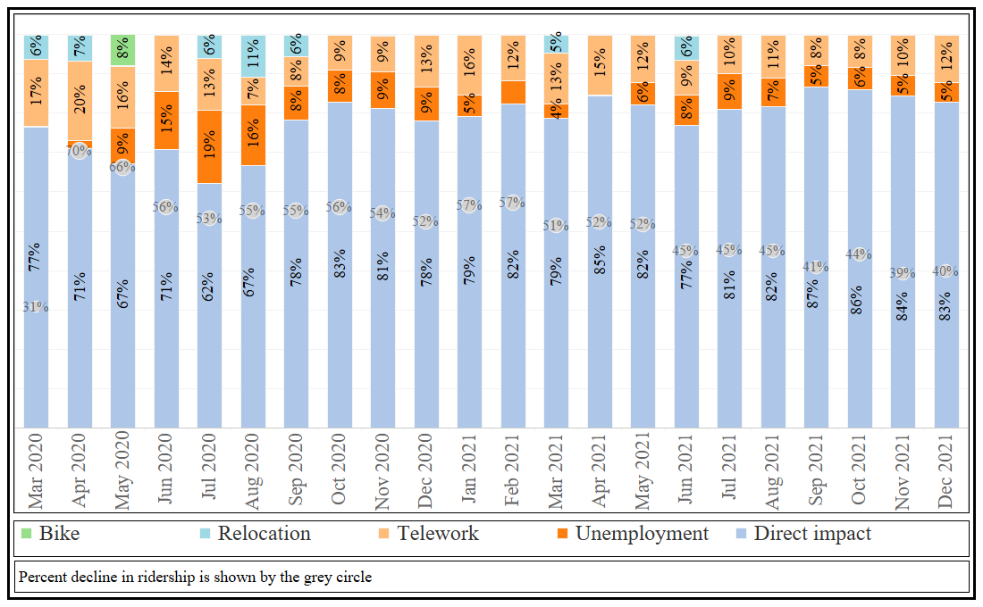
Figure ‎5.6: Direct and indirect impacts of COVID-19 on bus ridership by month for the period March 2020 to December 2021

Areas for Improvement and Areas for Future Research
This section discusses some limitations and areas for future research. First, this study explored the direct and indirect impacts of COVID-19 only until December 2021 due to data availability. Future studies could extend this analysis into 2022 as more data become available. Second, as transit agencies experienced a severe decline in ridership at the beginning of the pandemic, several agencies cut service. These transit service cuts might lead to some customers not riding the bus as they no longer have access to the service. This secondary impact was not considered in this study but is likely to have important implications for ridership. A third limitation is that this study used Google searches as a proxy for bike popularity due to the absence of reliable data. This proxy might not be capturing the actual use of bikes.
There are also several areas for future research that emerged from this study. First, as more data become available, future studies should explore other factors (e.g., car ownership, commute policies) that were not considered here and assess if the pandemic changed their impact on transit. Second, this study focused on bus ridership. Future studies could explore ridership trends for other modes, such as rail and demand-responsive transit, as they may have experienced different trends. Third, future studies could also consider the impacts of the COVID-19 vaccines on bus ridership. Fourth, this study focused only on ridership changes due to COVID-19, but other impacts on the transit industry emerged from the pandemic, such as transit revenue and funding, which are important areas for future research.

Conclusions
This study proposed a multiple mediation framework to estimate the monthly direct and indirect impacts of COVID-19 on bus ridership for the period March 2020 to December 2021. The multiple mediators used in this framework are employment, telework, gas prices, population relocation, bike popularity, and delivery popularity.
The findings suggest that three mediators (employment, telework, and population relocation) mediated about 13% to 38% of the total decline in bus ridership during the period of the analysis. Telework was an important mediated part of the impact of COVID-19 during the whole period, and the impact ranged from 8% to 20%. These findings suggest that teleworking is expected to be an important determinant of transit ridership in a post-COVID-19 world.
The findings of this study also indicate that population relocation mediated about 5% of the decline. This finding highlights another challenge facing the transit industry as people move from urban areas, which reduces density: more transit service would be required to serve the same number of people.
Changes in employment also mediated part of the impact of COVID-19 for all months but March 2020 and April 2021. This finding indicates that employment will continue to be a major determinant of bus ridership post-COVID-19, like it was prior COVID-19 findings. On the other hand, gas prices did not mediate any of the COVID-19 impacts on bus ridership. This finding suggests that gas prices might play a smaller role in determining bus ridership in the future. However, it should be noted that gas prices have continued to increase in 2022; therefore, future research could explore if these trends continue.
The findings of this study suggest that more than two-thirds of the impacts of COVID-19 on bus ridership are direct impacts of the spread of COVID-19. This direct impact includes people not using transit if they are sick or fear contradicting COVID-19 on the bus. This finding contradicts findings from an early study in Chicago that suggested ridership would largely recover when the stay-at-home orders were lifted (Osorio et al., 2022). This finding also highlights the challenge that the transit industry faces in the post-COVID-19 world, as these behavioral changes may not be easy to reverse.
The findings of this study also indicate that COVID-19 will likely have a long-lasting impact on transit ridership, and ridership will not likely fully recover to pre-COVID-19 level if cities and agencies do not act to counteract this impact. Some potential changes that policymakers, city planners, and transit agencies could consider to attract travelers back to transit include giving physical priority to transit (e.g., dedicated right of way), rethinking fare policy to consider part-time commuters, focusing services on the needs of essential workers, and providing vehicle crowding information (Federal Transit Administration, 2022; Gkiotsalitis and Cats, 2021; Hightower et al., 2022; Ziedan et al., forthcoming).
As transit ridership is still only about two-thirds pre-pandemic levels, the findings of this analysis will inform transit agencies and policymakers as they are seeking to fully recover from the impacts of the pandemic.

CHAPTER VI: WILL TRANSIT RECOVER? A RETROSPECTIVE STUDY OF NATIONWIDE RIDERSHIP IN THE UNITED STATES DURING THE COVID-19 PANDEMIC
This chapter is currently under review by the Journal of Public Transportation.

Author Statement
Abubakr Ziedan: Conceptualization, Methodology, Formal analysis, Visualization, Writing - Original Draft. Candace Brakewood: Conceptualization, Methodology, Writing - Original Draft, Supervision, Funding acquisition. Kari Watkins: Writing - Review & Editing, Funding acquisition.

Abstract
Although the COVID-19 pandemic highly impacted transit ridership as people reduced or stopped travel, these changes occurred at different rates in different regions across the United States. This study aims to explore the impacts of COVID-19 on ridership and recovery trends for all federally funded transit agencies in the United States from January 2020 to June 2022. The findings of this analysis show that overall transit ridership hit a 100-year low in 2020. Changepoint analysis used in this study shows that June 2021 marks the beginning of the recovery for transit ridership in the United States. Rail and bus ridership continued to recover slowly but were still only about two-thirds of the pre-pandemic levels in most MSAs by June 2022. In a handful of MSAs like Tampa and Tucson, rail ridership has reached or exceeded 2019 ridership. This study also discusses some long-term changes, including increased telecommuting and operator shortages and some new opportunities that emerged, such as free fares and increased availability of bus lanes. The findings can help inform agencies about their performance compared to their peers and highlight general challenges facing the transit industry over the coming decade.

Background
The COVID-19 pandemic has affected humanity in enormous ways. From the declaration of COVID-19 as a pandemic in March 2020 to August 2022, COVID-19 has resulted in more than one million deaths in the United States (CDC, 2022). One highly impacted sector has been public transit, as users stopped or reduced riding transit as they feared contracting COVID-19 on transit, no longer had the need to commute, or shifted their travel mode (Das et al., 2021; Hu et al., 2020; Simons et al., 2021). While transit ridership in the United States has been declining since 2014 (Watkins et al., 2021), the impact of COVID-19 on transit ridership was more devastating than any other prior event in the last century. Figure ‎6.1 shows that overall transit ridership and rail ridership hit a 100-year low in 2020, while bus ridership has been at the lowest level since the 1930s.
While some prior studies have considered the impacts of COVID-19 on transit ridership, they focused on the first year of the pandemic for specific agencies/regions. To the best of the authors’ knowledge, no prior study has explored transit ridership beyond the first year of the pandemic. Therefore, this study begins to fill this gap in the literature by exploring the impacts of the COVID-19 pandemic on transit ridership from January 2020 to June 2022 for all federally funded transit agencies in the United States. This retrospective analysis will help transit agencies to compare their performance to their peers and understand industry-wide recovery trends.
This paper begins with a brief review of the prior studies. Then, the data and method used to conduct this analysis are presented. Next, the results are presented, and the conclusions and directions forward are discussed.

Figure ‎6.1: Annual transit ridership in the United States
[Data Source: (American Public Transportation Association, 2021)]

Prior Studies
As the COVID-19 pandemic is still ongoing, a growing body of knowledge has explored different aspects of how COVID-19 has impacted transit ridership in various regions of the world. This body of knowledge includes numerous international studies from Europe and Asia, such as recent studies of Wuhan, China (Xin et al., 2021), Stockholm, Västra Götaland and Skåne, Sweden (Jenelius and Cebecauer, 2020), Coruña, Spain (Orro et al., 2020), Scotland (Downey et al., 2022), Canada (Kapatsila et al., 2022; Palm et al., 2021), and India (Das et al., 2021).
In the United States, several studies have explored the impact of COVID-19 on transit ridership with a focus on a specific city or a specific state like New York City (Halvorsen et al., 2021; Moghimi et al., 2022; Wang and Noland, 2021), Chicago (Hu and Chen, 2021), Nashville (Wilbur et al., 2020), Chattanooga (Wilbur et al., 2020), Los Angeles (Gleason, 2021), North Dakota (Molina et al., 2021), and Ohio (Simons et al., 2021). However, a limited number of studies have explored the COVID-19 impacts on transit ridership in more than one region of the United States, which is the focus of the following brief literature review.
In one study, Liu et al. 2020 used logistic regression to explore public transit demand changes for 113 transit agencies using data from the Transit app (a widely used smartphone application that provides transit information). This prior study showed that higher transit demand was observed in areas with higher percentages of essential workers, minorities, females, and people over 45 years old (Liu et al., 2020b). However, the authors of this study have acknowledged that one limitation is that Transit app data are not representative of all riders. They also invited future research to use data from automated passenger counters or other more representative sources.
A study by the USDOT on the impacts of the COVID-19 pandemic on the future of transportation explored changes in bus and rail ridership for the top 26 transit markets in the United States from August 2019 to August 2020 using ridership data from the National Transit Database (NTD) (Polzin and Choi, 2021). The findings of this study showed that rail ridership declined 72% from August 2019 to August 2020, while bus ridership declined by 37% in the same period. This difference in decline was partially attributed to the fact that rail riders typically “travel from white-collar urban and suburban locations to central business district” (Polzin and Choi, 2021). These white-collar jobs were more likely replaced by telecommuting, so the need for travel was negated. While this prior study is very relevant to the topic at hand, it focused on changes during the early months of the pandemic.
Another study by Qi et al. explored ridership changes for bus and light rail in the top 20 largest metropolitan areas in the United States from February 2020 to January 2021 (Qi et al., 2021). Using random-effects models, Qi et al. showed that areas with higher median household incomes, higher employment rates, and higher Asian populations experienced higher ridership declines (Qi et al., 2021). This study also focused on the first year of the pandemic, leaving room for additional research on nationwide trends in the later stages of the pandemic.
Another study by Sullivan explored the COVID-19 impacts on transit ridership in New England using NTD ridership data. This prior study found that 11 of the 12 transit agencies in the region experienced more than a 50% decline in ridership in the first year of the pandemic (Sullivan, 2021).
This brief review reveals that prior studies on the impacts of COVID-19 on ridership focused on the first year of the pandemic. While interesting, the transit industry now faces the question of how it should rebound as the major public health threat of the pandemic subsides. Therefore, continued analysis of the impact of COVID-19 on transit ridership is needed. This study explores transit ridership trends for all federally funded transit agencies that report to the National Transit Database (NTD) in the United States from January 2020 to June 2022, which is an area for research suggested in prior studies (Liu et al., 2020b; Qi et al., 2021). This study makes three contributions. First, this study explores ridership changes in operational clusters across the United States, allowing transit providers to compare their performance to their peers. Second, this study examines transit ridership trends during the early portion of the pandemic as well as more recent recovery trends (until June 2022). Third, this study uses a changepoint analysis to further investigate transit ridership’s recovery trajectory. This change point analysis detects any significant changes in the recovery of transit ridership.

Data
This study used monthly ridership data obtained from the National Transit Database (NTD) from January 2019 to June 2022 (National Transit Database, 2021). NTD data has monthly ridership estimates by mode for all transit agencies that receive federal funds. For the purpose of this analysis, only rail and bus were considered as they are the dominant modes in the United States. The rail mode included heavy rail (HR), light rail (LR), streetcars (SR), and commuter rail (CR), and the bus mode contained motor bus (MB), bus rapid transit (RB), trolley bus (TB), and commuter bus (CB). The unit of analysis was the metropolitan statistical area (MSA); all transit agencies operating in the same region were aggregated to the MSA level. The reason to use the MSA level instead of the transit agency was to compare regions with similar transit characteristics based on American Public Transportation Association (APTA) operational expenses clusters (American Public Transportation Association, 2019):
- High operational expenses (op-ex) cluster: Above $300 Million. This cluster had both bus and rail operators.
- Mid op-ex cluster: Between $30 Million and $300 Million. This cluster also had bus and rail operators.
- Low op-ex cluster: Below $30 Million. This cluster had bus operators only.
It should also be noted that the New York MSA, which includes transit agencies operating in the states of New York and New Jersey, was explored separately since this region carries about 40% of the total transit ridership in the United States (Watkins et al., 2021). New York was a COVID-19 hotspot in the early months of the pandemic, which also warrants special consideration.

Method
This study used a two-part methodology. The first part was a retrospective analysis of changes in ridership, service provision, and productivity using APTA operational expense clusters from January 2020 to June 2022. This part begins with exploring the aggregate trends for each cluster, then comparing trends across regions within each cluster. This retrospective analysis provides an overview of how transit ridership changed in the different MSAs and allows transit providers to compare their performance to their peers.
The second part of the study applied a changepoint analysis to detect any significant changes in the recovery of transit ridership. Changepoints are defined as “abrupt variations in time series data” (Aminikhanghahi and Cook, 2017). These changes could represent changes that occur between conditions or states (Aminikhanghahi and Cook, 2017). Changepoint analysis is gaining interest in the field of transportation in the wake of the COVID-19 pandemic as some recent studies have used it to explore changes in mobility levels and subway ridership during COVID-19 (Moghimi et al., 2022; Panik et al., Forthcoming) This study uses changepoint analysis to explore changes in ridership recovery measured as the percent decline compared to the same month in 2019. As the transit ridership recovery might have experienced more than one change during the study period, this study used the multiple changepoint detection method proposed by Killick and Eckley, which uses multiple search methods compared to other methods that apply single search methods (Killick and Eckley, 2014).
The Killick and Eckley method applies a likelihood-based framework to detect changepoints (Killick and Eckley, 2014). This is an extension of the single changepoint approach that uses a likelihood ratio test statistic for changes in the mean and/or variance of the outcome variable (y) before and after the changepoint. The likelihood ratio test has a null hypothesis indicating no changepoint (m = 0), and an alternative hypothesis there is a single changepoint (m = 1) (Killick and Eckley, 2014). The multiple changepoint approach uses the same concept to test for m>1 by summing the likelihood for each m (Killick and Eckley, 2014).
The multiple changepoint approach identifies the multiple changepoints by minimizing Equation 1 (Killick and Eckley, 2014).

min $\sum_{i=1}^{m+1}{\left\{C\left(y_{\left(т_{i-1}+1\right):т_{i}}\right)\right\}+βf(m)}$ (1)
Where:
y ≡ outcome variable
C ≡ cost function (e.g., negative log-likelihood)
$βf(m)$ ≡ penalty to guard against overfitting
m ≡ number of changepoints
$т_{i}$ ≡ changepoint at time i
Killick and Eckley proposed three different algorithms to minimize equation (1) as follows: binary segmentation, segment neighborhoods, and pruned exact linear time (PELT) (Killick and Eckley, 2014).
This study used the pruned exact linear time (PELT) algorithm to detect multiple changepoints in the mean of the percent decline in monthly ridership compared to 2019 (y),since it is the most accurate and computationally efficient (Killick and Eckley, 2014). Also, to protect against overfitting, this study applied a penalty = 200*log(n) and restricted the minimum length of the segment to two months. This analysis was carried out in RStudio using the “changepoint” package version 2.2.3 (Killick R et al., 2022)

Results
This section presents ridership, service provision, and productivity trends from January 2020 to June 2022 for both rail and bus.

Rail Trends
Figure ‎6.2 shows the percentage change compared to the same month in 2019 for New York, the high op-ex cluster, and the mid op-ex cluster. Figure ‎6.2 shows that New York experienced substantial drops early in the pandemic; ridership dropped by more than 90% in April 2020 and May 2020 compared to 2019. These dramatic drops coincided with a significant service reduction of 39% of vehicle revenue miles (VRM) in April 2020. However, as New York announced a phased reopening plan in June and July 2020 (Wang and Noland, 2021), 90% of the rail service was restored by July 2020, and ridership started to bounce back slightly. New York ridership recovered slowly in 2021 and the first half of 2022 until it reached about 70% of 2019 by June 2022.
Figure ‎6.2 also shows that rail ridership in the high op-ex cluster experienced similar ridership declines to New York in April and May (about an 87% decline in UPT). However, rail ridership in these MSAs experienced a slower recovery than in New York. By June 2022, they were still 47% below ridership levels in 2019, although the service levels were only 11% below 2019.
In the mid op-ex cluster shown in Figure ‎6.2, ridership declines were somewhat less dramatic early in the pandemic; the largest decline was 76% of 2019 ridership levels in April 2020. However, ridership was almost constant from July to December 2020 at about a third of 2019 levels. From the beginning of 2021, ridership started a slow recovery until it reached about 60% of the 2019 levels by June 2022.
Comparing ridership for these three clusters, it can be noticed that the high op-ex cluster experienced a slower recovery. This slower recovery suggests that transit agencies in this cluster are expected to face a tough challenge to bring rail ridership back to the pre-pandemic levels; it may be particularly challenging for those agencies with higher numbers of choice riders, who might be reluctant to return to transit as they have access to other options, or for higher levels of white-collar jobs that may continue to work from home to a greater degree.
In addition, Figure ‎6.2 shows that service levels measured as vehicle revenue miles (VRM) in New York were almost restored to pre-pandemic service provision levels by June 2022. For the high and mid op-ex clusters, VRM was only about 10% less than 2019 levels. This finding shows that rail service is almost at the pre-pandemic levels across the different clusters. Last, Figure ‎6.2 displays transit productivity (measured as UPT per VRM and shown in blue), which followed a similar trajectory as ridership for the different clusters.
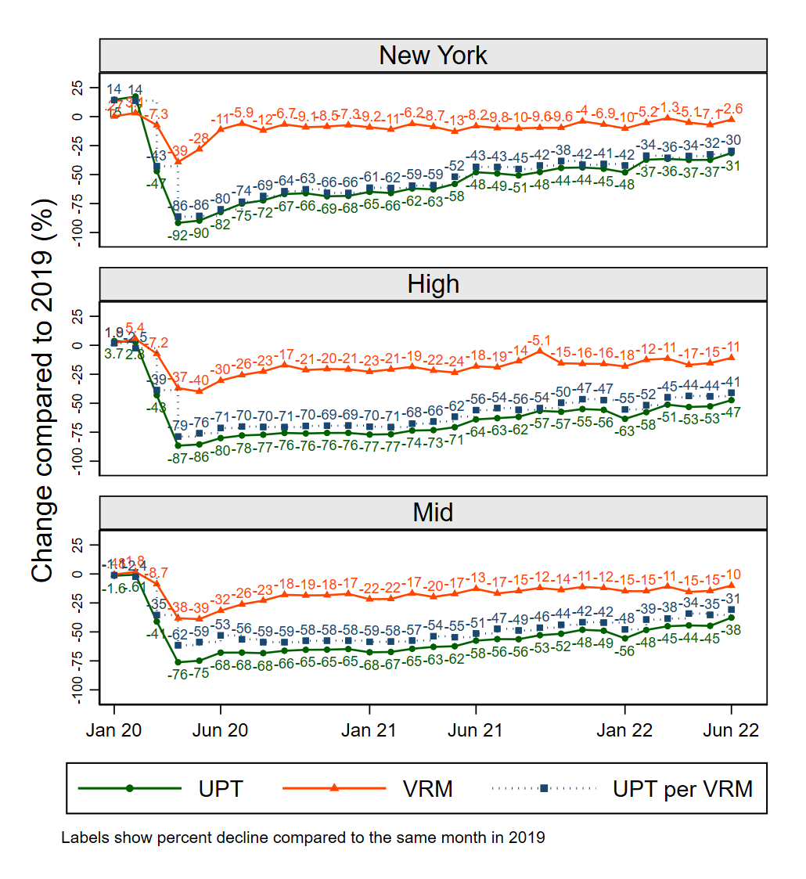
Figure ‎6.2: Percent decline in ridership, service provision, and productivity for rail

Rail Ridership Changes by Region in the High Operational Expenses Cluster
Figure ‎6.3 shows declines in rail ridership for 2020, 2021, and 2022 (Jan to Jun only) compared to similar periods in 2019, measured as a percent decline relative to 2019. Figure ‎6.3 also shows the change in ridership in June 2022 compared to June 2019 for each MSA, represented by the circle’s color and size. As can be seen in Figure ‎6.3, San Francisco and Washington, DC were the most affected MSAs in this cluster; they experienced ridership declines of 73% and 71% in 2020, respectively. One possible reason that may explain these sharp declines is telecommuting. Washington, DC, has suffered a substantial decline in ridership as most federal government employees worked virtually during 2020. Data from the Maryland Transportation Institute at the University of Maryland College Park showed that between March 2020 and December 2020, about 52% of the workforce in Washington, DC worked from home, the highest nationwide during this period (Maryland Transportation Institute, 2020). Similarly, San Francisco is the home to several tech companies whose employees can work virtually for extended periods. On the other hand, Houston, Dallas, Phoenix, and San Diego were the least affected in 2020 in percentage terms; they experienced ridership declines ranging from 42% to 44%.
In 2021, ridership declines in this cluster ranged from 40% to 78% (Figure ‎6.4). San Jose joined San Francisco and Washington, DC as the most affected MSAs, with ridership declines ranging from 78% to 76% below the 2019 levels. This high ridership decline in San Jose could be attributed to the system being out of service for three months due to a mass shooting in one of the light rail stations in May 2021 (Preciado et al., 2021). San Diego, Dallas, Miami, and Houston were the least affected in 2021. Figure ‎6.3 also shows that in June 2022, ridership in this cluster experienced declines ranging from 9% to 67%, with a mean decline of 43%. San Diego experienced the least decline as ridership was only 9% below June 2019, which indicates that it has almost recovered. On the other hand, ridership in Baltimore was 67% below June 2019 levels (the highest in this cluster). Also, it can be noticed that ridership in Chicago was about 52% less than in June 2019. This finding suggests that ridership in Chicago has yet to recover. This finding contradicts the prediction of a prior study in Chicago that expected ridership could recover immediately as all travel restrictions were lifted (Osorio et al., 2022).

Rail ridership changes by region in the mid-operational expenses cluster
Figure ‎6.5 shows that St. Louis experienced a 48% drop in ridership in 2020, the smallest drop in this cluster, followed by Sacramento (50% drop in 2020). Figure ‎6.5 also shows that the most impacted MSAs in terms of percentages were Albuquerque, Detroit, El Paso, Portland (ME), Nashville, and Stockton; these MSAs experienced ridership declines ranging between 83% to 73% in 2020. Those MSAs could be divided into two groups. The first group contains Albuquerque, Detroit, and El Paso. These three MSAs shut down their transit service in April 2020. The second group contains Portland, Nashville, and Stockton, which operate only commuter rail. These three MSAs with commuter rail only experienced higher declines than other MSAs in this cluster, which is expected as telecommuting was one of the main strategies used to reduce the spread of COVID-19 and many commuter rail patrons have higher income jobs that are more likely to allow work from home (Polzin and Choi, 2021).
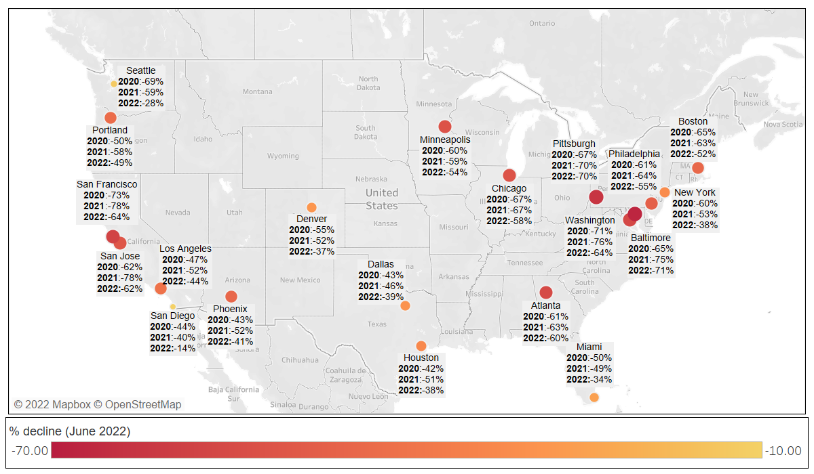
Figure ‎6.3: Rail ridership declines for New York and the high op-ex cluster MSAs

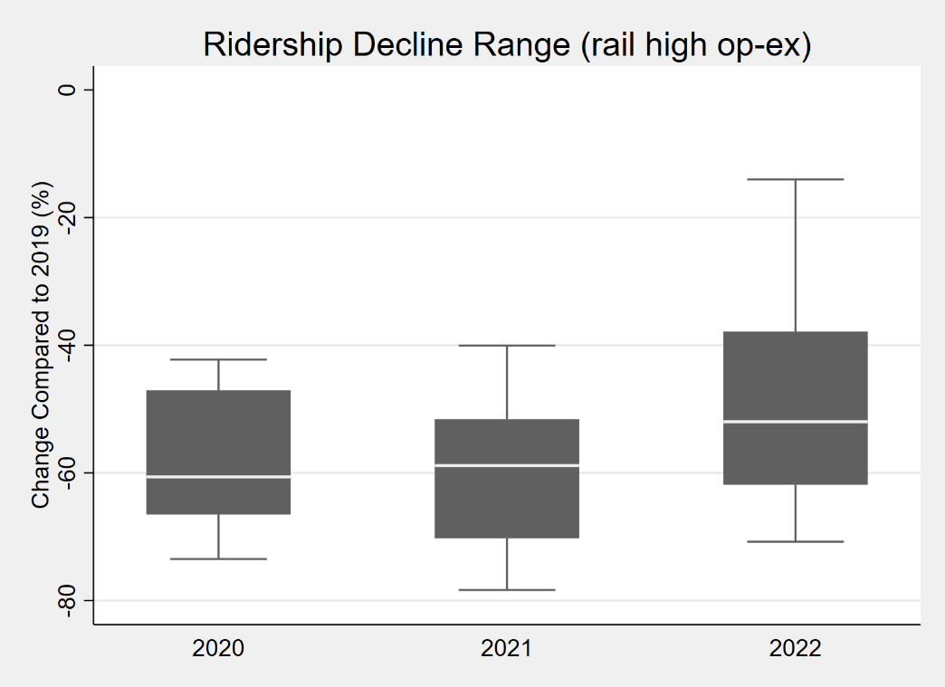
Figure ‎6.4: Rail ridership declines range for the high op-ex cluster

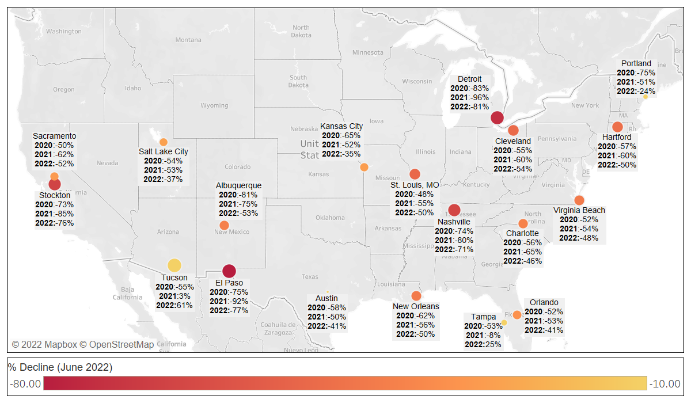
Figure ‎6.5: Rail ridership declines in the mid operational expenses cluster MSAs

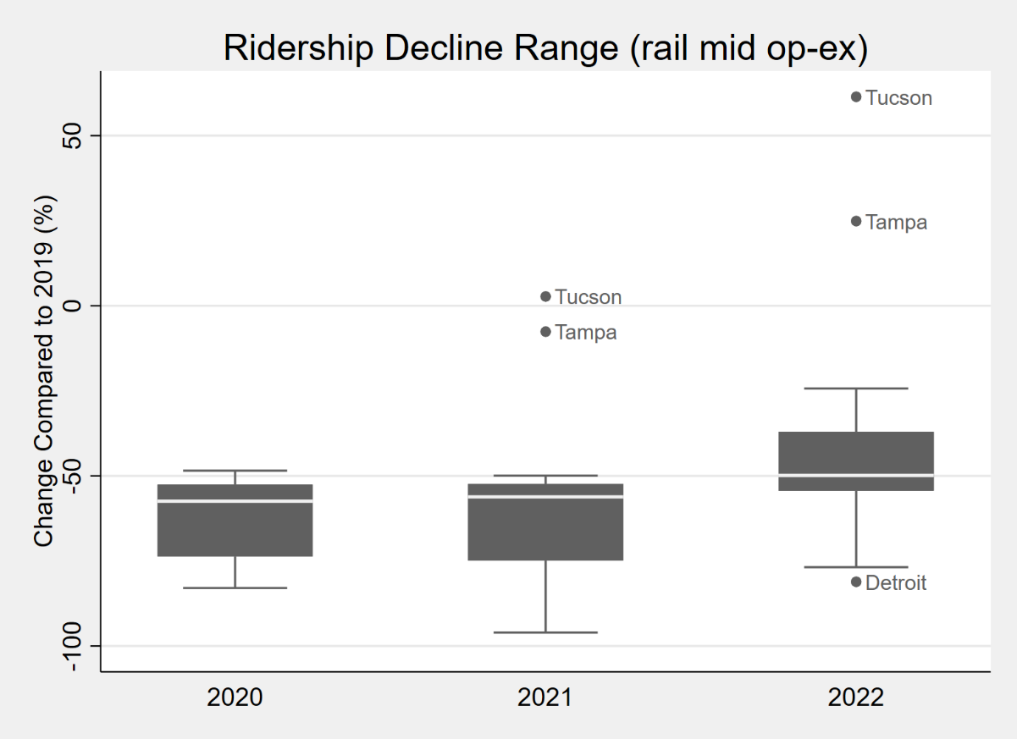
Figure ‎6.6: Rail ridership declines range for the mid op-ex cluster

In 2021, interestingly, rail ridership in Tucson exceeded 2019 ridership levels by 3%, which is the first MSA to reach pre-pandemic rail ridership levels (Figure ‎6.6). Transit officials in Tucson attribute this recovery to the continuation of offering free rides, waiving the $4.25 single fare on the streetcar system (KOLDNews, 2022). In the first half of 2022, Tampa joined Tucson as the only two MSAs to exceed 2019 ridership with increases of 25% and 61%, respectively. Officials in Tampa attribute this increase in ridership to increased tourism and major events like the Tampa Bay Lightning playoff (Spectrum Bay News 9, 2022). It should be noted that the Tampa streetcar has been running free since October 2018 (Harlan, 2022). Last, Detroit, El Paso, Nashville, and Stockton were also the most affected MSAs in both 2021 and the first half of 2022.

Bus Trends
Figure ‎6.7 shows that the largest bus ridership decline in the New York MSA was observed in April 2020, a 77% drop compared to April 2019. New York bus ridership reached two-thirds of 2019 levels in August 2020 before dropping again in the following months; this second decline was likely due to the increase in COVID-19 cases during this period. By June 2022, New York bus ridership was about two-thirds of ridership levels observed in 2019.
Bus ridership in the other operational expense clusters (High, Mid, and Low) followed a similar trend, as shown in Figure ‎6.7. Bus ridership in these three clusters experienced the largest decline in April 2020, about a 70% drop compared to April 2019. After that, ridership started a slow recovery until it reached about two-thirds of ridership levels observed in 2019 by June 2022. It is worth noting that bus ridership in the different clusters dipped in January 2021 and January 2022, and these dips are likely due to COVID-19 surges. This finding suggests that bus ridership was still affected by COVID-19 waves but at a smaller magnitude compared to when the pandemic first hit.
Figure ‎6.7 also shows the service provision for the different clusters. All clusters reduced bus service by about 30% in April and May 2020. New York, mid, and low op-ex clusters restored 90% of the service levels by Fall 2020. In the high op-ex cluster, VRM levels were about 80% to 85% of the 2019 levels until June 2021. In Figure ‎6.7, it can also be noticed that productivity followed a similar trend to ridership.
Comparing bus to rail, bus ridership experienced less declines compared to rail at the beginning of the pandemic and started to recover faster. This difference may be partly due to the demographics of bus riders compared to rail; in general, buses are more often used by essential workers than rail, and rail systems often have higher percentages of choice riders than buses (Brown et al., 2014; Clark, 2017; Taylor and Morris, 2015). Last, the results of this study indicate that rail and bus ridership both are experiencing ridership declines of around 30% in June 2022. This finding suggests that ridership is still below some of the early recovery predictions that projected ridership declines will be less than 20% by June 2022 (Polzin and Choi, 2021).

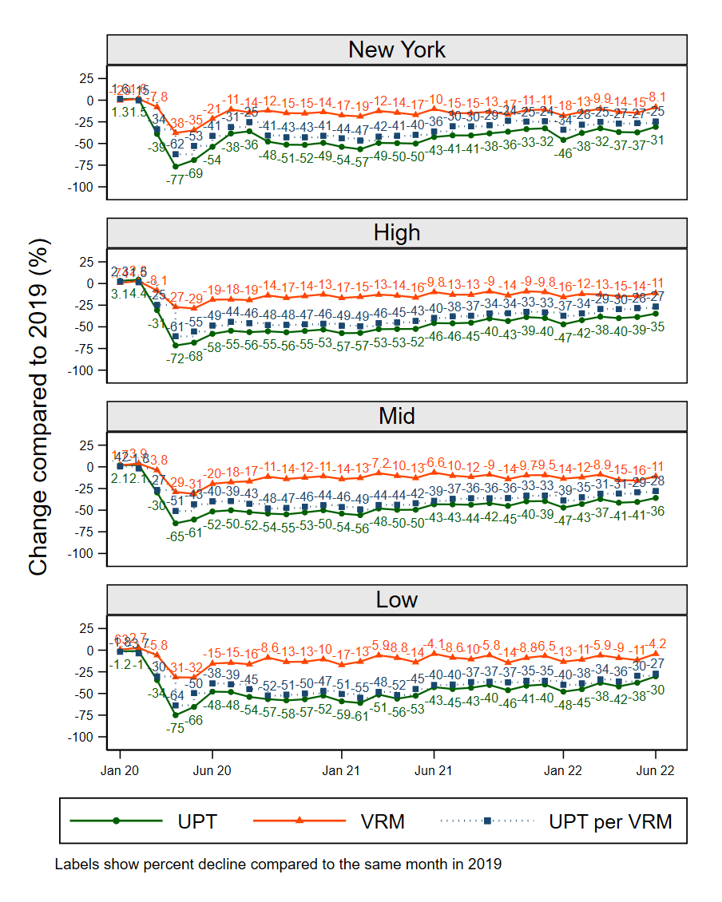
Figure ‎6.7: Percent decline in ridership, service provision, and productivity for bus

Bus Ridership Changes by Region in the High Operational Expenses Cluster
Figure ‎6.8 shows declines in bus ridership compared to 2019 for MSAs in the high op-ex cluster for 2021, 2022, and the first half of 2022. In 2020, MSAs in this cluster experienced a similar percentage drop in bus ridership, ranging from 36% to 54% (mean decline of 46%), except for Phoenix, which experienced a drop of only 24%. In 2021, most MSAs experienced larger percentages of declines compared to 2020, ranging from 29% to 60% (Figure ‎6.9). These larger declines were likely because COVID-19 affected ridership in 2020 starting from March, while it affected the whole year of 2021. Boston, Miami, Los Angeles, and Washington, DC debunked this trend as they experienced less declines in 2021 compared to 2020, suggesting they started to recover faster than other MSAs. In the first half of 2022, most MSAs’ ridership reached more than half the 2019 levels, with Miami being the fastest to recover (74% of 2019 ridership levels).

Bus Ridership Changes by Region in the Mid Operational Expenses Cluster
In 2020, this cluster’s mean decline of ridership was 44%. Richmond, VA, was the least affected, with a decline of only about 17% in 2020, as shown in Figure ‎6.10 and Figure ‎6.11. Bridgeport, CT, was the most affected in the mid op-ex (-73%), followed by Santa Cruz-Watsonville, CA (-68%) (Figure ‎6.11). In 2021, Tucson, AZ, and Richmond, VA, experienced the least declines in ridership, only 11% and 13% less than the 2019 levels, respectively. Bridgeport, CT (-73%) and Santa Cruz-Watsonville, CA (-68%) were also the most affected. In the first half of 2022, bus ridership in Worcester, MA-CT, recovered to the pre-pandemic levels, with ridership gains also attributed to the agency operating fare-free since the beginning of the pandemic (MilNeil, 2021). In June 2022, ridership in Worcester, MA-CT, was about 25% higher than in June 2019, which suggests ridership continued to increase.

Bus Ridership Changes by Region in the Low Operational Expenses Cluster
Figure ‎6.12 shows that declines in the low op-ex cluster ranged from -93% to -42%, with a mean decline of 42%. Rome, GA was the most impacted in this cluster in 2020 (-93% drop in ridership), followed by Elizabethtown, KY (-80%), Bay City, MI (-74%), State College, PA (-70%), Blacksburg, VA (-69%), and Ithaca, NY (-66%). Many of these cities are college towns in which students moved to eLearning when the COVID-19 pandemic began. It should also note that Elizabethtown, KY stopped fixed route bus services when the pandemic hit. In 2021, ridership declines ranged from 7% to 93% below 2019 levels (Figure ‎6.13) with a mean decline of 45%. Sebastian, FL, experienced the fastest recovery as ridership was only about 7% below 2019. One interesting aspect of transit in Sebastian, FL, is that GoLine (the transit provider) operates fare-free but encourages riders to donate to help the system (GoLine, 2022). In the first half of 2022, Toledo experienced a 19% increase in ridership compared to the same period in 2019. Also, the transit agency in Toledo was operating fare-free from March 2020 till July 2022 but reinstated fares starting August 2022 (Toledo Area Regional Transit Authority (TARTA), 2022). It is worth noting that Figure ‎6.12 and Figure ‎6.13 show that ridership in Fayetteville, NC, experienced a ridership increase of more than 20% in the first half of 2022. These increases resulted from lower ridership in the first half of 2019 in Fayetteville, NC, not a large increase in 2022.
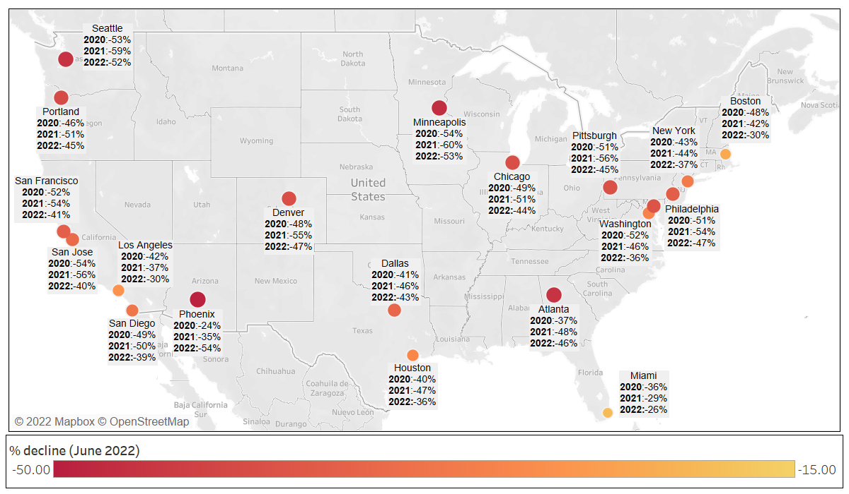
Figure ‎6.8. Bus ridership declines in the high operational expenses cluster MSAs

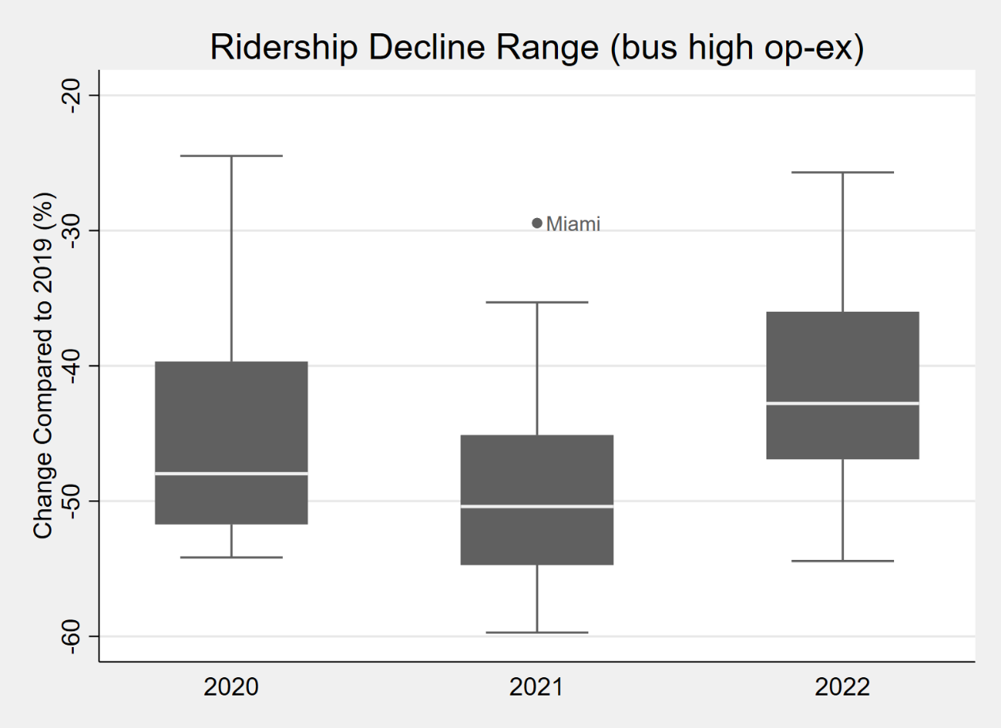
Figure ‎6.9: Bus ridership declines range for the high op-ex cluster

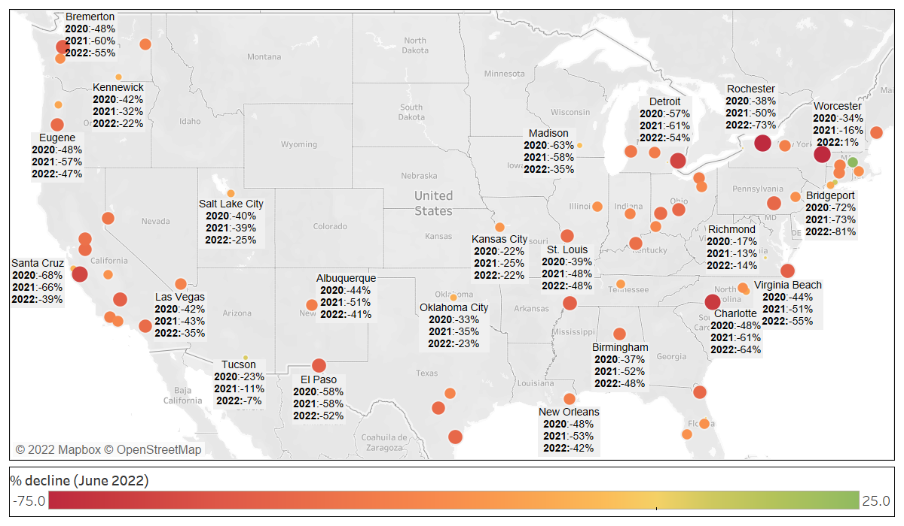
Figure ‎6.10: Bus ridership decline in the mid operational expenses cluster MSAs

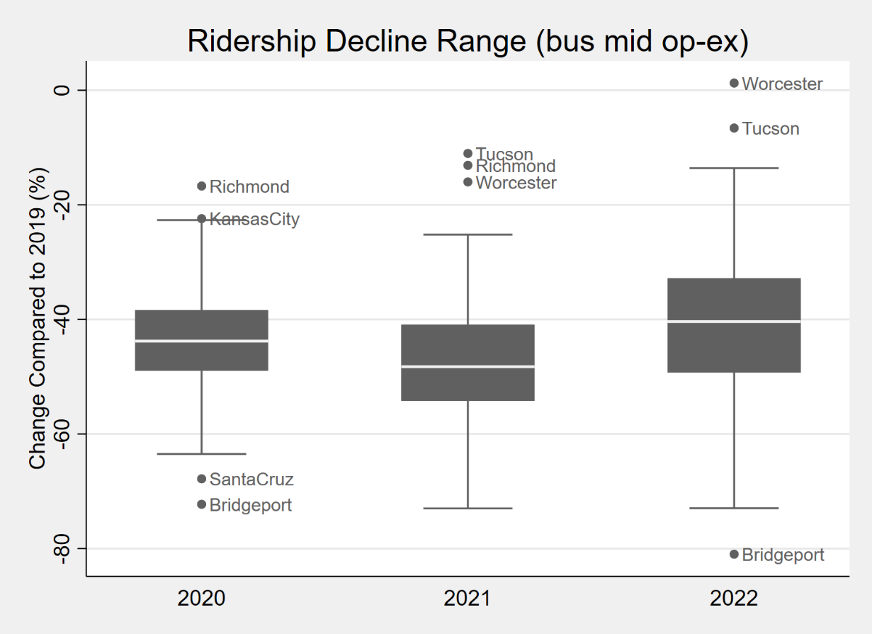
Figure ‎6.11: Bus ridership declines range for the mid op-ex cluster

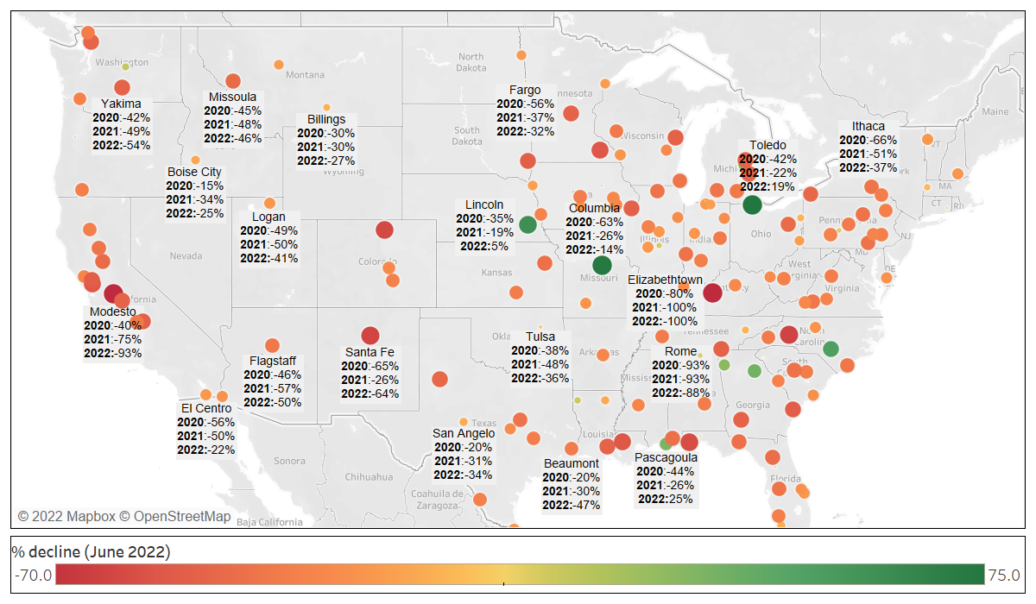
Figure ‎6.12: Bus ridership declines in the low operational expenses cluster MSAs

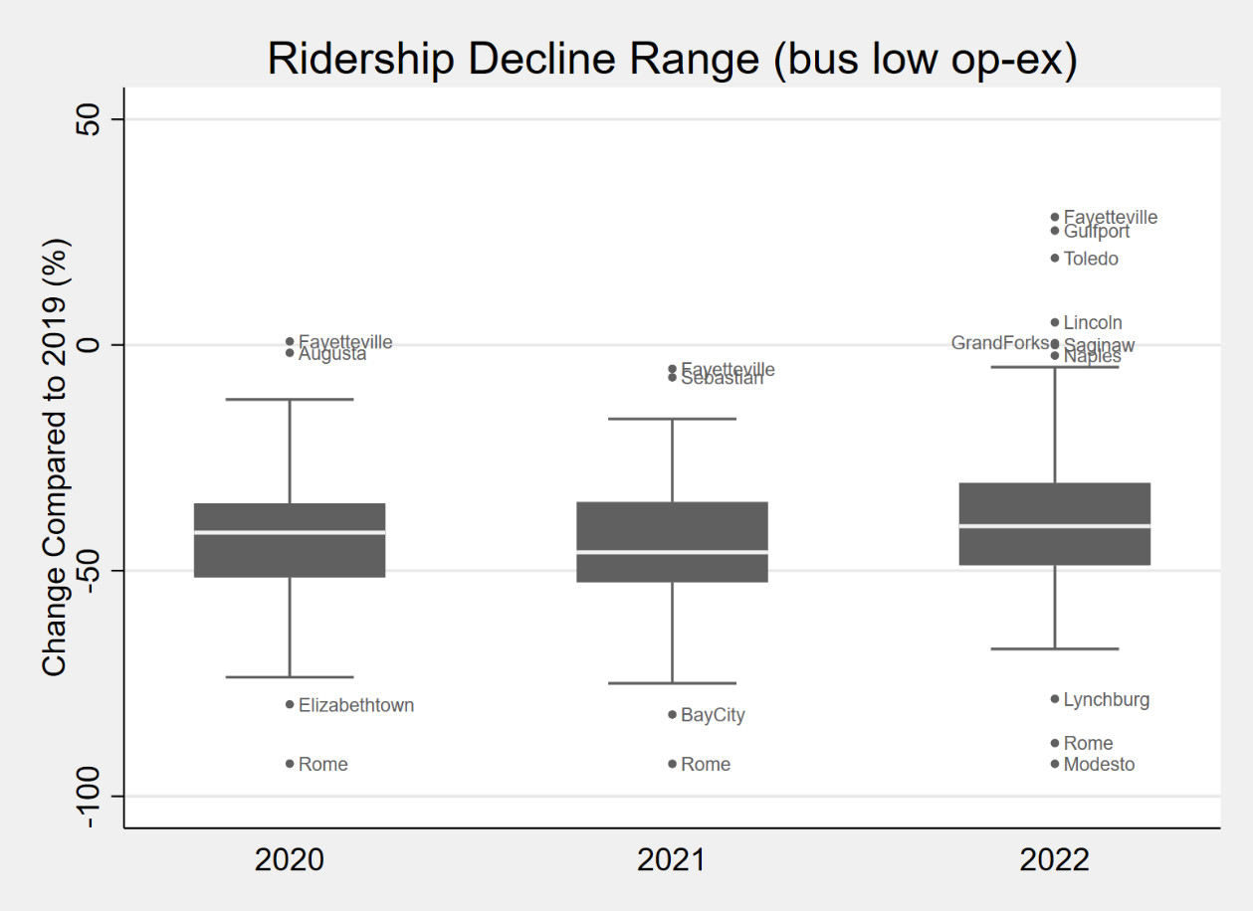
Figure ‎6.13: Bus ridership declines range for the low op-ex cluster

Changepoint Analysis
This section discusses the changepoint analysis results for rail and bus ridership change compared to 2019. Figure ‎6.14 shows the changepoint results of nationwide rail and bus ridership. The figure shows that rail and bus ridership change had two changepoints within the study period, in March 2020 and June 2021. The first changepoint in March 2020 identifies the pandemic’s beginning with substantial ridership declines until May 2021. During this period, the average monthly ridership decline was about 71.23% on rail and 53.82% on bus. Stay-at-home orders and higher unemployment rates defined this period. This finding aligns with the findings of a prior study that explored changes in seven subway stations in New York (Moghimi et al., 2022). The other changepoint in June 2021 signals the beginning of the recovery for transit ridership. This beginning of the recovery corresponds with 50% of US adults being fully vaccinated by the end of May 2021 (CDC, 2022). From June 2021 to June 2022, rail ridership was 47.65% lower than 2019 levels, while bus ridership was about 40.66% less than in 2019. These two numbers indicate increases of 23.58 and 13.16 percentage points for rail and bus, respectively. These increases are consistent with the findings of a nationwide survey of transit riders (n= 531) that found effective vaccines would encourage 38% of riders to increase transit use (Parker et al., 2021).
In summary, this analysis shows that early in the pandemic, buses experienced fewer declines compared to rail, likely due to the fact that buses tend to serve more essential workers and transit-dependent riders compared to rail (Clark, 2017). However, after the changepoint, rail recovered a higher portion of lost ridership compared to bus.
This changepoint analysis was also conducted by cluster, and the results are shown in Table ‎6.1. It can be noticed that in all clusters but rail mid op-ex, ridership recovery followed the same trend as nationwide ridership with two changepoints in March 2020 and June 2021. The rail mid op-ex cluster second changepoint was in July 2021, suggesting ridership in this cluster started to recover in a similar timeframe, although a little later. It is interesting that the COVID-19 pandemic hit when ridership across all clusters but bus low op-ex and rail mid op-ex was increasing with similar rates (Table ‎6.1). This increase came after years of decline for transit ridership since 2014 (Erhardt et al., 2022; Watkins et al., 2021). However, as the pandemic hit, ridership experienced the most severe declines in the last 100-years.
Table ‎6.1 also shows the difference in average ridership decline between the two periods before and after the second changepoint. It can be noticed that the recovered portion of ridership ranged from 10% in the bus mid op-ex cluster to 26% in the rail New York cluster.

Conclusions
This study explored transit ridership, service provision, and productivity changes for all federally funded agencies in the United States due to the COVID-19 pandemic from January 2020 to June 2022. Overall transit ridership and rail ridership hit 100-year lows in 2020, and bus ridership reached the lowest level since the 1930s.

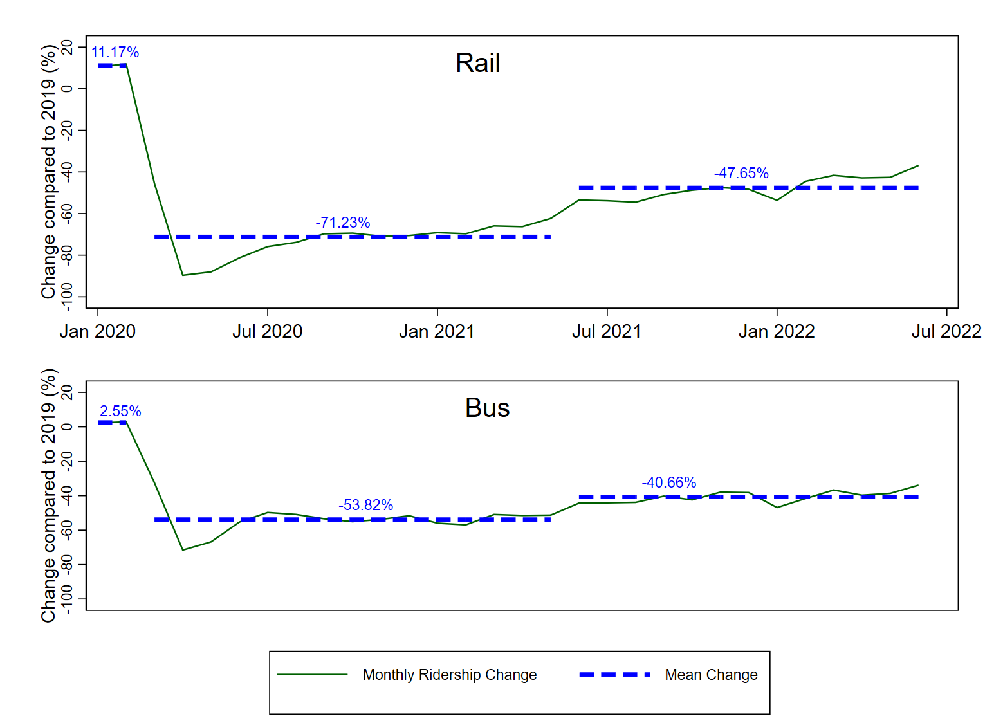
Figure ‎6.14: Changepoint results of nationwide rail and bus ridership

Table ‎6.1: Changepoint Results by Cluster
Cluster | # of CP | Time of CPs |  | Mean ridership change compared to 2019 (%) |  |  | Difference between (3) and (2)  (pp)
Cluster | # of CP |  |  | (1) Jan 20 to Feb 20 | (2) Mar 20 to May 21 | (3) Jun 21 to Jul 22 | Difference between (3) and (2)  (pp)
BUS (US) | 2 | March 2020 | June 2021 | 2.55 | -53.82 | -40.66 | 13.16
BUS NY | 2 | March 2020 | June 2021 | 1.36 | -51.48 | -37.33 | 14.15
BUS High | 2 | March 2020 | June 2021 | 3.72 | -55.38 | -41.56 | 13.82
Bus Mid | 2 | March 2020 | June 2021 | 2.08 | -51.86 | -41.66 | 10.20
Bus Low | 2 | March 2020 | June 2021 | -1.10 | -55.24 | -41.41 | 13.82
Rail (US) | 2 | March 2020 | June 2021 | 11.17 | -71.23 | -47.65 | 23.58
Rail NY | 2 | March 2020 | June 2021 | 15.94 | -69.45 | -42.81 | 26.64
Rail High | 2 | March 2020 | June 2021 | 3.23 | -74.95 | -56.84 | 18.11
Rail Mid | 2 | March 2020 | July 2021 | -1.09 | -65.02 | -49.17 | 15.85

The results of this study revealed that most metropolitan areas and modes experienced the highest drop in April 2020, when there were many lockdowns and/or travel restrictions. Riders started to return to transit as cities began to reopen, but ridership declines were still substantial in most MSAs until June 2021. June 2021 was a significant changepoint in the recovery trajectory. This changepoint in the recovery trajectory is likely attributed to 50% of US adults being fully vaccinated and messaging from officials that the pandemic was ending. From June 2021 to June 2022, ridership recovery continued slowly until it reached about two-thirds of the 2019 levels in most MSAs.
In a handful of MSAs like Tampa and Tucson, rail ridership has reached or exceeded 2019 ridership. Bus ridership also exceeded 2019 ridership in some MSAs in the low op-ex cluster. One common factor among these MSAs that recovered is continuing to offer fare-free transit for an extended period.
Last, transit productivity (measured as UPT per VRM) followed the same trend as ridership across different modes across all different clusters. This finding may indicate that the capacity limits implemented by agencies did not have a huge impact on ridership.

Directions Forward
The findings of this study showed that though transit ridership has continued to recover slowly, it is still about one-third below the 2019 levels, while other modes of travel, like vehicular travel, have already reached pre-pandemic levels (Bureau of Transportation Statistics, 2022a).
Transit ridership has been experiencing a slow recovery; however, service cuts due to bus operator shortages continue to be a major threat to this recovery. 71% of agencies that participated in a recent survey by APTA (n=117) stated that they had to cut service or delay service increases because of the bus operators’ shortage (American Public Transportation Association, 2022). This shortage could be attributed to factors like competition from delivery companies, generally low unemployment, and reports of increased assaults against transit operators that come along with increases in crime in many cities (TransitCenter, 2022; Walker, 2021). Transit providers must address this driver shortage issue as a major step toward full recovery.
Most of the MSAs that reached or exceeded pre-pandemic ridership levels operated fare-free services for extended periods, which suggests that it could play a role in transit recovery. However, the fare-free operation could be costly, particularly for agencies with higher farebox recovery ratios. Agencies benefited from the additional federal funding provided through the Coronavirus Aid, Relief, and Economic Security (CARES) Act (Congress.gov, March 27, 2020), the Coronavirus Response and Relief Supplemental Appropriations Act of 2021 (Congress.gov, December 27, 2020), and the American Rescue Plan Act of 2021 (Congress.gov, March 11, 2021) to overcome the loss of revenue resulting from fare collection suspension. In the future, transit providers need other sources of revenue to replace the farebox revenue if they decide to continue fare-free operations.
Telecommuting is expected to be a long-lasting impact of COVID-19; a survey of more than 30,000 Americans indicated that the percentage of telecommuting is expected to be 20% after COVID-19 compared to only 5% prior to the pandemic (Barrero et al., 2021). This significant increase in telecommuting is expected to change how people use transit either by reducing the frequency of riding or the purpose of using transit. Therefore, transit providers should consider this as they plan for future service changes. One aspect is that agencies could change their fare policy to encourage part-time commuters to use transit when they commute, through programs such as fare capping with flexible periods (Hightower et al., 2022) or short-term passes instead of 31-day passes. Also, agencies could consider planning services for more diverse travel purposes rather than focusing on commuting. A related challenge to telecommuting is people moving to less dense areas to avoid crowding or benefit from large areas for outdoor activities (Burke and Grogan, 2021). Lower densities would negatively affect transit ridership (Watkins et al., 2021), and more transit services would be needed to provide the same level of accessibility.
Several municipalities like Boston, Chicago, and San Francisco installed new temporary bus lanes during the pandemic (Cobbs, 2020). These temporary lanes helped to speed buses; an evaluation of a temporary bus lane installed along one of Muni’s highest ridership corridors showed that riders experienced 15% faster travel time (McMillan, 2022). The success of these temporary bus lanes shows that prioritizing transit could be achieved by simple means that could be installed quickly and at a low cost. Prioritizing transit could help transit agencies to recover from the pandemic’s impact.
Also, as this study focused on fixed-route transit, future studies should explore demand-responsive transit and how it was affected by the COVID-19 pandemic. It is expected that demand responsive transit has been facing different challenges than fixed routes transit. Therefore, a future study that takes a deep dive into demand response transit trends is necessary.
Last, while this study focused on ridership (the typical measure for transit performance), the COVID-19 pandemic showed that transit plays a critical equity role in providing access to essential workers around the country who helped keep the cities running. This kind of benefit could not be quantified by ridership or productivity. Therefore, in the future, transit success should not be measured only by ridership or productivity measures; other measures are needed to gauge transit performance.

CHAPTER VII: CONCLUSIONS

This chapter discusses the main findings of this dissertation and areas for future research.

Main Findings and Concluding Remarks
This dissertation investigated several questions about the impacts of different emerging factors on transit ridership, such as shared e-scooters, mobile fare payment applications, fare capping, and the COVID-19 pandemic. Understanding these questions and impacts is essential for transit agencies, and policymakers as they were concerned about ridership declines even before the COVID-19 pandemic and as they plan for a post-COVID-19 world. The main findings of this dissertation are summarized in Figure ‎7.1.
The findings of chapter two suggested that shared e-scooters did not significantly impact local bus ridership in Louisville, KY. This finding was further supported by chapter three about Nashville, TN, which showed that while shared e-scooter impacts on bus ridership varied based on e-scooter trip purpose, their net impact was minimal. The findings of these two chapters suggest that shared e-scooters are likely not one of the primary causes of bus ridership declines prior to the COVID-19 pandemic. Furthermore, some shared e-scooter trips could complement bus ridership, such as social e-scooter trips and possibly trips around express bus stops. This should encourage agencies to promote the use of these two modes together. One example is installing shared e-scooters corrals near transit stops that are likely to have significant numbers of e-scooter trips with a social purpose, which is currently ongoing in Nashville, TN, and has been guided by the findings of this dissertation (Ziedan et al., 2022). Offering an integrated trip planning and fare payment application could also be another approach for better integration of buses and e-scooters. Last, as agencies are restoring services that were cut during the pandemic, they may consider shared e-scooters as first/last mile connectors to increase transit accessibility.
The findings of chapter four of this dissertation suggest that launching mobile fare payment applications did not yield significant ridership gains at the fifty largest bus agencies in the United States. Despite this, the COVID-19 pandemic has highlighted their importance from a public health perspective because contactless technology can help promote social distancing (e.g., between passengers paying fares and bus drivers). On the other hand, adopting monthly fare capping policies was associated with ridership gains ranging from 3.6% to 4.1%. This finding about monthly fare capping is important for agencies across the United States as they consider different strategies to increase ridership and reverse recent bus ridership declines. An important caveat is that ridership gains might be different in magnitude in a post-COVID-19 world since this dissertation analyzed pre-pandemic ridership impacts; however, it is likely that fare capping policies will continue to have a positive impact as a policy tool that can help nudge riders’ behavior.
The findings of chapters five and six indicate that the COVID-19 pandemic was the largest disruption for transit in the last century, with both overall ridership and rail ridership hitting 100 years low and bus ridership at the lowest level since the 1930s. The findings of chapter five indicated that telework, unemployment, and people relocating were important drivers of ridership declines during the COVID-19 pandemic that mediated 13% to 38% of the COVID-19 impact. The findings of chapter six revealed that ridership is still (as of June 2022) one-third below pre-pandemic levels more than two years after the pandemic began, and only a few agencies have reached or exceeded pre-pandemic ridership levels.

Figure ‎7.1: Main findings

Reversing these ridership declines requires cities, agencies, and policymakers to take new and innovative actions and policies. One lesson learned from agencies that recovered from the pandemic impacts (i.e., reached or exceeded pre-pandemic ridership levels) is that some of them offered fare-free service for an extended period of time. This question about adopting fare-free policies is complex since fare-free service also has substantial challenges in terms of decreased revenues, demand management, and security challenges. Another lesson learned pertains to the continuing impacts of higher levels of teleworking, which was found to be a major driver of ridership declines during COVID-19. Transit agencies could consider various policy and planning changes to address the long-term impacts of increased levels of telework. First, there is likely to be a segment of riders who will only be occasional commuters (if they ever return to transit), who could be encouraged to return by policies like fare capping. Second, transit services should be designed for diverse travel purposes rather than focusing only on commuting. This could allow agencies to spread resources more evenly throughout the day (instead of focusing primarily on the two commuting peak periods). However, one critical issue that needs to be addressed by agencies is the shortage of bus operators. Driver shortages are a major threat to transit recovery since many agencies have recently had to cut services because of this shortage.

Future Research
There are several areas for future research that emerged from this dissertation. First, this dissertation showed that shared e-scooters were not one of the main reasons for bus ridership declines prior to the COVID-19 pandemic. Moreover, some shared e-scooter trips were associated with increased bus usage. Future studies could explore if these trends are similar after the COVID-19 pandemic. Also, future research could explore ways to integrate these two modes to improve accessibility for users.
Second, this dissertation studied the impact of mobile fare payment applications on bus ridership There are other new mobile-phone related advancements that have also emerged recently, like real-time crowding information. Future studies could explore the impact of real-time crowding information on rider behavior and ridership levels post COVID-19.
Third, this dissertation showed that monthly fare capping policies were associated with ridership gains. Based on this finding, a vital area for future research is the impact of these policies on fare revenue. Also, as this dissertation showed, the net impact of monthly fare capping policies is positive on ridership; an area for future research is to explore the source of these gains. Does the monthly cap result in some riders riding more frequently, or has it attracted some new riders, or a mix of both? Also, as the benefits of fare capping are expected to vary among riders, it is important to study who got the most benefit from fare capping and whether these policies archived their equity goals.
The dissertation showed that some transit agencies that offered fare-free services for extended periods were the first to reach pre-COVID-19 ridership levels. Several paths for future research could be pursued from this finding, such as the sustainability of offering fare-free service and how agencies could cover the lost revenue from free revenue.
Last, while this dissertation focused on ridership (the typical measure for transit performance), the COVID-19 pandemic showed that transit plays a critical equity role in providing access to essential workers around the country who helped keep the cities running. This kind of benefit could not be quantified by ridership. Therefore, in the future, transit success should not be measured only by ridership, but other broader measures are needed to gauge transit performance.

REFERENCES
Alam, B.M., Nixon, H., Zhang, Q. (2018) Factors Affecting Travel Demand by Bus: An Empirical Analysis at Us Metropolitan Statistical Area Level. Transportation Research Record, 2672, pp. 817-826.
American Public Transportation Association (2019) City Clustering Methodology Proposed by Apta. pp.
American Public Transportation Association (2022) Workforce Shortages Impacting Public Transportation Recovery
American Public Transportation Association, , (2021) The Covid-19 Pandemic: Public Transportation Responds: Safeguarding Riders and Employees. Retrieved from
Aminikhanghahi, S., Cook, D.J. (2017) A Survey of Methods for Time Series Change Point Detection. Knowledge and information systems, 51, pp. 339-367.
Anderson, M.L. (2014) Subways, Strikes, and Slowdowns: The Impacts of Public Transit on Traffic Congestion. American Economic Review, 104, pp. 2763-2796.
Apanasevic, T., Markendahl, J. (2018) The Value of Mobile Ticketing from a Public Transport Perspective. Journal of Payments Strategy & Systems, 11, pp. 292-305.
Athey, S., Imbens, G.W. (2022) Design-Based Analysis in Difference-in-Differences Settings with Staggered Adoption. Journal of Econometrics, 226, pp. 62-79.
Baek, K., Lee, H., Chung, J.-H., Kim, J. (2021) Electric Scooter Sharing: How Do People Value It as a Last-Mile Transportation Mode? Transportation Research Part D: Transport and Environment, 90, pp. 102642.
Bai, S., Jiao, J. (2020) Dockless E-Scooter Usage Patterns and Urban Built Environments: A Comparison Study of Austin, Tx, and Minneapolis, Mn. Travel behaviour and society, 20, pp. 264-272.
Baltimore City DOT (2019) Dockless Vehicle Pilot Program Evaluation Report. Retrieved Oct 14, 2019, from https://transportation.baltimorecity.gov/sites/default/files/Pilot%20evaluation%20report%20FINAL.pdf
Baron, R.M., Kenny, D.A. (1986) The Moderator–Mediator Variable Distinction in Social Psychological Research: Conceptual, Strategic, and Statistical Considerations. Journal of personality and social psychology, 51, pp. 1173.
Barrero, J.M., Bloom, N., Davis, S.J. (2021) Why Working from Home Will Stick.
Berrebi, S.J., Joshi, S., Watkins, K.E. (2021) On Bus Ridership and Frequency. Transportation research part A: policy and practice, 148, pp. 140-154.
Berrebi, S.J., Watkins, K.E. (2020) Who’s Ditching the Bus? Transportation research part A: policy and practice, 136, pp. 21-34.
Bian, J., Li, W., Zhong, S., Lee, C., Foster, M., Ye, X. (2021) The End-User Benefits of Smartphone Transit Apps: A Systematic Literature Review. Transport Reviews, pp. 1-20.
Boisjoly, G., Grisé, E., Maguire, M., Veillette, M.-P., Deboosere, R., Berrebi, E., El-Geneidy, A. (2018) Invest in the Ride: A 14 Year Longitudinal Analysis of the Determinants of Public Transport Ridership in 25 North American Cities. Transportation research part A: policy and practice, 116, pp. 434-445.
Brakewood, C. (2020) Tcrp Synthesis 148: Business Models for Mobile Fare Apps. Transit Cooperative Research Program: Transportation Research, B., , Washington, D.C.
Brakewood, C., Macfarlane, G.S., Watkins, K. (2015) The Impact of Real-Time Information on Bus Ridership in New York City. Transportation Research Part C: Emerging Technologies, 53, pp. 59-75.
Brakewood, C., Ziedan, A., Hendricks, S.J., Barbeau, S.J., Joslin, A. (2020) An Evaluation of the Benefits of Mobile Fare Payment Technology from the User and Operator Perspectives. Transport Policy, 93, pp. 54-66.
Brown, J., Thompson, G., Bhattacharya, T., Jaroszynski, M. (2014) Understanding Transit Ridership Demand for the Multidestination, Multimodal Transit Network in Atlanta, Georgia: Lessons for Increasing Rail Transit Choice Ridership While Maintaining Transit Dependent Bus Ridership. Urban studies, 51, pp. 938-958.
Buehler, R., Broaddus, A., Sweeney, T., Zhang, W., White, E., Mollenhauer, M. (2021) Changes in Travel Behavior, Attitudes, and Preferences among E-Scooter Riders and Nonriders: First Look at Results from Pre and Post E-Scooter System Launch Surveys at Virginia Tech. Transportation Research Record, pp. 03611981211002213.
Buehler, R., Pucher, J. (2021) Covid-19 Impacts on Cycling, 2019–2020. Transport Reviews, 41, pp. 393-400.
Bureau of Labor Statistics (2022a) Bureau of Labor Statistics Data. Retrieved from https://data.bls.gov/pdq/SurveyOutputServlet
Bureau of Labor Statistics (2022b) Effects of the Coronavirus Covid-19 Pandemic (Cps). Retrieved from https://www.bls.gov/cps/effects-of-the-coronavirus-covid-19-pandemic.htm
Bureau of Labor Statistics (BLS) (2021) Smoothed Seasonally Adjusted Metropolitan Area Estimates. Retrieved from https://www.bls.gov/lau/metrossa.htm
Bureau of Transportation Statistics (2022a) Latest Weekly Covid-19 Transportation Statistics. Retrieved from https://www.bts.gov/covid-19/week-in-transportation
Bureau of Transportation Statistics (2022b) Summary of Docked Bikeshare Trips by System and Other Attributes. Retrieved from https://data.bts.gov/stories/s/Summary-of-Docked-Bikeshare-Trips-by-System-and-Ot/7fgy-2zkf/
Burke, T., Grogan, T. (2021) Where Did People Relocate During 2020? Retrieved December 10, 2021
from https://www.streetlightdata.com/where-did-people-relocate-during-2020/?type=blog/
Byala, L., Johnson, S., Slocum, R., Zalewski, A., Weiland, J., Culp, L., Eby, B., Lewis, P., Sampson, D., Calves, G. (2021) Tcrp Report 221: Redesigning Transit Networks for the New Mobility Future. Board.., T.R. Washington, DC.
Byala, L.B., Filardo, K., Hirsch, O., Walk, M.J., Cardenas, J.P., Hwang, J. (2019) Tcrp Synthesis 140: Comprehensive Bus Network Redesigns. Transportation Research Board Washington, D.C.
Callaway, B., Sant’Anna, P.H. (2021) Difference-in-Differences with Multiple Time Periods. Journal of Econometrics, 225, pp. 200-230.
Campbell, K.B., Brakewood, C. (2017) Sharing Riders: How Bikesharing Impacts Bus Ridership in New York City. Transportation research part A: policy and practice, 100, pp. 264-282.
Caspi, O., Smart, M.J., Noland, R.B. (2020) Spatial Associations of Dockless Shared E-Scooter Usage. Transportation Research Part D: Transport and Environment, 86, pp. 102396.
Catalogue of Bias Collaboration, Spencer EA, Brassey J, K., M. (2017) Recall Bias - Catalog of Bias. Retrieved from https://catalogofbias.org/biases/recall-bias/
CDC (2020) Timing of State and Territorial Covid-19 Stay-at-Home Orders and Changes in Population Movement — United States, March 1–May 31, 2020 | Mmwr. Retrieved October 9, 2022, from https://www.cdc.gov/mmwr/volumes/69/wr/mm6935a2.htm#F1_down
CDC (2022) Covid Data Tracker. Retrieved from https://covid.cdc.gov/covid-data-tracker
Chalabianlou, R., Lawrence, A., Baxter, B. (2015) A Review and Assessment of Fare Capping as a Passenger Incentive Mechanism for Australia and New Zealand. Proceedings of the 37th Australasian Transport Research Forum (ATRF), Sydney, Australia.
Chen, C., Varley, D., Chen, J. (2011) What Affects Transit Ridership? A Dynamic Analysis Involving Multiple Factors, Lags and Asymmetric Behaviour. Urban studies, 48, pp. 1893-1908.
Choi, B.C., Pak, A.W. (2005) Peer Reviewed: A Catalog of Biases in Questionnaires. Preventing chronic disease, 2, pp.
Chu, A., Lomone, A., Chapleau, R. (2019) Evaluating the Impact of Fare Capping and Guaranteed Best Fare Policies. Proceedings of the Transit Data Paris, Paris, France.
City of Bloomington (2019) City of Bloomington: Scooter Survey Report. Retrieved Oct 14,2019, from https://bloomington.in.gov/sites/default/files/2019-04/Scooter%20Survey%20Report.pdf
City of Santa Monica (2019) Shared Mobility Device Pilot Program User Survey Results.
Clark, H.M. (2017) Who Rides Public Transportation. American Public Transportation Association.
Cobbs, C. (2020) How Have Pandemic Bus Lanes Worked out in Chicago, Boston, and Sf? Retrieved November 15, 2021, from https://chi.streetsblog.org/2020/12/03/how-have-pandemic-bus-lanes-worked-out-in-chicago-boston-and-sf/
Congress.gov (December 27, 2020) Text - H.R.133 - 116th Congress (2019-2020): Consolidated Appropriations Act, 2021. Retrieved from https://www.congress.gov/bill/116th-congress/house-bill/133/text.
Congress.gov (March 11, 2021) Text - H.R.1319 - 117th Congress (2021-2022): American Rescue Plan Act of 2021. Retrieved from https://www.congress.gov/bill/117th-congress/house-bill/1319/text.
Congress.gov (March 27, 2020) H.R.748 - 116th Congress (2019-2020): Cares Act. Retrieved from https://www.congress.gov/bill/116th-congress/house-bill/748.
Copic, A. (2019) Equity in Action. Proceedings of the APTA Mobility Conference, Louisville, KY.
Crowley, T.J. (2000) Causes of Climate Change over the Past 1000 Years. Science, 289, pp. 270-277.
Das, S., Boruah, A., Banerjee, A., Raoniar, R., Nama, S., Maurya, A.K. (2021) Impact of Covid-19: A Radical Modal Shift from Public to Private Transport Mode. Transport Policy, 109, pp. 1-11.
De Chaisemartin, C., d'Haultfoeuille, X. (2020) Two-Way Fixed Effects Estimators with Heterogeneous Treatment Effects. American Economic Review, 110, pp. 2964-2996.
Denver Department of Public Works , , (2019) Denver Dockless Mobility Program Pilot Interim Report.
Denver Public Works (2019) Denver Dockless Mobility Program: Pilot Interim Report. Retrieved Oct 14,2019, from https://www.denvergov.org/content/dam/denvergov/Portals/705/documents/permits/Denver-dockless-mobility-pilot-update-Feb2019.pdf
Di Pietro, L., Mugion, R.G., Mattia, G., Renzi, M., Toni, M. (2015) The Integrated Model on Mobile Payment Acceptance (Immpa): An Empirical Application to Public Transport. Transportation Research Part C: Emerging Technologies, 56, pp. 463-479.
Diab, E., DeWeese, J., Chaloux, N., El-Geneidy, A. (2020) Adjusting the Service? Understanding the Factors Affecting Bus Ridership over Time at the Route Level in Montréal, Canada. Transportation, pp. 1-22.
Dill, J., Schlossberg, M., Ma, L., Meyer, C. (2013) Predicting Transit Ridership at the Stop Level: The Role of Service and Urban Form. Proceedings of the 92nd annual meeting of the Transportation Research Board, Washington, DC.
Downey, L., Fonzone, A., Fountas, G., Semple, T. (2022) The Impact of Covid-19 on Future Public Transport Use in Scotland. Transportation research part A: policy and practice, 163, pp. 338-352.
Ederer, D., Berrebi, S., Diffee, C., Gibbs, T., Watkins, K.E. (2019) Comparing Transit Agency Peer Groups Using Cluster Analysis. Transportation Research Record, 2673, pp. 505-516.
Energy Information Administration (2022) Gasoline and Diesel Fuel Update. Retrieved from https://www.eia.gov/petroleum/gasdiesel/index.php
Erhardt, G.D., Hoque, J.M., Goyal, V., Berrebi, S., Brakewood, C., Watkins, K.E. (2022) Why Has Public Transit Ridership Declined in the United States? Transportation research part A: policy and practice, 161, pp. 68-87.
Erhardt, G.D., Mucci, R.A., Cooper, D., Sana, B., Chen, M., Castiglione, J. (2021) Do Transportation Network Companies Increase or Decrease Transit Ridership? Empirical Evidence from San Francisco. Transportation, pp. 1-30.
Evans, J.E. (2004) Tcrp Report 95: Traveler Response to Transportation System Changes, Chapter 9: Transit Scheduling and Frequency. Transportation Cooperative Research Program, Report, 95, pp.
Federal Transit Administration (2022) Covid-19 Recovery Practices in Transit. ed Department of Transportation.
Ferreira, M.C., Fontes, T., Costa, V., Dias, T.G., Borges, J.L., Cunha, J.F.e. (2017) Evaluation of an Integrated Mobile Payment, Route Planner and Social Network Solution for Public Transport. Transportation research procedia, 24, pp. 189-196.
Finley, M. (2017) Louisville Bike-Share Program, Louvelo, to Launch This Spring. Retrieved Sep 18, 2020, from https://www.bizjournals.com/louisville/news/2017/04/14/louisville-bike-share-program-louvelo-to-launch.html
Fontes, T., Costa, V., Ferreira, M.C., Shengxiao, L., Zhao, P., Dias, T.G. (2017) Mobile Payments Adoption in Public Transport. Transportation research procedia, 24, pp. 410-417.
Ghiasi, B., Alisoltani, T., Jalali, F., Tahsinpour, H. (2022) Effect of Covid-19 on Transportation Air Pollution by Moderation and Mediation Analysis in Queens, New York. Air Quality, Atmosphere & Health, 15, pp. 289-297.
Github (2020) Mobility Data Specification. Retrieved Oct 19,2020, from https://github.com/openmobilityfoundation/mobility-data-specification
Gkiotsalitis, K., Cats, O. (2021) Public Transport Planning Adaption under the Covid-19 Pandemic Crisis: Literature Review of Research Needs and Directions. Transport Reviews, 41, pp. 374-392.
Gleason, Q. (2021) The Effects of Covid-19 on Los Angeles Metro Bus Ridership. California State Polytechnic University, Pomona.
Goffin, R.D. (1993) A Comparison of Two New Indices for the Assessment of Fit of Structural Equation Models. Multivariate Behavioral Research, 28, pp. 205-214.
GoLine (2022) Riding Goline. Retrieved from http://www.golineirt.com/info.html
Gonçalves, S. (2011) The Moving Blocks Bootstrap for Panel Linear Regression Models with Individual Fixed Effects. Econometric Theory, 27, pp. 1048-1082.
Google LLC, , (2022) Google Covid-19 Community Mobility Reports. Retrieved from https://www.google.com/covid19/mobility/
Google Trends (2022) Google Trends. Retrieved from (https://www.google.com/trends
Graehler, M., Mucci, R.A., Erhardt, G.D. (2019a) Understanding the Recent Transit Ridership Decline in Major Us Cities: Service Cuts or Emerging Modes. Proceedings of the Transportation Research Board 98th Annual Meeting, Washington, DC, January.
Graehler, M., Mucci, R.A., Erhardt, G.D. (2019b) Understanding the Recent Transit Ridership Decline in Major Us Cities: Service Cuts or Emerging Modes? , Proceedings of the 98th Annual Meeting of the Transportation Research Board, Washington, D.C.
Hall, J.D., Palsson, C., Price, J. (2018) Is Uber a Substitute or Complement for Public Transit? Journal of Urban Economics, 108, pp. 36-50.
Halvorsen, A., Wood, D., Jefferson, D., Stasko, T., Hui, J., Reddy, A. (2021) Examination of New York City Transit’s Bus and Subway Ridership Trends During the Covid-19 Pandemic. Transportation Research Record, pp. 03611981211028860.
Harlan, A. (2022) Tampa Streetcar on Track to Surpass One Million Riders in 2022. Retrieved from https://thatssotampa.com/tampa-streetcar-ridership-2022/
Hawkins, A. (2020) Uber Is Doing 70 Percent Fewer Trips in Cities Hit Hard by Coronavirus. Retrieved from https://www.theverge.com/2020/3/19/21186865/uber-rides-decline-coronavirus-seattle-sf-la-nyc
Hayes, A.F. (2009) Beyond Baron and Kenny: Statistical Mediation Analysis in the New Millennium. Communication monographs, 76, pp. 408-420.
Hightower, A., Ziedan, A., Crossland, C., Brakewood, C. (2022) Current Practices and Potential Rider Benefits of Fare Capping Policies in the USA. Transportation Research Record, pp. 03611981221089572.
Hill, T.D., Davis, A.P., Roos, J.M., French, M.T. (2020) Limitations of Fixed-Effects Models for Panel Data. Sociological Perspectives, 63, pp. 357-369.
Hosseinzadeh, A., Algomaiah, M., Kluger, R., Li, Z. (2021) Spatial Analysis of Shared E-Scooter Trips. Journal of Transport Geography, 92, pp. 103016.
Hu, L.t., Bentler, P.M. (1999) Cutoff Criteria for Fit Indexes in Covariance Structure Analysis: Conventional Criteria Versus New Alternatives. Structural equation modeling: a multidisciplinary journal, 6, pp. 1-55.
Hu, S., Chen, P. (2021) Who Left Riding Transit? Examining Socioeconomic Disparities in the Impact of Covid-19 on Ridership. Transportation Research Part D: Transport and Environment, 90, pp. 102654.
Hu, Y., Barbour, W., Samaranayake, S., Work, D. (2020) Impacts of Covid-19 Mode Shift on Road Traffic. arXiv preprint arXiv:2005.01610, pp.
Ingvardson, J.B., Nielsen, O.A. (2018) How Urban Density, Network Topology and Socio-Economy Influence Public Transport Ridership: Empirical Evidence from 48 European Metropolitan Areas. Journal of Transport Geography, 72, pp. 50-63.
Iseki, H., Ali, R. (2015) Fixed-Effects Panel Data Analysis of Gasoline Prices, Fare, Service Supply, and Service Frequency on Transit Ridership in 10 Us Urbanized Areas. Transportation Research Record, 2537, pp. 71-80.
Jenelius, E., Cebecauer, M. (2020) Impacts of Covid-19 on Public Transport Ridership in Sweden: Analysis of Ticket Validations, Sales and Passenger Counts. Transportation Research Interdisciplinary Perspectives, 8, pp. 100242.
Jiao, J., Bai, S. (2020) Understanding the Shared E-Scooter Travels in Austin, Tx. ISPRS International Journal of Geo-Information, 9, pp. 135.
Johns Hopkins University The Center for Systems Science and Engineering (CSSE) (2021) Novel Coronavirus (Covid-19) Cases, Provided By ed Johns Hopkins University The Center for Systems Science and Engineering (CSSE).
Kapatsila, B., Grisé, E., van Lierop, D., Bahamonde-Birke, F.J. (2022) From Riding to Driving: The Effects of the Covid-19 Pandemic on Public Transit in Metro Vancouver. Findings, pp. 33884.
Kenny, D. (2021) Mediation (David A. Kenny). Retrieved from https://davidakenny.net/cm/mediate.htm
Killick R, Haynes K, Eckley I (2022) _Changepoint: An R Package for Changepoint Analysis_. R Package Version 2.2.3,. Retrieved from <https://CRAN.R-project.org/package=changepoint>.
Killick, R., Eckley, I. (2014) Changepoint: An R Package for Changepoint Analysis. Journal of statistical software, 58, pp. 1-19.
KOLDNews (2022) Sun Link Streetcar Experiencing Record Ridership after Fare Lifted Because of Covid-19 Pandemic. ed Currier, C. @KOLDNews.
Lime (2018) Lime San Francisco Scooter Survey Findings. Retrieved 04-05-2021, from https://www.li.me/hubfs/Lime%20San%20Francisco%20Scooter%20Survey%20Findings.pdf
Litman, T. (2016) The Hidden Traffic Safety Solution: Public Transportation.
Liu, L., Miller, H.J., Scheff, J. (2020a) The Impacts of Covid-19 Pandemic on Public Transit Demand in the United States. PLoS ONE, pp.
Liu, L., Miller, H.J., Scheff, J. (2020b) The Impacts of Covid-19 Pandemic on Public Transit Demand in the United States. PLoS ONE, 15, pp. e0242476.
Liu, Y., Osorio, J., Ouyang, Y. (2021) Literature Review and Data Analysis on the Impacts of Prolonged Events on Transit System Ridership. FHWA-ICT-21-021, pp.
Lo, S.-C., Hall, R.W. (2006) Effects of the Los Angeles Transit Strike on Highway Congestion. Transportation research part A: policy and practice, 40, pp. 903-917.
Louisville (LOJIC) Open GeoSpatial Data (2020) Louisville Metro Area Ky Tarc Bus Routes. Retrieved Sep 07, 2020, from https://data.lojic.org/datasets/louisville-metro-area-ky-tarc-bus-routes-/data
Louisville Metro Open Data (2020) Dockless Vehicle Trips - Block Level - 2018-08 to 2020-01. Retrieved September 14,2020, from https://data.louisvilleky.gov/dataset/dockless-vehicles/resource/e36546f6-888b-4e66-8a87-9b68cab471e6#{}
Louisville Metro Public Works and Assets (2019) Louisville Metro Public Works & Assets Dockless Vehicle Policy. Louisville.
Lu, M., Traut, E., Guler, S. (2021) Spatiotemporal Analysis of the Relationship between Micromobility, Transit, and Traffic. Proceedings of the Transportation Research Board 100th Annual Meeting, Washington D.C.
Lu, T., Ke, J.-y., Prager, F., Martinez, J.N. (2022) “Tele-Commuting” During the Covid-19 Pandemic and Beyond: Unveiling State-Wide Patterns and Trends of Telecommuting in Relation to Transportation, Employment, Land Use, and Emissions in California.
Luo, H., Zhang, Z., Gkritza, K., Cai, H. (2021a) Are Shared Electric Scooters Competing with Buses? A Case Study in Indianapolis. Transportation Research Part D: Transport and Environment, 97, pp. 102877.
Luo, H., Zhang, Z., Rambaram, A., Gkritza, K., Cai, H. (2021b) Are Shared Electric Scooters Competing with Transit? A Case Study in Indianapolis. Proceedings of the Transportation Research Board 100 Annual Meeting, Washington, D.C.
Ma, X., Zhang, X., Li, X., Wang, X., Zhao, X. (2019) Impacts of Free-Floating Bikesharing System on Public Transit Ridership. Transportation Research Part D: Transport and Environment, 76, pp. 100-110.
Maryland Transportation Institute (2020) University of Maryland Covid-19 Impact Analysis Platform,. Retrieved from https://data.covid.umd.edu
Mathew, J., Liu, M., Li, H., Seeder, S., Bullock, D. (2019) Analysis of E-Scooter Trips and Their Temporal Usage Patterns. Institute of Transportation Engineers. ITE Journal, 89, pp. 44-49.
McCollom, B.E., Pratt, R. (2004) Tcrp Report 95: Traveler Response to Transportation System Changes, Chapter 12 Transit Pricing and Fares. Transportation Research Board of the National Academies, Washington, DC, pp.
McGraw, J., Haas, P., Ewing, R., Sabouri, S. (2021) An Update on Public Transportation's Impacts on Greenhouse Gas Emissions. TCRP Research Report, pp.
McKenzie, G. (2019) Spatiotemporal Comparative Analysis of Scooter-Share and Bike-Share Usage Patterns in Washington, D.C. Journal of Transport Geography, 78, pp. 19-28.
McMillan, E. (2022) Benefits of Temporary Transit Lanes Made Permanent | Sfmta. Retrieved from https://www.sfmta.com/blog/benefits-temporary-transit-lanes-made-permanent
Merlin, L.A., Yan, X., Xu, Y., Zhao, X. (2021) A Segment-Level Model of Shared, Electric Scooter Origins and Destinations. Transportation Research Part D: Transport and Environment, 92, pp. 102709.
MilNeil, C. (2021) The Wrta’s Fare-Free Bus Experiment Was Popular, but Won’t Last without Funding. Retrieved from https://mass.streetsblog.org/2021/05/07/the-wrtas-fare-free-bus-experiment-was-popular-but-wont-last-without-funding/
Mishra, G.S., Clewlow, R.R., Mokhtarian, P.L., Widaman, K.F. (2015) The Effect of Carsharing on Vehicle Holdings and Travel Behavior: A Propensity Score and Causal Mediation Analysis of the San Francisco Bay Area. Research in Transportation Economics, 52, pp. 46-55.
Mobility Lab, , Arlington County Commuter Services ,,, (2019) Arlington County Shared Mobility Devices Pilot Evaluation Report.
Mobility Lab, Arlington County Commuter Services (2019) Arlington County Shared Mobility (Smd) Pilot Evaluation Report.
Moghimi, B., Kamga, C., Safikhani, A., Mudigonda, S., Vicuna, P. (2022) Non-Stationary Time Series Model for Station-Based Subway Ridership During Covid-19 Pandemic: Case Study of New York City. Transportation Research Record, pp. 03611981221084698.
Molina, A., Malalgoda, N., Taleqani, A.R., Mattson, J., Ezekwem, K., Askarzadeh, T., Hough, J. (2021) Surveys of Transit Riders and Agencies During the Covid-19 Pandemic.
Morrissey, A., Oke, T. (2022) Fare-Capping Impact Analysis Using Mobile Ticket Data. Transportation Research Record, pp. 03611981221082529.
MTA (2022) How Fare-Capping Works with Omny. Retrieved November 10, 2022, from https://new.mta.info/fares/omny-fare-capping
NACTO (2019) Shared Mobility in the U.S.: 2018. Retrieved Oct 14, 2019, from https://nacto.org/wp-content/uploads/2019/04/NACTO_Shared-Micromobility-in-2018_Web.pdf
NACTO (2020) Shared Mobility in the U.S.: 2019. Retrieved Sep 14, 2020, from https://nacto.org/wp-content/uploads/2020/08/2020bikesharesnapshot.pdf
National Transit Database (2021) Monthly Module Adjusted Data Release. Retrieved December 15, 2021, from https://www.transit.dot.gov/ntd/data-product/monthly-module-adjusted-data-release
Ngo, N.S. (2019) Urban Bus Ridership, Income, and Extreme Weather Events. Transportation Research Part D: Transport and Environment, 77, pp. 464-475.
Nielsen (2022) Dma Regions. Retrieved from https://markets.nielsen.com/us/en/contact-us/intl-campaigns/dma-maps
Noland, R.B. (2019) Trip Patterns and Revenue of Shared E-Scooters in Louisville, Kentucky. Transport Findings, pp.
NTD Transit Agency Profiles (2020) Metropolitan Transit Authority 2018 Annual Agency Profile. Retrieved 07-21-2020, from https://cms7.fta.dot.gov/sites/fta.dot.gov/files/transit_agency_profile_doc/2018/40004.pdf
Open Mobility Data, , (2019) Nashville Mta Gtfs. Retrieved 07-21-2020, from https://openmobilitydata.org/p/nashville-mta/220?p=2
Orro, A., Novales, M., Monteagudo, Á., Pérez-López, J.-B., Bugarín, M.R. (2020) Impact on City Bus Transit Services of the Covid–19 Lockdown and Return to the New Normal: The Case of a Coruña (Spain). Sustainability, 12, pp. 7206.
Osorio, J., Liu, Y., Ouyang, Y. (2022) Executive Orders or Public Fear: What Caused Transit Ridership to Drop in Chicago During Covid-19? Transportation Research Part D: Transport and Environment, 105, pp. 103226.
Owen, A., Levinson, D.M. (2015) Modeling the Commute Mode Share of Transit Using Continuous Accessibility to Jobs. Transportation research part A: policy and practice, 74, pp. 110-122.
Palm, M., Allen, J., Liu, B., Zhang, Y., Widener, M., Farber, S. (2021) Riders Who Avoided Public Transit During Covid-19: Personal Burdens and Implications for Social Equity. Journal of the American Planning Association, 87, pp. 455-469.
Panik, R.T., Watkins, K., Ederer, D. (Forthcoming) Metrics of Mobility: Assessing the Impact of Covid-19 on Travel Behavior. pp.
Parker, M.E., Li, M., Bouzaghrane, M.A., Obeid, H., Hayes, D., Frick, K.T., Rodríguez, D.A., Sengupta, R., Walker, J., Chatman, D.G. (2021) Public Transit Use in the United States in the Era of Covid-19: Transit Riders’ Travel Behavior in the Covid-19 Impact and Recovery Period. Transport Policy, 111, pp. 53-62.
Paul, J., Taylor, B.D. (2022) Pandemic Transit: Examining Transit Use Changes and Equity Implications in Boston, Houston, and Los Angeles. Transportation, pp. 1-29.
Pettine, A., Rosenblum, E., Manford, B. (2022) Tcrp Synthesis 160: Fare Capping Balancing Revenue and Equity Impacts. Transportation Research Board.
Polzin, S., Choi, T. (2021) Covid-19’s Effects on the Future of Transportation.
Populus (2018) The Micro-Mobility Revolution: The Introduction and Adoption of Electric Scooters in the United States.
Portland Bureau of Transportation (2019) 2018 E-Scooter Findings Report. Retrieved from https://www.portlandoregon.gov/transportation/article/709719
Preacher, K.J., Hayes, A.F. (2008) Asymptotic and Resampling Strategies for Assessing and Comparing Indirect Effects in Multiple Mediator Models. Behavior research methods, 40, pp. 879-891.
Preciado, N., Gabbert, L., Vera, V. (2021) Nine Dead in San Jose Vta Shooting; Light Rail Service Suspended - San José Spotlight. Retrieved from https://sanjosespotlight.com/vta-to-suspend-san-jose-light-rail-service-following-shooting/
Qi, Y., Liu, J., Tao, T., Zhao, Q. (2021) Impacts of Covid-19 on Public Transit Ridership. International Journal of Transportation Science and Technology, pp.
Reck, D.J., Guidon, S., Axhausen, K.W. (2020) Modelling Shared E-Scooters in Louisville, Kentucky: A Spatial Regression Approach. Proceedings of the 99th Annual Meeting of the Transportation Research Board.
Reck, D.J., Haitao, H., Guidon, S., Axhausen, K.W. (2021) Explaining Shared Micromobility Usage, Competition and Mode Choice by Modelling Empirical Data from Zurich, Switzerland. Transportation Research Part C: Emerging Technologies, 124, pp. 102947.
Rios-Avila, F. (2022) Csdid Version 1.6. Retrieved July 13, 2022, from https://friosavila.github.io/playingwithstata/main_csdid.html
Roth, J., Sant'Anna, P.H., Bilinski, A., Poe, J. (2022) What's Trending in Difference-in-Differences? A Synthesis of the Recent Econometrics Literature. arXiv preprint arXiv:2201.01194, pp.
Sackett, D.L. (1979) Bias in Analytic Research. The Case-Control Study Consensus and Controversy. Elsevier, pp. 51-63.
SAE International (2019) J3194 Taxonomy & Classification of Powered Micromobility Vehicles.
Salon, D., Conway, M.W., da Silva, D.C., Chauhan, R.S., Derrible, S., Mohammadian, A.K., Khoeini, S., Parker, N., Mirtich, L., Shamshiripour, A. (2022) Investigating Attitudinal and Behavioral Changes in Us Households before, During, and after the Covid-19 Pandemic. pp.
San Francisco Municipal Transportation Agency (2019) Powered Scooter Share Mid-Pilot Evaluation. Retrieved Oct 14, 2019, from https://www.sfmta.com/sites/default/files/reports-and-documents/2019/04/powered_scooter_share_mid-pilot_evaluation_final.pdf
Schrank, D., Eisele, B., Lomax, T. (2012) Tti’s 2012 Urban Mobility Report.
Shah, N., Guo, J., Han, L., Cherry, C. (Under Review) Why Do People Take E-Scooter Trips? Insights on Temporal and Spatial Usage Patterns of Detailed Trip Data., pp. http://dx.doi.org/10.2139/ssrn.3988137.
Shah, N.R. (2020) Big Data and Unsupervised Machine Learning Approach to Understand Why People Ride E-Scooter in Nashville, Tennessee. The University of Tennessee.
Shah, N.R., Guo, J., Lee, H.D., Cherry, C. Why Do People Take E-Scooter Trips? Insights on Temporal and Spatial Usage Patterns of Detailed Trip Data. Insights on Temporal and Spatial Usage Patterns of Detailed Trip Data, pp.
Shaheen, S.A., Cohen, A.P., Chung, M.S. (2009) North American Carsharing: 10-Year Retrospective. Transportation Research Record, 2110, pp. 35-44.
Simons, R.A., Henning, M., Poeske, A., Trier, M., Conrad, K. (2021) Covid-19 and Its Effect on Trip Mode and Destination Decisions of Transit Riders: Experience from Ohio. Transportation Research Interdisciplinary Perspectives, 11, pp. 100417.
Singhal, A., Kamga, C., Yazici, A. (2014) Impact of Weather on Urban Transit Ridership. Transportation research part A: policy and practice, 69, pp. 379-391.
Sioui, L., Morency, C., Trépanier, M. (2013) How Carsharing Affects the Travel Behavior of Households: A Case Study of Montréal, Canada. International Journal of Sustainable Transportation, 7, pp. 52-69.
Spectrum Bay News 9 (2022) Teco Line Streetcar Sees Record Ridership. Retrieved from https://www.baynews9.com/fl/tampa/news/2022/07/07/teco-line-streetcar-sees-record-ridership
StataCorp (2021) Stata: Release 17. Statistical Software. Stata Press College Station, Texas.
StataCorp LLC (2017) Stata Manual: Release 15. Stata Press College Station, Texas.
Statista (2022) Food Delivery Companies Market Share U.S. 2022. Retrieved from https://www.statista.com/statistics/1235724/market-share-us-food-delivery-companies/
Studenmund, A.H. (2016) Using Econometrics: A Practical Guide. Pearson.
Sullivan, R. (2021) The Covid-19 Pandemic's Impact on Public Transportation Ridership and Revenues across New England. Federal Reserve Bank of Boston.
Tang, L., Thakuriah, P.V. (2012) Ridership Effects of Real-Time Bus Information System: A Case Study in the City of Chicago. Transportation Research Part C: Emerging Technologies, 22, pp. 146-161.
Taylor, B., Fink, C. (2013) Explaining Transit Ridership: What Has the Evidence Shown? Transportation Letters, 5, pp. 15-26.
Taylor, B.D., Blumenberg, E., Wasserman, J., Garrett, M., Schouten, A., King, H., Paul, J., Ruvolo, M. (2020) Transit Blues in the Golden State: Analyzing Recent California Ridership Trends.
Taylor, B.D., Fink, C.N. (2003) The Factors Influencing Transit Ridership: A Review and Analysis of the Ridership Literature. pp.
Taylor, B.D., Miller, D., Iseki, H., Fink, C. (2009) Nature and/or Nurture? Analyzing the Determinants of Transit Ridership across Us Urbanized Areas. Transportation research part A: policy and practice, 43, pp. 60-77.
Taylor, B.D., Morris, E.A. (2015) Public Transportation Objectives and Rider Demographics: Are Transit’s Priorities Poor Public Policy? Transportation, 42, pp. 347-367.
The City of Atlanta (2019) Atlanta E-Scooter Survey 2019 Results. Retrieved 04-05-2021, from https://www.atlantaga.gov/home/showdocument?id=45981
The City of Chicago (2020) E-Scooter Pilot Evaluation. Retrieved from https://www.chicago.gov/content/dam/city/depts/cdot/Misc/EScooters/E-Scooter_Pilot_Evaluation_2.17.20.pdf
The City of Hoboken (2019) Hoboken Shared E-Scooter Program End-of-Pilot Survey. Retrieved 04-05-2021, from https://assets.website-files.com/58407e2ebca0e34c30a2d39c/5dd570e833006067e38907ca_e-scooter%20survey.pdf
The City of Norfolk (2020) Norfolk E-Scooter Survey. Retrieved 04-05-2021, from https://www.norfolk.gov/DocumentCenter/View/62966/Survey-Results
The City of Tucson (2020) E-Scooter Pilot Program Evaluation. Retrieved 04-05-2021, from https://www.tucsonaz.gov/files/bicycle/documents/E-Scooter_Pilot_Evaluation.pdf
The National Transit Database (NTD) (2019) Transit Authority of River City: 2018 Annual Agency Profile. Retrieved Sep 22, 2020, from https://cms7.fta.dot.gov/sites/fta.dot.gov/files/transit_agency_profile_doc/2018/40018.pdf
The National Transit Database (NTD) (2022) Monthly Module Adjusted Data Release. Retrieved Jul 17, 2022, from https://www.transit.dot.gov/ntd/data-product/monthly-module-adjusted-data-release
Toledo Area Regional Transit Authority (TARTA) (2022) Tarta Extends Fare-Free Policy through July, Announces Plans to Go Cashless. ed Cole, A.
Transit App, , (2022) Apta - Ridership Trends. Retrieved from https://transitapp.com/APTA
Transit Authority of River City, , (2018) Tarc News and Events. Retrieved Sep 18, 2020, from https://www.ridetarc.org/news-events/
TransitCenter (2022) Bus Operators in Crisis: The Steady Deterioration of One of Transit’s Most Essential Jobs, and How Agencies Can Turn Things Around.
U.S. Census Bureau (2020) U.S. Census Bureau; Quickfacts. Retrieved Sep 18, 2020, from https://www.census.gov/quickfacts/louisvillejeffersoncountybalancekentucky?
U.S. Census Bureau: American Community Survey, A.C.S.-Y.E., , (2022) American Community Survey 1-Year Data (2011-2019). ed Bureau, U.S.C.
U.S. Census Bureau: American Community Survey, A.C.S.-Y.E., ,, (2020) American Community Survey 1-Year Data (2011-2019). ed Bureau, U.S.C.
United States Census Bureau (2022) Monthly Retail Trade. Retrieved from https://www.census.gov/retail/index.html
USPS (2022) Foia Library - Who We Are - About.Usps.Com. Retrieved from https://about.usps.com/who/legal/foia/library.htm
Walk Bike Nashville (2019) Scooters in Nashville Recommended Policies for Scooting More Safely.
Walker, J. (2021) The Bus Driver Shortage Is an Emergency — Human Transit. Retrieved December 10, 2021, from https://humantransit.org/2021/12/the-bus-driver-shortage-is-an-emergency.html
Wang, H., Noland, R.B. (2021) Bikeshare and Subway Ridership Changes During the Covid-19 Pandemic in New York City. Transport Policy, 106, pp. 262-270.
Watkins, K., Berrebi, S., Diffe, C., Kiriazes, B., Ederer, D. (2020) Analysis of Recent Public Transit Ridership Trends.
Watkins, K., Berrebi, S., Erhardt, G., Hoque, J., Goyal, V., Brakewood, C., Ziedan, A., Darling, W., Hemily, B., Kressner, J. (2021) Tcrp 231: Recent Decline in Public Transportation Ridership: Analysis, Causes, Responses. Transportation Research Board.
WeGO Public Transit (2019a) Nashville Mta Board Approves of Wego Service Changes, Fare Increases.
WeGO Public Transit, , (2019b) New Fares for Wego Bus Service in Effect August 2.
Whitaker, S.D. (2021) Did the Covid-19 Pandemic Cause an Urban Exodus? Cfed District Data Briefs, pp.
Wilbur, M., Ayman, A., Ouyang, A., Poon, V., Kabir, R., Vadali, A., Pugliese, P., Freudberg, D., Laszka, A., Dubey, A. (2020) Impact of Covid-19 on Public Transit Accessibility and Ridership. arXiv preprint arXiv:2008.02413, pp.
Wooldridge, J.M. (2012) Introductory Econometrics: A Modern Approach. South-Western, Cengage Learning, United States.
Xin, M., Shalaby, A., Feng, S., Zhao, H. (2021) Impacts of Covid-19 on Urban Rail Transit Ridership Using the Synthetic Control Method. Transport Policy, 111, pp. 1-16.
Younes, H., Zou, Z., Wu, J., Baiocchi, G. (2020) Comparing the Temporal Determinants of Dockless Scooter-Share and Station-Based Bike-Share in Washington, Dc. Transportation research part A: policy and practice, 134, pp. 308-320.
Zhou, M., Wang, D., Li, Q., Yue, Y., Tu, W., Cao, R. (2017) Impacts of Weather on Public Transport Ridership: Results from Mining Data from Different Sources. Transportation Research Part C: Emerging Technologies, 75, pp. 17-29.
Ziedan, A., Brakewood, C., Watkins, K. (forthcoming) Transit Ridership During Covid-19: An Exploratory Analysis of Nationwide Trends. Proceedings of the Transportation Research Board 102st Annual Meeting, Washington DC, United States.
Ziedan, A., Darling, W., Brakewood, C., Erhardt, G., Watkins, K. (2021) The Impacts of Shared E-Scooters on Bus Ridership. Transportation research part A: policy and practice, 153, pp. 20-34.
Ziedan, A., Shah, N.R., Brakewood, C., Cherry, C.R. (2022) A Method for Placing Shared E-Scooter Corrals near Transit Stops.

APPENDICES

Table A-1: Summary statistics
 | Variable | Mean | SD | Min | Max
Outcome Variable | Ridership | 5.52E+07 | 6.16E+07 | 8605576 | 3.60E+08
Outcome Variable | Ridership (log scale) | 17.44 | 0.82 | 15.97 | 19.70
Traditional Internal | Vehicle Revenue Hours | 1678117 | 1388792 | 382455 | 6893196
Traditional Internal | Vehicle Revenue Miles | 1.96E+07 | 1.55E+07 | 4524751 | 8.12E+07
Traditional Internal | Average Speed (MPH) | 12.02 | 1.55 | 7.77 | 17.12
Traditional Internal | Average Fare per UPT ($) (adjusted for inflation) | 1.07 | 0.35 | 0.34 | 2.64
Traditional External | Population (log scale) | 4932968 | 4251642 | 613272 | 1.93E+07
Traditional External | Employment (log scale) | 2.84E+07 | 2.42E+07 | 4093983 | 1.15E+08
Traditional External | Gas Prices ($/gal) (adjusted for inflation) | 3.37 | 0.70 | 2.15 | 4.60
Traditional External | Percent Walk to Work | 2.64 | 1.11 | 0.70 | 6.30
Traditional External | Percent HH with No vehicle | 8.91 | 3.82 | 4.01 | 31.51
Traditional External | Percent HH with Income less than 25K | 19.29 | 4.17 | 8.50 | 29.30
Traditional External | Percent HH with Income less than 50K | 40.08 | 7.55 | 18.80 | 55.80
Traditional External | Percent HH with Income between 25-35K | 8.65 | 1.75 | 4.10 | 13.00
Traditional External | Percent HH with Income between 35-50K | 12.14 | 1.97 | 6.00 | 15.90
Traditional External | Percent HH with Income between 75-99K | 12.50 | 0.98 | 9.60 | 15.80
Traditional External | Percent HH with Income between 99-150K | 15.30 | 2.48 | 9.50 | 20.20
Traditional External | Median household income ($) (adjusted for inflation) | 69460.34 | 14179.38 | 48206.4 | 130865
Traditional External | Percent child dependency | 35.67 | 3.19 | 30.30 | 47.40
Traditional External | Percent old dependency | 22.31 | 4.27 | 12.40 | 34.30
Emerging Internal | Network Redesign | 0.03 | 0.17 | 0.00 | 1.00
Emerging External | Percent teleworkers | 5.22 | 1.19 | 2.60 | 10.50
Emerging External | Percent Carpool to work (log scale) | 8.99 | 1.21 | 6.00 | 12.70
Emerging External | Percent Taxicab to work | 1.24 | 0.38 | 0.50 | 3.20

Table A-2:Additional results treatment effects for the launch of mobile fare payment applications
 | Partially aggregated |  |  |  |  |  |  | Single parameter
Overall treatment effect ($θ_{W}^{0}$) |  |  |  |  |  |  |  | 0.023  (0.041)
Group-specific effects $θ_{sel}(\tilde{g})$ | g=2013  0.21  (0.183) | g=2014  -0.081*  (0.047) | g=2015  .026  (0.061) | g=2016  -0.001  (0.038) | g=2017  -0.039  (0.048) | g=2018  0.005  (0.056)
Event study $θ_{es}(e)$ | e=0  -0.004  (0.015) | e=1  0.109  (0.027) | e=2  0.109  (0.037) | e=3  0.0001  (0.043) | e=4  0.049  (0.07.) | e=5  0.296  (0.307) | e=6  0.586  (0.451)
Covariates
Traditional Internal | Vehicle Revenue Hours (log scale)  Average Fare per UPT (adjusted for inflation)  Average Speed
Traditional External | Population (log scale)  Employment (log scale)  Median household income (log scale)  Gas Prices (adjusted for inflation)  Percent HH with No vehicle  Percent HH with Income less than 50K  Percent walk to work
Emerging External | Percent teleworkers
Outcome variable: annual unlinked passenger trips (log scale)
Number of observations = 450
Control group = not yet treated; chi2(15) = 30.84, p-value = 0.01
Variable significance: ***p <0.01; **p <0.05; *p <0.10; no star = not significant
Wild bootstrap standard errors are shown in parentheses

Table A-3:Additional results for treatment effects for the adoption of daily fare capping policies
 | Partially aggregated |  |  |  |  |  |  |  | Single parameter
Overall treatment effect ($θ_{W}^{0}$) |  |  |  |  |  |  |  |  | 0.050  (0.059)
Group-specific effects $θ_{sel}(\tilde{g})$ | g=2012  0.038  (0.108) | g=2013  0.24***  (0.075) | g=2014  -0.07  (0.053) | g=2017  0.018  (0.032) | g=2018  0.037  (0.024) | g=2019  -0.086  (0.069)
Event study $θ_{es}(e)$ | e=0  -0.001  (0.026) | e=1  0.032  (0.033) | e=2  0.031  (0.053) | e=3  0.066  (0.093) | e=4  0.043  (0.111) | e=5  0.082  (0.143) | e=6  0.25*  (0.133) | e=7  0.23  (0.21)
Covariates
Traditional Internal | Vehicle Revenue Miles (log scale)  Average Fare per UPT (adjusted for inflation)  Average Speed
Traditional External | Population (log scale)  Employment (log scale)  Gas Prices (adjusted for inflation)  Percent HH with No vehicle (log scale)  Percent HH with Income between 25-35K  Percent HH with Income between 35-50K  Percent HH with Income between 75-99K  Percent child dependency  Percent old dependency
Emerging Internal | Network Redesign  Monthly fare cap
Emerging External | Percent teleworkers  Percent Carpool to work (log scale)  Percent Taxicab to work
Outcome variable: annual unlinked passenger trips (log scale)
Number of observations = 450
Control group = not yet treated; chi2(15) = 30.84, p-value = 0.01
Variable significance: ***p <0.01; **p <0.05; *p <0.10; no star = not significant
Wild bootstrap standard errors are shown in parentheses

Table A-4:Additional results treatment effects for the adoption of monthly fare capping policies
 | Partially aggregated |  |  | Single parameter
Overall treatment effect ($θ_{W}^{0}$) |  |  |  | 0.020  (0.022)
Group-specific effects $θ_{sel}(\tilde{g})$ | g=2017  0.036**  (0.015) | g=2018  0.041**  (0.015) | g=2019  -0.068  (0.043)
Event study $θ_{es}(e)$ | e=0  0.001  (0.033) | e=1  0.031**  (0.014) | e=2  0.058***  (0.020)
Covariates
Traditional Internal | Vehicle Revenue Hours  Average Fare per UPT (adjusted for inflation)
Traditional External | Population (log scale)  Employment (log scale)  Gas Prices (adjusted for inflation)  Percent Households (HH) with No Vehicle  Percent Walk to Work  Percent HH with Income less than 25K  Percent HH with Income between 75-99K  Percent HH with Income between 99-150K
Emerging Internal | Network Redesign  Daily Fare Cap
Emerging External | Percent Taxicab to work
Outcome variable: annual unlinked passenger trips (log scale)
Number of observations = 300
Control group = not yet treated
chi2(15) = 30.84, p-value = 0.011
Variable significance: ***p <0.01; **p <0.05; *p <0.10; no star = not significant
Wild bootstrap standard errors are shown in parentheses

Figure A-1: Bike and DoorDash popularity in the United States

Table A-5: Mediation analysis model with all mediators for March 2020 to July 2020
 | Mar-20 | Apr-20 | May-20 | Jun-20 | Jul-20
The decline in ridership (log scale)
Change in bike popularity | 0.0259  (1.28) | -0.0001 | 0.0181*** | -0.0001 | -0.0119
Change in bike popularity | 0.0259  (1.28) | (-0.02) | (2.63) | (-0.01) | (-1.24)
Increase in telework | 0.163*** | 0.132*** | 0.154*** | 0.194*** | 0.147***
Increase in telework | (6.11) | (8.37) | (8.64) | (10.44) | (6.34)
Increase in the unemployment rate | 0.126 | 0.0515* | 0.134*** | 0.286*** | 0.270***
Increase in the unemployment rate | (1.39) | (1.86) | (4.19) | (7.01) | (5.58)
Change in gas price (%) | -0.000565 | -0.00806 | -0.00191 | -0.0726* | -0.0261
Change in gas price (%) | (-0.04) | (-0.66) | (-0.06) | (-1.92) | (-0.90)
Net change of address request (in 100) | 0.0162*** | 0.0223*** | 0.00571 | -0.00224 | 0.0155**
Net change of address request (in 100) | (2.64) | (3.53) | (1.29) | (-0.41) | (1.97)
Change in DoorDash popularity | 0.00230 | 0.0180*** | 0.00476 | 0.00944 | -0.00995
Change in DoorDash popularity | (0.30) | (2.76) | (0.69) | (1.15) | (-1.33)
COVID cases (log scale) $(\acute{c}$) | 0.495*** | 0.404*** | 0.328*** | 0.462*** | 0.443***
COVID cases (log scale) $(\acute{c}$) | (8.29) | (7.86) | (6.06) | (8.99) | (7.18)
Increase in telework
COVID cases (log scale) $(\acute{c}$) | 0.835*** | 0.844*** | 0.511*** | 0.476** | 0.617***
COVID cases (log scale) $(\acute{c}$) | (5.93) | (3.74) | (2.87) | (2.24) | (3.08)
Increase in the unemployment rate
COVID cases (log scale) $(\acute{c}$) | 0.0147 | 0.248* | 0.332*** | 0.320*** | 0.485***
COVID cases (log scale) $(\acute{c}$) | (0.31) | (1.94) | (3.13) | (2.93) | (4.11)
Change in gas price (%)
COVID cases (log scale) | -0.206 | -0.133 | -0.265** | -0.00905 | 0.0561
COVID cases (log scale) | (-0.85) | (-0.49) | (-2.32) | (-0.11) | (0.41)
Net change of address request (in 100)
COVID cases (log scale) | 2.447*** | 1.862** | 1.791* | 3.844*** | 2.252*
COVID cases (log scale) | (2.85) | (2.53) | (1.88) | (3.04) | (1.86)
Change in DoorDash popularity
COVID cases (log scale) | -0.0876 | 0.409 | -0.0299 | -0.138 | 0.627
COVID cases (log scale) | (-0.20) | (0.96) | (-0.08) | (-0.35) | (1.46)
Change in bike popularity
COVID cases (log scale) | 0.448** | 1.059** | 2.119*** | 2.008*** | 1.792***
COVID cases (log scale) | (2.45) | (2.50) | (5.60) | (5.26) | (5.20)

Table A-6: Mediation analysis model with all mediators for August 2020 to December 2020
 | Aug-20 | Sep-20 | Oct-20 | Nov-20 | Dec-20
The decline in ridership (log scale)
Change in bike popularity | -0.00001 | -0.00871 | -0.00818 | 0.00800 | -0.0213
Change in bike popularity | (-0.00) | (-0.55) | (-0.52) | (0.61) | (-1.37)
Increase in telework | 0.146*** | 0.145*** | 0.166*** | 0.173*** | 0.153***
Increase in telework | (6.76) | (6.28) | (9.07) | (8.21) | (6.94)
Increase in the unemployment rate | 0.261*** | 0.237*** | 0.347*** | 0.309*** | 0.248***
Increase in the unemployment rate | (5.42) | (4.60) | (5.72) | (4.99) | (3.08)
Change in gas price (%) | 0.00266 | 0.00237 | -0.0251 | -0.0672** | 0.0384
Change in gas price (%) | (0.10) | (0.07) | (-1.03) | (-2.16) | (1.06)
Net change of address request (in 100) | 0.0183*** | 0.0185*** | 0.0114*** | 0.00980*** | 0.00841***
Net change of address request (in 100) | (2.87) | (2.75) | (3.13) | (3.64) | (2.63)
Change in DoorDash popularity | 0.00793 | 0.0160** | 0.00298 | 0.00117 | 0.00518
Change in DoorDash popularity | (1.01) | (2.01) | (0.41) | (0.13) | (0.61)
COVID cases (log scale) $(\acute{c}$) | 0.485*** | 0.780*** | 0.683*** | 0.744*** | 0.728***
COVID cases (log scale) $(\acute{c}$) | (8.43) | (10.32) | (10.02) | (10.85) | (9.61)
Increase in telework
COVID cases (log scale) | 0.555** | 0.506* | 0.505* | 0.514** | 0.810***
COVID cases (log scale) | (2.25) | (1.72) | (1.89) | (2.09) | (3.10)
Increase in the unemployment rate
COVID cases (log scale) | 0.448*** | 0.360*** | 0.204** | 0.281*** | 0.352***
COVID cases (log scale) | (4.55) | (3.26) | (2.08) | (3.03) | (4.50)
Change in gas price (%)
COVID cases (log scale) | -0.0239 | 0.345** | 0.00147 | 0.167 | -0.132
COVID cases (log scale) | (-0.13) | (2.17) | (0.01) | (1.07) | (-1.01)
Net change of address request (in 100)
COVID cases (log scale) | 2.955** | 3.138* | 2.165 | 2.850 | 2.151
COVID cases (log scale) | (2.07) | (1.85) | (0.74) | (1.08) | (0.75)
Change in DoorDash popularity
COVID cases (log scale) | 0.641 | 0.213 | -0.0932 | 0.00802 | 1.882***
COVID cases (log scale) | (1.48) | (0.38) | (-0.20) | (0.02) | (3.26)
Change in bike popularity
COVID cases (log scale) | 1.067*** | 1.545*** | 0.434 | 0.871*** | 1.334***
COVID cases (log scale) | (3.11) | (4.54) | (1.52) | (2.76) | (4.27)

Table A-7: Mediation analysis model with all mediators for January 2021 to Jun 2021
 | Jan-21 | Feb-21 | Mar-21 | Apr-21 | May-21 | Jun-21
The decline in ridership (log scale)
Change in bike popularity | -0.050*** | 0.0121 | 0.000824 | -0.00978 | 0.0107 | 0.00588
Change in bike popularity | (-3.04) | (1.06) | (0.08) | (-0.84) | (1.10) | (0.52)
Increase in telework | 0.150*** | 0.0719*** | 0.137*** | 0.128*** | 0.140*** | 0.109***
Increase in telework | (7.42) | (3.44) | (11.49) | (6.65) | (8.04) | (5.98)
Increase in the unemployment rate | 0.191*** | 0.122 | 0.118* | 0.0930 | 0.162** | 0.317***
Increase in the unemployment rate | (2.60) | (1.58) | (1.68) | (1.05) | (2.32) | (3.98)
Change in gas price (%) | -0.00942 | 0.00216 | 0.0150 | 0.00347 | 0.0534** | 0.0591**
Change in gas price (%) | (-0.66) | (0.07) | (0.47) | (0.09) | (2.08) | (2.54)
Net change of address request (in 100) | 0.0109*** | 0.0298*** | 0.0175*** | -0.000086 | -0.0033** | 0.0095
Net change of address request (in 100) | (3.41) | (3.55) | (2.69) | (-0.03) | (-1.97) | (1.62)
Change in DoorDash popularity | 0.00869 | 0.00543 | 0.000464 | -0.00751 | -0.00290 | -0.00363
Change in DoorDash popularity | (1.54) | (0.81) | (0.09) | (-1.33) | (-0.53) | (-0.49)
COVID cases (log scale) $(\acute{c}$) | 0.713*** | 0.709*** | 0.742*** | 0.739*** | 0.837*** | 0.689***
COVID cases (log scale) $(\acute{c}$) | (10.19) | (10.46) | (11.95) | (9.81) | (11.17) | (9.47)
Increase in telework
COVID cases (log scale) | 1.074*** | 1.243*** | 0.900*** | 1.102*** | 0.788*** | 0.669***
COVID cases (log scale) | (4.03) | (4.66) | (3.49) | (4.27) | (3.30) | (2.61)
Increase in the unemployment rate
COVID cases (log scale) | 0.314*** | 0.295*** | 0.291*** | 0.287*** | 0.279*** | 0.201***
COVID cases (log scale) | (4.79) | (4.37) | (4.40) | (4.68) | (4.29) | (3.06)
Change in gas price (%)
COVID cases (log scale) | 0.0141 | 0.0106 | 0.206 | 0.000400 | -0.112 | -0.131
COVID cases (log scale) | (0.04) | (0.06) | (1.34) | (0.00) | (-0.72) | (-0.79)
Net Change of address request (in 100)
COVID cases (log scale) | 1.414 | 1.735 | 2.603** | 3.568* | 6.367** | 5.523***
COVID cases (log scale) | (0.66) | (1.38) | (2.32) | (1.92) | (2.16) | (3.64)
Change in DoorDash popularity
COVID cases (log scale) | -0.0428 | -1.149* | -0.382 | -0.658 | -0.404 | 0.199
COVID cases (log scale) | (-0.06) | (-1.91) | (-0.61) | (-1.02) | (-0.60) | (0.37)
Change in bike popularity
COVID cases (log scale) | 1.475*** | 0.516 | 0.248 | 0.959*** | 0.899*** | 0.891**
COVID cases (log scale) | (4.80) | (1.35) | (0.70) | (2.70) | (2.63) | (2.37)

Table A-8: Mediation analysis model with all mediators for July 2021 to December 2021
 | Jul-21 | Aug-21 | Sep-21 | Oct-21 | Nov-21 | Dec-21
The decline in ridership (log scale)
Change in bike popularity | -0.0122 | -0.0316** | -0.0132 | -0.00148 | 0.0278** | 0.0118
Change in bike popularity | (-0.93) | (-2.07) | (-0.66) | (-0.09) | (2.13) | (0.88)
Increase in telework | 0.110*** | 0.0906*** | 0.107*** | 0.0952*** | 0.110*** | 0.105***
Increase in telework | (6.11) | (5.93) | (6.61) | (5.40) | (6.20) | (6.56)
Increase in the unemployment rate | 0.295*** | 0.237*** | 0.293*** | 0.290*** | 0.300*** | 0.300***
Increase in the unemployment rate | (3.80) | (3.03) | (3.86) | (3.54) | (3.45) | (3.65)
Change in gas price (%) | 0.0311 | 0.0190 | 0.0295 | 0.0150 | -0.00119 | 0.0528***
Change in gas price (%) | (1.31) | (1.04) | (1.15) | (1.46) | (-0.11) | (2.61)
Net change of address request (in 100) | 0.0288*** | 0.0333*** | 0.0208*** | 0.00407 | 0.00204 | 0.00382
Net change of address request (in 100) | (3.34) | (3.65) | (3.03) | (1.63) | (0.51) | (1.61)
Change in DoorDash popularity | -0.00563 | -0.00335 | -0.0143* | -0.00331 | -0.00905 | -0.00138
Change in DoorDash popularity | (-0.88) | (-0.48) | (-1.95) | (-0.36) | (-1.27) | (-0.20)
COVID cases (log scale) $(\acute{c}$) | 0.545*** | 0.609*** | 0.894*** | 0.935*** | 0.792*** | 0.796***
COVID cases (log scale) $(\acute{c}$) | (8.94) | (4.86) | (9.69) | (9.30) | (9.79) | (10.84)
Increase in telework
COVID cases (log scale) | 0.523*** | 0.722*** | 0.652** | 0.908*** | 0.909*** | 1.014***
COVID cases (log scale) | (2.93) | (3.20) | (2.22) | (3.15) | (4.34) | (4.60)
Increase in the unemployment rate
COVID cases (log scale) | 0.165*** | 0.159*** | 0.149** | 0.185*** | 0.150*** | 0.165***
COVID cases (log scale) | (3.48) | (3.04) | (2.03) | (2.77) | (2.70) | (3.41)
Change in gas price (%)
COVID cases (log scale) | -0.111 | -0.108 | 0.125 | 0.132 | 0.427 | -0.294
COVID cases (log scale) | (-0.74) | (-0.42) | (0.45) | (0.27) | (1.08) | (-1.60)
Net change of address request (in 100)
COVID cases (log scale) | 1.626 | 1.441 | 0.878 | 1.905 | 4.784** | 2.473
COVID cases (log scale) | (1.59) | (1.39) | (0.55) | (0.47) | (2.08) | (0.92)
Change in DoorDash popularity
COVID cases (log scale) | 1.129** | 1.166** | 0.852 | 0.305 | -0.114 | 2.147***
COVID cases (log scale) | (2.34) | (2.37) | (1.44) | (0.49) | (-0.21) | (3.84)
Change in bike popularity
COVID cases (log scale) | 0.406* | 0.919*** | 0.298 | -0.199 | -0.173 | 0.457*
COVID cases (log scale) | (1.78) | (3.13) | (0.92) | (-0.66) | (-0.74) | (1.80)

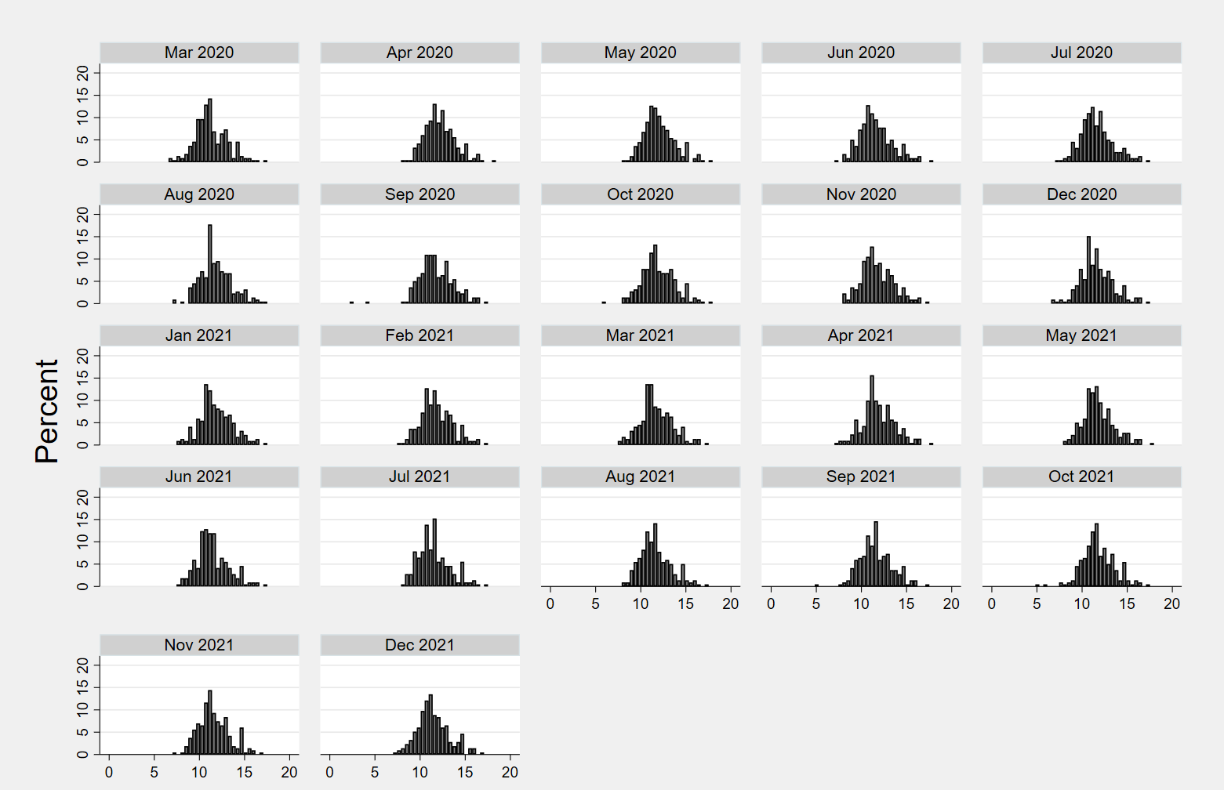
Figure A-2: Change in bus ridership monthly (log scale)

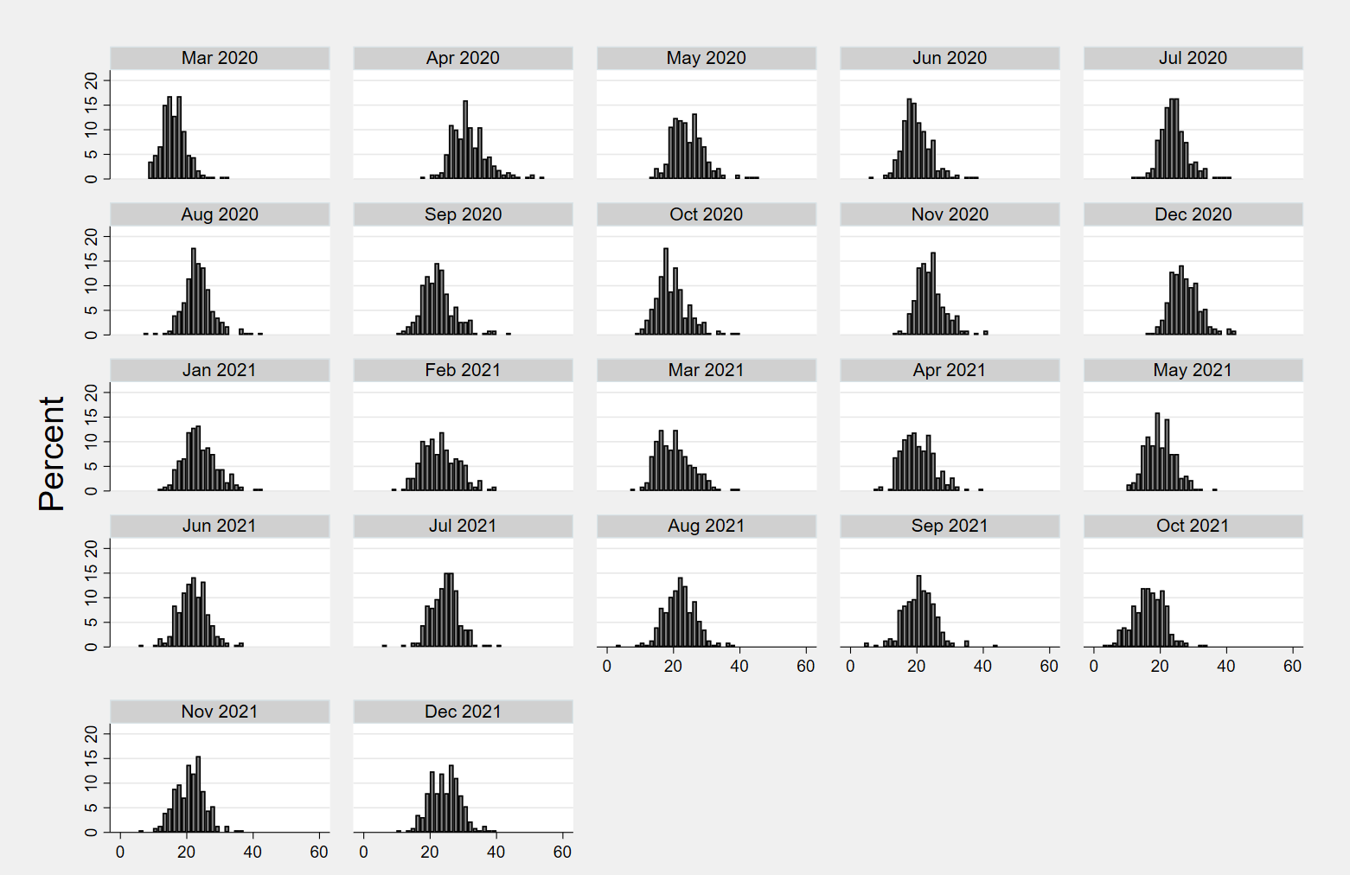
Figure A-3: Increase in telework (%)

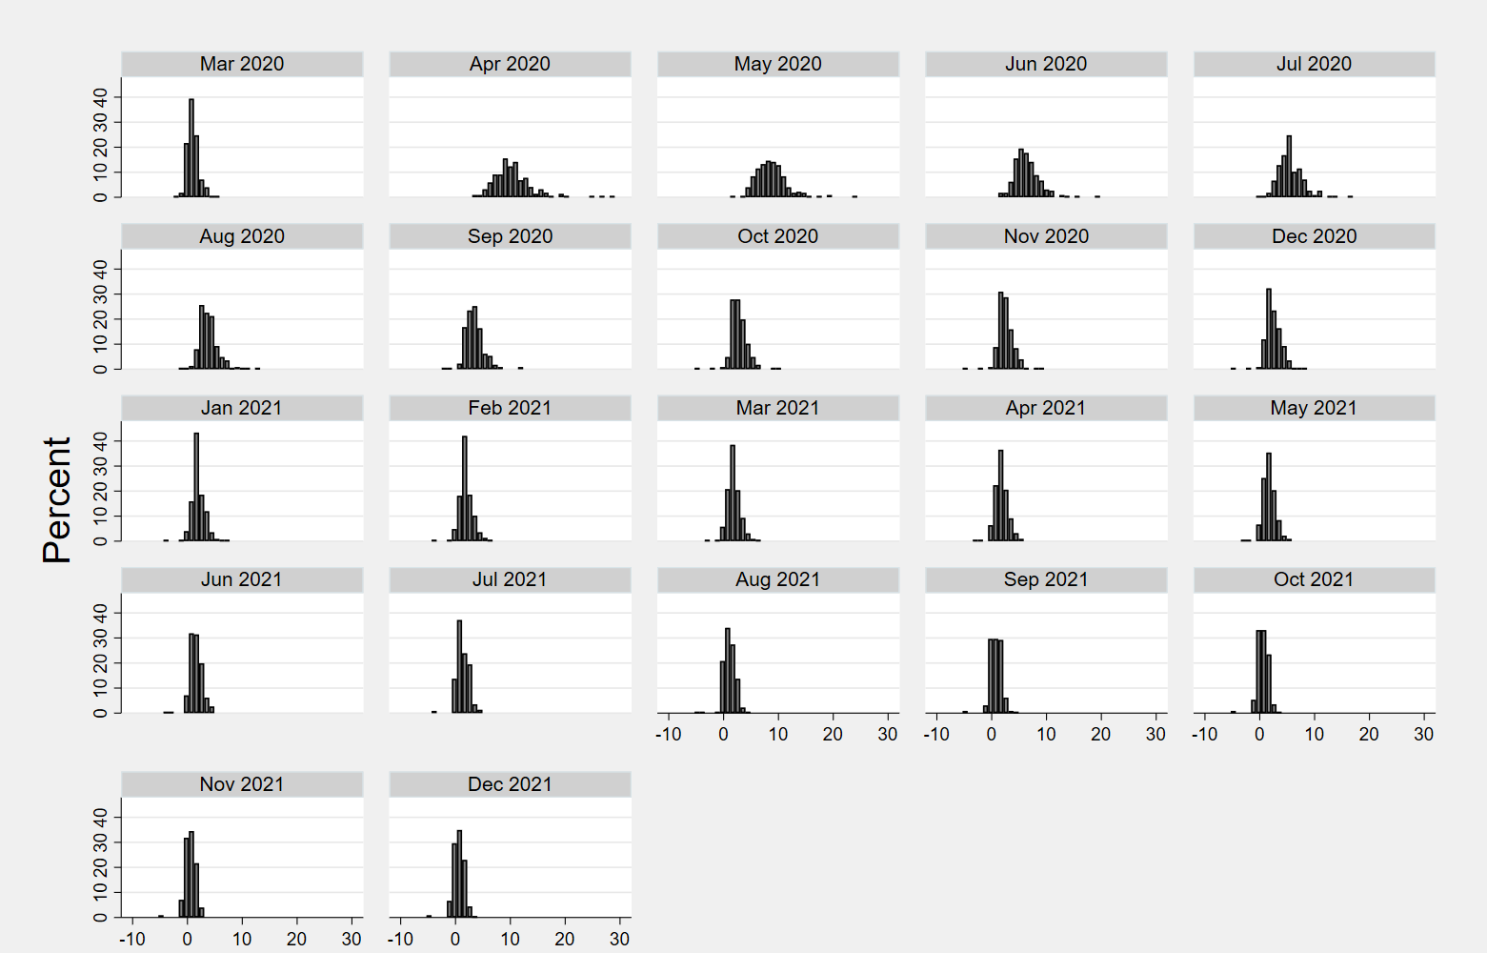
Figure A-4: Increase in the unemployment rate (%)

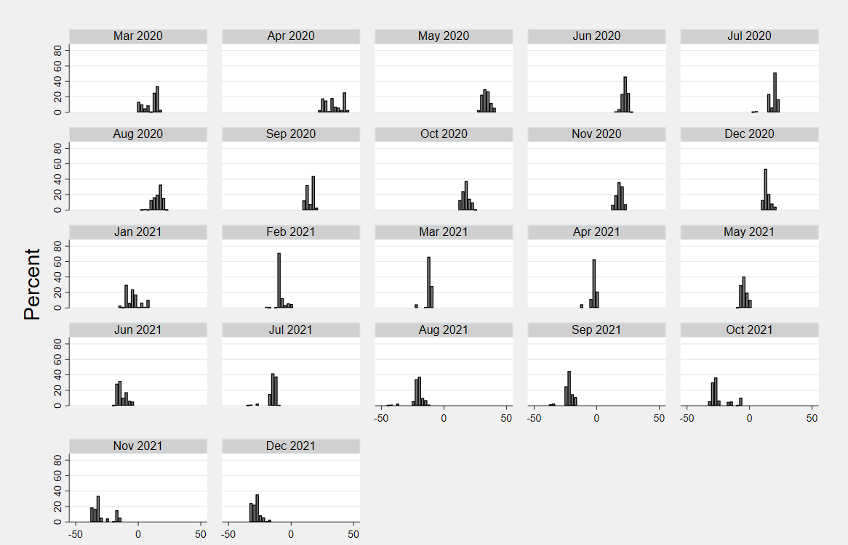
Figure A-5: Change in gas prices (%)

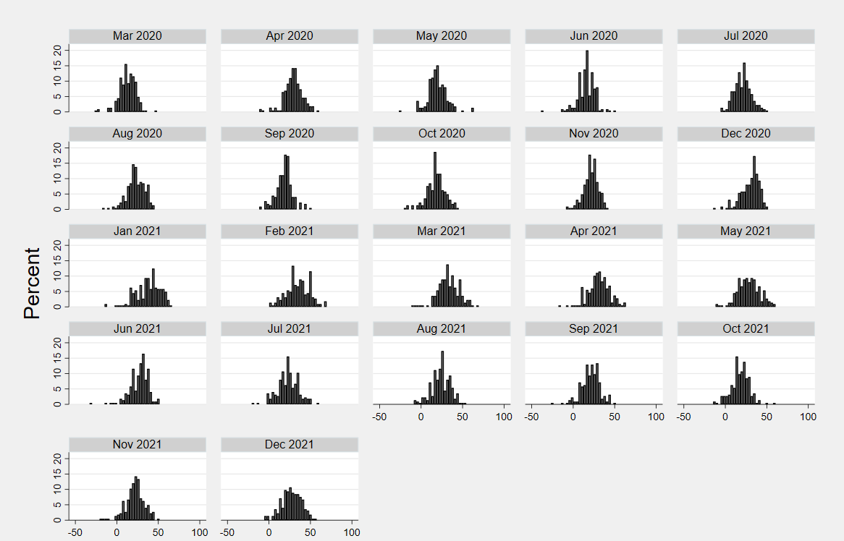
Figure A-6: Change in DoorDash popularity

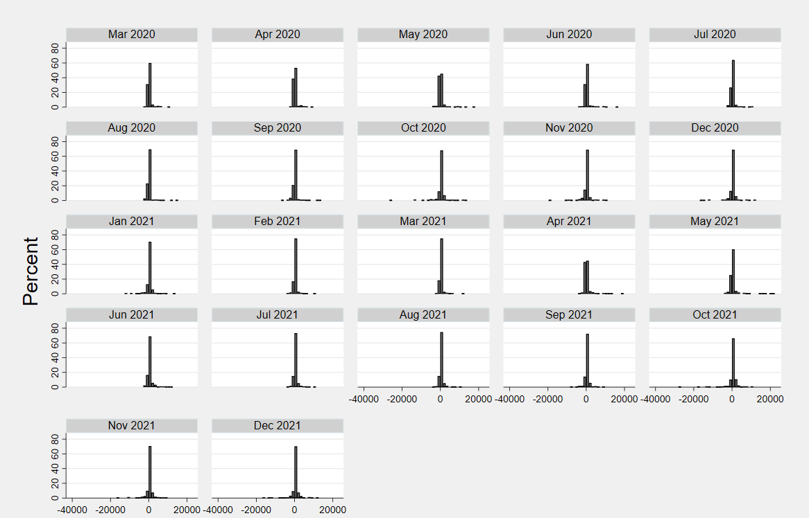
Figure A-7: Net change in the number of change of address requests

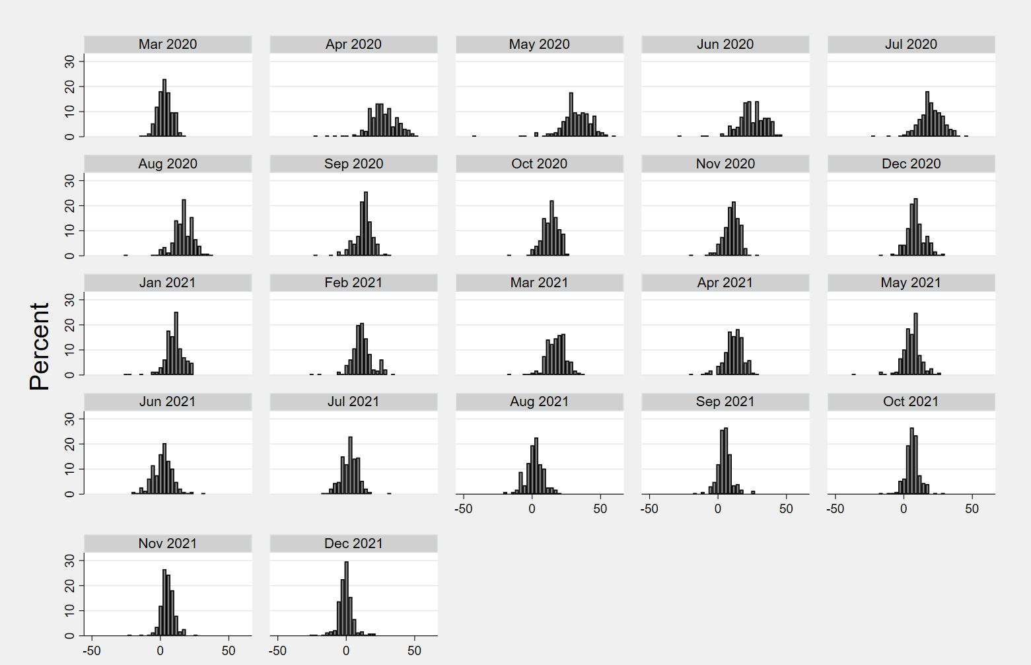
Figure A- 8: Change in bike popularity

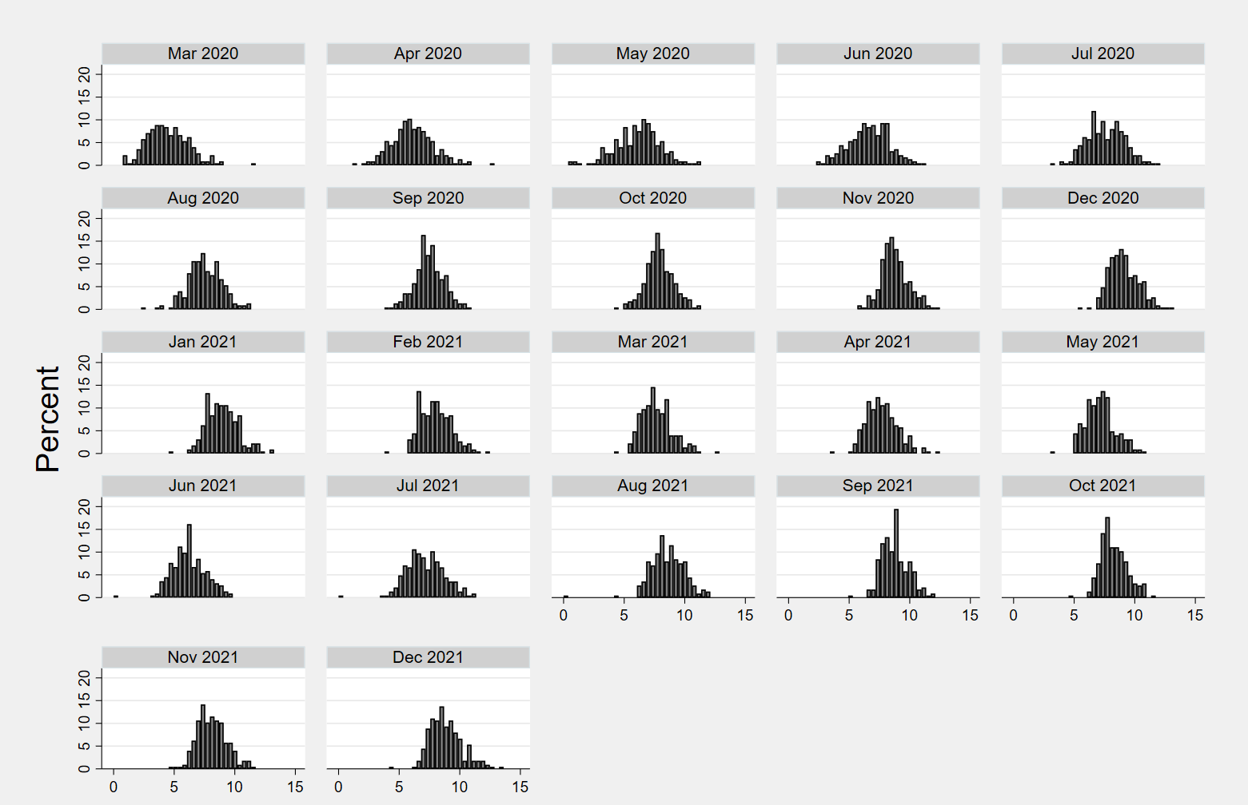
Figure A-9: COVID-19 cases

VITA
Abubakr Ziedan was born and raised in Khartoum, Sudan, to parents Mohamed Salah and Somia. He received his Bachelor of Science (Honors) in Civil Engineering with First Class in 2012. After graduation, Abubakr worked as a Transportation Planner for three years in Sudan. He received a Master’s degree in Civil Engineering in December 2017 from the University of Tennessee at Chattanooga. Abubakr was a transportation system planner intern at the Chattanooga Area Regional Transportation Authority for a year before starting his Ph.D. studies in 2018 at the University of Tennessee. His research interests include transit ridership trends, fare technology and policy, transit planning, and transit safety.
During his Ph.D. studies, Abubakr was the recipient of many notable awards, such as the 2022 William W. Millar award for the best paper in the area of public transportation by the Transportation Research Board (TRB), the 2018 Donald C. Hyde Memorial Essay Scholarship presented by the American Public Transportation Foundation, and Tickle Graduate Fellowship awarded by the University of Tennessee Tickle College of Engineering.

