THE POST-HUMAN GAMER:
REFLECTIONS ON FIELDWORK
IN WORLD OF WARCRAFT

A Dissertation Presented for the
Doctor of Philosophy
Degree
The University of Tennessee, Knoxville

Joshua S. Schendel
May 2013

Copyright © 2013 by Joshua S. Schendel
All rights reserved.

ACKNOWLEDGEMENTS

I would like to acknowledge all the individuals who helped me complete this dissertation. In particular, I would like to thank the members of my committee, starting with my Major Professor, Dr. Tricia Hepner. Dr. Hepner arrived at The University of Tennessee midway through this project, taking over as chair of my committee, and helped me re-shape, re-focus, and complete this research. Without her guidance and support, I would never have been able to finish this dissertation. The other members serving on my committee were Dr. Rosalind Hackett, Dr. De Ann Pendry, and Dr. Suzie Allard. I took a series of Religious Studies classes with Dr. Hackett, recognizing how beneficial she was in nurturing my ability to critically think. I am thankful for Dr. Pendry's guidance, especially through a difficult period of my life, and I am very glad I attended Dr. Allard's class on social media, exposing me to contemporary internet-based lines of inquiry. As I juggled research concerns in-game and IRL, it was these Professors who stood with me and provided needed guidance and criticism.
Additional thanks goes to the World of Warcraft players who took the time to include me in their raiding communities, and maintained contact with me, helping me finish this project years after our initial introductions. These players/informants are listed in Chapter 3. I would like to thank the Guild Masters and Raid Leaders of the Guilds and PuGs who included me in their raiding. In addition to participating in interviews and surveys, several players provided screenshots of events and places in-game (Zoombroom, Rumps, Vvetter) and recorded video of boss fights for use in this project (Star). I am indebted to their generosity.
Over the past decade, a number of family and friends have supported me throughout the various stages of my education. The list of these individuals is great, including my wife, my parents, my siblings, and my wife's family and friends. They rooted me on as I neared completion and I appreciate their support. I include my ex-wife and her deceased mother as they both encouraged and helped me to finish this project.
As a final note, in the past nine months, this dissertation has raced the birth of my son. I write this passage several days after his "supposed" due date. My wife and I still await his birth and I hope he has an opportunity to read this dissertation and understand what I was working on during this timeframe. I cannot imagine completing this dissertation without my (very pregnant) wife's patience and support. I would never have accomplished this project without your efforts to keep me focused.
Thank you.
ABSTRACT

This dissertation offers a longitudinal digital ethnography of a community of hardcore gamers who currently play, or have played, the Massively Multiplayer Online Role Playing Game (MMO) World of Warcraft. The central theme embraces the challenge of identifying and voicing the emic perspective of these hardcore players, presenting them as individuals mediating their real lives (IRL, or "in real life") and virtual lives through social media and online multiplayer technologies, including the maintenance of relationships developed within the IRL and in-game spaces they inhabit. The dissertation offers a critical analysis of the hardcore gaming lifestyle as voiced by the gamers themselves, revealing not only their contestation of the boundaries of cultural expression, identity, and community, especially as it pertains to notions of “real” and “virtual” relationships, but also the social costs to their IRL lives. Embedding themselves within a virtual world community by way of immersive computer technologies (modem, PC, VoiP, mouse, and so on), yet conceptualizing this world as a prioritized reality, repositions these players out of the realm of traditional gamers and into one representing a post-human status. Ultimately, through this collaboration with this community of Post-human Gamers, the ethnographer challenges existing portrayals of these cultural groups in the media and within WoW itself, and offers a reflexive examination of the ethnographer's own potentially self-destructive journey of researching the hardcore lifestyle.
PREFACE

"In simulation culture we become cyborg, and it can be hard to return to anything less."
Sherry Turkle, 2011: 209

"...the question ultimately to be answered is not where do I, or more accurately where does my body come from? (the enigma of sexual difference), but am I human or machine? And, am I alive or dead (the uncanny question for the information age)."
Margaret Morse, 1998: 205

"...the machine becomes a model for understanding the human. Thus the human is transformed into the post-human."
N. Catherine Hayles, 1999: 239

"The inferences of this definition are at once liberating and terrifying."

Sean Cubitt, 2000: 127

"Gnome man is an island."

Star and Arathene, <Gnome Alone>

TABLE OF CONTENTS

Chapter Page

PROLOGUE 1
CHAPTER I 3
Introduction 3
A Declaration of Sorts 3
The Backdrop to Now 7
Academic Influences 9
This Dissertation's Approach 12
Dissertation Objectives 14
Final Thoughts to the Introduction 18
CHAPTER II 20
The Ladder of Evolution is Shot All to Hell 20
Day One 20
Motivations for Choosing a Project on WoW 25
Blood and Thunder 25
Post-human Nation 28
I Took the Red Pill 32
A Post-human Dissertation 37
CHAPTER III 42
Down the Rabbit Hole 42
October 12, 2012 42
New Social (Gaming) Hubs 42
WoW as Social Hub 46
Social Gaming and the "Realness" of Relationships 50
Example 1: How Technology Weakens In-Game Bonds 52
Example 2: How Technology Strengthens In-Game Bonds 53
Viewing Virtual Identies as IRL Identities 53
Ending WoW 58
The Players 60
CHAPTER IV 69
It's a Hardcore Life 69
Pro Time 69
So...What does "Fun" Even Mean? 73
An Introduction to Hardcore Raiding 77
The First Step . 82
The Second Step .. 84
The Third and Final Step 85
A Bridge to Chapter V 87
Supplemental Overview: A Sort-of-Brief History of WoW Raiding 89
CHAPTER V 96
The Post-human Gamer 96
Virtual(ly) Best Friend Forever 96
There's More to Social Gaming than Meets the Eye 99
The Post-human Gamer, Part 1 106
The Post-human Gamer, Part 2 114
Friends and Warm Bodies 117
Virtual(ly) Disconnected 122
CHAPTER VI 126
Reflections on Fieldwork in World of Warcraft 126
Twilight 126
Night 127
Midnight 133
The Quiet Hours 136
First a Glimmer, then the Dawn 144
Conclusion: Memories of the Light 150
LIST OF REFERENCES 156
Vita 164

LIST OF FIGURES

Figure Page

Figure 1. Anthropos wearing Tier 11 ("Stormrider") in Darnassus, 2011. 5
Figure 2. Zoombroom and Anthropos embark on an adventure, 2011. 19
Figure 3. Darnassus is a city built atop the World Tree. 21
Figure 4. Night Elf Sentinels ride Hippogriffs and patrol the city. 21
Figure 5. The Temple of the Moon in Darnassus. 22
Figure 6. The portal to Rut'theran Village. 22
Figure 7. Anthropos quests in Arathi Highlands, 2005. 24
Figure 8. Leveling gear is never aesthetically pleasing, 2005. 33
Figure 9. Preparing for Beth'tilac, The Firelands (Tier 12), 2011. 39
Figure 10. Confront Ragnaros, The Firelands (Tier 12), 2011. 39
Figure 11. Zoombroom visits the Sunwell. 44
Figure 12. Zoombroom quests in the Wrath of the Lich King expansion. 44
Figure 13. Ahroo's PuG celebrates defeating Nefarian, 2012. 45
Figure 14. Ahroo's PuG, after downing Ragnaros, 2012. 45
Figure 15. Copperfield. 54
Figure 16. The Opening of the Ahn'Qiraji Gates event begins. 68
Figure 17. The Qiraji army invades the Silithus zone. 68
Figure 18. The Firelands raid zone (Tier 12). 70
Figure 19. Zoombroom braves the Firelands. 70
Figure 20. Lord Rhyolith (from a safe distance). 71
Figure 21. Ragnaros' citadel lurks in the distance. 71
Figure 22. Rumps and Cemetery observe PvP action unfold. 88
Figure 23. <Riders of the Apocolypse> defeats Princess Huhuran, AQ40. 88
Figure 24. Karazhan in Deadwind Pass. 97
Figure 25. Karazhan's ghostly inhabitants. 97
Figure 26. Zoombroom, Blitzan, and Xoot goof off in Icecrown Citadel. 116
Figure 27. Vvetter and Zoombroom are B.F.F.s!. 116
Figure 28. Arathene receives "Dragonwrath, Terecgosa's Rest".. 123
Figure 29. This legendary staff turns Arathene into a blue dragon. 123
Figure 30. Auberdine. 151
Figure 31. The Auberdine Inn. 151
Figure 32. Sunset in the Searing Gorge. 153
Figure 33. Anthropos and friend. 155

PROLOGUE

"Perish, insect!" Brutallus bellowed.
The Raid Boss "one-shot" a member of the large group of World of Warcraft (WoW) players attacking him, killing the player's avatar with a single thunderous blow.
"You are meat!" he cried again, clearly relishing his victory over those foolish enough to challenge him.
Of the 25 players with whom the Shattered Hand guild <Royalty> had originally engaged Brutallus, only Acec, Ahroo, and a few damage-dealers remained alive. The rest had died during the encounter. The remaining raiders still alive fled Brutallus, attempting to prolong the inevitable: the death of their avatars, and the "wipe" (failure) of the raid's latest attempt to defeat this Raid Boss. Though Brutallus was at 1% health - for all intents and purposes practically defeated - the fight had lasted so long that he had "enraged;" his damage output had increased to the point where it was not survivable by anyone without mitigation. The panicking raid had the makings of yet another "1% wipe," an unfortunate part of the raiding process, but a sign of continued practice and eventual future victory.
Brutallus was an armored Pit Lord, a quadruped demon the size of a dragon. He towered over the raiders with a long tail, big teeth, scales, spikes, and a surly disposition. Instead of the usual Pit Lord appearance (assuming a Pit Lord had a "usual" appearance), his back story involved the loss of his wings in some forgotten battle, and the replacement of his hands with massive blades dripping with rust and neon green fel fire. He commanded a segment of the Burning Legion intent on usurping Azeroth's font of magic known as the Sunwell in order to summon their lord, Kil'Jaeden. Over the course of nearly two months, <Royalty> had steadily progressed on Brutallus within the "Sunwell Plateau" raid dungeon, practicing his mechanics, mastering the transitions the "tank"-class players utilized to taunt the boss back and forth, and allowing the "healer"-classes to learn how to restore the players' health between the heavy raid damage and nasty "Burn" spell Brutallus used, a damage-over-time ability that grew in power the longer it afflicted a player.
As players fled Brutallus, Acec and Ahroo were the only two tank classes remaining, the only players with cooldowns capable of temporarily withstanding Brutallus' direct attacks. Acec taunted Brutallus, forcing the demon to attack him, and used "Shield Wall," an ability that temporarily reduced all incoming damage. Meanwhile, Ahroo stood on the opposite side of the fight area. As Brutallus pummeled Acec, Ahroo taunted the boss toward him and away from Acec. Ahroo used "Divine Protection," a spell that encased him in a protective bubble for a period of time whereby he would not take any damage. As Brutallus charged Ahroo, hammering on the magical bubble, the unthinkable happened. Brutallus lost his remaining "hit points" and died. Ahroo and Acec had extended the fight long enough for the remaining damage dealers to finish off the demon. For a moment, there was only silence over Ventrilo, the VoiP program the raid members used to coordinate their attempt. Then, 25 players united in a victory cry. Their months-long work, devoting anywhere from 50 - 80 hours a week (or more), had finally paid off. The screams and carousing continued into the night, as members of the guild hung out on Vent, chatting and congratulating each other on the hard fought accomplishment. 25 players, most of whom had never met in real life (IRL), celebrated their virtual achievement.
Brutallus was dead, another Raid Boss downed within WoW's persistent gameworld, a world where the threats, raids, and Raid Bosses never ceased to appear. As long as its best and most hardcore players continued to subscribe, WoW's developers introduced raids of ever-increasing complexity and difficulty. Though Brutallus (or even his master, Kil'Jaeden), were part of WoW's endgame in 2006, they were mere steps along a never-ending pathway, a journey that began in 2004 and saw players vie against a stream of other foes into the present day (undead kings, insane dragons, eons-old fire elementals, and so on). Each victory represented an important step for these hardcore players, an opportunity to increase their avatars' powers, prove their mettle, and create in-game personas capable of displaying the rarest and most prestigious items the game offered. I stepped into this hardcore lifestyle, conducting participant-observation through WoW's virtual spaces, confronting the unbelievable and the compelling, not only in terms of the virtual challenges its hardcore players faced, but also the dynamic and intimate real life cultural processes of community-building, social capital, and companionships recreated online. While the sights and sounds sparked the imagination, the cultural refractions represented in the hardcore gamer lifestyle - required to create, maintain, and conduct a raid community - marveled in terms of its logistical and social costs. The subsequent chapters of this dissertation feature the story of these players/informants (and the anthropologist fascinated by their virtual and IRL decisions), chronicling a narrative of their adventures within the many worlds bleeding into and out of Azeroth.

CHAPTER I

Introduction

A Declaration of Sorts

Since my first exposure to anthropology, I have remained passionate about reading, examining, studying, and considering the larger implications of ethnographers' willingness to offer reflexivity. I therefore approached my dissertation with the objective to record not just the adventures of the many players, gamers, informants, and individuals I interacted with over my time exploring the Massively Multiplayer Online Role Playing Game (MMO) World of Warcraft (WoW) and its various expansions (2004 - 2012), but also to present a testament of my own personal and academic journeys. The more I documented and analyzed these actions, strategies, worldmaking, and exercises in relationship-building, the more I realized my own reflections carried just as significant a weight as those of the individuals with whom I played. I ventured on epic forays in-game and in my real life, often simultaneously. Neglecting to parse these personal and academic challenges would be a missed opportunity.
As Barth (1995: 66) explained, using "knowledge (referring to what people employ to interpret and act on the world: feelings as well as thoughts, embodied skills as well as taxonomies and other verbal models) as our prototype for culture allows us to construct...models of culture" that focus less on inducing notions of difference and more on their contextual origins. The discussion existing at the heart of Barth's definition of culture is part of the process of gaining knowledge, even if it is "just" a set of personal realizations and self-discoveries. This approach fed into the construction of my dissertation. Indeed, the more I wrote, the more comfortable I felt incorporating my own story into the overarching discussion. The result is a dissertation constructed from both the notes of my time learning and mastering WoW, but also my own personal memories and experiences. I take to heart Rabinow's (1977: 5) views on the role of reflexivity in anthropology, specifically that "all cultural activity is experimental" and "fieldwork is a distinctive type of cultural activity...which defines the discipline." I hope the phenomenological, memoir-like approach I adopted for this project offers a personal touch, one capable of granting readers more insight into not just the world I was exploring, but the many profound effects this world had on myself, my internal relationships within the game world, and the external relationships I had in the real world, or "in real life" (IRL) as it is often referred to online.
That readers may not be inexperienced with the virtual worlds of massively multiplayer gaming (MMO) is not lost on me. My efforts to ground this discussion through personal experience grew from this understanding. I do not expect everyone to be versed in the unique language of these worlds, nor do I expect them to relate to what I and my informants experienced. I labeled as many acronyms as possible. Some of the specific internet-based and WoW-based lingo or terms I cited most often are:
- AFK: Away From Keyboard; acronym used when an individual leaves his/her computer
- Anthropos: my WoW avatar, a Night Elf Restoration Druid (see Figure 1)
- AOE: Area of Effect; acronym describing in-game damage capable of hitting multiple targets at once
- DPS: stands for Damage Per Second, referring to (1) a character who plays a damage-dealing specialist character and (2) the amount of damage a player is capable of dealing per second
- Dungeon: typically an in-game adventure designed for groups of players and featuring an exploration of a cordoned off area; sizes range from smaller 5 Player dungeons to larger raid dungeons
- Expansion: a paid content pack expanding the original WoW (often called "Vanilla" WoW), including 2007's The Burning Crusade (TBC), 2008's Wrath of the Lich King (WotLK), 2010's Cataclysm (Cata), and 2012's Mists of Pandaria (MoP)
- Guilds: formal communities of in-game players uniting around a specific focus (PvP or PvE raiding) and led by a GM (Guild Master); players are invited to one guild at a time with the guild name listed in <brackets>
- Healer: a player who uses in-game abilities to restore another player's lost health
- IRL: In Real Life, or outside of the game
- Items: in-game armor and weapons identified as Greens (Common items), Blues (Rare items), or Purples (Epic items), the power determined by its color; Orange (Legendary) quality items are extremely difficult to acquire and extraordinarily rare (a handful per server)
- Main/Alt: a player's primary (main) and secondary (alt) characters
- Melee: a DPSer who deals damage to a target "up close and personal"
- Min/Maxing: the process of increasing a player's power to its maximum potential through minimal or small statistical gains
- Mod: an aspect of the game that was modified by a player, like a program that allows for customization of certain controls
- MMO: Massively Multiplayer Online Role-playing Game
- Nerf: a term describing a reduction in difficulty or power ("the developers just nerfed that raid dungeon")
- Noob: an inexperienced player
- NPC: Non-player controlled units
- Patch: additional content added to the game during the cycle of an expansion
- PuG: a "pick up group" of random players
- PvE: Player versus Environment - a mode where players attack NPCs
- PvP: Player versus Player - a mode where players attack other players, typically in the goal-oriented Battlegrounds feature
- Raiding or raids: scenarios where players in groups of 10, 25, or 40 confront boss encounters ("Raid Bosses) and other creatures (raid "trash") within a large scale in-game dungeon
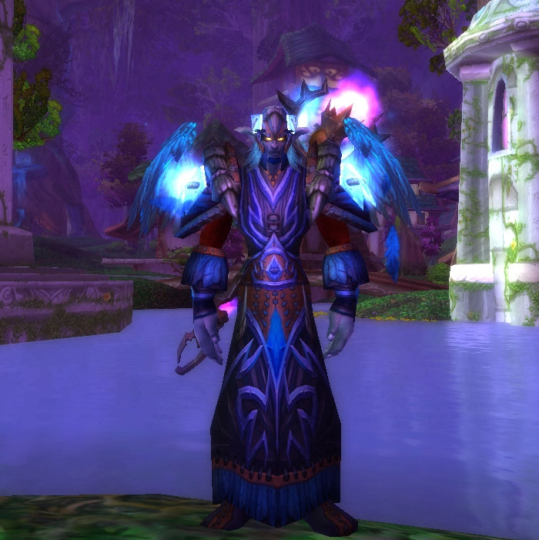
Figure 1. Anthropos wearing Tier 11 ("Stormrider") in Darnassus, 2011.

- Raid Boss: multi-phased creatures with health and damage dealing capabilities far beyond normal players that typically "drop" epic items upon death; requires raid coordination to defeat
- Raid Tier: raids are built off tiers of increasing difficulty
- Ranged: a DPSer who deals damage to a target from a distance
- RTS: a Real Time Strategy game genre unfolding in "real time"
- Shattered Hand: the WoW Realm (containing a complete iteration of the gameworld) my community of informants played on
- Tank: a player who uses in-game abilities to keep an enemy attacking him or her, and not other players
- Ventrilo/Vent: a VoIP (Voice Over Internet Protocol) system allowing people to speak to each other over the internet
- Wiping/Wipe: term used to describe when a WoW group loses to an encounter
My hope throughout this discussion was that readers would find value not just in my efforts to document the data I collected through my years of participant-observation in WoW, but also note the struggles I faced conducting a full-scale virtual-based ethnographic fieldwork project. Anthropologists reading this dissertation can certainly appreciate the challenges I faced. For instance, learning how to conduct an ethnography "in the field" of the virtual is as alien a world and as strange a process as I have encountered, particularly a persistent world designed to draw in and maintain the continued interest of its paying subscribers. This may not be "real world" ethnography, but the central challenges (loneliness, disorientation, self-doubt, confusion, loss of a sense of self, being unmoored from the “reality” in which one has previously known, learning a new language, and a new set of social norms) remain the same. As a result, I hope my presentation of the many bumps I faced and the various issues I analyzed both in-game (e.g. building and maintaining gaming relationships, the loss of various friendships, the challenges of in-game content) and IRL (e.g. juggling my role as an anthropologist "gone native" through a leadership role in my virtual community with the stress of crumbling relationships in my "real life") will help identify the potential dangers the ethnography of a persistent virtual world presents to the uninitiated, and create signpostd which future digital anthropologists can use to avoid the mistakes I made in my own virtual and real world experiences.
As I elaborate below, I envisioned these writings as an homage to Reflections on Fieldwork in Morocco; therefore, my dissertation opens with a variation on the personal anecdotes Paul Rabinow (1977: 8) discussed in his own Chapter 1. I open not with my first moments in WoW, but rather position myself as a member of a United States culture digesting the ramifications of the attacks of 9/11. I situate myself at the moment my Master's Thesis concluded, returning to the worldview of a young graduate student reconciling the attacks of 9/11 with his own research on the actions of politico-religious activist groups before, during, and after the timeframe of September 11, 2001. This opening provides a link between the then and the now, between the iteration of myself in the early post-9/11 period, and the iteration of myself in the present, nearly a decade later.

The Backdrop to Now

I knew the attacks of 9/11 had affected me in a profound way; it just wasn't until much later that I realized what a strange transformation I underwent in the subsequent years. This discussion is important to the overall frame of mind I carried through parts of my dissertation. My Master of Arts Thesis, written mostly in 2001 and entitled "The Politics of God: Theocratic Empire Building in the Age of Globalization," focused on understanding how political-religious activist groups like Pat Robertson's Christian Coalition of America represented themselves on their website and through the Christian Broadcasting Network's "The 700 Club." I was interested in their perspective on politics and their overarching cultural goals. Immediately after the attacks, I re-wrote the "Introduction" and "Conclusion" to my thesis, using the writings of Noam Chomsky (2001), Catherine Lutz (2002), Hannah Arendt (1966), and Russell T. McCutcheon (2001) in the reframing of my discussion. I struggled to grasp why the attacks had occurred; I failed to see the deeper connections between these acts and recent world history. The opening of my thesis reflected frustration with the generalized, even vague, discourse the media used in explaining the attacks, and the continual linking of the word "extremism" with the acts of religious groups in the Middle East, while giving a pass to the language and actions of groups within the United States. I was not satisfied with the explanations, or the etiology of the broadcast newscasters. I (Schendel 2002: 1) wrote the following:

Since the attacks of 9/11, an increased focus on the interplay of religion and politics has emerged in the media and the political world at large. Efforts to explain a “rationale” behind the event, as well as the repercussions, have resulted in poignant distinctions between notions of “us” and “them” in the delineation of individual roles in the global community, and the actions of the United States. An equation of “good” and “evil” have become more evident, with the continuing action painted in shades reminiscent of Romanticism and awash in political and financial gain for both the United States and its enemies.

Indeed, since the attacks of 9/11, and in the years after completing my Master of Arts degree, I remained dissatisfied with those running the 24 hour news cycle. After reading works like Chomsky's 9-11 (2001) or Lutz and White's "Emotions, War and Cable News" (2002), I found my metaphorical "ideological blinders" had fallen off. This dissatisfaction, even malaise, manifested itself in subtle, yet significant, manners. I cared less about my appearance, less about the quality of work I produced. I retreated into forms of entertainment that served essentially as a distraction from the world around me. This choice affected me in other ways: I adopted an increasingly grunge-inspired look and grew lazier, both personally and academically. Was this how a member of Generation X was supposed to act? Generation Y? I did not know. It progressed to the point where I did not recall what I wore or how I dressed pre-9/11. From 2002 on, I wrote, I dressed, I spoke as if I was locked in a particular moment in time, a post-9/11 version of myself. I was no longer the person who, after wandering into Hodges Library, wondered what was causing everyone to crowd around the television screens, why everyone stood and spoke to each other in hushed tones. The iteration of myself pre-9/11 is forgotten. Alien. His cares, his motivations, his philosophies are lost. I mention this now because this transformation from pre-to-post-9/11 was a significant moment in my life, particularly with respect to research choices I made over the next decade.
This "me" lasted a good decade. Long hair, faded jeans, a pair of Birkenstocks with well-worn heel indentations. The jeans came pre-scuffed, bought on sale from some forgotten store, the marks on the knees and shins were designed to look "authentically worn." I ended up buying three pairs, intending to rotate between each of them. At least, that was the initial plan. I ended up wearing one or two of the jeans over and over again. Five years after I had purchased those three pairs, I found the third pair in the back of my closet, practically unused. The misuse of these jeans, and the reliance on essentially two pairs, fit with my unkempt appearance. I was pale and, most significantly, I grew a scruffy beard. The combination of hair, jeans, beard, and a twenty-four/seven hoody (of various colors) gave me the appearance someone younger than my actual age, maybe a student, maybe mid-twenties, but certainly not a graduate student in his thirties, certainly not someone struggling to re-seize control of his life.
If I closed my eyes, I see myself not as I am now, but as I was in that previous decade. In this visage, my beard is not slim, not trimmed close to my face. It is bushy, unkempt. My hair is long. This look endured until 2011, when, after not a single session of examining myself in the mirror, but a series of sessions lasting over a period of days or weeks, I discovered I was not (despite the image of myself in my mind) in my mid-twenties anymore. I was most definitely displaced from whatever "fashion sense" had spawned my choice in clothes and demeanor, and I was playing a video game for none of the reasons I had initially set out to use it. I am not sure when the exact epiphany struck, when that moment that clicked in my head that informed me that I was no closer to obtaining my Ph.D. than when I had completed my Masters so many years earlier. That internal voice explained in a not-so-casual manner that I may not be a lost cause, but I was on the verge of falling into that category.
What was the reality of my situation? I was no longer a student, let alone a graduate student, despite my claims to the otherwise. I had not completed my comprehensive exams. I was separated from my (now ex) wife; I lived in Stafford, Virginia and was about to move back to Knoxville, Tennessee, back to the same minimum wage job I had worked before I left the state. Was this my moment of epiphany? Was this the time I determined that if I wanted to avoid that "lost cause" moniker, then it was time to act? I am not sure exactly how those series of questions went in my head. Perhaps it went something like this: How had I gotten here? Was I going to finish this degree? What was taking me so long? Who was this person staring back at me? I replayed the timeline that had brought me to this point. I did not see any part of the undergraduate student who had first fallen in love with the discipline of anthropology in 1998. I just saw a tired, burned out guy in his early thirties more interested in washing out then finishing what he had spent so much time, money, and energy on -
It is important I stop this testimony at this particular moment, lest I draw out this "unhappily ever after" storyline too far (which does have a happy ending, I assure you). Instead, I should make a solid effort to veer back on-course, to offer up a brief history of the founding of my relationship with Anthropology, the discipline that has defined my academic studies for the past two decades.

Academic Influences

I wanted to be an anthropologist ever since stumbling into Professor Virginia Kerns' "Introduction to Cultural Anthropology" my sophomore year at William and Mary in Spring of 1997. At the time I was an Art and English double major. I do not recall what drew me to the class; I had never heard of the discipline "Anthropology" before. Kerns used a soft-spoken manner, guiding the class through a number of fascinating ethnographies: Mama Lola by Karen McCarthy Brown, Nisa: The Life and Words of a !Kung Woman by Marjorie Shostak, and Reflections on Fieldwork in Morocco by Paul Rabinow. It took half a semester for me to dump my previously declared Art and English majors and embrace a future with this discipline. I discovered an affinity with Anthropology, a framework of ideas allowing me to take any given interest and expound critically upon the cultural, historical, and theoretical contexts contributing to its birth, use, misuse, influence (and so on) in our society and world. The result was my undergraduate honors thesis examining "The Cosmology of the Superhero" (focusing on the dystopian Batman graphic novel The Dark Knight Returns) followed closely by my thesis. Understanding superheroes as a tool of male engendering and situating politico-religious groups in a Post-9/11 world were my interests at the time, aligning with many of my hobbies, including drawing, cartooning, and writing fiction. Over the next decade, I moved away from these passions, focusing instead on a project that would offer me the opportunity to engage in extensive fieldwork for the first time. I began playing multiplayer RTS (Real Time Strategy) games like StarCraft and WarCraft III for a good portion of the early 00's, using them as a tool of escape. The more I gamed, the more fascinated I became by the role virtual communities played in fostering and maintaining relationships among people who never interacted face-to-face. I wondered how these gamers had transformed - and continued to transform - with the advent of social media and social media gaming, and how these developments affected the power of their relationships. Furthermore, I considered the strategies rooted in in-game intimacy and political-economic contexts associated with these partnerships. The entirety of these questions fomented within me, triggering a desire to participate and observe the world of these gamers at their level.
My initial goals in 2004 - 2005 were to apply these questions into a study of MMO gaming. I wanted to provide a voice to gamers within the MMO World of Warcraft. I wanted to learn about issues pertaining to player identity construction. I discuss in subsequent chapters the difficulties I faced with this pre-fieldwork process. I struggled with the mechanics of gameplay. I was uncertain who I should approach as an informant and even which communities of players I should embed myself within. I had no idea what I was doing. As it turned out, once I reached max level (Level 60 at the time) in 2005, my first contacts were players participating in endgame raiding. I fell in with these individuals and focused on studying not just their community, but the phenomenon that was WoW's endgame. It was not until 2009 - 2010, after playing WoW for several years, that I realized my priorities had veered from my initial academic goals (studying identity construction) into a fascination with the emic perspective of the hardcore raider. At this point, as I began writing and reflecting on the years I struggled to devote to my dissertation research, I recognized the transformative nature of my relationship with the discipline of Anthropology, as well as the importance of positioning my own personal (virtual and IRL) story into this deconstructionist narrative. I moved out of the funk that plagued most of my last decade (the beginning of the happy part of this story) in 2010 and rewired myself into the discipline I loved, wondering how to (re)embark on my digital research and make use of the new studies and ethnographies that had been created over my lull. As I reconnected with Anthropology, I remembered what drew me to it in the first place, what excited me. This was especially true as I read and examined the works of contemporary digital social scientists devoted to expanding a studies of virtual societies. I engrossed myself in these digital ethnographies, positioning myself and my own research against these works of the past few years that set out to boldly explore strange new virtual worlds. What I found was scary, enticing, and exciting. I was particularly excited to find Anthropologists who immersed themselves into video games and virtual worlds, examining these worlds using the lenses and tools of ethnographic methods. I relied on their texts to refocus my dissertation on not identity construction among MMO players, but on the technological means by which hardcore gamers recontextualize their cultural worlds (from their virtual and IRL relationships, to their conceptions of space and place, to reordering their priorities, and so on) and the costs this process has on their IRL lives.
Tom Boellstorff, for instance, in Coming of Age in Second Life: An Anthropologist Explores the Virtually Human (2008) relates his initial impressions of the massively multiplayer community in terms of his anthropological forebears. He cites Bronislaw Malinowski, seeing his arrival in Second Life in much the same way as Malinowski arrived in the Trobriand Islands. Fortunately, Boellstorff had some experience carrying out ethnographic fieldwork, and was able to get his bearings both anthropologically - and virtually. T. L. Taylor in Play Between Worlds: Exploring Online Game Culture (2006) applies these sensibilities to her discussion of EverQuest. Through in-game and face-to-face interviews, she attempts to understand and explain the actions of the individuals she encounters and befriends. Other social scientists moved to comprehend the digital generation at large (Generation Y, Generation Z, Digital Generation, The Millennials, the iGeneration, or other monikers used to describe 18-34 year olds). S. Craig Watkins in The Young & The Digital: What the Migration to Social-Network Sites, Games, and Anytime, Anywhere Media Means for Our Future (2009) relied on 500+ surveys and 350 in-depth interviews conducted with young adults over 2007 - 2008 to document the changes a digital-based lifestyle (involving mobile phones, multiplayer games, social media, blogging sites, among other technologies) has had on the way young people interact. Sherry Turkle (2011) in Alone Together: Why We Expect More from Technology and Less from Each Other discusses the relationship between human technological adoption and the increasing loneliness found within our pursuit of online-based intimacies. These social scientists are my major sources, memorable for the way they inspired, challenged, and shaped my perceptions of how virtual communities are constructed and maintained. Anthony Giddens was also highly influential in charting my course. Over two decades ago, Giddens (1990: 4; 6) discussed the “scope of change” inherent to modernity. “The modes of life brought into being by modernity,” he wrote, would sweep “us away from all traditional types of social order, in quite unprecedented fashion” (Giddens 1990: 4). He warned that such change would alter some of the most intimate and personal features of our day-to-day existence” (1990: 4) and he found the resulting age of “high modernity” humans resided in to be one of discontinuities and division, which we have been “cut loose” from the “moorings” of tradition’s reassurances (1990: 176-177). Modernity and globalization have transformed not just our cultural moorings, but also the methodologies social scientists use to analyze these forces. How applicable his writings remain to a contemporary study of transformational virtualities.
My “bearings," however, were not ones that required a great deal of re-orientation. Due to my experience with gaming in general, I was well-versed in the requirements of third-person gaming and multiplayer gaming - the real challenges I identified as I conducted my fieldwork was understanding my role in this research as both player and ethnographer, juggling the gameworld with the research world, and notions of individual agency to paint a picture of the player as both participant and worldmaker. How do these ideas translate to me, the ethnographer? Participant + worldmaker + analyst? Was I not (in my mind) voyaging to this new land in order to apply the skills and methodologies I learned in my anthropological training? Was I not logging into this world in order to become an anthropologist? Was that even possible? The answer, of course, is "yes" to these questions. David Hakken (1999: 2-3), in Cyborgs @ Cyberspace: An Ethnographer Looks to the Future, wrote of the changing roles of ethnographers of virtual worlds:
Anthropologists are commonly thought of, and socially justified as, cultural explorers. Emissaries from one culture, we go out deliberately to experience another. The new lifeways are typically both "other" and ones about which "we" are collectively unsure.

Studying virtual existence, then, means delineating labels and types, identifying and conceptualizing what is "virtual" and what is "real." Can an Anthropologist carry out an understanding of the rationality of one's "real-ness" or "unreal-ness" through ethnography, a process designed, as Nordstrom (2004: 15) notes in her description of war torn worlds her readers had not personally experienced, "to bring a people and a place to life in the eyes and hearts of those who have not been there"? A daunting notion. An internet-based ethnography takes on worlds available only on-line and on-screen. Accordingly, just as in IRL ethnographies, the acquisition of knowledge, especially personal knowledge, is a process that is continually "growing" (Hakken 2003: 12).
This section on academic influences would be remiss without mentioning a final significant source, that addresses interactions with cultural worlds through participant-observation. I explored a virtual world composed largely of individuals from my own culture (United States culture), forcing me to open myself up to self-criticism and to critique my own culture. This process was not easy, as Philip R. DeVita and James D. Armstrong note in Distant Mirrors: America as a Foreign Culture (1998). They explicitly address in "Understanding Ourselves: About the Second Edition" how difficult it is for scholars to appreciate the wonderful diversity and inherent oddities of one’s own culture. This should not, however, prevent scholars from conducting investigations that problematize aspects of their own lives and the impact they have on others. DeVita and Armstrong focus their attention on the "American" cultures found in the United States, stressing that social scientists situated in those cultures should seek to understand their position in the larger social scheme. Scholars should not turn a blind eye towards cultural activity at home because it is not “other” enough, or because a level of discomfort is experienced in analyzing situations too close-to-home. This call-to-arms resonated with me when I first read it a decade ago; it continues to maintain a strong grip on my present-day academic endeavors. Their message rings inside me, even now, years after my initial reading. It continually motivates me to hone my inward eye of self-reflection, and encourages me not to be afraid to critique my own culture.

This Dissertation's Approach
The core of this analysis presents World of Warcraft (WoW) not only as a game, but as a platform for social media and community interaction transforming the manner in which contemporary gamers identify themselves, their relationship with technology, and the framework through which they construct and conceptualize peer-to-peer intimacy. The multi-platform approach to gaming (single player, multi-playing, massively multi-player) and the introduction of social communities, creates a persistent world for its participants, allowing them the freedom to transform not only the space around them, but the technologies used to mediate relationships and virtual places. In a vein similar to S. Craig Watkins (2009) or T. L. Taylor (2006), my primary goal will be to give a voice and a face to a select demographic of MMO players, a group typically labeled as "hardcore" players. Implications both practical and theoretical result from this approach, particularly through viewing hardcore gamers as participants in N. Catherine Hayles' (1999) "Post-human" philosophy, an understanding of human/machine interaction whereby the human body is seen as "effectively no more than a tool of the emergent mind" that "can be replaced by other prostheses" (Cubitt 2000: 125). Additional implications of this research include: presenting players as part of a microcosm of the real world; seeing real-world processes like social capital as they manifest virtually; embracing a re-understanding of the flexibility of the ethnographic method as it unifies the phenomenological and the virtual; and accessing the costs of such an extreme digital ethnography. Indeed, studying online cultures and the individuals creating and composing them grants an intimate understanding of the internal and external factors impacting how individuals view themselves virtually, as well as the forces shaping and reshaping individual worldviews. Applying a "real world" anthropological framework to online communities allows for a thorough exploration of player identities, selves, and others: all core components of world-building. Social gaming and multiplayer gaming relies on the ability of the player(s) abilities to create and maintain an avatar in persistent worlds, as well as construct and nourish an online identity. Anthropology is, and continues to be, an exceedingly helpful lens through which to view and understand these processes in digital (online) and analog (offline) domains, as well as offer actionable insights regarding pertinent "in-game" and "in-real-life" (IRL) social issues.
My approach is to construct a cultural portrait of the seven-year period between WoW's infancy in November 2004 until November 2011, a transitional period characterized by an ongoing struggle between two competing playerbase communities. Taylor (2006) and Boellstorff (2008) have written extensively of the basics surrounding MMO gameplay, offering general descriptions of the games EverQuest and Second Life for an audience who may not be familiar with the terms or game mechanics. Like Taylor and Boellstorff, I provide definitions of some basic terms pertaining to WoW gameplay. My focus, however, is not on gameplay so much as chronicling the narrative of a group of "hardcore" players and the challenges, dramas, relationship-building (and collapsing) dynamics they faced, while also situating their decisions in terms of the IRL costs to their social and cultural lives. Throughout this dissertation, the reader will encounter a number of informants. Among them is a group of raiders who allowed me to follow and participate with them in gameplay for almost half a decade. Though this group's composition continually shifted as members fluctuated in the amount of time they devoted to the game, the core remained composed of a handful of players. These players are identified in Chapter 3; the informants I participated with the most were members of Ahroo's PuG, including Arathene, Star, Zoombroom, Chromedome, Xoot, Donnar, Blitzan, and Toastedbread. I interacted with them in-game and IRL on many occasions over the years, mostly in the capacity of gaming, but also through the social media platforms developing in popularity alongside WoW (Facebook, Ventrilo, Skype, chatrooms, message boards) and face-to-face meetings. Though most have never met each other IRL, MMO gaming united them, and continues to draw them together. Not a day goes by where these players do not speak to each other, or to me, in some digital-based or social platform. Indeed, the day I originally wrote this passage, I had Facebook open where two of these informants were engaging with each other, and with me, in a gaming related discussion. Gaming is, as Watkins (2009: xvii) argues, a powerful social process, one that facilitates and encourages interaction and "meaningful social ties."
Rabinow (1977: 6), writing of his transitional experiences during fieldwork in Morocco, chronicling the day-to-day encounters that encompassed this seminal period of time in his own academic development, wrote:

This [book] is a reconstruction of a set of encounters that occurred while doing fieldwork. At that time, of course, things were anything but neat and coherent. At this time, I have made them seem that way so as to salvage some meaning from that period for myself and for others. This book is a studied condensation of a swirl of people, places, and feelings.

What follows in my dissertation is a writing style similar to Rabinow's, though one devoted to an analysis of a massively multiplayer video game. Writing this dissertation was an experience, almost as exciting as the shared in-game adventures with my companions and informants. I felt compelled from my earliest fieldnotes to frame this research and the narrative of my informants as if it - and they - were part of a larger adventure story. After all, was that not what I had embarked on? Was that not a core part of the WoW experience? The thrill of the quest, of the hunt, of the boss kill, of the PvP encounter, of the fieldwork experience and dissertation itself. Writing about WoW, thinking about WoW, playing WoW, living WoW, and discussing WoW with those who play the game and those who do not play the game all blend together into a swirl of years. Surely framing my dissertation in this light would result in an analysis of epic scale, a longitudinal chronicle teeming with player insight and other hyperbolic adjectives and adverbs. At least that remained my hope.
I look back on November 23, 2004, WoW's release date, the very first day I played WoW. I ran as a new Level 1 Night Elf Druid named Anthropos through the forests of Teldressil. I see it as if it were today, as if it were yesterday. I remember my initial reactions as the camera swooped, as I combed through the player guide, as I tried to figure out how to quest, how to engage NPCs (non-player controlled units) in combat, or even simpler tasks, like how to move over the landscape, how to swim, how to recover my corpse after I died. I remember drowning in a small pool of water because I did not know how to swim. I remember dying at Level 3 at the hands of a Level 4 Grellkin (a small imp-like creature) because I did not understand the basics of using my offensive spells in combat. I remember thinking Teldressil was a massive continent rather than a small island one can ride across or fly across in minutes because I constantly got lost as I explored the zone while pursuing various quests. The experiences that shaped me as a player occurred simultaneously with the experiences shaping me as a researcher, or as an ethnographer, or as an anthropologist.
This introduction, and the following chapters constitute an account of my longitudinal fieldwork experiences in World of Warcraft between 2004 and 2011. While my first encounters in WoW were strictly leisurely, I eventually realized in a series of discussions with Dr. Faye Harrison from 2003 - 2005 that WoW offered a new fertile ground for ethnographic studies. We viewed WoW as a space blurring individual and group identity. As a result, we felt the game space offered a fantastic means by which an anthropologist could seek to learn how its participants constructed and maintained identities in a largely anonymous playing field, especially the small but zealous communities of hardcore players populating many of the most successful (in terms of item acquisition) positions of the game. My research progressed and matured into its current framework under the guidance of my advisor and major professor, Dr. Tricia Hepner, and my committee members, Dr. Rosalind Hackett, Dr. De Ann Pendry, and Dr. Suzanne Allard.

Dissertation Objectives
I constructed this dissertation research from 2004 - 2011. By 2011, I had identified the primary goals most salient to the overall research process. The first goal of this dissertation explores questions pertaining to the "reality" of a virtual reality and virtual friendship, especially pertaining to distinct communities forming bonds to acquire prestigious in-game items, mounts, and titles. A second goal focuses on identifying the nature of the in-game cultural group identified as the "hardcore" World of Warcraft gamer, ranging from their atypical play habits, their bonding with faceless players around the globe, and the methods by which they contested and transformed the framework of social gaming and relationship-formation itself. A third goal takes the form of a pragmatic and serious look into the process the (nascent) ethnographer takes in order to understand and carry out research of this type. I wanted very much to see myself as a “real” anthropologist, as someone who went into the field, conducted fieldwork, and emerged as an ethnographer. My fieldwork experienced a number of hiccups and bumps along the road, perhaps the result of a period of time where I lost direction, control, and ultimately, did very real damage to my personal life. A fourth goal of this dissertation became an effort to document and address this personal story. What I discovered over the length of the research were answers to a number of salient and timely questions, answers pertaining to the actions of the many in-game informants with whom I encountered and interacted, but also answers to questions myself when I initially began the research. A fifth goal, one that grew in importance the longer I considered it, was to address the significant life-altering situations (in-game and IRL) and costs digital anthropologists potentially face through a similar "hardcore" immersive approach.
I crafted the earliest version of this research project in the 2004/2005 time period, influenced by Arturo Escobar's "Welcome to Cyberia: Notes on the Anthropology of Cyberculture" (1994), a work challenging anthropologists to engage in studies focusing on the effects computer technology had on culture. Initially I wanted to apply IRL ethnographic methods to a study of in-game identity construction. The development of this research took its current form as my research progressed and as I was exposed to the works of digital ethnographers like Taylor (2006), Boellstorf (2008), Watkins (2009), and Turtkle (2011) in 2010/2011. Ultimately, the above five goals, focusing on the hardcore WoW community, and their lifestyle choices and relationship-building (and repercussions of these choices) frame the overarching narrative in this dissertation. An additional step of presenting a reflexive look at my digital ethnographic methodology and the effects of this research on my academic choices were the final goals I added to the project. Fortunately, the experiential and self-reflective nature of anthropology encouraged this type of personal and academic exploration—a message I reminded myself on a regular basis. Even the most difficult of journeys was worthy of examination. After all, Rabinow (1977: 4-5) wrote:
At the risk of violating the clan taboos, I argue that all cultural activity is experiential, that fieldwork is a distinctive type of cultural activity, and that it is this activity which defines the discipline.
Stepping into WoW as an anthropologist and as an ethnographer, therefore, was a difficult proposition, one going beyond the often repeated statement “I had no idea what I was doing.” Regularly, almost daily as I logged into the game, I tried to keep this confusion in check, reminding myself that I was an anthropologist first and foremost, that my lack of understanding of the game, gameplay, the MMO genre, or even basic skills, like how to chat with other players, or loot creatures I killed, was all part of the participant-observation process. This is why I played the game, I reminded myself: to learn. After all, everyone was a new player at one point. As I wrestled with the “participant” aspect of participant-observation, I continually asked myself a number of questions, ones designed to reinforce in my head my desire to maintain a gap between “research” and “play.” "What are your goals today?” “Who do you want to talk to?" "What do you want to talk about?" "What do you want to accomplish?” In other words, I developed an answer to the following questions: “What does it mean to be a virtual anthropologist?”; “What does it mean to be a virtual ethnographer?”; “Is there a way to legitimize what I am doing?” As I developed my formal research focus, I realized I needed a max level character to participate with other endgame players. I struck a deal with myself: reach Level 60 (the max level available in the game’s first iteration), then worry about developing the research proposal. It was a delightful proposition to someone fascinated by the process of building a character from scratch, a feeling that has yet to be repeated in any of the other alts (a player's secondary characters) I developed. I felt innocence. A childlike sense of wonder and enjoyment drove my gameplay, but also control and the ability to escape from situations looming IRL. I played the game as it was intended: not to acquire newer or better items (though I recall seeing a player wearing all blue quality gear and ogling that player’s achievement), but rather I played simply for fun. I explored, I quested, I engaged in the occasional 5 Player dungeon.
The longer I played, the more I realized I needed to craft a character that could interact with other characters in all situations, including the realms of PvE (player versus environment) and PvP (player versus player) combat. In my continuing efforts to maximize all possible character slots, in order to keep up with the myriad players engaging in raiding, dungeons, and Battlegrounds, I realized this meant taking on a series of actions WoW players term as "grinds." The challenges I faced were ones existing on multiple levels. On the one hand, when I started playing WoW, learning the game mechanics, understanding the actions and behaviors deemed acceptable (versus those viewed as unacceptable by the community) and learning how to speak the language challenged me. On the other hand, research issues dominated my IRL mind, including ensuring my research and data collection process presented itself with legitimacy. Is this a valid approach to a study of a virtual community? Can I justify this research as deserving serious consideration? Simply applying the lens and framework of cultural anthropology and ethnography was not a satisfactory prospect, especially in the context of a video game. Describing the project to individuals outside of WoW and academia invited scrutiny; they wondered why I would waste my time studying “just a video game.” Invariably I faced a line of questioning wondering what “this kind of study was even useful for.”
Crafting a virtual ethnography, one that is viewed in a legitimate light, was not an easy task. The opportunities to conduct face-to-face interviews were rare. Initial impressions as well as memories not recorded in a journal - due largely to myself being caught up in this fast-paced game - fade quickly. Forging relationships with in-game players who excelled at WoW took time. Representative informants were scattered all across the nation, if not the globe. I played with individuals across the United States and Canada, as well as overseas, including Florida, Indiana, Michigan, Virginia, Connecticut, California, Quebec, Ontario, Japan, and England. Luckily, the technology that unified these players in-game, including Ventrilo, Facebook, and Skype, were also available to eliminate the literal distance between myself and my informants. When I first sat down to play WoW, my goal was to meet people, to interact with informants, and to develop a strategy to understand the ways in which players manufacture and maintain online identities. The longer I played, the less interested I became in understanding this process of identity creation. Instead, I found myself developing intricate conceptions of how the game operated—in essence I embodied a shared game consciousness inhabiting the very players I set out to research—so much so that my focus drifted elsewhere. Raiding in-game dungeons and PvPing against other players within Arenas and Battlegrounds became second nature to me, a core component to my day-to-day affairs. I woke and logged in, I logged out and went to sleep. IRL Errands were run between various virtual activities, my mind constantly on the game. I spoke as the players spoke, I communicated with others through chat channels and Vent, more so than I did IRL to other human beings. I remembered thinking “uh oh” on more than one occasion, knowing (innately) I had “gone native,” a conclusion I was more than comfortable with ignoring, but a realization that implanted itself within me.
Gone native. Though I pretended I was in control for as long as I could, I realized, eventually, I had lost my way. I did not intend to go native; however, in the process of understanding these hardcore gamers - in order to be included in their community - I had to learn to play at a high level. I wish I could have continued to justify my position as someone who had merely imbibed the heart of the players: I could maintain that I "knew them" because I had played and socialized with them. I was just as they were. It was, of course, a silly thought on my part, one that deceived me first and foremost. It was also a childish attempt to delay the inevitable extraction from my fieldwork, a process I address at the conclusion of this dissertation, but one that also deserves forewarning. This consideration, and many others that rose in-game and IRL, rattled in my head for weeks, months, even years, eventually culminating in a general internal push toward a concrete realization, a determination to construct a set of personal and academic goals for the overarching framework of my research. This process may have taken some time, and most certainly could have been reached had I been hit over the head with the reality of my situation sooner than it happened, but the important thing is that I achieved an understanding with myself. Yes, the objective of my research was to illustrate the ethnographic voyage of discovery I took in the virtual worlds WoW presented, but I came to understand the opportunity for "more" practical work existed.
Boellstorff (2008: 24) would address this "more" as the chance to participate in the process of developing methods and analytical tools for a nascent virtual anthropology. I see my own contribution as outlining ways for the virtual ethnographer to position him/herself within the virtual ethnography itself. By this I mean, as part of the ethnography, the anthropologist can conceptualize his or her role in the shaping of the virtual study, particularly in regards to the real-life struggles he/she may experience along the way. Bouncing between two worlds (virtual and real) is difficult enough - I experienced the blurring between these two worlds on a daily basis - having to juggle issues manifesting within the virtual frame and the IRL frame is no doubt similar to the complications anthropologists face while conducting ethnographies in other IRL sites. In a virtual worlds research project, in which the anthropologist has fully embedded him or herself, these complications have the potential to occur simultaneously and to blow up in one's face in multiple planes of being. Furthermore, dealing with virtual-world and IRL issues are not mutually exclusive, nor do they ignore the boundaries, however thin, that the ethnographer manages to construct in his or her head between virtual and real.

Final Thoughts to the Introduction

It took ten years, but here I sit, staring at these very words on my computer screen, pleased and surprised as they form the conclusion to the Introduction to my dissertation. This dissertation is a culmination of nearly a decade of starts and stops, of real and virtual world struggles and complications. It composed itself in my head as life (both virtual and real) flowed past me, through births and deaths, friendships lost and gained, relationships begun and ended, and so on. It is, essentially, a story of a student who crossed over into another world for a not-so-brief period of time. This student encountered all sorts of magical creatures and wondrous sights: floating cities in the clouds, undead kings, anthropomorphic creatures and companions, dragons and mechanized monstrosities. He made friends and enemies and he met all sorts of new people from all across the world. He embarked on adventures with his friends and his enemies (but mostly friends) (Figure 2). The journey may have been long, lasting years and years, but it was a journey worth taking. The student came face-to-face with successes and failures, but he grew as a person and he grew as a student. Eventually, his adventure came to an end, as all adventures inevitably must, but the process lingered on within him. The process of meeting, of learning, of understanding. The process of interacting and worldmaking. Of watching others partake in many of the same processes.
This is a story told from many perspectives: perspectives of gamers, of players, of inhabitants in a vast fantasy-based virtual world, but it is also my story. I have a role to play in this account, not just in the massively multiplayer role-playing game, but also as the facilitator of these informants' narratives. With that assertion in hand, I most enthusiastically write the following sentence, something I've been waiting for a decade to see manifest on screen:
Let's begin.

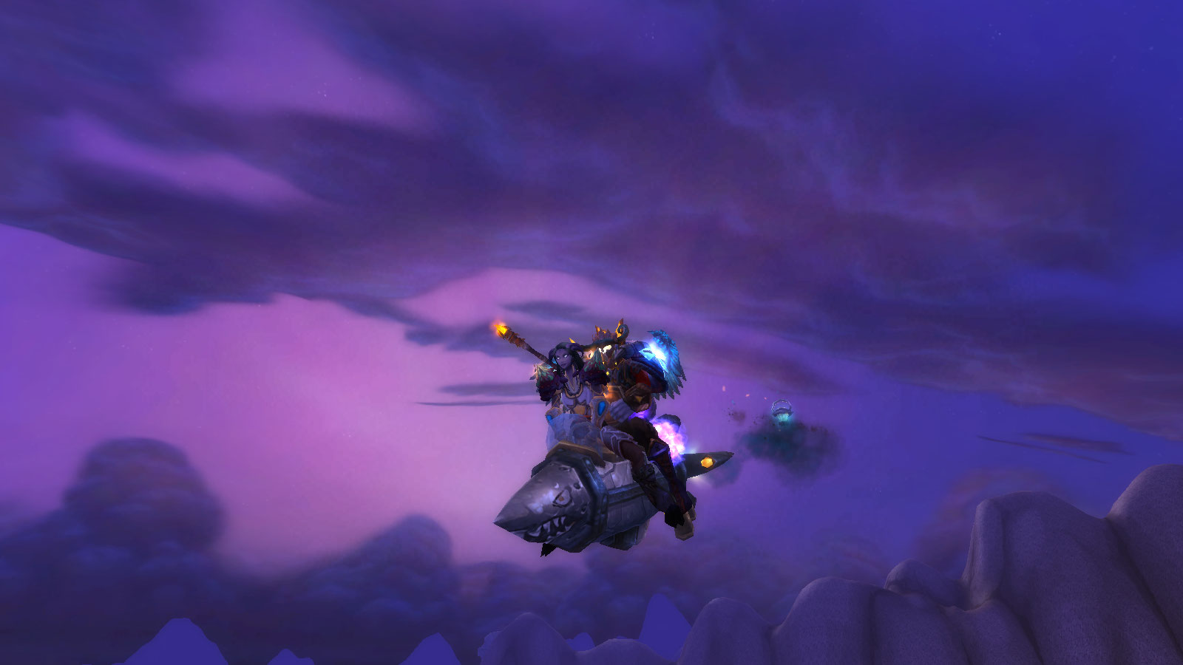
Figure 2. Zoombroom and Anthropos embark on an adventure, 2011.

CHAPTER II
THE LADDER OF EVOLUTION IS SHOT ALL TO HELL

Day One

Teldressil is Azeroth's new World Tree, a monstrosity rising from the oceans north of Kalimdor, a magical creation so immense entire cities and towns teeming with the remnants of the now-mortal Night Elf race populate its branches. The original World Tree was destroyed in Azeroth's recent past, sacrificed in a last ditch effort to thwart the invasion of The Burning Legion, a horrific demonic force. Rut'theran, a small fishing village at the base of its trunk, welcomes visitors to the tree, allowing newcomers an opportunity to step through a red portal and teleport into the heart of Darnassus, the capital city of the Night Elves (Figures 3, 4, 5 and 6). Beyond Darnassus, the tree stretches the tips of its branches, creating a haven for the many creatures attuned to the ebb and flow of nature and the environment. In addition to the Night Elves, a visitor to Darnassus meets a variety of denizens. Walking trees both great (Ancients) and small (Ents) mix with mystical emanations of sentient light (Wisps), half-female/half-deer Dryads, half-male/half stag Keepers of the Grove, and the mighty winged amalgamates known as Hippogriffs. Streams flow through the city, creating a series of islands linked by bridges and walkways. Buildings of all sort and purpose, from artisan and craftsmen, to military, to those linked to various trade skills, are constructed from the interiors of trees populating its edges.
A new player to WoW who chose to play as the Night Elf race quickly found him/herself face-to-face with first the suburbs of this city, and then mighty Darnassus itself. Upon logging in for the first time, the in-game camera lurches forward, taking the player on a roller coaster-like voyage through the city and into its outskirts. A narrator extolled the recent history of the Night Elf race (Blizzard Entertainment 2004: World of Warcraft Night Elf Opening Cinematic):

For ten thousand years, the immortal Night Elves cultivated a druidic society within the shadowy recesses of Ashenvale Forest. Yet recently, the catastrophic invasion of the Burning Legion shattered the tranquility of their ancient civilization. Led by the Archdruid Malfurian Stormrage, and the Priestess Tyrande Whisperwind, the mighty Night Elves rose to challenge the demonic onslaught. Though victorious, the Night Elves were forced to sacrifice their cherished immortality and watch their beloved forests burn. Seeking to regain their immortality, a number of wayward druids conspired to plant a special tree that would link their spirits to the eternal world.

Despite Malfurian's warnings that nature would never bless such a selfish act, the druids planted the great tree Teldressil off the stormy coast of northern Kalimdor.
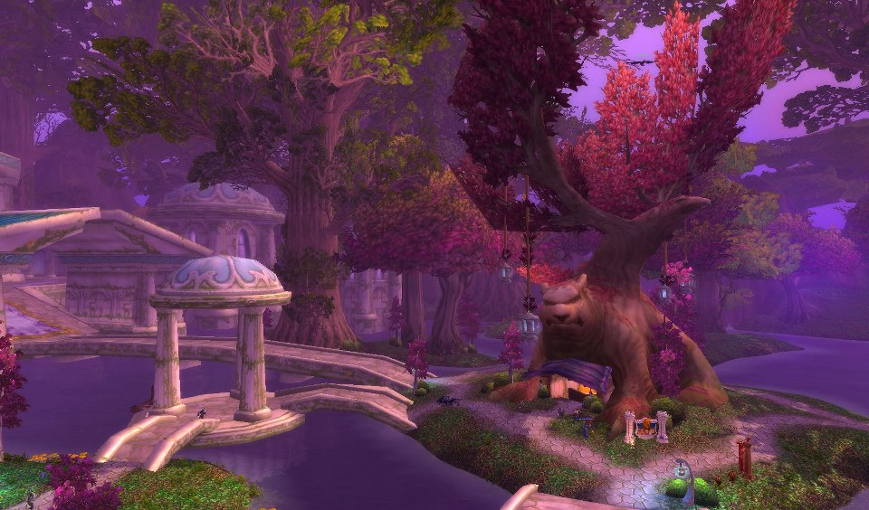
Figure 3. Darnassus is a city built atop the World Tree.
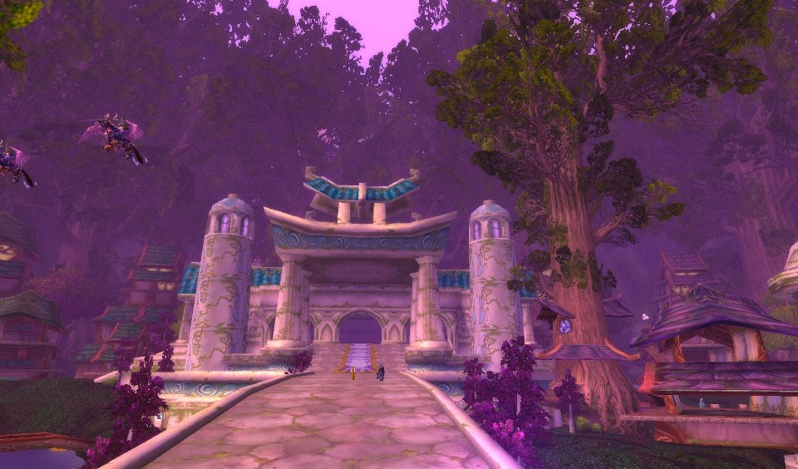
Figure 4. Night Elf Sentinels ride Hippogriffs and patrol the city.
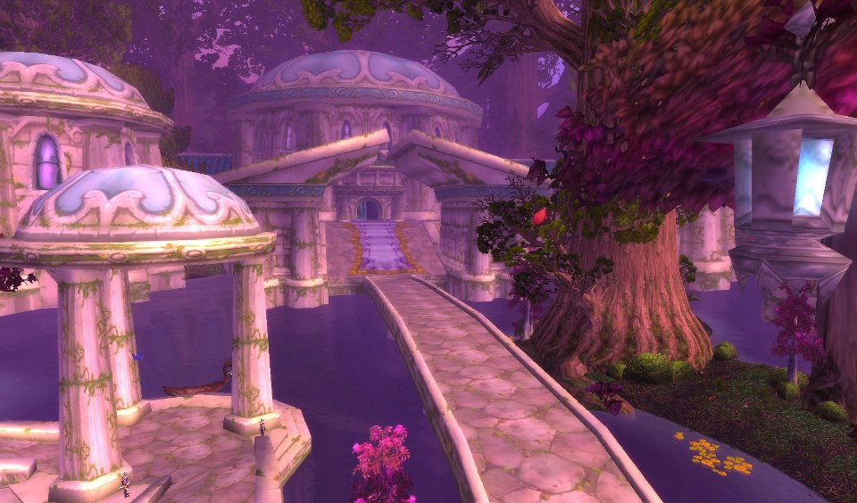
Figure 5. The Temple of the Moon in Darnassus.
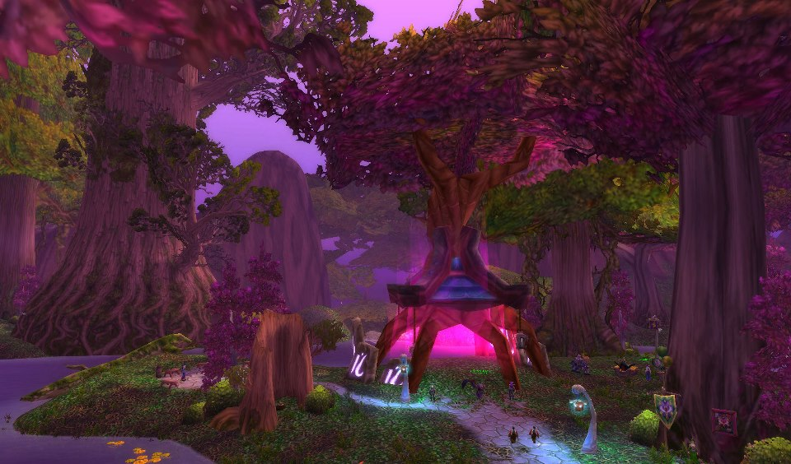
Figure 6. The portal to Rut'theran Village.
Within the twilight boughs of the colossal tree, the wondrous city of Darnassus
took root. However, the great tree was not consecrated with nature's blessing, and soon feel prey to the corruption of the Burning Legion. Now, the wildlife and
even the limbs of the great tree itself, are tainted by the growing darkness. As one of the few Night Elves still left in the world, it is your sworn duty to defend Darnassus and the wild children of nature against the Legion's encroaching corruption.

As the narration continued, the in-game camera swooped over the low lit forest in northeastern Teldressil, revealing other online players running along a winding stone pathway. The camera twisted and cavorted, offering a wide scale perspective of the forested land's scope. I largely ignored the landscape, my mouth dropping not at the immensity of the computer generated imagery, but at the sheer numbers of players inhabiting the zone. I had no idea how popular this game was going to be on Day One. For a supposedly endangered race, the Night Elves were not looking all that threatened. The game and the Night Elf race were thriving. I quested alongside the other players, completing in-game tasks in order to acquire "experience." The more experience I accrued, the more my character advanced in level.
As I composed the above description of Teldressil, I chuckled at the absurdity inherent in my prose. I wrote the passage the night WoW's latest expansion Mists of Pandaria was released (September 25, 2012), years after that initial Day One log-in (November 23, 2004), painting a picture about what is essentially interlocking pixels. My goal was to capture the city not as a flat 2-D reproduction, but a living, breathing entity. It was alive, a vast intermeshed network of nature and construct, a place where I (in the guise of my avatar) walked, ran, swam, rode, even flew. Something captured my attention as I wandered Teldressil for the first time: though "virtual," the world surrounding me was as "real" as the keyboard I use to type out this paragraph. Like the other Night Elves, I ran into the forest, questing, slaying giant spiders, exploring ransacked villages, helping local towns from attacks by mad bear-like Furbolgs. Pixels faded into cohesion. As I progressed in the game, I accepted the "reality" of its trees, bushes, and leafy floors; what I saw became not reality exactly, but something more than a virtual expression (Figure 7). It was "realness," or at least real enough for me to lose my sense of being and seamlessly participate in WoW's narrative dream. I knew I was not the only player experiencing a persistent world - term popularly used to describe the MMO genre - for the first time, and I knew I was not the only player developing new relationships in what is officially referred to as a massively multiplayer game. The realness, or rather the muddling of realness or virtualness, captivated my attention, igniting an interest in learning more about how other players reacted not only to this new world, but to the thousands of others populating it.
My fascination with how the reality of the game framed the formation and maintenance of these relationships served as the core of this research and grew from these opening experiences. Additionally, I wanted to observe how these relationships aided in the development of one's character, particularly in the processes of gear acquisition and identity construction. Sherry Turkle (2011: 212) described how online worlds "ask [players] to construct, edit, and perform a self," giving players an opportunity to "perform a life through our avatars," one that "express[es] our hopes,
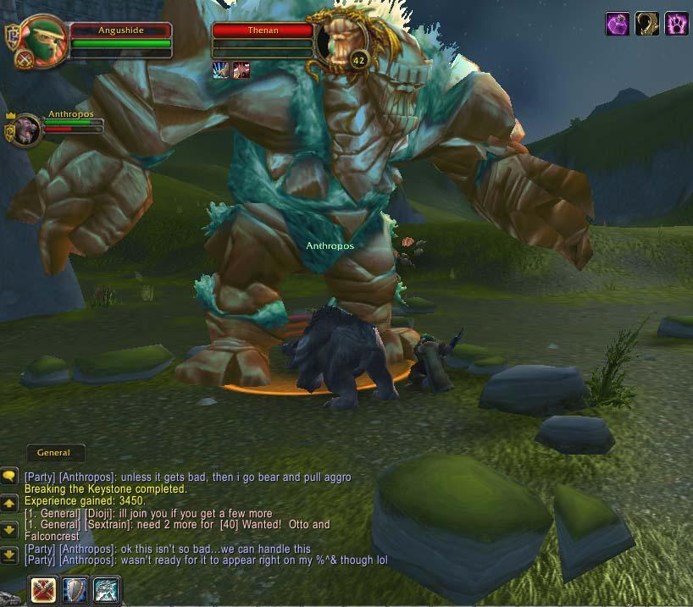
Figure 7. Anthropos quests in Arathi Highlands, 2005.
strengths, and vulnerabilities." Players performed these virtual lives with the help of others playing online aside them, including friends encountered IRL or online, family
members playing online, and companions assisting the player in-game. These representatives and allies were the people the player trusted, people players learned to trust, relationships players went "all in" on, relationships players casually explored (and expanded or abandoned), individuals players turned to in moments of crisis, and/or the first individuals players contacted upon log in. These other players represented friends, allies, acquaintances, enemies - all of varying degrees - but they were all players, all relations, all worthy of exploration and deeper understanding.
This chapter builds from the initial realizations that human relationships pierce the boundaries constructed between real and virtual worlds. Throughout the course of this chapter, I present the primary gaming and academic influences contributing to the direction of this dissertation research. The focus of this chapter's analysis and discussion include: (1) My primary gaming influences, offering the reader an introduction to the original RTS (Real Time Strategy) games composing the "Warcraft" franchise; and (2) Anthropological studies forming the backbone of my exploration of gaming and multiplayer gaming lifestyles, including notions surrounding cyberspace, virtual worlds, and contemporary understandings of our transformative virtual-socio-cultural plugged-in species. I conclude this chapter with: (3) A discussion of the dissertation's central argument. This composition includes the core questions I posed to my informants, the theoretical considerations I placed before myself during the course of this research, and the goals I assumed during the "write-up" and "presentation of findings" processes.

Motivations for Choosing a Project on WoW

Blood and Thunder
Seeing hundreds of player-controlled avatars exploring Teldressil on Day One contributed to my decision to research WoW, but it was not the only motivation, nor was it my first experience with the Warcraft franchise of games developed by Blizzard Entertainment, and later Activision-Blizzard. I have followed the Warcraft series since my undergraduate days at William and Mary, playing the very first game, Warcraft: Orcs and Humans (1994) when I was a freshman. Its sequels, Warcraft II: Tides of Darkness (1995), Warcraft II: Beyond the Dark Portal (1996), Warcraft III: Reign of Chaos (2002), Warcraft III: The Frozen Throne (2003) were played over the years as well. They were Real Time Strategy (RTS) games, a game genre unfolding in "real time" with both single player and multiplayer capabilities. These games featured various playable populations (known as "Races") like Humans, Orcs, the Undead, and Night Elves. Each player began with a Town Hall and a number of player-controlled worker units, similar to a Peasant. Depending on the player's selected Race, the equivalent of the Human's “Town Hall” building may be called by a different name - for instance, Orcs had a “Great Hall” and their basic worker unit was called a “Peon.” The player's goal, regardless of the race played, was to mine gold and harvest lumber, expand his/her base, build a town, construct an army, and upgrade his/her player controlled worker and soldier units and their individual abilities as quickly as possible. There was nothing subtle about this game: in addition to managing one's home base and worker units, one must destroy all opposing forces, whether NPC-controlled or player-controlled, on the map.
Skilled Warcraft players possessed the ability to track multiple actions at once, remember what units are being upgraded, what units are being developed, all the while roaming the landscape with the player's most powerful soldier units, the Hero Class, to “creep” (kill random monsters, called “creeps” for experience points and treasure). The best Warcraft players were skilled at “microing,” or the ability to manage all the nuances of the game, as well as utilize the skills (spell casting, moving an injured unit to the back of the army, focusing ones attacks on specific enemy units) of multiple individual units during the course of a battle. Whether you are playing the single-player campaign, or facing upwards of seven other players on-line, the action quickly intensifies. The battles featured in the four versus four player games, especially at the later stages of a game, had the potential to be huge confusing melees taking up the entire screen. These sorts of royal rumbles were not for the faint of heart, or those with slow internet connections. The longer the game's duration, the more advantage lay with players effectively strategizing attacks (choosing effective units, including ones able to counter enemy units abilities), microing (managing the game, from spell casting, to mining gold, to hunting down neutral monsters, or “creeps”), and expanding (maintaining multiple towns to increase gold and lumber harvesting).
World of Warcraft (2004) was a direct sequel to these RTS games. WoW expanded on the "blood and thunder" world created in the original RTS games and took the format of the MMO game genre (Jenkins 2002: 390). The major difference for the player was that, instead of controlling hundreds of units, the player ended up taking on the role of a single unit. As a result, instead of a birds-eye-view of the game, the game took a third person perspective behind the avatar. The player chose one of two in-game warring factions: Alliance and Horde, and then selected the Race they chose to play. The available races were a mixture of the original playable Races (Humans, Orcs, Night Elves, Undead) and new Races (Gnomes, Trolls, Dwarves, Tauren, Blood Elves, Goblins, Draenei, Worgen, Pandaran). The playable Classes were based on the abilities of the original soldier units (Warrior, Priest, Druid, Mage, Warlock, Death Knight, Hunter, Brewmaster, Paladin, Shaman, Rogue). The player created a stylistically unique representation from the available character customizations, becoming a combination of a Race and a Class (Night Elf Druid, Draenei Paladin, Gnome Rogue, and so on). WoW featured multiple “realms,” each containing a complete game world. So, while hundreds of thousands of players will not be able to truly interact with each other, thousands of characters will. Players selected and designed their hero (their avatar) from the following Alliance races: Human, Dwarf, Gnome, Night Elf, Draenei, Worgen, and Alliance-aligned Pandaran; and the following Horde races: Orc, Troll, Tauren, Undead, Blood Elf, Goblin, and Horde-aligned Pandaran. Individual players held the option of playing solo, grouping together with other players, and forming large social groups called "guilds." Blizzard notes that the game play was designed to accommodate groups of five, but that these groups can be “linked” with other groups to form even larger parties, called raids. These linked groups participated in large scale challenges, from farming, to creating a community, to refining employable crafts (Leatherworking, Blacksmithing, Alchemy, Tailoring, and so on), or the more standard adventuring, quest seeking, and dungeon crawling.
WoW's business approach took that of the Massively Multiplayer Online Role Playing Game or MMO model popularized by EverQuest, creating a player paid subscription experience capable of generating hundreds of millions of dollars each month. The game featured regular updates through patches and purchasable software and required an internet connection to play. The success of WoW was but one example of the MMO genre. There are (and were) many others. For instance, in July 2003, Star Wars Galaxies: An Empire Divided was released from Lucasarts Entertainment and Sony Online Entertainment. Galaxies represented an important step in popularizing the MMO genre. Before the game was even released, over 500,000 people had registered their names as interested in participating. The now defunct game was set in the Star Wars universe, during the time of the original trilogy of films. The cost of entering this world ranged from the one-month subscription fee of $14.99 to the year price of $143.99. Initially, over 125,000 people signed up to play. Before Sony Online Entertainment (2004) discontinued support for Star Wars Galaxies, its once-official website described the game in the following press release:

You can do just about anything you want! Whether you want to be a roguish smuggler, a simple shopkeeper, or a powerful diplomat, the options are open to you. There is no “winner” in the game, as everyone has different goals. However, the Empire has a firm grip on the galaxy and the Rebels struggle against its rule, and your actions can have an effect on how this epic struggle plays out!

Other projects created or in development at the time of WoW's release included Middle-Earth Online (2007, based on J.R.R. Tolkien’s series of books) and the now defunct The Matrix Online (2005, based on the “Matrix” series of films). Others included games based on Conan the Barbarian, DC Comics superheroes, and the popular role-playing game Warhammer. In 2011, the servers running Galaxies and The Matrix Online were shut off. Matrix was considered a disappointment. Galaxies was successful, lasting eight years. The development of another "Star Wars"-themed MMO by BioWare and LucasArts, Star Wars: The Old Republic, perhaps hastened its demise. Lord of the Rings Online adopted a free-to-play model, meaning the game relied on premium services, or additional paid features, to generate revenue. Age of Hybernia (2008, the Conan game) and Warhammer Online (2007), while making waves at their release, were not nearly as successful as the game designers had hoped. The most recent releases hoping to compete with WoW were Rift (2011), Star Wars: The Old Republic (2011), and the upcoming The Elder Scrolls Online. Of these three recent launches, Star Wars: The Old Republic adopted the free-to-play model on November 15, 2012.
WoW and its post-EverQuest MMO predecessors achieved success because, as social gaming platforms, they combined features enabling "various forms of social interaction and interdependence" with the gameplay (Taylor 2006: 39). In other words, tools existed in-game allowing for free and open communication with other players. These tools enabled players to form social groups of varying sizes, whether uniting in small numbers to complete specific quest challenges or dungeons, in large numbers to tackle raid dungeons, or even in the hundreds in the form of social guilds. WoW's development and success hinged on maintaining and improving these social networks. In fact, WoW's development team improved the ability of players to meet and form vast social networks through additions to the game. One example was the incorporation of a City/Trade Chat channel, allowing players an open network to form groups, raids, and communicate (or troll other players). During the Wrath of the Lich King (2008) expansion, WoW introduced a Dungeon Finder feature, one capable of forming cross-server dungeon groups from random players. The Cataclysm (2010) expansion expanded on this feature, creating Looking For Raid (LFR) mode, a tool forming cross-server 25-man raids at an easier difficulty level than traditional raiding modes.
Understanding the socio-cultural implications for social-mediated communication within the MMO world required an approach grounded not only in related game genres and social media platforms, but also in theoretical frameworks diving into these forms of life. As the popularity of WoW and social media simultaneously grew, so did my interests in obtaining an emic perspective of these online North American cultural groups and their inhabitants. Ignited by a passionate history of personal gaming, and fascinated by studies of the nature of (virtual) reality, I hoped to produce an analysis of online hardcore WoW cultures enabling American researchers to identify core underlying values and beliefs reflected virtually by its citizens, focusing not just on WoW, but the population of users transforming the way they game and interact socially. The insights of this field of research, particularly the notion of the cyborg, and the explorations of researchers amongst online inhabiting groups, are outlined in the subsequent section.

Post-human Nation
The immersive quality of virtual worlds takes players into a construct, a narrative dream, a "post-human" world treating the body as a "tool of the emergent mind," something capable of being "replaced by other prostheses" (Cubitt 2000: 125). Cyberspace, advanced information technologies, and video games, move players from the real world into a pseudo-reality, more often than not constructed as deliberate reflections of our own world. The extent of internet connectivity, and the many items running off WiFi and adopted into players daily lives, tie this persistent-connectivity into the "internet of things," the movement examining the technological unification of the internet with human use of day-to-day internet-wired objects (computers, phones, televisions, tablets, Twitter-enabled refrigerators, Facebook-enabled automobile dashboards, washers/dryers, and so on). In terms of a video game internet of things, the player is embedded within this expansive network, becoming the heart and coordinator of a network of linked smart technologies. The level of player immersion relies on real world locomotion and hand-eye coordination to navigate these cyber-worlds, whether that relies on "prostheses" like mice and keyboards to drive their on-screen icon, or something more grandiose, like their hero or heroine through worlds of fantasy. These acts leave the user stretched across two worlds: one foot is planted in reality, the other rooted in a creation of pixels and imagination. Sinking into one world, yet relying on actions in another blur the lines of "real" and "unreal." Analyzing WoW, therefore, becomes a foray into not only American culture, but also a distant and foreign land, requiring knowledge built from ethnographic fieldwork and an emic perspective drawn from previous gaming experiences. Broaching an understanding of this virtual world, its denizens, its language, and its terrain offers an ethnographic challenge: achieving an emic perspective asks anthropologists of computer-mediated communication (CMC) to straddle these two lines of reality and to embrace the union of technology and flesh the best players find commonplace.
Film, television, and literature have addressed the science fiction-esque quality of "the possibilities of transcending corporeal and individual identity" (Napier 2001: 104). While many examples of these films exist (Blade Runner, Brazil, Vanilla Sky, The Truman Show, The Terminator),The Matrix (1999) and Ghost in the Shell (1995) spring immediately to mind. Both films address the mixture of technology and the mind, and feature main characters in flux between reality and virtuality. The Matrix offered deep-seated cultural philosophies reflecting on the nature of existence itself, warranting special selection in 2012 by the United States Library of Congress' National Film Registry for permanent digital storage. The "sub-texts to The Matrix provide a useful insight into the extent to which the real and the non-real have been the subject of much debate and further requires the movie-goer to question their position in a world that is increasingly blurring the real with the fictional" (Miah 2000: 220). Neo, the protagonist, is offered a choice by hacker Morpheus: take the "blue pill" and return to his mundane life, or take the "red pill" and enter The Matrix, where he will discover the reality of his "reality." Neo swallows the red pill and learns the world is actually a computer-generated image designed to keep humans enslaved by parasitic machines. In peeling off his invisible blinders, he joins other enlightened humans in resisting the vast network of machines using humans as a living source of energy. Susan Napier (2001: 104-105) also discusses popular treatises of virtual reality, focusing on the anime film Ghost in the Shell. This film, set in an "alienated, near future world," chronicles a "shadowy" Japanese government agency's conflict with a terrorist known as "The Puppet Master." A highly decorated agent (Kusanagi), who herself crosses the line between human and machine through incorporation of technology into her body, discovers The Puppet Master is actually an advanced A.I. (Artificial Intelligence) seeking to escape "his" creators and live inside a body of his own. Kusanagi questions her own reality as a living being, and after running afoul of her own government, faces her destruction. Amidst this final battle, she couples what remains of her cybernetic body with The Puppet Master, creating a new offspring unifying "real" and "virtual."
These popular films influenced my conception of WoW and virtual reality, particularly the unification of human and machine. As an experienced denizen of cyber-worlds, I was all too aware that they were inhabited by individuals effortlessly using machines as tools to extend their consciousness into virtual spaces. Like Neo and Kusanagi, the real and the virtual mingled with the adoption of this MMO gaming technology - the cyber-reality in which real/unreal constructs transformed these pieces into amalgams of human expression and virtual presentation. The mind was the key element. The post-human inhabitants of WoW - Post-human Gamers - drew their mind from "the chaos of phylogeny," creating a union of flesh (mind) and machine (PC and Mac) capable of effortlessly traversing, worldbuilding, and conquering in-game challenges. This transformation parallels the climactic scene of Ghost in the Shell. In this finale, as Kusanagi defended The Puppet Master from his creators, an image of the Ladder of Evolution was shot to pieces, a clear signal from the anime's creators of the direction they viewed human/machine coupling heading. I assumed this perspective of a post-human world, finding "no essential differences or absolute demarcations between bodily existence and computer simulation, cybernetic mechanism and biological organism, robot teleology and human goals" (Hayles 1999: 3).
These post-human individuals, these metaphorical "cyborgs," carried cyber culture, as Hakken, channeling Donna Haraway, suggests. Aspects of “real” and “virtual” within the cyborg became difficult to distinguish between: observing reality-agency and virtual-agency became crucial to contextualize the actions of these individuals. Hakken (2003: 376) suggested renaming a study of these “transgenic organisms” and the virtual landscapes they interacted within “cyborgology.” Lest we lose sight of the anthropological methods that must be adapted for a successful study of these new worlds, something simpler, like e-thnography seems more obvious, and more appropriate. I feared that the process of establishing an academic beachhead in this virtual geography would overwhelm me, leaving me lost in the unfamiliar, disillusioning my path to becoming a virtual cartographer. How, I wondered, would I relate to these so-called cyborgs? What would that mean for my own identity and, by extension, American culture? Because I sought to enter the world of the WoW gamer, unifying mind and technology (another Kusanagi/Puppet Master hybrid), and embracing their emic perspective, was I also to become a cyborg? Donna Haraway, in The Cyborg Manifesto: Science, Technology, and Socialist-Feminism in the Late Twentieth Century (1991), argues that the increasing interconnections of human and machine results in the formation of a new denizen of cyberspace: the cyborg. Haraway proclaimed herself a cyborg; in an interview at wired.com, she labeled herself the “quintessential technological body,” an example of the human love/hate relationship with machines (Kunzru, 2007):

Meet Donna Haraway and you get a sense of disconnection. She certainly doesn't look like a cyborg. Soft-spoken, fiftyish, with an infectious laugh and a house full of cats and dogs, she's more like a favorite aunt than a billion-dollar product of the US military-industrial complex. Beneath the surface she says she has the same internal organs as everyone else - though it's not exactly the sort of thing you can ask her to prove in an interview. Yet Donna Haraway has proclaimed herself a cyborg, a quintessential technological body. (See "The Cyborg Ancestry.")
Haraway argues that humans are integrating their consciousness and the direction of their future with machines. The identities of these "cyborgs" are formed through the collapse of real and virtual worlds into each other. Overlapping actions may exist, but observing reality-agency and virtual-agency may provide juxtapositions worthy of being addressed. Fortunately, the theoretical perspectives necessary to adequately address cyber-culture and the global “matrix” are available on many levels (from philosophic discussions of reality versus virtuality, to ethnographic analysis of cyber-actions or cyber-agency).
Boellstorff is one such example of these digital anthropologists. Writing on virtual worlds, he (2008: 32) stated the following:

Too often, virtual worlds are described in terms of breathless futuristic and capitalist hype. Above all they seem new, and this apparent newness is central to their being interpreted as harbingers of a coming utopia of unforeseen possibilities, intimations of a looming dystopia of alienation, or trinkets of a passing fad. Yet the fact that millions of persons now regularly enter virtual worlds, adapting to them with varying degrees of ease, indicates that something is staying the same; something is acting as a cultural ground upon which these brave new virtual worlds are figured.

In this sense, if a social scientist bought into the "hype" surrounding the capabilities of identity formation on the internet, then, he argues, existence would be relative, a flexible tool capable of being formed and reformed at will (2008: 32). Identity on the internet would be what we make of it, repercussions be damned. Within the blink of an eye a player transforms into a space marine. Within another blink of an eye the player becomes a plumber with magical powers. Within a third blink of an eye, that player assumes the form of a Night Elf. Or a Jedi Knight. Or a robot unicorn. Within the blink of an eye, anyone can become anything. Virtual inhabitants are real, based in reality, relying on reality to function and exist. When I stand inside a virtual landscape, I know and accept the reality of my eternal form. Yet, I see a copy of me on-screen, a vessel holding my thoughts, my dreams, my goals and ambitions. An extension of myself, constructed from technologies I cannot begin to understand. I could say: "I am only on screen. The virtual supersedes my reality." Or: "I am only off screen, but playing an online character." Or: "I exist in multiple forms, but real and virtual extensions of myself." These statements represent interesting theoretical concepts, but ultimately how do these notions translate into a practical discussion? Did the act of plunging into the unreal separate an individual entirely from the real? Only partly? Are layers of reality shaved away, like peeling some unseen onion, leaving you less concrete? Diluted? Are you spread thin, caught between two cultural worlds, member of neither, master of none?
Anthropology is particularly suited to an ethnographic analysis of cyber-actions or cyber-agency. Contemporary anthropological research focuses on real-world aspects of cyber-culture, access to cyber-resources, lifestyles of cyborgs, and so on. Efforts to enter on-line, or virtual, communities, has resulted in a growing literature exploring individuals engaging the global “matrix” of cyberspace (Crang, Crang, and May 1999: 15; see also Boellstorff 2008; Watkins 2009; Taylor 2006; Ito 1997; and Turkle 2011). The participants documented in these projects formed a new cultural geography, a new transnational collective with new virtual interconnections and new virtual forms of communication (Crang, Crang, and May 1999: 15). Mizuko Ito (1996) applied ethnographic studies to programs like SeniorNet and SimCity2000, making videotapes of individuals using the programs. A study of cyber-culture or a cyber-sub-culture requires this layer of attention, adopting an anthropological methodology that fully immerses the anthropologist into the fine line between reality and virtuality (Figure 8). I explored these works simultaneously as I developed my research project, relying on their virtual-based research to support my position that if the anthropologist is to truly succeed on all planes of cyber-existence, he/she must immerse his/herself into cyberspace, becoming “virtual” in the process. In other words the anthropologist must enter these worlds in person.

I Took the Red Pill

Like Neo in The Matrix, I took the red pill. I entered WoW in person. I engaged in a playstyle cycling from casual, to hardcore, then back to casual. My reaction to logging into the game was eerily similar to Boellstorff's arrival in the game Second Life. When he first “landed” on the beaches of this virtual world, an online-based computer game described as a means for players to create their own virtual world (quite literally) from the ground up, his initial reaction evoked that of Bronislaw Malinowski. Boellstorff realized he, like Malinowski a hundred years earlier, had stumbled into a landscape quite beyond his initial expectations, a world challenging his perceptions of the one he left behind. Boellstorff could “fly,” teleport, and communicate with other player-controlled avatars in his surrounding area. He posited that his reaction was the same sort Malinowski experienced upon his arrival in the Trobriand Islands: an unfamiliar world, unknown peoples, and the sense that movement across and through this world, both physically and culturally, required careful consideration. Boellstorff’s immediate reaction to entering Second Life was not to panic, but instead to reach out to his academic influences, the masters of theory and methodology that had nurtured his maturation through his development in the social sciences. Boellstorff was an anthropologist working on gender and identity in Indonesia; as a result, he grounded the world he faced in the structure of a known methodology and embraced so-called “real world” theoretical considerations. A “real world” context to the study and analysis of worlds decidedly unreal.
Much like Boellstorff, I found myself settling on unfamiliar ground. After logging into WoW for the very first time, the in-game camera angle swooped over a dimly lit forest, down cobblestone paths, positioning itself behind a “Night Elf” avatar wearing the long purple robes of a novice Druid. The in-game narrator extolled the virtues of playing a Night Elf, expounding upon the long history associated with the race, the desperate plight of a demon-ravaged community that had recently lost its immortality. I half-listened to the booming narration, instead curious to see how I could handle the MMO game genre, a genre I had never experienced before. Years after my entrance into the game, as I sat reading Boellstorff’s analysis of Second Life, a flashback to these first seminal moments playing WoW crossed my mind. Here was Boellstorff, “landing,” like me, in a virtual world, no doubt experiencing some of the same nervousness, restrained excitement, perhaps even a twinge of anxiety to begin his exploration. Due to my inexperience with fieldwork, I hoped this was a similar feeling other anthropologists faced as they entered a new country, a new continent, a world not their own. If Boellstorff was able to conjure visions of Malinowski, linking a timeframe so vital to the development of anthropology and ethnography to what is essentially the world of a
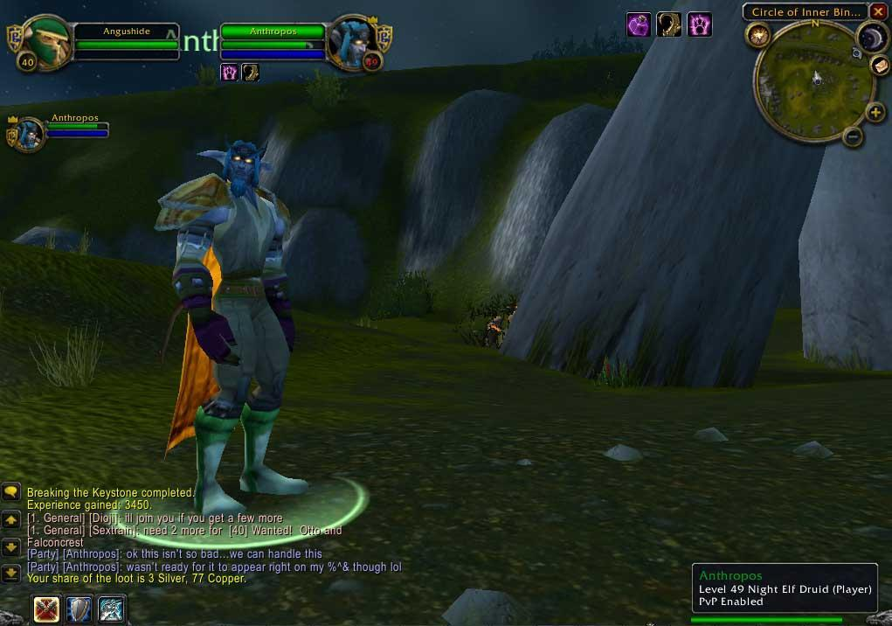
Figure 8. Leveling gear is never aesthetically pleasing, 2005.

game—a vessel for entertainment—then I would be a fool to dismiss the significance of my entrance. My own initial reactions were so like Boellstorff’s, which in turn were so like his representation of Malinowski’s. Though I stood in a “new” world, one in which I utilized Druidic spells and abilities in-game, as corny as this sounds, I had access to the IRL theoretical powers of the generations of anthropologists preceding me.
The unfamiliarity of these grounds, these landscapes, begs an important point of consideration: are virtual worlds so different, so foreign than the real world, that concepts consistently and effectively debated over the history of anthropological thought are not applicable? Can social scientists, the "cultural explorers" of the world, make any headway into this blurry, frequently contested and expanding world whose very inhabitants are protected by powerful shields of anonymity (Hakken 1999: 2)? Traditional ethnographic research projects have involved investigators traveling elsewhere. Helen B. Schwartzman (1993: 3-4) offers the following description of the traditional goals of ethnography:

One of the defining characteristics of ethnographic research is that the investigator goes into the field, instead of bringing the field to the investigator. Ethnographers go into the field to learn about a culture from the inside out…ethnography also requires researchers to examine the taken for granted, but very important, ideas and practices that influence the way lives are lived, and constructed in organizational contexts.

Can cyberspace apply as a “field” to enter? Does it qualify as a living space, possessing its own cultural rules and inhabitants capable of being observed and studied? Boellstorff (2008: 4) makes an impassioned plea for these very concepts through his study of Second Life; he takes "the methods and theories of anthropology and [applies] them to a virtual world accessible only through a computer screen," but recognizes the "controversial" nature of an ethnographic study conducted "entirely inside a virtual world." To counter this, he (2008: 4-5) argues:

...studying virtual worlds "in their own terms" is not only feasible but crucial to developing research methods that keep up with the realities of technological change. Most virtual worlds now have tens of thousands of participants, if not more, and the vast majority interact only in the virtual world. The forms of social action and meaning-making that take place do so within the virtual world, and there is a dire need for methods and theories that takes this into account.

The virtual world, including what is commonly referred to as "cyberspace," is not a niche platform. It has moved away from "merely a `cool' curiosity" and entered the mainstream, a revolutionary new system causing "social change" (Hakken 1999: 1). It is not a realm with a population of bleeding edge users. It is a platform that offers forums for social interaction, entertainment, business, sports, news, and so on. It offers iterations of the real world, and in terms of its usefulness for socio-cultural studies, should be treated as such.
The internet is part of both our own immediate world. I liken it to historian Eric Hobsbawm's (1995: 9, 12) descriptions of "revolutionary and constantly advancing technology, based on triumphs of natural science," the consequences of which "was a revolution in transport and communication which virtually annihilated time and distance," as well as its own very distinct and unique territory. Of course, in 2013, regular use of the internet has become extraordinarily prevalent, with WiFi offering a wide expanse of accessibility, and tablets/laptops/smart phones granting increased portability. I certainly never imagined living in a world where the sale of towers would actually decrease on a yearly basis in favor of handheld devises, where generations embrace the cloud experience over the collectability of the oh-so-comforting tactile DVDs and CDs. As a result, discussing terms like "cyberspace" or "internet identity" feels clunky now. It feels literally "played out." Since the advent of the term "cyberspace," many social scientists have tackled the conceptualization of virtual worlds and virtual spaces, quickly demonstrating the similarities and differences between real and virtual worlds.
For example, David Hakken (1999: 1) defines "cyberspace" as:

...the notional social arena we "enter" when using computers to communicate. "Cyberspace" can be used more generally to refer to the potential "lifeway" or general type of culture being created by Advanced Information Technology (AIT), the congeries of artifacts, practices, and relationships coming together around computing.

Cyberspace was a term first introduced in 1984 by William Gibson, referring to a “virtual” land possessing “virtual lives and virtual societies” (Jordan 1999: 1; 20). Gibson perceived cyberspace as a “place that collated all the information in the world and could be entered by disembodied consciousnesses…through a computer” (Jordan 1999: 20). Cyberspace is not a tactile space, but one existing on a plane composed of endless streams of data—the Internet. It is an infinite and endless realm stretching without borders, built from the ingenuity and imagination of the human mind. Boundaries spanning thousands of miles are connected in instants; as a result, these new technologies are “facilitating…a qualitatively different human experience of dwelling in the world” where “new articulations of near and far, present and absent, body and technology, self and environment” exist (Crang, Crang, and May 1999: 3). Marie-Laure Ryan (1999: 1) describes cyberspace as a “New Frontier,” one both “enticing and forbidding, a frontier awaiting exploration, promising discovery, threatening humanistic values, hatching new genres of discourse, altering our relation to the written word, and questioning our sense of self and of embodiment,” all ideas I can buy into. Ryan’s description of cyberspace is certainly illuminating, especially when drawing comparisons between frontiers of old, and the geography of cyberspace. Similarities quickly arise. The allure of the new domain. Romanticizing the region, painting its pioneers as individuals possessing super-normal characteristics (in the case of cyberspace, that would be “intelligence,” if for no other reason than the “I don’t understand what he/she is doing; he/she must be a genius"). And finally, once the area is “tamed” (i.e. businesses set up to profit), the more conventional masses begin to flock to explore these areas on their own, albeit tentative, pace. Finally, Hakken (2003: 4) expands on this discussion by arguing for a better, more empirical understanding of how knowledge has changed with the influx in new information technologies. Hakken (2003:4) writes:

A leap in knowledge's growth rate, its new types (e.g., "machine intelligence"), and a broad expansion of access to its forms are trumpeted most loudly by advocates for rapid and deep integration of automated information technologies (AITs) into the reproduction of current social formations.

Hakken's use of "knowledge" and "knowledge landscapes" can be equated with Fredrick Barth's framing of "culture" and "cultural landscapes." Barth (1987: xi; 1995) suggests we think of culture as knowledge. In doing so, culture can be seen as something reflexive and reactive, subject to manipulation. Culture as knowledge is transmitted and recreated by members of a particular cultural group, and passes from generation to generation (Barth 1987: xi). Crafted identity is a “transformation” between generations, resulting from the “interplay” of new and old meanings, metaphors, and influences (Barth 1987: 79-80, 82). These "transformations" in knowledge (culture) and knowledge landscapes (cultural landscapes) affect multiple locales, including access to new machine technologies in home, work, and school (Barth 1987: 79-80; Hakken 2003: 5-6).
Discussions pertaining to the natal period of cyberspace, in terms of understanding cyberspace's "infancy," where it "developed," and how it grew to become its current popular iteration are certainly relevant to this complex topic, and most undoubtedly remain fascinating. I worry, however, that spending too much time analyzing "the what" of cyberspace only dates the discussion. Humans are transforming (even adapting) into a plugged-in species, manifestations of the very "cyborg" concept raised by Haraway (1991), Hakken (1999), and others. I watch my wife wander around room-to-room on her iPhone, using it to call her friends and family, to update Facebook, to play Angry Birds or Bejeweled, literally changing any place she uses into her own portable virtual connection. Indeed, studying virtual spaces goes beyond simply remarking about the nature of the "space" itself, and instead extends into the transitional nature of humans as they interact and explore these "spaces." Cyberspace is cyberspace; by that, I mean "it is what it is," and I'll leave it to other experts in socio-cultural disciplines to deconstruct it as such. Understanding how we humans use (and continue to use) cyberspace in a world of portable worlds, malleable relationships, and flexible identities is, to this researcher, a far more fascinating objective.
This supposition applied not only to gamers and the worlds they inhabit, but more specifically, to hardcore gamers. Hence, one of the key arguments in my dissertation was that a dearth of research presenting the "emic" perspective of the hardcore gaming sub-culture existed. To fill this gap, I embraced the challenge of identifying and discussing their perspectives, positioning myself in a longitudinal study of hardcore World of Warcraft players. I present these individuals as ones using social gaming technology as a core mediation of their IRL and virtual lives, including within the development of relationships and the IRL/in-game spaces they inhabit. The novelty of my dissertation does not rely on this exercise, as others have written about WoW during the period of time I performed my research. For instance, Mark Chen, in Leet Noobs: The Life and Death of an Expert Player Group in World of Warcraft (2011) chronicles his time playing 20 hours a week through the leveling experience of World of Warcraft and alongside a raiding guild through the Molten Core (Tier 1) raid dungeon, culminating with their defeat of Ragnaros in 2006 and the group's eventual break-up. Through his research, he collects approximately 600 hours of in-game chat and 80 hours of in-game video to mount his narrative (Chen 2011: 19). The uniqueness of my dissertation's approach lies in offering an extensive critical analysis of the extended hardcore-mediated lifestyles occurring over the course of many years (2004 - 2011), and portraying/situating the social costs of this community's virtual decisions to their IRL lives. At my peak, I logged 70 - 80+ hours a week, joining them in their daily and weekly activities, playing on average 10 - 12+ hours a day, seven days a week, including the activities of endgame raiding, PvPing, and farming/grinding. These chapters represented my ultimate goal: a longitudinal presentation of the hardcore gamer lifestyle, in the gamers' own voices. Additionally, through my collaboration with these Post-human Gamers, I offer my own journey down the potentially self-destructive rabbit hole of hardcore raiding. To that end, I present the conclusion of this chapter, an overview of the perspective I adopted in this ethnography and the questions and considerations forming the heartbeats of this dissertation.

A Post-human Dissertation

Gaming and academic influences guided me toward a project examining the lifestyles and interactions of individuals diving in various degrees into the "realness" WoW provided. By 2012, WoW was a platform that 10-12 million players worldwide utilized. The longer I played WoW, the more I wondered about the motivation for, the formation of, and the maintenance of observed in-game MMO virtual relationships among these hardcore players. Online cultures in MMOs and those involved in their creation and population, whether formal (guilds, raiding groups, or PvP groups) or informal (friendship social networks) expanded and contracted on a regular basis. Players participating in a MMO game world like WoW did so for a variety of reasons, including ones involving social capital acquisition through achievement of individual and group goals. Understanding these internal and external social factors and their impact on relationships forged among hardcore players were critical to an overall conceptualization of the hardcore gameplaying lifestyle and hardcore social interaction as a whole. WoW, like its precursors EverQuest, Ultima Online, and Dark Age of Camelot, found its origins in a variety of social gaming systems. Taylor (2006: 21) outlined some of these "older traditions both in gaming and virtual multiuser spaces": (1) Tabletop gaming, (2) Multiuser Dungeons (MUDs), (3) Online Multiplayer Gaming Worlds, and (4) Early Massively Multiplayer Online Role Playing Games. The common theme running through these games was the combination of a "social" element with the promise of character (or avatar) development. In essence, players united in social groups with the common goal of defeating in-game challenges, the result of which strengthened a player's avatar. Friendships and social relationships were the catalyst for player improvement. Maintaining friendships and social relationships - finding common bonds in the face of in-game adversity - became the driving forces behind in-game success.
Raiding success, especially among hardcore players, grows from the coordination of a variety of players from different backgrounds, various time zones, and multiple work and leisure schedules into a cohesive unit raiding launched at a specific nightly time. Sherry Turkle (2011: 13) posits the following, discussing the changing reliance on technology:

Online connections were first conceived as a substitute for face-to-face contact, when the latter was for some reason impractical: Don't have time to make a phone call? Shoot off a text message. But very quickly, the text message became the connection of choice. We discovered the network - the world of connectivity - to be uniquely suited to the overworked and overscheduled life it makes possible. And now we look to the network to defend us against loneliness even as we use it to control the intensity of our connections. Technology makes it easy to communicate when we wish and to disengage at will.

The above statement, and my own curiosity, drove this longitudinal research into its current focus on hardcore players. As I traversed the virtual field, I established relationships with communities of hardcore gamers (see Figure 9 and Figure 10). Of these hundreds of gamers, I regularly communicated with approximately 40 players, using common communication tools like social media (Facebook), VoiP (Ventrilo and Skype), and mobile technology (SMS) to conduct one-on-one interviews and surveys with these informants. These players preferred to play as a group; they prioritized group play over solo play. I discussed not only their use of technology to mediate in-game and IRL relationships, but how seemingly IRL factors like stratification, power dynamics, and social capital operated in a virtual world. The participants included approximately 40 adult male current and former WoW players, ranging in age from their mid-20s to their mid-40s. All of the participants played the game for at least five years. Most have played since the inception of the game (November, 2004) with play times averaging 40 to 60+ hours per week. All of the participants volunteered to participate in the research without compensation. I came to know these informants over the period of time I attended scheduled raid and Player vs. Player (PvP) events. They represented a variety of skill and player types, with different ethnic backgrounds and location of origin. A glossary of these players are outlined in Chapter 2, using the names they chose to be represented by: their avatar name, their IRL first name, or another option. Much like how "in-game" player identity was crafted and malleable (Turkle 2011), so too were the in-game relationships these players formed. Much of my fieldwork involved following these raiders as they prepared for their nightly raids, socialized over Ventrilo, strategized and defeated raiding content, PvPed within the in-game world and within PvP Battlegrounds, hung out in major cities and over Ventrilo, and so on. They raided every weekday for approximately five hours, though this represented only a small portion of their in-game activities. Preparation for raids was also a popular activity, both in terms of gathering materials for useful items or advancing reputation with in-game factions, preliminary activities necessary for a successful raid. This preparation took many hours over a typical week, and I was expected to participate in these activities to maintain access to these high-end players. I discuss this preparation, and the players' perspectives on this process, in more detail in subsequent chapters.

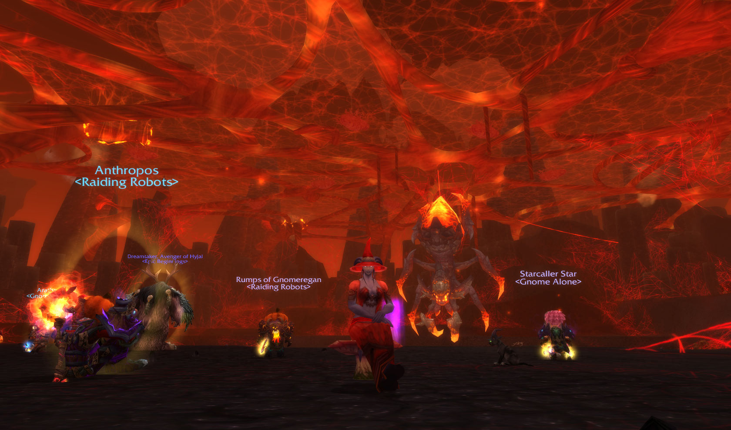
Figure 9. Preparing for Beth'tilac, The Firelands (Tier 12), 2011.

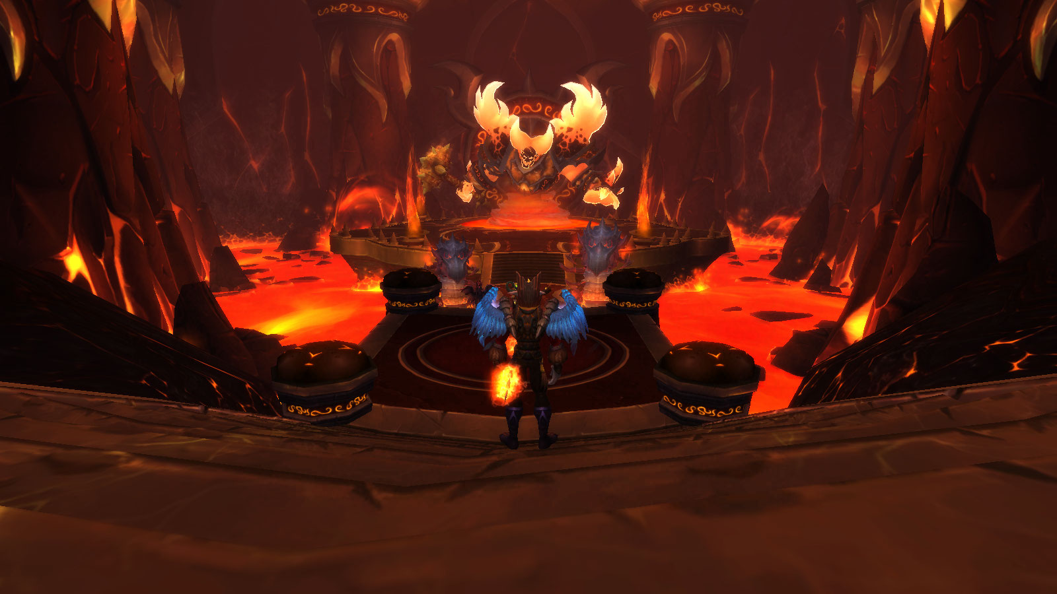
Figure 10. Confronting Ragnaros, The Firelands (Tier 12), 2011.

The longer I played the game, as I moved from guild to guild and raiding group to raiding group, the more contacts I made, many of whom were eager to assist in the research and become informants themselves. Over the years, the raiding groups and guilds with which I interacted grew, split, downsized, server transferred, faction transferred, and recruited new players, creating a vast network of family trees (raiding genealogy, if you will). Though guilds rose and fell, disbanded, server transferred, or even changed names, the lineages that were formed created ties and alliances that superseded in-game drama. My own raiding lineage linked myself to a series of raiding guilds, beginning with the Shattered Hand Alliance guild <Stoic> in 2005. My participation with <Stoic> began with the Tier 1 raid Molten Core (2005) through Tier 2 (2005's Blackwing Lair) and concluded with Tier 2.5 (2006's The Temple of Ahn'Qiraj). After <Stoic> broke apart, and my contacts transferred to play as Horde on another server in 2006, I participated with other guilds. I followed a new core group of hardcore raiders as they raided with the Alliance guilds <Indomitable>, <Royalty>, and <Raiding Robots>. These players are listed in Chapter 3. The guilds, time periods, and Guild Masters associated with these players are the following:
- <Indomitable> (Tier 2.5 - Tier 3 raids / 2006 - 2007) - Guild Master: M
- <Royalty> (Tier 4 - 7 raids / 2007 - 2008) - Guild Master: M
- <Raiding Robots> (Tier 7 - Tier 10 raids / 2008 - 2010) - Guild Master: Telcontarx
Additionally, while still a member of <Raiding Robots>, I simultaneously played with Ahroo's 10 Player PuG from 2009 - 2012, completing the Tier 8 through Tier 12 raid zones. Establishing my reputation on Shattered Hand as a skilled and dependable healer opened access to the participants in these guilds, as well as other players throughout the server. Tracking players—where they went in-game or out of game—was difficult throughout my research (2004 - 2011) until the rising popularity of social media allowed us to find common ground through the creation of a Facebook Group devoted to Shattered Hand players (2011). After I quit WoW in 2011, Facebook became instrumental in reaching out and contacting these informants.
I used text-based, phone-based, and VoiP-based technology to contact my informants. To address my research questions, I employed a qualitative research methodology, scanning for the emergence of key themes and issues surfaced by many or most of the players. I used these key points to develop a survey instrument, allowing for the collection of some quantitative response data. The interview and survey consisted of 10 - 20 closed-end questions and two - five open-end questions. I conducted the interviews and the surveys in 2012. All of these procedures were conducted with complete confidentiality. My analysis plan built on my previously stated research goals. I first conducted surveys and then in-depth interviews with players to understand and illustrate their in-game play choices, their methods of communication and strategy, their play history and guild participation/genealogy, their embrace of social media, and their demographic profiles, I developed a summary of data, including key takeaways backed with descriptive verbatims. Using the information gleaned from participant-observation, open-ended interviews, and surveys, I focused more broadly on what these players' embrace of this MMO world intimated for the current cultural milieu adopting (even devouring) the use of virtual and social media platform. I noted their embracing of the strongly social, even emotional and intimate, connections the (fantasy role playing) game offered in terms of their relationships forged with their "friends," including ones only found in-game, but who they have never met in real life. Understanding, let alone categorizing, our digital world, even its users, whether members of Generation X, the Millennial Generation, or Generation C, was difficult enough without having to take into account its inherent fluidity. The lifespan of cyber-communities and cooperative groups, by their (extremely) temporary nature, offered any researcher a high-level challenge in terms of nailing down and keeping up with his or her informants. In the grand scheme of things, the life span of a fruit fly seemed longer than some of the tenuous relationships built, especially in the current age of WoW, where faction and server transferring siphons from the (perceived) strongest of ties.
Studying these hardcore players offers an exciting challenge to any anthropologist. Moving participant ethnography online is certainly an endeavor by itself; engaging the world of hardcore raiders is a whole other beast. As I document, hardcore participant observation requires the anthropologist to immerse him/herself in a new lifestyle, one straddling two worlds around-the-clock, a virtual reality, of course, but also an IRL reality to support this life choice. Additional tests arise from juggling both worlds, navigating rapidly changing, action-packed environments with extraordinarily skilled players, finding comfort and confluence with the technologies required to negotiate the world of endgame raiding, and embracing the topsy-turvy lifestyles of its inhabitants. The end result gives voice to a unique generation of users who find themselves increasingly in cultural worlds of their own creation, ones digital in origin, yet also contest traditional analog cultural expressions. The first half of this dissertation, Chapter 1, Chapter 2 and Chapter 3 outlines the "set-up" to this research. The second half, Chapter 4, Chapter 5, and Chapter 6 represents "the findings" portion of the research, as voiced by my informants. The composition and narrative choices of S. Craig Watkins (2009) offered an important influence in the narrative styles I use for this write-up. Watkins' reliance on the stories of his informants (told through the words of these informants) created a believable voice, establishing readability with technical instruction and analysis. I hoped to strike this balance as well, using my informants' own words in the latter chapters to outline and expand on the many points I raised throughout the course of this analysis. It was through their voices that I situated my own self and my own position in this multiplayer game that was not really a multiplayer game. As a final note, due to the foreignness of the game world, and no doubt many readers' unfamiliarity with the genres which I discuss, I took time to intermix staunch analysis with narrative designed to flesh out and explain the significance of what I observed in the game world.
Hold fast. Uncertain waters lie ahead. Dragons too.
CHAPTER III
DOWN THE RABBIT HOLE

October 12th, 2012

My wife and I wandered into a Cuban/Mexican restaurant in Knoxville. We entered the dimmed dinner area, a large circular room with haphazard seating and a decor consisting of paintings, posters, and mustache-laden images strewn over the walls. By the time the server arrived with chips and salsa, my phone buzzed: a text from a WoW player, Arathene.
"You might as well come say hi to me," the text message read. "I'm across the room from you."
I looked up. Sure enough, there he sat, not twenty feet from us. Arathene waved. Of course this individual's IRL name was not "Arathene;" that was his WoW name, the name by which I conceptualized him. It was the name that I had used over the past half-decade to refer to him, speak to him, and speak about him. His real life name never entered my mind. Instead, he was Arathene, Gnome Shadow Priest, PvE raider and PvP player extraordinaire, destroyer of Horde multitudes, trash mobs, and monstrous raid bosses alike. It was also the name my wife used when asking him to come sit with us for dinner.
I first met Arathene in 2005 when he and his friend Itsgeorge transferred to Shattered Hand to play with his brother, Talius. We regularly conversed in-game and over Vent. Our first meeting occurred at a local sub shop when I ate lunch with him and Talius. The second meeting (after five years of online interaction) occurred in 2010 when I met him and another player, Blitzan, in Bristol, Virginia. I was nervous in these initial encounters; the situation reminded me of the anxiety T.L. Taylor described in Play Between Worlds in which she chronicled her trip to a “Fan Faire” hosted by SOE (Sony Online Entertainment) for players of EverQuest. Where, Taylor wondered, were the player representatives from her game server? How would they appear? Would they even want to speak with her? Taylor anxiously awaited encountering the “real world” versions of players from her server for the first time. In the same way, I felt "butterflies" before meeting with Arathene, Blitzan and later Itsgeorge outside the game context.
"Arathene," my wife said, "do you want to eat with us?"
I recall his amused shock as his WoW name (and identity) blended with real-life.
"You know, you can call me by my real name," he informed her.
"Sorry," she said. "Josh always called you Arathene, I couldn't help myself."
I laughed at the exchange.
How utterly appropriate, I thought.
.

New Social (Gaming) Hubs

The overarching narrative of this chapter focuses on the hidden and varied dimensions for the development, maintenance, and use of intimate social relationships among hardcore massively multiplayer communities. MMOs, like Facebook and other social media platforms, foster mediated human-to-human interaction on a daily basis. Forging friendships, relationships, and alliances among players is an inevitable process and integral to gameplay. The requirements of WoW encourage social interaction. Solo play is possible (see Figure 11 and Figure 12), but at the game's maximum level, successfully defeating raid content is group-driven (see Figure 13 and Figure 14). NPC bosses in current raid dungeons ("Raid Bosses") possess attributes requiring a large group of players to defeat them. For instance, they have multiple phases throughout their encounter. Raid Bosses also have high damage output (they hit the player very hard), and an "enrage timers" (a mechanic whereby a boss's damage output increases over time, effectively placing a time limit on a fight). Technological advances in WoW, such as their in-game VoiP system allowing players to speak with each other, or the "Cross-Realm Zones" (CRZ) feature were created with social play in mind. CRZ creates multiple versions of existing zones crossing over between lower population servers. This overlap of multiple servers allows players from these servers to interact, fostering more interaction between players as they quest, PvP, or explore the gameworld.
These social and grouping technologies foment active grouping and interaction, creating media-driven hubs through which content consumption and relationship-building occurs (Jenkins 2002: 389). As Watkins (2009: 171-172) recounts in his description of a crowd of middle-schoolers in a cafe, each whipping out their respective mobile phones and rapidly texting, talking, comparing, and discussing the mechanics and use of various apps at their fingertips, technology creates the hub around which social interaction can form. The mobile phone functions as a centerpiece of young American social life: a source of entertainment and an avenue to access digital media in any context (WiFi permitting). Unlike the stationary television set’s decades-long traditional role as the hub around which social groups gathered to access entertainment, mobile phones and other portable devices move as their users move and are easily incorporated into their owners’ pockets and handbags. WoW is another such social hub - albeit a stationary one requiring substantial computer equipment - a platform built for gamers by gamers. My informants' demographic is one coming of age not in the era of serialized radio shows, walkmans,"1-800-CALL-ATT"-like long distance programs, or even callused fingers from the extended overuse of #2 pencils. This generation grew up with the development of social networking, mobile devices, flatscreens, iPods and tablets, and with online-based educational systems like Blackboard. They represent the iGeneration, individuals capable of using with ease the the iPod MP3 player, the iPhone mobile phone, iPad tablet and its competitors, from Samsung, Microsoft, and Blackberry. Mobile phones are all around us; for me, the novelty of seeing one in action wore off in the late 1990s, when my junior year roommate talked to his girlfriend on a cell phone the size of an encyclopedia. Now, mobile phones blur into the background, occasionally reemerging or “sticking out” when their users walk or drive erratically or are particularly loud or disruptive in a social context like a supermarket or a movie theater (where “no texting” is now part of the pre-movie advertisements and trailers).
The significance of these new social hubs was driven home to me when I returned to a university classroom following several years’ hiatus. While teaching in the early and mid-2000s a laptop or two was used by students but there were a few smart
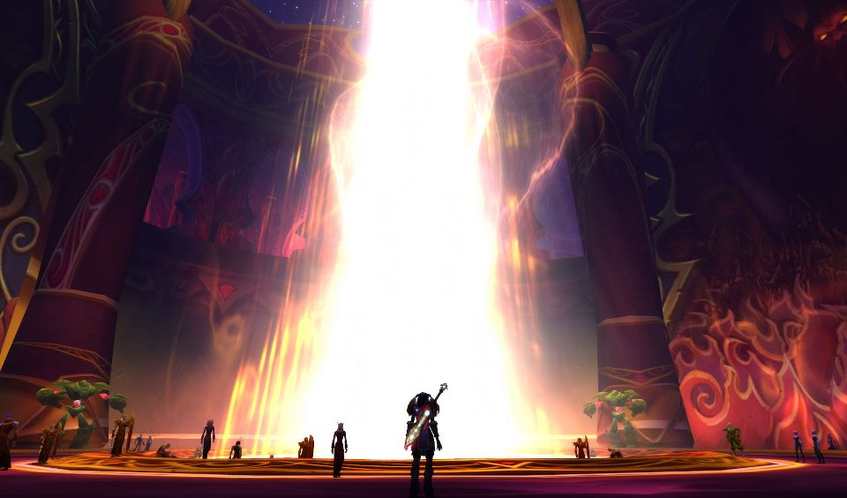
Figure 11. Zoombroom visits the Sunwell.
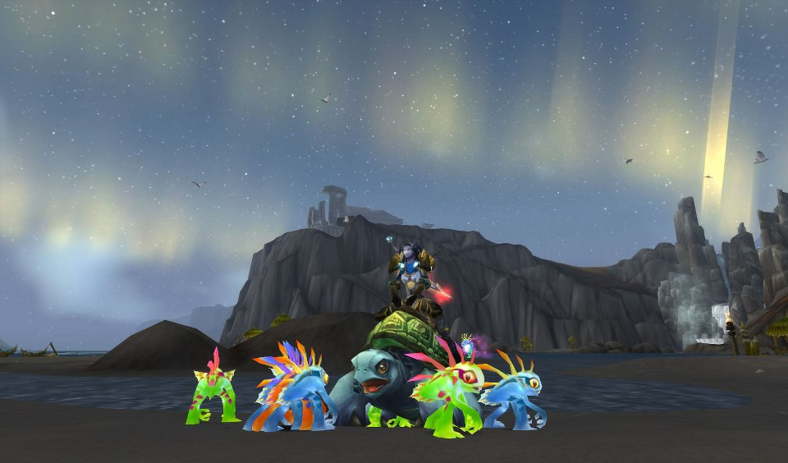
Figure 12. Zoombroom quests in the Wrath of the Lich King expansion.
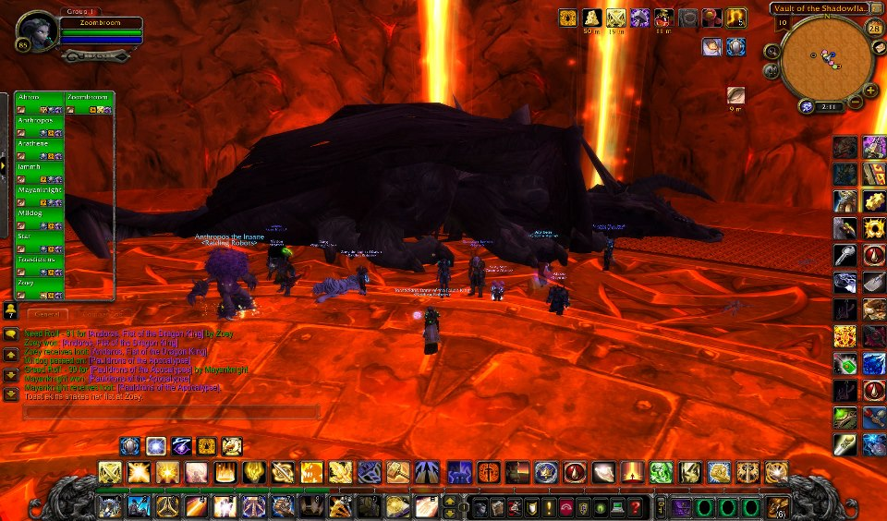
Figure 13. Ahroo's PuG celebrates defeating Nefarian, 2012.
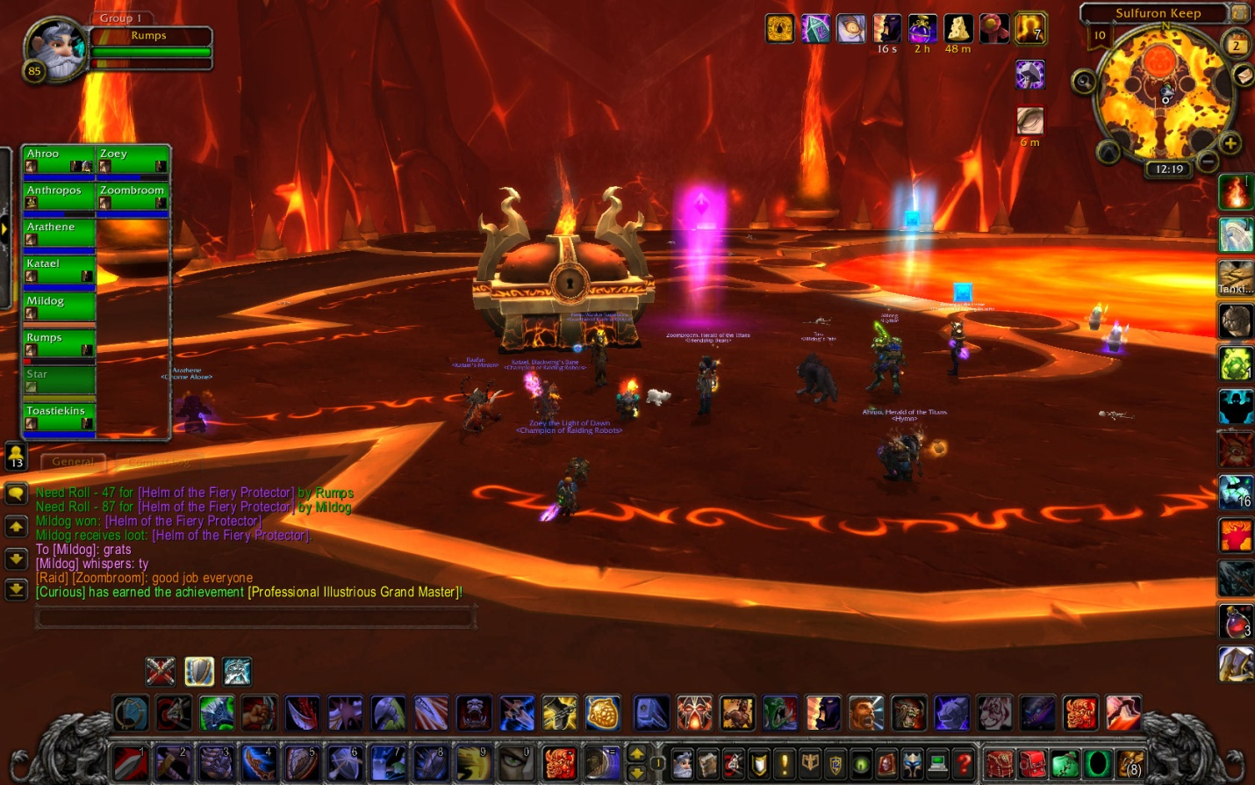
Figure 14. Ahroo's PuG, after downing Ragnaros, 2012.
phones and certainly none with the media and app downloading capabilities of the devices prevalent today. In April 2012, when Dr. Rosalind Hackett invited me to lecture in her “Anthropology of Religion” class, she prefaced the presentation by stating, “Please put away your cell phones and if you are going to use your laptops it better just be to type notes—I better not see any email or Facebook up on those screens.” A small nuclear bomb of rustling and clicking unfolded as every student stashed phones and tablets, clicking their keypads to close various websites and (I hoped) opened up a Word document to take notes as I began my presentation.
Bam! Epiphany!
The adoption of mobile phones had transitioned from “niche” machines with expensive contracts into the realm of the “magical” price range of $19.99 per unit with multiple lines individuals or entire families could afford to purchase. Indeed, as Watkins (2009: 171-172) noted, as mobile devices become more and more accessible, owning these phones have become akin to a rite of passage for American youth. In 2007, when 77% of all American teenagers (age 13 - 19) and 40% of American tweens (age 8-12) owned a phone—numbers relatively unchanged today in 2013 according to recent Pew Foundation findings—it was clear this technology assumed an important role in the developmental and social lives of young Americans (Watkins 2009: 171-172). Like a driver license, owning a cellular phone became a totem of responsibility, a signifier of maturity and growth. In the rush to adopt these mobile technologies, human interactions have been altered by unforeseen consequences. These devices enabled "continual connectivity," transforming the space and place around their users, turning flesh-and-blood humans into individuals permanently wearing the machine-based essentials of any budding cyborg, any citizen of the net, any individual investing him/herself into the virtual (Turkle 2011: 151).
Social network hubs appeared "for community-minded citizens, an almost limitless potential for an associational life, "but for social scientists it was a jumble of real and unreal, a mass of Lego bricks without a clear set of directions (Healy 1997: 64). Despite the release from limitations "by geographical happenstance" and the freedom "to create their own virtual places," cyberspace and virtual communities blurred the borders of something so basic as friendship, or really any face-to-face interaction (Healy 1997: 64). Though the internet created the possibility of "continual connectivity" and opportunities for continual relationships, separation and isolation into one's own internal world was largely necessary to undergo this process (Turkle 2011: 281). This, I recognized, was the harsh juxtaposition to internet gaming communities, including the informants participating in my own research. Though the internet was built on the myth of providing closeness, in actuality WoW players, especially hardcore raiders, created intimacy within isolation. When I joined a community of millions playing WoW, or a raid of 10 to 25 to 40, it was not through close proximity with these other players, but in an empty apartment or dorm room. I hung out with a raid group by myself. Logging into WoW may have required use of my imagination to creatively transform the space around me, but it also was a very lonely way to join a community of like-minded individuals.

WoW as Social Hub

Though WoW was not mobile-based - it required the use of a PC - it functioned just like any other social media platform. It functioned as a central node around which people could gather and socialize. Indeed, one saw the similarities between WoW and other social hubs through Blizzard's initial description of the game on Battle.net:

…an online role-playing experience set in the award-winning Warcraft universe. Players assume the roles of Warcraft heroes as they explore, adventure, and quest across a vast world. Being “Massively Multiplayer,” World of Warcraft allows thousands of players to interact within the same world. Whether adventuring together or fighting against each other in epic battles, players will form friendships, forge alliances, and compete with enemies for power and glory.

I noted the multiple opportunities for social relationship building. The developers created WoW's core on the maxim of multiplayer content and social networking, from its "official" content (e.g. PvE raids or PvP Battlegrounds) to its "unofficial" social interaction unfolding through in-game Trade Channel chat and messaging between guild members, friends, and connections, or communicating with friends across Blizzard's games using the Battle.net RealID feature. The game designers even extended WoW's reach from game to mobile phone app, allowing its players the opportunity to chat in-game even while "offline," using a special guild messaging functioning, and remotely interact with the Auction House system (2010). MMOs like WoW are, therefore, "vital" online social worlds, worlds providing "constant opportunity to meet, interact, and build relationships with others" (Watkins 2009: 122). The game and its expansions fashion virtual and persistent worlds where the consumption of content is largely player driven and "voluntary," meaning content completion relies on the motivation and drive of the players (Taylor 2006: 134). Players may not necessarily create the game world they inhabit, but their level of play and frequency of participation lie in their hands. They produce the roles and playstyles adopted within that world, and they are fully able to frame, even drive and impact, the play experiences of others.
The role of the individual and the group was fully expansive, capable of affecting other individuals and other groups positively and negatively. Despite their engagement with new technologies, the individuals playing this game were not fundamentally different from others formed at different temporal periods. As Watkins (2009: 6) stated, the people who "grew up in technology-rich homes" were "no different than the generations of youth who preceded them...It just so happened that for this and successive generations, digital technologies allowed them to branch out in some hyper-efficient and extraordinarily creative ways." Though he noted the mass movement to embrace social media networks, as he documents in his Chapter 6, the users of social media were the same individuals populating the persistent worlds of WoW (Watkins 2009 133-157). These "vital" worlds presented parallel opportunities for "real-time" (albeit a virtual version of "real-time") face-to-face contact, where participants can, of course, "see" each other (in the form of avatars) and took advantage of real-time chatting (Watkins 2009: 122). Turkle (2011: 153) described this process as the result of a "vexed relationship," when a gap opens between "what is true and what is ‘true here,’ true in simulation." This remotely tethered relationship-building resulted in communal groups and teams of like-minded individuals joining together to overcome in-game raid challenges (Watkins 2009: 124):

Virtual-world connections are complex social relationships made up of strong, weak, and temporary ties. On the one hand, these affiliations can be strong enough to help synthetic-world users accomplish challenging game-world tasks or...get through a turbulent period in their lives. Weak ties, on the other hand, may involve infrequent interaction or a brief alliance between synthetic-world users.

Expanding on this notion, Watkins (2009: 124) elaborated "strong, weak, and temporary" connections in which "strong" ties were built on trust and intimacy, "weak" ties were "infrequent" acquaintances, and "temporary" ties lasted over the course of one or a few team-ups. In the framework of WoW, guilds (especially small guilds), organized Arena teams, and individuals on a player's Friends List represented these "strong" ties. Though impossible to know everyone in a large guild (consisting typically of several hundred players and their alts), the opportunity to form friendships based off of shared interests existed through smaller circles of friends or cliques of friends within these organized communities. Groups of players who consistently collaborated in regular PvE raiding (for example, Ahroo's PuG) and PvP combat (for example, Arathene, Itsgeorge, and my 3v3 Arena team) experienced the strongest connections. Temporary alliances lasted a few minutes to a few hours and involved random players I grouped with through the Random Dungeon Finder tool, PvP Battlegrounds, or who my informants played with in the 25 Player Looking For Raid (LFR) grouping feature. The individuals I interacted with through raiding toed the line between weak and strong ties, the "weak"ness and "strong"ness dependant on the size of the raid (large versus small) and an aspect of gameplay I was not prepared for, or even expected: communicating and bonding virtually.
Upon reflection, the opportunity to create virtual connections should not have surprised me, nor should the sheer numbers that flocked to this very social game. WoW launched in November 2004, increasing in subscribership along with the growth in popularity and usage of two of the most used social media platforms, Facebook and Twitter in the late 00's. As the population using Facebook and Twitter exploded, so did the user population of WoW. WoW's subscribership peaked during the Wrath of the Lich King expansion with over 12 million players worldwide. Currently, WoW sits at "over 10 million players," according to the 4th quarter 2012/2013 Activision-Blizzard stockholder report. These numbers reflect participation in the Mists of Pandaria expansion. The social hub that is WoW remains an excellent example of the many opportunities the internet offers for "person-to-person communication" (Porter 1997: xii):

Recent media hype about the World Wide Web and Information Superhighway notwithstanding, what continues most powerfully to draw people to the Internet is its power and novelty as a medium of person-to-person communication. People log on to newsgroups, listservers, and the interactive role-playing sites known as MUDs and MOOs for the same reason they might hang out at a bar or on a street corner or at the coffee machine at work: they've either got something to say or else an ear to lend to those who do. There is an expectation here of exchange, of sociability, even of empathy in conversations that may involve personal concerns, playing banter or philosophical debate...There is no doubt, however, that such interactions, when sustained, can give rise to a unique and intriguing form of social space, and one that will continue to provoke reassessments of the fundamental nature of "community" itself.

As a virtual community within a social media hub grows, it falls on the shoulders of social scientists to reconceptualize the boundaries of "community" itself. This discourse requires rethinking the forms and figures of a community's composition, and the many research-based issues arising from these questions. I explore these concepts in the following segment.
Questions quickly emerged for anthropologists wading into these virtual spaces, questions building on (and similar to) the ones IRL ethnographers faced. For instance: were the traditional properties of the anthropologist/informant relationship affected by using real-life isolation to achieve virtual closeness? Along this line, could anthropologists effectively bond with others (friends, family, informants) given restrictions in proximity and reliance on text-based communication? Wilbur (1997: 6) wrote: "Whatever else Internet culture might be, it is still largely a text-based affair. Words are not simply tools which we can use in any way we see fit. They come to us framed by specific histories of use and meaning, and are products of particular ideological struggles." When interacting with others through text or VoiP, or other internet-based tools, could an anthropologist ever be sure that closeness and trust was created? Maintained? How many years of practice and patience was required for a virtual researcher/informant relationship to manifest itself? Building off this question, how long did it take for an anthropologist to make another vital transition, the leap of "thinking" of his/her informants in terms of their virtual "realness," to "think" of their virtual forms as "people" inhabiting a different plane of existence? In this sense, these inhabitants were real, yet they were unreal.
I conduct this reconceptualization through focusing not on the virtual community as a whole, but rather its requisite parts, its members. As Wilbur (1997: 20) writes:

It is too easy to log into an online chat system and imagine that it is just like wandering into a local bar. It is too easy to login and imagine that it is all make- believe. It is altogether too easy to enter a virtual world and imagine that this allows us to understand the "real" one. Any study of virtual community will involve us in the difficult job of picking a path across a shifting terrain, where issues of presence, reality, illusion, morality, power, feeling, trust, love, and much more, set up roadblocks at every turn.

For the remainder of this chapter, I will examine specific aspects of WoW as a platform for virtual community growth and as an outlet for anthropological analysis. Though I may skip around in time, each segment of this narrative connects to the larger chapter themes of "understanding my role as an anthropologist examining social gaming," "building a social network from virtual expressions of reality," and "negotiating the challenge of maintaining social networks in an transformational world." For instance, the following segment, "Social Gaming and the `Realness' of Relationships," explores cyberspace's effects on the anthropologist/informant relationship and the need for online ethnographers to make a difficult leap between what is considered "virtual" and what is "real." The segment "On Grouping" examines my growth as a both a player of WoW expanding my social network and as a researcher of the game embracing this unconventional acceptance of reality/virtual reality. "Viewing Virtual Identities as IRL Identities" presents the steps I took as a researcher to narrow the clumsy gap between my role as an ethnographer and my role as an explorer of internet-based identity. "Ending WoW" summarizes the effects my cessation of playtime had on the relationship between myself and my social network, and the strategies I formed to maintain access to these players. The chapter concludes with a glossary of my informants.

Social Gaming and the "Realness" of Relationships

While considering the researcher/informant relationships I developed and the friendships I made through WoW, I faced a continual internal struggle. On the one hand, I "knew" that these individuals, being of virtual origin, should be viewed as distinctly different from my IRL contacts and friends, the ones I met and interacted with on a face-to-face basis. I "knew" there was a player behind the avatar, yet the lack of physical contact and my own cultural preconceptions made them "feel" different in my mind. I distinguished between virtual friends and my IRL friends in my mind, initially struggling to develop relationships based on zero face-to-face communication. This changed over time as I became comfortable with bonding online. WoW's RealID feature (2010) enabled this process, allowing players to create a list composed not of in-game avatar names, but IRL names. Chatting in-game with players based on their IRL names stamped a degree of reality on these virtual interactions not previously present. Whether I classified these relationships as friendships or synthetic friendships, born from strong, weak, or temporary bonds, the relationships I observed in-game acquired realness. They did not feel like "nearly" friendships or "almost" relationships (in the sense that "virtual" means "nearly" or "almost"). These relationships plowed past the ritualized friendliness documented in Nancy K Baym's "I Think of Them as Friends: Interpersonal Relationships in the Online Community." Baym (2002: 488-489) explored "the creation of friendliness" on the internet through message boards devoted to Soap Operas. She argued that, given the computer's anonymity encourages "hostile and competitive discourse" aka "the widely noticed phenomenon of flaming (i.e., attacking others)," avoiding this and other "bad manners" results in a "sense of friendliness" (Baym 2002: 489). It was, as she suggested, "easy to be friendly so long as everyone is in apparent agreement" (Baym 2002: 489). She (2002: 491) wrote of one message board:

To summarize, instead of flaming, participants...attended to an ethic of friendliness by playing down the disagreement with qualifications, apologies, and reframings. They built social alignment with partial agreements, naming, and acknowledgements of the others' perspectives. They moved conversation rapidly away from the disagreement itself and back to the group's primary purpose of collaboratively interpreting the soap opera.

This notion of "ritualized" friendlessness and anonymity inhabited the virtual gaming worlds I explored, yet my own relationships exceeded this interaction in terms of intimacy and emotional intensification. The friendships and relationships I developed while inhabiting social gaming worlds required, just like any IRL friendship or relationship, nurturing, interaction, and attention. Indeed, Watkins (2009: 107) noted this trait:

In its third annual Active Gamer Benchmark Study, released in 2006, Nielsen Entertainment announced that the social elements of video games are becoming an increasingly important part of the overall gaming experience. Active Gamers, the study reports, spend upwards of five hours a week playing games socially. Teenagers, according to the study, are socially involved in gaming about seven hours a week.

Watkins (2009: 107) further expanded on this framework:

What is social gaming? Social gaming occurs in various styles and subgenres of games but refers primarily to those games in which social interaction with others is a key component of the gaming experience. Many MMORPGs are designed to be social, insofar as they encourage interaction between players, often in the form of collaboration and teamwork. Users of MMORPGs are drawn to the platforms precisely because they afford the opportunity to engage other users in real time.

In accounting for "major changes in human sociocultural practices," especially in a time period of rapid technological change, anthropologists must take into account even the most minute of transformations, like those in relationship-building and friendship building (Hakken 2003: 25). Just as new ways are needed to conceptualize on-line relationships and friendships, new ways of understanding how these relationships changed for the better and for the worse are also required. Two examples from WoW's history clarify the need for this analysis. First, the loosening of restrictions on server transferring promoted the weakening of social bonds, threatening the core mantra of the game's multiplayer and social network building focus. Second, the creation of a RealID network of social friends, fostered the strengthening of social bonds, and encouraged the maintenance of relationships across servers, factions, and games. Both of these examples illustrate the critical and central role technology played in developing virtual social networks, and how quickly a playing environment changed. They also crystallize the relationship at large between the developers and the game's players: though player agency is at the heart of WoW, its virtual world is ever-changing, subject to the developers, who have the power to greatly affect the direction and legacy of in-game relationships. With each release of in-game features, the current game iteration can quickly transform the manner, scope, and extent by which players are able to communicate.

Example 1: How Technology Weakens In-Game Bonds
From Day One, players interacted only with other players from their WoW server (or Realm). Before Cross-Realm Battlegrounds (2006), and before the Cross-Realm Dungeons/Dungeon Finder (2009) and Looking For Raid (2011) features were implemented, allowing interaction between players from multiple Realms, there was no "escape" through Realm or Faction transfers should one's reputation sour. In other words, I formed groups, raided, and participated in battlegrounds only with members of the Shattered Hand server with the expectation my reputation should be protected. The appearance of paid services rocked this initial reality. Paid transfers allowed players to leave their Realm and start fresh on another server. This service made jumping from Realm to Realm, or Faction to Faction (Alliance to Horde/Horde to Alliance), an easy and quick process. It also gave players more leeway to engage in uncivil behavior, or in behavior with consequences for their reputation, like a Rogue who ninjaed (illegally looted) the Tier 2 chest armor from <Stoic> before immediately transferring off Shattered Hand. This service reduced the potential strength of in-game relationships among friends, allies, and guild members, creating a haven for weak and temporary bonds. Bad manners/annoying behaviors such as griefing (bullying), corpse camping (killing someone repeatedly), trolling (fishing for a response), ninjaing (stealing) and flaming (attacking someone online), defined by William B. Millard (1997: 145-146), as a "form of personal verbal violence arising largely from the peculiar conditions of online writing" in "I Flamed Freud: A Case Study in Teletextual Incendiarism," had little consequence. Players could ninja items in dungeons or raids, abruptly leave a Realm, or change Factions for cash paid directly to Blizzard. As an example of this process, after the creation of paid server transfers, <Stoic>'s former GM Earl emptied the Guild Bank of gold and items, transferring off Shattered Hand to the Dentarg server with his then-girlfriend and an additional friend.
Though not the only catalyst for trolling, flaming, griefing, ninjaing, and other in-game taboos, server transfers promoted temporary bonds and reinforced the lack of serious social consequences for inappropriate actions. I found Millard's argument to be highly applicable to the above. He wrote (1997: 145-146):

For centuries, rhetoricians have considered the ad hominem attack a transgression of the norms of debate, a form of cheating; this meta-contumely or "contempt for contempt" is a ground rule of civil discourse in discursive communities that prize civility. Many of the newly developing communities on the Internet arguably do not share such a standard. Their members may vigorously castigate the uncivil, but this castigation itself is liable to cross the ad hominem line, sometimes helping extinguish a flamewar but more often extending it, and seldom diminishing the frequency of flamewars in general.

I should note that different Trolls had different motivations for their acts: infamous Shattered Hand troll "Copperfield," for instance, was well known for his role-playing antics. Among other shenanigans, Copperfield (a Human Warlock) mock-seriously launched an anti-Gnome agenda, going so far as to "purge" the "Gnome" from Gnomes, allowing Gnome players to leap into the "cleansing fires" of the Dwarven city of Ironforge, and, once the player resurrected him/herself, renaming (reframing) them as "short Humans" (see Figure 15). These followers joined the guild <Cult Copperfield> and assisted with his role-playing. While the players who oversaw the Copperfield avatar were harmless, other trolls incited arguments with or trash-talked to other players in General Chat or Trade Chat. Indeed, there were many well-known "troll" lines that never fail to hook the unsuspecting, expressing video game loyalties ("Why does Microsoft call it the Xbox 360? Because you take one look at it, rotate 360 degrees, and walk away"), sexism ("Girls don't play WoW" or "Girls don't play video games"), racism and ethnocentrism ("Remember Pearl Harbor! Down with China!"). Some of the above were the most cited for a reason, they never seemed to fail to hook a response in trade chat. Someone invariably felt the urge to correct the troll that "rotating 360 degrees means you will end up right where you started," or female gamers took to trade chat, trying to prove that girls did, in fact, play video games. Other popular forms of trolling included posting a series of Chuck Norris related "facts," spoiling the ending of books or movies ("Snape killed Dumbledore!"), or typing the word ANAL in trade chat, followed by linking a specific WoW-related item or spell.

Example 2: How Technology Strengthens In-Game Bonds
While new technologies had the effect of loosening and weakening existing bonds, or promoting temporary bonds, there were additional advancements that have the opposite effect. Efforts by the WoW development team to actively combat the weakening of social bonds exist and account for some of the game's most popular additions. For instance, many players celebrated the RealID system's implementation during the Wrath of the Lich King expansion, a technology allowing players access to a Blizzard-wide ID (2010). As I mentioned previously, this ID granted the ability to create a list of IRL names, which in turn gave players the option of chatting with others on the player's RealID list without limitation of Faction, Realm, or even game. Once players exchanged their IRL names, Alliance players could chat with Horde players, Horde could chat with Alliance players, and friends on different Realms could chat without restriction. Additionally, IRL or virtual friends playing WoW could chat with other friends playing Blizzard's recent games, including StarCraft II and Diablo III. This technology maintained relationships when players transferred their character to different Realms, or Faction changed from Alliance to Horde, or Horde to Alliance. Though many friends, contacts, and informants quit WoW or left Shattered Hand, the RealID system allowed me to catch up with these players if they Realm or Faction transferred, or moved onto another Blizzard. Additional advances such as WoW's in-game VoiP system (2007) granted the possibility of communicating in real-time, an often necessary tool for gamers, businesses, instructors, or anyone wishing to reach out and speak directly to another. As a result of these changes, it became easier than ever for me to regularly meet, speak, and interact with my contacts and informants.

Viewing Virtual Identities as IRL Identities

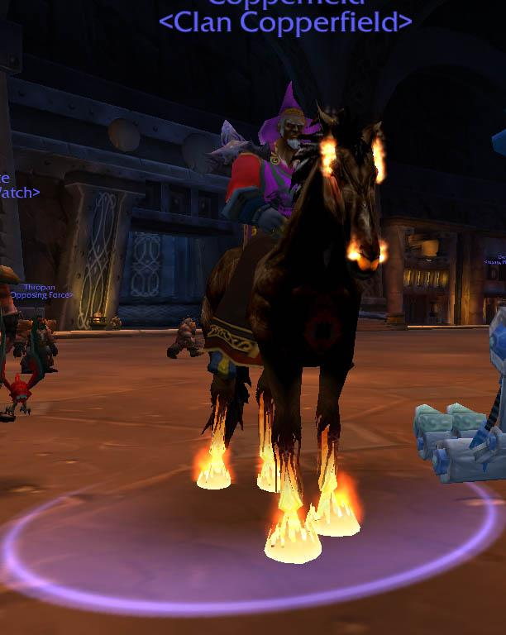

Figure 15. Copperfield.
Despite this ease of interaction, the development of my in-game relationships was anything but simple. When I began playing WoW (November 23, 2004), I had no conception of the game's potential in terms of inter-player interaction or the social grouping opportunities afforded within the game. As an early example: when I first entered the game and saw hundreds of other players (low level Night Elves in the Shadow Glen level 1 - 5 starting zone) bouncing around Teldressil, I initially did not register them as other players I was capable of interacting or teaming with. My first notion of the game's grouping potential occurred as I ran down the road leading from the Shadow Glen starting area to the Night Elf low level quest hub, Dolanar. As I approached Dolanar, two Gnomes ran past me. The Gnome Race is the smallest Alliance race and the Night Elves are the tallest. I questioned what I had just seen: two very small player-controlled units sprinting past me. This registered as an oddity because, at the time, I thought all Races were supposed to stick to their starting zones. The audacity of the Gnomes widened my noob eyes. I realized they worked together, apparently sight-seeing, visiting a friend, or perhaps questing the Night Elf starting zone. Whatever their reason, they were most definitely playing simultaneously, with a purpose.
The grouping process gradually clicked; I realized players were capable of teaming with any other player, were capable of forming networks of friends, allies, and guildmates. I understood the significance of the words scrolling through General Chat: I may not understand how these players typed or talked, but they were definitely chatting with each other. As this realization clicked, my understanding of the game's social potential expanded. I understood I could grow a social community within WoW just like my IRL social network. I just had to lean on the people I knew IRL, my real life friends. In this case, I needed the help of the person I played the most video games with at the time: Talius. He was my "in." While I had played the RTS StarCraft and WarCraft III with several individuals, I played these games with Talius the most. He was the one who, over the course of 2003 - 2004, convinced me to try the upcoming World of Warcraft. It would, he insisted, be just as fun as its RTS counterparts. I was hesitant. The $15 per month subscription fee confused me.
"What's it like?" I had asked, unclear on how a Massively Multiplayer Online game (MMO) worked.
"It's like you're a Hero from Warcraft III," he had said.
I followed Talius to Shattered Hand, a PvP Realm, a more dangerous leveling experience where members of the opposing factions (Horde and Alliance) could attack each other in the world. We both chose Alliance. I named my character Anthropos. Talius began as a Human Paladin in the beginner Human zone located on the other side of the world from Teldressil and Darnassus. He quickly outpaced me in leveling. By the time Talius took his first break from the game, he was in the mid-Level 40s while I was still plunking along in the mid-Level 20s. Talius may have been my "in" to the game, and he may have helped me to this point, but now I faced an important question: how was I to find others to play with? I realize, now, how important it was for Talius to leave the game. I could not rely on his virtual patronage anymore. As I leveled on my own, guildless, without any friends playing the game, I made an interesting transition: I advanced in level past Talius and started PuGing in-game dungeons. PuGs, or Pick-Up Groups, are composed of random players who don't know each other, but unite to complete an in-game challenge. I PuGed until I obtained the then-max level of 60, and then continued to PuG once I reached Level 60 in order to obtain better gear. The more I PuGed, the more I engaged in groups, the more I discovered myself inserted and included within the larger Alliance community.
I PuGed because I did not have an alternative, yet it was one of the best early decisions I made in the game. As I quickly discovered, it was a necessary step to encounter and develop virtual informants. After all, I did not have Talius to rely on; I needed to expand my network of contacts, allies, and friends. I adopted this role of explorer and researcher whole-heartedly, purposely developed my Anthropos personality, modeling it after the ethnographies I studied in my classes. I became a different person online, bolder, an ethnographer embedded in a foreign land, in-game. In this sense, I was not Josh anymore. I was Anthropos, someone else entirely: a combination of my real life sensibilities with my anthropological training and a Night Elf Restoration Druid. When I introduced myself, I mentioned that I was playing the game, conducting anthropological research, and motivated to obtain access to potential informants. I was the very definition of post-human, mediating aspects of both real and the virtual through technology, participating among millions and millions of other cyborgs. As my time in WoW increased, as I grouped, quested, and raided with many other players, the marvels I experienced became accepted realities. I grew comfortable among PuGs, I interacted with the people I met over-and-over, trying to leave a positive impression of myself. Furthermore, and most significantly, I stopped seeing other characters as empty pixels, as simply "player controlled units," and began viewing them as specific players. In other words, I transitioned my worldview from an individual hanging out among virtual expressions of other characters, seeing them as mere pixels, and moved into a worldview recognizing these avatars as actual players.
The use of Vent and Teamspeak facilitated this process. A seminal moment in this process for me occurred when a player I had met in a PuG, Wangbacca, invited me to run the half of the level 60 Stratholme dungeon colloquially known as SM2. Wang and his <Stoic> guildmates, Ambrey and Jaren were interested in my research project and were recruiting me to raid with their guild. I joined them on TeamSpeak, a VoiP system similar to Ventrilo. Hearing Wangbacca's, Ambrey's, and Jaren's voice (and learning to recognize their voices) granted personhood to these players, filling their avatars with their personalities. These avatars ceased to be empty shells; instead, they became people. Before this moment, it was easy to paint the denizens of these cyber-communities, these so-called cyborgs, as incorporeal voices filling a previously empty space. However, in listening to Wangbacca, Ambrey, and Jeren speak, I realized WoW and VoiP systems formed a link between myself and these other players. Very real (very tangible) machines allowed me access to not only cyberspace, but the players on the other end of the wires, so to speak. Computers and smart phones allowed individuals to "go online alone...with the intent of communicating with other people" (Watkins 2009: xix):

Among the teens and young adults that we talk to, time spent in front of a computer screen is rarely, if ever, considered time spent alone. Rather, the engagement with technology is viewed as an opportunity to connect with friends. Granted, connecting via a mobile phone or Facebook is a different way of bonding, but, as I argue in the following pages, these practices are expressions of intimacy and community.

In essence, these machines served as outlets. Tools. Links. Plugs. These devices were examples of the prostheses of which Cubitt (2000: 125) spoke. These tools, these machines, these plugs were devices, but they created extensions of our internal tools: our brains, the central hubs of our social and culture building capabilities. I was in continual connection to these social worlds not as a result of the mobile devices themselves, but because I used them to extend my own social and cultural consciousness online. My informants and I were cyborgs not because of the technologies we attached to our bodies or ported with us, we were cyborgs because we used these devices to marry the real with the virtual. We were cyborgs because we used these tools to transition our social selves into virtual situations.
Early into the process of relationship-building in WoW, as I spoke with individuals from <The Hammer Clan> and <Riders of the Apocalypse>, and as my contact list expanded, I realized the value of understanding these players not as pixels and often purposely misspelled names but as virtual expressions of real people. I could not just make some huge contact list and call it a night - I had to develop relationships with these people. This understanding compelled me to focus on developing relationships with other max level players, which in turn contributed to my still developing research goal. Being social with these players meant embracing their lifestyle. It meant raiding, it meant PvPing, it meant hanging out on Vent and hearing them speak, it meant recognizing their voices. In a nutshell, it meant coming to understand these players not as humans, but as post-humans. I wanted to maintain a gap between researcher and informant. As Turkle (2011: 230) stated, and as I came to discover, "when people create avatars, they are not themselves but express important truths about themselves." Virtual world actions, like the process of naming their avatar, shaped virtual identities and virtual personalities, offering mirrors to these "truths," the same process DeVita and Armstrong espoused. Names, handles, all embedded with clues, hinting at a player's manufactured identity (likes, dislikes, appearance, ethnicity, and so on). As I invested myself in playing WoW, the barrier I established between ethnographer and informant cracked. The more the relationship between myself and my informants developed, the longer I spoke and interacted with the informants, the more I understood the importance of seeing the virtual as that: as virtual.
Their names and identities were not their IRL names and identities, yet, to me and their virtual friends, they were just as "real" as their IRL names and identities. When I wanted to speak with an individual I knew through WoW, I may or may not know their real life name, but I knew their avatar's name, and I conceptualized that person as that avatar, as if their "real" name was their avatar's name and their WoW "identity" was their IRL identity. "Chromedome" was "Chromedome" or "Chrome." "Ahroo" was "Ahroo" or "Roo." "Zoombroom" was "Zoom" or "Angry." In the case of Angry, we met on the "Batman" message boards at www.dccomics.com in 1998. He referred to himself as "theangrybatman" and my handle at the time was "Junk Yard Dawg." For short, I, and other posters, called him "Angry" and they referred to me as "JYD" or, more likely, "Dawg." I have never met Angry IRL. Over the subsequent decade, we continued to play with each other through online games. We were friends, albeit ones interacting in virtual spaces. I knew his real life name, I knew his home address, I knew where he attended college. He knew my real life name, he knew my home address, he knew where I attended school. I "spoke" to him virtually through instant messaging and texting, and I spoke to him through Ventrilo. To this day, he refers to me as "Dawg," and I called him "Angry." Our entire identities in this on-line relationship were tied to the initial timeframe in which we first met and interacted on the "Batman" message boards. When I think of him and his avatars, they resembled not the image of a person, but rather a conglomeration of places and websites through which we have interacted. In essence, I did not see a "real" person or a "real" face when I thought of "Angry," I "saw" the many virtual forms he had taken over the past decade.
In the same way that I visualized "Angry" as his virtual selves, I met and developed relationships with a community of others. Of my informants listed at the conclusion of this chapter, including Angry, I know their real names, their avatars, their Facebook profiles, their place of residence, their contact information, and their pictures. A few I have met face-to-face, including Arathene, Blitzan, and Itsgeorge. Acquiring this information aids in conceptualizing these players as not just "friends," but "real life friends." This is a difficult distinction: after all, how can these players be "real life friends" when I have never met them "in real life"? How can I weight them the same as my real life friends? Answering this question meant exploring the boundaries of "friendship" developed in virtual setting. The belief, that friends were friends, whether or not one had met the player face-to-face, proved unsettling to those who listened to my dissertation's premise.
"How can these people be compared to anyone's real life friends?" I am frequently asked, the insinuation being that there was a difference between one's real life friends and the individuals met through the internet.
I present the viewpoints of my informants on this topic in Chapter 5. Friends formed through virtual places may "offer connection with uncertain claims to commitment," as Turkle (2011: 153) writes, but how is that any different from other friendships? Other relationships? Technology enables friendships, creating new outlets for like-minded people with similar interests to bond and build relationships. "The modes of life," Giddens (1990: 176-177) writes, "brought into being by modernity have swept us away from all traditional types of social order, in quite unprecedented fashion…On the extensional plane they have served to establish forms of social interconnection which span the globe; in intentional terms they come to alter some of the most intimate and personal features of our day-to-day existence.” If the use of new technologies can transform the meanings of once fixed concepts like "space" and "place" so easily, changing them into situational zones dependant on how we use our mobile devices (play, work, school, leisure), then concepts like "relationships" and "friendships" integral to social gaming are also malleable. To that end, if tools like the internet or WoW had never existed, I never would have met Ahroo, Angry, Arathene, or a host of others. My life and my research certainly would be all the poorer in this alternate history.

Ending WoW

After ending my subscription to WoW in November, 2011, I faced an immediate dilemma: how could I maintain contact with my informants without paying the required $15 per month subscription fee? Furthermore, would they still want to speak with me after I quit playing? The importance of maintaining contact with these individuals was paramount. As Rabinow (1977: 164) asserted,

...the ethnologist and his informants are collaborators in a work of interpretation, the informants proposing to the ethnologist, following an entirely special rhetoric of presentation, the `explanations' they invent as a function of their notion of their expectations and at the cost of a truly theoretical effort, one implying the assumption of an extraordinary stance induced by the interrogatory situation itself.

Maintaining a relationship with the informant, whether a strong or weak friendship, and therefore the situations through which the informant "elaborates for the anthropologist a representation of his own world," was critical to the process of social analysis (Rabinow 1977: 164-165). Despite their virtual nature (and even with the possibility of having a "continual connection," online social relationships remained precarious. They ran their course, people drifted apart, communicated less, engaged less and less, and so on. Disengaging from an online relationship or an online friendship took a mere click of a button. I experienced this transition first-hand. When I dialed back my participation in the game, I stopped paying for the most important tool necessary to maintain these pre-existing relationships; my lack of playtime severed my daily interaction.
The process of maintaining virtual friendships was especially challenging in a world where individuals were "increasingly connected to each other but oddly more alone: in intimacy, new solitudes" (Turkle 2011: 19). Users of virtual spaces, including players in multiplayer games, constructed relationships with machines and "robots" just as "relationships with people [were] ramping down" (Turkle 2011: 19). Transformations in relationships, possessing the intimacy multiplayer platforms promote, shifted the knowledge landscapes of these manufactured and created worlds. These virtual worlds within virtual worlds, populated by virtual expressions of real people, a reality easily forgotten in this age of anonymity-induced boldness. I may have never met these informants, acquaintances, and friends but I never viewed them as easily cast away or forgotten. I remembered (and still remembered) the times we spent together. Though I ward off nostalgic impulses, the intimacy and openness we experienced hold true. Our adventures linger as some of the most rousing social experiences of my life - to this end, it was imperative to address these periods of emotional intensification. The more I reflected on these relationships, the more I realized I wanted to maintain these connections, not only for research purposes, but also for my own social well-being.
My first inclination was regular use of Ventrilo, but I realized this tool did not guarantee social interaction. After all, people come and go in the game - my own journey away from WoW being "Exhibit A." I needed something permanent and popular to maintain contact with my informants. I solved this problem through the adoption of social media and, in particular, instant messaging. Facebook's reach, whether accessed through my tower, laptop, or mobile phone, offered a unique and instrumental means to remain in contact with my informants. By the time I joined Facebook in 2008, WoW was into its second expansion. When I quit WoW in 2011, nearly all of my informants were on Facebook in some capacity. This social networking worked as another prostheses, allowing players/posters a technological extension for communicating with current and former hardcore raider informants. I saw how seamlessly my informants used Facebook to interact with current and former raiders that I visualized a future where WoW (or other MMOs) borrowed from the "hangout" features of social networks like Facebook, Google +, and Instagram. I imagined these game companies incorporating "homepage" like features capable of browsing on personal computers, tablets, or mobile phones. In this coupling of gaming and social media, I saw a player's avatar sitting in a chair near a customizable representation of his/her virtual "hearth"/"living room." The players could post/display game images, videos, and other important notes within this game-sponsored environment for his/her in-game friends to peruse, comment, and react. Text-based and voice-based chatting privileges as well as stats, achievements, mini-games, and blogs allowed continual access to other players connected to this gaming network, accessible even while logged out of the game.
Back in the realm of real world applicability, Facebook also granted me a way to categorize my informants: while I was Facebook friends with many of the individuals I played with over the years - a gracious allowance on their part, allowing me access to their real life names and locations - I also joined a Facebook group entitled "WoW - Shattered Hand - Vanilla and BC." This group page assembled a list of 421 current and former Shattered Hand WoW players. My internal Battle.net "RealID" list served as an additional tool from which I drew the real life names of my contacts, and the ability to contact them through any Blizzard game utilizing their Battle.net system, which in turn fostered the deeper friendships and relationships I felt by the time I quit WoW in 2011. From these lists, I worked to maintain relationships with these informants. For the reader's benefit, I created a glossary of participants, some descriptions more detailed than the rest. These starred individuals are the ones I spent a great deal of time with, sharing various adventures, questing, raiding, PvPing, and the like.
Without further ado, I conclude this chapter with an alphabetical list of...

The Players

Acec: Acec, a Dwarf Protection Warrior, lives in Michigan. He is white in his early thirties. He played several MMOs before and during his time with WoW. I met Acec while raiding the original Naxxramas raid dungeon (Tier 3) launched toward the conclusion of Vanilla WoW, and continued raiding with him and his friend, Ahroo, throughout the subsequent expansions. Acec and Ahroo teamed as dual tanks for many of these encounters - this team, including Chromedome, remaining a successfully set of tanks for much of my raiding history. Acec stopped hardcore raiding during the Wrath of the Lich King expansion (2010), but occasionally plays casually. He has many alts, all named after sports players on Detroit teams.

Ahroo: Ahroo, a Dwarf Protection Paladin, lives in California. He is a Syrian-American in his early thirties. He played MMOs pre-WoW (Star Wars Galaxies), and sampled other MMOs and multiplayer gaming (Star Wars: The Old Republic, Diablo III) during lulls in interest with WoW. We met while raiding the original Naxxramas raid dungeon (Tier 3) launched toward the conclusion of Vanilla WoW. Ahroo is a quiet and effective raid leader with a wicked and often unexpected sense of humor. He formed a 10-man group during the Wrath of the Lich King expansion, one he works to maintain into the present. He greatly enjoys completing in-game achievements. Recent real life events curbed his efforts to play WoW as frequently as he had in the past, though his passion for the game remains true: he is a player with a subscription since Day 1.

Anthropos: Anthropos is a Night Elf Restoration Druid and is the character I play. I designed Anthropos as a healer, meaning he uses his nature-based powers to restore the lost health of his allies. I chose a healer specification because I felt it provided better access to grouping. While playing Anthropos, I played all current raid tiers, acquiring all complete sets of raid armor from Tier 1 - Tier 12. I also PvPed with my friends and informants through PvP Battlegrounds, Arenas, and Rated Battlegrounds. Of all my in-game experiences, I especially enjoyed playing as a part of Ahroo's PuG. Ahroo's PuG operated from 2009 - the present and featured a core group of dedicated raiders who trusted and respected each other.

Arathene: Arathene, a Gnome Shadow Priest, lives in Tennessee. We met while raiding the Blackwing Lair dungeon (Tier 2) during Vanilla WoW. Arathene is a sly wit with remarkable patience for some of the antics of his fellow raiders and PvPers. He is white and in his late twenties. He has participated in all aspects of the game since Day 1, playing both Horde and Alliance alts of all classes. He and his (virtual) friend Star formed and run the guild <Gnome Alone>, which participates in formal organized raiding and organized PvPing, and was one of the most advanced Alliance guilds on the server at the conclusion of the Cataclysm expansion. Arathene remains one of the most skilled PvE and PvP players I encountered in the game, a talent disguised by his quiet and unassuming nature.

Ben: Ben played various characters throughout WoW, most recently in the <Raiding Robots> guild. He often participated with Ahroo's 10 Person raid group, helping throughout Icecrown Citadel (Tier 10) depending on the raid's current need, whether tanking, healing, or DPSing. He played a number of characters outside of raiding, typically running the same raid multiple times a week on all his alts, working to acquire the best gear in the game. Since quitting WoW, he enjoys athletics and running long distance IRL, and his Facebook updates often depict races he has run, or the times he accomplished.

Brishal: Brishal, a Human Mage, is friends with a group of people I PvPed with extensively during Vanilla WoW, including Fetchelay and Shade. We interacted through Battlegrounds and raiding. His other friends were individuals I interacted with during my early WoW days, especially Snamuh and Sorchah. He remains a Facebook contact.

Chromedome: Chromedome, a Gnome Protection Warrior, lives in Florida. He has interests in other gaming genres outside MMOs, including the FPS Planetside and the RTS Defense of the Ancients (DotA). We met while raiding the Karazhan/Serpantshrine Caverns/Tempest Keep tier dungeons (Tier 5) from The Burning Crusade expansion. He is a Cuban-American in his late twenties, with a quirky laugh, able to bring a smile with ease. He is also competitive and focused, able to sit through the hundreds of wipes often necessary to defeat a particularly challenging raid encounter. He enjoys 25-man raiding and especially likes Rated PvPing, including Arenas and Rated Battlegrounds, where players acquiring a ranking dependent on their win/loss ratio.

Cuukey and Leslie: Cuukey (Human Fury Warrior) and Leslie (Night Elf Balance Druid) are a married couple living in Kansas. They are white, in their late twenties. They led the successful guild <Riders of the Apocalypse> (or <ROTA>) during Vanilla WoW and into the Wrath of the Lich King expansion, achieving rank among the top Alliance guilds on the server. <ROTA> died as a guild during the end of Wrath. While I was aware of Cuukey and Leslie during the Vanilla WoW years, I did not begin interacting with them until Cataclysm. Cuukey tanked for Ahroo's 10-man Raid during the Blackwing Descent/Bastion of Twilight/Throne of the Four Winds raid tier (Tier 11) and continued to tank/DPS situationally (using either his or Leslie's characters) for the remainder of the expansion. Cuukey brought <ROTA> back at the end of Cataclysm and continues to raid under that guild tag.

Cygany: Cygany, a Night Elf Assassination Rogue, lives in Arizona. He is white, in his late forties, married with children. We met while raiding the Black Temple/Hyjal tier (Tier 6) from The Burning Crusade expansion. Cygany invested a great deal of time with WoW, advancing multiple characters to max level. He raided on and off with Ahroo's PuG, on both his Rogue and his Mage. Eventually, his interest in the game waned, and he left toward the conclusion of the Wrath of the Lich King expansion, focusing on other real life activities and playing other multiplayer games, including Star Wars: The Old Republic, The Secret World, and Rift.

Donnar and Blitzan: Donnar (Draenei Holy Paladin) and Blitzan (Human Unholy Death Knight) are brothers living in New York. They are white, in their early thirties, and refer to each other (and their friends) as "bear." We met while raiding the Ulduar dungeon (Tier 8) from The Wrath of the Lich King expansion. They joined and became core members of Ahroo's PuG, participating in that raid until the Cataclysm expansion launched. While they had a great deal of experience and skill in terms of PvE raiding over the years playing WoW, they excelled at PvP arenas, teaming up to reach high rankings and obtain difficult-to-achieve armor and weapons. Their interest in WoW declined over the course of the Wrath expansion - particularly through the year-long "Ice Crown Citadel" tier (Tier 10), and they quit playing soon afterward, but they still participate in various MMOs (Guild Wars 2), fantasy sports, and social media.

Dookie: Dookie (various characters) is Chromedome's IRL friend. He is Cuban- American in his early thirties and lives in Florida. We met during Vanilla WoW: he raided with <War Ensemble>, a rival guild to <Indomitable>. Dookie's playtime varies. When active, he plays several different characters, both Horde and Alliance. He has a gregarious personality, and enjoys socializing on vent.

G: G (Dwarf Priest) lives in Quebec. He is French-Canadian in his late twenties. We met early during The Burning Crusade expansion while raiding with <Royalty> through the Karazhan/Gruul's Lair/Magtheridan's Lair raiding tier (Tier 4). G alternates between healing (Holy Priest) and DPSing (Shadow Priest), and also plays a mage. His playtime depended on school and work, and often he took extended breaks from the game, playing StarCraft II instead. G ended formal raiding during Wrath of the Lich King, instead playing casually and occasionally raiding with Ahroo's PuG.

H: H (Human Paladin) lives in Quebec. He is French-Canadian in his late twenties. We met during The Burning Crusade expansion while raiding with <Royalty> through the Karazhan/Gruul's Lair/Magtheridan's Lair raiding tier (Tier 4). Like G, his playtime varied, often with extended leaves from the game. He enjoys healing in both PvE raids and PvP arenas. His skill as an arena healer led to his acquiring high ratings. He continues to raid off-and-on with <Gnome Alone> and Ahroo's PuG.

Itsgeorge: Itsgeorge (Gnome Warlock) or "George" lives in Tennessee. He is white, in his early thirties, and is a doctor at an university hospital. We met through our mutual friend Arathene, and began PvPing and raiding together during The Burning Crusade expansion. After transferring to Shattered Hand, George and Arathene formed a powerful and highly rated 2v2 Arena team (shadow priest / warlock), eventually using my restoration druid for 3v3 Arena. George and his wife had a daughter halfway through the Cataclysm expansion. He currently focuses on his family and his medical responsibilities.

Jayson: Jayson played various characters throughout his time with WoW. We met through his participation in <Royalty>'s raiding in The Burning Crusade expansion. He server transferred all of his Shattered Hand characters late in the Wrath of the Lich King expansion in order to play with more advanced guilds, but we maintain contact through Facebook.

Jeffrey: Jeffrey (Gnome Fire Mage) lives in California. He is white, in his early thirties, and works as a lawyer in a law practice. We met at the conclusion of Vanilla WoW when I joined the <Indomitable> guild during the Ahn'Qiraj 40 raiding tier (Tier 2.5). Jeffrey was an officer in <Indomitable>, running the guild bank among other responsibilities. He played briefly in The Burning Crusade and raided more extensively during the Wrath and Cataclysm expansions with Ahroo's PuG. Though out of the game since Cataclysm's conclusion, he remained one of the most talented PvE DPSers I encountered in WoW with the ability to put out very high levels of damage in boss fights.

Kindinos: Kindinos (Night Elf Hunter) is of Greek ancestry, and in his late twenties. We met late into the The Burning Crusade expansion and raided with each other through the Mount Hyjal/Black Temple raid tier (Tier 6). He eventually server transferred, electing to play with friends elsewhere, but we maintain contact through Facebook.

llammh and Mildog: llammh (Night Elf Hunter) and Mildog (Worgen Hunter) raided with Ahroo's PuG as a Hunter committee, alternating themselves in and out depending on the boss fight and the items the boss dropped. The two were friends through WoW and raided extensively with Ahroo's PuG through the Cataclysm expansion's Blackwing Descent/Bastion of Twilight/Throne of the Four Winds raid tier (Tier 11). llammh (family, job, travel) and Mildog (military) had real world responsibilities interfering with their WoW play; as a result, they juggled multiple worlds in a very real sense.

M: M (Night Elf Druid and Draenei Shaman) lives in Ohio. He is of Ukrainian descent, in his early thirties, with a PhD and a position in academia. We met at the conclusion of Vanilla WoW when I joined the <Indomitable> guild during the Ahn'Qiraj 40 raiding tier (Tier 2.5). M was the Guild Master of <Indomitable> and built his reputation as an officer and healer in <Skyfang>, one of the three early Shattered Hand raiding guild super powers (alongside <Drama> and <Death and Taxes>). M served in multiple roles in <Indomitable> and, after <Indomitable> split apart, as GM of <Royalty>. He played briefly in Wrath of the Lich King with Ahroo's PuG before quitting for good.

Rumps: Rumps, a Gnome Warrior, lives in Vancouver, Canada. He is Canadian and Chinese, in his late twenties. We met while raiding the Karazhan/Serpantshrine Caverns/Tempest Keep tier dungeons (Tier 5) from The Burning Crusade expansion, but I had encountered him frequently during Vanilla WoW, where he raided with <RotA>. He played with <Royalty> during The Burning Crusade and joined Ahroo's PuG during Wrath of the Lich King. Rumps enjoys PvE raiding and PvP (arenas and battlegrounds). The time spent playing WoW fluctuates, influenced by his commitments to his family, trips to Hong Kong, studying for exams, and working. He is passionate about achievements, in-game accomplishments, and completing every aspect of the game.

Skipovo: Skipovo, a Gnome Mage, was one of Talius' friends and lives in Tennessee. He is white in his thirties. We met during Vanilla WoW as he was leveling. He raided with <Delta Flux> during Vanilla WoW and <Royalty> during The Burning Crusade. His family and job commitments remained his top priority, requiring him to play WoW and raid the endgame bosses in spurts.

Star: Star, a Gnome Rogue, formally named Princess, lives in Connecticut. He is white, in his early thirties. We met while raiding the AQ40 tier dungeon (Tier 2.5) during Vanilla WoW, and continued raiding together through every subsequent expansion. Star focuses on many aspects of WoW, investing in activities directly contributing to power increases in his character's armory (armor and weapons). Currently, Star raids with Ahroo's PuG, but his collection of tiered armor and weapons include representations from every tiered set, including the rare and discontinued Tier 3 set. Star and Arathene currently oversee the guild <Gnome Alone.>

Talius: Talius, originally a Human Paladin before server transferring and changing factions to a Blood Elf, lives in Tennessee. We met while playing daily games of basketball outside the Melrose and Hess dorms at The University of Tennessee, near Hodges library. Talius has had an on/off relationship with WoW over the years, mostly playing casually with friends and officemates. He introduced me to the game and patiently explained the nature of the game. He ran my low level character from Teldressil to Ironforge (before the Dwarven capital had an easy means for new players to reach it). He also convinced his brother, Arathene, to server transfer to Shattered Hand. The original character of "Talius" no longer exists, replaced by a Horde character on another server. He does not currently play WoW.

Telcontarx: Telcontarx, currently an Orc Hunter, lives in Canada. He is GM of two of the top ranked Alliance guilds on Shattered Hand: <Skill Overload> (during The Burning Crusade) and <Raiding Robots> (Wrath of the Lich King and Cataclysm). We met through our mutual friend Chromedome and raided together during from Tier 7 through Tier 10 of the Wrath of the Lich King expansion after <Royalty> imploded. His leadership and reputation enabled <SO> and <RR> to compete with/lead the best Horde (<Relentless> and <Downtime>) and Alliance guilds (<Pare Bellum>, <Royalty>, and <Clockwerk>) through two expansions in terms of server firsts and raid progression.

Titoness: Titoness, a Human Warlock, lives in Michigan. He is white, of Italian descent, in his late twenties. We met early in The Burning Crusade expansion and raided together off and on through Wrath of the Lich King and Cataclysm. Tito is a talented player known for his continual ribbing of other players. He enjoys dabbling in many aspects of the game and bounces between various alts and classes depending on his mood.

Toastedbread: Toasty is the very definition of an "altoholic," playing every class in the game. Before he quit WoW and took up Diablo III, he mostly played a Draenei Elemental Shaman. Toasty lives in California. He is white, in his late twenties. We met late in the Wrath of the Lich King expansion and began raiding together in the Blackwing Descent/Bastion of Twilight/Throne of the Four Winds raiding tier of the Cataclysm expansion (Tier 11) with Ahroo's PuG. Toasty is extremely competitive; at least one of his characters, if not more, participated in a cutting edge guild, defeating the hardest Heroic content available. He currently plays Diablo III and posts on Facebook.

Tockaray: Tockaray, a Human Paladin, is white and in his twenties. While we never raided together, I remembered this raider's posts in the general chat of various WoW instances. He participated with <WarEnsemble>'s raids, raiding throughout high school and eventually quit the game after four years of playing WoW.

Vvetter: Vvetter, a Night Elf Feral/Restoration Druid, lives in Massachusetts. He is white, in his twenties. We met while raiding the Karazhan/Serpantshrine Caverns/Tempest Keep tier dungeons (Tier 5) from The Burning Crusade expansion. The amount of time he devotes to WoW has varied over the years, depending on real life events, including his relationship status (single vs. dating), college (exams vs. no exams), and job status (job vs. no job). Whether playing casually or hardcore, he embraces the social side of the game, always checking in with his friends and guildmates, and regularly posting on Facebook.

Wangbacca: Wangbacca (previously a Human Rogue before transferring to a Horde server) lives in Montreal. He is Canadian, in his early thirties, and works for a game developer. I met Wangbacca during one of my early PuG runs healing Upper Blackrock Spire (UBRS) at level 60. He and his friend Ambrey from <Stoic> "adopted" me, drawing me into the formal atmosphere of an upper level raiding guild. As a result, I assisted <Stoic> on their first kills of Onyxia and Ragnaros in the Onyxia/Molten Core Vanilla WoW raiding tier (Tier 1), and continued to play with Wang and <Stoic> through Tier 2 (Blackwing Lair) and Tier 2.5 (Ahn'Qiraj). Wangbacca and many former members of <Stoic>, including his friends Ambrey and Jeren, transferred to another server after <Stoic>'s GM left the server.

Xoot: previously known as "Cemetery" (Human Frost Mage), Xoot (Gnome Frost Mage) lives in Michigan. He is white, in his early thirties, and works in IT. Xoot was one of the first players I met and conversed with during my raid experience with the guild <Stoic> in "The Molten Core"/"Onyxia" raiding tier (Tier 1). I raided with Xoot in some form through every tier of WoW's expansions. He was a loyal guild member, moving through guilds only after a group imploded. Xoot was an avid PvPer, and a good friend of Chromedome. Of his external WoW interests, DotA easily remains highest on that list.

Zoey: Zoey, a Human Holy Paladin, lives in Quebec. She is French-Canadian, in her early thirties. We met while raiding the Blackwing Descent/Bastion of Twilight/Throne of the Four Winds raiding tier of the Cataclysm expansion (Tier 11) with Ahroo's PuG. Zoey was an exceptional PvE healer, and a player with a variety of interests in WoW, including PvP, development of trade skills, and especially the social aspects of the game. Zoey was a competitive player, choosing to play on multiple servers, both Horde and Alliance, in search of positioning herself with the best hardcore raiding guilds in the game. Like Donnar, she teamed really well with my Druid, allowing the raiding group a great deal of success.

Zoombroom: Zoombroom, a Draenei Retribution Paladin, lives in Indiana. He is white, in his early thirties. We met pre-WoW in 1998, while participating in the DC Comics Batman Message Boards as "theangrybatman" and "Junk Yard Dawg." Due to this shared history, I affectionately refer to Zoombroom as Angry, often using these names interchangeably. Like Arathene, Angry has played all manner of characters, classes, and roles. He is an "altoholic," meaning he finds a great deal of pleasure playing his alts (Angushide, Pumpkinbread, Taterbread) as well as his advancing his main character. He raids with <Gnome Alone>.

In a game built upon iterations and iterations, these informants represented a variety of hardcore players, many present through every variation and patch the game offered. The sheer number of in-game years of playtime reflected in this list is remarkable, including several documented "Day 1" players, and others who joined throughout the course of the game's lifecycle. Longitudinally, these players witnessed the many social and demographic transitions of this virtual world, this Shattered Hand (PvP) server. Subsequent chapters reflect their interest in the game itself, and discuss the rise/fall of countless guilds and in-game social organizations. These players formed legacies and legacy guilds, some running the most powerful guilds on the server, remaining figures through which hardcore players traced their own legitimacy (see Figure 16 and Figure 17). Just as Watkins and Turkle chose to highlight the voices of their informants, I present the voices of my hardcore informants. I chronicle their lifestyle choices and the effects these developments had on their own lives, playstyles, and relationships. Their acceptance of my inclusion in their virtual lives - or in the case of Arathene, our real lives - influenced the lengthy pathway of this fieldwork. I hope the voices represented within these pages serve as accurate portrayals of their own personal journeys and adventures. On a final note, this list will prove handy to keep everyone's name straight. I recommend bookmarking this page.
Onward.

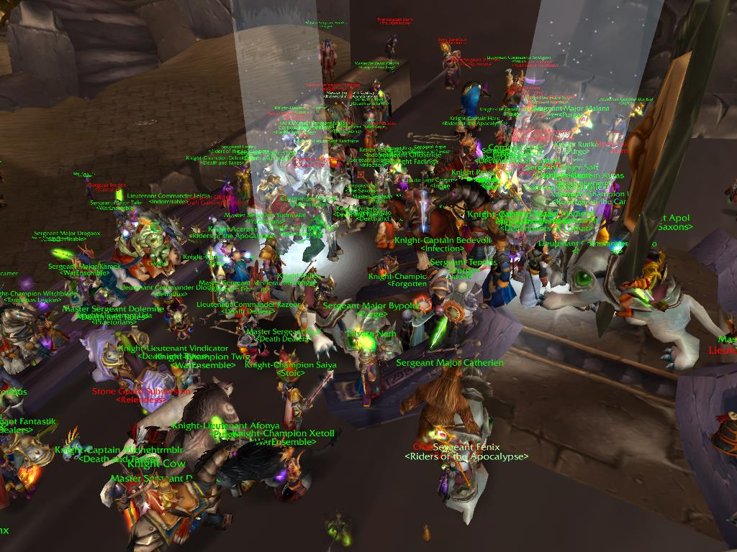

Figure 16. The Opening of the Ahn'Qiraj Gates event begins.
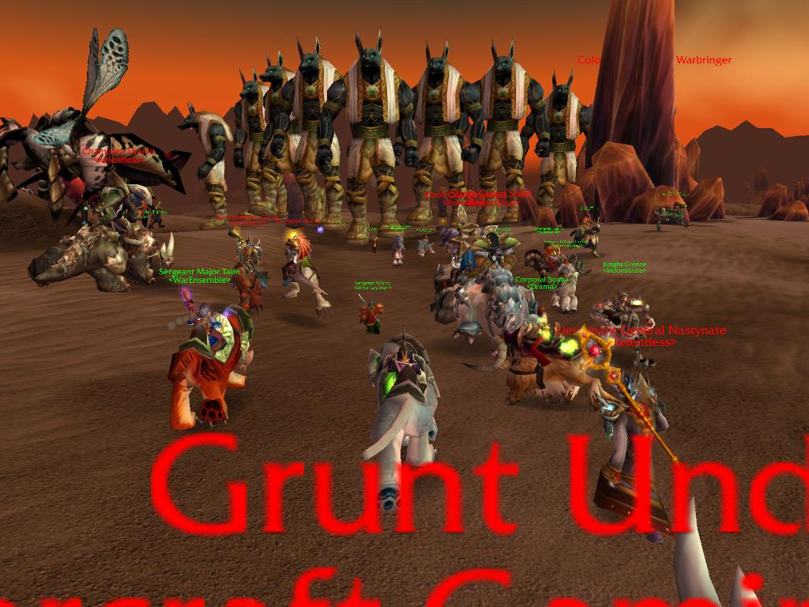
Figure 17. The Qiraji army invades the Silithus zone.

CHAPTER IV

IT'S A HARDCORE LIFE

Pro Time

“I kill you now,” screamed Heroic-mode Lord Rhyolith, a monstrous NPC Raid Boss composed of pure molten rock.
It was Fall 2011. While playing as Anthropos, I attended Ahroo's PuG raid group within The Firelands (Tier 12 raid content), the "elemental plane of fire" (see Figures 18 - 21). The raiders had worked on defeating Rhyolith all night. Several hours had passed, and after multiple attempts the raid was achingly close to defeating him. The DPS ("damage per second"), the raid's damage dealing members, had just completed Phase 1 of the fight, triggering the more intense Phase 2. Phase 1's mechanic was tricky: when the fight started, only Rhyolith's legs were vulnerable. While players attacked Rhyolith's legs, the giant stomped around his platform, moving toward the moat of lava surrounding it. Players "influenced" the direction he took by coordinating the amount of damage directed onto a particular leg. If more damage was done to his right leg, Rhyolith veered left (and vice versa). The goal was to carefully "walk" him in a specific path, preventing him from stepping into the lava (at which point, Rhyolith would cast fatal amounts of damage on the raid) and to inhibit Rhyolith's interaction with streams of lava slimes crawling from the lava and seeking to repair his legs. To complicate matters, Rhyolith regularly summoned forces to defend him: active volcanoes on the platform to pelt players with magma and crowds of various creatures of rock and lava to blow up players if they were not killed quickly enough.
The encounter required a great degree of mobility and coordination from every player. While the melee DPS "walked" Rhyolith around the platform, guiding him to trample the active volcanoes, the ranged DPS killed the additional summoned monsters ("adds"). The tanks controlled the adds, and the healers kept everyone alive through the barrages of constant AOE ("area of effect") damage from the active volcanoes and bursts from Rhyolith himself. At 25% of his total life, Phase 1 ended and Rhyolith unleashed Phase 2 of the fight. He erupted into a being of pure lava. Lasers gyrated from his torso, dancing randomly around his legs, creating damage players must avoid. He emitted the first of his many timed - and devastating - raid-wide AOE spells requiring the healers and tanks to coordinate use of raid-wide damage mitigating spells. Unfortunately, on this particular boss attempt, Rhyolith's AOE blast erupted, but the raid group’s mitigation timing was off. The players incorrectly used their raid-wide damage reduction cooldowns. Zoey and Anthropos could not restore everyone's health. One by one, the DPS players died, then Zoey and Anthropos died. Only Star the Gnome Rogue and Ahroo the Dwarf Paladin tank remained alive. The boss was at 5%. Our Ventrilo channel grew eerily silent.
Was defeating the boss possible with only two members of the raid still alive?
The answer to this question is "yes," but required explanation. Following a group of elite raiders through raid encounters presented scenarios both mentally challenging
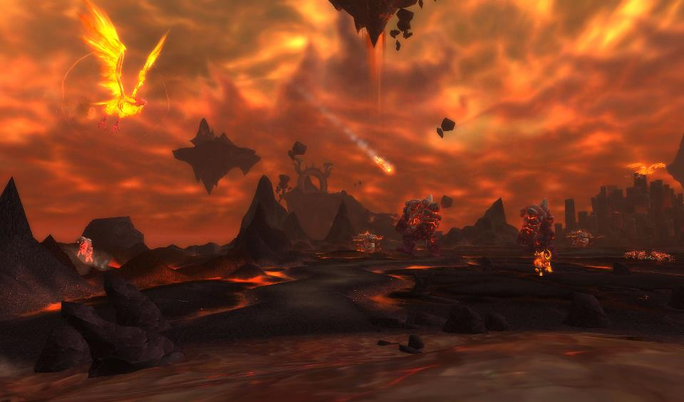
Figure 18. The Firelands raid zone (Tier 12).
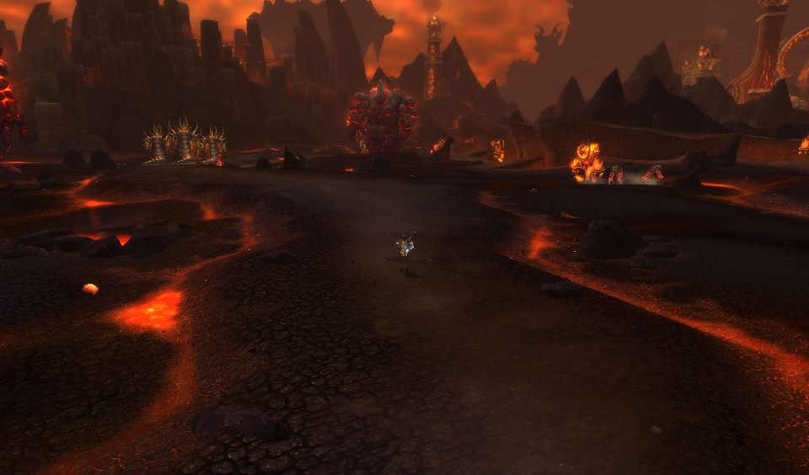
Figure 19. Zoombroom braves the Firelands.

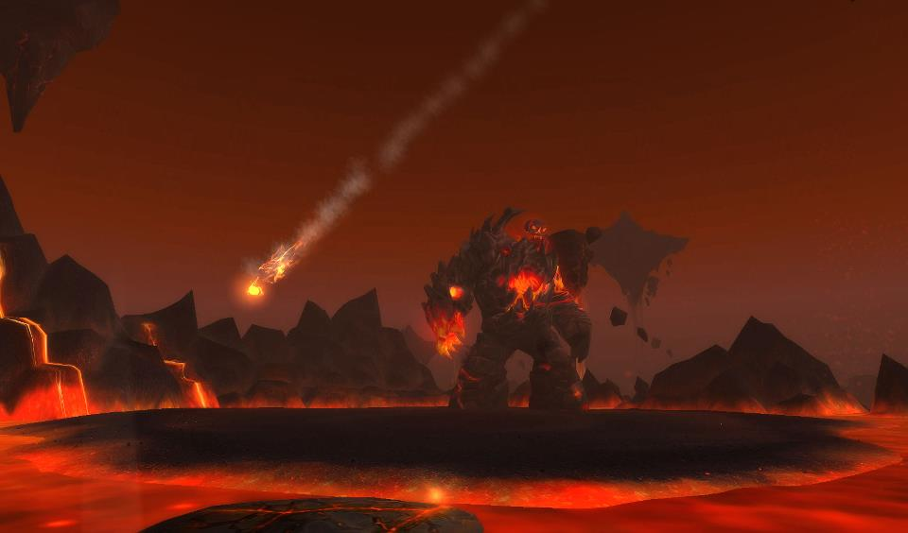
Figure 20. Lord Rhyolith (from a safe distance).
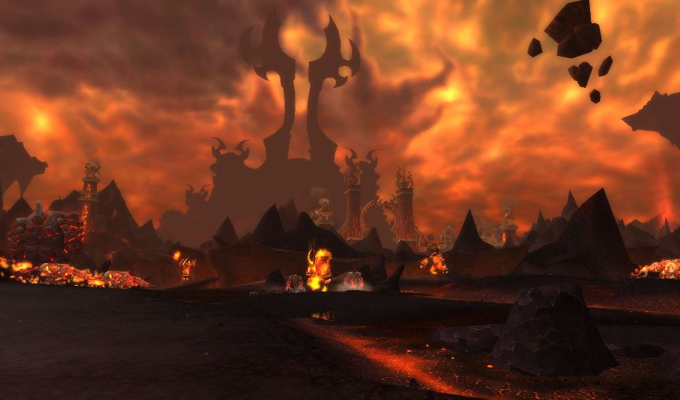
Figure 21. Ragnaros' citadel lurks in the distance.
and intellectually stimulating. In a PvE raid encounter, when a raid group fought a larger-than-life Raid Boss (who oftentimes literally filled the entire monitor, like Ragnaros or Brutallus), the on-screen action consumed the player's full attention. For me, healing a WoW boss encounter offered a unique perspective on the fight. Where the DPS and tank classes fought "up close and personal" with the bosses, and ranged DPS focused on maximizing their damage output, healers maneuvered around the entire plane of the fight, staying in healing range of multiple individuals or groups of individuals. Healing granted an excellent perspective on all stages of a fight, from areas affected by spells designed to harm the player, to additional summoned mobs requiring the raid’s concentration and coordination, to AOE spells threatening player lives, to devastating hits nearly one-shotting the tank. I worked around the area, reacting to various stimuli, sometimes using a heal rotation, sometimes "spamming" various instant cast spells keeping tanks and other places alive, sometimes blowing raid cooldown spells and abilities to prevent a wipe. In some cases, I reacted with plenty of time to choose the appropriate response; in others, the ability to logically “think” clicked off, with pure instinct replacing conscious thought. Failing the other raid members, whether nine or twenty-four, was not the ideal. Only practice, only reaction, lent the skills necessary to keep a raid group alive through the toughest of situations. Intensification of emotional experiences (characterized by cheering on Vent when boss encounters were defeated for the first time) within the raid community, whether real or virtual, or some combination of the two, resulted from these in-game conflicts.
Creating a social raiding end-game for MMOs offered players (especially hardcore players) “the best available vehicle for their fantasies of empowerment, while also offering “an intense release from real-world tensions” and the “humdrums” of life (Crang 1999: 15; Jenkins 2002: 391). WoW's "endgame," the in-game challenges for max level players of raiding and Rated PvPing, promoted multi-player grouping, created persistent activities (thus avoiding the “Game Over” screen of a single player game), and created a social-gaming context allowing players to form and maintain intense and intimate bonds of reciprocity and friendship. Incorporating a social element to the game's endgame—a “participatory platform” allowing players to create and drive their own world, as well as make their choices in social interaction--extended the lifespan of a game, facilitated player communication, and aided in the maintenance of online and offline relationships (Watkins 2009: 115). This decision indicated the developers understood the "preferences" of its subscribers in terms of the type of content they wished to consume (Schilling 2005: 89 - 90). It also allowed players to “create their own stories,” something epic akin to my Heroic Firelands tale, a capability standing in “stark contrast” to older media tools like television that “do” the telling (Watkins 2009: 115). Chat channels, locations for players to congregate and interact (or simply to go AFK), even formal arenas for players to duel or role-play fostered healthy in-game social and cultural interaction and maintained the population of a server’s community. I quickly identified the value of these social platforms, not just in terms of fostering community growth, but also in utilizing them to bolster my own research. In short, if I wanted to understand virtual community maintenance among hardcore raiders using social media to organize and play, I had to raid using these same social tools, and I had to raid at a level hardcore players would respect. In other words, through participant-observation I had to develop cultural and linguistic fluency.
Back in The Firelands, eight of the ten raid members facing Lord Rhyolith were dead, including yours truly. Only Ahroo and Star lived.
“I got this,” Ahroo exclaimed on Vent, oozing confidence. “It’s Pro Time.”
As the dead members of the group watched (my own heart beating a million miles an hour), Ahroo used his remaining defensive cooldown abilities, allowing him to stay alive long enough for Star to finish off the boss. It really was "Pro Time," a moment when talented players drew on years of raiding, years of practice and gaming, snatching victory from the jaws of near defeat. As Rhyolith expired, Vent erupted in cheers and congratulations. These raiders were individuals who had never met in real life, but interacted with each other on the other side of a computer screen in various parts of the country (and beyond the United States). Yet, somehow, they had developed a relationship enabling them to focus, to cooperate, and to ultimately defeat a challenging boss. Despite their mistakes, despite their wipes, they persevered.
How, I wondered, was this intimacy and collective action possible?

So...What Does "Fun" Even Mean?

Participation in the Lord Rhyolith boss fight unabashedly thrilled this ethnographer. I could fill these pages with details of the many boss encounters I experienced (for example, the Brutallus fight from the Prologue), including the many other close calls and triumphs I witnessed, yet my purpose in this dissertation is to push deeper into the relevant social issues expressed through hardcore multiplayer gaming. The need to ground my digital ethnography with elements found in more traditional forms of anthropological inquiry and less in the realm of storytelling remained paramount throughout my fieldwork. Boellstorff (2008: 248) left his readers with a "sense of wonder at the emergence of our New Worlds, a sense of wonder at how they draw upon our oldest traditions while presenting new possibilities." Though he conducted research in a new cultural realm that carried potential stigmas (Second Life), he continually left his readers with a sense of grandeur. I desired this same effect, and more. I looked forward to a time when readers identified my informants and this research world not be perceive as strange and unique to behold, something "other." My role as anthropologist involves not only translating the encounter into a language non-gamers would understand, but also a sort of "cultural datamining," whereby I extract nuggets of analysis pertinent to the discipline itself. In a larger sense, my participant observation within WoW conceptualized hardcore raiding as a cultural process crucial to virtual community growth and maintenance. More specifically, it helped me understand the players who enjoyed this PvE aspect of WoW, and the relationships they created in the process of carrying out these coordinated activities and common goals. These raiders - my informants (see Chapter 3) - represented the "cultural group" placed on the stage.
In order to comprehend and complete a proper analysis of their unique cultural norms and actions, I, the digital anthropologist, had to embed myself within their primary activity of choice: hardcore raiding. As Rabinow (1977: 46) noted in his own reflections, the "parameters seemed clear enough." I, like Rabinow (1977: 46), knew what was required of me; I had "to be willing to enter any situation as a smiling observer and carefully note down the specifics of the event under consideration...one simply endured whatever inconveniences and annoyances came along." I took notes and screenshots, but I knew that was not sufficient. It fell on my shoulders to learn the language of raiding, including their primary modes of communication and relationship-building, and "fit in" to such an extent that it was not a stretch to include me in their activities. For instance, as <Stoic>, my initial raiding guild, explored The Molten Core (Tier 1), as raid leader Jeren and guild master Earl barked orders over Vent for thirty-eight other players ("There's a Core Hound coming, all DPS focus the Hound"), I needed to speak their language and fit into their world. I needed to understand what "DPS " meant, how to pivot and "focus-fire" a mob like a Core Hound, and even memorize the abilities of the creatures ("trash mobs" and "bosses"). In an academic sense, the focus of this participation lay with observing the methods through which hardcore groups communicated, prepared for raiding, socialized, and conducted their raids. From a gamer's perspective, I couldn't be a "noob." I couldn't consistently "stand in the fire" (make stupid mistakes). I had to pull my own weight or they would never invite me back to accompany their raids. No one wanted to raid with a "baddie."
My research focus, and decision to study the world of hardcore raiding, was not chosen without some internal debate. Even after Wangbacca and <Stoic> included me in their raids (2005 - 2006), and after I graduated to other raiding groups (2006 and onward), I often wondered if an anthropologist should bother focusing a period on such a niche percentage of the overall gaming population. After all, through Vanilla WoW and The Burning Crusade, WoW's developers estimated their hardcore raiding player population in the 1% range. This 1% were their estimated figures for the amount of players who defeated the final and most difficult Raid Boss of each game iteration (Kel'thuzad of Naxxramas in Vanilla WoW and Kil'jaeden of the Sunwell Plateau in The Burning Crusade). In fact, because such a low percentage of raiders defeated the ultimate bosses of Vanilla WoW and TBC, the game's developers worked to make raiding more accessible starting with the release of Tier 7 in Wrath of the Lich King (2008) and the eventual creation of multiple modes of raid difficulty.
Despite my waffling, I justified this research focus in the following ways:
- The network of players I initially interacted with during Vanilla WoW (2004 - 2006) engaged in a hardcore lifestyle. They just happened to be the individuals I met frequently online (Wangbacca, Jeren, Ambrey) and with whom I ultimately enjoyed lasting relationships. I recognized now the sort of "vicious cycle" I entered. Initially, I wanted to meet as many potential informants of all player types as possible. To carry out this goal, my playtime continually increased, leading to many powerful character improvements on my part. This improvement led to an expanded contact network seeking my assistance in raids, which lead to increased playtime and character improvements, which lead to more requests to accompany groups in raiding, which... And so on. My intentional choice to play a healer class created more access to these groups. My healing ability, combined with my ever-more-powerful gear, attracted these groups of hardcore raiders. As it turned out, thanks to Wangbacca and <Stoic>, my first social and informant network "happened" to be hardcores, all of whom "happened" to be the types of players that stuck with the game over the course of many years, even still playing as WoW approaches its 10th Anniversary in 2014. I may not have intended to only study hardcore players in 2004/2005, but these were my connections. Thus, by the late 00's, I "discovered" I performed participant observation among a cultural group of video game players who had not received academic-minded attention to this point.
- The never-ending culture wars fought in-game through Trade Chat, and through the WoW message boards, between the hardcore and more casual playerbase piqued my attention. In these flamewars and through in-game conversations within Trade Chat (broadcast through all the major cities), anonymous trolls typically characterized hardcore players as having "no life," or "living in their mother's basement," or "overweight, zit faced, losers" with "no friends," and so on. Trolls also painted casual players as "baddies" or "noobs." It confirmed the stereotypical descriptions Taylor (2006: 70) documented in EverQuest. As these stereotypes were not remotely accurate to the hardcore and casual individuals I interacted with in my guilds or on Vent, I felt providing hardcore informants with a voice - an opportunity to break free of the labels - was a necessary and interesting line of inquiry.
- Taylor's Chapter 3 of "Play Between Worlds" ("Beyond Fun: Instrumental Play and Power Gamers") accentuated my research focus. In Chapter 3, Taylor offered a brief look into the culture of hardcore gamers in EverQuest, players she identified as "power gamers." In crafting her research for this chapter, Taylor interviewed a handful of the power gamers she met through her casual playstyle: Mitch, Josh, Bob, and Chris (and others). Through these and other interviews, and influenced by her own playstyle choices, Taylor (2006: 71-72) discussed these power gamers, including how their goal-oriented focus felt very different from the manner in which she played EverQuest, how their notions of “fun” (arising from completing various day-to-week-or-longer grinds) challenged a typical definition of the term, and how their appearance of being "too focused, too intent, too goal-oriented" contested the "spirit" of the game. I read Taylor in 2010, after several years of following the hardcore gaming lifestyle. Taylor was a major influence on my own research, particularly in her admission that Mitch and Josh appeared to be speaking a foreign language to her. As she observed them discuss in-game statistics and strategies, she conceded it was as if they played a different game than she did, a different version of EverQuest (2006: 68). After reading that passage, I felt the hardcore gaming communities in WoW required an additional "voice" who had engaged in participant-observation at their hardcore level, one who could speak their language and represent their game.
- Taylor's Chapter 3 asked serious questions about the lifestyles and gaming choices of power gamers. In between presenting what I regard as accurate and interesting tidbits about the power gaming lifestyle (they network, they work efficiently in groups, they min/max, they seek status), she asked a broader question: what constituted "fun" in a game that often required arduous labor to be successful? Taylor challenged the very definitions of "fun" and "leisure" through this chapter, suggesting that the activities power gamers participated in functioned more like "work" than "fun." How, she (2006: 88) wondered, could their type of play (grounded in efficiency and focus) be considered "fun" when it so clearly toed the line of "labor" (repetitive, boring, grinding)? I was not completely satisfied with Taylor's discussion in this chapter, nor her linking of an examination of what "fun" entailed to their gameplay choices. My issue lay not with the discussion itself - in fact, I found the idea of pleasure located on a spectrum between a "dichotomization" of "labor" and "fun" to be fascinating and well thought out (Taylor 2006: 88). I also appreciated how she presented power gamers as an "unique" gamer type whose in-game activities could "refigure popular notions about the distinction between work and fun" (Taylor 2006: 91). My main problem arose from the possibilities of "othering" within this discussion. I do not believe Taylor intended to suggest a lack of "fun" existed within their gameplay choices, nor did she mean to characterize power gamers as achieving fun only through efficiency. Yet, the insinuation persisted. Let me explain what I mean. If I told everyone reading this sentence, "don't think of elephants," what image would leap into your collective heads? Elephants, correct? In the same manner, Taylor raising the issue of power gaming contesting a traditional notion of fun created the impression that not only are average players who have fun with their games not power gamers, but, by extension, power gamers do not know how to have fun with their games. Due to (fortunately or unfortunately) the grinds I partook of in WoW and the extent of my raiding experience, I saw firsthand how hardcore gaming's notion of fun walked hand-in-hand with efficient and progressive use of in-game time and energy. I experienced the bliss of reward and completion of a long undertaking. For instance, the "Insane" title grind was insane. More on that below. This experience offered me insight into the hardcore gaming perspective. My desire to illuminate non-hardcore players about their lifestyle choices strengthened.
- Reading Taylor's work was a seminal moment for me. Her research and contribution to digital anthropology excited me. She elicited an examination of power gamers, the players who surrounded me. Her Chapter 3 sparked my research. I wanted to add onto her thoughts, demonstrating how hardcore gamers developed networks, improved their characters, and prepared for/conducted raids. Given Taylor's broader approach to understanding EverQuest as a whole, I decided to focus entirely on the hardcore community for the extent of my dissertation. I applied my familiarity and experience with the hardcore lifestyle to discuss the (often great) lengths and commitments of time hardcore gamers used to develop social networks of like-minded players, improve the power of their characters, ready their characters for raiding, and conduct these raids. I present examples of these activities through these final chapters - beginning in the next segment - examples I felt were not easily obtainable by logging in for a few hours once every three to four days (2006: 67). I am not criticizing Taylor's gameplay choice; her research had broader goals than simply studying power gamers. My point was simply the following: the hardcore players I observed logged in and played 10 - 12 hours a day, seven days a week, typically all night long. I participant-observed them on this schedule. This version of the game I experienced differed from Taylor's game, reminding me of the power gaming lifestyle of her informants Mitch and Josh.
- I resolved to utilize my direct experience with hardcore gaming to shed additional light on this community.
Presenting an introduction to raiding to readers unfamiliar with WoW, raiding terminology, the raiding scene, and WoW's raiding tiers is not an easy task. Throughout the remainder of this chapter, I flesh out these specific aspects for my readers. Hopefully, this will enable a more complete understanding of the cultural world of the hardcores and provide reference points for the remainder of this dissertation. The details included in this chapter entail a knowledge of vocabulary, language, and in-game details crucial for understanding the points raised through interviews and dialogue with these raiders. It also addresses my preparations and first stumblings as I entered the world of hardcore raiding. Chapter 4, Chapter 5, and Chapter 6 all contain dialogue from these hardcore raiders and assume the reader's familiarity with their language and terminology. The glossary at the beginning of Chapter 1 remains a useful tool to understand some of their acronyms and in-game references.

An Introduction to Hardcore Raiding

To understand raiding is to understand sacrifice and expectation. Raiding requires sacrificing personal time and energy for the benefit of a collective. For the new raider, coping with weeks without acquiring any items, juggling the time commitments and the required preparation, and developing the patience to wait in line for "your turn" for a reward, were all potentially trying situations. Raiding required patience, planning, efficiency, multi-tasking, and the ability to sit in front of a computer for extended periods of time. Cuukey (email to author, March 13, 2013), the GM of <Riders of the Apocalypse>, discussed the decision he made to prioritize running his guild, and the effects it had on his relationship with his wife, who played the game at a more leisurely pace:

Hardcore raiding was a huge series of ups and downs. The in game friendships turned into friendships that have lasted for years. The only insight I could offer about the quality of friendships, [sic] is that the real life ones will definitely suffer. You tend to commit yourself to your group, or guild, and you put them first. The relationship with wife suffered greatly because of this. I would put my guild first and her second. She was kind of understanding but it was still wrong of me to not put her needs first, over the needs of my online friends.

NPC Raid Bosses like Lord Rhyolith, or many of the iconic endgame bosses WoW featured (e.g. Ragnaros, Illidan, The Lich King, and so on) were not able to be defeated by a single player at their initial release. These bosses required a large group of players and coordination, and a rich choreography of pre-raid preparation, from daily hours of mat farming, to group formation, to strategy development, practice, and execution. Raid and guild leaders, like Cuukey, M, Telcontarx, and Ahroo engaged in a continual cycle to recruit new players to fill holes in their raid composition ("raid comp"). They screened, unified and coordinated hardcore players, forming 40, 25, 20, and 10 Player raids based on the requirements of the fights. They considered whether a raid was more or less advantageous with more melee DPS classes versus ranged DPS classes, or whether more or less healers than DPS players should be included. They decided whether to squeeze in some additional firepower (DPSers) at the expense of player survivability (healers). They also rated the skill level of players using DPS, HPS, or threat meters, identifying and utilizing the talents of their players in pursuit of "server firsts" (being the first guild on a server to defeat a particular Raid Boss) and raid progression. Telcontarx (post to author, March 16, 2013), the GM of <Raiding Robots> and the Co-GM of <Skill Overload> (with Drakul), outlined these responsibilities, and the commitment of leading a guild, in the following manner:

In my experience with WoW, I gained so much and realized so much about myself. By being voted/nominated/pushed into leadership positions, I learned to accept that I had an ability to lead people. I had seen this happen in sports during high school, but it showed a lot more when I was leading a WoW guild. I learned that I had the ability to deal with people and their issues very well. My experience with raiding hardcore has actually lead me to choosing a career path in Human Resources. And I love it. I had so many options for what I could've done, and could've potentially made more money. But I loved leading a guild, and to me, it's a lot like HR. Recruitment and selection, policies, employee/member relations, compensation, planning; the list could go on. I've taken a course in second year called Organizational Behavior, and most of the theories that I've learned about are theories that I applied during my time leading guilds. I didn't know their names, or who came about these theories, but I had already practiced them. So now I'm doing something that I believe I will be great at, and I love doing it. I'm currently at the top of my class, received multiple scholarships, am going to be the president of the human resource association of the college, am a member of a committee for the Human Resource Professionals Association of Windsor. All of this is because of the hardcore gaming and the people I met online.

The epic items that dropped off Raid Bosses possessed the most powerful statistics in the game. Furthermore, with each successive raid, more powerful items became available as well as rare vanity items, titles, mounts, and achievements. The time it took to manage a guild throughout subsequent tiers, and maintain a consistent excellence, required hours of additional time from the GMs and the guild's officers. Telcontarx (post to author, March 16, 2013) mentioned Rit (Gnome Warlock) as a close friend and confident, and also as a guild officer he could rely on to assist him.

[Leading a guild] made the game a very high priority. This is probably due to the fact that I felt like 25+ people relied on me to be there and do my duties as a leader. And since I had generally been pushed/voted/nominated into a leadership position (not that I hated it), I felt even more of an obligation to not let these people down. I would show up really tired for work sometimes because I would stay up late doing guild related duties, or because I wanted to play other games like DoTA with guildmates/friends.

Hardcore raiders, and the GMs/officers in their guild, prioritized raiding, understanding continual preparation and practice was necessary in order to play WoW at its most difficult setting. While discussing the lengths they went through in order to excel at raiding was important to this conversation, my focus was not on whether these additional tasks were or were not fun for these informants, or the long hours these hardcore players played the game on a daily basis. Focusing on how hardcore raiders played only exoticizes these players and ignores far more important considerations, such as why these players participated in and/or enjoyed raiding, who they raided for, and what types of motivations propelled them forward and encouraged them to return to this activity on a daily, weekly, monthly, even yearly basis. I found more satisfaction in obtaining an understanding of, and appreciation for, the varied reasons hardcore players underwent these trials and tribulations, and the social grouping mechanisms drawn on by these players, not whether an exterior definition of "fun" factored into their gameplay. Needless to say, my informants invested many pre-raid hours taking the time to locate ("farm up") materials necessary to craft items offering temporary boosts to their power, like potions, flasks, and food items. They admitted that farming materials for use during raids, or carrying out min/maxing tasks, like grinding out reward-based reputations - like the Argent Dawn rep grind in Vanilla WoW that rewarded a rare shoulder enchant - were all monotonous undertakings, and so they would try to find ways to liven the grind through social interaction, either through grouping or chatting, or hanging out on Vent. The hours devoted to item creation, or fishing up feast materials ("mats"), or farming up various obscure mats for potions and cauldrons, or other preparations for raids, were frequently mentioned in their interviews and within their surveys. These tasks were seen as arduous, but also as an important means to an end and critical to their goals.
Ahroo (post to author, March 6, 2013), for instance, felt farming materials and grinding out these daily tasks were part of the group activities central to raiding. When I met Ahroo, he was <Indomitable>'s DKP officer. Later, he assumed a leadership role in <Royalty> and in the PuGs he organized. He liked sharing his achievements and in-game accomplishments with other people, and showing off his armor and gear, but recognized the logistical cost accompanying this success. Ahroo (post to author, March 6, 2013) phrased his accomplishments as "being a badass hanging out with other badasses doing badass things." However, in order to acquire this "badass" gear and prepare for raiding, he stressed the necessary importance of farming materials for potions and flasks, as well as fishing. He shouldered this responsibility because he knew it increased his raiding success. Xoot disliked the farming aspect of raiding, emphasizing the monotonous task of conjuring water for approximately a half hour before a raid and how "boring" it was to constantly farm up herbs for pots and flasks. He was a DKP officer and made a point to discuss the extra responsibilities officers assumed, especially in farming up materials for more casual players. Donnar, who played a Holy Paladin and healed for Ahroo's PuG, also prepared extensively, always farming up raid materials because he understood how his contributions factored into the raid's larger success. "The winning is what matters," he said, viewing "winning" as defeating a raid boss and clearing a dungeon. "I like being successful. Preparation was always fun for me. Coming on before the raid, making sure I had all my pots, perfectly constructed my game plan and then having it work." He balanced this initial preparation with the hours-long requirements to defeat a difficult in-game Raid Boss. "When we're learning an encounter it's not fun for me. Until it's on farm mode, I'm the guy who's always having to figure things out. We're [healers] the ones who have to keep these idiots alive long enough for the boss to die." The hours these players devoted to raid preparation, and the hours applied to learning a boss encounter, clearly presented a unique challenge for these raiders, one testing their stamina, their ability to focus on the task at hand, and the strength of their relationships. Kindinos (post to author, March 16, 2013) discussed the strategy he and his in-game friends employed to make farming less tedious:

Most of the time I would be preparing for the night's or week's raid by stockpiling in-game supplies. During this time, I formed pretty strong relationships with a lot of my guild-mates. Since we were spending so much time "farming" for in-game supplies, we also talked a lot to help kill time. At one point, one of my virtual friends organized a social gathering to help foster community and teamwork amongst the group. In fact, the relationships I've formed with many of the people in the game are so strong, that even to this day, despite the fact that I no longer raid at a hardcore pace, I talk to them and keep in touch, thanks to social networking.

Rumps (post to author, March 9, 2013) provided an interesting perspective on the necessary evil of farming, remarking: "When you spend hours and hours late at night trying to kill a dragon with a group of friends, you develop the same camaraderie as you would if you were playing on a sports team trying to win the championship." Rumps, like other informants, emphasized the constant pre-raid preparation, and the need to practice. This "training" involved repeatedly wiping (dying) to an encounter, learning an encounter's stages, and eventually perfecting the strategy and downing (defeating) the boss.
Connecting with these informants and discovering their motivations required not just examining the intimate social relationships they developed, but also creating a point of reference to explain their raiding and raid preparation process. I did not always possess this ability. Early into Vanilla WoW, I was very inexperienced, lacking the knowledge and skill level to participate in the endgame. Despite my "noobness," I realized I stood in a unique position. Not only was the game itself in its nascence, I knew I had the opportunity to participate-observe raiding groups at their ground floor, because the group was new and still maturing as players. I recognized the importance of the relationships these hardcore players developed as a catalyst for successful raiding (whether friendships, alliances of convenience, or something more temporary). I understood they were the primary tools utilized to bring down the deadliest in-game bosses, complete achievements, and advance their characters' power. I realized that if I wanted to take advantage of this opportunity, and participate-observe with developing raid groups, I needed to improve my game. I needed to invest time and energy in keeping up with their in-game progress. But first, I had to solve my most pressing problem: I was a "noob" who definitely needed to improve his gameplay. In short, I had to L2P ("learn to play").
Learning to raid with <Stoic> from 2005 - 2006, making key contacts at the time, (Wangbacca, Ambrey, Jeren, and Earl with <Stoic> and later M, Jeffrey, Ahroo, Acec, and Cemetery/Xoot with <Indomitable>) in 2006 offered me initial instruction in raid preparation. Wangbacca (post to author, March 16, 2013) was the first hardcore raider to "discover" me. He related the story of when we first met:

I remember sitting by the flight master in Ironforge, and I was in a group with some Stoic people waiting around to find another healer for our run of whatever we were doing. I suppose it was UBRS [Upper Blackrock Spire, a dungeon], I don't remember the specifics, but yeah - here I saw an unguilded druid [Anthropos was not a member of a guild at the time] and figured I'd try to recruit you into the Stoic fold. So I said hi, and then thought it was pretty cool that you were doing your research stuff, so I made sure to keep ya in mind for raiding or other group runs that we might need ya for. And the rest is history!

The more I interacted with Wang, Ambrey, and Jeren, the more I listened as these informants explained during the course of play the value of assembling mats for pots, flasks, elixirs, food buffs, and various rare items, like "whipper root tubers" that provided a temporary boon to health or in-game abilities. Initially I felt like I was listening to another language, relying on an intricate knowledge of acronyms and in-game items. However, I quickly absorbed their lessons in the importance of min/maxing. Wangbacca served as my mentor. I learned where I was expected to farm up, grind out, or seek solutions to acquire any available stat increase, no matter how insignificant. I understood the lengths players went in order to obtain items and enchantments. For instance, if a "Chromatic Mantle of the Dawn" shoulder enchantment was available through an in-game reputation that offered "+5 to all magical resistances," raiders were expected to obtain it, regardless of the exhaustive grind for obnoxious amounts of obscure items ("Scourgestones") or the difficult reputation requirement ("Exalted with Argent Dawn") required in order to obtain the Mantle. Over time I progressed out of my "noob" stage and developed my skills as a healer. I learned when to use my HoTs (Heal over Time spells) versus when to apply a direct healing spell (Healing Touch). I learned how to use various ranks of spells (Healing Touch Rank 4). I learned how to pace my healing, how to conserve my Mana (the source of my magical abilities) and how not to go OOM ("Out Of Mana"). Time, experience, and practice taught me these lessons. As the game progressed, I added new abilities to my spellbook and new abilities to the rotations I relied on mid-fight.
In a recent discussion with Wangbacca, he mentioned his own feelings of "noobness." To my amusement, it corresponded with the timeframe of when he discovered and recruited me. Like my own learning process, he found the hardcore "pace" of raiding was beneficial in increasing his ability (post to author, March 16, 2013):

I suppose you could say it really increased my skill at MMO's, but even then, looking back on my time raiding with Stoic back in the day, I was a -horrible- player! A lot of people looked up to me, I think, as a good rogue, but frankly I was pretty garbage. I didn't have any concept of min-max, I don't even think I used slice-and-dice which is the most important dps finisher a rogue has... I'm kinda embarassed [sic] at my skill at the game when I think back to my time as Wangbacca the NE rogue. When I came back to the game and focused mainly on Euphylline, my undead rogue on a different server, that's when I felt like the game started to become fun again as opposed to feeling like a job.

Thanks to Wangbacca "discovering" me in a UBRS PuG, I was clearly in a unique situation, one allowing me to access not only these raiding groups as WoW began, but developing relationships with their hardcore members. Raiding with these hardcores as they themselves learned how to raid appealed to me as a personal and academic challenge. When I started the process of contacting these informants, I hoped at the time to find a few willing participants. That I developed relationships lasting years, allowing me to track players as they "aged" IRL and in-game went beyond my wildest hopes. In order to carry out this research agenda, I just needed to completely alter the manner by which I played the game, and the normal diurnal-based lifestyle I had lived to that point. I (naively?) committed to this research plan, having no idea what sacrifices (IRL and in-game) awaited me in the future. I went along with these hardcores "full steam ahead, damn the torpedoes," and so forth.

The first step in executing my research plan involved obtaining an understanding of the basic in-game raiding format. This undertaking, acquired in 2004-2005 through experiencing the large scale 15-Player dungeon groups (Upper Blackrock Spire) and 10-Player dungeon groups (Stratholme Baron Run, Stratholme SM2) hinted at the necessary logistics. After <Stoic> invited me to join their 40-Player raids in 2005, I observed other core details, from the recruitment process of attracting new players using websites and in-game chatting, to patiently assembling 40 players into a raid, to communicating on vent, to tracking DKP ("Dragon Kill Points") and awarding epic drops, to website maintenance, to creating a camaraderie that maintained attendance within a raid group, to composing a raid for the evening. As my observation period lasted from Vanilla WoW (2004) through Cataclysm (2010 - 2011), I witnessed a variety of player compositions, dictated by an ever changing in-game raid environment. Despite my knowledge and experience with gaming, engaging in MMO raiding was, anthropologically speaking, as if I observed the actions of a foreign culture. Who were these players? I wondered. How did they meet? Who were these individuals willing to raid well over a 40-hour week, and continue developing their character in their additional spare time? Who were these guild officers and raid leaders? Were they friends? Allies? Acquaintances? What drew them together - and kept them playing with each other? Kept them pushing each other? Kept them putting aside their personality differences to cooperate? What rules did they create for loot distribution - and what social expectations kept the players from breaking them?
Whether 40 Player raids with <Stoic> in 2005 or following Ahroo's 10 Player PuG in 2011, the players and relationship building required to conduct this gameplay remained a constant, allowing me to experience, and eventually communicate in the "language" of this raiding culture. The players I met in 2005 from <Stoic>, or even the raiders I described above in 2011 battling Rhyolith, (Ahroo, Star, Arathene, Zoey, Zoombroom, Cuukey, Itsgeorge, Rumps, and Toastedbread) shared a "language" I initially lacked, even when I reached the maximum level at the time (Level 60). They utilized this language not just in discussing the basic forms of raid communication (focus fire, targeting, spell rotations, spell efficiency, DPS on/DPS off, marking targets, add coordination, potting, flasking, buffing spells), but also in conversations pertaining to their raiding and guild legacies, and in the understanding of how boss drops are distributed (DKP, free roll, loot council, need/greed, ninjaing). These teams worked "like clockwork," as Skipovo (post to author, March 15, 2013) phrased it, overcoming the "learning curve" of various fights, eventually "killing the hardest bosses in the game like they were just another random mob." Vvetter (electronic communication to author, March 16, 2013) called this cooperation "teamwork," and emphasized just how important this aspect of raiding was to him, especially in learning who to trust and with whom to develop friendships.
An additional realization came as I watched many of the players cited above suppress their own individual ambitions and needs for the health of their raiding groups. Keeping the "need to upgrade" at bay, developing a patient approach to "waiting one's turn" for drops (or in Ahroo's case, constantly passing so others could upgrade worse gear), appeared at first glance to run counter to the point of WoW. Though the "anticipation of what would drop" was always high, as Skipovo (post to author, March 15, 2013) noted, this basic tenant formed the underlying principle for successful and continued raiding among these hardcore players. Raiders craved upgrades - after all, gear acquisition is the carrot at the end of raiding's stick - keeping this craving secondary to the overall health of the group became a balancing act. As Chromedome stated, "I wanted to be the best geared person on the server always," a process that required the players "to kill the best to get the best stuff." Xoot emphasized the competitive aspect of raiding: he stressed "being your best" and "helping out your guildies." For Xoot, the drops were never as important as the people you raided with: "Sometimes you will be maxed out, and you want to raid to help your teammates get the items they wanted. But if you're in a guild where you really don't care about anyone and it's pointless, then you don't really want to continue playing the game." Successfully forming and maintaining a raiding group among different people with differing attitudes and playstyles to meet these goals was a difficult process. Players did not always get along - Arathene was an example of an informant who noted his displeasure with one particular raider he participated with - but still was willing to cooperate with the other player in order to accomplish in-game tasks. As Skipovo (post to author, March 15, 2013) noted, his enjoyment of raiding went beyond simply the members he played with. The experience as a whole "depended on the members": "Some I enjoyed playing with very much and others not as much. I enjoyed the experience of being in there with all the people and enjoyed learning the fights." Jayson (post to author, March 8, 2013) recognized this attribute as well, commenting on the shared goals of "those surrounding [him] had [and] the same feelings and needs [they had] to fulfill." The culture of hardcore raiding, therefore, required more than simply learning the language, or preparing for a raid; it ultimately meant bonding with fellow players to the point where the needs of the group outweighed the needs of the individual.

The second step in this process built off much of the content featured within Chapter 3: understanding raiding meant viewing the participants as "real people" and not as "virtual things." This realization meshed with the current discussion of "the internet of things." As I mentioned in Chapter 3, Vent aided in understanding these avatars as real people. Rumps (post to author, March 9, 2013), an experienced gamer and gamer designer, discussed these virtual relationships as a contributing influence on his desire to raid:

Virtual relationships was a major factor for playing the game hardcore and is one of the reasons why I played this game and not another. I only enjoy playing games where I get to interact with other real people. Playing all the other games by myself would be just boring. As I played more and more and became hardcore, working to achieve a goal with other people had a very satisfying feeling. As we accomplished more things together our relationships blossomed.

These players, like Rumps, possessed expert level knowledge and experience in PvE dungeons, but at the same time, they led real lives outside of WoW. It was easy to forget these players spent the majority of their lives outside of WoW. These players were everyday people with everyday jobs (Ahroo works in Sacramento; Arathene is a teacher). They go to college (Zoombroom). They are married (Cuukey), with children (Blitzan, Cygany, Itsgeorge and Skipovo). Their hobby happened to involve teaming up socially over the internet and slaying fantastical creatures. Though these players held virtual and real lives, the tipping point remained an often controversial topic. One did not just walk into The Firelands (or whatever the current raiding tier might be; as I write this, it is "The Throne of Thunder," Tier 15) on Heroic difficulty. In order to overcome these challenging raids, players must understand not only their classes, but also the required reaction speed and playstyle associated with Heroic difficulty. They practiced and participated in previous raid tiers, binding keyboards, towers, mice, headsets, add-ons/apps, and VoiPs to their hands, fingers, heads, mouths, and ears. These raiders became the very definition of cyborgs.
Anthropologist Amber Case, Director of the Esri R & D Center in Portland, wrote in 2012's "Cyborg anthropologist: We can all be superhuman":

A cyborg is not Terminator or Robocop, but the experience of everyday life that's been altered by technology. Everyone that uses technology is a superhuman. It's not so strange anymore because it's the norm -- most everyone else around us is also a superhuman. The only time we notice it is when our devices run out of power. We're all super humans until our devices lose energy.

Case (2012) commented on the "intertwining" of humans and technology, finding these contemporary interactions of humans and technology to be "an extension of the mental self." Because of this "intertwining," Case (2012) continued, cyborgs were "able to travel faster and communicate differently through the use of technology." They were, as Turkle (2011: 151) characterized, merely individuals using technology in an attempt to be "better prepared and organized in an increasingly complex information environment." As Turkle (2011: 151) aptly added: "The brain needed help." These raiders, these members of a new breed of technological communards, extended themselves through their computer screens, projecting themselves into the virtual network that was WoW. For instance, as I healed the fight against Lord Rhyolith, as Star backstabbed the boss, as Ahroo rotated through his threat-creating abilities, we communicated virtually, not just in the use of Ventrilo, but also in the play choices we made during the encounter. When these players used WoW, as Case (2012) wrote, just like when we "use a social network, your sense of self extends into that virtual space. Getting a "Like" on Facebook or a comment on a status is a dopamine hit the equivalent of getting a hug. This isn't really a new form of communication, but a new way of connecting." To extend this thought, the "Facebook like" equivalency for WoW players is the connection developed through in-game accomplishment. Whether this accomplishment is quest, PvP, or raid-based, the correlating award (taking the form of in-game displayable item reward or an achievement toast/announcement of your success by the game) represented an in-game victory and another step toward "completing" one's character.

The third and final step in this process meant diving into the experience of hardcore raiding. This was the most difficult and potentially the most dangerous step. Perhaps I was naive in thinking I could just "step into" a different lifestyle, one that embraced many of the characteristics I mentioned above. Perhaps I was overly idealistic in assuming I could reorder the way I slept, or even the way I experienced this persistent gameworld. Perhaps I just needed something new and interesting in my life. Whatever the reason for adopting this step in the process, I embraced the challenge. I embedded myself in the hardcore lifestyle, wanting to go beyond simple "understanding" to experience it firsthand. Given the skill level and dedication of these players, I sought to move beyond an etic conceptualization of this community. I would always be an anthropologist - I recognized and accepted that fact - and my goal was to absorb this phenomenon from an emic, or insider, perspective. Initially I did not want to "become" a hardcore raider, but I wanted to get as close to an understanding as I could possibly could. To my surprise, the transition from etic to emic occurred quickly and seamlessly, so much so that I did not realize I had "become" not just an anthropologist, but a "hardcore raiding anthropologist."
I am not convinced this was a wise decision. True, it allowed access to a community of individuals representing some of the most elite guilds and raids on "Shattered Hand," and I acquired a world ranking and an almost encyclopedic knowledge about the game, raiding, and the hardcore community. I developed "efficiency" to my playstyle, as Taylor (2006: 74) discussed - like my informants, I grew to understand the many ways I could improve on reducing "wasteful" in-game actions and increase the power of my character. I min/maxed. I became patterned in the game, focusing on efficiently tackling the daily activities required to improve my character and keep up with the other advanced players. The surrounding game environment became secondary to my pre-raid and raid responsibilities. In many ways, this movement from a perspective embracing exploration and discovery to one focused on speed and efficiency was an unfortunate change. I lost the ability to "love" the MMO world, like that first jaw-dropping moment when I rode a hippogriff from Rut'theran Village to Auberdine. In exchange, I received a much colder view of the in-game world, where little surprised and excited me. I approached the game with a machine-like attitude. Logging in. Performing dailies. Raiding. Interacting with informants. In the process I lost sight of the world around me, the world that had initially amazed me on Day One. This decision also had a malicious effect on my personal life and health. My sleep and eating schedule changed dramatically. I stayed up all night, until the early morning hours. I slept in spurts. I forgot to eat on a regular schedule, turning to fast food and sugary drinks. I did not actively participate in the lives of my friends and family. I remained sedentary. I made poor personal decisions, leading to an eventual separation and divorce. My habit of taking notes and recording in-game events slackened.
This period was a dangerous alteration to my life, a process of "going native" that I expand on and contextualize in Chapter 6, including a discussion of the perils, pitfalls and stresses of digital fieldwork. Although my field and work were different from usual anthropological environments, the same disorientation, disillusionment, loss of self, and unraveling of one's personal life that occurs as a by-product of in-depth fieldwork also applied. Chapter 6 focuses not just on the costs of hardcore raiding on my research and personal life, but also takes into account the effects on my informants. My informants were open and honest about these repercussions, commenting at length at the directions their IRL lives took. Some brief examples are presented below and are expanded on in Chapter 6:

Kindinos (post to author, March 16, 2013): I also struggled in my classes when I would be constantly gaming. Not only did I not study as much as I ought to have, but I would sometimes cut class to stay home and play. And on days that I would go to class, my mind would wander of course, to what I needed to accomplish in the game. It had literally taken over much of my life.

Telcontarx (post to author, March 16, 2013): It affected my physical health for sure. I gained about 50 lbs in the span of 6 years. It wasn't just the game, it was a few other factors, but the game definitely played a role in it. I also lost interest in many other things.

Blitzan (post to author, March 16, 2013): I realized I was spending way less time with my girlfriend and she was getting very mad about the situation I slowed play down to weekends. But slowly it crept back in my everyday life with think oh I can just play a little while after work before she gets home [sic].

Wangbacca (post to author, March 16, 2013): If I was going to reflect on that particular instance of me playing at a hardcore pace, I'd say that while I liked a lot of the friends I made back then, ultimately my real life massively suffered for it. I had been working on my demo reel to finish college at the time, and I reeeeeeeally really half-assed it so I could play more WoW.

Additional and expansive testimonies from these players, as well as many other informants, including Star, Donnar, Ahroo, Zoombroom, Toastedbread, Rumps, and so on, await in Chapter 6. While these repercussions are relevant to mention in this section, my goal in briefly mentioning them here was to offer the lengths I was willing to go to in order to achieve what I assumed was the ultimate goal of anthropology: an ideal "emic-ness," a complete and unbiased understanding of one's informants. Whether I achieved this goal, or blew into the realm of "going native" is certainly up for discussion. While embracing this choice allowed me access to a side of this virtual world and a community "type" in this game I have yet to see fully realized academically, I know I made a mistake by going "all in." This account, these raiders, and this lifestyle are most certainly not characteristic of the playstyle and world described by Taylor. It was a fully realized community of players who went full board, devoting their time and energy to defeating any and all challenges in their path to obtaining the most elite status and items the game offered. I followed them, keeping pace.

A Bridge to Chapter 4

In an effort to briefly summarize the content of this chapter, and provide a bridge to the next one, I reiterate the development of my dissertation's focus as one growing hand-in-hand with both the lifestyle (in-game and IRL) of the hardcore informants I interacted with, and the raiding encounters I was invited to attend. Much like Tom Boellstorff "landing” on the virtual beaches of Second Life, or Rabinow (1977: 39) probing the notion of the "dialectic," I found myself exploring, and being drawn into, an uneasy world (a world refusing to remain "static") challenging the perceptions of the one
I left behind, but also prodding me to embrace an entirely new cultural lifestyle. I transformed my "way of life," working to follow along with a community of players who devoted 50, 60, 70, even 80+ hours of week to their craft, and were willing to play all hours of the day and night (see Figures 22 and 23). This cultural group I followed contributed to my own mediation and remediation as I became not only an observer, but an integral component of the group's world-making, community-building, and identify-constructing processes. The further into this transformation, the more I felt part of some forbidden experiment, the symptoms and ramifications of which I still deal with on a day-by-day basis. In embracing a new virtual life, I neglected my original IRL responsibilities.
Before I let things get away from me and damage my IRL life, the virtual exploration of WoW captivated and challenged me. Boellstorff's surprised reaction to his newfound abilities in Second Life (flying, teleporting, communicating with other player-controlled avatars) mirrored my own exploration of the massive raid dungeons WoW offered. This tight-knit, yet clique-ish, world of hardcore raiders, and the
monstrous bosses they coordinated against ignited my interest and imagination. The methods of raiding - and the means through which a guild's population were maintained - were as unfamiliar to me as my initial steps within the confines of the game itself. I
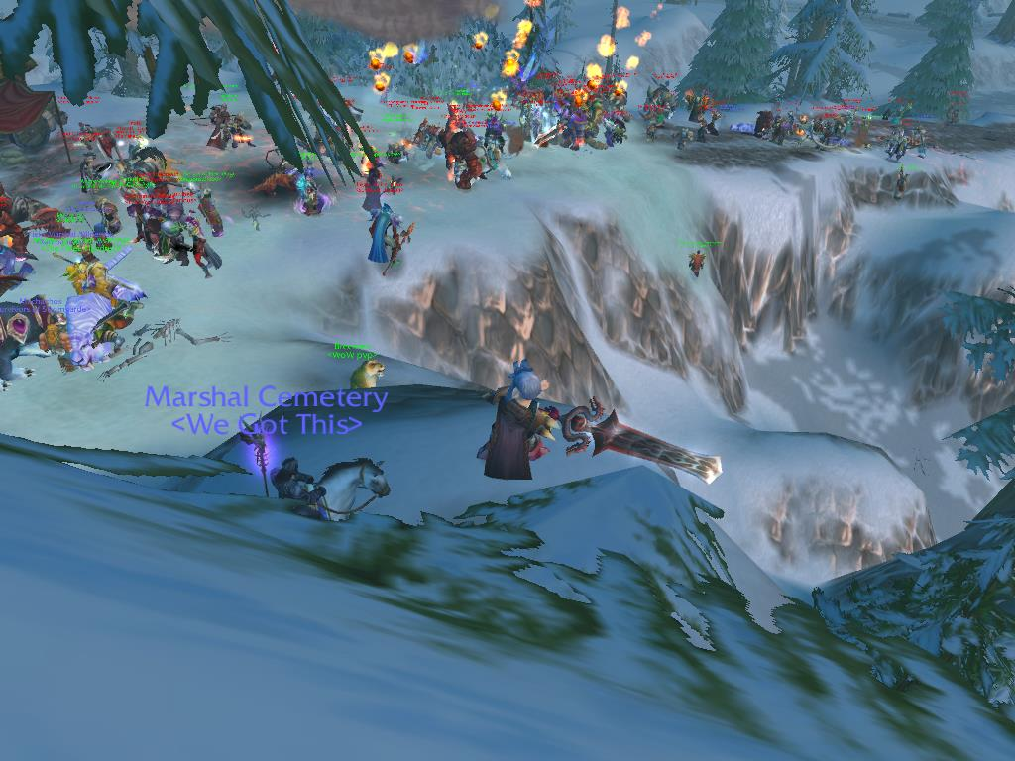
Figure 22. Rumps and Cemetery observe PvP action unfold.
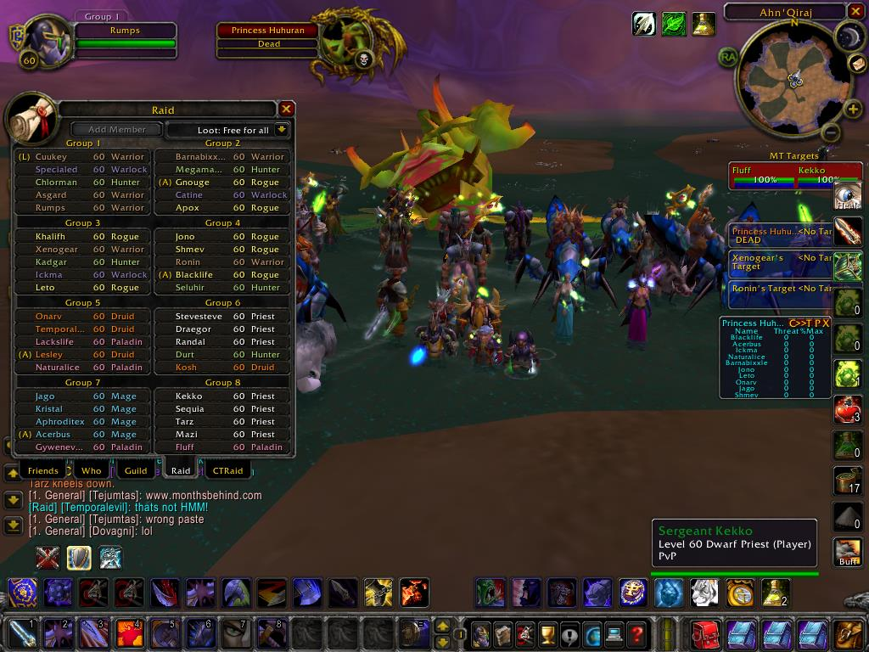
Figure 23. <Riders of the Apocalypse> defeats Princess Huhuran, AQ40.
remember my confusion, my wonder, my developing understanding of "how to play" this game, and my many mistakes. For instance, while leveling to 60, I had no idea what Raid Bosses were. I conceptualized Onyxia as some sort of giant spider (she was a massive black dragon, the brother of Nefarian AKA Blackwing, and daughter to Deathwing) and Ragnaros as a being of fire (accurate). When I saw these bosses in person for the first time, especially the building-sized Ragnaros, my jaw dropped. I transformed my playstyle and focus. I improved as a healer and developed an in-server reputation as a trusted and skilled Restoration Druid. When I defeated my first Raid Bosses, accompanying <Stoic> on their guild first kills of Ragnaros and Onyxia, I was
drawn into a larger collective: as the bodies fell in defeat, I was not viewed as Anthropos the Anthropologist, I was accepted as Anthropos the Raider.
I also improved as an in-game analyst. I did not panic at my confusing introduction to a cultural group/raiding lifestyle I did not "understand." Instead, I reached out to my academic influences, the masters of theory and methodology that had nurtured my maturation through the social sciences. My inclination was to ground the world of hardcore raiding (their world, my world, our world) in the structure of known methodologies and embrace so-called “real world” theoretical considerations: a “real world” context to the study and analysis of worlds decidedly unreal. I demonstrated this when Ahroo cried "It's Pro Time" at the beginning of this chapter: I weaved the means to understand not only his declaration as significant to a larger understanding of how hardcore raiders conceptualized their world, but also as a (very) unique cultural expression. Building on this effort, I situated the presentation of this research within an anthropological lens, giving these hardcore players a voice I felt they deserved. To that end, I will continue this analysis into Chapter 5, building on the introductory information I provided in Chapter 4, drawing on the voices of the informants presented in Chapter 3, and tackling the anthropological issues presented in Chapter 2. Where Chapter 4 introduced the basics in terms of raiding and the history of raiding in WoW, Chapter 5 presents the cultural stories and voices of the raiders (and myself, who, at this point was firmly situated in their world) capable of busting down raid doors and taking it to the grill of creatures, monsters, and bosses that mere mortals could not - and would not want to - ever face.
"It's Pro Time," in an analytical sense.

Supplemental Overview:
A Sort-of-Brief History of WoW Raiding

The path I took through this ethnographic and IRL challenge was long, winding, and ultimately life-changing. The individuals I initially encountered and developed relationships with in WoW were "hardcore" players. They enjoyed raiding and PvPing and spent the majority of their online time developing their characters and preparing them for the top difficulties WoW raiding offers. These players reached the game's maximum Level rapidly, and relied on raiding, grinding out difficult to acquire reputations, PvPing, and completing daily quests to increase the power of their respective characters. They unified around a common goal: forming a team of raiders with the express purpose of defeating WoW's raid content. Offering a "brief" introduction to WoW's raiding styles, frameworks, and adding detailed explanation into the complexity that are WoW's raid tiers is an apt choice for this segment, especially as I lead the readers into the heart of my ethnographic fieldwork. I include this section as a supplemental overview of the raid content my informants and I faced on a regular basis. Again, the glossary at the beginning of Chapter 1 is useful if the language depicted below becomes too "insider."
To begin, the very first release of WoW featured the Tier 1 difficulty level of raiding. Max level players participated in these endgame raids. The difficulty rose with each subsequent patch. The names, acronyms, level requirements, and features of these iterations are as follows:
- World of Warcraft ("Vanilla" WoW): the original game platform, featuring Levels 1 - 60 (2004 - 2007)
- The Burning Crusade (TBC): the first expansion, featuring Levels 61 - 70, the Outland continent, and introducing the Draenei (Alliance) and Blood Elves (Horde) races (2007 - 2008)
- Wrath of the Lich King (WotLK or Wrath): the second expansion, featuring Levels 71 - 80, the Northrend continent, and introducing the Death Knight class (2008 - 2010)
- Cataclysm (Cata): the third expansion, featuring Levels 81 - 85, an expanded/redesigned original world, and introducing the Worgen (Alliance) and Goblins (Horde) races (2010 - 2012)
- Mists of Pandaria (MoP or Mists): the fourth expansion, featuring Levels 86 - 90, the Pandaria continent, and introducing the Pandaren (Alliance and Horde) race and the Monk class (2012 - current)
I experienced raiding in its nascent form with the very first hardcore players on the Shattered Hand server. This raiding content initially existed in one format: 40 Player, requiring approximately five tank classes ("tanks"), ten healing classes ("healers"), and twenty-five damage-dealing classes ("DPSers"). Two smaller 20 Player raids, entitled "Zul'Gurab" (the troll kingdom of Zul'Gurab, or ZG) and "The Ruins of Ahn'Qiraj" (or AQ20), were included later in the life of Vanilla WoW. They were designed to appeal to a wider set of players and required less participants.
The raiding tiers for Vanilla WoW (2004 - 2007) featured:
- The Molten Core (Tier 1 - raided with <Stoic>), released 2004: a lava-filled hell font ruled by the elemental fire lord Ragnaros and his many servants of flame
- Onyxia's Lair (Tier 1 - raided with <Stoic>), 2004: a multi-phased female dragon's cave
- Blackwing Lair (Tier 2 - raided with <Stoic>), 2005: the labyrinthine hallways of Onyxia's brother, Blackwing, his dragon minions, and his various nightmare creations
- The Temple of Ahn'Qiraj (Tier 2.5 - raided first half with <Stoic> and second half with <Indomitable>), 2006: the desert hive of the insectoid Silithid race, and the Old God, C'Thun, driving them to the surface
- Naxxramus (Tier 3 - raided with <Indomitable>), 2006: a floating citadel of the undead lich Kel'Thuzad, and other servants of the Lich King, including the Four Horsemen and the undead Frost Dragon, Sappharon
Whether 40 players or 10 players, raid leaders expected their participants to spend the time and energy required to stay at or near the top of a game built on the concept of min/maxing. Acquiring every potential upgrade, even if the statistical upgrade was minor, was significant. Reputation challenges, the so-called "rep grinds," offered players the opportunity to achieve additional power boosts from in-game factions like the Cenarian Circle (the Silithus zone), the Argent Dawn (Eastern Plaguelands), the Timbermaw Furbolg (Felwood), and the Wintersaber Trainers (Winterspring). Acquiring exalted reputation with these groups offered many prestigious rewards, such as in the original Wintersaber Trainer rep, required completing the same monotonous quests over and over hundreds upon hundreds of times (Kill some ice giants! Collect fifteen pieces of chimera meat! Slay some corrupted furbolgs!). Though these boosts represented small increases in power, any minimal increase maximized player power, offering increased possibility of raiding success. The difficulty level and raid size for each WoW raid tier transitioned between Vanilla WoW and the first expansion, The Burning Crusade, which abandoned the 40 Person raid in favor of 10 and 25 Person raids. 10 Person raids featured two tank classes, two healing classes, and six DPS classes. 25 Person raids typically used three tanks, eight healers and fourteen DPS. This change resulted in a reduction of the amount of players a typical raiding guild required for each night's progression and farming raids. Instead of having to wait for 40 players to log in and join the raid, raid leaders could launch their play earlier each evening. The side effect was the reduction of 15 player slots. To Blizzard's surprise, the 10 player Karazhan raid proved so popular they added a second 10 player raid in TBC's lifecycle, the raid on the troll kingdom entitled Zul'aman, colloquially known as ZA. The consistent popularity of Karazhan and ZA prompted the most significant change to raiding in WoW: the formation of a permanent 10 player raiding tier. This change is discussed below.
The raiding tiers for The Burning Crusade (TBC) (2007 - 2008) featured significantly more raiding challenges (I excluded ZA in the below list as it is not an official "tier"):
- Karazhan (Tier 4 - raided with <Royalty>), 2007: the game's first 10 Person raid, it explored the mysterious tower of the presumed dead sorcerer Medivh and its demonic invaders, led by the corrupting force, Prince Malchazzar
- Gruul's Lair (Tier 4 - raided with <Royalty>), 2007: the home of the massive Gronn, Gruul the Dragonslayer and the elite Ogre council under his control
- Magtheridan's Lair (Tier 4 - raided with <Royalty>), 2007: a prison housing a demonic pit lord, Magtheridan, enslaved beneath Hellfire Citadel
- Serpantshrine Cavern (Tier 5 - raided with <Royalty>), 2007: the vast networks of the water-stealing Naga and their powerful mistress, the sorceress Naga, Lady Vassj
- Tempest Keep: The Eye (Tier 5 - raided with <Royalty>), 2007: the floating citadel of the arcane magic addicted, and demonically corrupted, former leader of the Blood Elves, Kael'thelas
- Mount Hyjal (Tier 6 - raided with <Royalty>), 2007: a raid scenario allowing players to travel back into the past and defend the World Tree against the Burning Legion (replaying the final level of the "WarCraft III: Reign of Chaos" RTS game)
- The Black Temple (Tier 6 - raided with <Royalty>), 2007: the walled and corrupted temple controlled by the fallen Night Elf, Illidan the Betrayer, his demonic underlings, and his Blood Elf and Naga allies
- Sunwell Plateau (Tier 6.5 - raided with <Royalty>), 2008: the final raid of the expansion, the hold of the Burning Legion on Azeroth, containing possessed and undead dragons, Dark Naaru, and an effort by Kael'thelas' allies to use the magic of the Blood Elves' Sunwell to summon the Burning Legion lord, Kil'Jaeden
The TBC raid dungeons required an elaborate attunement process, whereby higher level dungeons could only be entered through obtaining quest items off the endbosses of the previous raid tier. For instance, in order to enter Mount Hyjal, players needed to complete a quest requiring the deaths of Lady Vaashj and Kael'Thas, or accessing The Black Temple required the deaths of a boss inside Mount Hyjal. Late in TBC, in order to increase the use of raid dungeons, all attunement requirements to heroic dungeons and raid dungeons were lifted or reduced. A second noticeable change occurred with an across-the-board 30% nerf to all dungeons, heroic dungeons, and raid dungeon content in TBC. This included a 30% reduction in the health of all trash mobs and boss mobs, and a 30% reduction in mob damage. The justification for this change lay in the very few players able to successfully complete or participate in this final and most difficult raid dungeon. The second-to-last boss, M'uru, a corrupted Naaru (a being of good), was often cited as a guild breaking boss, though the final boss, the half-summoned Kil'Jaeden, was nothing to sneeze at. After this change, many guilds who had been struggling to defeat the M'uru and Kil'jaeden encounters were able to do so. From a long-term perspective, this sudden reduction in difficulty can be seen as the first attempt by WoW's developers to open up their raid dungeons to a wider player base.
The release of Wrath of the Lich King contained three raid dungeons in their Tier 7 levels, "Naxxramas" (a re-make of the Tier 3 raid dungeon), "The Obsidian Sanctum," and "The Eye of Eternity." These raids offered challenges to many different play styles, including, for the first time, the capability of players to determine the difficulty of a particular raid boss. While some of this tier of raid dungeons had a low level of difficulty (Naxx), and others challenging ("The Eye of Eternity"), the difficulty level of The Obsidian Sanctum (OS) allowed players freedom to determine how hard of an encounter they wanted to face. In OS, four levels of difficulty existed, all revolving around the main boss and his three mini-bosses. A raid group could fight only Sartharian (the main boss, a large dragon representing the evil black dragonflight), or they could fight Sartharian plus one, two, or three mini-bosses (each mini-boss was a drake of the black dragonflight). If the players killed all three of the mini-bosses in the zone, they only had to fight Sartharian while dodging waves of lava and dealing with fire elemental adds attacking the players mid-fight. Alternatively, keeping any of the mini-bosses alive meant additional strategies, added power and damage to Sartharian, and new game mechanics to master. Defeating Sartharian plus any number of the mini-bosses at once offered players more drops, drops of a higher item level than simply defeating Sartharian alone. Defeating Sartharian with all three of the mini-bosses alive gave players a new title, a flying mount to roll on, and item drops of increased power. Because these encounters were available in both 10 and 25 man, instead of merely having one set of raid dungeons to complete each week, players now had a chance to defeat each raid dungeon in both raid styles, with multiple levels of difficulty.
The raiding tiers represented in WotLK (2008 - 2010) were as follows:
- Naxxramus (Tier 7 - raided with <Royalty>), 2008: the same floating citadel of the undead lich Kel'Thuzad from Tier 3, retuned to be more accessible with more forgiving mechanics and damage requirements, and allowing raiders of all skills a new opportunity to face the servants of the Lich King, including the Four Horsemen and the undead Frost Dragon, Sappharon
- The Obsidian Sanctum (Tier 7 - raided with <Royalty>), 2008: in the sanctum of the black dragonflight, the kin of Blackwing and Onyxia, eggs of an unknown type are being grown: Twilight dragons
- The Eye of Eternity (Tier 7 - raided with <Royalty>), 2008: this single encounter fight featured Malygos, the dragon guarding the world's use of magic, who has gone insane and decided to kill all magic-users
- Ulduar (Tier 8 - raided with <Raiding Robots>), 2009: a Titan-built prison for one being, the Old God, Yogg-Saron, has fallen into disarray, leaving the Old God free and the prison's once-sane wardens under its control
- The Argent Tournament (Tier 9 - raided with <Raiding Robots>), 2009: a single arena featuring a series of progressively harder challenges designed to train the player for the upcoming fight against the Lich King...until the Lich King's servant Anub'rekhan crashes the party
- Icecrown Citadel (Tier 10 - raided with Ahroo's PuG), 2009: the battle against the Lich King, his generals, and his undead servants, unfolds on the most unhallowed ground of all: his monstrous fortress of undead horrors
- The Ruby Sanctum (Tier 10 - raided with Ahroo's PuG), 2010: this boss encounter featured the Twilight dragon Hallion, who has launched a brazen attack against the Red Dragonflight's sanctum
One of the more significant changes to the game began during the conclusion of WotLK and continued into WoW's third expansion, Cataclysm. During this period, WoW's developers launched an effort to improve the low number of players experiencing endgame content. All dungeons in WotLK had 10 Player and 25 Player formats. The developers added an additional difficulty for the most advanced players. The Heroic mode of the final raid of the expansion, Tier 10's Icecrown Citadel, rewarded the best item drops, with access to premiere titles that a player could wear. As an example, if a 25 man raid group beat the hardest boss in the expansion, "The Lich King" on heroic mode they were given the title "the Light of Dawn." Additionally, Blizzard made previous "epic" raid tier armors available on special venders so that the more casual players could have exactly the same "purples" what the elite raiders were wearing and could use these powerful items just a few months later to defeat previous raid bosses they couldn't handle at the time. As a result of these changes, more casual raiders were able to acquire the same epic items as the hardcore raiders.
Blizzard pointed to these changes as a success: this carrot on a stick approach ensured more of their players were using the end-game content, which equated to more people playing and paying per month. However, the reaction from the more elite raiders lay in the opposite direction. These changes trivialized the content they had defeated. Blizzard faced a conundrum: how do you please your hardcore player base, the group that will come back month-by-month vs. keeping the less hardcore (and more fickle) players returning? If content was too hard, they would lose players (as seen in the 4th Quarter 2011 stockholder report, when 5% of the player base quit playing). The framework introduced in WotLK, whereby in-game venders sold previous tier's epics, and content difficulty was reduced to ease access, continued through the third expansion, Cataclysm. Just as in WotLK, raids remained both 25 player and 10 player through the first two patches; however, now, 25 player and 10 player raids shared a lock-out timer - making players choose the raid format they would play each week - and each raid dropped equivalent gear.
The raid tiers of Cataclysm (2010 - 2012) featured the return of many bosses and creatures from the raid tiers of Vanilla WoW. These raid zones and their endbosses were:
- The Bastion of Twilight (Tier 11 - raided with Ahroo's PuG), 2010: the evil forces behind Azeroth's cataclysmic upheaval were revealed to be the Twilight's Hammer, secretly housed in a citadel in the sky, and led by the two-headed ogre mage Cho'Gall
- Blackwing Descent (Tier 11 - raided with Ahroo's PuG), 2010: AKA Blackwing's Lair, Part 2: Blackwing and Onyxia returned in undead and reanimated forms
- The Throne of the Four Winds (Tier 11), 2010: the elemental lord of air, Al'Aqir, rampaging over the secret Titan-built zone of Uldum, must be stopped
- The Firelands (Tier 12 - raided with Ahroo's PuG), 2011: AKA The Molten Core, Part 2, players invaded the home of Ragnaros, the elemental lord of fire, attempting to stop him and his strongest lieutenants of flame from re-invading Azeroth,
- The Dragon Soul (Tier 13 - raided with Ahroo's PuG), 2011: the massive world-destroying black dragon Deathwing, the corrupted Aspect of Earth and father of Blackwing and Onyxia - and his allies from the Twilight's Hammer - have assaulted Wyrmrest Temple, the home of the dragon aspects; in order to stop him, players must ascend the Temple, defeat his champions, launch themselves onto his back, and bring this Old God controlled creature down once and for all
The most significant change of this expansion was found in Patch 4.3, the final major content patch release of Cataclysm. In this patch, the developers released a new "raid finder" system. This tool, called LFR ("Looking For Raid") working similarly to the dungeon finder. It allowed random players the ability to join a cross-server and cross-realm PuG (pick-up group). They tuned this 25-man raid at an easier difficulty than the Normal and Heroic modes. This easier setting was more forgiving on player mistakes, such as "standing in fire," a generic term describing any spell effect requiring players to avoid taking damage. The raid setting required less coordination and caused less damage to the players. The bosses had lower health, meaning a lower DPS (damage per second) output was required to defeat the encounter. In order to distinguish loot drops from this raid difficulty from the two more difficult tiers, the items had a lower item level than Normal and Heroic mode (less stats, less power) and they were also colored differently. The LFR tool presented more casual players with an alternate means to gear up and see in-game content. Blizzard released the fourth expansion, Mists of Pandaria, on September 25, 2012. As of this writing (with some variations, including the Patch 5.2 introduction of randomly dropping "Thunderforged" gear with better stats), the model featured at the conclusion of Cataclysm (LFR, Normal, and Heroic with 10 and 25 man settings) continued. <Gnome Alone>'s Ahroo, Zoombroom, Arathene, Star, and Vvetter have teamed with another small guild (<Defiled>) to raid three nights a week, tackling the first tier of raids within the MoP expansion: Mogu'shan Vaults (6/6 bosses defeated), The Heart of Fear (1/4), and The Terrace of Endless Springs (0/4).
The debate over raid difficulty, nerfing, the ease of LFR, risk vs. reward, and various name calling continues to this day. For instance, in a recent conversation featured on WoW's European general forum, official poster Draztal attempted to justify the developer's current position against various player questions and accusations (in italics). The discussion continues throughout the remainder of the thread and was later posted on a popular WoW news and datamining site, MMO-Champion. It is but one example of an ongoing (years long) conversation official Blizzard representatives hold with their players. WoW's developers will never make every raider (hardcore, casual, hybrid midcores) completely happy, nor will their explanations satisfy every player. Arguments of this nature do little but prolong a (never-ending) series of confrontations between various raiding groups. If nothing more, this thread illustrates the need for culturally minded research offering mechanisms for engaging understanding and acceptance of these "vying" cultural groups (and, really, all dichotomous groups playing within WoW's virtual world) to the forefront. It is only through understanding, and ultimately accepting the legitimacy of, other viewpoints that forward progress can be made.

CHAPTER V

THE POST-HUMAN GAMER

Virtual(ly) Best Friends Forever

Karazhan lurked in the forefront of "The Burning Crusade" expansion, a citadel situated against a grim skyline (Figure 24). The tower, and the zone housing it, Deadwind Pass, held no quests or apparent use during Vanilla WoW. Aside from Ogres populating various sections, and giant buzzards harassing low level players traveling toward Swamp of Sorrows, the zone was devoid of life. Renewed interest in the zone grew in 2007 when Blizzard released TBC and unveiled Karazhan as WoW's first 10 Player raid. This Tier 4 raid zone featured an ascent up the sorcerer Medivh's corrupted tower, one populated by the undead, demons, skeletons, and other strange, restless souls (Figure 25). After investigating the activities at the tower's base, raiders climbed to its peak, where they defeated the tower's various security systems (including a life-size game of chess), put Medivh's troubled father to rest, defeated not one, but two zombie dragons, and confronted the demonic endboss, Prince Malchazzar. Within these confining, ghost-infested hallways, I first accompanied Ahroo, his longtime gaming partner, Acec, and other players from the <Royalty> raiding guild community in 2007. This contact with Ahroo was the first major step in a raiding partnership that lasted the remainder of my time playing WoW. It also offered clues as to the efficacy and intimacy of online relationships among WoW players, largely shaping the direction of my dissertation research.
I initially met Ahroo and Acec in 2005 through our mutual guild <Indomitable>. <Indomitable> featured many prominent and talented "Shattered Hand" players, including M (the Guild Master, or GM), Jeffrey (DKP officer and Raid Leader), Acec (Main Tank), Princess (an officer who renamed himself Star), Cemetery (who renamed himself Xoot), and Ahroo (serving in a healing role). It formed from a group of raiders splitting from the prominent guild <Skyfall> and competed with the other top Shattered Hand guilds, including <Drama>, <Death and Taxes>, <WarEnsemble>, and <Relentless>, for server first Raid Boss kills. <Indom> collapsed at the conclusion of Vanilla WoW after a prominent officer, Jug, logged onto GM M's account in 2006 and disbanded the guild. By the end of Vanilla WoW, after <Drama> and <Death and Taxes> transferred to the Korgath server, <Indom> competed with <WarEnsemble> in Naxxramas. <Indom> was the first to defeat the "Four Horsemen" encounter on Shattered Hand, but after Jug disbanded <Indom>, <WarEnsemble> was the only SH guild to defeat Naxxramas' final boss, Kel'thuzad. Though many of <Indom>'s players scattered elsewhere, many players reformed as <Royalty> in TBC. Other hardcore Vanilla players, including Chromedome, joined <Royalty>.
Though <Indomitable> included me in their 40 person raids in AQ40 and Naxxramas, Ahroo and I were not formally introduced until our time together in <Royalty> in 2006. Ahroo and Acec founded a weekly 10 Player Karazhan raid, one
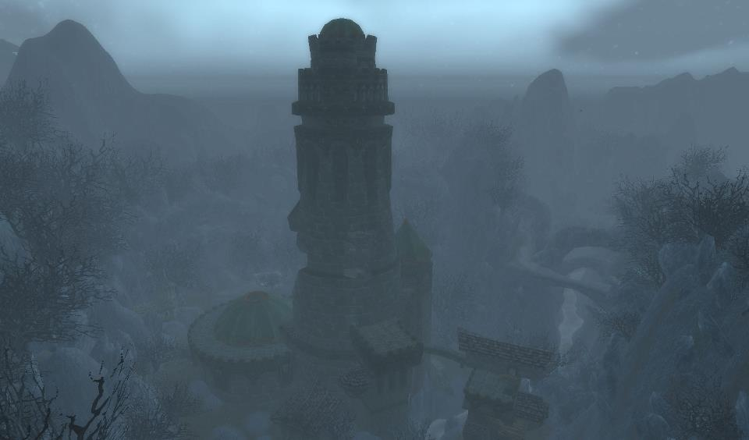
Figure 24. Karazhan in Deadwind Pass.
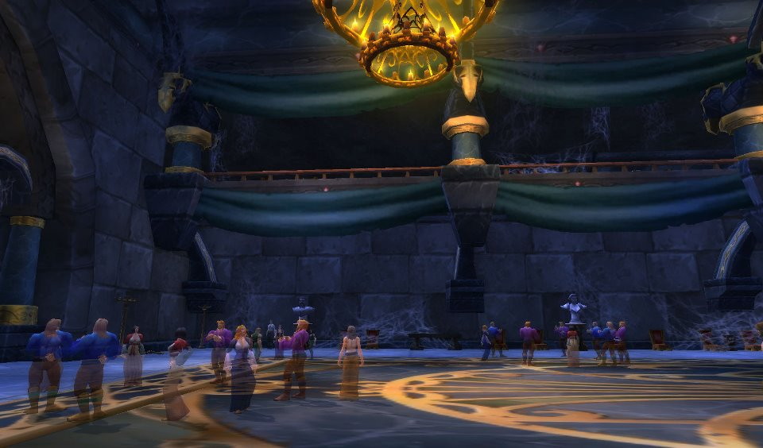
Figure 25. Karazhan's ghostly inhabitants.
requiring two tank classes (filled by Ahroo's Protection Paladin and Acec's Protection Warrior), two healing classes, and six DPS classes. They asked in <Royalty>'s guild
chat ("gchat") for healers. I volunteered and played well enough to warrant inclusion in future runs. The smaller number of players (10 vs. 40 Players) fostered a different raid dynamic. Acec and Ahroo, quiet in the 40 Person raids, were more animated in the smaller 10 Person raids. Their tanking style featured a cooperative and trusting style; while they bantered on Vent, they seamlessly moved through the mobs, pausing only to "mark" (or assign) targets to CC ("crowd control" spells temporarily incapacitating mobs) or focus-fire, and assign the targets each would tank. There was no dilly-dallying. The two trusted the other's tanking ability, their confidence - and results - infected me as well. We moved rapidly through the dungeon. This trust in Ahroo persisted through the remainder of my time playing WoW. He and I completed (original, non-nerfed) Heroic Burning Crusade dungeons, TBC 25 player raids (with Acec and Chromedome) with <Royalty>, 10 Player raids in WotLK (including server second "Undying" achievement), and 25 Player raids in WotLK until <Royalty> disbanded in 2008. When Ahroo created a permanent 10 Player raid to tackle the Ulduar (Tier 8) raid in 2009, I agreed to participate.
Ahroo and Acec's relationship typified the online alliances formed through raiding. Their jovial social interaction - "referred to as computer-mediated communication (CMC)" - held the traditional markers of friendship, except for one aspect: they had never met IRL (Pena and Hancock 2006: 92). When I asked Ahroo how he and Acec met, Ahroo (post to author, March 16, 2013) responded by stating:

[Acec] was active in the guild like me, and during all those 40 man raid nights after hanging around after raids chatting... I dunno, our views on the guild and people were about the same sorta and we just hung out in game. I dunno.

Their friendship was an example of an "Exclusively Internet-Based (EIB)" relationship, one "developed without any face-to-face interaction or interaction through traditional media, such as the telephone, letters, etc." (Wright 2004: 239). Despite this (nonexistent, at least to them) speedbump, the two created a cooperative relationship that spanned multiple games, social media, and mobile technology. Ventrilo/VoiP made up for a lack of face-to-face contact. When I first met Ahroo and Acec, the longevity and strength of their relationship intrigued me. When confronted with such an obvious example of virtual friendship, I found myself reflecting on the place of online relationships in the new “cultural milieu” (Watkins 2009: 191). Due largely to the strength of the relationships I observed (including Ahroo/Acec, Cemetery/Chromedome, Donnar/Blitzan, Arathene/Itsgeorge, guilds like <Royalty>, <Indomitable>, and <Stoic>, 10 Player PUGS like Ahroo's, and so on), my research interest focused on the "types" of online relationships and virtual communities developed through WoW and maintained through raiding. Many factors drew me toward this subject matter, including a relationship's continuation or discontinuation, maintenance of strength, capacity to achieve and continue achieving prestigious items, and development of online and offline interests. Problematizing the new digital media revolution's affect on social relationships and friendships was crucial for understanding the continued appeal of WoW and grasping the core mechanisms used in player/avatar/character development.

There's More to Social Gaming Than Meets the Eye

Ethnographic considerations of gamers and sensation seekers often take a qualitative approach. S. Craig Watkins' (2009: 113) research centered on mobile technology and connectivity, but he also spent part of Chapter Five of The Young and the Digital ("We Play: The Allure of Social Games, Synthetic Worlds, and Second Lives") discussing WoW, which he labeled as a "synthetic" world. This chapter featured face-to-face interviews with video gamers about their online experiences in "the quintessential participatory platform, a model of the interactive media franchise that is poised to thrive among a generation of young men and women who prefer using Web-based tools and applications to create their own content and build their own world" (Watkins 2009: 115). The chapter addressed what these players enjoyed about the game, how they spent their evenings in-game, who they interacted with, their online relationships, and also the ability of the player to be "the writer, director, actor and audience" of their own in-game stories (Watkins 2009: 115). Watkins (2009: 107) commented on WoW's place in the larger network of social gaming, noting the growth in popularity of the genre, remarking:

In its third annual Active Gamer Benchmark Study, released in 2006, Nielsen Entertainment announced that the social elements of video games are becoming an increasingly important part of the overall gaming experience. Active Gamers, the study reports, spend upwards of five hours a week playing games socially. Teenagers, according to the study, are socially involved in gaming about seven hours a week.

WoW was "planet Earth's most populous MMORPG" (Watkins 2009: 112). Since 2003, the 18-34 male demographic has abandoned network television in record droves. "Network TV Is Losing Young Male Viewers: A Nielsen study finds that men 18 to 34 are watching less television, and the drop is bigger during prime time" found considerable losses stretching back several seasons. "The Case of the Missing Young Male TV Viewers" points out that 1.5 million less young males were watching network television in 2003, even while viewership in other demographics were rising. Where, the industry wondered, were all the young males going? Were adjusted Nielson ratings to blame? Were they inaccurately counting young males watching television in bars? Were the young men living with their parents and using their parent's television? After years of declining 18-34 viewers (in the 2003 article, a 6-7% decline was noted), and many theories to explain the declines, new information technologies were discovered to be the root cause, including an exodus to a variety of new media platforms, including online video gaming and social media.
Putting numbers to WoW's popularity required locating Activision-Blizzard's quarterly press releases. Each quarter, Activision-Blizzard took part in a conference call with its stockholders. Though WoW had, according to the announced subscription numbers, lost approximately 900,000 players between 2011's Quarter 1 and Quarter 2, These numbers declined during the Cataclysm expansion, but upticked for Quarter 3 2012 (where it was listed as "over 10 million players"). The release for Quarter 4 2012 (December 31, 2012) during the Mists of Pandaria expansion listed WoW's population as 9.6 million subscribers, a drop of at least 500,000. Activision-Blizzard discussed these declines in subscribership in several 2012 interviews. One of WoW's lead designers, Tom Chilton, stated in a 2012 ign.com article (Onyett, 2011):

If you look at, if you look at the way the population breaks down, we're at a point in our history where there are more people that played World of Warcraft but no longer play World of Warcraft than currently play World of Warcraft. That was totally not true four or five years ago, and so in a way the demographic of the potential returning player becomes more and more important over time.

While exact figures have not been released by Activision-Blizzard, one can estimate over twenty plus million players have been involved in WoW's six year history, a considerable group of participants by any score. Watkins (2009: 107) ventured into what this signified for the social gaming genre:

What is social gaming? Social gaming occurs in various styles and subgenres of games but refers primarily to those games in which social interaction with others is a key component of the gaming experience. Many MMORPGs are designed to be social, insofar as they encourage interaction between players, often in the form of collaboration and teamwork. Users of MMORPGs are drawn to the platforms precisely because they afford the opportunity to engage other users in real time.

Watkins (2009: 124) reported that "39 percent of males and 53 percent of females believe that their in-game friends are comparable or better than their physical-world friends." He also found the following:

...the typical young person we met consistently rejected the idea that online-only relationships are just as fulfilling as off-line relations. Nearly seven in ten, or 68 percent, of our survey respondents disagreed with the idea that you can get to know someone better online than off-line. Heavy users of virtual worlds differ in this respect. Unlike the majority of young people who spend the bulk of their time online on social sites like Facebook, synthetic-world users are much more likely to believe that online relationships can be just as fulfilling as off-line relationships.

He bolstered the power of these metrics by suggesting "these sentiments will only deepen as the design and technology supporting the use of virtual worlds becomes more advanced" (2009: 124)
Illuminating Watkins' findings and illustrating the "types" of online relationships found within hardcore multiplayer gaming requires returning to the example of Ahroo and Acec. They met in one MMO (Star Wars Galaxies: An Empire Divided) and continued their friendship across two additional MMOs (WoW and Star Wars: The Old Republic). In watching them interact, chatting over Vent and in-game, I wondered just what it meant to be a "friend" in the world of participatory internet known as Web 2.0. As they explored Karazhan, or the other WoW raid dungeons, did Ahroo and Acec not demonstrate IRL friendship? Analyzing their online relationship on their own terms necessitated an examination of the existing mediation between humans and computer-related technologies, namely the blurring between IRL and virtual friendships crafted through online cultural identity, expression, and social relationships. Understanding this dichotomy of “real” and “virtual” as it pertained to the shaping of virtual human social relations remains challenging. Deconstructing online culture from the culture of the offline world meant focusing on the power of cyberspace to create “reality” out of “virtual” human interaction (Jordan 1999: 55). This process also required problematizing the space between virtual and IRL worlds, and by extension the space between IRL and virtual relationships, namely, the "closeness" individuals were capable of experiencing with their online friends.
In Chapter 3, I posited my impressions of the first time I met my informants IRL. Taylor also reflected on her version of this experience, describing her experiences when she first met her “online” friends in “real life.” She was not sure what to expect (2009: 54-56). Many of the friends she had met in-game, such as “Mitch”, “Jack,” Jack’s wife “Katinka”, or Katinka’s friend “Vin” had distinct in-game personalities — they were part of an extended IRL friends-and-family network Taylor befriended over her documented four years of gameplay but she had never met them face-to-face. Mitch, for instance, along with his friend “Josh,” and Taylor’s other friend, “Bob,” were “power gamers." Katinka, her husband Jack, her cousin, and her friend Vin were more casual. She (2006: 54) noted that in-game relationships “quite often move offline” resulting in players forming “out of game relationships with each other.” When it was time to meet “in real life,” Taylor was nervous. As she described in Chapter 3, watching Mitch and Josh interact IRL challenged her perception of their virtual identities. Observing them IRL (instead of virtually) created a disjointed experience for Taylor. Though she was very knowledgeable about the game, she experienced a profound sense of exclusion in the company of these two power gamers and a general unsettled feeling. Why, she wondered, had she experienced a disconnect of this nature (2006: 68)?
Despite my close reading of Taylor, Ito, and Boellstorff, I could not easily embrace this disconnect. My experiences and interviews with my informants suggested this disconnect did not exist for them. I spoke with players like Rumps (post to author, March 9, 2013) who emphasized just how important online relationships - virtual friendships - were for his love of hardcore gaming:

I only enjoy playing games where I get to interact with other real people. Playing all the other games by myself would be just boring. As I played more and more and became hardcore, working to achieve a goal with other people had a very satisfying feeling. As we accomplished more things together our relationships blossomed. It became enjoyable to just hang out online and talk to friends about the game and random things. Near the end of my hardcore playing days, I would log in just to talk to people and not really even play the game. If my friends weren't online, I would log off.

When I encountered perspectives like Rumps', or Kindinos (post to author, March 16, 2013), who felt "the relationships I've formed with many of the people in the game are so strong, that even to this day, despite the fact that I no longer raid at a hardcore pace, I talk to them and keep in touch, thanks to social networking," I wanted to believe in a more utopian conception of online friendship, one where the IRL proximity of the player, and whether face-to-face contact had occurred, did not matter. My observations aligned with the opinions of players like Xoot, who identified virtual friends as not "online only friends," but simply friends who loved "far away" from him. I read testimonies from players like Titoness (post to author, March 6, 2013), who viewed raiding as a group experience built off of "fun": "The fun part is of course the time spent with many of the friends I made in the guild I was in, <Royalty>, again, also overcoming hard game content with them. In the end what kept me coming back was the friendships." I heard, I saw, I absorbed the messages repeating the same concept over and over.
Rumps, Kindinos, Xoot, and Titoness, like all my informants, held a perspective on friendship that challenged my pre-WoW playing perceptions of IRL and virtual friendships. Their opinions meshed with that of Ito (1997: 100), who described online role-playing worlds as a "sort of magical realm of the digital," where the "machine...is a faithful extension of user agency." In Ito's scenario, cultural distinctions like friendship remained pure and unvarnished, no matter the origin of the relationship, no matter the amount of technology easing the process. She resisted the impulse to embrace the more idealistic notion of "seamlessness and transcendence" facilitating human/machine virtual interaction, stating (1997: 103):

...as I sit, tightly coupled to my computer keyboard, embedded in semiotic meanderings through my computer monitor, I question any clean separation between human and machine, the social and technological, the real and the textual.

I wanted to believe - so hard - in the purity of the virtual space and its capacity to keep cultural manifestations unblemished. I wanted to hold onto the ideal of virtual spaces capable of supporting the weight of real world cultural expressions, capable of allowing reflections - not refractions - to aggregate and propagate. I saw, however, the squint in my mind's eye as I pondered the similarities and differences of IRL and virtual friendships. I feared I (and the world at large) were not ready to make that leap. I feared I over thought this phenomenon. I wondered if these friendships were perceived as illegitimate because they occurred on a virtual landscape? Because "virtual" was seen as less significant than "real"? To that end, was friendship (or any in-game relationship) really friendship…when that friendship was only conducted online? When one had never met the person one called “your friend” IRL? When one had never spoken in real life to the person one called “your friend” IRL?
What I found instead was that the distinctions placed on what is "friend" and what is "friend-like" - did not hold for the hardcore gamers I got to know. I believed Ahroo and Acec were friends, just as Ahroo and Acec believed they were friends. Acec (post to author, March 7, 2013) went so far as to cite "friendships gained," like Ahroo, as the most positive effect the game had on his life. In a similar manner, Xoot felt these friendships outweighed the value of the loot dropping in raids. He raided because of his friends, and often for his friends, choosing not to get too attached to a bunch of "colored pixels." He ultimately quit WoW because he was not able to raid with these friends. Chromedome painted friendship as the "power that cheers me up when I am sad just by thinking of times/events with people" and emphasized that there was no difference between his IRL and virtual friends: "As long as someone is honest and genuine how I met them doesn't change anything." For Chromedome, the "bond matters more to me than anything else. If I can trust you and you can tell you genuinely care about my well being or state of living. That's a true friend." Brishal (post to author, March 7, 2013) mentioned how WoW and video gaming in general allowed him to develop more lasting friendships:

I actually met all those guys playing the first "Call of Duty" [a military-based FPS published by Activision] and then we moved on to playing WoW. Me, Sorchah, Thorlo, Fetchaley all met playing "Call of Duty." And then we ended up just meeting more mutual friends as we encouraged our real life friends to play WoW.

These individuals were not alone. Toastedbread (post to author, March 18, 2013) felt "one or two of my close online relationships" were "close friends [that] know me better than many of my close, and closer IRL friends." This was due to the openness of the virtual relationship, the ability for Toastedbread to "say or share with people versus what [was said to] people face-to-face." Star (post to author, February 28, 2013) found himself valuing online relationships because of the possibility of selecting who he wanted to interact with, and the duration of the interaction. He did not talk to people "much outside of WoW." He enjoyed WoW because he knew he didn't "have to really deal with anyone" inside the game if he "didn't want to." Rumps (post to author, March 9, 2013) also found many positive effects through his virtual friendships. However, he often ran into a conundrum in balancing his virtual friendships (which he felt carried a stigma) and his IRL friendships:

My friends knew I played the game but they didn't know I was hardcore. None of them played, so I wouldn't mention anything about the game to them unless they asked. I knew if I told them that I played this game almost every waking hour I was at home, I would get ridiculed. If they asked me to go hang out with them and I told them that I would just stay home, I would get ridiculed even more. So if they asked me to hang out, I would go. If they didn't, I would just stay home and play the game.

Xoot viewed his virtual friendships and his IRL friends in the same manner. He referred to his virtual friends as "long distance friends," not merely "virtual" ones. He gamed with Jeffrey on a regular basis, hanging out on Ventrilo and playing DotA (Defense of the Ancients). "The difference is going to the bar and having a few beers," he said, "and playing DotA and talking on Vent." Cuukey (email to author, March 13, 2013) noticed a relationship between the quality of his IRL relationships and the quality of his virtual friendships. He commented on the rise and fall of these relationships, stressing:

Hardcore raiding was a double edged sword. On one hand you get to establish a diverse array of friendships and bonds, while on the other hand, it was always possible for your real life friendships and relationships to crack and crumble. It can be tough for people to balance those two out. Early on in my MMO days, it was easy to maintain real life friendships, but the further you get entranced into the life style, the harder it became. While the quality of IRL friendships tended to deteriorate, the new friendships with the people you were playing with, tended to blossom.

These players represented a new generation of gamers, ones using the tools at their disposal (developed through virtual technology), from multiplayer gaming platforms to social media and VoiP, to redefine and reconceptualize what friendship means for them, and how they used these relationships to develop their in-game prowess. In this sense, IRL qualifiers to relationship-building like "spatial proximity and physical attractiveness are diminished in their importance, whereas self-discloser assumes a pivotal role in promoting computer mediated relationship formation" (Merkle and Richardson 2000:191). While Merkle and Richardson (2000: 191) conduct their research on online romantic relationships, their emphasis on "textual or graphical communication" applies to the generation engaging in social gaming. The 10 million subscribers playing WoW - accepted the validity of the lack of IRL face-to-face interaction in virtual spaces because they were already engaging in computer mediated communication through social updates (Facebook updates, blog posts), situational blurbs reduced to "X" number of characters (Twitter), and non-verbal communication (texting, IMing). In a sense, the avatars meet face-to-face and hang out, just virtually. Tockaray (post to author, March 2, 2013)commented on this distinction, stating:

I feel like I don't really know how to act IRL a lot of the time. I'm getting better at being more articulate but I still sometimes stumble over my words. Typing is just what I default to I guess. I feel like my virtual friends get a better sense of who I actually am only because I am better at communicating it in this medium. And I guess when you spend most of your life being shy or weird or quiet being able to be obnoxious and real on the internet is pretty cool.

For my WoW informants, bonds between IRL family members (Donnar/Blitzan) and virtual friends (Ahroo/Acec) took on new forms, with boundaries of interaction confined only by internet access, and even those boundaries were easily defeated by motivated players who enjoy traveling. Blitzan, for instance, loved to travel and meet his virtual friends. He was unique in the sense that he enjoyed putting faces to names, allowing his virtual friendships to bleed into his IRL life. In this passage, he mentions some of the many players he met through his journeys (post to author, March 16, 2013):

I have made some great friends threw [sic] gaming however. Most of which I stay in contact with and some I have met in real life I have traveled to Detroit to visit with Tito. Tree we met when I went to a wedding in Tennessee that's also where I met up with Arathene. Every year when I bring my mom down to Florida for the winter I try to meet up with [Chromedome] to go out to eat or something. I lived with Poger who I knew from high school and his now wife who he met threw [sic] online gaming [IRL name withheld] who was from south carolina [sic].

He (post to author, March 16, 2013) also dated an individual he met through hardcore raiding:
I continued to play for a long time years [sic] before finally not by choice but lack of money and a computer blowing up I was forced to take a 6-7 month break from gaming. When I returned I started causal but soon was right back into hardcore raiding I met a girl from WI we talked more and more she flew me out to see her. I then took the bold step and moved out to WI with a girl I had met in a game. In the game we had great fun but outside the game we where alot different people [sic] so eventually it just didn't work out. So I moved back to NY.
Chromedome also met up with several of raiding cohorts, traveling from Florida to Michigan in order to attend Alanoth's wedding. There, he, M, Cemetery, Acec, and Titoness had an opportunity to hang out IRL. Not every player was like Blitzan and Chromedome, willing to travel hundreds of miles and explore the blurring of IRL and virtual in his life. Still, for these players, their "virtual interactions are real" because "they take place between real people," a concept that fit well with the content of their interviews and surveys (Miah 2000: 220). Mitigating or constraining factors like space and place, time and distance, and other related concepts, were pared down to near inconsequentiality. Blitzan and Chromedome, my informants ignored the boundaries placed on them by exterior sources, seeing them as non-existent. Tockaray (post to author, March 2, 2013) clarified this belief through the following:

People who still think making friends on the internet is stupid are missing out on one of the best opportunities of their lives. Sad really. Why do we think of the internet as a "real life" divide when it has brought us much closer to people than "real life" ever could? Even if you haven't met, experiences shared together through the internet are just as valid/meaningful as anything else shared in life. Without internet I would be stuck talking to people I don't even really like just because they were the only people near me geographically speaking. It extends your reach much farther than your block or your town or your school.

Brishal (post to author, March 7, 2013) argued along the same lines, talking about WoW as a gateway to form and expand upon lasting friendships:

Playing WoW created new relationships for me. Many players I still talk to (including you, Thorlo, Sorchah, Fetchaley, Orchlann, and many others). My experience in World of Warcraft, though I played too much of the game at times, simply created yet another avenue in which I had been able to make friends throughout the years. My real life relationships were not neglected even while I was a hardcore player. I've always played a lot of video games in my free time when I wasn't playing sports, working, or in school. During my WoW days all my gaming consisted of playing one game, World of Warcraft, so it never was able to eat into my life negatively as much as people would expect a hardcore player to experience.

Though digital worlds and analog worlds never seemed so distant - nor so distinct - in my mind, especially in terms of the space and place they occupy, these gamers contested my conceptions of friendship and the limits of the human gaming experience. These gamers rewired themselves into Post-human Gamers, challenging the traditional manner in which individuals played video games, who they played with in-game, and the meanings they placed on the virtual and IRL intimacies they developed within the WoW hardcore community. "Post-human" is the term Hayles (1999: 3) coined and later discussed by Cubitt (2000: 127), to describe the "informationalizing of both body and consciousness" creating "no essential differences or absolute demarcations between bodily existence and computer simulation, cybernetic mechanism and biological organism, robot teleology and human goal." This future, which Dinerstein (2006: 570) also discusses, is one where "humans are cyborgs - in which the human organism is, for all practical purposes, a networked being composed of multiple human-machine interfaces." Because humans are advancing into the future hand-in-hand with machines, "the machine becomes a model for understanding the human. Thus the human is transformed into the post-human" (Hayles 1999: 239). And the gamer is transformed into the Post-human Gamer.

The Post-human Gamer, Part I

As I mentioned in the previous section, the "disconnect" I felt between myself and my online relationships was not as important to my informants, or to their own way of living virtually. In order to brave this disconnect and achieve a more emic cosmology - in order to successfully utilize an inward turning eye and understand Boellstorff's (2008: 248-249) representation of virtual lifestyle as one of the "many ways to live a human life" - I needed to better understand the worldview these hardcore gamers operated within. Ethnography offered an effective tool capable of analyzing this digital phenomenon because it offered "a kind of virtual investigation" into being human, even being human in a world constructed by machines (Boellstorff 2008: 248-249). Anthropologists were uniquely qualified to make sense of this new ordering of “artificial intelligence and biotechnology,” tools working hand-in-hand in the development and creation of cyberculture (Escobar 1996: 111). Space, place, time, location, individuality, and culture itself all become capable of being re-imagined in worlds where “real” and “virtual” blurred, where a “hyperrealisation” of the real resulted, a transcendence of our “mundane existence” (Doel and Clarke 1999: 262).
Understanding the Post-human Gamer and the virtual world he/she inhabited required a careful analysis of previous studies of cyberspace, including existing “actual” ethnographies conducted inside virtual spaces. I found myself in a unique position on this issue: my head told me one thing (a disconnect existed), but my heart took me in an entirely different direction (my informants - the individuals I interacted with for years - suggested the disconnect does not matter and was predicated on a leap of idealistic faith). Social scientists painted the virtual in blunt terms, calling it "subjective," "meant to shape or invent a world, not to represent it" (Morse 1998: 21; 24). Ultimately, the ethnographies and informants nestled into this discourse and increased my IRL anthropological power. My "class trainers" were the ethnographic studies of Taylor, Boellstorff, Watkins and others. The "spells" they "taught" included not only their theoretical philosophies, but also living amongst the virtual peoples being researched (in the spirit of Malinowski, Mead, and Evans-Pritchard), qualitative open-ended interviews (including traveling to meet many real world counterparts of in-game avatars), participant-observation (playing software along with their informants - Ito’s SimCity2000 and MUDs, Taylor’s EverQuest, Boellstorff’s Second Life), and surveying (Watkins surveyed nearly 500 young adults, parents, and teachers). These perspectives guided my own in-game performance and aided the in-dissertation "raid" I faced: the "raid" on the "citadel" housing the (re)conceptualization of virtual intimacy. To defeat this boss, and equip this dissertation with truly epic - and possibly legendary - armor and weapons, I summoned the theoretical powers of the anthropologists and social scientists preceding me. To clarify their contributions (and the theoretical magic they wield), I present these researchers and their salient points below. I also offer radical and unverifiable suppositions into the WoW "classes" these researchers most closely reflected.
- Turkle (1995: 43) and (2011) was a primary influence on my research. She characterized the past two decades in American technological culture as a liminal point in our socio-cultural history, a moment of passage with new technological-based symbols possessing new emergent meanings, where the computer is an actor in the struggle between modern and postmodern sensibilities. Like Porter (1999), she understood identity and sociality were at “play” on the internet (the real and the virtual bleeding together). Its “fluidity,” moving beyond notions of “stasis” created a borderless, flexible, mobile, and subjective realm. MUDs and MOOs (both text based multi-user role playing dungeons set on a server individuals with a modem could connect to) were only the first step for MMO identity construction. With modern technology able to working hand-in-hand with virtual culture, Turkle (2011: 209) explained, "we become cyborg, and it can be hard to return to anything less." Drawing on the testimony of her informants, and her own analysis of the relationships they formed with robotics, artificial intelligence, simulation, and mobile technology, she "asks how we got to this place and whether we are content to be here" (Turkle 2011: 2). With the fluidity she emphasized, she clearly would play a Druid in-game, a class capable of shapeshifting between different forms (healing, tanking, damage dealing) depending on the situation.
- Dinerstein (2006: 569) also examined technological progress, portraying the utopian faith in its development as a movement in the United States to embrace a new technological theology, a faith “of the future,” messianic in its promotion of a “better world.” I appreciated his philosophical discussion, especially as he referenced Haraway (1991), Hayles (1999), and the "cyborgs" who transformed their body into a sort of “mobile network” of phones, tablets, and computers allowing them to remain plugged in 24/7 (Dinerstein 2006: 583). He noted the differences between cyberspace as an abstract open space and one unifying differing notions of real and virtual as it pertained to our transitioning human-machine bodies. He also suggested that humans embrace a new world and a new “faith in the future…as a better world” (escaping the “panhuman”). Due to his linking of technological progress with theology, Dinerstein struck me as someone who played a Priest.
- Ellen Seiter's (2002) reflective studies encouraged researchers to avoid approaches adopting statistical patterns of design at the expense of understanding perceptions about computers and “the cultural contexts in which they are used, and the images, sounds, and words to be found on computer screens.” She suggested an ethnographic model offering a variety of ways people use internet, writing “When turning to the Internet, it will be especially important to treat computer communications as deeply cultural, as employing fiction and fantasy, as well as information, and as open to variable interpretations based on gender, race, and ethnicity” (2002: 694). I enjoyed reading her research recommendations and actively worked to incorporate this perspective into my ethnography. Her interest in promoting narrative ethnography creating a harmony of cultural communication suggests she would play a Paladin in WoW, probably in a support role with a Holy (healing) spec.
- David Hakken argued for better epistemological understandings of how knowledge has transformed with the influx of new information technologies. He pushed for researchers to be specific and careful in their examination of cyberspace; for instance, he suggested defining its development as a “revolution” was a mistake because it presumed “the potential is already a reality” (1999: 1). We should instead, he asserts, map our adoption/use of existing technologies without confusing it with some “general scheme for the future" (1999: 1). He suggested moving beyond such generic terms as “cyberspace,” and instead thinking more specifically about the effects such technological adoption has had on the changes in our socio-cultural lifeways. “My main goal,” he asserted, “has been to separate out what can reasonably be said and be grounded empirically from the nonsense that abounds in regard to this subject” (1999: 225). The rhetoric used in deconstructing cyberspace, he argued, especially an etiology assuming a computer-mediated revolution is already our cultural reality, does nothing to problematize the processes leading us to this point of time (1999: 227-228). How, Hakken wonders, are we to define the inhabitants of cyberspace? Are they, as Turkle, Jordan, and Haraway surmised, new “types” of individuals? Are they humans in the midst of a socio-cultural or even, as Hakken dares to wonder, a species-related transformation or evolution? He is unwilling to embrace the likelihood of the development of a new species. He does, however, conclude that the uses of anthropology in cyberspace are many, including finding the term “cyborg,” a metaphor to describe an organism mixing flesh and machine technology, to be an appropriate means of identifying and discussing the residents of cyberspace. More importantly, Hakken believes classical approaches to social thought must be re-thought in order to carry out this new era of ethnography—how we study virtual spaces effectively becomes one of the most challenging issues needing to be addressed. I took this suggestion to heart, hoping to problematize my research process and the effects it bore on my life. Hakken would play a tank class in-game; the directness of his analysis screams a "no nonsense" Death Knight.
- Sut Jhally (2002: 249) who, in both “Image-Based Culture: Advertising and Popular Culture” and his documentaries (“Dreamworlds,” “Dreamworlds 2,” Dreamworlds 3,” “Advertising and the End of the World”) values an “excavation” of our culture: "Because we “live inside the consumer culture, and most of us have done so far most of our lives, it is sometimes difficult to locate the origins of our most cherished values and assumptions. They simply appear to be part of our natural world. It is a useful exercise, therefore, to examine how our culture has come to be defined and shaped in specific ways—to excavate the origins of our most celebrated rituals." Identifying and studying something as participation in cyberspace has moved beyond niche groups and is rapidly becoming a normalized activity. With advertising and marketing influences--“the institutional structure of the consumer society orient[ing] the culture (and its attitudes, values, and ritual) more and more toward the world of commodities”—creating a “major structuring institution” out of “contemporary consumer society,” the physical body itself becomes a social construction (Jhally 2002: 250). With his interests in culturally excavating the physical body, and deconstructing the world at large, Jhally clearly plays a physical class skilled at slicing and dicing (a rogue); he also enjoys the in-game secondary profession of Archaeology.
- Anthony Giddens, in The Consequences of Modernity, offers a chilling analysis of the new realities we face in our rapidly techno-socializing world. Prophesying from 1990, he feared the effects an “unprecedented” sweep of modernity would hold on our culture. The mere “scope of change,” he warned, is sweeping “us away from all traditional types of social order” toward a polarizing era of “high modernity,” a cultural milieu of here and now, of quickening pace, where individuals can communicate with anyone in the world (again, WiFi and satellite permitting), where locations are transformable (breaking down the barriers associated with leisure, work, and school). Even the once-restrictive nature of time itself loses its potency, particularly with the launch of the 24 hour news cycle channels or the global stock markets (one of which always seems to be open). In order to understand the true significance of Giddens, we must return to Watkins (2009: 171-172) description of how youthful adoption of such norms as “owning a cell phone,” “being connected to the internet,” “talking to anyone at any point in time,” “downloading content anytime and anywhere,” “connectivity means speed,” “immersing the real and the virtual,” and so on, first takes root, first normalizes. Here, these young men and women mediate, shape and redevelop their connection to a larger and rapidly shifting cultural milieu, an era of “high modernity” capable of throwing us into “interconnection with [different areas of the globe]” launching “waves of social transformation” crashing across “virtually the whole of the earth’s surface” (Giddens 1990: 6). Given his linking of technological change with insinuations of thunderstorm-like manifestations, it seems obvious to me that Anthony Giddens plays a damage-dealing class with a knockback spell, like an elemental shaman.
- For those curious about other class representatives and the researchers I previously discussed, I have it on good faith that Boelstorff plays a Warlock (he is able to summon excellent ideas into reality), Taylor plays a Mage (she conjures interesting theory for her raid members), Watkins plays a Warrior (able to tank swarms of theoretical adds), and Ito plays a Monk (sure, why not).
Over the course of my research, I absorbed the perspectives of these researchers, including Boellstorff's and Ito's propositions that studies of virtual world cultural concepts do not completely align themselves with their IRL counterparts. It is to this concept I now turn. We may, as Ito (1997: 87-88) wrote, be witness to the "imploding" of boundaries established between the physical and the non-physical, and a unification of human and the technological (Haraway's "cyborg"). Despite this possibility, Boellstorff suggested that communities and intimate connections present in these virtual worlds do not qualify as “real’ communities or “real” intimate connections. He expounded on the existence of this disconnect, citing the existence of a "gap" or a "void" existing between such notions as "real" and "virtual." When discussing what it meant to be "virtual," he (2008: 63) believed "virtual worlds are not just recreations or simulations of actual-world selfhoods and communities;" he suggested the term "virtual" should be more closely equated with "nearly." He (2008: 63) further tailored this idea:

Actual-world sociality cannot explain virtual-world sociality. The sociality of virtual worlds develops on its own terms; it references the actual world but is not simply derivative of it. Events and identities in such worlds may reference ideas from the actual world (from landscape to gender) and may index actual-world issues (from economics to political campaigns) but this referencing and indexing takes place within the virtual world.

If, as Boellstorff wrote - in a similar vein to boyd and Ellison (2007) and Morse (1998) - a critical lapse exists between the "real" world and the "virtual" one, requiring a differing conceptual framework and terminology to discuss each plane, how can a digital researcher conceptualize a cultural expression as basic as friendship? As intimacy? As a desire to form or find companionship online? Boellstorff (2008: 157) labeled the "cultural concept" of friendship, as defined in Second Life, as surrounding the "two key characteristics of choice and egalitarianism." Given Boellstorff's and Ito's previous assertions, is it even possible to apply any real world notions to a virtual one, even something like "choice" and "egalitarianism," particularly when attempting to understand the ways virtual friendships are constructed? For online friends like Ahroo and Acec, or Chromedome and Xoot, or Arathene and George, and so on, no "disconnect" affected their relationships. In fact, my informants to a whole stressed the openness that went with virtual gaming relationships and the pleasure they had interacting with individuals that shared their passions. As an example, when I asked Vvetter (post to author, March 6, 2013) about the importance of virtual gaming friendships, he responded:
If you asked me that question like twelve years ago I would have laughed. Twelve years ago I was fourteen, and I was that kid who didn't like the idea of MySpace and AIM. But now a days I work on a computer all day, talk with my friends online, I have an iPhone so I'm always in contact with people on the go. Some say it's not the same thing as IRL friends but I disagree. The same principle applies to online friends except that it's easier to meet new people online than it is IRL.

Telcontarx (post to author, March 16, 2013) noted the comfort level he had while bonding with other players. Much like Vvetter, he developed the ability to open up to his companions in a way he could not to his IRL relationships:

I actually opened up to a select few people online about some personal issues that I've dealt with, some that I only recently told a very select few IRL friends. It might have something to do with feeling that I am judged less by the individuals that I spent hundreds of hours playing games with. It may also be that I never felt let down by some of the people that I raided with. We all put forth the time (which was a lot) and effort. I don't regret anything about the types of friendships I've lost and gained through raiding hardcore. I find that online friendships are just as good as IRL friendships for the most part. I feel that this is true because I've had many bad experiences with "friends" IRL, and they have a tendency of screwing people over. Where as [sic] online friends, that generally doesn't happen (speaking about the people that I raided with and I still talk to). We just get together to have fun and shoot the shit. There are online friends that I don't game with anymore, but I still talk to them and ask them how they are doing (and vice versa), just because I was so fond of them.

The borderless nature of the internet enabled these individuals to find each other, to develop a friendship that did not require face-to-face contact for meaningfulness to take root. That social scientists probed this disconnect meant nothing to the legitimacy of these relationships; it was what it was ("now buff me please so we can get this raid going"). Their disinterest in the changing nature of friendship driven by social gaming and platforms does not discredit Ito and Boellstorff's analyses, nor does it discount my own ambivalence toward the subject. Whether that disconnect existed solely in my mind (or Boellstorff's or Ito's or other individual's minds), or whether the actual players dismissed the concern as insignificant, does not change the need for more discussion on the subject.
Considering the above theories - and finding their arguments both sound and interesting - led to a questioning of the "authenticity" of observed online relationships. The heart of my questioning related to my stated goal in authoring this dissertation. Namely, accepting the existence of a disconnect between "virtual" and IRL flew against my desire to treat every aspect of this research into the "virtual" as no more or no less than the "real." boyd and Ellison's (2007) distinction between "friendship" and "friend-like relations" came to mind. My immediate impulse: if I felt this inherent disconnect - meaning if I sensed a "gap" lurking between myself and my virtual relationships - would this puncture the overall design of my research framework? Furthermore, would this make my online friends and relationships "less" valid than my IRL ones? Were the individuals I developed intimate relationships with online nothing more than "friend-like"? I feared the implications of this thought. In one sense, I saw the real world casually dismiss online relationships (developed through WoW, other gaming, Facebook, and so on) as "not like real relationships."
This line of thought frustrated me. I saw the intimacy developed through relationships like Ahroo/Acec's friendship, Arathene/Itsgeorge's friendship, Chromedome/Xoot/M's friendship, or even Cuukey and Leslie's marriage. I traced the tension inside me to my loyalty for a more empiricist approach, something flying against the viewpoints of my informants, who were blissfully untroubled by the "real" versus "unreal" labels thrust upon IRL and virtual relationships. Was the social scientist/analyst side of me allowing shreds of doubt to worm inside me? Despite the opinion of my informants, was I unable to "accept" their virtual relationships because my mind was too conservative? Or too old (in terms of generation)? How could I explain the existence of virtual friendship or virtual relationships - how could I justify something in the face of an entire history of human experience based IRL? Could something nascent and budding, something like social media, like multiplayer gaming, or tools like VoiP, even come close to transforming the weight of human relationship building in a decade? Two decades? Though this reasoning smacked of Dinerstein's (2006: 586) "technological utopianism," I bore witness to enough virtual intimacy to question the painting of distinct zones for virtual and IRL by the leagues of social scientists and researchers preceding me. At some point, I needed to accept the perspective of my informants. They, in actuality, possessed the "truth" of the matter.
"Perhaps," Boellstorff (2008: 157) reflected, there was more to this equation then the simple dynamic of real/unreal:

Perhaps friendship is not just "pure relationship," but "virtual relationship," built through techne rather than any received biological or social arrangement. Were this the case, then one reason for the ubiquity of friendship online might be that like ethnography, friendship anticipated the emergence of virtual worlds.

For my informants, the connection felt through virtual intimacy transcended mundane and limiting classifications like "online" and "IRL." Gamers of all sorts (virtual, social, multiplayer, hardcore) were not just "nodes in technological networks" (Dinerstein 2006: 585). They carried their cultural baggage with them, transferring/coupling not just our immediate selves in various forms, but our capacity to be "social" (Dinerstein 2006: 585). These Post-human Gamers, engaging the virtual as if it were mere extensions of the real without the existence of the disconnect, applied this baseline, yet significant, component of Boellstorff's research into WoW's framework. It is no wonder that WoW's developers - and the development team of other games built around multiplayer and social media platforms - rewarded friendship, relationship-building, and grouping as an integral part of the game. The game was always "better" with friends, developer "Ghostcrawler" maintained while posting on his Twitter account. This in-game cosmology was important to an analysis of online and offline cultures. The sticking point to me, however, is how friendship fit into this discussion. On the one hand, I bought into the notion of a disconnect between the real and the virtual; it was difficult, as Boellstorff discussed, to apply real world terms to virtual concepts. Beer (2008) expanded on this notion, pointing out how a concept like "friendship" transformed with the inclusion of additional social-mediating technologies. He argued against boyd and Ellison (2007)'s use of "friends" and "Friends" in their argument, requesting that scholars take account of the technologies creating their use of concepts like "friendship" and "friend-like relations." Beer stressed the importance of including the technological contexts used to create and maintain relationships fostered online.
Beer (2008) believed that technologically-based social networks, as they became "mainstream, might well have an influence on what friendship meant, how it was understood, and, ultimately, how it was played out" in both offline and online worlds. His (2008) point was:

...that where these technologies are so mundane and integrated in how we live, why try to understand them by separating them out of our routines, how we live, how we connect with people and form relationships and so on. I’m sure that this [was] not boyd and Ellison’s goal, but the general concern with online and offline living pushe[d] the analysis, and most importantly shape[d] the development of the nascent stages of study of SNS, in this direction.

Technology mediated our ability to extend culturally into the virtual. Technology offered fantastic possibilities, granting gamers the ability to reconcile their multiple worlds, but ultimately its various tools remained that: tools. At some point, we have to recognize the keyboard, mouse, modem, console system, television set, and monitor were nothing more than windows, simple mediating tools, on the same level as our impulses and our feelings. Even when mediated by a modem, a cultural concept like "friendship" cannot be "real" in the "real world" and only "friendlike" in the virtual world. One small layer of plastic and metal cannot be capable of completely disrupting an entire online cosmology. Like Beer (2008), I wondered if there is even a use in distinguishing between the "offline and the "online" in terms of online relationships: "Perhaps one of the things that SNS reveal, in the way that they are integrated into the mundane ways people live and as they communicate mundane aspects of their lives to other users (in photos, status, views, activities, favorites, and so on), is that we need to consider other types of theoretical frameworks and the grounding premises that underpin them."
The hardcore players I observed in this longitudinal study would never classify their use of machines as mediating cultural spaces with advanced technological tools. Nor would they pause to theorize about the virtual, super real, and potentially out-of-body experience they and their companions were about to embark on. Instead, they would characterize their interaction as simply playing a game with friends. Maybe that was for the best. Let me deal with my own self-doubt and insecurities; let me by the one to conceptualize this "disconnect." If Ahroo and Acec were friends in their minds, then they were friends, end of story. The evidence supports the facts, pointing to a clear and long-lasting friendship. After all, if they were not friends, they never would have teamed to explore Naxxramas, Karazhan, Gruul's Lair, Magtheridan's Lair, Serpantshrine Cavern, Tempest Keep, Hyjal, The Black Temple, Sunwell Plateau, Naxxramas (again), Ulduar, and more importantly they never would have stayed in touch when Acec took breaks from the game. In the face of this 10+ year-long commitment, I had no business dismissing their relationship simply because its origin was virtual. They were true blue Post-human Gamers, using technology to form intimate bonds of reciprocity and exchange, not caring where these connections lived, what time zone, what ethnicity or gender or age. Their social relationships superseded the human-made boundaries of this virtual environment, and cast aside the superficial undertones of face-to-face interaction. I concluded that it was our job as anthropologist and social scientists not to dismiss what they felt, what they knew to be authentic. It became our duty to, instead, understand why they felt that way, why this generation of gamers transcended - or perhaps ignored - previous cultural assumptions. It became our task to account for the types of relationships developing and unfolding through online gaming.

The Post-human Gamer, Part II

Crafting a successful video game previously required at least three elements: "an ability to provide advanced technology consoles, an ability to provide compelling content and ensure that high-quality games are widely available, and an ability to strategically manipulate network externalities" (Schilling 2006: 100). Developers design current games around a fourth element: social play involving multiple players and unfolding online. WoW, and the MMO genre, is not the only game/genre structured around an internet connection. Many of Activision-Blizzard's other popular titles, such as the First Person Shooter (FPS) "Call of Duty" (whose latest incarnation "Black Ops II" reached $1 billion in sales in 15 days, two days faster than the movie "Avatar") and the kids-oriented "Skylanders" (amassing over $1 billion in lifetime sales) require internet connections. The success and drawing power of online gaming bestowed new life to all manner of game genres, allowing developers to take tried and true formats (the Madden football game series, sims, The Sims, and so on) and translate them for an increasingly virtual audience. Social media and multiplayer games designed with a social platform are the new alter of communion around which internet browsers, digitati, and Post-human Gamers like my informants gather. Probing the disconnect between what is "real" and what "appears real" impacted my capacity for pure engagement in the virtual. Because of the perspectives of researchers and IRL individuals delegitimizing the veracity of my virtual relationships, I always had a doubting voice whispering in my ear, suggesting these online-based friendships were not as "real" as my IRL ones. Through my analysis of online relationships, individuals who took the part of "children" and individuals who took the part of "adults" formed in my mind. In using the terms children and adult I am not suggesting maturity levels. Instead, I view the children as capable of tinkering, playing, and exploring virtual spaces without noticing implications for the real world. They accept the purity of intent arriving with these technologies. The adults, unlike the children, have lost their sense of wonder, focusing not on the capability of the internet itself to engage and transform, but the ramifications of these observed cultural alterations. To these adults, the internet is not a thing of purity. It is a tool that mediates, that governs, that facilitates. I am one of these adults. I watch the children play within the grounds of the virtual. I strive to embrace their style of play myself, yet remain standing on the outskirts of Eden.
Despite my "adult"hood, I latched onto the benefits of permanent and mobile connectivity in relationship-formation. Mobile technology offered, as Turkle (2011: 152) suggested "new possibilities for experimenting with identity." I considered the narratives of my informants, members of the generation Turkle (2011) and Watkins (2009) characterized as the “digital generation” or “Generation C” (for “Connected”). I played firsthand with gamers like Chromedome, Xoot, Arathene, Vvetter, or Kindinos who said, "the relationships I've formed with many of the people in the game are so strong, that even to this day, despite the fact that I no longer raid at a hardcore pace, I talk to them and keep in touch, thanks to social networking." I experienced these connections firsthand. Like Ahroo, Acec, and Wangbacca, I developed virtual bonds just as close as, if not more than, my IRL bonds. I understood and concurred with Wangbacca's perception of this situation, who wrote the following (post to author, March 16, 2013):

I formed a number of pretty close virtual relationships, however, and that's part of what made the game so addicting. I would feel obligated to log on to spend time with my virtual friends, and do to the much more hardcore nature of raiding back then, I would also feel obligated to spend a ridiculous number of hours raiding or farming dungeons with those friends.

As I reflected on my longitudinal research and the testimonies of my informants, the preconceptions I held pertaining to the existence of a "disconnect" were challenged. Indeed, I see not only the baby steps of technologically-mediated relationship-building, but also the passage of cultural growth into a perspective where players use this technology to author gaming relationships viewed not as weird, but as accepted, and as legitimate as IRL ones.
Part of this process involves the reconceptualizing of the boundaries of "community" itself, meaning virtual ethnographers must rethink the forms and figures of its composition. One does not “make a new world every time we take things apart or put them together in another way; but worlds may differ in that not everything belonging to one belongs to the other” (Goodman 1978: 8). Social gaming and open-ended MMO gaming relies almost solely on the player's ability to create and maintain an avatar and an avatar's relationships in a wide-open space. Worlds are not only composed of what is said “literally…and metaphorically,” but also “what is exemplified and expressed” (Goodman 1978: 18). Truth—as it is viewed in the present worldview—pertains to a sense of righteousness. Truths “differ for different worlds” and “beliefs are framed in concepts informed by precepts” (Goodman 1978: 17). Understanding the power of hardcore gaming relationships meant accepting their version of events, their conceptions of friendship. Developed from many individuals and groups, a multitude of worlds in WoW are formed, pieced together from life histories, experiences, and interactions from various sub-cultural groups, including that of hardcore gaming. One did not “make a new world every time we take things apart or put them together in another way; but worlds may differ in that not everything belonging to one belongs to the other” (Goodman 1978: 8). For example, if I entered Alliance territory (Human, Dwarf, Night Elf, Gnome, Draenei, Worgen, Alliance Pandaran), or the Horde's turf (Orc, Troll, Blood Elf, Goblin, Tauren, Undead, Horde Pandaran), I encountered hundreds of players representing many guilds, factions, or reputations, participating in PvE, PvP, or even RP (role playing) play styles (see Figure 26 and Figure 27). Some of these players moved rapidly in and then out of my life; others lasted for the entire duration of the time I spent playing the game. Each of these players, groups, and guilds were inherently different, yet they united under the tent pole of this singular game, all carrying
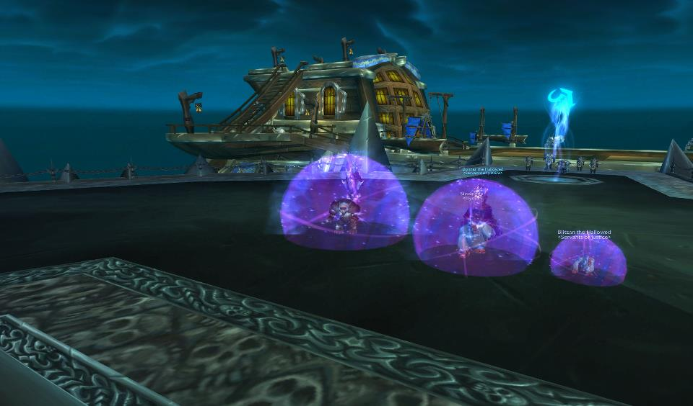

Figure 26. Zoombroom, Blitzan, and Xoot goof off in Icecrown Citadel.
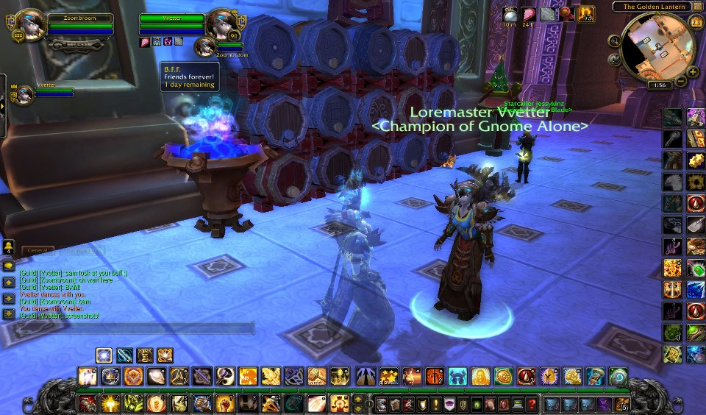
Figure 27. Vvetter and Zoombroom are B.F.F.s!

different interpretations and worldviews, all playing the game in their own unique fashion, allying and befriending who they wanted, when they wanted, and for whatever reason they adopted, not unlike the equivalent IRL processes.

FRIENDS AND WARM BODIES

Technologically-based mediation allowed for a wider range of friendship, and an ease in access to friend-like relations. In interacting cooperatively with other hardcore players - unifying to accomplish specific goals in dungeons, raids, and PvP battlegrounds - I encountered several "types" of these distinct groupings, influenced around very real, very visible socio-cultural dynamics. Whether short-term relationships, or long-term bonds continuing to this day, the sheer prevalence of these unions emphasized their overall importance as an in-game mechanism for power and prestige acquisition. Watkins (2009: 124) framed them as "strong, weak, and temporary ties." I characterized these modes of friend-like relations and stronger friendship in a different light, noticing several distinct contexts during the 2004 - 2011 timeframe in which they were established. As a result, many key components of IRL human social relations wormed their way into the virtual world. These components stand in ambivalent tension to a more pure concept like friendship, that we define through affective ties, with positive connotations. The establishment and maintenance of online ritualized friend-like relations were demonstrated and reinforced through non-affective instances based in convenience, hegemony, power based status, and violent experiences. By no means were these technologically-mediated contexts the "be all and end all" of the types of documented friend-like relations and on-line friendships found in MMOs (in general) and WoW (in specific). In fact, I suspected they only cracked the surface of the types of relationships capable of being formed, or transformed, by and through online intimacy. Unfortunately, being privy to such a low percentage and distinct population of WoW players (approximately 1% of all players fit the hardcore lifestyle) I was not able to interview/survey more casual playstyles.
As my WoW informants attested, without trust, cooperation, and practice, completing in-game tasks would be near impossible. Pena and Hancock (2006: 106) found "many more positive than negative messages" exchanged in the online multiplayer games they observed. Their "data suggest that online video games, even ones with ostensibly violent objectives (e.g. to duel or kill one another for points), may involve substantial amounts of positive socioemotional communication" (2006: 106). I outlined some of the challenges of mounting a raid in-game from an organizational and material farming standpoint. Toastedbread (post to author, March 18, 2013) documented the many uses of IRL technology like vent "to communicate and organize during raid times," websites for "guild forums to organize scheduling or reschedule if key people were going to be gone," and "having class specific channels [e.g. where all the warlocks of a raid group could chat and prepare for boss fights] in game to try and organize." Drawing on multiple forms of communication was especially important for the more complicated fights "like Leotheras which required warlocks to seek our fire resist gear to step out of our normal roles and tank." Raiding worked similarly. From formal guild raiding to Ahroo's PUG, these raids faced bosses of all shapes and sizes, using required cooperation to defeat. In a PvP battleground or a PvE raid dungeon, as spells were launched and players charged into battle, as critical strikes and area-of-effect spells lit up my screen, as I scrambled about keeping my allies (and myself) alive, adrenaline coursed through me and my heart hammered my chest. Only practice, communicating through VoiP, proper reaction, and raw instinct (and sometimes luck) drove a team to victory, completed a goal, or saved a player's life. Zoombroom identified the challenge in "playing a game like wow, you need to rely on a group of people preferably friends to progress and also helps if you can enjoy your experience rather than be miserable around strangers that only think of their own interests. And remember, friendship is magic especially virtually!" Vvetter (post to author, March 18, 2013) discussed the importance of "progression" to raiding and the inevitability of wiping (losing) to raid bosses: "Of course it could become mind numbing but you have to try, try again to get to your goals in life." He added that "without teamwork you won't go anywhere in life," asserting that in WoW, "you can't work alone, someone is always there to help you." The contrast to these situations were raid groups not built off of companionship and respect, but off of convenience.
Players often tolerated other members of their raid or their guild, not because they enjoyed playing with them, but because they helped them acquire the items they wanted. Vvetter mentioned the names of several players he reluctantly grouped with in-game. He was forced to raid with them even though they "screwed up accomplishing my goals" not because he wanted to, but because they were members of his raiding guild. His view on this situation was practical, noting that "you can't like everyone [in] life, just deal with them and move on." When these individuals broke apart the guild he was a member of at the time, he moved on to other options. Xoot enjoyed raiding with his in-game friends, in particularly the players he had raided with over seven years. As time progressed, after the guild he and Vvetter shared disbanded, he joined other raiding guilds. The longer he participated in this new guild, the less happy he was. "Some points were fun and I could enjoy everyone, other points you were just raiding just to get loot and it was boring." He phrased this aspect of raiding as just "joining a group of assholes just so a friend can get his stuff. When the goal was just get the loot versus playing with your e-friends it becomes frustrating." Chromedome noted that it was often easier to play with players you did not particularly like, suggesting:

it was easier to bring them in and have a chance at progression the[n] having to find warm bodies. Recycle ppl just is faster no need to reloot them or explain to them there roll [sic].

Star (post to author, March 18, 2013) agreed with these players, finding himself in raiding situations he did not enjoy, but tolerated:

There were certainly people I didn't like raiding with, especially back in the 40 man days. It's almost impossible to find 39 people you're going to get along with. There were always sub groups within the raid of friends, and sometimes I didn't get along with individuals or groups of individuals. The only time I really disliked raiding overall though was near the end of classic wow raiding [because the guild Star was in disbanded].

He attempted to explain why he tolerated these raiders, mentioning he was often "in some sort of leadership role in a guild and felt obligated to try and keep things going. I also always had some group of friends so keeping the raids going for their sake and mine was important" (post to author, March 18, 2013). He held a perspective very similar to Vvetter, noting, "at the end of the day, we raided to advance our characters so I was willing to put up with some amount of BS from people in order to advance my character. The odds of me finding another group where I disliked no one was almost zero" (post to author, March 18, 2013). Zoombroom noted the difficulties the Alliance side of Shattered Hand faced at the conclusion of Cataclysm, including the inability to find enough players for raiding. He cited a situation where he found himself raiding with people he did not care for, yet had no alternative:

Well once you and others left that's when it started to get a bit too not enjoyable. Seems we started to get more people there for loot than friendship/fun and people started to become unreliable or defensive about everything. I put up with it because it was the only raid going on Shattered Hand and because of the few others that I liked were still there.

When I asked him how he raided in these situations when it did not sound very enjoyable, he stated:

I pretty much just did what I was told and adjusted my dps when I started to learn the fight a little more to manage my cds a bit better. I also ignored the drama when it happened and felt keeping quiet in vent also helps people cooperate with you since they don't think you're some loud mouth dummy.

In addition to relationships of convenience, raiders united around partnerships formed through formal policies of hierarchy and power distribution. Many of the raids I attended relied on a formal distribution of raid loot entitled "DKP," an acronym standing for "Dragon Kill Points," a system originating in EverQuest to reward players with the most contribution to the raid. Raiding guilds in WoW used DKP to distribute the epic (or, rarely, legendary) items dropping from defeated Raid Bosses. Because each Raid Boss only dropped limited epic items each week upon its death (2-3 items typically), a system tracking player contribution was needed. Ideally, each item was given a point value and players bid on or spent their points on any item that dropped. Players earned DKP for each boss kill and ideally would be able to spend their points in order to purchase an item. DKP was controlled by the officers in charge of the guild. As individuals charged with organizing raids, inviting and kicking (removing) members, managing DKP allotment, managing attendance, analyzing raid performance, inviting members into a raid (especially for fights that require a particular raid composition in terms of race, class, situational awareness, or special abilities), guild leaders and officers represented the dominant ideology. They communicated guild rules and regulations, enforcing their brand through loss of DKP, loss of raiding rights, or even loss of guild membership.
Star, who was an officer in <Indomitable>, but not in his other guilds, held an insider-status on this process and observed purposeful strategies to reinforce power hierarchies. Other players, choosing to remain anonymous, but who served in verifiable officer roles also commented on the prevalence of these events. Star (post to author, March 18, 2013) noted frequent misuses of acquired power, suggesting it was "the same sort of abuse that you see sometimes at corporations:"

people trying to give promotions or special treatment to their friends, etc... Everyone sees things differently though, a lot of people in indom thought I was corrupt too. Biggest problems were when people who had some sort of relationship IRL were in the group at the same time, since if they didn't use their position in game to help the other person out they'd take shit for it IRL where its [sic] harder to deal with.

Star noted some of the reasons he "put up" with players while in his officer role. He equated this role to something business-like, finding similarities to running a guild with organized corporate culture (post to author, March 18, 2013):
Maybe I'm an officer and I put up with someone who is an annoying pain in the ass because they are good at their job in the raid. sometimes that was the situation in wow, or the reverse. one that you missed is that this person is a useless douchebag [sic], but they have 3 friends who we need who will leave if we get rid of them. thats [sic] a situation that rarely happens in a workplace since there are bigger consequences to leaving for the other people. like at work if I hate my boss but the job is good, I might put up with them. I wouldn't call that a friendship, not sure what to call it.
Toastedbread (post to author, March 18, 2013) also noticed the role power played in affecting in-guild and raiding relationships, commenting:
Oddly enough one person was a guy who was in my first guild with me and we were friends for awhile. Even was invited to his wedding. But once he was an officer just became annoying and power did corrupt. Became very ego centric and a know it all of sorts.

Found out after the fact he blocked people for loot. Loot council situation for awhile. Also a melee based officer group. Two rogues. A warrior and a feral Druid and a holy pally. Also when the guild died he looted a good chunk of pricy items from the guild bank. Also left the guild for a better progressing guild but came back. But with an air of elitism.

Chromedome mentioned a situation where he found himself at odds with his guild leader. A player who had abandoned the guild and server transferred off Shattered Hand returned to the server and to the guild on his alt. The guild leader allowed the player to raid with them again, despite Chrome's opposition. Months later, the player and his in-guild friend led a "mutiny," as Chrome phrased it, breaking the guild apart. When I asked Chrome why he thought this player, and this player's friend, who also server transferred multiple times, were so easily forgiven, he mentioned the following:

[I] didn't [NAME OF GM WITHHELD] did. We just accepted what [GM] said but we never had trust in them again. I was always against bring[ing] in there alt[s] and making them O[fficers] again.

In viewing these testimonies, and the information from informants who mentioned names of players who stole items from guild banks, left guilds in the lurch through server transfers, ninjaed items, and fractured guilds, I wondered why guild and raid members accepted situations they did not agree with.
Ultimately, I found these in-game relationships were built off the IRL process James Lull described as hegemony. In this case, power became accepted by players under the dominant ideological stream of the guild's officers (Lull 2002: 62). The raiders' willingness to follow guild laws operating in what they perceived as their best interest, included accepting online raiding partnerships they did not agree with, friendships and situations of convenience they would not entertain IRL, and tolerance of players not necessarily friends, but were means to an end. These forms of cooperation between the "information-diffusing, socializing agencies" and "the interacting, cumulative, socially accepted ideological orientations they create and sustain is the essence of hegemony" (Lull 2002: 63). Maintaining an effective hegemony, Lull asserts, is a continual process, one requiring the individuals under the dominant ideological stream to accept the dictated terms as the norm. The concept of hegemony was particularly useful for understanding the unbalanced relationship existing between raiding guild members and the raiding guild elite. As Weber (1965: 117) wrote, power was critical to the relationship between leaders and followers, as well as the maintenance of prestige and status. Power was a valuable tool—it allowed leaders to control the distribution of knowledge or other cultural items (raid spots, guild membership or rank, access to epic or legendary items), as well as economic interests (ability to acquire and continue to acquire valued or prestige items, mounts, titles, and achievements). Foucault's discussions on governmentality helped me refine this discussion and clarify the “why” in “why players put up with loot distribution shenanigans.” The relationship between guild leaders and their members fell under Foucault’s definition of government (any activity affecting the relations between different selves), discussed in Hardt and Negri’s (2000) concept of the role of the state in creating a culture and identity that becomes the “authorized” version. Much like Lull’s discussion of hegemony, Foucault emphasized the important roles everyday individuals (the rank and file guild members reliant on officers for a raid spot) play in their relationship to a dominant governmentality (a sovereign social institution, like the guild leader/officers). Like governments, they were social-organizing forces, but in-game their control was restricted to the shaping of economics-related activities as well as the distribution of power associated with gameplay, and the acquisition of in-game items and prestige.
Relationships forged between dominant and subordinate groups were grounded in persuasion. Either the powerless were persuaded the manipulation of access was a normalcy or something else was at play. Perhaps these guild members did not want to lose access to their regular raid spot. Perhaps they were patient, knowing their access to these epic items would eventually arrive. Perhaps they saw themselves as easily replaceable by the dozens of applicants top guilds received. Perhaps they were satisfied with their position, finding regular access to top level content and regular epic item upgrades. Or perhaps power was inscribed in everyday guild life (Lull’s hegemony), grounded and shaped between the powerful and powerless (in a way whereby the powerful are seen as contributing the most to the guild, and therefore deserve faster or better rewards), and continually reinforced through gameplay. The end result can be described using Foucault’s notion of normalcy: everyday roles of guild members (even with gaps in access to gear drops) bore the “stamp of normalcy”—those in power control the direction of the guild because they are viewed as the most knowledgeable, the most powerful, the most capable of defining and mediating the conditions in which raids play out. Those who disagreed or resisted were removed. Those that said nothing, fell in line, reinforced and recreated a persisting hegemony, a persisting normalcy, an “existing state of affairs” that was fixed as “always meant to be” (Hardt and Negri 2000: xiv-xv).

Virtual(ly) Disconnected

Throughout this chapter, I explored aspects of modern social gamers, focusing on the types of relationship hardcore gamers entered into. I noted the case of Ahroo and Acec, who had never met face-to-face, yet juggled not just the logistical coordination required to lead a raid, but also conversed freely over Vent, congratulating each other on their victories. I discussed the bonds unifying these players, stemming from their enjoyment of raiding and the shared emotional achievements obtained through learning, practicing, and defeating raid encounters. These players shared goals, communicated effectively, and focused on defeating fantasy creatures using melee, ranged, and spell-based attacks. Despite their observable intimacy, I felt a "disconnect" between myself and my own online relationships, a nagging itch suggesting my virtual relationships were "virtually" real (instead of "truly" real). I fought this disconnect. I resisted the urge to dismiss my online relationships as "less than valid" than my IRL ones. I wanted to understand - I wanted to feel - the level of intimacy I observed in my informants. The hesitancy I experienced, the same hesitancy I face now, prevented me from a complete emic understanding of this form of virtual relationship. I bought into the notion that "human existence - having always been mediated through the senses or some other media - has always been virtual and that cyberspace is another media through which we experience the real" (Miah 2000:221). I just possessed too much doubt to be one of the true believers of this perspective. That was not to say I did not try to accept and understand this emic perspective. I was beholden to too many doubting perspectives (academic and IRL) that found virtual relationships to ultimately be different and less authentic than IRL ones.
I close this chapter with a reassessment of the hardcore individuals effortlessly straddling both IRL and virtual worlds (see Figures 28 and 29). I may have understood how to excel at WoW, but the process of conceptualizing not only their friendships, but
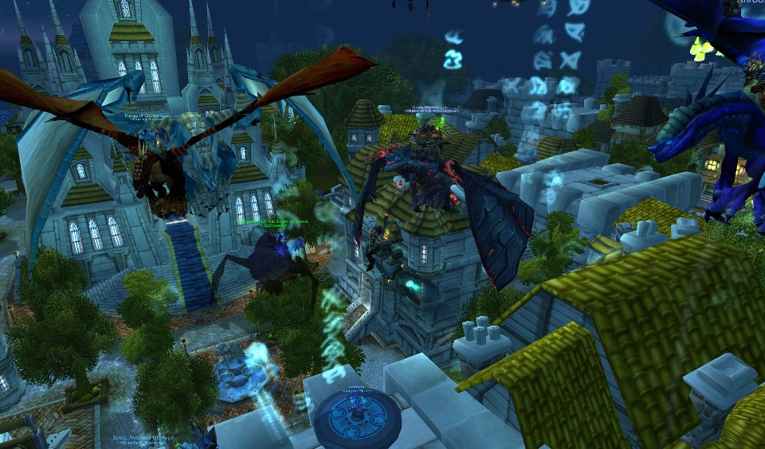
Figure 28. Arathene receives "Dragonwrath, Terecgosa's Rest."
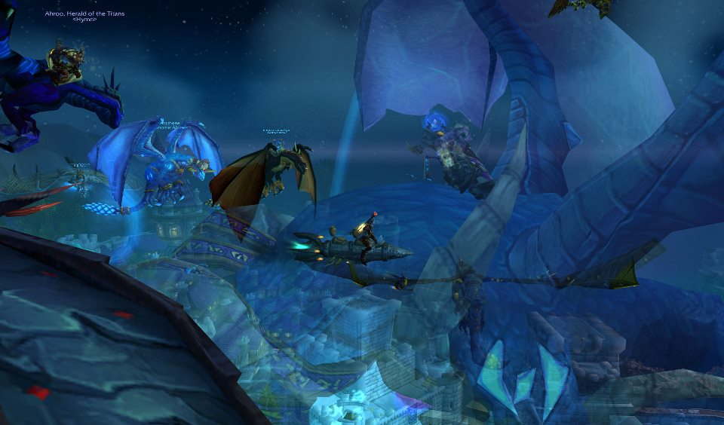
Figure 29. This legendary staff turns Arathene into a blue dragon.
also the relationships they formed in-game that were not as friendly, was a long and fascinating one, requiring years to realize. The more I immersed myself emically into WoW - playing alongside other hardcore inhabitants of the game world, learning the mechanics of game play - the more I understood the power of their relationship-building. I listened closely on Vent, focusing on the interaction of the players, “listening” and “watching” with an ethnographic lens as they conversed through in-game channels, world channels, and guild channels, but the convergence of so many social media hubs challenged the ways through which I communicated with these players. These informants media-hopped, their conversations cited articles, pictures, memes, and so on from exterior media. Topics of conversation veered from within WoW to the virtual world's exterior, and relied on coded words to follow which website they referenced. "MMO," for instance, referred to the www.mmo-champion.com news site and forums. "General" was the WoW General Forums. "World of Logs" was www.worldoflogs.com, a site allowing players to capture, post, and analyze their raid statistics. I participated in their use of out-of-game channels, like Ventrilo, Teamspeak, and Skype, or social media platforms like Facebook. Grounding virtual ethnographic research with IRL anthropological methodologies was difficult in these cases - the speed through which these informants multitasked, or switched conversations, or changed subjects was remarkable. Donnar, Blitzan, Titoness, and Chromedome often referenced movies and television shows, or other websites, they watched while raiding (while clearing trash or between wipes).
I quickly realized that distinguishing between “real” and “virtual” when discussing human social relationships, especially in terms of the theoretical concepts each of the virtual ethnographers chose to examine, only emphasized the “gap” or “void” existing between “the real world” and “the virtual world” and ran the risk of "distracting from the realness of on-line experiences." (Miah 2000: 200). I needed to rethink this disconnect, this whisper sticking with me, plaguing my online interactions, making me question whether my "feelings" and "emotional bonds" were real or simply virtual expressions of online connections. Fortunately, as I mentioned previously, Porter (1997: xi) offered some insight on my plight, discussing the nature of cyberspace itself in shaping cultural “norms” and “reality”: just because there was an absence of the “physical” (the “real”) inside these online worlds, he wrote, did not mean the presence of a void or emptiness. People logged onto the internet in order to be social, not to hang out with "nearly" friends. To meet, to hang out, to discuss, to play, represented “intriguing form[s] of social space” (Porter 1997: xii). People downloaded their bodies into new representations, crafting virtual imagery from the recesses and influences of their cultural histories (Ito: 1997). As a result, we, as social scientists, should, Porter asserted, identify distinctive, defining characteristics of the internet that constructed it into a cultural sphere (the real embedded within the virtual), embrace and examine the sociological considerations of these virtual communities on their own merits (the virtual embedded within the real), and work to understand what it meant (psychological and culturally) to be both part of a virtual collective, but also a configured virtual individual.
As I complete this conclusion I listen to Beach House's "Bloom" album (2012). The final track on the album, "Irene" repeated the phrase "It's a strange paradise" over and over to a steady beat:

Though you hardly know her
The lights on its way
The hand that rests upon it

Still wanna stay

No way of recognizing
The cat knows the call
Fair child is rising

There's no mystery at all

It's a strange paradise
You'll be waiting

I closed my eyes; I relaxed. I thought of Chromedome, who professed an almost magical power to his friendships.
"I'm weird," he told me. "I think that there's a level you get to where no matter how much we talk or interact I still think of you as a friend. And will always be there for said person. Even if they are not the same way. Once I give someone else the ability to control outlook/attitude I am empowering said person."
Truth be told, my fascination with the void, the disconnect, the gap, the chasm - however I wanted to phrase this "virtually" or "nearly" I observed among my informants - just needed to be set aside for a few hours, a few days, a few months, a few years, for the length of time it took me to make that final transition, that final emic leap, from gamer into the "strange paradise" of the Post-human Gamer.

CHAPTER VI

REFLECTIONS ON FIELDWORK

IN wORLD OF wARCRAFT

Twilight

WoW's virtual world is a reflection of our own. Unsurprisingly, just as there is "gloom" in the real world (taking the form of social stratification, powerlessness, elitism, and other forces), these same cultural-wrought shadows lurk in WoW's virtual corners (Watkins 2009: 150). Topics of this sensitive nature require the attention of digital ethnographers willing to turn an inward eye and apply political-economic lenses onto these virtual cultural expressions. Deconstructing the ramifications of the hardcore gaming lifestyle necessitated such an approach. To this end, I focused this chapter on the post-ethnographic considerations of my examination of hardcore Post-human Gamers, focusing on aspects of this lifestyle that lack the luster of even the most idealistic portraits of the internet (as Ito would phrase it). Identifying and conceptualizing IRL anthropological notions like "virtual stratification" and self-destructive "virtual addictive behavior" appear out-of-place in a fantasy world of Elves, Gnomes, Dwarves, and Orcs. However, neglecting to critically analyze their presence in this virtual world simply because the stage is a video game does injustice to the many players who directly experienced these forces in their IRL and virtual lives (or both, as the case may be). At the same time, ignoring cultural phenomena like "addictive behavior" or "going native" when these patterns factor into a game encouraging persistent and repeated play, and impacted my own research choices, represents a lack of emotional and academic maturity on my part.
In previous chapters, I outlined the strategies I employed in developing my research. In this chapter, I discuss the post-ethnographic considerations, including a reflection on my informants’ hardcore playstyle and the ramifications of this playstyle on my own journey. I author this chapter in the hope that future digital ethnographers willing to study these - or other - hardcore players at their level prepare themselves for the emotional, physical, and mental challenges that await. This holds true as digital ethnographies expand into areas previously unexplored requiring the ethnographer to situate him/herself within contextual scenarios and playstyles of which he/she may not be entirely familiar. For instance, assuming the lifestyle of these hardcore cultural groups - participating at their level - presented risks, especially when the ethnography necessitated an alteration of one's daily way of life. Adjusting to these physical and mental changes of this fieldwork, like altering sleeping patterns so the ethnographer could stay awake all night and sleep in the daytime, thus aligning him/herself to peak gameplay hours, presented very real dilemmas to the uninitiated. The excitement generated by the internet, and the potential found within studying the many cultures housed in its confines - especially that of the hardcore gamer - glossed over these perils and lifestyle changes. As a result, I entered the hardcore lifestyle unprepared for these dangers, unsuspecting of the ease with which one could potentially "go native,” and lacking a sufficient fix for this dilemma or a language through which to express my situation. I have this language now, and I have the wherewithal to express myself. I still do not have an explanation for my own behavior. Hopefully that explanation will arrive in time. Perhaps I was more susceptible than other players, perhaps my own inexperience with hardcore gaming meant I poured too much of myself into this quest, or perhaps I wanted to "visualize" the emic perspective of this lifestyle, regardless the cost. Whatever the reason for the pathway I followed, my longitudinal "damn the torpedoes, full steam ahead" approach offers constructive advice for future digital ethnographers seeking to embark on their own ambitious projects.
The beat of anthropology goes around and around. It is a continuous cycle, taking theoretical frameworks previously drawn upon, incorporating these intellectual considerations into future arrangements. It is a wheel, a circle, a snake swallowing its own tail. I traverse its spine, considering and reconsidering the beginnings and ends of this research simultaneously, watching from afar as my academic journey commences and concludes. Perhaps this is why - though I have quit playing WoW - I find myself dreaming of replaying the game, not necessarily to reconnect to this lost past, but to feel the initial sense of wonder and confusion as I set down those wooded Teldressil pathways. In these dreams, I returned to my virtual infancy, before the darkness set in. I dreamed of the time I worked out the mechanics of gameplay, questing, and PvPing, when I first learned how to defeat dungeons, heal properly, and when I experienced the thrill of raiding and successful boss kills. When I established friendships and developed an in-game reputation and legacy. This ethnographer wants "it" back. I want the time I misplaced (wasted?); I want to revisit all the IRL relationships my decisions affected (hurt?). I want a chance to recover myself, my life. I want to be free of this past, the pathway unfolding in the dark, that which encapsulated years where I saw only the night sky and spoke only with people I never saw face-to-face. I want to recover my memories of the light.

Night

Despite WoW’s cartoony appearance, this virtual world was not all serenity and joy, nor was my ethnographic fieldwork neat and tidy. In fact, my conceptualization of WoW as a virtual world simplified much of the activities unfolding within its grounds, glossing over the decidedly IRL actions and reactions, and the consequences of the hardcore lifestyle for its participants. The ramifications of the hardcore lifestyle were unexpected. As I outlined in Chapter 4, to excel at WoW - to not just be “good,” but play at a level where one participated with the upper echelons of WoW players and cleared heroic level raid dungeons - hardcore players devoted a great deal of time to the game. The actions of these players created a fertile ground for IRL political-economic and power-related dynamics motivating hardcore behavior within WoW, including the never-ending quest for prestige and status items and non-abstract concepts like virtual player stratification. WoW's dark side manifested very real hierarchies through its players’ selective usage of in-game culture - as Fredrik Barth (1995) would phrase it - to reinforce particular dominant ideologies. Through my collaboration with my informants, I discovered these expressions of power by elite level players, guilds, and guild officers were not fostered or encouraged in-game by the developers, but rather sprung from a crafted and maintained pattern of in-game player culture. The hardcore life was a hardcore quest for in-game status and elevated player power. The acquisition of this status grew not only from the items players wore in-game, but also the accomplishments a player, guild, or raiding group racked up, ranging from raid progression, to server first Raid Boss kills, to elite-level achievements.
For these hardcore players, WoW substituted for "real life;" it was a fantasy-world projection of IRL considerations and realities with very real IRL costs. Tockaray, a hardcore raider from <WarEnsemble> during Vanilla WoW/TBC labeled WoW as "a great form of escapism from my terrible home life." He played in high school for four years, achieved server first Raid Boss kills, and characterized WoW as an important variation on "real life" (post to author, March 2, 2013):

The obvious element of having that common activity, that thing that you all do together, is what makes games like that different from other regular internet interactions like chatting or whatever and particularly in the sense of hardcore gaming, where you spend so much time with it, it starts to feel as real as your real life. I would think sometimes how it would be weird that the internet could have your brain totally convinced that you have friends and you're being active and participating in things when really you've just been sitting alone in the dark for 8 hours.

Tockaray's insight fascinated me, going to the heart of the "disconnect" I discussed in Chapter 5. Much like my informants’ dismissal of the difference between IRL and virtual friendships, the amount of time spent playing WoW allowed it to align more closely with real life than non-players would possibly accept. Boellstorff suggested the virtual world he explored, Second Life, was a reflection of the physical world. However, in extending this metaphor, I view any image cast in a pool of water as one which never quite matches its source. The reflection blurs. It shivers the movement of forces beyond observation or control. It is not a “neat and tidy” reflection. Analyzing these refractions requires adjustments, a need to tip over the ideological toolbox, mix its contents with the reflected (refracted) images, and see what bobs to the surface. In that sense, thinking of my informants as individuals divided between two realities (not a reality and a virtuality) feels like a fair assessment. Though players chose from clearly inhuman races (gruff and surly Dwarves, nature-loving Minotaur-like Tauren race, Asian-inspired Pandaran, and so on) that demarcated WoW as a clear fantasy world, enough time was spent by these players online to construct a genuine reality out of this virtual reality. This theme carries through the remainder of this chapter.
In Chapter 4, I outlined the time and farming requirements hardcore raiders satisfied in order to raid at the game's highest difficulty levels. These "time sinks" have gradually shrunk with each subsequent expansion; however the cost to a player's IRL life remains the same. Players who could not commit significant "blocks of time" to the game, as Itsgeorge and Arathene both attested, could not realistically raid at these levels. This time commitment necessary to acquire the very best gear and ancillary items (titles, mounts, and so on) was best summarized by Itsgeorge:

Raiding was a second job. You gave four or five days a week to this process, staying up until midnight or later. Your friends expected you to log in and play. When I quit, it was because my wife and I had a baby. I couldn't commit hours in a block anymore. I have a hard time finding twenty minutes to string together to play "League of Legends" now. If I play anything, my daughter is usually sitting in my lap, watching me play.

In addition to raiding, players were also expected to optimize their statistics, use the most advantageous in-game items and professions (e.g. the Leatherworking profession in the Sunwell raid), reputations, daily quests, reagents (e.g. farmable materials like Ghost Mushrooms and Whipped Tubers for the Naxxramas raid), and so on, even repeat these very same processes over and over again. For guild officers, there were added responsibilities, like raid leading (M), running the guild bank (Jeffrey), or tallying the guild DKP system (Ahroo). There was no opt-out for these daily activities. In order to compete for world or server firsts, the game took priority. The effects of this lifestyle on the lives of my informants varied from significant to minor. Star (post to author, February 27, 2013), for instance, noted he was "totally addicted" to the game when it first came out while he was in college:

I ended up scheduling the rest of my life around WoW for a few years, even working night shifts to make sure I could raid. I really enjoyed the game back then thought, so I don't really look back on the time negatively.

Given his devotion and skill level, Star's WoW choices resulted in regular participation in server first boss kills through the guilds <Skyfang>, <Indomitable>, and <Royalty>. Itsgeorge stressed how raiding became like "a second job." He played 4 - 5 nights a week, raiding for hours at end, ensuring these "blocks of time" were always set aside. Vvetter lived the hardcore life in a similar manner. He said (post to author, March 16, 2013):

When I was hardcore I did what most people did, lose sleep, eat crap food, did bad in school. Rush home from work just to raid or other things in WoW. When I was addicted to WoW and became hardcore I actually lost contact with my past online friends as well as my IRL friends. I left WoW for my first GF [girlfriend] because life was just much better off the computer. Then I came back when that relationship was over. This happened for three girls.

Brishal found this lifestyle too taxing and repetitive, especially considering the varied interests he had in and out of the game. He wrote (post to author, March 7, 2013):

I stopped playing WoW because their business model grew boring. Once I realized there was going to be an expansion pack every few months that essentially wiped out the end game content that we all worked so hard to achieve, the game became significantly less fun. I think most of the fun from WoW could be attributed to the fact that you could essentially acquire most of the best items in the game, given that you put in the proper time, and you could still find things to do to keep it fun (raids, pvp, etc.). I think the fact that there was an end in sight with the game, kept me coming back for more. When I realized there was no end in sight, and that there would never be, the game became stale for me. Overall my experience playing the game was great. I could see where a game like WoW could destroy someone's life, but I was always finding time to do other things. I've always been a well rounded person and because of that my experience in the game never negatively impact my life.

Acec (post to author, March 7, 2013) agreed with Brishal's assessment, noting, "The conclusion I came to was I wasted a fair amount of time and money on something that junked everything every other year. That may be more of a reflection of the game itself than anything else." Other informants addressed a range of issues surrounding the scheduling and attending of raids. Toastedbread (post to author, March 18, 2013) mentioned a difficulty with poorer grades as a result of the length of time he committed to his raiding schedule. He played WoW while in college and revealed his grades "did suffer a little" as he combined WoW with his undergraduate classes. Ahroo lived and worked in California, but played on an East Coast server; as a result he had to "rush home" from work each evening to make raids on time:

Of course, lots of times I was eager to be at raids on time to get the invite or whatever (say in the <Indom> period) (l was always in because I was an officer/DKP dude). Lots of time I had to rush home or do this and that to make it, and I got upset at others when shit didn't happen or were canceled. I dunno, no matter what, you will put raiding at times over other things, especially during progression. Another issue is if you're a healer or tank, forget it, you almost gotta be there 100%, can't slack like DPS [damage dealing players].

Tockaray (post to author, March 2, 2013) viewed WoW as a sort-of "reality" in and of itself, a portal offering links to people he never would have met IRL. He emphasized the virtual friendships he experienced, commenting "I met my current IRL best friend of five years in game. I still keep in touch with a lot of people that I knew in game but still have never met IRL." Donnar remarked how he also raced home each night from work in order to play with Ahroo's 10 Player PuG, pausing long enough to "make something to eat" before staying up until six to eight in the morning. He cited the power of the social interactions in holding his interest, not the game itself, which he characterized as "work." In this regard, he emphasized the stress he experienced through PvP Arenas, his primarily point of interest:

I don't have fun actually playing. I have fun winning. It is work. I'm doing the work, I'm managing my cooldowns. What happens if they get lucky? What happens if they get some double crit? 15 minute arena match, and the only fun I have is that 5 seconds when I know everything is going to be ok.

Zoombroom remembers playing "12 hours a day" on his off days from work, but mostly he tried to stay in the "4 hours a day" range, playing from approximately midnight to 4 AM:

Some days I had off years ago I do remember sometimes playing 12 hours every now and then, but I've never seem to get "captured" by the game as much as others. Not sure if I want to play more presently or not, sometimes I think about leveling an alt but then think about how much a hassle it is to do this expansion. So currently I only have Zoombroom at [Level] 90 and just do a few things or nothing at all on her most nights. When college is done I'm not sure if I'll play more or not, kind of want [to] work on other things once I'm done.

Titoness (post to author, March 16, 2013) recounted the struggle to engage in a hardcore raiding lifestyle, school, and family life. In this sense, even in face of the many positives the game offered his life, something had to give. He often found himself:

...rushing to make raids on time, which included speeding, getting tickets or things of that nature. Some of the more harder things was if the raid went late, you don’t want to be the one to leave and miss that awesome first kill. So lack of sleep was another issue...which in turn made school harder, functioning as a productive person harder...and personal relationships harder. But, again, to me those were minor in the end...I mean...when all that is happening is hard, frustrating, and upsetting...but when I think about it now...it was what I enjoyed, more than the things I was missing out on in real life. Now for me, some of the positive things that came from the game and I said already was the friends I have, till this day. The experiences I will never forget and things I’ve learned from some of the amazing people I met. I learned patients, acceptances, and when to take charge of situations.

Each of these informants mentioned the necessity of "keeping pace" with other faction or cross-faction competitive guilds and their peers. This collective arms race mentality meant hardcore players as a whole dictated the pace set and the path taken to achieve server first boss kills, top DPS (damage per second), TPS (threat per second), or HPS (heals per second) ratings. As an example, much of my participation in Vanilla WoW and TBC outside of raiding involved these repetitious tasks, including:
- the Argent Dawn reputation grind (for the best shoulder enhancement at the time)
- the Zul'Gurab reputation grind (for a head enchant and an even better shoulder enchant)
- turning in raw materials to help Shattered Hand open the Ahn'Qiraj gates and unlock the Ahn'Qiraj raid dungeons
- completion of the pre-nerf Wintersaber Trainers quest lines required to purchase the Wintersaber mount
- the original honor system grind, reaching Marshal, very near to Field Marshal
- "the Insane" title grind, requiring exalted reputation with various obscure factions

Why were these upgrades and grinds so important? What would propel a player to engage in these repeated tasks? In a word: status, a demarcation Taylor (2006: 67-92) noticed in her interaction with power gamers. Like in EverQuest, endgame raiding in WoW was the ultimate motivating factors for what make hardcore raiders, hardcore raiders. The epic items bosses dropped were the carrots on the stick. As Ahroo noted, because he came from Star Wars Galaxies (SWG), he had never experienced anything so "epic" as a MMO raiding encounter:

Technically [raiding] was new to me coming from SWG, where there were no raids. Your whole group had something to do besides PvP all day like in SWG. Also, [it was the] only place to get better gear and fancy items and show them off to the server. Taking bosses down in a huge group was awesome.

With each subsequent raiding tier, more powerful items became available, typically part of a set of eight matching pieces that together formed a class-specific gear set. I outlined these raiding tiers in the appendix to Chapter 4. Each of the tiers I described had sets associated with them. Many players collected these sets, seeking to acquire armor and weapons with higher item levels. For example, Zoombroom in the Tier 14 raid acquired all the Paladin-centric tier pieces. It took him from the MoP release on September 25, 2012 until February 26, 2013 to complete this set. He received the final item, the helm, and completed the "White Tiger Battlegear" set. Five months of running the same instances each and every week, hoping to pick up that last item from his tier, represented the dedication required to obtain every piece of armor. His case was not unusual. Other players waited significant periods of time for needed item drops. Heroic rogue gloves remained elusive for Star all through The Firelands instance (Tier 12). Arathene missed out the Tier 11 Priest helm off Cho'Gall because the necessary reagent never dropped while he was present in the raid. Ahroo never received the shield he wanted from Felmyst in the Sunwell Plateau instance (Tier 6.5) while the TBC expansion was active. M missed out on the Druid helm from Naxxramas in order to complete his Tier 3 Dreamwalker set. Prestigious in-game items were not limited to armor or weapons. Rare mounts and hard-to-obtain titles like "Battlemaster" (for killing 100,000 members of the opposite faction), "the Bloodthirsty" (for killing 250,000 members of the opposite faction), and "the Insane" (an absurdly long reputation grind) held equal import. Chromedome desperately wanted the incredibly rare Ashes of A'lar firebird mount (a 1% drop off the Tier 5 raid boss Kael'thas), only to have it "ninjaed" (stolen) by Shawky.
Over the course of several expansions, the difficulty levels of WoW's raids were gradually and significantly altered, including the creation of a range of raid difficulties. More players than ever were participating in the raiding scene, peaking during the WotLK expansion. As a result of this transformation, both casual and hardcore players were obtaining complete sets of epic items, the reward only hardcore raiders had achieved through Vanilla WoW and TBC. The introduction of accessible epic items that more casual players could grind for outside of raid instances and reduced-difficulty raiding meant the game's design skewed the ratio of risk versus reward. Thus, in order to give individuals with the time and freedom to raid the game's highest levels more powerful gear, Heroic raids were created. The items dropped from Heroic Raid Bosses were the game's most powerful items and featured specific color combinations marking the player as "elite." Once heroic dungeons appeared in-game, these items contained the words "HEROIC" in green text beside the name, further delineating them from their "Normal" and "Looking for Raid" (or "LFR") counterparts. The Heroic items featured more stats than their less powerful counterparts, namely the items obtained from the Normal and LFR feature. Zoombroom, who I mentioned had received his tier helm after a great deal of time and had a long history of raiding Heroic raid dungeons over WoW's expansions, was quick to mention the helm came from the LFR tier. He emphasized the helm came from a lower status boss, and added it was all he could raid since "I don't have a normal raid to work with." My informants, like Zoombroom, may not have collectively judged someone on the basis of their gear, but they recognized the existence of tiers of prestige, strata dependent on the types of epic items a player wore. The power of these rewards in shaping in-game stratification and contributing to a virtual elitism should not be ignored. I discuss these phenomena in more detail through the subsequent paragraphs.

Midnight

My informants likened the acquisition of these items to obtaining social capital - prestige or status. They conceptualized these items as gateways to membership in a higher, more elite, class of raiders, a group that awed the general populace of players surrounding them. The items they displayed in-game were extremely important, not only increasing their collective power, but also offering a very public testimony to their persistence, raid progression, and skill level. Chromedome explained this rationale, mentioning his motivation for standing around in his most powerful gear and sitting atop his rarest mount in crowded public places. "I wanted people looking at me," he said, adding "I had a mod to tell me when people would target me so I would know [that they looked at me]!" Chrome's long history of hardcore raiding, including stints with <WarEnsemble>, <Royalty>, and <Raiding Robots> was frequently on display. During the course of these raids, he remained one of the more progressed raiders on Shattered Hand and enjoyed standing in public, showing off gear with some of the highest average item levels possible. He recently returned to WoW after an absence. He began playing the MoP expansion and ran the Looking For Raid (LFR) level of raids, hoping to use them to obtain some better gear. He found the LFR format to be "faceroll," a term implying an extremely easy process that anyone who randomly rolled their face across their keyboard could defeat. These "fake raids" were "too easy" and "Blizzard's way to get the casual fan back." Disappointed with LFR and his current gear's lack of power and prestige, he hid from public view, AFKing on a flying mount above Stormwind. Though Chromedome ran LFR and PvPs, his change in displayable status and correlating actions presented a strong indication of the social power raiding items held, particularly rare items, or items that had been removed from the game. For instance, Ahroo's favorite raiding tier gear was Tier 3, items from the original Naxxramas dungeon. When the developers introduced "transmogrification" to the game, or the ability for a player to customize their armor and weapons, Ahroo transformed all his gear to look like this rare Tier 3 Paladin set (the "Redemption" armor set). He liked to display this armor in public because "it was removed [from the game] and I did it at the time of content," meaning he completed the Tier 3 set at the time of its release. He also liked the design of the "Bulwark Shield," a large rectangular shield which dropped off the raid boss named Illidan. Wearing these items allowed Ahroo's character to announce to the rest of the server that he was part of a successful guild. Without saying a word, simply by AFKing in a major city, his armor suggested he was a member of "the crew that put shit down."
In a Weberian sense, Chromedome's story (and Ahroo and Zoombroom's stories) offered situations similar to the ideas Giddens (1971) discussed. Giddens (1971: 167) summoned the arguments of Max Weber in his discussion of the "clear distinctions" drawn "between economic possession and status privilege." From the perspective of hardcore raiders, epic and legendary items were used in the creation and maintenance of status groups, communities who "manifest their distinctiveness through following a particular life-style, and through placing restrictions upon the manner in which others may interact with them" (Giddens 1971: 166). While caste is an obvious indicator of IRL status groups, the use of mods created something similar: in-game groupings constructed from displayed gear. Whether they were obtained through raiding the hardest content, acquired in dungeons, or even off so-called “welfare epic venders,” interest in acquiring epic items was high. Additionally, much of the gear, even if it possessed variations in power, held similar designs. In order to more easily distinguish between players, the mod known as GearScore (or GS) was developed. GearScore calculated the power of a player based off the combined value of his/her armor and weapons. This was not an in-game feature, this was a mod created by a player, downloadable to the game, allowing players organizing raids to filter players based on a number of factors. A numerical value was assigned to each armor slot item (head, neck, shoulders, chest, etc.) and players with the GearScore mod were able to evaluate players. Players were judged to be good, bad, elite, noobs, baddies etc. (descriptive terminology is flexibly used in the general chat systems) based off their GearScore. Raid organizers advertising in public had specific GS requirements they asked of their raid members—furthermore, they “inspected” any applicant to their PuG raids, ensuring the player had the required GearScore number. Often, even for the most basic raids, the requested GearScore numbers were quite restrictive, designed only to attract the best geared players. Lesser geared players, due to their lack of quality armor and weapons, were prevented from participating.
Perhaps relying on manufactured stratification to explain video game elitism is trite, but the motivations of these hardcore players over the life of the game was rooted in gear acquisition and achieving/maintaining power disparities over other players. When a player right-clicked on another player's portrait (the icon of a player appearing in the upper left part of the screen), they could "inspect" that player, viewing every piece of armor or weapon equipped on that player. Each piece of armor or weapon contained a listed item level, a number that connects it to a specific "tier" of gear. For instance, the WotLK Tier 10 raid covered item levels 251 - 284. Unless a player RPed, or wore a particular set of clothes for a fashion statement, players typically represented themselves in their most powerful or up-to-date gear, the items they would use to quest, raid, or PvP in. Unfortunately, this made the process of judging a player considerably easy. When a player identifies the gear a player wears, including their enchanting, gem, or reforging enhancements, and makes judgments based off a players level of power, or knowledge of the game, stratification results. A new vocabulary was necessary to fully explicate this discussion, an adaptable terminology specific to studies of actions undertaken by hardcore gamers, yet acknowledging a virtual context to their origin. Degrees of fragmentation occur within the raiding community between more casual raiders and those able to access the highest level content. Despite the majority of the population’s desire to become equal with the most powerful gamers, GearScore and related tools ranking players on the basis of their average item level were developed to reinforce boundaries created in-game, a methodology to preserve the status quo and reward in-game time investment. Just as virtual friendships refract IRL relationships, the stratification and prestige emerging in the gameworld refract patterns of stratification in the real world. These caste-like hierarchies were forged from the differentiation emerging in-game between the “less skilled” or “less geared” player (as defined and redefined by individuals in possession of items of power) and were identified with less-than-flattering language. The fragmentation in this sense, while not tactile or visible, are ones hidden within the coding of the game itself, structures built and designed to protect the achievements of a minority “elite” population, and composed from this population’s desire to remain in a position of power (in-game power) and prestige. They were especially powerful in the gameworld because they allowed players to craft their own in-game hierarchies and attain status, prestige, power and therefore respect on their own terms, in their own reality.
Ahroo observed this elitism on a regular basis, commenting "of course there [was discrimination]." Surface features, like a player's name, a player's gear, or the title they wore were "really all people can go by unless they know your in-game history. Also their name is a big one. Douche names = douches." Zoombroom touched on the kind of traits that were picked on. Typically less-than-skilled players wore armor inappropriate to their class, such as "people with greens with agility when they were a caster." He also backed up Ahroo's point about names like "xxxnamexxx," commenting "usually that was a sign we were dealing with someone special." Examples of the language used to delineate and polarize is readily seen through a simple perusal of the WoW General Forums. Threads and posts reveal a broad discourse of trolling and sarcasm intermixed with legitimate concerns and questions. Just as they did in-game, gamers manipulated words and phrases, adding additional levels of meaning to the words and phrases being mis/used. A good example is the change of “owned” to “pwned” (I owned you/I pwned you). The transformation of the “o” to the “p” created a seemingly nonsensical word suggesting a higher level of defeat, of being "owned." Another example is referring to a player as a “noob,” short for noobie, or a new player. Playful misspellings include writing “noob” (itself a created non-word) as nOOb (with capital O’s) or n00b (changing the o’s to zeros). I laugh at the formality of this semiotic analysis, but these mistakes are not accidental, running hand-in-hand with Salzmann's (1993: 209) documentation of “speech disguise or concealment” among the Hanunoo of central Philippines. He noted that a process of “rearranging, substituting, or otherwise modifying the sounds” of sentences and words leading to the “inverting the meaning of a sentence” in order to joke and tease. In the same manner, gamers purposely manipulate the way particular words are written or even said, leading to the need in an online environment to communicate through the written and the non-written, and understanding the multiple modes by which meaning is transferred is paramount. Having an grasp on an ethnography of communication in this context relies on the researcher to understand all levels of online communication, including forms of slang and casual speaking (Salzmann 1993: 207). Despite the efforts by its creators to frame it as a fantasy-based extension of the real world, WoW is not the real world. It “referenced” the real world—in-game events, names, personalities, and so on - in referencing real world considerations and crafting a translation that differs or alters from its real world origins, it still maintains its many human-crafted cultural traits, even ones that should never have seen the light of day to begin with.

The Quiet Hours

In Chapter 1, I remarked about the need to situate my research and my own personal experiences within the larger analysis of these hardcore players, or what I have termed Post-human Gamers. To this end, I followed in the vein of Rabinow (1977: 6), who wrote of his “encounters while doing fieldwork”:
At that time, of course, things were anything but neat and coherent. At this time, I have made them seem that way so as to salvage some meaning from that period for myself and for others. This book is a studied condensation of a swirl of people, places, and feelings.
In order to aid this reconstruction, I incorporated my own voice into this narrative. This focus remained on-going as I moved from my ethnographic write-up into this post-research "debriefing." Accounting for the post-fieldwork considerations of my fieldwork was a necessary process. Throughout these chapters, while it appeared I pursued my research in a step-by-step process, in truth, there was very little "neatness" to my fieldwork. I stumbled through these years, groping forward, unconsciously burying myself within some subearthen grotto, devoid of sunlight and human contact. It was only years afterward that I achieved the distance necessary to see just how truly "alone" I traveled along this pathway. Yes, I interacted with many individuals in WoW, but this relationship-building was always from a distance, always mediated through technology at hand. It was "I" who determined when to talk, when to chat, when to respond, when to speak. It was "I" who established the pace of interaction, the pace of reaction. As Zoombroom noted, there was always a way to keep "control" of any personal interaction in WoW, always a way to determine how to respond, or if a response was even warranted. Furthermore, in conducting such immersive research, my IRL interactions disintegrated.
I reflect on these decisions with the intent to provide an archaeology of my ethnographic research, warts included. I was ill-equipped to realize how far I had "gone native" in WoW and initially lacked the appropriate IRL guidance to reel me in. I pursued my goal of a hardcore "emic" perspective with abandon. I dug too deeply, wedded to a never-ending quest to maintain pace in what amounted to a never-ending game world. My desire to play butted up against my IRL difficulties and academic responsibilities. I felt anxious and lost. "Unattuned" to reality, I relaxed only after logging in. As a result, I sat alone in my apartment, focused on "keeping up with the most hardcore Joneses" on the server. As Turkle (2011: 296) commented:

...I believe we have reached a point of inflection, where we can see the costs and start to take action...As we try to reclaim our concentration, we are literally at war with ourselves. Yet, no matter how difficult, it is time to look again toward the virtues of solitude, deliberateness, and living fully in the moment.

Turkle discussed the usage of mobile technology in instances requiring respectful attention (lectures, plays, funerals), but her statement has more far reaching implications. The ease and accessibility of mobile technology, and the virtual worlds it allowed us to access, had the potential to create harmful effects within our day-to-day lives. It became easy to forget our IRL lives and responsibilities in the face of a fantasy-based enterprise. Too easy sometimes. I was "at war" with myself, and embraced the ease of avoiding anything outside of the game (Turkle 2011: 296). The cost was significant: I lost a marriage, family members, my own health, my academic standing. I lost people's trust. I lost my way.
If anything, WoW allows the pursuit of a kind of prestige and status, especially the thrill of recognition by others of your in-game achievements. Having a high average item level, a rare title, or an impressive amount of Achievement Points positions you at an upper level within the in-game hierarchy. Displaying my gear, title, Achievement Points, gear, and mount allowed me access to in-game recognition, offering me feelings of personal accomplishment, companionship, and intimacy, granting me thrills I was not obtaining while slogging through a third shift job, dealing with a family member's death, a sense of loneliness, and a non-existent social life. I was not the only person who felt this way. On March 16, 2013, as I was driving an errand, I was contacted by my informant, Chromedome. I pulled my car over and rapidly scribbled notes on the conversation, listening as he relayed the events of his previous evening. Chrome and his friend M had held a heated argument over the positives and negatives of WoW, focusing on why he (Chromedome) chose to still play the game despite the negative effects on their lives. After the argument, Chrome felt a strong urge to "get something off his chest" to me, and could not wait to speak to me. The game, he stressed to me, while not perfect, offered him a level playing field, free from IRL aspects he "could not control."
"I can't control being short," he said. "But I can control who I hang out with. And I can control my achievements in-game."
I nodded, completely understanding his point. In-game, Chromedome had the chance to achieve popularity and success, virtual social capital allowing him to not feel "looked down upon" or "judged" by his IRL friends. He could wear epic items or sit on rare mounts that people would stop, look at him, and say "that's cool." He could make friends with similar-minded people online from "all walks of life," all of whom "had their thing, their own IRL issues." Though he played a Gnome in-game, Chrome stood tall among his peers. WoW raider Benito, or Ben, also wrote to me on this complicated subject. While Chrome spun his experience as positive, Ben took a more serious approach. As Ben relayed his story, I immediately recognized its similarity to my own. Like me, Ben had a long history of raiding with WoW, participating in top tier guilds like <Skill Overload> and <Raiding Robots>. He explained the impact a hardcore lifestyle had on his life, writing the following (post to author, March 18, 2013):

gaming is just like any other addiction, it allows ppl to to [sic] escape reality or fulfill personaility [sic] traits (e.g. leaders, followers, just wanting to be someone else, socializing, being an asshole, etc.) without the social repercussions and consequences. personally i'm a "nice guy" and it fulfilled my needs in those terms. i can also be a strong leader but i was very lost at the time and could not be an effective leader. as much as i wasted a lot of time in the game it prevented me from seeking other escapes like drug addictions. turns out that i got into running and that became a new addiction that replaced gaming. i ended up doing marathons and have only recently decided to stop running from my problems and face reality. i wish i had the support of friends and family to see that i was silently screaming for help because i never learned to properly ask for help. it wasn't until recently that i lost a close friend and had my heart broken for the second time in my life that i finally said "fuck this, i can't waste my life away blaming others, i need to do whatever it takes to get out of this situation, i've led a life void of true passion because i've allowed others to tell me what i should do" so this is where i currently stand, it sucks and it's not fun but at least i know i'm seeking a way out. i used to have a tough time opening up to people but now i know that healthy humans know what it is to make mistakes and will not look at you any less for being real and honest and admitting that you fucked up.

Indeed, for myself and my informant Ben, and for Chrome and the stories of my other informants (outlined below), the game truly created and refracted the blessings and gifts social interaction grants individuals IRL, offering players virtual alternatives for the social capital and intimacy I lost IRL.
Watkins (2009: 145) addressed excessive use of social technology (social media, internet surfing, video gaming), noting that "consequences" exist for players who maintain on-line lives at the expense of their IRL ones. "In addition to the neurobiological effects of compulsive behavior, there are important social consequences. In the case of young people, excessive media use has been linked to problems like obesity, poor body image, and decreased school performance." Nicholas Yee (2006: 22-23) in "The Psychology of Massively Multi-User Online Role-Playing Games: Motivations, Emotional Investment, Relationships and Problematic Usage" cited that 50% of all MMO players find themselves unable to stop playing once they start and 20% admitted to experiencing IRL problems as a result of their addiction. Studies tracking problematic Internet use (PIU), proposes that this behavior "lead individuals to excessive and compulsive computer-mediated social interaction, which, in turn, worsens their [IRL] problems (Caplan 2003: 626). Watkins (2009: 143) wrote of international efforts to discuss internet and gaming addiction, a phenomenon unrecognized in the United States:

The South Korean government has declared war on Internet addiction by training counselors and creating treatment centers. In 2007 South Korea also crafted what amounts to an Internet rehab boot camp, believed to be one of the world's first. Jump Up Internet Rescue School's primary mission is to encourage young South Koreans to put down their keyboards and turn off their computers. As one counselor from the boot camp told the New York Times in 2007, "It is most important to provide them experience of a lifestyle without the Internet."

Watkins identified an individual named Curtis who felt he played too much video games (including WoW) and was taking time off from playing to evaluate his lifestyle. He chose not to question Curtis' actions in too much detail, a choice he included to save this informant further embarrassment. This restraint is noble, but prevents a discussion about a very important, albeit dark, issue present in cyberspace. I feel Watkins missed out on an opportunity to bring this topic to light, a topic I understand all too well. I understand Curtis' plight because I am surrounded by Curtises - I am Curtis too - and each individual Curtis wants his voice to be heard, not just to discuss their connection to the game and to the allure of virtual life, but to understand how this is related to disconnection from “real life,” and make peace with him/herself.
Turkle (2011: 293-294) cautioned against describing the continuous desire to play online as addiction:

...however apt the metaphor, we can ill afford the luxury of using it. Talking about addiction subverts our best thinking because it suggests that if there are problems, there is only one solution. To combat addiction, you have to discard the addicting substance....We have to find a way to live with seductive technology and make it work to our purposes.

She emphasized that "networked culture is very young," that many problems were spiraling from the adventurous pace with which its embracers explored virtual worlds and many solutions beyond simply abandoning the technology should be developed (2011: 294). A metaphor other than simply using the term "addiction" to discuss obsessive internet usage should be embraced. While I agreed with this assessment - and the need for solutions beyond simply going "cold turkey" - the reality of my situation was more difficult and more pressing than simply stating our hopes and dreams. Others experienced a similar plight. As an example, upon hearing the direction of my research, an individual named Omnipotent contacted me. Through our conversation, he identified many positive and negative results from his life playing WoW, including a long struggle with what he characterized as "addiction." He presented an extensive testimony, focusing the period "before" and "after" he quit WoW (post to author, March 3, 2013):
I was a day one player; picking up the game at a midnight release. When I quit after about 4 years of playing, I had over 400 days played between all of my characters. I was a hardcore raider. Over 25% of my life during that time was dedicated to this game. I put on over 50 pounds, lost multiple jobs, saw my GPA shrink to an abysmal 1.5. I lost my academic scholarship, which now has me sitting with over $30k in student loans, rather than graduating debt free. I threw away a fantastic relationship with a great young woman, because I became emotionally unavailable due to my increasing desire to raid.

Today, I have lost almost all of the weight, graduated school (albeit four years later than my original anticipated graduation date), have found a great job, and even managed to purchase my first home. I game only occasionally, and have sworn off MMO's for the remainder of my life. If the game doesn't end when I turn the power off, I'm not interested...I now better understand what addiction is, and how it affects people. It's given me a more sympathetic ear to others who say they are struggling with addiction.
Vvetter, a professional graphic designer, also offered a summary of the time he spent playing WoW, and the period after he stopped playing (post to author, March 16, 2013):

Without Call of Duty I would not have made my first company. Without forming that online company I wouldn't have gone to my first college for graphic design. Then without stumbling into WoW I wouldn't have wanted to continue my education in animation. And without the lessons of addiction I got from WoW I wouldn't have pushed myself in school. And without me pushing myself I wouldn't have the professional career I have now. Overall it wasn't terrible, I mean I still play today, just not hardcore, I certainly cannot. Once I stopped, life kicked off for me in college. Graduated top of my class. Had a variety of ladies in my life. And I'm going places as a professional animator

Blitzan, Donnar's brother, related his own sense of loss as a result of his playtime and hardcore raiding, including a damaged relationship and loss of sleep (post to author, March 16, 2013):

It ruined a six year relationship with a IRL girlfriend...The six year relationship ended when WoW started and me and my brother got so into it I would stay up until 2 - 3 AM playing, which during my gaming career wasn't unheard of. Yet always going to work at 6 - 7 AM but as soon as I got home straight gaming maybe a nap first sometimes.

Cygany felt he prioritized the game over other aspects of his life, a decision he came to regret (email to author, March 18, 2013):

The negative part of hardcore raiding for me was not so much the amount of time each week raiding, but the priority in my life that I gave to it. I found myself wanting to work my schedule around raiding. This proved to be a little stressful. When playing games casually, it is easy to play games for entertainment. Entertainment that can be paused, interrupted, or consume less of my free time.

When I decided to quit WoW, it was because I was doing the weekly raid content four times a week. It also felt like a job, a chore, with a number of mundane tasks that I had to do every day. I decided that I need to quit the game cold turkey. I could not play WoW casually, it had become something that I played at a high level and had been driven to complete most of the achievements that the game presented.

Titoness (post to author, March 16, 2013) relayed his own personal story, one drawing on many of the themes from these other informants, in particular the impact hardcore raiding had on his social life:

The hardcore lifestyle impacted my life many ways. My IRL relationships did get effected by this lifestyle in the fact that I would dodge parties or friends or even family events depending on what was going on in game, even my at the time GF. For the most part I honestly didn’t mind. For me the game was here and now. From what I learned from real life things is that if you do not take advantage of what's going on now you may never get that choice again. Do I regret ditching some people? Of course, would I do it again...most likely.

After quitting hardcore raiding, Cuukey worked on repairing the IRL relationships he had with his family members (email, March 13, 2013):

When i stopped playing at the "hard core" pace, i was able to take back many of the relationships that had suffered. Many of my real life relationships, like the one with my brothers and sister and mom were damaged during that period of time. I was able to repair the damage that my absence had caused, simply by just being around. I cannot say hardcore raiding was completely bad though. I was able to establish many lifelong and lasting friendships that have been tested and are tried and true. I am still able to play the game, i just do so more at a leisurely pace instead of beong [sic] on and raiding 7 days a week. I am still able to maintained my friendships with people in the real world and people in the game. I came to the conclusion everything is good, if taken in moderation.

How would I explain an individual like Omnipotent given Turkle's avoidance of the term "addiction"? How would I explain Star and Vvetter, or Cuukey, who all described their WoW lifestyles using the term "addiction?" Blitzan's lost relationship? Tito's social life? How would I explain my own actions? I wanted to understand the emic perspective of hardcore raiding: I achieved this goal, yet in the process I discovered another aspect to hardcore raiding: the emic perspective of addiction to hardcore raiding.
Plain and simple, I had "gone native." I lost touch with the reason I started playing the game. Like Omnipotent, I detected a problem arising through the pace of my consumption of the game. Like Star, Vvetter, and Omnipotent, I spotted addictive behavior in my actions. Unlike Zoombroom, who was able to play WoW and maintain his academic standing, I withdrew into self-destructive behavior. Unlike Arathene and George, I had difficulty cleanly separating myself from the leviathan of hardcore researching and hardcore raiding. Ahroo was able to keep his personal and gaming life juggled half the time ("50/50"), but he acknowledged he would "drop other things to be [at raids]" and he also would "keep a lot of things to myself with personal things so they never met together." I felt overwhelmed and my body was weary with the many things I attempted to engage in. Whether I would label my behavior as "addictive" or not, cutting myself off from social gaming "cold turkey" (quoting Cygany) was my only viable solution (Turkle 2011: 227). Leaving WoW and forcefully concluding the online portion of my research was a difficult process, but a necessary and pragmatic one. I spotted the problem, I just lacked the wherewithal to execute an exit strategy. My playstyle was a dilemma, performing participant observation among players who later acknowledged having a problem with their ability to manage the game with IRL considerations, seemed very "blind leading the blind." Some players, like Cygany summed up his feelings on this difficulty, stating, "While it is an amazing feeling of accomplishment to have a far flung group of people defeat an encounter, it takes a lot of time and effort to achieve those results. I prefer now to have more flexibility and less constraints with my free time." Some players elected to quit playing (Jeffrey, Donnar, Blitzan). Some continued playing, but acknowledged they missed playing as much and missed playing within a "huge group of people raiding" (Star, Vvetter). Most remained in game, continuing to play without any real issues in their real lives.
Beginning in Summer 2011, I made a conscientious effort to play less WoW. I knew there was nothing left to discover in-game, no new "insight" to glean. I was simply playing to play, and even then, it was only to obtain another in-game "high" from item acquisition (and the accompanying recognition and prestige). In November 2011, I pulled the veritable plug. Each day after quitting, I woke up, sitting at the computer, wandering around my apartment, staring at the monitor, wondering what I "should" be doing instead of playing WoW. The itch to play was not massive or uncontrollable but it was very present, most especially in the early days. I created activities for myself, busywork, something to distract myself. I ran. I developed this dissertation. I read academic books or books for pleasure. I drew or painted, something I had not done in years. I tinkered with Facebook. I started a blog. Wrote a novel. I pledged to check my email once a day, and respond when people wrote me. The longer I sat in my room, the more I realized I was not necessarily missing "the game." Instead of "the game," I realized I missed the social connections I had established with my friends. In scaling back my involvement with WoW, I discovered my ability to communicate with what was once a wide stable of friends and acquaintances was severed.
This emotional blowback was starker than quitting the game. These were individuals I had played with frequently over a six-to-seven year time frame, yet once I limited my playtime, or they ceased playing at their average rate, I lost touch with them. Occasionally these individuals popped into Vent to say hi, to check in, but for the most part, they vanished into their real world day-to-day lives or went on with the gameworld without me. It was quite a change, having access to someone every day, checking in, finding out how they were/are doing, then suddenly, having that person essentially vanish. Titoness recounted his own mixed emotions upon quitting, writing the following to me (post to author, March 16, 2013):

When I stopped...for me at least...was hard. One of the only reasons I was able to stop was mainly because my core group of friends that I enjoyed playing with moved on with their lives. Even though it made me sad, moving on is also a good thing. As I said before even though some of the times being a hardcore gamer was tough, in the end I would do it all over again.

Quitting was difficult. Taking a "step back" was hard too; limiting myself to only a single day initially was a chore. Perhaps smokers or other individuals trying to quit addictive substances felt the same way, perhaps not. Omnipotent and Itsgeorge felt a similar itch to play after they quit. Omnipotent (post to author, March 3, 2013) wrote, " The allure of WoW is still there, and occasionally I'll still get a message from someone I know who is playing, asking me to come back and play with them. My reply is always the same, "no" but deep down, I still want to play. I just know better..." Vvetter missed hardcore raiding as well. My experience was a bit of a chore, and is about as close to a feeling as addiction as I can conceptualize.
While easy to identify now, the ill effects of my ethnographic work were hard to foresee. The hardcore lifestyle gradually altered my day-to-day schedule, a slow creep challenging my IRL and in-game decisions. I played all night because my informants played all night; I went to sleep in the morning because they went to sleep in the morning. Playing all night, alone in my room, was an interesting and new experience. The night was quiet and comforting, free of the hustle and bustle of the daytime. I slept all day, waking when required. Eventually, because it was convenient for raiding (like Star), I worked four nights a week in an all-night third shift job and napped during the day. In the midst of all this, I tried to keep up with my academic responsibilities, including class work, teaching and lecturing, and grading. I rinsed and repeated. Lost myself and my focus. WoW, once a hobby, a portal into a new ethnographic form, transformed into something different. I felt isolated, literally and figuratively, a runaway from convention and "normalcy" (whatever "normalcy" even is anymore), no end in sight. In the face of family members dying (breast cancer, brain cancer, dementia), a months-long illness, a marriage crumbling, I needed the grip of the headphones on my ears, the keypad at my fingertips, the microphone near my mouth. I needed the control the game offered. I ignored (unsuccessfully) the fabric tearing away at the edges of my IRL self. Ultimately, I needed the quiet darkness and the computer itself, to feel at ease, to hold this sense of "normalcy."
I realize now that this "normalcy," this "peace" was a comforting lie I cloaked myself within. I was not, in fact, at "peace." I was merely in hiding, caught in the grip of something larger, a misrepresentation eddying around a cultural group's breakneck paced lifestyle. My situation reminded me of that of black holes, the massive cosmic bodies collecting interstellar dust, radiation, even light in its gravitational pull. Black holes are beautiful, with emanations of light and color, but deadly for the unprepared. I felt trapped in this endless swirl, twisting and gaming at a mind-blowing pace, unable to escape the this lifestyle's grip. I circled this drain because I had no choice, because I had convinced myself it was my work, my passion, my research. It took years to regain my sense of balance, to piece together a representation of this game, from the emotional highs to the starker displays of which I bore witness. Even now, over a year removed from playing WoW, I remain confused as to the variations of virtual life and intimacy I observed. I remember the times of success and euphoria not as separate distinct occasions, but as moments intermixed with boredom, loneliness, and confusion. I fight an urge to play the game, to return to the simplicity of logging in, to a time when I pushed aside responsibility. I know it is not the game itself I want to experience, but the intimacy I found - and hardcore community I flourished within - online. The relationships and communities I partook was the most difficult part of leaving the virtual lifestyle. Donnar provided some insight as to the efficacy of these relationships, saying:

We spent hours of the day with each other. We made the decision to have almost a work-like relationship with each other where we devoted six, eight, ten hour blocks with each other. I'd come home from work, make something to eat, and then spend until like 6 - 8 in the morning hanging out. It feels like a LAN party. You might as well as be in the same room as me. I can log onto Vent and log into a Warcraft whatever server and we're just doing it.

With individuals online, there were little consequences, a point Donnar emphasized:

You're able to find the exact people you want to be with [online]. IRL you are stuck with the people you are stuck with." I think what made it different from a real life relationship - and what made it special - even though we share problems you aren't part of the problems, so I can tell them whatever I want about them. Because you aren't part of the problem. Anything said on the internet to my internet friends is blocked off and stays on the internet. It stays there and its almost safer than talking to my IRL friends.

These were the connections I removed myself from, somewhat abruptly, these were the connections I craved. While this disruption was not something I measured empirically, I reevaluated the toll of embracing a hardcore lifestyle, and the effects this decision had mentally, emotionally, and physically. It is only now that I realized just how far I fell, just how long I lost sight of who I was, what I wanted, where I wanted to go. In writing this ethnography, in placing myself in a central position to this write-up and to this chapter, I wanted to present my own voice of self-discovery and self-examination alongside those of the many players I interacted with and interviewed. At the same time, I wanted to present a warning for future ethnographers of the virtual: be wary. The limitlessness of these persistent worlds, and the demands of the hardcore lifestyle, take too much from you. The sacrifices that are required - in terms of one's personal life - are not so easily dismissed. Very real considerations must be made to structure any entry into these worlds, especially when one has no preconceptions of the day-to-day requirements and the complete and utter lifestyle transitions. My informants, to a player, emphasized the "commitment" (as Arathene and Itsgeorge attested) of hardcore raiding: a commitment to your friends, to their schedule, to their dependence on your in-game participation. Players committed this block of time because their friends relied on them to log in; this connection to individuals you never met face-to-face was a core aspect to the Post-human Gamer and was difficult to "understand" for those "outside the system" (as Arathene put it), but it takes you far down the rabbit hole. A support network that can track one's progress and regularly checks in (while also recognizing the signs of withdrawal and depression) and can prevent one from falling too deep down this hole is strongly encouraged.

First a Glimmer, then the Dawn

The whole of this chapter represented my final thoughts to this dissertation, building on the post-ethnographic considerations of my research, moving into a reexamination of the costs to this research (the costs to my informants, the costs to myself), and ending with this section, an overview of my own personal journey as well as a re-articulation of my research goals. In composing this section, I draw inspiration from Paul Rabinow's (1971: 151 - 152) conclusion to Reflections on Fieldwork in Morocco, which featured the following:

Anthropology is an interpretive science. Its object of study, humanity encountered as Other, is on the same epistemological level as it is. Both the anthropologist and his informants live in a culturally mediated world, caught up in "webs of signification" they themselves have spun. This is the ground of anthropology; there is no privileged position, no absolute perspective, and no valid way to eliminate consciousness from our activities or those of others.

Chronicling this research was no mean task. I first broached a research project on WoW to a former advisor in 2004. I envisioned this project as one applying IRL ethnographic methods to WoW's virtual space, utilizing both participant-observation of MMO players and a series of interviews/surveys to capture their voice. Essentially, I wanted to apply participant-observation in a "place" without definable boundaries, and conduct it from behind a computer screen alongside virtual informants. In examining my ethnography from the distance of "years later," I found the research pathways I followed were driven by (1) sheer luck and chance encounters (impressing Wangbacca and Ambrey in UBRS, who needed a healer for <Stoic>'s Molten Core/Onyxia raids), (2) IRL situations I took refuge in online to avoid (cancer, illness, financial situation, university-related issues), (3) the ease through which WoW allowed me a quick and easy escape from these IRL situations, (4) the gradual process of going "native," (5) the encouragement of my committee in helping me find my way "back" through face-to-face interaction and ethnographic suggestions (Tayler, Boellstorff, Watkins), and ultimately (6) coming to terms with poor IRL decisions and resolving to succeed academically.
Anthropos was never a “less real” version of me, a “virtually” me, a “nearly” me. Anthropos “felt” like a stronger, more powerful version of myself. After all, not only could he perform amazing feats (shapeshifting into various animals, drawing on the power of nature, and so on), but he possessed all my existing knowledges, experiences, histories, and relationships. Anthropos was a combination of two realities: my reality as "Joshua Schendel" and my reality as "Anthropos." I relied on technology to create and mediate this virtual identity and its place in the virtual world. On Day One in 2004, as I stepped foot into Teldressil, I operated under a misconception, falsely believing I entered a world where I could operate more freely than the real one, where IRL limitations were lifted. I had a notebook, I had a pen, I was ready to record the names of people I spoke with. The sheer numbers playing the game on Day One staggered me. The process of acquiring contacts was slow and cumbersome. Most players just wanted to level, they just wanted to play the game. Was I expecting willing informants to conjure themselves out of thin air? Would people just voluntarily stand in line to speak with me? Obviously not. Despite the "newness" of the virtual world I had entered, the same hesitancies I felt IRL reared their collective heads.
Engaging in the process of reflection and self-examination both during and after the conclusion of this research offered additional challenges, particularly in the discovery of how quickly my memories blurred. Remembering all that unfolded over this passage of time presented a harder task than I ever imagined, even for this, one of the more significant parts of my life. The further I drifted from Day One, the more my memories softened, becoming more like a sum of feelings and nostalgia than actual context. I remember sitting in my Greve dorm room that first day, watching as the camera swooped over the Teldressil woods. I recalled confusion, a sense of wonder. Curiosity as I paged through the game manual. I remember feeling tired once I had reached Level 6, overwhelmed at the amount of information I experienced in-game (and the IRL fatigue setting into my body). As I grew out of "noobness" and into a more skilled player, I quickly discovered roadblocks in my path: it was not enough to play the game. To acquire informants, I had to learn WoW's “identity” (assuming a manufactured world possesses something so anthropomorphic as an “identity”) and language, and I had to understand how to navigate not just the game socially and culturally, but that of the "endgame," the group activity built around hardcore raiding. I also had to learn the manner by which players interacted, including the ways they conceptualized each other. For instance, when my research began, concepts as basic as "friendships manufactured through social gaming" and "communities constructed entirely online" were alien ones. Gamers were seen as solitary creatures. Members of a niche group of geeks. Thankfully, WoW's booming success - hitting 12 million players in the WotLK expansion, and the rise in popularity of Nintendo's "accessible" social gaming hub, the Wii console, contested the "solitary" nature of gaming (Watkins 2009: 110-111).
Just as my own research was never neat and tidy, the ramifications of the hardcore lifestyles I participated within took unexpected avenues, mostly circling the types of virtual friendships I outlined in Chapter 4. I juxtaposed my Day One experience with the descent I took into the game: the hardcore lifestyle I adopted, and the hours this hardcore participation required. I recalled staying awake later and later, testing the limits of my ability to function properly the next day. Midnight was child's play, 3 or 4 AM just as easy. Then came the challenge: hitting 6 AM, then 7 AM, then 8 AM. Then 9 AM. Making it to class on three or four hours of sleep, and so on. Juggling multiple sets of priorities, failing at all of them. Despite these difficulties, my desire to represent the voices of the hardcore raiding community lead to a series of intricate connections with people in-game, ranging from meaningful friendships to more convenient friend-like relations. These intimacies were varied, driven by the desire to overcome any and all in-game obstacles. As noted in previous chapters, many of these connections were formed through my participation in the large scale communities called “guilds” or even in close-knit raiding groups of friends, like Ahroo's PuG. These cooperatives united behind a particular focus, whether raiding, PvPing, or even a set of friends and family. Through the connections I developed, I was given the opportunity to observe a handful of raiding guilds in action over many raiding tiers. During my time with the WoW raiding community, I traced my raiding legacy through the following guilds:
- <Stoic> (Tier 1 - 2.5 / 2005 - 2006) - Guild Master: Earl
- <Indomitable> (Tier 2.5 - Tier 3 / 2006) - Guild Master: M
- <Royalty> (Tier 4 - 7 / 2006 - 2008) - Guild Master: M
- <Raiding Robots> (Tier 7 - Tier 12 / 2008 - 2011) - Guild Master: Telcontarx
My informants also traced their lineage through other "Shattered Hand" guilds. For instance, Chromedome moved from <WarEnsemble> to <Royalty> to <Servants of Justice> before quitting and, recently, restarting. Star represented <Skyfang>, <Indomitable>, <Royalty>, and <Gnome Alone>. After Arathene transferred from the Magtheridan server, he moved from <Delta Flux> to <Royalty> to <Gnome Alone>. Though guilds rose and fell, some growing in prominence and prestige, some falling into disrepair and disbanding, the friendships and relationships formed within their confines persisted, branching out from the game.
The more I wrote about WoW and social media platforms, the more I participated with these hardcore players, their raids and their daily interaction, the more I recognized the significance of the new bonds they formed. My self-reflection and participation reinforced my conceptualization of the virtual and the real as worlds capable of bleeding together in surprising ways. WoW, I realized, was not just a game or a hangout, it was a mechanism to escape and ultimately control IRL situations and events. It was one of many platforms launching a new classification of gamer, a Post-human Gamer transforming social gaming into a lifestyle, rewriting the traditional confines of intimate relationships. It was a technology, a tool, used by these gamers to mediate and control the development and maintenance of their online relationships and friendships. Logging into WoW was more than just entering a game and it was not a hindrance or barrier to "hanging out with friends" (as Itsgeorge frequently mentioned): it was "the same thing." In every conversation, in every interview, the direction of the answers and the significance of the hardcore experience always returned to friendship.
Friendship.
Friends.
Best friends.
Only friends.
The friends I trusted most.
The friends I could share the most with.
It always returned to the individuals making their gaming experience special, memorable.
"I have more trust in my online friends," Chromedome said, "because they don't judge me as much as my IRL friends."
"I think what made it different from a real life relationship," Donnar said, "and what made it special - even though we share problems with each other, you aren't part of the problems, so I can tell them whatever I want about them. Because you aren't part of the problem. Anything said on the internet to my internet friends is blocked off and stays on the internet. It stays there and its almost safer than talking to my IRL friends."
"I played because of my friends," Itsgeorge said, "I don't have any regrets about the game or the time I spent. I played the game as a way to hang out. Some people went to bars to hang out with their friends. I hung out with my friends in a dark room with my headphones on."
"I learned the value of teamwork," Vvetter (electronic transmission to author, March 16, 2013) said. "I learned how easy it is to make friends and socialize with people online. I had responsibility as a healer and showed me that people can depend on me even if I was a teen."
"I have visited with friends I have made during gaming spanning a travel span anywhere from one hour to twelve," Blitzan (post to author, March 16, 2013) said.
"I'd say playing WoW at a hardcore pace positively impacted my life for the most part," Brishal (post to author, March 7, 2013) said. "Though I had never had trouble making friends growing up, I believe that making a connection with a small group of those who played the game with me, not only increased the fun I was having playing the game, but it established friendships on just as powerful a level as real life friendships do. I still talk to many of these people on a regular basis and continue playing different PC games with them."
"I enjoyed playing with my friends," Arathene said, "and I played less and less because my friends kept quitting. I wasn't playing with my friends so much as with strangers."
"I played with my friends," Ahroo said, "I used to hang out after raids chatting in Vent. Acec and I just found a lot to talk about."
"I quit playing WoW because I was playing with two or three people I liked and eighteen people I didn't like," Xoot said. "It was ok, but it was more raiding for the reward and I didn't like being yelled at by people that were just raiding for loot and not friendship."
"I wouldn’t change [my virtual relationships] for the world," Titoness (post to author, March 16, 2013) said. "The friends and experiences I got from the game, for me, are priceless. Even though I ditched real life parties and things like that, that was never something I enjoyed too much anyway. The friends that were true friends with me then, are still now. The friends I gained from the game, they are still my friends. We share the common bond of the game and time together. I think the time I spend in game, on vent, was more then I talked to most of my real friends...but that’s not right for me to say...the people I met in game...they turned out to be real friends. I wouldn’t change that."
"I raided," Zoombroom said, "because I was curious about the raid zones, but also because my friends were raiding. Also, friendship is magic."
While my initial goals revolved around representing a previously misunderstood population of gamers, I found the overarching significance of this research moved beyond simply labeling "how these gamers choose to game” and "how gamers make and keep friends." My participation within their virtual journeys identified a rich network of cooperation and strategizing, the implications of which extended beyond the framework of this dissertation into the discipline as a whole. Though WoW's gameworld was finite, the significance of the hardcore gaming lifestyle and the intimacies formed for the Post-human Gamer community was not lost on me. When informants like Donnar confessed he felt "more comfortable being myself around close internet friends because in most cases internet friends are isolated from the rest of what I consider as my real life," we as anthropologists must perk up our ears. Something novel is at play here, not just a transformation in the way gamers connect, but a questioning of the very bonds and assumptions surrounding relationships themselves. Whether a "disconnect" or a stigma exists between "real" and "virtual" friendships does not matter to these gamers; the connection is very real, deserving of additional commentary and explanation. This stigma may matter for Pope Benedict, who famously warned his followers not to be lured by "virtual friendships," but it does not matter for these players (Turkle 2011: 347). Ahroo summarized this changing perception nicely, saying:

I say under [age] twenty-five it's not a big deal and their parents probably don't care [who they hang out with online]. For me its opposite. My parents would be like what the hell, you'll be killed!!! Internet bad! Most people get the social part of online I think. But say you play WoW and there is still a negative notion "oh you play that game"

Indeed, the game itself is subservient to what Itsgeorge identified as the "hangout" aspect of friendship maintenance, challenging the traditional image of a group of friends meeting at a bar or social gathering. Zoombroom identified his thoughts on this subject in the following manner:

I feel I have more "control" over virtual friendships than I do with real ones. Since it seems to be no big deal to help someone online than it is in real life where people are reluctant to come to help out, the virtual friend can come back and answer your question or help out about anytime while the real life one is restricted by physical boundaries or just simply leaving if they don't want to participate. I guess the virtual friend can do the same with "ignoring" features or going afk, etc. Also you're less likely to "read into something" with a virtual friend while a real life one can't hide their emotions as well and can make you feel unwanted if they act a particular way while around you.

Well you can answer someone just about any time you feel like it or when you're able to when it's virtual, in real life you might be forced to answer people right there because you're not able to leave the situation as easily to think upon things. So the control I guess is over how a conversation goes, whether to be mad or to let it go, etc. Also I guess if you want to "disappear" for a while, it's easier to do online than it is in real life since your real friends are more likely live near you and can seek you out sooner, unless you move away overnight or something.

Reconceptualizing the boundaries of cultural expression, identity, and community, especially as it pertained to notions of “real” and “virtual” friendship, meant rethinking the many forms and figures of this concept's composition. I spent a great deal of time considering the role of the individual in the creation of “real world” and “virtual” relationships and friendships, including the ill effects of the hardcore pace set through the maintenance of these relationships. I still fear this examination erodes the legitimacy of that concept's “realness," or at least its virtual expression. I do not question the existence of this intimacy, nor its ability, dynamic and forthright, in manufacturing new worlds (worlds of friendship) out of worlds at hand.
My reconceptualization extended into the darker side of the hardcore lifestyle, focusing particularly on addictive behavior generated through the hardcore lifestyle. I provided a commentary on my own actions and the months subsequent to my decision to quit playing. As the months passed, bringing me from November 2011 to the present day, I experienced a feeling of loss, one tied not to the game itself, but rather the social experiences the game afforded me. In scaling back my involvement with WoW, I discovered my ability to communicate with what was once a wide stable of friends and acquaintances was severed. I still felt the "itch" to play (as Itsgeorge called it) but in my mind, the fact that I lived as one "disconnected" (as Taylor and Boellstorff noted) from my friends, not just in a "IRL" versus "virtual" line of thinking, but truly separated from them, only reinforced the legitimacy of these bonds.
Whether friendships, friend-like relations, or synthetic friendships, these were relationships I created and maintained over seven years. Though I made the choice to sever my relationship with the game, I refused to allow this separation to control my life, or my access to this network of friends and allies. The irony is not lost on me as I make mundane efforts to call my friends and informants on the phone or contact them through VoiP. I know I could rejoin them in WoW, or another game like Star Wars: The Old Republic, or Diablo III, or The Secret World, and reignite our hardcore raiding again. I would be welcomed back with open-arms in these scenarios; however, given my current life focus, such a distraction would be a poor choice on my part. Feeling the straining of once strong daily bonds, even ties created over seven years, was a strange, almost numbing experience, one that I never expected I would experience. I used to fear WoW's population declines would take away the access I had to many of my informants. I never suspected it would be my own personal decision to quit at the root of this issue. I never imagined I would be the next to vanish from that (once) wide, (once) wild, expanse of virtual space we all (once) called home. It is no wonder I feel so strange, so disconnected, so unreal.

Conclusion:
Memories of the Light

The first time I entered Auberdine, a fishing village/quest hub south of Darnassus for Level 11 - 20 Night Elf players, a sense of peace washed over me. It was December 2004. I was Level 14, standing atop the ferry approaching the shoreline. The ship docked at the Auberdine pier, revealing a village resting against pearl gray beaches, a distant corrupted (of course) woods, and a skyline the same murky hues of the ocean. Despite the foreboding atmosphere, I used the inn as a "rest" location for my player. I continued to use the inn as a resting spot throughout the next several years, even after I reached max level. Auberdine was scenic and relaxing, a seaside town featuring mostly NPCs and few players (see Figures 30 - 31). I sat Anthropos on a hill overlooking the ocean, listening to the gentle lapping of the waves and the (perhaps imagined) chorus of nighttime insects. While in Auberdine, I chatted with friends and informants on vent or in-game. I also alt-tabbed out of the game to read various websites. I logged in and out of the game from this location. Unfortunately, the Auberdine I once knew and visited no longer exists. During the launch of the "Cataclysm" expansion in 2010, the dragon "Deathwing" shattered the world, a plot point allowing the game's developers to remake the Level 1 - 60 questing experience. In the new Azeroth, Auberdine was destroyed; most of the NPCs killed off. My place of quiet reflection literally in ruins (foreshadowing my own life), I relocated to Darnassus, situating myself near the massive tree housing the city's bank. As Arathene noted, I tended to "pull a
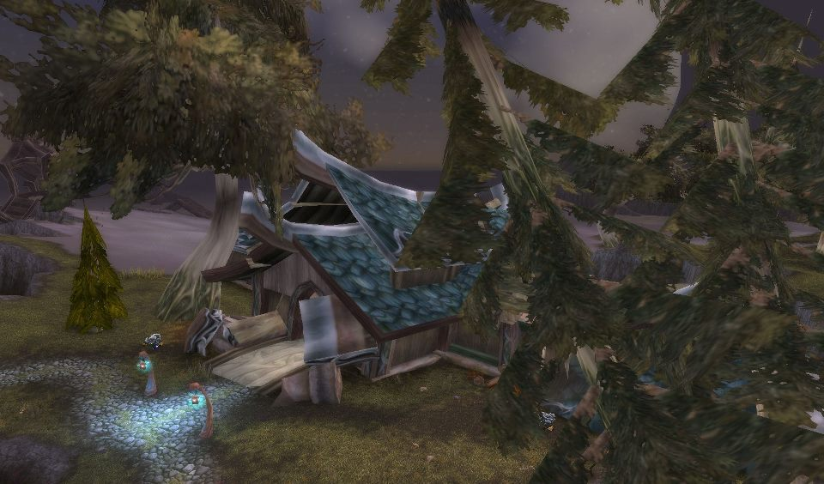
Figure 30. Auberdine.
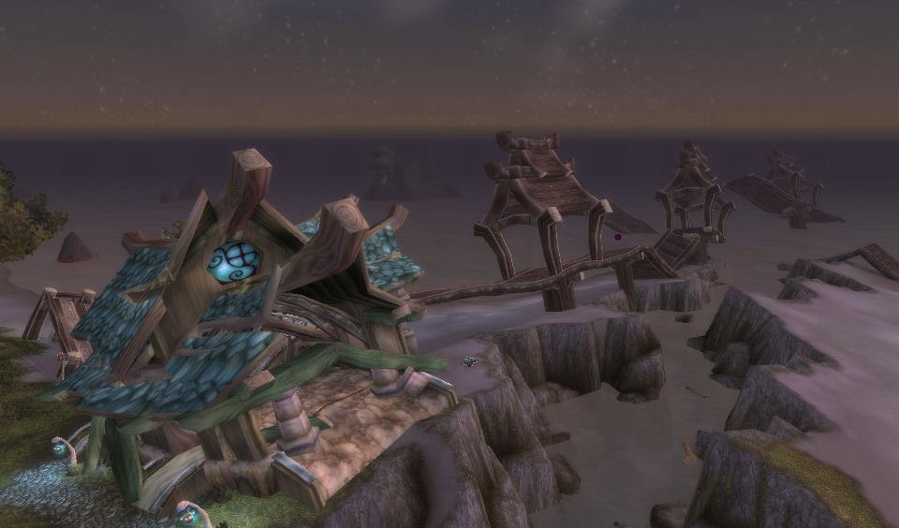
Figure 31. The Auberdine Inn.
Darnassus," referencing my tendency to sit AFK in the city. When I asked my hardcore informants if they had "special" locations of their own, I was surprised at the answers. Zoombroom AFK'd in the secret mage tower of Dalaran, a location only known to people who had assembled a device from eight randomly-spawning pieces and completed a corresponding achievement. Chromedome used to sit on the pillar of the bridge between the Ironforge bank and auction house, or in front of the Scryer's bank in Shattrath City. Ahroo AFK'd near the Ironforge bank area. Vvetter choose the Sunwell island from TBC and floated above Stormwind (or Orgrimmar if he was on his Horde character). Itsgeorge chose Shattrath and Dalaran. Each had their own "spots" - individual zones from which they communicated with each other (though at a distance), patrolled the internet, queued for dungeons or Battlegrounds, alt-tabbed, talked on vent, and so on. Why had we chosen these distinct spots in-game? More specifically: why did I sit in Auberdine (and later Darnassus) all those years? Was I hiding from something in-game? IRL? Did I find comfort in the opportunity to remain solitary and interact with these players on my own terms?
In considering these questions, I ran across the following passage from Turkle (2011: 1):

Technology is seductive when what it offers meets our human vulnerabilities. And as it turns out, we are very vulnerable indeed. We are lonely but fearful of intimacy. Digital connections and the sociable robot may offer the illusion of companionship with the demands of friendship. Our networked life allows us to hide from each other, even as we are tethered to each other.

Technology is seductive. And empowering. Through this medium, our imagination becomes a driving engine—we author new spaces in our heads, inhabit new planes of being (almost mythic). When playing WoW, I entered a narrative dream (Figure 32). IRL physical discomfort, or the hungry cat mewing in my face, vanished. The interaction of the IRL and the virtual in this new form of nature, this cyberworld, became more than just bits and pieces of identity construction, but also personality construction in constant daily flux from hour-to-hour, instance-to-instance, experience-to-experience, night-to-night. It served as a declaration of independence from reality. Still, despite our imaginations regularly penetrating cyberspaces, we are still very much alive. We are not "passive characters in a book," as Itsgeorge suggested. We are not captured on a page, eliciting certain emotional reactions, nor are we living and breathing entities. We contest ourselves, we contest the environment we move around in, we contest others we meet. Auberdine, and later Darnassus, represented that reconceptualized space. It was a place in-game blending my virtual imagery and IRL needs. It was more than just a spot in game to sit and AFK. While WoW itself was a refuge from my IRL struggles, the game itself grew bloated with too much reality. Too much of my own internal conflicts bled into the "reality" of the virtual world. I quickly realized the significance of my choice to sit in Auberdine: I had become so invested in the game that it had melded with IRL itself. Auberdine, then, was a sanctuary within what should have already served as a sanctuary.
In WoW, the avatar is designed by the player, but so is the manner in which we interact with the world and the methods by which we engage with other players. We are
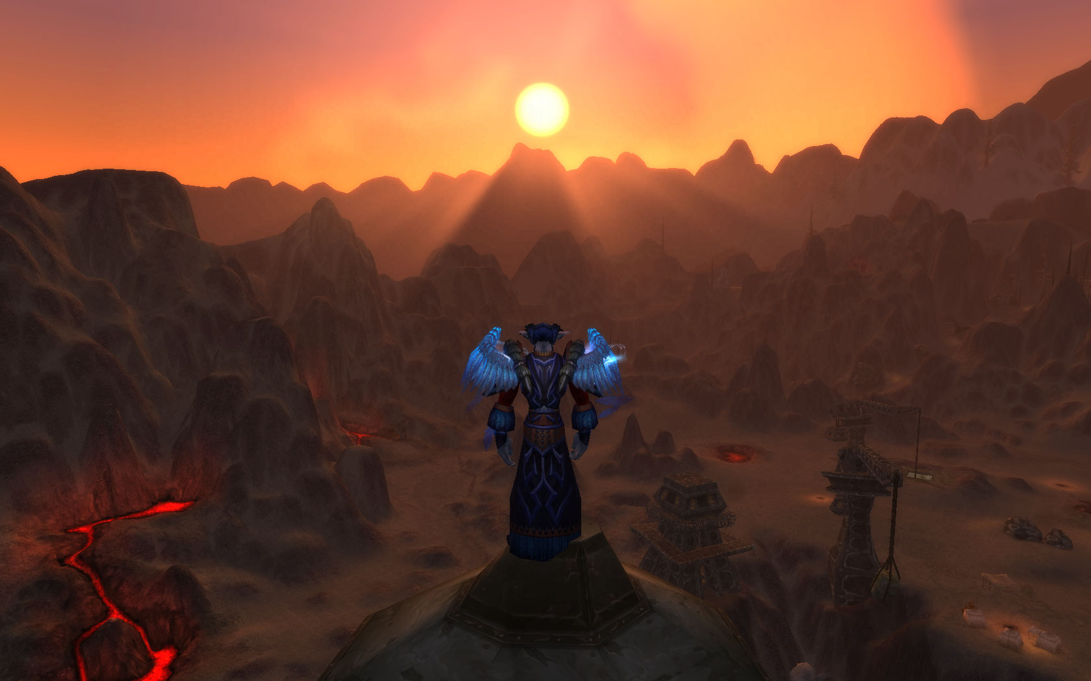
Figure 32. Sunset in the Searing Gorge.

world makers. Life constructers. Myth builders. The "blood and thunder" imagery of our cosmology is only one aspect to this reality: in between the muscle-bound Orcs and Taurens, the elegant Night Elves, the permanent scowl or smile, tattoos or markings of avatar faces and other race, class, and feature options, are the social and cultural choices made in our daily interactions, the forces contributing to the advent of new beings, new mutants. We are cyborgs in one sense, mutants in another, unions of the player's real life sensibilities and online fantasies. Whether these fantasies were of the "blood and thunder" type, or some other form of empowering visualization, something new and exciting appeared on screen (Jenkins 2002: 390). The idea behind this creation extended beyond the image itself. The "mutant" I/Anthropos assumed/became included not just my character, or my IRL pretense, but the manner in which I conceptualized the space around me. The room around me ceased to be "just" a room. It was a portal, a doorway, a union of space and place. Sitting in a vent channel with several other players was not just an empty online space: it was a meeting ground, a place to strategize (as Arathene would put it), a place to play and interact.
Though ideally I set out to maintain two distinct zones, adopting such a taxing hardcore way of life into my ethnographic research mediated too much IRL into the virtual. The game, even my online identity itself, became oversaturated, ceasing to remain a pure entertainment. This hardcore research and lifestyle controlled my virtual actions and affected my IRL responsibilities, instead of the other way around. It bled my thoughts and my reality, ultimately derailing both. Fortunately, all was not for naught. The acts of kindness and reciprocity (by personages virtual and professors IRL) shone onto this misplaced soul. It may have taken a breath or two for those first glimmers to take hold - especially in the face of a decade-long journey - but they pierced even the thickest shell, brightening, revealing horizons long, forested, and clouded. Even the dimness of one's recent past was not so strong as to outdo the power of this fountain. The night faded, a curtain drawn aside by the acts, deeds, and shared adventures of myself and my friends and companions, revealing a new stage, a new actor, a new father, a new husband.
A new anthropologist.
A new ethnographer.
A new adventurer.
I am no longer "at war" with myself (Turkle 2011: 296). The dark places were sundered by my memories of the light.

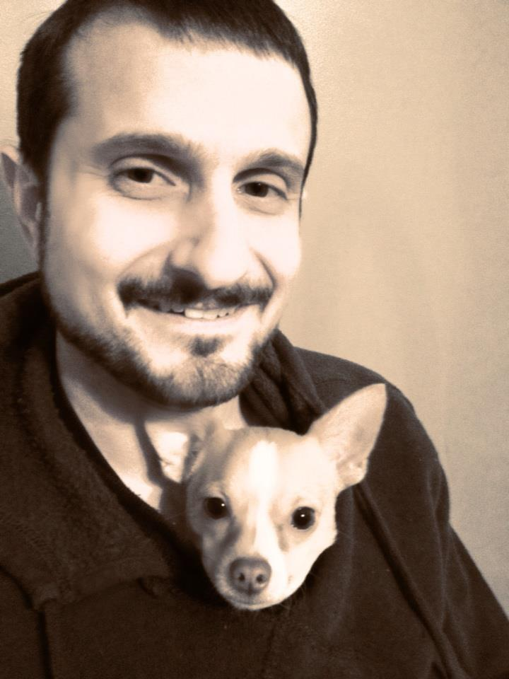
Figure 33. Anthropos and friend.

LIST OF REFERENCES

Activision-Blizzard Entertainment
2004 World of Warcraft.
2012 http://www.blizzard.com/wow/features.shtml
2012 http://investor.activision.com/events.cfm

Arendt, Hannah
1966 The Origins of Totalitarianism. New York: Harcourt, Brace & World, Inc.

Barth, Fredrik
1987 Cosmologies in the Making: A Generative Approach to Cultural Variation in Inner New Guinea. Cambridge and New York: Cambridge University Press.
1994 A Personal View of Present Tasks and Priorities in Cultural and Social Anthropology. In Assessing Cultural Anthropology. Robert Borofsky, ed. Pp. 349– 361. New York: McGraw-Hill, INC.
1995 Other Knowledge and Other Ways of Knowing. Journal of Anthropological Research 51(1):65–68.

Baym, Nancy K.
2002 "I Think of Them as Friends": Interpersonal Relationships in the Online Community. In Gender, Race, and Class in Media. 2nd edition. Gail Dines and Jean M. Humez, eds. Pp. 488-496. Thousand Oaks, London, and New Delhi: Sage Publications.

Beach House
2012 Irene. From Bloom. Seattle, WA: Sub Pop Records.

Beer, David
2008 Social network(ing) sites...revisiting the story so far: A response to danah boyd and Nicole Elison. Journal of Computer-Mediated Communication 13(2): 516- 529.
Article first published online.

Boellstorff, Tom
2008 Coming of Age in Second Life: An Anthropologist Explores the Virtually Human. Princeton and Oxford: Princeton University Press.

boyd, danah m. and Elison, Nicole B.
2007 Social network sites: Definition, History, and Scholarship. Journal of Computer- Mediated Communication 13(1): 210-230.
Caldeira, Teresa P. R.
1999 Fortified Enclaves: The New Urban Segregation. In Theorizing the City: The New Urban Anthropology Reader. Setha M. Low, ed. Pp. 83–107. New Brunswick: Rutgers University Press.

Caplan, Scott E.
2003 Preference for Online Social Interaction: A Theory of Problematic Internet Use and Psychosocial Well-Being. Communication Research 30(6): 625 - 648.

Case, Amber
2012 Cyborg anthropologist: We can all be superhuman
www.cnn.com December 5, 2012
http://www.cnn.com/2012/12/05/tech/cyborg-anthropology-amber- case/index.html?iref=obnetwork

Chen, Mark
2011 Leet Noobs: The Life and Death of an Expert Player Group in World of Warcraft. New York: Peter Lang Publishing, Inc.

Chomsky, Noam
2001 9-11. New York: Seven Stories Press.

Crang, Mike, Crang, Philip, and May, Jon
1999 Introduction. In Virtual Geographies: Bodies, Space, and Relations. Mike Crang, Philip Crang, and Jon May, eds. Pp. 1-20. London and New York: Rutledge.

Cubitt, Sean
2000 The virtual disembodied: A crisis in post-humanism. International Journal of Cultural Studies 3(1): 123-130.

DeVita, Philip R. and Armstrong, James D.
1998 Understanding Ourselves: About the Second Edition. In Distant Mirrors: America as a Foreign Culture. 2nd edition. Philip R. DeVita and James D. Armstrong, eds. Pp. xi-xvi. Belmont, California: West/Wadsworth.

Dinerstein, Joel
2006 Technology and Its Discontents: On the Verge of the Posthuman. Theme issue, “Rewiring the "Nation": The Place of Technology in American Studies,” American Quarterly 58(3):569 - 597.

Doel, Marcus A. and David B. Clarke
1999: Virtual worlds: simulation, supplication, s(ed)uction and simulacra In Virtual Geographies: Bodies, Space, and Relations. Mike Crang, Philip Crang, and Jon May, eds. Pp. 261 - 284. London and New York: Rutledge.

Escobar, Arturo
1994 Welcome to Cyberia: Notes on the Anthropology of Cyberculture. Current Anthropology 35(3): 211-231.

Foucault, Michel
1970 The Order of Things: An Archaeology of the Human Sciences. New York: Vintage Books.

Goodman, Nelson
1978 Ways of Worldmaking. Indianapolis: Hackett.

Giddens, Anthony
1971 Capitalism and modern social theory: An analysis of the writings of Marx, Durkheim, and Max Weber. Cambridge: Cambridge University Press.
1990 The Consequences of Modernity. Stanford, California: Stanford University Press.

Halter, Ed
2006 From Sun Tzu to XBox: War and Video Games. New York: Thunder's Mouth Press.

Hakken, David
1999 Cyborgs@Cyberspace?: An Ethnographer Looks to the Future. New York and London: Routledge.
2003 The Knowledge Landscapes of Cyberspace. New York and London: Routledge.

Haraway, Donna
1991 Simians, Cyborgs, and Women: The Reinvention of Nature. New York: Routledge.

Hardt, Michael and Negri, Antonio
2000 Empire, Cambridge, Mass.: University of Harvard Press.

Hayles, N. Katherine
1999 How We Became Post-human: Virtual Bodies in Cybernetics, Litature and Informatics. Chicago, Illinois: University of Chicago Press.

Healy, Dave
1997 Cyberspace and Place: The Internet as Middle Landscape on the Electronic Frontier. In David Porter, ed. Pp. 55-68. Internet Culture. New York and London: Routledge.

Hobsbawm, Eric J.
1997 On History. London: Weidenfeld & Nicolson.

Ito, Mizuko
1996 Inhabiting Multiple Worlds: Making Sense of SimCity2000 in the Fifth Dimension. In Cyborg Babies: From Techno-Sex to Techno Tots. Robbie Davis-Floyd and Joseph Dumit, eds. Pp. 301-316. New York and London: Rutledge.
1997 Virtually Embodied: The Reality of Fantasy in a Multi-User Dungeon. In Internet Culture. David Porter, ed. Pp. 87-109. New York: Rutledge.

Jenkins, Henry
2002 Lessons from Littleton: What Congress Doesn't Want to Hear about Youth and Media. In Gender, Race, and Class in Media. 2nd edition. Gail Dines and Jean M. Humez, eds. Pp. 385-396. Thousand Oaks, London, and New Delhi: Sage Publications.

Jhally, Sut
2002 Image-Based Culture: Advertising and Popular Culture. In Gender, Race, and Class in Media. 2nd edition. Gail Dines and Jean M. Humez, eds. Pp. 249 - 258. Thousand Oaks, London, and New Delhi: Sage Publications.

Jordan, Tim
1999 Cyberpower: The Culture and Politics of Cyberspace and the Internet. London and New York: Routledge.

Kunzru, Hari
2007 You Are Cyborg
www.wired.com February 2007 http://www.wired.com/wired/archive/5.02/ffharaway.html?person=norbert_wiener &topic_set=wiredpeople

Lull, James
2002 Hegemony In Gender, Race, and Class in Media. 2nd edition. Gail Dines and Jean M. Humez, eds. Pp. 61 - 67. Thousand Oaks, London, and New Delhi: Sage Publications.

Lutz, Catherine and White, Geoffrey
2002 Emotions, War and Cable News. Anthropology News 43(2): 6-7.

McCutcheon, Russell T.
2001 Critics not Caretakers: Redescribing the Public Study of Religion. Albany: SUNY Press.

Merkle, Erich R. and Richardson, Rhonda A.
2000 Digital Dating and Virtual Relating: Conceptualizing Computer Mediated Romantic Relationships. Family Relations 49(2): 187 - 192.

Miah, Andy
2000 Virtually nothing: re-evaluating the significance of cyberspace. Leisure Studies 19(2000): 211-225.

Millard, William B.
1997 I Flamed Freud: A Case Study in Teletextual Incendiarism. In David Porter, ed. Pp. 145-160. Internet Culture. New York and London: Routledge.

Morse, Margaret
1998 Virtualities: Television, Media Art, and Cyber-culture. Bloomington: Indiana University Press.

Napier, Susan
2001 Anime from Akira to Princess Mononoke: Experiencing Contemporary Japanese Animation. New York: Palgrave.

Nordstrom, Carolyn
2004 Shadows of War: Violence, Power, and International Profiteering in the Twenty- First Century. Berkeley, Los Angeles, and London: University of California Press.

Onyett, Charles
2011 The Future of World of Warcraft: Blizzard talks 4.3 changes, Mists of Pandaria rumors and more.
http://pc.ign.com/articles/119/1191590p1.html August 30, 2011

Pena, Jorge and Hancock, Jeffrey
2006 An Analysis of Socioemotional and Task Communication in Online Multiplayer Video Games. Communication Research 33(1): 92 - 109.

Porter, David
1997 Introduction. In David Porter, ed. Pp. xi-xviii. Internet Culture. New York and London: Routledge.

Rabinow, Paul
1977 Reflections on Fieldwork in Morocco. Berkeley, Los Angeles, and London: University of California Press

Ryan, Marie-Laure
1999 Cyberspace Textuality: Computer Technology and Literary Theory. Bloomington and Indianapolis: Indiana University Press.

Salzmann, Zdenek
1993 Language, Culture and Society: An Introduction to Linguistic Anthropology. 2nd edition. Boulder: Westview Press.

Schendel, Joshua S.
2002 The Politics of God: Theocratic Empire Building in the Age of Globalization. M.A. thesis, Department of Anthropology, The University of Tennessee.

Sony Online Entertainment
2004 starwarsgalaxies.station.sony.com.

Schilling, Melissa A.
2005 Game Not Over: Competitive Dynamics in the Video Game Industry. In Joseph Lampel, Jamal Shamsie and Theresa Lant, eds. The Business of Culture: Strategic Perspectives on Entertainment and Media. Pp. 75 - 103. Mahwah, NJ: Lawrence Erlbaum Associates.

Schwartzman, Helen B.
1993 Qualitative Research Methods, vol. 27: Ethnography in Organizations. John Van Maanen, Peter K. Manning, and Marc L. Miller, eds. Newbury Park, London, and New Delhi: SAGE Publications.

Seiter, Ellen
2002 Television and the Internet In Gender, Race, and Class in Media. 2nd edition. Gail Dines and Jean M. Humez, eds. Pp. 688 - 696. Thousand Oaks, London, and New Delhi: Sage Publications.

Taylor, T. L.
2006 Play Between Worlds: Exploring Online Game Culture. Cambridge, Massachusetts and London, England: The MIT Press.

Turkle, Sherry
1995 Life on the Screen: Identity in the Age of the Internet. New York: Touchstone.
2011 Alone Together: Why We Expect More from Technology and Less from Each Other. New York: Basic Books.

Watkins, S. Craig
2009 The Young & The Digital: What the Migration to Social-Network Sites, Games, and Anytime, Anywhere Media Means for Our Future. Boston: Beacon Press.

Weber, Max
1923 General Economic History. London: Allen & Unwin.
1947 The Theory of Social and Economic Organization, New York:
Free Press.
1965 The Sociology of Religion, T. Parsons (Ed.), London: Methuen.

Wilbur, Shawn P.
1997 An Archaeology of Cyberspaces: Virtuality, Community, Identity. In David Porter, ed. Pp. 5-22. Internet Culture. New York and London: Routledge.

Wright, Kevin B.
2004 On-line relational maintenance strategies and perceptions of partners within exclusively Internet-based and Primarily internet-based relationships. Communication Studies 55(2): 239 - 253.

Yee, Nicholas
2006 The Psychology of Massively Multi-User Online Role-Playing Games:
Motivations, Emotional Investment, Relationships and Problematic Usage. In Ralph Schroeder & Anne-Sofie Axelsson, eds. Pp. 187 - 207. Avatars at Work and Play: Collaboration and Interaction in Shared Virtual Environments. London: Springer - Verlag.

Vita

Joshua S. Schendel received his B.A. in Anthropology from The College of William and Mary and his M.A. in Anthropology from The University of Tennessee. His interests include online culture, multiplayer gaming, cartooning, blogging (http://allmadherecartoons.wordpress.com/), fiction writing, and coping with the crushing disappointment triggered by his favorite sports teams. He also loves waffles.

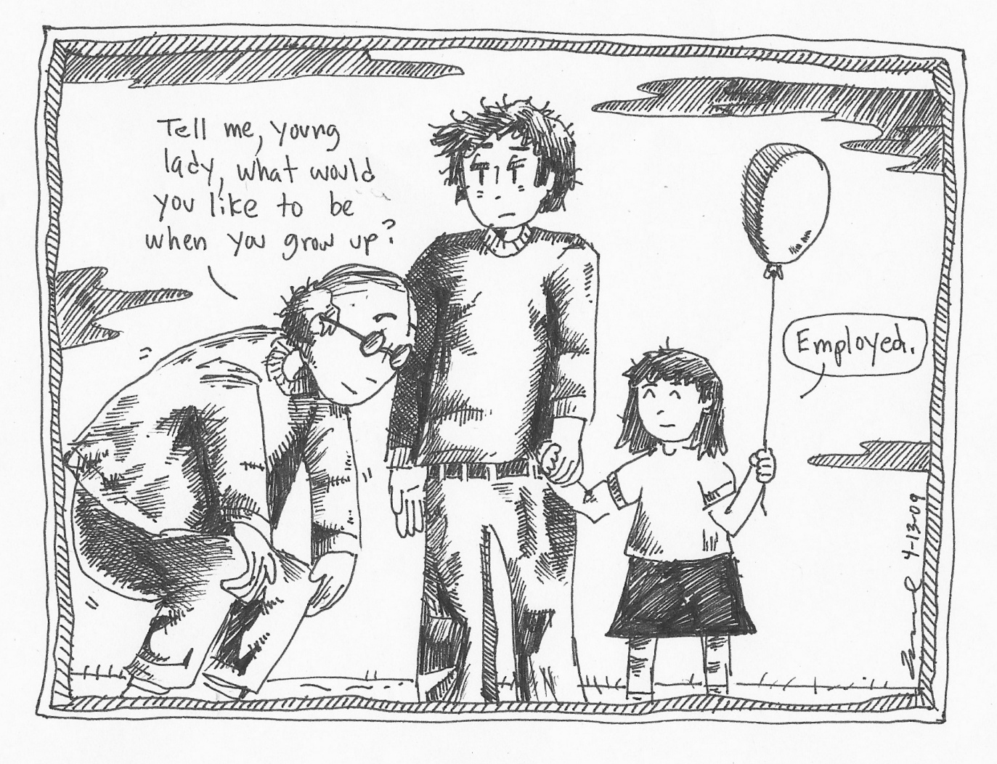

The Night Elves live in Darnassus, a city located at the top of a giant tree. Anthropos is a Druid, capable of shifting into various forms. I play as a Restoration specialization, allowing me to use healing spells to restore player health. My most powerful form is that of a giant tree, which grants special use of increased healing powers for a short period of time.
Zoombroom and Anthropos travel atop the X-53 Touring Rocket, a flying mount that seats two players. They travel away from Darnassus toward Hyjal Zone. In Hyjal, many quests and The Firelands raid dungeon await players.
Anthropos and Angushide team up to quest in the Arathi Highlands Zone. In the lower right of the screenshot, one can see the different chat feeds available for in-game player communication. General Chat is a Zone-wide chat. Party Chat is a chat only available for a group's members (in this case, only available for Anthropos and Angushide). Anthropos (in bear form) completes the "Breaking the Keystone" quest and is awarded 3450 Experience. As Experience accumulates, players level from Level 1 until they reach the maximum level of the game. Originally, the max level was Level 60. After four expansions, this max level is Level 90.
http://starwarsgalaxies.station.sony.com
http://www.wired.com/wired/archive/5.02/ffharaway.html?person=norbert_wiener&topic_set=wiredpeople
Anthropos (Level 49) stands in Arathi Highlands, wearing Green (Common) and Blue (Rare) level armor. As players level, they acquire more power items. Typically, Blue gear lasts longer than Green gear, and Purple (Epic) gear lasts longest of all. All gear, inevitably, gets replaced by something more powerful.
Beth'tilac is the first Raid Boss of The Firelands raid. Ragnaros is the final (and more difficult) boss.
Nefarian is the final Raid Boss of the Blackwing Descent raid dungeon.
http://www.blizzard.com/wow/features.shtml
Copperfield of <Clan Copperfield> stands in the Dwarven capital city of Ironforge and recruits followers.
http://www.cnn.com/2012/12/05/tech/cyborg-anthropology-amber-case/index.html?iref=obnetwork
http://eu.battle.net/wow/en/forum/topic/6444144923
www.mmo-champion.com
http://investor.activision.com/events.cfm
http://pc.ign.com/articles/119/1191590p1.html
https://twitter.com/Ghostcrawler
http://us.battle.net/wow/en/forum/984270/

