                - Population Abundance and Growth of Elk (Cervus canadensis) in Western North Carolina

A Dissertation Presented for the
Doctor of Philosophy
Degree
The University of Tennessee, Knoxville

Jessica Braunstein
August 2023
Copyright © 2023 by Jessica Braunstein
All rights reserved.

ACKNOWLEDGEMENTS

I would like to express my gratitude to the many individuals and organizations that have contributed to the success of this elk research project and to my graduate career and professional development over the past several years. Firstly, I owe many thanks to my major professor, Dr. Joe Clark, for the opportunity to study bears and elk as part of his lab over the past 8 years. I am incredibly grateful for all of the time Joe has invested in my professional development and learning and for all of his support throughout the highs and lows of graduate school. I have had a wonderful graduate experience and I attribute much of that to having a great advisor. I also owe many thanks to Terry White (University of Tennessee, Knoxville [UTK]) for her administrative and logistical assistance throughout the project as well as her encouragement and support throughout my entire time as a graduate student at UTK.
I also thank my fellow graduate students for their support and comradery the past few years. Thanks to Jake Humm for his encouragement and spatial capture-recapture guidance early on in the study. Thanks to Josh Alston for his willingness to talk through the logistics of my winter field work. I owe many thanks to Katherine Kurth for her friendship, assistance with coding and statistics homework, and for her willingness to answer all of my questions as I prepared for my comprehensive exams and dissertation defense. Also, many thanks to Kristin Botzet for always lending an ear to all things graduate school and life, giving me the opportunity to join in on some bear work, and for sharing many amazing desserts with the lab.
I owe many thanks to my family and friends for their support over the past few years. I thank my parents, Robert and Sunny, for their unwavering support and encouragement in all aspects of my life but especially during my time as a graduate student. I thank my siblings, Jennifer and James, and their spouses as well as my in-laws for being constant sources of encouragement over the years. Finally, I thank my husband, Jevin Hoeper, for being a constant source of love and support throughout my Ph.D.
This study was funded by the North Carolina Wildlife Resources Commission (NCWRC) through a cooperative agreement with UTK. I am grateful to Justin McVey (NCWRC), Joseph Yarkovich (National Park Service [NPS]), and Caleb Hickman (Eastern Band of Cherokee Indians [EBCI]) for their insight during the early stages of study design and their support and assistance coordinating winter field work. Thanks to the many NCWRC, NPS, and EBCI staff that assisted with transects and logistics each winter. I also thank the UTK winter research technicians (Kirby Lau, Brandon Garcia, Joelle Ciriacy, Blake Ledbetter, Katrina Anderson, and Rebecca Leloudis) for all of their hard work completing transects and contacting private landowners. I deeply appreciate the many private landowners that provided access to their properties for research activities. Thanks go to Wildlife Genetics International and Heather Evans (NCWRC) who performed all DNA extraction and genotyping work. I also thank the many individuals that provided support during the data analysis and writing stages. Ben Augustine (Cornell University) and Murray Efford (University of Otago, New Zealand) provided advice and assistance with the population estimation models. Lisa Muller (UTK), Richard Chandler (University of Georgia), and Sheng-I Yang (UTK) provided feedback and guidance throughout the project.

ABSTRACT

In an effort to restore extirpated elk to their previous range, 52 elk were reintroduced to Great Smoky Mountains National Park (GRSM) in North Carolina during 2001 and 2002. Since their reintroduction, elk numbers have increased and their range has extended beyond GRSM boundaries. My primary research objectives included estimating population abundance, apparent survival, per capita recruitment, and population growth rate of elk in North Carolina. I used spatially explicit capture-recapture (SECR) models based on fecal DNA to identify individual elk and estimate population abundance and growth in the region. Technicians and I walked a series of transects throughout the region over 3 winter field seasons (2020–2022) and collected elk pellets encountered along these transects. These data were incorporated into both closed and open population SECR models to estimate elk densities, abundance, and population vital rates over the three-year period.
The top performing single-sex closed SECR models for males and females estimated density separately by year and as a function of the scaled distance to primary field with densities decreasing as the distance to field increased. The total realized abundance estimates of combined males and females in the study area were 179 elk (95% CI = 149–215) in 2020, 220 elk (95% CI = 188–256) in 2021, and 240 elk (95% CI = 207–279) in 2022.
The top open population SECR model estimated both apparent survival (φ [phi]) and population growth rate as functions of sex and year. Mean φ [phi] for males were 0.682 (95% CI = 0.317–0.908) for 2020-21 and 0.339 (95% CI = 0.152–0.596) for 2021-22. Mean φ [phi] for females were 0.953 (95% CI = 0.830–1.000) for 2020-21 and 0.829 (95% CI = 0.601–1.000) for 2021-22. Mean population growth rate estimates (λ [lambda]) for females were 1.559 (95% CI = 1.162–2.091) for 2020-21 and 1.122 (95% CI = 0.876–1.437) for 2021-22. Mean λ [lambda] for males were 1.127 (95% CI = 0.806–1.575) for 2020-21 and 0.811 (95% CI = 0.566–1.163) for 2021-22. This population likely could support limited sport hunting; continued monitoring is recommended.

Table of Contents

Chapter I. Introduction 1
History and Population Status of Elk in North Carolina 1
Research Objectives 7
Chapter II. Materials and Methods 8
Study Area 8
Estimating Elk Population Growth and Abundance 9
Field Methods 15
Fecal DNA Extraction and Genotyping 18
Spatially Explicit Capture-Recapture Models 21
Population Projections 24
Chapter III. Results 26
Field Sampling and Genotyping 26
Spatially Explicit Capture-Recapture Estimates 30
Population Projections 32
Chapter IV. Discussion 34
Chapter V. Conclusions and Recommendations 46
Literature Cited 49
Appendices 60
Appendix A. Tables 60
Appendix B. Figures 72
Appendix C. Recommended Sampling Protocol 89
Appendix D. Elk Fecal Pellet Collection Form 94
Appendix E. Elk Pellet Collection Protocol 96
Appendix F. Garmin GPS Tracklog Instructions 97
Appendix G. onX Instructions 98
Appendix H. Elk Pellet Surface Rub Protocol 99
Vita 100

LIST OF TABLES

Table 1. Program RISKMAN input values used for population projections of elk in western North Carolina, USA. 60
Table 2. Quality rating of all elk pellet samples collected on transects in western North Carolina, 2020–2022. 61
Table 3. Summary of sample data used in spatially explicit capture-recapture (SECR) analyses of elk in western North Carolina, 2020–2022. 62
Table 4. Model selection results for male elk density models in western North Carolina, 2020–2022, using bias-corrected Akaike’s Information Criterion (AIC_{c}) to rank models. Null models were fitted first to determine appropriate detection function before adding density covariates. 63
Table 5. Mean closed population spatially explicit capture-recapture (SECR) model parameter estimates pooled across years, standard errors (SE), and 95% confidence intervals (LCL, UCL) for male and female elk in western North Carolina, 2020–2022. 64
Table 6. Realized abundance (N) estimates, standard errors (SE), 95% confidence intervals (LCL, UCL), number detected (n), and the coefficient of variation of abundance estimates (CV) for male and female elk in western North Carolina, 2020–2022. 65
Table 7. Model selection results for female elk density models in western North Carolina, 2020–2022, using bias-corrected Akaike’s Information Criterion (AIC_{c}) to rank models. Null models were fitted first to determine appropriate detection function before adding density covariates. 66
Table 8. Model selection results for open population spatially explicit capture-recapture models in western North Carolina, 2020–2022, using bias-corrected Akaike’s Information Criterion (AIC_{c}) to rank models. The spatial Jolly-Seber-Schwarz-Arnason (JSSA) model was parameterized in terms of lambda (λ) and fitted by maximizing the conditional likelihood. 67
Table 9. Mean population vital rate estimates, standard errors (SE), and 95% confidence intervals (LCL, UCL) of male and female elk in western North Carolina, 2020–2022. 68
Table 10. Geometric mean estimates of population vital rate parameters pooled across years and sex, standard errors (SE), and 95% confidence intervals (LCL, UCL) of all elk in western North Carolina, 2020–2022. 69
Table 11. Program RISKMAN population sizes and growth rates for 10-year population projections under various harvest scenarios for elk in western North Carolina. Population trajectories were simulated using the geometric mean SECR parameter estimates for males and females during 2022 as inputs and additional simulations included reducing female survival and adult recruitment rates by 5% and 10%. 70
Table 12. Elk minimum count summary for western North Carolina, 2020–2022. Elk minimum counts were completed over 2 consecutive days in the fall of each year. Data provided by Justin McVey, North Carolina Wildlife Resources Commission. 71
Table 13. Total number of elk pellet samples collected in each density layer used in simulations and final study design of elk population research in western North Carolina, 2020–2022. Density level D1 represents the region with the presumed highest elk densities and level D5 represents the region with the lowest presumed elk densities. 90
Table 14. Final PCR conditions for each microsatellite marker analyzed by NCWRC. PCRs were either conducted using Qiagen Multiplex MasterMix (Qiagen MM) or a 1:10 mixture of Takara Premix Ex Taq and Promega GoTaq MasterMix (1:10 Taq). Times for cycling conditions are shown in minutes and seconds using the format mm:ss. Primer concentrations are 10 µM unless otherwise indicated. 93

LIST OF FIGURES

Figure 1. Elk were reintroduced into the Cataloochee Valley located in the southeastern corner of Great Smoky Mountains National Park in 2001 and 2002.. 72
Figure 2. Five elk areas were delineated and used to assess the feasibility of establishing a huntable elk population in North Carolina (RTI International 2014). 73
Figure 3. Map of current elk range in western North Carolina. Map courtesy of North Carolina Wildlife Resources Commission. 74
Figure 4. Locations of major elk herds in western North Carolina and cells of presumed high and low elk densities used to construct transect sampling designs and perform preliminary simulations. 75
Figure 5. Elk density layers used in simulations and in final sampling design. Elk densities were presumed highest in Density 1 and lowest in Density 5. . 76
Figure 6. A total of 379 transects were completed in 2020 and 60 elk were identified from fecal DNA. Density layers represent varying levels of presumed elk density with the highest presumed number of elk in Density 1 and lowest number of elk in Density 5. Sampling intensity was highest in Density 1 and decreased to Density 5. 77
Figure 7. A total of 431 transects were completed in 2021 and 80 elk were identified from fecal DNA. Density layers represent varying levels of presumed elk density with the highest presumed number of elk in Density 1 and lowest number of elk in Density 5. Sampling intensity was highest in Density 1 and decreased to Density 5. . 78
Figure 8. A total of 412 transects were completed in 2022 and 88 elk were identified from fecal DNA. Density layers represent varying levels of presumed elk density with the highest presumed number of elk in Density 1 and lowest number of elk in Density 5. Sampling intensity was highest in Density 1 and decreased to Density 5. . 79
Figure 9. Predicted male elk density surface in western North Carolina, averaged from 2020 to 2022. The gray lines represent completed transects. Highest male elk densities were located in and around fields.. 80
Figure 10. Predicted female elk density surface in western North Carolina, averaged from 2020 to 2022. The gray lines represent completed transects. Highest female elk densities were located in and around fields.. 81
Figure 11. Realized abundance (N) estimates and 95% confidence intervals for male and female elk in western North Carolina, 2020–2022. 82
Figure 12. Mean annual survival (φ) estimates and 95% confidence intervals for male and female elk in western North Carolina, 2020–2022. 83
Figure 13. Mean annual population growth rate (λ) estimates and 95% confidence intervals of male and female elk in western North Carolina, 2020–2022. The black dashed line depicts the geometric mean population growth rate for both sexes and all years pooled (λ = 1.125), and the black dotted lines represent 95% confidence intervals. 84
Figure 14. Number of bulls (adult males >3 years of age) harvested each year of a 10-year population projection period under various harvest scenarios across huntable lands in western North Carolina. 85
Figure 15. Number of bulls (adult males >3 years of age) in the population each year of a 10-year population projection period under various harvest scenarios across huntable lands in western North Carolina. 86
Figure 16. Histogram of the Euclidean distance to the nearest primary field for all genotyped elk pellet samples (n = 390) in western North Carolina, 2020–2022. 87
Figure 17. The revised sampling protocol focuses sampling effort within 300 m of the primary fields used by elk with a slightly increased sampling intensity of approximately 100 500-m transects. Transects shown here were randomly generated. 88

Chapter I. Introduction

History and Population Status of Elk in North Carolina
Prior to the arrival of European settlers, elk were abundant and populations were widespread across North America (Thomas et al. 1982, O’Gara and Dundas 2002). The naturalist E. T. Seton (1927) estimated that the continent was home to 10 million elk during this time. Elk were comprised of 6 subspecies: Eastern elk (C. c. canadensis), Roosevelt or Olympic elk (C. c. roosevelti), Merriam elk (C. c. merriami), Tule or dwarf elk (C. c. nannodes), Manitoban elk (C. c. manitobensis), and Rocky Mountain elk (C. c. nelsoni, Thomas et al. 1982). As European settlers explored westward, they relied on elk as a valuable source of food and hides which eventually led to overharvest and severe population declines throughout elk range. By 1907, <100,000 elk remained in North America and populations were continuing to decline (Thomas et al. 1982). During that time, Eastern elk populations (C. c. canadensis) suffered drastic declines with extirpations in Tennessee and North Carolina occurring as early as the late 1700s to mid-1800s (Oberholser 1905, Thomas et al. 1982). By the early 1920s, about 90,000 elk remained across North America, with many of the remaining populations being restricted to Yellowstone National Park, Grand Teton National Forest, and a few locations in Canada (Thomas et al. 1982).
Many elk reintroductions were attempted in eastern North America during the first half of the 20th century with most attempts being unsuccessful (Popp et al. 2014). However, recent reintroduction attempts have been more fruitful, resulting in the establishment of elk populations in several southeastern United States. For example, from 1997 to 2002, the Kentucky Department of Fish and Wildlife released 1,548 elk from 6 western states at 8 different sites in the southeastern portion of Kentucky. State officials now estimate a population of >11,000 individuals (Youngmann et al. 2020). The success of the Kentucky elk population was attributed to a large and genetically diverse population of founders and abundant early successional stage habitat in the form of reclaimed strip mines (Youngmann et al. 2020). Officials in Tennessee released 201 elk from 2000 to 2008 at the North Cumberland Wildlife Management Area (NCWMA), and Kurth (2022) estimated a population of about 159 elk in a portion of managed wildlife openings within NCWMA in 2019. Wildlife agencies in Tennessee and Kentucky have reported hunting, poaching, and disease associated with meningeal worm (Parelaphostrongylus tenuis) as major causes of elk mortality in the reintroduced populations and this may have hampered growth (Kindall et al. 2002, Popp et al. 2014, Kurth 2022).
In the 1990s, several agencies including the Rocky Mountain Elk Foundation and the National Park Service (NPS) began discussing the potential of reintroducing elk to Great Smoky Mountains National Park (GRSM or Park) in North Carolina. A habitat feasibility study was initiated in 1991 and researchers concluded that there were adequate resources within and surrounding GRSM to support elk (Long 1996). In fall 1998, the Park announced their decision to begin planning for an experimental release of elk. The Manitoban elk subspecies (C. c. manitobensis), found in the Midwest region of the United States and southern portions of Canadian Prairies, was thought to be the most closely related to the eastern elk subspecies and was, therefore, chosen to serve as the source stock during reintroduction efforts. In 2001, 25 elk (13M:12F) were transported from Land Between the Lakes National Recreation Area (LBL), Kentucky, and placed into an acclimation pen at Cataloochee Valley in GRSM (Figure 1; all tables and figures are located in the appendices). Elk from LBL were part of earlier translocation efforts in Kentucky during 1996 and 1997 and were originally obtained from Elk Island National Park (EINP) in Alberta, Canada. After a short acclimation period (i.e., soft release), the elk were released into Cataloochee Valley. In 2002, an additional 27 elk (8M:19F) were obtained directly from EINP and soft-released into Cataloochee Valley as before. The original elk reintroduction proposal planned for a third release of elk for a total of 75 to 90 individuals; however, the final release did not occur due to changes in regulations related to interstate transportation and importation of cervids (GRSM 2011).
Since the elk reintroduction efforts, several studies on various aspects of the elk population in and around GRSM have been conducted. Murrow et al. (2009) evaluated the elk reintroduction effort in GRSM by monitoring the newly released elk from 2001 to 2006 and used those data to examine population vital rates and to project population growth over a 25-year period. They estimated the mean population size after 25 years at 61.1 individuals and reported that the population failed to reach sustainability in 46% of their population projections. The average annual population growth rate (λ) was 0.996 which suggested the population would slowly decline over the 25-year period. American black bear (Ursus americanus) predation on elk calves had a significant negative impact on calf survival and the growth of the overall elk population. The study’s authors concluded that an increase in calf survival would facilitate successful elk re-establishment in the region.

Following the work of Murrow et al. (2009), Yarkovich et al. (2011) examined elk calf survival and predation on calves by black bears. From 2006 to 2008, Park officials trapped 49 bears in Cataloochee Valley and relocated them to other areas of GRSM during the calving season. The relocation of bears during this critical period resulted in increased calf survival rates. Estimated λ increased to 1.118 due to the increased calf survival, and population projections were sustainable in all simulations (Yarkovich et al. 2011, Yarkovich and Clark 2013). Bear trapping and relocation was discontinued after the 2008 calving season.
Elk were solely managed by the NPS until 2008 when Park officials declared that the experimental stage of the reintroduction effort was complete. Once the experimental release phase was concluded, elk management became the responsibility of 3 agencies including NPS, the North Carolina Wildlife Resources Commission (NCWRC), and the Eastern Band of Cherokee Indians (EBCI). Elk management responsibilities were divided with NPS personnel being responsible for elk within GRSM boundaries, EBCI personnel managing elk on tribal lands, and NCWRC managing elk on private lands and other public lands in the state. Elk regularly cross jurisdictional boundaries and, therefore, collaboration among agencies is necessary and common.
Following the cessation of bear trapping and relocation, NPS officials were interested in determining whether calf recruitment returned to levels prior to bear relocation. Consequently, Yarkovich et al. (2023) collected and analyzed data on survival and recruitment via radio telemetry. Models that depicted calf recruitment returning to pre-2006 levels at Cataloochee Valley were supported, with recruitment of Cataloochee elk before/after bear relocation being lower (0.051) than during bear relocation (0.367). Calf predation by bears continued to be high but senescence of cows also contributed to reduced calf recruitment in Cataloochee Valley. The mean annual growth rate for monitored elk was 0.987 from 2009-10 to 2019-20 based on the recruitment and survival data. Recruitment was higher in elk that dispersed from Cataloochee, however, and officials suspect that elk population growth was higher on public and private land elsewhere in the region where fewer elk were radio collared and bear densities were likely lower.
In 2014, Research Triangle Institute International (RTI International) examined biological, social, and economic variables associated with the establishment of a huntable elk population in the state. The researchers divided the western North Carolina area into 5 regions with 3 of the regions being already occupied by elk (Figure 2). The other 2 regions were unoccupied but had the potential to support elk because of the presence of suitable habitat. In the 3 study areas currently occupied by elk, population projections indicated that slow, steady growth rates were possible and that the probability of extinction was low for all 3 regions. However, results indicated that the 2 unoccupied regions would not be able to support sustainable elk herds over the 25-year projection period due to lower survival and recruitment rates. The researchers also examined the effects of hunting on population viability. The only region of the 5 examined that was capable of supporting hunting was the Haywood County study area which had the highest starting population size of 55 elk. Results indicated that the elk population would remain sustainable at harvest rates of 4 and 6 elk over 25- and 50-year projections with the sex ratio of the harvest ranging from 100M:0F to 80M:20F. However, the researchers recommended that hunting be limited to only males and cautioned that other hunted elk populations in the eastern U.S. were comprised of >200 individuals. Additionally, they suggested considering the number of depredation permits issued annually when considering the feasibility of introducing a hunt. RTI International (2014) used the simulation program RISKMAN (Taylor et al. 2001) to provide NCWRC with population projections under various harvest scenarios. Users of the RISKMAN program must input a starting population size and demographic data for the population of interest. For the RTI International (2014) report, population abundance data were compiled via personal communication with wildlife agency personnel in June 2014. These data were based on the movements of radio-collared elk and personal observations from research conducted on elk in GRSM from 2006 to 2012 (Yarkovich and Clark 2013). While the simulations used the best available data at the time, there was a need for better estimates of starting population size and variance.
Personnel from NCWRC began conducting annual elk minimum counts to track elk population size and trend beginning in 2013. During fall, agency personnel counted the number of elk observed in fields and other openings that elk were known to frequent. Elk were counted in both the morning and again in the evening over 2 consecutive days. These counts provided a minimum number of elk in the population and were easy to implement and did not require additional statistical analyses. However, minimum counts also have limitations. For example, elk that are not in openings at the time of counting may go undetected because simple minimum counts do not account for this incomplete detection of animals. Assumptions about animal detectability are not testable which limits inference (Pollock et al. 2002), though there have been recent methodological advances that aim to address incomplete detection of animals (Schmidt et al. 2019). Additionally, elk were counted in fields and other openings, and this nonrandom sampling also limits inferential power and rigor (Rabe et al. 2002). Finally, minimum counts do not include any estimates of uncertainty. Clearly, a statistically rigorous estimate of elk population abundance and growth in western North Carolina is needed.

Research Objectives
My research objectives were to estimate elk population density (D), abundance (N), apparent survival (φ), per-capita recruitment (f), and growth (λ) in western North Carolina. This information is critical for monitoring changes in the elk population and making harvest and other management decisions. Hypotheses to be tested are:
1. The elk herd within the boundaries of GRSM serves as the source for animals emigrating from the Park to other public and private lands in western North Carolina,
2. Immigration, survival, and recruitment rates are sufficient to enable a sustainable hunt outside Park boundaries in North Carolina, and
3. Techniques can be developed that are practical, cost-effective, and reliable for estimating the above parameters and for monitoring vital rates in elk.

chapter II. Materials and Methods

Study Area
Yarkovich et al. (2023) found that the elk population in North Carolina had increased and elk range in the state had spread beyond the GRSM boundary onto neighboring public lands and privately-owned property. The current known elk range (Figure 3) extends north of Cataloochee Valley into Pisgah National Forest, east into Waynesville, and south-southwest into the cities of Maggie Valley, Cherokee, Whittier, and Bryson City, North Carolina. The current known elk range overlaps public lands including GRSM, Pisgah National Forest, Nantahala National Forest, the William H. Silvers Game Lands, and the Blue Ridge Parkway. Elk range also includes some land set aside for conservation purposes including land owned by the Conservation Fund and Maggie Valley Sanitary District and the Southern Appalachian Highlands Conservancy. Elk range south of the Oconaluftee area of GRSM extends into Eastern Band of Cherokee Indians tribal lands.
My study took place in Swain, Haywood, and Madison counties in western North Carolina, covering a region currently or potentially occupied by elk (Figure 3). The region included a mix of tribal, public, and private lands. Public lands included GRSM, the William H. Silver Game Lands, Blue Ridge Parkway, and Pisgah National Forest. These areas were characterized by mostly natural landcover types and minimal human development. Eastern Band of Cherokee Indians land bordered the southeastern portion of GRSM and consisted of a mix of developed, forested, and agricultural landcover types. The remaining private land was dominated by human development and rural agricultural communities.
Elevations in the study area range from roughly 550 to 1700 m and climatic conditions varied by elevation and aspect. Average annual rainfall at low and high elevations in GRSM was about 140 and 215 cm, respectively (NPS 2018). Cataloochee Valley had average annual temperatures ranging from 0.9° C in January to 20.2° C in July (Arguez et al. 2010). Terrain is often steep, and the highest elevations found along the Blue Ridge Parkway and in GRSM were dominated by spruce (Picea rubens)-fir (Abies fraseri) forest types whereas lower elevations were mostly comprised of montane oak (Quercus spp.)-hickory (Carya spp.) forest types. The shrub layer largely consisted of species in the Ericaceae (heath) family (Jenkins 2007). Open areas within the study area included open fields, grassy balds, and agricultural fields. Large mammal species besides elk commonly observed in the region included wild hogs (Sus scrofa), white-tailed deer (Odocoileus virginianus), and American black bears (NPS 2018).

Estimating Elk Population Growth and Abundance
Traditional capture-mark-recapture (CMR) techniques have been used for nearly a century to study wildlife populations. Capture-mark-recapture studies require the capture of animals either physically (e.g., live capture) or non-invasively (e.g., photographs, DNA from scats or hair) and the creation of encounter histories based on whether an animal was observed over a series of sampling periods, or occasions. These data can then be used to estimate detection probability and, knowing the number of previously marked animals in the population, animal abundance can be derived.
The most basic CMR model is the Lincoln-Petersen estimator in which there are only 2 sampling occasions which occur close enough together in time to assume there are no additions (i.e., births or immigration) or deletions (i.e., deaths or emigration) to the population of interest (i.e., the population is closed). One of the earliest studies using this approach was conducted by Lincoln (1930) to estimate the number of waterfowl based on birds marked with leg bands. The Lincoln-Petersen estimator assumes that the population is closed, that no marks are lost or overlooked, and that all animals have an equally likely chance of being captured or observed. This estimator is sensitive to violations of any of these assumptions and violations can produce biased results. Other closed population CMR models have since been developed that are more robust to violation of assumptions such as unequal capture probability (Williams 2002) which can include behavioral effects (e.g., trap happy or trap shy), temporal effects (e.g., unequal detection rates across time), and individual capture heterogeneity (e.g., differences in detection rate based on unknown age, size, or reproductive class).
Capture-mark-recapture methods can also be used in open population contexts to examine not only population density and abundance during a given period, but also to assess temporal variation in population density and vital rates such as survival and fecundity. Knowledge about a population’s vital rates is critical when modeling population changes over time and assessing population viability (Royle et al. 2014). Both population abundance and the demographic processes driving changes in a population have been estimated using CMR data and traditional Cormack-Jolly-Seber (CJS) and Jolly-Seber (JS) models (Cormack 1964, Jolly 1965, Seber 1965). The CJS model was developed to estimate survival rates and the JS models can also estimate recruitment and abundance. Other open population CMR models have since been developed that combine and extend on the CJS and JS models, such as the Jolly‐Seber‐Schwarz‐Arnason (JSSA) model. The JSSA model estimates time‐specific survival, recruitment, population growth rate, and abundance within a maximum likelihood framework (Schwarz and Arnason 1996).
One major challenge when using traditional CMR models to estimate population density and abundance is that the area that traps effectively sample is difficult to quantify because these methods do not incorporate where animals are encountered on the landscape in relation to the trapping grid. Spatially explicit capture-recapture (SECR) methods have been developed to address some of the difficulties posed by traditional CMR methods (Efford 2004, Borchers and Efford 2008, Royle et al. 2014). When using SECR estimators, the spatial data related to trap locations and animal activity centers are also incorporated into the models. This estimator fits a detection function whereby detection probability declines as the distance between the trap and an animal’s activity center increases. Incorporating animal movement data into the estimation process provides a statistically rigorous way to determine the area that is effectively sampled. The integration of these spatial data has been applied to both closed and open population contexts to estimate population abundance, density, survival, and recruitment (Royle et al. 2014). Open population SECR models have been used to estimate survival probability and population abundance over time of jaguars (Panthera onca) in Belize (Glennie et al. 2019), population density and survival of brushtail possums (Trichosurus vulpecula) in New Zealand (Efford and Schofield 2020), as well as apparent survival, per capita recruitment, and population growth rates of grizzly bears (Ursus arctos) in Banff National Park in Canada (Whittington and Sawaya 2015) and American black bears in Georgia (Hooker et al. 2020).
Incorporating the spatial data inherent in CMR studies may ultimately improve parameter estimates. Whittington and Sawaya (2015) found that spatial capture-recapture models produced more accurate parameter estimates and had better credible interval coverage than non-spatial capture-recapture models. Additionally, they found that non-spatial models resulted in negatively biased estimates of apparent survival and positively biased estimates of per capita recruitment and stated this may be especially true in areas with low densities of target species and low detection probabilities (Whittington and Sawaya 2015).
A key requirement of most capture-recapture methods is the ability to identify individual animals, and noninvasive methods using DNA collected from tissues or feces are of interest to many wildlife researchers. DNA consists of 4 nucleotides bases: adenine, thymine, cytosine, and guanine. Chromosomes are made up of DNA that is inherited from the parent organisms and are found in the nucleus of cells. In diploid organisms, such as humans and elk, the animal inherits 1 set of chromosomes from each parent resulting in 2 sets of chromosomes. Stretches of DNA along the chromosomes make up various genes and this genetic makeup, or genotype, gives rise to an organism’s physical characteristics, or phenotypic expression. The location of a gene on a chromosome is called the locus. Variation in the order of nucleotide base pairs results in different forms of genes that are called alleles. In diploid organisms, if 2 alleles at a particular locus are the same, the organism is considered homozygous for that gene. If the 2 alleles differ, the organism is heterozygous for that gene. The average number of different alleles at a specific locus is referred to as allelic richness and is an important measure in assessing genetic diversity at the population level.
Microsatellite markers are useful tools in identifying individual animals. These markers are loci along chromosomes that contain a relatively short sequence of base pairs (1–10 base pairs, usually 2–5 base pairs) that are repeated 5–100 times (Mills 2013). Microsatellites tend to be highly polymorphic (i.e., many alleles) which enables researchers to distinguish between individuals. Specific microsatellites can be extracted and amplified using polymerase chain reaction (PCR) and the DNA fragments can be identified based on their size and charge by placing the molecules on a gel and subjecting the gel to an electric field (i.e., electrophoresis). A DNA ladder, which consists of DNA molecules of known sizes, is also placed on the gel. The molecules move through the gel at different rates based on size and their mobility in the electrical field and appear as bands at different locations on the gel. The bands can then be compared to the reference DNA ladder to determine the fragment size. A homozygous individual will display 1 band on the gel whereas a heterozygous individual will display 2 fragments of differing base pair lengths.
Several studies have used fecal DNA from ungulate pellets to estimate population abundance in a SECR framework (Goode et al. 2014, Brazeal et al. 2017, Furnas et al. 2018, Nelson 2020, Batter et al. 2022, Henk et al. 2022). Epithelial cells containing DNA are shed as stool passes through the gastrointestinal tract, and these cells can be found in the mucus layer coating ungulate pellets. Many of the previous studies using fecal DNA from ungulate pellets have taken place in the western U.S., where conditions are much drier compared with climatic conditions found in the southeastern U.S., where winters are relatively wet and mild with significant annual variation in seasonal snowfall (Eck et al. 2019). Brinkman et al. (2010b) found that precipitation significantly impacted DNA degradation rates for Sitka black-tailed deer (Odocoileus hemionus sitkensis) pellets in a temperate coniferous rainforest in southeastern Alaska. Piggot (2004) found that precipitation differences between 2 different sampling seasons influenced microsatellite genotyping success of fecal DNA collected from red fox (Vulpes vulpes) and brush-tailed rock-wallaby (Petrogale penicillata) scats. Diet can also influence genotyping success from fecal DNA. For example, Maudet et al. (2004) demonstrated significant differences in genotyping success of fecal DNA collected from Alpine ibex (Capra ibex) and Corsican mouflon (Ovis musimon) feces collected in the winter versus spring seasons. Seasonal alterations in diet may change digestion time and therefore amount of time feces are in contact with intestinal membranes. Furthermore, a seasonal increase in fibrous matter in the diet may result in more intestinal abrasion and increased shedding of epithelial cells on feces.
More recently, fecal DNA has been used in SECR modeling frameworks to estimate population density and abundance of elk populations in other regions of North America. Nelson (2020) used fecal DNA from elk scats collected along transects to estimate density of Roosevelt elk at multiple sites in a wet forest climate in western Oregon in 2018 and 2019. Nelson (2020) reported a genotyping success rate of roughly 41% and found that SECR models performed well when using data collected from a study site with high elk densities, but more intensive sampling was required in areas of low elk densities to obtain adequate recaptures. Henk et al. (2022) used scat detection dogs to sample for elk pellets in northern California based on an unstructured but intensive sampling approach in which their survey routes were determined by GPS radiocollar data from Roosevelt elk. They found that their survey methodology was efficient and provided a reliable way to monitor elk in a densely forested region. Finally, Batter et al. (2022) used fecal DNA collected from Tule elk scat samples in a SECR framework to estimate population density and abundance and to assess effects of clustered space-use on model performance. In that study, researchers used a stratified sampling approach based on a species distribution model to sample more intensively in areas likely to have more elk. Transects were completed during the summer months, between calving season and the fall rut, and estimates were found to be robust to gregariousness in elk.

Field Methods

Simulations
To estimate the number and location of line transects for sampling elk pellets, I performed a series of simulations. I used a stratified sampling approach based on the central locations of 11 known elk herds in the state (Justin McVey, NCWRC, unpublished data). I plotted these herd locations in ArcMap 10.8.1® (Environmental Systems Research Institute, Redlands, CA) and created 3,500-m buffers around the herd centroids (Figure 4). The buffer size was based on the male elk home range size radius reported by Murrow (2007). Based on communication with agency personnel, I assumed this area would have higher densities of elk and I classified the area as high-density (HD). I created an additional 1,750-m buffer around the HD area. This buffer area was assumed to have elk in lower densities and was, therefore, classified as low-density (LD). I then met with agency personnel to reclassify any areas that appeared to be incorrectly labeled and to remove areas that were not of interest for the study (Figure 4).
I used the R package ‘secr’ version 3.2.1 (Efford 2004, Efford 2022b) in Program R version 3.6.3 (R Core Team 2020) to run simulations with varying numbers of short (500 m) and long (1,500 m) transects. I used short transects in HD areas and long transects in LD areas, and I assigned a random starting point and azimuth to all transects. I used longer transects in the low elk-density areas because those areas were usually more remote, and the longer transects would allow technicians to maximize data collection at sites that were time-consuming to access. In addition to straight-line transects, I also created S-shaped transects and performed simulations using various numbers of these transects in HD and LD areas. I also tested breaking up the sampling area into 5 parts based on distance from the elk herd centroids provided by NCWRC, presuming that elk densities would decrease as distance from centroids increased (Figure 5). For all simulations, I used a stratified approach in which areas of higher elk densities were sampled more intensively than areas of lower elk densities.
I used package ‘secr’ to simulate an elk population of roughly 160–200 individuals (Justin McVey, NCWRC, personal communication) and stratified elk densities with higher densities closer to the herd centroids. I then simulated a capture history using a hazard half-normal detection function, σ = 1,000 m, and λ₀ = 0.7. The σ value is a spatial scaling parameter and λ₀ represents the expected number of detections of an individual (Efford 2021). The σ and λ₀ values were based on previous work conducted by Murrow (2007) and pilot scat collection work that I conducted during summer 2019 in the Oconaluftee area of GRSM. Next, I fit a SECR model using the ‘transect’ detector type, simulated capture history data, and a density covariate in ‘secr’. The density covariate was used to distinguish between HD and LD areas. I repeated this process to test various trap configurations (10 replicates of each configuration) and assessed bias and precision. I also considered the amount of effort needed to sample the various trap configurations when deciding on the final sampling design. Based on the simulations, I concluded that a stratified sampling design using 280 500-m and 130 1,500-m straight line transects each year would likely yield adequate data and result in unbiased and precise elk density and abundance estimates. In this design, the shorter 500-m transects were used in density levels 1–3 and the longer 1,500-m transects were in density levels 4–5. This resulted in more intensive sampling near elk herd centroids.

Transect Sampling
From 2020 to 2022, I generated 280 500-m and 130 1,500-m proposed transects (410 total) with random starting points and azimuths. From January 1 to March 31 of each year, field technicians and I walked the transects while searching for elk pellets on the ground. We collected any pellets encountered within a search width of 2 m along the transect until we reached the assigned length of 500 or 1,500 m. We allowed for deviation from compass bearings to follow suspected elk trails to maximize potential sample collection (Brazeal et al. 2017). We waited about 36 hours following any form of precipitation before conducting transects to reduce the potential of collecting samples in which the fecal DNA had been degraded by moisture (Brinkmann et al. 2010b). When a pellet group was encountered, we recorded GPS coordinates and assigned the pellet group a quality rating of ‘1’ to ‘3’ (‘1’ = good [fresh sample, pellets intact, visible mucus], ‘1/2’ = between ‘1’ and ‘2’, ‘2’ = average [pellets still intact but older, lacking mucous sheen], ‘2/3’ = between ‘2’ and ‘3’, and ‘3’ = poor [obviously degraded samples, visible plant fibers, decomposing]; Brinkman et al. 2010a). We collected 6–8 pellets from the pellet group and placed them in a labeled plastic bag. Pellet samples were kept cool before being stored in a freezer until the end of the field season. We recorded a GPS tracklog for each transect walked.
At the end of the field season, I removed pellet samples from the freezer in small batches and allowed the samples to briefly thaw. I gently rubbed the outer surfaces of 2–3 pellets with a flat-sided, porous wooden toothpick and repeated this process to collect 3 toothpicks per sample following Wildlife Genetics International (WGI; Nelson, British Columbia, Canada) recommendations. I was careful to avoid or minimize transferring fecal matter to toothpicks as compounds in feces can inhibit DNA amplification (Bach et al. 2022). I placed toothpicks for each sample in labeled coin envelopes which were then stored in a cool, dry place until I shipped them to WGI for genetic analysis.

Fecal DNA Extraction and Genotyping
Samples submitted to WGI were purified using QIAGEN DNeasy Blood and Tissue kits, following the tissue protocol. Lab technicians used clippings approximately 5 mm long from 1 or 2 toothpicks per sample and recorded notes on toothpick discoloration. Light to moderate discoloration could indicate successful transfer of mucous containing epithelial cells, while heavy discoloration could indicate that fecal matter had been transferred to the toothpick, potentially inhibiting DNA amplification. Technicians used 1 toothpick per sample if discoloration was classified as medium or greater and 2 toothpicks if discoloration was classed as light or very light.
The samples from 2020 were genotyped using 10 microsatellite markers and an amelogenin sex marker (i.e., 11 markers). In years 2021 and 2022, following a recommendation from WGI, an additional 2 microsatellite markers were used for a total of 13 markers (i.e., BL42, BM203, BM3507, BM4028, BM4107, BM4513, BM6506, BM888, BMC1009, CSSM041, OvirH, Rt1, and Rt7). Genotyping the 2020 samples involved 3 phases consisting of a first pass, cleanup, and error-check. During the first pass of genotyping, technicians used 3 µL of DNA per reaction and a combination of objective and subjective criteria to assign a confidence level to each marker. Following the first pass phase on the 11 markers, samples that produced high confidence scores for >5 of the 11 markers were set aside for further analysis. During the clean-up phase, technicians used 5 µL of DNA to reanalyze samples with incomplete genotypes at the markers that were weak or difficult to read during the first pass. In cases where particular markers gave low-confidence scores on first pass and then repeatedly failed during cleanup, technicians performed a reanalysis using 1 µL of DNA per reaction. These markers were assumed to be more sensitive to fecal inhibitors, and thus would amplify more strongly when less material was used from extracts containing PCR inhibitors.
The first pass of genotyping of the 2021 and 2022 samples by WGI followed a similar approach as detailed above except that the first pass was split into 2 parts. An initial run was conducted using 6 markers, and samples that had high confidence scores for <3 markers were removed from future analysis. Technicians then analyzed the remaining samples using the other 7 markers and removed samples from further consideration that had <7 markers with high confidence scores. The final error-checking phase involved scrutinizing pairs of genotypes that were so similar as to have possibly arisen through genotyping error as detailed in Paetkau (2003).
All samples that failed to genotype at WGI were then submitted to the Genomics and Microbiology Research Lab at the North Carolina Museum of Natural Sciences for additional processing by NCWRC personnel. Samples were extracted using a single toothpick with the Macherey-Nagel NucleoSpin DNA Stool kit and eluted with 50 µL of the provided elution buffer. Sixteen microsatellite markers and a sex marker (SRY) were initially screened as singles and in multiplex panels and tested with Qiagen Multiplex Master Mix as well as a 1:10 mixture of Takara Premix Ex Taq and Promega GoTaq MasterMix. Final volume for PCR reactions was 10 µL. All allele calls were verified by 2 independent researchers. Two markers (INRA107 and RT7) did not amplify well in any of the tests and were discarded. For inclusion in the final genotyping set, markers had to be scored at both alleles at a minimum of 9 markers (BM203, BL42, BM4028, BMC1009, BM888, BM4107, CSSM041, BM6506, and RT1) to ensure overlap with the WGI samples. All successfully genotyped samples were used as elk detections in SECR models.

Spatially Explicit Capture-Recapture Models

Closed Population Models
I used package ‘secr’ version 4.4.5 (Efford 2004, Efford 2022b) in Program R to estimate population density and abundance of elk in the study area. Package ‘secr’ requires animal capture (i.e., detections) and trap layout files which are then combined to create a capture history object used by ‘secr’. I created annual capture files that included spatial locations of detections and the corresponding animal ID. I then created annual trap layout files by compiling all transect GPS tracklogs in ArcGIS Pro® (Environmental Systems Research Institute, Redlands, California, USA) and exporting the spatial data as a spreadsheet. When reading in the trap file, package ‘secr’ allows users to specify the detector type. I discretized the transects by 250 m and defined the resulting traps as ‘proximity’ detectors which record presence without restricting animal movement. All detections were re-assigned to the nearest proximity detector (e.g., a 500-m transect would consist of 2 discretized proximity detectors whereas a 1,500-m transect would consist of 6 detectors) and duplicate detections of the same individual at a given detector were removed. For each year, I used the discretized detector layout file and associated capture file to form annual capture histories which were then combined into a multi-session capture history object. Multi-session models allow for parameter estimates to be estimated annually or pooled across years when model fitting.
I then created a habitat mask object which is a raster containing habitat information in the state space. To do this, I created a polygon layer of primary fields in elk range with ArcGIS Pro®. This field layer included fields that were known to be frequently used by elk, which was provided by NCWRC and I modified the layer based on satellite imagery. I converted these field polygons to a binary raster at a 30-m spatial resolution with fields coded as 1 and non-fields coded as 0 using the ‘Polygon to Raster’ tool in ArcGIS Pro®. I then used the ‘Euclidean Distance’ tool to create a raster of the distance to the nearest primary field at a 30-m resolution. To create the habitat mask, I used function ‘make.mask’ in package ‘secr’ with a buffer width of 3,500 m around all traps combined and a mask spacing of 500 m. I used function ‘suggest.buffer’ in ‘secr’ to approximate an appropriate buffer width and verified the buffer width was sufficient using the function ‘esa.plot’ on fitted models. The ‘esa.plot’ function creates a plot showing the relationship between buffer width and effective sampling area (Borchers and Efford 2008). Habitat data were extracted from the rasters listed above and added as covariates to the habitat mask. The distance to primary fields covariate was scaled to have values ranging from 0 to 1 based on the following function:
$$\frac{x-min(x)}{\max\left(x\right)-min(x)} ,$$
where $x$ is the distance value for a particular raster cell, $min\left(x\right)$ is the minimum distance value among all cells, and $\max\left(x\right)$ is the maximum distance value among all cells.
I then used ‘secr.fit’ to fit several closed population SECR models estimating density (D), capture probability if the trap was at the animal’s activity center (g_{o}), and the spatial scaling parameter, sigma (σ). I separately analyzed male and female datasets and tested models with density varying by distance to nearest primary field and year. The herding behavior of elk can result in a lack of independence in the observations and such overdispersion in the data can produce underestimates of the sampling variance (Fletcher 2012, Bischof et al. 2020). I checked for overdispersion using the ‘chat.nk’ function in ‘secr’ on the global model for both males and females. If overdispersion is detected (ĉ > 3, Cooch and White 2022), the variance estimates can be adjusted accordingly (Fletcher 2012, Bischof et al. 2020).
I reported realized abundance (Johnson et al. 2010, Efford and Fewster 2013) for both males and females. Realized abundance estimates were calculated as the sum of individuals observed and those predicted to be present based on the model, but unobserved. I calculated the coefficient of variation (CV) of abundance estimates to use as a relative measure of precision. The CV was calculated as a percentage using the formula:
$CV= \frac{S_{\hat{N} }}{\hat{N}}×100$,
where $S_{\hat{N} }=$standard error of the abundance estimate and $\hat{N}$ = abundance estimate. I used Akaike’s Information Criterion adjusted for small sample size (AIC_{c;} Burnham and Anderson 1998) for model selection in cases where there was no adjustment to variance estimates due to overdispersed data. In cases where variance estimates were adjusted in response to overdispersion, I used quasi-AIC_{c} (QAIC_{c}).

Open Population Models
I used R package ‘openCR’ version 2.2.5 (Efford 2022a) in Program R to fit spatial open population models and estimated apparent survival (φ), population growth rate (λ), and per capita recruitment (f). I used the same multi-session capture history data set as previously described. I used the ‘JSSAsecrlCL’ model type to estimate φ, λ, the detection function intercept (λ₀), and σ. The ‘JSSAsecrlCL’ model type specifies a spatial Jolly-Seber-Schwarz-Arnason model that is parameterized in terms of λ and fitted by maximizing the conditional likelihood (Schwarz and Arnason 1996, Efford 2022a). I fit and compared models with λ₀ constant, φ constant or varying by year and/or sex, λ constant or varying by year and/or sex, and σ constant or varying by sex. I used AIC_{c} to evaluate and rank the models.

Population Projections
I used the computer simulation program RISKMAN version 1.8.006 (Ontario Ministry of Natural Resources, Toronto, Ontario, Canada) to estimate population growth rate and quasi-extinction probabilities under different harvest scenarios. RISKMAN uses input estimates of population abundance, age structure, and demographic parameters to produce population trajectories, and the program uses a Monte Carlo approach to estimate the uncertainty of these population trajectories. First, I estimated the number of individuals available for harvest by calculating the number of elk in huntable areas in North Carolina in 2022. Many areas within my study area did not allow for hunting (e.g., GRSM) and I only wanted to include individuals vulnerable to harvest in population projections. I used a huntable lands layer provided by NCWRC and used the ‘region.N’ function in package ‘SECR’ to calculate the realized abundance of elk in these areas. I assuming a stable age distribution for all the age classes. I then calculated the geometric mean recruitment rate for females and the geometric mean survival rates for males and females (Table 1) and associated process standard errors.
The SECR estimates of variance included for both sampling error and process variance. Using sampling error in population projections may result in pessimistic estimates of population persistence; therefore, I only used process standard errors (White et al. 2002). I used the calf sex ratio reported by Yarkovich et al. (2023) in all simulations. Because the SECR female per capita recruitment rate represented the number of female calves per adult female, I doubled the geometric mean female recruitment rate and used this value to represent the recruitment rate of both male and female calves per adult female. I set all calf survival rates to 1.0 and used the doubled geometric mean SECR female recruitment rate as the calf production rates for elk 2–14 years of age (Table 1). I set a maximum litter size of 1 calf, a minimum age of reproduction of 2 years of age, a maximum age of reproduction of 14 years of age, and a maximum age of 20 years (Table 1). I was interested in determining the effect of various harvest scenarios on overall population growth and harvest sustainability. I simulated populations based on 7 different annual quota hunt scenarios: no harvest, 2 bulls, 3 bulls, 4 bulls, 5 bulls, 10 bulls and 15 bulls. I assumed only bulls >3 years of age (mature antlered) were subject to harvest. Next, I followed the sensitivity analysis approach of Murrow (2007) and reduced female survival and recruitment rates by 5% and 10% for the 5- and 10-bull quota harvest scenarios. I set recruitment and survival rates to co-vary, used 500 stochastic trials, and projected the population 10 years. I did not model density-dependent effects.

chapter III. Results

Field Sampling and Genotyping
In 2020 we completed 379 out of the 410 proposed transects (92.4%, Figure 6), and we collected 655 scat samples on those transects. In 2021 we followed the same proposed transect design as used in 2020 but transects were re-randomized. We completed 409 of the 410 proposed transects (99.8%), and an additional 21 transects were opportunistically completed in and around fields and other openings at Cataloochee Valley, Oconaluftee, Black Camp Gap, Blue Ridge Parkway, and private land in Maggie Valley. Overall, we completed 431 transects during the 2021 winter field season (Figure 7), from which we recorded 932 elk scat samples. I re-randomized the transects again in 2022 as in previous years and we completed all 410 of the proposed transects (100%), and an additional 2 transects were opportunistically completed in Cataloochee Valley. Thus, the total number of transects completed during the 2022 winter field season was 412, from which 869 samples were recorded (Figure 8).
In 2020 I submitted 390 pellet surface rub samples to WGI for genetic analyses and, of those, 342 surface rubs were from unique elk scat collection events. The remaining 48 surface rubs were duplicate samples. In 2021 I prepared 414 pellet surface rub samples from pellets collected in the field and frozen until the end of the field season. I completed an additional 59 surface rubs at the time of field collection versus at the end of the field season after samples had been frozen and briefly thawed. Several samples were removed from the final shipment to WGI based on notes taken at the time of the surface rub that indicated successful DNA extraction would be unlikely due to poor sample quality and limited DNA-containing mucus. I sent 433 samples to WGI for DNA extraction and genotyping from the 2021 field season. Finally, in 2022 I prepared 348 pellet surface rub samples from pellets collected in the field and frozen until the end of the field season. An additional 14 surface rubs were completed at the time of field collection versus at the end of the field season after samples had been frozen and briefly thawed. As in 2021, several samples were removed from the final shipment to WGI due to poor sample quality and very limited DNA-containing mucus. I sent 362 samples to WGI for DNA extraction and genotyping from the 2022 field season.
Genetic data from the 2020 field season arrived from WGI in January 2021 with a turnaround time of about 8 months. Of the 390 samples submitted for analyses, 89 samples were successfully genotyped (23%) by WGI. I submitted all samples regardless of quality ratings, and genotyping success rate was higher for higher-quality samples (Table 2). For example, the genotyping success rate was 41% for samples rated ‘1’ or ‘1/2’. The NCWRC genetics lab genotyped an additional 10 samples from the 2020 field season. The successfully genotyped samples represented 60 individuals (24M:36F) with 12 recaptured individuals. These samples were collected on 38 different transects (32 500-m transects and 6 1,500-m transects). Eighty successfully genotyped samples were collected on 500-m transects (81%) compared with 19 (19%) on the 1,500-m transects. One sample was removed from the dataset and subsequent analyses due to missing spatial data.
Genetic data from the 2021 field season arrived from WGI in December 2021 with a turnaround time of about 8 months. Of the 432 samples analyzed by WGI, 119 samples were successfully genotyped (28%), a slight increase from the 2020 winter field season results. Again, I submitted all samples regardless of quality rating, but genotyping success rate was higher for higher-quality samples. The genotyping success rate was 42% for samples with quality ratings of ‘1’ but success rate reduced to 30% for samples rated ‘1/2’, and 12% for samples rated ‘2/3’. The NCWRC genetics lab genotyped an additional 6 samples from the 2021 field season. The successfully genotyped samples represented 80 individuals (21M:59F) with 22 of those individuals having recaptures within the same season. The 119 successfully genotyped samples by WGI also included 24 individuals that had been previously identified during the 2019 summer pilot study or the 2020 winter field season. I collected these samples on 28 different transects (26 500-m transects and 2 1,500-m transects). I collected additional samples on 7 of the transects that were opportunistically completed. A total of 104 of the successfully genotyped samples were collected on 500-m transects (83%) compared with 3 samples (2%) on the 1,500-m transects. I collected 17 successfully genotyped samples (14%) on the extra transects that were opportunistically completed at the end of the field season.
Genetic data from the 2022 field season arrived from WGI in January 2023 with a turnaround time of about 9 months. Of the 362 samples analyzed by WGI, 182 samples were successfully genotyped (50%), an increase from the 2021 winter field season. The NCWRC genetics lab genotyped an additional 5 samples from the 2022 field season. The successfully genotyped samples represented 88 individuals (23M:65F) with 40 of those individuals having recaptures in previous winter sampling seasons. These samples were collected on 22 different transects (21 500-m transects and 1 1,500-m transect). I opportunistically collected additional samples on both of the extra transects that were completed. Most of the successfully genotyped samples were collected on 500-m transects (84%, n = 157) and 26 samples (14%) were collected on the 1,500-m transects. I collected and successfully genotyped 4 (2%) samples on the extra transects that were opportunistically completed at the end of the field season.
Based on the combined data set, I cumulatively identified 166 individual elk using fecal DNA during the 2020, 2021, and 2022 winter field seasons. An additional 9 elk were identified during the pilot season in summer 2019 but were not detected in subsequent years. I identified 61 individuals in 2020, 80 individuals in 2021, and 88 individuals in 2022 (Table 3). I excluded 1 genotyped individual in 2020 from analysis due to missing spatial data.
Successful genotyping resulted in 382 capture events from 2020 to 2022, with 85 events occurring during the 2020 season, 114 events during the 2021 season, and 183 events during the 2022 season (Table 3). Of those events, 14, 24, and 49 individuals were recaptured during the same field season during 2020, 2021, and 2022, respectively. Across all 3 field seasons, 112 individuals were only detected in a single year and 54 of the 166 individuals were detected during multiple years. I detected 46 individuals during 2 field seasons and 8 individuals in all 3 field seasons.
Overall, discretizing transects by 250 m resulted in 1,069, 1,159, and 1,155 detectors used in 2020, 2021, and 2022, respectively, or a total of 3,383 proximity detectors across all 3 years. Following the removal of duplicate captures at individual traps, we used 72, 97, and 148 elk detections to create capture histories for 2020, 2021, and 2022 respectively. In 2020, 41 of the 1,069 detectors produced samples from 60 individuals (24M:36F), including 12 within-year recaptures. In 2021, 40 of the 1,159 detectors produced scat samples resulting in 80 detected individuals (21M:59F), 17 of which were within-year recaptures. The 2022 capture history included 88 individuals (23M:65 females) and 60 recaptures from 34 of the 1,155 detectors (Table 3).

Spatially Explicit Capture-Recapture Estimates
The fitted null ‘secr’ model for males (D~1, g₀~1, σ~1) using an exponential detection function performed better than the null model using a half-normal detection function (i.e., ΔAIC_{c} = 4.7; Table 4); therefore, additional models incorporating covariates on density were fitted using the exponential function. There was no evidence of overdispersion in the male elk dataset (ĉ < 3); therefore, I used AIC_{c} for model selection and did not adjust variance estimates. The top performing single-sex model for males used an exponential detection function and estimated density as a function of sampling year and the scaled distance to primary field (Table 4) with male elk densities decreasing as the distance to field increased (β = -105.9, 95% CI = -165.7–-46.1; Figure 9). The mean density of male elk across the study area was 0.034 elk/km² (95% CI = 0.025–0.047; Table 5). The realized population estimates of male elk in the 1,406-km² study area were 71 males (95% CI = 54–97) in 2020, 58 males (95% CI = 44–78) in 2021, and 62 males (95% CI = 48–82) in 2022 (Table 6, Figure 11).
For the female-only models, the exponential detection function performed better than the model using the half-normal detection function (ΔAIC_{c} = 17.2, Table 7) and I used the exponential detection function in all additional density models. The female elk dataset exhibited overdispersion in 2022 (ĉ = 9.256), but not in 2020 (ĉ = 1.040) or 2021 (ĉ = 1.705) based on the most global model tested (D~session + scaled distance to primary field; Table 7). However, because the male data for all 3 years and the female data for the first 2 years were not overdispersed, and because of a sampling artifact for year 3 that I describe below, I did not consider the data to be overdispersed and did not adjust variances and used AIC_{c} rather than QAIC_{c} for model selection. The top performing single-sex model for females used an exponential detection function and estimated density as a function of sampling year and the scaled distance to primary field (Table 7) with female elk densities decreasing as the distance to field increased (β = -3145.8, 95% CI = -3145.8–-3145.8; Figure 10). The mean density of female elk across the study area was 0.081 elk/km² (95% CI = 0.064–0.101; Table 5). The realized population estimates of female elk in the 1,406-km² study area were 108 females (95% CI = 87–137) in 2020, 162 females (95% CI = 136–196) in 2021, and 178 females (95% CI = 151–215) in 2022 (Table 6, Figure 11). The total realized abundance estimates of combined male and female elk in the study area were 179 elk (95% CI = 149–215) in 2020, 220 elk (95% CI = 188–256) in 2021, and 240 elk (95% CI = 207–279) in 2022 (Table 6, Figure 11).
The top open population SECR model estimated both φ and λ as functions of sex and year (Table 8). Estimates of annual φ for females were 0.953 (95% CI = 0.830–1.000) during 2020-21 and 0.829 (95% CI = 0.601–1.000) during 2021-22 (Table 9, Figure 12). Estimates of annual φ for males were 0.682 (95% CI = 0.317–0.908) during 2020-21 and 0.339 (95% CI = 0.152–0.596) during 2021-22 (Table 9, Figure 12). The geometric mean φ for both sexes and all years pooled was 0.654 (95% CI = 0.515–0.793; Table 10).
Mean annual f estimates by sex and session were derived from the top model estimates of λ and φ. Mean f estimates for females were 0.606 (95% CI = 0.169–1.043) during 2020-21 and 0.293 (95% CI = 0.011–0.575) during 2021-22 (Table 9). Mean f estimates for males were 0.445 (95% CI = 0.000–0.902) during 2020-21 and 0.472 (95% CI = 0.190–0.754) during 2021-22 (Table 9). The geometric mean f for both sexes and all years pooled was 0.440 (95% CI = 0.248–0.631; Table 10).
Mean annual λ estimates for females were 1.559 (95% CI = 1.162–2.091) during 2020-21 and 1.122 (95% CI = 0.876–1.437) during 2021-22 (Table 9, Figure 13) and 1.323 (95% CI = 1.088–1.557) for both years combined. Mean annual λ estimates for males were 1.127 (95% CI = 0.806–1.575) during 2020-21 and 0.811 (95% CI = 0.566–1.163) during 2021-22 (Table 9, Figure 13) and 0.956 (95% CI = 0.688–1.224) for both years combined. The geometric mean annual λ for both sexes and all years pooled was 1.125 (95% CI = 0.941–1.309; Table 10, Figure 13).

Population Projections
About 42.0% of my study area was comprised of huntable lands in western North Carolina. The realized abundance estimate of elk in 2022 residing on huntable lands was 154 (95% CI = 144–163) individuals (40M:114F). All harvest scenarios, including those with reduced cow survival and recruitment, resulted in positive population growth (Table 11). However, not all harvest scenarios were achievable during the 10-year projection period. Harvest quotas would not be achieved based on model projections for annual bull quotas >4 but quotas <4 were fillable in most cases (Figure 14). The 15-bull quota was not achieved during the 10-year projection period and the 10-bull quota was not achieved on average until the 9th year. Moreover, The number of bulls >3 years of age remained very low for the 10- and 15-bull quota options, which would produce a bull:cow sex ratio of 0.023 for year 10 for the 15-bull quota compared with 0.104 for the 2-bull quota (Figure 15). Although population growth was positive in all simulations, the total number of elk at year 10 of both sexes were lower with higher harvest levels. Reducing the survival rate of females resulted in greater reductions in population growth compared with reducing recruitment (Table 11).

chapter IV. Discussion

Distance to primary field was an important predictor of elk density in western North Carolina. Elk are adaptable ruminants that consume a mixture of grasses, forbs, and browse (Thomas et al. 1982), though they show a preference for grass-forb strata (Harper et al. 1967). Hillard (2013) found that elk in Great Smoky Mountains National Park selected for areas that had a history of disturbance and forage that was produced by more open canopies. The top-performing models only predicted female and male activity centers in or immediately adjacent to fields (Figure 9, Figure 10). Moreover, we collected relatively few fecal samples far from fields (Figure 16); 92.7% of the elk scats were collected in and adjacent (<300 m) to the fields. Therefore, future monitoring could be confined within and adjacent to fields known to be used by elk, with little loss of information. Transects in and adjacent to fields are more easily traversed by technicians (an all-terrain vehicle could be used for sampling in some fields) and access is usually much better than the forest transects, which were much more labor intensive to complete.
Mean density estimates across years were 0.081 elk/km² (95% CI = 0.064–0.101) for female elk and 0.034 elk/km² (95% CI = 0.025–0.047) for males, and my abundance estimates derived from estimated elk densities had good precision with CVs <20% (Table 6). These density estimates are lower than those observed in some other elk populations. Batter et al. (2020) reported female Tule elk densities ranging from 0.12 to 0.88 elk/km² and male elk densities of 0.19–0.82 elk/km² across 3 populations in Colusa and Lake counties, California. Nelson (2020) reported Roosevelt elk densities of 0.2 elk/km² in the McKenzie Wildlife Management Unit and 0.8 elk/km² in the Tioga Wildlife Management Unit, both located in western Oregon. Henk et al. (2022) estimated a mean density of 1.09 Roosevelt elk/km² in Humboldt County, California. The elk herd outside GRSM in western North Carolina is still increasing, so it is not surprising that density estimates there were lower.
Estimated apparent survival rates (φ) for female elk were 0.953 (95% CI = 0.830–1.000) from 2020-2021 and 0.829 (95% CI = 0.601–1.000) during 2021-22. Female estimates of φ had good precision with CVs <20% (Table 9, Table 10). Mean φ for males were 0.682 (95% CI = 0.317—0.908) during 2020-21 and 0.339 (95% CI = 0.152–0.596) during 2021-22. Male estimates of φ lacked precision with CVs >20% (Table 9, Table 10). Yarkovich et al. (2023) used radio telemetry data and known-fate analysis to estimate true survival (i.e., the estimate does not include emigration) of elk in GRSM, which primarily consisted of elk in the Cataloochee Valley and Oconaluftee areas of the Park. Annual survival rates for elk >1 year of age were 0.884 (95% CI = 0.854–0.915) for females and 0.785 (95% CI = 0.730–0.841) for males. My female φ estimates during 2020-21 and 2021-22 had confidence intervals that overlapped the GRSM estimates. My male φ estimate during 2020-21 was similar to estimates from telemetry, but male φ during 2021-22 was lower and confidence intervals did not overlap the GRSM estimates. However, SECR estimates include losses due to emigration whereas those from telemetry do not. Male elk may be more prone to dispersal than females and the low φ could reflect that dispersal. Also, the telemetry data were largely collected within GRSM boundaries where losses due to vehicle collisions, poaching, and conflict would be expected to be lower. Smith and Anderson (2001) found male-biased dispersal of yearlings and 2-year-old elk in Grand Teton National Park in Wyoming, which was accompanied by higher mortality rates for dispersing individuals. In British Columbia and Alberta, Canada, Killeen et al. (2014) documented 16 dispersal events in elk, all but 1 of which was by males. The dispersal rate for males in that study was estimated at 39%. Finally, Petersburg et al. (2001) estimated emigration probabilities of 2-year-old male elk in Colorado at 0.56 and 0.33 in 1995 and 1996, respectively. Clearly, emigration in young male elk can be significant and could partially account for the low estimates of φ in my study.
The high estimated φ for female elk were similar to annual survival rates observed in other studies of elk populations. Keller et al. (2015) reviewed 23 studies of elk population demographics from populations in eastern North America and reported an overall weighted mean adult female φ of 0.92 (95% CI = 0.86–0.98). Overall weighted mean φ of subadult females was 0.91 (95% CI = 0.80–1.02). Ballard et al. (2000) reported female survival rates of 0.969 in an unhunted population and survival rates of 0.897 and 0.935 in 2 hunted populations in northern Arizona. Kindall et al. (2011) monitored survival of 156 newly reintroduced elk in the Cumberland Mountains, Tennessee from 2000 to 2004. They did not detect differences in survival rates by sex and reported average annual survival of 0.799 for both males and females pooled. Kurth (2022) reported a similar average rate of 0.802 for the same elk population from 2019 to 2021 based on a smaller sample size (n = 29). Both Kindall et al. (2011) and Kurth (2022) used radio-collar data to monitor elk survival.
Apparent survival rates (φ) were lower for males than females, particularly during 2021-22. Slabach et al. (2018) reported an average male survival of 0.57 (95% CI = 0.45–0.71) and an average female survival of 0.67 (95% CI = 0.53–0.81) in a region of Kentucky open to elk hunting. They found male elk survival was influenced by age class, with males >4 years of age having higher hazards of dying than younger males. Legal harvest was the highest cause of elk mortality and accounted for 47.9% of male deaths. However, many studies on elk report similar male and female survival rates. Lubow and Smith (2004) reported estimated annual natural survival rates (excluding harvest) of 0.968 for males and 0.972 for females in Jackson, Wyoming and Keller et al. (2015) reported overall weighted means for annual adult female survival of 0.92 and adult male survival of 0.93 in eastern North America. However, as noted earlier, my SECR estimates include losses due to emigration whereas those from telemetry do not, and male dispersal may be contributing to the differences between male and female φ.
My estimates of annual recruitment (f) for female elk were 0.606 (95% CI = 0.169–1.043) during 2020-21 and 0.293 (95% CI = 0.011–0.575) during 2021-22. Likewise, f for males were 0.445 (95% CI = 0.000–0.902) during 2020-21 and 0.472 (95% CI = 0.190–0.754) during 2021-22. All estimates of f lacked precision with CVs >20% (Table 9, Table 10). Based on radio telemetry, Yarkovich et al. (2023) reported lower female recruitment rates in Cataloochee Valley (0.130, 95% CI = 0.104–0.156) compared with non-Cataloochee Valley females (0.330, 95% CI = 0.292–0.368), and the latter estimate overlaps my estimates based on SECR. Paterson et al. (2019) reported an overall mean per capita recruitment rate of 0.25 (90% Bayesian CI = 0.21–0.29) for elk in western Montana from 2004 to 2016. Average per capita recruitment ranged from <0.2 to >0.4 across the years (Paterson et al. 2019). Proffitt et al. (2020) reported similar per capita recruitment rates as Paterson et al. (2019) for several elk populations in west-central Montana. Per capita recruitment ranged from 0.21 (90% Bayesian CI = 0.11–0.32) to 0.42 (90% Bayesian CI = 0.29–0.56) in the Bitterroot watershed and 0.30 (90% Bayesian CI = 0.20–0.35) to 0.31 (90% Bayesian CI = 0.26–0.36) in the Clark Fork watershed in Montana.
Finally, the population growth rate (λ) estimates based on SECR for females were 1.559 (95% CI = 1.162–2.091) during 2020-21 and 1.122 (95% CI = 0.876–1.437) during 2021-22. Mean λ for males were 1.127 (95% CI = 0.806–1.575) during 2020-2021 and 0.811 (95% CI = 0.566–1.163) during 2021-22. All estimates of λ had good precision with CVs <20% (Table 9, Table 10). Estimates of λ based on radio telemetry from 2009-10 to 2019-20 for both sexes was 0.987 (95% CI = 0.863–1.110, Yarkovich et al. 2023). Yarkovich et al. (2023), however, reported that many of the elk in this study were located in Cataloochee Valley, the site of the original release, with many of the cows in that population being senescent. They suspected that population growth outside Cataloochee Valley was higher.
The CMR methodology in my study resulted in estimates of φ, f, and λ that were less precise than the estimates from telemetry. It should be noted, however, that the telemetry estimates were based on many years of data and did not include emigration or immigration as the CMR estimates did. Those SECR estimates should markedly improve if more data are added to the data set in future years. The annual abundance estimates were similar to the state’s minimum counts and follow a similar pattern over time (Table 12). This supports my finding that most elk are associated with open fields where they are visible, and that little data are lost if sampling in areas far from fields does not take place.

Genotyping success rate varied by year with 23%, 28%, and 50% of samples submitted being successfully genotyped in 2020, 2021, and 2022, respectively. Genotyping success appeared to be related to the sample quality at time of collection and discoloration of the toothpicks shipped to WGI. For example, in 2022, samples rated as quality category ‘1’ (i.e., fresh sample, pellets intact, visible mucus) had an 83% genotyping success rate. Only 30% of samples with quality ratings of ‘2’ or ‘3’ were successfully genotyped. The technique used when performing toothpick rubs of samples also may have impacted genotyping success rate. Toothpicks with very light discoloration or very dark discoloration did not yield as many successful genotypes as toothpicks with light to moderate discoloration. The heavy discoloration of some toothpicks was likely fecal matter that was transferred if too much pressure was applied during the swab or because the sample was possibly waterlogged and lacking a mucous coat. Very light discoloration could indicate a sample that was not swabbed with enough pressure or lacked a mucous coat. Genotyping success rate was much higher in 2022, but this was likely due to the increased number of high-quality samples collected and submitted that year (see below).
Whereas my genotyping success rate seemed somewhat low in 2020 and 2021, success rates were higher for better quality samples, and these genotyping success rates are comparable with other elk studies that only collected higher quality samples. For example, Kurth (2022) reported a genotyping success rate of 44% from elk pellet samples collected in the Cumberland Mountains of Tennessee. Nelson (2020) had a success rate of 41% from Roosevelt elk pellet samples collected in Oregon. Finally, Goode et al. (2014) obtained genotyping success rates of 79%, 67%, and 59% for white-tailed deer fecal pellets with quality ratings of ‘1’, ‘2’, and ‘3’, respectively, in middle Tennessee. Scat detector dogs have been found to be useful in detecting elk and other scats elsewhere in North America, but because most of the pellets in my study were found in open fields that were easy to traverse and sample, the use of detector dogs might not result a significant improvement in sample collection.
One sampling challenge that I faced was frequent precipitation during the winter months that inhibited extraction success. Winter precipitation varied by year, with total accumulated precipitation from January 1 to March 31 of 2020, 2021, and 2022 being 41.2 cm, 35.7 cm, and 29.8 cm, respectively (U.S. Geological Survey 2023). In 2022, the driest field season, we were able to complete all transects in a shorter amount of time as there were more available sampling days and we collected more high-quality samples. It may be beneficial to sample at a drier time of year such as the fall. This could shorten the overall sampling window (i.e., <3 months) as sampling was often inhibited by rain and snow and this could also increase the chances of collecting pellets with intact fecal DNA. However, elk breeding occurs in the fall and this might lead to the violation of the stable activity center assumption required for SECR. Because my sampling around individual fields took place over a relatively short period of time with only 1 sampling occasion, this potential bias may not be consequential.
Another option might be to use an alternative genotyping technique. Single nucleotide polymorphisms (SNPs) have received increased attention in recent years for wildlife monitoring from non-invasive samples due to the availability of high-throughput sequencing, the ease of comparison of results across laboratories compared with microsatellites, lower error rates, and lower costs per sample analyzed (von Thaden et al. 2017, López-Bao et al. 2020). However, this approach involves developing an informative panel of SNP loci and validating that the selected panel would perform well even on low-quality samples (von Thaden et al. 2017, Bali 2018). von Thaden et al. (2020) developed a panel of SNPs to monitor European wildcat (Felis silvestris) populations and evaluated their panel’s ability to identify individuals and determine population structure when using low quantities of degraded DNA, typical of non-invasively collected samples such as scat and hair. Bali (2018) developed a panel of 96 SNPs that was able to successfully identify individual elk and distinguish among 3 elk subspecies (Tule, Roosevelt, and Rocky Mountain) using low- and high-quality DNA from elk pellet samples. The 96 SNP assay was also able to successfully genotype elk pellet samples that had failed when using microsatellite markers.
The herding behavior of elk may violate the assumptions that individuals are distributed and detected independently of one another in SECR models and Bischof et al. (2020) recommend testing for overdispersion in SECR datasets. I did not detect overdispersion in the male dataset for any years. When examining the female dataset, the overdispersion factor ĉ was >3 only in 2022. Overdispersion of the female dataset in 2022 was likely a result of a much larger number of elk detections in the Oconaluftee area of the study area that year compared with previous years. One transect was in a restricted area adjacent to some human dwellings that forced elk to concentrate as they passed through. Sampling occurred shortly after elk traversed the area resulting in a large number of samples per transect segment (e.g., 27 samples for 1 segment). Given this finding, I did not adjust my variance estimates or model selection routine (i.e., AIC_{c} versus QAIC_{c}) to account for overdispersion. Studies that have examined the effect of grouping behavior on SECR models have produced conflicting results, with some authors reporting significant biases and underestimation of variance (e.g., Emmet et al. 2022, Henk et al. 2022, Dupont et al. 2023) and others reporting only minor effects (López-Bao et al. 2018, Bischof et al. 2020, Batter et al. 2022). The fact that the elk were detected in or close to the fields may have reduced the effect of herding behavior on my estimates. Even though the elk were grouped, they were grouped largely in and around the fields which was accounted for by the distance to fields covariate on density.
The population projection results under various harvest scenarios were consistent with those reported by RTI International (2014). Those researchers used a similar approach to assess population viability and reported that the Haywood study area (Figure 2), with a starting population of only 55 individuals, could likely sustain a small quota hunt of only male animals. They reported that the population was still vulnerable, particularly to female mortality, so I performed simulations in which female survival rates were reduced by 5% and 10%. Despite the reduction in female survival and recruitment rates, all harvest scenario simulations using the 2022 elk population abundance estimate and SECR parameter estimates as input values produced mean positive population growth rates (λ > 1.0) over a 10-year period. The high female survival and recruitment rates likely contributed to the simulated population’s resiliency to annual harvest. However, simulations indicated that only the harvest objectives of <4 bulls annually were achievable during the first few years of a potential quota hunt (Figure 14) and the number of adult bulls in the population was significantly reduced with quotas >5 bulls/year (Figure 15). These results were largely the result of high recruitment and survival for females and low for males in my study area.
There are limitations to the RISKMAN simulations that should be considered when using these results to inform management. For example, these population projections used my SECR survival and recruitment estimates as input parameters, and a single geometric mean recruitment rate and survival rate was applied to all adult male elk and all adult female elk, regardless of age class. Previous population projection models using elk data from GRSM used different survival rate and recruitment rate estimates for different elk age classes (Murrow 2007, Yarkovich and Clark 2013). These estimates were also generated from just 3 years of sampling data, and additional sampling would likely improve the precision of these estimates. My population projections also did not model density effects, and simulated elk populations could increase without limit. This is unrealistic as the western North Carolina region includes many developed areas that limit available habitat and lead to increased conflicts between elk and humans. Also, I assumed a stable age distribution for adult elk in my projections, the model assumes that the adult male:female ratios do not affect reproductive success, and it assumes that vital rates are constant over time. The age distribution likely is not stable, low adult male:female sex ratios have been shown to affect reproductive rates in elk (Larkin et al. 2002), and the vital rate estimates for females (λ ~ 1.2) is high and may not be sustainable over time. Other limitations of my projections are that I did not model elk movements between herds or herd sizes. Several herds are smaller and more isolated with little to no elk movements to and from these herds. These herds likely have fewer adult males available for harvest, and managers should consider adjusting harvest quotas by area based on knowledge of herd dynamics. Given the paucity of adult bull elk in the North Carolina population, I suggest that wildlife managers take a conservative approach to harvest until more vital rate data can be collected.
I did not estimate sociological and ecological carrying capacity in western North Carolina. RTI International (2014) estimated that the regions coinciding with our study area (Haywood, Jackson, and Madison; Figure 2) would reach a biological carrying capacity at around 1,000 animals based on available habitat. Hillard (2013) reported that elk in GRSM selected for areas with histories of human disturbance and areas containing forage associated with open canopies, and my SECR model results indicated the highest elk densities occurred in fields. Open fields are somewhat limited in the region, and many fields may be fenced off for agricultural uses. Additionally, the social carrying capacity of the region may be lower than the ecological carrying capacity due to the many agricultural communities and the likelihood of human-elk conflicts in these areas. Furthermore, my population projections did not account for the spatial locations or size of the elk herds. While the overall population of elk in the region could likely sustain some harvest, some of the smaller and more isolated herds may be more susceptible to local extirpations with hunting. Elk in the region cross several jurisdictional boundaries and the locations of the largest elk herds do not necessarily overlap huntable lands.
My data offer further confirmation that elk in the eastern U.S. are closely associated with fields. Devlin and Tzilkowski (1986) reported that grasses were a major part of elk diets in north-central Pennsylvania, particularly during the spring and mid-fall, and expressed the importance of creating and or maintaining grassy and herbaceous openings for elk. Elk translocated in Kentucky were more likely to remain at translocation sites containing higher percentages of openings and open-forest edges (Larkin et al. 2004). Fields are limited within GRSM so it is not surprising that the Smokies elk herd has expanded onto private land outside the Park. Though elk certainly use forested cover types, our sampling suggests that such usage is limited. If elk herd expansion on public lands is desired, we suggest habitat modification to establish open grasslands adjacent to forests in the region.
The reintroduced elk population in Cataloochee Valley previously served as the source of elk across the region. However, Yarkovich et al. (2023) reported lower female f in Cataloochee Valley (0.130, 95% CI = 0.104–0.156) compared with non-Cataloochee Valley females (0.330, 95% CI = 0.292–0.368) and also posited that the reported λ (0.987, 95% CI = 0.863–1.110) was likely higher outside of Cataloochee Valley. My SECR geometric mean estimate of f for both sexes and all years pooled was 0.440 (95% CI = 0.248–0.631) which was higher than that of Cataloochee Valley females (Yarkovich et al. 2023). The SECR geometric mean λ for both sexes and all years pooled was 1.125 (95% CI = 0.941–1.309). This estimate is higher than that reported by Yarkovich et al. (2023) but the confidence intervals overlap. These results may indicate that the elk herd in Cataloochee Valley may no longer be the primary source of elk in the state and that elk have successfully dispersed and become established in other parts of the region.

chapter V. Conclusions and Recommendations

The reintroduced elk population in North Carolina was comprised of about 240 animals in 2022. My data suggest that the elk population is growing in size, particularly on land outside the National Park, largely due to higher recruitment rates on private land where bear predation is low, habitat is favorable, and the herd is younger. The relatively stable to declining growth of the male portion of the population is largely the result of low φ due to higher mortality and greater dispersal. This population likely could support limited sport hunting (Table 11), but I suggest a conservative approach to harvest and continued monitoring, based on the protocols provided (Appendix A), to ensure that the harvest is consistent with management goals for the species.
I used a stratified sampling approach with areas of higher elk density being sampled more intensively than areas of lower elk density. However, most of the successfully genotyped elk pellet samples were collected in or within 100 m of a primary field used by elk (Figure 14). A relatively small fraction of the total number of elk detections were from 100 to 700 m of a primary field and elk detections beyond 700 m were rare. As a result, I suggest reducing the number of transects focusing efforts in and around fields in future sampling years. This will greatly reduce the amount of time and effort needed to complete the transects.
I used ArcGIS Pro® to create a modified layer of fields that was based on a fields layer that was previously provided by NCWRC, satellite imagery, and elk scat locations. I created a 300-m buffer around the modified fields layer and calculated the number of transects walked each year. We completed 68, 83, and 70 500-m transects in 2020, 2021, and 2022, respectively, in this buffered area. Therefore, I suggest increasing the total number of transects to about 100 500-m transects in the buffered area in future years (Figure 17). Although this is an increase in sampling intensity in these areas compared with the 2020–2022 sampling design, the total sampling intensity is much reduced (410 transects totaling 335 km in length compared with 100 transects totaling 50 km in length). I suggest only collecting and genotyping samples of higher quality (i.e., ratings of ‘1’ or ‘1/2’) as genotyping success rate was low in poorer quality samples.
Given my suggestion that only samples with quality ratings of ‘1’ or ‘1/2’ be submitted for genotyping, I estimate that 200–250 samples could be collected annually based on my sampling protocol. Wildlife Genetics International (WGI) charged $59.65 (U.S.) per sample for genotyping, plus a project set-up fee of $791.00. If WGI were used for DNA extraction and genotyping, this would result in an annual laboratory cost of about $15,703.50 for 250 samples. Costs likely would be significantly less if the genotyping was done in the NCWRC genetics laboratory and might be lower still if SNPs rather than microsatellites were used. The time required to survey 100 transects in and around fields, as I suggested, would be about 14 person-days, assuming about 7 transects could be completed in a day by a technician.
Estimates of N for males, females, and both sexes had good precision with CVs ranging from 7.7 to 15.1% (Table 6). Precision of open model parameters (φ, f, λ) was not as good, with CVs ranging from 6.6% up to 52.4% (Table 9). If surveys were conducted annually, however, the performance of both the closed and the open population estimators would improve, as it should be feasible to use past data to help estimate difficult model parameters such as the base detection rate (e.g., g₀) and the scaling parameter (σ) that should be fairly stable over time. The revised sampling protocol was designed to achieve adequate sampling intensity while also being more efficient and less labor-intensive compared with previous years. This design was developed under the premise of annual sampling; however, the sampling interval can be adjusted to agency needs but some loss of precision should be expected.
Finally, radio telemetry data on elk movements could be incorporated into the SECR models. The data were too sparse to allow inclusion of telemetry data in the current analysis but increasing the sample size of GPS-collared elk of both sexes that are representative of the populations of interest would make this possible for future analyses. These data could help in estimating σ as well as provide supplemental data on survival and recruitment. The advent of integrated population modeling may make it possible to incorporate the SECR and the radio telemetry data into an integrated and unified analysis in the future (Schaub and Kéry 2022).

LITERATURE CITED

Arguez, A., I. Durre, S. Applequist, M. Squires, R. Vose, X. Yin, and R. Bilotta. 2010. NOAA's U.S. climate normals (1981–2010). Cataloochee, NC US USC00311564. NOAA National Centers for Environmental Information. <DOI:10.7289/V5PN93JP>. Accessed 19 May 2023.
Bach, B. H., A. B. Quigley, K. M. Gaynor, A. McInturff, K. L. Charles, J. Dorcy, and J. S. Brashares. 2022. Identifying individual ungulates from fecal DNA: a comparison of field collection methods to maximize efficiency, ease, and success. Mammalian Biology 102:863–874.
Bali, G. K. 2018. Development of a single nucleotide polymorphism (SNP) assay for rapid genotyping of elk (Cervus canadensis) based on non-invasively collected samples. Thesis, University of California, Davis, USA.
Ballard, W. B., H. A. Whitlaw, B. F. Wakeling, R. L. Brown, J. C. deVos, Jr., and M. C. Wallace. 2000. Survival of female elk in northern Arizona. Journal of Wildlife Management 64:500–504.
Batter, T. J., J. P. Bush, and B. N. Sacks. 2022. Robustness of fecal DNA spatial capture-recapture to clustered space-use by tule elk. Journal of Wildlife Management 86:e22290.
Bischof, R., P. Dupont, C. Milleret, J. Chipperfield, and J. A. Royle. 2020. Consequences of ignoring group association in spatial capture-recapture analysis. Wildlife Biology 2020:wlb.00649.
Borchers, D. L., and M. G. Efford. 2008. Spatially explicit maximum likelihood methods for capture-recapture studies. Biometrics 64:377–385.
Brazeal, J. L., T. Weist, and B. N. Sacks. 2017. Noninvasive genetic spatial capture-recapture for estimating deer population abundance. Journal of Wildlife Management 81:629–640.
Brinkman, T. J., D. K. Person, M. K. Schwartz, K. L. Pilgrim, K. E. Colson, and K. J. Hundertmark. 2010a. Individual identification of sitka black-tailed deer (Odocoileus hemionus sitkensis) using DNA from fecal pellets. Conservation Genetic Resources 2:115–118.
Brinkman, T. J., M. K. Schwartz, D. K. Person, K. L. Pilgrim, and K. J. Hundertmark. 2010b. Effects of time and rainfall on PCR success using DNA extracted from deer fecal pellets. Conservation Genetics 11:1547–1552.
Burnham, K. P., and D. R. Anderson. 1998. Model selection and inference: a practical information-theoretic approach. Springer-Verlag, New York, New York, USA.
Cooch, E. G., and G. C. White. 2022. Goodness of fit testing. Pages 5-1–4.40 in E. G. Cooch and G. C. White, editors. Program Mark: a gentle introduction. < chrome-extension://efaidnbmnnnibpcajpcglclefindmkaj/http://www.phidot.org/software/mark/docs/book/pdf/chap5.pdf>. Accessed 1 May 2023.
Cormack, R. M. 1964. Estimates of survival from the sighting of marked animals. Biometrika 51:429–438.
Devlin, D. A., and W. M. Tzilkowski. 1986. Grass use by elk and white-tailed deer in Pennsylvania: habitat management implications. Proceedings of the Pennsylvania Academy of Science 60(1):51–54.
Dupont, P. P. A., R. Bischof, C. Milleret, W. Peters, H. Edelhoff, C. Ebert, A. Klamm, and U. Hohmann. 2023. An evaluation of spatial capture-recapture models applied to ungulate non-invasive genetic sampling data. Journal of Wildlife Management 87:e22373.
Eck, M. A., L. B. Perry, P. T. Soule, J. W. Sugg, and D. K. Miller. 2019. Winter climate variability in the southern Appalachian Mountains, 1910-2017. International Journal of Climatology 39:206–217.
Efford, M. 2004. Density estimation in live-trapping studies. Oikos 106:598–610.
Efford, M. G. 2021. Polygon and transect detectors in secr 4.4. Department of Mathematics and Statistics, University of Otago, Dunedin, New Zealand. <https://www.otago.ac.nz/density/pdfs/secr-polygondetectors.pdf>. Accessed 26 Aug 2021.
Efford, M. G. 2022a. openCR: Open population capture-recapture models. R package version 2.2.5. <https://cran.r-project.org/web/packages/openCR/index.html>. Accessed 1 December 2022.
Efford, M. G. 2022b. SECR: Spatially explicit capture-recapture models. R package version 4.5.8. <https://CRAN.R-project.org/package=secr>. Accessed 1 November 2022.
Efford, M. G., and R. M. Fewster. 2013. Estimating population size by spatially explicit capture-recapture. Oikos 122:918–928.
Efford, M., and M. R. Schofield. 2020. A spatial open-population capture-recapture model. Biometrics 76:392–402.
Emmet, R. L., B. C. Augustine, B. Abrahms, L. N. Rich, and B. Gardner. 2022. A spatial capture-recapture model for group-living species. Ecology 103:e3576.
Fletcher, D. J. 2012. Estimating overdispersion when fitting a generalized linear model to sparse data. Biometrika 99:230–237.
Furnas, B. J., R. H. Landers, S. Hill, S. S. Itoga, and B. N. Sacks. 2018. Integrated modeling to estimate population size and composition of mule deer. Journal of Wildlife Management 82:1429–1441.
Glennie, R., D. L. Borchers, M. Murchie, B. J. Harmsen, and R. J. Foster. 2019. Open population maximum likelihood spatial capture-recapture. Biometrics 75:1345–1355.
Goode, M. J., J. T. Beaver, L. I. Muller, J. D. Clark, F. T. van Manen, C. A. Harper, and P. S. Basinger. 2014. Capture-recapture of white‐tailed deer using DNA from fecal pellet groups. Wildlife Biology 20:270–278.
Great Smoky Mountains National Park. 2011. Environmental assessment for the establishment of elk (Cervus elaphus) in Great Smoky Mountains National Park: elk status and management. United States Department of the Interior, National Park Service, Gatlinburg, Tennessee, USA.
Harper, J. A., J. H. Harn, W. W. Bentley, and C. F. Yocum. 1967. The status and ecology of Roosevelt elk in California. Wildlife Monographs 16:1–49.
Henk, M., C. Hilson, W. T. Bean, D. C. Barton, and M. S. Gunther. 2022. Noninvasive genetic sampling with a spatial capture-recapture analysis to estimate abundance of Roosevelt elk. Journal of Wildlife Management 86:e22294.
Hillard, E. M. 2013. Elk (Cervus elaphus L.) habitat selection in Great Smoky Mountains National Park. Thesis, Western Carolina University, Cullowhee, North Carolina, USA.
Hooker, M. J., R. B. Chandler, B. T. Bond, and M. J. Chamberlain. 2020. Assessing population viability of black bears using spatial capture-recapture models. Journal of Wildlife Management 84:1100–1113.
Jenkins, M. A. 2007. Vegetation communities of Great Smoky Mountains National Park. The Great Smoky Mountains National Park All Taxa Biodiversity Inventory: a search for species in our own backyard. Southeastern Naturalist 261:35–56.
Johnson, D. S., J. L. Laake, and J. M. Ver Hoef. 2010. A model-based approach for making ecological inference from distance sampling data. Biometrics 66:310–318.
Jolly, G. M. 1965. Explicit estimates from capture-recapture data with both death and dilution-stochastic model. Biometrika 52:225–247.
Keller, B. J., R. A. Montgomery, H. R. Campa, D. E. Beyer, S. R. Winterstein, L. P. Hansen, and J. J. Millspaugh. 2015. A review of vital rates and cause-specific mortality of elk Cervus elaphus populations in eastern North America. Mammal Review 45:146–159.
Killeen, J., H. Thurfjell, S. Ciuti, D. Paton, M. Musiani, and M. S. Boyce. 2014. Habitat selection during ungulate dispersal and exploratory movement at broad and fine scale with implications for conservation management. Movement Ecology 2:1–13.
Kindall, J. L., L. I. Muller, J. D. Clark, J. L. Lupardus, and J. L. Murrow. 2011. Population viability analysis to identify management priorities for reintroduced elk in the Cumberland Mountains, Tennessee. Journal of Wildlife Management 75:1745–1752.
Kurth, K. 2022. Elk abundance, survival, and health in the Cumberland Mountains of Tennessee. Dissertation, University of Tennessee, Knoxville, Tennessee, USA.
Larkin, J. L., D. S. Maehr, J. J. Cox, M. W. Wichrowski, and R. D. Crank. 2002. Factors affecting reproduction and population growth in a restored elk Cervus elaphus nelsoni population. Wildlife Biology 8(1):49–54.
Larkin, J. L., J. J. Cox, M. W. Wichrowski, M. R. Dzialak, and D. S. Maehr. 2004. Influences on release-site fidelity of translocated elk. Restoration Ecology 12(1):97–105.
Lincoln, F. C. 1930. Calculating waterfowl abundance on the basis of banding returns. Circular U.S. Department of Agriculture No. 118:1–4.
López-Bao, J. V., R. Godinho, C. Pacheco, F. J. Lema, E. Garcia, L. Llaneza, V. Palacios, and J. Jiménez. 2018. Toward reliable population estimates of wolves by combining spatial capture-recapture models and non-invasive DNA monitoring. Scientific Reports 8:2177.
López-Bao, J. V., R. Godinho, R. G. Rocha, G. Palomero, J. C. Blanco, F. Ballesteros, and J. Jiménez. 2020. Consistent bear population DNA-based estimates regardless molecular markers type. Biological Conservation 248:108651.
Long, J. R. 1996. Feasibility assessment for the reintroduction of North American elk into Great Smoky Mountains National Park. Thesis, University of Tennessee, Knoxville, Tennessee, USA.
Lubow, B. C., and B. L. Smith. 2004. Population dynamics of the Jackson elk herd. Journal of Wildlife Management 68:810–829.
Maudet, C., G. Luikart, D. Dubray, A. Von Hardenberg, and P. Taberlet. 2004. Low genotyping error rates in wild ungulate faeces sampled in winter. Molecular Ecology Notes 4:772–775.
Mills, L. S. 2013. Conservation of wildlife populations: demography, genetics, and management. Second edition. Wiley-Blackwell, West Sussex, United Kingdom.
Murrow, J. L. 2007. An experimental release of elk in Great Smoky Mountains National Park. Dissertation. University of Tennessee, Knoxville, Tennessee, USA.
Murrow, J. L., J. D. Clark, and E. K. Delozier. 2009. Demographics of an experimentally released population of elk in Great Smoky Mountains National Park. Journal of Wildlife Management 73:1261–1268.
National Park Service. 2018. National Park Service homepage. <https://www.nps.gov/index.htm>. Accessed 10 Oct 2018.
Nelson, J. E. 2020. Using spatial capture-recapture to estimate density of Roosevelt elk in western Oregon. Thesis, Oregon State University, Corvallis, Oregon, USA.
Oberholser, H. C. 1905. The mammals and summer birds of western North Carolina. Biltmore Forestry School, Biltmore, North Carolina, USA.
O’Gara, B. W., and R. G. Dundas. 2002. Distribution: past and present. Pages 67–120 in D. E. Toweill and J. W. Thomas, editors. North American elk: ecology and management. Smithsonian Institution Press, Washington, D.C., USA.
Paetkau, D. 2003. An empirical exploration of data quality in DNA-based population inventories. Molecular Ecology 12:1375–1387.
Paterson, J. T., K. Proffitt, J. Rotella, and R. Garrott. 2019. An improved understanding of ungulate population dynamics using count data: insights from western Montana. PLoS ONE 14(12):e0226492.
Petersburg, M. L., A. W. Alldredge, and W. J. de Vergie. 2000. Emigration and survival of 2-year-old male elk in northwestern Colorado. Wildlife Society Bulletin 28:708–716.
Piggott, M. P. 2004. Effect of sample age and season of collecting on the reliability of microsatellite genotyping of faecal DNA. Wildlife Research 31:485–493.
Pollock, K. H., J. D. Nichols, T. R. Simons, G. L. Farnsworth, L. L. Bailey, and J. R. Sauer. 2002. Large scale wildlife monitoring studies: statistical methods for design and analysis. Environmetrics 13:105–119.
Popp, J. N., T. Toman, F. F. Mallory, and J. Hamr. 2014. A century of elk restoration in eastern North America. Restoration Ecology 22:723–730.
Proffitt, K. M., R. Garrott, J. A. Gude, M. Hebblewhite, B. Jimenez, J. T. Paterson, and J. Rotella. 2020. Integrated carnivore-ungulate management: a case study in west-central Montana. Wildlife Monographs 206.
R Core Team. 2020. R: A language and environment for statistical computing. R Foundation for Statistical Computing, Vienna, Austria. <https://www.R-project.org/>. Accessed 1 March 2020.
Rabe, M. J., S. S. Rosenstock, and J. C. deVos, Jr. 2002. Review of big-game survey methods used by wildlife agencies of the western United States. Wildlife Society Bulletin 30:46–52.
Royle, J. A., R. B. Chandler, R. Sollmann, and B. Gardner. 2014. Spatial capture-recapture. Academic Press, London, United Kingdom.
RTI International. 2014. Evaluation of the feasibility of establishing a huntable elk population in North Carolina. Final report to the North Carolina Wildlife Resources Commission, Raleigh, North Carolina, USA.
Schmidt, J. H., J. H. Reynolds, K. L. Rattenbury, L. M. Phillips, K. S. White, D. Schertz, J. M. Morton, and H. S. Kim. 2019. Integrating distance sampling with minimum counts to improve monitoring. Journal of Wildlife Management 83:1454–1465.
Schwarz, C. J. and A. N. Arnason. 1996. A general methodology for the analysis of capture‐recapture experiments in open populations. Biometrics 52:860–873.
Schaub, M., and M. Kéry. 2022. Integrated population models: theory and ecological applications with R and JAGS. Academic Press, London, United Kingdom.
Seber, G. A. F. 1965. A note on the multiple-recapture census. Biometrika 52:249–259.
Seton, E. T. 1927. Lives of game animals. Volume 3. Doubleday, Page and Company, Garden City, New York, USA.
Slabach, B. L., J. T. Hast, S. M. Murphy, W. E. Bowling, R. D. Crank, G. Jenkins, K. L. Johannsen, and J. J. Cox. 2018. Survival and cause-specific mortality of elk Cervus canadensis in Kentucky, USA. Wildlife Biology 2018:wlb.00459.
Smith, B. L., and S. H. Anderson. 2001. Does dispersal help regulate the Jackson elk herd? Wildlife Society Bulletin 29:331–341.
Taylor, M., M. Kuc, M. Obbard, H. D. Cluff, and B. Pond. 2001. RISKMAN: Risk analysis for harvested populations of age structured, birth-pulse species. Software manual. Ontario Ministry of Natural Resources, Peterborough, Ontario, Canada.
Thomas, J. W., D. E. Toweill, and D. P. Metz. 1982. Elk of North America: ecology and management. Stackpole Books, Harrisburg, Pennsylvania, USA.
U.S. Geological Survey. 2023. National Water Information System data available on the World Wide Web (USGS Water Data for the Nation). <https://waterdata.
usgs.gov/monitoring-location/03456500/#parameterCode=00045&period=P7D>. Accessed 19 April 2023.
von Thaden, B. Cocchiararo, A. Jarausch, H. Jüngling, A. A. Karamanlidis, A. Tiesmeyer, C. Nowak, and V. Muñoz-Fuentes. 2017. Assessing SNP genotyping of noninvasively collected wildlife samples using microfluidic arrays. Scientific Reports 7:10768.
von Thaden, A., C. Nowak, A. Tiesmeyer, T. E. Reiners, P. C. Alves, L. A. Lyons, F. Mattucci, E. Randi, M. Cragnolini, J. Galián, Z. Hegyeli, A. C. Kitchener, and B. Cocchiararo. 2020. Applying genomic data in wildlife monitoring: development guidelines for genotyping degraded samples with reduced single nucleotide polymorphism (SNP) panels. Molecular Ecology Resources 20: doi:10.1111/1755-0998.13136.
White, G. C., A. B. Franklin, and T. M. Shenk. 2002. Estimating parameters of PVA models from data on marked animals. Pages 169-190 in S. R. Beissinger and D. R. McCullough, editors. Population Viability Analysis. University of Chicago Press, Chicago, Illinois, USA.
Whittington, J., and M. A. Sawaya. 2015. A comparison of grizzly bear demographic parameters estimated from non-spatial and spatial open population capture-recapture models. PLoS ONE 10:e0134446.
Williams, B. K., J. D. Nichols, and M. J. Conroy. 2002. Analysis and management of animal populations: modeling, estimation, and decision making. Academic Press, San Diego, California, USA.
Yarkovich, J., J. D. Clark, and J. L. Murrow. 2011. Effects of black bear relocation on elk calf recruitment at Great Smoky Mountains National Park. Journal of Wildlife Management 75:1145–1154.
Yarkovich, J. and J. D. Clark. 2013. Elk population growth at Great Smoky Mountains National Park, 2006–2012. Internal report for Great Smoky Mountains National Park, Gatlinburg, Tennessee, USA.
Yarkovich, J., J. L. Braunstein, J. M. Mullinax, and J. D. Clark. 2023. Factors associated with recruitment and survival of elk reintroduced to Great Smoky Mountains National Park. Journal of Wildlife Management (in review).
Youngmann, J. L., R. W. Deyoung, S. Demarais, B. K. Strickland, and G. Jenkins. 2020. Genetic characteristics of restored elk populations in Kentucky. Journal of Wildlife Management 84:515–523.

APPENDICES

Appendix A. Tables

Table 1. Program RISKMAN input values used for population projections of elk in western North Carolina, USA.
RISKMAN Inputs | Value (process standard error)
Simulation years | 10
Stochastic trials | 500
Initial population | 154 (4.79)ª
Maximum age (years) | 20^{b}
Maximum litter size | 1^{b}
Minimum age of reproduction | 2^{b}
Maximum age of reproduction | 14^{b}
Calf sex ratio | 0.478 (0.002)^{b}
Recruitment | 0.844 (0.015)^{c}
Calf survival | 1.000 (0.000)
Male survival (1–20 years of age) | 0.481 (0.039)^{c}
Female survival (1–20 years of age) | 0.899 (0.000)^{c}

ªTotal standard error used instead of process standard error.
^{b}Values based on Yarkovich et al. 2023
^{c}Values from open population spatially explicit capture-recapture models

Table 2. Quality rating of all elk pellet samples collected on transects in western North Carolina, 2020–2022.

 | Year
Quality ratingª |  | 2020 |  |  | 2021 |  |  | 2022 |  |  |  |  | Total |  |  |  | % of total samples
1 | 49 |  |  | 87 |  |  | 127 |  |  |  | 263 |  |  |  |  | 11.1
1/2 | 40 |  |  | 54 |  |  | 25 |  |  |  | 119 |  |  |  |  | 5.0
2 | 126 |  |  | 170 |  |  | 143 |  |  |  | 439 |  |  |  |  | 18.6
2/3 | 90 |  |  | 93 |  |  | 63 |  |  |  | 246 |  |  |  |  | 10.4
3 | 315 |  |  | 457 |  |  | 504 |  |  |  | 1276 |  |  |  |  | 54.0
NA | 18 |  |  | 1 |  |  | 3 |  |  |  | 22 |  |  |  |  | 0.9
Total |  |  | 638 |  |  | 862 |  |  | 865 |  |  |  |  |  | 2365

ªQuality rating of elk pellet samples modeled after ratings described in Brinkman et al. 2010a
Table 3. Summary of sample data used in spatially explicit capture-recapture (SECR) analyses of elk in western North Carolina, 2020–2022.
Year | Total samples submitted | Genotyped samples | Total detectionsª | SECR capture history detections^{b} | Individuals | Recaptures^{c} | Detectors visited | Detectors  used
2020 | 390 | 99 | 85 | 72 | 60 (24M:36F) | 12 | 41 | 1069
2021 | 432 | 125 | 114 | 97 | 80 (21M:59F) | 17 | 40 | 1159
2022 | 362 | 187 | 183 | 148 | 88 (23M:65F) | 60 | 34 | 1155
Total | 1184 | 390 | 382 | 317 | 166^{d} | 89 | 115 | 3383

ªTotal detections are the number of elk detections after duplicate samples from toothpick surface rubs conducted in the field versus at the end of the field season were removed.
^{b}The SECR capture history detections are the number of detections remaining after transects were discretized into 250-m segment proximity detectors, detections snapped to the nearest proximity detector, and repeat detections of an individual at a given detector were removed.
^{c}Recaptures represent the total number of pellet samples representing multiple detections of an individual at >1 proximity detector.
^{d}Total individuals is the total number of unique individuals identified during the study period and does not include elk captured in multiple years in the total.

Table 4. Model selection results for male elk density models in western North Carolina, 2020–2022, using bias-corrected Akaike’s Information Criterion (AIC_{c}) to rank models. Null models were fitted first to determine appropriate detection function before adding density covariates.
Modelª | Detection function | No. parameters | Log  likelihood | AIC_{c} | ΔAIC_{c} | Model weight
D~session+scaled_dist_primaryfield, g₀~1, σ~1 | exponential | 6 | -381.7 | 776.9 | 0.0 | 1.0
D~scale_dist_primaryfield, g₀~1, σ~1 | exponential | 4 | -411.8 | 832.2 | 55.3 | 0.0
D~1, g₀~1, σ~1 | exponential | 3 | -491.5 | 989.3 | 212.5 | 0.0
D~session, g₀~1, σ ~1 | exponential | 5 | -491.2 | 993.4 | 216.5 | 0.0
D~1, g₀~1, σ~1 | half-normal | 3 | -493.8 | 994.0 | 217.2 | 0.0

ªD represents density, g₀ represents the base detection rate, σ represents the home range scaling parameter, scaled_dist_primaryfield represents the Euclidean distance to the nearest primary field in the study area scaled between 0-1, and session represents the year.

Table 5. Mean closed population spatially explicit capture-recapture (SECR) model parameter estimates pooled across years, standard errors (SE), and 95% confidence intervals (LCL, UCL) for male and female elk in western North Carolina, 2020–2022.
 |  | Parameterª |  | Estimate |  |  | SE |  |  | LCL |  |  | UCL
Females
 | D |  | 0.081 |  | 0.009 |  |  | 0.064 |  |  | 0.101
 | g₀ |  | 0.102 |  | 0.016 |  |  | 0.075 |  |  | 0.137
 | σ |  | 593.1 |  | 42.3 |  |  | 515.9 |  |  | 681.9
Males
 | D |  | 0.034 |  | 0.006 |  |  | 0.025 |  |  | 0.047
 | g₀ |  | 0.197 |  | 0.046 |  |  | 0.122 |  |  | 0.302
 | σ |  | 426.1 |  | 47.1 |  |  | 343.4 |  |  | 528.7

ªD is density (elk/km²), g₀ is the base detection rate, and σ is the home range scaling parameter (m).

Table 6. Realized abundance (N) estimates, standard errors (SE), 95% confidence intervals (LCL, UCL), number detected (n), and the coefficient of variation of abundance estimates (CV) for male and female elk in western North Carolina, 2020–2022.
Year |  |  | N |  | SE |  | LCL |  | UCL |  | n |  | CV (%)
2020
 | Total | 179 |  | 16.7 |  | 149 |  | 215 |  | 60 |  | 9.3
 | Females | 108 |  | 12.8 |  | 87 |  | 137 |  | 36 |  | 11.8
 | Males | 71 |  | 10.7 |  | 54 |  | 97 |  | 24 |  | 15.1
2021
 | Total | 220 |  | 17.3 |  | 188 |  | 256 |  | 80 |  | 7.9
 | Females | 162 |  | 15.1 |  | 136 |  | 196 |  | 59 |  | 9.3
 | Males | 58 |  | 8.5 |  | 44 |  | 78 |  | 21 |  | 14.6
2022
 | Total | 240 |  | 18.5 |  | 207 |  | 279 |  | 88 |  | 7.7
 | Females | 178 |  | 16.4 |  | 151 |  | 215 |  | 65 |  | 9.2
 | Males | 62 |  | 8.5 |  | 48 |  | 82 |  | 23 |  | 13.8

Modelª | Detection function | No. parameters | Log  likelihood | AIC_{c} | ΔAIC_{c} | Model weight
D~session+scaled_dist_primaryfield, g₀~1, σ~1 | exponential | 6 | -779.7 | 1571.9 | 0.0 | 0.973
D~scale_dist_primaryfield, g₀~1, σ~1 | exponential | 4 | -785.4 | 1579.1 | 7.2 | 0.027
D~session, g₀~1, σ ~1 | exponential | 5 | -1049.5 | 2109.5 | 537.5 | 0.000
D~1, g₀~1, σ~1 | exponential | 3 | -1053.0 | 2112.2 | 540.2 | 0.000
D~1, g₀~1, σ~1 | half-normal | 3 | -1061.6 | 2129.3 | 557.4 | 0.000
Table 7. Model selection results for female elk density models in western North Carolina, 2020–2022, using bias-corrected Akaike’s Information Criterion (AIC_{c}) to rank models. Null models were fitted first to determine appropriate detection function before adding density covariates.

ªD represents density, g₀ represents the base detection rate, σ represents the home range scaling parameter, scaled_dist_primaryfield represents the Euclidean distance to the nearest primary field in the study area scaled between 0-1, and session represents the year.

Table 8. Model selection results for open population spatially explicit capture-recapture models in western North Carolina, 2020–2022, using bias-corrected Akaike’s Information Criterion (AIC_{c}) to rank models. The spatial Jolly-Seber-Schwarz-Arnason (JSSA) model was parameterized in terms of lambda (λ) and fitted by maximizing the conditional likelihood.
Modelª | No. parameters |  | Log likelihood |  | AIC_{c} |  | ΔAIC_{c} |  | Model  weight
λ₀~1, φ~sex+session, λ~sex+session, σ~sex |  | 9 |  | -2319.8 |  | 4658.9 |  | 0.000 | 0.790
λ₀~1, φ~1, λ~1, σ~sex |  | 5 |  | -2325.3 |  | 4661.0 |  | 3.036 | 0.173
λ₀~1, φ~sex, λ~sex, σ~1 |  | 6 |  | -2326.7 |  | 4666.0 |  | 7.774 | 0.016
λ₀~1, φ~1, λ~1, σ~1 |  | 4 |  | -2329.1 |  | 4666.5 |  | 8.642 | 0.011
λ₀~1, φ~sex+session, λ~sex + session, σ~1 |  | 8 |  | -2325.2 |  | 4667.4 |  | 8.788 | 0.010
λ₀~1, φ~session, λ~session, σ~1 |  | 6 |  | -2328.6 |  | 4669.8 |  | 11.617 | 0.000

ªλ₀ represents the detection function intercept, φ represents apparent survival, sex represents the sex of the individual, session represents the year, λ represents the population growth rate, and σ represents the detection function scale.

Table 9. Mean population vital rate estimates, standard errors (SE), and 95% confidence intervals (LCL, UCL) of male and female elk in western North Carolina, 2020–2022.
 |  |  | Parameterª |  | Estimate |  |  | SE |  | LCL | UCL |  |  | CV (%)
2020-2021
 | Females
 |  |  | λ |  | 1.559 |  | 0.234 |  | 1.162 |  | 2.091 |  | 15.0
 |  |  | φ |  | 0.953 |  | 0.063 |  | 0.830 |  | 1.000 |  | 6.6
 |  |  | f |  | 0.606 |  | 0.223 |  | 0.169 |  | 1.043 |  | 36.8
 | Males
 |  |  | λ |  | 1.127 |  | 0.193 |  | 0.806 |  | 1.575 |  | 17.1
 |  |  | φ |  | 0.682 |  | 0.169 |  | 0.317 |  | 0.908 |  | 24.8
 |  |  | f |  | 0.445 |  | 0.233 |  | 0.000 |  | 0.902 |  | 52.4
2021-2022
 | Females
 |  |  | λ |  | 1.122 |  | 0.142 |  | 0.876 |  | 1.437 |  | 12.7
 |  |  | φ |  | 0.829 |  | 0.117 |  | 0.601 |  | 1.000 |  | 14.1
 |  |  | f |  | 0.293 |  | 0.144 |  | 0.011 |  | 0.575 |  | 49.1
 | Males
 |  |  | λ |  | 0.811 |  | 0.149 |  | 0.566 |  | 1.163 |  | 18.4
 |  |  | φ |  | 0.339 |  | 0.121 |  | 0.152 |  | 0.596 |  | 35.7
 |  |  | f |  | 0.472 |  | 0.141 |  | 0.190 |  | 0.754 |  | 29.9

ªλ represents the population growth rate, φ represents the apparent survival, and f represents the per capita recruitment rate.

Table 10. Geometric mean estimates of population vital rate parameters pooled across years and sex, standard errors (SE), and 95% confidence intervals (LCL, UCL) of all elk in western North Carolina, 2020–2022.
Parameterª | Estimate | SE | LCL | UCL |  | CV (%)
λ | 1.125 | 0.094 | 0.941 | 1.309 |  | 8.4
φ | 0.654 | 0.071 | 0.515 | 0.793 |  | 10.9
f | 0.440 | 0.098 | 0.248 | 0.631 |  | 22.3

ªλ represents the population growth rate, φ represents the apparent survival, and γ represents the per capita recruitment rate.

Table 11. Program RISKMAN population sizes and growth rates for 10-year population projections under various harvest scenarios for elk in western North Carolina. Population trajectories were simulated using the geometric mean SECR parameter estimates for males and females during 2022 as inputs and additional simulations included reducing female survival and adult recruitment rates by 5% and 10%.
Harvest scenario | Males |  |  | Females |  |  |  |  | Total |  |  | Geometric mean growth rate
No harvest | 353.8 | 671.1 |  |  |  |  | 1024.9 |  |  |  | 1.2079
2-bull quota harvest | 343.2 | 658.8 |  |  |  |  | 1002.1 |  |  |  | 1.2053
3-bull quota harvest | 345.6 | 666.5 |  |  |  |  | 1012.1 |  |  |  | 1.2064
4-bull quota harvest | 344.7 | 671.6 |  |  |  |  | 1016.3 |  |  |  | 1.2068
5-bull quota harvest | 339.8 | 662.9 |  |  |  |  | 1002.6 |  |  |  | 1.2058
10-bull quota harvest | 332.4 | 664.6 |  |  |  |  | 997.0 |  |  |  | 1.2046
15-bull quota harvest | 324.8 | 668.5 |  |  |  |  | 993.3 |  |  |  | 1.2042
5% reduction in female survival
5-bull quota harvest | 234.1 | 447.6 |  |  |  |  | 681.7 |  |  |  | 1.1592
10-bull quota harvest | 223.9 | 444.7 |  |  |  |  | 668.6 |  |  |  | 1.1575
10% reduction in female survival
5-bull quota harvest | 156.8 | 295.4 |  |  |  |  | 452.2 |  |  |  | 1.1126
10-bull quota harvest | 146.2 | 288.3 |  |  |  |  | 434.4 |  |  |  | 1.1080
5% reduction in female recruitment
5-bull quota harvest | 298.6 | 599.8 |  |  |  |  | 898.4 |  |  |  | 1.1920
10-bull quota harvest | 289.9 | 596.9 |  |  |  |  | 886.8 |  |  |  | 1.1906
10% reduction in female recruitment
5-bull quota harvest | 259.8 | 533.3 |  |  |  |  | 793.1 |  |  |  | 1.1774
10-bull quota harvest | 251.4 | 536.0 |  |  |  |  | 787.5 |  |  |  | 1.1765

Table 12. Elk minimum count summary for western North Carolina, 2020–2022. Elk minimum counts were completed over 2 consecutive days in the fall of each year. Data provided by Justin McVey, North Carolina Wildlife Resources Commission.
 |  | Year
 | 2019 | 2020 | 2021
Adult female | 87 | 98 | 117
Calf | 36 | 28 | 30
Spike | 15 | 12 | 6
Adult male | 13 | 25 | 30
Total | 151 | 163 | 183

Appendix B. Figures
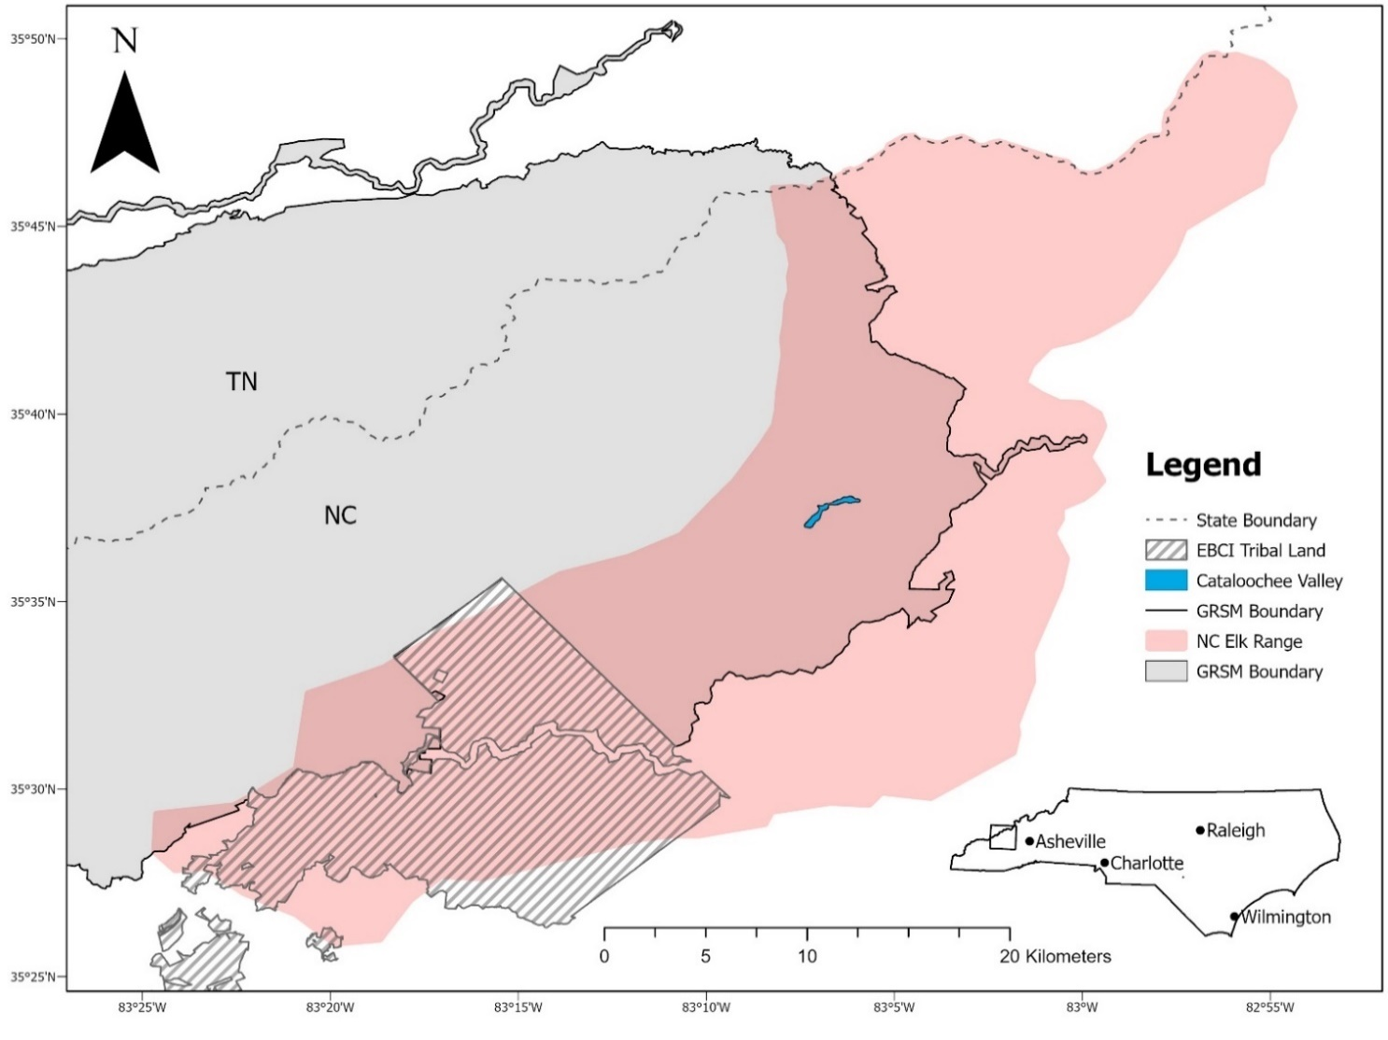
Figure 1. Elk were reintroduced into the Cataloochee Valley located in the southeastern corner of Great Smoky Mountains National Park in 2001 and 2002. (Service layer credits: Esri, HERE, Garmin, SafeGraph, FAO, METI/NASA, USGS, EPS, NPS).

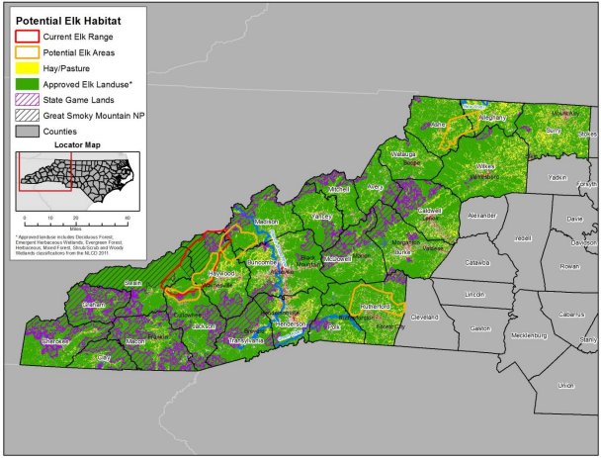
Figure 2. Five elk areas were delineated and used to assess the feasibility of establishing a huntable elk population in North Carolina (RTI International 2014).
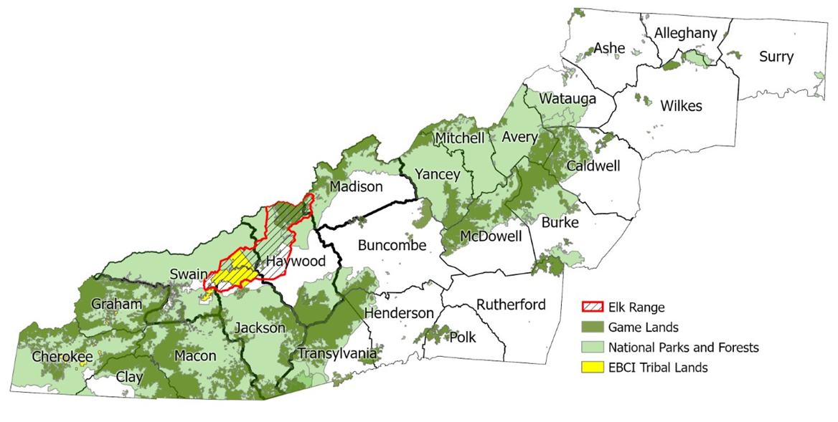
Figure 3. Map of current elk range in western North Carolina. Map courtesy of North Carolina Wildlife Resources Commission.

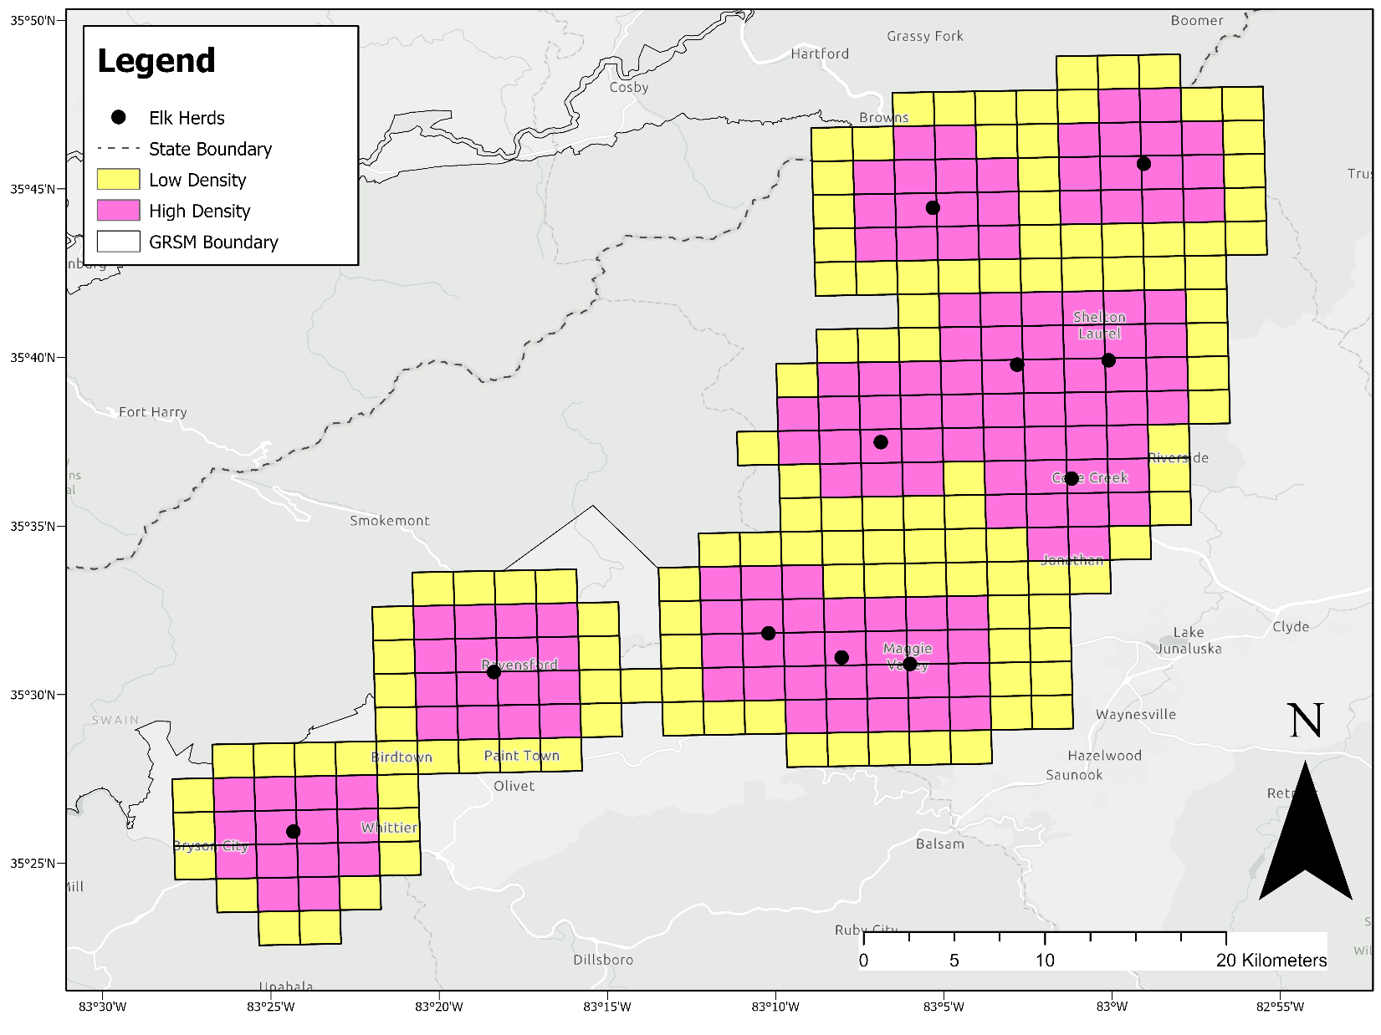
Figure 4. Locations of major elk herds in western North Carolina and cells of presumed high and low elk densities used to construct transect sampling designs and perform preliminary simulations. (Service layer credits: Esri, HERE, Garmin, SafeGraph, FAO, METI/NASA, USGS, EPS, NPS).

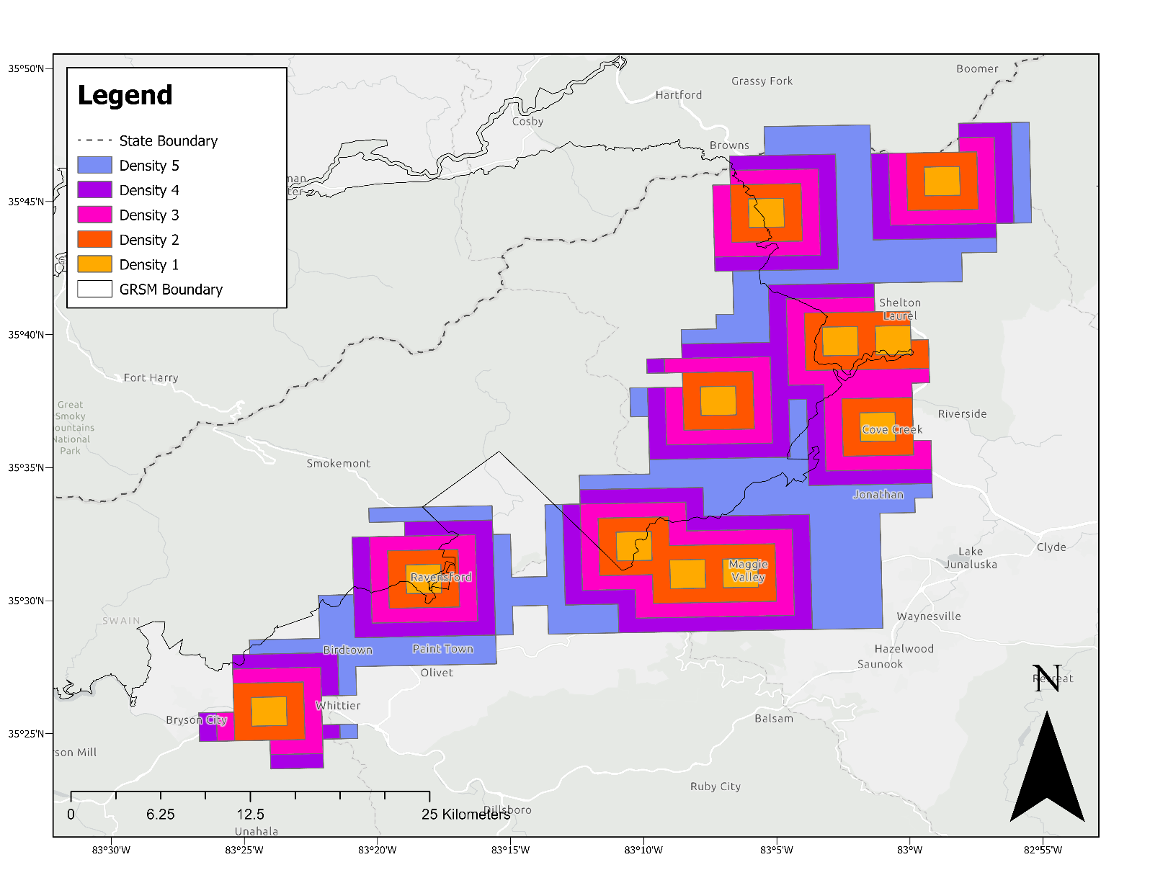
Figure 5. Elk density layers used in simulations and in final sampling design. Elk densities were presumed highest in Density 1 and lowest in Density 5. (Service layer credits: Esri, HERE, Garmin, SafeGraph, FAO, METI/NASA, USGS, EPS, NPS).
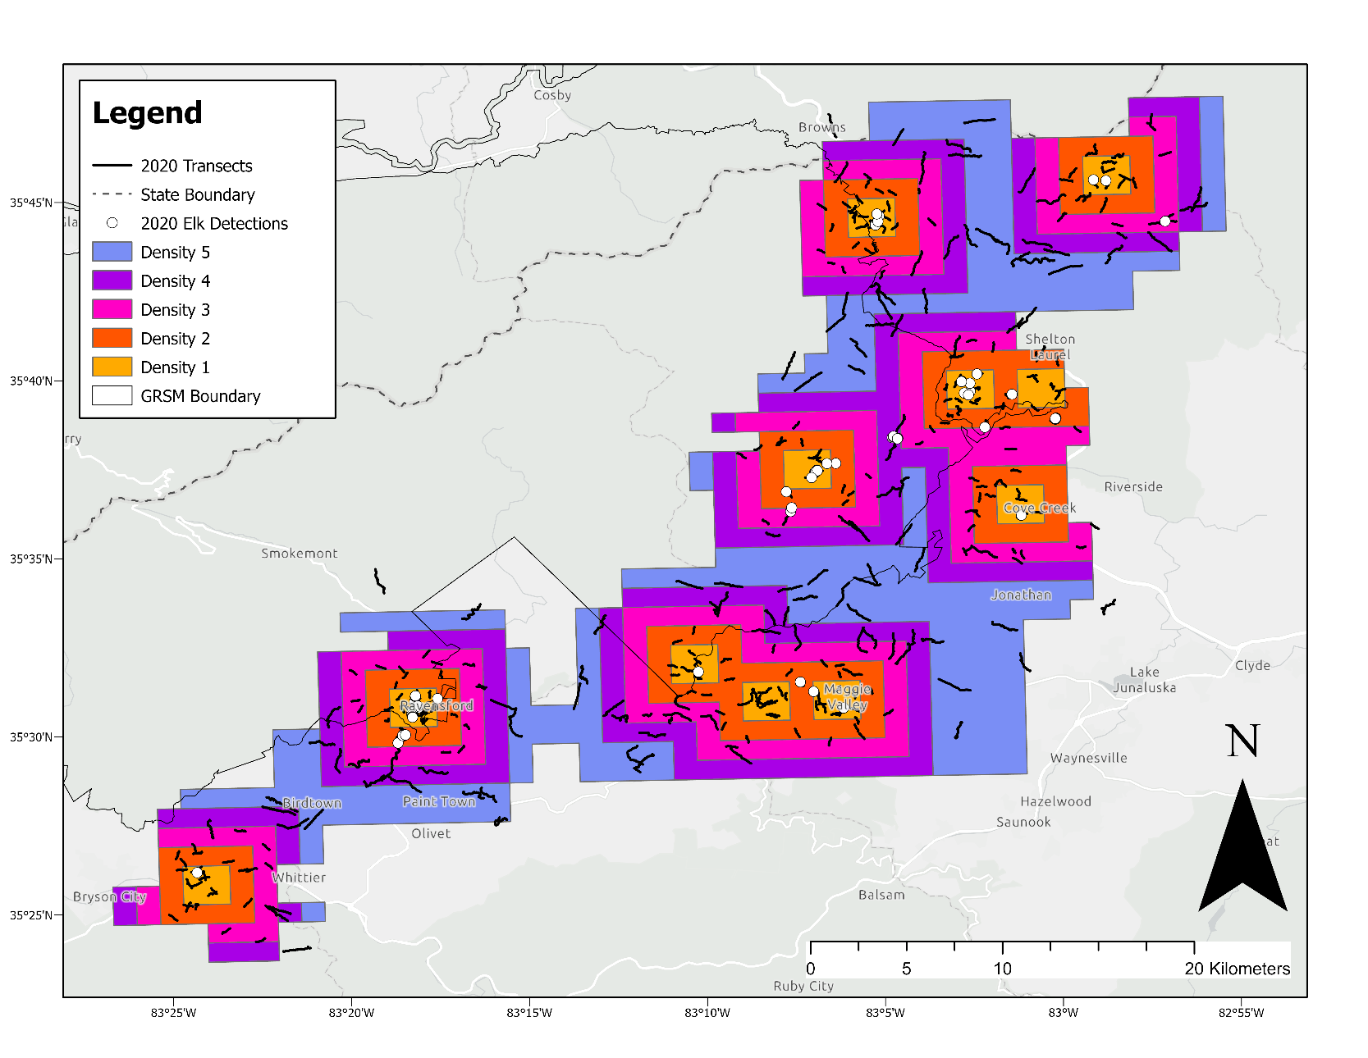
Figure 6. A total of 379 transects were completed in 2020 and 60 elk were identified from fecal DNA. Density layers represent varying levels of presumed elk density with the highest presumed number of elk in Density 1 and lowest number of elk in Density 5. Sampling intensity was highest in Density 1 and decreased to Density 5. (Service layer credits: Esri, HERE, Garmin, SafeGraph, FAO, METI/NASA, USGS, EPS, NPS).

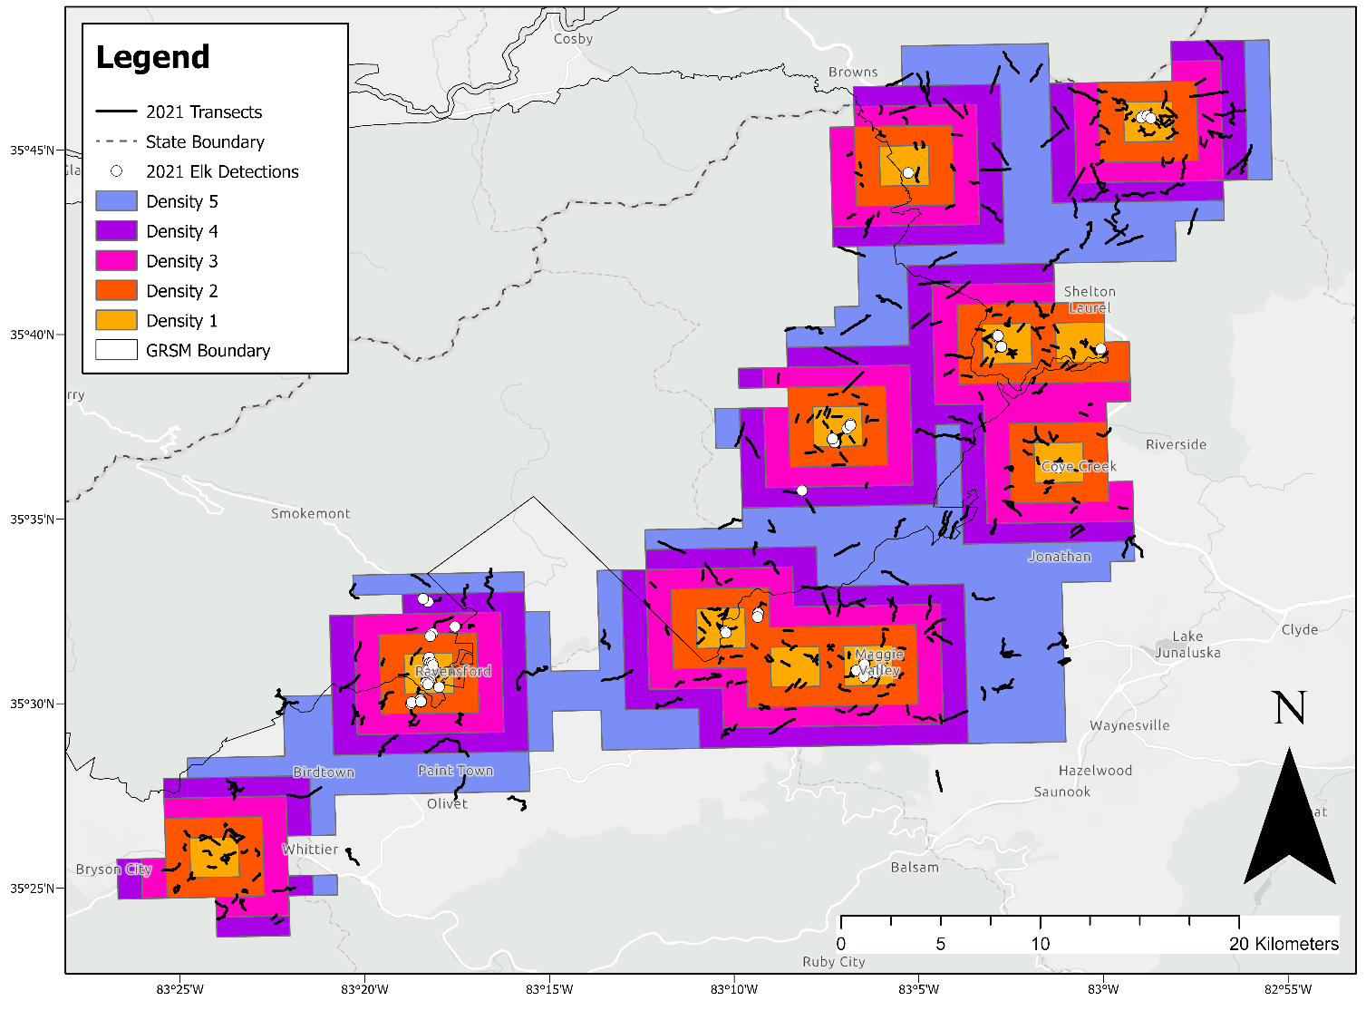
Figure 7. A total of 431 transects were completed in 2021 and 80 elk were identified from fecal DNA. Density layers represent varying levels of presumed elk density with the highest presumed number of elk in Density 1 and lowest number of elk in Density 5. Sampling intensity was highest in Density 1 and decreased to Density 5. (Service layer credits: Esri, HERE, Garmin, SafeGraph, FAO, METI/NASA, USGS, EPS, NPS).

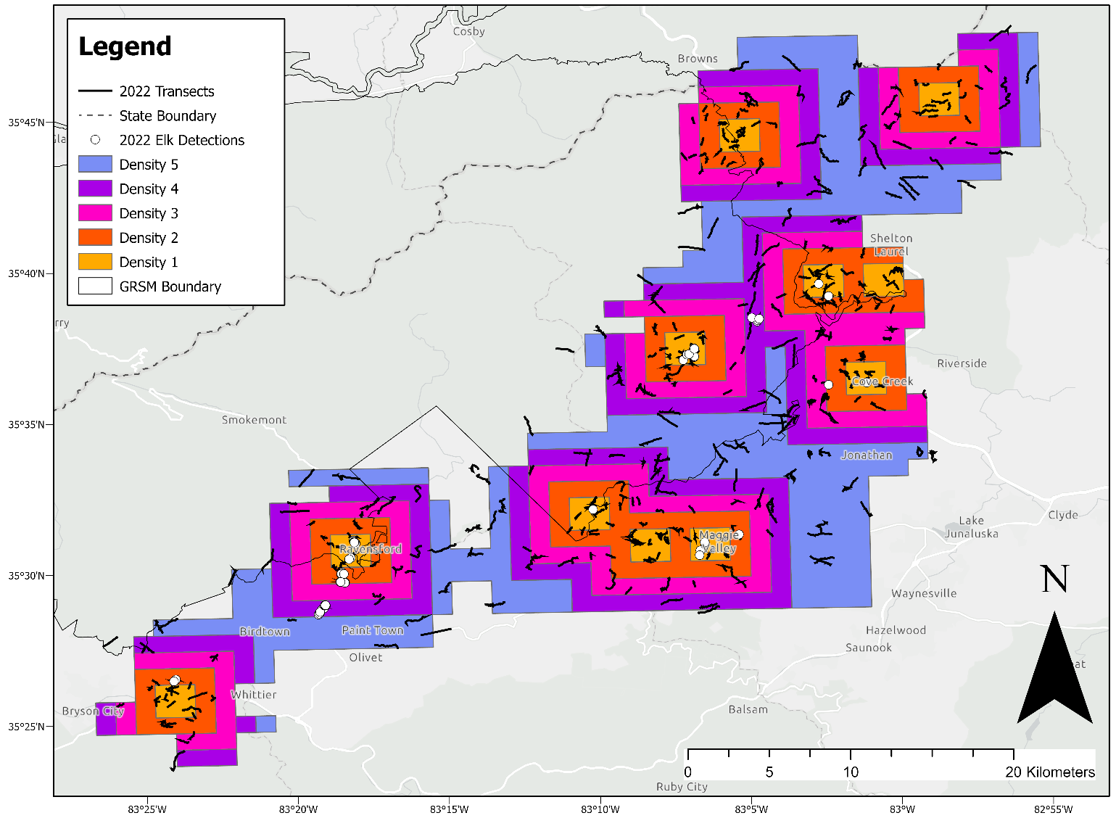
Figure 8. A total of 412 transects were completed in 2022 and 88 elk were identified from fecal DNA. Density layers represent varying levels of presumed elk density with the highest presumed number of elk in Density 1 and lowest number of elk in Density 5. Sampling intensity was highest in Density 1 and decreased to Density 5. (Service layer credits: Esri, HERE, Garmin, SafeGraph, FAO, METI/NASA, USGS, EPS, NPS).
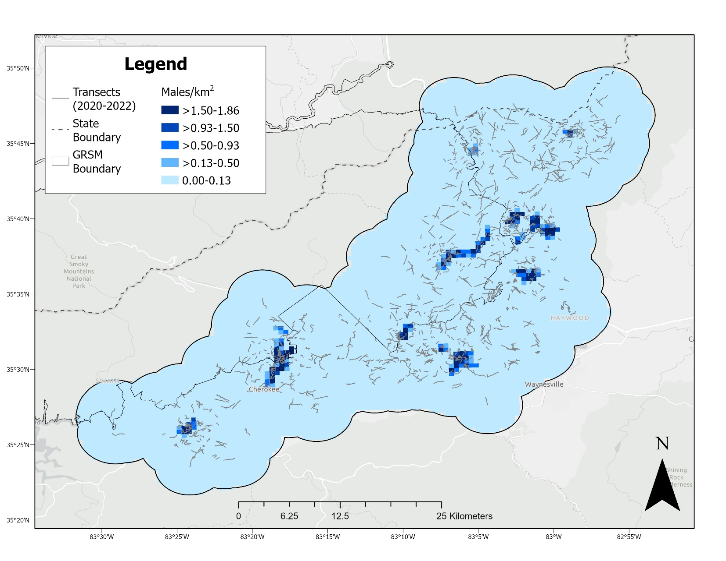
Figure 9. Predicted male elk density surface in western North Carolina, averaged from 2020 to 2022. The gray lines represent completed transects. Highest male elk densities were located in and around fields. (Service layer credits: Esri, HERE, Garmin, SafeGraph, FAO, METI/NASA, USGS, EPS, NPS).
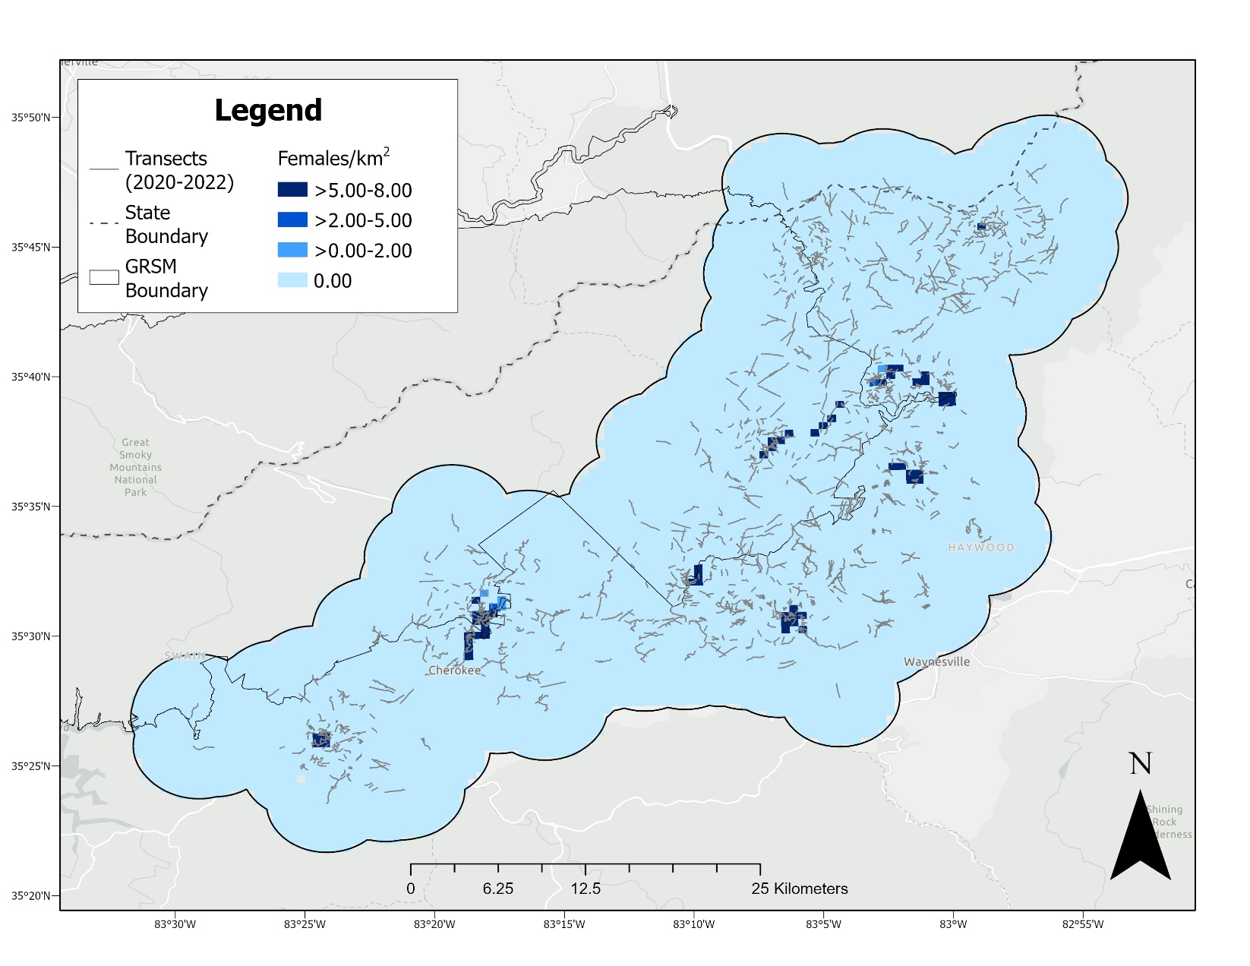
Figure 10. Predicted female elk density surface in western North Carolina, averaged from 2020 to 2022. The gray lines represent completed transects. Highest female elk densities were located in and around fields. (Service layer credits: Esri, HERE, Garmin, SafeGraph, FAO, METI/NASA, USGS, EPS, NPS).
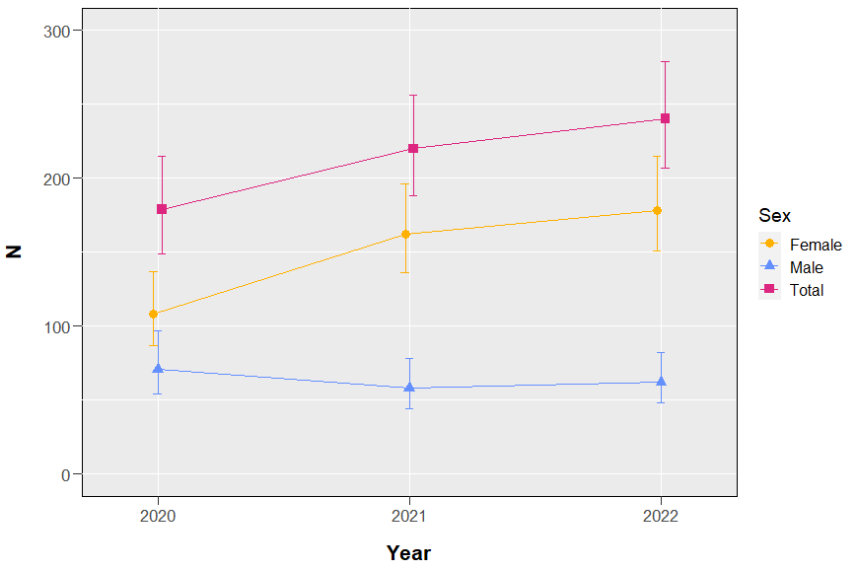

Figure 11. Realized abundance (N) estimates and 95% confidence intervals for male and female elk in western North Carolina, 2020–2022.

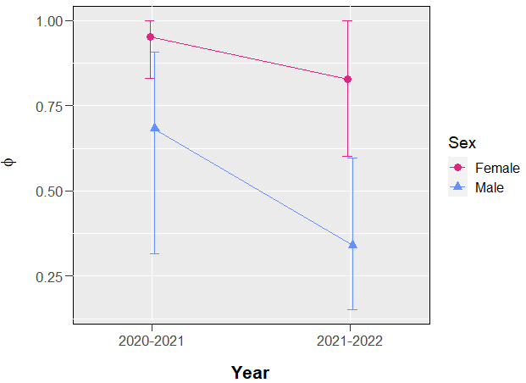
Figure 12. Mean annual survival (φ) estimates and 95% confidence intervals for male and female elk in western North Carolina, 2020–2022.
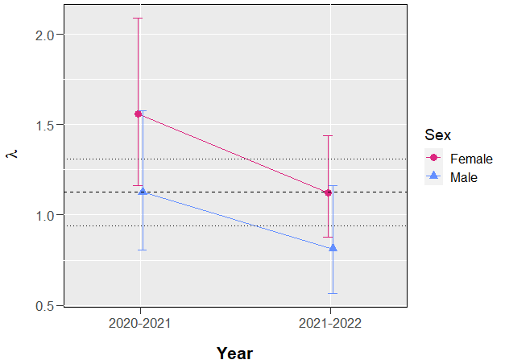
Figure 13. Mean population growth rate (λ) estimates and 95% confidence intervals of male and female elk in western North Carolina, 2020–2022. The black dashed line depicts the geometric mean population growth rate for both sexes and all years pooled (λ = 1.125), and the black dotted lines represent 95% confidence intervals.
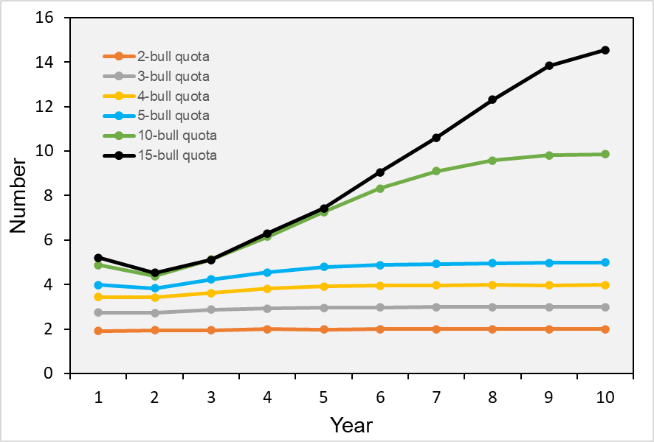
Figure 14. Number of bulls (adult males >3 years of age) harvested each year of a 10-year population projection period under various harvest scenarios across huntable lands in western North Carolina.

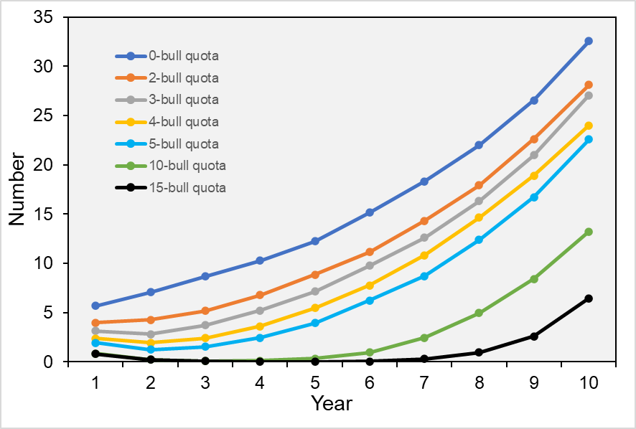
Figure 15. Number of bulls (adult males >3 years of age) in the population each year of a 10-year population projection period under various harvest scenarios across huntable lands in western North Carolina.

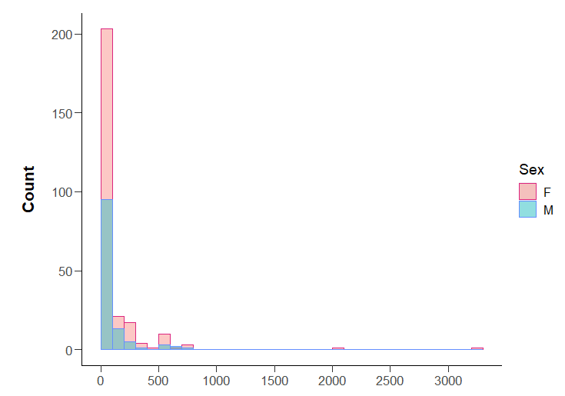
Figure 16. Histogram of the Euclidean distance to the nearest primary field for all genotyped elk pellet samples (n = 390) in western North Carolina, 2020–2022.

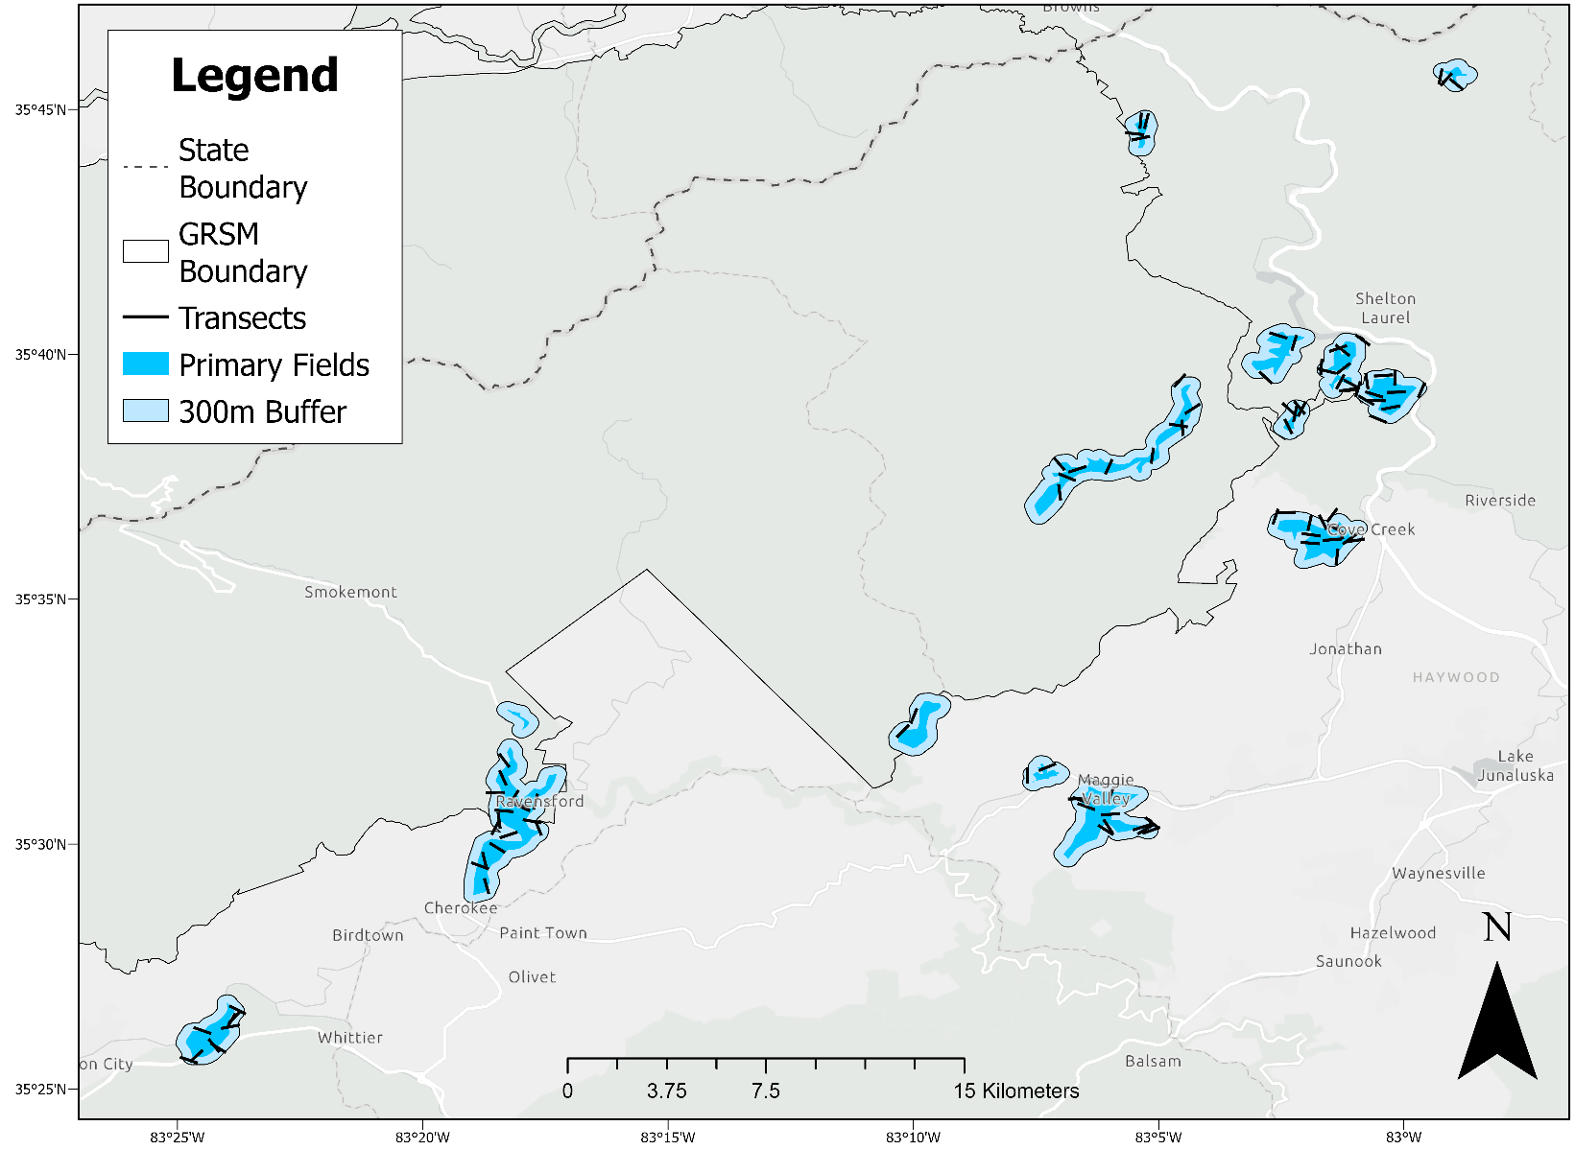
Figure 17. The revised sampling protocol focuses sampling effort within 300 m of the primary fields used by elk with a slightly increased sampling intensity of approximately 100 500-m transects. Transects shown here were randomly generated. (Service layer credits: Esri, HERE, Garmin, SafeGraph, FAO, METI/NASA, USGS, EPS, NPS)

Appendix C. Recommended Sampling Protocol

Justification
The sampling protocol used from 2020 to 2022 was designed based on the location of known elk herds in western North Carolina. The study area was divided into 5 different elk density layers (Figure 5), with density level 1 having the highest elk densities and level 5 having the lowest elk densities. Density level 1 included areas that were 0–1,000 m from elk herd centroids and density levels increased in distance from herds in 1,000-m increments. I used a stratified sampling approach with areas of higher elk density being sampled more intensively than areas of lower elk density, using a large number of 500-m transects in density levels 1–3 and a reduced number of 1,500-m transects in density levels 4–5. About 88.7% of the successfully genotyped elk pellet samples collected from 2020 to 2022 were in density levels 1 and 2 (i.e., 0–2,000 m from elk herd centroid) and the remaining 11.3% were in density levels 3 and 4 (i.e., 2,000–4,000 m from elk herd centroid). No successfully genotyped elk pellet samples were collected in density level 5 (i.e., >4,000 m from elk herd centroid; Table 13). A majority of the successfully genotyped elk pellet samples were collected in or within 100 m of a primary field used by elk in western North Carolina. A relatively small fraction of the total number of elk detections were from 100 to 700 m of a primary field and elk detections beyond 700 m were rare.
We aimed to complete 410 transects annually and each year, the proportion of transects with successfully genotyped elk pellet samples was relatively small. We collected successfully genotyped samples on 37 of 379 completed transects, 35 of 431 completed transects, and 24 of 412 completed transects in 2020, 2021, and 2022,
Table 13. Total number of elk pellet samples collected in each density layer used in simulations and final study design of elk population research in western North Carolina, 2020–2022. Density level D1 represents the region with the presumed highest elk densities and level D5 represents the region with the lowest presumed elk densities.
 |  |  | Year
Density  level | 2020 |  | 2021 | 2022 | Total |  | % of Total
D1 |  | 50 | 82 | 52 |  | 184 |  | 0.482
D2 |  | 25 | 28 | 102 |  | 155 |  | 0.406
D3 |  | 2 | 1 | 0 |  | 3 |  | 0.008
D4 |  | 8 | 3 | 29 |  | 40 |  | 0.105
D5 |  | 0 | 0 | 0 |  | 0 |  | 0.000
Total |  | 85 | 114 | 183 |  | 382

respectively. Because samples were collected on relatively few of the total completed transects and successfully genotyped samples were collected primarily in and adjacent to fields, I suggest reducing the number of transects and focusing efforts in and around fields in future sampling years. This will greatly reduce the amount of time and effort needed to complete the transects.

Revised Sampling Design
I used ArcGIS Pro® to create a modified layer of fields that was based on a fields layer that was previously provided by NCWRC, satellite imagery, and elk scat locations. I created a 300-m buffer around the modified fields layer and calculated the number of transects walked each year. We completed 68, 83, and 70 500-m transects in 2020, 2021, and 2022, respectively, in this buffered area. Therefore, I suggest increasing the total number of transects to about 100 500-m transects in the buffered area in future years. Although this is an increase in sampling intensity in these areas compared to the 2020–2022 sampling design, the total sampling intensity is much reduced (410 transects totaling 335 km in length compared with 100 transects totaling 50 km in length).
Next, I generated 100 random starting points in ArcGIS Pro® that fell within the 300-m buffer around the modified fields layer. I assigned each starting point a random azimuth value of 1–360 and generated 500-m lines using the random starting points and azimuths (Figure 17). These same methods can be repeated at the beginning of each sampling season to generate a new set of random transects. As in previous years, some transects may need to be shifted due to accessibility issues. I suggest following the same transect sampling methods used from 2020 to 2022 (Appendices D–H). However, I suggest only collecting and genotyping samples of higher quality (i.e., ratings of 1–2) as genotyping success rate was low in poorer quality samples.
Dr. Heather Evans (NCWRC) has suggested an alternative approach to sample storage than the freezing method recommended by WGI. Dr. Evans recommends collecting 3–4 pellets from each pellet group encountered and placing pellets into a 15-ml conical tube (e.g., Falcon® Conical Centrifuge Tubes) containing 95% non-denatured alcohol. Only pellets that are dark in color and have not fully hardened should be collected. Tubes containing pellets and ethanol should be labeled and refrigerated until shipment. Samples should be shipped with ice packs to the genetics lab. Final PCR conditions for each microsatellite markers evaluated by Dr. Evans are provided in Table 14.
This revised sampling protocol was designed to achieve adequate sampling intensity while also being more efficient and less labor-intensive compared to previous years. This design was developed under the premise of annual sampling; however, the sampling interval can be adjusted to agency needs. Additional sampling data at regular intervals should improve the performance of our estimation routines.
Table 14. Final PCR conditions for each microsatellite marker analyzed by NCWRC. PCRs were either conducted using Qiagen Multiplex MasterMix (Qiagen MM) or a 1:10 mixture of Takara Premix Ex Taq and Promega GoTaq MasterMix (1:10 Taq). Times for cycling conditions are shown in minutes and seconds using the format mm:ss. Primer concentrations are 10 µM unless otherwise indicated.
Marker | Cycling Conditions: |  |  | Marker | Cycling Conditions: |  |  | Marker | Cycling Conditions:
0.5 µL OvirH | 95°C | 2:00 |  | 0.65 µL BMC1009 (20 µM) | 95°C | 15:00 |  | 0.48 µL BM4513 | 95°C | 15:00
5.0 µL 1:10 Taq | 94°C | 0:30 |  | 0.25 µL BM6506 (20 µM) | 94°C | 0:30 |  | 5.0 µL Qiagen MM | 94°C | 0:30
3.0 µL H2O | TDª 62°C-52°C | 1:00 |  | 0.25 µL SRY (20 µM) *** | 54°C | 0:30 |  | 1.0 µL Q solution | TD 62°C-52°C | 1:00
1.0 µL DNA | 72°C | 1:30 |  | 0.27 µL Rt1 (20 µM) | 72°C | 1:00 |  | 2.04 µL H2O | 72°C | 1:30
 | 60°C | 30:00 |  | 5.0 µL Qiagen MM | 60°C | 30:00 |  | 1.0 µL DNA | 60°C | 30:00
 |  | 40 cycles |  | 1.0 µL Q solution |  | 40 cycles |  |  |  | 38 cycles
 |  |  |  | 0.16 µL H2O |  |  | ``
0.5 µL BL42 (20 µM) | 95°C | 15:00 |  | 1.0 µL DNA |  |  |  | 0.5 µL BM4028 | 95°C | 15:00
5.0 µL Qiagen MM | 94°C | 0:30 |  |  |  |  |  | 5.0 µL Qiagen MM | 94°C | 0:30
1.0 µL Q solution | 54°C | 1:00 |  | 0.48 µL BM888 | 95°C | 15:00 |  | 1.0 µL Q solution | TD 63°C-53°C | 1:00
2.4 µL H2O | 72°C | 1:30 |  | 0.5 µL BM4107 | 94°C | 0:30 |  | 2.0 µL H2O | 72°C | 1:30
1.0 µL DNA | 60°C | 30:00 |  | 0.48 µL OarFCB193 | 52°C | 1:00 |  | 1.0 µL DNA | 60°C | 30:00
 |  | 40 cycles |  | 5.0 µL Qiagen MM | 72°C | 1:30 |  |  |  | 37 cycles
 |  |  |  | 1.0 µL Q solution | 60°C | 30:00
0.5 µL BM203 | 95°C | 2:00 |  | 0.08 µL H2O |  | 38 cycles |  | 0.5 µL BM3507 (15 µM) | 95°C | 15:00
5.0 µL 1:10 Taq | 94°C | 0:30 |  | 1.0 µL DNA |  |  |  | 5.0 µL Qiagen MM | 94°C | 0:30
0.6 µL MgCl2 | 54°C | 0:30 |  |  |  |  |  | 1.0 µL Q solution | 53°C | 1:00
2.4 µL H2O | 72°C | 1:00 |  | 0.75 µL Rt7 (30 µM) | 95°C | 15:00 |  | 2.0 µL H2O | 72°C | 1:30
1.0 µL DNA | 72°C | 10:00 |  | 5.0 µL Qiagen MM | 94°C | 0:30 |  | 1.0 µL DNA | 60°C | 30:00
 |  | 40 cycles |  | 1.0 µL Q solution | 49°C | 0:30 |  |  |  | 40 cycles
 |  |  |  | 1.0 µL H2O | 72°C | 1:00
1.0 µL INRA107 (20 µM) | 95°C | 15:00 |  |  | 72°C | 30:00 |  | 0.48 µL OarFCB193 | 95°C | 2:00
5.0 µL Qiagen MM | 94°C | 0:30 |  |  |  | 40 cycles |  | 5.0 µL 1:10 Taq | 94°C | 0:30
1.0 µL Q solution | TD 60°C-50°C | 1:00 |  |  |  |  |  | 1.0 µL Q solution | 52°C | 1:00
1.0 µL H2O | 72°C | 1:30 |  | 0.6 µL CSSM041 | 95°C | 2:00 |  | 2.04 µL H2O | 72°C | 1:30
1.0 µL DNA | 60°C | 30:00 |  | 5.0 µL 1:10 Taq | 94°C | 0:30 |  | 1.0 µL DNA | 60°C | 30:00
 |  | 40 cycles |  | 1.0 µL Q solution | 50°C | 0:30 |  |  |  | 38 cycles
 |  |  |  | 1.8 µL H2O | 72°C | 1:00
0.75 µL Rt13 (20 µM) | 95°C | 15:00 |  | 1.0 µL DNA | 72°C | 10:00 |  | 0.25 µL SRY (20 µM) | 95°C | 2:00
5.0 µL Qiagen MM | 94°C | 0:30 |  |  |  | 40 cycles |  | 5.0 µL 1:10 Taq | 94°C | 0:30
1.0 µL Q solution | 49°C | 0:30 |  |  |  |  |  | 0.6 µL MgCl2 | 54°C | 0:30
1.0 µL H2O | 72°C | 1:00 |  |  |  |  |  | 2.09 µL H2O | 72°C | 1:00
 | 72°C | 30:00 |  |  |  |  |  | 1.0 µL DNA | 60°C | 30:00

ªTD=Touchdown PCR where annealing temperature is decreased one degree per cycle for the first ten cycles.

Appendix D. Elk Fecal Pellet Collection Form

North Carolina Elk Population Study
Scat Collection Data Form
Technician(s):__________________________________________________________ Date:___________________________________________________________
Transect Location:_____________________________________________________ TransectID:_____________________________________________________
Weather Conditions (Temperature, humidity, etc.):___________________________________________________________________________________________

Start coordinates (UTM):____________________________ Start time:______________________________
End coordinates (UTM):_____________________________ End time:______________________________
GPS tracklog: Y N Tracklog name:_________________________________________________________________

Scat  # | # pellets collected | Quality  rating | Coordinates  (UTM) | Waypoint  in GPS? | Sample  labelled? | Notes
Scat  # | # pellets collected | Quality  rating | Coordinates  (UTM) | Waypoint  in GPS? | Sample  labelled? | Notes
Comments:
Date GPS downloaded:  Initials: | Date entered:  Initials: | Date scanned:  Initials:

Appendix E. Elk Pellet Collection Protocol
- Navigate to transect starting location (can start at either end, use appropriate compass bearing)
- Begin filling out data sheet
  - Technician name
  - Date
  - Transect location (“Cataloochee”, “White Oak”, etc.)
  - TransectID (ex: S100)
  - Weather conditions
  - Starting coordinates
  - Starting time
- Start GPS tracklog (see pages 3–4 of this protocol for detailed instructions)
  - Name tracklog by TransectID (ex: S100)
- Begin walking in direction of assigned compass bearing, searching for pellet piles within a 2-m wide area (roughly arm span)
  - ***Follow elk trails when encountered (this will help maximize the number of samples collected***
- When a pellet pile is encountered:
  - Collect 6-8 pellets and place in Ziploc bag (*only need to collect pellets with a quality rating of 1 or 2; record all other data on datasheet for quality rating 3 but do not collect pellets)
  - Label Ziploc bag with TransectID and sample # (ex: S100_01, first sample collected on transect S100)
  - Save as a waypoint in GPS using same label as above (ex: S100_01)
  - Fill out sample info on datasheet
    - Scat # (ex: 01)
    - # of pellets collected
    - Quality rating: Assign a value of 1–3 based on appearance (Brinkman et al. 2010)
      - 1 = good; freshly deposited in a clumped distribution with pellets intact, surface with a glossy sheen, and/or a detectable coating of mucus
      - 2 = average; slightly older with intact pellets with smooth surfaces but lacking glossy sheen
      - 3 = poor; spread out group with rough-surfaced pellets, showing signs of decomposition
    - GPS coordinates
    - Notes (comments on sample quality, location, etc.)
- Check GPS tracklog occasionally to monitor distance covered (500 meters for S transects, 1,500 meters for L transects)
- Once transect is completed, save GPS tracklog
- Fill out end coordinates, end time, and any additional comments
- Once at vehicle, store samples in a cooler, preferably with an ice pack, until placing in freezer

*GPS tracklogs and waypoints are very important! We will have to repeat transects with missing or inaccurate GPS tracklogs.

* Precipitation can remove DNA from surface of pellets. We will not collect samples during rain events or for at least 1.5 days (36 hours) after a rain event.

Appendix F. Garmin GPS Tracklog Instructions

Check GPS Position Format Settings
- Menu 🡪 Setup 🡪 Position Format
- Set “Position Format” to “UTM UPS”
- Set “Map Datum” to “WGS 84”

Check Tracklog Settings
- Menu 🡪 Setup 🡪 Tracks 🡪 Track Log
- Set Track Log to “Record, Show on Map”

Creating and Saving a Waypoints and Tracklogs
- Navigate to starting point and begin a new tracklog
  - Menu 🡪 Track Manager 🡪 Current Track 🡪 Clear Current Track
  - This starts a new tracklog from your current location

- Begin walking transect, following assigned compass bearing

- Check Trip Computer occasionally to monitor distance walked
  - Menu 🡪 Trip Computer

- Create a waypoint for each pellet pile collected
  - Menu 🡪 Mark Waypoint
  - Save as TransectID_Sample# (ex: S100_01)
  - Press “Done”
  - Record data on datasheet

- Once transect is completed, save track
  - Menu 🡪Track Manager 🡪 Save Track
  - Save Track as transectID (ex: S100, etc.)

- A page will then pop up asking if you’d like to “clear the current track and associated trip data”? Either is okay.
  - “Yes” will delete it from the map view but it is still saved in the GPS
  - “No” keeps it on the map view

Appendix G. onX Instructions

Getting Started with onX
- Download onX hunting app onto phone
- Login information:
  - Email/username: #####
  - Password: #####
- All transects are loaded into the app
  - Red transects have not been completed yet
  - Neon blue/teal transects have been completed

Creating and Saving Waypoints and Tracklogs in onX
- Before going into the field, download map layers for use offline
  - Off-Grid 🡪 Save New Map
- Navigate to starting point and adjust app settings
  - Set the app to Offline mode – this will use satellites rather than cell towers to collect GPS data
  - Off-Grid 🡪 Go Offline
  - Confirm map using UTM coordinates (Map Settings 🡪 Coordinates: UTM)
    - *Note: onX uses WGS84 map datum
- Start a new tracklog
  - Tracker 🡪 Start
- Begin walking transect, following assigned compass bearing
- Check app occasionally to monitor distance walked
- Create a waypoint for each pellet pile collected
  - Press current location
  - Add Waypoint
  - Save as TransectID_Sample# (ex: S100_01)
  - Press “Save”
  - Record data on datasheet
- Once transect is completed, save track
  - Stop
  - Save Track as transectID (ex: S100, etc.)
  - Save (orange button)
- Change the color of the transect to indicate it has been completed
  - Select the transect
  - Press the 3 dots in the lower right hand corner of pop-up box
  - View/Edit
  - Scroll to Line Color and change
  - Scroll to bottom and press Save

Appendix H. Elk Pellet Surface Rub Protocol

- Remove batch of samples from freezer and set at room temperature to thaw for 10–15 minutes
- Once thawed, use a POROUS, FLAT-SIDED toothpick to rub the outside surface of 2–3 pellets from a sample bag
  - Rub vigorously and thoroughly, but do not transfer fecal matter to toothpick
  - See video: http://youtu.be/Dvs12G7h0tU
- Repeat with a second toothpick using 2-3 other pellets from the same sample bag
- Place toothpicks in a coin envelope and label with sample ID, initials, and date
- Repeat process for additional samples; you should have 3 toothpicks per sample
- Store coin envelopes at room temperature

Pellet Surface Rub FIELD Protocol
We would like to test if conducting surface rubs in the field will result in better DNA extraction compared to conducting surface rubs in the lab after samples have been stored in the freezer.
- Conduct transects like normal, collecting samples in Ziploc bags
- For 1 out of every 4–5 samples, conduct a surface rub in the field as described above in steps 2–4 in addition to collecting a sample in a bag (you will have both a surface rub sample and actual pellet pile sample)
- Include the word “Field” on the coin envelope
- Make a note in the comments section of the datasheet that a surface rub sample was collected
*Aim to conduct field surface rubs for a minimum of 25% of the pellet piles sampled (more is great!)

VITA

Jessica Braunstein is the daughter of Robert and Sunny Braunstein and was born in Daegu, South Korea in 1990. Her family moved to Maryville, Tennessee in 1992 where she grew up and attended Maryville High School. In 2009, she began her Bachelor of Science in Biological Sciences at Lee University in Cleveland, Tennessee. During her undergraduate studies, she assisted with several research projects including studies on the eastern hellbender in Tennessee and blue crabs in the Chesapeake Bay. After completion of her bachelor’s degree in May of 2013, she moved to California to work as a wildlife intern for the United States Forest Service’s King’s River Fisher Project in the Sierra National Forest. The following year, she completed an Appalachian Trail thru-hike before applying for graduate school. In April 2015, she returned to Tennessee to begin her Master of Science in Wildlife Science at the University of Tennessee in Knoxville under the guidance of Dr. Joseph D. Clark. Her M.S. research focused on food-conditioning and movements of American black bears in Great Smoky Mountains National Park. Following completion of her Master’s degree, Jessica continued her graduate studies at the University of Tennessee by pursing a Doctor of Philosophy in Natural Resources. Her doctoral research focused on estimating population abundance and growth in western North Carolina.

