SOCIAL-ECOLOGICAL PERSPECTIVES ON INFECTIOUS DISEASE RISK ACROSS AN URBAN LANDSCAPE

A Dissertation Presented for the
Doctor of Philosophy
Degree
The University of Tennessee, Knoxville

Nathaniel Lee Gibson
August 2025

DEDICATION
To New Orleans and the people that call it home. It is a special city; a place and community without which this research would not exist. There is much in my life and career I owe to New Orleans – I will remain forever indebted.

To the federal scientists and researchers across the country, especially those at CDC, NIH, and USDA. Your work is more important now than ever.

To Dad, Mom, Tyler and Jensen; Olivia, Blue and Neo. I am not here without you.

In loving memory: Mimi, PopPop, Uncle Randall.

ACKNOWLEDGEMENTS
First and foremost, I must thank all my family, friends, and loved ones that have believed in and supported me over the years. In one way or another you have all been there for me, whether it was phone calls driving to or from field seasons to drinks and conversations shared over the last 6 years. This dissertation in part reflects your love and support all in the name of fulfilling my dream to be a scientist. Some say it takes a village, but for me it feels more like a city – thank you for being a part of this journey.
I also thank the numerous mentors, collaborators, and colleagues that are part and parcel to the body of work presented in this dissertation. My doctoral committee, headed by Dr. Michael Blum: Dr. Joshua Lewis, Dr. Paul Armsworth, Dr. Michael McKinney. Members of the Blum Lab past and present: Dr. Bruno Ghersi, Dr. Anna Peterson, Dr. Kristine Moody, Dr. Candice Lumbao, Dr. Rebecca Hazen, Dr. Rosalyn Rael, Haley Kodak, Na’imah Bradley, and Christopher Duncan. Dr. Claudia Herrera and Dr. Eric Dumonteil of the Tulane University School of Public Health and Tropical Medicine, valuable collaborators who provided their expertise in T. cruzi. All members of the New Orleans Coupled Natural and Human Systems project team. The ByWater Institute at Tulane University, particularly David Baker who taught me so many lessons throughout those summers in New Orleans. The dedicated public servants of the New Orleans Mosquito, Termite, and Rodent Control Board, including Dr. Claudia Riegel, Dr. Jennifer Breaux (former), and Timmy Madere. Finally, my cohort at the University of Tennessee Knoxville, especially Dr. Sarah J. Love, Dr. Eric Shershen, Dr. Maryrose Weatherton, Dr. Amy Luo, and Dr. Guido Herrera R. I am a better person and scientist because of each of you, and I will cherish our time spent together.
Finally, I thank and acknowledge the funding support which made this work possible: The Tulane-Xavier Center for Bioenvironmental Research, The Tulane ByWater Institute, the National Science Foundation (GRANTS), Tulane University Carol Lavin Bernick Faculty Grant Program, the Louisiana Board of Regents, The National Primate Research Center, the University of Tennessee Knoxville Graduate School, the UT Herbarium, and the University of Tennessee Department of Ecology and Evolutionary Biology
ABSTRACT
The push and pull of urban expansion and counter-urbanization in cities can lead to complex, dynamic social-ecological landscapes. Across urban landscapes, social-ecological features reshape the interfaces between built environments, people, animals, and vector-born pathogens in ways that amplify zoonotic disease risk. My aim in this dissertation was to evaluate and contextualize how social-ecological factors can influence the dynamics of hosts, vectors, and the pathogens they carry across the greater New Orleans (Louisiana, USA) area. The social-ecological investigations I undertook examined multiple host taxa and disease systems, considering exposure risk at multiple scales: within hosts, host-to-host, and vector-landscape interactions. I first considered if and how vertical transmission can sustain Trypanosoma cruzi infection within urban rodent reservoir populations. Utilizing an existing archive of T. cruzi positive rodents, I determined infection status for 66 embryos from 3 rodent species (Norway rats, roof rats, and house mice) to test for evidence of vertical transmission from mother to offspring. I found that 15/66 embryos (22.7%) were infected with T. cruzi and that multiple genotypes of T. cruzi can pass from mother to offspring. Next, I compared Angiostrongylus cantonensis prevalence in 3728 gastropods to rodents collected at 73 rodent trapping sites to explore primary host to secondary host transmission of A. cantonensis and if infection in different host species is influenced by a common set of social-ecological factors. I found that gastropods and rodents respond differently to factors like vacancy, unmaintained vegetation, and flooding history, highlighting the complexity of multi-host transmission cycles in urban landscapes. Finally, I examined social-ecological predictors of mosquito diversity and demography. Social-ecological modelling revealed that abundances of vector mosquitoes respond to urban heat and tree cover and may remain stable over time despite seasonal climate variability.

Table of Contents

Introduction 1
Background and objectives 1
Hosts and pathogens in urban landscapes 1
Infectious disease in the social-ecological framework 2
Social-ecological dynamics of hosts and pathogens 3
Objectives and aims of the dissertation 4
References 6
Chapter One Potential vertical transmission of genetically diverse Trypanosoma cruzi in natural rodent populations 10
Abstract 11
Introduction 12
Methods 15
Ethics statement 15
Study area and samples 15
Tissue dissection and DNA extraction 16
Diagnostic and genotyping PCR assays 17
DNA sequence analysis 17
Results 18
Prevalence of vertical transmission 18
T. cruzi DTUs detected in embryos 18
DTU assemblage structure 19
Discussion 20
Evidence of vertical transmission 20
Evidence of mixed infection of embryos 22
Conclusions 23
References 25
Appendix 33
Chapter Two Rat lungworm (Angiostrongylus cantonesis) infection in gastropod and rodent hosts across an urban landscape 37
Abstract 38
Introduction 40
Methods 43
Study area and samples 43
Gastropod sampling 44
DNA extraction and molecular analysis 44
Results 46
Gastropod assemblage structure 46
Prevalence of infection in gastropods and comparison to rodent infections 47
Social-ecological analyses 48
Discussion 49
Gastropod assemblage structure and prevalence of infection in gastropods 50
Comparison of infection rates between gastropods and rodents 52
Social-ecological drivers of host abundance and rat lungworm prevalence 53
References 56
Appendix 62
Chapter Three shifts in urban mosquito populatons across a social-ecologial landscape may alter pathogen transmission risk 67
Abstract 68
Introduction 69
Methods 72
Study area and mosquito trapping 72
Land cover, vegetation, climate, topographic and sociodemographic data 72
Statistical methods 74
Results 75
Community composition and abundances across neighborhoods and between seasons 75
Social-ecological predictors of mosquito richness, diversity, and abundance 77
Discussion 78
Spatiotemporal variation in community composition and demography 79
Social-ecological predictors of mosquito communities and demographics 81
Conclusions 84
References 86
Appendix 92
Vita 104

LIST OF TABLES
Table 1.1 Prevalence of T. cruzi infection in rodent offspring according to species and across all species; + represents standard error of the mean…………………..………….34
Table 1.2 DTUs detected in M. musculus embryos and parous females captured in the study area as determined by deep sequencing…………………………………………...35
Table 2.1 Gastropod abundance according to species and neighborhood……………….65
Table 2.2 Prevalence of infection according to gastropod species, and areas where infected gastropods were found. Abbreviations: BW = Bywater; L9 = Lower 9th; U9 = Upper 9th, GT = Gentilly; LS = Lakeshore; FQ = French Quarter, UT = Uptown……...66
Table 3.1 Average annual diversity, richness, and abundances of vector mosquitoes at trapping sites within each neighborhood across the study period. Standard deviation is noted as (+)………………………………………………………………………………95
Table 3.2 Neighborhood-level profiles to distinguish by land cover, topography, demographics, and socioeconomic status. All values represent averages for sites within neighborhoods………………………………………………………………...……….....96
Table 3.3 All social-ecological predictors included in the global model according to overarching data type………………………………………………………………….....97
Table 3.4 Models within the threshold of best-fit according to delta AIC (<2) for richness and diversity. * Indicates the model selected as the final model……………………99-100
Table 3.5 Models within the threshold of best-fit according to delta AIC (<2) for mosquito abundances. * Indicates the model selected as the final model………....101-103
LIST OF FIGURES
Figure 1.1 Map of T. cruzi prevalence in rodents across New Orleans and neighboring St. Bernard Parish. Black dots identify sites where T. cruzi-positive rodents were located with dot size representing total prevalence of infection; red dots identify sites with T. cruzi-positive parous mothers and embryo(s). The inset map describes the rodent assemblage at sites with T. cruzi infected rodents with colors denoting rodent species, and size representing number of rodents collected………………………………………33
Figure 1.2 Evolutionary relationships among 25 specimens inferred according to the Maximum Likelihood method with a General Time Reversible model. The tree with the highest log likelihood (-3530.44) is shown. The tree is drawn to scale, with branch lengths measured in the number of substitutions per site. There was a total of 723 positions in the final dataset; numbers at nodes indicate bootstrap support. * indicate rodents captured from the same study area; ** indicate DTU reference sequences……..36
Figure 2.1 Map of sites with A. cantonensis infected gastropods across sampled neighborhoods. Circle color denotes neighborhood whereas circle size is proportional to the prevalence of infection. Black diamond outlines represent rodent trapping sites where gastropods were collected but A. cantonensis infection was not detected……………….62
Figure 2.2 NMDS ordination plot of gastropod assemblage structure across New Orleans (LA, USA). Environmental vectors reflect rodent abunances (total and by species) and important social-ecological characteristics………………………………………………63

Figure 2.3 Boxplot of gastropod abundances in neighborhoods across New Orleans (LA, USA)……………………………………………………………………………………..64
Figure 3.1 Map of 44 permanent mosquito trapping sites across New Orleans, Louisiana, USA. Color denotes neighborhood and size represents total mosquito abundance……...92
Figure 3.2 Box plot of seasonal mosquito abundances according to neighborhood for each of Cu. quinquefasciatus (top), Ae. aegpyti (middle), and Ae. albopictus (bottom). Box plot color denotes seasonality……………………………………………………………93
Figure 3.3 Biplot of NMDS ordination of the full mosquito assemblage across New Orleans, LA………………………………………………………………………………94
Figure 3.4 Biplot of NMDS ordination of the mosquito assemblage with Cu. quinquefasciatus removed across New Orleans, LA………………………………….....98

Introduction

background and objectives

Hosts and pathogens in urban landscapes
Over the past several decades, (counter)urbanization processes have led to growing concerns about potential hazards posed by zoonotic vectors, hosts, and pathogens (Gulachenski et al 2016, Eskew and Olival 2018). Alteration and augmentation of urban-wildland interfaces and related human-wildlife interactions can promote transmission risk of zoonotic pathogens and corresponding disease in human populations (Patz et al. 2004, Hassel et al 2017, White and Razgour 2020). The emergence of Lyme disease in the eastern United States, for example, underscores the risks posed by greater zoonotic pathogen transmission as urban and suburban areas expand (Larsen et al. 2014). Emergence can also occur on a global scale, with diseases such as dengue and schistosomiasis impacting tens of millions of people as urbanization continues along a cycle of expansion and contraction (Hotez 2017). Urban landscapes thus can have a particular capacity to facilitate the (re)emergence of infectious diseases as a confluence of ecological, environmental, and societal factors converge to increase pathogen distributions and prevalence (Vanwambeke et al 2019).
The degradation of urban areas — characterized by increasing land abandonment, property vacancy, and unmaintained vegetation — can elevate pathogen transmission risk by elevating or altering zoonotic assemblages across complex mosaics of human-wildlife interactions within cities (Gulachenski et al. 2016, Ahmed et al 2019, Combs et al 2021). This is particularly true in cities experiencing counter-urbanization, where abandonment and vacancy increase due to depopulation (Gulachenski et al. 2016, Rael et al. 2016, Lewis et al. 2017). Areas experiencing counter-urbanization can become urban refugia for both hosts and pathogens that can directly increase risks posed to residents that are often already facing socioeconomic hardship (Himsworth et al 2013, Eskew and White 2018). Further understanding of the social and ecological dynamics of zoonotic pathogen transmission risk as a coupled social-ecological system could thus substantively improve human wellbeing and identify possible public health disparities.

Infectious disease in the social-ecological framework
Social-ecological scholarship has been formally conceptualized as a transdisciplinary consideration of ecological (i.e. organisms and the environment) and sociological (i.e. socio-economic, governance, and cultural systems) phenomena as a singular dynamic constituting a complex system (Anderies et al. 2004). Accordingly, it is expected that adopting a ‘socioecological’ approach can facilitate the examination of relationships, particularly feedbacks (e.g. Gulachenski 2016, Lewis et al. 2017), among and between the ecological and social components of a coupled system. For example, gaining social-ecological perspective can allow explicit consideration of linkages between land management policy (governance), ecological (re)assembly, legacies of socio-economic disparity, and disease risk (Lewis et al. 2017, Rael et al. 2016). Thus, adopting a social-ecological framework should be particularly useful for investigating landscapes with a prominent built environment (Moffat and Kohler 2008), like urban areas and zoonotic biota (i.e., hosts, vectors, and pathogens). Such a social-ecological perspective can also aid in identifying shared suites of ecological, environmental, and anthropological drivers of co-occuring hosts and pathogens (Combs et al 2021).

Social-ecological dynamics of hosts and pathogens
Host-pathogen dynamics can govern social-ecological feedbacks that pose a risk to human well-being. Multilevel relationships can be complex as hosts, vectors, and pathogens can exhibit variable responses to social-ecological drivers. Responses can elicit direct (e.g. shifts in host/vector populations or pathogen prevalence) and indirect outcomes (e.g. land use change altering habitat quantity or quality) (Magori and Drake 2013, Rael et al. 2016, Rizzoli et al. 2019). There is also evidence, however, that sensitivity in response to change can be more pronounced in urban environments due to acute and contrasting shifts in social-ecological conditions. Specifically, changes in environmental (e.g. disturbance, land use change) and sociological (e.g. human behavior at individual and institutional levels) components have been shown to alter zoonotic pathogen transmission risk (LaDeau et al. 2015). A range of studies over the past several years also have noted that some hosts and pathogens exhibit similar distributions, highlighting the possibility of parallel or coordinated responses to shifts in social-ecological conditions across urban landscapes (Rothenburger et al. 2017).
Parallels in pathogen transmission dynamics that have been observed across different urban taxa and geographies highlight the merit of adopting a social-ecological approach for characterizing potential health risks and disparities. For example, studies investigating rodents in New Orleans (Louisiana, US) have examined how social-ecological variation following Hurricane Katrina shaped rodent communities and pathogens present in rodent hosts (e.g. Rael et 2018, Peterson et al. 2020, Ghersi et al. 2020, Ghersi et al. 2021). This work has revealed that rodent population size and assemblage structure trend with urban blight in post-Katrina New Orleans, with larger populations and greater species diversity occurring in areas with more land abandonment (Peterson et al. 2020, Ghersi et al. 2021). Notably, the prevalence of some pathogens like Leptospira spp. (Peterson et al. 2021) appear to align with this pattern whereas others such as Angiostrongylus cantonensis (Rael et al. 2018) and Trypanosoma cruzi (Ghersi et al. 2020) do not. Similarly, it appears that the mosquito community in Baltimore (Maryland, US) varies along a social-ecological gradient of urban blight across inner-city neighborhoods. Vector species of public health concern, like Aedes albopictus and Culex pipiens, were found to thrive in areas with greater abandonment and unmaintained vegetation (LaDeau et al. 2013, Little et al. 2017). It should be noted, though, that environmental variation (e.g. changes precipitation levels) was observed to also be an important factor, as surveys conducted during a drier period detected higher abundances of vector mosquitoes in higher-income areas where human residence-related containers (planter boxes, trash cans) were more common (Becker et al. 2014). Evidence of seasonal shifts in urban mosquito populations highlights the sensitivity of zoonotic dynamics to social and ecological conditions and illustrates the value of increased understanding of urban zoonoses.

Objectives and aims of the dissertation
This dissertation examines multiple zoonotic hosts, vectors, and pathogens in an explicit social-ecological context to improve understanding of infectious disease risk across urban landscapes. I first consider how an alternative pathway of transmission - vertical transmission - can help sustain the prevalence and diversity of Tyrpanasoma cruzi in urban rodent populations by examining infection prevalence and pathogen diversity in T. cruzi-infected mothers and embryos. I then examined how Angiostrongylus cantonensis infection prevalence varies between primary rodent and intermediate gastropod hosts and considered if similar social-ecological factors influence the probability of infection. Finally, I characterized spatiotemporal variation of urban mosquito populations and determined what social-ecological features predict mosquito diversity and demography across an urban landscape.

References
Ahmed S, Dávila JD, Allen A, Haklay M, Tacoli C, Fèvre EM. Does urbanization make emergence of zoonosis more likely? Evidence, myths and gaps. Environment and urbanization. 2019 Oct;31(2):443-60.
Anderies JM, Janssen MA, Ostrom E. A framework to analyze the robustness of social-ecological systems from an institutional perspective. Ecology and society. 2004 Jun 1;9(1).
Becker B, Leisnham PT, LaDeau SL. A tale of two city blocks: differences in immature and adult mosquito abundances between socioeconomically different urban blocks in Baltimore (Maryland, USA). International journal of environmental research and public health. 2014 Mar;11(3):3256-70.
Combs MA, Kache PA, VanAcker MC, Gregory N, Plimpton LD, Tufts DM, Fernandez MP, Diuk‐Wasser MA. Socio‐ecological drivers of multiple zoonotic hazards in highly urbanized cities. Global Change Biology. 2022 Mar;28(5):1705-24.
Eskew EA, Olival KJ. De-urbanization and zoonotic disease risk. Ecohealth. 2018 Dec;15:707-12.
Ghersi BM, Peterson AC, Gibson NL, Dash A, Elmayan A, Schwartzenburg H, Tu W, Riegel C, Herrera C, Blum MJ. In the heart of the city: Trypanosoma cruzi infection prevalence in rodents across New Orleans. Parasites & vectors. 2020 Dec;13:1-0.
Ghersi BM, Peterson AC, Riegel C, Campanella R, Childs JE, Blum MJ. Flooding and abandonment have shaped rat demography across post-Katrina New Orleans. Landscape and Urban Planning. 2021 Nov 1;215:104218.
Gulachenski A, Ghersi BM, Lesen AE, Blum MJ. Abandonment, ecological assembly and public health risks in counter-urbanizing cities. Sustainability. 2016 May 19;8(5):491.
Hassell JM, Begon M, Ward MJ, Fèvre EM. Urbanization and disease emergence: dynamics at the wildlife–livestock–human interface. Trends in ecology & evolution. 2017 Jan 1;32(1):55-67.
Himsworth CG, Parsons KL, Jardine C, Patrick DM. Rats, cities, people, and pathogens: a systematic review and narrative synthesis of literature regarding the ecology of rat-associated zoonoses in urban centers. Vector-Borne and Zoonotic Diseases. 2013 Jun 1;13(6):349-59.
Hotez PJ. Global urbanization and the neglected tropical diseases. PLOS Neglected Tropical Diseases. 2017 Feb 23;11(2):e0005308.
LaDeau SL, Allan BF, Leisnham PT, Levy MZ. The ecological foundations of transmission potential and vector‐borne disease in urban landscapes. Functional ecology. 2015 Jul;29(7):889-901.
LaDeau SL, Leisnham PT, Biehler D, Bodner D. Higher mosquito production in low-income neighborhoods of Baltimore and Washington, DC: understanding ecological drivers and mosquito-borne disease risk in temperate cities. International journal of environmental research and public health. 2013 Apr;10(4):1505-26.
Larsen AE, MacDonald AJ, Plantinga AJ. Lyme disease risk influences human settlement in the wildland–urban interface: evidence from a longitudinal analysis of counties in the northeastern United States. The American journal of tropical medicine and hygiene. 2014 Oct 1;91(4):747.
Lewis JA, Zipperer WC, Ernstson H, Bernik B, Hazen R, Elmqvist T, Blum MJ. Socioecological disparities in New Orleans following Hurricane Katrina. Ecosphere. 2017 Sep;8(9):e01922.
Little E, Biehler D, Leisnham PT, Jordan R, Wilson S, LaDeau SL. Socio-ecological mechanisms supporting high densities of Aedes albopictus (Diptera: Culicidae) in Baltimore, MD. Journal of medical entomology. 2017 Sep 1;54(5):1183-92.
Magori K, Drake JM. The population dynamics of vector-borne diseases. Nature education knowledge. 2013;4(4):14.
Moffatt S, Kohler N. Conceptualizing the built environment as a social–ecological system. Building research & information. 2008 Jun 1;36(3):248-68.
Patz JA, Daszak P, Tabor GM, Aguirre AA, Pearl M, Epstein J, Wolfe ND, Kilpatrick AM, Foufopoulos J, Molyneux D, Bradley DJ. Unhealthy landscapes: policy recommendations on land use change and infectious disease emergence. Environmental health perspectives. 2004 Jul;112(10):1092-8.
Peterson AC, Ghersi BM, Campanella R, Riegel C, Lewis JA, Blum MJ. Rodent assemblage structure reflects socioecological mosaics of counter-urbanization across post-Hurricane Katrina New Orleans. Landscape and Urban Planning. 2020 Mar 1;195:103710.
Peterson AC, Ghersi BM, Riegel C, Wunder Jr EA, Childs JE, Blum MJ. Amplification of pathogenic Leptospira infection with greater abundance and co‐occurrence of rodent hosts across a counter‐urbanizing landscape. Molecular Ecology. 2021 May;30(9):2145-61.
Rael RC, Peterson AC, Ghersi BM, Childs J, Blum MJ. Disturbance, reassembly, and disease risk in socioecological systems. EcoHealth. 2016 Sep;13:450-5.
Rael RC, Peterson AC, Ghersi-Chavez B, Riegel C, Lesen AE, Blum MJ. Rat lungworm infection in rodents across post-Katrina New Orleans, Louisiana, USA. Emerging Infectious Diseases. 2018 Dec;24(12):2176.
Rizzoli A, Tagliapietra V, Cagnacci F, Marini G, Arnoldi D, Rosso F, Rosà R. Parasites and wildlife in a changing world: The vector-host-pathogen interaction as a learning case. International Journal for Parasitology: Parasites and Wildlife. 2019 Aug 1;9:394-401.
Rothenburger JL, Himsworth CH, Nemeth NM, Pearl DL, Jardine CM. Environmental factors and zoonotic pathogen ecology in urban exploiter species. EcoHealth. 2017 Sep;14:630-41.
Vanwambeke SO, Linard C, Gilbert M. Emerging challenges of infectious diseases as a feature of land systems. Current Opinion in Environmental Sustainability. 2019 Jun 1;38:31-6.
White RJ, Razgour O. Emerging zoonotic diseases originating in mammals: a systematic review of effects of anthropogenic land‐use change. Mammal review. 2020 Oct;50(4):336-52.

Potential vertical transmission of genetically diverse Trypanosoma cruzi in natural rodent populations

A version of this chapter by Nathaniel L. Gibson, Bruno M. Ghersi, Bridget Knudson, Anna C. Peterson, Claudia Riegel, Eric Dumonteil, Claudia Herrera, and Michael J. Blum was published April 1st 2025 in the journal PLOS Neglected Tropical Diseases.
The article has been reformatted from the published version as part of this dissertation. N.L. Gibson, B.M. Ghersi, C. Herrera, and M.J. Blum designed the study. N.L. Gibson, B.M. Ghersi, and A.C. Peterson collected and processed rodent samples. B. Knudson, C. Herrera, and E. Dumontiel provided genome sequencing expertise and analyses. N.L. Gibson completed all other analyses and wrote the manuscript. All authors provided revisions and comments to the manuscript.

Abstract
Trypanosoma cruzi, the causative agent of Chagas disease, has been detected in mammalian hosts occupying densely populated urban environments. This suggests that the risk of transmission to humans is higher than prevailing estimates, which largely reflect conditions in rural and peri-urban areas. Understanding the risks posed by T. cruzi thus requires further study of transmission pathways in part because triatomines – the primary vectors for T. cruzi – appear to be uncommon or absent in urban landscapes. Here I test the hypothesis that vertical transmission contributes to the prevalence of infection and diversity of T. cruzi in urban reservoirs. I assessed whether embryos of T. cruzi-positive parous female rodents also exhibit evidence of infection. A diagnostic PCR assay detected T. cruzi in 15 out of 66 (22.7%) embryos from Norway rats, black rats, and house mice captured in New Orleans (LA, USA). Genotyping PCR identified the presence of TcI and non-TcI discrete typing units (DTUs) in individual infected embryos, providing evidence of mixed infection. Next-generation sequencing provided additional evidence of mixed infection in individual embryos. My findings provide additional evidence that vertical transmission can occur in natural populations of reservoir species and demonstrates for the first time that multiple DTUs can transmit from mother to offspring. My study also demonstrates that vertical transmission can contribute to the prevalence of infection and diversity of T. cruzi in multiple reservoir species occupying urban landscapes where vectors appear to be rare or absent, providing a new baseline for understanding transmission pathways and eco-epidemiological cycling of T.cruzi.

Introduction
The protozoan parasite Trypanosoma cruzi is the etiological agent of Chagas disease, often described as the most burdensome anthropozoonosis in the Western Hemisphere (Bern et al 2011, Lidani et al 2019). An estimated 6–7 million people have developed Chagas disease due to T. cruzi infection and upwards of 100 million people are at risk of infection. Chronic infection can result in damage to digestive systems (e.g., enlarged esophagus and/or colon) and cardiovascular damage (e.g., cardiomyopathy), which can lead to death. While the majority of human infections occur in Mexico, Central and South America, T. cruzi vectors and hosts are endemic to the southern United States (Bern et al 2011, Bern et al 2019). Aspects of global change like increasing temperature and land use intensification as well as immigration and displacement of human populations are expected to expand the range of T. cruzi in North America (Hanford et al 2007, Garza et al 2014, Short et al 2017, Šafářová et al 2021). It also appears that T. cruzi is expanding into novel landscapes. Notably, the long-standing convention that Chagas disease is a rural disease has been challenged by recent studies showing that T. cruzi-infected hosts can be widespread across urban landscapes (Ghersi et al 2020, Majeau et al 2020, Zecca et al 2020, Rodriguez et al 2021). Urban hosts also appear to harbor genetically diverse assemblages of T. cruzi DTUs (Provonost et al 2020), further suggesting that risk of transmission to humans is far higher than currently thought.
Evidence of infection in low-vagility hosts like Norway rats (Rattus norvegicus) and other commensal rodents in cities (e.g., Ghersi et al 2020) suggests that T. cruzi is primarily sustained in urban reservoirs by local transmission via resident triatomine vectors. Some mammalian hosts (e.g., raccoons, feral dogs) that frequent urban landscapes are highly mobile, however, and thus could be infected upon contact with triatomines in proximate peri-urban or sylvatic habitats (Hodo et al 2017, Bussleman & Hamer 2022). Such incidental transmission is unlikely to occur with low-vagility hosts like Norway rats, which rarely move more than a distance equivalent to a city block over the course of a lifespan (Combs et al 2018, Byers et al 2019). This would suggest that contact with triatomine vectors is local and widespread. Yet work thus far indicates that triatomines are uncommon- and perhaps absent- across urban landscapes (Dye-Braumuller et al 2019, Gaspe et al 2020). It follows then that other transmission pathways could be maintaining T. cruzi in urban reservoirs.
Vertical transmission, wherein infection is passed from mother to offspring, represents a potential pathway for maintaining T. cruzi in reservoirs where vectors are rare or absent. Instances of vertical transmission have been widely documented in cases of human infection (Manne-Goehler et al 2016, Buekens et al 2018), and laboratory-based studies have demonstrated that vertical transmission can occur in rodent hosts (Cencig et al 2013, Moreno et al 2003, Alarconm et al 2010). So far, however, laboratory-based studies of vertical transmission have not considered several key aspects of infection that can contribute to the maintenance of T. cruzi in natural reservoirs. For example, laboratory tests have focused on transmission of a single discrete typing unit (DTU) of T. cruzi. Recent work suggests that diverse assemblages of DTUs can co-occur in a host (hereafter referred to as ‘mixed infection’) (Zingales 2018), and that mixed infection is likely common in rodents (Provonost et al 2020, Herrera et al 2015). It is also unclear whether vertical transmission varies among hosts, with conveyance from mother-to-offspring occurring more frequently in some species more than others. Vertical transmission thus merits further study. A focus on natural populations of low-vagility urban hosts would be particularly informative, as finding evidence of vertical transmission would indicate that it might sustain infection and genetic variation of T. cruzi in reservoirs that have little or no contact with triatomine vectors.
I leveraged an existing archive of T. cruzi-positive rodents from metropolitan New Orleans (LA, USA) (Ghersi et al 2020, Peterson et al 2021) to determine the extent of vertical transmission within and among species of an urban rodent community. By drawing comparisons between infected mothers and their embryos, respectively, I first determined whether there is evidence of vertical transmission (i.e., presence of T. cruzi in embryos from T. cruzi-positive mothers) and if so, how transmission frequency compares within and among host species. I also compared DTU profiles of infected mothers and embryos to determine whether and how vertical transmission might influence T. cruzi diversity in rodent hosts and host populations. If conveyance varies among DTUs, for example, then vertical transmission might act as a filter that reduces the prevalence of mixed infection and T. cruzi diversity within host populations. I expected to find rates of vertical transmission comparable to those observed in laboratory settings, though I anticipated that mixed infection is less likely in embryos due in part to the possibility of tissue tropism limiting T. cruzi infection (i.e., a lack of tissue specificity in embryos leads to less opportunity for mixed infection) (Provonost et al 2020, Zingales 2018). Accordingly, I anticipated that infected embryos would carry the most prevalent DTU (i.e., TcI) so far detected in rodents from the study area (Herrera et al 2015).

Methods

Ethics statement
Sampling protocols were approved by the Tulane University Instituational Animal Care & Use Committee (IACUC) protocols #0451 and #0460.

Study area and samples
All parous females used in this study were trapped as part of quantitative demographic and assemblage surveys in Orleans Parish and an adjacent area of St. Bernard Parish (LA, USA) between May 2014 and February 2017 as detailed in Peterson et al. (2020) and Ghersi et al. (2021) (Fig 1.1; all tables and figures are located in the Appendix of this chapter). All specimens and associated tissue samples have been stored at -80º C since the time of original necropsy. PCR assays of genomic DNA from blood or heart tissue samples were conducted to determine T. cruzi infection status of adults as described in Ghersi et al. (2020). A total of 158 rodents were identified as T. cruzi-positive (2020), including 12 parous females from three species (Mus musculus, Rattus norvegicus, and Rattus rattus) (Table 1.1). The 12 parous females were carrying a total of 66 embryos (Table 1.1). The number of embryos per mother ranged from two to 11, with parous females averaging approximately 5 embryos across all three species (Table 1.1). All embryos in this study were estimated to have developed for 13–17 days, where gestation period for rats and mice is approximately 21–23 days (Torres et al 2008, Xue et al 2013).

Tissue dissection and DNA extraction
Genomic DNA was extracted from all 66 embryos recovered from the T. cruzi-positive parous females. Up to 25 mg of embryonic tissue was used for genomic DNA extractions. Either the entire embryo was used for the extraction process or tissue was sampled from the thoracic region because the heart had not yet developed in any of the specimens used in this study. All dissections were carried out on a sterilized dissection pan in a Thermo Scientific Type A2 Biological Safety Cabinet (ThermoFisher Scientific, Waltham, MA). Embryos were dissected individually with sterilized forceps and scissors, first by removing the embryonic horn from the mother before separating each embryo from one another and placing each embryo on a different sterilized dissection pan. All tools and surfaces were sterilized with ethanol between each dissection. When the embryonic sac was intact, embryos were carefully removed by bisecting sac tissue to prevent cross-contamination between the embryo and mother. Forceps were used to peel embryonic sacks back away from embryos while a separate pair of forceps was used to extract the embryo from the bisected sac. All embryonic sacs and remaining embryonic tissues were placed into separate microcentrifuge tubes for long term storage at -80o C. Genomic DNA was also obtained from 9 embryos carried by 2 T. cruzi-negative rodents to serve as negative controls. All DNA extractions were performed using Qiagen DNeasy Blood & Tissue Kits (QIAGEN, Valencia, CA) according to manufacturer protocols.

Diagnostic and genotyping PCR assays
DNA extractions from all embryos were subjected to a sequence of PCR assays to first determine T. cruzi infection status and to then determine which of several possible DTUs were present in T. cruzi-positive individuals. The first diagnostic PCR assay, which relies on markers corresponding to highly repetitive genomic satellite DNA (described in (Herrera et al 2015), allowed us to determine whether vertical transmission had occurred, and if so, its frequency within and among species. The subsequent genotyping PCR assay, which utilizes a primer multiplex based on the mini-exon gene to detect several DTUs (TCI, TCII, TCV) (Souto et al 1993, Dumonteil et al 2018), allowed us to make a proof-of-principle determination of mixed infection. The DTUs detected by the genotyping multiplex are not exhaustive of all DTUs present in rodents, but nonetheless can provide evidence of mixed infection in offspring of T. cruzi-positive parous females. All PCR products were visualized using agarose gel electrophoresis with 2% gels cast with ethidium bromide.

DNA sequence analysis
I further characterized the nature of T. cruzi infections by sequencing DTUs in T. cruzi-positive mothers and embryos. PCRs were conducted using primers TrypME and TcCH to amplify a 500 bp fragment of the mini-exon gene marker (Majeau et al 2019). A total of 25 PCR products were generated from 10 mothers and 15 embryos. All products were purified using the Invitrogen PureLink PCR Purification Kit (Life Technologies, Carlsbad, CA). Following end-repair and indexing, libraries were prepared and sequenced on a MiSeq (Illumina) platform. Mini-exon sequences were mapped to reference sequences from each DTU to identify haplotypes using the FreeBayes (Garrison 2012) variant caller; sequences were deposited into GenBank under accession numbers PP933966-PP933986. Low abundance sequence variants (<0.1% of reads) were not included in the analysis. The reference sequences used were: Tcl: Raccoon70 (EF576837), Tcll:Tul8 (AY367125), TcIII: M5631(AY367126), TcIV: 92122102r (AY367124), TcV: SC43 (AY367127), TcVI: CL (U57984) and TcBat: TCC2477cll (KT305884). Additional sequence variants were identified using Geneious v9.1 (Dotmatics, Boston, MA). Maximum Likelihood phylogenetic trees were then built using MEGA X software (Kumar et al 2018). Mini-exon sequences from other rodents from New Orleans (Provonost et al 2020) were included for comparison.

Results

Prevalence of vertical transmission
Overall, 15 of the 66 (22.7% ± 5.2%) embryos were PCR-positive for T. cruzi (Table 1.1). Evidence of vertical transmission was found for all three host species, with T. cruzi detected in embryos from 10 of the 12 T. cruzi-positive parous females included in the study (Fig 1.1). The frequency of vertical transmission ranged from 0% to 100%, averaging 32.9% per parous female. The frequency of vertical transmission also appears to differ by host species, with it being more frequent in house mice and black rats than Norway rats (Table 1.1).

T. cruzi DTUs detected in embryos
PCR assays demonstrated that T. cruzi-positive embryos carried variable complements of DTUs and provided evidence of mixed infection. Of the 15 T. cruzi-positive embryos, one Norway rat embryo and five roof rat embryos displayed evidence of mixed infection of multiple DTUs associated with the TcI and non-TcI DTUs according to the genotyping PCR assay. Of the six embryos exhibiting evidence of mixed infection, all carried TcI as well as either TcII or TcV. The genotyping assay of mixed infection in house mice embryos was inconclusive.
I limited analyses of parasite sequence variation to two house mice embryos (Table 1.2) as sequences derived from all other samples could not be mapped to reference sequences. Sequence analysis recovered evidence of mixed infection in the two house mice embryos (Table 1.2). The recovered haplotypes from the two embryos corresponded to TcI (4 haplotypes) and TcV (3 haplotypes) in one of the embryos (Embryo 1609.6). The other embryo (Embryo 1793.2) carried TcII (one haplotype) and TcV (3 haplotypes).

DTU assemblage structure
Direct comparisons of embryos to corresponding mothers were not possible, as sequences from the mothers of embryos 1609.6 and 1793.2 could not be mapped to reference sequences (Table 1.2). To gain further perspective on parasite diversity, I instead assessed the prevalence and haplotype diversity of DTU in both embryos and other parous female house mice with reference to data from other specimens captured in the study area. Notably, I recovered multiple haplotypes of TcV (mother 1779) and TcVI (mother 1777) in parous female house mice, which is consistent with previous work on T. cruzi variability in rodents from urban areas in Louisiana (Provonost et al 2020). Maximum likelihood phylogenetic analysis (Fig 1.2) of parasite sequences recovered from infected parous females and embryos with reference to sequences from rodents and vectors from the study area- along with reference sequences from each DTU- indicates a broad parasite diversity, consistent across southern Louisiana.

Discussion

Evidence of vertical transmission
Mother-to-embryo comparisons provides the first indication that vertical transmission can occur in natural populations of rodent hosts inhabiting an urban landscape. I found evidence of potential vertical transmission across multiple platforms of molecular diagnostics in three common and widespread rodent host species at an overall transmission rate of 22.7%. The magnitude of mother-embryo transmission in Norway rats and roof rats was commensurate with rates observed in laboratory settings (Moreno et al 2003), while transmission in house mice was higher than had previously been detected under laboratory conditions (Cencig et al 2013). The potential rates of transmission observed in our results would be higher than rates exhibited by other hosts such as rhesus macaques (3.9%) (Avos-Borges et al 2022), Virginia opossum (2.7%) (Torhost et al 2022), and humans (4.7%) (Howard et al 2014). The rates of potential T. cruzi transmission in rodents I found would also be commensurate with other rodent-borne pathogens like Toxoplasmosis gondii (~18%) (Varges-Villavicencio et al 2016) and Leishmania infantum (~29%) (Martin-Sanchez et al 2020). Evidence of vertical transmission in natural populations of T. cruzi reservoirs indicates that our understanding of parasite-vector-host interactions warrants reconsideration. The persistence of T. cruzi infection among rodents via vertical transmission would be of particular concern considering that rodents are a widely distributed, prolific host of T. cruzi that come into frequent contact with humans (Busselman & Hamer 2022, Torhost et al 2023, Martinez et al 2024, Kramm et al 2017, Lisboa et al 2015).
Vector-borne transmission of T. cruzi has long been viewed as the primary- and arguably only- pathway of conveyance among non-human hosts (Bern et al 2011). Thus far, the importance of vertical transmission in non-humans has been discounted, in part because of clinical investigations (Avalos-Borges et al 2022) and work on reservoir species such as golden lion tamarin that did not detect evidence of vertical transmission (Lisboa et al 2015). My study provides additional evidence supporting findings of laboratory-based studies on rodents. Moreover, our results indicate that vertical transmission could be a frequent occurrence in natural populations of common and widespread hosts like commensal rodents should offspring survive post-natal infection. If vertical transmission is indeed more common than previously believed, urban reservoirs may become larger and more permanent over time, posing greater risks to human health and well-being.
My results suggest that vertical transmission could be an important mechanism for the maintenance of T. cruzi in hosts that inhabit landscapes that constrain interactions with vectors. In urban landscapes, for example, disassociation between T. cruzi vectors and hosts can occur because of habitat loss or chronic disturbance that limits the occurrence or depresses the prevalence of vectors. For instance, this may explain in part the limited success of a 3-year effort to detect triatomines in Houston (TX, USA) that only found nine individuals (Dye-Braumuller et al 2019). Habitat isolation and fragmentation can also limit movement and thus co-occurrence of hosts and vectors in urban landscapes. It follows then that vertical transmission might amplify the effects of limited interactions with in situ vectors or interactions in peripheral areas where vectors are more prevalent (e.g., peri-urban or neighboring sylvatic habitat). For example, evidence of vertical transmission has been found in stray dogs, which can be a widely distributed and common reservoir in cities (Hodo & Hamer 2017, Rodriguez-Morales et al 2011). It also follows that vertical transmission might supplant vector-borne transmission as the primary pathway in areas that provide for limited opportunities for direct interactions with vectors. Either scenario might allow for the maintenance and perhaps elevate the spread of infection, possibly increasing the risk of transmission to humans in areas that otherwise might not afford much opportunity for eco-epidemiological cycling.

Evidence of mixed infection of embryos
I found evidence of mixed T. cruzi infections in embryos indicating that it is likely a common phenomenon in several species of commensal rodents. I had anticipated that mixed infection would be unlikely in embryos, particularly those that have not yet developed highly differentiated tissues, due to tissue tropism [24]. Rather, our study provides a benchmark finding of mixed infection in embryos from mothers that can carry diverse complements of T. cruzi DTUs. These results suggest that T. cruzi does not exhibit substantive tissue tropism and that DTUs are more likely paninfective (Anez et al 2021). The existence of embryos with mixed infections highlights the possibility that vertical transmission can contribute to the maintenance of T. cruzi genetic variation in natural reservoirs, especially considering the apparent rarity of sexual reproduction of T. cruzi in mammalian hosts (Gaunt et al 2003, Berry et al 2019). Evidence of T. cruzi diversity being sustained across generations also points to the possibility of reservoir populations becoming self-sustaining where vectors are rare or absent (or after vectors have been removed). Moreover, diversity sustained over multiple generations could in part account for the heightened parasite diversity across the region (Fig 1.2), as has been explored in instances of vertical transmission in human mothers and children (Herrera et al 2019, Carlier & Truyens 2015). Maintenance of multiple DTUs via vertical transmission is also of concern because mixed infection can promote parasite persistence in hosts by decreasing virulence and potentially lead to more adverse human health outcomes over time (Zingales 2018, DFumonteil et al 2023).

Conclusions
The impact of vertical transmission could be more muted than our results suggest in part because I did not account for offspring survival. The hemochorial placentation – wherein maternal blood can come into direct contact with developing offspring (Avalos-Borges et al 2022, Soares et al 2018) – exhibited by rats and mice may account for the transmission of the parasite from mother to embryo during the developmental stage. Unlike prior investigations of vertical transmission in rodents, I examined embryos rather than pups born from T. cruzi-positive mothers. Some prior laboratory-based studies have tracked T. cruzi infection from the time of zygote formation to birth and through early pup development, while also noting secondary effects such as T. cruzi induced pup mortality (Cencig et al 2013). Other approaches, such as testing wild female rodents accompanied by newborn offspring (Torhost et al 2022), can circumvent potential limiting factors such as contamination of embryos during dissection.
Accordingly, it would be prudent to mount further investigations to better understand the impact of vertical transmission on T. cruzi prevalence and diversity in natural reservoir populations. For example, combining diagnostic and genotyping assays with genomic estimates of relatedness among T. cruzi-positive individuals could shed further light on the importance of vertical transmission in natural populations. Further work is warranted to obtain definitive evidence of vertical transmission in natural populations of rodents, such as testing wild female rodents accompanied by newborn offspring, as has been done in recent work on Virginia opossum (Torhost et al 2022). Broader ecological assessments of infection prevalence versus habitat isolation or fragmentation could likewise provide valuable perspectives on the relative importance of vertical transmission, particularly in urban areas where interactions with triatomine vectors are likely to be uncommon. Insights gained from mounting additional investigations could afford a stronger basis for mitigating the risk of transmission to humans where Chagas disease is widespread or emerging as a public health concern.

References
Alarcón Mendoza ME, Ruiz Rangel G, Lugo de Yarbuh A, Briceida Guillén C, Moreno Balza EA, Pérez Aguilar MC, Cruz J. Congenital Trypanosoma cruzi transmission in pups of Wistar rats with acute Chagas infection. Rev Soc Venez Microbiol. 2010;30(2):114-20.
Añez N, Crisante G. The tissue specific tropism in Trypanosoma cruzi. Is it true? Acta Trop. 2021;213:105736.
Avalos-Borges EE, Rios LE, Jiménez-Coello M, Ortega-Pacheco A, Garg NJ. Animal Models of Trypanosoma cruzi Congenital Transmission. Pathogens. 2022;11(10):1172.
Bern C, Kjos S, Yabsley MJ, Montgomery SP. Trypanosoma cruzi and Chagas' disease in the United States. Clin Microbiol Rev. 2011;24(4):655-81.
Bern C, Messenger LA, Whitman JD, Maguire JH. Chagas disease in the United States: a public health approach. Clin Microbiol Rev. 2019;33(1).
Berry AS, Salazar-Sanchez R, Castillo-Neyra R, Borrini-Mayori K, Chipana-Ramos C, Vargas-Maquera M, et al. Sexual reproduction in a natural Trypanosoma cruzi population. PLoS Negl Trop Dis. 2019;13(5).
Buekens P, Cafferata ML, Alger J, Althabe F, Belizán JM, Bustamante N, et al. Congenital transmission of Trypanosoma cruzi in Argentina, Honduras, and Mexico: an observational prospective study. Am J Trop Med Hyg. 2018;98(2):478.
Busselman RE, Hamer SA. Chagas disease ecology in the United States: recent advances in understanding Trypanosoma cruzi transmission among triatomines, wildlife, and domestic animals and a quantitative synthesis of vector–host interactions. Annu Rev Anim Biosci. 2022;10:325-48.
Byers KA, Lee MJ, Patrick DM, Himsworth CG. Rats about town: A systematic review of rat movement in urban ecosystems. Front Ecol Evol. 2019;7:13.
Carlier Y, Truyens C. Congenital Chagas disease as an ecological model of interactions between Trypanosoma cruzi parasites, pregnant women, placenta and fetuses. Acta Trop. 2015;151:103-15.
Cencig S, Coltel N, Truyens C, Carlier Y. Fertility, gestation outcome and parasite congenital transmissibility in mice infected with TcI, TcII and TcVI genotypes of Trypanosoma cruzi. PLoS Negl Trop Dis. 2013;7(6).
Combs M, Byers KA, Ghersi BM, Blum MJ, Caccone A, Costa F, et al. Urban rat races: spatial population genomics of brown rats (Rattus norvegicus) compared across multiple cities. Proc Biol Sci. 2018;285(1880):20180245.
Dumonteil E, Desale H, Tu W, Hernandez-Cuevas N, Shroyer M, Goff K, et al. Intra-host Trypanosoma cruzi strain dynamics shape disease progression: the missing link in Chagas disease pathogenesis. Microbiol Spectr. 2023;11(5).
Dumonteil E, Ramirez-Sierra MJ, Pérez-Carrillo S, Teh-Poot C, Herrera C, Gourbière S, Waleckx E. Detailed ecological associations of triatomines revealed by metabarcoding and next-generation sequencing: implications for triatomine behavior and Trypanosoma cruzi transmission cycles. Sci Rep. 2018;8(1):4140.
Dye-Braumuller KC, Gorchakov R, Gunter SM, Nielsen DH, Roachell WD, Wheless A, et al. Identification of Triatomines and their habitats in a highly developed urban environment. Vector Borne Zoonotic Dis. 2019;19(4):265-73.
Garrison E. FreeBayes source repository. 2012 [cited 2024 May 30]. https://github.com/ekg/freebayes.
Garza M, Feria Arroyo TP, Casillas EA, Sanchez-Cordero V, Rivaldi CL, Sarkar S. Projected future distributions of vectors of Trypanosoma cruzi in North America under climate change scenarios. PLoS Negl Trop Dis. 2014;8(5).
Gaspe MS, Fernández MDP, Cardinal MV, Enriquez GF, Rodríguez-Planes LI, Macchiaverna NP, Gürtler RE. Urbanisation, risk stratification and house infestation with a major vector of Chagas disease in an endemic municipality of the Argentine Chaco. Parasit Vectors. 2020;13(1):1-14.
Gaunt MW, Yeo M, Frame IA, Stothard JR, Carrasco HJ, Taylor MC, et al. Mechanism of genetic exchange in American trypanosomes. Nature. 2003;421(6926):936-9.
Ghersi BM, Peterson AC, Gibson NL, Dash A, Elmayan A, Schwartzenburg H, et al. In the heart of the city: Trypanosoma cruzi infection prevalence in rodents across New Orleans. Parasit Vectors. 2020;13(1):1-10.
Ghersi BM, Peterson AC, Riegel C, Campanella R, Childs JE, Blum MJ. Flooding and abandonment have shaped rat demography across post-Katrina New Orleans. Landsc Urban Plan. 2021;215:104218.
Hanford EJ, Zhan FB, Lu Y, Giordano A. Chagas disease in Texas: recognizing the significance and implications of evidence in the literature. Soc Sci Med. 2007;65(1):60-79.
Herrera C, Truyens C, Dumonteil E, Alger J, Sosa-Estani S, Cafferata ML, et al. Phylogenetic analysis of Trypanosoma cruzi from pregnant women and newborns from Argentina, Honduras, and Mexico suggests an association of parasite haplotypes with congenital transmission of the parasite. J Mol Diagn. 2019;21(6):1095-105.
Herrera CP, Licon MH, Nation CS, Jameson SB, Wesson DM. Genotype diversity of Trypanosoma cruzi in small rodents and Triatoma sanguisuga from a rural area in New Orleans, Louisiana. Parasit Vectors. 2015;8:1-9.
Hodo CL, Hamer SA. Toward an ecological framework for assessing reservoirs of vector-borne pathogens: wildlife reservoirs of Trypanosoma cruzi across the southern United States. ILAR J. 2017;58(3):379-92.
Howard EJ, Xiong X, Carlier Y, Sosa‐Estani S, Buekens P. Frequency of the congenital transmission of T rypanosoma cruzi: a systematic review and meta‐analysis. BJOG: An International Journal of Obstetrics & Gynaecology. 2014 Jan;121(1):22-33.
Kramm III MM, Gutierrez MR, Luepke TD, Soria C, Lopez RR, Cooper SM, Davis DS, Parker ID. Trypanosoma cruzi in free-ranging mammalian populations in South Texas, USA. Journal of Wildlife Diseases. 2017 Oct 1;53(4):788-94.
Kumar S, Stecher G, Li M, Knyaz C, Tamura K. MEGA X: molecular evolutionary genetics analysis across computing platforms. Mol Biol Evol. 2018;35(6):1547.
Lidani KCF, Andrade FA, Bavia L, Damasceno FS, Beltrame MH, Messias-Reason IJ, Sandri TL. Chagas disease: from discovery to a worldwide health problem. Front Public Health. 2019;7:166.
Lisboa CV, Monteiro RV, Martins AF, Xavier SC, Lima VD, Jansen AM. Infection with Trypanosoma cruzi TcII and TcI in free-ranging population of lion tamarins (Leontopithecus spp): an 11-year follow-up. Memórias do Instituto Oswaldo Cruz. 2015 Apr 28;110:394-402.
Majeau A, Herrera C, Dumonteil E. An improved approach to Trypanosoma cruzi molecular genotyping by next-generation sequencing of the mini-exon gene. T. cruzi Infection: Methods and Protocols. 2019:47-60.
Majeau A, Pronovost H, Sanford A, Cloherty E, Anderson AN, Balsamo G, et al. Raccoons as an important reservoir for Trypanosoma cruzi: a prevalence study from two metropolitan areas in Louisiana. Vector Borne Zoonotic Dis. 2020;20(7):535-40.
Manne-Goehler J, Umeh CA, Montgomery SP, Wirtz VJ. Estimating the burden of Chagas disease in the United States. PLoS Negl Trop Dis. 2016;10(11).
Martinez Ibarra JA, Martinez BO, Rodas Martinez AZ, Flores RA, Garcia CI, Franco ER, Villalobos G, Martinez Hernandez F. Trypanosoma cruzi in Wild and Synanthropic Mammals in Two Regions of Mexico: A Fieldwork and Genetic Discrete Typing Unit Review. Vector-Borne and Zoonotic Diseases. 2024 Jun 5.
Martín‐Sánchez J, Torres‐Medina N, Corpas‐López V, Morillas‐Márquez F, Díaz‐Sáez V. Vertical transmission may play a greater role in the spread of Leishmania infantum in synanthropic Mus musculus rodents than previously believed. Transboundary and Emerging Diseases. 2020 May;67(3):1113-8.
Moreno EA, Rivera IM, Moreno SC, Alarcón ME, Lugo-Yarbuh A. Vertical transmission of Trypanosoma cruzi in Wistar rats during the acute phase of infection. Invest Clin. 2003;44(3):241-54.
Peterson A, Blum M, Ghersi B, Riegel C, Wunder E, Childs J. Pathogenic leptospira isolated from rodents in New Orleans, Louisiana USA, and associated site information. Dryad Digital Repository. 2021.
Peterson AC, Ghersi BM, Campanella R, Riegel C, Lewis JA, Blum MJ. Rodent assemblage structure reflects socioecological mosaics of counter-urbanization across post-Hurricane Katrina New Orleans. Landsc Urban Plan. 2020;195:103710.
Pronovost H, Peterson AC, Chavez BG, Blum MJ, Dumonteil E, Herrera CP. Deep sequencing reveals multiclonality and new discrete typing units of Trypanosoma cruzi in rodents from the southern United States. J Microbiol Immunol Infect. 2020;53(4):622-33.
Rodriguez F, Luna BS, Calderon O, Manriquez-Roman C, Amezcua-Winter K, Cedillo J, et al. Surveillance of Trypanosoma cruzi infection in Triatomine vectors, feral dogs and cats, and wild animals in and around El Paso County, Texas, and New Mexico. PLoS Negl Trop Dis. 2021;15(2).
Rodríguez-Morales, O., Ballinas-Verdugo, M. A., Alejandre-Aguilar, R., Reyes, P. A., & Arce-Fonseca, M. (2011). Trypanosoma cruzi connatal transmission in dogs with Chagas disease: experimental case report. Vector-Borne and Zoonotic Diseases, 11(10), 1365-1370.
Šafářová B, Giusti CH, Perez MP, Zecca IB, Carbajal ES, Hamer GL, Hamer SA. Habitat and environmental risks of Chagas disease in low-income colonias and peri-urban subdivisions in South Texas. Habitat Int. 2021;118:102460.
Short EE, Caminade C, Thomas BN. Climate change contribution to the emergence or re-emergence of parasitic diseases. Infect Dis Res Treat. 2017;10:1178633617732296.
Soares MJ, Varberg KM, Iqbal K. Hemochorial placentation: development, function, and adaptations. Biology of reproduction. 2018 Jul 1;99(1):196-211.
Souto RP, Zingales B. Sensitive detection and strain classification of Trypanosoma cruzi by amplification of a ribosomal RNA sequence. Mol Biochem Parasitol. 1993;62(1):45-52.
Torhorst CW, Ledger KJ, White ZS, Milleson MP, Corral CC, Beatty NL, Wisely SM. Trypanosoma cruzi infection in mammals in Florida: New insight into the transmission of T. cruzi in the southeastern United States. International Journal for Parasitology: Parasites and Wildlife. 2023 Aug 1;21:237-45.
Torhorst CW, White ZS, Bhosale CR, Beatty NL, Wisely SM. Identification of the parasite, Trypanosoma cruzi, in multiple tissues of epidemiological significance in the Virginia opossum (Didelphis virginiana): Implications for environmental and vertical transmission routes. PLOS Neglected Tropical Diseases. 2022 Dec 19;16(12):e0010974.
Torres EM, Weyrauch UM, Sutcliffe R, Dunnett SB. A rat embryo staging scale for the generation of donor tissue for neural transplantation. Cell Transplantation. 2008 May;17(5):535-42.
Vargas-Villavicencio JA, Cedillo-Peláez C, Rico-Torres CP, Besne-Merida A, Garcia-Vazquez F, Saldana JI, Correa D. Mouse model of congenital infection with a non-virulent Toxoplasma gondii strain: Vertical transmission,“sterile” fetal damage, or both?. Experimental parasitology. 2016 Jul 1;166:116-23.
Xue L, Cai JY, Ma J, Huang Z, Guo MX, Fu LZ, Shi YB, Li WX. Global expression profiling reveals genetic programs underlying the developmental divergence between mouse and human embryogenesis. BMC genomics. 2013 Dec;14:1-7.
Zecca IB, Hodo CL, Slack S, Auckland L, Hamer SA. Trypanosoma cruzi infections and associated pathology in urban-dwelling Virginia opossums (Didelphis virginiana). Int J Parasitol Parasites Wildl. 2020;11:287-93.
Zingales B. Trypanosoma cruzi genetic diversity: Something new for something known about Chagas disease manifestations, serodiagnosis and drug sensitivity. Acta Trop. 2018;184:38-52.

Appendix
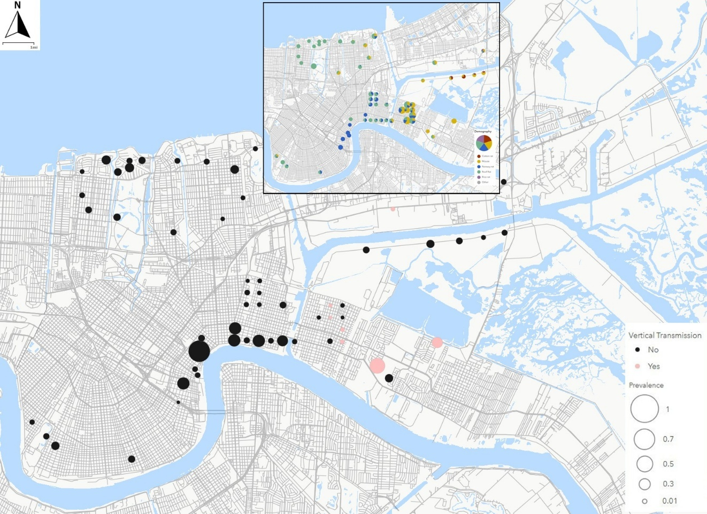
Figure 1.1. Map of T. cruzi prevalence in rodents across New Orleans and neighboring St. Bernard Parish. Black dots identify sites where T. cruzi-positive rodents were located with dot size representing total prevalence of infection; red dots identify sites with T. cruzi-positive parous mothers and embryo(s). The inset map describes the rodent assemblage at sites with T. cruzi infected rodents with colors denoting rodent species, and size representing number of rodents collected.

Table 1.1. Prevalence of T. cruzi infection in rodent offspring according to species and across all species; + represents standard error of the mean
Species | # Mothers | # Embryos  (avg / mother) | # Infected embryos | Embryo Infection prevalence
R. norvegicus | 2 | 12 (6) | 1 | 8.3% + 8.3%
R. rattus | 2 | 18 (9) | 5 | 27.8% + 10.5%
M. musculus | 8 | 36 (4) | 9 | 25% + 7.2%
All species | 12 | 66 (5.5) | 15 | 22.7% + 5.2%

Table 1.2. DTUs detected in M. musculus embryos and parous females captured in the study area as determined by deep sequencing
Sample ID | Life stage | DTUs Present (haplotypes recovered)
1609.6 | Embryo | TcI (4), TcII (1), TcVI (1), TcV (1)
1793.2 | Embryo | TcI (1), TcII (1), TcV (2)
1777 | Adult | TcV, TcVI (2)
1779 | Adult | TcV (5)
1773 | Adult | TcI

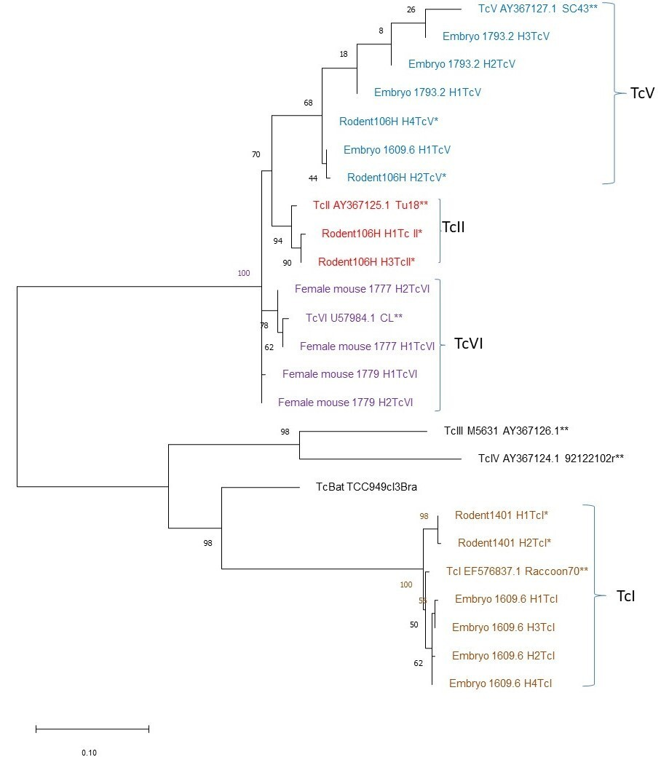
Figure 1.2. Evolutionary relationships among 25 specimens inferred according to the Maximum Likelihood method with a General Time Reversible model. The tree with the highest log likelihood (-3530.44) is shown. The tree is drawn to scale, with branch lengths measured in the number of substitutions per site. There was a total of 723 positions in the final dataset; numbers at nodes indicate bootstrap support. * indicate rodents captured from the same study area; ** indicate DTU reference sequences.

Rat lungworm (Angiostrongylus cantonesis) infection in gastropod and rodent hosts across an urban landscape

A version of this chapter by Nathaniel L. Gibson, Rebecca F. Hazen, Bruno M. Ghersi, Anna C. Peterson, Josua A. Lewis, Rosalyn Rael, Claudia Riegl, and Michael J. Blum has been submitted to the journal Parasites & Vectors for peer review.
The article has been reformatted from the submitted version as part of this dissertation. NLG, RH, and MJB conceptualized the study. NLG and RH collected gastropod specimens. NLG performed all laboratory-based work including but not limited to collection management, DNA extractions, and qPCR assays of A. cantonensis infection in gastropods. NLG and MJB secured funding for field work and laboratory materials. NLG and MJB wrote and revised all drafts of the manuscript; all authors reviewed and contributed to drafts of the manuscript.

Abstract
Angiostrongylus cantonensis (rat lungworm) is a parasitic nematode that causes angiostrongyliasis, an emerging infectious disease linked to eosinophilic meningitis in humans. In New Orleans, considered to be the likely point of introduction to North America, there is widespread infection in rats, the primary host of the parasite. However, relying solely on rats as an indicator of transmission risk may not account for other key aspects of the A. cantonensis lifecycle, including the possibility that transmission to humans may result from contact with intermediate gastropod hosts. Likewise, focusing solely on rats as an indicator does not consider the possibility that different social-ecological factors may influence rat and gastropod communities, respectively. Leveraging prior efforts, I compared A. cantonensis infection prevalence in intermediate gastropod hosts to infection prevalence in primary rat hosts across nine neighborhoods in Greater New Orleans, encompassing urban, peri-urban, and natural environments. Gastropods were collected using timed visual searches from 90 sites in 2018 and from the remaining 6 sites in 2021. Gastropods were identified to species and screened for infection using qPCR protocols targeting ITS1 DNA. This allowed comparison to available data on infection prevalence in rats that were sampled at 96 sites between 2014 and 2016. Regression models were then constructed to identify social-ecological predictors of infection prevalence in intermediate and primary hosts, respectively. A total of 3728 gastropods were collected from 73 sites within the study region, representing 12 species. I did not observe clear dissimilarity or significant differences in the gastropod assemblage structure across New Orleans outside of one species occurring more often in Uptown than other neighborhoods. The overall prevalence of A. cantonensis infection in gastropods was 2.6%. Analyses constrained to sites of co-occurrence revealed that gastropod infection prevalence was not correlated with overall rat infection prevalence. A significant positive association was found, however, between both overall gastropod infection and the most abundance gastropod species with infection in Norway rats. The presence of primary rat hosts, vegetation, and historical flooding significantly influenced gastropod abundance; the proportion of vacant lots and vegetation were significant drivers of infection in gastropods. Drivers of infection in rodents varied between Norway rats and roof rats, while the overall rodent prevalence had no significant influences. My results highlight the complex nature of multi-host pathogen transmission in cities. Notably, infection prevalence in gastropods relates to infection in commensal Norway rats, but rats and gastropods appear to respond differently to social-ecological factors, which could mitigate transmission of A. cantonensis between intermediate and primary hosts. My work- representing one of the most extensive and fine-scale comparisons of rat lungworm infection co-occurring populations of primary and intermediate hosts completed to date- thus points to the merits of using multiple indicators to characterize transmission risk of multi-host pathogens in cities.

Introduction
Rat lungworm (Angiostrongylus cantonesis) is a parasitic nematode and the causative agent of angiostrongyliasis, a globally emerging infectious disease that is present across the United States (Cowie 2013, York et al. 2014, Barrat et al. 2016). Angiostrongyliasis in humans can lead to eosinophilic meningitis, an infection of the brain with symptoms ranging from fever and headache to a comatose state and death (Cowie et al. 2017). While A. cantonensis is a well-recognized threat in areas of high prevalence in the United States (US) such as Hawaii, there is growing concern about pathogen transmission elsewhere in the US where it is becoming endemic – particularly across the Gulf Coast region (Teem et al. 2013, York et al. 2015). Notably, recent work on infection prevalence in primary rodent hosts suggests that A. cantonensis has become widespread in New Orleans (LA, US) (Rael et al. 2018), which is the likely point of entry into the continental US (Kim et al. 2002).
As primary hosts in the A. cantonensis transmission cycle, rats can be conspicuous indicators of infection risk, providing benchmarks for transmission risk to humans. Accordingly, the distribution of infected rats across New Orleans suggests that there is widespread risk of transmission to humans (Rael et al. 2018). Relying solely on rats as indicators may, however, underestimate risk if there are differences of infection prevalence in primary and intermediate hosts involved in the complex lifecycle of A. cantonensis. Drawing comparisons that circumscribe more stages of the A. cantonensis life cycle might thus offer a richer understanding of transmission risk and possible drivers of infection across cities like New Orleans.
Accounting for infection of intermediate gastropod hosts could be particularly informative as consumption of infected gastropods is thought to sustain infection in rats (Cowie 2013a). Gastropods are typically infected by A. cantonesis larvae contained in feces from local ratts, with rats then ingesting infected gastropods (or related contaminated food or water source(s)) to complete the intermediate-to-primary stage of the transmission cycle. Gastropod hosts are also thought to serve as an important route of transmission to humans (Cowie 2013a, Cowie 2013b). Transmission to humans can occur through inadvertent ingestion of infected gastropods, consumption of an infected paratenic host, or contaminated food and water (Cowie 2013b). Thus, an examination of infection prevalence in gastropod hosts - with comparisons drawn to infection in rat hosts - could yield more substantive understanding of the risks posed by A. cantonensis to human health and well-being.
Understanding A. cantonensis transmission risk can arguably be further improved by considering how social-ecological features might influence infection prevalence in rats and gastropods across a co-inhabited landscape. It has been demonstrated, for example, that social-ecological factors such as land abandonment and vacancy, vegetation, and debris can affect the distribution and abundance of hosts and prevalence of pathogen infection across New Orleans (e.g. Peterson et al 2021, Ghersi et al 2020). Rodent demography and assemblage structure, for example, were found to strongly differ across the city (Ghersi et al. 2021, Peterson et al. 2020), reflecting post-Hurricane Katrina human population loss and land management that have resulted in a social-ecological mosaic of counter-urbanization (Rael et al. 2016, Lewis et al. 2017). A recent study (Rael et al. 2018) did not detect obvious parallels in A. cantonensis infection of rats sampled across the city. Parallels might, however, occur between landscape features, gastropod communities, and infection of gastropod hosts. Parallels might also occur because conditions that shape rodent communities in New Orleans might also exert influence on gastropods (Horsak et al 2009, Souza et al 2021). Thus, considering whether and what social-ecological factors shape gastropod communities, as well as infection prevalence in both rodents and gastropods, may help identify drivers of A. cantonensis infection risk across the transmission cycle.
Herein I describe a comparative study of A. cantonensis infection across intermediate and primary hosts from existing data on rat lungworm infection in rodents (Rael et al. 2018) and de novo data on gastropods collected from rodent trapping sites across New Orleans. My aim was to first examine the distribution of gastropod species across the study area and to determine the prevalence of A. cantonensis infection among members of the gastropod assemblage. I then compared infection prevalence in rats and gastropods. Finally, I considered whether the social-ecological factors that shape rodent assemblages likewise exert influence on gastropods. Similarly, I examined whether similar factors exert influence on infection prevalence in rat and gastropod hosts. I anticipated finding that gastropod assemblage structure exhibits parallels to rodent assemblage structure, and likewise, that infection prevalence in gastropods would parallel infection prevalence in rats, allowing for a potential difference in magnitude due to variation in gastropod host competency (Kim et al. 2014, Medeiros et al. 2020, Walden et al. 2021). By extension, I anticipated finding that infection prevalence in rats and gastropods would be subject to the influence of a common set of social-ecological factors (Meideros et al. 2020, Rollins et al. 2021).

Methods

Study area and samples
The study region is comprised of nine sampling areas (hereafter ‘neighborhoods’) that span a range of social and ecological conditions across Greater New Orleans: seven neighborhoods in the city of New Orleans, an adjacent natural area located in Orleans Parish, and an adjacent residential area in St. Bernard Parish (Figure 2.1; all tables and figures are located in the Appendix of this chapter). Rats were trapped from a total of 96 sites from 2014 to 2016, in part to determine rat lungworm prevalence across the city (Rael et al. 2018). Traps were set at eight to 12 sites per sampling area, which varied in social-ecological characteristics that span from the urban core to natural and peri-urban conditions. During the summer of 2018, gastropods were collected from 90 of the rodent trapping sites in New Orleans and neighboring St. Bernard Parish. Gastropods were collected at all six natural area sites in Orleans Parish during the summer of 2021. Social-ecological data on sociodemographic (e.g. land abandonment, proportion of vacancy, median household income) and environmental (e.g. land cover type and extent, vegetation diversity, presence of trash and debris) factors were obtained for all sites in prior studies of vegetation, rodents, and pathogens across the study region (Lewis et al. 2017, Peterson et al. 2020, Ghersi et al. 2021). Data from a subset of 73 sites were used for comparisons of infection prevalence between rats and gastropods (i.e., rats were not trapped and/or gastropods were not collected during the respective sampling periods at the remaining 23 sites).

Gastropod sampling
Gastropods were collected via timed visual searches conducted at each site following the protocol described in Clergeau et al. (2011). For sites sampled in 2018, a visual search was carried out by two investigators for 30 minutes each where leaf litter and soil were inspected by hand in addition to searches being done on or around conspicuous objects (trees, fallen branches, garbage and debris, trash cans, etc.) to ensure coverage of all microhabitat types present during collection. Searches were conducted in 2021 by a single investigator for 30 minutes following the same protocol. Visual searches are generally considered to be the most practical approach for collecting specimens in an urban environment and are an effective method for characterizing macro-gastropod assemblage at a given site (Cameron and Pokryszko 2005, Clergeau et al. 2011). Gastropods were sorted and enumerated by species immediately following field collections with identification based on a combination of taxonomic checklist (Minton & Perez 2005) supplemented with regional internet-based visual guides (e.g., iNaturalist; jaxshells.org). All specimens were then fixed in 70% ethanol and later transferred into 95% ethanol for long-term storage.

DNA extraction and molecular analysis
DNA was extracted from ≤15 individuals per gastropod species per site, resulting in a total of 1636 gastropod DNA extractions. Genomic DNA was extracted using Qiagen (Valencia, CA) DNeasy Blood and Tissue Kits according to manufacturer protocols. DNA extractions were completed using < 25mg of foot tissue excised from each individual. When necessary, the entire gastropod was used for the extraction. All DNA samples served as qPCR templates to determine A. cantonensis infection status following the protocol described in Qvarnstrom et al. (2010). The qPCR protocol results in the amplification of the first internal transcribed spacer (ITS1) region of A. cantonensis, and thus serves as a screening tool to determine presence in a gastropod sample. All qPCR reactions were carried out using an Applied Biosystems 7500 Real-time PCR system with reference to a standard curve that was generated using a series of five 10-fold dilutions of genomic DNA from adult A. cantonensis starting with an initial DNA concentration of 135.6 ng/uL.
Statistical analysis and modeling
All analyses were carried out using R vers. 4.4.3. Ordination using non-metric multidimensional scaling (NMDS) was conducted to characterize gastropod assemblage structure among study sites with reference to neighborhoods. Bray-Curtis dissimilarity values served as the basis for ordination. Species were only included for ordination analysis if there were either >10 individuals sampled or the species was present at >5 sites across the study area to prevent inflated dissimilarity from hyper rare species. ANOVAs with a posthoc Tukey’s HSD test were used to determine if overall gastropod abundance and abundances of species differed across or between neighborhoods. Pearson correlation was used to characterize the relationship between the prevalence of A. cantonensis infection in rat and gastropod hosts from the subsample of 72 sites. Likewise, correlation analysis was also used to assess whether there was an association between infection prevalence in particular rat species with infection prevalence in gastropods.
Social-ecological analyses were conducted primarily following a generalized linear mixed-effects modeling (GLMM) methodology as done in related studies examining drivers of rodent demography and assemblage structure across New Orleans (Peterson et al. 2020, Ghersi et al. 2021). I used GLMM with a binomial distribution to assess social-ecological drivers (Peterson et al. 2020, Ghersi et al. 2021) of infection prevalence in rat hosts and infection prevalence in gastropod hosts, respectively. Gastropod abundances were modelling using a generalized linear model with a Poisson distribution. The model selection process utilized a global model that included land cover (unmaintained vegetation, tree cover, dirt, unmaintained buildings, flooding depth), land use (proportion of vacancy, level of trash and debris present), and sociodemographic factors (median household income, population density). Models of gastropod demography included rodent abundances (overall and by species), while models of infection prevalence included infection of hosts (i.e. a model for gastropod infection included infection of rodents). Sites were included as a random effect for models of rodent infection due to repeated sampling. Best-fit models were selected according to AIC score, with models being generated using the MuMin package in R.

Results

Gastropod assemblage structure
A total of 3728 specimens were collected from the 72 rodent-gastropod sites, comprising 13 species of snails and slugs (Table 2.1). Both native and invasive gastropod species were collected; the invasive Asian tramp snail (Bradybaena similaris) was the most abundant species, accounting for 75% of samples (2793 individuals). The native globular drop snail (Helicina orbiculate) was the next most abundant species, accounting for 11.1% of samples (415 individuals). Slugs were not a significant proportion of total gastropod abundance, totaling only 64 individuals and 5 species. Notably, the vast majority (55 of 64) were the invasive greenhouse slug (Ambigolimax valeentianus). Ordination did not reveal evidence of gastropod assemblage structure according to neighborhood (Figure 2.2), and total abundance of gastropods did not significantly differ across neighborhoods (Figure 3; df = 9, F = 1.665, p = 0.117). Accordingly, abundances of the dominant B. similaris (df = 9, F = 1.643, p = 0.123) were not significantly across or between neighborhoods. I did detect significant differences in the abundance of H. orbiculate across neighborhoods (df = 9, F = 4.176, p<0.001) and A. valeentianus (df = 9, F = 1.241, p = 0.283). Posthoc analysis did not determine any significant pairwise comparisons for A. valeentianus, but did show that H. orbiculate abundances in Uptown were significantly higher than abundances in the Upper 9th Ward, St. Bernard Parish, French Quarter, and Lower 9th Ward.

Prevalence of infection in gastropods and comparison to rodent infections
I detected an overall A. cantonensis infection prevalence of 2.6% (44/1689) with infected gastropods present in all neighborhoods but the Natural Area and Lakeview (Table 2.2, Figure 2.1). Only three of 15 gastropod species were found to serve as competent hosts for A. cantonensis: B. similaris, H. orbiculate, and the invasive peripatetic scrubsnail (Praticolella nexicana). B. similaris exhibited an infection prevalence of 2.98% (28/937), similar to H. orbiculate (3.53%; 11/311) and P. Mexicana (4.67%; 5/107).
I did not detect a relationship between the overall infection prevalence of gastropods and overall infection prevalence in rats (df = 71, r = 0.157, p = 0.185). Likewise, there was no relationship between infection prevalence in roof rats and gastropods (df = 71, r = 0.077, p = 0.517). A significant, positive association was detected between infection prevalence in Norway rats and overall infection prevalence in gastropods (df = 71, r = 0.302, p = 0.012) as well as in the dominant B. similaris and Norway rats (df = 71, r = 0.335, p = 0.004).

Social-ecological analyses
Using a generalized linear model with a Poisson distribution, the best fit model retained flooding depth, population size of Norway and roof rats, proportion of vacancy, number of trees and proportion of unmaintained vegetation as predictors of gastropod abundance. I found that the abundances of Norway rats were a significant negative predictor of overall gastropod abundance (coef. -0.061, P= 0.018), while the presence of roof rats demonstrated a significant positive effect (coef. = 0.189, P<0.0005). Site features such as the number of trees (coef. = 0.062, P<0.0005) and flooding depth (coef. 0.059, P<0.0005) had a positive effect on gastropod populations, but proportion of vacancy appeared to have a negative effect (coef. = -0.187, P<0.001). Proportion of unmaintained vegetation, an emblematic feature of counter-urbanization, was not predictor of overall gastropod abundance.
For our analyses of A. cantonensis prevalence in gastropods and rodents, generalized linear mixed models with binomial distributions were used to determine drivers of infection in primary and intermediate hosts. From the top model, I found that A. cantonensis infection prevalence in gastropods was significantly influenced only by the proportion of vacancy (coef. = -1.503, P = 0.043) and unmaintained vegetation (coef. = 2.252, P = 0.041); flooding depth, abundances of rodent species, number of trees, and overall rodent prevalence did not significantly affect infection in gastropods. The best fit model of infection in Norway rats only returned overall gastropod prevalence as a significant predictor (coef. = 11.08, P =0.0374); infection of roof rats was significantly driven by the proportion of vacancy (coef. = -2.573, P<0.005), unmaintained vegetation (coef. = -2.85, P=0.01), and the interaction of vacancy with unmaintained vegetation (coef. = 4.672, P=0.002). The overall prevalence of A. cantonesis in rodents returned no significant predictors from the best fit model.

DISCUSSION
Here I characterized gastropod community structure and the prevalence of A. cantonensis in intermediate gastropod hosts for comparison to infection prevalence in rat hosts across New Orleans (Rael et al 2018). I underscore the complexity of the A. cantonensis transmission cycle in an urban landscape; wherein primary and intermediate hosts demonstrate disparate responses to social-ecological features and variable levels of host competency. I established the overall infection prevalence for a sizable urban gastropod population, the prevalence of infection in three of the most competent gastropod hosts and determined how closely associated infection prevalence is for co-occurring primary and intermediate hosts. Finally, I examined what social-ecological features of the urban landscape might influence gastropod host abundances, and A. cantonensis infection in rats and gastropods, representing one of the most comprehensive comparative examinations of A. cantonensis infection in urban host populations thus far completed. The spatial extent and granularity of our data facilitated provided a basis to explore the nature of transmission risk across key stages of the A. cantonensis life cycle, highlighting how consideration of multiple indicators may help improve understanding of transmission risk – both now and in the future – to human health and well-being.

Gastropod assemblage structure and prevalence of infection in gastropods
There was minimal dissimilarity in gastropod assemblage structure across and between neighborhoods (Figure 2.2, Figure 2.3). Differences appear to be driven by variation in H. orbiculate abundance, which was higher in Uptown than in other neighborhoods. Sites characterized by higher abundances of H. orbiculata tended to be in areas with higher household income and be more densely populated such as Uptown. In contrast, sites with higher degrees of unmaintained vegetation and historical flooding shared in the presence of P. mexicana (e.g. Lower 9th Ward). Most of the gastropods collected were B. similaris, an invasive species that has had a homogenizing influence on gastropod assemblage structure in New Orleans. Biotic homogenization appears to be common for urban gastropod communities (Horsak et al 2009, Horsak et al 2013, Perez et al 2021), a phenomenon which could have downstream consequences on potential risks posed by gastropods to human well-being if, for example, the dominant species in an urban area are also highly competent hosts for a pathogen like A. cantonensis.
Of the 12 species of gastropods examined, three species - B. similaris, H. orbiculate, and P. mexicana - were found to be competent host. The overall prevalence of A. cantonensis infection observed in gastropods across New Orleans was 2.6% and infected gastropods were present in every neighborhood aside from Lakeview and a natural area in Orleans Parish (Figure 2.1). Observations of A. cantonensis prevalence in gastropods across New Orleans are largely consistent with those made in other studies of A. cantonensis in gastropods elsewhere in the continental United States (Teem et al 2013, Stockdale-Walden 2017) and other regions such as Brazil (Souza et al 2021) and Spain (Jaume-Ramis et al 2023). Evidence that A. cantonensis is carried by B. similaris and P. mexicana is also consistent with findings of other work demonstrating that invasive gastropod species can serve as competent hosts of A. cantonensis (Kim et al 2014, Giannelli et al 2015, Stockdale-Walden et al 2015, Niebhur et al 2019, Medeiros et al 2020). Notably, A. cantonensis prevalence in gastropods from New Orleans is markedly lower than in other endemic areas like Hawaii where prevalence in intermediate hosts can reach upwards of 86% (Jarvi et al 2017, Niebuhr et al 2020, Rollins et al 2021).
Differences in prevalence between New Orleans and locations like Hawaii may be driven by the presence/absence of the yellow-shelled semi-slug (Parmarion martensi). This species appears to be a high-competency host of A. cantonesis that can be readily infected by primary rat hosts and is frequently found in areas with human incidences of infection (Jarvi et al 2017, Niebhur et al 2019, Niebhur et al 2021). It is possible that there are ecological mechanisms (e.g., competitive exclusion) structuring the gastropod community in New Orleans that are suppressing or diluting infection prevalence that otherwise might be elevated by the presence of P. martensi. Other factors such as environmental conditions, human disturbance, or barriers that limit host dispersal may also be constraining infection prevalence. Given the potentially important role that gastropod species identity and assemblage structure appears to play in determining A. cantonesis infection prevalence (Meidoros et al 2020), monitoring for the introduction of high competency host species into novel environments – particularly urban environments with dense human populations– could improve efforts to combat the spread of A. cantonesis and improve evaluation of transmission risk (and changes thereof).

Comparison of infection rates between gastropods and rodents
As anticipated, I found that the magnitude of infection in gastropods differs from that reported for co-occurring rats (Rael et al. 2018) - overall A. cantonensis infection of rats across the greater New Orleans areas was 38%, which is largely commensurate with other endemic areas of infection (Niebhur et al. 2019). Notably, 24 of the 73 sites that allowed direct comparison had both infected gastropods and infected rodents present, where A. cantonensis prevalence was 6.9% and 44% respectively. Interestingly, our results are similar to those of a study examining conditions across 18 counties in the state of Florida (Stockdale-Walden et al 2017) where A. cantonesis prevalence was 1.9% in gastropods and 22.8% in rats. It is possible that the parallels partly reflect the dominance of B. similaris in both gastropod communities (Stockdale-Walden et al 2017) and absence of high-competency host species. Notably, I did find that infected primary and intermediate hosts were both widely distributed across the city. This is generally consistent with expectations, but I did not detect a significant correlation between infection in gastropod and infection in rat hosts sampled from the same locations across the city. There were no discernable trends when comparing infection across all gastropods with all rats or for roof rats alone, but I did observe a positive association with infection in Norway rats which may indicate that Norway rats come into more frequent contact with gastropods than are do other rat species in New Orleans. The apparent relationship between gastropod and Norway rat infection could be due to increased probability of interactions, as both host populations are ground dwelling thus increasing the chance of rodent predation and/or cohabitation.
The magnitude of difference in A. cantonensis infection prevalence between primary and intermediate hosts highlights the potential importance of un(der)recognized environmental transmission pathways such as larval release from deceased intermediate hosts into water (Modry et al 2020, Rivory et al 2023) and larval shedding via mucus secretions (Kramer et al 2018, Rollins et al 2023). The expulsion of A. cantonensis into the environment, particularly into a habitat with standing water available (Howe et al 2019), could create ample opportunities for initial infection and reinfection of primary rodent hosts. Environmental transmission involving standing water could be of particular concern in places like New Orleans, where frequent rainfall can remain on the surface for extended periods of time. The potential persistence of infective larvae shed into water sources (Howe et al 2019, Rivory et al 2023) or in mucus residue on food sources (e.g., garden vegetables) (Kramer et al 2018) also raises the possibility that the risk of A. cantonensis transmission to humans has been underestimated.

Social-ecological drivers of host abundance and rat lungworm prevalence
Contrary to expectations, urban gastropods and rodents do not appear to be subject to the influence of a common set of social-ecological factors (Peterson et al 2020, Ghersi et al 2021). I did, however, find some indications that Norway rats constrain gastropod abundance, which could be a consequence of rat predation on gastropods. It is also possible that this reflects the indirect influence of habitat on gastropod abundance. I found that gastropod abundance had no response while rat abundance increased with greater unmaintained vegetation (Peterson et al 2020, Ghersi et al 2021), which could indicate that habitat or habitat-mediated predation is constraining gastropod abundance. I also found that gastropods are negatively affected by the proportion of vacant houses and not influenced by presence of trash or debris, both of which significantly influence rodent abundance (Peterson et al 2020). This, along with evidence of dispersal limitation, suggests that (micro)habitat characteristics exert more influence on gastropod abundance compared to the broader social-ecological features that appear to have greater influence on urban rodents. Some of our model outputs are consistent with this interpretation. For example, our model indicates that tree count is predictors of gastropod abundances, which is consistent with evidence from other work (Nandy et al 2022) that urban gastropods favor leaf litter microhabitats which can mitigation desiccation and thus facilitate environmental transmission of A. cantonensis larvae (Steel et al 2020). Future efforts might therefore focus on characterizing microhabitat conditions to better determine drivers of gastropod abundance.
My models also did not identify a common set of social-ecological predictors of A. cantonensis prevalence in rats and in gastropods. I found that infection in gastropods to be negatively associated with increased proprotion of vacancy, though prevalence increased with higher levels of unmaintained vegetation. One interpretation of this relates back to habitat preferences- there might be more limited transmission in areas that favor rats and not gastropods (i.e., there is more limited interactions on a per-capita basis). Similarly, the presence of trash and debris may provide alternative food resources for rats that would otherwise predate on gastropods. A positive relationship between gastropod prevalence and unmaintained vegetation could again point to the importance of microhabitat conditions helping to sustain infection in gastropod reservoirs. Importantly, I can provide evidence that gastropods do serve as linchpin intermediate hosts for Norway rats though no other variables appeared to have a significant effect on infection status. Additional work might test this hypothesis by examining urban rat diets to assess relationships between habitat, gastropod consumption and A. cantonensis infection prevalence. Drawing connections to conditions that might favor environmental transmission would potentially offer even greater understanding of risk to human health and well-being, particularly in urban areas like New Orleans where there is a greater likelihood of concurrent modes of transmission (i.e. host-host and environmental).

References
Barratt, J., Chan, D., Sandaradura, I., Malik, R., Spielman, D., Lee, R., ... & Stark, D. (2016). Angiostrongylus cantonensis: a review of its distribution, molecular biology and clinical significance as a human pathogen. Parasitology, 143(9), 1087-1118.
Cameron, R. A., & Pokryszko, B. M. (2005). Estimating the species richness and composition of land mollusc communities: Problems, consequences and practical advice. Journal of Conchology, 38(5), 529-548.
Clergeau, P., Tapko, N., & Fontaine, B. (2011). A simplified method for conducting ecological studies of land snail communities in urban landscapes. Ecological research, 26(3), 515-521.
Cowie, R. H. (2013). Biology, systematics, life cycle, and distribution of Angiostrongylus cantonensis, the cause of rat lungworm disease. Hawai'i Journal of Medicine & Public Health, 72(6 Suppl 2), 6.
Cowie, R. H. (2013). Pathways for transmission of angiostrongyliasis and the risk of disease associated with them. Hawai'i Journal of Medicine & Public Health, 72(6 Suppl 2), 70.
Cowie, R. H. (2017). Angiostrongylus cantonensis: agent of a sometimes fatal globally emerging infectious disease (rat lungworm disease). ACS Chemical Neuroscience, 8(10), 2102-2104.
Ghersi BM, Peterson AC, Gibson NL, Dash A, Elmayan A, Schwartzenburg H, Tu W, Riegel C, Herrera C, Blum MJ. In the heart of the city: Trypanosoma cruzi infection prevalence in rodents across New Orleans. Parasites & vectors. 2020 Dec;13:1-0.
Ghersi, B. M., Peterson, A. C., Riegel, C., Campanella, R., Childs, J. E., & Blum, M. J. (2021). Flooding and abandonment have shaped rat demography across post-Katrina New Orleans. Landscape and Urban Planning, 215, 104218.
Giannelli, A., Colella, V., Abramo, F., do Nascimento Ramos, R. A., Falsone, L., Brianti, E., ... & Otranto, D. (2015). Release of lungworm larvae from snails in the environment: potential for alternative transmission pathways. PLoS Neglected Tropical Diseases, 9(4), e0003722.
Horsák, M., Juřičková, L., Kintrová, K., & Hájek, O. (2009). Patterns of land snail diversity over a gradient of habitat degradation: a comparison of three Czech cities. Biodiversity and conservation, 18, 3453-3466.
Horsák, M., Lososová, Z., Čejka, T., Juřičková, L., & Chytrý, M. (2013). Diversity and biotic homogenization of urban land-snail faunas in relation to habitat types and macroclimate in 32 central European cities. PloS one, 8(8), e71783.
Howe, K., Kaluna, L., Lozano, A., Torres Fischer, B., Tagami, Y., McHugh, R., & Jarvi, S. (2019). Water transmission potential of Angiostrongylus cantonensis: larval viability and effectiveness of rainwater catchment sediment filters. PLoS One, 14(4), e0209813.
iNaturalist. (n.d.). Terrestrial gastropods of Louisiana. Retrieved April 8, 2025, from https://www.inaturalist.org/guides/5288
Jarvi, S. I., Quarta, S., Jacquier, S., Howe, K., Bicakci, D., Dasalla, C., ... & Niebuhr, C. N. (2017). High prevalence of Angiostrongylus cantonensis (rat lungworm) on eastern Hawai ‘i Island: A closer look at life cycle traits and patterns of infection in wild rats (Rattus spp.). PLoS One, 12(12), e0189458.
Jaume-Ramis, S., Martínez-Ortí, A., Delgado-Serra, S., Bargues, M. D., Mas-Coma, S., Foronda, P., & Paredes-Esquivel, C. (2023). Potential intermediate hosts of Angiostrongylus cantonensis in the European Mediterranean region (Mallorca, Spain). One Health, 17, 100610.
Jax Shells. (n.d.). Jax shells online. Retrieved April 8, 2025, from https://www.jaxshells.org/
Kim, D. Y., Stewart, T. B., Bauer, R. W., & Mitchell, M. (2002). Parastrongylus (= Angiostrongylus) cantonensis now endemic in Louisiana wildlife. Journal of Parasitology, 88(5), 1024-1026.
Kim, J. R., Hayes, K. A., Yeung, N. W., & Cowie, R. H. (2014). Diverse gastropod hosts of Angiostrongylus cantonensis, the rat lungworm, globally and with a focus on the Hawaiian Islands. PloS one, 9(5), e94969.
Kramer, K. J., Posner, J., & Gosnell, W. L. (2018). Role of gastropod mucus in the transmission of Angiostrongylus cantonensis, a potentially serious neurological infection. ACS chemical neuroscience, 9(4), 629-632.
Lewis, J. A., Zipperer, W. C., Ernstson, H., Bernik, B., Hazen, R., Elmqvist, T., & Blum, M. J. (2017). Socioecological disparities in New Orleans following Hurricane Katrina. Ecosphere, 8(9), e01922.
Medeiros, M. C., Rollins, R. L., Echaluse, M. V., & Cowie, R. H. (2020). Species identity and size are associated with rat lungworm infection in gastropods. EcoHealth, 17, 183-193.
Minton, R. L., & Perez, K. E. (2005). A systematic checklist of the land snails of Louisiana. Texas Journal of Science, 57(2), 153.
Modrý, D., Fecková, B., Putnová, B., Manalo, S. M., & Otranto, D. (2021). Alternative pathways in Angiostrongylus cantonensis (Metastrongyloidea: Angiostrongylidae) transmission. Parasitology, 148(2), 167-173.
Nandy, G., Barman, H., Pramanik, S., Banerjee, S., & Aditya, G. (2022). Land snail assemblages and microhabitat preferences in the urban areas of Kolkata, India. Journal of Urban Ecology, 8(1), juac004.
Niebuhr, C. N., Jarvi, S. I., & Siers, S. R. (2019). A review of rat lungworm infection and recent data on its definitive hosts in Hawaii. Human-Wildlife Interactions, 13(2), 238-249.
Niebuhr, C. N., Siers, S. R., Leinbach, I. L., Kaluna, L. M., & Jarvi, S. I. (2021). Variation in Angiostrongylus cantonensis infection in definitive and intermediate hosts in Hawaii, a global hotspot of rat lungworm disease. Parasitology, 148(2), 133-142.
Perez, K. E., Najev, B. S. L., Christoffersen, B., & Nekola, J. C. (2021). Biotic homogenization or riparian refugia? Urban and wild land snail assemblages along a subtropical precipitation gradient. Journal of Urban Ecology, 7(1), juab002.
Peterson AC, Ghersi BM, Riegel C, Wunder Jr EA, Childs JE, Blum MJ. Amplification of pathogenic Leptospira infection with greater abundance and co‐occurrence of rodent hosts across a counter‐urbanizing landscape. Molecular Ecology. 2021 May;30(9):2145-61.
Peterson, A. C., Ghersi, B. M., Campanella, R., Riegel, C., Lewis, J. A., & Blum, M. J. (2020). Rodent assemblage structure reflects socioecological mosaics of counter-urbanization across post-Hurricane Katrina New Orleans. Landscape and Urban Planning, 195, 103710.
Qvarnstrom, Y., da Silva, A. C. A., Teem, J. L., Hollingsworth, R., Bishop, H., Graeff-Teixeira, C., & da Silva, A. J. (2010). Improved molecular detection of Angiostrongylus cantonensis in mollusks and other environmental samples with a species-specific internal transcribed spacer 1-based TaqMan assay. Applied and environmental microbiology, 76(15), 5287-5289.
Rael, R. C., Peterson, A. C., Ghersi, B. M., Childs, J., & Blum, M. J. (2016). Disturbance, reassembly, and disease risk in socioecological systems. EcoHealth, 13, 450-455.
Rael, R. C., Peterson, A. C., Ghersi-Chavez, B., Riegel, C., Lesen, A. E., & Blum, M. J. (2018). Rat lungworm infection in rodents across post-Katrina New Orleans, Louisiana, USA. Emerging Infectious Diseases, 24(12), 2176.
Rivory, P., Lee, R., & Šlapeta, J. (2023). Rat lungworm (Angiostrongylus cantonensis) active larval emergence from deceased bubble pond snails (Bullastra lessoni) into water. Parasitology, 150(8), 700-704.
Rollins, R. L., Cowie, R. H., Echaluse, M. V., & Medeiros, M. C. (2021). Host snail species exhibit differential Angiostrongylus cantonensis prevalence and infection intensity across an environmental gradient. Acta Tropica, 216, 105824.
Rollins, R. L., Medeiros, M. C., & Cowie, R. H. (2023). Stressed snails release Angiostrongylus cantonensis (rat lungworm) larvae in their slime. One Health, 17, 100658.
Souza, F. N., Santos, M. A., Alves, D. A., de Melo, L. C. V., da Mota, D. J. G., Pertile, A. C., ... & Carvalho-Pereira, T. (2021). Angiostrongylus cantonensis in urban populations of terrestrial gastropods and rats in an impoverished region of Brazil. Parasitology, 148(8), 994-1002.
Steel, A., Jacob, J., Klasner, I., Howe, K., Jacquier, S. H., Pitt, W. C., ... & Jarvi, S. I. (2021). In vitro comparison of treatments and commercially available solutions on mortality of Angiostrongylus cantonensis third-stage larvae. Parasitology, 148(2), 212-220.
Stockdale Walden, H. D., Slapcinsky, J. D., Roff, S., Mendieta Calle, J., Diaz Goodwin, Z., Stern, J., ... & McIntosh, A. (2017). Geographic distribution of Angiostrongylus cantonensis in wild rats (Rattus rattus) and terrestrial snails in Florida, USA. PLoS One, 12(5), e0177910.
Stockdale-Walden, H. D., Slapcinsky, J., Qvarnstrom, Y., McIntosh, A., Bishop, H. S., & Rosseland, B. (2015). Angiostrongylus cantonensis in introduced gastropods in southern Florida. The Journal of Parasitology, 101(2), 156-159.
Teem, J. L., Qvarnstrom, Y., Bishop, H. S., da Silva, A. J., Carter, J., White-McLean, J., & Smith, T. (2013). The occurrence of the rat lungworm, Angiostrongylus cantonensis, in nonindigenous snails in the Gulf of Mexico region of the United States. Hawai'i Journal of Medicine & Public Health, 72(6 Suppl 2), 11.
Walden, H. D., Slapcinsky, J., Rosenberg, J., & Wellehan, J. F. (2021). Angiostrongylus cantonensis (rat lungworm) in Florida, USA: current status. Parasitology, 148(2), 149-152.
York, E. M., Butler, C. J., & Lord, W. D. (2014). Global decline in suitable habitat for Angiostrongylus (= Parastrongylus) cantonensis: the role of climate change. PLoS One, 9(8), e103831.
York, E. M., Creecy, J. P., Lord, W. D., & Caire, W. (2015). Geographic range expansion for rat lungworm in North America. Emerging Infectious Diseases, 21(7), 1234.

Appendix
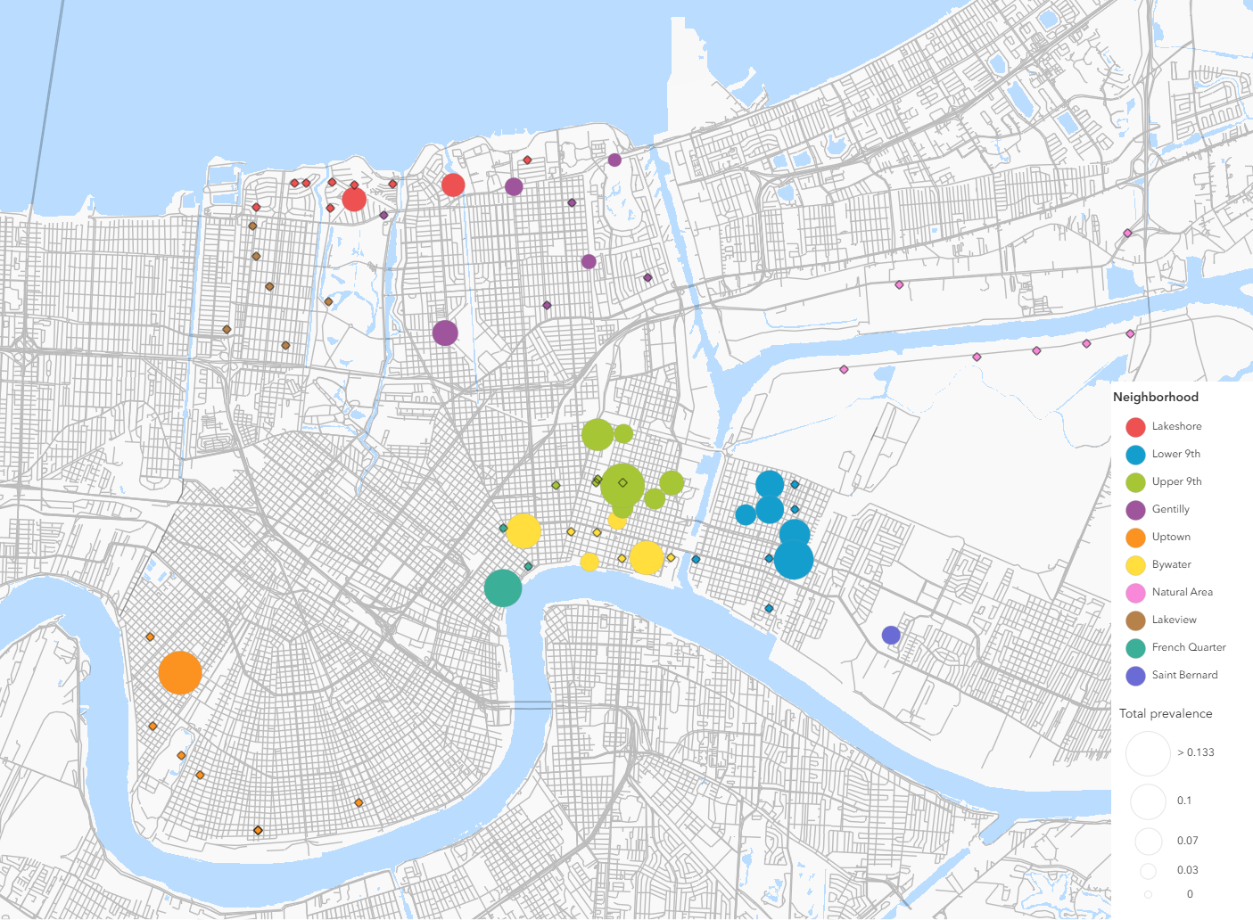
Figure 2.1: Map of sites with A. cantonensis infected gastropods across sampled neighborhoods. Circle color denotes neighborhood whereas circle size is proportional to the prevalence of infection. Black diamond outlines represent rodent trapping sites where gastropods were collected but A. cantonensis infection was not detected.

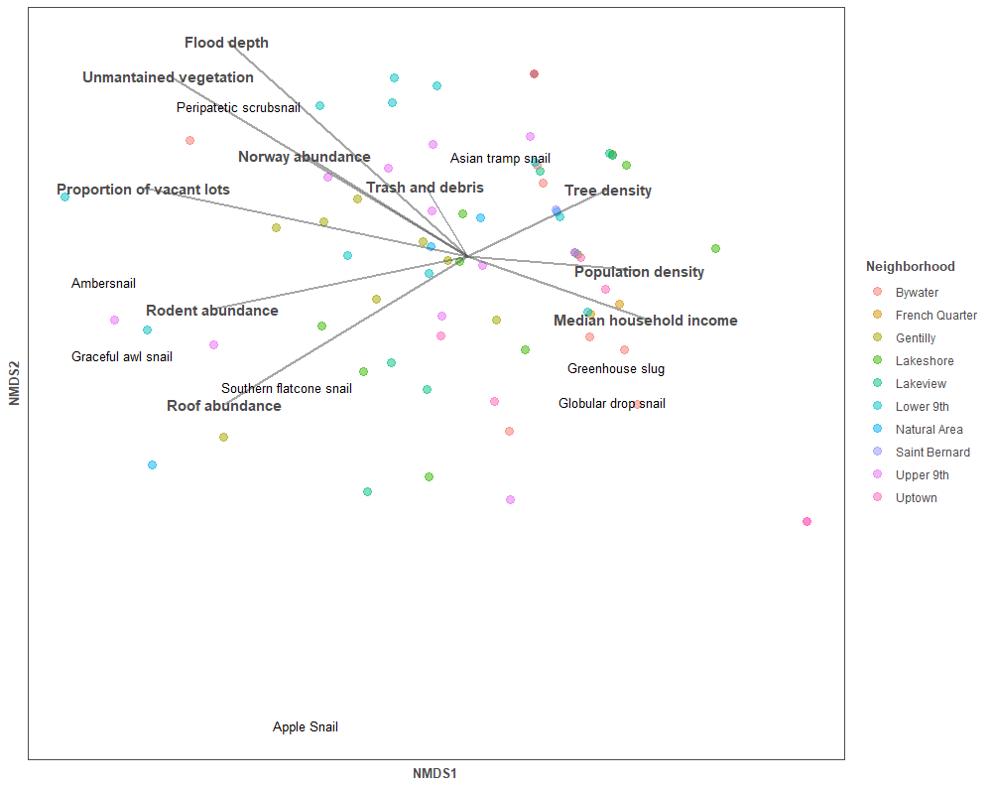
Figure 2.2. NMDS ordination plot of gastropod assemblage structure across New Orleans (LA, USA). Environmental vectors reflect rodent abunances (total and by species) and important social-ecological characteristics.

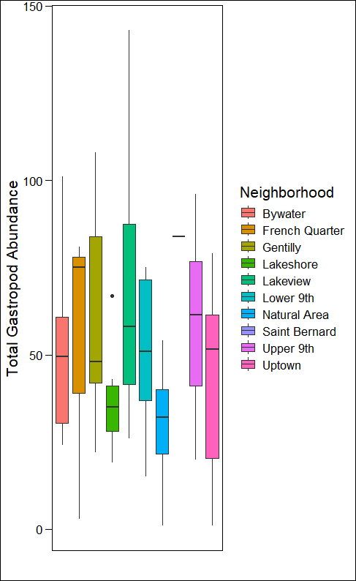
Figure 2.3. Boxplot of gastropod abundances in neighborhoods across New Orleans (LA, USA).
Table 2.1. Gastropod abundance according to species and neighborhood. Species scientific and common names: B. similaris (Asian tramp snail); P. Mexicana (Peripatetic scrubsnail); H. orbiculate (Globular drop snail); Polygyra cereolus (Southern flatcoil); A. valeentianus (Threeband gardenslug); Belocaulus angustipes (Black velvet leatherleaf slug); Euglandia rosea (Rosy wolfsnail); Pomocea maculata (Apple snail); Succineaidae spp. (Amber snail); Allopeas gracile (Graceful awl snail); Arion subfuscus (Dusky arion); Leidyula floridana (Florida leatherleaf slug); Philomycus carolinianus (Carolina mantleslug).
 | Bywater | French Quarter | Gentilly | Lakeshore | Lakeview | Lower 9th | Natural Area | Saint Bernard | Upper 9th | Uptown
B. similaris | 287 | 143 | 397 | 249 | 429 | 413 | 114 | 75 | 437 | 166
P. mexicana | 16 | 0 | 0 | 0 | 0 | 105 | 0 | 0 | 46 | 0
H. orbiculata | 86 | 8 | 33 | 39 | 6 | 22 | 6 | 18 | 54 | 198
P. cereolus | 6 | 0 | 100 | 40 | 15 | 35 | 0 | 22 | 44 | 10
A. valeentianus | 8 | 7 | 4 | 32 | 12 | 3 | 0 | 37 | 0 | 1
B. angustipes | 0 | 2 | 0 | 0 | 0 | 0 | 0 | 0 | 1 | 0
E. rosea | 0 | 0 | 0 | 2 | 0 | 0 | 0 | 1 | 0 | 1
P. maculata | 0 | 0 | 0 | 0 | 17 | 0 | 0 | 0 | 0 | 0
Succineaidae spp. | 5 | 0 | 9 | 2 | 1 | 8 | 0 | 0 | 15 | 0
A. gracile | 0 | 0 | 2 | 2 | 5 | 3 | 0 | 0 | 0 | 0
A. subfuscus | 0 | 1 | 0 | 0 | 0 | 0 | 0 | 0 | 0 | 0
L. floridana | 1 | 0 | 2 | 0 | 0 | 0 | 0 | 0 | 0 | 0
P. carolinianus | 1 | 0 | 0 | 0 | 0 | 1 | 1 | 0 | 1 | 0

Table 2.2. Prevalence of infection according to gastropod species, and areas where infected gastropods were found. Abbreviations: BW = Bywater; L9 = Lower 9th; U9 = Upper 9th, GT = Gentilly; LS = Lakeshore; FQ = French Quarter, UT = Uptown.
Species |  | # of gastropods tested | # of positive gastropods | Neighborhoods with infected individuals | # of sites with infected individuals
B. similaris |  | 937 | 28 | BW, L9, U9, UT, GT, LS, FQ | 16
P. mexicana |  | 109 | 5 | L9, U9 | 3
H. orbiculata |  | 311 | 11 | BW, L9, U9, UT, GT | 8
P. cereolus |  | 174 | 0 | -- | --
A. valeentianus |  | 55 | 0 | -- | --
B. angustipes |  | 2 | 0 | -- | --
E. rosea |  | 4 | 0 | -- | --
P. maculata |  | 17 | 0 | -- | --
Succineaidae spp. |  | 37 | 0 | -- | --
L. floridana |  | 3 | 0 | - | --
P. carolinianus |  | 4 | 0 | -- | --
A. gracile | 12 |  | 0 | -- | --
A. subfuscus | 1 |  | 0 | -- | --

SHIFTS IN URBAN MOSQUITO POPULATONS ACROSS A SOCIAL-ECOLOGIAL LANDSCAPE MAY ALTER PATHOGEN TRANSMISSION RISK
A version of this chapter by Nathaniel L. Gibson, Joshua A. Lewis, David Baker, Claudia Riegel, and Michael J. Blum has been prepared for submission for peer review.
Nathaniel L. Gibson, Joshua A. Lewis, and Michael J. Blum conceived and designed the study. Field surveys were conducted by Nathaniel L. Gibson, Joshua A. Lewis, and David Baker. Mosquito trapping was coordinated by Claudia Riegel. Joshua A. Lewis contributed spatial statistics and remote sensing. All other analyses were completed by Nathaniel L. Gibson. The manuscript was written by Nathaniel L. Gibson. All the coauthors reviewed and revised the manuscript.

Abstract
Mosquitoes are one of the most prevalent vectors of pathogens that are detrimental to human health in part because some species of notable concern can be prevalent across urban landscapes. Understanding the social-ecological features that influence mosquito communities and populations can aid in assessing and mitigating pathogen transmission risk. Herein, I present a social-ecological study of mosquito abundance and diversity across the New Orleans metropolitan area (Louisiana, USA). My aim was to determine whether vector diversity and demography differ among neighborhoods according to sociodemographic factors, landscape features, and ecological factors. Using three years (2018-2020) of weekly data from 44 trapping sites, I first characterized the community composition and distributions of mosquito species in the study area. I then determined whether a suite of social-ecological variables serve as predictors of abundance for three prominent species (Ae. aegypti, Aedes albopictus, Cu. Quinquefasciatus). Over 530,000 mosquitoes were collected over the study period, representing 30 species. Mosquito assemblage structure did not exhibit clear (dis)similarity across the study area, though richness and diversity were significantly higher in the New Orleans East neighborhood compared to other neighborhoods. Cu. quinquefasciatus was by far the most prevalent species across the city during the study period. I found no significant differences in the abundance of any species among neighborhoods. Abundance was generally greater in warmer months, though populations of both Aedes species did not exhibit seasonal fluctuations in all neighborhoods. Regression modeling identified the Urban Heat Island effect as a significant negative predictor and tree density as a positive predictor of abundance for all three species. The proportion of vacant properties also was a negative predictor of Ae. aegypti abundance. Residential density was a positive predictor of Ae. aegypti and Cu. quinquefasciatus abundance. Contrary to findings in other cities, I did not find a strong signature of demographic response to household income. These findings indicate that mosquito-borne pathogen transmission risk likely fluctuates over time and varies across New Orleans neighborhoods according to differences in built and natural conditions.

Introduction
Despite longstanding and intensive control efforts, mosquitoes are still one of the most prevalent vectors of pathogens that are detrimental to human health. Mosquitoes can transmit deadly pathogens like arboviruses, leading to disease (re)emergence that can pose direct and significant threats to human health and well-being (Adalja et al 2012, Huang, Higgs, and Vanlandingham 2019). Indeed, incidences of diseases caused by mosquito-borne pathogens have dramatically increased over the past several decades. There also have been several notable spikes in incidences due to acute outbreaks (Rosenberg et al 2018, Peterson, Bear, and Visser 2018). It is thought that disease incidence is in part a consequence of vector species inhabiting densely occupied urban landscapes (i.e. cities) (Perrin et al 2022). Thus determining whether there are specific features of urban landscapes that influence mosquito diversity and demography (i.e. abundance and stability over time) could inform assessments of pathogen transmission risk and by extension disease incidence.
Recent work suggests that mosquito diversity and demography can track social-ecological variation in cities. Some evidence indicates that sharp demographic contrasts correspond to shifts in household income, reflecting social-ecological hotspots of pathogen transmission (Chaves et al 2011, LaDeau et al 2015, Little et al 2017). Both systematic reviews and meta-analyses suggest, however, that the distribution and abundance of vector species are not always associated with marquee social-ecological characteristics like vacancy, vegetative cover, and household income (Whiteman et al 2020, Holeva-Eklund et al 2021, Yitbarek et al 2023). Some work also points to inconsistencies in co-occurring species responses in the same city. For instance, one study of mosquitos in New Orleans (Louisiana, USA) demonstrated that tires and heat severity were positive predictors of Ae. aegptyi abundance, whereas heat severity was a negative predictor of Cu. quinquefasciatus (de Jesus Crespo et al 2024). It stands to reason that additional social-ecological investigations could clarify whether and how vector species are subject to social-ecological influences.
Further understanding might be achieved by avoiding confounding factors. For example, concurrently comparing responsiveness of co-occurring species to social-ecological factors (Beketov et al 2010) would avoid aspects of annual variation that can limit inferences drawn from combinations of studies, like those that have collectively examined demographic responses of C. quinequefasciatus (Sallam et al 2017a, Moise, Riegel and Muturi 2018), Ae. aegpyti and Ae. albopictus to environmental and some sociodemographic conditions in New Orleans (Thongsripong et al 2023). Notably, one study did consider all three species but only over an abbreviated time period (de Jesus Crespo et al 2024). Examining conditions over an extended time period might help advance understanding by providing opportunities to examine the interplay between different factors over time. For example, it might illustrate whether seasonality dampens or accentuates responsiveness to different social-ecological factors, potentially clarifying the nature of inconsistencies (i.e., spatiotemporal variation) in responsiveness to social-ecological factors.
Here I present a social-ecological examination of mosquitoes across the New Orleans metropolitan area. My aim was to determine whether mosquito diversity and abundance differ among neighborhoods according to sociodemographic factors, landscape features, and ecological factors. I examined community composition and the abundances of three prominent species across the city over a three year period to compare responsiveness across species over space and time. This allowed us to draw insights about pathogen transmission risk in comparison to prior studies of mosquitoes in New Orleans and other cities. Consistent with what has been found in prior work on New Orleans and other cities (Little et al 2017, Sallam et al 2017a, , Sallam et al 2017b), I anticipated finding that the mosquito community would shift according to the prominence of vegetation across the city, and that species abundances would consistently reflect socioeconomic variation among neighborhoods, where more mosquitoes would occur in lower income neighborhoods with higher vacancy (Yitbarek et al 2023, Thongsripong et al 2023).

Methods

Study area and mosquito trapping
Mosquitoes were collected at 44 permanent stations distributed across the New Orleans metropolitan area (Louisiana, USA) (Figure 3.1; all tables and figures are located in the Appendix of this chapter). Mosquitoes were trapped weekly, weather permitting, across a 32-month time period (February 2018 to October 2020) using both CDC Gravid and BG mosquito traps. Trapping sites were placed into seven neighborhoods that vary in geography, demography, and socioeconomic profiles (Table 3.1), corresponding (when possible) with neighborhood designations established by previous social-ecological investigations of the city (Lewis et al 2017, Peterson et al 2020, Ghersi et al 2021). Each neighborhood was comprised of 5 to 7 trapping sites. For these analyses, the Upper and Lower 9th Wards were combined to ensure a more representative distribution of sites among all study neighborhoods. Traps were collected by New Orleans Mosquito, Termite, and Rodent Control Board personnel who also identified, sexed and enumerated all specimens. Herein species counts are a combination of male and female counts to capture both transmission risk (i.e. female bites) and long-term mosquito demography (i.e. reproductive males).

Land cover, vegetation, climate, topographic and sociodemographic data
Social-ecological characteristics of each site were determined via a combination of in-person site surveys and remote sensing. Site surveys were used to assess land cover and vegetation within a 100 m radius of the mosquito trap location. Site surveys included assessments of vegetation assemblage structure (tree and shrub species richness), tree density (calculated as the average distance between trees and the trap location), and the number of discarded tires present. Tree density was calculated such that higher values correspond to a greater average distance (i.e., higher values = lower density). Satellite imagery was used to assess land cover types (e.g. standing water) and to calculate normalized difference vegetation index (NDVI) values for the area within a 400 m radius of each trap location. Land cover and NDVI were characterized using Copernicus Sentinel-2 imagery in Google Earth Engine, with values measured as the sum of pixels in ArcGIS Pro v3.5. Seasonality was determined according to data on mean monthly temperature measurements at the New Orleans Louis Armstrong International Airport archived by the National Oceanic and Atmospheric Administration (https://www.ncei.noaa.gov/). Months were binned into two categories; hot months were those with mean temperatures >50º F and cold months were months with <50º F mean temperatures. Urban Heat Island (UHI) values were measured at the census block level to provide an additional heat index measure, which were estimated according to the sum of temperature contributions of built and natural land cover types present within the census tract (Climate Central 2023, Sangriogio et al 2020, Demuzere et al 2020). Census neighborhood-level sociodemographic data was obtained from the U.S. Census Bureau and American Community Survey through the Data Center (New Orleans, Louisiana USA) (Plyer 2021). Sociodemographic data included population density and recent changes in population size (change in population between the 2010 and 2020 census surveys), race/ethnicity, median household income, and proportion of vacancy (calculated as the number of vacant homes divided by the total number of homes).

Statistical methods
All statistical analyses were carried out in R version 4.4.3. Species richness and diversity were determined for each neighborhood by averaging richness and Shannon’s index across the study period. Overall and neighborhood-level community composition was characterized by non-metric multidimensional scaling using Bray-Curtis dissimilarity values for the basis of ordination. A one-factor ANOVA was used to determine differences in mosquito diversity and abundance (respectively) among neighborhoods and between seasons (respectively). Abundances were compared for each vector species in the study (C. quinquifasciastus, Ae. aegpyti and Ae. albopictus) and for total mosquito abundance. A two-way ANOVA was used to determine whether abundances varied according to the interaction of neighborhood and seasonality (Neighborhood*Season). Significance was determined according to posthoc Tukey’s tests.
Generalized linear mixed-effects models (GLMM) were used to identify social-ecological predictors of mosquito richness, diversity, and abundances (separate models were run for total and species-level abundances). A global modeling approach was used (Peterson et al 2020, Ghersi et al 2021), with the global model including the full suite of variables (Table 3.2). Sites were treated as a random effect to account for repeated sampling at trapping sites. Best-fit models were selected according to AIC values. If no model exhibited a delta AIC of >2, then model averaging was performed across the group of models with a delta AIC <2 using the MuMin package in R.

Results

Community composition and abundances across neighborhoods and between seasons
A total of 535,465 mosquitoes representing 30 species were trapped and enumerated during the study period. Of the total, 463,443 were Cu. quinquefasciatus, 3,472 were Ae. aegpyti, 4,005 were Ae. Albopictus, and 5,213 were comprised of the remaining 27 species; 59,332 mosquitoes were identified to the genus level of Aedes and Culex that were included in the total mosquito sums but excluded from other species level analyses.
NMDS ordination analyses did not reveal clear (dis)similarity of mosquito assemblage structure among neighborhoods (Figure 3.2, Figure 3.3). Mosquito richness was significantly different across neighborhoods (F = 4.259, p <0.001) (Table 3.3), with posthoc analysis finding that richness was significantly higher in New Orleans East compared to the French Quarter (diff = 3.90, p = 0.008) and Lakeview (diff = 3.29, p = 0.028); Uptown had significantly lower richness than New Orleans East (diff = -4.57, p < 0.001). Diversity, measured as Shannon’s index values, was also significantly different across neighborhoods (F = 7.29, p < 0.00001) (Table 3.3). Posthoc analysis demonstrated that diversity was significantly higher in New Orleans East than the French Quarter (diff = 0.145, p = 0.0001), Gentilly (diff = 0.127, p = 0.0002), and Lakeview (diff = 0.123, p = 0.0012); Uptown (diff = -0.173, p <0.00001), Upper/Lower 9th Ward (-0.13, p <0.0001).
Total mosquito abundance was highly and significantly correlated with Cu. quinquefasciatus abundance (r = 0.992, p <0.000001). Total mosquito abundance was significantly higher in hot months compared to cold months (F = 266.5, p<0.000001). Total mosquito abundance was not significantly different according to neighborhood (F = 0.567, p = 0.756). The two-way ANOVA did not reveal a significant interaction between season and neighborhood (F = 1.138) p = 0.340, but posthoc analysis confirmed that abundance significantly differed by season in each neighborhood. For example, mosquito abundances were significantly higher in the French Quarter during the hot season compared to the cold season (diff = 2235.867, p = 0.004).
C. quinquefasciatus abundance was significantly different according to season (F = 268.35, p<0.000001) with average abundance being far greater during the hot season. Notably, there was no significant differences among neighborhoods (F = 1.160, p = 0.3289). The two-way ANOVA also was not significant (F = 0.964) p = 0.450), but posthoc analysis confirmed that abundance in each neighborhood differed by season (Figure 3.4).
Ae. aegptyi abundance was significantly different according to season, with significantly higher averages found in hot seasons (F = 83.12, p<0.000001). Abundance was not significantly different across neighborhoods (F = 1.886, p = 0.0835) and posthoc analysis did not reveal any pairwise significant differences between neighborhoods. The two-way ANOVA revealed significant differences in abundances (F = 2.664, p = 0.016), with posthoc analysis revealing seasonal differences in the Upper/Lower 9th Ward (diff = 42.67, p<0.0001) and Uptown (diff = 42.71, p<0.0001). No seasonal differences were detected for the French Quarter, Gentilly, Lakeview, New Orleans East, and West Bank neighborhoods (Figure 3.4).
Ae. albopictus abundance also was significantly different according to season, with significantly higher averages occurring in hot seasons (F = 78.27, p<0.000001). Abundance also was not significantly different across neighborhoods (F = 0.526, p = 0.789). The two-way ANOVA did not detect an overall difference according to season and neighborhood (F = 0.964, p =0.450), but posthoc analysis revealed that abundance in the Lakeview (diff = 28.05, p =0.02), New Orleans East (diff = 26.85, p = 0.018), Upper/Lower 9th (diff = 36.22, p <0.0001), and Uptown (diff = 28.46, p = 0.049) neighborhoods was significantly higher in hot seasons. Abundances in the Downtown, Gentilly, and Westbank neighborhoods were not significantly different between seasons (Figure 2).

Social-ecological predictors of mosquito richness, diversity, and abundance
I did not recover an outright best-fit model for mosquito richness, diversity, total abundance or for Cu. quinquefasciatus, Ae. aegpyti, or Ae. Albopictus abundances, respectively. Best-fit models were therefore averaged among all models with a delta AIC < 2 compared to the top model (Table 3.4, Table 3.5).
The average best-fit model for mosquito richness retained all variables from the full model. NDVI (coef. = 0.00051, p = 0.006) and tree density (coef. = -0.0068, p = 0.009) were significant, positive predictor of richness while the shrub species richness was a significant negative predictor (coef. = -0.045, p < 0.0005). No other predictors were significantly associated with mosquito richness. The average best-fit model for diversity retained all variables from the full model. Population density was a significant negative predictor of mosquito diversity (coef. = -1.082E-5, p = 0.0147), while NDVI was a significant positive predictor (coef. = 0.00015, p = 0.0306). Median household income had a weak negative effect on diversity (coef. = -4.569E-7, p = 0.0662) while no other predictors were significant.
The average best-fit models for total abundance and Cu. quinquefasciatus abundance included all predictors from the full model. For both models, tree density (coef. = -0.012, p = 0.019; coef. = -0.010, p = 0.008) was the only significant positive predictor, while UHI (coef. = -0.312, p = 0.010; coef. = -0.258, p = 0.008) was a significant negative predictor. The average best-fit model for Ae. aegypti abundance included population density, proportion of vacancy, NDVI, tree density, tree species richness, shrub species richness, and UHI as predictors. Vacancy (coef. = -3.313, p = 0.0205), NDVI (coef. = -0.00183, p<0.000001), and UHI (coef. = -0.353, p = 0.0417) were significant negative predictors of Ae. aegpyti abundance. Tree density (coef. = -0.012, p= 0.0529) was a significant positive predictor (coef. = -0.013, p = 0. 0412). The average best-fit model for Ae. albopictus abundance retained all potential predictors. Both NDVI (coef. = 0.00074, p = 0.017) and tree density (coef. = -0.0147, p = 0.003) were significant positive predictors whereas UHI was a significant negative predictor (coef. = -0.463, p = 0.0001). There were no other significant predictors for the average best-fit model.

Discussion
Urban landscapes exhibit a complex mosaic of social-ecological features that can influence mosquito community composition and demography and by extension potentially alter transmission of pathogens that pose a threat to residents. Examining three years of collections across a city-wide network of trapping sites revealed that the mosquito community is remarkably homogenous across New Orleans, reflecting the dominance of a single widespread species (Cu. quinquiefasciatus). Comparisons also revealed clear signatures of seasonality in abundance, but the extent of seasonal differences varied by neighborhood, particularly for Ae. aegptyi and Ae. albopictus. Notably, complements of predictors were identified for community and demographic variation, with different combinations identified for different species. I found varying support for my prediction, with some results providing support for my anticipated outcomes, effectively reinforcing key findings of prior studies. Though this offers a stronger basis for reducing the risks posed by mosquito vectors to human health and well-being, it is important to emphasize that the community and population dynamics of urban mosquitoes can have a high degree of complexity and context dependency (Yitbarek et al 2023).

Spatiotemporal variation in community composition and demography
Comparisons across the city revealed that there is a homogeneous mosquito community despite sharp social-ecological shifts across New Orleans (Lewis et al 2017, Peterson et al. 2020, Ghersi et al 2021). The notable exception to this trend was that mosquito richness and diversity were found to be greater in New Orleans East – the neighborhood which also maintained the highest average NDVI measure across sites, underscoring the role vegetation and plant cover can play in mosquito richness and diversity. This finding contrasts with those from studies conducted in other cities such as Baltimore (LaDeau et al 2013, Becker et al 2014, Goodman et al 2018), where differences in mosquito communities parallel differences in socioeconomic conditions. My results are, however, consistent with findings from a study of mosquitoes in nearby Baton Rouge (Lousiana, USA). Parallels between New Orleans and Baton Rouge likely reflect the dominance of Cu. quinquefasciatus, which did not differ in abundance among study areas in either city (de Jesus Crespo et al 2021). Likewise, I did not detect geographic differences in the abundance of either Aedes species, which is consistent with other work showing that Aedes mosquitoes do not exhibit strong socioeconomic associations (reviewed by Whiteman et al (2020)). It is possible, however, that the absence of spatial variation reflects where traps were placed at each location in New Orleans. Spatial variation could have been dampened because most of the trapping sites were located on city properties such as fire stations, libraries, or maintained parks that exhibit a higher degree of vegetation maintenance, which can constrain mosquito community and demographic variation by reducing plant diversity (Yang et al 2019, Hu and Lima 2024).
Analyses of seasonality revealed differences in demographic stability across the city. Cu. quinquefasciatus exhibit consistent seasonal variation across all neighborhoods (i.e. abundances were always significantly higher in hotter periods), but disparities were found for Aedes mosquitoes. There were several neighborhoods where the abundance of either or both Ae. aegpyti and Ae. albopictus did not differ by season (Figure 3.4). For example, neither species exhibited seasonal differences in abundance in the Gentilly and West Bank neighborhoods. The higher amounts of vegetation in these neighborhoods, demonstrated by higher average NDVI measurements across sites (Table 3.1) may play a role in this potential stability. Differences in fluctuations among species could be a mechanism allowing for persistence (i.e. co-occurrence) rather than competitive exclusion (i.e. competitive pressures may be reduced during time periods when the more dominant Cu. quinquefasciatus significantly decreases in abundance). Differences in seasonality also point to possible differences in temporal lags in response to temperature change (Rajarethinam et al 2020) or to differences in thermal tolerance among species (Reinhold, Lazzari, and Lahondere 2018). Notably, demographic stability in particular neighborhoods can be a public health concern because it can extend the duration of exposure, effectively sustaining transmission risk over longer time periods.

Social-ecological predictors of mosquito communities and demographics
My modeling results offer further evidence of complex relationships between social-ecological factors, mosquito diversity and mosquito demography. Higher NDVI was consistently found to be associated with increased species richness and diversity. Consistent with this, the best-fit model of diversity was the only one that did not retain tree density. It is possible that the NDVI metric captures more complex and/or heterogeneous vegetation, both of which have previously been shown to have a positive impact on mosquito richness and diversity (Chaves et al 2011, Yang et al 2019). Evidence of a negative relationship between mosquito diversity and population density suggests that increased urbanization negatively affects diversity as exploiter species like Cu. quinqufasciatus become more prevalent (Perri et al 2022). Some support for this comes from a post-model correlation analysis demonstrating that there was a significant negative correlation between Cu. quinquefasciatus abundance and diversity in my study areas (r = -0.216, p = 0.0127). Tradeoffs between mosquito diversity and vector species abundances can have direct impact human well being by increasing risk of arbovirus transmission with the proliferation of vectors (Medeiros-Sousa et al 2017, Chaves et al 2021).
Though overall the models were quite variable, some factors were consistently identified as predictors of abundance. For example, UHI was recovered as a negative predictor of abundance for all three vector species. This is a surprising finding in part because it has been conceptualized that urban heating can contribute to increased vector abundances (LaDeau et al 2015). The disparity is understandable if consideration is given to differences in temperature conditions between New Orleans and more temperate cities like Baltimore, where increased urban temperature can expand opportunity for vector reproduction and growth. Temperatures are generally higher in New Orleans, so it might be more likely that temperature increases from urban heat island effects push mosquitoes beyond thermal optima, which can reduce performance and increase mortality (Schmidt et al 2018). Consistent with my findings, a prior study focusing on New Orleans cemeteries found that the abundances of Ae. albopictus and Cu. quinquefasciatus were lower with more intense UHI (de Jesus Crespo and Rogers 2021), although the opposite was found for Ae. aegptyi. Notably, extreme urban heat island effects might also lead to more frequent pulse-like disturbances that cause short term or sustained reductions in abundance (Duchet et al 2019), wherein periods of intense urban heating may push mosquitoes outside of thermal optima or acutely alter microclimate conditions (LaDeau et al 2015).
Tree density also was recovered as a predictor in best-fit models of abundances. Trees can create structural and other forms of microhabitat that are favored by mosquitoes. For example, Ae. albopictus can utilize tree holes as breeding habitat, whereas Cu. quinquefasciatus and Ae. aegpyti are more likely to benefit from microhabitat conditions created by tree cover. Tree cover can also provide refugia for mosquitoes in the event of extreme urban heating (de Jesus Crispo and Rogers 2021). The negative association between NDVI and Ae. aegpyti abundance underscores the importance of site surveys that yield information on conditions like tree density. My modeling results illustrate that it can be important to take stock of the type of vegetation present (i.e. tree cover) than to simply register a general measure of vegetation cover (i.e. NDVI). My findings also point to the potential for context dependency. For example, studies of urban mosquitoes in Mexico (Valdez-Delgado 2023) and Tuscon (Arizona, USA) (Landau and van Leeuwen 2012) found that NDVI can be a strong, positive predictor of Ae. aegpyti abundance.
Overall, I did not find evidence of sharp contrasts (i.e. hotspots) or that differences in mosquito demography paralleled socioeconomic conditions as has been found elsewhere (Becker et al 2014, Little et al 2017). This finding was surprising because it is inconsistent with evidence from work on other ecological communities across New Orleans. For example, plant communities (Lewis et al 2017) as well as rodent assemblage structure (Peterson et al 2020) and demography (Ghersi et al 2021) reflect and potentially reinforce legacies of socioeconomic disparities in New Orleans (Gulachenski et al 2016). There is also some evidence indicating that mosquito communities correspond to socioeconomic gradients generally and in New Orleans (Yitbarek et al 2023, Thongsripong et al 2023). I did, however, find indicators of responsiveness to sociodemographic differences across the city. For example, Cu. quinequefascitus appears to favor areas of New Orleans that sustain more dense residential occupancy (i.e. population density was identified as a positive predictor of abundance, though it was not significant in the model). This phenomenon has been widely observed for Cu. quinquefasciatus, which appears to favor developed areas where there is opportunistic access to water sources like sewers, ditches, and other breeding habitats (Farajollahi et al 2011, Wang et al 2021). Similarly, Ae. aegptyi abundance was positively predicted by tree density and negatively predicted by vacancy. The negative relationship observed in the best fit model implies that vacancy may drive down Ae. aegpyti populations, possibly due to a lack of anthropogenic breeding containers that can amplify abundance (Barrera, Amador, and MacKay 2011, Padmanabha et al 2012). This inference is supported by evidence (Thongsripong et al 2023) that housing unit density is a positive predictor of Ae. aegpyti oviposition intensity. It should be noted, however, that trapping methodology may also have a strong influence on trapping results (Gorsich et al 2019) which can complicate direct comparisons between studies. Thongsripong et al (2023) specifically trapped for Aedes mosquitoes, generating much higher abundances than I observed in my trapping data which was heavily dominated by Cu. quinquefasciatus.

Conclusions
The results of our study did not fully conform to expectations. Whereas I found support for the expectation that vegetation would exert influence on mosquito communities and demography, I did not find responses to socioeconomic variation across the city. Notably, I did not find that more mosquitoes would occur in lower income neighborhoods with higher vacancy (LaDeau et al 2015, Yitbarek et al 2023, Thongsripong et al 2023). Evidence of spatiotemporal variation indicates that the nature and strength of relationships might fluctuate over time. Future investigations might focus on time-series analyses to further explore the nature of responsiveness. This might show, for example, whether there are lags in response to seasonal shifts in temperature or physical changes in land cover and vegetation. Analyzing mosquito responses to social-ecological predictors at peaks (i.e. hotter months) and valleys (i.e. cold months) could likewise be a valuable future pursuit; variation in response to social-ecological features across seasons could help to identify why and how arbovirus transmission risk might shift over time. Insights gained from this work could better time and direct mosquito control efforts to focus on target areas harboring particularly favorable conditions, to advance beyond general recommendations like targeting areas with greater tree coverage and denser residential occupancy.

REFERENCES
Adalja AA, Sell TK, Bouri N, Franco C. Lessons learned during dengue outbreaks in the United States, 2001–2011. Emerging infectious diseases. 2012 Apr;18(4):608.
Barrera R, Amador M, MacKay AJ. Population dynamics of Aedes aegypti and dengue as influenced by weather and human behavior in San Juan, Puerto Rico. PLoS neglected tropical diseases. 2011 Dec 20;5(12):e1378.
Becker B, Leisnham PT, LaDeau SL. A tale of two city blocks: differences in immature and adult mosquito abundances between socioeconomically different urban blocks in Baltimore (Maryland, USA). International journal of environmental research and public health. 2014 Mar;11(3):3256-70.
Beketov MA, Yurchenko YA, Belevich OE, Liess M. What environmental factors are important determinants of structure, species richness, and abundance of mosquito assemblages?. Journal of medical entomology. 2014 Dec 1;47(2):129-39.
Chaves LF, Hamer GL, Walker ED, Brown WM, Ruiz MO, Kitron UD. Climatic variability and landscape heterogeneity impact urban mosquito diversity and vector abundance and infection. Ecosphere. 2011 Jun;2(6):1-21.
Chaves LS, Bergo ES, Conn JE, Laporta GZ, Prist PR, Sallum MA. Anthropogenic landscape decreases mosquito biodiversity and drives malaria vector proliferation in the Amazon rainforest. PLoS One. 2021 Jan 14;16(1):e0245087.
Climate Central. Urban Heat Hot Spots. Climate Matters (climatecentral.org). 2023
de Jesús Crespo R, Harrison M, Rogers R, Vaeth R. Mosquito vector production across socio-economic divides in Baton Rouge, Louisiana. International Journal of Environmental Research and Public Health. 2021 Feb;18(4):1420.
de Jesús Crespo R, Pavlakis A, Breaux J, Riegel C. Discarded vehicle tires and their association with mosquito vector abundance across socioenvironmental gradients in New Orleans, LA. Journal of Medical Entomology. 2024 Sep;61(5):1240-50.
de Jesús Crespo R, Rogers RE. Habitat segregation patterns of container breeding mosquitos: the role of urban heat islands, vegetation cover, and income disparity in cemeteries of New Orleans. International Journal of Environmental Research and Public Health. 2021 Dec 26;19(1):245.
Demuzere M, Hankey S, Mills G, Zhang W, Lu T, Bechtel B. Combining expert and crowd-sourced training data to map urban form and functions for the continental US. Scientific data. 2020 Aug 11;7(1):264.
Duchet C, Mukherjee S, Stein M, Spencer M, Blaustein L. Effect of desiccation on mosquito oviposition site selection in Mediterranean temporary habitats. Ecological Entomology. 2020 Jun;45(3):498-513.
Farajollahi A, Fonseca DM, Kramer LD, Kilpatrick AM. “Bird biting” mosquitoes and human disease: a review of the role of Culex pipiens complex mosquitoes in epidemiology. Infection, genetics and evolution. 2011 Oct 1;11(7):1577-85.
Ghersi BM, Peterson AC, Riegel C, Campanella R, Childs JE, Blum MJ. Flooding and abandonment have shaped rat demography across post-Katrina New Orleans. Landscape and Urban Planning. 2021 Nov 1;215:104218.
Goodman H, Egizi A, Fonseca DM, Leisnham PT, LaDeau SL. Primary blood-hosts of mosquitoes are influenced by social and ecological conditions in a complex urban landscape. Parasites & vectors. 2018 Dec;11:1-0.
Gorsich EE, Beechler BR, van Bodegom PM, Govender D, Guarido MM, Venter M, Schrama M. A comparative assessment of adult mosquito trapping methods to estimate spatial patterns of abundance and community composition in southern Africa. Parasites & vectors. 2019 Dec;12:1-2.
Holeva-Eklund WM, Behrens TK, Hepp CM. Systematic review: the impact of socioeconomic factors on Aedes aegypti mosquito distribution in the mainland United States. Reviews on Environmental Health. 2021 Mar 1;36(1):63-75.
Hu X, Lima MF. The association between maintenance and biodiversity in urban green spaces: A review. Landscape and Urban Planning. 2024 Nov 1;251:105153.
Huang YJ, Higgs S, Vanlandingham DL. Emergence and re-emergence of mosquito-borne arboviruses. Current opinion in virology. 2019 Feb 1;34:104-9.
LaDeau SL, Allan BF, Leisnham PT, Levy MZ. The ecological foundations of transmission potential and vector‐borne disease in urban landscapes. Functional ecology. 2015 Jul;29(7):889-901.
Landau KI, van Leeuwen WJ. Fine scale spatial urban land cover factors associated with adult mosquito abundance and risk in Tucson, Arizona. Journal of Vector Ecology. 2012 Dec;37(2):407-18.
Lewis JA, Zipperer WC, Ernstson H, Bernik B, Hazen R, Elmqvist T, Blum MJ. Socioecological disparities in New Orleans following Hurricane Katrina. Ecosphere. 2017 Sep;8(9):e01922.
Little E, Biehler D, Leisnham PT, Jordan R, Wilson S, LaDeau SL. Socio-ecological mechanisms supporting high densities of Aedes albopictus (Diptera: Culicidae) in Baltimore, MD. Journal of medical entomology. 2017 Sep 1;54(5):1183-92.
Medeiros-Sousa AR, Fernandes A, Ceretti-Junior W, Wilke AB, Marrelli MT. Mosquitoes in urban green spaces: using an island biogeographic approach to identify drivers of species richness and composition. Scientific reports. 2017 Dec 19;7(1):17826.
Moise IK, Riegel C, Muturi EJ. Environmental and social-demographic predictors of the southern house mosquito Culex quinquefasciatus in New Orleans, Louisiana. Parasites & vectors. 2018 Dec;11:1-8.
Padmanabha H, Durham D, Correa F, Diuk-Wasser M, Galvani A. The interactive roles of Aedes aegypti super-production and human density in dengue transmission.
Perrin A, Glaizot O, Christe P. Worldwide impacts of landscape anthropization on mosquito abundance and diversity: A meta‐analysis. Global Change Biology. 2022 Dec;28(23):6857-71.
Petersen LR, Beard CB, Visser SN. Combatting the increasing threat of vector-borne disease in the United States with a national vector-borne disease prevention and control system. The American journal of tropical medicine and hygiene. 2018 Nov 29;100(2):242.
Peterson AC, Ghersi BM, Campanella R, Riegel C, Lewis JA, Blum MJ. Rodent assemblage structure reflects socioecological mosaics of counter-urbanization across post-Hurricane Katrina New Orleans. Landscape and Urban Planning. 2020 Mar 1;195:103710.
Plyer, A. Changing New Orleans neighborhoods. The Data Center (datacenterresearch.org). 2021.
Rajarethinam J, Ong J, Neo ZW, Ng LC, Aik J. Distribution and seasonal fluctuations of Ae. aegypti and Ae. albopictus larval and pupae in residential areas in an urban landscape. PLoS neglected tropical diseases. 2020 Apr 20;14(4):e0008209.
Reinhold JM, Lazzari CR, Lahondère C. Effects of the environmental temperature on Aedes aegypti and Aedes albopictus mosquitoes: a review. Insects. 2018 Nov 6;9(4):158.
Rosenberg R. Vital signs: trends in reported vectorborne disease cases—United States and Territories, 2004–2016. MMWR. Morbidity and mortality weekly report. 2018;67.
Sallam MF, Fizer C, Pilant AN, Whung PY. Systematic review: Land cover, meteorological, and socioeconomic determinants of Aedes mosquito habitat for risk mapping. International journal of environmental research and public health. 2017b Oct;14(10):1230.
Sallam MF, Michaels SR, Riegel C, Pereira RM, Zipperer W, Lockaby BG, Koehler PG. Spatio-temporal distribution of vector-host contact (VHC) ratios and ecological niche modeling of the West Nile virus mosquito vector, Culex quinquefasciatus, in the City of New Orleans, LA, USA. International Journal of Environmental Research and Public Health. 2017a Aug;14(8):892.
Sangiorgio V, Fiorito F, Santamouris M. Development of a holistic urban heat island evaluation methodology. Scientific reports. 2020 Oct 21;10(1):17913.
Schmidt CA, Comeau G, Monaghan AJ, Williamson DJ, Ernst KC. Effects of desiccation stress on adult female longevity in Aedes aegypti and Ae. albopictus (Diptera: Culicidae): results of a systematic review and pooled survival analysis. Parasites & vectors. 2018 Dec;11:1-21.
Thongsripong P, Carter BH, Ward MJ, Jameson SB, Michaels SR, Yukich JO, Wesson DM. Aedes aegypti and Aedes albopictus (Diptera: Culicidae) Oviposition activity and the associated socio-environmental factors in the New Orleans area. Journal of medical entomology. 2023 Mar 1;60(2):392-400.
Valdez-Delgado KM, Garcia-Salazar O, Moo-Llanes DA, Izcapa-Treviño C, Cruz-Pliego MA, Domínguez-Posadas GY, Armendáriz-Valdez MO, Correa-Morales F, Cisneros-Vázquez LA, Ordóñez-González JG, Fernández-Salas I. Mapping the Urban Environments of Aedes Aegypti Using Drone Technology. Drones. 2023 Sep 15;7(9):581.
Wang X, Zhou G, Zhong D, Li Y, Octaviani S, Shin AT, Morgan T, Nguyen K, Bastear J, Doyle M, Cummings RF. Impact of underground storm drain systems on larval ecology of Culex and Aedes species in urban environments of Southern California. Scientific Reports. 2021 Jun 16;11(1):12667.
Whiteman A, Loaiza JR, Yee DA, Poh KC, Watkins AS, Lucas KJ, Rapp TJ, Kline L, Ahmed A, Chen S, Delmelle E. Do socioeconomic factors drive Aedes mosquito vectors and their arboviral diseases? A systematic review of dengue, chikungunya, yellow fever, and Zika Virus. One Health. 2020 Dec 20;11:100188.
Yitbarek S, Chen K, Celestin M, McCary M. Urban mosquito distributions are modulated by socioeconomic status and environmental traits in the USA. Ecological Applications. 2023 Jul;33(5):e2869.

Appendix
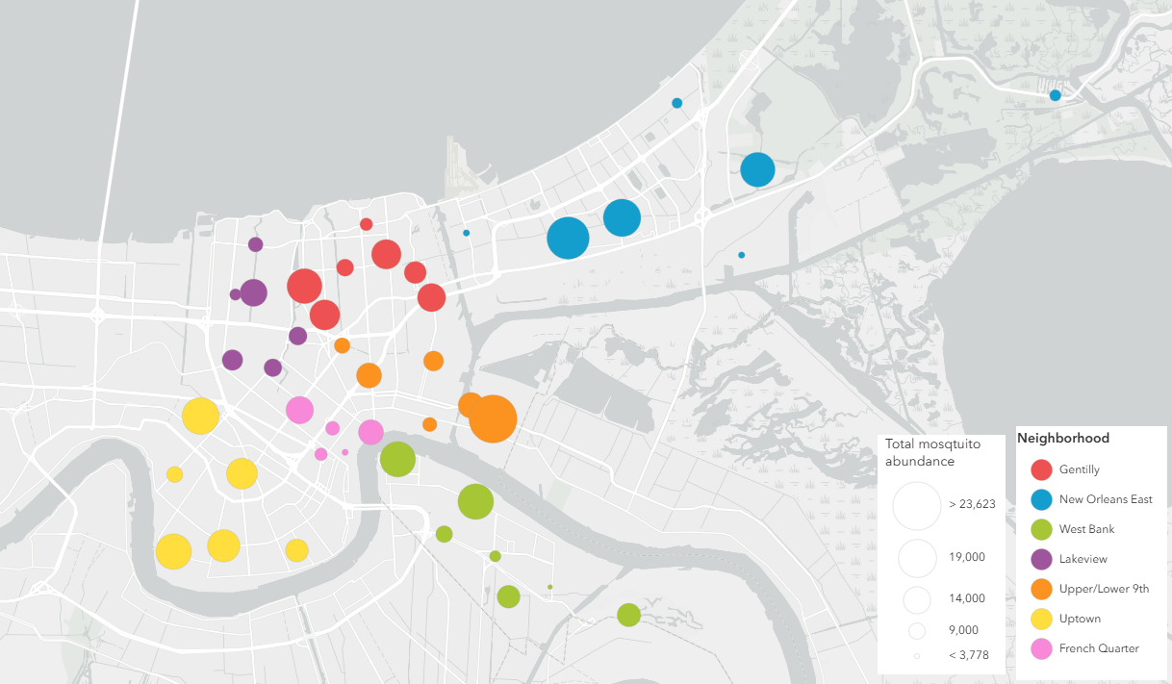
Figure 3.1. Map of 44 permanent mosquito trapping sites across New Orleans, Louisiana, USA. Color denotes neighborhood and size represents total mosquito abundance.

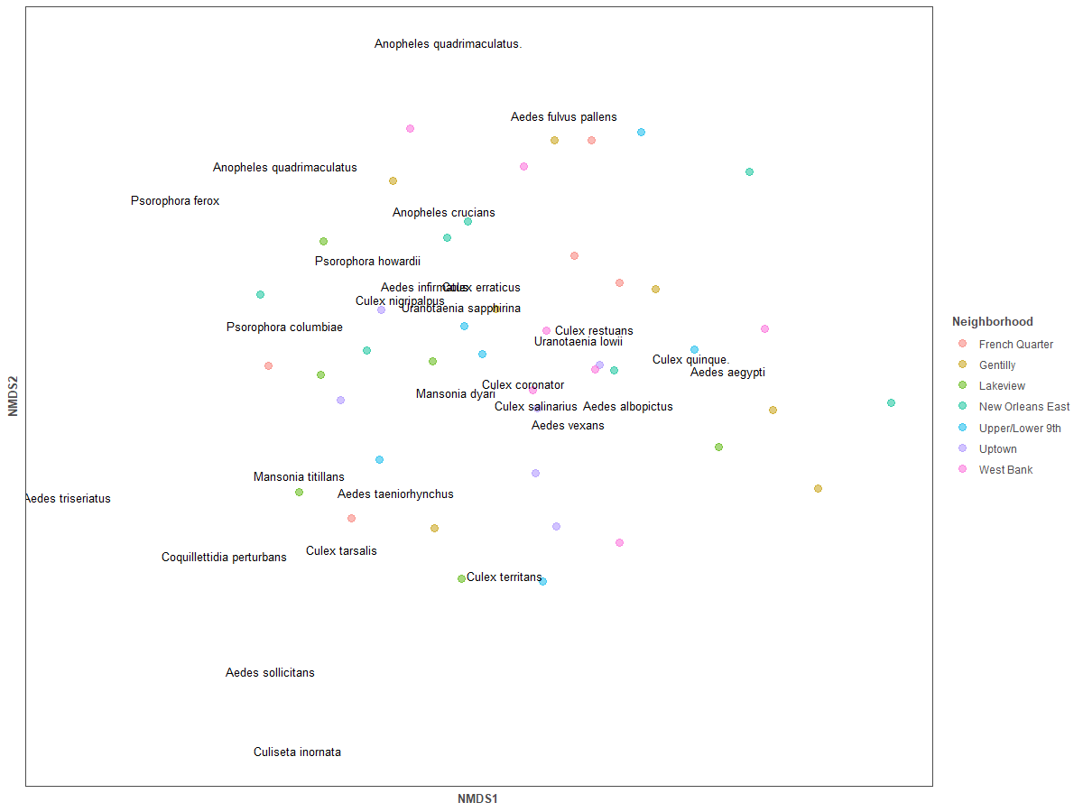Figure 3.2. Biplot of NMDS ordination of the full mosquito assemblage across New Orleans, LA.
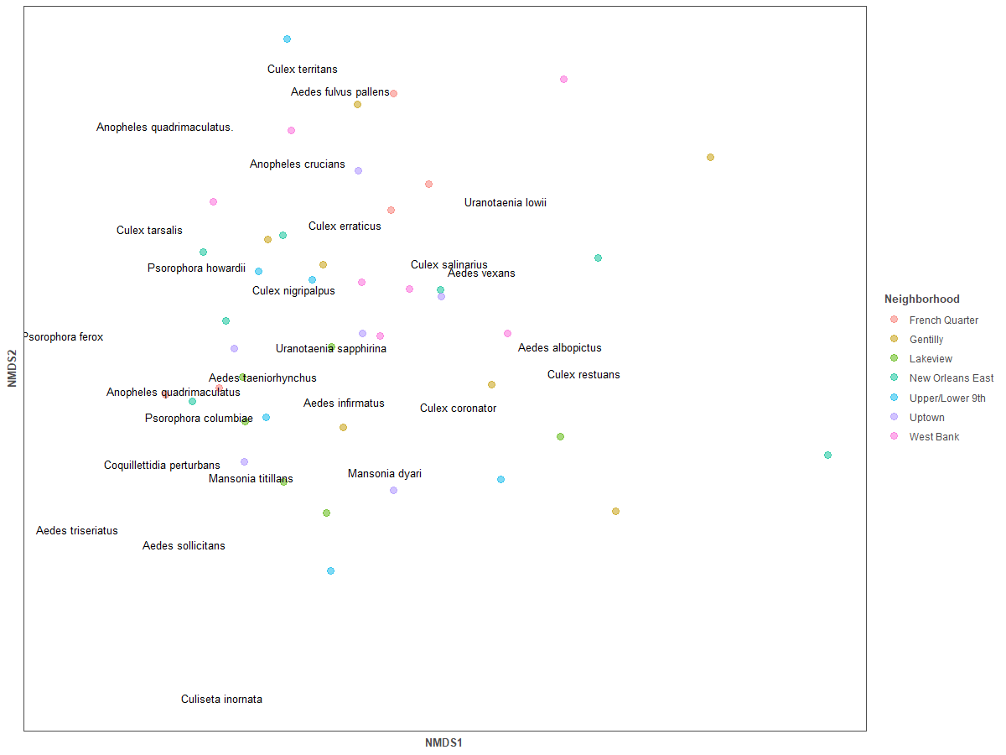Figure 3.3. Biplot of NMDS ordination of the mosquito assemblage with Cu. quinquefasciatus removed across New Orleans, LA.

Table 3.1. Neighborhood-level profiles to distinguish by land cover, topography, demographics, and socioeconomic status. All values represent averages for sites within neighborhoods.
Neighborhood | NDVI | Elevation  (m) | Population density | Proportion of vacancy | Median household income
French Quarter | 192.9895 | 5.8 | 7122.6 | 0.3524402 | 101823.4
Gentilly | 558.9787 | 2 | 4960.857 | 0.0940828 | 77432.14
Lakeview | 555.0595 | 2.166667 | 3727.333 | 0.0826525 | 130127.17
New Orleans East | 829.2223 | 2.857143 | 3336.571 | 0.1211488 | 59044.14
Upper/Lower 9th Ward | 538.7469 | 0.5 | 6270.667 | 0.1551575 | 51242
Uptown | 537.8909 | 3.833333 | 8845.667 | 0.1424573 | 133879.83
Westbank | 776.4413 | 2 | 4808.714 | 0.1149747 | 81855

Table 3.2. All social-ecological predictors included in the global model according to overarching data type.
Data type |  |  | Variable
Land cover |  |  | NDVI
 |  |  | Tree density
 |  |  | Number of tires present
Vegetation |  |  | Tree species richness
 |  |  | Shrub species richness
Climate |  |  | Urban heat island estimates
Demographic/  Socioeconomic |  |  | Population density
 |  |  | Proportion of vacancy
 |  |  | Median household income
Topography |  |  | Elevation
French Quarter | 8162.4  (+3614.38) | 51.8 (+35.26) |  | 60.2 (+59.19) | 7.33 (+2.37) | 0.088 (+0.041)

Table 3.3. Average annual diversity, richness, and abundances of vector mosquitoes at trapping sites within each neighborhood across the study period. Standard deviation is noted as (+).
Neighborhood | Cu. quinquefasciatus | Ae. aegpyti | Ae. albopictus | Richness | H’
Gentilly | 11209.85  (+3000.08) | 64.71  (+38.01) | 79.58  (+19.48) | 9.19  (+ 1.24) | 0.105  (+0.048)
New Orleans East | 9867.29  (+6526.64) | 54.71  (+28.45) | 83.86  (+38.63) | 11.24  (+3.46) | 0.232  (+0.156)
West Bank | 10015  (+4755.41) | 55.71  (+48.32) | 91.57  (+84.59) | 9.09  (+2.92) | 0.120  (+0.081)
Lakeview | 8707  (+2073.31) | 63.33  (+38.55) | 99.5  (+88.19) | 7.94  (+3.08) | 0.111  (+0.070)
Upper/Lower 9th | 11328  (+5240.76) | 131.67  (+72.62) | 122.33  (+55.59) | 9.33  (+2.20) | 0.099  (+0.038)
Uptown | 12961.83  (+3368.58) | 129.17  (+52.91) | 85.83  (+62.79) | 6.67  (+1.39) | 0.059  (+0.110)
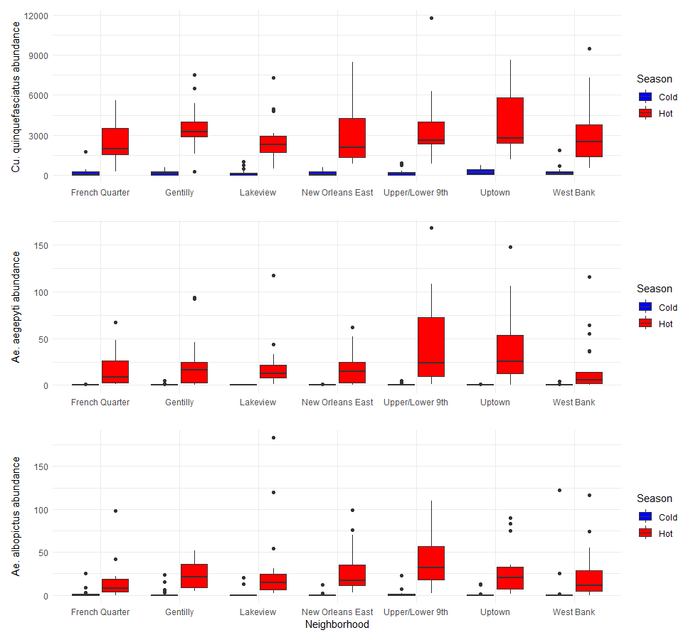 Figure 3.4. Box plot of seasonal mosquito abundances according to neighborhood for each of Cu. quinquefasciatus (top), Ae. aegpyti (middle), and Ae. albopictus (bottom). Box plot color denotes seasonality.

Table 3.4. Models within the threshold of best-fit according to delta AIC (<2) for richness and diversity.
Model target | Rank | Retained variables | AIC | Delta AIC
Richness | 1 | NDVI, shrub species richness, tires, tree density, tree species richness | 665.689 | 0.00
Richness | 2 | Elevation, NDVI, shrub species richness, tires, tree density | 666.872 | 1.183
Richness | 3 | NDVI, shrub species richness, tires, tree density, UHI | 666.878 | 1.189
Richness | 4 | Proportion of vacancy, NDVI, shrub species richness, tires, tree density | 666.885 | 1.196
Richness | 5 | Median household income, NDVI, shrub species richness, tires, tree density, tree species richness | 666.943 | 1.254
Richness | 6 | Population density, NDVI, shrub species richness, tires, tree density | 666.975 | 1.285
Richness | 7 | Median household income, elevation, NDVI, shrub species richness, tires, tree density | 667.515 | 1.826
Richness | 8 | Median household income, NDVI, shrub species richness, tires, tree density, UHI | 667.625 | 1.935

Table 3.4 continued.
Shannon’s index | 1 | Population density, median household income, proportion of vacancy, NDVI, tree density | -283.875 | 0.00
Shannon’s index | 2 | Population density, median household income, proportion of vacancy, NDVI | -283.756 | 0.118
Shannon’s index | 3 | Population density, median household income, proportion of vacancy, NDVI, tires | -283.637 | 0.237
Shannon’s index | 4 | Population density, median household income, proportion of vacancy, elevation, NDVI | -283.563 | 0.312
Shannon’s index | 5 | Population density, median household income, proportion of vacancy, NDVI, shrub species richness | -283.560 | 0.315
Shannon’s index | 6 | Population density, median household income, proportion of vacancy, NDVI | -283.558 | 0.316
Shannon’s index | 7 | Population density, median household income, elevation, NDVI | -282.270 | 1.604

Table 3.5. Models within the threshold of best-fit according to delta AIC (<2) for mosquito abundances.
Abundance model | Rank | Retained variables | AIC | Delta AIC
Culex | 1 | Population density, proportion of vacancy, tires, tree density, UHI | 2363.566 | 0.000
Culex | 2 | Proportion of vacancy, NDVI, tires, tree density, UHI | 2363.862 | 0.296
Culex | 3 | Proportion of vacancy, elevation, tires, tree density, UHI | 2364.175 | 0.608
Culex | 4 | Proportion of vacancy, shrub species richness, tires, tree density, UHI | 2364.268 | 0.702
Culex | 5 | Proportion of vacancy, tires, tree density, tree species richness, UHI | 2364.272 | 0.706
Culex | 6 | Population density, proportion of vacancy, shrub species richness, tires, tree density, UHI | 2365.287 | 1.721
Culex | 7 | Shrub species richness, tires, tree density, tree species richness, UHI | 2365.372 | 1.806
Culex | 8 | Population density, shrub species richness, tires, tree density, UHI | 2365.435 | 1.869
Culex | 9 | Population density, tires, tree density, tree species richness, UHI | 2365.47 | 1.911
Aegptyi | 1 | Proportion of vacancy, NDVI, shrub species richness, tree density, UHI | 1109.327 | 0.000
Aegptyi | 2 | Proportion of vacancy, NDVI, tree density, tree species richness, UHI | 1109.772 | 0.445
Aegptyi | 3 | Population density, proportion of vacancy, NDVI, tree density, UHI | 1110.665 | 1.338

Table 3.5 continued.
 | 4 | Proportion of vacancy, NDVI, shrub species richness, tree density, tree species richness, UHI | 1111.029 | 1.702
 | 5 | Population density, proportion of vacancy, NDVI, shrub species richness, tree density, UHI | 1111.279 | 1.952
Albopictus | 1 | NDVI, shrub species richness, tires, tree density, UHI | 1154.311 | 0.000
Albopictus | 2 | Elevation, NDVI, shrub species richness, tree density, UHI | 1155.800 | 1.489
Albopictus | 3 | Population density, NDVI, tires, tree density, UHI | 1155.961 | 1.650
Albopictus | 4 | Population density, NDVI, shrub species richness, tree density | 1155.961 | 1.650
Albopictus | 5 | Median household income, NDVI, shrub species richness, tree density, UHI | 1156.029 | 1.718
Albopictus | 6 | Median household income, NDVI, shrub species richness, tires, tree density, UHI | 1156.080 | 1.769
Albopictus | 7 | Median household income, elevation, NDVI, shrub species richness, tree density, UHI | 1156.105 | 1.794
Albopictus | 8 | NDVI, shrub species richness, tree density, tree species richness, UHI | 1156.117 | 1.806
Albopictus | 9 | Population density, NDVI, shrub species richness, tires, tree density, | 1156.280 | 1.969
Albopictus | 10 | Proportion of vacancy, NDVI, shrub species richness, tree density, UHI | 1156.308 | 1.997
Table 3.5 continued.
Total | 1 | Population density, proportion of vacancy, tires, tree density , UHI | 2391.996 | 0.00
Total | 2 | Proportion of vacancy, elevation, tires, tree density, UHI | 2392.560 | 0.564
Total | 3 | Proportion of vacancy, NDVI, tires, tree density, UHI | 2392.638 | 0.642
Total | 4 | Proportion of vacancy, shrub species richness, tires, tree density, UHI | 2392.722 | 0.726
Total | 5 | Proportion of vacancy, tires, tree density, tree species richness, UHI | 2392.859 | 0.863
Total | 6 | Median household income, proportion of vacancy, tires, tree density, UHI | 2392.899 | 0.903
Total | 7 | Population density, proportion of vacancy, shrub species richness, tires, tree density, UHI | 2393.354 | 1.358
Total | 8 | Population density proportion of vacancy, elevation, tree density, UHI | 2393.609 | 1.614
Total | 9 | Population density, shrub species richness, tires, tree density, UHI | 2393.746 | 1.750
Total | 10 | Shrub species richness, tires, tree density, tree species richness, UHI | 2393.856 | 1.860
Total | 11 | Population density, proportion of vacancy, elevation, tires, tree density, UHI | 2393.857 | 1.861

Vita
Nathaniel Lee Gibson was born in Poughkeepsie, New York. He attended Tulane University in New Orleans, Louisiana for his undergraduate studies, graduating Cum Laude in 2018. Following a gap working at the ByWater Institute at Tulane University, Nathaniel joined the Blum Lab at the University of Tennessee Knoxville in 2019 where he completed a doctoral degree in Ecology and Evolutionary Biology. He is now a postdoctoral scholar at the University of South Florida, working with Dr. Lynn Martin on Lyme disease ecology.

