Blinded by the Brand: Why and When Salesperson Brand Attachment Decreases Customer Purchase Intentions?

A Dissertation Presented for the
Doctorate of Business Administration
Degree
The University of Tennessee, Knoxville

Lisa Beeler
April 2017

Copyright © 2017 by Lisa Beeler.
All rights reserved.

ABSTRACT

Prior research finds that the more attached salespeople are to a brand, the more effort they extend on behalf of the brand, thus improving sales performance. However, salesperson brand attachment may also have undesirable consequences only evident when viewed through the customers’ lens. Specifically, we argue that brand attachment has a “blinding effect” on salespeople, leading them to adopt inappropriate sales strategies that discourage customers from purchasing the brand. We explore these ideas using data collected from 20 exploratory interviews with salesperson-customer dyads and a field study that includes 153 salespeople and 98 matched customers. The data offer support for our ideas and reveal that while brand attachment does increase salesperson effort and sales performance, it also decreases customer future purchase intentions by damaging customer trust in the brand. The data also demonstrate that salesperson authenticity diminishes the negative effect of brand attachment on customers’ future purchase intentions. The study findings thus suggest that while managers should promote salesforce brand attachment to achieve short-term sales goals, doing so may come at the expense of the brand’s long-term health.

Table of Contents

Chapter One Introduction and General Information 7
Chapter Two Literature Review 12
Theoretical Foundation: Social Identity Theory 12
Brand Attachment’s Desirable Effects on Sales Performance 13
Brand Attachment’s Undesirable Effects on Customer Outcomes 14
Brand attachment’s negative influence on customer outcomes 15
Authenticity as a Moderator of Brand Attachment’s Negative Influence on
Customer Outcomes 17
Chapter Three Materials and Methods 21
Context 21
The Field Study 22
Sample 22
Construct Measures 23
Salesperson Survey 23
Customer Survey 24
Chapter Four Results 25
Analytical Procedures 25
Common Method Bias and Non-Response Bias 25
Test of Salesperson Model 26
Measurement Quality 26
Test of Hypothesis 1 27
Test of Dyadic, Salesperson-Customer Model 27
Measurement Validation 28
Test of Hypotheses 2-5 28
Chapter Five Discussion 29
Implications for Theory 29
Salesperson brand attachment may undermine customer outcomes 30
Authenticity as a key influences of customer outcomes 31
Implications for Practice 32
Managers should consider the short- versus long term trade-offs of
salesperson brand attachment 32
Managers should rely on customer perceptions to build training and
incentive systems 33
Managers should encourage authentic selling strategies 33
Limitations and Future Research 34
Concluding Thoughts 35
List of References 36
Appendix 47
Vita 57

LIST OF TABLES

Table 1. ……………………………………………………………………………48-49
Table 2. ………………………………………………………………………………..51
Table 3. ………………………………………………………………………………..52
Table 4. ………………………………………………………………………………..53

LIST OF FIGURES

Figure 1. …………………………………………………………………………........50
Figure 2. ………………………………………………………………………………..54
Figure 3. ………………………………………………………………………………..55

Introduction and General Information

Brand attachment is defined as the strength of the [affective] bond connecting the brand with the self (Allison et al. 2016; Park et al. 2010). Previous research has explored the critical role of brand attachment in consumer contexts (Fournier 1998; Kervyn, Fiske, and Malone 2012; Fournier and Alvarez 2012). Brand attachment has been described as an important outcome for customer-brand relationships (Park et al. 2010) due to its influence on a consumer’s general happiness with their self-identity, pro-brand behaviors, and repeat purchase behaviors (Fournier 2009). Recently, authors have expanded the scope of the brand attachment literature, exploring the effects of brand attachment on employees as well. For example, studies by Hughes and Ahearne (2010) and Allison et al. (2016) find that strong employee-brand relationships increase salesperson effort on behalf of the brand.
While extant research generally affirms the wisdom inherent in encouraging employees to develop a strong attachment to the brands they represent (Hughes and Ahearne 2010), anecdotal evidence suggests that employee’s strong brand attachments may have a dark side. For instance, in a recent article posted on Forbes.com called “Why Culture Eats Strategy for Lunch at Chick-fil-A,” a scan of reader comments on the article suggests not all potential customers appreciate the passionate brand culture Chick-fil-A has built. One person writes, “I can’t stand the Chick-fil-A people. They are obsessed! It’s just chicken!” Exploratory interviews conducted for this study also suggests a similar sentiment regarding salespeople with a strong attachment to the brands they sell:
“I literally avoid him now…I bought stuff from him when he first started selling because I wanted to supportive, but now I regret that $200 purchase. He believes in [brand name] and their products so much I almost feel sorry for him. We [their group of friends] now make fun of him because he thinks what he sells is the cure for everything, including cancer (laughs).”

These examples suggest that although brand attachment may be beneficial from the employee’s perspective (e.g., increasing brand selling effort), brand attachment may have a detrimental effect on customers’ experiences with the brand. Said differently, building on social identity theory, we posit that brand attached employees may be blinded by the brand, ultimately hurting customer brand perceptions, attitudes, and intentions. The research presented here explores this potential dark side of brand attachment by considering whether in addition to its desirable motivational effect on behalf of the brand (Allison et al 2016), salesperson brand-attachment has undesirable effects on customer responses to the brand.
We explore these ideas through a series of field studies. We begin with an exploratory study that relies on 20 salesperson-customer dyads. This qualitative study informed our conceptual model, and led to Study 1(a), a field study of 153 salespeople in which we replicate prior research and find that brand attachment has a positive indirect effect on salesperson performance mediated through brand effort. Study 1(b) combines 98 matched customer responses with the salesperson data obtained in study 1(a) to explore brand attachment’s negative influence on brand trust and ultimately customer future purchase intentions. The findings reveal that salesperson brand attachment does, indeed, have a dark side. Specifically, the study reveals that salesperson brand attachment decreases customer trust in the brand and ultimately customer future purchase intentions. However, we also find that the negative effect of salesperson brand attachment on customer brand trust is attenuated when a salesperson is authentic in his or her brand performance.
As suggested by Table 1, this study makes three significant contributions to the sales literature. First, although past research suggests that employee brand attachment leads to positive employee outcomes, no known research explores how employee brand attachment influences customer responses to the brand. Prior research establishes that brand attachment is a positive influencer of customer outcomes (Kervyn, Fiske, and Malone 2012), but little is known about the possible negative effects of brand attachment (Hughes and Ahearne 2010). We demonstrate here that the literature’s focus on short-term sales outcomes may not fully capture the performance consequences of salesperson brand attachment. Specifically, using matched dyadic data and a forward-looking outcome metric (customer brand purchase intentions) we provide evidence that employee brand attachment has the potential to be detrimental to the future health of a brand. Consequently, this study offers initial insight into the potential dark side of employee-brand relationships specifically, and brand attachment in general.
Second, this study also provides insight regarding salesperson authenticity, which is scarcely explored in the sales context (Schaefer and Pettijohn, 2006) but anecdotally a key aspect of sales training and sales strategies. Some authors suggest that authenticity is critical for customers, with customers often on the “quest” to authenticity in their consumption occurrences (Leigh, Peters, and Shelton 2006). The findings shed light on salesperson’s authenticity’s effect on customer outcomes, showing that authentic salesperson behaviors can attenuate the negative effect brand attachment has on customer outcomes. This research thus extends the literature on the salesperson-brand relationship by advancing an explanation of why brand attachment may have both positive and negative effects on organizationally-valued outcomes.
Third, this study contributes to the literature on salesperson-brand relationships, which, as is noted in Table 1, has not received sufficient attention in the literature (we found only seven studies on the topic). Only recently have authors begun to explore the influence that brand attachment, and similar constructs, have on salespeople (Allison et al. 2016), despite the fact that firms invest large amounts of time and money to ensure salespeople become emotionally bonded to the brand they sell (Morhart, Herzog, and Tomczak 2009).
The remainder of this manuscript is organized as follows. We begin with a brief overview of the social identity theory, the theoretical lens that guides our work. Next, we review the relevant literature to support our development of the study’s hypotheses. Then we proceed to provide a description of the study’s procedures and processes that were utilized to address the study’s research questions. We then present the study’s findings, and conclude with an extensive discussion of our study’s contribution to theory and of the implications of our findings for practice.
<<<Insert Table 1 Here>>>

Literature Review
Theoretical Foundation: Social Identity Theory

Brand relationships often provide more than just utilitarian benefits to employees and customers (e.g., Fournier 1998; Keller and Lehmann 2006). Brands can aid in the construction and validation of an individual’s social identity (Elliott and Wattanasuwan 1998), acting as a visible extension of themselves (Belk 1989). Social identity theory (SIT) posits that membership in groups enhances one’s self-concept through in-group, out-group comparisons (Tajfel 1978; Van Dick et al. 2004). Research exploring phenomena using social identity theory has shown that social group membership, such as social groups that rally around a brand, lead to increased self-esteem (Fournier 1998; Van Dick et al. 2004) and work as a foundational psychological resource (Allison et al. 2016). The influence that strong salesperson-brand relationships have on salesperson outcomes has not gone unnoticed. For example, using SIT as a theoretical framework, authors have found salesperson-brand relationships increase brand sales effort (Hughes and Ahearne, 2010), job satisfaction (Gammoh, Mallin, and Pullins 2014a), motivation (Gommah, Mallin, and Pullins 2014b), and salesperson security and happiness (Park et al. 2009).
These brand relationships may impact salespeople at an even greater degree than customers because of their interdependence between the brand they sell and their own psychological and economic well-being (Allison et al. 2016). Customer-brand relationships are also largely influenced by salespeople who act as ambassadors of the firm (Ahearne, Jelinek, and Rapp 2005; Sirianni et al. 2013). In many contexts, the salesperson is the primary, if not the only brand representative customers interact with, leading customers to base their views about the brand on their interactions with the salesperson. Consequently, firms often invest a significant amount of effort to ensure that customer-facing employees, such as salespeople, successfully adopt and identify with the brands they sell (Park et al. 2010; Wieseke, Homburg, and Lee 2008).
Brand Attachment’s Desirable Effects on Sales Performance

Salesperson brand attachment is an affective construct that is defined as “the strength of the bond connecting the brand with the self “(Allison et al. 2016, p.1). Brand attachment represents the strong emotional responses or “hot affect” (Allison et al. 2016) a salesperson associates with the brand as well as the dominance of thoughts and feelings associated with the brand. Generally, employee-brand relationship research suggests that when salespeople feel an attachment to the brand, they put forth a strong effort to promote the brand (Allison et al. 2016) because, according to self-identity theory, doing so allows them to protect their self-identity and reinforce their membership in the brand community (Elliott and Wattanasuwan 1998). Similarly, Hughes and Ahearne (2010) find that the more a salesperson identifies with an organization, the more intrinsically motivated they are to act in the firm’s best interests, and the more effort they invest in brand selling activities. This positive influence of brand attachment on salesperson effort and ultimately performance has received empirical support in the literature (See Table 1), which leads us to advance the following replication hypothesis:
H1: Salesperson brand attachment has a positive indirect effect on salesperson performance through brand selling effort.

Brand Attachment’s Undesirable Effects on Customer Outcomes
The exploratory study. Because no known literature exists regarding the negative consequences of brand attachment, exploratory interviews were conducted and observation of Facebook activity was recorded to provide insight regarding the construction of the proposed conceptual model. A total of 40 (20 salesperson-customer dyads) exploratory interviews were conducted. The interviews ranged from 15 to 75 minutes long, with a variety of direct sellers across multiple industries (e.g., healthcare, fitness, insurance, financial services) and a variety of customers (e.g. have never bought from the salesperson, have bought from the salesperson frequently). Interviews were conducted in a neutral location or via telephone and were taped and transcribed. We began each interview in a grand tour, exploratory manner, focusing on each individual’s view of the sales interactions (McCracken 1988). After the grand tour questions were answered, flexible interview guides were used to ensure that each topic was covered. Following established protocol for qualitative data, categories emerged from the data (Glaser and Strauss 1967). Codes were identified that influenced both positive and negative outcomes of brand attachment. Coder reliability estimate was 97%. In cases of disagreement, the codes were discussed until an agreement was reached. The results of this study informed the model and excerpts from the interviews are used in the following sections to support the proposed hypotheses.
Brand attachment’s negative influence on customer outcomes
As noted, highly brand attached salespeople tend to put forth a strong effort to promote the brand (Allison et al. 2016; Hughes and Ahearne 2010). However, recent research suggests that highly brand attached employees may also be blinded by their passion for the brand: “Over-passionate salespeople sometimes get into the customer role instead of assuming the position of the sales advisors. This may likely depreciate their credibility” (Michel, Merk, and Eroglu 2015, p. 319). These findings suggest that strongly attached salespeople tend to act as emotional zealots for the brand they sell, leading customer to question the credibility, or trustworthiness of the salesperson and the brand they sell. For example, if a salesperson truly loves the brand they sell, their attachment to the brand may lead to an “over the top” sales strategy that is based on emotional appeal. This leaves the customer questioning the salesperson’s objectivity and ultimately wondering if the product really can deliver all these extreme promises. The exploratory interviews revealed similar findings:
“Whenever she tries to sell me [brand name] all she talks about is how it has worked for her, and how much she loves it over and over. I feel like she’s a broken record. I am not even trying to lose weight, but she keeps telling me that is what it is good for. I don’t trust her enthusiasm. Seems like she is selling one of those as seen on TV products.”

“She is trying so hard. It feels dishonest or not genuine. It seems like she is focused on her own ideas, not mine.”

These quotes suggests that salespeople, although exhibiting high brand attachment, are perceived as distrustful due to their focus on their own brand experiences. SIT suggests that brand relationships create social identities that encourage individuals to seek out other “in group” members who also have strong attachments to the brand. A salesperson who truly believes in the brand they sell may try to “recruit” members to become an “in group” member of the brand community. However, in doing so, their passion for the brand may seem inauthentic or “unbelievable” as one interview respondent noted. This extreme brand behavior can erode customer brand trust, which we define here as the degree to which a person believes a brand will deliver on its promise (Erdem, Swait, and Valenzuela 2006). Perceptions of brand trust are generally arrived at through a highly cognitive process (Chaudhuri and Holbrook 2001), suggesting the customer may search for objective signals from the salesperson that confirms brand trust. However, brand attachment is a highly affective state, often leading the salesperson to speak emotionally about the brand. For example, while brand attachment may encourage the salesperson to passionately express their belief in the brand, customers are likely to perceive the manifestations of the salesperson’s brand attachment as an exaggeration of the actual abilities of the brand, instead of a well thought out, objective sales presentation. In other words, the salesperson’s enthusiasm for the brand is likely to raise customers’ suspicions about the brand (e.g., this is too good to be true), ultimately decreasing their trust in the brand. Similar sentiments regarding trust were expressed in the exploratory interviews:
“I can appreciate her experiences with [brand name], but it is really annoying and somewhat unbelievable that the brand works that well.”

In summary, while brand attachment motivates salesperson brand-selling behaviors, it also has the potential to convert salespeople into brand zealots who lose their objectivity when representing the brand to customers. This lack of objectivity, in turn, is likely to harm the long-term health of the brand because it leads customers to perceive brand claims as “too good to be true” and the brand to be untrustworthy and unable to deliver on the benefits that it promises. Hence, we propose the following:
H2: Increasing salesperson brand attachment decreases customer brand trust.

Extant research finds that brand trust is a critical determinant of consumer purchase intentions and behaviors towards a brand (Chaudhuri and Holbrook 2001). This effect is posited to result because trustworthiness enhances the inherent value that customers derive from their exchange relationship with a brand (Morgan and Hunt 1994), thus increasing customers’ willingness to purchase the brand in the future. Hence, we propose:
H3: Increasing customer brand trust increases customer future purchase intentions of the brand.

Authenticity as a Moderator of Brand Attachment’s Negative Influence on Customer Outcomes
Authenticity is a key component of life (Grayson and Martinec 2004). Salesperson authenticity has been shown to be significantly related to sales performance (Schaefer and Pettijohn 2006). Similarly, researchers have found that authenticity is also central to most consumption situations and buying contexts (Kozinets 2002; Muniz and O'Guinn 2001; Schouten and McAlexander 1995). Authenticity has been studied in numerous buying situations such as product style, geographic origin of a product, production methods, and firm values (e.g., Beverland and Farrelly 2010; Grayson and Martinec 2004; McCracken 1986; Peterson 2005; Wang 1999). Consumers now demand authenticity in both products (Lewis and Bridger 2000) and the strategies used to market them (Dolliver 2001).
Although the conceptual understanding of “authenticity” has been widely debated, most researchers agree that authenticity describes a “verification process – the evaluation of some truth or fact” (Newman and Dhar 2014, p.372). Beverland and Farrelly (2010, p. 839) write, “despite the multiplicity of terms and interpretations applied to authenticity, ultimately what is consistent across the literature is that authenticity encapsulates what is genuine, real, and/or true.” An authentic sales strategy is one that is straightforward and legitimate (Brown 1990). Khalsa (1999) suggests that consumers have built-in authenticity detectors when dealing with salespeople. This ability to detect authenticity in salespeople is built on past experiences. Consumers develop pattern recognition heuristics in regards to the actions, appearance, and words that undermine trust (Khalsa 1999). Consequently, consumers expect salespeople to be trustworthy, as opposed to merely claiming trustworthiness (Khalsa 1999). Authenticity has been shown to be a critical antecedent to trust (Newman and Dhar 2014). Research has shown that salespeople often mask their authentic emotions to evoke a positive consumer response. For example, salespeople may laugh at a customer's bad joke to keep the customer engaged during a sales call (Gross and Stone 1964).
When considering salesperson brand attachment, authenticity should play a critical role in determining customer outcomes. Rather than being viewed as a zealot that lacks objectivity, a brand attached salesperson that employs authentic sales strategies is likely to be viewed as passionate but objective when representing the brand. In contrast, when interacting with a brand attached but inauthentic salesperson, customers are likely to place little faith in the brand’s promise because the salesperson’s enthusiasm for the brand is likely to signal an ulterior motive (e.g., the desire to make the sale) rather than an invitation to become a member of the brand group.
This lack of authenticity can be highly frustrating for the customer, leading to negative emotions, such as distrust, regarding the selling situation, the salesperson, and the brand. This represents the negative effect of brand attachment. Although salesperson brand attachment may induce brand trial, the blinding effect of strong brand attachment should decrease customers’ future purchase intention because they do not trust the salesperson’s affective-based claims regarding the brand. Our exploratory interviews revealed this sentiment:
“I bought it from him because he wouldn’t leave me alone. I gave it away. He was so persistent, but now I ignore him. I don’t want to buy anything else from him…I am pretty sure all he wants to do is use me for a sale anyways. He doesn’t even know that I am allergic to half of the products. He never asked.”

“I buy from her because she’s just honest and real and it makes [brand] feel honest and real. She doesn’t pretend like [brand] is more than it is. She just tells you the truth and I can appreciate that.”

Based on past evidence and our exploratory study, we thus propose:
H4: Authenticity attenuates the negative effect of salesperson brand attachment on customer brand trust.

Figure 1 offers a visual depiction of the sequence of effects that we posit are responsible for the detrimental effect of salesperson brand attachment on customer future purchase intentions (All tables and figures are located in the appendix. As the figure illustrates, we argue that salesperson brand attachment decreases customer future purchase intentions by damaging customer trust in the brand. This negative indirect effect, however, is attenuated by salesperson authenticity. Hence, we propose:
H5: Salesperson brand attachment has a negative indirect effect (through customer brand trust) on customer brand purchase intentions that becomes weaker as salesperson authenticity increases.

<<<Insert Figure 1 Here>>>

Materials and Methods

Context
The direct selling industry was chosen for this study because direct selling companies invest a vast amount of time and money on building highly brand attached salespeople. Direct selling companies do this through offering incentives to salespeople to personally use the products they sell and by encouraging them to sell to their own network, building a brand community around them (www.dsa.org). Interviewees’ Facebook posts observed during the exploratory phase provides evidence for the attachment many of these salespeople have for the brands they sell:
“[Brand name] has changed my life. When I started I was always tired and gross feeling, but now I can’t wait to get up and get moving. If you want to feel the same message me”

“The new line of [product category] is unbelievable! I can’t believe I ever used anything else. The before and after pics below are 9 hours apart and you can’t even see any fading! [Brand name] #obsessed #[brand name]”

“After tomorrow you are going to wish you were apart of #[brand name]. Trust me, if you gave up on it without really giving it a try and you were on my team.... go reactivate your account FAST and inbox me. Thank me later!”

Call me crazy, but I NEVER get tired of seeing transformation pictures! These are my friend [name] results! The left is 6 weeks after having her precious baby boy. The right is 1 wrap, and 1 week later So amazing!

The focus on the direct selling industry allows for the exploration of highly brand attached salespeople with the lack of other organizational factors that often influence salespeople outcomes (e.g. common sales managers, common geographic location). Unlike most B2B or retail salespeople, these salespeople rarely share the same geographic spaces (e.g. offices), sales managers, or even training. Additionally, this industry encourages, if not requires, the personal use of the products they sell, enhancing the opportunity to build highly brand attached salespeople.
In 2014, 18.2 million Americans reported that they work as a salesperson for a direct selling company, which is almost two million more than reported the same in 2013 (www.dsa.org). The direct selling industry is a $34.5 billion industry (i.e. the equivalent of the coffee industry) and the rise of brands such as ViSalus, Rodan and Fields, and Northwestern Mutual continues to fuel industry growth. As such, this represents an important sector of the economy.
The Field Study

Sample. The exploratory interviews revealed that a vast majority of direct selling companies train or encourage employees to use social media as one of their main selling tools. Consequently, the salesperson and customer samples were drawn from the top three direct selling business groups on Facebook. To ensure those included in the sample were actively involved in direct selling, we invited 200 sellers who had most recently posted on each page to complete the survey. These same salespeople were then asked to forward a link to a survey to one of their customers. The salesperson-matched customer was chosen at random from a list of four individuals provided by the salesperson (two actual customers, two potential customers). The data collection process resulted in 209 salesperson responses (35% response rate) and 100 customer responses (48% response rate), and 98 fully-matched dyads, after deletion of two customer responses due to incomplete data. Both salespeople and customers were sent four reminder emails over the course of three months to complete their survey and offered a financial incentive. The salesperson demographics were typical for the direct selling industry, as indicated by a summary of the sample characteristics provided in Table 2.
<<<Insert Table 2 Here>>>
Construct Measures
Salesperson Survey. Salesperson brand attachment was measured using a 9-item, 7-point scale adapted from past research (Allison et al., 2016; MacInnis et al. 2009). Salesperson Effort was measured using a 3-item, 7-point scale taken from Miao and Evans (2013). Salesperson performance was measured by a single, ratio-scaled item that asked salespeople to report the revenues they had generated in the past 12 months. As sales data are skewed, we used the natural log of the 12 month sales measure for model testing purposes (the transformation achieved the normalization of the sales data; O’Connell and O’Sullivan 2014). Authenticity was measured using a 4-item, 7-point adapted scale from the work of Schaefer and Pettijohn (2006). Control variables were used in the analysis. In the salesperson model (H1) we control for extrinsic motivation and sales experience, which have both been found to influence sales performance (Levin, Hansen and Laverie 2012; Sabnis et al. 2013). Extrinsic motivation was included as a control to ensure that any effect of brand attachment on sales performance exists above and beyond the effect of salesperson’s level of effort due to the expectation of financial gain. Additionally, sales experience was included to control for the effect of job learning on sales performance. Extrinsic motivation was measured using a 3-item, 7-point adapted scale from Oliver and Anderson (1994). Sales experience was measured as how many months the direct seller had been selling the focal brand. All measures used in the study are presented in Table 3.
Customer Survey. Customer brand trust was measured using a 4-item, 7-point scale taken from Erdem, Swait, and Valenzuela (2006). Brand future purchase intention was measured using a 3-item, 7-point scale adapted from Jones, Mothersbaugh, and Beatty Jr. (2000). In the salesperson-customer model we control for customer attitude toward the industry and whether the customer had tried the focal brand. Attitude towards the industry was included to ensure that any effects isolated were independent of customer perceptions about the direct selling industry. Additionally, we controlled for brand trial as customers’ experience with the brand should influence their intentions to purchase in the future. Attitude towards the industry was used using a single-item construct with a7-point scale, which simply asked the respondent their perception of the direct selling industry. Brand trial was measured using a by asking respondents if they had ever purchased the focal brand. All measures used in the study are presented in Table 3.
<<<Insert Table 3 Here>>>

Results

Analytical Procedures
Study data were analyzed using partial least squares (PLS-SEM) as implemented in SmartPLS 3 (Ringle, Wende, and Becker 2014). T-statistics (for significance testing purposes) were computed by means of bootstrap resampling with 500 subsamples (Henseler and Ringle 2009). The choice to use PLS-SEM over other statistical covariance-based approaches (Hair, Ringle, and Sarstedt 2011) was motivated by the exploratory nature of our research question and the sample size constraints (Steinhoff and Palmatier, 2016) that are common in dyadic studies ( the difficulties of collecting dyadic data are widely known, often producing smaller sample sizes than single source studies). For ease of presentation, PLS-SEM was used to test both the salesperson model and the dyadic salesperson-customer model; however, the study results do not change when the study hypotheses are tested using OLS regression. In sum, the statistical procedures outlined by Hair et al. (2011) were employed to test the study hypotheses using PLS-SEM.
Common Method Bias and Non-Response Bias
While our study employs matched dyadic data, some of the proposed study relationships were tested using data drawn from the same source. Hence, we sought to account for the possible impact of common method bias in multiple ways. First, following recommendations in the literature, our study minimized the potential impact of common method variance through study design decisions (MacKenzie, Scott, and Podsakoff 2012; Podsakoff et al. 2003). Specifically, we ensured anonymity for respondents of the study and emphasized the lack of right or wrong answers. Second, we performed Harman’s single-factor tests and found that no single factor, in either the customer or employee samples, accounted for more than 50% of the variance in the study measures (Podsakoff and Organ 1986). To assess the potential influence of non-response bias on our results, mean values across key study constructs were compared for responses provided by participants in the first quartile and fourth quartile (Armstrong and Overton 1977). The analysis revealed no significant differences (p>.10) in construct means, thus suggesting that nonresponse bias is not a source of concern in our study.

Test of the Salesperson Model

Measurement Quality
The reliability, convergent validity, and discriminant validity of the measures used in the salesperson model were evaluated. All analyses provide strong evidence in support of the measures employed. As shown in Table 3, the composite reliability scores for all constructs are above .70, which exceeds common standards for establishing measure reliability (Hair et al. 2014). Moreover, as shown in Table 4, the average variance extracted (AVE) for all of the constructs is greater than .50 (Hair et al. 2014), which provides evidence of the measures’ convergent validity. Moreover, the square root of the AVE for all constructs is greater than the correlations between any of the latent variables, thus offering evidence in support of the discriminant validity of the constructs (Fornell and Larcker 1981). Construct discriminant validity was also confirmed using the heterotrait-monotrait ratio (HTMT) test (Henseler, Ringle, and Sarstedt 2015). All HTMT values were less than .90 (Henseler et al. 2015), thus confirming the results of the Fornell and Larcker (1981) test. The correlation matrix, means, standard deviations, and AVEs for all study constructs are presented in Table 4.
<<<Insert Table 4 Here>>>
Test of Hypothesis 1
In support of H1, the results indicate that salesperson brand attachment has a positive indirect effect on salesperson performance that is mediated by selling effort (ab=.05, p<.05). Consistent with this finding, the structural coefficients reported in Figure 2 reveal that the path between salesperson brand attachment and salesperson effort is positive and significant (.26, p<.01); likewise, the path between salesperson effort and 12 months sales performance is also positive and significant (.21, p<.05). In addition, as Figure 2 illustrates, several of the control paths were also statistically significant. Specifically, we find that extrinsic motivation is a significant predictor of salesperson effort (.56, p<.01), while sales experience is a predictor of both salesperson effort (.28, p<.01) and salesperson performance (.17, p<.05). Overall, the model explains 43% of the variance in salesperson brand effort and 16% of the variance in salesperson performance.

Test of the Dyadic, Salesperson-Customer Model

Measurement Validation
The same measurement validation procedures used for the salesperson model were employed to evaluate the reliability, convergent validity, and discriminant validity of the measures used in the dyadic model. As shown in Table 3, the composite reliability scores for all constructs are above .70, which exceeds common standards for establishing measure reliability (Hair et al. 2014). Once again, as shown in Table 4, the average variance extracted (AVE) for all of the constructs is greater than .50 (Hair et al. 2014), which provides evidence of the measures’ convergent validity. Moreover, the square root of the AVE for all constructs is greater than the correlations between any of the latent variables, thus offering evidence in support of the discriminant validity of the constructs (Fornell and Larcker 1981). Construct discriminant validity was also confirmed using the heterotrait-monotrait ratio (HTMT) test (Henseler et al. 2015). All HTMT values were less than .90 (Henseler et al. 2015), thus confirming the results of the Fornell and Larcker (1981) test.
Test of Hypotheses 2-5
Figure 3 provides an empirical summary of our test of the dyadic model and hypotheses 2-5. In support of H2, the results show that a marginally significant relationship exists between salesperson brand attachment and customer brand trust (-.11, p<.10). Consistent with H3, the results also reveal a positive relationship between customer brand trust and customer future purchase intentions (.34, p<.01). In support of H4 (.28, p<.01) we find that salesperson authenticity moderates the negative relationship between salesperson brand attachment and customer brand trust (the interaction accounts for a 7% increase in adjusted R² for customer brand trust). Specifically, as is illustrated in Figure 4, a simple slopes analysis reveals that brand attachment has a significant (p<.05) and negative (b=-.51) effect on customer brand trust when salesperson authenticity is low and a positive albeit non-significant effect on customer brand trust when salesperson authenticity is high (b=.22, p>.10). Consistent with these findings – and in support of H5 – we find that salesperson brand attachment has a negative indirect effect on customer purchase intentions when salesperson authenticity is low (ab=-.26, p<.05), and is unrelated to customer purchase intentions when salesperson authenticity is high (ab=.11, p>.10). In addition, several of the control variables have significant effects on model constructs. As noted in Figure 3, attitude towards industry is a significant predictor of customer brand trust (.46, p<.01) and customer future purchase intentions (.31, p<.01). Customer brand trial is a significant predictor of both customer brand trust (.18, p<.05) and customer future purchase indentions (.34, p<.01). Overall, the model explains 33% of the variance in customer brand trust and 74% of the variance in customer future purchase intentions.

CHAPTER FIVE DISCUSSION

Implications for Theory
Salesperson brand attachment may undermine customer outcomes. Based on past literature regarding employee-brand relationships, the finding that salesperson brand attachment can be harmful to long-term brand health is unexpected. Companies invest large amounts of time and money encouraging their employees to adopt and believe in the brands they sell. However, this research provides evidence that promoting strong employee-brand bonds can create employees that are so highly attached to the brand that they become zealots of the brand, ultimately hurting customers’ future relationship with the brand. Brand relationship literature has generally suggested a positive relationship between bran attachment and brand outcomes (Fournier 1998; Kervyn, Fiske, and Malone 2012); this study is thus the first to suggest and demonstrate that there may be long-term negative consequences to building a strong brand culture amongst employees. Brand attachment has been viewed as critical for successful salespeople, however, our study suggests that there can be “too much of a good thing” when it comes to the level of salesperson love for the brand they sell. This intense love for the brand blinds the salesperson, or, in other words, inhibits their ability to perceive how they may be affecting the customer. This blinding effect that spawns from high brand attachment should be considered at a strategic level.
Past employee-brand relationship literature, and our current study, has provided evidence for the positive effects of brand attachment on sales performance, mediated through effort. However, sales performance may be too myopic of a focus when considering the effects of brand attachment. Although highly brand attached salespeople may succeed in generating sales in the short-term, until now, it was unclear what brand attachment does to long-term brand health. This study contributes to the understanding of how brand attachment can be a double-edged sword for salespeople. The dark side of brand attachment, or the negative influence salesperson brand attachment has on customer brand trust and customer future purchase intentions is critical for understanding how both practitioners and academics consider employee-brand relationships and the balance of both short-term and long term goals.
Authenticity as a key influences of customer outcomes. Another key contribution of our study highlights the use of authentic selling strategies and how this strategy can attenuate the negative effect of high salesperson brand attachment. In other words, authenticity works a mechanism that seems to “remove the blinders” from salespeople’s eyes, ultimately increasing customer brand trust due to the observed objectivity and understanding from the salesperson. Past studies have provided evidence that authenticity positively influences sales performance (Schaefer and Pettijohn 2006), but little is known regarding authenticity’s effect on brand outcomes. Researchers have found evidence for the negative effect manipulative behaviors have on sales performance (McFarland 2003; Saxe and Weitz 1982). Generally, consumers are searching for authenticity in products and consumptions experiences (Leigh et al. 2006). A recent editorial entitled Advancing Sale Performance Research: A Focus on Five Under researched Topic Areas (Evans et al. 2012) suggests that “Furthering our understanding of the underlying sales strategies that are used by salespeople is an under researched area. Although there exists a large body of sales strategy research, these strategies are still misunderstood in the sales context due to proliferation of typologies and the disjointed, or “pick and choose” use of these typologies. This study provides evidence for a sales strategy that is effective, authenticity. Salesperson authenticity increases the trust a customer has in the focal brand, ultimately increasing customer future purchase intentions. As salespeople fight the long-standing negative stereotypes of dishonesty and self-interest, authenticity is a key tool that salespeople must use to ensure long term brand health and repeat purchases.
Implications for Practice

Managers should consider the short- versus long term trade-offs of salesperson brand attachment. Firms must consider the long term effects of building highly brand attached salespeople. A recent article in the Harvard Business Review entitled “If Brands are Built Over Years, Why are They Managed Over Quarters?” suggests that firms who focus on sales are adopting a myopic strategy, while firms (e.g. Nike) who focus on long term brand outcomes are found to be more profitable in the long run. Although brand attachment may increase sales efforts in the short term, it can lead to decrease in brand trust and future purchase intentions. The strategic focus on solely sales is a myopic strategy. Firms must find the appropriate balance between both sales goals and marketing goals. This tension between the sales and marketing strategies and functions is not novel phenomena, but this study suggests that solely focusing on either sales or marketing related outcomes such as brand trust isn’t sound as a long term strategy.
Managers should rely on customer perceptions to build training and incentive systems. Training is a critical component to any sales force, but firms must realize that brand training initiatives may backfire if salespeople adopt the brand, but do so in an inauthentic nature. Firms should also take into account the control systems used to incentivize these salespeople. Outcome based control systems that are based on sales performance may encourage short term profits, but it may come at a cost to brand perception. Instead, it may be vital for firms to adopt a hybrid control system that focuses on both sales and brand outcomes. For example, firms may base compensation on sales performance, but also have the salesperson’s customer complete an anonymous brand perceptions survey, ensuring that the salesperson is striking the right balance between short term sales goals and long term brand health goals.
Managers should encourage authentic selling strategies. Selling strategies across firms and individual salespeople often vary. Although firms may train salespeople on a specific selling approach (e.g. the Challenger model), individuals adapt the intended approach to enhance their own strengths and to ensure an appropriate fit between a selling situation and a sales strategy. Based on the current research and the general body of knowledge regarding authenticity, regardless of the adopted firm selling model, firms must ensure that their sales force uses authentic selling approaches. Although other, more manipulative, models of selling may increase short term sales performance, the deteriorated customer brand trust will ultimately damage long term brand outcomes. Firms should also reconsider training sales people to adopt sales strategies that are rooted in authentic approaches. The selling landscape has changed strikingly over the past two decades. With the rise of competition, digital landscapes, and the power of the consumer, came the fall of the “do anything for a sale” strategy. Now, salespeople should focus on being authentic to ensure that customers remain loyal and brand health remains strong.

Limitations and Future Research

Although we are encouraged by the findings in this study, it is important to recognize the limitations of this research. First, although the context was chosen due to the nature of the highly attached salespeople within the direct sales industry, it is important to explore other contexts (e.g. retailing, business-to-business) and other brand categories (e.g. hedonic, expensive) to determine if our findings hold in those environments. The brands in this study were varied to maximize the generalizability of the sample, however, a focus on specific types of brands may produce some additional insights findings. Second, future research should explore the antecedents of high brand attachment and authenticity. This type of research could provide strong managerial implications for firms regarding training and environmental aspects influencing how salespeople adopt a brand. For example, in this study, the exploratory interviews suggested that personal use was a strong influencer of brand attachment. However, other factors that may influence brand attachment and authenticity should be examined to better understand the nomological network of employee-brand relationships.

Concluding Thoughts

This study provides evidence that employee-brand relationships may not always be beneficial for the firm. This finding is startling considering past research regarding brand attachment and the anecdotal evidence of the investments firms employ to ensure their employees believe in the brands they sell.. We hope that this research provides a foundation for exploring the dark side of employee-brand relationships.

List of References
Ahearne, Michael, Ronald Jelinek, and Adam Rapp (2005), "Moving beyond the direct effect of SFA adoption on salesperson performance: Training and support as key moderating factors," Industrial Marketing Management, 34 (4), 379-88.

Allison, Lee, Karen E Flaherty, Jin Ho Jung, and Isaac Washburn (2016), "Salesperson brand attachment: a job demands-resources theory perspective," Journal of Personal Selling & Sales Management, 36 (1), 3-18.

Armstrong, J Scott and Terry S Overton (1977), "Estimating nonresponse bias in mail surveys," Journal of marketing research, 396-402.

Badrinarayanan, Vishag and Debra A Laverie (2011), "Brand advocacy and sales effort by retail salespeople: Antecedents and influence of identification with manufacturers’ brands," Journal of Personal Selling & Sales Management, 31 (2), 123-40.

Belk, Russell W (1989), "Extended self and extending paradigmatic perspective," Journal of Consumer Research, 16 (1), 129-32.

Beverland, Michael B and Francis J Farrelly (2010), "The quest for authenticity in consumption: Consumers’ purposive choice of authentic cues to shape experienced outcomes," Journal of Consumer Research, 36 (5), 838-56.

Brown, Steven P (1990), "Use of closed influence tactics by salespeople: Incidence and buyer attributions," Journal of Personal Selling & Sales Management, 10 (4), 17-29.

Burmann, Christoph, Sabrina Zeplin, and Nicola Riley (2009), "Key determinants of internal brand management success: An exploratory empirical analysis," Journal of Brand Management, 16 (4), 264-84.

Chaudhuri, Arjun and Morris B Holbrook (2001), "The chain of effects from brand trust and brand affect to brand performance: the role of brand loyalty," Journal of marketing, 65 (2), 81-93.

Dolliver, Mark (2001), "It's Popular, But Authenticity Isn't What It Used to Be," Adweek Eastern Edition, 42 (27), 19-19.

Elliott, Richard and Kritsadarat Wattanasuwan (1998), "Brands as symbolic resources for the construction of identity," International journal of Advertising, 17 (2), 131-44.

Erdem, Tülin, Joffre Swait, and Ana Valenzuela (2006), "Brands as signals: A cross-country validation study," Journal of Marketing, 70 (1), 34-49.

Evans, Kenneth R, Richard G McFarland, Bart Dietz, and Fernando Jaramillo (2012), "Advancing sales performance research: A focus on five underresearched topic areas," Journal of Personal Selling & Sales Management, 32 (1), 89-105.

Fornell, Claes and David F Larcker (1981), "Evaluating structural equation models with unobservable variables and measurement error," Journal of marketing research, 39-50.

Fournier, Susan (1998), "Consumers and their brands: Developing relationship theory in consumer research," Journal of consumer research, 24 (4), 343-73.

---- (2009), "Lessons learned about consumers’ relationships with their brands," Handbook of brand relationships, 5, 23.

Fournier, Susan and Claudio Alvarez (2011), "Brands as relationship partners: Warmth, competence, and in-between."

Gammoh, Bashar S, Michael L Mallin, and Ellen Bolman Pullins (2014), "Antecedents and consequences of salesperson identification with the brand and company," Journal of Personal Selling & Sales Management, 34 (1), 3-18.

Gammoh, Bashar, Michael L. Mallin, and Ellen Bolman Pullins (2014), "The impact of salesperson-brand personality congruence on salesperson brand identification, motivation and performance outcomes," Journal of Product & Brand Management, 23 (7), 543-53.

Glaser, Barney and Anselm Strauss (1967), "The discovery of grounded theory. 1967," Weidenfield & Nicolson, London, 1-19.

Grayson, Kent and Radan Martinec (2004), "Consumer perceptions of iconicity and indexicality and their influence on assessments of authentic market offerings," Journal of consumer research, 31 (2), 296-312.

Gross, Edward and Gregory P Stone (1964), "Embarrassment and the analysis of role requirements," American Journal of Sociology, 70 (1), 1-15.

Hair, Joe F, Christian M Ringle, and Marko Sarstedt (2011), "PLS-SEM: Indeed a silver bullet," Journal of Marketing theory and Practice, 19 (2), 139-52.

Hair Jr, Joseph F, G Tomas M Hult, Christian Ringle, and Marko Sarstedt (2016), A primer on partial least squares structural equation modeling (PLS-SEM): Sage Publications.

Henseler, Jörg, Christian M Ringle, and Marko Sarstedt (2015), "A new criterion for assessing discriminant validity in variance-based structural equation modeling," Journal of the Academy of Marketing Science, 43 (1), 115-35.

Henseler, Jörg, Christian M Ringle, and Rudolf R Sinkovics (2009), "The use of partial least squares path modeling in international marketing," in New challenges to international marketing: Emerald Group Publishing Limited.

Hughes, Douglas E and Michael Ahearne (2010), "Energizing the reseller's sales force: The power of brand identification," Journal of Marketing, 74 (4), 81-96.

Jones, Michael A, David L Mothersbaugh, and Sharon E Beatty (2000), "Switching barriers and repurchase intentions in services," Journal of retailing, 76 (2), 259-74.

Keller, Kevin Lane and Donald R Lehmann (2006), "Brands and branding: Research findings and future priorities," Marketing science, 25 (6), 740-59.

Kervyn, Nicolas, Susan T Fiske, and Chris Malone (2012), "Brands as intentional agents framework: How perceived intentions and ability can map brand perception," Journal of consumer psychology: the official journal of the Society for Consumer Psychology, 22 (2).

Khalsa, Mahan (1999), Let's get real or let's not play: the demise of dysfunctional selling and the advent of helping clients succeed: Franklin Covey Co.

Kozinets, Robert V (2002), "Can consumers escape the market? Emancipatory illuminations from burning man," Journal of consumer research, 29 (1), 20-38.

Leigh, Thomas W, Cara Peters, and Jeremy Shelton (2006), "The consumer quest for authenticity: The multiplicity of meanings within the MG subculture of consumption," Journal of the Academy of Marketing Science, 34 (4), 481-93.

Levin, Michael A, Jared M Hansen, and Debra A Laverie (2012), "Toward UndersTanding new sales employees’ parTicipaTion in markeTing-relaTed Technology: moTivaTion, volUnTariness, and pasT performance," Journal of Personal Selling & Sales Management, 32 (3), 379-93.

Lewis, D and D Bridger (2000), "Authenticity; The Soul of the New Consumer," Nicholas Brealey Publishing, London.

MacKenzie, Scott B and Philip M Podsakoff (2012), "Common method bias in marketing: causes, mechanisms, and procedural remedies," Journal of Retailing, 88 (4), 542-55.

McCracken, Grant (1986), "Culture and consumption: A theoretical account of the structure and movement of the cultural meaning of consumer goods," Journal of consumer research, 13 (1), 71-84.

---- (1988), The long interview: Sage.

McFarland, Richard G (2003), "Crisis of conscience: The use of coercive sales tactics and resultant felt stress in the salesperson," Journal of Personal Selling & Sales Management, 23 (4), 311-25.

Miao, C Fred and Kenneth R Evans (2013), "The interactive effects of sales control systems on salesperson performance: a job demands–resources perspective," Journal of the Academy of Marketing Science, 41 (1), 73-90.

Michel, Géraldine, Michaela Merk, and Sevgin Eroglu (2015), "Salesperson–brand relationship: main dimensions and impact within the context of private brand retailing," Journal of Personal Selling & Sales Management, 35 (4), 314-33.

Morgan, Robert M and Shelby D Hunt (1994), "The commitment-trust theory of relationship marketing," The journal of marketing, 20-38.

Morhart, Felicitas M, Walter Herzog, and Torsten Tomczak (2009), "Brand-specific leadership: Turning employees into brand champions," Journal of Marketing, 73 (5), 122-42.

Muniz, Albert M and Thomas C O'guinn (2001), "Brand community," Journal of consumer research, 27 (4), 412-32.

Newman, George E and Ravi Dhar (2014), "Authenticity is contagious: Brand essence and the original source of production," Journal of Marketing Research, 51 (3), 371-86.

O'Connell, Vincent and Don O'Sullivan (2014), "The influence of lead indicator strength on the use of nonfinancial measures in performance management: Evidence from CEO compensation schemes," Strategic Management Journal, 35 (6), 826-44.

Oliver, Richard L and Erin Anderson (1994), "An empirical test of the consequences of behavior-and outcome-based sales control systems," The Journal of Marketing, 53-67.

Park, C Whan, Joseph R Priester, Deborah J MacInnis, Zhong Wan, D MacInnis, C Park, and J Priester (2009), "The connection-prominence attachment model (CPAM)," Handbook of brand relationships, 327-41.

Peterson, Richard A (2005), "In search of authenticity," Journal of Management Studies, 42 (5), 1083-98.

Podsakoff, Philip M, Scott B MacKenzie, Jeong-Yeon Lee, and Nathan P Podsakoff (2003), "Common method biases in behavioral research: a critical review of the literature and recommended remedies," Journal of applied psychology, 88 (5), 879.

Podsakoff, Philip M and Dennis W Organ (1986), "Self-reports in organizational research: Problems and prospects," Journal of management, 12 (4), 531-44.

Ringle, Christian M, Sven Wende, and Jan-Michael Becker (2014), "Smartpls 3. Hamburg: SmartPLS," Academy of Management Review, 9, 419-45.

Sabnis, Gaurav, Sharmila C Chatterjee, Rajdeep Grewal, and Gary L Lilien (2013), "The sales lead black hole: On sales reps' follow-up of marketing leads," Journal of marketing, 77 (1), 52-67.

Schaefer, Allen D and Charles E Pettijohn (2006), "The relevance of authenticity in personal selling: Is genuineness an asset or liability?," Journal of Marketing Theory and Practice, 14 (1), 25-35.

Schouten, John W and James H McAlexander (1995), "Subcultures of consumption: An ethnography of the new bikers," Journal of consumer research, 22 (1), 43-61.

Sirianni, Nancy J, Mary Jo Bitner, Stephen W Brown, and Naomi Mandel (2013), "Branded service encounters: Strategically aligning employee behavior with the brand positioning," Journal of Marketing, 77 (6), 108-23.

Steinhoff, Lena and Robert W Palmatier (2016), "Understanding loyalty program effectiveness: managing target and bystander effects," Journal of the Academy of Marketing Science, 44 (1), 88-107.

Tajfel, Henri Ed (1978), Differentiation between social groups: Studies in the social psychology of intergroup relations: Academic Press.

Van Dick, Rolf, Oliver Christ, Jost Stellmacher, Ulrich Wagner, Oliver Ahlswede, Cornelia Grubba, Martin Hauptmeier, Corinna Hoehfeld, Kai Moltzen, and Patrick A Tissington (2004), "Should I stay or should I go? Explaining turnover intentions with organizational identification and job satisfaction," British Journal of Management, 15 (4), 351-60.

Wang, Ning (1999), "Rethinking authenticity in tourism experience," Annals of tourism research, 26 (2), 349-70.

Whan Park, C, Deborah J MacInnis, Joseph Priester, Andreas B Eisingerich, and Dawn Iacobucci (2010), "Brand attachment and brand attitude strength: Conceptual and empirical differentiation of two critical brand equity drivers," Journal of marketing, 74 (6), 1-17.

Wieseke, Jan, Christian Homburg, and Nick Lee (2008), "Understanding the adoption of new brands through salespeople: a multilevel framework," Journal of the Academy of Marketing Science, 36 (2), 278-91.

Appendix

Table 1: Summary of Relevant Literature and Contributions
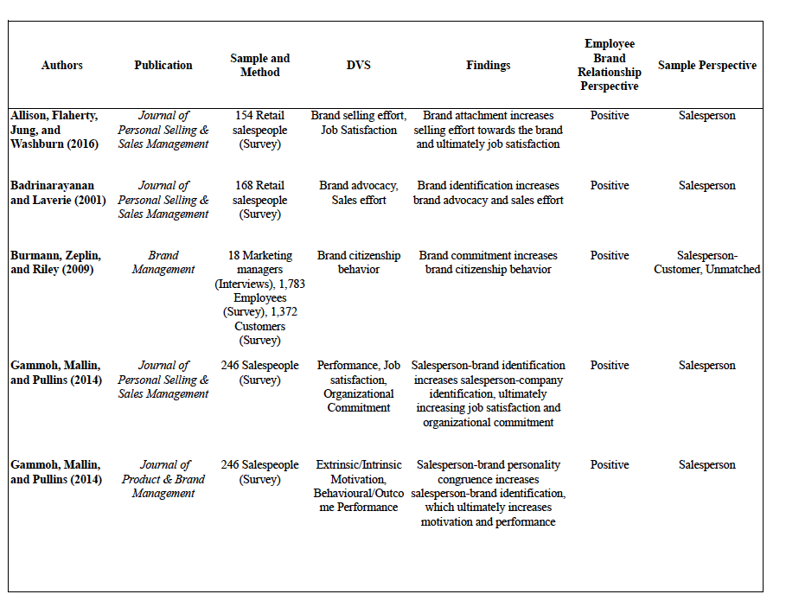

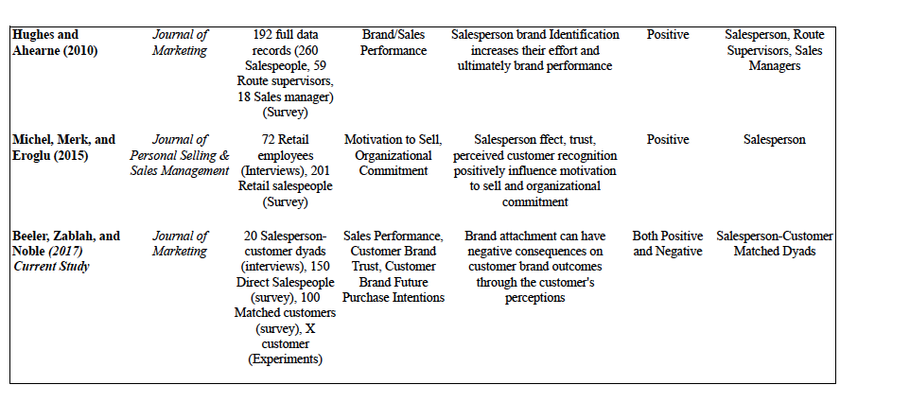
(Table 1 continued)

Figure 1: Proposed Conceptual Models
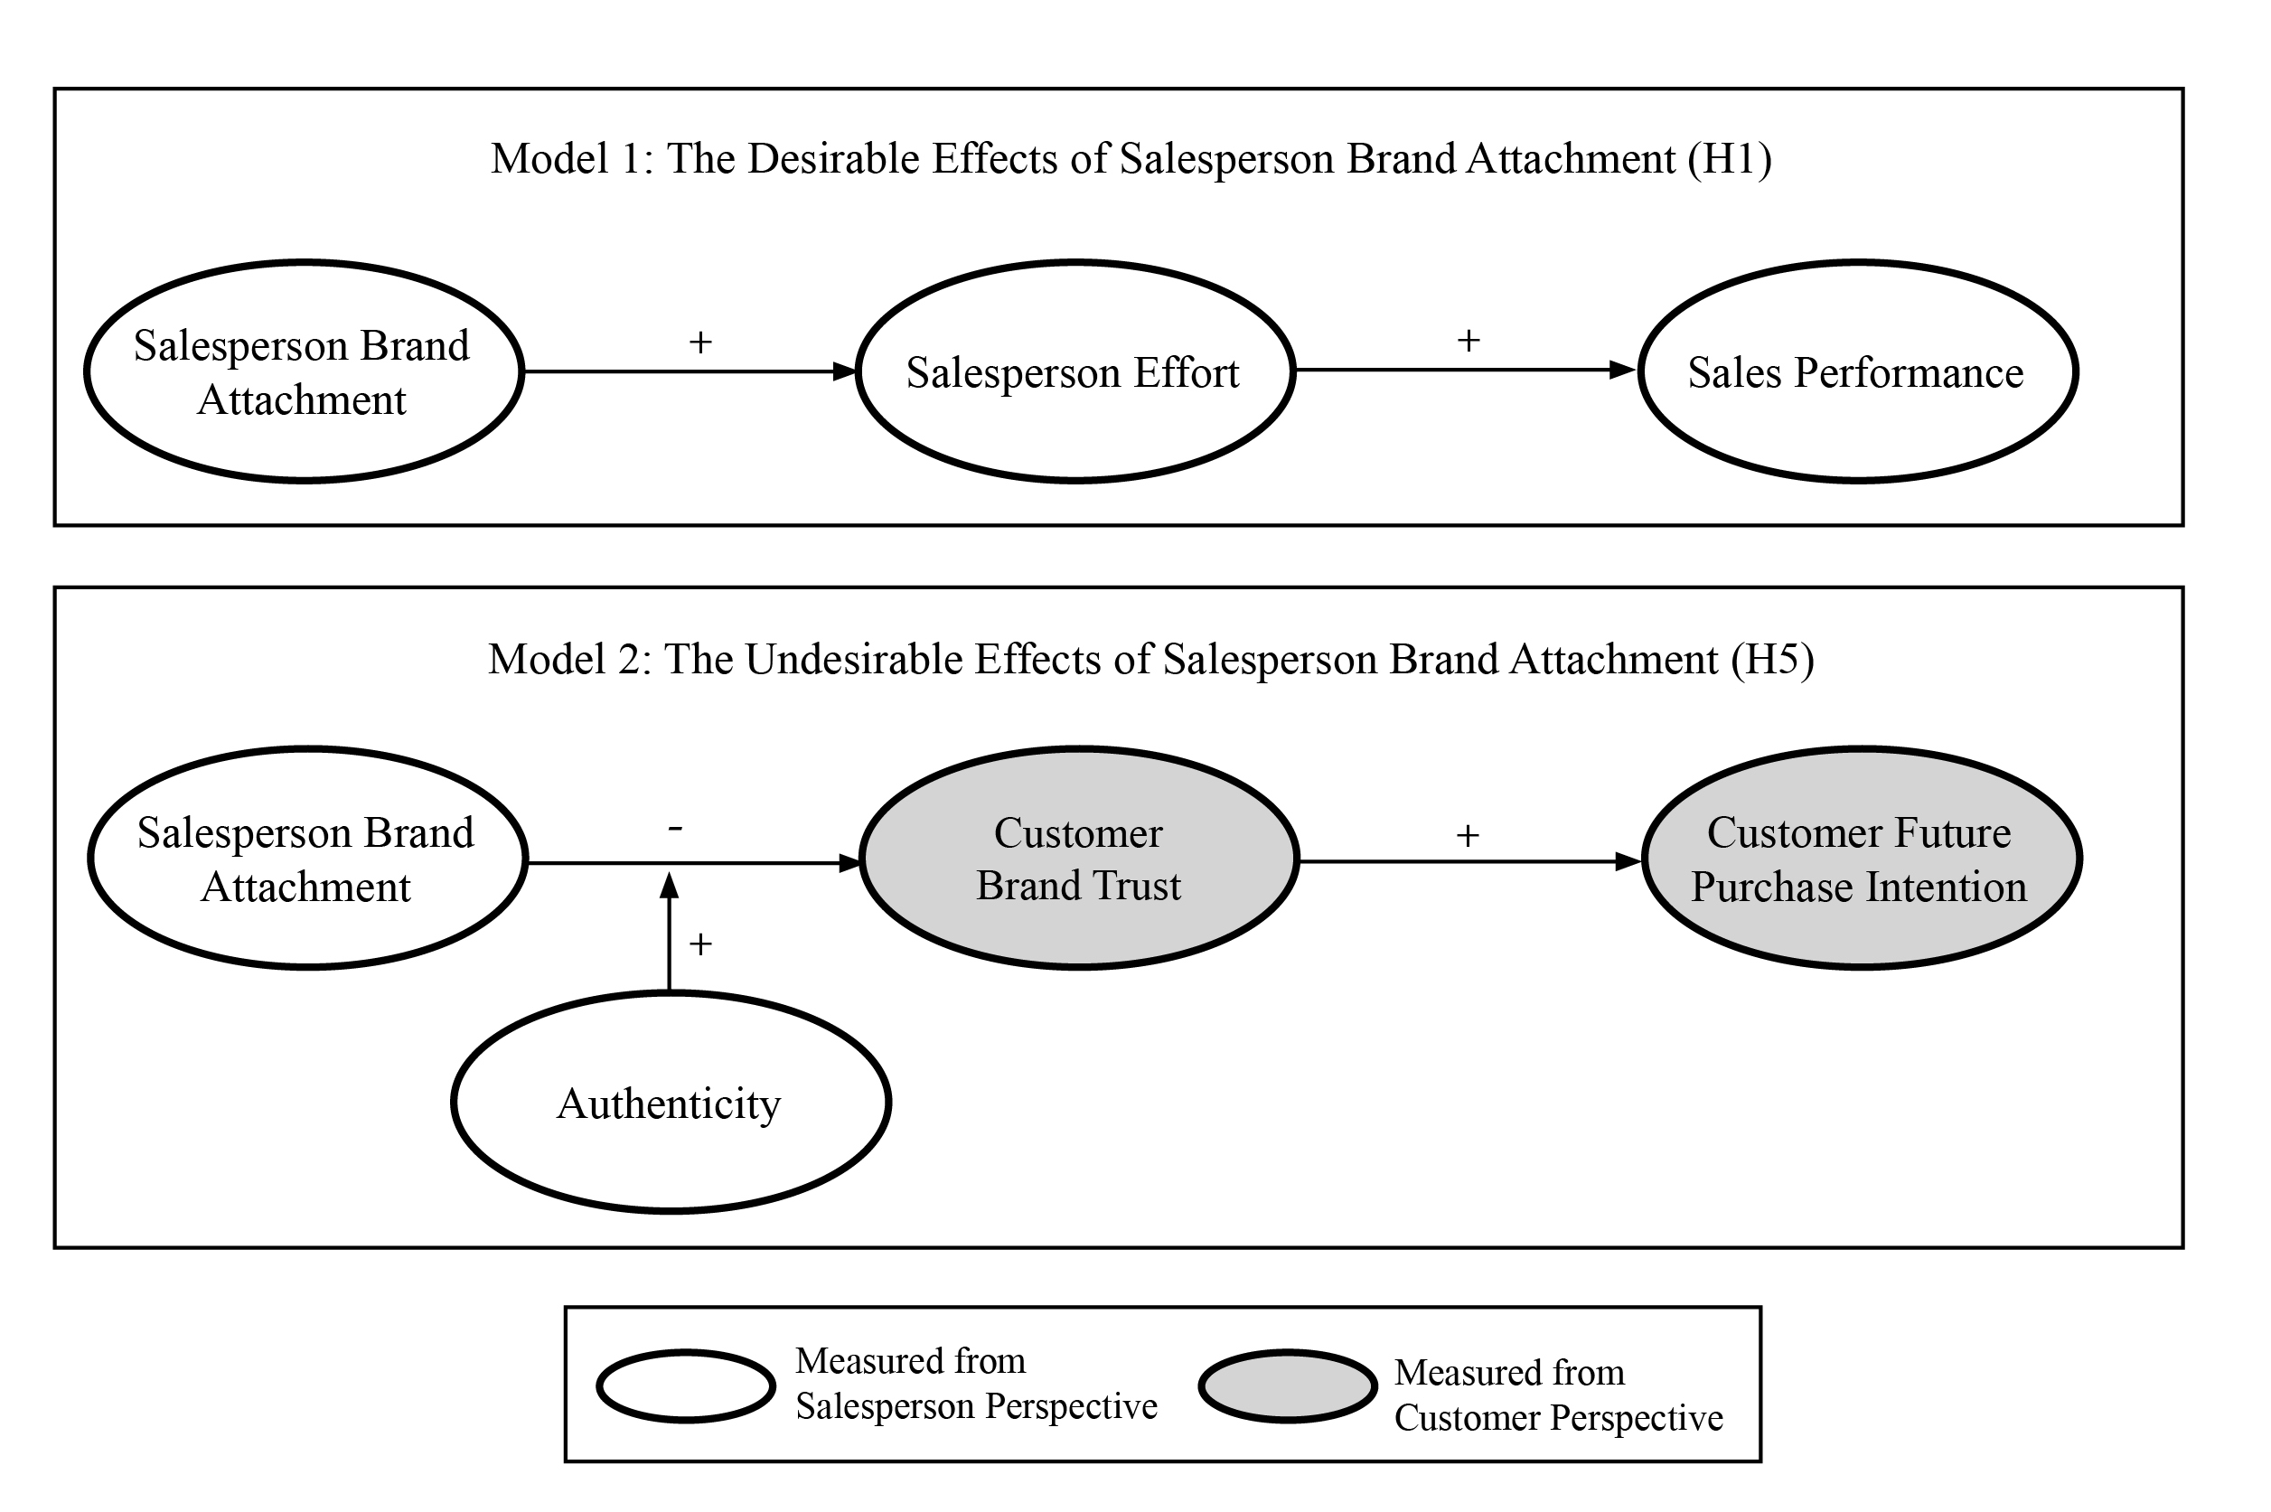

Table 2: Demographics Table

 | Exploratory Study |  | Fields Study
 | Salespeople | Customers | Salespeople | Customers
Sample (n) 20 20 153 98
Gender
Female 85% 80% 87% 87%
Male 15% 20% 13% 13%
Age
18-32 35% 35% 47% 43%
33-55 60% 55% 49% 48%
56 and up 5% 10% 4% 9%

Table 3: Construct Measures and loadings

Measures Loadings
Salesperson Brand Attachment (adapted from Allison et al., 2016; MacInnis et al. 2009)*  …do you feel that the brand is part of you?  ...do you feel that you are personally connected to the brand?  ...do you feel that you are emotionally bonded to the brand?  ...is the brand a part of you and who you are?  ...does the brand reflect the values you personally cherish?  ...are your thoughts and feelings toward the brand automatic, coming to mind seemingly on their own?  ...does the mention of the brand automatically evoke many thoughts about the past, present and future?  ...do your thoughts and feelings toward the brand come to mind so naturally and instantly that you do not have much control over them?  ...do you have many positive thoughts about the brand? | .830  .794  .840  .829  .715  .746  .713  .762  .605
Salesperson Effort (adapted from Brown and Peterson 1994; Miao and Evans 2013)  I work long hours to meet my sales objectives.  I do not give up easily when I encounter a difficult customer.  I work untiringly at selling a customer until I get an order. | .895  .620  .898
Sales Performance  What was your approximate total sales in [brand] products or services for the last 12 months? | N/A
Salesperson Authenticity (adapted from Schaefer and Pettijohn, 2006)  I am straightforward as a salesperson.  I am authentic as a salesperson.  I am not deceptive as a salesperson.  I do not have a hidden objective. | .681  .888  .841  .892
Customer Brand Trust (adapted from Erdem, Swait, and Valenzuela 2006)  This brand delivers what it promises.  This brand’s product claims are believable.  This brand has a name you can trust.  This brand doesn’t pretend to be something it isn’t. | .962  .961  .962  .930
Customer Brand Purchase Intent (adapted from Jones, Mothersbaugh, and Beatty Jr. 2000)  Will you purchase the brand in the future?  Improbable: Probable  No Chance: Certain I will  Unlikely: Likely | .978  .994  .988

Table 4: Descriptive Statistics and Correlations

Model 1: Salesperson Model Correlations
 | M | SD | AVE |  | 1 | 2 | 3 | 4 | 5
1. Brand Attachment | 5.44 | 1.12 | .631 |  | .939 | .135 | .249* | -.112 | -.252*
2. Salesperson Effort | 3.87 | 1.63 | .664 |  |  | .853 | .278* | .291* | .461*
3. Sales Performance | 23K | 28K | n/a |  |  |  | 1 | .209 | .124
4. Sales Experience | .5 | .5 | n/a |  |  |  |  | 1 | .097
5. Extrinsic Motivation | 3.42 | 1.85 | .815 |  |  |  |  |  | .929

Model 2: Salesperson-Customer Model Correlations
 | M | SD | AVE |  | 1 | 2 | 3 | 4 | 5 | 6
1. Brand Attachment | 5.46 | 1.13 | .566 |  | .939 | -.103 | -.054 | .414* | -.152 | -.104
2. Customer Brand Trust | 4.86 | 1.90 | .909 |  |  | .976 | .729* | .036 | .381* | .566*
3. Customer Future Purchase Intention | 4.69 | 2.26 | .973 |  |  |  | .991 | .029 | .638* | .702*
4. Salesperson Authenticity | 6.19 | 1.00 | .689 |  |  |  |  | .897 | -.089 | -.011
5. Brand Trial | .72 | .449 | n/a |  |  |  |  |  | 1 | .442*
6. Attitude Towards Industry | 4.49 | 1.59 | n/a |  |  |  |  |  |  | 1
*Correlations is significant at the .05 level
Composite reliability noted on the diagonal

Figure 2: Model 1 Results
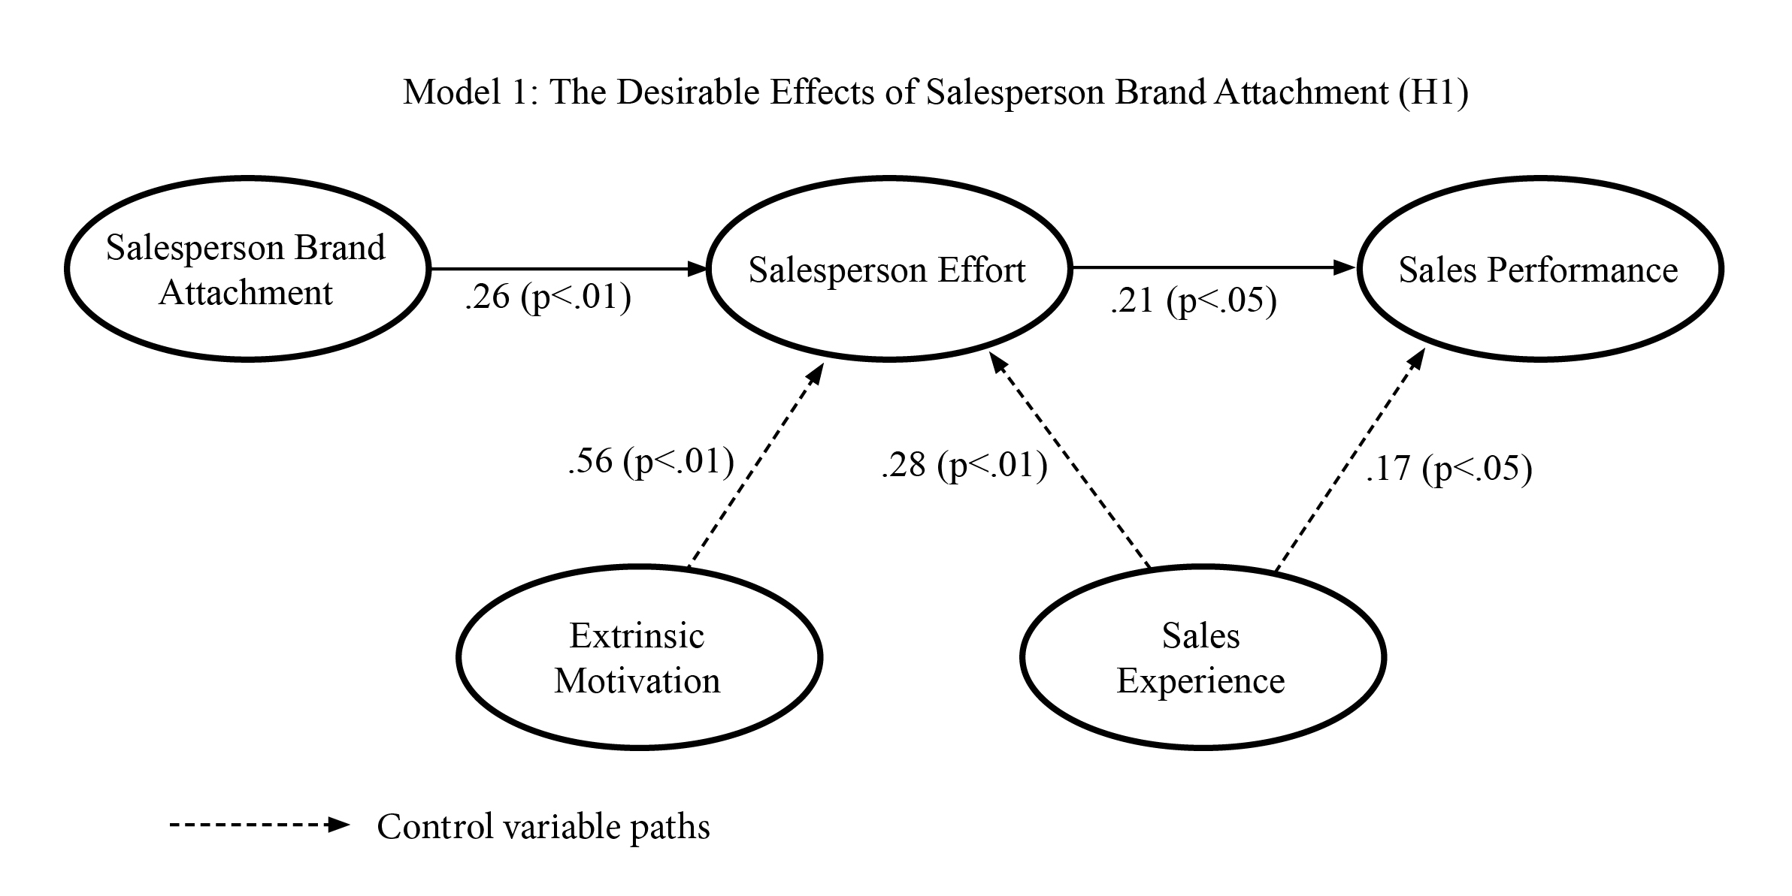

Figure 3: Model 2 Results
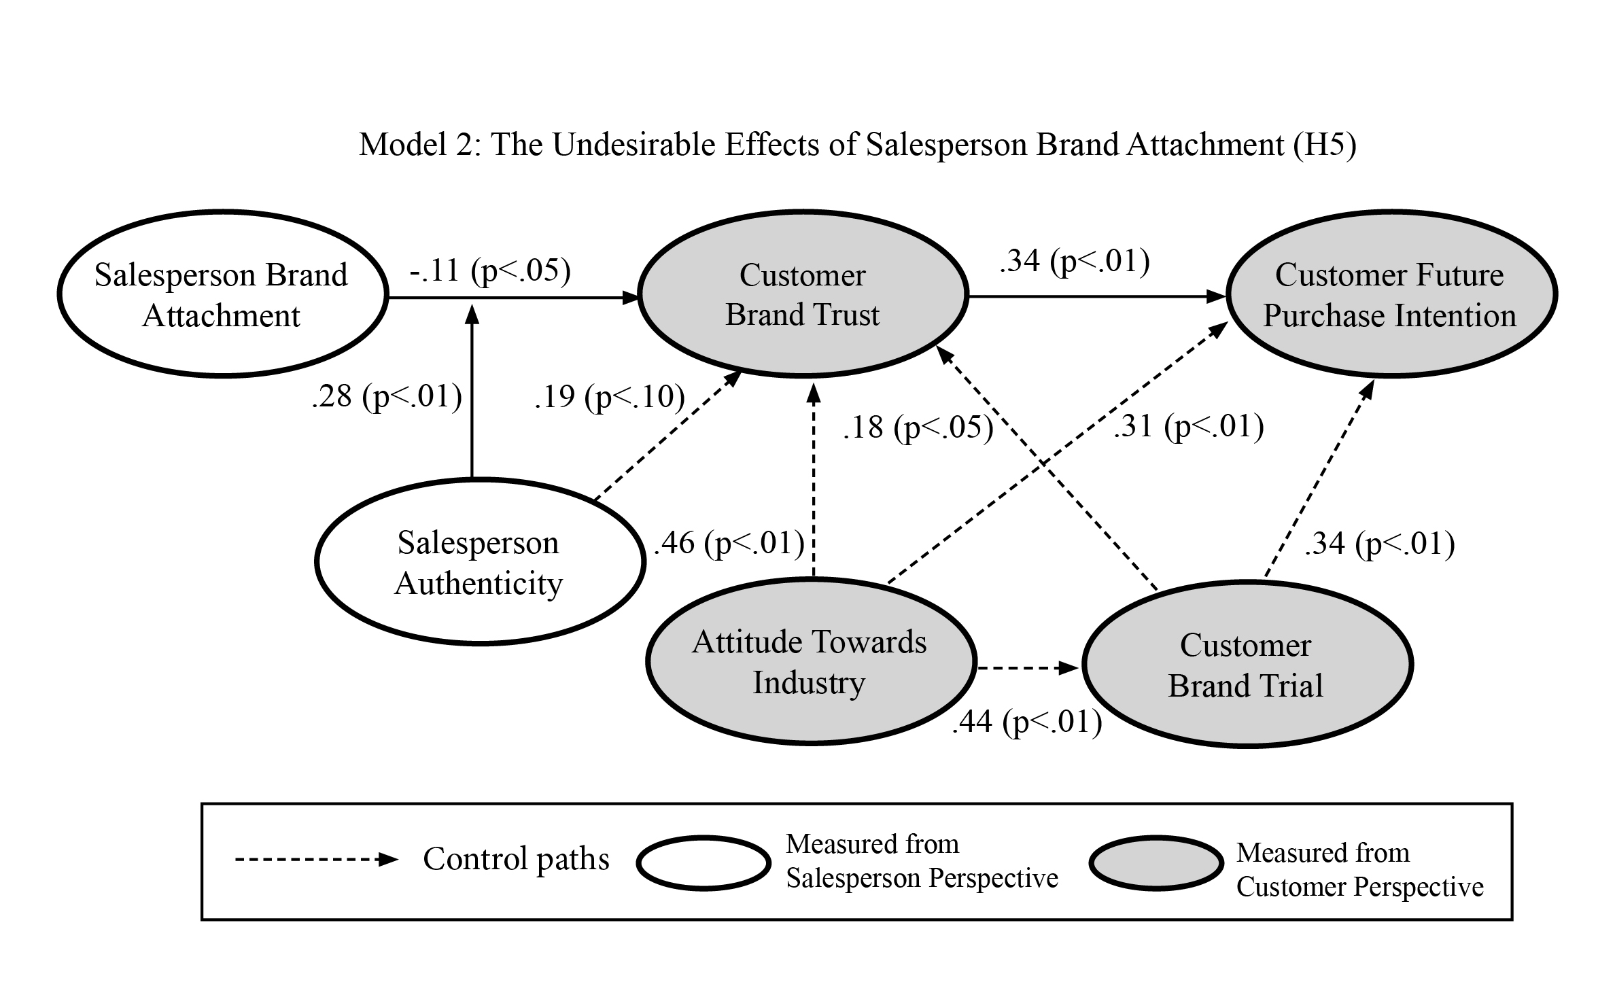

Figure 4: Salesperson Authenticity as Moderator of the Salesperson Brand Attachment-Customer Brand Trust Relationship

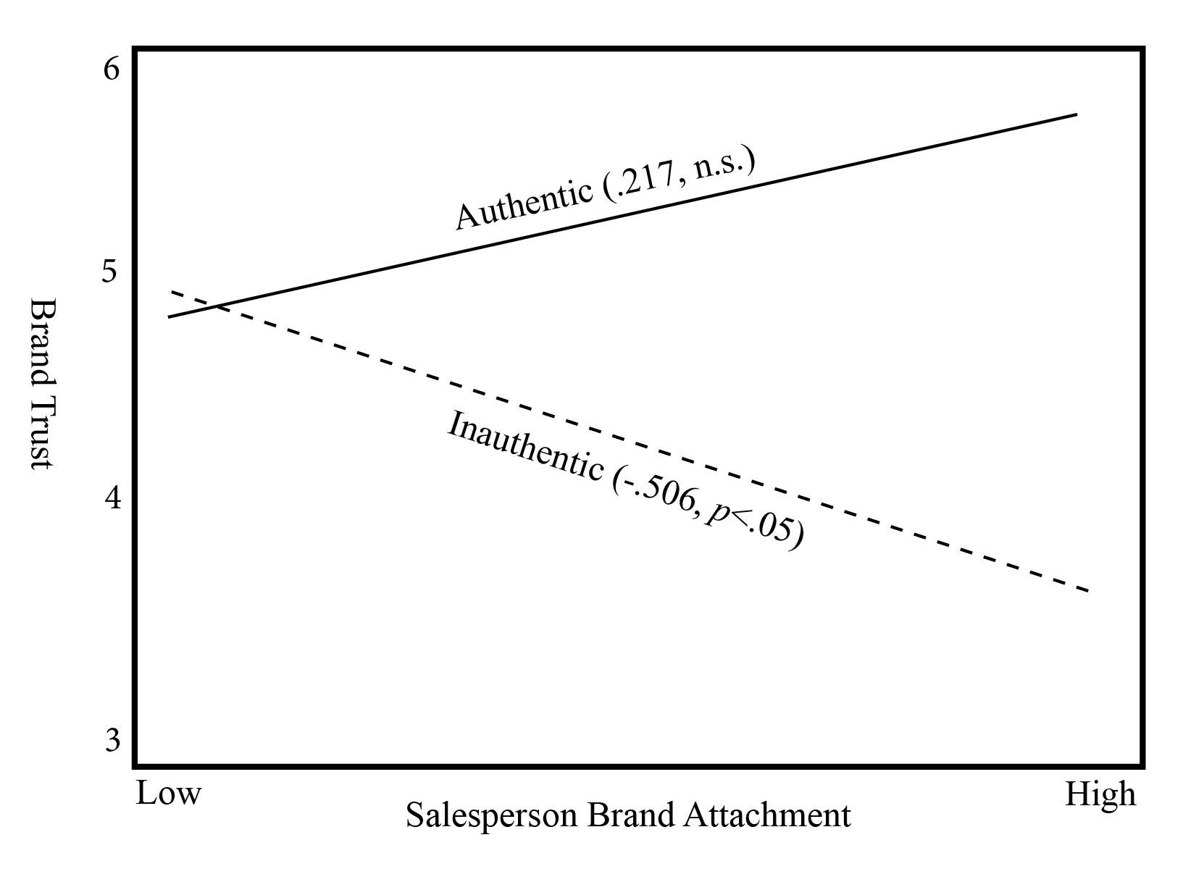

Vita
Lisa Beeler
Haslam College of Business, The University of Tennessee
Department of Marketing and Supply Chain Management
310 Stokely Management Center
Knoxville, TN 37996
Lbeeler1@vols.utk.edu Mobile: 865-705-9975

Education University of Tennessee, Knoxville, TN
Ph.D, Business, Spring 2017 (expected)
Major: Marketing,
Minor: Supply Chain Management

University of Kentucky, Lexington, KY
M.A., Communications, December 2007
Major: Mass Media Effects

University of Tennessee, Knoxville, TN
B.S., Communications, Spring 2005
Major: Advertising
Minor: Business

Research Personal selling, sales management, cross-functional team
Interests management, B2B, marketing frontlines

Published Shaner, Matthew, Lisa Beeler and Charles Noble (2016). “Do We Manuscripts Have to Get Along to Innovate? The Influence of Multilevel Social Cohesion on New Product and New Service Development.” Journal of Product Innovation Management.

Beeler, Lisa, Alex Zablah and Wesley Johnston. “Cultural Evolutions in a Sales Dominant Firm,” Forthcoming at the Journal of Business Research.

Delpechitre, Duleep and Lisa Beeler. “Faking it: Emotional Intelligence and it’s Effect on Emotional Labor Strategies and Customer Outcomes.” Forthcoming at the Journal of Business and Industrial Marketing

Manuscripts “Sales Strategies and Social Media; A Netnography,” with Alex In Development Zablah; data collected and first draft completed; target journal: Journal of the Academy of Marketing Science.

“Why Giving Salespeople Authority is a Double-edged Sword,” with Lucy Matthews and Alex Zablah; data collected and first draft completed; target journal: Journal of Personal Selling and Sales Management.

Professional National Marketing and Sales Director
Experience January 2010-July 2013
AmeriPark, Atlanta, GA

Marketing and Sales Consultant
February 2011-July 2013
The Arches Threading Lounge, Atlanta, GA

Marketing and Sales Coordinator
August 2008-December 2009
Homespice Décor, Atlanta, GA

Marketing Design Assistant
August 2006-May 2008
University of Kentucky College of Arts & Sciences and Communication, Lexington, KY

Honors and 2016, Sheth Consortium Fellow
Awards 2016, Haslam College of Business Outstanding Doctoral Student Teacher Award
2016, Co-recipient of the Southeastern Marketing Symposium DRS Award
2016, Supply Chain Forum Grant Recipient for research
2013-Present, University of Tennessee Chancellor’s Scholarship
2013-Present, University of Tennessee ESPN Scholarship

Conference Nawar Chaker, Adam Powell and Lisa Beeler (2016), Presentations "Interfunctional Tension: Considering a Socio-psychological Inhibitor of Sales Cross Functional Integration," presenting at the American Marketing Association Summer Educators’ Conference, Atlanta, GA

Beeler, Lisa and Nawar Chaker (2015), “Co-opetition’s Influence on Intra-Firm Social Capital and Performance Between the Marketing and Sales Functions,” presented at the American Marketing Association Summer Educators’ Conference, Chicago, IL.

Shaner, Matthew, Lisa Beeler and Charles Noble (2015), “Do We Have to Get Along to Innovate? The Influence of Multilevel Social Cohesion on New Product and New Service Development,” presented at the Southeast Marketing Symposium, Tallahassee, FL.

Beeler, Lisa (2014), “To Compete or Cooperate? That is the Question. A Conceptual Model of the Antecedents of Intra-firm Co-opetition,” presented at the Southeast Marketing Symposium, Fayetteville, AR.

Undergraduate Instructor, Consumer Behavior (MKT 350), University of Teaching
Teaching Tennessee, Haslam College of Business, Fall 2015
Experience Instructor rating: 4.6/5.0, College Average: 4.0; Class size: 48

Instructor, Consumer Behavior (MKT 350), University of Tennessee, Haslam College of Business, Summer 2015
Instructor rating: 4.6/5.0, College Average: 3.9; Class size: 6

Instructor, Consumer Behavior (MKT 350), University of Tennessee, Haslam College of Business, Spring 2015
Instructor rating: 4.2/5.0, College Average: 4.0; Class size: 37

Instructor, Marketing and Supply Chain Management (MKT 300), University of Tennessee, Haslam College of Business, Summer 2014
Instructor rating: 4.5/5.0, College Average: 4.0; Class size: 50

Guest Lecturer, Mark Moon’s Market Demand undergraduate course, University of Tennessee, Fall 2013: Global Branding and Fall 2014: Marketing Strategy

Guest Lecturer, Charles Noble’s Marketing Strategy undergraduate course, University of Tennessee, Fall 2015: Case study of Apple, Inc.

Graduate Guest Lecturer, Charles Noble’s New Product Development MBA Teaching course, University of Tennessee, Fall 2015
Experience
Guest Lecturer, Daniel Flint’s Shopper Marketing MBA course, University of Tennessee, Spring 2015

Service 2016-2017, President, Haslam College of Business Doctoral Student Association
2016, Reviewer, American Marketing Association Summer Educators’ Conference, Atlanta, GA
2015, Chair of Session, American Marketing Association Summer Educators’ Conference, Chicago, IL
2015, Reviewer, Decision Sciences Institute, Fall Marketing Strategy Track
2013-2015, Board member, University of Tennessee, Young Alumni Board

