Northern bobwhite and grassland-associated birds benefit from native-warm season grasses in a working landscape dominated by cool-season grasses

A Dissertation Presented for the

Doctor of Philosophy

Degree

The University of Tennessee, Knoxville

Douglas Bryan Mitchell
May 2025
Copyright © 2025 by Douglas Bryan Mitchell.
All rights reserved.

DEDICATION

This is dedicated to the natural resources that remain on our planet and to my own education – a pursuit that I began sometime near the year 2008. For all of the sins that my species has committed against their own environment, it is my hope that any work that I will have done before the end of my life will have a positive impact.

ACKNOWLEDGEMENTS
My advisor (Dr. Patrick Keyser) and my committee (Dr. Dave Buehler, Dr. Joseph Clark, Dr. James Martin) have been patient and helpful in an environment that was not always conducive to efficient education. Although the knowledge I gained and the methods of learning did not match my expectations, I have still enhanced my own education.
KDFWR - John Morgan, Cody Rhoden, Tom Edwards, Marcia Schroder
USDA/NRCS Kentucky - Randall Alcorn
Bridgett Costanzo (USDA/NRCS) worked with my advisor and the KDFWR team to acquire funding prior to the day I began refining the design and conducting the study.
Andy Dickson (former BGAD), Raysha Childers (BGAD), Jim Hawkins (BGAD)
Field Technicians - Dylan Abner, Zach Lemmon, Daniel Skinner, Tristan Moorehead, Jonathan Pennington, Marissa Angel, Colin Portman, John Garland

ABSTRACT

Most North American avian species populations have been declining since at least 1966. Grassland-associated species in the southeastern US have experienced some of the most drastic declines, primarily due to widespread loss of habitat. The northern bobwhite (Colinus virginianus; “bobwhite”) has also been affected by these changes, declining by 85% since 1966.
A major factor in lost habitat is the widespread conversion of native grassland to tall fescue (TF; Lolium arundinaceum), an introduced cool-season grass (CSG), grown on 14 million ha for livestock forage. Traditional management of TF pasture lacks characteristics to which native fauna are adapted.
Native warm-season grasses (NWSGs) have been proposed as an alternative forage that may benefit both cattle and wildlife. However, few experiments have tested hypotheses about wildlife in a working-lands context, where there is a conservation benefit with minimal detriment to agriculture. I conducted a study in eastern Kentucky, USA to evaluate resource selection and survival of bobwhites, and occupancy of bobwhites and grassland birds among NWSGs and CSGs in a working lands context. Between April 2019 and October 2022, I tracked bobwhites using radio telemetry and surveyed for avian breeding season occupancy.
Bobwhites selected traditionally managed CSG less than expected and NWSG more than expected at the 2nd-order scale. This selection was corroborated by 3rd-order selection of NWSGs and woody stems (breeding season) and avoiding high proportion of grass but choosing taller canopy (nonbreeding season). Variation in breeding season survival was explained by an interaction of grazed NWSG and shrub interspersion-juxtaposition index where survival increased with grazed NWSG cover and greater (breeding season) or less (non-breeding season) shrub interspersion. Occupancy of bobwhites was greater in grazed NWSG than idle-burned NWSG and CSG. Henslow’s sparrow (Ammodramus henslowii) occupancy was greater with increasing grazed NWSG cover and decreasing shrub cover. None of the species analyzed had reduced occupancy associated with NWSG.
The results of this study suggest incorporating NWSGs in a CSG-dominated landscape may contribute to conservation of bobwhites and other grassland birds. However, shrub cover and interspersion should be considered when planning species-specific conservation goals.

Keywords: Native warm-season grass, tall fescue, exotic grass, fescue belt, habitat, northern bobwhite, survival, resource selection, occupancy, grassland birds, avian conservation, working lands conservation

TABLE OF CONTENTS

CHAPTER I: NORTHERN BOBWHITES SELECT FOR NATIVE GRASSES ON WORKING GRAZING LAND 1
Abstract 2
Introduction 3
Methods 5
Results 12
Discussion 14
Literature Cited 23
Appendices 35
CHAPTER II: NATIVE WARM-SEASON GRASS IMPROVES SURVIVAL OF ADULT NORTHERN BOBWHITES IN A LANDSCAPE OF EXOTIC COOL-SEASON GRASS FOR CATTLE PRODUCTION 52
Abstract 53
Introduction 54
Methods 56
Results 62
Discussion 63
Literature Cited 69
Appendices 78
CHAPTER III: NATIVE WARM-SEASON GRASSES INCREASE OCCUPANCY OF GRASSLAND-ASSOCIATED BIRDS IN A WORKING LANDSCAPE OF EXOTIC COOL-SEASON GRASSES 91
Abstract 92
Introduction 93
Methods 95
Results 100
Discussion 102
Literature Cited 109
Appendices 119
CONCLUSION 133
VITA 138

LIST OF TABLES
Table 1.1: Summary of mean values and standard errors of covariates at used and available locations (local selection) of adult northern bobwhites in major cover types in breeding season (Apr - Sep). Blue Grass Army Depot, Madison County, Kentucky, 2019-2022. 35
Table 1.2: Summary of mean values and standard errors of covariates at used and available locations (local selection) of adult northern bobwhites in major cover types in non-breeding season (Oct - Mar). Blue Grass Army Depot, Madison County, Kentucky, 2019-2022. 36
Table 1.3: Parameter estimates explaining variation in home range selection (95% kernel density: study area) of all adult northern bobwhites in breeding season (Apr - Sep) and non-breeding season (Oct - Mar). Blue Grass Army Depot, Madison County, Kentucky, 2019-2022. 37
Table 1.4: Univariate models explaining variation in local-scale selection of all adult northern bobwhites in breeding season (Apr - Sep) and non-breeding season (Oct - Mar). Blue Grass Army Depot, Madison County, Kentucky, 2019-2022. 38
Table 1.5: Multivariate models explaining variation in local-scale selection of all adult northern bobwhites in breeding season (Apr - Sep) and non-breeding season (Oct - Mar). Blue Grass Army Depot, Madison County, Kentucky, 2019-2022. 39
Table 1.6: Parameter estimates for most supported models explaining variation in local selection of all adult northern bobwhites in breeding season (Apr - Sep) and non-breeding season (Oct - Mar). Blue Grass Army Depot, Madison County, Kentucky, 2019-2022. 40
Table 1.7: Multivariate models explaining variation in local selection of adult northern bobwhites with home ranges in grazed and idle-burn NWSG in breeding season (Apr - Sep). Blue Grass Army Depot, Madison County, Kentucky, 2019-2022. 41
Table 1.8: Multivariate models explaining variation in local selection of adult northern bobwhites with home ranges in grazed NWSG and idle-burn NWSG in non-breeding season (Oct - Mar). Blue Grass Army Depot, Madison County, Kentucky, 2019-2022. 42
Table 1.9: Parameter estimates for most supported models explaining variation in local selection of adult northern bobwhites in grazed NWSG and idle-burn NWSG in breeding season (Apr - Sep). Blue Grass Army Depot, Madison County, Kentucky, 2019-2022. 43
Table 1.10: Parameter estimates for most supported models explaining variation in local selection of adult northern bobwhites in grazed NWSG and idle-burn NWSG in non-breeding season (Oct - Mar). Blue Grass Army Depot, Madison County, Kentucky, 2019-2022. 44
Table 2.1: Univariate models explaining variation in seasonal survival of adult northern bobwhites in breeding season (Apr - Sep) at the home range scale (95% k.d.) and the landscape scale (95% k.d. + 250 m), Blue Grass Army Depot, Madison County, Kentucky, 2019-2022. 78
Table 2.2: Univariate models explaining variation in seasonal survival of adult northern bobwhites in non-breeding season (Oct - Mar) at the home range scale (95% k.d.) and the landscape scale (95% k.d. + 250 m), Blue Grass Army Depot, Madison County, Kentucky, 2019-2022. 79
Table 2.3: Multivariate models explaining variation in seasonal survival of adult northern bobwhites in breeding season (Apr - Sep) and non-breeding season (Oct - Mar), Blue Grass Army Depot, Madison County, Kentucky, 2019-2022. 80
Table 2.4: Parameter estimates for most supported model and competing models explaining variation in seasonal survival of adult northern bobwhites in breeding season (Apr - Sep), Blue Grass Army Depot, Madison County, Kentucky, 2019-2022. 81
Table 2.5: Parameter estimates for most supported model and competing models explaining variation in seasonal survival of adult northern bobwhites in non-breeding season (Oct - Mar), Blue Grass Army Depot, Madison County, Kentucky, 2019-2022. 82
Table 2.6: List of multivariate models including models that were not included in final sets explaining variation in seasonal survival of adult northern bobwhites in breeding season (Apr - Sep) and non-breeding season (Oct - Mar), Blue Grass Army Depot, Madison County, Kentucky, 2019-2022. 83
Table 3.1: Detection (p) model selection for grassland-associated avian species including top models, supported models, and null models (p ~ 1 psi ~1). Blue Grass Army Depot, Richmond, Kentucky, USA, 2019-2021. 119
Table 3.2: Occupancy (psi) model selection for grassland-associated avian species including top models, supported models, and null models (psi ~1). Blue Grass Army Depot, Richmond, Kentucky, USA, 2019-2021. 120
Table 3.3: Occupancy model summaries and mean occupancy estimates (psi) for top models of grassland-associated avian species. LCI and UCI based on 95% credible intervals. Blue Grass Army Depot, Richmond, Kentucky, USA, 2019-2021. 121
Table 3.4: Summary of effects of major cover type on occupancy of focal grassland-associated avian species. Blue Grass Army Depot, Richmond, Kentucky, USA, 2019-2021. 122
Table 3.5: Summary of cover type composition in 150-meter point count rings among treatment groups. Blue Grass Army Depot, Richmond, Kentucky, USA, 2019-2022. NWSG = Native warm-season grass, CSG = Cool-season grass. 123
Table 3.6: Summary of landscape cover type composition in a 250-m buffer around 150-meter point count rings among treatment groups. Blue Grass Army Depot, Richmond, Kentucky, USA, 2019-2021. NWSG = Native warm-season grass, CSG = Cool-season grass. 124

LIST OF FIGURES
Figure 1.1. Fescue Belt region of the United States (top, green polygon) and general study area (bottom, red polygon) in Kentucky, USA. Fescue Belt map adapted from Belesky and West (2009), and Keyser (2021). Other imagery (ESRI 2022). 45
Figure 1.2. Map of northern bobwhite study area with major cover type delineations (forest and shrub not depicted). Blue Grass Army Depot, Richmond, Kentucky, USA, 2019-2022. NWSG = native warm-season grass, CSG = cool-season grass. 46
Figure 1.3. Map of remotely sensed cover types (5 m pixels) and available area for 2nd-order (home range selection) resource selection analyses. Available area was determined by applying a minimum convex polygon to all trapped areas and adding a 2 km buffer. Blue Grass Army Depot, Richmond, Kentucky, USA. NWSG = Native warm-season grass, CSG = Cool-season grass. 47
Figure 1.4. Relative probability of use at the local scale for percent grazed native warm-season grass (top) and woody stems (bottom) by all adult northern bobwhites in breeding season (Apr - Sep). Blue Grass Army Depot, Richmond, Kentucky, USA, 2019-2022. 48
Figure 1.5. Relative probability of use for percent grass (top) and vegetation height (bottom) by all adult northern bobwhites in non-breeding season (Oct - Mar). Blue Grass Army Depot, Richmond, Kentucky, USA, 2019-2022. 49
Figure 1.6. Relative probability of use for percent cool-season grass and wood stems (top), and percent grazed native warm-season grass and woody stems (bottom) by adult northern bobwhites with home ranges in grazed native warm-season grass in breeding season (Apr - Sep). Blue Grass Army Depot, Richmond, Kentucky, USA, 2019-2022. 50
Figure 1.7. Probability of selection for percent grass (top) and vegetation height (bottom) by adult northern bobwhites with home ranges in native warm-season grass idle-burned in non-breeding season (Oct - Mar). Blue Grass Army Depot, Richmond, Kentucky, USA, 2019-2022. 51
Figure 2.1. Fescue Belt region of the United States (top, green polygon) and general study area (bottom, red polygon) in Kentucky, USA. Fescue Belt map adapted from Belesky and West (2009), and Keyser (2021). Other imagery (ESRI 2022). 86
Figure 2.2. Map of northern bobwhite study area with cover type delineations (not depicted: forest and shrub). Blue Grass Army Depot, Richmond, Kentucky, USA, 2019-2022. NWSG = native warm-season grass, CSG = cool-season grass. 87
Figure 2.3. Map of remotely sensed cover types (5 m pixels). Blue Grass Army Depot, Richmond, Kentucky, USA. NWSG = Native warm-season grass, CSG = Cool-season grass. 88
Figure 2.2. Breeding season (Apr - Sep) seasonal survival estimates and confidence intervals for adult northern bobwhites at Blue Grass Army Depot, Madison County, Kentucky, 2019 – 2022. “NWSG” = Native Warm-Season Grass at the home range scale (95% kernel density), “ij.sb.250” = interspersion-juxtaposition index of shrub at the landscape scale (95% kernel density home range plus a 250 m buffer). Different bands represent the range (60-80) and the mean value (72) of ij.sb.250. Confidence intervals that include values below -0.1 are excluded for visual clarity. 89
Figure 2.3. Non-breeding season (Oct - Apr) seasonal survival estimates and confidence intervals for adult northern bobwhites at Blue Grass Army Depot, Madison County, Kentucky, 2019 – 2022. “NWSG” = native warm-season grass, “ij.sb” = interspersion-juxtaposition index of shrub at the home range scale (inside 95% kernel density home range contour). Different bands represent the range (60-80) and the mean value (70) of ij.sb. Confidence intervals that include values below -0.1 are excluded for visual clarity. 90
Figure 3.1. Fescue Belt region of the United States (top, green polygon) and general study area (bottom, red polygon) in Kentucky, USA. Fescue Belt map adapted from Belesky and West (2009), and Keyser (2021). Other imagery (ESRI 2022). 125
Figure 3.2. Map of spring point count locations (black circles = 150 m radius distance guides) and general cover type delineations (not depicted: forest and shrub). Blue Grass Army Depot, Richmond, Kentucky, USA, 2019-2021. NWSG = Native warm-season grass, CSG = Cool-season grass. 126
Figure 3.3. Probability of occupancy of northern bobwhite in 4 major cover type treatments. NWSG = native warm-season grass, CSG = cool-season grass. Error bars indicate 95% credible intervals. Blue Grass Army Depot, Madison County, KY. 2019-2021. 127
Figure 3.4. Probability of occupancy of Henslow’s sparrow with increasing cover of grazed native warm-season grass (NWSG), decreasing cover of shrub, and annual differences (Year). Error bars indicate 95% credible intervals. Only the error bars for the mean value of shrub (12%) are included for clarity; 6% and 16% represent the interquartile range. Blue Grass Army Depot, Madison County, KY. 2019-2021. 128
Figure 3.5. Probability of occupancy of common yellowthroat with increasing cover of idle native warm-season grass (NWSG) and annual differences (Year). Error bars indicate 95% credible intervals. Blue Grass Army Depot, Madison County, KY. 2019-2021. 129
Figure 3.6. Probability of occupancy of eastern meadowlark with increasing cover of idle native warm-season grass (NWSG) and decreasing cover of shrub. Error bars indicate 95% credible intervals. Blue Grass Army Depot, Madison County, KY. 2019-2021. 130
Figure 3.7. Probability of occupancy of field sparrow with increasing cover of idle native warm-season grass (NWSG) and increasing cover of shrub. Error bars indicate 95% credible intervals. Only the error bars for the mean value of shrub (12%) are included for clarity; 6% and 16% represent the interquartile range. Blue Grass Army Depot, Madison County, KY. 2019-2021. 131
Figure 3.8. Probability of occupancy of prairie warbler by treatment and with increasing shrub edge density. Error bars indicate 95% credible intervals. NWSG = native warm-season grass. CSG = cool-season grass. Blue Grass Army Depot, Madison County, KY. 2019-2021. 132

CHAPTER I: NORTHERN BOBWHITES SELECT FOR NATIVE GRASSES ON WORKING GRAZING LAND

Abstract
The northern bobwhite (Colinus virginianus; “bobwhite”) has experienced an 85% decrease in population since the 1960s. The most drastic declines have been in the southeastern US where biologists have attributed widespread habitat loss to land conversion, including conversion to tall fescue (Lolium arundinaceum) and other exotic cool-season grass (CSG) cattle pasture and hayfields. Alternative forages such as native warm-season grasses (NWSGs) and their associated management practices have been suggested as a possible working-lands conservation strategy to create bobwhite habitat on a landscape scale. I conducted a field study on a population of bobwhites in eastern Kentucky where grazed and idle-burned NWSG fields were adjacent to exotic grazed and hayed CSG fields. Between April 2019 and October 2022, I used radio telemetry to continuously track bobwhites and evaluate their resource selection at 2nd- and 3rd-order scales. Bobwhites used traditionally managed CSG less than expected at the 2nd-order scale in both breeding and non-breeding seasons. Whereas bobwhites used grazed and idle-burned NWSG more than expected at the 2nd-order scale in both breeding and non-breeding season. Further, at the 3rd-order scale, bobwhites used CSGs less than expected and NWSGs more than expected, but availability of woody stems was also important. The results of this study suggest that bobwhites select NWSGs at multiple spatial scales in a landscape dominated by traditionally managed exotic CSGs. Under a working-lands framework, the conversion of a portion of current exotic CSG land to NWSGs may create extensive bobwhite habitat in the southeastern US.

Introduction
The northern bobwhite (Colinus virginianus; hereafter, bobwhite) and other North American grassland-associated bird species are declining across much of their range, especially in the southeastern US (Brennan 1991, Peterjohn and Sauer 1999, Sauer et al. 2017, Rosenberg et al. 2019). Declining populations of bobwhites have been attributed to various changes in land use leading to widespread loss of habitat (Roseberry et al. 1979, Brennan et al. 1998, Burger 2002). For example, in the southeastern US, tall fescue (Lolium arundinaceum) is the dominant forage grown on about 14 million ha in an area known as the “Fescue Belt” (Kallenbach et al. 2012; Figure 1.1). More broadly, agricultural practices have a strong influence on this guild of birds and historically, populations were bolstered by patchwork agriculture (Peterjohn 2003, Burger et al. 2006, Hernandez and Guthery 2012, Murphy 2019). However, returning to less intensive agricultural practices at a large scale is not a practical solution (Peterjohn 2003).
For large geographic areas such as the Fescue Belt, a working-lands conservation approach may prove to be more effective (Keyser et al. 2019, 2022). A working-lands approach, land sharing rather than land sparing, has been suggested as a wildlife conservation tool across the globe (Phalan et al. 2011). In working lands conservation, land is not eliminated from agriculture as in other conservation practices such as CRP (Monroe et al. 2017; Keyser et al. 2019, 2020). In the case of the Fescue Belt, a possible solution is to incorporate native warm-season grasses (NWSG) into farmlands currently dominated by exotic cool- (CSG) and warm-season grass (WSG) (Giuliano and Daves 2002, Harper et al. 2015, West et al. 2016). These NWSGs improve cattle performance over CSGs and WSGs during summer (Burns and Fisher 2013, Keyser et al. 2016, Backus et al. 2017) and have a positive impact on profitability (Lowe II et al. 2015, 2016, Monroe et al. 2017, Brazil et al. 2020). Spring burning can further increase the forage quantity and quality of these grasses, thereby increasing cattle performance (Woolfolk et al. 1973, Svejcar 1989, Mitchell et al. 1994).
Adoption of NWSG can also provide habitat for grassland birds (George et al. 1979, Ryan and Marks 2005, Harper et al. 2015, West et al. 2016). The density of ground-foraging species, nests, and nest success may be increased (George et al. 1979, Giuliano and Daves 2002, Flanders et al. 2018) with NWSGs. Additionally, NWSGs may provide important habitat for wintering birds (King and Savidge 1995). The disturbance-derived vegetation characteristics associated with working grasslands may positively influence the abundance, diversity, and species richness of grassland-associated birds (Coppedge et al. 2008). For example, rotational grazing and patch-burn grazing NWSG pastures increased relative abundance of grassland-associated birds in Tennessee and Kentucky (Lituma et al. 2022).
Resource selection studies allow researchers to link individual animals to their environment by comparison of “used” and “available” resources, sometimes at multiple scales (Johnson 1980, Fieberg et al. 2021). Biologists can use resource selection analyses to infer the ecological needs and limitations of a species and thereby support conservation (Boyce and McDonald 1999, Cooper and Millspaugh 1999, Fieberg et al. 2021). Many of these studies are used to study the impact of habitat change (Manly et al. 2007). For example, characteristics of successful nesting locations were studied in selection studies on bobwhites (Lusk et al. 2006, Collins et al. 2009) . Hill et al. (2023) illustrated that diurnal and nocturnal habitats vary in bobwhite chicks and that land management could be improved for heavily hunted areas. A recent study in Missouri suggested that brooding bobwhites selected NWSGs that were managed with grazing and burning, and that brood survival was positively influenced (Thompson et al. 2022).
Other studies that focus specifically on bobwhites in relation to grazing and fire in the Fescue Belt are lacking. I evaluated how NWSG managed with either prescribed fire or grazing within a broader landscape dominated by exotic CSG forage production affected resource selection of bobwhites. Specifically, my objectives were to evaluate where bobwhites chose to place their home range (2nd-order, home range selection; Johnson 1980) and what resources bobwhites were using within their home range (3rd-order, local selection; Johnson 1980) in a landscape of grazed and idle-burned NWSGs and grazed and hayed CSGs during breeding season and non-breeding season. I hypothesized that at the home range scale, bobwhites would place home ranges in areas with NWSGs (grazed and idle-burned) and avoid placing home ranges in areas dominated by CSGs. I hypothesized the pattern of 2nd-order selection would be corroborated by 3rd-order selection of NWSGs, proximity to woody escape cover, and structural characteristics such as increased levels of visual obstruction, canopy height, and bare ground.

Methods
I conducted this study on the Blue Grass Army Depot (hereafter, BGAD) in Madison County, Kentucky, USA, between January 2019 and October 2022. The BGAD is a military facility located in the Interior Low Plateau physiographic province on the southeast edge of the Bluegrass Region (Jones 2005) that encompassed approximately 6070 ha (Figure 1.1).
The south, southeast, and eastern portions of the BGAD included a mix of cattle pastures (CSG and NWSG) and fields managed for early successional wildlife. I designated this section of the BGAD as my study area and delineated four predominant cover types based on existing management: hayed CSG fields (722 ha), grazed CSG fields (622 ha), grazed NWSG fields (169 ha), and idle-burned NWSG fields (124 ha) (Figure 1.2). Grass composition of NWSG fields primarily consisted of a mix of indiangrass (Sorghastrum nutans), big bluestem (Andropogon gerardii), and some switchgrass (Panicum virgatum). Grasses in CSG fields primarily consisted of tall fescue and orchardgrass (Dactylis glomerata). Both CSG and NWSG areas also included other native and exotic species common in the Fescue Belt such, as broomsedge (A. virginicus), dallisgrass (Paspalum dilatatum), johnsongrass (Sorghum halapense), bluegrass (Poa spp.), foxtails (Setaria spp.), purpletop (Tridens flavus), and bromes (Bromus spp.).
The idle-burned NWSG areas were burned on a 3-year return interval. One large area of NWSG (82 ha) was split roughly into thirds and each burned on a 3-year return interval. Hayed CSG fields were harvested annually (typically only once) between mid-June and early July. Cattle were stocked on grazed NWSG in mid-April to mid-May each year and removed in mid-August to mid-September. Cattle were stocked continuously in grazed CSG areas on most of the study site. Stocking density in both grazed NWSG areas and grazed CSG areas was approximately 140-200 kg ha⁻¹, typically using weaned calves (250-300 kg each) or yearling heifers (350-450 kg each). Typical production scenarios for this region, although highly variable, would maintain stocking densities of approximately 200-250 kg ha⁻¹ (Boyer et al. 2022).
I trapped bobwhites year-round (April 2019 – September 2022) using anchored, wire funnel-traps baited with a mix of cracked corn (Zea mays), milo (Sorghum bicolor), millet (Panicum miliaceum), sunflower (Helianthus annuus), and other grains (Stoddard 1931, Burger et al. 1995a, West et al. 2012). Traps were staked on one side and located under overhanging cover or covered with small branches to reduce predation and capture stress of the birds (Palmer and Wellendorf 2007). I attempted a 24-hour trapping schedule used in similar bobwhite telemetry studies but had to switch to a daylight-hours-only schedule because of nocturnal trap disturbance by mesopredators. I set and baited traps each morning and checked and closed them in late afternoon to avoid crepuscular and nocturnal predation and disturbance.
Captured bobwhites were fitted with two uniquely numbered aluminum leg bands (band size #4; one on each leg), sexed and aged (juvenile or adult), and weighed to the nearest gram. I aged birds by the presence of buff-tipped wing coverts (Rosene 1969). All birds weighing ≥ 129 g were fitted with a necklace-style VHF transmitter with a 12-hr mortality sensor (American Wildlife Enterprises, Monticello, FL, USA). Transmitters were about 6 g and represented ≤5% of the bird’s mass. All birds were processed and released within 20 m of the trap. Trapping, handling, and marking procedures were in accordance with the University of Tennessee IACUC approved protocol nos. 2608-0418 and 2608-0321.
I located all radio-marked birds ≥4 times per week. I varied location times throughout the day and week to capture a full range of behavior (Lohr et al. 2011). I located birds using a hand-held, 3-element folding Yagi antenna (Advanced Telemetry Systems, Isanti, MN, U.S.A.) and homing to within 15-30 m of the bird’s location (White and Garrott 1990). I recorded estimated distance to the bird, azimuth, and UTM coordinates using a laser rangefinder, compass, and handheld GPS unit, respectively. Locations were estimated by the strength of the transmitter’s signal and by approaching the assumed location of the bird from more than one direction. All technicians were trained to locate hidden transmitters to within a 5-m radius.
I used the image classification wizard in ArcGIS Pro (ESRI 2022) to create a high resolution cover type map of the study area (Figure 1.3). I used high resolution aerial images (KYfromAbove.gov; 2-m resolution) from 2019, 2020, and 2021 as the base maps for pixel classification. I restricted the classes (5 m pixel) to 9 land-cover types: forest, shrub, CSG poor (cool-season grass; areas including <50% grass), CSG hay, CSG traditional (tall fescue-dominated pastures typical of Fescue Belt conditions; located immediately adjacent to the study area), NWSG grazed (stands grazed by cattle each summer), NWSG idle-burned (stands managed with triennial burning rotation; March burns), developed (roads, buildings, paved areas), and water. I inspected representative areas of each cover type across the study area to confirm classifications and manually corrected any errors (Brooke et al. 2015). I dissolved “developed” and “water” to a common “other” cover type. For all training images and ground truthing, I used cover-type and habitat definition information similar to the NBCI Coordinated Implementation Program (Morgan et al. 2016).
I used locations of radio-tagged birds to collect data on resource selection patterns of bobwhites in breeding (April - Sep) and non-breeding (Oct - March) seasons, starting in April 2019. I modeled breeding and non-breeding season data separately because life history and associated behavioral shifts that occur seasonally in bobwhites (Rosene 1969, Brooke et al. 2015). I also modeled the 2nd- and 3rd-order data separately in each season because of unequal sample sizes (Johnson 1980).
For 2nd-order selection, I included a “cover” covariate as a factor with 8 levels (CSG poor, CSG hay, CSG traditional, Forest, NWSG graze, NWSG idle-burn, Shrub, and Other). I chose CSG hay as our reference category because it was the most abundant cover type and its structural and compositional properties provided the most appropriate baseline for our hypotheses (Unger et al. 2015, Fieberg et al. 2021). For 3rd-order selection, I included 6 covariates for composition (NWSG, CSG, forb, woody stems, bare ground, litter; all in %), 3 covariates for structure (plant height, visual obstruction, litter depth; all in cm), and 1 covariate for distance to woody cover (m). I chose to evaluate selection in non-breeding at the covey level because individual birds in the same covey were in very close proximity to each other and their selection would be unlikely to be independent (Brooke et al. 2015). Prior to building models, I calculated Pearson’s correlation coefficients for all possible pairs of covariates. I used a threshold of 0.7 as a cut-off for excluding any covariates from the analyses. I inspected each covariate in univariate models first, and then fit additive and interactive models based on a priori hypotheses. I ranked the models using Akaike’s Information Criterion values (Burnham and Anderson 2002).
I chose to evaluate 2nd-order selection to understand how bobwhites placed their home ranges on our defined study site. To assess 2nd-order selection, I clipped the telemetry points from inside each birds’ home range (95% kernel density). These served as “used” points for each bird. I then used the locations of all traps to generate a minimum convex polygon. I added a 2000-m buffer around the trap polygon to define the available landscape. I chose a 2000-m buffer distance because it is the approximate mean dispersal distance of bobwhites on both my study area and the region (Cook et al. 2009). I used the “create random points” tool in ArcGIS (ESRI 2022) to create a random point at a 1:1 ratio to the “used” points using the 2000-m buffer as a restriction. These points served as the “available” points for each bird. I used the “extract values to points” tool in ArcGIS to query the raster cell association for each point (ESRI 2022).
To assess 3rd-order selection, I chose one telemetered point per week from each bird and compared it with another randomly selected, paired point. Random points were generated by applying a random azimuth (0-359°) and distance from the telemetered point. Random distances were chosen from a distribution of average daily movements (linear distance between consecutive [≈24 h] locations) for all bobwhites on our study area (20-175 m; Terhune et al. 2006, Lohr et al. 2011, Peters et al. 2015). I generated a new random point if the initial point landed in a body of water or building.
All local vegetation sampling was collected ≤7 days of collecting the telemetry point (Brooke et al. 2015, Peters et al. 2015). Using the point-intercept method, at each point I measured composition (forbs, NWSG, CSG, bare ground, litter, wood stems; all in %) and structure (plant height, litter depth, both in cm) at 12 points, each 1 m apart, located along 2 perpendicular transects centered on the point and oriented to cardinal directions. I measured visual obstruction by observing a cover pole (located where the transects intersected; 5-cm strata) from 4 m and 1 m above the ground from each cardinal direction (Collins et al. 2009, Martin et al. 2009). I included semi-woody plants like Rubus spp. and Rosa multiflora in our definition of woody stems. I defined litter as dead vegetation in contact with the ground at a depth ≥0.5 cm (Rosene 1969, Peters et al. 2015). I also included a point where the two transects crossed, for a total of 25 points. In the non-breeding season, I combined NWSG and CSG into a common “grass” category to avoid misclassification of dormant plants. If the plot contained woody cover, I estimated the percent of the area. If the plot did not include woody cover, I measured the distance to nearest woody cover (m) using a laser rangefinder. I defined woody cover as a patch of predominately woody vegetation that was sufficiently large (≥30 m²) and dense enough to provide a bobwhite potential cover from predators (Peters et al. 2015, Morgan et al. 2016). Although I trained all telemetry observers to locate hidden transmitters and birds within 5-10 m, the radius of the plot (6 m) was chosen to be consistent with similar studies (Unger et al. 2015). I did not collect local resource selection data in summer 2022 due to logistical constraints.
I used a standard generalized linear mixed model using the glmer function in the lme4 package (Bates et al. 2024) for 2nd-order analyses and the mclogit and clogit functions in the mclogit package (Elff 2022) in R statistical programming language (R-CoreTeam 2022) for 3rd-order analyses to fit selection data to a resource selection function. The clogit function uses conditional logistic regression to fit a resource selection function that compares “used” and “available” resources to test for disproportionate use. The mclogit package provides the flexibility to incorporate mixed effects into a conditional logistic regression framework. I chose conditional logistic regression because it is appropriate for our matched pair (i.e., case-control) selection data and has been suggested that it may provide more appropriate inference than standard logistic regression (Keating and Cherry 2004, Vittinghoff et al. 2013).
I fit my models using univariate covariates first, and then added supported and biologically relevant terms in additive and interactive terms in a hypothesis testing framework. First, I assessed the 2nd-order selection of bobwhites and then evaluated the 3rd-order selection covariates by including terms for grass cover first and adding and removing linear terms for relevant compositional and structural characteristics. Using this workflow, I assessed the 2nd-order selection of bobwhites on the study area and then evaluated 3rd-order structural or compositional metrics related to grass cover that may corroborate 2nd-order selection. I also added quadratic terms for the 3rd-order covariates forb (%), woody stems (%), height (cm), and distance to woody cover (m) because I hypothesized that these relationships may not be linear. I also included individual (breeding season) or covey (non-breeding season) as a mixed effect.

Results
In breeding season, I collected data on 87 bird home ranges for 2nd-order selection (3,954 pairs of observations) and 68 birds with 3rd-order selection data (529 pairs of observations). In non-breeding season, I had 25 covey home ranges for 2nd-order selection (1,972 pairs of observations) and 22 coveys with 3rd-order selection data (402 pairs of observations). None of the covariates were correlated. Mean available forb and woody stem cover, bare ground, litter depth, and visual obstruction were generally similar across all cover types (Table 1.1 and Table 1.2). However, woody stem availability was lower in NWSG graze in non-breeding season (Table 1.2).
At the home range scale during breeding season, bobwhites were 15.36 times less likely to select CSG traditional over the reference category. Compared to the reference category, NWSG idle-burn and grazed NWSG had similar levels of selection (odds ratio = 8.20 and 8.57, respectively). The CSG poor cover type was marginally more likely to be selected compared to the reference category, but had a high error rate and a relative probability of selection near 0.50 (Table 1.3). At the home range scale, bobwhites in non-breeding season selected against CSG traditional (odds ratio = 8.02) and CSG poor, although estimates for CSG poor were weak and crossed zero (Table 1.3). They were 5.46 times more likely to select NWSG graze and 10.09 times more likely to select NWSG idle-burn over the reference category.
For breeding and non-breeding season local-scale selection, bobwhites used forb cover and litter depth equal to availability (Table 1.1 and Table 1.2), and woody stem cover provided the most parsimonious univariate model (Table 1.4). Top multivariate models for local selection included grass and wood stem cover (breeding season) and grass cover and plant height (non-breeding season). Linear terms provided a better fit than quadratic terms for all the competitive models (Table 1.5). The most parsimonious model for breeding season included NWSG and wood stems cover. Probability of selection increased with greater cover of NWSG and wood stems (Table 1.6, Figure 1.4). In non-breeding season, decreased percent grass cover and increased plant height were associated with selection (Table 1.6, Figure 1.5).

Discussion
Bobwhites on my study area selected grazed NWSG and idle-burned NWSG cover types more than expected in both breeding season and non-breeding season at the home range scale, supporting my hypotheses concerning home range selection. Bobwhites also selected traditional CSG less than expected in breeding and non-breeding season, which also supported my hypotheses. There was a positive association with selection for CSG poor in breeding season, which did not match my hypotheses. However, for this cover type the effect was very weak compared to grazed and idle-burned NWSGs ([odds ratios = (+)1.25 vs. (+)8.57 and (+)8.20, respectively]).
However, bobwhites on my study area showed some differences in strength of selection between breeding season and non-breeding season. Specifically, use of CSG traditional in breeding season was nearly 2 times less likely than in non-breeding season ([odds ratio = (-)15.36 vs. (-)8.02, respectively]). Use of NWSG idle-burn was stronger in non-breeding season compared to breeding season ([odds ratio = (+)10.09 vs. (+)8.20, respectively]). This suggests that at the home range scale the structure provided by idle-burned NWSGs provide valuable cover that bobwhites are attracted to in non-breeding season. Similarly, the lack of cover and food, factors that likely contribute to reduced survival rates (Peters et al. 2015), in CSG traditional may influence bobwhites to avoid this cover type even more so in breeding season (Barnes et al. 1995). Although, the relative probability of use was low for CSG traditional in both non-breeding and breeding season (0.11 and 0.06, respectively). This may suggest that the abundance of this cover type is a limiting factor for bobwhites (McGarigal et al. 2016).
Bobwhites also selected grazed NWSG more so in breeding season than non-breeding season, although the magnitude of the difference was not large. This may be due to the structure and mobility this cover type provided during breeding season, particularly the tall canopy height (mean 84 cm for used) and trails created by grazing cattle that can facilitate movement by bobwhites (Lusk et al. 2006, Palmer et al. 2021). Similarly, Brooke et al. (2015) suggested that bobwhites selected disked firebreaks for mobility and access to food. However, in early fall, after cattle were removed from NWSG pastures, grass stubble often remained at heights of approximately 20 - 30 cm, below suggested residual height of >30 cm (Keyser and Smith 2021, Keyser et al. 2022). This stubble is considerably lower than the 1.25 – 1.5 m visual obstruction means that non-breeding bobwhites selected in another Kentucky study (Brooke et al. 2015). Despite this, the relative probability of use for grazed NWSG was high for both breeding and non-breeding seasons (90% and 85%, respectively).
Shrub cover was used more than the reference category in both non-breeding and breeding season. Forest was used less than expected in breeding season, but more than expected in non-breeding season. Bobwhites are not usually associated with forest cover types (Seckinger et al. 2008, Lohr et al. 2011, Howell et al. 2021). My study site was dissected by patches of forest cover in all of the grass cover types and these forest patches were, in turn, strongly associated with shrub cover types (Figure 1.3). Therefore, the selection of forest cover types may be attributed to the implicit availability of forest near typical cover types associated with the focal species, a phenomenon of hierarchical spatial levels of selection (Johnson 1980, McGarigal et al. 2016). Nevertheless, the shrub availability at the home range scale may be an important component to bobwhite populations as it can affect their survival rates. In southern Missouri, Mosloff et al (2021) also found that non-breeding bobwhite selected areas of shrub thickets, but also reported that shrubs were associated with trees and that proximity to trees created an ecological trap and decreased survival. Although trees and shrubs were frequently associated with each other in my study, a concurrent study suggested that medium to high levels of shrub interspersion-juxtaposition indices contributed to greater bobwhite survival rates in grazed NWSG cover types (Mitchell et al. 2025b). Accordingly, Mosloff et al. (2021) suggested that maintaining adequate shrub interspersion and felling trees might prevent the ecological trap in their study.
Because bobwhites selected home ranges in grazed and idle-burned NWSG more than expected in both seasons, I analyzed 3rd-order selection data for these birds separately as a post-hoc selection model to infer the compositional and structural factors contributing to bobwhite use of these particular areas. To accomplish this, I plotted the coordinates of the center of each 25-point transect under a home range polygon layer in ArcGIS. I then isolated bobwhite home ranges that were within grazed NWSG (for breeding season) and NWSG idle-burn (for non-breeding season) cover types. I used 70% as a cut-off when determining if home ranges were within a category (Peters et al. 2015). I then extracted the local selection data inside these home ranges by using the clip tool in ArcGIS (ESRI 2022). I used this subset of local selection data to model resource selection by adding and subtracting logical compositional and structural covariates in linear and quadratic terms to measures of local grass cover (% NWSG and %CSG in grazed and idle-burned NWSG during breeding season; % grass in grazed and idle-burned NWSG during non-breeding season).
Patterns of use at the 3rd-order corroborated the 2nd-order resource selection. Use of the grassland cover types during breeding season was characterized by the availability of NWSGs and wood stems, an outcome that was consistent for models that included all birds as well as those restricted to only those with home ranges within grazed NWSG. However, some bobwhites in CSG-dominated areas did not have access to NWSGs and may have instead based their selection on the amount of wood stems. This is not surprising because bobwhites are associated with woody cover at all times of the year. Gates et al. (2017) reported that bobwhite use of woody cover was greater than other cover types despite being the least abundant type on their study area in Ohio. Early successional woody vegetation was also used the most in other agricultural settings, such as row crops (Janke and Gates 2013), highlighting the importance of woody vegetation.
Interestingly, the top model for 3rd-order selection restricted to NWSG grazed areas suggested that during breeding season bobwhites were avoiding areas where CSGs had encroached. This may have been due to the dense structure and lack of available nutrition typical in CSGs like tall fescue (Barnes et al. 1995, 2013, Washburn et al. 2000). The mean cover of encroaching CSGs in the NWSG grazed areas was approximately 13%. Despite this relatively small amount of CSG, bobwhites used these areas less than expected (Figure 1.6).
In non-breeding season, the availability of taller plants and reduced grass cover characterized the selection regardless of the composition of the home range (NWSG-dominated or other). In Tennessee and Kentucky, northern bobwhite detection during breeding season was attributed positively to vegetation height (West et al. 2016). This is also similar to the trends in selection of bobwhites in Missouri, where birds selected areas of higher visual obstruction and lower percentage of grass cover in non-breeding season (Thompson et al. 2022). Brooke et al. (2015) also reported that visual obstruction (0.25 – 0.5, and 1.75 – 2 m) was important in non-breeding season resource selection for bobwhites. In my study, bobwhites in non-breeding season had available plant heights of 30 – 105 cm, but selected for areas with plants heights approximately 50% taller than the mean height across all cover types (Table 1.1).
The use of NWSG idle-burn at the home range scale, which was similar to use of grazed NWSG graze in breeding season, also supported my hypotheses. However, the heavier use of NWSG idle-burn over grazed NWSG during non-breeding season (home-range scale) was unexpected. Local selection in NWSG idle-burn was characterized by decreased grass cover and increased plant height. The mean available grass cover was 36.1%, but bobwhites used areas with a mean value of 23.1% (Table 1.1). This use pattern likely reflects the value of NWSG idle-burn as cover in areas where grass is tall, but relatively sparse. Similarly, non-breeding bobwhite in Missouri selected areas with low abundance of grass, possibly to facilitate movement and feeding (Mosloff et al. 2021). In addition, idle-burned NWSGs may have provided more vertical cover than what was available in NWSG pastures given typical grazing recommendations for NWSG to maintain canopies >30cm (Keyser and Smith 2021). Indeed, mean available and used plant height in NWSG idle was greater compared to NWSG graze. This improved cover may contribute to greater survival rates in non-breeding season (Mitchell et. al. 2025b). The NWSG idle-burn stands had patches of forb and shrub that do not reflect typical production stands. On the other hand, forbs and woody cover explained little variation in local selection in NWSG idle-burn. This may have been because the availability of forbs and wood stems in the area were within a preferred range for this species (Table 1.1 and Table 1.2). Similarly, bobwhites in North Carolina had forb availability similar to the NWSG idle-burn areas in my study (~18%) and likewise displayed weak selection for forb cover (Rosche et al. 2019). Bobwhites in southern Missouri also did not display selection trends for forbs with an available forb abundance of approximately 10% (Mosloff et al. 2021).
Contrary to my hypotheses, CSG poor was selected more than expected at the home range scale in breeding season, although less compared to grazed NWSG and NWSG idle-burn (odds ratio = 1.25 vs. 8.57 and 8.20, respectively). It is important to note though, that the composition and structure of CSG poor did not reflect areas typical of the Fescue Belt. Management in CSG poor did not provide rest from grazing and, consequently, suppressed forage grasses (e.g., tall fescue) thus fostering substantial cover of common pasture weeds and woody stems. This phenomenon is not unusual in grazing systems of the southeastern US, but is typically avoided by most producers and, in any case, rarely occurs to the extreme that it did on my study area. The availability of forbs and wood stems in CSG poor was approximately 31% and 14% (breeding season) and 14% and 26% (non-breeding season), respectively.
Forb cover with did not explain any variation in selection in any cover types in either season. On my study site, the interquartile range of forb cover was approximately 12% to 40% in all of the major cover types, with both mean and median values at approximately 28%. This is somewhat lower than forb cover reported elsewhere for bobwhites in the southeastern US (30%-60%, Yeiser et al. 2015; 40-65%, Kroeger et al. 2020). Bobwhites on a reclaimed surface mine with NWSGs and 35%-65% forb cover also did not exhibit selection trends with regards to forbs, although much of this consisted of sericea lespedeza (Ledspedeza cuneata), an invasive exotic (Brooke et al. 2015). This is likely an extension of the interchangeability of cover types required by bobwhites (Guthery 1999). Forbs are a critical component of bobwhite habitat, especially because they facilitate movement and food for juvenile bobwhites (Taylor et al. 1999). Ungrazed NWSGs in Tennessee with less than 10% forb cover had low invertebrate biomass (Fettinger et al. 2002). However, Harper et al. (2015) found sufficient insect forage for juvenile bobwhites in grazed NWSGs with approximately 10% forb cover.
These results corroborate the suggestions that grazed NWSGs provide preferred structure for bobwhite in the southeastern US (Harper et al. 2015, Thompson et al. 2022). Further, this may strengthen the argument that incorporating NWSGs into production systems with appropriate amounts of disturbance can provide habitat for bobwhite and other grassland-associated birds (Harper et al. 2015, West et al. 2016, Thompson et al. 2022).
My study supports the working lands model concept in that grazing (CSG or NWSG) appears to be compatible with maintaining bobwhite habitat. However, the lower threshold for forb cover in grazed areas remains unclear. Further research in areas with grazed and idle-burned NWSGs in the Fescue Belt may provide insight on the range of weedy encroachment in such pastures needed to support bobwhite. This is critical in working lands where producers and land owners are primarily concerned with managing forage production for cattle and may have a low tolerance for weed competition. Furthermore, the importance of proximity to woody cover and maintaining taller plant heights is highlighted in both breeding season and non-breeding season. Similarly, idle NWSG fields (burned in my study) may provide critical component of bobwhite habitat, although idle NWSG fields that are typically undisturbed during summer (e.g., biomass or other production) may have fewer woody stems than my study site.
As populations of grassland-associated birds continue to decline, incorporation of NWSGs on working lands in the mid-South could be an effective conservation strategy. Clearly, efficacy would be contingent on other demographic parameters such as survival and nesting success. With respect to survival, breeding and non-breeding season survival estimates in a concurrent study were above stable population thresholds where home ranges had high proportions of grazed NWSG cover and optimal shrub interspersion (Mitchell et al., 2025b). Bobwhites in this working-lands study showed clear selection trends for NWSGs at multiple scales in an environment otherwise dominated by exotic CSG. Cattle producers could benefit their operations by converting approximately one-third of their pasture to NWSGs (Keyser and Smith 2021), which, given the scale of grazing lands in this region, could have a substantial impact on available bobwhite habitat (Keyser et al. 2022). Maintaining structure through proper grazing practices is critical to the productivity of these pastures and for providing cover for wildlife such as bobwhite. Allowing for the development of well distributed woody stems, whether in the form of small within-pasture patches or along pasture margins, will also be critical to realizing the full potential of such a system. State and Federal agricultural incentive programs could be adapted to encourage these practices across the Fescue Belt, thereby providing a landscape level solution that may contribute to grassland-associated bird populations and bolster conservation.

Literature Cited
Backus, W. M., J. C. Waller, G. E. Bates, C. A. Harper, A. Saxton, D. W. McIntosh, J. Birckhead, and P. D. Keyser. 2017. Management of native warm-season grasses for beef cattle and biomass production in the mid-south USA. Journal of Animal Science 95:3143–3153.
Barnes, T. G., S. J. Demaso, and M. A. Bahm. 2013. The impact of 3 exotic, invasive grasses in the southeastern united states on wildlife. Wildlife Society Bulletin 37:497–502.
Barnes, T. G., L. A. Madison, J. D. Sole, and M. J. Lacki. 1995. An assessment of habitat quality for northern bobwhite in tall fescue-dominated fields. Wildlife Society Bulletin 23:231–237.
Bates, D., M. Maechler, B. Bolker, S. Walker, R. H. B. Christensen, H. Singmann, B. Dai, F. Scheipl, G. Grothendieck, P. Green, J. Fox, A. Bauer, P. N. Krivitsky, E. Tanaka, and M. Jagan. 2024. Package “lme4”: Linear Mixed-Effects Models using “Eigen” and S4. CRAN.
Boyce, M. S., and L. L. McDonald. 1999. Relating populations to habitats using resource selection functions. Trends in Ecology and Evolution 14:268–272.
Boyer, C. N., D. M. Lambert, A. P. Griffith, and C. D. Clark. 2022. Factors influencing use and frequency of rotational grazing for beef cattle in Tennessee. Journal of Agricultural and Applied Economics 54:394–406.
Brazil, K. A., P. D. Keyser, G. E. Bates, A. M. Saxton, and E. D. Holcomb. 2020. Continuous grazing of mixed native warm-season grass in the fescue belt. Agronomy Journal 112:5067–5080.
Brennan, L. A. 1991. How can we reverse the northern bobwhite population decline? Wildlife Society Bulletin 19:544–555.
Brennan, L. A., R. T. Engstrom, W. E. Palmer, S. M. Hermann, G. A. Hurst, L. W. Burger, and C. L. Hardy. 1998. Whither wildlife without fire? North American Wildlife and Natural Resources Conference 63:402–414.
Brooke, J. M., D. C. Peters, A. M. Unger, E. P. Tanner, C. A. Harper, P. D. Keyser, J. D. Clark, and J. J. Morgan. 2015. Habitat manipulation influences northern bobwhite resource selection on a reclaimed surface mine. Journal of Wildlife Management 79:1264–1276.
Burger, L. W. 2002. Quail management: issues, concerns, and solutions for public and private lands - a southeastern perspective. Quail V: Proceeding of the Fifth National Quail Symposium 5:20–34.
Burger, L. W., D. McKenzie, R. Thackston, and S. J. Demaso. 2006. The role of farm policy in achieving large-scale conservation: bobwhite and buffers. Wildlife Society Bulletin 34:986–993.
Burger, L. W., M. R. Ryan, T. V. Dailey, and E. W. Kurzejeski. 1995. Reproductive strategies, success, and mating systems of northern bobwhite in Missouri. The Journal of Wildlife Management 59:417–426.
Burnham, K. P., and D. R. Anderson. 2002. Model Selection and Inference: A Practical Information-Theoretic Approach. The Journal of Wildlife Management. Second Edi. Springer-Verlag, New York, NY.
Burns, J. C., and D. S. Fisher. 2013. Steer performance and pasture productivity among five perennial warm-season grasses. Agronomy Journal 105:113–123.
Collins, B. M., C. K. Williams, and P. M. Castelli. 2009. Reproduction and microhabitat selection in a sharply declining northern bobwhite population. The Wilson Journal of Ornithology 121:688–695.
Cook, M. P., R. G. Hamrick, and J. P. Carroll. 2009. Effects of sex, age, and habitat on northern bobwhite spring dispersal patterns. National Quail Symposium Proceedings 6:135–145. <http://trace.tennessee.edu/nqsp/vol6/iss1/16>.
Cooper, A. B., and J. J. Millspaugh. 1999. The application of discrete choice models to wildlife resource selection studies. Ecology 80:566.
Coppedge, B. R., S. D. Fuhlendorf, W. C. Harrell, and D. M. Engle. 2008. Avian community response to vegetation and structural features in grasslands managed with fire and grazing. Biological Conservation 141:1196–1203.
Elff, M. 2022. Package “mclogit”: multinomial logit models, with or without random effects or overdispersion. CRAN.
ESRI. 2022. ArcGIS Pro desktop. Environmental Systems Research Institute, Redlands, CA.
Fettinger, J. L., C. A. Harper, and C. E. Dixon. 2002. Invertebrate availability for upland game birds in tall fescue and native warm-season grass fields. Journal of the Tennessee Academy of Science 77:83–87.
Fieberg, J., J. Signer, B. Smith, and T. Avgar. 2021. A ‘how to’ guide for interpreting parameters in habitat-selection analyses. Journal of Animal Ecology 90:1027–1043.
Flanders, A. A., W. P. Kuvlesky, D. C. Ruthven, Robert, R. E. Zaiglin, R. L. Bingham, T. E. Fulbright, F. Hernandez, and L. A. Brennan. 2018. Effects of invasive exotic grasses on south Texas rangeland breeding birds. The Auk 123:171–182.
Gates, R. J., M. J. Wiley, A. K. Janke, and M. R. Liberati. 2017. Temporal and spatial assessment of usable space and cover type interspersion for northern bobwhites on private farmlands in southwestern Ohio. National Quail Symposium Proceedings 8.
George, R. R., A. L. Farris, C. C. Schwartz, D. D. Humburg, and J. C. Coffey. 1979. Native prairie grass pastures as nest cover for upland birds. Wildlife Society Bulletin 7:4–9.
Giuliano, W. M., and S. E. Daves. 2002. Avian response to warm-season grass use in pasture and hayfield management. Biological Conservation 106:1–9.
Guthery, F. S. 1999. Slack in the configuration of habitat patches for northern bobwhites. The Journal of Wildlife Management 63:245–250.
Harper, C. A., J. L. Birckhead, P. D. Keyser, J. C. Waller, M. M. Backus, G. E. Bates, E. D. Holcomb, and J. M. Brooke. 2015. Avian habitat following grazing native warm-season forages in the mid-south United States. Rangeland Ecology and Management 68:166–172.
Hernandez, F., and F. S. Guthery. 2012. Beef, brush, and bobwhites: Quail management in cattle country. T. E. Fulbright, editor. 1st editio. Texas A&M University Press, College Station, TX.
Hill, J. N., T. M. Terhune, and J. A. Martin. 2023. Behavioral state-specific resource selection of northern bobwhite chicks. Journal of Wildlife Management 87:1–19.
Howell, P. E., N. G. Wilhite, R. Gardner, J. L. Mohlman, R. B. Chandler, I. B. Parnell, and J. A. Martin. 2021. The effects of landscape characteristics on northern bobwhite density. Journal of Wildlife Management 85:1001–1008.
Janke, A. K., and R. J. Gates. 2013. Home range and habitat selection of northern bobwhite coveys in an agricultural landscape. Journal of Wildlife Management 77:405–413.
Johnson, D. H. 1980. The comparison of usage and availability measurements for evaluating resource preference. Ecology 61:65–71.
Jones, R. L. 2005. Plant life of Kentucky: An illustrated guide to the vascular flora. The University Press of Kentucky, Lexington.
Kallenbach, R. L., J. J. Crawford, M. D. Massie, M. S. Kerley, and N. J. Bailey. 2012. Integrating bermudagrass into tall fescue-based pasture systems for stocker cattle. Journal of Animal Science 90:387–394.
Keating, K. A., and S. Cherry. 2004. Use and Interpretation of Logistic Regression in Habitat-Selection Studies. The Journal of Wildlife Management 68:774–789.
Keyser, P. D., D. A. Buehler, J. H. Fike, D. L. Finke, S. D. Fuhlendorf, J. A. Martin, H. D. Naumann, and S. R. Smith. 2022. The birds and the bees: producing beef and conservation benefits on working grasslands. Agronomy 12:1–17.
Keyser, P. D., D. A. Buehler, K. Hedges, J. Hodges, C. M. Lituma, F. Loncarich, and J. A. Martin. 2019. Eastern grasslands: conservation challenges and opportunities on private lands. Wildlife Society Bulletin 43:382–390.
Keyser, P. D., E. D. Holcomb, C. M. Lituma, G. E. Bates, J. C. Waller, C. N. Boyer, J. Travis Mulliniks, T. J. Mulliniks, and J. Travis Mulliniks. 2016. Forage attributes and animal performance from native grass inter-seeded with red clover. Agronomy Journal 108:373–383.
Keyser, P. D., and S. R. Smith. 2021. Grazing management. Pages 189–222 in. Native Grass Forages for the Eastern United States. University of Tennessee Extension, Knoxville.
Keyser, P. D., A. S. West, D. A. Buehler, C. M. Lituma, J. J. Morgan, and R. D. Applegate. 2020. Breeding bird use of production stands of native grasses—a working lands conservation approach. Rangeland Ecology and Management 73:827–837.
King, J. W., and J. A. Savidge. 1995. Effects of the conservation reserve program on wildlife in southeast Nebraska. Wildlife Society Bulletin 23:377–385.
Kroeger, A. J., C. S. DePerno, C. A. Harper, S. B. Rosche, and C. E. Moorman. 2020. Northern bobwhite non-breeding habitat selection in a longleaf pine woodland. Journal of Wildlife Management 84:1348–1360.
Lituma, C. M., B. R. Buckley, P. D. Keyser, E. Holcomb, R. Smith, J. Morgan, and R. D. Applegate. 2022. Effects of patch-burn grazing and rotational grazing on grassland bird abundance, species richness, and diversity in native grassland pastures of the Midsouth USA. Agriculture, Ecosystems and Environment 324:107710. Elsevier B.V. <https://doi.org/10.1016/j.agee.2021.107710>.
Lohr, M., B. M. Collins, C. K. Williams, and P. M. Castelli. 2011. Life on the edge: northern bobwhite ecology at the northern periphery of their range. Journal of Wildlife Management 75:52–60.
Lowe II, J. K., C. N. Boyer, A. P. Griffith, G. E. Bates, P. D. Keyser, J. C. Waller, J. A. Larson, and W. M. Backus. 2015. Profitability of beef and biomass production from native warm-season grasses in Tennessee. Agronomy Journal 107:1733–1740.
Lowe II, J. K., C. N. Boyer, A. P. Griffith, J. C. Waller, G. E. Bates, P. D. Keyser, J. A. Larson, and E. Holcomb. 2016. The cost of feeding bred dairy heifers on native warm-season grasses and harvested feedstuffs. Journal of Dairy Science 99:634–643. <http://dx.doi.org/10.3168/jds.2015-9475>.
Lusk, J. J., S. G. Smith, S. D. Fuhlendorf, and F. S. Guthery. 2006. Factors influencing northern bobwhite nest-site selection and fate. Journal of Wildlife Management 70:564–571.
Manly, B. F. J., L. L. McDonald, D. L. Thomas, T. L. McDonald, and W. P. Erickson. 2007. Resource Selection by Animals: Statistical Design and Analysis for Field Studies. Volume 65. Springer Science & Business Media. <http://search.ebscohost.com/login.aspx?direct=true&db=ofs&AN=507624608&site=ehost-live>.
Martin, N., J. A. Martin, and J. P. Carroll. 2009. Northern bobwhite brood habitat selection in south Florida. National Quail Symposium Proceedings 6.
McGarigal, K., H. Y. Wan, K. A. Zeller, B. C. Timm, and S. A. Cushman. 2016. Multi-scale habitat selection modeling: a review and outlook. Landscape Ecology 31:1161–1175. Springer Netherlands.
Mitchell, R. B., R. A. Masters, S. S. Waller, K. J. Moore, and L. E. Moser. 1994. Big bluestem production and forage quality responses to burning date and fertilizer in tallgrass prairies. Journal of Production Agriculture 7:355–359.
Monroe, A. P., L. W. Burger, H. T. Boland, and J. A. Martin. 2017. Economic and conservation implications of converting exotic forages to native warm-season grass. Global Ecology and Conservation 11:23–32. <http://dx.doi.org/10.1016/j.gecco.2017.04.006>.
Morgan, J. J., K. Duren, and T. V. Dailey. 2016. NBCI coordinated implementation program v1.1. National Bobwhite Technical Committee Technical Publication, ver. 2.0. Knoxville, TN.
Mosloff, A. R., M. D. Weegman, F. R. Thompson, and T. R. Thompson. 2021. Northern bobwhite select for shrubby thickets interspersed in grasslands during fall and winter. PLoS ONE 16:1–20. <http://dx.doi.org/10.1371/journal.pone.0255298>.
Murphy, M. T. 2019. Avian population trends within the evolving agricultural landscape of eastern and central United States. The Auk 120:20–34.
Palmer, B. J., T. E. Fulbright, E. D. Grahmann, F. Hernandez, M. W. Hehman, and D. B. Wester. 2021. Vegetation structural attributes providing thermal refugia for northern bobwhites. Journal of Wildlife Management 85:543–555.
Palmer, W. E., and S. D. Wellendorf. 2007. Effect of radiotransmitters on northern bobwhite annual survival. Journal of Wildlife Management 71:1281–1287.
Peterjohn, B. G. 2003. Agricultural landscapes: can they support healthy bird populations as well as farm products? The Auk 120:14–19.
Peterjohn, B. G., and J. R. Sauer. 1999. Population status of North American grassland birds from the North American breeding bird survey, 1966-1996. Studies in Avian Biology 19:27–44.
Peters, D. C., J. M. Brooke, E. P. Tanner, A. M. Unger, P. D. Keyser, C. A. Harper, J. D. Clark, and J. J. Morgan. 2015. Impact of experimental habitat manipulation on northern bobwhite survival. Journal of Wildlife Management 79:605–617.
Phalan, B., M. Onial, A. Balmford, and R. E. Green. 2011. Reconciling food production and biodiversity conservation: land sharing and land sparing compared. Science 333:1289–1291.
R-CoreTeam. 2022. R: A language and environment for statistical computing. R Foundation for Statistical Computing, Vienna, Austria. <https://www.r-project.org/>.
Rosche, S. B., C. R. E. Moorman, K. Pacifici, J. G. Jones, and C. S. DePerno. 2019. Northern bobwhite breeding season habitat selection in fire-maintained pine woodland. Journal of Wildlife Management 83:1226–1236.
Roseberry, J. L., B. G. Peterjohn, and W. D. Klimstra. 1979. Dynamics of an unexploited bobwhite population in deteriorating habitat. The Journal of Wildlife Management 43:306–315.
Rosenberg, K. V., A. M. Dokter, P. J. Blancher, J. R. Sauer, A. C. Smith, P. A. Smith, J. C. Stanton, A. Panjabi, L. Helft, M. Parr, and P. P. Marra. 2019. Decline of the North American avifauna. Science 366:120–124.
Rosene, W. 1969. The bobwhite quail: its life and management. Rutgers University Press, New Brunswick, New Jersey, USA.
Ryan, M. B., and R. Marks. 2005. Native Warm-Season Grasses and Wildlife. Natural Resources Conservation Service and Wildlife Habitat Council.
Sauer, J. R., K. L. Pardieck, D. J. Ziolkowski, A. C. Smith, M.-A. A. R. Hudson, V. Rodriguez, H. Berlanga, D. K. Niven, and W. A. Link. 2017. The first 50 years of the North American breeding bird survey. The Condor 119:576–593.
Seckinger, E. M., L. W. Burger, R. Whittington, A. Houston, and R. Carlisle. 2008. Effects of landscape composition on winter survival of northern bobwhites. Journal of Wildlife Management 72:959–969.
Stoddard, H. L. 1931. The bobwhite quail: its habits, preservation and increase. Third Edition. Charles Scribner’s Sons, New York, USA.
Svejcar, T. J. 1989. Animal performance and diet quality as influenced by burning on tallgrass prairie. Journal of Range Management 42:11–15.
Taylor, J. S., K. E. Church, and D. H. Rusch. 1999. Microhabitat selection by nesting and brood-rearing northern bobwhite in Kansas. The Journal of Wildlife Management 63:686–694.
Terhune, T. M., D. C. Sisson, H. L. Stribling, and J. P. Carroll. 2006. Home range, movement, and site fidelity of translocated northern bobwhite (Colinus virginianus) in southwest Georgia, USA. European Journal of Wildlife Research 52:119–124.
Thompson, F. R., M. D. Weegman, E. A. Sinnott, A. R. Mosloff, K. R. Hedges, F. L. Loncarich, T. R. Thompson, N. C. Burrell, S. Whitaker, and D. E. Hoover. 2022. Northern bobwhite demographics and resource selection are explained by prescribed fire with grazing and woody cover in southwest Missouri. National Quail Symposium Proceedings 9.
Unger, A. M., E. P. Tanner, C. A. Harper, P. D. Keyser, F. T. Van Manen, J. J. Morgan, and D. L. Baxley. 2015. Northern bobwhite seasonal habitat selection on a reclaimed surface coal mine in Kentucky. Journal of the Southeastern Association of Fish and Wildlife Agencies 2:235–246.
Vittinghoff, E., D. V. Glidden, S. C. Shiboski, and C. E. McCulloch. 2013. Regression methods in biostatistics. Statistics for Biology and Health. Volume 23.
Washburn, B. E., T. G. Barnes, and J. D. Sole. 2000. Improving northern bobwhite habitat by converting tall fescue fields to native warm-season grasses. Wildlife Society Bulletin 28:97–104.
West, A. S., P. D. Keyser, C. M. Lituma, D. A. Buehler, R. D. Applegate, and J. Morgan. 2016. Grasslands bird occupancy of native warm-season grass. Journal of Wildlife Management 80:1081–1090.
West, A. S., P. D. Keyser, and J. J. Morgan. 2012. Northern bobwhite survival, nest success, and habitat use in Kentucky during the breeding season. National Quail Symposium Proceedings 7:217–222.
White, G. C., and R. A. Garrott. 1990. Analysis of wildlife radio-tracking data. Academic Press, San Diego, CA, USA.
Woolfolk, J. S., R. R. Schalles, L. H. Harbers, L. J. Allen, E. F. Smith, and C. E. Owensby. 1973. The effect of nitrogen fertilization and annual burning of bluestem pastures on cows, calves, and vegetation. Kansas Agricultural Experiment Station Research Reports 8–9.
Yeiser, J. M., D. L. Baxley, B. A. Robinson, and J. J. Morgan. 2015. Using prescribed fire and herbicide to manage rank native warm season grass for northern bobwhite. Journal of Wildlife Management 79:69–76.

Appendices

Tables

Table 1.1: Summary of mean values and standard errors of covariates at used and available locations (local selection) of adult northern bobwhites in major cover types in breeding season (Apr - Sep). Blue Grass Army Depot, Madison County, Kentucky, 2019-2022.
 | NWSG graze |  | NWSG idle-burn |  | CSG graze |  | CSG hay
 | used | available | used | available | used | available | used | available
no. obs. | 224 | 224 | 176 | 176 | 58 | 58 | 71 | 71
%  NWSG | 22.8  (1.6) | 25.1 (1.4) | 12.6 (1.6) | 16.8 (1.7) | 0.0  (0.0) | 0.0  (0.0) | 1.0 (0.8) | 2.2  (1.5)
%  CSG | 9.2  (0.9) | 13.2 (1.1) | 9.3 (1.1) | 13.1 (1.5) | 31.4 (3.1) | 34.6 (3.0) | 23.3 (2.9) | 40.8 (3.4)
%  forb | 27.0  (1.2) | 25.4 (1.3) | 31.2 (1.7) | 29.3 (1.8) | 29.3 (2.2) | 31.2 (2.4) | 26.8 (2.2) | 26.6 (2.2)
%  wood | 19.5  (1.5) | 10.0  (1.1) | 25.9 (1.8) | 14.4 (1.4) | 23.2 (2.9) | 13.8 (2.1) | 29.4 (3.0) | 9.9  (2.0)
% bare ground | 14.5  (0.8) | 9.1  (0.7) | 13.1 (0.7) | 12.3 (1.3) | 11.0 (1.5) | 15.4 (2.3) | 8.5 (1.2) | 11.3 (1.7)
%  litter | 7.1  (0.6) | 17.2  (1.0) | 7.9  (0.7) | 14.2  (1.0) | 5.0  (0.9) | 5.0  (1.3) | 11.2  (1.6) | 9.3  (1.7)
litter depth (cm) | 2.0  (0.1) | 3.0  (0.2) | 1.7  (0.1) | 2.8  (0.2) | 0.9  (0.2) | 1.4  (0.6) | 1.8  (0.2) | 1.4  (0.3)
height (cm) | 84.0  (2.9) | 66.5  (2.5) | 104.0  (3.6) | 78.3  (3.6) | 71.3  (4.8) | 48.7  (4.3) | 85.7  (5.8) | 55.7  (4.6)
VO  (cm) | 66.6  (3.1) | 49.6  (2.4) | 77.2  (4.0) | 55.3  (3.5) | 65.4  (5.4) | 49.8  (4.8) | 82.2  (6.2) | 47.6  (5.3)
dist. wdy cvr (m) | 28.1  (1.6) | 46.3  (2.4) | 24.4  (1.9) | 34.1  (2.1) | 33.1  (4.1) | 46.0  (3.5) | 22.0  (3.2) | 34.4  (3.5)
CSG = cool-season grass, NWSG = native warm-season grass, VO = visual obstruction, dist.wdy.cvr = distance to woody cover

Table 1.2: Summary of mean values and standard errors of covariates at used and available locations (local selection) of adult northern bobwhites in major cover types in non-breeding season (Oct - Mar). Blue Grass Army Depot, Madison County, Kentucky, 2019-2022.
 | NWSG graze |  | NWSG idle-burn |  | CSG graze |  | CSG hay
 | used | available | used | available | used | available | used | available
no. obs. | 66 | 66 | 188 | 188 | 38 | 38 | 110 | 110
%  grass¹ | 25.6  (2.9) | 43.5  (2.7) | 23.1  (1.6) | 36.1  (1.9) | 21.8  (3.7) | 40.3  (4.8) | 20.8  (2.1) | 43.6  (3.2)
%  forb | 15.8(1.7) | 16.3  (1.7) | 19.3  (1.4) | 17.6  (1.3) | 15.2  (2.3) | 13.7  (1.9) | 11.0  (1.1) | 12.1  (1.3)
%  wood | 29.5  (3.2) | 8.3  (1.5) | 33.4  (1.5) | 17.2  (1.6) | 37.4  (4.0) | 26.3  (4.3) | 41.1  (2.4) | 20.1  (2.2)
% bare ground | 16.2  (1.3) | 14.4  (1.7) | 13.0  (0.7) | 13.4  (1.0) | 4.4  (1.1) | 2.4  (0.8) | 10.8  (1.6) | 11.8  (1.7)
%  litter | 11.6  (0.8) | 17.8  (1.6) | 11.8  (0.6) | 15.7  (0.9) | 21.3  (3.2) | 17.3  (3.0) | 16.2  (1.4) | 12.7  (1.5)
litter depth (cm) | 2.4  (0.2) | 2.9  (0.2) | 2.3  (0.1) | 2.7  (0.2) | 2.8  (0.3) | 2.1  (0.3) | 1.9  (0.1) | 1.8  (0.1)
height (cm) | 92.2  (6.3) | 58.2  (5.5) | 105.3  (3.9) | 75.7  (3.9) | 44.8  (5.3) | 30.0  (4.7) | 73.0  (5.3) | 50.1  (5.1)
VO  (cm) | 42.0  (4.2) | 27.2  (2.6) | 48.6  (2.8) | 33.1  (2.3) | 56.2  (8.1) | 35.0  (7.8) | 38.3  (3.4) | 24.5  (2.5)
dist. wdy cvr (m) | 32.1  (3.2) | 50.0  (4.2) | 21.0  (1.6) | 33.4  (1.8) | 25.0  (3.5) | 32.0  (4.2) | 21.1  (1.8) | 25.8  (1.8)
CSG = cool-season grass, NWSG = native warm-season grass, VO = visual obstruction, dist.wdy.cvr = distance to woody cover
¹ NWSG and CSG were collapsed to a common grass category in non-breeding season to avoid misidentification of dormant plants

Table 1.3: Parameter estimates explaining variation in home range selection (95% kernel density: study area) of all adult northern bobwhites in breeding season (Apr - Sep) and non-breeding season (Oct - Mar). Blue Grass Army Depot, Madison County, Kentucky, 2019-2022.
 | coef | se | lower .95 | upper .95 | Odds ratio | Relative probability of use
Breeding season
CSG hayed | -0.19 | 0.09 | -0.36 | -0.01 | (-) 1.20 | 0.45
CSG poor | 0.22 | 0.10 | 0.02 | 0.43 | (+) 1.25 | 0.56
CSG traditional | -2.73 | 0.16 | -3.04 | -2.42 | (-) 15.36 | 0.06
NWSG grazed | 2.15 | 0.15 | 1.86 | 2.44 | (+) 8.57 | 0.90
NWSG idle-burn | 2.10 | 0.16 | 1.78 | 2.43 | (+) 8.20 | 0.89
Forest | -0.27 | 0.10 | -0.47 | -0.08 | (-) 1.32 | 0.43
Shrub | 1.03 | 0.10 | 0.83 | 1.23 | (+) 2.80 | 0.74
Other | -1.22 | 0.16 | -1.53 | -0.91 | (+) 3.39 | 0.23
Non-breeding season
CSG hayed | -0.40 | 0.14 | -0.68 | -0.13 | (-) 1.50 | 0.40
CSG poor | -0.18 | 0.16 | -0.50 | 0.13 | (-) 1.20 | 0.45
CSG traditional | -2.08 | 0.20 | -2.47 | -1.69 | (-) 8.02 | 0.11
NWSG grazed | 1.70 | 0.23 | 1.25 | 2.15 | (+) 5.46 | 0.85
NWSG idle-burn | 2.31 | 0.21 | 1.90 | 2.72 | (+) 10.09 | 0.91
Forest | 0.44 | 0.15 | 0.15 | 0.73 | (+) 1.56 | 0.61
Shrub | 1.51 | 0.15 | 1.21 | 1.81 | (+) 4.51 | 0.82
Other | -1.25 | 0.25 | -1.73 | -0.76 | (-) 3.48 | 0.22
CSG = cool-season grass
NWSG = native warm-season grass
Other = bodies of water and artificial impermeable surfaces
Odds ratios indicate the odds of an animal’s choice of a cover type compared to the CSG hay reference cover type, where (+) indicates the odds more likely to choose and (-) indicates the odds less likely to choose

Table 1.4: Univariate models explaining variation in local-scale selection of all adult northern bobwhites in breeding season (Apr - Sep) and non-breeding season (Oct - Mar). Blue Grass Army Depot, Madison County, Kentucky, 2019-2022.
model | df | AIC | AIC | AICwt
Breeding season
~ % woody stems | 1 | 635.8 |  | 0.98
~ height | 1 | 645.3 | 9.5 | 0.01
~ distance to woody cover | 1 | 645.9 | 10.2 | 0.01
~ % litter | 1 | 657.3 | 21.5 | <0.01
~ visual obstruction | 1 | 663.3 | 27.6 | <0.01
~ litter depth | 1 | 683.2 | 47.4 | <0.01
~ % CSG | 1 | 704.7 | 68.9 | <0.01
~ % bare ground | 1 | 728.9 | 93.1 | <0.01
~ % NWSG | 1 | 729.9 | 94.1 | <0.01
~ % forb | 1 | 734.3 | 98.5 | <0.01
Non-breeding season
~ % woody stems | 1 | 444.2 |  | 0.99
~ % grass | 1 | 468.8 | 24.6 | <0.01
~ height | 1 | 480.2 | 36.0 | <0.01
~ visual obstruction | 1 | 505.3 | 61.2 | <0.01
~ distance to woody cover | 1 | 509.2 | 65.1 | <0.01
~ litter depth | 1 | 555.2 | 111.1 | <0.01
~ % litter | 1 | 556.3 | 112.1 | <0.01
~ % forb | 1 | 558.9 | 114.8 | <0.01
~ % bare ground | 1 | 559.3 | 115.1 | <0.01
CSG = cool-season grass
NWSG = native warm-season grass

Table 1.5: Multivariate models explaining variation in local-scale selection of all adult northern bobwhites in breeding season (Apr - Sep) and non-breeding season (Oct - Mar). Blue Grass Army Depot, Madison County, Kentucky, 2019-2022.
model | df | AIC | AIC | AICwt
Breeding season
~ % NWSG + % woody stems | 2 | 631.1 |  | 0.60
~ % NWSG x % woody stems | 3 | 632.5 | 1.4 | 0.29
~ % CSG + % woody stems | 2 | 635.2 | 4.1 | 0.08
~ % CSG x % woody stems | 3 | 637.2 | 6.1 | 0.03
~ % CSG + height | 2 | 643.3 | 12.2 | <0.01
~ % CSG x height | 3 | 644.8 | 13.7 | <0.01
~ % NWSG + height | 2 | 646.7 | 15.6 | <0.01
~ % NWSG x height | 3 | 648.7 | 17.6 | <0.01
~ % CSG + % woody stems² | 2 | 653.3 | 22.2 | <0.01
~ % NWSG x % woody stems² | 3 | 654.1 | 23.0 | <0.01
~ % CSG x % woody stems² | 3 | 655.2 | 24.1 | <0.01
~ % NWSG + % woody stems² | 2 | 658.5 | 27.4 | <0.01
~ % CSG + % forb | 2 | 706.7 | 75.6 | <0.01
~ % CSG x % forb | 3 | 708.4 | 77.3 | <0.01
~ % NWSG + % forb | 2 | 731.8 | 100.7 | <0.01
~ % NWSG x % forb | 3 | 733.8 | 102.7 | <0.01
Non-breeding season
~ % grass + height | 2 | 430.5 |  | 0.63
~ % grass x height | 3 | 431.8 | 1.3 | 0.33
~ % grass x % woody stems | 3 | 436.3 | 5.8 | 0.04
~ % grass + % woody stems | 2 | 441.9 | 11.4 | <0.01
~ % grass + height² | 2 | 446.8 | 16.3 | <0.01
~ % grass + % forb | 2 | 470.7 | 40.2 | <0.01
~ % grass x % forb | 3 | 472.5 | 41.0 | <0.01
CSG = cool-season grass cover, NWSG = native warm-season grass cover

Table 1.6: Parameter estimates for most supported models explaining variation in local selection of all adult northern bobwhites in breeding season (Apr - Sep) and non-breeding season (Oct - Mar). Blue Grass Army Depot, Madison County, Kentucky, 2019-2022.
 | coef | se | z | Pr (>|z|) | lower .95 | upper .95
Breeding season
% NWSG | 0.011 | 0.004 | 2.572 | 0.01 | 0.003 | 0.019
% woody stems | 0.043 | 0.005 | 8.363 | <0.01 | 0.033 | 0.053
% CSG | -0.007 | 0.006 | -1.572 | 0.12 | -0.016 | 0.002
% woody stems | 0.035 | 0.006 | 7.449 | <0.01 | 0.025 | 0.044
Non-breeding season
% grass | -0.025 | 0.004 | -6.452 | <0.01 | -0.033 | -0.018
height | 0.013 | 0.002 | 5.616 | <0.01 | 0.009 | 0.018
CSG = cool-season grass, NWSG = native warm-season grass cover

Table 1.7: Multivariate models explaining variation in local selection of adult northern bobwhites with home ranges in grazed and idle-burn NWSG in breeding season (Apr - Sep). Blue Grass Army Depot, Madison County, Kentucky, 2019-2022.
model | df | AIC | AIC | AICwt
grazed NWSG
~ % CSG + % woody stems | 2 | 277.2 |  | 0.42
~ % NWSG + % woody stems | 2 | 278.3 | 1.2 | 0.24
~ % CSG x % woody stems | 3 | 279.0 | 1.8 | 0.17
~ % NWSG x % woody stems | 3 | 280.2 | 3.0 | 0.09
~ % CSG + height | 2 | 282.3 | 5.1 | 0.03
~ % CSG + % woody stems² | 2 | 283.5 | 6.3 | 0.02
~ % CSG x height | 3 | 283.8 | 6.6 | 0.02
~ % CSG x % woody stems² | 3 | 284.9 | 7.8 | 0.01
~ % NWSG + height | 2 | 287.1 | 9.9 | <0.01
~ % NWSG x % woody stems² | 3 | 289.0 | 11.8 | <0.01
~ % NWSG x height | 3 | 289.0 | 11.9 | <0.01
~ % NWSG + % woody stems² | 2 | 289.2 | 12.1 | <0.01
~ % CSG + % forb | 2 | 300.1 | 22.9 | <0.01
~ % CSG x % forb | 3 | 302.0 | 24.9 | <0.01
~ % NWSG + % forb | 2 | 312.4 | 35.2 | <0.01
~ % NWSG x % forb | 3 | 314.3 | 37.1 | <0.01
idle-burn NWSG
~ % NWSG + height | 2 | 215.92 |  | 0.23
~ % CSG + height | 2 | 216.44 | 0.52 | 0.18
~ % NWSG x height | 3 | 216.59 | 0.67 | 0.17
~ % NWSG + wood | 2 | 216.71 | 0.79 | 0.16
~ % NWSG x wood | 3 | 218.05 | 2.13 | 0.08
~ % CSG x height | 3 | 218.10 | 2.18 | 0.08
~ % NWSG x wood² | 3 | 219.55 | 3.63 | 0.04
~ % CSG x wood | 3 | 219.67 | 3.74 | 0.04
~ % NWSG x height² | 3 | 223.45 | 7.53 | 0.01
~ % NWSG + height² | 2 | 223.73 | 7.81 | <0.01
~ % CSG + forb | 2 | 224.06 | 8.14 | <0.01
~ % CSG + wood² | 2 | 224.40 | 8.48 | <0.01
~ % NWSG + wood² | 2 | 224.87 | 8.95 | <0.01
~ % CSG + forb | 2 | 242.81 | 26.89 | <0.01
~ % NWSG + forb | 2 | 244.57 | 28.65 | <0.01
CSG = cool-season grass cover
NWSG = native warm-season grass cover

Table 1.8: Multivariate models explaining variation in local selection of adult northern bobwhites with home ranges in grazed NWSG and idle-burn NWSG in non-breeding season (Oct - Mar). Blue Grass Army Depot, Madison County, Kentucky, 2019-2022.
model | df | AIC | AIC | AICwt
grazed NWSG
~ % grass + % woody stems² | 2 | 53.85 |  | 0.49
~ % grass + % woody stems | 2 | 55.72 | 1.87 | 0.19
~ % grass x % woody stems² | 3 | 55.84 | 1.99 | 0.18
~ % grass x % woody stems | 3 | 56.61 | 2.77 | 0.12
~ % grass + height | 2 | 62.49 | 8.64 | 0.01
~ % grass x height | 3 | 64.44 | 10.59 | <0.01
~ % grass + height² | 2 | 67.06 | 13.21 | <0.01
~ % grass x % forb² | 3 | 68.90 | 15.05 | <0.01
~ % grass x height² | 3 | 69.00 | 15.15 | <0.01
~ % grass x % forb | 3 | 70.14 | 16.30 | <0.01
~ % grass + % forb | 2 | 70.98 | 17.13 | <0.01
~ % grass + % forb² | 2 | 71.14 | 17.29 | <0.01
idle-burn NWSG
~ % grass x height | 3 | 205.81 |  | 0.65
~ % grass + height | 2 | 207.32 | 1.51 | 0.30
~ % grass x wood | 3 | 212.02 | 6.20 | 0.03
~ % grass + wood | 2 | 214.70 | 8.89 | 0.01
~ % grass x height² | 3 | 214.98 | 9.17 | 0.01
~ % grass + height² | 2 | 216.43 | 10.62 | <0.01
~ % grass x wood² | 3 | 217.16 | 11.35 | <0.01
~ % grass + wood² | 2 | 220.24 | 14.42 | <0.01
~ % grass + forb | 2 | 234.70 | 28.89 | <0.01
~ % grass + forb² | 2 | 234.76 | 28.95 | <0.01
~ % grass x forb² | 3 | 236.63 | 30.82 | <0.01
~ % grass x forb | 3 | 236.70 | 30.89 | <0.01

Table 1.9: Parameter estimates for most supported models explaining variation in local selection of adult northern bobwhites in grazed NWSG and idle-burn NWSG in breeding season (Apr - Sep). Blue Grass Army Depot, Madison County, Kentucky, 2019-2022.
 | coef | se | z | Pr (>|z|) | lower .95 | upper .95
grazed NWSG
% CSG | -0.023 | 0.010 | -2.281 | 0.023 | -0.043 | -0.003
% woody stems | 0.029 | 0.007 | 4.319 | <0.001 | 0.016 | 0.043
% NWSG | 0.013 | 0.006 | 2.089 | 0.037 | 0.001 | 0.026
% woody stems | 0.041 | 0.008 | 5.048 | <0.001 | 0.025 | 0.058
idle-burn NWSG
% NWSG | -0.004 | 0.006 | -0.753 | 0.452 | -0.015 | 0.007
height | 0.015 | 0.003 | 4.624 | <0.001 | 0.009 | 0.022
% CSG | -0.002 | 0.008 | -0.222 | 0.824 | -0.017 | 0.014
height | 0.015 | 0.003 | 4.503 | <0.001 | 0.009 | 0.022
% NWSG | -0.020 | 0.016 | -1.309 | 0.190 | -0.051 | 0.010
height | 0.013 | 0.004 | 3.739 | <0.001 | 0.006 | 0.020
% NWSG x height | <0.001 | <0.001 | 1.125 | 0.260 | <0.001 | 0.001
% NWSG | 0.007 | 0.006 | 1.163 | 0.245 | -0.005 | 0.020
% woody stems | 0.037 | 0.008 | 4.547 | <0.001 | 0.021 | 0.054
CSG = cool season-grass cover, NWSG = native warm-season grass cover

Table 1.10: Parameter estimates for most supported models explaining variation in local selection of adult northern bobwhites in grazed NWSG and idle-burn NWSG in non-breeding season (Oct - Mar). Blue Grass Army Depot, Madison County, Kentucky, 2019-2022.
 | coef | se | z | Pr (>|z|) | lower .95 | upper .95
grazed NWSG
% grass | -0.003 | 0.015 | -0.203 | 0.839 | -0.033 | 0.027
% woody stems² | 0.002 | 0.001 | 2.520 | 0.012 | <0.001 | 0.004
% grass | 0.001 | 0.016 | 0.062 | 0.951 | -0.030 | 0.032
% woody stems | 0.089 | 0.027 | 3.298 | 0.001 | 0.035 | 0.142
% grass | -0.003 | 0.015 | -0.198 | 0.843 | -0.033 | 0.027
% woody stems² | 0.002 | 0.001 | 1.822 | 0.068 | <0.001 | 0.005
% grass x % woody stems² | <0.001 | <0.001 | -0.103 | 0.918 | <0.001 | <0.001
idle-burn NWSG
% grass | -0.008 | 0.010 | -0.855 | 0.392 | -0.027 | 0.011
height | 0.020 | 0.005 | 4.215 | <0.001 | 0.011 | 0.029
% grass x height | <-0.001 | <0.001 | -1.846 | 0.065 | <-0.001 | <0.001
% grass | -0.024 | 0.006 | -4.117 | <0.001 | -0.035 | -0.012
height | 0.014 | 0.003 | 4.488 | <0.001 | 0.008 | 0.020
CSG = cool season-grass cover, NWSG = native warm-season grass cover

Figures
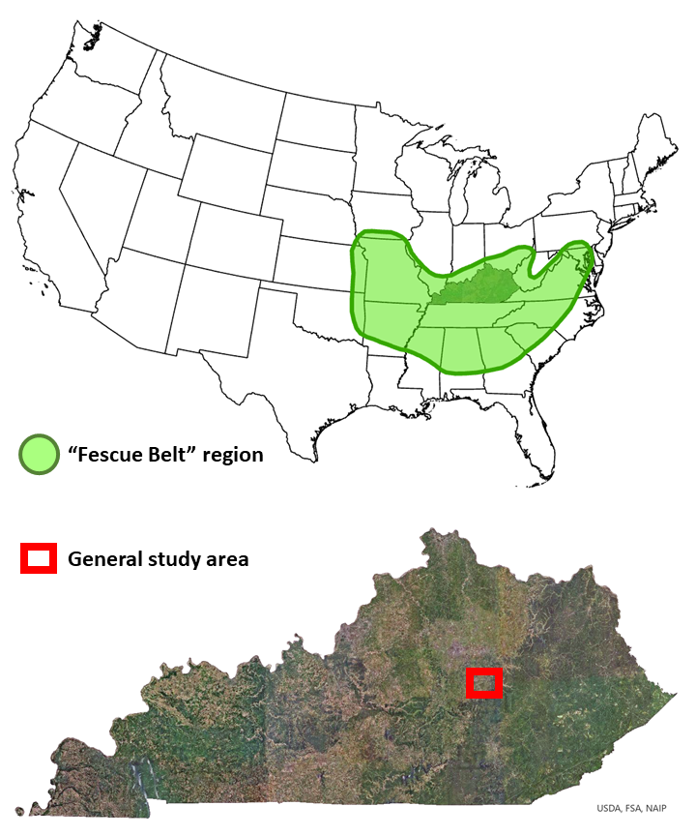
Figure 1.1. Fescue Belt region of the United States (top, green polygon) and general study area (bottom, red polygon) in Kentucky, USA. Fescue Belt map adapted from Belesky and West (2009), and Keyser (2021). Other imagery (ESRI 2022).

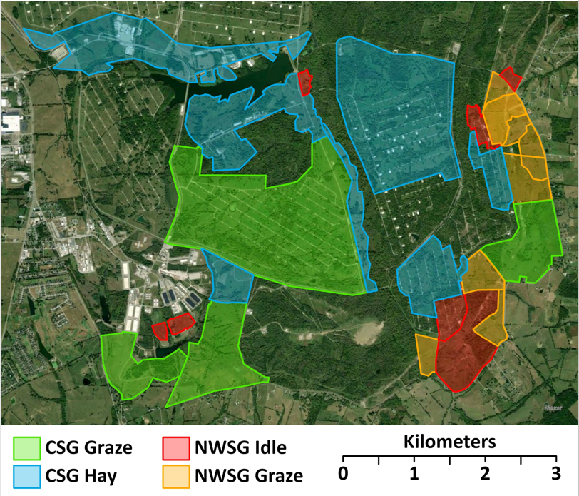
Figure 1.2. Map of northern bobwhite study area with major cover type delineations (forest and shrub not depicted). Blue Grass Army Depot, Richmond, Kentucky, USA, 2019-2022. NWSG = native warm-season grass, CSG = cool-season grass.

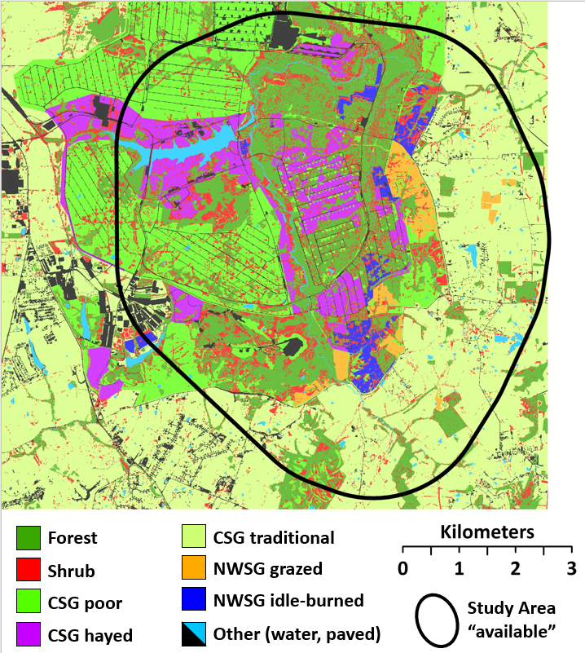
Figure 1.3. Map of remotely sensed cover types (5 m pixels) and available area for 2nd-order (home range selection) resource selection analyses. Available area was determined by applying a minimum convex polygon to all trapped areas and adding a 2 km buffer. Blue Grass Army Depot, Richmond, Kentucky, USA. NWSG = Native warm-season grass, CSG = Cool-season grass.

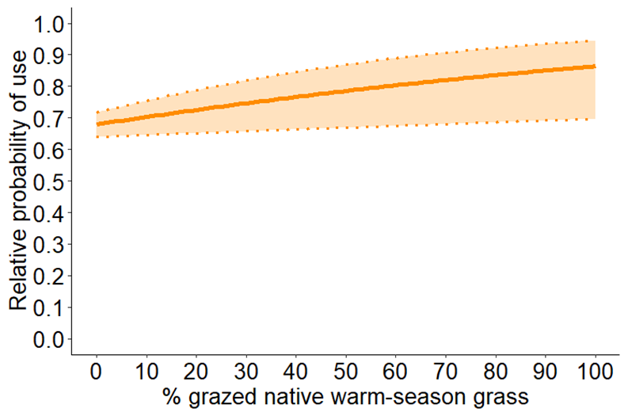
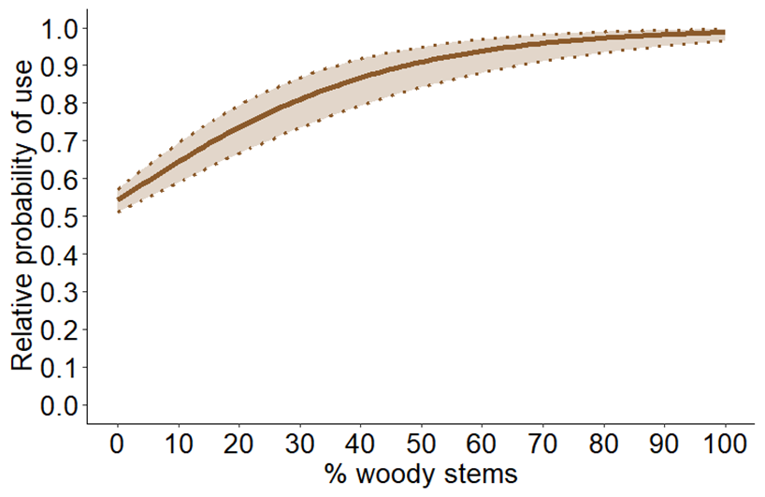
Figure 1.4. Relative probability of use at the local scale for percent grazed native warm-season grass (top) and woody stems (bottom) by all adult northern bobwhites in breeding season (Apr - Sep). Blue Grass Army Depot, Richmond, Kentucky, USA, 2019-2022.

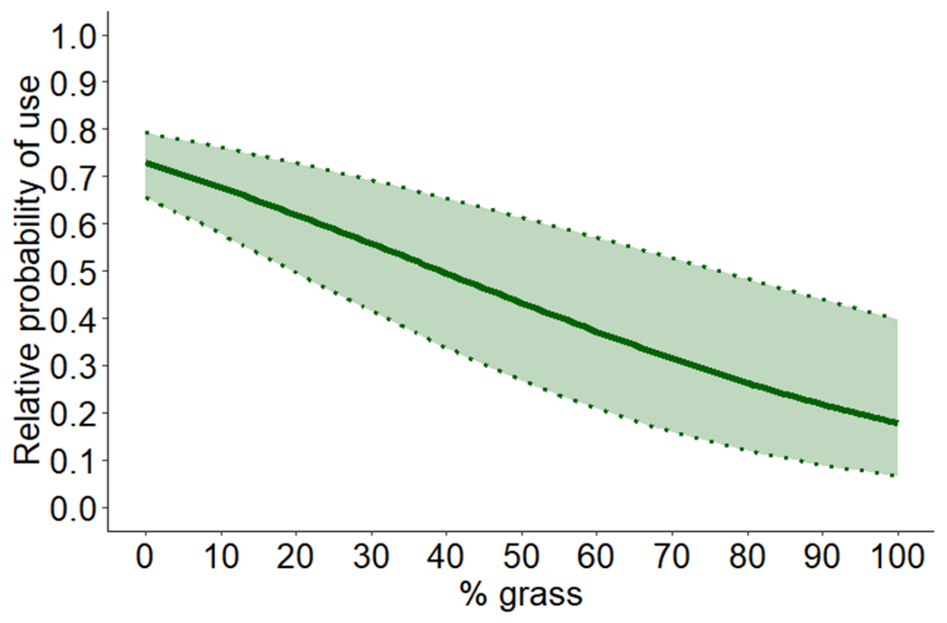
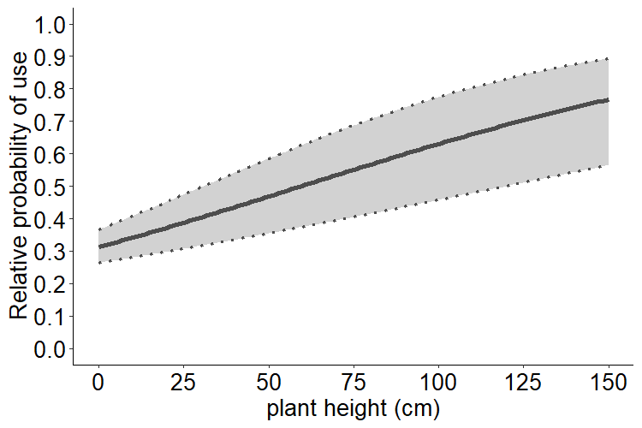
Figure 1.5. Relative probability of use for percent grass (top) and vegetation height (bottom) by all adult northern bobwhites in non-breeding season (Oct - Mar). Blue Grass Army Depot, Richmond, Kentucky, USA, 2019-2022.

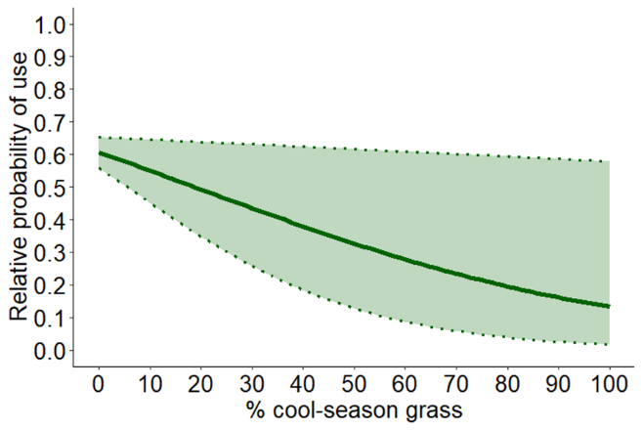 | 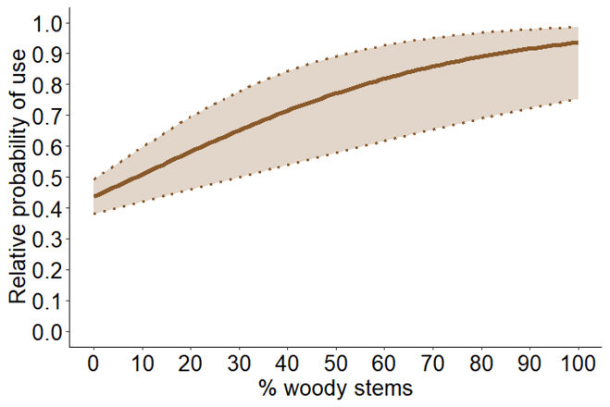
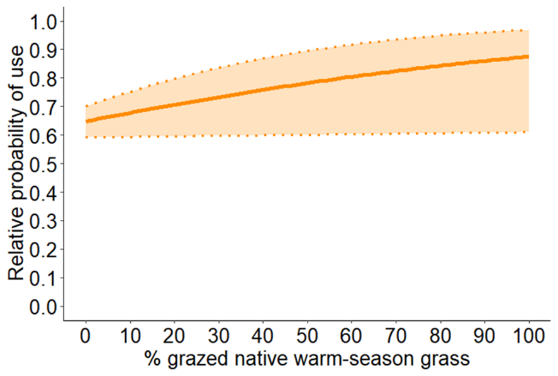 | 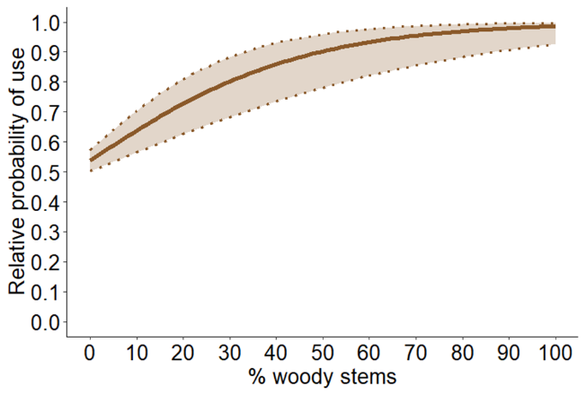
Figure 1.6. Relative probability of use for percent cool-season grass and wood stems (top), and percent grazed native warm-season grass and woody stems (bottom) by adult northern bobwhites with home ranges in grazed native warm-season grass in breeding season (Apr - Sep). Blue Grass Army Depot, Richmond, Kentucky, USA, 2019-2022.

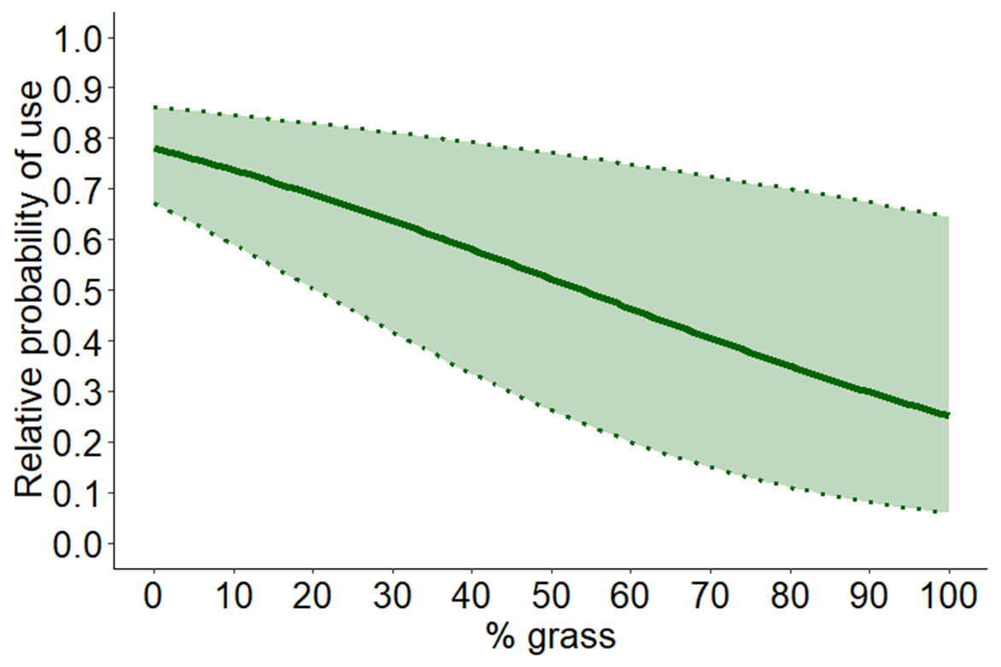

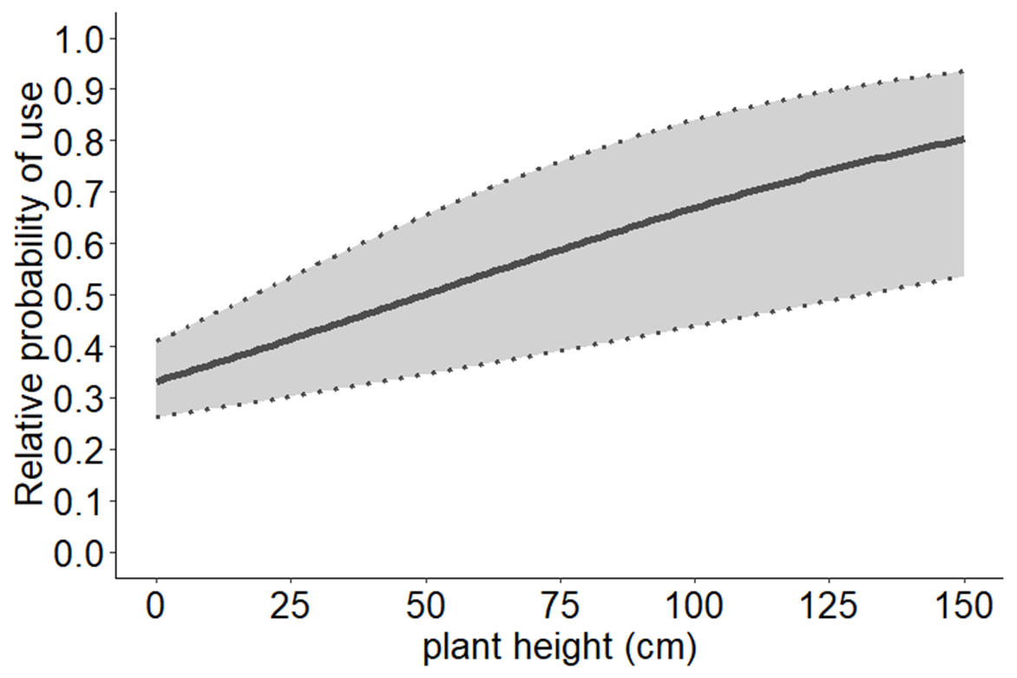
Figure 1.7. Probability of selection for percent grass (top) and vegetation height (bottom) by adult northern bobwhites with home ranges in native warm-season grass idle-burned in non-breeding season (Oct - Mar). Blue Grass Army Depot, Richmond, Kentucky, USA, 2019-2022.

CHAPTER II: NATIVE WARM-SEASON GRASS IMPROVES SURVIVAL OF ADULT NORTHERN BOBWHITES IN A LANDSCAPE OF EXOTIC COOL-SEASON GRASS FOR CATTLE PRODUCTION

Abstract
Northern bobwhite (Colinus virginianus; “bobwhite”) populations have declined approximately 85% across the majority of their range since 1966. These declines have been more pronounced in portions of the southeastern United States (U.S.) where a large proportion of agricultural land is in pasture dominated by tall fescue (Lolium arundinaceum), an exotic cool-season grass (CSG). Traditional management of CSG is thought to negatively influence bobwhite survival rates. Native-warm season grasses (NWSG) may be a viable alternative but to date, data are lacking. I conducted an experiment in southeastern Kentucky, U.S., where grazed and hayed CSG fields were adjacent to grazed and idle-burned NWSG fields. I tracked bobwhites continuously from April 2019 to October 2022 and monitored their survival rates. Variation in bobwhite survival was explained by a positive interaction of grazed NWSG and moderate shrub interspersion in their home range (non-breeding) and high interspersion of shrubs within their home range plus a 250-m buffer (breeding). The results of this study suggest that incorporating NWSGs into existing exotic-CSG cattle production operations may provide a working-lands conservation strategy for bobwhites. This strategy has potential to create large amounts of habitat across the bobwhite’s range in the southeastern US.

Introduction
The northern bobwhite (Colinus virginianus; hereafter, bobwhite) and the majority of other North American grassland bird species continue to decline across much of their range (Sauer et al. 2017). These declines are the most pronounced in the southeastern United States (Brennan 1991, Peterjohn and Sauer 1999). Declining populations of bobwhites have been attributed to many changes in land use, but the ultimate cause is the widespread loss and degradation of habitat (Roseberry et al. 1979, Brennan et al. 1998, Burger 2002, Veech 2006).
Bobwhites are an important game bird and the funds generated by bobwhite hunting provide economic benefits at multiple levels (Burger et al. 1999, Poudel et al. 2016). Money spent on bobwhite hunting also provides funding towards conservation efforts that also benefit other wildlife (Brennan and Kuvlesky 2005, Crosby et al. 2015). Agricultural practices have a strong influence on this guild of birds and historical bobwhite abundance can be attributed to patchwork agriculture (Hernandez and Guthery 2012, Murphy 2019). However, returning to less intensive agricultural practices is not a practical solution (Peterjohn 2003).
Estimation of survival rate is critical to understanding bobwhite populations and designing effective management strategies (Cox et al. 2004). Populations may be affected by varying rates of predation and seasonal, nesting, chick, and brood survival (Klimstra and Roseberry 1975, Burger et al. 1995a, Folk et al. 2007). Differing agricultural practices can influence adult and juvenile movement and survival, as well as nesting attempts, nest placement and nest survival rates (Puckett et al. 1995, West et al. 2012, Sinnott et al. 2022).
In the southeastern United States (U.S.), there is a substantial amount of agricultural land used for cattle/forage production (Ball et al. 2015, Keyser 2021). Here, the exotic grass tall fescue (Lolium arundinaceum) is the dominant forage and is grown on approximately 14 million ha in an area known as the “Fescue Belt” (Kallenbach et al. 2012; Figure 0.1). Tall fescue has been negatively associated with bobwhite populations (Brennan 1991, Barnes et al. 1995, Keyser et al. 2022) leading to an interest in the use of native warm-season grasses (NWSG) as alternative forages (George et al. 1979, Washburn et al. 2000, USDA-NRCS 2006, West et al. 2012). Additionally, converting existing tall fescue production stands to NWSGs may produce benefits for cattle producers (Keyser et al. 2016, Monroe et al. 2017, Brazil et al. 2020), bobwhites (Harper et al. 2015, Thompson et al. 2022) and other grassland-associated avian species (Giuliano and Daves 2002, Harper et al. 2015, West et al. 2016). A recent study in southwest Missouri suggested that juvenile bobwhite survival rates were positively influenced by grazed and burned native grasslands (i.e., “patch-burn grazing”) and negatively influenced by non-native grassland (Sinnott et al. 2022). Aside from this study, there is a lack of studies conducted in the Fescue Belt that focus on the response of bobwhites to NWSGs and grazing. Moreover, there is a lack of research that examines how bobwhite survival rates respond to grazed and idle NWSGs in an agricultural landscape dominated by exotic CSG pastures and hayfields. This working lands conservation approach in the Fescue Belt may be an excellent opportunity for bobwhite and other wildlife (Keyser et al. 2019, 2022).
The purpose of my study was to evaluate how bobwhite survival rates may be affected by NWSGs managed with grazing or prescribed fire in a broader landscape dominated by tall fescue forage production. My objectives were to evaluate seasonal survival (breeding [1 April – 30 Sept] and non-breeding [1 Oct – 31 Mar]) of bobwhites among grazed and idle NWSG and grazed and hayed CSG-dominated cover types. More specifically, I evaluated how survival rates may be influenced by these cover types at the home range (95% kernel density) and landscape scales (250-m buffer outside the home range)(2nd-order selection; Johnson 1980) and then evaluate local-scale vegetative and structural characteristics (3rd-order selection) that may influence those rates. I hypothesized that at the landscape and home range scale, more NWSG cover (grazed and idle) would positively influence survival rates and that more CSG cover (grazed and hayed) would negatively influence survival rates. I also hypothesized that shrub cover would increase survival and forest cover would decrease survival. Finally, I hypothesized that local-scale vegetation composition and structural characteristics such as higher forb cover, woody stem cover, and visual obstruction would also increase survival rates.

Methods
I conducted this study on the Blue Grass Army Depot (hereafter, BGAD) in Madison County, Kentucky between January 2019 and October 2022. The study area was located in the Interior Low Plateau physiographic province on the southeast edge of the Bluegrass Region (Jones 2005; Figure 2.1). The BGAD is a military facility that encompasses approximately 6070 ha. The BGAD had scattered woodlots, but was predominantly pastures that were maintained by grazing cattle, haying, and burning.
The south, southeast, and eastern portions of the BGAD include a mix of cattle pastures (CSG and NWSG) and fields managed for early successional wildlife. I designated this section of the BGAD as our study area and delineated four areas of predominant cover types based on existing management: hayed CSG fields (722 ha), grazed CSG fields (622 ha), grazed NWSG fields (169 ha), and burned NWSG fields (124 ha) (Figure 2.2). The NWSG fields on the BGAD primarily consist of a mix of indiangrass (Sorghastrum nutans), big bluestem (Andropogon gerardii), switchgrass (Panicum virgatum), and some broomsedge (Andropogon virginicus). Grasses in CSG fields primarily consisted of tall fescue and orchardgrass (Dactylis glomerata). Both CSG and NWSG areas also included other native and exotic cool-season and warm-season grass species common to fields in the Fescue Belt such as dallisgrass (Paspalum dilatatum), johnsongrass (Sorghum halapense), bluegrass (Poa spp.), foxtails (Setaria spp.), purpletop (Tridens flavus), and bromes (Bromus spp.).
One large area of NWSG (82 ha) was split into approximate thirds and each burned on a successive 3-year return interval. Hayed CSG fields were harvested annually (mid-June to mid-July). Cattle were stocked to NWSG grazed areas in late spring (mid-April to mid-May) each year and removed in late breeding season (mid-Aug to mid-Sept). The CSG graze areas were grazed continuously on the majority of the study site. Stocking density in both NWSG graze areas and CSG graze areas was approximately 140-200 kg ha⁻¹, typically using weaned calves (250-300 kg each) or yearling heifers (350-450 kg each). Stocking densities for individual cattle producers are variable in the region but typically maintain stocking densities of approximately 200-250 kg ha⁻¹ (Boyer et al. 2022).
Beginning in April 2019 and continuing through September 2022 I trapped bobwhites year-round using anchored, wire funnel-traps baited with a mix of cracked corn (Zea mays), milo (Sorghum bicolor), millet (Panicum miliaceum), sunflower (Helianthus annuus), and other grains (Stoddard 1931, Burger et al. 1995a, West et al. 2012). Traps were staked on one side and located under overhanging cover or covered with small branches to reduce predation and capture stress of the birds (Palmer and Wellendorf 2007). I attempted a 24-hour trapping schedule used in similar bobwhite telemetry studies, but had to switch to a daylight-hours only schedule due to heavy trap disturbance by crepuscular and nocturnal mammals. For the majority of the study period, I set and baited traps each morning and checked and dismantled them in late afternoon to avoid predator-related disturbance.
Captured bobwhites were fitted with two uniquely numbered aluminum leg bands (band size #4; one on each leg), sexed and aged (juvenile or adult), and weighed to the nearest gram (g). I aged birds by the presence of buff-tipped wing coverts (Rosene 1969). All birds weighing ≥129 g were fitted with a necklace-style VHF transmitter (American Wildlife Enterprises, Monticello, FL, USA) (approx. 6 g; ≤5% of the bird’s mass). All birds were processed and released ≤20 m of the trap. Trapping, handling, and marking procedures were in accordance with the University of Tennessee IACUC approved protocol no. 2608-0418 and 2608-0321.
I located all radio-marked birds ≥ 4 times per week. I varied location times throughout the day and week to capture a full range of behavior (Lohr et al. 2011). I located birds using a hand-held, 3-element folding Yagi antenna (Advanced Telemetry Systems, Isanti, MN, U.S.A.) and homing to within 15-30 m of the bird’s location (White and Garrott 1990). I recorded estimated distance to the bird (using a laser rangefinder), azimuth, cover type, and UTM coordinates using a compass and handheld GPS unit. Locations were estimated by the strength of the transmitter’s signal and by the technician approaching the assumed location of the bird from more than one direction. All technicians were trained in their first two weeks to locate a hidden transmitter to within a 5-m radius.
I used the image classification wizard in ArcGIS Pro (ESRI 2022) to classify a raster data layer representing cover on the study site and the surrounding privately-owned properties. I used aerial images (KYfromAbove.gov; 2-meter resolution) from 2019, 2020, and 2021 as the base map for the software. I restricted the classes to 9 land-cover types: forest, shrub, CSG poor (cool-season grass; areas including <50% forbs), CSG hay, CSG traditional (typical of “Fescue Belt” management), NWSG (native-warm season grass), NWSG idle (rank, undisturbed stands), developed (roads, buildings, paved areas), and water. I inspected representative cover types across the study area and manually corrected any misclassified cells (Brooke et al. 2015). For all training images and ground truthing, I used cover-type and habitat definition information similar to the NBCI Coordinated Implementation Program (Morgan et al. 2016). I dissolved each class to a 5-m resolution (5 x 5 m pixel size) because I determined that many features on our study site could be detected at this scale.
I used trapping and radio-telemetry to monitor northern bobwhites and study their survival patterns. I generated capture histories for each bird using the first day the bird was captured, the last day known alive, and the day that fate was determined. I censored birds that dropped their collars or emigrated from the study area. If a bird could not be located, I systematically searched the study area and surrounding area for two weeks until it could be relocated or declared lost or emigrated.
I used the “nest” model approach using the Rmark package in Program R (Laake et al. 2022, R-CoreTeam 2022). I used the nest model because the fate or exact day of death for some individuals in our study could not be reliably determined (“ragged” or “staggered entry”). The nest model is robust to data collected in a sampling structure such as this (Rotella 2019). I modeled seasonal survival rates of our study population using sex (2 levels) and treatment (4 levels). I assigned treatment to each bird by using the dominant cover type (CSG graze, CSG hay, NWSG graze, NWSG idle) in each bird’s home range (95% kd). If I could not generate a home range for a bird (<20 points), I approximated home ranges using a minimum convex polygon of the total points (n = 8).
I overlaid all home ranges of both breeding season and non-breeding season birds over the raster cover type layer of our study area (5-m pixel resolution). I clipped our cover type layer in ArcGIS using the home range (home range scale) and the home range plus a 250 buffer (landscape scale). I then used the “landscapetools” and “landscapemetrics” packages in Program R to extract metrics from each home range and home range buffer (Sciaini et al. 2022, Hesselbarth et al. 2024). For each home range, I calculated the proportion of each cover type (%), edge density (m/ha), interspersion-juxtaposition index (0-100). I also used the mean values of local selection (3rd-order sensu Johnson 1980) data for each bird (Mitchell et al., 2024a). I checked all covariates for correlation using Pearson’s correlation coefficient with a cut-off of 0.7. If any covariates were intercorrelated, I retained the covariate that was more biologically meaningful.
I modeled non-breeding season (1 Oct – 31 Mar) and breeding season (1 Apr – 30 Sept) survival separately. I inspected each covariate in univariate models first. Then I developed models based on a priori hypotheses regarding the influence of grass cover types (NWSG graze, NWSG idle, CSG graze, and CSG hay) on bobwhite survival by first fitting home range metrics and then adding landscape covariates using additive and interactive terms. I included a null model (constant survival) for both breeding season and non-breeding season univariate and multivariate model sets. I ranked my models using Akaike’s Information Criterion values. Finally, using the most parsimonious multivariate home range-scale models, I added local-scale covariates for biologically-appropriate covariates such as forb cover, woody stem cover, and plant height using additive and interactive terms. After I determined the most parsimonious models that included home range and local-scale covariates, I further evaluated the local-scale covariates using quadratic terms because we hypothesized that there might not be a non-linear relationship. By applying this workflow, I sought to determine which home-range level covariates influenced survival, if the surrounding landscape had an effect, and if fine-scale vegetative composition or structure corroborated these findings.

Results
I had 111 usable capture histories in breeding season and 105 in non-breeding season. The mean seasonal survival estimate for breeding season was 0.20 (CI = 0.13 – 0.30), while the non-breeding season estimate was 0.34 (CI = 0.24 – 0.44). The only supported grass cover type univariate model for breeding season survival was NWSG graze (Table 2.1). There were no grass cover type univariate models that explained variation in non-breeding season (Table 2.2). Factor-level treatment and sex covariates did not explain variation in survival for breeding season or non-breeding season.
After fitting landscape and local selection covariates, the multivariate models that explained variation in survival for breeding season and non-breeding season included percent of home range with grazed NWSG and an interaction term with interspersion-juxtaposition of shrub at the landscape (breeding season) and home range (non-breeding season) scales (Table 2.3). Competing models included an interaction between % grazed CSG at the home range scale and landscape scale shrub interspersion (non-breeding season), as well as local selection covariates such as canopy height, visual obstruction, litter depth, and bare ground (%). However, in these models the estimates were weak, had confidence intervals that overlapped zero, or both (Table 2.4 Table 2.5). Similarly, terms for forb (%) did not explain variation in survival. None of the quadratic terms I added improved the fit of our models.
For bobwhites during breeding season, there was an increase in probability of seasonal survival due to the interaction of % NWSG graze in the home range and the interspersion-juxtaposition of shrub in the landscape (Table 2.4). There was a positive effect on seasonal survival when the interspersion-juxtaposition of shrub was held above the mean value of 72, but a negative effect at values below that mean (Figure 2.4). In non-breeding season, variation in survival was best explained by an interaction of % NWSG and interspersion-juxtaposition of shrub at the home range scale (Table 2.5). There was a positive effect on survival with % NWSG cover when interspersion-juxtaposition of shrub was held below the mean of 70, but a negative effect at values above the mean (Figure 2.5).

Discussion
The breeding season survival rate for bobwhites in my study (0.20) was greater than estimates from a reclaimed surface mine in Kentucky (0.148) (Peters et al. 2015), but less than estimates from northern Missouri (0.332) (Burger et al. 1995b), Georgia, and Alabama (0.352) (Sisson et al. 2009). Non-breeding season survival for my study (0.34) was greater than estimates from northern Missouri (0.159) (Burger et al. 1995b) and Kentucky (0.282) (Peters et al. 2015). Thompson et al. (2022) reported 90-day non-breeding survival rates in southern Missouri of 0.78, higher than non-breeding survival in my study transformed to 90-day rates (0.58).
The annual and seasonal survival estimates in my study were much less than those proposed by Sandercock et al. (2008) for a stable population (annual = 0.07 vs 0.41, breeding = 0.20 vs 0.79, non-breeding = 0.34 vs 0.52). However, Sandercock et al. (2008) also reported that survival estimates for bobwhite studies are likely to be negatively biased. More recently, McConnell et al. (2018) studied a 42-year data set and found that a stable population had an average adult female survival rate of 0.13. While the mean survival rates in my study do not meet McConnell et al.’s (2018) suggested minimum for a stable population, my models suggest higher survival rates within the range of my data where conditions were more favorable. For example, during the non-breeding season, survival estimates were above 0.52 where home ranges had at least 30% grazed NWSGs and shrub interspersion was near 60%. Likewise, survival estimates exceeded 0.25 in breeding season where home ranges had at least 30% grazed NWSGs and the landscape had shrub interspersion near 80%. Collectively, these conditions would meet the 0.13 annual survival rate suggested by McConnell et al. (2018). In both cases, estimated rates were higher where NWSG cover exceeded 30% of a home range.
The variation in bobwhite survival rates on my study area was positively associated with the proportion of NWSG cover types within the home range during breeding and non-breeding seasons. This supported my hypotheses concerning NWSG cover and survival at the home range scale. Survival rates were also influenced by shrub distribution patterns in the home range and landscape, also supporting my hypotheses. However, the opposing seasonal responses to moderate and high % interspersion-juxtaposition indices (breeding, iji ≥ ≈ 74 = survival increase; non-breeding, iji ≤ ≈ 68 = survival increase) were unexpected. These responses may reflect the relative importance of shrub cover in each season (Janke and Gates 2013, Mosloff et al. 2021). Local scale composition and structure covariates (VO, height, litter depth, and woody stem cover) marginally improved parsimony in breeding and non-breeding season, matching my hypotheses, but the estimates for all crossed zero or had unmeaningful effect sizes (Table 2 .4 Table 2.5).
My study suggests that NWSGs can benefit bobwhite populations by contributing to increased survival rates where increased cover of grazed NWSG was associated with moderately high levels of shrub interspersion-juxtaposition at home range and landscape scales. These findings corroborate the finding that bobwhite select NWSG cover types in a CSG-dominated landscape (Mitchell et. al. 2024a) and that they select this resource based on an adaptive benefit (Cooper and Millspaugh 1999).
Increased cover of grazed NWSGs in home ranges increased survival rates in breeding season, but only in areas where there was a high degree of interspersion-juxtaposition (>≈ 74%) of shrubs in the landscape. This high index value indicates a more complete interspersion of shrubs among the other cover types in the buffer (McGarigal and Marks 1995, Hesselbarth et al. 2024). The actively growing NWSGs inside breeding season home ranges may have provided sufficient usable space and cover such that the existing amount and configuration of shrubs at that scale did not influence survival. Immediately outside of the home ranges where NWSGs were less abundant, but shrubs were more evenly distributed, birds may have benefited from reduced predator activity at a larger scale.
At the end of grazing season and leading into non-breeding season, stubble heights in many grazed NWSG areas were ≤30cm. Because of this reduced vertical cover in non-breeding season, bobwhite survival rates may have depended more on the clumpy distribution of shrub inside the home range for protective cover. This is consistent with how bobwhites are typically more dependent on woody cover in non-breeding season (Janke and Gates 2013, Mosloff et al. 2021). Harper et al. (2015) recommended that stand heights should remain at 40 cm during the growing season, but heights up to 60 cm may be beneficial for other avian species (Moorman et al. 2017, Lituma et al. 2022). Retaining stubble heights in this range over non-breeding season may have reduced some of this dependency on woody cover. However, shrubs remain a critical component of bobwhite habitat year-round and can contribute to increased survival rates (Peters et al. 2015).
At the local scale, forb cover, woody stem cover, bare ground cover, and visual obstruction did not explain variation in survival, which did not match my hypotheses. The amount of local-scale forbs, woody stems, and visual obstruction in home ranges had broad ranges in values, but the means were similar across major cover types for each season (Table 2.1). Although the range in values for these covariates was broad in some cases, my models did not detect any influence on their survival. Bobwhites have adapted to a wide range of conditions across their range (Guthery 1999) and similar studies have failed to detect differences in variables that are typically considered important in bobwhite habitat (Rosche et al. 2019, Mosloff et al. 2021).
The large majority (88%) of bobwhite mortalities in my study were attributed to predation. Of these, inferred raptor (44%) and large mammal (32%) predations were the most common. My study site was dissected by forested areas and many of the fields that bobwhites used were bordered by forest that were also associated with patches of shrubs. Mosloff et al (2021) found that bobwhites selected areas near trees and areas with well-interspersed shrubs, but speculated that such selection may have produced an ecological trap due to an inverse relationship between survival and proximity to trees. Seckinger et al. (2008) suggested a similar effect where bobwhite habitat was created near closed canopy forests in Tennessee.
The association of bobwhite habitat with cattle production has been recognized for many years in more arid parts of the U.S. (Hernandez and Guthery 2012). Interest in working-lands conservation for bobwhite using NWSGs in mid-South cattle production has increased in recent years (Keyser et al. 2019, Hodges et al. 2021). Recent studies within the Fescue Belt appear to validate this interest (Harper et al. 2015, Mosloff et al. 2021, Sinnott et al. 2021b, 2022), but data on such systems remains limited. My study suggests that NWSGs in production settings contribute to increased survival of adult bobwhite, an important component of population growth (Sandercock et al. 2008, McConnell et al. 2018). Similarly, NWSGs in other research within the Fescue Belt have been reported to provide nesting habitat (West et al. 2012) and improve body condition and survival rates of juvenile bobwhite (Sinnott et al. 2021a, 2022). It is important to note that the benefits of NWSGs in many of these studies are also related to the availability of shrubs (Thompson et al. 2022). Cattle producers in the Fescue Belt can benefit from NWSGs as a forage, while at the same time providing habitat for bobwhite and other grassland-associated birds (Brazil 2019, Brazil et al. 2020, Keyser et al. 2022, Lituma et al. 2022, Mitchell et al. 2025c). Land managers who desire to increase bobwhite abundance could adapt their strategies to allow for shrubs in close proximity to NWSG pastures including along fencerows or in areas of poor soil within the pasture itself. Such an approach can be an effective working-lands conservation strategy, one that could exceed the current area enrolled in CRP and thus, provide a landscape-scale solution to a landscape-scale problem (Keyser et al. 2019, 2020).

Literature Cited
Ball, D. M., C. S. Hoveland, and G. D. Lacefield. 2015. Southern forages: modern concepts for forage crop management. Fifth edition. International Plant Nutrition Institute.
Boyer, C. N., D. M. Lambert, A. P. Griffith, and C. D. Clark. 2022. Factors influencing use and frequency of rotational grazing for beef cattle in Tennessee. Journal of Agricultural and Applied Economics 54:394–406.
Brazil, K. A. 2019. Avian density and nest survival and beef production on continuously-grazed native warm-season grass pastures. University of Tennesse, Knoxville.
Brazil, K. A., P. D. Keyser, G. E. Bates, A. M. Saxton, and E. D. Holcomb. 2020. Continuous grazing of mixed native warm-season grass in the fescue belt. Agronomy Journal 112:5067–5080.
Brennan, L. A. 1991. How can we reverse the northern bobwhite population decline? Wildlife Society Bulletin 19:544–555.
Brennan, L. A., R. T. Engstrom, W. E. Palmer, S. M. Hermann, G. A. Hurst, L. W. Burger, and C. L. Hardy. 1998. Whither wildlife without fire? North American Wildlife and Natural Resources Conference 63:402–414.
Brennan, L. A., and W. P. Kuvlesky. 2005. North American grassland birds: an unfolding conservation crisis? Journal of Wildlife Management 69:1–13.
Burger, L. W. 2002. Quail management: issues, concerns, and solutions for public and private lands - a southeastern perspective. Quail V: Proceeding of the Fifth National Quail Symposium 5:20–34.
Burger, L. W., D. A. Miller, and R. I. Southwick. 1999. Economic impact of northern bobwhite hunting in the southeastern United States. Wildlife Society Bulletin 27:1010–1018.
Burger, L. W., M. R. Ryan, T. V. Dailey, and E. W. Kurzejeski. 1995a. Reproductive strategies, success, and mating systems of northern bobwhite in Missouri. The Journal of Wildlife Management 59:417–426.
Burger, L. W., M. R. Ryan, T. V. Dailey, and E. W. Kurzejeski. 1995b. Survival and cause-specific of northern bobwhite in Missouri. The Journal of Wildlife Management 59:401–410.
Cooper, A. B., and J. J. Millspaugh. 1999. The application of discrete choice models to wildlife resource selection studies. Ecology 80:566.
Cox, S. A., A. D. Peoples, S. J. Demaso, J. J. Lusk, and F. S. Guthery. 2004. Survival and cause-specific mortality of northern bobwhites in western Oklahoma. Journal of Wildlife Management 68:663–671.
Crosby, A. D., R. D. Elmore, D. M. Leslie, and R. E. Will. 2015. Looking beyond rare species as umbrella species: Northern Bobwhites (Colinus virginianus) and conservation of grassland and shrubland birds. Biological Conservation 186:233–240.
Folk, T. H., R. R. Holmes, and J. B. Grand. 2007. Variation in northern bobwhite demography along two temporal scales. Population Ecology 49:211–219.
George, R. R., A. L. Farris, C. C. Schwartz, D. D. Humburg, and J. C. Coffey. 1979. Native prairie grass pastures as nest cover for upland birds. Wildlife Society Bulletin 7:4–9.
Giuliano, W. M., and S. E. Daves. 2002. Avian response to warm-season grass use in pasture and hayfield management. Biological Conservation 106:1–9.
Guthery, F. S. 1986. Beef, brush and bobwhites.
Guthery, F. S. 1999. Slack in the configuration of habitat patches for northern bobwhites. The Journal of Wildlife Management 63:245–250.
Harper, C. A., J. L. Birckhead, P. D. Keyser, J. C. Waller, M. M. Backus, G. E. Bates, E. D. Holcomb, and J. M. Brooke. 2015. Avian habitat following grazing native warm-season forages in the mid-south United States. Rangeland Ecology and Management 68:166–172.
Hesselbarth, M. H. K., M. Sciaini, J. Nowosad, S. Hanss, L. J. Graham, J. Hollister, K. A. With, P. Nayuki, and M. Strimas-Mackey. 2024. Package “landscapemetrics”: landscape metrics for categorical map patterns. CRAN. <https://r-spatialecology.github.io/landscapemetrics/>.
Hodges, J. L., P. D. Keyser, W. Newman, K. A. Brazil, S. J. DeMaso, and R. Diener. 2021. Beef, grass, and bobwhites - quail management in eastern native warm-season grass pastures. National Bobwhite Technical Committee, Knoxville, TN.
Janke, A. K., and R. J. Gates. 2013. Home range and habitat selection of northern bobwhite coveys in an agricultural landscape. Journal of Wildlife Management 77:405–413.
Johnson, D. H. 1980. The comparison of usage and availability measurements for evaluating resource preference. Ecology 61:65–71.
Jones, R. L. 2005. Plant life of Kentucky: An illustrated guide to the vascular flora. The University Press of Kentucky, Lexington.
Kallenbach, R. L., J. J. Crawford, M. D. Massie, M. S. Kerley, and N. J. Bailey. 2012. Integrating bermudagrass into tall fescue-based pasture systems for stocker cattle. Journal of Animal Science 90:387–394.
Keyser, P. D. 2021. Native grass forages for the eastern US. University of Tennessee Extension, Knoxville, TN, USA.
Keyser, P. D., D. A. Buehler, J. H. Fike, D. L. Finke, S. D. Fuhlendorf, J. A. Martin, H. D. Naumann, and S. R. Smith. 2022. The birds and the bees: producing beef and conservation benefits on working grasslands. Agronomy 12:1–17.
Keyser, P. D., D. A. Buehler, K. Hedges, J. Hodges, C. M. Lituma, F. Loncarich, and J. A. Martin. 2019. Eastern grasslands: conservation challenges and opportunities on private lands. Wildlife Society Bulletin 43:382–390.
Keyser, P. D., E. D. Holcomb, C. M. Lituma, G. E. Bates, J. C. Waller, C. N. Boyer, J. Travis Mulliniks, T. J. Mulliniks, and J. Travis Mulliniks. 2016. Forage attributes and animal performance from native grass inter-seeded with red clover. Agronomy Journal 108:373–383.
Keyser, P. D., A. S. West, D. A. Buehler, C. M. Lituma, J. J. Morgan, and R. D. Applegate. 2020. Breeding bird use of production stands of native grasses—a working lands conservation approach. Rangeland Ecology and Management 73:827–837. Elsevier Inc.
Klimstra, W. D., and J. L. Roseberry. 1975. Nesting Ecology of the Bobwhite in Southern Illinois. Wildlife Monographs 41:3–37.
Laake, J., E. Rakhimberdiev, B. Augustine, D. Turek, B. McClintock, J. Hines, B. Collier, J. Rotella, D. Pavlacky, A. Paul, L. Eberhart-Phillips, J. Ivan, and C. Wood. 2022. Package ‘RMark’: R code for MARK analysis. CRAN.
Lituma, C. M., B. R. Buckley, P. D. Keyser, E. Holcomb, R. Smith, J. Morgan, and R. D. Applegate. 2022. Effects of patch-burn grazing and rotational grazing on grassland bird abundance, species richness, and diversity in native grassland pastures of the Midsouth USA. Agriculture, Ecosystems and Environment 324:107710. Elsevier B.V. <https://doi.org/10.1016/j.agee.2021.107710>.
Lohr, M., B. M. Collins, C. K. Williams, and P. M. Castelli. 2011. Life on the edge: northern bobwhite ecology at the northern periphery of their range. Journal of Wildlife Management 75:52–60.
McConnell, M. D., A. P. Monroe, R. Chandler, W. E. Palmer, S. D. Wellendorf, L. W. Burger, and J. A. Martin. 2018. Factors influencing northern bobwhite recruitment, with implications for population growth. Auk 135:1087–1099.
McGarigal, K., and B. J. Marks. 1995. FRAGSTATS: spatial pattern analysis program for quantifying landscape structure. General Technical Report. PNW-GTR-351. Portland, OR.
Monroe, A. P., L. W. Burger, H. T. Boland, and J. A. Martin. 2017. Economic and conservation implications of converting exotic forages to native warm-season grass. Global Ecology and Conservation 11:23–32. Elsevier Ltd. <http://dx.doi.org/10.1016/j.gecco.2017.04.006>.
Moorman, C. E., R. L. Klimstra, C. A. Harper, J. F. Marcus, and C. E. Sorenson. 2017. Breeding songbird use of native warm-season and non-native cool-season grass forage fields. Wildlife Society Bulletin 41:42–48.
Morgan, J. J., K. Duren, and T. V. Dailey. 2016. NBCI coordinated implementation program v1.1. National Bobwhite Technical Committee Technical Publication, ver. 2.0. Knoxville, TN.
Mosloff, A. R., M. D. Weegman, F. R. Thompson, and T. R. Thompson. 2021. Northern bobwhite select for shrubby thickets interspersed in grasslands during fall and winter. PLoS ONE 16:1–20. <http://dx.doi.org/10.1371/journal.pone.0255298>.
Murphy, M. T. 2019. Avian population trends within the evolving agricultural landscape of eastern and central United States. The Auk 120:20–34.
Palmer, W. E., and S. D. Wellendorf. 2007. Effect of radiotransmitters on northern bobwhite annual survival. Journal of Wildlife Management 71:1281–1287.
Peterjohn, B. G. 2003. Agricultural landscapes: can they support healthy bird populations as well as farm products? The Auk 120:14–19.
Peterjohn, B. G., and J. R. Sauer. 1999. Population status of North American grassland birds from the North American breeding bird survey, 1966-1996. Studies in Avian Biology 19:27–44.
Peters, D. C., J. M. Brooke, E. P. Tanner, A. M. Unger, P. D. Keyser, C. A. Harper, J. D. Clark, and J. J. Morgan. 2015. Impact of experimental habitat manipulation on northern bobwhite survival. Journal of Wildlife Management 79:605–617.
Poudel, J., J. E. Henderson, and I. A. Munn. 2016. Economic contribution of hunting expenditure to the southern United States of America. International Journal of Environmental Studies 73:236–254. Routledge. <http://dx.doi.org/10.1080/00207233.2016.1143701>.
Puckett, K. M., W. E. Palmer, P. T. Bromley, J. R. Anderson, and T. L. Sharpe. 1995. Bobwhite nesting ecology and modern agriculture: a management experiment. Proceedings of the Forty-Ninth Annual Conference - Southeastern Association of Fish and Wildlife Agencies 7:505–515.
Rosche, S. B., C. R. E. Moorman, K. Pacifici, J. G. Jones, and C. S. DePerno. 2019. Northern bobwhite breeding season habitat selection in fire-maintained pine woodland. Journal of Wildlife Management 83:1226–1236.
Roseberry, J. L., B. G. Peterjohn, and W. D. Klimstra. 1979. Dynamics of an unexploited bobwhite population in deteriorating habitat. The Journal of Wildlife Management 43:306–315.
Rosene, W. 1969. The bobwhite quail: its life and management. Rutgers University Press, New Brunswick, New Jersey, USA.
Rotella, J. 2019. Chapter 17: Nest survival models. Pages 17.1-17.19 in E. Cooch and G. C. White, editors. Program MARK: a gentle introduction. 14th edition. Volume 2396. Colorado State University.
Sandercock, B. K., W. E. Jensen, C. K. Williams, and R. D. Applegate. 2008. Demographic sensitivity of population change in northern bobwhite. The Journal of Wildlife Management 72:970–982.
Sauer, J. R., K. L. Pardieck, D. J. Ziolkowski, A. C. Smith, M.-A. A. R. Hudson, V. Rodriguez, H. Berlanga, D. K. Niven, and W. A. Link. 2017. The first 50 years of the North American breeding bird survey. The Condor 119:576–593.
Sciaini, M., M. Fritsch, M. H. K. Hesselbarth, J. Nowosad, L. Graham, and J. Hollister. 2022. Package ‘landscapetools’ : landscape utility toolbox. CRAN. <https://ropensci.github.io/landscapetools/ BugReports>.
Seckinger, E. M., L. W. Burger, R. Whittington, A. Houston, and R. Carlisle. 2008. Effects of landscape composition on winter survival of northern bobwhites. Journal of Wildlife Management 72:959–969.
Sinnott, E. A., F. R. Thompson, M. D. Weegman, and T. R. Thompson. 2022. Northern bobwhite juvenile survival is greater in native grasslands managed with fire and grazing and lower in non-native field borders and strip crop fields. Ornithological Applications 124:1–15.
Sinnott, E. A., M. D. Weegman, F. R. Thompson, and T. R. Thompson. 2021a. Early hatch and managed native grasslands minorly improve bobwhite juvenile body condition. American Midland Naturalist 186:231–244.
Sinnott, E. A., M. D. Weegman, T. R. Thompson, and F. R. Thompson. 2021b. Resource selection and movement by northern bobwhite broods varies with age and explains survival. Oecologia 195:937–948. Springer Berlin Heidelberg. <https://doi.org/10.1007/s00442-021-04893-z>.
Sisson, D. C., T. M. Terhune, H. L. Stribling, J. F. Sholar, and S. D. Mitchell. 2009. Survival and Causes of Mortality for Northern Bobwhites in the Southeastern USA. Warnell School of Forestry and Natural Resources 6:467–478. <http://trace.tennessee.edu/nqsp/vol6/iss1/49>.
Stoddard, H. L. 1931. The bobwhite quail: its habits, preservation and increase. Book. Third Edit. Charles Scribner’s Sons, New York, USA.
Thompson, F. R., M. D. Weegman, E. A. Sinnott, A. R. Mosloff, K. R. Hedges, F. L. Loncarich, T. R. Thompson, N. C. Burrell, S. Whitaker, and D. E. Hoover. 2022. Northern bobwhite demographics and resource selection are explained by prescribed fire with grazing and woody cover in southwest Missouri. National Quail Symposium Proceedings 9.
USDA-NRCS. 2006. Native warm-season grasses and wildlife.
Veech, J. A. 2006. Increasing and declining populations of northern bobwhites inhabit different types of landscapes. Journal of Wildlife Management 70:922–930.
Washburn, B. E., T. G. Barnes, and J. D. Sole. 2000. Improving northern bobwhite habitat by converting tall fescue fields to native warm-season grasses. Wildlife Society Bulletin 28:97–104.
West, A. S., P. D. Keyser, C. M. Lituma, D. A. Buehler, R. D. Applegate, and J. Morgan. 2016. Grasslands bird occupancy of native warm-season grass. Journal of Wildlife Management 80:1081–1090.
West, A. S., P. D. Keyser, and J. J. Morgan. 2012. Northern bobwhite survival, nest success, and habitat use in Kentucky during the breeding season. National Quail Symposium Proceedings 7:217–222.
White, G. C., and R. A. Garrott. 1990. Analysis of wildlife radio-tracking data. Academic Press, San Diego, CA, USA.

Appendices

Tables
Table 2.1: Univariate models explaining variation in seasonal survival of adult northern bobwhites in breeding season (Apr - Sep) at the home range scale (95% k.d.) and the landscape scale (95% k.d. + 250 m), Blue Grass Army Depot, Madison County, Kentucky, 2019-2022.
model | df | AIC | AIC | AICwt
Breeding season
(home range)
~ % NWSG graze | 2 | 598.50 | 0.00 | 0.39
~ 1 (null) | 1 | 599.01 | 0.51 | 0.30
~ % CSG graze | 2 | 599.28 | 0.77 | 0.26
~ % NWSG idle-burn | 2 | 599.94 | 1.44 | 0.19
~ % CSG hay | 2 | 600.69 | 2.19 | 0.13
~ % CSG traditional | 2 | 600.85 | 2.35 | 0.12
~ % forest | 2 | 598.41 | 0.00 | 0.45
~ 1 (null) | 1 | 599.01 | 0.60 | 0.34
~ % shrub | 2 | 599.42 | 1.01 | 0.27
~ ed shrub | 2 | 600.81 | 2.40 | 0.14
~ iji forest | 2 | 600.96 | 2.55 | 0.13
~ iji shrub | 2 | 600.99 | 2.58 | 0.12
Breeding season
(home range + 250-m buffer)
~ iji shrub 250 | 2 | 593.59 | 0.00 | 0.56
~ % NWSG idle-burn 250 | 2 | 596.52 | 2.92 | 0.13
~ % forest 250 | 2 | 598.19 | 4.60 | 0.06
~ % CSG poor 250 | 2 | 598.44 | 4.85 | 0.05
~ % NWSG graze 250 | 2 | 598.86 | 5.27 | 0.04
~ 1 | 1 | 599.01 | 5.42 | 0.04
~ ed forest 250 | 2 | 599.22 | 5.63 | 0.03
~ % CSG traditional 250 | 2 | 599.86 | 6.27 | 0.02
~ % shrub 250 | 2 | 599.98 | 6.39 | 0.02
~ ed shrub 250 | 2 | 600.65 | 7.06 | 0.02
~ % CSG hay 250 | 2 | 600.76 | 7.17 | 0.02
~ iji forest 250 | 2 | 600.80 | 7.21 | 0.02
iji = interspersion-juxtaposition index
ed = edge density (m ha⁻¹)
NWSG = native warm-season grass
CSG = cool-season grass

Table 2.2: Univariate models explaining variation in seasonal survival of adult northern bobwhites in non-breeding season (Oct - Mar) at the home range scale (95% k.d.) and the landscape scale (95% k.d. + 250 m), Blue Grass Army Depot, Madison County, Kentucky, 2019-2022.
model | df | AIC | AIC | AICwt
Non-breeding season
(home range)
~ 1 (null) | 1 | 623.41 | 0.00 | 0.35
~ % CSG graze | 2 | 624.18 | 0.77 | 0.24
~ % NWSG idle-burn | 2 | 625.21 | 1.80 | 0.14
~ % NWSG graze | 2 | 625.24 | 1.83 | 0.14
~ % CSG hay | 2 | 625.36 | 1.95 | 0.13
~ % CSG traditional | 2 | 625.39 | 1.98 | 0.13
~ iji shrub | 2 | 618.08 | 0.00 | 0.76
~ ed forest | 2 | 622.85 | 4.77 | 0.07
~ % shrub | 2 | 623.29 | 5.22 | 0.06
~ 1 (null) | 1 | 623.41 | 5.33 | 0.05
~ iji forest | 2 | 624.31 | 6.23 | 0.03
~ ed shrub | 2 | 624.64 | 6.56 | 0.03
Non-breeding season
(home range + 250-m buffer)
~ iji shrub 250 | 2 | 619.15 | 0.00 | 0.62
~ 1 (null) | 1 | 623.41 | 4.26 | 0.07
~ % CSG poor 250 | 2 | 623.66 | 4.51 | 0.07
~ % forest 250 | 2 | 623.95 | 4.80 | 0.06
~ ed shrub 250 | 2 | 625.06 | 5.91 | 0.03
~ % NWSG idle-burn 250 | 2 | 625.09 | 5.94 | 0.03
~ % CSG traditional 250 | 2 | 625.23 | 6.08 | 0.03
~ % shrub 250 | 2 | 625.27 | 6.12 | 0.03
~ % CSG hay 250 | 2 | 625.34 | 6.19 | 0.03
~ % NWSG graze 250 | 2 | 625.39 | 6.24 | 0.03
iji = interspersion-juxtaposition index
ed = edge density (m ha⁻¹)
NWSG = native warm-season grass
CSG = cool-season grass

Table 2.3: Multivariate models explaining variation in seasonal survival of adult northern bobwhites in breeding season (Apr - Sep) and non-breeding season (Oct - Mar), Blue Grass Army Depot, Madison County, Kentucky, 2019-2022.
model | df | AIC | AIC | AICwt
Breeding season
~% NWSG graze x iji.sb.250 + height | 5 | 588.25 | 0.00 | 0.18
~% NWSG graze x iji.sb.250 + litter depth | 5 | 588.63 | 0.38 | 0.15
~% NWSG graze x iji.sb.250 + VO | 5 | 589.19 | 0.94 | 0.11
~% NWSG graze x iji.sb.250 | 4 | 589.28 | 1.04 | 0.11
~% NWSG graze x iji.sb.250 + % woody stems | 5 | 590.71 | 2.46 | 0.05
~% NWSG idle-burn x iji.sb.250 + height | 4 | 592.15 | 3.90 | 0.03
~% CSG hay x iji.sb.250 + VO | 5 | 592.32 | 4.07 | 0.02
~% CSG hay + iji.sb.250 + VO | 4 | 592.67 | 4.43 | 0.02
~ %CSG traditional + ij.sb.250 + VO | 4 | 592.77 | 4.53 | 0.02
~ % CSG graze + ij.sb.250 + VO | 4 | 592.98 | 4.73 | 0.02
~ % CSG graze + ij.sb.250 + height | 4 | 593.16 | 4.91 | 0.02
~ % CSG hay x ij.sb.250 + height | 5 | 593.26 | 5.02 | 0.01
~ %NWSG idle-burn x ij.sb.250 + height | 5 | 593.28 | 5.03 | 0.01
~ % NWSG graze + ij.sb.250 + VO | 4 | 593.35 | 5.10 | 0.01
~1 [null model] | 1 | 599.01 | 11.82 | 0.00
Non-breeding season
~ % CSG graze x ij.sb.250 + height | 5 | 614.69 | 0.00 | 0.18
~ % NWSG graze x ij.sb + litter depth | 5 | 615.48 | 0.79 | 0.12
~ % CSG graze x ij.sb.250 | 4 | 616.22 | 1.52 | 0.09
~ % CSG graze x ij.sb.250 + litter depth | 5 | 616.30 | 1.60 | 0.08
~ % CSG graze x ij.sb.250 + VO | 5 | 616.55 | 1.86 | 0.07
~ % NWSG graze x ij.sb | 4 | 616.77 | 2.07 | 0.07
~ % NWSG graze x ij.sb + % grass | 5 | 617.94 | 3.25 | 0.04
~ % NWSG graze x ij.sb + VO | 5 | 618.07 | 3.38 | 0.03
~ % CSG graze x ij.sb.250 + % woody stems | 5 | 618.10 | 3.41 | 0.03
~ % CSG graze x ij.sb.250 + % litter | 5 | 618.14 | 3.44 | 0.03
~ % CSG graze x ij.sb.250 + % grass | 5 | 618.15 | 3.46 | 0.03
~ % NWSG graze x ij.sb + % forb | 5 | 618.19 | 3.49 | 0.03
~ % CSG graze x ij.sb.250 + % forb | 5 | 618.22 | 3.52 | 0.03
~ % NWSG graze x ij.sb + height | 5 | 618.26 | 3.56 | 0.03
~1 [null model] | 1 | 623.41 | 7.45 | 0.00
NWSG = native warm-season grass, CSG = cool-season grass, VO = visual obstruction
iji.sb – interspersion-juxtaposition index of shrub at home-range scale
iji.sb.250 – interspersion-juxtaposition index of shrub in the home range and a 250 m buffer

Table 2.4: Parameter estimates for most supported model and competing models explaining variation in seasonal survival of adult northern bobwhites in breeding season (Apr - Sep), Blue Grass Army Depot, Madison County, Kentucky, 2019-2022.
Parameter | Estimate | SE | LCI | UCI
intercept | 13.601 | 2.466 | 8.768 | 18.435
% NWSG grazed | -0.281 | 0.097 | -0.472 | -0.090
iji shrub 250 | -0.121 | 0.034 | -0.188 | -0.055
% NWSG grazed x iji shrub 250 | 0.004 | 0.001 | 0.001 | 0.006
intercept | 11.469 | 2.657 | 6.261 | 16.677
% NWSG grazed | -0.252 | 0.094 | -0.436 | -0.068
iji shrub 250 | -0.107 | 0.033 | -0.172 | -0.042
height | 0.013 | 0.008 | -0.002 | 0.028
% NWSG grazed x iji shrub 250 | 0.003 | 0.001 | 0.001 | 0.006
intercept | 12.945 | 2.396 | 8.249 | 17.640
% NWSG grazed | -0.266 | 0.095 | -0.451 | -0.081
iji shrub 250 | -0.107 | 0.034 | -0.173 | -0.040
litter depth | -0.223 | 0.132 | -0.483 | 0.036
% NWSG grazed x iji shrub 250 | 0.004 | 0.001 | 0.001 | 0.006
intercept | 11.884 | 2.718 | 6.556 | 17.212
% NWSG grazed | -0.244 | 0.099 | -0.438 | -0.049
iji shrub 250 | -0.109 | 0.035 | -0.177 | -0.041
visual obstruction | 0.011 | 0.008 | -0.004 | 0.026
% NWSG grazed x iji shrub 250 | 0.003 | 0.001 | < -0.001 | 0.006
NWSG = native warm-season grass
iji.sb.250 – interspersion-juxtaposition index of shrub in a buffer 250m outside of the home range

Table 2.5: Parameter estimates for most supported model and competing models explaining variation in seasonal survival of adult northern bobwhites in non-breeding season (Oct - Mar), Blue Grass Army Depot, Madison County, Kentucky, 2019-2022.
Parameter |  | Estimate | SE | LCI | UCI
intercept | 1.981 |  | 0.892 | 0.232 | 3.730
% grazed NWSG | 0.289 |  | 0.117 | 0.059 | 0.519
iji shrub | 0.045 |  | 0.013 | 0.019 | 0.072
% grazed NWSG x iji shrub | -0.004 |  | 0.002 | -0.007 | -0.001
intercept |  | 1.847 | 0.893 | 0.097 | 3.597
% grazed NWSG |  | 0.365 | 0.122 | 0.126 | 0.604
iji shrub |  | 0.056 | 0.015 | 0.027 | 0.085
litter depth |  | -0.272 | 0.145 | -0.557 | 0.012
% grazed NWSG x iji shrub |  | -0.005 | 0.002 | -0.009 | -0.002
intercept |  | 4.050 | 0.883 | 2.318 | 5.783
% grazed CSG graze |  | -0.181 | 0.089 | -0.355 | -0.007
iji shrub 250 |  | 0.014 | 0.014 | -0.013 | 0.040
% CSG graze x iji shrub 250 |  | 0.003 | 0.001 | < 0.001 | 0.006
intercept |  | 4.310 | 0.904 | 2.537 | 6.082
% grazed CSG |  | -0.191 | 0.094 | -0.375 | -0.006
iji shrub 250 |  | 0.015 | 0.013 | -0.012 | 0.042
litter depth |  | -0.212 | 0.146 | -0.499 | 0.074
% grazed CSG x iji shrub 250 |  | -0.003 | 0.002 | < 0.001 | 0.006
intercept |  | 5.093 | 1.051 | 3.032 | 7.153
% grazed CSG |  | -0.213 | 0.096 | -0.400 | -0.025
iji shrub 250 |  | 0.009 | 0.014 | -0.018 | 0.036
height |  | -0.007 | 0.004 | -0.015 | < 0.001
% grazed CSG x iji shrub 250 |  | 0.003 | 0.002 | < 0.001 | 0.006
intercept |  | 4.180 | 0.853 | 2.509 | 5.853
% grazed CSG |  | -0.192 | 0.093 | -0.375 | -0.009
iji shrub 250 |  | 0.016 | 0.013 | -0.010 | 0.042
visual obstruction |  | -0.007 | 0.005 | -0.017 | 0.003
% CSG graze x iji shrub 250 |  | 0.003 | 0.001 | < 0.001 | 0.006
NWSG = native warm-season grass, CSG = cool-season grass
iji.sb – interspersion-juxtaposition index of shrub at home-range scale
iji.sb.250 – interspersion-juxtaposition index of shrub in a home range and a 250 m buffer.

Table 2.6: List of multivariate models including models that were not included in final sets explaining variation in seasonal survival of adult northern bobwhites in breeding season (Apr - Sep) and non-breeding season (Oct - Mar), Blue Grass Army Depot, Madison County, Kentucky, 2019-2022.
model | df | AIC | AIC | AICwt
Breeding season
~% NWSG graze x iji.sb.250 + height | 5 | 588.25 | 0.00 | 0.18
~% NWSG graze x iji.sb.250 + litter depth | 5 | 588.63 | 0.38 | 0.15
~% NWSG graze x iji.sb.250 + VO | 5 | 589.19 | 0.94 | 0.11
~% NWSG graze x iji.sb.250 | 4 | 589.28 | 1.04 | 0.11
~% NWSG graze x iji.sb.250 + % woody stems | 5 | 590.71 | 2.46 | 0.05
~% NWSG idle-burn x iji.sb.250 + height | 4 | 592.15 | 3.90 | 0.03
~% CSG hay x iji.sb.250 + VO | 5 | 592.32 | 4.07 | 0.02
~% CSG hay + iji.sb.250 + VO | 4 | 592.67 | 4.43 | 0.02
~ %CSG traditional + ij.sb.250 + VO | 4 | 592.77 | 4.53 | 0.02
~ % CSG graze + ij.sb.250 + VO | 4 | 592.98 | 4.73 | 0.02
~ % CSG graze + ij.sb.250 + height | 4 | 593.16 | 4.91 | 0.02
~ % CSG hay x ij.sb.250 + height | 5 | 593.26 | 5.02 | 0.01
~ %NWSG idle-burn x ij.sb.250 + height | 5 | 593.28 | 5.03 | 0.01
~ % NWSG graze + ij.sb.250 + VO | 4 | 593.35 | 5.10 | 0.01
~ % NWSG idle-burn + ij.sb.250 + VO | 4 | 593.37 | 5.12 | 0.01
~ % CSG hay * ij.sb.250 + litter depth | 5 | 593.38 | 5.13 | 0.01
~ % CSG hay + ij.sb.250 + height | 4 | 593.40 | 5.16 | 0.01
~ % NWSG graze + ij.sb.250 + height | 4 | 593.45 | 5.20 | 0.01
~% CSG hay * ij.sb.250 | 4 | 593.93 | 5.69 | 0.01
~ % NWSG idle-burn * ij.sb.250 + VO | 5 | 593.98 | 5.73 | 0.01
~ % CSG graze * ij.sb.250 + VO | 5 | 594.46 | 6.22 | 0.01
~ % NWSG idle-burn + ij.sb.250 + litter depth | 4 | 594.58 | 6.33 | 0.01
~ % CSG hay * ij.sb.250 + % woody stems | 5 | 594.69 | 6.44 | 0.01
~ % CSG hay + ij.sb.250 + litter depth | 4 | 594.70 | 6.46 | 0.01
~ % CSG graze + ij.sb.250 + litter depth | 4 | 594.71 | 6.46 | 0.01
~ % NWSG graze + ij.sb.250 + litter depth | 4 | 594.71 | 6.47 | 0.01
~ % CSG graze * ij.sb.250 + height | 5 | 595.04 | 6.80 | 0.01
~ % CSG graze + ij.sb.250 + % woody stems | 4 | 595.20 | 6.95 | 0.01
~ % CSG hay + ij.sb.250 + % woody stems | 4 | 595.30 | 7.06 | 0.01
~% NWSG idle-burn + ij.sb.250 | 3 | 595.36 | 7.12 | 0.01
~ % NWSG idle-burn + ij.sb.250 + % woody stems | 4 | 595.40 | 7.15 | 0.01
~% CSG graze + ij.sb.250 | 3 | 595.43 | 7.19 | 0.01
~ % NWSG idle-burn * ij.sb.250 + litter depth | 5 | 595.45 | 7.21 | 0.01
~ % NWSG graze + ij.sb.250 + % woody stems | 4 | 595.49 | 7.25 | <0.01
~% NWSG graze + ij.sb.250 | 3 | 595.51 | 7.26 | <0.01
~% CSG hay + ij.sb.250 | 3 | 595.59 | 7.34 | <0.01
~% CSG graze + % forest 250 | 3 | 595.67 | 7.43 | <0.01
~% NWSG idle-burn * ij.sb.250 | 4 | 595.87 | 7.62 | <0.01
Table 2.6: Continued

~ % CSG graze * ij.sb.250 + litter depth |  | 5 | 596.21 | 7.96 | <0.01
~ % CSG graze * ij.sb.250 + % woody stems |  | 5 | 596.80 | 8.55 | <0.01
~% CSG graze * ij.sb.250 |  | 4 | 597.19 | 8.95 | <0.01
~% CSG hay * ij.sb |  | 4 | 597.31 | 9.07 | <0.01
~% CSG graze * % forest 250 |  | 4 | 597.54 | 9.29 | <0.01
~% CSG graze + % forest |  | 3 | 598.24 | 10.00 | <0.01
~% NWSG graze + ij.for.250 |  | 3 | 598.31 | 10.06 | <0.01
~% NWSG graze * % forest |  | 4 | 598.39 | 10.15 | <0.01
~% NWSG graze + % forest 250 |  | 3 | 598.72 | 10.48 | <0.01
~% NWSG graze * % shrub |  | 4 | 598.88 | 10.64 | <0.01
~1 null |  | 1 | 599.01 | 10.77 | <0.01
Non-breeding season
~ % CSG graze x ij.sb.250 + height | 5 |  | 614.69 | 0.00 | 0.18
~ % NWSG graze x ij.sb + litter depth | 5 |  | 615.48 | 0.79 | 0.12
~ % CSG graze x ij.sb.250 | 4 |  | 616.22 | 1.52 | 0.09
~ % CSG graze x ij.sb.250 + litter depth | 5 |  | 616.30 | 1.60 | 0.08
~ % CSG graze x ij.sb.250 + VO | 5 |  | 616.55 | 1.86 | 0.07
~ % NWSG graze x ij.sb | 4 |  | 616.77 | 2.07 | 0.07
~ % NWSG graze x ij.sb + % grass | 5 |  | 617.94 | 3.25 | 0.04
~ % NWSG graze x ij.sb + VO | 5 |  | 618.07 | 3.38 | 0.03
~ % CSG graze x ij.sb.250 + % woody stems | 5 |  | 618.10 | 3.41 | 0.03
~ % CSG graze x ij.sb.250 + % litter | 5 |  | 618.14 | 3.44 | 0.03
~ % CSG graze x ij.sb.250 + % grass | 5 |  | 618.15 | 3.46 | 0.03
~ % NWSG graze x ij.sb + % forb | 5 |  | 618.19 | 3.49 | 0.03
~ % CSG graze x ij.sb.250 + % forb | 5 |  | 618.22 | 3.52 | 0.03
~ % NWSG graze x ij.sb + height | 5 |  | 618.26 | 3.56 | 0.03
~ % NWSG graze x ij.sb + % woody stems | 5 |  | 618.73 | 4.03 | 0.02
~ % NWSG graze x ij.sb + % litter | 5 |  | 618.75 | 4.06 | 0.02
~ % CSG hay x ij.sb + height | 5 |  | 619.64 | 4.94 | 0.01
~ % CSG hay x ij.sb | 4 |  | 619.89 | 5.20 | 0.01
~ % CSG hay + ij.sb | 3 |  | 619.96 | 5.27 | 0.01
~ % NWSG idle-burn + ij.sb | 3 |  | 619.98 | 5.28 | 0.01
~ % CSG graze + ij.sb | 3 |  | 619.99 | 5.30 | 0.01
~ % NWSG graze + ij.sb | 3 |  | 620.00 | 5.30 | 0.01
~ % NWSG idle-burn + ij.sb.250 | 3 |  | 620.49 | 5.80 | 0.01
~ % NWSG idle-burn x ij.sb | 4 |  | 620.62 | 5.93 | 0.01
~ % CSG hay x ij.sb + VO | 5 |  | 620.75 | 6.06 | 0.01
~ % CSG hay + ij.sb.250 | 3 |  | 620.83 | 6.14 | 0.01
~ % CSG graze + ij.sb.250 | 3 |  | 620.87 | 6.17 | 0.01
~ % CSG hay x ij.sb + lit.d | 5 |  | 620.92 | 6.22 | 0.01
~ % NWSG graze + ij.sb.250 | 3 |  | 621.08 | 6.39 | 0.01
Table 2.6: Continued

~ % CSG graze x ij.sb | 4 | 621.22 | 6.53 | 0.01
~ % NWSG idle-burn x ij.sb.250 | 4 | 621.71 | 7.02 | <0.01
~ % CSG hay x ij.sb + % litter | 5 | 621.76 | 7.06 | <0.01
~ % CSG hay x ij.sb + % forb | 5 | 621.79 | 7.10 | <0.01
~ % CSG hay x ij.sb + % grass | 5 | 621.85 | 7.16 | <0.01
~ % CSG hay x ij.sb + % woody stems | 5 | 621.87 | 7.17 | <0.01
~ % CSG hay x ij.sb.250 | 4 | 622.80 | 8.11 | <0.01
~ % NWSG graze x ij.sb.250 | 4 | 623.04 | 8.34 | <0.01
~1 (null) | 1 | 623.41 | 8.72 | <0.01
NWSG = native warm-season grass, CSG = cool-season grass, VO = visual obstruction
iji.sb – interspersion-juxtaposition index of shrub at home-range scale
iji.sb.250 – interspersion-juxtaposition index of shrub in the home range and a 250 m buffer

Figures
Figure 2.1. Fescue Belt region of the United States (top, green polygon) and general study area (bottom, red polygon) in Kentucky, USA. Fescue Belt map adapted from Belesky and West (2009), and Keyser (2021). Other imagery (ESRI 2022).

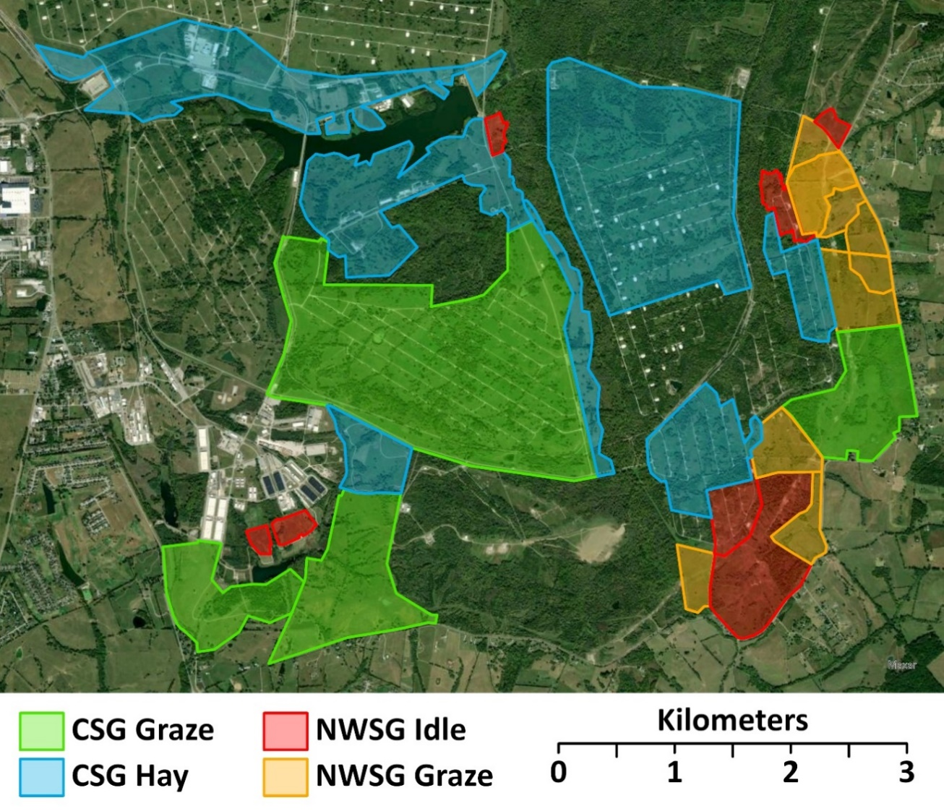
Figure 2.2. Map of northern bobwhite study area with cover type delineations (not depicted: forest and shrub). Blue Grass Army Depot, Richmond, Kentucky, USA, 2019-2022. NWSG = native warm-season grass, CSG = cool-season grass.

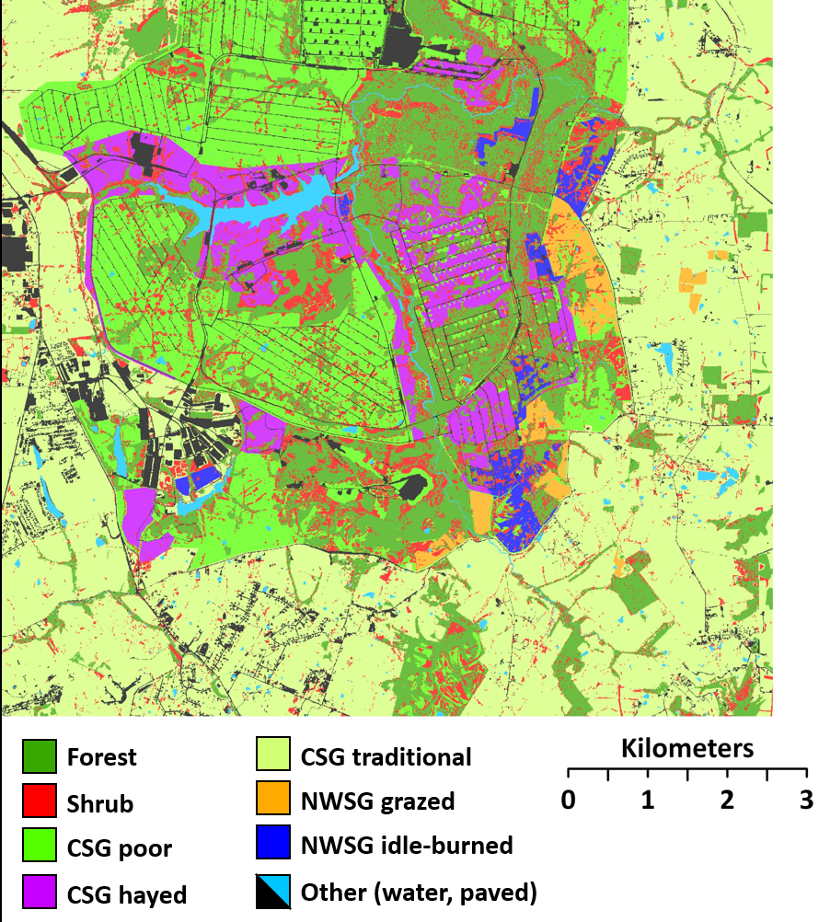
Figure 2.3. Map of remotely sensed cover types (5 m pixels). Blue Grass Army Depot, Richmond, Kentucky, USA. NWSG = Native warm-season grass, CSG = Cool-season grass.

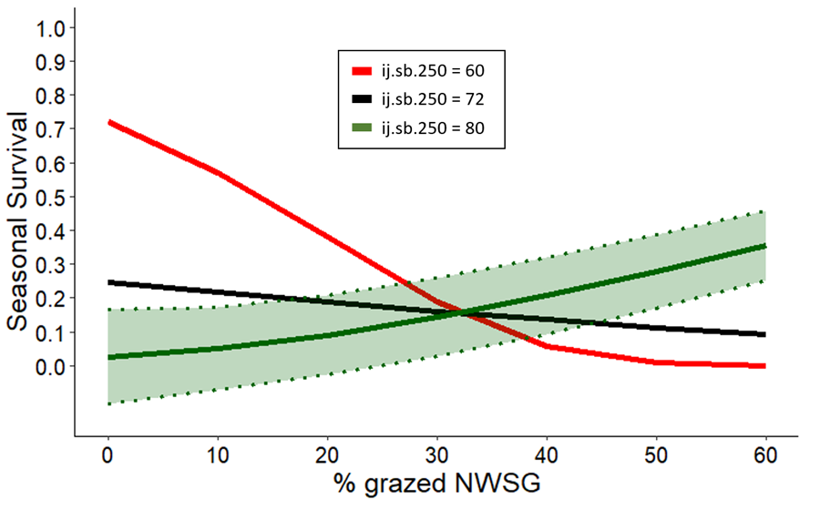
Figure 2.4. Breeding season (Apr - Sep) seasonal survival estimates and confidence intervals for adult northern bobwhites at Blue Grass Army Depot, Madison County, Kentucky, 2019 – 2022. “NWSG” = Native Warm-Season Grass at the home range scale (95% kernel density), “ij.sb.250” = interspersion-juxtaposition index of shrub at the landscape scale (95% kernel density home range plus a 250 m buffer). Different bands represent the range (60-80) and the mean value (72) of ij.sb.250. Confidence intervals that include values below -0.1 are excluded for visual clarity.

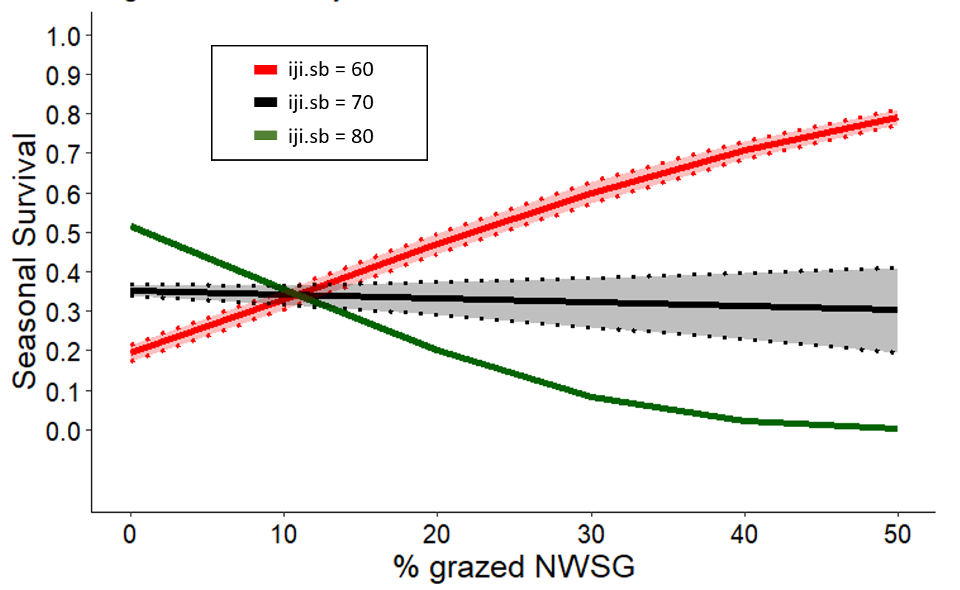
Figure 2.5. Non-breeding season (Oct - Apr) seasonal survival estimates and confidence intervals for adult northern bobwhites at Blue Grass Army Depot, Madison County, Kentucky, 2019 – 2022. “NWSG” = native warm-season grass, “ij.sb” = interspersion-juxtaposition index of shrub at the home range scale (inside 95% kernel density home range contour). Different bands represent the range (60-80) and the mean value (70) of ij.sb. Confidence intervals that include values below -0.1 are excluded for visual clarity.

CHAPTER III: NATIVE WARM-SEASON GRASSES INCREASE OCCUPANCY OF GRASSLAND-ASSOCIATED BIRDS IN A WORKING LANDSCAPE OF EXOTIC COOL-SEASON GRASSES

Abstract
The majority of grassland-associated birds in North America have declined since the 1960s. These declines have been most pronounced in the southeastern US. In this region, grasslands converted to exotic cool-season grass (CSG) cattle pastures comprise a substantial amount of the agriculture land base. Biologists in the region have proposed that cattle producers convert a portion of their CSG pastures to native warm-season grass (NWSG) as a way of both increasing profit and providing habitat for grassland-associated birds. However, very few empirical studies have investigated the benefits of NWSG pasture for birds. I conducted a study in eastern Kentucky, U.S. using distance sampling for select grassland birds in an area where grazed and idle-burned NWSG fields were immediately adjacent to grazed and hayed CSG fields. Northern bobwhite (Colinus virginianus) and Henslow’s sparrow (Centronyx henslowii) occupancy was greater in grazed NWSG, while no focal species was positively associated with grazed CSG. The results of this study suggest that a working-lands conservation model that incorporates NWSGs into a CSG-dominated cattle production system could benefit populations of some grassland-associated bird species without negatively impacting others on a landscape scale. To help conserve grassland-associated birds on a landscape scale, agencies could incentivize the adoption of NWSGs on working lands.

Introduction
The northern bobwhite (Colinus virginianus; hereafter, bobwhite) and the majority of North American grassland birds continue to decline across much of their range (Sauer et al. 2017). These declines are the most pronounced in the southeastern United States (Brennan 1991, Peterjohn and Sauer 1999). For the bobwhite, declining populations have been attributed to changes in land use, planting of non-native forages, increased grazing intensity, and a reduction of fire (Roseberry et al. 1979, Klimstra 1982, Church et al. 1993, Brennan et al. 1998, Burger 2002, Veech 2006).
Managing habitat to maintain or increase the population of bobwhite may also have a positive influence on declining grassland bird species (Gruver and Guthery 1986, Brennan and Kuvlesky 2005, Crosby et al. 2015). Grassland-associated birds like the bobwhite responded positively to patchwork agriculture in the early 20th century (Gruver and Guthery 1986, Peterjohn 2003). Changes in agricultural land use have affected both grassland and shrubland birds (Murphy 2019). However, returning to less intensive agricultural practices is not a practical solution (Peterjohn 2003). One possible solution is to incorporate native warm-season grasses (NWSGs) in existing cool-season grass dominated farmlands (Giuliano and Daves 2002, Harper et al. 2015, West et al. 2016).
Incorporating NWSGs can provide numerous benefits to cattle producers. The summer production gap left by cool-season grasses can be filled by NWSGs, providing effective forage for livestock during summer (Krueger and Curtis 1979, Keyser et al. 2016, Backus et al. 2017). Weight gain of steers may be improved, as well as improving cost efficiency for developing heifers when compared to traditional tall fescue (Monroe et al. 2017, McFarlane et al. 2018).
Adoption of NWSG can also provide habitat for grassland birds in agricultural systems (George et al. 1979, Harper et al. 2015, West et al. 2016). The relative abundance of grassland birds has been shown to be greater in NWSG-dominated pastures than those dominated by mixed, exotic cool-season grasses (CSG), particularly for ground-foraging species (Giuliano and Daves 2002, Flanders et al. 2018). The density and success of bird nests can be improved (George et al. 1979), occupancy for some species increased (West et al. 2016), and dickcissels (Spiza americana) may perceive NWSGs as a higher quality habitat (Conkling et al. 2017). Native-warm season grasses may also provide important non-breeding season cover (King and Savidge 1995). However, Moorman et al. (2017) suggested that dense stands of NWSG may not provide a good alternative cover for grassland songbirds.
Occupancy is the probability that a site is occupied or used by a particular organism. Occupancy models are a useful and cost-effective method for testing hypotheses about environmental factors or other conditions that might influence occurrence (MacKenzie et al. 2002, Gerber et al. 2022). My objective was to evaluate how NWSG managed with either prescribed fire or grazing within a broader landscape dominated by CSG affected the occupancy of bobwhites and grassland-associated passerines. Specifically, I sought to determine if four grassland types [NWSG (grazed and idle-burned) and CSG (grazed and hayed)] were related to occupancy of 9 focal species. I also sought to determine how occupancy might be affected by the amount (proportion of area) and configuration (edge density and interspersion-juxtaposition) of shrubs and forests in each grassland type. I hypothesized that occupancy for facultative and obligate grassland birds would be associated with grazed NWSG, and that some shrubland species would be associated with idle-burn NWSG. I also predicted that for obligate grassland and shrubland species, occupancy would also be associated the configuration and amount of shrub and forest cover.

Methods
I conducted this study on the Blue Grass Army Depot (hereafter, BGAD) in Madison County, Kentucky between January 2019 and October 2022. The study area is located in the Interior Low Plateau physiographic province on the southeast edge of the Bluegrass Region (Jones 2005; Figure 3.1. The BGAD is a military facility that encompasses approximately 6070 ha. The BGAD has scattered woodlots, but is predominantly pastures that are maintained by grazing cattle, haying, and burning.
I designated a section of the BGAD with a mix of cattle pastures (CSG and NWSG) and fields managed for early successional wildlife as the study area. I delineated four cover types based on existing management: hayed CSG fields (722 ha), grazed CSG fields (622 ha), grazed NWSG fields (169 ha), and burned NWSG fields (124 ha) (Figure 3.2). Native-warm season grass fields on the BGAD primarily consist of a mix of indiangrass (Sorghastrum nutans), big bluestem (Andropogon gerardii), switchgrass (Panicum virgatum), and some broomsedge (Andropogon virginicus). Cool-season grass fields consisted of tall fescue (Lolium arundinaceum) and orchardgrass (Dactylis glomerata). Both CSG and NWSG areas also included sparse patches of other native and exotic cool-season and warm-season grass species and forbs common to fields in the Fescue Belt such as dallisgrass (Paspalum dilatatum), johnsongrass (Sorghum halapense), bluegrass (Poa spp.), foxtails (Setaria spp.), purpletop (Tridens flavus), and bromes (Bromus spp.).
One large area of NWSG (82 ha) was split into thirds and each burned on a successive 3-year return interval. Hayed CSG fields were harvested in mid-June annually. Cattle were stocked to NWSG grazed areas in late spring (20 April to 10 May) each year and removed in late summer (15 August to 15 September). Cool-season grass graze areas were grazed continuously on the majority of the study site. One CSG pasture (79 ha) on our study site was rested during summer months (~July to ~October). Stocking density in both NWSG graze areas and CSG graze areas was approximately 140-200 kg ha⁻¹, typically using weaned calves (250-300 kg each) or yearling heifers (350-450 kg each). This is similar to typical stocking densities across the Fescue Belt (200-250 kg ha⁻¹), although variable among individual producers (Boyer et al. 2022).
To evaluate occupancy of grassland-associated birds, I targeted five grassland obligates, Henslow’s sparrow (Centronyx henslowii; HESP), grasshopper sparrow (Ammodramus savannarum; GRSP), bobolink (Dolichonyx oryzivorus; BOBO), eastern kingbird (Tyrannus tyrannus; EAKI), eastern meadowlark (Sturnella magna; EAME), and two grassland facultative species, field sparrow (Spizella pusilla; FISP), and northern bobwhite (Colinus virginianus; NOBO, “bobwhite”), and two shrubland species often associated with grasslands, common yellowthroat (Geothlypis trichas; COYE), and prairie warbler (Setophaga discolor; PRAW). I selected these species because they are typically associated with grasslands and early successional vegetation communities in the southeastern US, and/or have populations that are declining and are known or expected to occur on the study area. For example, HESP has recently been designated as a “tipping-point species” (North American Bird Conservation Initiative 2022) and is listed as endangered in seven U.S. states and Canada (Herkert et al. 2020). Further, Partners in Flight lists HESP, PRAW, and BOBO as a “species of continental concern” while GRSP, EAME, bobwhite, and FISP are considered “common birds in steep decline” (Rosenberg et al. 2016).
I conducted avian point-counts at 27 listening stations distributed among 4 major cover types in approximate proportion to the area of each category (6 CSG grazed, 9 CSG hayed, 7 NWSG grazed, 5 NWSG idle-burned) (Figure 3.2). I sampled each point count station 3 times centered on peak singing rates (May 15 – June 30) annually, 2019–2021. Routes began no earlier than 30 minutes prior to sunrise and ended no later than 3 hours after sunrise. I used a 5-minute listening period and recorded the first detection and its estimated location on aerial maps for each 1-minute interval. I placed distance guides on the aerial maps but recorded estimated distances to the nearest meter. For each repetition of routes, I reversed the order of visits. I did not conduct counts under adverse conditions including precipitation, fog, cloud cover ≥75%, or high winds (Beaufort scale ≥ 4). To prevent double-counting between adjacent listening stations, I kept notes in the field for target avian species that sounded like they may be vocalizing near other point-count perimeters. I used an unlimited distance detection radius, but truncated our data to effective detection distances for each species (150 m for EAME, FISP, bobwhite; 100 m for COYE, HESP, PRAW). Similarly, I did not include detections beyond 150 m to prevent spatial overlap.
I used the image classification wizard in ArcGIS Pro (ESRI 2022) to create a land cover map of the study site. I used aerial images (KYfromAbove.gov; 2-meter resolution) from 2019, 2020, and 2021 as the base map for the tool. I restricted the classes to the following land-cover classes: forest, shrub, CSG poor (cool-season grass; areas including <50% forbs), CSG hay, NWSG (native-warm season grass), NWSG idle-burned (rank, undisturbed stands). I visited areas of each cover type across the study area to confirm classifications and manually corrected any errors (Brooke et al. 2015). For all training images and ground-truthing, I used cover-type and habitat component definitions information in accordance the NBCI Coordinated Implementation Program (Morgan et al. 2016).
I overlaid all point count rings at both 100-m and 150-m radii over the land cover layer of the study area and clipped the layer using the clip tool in ArcGIS (ESRI 2022). I used the “landscapetools” and “landscapemetrics” packages in Program R (R-CoreTeam 2022) to extract metrics from each point count perimeter (Sciaini et al. 2022, Hesselbarth et al. 2024). For each ring, I calculated the proportion of each cover type (%), and edge density (m/ha) of shrub and forest. Additionally, I assigned each point count ring a treatment category as a single covariate with 4 levels corresponding to our 4 major cover types (determined by the grass cover type with the greatest proportion of cover inside the point count ring).
I analyzed my point count data using a Bayesian occupancy framework. I used the “ubms” package in the R statistical programming language and fit models using Stan (Carpenter et al. 2017, Kellner et al. 2022, R-CoreTeam 2022). I chose this model because it allows for open populations between periods and is robust to missing observations. Prior to modeling occupancy, I evaluated detection probabilities for each species using covariates for time of survey and conditions (Julian date, minutes since sunrise, % cloud cover [0-100], and wind speed [Beaufort wind scale 0-4]). The majority (92%) of point counts were conducted by the same observer over the 3-year study period, so I did not include observer as a detection covariate. For each species, I included the best detection model in all successive occupancy models.
For occupancy models, I set the reference category to CSG hay because it was the most abundant cover type and provided the best frame of reference for our hypotheses. I first evaluated univariate models for each species using covariates for treatment, and then included continuous variables measured within each point count ring (i.e., the proportion of each grass cover type, shrub, forest, and edge density [m ha⁻¹] of shrub and forest). I then fit multivariate models by adding terms for shrub and forest (percent and edge density) to the treatment and % grass cover type covariates in additive and interactive terms. I also included year (as a factor variable with 3 levels) in the univariate and multivariate analyses to test for potential annual variation. I also included the individual point count stations as a mixed effect to account for possible variation among the points. For each model, I specified a 3-core run and used 15,000 simulation draws. I inspected each model by evaluating R-hat values and trace plots for Markov chain Monte Carlo convergence and checked for goodness-of-fit using the MacKenzie-Bailey chi-squared test (MacKenzie and Bailey 2004, Lassiter et al. 2021). I selected models using leave-one-out cross-validation and sorted models by the largest expected predictive accuracy (Vehtari et al. 2017, Lassiter et al. 2021).

Results
I did not detect any GRSP on the defined study area between 2019-2022. Similarly, I had a very limited number of detections for BOBO (n = 1) and EAKI (n = 30) inside the effective detection distances, so I excluded these species from analyses. The best detection model for bobwhite, COYE, and FISP included Julian date (P < 0.01). Detection for EAME was best explained by Julian date and minutes-since-sunrise. The null detection model provided the best fit for HESP and PRAW (Table 3.1).
Grazed NWSG area was related to occupancy for bobwhite and HESP. A univariate model with treatment explained variation in occupancy best for bobwhite (M-B GOF Χ² = 18.12, posterior p = 0.09) (Table 3.2), where occupancy was greatest in NWSG graze (ß = 3.397, CI = 1.293, 6.229) compared to the reference category (Figure 3.3). Henslow’s sparrow occupancy was also related to the amount of grazed NWSG. For HESP, an interaction of increasing percent NWSG graze and decreasing percent shrub cover provided the best fit (M-B GOF Χ² = 6.98, posterior p = 0.71), with an increased occupancy probability in the first year of study (2019; Table 3.3, Figure 3.4).
The occupancy of some species was associated with the NWSG idle-burn cover type. There was a weak, but positive relationship for COYE to the proportion of cover that was NWSG idle-burn (ß = 0.550, CI = -0.334, 1.832), but this also may have been influenced by annual variation (Table 3.3; Figure 3.5) and had weak support for goodness-of-fit (M-B GOF Χ² = 26.72, posterior P = 0.006). Idle-burned NWSG also was also associated with EAME occupancy. However, the effect was also weak here and credible intervals nearly straddled zero for this term (ß = 0.343, CI = -1.058, 1.718; Table 3.3) though this model had support for goodness-of-fit (M-B GOF Χ² = 10.54, posterior p = 0.339). Occupancy probability for EAME had a strong negative association with shrub cover (Figure 3.6), as the additive model with the NWSG idle-burn term explained variation similarly to a univariate term for percent shrub (Table 3.2). Field sparrow occupancy was also associated with NWSG idle-burn with an interaction with percent shrub that had good support for goodness-of-fit (M-B GOF Χ² = 11.90, posterior p = 0.363). However, this association was very weak and the model had wide credible intervals, an estimate that nearly crossed zero (ß = 0.209, CI = -2.127, 2.990), and produced inconsistent predictions (Figure 3.7). The NWSG idle-burn cover type was associated with more shrub cover than other cover types inside the 150 m sampling perimeter and in the surrounding landscape (Table 3.5 Table 3.6). The NWSG idle-burn term in the models for these species may have been uninformative (i.e., "pretending parameter"; Sutherland et al. 2023).
The amount of hayed CSG was related to only one target species, PRAW. A combination of treatment and shrub edge density explained variation best in occupancy for PRAW Table 0.5: Summary of cover type composition in 150-meter point count rings among treatment groups.(Table 3.2) and had some support for goodness-of-fit (M-B GOF Χ² = 14.06, posterior p = 0.279). Occupancy for PRAW was greatest in CSG hay, although credible intervals were wide. The treatment model also included a term with a positive association with shrub edge density, however credible intervals straddled zero for the NWSG idle-burn treatment estimates (Table 3.3; Figure 3.8). Occupancy estimates were least affected by CSG graze, with no positive correlation with any of my target species. Occupancy for bobwhite was lowest in CSG graze (ß = -0.697, CI = -2.580, 0.936) among the treatments (Figure 3.3). Similarly, PRAW occupancy was lowest in CSG graze (ß = -4.165, CI = -7.593, -1.722) (Figure 3.8).

Discussion
Overall, the mean occupancy estimates were highest for EAME and FISP (0.67 and 0.97, respectively) and lowest for HESP (0.22; Table 3.3). In general, each focal species displayed a different response to cover types on the study area. As a treatment, NWSG graze had the highest occupancy estimates for bobwhite. Increasing NWSG graze cover also was associated with a higher probability of occupancy for HESP. Idle-burned NWSGs were associated with occupancy of EAME and FISP but variation was explained better by shrub cover. Although CSG hay had an effect on PRAW occupancy, this variation was strongly associated with shrub edge density. CSG graze produced either the lowest estimates for each species or had no effect (Table 3.4).
My hypothesis that grazed NWSG would increase occupancy was supported by the models for some of the focal species. Similarly, my hypothesis that grazed CSG would produce lower estimates was also supported in some cases. My data suggests that some grassland-associated species responded more to increased NWSG idle-burn, which was unexpected and did not support my hypotheses. However, in every model supporting NWSG idle-burn, there was a strong effect associated with shrub cover and configuration, which did support my hypotheses.
Grazed NWSGs on my study area were conducive to ground-foraging avian species like bobwhite and HESP. Bobwhites spend most of their time on the ground as opposed to flight, highlighting the importance of near-ground structure (Stoddard 1931, Hernandez and Guthery 2012). My study may strengthen the suggestions that grazing NWSGs provides the appropriate disturbance to maintain the structural habitat requirements of bobwhite and other grassland songbirds (Harper et al. 2015, West et al. 2016, Keyser et al. 2020). Additionally, Mitchell et al. (2025a, 2025b) reported that bobwhite used NWSG grazed areas more than expected and that this cover type may have been associated with increased survival rates. Similarly, HESPs are a long-legged sparrow that often walk or run on the ground instead of flying (Herkert et al. 2020). Henslow’s sparrows, like bobwhite, also display strong association with near-ground structure (Coppedge et al. 2008). Walk and Warner (2000) found that HESP had the highest occurrence in grazed NWSGs, but did not occur in burned or hayed grasses, and suggested that grazing created appropriate habitat structure for this species. Jacobs et al. (2012) reported that HESP abundance was associated with ground-level vegetation structure, confirming findings of previous researchers (Zimmerman 1988, Herkert 1994). Decreasing amounts of shrub were also correlated with HESP occupancy on my study site. This is also similar to the association of HESP with increasing grass cover and decreased edge habitat (Jacobs et al. 2012). None of the species I modeled demonstrated reduced occupancy in association with grazed NWSG.
Idle-burned NWSGs on my study site produced unexpected results for grassland bird occupancy. For example, EAME displayed a weak positive response to NWSG idle-burn, a cover type that had approximately twice the shrub cover as the other treatments (Table 3.5). Nevertheless, the model also predicted a strong negative response to shrub cover, a response consistent with this species’ habitat status as a grassland obligate (Jacobs et al. 2012, West et al. 2016, Moorman et al. 2017). Predicted occupancy of EAME declined precipitously between 10% and 30% shrub cover (Figure 3.6) indicating the very low tolerance of this species for shrub components in grasslands. However, the mean occupancy estimate for EAMEs was moderately high (0.69). It may be that EAME were occupying patches within idle-burned NWSGs where abundance of shrubs was low. Keyser et al. (2020) reported that EAME responded positively to production stands of hayed or grazed NWSG. Similarly, stands of NWSGs that were managed for seed harvest produced the highest detection probabilities for EAME in Kentucky and Tennessee (West et al. 2016). Although NWSGs on my study site were not used for hay during this study, these responses may be comparable because disturbance levels of idle NWSG (burned in my study) and hayed NWSG may produce structural characteristics within the range of conditions conducive to this species (West et al. 2016).
The weak positive response of COYEs to NWSG idle-burn seemed reasonable given its association with dense vegetation and shrub cover (Kroodsma 1982, Rodewald and Vitz 2005, Fink et al. 2010, Guzy and Ritchison 2020). Although NWSG idle-burn cover types in my study had higher amounts of shrub and shrub edge density (Table 3.5), models that included these covariates did not explain variation in COYE occupancy (Table 3.2). However, idle NWSGs provide nesting habitat for COYE (Murray and Best 2014), and grasslands with burn-only or patch-burn grazing treatments also can increase COYE abundance and density (Duchardt et al. 2016, Lituma et al. 2022). Similarly, idle NWSG fields in a North Carolina study had high territory density of some shrub-oriented species (Moorman et al. 2017). Given that these species are typically associated with shrubs and shrub-like structure, my study corroborates the findings of other studies that idle NWSGs can provide habitat for some shrub-oriented species like COYE. According to my data, none of the focal species demonstrated their lowest occupancy rates in NWSG idle-burn compared to the other cover types.
Hayed CSG was associated with increased PRAW occupancy with NWSG idle-burn having the next highest probability for PRAW occupancy, two outcomes which I did not expect. However, the best explanatory model for PRAW occupancy also included a term for shrub edge-density indicating the probability of occupancy rose rapidly as edge density increased from 50 – 400 m ha⁻¹ (Figure 3.8). My study site was dissected by many patches of shrubs associated with drainages. Habitat for PRAW is often associated with old fields and grassland-forest edges, but the species has also been described as a generalist (Jones et al. 2017, Nolan Jr. et al. 2020). Therefore, the effect of CSG hay on PRAW could be more associated with the edge density of shrubs on my study site. The mean value of shrub edge density in CSG hay was 290 m ha⁻¹, similar to CSG graze and NWSG graze (313 and 228, respectively), but lower than NWSG idle-burn (489 m ha⁻¹) (Table 3.5). However, the probability of PRAW occupancy in NWSG idle-burn was slightly lower than in CSG hay (Figure 3.8). It is unclear if shrub edge density in CSG hay on my study area was near or above an optimal threshold for PRAW occupancy. Similarly, it is unclear if PRAW occupancy was related to near-ground vegetation such as that which occurred in CSG hay. In oak and woodland savannah, PRAW responded positively to increasing herbaceous ground cover and not to woody shrub density (Vander Yacht et al. 2016). However, in Kentucky and Tennessee, there was no difference in relative abundance of PRAW among different production stands of NWSG (Keyser et al. 2020). Moore (1980) compared PRAW density in areas with similar shrub density, but attributed differing PRAW densities to food availability and regeneration in tree layers and reported that birds rarely used near-ground herbaceous layers. Prairie Warblers were observed feeding most frequently on large branches in upper portions of trees in dissected fields in Virginia (Crowder 1976).
None of the focal species responded positively to CSG graze. For species whose best explanatory model included a treatment group (bobwhite and PRAW), CSG graze produced the lowest occupancy estimates. For bobwhite, this both supports my hypotheses and corroborates hypotheses of many biologists working in the Fescue Belt, a region where tall fescue dominates grasslands (Kallenbach et al. 2012). Typical management of tall fescue pastures is not conducive to habitat for bobwhite and other wildlife (Barnes et al. 1995, 2013, Washburn et al. 2000). While other researchers have found that EAME may respond positively to grazed CSG (Moorman et al. 2017, Keyser et al. 2020), my study did not corroborate this effect. However, grazed CSG on my study site was subject to management that is atypical of Fescue Belt norms. Grazing practices on my site fostered growth of forbs and patches of shrubs (Table 3.5). These conditions are often promoted for bobwhite habitat, but occupancy estimates in this cover type were very low (Figure 3.3). Similarly, a concurrent study on bobwhite suggested that they used CSG graze less than other cover types and avoided traditionally managed CSG (Mitchell et al. 2025a).
The mean amount and configuration of shrubs and forest varied among cover types at 2 spatial scales. I could not incorporate these effects at the landscape scale in the models because there was a lack of independence due to the close proximity and associated overlap among point count locations. However, these differences did not appear to confound any of results aside from the pretending parameter (Sutherland et al. 2023) effect of idle-burn NWSG on some facultative and obligate grassland species. Bobwhites are typically associated with shrub cover (Hernandez and Guthery 2012), however my data did not indicate an effect of shrubs on NOBO occupancy estimates. In grazed NWSGs, where estimated NOBO occupancy was highest, the mean amount and configuration of shrub and forest did not differ from the other cover types at the 150-m scale. However, the edge density of forest was different at the landscape scale (Table 3.6). Similarly, in concurrent studies where bobwhites were associate with grazed NWSGs the amount of shrub inside the home range did not explain variation in breeding season survival (Mitchell et al. 2025b), suggesting that actively growing NWSGs may provide enough cover that shrub effects are not detected.
My study corroborates the promotion of grazed NWSGs in production systems as a conservation tool for grassland-associated avian species like bobwhite and HESP. Species like PRAW, EAME, and COYE may also benefit from idle-burned NWSGs, such as those used in biomass production. Similarly, none of the focal species in this study responded negatively to NWSG graze or NWSG idle-burned. Landowners and managers may benefit other species as well by incorporating NWSG in either grazed or idle management styles (Moorman et al. 2017). However, it is important to note that the response of many grassland-associated birds to NWSGs was bolstered or suppressed by shrub cover. Government incentive programs could be diversified to account for this varied response in accordance with the conservation goals of landowners and managers.
While occupancy estimates in grazed NWSGs suggest a benefit to some grassland birds, further study would be required to infer other important dynamics such as reproduction and survival. However, the association of grazed NWSGs with occupancy of grassland birds and benefits to agriculture suggests an effective working-lands conservation approach that could surpass the land area enrolled in other conservation practices (Keyser et al. 2020). Cattle producers may retain flexibility in their operations via different management approaches with NWSGs and still benefit wildlife (Brazil 2019, Brazil et al. 2020, Lituma et al. 2022). Similarly, the biodiversity and soil health of the Fescue Belt may benefit from a NWSG working lands model, but it may be important to modify existing policies to better incentives for land owners (Keyser et al. 2022).

Literature Cited
Backus, W. M., J. C. Waller, G. E. Bates, C. A. Harper, A. Saxton, D. W. McIntosh, J. Birckhead, and P. D. Keyser. 2017. Management of native warm-season grasses for beef cattle and biomass production in the mid-south USA. Journal of Animal Science 95:3143–3153.
Barnes, T. G., S. J. Demaso, and M. A. Bahm. 2013. The impact of 3 exotic, invasive grasses in the southeastern united states on wildlife. Wildlife Society Bulletin 37:497–502.
Barnes, T. G., L. A. Madison, J. D. Sole, and M. J. Lacki. 1995. An assessment of habitat quality for northern bobwhite in tall fescue-dominated fields. Wildlife Society Bulletin 23:231–237.
Boyer, C. N., D. M. Lambert, A. P. Griffith, and C. D. Clark. 2022. Factors influencing use and frequency of rotational grazing for beef cattle in Tennessee. Journal of Agricultural and Applied Economics 54:394–406.
Brazil, K. A. 2019. Avian density and nest survival and beef production on continuously-grazed native warm-season grass pastures. University of Tennesse, Knoxville.
Brazil, K. A., P. D. Keyser, G. E. Bates, A. M. Saxton, and E. D. Holcomb. 2020. Continuous grazing of mixed native warm-season grass in the fescue belt. Agronomy Journal 112:5067–5080.
Brennan, L. A. 1991. How can we reverse the northern bobwhite population decline? Wildlife Society Bulletin 19:544–555.
Brennan, L. A., R. T. Engstrom, W. E. Palmer, S. M. Hermann, G. A. Hurst, L. W. Burger, and C. L. Hardy. 1998. Whither wildlife without fire? North American Wildlife and Natural Resources Conference 63:402–414.
Brennan, L. A., and W. P. Kuvlesky. 2005. North American grassland birds: an unfolding conservation crisis? Journal of Wildlife Management 69:1–13.
Brooke, J. M., D. C. Peters, A. M. Unger, E. P. Tanner, C. A. Harper, P. D. Keyser, J. D. Clark, and J. J. Morgan. 2015. Habitat manipulation influences northern bobwhite resource selection on a reclaimed surface mine. Journal of Wildlife Management 79:1264–1276.
Burger, L. W. 2002. Quail management: issues, concerns, and solutions for public and private lands - a southeastern perspective. Quail V: Proceeding of the Fifth National Quail Symposium 5:20–34.
Carpenter, B., A. Gelman, M. D. Hoffman, D. Lee, B. Goodrich, M. Betancourt, M. A. Brubaker, J. Guo, P. Li, and A. Riddell. 2017. Stan: A probabilistic programming language. Journal of Statistical Software 76.
Church, K. E., J. R. Sauer, and S. Droege. 1993. Population trends of quails in North America. National Quail Symposium Proceedings 3:44–54.
Conkling, T. J., J. L. Belant, T. L. DeVault, and J. A. Martin. 2017. Effects of crop type and harvest on nest survival and productivity of dickcissels in semi-natural grasslands. Agriculture, Ecosystems and Environment 240:224–232.
Coppedge, B. R., S. D. Fuhlendorf, W. C. Harrell, and D. M. Engle. 2008. Avian community response to vegetation and structural features in grasslands managed with fire and grazing. Biological Conservation 141:1196–1203.
Crosby, A. D., R. D. Elmore, D. M. Leslie, and R. E. Will. 2015. Looking beyond rare species as umbrella species: Northern Bobwhites (Colinus virginianus) and conservation of grassland and shrubland birds. Biological Conservation 186:233–240.
Crowder, O. B. 1976. Foraging ecology of the common yellowthroat, the prairie warbler and the white-eyed vireo. College of William and Mary.
Duchardt, C. J., J. R. Miller, D. M. Debinski, and D. M. Engle. 2016. Adapting the fire-grazing interaction to small pastures in a fragmented landscape for grassland bird conservation. Rangeland Ecology and Management 69:300–309. Elsevier Inc. <http://dx.doi.org/10.1016/j.rama.2016.03.005>.
ESRI. 2022. ArcGIS Pro desktop. Environmental Systems Research Institute, Redlands, CA.
Fink, A. D., F. R. Thompson III, and A. A. Tudor. 2010. Songbird use of regenerating forest, glade, and edge habitat types. Journal of Wildlife Management 70:180–188.
Flanders, A. A., W. P. Kuvlesky, D. C. Ruthven, Robert, R. E. Zaiglin, R. L. Bingham, T. E. Fulbright, F. Hernandez, and L. A. Brennan. 2018. Effects of invasive exotic grasses on south Texas rangeland breeding birds. The Auk 123:171–182.
George, R. R., A. L. Farris, C. C. Schwartz, D. D. Humburg, and J. C. Coffey. 1979. Native prairie grass pastures as nest cover for upland birds. Wildlife Society Bulletin 7:4–9.
Gerber, B. D., D. Martin, L. Bailey, and B. Mosher. 2022. Occupancy models – single-species. Pages 21–46 in. Program MARK: A Gentle Introduction. <http://www.phidot.org/software/mark/docs/book/>.
Giuliano, W. M., and S. E. Daves. 2002. Avian response to warm-season grass use in pasture and hayfield management. Biological Conservation 106:1–9.
Gruver, B. J., and F. S. Guthery. 1986. Effects of brush control and game-bird management on nongame birds. Journal of Range Management 39:251–253.
Guzy, M. J., and G. Ritchison. 2020. Common yellowthroat (Geothlypis trichas). P. G. Rodewald, editor. Birds of the World. version 1. Cornell Lab of Ornithology, Ithaca, NY, USA.
Harper, C. A., J. L. Birckhead, P. D. Keyser, J. C. Waller, M. M. Backus, G. E. Bates, E. D. Holcomb, and J. M. Brooke. 2015. Avian habitat following grazing native warm-season forages in the mid-south United States. Rangeland Ecology and Management 68:166–172.
Herkert, J. R. 1994. Status and habitat selection of the Henslow’s sparrow in Illinois. The Wilson Bulletin 106:35–45.
Herkert, J. R., P. D. Vickery, and D. E. Kroodsma. 2020. Henslow’s sparrow (Centronyx henslowii). P. G. Rodewald, editor. Birds of the World. version 1. Cornell Lab of Ornithology, Ithaca, NY, USA. <https://doi-org.utk.idm.oclc.org/10.2173/bow.henspa.01>.
Hernandez, F., and F. S. Guthery. 2012. Beef, brush, and bobwhites: Quail management in cattle country. T. E. Fulbright, editor. 1st editio. Texas A&M University Press, College Station, TX.
Hesselbarth, M. H. K., M. Sciaini, J. Nowosad, S. Hanss, L. J. Graham, J. Hollister, K. A. With, P. Nayuki, and M. Strimas-Mackey. 2024. Package “landscapemetrics”: landscape metrics for categorical map patterns. CRAN. <https://r-spatialecology.github.io/landscapemetrics/>.
Jacobs, R. B., F. R. Thompson, R. R. Koford, F. A. La Sorte, H. D. Woodward, and J. A. Fitzgerald. 2012. Habitat and landscape effects on abundance of Missouri’s grassland birds. Journal of Wildlife Management 76:372–381.
Jones, C. D., K. W. Stodola, J. Coombs, M. P. Ward, and R. J. Cooper. 2017. Responses of Bachman’s sparrows and prairie warblers to fragmentation. Journal of Wildlife Management 81:347–355.
Jones, R. L. 2005. Plant life of Kentucky: An illustrated guide to the vascular flora. The University Press of Kentucky, Lexington.
Kallenbach, R. L., J. J. Crawford, M. D. Massie, M. S. Kerley, and N. J. Bailey. 2012. Integrating bermudagrass into tall fescue-based pasture systems for stocker cattle. Journal of Animal Science 90:387–394.
Kellner, K. F., N. L. Fowler, T. R. Petroelje, T. M. Kautz, D. E. Beyer, and J. L. Belant. 2022. ubms: An R package for fitting hierarchical occupancy and N-mixture abundance models in a Bayesian framework. Methods in Ecology and Evolution 13:577–584.
Keyser, P. D., D. A. Buehler, J. H. Fike, D. L. Finke, S. D. Fuhlendorf, J. A. Martin, H. D. Naumann, and S. R. Smith. 2022. The birds and the bees: producing beef and conservation benefits on working grasslands. Agronomy 12:1–17.
Keyser, P. D., E. D. Holcomb, C. M. Lituma, G. E. Bates, J. C. Waller, C. N. Boyer, J. Travis Mulliniks, T. J. Mulliniks, and J. Travis Mulliniks. 2016. Forage attributes and animal performance from native grass inter-seeded with red clover. Agronomy Journal 108:373–383.
Keyser, P. D., A. S. West, D. A. Buehler, C. M. Lituma, J. J. Morgan, and R. D. Applegate. 2020. Breeding bird use of production stands of native grasses—a working lands conservation approach. Rangeland Ecology and Management 73:827–837.
King, J. W., and J. A. Savidge. 1995. Effects of the conservation reserve program on wildlife in southeast Nebraska. Wildlife Society Bulletin 23:377–385.
Klimstra, W. D. 1982. Bobwhite quail and changing land use. National Quail Symposium Proceedings 2:1–5.
Kroodsma, R. L. 1982. Bird community ecology on power-line corridors in east Tennessee. Biological Conservation 23:79–94.
Krueger, C. R., and D. C. Curtis. 1979. Evaluation of big bluestem, indiangrass, sideoats grama, and switchgrass pastures with yearling steers. Agronomy Journal 71:480–482.
Lassiter, Ellery V., Marcus Asher, Grace Christie, Connor Gale, Andrhea Massey, Cody Massery, Christopher R. Middaugh, John T. Veon, Brett A. DeGregorio, E. V. Lassiter, G. Christie, C. Gale, A. Massey, J. T. Veon, M. Asher, C. Massery, C. R. Middaugh, and B. A. DeGregorio. 2021. Northern bobwhite occupancy patterns on multiple spatial scales across Arkansas. Journal of Fish and Wildlife Management 12:502–512.
Lituma, C. M., B. R. Buckley, P. D. Keyser, E. Holcomb, R. Smith, J. Morgan, and R. D. Applegate. 2022. Effects of patch-burn grazing and rotational grazing on grassland bird abundance, species richness, and diversity in native grassland pastures of the Midsouth USA. Agriculture, Ecosystems and Environment 324:107710. Elsevier B.V. <https://doi.org/10.1016/j.agee.2021.107710>.
MacKenzie, D. I., and L. L. Bailey. 2004. Assessing the fit of site-occupancy models. Journal of Agricultural, Biological, and Environmental Statistics 9:300–318.
MacKenzie, D. I., J. D. Nichols, G. B. Lachman, S. Droege, A. A. Royle, and C. A. Langtimm. 2002. Estimating site occupancy rates when detection probabilities are less than one. Ecology 83:2248–2255.
McFarlane, Z. D., C. Boyer, and J. T. Mulliniks. 2018. Profitability of developing beef heifers on stockpiled winter forages. Journal of Applied Farm Economics 2.
Monroe, A. P., L. W. Burger, H. T. Boland, and J. A. Martin. 2017. Economic and conservation implications of converting exotic forages to native warm-season grass. Global Ecology and Conservation 11:23–32. <http://dx.doi.org/10.1016/j.gecco.2017.04.006>.
Moore, M. C. 1980. Habitat structure in relation to population density and timing of breeding in prairie warblers. The Wilson Bulletin 92:177–187.
Moorman, C. E., R. L. Klimstra, C. A. Harper, J. F. Marcus, and C. E. Sorenson. 2017. Breeding songbird use of native warm-season and non-native cool-season grass forage fields. Wildlife Society Bulletin 41:42–48.
Morgan, J. J., K. Duren, and T. V. Dailey. 2016. NBCI coordinated implementation program v1.1. National Bobwhite Technical Committee Technical Publication, ver. 2.0. Knoxville, TN.
Murphy, M. T. 2019. Avian population trends within the evolving agricultural landscape of eastern and central United States. The Auk 120:20–34.
Murray, L. D., and L. B. Best. 2014. Nest-site selection and reproductive success of common yellowthroats in managed Iowa grasslands. The Condor 116:74–83.
Nolan Jr., V., E. D. Ketterson, and C. A. Buerkle. 2020. Prairie warbler (Setophaga discolor). A. F. Poole, editor. Birds of the World. version 1. Cornell Lab of Ornithology, Ithaca, NY, USA.
North American Bird Conservation Initiative. 2022. The state of the birds. United States of America.
Peterjohn, B. G. 2003. Agricultural landscapes: can they support healthy bird populations as well as farm products? The Auk 120:14–19.
Peterjohn, B. G., and J. R. Sauer. 1999. Population status of North American grassland birds from the North American breeding bird survey, 1966-1996. Studies in Avian Biology 19:27–44.
R-CoreTeam. 2022. R: A language and environment for statistical computing. R Foundation for Statistical Computing, Vienna, Austria. <https://www.r-project.org/>.
Rodewald, A. D., and A. C. Vitz. 2005. Edge- and area-sensitivity of shrubland birds. Journal of Wildlife Management 69:681–688.
Roseberry, J. L., B. G. Peterjohn, and W. D. Klimstra. 1979. Dynamics of an unexploited bobwhite population in deteriorating habitat. The Journal of Wildlife Management 43:306–315.
Rosenberg, K. V., J. A. Kennedy, R. Dettmers, R. P. Ford, D. Reynolds, J. D. Alexander, C. J. Beardmore, P. J. Blancher, R. E. Bogart, G. S. Butcher, A. F. Camfield, A. Couturier, D. W. Demarest, W. E. Easton, J. J. Giocomo, R. H. Keller, A. E. Mini, A. O. Panjabi, and T. Will. 2016. Partners in flight landbird conservation plan: 2016 revision for Canada and continental United States. Partners in Flight Science Committee. <https://partnersinflight.org/wp-content/uploads/2016/08/pif-continental-plan-final-spread-single.pdf>.
Sauer, J. R., K. L. Pardieck, D. J. Ziolkowski, A. C. Smith, M.-A. A. R. Hudson, V. Rodriguez, H. Berlanga, D. K. Niven, and W. A. Link. 2017. The first 50 years of the North American breeding bird survey. The Condor 119:576–593.
Sciaini, M., M. Fritsch, M. H. K. Hesselbarth, J. Nowosad, L. Graham, and J. Hollister. 2022. Package ‘landscapetools’ : landscape utility toolbox. CRAN. <https://ropensci.github.io/landscapetools/ BugReports>.
Stoddard, H. L. 1931. The bobwhite quail: its habits, preservation and increase. Third Edit. Charles Scribner’s Sons, New York, NY, USA.
Sutherland, C., D. Hare, P. J. Johnson, D. W. Linden, R. A. Montgomery, and E. Droge. 2023. Practical advice on variable selection and reporting using Akaike information criterion. Proceedings of the Royal Society B: Biological Sciences 290.
Veech, J. A. 2006. Increasing and declining populations of northern bobwhites inhabit different types of landscapes. Journal of Wildlife Management 70:922–930.
Vehtari, A., A. Gelman, and J. Gabry. 2017. Practical Bayesian model evaluation using leave-one-out cross-validation and WAIC. Statistics and Computing 27:1413–1432.
Walk, J. W., and R. E. Warner. 2000. Grassland management for the conservation of songbirds in the midwestern USA. Biological Conservation 94:165–172.
Washburn, B. E., T. G. Barnes, and J. D. Sole. 2000. Improving northern bobwhite habitat by converting tall fescue fields to native warm-season grasses. Wildlife Society Bulletin 28:97–104.
West, A. S., P. D. Keyser, C. M. Lituma, D. A. Buehler, R. D. Applegate, and J. Morgan. 2016. Grasslands bird occupancy of native warm-season grass. Journal of Wildlife Management 80:1081–1090.
Vander Yacht, A. L., P. D. Keyser, D. A. Buehler, C. A. Harper, D. S. Buckley, and R. D. Applegate. 2016. Avian occupancy response to oak woodland and savanna restoration. Journal of Wildlife Management 80:1091–1105.
Zimmerman, J. L. 1988. Breeding season babitat selection by the Henslow’s sparrow (Ammodramus henslowii) in Kansas. The Wilson Bulletin 100:17–24.

Appendices

Tables
Table 3.1: Detection (p) model selection for grassland-associated avian species including top models, supported models, and null models (p ~ 1 psi ~1). Blue Grass Army Depot, Richmond, Kentucky, USA, 2019-2021.
Model statement | elpd | elpd^{c} | nparam
COYEª
~ Julian date ~1 | -98.7 |  | 9.1
~ 1 ~1 | -106.5 | -7.8 | 7.8
~ minutes since sunrise ~1 | -106.9 | -8.1 | 9.6
~ % cloud cover ~1 | -107.6 | -8.9 | 8.9
EAME
~ minutes since sunrise + Julian date ~1 | -93.4 |  | 16.4
~ minutes since sunrise ~1 | -93.7 | -0.3 | 15.4
~ Julian date ~1 | -94.6 | -1.2 | 15.6
~1 ~1 | -94.7 | -1.3 | 14.9
FISP
~ Julian date ~1 | -104.3 |  | 8.2
~ 1 ~1 | -105.2 | -0.9 | 7.1
~ minutes since sunrise ~1 | -105.9 | -1.6 | 8.0
~ % cloud cover ~1 | -106.0 | -1.7 | 8.2
HESP
~ 1 ~1 | -62.5 |  | 12.9
~ wind ~1 | -63.2 | -0.7 | 14.2
~ % cloud cover ~1 | -63.2 | -0.7 | 14.1
~ Julian date ~1 | -63.5 | -0.9 | 14.3
NOBO
~ 1 ~1 | -82.9 |  | 12.7
~ Julian date ~1 | -83.6 | -0.7 | 13.9
~ wind ~1 | -83.9 | -1.0 | 13.9
~ minutes since sunrise ~1 | -84.0 | -1.1 | 14.2
PRAW
~ 1 ~1 | -93.6 | 0.0 | 13.3
~ Julian date ~1 | -93.8 | -0.2 | 14.4
~ % cloud cover ~1 | -94.4 | -0.9 | 14.5
~ minutes since sunrise ~1 | -94.5 | -0.9 | 14.8
ªCOYE = common yellowthroat, EAE = eastern meadowlark, FISP = field sparrow, HESP = Henslow’s sparrow, NOBO = northern bobwhite, PRAW = prairie warbler
^{c}elpd = expected log pointwise predictive density

Table 3.2: Occupancy (psi) model selection for grassland-associated avian species including top models, supported models, and null models (psi ~1). Blue Grass Army Depot, Richmond, Kentucky, USA, 2019-2021.
Model statement | elpd | elpd^{c} | nparam
COYEª
~ % NWSG idle-burned + Year | -89.4 |  | 8.4
~ Year | -89.6 | -0.2 | 7.4
~ Treatment^{b} x % forest | -98.4 | -9.0 | 11.2
~ 1 | -98.5 | -9.1 | 9.5
EAME
~ % NWSG idle-burned + % shrub | -91.6 |  | 14.1
~ % shrub | -91.7 | -0.1 | 13.2
~ Treatment | -93.4 | -1.8 | 16.9
~ 1 | -93.5 | -1.8 | 16.4
FISP
~ % NWSG idle-burned + % shrub | -100.4 |  | 5.0
~ % CSG graze + % shrub | -100.5 | -0.1 | 5.3
~ % NWSG graze + % forest | -104.1 | -3.7 | 8.7
~ 1 | -104.1 | -3.7 | 8.2
~ Treatment | -105.6 | -5.2 | 2.4
HESP
~ % NWSG grazed x % shrub + Year | -58.1 |  | 10.8
~ % Treatment + % forest | -59.4 | -1.3 | 7.2
~ % shrub | -62.5 | -4.4 | 13.3
~ 1 | -62.5 | -4.4 | 12.9
NOBO
~ Treatment | -77.6 |  | 7.2
~ Treatment + Year | -78.3 | -0.8 | 8.3
~ % CSG hayed | -82.6 | -5.0 | 12.3
~ 1 | -83.0 | -5.4 | 12.8
PRAW
~ Treatment + shrub edge density | -83.5 |  | 5.8
~ Treatment + Year | -84.5 | -0.6 | 6.6
~ % NWSG grazed + % forest | -93.3 | -9.9 | 13.1
~ 1 | -93.6 | -10.1 | 13.3
ªCOYE = common yellowthroat, EAE = eastern meadowlark, FISP = field sparrow, HESP = Henslow’s sparrow, NOBO = northern bobwhite, PRAW = prairie warbler
^{b}Treatment = factor variable indicating dominant grass and management in the point count ring
^{c}elpd = expected log pointwise predictive density
CSG = cool-season grass, NWSG = native warm-season grass

Table 3.3: Occupancy model summaries and mean occupancy estimates (psi) for top models of grassland-associated avian species. LCI and UCI based on 95% credible intervals. Blue Grass Army Depot, Richmond, Kentucky, USA, 2019-2021.
Model terms |  | ß | SD | LCI | UCI | psi
COYEª |  |  |  |  |  | 0.806
 | % NWSG idle-burned | 0.550 | 0.557 | -0.334 | 1.832
 | Year
 | 2019 | -1.830 | 0.910 | -3.671 | 0.033
 | 2020 | 3.220 | 1.070 | 1.339 | 5.566
 | 2021 | 3.170 | 1.075 | 1.291 | 5.498
EAME |  |  |  |  |  | 0.685
 | % NWSG idle-burned | 0.343 | 0.689 | -1.058 | 1.718
 | % shrub | -2.451 | 1.019 | -4.774 | -0.762
FISP |  |  |  |  |  | 0.973
 | % NWSG idle-burned | 0.134 | 1.267 | -2.163 | 2.830
 | % shrub | 2.909 | 1.159 | 0.829 | 5.400
 | % NWSG idle x % shrub | 0.209 | 1.290 | -2.127 | 2.990
HESP |  |  |  |  |  | 0.222
 | % NWSG grazed | 2.136 | 0.875 | 0.733 | 4.163
 | % shrub | -0.702 | 0.851 | -2.463 | 0.897
 | % NWSG grazed x % shrub | -2.271 | 1.341 | -5.237 | -5.237
 | Year
 | 2019 | -0.427 | 0.785 | -2.020 | 1.071
 | 2020 | -1.770 | 0.973 | -3.888 | -0.058
 | 2021 | -1.501 | 0.938 | -3.517 | 0.202
NOBO |  |  |  |  |  | 0.441
 | Treatment^{b}
 | CSG grazed | -0.697 | 0.541 | -2.221 | -0.079
 | CSG hay | -1.157 | 0.889 | -2.580 | 0.936
 | NWSG grazed | 3.377 | 1.273 | 1.293 | 6.229
 | NWSG idle-burned | 0.397 | 0.798 | -1.200 | 1.992
PRAW |  |  |  |  |  | 0.468
 | Treatment
 | CSG grazed | -4.165 | 1.500 | -7.593 | -1.722
 | CSG hay | 1.076 | 0.623 | -0.045 | 2.415
 | NWSG grazed | -1.410 | 0.904 | -3.227 | 0.313
 | NWSG idle-burned | -0.219 | 1.246 | -2.414 | 2.596
 | shrub edge density | 1.430 | 0.697 | 0.225 | 2.967
ªCOYE = common yellowthroat, EAME = eastern meadowlark, FISP = field sparrow, HESP = Henslow’s sparrow, NOBO = northern bobwhite, PRAW = prairie warbler
^{b}Treatment = factor variable indicating dominant grass and management in the point count ring
CSG = cool-season grass, NWSG = native warm-season grass
Table 3.4: Summary of effects of major cover type on occupancy of focal grassland-associated avian species. Blue Grass Army Depot, Richmond, Kentucky, USA, 2019-2021.
 | CSG  Grazed | CSG  hayed | NWSG  grazed | NWSG  idle-burned
common yellowthroat | 0 | 0 | 0 | +*
eastern meadowlark | 0 | 0 | 0 | +*
field sparrow | 0 | 0 | 0 | 0
Henslow’s sparrow | 0 | 0 | + | 0
northern bobwhite | - | 0 | + | 0
prairie warbler | -* | +* | 0 | +*
- indicates a negative association, 0 indicates no effect, + indicates positive effect
*Indicates where shrub cover (%) or configuration (edge density) had a strong association with occupancy

Table 3.5: Summary of cover type composition in 150-meter point count rings among treatment groups. Blue Grass Army Depot, Richmond, Kentucky, USA, 2019-2022. NWSG = Native warm-season grass, CSG = Cool-season grass.
 | CSG  grazed | CSG  hayed | NWSG  grazed | NWSG  idle-burned
 | n = 6 | n = 9 | n = 7 | n = 5
 | mean (se) | mean (se) | mean (se) | mean (se)
% CSG grazed | 68.6 (12.3) | 4.4 (1.0) | 7.5 (2.0) | 11.6 (2.1)
% CSG hayed | 13.5 (13.5) | 67.6 (2.5) | 0.1 (0.1) | 0.0
% NWSG grazed | 0.0 | 0.0 | 77.6 (2.8) | 11.5 (5.3)
% NWSG idle-burn | 0.0 | 1.3 (0.7) | 0.2 (0.1) | 42.9 (4.9)
% forest | 6.5 (3.5) | 12.9 (1.6) | 2.9 (0.9) | 10.6 (2.7)
% shrub | 8.7 (1.9) | 9.6 (0.9) * | 9.3 (2.1) | 21.4 (2.1) *
ed forest | 118.7 (36.0) | 216.4 (44.8) | 62.1 (14.6) | 219.4 (81.9)
ed shrub | 242.0 (49.8) | 311.4 (42.6) * | 228.2 (43.3) | 472.7 (62.2) *
*indicates differences in means at the 0.05 level

Table 3.6: Summary of landscape cover type composition in a 250-m buffer around 150-meter point count rings among treatment groups. Blue Grass Army Depot, Richmond, Kentucky, USA, 2019-2021. NWSG = Native warm-season grass, CSG = Cool-season grass.
 | CSG  grazed | CSG  hayed | NWSG  grazed | NWSG  idle-burned
 | n = 6 | n = 9 | n = 7 | n = 5
 | mean (se) | mean (se) | mean (se) | mean (se)
% CSG grazed | 52.3 (8.6) | 11.6 (1.6) | 9.3 (1.7) | 11.2 (1.3)
% CSG hayed | 8.4 (6.7) | 35.8 (1.5) | 1.7 (1.1) | 6.7 (1.3)
% NWSG grazed | 0.0 | 0.6 (0.2) | 25.9 (5.6) | 12.0 (2.0)
% NWSG idle-burn | 0.0 | 2.7 (1.0) | 7.9 (2.6) | 26.6 (3.0)
% forest | 13.7 (3.4) * | 27.6 (1.2) * | 21.4 (4.8) | 16.4 (1.0) *
% shrub | 13.2 (1.9) * | 14.9 (0.7) | 13.4 (1.8) | 20.9 (0.8) *
ed forest | 168.5 (40.0) * | 380.6 (35.7) * | 225.9 (54.0) * | 304.3 (49.4)
ed shrub | 316.1 (33.4) * | 444.8 (28.9) * | 355.8 (34.4) | 503.0 (44.2)
*indicates differences in means at the 0.05 level

Figures

Figure 3.1. Fescue Belt region of the United States (top, green polygon) and general study area (bottom, red polygon) in Kentucky, USA. Fescue Belt map adapted from Belesky and West (2009), and Keyser (2021). Other imagery (ESRI 2022).

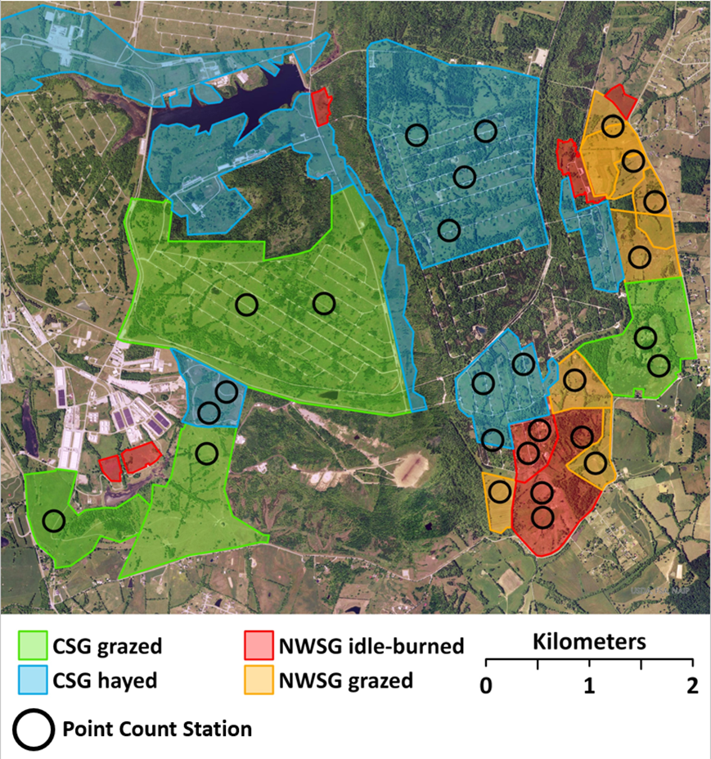

Figure 3.2. Map of spring point count locations (black circles = 150 m radius distance guides) and general cover type delineations (not depicted: forest and shrub). Blue Grass Army Depot, Richmond, Kentucky, USA, 2019-2021. NWSG = Native warm-season grass, CSG = Cool-season grass.

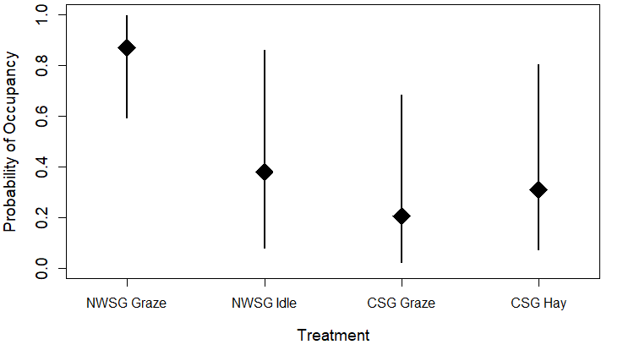
Figure 3.3. Probability of occupancy of northern bobwhite in 4 major cover type treatments. NWSG = native warm-season grass, CSG = cool-season grass. Error bars indicate 95% credible intervals. Blue Grass Army Depot, Madison County, KY. 2019-2021.

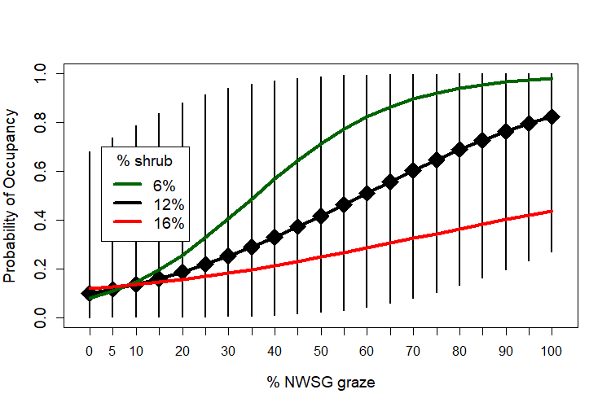
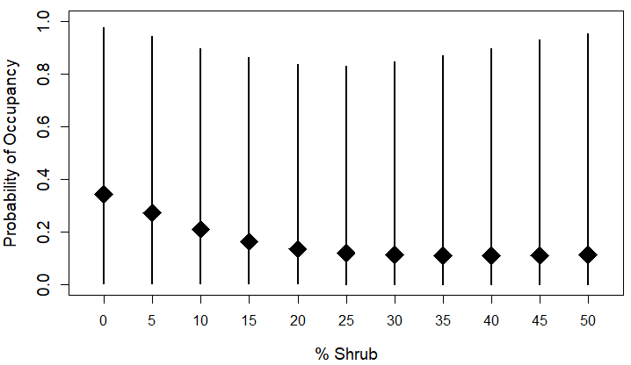 | 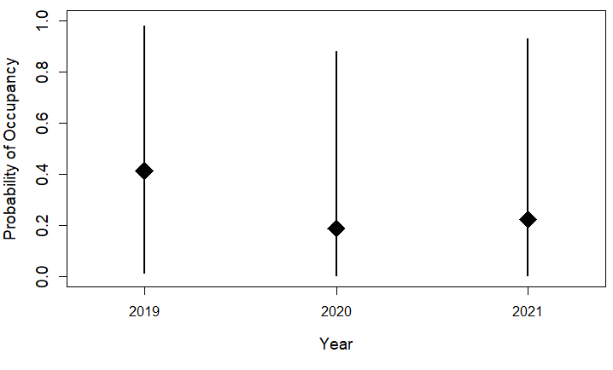
Figure 3.4. Probability of occupancy of Henslow’s sparrow with increasing cover of grazed native warm-season grass (NWSG), decreasing cover of shrub, and annual differences (Year). Error bars indicate 95% credible intervals. Only the error bars for the mean value of shrub (12%) are included for clarity; 6% and 16% represent the interquartile range. Blue Grass Army Depot, Madison County, KY. 2019-2021.

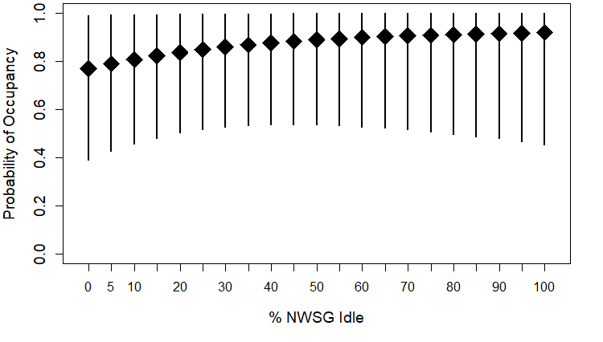
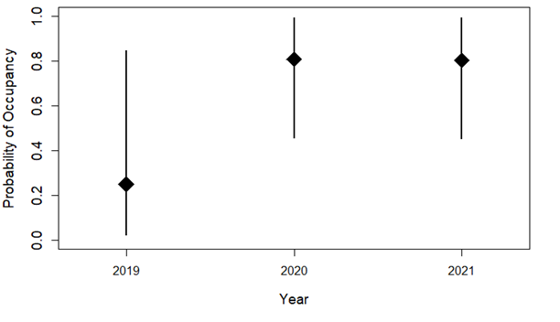
Figure 3.5. Probability of occupancy of common yellowthroat with increasing cover of idle native warm-season grass (NWSG) and annual differences (Year). Error bars indicate 95% credible intervals. Blue Grass Army Depot, Madison County, KY. 2019-2021.

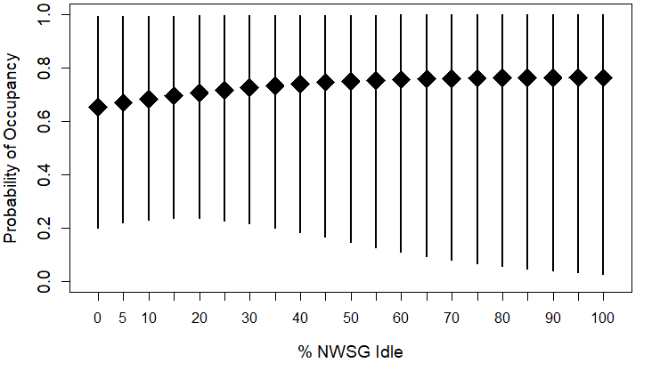
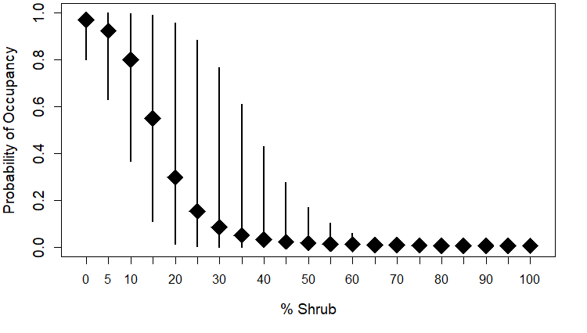
Figure 3.6. Probability of occupancy of eastern meadowlark with increasing cover of idle native warm-season grass (NWSG) and decreasing cover of shrub. Error bars indicate 95% credible intervals. Blue Grass Army Depot, Madison County, KY. 2019-2021.

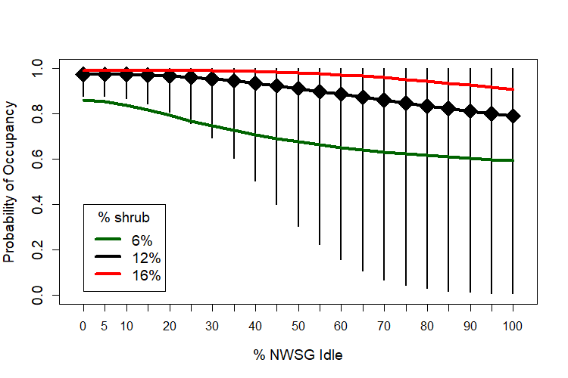
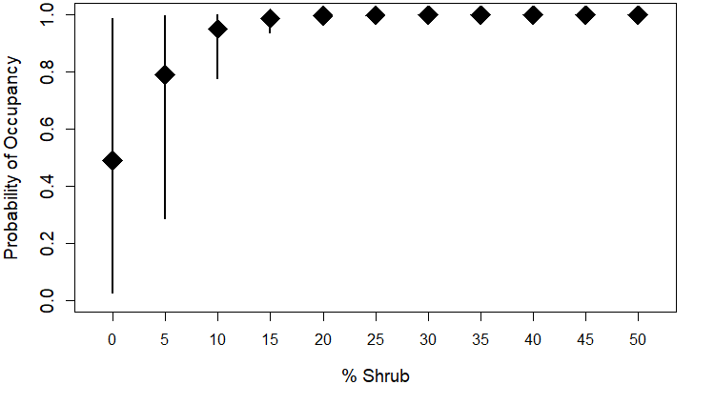
Figure 3.7. Probability of occupancy of field sparrow with increasing cover of idle native warm-season grass (NWSG) and increasing cover of shrub. Error bars indicate 95% credible intervals. Only the error bars for the mean value of shrub (12%) are included for clarity; 6% and 16% represent the interquartile range. Blue Grass Army Depot, Madison County, KY. 2019-2021.

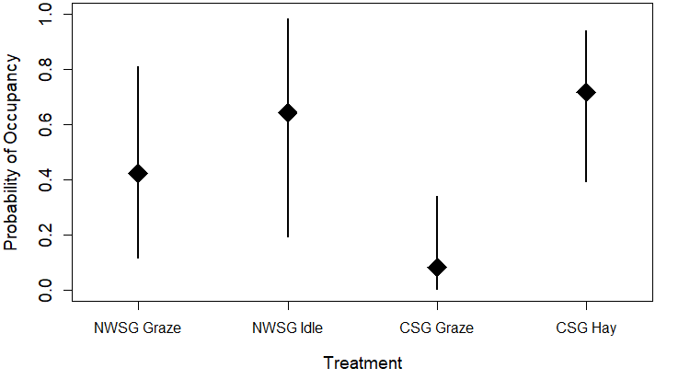
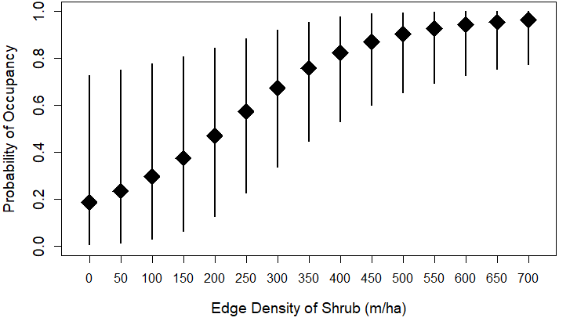
Figure 3.8. Probability of occupancy of prairie warbler by treatment and with increasing shrub edge density. Error bars indicate 95% credible intervals. NWSG = native warm-season grass. CSG = cool-season grass. Blue Grass Army Depot, Madison County, KY. 2019-2021.

CONCLUSION

As the northern bobwhite (Colinus virginianus; “bobwhite”) and the majority of other North American grassland-associated bird species have continued to decline, conservation strategies must be explored (Brennan 1991, Brennan and Kuvlesky 2005, Sauer et al. 2017, Rosenberg et al. 2019). These declines have been most pronounced in the southeastern US (Brennan 1991, Peterjohn and Sauer 1999). This region is also largely privately owned and most of the native grasslands have been converted to tall fescue (Lolium arundinaceum) forage production for the cattle industry, an area known as the “Fescue Belt” (Kallenbach et al. 2012, Keyser et al. 2019). Tall fescue has been associated as poor habitat for bobwhites and other grassland birds for decades (Brennan 1991, Barnes et al. 1995). Native warm-season grasses (NWSGs) have been recommended as bird habitat starting as early as George et al. (1979), and have continued to be promoted (Washburn et al. 2000, USDA-NRCS 2006, West et al. 2012). These grasses are also an effective alternative livestock forage, exceeding the quality of some other forages and provide benefits to producers (Keyser et al. 2016, Backus et al. 2017, McFarlane et al. 2018). The benefits for some grassland birds have been studied where NWSGs are integrated into cattle production systems (Harper et al. 2015, West et al. 2016). Given the potential benefits for both cattle and birds and the large area of the Fescue Belt, a working lands conservation approach may be effective (Keyser et al. 2019, 2022). However very few empirical studies have been done on this topic for bobwhites.
My study was unique in that it was conducted in a working lands context: where exotic CSG pastures and hayfields that were immediately adjacent to NWSG pastures and idle fields. This allowed me collect data that would be applicable to working lands conservation efforts for bobwhites that concerned occupancy, survival, and resource selection.
The occupancy of bobwhites and Henslow’s sparrows (Centronyx henslowii) was positively associated with grazed NWSGs. Bobwhites used traditionally-managed CSG less than expected and grazed NWSGs more than expected at the home range scale in both breeding and non-breeding season. These use patterns at the home range scale were corroborated by use of NWSGs and wood stems at the local scale. Similarly, bobwhites avoided encroaching CSGs in NWSG pastures at the local scale. Survival rates of bobwhites were also positively associated with an interaction of grazed NWSG and shrub interspersion that, under certain conditions, had estimated survival rates exceeding suggested values required for a stable population. The results of this study suggest that a working-lands conservation model that implements NWSGs into a CSG-dominated cattle production system could provide benefits to populations of bobwhites and other grassland birds. However, it is important to understand the effects of shrub cover and interspersion when making species specific conservation goals.

Literature Cited
Backus, W. M., J. C. Waller, G. E. Bates, C. A. Harper, A. Saxton, D. W. McIntosh, J. Birckhead, and P. D. Keyser. 2017. Management of native warm-season grasses for beef cattle and biomass production in the mid-south USA. Journal of Animal Science 95:3143–3153.
Brennan, L. A. 1991. How can we reverse the northern bobwhite population decline? Wildlife Society Bulletin 19:544–555.
Brennan, L. A., and W. P. Kuvlesky. 2005. North American grassland birds: an unfolding conservation crisis? Journal of Wildlife Management 69:1–13.
George, R. R., A. L. Farris, C. C. Schwartz, D. D. Humburg, and J. C. Coffey. 1979. Native prairie grass pastures as nest cover for upland birds. Wildlife Society Bulletin 7:4–9.
Harper, C. A., J. L. Birckhead, P. D. Keyser, J. C. Waller, M. M. Backus, G. E. Bates, E. D. Holcomb, and J. M. Brooke. 2015. Avian habitat following grazing native warm-season forages in the mid-south United States. Rangeland Ecology and Management 68:166–172.
Kallenbach, R. L., J. J. Crawford, M. D. Massie, M. S. Kerley, and N. J. Bailey. 2012. Integrating bermudagrass into tall fescue-based pasture systems for stocker cattle. Journal of Animal Science 90:387–394.
Keyser, P. D., D. A. Buehler, J. H. Fike, D. L. Finke, S. D. Fuhlendorf, J. A. Martin, H. D. Naumann, and S. R. Smith. 2022. The birds and the bees: producing beef and conservation benefits on working grasslands. Agronomy 12:1–17.
Keyser, P. D., D. A. Buehler, K. Hedges, J. Hodges, C. M. Lituma, F. Loncarich, and J. A. Martin. 2019. Eastern grasslands: conservation challenges and opportunities on private lands. Wildlife Society Bulletin 43:382–390.
Keyser, P. D., E. D. Holcomb, C. M. Lituma, G. E. Bates, J. C. Waller, C. N. Boyer, J. Travis Mulliniks, T. J. Mulliniks, and J. Travis Mulliniks. 2016. Forage attributes and animal performance from native grass inter-seeded with red clover. Agronomy Journal 108:373–383.
Krueger, C. R., and D. C. Curtis. 1979. Evaluation of big bluestem, indiangrass, sideoats grama, and switchgrass pastures with yearling steers. Agronomy Journal 71:480–482.
McFarlane, Z. D., C. Boyer, and J. T. Mulliniks. 2018. Profitability of developing beef heifers on stockpiled winter forages. Journal of Applied Farm Economics 2.
Peterjohn, B. G., and J. R. Sauer. 1999. Population status of North American grassland birds from the North American breeding bird survey, 1966-1996. Studies in Avian Biology 19:27–44.
Rosenberg, K. V., A. M. Dokter, P. J. Blancher, J. R. Sauer, A. C. Smith, P. A. Smith, J. C. Stanton, A. Panjabi, L. Helft, M. Parr, and P. P. Marra. 2019. Decline of the North American avifauna. Science 366:120–124.
Sauer, J. R., K. L. Pardieck, D. J. Ziolkowski, A. C. Smith, M.-A. A. R. Hudson, V. Rodriguez, H. Berlanga, D. K. Niven, and W. A. Link. 2017. The first 50 years of the North American breeding bird survey. The Condor 119:576–593.
West, A. S., P. D. Keyser, C. M. Lituma, D. A. Buehler, R. D. Applegate, and J. Morgan. 2016. Grasslands bird occupancy of native warm-season grass. Journal of Wildlife Management 80:1081–1090.

VITA
Douglas Bryan Mitchell was born and raised in a rural area of the Ozarks. It is now a very different time and very different place.

