Black Tie Poems:
An Exploration of Formal Poetry

by

Shelby Tansil

Introduction
It has been said that Ezra Pound’s famous poem, “In a Station of the Metro,” was originally 30 lines long (Kennedy). But for whatever reason, Pound was unsatisfied with the length. Eventually, he cropped it down to two lines, using a form resembling the traditional Japanese haiku. The final product has been reprinted in countless poetry anthologies and helped make Pound one of the best-loved modernist poets of all time. Here is the poem in its entirety:

The apparition of these faces in the crowd;
Petals on a wet, black bough. (Pound)

Form plays a crucial role in the poem’s success. Somehow the brevity makes the poetic message even stronger. The cropped form fits the fast-paced atmosphere of the metro and it allows Pound to directly compare the image of the faces in a crowd with the image of petals on a tree branch. Did Pound realize these formal effects at the time he was writing this? Why did he choose to write such a short poem? Would his original, 30-line version of the poem have made it into our contemporary literary anthologies?
I have long been curious about how poems get their forms. It fascinates me that some poets tend to write in free verse while others tend to write in more traditional, structured forms. And that some forms seem to work better with certain themes. Anachronisms aside, imagine if The Odyssey had been squashed into a light-hearted clerihew, or if one of Basho’s haikus had been stretched into an epic poem? Surely, that would have been bizarre. But why?
My senior honors thesis seemed like the perfect opportunity to explore my curiosity about poetic form, especially because the University of Tennessee does not currently offer any courses exclusively on this subject. It also seemed like a useful tool for improving my general knowledge of poetry and my own writing. So, I decided to write a collection of poetry exploring various poetic forms.
Ideally, I would have experimented with every poetic form in existence. Due to time constraints, I decided to focus on nine unique forms: the acrostic, blackout poetry, the clerihew, the ghazal, rimas dissolutas, the sestina, sijo, the sonnet and syllabic verse. From Korea to Arabia to the United States, these forms come from a variety of cultures and poetic traditions. Their origins date to unique time periods, ranging from the acrostic’s emergence in Ancient Greece to blackout poetry’s much more recent appearance in the 2000’s. In addition to these forms, I also explored the traditional meter of common measure. Please note that from now on when I use the word “form,” I will be referring to both the aforementioned poetic forms and common measure, even though it is not technically a form itself.
This semester, I read poems written in each of these forms, wrote my own poems, and then discussed them with my thesis director, Dr. Arthur Smith, and my second reader, Dr. Marcel Brouwers. During the process, I was primarily concerned with learning about the characteristics, advantages, and disadvantages of each poetic form. I thought that by exploring these fundamental elements I might gain greater insight into what draws poets to these particular forms.
Before I discuss what I have learned from this process, I will explain what I consider to be the biggest flaw in my thesis’s approach to poetic form. In order to give myself a sense of structure, I chose to spend 1-2 weeks focusing on each form. In other words, I wrote poems in only one style during each time period. Because I approached each poem with a specific form in mind, my approach was somewhat unnatural. I think some of the poems feel forced into a given style as a result. For two of these poems, “the stay-at-home skeptic” and “The Desert, My Father & Me,” I have decided to include both the original version and a revised version that breaks the form but seems to be more effective. In “the stay-at-home skeptic,” the form is only altered slightly—though it is enough to make it no longer an acrostic poem. On the other hand, I have completely changed the form of “The Desert, My Father & Me,” from an acrostic poem to a prose poem. The prose poem is not one of the forms I cover in my thesis, but I decided to include this revised version to demonstrate how dramatically form can alter the effect of a poem.
I will now walk through the forms I worked with this semester and highlight what I have learned about their characteristics, advantages and disadvantages.

Acrostic
Origin: Ancient Greece
Scholars believe the acrostic was originally used in the “oral transmission of sacred texts.” (Preminger). Despite these lofty origins, I associate this form with my middle school classroom. I remember being taught how to write acrostics of my own name and the names of loved ones. The acrostic is a great gateway poetic form for children because of its simple structure. There is only one rule: the first letters in the lines must combine to spell out a word or phrase.
The acrostic form can make poems more personal and convey hidden messages, which provides a certain aesthetic appeal. However, it has one major disadvantage: it can be distractingly obvious to readers. Thankfully, there are a few tools writers can use to make acrostics less obvious. Frank O’Hara’s “You Are Gorgeous and I’m Coming” does an excellent job of hiding his lover’s name: “Vincent Warren.” O’Hara uses enjambment and indentation to disguise the form. The opening lines read:

Vaguely I hear the purple roar of the torn-down Third Avenue
El
it sways slightly but firmly like a hand or a golden-downed
thigh
normally I don’t think of sounds as colored unless I’m
feeling corrupt (O’Hara 1-3)

O’Hara further obscures the form by varying the capitalization at the start of each line. Many classic acrostic poems, such as Lewis Carroll’s “A Boat Beneath a Sunny Sky” and Dabney Stuart’s “Discovering My Daughter,” capitalize all of the letters that spell out the hidden word or phrase. The acrostic message is quickly recognized in these poems, taking away the sense of discovery that O’Hara’s poem offers.
I mimicked the style of “You Are Gorgeous and I am Coming” in my poems, “the stay-at-home skeptic” and “Clock Tower Peace.” Although I also experimented with a more traditional acrostic style in “And Now, Me,” I think my Frank O’Hara-style poems are more interesting because they require readers to engage with the poem on a deeper level.

Blackout Poetry
Origin: United States, c. 2010
Blackout poetry is one of the latest editions to the canon of poetic form. Austin Kleon, a cartoonist and web designer, popularized the form in 2010 with the release of his book, Newspaper Blackout (Kleon). To write blackout poetry, find an existing text—typically a newspaper—and use a permanent marker to cross out words until the remaining words form a poem. This form has become incredibly popular on the Internet, especially on Tumblr blogs (Kleon). Blackout poetry comes from the tradition of found poetry, which became prominent in the 1900’s. The Academy of American Poets states:

Found poems take existing texts and refashion them, reorder them, and present them as poems. The literary equivalent of a collage, found poetry is often made from newspaper articles, street signs, graffiti, speeches, letters, or even other poems. (“Poetic”)

For me, blackout poetry was even more fun to write than the comedic clerihew. The multimedia aspect made it different from any other form I experimented with this semester. Blackout poetry also allows poets a lot of freedom in the physical presentation of poems. In my poem, “For Me, There’s No Going Back,” the words connect like a flow chart. But in another poem, “Bed Head,” I drew a picture of two faces around the text. Blackout poetry, like the acrostic, can benefit a poem on an aesthetic level.
The fact that all of the words in a blackout poem must come from an existing text poses a unique challenge. On the one hand, this is limiting to the poem’s vocabulary. On the other hand, it pushes poets to use words they would have never considered using otherwise. I realized this while writing “For Me, There’s No Going Back,” which closes with the unusual phrase, “Goosebumps. Goosebumps.”
In addition to its limited vocabulary, blackout poetry can also suffer from complicated graphics. It can be difficult to tell which direction a blackout poem reads. For example, in my poem, “Elliot and His Gun,” even I will admit that it is hard to tell where to start reading. If the font in the found text is small, or if the poet crosses out too much, it can become even harder to read. I chose not to include some of the blackout poems I wrote because I accidentally blacked out part of a letter or two. Note to self: Sharpie bleeds.

Clerihew
Origin: England, Early 20th century
Ah, the clerihew. I had quite a bit of fun working with this form. Clerihews are comical, biographical poems, traditionally written about well-known public figures. The form was crafted by then schoolboy Edmund Clerihew Bentley, in an attempt to entertain his friend (White 238). The rules are simple: clerihews should be four lines in length, follow the rhyme scheme aabb, and include the subject’s name at the end of the first line. There are no restrictions on line length or meter, and these are often altered to create an awkward, humorous effect. This form is intended to be playful and mocking toward its subjects.
Clerihews have several advantages. First, they are delightfully fun to write and read. Writing in this form reminded me that there is no such thing as a proper way to write poetry. It can be serious or silly, light or dark, deep or shallow. Second, clerihews are low investment. If I write a crummy clerihew, it does not matter very much. I can just think of a new name and write another poem, all within a few minutes’ time. Third, because clerihews are short and comical, they can briefly help ease tension and provide comedic relief. Many of my thesis poems are about death, loneliness and other heavy themes. I think the clerihew section provides a nice moment of levity. Furthermore, the short length of this form allows readers a chance to catch their breath between longer poems. Sijo, though traditionally more serious in content than the clerihew, also has this effect because of its similarly short length.
The flip side is that the clerihew’s humor and low investment hinder its ability to tackle more serious themes. In Poetic Meter & Poetic Form, Paul Fussell states, “Immense frivolity…is the inseparable accessory of the four-line stanza called the clerihew, a whimsical kind of quatrain” (Fussell 138). Even the clerihews I wanted to have more serious themes—“Candidate Donald Trump” and “Edward Joseph Snowden”—were unable to escape the ridiculousness and cheesiness of the clerihew.

Common Measure
Origin: Traditional hymns and ballads; Popularized in English poetry c. 19th century
Common measure is a poetic meter that alternates between iambic tetrameter and iambic trimeter. Each stanza contains four lines. The rhyme scheme is abab cdcd, etc. Although common measure has existed for hundreds of years in hymns and ballads, it is perhaps best known in poetry circles for its frequent appearance in Emily Dickinson’s work. “Because I could not stop for Death (479)” and “I heard a Fly buzz - when I died - (591)” are two examples of common measure poems.
Writing in any iambic meter is tricky because as John Ridland points out, “In the twentieth century…iambic meter has been charged with monotony” (Ridland 40). Poets writing in common measure face an additional challenge because of its potentially distracting, sing-song rhythm, which makes it great for hymns and ballads. To avoid monotony, poets can vary their sentence endings (e.g. switching between enjambment and end-stopped lines), make substitutions for iambic feet and vary their line length (41-43).
My poem, “The Desert, My Father & Me,” follows the common measure meter/rhyme scheme closely, with few substitutions. This, in combination with the poem’s relatively long length, makes the poem overly sing-songy and perhaps also monotonous. Because of this, I decided to rewrite the poem without adhering to the common measure form. It turned into a prose poem, which I have decided to include alongside the original version. I believe my other common measure poem, “Confession,” is more successful because I made substitutions for some iambic feet and varied the line length more frequently.

Ghazal
Origin: Arabia, c. 7th century
Like the sestina, the ghazal relies on a pattern of repeated end words. Ghazals consist of a minimum of five couplets and have a unique rhyme scheme, which accompanies the repeated end words. The rhyme/end word scheme was incredibly confusing to me until I read “Ghazal: To Be Teased into DisUnity” by Agha Shahid Ali, one of the best known ghazal poets of the 20th century. In this essay, Ali explains,

The opening couplet (called matla) sets up a scheme rhyme (qafia) and a refrain (radif) by having it occur in both lines. Then this scheme occurs only in the second line of each succeeding couplet. That is, once a poet establishes the scheme—with total freedom, I might add—s/he becomes its slave. (Ali 210)
We can see this rhyme/end word scheme at work in the opening lines of Rafique Kathwari’s “Jewel House Ghazal”:

In Kashmir, half asleep, Mother listens to the rain.
In another country, I feel her presence in the rain.

A rooster precedes the Call to Prayer at Dawn:
God is a name dropper: all names at once in the rain. (Kathwari 1-4)

The refrain, “to/in the rain,” appears twice in the opening couplet and once in the subsequent couplet. Likewise, we can see the rhyme twice in the opening couplet (“listens,” “presence”) and once in the subsequent couplet (“once”). In ghazals, the rhyme immediately precedes the refrain.
The repeated end words/rhymes give the ghazal a musical feel, which makes sense considering that they were traditionally sung in front of a live audience. These poems also often appeal to a “profound and complex cultural unity,” despite the fact that each couplet is intended to be “thematically and emotionally complete in itself” (Ali 210). If a poet is working with subject matter related to music, culture or a specific community, the ghazal could be a great form in which to test drive the poem. Additionally, the inherent clash between unity and disunity in the ghazal makes it work well with contradictory or chaotic subjects.
In my poem, “Hey, College Kid,” I tried to address some of the contradictory things that college students experience. For example, many students are simultaneously “beer-stained” (1) and intelligent and hardworking: “You are the beautiful brain, college kid” (2). I wanted to provide a more holistic representation of college students by highlighting the disunities among our experiences.
The main disadvantages of the ghazal are identical to those of the sestina. The form can distract readers, feel monotonous and give the poet a hard time, depending on which end words/rhymes she picks. I found it especially challenging to commit to rhymes. Because they must appear directly before the refrain, I struggled to find words that would make grammatical sense. In my ghazal, “Isla Vista: May 23, 2014,” I decided to explore what would happen if I dropped the rhyme scheme but kept the pattern of end words. Dropping the rhyme scheme gave me more freedom, but it also took away some of the poem’s musical quality.

Rimas Dissolutas
Origin: France, c. 12th-13th centuries
In this form, “each line of a nonrhyming stanza (which may be of any length) rhymes with its corresponding line in subsequent stanzas. For example, a three-stanza poem in four line stanzas would rhyme abcd abcd abcd” (Dacey 440). This form is intended to be written in isosyllabics—meaning that all lines have the same syllable lengths.
In an age where rhyme seems to have fallen out of fashion, rimas dissolutas seems like the perfect hybrid of rhyme and contemporary preference. The rhymes are subtle—and sometimes even unnoticeable—because of the distance that lies between them. This produces a beautiful echo effect between the different stanzas.
The downside to this form is that it can be difficult to keep up the intricate rhyme scheme. In my poem, “Takeout Night,” I struggled to find a rhyme for the fourth line in each stanza. To keep the poem as close to the meaning I intended, I eventually re-used the word, “going,” in the final line, despite my desire to make each end word unique. Additionally, I significantly altered the rimas dissolutas form in my poem, “What I Learned from the Cooks.” Instead of maintaining the same rhyme scheme throughout the entire poem, I wrote a series of paired stanzas that each share a rhyme scheme. In this manner, the poem is more like a series of connected rimas dissolutas poems than it is like a single unified rimas dissolutas poem.

Sestina
Origin: France, c. 12th century
The sestina was the most challenging form I tried this semester. It consists of six sestet stanzas, followed by a three-line envoi. Repetition is paramount in this form, with the same end words used in each sestet stanza, but in a unique order. Typically, the envoi also uses these same end words, with two in each line.
The primary downsides to the sestina are clear: 1) it is a hassle to get all of the end words in their proper positions, 2) the lines risk becoming monotonous and 3) the form can distract the reader. In his essay, “Sestina: The End Game,” Lewis Turco suggests that poets can avoid monotony and distraction by using enjambment, as well as homographs and ploys (e.g. “can and toucan) for the end words. (Turco 291). Another issue, which I had not considered until I began experimenting with sestinas for myself, is that it can be difficult to choose the right end words. In my sestina, “Father America,” I backed my imagination into a corner by choosing to include the end word, “blanket.” Not that the word could not work well in another poem, but it is perhaps too far flung from the context of the poem to naturally use seven times. The next time I write a sestina, I will make sure to brainstorm words for a while, instead of rushing into the structure with the first six words that seem halfway decent.
If sestinas are such a hassle, why write them? When it is functioning properly, I do not think there is any poetic form as beautiful or entrancing. The rhythmic repetition is almost hypnotic. Peter Cooley’s “A Place Made of Starlight” uses the sestina form to suck readers into the atmosphere of the poem. In the opening stanzas, he writes:

This is the woman I know to be my sister.
Wizened, apple-sallow, she likes her room dark
inside the nursing home’s glare. She barely sees me,
black shades drawn against the radiant autumn day,
purple, hectic yellow streaming from the trees.
I stand and stare. One of us has to speak.

How are you? FINE. Why did I try to speak
as if we could talk, a brother and a sister
perched on the same branch of our family tree?
We share our parents. But the forest, suddenly dark,
dwarfs me always, now I’m here, where I see me,
fifty years back, ten years younger, even today. (Cooley 1-12)

By using the end words, “dark” and “trees,” Cooley creates an ominous, forest-like setting. This dark setting becomes inescapable due to the repetition that occurs in the sestina form. As a result, readers experience the same trapped feeling as the speaker of the poem. The sestina is a useful form for writing about themes involving entrapment of a physical or psychological nature.

Sijo
Origin: Korea, c. 14th century
Like the ghazal, sijo is traditionally sung to music. Today, sijo still has a strong presence in Korea. Sijo practitioners, young and old, sing the poetry to the beat of a folk drum. Some schools require children to memorize sijo and rural farmers use scrolls of it as wallpaper to decorate their homes. Classic sijo themes include: country life, nostalgia, love and scenes of ordinary life (Rutt). The form is composed of three lines, each of which contains 14-16 syllables. Tap Dancing on the Roof: Sijo (Poems) explains the traditional purpose of each line: “The first line introduces the topic. The second line develops the topic further. And the third line always contains some kind of twist—humor or irony, an unexpected image, a pun, or a play on words” (Park). This structural format makes the sijo feel somewhat like a condensed sonnet.
The most challenging aspect of the sijo for me was achieving a line length of 14-16 syllables. I generally do not write such long lines in my poetry. Though the other poems I wrote follow the appropriate meter, “Apple of My Eye” contains only 13 syllables in the first line and 11 syllables is in the final line. However, because the poem invokes the traditional sijo themes of love and nature and includes a twist in the final line, I think it can still be categorized as sijo.
Sijo’s sonnet-like structure makes it a great form for addressing questions or multiple perspectives on a topic. The tradition of writing sijo about country life makes it a meaningful format for reflecting on powerful natural imagery. We can see all of these elements working together in the following sijo from U T’ak (1262-1342):
The spring breeze melted snow on the hills, then quickly disappeared.
I wish I could borrow it briefly to blow over my hair
and melt away the aging frost forming now about my ears. (T’ak)

Sijo is similar to the haiku: short, but powerful. The poet throws readers into the poem, hits them with an image and then immediately yanks them back out.

Sonnet
Origin: Italy, c. 13th century
There are two major types of sonnet: the Petrarchan (Italian) sonnet and the Shakespearean (English) sonnet. Petrarchan sonnets contain fourteen lines, which are divided between an octave and a sestet. These poems are traditionally written in iambic pentameter with the rhyme scheme: abbaabba cdecde or abbaabba cdcdcd. Shakespearean sonnets are also written in fourteen-lined iambic pentameter, but they use a different stanza form and rhyme scheme. These sonnets have three quatrains, followed by a rhyming couplet. The rhyme scheme is: abab cdcd efef gg. Despite these variations, sonnets written in both forms present their poetic messages in the same way. They use a narrative structure in which a problem is presented, complicated, and then responded to or resolved. In Petrarchan sonnets, the octave and sestet have “clearly defined rhetorical roles. Stanza 1 (the octave) presents a situation or problem that Stanza 2 (the sestet) comments on or resolves” (Williams 80). In contrast, the first eight lines of a Shakespearean sonnet present an issue that is “dealt with tentatively in the next four lines and summarily in the terminal couplet” (82). These sudden shifts in perspective can have a jarring impact on readers.
One poem that uses these perspective shifts to its advantage is Keats’ Shakespearean sonnet, “When I Have Fears.” In this poem, the narrator uses the first three quatrains to list his fears: “that I may cease to be / Before my pen has gleaned my teeming brain” (Keats 1-2), “When I behold, upon the night’s starred face, / huge cloudy symbols of a high romance, / And think that I may never trace / their shadows” (5-8) and “That I shall never look upon thee more” (10). The speaker’s fears shift from the broad idea of death, to the idea of lost romance to the idea of losing a specific person. The issue becomes more precisely defined as the poem progresses, as is characteristic of Shakespearean sonnets. Yet we do not see how these fears impact the narrator until we reach the concluding couplet: “Of the wide world I stand alone, and think / Till Love and Fame to nothingness do sink (13-14). The sonnet asks the question: What happens when I have fears? But it does not answer right away; instead it continues to list the speaker’s fears, causing the tension to build until the poem’s final moment. This procrastinated response gives the sonnet a unique sense of angst and intensity.
Because of these qualities, I find the sonnet to be a great form for exploring topics that bother me and things that I cannot understand. For example, my Petrarchan sonnet, “In Memory of You(r Hair),” grew from questions I had related to a high school classmate’s suicide. Was he depressed? Why did his death impact me so much when I did not know him personally? Why weren’t we friends? Why could I only remember his physical features? This mixture of curiosity, shame, angst and sadness transitioned somewhat easily into a sonnet. The form also seems suitable for “In Memory of You(r Hair)” because the poem features a major shift in tone between the octet and the sestet. Between these two stanzas, the focus shifts from the shallowness of the speaker’s relationship to the “You” character to a deeper consideration of the “You” character’s death.
I struggled with other aspects of the sonnet. Although the narrative structure can have a jarring impact on the reader, it can also feel obvious. In my poem, “Progress,” this method is obstructively obvious. Between the octet and sestet, there is a shift in tone, a literal blank space and a break in the anaphora of “There have always been.” These combined elements make the sonnet form stick out like a sore thumb. Here, form takes precedence over content, which risks inhibiting the poetic meaning. Writing sonnets has taught me that forms tend to work the best when they are not obvious.

Syllabic Verse
Origin: England, c. 20th century
Syllable count plays an important role in many Eastern and Western poetic traditions, but I decided to focus solely on English syllabic verse. Unlike other syllable-counting forms, this form does not have restrictions on accent or meter. There is only one rule in syllabic verse: there must be the same number of syllables in corresponding lines of all stanzas (e.g. the 1st line of every stanza must have the same number of syllables, and so forth).
Margaret Holley’s essay, “Syllabics: Sweeter Melodies,” highlights some of the main disadvantages of syllabic verse. One issue is that poems can begin to feel robotic and monotonous if the lines containing the same syllables also have similar metrical patterns. Holley suggests using lines with odd numbers of syllables to prevent this from happening (Holley). I experienced trouble with the numerical aspect of syllabic verse. When I first started writing in this style, I counted on my fingers as I went along. I was so focused on the syllable count being perfect that I put the content on the back burner. This is apparent in “We want our buildings,” which was the first syllabic poem I wrote. Despite the poem’s short length, it is filled with uninteresting, one syllable filler words like “and” and “the.”
I had more success in later syllabic poems, such as “Love in Boxes.” For this poem, I did not count obsessively while I was writing it, but instead went back and altered lines after most of it was written. Syllabic verse also works well in this poem because of how the stanzas are broken up. I think the transition between the sixth and seventh stanza is particularly effective:

when you are carefree and singing
hip-hop songs in
your pickup truck, on
the road to nowhere

you have to be. I want for you
to always feel
that free. And if my
hand feels like a trap (21-28)

These stanzas seem like complete ideas, but they also build off of each other. The truck is both “on / the road to nowhere” and “on / the road to nowhere / you have to be.” Here, syllabic verse adds complexity to the poem. This form works best when poets focus not just on syllable count, but also on word placement.

After studying and writing in these diverse poetic forms, I have come to a couple of conclusions. First, it is difficult for a poem to succeed when any form is forced upon it. Because each form has unique characteristics, some poems work well as acrostics. Some work well as sestinas. Others do not work well in either form. I only provided post-formal versions of my poems, “the stay-at-home-skeptic” and “The Desert, My Father & Me,” but I think many of my other poems could also benefit from further altering or breaking of their forms. The most important lesson I learned this semester is how to be more flexible with my poetry. I am now giving myself permission to let a sonnet become a haiku and to let a free verse poem turn into a sestina. I structured my thesis so that I was writing toward a form each week, and I have learned that this method does not work for me. Poetic form should not be the poem’s destination; it is merely a vehicle that helps the poem get there.
Only two of the poems I wrote this semester did not begin with an end form in mind: “In Memory of You(r Hair)” and “Love in Boxes.” While I was part of the way through writing these poems, I recognized characteristics that they shared with specific forms. “In Memory of You(r Hair) came out in rough iambic pentameter and was broken up into two narrative sections, like a Petrarchan sonnet. The first two stanzas of “Love in Boxes” came out approximately in syllabic verse. In both of these poems, the forms developed almost naturally. I do not think it is a coincidence that these are two of my stronger poems. I believe they work well in large part because the forms work. From my experience, poetic form is more likely to succeed when it emerges after the writing process begins.
But the only reason these poems were able to develop somewhat naturally is that I knew the main characteristics of the poetic forms I ended up using. Reading formal poetry and books on poetic form taught me this information. For poets interested in writing in form, it is crucial to read a variety of poems written in these styles. All forms have unique rhythms, rhyme schemes, syllable counts, etc. Being able to recognize these characteristics in another poet’s work makes it possible to recognize them in one’s own work. Another benefit to reading formal poetry is that we can learn tricks from other poets. When I was writing acrostic poems this semester, I relied on Frank O’Hara’s techniques to help me disguise the form. When I was creating blackout poetry, I experimented not just with blacking out words, but also with drawing pictures around them. This is a method I saw used among some of the poems I read.
A final lesson I learned is that altering the form or breaking the rules can actually make a poetic form more effective. If the iambic meter in a poem is becoming monotonous, the poet can vary the line length. If a poem is written in syllabics, varying the number of syllables in a few lines can have an interesting, dissonant effect. Formal poetry is often seen as more restrictive than free verse, but I would argue that there is far more freedom here than meets the eye.

Bibliography
Ali, Agha Shahid. "Ghazal: To Be Teased into DisUnity." An Exaltation of Forms. Ed. Annie
Finch and Katherine Varnes. Ann Arbor: U of Michigan, 2002. 210-216. Print.
Anderson, Jon. "The Blue Animals." Strong Measures: Contemporary American Poetry in
Traditional Forms. Ed. Philip Dacey and David Jauss. New York:
HarperCollinsPublishers, 1986. 17. Print.
"Common Measure." The Poetry Foundation. N.p., n.d. Web.
Cooley, Peter. “A Place Made of Starlight.” A Place Made of Starlight. Pittsburgh: Carnegie Mellon.
2003. 27-28. Print.
Dacey, Philip, and David Jauss, eds. Strong Measures: Contemporary American Poetry in
Traditional Forms. New York: HarperCollinsPublishers, 1986. Print.
Fussell, Paul. Poetic Meter & Poetic Form (Revised Edition). New York: McGraw-Hill, 1979.
Print.
Kathwari, Rafique. "Jewel House Ghazal." An Exaltation of Forms. Ed. Annie Finch
and Katherine Varnes. Ann Arbor: U of Michigan, 2002. 214. Print.
Keats, John. "When I Have Fears." Ed. R. S. Gwynn. Poetry: A Pocket Anthology. 6th ed. New
York: Pearson Education, 2009. 130-131. Print.
Kennedy, X. J. An Introduction to Poetry. 3rd ed. Boston: Little, Brown, 1974. Print.
Kleon, Austin. Austin Kleon. N.p., n.d. Web.
Holley, Margaret. "Syllabics: Sweeter Melodies." An Exaltation of Forms. Ed. Annie
Finch and Katherine Varnes. Ann Arbor: U of Michigan, 2002. 24-31. Print.
O'Hara, Frank. "You Are Gorgeous and I'm Coming." Strong Measures: Contemporary
American Poetry in Traditional Forms. Ed. Philip Dacey and David Jauss. New York:
HarperCollinsPublishers, 1986. 254. Print.
Park, Linda Sue. Tap Dancing on the Roof: Sijo (Poems). Boston: Houghton Mifflin Harcourt,
2007. Print.
"Poetic Form: Found Poem." Poets.org. Academy of American Poets, n.d. Web.
Pound, Ezra. "In a Station of the Metro" Modern American Poetry. Ed. Louis Untermeyer.
New York: Harcourt, Brace and Howe, 1919; Bartleby.com, 1999.
Preminger, Alex, ed. The Princeton Encyclopedia of Poetry and Poetics: Fourth Edition.
Princeton: Princeton UP, 1974. Print.
Ridland, John. "Iambic Meter." An Exaltation of Forms. Ed. Annie Finch and Katherine Varnes.
Ann Arbor: U of Michigan, 2002. 210-216. Print.
Rutt, Richard, ed. The Bamboo Grove: An Introduction to Sijo. Ann Arbor: U of Michigan, 1998.
Print. Ann Arbor Paperbacks.
T'ak, U. Trans. Larry Gross. N.p.: n.p., n.d. The Sejong Cultural Society. Web. 1262-1342.
Turco, Lewis. "Sestina: The End Game." An Exaltation of Forms. Ed. Annie Finch
and Katherine Varnes. Ann Arbor: U of Michigan, 2002. 290-296. Print.
White, Gail. "Form Lite: Limericks and Clerihews." An Exaltation of Forms. Ed. Annie Finch
and Katherine Varnes. Ann Arbor: U of Michigan, 2002. 238-241. Print.
Williams, Miller. Patterns of Poetry: An Encyclopedia of Forms. Baton Rouge: Louisiana State
UP, 1986. Print.

Note: In the blackout poetry section, I used existing texts as the source material for each of my poems. The following is a list of my blackout poems along with a citation of the found text I used in each one.

1) “Bed Head”
Havrilesky, Heather. "What You Should Really Look For in a Guy." Cosmopolitan Mar.
2016: 144. Print.

2) “Elliot and His Gun”
Welch, Liz. "Love and Guns." Cosmopolitan Mar. 2016: 164. Print.

3) “For Me, There’s No Going Back”
Gioia, Michael. "For Me, There's No Going Back." Phantom of the Opera Playbill (2016): 36.
Print.

THE ACROSTIC

AND NOW, ME
Balloons, candy-colored and limping in the sun,
Rickety push carts of aguas frescas,
Orthodox Jews quietly returning home under streetlight,
Off-brand snacks crackling open,
Kids racing through Laundromats, their parents
Loading shiny quarters into the machines, sighing,
Yellow flowers peeping through sidewalk cracks and
Nobody waiting for the Sunday train.

THE STAY-AT-HOME SKEPTIC
*original version

any time lightning bugs float between
fire hydrants and stray cats,
god a prettier picture seems, and he
dances in me like light through stained glass
now what could these wandering stars
possibly be doing on my doorstep?
other times, I am opening a pickle jar
and the lid makes a small pop
somehow the line “everything is in god’s plan”
excites me more than ever
the earth was created so my hands
could open Vlasic jars, how clever!
is there anything more god-inspiring
than the beautiful bizarre?
churches can’t light my faithfire
but answerless questions take me far.

looking at pickle jars and lightning bugs,
my heart squints, in search of god’s face
only I’m distracted by barcodes, insect legs
and the heavens slowly evaporate. I
view eternity from my front door,
put on my Sunday shoes, but
eternity is too cloud white for me
I find my sanctuary in the Sunday news.

THE STAY-AT-HOME SKEPTIC
*revised, post-acrostic version

any time lightning bugs float between
fire hydrants and stray cats,
god a prettier picture seems, and he
dances in me like light through stained glass
now what could these wandering stars
be doing on my doorstep?

other times, I open a pickle jar
and the lid makes a small pop
somehow the line “everything is in god’s plan”
excites me more than ever
the earth was created so my hands
could open Vlasic jars, how clever!

is there anything more god-inspiring
than the beautiful bizarre?
churches don’t light my faithfire
but answerless questions take me far.

looking at pickle jars and lightning bugs,
my heart squints, in search of god’s face
but I’m distracted by barcodes, insect legs
and the heavens slowly evaporate.

CLOCK TOWER PEACE

If you pay a small fee, you can tour the Bath Abbey
and spy on the choir through ceiling cracks.

Near sweaty tourists, you can scale the steps,
which are misshapen like a heart.

Somewhere in the dark, the clock tower waits
to meet a crowd of new faces.

On nights like this, I long to be in the Abbey clock
where the gears silently stir the air.

My wristwatches sit on the bureau, counting stars.
These walls echo their tick-tocks, which

Never stop to catch their breath. It’s as if
I am living inside their sound.

I am always awake this time of year
when work feels long and days feel short.

Airplane tickets are not cheap, but maybe
it would be worth it to fly there and

Crawl into the clock tower’s open hands.
Maybe then I could finally sleep.

BLACKOUT POETRY

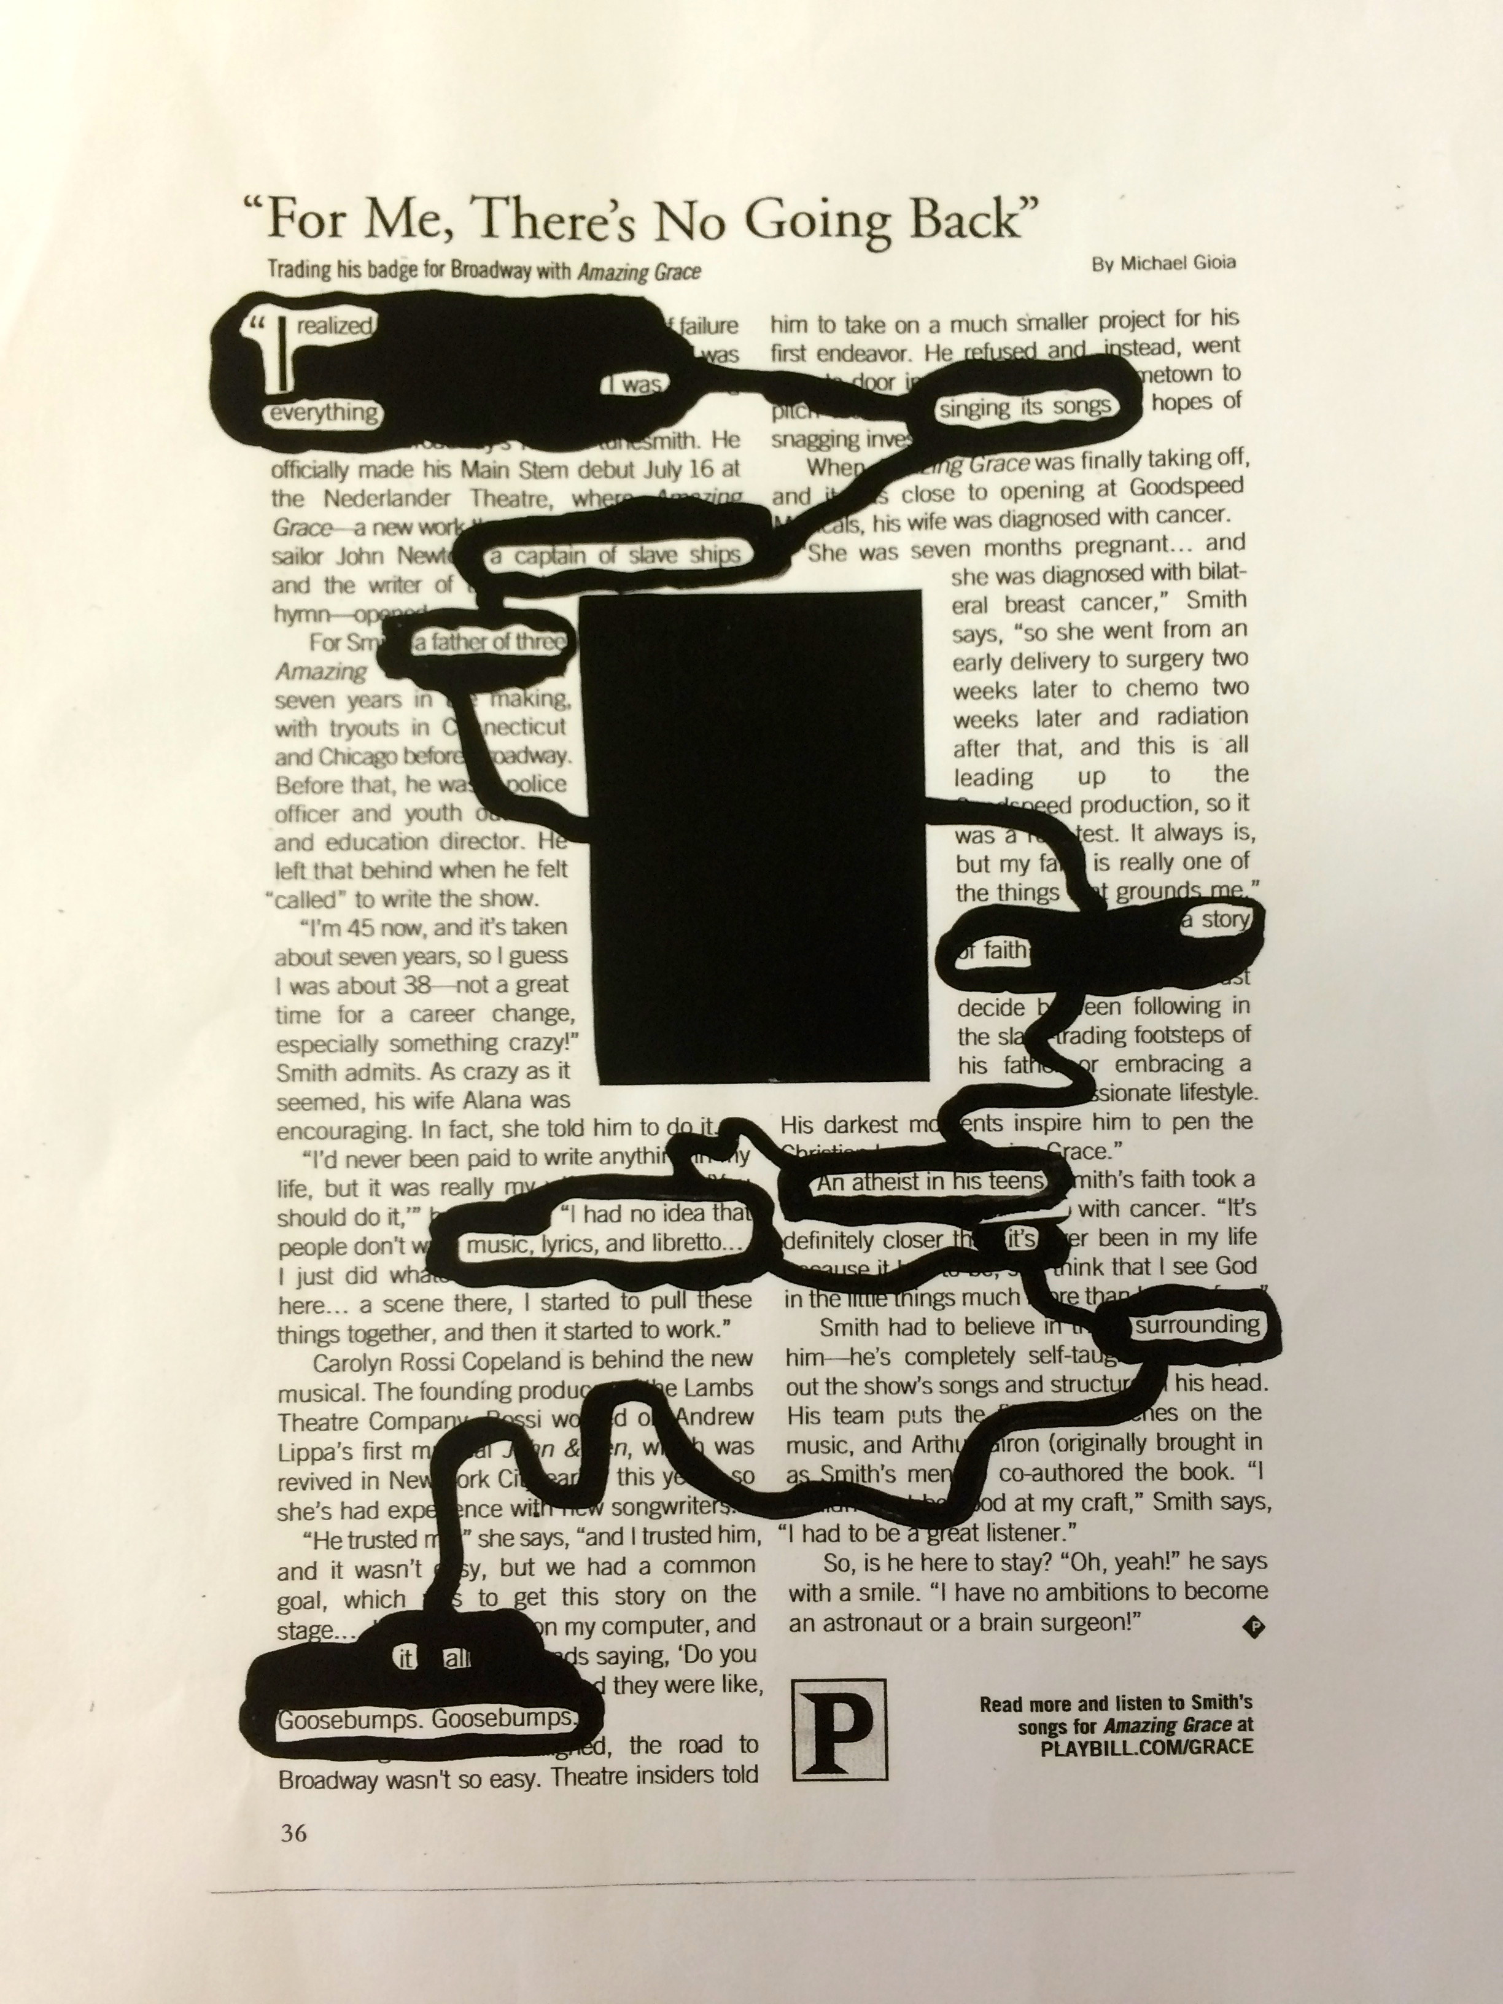
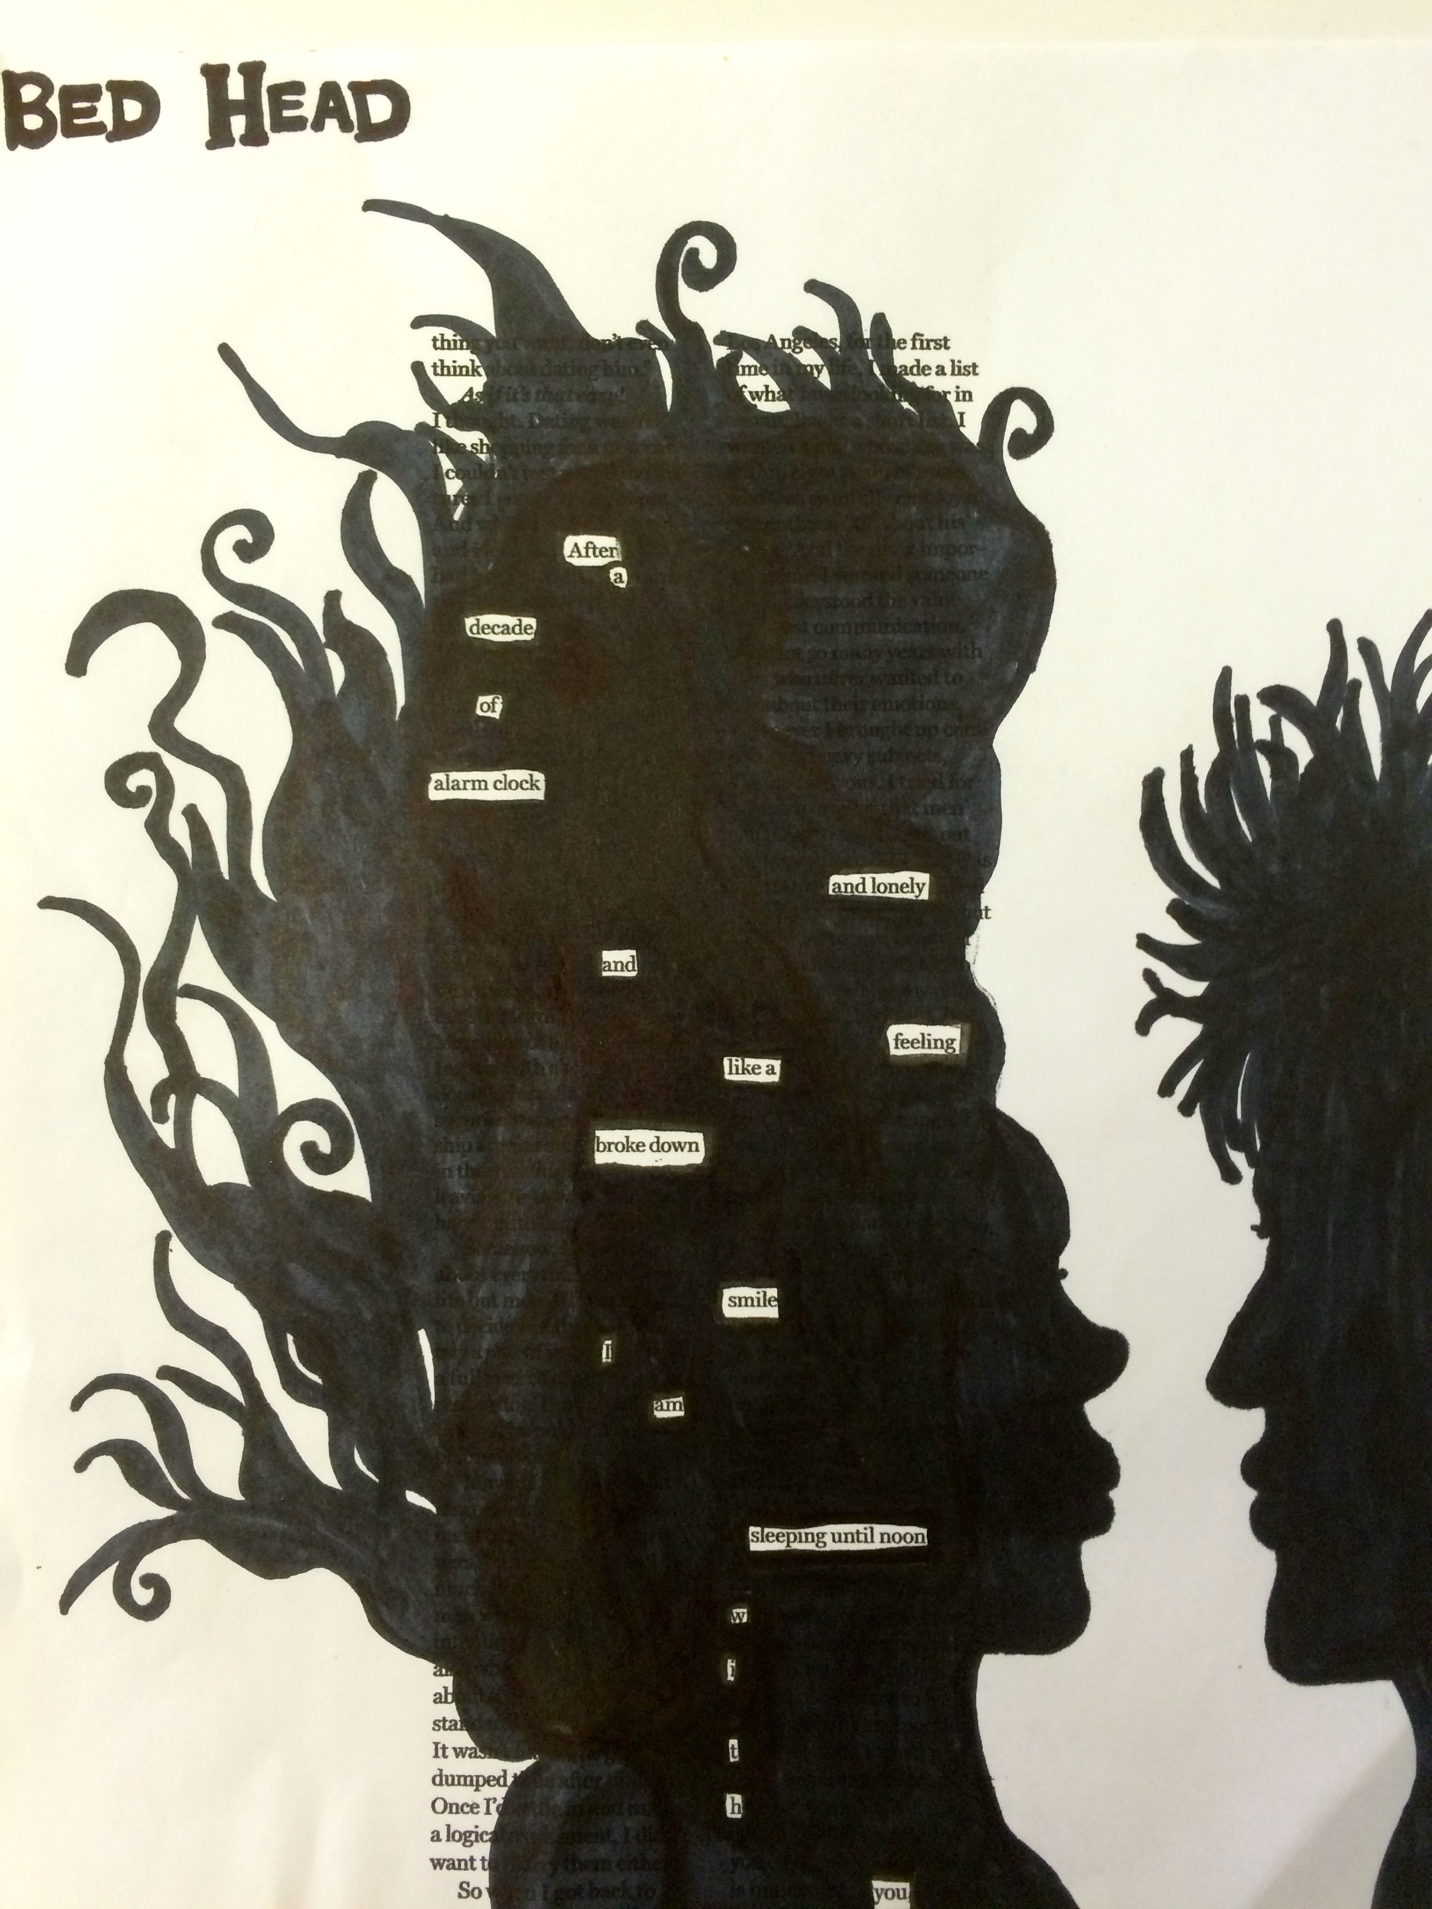

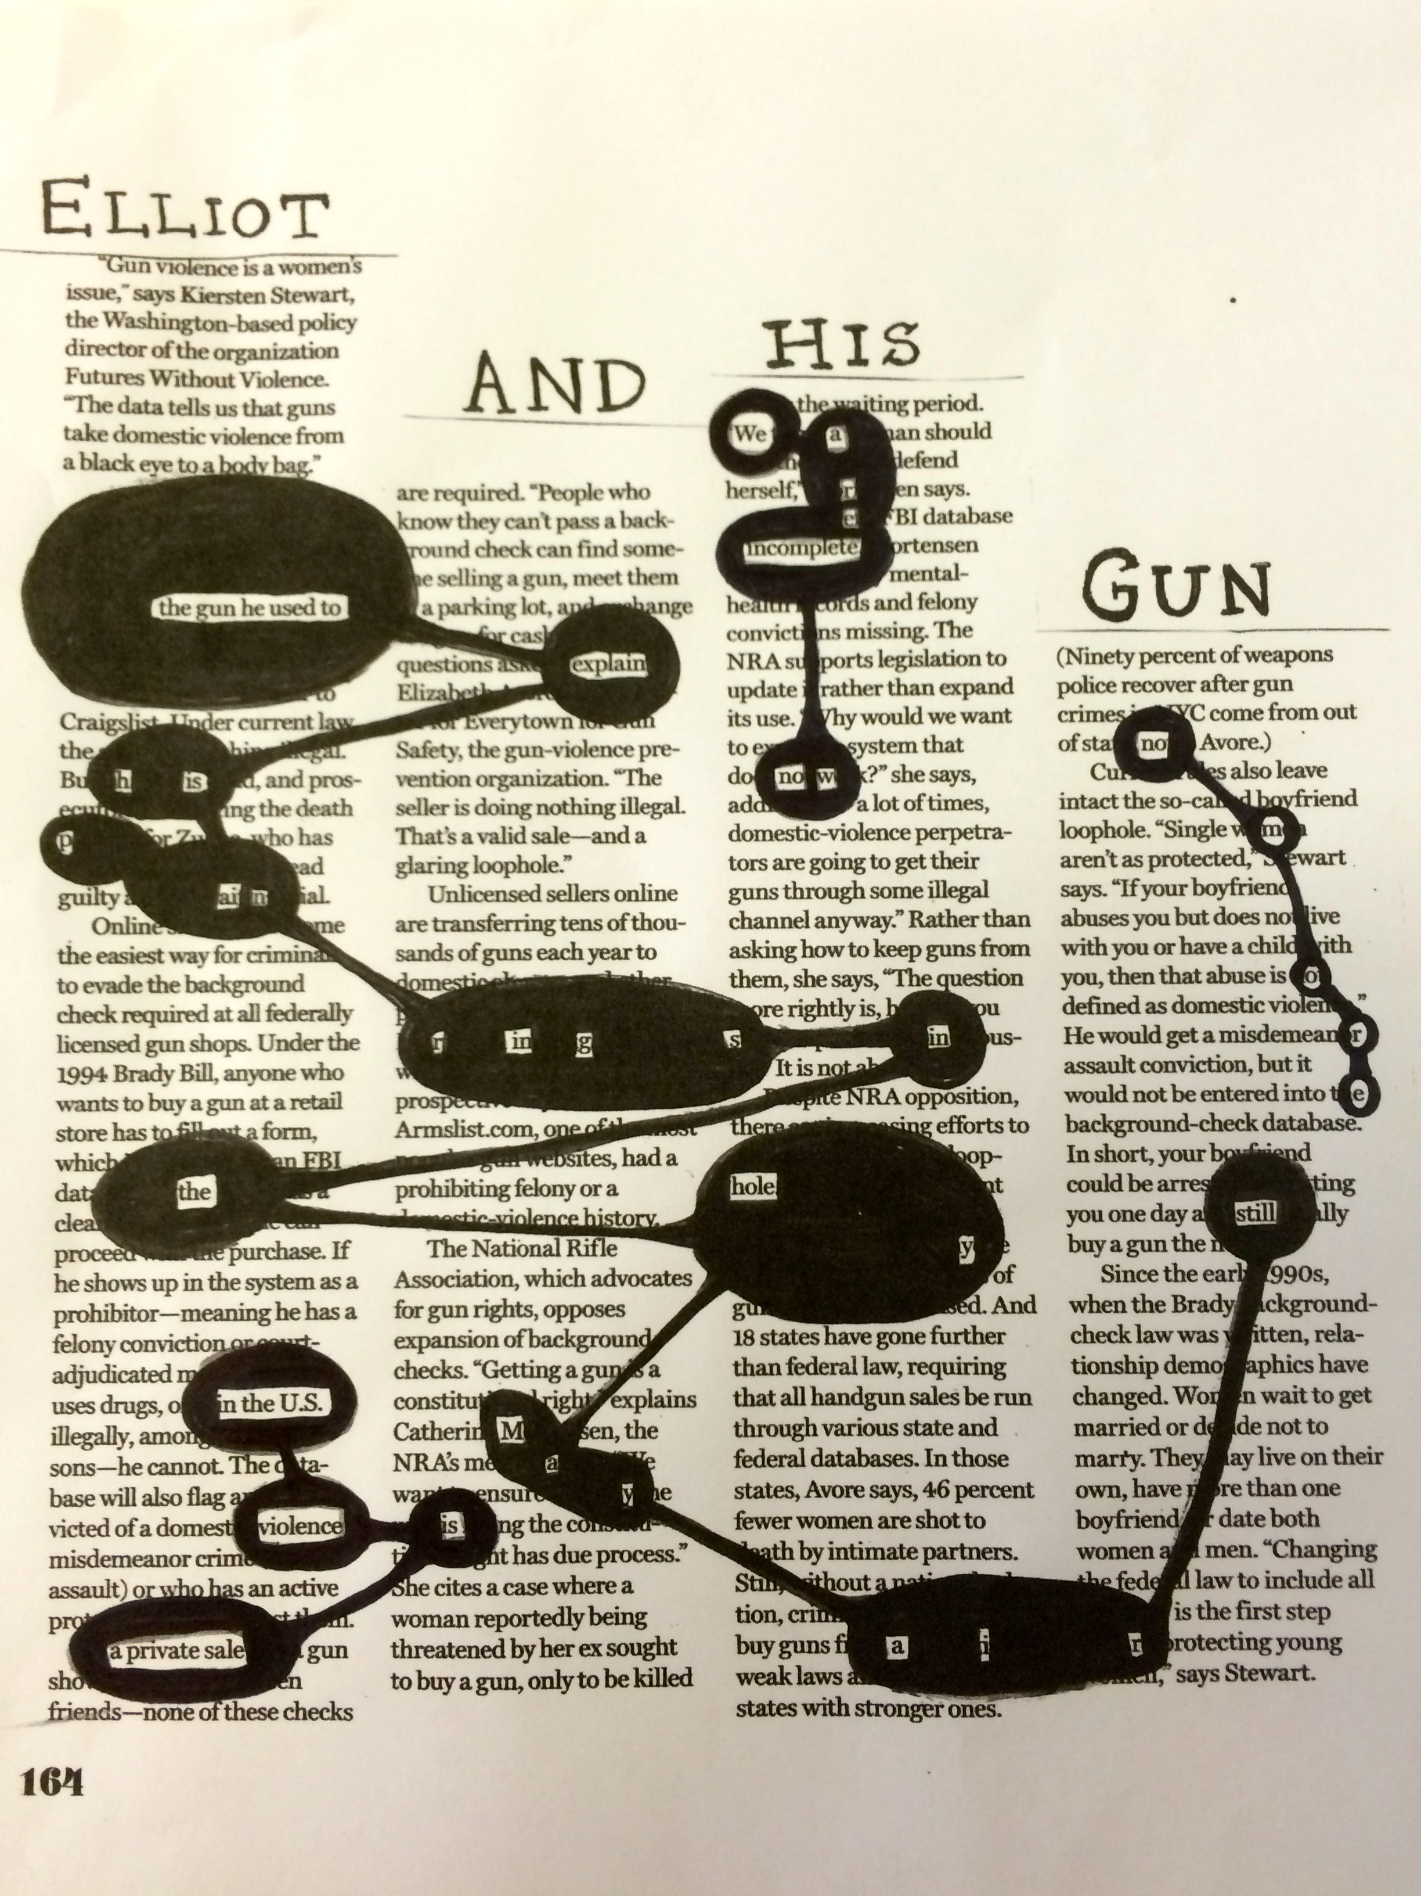
THE CLERIHEW

The dog named Rosie
had an awful long nose-y
which she used to sniff socks
and unsuspecting buttocks.

Edward Joseph Snowden
He’s in Russia, snowed in
Leaked government information
To save us from our nation.

I AM CAPSLOCK
I POUND, I DO NOT KNOCK
ON YOUR COMPUTER SCREEN
MY BEST FRIENDS ARE FEMALE TWEENS

Candidate Donald Trump
Another GOP cancerous lump
Flares up hate like an angry pimple
But filling hotel rooms was never so simple!

COMMON MEASURE

THE DESERT, MY FATHER & ME

*original version

“I love these New Mexico skies,”
my father says to me.
“The clouds are special, don’t you think?”
I tilt my head to see.

There’s something odd about the way
they stretch across the blue
As if scrawled by some carefree hand
that had nothing to do.

I nod my head. “They’re beautiful.”
Then silence kicks back in.
One hundred miles or so today,
our words are wearing thin.

My father, me. We’re great with words
when written on a page.
But here in human company,
our voices disengage.

Between my windshield wiper toes
the desert never ends,
in spite of shrubs that green the brown
and parasite the sands.

I wonder why he loves this scene
until I can recall:
He grew up in some Texas town.
He learned the desert’s crawl.

For every fact I know about
his past, I don’t know three.
I want to know his hangout spot
when he was a child, wild and free.

A few miles back we passed a town,
along route 66.
American dream built that town,
but it had gotten sick.
Abandoned buildings, broken glass
and faded product ads
for things that no longer exist.
The town was aged and sad.

To my surprise, people lived there
in small forgotten homes.
They walked and talked as people do
and did not seem alone.

My father’s past is like that town,
he’s almost let it die.
But there is beauty hidden there,
I find it when I try.

THE DESERT, MY FATHER & ME

*Revised, prose poem version

We are driving through the New Mexican desert when my father says something about the clouds. I press my nose to the window, exhaling a small cloud of my own. This sky doesn’t interest me. Tell me how the clouds looked when you tasted your first kiss. Tell me how they looked when you were eight years old, sneaking cherry tomatoes from your mother’s garden while her back was turned. Tell me how they looked after you stopped believing in God. Still, I am thankful when you say anything at all. Words fall between us, precious and rare as desert rain.

CONFESSION

Because I am not brave enough,
my love is made of paper.
A love that’s easily torn up
or kept inside a drawer.

I am scared to write your name,
so your shadow slinks alone
between printed words, claiming
metaphors for its own.

If you should ever read these poems,
you won’t know who you are.
I’ve made you into anyone.
That’s my worst crime by far.

THE GHAZAL

HEY, COLLEGE KID

You are the bloodshot, beer-stained college kid
You are the beautiful brain, college kid.

Swallow your expired Ibuprofen
Hangovers pound like a train, college kid.

Football Saturday, orange and white war paint.
Oh shit. Forecast predicts rain, college kid.

Stutter through public speech, study through night
Sleep now or you’ll go insane, college kid.

Five-dollar movies, cheap shirts and koozies
Free fitness classes—go train, college kid.

Salad bar has it all: peas, croutons, corn,
But beware of that chow mein, college kid.

Hours on laptop—doing work, watching porn
Take a break to fight eyestrain, college kid.

If you ache for home or always feel alone
Please reach out—don’t live in pain, college kid.

Use skillets for umbrellas, t-shirts for towels
Creativity is off the chain, college kid.

Forget those fools; the best years await you
Life’s not down the drain after college, kid.

ISLA VISTA: May 23, 2014

We were getting trashed like a wet lawn newspaper.
Vodka stained my mind—spilt ink on newspaper.

Sorority girls walked home from class.
Locals bought convenience store newspapers.

A few streets away, he exited the car.
Black semi-automatic in white hand: newspaper

colors. We ran outside because it sounded like fireworks
breaking the dark, the way stories break in newspapers.

The next morning we sank in the couch, watching
the nights’ events on every TV, in every newspaper.

Seven dead. His guns and knives
sliced open their skin like sharp-edged newspapers.

The living room smelled of alcohol and fruit punch.
Our mouths opened and closed like newspapers.

RIMAS DISSOLUTAS

TAKEOUT NIGHT

Plastic bag of takeout food, crumpled receipt, keys in hand.
Night air smells of gasoline and something I cannot name.
I walk past a kid my age—ear gauges, bed head, alone.
Our eyes meet. Does he also wonder where I am going?

The apartment is a dirty, inanimate wasteland
Of crusted on frying pans and dusted on window panes.
I eat with my fingers, sit on the floor,
Listen to the sound of eyelids opening and closing.

Outside, students are stepping in time to their private bands.
Music can drown out thoughts in even the noisiest brain
And it almost feels like a hug—the ears in the headphones.
Maybe they are all hearing the same song without knowing.

My roommate returns and tells me about her weekend plans.
She is the gust of wind to my old fashioned weathervane:
Stirs me from loneliness, that dull feeling which has shown
Itself over the years, like the crow’s feet growing

Next to my eyes. I age myself from the inside out and
I am bitter as the child who loses a game.
But the only one here to blame is this heart of my own.
It stays silent when I ask where I’m going.

WHAT I LEARNED FROM THE COOKS

Two summers of working in a kitchen
with well-seasoned cooks
taught me more about love
than any corny romance flick.
No rain-soaked caress
could match their reverence for food
or produce such milk white smiles.

They were positively smitten
(you could tell by one look)
with the ripe thump of
melon or a honey-thick
glaze. And they loved no less
to see the different hues
in an heirloom tomato pile.

Even carrots that bent like witches’ fingers
and gallon tubs of mayonnaise
were treated with respect.
And maybe they were loved more
because of their grotesque nature.

Memories of the summer kitchen linger
as years are lovingly spun from days.
Again and again I resurrect
How their hands opened like doors
to welcome culinary friend and stranger.

Food is not just fuel or taste;
it has a sound, rhythm and touch
in the hands of those who love it.

In the kitchen, I was a novice fool,
I’m not afraid to admit that much.
But I loved to see them covet

every inch of those earthly creations—

it was a love that made altars of food stations.

THE SESTINA

FATHER AMERICA

The founding fathers
Spread their legs and gave birth
to a ruddy-faced America.
It howled into the bright room
Of the world
And soiled its blanket.

America slept under a blanket of
Stars stolen from another’s fathers.
The Old World
Sighed. A stolen brat from birth,
The child always asked for more room.
Nothing was enough for America.

But America
Wasn’t a bad kid. It shared its stolen blanket
And left others sleep in its large bedroom.
It welcomed children, mothers, fathers
Of different religions and social births.
It said, “Let’s make this home our world.”

“I’ll make this world
my home,” shouted teenage America.
It glared, shoved, gave no one a wide berth.
America wore combat boots, blanketed
Bodies and fatherlands
In chemical dust and empty rooms.

Is there room
In this world
For a self-proclaimed father
figure like America?
My mind goes blank. It
Seems odd to be a father so soon after birth.

240 years have passed since its birth.
America is young and has much room
To grow up. On the blanket
Of the world,
A mere stitch is America,
Threaded by its forefathers.

Birth follows birth, sons become fathers
The world becomes a small room.
America clings to the past like a warm blanket.

SIJO

APPLE OF MY EYE

I slice memories of you into bite-size pieces
And suck on the sweet juice. The sugar tingles on my taste buds.
Tell me where our tree grows, if it still bears fruit.

EARTH SONG

The same rain may fall on our heads,

but not the same raindrops

The same sun may warm our bodies,

but we burn differently

The same ground may hold our feet,

but we leave only our own prints

IN THE DARKROOM

Under the pale glow, I lower paper into liquid.
Your wrinkled hands emerge and stain the whiteness of the page.
To be the space between your fingers, which knows loneliness.

MIDNIGHT IN GALWAY

The man under the moon drags his soul across his bowstrings.
Drunk, carrying their heels, girls spill out of pubs to listen.
They toss euros into his case, crying, “Play us another!”

MY GRANDFATHER AT TWO YEARS OLD

His mother’s death was a black city car, a man in a cheap suit.
His grief was walking through cornfields in a dirty diaper.
Not even the wind raised its voice to ask where he was going.

THE SONNET

IN MEMORY OF YOU(R HAIR)

For Shane

The truth is, I knew you mainly
by your hair. It always looked soft, like fountain
grass. I wonder what shampoo it wore each
day. Perhaps it smelled of mint or fresh leaves?
My friends and I would whisper when you walked
into our classroom. Hearts beating faster,
and all because we really loved your hair.
We were that high school brand of shallow.
I wonder if you ran your fingers through it
before you pulled the trigger. Did you
cry and did that wet the blonde like unheard
rain? If I could go back in time, I would.
To learn the way your thunder sounded and
brush away the thoughts that tucked you into sleep.

PROGRESS

There have always been people wailing in the street,
teenagers raped by mutual friends,
minorities warred on again and again
and poor folks licking boots of the elite.
There have always been people singing in the street,
perfumed love letters to send,
blackberry-picking at summer’s end
and infants stumbling onto first feet

We are always saying the word “progress,”
referencing some distant past.
We laugh at the Neanderthal
special featured on PBS.
“What brutes, thank God they didn’t last!”
Up next: Police kill black boy in brawl.

FAT GIRL EATING JELLY BEANS

I admit I have been eating jelly beans.
My fingertips are Cotton Candy pink,
sticky like my sweating thighs,
which are Cryovaced into jeans.
Yeah, I shouldn’t be eating them.
Shut the fuck up, brain.
They remind me of summertime
and my mom’s laughter, okay?
What else do you want me to say?
Depression is eating me up inside
and I need junk food to get through today?
I bet it’s something along those lines.
It’s true that I’m addicted to the taste and feeling.
But listen, sometimes jelly beans are just jelly beans.

SYLLABIC VERSE

WE WANT OUR BUILDINGS

but we scoff
at safety vests
and orange hard hats.

As soon as
the cranes roll in and the
boards are piled,

you can hear
the residential sigh
settling in.

We loathe the
hammers, the drills, the nails.
How will we sleep

in our beds
or enjoy a quiet
dinner at the

kitchen table?

AT ANY MUSEUM IN THE WORLD

Remember Amsterdam?
Disoriented
by flowered bikes and foreign language,
your eyes swung
between the pavement and the constellations,
which you could not trust
because even the sky
was different
from home.

But we spent three hours
in the Rijksmuseum
breathing in ancient books, clean floors and
forgotten
oil paintings by Dutch artists who killed them-
selves. Your happy place.
And it was okay that
we did not
know how

to order sandwiches
or say “Good evening”
because art was the same everywhere
because all
over the world, ideas were moving artists,
artists were moving
their hands, people were moving
through rooms just
like us.

LOVE IN BOXES

I am sorry for loving you
nostalgically.
You are a person,
not a photograph.

I cling to the colors of our
laughter (balloon
gray, popcorn yellow).
They fade to off-white

at my useless touch. I blamed you
at first—it’s true.
Wanted to keep you
growing by my side

forever. Like two willow trees
who shake their leaves
and weep together
and age in the sun.

But I cannot root you to my
ground. And I would
not want to either.
You are most lovely

when you are carefree and singing
hip-hop songs in
your pickup truck, on
the road to nowhere

you have to be. I want for you
to always feel
that free. And if my
hand feels like a trap,

let it go. I have loved you with
nostalgia—please
forgive me for this.
I was not prepared

for you to leave the pages of
my albums. But
you are still here and
I will try to love
you in this moment, even if
it hurts a bit
to know our friendship
lives in an old box.

