Exploration of the Stability of Multicomponent Metal Halide Perovskites utilizing Automated, High-throughput Methods and Machine Learning

A Dissertation Presented for the
Doctor of Philosophy
Degree
The University of Tennessee, Knoxville

Katherine Nicole Higgins
May 2022
Copyright © 2022 by Katherine Nicole Higgins.
All rights reserved.

Acknowledgements
I would first like to thank my advisor Mahshid Ahmadi for her insight and direction during this entire journey. Your support at every new challenge has led to a wonderful graduate career. I would also like to thank Sergei Kalinin for all his help with machine learning and other questions during this process. I also owe many thanks to my other committee members, Eric Lass and Haixuan Xu. I would also like to thank my fellow graduate students for bring light and understanding during this process.
Finally, I would like to thank my spouse, Andy, and our wonderful dog, Fancy. Without your support, I would have given up a long time ago. I would also like to thank my family for providing love and encouragement at every point. I would like to thank my friends for faithfully listening to me talk about my research while not understanding a single word.

Abstract
Because of their outstanding optoelectronic properties and low-cost, solution-based fabrication, metal halide perovskites (MHP) are appealing candidates for a variety of applications, such as photovoltaics, light-emitting diodes, photodetectors, and ionizing radiation detectors. However, concerns of this material’s stability in pure or device-integrated form under external stimuli, such as light, humidity, oxygen, and heat, have prohibited the widespread utilizations of MHPs. It is well established that alloying can lessen detrimental effects of these factors. To date, a small portion of alloyed compositions have been investigated compared to the thousands of possible perovskites proposed theoretically. Conventional approaches to materials discovery and optimization, involving the modification of a single compositional or synthesis variable, observing the changes in functionalities, and making further improves, is incredibly inefficient in exploring vast design spaces. Therefore, there is an increasing necessity for an efficient workflow for the rapid synthesis, characterization, and exploration of MHPs via combinatorial synthesis in combination with high-throughput measurements and machine learning approaches.
Here, we develop this workflow that utilizes chemical robotics, rapid high-throughput PL measurements, and machine learning approaches, such as Gaussian process, to explore the intrinsic stability of four triple cation lead halide perovskite systems in Chapter 2. In Chapter 3, we demonstrate the universality of this workflow to explore the intrinsic stability of cesium lead halide quantum dots. As well, we incorporate another machine learning technique, Bayesian inference, to describe the changes in photoluminescent properties across the ternary compositional space. Next, we demonstrate how this workflow can also be utilized to explore experimental parameters in Chapter 4. There, we investigate how antisolvent engineering affects the intrinsic stability of binary MHP systems. Finally, we provide an outlook for future studies utilizing similar workflows in Chapter 5.

Table of Contents
Chapter 1 Introduction 1
1.1 Metal Halide Perovskites 2
1.1.1 Crystal Structure 2
1.1.2 Optoelectronic Properties 6
1.1.3 Stability 9
1.1.4 Complete and Partial Substitution 14
1.2 Optical in-situ Characterization 16
1.3 High-throughput Experimentation 19
1.3.1 Self-Driven Laboratories 21
1.3.2 Microfluidic Platforms 22
1.3.3 Pipetting Platforms 27
1.4 Machine Learning 30
1.4.1 Preprocessing: Dimensionality Reduction 30
1.4.2 Gaussian Process Regression 31
1.4.3 Bayesian Optimization 32
1.5 Dissertation Outline 33
Chapter 2 Chemical Robotics Enabled Exploration of Stability in Multicomponent Lead Halide Perovskites via Machine Learning 34
2.1 Abstract 35
2.2 Introduction 35
2.3 High-throughput Synthesis 38
2.4 Automated Photoluminescence Measurements 41
2.5 Incorporation of Machine Learning 44
2.6 Initial Photoluminescence Behavior 48
2.7 Time-dependent PL Behavior 54
2.8 Summary 65
Chapter 3 Quantum Dots 68
3.1 Abstract 69
3.2 Introduction 69
3.3 Robotic Quantum Dot Synthesis 71
3.4 Photoluminescence Measurements 76
3.5 NMF-GP Analysis 79
3.6 Intrinsic Stability of the Ternary QD System 80
3.7 Intrinsic Stability of the Binary Systems 83
3.8 Implementation of Bayesian Inference 85
3.9 Summary 96
Chapter 4 Antisolvent 101
4.1 Abstract 102
4.2 Introduction 102
4.3 Synthesis and Characterization of Combinatorial Libraries 104
4.4 Mixed Cation Perovskites Systems 112
4.5 Mixed Halide Perovskites Systems 125
4.6 Double Cation Lead Double Halide Systems 133
4.7 Guide for Antisolvent Engineering 145
4.8 Summary 149
Chapter 5 Conclusion and Outlook 151
References 154
Appendix 175
Vita 178

List of Tables
Table 2-1 Volumes (in μL) of each precursor solution in each well of the microplate. Precursor 1 is shown in black, precursor 2 in red, and precursor 3 in blue. 42
Table 3-1 Volumes for Ternary 73
Table 3-2 First Plate 74
Table 3-3 Second Plate 75
Table 3-4 Priors used in sampling 88
Table 4-1 Chosen solvent for each material synthesized. 107
Table 4-2 Exact volume of each precursor deposited into each well. Precursor 1 is shown in black, and precursor 2 is shown in red. 108

List of Figures
Figure 1-1 Schematic illustrating of metal halide perovskites in possible forms (SC: single crystals, NC: nanocrystals, QD: quantum dot, NP: nanoplatet, PS: polycrystal, and NW:nanowire) and their potential applications⁶. 3
Figure 1-2 a) Crystal structure of cubic ABX₃ MHPs and b) the Goldschmidt Tolerance Factor of commonly used perovskite compositions. 5
Figure 1-3 Cation and anion effects on the optical properties of MHPs. a) Absorption and photoluminescence spectra of CsPbX₃ nanoparticles²⁷. b) Theoretical and experimental bandgaps of cubic (c), tetragonal (t), and triclinic (t_{c}) phases of APbI₃ where A = Cs, MA, and FA²⁸. c) Size-dependent absorption and photoluminescence spectra of CsPbBr₃²⁹. d) pressure-dependent photoluminescence of FAPbBr₃³⁰. 7
Figure 1-5 Time evolution of an ion exchange reaction investigated by in situ PL measurements¹¹⁴. 20
Figure 1-6 Two examples of self-driving laboratories. a) “Ada” developed by MacLeod et al. for the optimization of hole transport layers for MHP thin films¹²⁴. b) Schematic of the AIR-Chem platform¹²⁸. 23
Figure 1-7 Microfluidic robotic platforms for the high- and low-temperature synthesis of lead halide quantum dots¹²⁹. a) Two-phase platform with in situ PL and absorption spectroscopy for the high-temperature synthesis of CsPbX₃ QDs¹³⁷. b) Modified microfluidic platform from a) to include a TCPSC module for measuring the PL lifetime¹⁴⁴. c) Another two-phase microfluidic platform for exploring the effects of temperature and ligand ratio of PQDs¹⁴⁵. d) Low-temperature flow synthesis of CsPbBr₃ QDs¹³⁸. e) Schematic of the microfluidic platform for low temperature synthesis of MAPbX₃ QDs¹⁴¹. 25
Figure 2-1 A schematic of the automated workflow for the combinatorial discovery of MHP materials. The combinatorial library is first created in a chosen multidimensional compositional space using the pipetting robot (robotic synthesis). The precipitation of 92 microcrystals of MHP is indicated by the change in color in a well-plate. Photoluminescent properties are measured over the combinatorial library as a function of time (automated characterization). This data is analyzed via machine learning methods to yield information on the time-dependent behaviors in the system that can be further used to navigate the compositional space. 39
Figure 2-2 Sample point distribution in a phase diagram for each microplate. The compositions sampled were roughly, equally spaced, approximately 8 at % apart, except for an edge of the phase diagram in which the compositions are 12 at % apart, to characterize the entirety of the phase diagram. 40
Figure 2-3 Photos of the four microplates characterized in this study. The compositions of these plates are a) Cs_{x}MA_{y}FA_{1-x-y}PbBr₃, b) Cs_{x}MA_{y}FA_{1-x-y}PbI₃, c) Cs_{x}FA_{y}MA_{1-x-y}Pb(Br_{x+y}I_{1-x-y})₃, and d) Cs_{x}MA_{y}FA_{1-x-y}Pb(I_{x+y}Br_{1-x-y})₃. 43
Figure 2-4 Side view of the well-plate. Here, we observe a gradient of perovskites that have interacted with ambient conditions (at the top) to the perovskites yet to interact with the air (at the bottom). 45
Figure 2-5 Characteristic PL properties of 4 different plates at time zero in a) Cs_{x}FA_{y}MA_{1-x-y}PbBr₃, b) Cs_{x}FA_{y}MA_{1-x-y}PbI₃, c) Cs_{x}FA_{y}MA_{1-x-y}Pb(Br_{x+y}I_{1-x-y})₃ and d) Cs_{x}MA_{y}FA_{1-x-y}Pb(I_{x+y}Br_{1-x-y})₃ systems. The color change in each panel represents different concentration of precursors. 46
Figure 2-6 Visual comparison for determining the correct number of components for Non-negative Matrix Factorization (NMF) for the Cs_{x}FA_{y}MA_{1-x-y}Pb(Br_{x+y}I_{1-x-y})₃ quasi-ternary system at time zero. 50
Figure 2-7 Multivariate analysis of the PL data immediately after synthesis for the explored compositional spaces: a,b) MA_{x}FA_{y}Cs_{1-x-y}PbBr₃, c,d) MA_{x}FA_{y}Cs_{1-x-y}PbI₃, e,f) Cs_{x}FA_{y}MA_{1-x-y}Pb(Br_{x+y}I_{1-x-y})₃ and g,h) Cs_{x}MA_{y}FA_{1-x-y}Pb(I_{x+y}Br_{1-x-y})₃. The PL spectrum shows the characteristic behavior for each composition series. The ternary inset plots are the loading maps that represent the variability of the spectral behaviors across the compositional space. Specifically, the intensity of the color map indicates how the characteristic spectrum describes that composition. 51
Figure 2-8 Complementary maps to Figure 2-7. The triangle maps demonstrate the analysis of PL responses prior to GP interpolation. 53
Figure 2-9 a) Comparison of the linear prediction and actual bandgap for the Cs_{x}MA_{y}FA_{1-x-y}Pb(I_{x+y}Br_{1-x-y})₃ (red) and Cs_{x}FA_{y}MA_{1-x-y}Pb(Br_{x+y}I_{1-x-y})₃ (blue) systems. b) Comparison of linear prediction and actual bandgap of the interpolated quaternary system. The green line is plotted to show the deviation from slope 1 and the root mean squared error (RMSE) is calculated for evaluating the quality of the surrogate model. 55
Figure 2-10 Time dependent PL spectra for several compositions in ambient condition: a) MA_{0.84}FA_{0.16}PbBr₃, b) MA_{0.60}FA_{0.32}Cs_{0.08}PbI_{2.04}Br_{0.96}, c) MA_{0.68}FA_{0.28}Cs_{0.04}PbI_{2.04}Br_{0.96}, d) MA_{0.20}FA_{0.72}Cs_{0.08}PbI_{0.60}Br_{2.40}, e) MA_{0.44}FA_{0.48}Cs_{0.08}PbI_{1.32}Br_{1.68} and f) MA_{0.36}FA_{0.56}Cs_{0.08}PbI₃. 56
Figure 2-11 Visual comparison for determining the correct number of components for Non-negative Matrix Factorization (NMF) for the Cs_{x}FA_{y}MA_{1-x-y}Pb(Br_{x+y}I_{1-x-y})₃ quasi-ternary system for the time-dependent dataset. 58
Figure 2-12 The multivariate analysis of the stability in a-f) MA_{x}FA_{y}Cs_{1-x-y}PbBr₃ system and g-l) MA_{x}FA_{y}Cs_{1-x-y}PbI₃ system. Shown as ternary diagrams are the compositional dependencies of the component intensities (top rows) and 2D NMF components (bottom rows). The 2D plots describe the PL behavior of the corresponding phase diagram (represented by a non-zero weight) as a function of wavelength and time. For the ternary phase diagrams, the color is indicative of how the characteristic PL behavior over time describes that compositional region. For the 2D plots, the color describes the intensity of the PL peak. 60
Figure 2-13 The multivariate analysis of the stability in quasi-ternary a-f) Cs_{x}FA_{y}MA_{1-x-y}Pb(Br_{x+y}I_{1-x-y})₃ and g-l) Cs_{x}MA_{y}FA_{1-x-y}Pb(I_{x+y}Br_{1-x-y})₃ systems. Shown as ternary diagrams are the compositional dependencies of the component intensities (top rows) and 2D NMF components (bottom rows), describing the PL behavior of the corresponding phase diagram (represented by a non-zero weight) as a function of wavelength and time. The color of the ternary phase diagram is indicative of how the characteristic PL behavior over time describes that compositional region. In the 2D plots, the color describes the intensity of the PL peak. 62
Figure 2-14 PL spectra of CsPbI₃ microcrystals as function of time. We observe a broad peak around the 500-600 nm region with extraneous peaks at higher wavelengths. In combination with the color of the precipitates, this spectrum indicates the formation of PbI₂ microcrystals instead of CsPbI₃. Overall, this is indicative of this composition being unstable before exposure to ambient conditions. 64
Figure 2-15 The estimated Bayesian uncertainty for the assessment of GP model for the three components in Figure 2-13a-c). The resultant root mean squared error (RMSE) calculated for each component is also shown. The line with large uncertainties is related to large spacing between measurement points in the parameter space. 66
Figure 3-1 Transmission electron microscopy (TEM) images of as synthesized a) CsPbBr₃, b) CsPbCl₃, and c) CsPbI₃ QDs in this study. 77
Figure 3-2 QDs illuminated by a UV lamp. a) 66 combinations of CsPbX3 ternary QDs immediately after synthesis illuminated under a 365 nm handheld UV light. b) 66 combinations of CsPbX3 (X= Br, Cl) binary QDs immediately after synthesis illuminated under a 365 nm handheld UV light. c) 66 combinations of CsPbX3 (X= Br, I) binary QDs in Table S2 immediately after synthesis illuminated under a 365 nm handheld UV light 78
Figure 3-3 The multivariate analysis of time dependent PL properties of ternary CsPb(I_{x}Br_{y}Cl_{1-x-y})₃ QDs system. At an excitation of 350 nm, 2D NMF components of PL behavior of the corresponding phase diagram (represented by a non-zero weight) as a function of wavelength and time where the color describes the intensity of the PL peak (top: a-c)) and GP interpolation of compositional dependencies of the component PL intensities within the ternary diagram where the color is indicative of how the characteristic PL behavior over time describes that compositional region (bottom: d-f)). At an excitation of 450 nm, 2D NMF components (top: g-i)) and compositional dependencies of the component intensities within the ternary diagram (bottom: j-l)). 81
Figure 3-4 The NMF analysis of time dependent PL behavior in CsPb(Br_{x}Cl_{1-x})₃, CsPb(Br_{x}I_{1-x})₃ binary QDs systems. Compositional dependencies of the component intensities within the CsPbBr₃ and CsPbCl₃ binary system excited at 350 nm (Top: a-c)). Compositional dependencies of the component intensities within the CsPbBr₃ and CsPbI₃ binary system excited at 450 nm (bottom: d-f)). 84
Figure 3-5 . a-d) Demonstrate how a synthetic dataset is created utilizing a known function and a certain amount of noise is produced. Shown in e) and f) is the fitting of the Double Lorentzian model as a function of noise. As indicated by the arrow in e), at a particular amount of noise, this model begins to fail at describing the dataset. Utilizing the Lorentzian-Gaussian model as shown g) and h), this fail point begins at a lower amount of noise. 90
Figure 3-6 Shown in a) is the Double Lorentzian function (known truth) utilized for the synthetic dataset. The fit and uncertainty for the b) Lorentzian, c) Gaussian, d) Double Lorentzian, e) Double Gaussian, and f) Lorentzian-Gaussian models are shown. Shown in g) is how the WAIC parameters changes for each model as a function of noise. Similarly, h) shows how the weight parameters changes for each model as a function of noise. 91
Figure 3-7 Fitting of each model for characteristic PL behaviors represented by three different compositions: a) CsPb(I_{0.30}Br_{0.60}Cl_{0.10})₃, b) CsPb(I_{0.60}Br_{0.10}Cl_{0.30})₃, and c) CsPb(I_{0.70}Cl_{0.30})₃. Exploration of the WAIC parameter for each model across the ternary phase diagram is shown in 93
Figure 3-8 The fit and uncertainty for the (a) Lorentzian, (b) Gaussian, (c) Double Lorentzian, (d) Double Gaussian, and (e) Lorentzian Gaussian models are shown for the PL spectra in Figure 3-7a). As mentioned in the main text, the Gaussian model describes this dataset well. Notably, the Double Lorentzian and Lorentzian Gaussian models use the second peak to describe the noise at higher wavelengths. We observe high uncertainty at these higher wavelengths for the Double Gaussian model. 94
Figure 3-9 Shown is the Bayesian fit parameters, specifically the offset, peak positions, amplitudes, and widths, for the a–d) Gaussian and e–k) Double Gaussian models. The parameters for the Lorentzian, Double Lorentzian, and Lorentzian Gaussian model are shown in Figure 3-10. 97
Figure 3-10 Shown are the priors of the a-d) Lorentzian, e-h) Double Lorentzian, and i-l) Lorentzian-Gaussian models for the 450 nm excitation wavelength. As mentioned, these models do not accurately describe the PL behavior of this ternary system; however, it is included for completeness. 98
Figure 3-11 Shown are two parameters, WAIC a-c) and weight f-j), which describe each of these models' fit for the dataset excited with the 350 nm wavelength. Here, we note that the iodide-rich compositions are not accurately represented because the wavelength measurement range does not include peak wavelength for CsPbI₃ QDs; therefore, we focus on the CsPbCl₃ and CsPbBr₃-rich compositions. As observed with the 450 nm excitation wavelength dataset, CsPbBr₃-rich compositions are described well with the Gaussian model. Conversely, the Lorentzian Gaussian model fit the PL spectra of CsPbCl3-rich compositions. 99
Figure 4-1 a) Schematic of the experimental workflow utilized for the exploration of 15 combinatorial libraries of MHPs. We utilize robotic synthesis to fabricate a library twice with two different antisolvents: toluene and chloroform, and photoluminescence (PL) spectroscopy is automatically performed next. Finally, we utilize machine learning to effectively map characteristic PL behaviors onto composition regions. b) List of all combinatorial libraries that were chosen from combinations of the six endmembers. 105
Figure 4-2 Images of each microplate immediately after synthesis when a), c), and e) toluene and b), d), and f) chloroform is utilized as the antisolvent for the FA_{x}Cs_{1-x}PbI₃, MA_{x}Cs_{1-x}PbBr₃, and MA_{x}Cs_{1-x}Pb(Br_{x}I_{1-x})₃ systems, respectively. 109
Figure 4-3 Visual comparison for determining the number of components for the NMF decomposition of the MA_{x}FA_{1-x}PbI₃ system. 111
Figure 4-4 Double cation lead iodide system, MA_{x}FA_{1-x}PbI₃. a) initial PL behavior when toluene is used as the antisolvent. b), c), and d) are the loading maps for FAPbI₃-rich compositions, solid solutions of FAPbI₃ and MAPbI₃, and MAPbI₃-rich compositions, respectively. e), f), and g) Characteristic PL behavior for FAPbI₃-rich compositions, solid solutions of FAPbI₃ and MAPbI₃, and MAPbI₃-rich compositions, respectively. h) initial PL behavior when chloroform is used as the antisolvent. Similar to NMF decomposition for the toluene data set i), j), and k) and l), m), and o) are the loading maps and characteristic PL behavior for FAPbI₃-rich compositions, solid solutions of FAPbI₃ and MAPbI₃, and MAPbI₃-rich compositions, respectively. 114
Figure 4-5 Comparison of the PL behavior when toluene, chloroform, and chlorobenzene is utilized as the antisolvent for the MA_{x}FA_{1-x}PbI₃ system. Initial PL behavior of the system when a) toluene, b) chloroform, and c) chlorobenzene is utilized. Time-dependent PL behavior of d-f) MAPbI₃-rich compositions, g-i) solid solutions of MAPbI₃ and FAPbI₃, and j-l) FAPbI₃-rich compositions for each antisolvent. 116
Figure 4-6 Double cation lead iodide system, MA_{x}Cs_{1-x}PbI₃. Initial PL behavior when a) toluene and h) chloroform is used as the antisolvent. When toluene is used as the antisolvent, b), c), and d) are the loading maps for CsPbI₃-rich compositions, solid solutions of CsPbI₃ and MAPbI₃, and MAPbI₃-rich compositions, respectively. e), f), and g) Characteristic PL behavior for CsPbI₃-rich compositions, solid solutions of CsPbI₃ and MAPbI₃, and MAPbI₃-rich compositions, respectively. When chloroform is used as the antisolvent, i) and j) and k) and l) are the loading maps and characteristic PL behavior for CsPbI₃-rich compositions, solid solutions of CsPbI₃ and MAPbI₃, and MAPbI₃-rich compositions, respectively. 118
Figure 4-7 Double cation lead iodide system, FA_{x}Cs_{1-x}PbI₃. Initial PL behavior when a) toluene and h) chloroform is used as the antisolvent. When toluene is used as the antisolvent, b), c), and d) are the loading maps for CsPbI₃-rich compositions, solid solutions of CsPbI₃ and FAPbI₃, and FAPbI₃-rich compositions, respectively. e), f), and g) Characteristic PL behavior for CsPbI₃-rich compositions, solid solutions of CsPbI₃ and FAPbI₃, and FAPbI₃-rich compositions, respectively. When chloroform is used as the antisolvent, i), j), and k) and l), m), and n) are the loading maps and characteristic PL behavior for CsPbI₃-rich compositions, solid solutions of CsPbI₃ and FAPbI₃, and FAPbI₃-rich compositions, respectively. 120
Figure 4-8 Double cation lead bromide system, MA_{x}FA_{1-x}PbBr₃. Initial PL behavior when a) toluene and h) chloroform is used as the antisolvent. When toluene is used as the antisolvent, b), c), and d) are the loading maps for FAPbBr₃-rich compositions, solid solutions of FAPbBr₃ and MAPbBr₃, and MAPbBr₃-rich compositions, respectively. e), f), and g) Characteristic PL behavior for FAPbBr₃-rich compositions, solid solutions of FAPbBr₃ and MAPbBr₃, and MAPbBr₃-rich compositions, respectively. When chloroform is used as the antisolvent, i), j) and k) and l), m), and n) are the loading maps and characteristic PL behavior for FAPbBr₃-rich compositions, solid solutions of FAPbBr₃ and MAPbBr₃, and MAPbBr₃-rich compositions, respectively. 122
Figure 4-9 Double cation lead bromide system, MA_{x}Cs_{1-x}PbBr₃. Initial PL behavior when a) toluene and h) chloroform is used as the antisolvent. When toluene is used as the antisolvent, b), c), and d) are the loading maps for CsPbBr₃-rich compositions, solid solutions of CsPbBr₃ and MAPbBr₃, and MAPbBr₃-rich compositions, respectively. e), f), and g) Characteristic PL behavior for CsPbBr₃-rich compositions, solid solutions of CsPbBr₃ and MAPbBr₃, and MAPbBr₃-rich compositions, respectively. When chloroform is used as the antisolvent, i), j) and k) and l), m), and n) are the loading maps and characteristic PL behavior for CsPbBr₃-rich compositions, solid solutions of CsPbBr₃ and MAPbBr₃, and MAPbBr₃-rich compositions, respectively. 124
Figure 4-10 Double cation lead bromide system, FA_{x}Cs_{1-x}PbBr₃. Initial PL behavior when a) toluene and h) chloroform is used as the antisolvent. When toluene is used as the antisolvent, b), c), and d) are the loading maps for CsPbBr₃-rich compositions, solid solutions of CsPbBr₃ and FAPbBr₃, and FAPbBr₃-rich compositions, respectively. e), f), and g) Characteristic PL behavior for CsPbBr₃-rich compositions, solid solutions of CsPbBr₃ and FAPbBr₃, and FAPbBr₃-rich compositions, respectively. When chloroform is used as the antisolvent, i), j) and k) and l), m), and n) are the loading maps and characteristic PL behavior for CsPbBr₃-rich compositions, solid solutions of CsPbBr₃ and FAPbBr₃, and FAPbBr₃-rich compositions, respectively. 126
Figure 4-11 Methylammonium lead double halide system, MAPb(I_{x}Br_{1-x})₃. a) initial PL behavior when toluene is used as the antisolvent. b), c), and d) are the loading maps for MAPbBr₃-rich compositions, solid solutions of MAPbBr₃ and MAPI₃, and MAPbI₃-rich compositions, respectively. e), f), and g) Characteristic PL behavior for MAPbBr₃-rich compositions, solution solutions of MAPbBr₃ and MAPbI₃, and MAPbI₃-rich compositions, respectively. h) initial PL behavior when chloroform is used as the antisolvent. Similar to NMF decomposition for the toluene data set i), j) and k) and l), m), and n) are the loading maps and characteristic PL behavior for MAPbBr₃-rich compositions, solution solutions of MAPbBr₃ and MAPbI₃, and MAPbI₃-rich compositions, respectively. 128
Figure 4-12 Formamidinium lead double halide system, FAPb(I_{x}Br_{1-x})₃. Initial PL behavior when a) toluene and h) chloroform is used as the antisolvent. When toluene is used as the antisolvent, b), c), and d) are the loading maps for FAPbBr₃-rich compositions, solid solutions of FAPbBr₃ and FAPbI₃, and FAPbI₃-rich compositions, respectively. e), f), and g) Characteristic PL behavior for FAPbBr₃-rich compositions, solid solutions of FAPbBr₃ and FAPbI₃, and FAPbI₃-rich compositions, respectively. When chloroform is used as the antisolvent, i), j) and k) and l), m), and n) are the loading maps and characteristic PL behavior for FAPbBr₃-rich compositions, solid solutions of FAPbBr₃ and FAPbI₃, and FAPbI₃-rich compositions, respectively. 130
Figure 4-13 Cesium lead double halide system, CsPb(I_{x}Br_{1-x})₃. Initial PL behavior when a) toluene and h) chloroform is used as the antisolvent. When toluene is used as the antisolvent, b), c), and d) are the loading maps for CsPbBr₃-rich compositions, solid solutions of CsPbBr₃ and CsPbI₃, and CsPbI₃-rich compositions, respectively. e), f), and g) Characteristic PL behavior for CsPbBr₃-rich compositions, solid solutions of CsPbBr₃ and CsPbI₃, and CsPbI₃-rich compositions, respectively. When chloroform is used as the antisolvent, i), j) and k) and l), m), and n) are the loading maps and characteristic PL behavior for CsPbBr₃-rich compositions, solid solutions of CsPbBr₃ and CsPbI₃, and CsPbI₃-rich compositions, respectively. 132
Figure 4-14 Double cation lead double halide system, MA_{x}FA_{1-x}Pb(I_{x}Br_{1-x})₃. Initial PL behavior when a) toluene and h) chloroform is used as the antisolvent. When toluene is used as the antisolvent, b), c), and d) are the loading maps for FAPbBr₃-rich compositions, solid solutions of FAPbBr₃ and MAPbI₃, and MAPbI₃-rich compositions, respectively. e), f), and g) Characteristic PL behavior for FAPbBr₃-rich compositions, solid solutions of FAPbBr₃ and MAPbI₃, and MAPbI₃-rich compositions, respectively. When chloroform is used as the antisolvent, i), j) and k) and l), m), and n) are the loading maps and characteristic PL behavior for FAPbBr₃-rich compositions, solid solutions of FAPbBr₃ and MAPbI₃, and MAPbI₃-rich compositions, respectively. 134
Figure 4-15 Double cation lead double halide system, MA_{x}FA_{1-x}Pb(Br_{x}I_{1-x})₃. Initial PL behavior when a) toluene and h) chloroform is used as the antisolvent. When toluene is used as the antisolvent, b), c), and d) are the loading maps for FAPbI₃-rich compositions, solid solutions of FAPbI₃ and MAPbBr₃, and MAPbBr₃-rich compositions, respectively. e), f), and g) Characteristic PL behavior for FAPbI₃-rich compositions, solid solutions of FAPbI₃ and MAPbBr₃, and MAPbBr₃-rich compositions, respectively. When chloroform is used as the antisolvent, i), j) and k) and l), m), and n) are the loading maps and characteristic PL behavior for FAPbI₃-rich compositions, solid solutions of FAPbI₃ and MAPbBr₃, and MAPbBr₃-rich compositions, respectively. 136
Figure 4-16 Double cation and double halide system, MA_{x}Cs_{1-x}Pb(I_{x}Br_{1-x})₃. a) initial PL behavior when toluene is used as the antisolvent. b), c), and d) are the loading maps for CsPbBr₃-rich compositions, solution solutions of CsPbBr₃ and MAPbI₃, and MAPbI₃-rich compositions, respectively. e), f), and g) Characteristic PL behavior for CsPbBr₃-rich compositions, solution solutions of CsPbBr₃ and MAPbI₃, and MAPbI₃-rich compositions, respectively. h) initial PL behavior when chloroform is used as the antisolvent. Similar to NMF decomposition for the toluene data set i), j) and k) and l), m), and n) are the loading maps and characteristic PL behavior for CsPbBr₃-rich compositions, solution solutions of CsPbBr₃ and MAPbI₃, and MAPbI₃-rich compositions, respectively. 139
Figure 4-17 PL spectrum of MA_{0.20}Cs_{0.80}Pb(I_{0.20}Br_{0.80})₃. Absence of a defined peak, indicating the rapid degradation of CsPbBr₃-rich compositions when toluene is used as the antisolvent. 141
Figure 4-18 Double cation and double halide system, MA_{x}Cs_{1-x}Pb(Br_{x}I_{1-x})₃. a) initial PL behavior when toluene is used as the antisolvent. b), c), and d) are the loading maps for CsPbI₃-rich compositions, solution solutions of CsPbI₃ and MAPbBr₃, and MAPbBr₃-rich compositions, respectively. e), f), and g) Characteristic PL behavior for CsPbI₃-rich compositions, solution solutions of CsPbI₃ and MAPbBr₃, and MAPbBr₃-rich compositions, respectively. h) initial PL behavior when chloroform is used as the antisolvent. Similar to NMF decomposition for the toluene data set i), j) and k) and l), m), and n) are the loading maps and characteristic PL behavior for CsPbI₃-rich compositions, solution solutions of CsPbI₃ and MAPbBr₃, and MAPbBr₃-rich compositions, respectively. 142
Figure 4-19 Double cation lead double halide system, FA_{x}Cs_{1-x}Pb(I_{x}Br_{1-x})₃. Initial PL behavior when a) toluene and h) chloroform is used as the antisolvent. When toluene is used as the antisolvent, b), c), and d) are the loading maps for CsPbBr₃-rich compositions, solid solutions of CsPbBr₃ and FAPbI₃, and FAPbI₃-rich compositions, respectively. e), f), and g) Characteristic PL behavior for CsPbBr₃-rich compositions, solid solutions of CsPbBr₃ and FAPbI₃, and FAPbI₃-rich compositions, respectively. When chloroform is used as the antisolvent, i), j) and k) and l), m), and n) are the loading maps and characteristic PL behavior for CsPbBr₃-rich compositions, solid solutions of CsPbBr₃ and FAPbI₃, and FAPbI₃-rich compositions, respectively. 144
Figure 4-20 Double cation lead double halide system, FA_{x}Cs_{1-x}Pb(Br_{x}I_{1-x})₃. Initial PL behavior when a) toluene and h) chloroform is used as the antisolvent. When toluene is used as the antisolvent, b), c), and d) are the loading maps for CsPbI₃-rich compositions, solid solutions of CsPbI₃ and FAPbBr₃, and FAPbBr₃-rich compositions, respectively. e), f), and g) Characteristic PL behavior for CsPbI₃-rich compositions, solid solutions of CsPbI₃ and FAPbBr₃, and FAPbBr₃-rich compositions, respectively. When chloroform is used as the antisolvent, i), j) and k) and l), m), and n) are the loading maps and characteristic PL behavior for CsPbI₃-rich compositions, solid solutions of CsPbI₃ and FAPbBr₃, and FAPbBr₃-rich compositions, respectively. 146
Figure 4-21 Guide for which antisolvent is more applicable for each binary MHP system. a) White or light red/blue indicate the antisolvent is not ideal for that section of the phase diagram as the microcrystals either form different phases or exhibit poor stability. As the color darkens, this indicates the antisolvent is an appropriate choice for the portion of the phase diagram as the correct phase forms and remains stable for longer periods of time. b) Relatively consistent PL spectrum when toluene is used. c) Changing PL spectrum, including a peak shift and decrease in intensity, when chloroform is utilized. 148
Figure 4-22 Confirmation that these results can be observed in other forms, such as single crystals. Demonstration of the same bimodal PL spectra shown in the publication studying a Cs_{x}MA_{1-x}PbBr₃ system²⁴². Utilizing photoluminescence (PL) measurements, their PL peaks begin to shift towards higher wavelengths as Cs is incorporated into the single crystal of MAPbBr₃ at low concentrations. Then, they observe the PL peaks blue-shift towards the CsPbBr₃ peak (~535 nm) as the mixing ratio x increases to above 0.13, indicating a bimodal PL spectrum. We observe a similar effect, in which the PL peaks start to blue-shift; however, we observe this occurring at a slightly higher CsPbBr₃ concentration, where x is roughly 0.22 instead of 0.17. We attribute this discrepancy to the possibility that the Cs concentration of the synthesized single crystals in this reference could be different than the ratio of the precursor solution. 150

Introduction

Metal Halide Perovskites
In the past decade, metal halide perovskites (MHPs) have emerged as promising candidates for low-cost photovoltaics¹, light-emitting diodes^{2, 3}, photodetectors⁴, and ionizing radiation sensors⁵. Figure 1-1 illustrates the potential applications of MHPs. The variety of applications is due to their relatively simple, low-cost solution synthesis and their unique spectrum of functional properties.
Historically, the term, “perovskite,” refers to the crystal structural of calcium titanate (CaTiO₃) and was named after Lev Perovski⁶. In the early 1980s, the first instances of MHPs, specifically CH₃NH₃PbX₃ (X = Cl, Br, and I), were studied; however, these investigations were limited due to the lack of possible applications⁷. Then, in the 1990s, interest in the development of MHPs for field effect transistors (FETs) and organic light-emitting diodes (OLEDs) was beginning to increase^{8, 9}. When Miyasaka’s group demonstrated how CH₃NH₃PbI₃ could be utilized a light absorber in a dye-sensitized solar cell (DSSC) in 2009, the potential of MHPs for energy-related applications was finally realized¹⁰. Although the utilization of MHPs as a liquid electrolyte produced solar cells with low power conversion efficiency (PCE) and with poor stability, this work attracted immense attention and created the possibility of using MHPs in photovoltaic devices. A few years later, the PCE of MHP solar cells leapt up to over 10%¹¹. Since then, the PCE reported in the literature has continued to increase¹², partly due to an improved understanding of the fundamentals of MHPs. Continued research interest has focused on furthering our fundamental understanding of MHPs to improve both device performance and device stability for commercialization.

Crystal Structure
3D metal halide perovskites (MHPs) are usually denoted by ABX₃, where A and B are monovalent and bivalent cations, and X is a monovalent anion⁶. In general, A is typically either an organic cation, methylammonium (CH₃NH₃⁺ or MA⁺) or formamidinium (CH(NH₂)₂⁺ or FA⁺), or an inorganic cation, such as cesium (Cs⁺). The bivalent cation is either lead (Pb⁺) or tin (Sn⁺). The anion is a halide, such as chloride (Cl⁻), bromide (Br⁻), or iodide (I⁻). While the first and prototype MHP is methylammonium lead iodide (MAPbI₃), various derivatives of MAPbI₃, achieved through substitutional doping at each crystallographic site, have also been synthesized and studied.

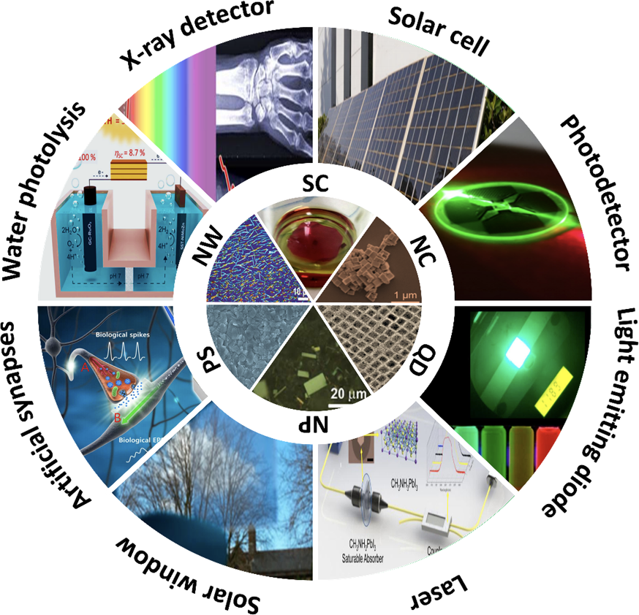
Figure 1-1 Schematic illustrating of metal halide perovskites in possible forms (SC: single crystals, NC: nanocrystals, QD: quantum dot, NP: nanoplatet, PS: polycrystal, and NW:nanowire) and their potential applications⁶.

The crystal structure of 3D ABX₃ perovskites consists of corner-sharing BX₆ octahedra with the interstitial A cations, as shown in Figure 1-2a). For this particular structure, a geometric parameter known as the Goldschmidt tolerance factor (t) is used to evaluate the structural formability and stability¹³. The Goldschmidt tolerance factor is found with the formula,
 | $$t= \frac{R_{A}+R_{X}}{\sqrt{2}(R_{B}+R_{X})}$$ | (1-1)
where R_{A}, R_{B}, and R_{X} are the ionic radii of the A, B, and X ions, respectively. When t is close to 1, the perovskite tends to adopt an ideal cubic perovskite structure. As t deviates from 1, there tends to be structural distortion of the unit cell, leading to a lower symmetry structure. Figure 1-2b) provides the approximate tolerance factor for commonly utilized MHPs. Typically, the cubic structure, also known as the α-phase, forms when 0.89 < t < 1¹⁴. The lower-symmetry trigonal (β-phase) or orthorhombic (γ-phase) structures begin to appear when t < 0.89 because the smaller ionic radii of the A site cation will cause a distortion in the BX₆ octahedra framework. Conversely, a larger A site cation will cause a change in the crystal dimensionality, producing low-dimensional 2D and 1D structures (e.g., Aurivillius, Ruddleson-Popper, and Dion-Jacobson phases)¹⁵.
The tolerance factor of MAPbI₃ is 0.81, signifying that it will have a tetragonal structure at room temperature. This is confirmed by X-ray diffraction (XRD), and the perovskite is assigned the I4cm space group¹⁶. At higher temperatures, the organic ion, CH₃NH₃⁺, becomes disordered, causing a lattice distortion, which in combination with [PbI₆]⁻ octahedral tilting¹⁷ could drive a phase transition¹⁸. Above 330 K, the tetragonal phase α-MAPbI₃ transforms into the cubic phase β-MAPbI₃, while below 160 K, the α-MAPbI₃ transitions to a orthorhombic phase γ-MAPbI₃, respectively¹⁹. While the α↔β occurs above room temperature, it is within the operational window of solar cells; therefore, it becomes incredibly important to understand how this transition affects the device stability and performance. It has been established that this phase transition alters the electronic band structure and thus affects the optoelectronic properties of the photoinactive layer²⁰.
For some MHPs, such as CsPbI₃, FAPbI₃, and CsSnI₃, a non-perovskite δ-phase is observed at room temperature. Unlike with the α-phase to β- and γ-phase transitions, this δ-phase is not caused by the X-B-X bond distortion in the α-phase because the B-X bond is broken in the δ-phase²¹. It has been well established that the stabilization of this δ-phase into the α-phase in these MHPs can be induced through doping and alloying²²⁻²⁴.

Figure 1-2 a) Crystal structure of cubic ABX₃ MHPs and b) the Goldschmidt Tolerance Factor of commonly used perovskite compositions.

Optoelectronic Properties
The excellent performance of MHP devices is attributed to its unique optoelectronic properties, such as high and tunable optical absorption, small effective masses for electrons and holes, large charge diffusion lengths, and high charge carrier mobilities.

Optical Properties
By varying the cations and halides or modifying external parameters, such as temperature and pressure, the absorption and photoluminescence (PL) of MHPs can be tuned in the ultraviolet (UV), visible, and near-infrared regions. The bandgap of MHPs can be adjusted from approximately 1.5 to 3.2 eV by adjusting the I/Br and Br/Cl ratio and the A-site cations (Cs, FA, and MA)^{25, 26}, as shown in Figure 1-3a). Changes in crystal structure from cubic to tetragonal or other phases can affect the bandgap and cause a PL shift. The bandgap energies of difference crystalline phases of Cs, MA, and FA lead iodide perovskites is shown in Figure 1-3b).
Another factor that affects the optoelectronic properties is crystal size. As the crystal size decreases below the exciton Bohr radius, quantum confinement effects can be observed in MHPs through the appearance of sharp excitonic peaks, narrow PL bands, and blue-shifted absorption and PL spectra^{29, 31, 32}. For example, Dong et al. observed a gradual blue-shift in the absorption onset as the crystal size decreased from 6.2 to 3.7 nm, as shown in Figure 1-3c), demonstrating quantum confinement effects in CsPbBr₃ perovskites²⁹. Quantum confinement effects can also be influenced by the type of halogen. Protesescu et al. found the exciton Bohr radius of CsPbX₃ nanocrystals varies from 2.5 nm for CsPbCl₃ to 3.5 nm for CsPbBr₃ to 6 nm for CsPbI₃²⁷.
Finally, it has been demonstrated that temperature and pressure can also affect the absorption and PL properties of MHPs. As mentioned previously in 1.1.1 Crystal Structure, as the temperature of MHPs deviates from room temperature, a series of phase transitions or structural changes occur. For MAPbI₃, the variation of PL properties is typically grouped into three different groups based upon the crystal structure: low temperature (orthorhombic), room temperature (tetragonal), and high temperature (cubic)³³. At high temperatures, the bandgap decreases, and broadening of the absorption and PL spectra is observed, signifying enhanced exciton-phonon interactions. Similarly, the pressure applied to MHPs can not only affect the structure, but also the optical properties³⁰.
Figure 1-3 Cation and anion effects on the optical properties of MHPs. a) Absorption and photoluminescence spectra of CsPbX₃ nanoparticles²⁷. b) Theoretical and experimental bandgaps of cubic (c), tetragonal (t), and triclinic (t_{c}) phases of APbI₃ where A = Cs, MA, and FA²⁸. c) Size-dependent absorption and photoluminescence spectra of CsPbBr₃²⁹. d) pressure-dependent photoluminescence of FAPbBr₃³⁰.

For example, Wang et al. demonstrated that applied pressure to FAPbBr₃ can induce two phase transitions and subsequent amorphization, causing bandgap evolution in which a red-shift in the absorption onset and PL peak followed by blue-shift is observed, as shown in Figure 1-3d)³⁰.

Charge Transport Properties
MHPs have demonstrated to have long charge carrier lifetimes, long carrier diffusion lengths, and high mobility, all contributing to efficient charge transport in devices^{1, 6}. The generation, dynamics, and recombination of charge carriers and excitons is found to be largely dependent on the composition, crystal structure, and size²⁸.
The carrier lifetime is defined as the length of time between when a photon being excited and when the free electrons and holes recombine to the ground state. This recombination process is an incredibly important process for optoelectronic properties³⁴. For example, radiative recombination emits a photon, and, therefore, allows this material to be used in light-emitting diode (LED) devices. Conversely, in non-radiative recombination, a trap or other mechanism causes carrier recombination to occur with an emitted photon. The carrier lifetime (τ) can be obtained through the equation,
 | $$\frac{1}{τ}= \frac{1}{τ_{R}}+\frac{1}{τ_{NR}}$$ | (1-2)
where τ_{R} is the radiative lifetime and τ_{NR} is the non-radiative lifetime³⁴. Because the non-radiative lifetime is contingent on the trap density of the MHP, the carrier lifetime is typically larger in single crystals than polycrystalline thin films³⁵. Currently, increasing the carrier lifetime of MHPs is an important area of research because it has a direct impact on the efficiency of devices such as solar cells^{34, 36, 37}.
Charge carrier mobility is defined as the speed at which a carrier moves through the material when an electric field is applied. It can be found utilizing the equation,
 | $$μ= \frac{qτ}{m^{*}}$$ | (1-3)
where μ is charge carrier mobility, q is the charge of an electron (1.6022 x 10⁻¹⁹ C), τ is the lifetime, and m* is the effective mass of the charge carriers. It has been demonstrated that the carrier mobility is dependent on whether the main charge carrier is a hole or an electron, due to the difference in effective mass^{34, 37}. Generally, the charge carrier mobility is much higher in single crystals than in polycrystalline thin films³⁵. For example, for MAPbI₃, in polycrystalline thin films, the mobility is found to be 0.4-35 cm² V⁻¹ s⁻¹, while it is between 67-164 0.4-35 cm² V⁻¹ s⁻¹ for single crystals, and this trend is also observed for MAPbBr₃^{34, 36-38}. It should be noted that the exact values for the charge carrier mobility can depend on the characterization technique⁶. For example, the measured mobility can range over 8-orders-of magnitude using such techniques as time-resolved microwave conductivity (TRMC), time-resolved terahertz absorption spectroscopy (TRTS), charge extraction by linearly increasing voltage (CELIV), space charge limited current (SCLC) technique, time-of-flight (TOF) method, field-effect transistor (FET) technique, and Hall effect technique³⁹.
Charge carrier diffusion length (L_{D}) is defined as the average distance carriers will travel before recombination. The diffusion length is dependent on both the carrier lifetime and mobility and can be found through the equation,
 | $$L_{D}=\sqrt{k_{B}T\frac{μτ}{q}}$$ | (1-4)
where k_{B} is Boltzmann constant (1.380 x 10⁻²³ m² kg s⁻² K⁻¹), T is the temperature, and q is the charge of an electron (1.6022 x 10⁻¹⁹ C)³⁴. It has been found that the photogeneration needs to take place at a distance equal or smaller than the diffusion length of minority carriers for the optimal collection of photogenerated free charge majority carriers³⁵. In large single crystals, the diffusion lengths of MAPbI₃ and MAPbBr₃ are found to be between 1.3-175 ± 25 μm and 1.8-4.3 μm, respectively³⁴.

Stability
Currently, one of the main obstacles to the wide-spread commercialization of this material is its poor stability due to the intrinsic stability and compositional sensitivity of MHPs to environmental conditions, such as oxygen, humidity, light, and electric field.
The decomposition of MAPbI₃ can be described by two mechanisms: intrinsic and extrinsic. The intrinsic decomposition is driven by the rearrangement of ions already present in MAPbI₃, while the extrinsic decomposition is driven by additional ions or molecules entering the perovskite, causing chemical or structural changes⁴⁰.
Regarding the intrinsic stability, MAPbI₃ has been shown to have a relatively low formation enthalpy⁴¹, suggesting that it has a low energy barrier to revert back to MAI and PbI₂. Additional direct decomposition routes lead to the formation of CH₃NH₂ and HI or CH₃I and NH₃. HI, CH₃I, and NH₃ evaporate from the substrate, while CH₃NH₂ could also evaporate or be trapped at grain boundaries^{42, 43}. Thus, the intrinsic decomposition of MAPbI₃ is considered to be the following pathway⁴⁴:

 | $${CH}_{3}NH_{3}PbI_{3}\left(s\right)↔ {CH}_{3}{NH}_{2}\left(g\right)+HI\left(g\right)+PbI_{2}\left(s\right)$$ | (1-5)

 | $${CH}_{3}NH_{3}PbI_{3}\left(s\right)→ {NH}_{3}\left(g\right)+{CH}_{3}I\left(g\right)+PbI_{2}\left(s\right)$$ | (1-6)

 | $${CH}_{3}NH_{3}PbI_{3}\left(s\right)→ {NH}_{3}\left(g\right)+{CH}_{3}PbI_{3}\left(s\right)$$ | (1-7)

 | $${CH}_{3}PbI_{3} → {CH}_{3}I\left(g\right)+PbI_{2}(s)$$ | (1-8)

 | $$n{CH}_{3}I\left(s\right) \begin{matrix}in {PbI}_{2} \\ →\end{matrix} C_{n}H_{2n}\left(s\right)+nHI(g)$$ | (1-9)
All decomposition pathways lead to the formation of PbI₂. This degradation route was initially considered to only occur at high temperatures, (above 250 °C)⁴⁰; however, it has been shown that MAPbI₃ decomposition can occur at much lower temperatures (85 °C)⁴⁵; therefore, it is important to understand intrinsic MAPbI₃ decomposition to develop strategies for improving performance of MAPbI₃ devices.
Oxygen is considered to be a source of major instability of MHPs⁴⁶. Some studies have demonstrated that oxygen can strongly and reversibly improve the PL in MHPs⁴⁷⁻⁴⁹. Other studies have observed the formation of superoxide species caused by charge transfer between O₂ and photo-excited MHPs^{46, 50-52}. Utilizing DFT calculations, it proposed that the degradation route as MAPbI₃ is exposed to oxygen is,
 | $${4 CH}_{3}NH_{3}PbI_{3}\left(s\right) + O_{2}→ 4{PbI}_{2}\left(s\right)+2I_{2}+2H_{2}O+4{CH}_{3}{NH}_{2}$$ | (1-10)
Thermodynamically, MAPbI₃ is expected to decompose forming water and iodine. It should be noted that the oxygen incorporation is sluggish in the dark, but is strongly enhanced under illumination⁵³, as discussed later in this section.
Several studies have focused on characterizing how humidity affects the structural stability of MAPbI₃; however, an understanding of the critical levels of humidity and the duration of exposure at which irreversible chemical degradation occurs is lacking. Frost et al. demonstrated that the final products of MAPbI₃ phase degradation are CH₃NH₂, HI, and PbI₂ in the presence of water⁵⁴. Li et al. suggests the following degradation route (1-11) of MAPbI₃, resulting in the irreversible formation of CH₂, NH₃, HI, and PbI₂⁵⁵.
 | $${CH}_{3}NH_{3}PbI_{3}\left(s\right)→ {(-CH}_{2}-)+NH_{3}(g)+HI(g)+ {PbI}_{2}(s)$$ | (1-11)
This degradation route was confirmed because while the concentration of nitrogen and iodine decreases, the amounts of PbI₂ and CH₂ in the thin film increase with water absorption. Zhao et al. proposed a different degradation route (1-12), in which an intermediate monohydrated MAPbI₃⋅H₂O is observed as MAPbI₃ decomposes into the final products, PbI₂ and CH₃NH₃I⁵⁶.
 | $${CH}_{3}NH_{3}PbI_{3}\left(s\right)→ {CH}_{3}{NH}_{3}\left(aq\right)+ {PbI}_{2}(s)$$ | (1-12)

Toloueinia et al. observes different degradation behavior depending on the relative humidity (RH) in which devices are characterized⁵⁷. At relatively low humidity levels (RH < 65%), there is a limited impact on the structural stability of MAPbI₃. At high levels of humidity (~100% RH), the following series of reactions (1-13) is proposed.
 | $${CH}_{3}NH_{3}PbI_{3}\left(s\right)+ H_{2}O (g)↔{CH}_{3}NH_{3}PbI_{3}∙ H_{2}O (s)$$ | (1-13)

 | $${4 CH}_{3}NH_{3}PbI_{3}∙ H_{2}O \left(s\right)↔({CH}_{3}{NH}_{3})_{4}{PbI}_{6}∙{2H}_{2}O\left(s\right)+3 {PbI}_{2}(s)+2H_{2}O (g)$$ | (1-14)

 | $$({CH}_{3}{NH}_{3})_{4}{PbI}_{6}∙{2H}_{2}O\left(s\right) →4{CH}_{3}{NH}_{2}\left(g\right)+4HI\left(g\right)+PbI_{2}\left(s\right)+2H_{2}O(g)$$ | (1-15)

 | $$4{CH}_{3}{NH}_{2}\left(g\right)+4HI\left(g\right)→4 {CH}_{3}{NH}_{3}I(s)$$ | (1-16)

 | $$4 {CH}_{3}{NH}_{3}I\left(s\right) \begin{matrix}H_{2}O \\ →\end{matrix} 4{CH}_{3}{{NH}_{3}}^{+}\left(aq\right)+4I^{-}(aq)$$ | (1-17)

 | $$4I^{-}\left(aq\right)→2I^{-}\left(g\right)+4e^{-}$$ | (1-18)

It is suggested that the high humidity causes a gas-phase acid-based reaction between CH₃NH₂ and HI, resulting in solid MAI on the surface. MAI is then hydrolyzed, and MA⁺ could then be released. It is found that this degradation fundamentally changes the charge transport properties of MAPbI_{3.}
While effects due to oxygen and humidity can be partially mitigated by encapsulation⁵⁸, the light stability is crucially important of MHPs when utilizing in certain applications, such as photovoltaics. Tang et al. performed a systematic investigation to determine the degradation routes caused by illumination in nitrogen, vacuum, and air⁵⁹. MAPbI₃ thin films in a nitrogen atmosphere did not show any color conversion, regardless of illumination. Optical absorption and PL measurements show a slight decrease compared to the pristine samples. Conversely, even in dark conditions in either vacuum or air, the MAPbI₃ thin films displayed a significant drop in absorbance and PL. Once illuminated, the samples are considered to have completely decomposed as there is no absorbance or PL peak.
Utilizing in situ X-ray diffraction (XRD) measurements, Tang et al. describe the degradation kinetics when MAPbI₃ are illuminated in vacuum or air (40% RH). Under vacuum conditions, the degradation occurs much faster than when in air conditions. It has been demonstrated the faster photodegradation is mainly caused by the creation of vacancies, not chemical reactions, when exposed to vacuum conditions⁶⁰. Thus, the photoinduced degradation in vacuum starts with the creation of iodine vacancies because of MAI volatility. They observe the formation of metallic lead and lead iodide as well. Therefore, the following degradation route (Equations (1-19 - (1-25) is proposed,
 | $${CH}_{3}{NH}_{3}PbI_{3} \begin{matrix}vacuum \\ →\end{matrix} {CH}_{3}{NH}_{2}\left(g\right)+HI\left(g\right)+ {PbI}_{2}+ V_{1}^{-}$$ | (1-19)

 | $$e+V_{1}^{-}\begin{matrix}trapped \\ →\end{matrix} e(V_{1}^{-})$$ | (1-20)

 | $$e\left(V_{1}^{-}\right)+Pb^{2+}→{Pb}^{+}+2I^{-}+V_{Pb}^{2+}$$ | (1-21)

 | $$2{Pb}^{+}→{Pb}^{0}+{Pb}^{2+}$$ | (1-22)

 | $$h+V_{Pb}^{2+}\begin{matrix}trapped \\ →\end{matrix} h(V_{Pb}^{2+})$$ | (1-23)

 | $$2 h\left(V_{Pb}^{2+}\right)+2I^{-}→ I_{2}$$ | (1-24)

 | $2{CH}_{3}{NH}_{3}PbI_{3}\begin{matrix}vacuum \\ → \\ light\end{matrix}2{CH}_{3}{NH}_{2}\left(g\right)+2HI\left(g\right)+PbI_{2}+ I_{2}$(g) | (1-25)
Utilizing the same characterization method, they observed degradation products such as metallic lead and lead salts (PbO, Pb(OH)₂, and PbCO₃) in air and illuminated. These lead salts cannot be formed without water⁴⁶. They suggest that the fast decomposition, roughly 2 hours, observed is completely initiated by light. Overall, under vacuum or air, the degradation of MAPbI₃ is significantly accelerated by light.
Under electric bias, it has been reported that three important phenomena occur. Firstly, ion migration, such I⁻ and organic cations, is caused by the electric field because they have a low activation energy⁶¹⁻⁶⁵. Secondly, there are changes in the light current-voltage characteristics caused by ion migration or dipole orientation^{62, 66, 67}. Finally, the photovoltaic effect is observed when the electric field is applied to the perovskite layer because of the self-doping effects caused by ion migration^{62, 68, 69}. It is important to highlight that the impact of electric field is dependent on moisture level⁷⁰. It has also been demonstrated that at elevated temperatures, a reversible conversion between MAPbI₃ and PbI₂ phases is caused by a set of solid state chemical reactions⁷¹.

 | $${CH}_{3}{NH}_{3}PbI_{3}↔{CH}_{3}{NH}_{3}^{+}+ {PbI}_{2}+I^{-}$$ | (1-26)

 | $${2I}^{-}→I_{2}↑ +2e^{-}$$ | (1-27)

Complete and Partial Substitution
As described earlier in the previous section, MAPbI₃ is significantly affected by external stimuli, such as light, humidity, oxygen, and electrical bias. It has been demonstrated that partial substitution of the A-site, B-site, and/or X-site can be utilized to tune optical bandgaps, promote phase stability, improve charge carrier transport properties, and improve stability when exposed to external conditions.

A-site Substitution
In the first and prototype MHP, the A-site is occupied by the monovalent cation, MA⁺. To tune the bandgap and optoelectronic properties or to improve the stability, the A-site is typically partially or entirely substituted by other organic cations, such as FA⁺, or inorganic cations, such as Cs⁺ or Rb⁺. For example, by substituting MA with FA or Cs, the bandgap of the MHP can be tuned from 1.57 eV to 1.48 eV or to 1.73 eV, respectively⁷². The bandgap of FAPbI₃ has a bandgap closer to that of an “ideal” photovoltaic material (1.1-1.4 eV). While the bandgap is more favorable and has comparable or better device performance, the photoactive phase, α-FAPbI₃, is only stable at high temperatures and tends to revert to the yellow, photoinactive phase, γ-FAPbI₃, under normal operational conditions⁷³. The replacement of FA with MA, roughly 20%, was found to stabilize the α-phase at room temperature⁷⁴. This stabilization can also occur through A-cation and X-site substitution. Joen et al. demonstrated how (FAPbI₃)_{1-x}(MAPbBr₃)_{x} where 0 < x < 0.3, can not only stabilize the α-phase, but also improve the device efficiency up to 18.0%⁷⁵. Like FAPbI₃, a yellow, photoinactive δ-phase is also present for CsPbI₃ at room temperature⁷⁶. It was demonstrated that α-CsPbI₃ could be stabilized by partial substitution of MA⁷⁶; however, the material stability and film quality was poor and led to low efficiencies for solar cells⁴⁵. Conversely, the mixed cation system, FA_{x}Cs_{1-x}PbI₃, exhibits good stability. For example, Lee et al. found the FA_{0.9}Cs_{0.1}PbI₃ was remarkably stable and the efficiency increased, partly caused by the reduced trap density upon Cs doping⁷⁷. Other inorganic cations, such as Rb⁺, have been utilized to improve the stability of MHPs⁷⁸. Like Cs, the Rb cation also stabilizes the photoactive α-FAPbI₃ phase and produce a device with an efficiency of 21.6%.
The A-site can also be completely or partially substituted by larger organic cations with long chain lengths, enlarging the space between the inorganic framework and leading to layered perovskites, also known as 2D perovskites⁷⁹. 2D perovskites generally have the formula A₂BX₄ (A = CH₃(CH₂)_{n}NH₃⁺, C₆H₅(CH₂)_{n}NH₃⁺, B = Sn²⁺, Pb²⁺, X = Cl, Br, I), where the inorganic layers and the organic layers are alternatively stacked. These 2D perovskites improve the material stability because of the hydrophobic alkylamines, but the optoelectronic properties become less favorable as the large organic cation increases the exciton binding energy, lowering the efficiency^{80, 81}. One strategy to maintain this stability, but improve the optoelectronic properties is to synthesize mixed 2D and 3D perovskites. For example, Tsai et al. recently fabricated a solar cell made with (BA)₂(MA)_{n-1}Pb_{n}I_{3n+1} (n = 3,4) that had a remarkably high PCE of 12.51% ⁸², which is drastically higher than other 2D perovskites (< 5%).
Overall, A-site substitutional allows for improved material stability and tunable material dimensionality.

B-site Substitution
Many have focused on replacing the toxic lead element at the B-site with other divalent cations, such as Sr, Sb, Bi, and Ge. However, replacing lead with these different metals and maintaining the excellent optoelectronic properties is not easy. For example, it was predicted that MASrI₃ would have excellent phase stability, but its bandgap is roughly 3.6 eV, too large for solar cell applications⁸³. Conversely, the bandgap of Ge-based perovskites can be tuned from 1.6 to 3.1 eV, making it suitable for solar cell applications; however, the efficiency of these devices has a low PCE of roughly 3.2%⁸⁴. Thus, most of the effort has focused on lead-free perovskites revolves around tin as these perovskites have demonstrated excellent electrical properties⁸⁵. However, Sn²⁺ is less stable in the presence of oxygen⁸⁶ and can easily oxidize into Sn²⁺, thereby degrading the perovskite structure.

X-site Substitution
As mentioned previously in the Optical Properties section, the bandgap of the perovskites can be tuned by changing the anion from iodide to bromide to chloride⁸⁷. It has also been shown that the replacement of iodide with bromide leads to better stability under ambient conditions^{88, 89}. Several decomposition pathways proposed for the MAPbI₃ also occur with MAPbBr₃; however, energetically, it is more favorable for MAPbBr₃ to undergo the reversible reaction (1-5), producing CH₃NH₂, HBr, and PbBr₂, than the irreversible reaction (1-6), whose final products are NH₃, CH₃Br, and PbBr₂^{88, 90}. As mentioned previously (1-10), in the presence of oxygen, a degradation route can include a superoxide compound^{46, 50}. Aziz et al. found that while this is energetically exothermic for MAPbI₃, it is energetically endothermic for MAPbBr₃⁸⁸. They postulate the reason for this is that the stronger hydrogen bonds between the MA⁺ cation and Br atoms provide better structural stability. Lin et al. also proposed that the stronger Pb-Br bond could suppress degradation caused by ion migration⁹¹. Nandi et al. confirmed the stronger Pb-Br bond by demonstrating that MAPbBr₃ had a reduced linear coefficient of linear expansion, higher Einstein temperature, and smaller dynamic disorder. They suggest that this bond prevents the migration of methylammonium, resulting in improved stability of MAPbBr₃.
Bromide-based perovskites have demonstrated improved stability in humidity as well. As mentioned previously, humidity can be detrimental to the stability of MAPbI₃ because of the formation of intermediate hydrated phases, such as CH₃NH₃PbI₃⋅H₂O and (CH₃NH₃)₄PbI₆⋅H₂O⁵⁷. These hydrate phases then decompose in PbI₂ and volatile gases, such as HI and CH₃NH₂. Song et al. showed how initial exposure to humidity passivates the surface as the water molecules bond with uncoordinated Br atoms⁹². This surface passivation improves the optoelectronic properties of MAPbBr₃ and, typically, a PL enhancement is observed. These improvements are then reversed as the water surface layer delocalizes the electron wave function⁹³, creating an effective n-type doping. This process occurs rapidly, preventing MAPbBr₃ from further decomposition, unlike MAPbI₃⁹². Again, the improvement in stability is attributed to the strong Pb-Br bonds, preventing the formation of intermediate hydrated phases.
Finally, device performance can also be improved by partial substitution of the halide. For example, the bandgap of the mixed halide perovskite, MAPb(Br_{x}I_{1-x})₃, can continuous tuned from 1.58 to 2.28 eV by simply changing the I/Br molar ratio^{25, 94}. This tunability becomes beneficial in multi-junction devices because light with different wavelengths can be absorbed^{95, 96}. However, these mixed halide perovskites undergo halide segregation when exposed to external stimuli, leading to the degradation of the devices⁹⁷.

Optical in-situ Characterization
Optical characterization methods, such as absorption and photoluminescence (PL) spectroscopy, have been utilized to measure the optoelectronic properties of MHPs. With technical modifications to traditional ex situ absorption and PL equipment, researchers can monitor the evolving optical properties of MHPs in situ⁹⁸. For example, most photovoltaic devices are fabricated utilizing solution-based synthesis, such as spin-coating, and annealing afterward. All of the steps, such as wet film thinning and solvent evaporation, influence the film properties, such as morphology, electrical, and optical properties⁹⁹; therefore, in situ monitoring of optical properties provides a real time probe to measure dynamical processes that occur during spin coating and annealing. In situ characterization can also be useful in measuring the optoelectronic properties when MHPs are exposed to external conditions, such as light, heat, humidity, or electric bias¹⁰⁰. Overall, optical in situ characterization can be utilized to advance the understanding such dynamical processes such as perovskite formation, ionic movement, phase changes, and degradation¹⁰¹⁻¹⁰⁵.
PL measurements require a few components, a monochromatic illumination source and a detector/spectrometer; therefore, many laboratories utilize PL to characterize samples. The PL spectra of MHPs at room temperature generally have one peak corresponding to the bandgap¹⁰⁶. The peak width is dependent on the temperature, Urbach tailing, internal strain, and Froehlich phonons^{106, 107}. By analyzing the low energy part of the PL spectrum, the Urbach energy can be determined¹⁰⁸. The Urbach energy is affected by shallow defects, disorder, and bandgap fluctuations. If the setup is properly calibrated, the external radiative efficiency, also known as the PL quantum yield (PLQY), can be quantified through the full-width half-maximum (FWHM) of the PL peak. Overall, important optoelectronic properties, signifying whether a composition would be appropriate for a certain application, can be measured through a rather simple characterization technique.
Firstly, in situ PL measurements during synthesis and fabrication of MHPs can provide insight into synthesis mechanisms, nucleation, and growth. For example, the determination of the optimal temperature and duration of annealing MHPs is crucial to improving device performance^{99, 109-111}. Franeker et al. utilized in situ PL to investigate the formation of MAPbI₃ deposited by a hot casting method in air and correlated these observations to solar cell efficiency¹¹². They observed an initial exponential PL decay, which was temperature-dependent followed by a slower decay behavior. They found that an annealing temperature of 97 °C for approximately 7 minutes produced a device with the highest power conversion efficiencies. In situ PL measurements can also be useful in assessing new synthesis pathways, such as using nonstoichiometric instead stoichiometric precursors with mixed organic cations. Regarding at mixed cation perovskites, FA_{x}MA_{1-x}PbI₃, Xie et al. found an amorphous phase, indicated by a broad PL peak with a large FWHM, when stoichiometric precursors were utilized¹¹³. They attribute this peak to the formation of the photoinactive phase, δ-phase, which could only be transformed to the α-phase upon annealing. Utilizing an excess of MAI in the synthesis, the α-phase formed without the need for annealing. Next, these measurements can monitor compositional tuning, such as ion exchange reactions at the cation or anion. For example, Pellet et al. utilized PL emissions to observe halide substitution in MAPbX₃ (X = Cl, Br, I) by dipping thin films into MAX solutions, shown in Figure 1-4¹¹⁴. The halide in the dipping solution governs the final halide composition. While the complete conversion from MAPbBr₃ to MAPbI₃ does not occur even after a reaction time of 1 hour, the conversion from MAPbI₃ to MAPbBr₃ occurs after approximately 5 minutes. In situ PL measurements can also be utilized in a high-throughput manner to observe the nucleation and growth of CsPbX₃ (X = I, Br, Cl) nanocrystals²⁷. During synthesis, a broad peak at high energies was observed, likely caused by surfactants. Once the formation is initiated, either by hot-injection or halide precursor injection, they observe a red-shifting and narrowing of the PL peak, indicating nucleation and growth^{115, 116}. This process occurs within 1-3 seconds. In this study, they determined that the size of the nanocrystals is controlled by the reaction temperatures and not growth time.
Next, in situ PL measurements can also be utilized to explore the effects of light soaking, to investigate ion migration, and to characterize sample degradation. As mentioned in Optical Properties, the bandgap of MHPs can be tuned through cation and anion substitution. Hoke et al. found MAPb(Br_{x}I_{1-x})₃ thin films undergo a light-induced, reversible transformation into bromide- and iodide-rich domains¹¹⁷. By measuring PL over 45 seconds in 5 second increments, they observed the appearance of an additional PL peak at a lower energy that increased over time, indicating this transformation. Overall, this study demonstrated how mobile halides are in this system. Zhou et al. also utilized in situ PL to improve the photostability of the mixed cation system, Cs_{0.17}FA_{0.83}Pb(Br_{x}I_{1-x})₃¹¹⁸. By comparing the PL of different samples over time, they found that an excess of FAX (X = Br, I) during synthesis produced better photostability because this excess produced a larger grain size, reduced the number impurities, and passivated grain boundaries.
The effect of other external stimuli, such as air and humidity, can also be investigated. Galisteo-Lopez et al. and others reported that O₂ can cause substantial PL enhancement in MAPbI₃^{47, 48}. It was also shown that N₂ has little effect on PL because it cannot undergo redox activity caused by O₂ or surface conversion reactions from H₂O¹¹⁹. Howard et al. also explored the effect of environmental conditions on the mixed cation and mixed halide system, Cs_{x}FA_{1-x}Pb(I_{y}Br_{1-y})₃¹²⁰. They observed PL intensity hysteresis curves caused by humidity. They also observed PL enhancement dependent on Cs/Br ratio under different humidity levels. Knight et al. also demonstrated that the halide segregation dynamics are dependent on the atmospheric environment¹²¹. In another study, Song et al. utilized in situ PL to describe the degradation mechanisms of MAPbI₃ when exposed to high humidity levels⁹². They postulate that degradation occurs in four stages: humidity-assisted surface passivation, n-type doping, formation of a monohydrated perovskite, and conversion into a hydrate phase. Overall, in-depth investigations into the process leading to PL enhancement are made possible by performing in situ PL measurements as samples are exposed to external stimuli.

High-throughput Experimentation
Significant innovations in technology have historically been furthered by the discovery of novel materials. Currently, the materials development process relies on three key steps: 1) identification of a new composition of interest, 2) detailed synthesis of that compound, and 3) post-processing to carefully optimize its properties¹²². To accelerate this process, it is not only important to increase the effectiveness of each step, but also to incorporate all three steps into a closed loop so these steps can proceed in rapid succession and utilize feedback to inform future experiments. While the first step has been aided by large-scale ab initio simulations, the latter two steps are generally time-consuming because of the iterative trial-and-error approach necessary for both synthesis and optimization. To overcome these challenges, one solution is autonomous research systems that combine both high-throughput robotic platforms and machine learning approaches to accelerate materials discovery and development.
Historically, the widespread usage of high-throughput platforms was first demonstrated in the pharmaceutical industry¹²³. There, these platforms were utilized to accelerate drug discovery through combinatorial sampling, which can typically be performed in an automated and systematic manner, saving considerable time and money. This has prompted more sophisticated applications of the systems ranging from the systematic exploration of optoelectronic properties of quantum dots to the performance optimization of MHP thin films.
The first major step in the automated optimization of materials discovery is the synthesis of samples. The ability to automate depending on the synthesis method and the form of the end products.

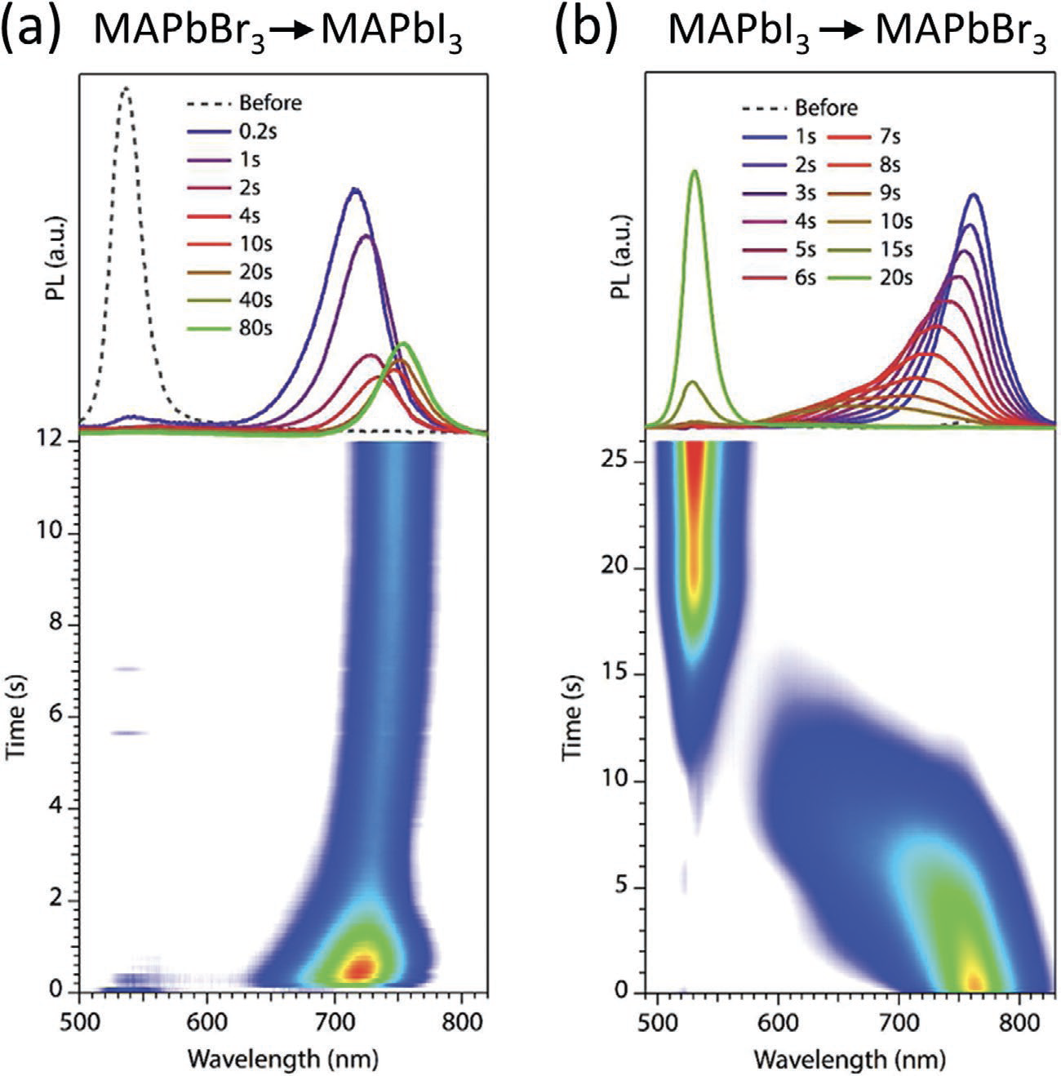
Figure 1-4 Time evolution of an ion exchange reaction investigated by in situ PL measurements¹¹⁴.

Regarding the automated synthesis of metal halide perovskites, the platforms can vary from micropipetting robots, microfluidic systems, and self-driving laboratories and can produce perovskites in a variety of forms, such as microcrystals, single crystals, thin films, and quantum dots. Once the samples have been prepared, the appropriate characterization method should be utilized to describe the properties of interest and provide information for the next batch of experiments. Characterization can be executed after batch synthesis or in real-time. Overall, these automated synthesis platforms allow for the quick and efficient synthesis of large combinatorial libraries.

Self-Driven Laboratories
The first strategy is automating high-throughput and optimization MHP experimentation was to simply replicate what a researcher does in the laboratory. This could range from the implementation of robotic arms or automated guided vehicles moving from one area of the lab to another.
MacLeod et al. designed a self-driving laboratory, “Ada,” to autonomously synthesize, process, and characterize MHP thin films¹²⁴. Ada is based on a modular robotic platform that using robotic arms to perform the fluid handling and to move substrates from the spin coater to heat gun for annealing to characterization instruments. A schematic of Ada is shown in Figure 1-5a). In this study, they utilize Ada to optimize the hole mobility of spiro-OMeTAD, which is an organic hole transport material (HTM) commonly used in perovskite solar cells¹²⁵. It is well established that the hole mobility of spiro-OMeTAD is critical to the solar cell performance and is also highly sensitive to dopants, additives, solvents, and post-deposition processing¹²⁶. Typically, the optimization of the spiro-OMeTAD layer using these parameters is done empirically and can often take months. Utilizing Ada, they optimize the hole mobility by 1) measuring and mixing solutions of HTMs and dopants, 2) depositing the solution on thin films, annealing each film, 3) imaging each film to characterize the morphologies, defects, and impurities, and 4) measure the optical and conductivity properties. The data from these measurements are then sent to ChemOS¹²⁷, which used the Phoenics global Bayesian optimization algorithm to design the next experiment by learning from the acquired data. Utilizing Ada in combination with ChemOS, they were able to quickly optimize dopants and the duration of annealing to maximize the hole mobility of spiro-OMeTAD. Overall, the development of this self-driving laboratory demonstrates how these autonomous systems can be utilized to optimize device performance efficiently through modifications of experimental parameters.
Li et al. also developed a robotic laboratory, denoted as AIR-Chem (Authentic Intelligent Robotics for Chemistry), capable of not only automating the actions performed by researchers, but also utilizing real-time computer vision (CV) to capture data during fabrication to improve future experiments¹²⁸. The synthesis and characterization are performed by a multirobot system, which includes a robotic arm on top of an automatic guided vehicle (AGV), a workstation for fabrication and an industrial camera, and a reaction chamber also on top of a an AGV. A schematic of this set-up is shown in Figure 1-5b). Here, the AIR-Chem system is utilized to experimentally confirm a theoretically predicted, improved nucleation theory of size of inorganic perovskite quantum dots, specifically cesium lead halide (CsPbX₃). Once the quantum dots were automatically fabricated, optical measurements of the quantum dots were performed under 365 nm UV illumination. Images were then divided into two modes: RGB and gray. The solution within the beaker was found through the gray mode images based on edge detection. From the RGB mode images, they were not only able to measure the band gap, but, based upon the curvature of the RGB curve, also the growth rate of the quantum dots. From the obtained data, users then can modify the future experimental procedure performed by the AIR-Chem system. This work is another illustration of how unmanned laboratory can perform the chemical synthesis and characterization of materials.
Overall, these self-driven laboratories are effective in automating the synthesis of MHPs; however, the engineering involved in the development of these systems is quite time-consuming. Therefore, the utilization of established platforms, such as microfluidics and micropipettes, eventually began to dominate the field of MHP automated high-throughput experiments.

Microfluidic Platforms
Microfluidic platforms with the capability of performing microscale flow synthesis have accelerated the development of MHP quantum dots (QDs)¹²⁹. Perovskite QDs can be utilized in a wide variety of applications, such as photovoltaics^{130, 131} and LEDs^{111, 132}, due to their compositional and size dependent optoelectronic properties, such as a narrow PL bandwidth, high mobility, long diffusion lengths, and near-unity PL quantum yield (PLQY)^{133, 134}. Typically, QDs are fabricated using either the hot-injection method or ligand-assisted reprecipitation (LARP) method¹³⁵.
Figure 1-5 Two examples of self-driving laboratories. a) “Ada” developed by MacLeod et al. for the optimization of hole transport layers for MHP thin films¹²⁴. b) Schematic of the AIR-Chem platform¹²⁸.

The success in producing monodisperse QDs for both synthesis methods depend on several reaction parameters, such as the reaction temperature, growth time, structure and concentration of surface capping ligands, and precursor concentrations^{135, 136}. Recently, microscale flow synthesis has been successfully utilized as a reliable and reproducible technique to accelerate studies of perovskite QDs¹³⁷⁻¹⁴².
Microfluidic platforms typically consist of three modules: a precursor formulation module, a microfluid reactor, and an in situ diagnostics module. Compared to batch methods, microfluidic platforms allow for precise control of experimental parameters, such as temperature and mixing, reduce the amount of consumables during exploration studies, characterize properties in situ and real-time, enable high-throughput experimentation, and, overall, accelerate the parameter space mapping and optimization¹³⁷⁻¹⁴³.
Lignos et al. was one of the first groups to utilize a microfluidic platform for the synthesis of cesium lead halide (CsPbX₃ where X = Cl, Br, I) nanocrystals¹³⁷, as shown in Figure 1-6a). Through the fast mixing with microscale flow synthesis in combination with in-situ absorption and PL measurements, they generated a comprehensive map of reaction parameters, such as the molar ratios of Cs, Pb, and halide precursors, reaction temperature, and reaction times. Minimizing the quantity of precursors and reagents, they found the optimal parameters for batch syntheses of the nanocrystals. In addition, they describe the early stages of nucleation and growth, roughly on the timescale of 0.1-5 seconds. This is not possible for batch synthesis, leading to new insights into nucleation mechanisms.
Next, Epps et al. expanded the capabilities by accessing experimental parameter spaces not available to traditional microreactors through the incorporation of a three-port transitional flow cell, which allows for the continuous and precise control of precursors¹³⁸. Utilizing their platform, shown in Figure 1-6d), they demonstrated rapid characterization of the reaction parameters of CsPbBr₃ QDs. Further, by measuring the absorption and PL of the QDs as they traveled through microreactor, they provided an in-depth investigation into the early stages of nanocrystal growth. Overall, this platform is universal for QD synthesis and allows for additional experimentation that could explore other reaction parameters, such as a compositional gradient.
Most microfluidic platforms focused on the synthesis of cesium lead halide synthesis, but Maceiczyk et al. utilized it to gain preparative insights into the synthesis of formamidinium lead halide (FAPbX₃ where X = Br, I) nanocrystals¹³⁹.
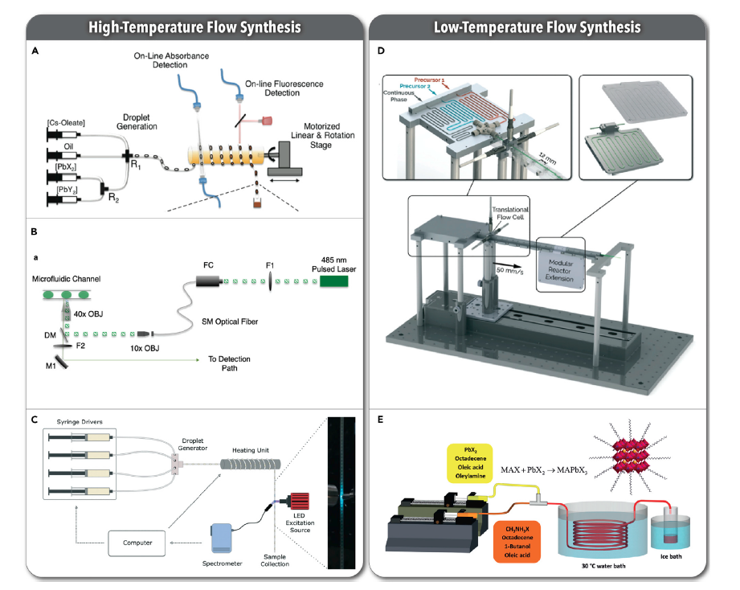
Figure 1-6 Microfluidic robotic platforms for the high- and low-temperature synthesis of lead halide quantum dots¹²⁹. a) Two-phase platform with in situ PL and absorption spectroscopy for the high-temperature synthesis of CsPbX₃ QDs¹³⁷. b) Modified microfluidic platform from a) to include a TCPSC module for measuring the PL lifetime¹⁴⁴. c) Another two-phase microfluidic platform for exploring the effects of temperature and ligand ratio of PQDs¹⁴⁵. d) Low-temperature flow synthesis of CsPbBr₃ QDs¹³⁸. e) Schematic of the microfluidic platform for low temperature synthesis of MAPbX₃ QDs¹⁴¹.

They determined the optimal synthesis conditions for FAPbI₃, FAPbBr₃, and mixed halide FAPb(Br_{x}I_{1-x})₃ nanocrystals. They also demonstrated that the precursor stoichiometry influenced the shape of the resulting nanocrystals. Notably, the incorporation of bromine into FAPbI₃ lowered the optical quality of the nanocrystals, contrasting cesium lead halide nanocrystals in which bromine is shown to improve the optical properties. Overall, this study provided the groundwork necessary to explore mixed cation MHPs utilizing microfluidic platforms.
Next, Lignos et al. explored shape evolution and halide segregation in formamidinium lead halide (FAPbX₃ where X = Cl, Br, I) nanocrystals¹⁴⁰. Firstly, they further improved the photoluminescence properties, such as precise bandgap tuning, narrow emissions, and high PLQYs, of FAPbBr₃ and FAPbI₃. Next, FAPb(Cl_{x}Br_{1-x})₃ nanocrystals were synthesized for the first time using a fully automated microfluidic platform, and the optimal experimental parameters were found for later batch synthesis. However, Cl-rich (>60%) FAPb(Cl_{x}Br_{1-x})₃ nanocrystals undergo halide segregation not observed with Br-rich FAPb(Cl_{x}Br_{1-x})₃ nanocrystals. Although they were not able to optimize the experimental parameters to deter halide segregation, this was one of the first studies to elucidate halide segregation in microfluidic platforms.
In another study, Lignos et al. was the first to systematically investigate the experimental parameter space of mixed cation and mixed halide MHPs, specifically, Cs_{x}FA_{1-x}PbI₃ and Cs_{x}FA_{1-x}Pb(Br_{y}I_{1-y})₃, nanocrystals¹⁴². Successful synthesis of these nanocrystals depends on an understanding of the complex relationships between bulk thermodynamics, crystal surface energies, dynamics of capping ligands, and effects of multiple reagents in solution. Utilizing their microfluidic platform, they optimize the experimental parameters to produce high photoluminescence intensities, narrow emission wavelengths, high PLQYs, and longer stability. Further, they utilize these experimental parameters to fabricate LEDs with high external quantum efficiencies of 5.9% and excellent chemical stability.
Liang et al. was the first to utilize automated flow reactor, shown in Figure 1-6e), for the continuous, room temperature synthesis of MAPbX₃ (X = Br, I) nanocrystals¹⁴¹. In this reactor the nanocrystals nucleated rapidly and were initially, highly fluorescent. When remaining in their solvent, octadecene (ODE), the nanocrystals would degrade after approximately one hours; however, once the nanocrystals were separated from ODE through centrifugation and dispersed in toluene, the nanocrystals remained stable for 8 months. Mixed halide nanocrystals also demonstrated high stability. Overall, the platform developed here proved that it could reproducibly synthesize MAPbBr₃, MAPbI₃, and MAPb(Br_{x}I_{1-x})₃ nanocrystals with narrow size distribution, high stability, and outstanding emissive properties.
Most microfluidic platforms utilize absorption and PL measurements to characterize the optical properties of the fabricated quantum dots or nanocrystals. Lignos et al. incorporated time-correlated single photon counting (TCSPC) measurements to quantify the fluorescence lifetimes of CsPbX₃ (X = Br, I) nanocrystals¹⁴⁴. The platform is shown in Figure 1-6b). By performing calibrated TCSPC measurements, they can determine an absolution measure of the photoluminescent quantum efficiency (PLQY) independent of the sample concentration. Utilizing their microfluidic platform, they rapidly fine-tuned the experimental parameters, such as precursors (Pb/Cs and Br/I ratios) and reaction temperatures, to produce nanocrystals with the highest fluorescence lifetimes possible, generating a recipe for nanocrystals with the highest PLQY.
The molecular surface ligands utilizing in the synthesis of quantum dots and nanocrystals plays an important role in the stabilization and optical properties¹²⁹. Li et al. utilizes a microfluidic platform, shown in Figure 1-6c), to investigate multiple parameters regarding ligands and other factors, such as reaction temperature, to find CsPbBr₃ nanocrystals with the maximum photoluminescence and minimal emission bandwidth¹⁴⁵. Utilizing four different ligands, two with a linear chain structure and two with a branched chain structure, they map the peak intensity, peak position, and Interquartile Range (IQR), which is related to the PLQY, as a function of base:acid ratio, which is dependent on the ligands, and the reaction temperature. Overall, they found the optimal experimental parameters to produce the highest quality CsPbBr₃ nanocrystals but were also able to explore how the surface capping ligands can affect the optical properties.
Overall, the utilization of microfluidic platforms has accelerated the development of QDs for applications as it is now possible to find the optimal experimental parameters to find QDs with the best optoelectronic properties without tedious trial-and-error experimentation.

Pipetting Platforms
Because micropipetting robots focus on automating the role of the researcher by replicating actions typically performed, such as dispensing and mixing solvents, these platforms, in principle, can be applied to a variety of experiments simply by changing out labware and re-programming accordingly. The cost of micropipetting robots can range from relatively inexpensive to costly depending on the features of each system. Usually, the utilization of this automated platform is performed in batches. Well plates are typically used when microcrystals or single crystals are synthesized through growth methods, such as antisolvent crystallization and inverse temperature crystallization. Thin films can also be fabricated with this platform using a drop-casting technique onto glass substrates. Overall, micropipetting robots can automatically synthesize combinatorial libraries in batches quickly.
One of first utilization of micropipetting robot platforms to explore the properties of MHPs was demonstrated by Chen et al.¹⁴⁶. Utilizing five common perovskites, MAPbI₃, FAPbI₃, CsPbI₃, MAPbBr₃, and FAPbBr₃, they synthesized six binary mixed halide systems via Antisolvent Crystallization¹⁴⁷. After precursor solutions were dispensed into each well, an antisolvent, chloroform, was then added into the well. An obvious color change upon antisolvent application indicated the precipitation of perovskite microcrystals. Utilizing a plate reader, the absorption and PL of the microcrystals was then measured to determine the band gap of each composition. The stability of the perovskites was determined by observing the color change of each well over the course of three days. For example, if the color changed from black to yellow, this indicated the formation of the yellow, photoinactive phase or halide segregation. Stable compositions were then fabricated in devices and electrical properties, such as open circuit voltage, V_{oc}. They find that Cs_{x}MA_{1-x}PbI₃ and Cs_{x}FA_{1-x}PbI₃ films are less prone to halide segregation. Overall, this study demonstrated how high-throughput approaches could be utilized to rapidly explore the properties of MHPs and eventually accelerate the discovery of novel perovskites for applications.
Later, Gu et al. utilized a pipetting robot platform to explore how the selection of solvents and antisolvents affects the formation of MHPs¹⁴⁸. For example, utilizing a high-throughput approach, they synthesize 336 different combinations using three different solvents, dimethyl sulfoxide (DMSO), n’n-dimethylformamide (DMF), and γ-butyrolactone (GBL), and 46 different antisolvents. Through visual observation and absorption, PL, and X-ray diffraction measurements, they determined whether the correct perovskite phase formed. An example of a microplate with formed and unformed perovskites because of the antisolvent used. Because of the high-throughput approach, they were able to study the influence of interactions of the solvent molecules, cations, metal-halides, and antisolvents, to build a model and to describe the selection criteria of antisolvents, avoiding time-consuming trial and error experiments.
In combination with a pipetting robot, Li et al. utilized a temperature module to perform a total of 8172 MHP reactions to explore the experimental parameters, such as the molarity of the solutions and the reaction temperature, necessary to synthesize single crystals through the Inverse Temperature Crystallization (ITC) method¹⁴⁹. ITC takes advantage of the retrograde solubility of MHP precursor solutions, thereby producing single crystals as the temperature is increased¹⁵⁰. 45 different organic ammonium cations, ranging structurally from aliphatic to aromatic to linear chains to branched structures to cyclic cations to secondary and tertiary ammoniums to amidinium ions. Utilizing 96-well microplates, the pipetting robot dispenses four different stock solutions: 1) solution of lead iodide and the organoammonium iodide, 2) solution of the organoammonium iodide, 3) the pure solvent, and 4) neat formic acid, which is utilized to promote crystallization. After the solutions are heated for 2.5 hours, photographs of each well are taken and the resulting crystals are divided into four categories: 1) clear solution with any precipitates, 2) fine powder, 3) small crystallites (average dimension <0.1 mm), and 4) large (>0.1 mm) crystals. From this, maps are created to illustrate which experimental parameters, such as the molarity of the precursors and formic acid, produce large single crystals. Notably, they also observed the formation of two new perovskite phases, CH₂H₇N₂PbI₃ and (C₇H₁₆N)₂PbI₄. This study demonstrates how high-throughput approaches can be utilized to not only explore the effect of experimental parameters on single crystal growth, but also accelerate the discovery of new perovskites.
Kirman et al. also utilized a robotic pipetting platform for the discovery of new MHP single crystals¹⁵¹. Here, they utilized a specialized 96-well plate to synthesize these single crystals via Antisolvent Vapor Crystallization (AVC)¹⁵⁰. Initially, they focused on a known perovskite, (C₈H₁₂N)₂PbBr₄ or PEA₂PbBr₄, to train a convolution neural network (CNN) to detect whether a single crystal formed or not from optical images. Once trained, they modified the experimental parameters, such as precursor molarity, solvents, etc., to find the optimal conditions to synthesize the perovskite, (3-PLA)₂PbCl₄, which had never been fabricated as a single crystal. Utilizing the parameters found using the high-throughput approach, they scaled up the growth and produced a sizable single crystal. Here, they demonstrate how the combination of high-throughput experimentation and machine learning can lead to the optimization of experimental parameters for the single crystal growth of new perovskites.
Most recently, Zhao et al. proved how these pipetting platforms can also be utilized to fabricate and characterize thin films¹⁵². In this study, they incorporated the cations, methylammonium (MA), cesium (Cs), rubidium (Rb), and potassium (K) into FAPbI₃. The precursor solutions are mixed in a well plate using the pipetting robot, then, the mixed solutions are dropped onto a glass substrate and heated, fabricating thin films. The operational stability of these films was established through absorption measurements over time at a high temperature (140 °C). They observe that increasing the concentration of the organic cation or decreasing the concentration of the inorganic cation has a harmful effect on the photo- and thermal-stability of MHPs. However, this effect is reversed below 100 °C. Overall, from this study, they determine the optimal MHP for device stability (< 100 °C) is FAPbI₃ with at least 10 mol.% MA and up to 5 mol.% Cs/Rb.
Overall, the variety in these studies demonstrate how versatile robotic micropipetting platforms are at exploring both the characteristics of MHPs, discovery new compositions, and optimizing doping and alloying to optimize device performance.

Machine Learning
Recently, the emergence of machine learning approaches has led to the increased efficacies in analyzing combinatorial libraries and in guiding the exploration of design spaces.

Preprocessing: Dimensionality Reduction
Dimensionality reduction is, simply, the process of reducing the dimensions of the dataset while maintaining as much of the variation of the original dataset as possible. These datasets could have many attributes, making visualizing these datasets difficult because they lie in a high-dimensional space. It is typically a preprocessing step before machine learning approaches are applied to the dataset. Although we lose a certain percentage, approximately 1-15%, of the variability in the original dataset, there are many advantageous in performing dimensionality reduction. By reducing the number of dimensions, the training time and computational resources decreases, while the overall performance of machine learning algorithms increases. It is very useful for data visualization as these datasets can now be represented with 2D or 3D plots. Finally, it is extremely valuable for factor analysis.
There are a variety of dimensionality reduction methods that can be used depending on the dataset and the conditions¹⁵³. Simply, there are two types of methods. The first type only keeps the most prominent features and removes the redundancy. Methods falling in this type are Backward Elimination, Forward Selection, and Random Forests. The other type finds a combination of a new set of features, which contain different values instead of the original values. This category can further be divided into linear methods and non-linear methods. The linear methods can include Principal Component Analysis (PCA), Non-negative Matrix Factorization (NMF), Factor Analysis (FA), and Linear Discriminant Analysis (LDA). Kernel PCA, t-distributed Stochastic Neighbor Embedding (t-SNE), and Multidimensional Scaling (MDS) are examples of the non-linear methods.
Here, there is a focus on Non-negative Matrix Factorization (NMF) as it is used in later chapters. As an example, we assume that a matrix X, such X ≈ WH, has n data points each with p dimensions, and every column of X is a data point. The goal is to reduce the p original dimensions to r, also known as the rank, so that $W ∈R^{p × r}$ and $H∈R^{r × n}$. Each column of W is interpreted as a basis element, which is some characteristic that appears repeatedly in the original dataset. The columns of H are used to approximate the location of the original data point from a linear combination of W.
To illustrate the mechanics of NMF, a simple example of how it can be utilized for text mining is provided. Here, the matrix X is a collection of verbose word documents. As stated previously, by performing NMF, two matrices W and H are produced. The columns of W represent the main topics in the documents. H demonstrates the importance of each topic within the documents. Mathematically, it would look like,
 | $X\left(:,j\right)= \sum_{k=1}^{r}{W\left(:,k\right) H(k,j)}$. | (1-28)
This is a simple example of how NMF can be used to identify topics while also labeling the importance of each topic from a large dataset.

Gaussian Process Regression
While many supervised machine learning approaches learn from exact values in a function, the Bayesian approach assumes a probability distribution over all possible values. For example, assume there is a linear function: $y=wx+ ϵ$. This approach then specifies a prior distribution, p(w), on the parameter, w, and determining probabilities based on the observed data using Bayes’ Theorem:
 | $$p\left(w | y, X\right)= \frac{p\left(y | X, w\right)p(w)}{p(y|X)}$$ | (1-29)
or, in words,
$$posterior= \frac{likelihood × prior}{marginal likelihood}$$
The posterior distribution, p(w|y,X), combines information from both the prior distribution and the data. To then make predictions at other data points that have not been measured, also called x*, the predictive distribution can be calculated by weighting all possible predictions by the calculated posterior distribution,
 | $$p\left(f^{*} | x^{*}, y, X\right)= \int_{w}{p(}f^{*}\left|x^{*},w\right) p\left(w | y, X\right)dw$$ | (1-30)
Solving for the predictive distribution, the result is a Gaussian distribution that can give a prediction using its mean and uncertainty¹⁵⁴.
While this approach calculates the probability distribution of a specific function, Gaussian Process Regression (GPR) calculates the probability distribution over all possible functions that could fit the dataset. However, like the approach above, a prior is specified, the posterior is calculated using training data, and the predictive posterior distribution is computed for points of interest.

Bayesian Optimization
Bayesian Optimization (BO) is also an approach based on Bayes’ Theorem (1-29). Generally, Bayesian Optimization operates by developing a probabilistic model of the objective function and uses this model to choose a parameter to evaluate in the true objective function, which is a fixed function^{155, 156}. For example, assume there is a fixed function, and if there were unlimited resources and time, it could be possible to calculate every single data point to know the actual shape; however, this is virtually impossible. Therefore, the process begins by sampling a few points from the true objective function. Using those samples, a surrogate model is built to approximate the true objective function. The surrogate model is represented by the solid blue line, while the blue shaded region represents the deviation. Next, an acquisition function is built to decide the next data point to sample. This next point is chosen based on where the acquisition function is maximized. Once this new sample point is collected, the surrogate model is then updated based on the value obtained. This process is repeated until the maximum time or maximum iteration is reached, leading to an accurate approximation of the true objective function.

Dissertation Outline
Despite the excellent optoelectronic properties of MHPs, the long-term and operational stability remains elusive, hindering the wide-scale commercialization of this material in a variety of applications. Autonomous research systems, combining robotic platforms and machine learning techniques, are an efficient approach to explore not only compositional spaces and find experimental parameters to improve the stability. The research in this dissertation focuses on the development of an automated, experimental framework to synthesize and characterize combinatorial libraries of MHPs, sometimes under different experimental parameters, to find possible stable compositions. The outline of this dissertation is as follows.
In Chapter 2, we describe the development of an experimental framework that can be utilized to explore combinatorial libraries of MHPs. Here, we use robotic micropipetting platforms to synthesize four different mixed cation and mixed halide perovskite systems. They are then automatically characterized via photoluminescent (PL) spectroscopy. These measurements are performed over time, and the evolution in the PL spectra describes complex dynamical processes, such as halide segregation, as the perovskites are exposed to air. To efficiently describe these changes, we utilize Non-negative Matrix Factorization (NMF) and Gaussian Processing Regression (GPR). Thus, we map these time- and compositional-dependent optoelectronic properties of MHPs onto a phase diagram. This experimental framework is universal and can be utilized with other solution-based synthesis materials. We demonstrate this by utilizing the workflow to explore the stability of CsPbX₃ quantum dots in 0. There, we also incorporate Bayesian Inference into the framework to describe the PL peak properties across the phase diagram. In Chapter 4, we then explore the stability of 15 different binary MHP systems utilizing different antisolvents with this workflow. Overall, this work demonstrates how vital antisolvent engineering is to the improvement of MHP stability.
Finally, Chapter 5 presents an overall summary of the research work within this dissertation and an outlook for future works.

Chemical Robotics Enabled Exploration of Stability in Multicomponent Lead Halide Perovskites via Machine Learning

Abstract
Metal halide perovskites (MHPs) have attracted research interest as a promising candidate for a variety of optoelectronic and sensing applications; however, concerns regarding the long-term stability of MHPs remains the barrier for wide-scale commercialization. In this study, we develop an automated experimental workflow employing combinatorial synthesis and rapid high-throughput characterization to investigate the long-term stability of MHPs in ambient conditions. We demonstrate the efficacy of this workflow by exploring four model perovskite systems: MA_{x}FA_{y}Cs_{1-x-y}PbBr₃, MA_{x}FA_{y}Cs_{1-x-y}PbI₃, Cs_{x}FA_{y}MA_{1-x-y}Pb(Br_{x+y}I_{1-x-y})₃, and Cs_{x}MA_{y}FA_{1-x-y}Pb(I_{x+y}Br_{1-x-y})₃. Non-negative matrix factorization and Gaussian process regression is utilized to map and interpolate the time- and compositional-dependent photoluminescent behavior of the entire phase diagram. This interpolative regression analysis assists in identifying mixtures that form solid solutions from those that segregate into multiple phases, indicating the most stable regions of the phase diagram. We observe how the stability dependence on composition is nonuniform within the compositional space, signifying the existence of potential preferential compositional regions. Our developed workflow is universal and can be applied to other solution-processable materials. This chapter is revised based on an article published by Kate Higgins, Sai Mani Valleti, Maxim Ziatdinov, Sergei V. Kalinin, and Mahshid Ahmadi, in ACS Energy Letters 2020, DOI: 10.1021/acsenergylett.0c01749.

Introduction
Because of their outstanding optoelectronic properties and low fabrication cost, metal halide perovskites (MHPs) are attractive candidates for numerous applications, such as photovoltaics¹⁵⁷, light-emitting diodes^{2, 3}, photodetectors⁴, and ionizing radiation detectors^{5, 158}. Currently, the crucial issue prohibiting the widespread utilization of MHPs is its stability in pure or device-integrated form^{159, 160} . The application potential of MHPs is determined equitably by the intrinsic properties⁹⁰ and by the stability and responses to environmental conditions, such as light⁵², humidity¹²⁰, and heat¹⁶¹. It has been well established that the alloying can alleviate the detrimental effects of these factors. For example, the alloying to form solid solutions of FAPbI₃, MAPbBr₃, and CsPbI₃ has shown to be a pathway to combat the instability and the improvement of MHP photovoltaics¹⁶²⁻¹⁶⁴.
However, solid solutions formed from alloying and substitution of the cation and anion sites can lead to the products exhibiting dissimilar structural and optoelectronic properties and nonmonotonic stability over the compositional space. The interaction of the variability of the resulting structures along with the classical thermodynamic factors, such as limited solubilities, gives rise to complex phase spaces with multiple solid solutions and, possibly, two- and three-phase regions, etc. The large number of possible solid solutions, the various aspects of figure of merits that can be optimized in other areas, and the necessity for optimization of synthesis conditions for each specific composition make the classical search and optimization of these materials extremely tedious. To date, only a few tens of solid solution systems have been investigated compared to the over thousands of possible variants proposed theoretically and the virtually unlimited range of possible compounds made possible via doping and alloying¹⁶⁵⁻¹⁶⁸.
Despite the extensive theoretical effort to predict the properties, the experimental synthesis of these materials preponderantly involves modifying a single compositional or synthesis variable, observing the changes in structure and functionalities, and making further improvements. This approach has been inefficient in its ability to explore vast design spaces, along with lengthy processing and optimization times for device fabrication. Further, the ability to predict the outcomes quantitatively and provide a reasonable understanding of variable correlations, constraints challenging reproducibility, and factors necessary to facilitate the commercialization of MHP is deficient. Therefore, despite theoretical efforts, only a small number of predicted MHP compositions have been experimentally fabricated in high-quality thin film and single-crystal device level studies.
Over the past decade, several groups have illustrated how high-throughput experimentation accelerates materials discovery through automated synthesis^{138, 148, 169-171} and full device-preparation workflows¹²⁴. For example, MacLeod et al. demonstrated how effective a self-driving laboratory could fabricate and characterize MHP thin films¹²⁴. This laboratory then utilizes a software program employing a Bayesian optimization algorithm to decide the next sample to synthesize. Such an iterative approach combining automated experimentation and machine learning-based experiment planning has resulted in early victories in solving high-dimensional problems in experimental physics¹⁷², chemistry¹⁷³, life sciences¹⁷⁴, and, recently, materials sciences¹²⁸.
Until recently, solution-based combinatorial synthesis has been limited to custom designed microfluidic or robotic manipulation systems^{138, 146, 169, 175}. As well, the previous limiting factors for combinatorial methods have been the availability of high-throughput characterization methods and machine learning tools, allowing for the results to be integrated into correlative models. It should also be noted that continuous combinatorial libraries, like those fabricated with pulsed laser deposition, also require composition characterization because the local composition can drastically differ from expected from the deposition process. Here, the utilization of 96-well plate-based combinatorial libraries address these issues. Firstly, the compositions are controlled by the pipetting process and endmember concentrations and, therefore, are determined precisely. Next, the 96-well plate enables for simple characterization through optical spectrometry performed by an optical plate reader. Also, this synthesis and characterization of up to 96 different compositions can be performed at one time. Finally, the defining element of this study is the automated exploration and characterization of vast compositional spaces and utilizing the material knowledge to determine the optimal compositional areas to exploit for specific optoelectronic applications.
Here, we develop a workflow for the rapid synthesis and characterization of MHPs via combinatorial synthesis in combination with rapid high-throughput photoluminescence (PL) screenings. To gain further insight into the variability of the PL properties across the compositions, we also utilize an approach based on multivariate statistical analyses. Then, we map the time- and compositional-dependent optical properties and stability relationships and use the Gaussian processing framework to determine the associated uncertainties. This investigation establishes how the utilization of automated synthesis and the creation of data-driven machine learning (ML) models for the accelerated discovery of large compositional space with optimized optoelectronic properties for applications. This framework can be further extended to higher-dimensional spaces via the evolutionary experiment optimization in future studies.
To efficiently investigate the photoluminescent properties over multidimensional compositional spaces, we develop a workflow that combines chemical robotic synthesis, automated characterization, and machine learning approaches, as shown in Figure 2-1. Here, combinatorial libraries are fabricated with a pipetting robotic platform all at once in a chosen multidimensional compositional space. With automated optical methods, optoelectronic properties and their evolution while in ambient conditions are explored, providing insight into the band gap energy and the stability of the resulting libraries. We utilize the machine learning technique, Gaussian process optimization, to interpolate the observed behaviors across the compositional space, and the associated uncertainties could be used further to guide the selection of new compositional points. Overall, this main objective of this workflow is an exploratory one that prioritizes materials discovery, but this workflow could also be used for the optimization of devices. Here, we performed only one iteration of this workflow.

High-throughput Synthesis
Here, we chose to explore several 3D ABX₃ ternary and quasi-ternary perovskite systems of mixed A cations and X anions. We chose Cs-MA-FA as the cation solutions and I⁻ and Br⁻ as the anions to validate our observations with previously reported endmembers and to investigate the optoelectronic properties and stability of each individual systems. For the combinatorial libraries of triple cations, 92 combinations of (Cs/MA/FA)PbI₃ and 92 combinations of (Cs/MA/FA)PbBr₃ solid solutions are synthesized in two separate well plates. 184 combinations of (Cs/MA/FA)Pb(I/Br)₃ are synthesized in two independent well plates for the combinatorial library of mixed cations and anions. The sample point distribution in a phase diagram for each microplate is shown in Figure 2-2. We sampled the compositional space roughly, equally spaced, approximately 8 at % apart, except for an edge of the phase diagram in which the compositions are 12 at % apart.
Regarding the chemicals used in this study, methylammonium iodide (Sigma-Aldrich, ≥99%, anhydrous), methylammonium bromide (Sigma-Aldrich, ≥99%, anhydrous), formamidinium iodide (Sigma Aldrich, ≥99%, anhydrous), formamidinium bromide (Sigma-Aldrich, ≥99%, anhydrous), cesium iodide (Sigma-Aldrich, anhydrous, beads, −10 mesh, 99.999% trace metals basis), cesium bromide (Sigma-Aldrich, 99.999% trace metals basis), lead iodide (Sigma-Aldrich, 99.999% trace metals basis) and lead bromide (Sigma-Aldrich, 99.999% trace metals basis) were used without further purification. Chloroform (anhydrous, ≥99%, contains 0.5-1.0% ethanol as stabilizer) was also purchased from Sigma-Aldrich and used without further purification.

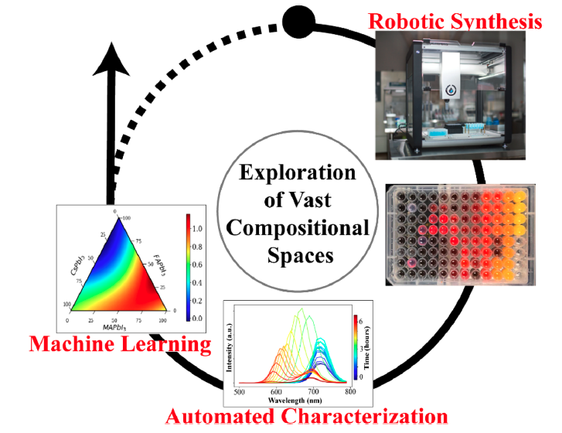
Figure 2-1 A schematic of the automated workflow for the combinatorial discovery of MHP materials. The combinatorial library is first created in a chosen multidimensional compositional space using the pipetting robot (robotic synthesis). The precipitation of 92 microcrystals of MHP is indicated by the change in color in a well-plate. Photoluminescent properties are measured over the combinatorial library as a function of time (automated characterization). This data is analyzed via machine learning methods to yield information on the time-dependent behaviors in the system that can be further used to navigate the compositional space.

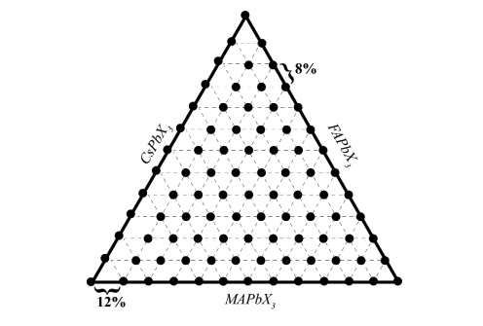
Figure 2-2 Sample point distribution in a phase diagram for each microplate. The compositions sampled were roughly, equally spaced, approximately 8 at % apart, except for an edge of the phase diagram in which the compositions are 12 at % apart, to characterize the entirety of the phase diagram.

The 0.3 M precursor solutions of MAPbBr₃, MAPbI₃, FAPbBr₃, FAPbI₃, CsPbBr₃, and CsPbI₃ are made by dissolving the precursors, i.e., AX and PbX₂, in n’n-dimethylformamide (DMF), γ-butyrolactone (GBL), DMF, GBL, dimethyl sulfoxide (DMSO), and DMF, respectively.
Each solution was stirred at 500 RPM for approximately 1 hour or until the precursors were completely dissolved. Vials were then covered with aluminum foil to protect from possible light effects. All steps mentioned here were performed under a nitrogen atmosphere. After dissolving, precursor solutions were immediately used for the synthesis of microcrystals to avoid the effects of ageing.
The automated synthesis of the combinatorial libraries of ternary (MA_{x}FA_{y}Cs_{1-x-y}PbBr₃ and MA_{x}FA_{y}Cs_{1-x-y}PbI₃) and quasi-ternary (Cs_{x}FA_{y}MA_{1-x-y}Pb(Br_{x+y}I_{1-x-y})₃ and Cs_{x}MA_{y}FA_{1-x-y}Pb(I_{x+y}Br_{1-x-y})₃) was performed using the Opentrons OT-2 pipetting robot (https://opentrons.com/) and the classical 96-well microplates shown in Figure 2-1. Exact volumes of the precursors deposited in each well of the microplate is shown in Table 2-1. Once each of the precursors was pipetted into their respective wells, 250 μL of chloroform, acting as an antisolvent to cause the precipitation of the microcrystals, was added^{146, 158}. Immediately after the addition of the antisolvent, the microcrystals precipitated as indicated by the color change as shown in Figure 2-3.

Automated Photoluminescence Measurements
Recently, it has been demonstrated that dynamical processes related to MHP formation, ion migration, phase changes, and degradation^{98, 121}. The intrinsic stability is often explored by X-ray diffraction (XRD)^{39, 176}, UV-vis absorption spectroscopy^{98, 114}, etc. Commonly, the optical properties of MHPs are explored with photoluminescence (PL) spectroscopy as it is a relatively simple measurement to perform in most laboratories^{97, 98, 120, 177}.
Utilizing PL spectroscopy with a conventional setup to characterize an entire combinatorial library would be tedious. Thankfully, PL spectroscopy is scalable to the microgram volumes in robotic laboratory environments; therefore, it can be incorporated into automated workflows for materials discovery and optimization. Here, we utilized the BioTek Cytation Hybrid Multi-Mode Reader, which is popular in biology and cell science fields, for PL spectroscopy. With this equipment, the data collection is performed through the Gen 5TM software, which has the capability of data processing complex arrays.
Table 2-1 Volumes (in μL) of each precursor solution in each well of the microplate. Precursor 1 is shown in black, precursor 2 in red, and precursor 3 in blue.
 | 1 | 2 | 3 | 4 | 5 | 6 | 7 | 8 | 9 | 10 | 11 | 12
A | 50  0  0 | 38  4  8 | 30  16  4 | 26  12  12 | 22  12  16 | 18  16  16 | 14  24  12 | 10  36  4 | 10  4  36 | 6  20  24 | 0  42  8 | 0  10  40
B | 46  4  0 | 38  0  12 | 30  12  8 | 26  8  16 | 22  8  20 | 18  12  20 | 14  20  16 | 10  32  8 | 10  0  40 | 6  16  28 | 0  38  12 | 0  6  44
C | 46  0  4 | 34  16  0 | 30  8  12 | 26  4  20 | 22  4  24 | 18  8  24 | 14  16  20 | 10  28  12 | 6  44  0 | 6  12  32 | 0  34  16 | 0  2  48
D | 42  8  0 | 34  12  4 | 30  4  16 | 26  0  24 | 26  0  24 | 18  4  28 | 14  12  24 | 10  24  16 | 6  40  4 | 6  8  36 | 0  30  20 | 0  0  50
E | 42  4  4 | 34  8  8 | 30  0  20 | 22  28  0 | 22  28  0 | 18  0  32 | 14  8  28 | 10  24  16 | 6  40  4 | 6  8  36 | 0  26  24
F | 42  0  8 | 34  4  12 | 26  24  0 | 22  24  4 | 22  24  4 | 14  36  0 | 14  4  32 | 10  16  24 | 6  32  12 | 6  0  44 | 0  22  28
G | 38  12  0 | 34  0  16 | 26  20  4 | 22  20  8 | 22  20  8 | 14  32  4 | 14  0  36 | 10  12  28 | 6  28  16 | 0  50  0 | 0  18  32
H | 38  8  4 | 30  20  0 | 26  16  8 | 22  16  12 | 22  16  12 | 14  28  8 | 10  40  0 | 10  8  42 | 6  24  20 | 0  46  4 | 0  14  36

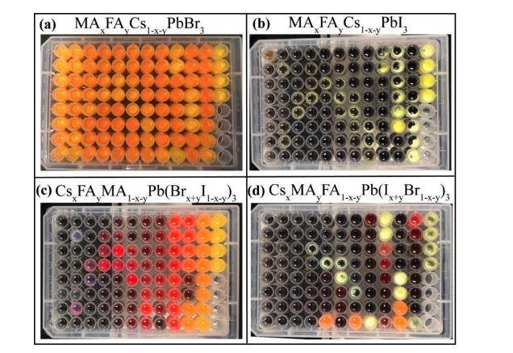
Figure 2-3 Photos of the four microplates characterized in this study. The compositions of these plates are a) Cs_{x}MA_{y}FA_{1-x-y}PbBr₃, b) Cs_{x}MA_{y}FA_{1-x-y}PbI₃, c) Cs_{x}FA_{y}MA_{1-x-y}Pb(Br_{x+y}I_{1-x-y})₃, and d) Cs_{x}MA_{y}FA_{1-x-y}Pb(I_{x+y}Br_{1-x-y})₃.

The reader equips monochromators with variable bandwidths from 10-50 nm to optimize detection conditions. The monochromator has the capability of exciting from both the top and the bottom of the microplate. We chose to excite from the bottom of the microplate. As shown in Figure 2-4, the top of each well could be immediately affected by the exposure to ambient conditions. By exciting from the bottom, there is more time to explore degradation mechanisms. The PL measurements were performed with an excitation wavelength of 450 nm and measured over the range of 500 to 799 nm with steps of 10 nm. All measurements were performed in a sweep mode, enabling for the characterization of an entire plate within 5-7 minutes.
These measurements were performed every 10 minutes for approximately 6 hours to develop a time- and compositional-dependent dataset of the optoelectronic properties and intrinsic stability in ambient conditions of the chosen system. Here, we do not focus on the optimization of optoelectronic properties, but, instead, on the exploration of vast compositional spaces and time evolution of PL properties, i.e., PL aging. While we investigate materials level stability only, this is an absolute prerequisite for device stability.
First, we investigate the PL properties of the four different perovskite systems before prolonged exposure to ambient conditions. Upon an initial inspection, we can conclude about what regions of the phase diagram would be optimal for certain applications based on the bandgap. The initial PL spectra of the microcrystals immediately after precipitation is shown in Figure 2-5. In each panel, the compositional-dependent PL spectra of the 92 different compositions is shown. It is obvious to observe how the emission wavelength shifts significantly in the quasi-ternary systems with varying halide concentrations. However, it is particularly challenging to recognize trends caused by alloying with this visual representation. Therefore, to gain insight into the variability of the PL properties across the compositional spaces, we utilize an approach based on multivariate statistical analysis.

Incorporation of Machine Learning
Our synthesis and characterization yield a set of spectra as $A(x,y,ω,t)$, where A is the PL emission, x and y define the composition, ω is the wavelength, and t is the time since synthesis. The first step in gaining insight into the compositional dependence of optoelectronic properties is to define the initial PL spectra $L_{0}\left(x,y,ω\right)=L(x,y,ω,0)$ and to analyze the dataset using unsupervised linear unmixing methods.

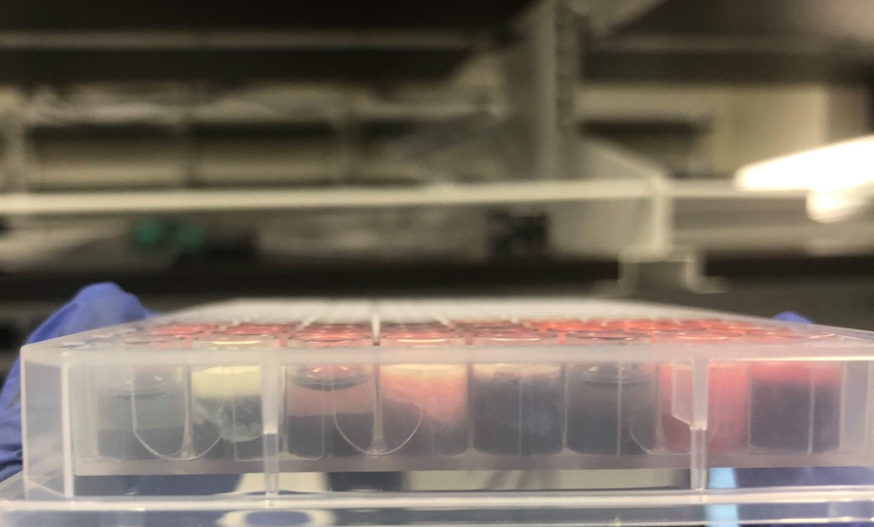
Figure 2-4 Side view of the well-plate. Here, we observe a gradient of perovskites that have interacted with ambient conditions (at the top) to the perovskites yet to interact with the air (at the bottom).

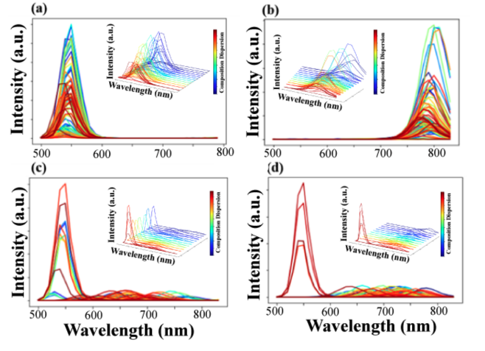
Figure 2-5 Characteristic PL properties of 4 different plates at time zero in a) Cs_{x}FA_{y}MA_{1-x-y}PbBr₃, b) Cs_{x}FA_{y}MA_{1-x-y}PbI₃, c) Cs_{x}FA_{y}MA_{1-x-y}Pb(Br_{x+y}I_{1-x-y})₃ and d) Cs_{x}MA_{y}FA_{1-x-y}Pb(I_{x+y}Br_{1-x-y})₃ systems. The color change in each panel represents different concentration of precursors.

These generally include techniques, such as Principal Component Analysis (PCA), Non-negative Matrix Factorization (NMF), and Independent Component Analysis (ICA). The choice of decomposition method is dictated by the physical constraints on endmembers and loading maps. Therefore, we chose NMF because it produces non-negative components and decomposes the initial time spectra as
 | $$L_{0}\left(x,y,ω\right)= \sum_{i=1}^{N}{L_{i}(x,y)w_{i}(ω)}$$ | (2-1)

where L_{i}(x,y) are the loading maps, representing the variability of spectral behaviors across the compositional space, and w_{i}(ω) are the endmembers, determining the characteristic spectral behaviors.
The number of components, N, is chosen by the operator based on the knowledge of the system. Here, we chose the number of components subjectively by visually inspecting the loading maps as the number of components is increased. However, the “optimal” number of components can be obtained analytically by calculating the error between the NMF decomposition and the actual matrix. The error difference, δ₁, is calculated by subtracting the error for N + 1 components by N components. This is done for N + k components, generating a list of error difference values. Once δ₁ ceases to change substantially, the assumption is made that the approximation could not be improved by adding more components.
We note that blind linear separation methods explicitly assume that the nature of the characteristic behaviors, w_{i}(ω), is unknown. If the behaviors are assumed to be known e.g., comport with the spectra of pure endmembers, then (2-1) becomes a linear regression model, and the additional unknown components can be introduced to account for chemical reactivity and the formation of new compounds. These approaches are expected to be beneficial for spectrophotometric data, i.e., optical absorption. However, this is not applicable for the PL data that can exhibit complex behavior as a function of composition, crystallinity, defect properties, and environmental stability. Therefore, we use unconstrained linear blind separation to allow for possible chemical reactions and morphological evolution within the system. Concurrently, we limit the analysis to the linear unmixing as a natural first approximation.
Then, we use Gaussian processing (GP) regression to interpolate between the NMF components [43,44]. GP is a general approach for determining an unknown function, f, from a set of noisy observations D = (x₁, y₁),…, (x_{N}, y_{N}). The constraints placed on the GP model are very general, and it is assumed only that the observational noise ε has zero mean. From the observations, the function f is constructed via Bayesian inference in a function space. Here, it is assumed that the function f has a prior distribution f ~ gp(0, K_{f}(x,x’)), where K_{f} is a kernel function. The kernel describes the correlations between the values of the function across the parameter space. We postulate the functional form of the kernel at the beginning of the process, whereas the kernel hyperparameters are optimized during the regression, y = f(x) + ε. Then, the learned kernel is used for predicting function values at new points. Typically, the choice of kernel is dictated by the known physical constraints on the system; in the cases when prior knowledge is absent, the typical option is the Gaussian kernel, which corresponds to a Bayesian linear regression model with an infinite number of basis functions¹⁵⁴. The output of the GP regression is the predicted function values and the uncertainty maps represent the quality of prediction. As well, the learned kernel parameters can yield information on the physics of the system. Here, we note that because GP is formulated in a Bayesian setting, the uncertainty quantification is inherent in GP-based methods. This has been the primary motivation for choosing this method instead of readily available simpler interpolation schemes as the uncertainty allows for the formulation of the strategies for exploratory and exploration-exploitation searches through compositional spaces as will explored in the future.
In this study, we use GP as a universal interpolator to convert the set of measurements in the compositional space into dense maps of functional responses. The GP interpolation is implemented using the GPim library in Python. We visualize the functional behaviors in ternary diagrams using the ternary library.

Initial Photoluminescence Behavior
To map the compositional-dependent PL properties of each system before prolonged exposure to ambient conditions, we utilize the combined NMF-GP analysis; however, we first must determine the number of components, N, for the decomposition of the initial PL spectra. We chose N = 2 because it was the simplest representation of variability for each system. For example, the loading maps for the decomposition with different Ns of the Cs_{x}FA_{y}MA_{1-x-y}Pb(Br_{x+y}I_{1-x-y})₃ quasi-ternary system at time zero is shown in Figure 2-6. As mentioned previously, an indicator that N is too large is the observation of the splitting of components, indicating that we are not gaining more information from the extra components. As the number of components is increased from 1 to 2, we observe the description of a new area of the phase diagram, indicating that the increase is beneficial. If the number of components is increased to 3, we see the first component from N = 2 is split into the first and third components, signifying that the decomposition is performed with too many components. This trend continues as the number of components increased. We confirmed these visual observations by the analytical approach as well. Therefore, N = 2 was chosen for the decomposition of the time zero datasets.
Illustrated in Figure 2-7 is the combined NMF-GP analysis of the ternary and quasi-ternary systems at time zero. Here, the phase diagrams represent $L_{i}(x,y)$, where x and y are the compositions of the precursors, and L_{i} is the weight of the characteristic PL spectrum for each area of the phase diagram. For example, the high intensity areas of the phase diagram, indicated by red, in the inset of Figure 2-7a) have the associated PL spectrum in Figure 2-7a). This signifies how FAPbBr₃-rich compositions doped with small amounts of MAPbBr₃ and CsPbBr₃ have a single PL peak centered at 550 nm. This result is consistent with the literature, as the bandgap of FAPbBr₃ is about 2.13 eV, suggesting a PL peak centered at 580 nm¹⁵⁰, but the peak would be slightly blue-shifted due to the small amounts of MA and Cs. We continue to observe shifts in peak positions as the system is further alloyed with Cs. As shown in Figure 2-7b), the PL peak is centered at approximately 540 nm for CsPbBr₃-rich compositions as expected¹⁷⁸. In the literature, it is well established that the bandgap can be tuned both through cation and halide substitution¹⁷⁹. We further confirm how the effect of cation alloying can affect the bandgap by analyzing the MA_{x}FA_{y}Cs_{1-x-y}PbI₃ system as well. Consistent with the literature, MAPbI₃ rich compositions have a PL peak centered at approximately 800 nm, as shown in Figure 2-7c)¹⁸⁰. As the incorporation of Cs increasing in the solid solution, we observe the PL shift towards lower wavelength (Figure 2-7d)), as expected¹⁸¹.
In the quasi-ternary systems, Cs_{x}FA_{y}MA_{1-x-y}Pb(Br_{x+y}I_{1-x-y})₃ and Cs_{x}MA_{y}FA_{1-x-y}Pb(I_{x+y}Br_{1-x-y})₃, we observe the compositional tuning of the bandgap caused by substituting bromide with iodide and vice versa. In the Cs_{x}FA_{y}MA_{1-x-y}Pb(Br_{x+y}I_{1-x-y})₃, as shown in Figure 2-7e) the bromide-rich compositions have a PL peak centered approximately at 550 nm, as expected^{150,178}. As more iodide is incorporated, forming a mixed cation and mixed halide solid solution, the PL peak shifts toward higher wavelengths, approximately centered around 650 nm, as shown in Figure 2-7f). We observe distinct halide segregation when analyzing the Cs_{x}MA_{y}FA_{1-x-y}Pb(I_{x+y}Br_{1-x-y})₃ system.

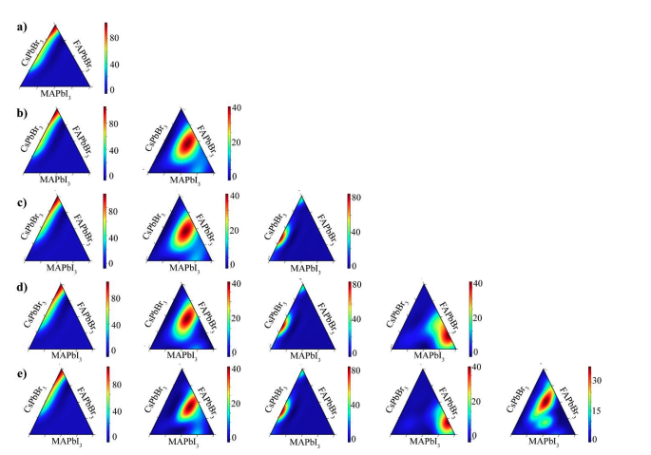
Figure 2-6 Visual comparison for determining the correct number of components for Non-negative Matrix Factorization (NMF) for the Cs_{x}FA_{y}MA_{1-x-y}Pb(Br_{x+y}I_{1-x-y})₃ quasi-ternary system at time zero.

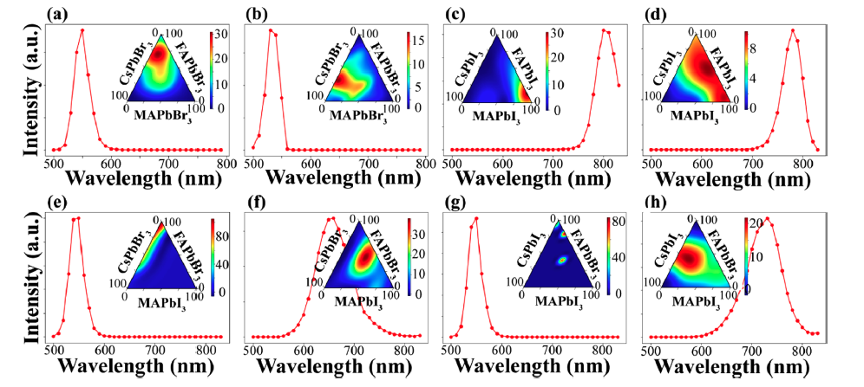
Figure 2-7 Multivariate analysis of the PL data immediately after synthesis for the explored compositional spaces: a,b) MA_{x}FA_{y}Cs_{1-x-y}PbBr₃, c,d) MA_{x}FA_{y}Cs_{1-x-y}PbI₃, e,f) Cs_{x}FA_{y}MA_{1-x-y}Pb(Br_{x+y}I_{1-x-y})₃ and g,h) Cs_{x}MA_{y}FA_{1-x-y}Pb(I_{x+y}Br_{1-x-y})₃. The PL spectrum shows the characteristic behavior for each composition series. The ternary inset plots are the loading maps that represent the variability of the spectral behaviors across the compositional space. Specifically, the intensity of the color map indicates how the characteristic spectrum describes that composition.

For example, as shown in Figure 2-7g), there are distinct regions in the phase diagram where the characteristic PL behavior is a peak centered around 550 nm, indicating compositions that have undergone halide segregation upon synthesis and would not be suitable for optoelectronic devices. The majority of this system, represented by dark blue in the inset of Figure 2-7g), does not exhibit halide segregation because the weight of this characteristic PL spectrum is approximately zero. Conversely, the red dots within the same phase diagram indicate where this characteristic spectrum is heavily weighted, denoting where halide segregation occurs in compositional space. If the GP analysis was not performed along with the NMF decomposition, there would be sample points within the phase diagram instead of the continuous image, as shown in Figure 2-8, because GP interpolates the weights between each sample point. Conversely, the second component (Figure 2-7h)) establishes that the majority of this system is a solid solution not experiencing halide segregation with a peak wavelength around 720 nm. Overall, this analysis can provide crucial information about the optimal compositions for certain optoelectronic applications.
Next, we can utilize this data to analyze the compositional dependence of the bandgap energy. Here, the position of the photoluminescence maximum is used as a measure of the bandgap, and the concentration of the latter can be analyzed. We use the simple linear estimator to explore the cation and anion effects on the bandgap. For example, for the pure Br system, the linear regression E_{g} = a_{Br}x + b_{Br}y + c_{Br}, where x and y correspond to the concentrations in MA_{x}FA_{y}Cs_{1-x-y}PbBr₃, producing a_{Br} = -0.046, b_{Br} = -0.1, and c_{Br} = 2.33. Similarly, the corresponding parameters for the MA_{x}FA_{y}Cs_{1-x-y}PbI₃ are a_{I} = -0.041, b_{I} = 0.021, and c_{I} = 1.58, satisfying the Vegard’s law for bandgap energy as a function of cation concentrations in MHPs.
In the quasi-ternary systems, Cs_{x}FA_{y}MA_{1-x-y}Pb(Br_{x+y}I_{1-x-y})₃ and Cs_{x}MA_{y}FA_{1-x-y}Pb(I_{x+y}Br_{1-x-y})₃, the compositional dependence of the bandgap energy can be investigated similarly, although for specific parameter combinations. Shown in Figure 2-9a) is a comparison of the linear prediction and the actual bandgap energies for the two systems. We observe a general agreement between the predicted and the actual bandgap energy from the measurements, with a small deviation from Vegard’s law and a near-linear behavior in the bandgap energy. Similar trends for studying the compositional tuning of bandgap energies in binary mixed halide systems have also been explored^{25, 182}.

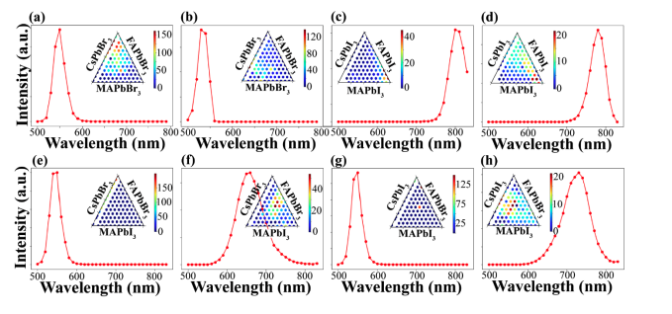
Figure 2-8 Complementary maps to Figure 2-7. The triangle maps demonstrate the analysis of PL responses prior to GP interpolation.

At the same time, the analysis of the quaternary diagram created by the combination of the data produced by all four plates illustrates a significant deviation from the linear model, as shown in Figure 2-9b), indicating the formation of more complex solid solutions and potential chemical segregation in higher-dimensional composition space.

Time-dependent PL Behavior
Next, we explore the time- and compositional-dependence of the PL behavior, providing insight into the stability of these perovskites in ambient conditions. Figure 2-10 illustrates several representative time-dependent photoluminescent behaviors. For example, as shown in Figure 2-10a), the binary cation composition, MA_{0.84}FA_{0.16}PbBr₃, exhibits PL enhancement within the first 3 hours, indicating possible passivation of potential trap states as time progress under ambient conditions in agreement with previous PL studies¹²¹. The PL intensity gradually decreases over the remaining 3 hours; however, even after 6 hours of exposure to ambient conditions, the peak does not entirely disappear, signifying that this binary composition did not fully degrade. Conversely, the PL intensity for the quasi-ternary composition, MA_{0.6}FA_{0.32}Cs_{0.08}PbI_{2.04}Br_{0.96}, presents a more complicated behavior, as shown in Figure 2-10b). For this composition, there is a combination of a peak intensity enhancement, peak position shift, peak separation, eventual decrease in peak intensity, and, finally, the complete disappearance of the peak after prolonged exposure in ambient conditions, indicating full degradation of this perovskite composition. We note that this peak shift and peak separation as time progresses is indicative of phase separation in this iodide-rich system⁹⁷. In the same quasi-ternary system, a composition more MA-rich and less FA- and Cs-rich than in Figure 2-10b) exhibits similar PL behavior, as shown in Figure 2-10c); however, at the end of the measurements, the peaks have not entirely disappeared. Noticeably, we observe the significant effect of mixed halides on the instability of such compositions. For example, the composition, MA_{0.2}FA_{0.72}Cs_{0.08}PbI_{0.6}Br_{2.4}, in the bromide-rich mixed halide systems exhibits a slight peak shift towards lower wavelengths as the peak intensity gradually increases, as shown in Figure 2-10d); therefore, the final composition remains stable. Conversely, in the same quasi-ternary system, MA_{0.44}FA_{0.48}Cs_{0.08}PbI_{1.32}Br_{1.68} demonstrates different PL behavior, as shown in Figure 2-10e). There, the PL peak gradually shifts 100 nm toward lower wavelengths, without the apparent peak splitting, while the peak intensity changes.

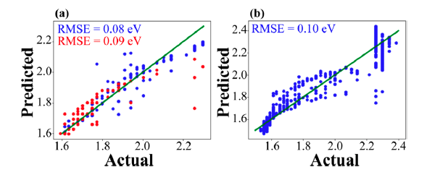
Figure 2-9 a) Comparison of the linear prediction and actual bandgap for the Cs_{x}MA_{y}FA_{1-x-y}Pb(I_{x+y}Br_{1-x-y})₃ (red) and Cs_{x}FA_{y}MA_{1-x-y}Pb(Br_{x+y}I_{1-x-y})₃ (blue) systems. b) Comparison of linear prediction and actual bandgap of the interpolated quaternary system. The green line is plotted to show the deviation from slope 1 and the root mean squared error (RMSE) is calculated for evaluating the quality of the surrogate model.

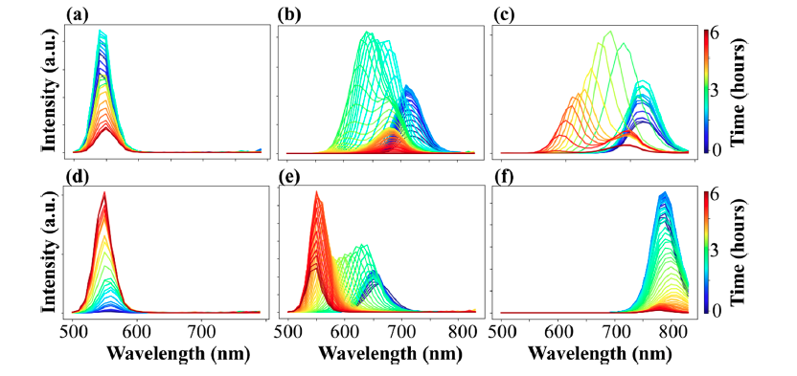
Figure 2-10 Time dependent PL spectra for several compositions in ambient condition: a) MA_{0.84}FA_{0.16}PbBr₃, b) MA_{0.60}FA_{0.32}Cs_{0.08}PbI_{2.04}Br_{0.96}, c) MA_{0.68}FA_{0.28}Cs_{0.04}PbI_{2.04}Br_{0.96}, d) MA_{0.20}FA_{0.72}Cs_{0.08}PbI_{0.60}Br_{2.40}, e) MA_{0.44}FA_{0.48}Cs_{0.08}PbI_{1.32}Br_{1.68} and f) MA_{0.36}FA_{0.56}Cs_{0.08}PbI₃.

This final decomposed composition also remains stable; however, it would potentially not be suitable for certain applications as the final product is drastically different than the starting composition. Finally, in the ternary system, for the composition, MA_{0.36}FA_{0.56}Cs_{0.08}PbI₃, we observe an initial broad PL peak that gradually decreases in intensity, as shown in Figure 2-10f). Eventually, a small peak shift follows this to higher wavelengths until the peak splits and disappears, indicating that this composition is not stable in ambient conditions.
As illustrated in Figure 2-10, the time dynamics of the PL behavior in the multicomponent systems are very complex, as a result of simultaneous processes of crystallization, defect healing, compositional changes induced by the preferential I⁻ oxidation in ambient conditions, and chemical degradation. Similarly, it is difficult and time-consuming to study the PL behavior of each individual composition in these large compositional spaces separately. Therefore, to explore the time- and compositional-dependent PL behavior systematically, we extend the analysis in (2-1) toward the joint analysis of the spectral and time domain. We analyze the full L(x, y, ω, t) data set using NMF via the decomposition
 | $$L_{0}\left(x,y,ω,t\right)= \sum_{i=1}^{N}{L_{i}(x,y)g_{i}(ω,t)}$$ | (2-2)
where L_{i}(x, y) are the loading maps that represent the variability in behaviors across the compositional space and g_{i}(ω, t) are the endmembers that determine the characteristic behaviors in the time-spectral domain. Similar to the analysis of the initial PL behavior before exposure to ambient conditions, the loading maps are represented via a ternary phase diagram after GP interpolation. In contrast, the endmembers are visualized via 2D representations.
Before exploring the PL evolution of each system, we determine the number of components similar to the process described previously for the initial PL data set. We visually compare the loading maps utilizing different Ns for the Cs_{x}FA_{y}MA_{1-x-y}Pb(Br_{x+y}I_{1-x-y})₃ shown in Figure 2-11 as an example. Here, we chose N = 3 as it describes the majority of the phase diagram without splitting the components. For example, when N = 4, the first components splits into two, indicating that this number of components is too high. For all systems, we utilize N = 3.

Figure 2-11 Visual comparison for determining the correct number of components for Non-negative Matrix Factorization (NMF) for the Cs_{x}FA_{y}MA_{1-x-y}Pb(Br_{x+y}I_{1-x-y})₃ quasi-ternary system for the time-dependent dataset.

Employing this strategy, we begin by examining the time evolution of PL properties of the pure bromine ternary phase system, MA_{x}FA_{y}Cs_{1-x-y}PbBr₃. As shown in Figure 2-12a,d), the first component illustrates how the solid solutions of MAPbBr₃, FAPbBr₃, and CsPbBr₃ have a PL emission wavelength between 540 and 550 nm. These compositions experience an increase in PL intensity in ambient conditions as time progresses. Increasing PL intensity in ambient conditions has been previously attributed to a boost in the carrier radiative recombination rate or defect healing¹²⁰. FAPbBr₃-rich compositions exhibit a different evolution in PL behavior as shown in the second component, Figure 2-12b,e). Here, we first observe a broad PL emission between 530 and 570 nm. The PL intensity gradually decreases after roughly 3 hours, an indication of compositional degradation. Finally, the third component, shown in Figure 2-12c,f), the CsPbBr₃-rich compositions have a much narrower PL emission centered around 530 nm, indicating these compositions have a higher bandgap emission and possibly higher crystallinity¹⁸³. Even though the PL intensity begins to decrease, this compositional region remains stable during prolonged exposure to ambient conditions.
Next, we investigate the time evolution of PL behavior of the pure iodide ternary phase system, MA_{x}FA_{y}Cs_{1-x-y}PbI₃. The first component (Figure 2-12g,j)) describes the behavior of MAPbI₃-rich compositions and a region of solid solutions between MAPbI₃, FAPbI₃, and CsPbI₃. This area begins with a high intensity PL peak centered around 800 nm and over time, the intensity of this peak decreases and eventually disappears, indicating full degradation. In the second component (Figure 2-12h,k)), we observe how FAPbI₃-rich compositions and solid solutions between FAPbI₃ and CsPbI₃ exhibit a slow increase in PL intensity that begins to decrease as time progresses. This area appears to be relatively more stable as compared to the other regions of the phase diagram, and this is in agreement with the literature in which it has been observed that low cesium doping of FAPbI₃ is effective in the stabilization of FAPbI₃ in nonideal conditions^{22, 184}. Finally, the third component (Figure 2-12i,l)) illustrates how solid solutions of FA-triple cation compositions exhibit an increase in PL intensity, followed by an abrupt decrease. In general, this analysis confirms that compositions in the ternary cation lead bromide system are relatively more stable that the compositions in the ternary cation lead iodide system, possibly because of the limited formation of superoxide species in ambient conditions^{25, 88}. Furthermore, we offer a possible strategy in cation or anion management through this analysis to successfully guide the selection of compositions with higher stability or crystallization in such ternary systems.
Figure 2-12 The multivariate analysis of the stability in a-f) MA_{x}FA_{y}Cs_{1-x-y}PbBr₃ system and g-l) MA_{x}FA_{y}Cs_{1-x-y}PbI₃ system. Shown as ternary diagrams are the compositional dependencies of the component intensities (top rows) and 2D NMF components (bottom rows). The 2D plots describe the PL behavior of the corresponding phase diagram (represented by a non-zero weight) as a function of wavelength and time. For the ternary phase diagrams, the color is indicative of how the characteristic PL behavior over time describes that compositional region. For the 2D plots, the color describes the intensity of the PL peak.

We progress further by investigating the evolution of PL behavior during prolonged exposure to ambient conditions of the two quasi-ternary systems: bromide-rich Cs_{x}FA_{y}MA_{1-x-y}Pb(Br_{x+y}I_{1-x-y})₃ and iodide-rich Cs_{x}MA_{y}FA_{1-x-y}Pb(I_{x+y}Br_{1-x-y})₃. The first component of the Cs_{x}FA_{y}MA_{1-x-y}Pb(Br_{x+y}I_{1-x-y})₃ system is shown in Figure 2-13a,d). In this component, we observe a shift in bandgap energy of the mixed iodide-bromide solid solutions toward lower wavelengths with a growing intensity of the PL emission as time progresses. The resulting PL spectra of this compositional region is similar to that of the MA_{x}FA_{y}Cs_{1-x-y}PbBr₃ system, signifying firstly halide segregation and eventual degradation of the iodide-rich regions, leaving only bromide-rich perovskite compositions. For a region of solid solutions between MAPbI₃ and FAPbBr₃ (Figure 2-13b)), the 2D NMF endmember shown in in Figure 2-13d) illustrates a significant blue shift, clearly indicating phase separation over time and, here, ultimately degrading. Generally, the blue shifting of the PL peak of these bromide-rich mixed halide perovskites (Figure 2-13d,e)) once exposed to ambient conditions is in agreement with previous reports¹²¹. Finally, the third component (Figure 2-13c,f)) focuses on a small region of MAPbI₃-rich compositions that have an initial emission wavelength around 770 nm. Over time, the PL emission slightly redshifts and finally disappears. Overall, we conclude that in this system, the CsPbBr₃- and FAPbBr₃-rich regions are relatively more stable because the PL peak positions do not change, and the PL intensity increases as a function of time. This observation is confirmed by analyzing at individual compositions as well. For example, shown in Figure 2-10d), MA_{0.20}FA_{0.72}Cs_{0.08}PbI_{0.60}Br_{2.40} exhibits this behavior, i.e., an increase in intensity and limited peak shifts. Conversely, the remainder of this phase diagram experiences prominent peak shifts along with a decrease in PL intensity, indicating limited stability in ambient conditions.
Finally, the iodide-rich Cs_{x}MA_{y}FA_{1-x-y}Pb(I_{x+y}Br_{1-x-y})₃ system demonstrates a wide variety of PL behavior across the compositional space. First, the small CsPbI₃-rich region shown in the first component (Figure 2-13g,j)) has a broad PL emission between 500 and 600 nm, indicative of either the formation of the δ-CsPbI₃ or the lack of phase formation, leaving only PbI₂. We conclude this from the initial yellow precipitates after antisolvent application along with the PL spectrum shown in Figure 2-14. Next, we observe another instance of halide segregation in the second component (Figure 2-13h,k)).

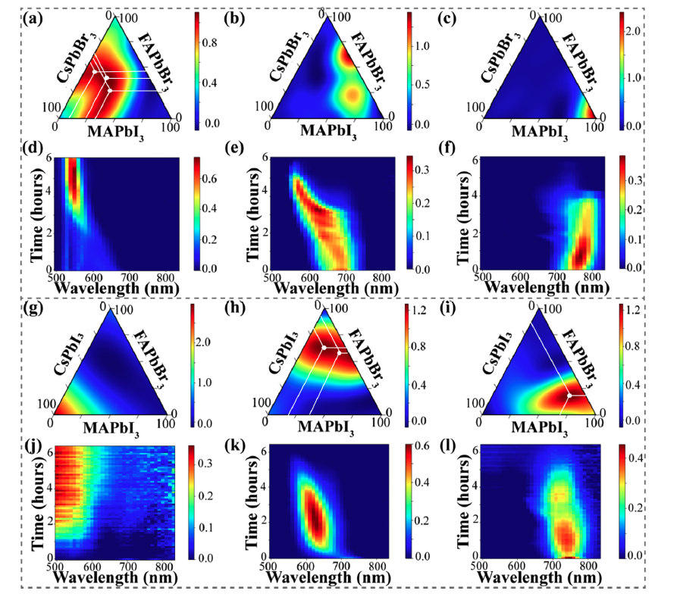
Figure 2-13 The multivariate analysis of the stability in quasi-ternary a-f) Cs_{x}FA_{y}MA_{1-x-y}Pb(Br_{x+y}I_{1-x-y})₃ and g-l) Cs_{x}MA_{y}FA_{1-x-y}Pb(I_{x+y}Br_{1-x-y})₃ systems. Shown as ternary diagrams are the compositional dependencies of the component intensities (top rows) and 2D NMF components (bottom rows), describing the PL behavior of the corresponding phase diagram (represented by a non-zero weight) as a function of wavelength and time. The color of the ternary phase diagram is indicative of how the characteristic PL behavior over time describes that compositional region. In the 2D plots, the color describes the intensity of the PL peak.

Here, the evolution of PL behavior of solid solutions of MAPbI₃, CsPbI₃, and FAPbBr₃ is a slow emission shift toward lower wavelengths and eventual disappearance. In the third component (Figure 2-13I,l)), MAPbI₃-rich solid solutions experience a decrease in PL intensity as time progressing, indicating eventual degradation of these compositions. Overall, this analysis of the quasi-ternary systems illustrates how most solid solutions in mixed halide perovskites experience compositional changes possibly caused by preferential I⁻ oxidation in ambient conditions, phase separation toward more stable components, and ultimately experience chemical degradation. Halide segregation induced by exposure to ambient conditions has been widely reported^{120, 185}. For example, Knight et al. detailed how halide segregation dynamics are strongly influenced by the atmospheric environment¹²¹. Overall, these studies explain how the wavelength shifts observed in the 2D NMF components of mixed halide samples shown in Figure 2-13 are instances of halide segregation. In general, we observe that the PL emission of mixed halide perovskite systems is more likely to shift as a function of time, while this is not the case in the single-anion iodide or bromide systems shown in Figure 2-12.
We note that although the general trends observed here agree with limited compositional systems studied in the literature to date, it is well established that materials processing can affect the intrinsic stability of MHPs. Therefore, it is important to considering these materials processing factors, such as antisolvents, solvents, annealing time, annealing temperature, excess precursors, synthesis environment, etc., when comparing stable compositions here with ones in the literature¹⁸⁶⁻¹⁸⁸. While this experimental workflow is beneficial in accelerating the discovery of more stable areas in the phase diagram, more studies are necessary to explore the role of other parameters in materials processing. For example, Gu et al. illustrated the effect of antisolvents of the formation of a few MHP compositions through a high-throughput approach¹⁴⁸. Later, in Chapter 4, we discuss how antisolvent engineering affects the stability of different perovskite systems during exposure to ambient conditions.

Figure 2-14 PL spectra of CsPbI₃ microcrystals as function of time. We observe a broad peak around the 500-600 nm region with extraneous peaks at higher wavelengths. In combination with the color of the precipitates, this spectrum indicates the formation of PbI₂ microcrystals instead of CsPbI₃. Overall, this is indicative of this composition being unstable before exposure to ambient conditions.

Summary
Here, we demonstrate how robotics-assisted materials synthesis combined with machine learning approaches can explore vast compositional spaces in MHPs. We accomplished this through the utilization of a pipetting robot and a Multi-mode well plate reader to automate synthesis and characterization of a large number of compositions simultaneously. Next, we developed a workflow to explore the PL properties and intrinsic stability of MHPs in ambient conditions and applied it to four perovskite materials systems: MA_{x}FA_{y}Cs_{1-x-y}PbBr₃, MA_{x}FA_{y}Cs_{1-x-y}PbI₃, Cs_{x}FA_{y}MA_{1-x-y}Pb(Br_{x+y}I_{1-x-y})₃, and Cs_{x}MA_{y}FA_{1-x-y}Pb(I_{x+y}Br_{1-x-y})₃. Impressively, the fabrication and characterization of time-dependent PL behavior of 368 MHP compositions only took approximately 4 days.
As mentioned previously, the monitoring of PL properties is an established, effective strategy for obtaining insight into the optoelectronic qualities of MHPs¹⁸⁹; however, PL properties are difficult to predict for a sizable compositional space. Here, we quickly mapped the PL properties as the entire optical characterization of a 96-well plate takes approximately 5 minutes for each system; therefore, we established a composition-properties relationship for a large number of compositions across a specific phase diagram. In combination with machine learning techniques, specifically NMF and Gaussian process, we further gained information into the variability of the optical bandgap and PL properties across the compositional series. We have estimated the Bayesian uncertainty model to assess how well the GP model fits the experimental data. The uncertainty maps for each three components in Figure 2-12a-c) are shown in Figure 2-15. In general, the uncertainty is low except for the region with large uncertainties, which is caused by the large spacing between measurements in the parameter space. The resulting RMSE values have indicated the high quality of the GP prediction. Overall, this workflow is an exploratory one; however, combined with materials knowledge in the literature, conclusions can be drawn about the characteristics of the chosen perovskite systems. For example, the interpolative regression analysis of the PL properties assists in distinguishing mixtures that form solid solutions from those that segregate into multiple phases in ambient conditions. As well, the effect of alloying on PL emission wavelengths, and therefore bandgaps, is found to be near-linear along certain compositional axes.

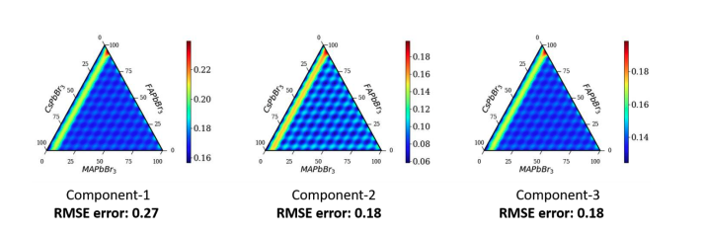
Figure 2-15 The estimated Bayesian uncertainty for the assessment of GP model for the three components in Figure 2-13a-c). The resultant root mean squared error (RMSE) calculated for each component is also shown. The line with large uncertainties is related to large spacing between measurement points in the parameter space.

Ordinarily, significant scientific progress is hindered by the utilization of trial-and-error approaches, which are when one variable is changed at a time and then the result is measured. Here, automated combinatorial synthesis and characterization allows for the opportunity to accelerate this approach by more than 2 order of magnitude for the fabrication of MHPs with large compositional spaces. Here, we advance this field of study by demonstrating a proof of concept for the development of an automated workflow that incorporates chemical robotics synthesis and machine learning to explore the evolution of photoluminescent behavior of MHPs. We illustrate how a combination of laboratory automation and machine learning can be utilized together for the rapid mapping of both concentration-dependent physical properties and long-term stability. This workflow is a required step to guide materials synthesis and to gain information into the overall behavior of the complex phase diagram of mixed perovskites. The incorporation of experimental optimization methods, i.e., those based on Gaussian processes, enable the transition from combinatorial synthesis to future guidance of materials research and optimization. Consequently, this experimental framework reveals a pathway for the discovery of new MHPs with optimized properties for multifunctional optoelectronics.

Exploring the Physics of Cesium Lead Halide Quantum Dots utilizing Chemical Robotics and Bayesian Inference

Abstract
Because of their desirable optoelectronic properties, metal halide perovskite (MHP) quantum dots (QDs) are promising candidates for applications in light-emitting diodes (LEDs), scintillators, and other photonic devices. Automated synthesis platforms equipped with an optical reader have made it possible to perform high-throughput studies, exploring both how both composition and materials processing factors affect the photoluminescent behavior of QDs. Here, we investigate the compositional dependence of the PL behavior and intrinsic stability of a combinatorial library of cesium lead halide (CsPbX₃) perovskites QDs via an automated platform. We explore the time-dependent PL properties and stability of synthesized QDs in binary and ternary configurations utilizing previously developed machine learning analysis presented in Chapter 2. We introduce a Bayesian inference framework to further explore the PL behavior of the ternary CsPbX₃ QD system systematically. This framework finds the probabilistic fit of multiple models to the PL data and establishes both the optimal model and the model parameters robustly. Further, these behaviors can then be used as a control parameter for the future navigation of higher-dimensional compositional spaces. Our analysis illustrates the nonuniformity of the PL peak behavior in the ternary CsPbX₃ QD system. As well, it confirms the narrow size distribution and good quality of CsPbBr₃ QDs that have been alloyed with low concentrations of iodide and chloride. This chapter is revised based on an article published by Amanda Heimbrook, Kate Higgins (co-first author), Sergei V Kalinin, Mahshid Ahmadi in Nanophotonics 2020, DOI: 10.1515/nanoph-2020-0662.

Introduction
Recently, there has been an increasing interest in nanostructured metal halide perovskites (MHPs), in particular, quantum dots (QDs)¹²⁹, for a variety of optoelectronic applications, such as light-emitting diodes (LEDs)^{190, 191}, scintillators¹⁹²⁻¹⁹⁴, solar cells¹⁹⁵, etc. because of the superior properties of perovskite quantum dots (PQDs) as compared to their bulk counterparts. Typically, PQDs have low trap densities and therefore high color purity, exhibit high photoluminescence quantum yield (PLQY) efficiency, and have a tunable and narrow emission wavelength¹⁹⁶. The size of the PQDS is dependent on the types and the amount of long-chained ligands added to the perovskite solution, allowing for precise and facile tunability for encapsulation. PQDs are typically categorized into groups: all inorganic and hybrid organic-inorganic halide perovskites. All inorganic PQDs, which have a general formula of CsPbX₃ (X = I, Br, Cl) are known to be more relatively more stable than the hybrid organic-inorganic halide perovskite QDs, such as APbX₃ (A: MA or FA; X = I, Br, Cl)¹⁹⁶.
Hot injection and ligand-assisted reprecipitation (LARP) are commonly used methods to synthesize all inorganic PQDs¹⁹⁶⁻¹⁹⁸. The hot injection method is usually performed at an elevated temperature to create a supersaturated mixture that is then rapidly cooled in an ice bath, producing a multitude of small nuclei and results in nanocrystals¹⁹⁷. An advantageous aspect to this technique is that the solution temperature controls the size and emission wavelength of the PQDs. Comparatively, the ligand-assisted reprecipitation (LARP) requires less energy and specialized equipment than the hot injection technique to synthesize QDs^{196, 198}. Depending on the composition of the perovskite, this process can be performed at temperature as low as room temperature and still demonstrate quantum confinement effects^{198, 199}. Typically, the perovskite precursor solution is made utilizing an organic solvent, such as n’n-dimethylformamide (DMF) or dimethyl sulfoxide (DMSO) ¹⁹⁸. Ligands, such oleic acid (OA) and oleylamine (OAM) are commonly added at different ratios in conjunction with an antisolvent under vigorous stirring to create luminescent QDs¹⁹⁸.
Although the above techniques are widely successful in synthesizing high-quality QDs, subtle differences in fabrication can alter the size and shape of the QDs, therefore affecting the optical performance^{169, 196}. Furthermore, the synthesis using both techniques can be time-consuming and tedious to explore large compositional spaces and optimize the protocol, possibly leading to a lack of reproducibility and an increase in the cost of production. Over the past few years, microfluidic platforms have utilized to accelerate the fabrication of PQDs and improve reproducibility^{169,200}. These platforms improve the synthesis process by more efficient mixing, reduced cost of materials, high heat and mass transfer, high surface to volume ratio, temperature control, and continuous production²⁰⁰. Microfluidics can also enable the systematic exploration and precise control of composition, concentration, flow rate, reaction time, and temperature¹⁶⁹. While this approach is useful in the exploration of an optimized synthesis reaction, it has not yet been utilized to explore large compositional spaces at once¹⁶⁹.
Current PQDs have shown excellent promise due to their high PLQY and extended lifetime, there is still a search for compositions with optimal properties and stability over extended periods of time. In this study, we evaluate the utility of a micropipetting robotic platform to explore a broad range of conditions and techniques to automate the synthesis of binary and ternary cesium lead halide (CsPbX₃, X = I, Br, Cl) QDs at room temperature without any post-synthesis processing. Through this automated pipetting technique, derived from the synthesis of combinatorial libraries of MHP microcrystals²⁰¹, we synthesize, characterize, and compare multiple compositions and properties of interest using a previously described (Chapter 2) machine learning (ML) analysis framework²⁰¹. The quality of the QDs can be largely characterized by the photoluminescence (PL) properties and quantum yield calculations¹⁹⁶. The PL emission, including the shape, intensity, position, and width, provide information about the optical properties, such as polydispersity and purity, of PQDs. Thus, we develop a Bayesian Inference approach to define the optimal model for the PL emission and map the model and model parameters across the compositional spaces. These model parameters allow for a more comprehensive understanding of the chemical and physical behavior of the systems and can be utilized to further navigate higher-dimensional chemical spaces.

Robotic Quantum Dot Synthesis
In this study, we modified the ligand-assisted reprecipitation (LARP) method to fit our micropipetting robot’s capabilities for the automated synthesis of binary and ternary combinatorial libraries of CsPbX₃ QDs. Our approach is similar to other microfluidic platforms, enabling the accelerated exploration of large compositional spaces while also maintaining control over many aspects of synthesis. In addition, this modified method could be utilized to synthesize other PQDs, such as hybrid organic-inorganic PQDs. It is also highly reproducible.
Firstly, CsBr (99.999% trace metals basis), PbBr₂ (99.999% trace metals basis), PbCl₂ (anhydrous, 99.999%), oleylamine (technical grade, 70%), oleic acid (≥99%, GC), toluene (anhydrous, 99.8%), n’n-dimethylformamide (anhydrous, 99.8%), dimethyl sulfoxide (anhydrous, >99.9%) were all purchased from Sigma Aldrich. CsCl (99.999+%, metals basis), CsI (anhydrous, beads, 99.999% trace metals basis), PbI₂ (ultra-dry, 99.999%, metals basis) were purchased from Alfa Aesar. All materials were used without further purification. Each precursor solution (0.04 M) was prepared according to an established procedure²⁰² at 35 °C in a nitrogen rich environment. The solvent used for CsPbBr₃ and CsPbI₃ solutions was DMF, while the solvent for the CsPbCl₃ solution is DMSO.
We utilized an Opentrons OT-2 pipetting robot for the automated synthesis of CsPbX₃ QDs. The protocol was written in Opentron’s protocol designer that converts the visual interface into Python code for the seamless dispensing and mixing of the precursor solutions in a 96-well plate. For the ternary system, a total of two 96-well plates was used. One plate was utilized to make the precursor solutions, consisting of the ligands and perovskite solution. In each well, there was a total of 100 μL of perovskite solution, 10 μL of OA, and 4 μL of OAm. The exact volumes deposited into each well are shown in Table 3-1. The solution in each well was then mixed using the mix function of the pipetting robot. 30 μL of the solution in each well was then transferred to the same well of a different plate, which was placed on top of the temperature module set at 35 °C. Finally, 300 μL of the antisolvent, toluene, was deposited into each well to precipitate the QDs. We utilized two plates, one for a stock solution and the final QD plate, to cooperate with the accuracy limitations of the pipetting robot.
For the binary systems, the difference between each composition is approximately 1 at%. In total, four plates were used for the synthesis of each system to produce 100 samples. By doubling the number of plates used, we sample the entire phase diagram uniformly since we were limited by the number of wells. For example, for the synthesis of the binary system CsPb(Br_{x}I_{1-x})₃, the first two plates were utilized to fabricate CsPbBr₃ to CsPb(Br_{0.50}I_{0.50})₃ QDs, while the other two are used for the synthesis of the region, CsPb(Br_{0.50}I_{0.50})₃ to CsPbI₃. Therefore, the combined plates produce 102 samples or 101 unique compositions. The exact precursor volumes for each well are shown in Table 3-2 and Table 3-3. Like the ternary plates, 100 μL, in total, of the perovskite solution, 10 μL of OA, and 5 μL of OAM to make the precursor solutions. The solution is then mixed using the pipette. Once mixed, 30 μL of the precursor solution is transferred to the well plate on the temperature module at 35 °C. Then, 300 μL of toluene is then added to each well to cause the precipitation of the QDs.
Transmission electron microscopy (TEM) images of the synthesized CsPbBr₃, CsPbCl₃, and CsPbI₃ QDs using the micropipetting technique are shown in Figure 3-1. CsPbBr₃ QDs, shown in Figure 3-1a), have a uniform cubic array and an average size around 10-12 nm. We observe darker nanodots on the surface of the CsPbBr₃ QDs, and these are not specific to our synthesis method and have been reportedly attributed to excess PbBr₂ attaching to the surface of the QDs due to incomplete purification after solvent evaporation^{203, 204}.

Table 3-1 Volumes for Ternary
 | 1 | 2 | 3 | 4 | 5 | 6 | 7 | 8 | 9 | 10 | 11 | 12
A | 100  0  0 | 90  10  0 | 90  0  10 | 80  20  0 | 80  10  10 | 80  0  20 | 70  30  0 | 70  20  10 | 70  10  20
B | 70  0  30 | 60  40  0 | 60  30  10 | 60  20  20 | 60  10  30 | 60  0  40 | 50  50  0 | 50  40  10 | 50  30  20
C | 50  20  30 | 50  10  40 | 50  0  50 | 40  60  0 | 40  50  10 | 40  40  20 | 40  30  30 | 40  20  40 | 40  10  50
D | 40  0  60 | 30  70  0 | 30  60  10 | 30  50  20 | 30  40  30 | 30  30  40 | 30  20  50 | 30  10  60 | 30  0  70
E | 20  80  0 | 20  70  10 | 20  60  20 | 20  50  30 | 20  40  40 | 20  30  50 | 20  20  60 | 20  10  70 | 20  0  80
F | 10  90  0 | 10  80  10 | 10  70  20 | 10  60  30 | 10  50  40 | 10  40  50 | 10  30  60 | 10  20  70 | 10  10  80
G | 10  0  90 | 0  100  0 | 0  90  10 | 0  80  20 | 0  70  30 | 0  60  40 | 0  50  50 | 0  40  60 | 0  30  70
H | 0  20  80 | 0  10  90 | 0  0  100

Table 3-2 First Plate
 | 1 | 2 | 3 | 4 | 5 | 6 | 7 | 8 | 9 | 10 | 11 | 12
A | 100  0  0 | 90  10  0 | 90  0  10 | 80  20  0 | 80  10  10 | 80  0  20 | 70  30  0 | 70  20  10 | 70  10  20
B | 70  0  30 | 60  40  0 | 60  30  10 | 60  20  20 | 60  10  30 | 60  0  40 | 50  50  0 | 50  40  10 | 50  30  20
C | 50  20  30 | 50  10  40 | 50  0  50 | 40  60  0 | 40  50  10 | 40  40  20 | 40  30  30 | 40  20  40 | 40  10  50
D | 40  0  60 | 30  70  0 | 30  60  10 | 30  50  20 | 30  40  30 | 30  30  40 | 30  20  50 | 30  10  60 | 30  0  70
E | 20  80  0 | 20  70  10 | 20  60  20 | 20  50  30 | 20  40  40 | 20  30  50 | 20  20  60 | 20  10  70 | 20  0  80
F | 10  90  0 | 10  80  10 | 10  70  20 | 10  60  30 | 10  50  40 | 10  40  50 | 10  30  60 | 10  20  70 | 10  10  80
G | 10  0  90 | 0  100  0 | 0  90  10 | 0  80  20 | 0  70  30 | 0  60  40 | 0  50  50 | 0  40  60 | 0  30  70
H | 0  20  80 | 0  10  90 | 0  0  100

Table 3-3 Second Plate
 | 1 | 2 | 3 | 4 | 5 | 6 | 7 | 8 | 9 | 10 | 11 | 12
A | 100  0  0 | 90  10  0 | 90  0  10 | 80  20  0 | 80  10  10 | 80  0  20 | 70  30  0 | 70  20  10 | 70  10  20
B | 70  0  30 | 60  40  0 | 60  30  10 | 60  20  20 | 60  10  30 | 60  0  40 | 50  50  0 | 50  40  10 | 50  30  20
C | 50  20  30 | 50  10  40 | 50  0  50 | 40  60  0 | 40  50  10 | 40  40  20 | 40  30  30 | 40  20  40 | 40  10  50
D | 40  0  60 | 30  70  0 | 30  60  10 | 30  50  20 | 30  40  30 | 30  30  40 | 30  20  50 | 30  10  60 | 30  0  70
E | 20  80  0 | 20  70  10 | 20  60  20 | 20  50  30 | 20  40  40 | 20  30  50 | 20  20  60 | 20  10  70 | 20  0  80
F | 10  90  0 | 10  80  10 | 10  70  20 | 10  60  30 | 10  50  40 | 10  40  50 | 10  30  60 | 10  20  70 | 10  10  80
G | 10  0  90 | 0  100  0 | 0  90  10 | 0  80  20 | 0  70  30 | 0  60  40 | 0  50  50 | 0  40  60 | 0  30  70
H | 0  20  80 | 0  10  90 | 0  0  100

Overall, the CsPbBr₃ QDs produced here have a very similar size and shape as compared to other studies in the literature that use both the LARP and hot injection methods^{198, 205}. Figure 3-1b) illustrates how the CsPbCl₃ QDs are more spherical and have an average size around 3 nm. CsPbI₃ QDs appear to have a more amorphous shape and a larger-size distribution ranging from approximately 7 to 15 nm, as shown in Figure 3-1c). From these images, we infer that the size uniformity, and thus the likely bandgap energy uniformity for the CsPbCl₃ and CsPbBr₃ QDs are greater than the CsPbI₃ QDs.
Immediately after synthesis, we excite all quantum dots under a 6 W, 365 nm excitation Ultraviolet (UV) lamp. Pure CsPbCl₃ and CsPbI₃ QDs did not glow as shown in Figure 3-2, whereas the CsPbBr₃ QDs emitted a bright green color. In theory, all CsPbX₃ QDs should glow under a UV lamp; however, the lack of proper power and wavelength of our UV lamp could be a reason that we did not see the glow of the CsPbCl₃ and CsPbI₃ QDs. It has also been demonstrated that these QDs tend to have a faint glow and require the addition of ZnX₂ to increase the intensity of the glow under a UV lamp²⁷. All of the emitted colors of the binary and ternary QDs excited under the UV lamp are shown in Figure 3-2.

Photoluminescence Measurements
Here, we chose photoluminescence (PL) spectroscopy to characterize the QDs as it can investigate the optoelectronic properties and by performing these measurements over time, the evolution of the PL properties can be an indicator of the intrinsic stability of the material⁹⁸. While other techniques, such as X-ray diffraction (XRD), have been utilized to explore important dynamical process, such as halide segregation¹⁸⁵, we did not utilize it in this study because we are primarily focused on the evolution of optoelectronic properties and are limited in our capability to perform a high-throughput study utilizing techniques such as XRD.
We utilized a BioTek Cytation 5 Multi-mode optical reader for PL spectroscopy. The monochromator was excited from the bottom of the well plate at a gain of about 70 for each well plates in both the binary and ternary systems. Due to the wide bandgap energy differences between CsPbX₃ QDs, the PL peaks range from 405 to 515 to 700 nm for CsPbCl₃, CsPbBr₃, and CsPbI₃, respectively^{27, 196, 202}.

Figure 3-1 Transmission electron microscopy (TEM) images of as synthesized a) CsPbBr₃, b) CsPbCl₃, and c) CsPbI₃ QDs in this study.

Figure 3-2 QDs illuminated by a UV lamp. a) 66 combinations of CsPbX3 ternary QDs immediately after synthesis illuminated under a 365 nm handheld UV light. b) 66 combinations of CsPbX3 (X= Br, Cl) binary QDs immediately after synthesis illuminated under a 365 nm handheld UV light. c) 66 combinations of CsPbX3 (X= Br, I) binary QDs in Table S2 immediately after synthesis illuminated under a 365 nm handheld UV light

Therefore, to effectively study and capture the wide range of PL behaviors of the QDs, we selected different excitation wavelengths depending on the system. We note that at the 450 nm excitation wavelength, CsPbI₃-rich QDs do not have an intense PL peak as compared to the other QDs as they can degrade easily in polar solvents, such as DMF²⁰⁶, and, therefore, they may not be as prominently represented in the ternary phase diagrams shown later. However, we confirmed that CsPbI₃ were synthesized by the TEM images shown in Figure 3-1c) and individual PL spectra.
For the ternary system, PL measurements were performed with an excitation wavelength of 350 nm, and the emission was measured from 375 nm to 800 nm. The same well plate was also characterized with an excitation wavelength of 450 nm, and the emission was measured from 475 nm to 800 nm. The step size was 2 nm. All measurements were performed in sweep mode; therefore, both measurements with the two excitation wavelengths took approximately 20 minutes in total. This was repeated 15 times for a total of 45 reads to study the evolution of the optoelectronic properties.
For the CsPb(Br_{x}Cl_{1-x})₃ system, PL measurements were performed with a 350 nm excitation wavelength, and the emission was measured from 375 to 800 nm with a 2 nm step size. This process was repeated 56 times to study the evolution of the PL in ambient conditions for approximately 6 hours. For the CsPb(Br_{x}I_{1-x})₃ system, the excitation wavelength was 405 nm with an emission measurement range from 450 to 800 nm, and then it was measured again with an excitation wavelength of 450 nm with an emission measurement range from 475 to 800 nm with a 2 nm step size. For the CsPb(Cl_{x}I_{1-x})₃ system, PL was measured with a 405 nm excitation wavelength with an emission measurement range from 450 nm to 800 nm and with a 450 nm excitation wavelength with an emission measurement range from 475 to 800 nm with a step size of 2 nm. These measurements for the CsPb(Br_{x}I_{1-x})₃ and CsPb(Cl_{x}I_{1-x})₃ systems were repeated 20 times for 60 reads total.

NMF-GP Analysis
This protocol yields a large time- and compositional-dependent PL data set. To rapidly and efficiently analyze this data set and deduce the optical properties and quality of QDs over time, we adopt a multivariate statistical approach, Non-negative Matrix Factorization (NMF). Then, to interpolate the PL behavior across the binary and ternary compositional space and map the emission properties of CsPbX₃ QDs, we implement a Gaussian processing (GP) model. Specifics of this analysis can be found in Chapter 2. Here, we select three NMF components to represent the variability in the QDs systems.

Intrinsic Stability of the Ternary QD System
Shown in Figure 3-3 is the NMF-GP analysis of the time- and compositional-dependent PL behavior of the ternary system, CsPb(I_{x}By_{y}Cl_{1-x-y})₃ QDs at the two different excitation wavelengths, 350 nm and 450 nm. We note that different characteristic PL behaviors become more apparent when performing the NMF-GP analysis on the two separate datasets. For example, when the analysis is performed on the dataset excited by 350 nm, we uncover more information about the chloride-rich compositions, while losing information about the iodide-rich compositions. We observe the opposite when the NMF-GP analysis is performed on the 450 nm dataset, gaining insight about the iodide-rich composition and losing information about the chloride-rich compositions. Since the CsPbBr₃-rich compositions are represented in both datasets, we used these samples to determine whether there was a difference in PL behavior caused by the excitation wavelength, and we did not observe a distinct difference. However, it should be noted that the excitation wavelength can have an effect on the stability of perovskites as demonstrated elsewhere¹⁷⁷; however, this effect is not applicable here as we alternated between the two excitation wavelengths over time.
In the first component of the NMF decomposition of the 350 nm excitation wavelength, shown in Figure 3-3a), the initial PL behavior is a broad, high intensity peak centered around 420 nm. Prolonged exposure to ambient conditions causes the intensity of the PL peak to decrease and to narrow. At the end of the measurement period, a prominent, narrow PL peak remains, indicating that these QDs are stable. This PL behavior is assigned to CsPbCl₃-rich compositions, as indicated by the dark red region of the ternary phase diagram shown in Figure 3-3d). CsPbBr₃-rich compositions still alloyed with a significant amount of chloride (< 50 at%), shown in the phase diagram Figure 3-3e), initially have a narrow PL peak centered at approximately 520 nm. As shown in Figure 3-3b), this PL peak begins to broaden and become more intense as exposed to ambient conditions; however, approximately halfway through the measurement period, the intensity of this peak starts to decrease. There is still a PL peak at the end, so it is technically stable, but based on the rate of decrease during the measurement period, these QDs would possibly degrade after a few more hours while exposed to ambient conditions.
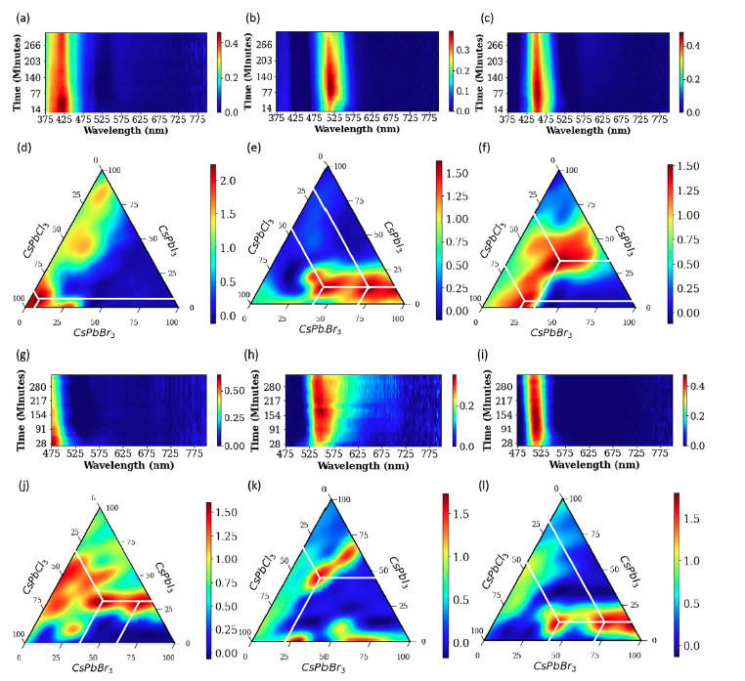
Figure 3-3 The multivariate analysis of time dependent PL properties of ternary CsPb(I_{x}Br_{y}Cl_{1-x-y})₃ QDs system. At an excitation of 350 nm, 2D NMF components of PL behavior of the corresponding phase diagram (represented by a non-zero weight) as a function of wavelength and time where the color describes the intensity of the PL peak (top: a-c)) and GP interpolation of compositional dependencies of the component PL intensities within the ternary diagram where the color is indicative of how the characteristic PL behavior over time describes that compositional region (bottom: d-f)). At an excitation of 450 nm, 2D NMF components (top: g-i)) and compositional dependencies of the component intensities within the ternary diagram (bottom: j-l)).
Next, as more iodide and bromide are incorporated into the CsPbCl₃-rich compositions, shown in Figure 3-3f), the initial PL peak centered around 460 nm is narrow and intense. As the QDs are exposed to ambient conditions, the PL intensity increases, but the peak broadens, and again halfway through the measurement period, the peak intensity decreases and the peak narrows, as shown in Figure 3-3c). Even at the end of the measurements, there remains a relatively intense and narrow peak, suggesting that these QDs could remain stable for longer in ambient conditions. Overall, a solid solution between CsPbCl₃, CsPbBr₃, and CsPbI₃ emerges as the compositional region that could produce high-quality QDs, as indicated by the narrow PL peak, and prolonged intrinsic stability in ambient conditions.
Next, we explore the same ternary phase system in ambient conditions using PL spectroscopy with a different excitation wavelength, 450 nm. Solid solutions between CsPbCl₃, CsPbBr₃, and CsPbI₃ shown in red on the phase diagram in Figure 3-3j) have a high intensity PL peak just before the measurement range, as shown in Figure 3-3g). Over time, it appears as if the intensity of this peak begins to either shift or decrease in intensity. More iodide-rich solid solutions, as indicated in Figure 3-3k), have a very broad peak center around 550 nm, spanning approximately 100 nm, as shown in Figure 3-3h). Although the PL intensity remains relatively constant through the duration of the measurements, the broad peak indicates that these QDs are relatively low quality and would possibly be not suitable for certain optoelectronic applications. Finally, in Figure 3-3i,l), we observe an emission wavelength around 515 nm close the emission of pure CsPbBr₃ QDs. This trend is similar to that of the CsPbBr₃-rich samples excited at 350 nm shown in Figure 3-3b,e). Over time, there is a slight blue shift in the peak position, possibly due to the changes in size and crystallization of the QDs with time. The intensity of the PL emission is relatively constant with a narrow peak width throughput the measurement period, indicating the high quality and stability of these QDs in ambient conditions.
The intervals of the samples in the ternary diagram are father apart compositionally (X-site doping changes by 10 at% increments). Because there are fewer samples in this compositional space, the uncertainty between each data point is higher, and, therefore, the test will have a greater margin of error. To develop a better understanding of the time- and compositional-dependent PL behavior of the QDs, we fabricated and studied two binary systems, CsPb(Br_{x}Cl_{1-x})₃ and CsPb(Br_{x}I_{1-x})₃ QDs based on the two endmembers on the edges of the ternary phase diagram. Within these binary systems, we sampled compositions approximately 1 at% apart yielding a total of 101 sample in each system, thus decreasing the margin of error.

Intrinsic Stability of the Binary Systems
Shown in the top row of Figure 3-4 is the NMF decomposition of the time dependent PL for the solid solutions between CsPbBr₃ and CsPbCl₃. These QDs were excited at 350 nm and generally exhibit narrow and intense PL peaks over 6 hours in ambient conditions. In the first component (Figure 3-4a)), the PL emission peak is centered around 410 nm when the QDs are CsPbCl₃ rich. The intensity of the PL peak increases until about 1.5 hours in ambient conditions, possibly due to QDs having more time to crystallize and self-assemble, thus allowing for less defects and higher emission yield as evidenced by the overall narrow emission range. For CsPbBr₃-rich compositions, shown in Figure 3-4b), the PL emission is centered around 505 nm and is relatively broader than the spectra for high-concentrated chloride QDS, partially caused by the larger size of bromide based QDs and a more heterogenous size distribution. Another notable difference in the bromide-rich QDs is that intensity of the PL peak is much more intense than the other compositions. This is likely due to the better crystal quality of the bromide-rich QDs as confirmed by the TEM images in Figure 3-1a). At the end of the measurement period, the QDs remain stable, and the intensity of the PL emission has only slightly decreased. The width of this PL peak also increases slightly over time. Overall, the bromide-rich QDs demonstrate remarkable stability after 6.5 hours in ambient conditions. Finally, the characteristic PL behavior of the solid solutions between CsPbCl₃ and CsPbBr₃ is shown in Figure 3-4c). The position of the PL emission is between 425 and 475 nm. Over 1.5 hours, the intensity of the PL emission increases, but after about 5 hours, the PL emission becomes narrower and less intense. These changes could be caused by the degradation of the QDs over time or the defect densities is increasing.
Shown in the bottom row of Figure 3-4 is the NMF decomposition of the time dependent PL for the CsPb(Br_{x}I_{1-x})₃ excited at 450 nm. Generally, the fabricated CsPb(Br_{x}I_{1-x})₃ QDs have a broader PL peak as compared to the PL behavior of the CsPb(Br_{x}Cl_{1-x})₃ system, possibly caused by the wider emission wavelength differences between endmembers or the inherent difference in size of the halide. As well, PL emissions positioned at higher wavelengths typically increase in intensity as time in ambient conditions increases.

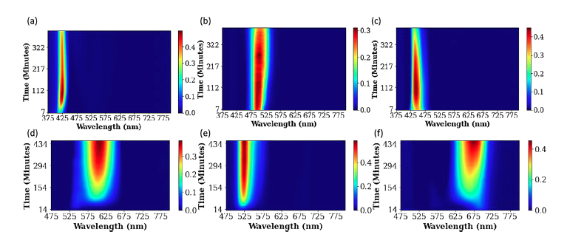
Figure 3-4 The NMF analysis of time dependent PL behavior in CsPb(Br_{x}Cl_{1-x})₃, CsPb(Br_{x}I_{1-x})₃ binary QDs systems. Compositional dependencies of the component intensities within the CsPbBr₃ and CsPbCl₃ binary system excited at 350 nm (Top: a-c)). Compositional dependencies of the component intensities within the CsPbBr₃ and CsPbI₃ binary system excited at 450 nm (bottom: d-f)).

More iodide-rich compositions exhibit a PL emission at approximately 700 nm before exposure to ambient conditions, confirming the formation of iodide-rich QDs (Figure 3-4f)). Over time, the PL peak begins to increase in intensity, to blue shift, and to broaden, indicating that the quality of these QDs is decreasing over time as compared to bromide-rich compositions. We postulate that the peak widening could be due to phase segregation or peak splitting due to degradation, producing nonuniform mixture results. A similar PL behavior is observed for more bromide-rich solid solutions between CsPbBr₃ and CsPbI₃, as shown in Figure 3-4d). However, it appears that these compositions do not form until approximately an hour in ambient conditions. This delay in formation could be caused by bromide slowly stabilizing the QDs²⁰⁷, leading to its eventual formation. Since CsPbI₃ tends to be the most unstable in ambient conditions, the increase in PL peak intensity as exposure continues is surprising²⁰⁶. Bromide-rich compositions exhibit an emission wavelength at approximately 515 as shown in Figure 3-4e)¹⁹⁶. Here, unlike the bromide-rich compositions in the CsPb(Br_{x}Cl_{1-x})₃ system (Figure 3-4c)), we observe an increase in PL intensity and broadening as time continues. We hypothesize that the difference in this behavior is because the iodide-rich QDs do not form quite as effectively as the chloride-based QDs, limiting the performance of the doped bromide-rich compositions.

Implementation of Bayesian Inference
Next, we explore the compositional dependence on the shape of the PL spectra. As mentioned previously, the expected emission spectrum is a Lorentzian shape with its full width at half maximum (FWHM) corresponding to the photoluminescence quantum yield (PLQY) for monodispersed PQDs²⁰⁸. In. the presence of any disorder, this emission shape begins to adopt a Gaussian profile and becomes more complex in the presence of polydispersity. As well, multiple well-defined peaks can be observed if the system separates into different phases.
Here, we explore the evolution of the PL properties across the ternary system’s compositional space. Initially, we found that using a simple least square fits approach implemented via the lmfit library in Python to be unstable and very sensitive to the initial choice of parameters. While well-defined peaks can be fitted well, systems with multiple peaks yield spurious parameter values, especially when clear peaks are absent. Correspondingly, the usage of a least square fit is also impractical because of the analysis across the compositional space containing a variety of PL behaviors.
Therefore, to systematically explore the compositional dependence of PL, we apply a Bayesian framework for the analysis of the emission spectra. Generally, Bayesian inference (BI) is based on the concepts of prior and posterior probability. The prior, p(θ_{i}), represents the level of knowledge about the system before the experiment begins. The experiment yields the data, D, based on which the posterior distribution is calculated via Bayes formula [31,32]:
 | $$p\left(θ_{i} | D\right)= \frac{p\left(D | θ_{i}\right)p(θ_{i})}{p(D)}$$ | (3-1)
where p(θ_{i}|D) is the likelihood that this data can be generated by the given choice of the model i and model parameters θ. The p(D) is defined as the total space of possible outcomes.
Here, it is beneficial to compare the Bayesian inference (BI) framework and the classical least square (LS) fitting approach. We assume that the experimental observations here are given in the form of measured scalar values y_{i} for the points x_{i}. In LS fitting, we assume that the observed behavior is described by the function f(θ) and seek to find the function parameter vector θ. The optimization is performed by minimizing the least square error between the data and the prediction, defined as a calculated version of function over the data points, f(x_{i}). The minimum of mean square error in the space of parameters θ defines the point estimate of the function. We note that in a classical least square fits the parameter can be fixed, free, or rigidly constrained.
The BI approach treats the prior information on parameters θ as a joint probability distribution. For convenience, the prior distributions are often marginalized, meaning that the distributions are independent. If the specific parameter is well known, the corresponding distribution is narrow and can be chosen based on prior experiments, either from available published data or physical model. If the parameter is known poorly, the distribution is broad and for bound parameters is typically chosen as a uniform distribution and for the unbound parameter as a Gaussian. The result of the BI is then the posterior parameter distribution, reflecting the updated knowledge on the parameters. Note that this approach allows for considerably more flexibility compared to the LS fitting. For example, if several parameter values can describe experimental data, the posterior distribution will be multimodal. Second, the unique strength of Bayesian approach is that the model selection can be incorporated as part of inference process. In this case, the models can be drawn from a list of possible models with certain probability, and posterior distribution will update this probability to define the model selection.
In this study, we consider five primary models, namely single Lorentzian,
 | $$y\left(x\right)= y_{0}+ \frac{A}{((x-x_{0})^{2}+w^{2})^{1/2}}$$ | (3-2)
single Gaussian,
 | $$y\left(x\right)= y_{0}+ Ae^{-(\frac{(x-x_{0})}{w})^{2}}$$ | (3-3)

double Lorentzian, double Gaussian, and Lorentzian-Gaussian defined similarly as sum of (3-2 and (3-3.
The Bayesian regression is implemented via the PyMC3 library in Python. We have also used the Metropolis-Hastings (MH) algorithm to sample the distributions of model parameters with the assumption that the measurement error η comes from a normal distribution with a variance of σ². Therefore, in addition to the model parameters, the data variance is also estimated. The priors for the two models are given in Table 3-4. We have also placed bounds on two parameters, peak position and width. For the peak position, the bounds were the measurable wavelength range. For the width parameter, the minimum width allowed was at least 2 nm as this is the measurable wavelength step size. We compared convergence for 4 to 16 chains for variable chain length and burn length. Based on these analyses, we have chosen four chains of 3000 steps with the burn of 500.
To illustrate the principle and performance of the Bayesian regression, we show an example of the BI analysis on a synthetic data set with a known ground truth in Figure 3-5. Here, the synthetic data are generated to follow a Double Lorentzian form with the parameters: y₀ = 0, x₀₁ = 1, A₁ = 0.5, w₁ = 1, x₀₂ = 6, A₂ = 1, and w₂ = 1. We can vary the level of the Gaussian noise, making the data points further from the ground truth, as shown in Figure 3-5a-d). For a low noise level, the fit reproduces the data as expected, while as the noise level increases, the confidence interval becomes broader. This trend is shown systematically in Figure 3-5e,f), showing the evolution of the mean of reconstructed function and the reconstruction uncertainty. Clearly, BI allows for the reconstruction of the function behavior for a noise level up to approximately 0.1. Above this noise level, the reconstructed function deviates from the ground truth and the corresponding uncertainty increases rapidly, indicated by the white arrow. We note that by using more restrictive priors, i.e., known peak positions, etc., allows us to reconstruct the function for much higher noise levels.

Table 3-4 Priors used in sampling
 | Lorentzian Priors | Gaussian Priors
Offset | y₀ ~ Uniform (-1,1) | y₀ ~ Uniform (-1,1)
Amplitude | A ~ HalfNormal (0,10) | A ~ HalfNormal (0,10)
Peak Position | x₀ ~ Normal (x_{avg}, x_{sd}) | x₀ ~ Normal (x_{avg}, x_{sd})
Width | w ~ Normal (10, 30) | w ~ Normal (10, 30)
Data Variance | η ~ Gamma (0.1, 0.1) | η ~ Gamma (0.1, 0.1)

Comparatively, utilizing a different functional form than the ground truth, a Lorentzian-Gaussian model, we show the noise dependence of the reconstruction for the same dataset in Figure 3-5g,h). The uncertainty is significantly higher for all noise levels, and the fit begins to fail at lower noise levels, illustrating that the “correct” model allows for a better fit of the data and the tunability of BI via priors.
The ability of the BI approach to distinguish different models is one of its unique strengths. Generally, this can be accomplished through the hierarchical Bayesian model, where the model is drawn from the multinomial distribution M(i), and the model parameters are then optimized in the usual fashion. Alternatively, the probabilities of the models can be estimated from the posterior densities using the widely applicable information criterion (WAIC)²⁰⁹ as proposed by Gelman et al. [34]. The WAIC is defined as:
 | $$WAIC= \sum_{i=1}^{n}{log⁡(\frac{1}{S}\sum_{s=1}^{S}{p(y_{i}|θ^{S}))-\sum_{i=1}^{n}{{var}_{post}(\log{p(y_{i}|θ))}}}}$$ | (3-4)
where S is the number of simulations draws and n is the number of available datapoints. The first term is the logarithm of predictive density defining the quality of the fit. The second term is the effective number of parameters, pWAIC, determined by the total variance of the log likelihood, log p(y_{i}|θ). This term defines the complexity of the fitting function. We note that similar to calculation of the Bayesian estimate and uncertainty as shown in Figure 3-5, the calculation of WAIC requires traces acquired during the sampling rather than just the point estimates. Subsequently, the probability of the model p(M) is recovered though a Bayesian model averaging approach.
We show the fit of the synthetic dataset using dissimilar models for low noise levels in Figure 3-6. The correct model gives an excellent fit as shown in Figure 3-6d). The single peak Lorentzian (Figure 3-6b)) and Gaussian (Figure 3-6c)) functions identify the dominant peak in a robust manner. It is remarkable that the remainder of the data is interpreted as the offset. Correspondingly, the dependence on the level of the prior knowledge, e.g., using constrained distribution of the offset, allows to control the inference process. Finally, the prediction is slightly worse when the double Gaussian (Figure 3-6e)) and Lorentzian-Gaussian (Figure 3-6f)) is used. We note that the nature of the fit procedure suggest that the width, amplitudes, and the positions of the peaks are relatively insensitive to the choice of the fit function; therefore, we consider the best model and the effective model parameters complementary descriptors.

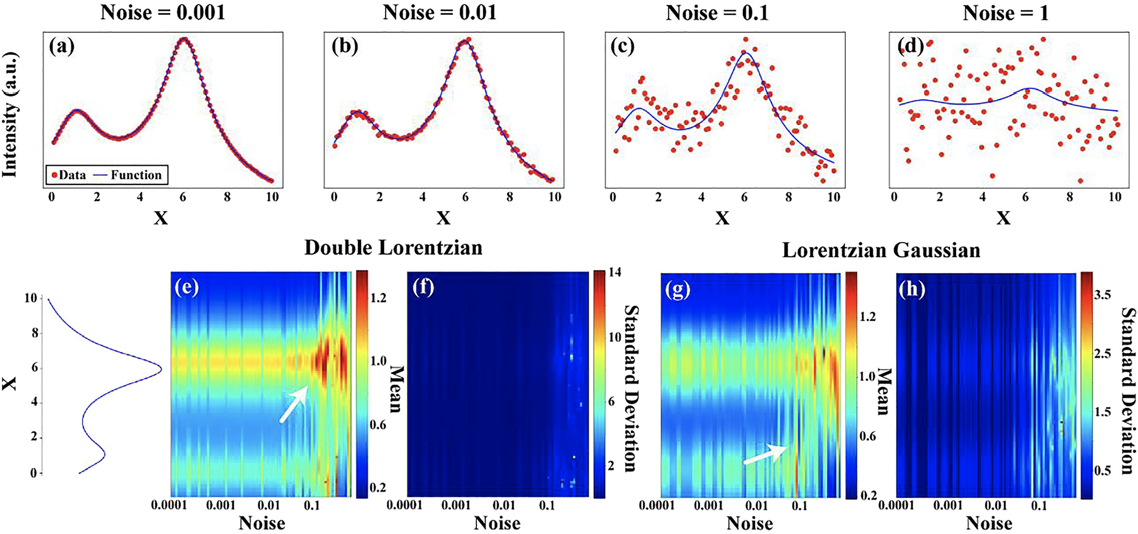
Figure 3-5 . a-d) Demonstrate how a synthetic dataset is created utilizing a known function and a certain amount of noise is produced. Shown in e) and f) is the fitting of the Double Lorentzian model as a function of noise. As indicated by the arrow in e), at a particular amount of noise, this model begins to fail at describing the dataset. Utilizing the Lorentzian-Gaussian model as shown g) and h), this fail point begins at a lower amount of noise.

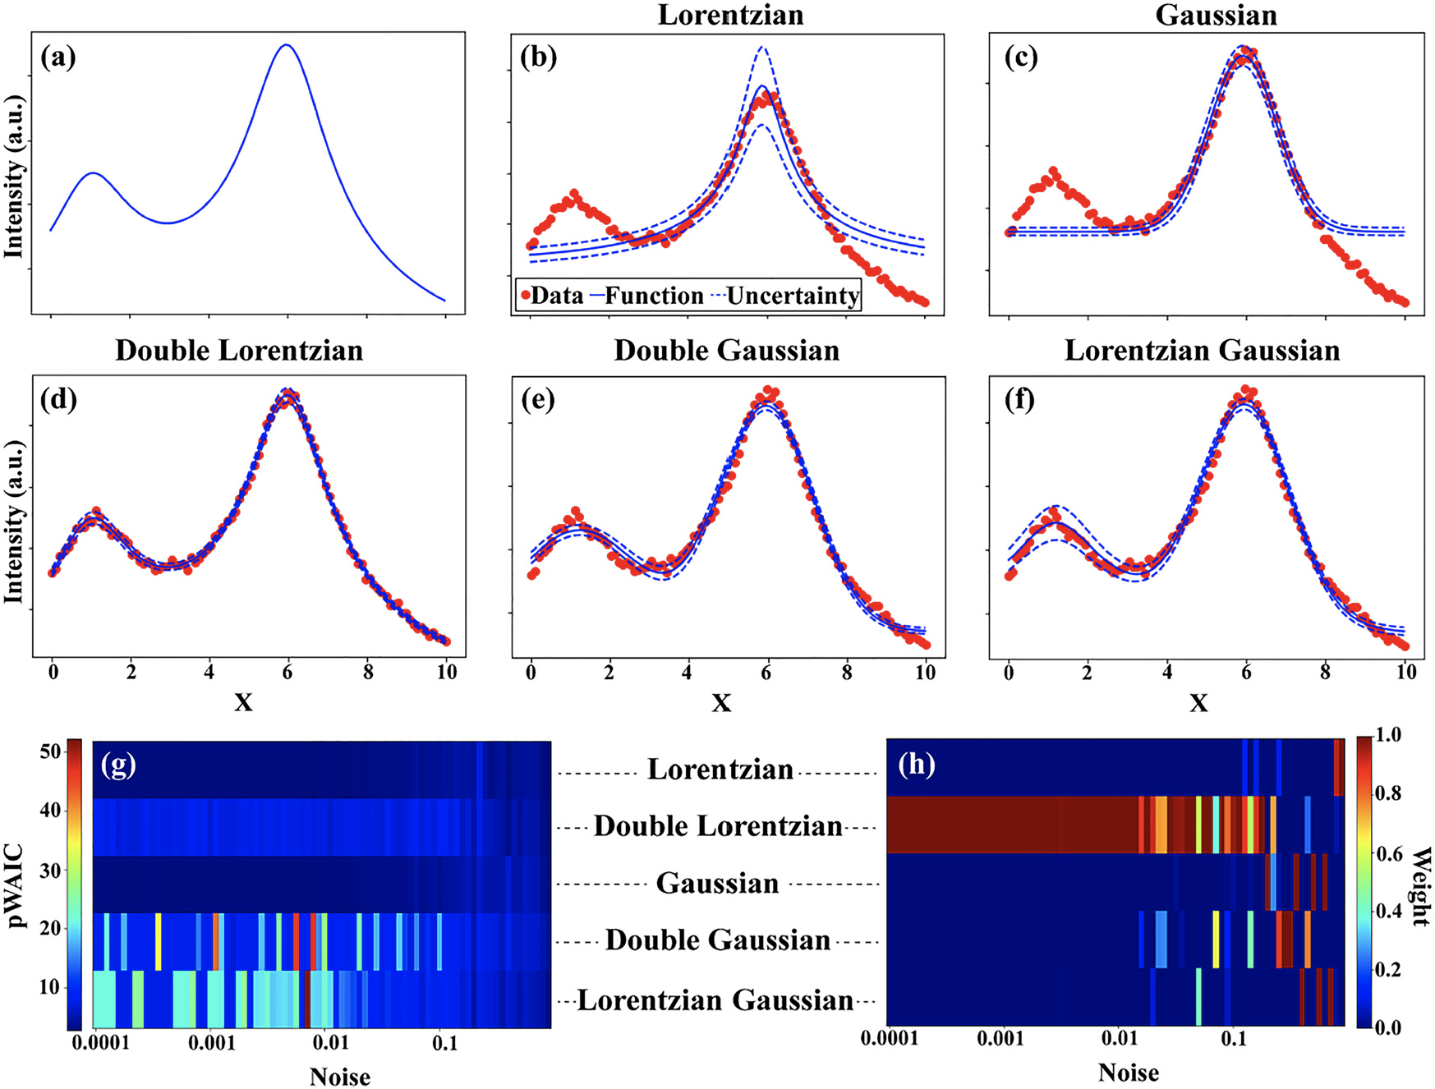
Figure 3-6 Shown in a) is the Double Lorentzian function (known truth) utilized for the synthetic dataset. The fit and uncertainty for the b) Lorentzian, c) Gaussian, d) Double Lorentzian, e) Double Gaussian, and f) Lorentzian-Gaussian models are shown. Shown in g) is how the WAIC parameters changes for each model as a function of noise. Similarly, h) shows how the weight parameters changes for each model as a function of noise.

Shown in Figure 3-6g,h) is the dependence of the WAIC score and the model probability on the noise level. Here, we observe that for low noise levels, the correct model gives noise-independent pWAIC values; however, for incorrect models, the value strongly depends on the specific realization of the dataset. The usage of the simple Gaussian and Lorentzian functions leads to low pWAIC values. The critical behavior as a function of noise level is clearly seen through the model probability shown in Figure 3-6h). We note that a similar analysis can be performed as a function of discretization (corresponding to the wavelength at which the measurements are performed); therefore, we can pinpoint optimal experimental parameters. Similarly, such analysis can also be performed as a function of the priors’ strength, illustrating to which extent prior knowledge of the system affects interpretability.
As illustrated with the synthetic data, the BI approach allows for a natural and flexible framework for the analysis of PL behavior. We further explore the combinatorial of the ternary CsPbX₃ QDs utilizing this framework.
Firstly, we apply this analysis to a few characteristic PL spectra at time zero in the ternary system. In Figure 3-7a), we show the fitting of the PL behavior of CsPb(I_{0.30}Br_{0.60}Cl_{0.10})₃ QDs. Here, we observe a high-intensity, single peak centered at approximately 540 nm. Shown in Figure 3-8 are the fits for each model for the PL behavior of this composition. We observe that the Gaussian model (Figure 3-8b)) best fits this PL spectrum because the Lorentzian model (Figure 3-8a)) overestimates fit the width of the peak base, and the double Lorentzian , double Gaussian, and Lorentzian-Gaussian models (Figure 3-8c-e)) add extraneous peaks at higher wavelengths. We also confirm this with the WAIC and weight values. Another typical PL spectrum observed in this ternary system is a broad peak spanning over 100 nm. An example is the PL spectrum for CsPb(I_{0.60}Br_{0.10}Cl_{0.30})₃, shown in Figure 3-7b). Overall, this PL behavior is best described by a broad Gaussian profile. Finally, another characteristic PL behavior, shown in Figure 3-7c), is the same broad peak with another broader peak at higher wavelengths, indicating phase separation between iodide, for example, in a binary CsPb(I_{0.90}Cl_{0.10})₃ composition. This behavior was best fit with a Double Gaussian model because the single peak models miss the peak at higher wavelengths and the other two peak models overestimate the intensity of this second peak.

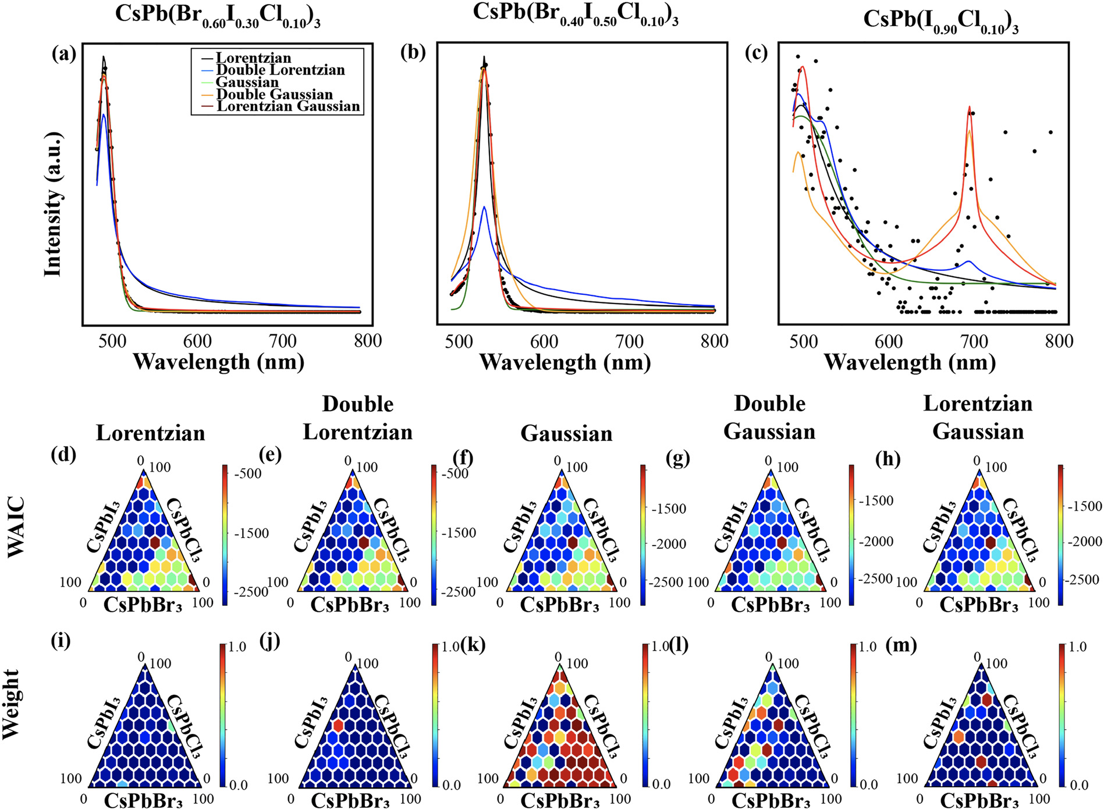
Figure 3-7 Fitting of each model for characteristic PL behaviors represented by three different compositions: a) CsPb(I_{0.30}Br_{0.60}Cl_{0.10})₃, b) CsPb(I_{0.60}Br_{0.10}Cl_{0.30})₃, and c) CsPb(I_{0.70}Cl_{0.30})₃. Exploration of the WAIC parameter for each model across the ternary phase diagram is shown in
d-h). Similarly, the compositional dependence of the weight parameter for each model is shown in i-m). The fits and uncertainties of the five models for the PL spectra in a) are shown in Figure 3-8.

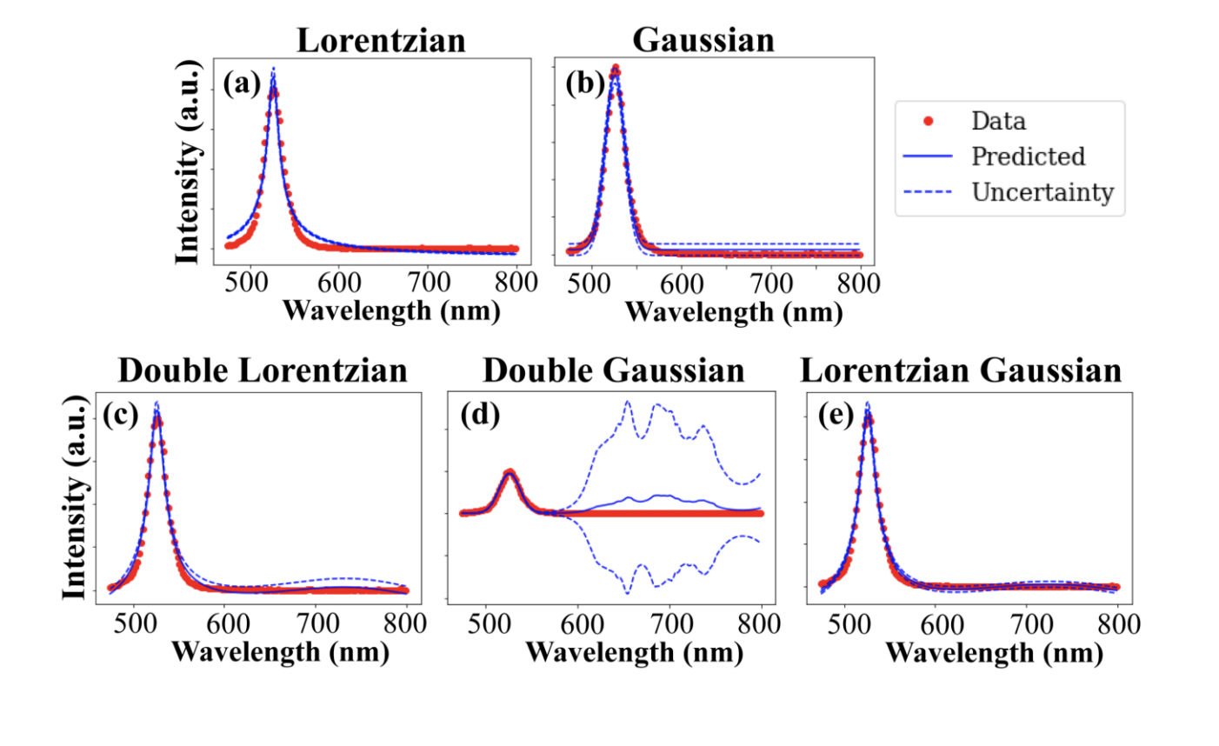
Figure 3-8 The fit and uncertainty for the (a) Lorentzian, (b) Gaussian, (c) Double Lorentzian, (d) Double Gaussian, and (e) Lorentzian Gaussian models are shown for the PL spectra in Figure 3-7a). As mentioned in the main text, the Gaussian model describes this dataset well. Notably, the Double Lorentzian and Lorentzian Gaussian models use the second peak to describe the noise at higher wavelengths. We observe high uncertainty at these higher wavelengths for the Double Gaussian model.

Next, we explore the compositional dependence of the model fits across the entire ternary phase space utilizing two metrics: WAIC (Figure 3-7d-h)) and weight (Figure 3-7i-m)). Here, we explore the dataset using the 450 nm excitation wavelength, but we will explore the 350 nm excitation wavelength dataset later. We should note that this dataset describes the PL behavior of CsPbBr₃- and CsPbI₃-rich compositions as the PL peak positions of the CsPbCl₃-rich compositions are excluded from the measurement range here. Firstly, we observe that the weight for the Lorentzian model is considerably smaller in magnitude than the other models, as shown in Figure 3-7i), indicating that this model does not describe the PL behavior of this ternary system, possibly due to disorder, polydispersity, and phase separation throughout the system. The weight of the double Lorentzian and Lorentzian-Gaussian models (Figure 3-7j,m)) is only high for some compositions as indicated by the red points, signifying the presence of double peaks and phase separation in CsPbCl₃-rich compositions and solid solutions. Notably, the CsPbBr₃-rich compositions are best described by a Gaussian fit as indicated by the high magnitude in weight for this model (Figure 3-7k)), implying that these compositions exhibit little phase separation and slight disorder. Finally, the remainder of the phase system, specifically CsPbI₃-rich compositions, is best described by the Double Gaussian model (Figure 3-7l)), indicating both phase separation and disorder.
Now, with the knowledge about each model’s fit, we can then calculate the posteriors, such as the offset, peak amplitude, and peak width, across the ternary compositional space. In particular, we focus on the peak width parameter as it is related to the FWHM and, therefore, the PLQY of the QDs. The posteriors for the Gaussian and Double Gaussian models are shown in Figure 3-9. The posteriors for the Lorentzian, double Lorentzian, and Lorentzian-Gaussian models are shown in Figure 3-10, but we focus on the Gaussian and Double Gaussian posteriors because, as mentioned previously, these models have the highest weights, therefore describing the majority of the phase diagram. The CsPbBr₃-rich compositions are primarily described by the Gaussian model, and the associated posteriors are shown in Figure 3-9a-d). Here, we observe a high amplitudes and narrow peak widths, indicating high PLQYs for these compositions. Next, CsPbI₃-rich compositions are also described by the double Gaussian models. Generally, the first width (Figure 3-9h)) are large and the second width is slightly smaller (Figure 3-9k)), indicating a broad peak with a slightly smaller one at higher wavelengths as the one seen in Figure 3-7c). This confirms that these regions experience phase separation. This analysis further confirms that capability of the BI approach, providing new insight on the formation and quality of the ternary solid solution of CsPbX₃ QDs that cannot be revealed solely by the GP approach.
Next, we apply the BI approach to the PL dataset excited by the 350 nm wavelength. Here, as mentioned previously, we note that the iodide-rich compositions are not accurately represented as the wavelength measurement range does not include the peak wavelengths for the CsPbI₃; therefore, we focus on the CsPbCl₃- and CsPbBr₃-rich compositions. Generally, these compositions are best described by the Gaussian model, as shown in Figure 3-11. This is consistent with the observations seen in the 450 nm excitation wavelength dataset. As shown in Figure 3-11n-q), the posteriors indicate that these compositions have high intensity, narrow peaks, like the PL spectra observed in Figure 3-7a,b). We observe that the width of these peaks slightly increase as the QDs are more alloyed with CsPbCl₃, as shown in Figure 3-11q). The broadening of these peaks indicates that these compositions have a lower quality, such as being more amorphous like observed in the TEM images (Figure 3-1b)) than the CsPbBr₃-rich QDs. Overall, applying this BI approach to this particular dataset gives more information about the quality of CsPbCl₃-rich compositions and confirming what we observe in the other dataset.

Summary
Here, we have synthesized cesium lead halide QDs in binary and ternary solid solution configuration via an automated micropipetting platform. This synthesis approach of the large compositional spaces of CsPbX₃ QDs is highly reproducible using this platform and can be extended to other PQDs, including hybrid organic-inorganic perovskites. We then investigate the ambient stability of QDs by measuring PL repeatedly over six hours. We utilize Non-negative Matrix Factorization and Gaussian process to show the time- and compositional-dependent PL behavior. Next, we apply a Bayesian inference approach to obtain a model that best describes the PL behavior and yield the model parameters and associated uncertainties. This analysis further describes the size distribution and phase segregation of ternary QDs through the examination of the PL peak shape and width. Overall, we observe a better performance of the chlorine doped CsPbBr₃ QDs than the iodide doped CsPbBr₃ QDs with CsPbBr₃ QDs performing the best as it maintains a high intensity and narrow PL peak over time.

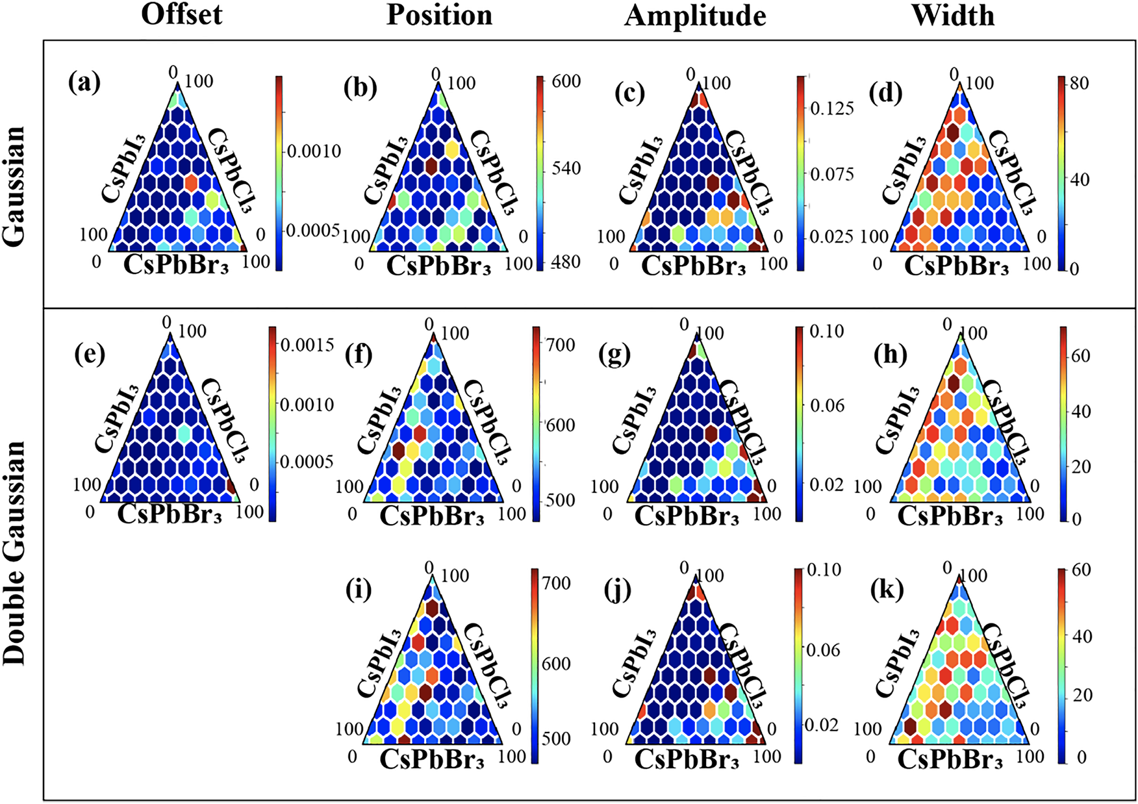
Figure 3-9 Shown is the Bayesian fit parameters, specifically the offset, peak positions, amplitudes, and widths, for the a–d) Gaussian and e–k) Double Gaussian models. The parameters for the Lorentzian, Double Lorentzian, and Lorentzian Gaussian model are shown in Figure 3-10.

Figure 3-10 Shown are the priors of the a-d) Lorentzian, e-h) Double Lorentzian, and i-l) Lorentzian-Gaussian models for the 450 nm excitation wavelength. As mentioned, these models do not accurately describe the PL behavior of this ternary system; however, it is included for completeness.

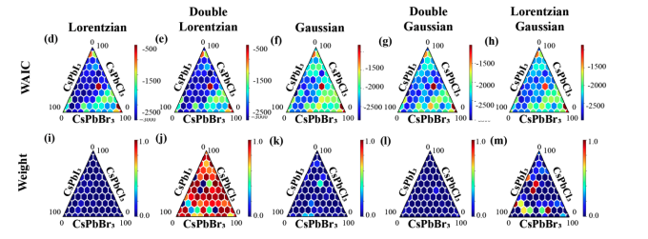
Figure 3-11 Shown are two parameters, WAIC a-c) and weight f-j), which describe each of these models' fit for the dataset excited with the 350 nm wavelength. Here, we note that the iodide-rich compositions are not accurately represented because the wavelength measurement range does not include peak wavelength for CsPbI₃ QDs; therefore, we focus on the CsPbCl₃ and CsPbBr₃-rich compositions. As observed with the 450 nm excitation wavelength dataset, CsPbBr₃-rich compositions are described well with the Gaussian model. Conversely, the Lorentzian Gaussian model fit the PL spectra of CsPbCl3-rich compositions.

Generally, the capability of the Bayesian inference methods to use the prior knowledge of the system and update it based on the experimental observations can provide a complementary approach for navigating multidimensional compositional spaces fabricated by automated, high-throughput synthesis. This approach, traditionally, is based solely on the Bayesian optimization methods using a combination of uncertainty and functional properties to define the corresponding acquisition function. Here, the Bayesian inference produces additional parameters that characterize the physical responses in the systems, as well as the associated uncertainties. Overall, this provides an additional spectrum of descriptors to navigate the chemical space of these systems.

Effect of Antisolvent Engineering on the Stability of Binary Metal Halide Perovskites

Abstract
Frequently, antisolvent crystallization is utilized to fabricate high-quality metal halide perovskites (MHP) thin films, single crystals, and nanoparticles; however, an understanding of the effect of specific antisolvent on the intrinsic stability of multicomponent MHPs is lacking. Here, we utilize a high-throughput experimental framework that incorporates chemical robotic synthesis, automated characterization, and multivariate statistical approaches to explore how an antisolvent affects the intrinsic stability of binary MHP systems in ambient conditions over time. Different combinations of endmembers, MAPbI₃, MAPbBr₃, FAPbI₃, FAPbBr₃, CsPbI₃, and CsPbBr₃ (MA⁺, methylammonium; FA⁺, formamidinium), are used to fabricate 15 combinatorial libraries, each with 96 unique combinations. In total, roughly 1100 different combinations are synthesized. Each library is fabricated twice by using two different antisolvents: chloroform and toluene. Once fabricate, photoluminescence (PL) spectroscopy is automatically performed every 5 minutes for approximately 6 hours in ambient conditions. Next, Non-negative Matrix Factorization (NMF) is utilized to map the time- and compositional-dependent optoelectronic properties. From this investigation for each library, we demonstrate that the selection of the antisolvent is critical to the intrinsic stability of MHPs in ambient conditions. We describe possible dynamical processes, such as halide segregation, that are responsible for either the stability or eventual degradation based on the choice of antisolvent. Overall, this high-throughput study demonstrates the vital role that antisolvent engineering plays in the fabrication of high-quality multicomponent MHP systems. This chapter is revised based on an article published by Kate Higgins, Maxim Ziatdinov, Sergei V Kalinin, Mahshid Ahmadi in the Journal of American Chemical Society 2021, DOI:10.1021/jacs.1c10045.

Introduction
Metal halide perovskites (MHPs) are ideal candidates for a variety of applications, such as solar cells¹⁵⁷, photodetectors⁴², ionizing radiation sensors^{5, 158}, and light-emitting diodes^{2, 3} because of the combination of exceptional optoelectronic properties and low fabrication costs. Even so, the development of MHPs for commercialization must overcome its limited stability in pure or device-integrated form^{159, 160}. Overcoming adverse effects originating from external stimuli can be minimized or avoided by utilizing established encapsulation methods and device engineering^{22, 210, 211}. Simultaneously, another strategy to improve the intrinsic stability is by cation and/or halide alloying to synthesize multicomponent MHPs^{163, 212, 213}. A multitude of studies have demonstrated how the incorporation of other cations, particular cesium (Cs⁺)²¹³ and formamidinium (FA⁺)²¹⁴ into methylammonium (MA) systems, leading to the improved stability in ambient and operational conditions. Mixing halides, such as bromide (Br⁻)¹¹¹, iodide (I⁻), and chloride (Cl⁻)¹⁴⁷, has also proven to be an effective strategy toward stable perovskite materials.
To fabricate high-quality thin films, to produce high-quality single crystals¹⁴⁷, and to synthesize nanoparticles at room temperature²¹⁵, antisolvent crystallization is an effective solution-based method. Simply, this approach requires the application of an antisolvent to a perovskite solution, and then the antisolvent then extracts the solvent, leading to the fast supersaturation of the precursor and causes precipitation of the perovskite. Many investigations have focused on the antisolvent, including the types, volumes, and mixtures of solvent²¹⁶. For example, Sakai et al. illustrated how dropping toluene on the perovskite film during spin-coating can enhance the early stages of nucleation and grain growth, depending on the chemical composition of the precursor solution²¹⁷. Wang et al. suggested that the use of chlorobenzene mixed with isopropyl alcohol removes the residual chlorobenzene, therefore, increasing the grain size of the film and drop in defect density²¹⁸.
Until recently, most of these investigations utilized a manual trial-and-error approaches to determine which antisolvent is applicable for a particular perovskite system. Automated experimentation has proven to accelerate this trial-and-error process through^{148, 149, 169}and full device preparation workflows^{124, 128}. However, the number of groups utilizing these robotic platforms to explore antisolvent engineering is small. For example, Gu et al. utilized a robot-based high-throughput workflow to screen antisolvents on single component MHPs¹⁴⁸. By testing 48 different antisolvents and three commonly used solvents, dimethyl sulfoxide (DMSO), γ-butyrolactone (GBL), and n’n-dimethylformamide (DMF), they explored how the choice of solvent and antisolvent affects the formation of microcrystals. In another high-throughput study screening antisolvents, Manion et al. demonstrated how the quality of thin films can be predicted by analyzing these formations²¹⁹. While both studies focus on the effect of antisolvents on single endmember systems, investigations exploring antisolvent engineering effects on multicomponent MHP systems is limited, and none have documented the intrinsic stability of these systems in ambient conditions. Generally, the intrinsic stability of a compositions is a crucial property in developing a stable and efficient device for applications.
Here, we utilize the workflow shown in Figure 4-1 and described in Chapter 2 to explore how the choice of antisolvent affects the intrinsic stability of multicomponent MHP systems over time in ambient conditions. With the utilization of a pipetting robot, we fabricate 15 different binary perovskite combinatorial libraries twice using two different solvents: toluene and chloroform. In total, roughly 1100 unique perovskite compositions were synthesized. Next, photoluminescence (PL) spectroscopy is performed on each combinatorial library in ambient conditions for approximately 6 hours. We then map the time- and compositional-dependent PL behavior of each combinatorial library using a multivariate statistical approach, specifically Non-negative Matrix Factorization (NMF). Finally, we characterize the intrinsic stability for each combinatorial library in a specific antisolvent, helping guide future experiments done elsewhere.

Synthesis and Characterization of Combinatorial Libraries
As mentioned, we investigate 15 different multicomponent MHP binary systems as shown in Figure 4-1b). Our chosen endmembers are MAPbI₃, MAPbBr₃, FAPbI₃, FAPbBr₃, CsPbI₃, and CsPbBr₃. In each combinatorial library, there are 96 unique compositions; therefore, approximately 1100 unique compositions fabricated in total. We utilize an antisolvent approach to precipitate microcrystals^{146, 158}. Commonly used antisolvent documented elsewhere are typically classified into two categories: halogenated (chlorobenzene²²⁰ and chloroform¹⁴⁶) and non-halogenated (toluene¹¹¹, anisole²²¹, diethyl ether²²², and ethyl acetate²²³). Here, we chose to use two antisolvents, chloroform and toluene, as both represent each category and as they are commonly used in the literature for the production of high-quality MHPs. Because we utilize these two antisolvents, each combinatorial library is synthesized twice, and therefore, approximately 2880 different samples in total were synthesized and characterized, only taking approximately 270 hours. Here, we describe the fabrication of these combinatorial libraries in detail.
Methylammonium iodide (Sigma-Aldrich, ≥99%, anhydrous), methylammonium bromide (Sigma-Aldrich, ≥99%, anhydrous), formamidinium iodide (Sigma Aldrich, ≥99%, anhydrous), formamidinium bromide (Sigma-Aldrich, ≥99%, anhydrous), cesium iodide (Sigma-Aldrich, anhydrous, beads, −10 mesh, 99.999% trace metals basis), cesium bromide (Sigma-Aldrich, 99.999% trace metals basis), lead iodide (Sigma-Aldrich, 99.999% trace metals basis) and lead bromide (Sigma-Aldrich, 99.999% trace metals basis) were used without further purification.

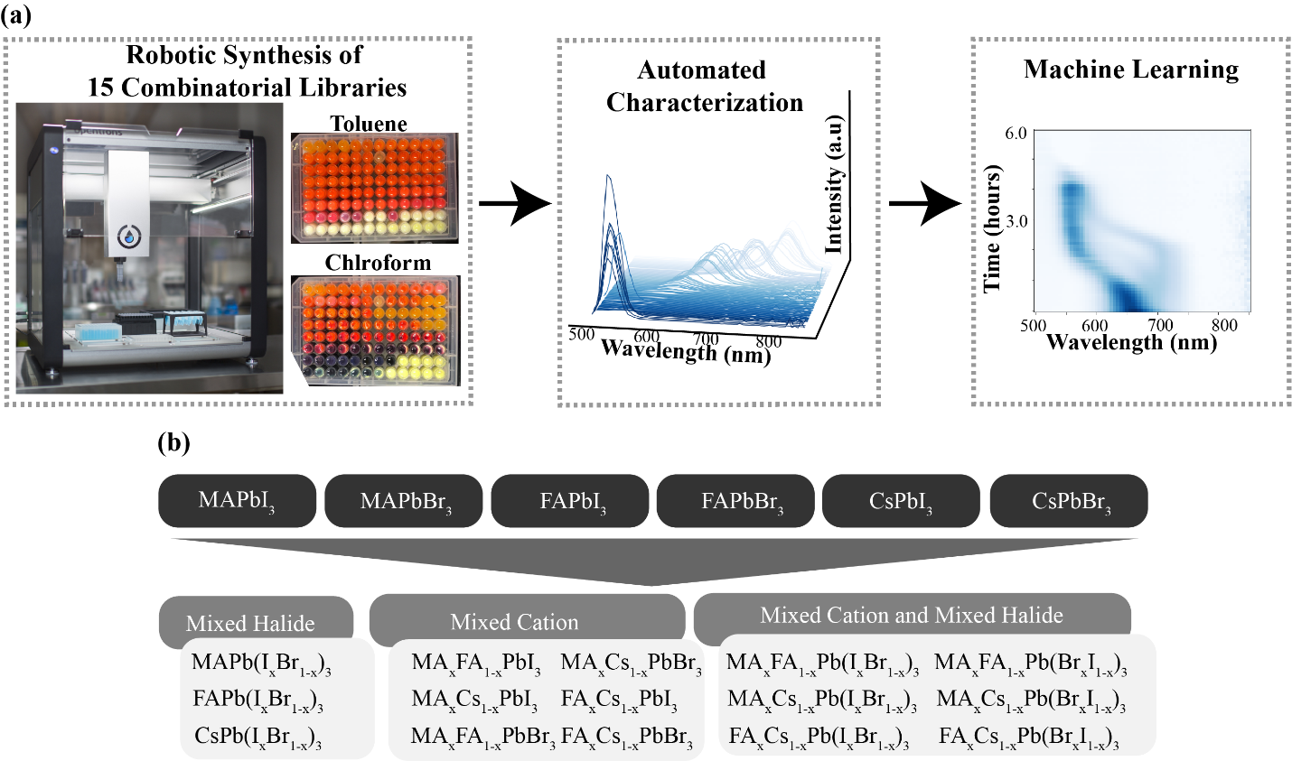
Figure 4-1 a) Schematic of the experimental workflow utilized for the exploration of 15 combinatorial libraries of MHPs. We utilize robotic synthesis to fabricate a library twice with two different antisolvents: toluene and chloroform, and photoluminescence (PL) spectroscopy is automatically performed next. Finally, we utilize machine learning to effectively map characteristic PL behaviors onto composition regions. b) List of all combinatorial libraries that were chosen from combinations of the six endmembers.

Toluene (anhydrous, 99.8%), chloroform (anhydrous, ≥99%, contains 0.5-1.0% ethanol as stabilizer), and chlorobenzene (anhydrous, 99.8%) were used without further purification.
We synthesized 0.3 M solutions by dissolving the precursor materials (1:1 AX:PbX₂ ratio) into the solvent shown in
Table 4-1. The precursor solutions were left to stir for approximately one hour before they were removed and immediately used for the robotic synthesis of a binary system.
Automated synthesis of microcrystals was performed using the Opentrons OT-2 pipetting robot. The protocol to perform this synthesis was written using their python API. We synthesized 15 different binary systems. For each system, the exact volumes of each precursor as shown in Table 4-2 were deposited into each well. Once each precursor was deposited into the wells, 250 μL of the chosen antisolvent (toluene, chloroform, or chlorobenzene) was pipetted into each well. An immediate change in color was observed upon the addition of the antisolvent, indicating the formation of microcrystals. As shown in Figure 4-2, there is a distinct difference in phase formation, based upon the color, of the microcrystals depending on the selection of the antisolvent.
Here, we utilized a fine grid of data points for a few reasons. In our previous study developing this workflow described in Chapter 2, we explored an entire ternary system utilizing a coarse grid of sample points, approximately 8% or 12% atomic weight difference between each composition²⁰¹. For this investigation, we wanted to explore how small changes in composition affect the PL behavior in ambient conditions. Secondly, because of the large number of systems characterized in this study, we decided to not adopt an iterative approach; therefore, a fine grid of sample points was necessary to comprehensively describe the entire system.
To explore the time- and compositional-dependent photoluminescence (PL) behavior of each system, we utilized the BioTek Cytation Hybrid Multi-Mode Reader for the PL spectroscopy. The Gen 5TM software accompanying this system is used for data collection. PL measurements were performed with an excitation wavelength of 450 nm and measured over the range of 500 to 850 nm with the step size of 5 nm. All measurements were performed in sweep mode and taken from the bottom of the well plate. PL measurements were performed approximately every 5 minutes for 6 hours.
To map the time- and compositional-dependent PL properties of each system, we utilize Non-negative Matrix Factorization (NMF). Also, NMF allows for the efficient extrapolation of material properties of chemical reactions of large datasets.
Table 4-1 Chosen solvent for each material synthesized.
Material | Solvent
MAPbI₃ | γ-butyrolactone (GBL)
MAPbBr₃ | n’n-dimethylformamide (DMF)
FAPbI₃ | γ-butyrolactone (GBL)
FAPbBr₃ | n’n-dimethylformamide (DMF)
CsPbI₃ | n’n-dimethylformamide (DMF)
CsPbBr₃ | Dimethyl sulfoxide (DMSO)

Table 4-2 Exact volume of each precursor deposited into each well. Precursor 1 is shown in black, and precursor 2 is shown in red.
 | 1 | 2 | 3 | 4 | 5 | 6 | 7 | 8 | 9 | 10 | 11 | 12
A | 50  0 | 49  1 | 48  2 | 47.5  2.5 | 47  3 | 46.5  3.5 | 46  4 | 45.5  4.5 | 45  5 | 44.5  5.5 | 44  6 | 43.5  6.5
B | 43  7 | 42.5  7.5 | 42  8 | 41.5  8.5 | 41  9 | 40.5  9.5 | 40  10 | 39.5  10.5 | 39  11 | 38.5  11.5 | 38  12 | 37.5  12.5
C | 37  13 | 36.5  13.5 | 36  14 | 35.5  14.5 | 35  15 | 34.5  15.5 | 34  16 | 33.5  16.5 | 33  17 | 32.5  17.5 | 32  18 | 31.5  18.5
D | 31  19 | 30.5  19.5 | 30  20 | 29.5  20.5 | 29  21 | 28.5  21.5 | 28  22 | 27.5  22.5 | 27  23 | 26.5  23.5 | 26  24 | 25.5  24.5
E | 25  25 | 24.5  25.5 | 24  26 | 23.5  26.5 | 23  27 | 22.5  27.5 | 22  28 | 21.5  28.5 | 21  29 | 20.5  29.5 | 20  30 | 19.5  30.5
F | 19  31 | 18.5  31.5 | 18  32 | 17.5  32.5 | 17  33 | 16.5  33.5 | 16  34 | 15.5  34.5 | 15  35 | 14.5  35.5 | 14  36 | 13.5  36.5
G | 13  37 | 12.5  37.5 | 12  38 | 11.5  38.5 | 11  39 | 10.5  39.5 | 10  40 | 9.5  40.5 | 9  41 | 8.5  41.5 | 8  42 | 7.5  42.5
H | 7  43 | 6.5  43.5 | 6  44 | 5.5  44.5 | 5  45 | 4.5  45.5 | 4  46 | 3.5  46.5 | 3  47 | 2  48 | 1  49 | 0  50

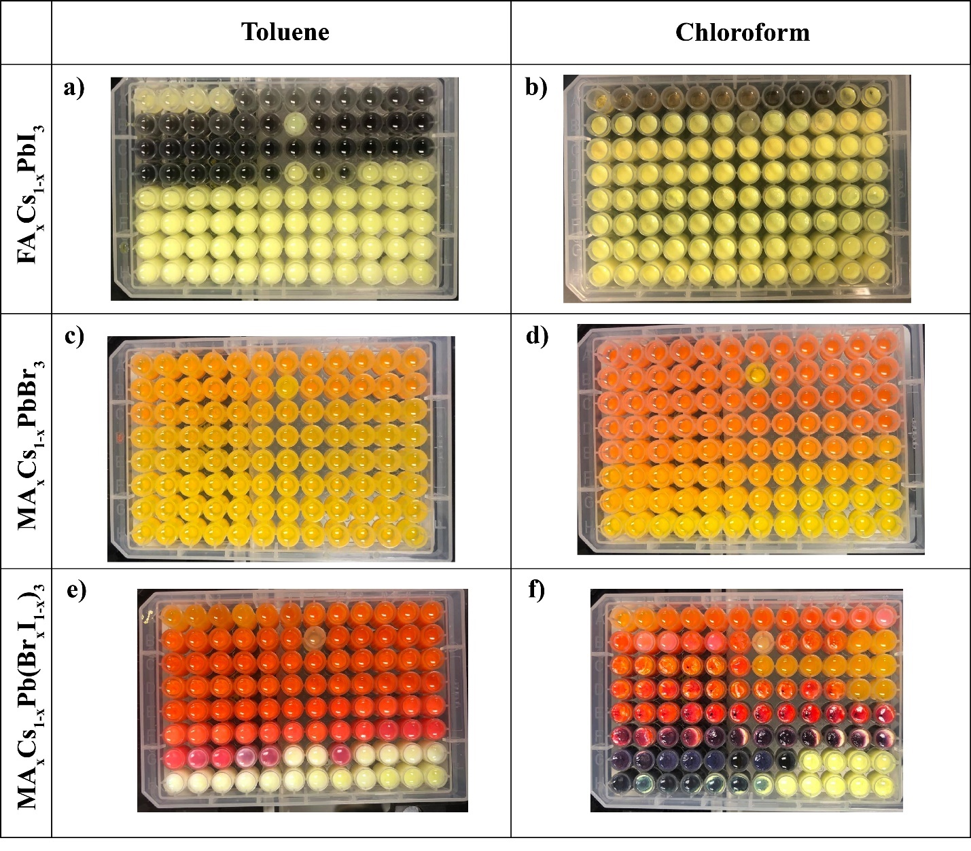
Figure 4-2 Images of each microplate immediately after synthesis when a), c), and e) toluene and b), d), and f) chloroform is utilized as the antisolvent for the FA_{x}Cs_{1-x}PbI₃, MA_{x}Cs_{1-x}PbBr₃, and MA_{x}Cs_{1-x}Pb(Br_{x}I_{1-x})₃ systems, respectively.

Here, the entire dataset, L(x,y,λ,t), analyzed via the decomposition
 | $$L\left(x,y,λ,t\right)= \sum_{i=1}^{N}{L_{i}(x,y)g_{i}(λ,t)}$$ | (4-1)
where L_{i}(x,y) are the loading maps, representing the variability of the PL behavior across the compositional space, and g_{i}(λ,t) are the endmembers that determine the characteristic behaviors in the time-spectral domain. Here, the loading maps are a 1D plot in which the x-axis represents the compositional change, and the y-axis is the intensity, indicating if the endmember applies to the composition, i.e., low intensity, the endmember is less applicable. Endmember maps are 2D plots, demonstrating how the characteristic PL behavior changes over time. We use the NMF decomposition from the scikit-learn library²²⁴. Our code and datasets are publicly provided on GitHub (https://git.io/JCLC7).
As mentioned previously, the operator determines the number of components utilized based on the knowledge of the system²⁰¹. For this determination, we performed the NMF decomposition of each system using two, three, and four components. We utilize the MA_{x}FA_{1-x}PbI₃ system as an example here to demonstrate our decision process, as shown in Figure 4-3. With two components, the compositional region (0.1 ≤ x ≤ 1) is described; however, we are lacking information about the FAPbI₃-rich compositions. When the decomposition using three components, we gain insight into the unstable PL behavior of the FAPbI₃-rich compositions. By increasing the number of components to four, we observe that the first component (most left component), representing the solid solutions between MAPbI₃ and FAPbI₃, has been split into two components (most left and right component in the N = 4 panel). This signifies that the number of components selected is too high. We observe this trend for other systems as well, confirming that this strategy is once applicable for this workflow.
Overall, by utilizing NMF here, we can visually describe the evolution of PL behavior of broad compositional regions of each system. The evolution of the PL behavior provides insight into the intrinsic stability of these regions. A composition is defined as qualitatively stable if we do not observe the formation of secondary peaks, shifts in peak positions, or the complete disappearance of the peaks as these changes indicate complex, dynamical processes, such as halide segregation, phase separation, or degradation.

Figure 4-3 Visual comparison for determining the number of components for the NMF decomposition of the MA_{x}FA_{1-x}PbI₃ system.

Mixed Cation Perovskites Systems
As mentioned previously in Chapter 1, mixed cation MHPs have improved stability in external stimuli. For example, the replacement of FA with MA, roughly 20%, was found to stabilize the α-phase at room temperature⁷⁴. As well, it was demonstrated that α-CsPbI₃ could be stabilized by partial substitution of MA⁷⁶; however, the film quality was poor and led to low efficiencies for solar cells⁴⁵. Many studies have proven how doping with other cations is beneficial; however, few have systematically explored how the antisolvent affects these improvements.
Firstly, we begin with the exploration of the mixed cation system, MA_{x}FA_{1-x}PbI₃. Both endmembers of this system, MAPbI₃ and FAPbI₃, have demonstrated high performances in photovoltaic devices^{225, 226}; however, the lack of phase stability and stability in air, moisture, and elevated temperatures has prevented its commercialization⁴⁰. It has been well established that the combination of MA and FA cations in solid solutions can stabilize the perovskite phase and hinder the degradation of the perovskite²²⁷⁻²²⁹. Huang et al. synthesized MA_{x}FA_{1-x}PbI₃ single crystals over the compositional ranges 0 ≤ x ≤ 0.2 and 0.8 ≤ x ≤ 1 in increments of x = 0.05 to correlate charge transport properties with the organic cations²²⁷. It was found that MA_{0.15}FA_{0.85}PbI₃ single crystals both stabilize the phase and have the best charge transport properties as compared to the other compositions. Partial substitution of FA, roughly 10%, into MAPbI₃ was found to improve the performance of photovoltaic devices by increasing the efficiency from 18.6% to 20.2%²²⁹. Incorporation of MA into FAPbI₃ has been shown to prevent the formation of the yellow, photoinactive phase, δ-FAPbI₃, at room temperature and to hinder the phase transition to the δ-FAPbI₃ over time²³⁰. The degradation routes over time were investigated by Charles et al. utilizing thin films over the full compositional range in increments of x = 0.1 in dry atmospheric conditions²³¹.MA-rich phases decompose into MAI and PbI₂, while FA-rich phases transform into the yellow, photoinactive phase, δ-FAPbI₃. Conversely, mixed cation phases demonstrate remarkable stability as the degradation route to the endmembers is less thermodynamically favorable. While the high photovoltaic performance and phase stabilization of this system has been explored, these studies utilize a small number of samples to describe the entire phase diagram, possibly missing important degradation mechanisms.
With both toluene (Figure 4-4a)) and chloroform (Figure 4-4h)) used as the antisolvent, we observe shifting in the PL peak position as the MAPbI₃ system is doped with FAPbI₃, confirming compositional tuning of the bandgap²³². For FAPbI₃-rich compositions, we observe a broad PL peak at lower wavelengths, as shown in Figure 4-4a). Along with the yellow color of the microcrystals upon antisolvent application, we conclude that the yellow, photoinactive phase has formed instead of the black, photoactive phase²³⁰. We observe phase stabilization as the yellow phase begins to recede as the concentration of MAPbI₃ is increased²³³. This stabilization is also observed when chloroform is utilized as the antisolvent, as shown in Figure 4-4h). Based upon this initial measurement, we learn that neither toluene nor chloroform is the appropriate antisolvent to form the pure phase α-FAPbI₃ and that the stabilization of the α-FAPbI₃ phase can be accomplished through the doping of MAPbI₃, which is in agreement with previous studies²³³.
Next, by analyzing the time-dependent PL behavior, we conclude that this double cation system undergoes fewer changes in the spectra over time when toluene is utilized instead of chloroform. As mentioned previously, the FAPbI₃-rich compositions likely form a solid solution between the δ-FAPbI₃ and α-FAPbI₃ phases; therefore, we expect to see a broad peak at lower wavelengths spanning approximately 100 nm, and this is observed in the endmembers (Figure 4-4e,l)) and corresponding loading maps (Figure 4-4b,i)) regardless of the antisolvent used. When using chloroform, this peak rapidly disappears approximately 30 minutes after synthesis, whereas with the toluene, we see this peak begin to narrow and shift toward lower wavelengths, indicating a continued presence of this mixed phase for a longer period. We observe a similar trend when comparing the FAPbI₃-rich and MAPbI₃ solid solutions in toluene and chloroform. Even with a slight peak shift and decrease in intensity, toluene as the antisolvent produces a consistent PL peak for the entirety of the characterization, as shown in Figure 4-4c,f). This stabilization is consistent with literature as it has been shown that α-FAPbI₃ can be achieved through small amounts of doping with MAPbI₃²³³. Conversely, this stabilization is temporary when chloroform is utilized, as shown in Figure 4-4j,m). For approximately 4 hours, we observe a steady PL peak before it begins to disappear.
This decrease in PL intensity is attributed to the perovskite reacting with the moisture in ambient conditions, possibly causing the perovskite to decompose into PbI₂ or forming a hydrate product²³⁴. Toluene is confirmed as the better choice for the antisolvent for this system by analyzing the time-dependent PL behavior of the MAPbI₃-rich compositions. As shown in Figure 4-4d,g), these compositions demonstrate remarkable stability in ambient conditions as their peak properties, such as width and position, remain relatively constant. We observe a slight increase in PL intensity at the beginning, indicating possible filling of trap states²³⁵.
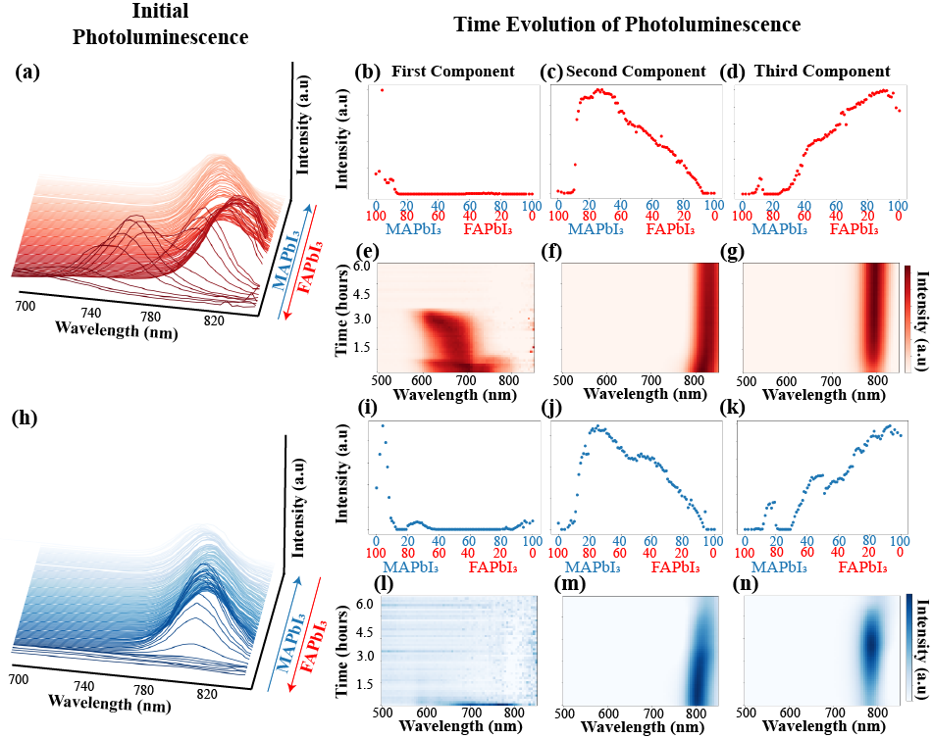
Figure 4-4 Double cation lead iodide system, MA_{x}FA_{1-x}PbI₃. a) initial PL behavior when toluene is used as the antisolvent. b), c), and d) are the loading maps for FAPbI₃-rich compositions, solid solutions of FAPbI₃ and MAPbI₃, and MAPbI₃-rich compositions, respectively. e), f), and g) Characteristic PL behavior for FAPbI₃-rich compositions, solid solutions of FAPbI₃ and MAPbI₃, and MAPbI₃-rich compositions, respectively. h) initial PL behavior when chloroform is used as the antisolvent. Similar to NMF decomposition for the toluene data set i), j), and k) and l), m), and o) are the loading maps and characteristic PL behavior for FAPbI₃-rich compositions, solid solutions of FAPbI₃ and MAPbI₃, and MAPbI₃-rich compositions, respectively.

A similar increase in intensity is observed when chloroform is used, as shown in Figure 4-4k,n). However, after approximately 5 hours, the PL intensity decreases, indicating the formation of hydrate products or decomposition occurring for these compositions as well.
Here, we find a broader compositional region (0 ≤ x ≤ 0.9) to not exhibit changes in PL behavior indicating degradation. We attribute this improvement in stability to the utilization of toluene as the antisolvent because in the study performed by Charles et al.²³¹, no antisolvent was used in fabrication. We explored this system further by performing the same synthesis and characterization but utilized chlorobenzene as the antisolvent. Chlorobenzene falls into the same category as chloroform, a halogenated antisolvent but includes an aromatic component. Other studies have widely utilized this antisolvent to improve the device performance^{236, 237}. Overall, as shown in Figure 4-5, the PL behavior when chlorobenzene is used is similar to the behavior when chloroform is utilized, indicating that this aromatic component does not drastically cause a difference. We postulate that the differences in PL behavior between the two groups are caused by the antisolvent’s ability in dissociating the coordinative bonds between the solvent and Pb ion. We suggest that the presence of the halogenated ion in the antisolvent does not fully cause this dissociation and therefore, cause complex lead halide ions, such as [PbI₃]⁻, to remain, interact with the air, and motivate degradation.
Next, we investigate how the choice of antisolvent affects the PL behavior of a different mixed cation lead iodide system: MA_{x}Cs_{1-x}PbI₃. Fan et al. demonstrated how small amount of Cs doping (<15%) can improve the stability of MAPbI₃ devices as the doping allows for the strengthening of the methylammonium cations and the [PbI₆] octahedrons, limiting the diffusion of MA and therefore stabilizing the perovskite structure²³⁸. It has also been demonstrated that MA can also stabilize CsPbI₃, prompting the formation of the photoactive phase instead of the yellow phase²³⁹.
The PL behavior of this system before exposure to ambient conditions is notably different depending on the antisolvent used in synthesis. When toluene is utilized, as shown in Figure 4-6a), the photoactive phase of CsPbI₃ did not form as indicated by the lack of PL peak. As more MAPbI₃ is incorporated into the system, a PL peak begins to appear. Conversely, the formation of a PL peak does not occur until the system is very MAPbI₃ rich when chloroform is used as the antisolvent, as shown in Figure 4-6h).

Figure 4-5 Comparison of the PL behavior when toluene, chloroform, and chlorobenzene is utilized as the antisolvent for the MA_{x}FA_{1-x}PbI₃ system. Initial PL behavior of the system when a) toluene, b) chloroform, and c) chlorobenzene is utilized. Time-dependent PL behavior of d-f) MAPbI₃-rich compositions, g-i) solid solutions of MAPbI₃ and FAPbI₃, and j-l) FAPbI₃-rich compositions for each antisolvent.

Here, we note that understanding the formation of this system is more complicated as compared to the MA_{x}FA_{1-x}PbI₃ system as two solvents (DMF and GBL) were used instead of just one (GBL).
Generally, the evolution of the PL behavior during exposure to ambient conditions is similar to the behavior observed initially. For example, when toluene is utilized as the antisolvent, as shown in Figure 4-6b,e), CsPbI₃-rich compositions (< 20% MAPbI₃), we do not observe the formation of the perovskite phase as indicated by the lack of a distinct PL peak. As the amount of MA in the system increases, we see a distinct PL peak centered around 770 nm; however, as exposure to ambient conditions continues, this peak rapidly disappears after approximately 2 hours, as shown in Figure 4-6c,f). In the MA_{x}FA_{1-x}PbI₃, we observed that the MAPbI₃-rich compositions were remarkably stable when toluene is utilized; however, this stability in ambient conditions is not observed in this system. Here, the MAPbI₃-rich compositions (< 20% CsPbI₃) exhibit an initial PL peak centered around 790 nm, as shown in Figure 4-6d,g). Prolonged exposure to ambient conditions causes the intensity of this peak to increase until it disappears after approximately 5 hours. We postulate that this difference in stability could be caused by the interaction of toluene, DMF, and the CsPbI₃ precursors. Most likely, there was phase separation between the photoinactive phase of CsPbI₃ and a solid solution of MAPbI₃ and CsPbI₃. This photoinactive phase interacts with the oxygen and moisture, initially decomposing into PbI₂ and leading to the eventual degradation of the composition. Comparably, when chloroform is used as the antisolvent, the majority of this system does not form the perovskite phase, as shown in Figure 4-6i,k). Shown in Figure 4-6j,l), for the MAPbI₃-rich compositions (< 10% CsPbI₃), we observe the formation of a distinct PL peak that initially increases in intensity, possibly caused by the initially filling of trap states. Overall, neither antisolvent produces stable microcrystals when the system is CsPbI₃ rich. This could be possibly resolved by the usage of a different antisolvent or using a different solvent for the CsPbI₃ solution.
Next, we explore how the choice of antisolvent affects the double cation lead iodide system, FA_{x}Cs_{1-x-}PbI₃. As shown in Figure 4-7a), a distinct PL peak does not initially form for the majority of the system, only in the region where 0.60 < x < 0.90. We observe something similar for the system when chloroform is utilized as the antisolvent except there is an additional region where a distinct PL peak forms, as shown in Figure 4-7b).

Figure 4-6 Double cation lead iodide system, MA_{x}Cs_{1-x}PbI₃. Initial PL behavior when a) toluene and h) chloroform is used as the antisolvent. When toluene is used as the antisolvent, b), c), and d) are the loading maps for CsPbI₃-rich compositions, solid solutions of CsPbI₃ and MAPbI₃, and MAPbI₃-rich compositions, respectively. e), f), and g) Characteristic PL behavior for CsPbI₃-rich compositions, solid solutions of CsPbI₃ and MAPbI₃, and MAPbI₃-rich compositions, respectively. When chloroform is used as the antisolvent, i) and j) and k) and l) are the loading maps and characteristic PL behavior for CsPbI₃-rich compositions, solid solutions of CsPbI₃ and MAPbI₃, and MAPbI₃-rich compositions, respectively.
Overall, we expect the lack in microcrystal formation because it is well established that this system will only form a solid solution for certain compositional regions²⁴⁰. Chloroform appears to be the better antisolvent for this system as there are more compositions forming the photoactive phase as compared to toluene.
Generally, chloroform remains the better antisolvent choice as the microcrystals are exposed to ambient conditions. As shown in Figure 4-7b,e), the majority of the system does not form the perovskite phase and that remains the case as exposure to ambient conditions continues. For a specific region of the phase diagram (0.60 < x < 0.90), the photoactive perovskite phase forms; however, within approximately 1 hour in ambient conditions, the PL peak rapidly disappears, indicating degradation, as shown in Figure 4-7c,f). For the FAPbI₃-rich regions (Figure 4-7c,f), we observe the same solid solution of α-FAPbI₃ and δ-FAPbI₃ that was observed in the MA_{x}FA_{1-x}PbI₃ in Figure 4-4b,e). Comparatively, when chloroform is utilized as the antisolvent, we observe better intrinsic stability for a specific compositional region not observed when toluene is used. Like when toluene is utilized, we observe the formation of a non-perovskite phase that remains for CsPbI₃-rich regions, as shown in Figure 4-7i,l). However, solid solutions of FAPbI₃ and CsPbI₃ do form the perovskite phase, indicated by a distinct PL peak, as shown in Figure 4-7j,m). The compositions are not intrinsically stable when expose to ambient conditions as demonstrated by the rapid disappearance of this PL peak within approximately 1 hour. Conversely, when chloroform is used, FAPbI₃-rich regions (0.60 < x < 0.92) demonstrate remarkable stability as compared to when toluene is utilized as the antisolvent, as shown in Figure 4-7k,n). The compositions have a distinct PL peak centered around 800 nm; however, at approximately 4 hours into the measurement period, this peak disappears. Although these compositions degrade before the measurement period ends, this improvement in stability when chloroform is used indicates that other methods, such as annealing or the addition of additives, could lead to stable compositions not possible when toluene is used as the antisolvent.
Next, we explore the evolution of PL behavior of the double cation lead bromide systems: MA_{x}FA_{1-x}PbBr₃, MA_{x}Cs_{1-x}PbBr₃, and FA_{x}Cs_{1-x}PbBr₃. Overall, we observe the formation of the perovskite phase for the majority of compositions regardless of the antisolvent utilized. Generally, the intrinsic stability of these bromide systems is better than the iodide systems.

Figure 4-7 Double cation lead iodide system, FA_{x}Cs_{1-x}PbI₃. Initial PL behavior when a) toluene and h) chloroform is used as the antisolvent. When toluene is used as the antisolvent, b), c), and d) are the loading maps for CsPbI₃-rich compositions, solid solutions of CsPbI₃ and FAPbI₃, and FAPbI₃-rich compositions, respectively. e), f), and g) Characteristic PL behavior for CsPbI₃-rich compositions, solid solutions of CsPbI₃ and FAPbI₃, and FAPbI₃-rich compositions, respectively. When chloroform is used as the antisolvent, i), j), and k) and l), m), and n) are the loading maps and characteristic PL behavior for CsPbI₃-rich compositions, solid solutions of CsPbI₃ and FAPbI₃, and FAPbI₃-rich compositions, respectively.

For the MA_{x}FA_{1-x}PbBr₃, when toluene is used as the antisolvent, we observe high intensity PL peaks for MAPbBr₃-rich compositions and solid solutions of MAPbBr₃ and FAPbBr₃, as shown in Figure 4-8a). In comparison, FAPbBr₃-rich compositions have a lower intensity PL peak evident in individual spectra. Conversely, using chloroform as the antisolvent produces high intensity PL peaks for FAPbBr₃-rich compositions and solid solutions of MAPbBr₃ and FAPbBr₃, as shown in Figure 4-8h).
As the system is exposed to ambient conditions, we observe different evolutions in PL peak depending on the antisolvent used. As mentioned previously, FAPbBr₃-rich compositions have a very low intensity PL peak as compared to the rest of the phase diagram. In the first component of the NMF decomposition (Figure 4-8b,e)), we observe the gradual increasing of the PL intensity as exposure to ambient conditions of the compositions continues. A high intensity PL peak remains at the end of the measurements indicating stability in these ambient conditions. As the amount of MA increases within the system, we observe a high intensity PL peak from the beginning of the measurement period; however, near the end of the measurements, the intensity dramatically decreases, indicating that these compositions experienced degradation, as shown in Figure 4-8c,f). However, as the system becomes MAPbBr₃-rich, we observe a constant, high-intensity PL peak shown in Figure 4-8d,g). Overall, this indicates that toluene will produce stable MAPbBr₃-rich microcrystals. While we observe the same evolution of PL behavior of the FAPbBr₃-rich compositions regardless of whether toluene (Figure 4-8b,e)) or chloroform (Figure 4-8i,l)) is used, we observe different PL behavior for the remainder of the phase diagram. For the solid solutions of FAPbBr₃ and MAPbBr₃, there is a high intensity PL peak at the beginning of the measurements, as shown in Figure 4-8j,m). As the duration of exposure to ambient conditions increases, we see a gradual decrease in PL intensity, however, the PL intensity rapidly increases near the end of the measurements. For the MAPbBr₃-rich compositions, we observe a similar evolution of PL behavior when toluene is utilized (Figure 4-8d,g)); however, near the end of the characterization period, we observe the sudden decrease in PL intensity.
For the MA_{x}Cs_{1-x}PbBr₃ system, we observe different PL behavior for CsPbBr₃-rich compositions as compared to the FAPbBr₃-rich regions in the MA_{x}FA_{1-x}PbBr₃ system. A possible explanation for the difference in behavior could be the different solvent utilized in the MA_{x}CsPbBr₃ system, DMF and DMSO, as compared to the usage of a single solvent, DMF, in the MA_{x}FA_{1-x}PbBr₃.
Figure 4-8 Double cation lead bromide system, MA_{x}FA_{1-x}PbBr₃. Initial PL behavior when a) toluene and h) chloroform is used as the antisolvent. When toluene is used as the antisolvent, b), c), and d) are the loading maps for FAPbBr₃-rich compositions, solid solutions of FAPbBr₃ and MAPbBr₃, and MAPbBr₃-rich compositions, respectively. e), f), and g) Characteristic PL behavior for FAPbBr₃-rich compositions, solid solutions of FAPbBr₃ and MAPbBr₃, and MAPbBr₃-rich compositions, respectively. When chloroform is used as the antisolvent, i), j) and k) and l), m), and n) are the loading maps and characteristic PL behavior for FAPbBr₃-rich compositions, solid solutions of FAPbBr₃ and MAPbBr₃, and MAPbBr₃-rich compositions, respectively.

Here, when toluene is used as the antisolvent, we observe the formation of distinct PL peaks for the entire system, as shown in Figure 4-9a).
The CsPbBr₃-rich compositions do have a lower PL intensity as compared to the MAPbBr₃-rich compositions. Conversely, the CsPbBr₃-rich compositions exhibit a higher PL intensity than the MAPbBr₃-rich compositions when chloroform is utilized, as shown in Figure 4-9h). We postulate that this difference in PL behavior for the CsPbBr₃-rich compositions could be because of the polarity index disparity between DMSO and toluene²⁴¹, leading to poor extraction of the solvent and possibly causing the formation of secondary phases.
Next, we explore how the choice of antisolvent affects the evolution of PL behavior of the system as it is exposed to ambient conditions. Firstly, we observe the presence of a PL peak for the CsPbBr₃-rich compositions; however, as time progresses, this PL peak disappears after approximately 4 hours, as shown in Figure 4-9b,e). This degradation is possibly caused by the initial formation and gradual decomposition of complex CsPbBr₃-DMSO phases due to the usage of toluene as the antisolvent. However, as more MA is introduced into the system, we observe the gradual increase in PL intensity of the peak, as shown in Figure 4-9c,f). This improvement in stability only continues as the system becomes more MAPbBr₃ rich, as shown in Figure 4-9d,g). Overall, this indicates that while toluene is an appropriate antisolvent choice for MAPbBr₃-rich compositions, it is not the ideal antisolvent for CsPbBr₃-rich compositions when DMSO is used as the solvent. When chloroform is utilized as the antisolvent, we observe an improvement in intrinsic stability of the CsPbBr₃-rich compositions. As shown in Figure 4-9i,l), we observe a slow increase in PL intensity as exposure to ambient conditions continues. Conversely, for some solid solutions of CsPbBr₃ and MAPbBr₃, the PL peak disappears after approximately 5.5 hours in ambient conditions, as shown in Figure 4-9j,m). However, for MAPbBr₃-rich compositions with a significant amount of Cs, shown in Figure 4-9k,n), the PL intensity of the peak gradually increases as time continues and remains at the end of the measurement period, indicating remarkable stability. The inclusion of Cs appears to have improved the stability of MAPbBr₃-rich compositions when chloroform is used as compared to the MAPbBr₃-rich compositions in the MA_{x}FA_{1-x}PbBr₃ system (Figure 4-8k,n)).
Finally, we investigate the effects of the antisolvent on the system, FA_{x}Cs_{1-x}PbBr₃. As with the MA_{x}Cs_{1-x}PbBr₃ system, there are two solvents (DMF and DMSO) presented in synthesis.

Figure 4-9 Double cation lead bromide system, MA_{x}Cs_{1-x}PbBr₃. Initial PL behavior when a) toluene and h) chloroform is used as the antisolvent. When toluene is used as the antisolvent, b), c), and d) are the loading maps for CsPbBr₃-rich compositions, solid solutions of CsPbBr₃ and MAPbBr₃, and MAPbBr₃-rich compositions, respectively. e), f), and g) Characteristic PL behavior for CsPbBr₃-rich compositions, solid solutions of CsPbBr₃ and MAPbBr₃, and MAPbBr₃-rich compositions, respectively. When chloroform is used as the antisolvent, i), j) and k) and l), m), and n) are the loading maps and characteristic PL behavior for CsPbBr₃-rich compositions, solid solutions of CsPbBr₃ and MAPbBr₃, and MAPbBr₃-rich compositions, respectively.

We observe similar trends in the initial PL behavior for this system when toluene is utilized as for the MA_{x}Cs_{1-x}PbBr₃ system (Figure 4-9a)).As shown in Figure 4-10a), the intensity of the PL peak increases as the amount of FA increases within the system. We observe a similar increase as FA is introduced when chloroform is utilized as the antisolvent, as shown in Figure 4-10h); however, the intensity of the PL peaks for the CsPbBr₃-rich compositions is generally higher with chloroform as the antisolvent.
As mentioned in the previous system, there is a high polarity index disparity between DMSO and toluene; therefore, we expect and observe the same decrease in PL intensity, shown in Figure 4-10b,e), as exposure to ambient conditions continues for the CsPbBr₃-rich compositions as in the last system when toluene is used, indicating eventual degradation. Conversely, we do not observe the degradation of the solid solutions between CsPbBr₃ and FAPbBr₃ as the intensity of the PL peak only increases as time progresses, as shown in Figure 4-10c,f). Noticeably, we see a different PL evolution for the FAPbBr₃-rich compositions than in the MA_{x}FA_{1-x}PbBr₃ system. Here, as shown in Figure 4-10d,g), we observe the gradual decrease in PL intensity as exposure to ambient conditions increases. This difference in behavior is possibly caused by the addition of DMSO into the system, affecting the stability of FAPbBr₃-rich compositions. Generally, the behavior of this system when chloroform is the opposite as to when toluene is used as the antisolvent. For example, the CsPbBr₃-rich compositions demonstrate remarkable stability in ambient conditions as the PL peak remains consistent throughout the measurement period, as shown in Figure 4-10i,l). As the amount of FA increases within the system, we observe an initial high intensity PL peak that rapidly disappears after 4.5 hours, as shown in Figure 4-10j,m). The lack of stability continues for the FAPbBr₃-rich compositions as the PL peak intensity increases, but suddenly decreases after 5 hours, as shown in Figure 4-10k,n). Overall, chloroform has proven to be the better choice for CsPbBr₃-rich compositions; however, this improvement in stability when chloroform is used is lacking for the other lead bromide precursors.

Mixed Halide Perovskites Systems
Next, we proceed further by explore how the antisolvent affects mixed halide systems: MAPb(Br_{x}I_{1-x})₃, FAPb(Br_{x}I_{1-x})₃, and CsPb(Br_{x}I_{1-x})₃.

Figure 4-10 Double cation lead bromide system, FA_{x}Cs_{1-x}PbBr₃. Initial PL behavior when a) toluene and h) chloroform is used as the antisolvent. When toluene is used as the antisolvent, b), c), and d) are the loading maps for CsPbBr₃-rich compositions, solid solutions of CsPbBr₃ and FAPbBr₃, and FAPbBr₃-rich compositions, respectively. e), f), and g) Characteristic PL behavior for CsPbBr₃-rich compositions, solid solutions of CsPbBr₃ and FAPbBr₃, and FAPbBr₃-rich compositions, respectively. When chloroform is used as the antisolvent, i), j) and k) and l), m), and n) are the loading maps and characteristic PL behavior for CsPbBr₃-rich compositions, solid solutions of CsPbBr₃ and FAPbBr₃, and FAPbBr₃-rich compositions, respectively.

Generally, regardless of the antisolvent utilized, we observe phase separation for solid solutions of APbBr₃ and APbI₃; however, the stability of certain compositional regions is improved depending on the antisolvent used in synthesis.
Firstly, we investigate how the choice of antisolvent affects the mixed halide perovskite systems, MAPb(Br_{x}I_{1-x})₃. Shown in Figure 4-11a) is the initial PL behavior of this mixed halide system when toluene is used. We observe a peak shift towards higher wavelengths as the concentration of MAPbI₃ increases, indicating an expected decrease in the band gap. This shift is more apparent when chloroform (Figure 4-11h)) is used as the antisolvent as the MAPbI₃-rich compositions have a comparatively large PL intensity as compared to the same compositions when toluene is used.
Regardless of the antisolvent used, the PL behavior of the MAPbBr₃-rich compositions is approximately the same; however, this is not the case as more MAPbI₃ is introduced into the system. For example, for the MAPbBr₃-rich compositions, we observe an increase in PL intensity without a shift in peak position for both toluene (Figure 4-11b,e)) and chloroform (Figure 4-11i,l)), indicating that these compositions remain relatively stable regardless of the antisolvent choice. We observed this similar trend for the MAPbBr₃-rich compositions in the double cation lead bromide systems. However, the solid solutions between MAPbBr₃ and MAPbI₃ undergo different dynamical processes depending on the antisolvent used during synthesis. As shown in Figure 4-11c,f), when toluene is used, a broad peak, likely indicative of two convolved peaks, is present initially. Eventually, this peak begins to separate into two, with one representing the bromine-rich phase and one the mixed phase. After approximately 3 hours, both peaks disappear, indicating complete degradation of the compositions. Simultaneously, when these same compositions are synthesized using chloroform as the antisolvent, we observe the initial presence of a broad, low-intensity peak, as shown in Figure 4-11j,m). Over time, this peak narrows as the intensity of the bromine-rich phase increases and the mixed phase decreases. In both cases, we observe halide segregation caused by reactions with the environment⁹⁷, indicating that halide segregation cannot be mitigated for these particular compositional regions using these two antisolvents. Finally, the MAPbI₃-rich compositions in this system behave similarly to the same region of the phase diagram for the MAPbI₃-rich regions in the double cation lead iodide systems, as expected.

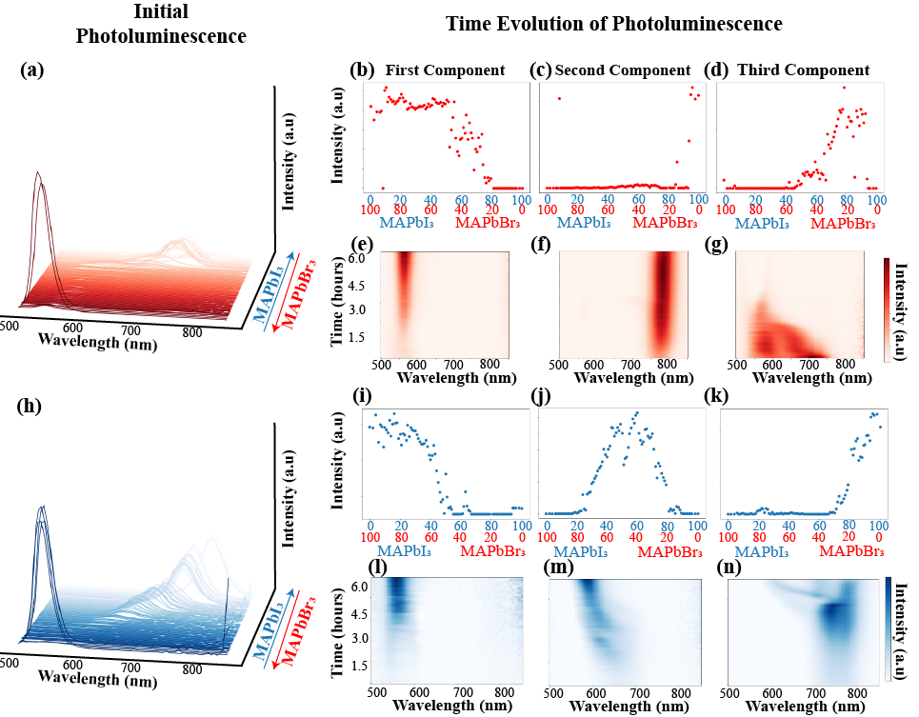
Figure 4-11 Methylammonium lead double halide system, MAPb(I_{x}Br_{1-x})₃. a) initial PL behavior when toluene is used as the antisolvent. b), c), and d) are the loading maps for MAPbBr₃-rich compositions, solid solutions of MAPbBr₃ and MAPI₃, and MAPbI₃-rich compositions, respectively. e), f), and g) Characteristic PL behavior for MAPbBr₃-rich compositions, solution solutions of MAPbBr₃ and MAPbI₃, and MAPbI₃-rich compositions, respectively. h) initial PL behavior when chloroform is used as the antisolvent. Similar to NMF decomposition for the toluene data set i), j) and k) and l), m), and n) are the loading maps and characteristic PL behavior for MAPbBr₃-rich compositions, solution solutions of MAPbBr₃ and MAPbI₃, and MAPbI₃-rich compositions, respectively.

As shown in Figure 4-11d,g), the MAPbI₃-rich compositions, specifically x < 10%, demonstrate an increase in PL intensity but remain stable for the entirety of the characterization period when toluene is utilized. When chloroform is used (Figure 4-11k,n)), we observe an increase and subsequent decrease in PL intensity as exposed to ambient conditions. Interestingly, we observe a small peak extending toward lower wavelengths, indicating that halide segregation is occurring even with a small amount of MAPbBr₃ when chloroform is used.
Next, we explore the effect of antisolvents on the formamidinium lead double halide system, FAPb(I_{x}Br_{1-x})₃. Generally, we observe the same initial PL behavior regardless of the antisolvent used. Both undergo a gradual shift toward higher wavelengths as the amount of FAPbI₃ is increased, as shown in both Figure 4-12a) and Figure 4-12h). A slight difference in behavior is a small compositional region consisting of solid solutions of FAPbI₃ and FAPbBr₃ illustrates an increase in PL intensity when toluene is used as compared to when chloroform is used.
When toluene is used as the antisolvent, we observe remarkable stability for both FAPbBr₃-rich compositions and solid solutions of FAPbBr₃ and FAPbI₃. As shown in Figure 4-12b,e) and Figure 4-12ac,f), we observe a constant, high-intensity PL peak with no peak shifts for the duration of the characterization period. However, this stability does not continue as more FAPbI₃ is introduced into the system. For this region, we observe a broad peak that begins to narrow and decrease in intensity before disappearing as exposure to ambient conditions continues, as shown in Figure 4-12d,g). The stability observed for the FAPbBr₃-rich compositions and the solid solutions between FAPbBr₃ and FAPbI₃ are not observed when chloroform is used as the antisolvent. As shown in Figure 4-12i,l), we observe a broad peak for FAPbBr₃-rich compositions that gradually decreases in intensity and shifts toward lower wavelengths as exposure to ambient conditions continues. Likewise, for the solid solutions of FAPbBr₃ and FAPbI₃, we observe a broad peak centered around 700 nm that begins to shift toward lower wavelengths and decrease in intensity before disappearing, as shown in Figure 4-12j,m). We observe slight improvements in stability for the FAPbI₃-rich compositions as the PL peak does not shift and decreases in intensity slower, as shown in Figure 4-12k,n). Although the PL peak disappears before the end of the characterization period, this improvement in stability for the FAPbI₃-rich compositions as small amounts of bromide is introduced indicates that utilizing chloroform for this region might be a possible way, along with other post-processing methods, might be a possibly strategy in producing stable FAPb(Br_{x}I_{1-x})₃ (0.1 < x < 0.4) devices.
Figure 4-12 Formamidinium lead double halide system, FAPb(I_{x}Br_{1-x})₃. Initial PL behavior when a) toluene and h) chloroform is used as the antisolvent. When toluene is used as the antisolvent, b), c), and d) are the loading maps for FAPbBr₃-rich compositions, solid solutions of FAPbBr₃ and FAPbI₃, and FAPbI₃-rich compositions, respectively. e), f), and g) Characteristic PL behavior for FAPbBr₃-rich compositions, solid solutions of FAPbBr₃ and FAPbI₃, and FAPbI₃-rich compositions, respectively. When chloroform is used as the antisolvent, i), j) and k) and l), m), and n) are the loading maps and characteristic PL behavior for FAPbBr₃-rich compositions, solid solutions of FAPbBr₃ and FAPbI₃, and FAPbI₃-rich compositions, respectively.

Finally, we investigate the effect of toluene and chloroform on the stability of the cesium lead double halide system, CsPb(I_{x}Br_{1-x})₃. Here, we observe distinct PL peaks for CsPbBr₃-rich and solid solutions of CsPbBr₃ and CsPbI₃ (around x = 0.5) when toluene is utilized as the antisolvent, as shown in Figure 4-13a). Conversely, distinct PL peaks are only observed for CsPbBr₃-rich compositions when chloroform is used, as shown in Figure 4-13h). Generally, both antisolvents lead to the formation of the photoinactive phase of CsPbI₃; therefore, the lack of PL is not surprising.
Here, we examine the difference in the evolution of PL behavior depending on the antisolvent utilized for this system. Noticeably, we observe stability for the CsPbBr₃-rich compositions when toluene is used as we observe an increase in PL intensity over time, as shown in Figure 4-13b,e). This improvement in stability is remarkable as previously in the CsPbBr₃-rich regions of the double cation lead bromide systems, we observed that the high polarity disparity between DMSO and toluene caused instability. We postulate that the difference in behavior is possibly caused by the difference in solvents used for CsPbI₃ (GBL) and FAPbBr₃/MAPbBr₃ (DMF). The addition of GBL could hinder the formation of perovskite-solvent complexes, leading to an improvement in stability. This improvement in stability does not remain as more CsPbI₃ is introduced into the system. For solid solutions of CsPbBr₃ and CsPbI₃, we observe a distinct PL peak that begins to separate into two before disappearing, as shown in Figure 4-13c,f), indicating halide segregation before eventual degradation. Finally, the photoinactive phase of CsPbI₃ forms when toluene is used as indicated by the PL peak at low intensity wavelengths, as shown in Figure 4-13d,g). For CsPbBr₃-rich compositions when chloroform is used, we observe the a distinct PL peak centered around 540 nm that initially increasing in intensity before a gradual decrease, as shown in Figure 4-13i,l). The decrease towards the end of the measurement period is surprising as chloroform has proven to a decent antisolvent for CsPbBr₃-rich compositions as shown in the same regions of the double cation lead bromide systems. It is possible that the addition of the GBL has the opposite effect here as it does when toluene is used by leading to eventual degradation. As the amount of CsPbI₃ is increased, we still observe a PL peak centered around 560 nm, as shown in Figure 4-13j,m), indicating that some of the iodide was incorporated but still is bromide rich. The lack of incorporation is probably caused by the formation of the photoinactive phase of CsPbI₃, limiting the fabrication of stoichiometric solid solutions.

Figure 4-13 Cesium lead double halide system, CsPb(I_{x}Br_{1-x})₃. Initial PL behavior when a) toluene and h) chloroform is used as the antisolvent. When toluene is used as the antisolvent, b), c), and d) are the loading maps for CsPbBr₃-rich compositions, solid solutions of CsPbBr₃ and CsPbI₃, and CsPbI₃-rich compositions, respectively. e), f), and g) Characteristic PL behavior for CsPbBr₃-rich compositions, solid solutions of CsPbBr₃ and CsPbI₃, and CsPbI₃-rich compositions, respectively. When chloroform is used as the antisolvent, i), j) and k) and l), m), and n) are the loading maps and characteristic PL behavior for CsPbBr₃-rich compositions, solid solutions of CsPbBr₃ and CsPbI₃, and CsPbI₃-rich compositions, respectively.

Finally, as expected, the CsPbI₃-rich regions produce the photoinactive phase when chloroform is utilized too, as shown in Figure 4-13k,n).

Double Cation Lead Double Halide Systems
We proceed further by investing the effect of each antisolvent on the double cation and double halide systems, MA_{x}FA_{1-x}Pb(I_{x}Br_{1-x})₃, MA_{x}FA_{1-x}Pb(Br_{x}I_{1-x})₃, MA_{x}Cs_{1-x}Pb(I_{x}Br_{1-x})₃, MA_{x}Cs_{1-x}Pb(Br_{x}I_{1-x})₃, FA_{x}Cs_{1-x}Pb(I_{x}Br_{1-x})₃, and FA_{x}Cs_{1-x}Pb(Br_{x}I_{1-x})₃. We note that, for example, the systems, MA_{x}FA_{1-x}Pb(I_{x}Br_{1-x})₃ and MA_{x}FA_{1-x}Pb(Br_{x}I_{1-x})₃, produce the same final end composition; however, we synthesize both to explore the effect of precursors and their respective solvents on the stability of the system.
First, we explore the effect toluene and chloroform have on the stability of the system, MA_{x}FA_{1-x}Pb(I_{x}Br_{1-x})₃. Regardless of the antisolvent utilized, we observe high-intensity PL peaks for FAPbBr₃-rich regions, as shown in Figure 4-14a) and Figure 4-14h). For both antisolvents, as more MAPbI₃ is incorporated into the system, we observe the gradual decrease in the bandgap energy. Although the intensity of the PL peaks is relatively low for the MAPbI₃-rich compositions as compared to the FAPbBr₃-rich compositions, the peaks are still present in the individual spectra.
Next, we explore the stability in ambient conditions of this system depending on the antisolvent utilized. FAPbBr₃-rich compositions exhibit a high-intensity PL peak without shifting for the majority of the measurement period, as shown in Figure 4-14b,e), indicating remarkable stability when toluene is utilized. However, this PL behavior is not observed when chloroform is utilized. As shown in Figure 4-14i,l), there is a peak centered at approximately 650 nm, however, as time progresses, there is a noticeable peak shift towards lower wavelengths as the intensity increases, indicating the decomposition into bromide- and iodide-rich regions. As the amount of MAPbI₃ increases, we observe a PL at higher wavelengths that increases in intensity without shifting as time progresses when toluene is utilized, as shown in Figure 4-14c,f). When chloroform is used, this region has a low-intensity PL peak approximately centered around 680 nm that broadens, shifts, and increases in intensity as time progresses, as shown in Figure 4-14j,m). Here, the same halide segregation is observed as in the FAPbBr₃-rich regions when chloroform is utilized. Finally, for the MAPbI₃-rich regions, we observe a very broad PL peak centered at approximately 800 nm when toluene is used, as shown in Figure 4-14d,g). The broadness of this peak indicates there is halide segregation occurring.
Figure 4-14 Double cation lead double halide system, MA_{x}FA_{1-x}Pb(I_{x}Br_{1-x})₃. Initial PL behavior when a) toluene and h) chloroform is used as the antisolvent. When toluene is used as the antisolvent, b), c), and d) are the loading maps for FAPbBr₃-rich compositions, solid solutions of FAPbBr₃ and MAPbI₃, and MAPbI₃-rich compositions, respectively. e), f), and g) Characteristic PL behavior for FAPbBr₃-rich compositions, solid solutions of FAPbBr₃ and MAPbI₃, and MAPbI₃-rich compositions, respectively. When chloroform is used as the antisolvent, i), j) and k) and l), m), and n) are the loading maps and characteristic PL behavior for FAPbBr₃-rich compositions, solid solutions of FAPbBr₃ and MAPbI₃, and MAPbI₃-rich compositions, respectively.

Comparatively, the PL peak for this same region when chloroform is used is narrow and increases in PL intensity as exposed to ambient conditions, as shown in Figure 4-14k,n). Overall, toluene mitigates the effects of halide segregation by limiting the incorporation of iodide into the perovskite as indicated by the discrepancy in bandgaps, i.e., compositions have a higher bandgap than expected by Vegard’s Law. However, in iodide-rich compositions, halide segregation occurs as indicated by the broad peaks. Noticeably, at the end of the characterization period, the PL intensity for each region remains remarkably high, indicating stability. Conversely, while chloroform permits this incorporation of iodide into the system, producing stoichiometric compositions, it also allows for the occurrence of halide segregation as indicated by the peak shifts.
Now, we explore the effect of the antisolvent of the same compositions but utilizing different precursors. For example, in the previous system, the precursors were MAPbI₃ and FAPbBr₃. Here, we look at the system with the precursors MAPbBr₃ and FAPbI₃. We expect to see a difference in PL behavior because of the different precursor solubilities in their respective solvents.
The initial PL behavior of the system when toluene and chloroform is used is shown in Figure 4-15a) and Figure 4-15h), respectively. For both, we observe the shift in PL peak position towards lower wavelengths as more MAPbBr₃ is introduced into the system, as expected. When toluene is utilized, the MAPbBr₃-rich compositions have a relatively high PL intensity, while when chloroform is used, these same compositions have a lower PL intensity. Next, we explore the effect of the antisolvent on the evolution of PL behavior as the microcrystals are exposed to ambient conditions. As shown in Figure 4-15b,e), FAPbI₃-rich compositions with small amounts of MAPbBr₃ (x < 20%) demonstrate remarkable stability. The PL peak is centered at approximately 780 nm and has a high intensity at the beginning of the measurements. As time progresses, we observe a slight shift towards higher wavelengths and a small decrease in intensity, however, this intensity after the initial decrease remains constant. Small amounts MAPbBr₃ has been shown to stabilize and improve the stability of FAPbI₃, but instances of halide segregation remain frequent⁹⁷ as exemplified by the evolution of PL behavior of this same region when chloroform is utilized (Figure 4-15i,l)). Here, the peak gradually shifts towards lower wavelengths as halide segregation occurs and eventually degradation occurs as the iodide-rich regions interact with the oxygen and moisture. Overall, this difference in PL behavior demonstrates how antisolvent engineering can lead to improvements in intrinsic stability.
Figure 4-15 Double cation lead double halide system, MA_{x}FA_{1-x}Pb(Br_{x}I_{1-x})₃. Initial PL behavior when a) toluene and h) chloroform is used as the antisolvent. When toluene is used as the antisolvent, b), c), and d) are the loading maps for FAPbI₃-rich compositions, solid solutions of FAPbI₃ and MAPbBr₃, and MAPbBr₃-rich compositions, respectively. e), f), and g) Characteristic PL behavior for FAPbI₃-rich compositions, solid solutions of FAPbI₃ and MAPbBr₃, and MAPbBr₃-rich compositions, respectively. When chloroform is used as the antisolvent, i), j) and k) and l), m), and n) are the loading maps and characteristic PL behavior for FAPbI₃-rich compositions, solid solutions of FAPbI₃ and MAPbBr₃, and MAPbBr₃-rich compositions, respectively.

However, as the amount of MAPbBr₃ increases in the system, we do observe halide segregation when toluene is used, as shown in Figure 4-15c,f). There is a broad peak centered around 630 nm, indicating two convolved peaks representing bromide- and iodide-rich regions. The PL intensity remains relatively constant throughout the measurement period, suggesting that although these compositions experience halide segregation, they are relatively stable. This is not the case when chloroform is utilized for the same compositional regions. As shown in Figure 4-15j,m), the PL peak shifts towards lower wavelengths as halide segregations occurs and eventually the PL peak disappears, indicating that this segregation caused degradation. Finally, the MAPbBr₃-rich regions are also stable when toluene is utilized as the peak intensity remains constant, and there is only a slight shift towards higher wavelengths, as shown in Figure 4-15d,g). Again, these same regions demonstrate a distinctly different PL behavior when chloroform is used as opposed toluene. As shown in Figure 4-15k,n), there is a large peak shift over time, however, the intensity of the PL increases, indicating that these bromide-rich regions are stable, but that the iodide-rich regions decomposed during exposure to ambient conditions. Overall, toluene appears to be the better choice for this double cation lead double halide system as the majority of the phase diagram remains stable, even with the occurrence of halide segregation.
As we compare the two systems utilizing different precursors, the system appears to be the most stable when toluene is used and the precursors are FAPbI₃ and MAPbBr₃. When the other precursors, MAPbI₃ and FAPbBr₃, are used, the compositions are relatively stable, but the reported bandgaps do not follow Vegard’s law, possibly making fabrication difficult. As well, most photovoltaic applications require a low bandgap, and the compositions with the lowest bandgaps of this system have a narrower peak with FAPbI₃ and MAPbBr₃ as compared to when MAPbI₃ and FAPbBr₃ is used. Generally, chloroform is not the ideal antisolvent for either system as halide segregation and eventual degradation are prominent for most compositions.
Next, we further proceed by investigating the effect of toluene and chloroform on the system shown in Figure 4-16. Firstly, we clearly observe that MAPbI₃-rich compositions are comparatively lower in intensity than the CsPbBr₃-rich compositions when toluene is used (Figure 4-16a)), whereas this is not the case when chloroform is utilized (Figure 4-16h)) as indicated by the high-intensity MAPbI₃ peaks. However, in both cases, adherence to Vegard’s law, in which the bandgap shifts based on compositional alloying, is upheld.
Looking at the time-dependent PL behavior, it is apparent that toluene is a more beneficial antisolvent for MAPbI₃ and chloroform is a better antisolvent for CsPbBr₃, as expected. As shown in Figure 4-16b,e), we observe rapid degradation of the CsPbBr₃-rich compositions when toluene is used because the individual PL spectra could simply be characterized as noise, as shown in Figure 4-17. As mentioned previously, this lack of stability when toluene is used for CsPbBr₃-rich compositions is not unexpected because of the polarity index disparity between DMSO and toluene⁵². Conversely, when chloroform is utilized as the antisolvent, for these same compositions, there is an increase in peak intensity without major peak shifts, indicating the stability of these compositions in ambient conditions, as shown in Figure 4-16i,l). Solid solutions of MAPbI₃-rich and CsPbBr₃ exhibit a brief appearance of an intense peak when toluene is used, as shown in Figure 4-16c,f), however, after approximately 2 hours, it disappears, indicating degradation. Noticeably, even though these compositions contain a considerable amount of iodide, we do not observe an iodide-rich PL peak. On the contrary, when chloroform is used, we initially observe a mixed-phase PL peak, as shown in Figure 4-16j,m); however, after approximately 2 hours, this peak separates into two, each representing the iodide-rich and bromide-rich regions, confirming halide segregation³⁷. Interestingly, the MAPbI₃-peak does not disappear as time increase but begins to shift toward lower wavelengths. Finally, as stated previously, MAPbI₃-rich compositions are remarkably stable with toluene as the antisolvent, as shown in Figure 4-16d,g), whereas when chloroform is utilized, these same compositions experience an increase in PL intensity before a decrease, as shown in Figure 4-16k,n).
We explore the same compositions utilizing different precursors, MAPbBr₃ and CsPbI₃, shown in Figure 4-18. Either toluene or chloroform produces well-defined, high-intensity peaks for MAPbBr₃-rich compositions, as shown in Figure 4-18a,h). For CsPbI₃-rich compositions, there is a broad low-intensity peak observed when toluene is used, indicating that the wide-bandgap polymorph δ-CsPbI₃ formed. This formation of this phase is not dependent on the antisolvent, as evidenced by its presence when chloroform is also used. Noticeably, Vegard’s law is better adhered to when chloroform is utilized versus the usage of toluene.
Regarding the time-dependent evolution of the PL, we observe a variety of dynamical process caused by either antisolvent. First, as shown in Figure 4-18b,e), we observe the formation of a unstable polymorph, δ-CsPbI₃, when toluene is used. Surprisingly, utilizing chloroform produces a stable, yellow phase of δ-CsPbI₃.

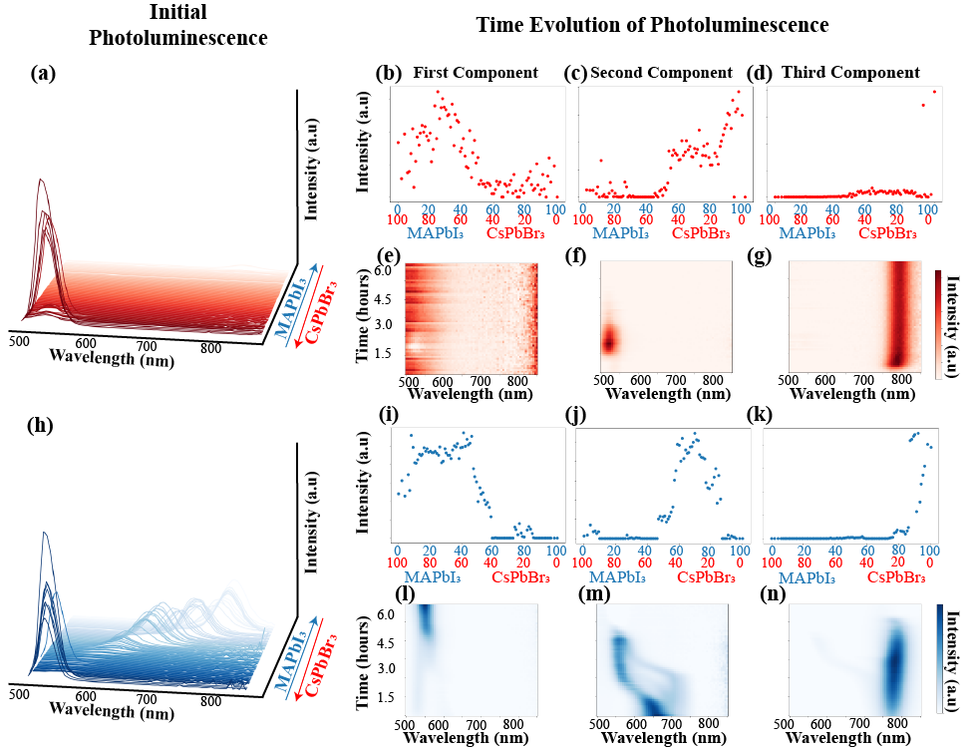
Figure 4-16 Double cation and double halide system, MA_{x}Cs_{1-x}Pb(I_{x}Br_{1-x})₃. a) initial PL behavior when toluene is used as the antisolvent. b), c), and d) are the loading maps for CsPbBr₃-rich compositions, solution solutions of CsPbBr₃ and MAPbI₃, and MAPbI₃-rich compositions, respectively. e), f), and g) Characteristic PL behavior for CsPbBr₃-rich compositions, solution solutions of CsPbBr₃ and MAPbI₃, and MAPbI₃-rich compositions, respectively. h) initial PL behavior when chloroform is used as the antisolvent. Similar to NMF decomposition for the toluene data set i), j) and k) and l), m), and n) are the loading maps and characteristic PL behavior for CsPbBr₃-rich compositions, solution solutions of CsPbBr₃ and MAPbI₃, and MAPbI₃-rich compositions, respectively.

The bandgap of this polymorph is roughly 2.82 eV, explaining the distinct peak at lower wavelengths, shown in Figure 4-18l). Solid solutions between CsPbI₃-rich and MAPbBr₃ compositions exhibit a decreasing PL intensity without any peak shifts over the duration of the measurement period, as shown in Figure 4-18c,f). Conversely, these same compositions begin with a single mixed-phase PL peak before experiencing halide segregation as the peak moves toward lower wavelength when chloroform is used, as shown in Figure 4-18j,m). Finally, we observe similar trends, in which the peak grows in intensity over time, for the MAPbBr₃-rich compositions for both antisolvents (Figure 4-18d,g,k,n)). However, as shown in Figure 4-18k), when chloroform is used, these compositions also include fair amounts of CsPbI₃, explaining the peak shift over time, as shown in Figure 4-18n). Full stability analysis of this system is limited by the formation of δ-CsPbI₃ when toluene is used; however, chloroform appears to be the more appropriate choice to help with the formation of α-CsPbI₃ through alloying with MAPbBr₃.
For both systems, toluene does not appear to be the appropriate choice for solid solutions of CsPbX₃-rich and MAPbX₃-rich compositions. In the MA_{x}Cs_{1-x}Pb(I_{x}Br_{1-x})₃ system, as mentioned previously, the polar index disparity between DMSO and toluene causes the formation of CsPbBr₃ to be stagnated, whereas toluene produces an unstable δ-CsPbI₃ phase in the MA_{x}Cs_{1-x}Pb(Br_{x}I_{1-x})₃. Conversely, in both systems, chloroform initially produces mixed-phase compositions, and, eventually, halide segregation begins to occur.
Next, we explore the PL behavior of the double cation lead double halide system, FA_{x}Cs_{1-1-x}Pb(I_{x}Br_{1-x})₃, shown in Figure 4-19. When toluene is used an antisolvent, as shown in Figure 4-19a), only CsPbBr₃-rich compositions exhibit an intense PL peak as compared to the rest of the phase diagram. Conversely, when chloroform is utilized, more compositions exhibit high intensity peaks, indicating that more compositions form the perovskite phase, as shown in Figure 4-19h).
Next, we explore the time-dependent PL behavior of this system for each antisolvent. As mentioned in other system utilizing CsPbBr₃ as a precursor, toluene does hinders the formation of CsPbBr₃ because of the polar index disparity; therefore, the appears of a low-intensity, broad peak appearing late in the measurement period is expected, as shown in Figure 4-19b,e). As more FAPbI₃ is incorporated into the system, we observe the formation of photoinactive perovskite phases, as indicated by the lack of a distinct peak in the measurement range shown in Figure 4-19c,f).

Figure 4-17 PL spectrum of MA_{0.20}Cs_{0.80}Pb(I_{0.20}Br_{0.80})₃. Absence of a defined peak, indicating the rapid degradation of CsPbBr₃-rich compositions when toluene is used as the antisolvent.

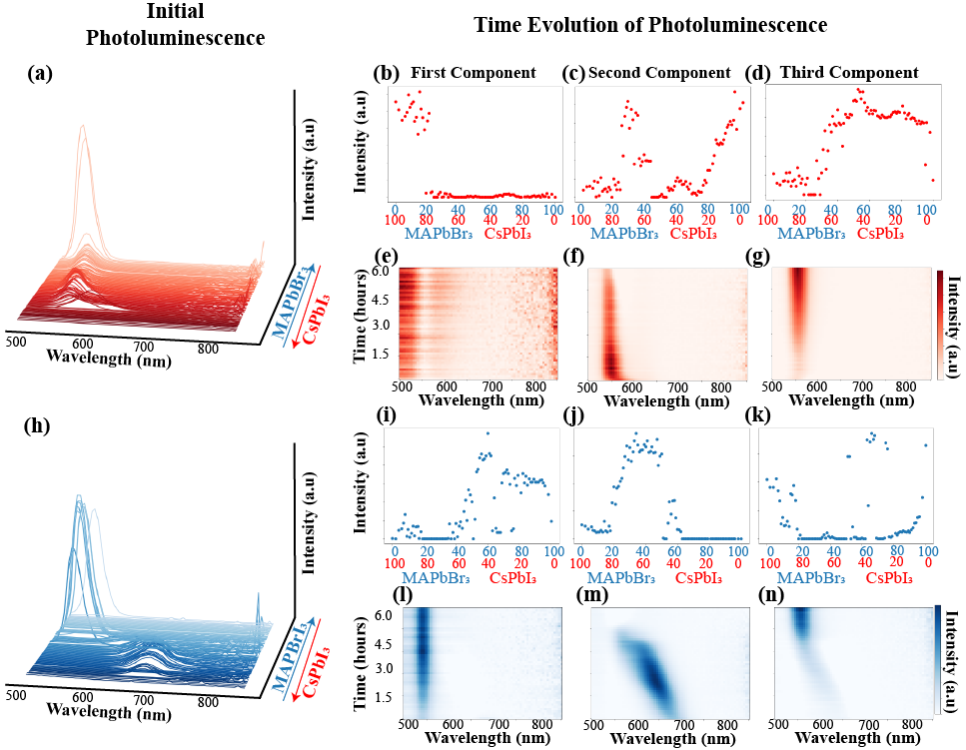
Figure 4-18 Double cation and double halide system, MA_{x}Cs_{1-x}Pb(Br_{x}I_{1-x})₃. a) initial PL behavior when toluene is used as the antisolvent. b), c), and d) are the loading maps for CsPbI₃-rich compositions, solution solutions of CsPbI₃ and MAPbBr₃, and MAPbBr₃-rich compositions, respectively. e), f), and g) Characteristic PL behavior for CsPbI₃-rich compositions, solution solutions of CsPbI₃ and MAPbBr₃, and MAPbBr₃-rich compositions, respectively. h) initial PL behavior when chloroform is used as the antisolvent. Similar to NMF decomposition for the toluene data set i), j) and k) and l), m), and n) are the loading maps and characteristic PL behavior for CsPbI₃-rich compositions, solution solutions of CsPbI₃ and MAPbBr₃, and MAPbBr₃-rich compositions, respectively.

The formation of this perovskite phase is not improved for the FAPbI₃-rich compositions when toluene is used as we observe broad PL peak centered around 650 nm, indicating a mixed phase of δ-FAPbI₃ and α-FAPbI₃, as shown in Figure 4-19d,g). Conversely, we observe the formation of the perovskite phase when chloroform is used; however, we observe dynamical processes, such as halide segregation. For example, for solid solutions of CsPbBr₃-rich and FAPbI₃ compositions, as shown in Figure 4-19i,l), we observe an initial peak centered at approximately 650 nm; however, as exposure to ambient conditions continues, we observe the shift of this peak towards lower wavelengths and an increase in intensity, indicating the separation into bromide- and iodide-rich regions. Eventually, these iodide-rich regions decompose, leaving the bromide-rich regions. Halide segregation continues to be observed even as the amount of FAPbI₃ is increased in the system, as shown in Figure 4-19j,m). Here, a PL peak centered at approximately 680 nm broadens and decreases in intensity over time, indicating degradation of the perovskite. Finally, the α-FAPbI₃ phase appears to be initially stabilized by the addition of CsPbBr₃ into the system, as demonstrated by the PL peak centered around 750 nm shown in Figure 4-19k,n); however, as time progress, this intensity of the peak eventually disappears because of its eventual degradation. Overall, toluene is not an appropriate solvent choice for this system, and while the compositions produced with chloroform are not remarkably stable, they do initially form the correct perovskite phase, so the usage of other post-processing methods could possibly improve the stability.
Finally, we explore the effect toluene and chloroform has on the same compositions utilizing different precursors, FAPbBr₃ and CsPbI₃. As shown in Figure 4-20a), toluene produces high-intensity PL peaks for FAPbBr₃-rich compositions; however, the same intensity PL peaks are not observed for solid solutions and CsPbI₃-rich compositions. Conversely, we observe the formation of distinct PL peak for the majority of the phase diagram, with the exception of CsPbI₃-rich regions, when chloroform is used, as shown in Figure 4-19h).
The time-dependent PL behavior of this system is drastically different depending on the antisolvent utilized. When toluene is used, CsPbI₃-rich regions (x < 0.40) exhibit a noisy PL spectra, as shown in Figure 4-19b,e), indicating the formation of the polymorph δ-CsPbI₃. Conversely, some of these same compositions (0.10 < x < 0.40) form the photoactive phase when chloroform is used, as shown in Figure 4-19i,l).

Figure 4-19 Double cation lead double halide system, FA_{x}Cs_{1-x}Pb(I_{x}Br_{1-x})₃. Initial PL behavior when a) toluene and h) chloroform is used as the antisolvent. When toluene is used as the antisolvent, b), c), and d) are the loading maps for CsPbBr₃-rich compositions, solid solutions of CsPbBr₃ and FAPbI₃, and FAPbI₃-rich compositions, respectively. e), f), and g) Characteristic PL behavior for CsPbBr₃-rich compositions, solid solutions of CsPbBr₃ and FAPbI₃, and FAPbI₃-rich compositions, respectively. When chloroform is used as the antisolvent, i), j) and k) and l), m), and n) are the loading maps and characteristic PL behavior for CsPbBr₃-rich compositions, solid solutions of CsPbBr₃ and FAPbI₃, and FAPbI₃-rich compositions, respectively.

Here, we observe a distinct peak centered at approximately 720 nm; however, at approximately 3 hours, this peak rapidly disappears, indicating degradation. However, the initial formation indicates that other post-processing methods could improve the device stability. Next, when using toluene (Figure 4-19c,f)), as more FAPbBr₃ is incorporated into the system to form solid solutions, we observe a PL peak centered at 600 nm that slowly shifts toward lower wavelengths as it increases in intensity, indicating halide segregation. Eventually, this intensity of this PL peak decreases until it is faint, indicating degradation of these compositions. We observe similar trend when chloroform is used (Figure 4-19j,m)) for the same composition regions with a few differences. Here, the peak is centered higher wavelengths but it relatively broad, spanning 50 nm, indicating two peaks convolved, suggesting two phases. Eventually, the iodide-rich region degrades as the PL peak shifts towards lower wavelengths. Finally, for the FAPbBr₃-rich compositions, an intense PL peak is produced when toluene is utilized; however, this PL peak suddenly disappears after approximately 2 hours, as shown in Figure 4-19d,g). When chloroform is used, these same compositions have a broad peak that shifts toward lower wavelengths as time progresses, but the intensity of the peak remains relatively constant, indicating that the bromide-rich phases of these compositions remains stable, as shown in Figure 4-19k,n). Overall, chloroform is the better choice for the antisolvent as it produces stable compositions for a few hours, and it is possible that this stability could be improved with the additions of other methods for device fabrication.
Generally, chloroform leads to the formation of the perovskite phase regardless of the precursors utilized while this is not the case for toluene. For the system utilizing CsPbBr₃, this lack of efficacy of toluene is caused by the polar index disparity, as mentioned previously, making it not the optimal choice regardless of the other precursor.

Guide for Antisolvent Engineering
Finally, through the qualitative assessment of the NMF decompositions of each binary system, we produce Figure 4-21a) as a guide for which antisolvent produces a more intrinsically stable perovskite. As mentioned previously, this stability is determined by a consistent PL spectrum over time, in which the peak intensity remains relatively constant or increases, the peak position does not drastically shift, or a secondary peak does not appear.

Figure 4-20 Double cation lead double halide system, FA_{x}Cs_{1-x}Pb(Br_{x}I_{1-x})₃. Initial PL behavior when a) toluene and h) chloroform is used as the antisolvent. When toluene is used as the antisolvent, b), c), and d) are the loading maps for CsPbI₃-rich compositions, solid solutions of CsPbI₃ and FAPbBr₃, and FAPbBr₃-rich compositions, respectively. e), f), and g) Characteristic PL behavior for CsPbI₃-rich compositions, solid solutions of CsPbI₃ and FAPbBr₃, and FAPbBr₃-rich compositions, respectively. When chloroform is used as the antisolvent, i), j) and k) and l), m), and n) are the loading maps and characteristic PL behavior for CsPbI₃-rich compositions, solid solutions of CsPbI₃ and FAPbBr₃, and FAPbBr₃-rich compositions, respectively.

Therefore, if the composition is stable with a particular antisolvent, it is represented with a dark color, whereas if those changes are observed, a light color is used to indicate that it is not the ideal antisolvent for stability. For example, toluene is considered a more appropriate antisolvent for the solid solutions of MAPbI₃ and FAPbI₃, as indicated by the dark red color in the guide, because the PL spectrum remains relatively unchanged over time, as shown in Figure 4-21b). Conversely, when chloroform is used, we observe a decrease in intensity and shifts in peak position as time progresses, as shown in Figure 4-21c), indicating a lack of intrinsic stability. Therefore, we utilize a light color for this region in the guide.
We have demonstrated how antisolvent engineering affects the formation and intrinsic stability for multicomponent MHPs as they are exposed to ambient conditions. Noticeably, through this study, we observe the improved stability of the MA_{x}FA_{1-x}PbI₃ system, which was previously thought unstable, when toluene is used. Although our measurements were only on microcrystals, we emphasize that these results can translated for other studies, as we have been able to confirm our results by comparing them to results in the literature. For example, Liu et al. observed a bimodal distribution of bandgap in the Cs_{x}MA_{1-x}PbBr₃ single crystals utilizing PL measurements²⁴². We observe a similar trend PL behavior, as shown in Figure 4-22, further validating our results. Generally, we further illustrate how these workflows are beneficial to efficiently determining the intrinsic stability of a composition, a crucial step in developing a stable and efficient device for applications.
Finally, we postulate that such drastic differences in stability are caused by the relative solubility of the precursor components in each antisolvent²⁴³. The overall effectiveness of an antisolvent is determine by the difference between the precursor and the solvent. For example, if the antisolvent removes the organic halides upon application along with the solvent, residual PbX₂ remains in the precursor solution, leading to further degradation as this PbX₂ interacts with oxygen and moisture. As well, if the antisolvent does not fully extract the solvent, this solvent could possibly form complex perovskite-solvent phases, which are more unstable in ambient conditions. Overall, we highlight how we cannot simply utilize a standard recipe for the processing of different MHPs, emphasizing the importance of antisolvent engineering in intrinsic stability.

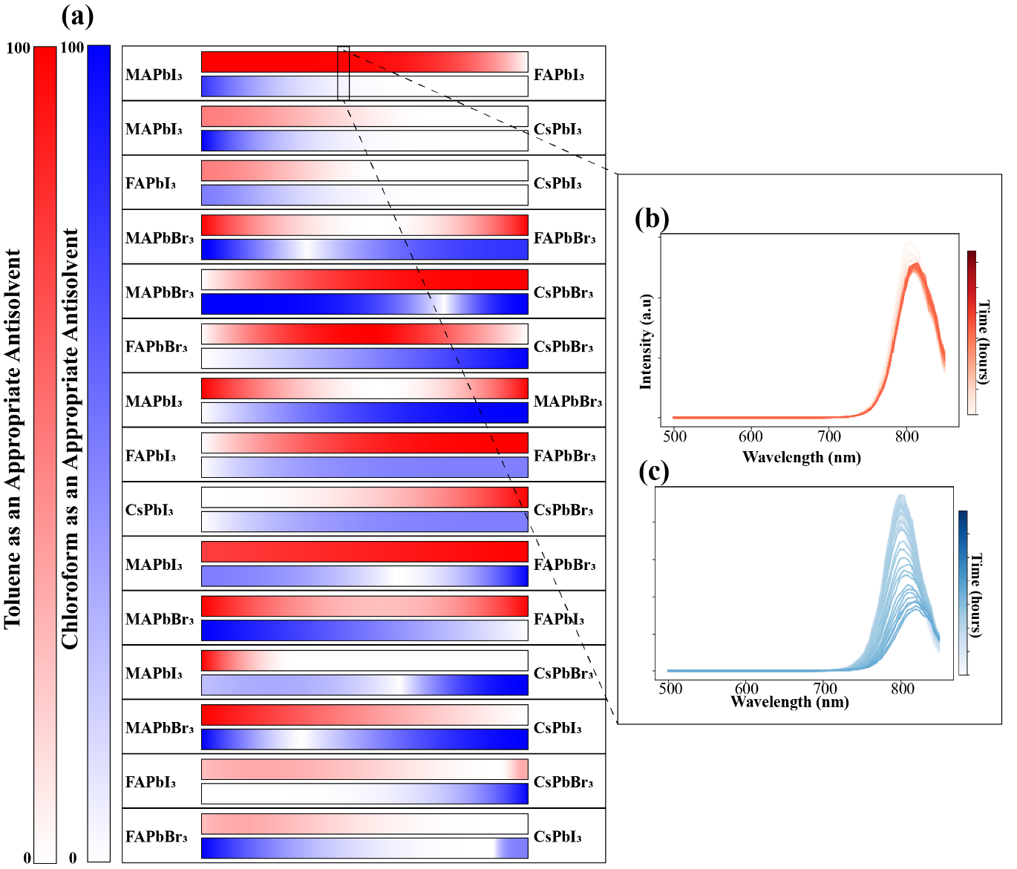
Figure 4-21 Guide for which antisolvent is more applicable for each binary MHP system. a) White or light red/blue indicate the antisolvent is not ideal for that section of the phase diagram as the microcrystals either form different phases or exhibit poor stability. As the color darkens, this indicates the antisolvent is an appropriate choice for the portion of the phase diagram as the correct phase forms and remains stable for longer periods of time. b) Relatively consistent PL spectrum when toluene is used. c) Changing PL spectrum, including a peak shift and decrease in intensity, when chloroform is utilized.

Summary
Through the utilization of the workflow described in Chapter 2, we have demonstrated how it can be used to synthesize and characterize large amounts of compositions using two different antisolvents to explore both the effect of experimental choices and dynamical processes caused by the exposure to ambient conditions. As stated previously, we synthesized and characterized approximately 2880 different microcrystal samples of different binary mixed cation and mixed halide perovskite systems. Altogether the absolute synthesis and characterization times total only 1.5 weeks. We observed drastically different PL spectra evolutions in ambient conditions of the same perovskite compositions, entirely dependent on the antisolvent utilized. We conclude which antisolvent is the better choice for a particular compositional region based on the characteristic PL spectrum, providing guidance for future studies to explore the exact intricacies of the intrinsic material stability of a specific composition.

Figure 4-22 Confirmation that these results can be observed in other forms, such as single crystals. Demonstration of the same bimodal PL spectra shown in the publication studying a Cs_{x}MA_{1-x}PbBr₃ system²⁴². Utilizing photoluminescence (PL) measurements, their PL peaks begin to shift towards higher wavelengths as Cs is incorporated into the single crystal of MAPbBr₃ at low concentrations. Then, they observe the PL peaks blue-shift towards the CsPbBr₃ peak (~535 nm) as the mixing ratio x increases to above 0.13, indicating a bimodal PL spectrum. We observe a similar effect, in which the PL peaks start to blue-shift; however, we observe this occurring at a slightly higher CsPbBr₃ concentration, where x is roughly 0.22 instead of 0.17. We attribute this discrepancy to the possibility that the Cs concentration of the synthesized single crystals in this reference could be different than the ratio of the precursor solution.

Conclusion and Outlook

In this dissertation, the research conducted was focused on the development of a universal workflow to explore vast compositional and design spaces, specifically focusing on the intrinsic stability of MHPs. Here, we have demonstrated how this workflow can be utilized for multiple material forms, such as microcrystals and quantum dots. We have also illustrated how the incorporation of additional machine learning approaches, such as Bayesian inference, can be easily implemented to improve the understanding of each perovskite system. Finally, we verified that this workflow can also be utilized to explore experimental parameters, such as antisolvents, to help accelerate the fabrication of high-efficiency devices.
Through these studies, we have proven how PL measurements can be utilized to gain insight into the stability of perovskites. As shown in Figure 5-1, we provide a simplified flowchart for determining the stability based on PL evolution. If there is the absence of a PL peak initially, this indicates that the perovskite phase did not form upon application of the antisolvent. If a perovskite phase formed, we then measure the PL over time to gain further insight into the perovskite. If there is a stable peak position, intensity, and width throughout the measurement period, the perovskite is deemed in stable under those conditions for the characterization time. If the peak intensity changes but the peak position does not, this indicates degradation of the material under the conditions. If the peak intensity remains relatively constant but the peak position changes, this indicates possible halide segregation if the perovskite is a mixed halide perovskite. If both the position and intensity changes, the perovskite mostly likely underwent halide segregation and eventually degraded under the conditions.
Overall, this research performed here provides a foundation for future studies exploring materials discovery and optimization. As demonstrated by the microcrystals studies in Chapter 2 and Chapter 4, the optoelectronic properties can directly relate the same compositions in device form, providing simple tests to determine which composition or synthesis variable would be optimal without the need for lengthy fabrication times. As well, by manufacturing, engineering, or purchasing specialized equipment for the micropipetting robotic platform, other material forms, such as single crystals and thin films, can be fabricated. These high-throughput studies in combination with advanced machine learning techniques would be able to accelerate the optimization of single crystal growth or fabrication of high-quality thin films for optoelectronic applications.

Figure 5-1 Simplified flowchart for determining the stability or instability of perovskites based on the evolution of the PL spectrum.

References
1. Stranks, S. D.; Snaith, H. J., Metal-halide perovskites for photovoltaic and light-emitting devices. Nat Nanotechnol 2015, 10 (5), 391-402.
2. Zhao, B.; Bai, S.; Kim, V.; Lamboll, R.; Shivanna, R.; Auras, F.; Richter, J. M.; Yang, L.; Dai, L.; Alsari, M.; She, X.-J.; Liang, L.; Zhang, J.; Lilliu, S.; Gao, P.; Snaith, H. J.; Wang, J.; Greenham, N. C.; Friend, R. H.; Di, D., High-efficiency perovskite–polymer bulk heterostructure light-emitting diodes. Nature Photonics 2018, 12 (12), 783-789.
3. Zou, Y.; Yuan, Z.; Bai, S.; Gao, F.; Sun, B., Recent progress toward perovskite light-emitting diodes with enhanced spectral and operational stability. Materials Today Nano 2019, 5.
4. Ahmadi, M.; Wu, T.; Hu, B., A Review on Organic-Inorganic Halide Perovskite Photodetectors: Device Engineering and Fundamental Physics. Adv Mater 2017, 29 (41).
5. Lukosi, E.; Smith, T.; Tisdale, J.; Hamm, D.; Seal, C.; Hu, B.; Ahmadi, M., Methylammonium lead tribromide semiconductors: Ionizing radiation detection and electronic properties. Nuclear Instruments and Methods in Physics Research Section A: Accelerators, Spectrometers, Detectors and Associated Equipment 2019, 927, 401-406.
6. Wang, K.; Yang, D.; Wu, C.; Sanghadasa, M.; Priya, S., Recent progress in fundamental understanding of halide perovskite semiconductors. Progress in Materials Science 2019, 106.
7. Yin, W.-J.; Yang, J.-H.; Kang, J.; Yan, Y.; Wei, S.-H., Halide perovskite materials for solar cells: a theoretical review. Journal of Materials Chemistry A 2015, 3 (17), 8926-8942.
8. Chondroudis K; DB, M., Electroluminescence from an Organic-Inorganic Perovskite Incorporating a Quaterthiophene Dye within Lead Halide Perovskite Layers. Chem Mater 1999, 11, 3028-30.
9. Mitzi DB; Prikas MT; K., C., Thin Film Deposition of Organic−Inorganic Hybrid Materials Using a Single Source Thermal Ablation Technique. Chem mater 1999, 11, 542-4.
10. Kojima A; Teshima K; Shirai Y; T., M., Organometal Halide Perovskites as Visible-Light Sensitizers for Photovoltaic Cells. J Am Chem Soc 2009, 131, 6050-1.
11. Kim, H. S.; Lee, C. R.; Im, J. H.; Lee, K. B.; Moehl, T.; Marchioro, A.; Moon, S. J.; Humphry-Baker, R.; Yum, J. H.; Moser, J. E.; Gratzel, M.; Park, N. G., Lead iodide perovskite sensitized all-solid-state submicron thin film mesoscopic solar cell with efficiency exceeding 9%. Sci Rep 2012, 2, 591.
12. Fan, Z.; Sun, K.; Wang, J., Perovskites for photovoltaics: a combined review of organic–inorganic halide perovskites and ferroelectric oxide perovskites. Journal of Materials Chemistry A 2015, 3 (37), 18809-18828.
13. Goldschmidt, V. M., Krystallbau und chemische Zusammensetzung. Ber. Dtsch. Chem. Ges. 1927, 60, 1263-1268.
14. Li, C.; Lu, X.; Ding, W.; Feng, L.; Gao, Y.; Guo, Z., Formability of ABX3 (X = F, Cl, Br, I) halide perovskites. Acta Crystallogr B 2008, 64 (Pt 6), 702-7.
15. Kim, E.-B.; Akhtar, M. S.; Shin, H.-S.; Ameen, S.; Nazeeruddin, M. K., A review on two-dimensional (2D) and 2D-3D multidimensional perovskite solar cells: Perovskites structures, stability, and photovoltaic performances. Journal of Photochemistry and Photobiology C: Photochemistry Reviews 2021, 48.
16. Dang, Y.; Liu, Y.; Sun, Y.; Yuan, D.; Liu, X.; Lu, W.; Liu, G.; Xia, H.; Tao, X., Bulk crystal growth of hybrid perovskite material CH3NH3PbI3. CrystEngComm 2015, 17 (3), 665-670.
17. Ong, K. P.; Goh, T. W.; Xu, Q.; Huan, A., Structural Evolution in Methylammonium Lead Iodide CH3NH3PbI3. J Phys Chem A 2015, 119 (44), 11033-8.
18. Baikie, T.; Fang, Y.; Kadro, J. M.; Schreyer, M.; Wei, F.; Mhaisalkar, S. G.; Graetzel, M.; White, T. J., Synthesis and crystal chemistry of the hybrid perovskite (CH3NH3)PbI3 for solid-state sensitised solar cell applications. Journal of Materials Chemistry A 2013, 1 (18).
19. Ball, J. M.; Lee, M. M.; Hey, A.; Snaith, H. J., Low-temperature processed meso-superstructured to thin-film perovskite solar cells. Energy & Environmental Science 2013, 6 (6).
20. Quarti, C.; Mosconi, E.; Ball, J. M.; D'Innocenzo, V.; Tao, C.; Pathak, S.; Snaith, H. J.; Petrozza, A.; De Angelis, F., Structural and optical properties of methylammonium lead iodide across the tetragonal to cubic phase transition: implications for perovskite solar cells. Energy & Environmental Science 2016, 9 (1), 155-163.
21. Stoumpos, C. C.; Malliakas, C. D.; Kanatzidis, M. G., Semiconducting tin and lead iodide perovskites with organic cations: phase transitions, high mobilities, and near-infrared photoluminescent properties. Inorg Chem 2013, 52 (15), 9019-38.
22. Lee, J.-W.; Kim, D.-H.; Kim, H.-S.; Seo, S.-W.; Cho, S. M.; Park, N.-G., Formamidinium and Cesium Hybridization for Photo- and Moisture-Stable Perovskite Solar Cell. Advanced Energy Materials 2015, 5 (20).
23. Yi, C.; Luo, J.; Meloni, S.; Boziki, A.; Ashari-Astani, N.; Grätzel, C.; Zakeeruddin, S. M.; Röthlisberger, U.; Grätzel, M., Entropic stabilization of mixed A-cation ABX3 metal halide perovskites for high performance perovskite solar cells. Energy & Environmental Science 2016, 9 (2), 656-662.
24. Li, Z.; Yang, M.; Park, J.-S.; Wei, S.-H.; Berry, J. J.; Zhu, K., Stabilizing Perovskite Structures by Tuning Tolerance Factor: Formation of Formamidinium and Cesium Lead Iodide Solid-State Alloys. Chemistry of Materials 2015, 28 (1), 284-292.
25. Noh, J. H.; Im, S. H.; Heo, J. H.; Mandal, T. N.; Seok, S. I., Chemical management for colorful, efficient, and stable inorganic-organic hybrid nanostructured solar cells. Nano Lett 2013, 13 (4), 1764-9.
26. Albero, J.; Asiri, A. M.; García, H., Influence of the composition of hybrid perovskites on their performance in solar cells. Journal of Materials Chemistry A 2016, 4 (12), 4353-4364.
27. Protesescu, L.; Yakunin, S.; Bodnarchuk, M. I.; Krieg, F.; Caputo, R.; Hendon, C. H.; Yang, R. X.; Walsh, A.; Kovalenko, M. V., Nanocrystals of Cesium Lead Halide Perovskites (CsPbX(3), X = Cl, Br, and I): Novel Optoelectronic Materials Showing Bright Emission with Wide Color Gamut. Nano Lett 2015, 15 (6), 3692-6.
28. Chouhan, L.; Ghimire, S.; Subrahmanyam, C.; Miyasaka, T.; Biju, V., Synthesis, optoelectronic properties and applications of halide perovskites. Chem Soc Rev 2020, 49 (10), 2869-2885.
29. Dong, Y.; Qiao, T.; Kim, D.; Parobek, D.; Rossi, D.; Son, D. H., Precise Control of Quantum Confinement in Cesium Lead Halide Perovskite Quantum Dots via Thermodynamic Equilibrium. Nano Lett 2018, 18 (6), 3716-3722.
30. Wang, L.; Wang, K.; Zou, B., Pressure-Induced Structural and Optical Properties of Organometal Halide Perovskite-Based Formamidinium Lead Bromide. J Phys Chem Lett 2016, 7 (13), 2556-62.
31. Malgras, V.; Tominaka, S.; Ryan, J. W.; Henzie, J.; Takei, T.; Ohara, K.; Yamauchi, Y., Observation of Quantum Confinement in Monodisperse Methylammonium Lead Halide Perovskite Nanocrystals Embedded in Mesoporous Silica. J Am Chem Soc 2016, 138 (42), 13874-13881.
32. Zhang, D.; Yu, Y.; Bekenstein, Y.; Wong, A. B.; Alivisatos, A. P.; Yang, P., Ultrathin Colloidal Cesium Lead Halide Perovskite Nanowires. J Am Chem Soc 2016, 138 (40), 13155-13158.
33. Milot, R. L.; Eperon, G. E.; Snaith, H. J.; Johnston, M. B.; Herz, L. M., Temperature‐Dependent Charge‐Carrier Dynamics in CH
3
NH
3
PbI
3
Perovskite Thin Films. Advanced Functional Materials 2015, 25 (39), 6218-6227.
34. Liu, Y.; Yang, Z.; Liu, S. F., Recent Progress in Single-Crystalline Perovskite Research Including Crystal Preparation, Property Evaluation, and Applications. Adv Sci (Weinh) 2018, 5 (1), 1700471.
35. Maggiora, J.; Li, F.; Zheng, R., Charge Transport Properties of Methylammonium Lead Trihalide Hybrid Perovskite Bulk Single Crystals. physica status solidi (RRL) – Rapid Research Letters 2020, 15 (1).
36. Huang, J.; Yuan, Y.; Shao, Y.; Yan, Y., Understanding the physical properties of hybrid perovskites for photovoltaic applications. Nature Reviews Materials 2017, 2 (7).
37. Herz, L. M., Charge-Carrier Mobilities in Metal Halide Perovskites: Fundamental Mechanisms and Limits. ACS Energy Letters 2017, 2 (7), 1539-1548.
38. Cho, N.; Li, F.; Turedi, B.; Sinatra, L.; Sarmah, S. P.; Parida, M. R.; Saidaminov, M. I.; Murali, B.; Burlakov, V. M.; Goriely, A.; Mohammed, O. F.; Wu, T.; Bakr, O. M., Pure crystal orientation and anisotropic charge transport in large-area hybrid perovskite films. Nat Commun 2016, 7, 13407.
39. Peng, J.; Chen, Y.; Zheng, K.; Pullerits, T.; Liang, Z., Insights into charge carrier dynamics in organo-metal halide perovskites: from neat films to solar cells. Chem Soc Rev 2017, 46 (19), 5714-5729.
40. McLeod, J. A.; Liu, L., Prospects for Mitigating Intrinsic Organic Decomposition in Methylammonium Lead Triiodide Perovskite. J Phys Chem Lett 2018, 9 (9), 2411-2417.
41. Buin, A.; Pietsch, P.; Xu, J.; Voznyy, O.; Ip, A. H.; Comin, R.; Sargent, E. H., Materials processing routes to trap-free halide perovskites. Nano Lett 2014, 14 (11), 6281-6.
42. Jung, M.-C.; Lee, Y. M.; Lee, H.-K.; Park, J.; Raga, S. R.; Ono, L. K.; Wang, S.; Leyden, M. R.; Yu, B. D.; Hong, S.; Qi, Y., The presence of CH3NH2 neutral species in organometal halide perovskite films. Applied Physics Letters 2016, 108 (7).
43. Juarez-Perez, E. J.; Hawash, Z.; Raga, S. R.; Ono, L. K.; Qi, Y., Thermal degradation of CH3NH3PbI3 perovskite into NH3 and CH3I gases observed by coupled thermogravimetry–mass spectrometry analysis. Energy & Environmental Science 2016, 9 (11), 3406-3410.
44. Leijtens, T.; Bush, K.; Cheacharoen, R.; Beal, R.; Bowring, A.; McGehee, M. D., Towards enabling stable lead halide perovskite solar cells; interplay between structural, environmental, and thermal stability. Journal of Materials Chemistry A 2017, 5 (23), 11483-11500.
45. Conings, B.; Drijkoningen, J.; Gauquelin, N.; Babayigit, A.; D'Haen, J.; D'Olieslaeger, L.; Ethirajan, A.; Verbeeck, J.; Manca, J.; Mosconi, E.; Angelis, F. D.; Boyen, H.-G., Intrinsic Thermal Instability of Methylammonium Lead Trihalide Perovskite. Advanced Energy Materials 2015, 5 (15).
46. Aristidou, N.; Sanchez-Molina, I.; Chotchuangchutchaval, T.; Brown, M.; Martinez, L.; Rath, T.; Haque, S. A., The Role of Oxygen in the Degradation of Methylammonium Lead Trihalide Perovskite Photoactive Layers. Angew Chem Int Ed Engl 2015, 54 (28), 8208-12.
47. Tian, Y.; Peter, M.; Unger, E.; Abdellah, M.; Zheng, K.; Pullerits, T.; Yartsev, A.; Sundstrom, V.; Scheblykin, I. G., Mechanistic insights into perovskite photoluminescence enhancement: light curing with oxygen can boost yield thousandfold. Phys Chem Chem Phys 2015, 17 (38), 24978-87.
48. Galisteo-Lopez, J. F.; Anaya, M.; Calvo, M. E.; Miguez, H., Environmental Effects on the Photophysics of Organic-Inorganic Halide Perovskites. J Phys Chem Lett 2015, 6 (12), 2200-5.
49. Brenes, R.; Guo, D.; Osherov, A.; Noel, N. K.; Eames, C.; Hutter, E. M.; Pathak, S. K.; Niroui, F.; Friend, R. H.; Islam, M. S.; Snaith, H. J.; Bulović, V.; Savenije, T. J.; Stranks, S. D., Metal Halide Perovskite Polycrystalline Films Exhibiting Properties of Single Crystals. Joule 2017, 1 (1), 155-167.
50. Aristidou, N.; Eames, C.; Sanchez-Molina, I.; Bu, X.; Kosco, J.; Islam, M. S.; Haque, S. A., Fast oxygen diffusion and iodide defects mediate oxygen-induced degradation of perovskite solar cells. Nat Commun 2017, 8, 15218.
51. Pont, S.; Bryant, D.; Lin, C.-T.; Aristidou, N.; Wheeler, S.; Ma, X.; Godin, R.; Haque, S. A.; Durrant, J. R., Tuning CH3NH3Pb(I1−xBrx)3 perovskite oxygen stability in thin films and solar cells. Journal of Materials Chemistry A 2017, 5 (20), 9553-9560.
52. Bryant, D.; Aristidou, N.; Pont, S.; Sanchez-Molina, I.; Chotchunangatchaval, T.; Wheeler, S.; Durrant, J. R.; Haque, S. A., Light and oxygen induced degradation limits the operational stability of methylammonium lead triiodide perovskite solar cells. Energy & Environmental Science 2016, 9 (5), 1655-1660.
53. Senocrate, A.; Acartürk, T.; Kim, G. Y.; Merkle, R.; Starke, U.; Grätzel, M.; Maier, J., Interaction of oxygen with halide perovskites. Journal of Materials Chemistry A 2018, 6 (23), 10847-10855.
54. Frost, J. M.; Butler, K. T.; Brivio, F.; Hendon, C. H.; van Schilfgaarde, M.; Walsh, A., Atomistic origins of high-performance in hybrid halide perovskite solar cells. Nano Lett 2014, 14 (5), 2584-90.
55. Li, Y.; Xu, X.; Wang, C.; Wang, C.; Xie, F.; Yang, J.; Gao, Y., Degradation by Exposure of Coevaporated CH3NH3PbI3 Thin Films. The Journal of Physical Chemistry C 2015, 119 (42), 23996-24002.
56. Zhao, J.; Cai, B.; Luo, Z.; Dong, Y.; Zhang, Y.; Xu, H.; Hong, B.; Yang, Y.; Li, L.; Zhang, W.; Gao, C., Investigation of the Hydrolysis of Perovskite Organometallic Halide CH3NH3PbI3 in Humidity Environment. Sci Rep 2016, 6, 21976.
57. Toloueinia, P.; Khassaf, H.; Shirazi Amin, A.; Tobin, Z. M.; Alpay, S. P.; Suib, S. L., Moisture-Induced Structural Degradation in Methylammonium Lead Iodide Perovskite Thin Films. ACS Applied Energy Materials 2020, 3 (9), 8240-8248.
58. Han, Y.; Meyer, S.; Dkhissi, Y.; Weber, K.; Pringle, J. M.; Bach, U.; Spiccia, L.; Cheng, Y.-B., Degradation observations of encapsulated planar CH3NH3PbI3 perovskite solar cells at high temperatures and humidity. Journal of Materials Chemistry A 2015, 3 (15), 8139-8147.
59. Tang, X.; Brandl, M.; May, B.; Levchuk, I.; Hou, Y.; Richter, M.; Chen, H.; Chen, S.; Kahmann, S.; Osvet, A.; Maier, F.; Steinrück, H.-P.; Hock, R.; Matt, G. J.; Brabec, C. J., Photoinduced degradation of methylammonium lead triiodide perovskite semiconductors. Journal of Materials Chemistry A 2016, 4 (41), 15896-15903.
60. Deretzis, I.; Alberti, A.; Pellegrino, G.; Smecca, E.; Giannazzo, F.; Sakai, N.; Miyasaka, T.; La Magna, A., Atomistic origins of CH3NH3PbI3 degradation to PbI2 in vacuum. Applied Physics Letters 2015, 106 (13).
61. Azpiroz, J. M.; Mosconi, E.; Bisquert, J.; De Angelis, F., Defect migration in methylammonium lead iodide and its role in perovskite solar cell operation. Energy & Environmental Science 2015, 8 (7), 2118-2127.
62. Xiao, Z.; Yuan, Y.; Shao, Y.; Wang, Q.; Dong, Q.; Bi, C.; Sharma, P.; Gruverman, A.; Huang, J., Giant switchable photovoltaic effect in organometal trihalide perovskite devices. Nat Mater 2015, 14 (2), 193-8.
63. Eames, C.; Frost, J. M.; Barnes, P. R.; O'Regan, B. C.; Walsh, A.; Islam, M. S., Ionic transport in hybrid lead iodide perovskite solar cells. Nat Commun 2015, 6, 7497.
64. Unger, E. L.; Hoke, E. T.; Bailie, C. D.; Nguyen, W. H.; Bowring, A. R.; Heumüller, T.; Christoforo, M. G.; McGehee, M. D., Hysteresis and transient behavior in current–voltage measurements of hybrid-perovskite absorber solar cells. Energy Environ. Sci. 2014, 7 (11), 3690-3698.
65. Haruyama, J.; Sodeyama, K.; Han, L.; Tateyama, Y., First-Principles Study of Ion Diffusion in Perovskite Solar Cell Sensitizers. J Am Chem Soc 2015, 137 (32), 10048-51.
66. Deng, Y.; Xiao, Z.; Huang, J., Light-Induced Self-Poling Effect on Organometal Trihalide Perovskite Solar Cells for Increased Device Efficiency and Stability. Advanced Energy Materials 2015, 5 (20).
67. Li, X.; Wang, X.; Zhang, W.; Wu, Y.; Gao, F.; Fang, J., The effect of external electric field on the performance of perovskite solar cells. Organic Electronics 2015, 18, 107-112.
68. Leijtens, T.; Hoke, E. T.; Grancini, G.; Slotcavage, D. J.; Eperon, G. E.; Ball, J. M.; De Bastiani, M.; Bowring, A. R.; Martino, N.; Wojciechowski, K.; McGehee, M. D.; Snaith, H. J.; Petrozza, A., Mapping Electric Field-Induced Switchable Poling and Structural Degradation in Hybrid Lead Halide Perovskite Thin Films. Advanced Energy Materials 2015, 5 (20).
69. Yuan, Y.; Chae, J.; Shao, Y.; Wang, Q.; Xiao, Z.; Centrone, A.; Huang, J., Photovoltaic Switching Mechanism in Lateral Structure Hybrid Perovskite Solar Cells. Advanced Energy Materials 2015, 5 (15).
70. Deng, X.; Wen, X.; Lau, C. F. J.; Young, T.; Yun, J.; Green, M. A.; Huang, S.; Ho-Baillie, A. W. Y., Electric field induced reversible and irreversible photoluminescence responses in methylammonium lead iodide perovskite. Journal of Materials Chemistry C 2016, 4 (38), 9060-9068.
71. Yuan, Y.; Wang, Q.; Shao, Y.; Lu, H.; Li, T.; Gruverman, A.; Huang, J., Electric-Field-Driven Reversible Conversion Between Methylammonium Lead Triiodide Perovskites and Lead Iodide at Elevated Temperatures. Advanced Energy Materials 2016, 6 (2).
72. Eperon, G. E.; Stranks, S. D.; Menelaou, C.; Johnston, M. B.; Herz, L. M.; Snaith, H. J., Formamidinium lead trihalide: a broadly tunable perovskite for efficient planar heterojunction solar cells. Energy & Environmental Science 2014, 7 (3).
73. Koh, T. M.; Fu, K.; Fang, Y.; Chen, S.; Sum, T. C.; Mathews, N.; Mhaisalkar, S. G.; Boix, P. P.; Baikie, T., Formamidinium-Containing Metal-Halide: An Alternative Material for Near-IR Absorption Perovskite Solar Cells. The Journal of Physical Chemistry C 2013, 118 (30), 16458-16462.
74. Pellet, N.; Gao, P.; Gregori, G.; Yang, T. Y.; Nazeeruddin, M. K.; Maier, J.; Gratzel, M., Mixed-organic-cation perovskite photovoltaics for enhanced solar-light harvesting. Angew Chem Int Ed Engl 2014, 53 (12), 3151-7.
75. Yang, W. S.; Noh, J. H.; Jeon, N. J.; Kim, Y. C.; Ryu, S.; Seo, J.; Seok, S. I., High-performance photovoltaicperovskite layers fabricated throughintramolecular exchange. Science 2015, 348, 1234-7.
76. Choi, H.; Jeong, J.; Kim, H.-B.; Kim, S.; Walker, B.; Kim, G.-H.; Kim, J. Y., Cesium-doped methylammonium lead iodide perovskite light absorber for hybrid solar cells. Nano Energy 2014, 7, 80-85.
77. Volonakis, G.; Haghighirad, A. A.; Snaith, H. J.; Giustino, F., Route to Stable Lead-Free Double Perovskites with the Electronic Structure of CH3NH3PbI3: A Case for Mixed-Cation [Cs/CH3NH3/CH(NH2)2]2InBiBr6. J Phys Chem Lett 2017, 8 (16), 3917-3924.
78. Albadri, A.; Yadav, P.; Alotaibi, M.; Arora, N.; Alyamani, A.; Albrithen, H.; Dar, M. I.; Zakeeruddin, S. M.; Grätzel, M., Unraveling the Impact of Rubidium Incorporation on the Transport-Recombination Mechanisms in Highly Efficient Perovskite Solar Cells by Small-Perturbation Techniques. The Journal of Physical Chemistry C 2017, 121 (45), 24903-24908.
79. Mitzi, D. B., Templating and structural engineering in organic–inorganic perovskites. Journal of the Chemical Society, Dalton Transactions 2001, (1), 1-12.
80. Ema, K.; Inomata, M.; Kato, Y.; Kunugita, H.; Era, M., Nearly perfect triplet-triplet energy transfer from Wannier excitons to naphthalene in organic-inorganic hybrid quantum-well materials. Phys Rev Lett 2008, 100 (25), 257401.
81. Takeoka, Y.; Asai, K.; Rikukawa, M.; Sanui, K., Systematic Studies on Chain Lengths, Halide Species, and Well Thicknesses for Lead Halide Layered Perovskite Thin Films. Bulletin of the Chemical Society of Japan 2006, 79 (10), 1607-1613.
82. Tsai, H.; Nie, W.; Blancon, J. C.; Stoumpos, C. C.; Asadpour, R.; Harutyunyan, B.; Neukirch, A. J.; Verduzco, R.; Crochet, J. J.; Tretiak, S.; Pedesseau, L.; Even, J.; Alam, M. A.; Gupta, G.; Lou, J.; Ajayan, P. M.; Bedzyk, M. J.; Kanatzidis, M. G., High-efficiency two-dimensional Ruddlesden-Popper perovskite solar cells. Nature 2016, 536 (7616), 312-6.
83. Jacobsson, T. J.; Pazoki, M.; Hagfeldt, A.; Edvinsson, T., Goldschmidt’s Rules and Strontium Replacement in Lead Halogen Perovskite Solar Cells: Theory and Preliminary Experiments on CH3NH3SrI3. The Journal of Physical Chemistry C 2015, 119 (46), 25673-25683.
84. Navas, J.; Sanchez-Coronilla, A.; Gallardo, J. J.; Hernandez, N. C.; Pinero, J. C.; Alcantara, R.; Fernandez-Lorenzo, C.; De los Santos, D. M.; Aguilar, T.; Martin-Calleja, J., New insights into organic-inorganic hybrid perovskite CH(3)NH(3)PbI(3) nanoparticles. An experimental and theoretical study of doping in Pb(2)(+) sites with Sn(2)(+), Sr(2)(+), Cd(2)(+) and Ca(2)(+). Nanoscale 2015, 7 (14), 6216-29.
85. Feng, J., Mechanical properties of hybrid organic-inorganic CH3NH3BX3 (B = Sn, Pb; X = Br, I) perovskites for solar cell absorbers. APL Materials 2014, 2 (8).
86. Liu, C.; Li, W.; Fan, J.; Mai, Y., A brief review on the lead element substitution in perovskite solar cells. Journal of Energy Chemistry 2018, 27 (4), 1054-1066.
87. Fang, Y.; Dong, Q.; Shao, Y.; Yuan, Y.; Huang, J., Highly narrowband perovskite single-crystal photodetectors enabled by surface-charge recombination. Nature Photonics 2015, 9 (10), 679-686.
88. Aziz, A.; Aristidou, N.; Bu, X.; Westbrook, R. J. E.; Haque, S. A.; Islam, M. S., Understanding the Enhanced Stability of Bromide Substitution in Lead Iodide Perovskites. Chemistry of Materials 2019, 32 (1), 400-409.
89. McGovern, L.; Futscher, M. H.; Muscarella, L. A.; Ehrler, B., Understanding the Stability of MAPbBr3 versus MAPbI3: Suppression of Methylammonium Migration and Reduction of Halide Migration. J Phys Chem Lett 2020, 11 (17), 7127-7132.
90. Brunetti, B.; Cavallo, C.; Ciccioli, A.; Gigli, G.; Latini, A., On the Thermal and Thermodynamic (In)Stability of Methylammonium Lead Halide Perovskites. Sci Rep 2016, 6, 31896.
91. Lin, C.; Li, S.; Zhang, W.; Shao, C.; Yang, Z., Effect of Bromine Substitution on the Ion Migration and Optical Absorption in MAPbI3 Perovskite Solar Cells: The First-Principles Study. ACS Applied Energy Materials 2018, 1 (3), 1374-1380.
92. Song, Z.; Shrestha, N.; Watthage, S. C.; Liyanage, G. K.; Almutawah, Z. S.; Ahangharnejhad, R. H.; Phillips, A. B.; Ellingson, R. J.; Heben, M. J., Impact of Moisture on Photoexcited Charge Carrier Dynamics in Methylammonium Lead Halide Perovskites. J Phys Chem Lett 2018, 9 (21), 6312-6320.
93. Long, R.; Fang, W.; Prezhdo, O. V., Moderate Humidity Delays Electron-Hole Recombination in Hybrid Organic-Inorganic Perovskites: Time-Domain Ab Initio Simulations Rationalize Experiments. J Phys Chem Lett 2016, 7 (16), 3215-22.
94. Suarez, B.; Gonzalez-Pedro, V.; Ripolles, T. S.; Sanchez, R. S.; Otero, L.; Mora-Sero, I., Recombination Study of Combined Halides (Cl, Br, I) Perovskite Solar Cells. J Phys Chem Lett 2014, 5 (10), 1628-35.
95. Liang, P.-W.; Chueh, C.-C.; Xin, X.-K.; Zuo, F.; Williams, S. T.; Liao, C.-Y.; Jen, A. K. Y., High-Performance Planar-Heterojunction Solar Cells Based on Ternary Halide Large-Band-Gap Perovskites. Advanced Energy Materials 2015, 5 (1).
96. Zhao, Y.; Zhu, K., Efficient planar perovskite solar cells based on 1.8 eV band gap CH3NH3PbI2Br nanosheets via thermal decomposition. J Am Chem Soc 2014, 136 (35), 12241-4.
97. Knight, A. J.; Borchert, J.; Oliver, R. D. J.; Patel, J. B.; Radaelli, P. G.; Snaith, H. J.; Johnston, M. B.; Herz, L. M., Halide Segregation in Mixed-Halide Perovskites: Influence of A-Site Cations. ACS Energy Lett 2021, 6 (2), 799-808.
98. Babbe, F.; Sutter‐Fella, C. M., Optical Absorption‐Based In Situ Characterization of Halide Perovskites. Advanced Energy Materials 2020, 10 (26).
99. Dunlap-Shohl, W. A.; Zhou, Y.; Padture, N. P.; Mitzi, D. B., Synthetic Approaches for Halide Perovskite Thin Films. Chem Rev 2019, 119 (5), 3193-3295.
100. Walsh, A.; Stranks, S. D., Taking Control of Ion Transport in Halide Perovskite Solar Cells. ACS Energy Letters 2018, 3 (8), 1983-1990.
101. Hu, Q.; Zhao, L.; Wu, J.; Gao, K.; Luo, D.; Jiang, Y.; Zhang, Z.; Zhu, C.; Schaible, E.; Hexemer, A.; Wang, C.; Liu, Y.; Zhang, W.; Gratzel, M.; Liu, F.; Russell, T. P.; Zhu, R.; Gong, Q., In situ dynamic observations of perovskite crystallisation and microstructure evolution intermediated from [PbI6](4-) cage nanoparticles. Nat Commun 2017, 8, 15688.
102. Miyadera, T.; Shibata, Y.; Koganezawa, T.; Murakami, T. N.; Sugita, T.; Tanigaki, N.; Chikamatsu, M., Crystallization Dynamics of Organolead Halide Perovskite by Real-Time X-ray Diffraction. Nano Lett 2015, 15 (8), 5630-4.
103. Moore, D. T.; Sai, H.; Tan, K. W.; Smilgies, D. M.; Zhang, W.; Snaith, H. J.; Wiesner, U.; Estroff, L. A., Crystallization kinetics of organic-inorganic trihalide perovskites and the role of the lead anion in crystal growth. J Am Chem Soc 2015, 137 (6), 2350-8.
104. Zhang, W.; Saliba, M.; Moore, D. T.; Pathak, S. K.; Horantner, M. T.; Stergiopoulos, T.; Stranks, S. D.; Eperon, G. E.; Alexander-Webber, J. A.; Abate, A.; Sadhanala, A.; Yao, S.; Chen, Y.; Friend, R. H.; Estroff, L. A.; Wiesner, U.; Snaith, H. J., Ultrasmooth organic-inorganic perovskite thin-film formation and crystallization for efficient planar heterojunction solar cells. Nat Commun 2015, 6, 6142.
105. Munir, R.; Sheikh, A. D.; Abdelsamie, M.; Hu, H.; Yu, L.; Zhao, K.; Kim, T.; Tall, O. E.; Li, R.; Smilgies, D. M.; Amassian, A., Hybrid Perovskite Thin-Film Photovoltaics: In Situ Diagnostics and Importance of the Precursor Solvate Phases. Adv Mater 2017, 29 (2).
106. Gfroerer, T. H., Photoluminescence in Analysis of Surfaces and Interfaces. In Encyclopedia of Analytical Chemistry, 2006.
107. Yu, P. Y.; Cardona, M., <2010_Book_FundamentalsOfSemiconductors.pdf>. 2010.
108. Sutter-Fella, C. M.; Ngo, Q. P.; Cefarin, N.; Gardner, K. L.; Tamura, N.; Stan, C. V.; Drisdell, W. S.; Javey, A.; Toma, F. M.; Sharp, I. D., Cation-Dependent Light-Induced Halide Demixing in Hybrid Organic-Inorganic Perovskites. Nano Lett 2018, 18 (6), 3473-3480.
109. Nenon, D. P.; Christians, J. A.; Wheeler, L. M.; Blackburn, J. L.; Sanehira, E. M.; Dou, B.; Olsen, M. L.; Zhu, K.; Berry, J. J.; Luther, J. M., Structural and chemical evolution of methylammonium lead halide perovskites during thermal processing from solution. Energy & Environmental Science 2016, 9 (6), 2072-2082.
110. Park, S. J.; Kim, A. R.; Hong, J. T.; Park, J. Y.; Lee, S.; Ahn, Y. H., Crystallization Kinetics of Lead Halide Perovskite Film Monitored by In Situ Terahertz Spectroscopy. J Phys Chem Lett 2017, 8 (2), 401-406.
111. Xiao, Z.; Dong, Q.; Bi, C.; Shao, Y.; Yuan, Y.; Huang, J., Solvent annealing of perovskite-induced crystal growth for photovoltaic-device efficiency enhancement. Adv Mater 2014, 26 (37), 6503-9.
112. van Franeker, J. J.; Hendriks, K. H.; Bruijnaers, B. J.; Verhoeven, M. W. G. M.; Wienk, M. M.; Janssen, R. A. J., Monitoring Thermal Annealing of Perovskite Solar Cells with In Situ Photoluminescence. Advanced Energy Materials 2017, 7 (7).
113. Xie, Y.-M.; Yu, B.; Ma, C.; Xu, X.; Cheng, Y.; Yuan, S.; Wang, Z.-K.; Chandran, H. T.; Lee, C.-S.; Liao, L.-S.; Tsang, S.-W., Direct observation of cation-exchange in liquid-to-solid phase transformation in FA1−xMAxPbI3 based perovskite solar cells. Journal of Materials Chemistry A 2018, 6 (19), 9081-9088.
114. Pellet, N.; Teuscher, J.; Maier, J.; Grätzel, M., Transforming Hybrid Organic Inorganic Perovskites by Rapid Halide Exchange. Chemistry of Materials 2015, 27 (6), 2181-2188.
115. Do, M.; Kim, I.; Kolaczkowski, M. A.; Kang, J.; Kamat, G. A.; Yuan, Z.; Barchi, N. S.; Wang, L. W.; Liu, Y.; Jurow, M. J.; Sutter-Fella, C. M., Low-dimensional perovskite nanoplatelet synthesis using in situ photophysical monitoring to establish controlled growth. Nanoscale 2019, 11 (37), 17262-17269.
116. Akkerman, Q. A.; Motti, S. G.; Srimath Kandada, A. R.; Mosconi, E.; D'Innocenzo, V.; Bertoni, G.; Marras, S.; Kamino, B. A.; Miranda, L.; De Angelis, F.; Petrozza, A.; Prato, M.; Manna, L., Solution Synthesis Approach to Colloidal Cesium Lead Halide Perovskite Nanoplatelets with Monolayer-Level Thickness Control. J Am Chem Soc 2016, 138 (3), 1010-6.
117. Hoke, E. T.; Slotcavage, D. J.; Dohner, E. R.; Bowring, A. R.; Karunadasa, H. I.; McGehee, M. D., Reversible photo-induced trap formation in mixed-halide hybrid perovskites for photovoltaics. Chem Sci 2015, 6 (1), 613-617.
118. Zhou, Y.; Jia, Y.-H.; Fang, H.-H.; Loi, M. A.; Xie, F.-Y.; Gong, L.; Qin, M.-C.; Lu, X.-H.; Wong, C.-P.; Zhao, N., Composition-Tuned Wide Bandgap Perovskites: From Grain Engineering to Stability and Performance Improvement. Advanced Functional Materials 2018, 28 (35).
119. Brenes, R.; Eames, C.; Bulovic, V.; Islam, M. S.; Stranks, S. D., The Impact of Atmosphere on the Local Luminescence Properties of Metal Halide Perovskite Grains. Adv Mater 2018, 30 (15), e1706208.
120. Howard, J. M.; Tennyson, E. M.; Barik, S.; Szostak, R.; Waks, E.; Toney, M. F.; Nogueira, A. F.; Neves, B. R. A.; Leite, M. S., Humidity-Induced Photoluminescence Hysteresis in Variable Cs/Br Ratio Hybrid Perovskites. J Phys Chem Lett 2018, 9 (12), 3463-3469.
121. Knight, A. J.; Wright, A. D.; Patel, J. B.; McMeekin, D. P.; Snaith, H. J.; Johnston, M. B.; Herz, L. M., Electronic Traps and Phase Segregation in Lead Mixed-Halide Perovskite. ACS Energy Letters 2018, 4 (1), 75-84.
122. Tabor, D. P.; Roch, L. M.; Saikin, S. K.; Kreisbeck, C.; Sheberla, D.; Montoya, J. H.; Dwaraknath, S.; Aykol, M.; Ortiz, C.; Tribukait, H.; Amador-Bedolla, C.; Brabec, C. J.; Maruyama, B.; Persson, K. A.; Aspuru-Guzik, A., Accelerating the discovery of materials for clean energy in the era of smart automation. Nat Rev Mater 2018, 3, 5-20.
123. Shevlin, M., Practical High-Throughput Experimentation for Chemists. ACS Med Chem Lett 2017, 8 (6), 601-607.
124. MacLeod, B. P.; Parlane, F. G. L.; Morrissey, T. D.; Häse, F.; Roch, L. M.; Dettelbach, K. E.; Moreira, R.; Yunker, L. P. E.; Rooney, M. B.; Deeth, J. R.; Lai, V.; Ng, G. J.; Situ, H.; Zhang, R. H.; Elliott, M. S.; Haley, T. H.; Dvorak, D. J.; Aspuru-Guzik, A.; Hein, J. E.; Berlinguett, C. P., Self-Driving Laboratory for Accelerated Discovery of Thin-Film Materials. Sci. Adv. 2020, 6.
125. Yang, X.; Wang, H.; Cai, B.; Yu, Z.; Sun, L., Progress in hole-transporting materials for perovskite solar cells. Journal of Energy Chemistry 2018, 27 (3), 650-672.
126. Bakr, Z. H.; Wali, Q.; Fakharuddin, A.; Schmidt-Mende, L.; Brown, T. M.; Jose, R., Advances in hole transport materials engineering for stable and efficient perovskite solar cells. Nano Energy 2017, 34, 271-305.
127. Roch, L. M.; Hase, F.; Kreisbeck, C.; Tamayo-Mendoza, T.; Yunker, L. P. E.; Hein, J. E.; Aspuru-Guzik, A., ChemOS: An orchestration software to democratize autonomous discovery. PLoS One 2020, 15 (4), e0229862.
128. Li, J.; Lu, Y.; Xu, Y.; Liu, C.; Tu, Y.; Ye, S.; Liu, H.; Xie, Y.; Qian, H.; Zhu, X., AIR-Chem: Authentic Intelligent Robotics for Chemistry. J Phys Chem A 2018, 122 (46), 9142-9148.
129. Abdel-Latif, K.; Bateni, F.; Crouse, S.; Abolhasani, M., Flow Synthesis of Metal Halide Perovskite Quantum Dots: From Rapid Parameter Space Mapping to AI-Guided Modular Manufacturing. Matter 2020, 3 (4), 1053-1086.
130. Fu, Y.; Zhu, H.; Chen, J.; Hautzinger, M. P.; Zhu, X. Y.; Jin, S., Metal halide perovskite nanostructures for optoelectronic applications and the study of physical properties. Nature Reviews Materials 2019, 4 (3), 169-188.
131. Wheeler, L. M.; Sanehira, E. M.; Marshall, A. R.; Schulz, P.; Suri, M.; Anderson, N. C.; Christians, J. A.; Nordlund, D.; Sokaras, D.; Kroll, T.; Harvey, S. P.; Berry, J. J.; Lin, L. Y.; Luther, J. M., Targeted Ligand-Exchange Chemistry on Cesium Lead Halide Perovskite Quantum Dots for High-Efficiency Photovoltaics. J Am Chem Soc 2018, 140 (33), 10504-10513.
132. Song, J.; Li, J.; Li, X.; Xu, L.; Dong, Y.; Zeng, H., Quantum Dot Light-Emitting Diodes Based on Inorganic Perovskite Cesium Lead Halides (CsPbX3 ). Adv Mater 2015, 27 (44), 7162-7.
133. Pan, J.; Quan, L. N.; Zhao, Y.; Peng, W.; Murali, B.; Sarmah, S. P.; Yuan, M.; Sinatra, L.; Alyami, N. M.; Liu, J.; Yassitepe, E.; Yang, Z.; Voznyy, O.; Comin, R.; Hedhili, M. N.; Mohammed, O. F.; Lu, Z. H.; Kim, D. H.; Sargent, E. H.; Bakr, O. M., Highly Efficient Perovskite-Quantum-Dot Light-Emitting Diodes by Surface Engineering. Adv Mater 2016, 28 (39), 8718-8725.
134. Nedelcu, G.; Protesescu, L.; Yakunin, S.; Bodnarchuk, M. I.; Grotevent, M. J.; Kovalenko, M. V., Fast Anion-Exchange in Highly Luminescent Nanocrystals of Cesium Lead Halide Perovskites (CsPbX3, X = Cl, Br, I). Nano Lett 2015, 15 (8), 5635-40.
135. Fu, P.; Shan, Q.; Shang, Y.; Song, J.; Zeng, H.; Ning, Z.; Gong, J., Perovskite nanocrystals: synthesis, properties and applications. Science Bulletin 2017, 62 (5), 369-380.
136. Dong, Y.; Zhao, Y.; Zhang, S.; Dai, Y.; Liu, L.; Li, Y.; Chen, Q., Recent advances toward practical use of halide perovskite nanocrystals. Journal of Materials Chemistry A 2018, 6 (44), 21729-21746.
137. Lignos, I.; Stavrakis, S.; Nedelcu, G.; Protesescu, L.; deMello, A. J.; Kovalenko, M. V., Synthesis of Cesium Lead Halide Perovskite Nanocrystals in a Droplet-Based Microfluidic Platform: Fast Parametric Space Mapping. Nano Lett 2016, 16 (3), 1869-77.
138. Epps, R. W.; Felton, K. C.; Coley, C. W.; Abolhasani, M., Automated microfluidic platform for systematic studies of colloidal perovskite nanocrystals: towards continuous nano-manufacturing. Lab Chip 2017, 17 (23), 4040-4047.
139. Maceiczyk, R. M.; Dümbgen, K.; Lignos, I.; Protesescu, L.; Kovalenko, M. V.; deMello, A. J., Microfluidic Reactors Provide Preparative and Mechanistic Insights into the Synthesis of Formamidinium Lead Halide Perovskite Nanocrystals. Chemistry of Materials 2017, 29 (19), 8433-8439.
140. Lignos, I.; Protesescu, L.; Emiroglu, D. B.; Maceiczyk, R.; Schneider, S.; Kovalenko, M. V.; deMello, A. J., Unveiling the Shape Evolution and Halide-Ion-Segregation in Blue-Emitting Formamidinium Lead Halide Perovskite Nanocrystals Using an Automated Microfluidic Platform. Nano Lett 2018, 18 (2), 1246-1252.
141. Liang, X.; Baker, R. W.; Wu, K.; Deng, W.; Ferdani, D.; Kubiak, P. S.; Marken, F.; Torrente-Murciano, L.; Cameron, P. J., Continuous low temperature synthesis of MAPbX3 perovskite nanocrystals in a flow reactor. Reaction Chemistry & Engineering 2018, 3 (5), 640-644.
142. Lignos, I.; Morad, V.; Shynkarenko, Y.; Bernasconi, C.; Maceiczyk, R. M.; Protesescu, L.; Bertolotti, F.; Kumar, S.; Ochsenbein, S. T.; Masciocchi, N.; Guagliardi, A.; Shih, C. J.; Bodnarchuk, M. I.; deMello, A. J.; Kovalenko, M. V., Exploration of Near-Infrared-Emissive Colloidal Multinary Lead Halide Perovskite Nanocrystals Using an Automated Microfluidic Platform. ACS Nano 2018, 12 (6), 5504-5517.
143. Abolhasani, M.; Coley, C. W.; Xie, L.; Chen, O.; Bawendi, M. G.; Jensen, K. F., Oscillatory Microprocessor for Growth and in Situ Characterization of Semiconductor Nanocrystals. Chemistry of Materials 2015, 27 (17), 6131-6138.
144. Lignos, I.; Maceiczyk, R. M.; Kovalenko, M. V.; Stavrakis, S., Tracking the Fluorescence Lifetimes of Cesium Lead Halide Perovskite Nanocrystals During Their Synthesis Using a Fully Automated Optofluidic Platform. Chemistry of Materials 2019, 32 (1), 27-37.
145. Li, S.; Baker, R. W.; Lignos, I.; Yang, Z.; Stavrakis, S.; Howes, P. D.; deMello, A. J., Automated microfluidic screening of ligand interactions during the synthesis of cesium lead bromide nanocrystals. Molecular Systems Design & Engineering 2020, 5 (6), 1118-1130.
146. Chen, S.; Hou, Y.; Chen, H.; Tang, X.; Langner, S.; Li, N.; Stubhan, T.; Levchuk, I.; Gu, E.; Osvet, A.; Brabec, C. J., Exploring the Stability of Novel Wide Bandgap Perovskites by a Robot Based High Throughput Approach. Advanced Energy Materials 2018, 8 (6).
147. Shi, D.; Adinolfi, V.; Comin, R.; Yuan, M.; Alarousu, E.; Buin, A.; Chen, Y.; Hoogland, S.; Rothenberger, A.; Katsiev, K.; Losovyj, Y.; Zhang, X.; Dowben, P. A.; Mohammed, O. F.; Sargent, E. H.; Bakr, O. M., Low trap-state density and long carrier diffusion in organolead trihalide perovskite single crystals. Science 2015, 347 (6221), 519-522.
148. Gu, E.; Tang, X.; Langner, S.; Duchstein, P.; Zhao, Y.; Levchuk, I.; Kalancha, V.; Stubhan, T.; Hauch, J.; Egelhaaf, H. J.; Zahn, D.; Osvet, A.; Brabec, C. J., Robot-Based High-Throughput Screening of Antisolvents for Lead Halide Perovskites. Joule 2020, 4 (8), 1806-1822.
149. Li, Z.; Najeeb, M. A.; Alves, L.; Sherman, A. Z.; Shekar, V.; Cruz Parrilla, P.; Pendleton, I. M.; Wang, W.; Nega, P. W.; Zeller, M.; Schrier, J.; Norquist, A. J.; Chan, E. M., Robot-Accelerated Perovskite Investigation and Discovery. Chemistry of Materials 2020, 32 (13), 5650-5663.
150. Saidaminov, M. I.; Abdelhady, A. L.; Maculan, G.; Bakr, O. M., Retrograde solubility of formamidinium and methylammonium lead halide perovskites enabling rapid single crystal growth. Chem Commun (Camb) 2015, 51 (100), 17658-61.
151. Kirman, J.; Johnston, A.; Kuntz, D. A.; Askerka, M.; Gao, Y.; Todorović, P.; Ma, D.; Privé, G. G.; Sargent, E. H., Machine-Learning-Accelerated Perovskite Crystallization. Matter 2020, 2 (4), 938-947.
152. Zhao, Y.; Zhang, J.; Xu, Z.; Sun, S.; Langner, S.; Hartono, N. T. P.; Heumueller, T.; Hou, Y.; Elia, J.; Li, N.; Matt, G. J.; Du, X.; Meng, W.; Osvet, A.; Zhang, K.; Stubhan, T.; Feng, Y.; Hauch, J.; Sargent, E. H.; Buonassisi, T.; Brabec, C. J., Discovery of temperature-induced stability reversal in perovskites using high-throughput robotic learning. Nat Commun 2021, 12 (1), 2191.
153. Raschka, S.; Mirjalili, V., Python Machine Learning - Third Edition. Packt Publishing: Birmingham, UK, 2019; p 770.
154. Rasmussen, C. E.; Williams, C. K. I., Gaussian Processes for Machine Learning. The MIT Press: 2016.
155. Martin, O., Bayesian Analysis with Python: Introduction to
Statistical Modeling and Probabilistic Programming Using
PyMC3 and ArviZ. 2nd ed.; Packt Publishing: Brimingham, UK, 2018.
156. Lambert, B., A Student’s Guide to Bayesian Statistics. SAGE Publications Ltd. : UK, 2018.
157. Park, N.-G.; Grätzel, M.; Miyasaka, T.; Zhu, K.; Emery, K., Towards stable and commercially available perovskite solar cells. Nature Energy 2016, 1 (11).
158. Shrestha, S.; Fischer, R.; Matt, G. J.; Feldner, P.; Michel, T.; Osvet, A.; Levchuk, I.; Merle, B.; Golkar, S.; Chen, H.; Tedde, S. F.; Schmidt, O.; Hock, R.; Rührig, M.; Göken, M.; Heiss, W.; Anton, G.; Brabec, C. J., High-performance direct conversion X-ray detectors based on sintered hybrid lead triiodide perovskite wafers. Nature Photonics 2017, 11 (7), 436-440.
159. Liu, W. W.; Wu, T. H.; Liu, M. C.; Niu, W. J.; Chueh, Y. L., Recent Challenges in Perovskite Solar Cells Toward Enhanced Stability, Less Toxicity, and Large‐Area Mass Production. Advanced Materials Interfaces 2019, 6 (9).
160. Salhi, B.; Wudil, Y. S.; Hossain, M. K.; Al-Ahmed, A.; Al-Sulaiman, F. A., Review of recent developments and persistent challenges in stability of perovskite solar cells. Renewable and Sustainable Energy Reviews 2018, 90, 210-222.
161. Tang, Y.; Li, Z.; Nellikkal, M. A. N.; Eramian, H.; Chan, E. M.; Norquist, A. J.; Hsu, D. F.; Schrier, J., Improving Data and Prediction Quality of High-Throughput Perovskite Synthesis with Model Fusion. J Chem Inf Model 2021, 61 (4), 1593-1602.
162. Ono, L. K.; Juarez-Perez, E. J.; Qi, Y., Progress on Perovskite Materials and Solar Cells with Mixed Cations and Halide Anions. ACS Appl Mater Interfaces 2017, 9 (36), 30197-30246.
163. Xu, F.; Zhang, T.; Li, G.; Zhao, Y., Mixed cation hybrid lead halide perovskites with enhanced performance and stability. Journal of Materials Chemistry A 2017, 5 (23), 11450-11461.
164. Wang, Z.; Shi, Z.; Li, T.; Chen, Y.; Huang, W., Stability of Perovskite Solar Cells: A Prospective on the Substitution of the A Cation and X Anion. Angew Chem Int Ed Engl 2017, 56 (5), 1190-1212.
165. Jain, A.; Voznyy, O.; Sargent, E. H., High-Throughput Screening of Lead-Free Perovskite-like Materials for Optoelectronic Applications. The Journal of Physical Chemistry C 2017, 121 (13), 7183-7187.
166. Nakajima, T.; Sawada, K., Discovery of Pb-Free Perovskite Solar Cells via High-Throughput Simulation on the K Computer. J Phys Chem Lett 2017, 8 (19), 4826-4831.
167. Zhao, X.-G.; Yang, D.; Ren, J.-C.; Sun, Y.; Xiao, Z.; Zhang, L., Rational Design of Halide Double Perovskites for Optoelectronic Applications. Joule 2018, 2 (9), 1662-1673.
168. Saliba, M., Polyelemental, Multicomponent Perovskite Semiconductor Libraries through Combinatorial Screening. Advanced Energy Materials 2019, 9 (25).
169. Epps, R. W.; Bowen, M. S.; Volk, A. A.; Abdel-Latif, K.; Han, S.; Reyes, K. G.; Amassian, A.; Abolhasani, M., Artificial Chemist: An Autonomous Quantum Dot Synthesis Bot. Adv Mater 2020, 32 (30), e2001626.
170. Lee, L. C.; Huq, T. N.; MacManus-Driscoll, J. L.; Hoye, R. L. Z., Research Update: Bismuth-based perovskite-inspired photovoltaic materials. APL Materials 2018, 6 (8).
171. Choubisa, H.; Askerka, M.; Ryczko, K.; Voznyy, O.; Mills, K.; Tamblyn, I.; Sargent, E. H., Crystal Site Feature Embedding Enables Exploration of Large Chemical Spaces. Matter 2020, 3 (2), 433-448.
172. Gopalaswamy, V.; Betti, R.; Knauer, J. P.; Luciani, N.; Patel, D.; Woo, K. M.; Bose, A.; Igumenshchev, I. V.; Campbell, E. M.; Anderson, K. S.; Bauer, K. A.; Bonino, M. J.; Cao, D.; Christopherson, A. R.; Collins, G. W.; Collins, T. J. B.; Davies, J. R.; Delettrez, J. A.; Edgell, D. H.; Epstein, R.; Forrest, C. J.; Froula, D. H.; Glebov, V. Y.; Goncharov, V. N.; Harding, D. R.; Hu, S. X.; Jacobs-Perkins, D. W.; Janezic, R. T.; Kelly, J. H.; Mannion, O. M.; Maximov, A.; Marshall, F. J.; Michel, D. T.; Miller, S.; Morse, S. F. B.; Palastro, J.; Peebles, J.; Radha, P. B.; Regan, S. P.; Sampat, S.; Sangster, T. C.; Sefkow, A. B.; Seka, W.; Shah, R. C.; Shmyada, W. T.; Shvydky, A.; Stoeckl, C.; Solodov, A. A.; Theobald, W.; Zuegel, J. D.; Johnson, M. G.; Petrasso, R. D.; Li, C. K.; Frenje, J. A., Tripled yield in direct-drive laser fusion through statistical modelling. Nature 2019, 565 (7741), 581-586.
173. Milo, A.; Bess, E. N.; Sigman, M. S., Interrogating selectivity in catalysis using molecular vibrations. Nature 2014, 507 (7491), 210-4.
174. Kording, K. P.; Wolpert, D. M., Bayesian integration in sensorimotor learning. Nature 2004, 427 (6971), 244-7.
175. Caramelli, D.; Salley, D.; Henson, A.; Camarasa, G. A.; Sharabi, S.; Keenan, G.; Cronin, L., Networking chemical robots for reaction multitasking. Nat Commun 2018, 9 (1), 3406.
176. Ruan, S.; Surmiak, M.-A.; Ruan, Y.; McMeekin, D. P.; Ebendorff-Heidepriem, H.; Cheng, Y.-B.; Lu, J.; McNeill, C. R., Light induced degradation in mixed-halide perovskites. Journal of Materials Chemistry C 2019, 7 (30), 9326-9334.
177. Quitsch, W. A.; deQuilettes, D. W.; Pfingsten, O.; Schmitz, A.; Ognjanovic, S.; Jariwala, S.; Koch, S.; Winterer, M.; Ginger, D. S.; Bacher, G., The Role of Excitation Energy in Photobrightening and Photodegradation of Halide Perovskite Thin Films. J Phys Chem Lett 2018, 9 (8), 2062-2069.
178. Mannino, G.; Deretzis, I.; Smecca, E.; La Magna, A.; Alberti, A.; Ceratti, D.; Cahen, D., Temperature-Dependent Optical Band Gap in CsPbBr3, MAPbBr3, and FAPbBr3 Single Crystals. J Phys Chem Lett 2020, 11 (7), 2490-2496.
179. Li, Y.; Lu, Y.; Huo, X.; Wei, D.; Meng, J.; Dong, J.; Qiao, B.; Zhao, S.; Xu, Z.; Song, D., Bandgap tuning strategy by cations and halide ions of lead halide perovskites learned from machine learning. RSC Advances 2021, 11 (26), 15688-15694.
180. Leguy, A. M.; Azarhoosh, P.; Alonso, M. I.; Campoy-Quiles, M.; Weber, O. J.; Yao, J.; Bryant, D.; Weller, M. T.; Nelson, J.; Walsh, A.; van Schilfgaarde, M.; Barnes, P. R., Experimental and theoretical optical properties of methylammonium lead halide perovskites. Nanoscale 2016, 8 (12), 6317-27.
181. Xu, S.; Libanori, A.; Luo, G.; Chen, J., Engineering bandgap of CsPbI3 over 1.7 eV with enhanced stability and transport properties. iScience 2021, 24 (3), 102235.
182. Kumawat, N. K.; Dey, A.; Kumar, A.; Gopinathan, S. P.; Narasimhan, K. L.; Kabra, D., Band Gap Tuning of CH(3)NH(3)Pb(Br(1-x)Clx)(3) Hybrid Perovskite for Blue Electroluminescence. ACS Appl Mater Interfaces 2015, 7 (24), 13119-24.
183. Si, H.; Zhang, Z.; Liao, Q.; Zhang, G.; Ou, Y.; Zhang, S.; Wu, H.; Wu, J.; Kang, Z.; Zhang, Y., A-Site Management for Highly Crystalline Perovskites. Adv Mater 2020, 32 (4), e1904702.
184. Szymanski, N. J.; Zeng, Y.; Huo, H.; Bartel, C. J.; Kim, H.; Ceder, G., Toward autonomous design and synthesis of novel inorganic materials. Materials Horizons 2021, 8 (8), 2169-2198.
185. Boyd, C. C.; Cheacharoen, R.; Leijtens, T.; McGehee, M. D., Understanding Degradation Mechanisms and Improving Stability of Perovskite Photovoltaics. Chem Rev 2019, 119 (5), 3418-3451.
186. Schelhas, L. T.; Li, Z.; Christians, J. A.; Goyal, A.; Kairys, P.; Harvey, S. P.; Kim, D. H.; Stone, K. H.; Luther, J. M.; Zhu, K.; Stevanovic, V.; Berry, J. J., Insights into operational stability and processing of halide perovskite active layers. Energy & Environmental Science 2019, 12 (4), 1341-1348.
187. Zhou, Y.; Padture, N. P., Gas-Induced Formation/Transformation of Organic–Inorganic Halide Perovskites. ACS Energy Letters 2017, 2 (9), 2166-2176.
188. Petrus, M. L.; Schlipf, J.; Li, C.; Gujar, T. P.; Giesbrecht, N.; Müller-Buschbaum, P.; Thelakkat, M.; Bein, T.; Hüttner, S.; Docampo, P., Capturing the Sun: A Review of the Challenges and Perspectives of Perovskite Solar Cells. Advanced Energy Materials 2017, 7 (16).
189. Motti, S. G.; Meggiolaro, D.; Barker, A. J.; Mosconi, E.; Perini, C. A. R.; Ball, J. M.; Gandini, M.; Kim, M.; De Angelis, F.; Petrozza, A., Controlling competing photochemical reactions stabilizes perovskite solar cells. Nature Photonics 2019, 13 (8), 532-539.
190. Zhang, M.; Wang, M.; Yang, Z.; Li, J.; Qiu, H., Preparation of all-inorganic perovskite quantum dots-polymer composite for white LEDs application. Journal of Alloys and Compounds 2018, 748, 537-545.
191. Van Le, Q.; Park, M.; Sohn, W.; Jang, H. W.; Kim, S. Y., Investigation of Energy Levels and Crystal Structures of Cesium Lead Halides and Their Application in Full-Color Light-Emitting Diodes. Advanced Electronic Materials 2017, 3 (1).
192. Chen, Q.; Wu, J.; Ou, X.; Huang, B.; Almutlaq, J.; Zhumekenov, A. A.; Guan, X.; Han, S.; Liang, L.; Yi, Z.; Li, J.; Xie, X.; Wang, Y.; Li, Y.; Fan, D.; Teh, D. B. L.; All, A. H.; Mohammed, O. F.; Bakr, O. M.; Wu, T.; Bettinelli, M.; Yang, H.; Huang, W.; Liu, X., All-inorganic perovskite nanocrystal scintillators. Nature 2018, 561 (7721), 88-93.
193. Gandini, M.; Villa, I.; Beretta, M.; Gotti, C.; Imran, M.; Carulli, F.; Fantuzzi, E.; Sassi, M.; Zaffalon, M.; Brofferio, C.; Manna, L.; Beverina, L.; Vedda, A.; Fasoli, M.; Gironi, L.; Brovelli, S., Efficient, fast and reabsorption-free perovskite nanocrystal-based sensitized plastic scintillators. Nat Nanotechnol 2020, 15 (6), 462-468.
194. Williams, R. T.; Wolszczak, W. W.; Yan, X.; Carroll, D. L., Perovskite Quantum-Dot-in-Host for Detection of Ionizing Radiation. ACS Nano 2020, 14 (5), 5161-5169.
195. Panigrahi, S.; Jana, S.; Calmeiro, T.; Nunes, D.; Martins, R.; Fortunato, E., Imaging the Anomalous Charge Distribution Inside CsPbBr3 Perovskite Quantum Dots Sensitized Solar Cells. ACS Nano 2017, 11 (10), 10214-10221.
196. Sun, S.; Hartono, N. T. P.; Ren, Z. D.; Oviedo, F.; Buscemi, A. M.; Layurova, M.; Chen, D. X.; Ogunfunmi, T.; Thapa, J.; Ramasamy, S.; Settens, C.; DeCost, B. L.; Kusne, A. G.; Liu, Z.; Tian, S. I. P.; Peters, I. M.; Correa-Baena, J.-P.; Buonassisi, T., Accelerated Development of Perovskite-Inspired Materials via High-Throughput Synthesis and Machine-Learning Diagnosis. Joule 2019, 3 (6), 1437-1451.
197. Salaheldin, A. M.; Walter, J.; Herre, P.; Levchuk, I.; Jabbari, Y.; Kolle, J. M.; Brabec, C. J.; Peukert, W.; Segets, D., Automated synthesis of quantum dot nanocrystals by hot injection: Mixing induced self-focusing. Chemical Engineering Journal 2017, 320, 232-243.
198. De Marco, N.; Zhou, H.; Chen, Q.; Sun, P.; Liu, Z.; Meng, L.; Yao, E. P.; Liu, Y.; Schiffer, A.; Yang, Y., Guanidinium: A Route to Enhanced Carrier Lifetime and Open-Circuit Voltage in Hybrid Perovskite Solar Cells. Nano Lett 2016, 16 (2), 1009-16.
199. Yang, G.-L.; Zhong, H.-Z., Organometal halide perovskite quantum dots: synthesis, optical properties, and display applications. Chinese Chemical Letters 2016, 27 (8), 1124-1130.
200. Kubendhiran, S.; Bao, Z.; Dave, K.; Liu, R.-S., Microfluidic Synthesis of Semiconducting Colloidal Quantum Dots and Their Applications. ACS Applied Nano Materials 2019, 2 (4), 1773-1790.
201. Higgins, K.; Valleti, S. M.; Ziatdinov, M.; Kalinin, S. V.; Ahmadi, M., Chemical Robotics Enabled Exploration of Stability in Multicomponent Lead Halide Perovskites via Machine Learning. ACS Energy Letters 2020, 5 (11), 3426-3436.
202. Li, X.; Wu, Y.; Zhang, S.; Cai, B.; Gu, Y.; Song, J.; Zeng, H., CsPbX3Quantum Dots for Lighting and Displays: Room-Temperature Synthesis, Photoluminescence Superiorities, Underlying Origins and White Light-Emitting Diodes. Advanced Functional Materials 2016, 26 (15), 2435-2445.
203. Zhang, M.; Li, H.; Jing, Q.; Lu, Z.; Wang, P., Atomic Characterization of Byproduct Nanoparticles on Cesium Lead Halide Nanocrystals Using High-Resolution Scanning Transmission Electron Microscopy. Crystals 2017, 8 (1).
204. Ko, Y.-H.; Prabhakaran, P.; Jalalah, M.; Lee, S.-J.; Lee, K.-S.; Park, J.-G., Correlating nano black spots and optical stability in mixed halide perovskite quantum dots. Journal of Materials Chemistry C 2018, 6 (29), 7803-7813.
205. Ng, C. K.; Yin, W.; Li, H.; Jasieniak, J. J., Scalable synthesis of colloidal CsPbBr3 perovskite nanocrystals with high reaction yields through solvent and ligand engineering. Nanoscale 2020, 12 (8), 4859-4867.
206. Shamsi, J.; Urban, A. S.; Imran, M.; De Trizio, L.; Manna, L., Metal Halide Perovskite Nanocrystals: Synthesis, Post-Synthesis Modifications, and Their Optical Properties. Chem Rev 2019, 119 (5), 3296-3348.
207. Kidokoro, K.; Iso, Y.; Isobe, T., Complete self-recovery of photoluminescence of photodegraded cesium lead bromide quantum dots. Journal of Materials Chemistry C 2019, 7 (28), 8546-8550.
208. Merritt, T. R.; Meeker, M. A.; Magill, B. A.; Khodaparast, G. A.; McGill, S.; Tischler, J. G.; Choi, S. G.; Palmstrøm, C. J., Photoluminescence lineshape and dynamics of localized excitonic transitions in InAsP epitaxial layers. Journal of Applied Physics 2014, 115 (19).
209. Watanabe, S., A widely applicable bayesian information criterion. J. Mach. Learn. Res 2013, 14, 867-897.
210. Hwang, I.; Jeong, I.; Lee, J.; Ko, M. J.; Yong, K., Enhancing Stability of Perovskite Solar Cells to Moisture by the Facile Hydrophobic Passivation. ACS Appl Mater Interfaces 2015, 7 (31), 17330-6.
211. Seo, S.; Jeong, S.; Bae, C.; Park, N. G.; Shin, H., Perovskite Solar Cells with Inorganic Electron- and Hole-Transport Layers Exhibiting Long-Term ( approximately 500 h) Stability at 85 degrees C under Continuous 1 Sun Illumination in Ambient Air. Adv Mater 2018, e1801010.
212. Hieulle, J.; Wang, X.; Stecker, C.; Son, D. Y.; Qiu, L.; Ohmann, R.; Ono, L. K.; Mugarza, A.; Yan, Y.; Qi, Y., Unraveling the Impact of Halide Mixing on Perovskite Stability. J Am Chem Soc 2019, 141 (8), 3515-3523.
213. Saliba, M.; Matsui, T.; Seo, J. Y.; Domanski, K.; Correa-Baena, J. P.; Nazeeruddin, M. K.; Zakeeruddin, S. M.; Tress, W.; Abate, A.; Hagfeldt, A.; Gratzel, M., Cesium-containing triple cation perovskite solar cells: improved stability, reproducibility and high efficiency. Energy Environ Sci 2016, 9 (6), 1989-1997.
214. Li, W.-G.; Rao, H.-S.; Chen, B.-X.; Wang, X.-D.; Kuang, D.-B., A formamidinium–methylammonium lead iodide perovskite single crystal exhibiting exceptional optoelectronic properties and long-term stability. Journal of Materials Chemistry A 2017, 5 (36), 19431-19438.
215. Seth, S.; Samanta, A., A Facile Methodology for Engineering the Morphology of CsPbX3 Perovskite Nanocrystals under Ambient Condition. Sci Rep 2016, 6, 37693.
216. Jung, M.; Ji, S. G.; Kim, G.; Seok, S. I., Perovskite precursor solution chemistry: from fundamentals to photovoltaic applications. Chem Soc Rev 2019, 48 (7), 2011-2038.
217. Sakai, N.; Pathak, S.; Chen, H.-W.; Haghighirad, A. A.; Stranks, S. D.; Miyasaka, T.; Snaith, H. J., The mechanism of toluene-assisted crystallization of organic–inorganic perovskites for highly efficient solar cells. Journal of Materials Chemistry A 2016, 4 (12), 4464-4471.
218. Wang, Y.; Wu, J.; Zhang, P.; Liu, D.; Zhang, T.; Ji, L.; Gu, X.; David Chen, Z.; Li, S., Stitching triple cation perovskite by a mixed anti-solvent process for high performance perovskite solar cells. Nano Energy 2017, 39, 616-625.
219. Manion, J. G.; Proppe, A. H.; Hicks, G. E. J.; Sargent, E. H.; Seferos, D. S., High-Throughput Screening of Antisolvents for the Deposition of High-Quality Perovskite Thin Films. ACS Appl Mater Interfaces 2020, 12 (23), 26026-26032.
220. Hou; Scheiner, S. M., D. P.; Wang, Z.; Li, N.; Chen,; H.; Richter, M. L., I.; Schrenker, N.; Stubhan, T.; Luechinger,; N. A.; Hirsch, A. S. c., H.-P.; Fink, R. H.; Halik, M.; Snaith, H.; J.; Brabec, C. J. D., H.; Killian, M. S.; Spiecker, E.; Schmuki, P., A generic interface to reduce the efficiency-stability-cost gap of perovskite solar cells. Science 2017, 358 (6367), 1192-1197.
221. Yavari, M.; Mazloum-Ardakani, M.; Gholipour, S.; Tavakoli, M. M.; Turren-Cruz, S.-H.; Taghavinia, N.; Grätzel, M.; Hagfeldt, A.; Saliba, M., Greener, Nonhalogenated Solvent Systems for Highly Efficient Perovskite Solar Cells. Advanced Energy Materials 2018, 8 (21).
222. Ahn, N.; Son, D. Y.; Jang, I. H.; Kang, S. M.; Choi, M.; Park, N. G., Highly Reproducible Perovskite Solar Cells with Average Efficiency of 18.3% and Best Efficiency of 19.7% Fabricated via Lewis Base Adduct of Lead(II) Iodide. J Am Chem Soc 2015, 137 (27), 8696-9.
223. Yin, M.; Xie, F.; Chen, H.; Yang, X.; Ye, F.; Bi, E.; Wu, Y.; Cai, M.; Han, L., Annealing-free perovskite films by instant crystallization for efficient solar cells. Journal of Materials Chemistry A 2016, 4 (22), 8548-8553.
224. Pedregosa, F.; Varoquaux, G.; Gramfort, A.; Michel, V.; Thirion, B.; Grisel, O.; Blondel, M.; Prettenhofer, P.; Weiss, R.; Dubourg, V.; Vanderplas, J.; Passos, A.; Cournapeau, D.; Brucher, M.; Perrot, M.; Duchesnay, É., Scikit-learn: Machine Learning in Python. Journal of Machine Learning Research 2011, 12 (85), 2825-2830.
225. Luongo, A.; Brunetti, B.; Vecchio Ciprioti, S.; Ciccioli, A.; Latini, A., Thermodynamic and Kinetic Aspects of Formamidinium Lead Iodide Thermal Decomposition. J Phys Chem C Nanomater Interfaces 2021, 125 (40), 21851-21861.
226. Akman, E.; Shalan, A. E.; Sadegh, F.; Akin, S., Moisture-Resistant FAPbI3 Perovskite Solar Cell with 22.25 % Power Conversion Efficiency through Pentafluorobenzyl Phosphonic Acid Passivation. ChemSusChem 2021, 14 (4), 1176-1183.
227. Huang, Y.; Li, L.; Liu, Z.; Jiao, H.; He, Y.; Wang, X.; Zhu, R.; Wang, D.; Sun, J.; Chen, Q.; Zhou, H., The intrinsic properties of FA(1−x)MAxPbI3 perovskite single crystals. Journal of Materials Chemistry A 2017, 5 (18), 8537-8544.
228. Rehman, W.; McMeekin, D. P.; Patel, J. B.; Milot, R. L.; Johnston, M. B.; Snaith, H. J.; Herz, L. M., Photovoltaic mixed-cation lead mixed-halide perovskites: links between crystallinity, photo-stability and electronic properties. Energy & Environmental Science 2017, 10 (1), 361-369.
229. Zhang, Y.; Grancini, G.; Feng, Y.; Asiri, A. M.; Nazeeruddin, M. K., Optimization of Stable Quasi-Cubic FAxMA1–xPbI3 Perovskite Structure for Solar Cells with Efficiency beyond 20%. ACS Energy Letters 2017, 2 (4), 802-806.
230. Pisanu, A.; Ferrara, C.; Quadrelli, P.; Guizzetti, G.; Patrini, M.; Milanese, C.; Tealdi, C.; Malavasi, L., The FA1–xMAxPbI3 System: Correlations among Stoichiometry Control, Crystal Structure, Optical Properties, and Phase Stability. The Journal of Physical Chemistry C 2017, 121 (16), 8746-8751.
231. Charles, B.; Dillon, J.; Weber, O. J.; Islam, M. S.; Weller, M. T., Understanding the stability of mixed A-cation lead iodide perovskites. Journal of Materials Chemistry A 2017, 5 (43), 22495-22499.
232. Bush, K. A.; Frohna, K.; Prasanna, R.; Beal, R. E.; Leijtens, T.; Swifter, S. A.; McGehee, M. D., Compositional Engineering for Efficient Wide Band Gap Perovskites with Improved Stability to Photoinduced Phase Segregation. ACS Energy Letters 2018, 3 (2), 428-435.
233. Binek, A.; Hanusch, F. C.; Docampo, P.; Bein, T., Stabilization of the Trigonal High-Temperature Phase of Formamidinium Lead Iodide. J Phys Chem Lett 2015, 6 (7), 1249-53.
234. Christians, J. A.; Miranda Herrera, P. A.; Kamat, P. V., Transformation of the excited state and photovoltaic efficiency of CH3NH3PbI3 perovskite upon controlled exposure to humidified air. J Am Chem Soc 2015, 137 (4), 1530-8.
235. Stranks, S. D.; Burlakov, V. M.; Leijtens, T.; Ball, J. M.; Goriely, A.; Snaith, H. J., Recombination Kinetics in Organic-Inorganic Perovskites: Excitons, Free Charge, and Subgap States. Physical Review Applied 2014, 2 (3).
236. Hong, M. J.; Johnson, R. Y.; Labram, J. G., Impact of Moisture on Mobility in Methylammonium Lead Iodide and Formamidinium Lead Iodide. J Phys Chem Lett 2020, 11 (13), 4976-4983.
237. Yang, F.; Dong, L.; Jang, D.; Tam, K. C.; Zhang, K.; Li, N.; Guo, F.; Li, C.; Arrive, C.; Bertrand, M.; Brabec, C. J.; Egelhaaf, H. J., Fully Solution Processed Pure α‐Phase Formamidinium Lead Iodide Perovskite Solar Cells for Scalable Production in Ambient Condition. Advanced Energy Materials 2020, 10 (42).
238. Fan, Y.; Qin, H.; Ye, W.; Liu, M.; Huang, F.; Zhong, D., Improving the stability of methylammonium lead iodide perovskite solar cells by cesium doping. Thin Solid Films 2018, 667, 40-47.
239. Lau, C. F. J.; Wang, Z.; Sakai, N.; Zheng, J.; Liao, C. H.; Green, M.; Huang, S.; Snaith, H. J.; Ho‐Baillie, A., Fabrication of Efficient and Stable CsPbI
3
Perovskite Solar Cells through Cation Exchange Process. Advanced Energy Materials 2019, 9 (36).
240. Li, D.; Chen, C. S.; Wu, Y. H.; Zhu, Z. G.; Shih, W. Y.; Shih, W. H., Improving Stability of Cesium Lead Iodide Perovskite Nanocrystals by Solution Surface Treatments. ACS Omega 2020, 5 (29), 18013-18020.
241. Kerner, R. A.; Zhao, L.; Xiao, Z.; Rand, B. P., Ultrasmooth metal halide perovskite thin films via sol–gel processing. Journal of Materials Chemistry A 2016, 4 (21), 8308-8315.
242. Liu, F.; Wang, F.; Hansen, K. R.; Zhu, X. Y., Bimodal Bandgaps in Mixed Cesium Methylammonium Lead Bromide Perovskite Single Crystals. The Journal of Physical Chemistry C 2019, 123 (23), 14865-14870.
243. Taylor, A. D.; Sun, Q.; Goetz, K. P.; An, Q.; Schramm, T.; Hofstetter, Y.; Litterst, M.; Paulus, F.; Vaynzof, Y., A general approach to high-efficiency perovskite solar cells by any antisolvent. Nat Commun 2021, 12 (1), 1878.
Park, N.-G.; Grätzel, M.; Miyasaka, T.; Zhu, K.; Emery, K., Towards stable and commercially available perovskite solar cells. Nature Energy 2016, 1 (11), e16152.
2. Ahmadi, M.; Wu, T.; Hu, B., A Review on Organic-Inorganic Halide Perovskite Photodetectors: Device Engineering and Fundamental Physics. Adv Mater 2017, 29 (41), e1605242.
3. Lukosi, E.; Smith, T.; Tisdale, J.; Hamm, D.; Seal, C.; Hu, B.; Ahmadi, M., Methylammonium lead tribromide semiconductors: Ionizing radiation detection and electronic properties. Nuclear Instruments and Methods in Physics Research Section A: Accelerators, Spectrometers, Detectors and Associated Equipment 2019, 927, 401-406.
4. Shrestha, S.; Fischer, R.; Matt, G. J.; Feldner, P.; Michel, T.; Osvet, A.; Levchuk, I.; Merle, B.; Golkar, S.; Chen, H.; Tedde, S. F.; Schmidt, O.; Hock, R.; Rührig, M.; Göken, M.; Heiss, W.; Anton, G.; Brabec, C. J., High-performance direct conversion X-ray detectors based on sintered hybrid lead triiodide perovskite wafers. Nature Photonics 2017, 11 (7), 436-440.
5. Zhao, B.; Bai, S.; Kim, V.; Lamboll, R.; Shivanna, R.; Auras, F.; Richter, J. M.; Yang, L.; Dai, L.; Alsari, M.; She, X.-J.; Liang, L.; Zhang, J.; Lilliu, S.; Gao, P.; Snaith, H. J.; Wang, J.; Greenham, N. C.; Friend, R. H.; Di, D., High-efficiency perovskite–polymer bulk heterostructure light-emitting diodes. Nature Photonics 2018, 12 (12), 783-789.
6. Zou, Y.; Yuan, Z.; Bai, S.; Gao, F.; Sun, B., Recent progress toward perovskite light-emitting diodes with enhanced spectral and operational stability. Materials Today Nano 2019, 5, e100028.
7. Liu, W. W.; Wu, T. H.; Liu, M. C.; Niu, W. J.; Chueh, Y. L., Recent Challenges in Perovskite Solar Cells Toward Enhanced Stability, Less Toxicity, and Large‐Area Mass Production. Advanced Materials Interfaces 2019, 6 (9), e1801758.
8. Salhi, B.; Wudil, Y. S.; Hossain, M. K.; Al-Ahmed, A.; Al-Sulaiman, F. A., Review of recent developments and persistent challenges in stability of perovskite solar cells. Renewable and Sustainable Energy Reviews 2018, 90, 210-222.
9. Hwang, I.; Jeong, I.; Lee, J.; Ko, M. J.; Yong, K., Enhancing Stability of Perovskite Solar Cells to Moisture by the Facile Hydrophobic Passivation. ACS Appl Mater Interfaces 2015, 7 (31), 17330-6.
10. Lee, J.-W.; Kim, D.-H.; Kim, H.-S.; Seo, S.-W.; Cho, S. M.; Park, N.-G., Formamidinium and Cesium Hybridization for Photo- and Moisture-Stable Perovskite Solar Cell. Advanced Energy Materials 2015, 5 (20), e1501310.
11. Seo, S.; Jeong, S.; Bae, C.; Park, N. G.; Shin, H., Perovskite Solar Cells with Inorganic Electron- and Hole-Transport Layers Exhibiting Long-Term ( approximately 500 h) Stability at 85 degrees C under Continuous 1 Sun Illumination in Ambient Air. Adv Mater 2018, e1801010.
12. Xu, F.; Zhang, T.; Li, G.; Zhao, Y., Mixed cation hybrid lead halide perovskites with enhanced performance and stability. Journal of Materials Chemistry A 2017, 5 (23), 11450-11461.
13. Hieulle, J.; Wang, X.; Stecker, C.; Son, D. Y.; Qiu, L.; Ohmann, R.; Ono, L. K.; Mugarza, A.; Yan, Y.; Qi, Y., Unraveling the Impact of Halide Mixing on Perovskite Stability. J Am Chem Soc 2019, 141 (8), 3515-3523.
14. David P. McMeekin, G. S., Waqaas Rehman, Giles E. Eperon, Michael Saliba, Maximilian T. Hörantner, Amir Haghighirad, Nobuya Sakai, Lars Korte, Bernd Rech, Michael B. Johnston, Laura M. Herz, Henry J. Snaith, A Mixed-Cation Lead Mixed-Halide Perovskite Absorber for Tandem Solar Cells. Science 2016, 351 (6269), 151-155.
15. Saliba, M.; Matsui, T.; Seo, J. Y.; Domanski, K.; Correa-Baena, J. P.; Nazeeruddin, M. K.; Zakeeruddin, S. M.; Tress, W.; Abate, A.; Hagfeldt, A.; Gratzel, M., Cesium-containing triple cation perovskite solar cells: improved stability, reproducibility and high efficiency. Energy Environ Sci 2016, 9 (6), 1989-1997.
16. Li, W.-G.; Rao, H.-S.; Chen, B.-X.; Wang, X.-D.; Kuang, D.-B., A formamidinium–methylammonium lead iodide perovskite single crystal exhibiting exceptional optoelectronic properties and long-term stability. Journal of Materials Chemistry A 2017, 5 (36), 19431-19438.
17. Jeon, N. J.; Noh, J. H.; Kim, Y. C.; Yang, W. S.; Ryu, S.; Seok, S. I., Solvent engineering for high-performance inorganic-organic hybrid perovskite solar cells. Nat Mater 2014, 13 (9), 897-903.
18. Shi, D.; Adinolfi, V.; Comin, R.; Yuan, M.; Alarousu, E.; Buin, A.; Chen, Y.; Hoogland, S.; Rothenberger, A.; Katsiev, K.; Losovyj, Y.; Zhang, X.; Dowben, P. A.; Mohammed, O. F.; Sargent, E. H.; Bakr, O. M., Solar cells. Low trap-state density and long carrier diffusion in organolead trihalide perovskite single crystals. Science 2015, 347 (6221), 519-22.
19. Seth, S.; Samanta, A., A Facile Methodology for Engineering the Morphology of CsPbX3 Perovskite Nanocrystals under Ambient Condition. Sci Rep 2016, 6, 37693.
20. Jung, M.; Ji, S. G.; Kim, G.; Seok, S. I., Perovskite precursor solution chemistry: from fundamentals to photovoltaic applications. Chem Soc Rev 2019, 48 (7), 2011-2038.
21. Sakai, N.; Pathak, S.; Chen, H.-W.; Haghighirad, A. A.; Stranks, S. D.; Miyasaka, T.; Snaith, H. J., The mechanism of toluene-assisted crystallization of organic–inorganic perovskites for highly efficient solar cells. Journal of Materials Chemistry A 2016, 4 (12), 4464-4471.
22. Wang, Y.; Wu, J.; Zhang, P.; Liu, D.; Zhang, T.; Ji, L.; Gu, X.; David Chen, Z.; Li, S., Stitching triple cation perovskite by a mixed anti-solvent process for high performance perovskite solar cells. Nano Energy 2017, 39, 616-625.
23. Epps, R. W.; Bowen, M. S.; Volk, A. A.; Abdel-Latif, K.; Han, S.; Reyes, K. G.; Amassian, A.; Abolhasani, M., Artificial Chemist: An Autonomous Quantum Dot Synthesis Bot. Adv Mater 2020, 32 (30), e2001626.
24. Gu, E.; Tang, X.; Langner, S.; Duchstein, P.; Zhao, Y.; Levchuk, I.; Kalancha, V.; Stubhan, T.; Hauch, J.; Egelhaaf, H. J.; Zahn, D.; Osvet, A.; Brabec, C. J., Robot-Based High-Throughput Screening of Antisolvents for Lead Halide Perovskites. Joule 2020, 4 (8), 1806-1822.
25. Choubisa, H.; Askerka, M.; Ryczko, K.; Voznyy, O.; Mills, K.; Tamblyn, I.; Sargent, E. H., Crystal Site Feature Embedding Enables Exploration of Large Chemical Spaces. Matter 2020, 3 (2), 433-448.
26. Li, Z.; Najeeb, M. A.; Alves, L.; Sherman, A. Z.; Shekar, V.; Cruz Parrilla, P.; Pendleton, I. M.; Wang, W.; Nega, P. W.; Zeller, M.; Schrier, J.; Norquist, A. J.; Chan, E. M., Robot-Accelerated Perovskite Investigation and Discovery. Chemistry of Materials 2020, 32 (13), 5650-5663.
27. B. P. MacLeod, F. G. L. P., T. D. Morrissey, F. Häse, L. M. Roch,K. E. Dettelbach, R. Moreira, L. P. E. Yunker, M. B. Rooney, J. R. Deeth, V. Lai, G. J. Ng, H. Situ, R. H. Zhang, M. S. Elliott, T. H. Haley, D. J. Dvorak, A. Aspuru-Guzik, J. E. Hein, C. P. Berlinguette, Self-driving laboratory for accelerated discovery of thin-film materials. Sci Adv 2020, 6 (eaaz8867).
28. Li, J.; Lu, Y.; Xu, Y.; Liu, C.; Tu, Y.; Ye, S.; Liu, H.; Xie, Y.; Qian, H.; Zhu, X., AIR-Chem: Authentic Intelligent Robotics for Chemistry. J Phys Chem A 2018, 122 (46), 9142-9148.
29. Higgins, K.; Valleti, S. M.; Ziatdinov, M.; Kalinin, S. V.; Ahmadi, M., Chemical Robotics Enabled Exploration of Stability in Multicomponent Lead Halide Perovskites via Machine Learning. ACS Energy Letters 2020, 5 (11), 3426-3436.
30. Manion, J. G.; Proppe, A. H.; Hicks, G. E. J.; Sargent, E. H.; Seferos, D. S., High-Throughput Screening of Antisolvents for the Deposition of High-Quality Perovskite Thin Films. ACS Appl Mater Interfaces 2020, 12 (23), 26026-26032.
31. Chen, S.; Hou, Y.; Chen, H.; Tang, X.; Langner, S.; Li, N.; Stubhan, T.; Levchuk, I.; Gu, E.; Osvet, A.; Brabec, C. J., Exploring the Stability of Novel Wide Bandgap Perovskites by a Robot Based High Throughput Approach. Advanced Energy Materials 2018, 8 (6), e1701543.
32. Yi Hou, X. D., Simon Scheiner, David P. McMeekin, Zhiping Wang,; Ning Li, M. S. K., Haiwei Chen, Moses Richter,Ievgen Levchuk,; Nadine Schrenker, E. S., Tobias Stubhan, Norman A. Luechinger,; Andreas Hirsch, P. S., Hans-Peter Steinrück, Rainer H. Fink, Marcus Halik, Henry J. Snaith, Christoph J. Brabec, A generatic interface to reduce the efficiency-stability-cost gap of perovskite cells. Science 2017, 358 (6367), 1192-97.
33. Yavari, M.; Mazloum-Ardakani, M.; Gholipour, S.; Tavakoli, M. M.; Turren-Cruz, S.-H.; Taghavinia, N.; Grätzel, M.; Hagfeldt, A.; Saliba, M., Greener, Nonhalogenated Solvent Systems for Highly Efficient Perovskite Solar Cells. Advanced Energy Materials 2018, 8 (21), e1800177.
34. Ahn, N.; Son, D. Y.; Jang, I. H.; Kang, S. M.; Choi, M.; Park, N. G., Highly Reproducible Perovskite Solar Cells with Average Efficiency of 18.3% and Best Efficiency of 19.7% Fabricated via Lewis Base Adduct of Lead(II) Iodide. J Am Chem Soc 2015, 137 (27), 8696-9.
35. Yin, M.; Xie, F.; Chen, H.; Yang, X.; Ye, F.; Bi, E.; Wu, Y.; Cai, M.; Han, L., Annealing-free perovskite films by instant crystallization for efficient solar cells. Journal of Materials Chemistry A 2016, 4 (22), 8548-8553.
36. Babbe, F.; Sutter‐Fella, C. M., Optical Absorption‐Based In Situ Characterization of Halide Perovskites. Advanced Energy Materials 2020, 10 (26), e1903587.
37. Knight, A. J.; Wright, A. D.; Patel, J. B.; McMeekin, D. P.; Snaith, H. J.; Johnston, M. B.; Herz, L. M., Electronic Traps and Phase Segregation in Lead Mixed-Halide Perovskite. ACS Energy Letters 2018, 4 (1), 75-84.
38. Ruan, S.; Surmiak, M.-A.; Ruan, Y.; McMeekin, D. P.; Ebendorff-Heidepriem, H.; Cheng, Y.-B.; Lu, J.; McNeill, C. R., Light induced degradation in mixed-halide perovskites. Journal of Materials Chemistry C 2019, 7 (30), 9326-9334.
39. Schelhas, L. T.; Li, Z.; Christians, J. A.; Goyal, A.; Kairys, P.; Harvey, S. P.; Kim, D. H.; Stone, K. H.; Luther, J. M.; Zhu, K.; Stevanovic, V.; Berry, J. J., Insights into operational stability and processing of halide perovskite active layers. Energy & Environmental Science 2019, 12 (4), 1341-1348.
40. Pellet, N.; Teuscher, J.; Maier, J.; Grätzel, M., Transforming Hybrid Organic Inorganic Perovskites by Rapid Halide Exchange. Chemistry of Materials 2015, 27 (6), 2181-2188.
41. Bush, K. A.; Frohna, K.; Prasanna, R.; Beal, R. E.; Leijtens, T.; Swifter, S. A.; McGehee, M. D., Compositional Engineering for Efficient Wide Band Gap Perovskites with Improved Stability to Photoinduced Phase Segregation. ACS Energy Letters 2018, 3 (2), 428-435.
42. Binek, A.; Hanusch, F. C.; Docampo, P.; Bein, T., Stabilization of the Trigonal High-Temperature Phase of Formamidinium Lead Iodide. J Phys Chem Lett 2015, 6 (7), 1249-53.
43. Christians, J. A.; Miranda Herrera, P. A.; Kamat, P. V., Transformation of the excited state and photovoltaic efficiency of CH3NH3PbI3 perovskite upon controlled exposure to humidified air. J Am Chem Soc 2015, 137 (4), 1530-8.
44. Stranks, S. D.; Burlakov, V. M.; Leijtens, T.; Ball, J. M.; Goriely, A.; Snaith, H. J., Recombination Kinetics in Organic-Inorganic Perovskites: Excitons, Free Charge, and Subgap States. Physical Review Applied 2014, 2 (3), 03007-8.
45. Huang, Y.; Li, L.; Liu, Z.; Jiao, H.; He, Y.; Wang, X.; Zhu, R.; Wang, D.; Sun, J.; Chen, Q.; Zhou, H., The intrinsic properties of FA(1−x)MAxPbI3 perovskite single crystals. Journal of Materials Chemistry A 2017, 5 (18), 8537-8544.
46. Rehman, W.; McMeekin, D. P.; Patel, J. B.; Milot, R. L.; Johnston, M. B.; Snaith, H. J.; Herz, L. M., Photovoltaic mixed-cation lead mixed-halide perovskites: links between crystallinity, photo-stability and electronic properties. Energy & Environmental Science 2017, 10 (1), 361-369.
47. Zhang, Y.; Grancini, G.; Feng, Y.; Asiri, A. M.; Nazeeruddin, M. K., Optimization of Stable Quasi-Cubic FAxMA1–xPbI3 Perovskite Structure for Solar Cells with Efficiency beyond 20%. ACS Energy Letters 2017, 2 (4), 802-806.
48. Charles, B.; Dillon, J.; Weber, O. J.; Islam, M. S.; Weller, M. T., Understanding the stability of mixed A-cation lead iodide perovskites. Journal of Materials Chemistry A 2017, 5 (43), 22495-22499.
49. Hong, M. J.; Johnson, R. Y.; Labram, J. G., Impact of Moisture on Mobility in Methylammonium Lead Iodide and Formamidinium Lead Iodide. J Phys Chem Lett 2020, 11 (13), 4976-4983.
50. Yang, F.; Dong, L.; Jang, D.; Tam, K. C.; Zhang, K.; Li, N.; Guo, F.; Li, C.; Arrive, C.; Bertrand, M.; Brabec, C. J.; Egelhaaf, H. J., Fully Solution Processed Pure α‐Phase Formamidinium Lead Iodide Perovskite Solar Cells for Scalable Production in Ambient Condition. Advanced Energy Materials 2020, 10 (42), e2001869.
51. Ruess, R.; Benfer, F.; Bocher, F.; Stumpp, M.; Schlettwein, D., Stabilization of Organic-Inorganic Perovskite Layers by Partial Substitution of Iodide by Bromide in Methylammonium Lead Iodide. Chemphyschem 2016, 17 (10), 1505-11.
52. Kerner, R. A.; Zhao, L.; Xiao, Z.; Rand, B. P., Ultrasmooth metal halide perovskite thin films via sol–gel processing. Journal of Materials Chemistry A 2016, 4 (21), 8308-8315.
53. Wang, B.; Novendra, N.; Navrotsky, A., Energetics, Structures, and Phase Transitions of Cubic and Orthorhombic Cesium Lead Iodide (CsPbI3) Polymorphs. J Am Chem Soc 2019, 141 (37), 14501-14504.
54. Liu, F.; Wang, F.; Hansen, K. R.; Zhu, X. Y., Bimodal Bandgaps in Mixed Cesium Methylammonium Lead Bromide Perovskite Single Crystals. The Journal of Physical Chemistry C 2019, 123 (23), 14865-14870.
55. Taylor, A. D.; Sun, Q.; Goetz, K. P.; An, Q.; Schramm, T.; Hofstetter, Y.; Litterst, M.; Paulus, F.; Vaynzof, Y., A general approach to high-efficiency perovskite solar cells by any antisolvent. Nat Commun 2021, 12 (1), 1878.

Appendix

List of Publications
High-throughput study of antisolvents on the stability of multicomponent metal halide perovskites through robotics-based synthesis and machine learning approaches
Kate Higgins, Maxim Ziatdinov, Sergei V Kalinin, Mahshid Ahmadi
Journal of American Chemical Society 2021, DOI:10.1021/jacs.1c10045

Unraveling the hysteretic behavior at double cations-double halide perovskite-electrode interfaces
Dohyung Kim, Yongtao Liu, Anton V Ievlev, Kate Higgins, Olga S Ovchinnikova, Jae Sung Yun, Jan Seidel, Sergei V Kalinin, Mahshid Ahmadi
Nano Energy 2021, DOI: 10.1016/j.nanoen.2021.106428

Navigating grain boundaries in perovskite solar cells
Dohyung Kim, Kate Higgins, Mahshid Ahmadi
Matter 2021, DOI: 10.1016/j.matt.2021.04.006

Chemical robotics enabled exploration of stability in multicomponent lead halide perovskites via machine learning
Kate Higgins, Sai Mani Valleti, Maxim Ziatdinov, Sergei V Kalinin, Mahshid Ahmadi
ACS Energy Letters 2020, DOI: 10.1021/acsenergylett.0c01749

Exploring the physics of cesium lead halide perovskite quantum dots via Bayesian inference of the photoluminescence spectra in automated experiment
Amanda Heimbrook, Kate Higgins (co-first author), Sergei V Kalinin, Mahshid Ahmadi
Nanophotonics 2020, DOI: 10.1515/nanoph-2020-0662

Exploration of electrochemical reactions at organic-inorganic halide perovskites interfaces via machine learning in in situ time-of-flight secondary ion mass spectrometry
Kate Higgins, Matthias Lorenz, Maxim Ziatdinov, Rama K Vasudevan, Anton V Ievlev, Eric D Lukosi, Olga S Ovchinnikova, Sergei V Kalinin, Mahshid Ahmadi
Advanced Functional Materials 2020, DOI: 10.1002/adfm.202001995

Spatially resolved carrier dynamics at MAPbBr₃ single crystal-electrode interface
Mahshid Ahmadi, Liam Collins, Kate Higgins, Dohyung Kim, Eric Lukosi, Sergei V Kalinin
ACS Applied Materials & Interfaces 2019, DOI: 10.1021/acsami.9b16287

Vita
Kate Higgins was born in 1995 in Decatur, Illinois. She received her bachelor’s degree in both Physics and German at Carleton College, located in Northfield Minnesota. She pursued her Ph.D. in Materials Science and Engineering at the University of Tennessee Knoxville, mentored by Dr. Mahshid Ahmadi. Kate’s research interests during her graduate career focused on the automation of metal halide perovskite synthesis and utilization of machine learning to analyze complex datasets and guide future experimentation.

