The Synthesis and Optimization of Sulfide and Halide Solid Electrolytes for All Solid-State Batteries

A Dissertation Presented for the

Doctor of Philosophy

Degree

The University of Tennessee, Knoxville

Teerth Brahmbhatt

May 2023

ATION

I dedicate this work to my parents, Deepak and Pragna Brahmbhatt.

ACKNOWLEDGEMENTS

I want to acknowledge my advisors Dr. Robert Sacci and Dr. Jagjit Nanda for their mentorship, patience, and support during my graduate studies. I would also like to thank my committee members Dr. Bhamin Khomami and Dr. Thomas A. Zawodzinski for their guidance and suggestions during my studies. I would like to thank my colleagues and friends for their guidance and help throughout this time: Devendrasinh Darbar, Landon Tyler, Thomas Malkowski, Mounesha Ganapathy, Saurabh Pethe, Shripad Patil, Anna Mills, Kevin Llopart, and Tyler Bennet. I would also like to thank all the wonderful staff in the Energy Storage and Conversion group at ORNL for their guidance and support particularly: Frank Delnick, Rebecca Mcauliffe, Ritu Sahore, Wan-Yu Tsai, Guang Yang, Ethan Self, Chelsea Chen, Andrew Westover, and Andrew Ullman. I would like to thank all the wonderful staff at user facilities at ORNL: Jong Keum, Dale Hensley, Melanie Kirkham, Cheng Li, and Qiang Zhang. Lastly, I would like to thank my parents Deepak and Pragna Brahmbhatt, my sister Tage Brahmbhatt, and my significant other Deanna Zhong for support.

ABSTRACT
Countries and organizations around the world have established ambitious targets to transition away from fossil fuel-based energy sources and devices. The transition is focused on cleaning up power generation by converting coal, natural gas, and oil-based power generation to renewables and nuclear energy. Decarbonizing other sectors of energy use, transportation for example, will require broader electrification. To drive this move away from fossil fuel powered transportation will require portable energy storage devices. Conventional lithium-ion batteries are a popular candidate to lead this shift. However, these batteries often rely on flammable liquid electrolytes and carbon anodes that suffer from low energy density and safety risks. All-solid-state lithium batteries in which liquid electrolytes and graphite anodes are placed with solid electrolytes and lithium metal anodes, have emerged as a potential candidate that can meet these requirements of improved safety and energy density. The key to enabling these new chemistries is the development of solid electrolytes with high ionic conductivities, electrochemical and thermal stability, low cost, and ease of processibility for scale up. Although research in solid electrolytes has grown rapidly over the last two decades the impact of synthesis and processing routes on different classes of materials is poorly understood. Developing a deep and thorough understanding of these impacts is crucial to evaluating and enabling the scalability of these materials for incorporation into batteries for electric vehicle applications. This dissertation presents an investigation of the impacts of synthetic and processing conditions on material properties for halide and sulfide lithium solid electrolytes and the impact of these properties on ASSB performance.

TABLE OF CONTENTS

Chapter I: Introduction: Solid Electrolytes and All Solid-State Batteries 1
Energy Storage 2
Rechargeable Lithium Based Batteries 2
All-Solid-State Batteries 5
Types Of Inorganic Solid Electrolytes 6
Challenges In ASSBs 8
Synthesis And Processing Of SEs For ASSBs 9
Scope Of The Thesis 12

Chapter II methods and Techniques 13
Solid Electrolyte Synthesis 14
Solid State Route 14
Mechanochemical Synthesis 14
Liquid Phase Synthesis 15
Diffraction Techniques 16
Lab Scale X-ray Powder Diffraction 16
Time-of-Flight Powder Neutron Diffraction 17
Materials Characterization 18
Scanning Electron Microscopy And Energy Dispersive X-ray Spectroscopy (EDX) 18
Raman Spectroscopy 19
X-ray Photoelectron Spectroscopy (XPS) 19
Differential Scanning Calorimetry (DSC) 20
Thermogravimetric Analysis (TGA) 20
Electrochemical Techniques 21
Electrochemical Impedance Spectroscopy (EIS) 21
Galvanostatic Cycling 22

Chapter III Relating synthesis methodology to formation, Li⁺ conductivity, and full cell cycle performance of Li₃YCl₆-based solid state batteries. 23
Abstract 24
Introduction 24
Experimental 25
Li₃YCl₆ Synthesis. 25
In-Situ Neutron Powder Diffraction 26
DSC And TGA 26
Material Characterization 26
Conductivity Measurements 27
Battery Assembling And Electrochemical Testing 27
Results And Discussion 27
Comparison Of Li₃YCl₆ Formation Across Synthesis Routes 27
Synthesis – Structure – Performance Relationship For Li₃YCl₆ 41
Conclusion 51

Appendix 53

Chapter IV The Impact Of Milling Method On The Reaction Mechanism, Structure, And Electrolyte Properties Of Li₆PS₅Cl 62
Abstract 63
Introduction 63
Experimental 65
Li₆PS₅Cl Synthesis 65
In – Situ Neutron Powder Diffraction And Rietveld Analysis 65
Differential Scanning Calorimetry (DSC) 66
Materials Characterization 66
Conductivity Measurements 66
Battery Assembling And Electrochemical Testing 66
Results And Discussion 67
Comparison Of The Formation Of Li₆PS₅Cl Across Milling Method. 67
Conclusion 82
Appendix 83

Chapter V Comparison Of Pressure Effects On Halide And Sulfide Electrolytes For All-Solid-State Batteries 84
Abstract 85
Introduction 85
Experimental 86
Materials 86
Electrochemical Testing Of Solid-State Cells 86
Materials Characterization 87
Results and Discussion 87
Conclusion 96
Appendix 97

Chapter VI: Conclusion And Future Directions 98

References 102

Vita 113

LIST OF TABLES

Table 1. Linear fit function of the lattice parameters of Li₃YCl₆ from the Rietveld refinements of in-situ NPD cooling data 54
Table 2. Results from fitting Transmission Line Model Fitting of EIS data during cycling of LYC MCA Full Cell 56
Table 3. Activation Energies for the LYC MC, MCA, AC bulk and grain conductivity processes 62
Table 4. Parametric fitting results from In-situ NPD cooling data for each of the PM, VM, and CM samples. 85

LIST OF FIGURES

Figure 1. Schematic of the configuration of rechargeable Li-ion batteries. Traditional Li-ion batteries consist of a graphite anode, layered LiCoO2 cathode, and a separator immersed in liquid electrolyte, respectively. Ref ⁷ 3
Figure 2 Schematic diagram of void formation at the Lithium Metal | Electrolyte interface leading to lithium dendrite growth. Reproduced with permission from Ref.¹³ Copywrite 2019 Springer Nature. 5
Figure 3 Schematic diagrams showing a typical LIB (middle), Li-ion solid state battery (right), lithium metal solid state battery (left). The Wvol and Wgrav denote the percent changes in volumetric and gravimetric energy densities respectively. Reproduced with permission from Ref.¹⁹ Copyright 2016, Macmillan Publishers Limited. 6
Figure 4 Overview of the observed ionic conductivities for well-known Li-ion and Na-ion solid electrolytes as a function of synthetic condition. Ref⁵⁴ 10
Figure 5 Schematic of the principle of a planetary ball mill (a) two oppositely located jars are attached to a rotating disk with the radius R to the center of one of the jars. (b) the jars rotate around their own axis in normal directions to the disk. Influential factors of the synthesis route are the powder filling ratio (b) the sun wheel rotation speed and (c) the jar rotation speed. Ref⁵⁸ 16
Figure 6 Schematic of Bragg's Law, Reproduced from Ref.⁸³ .CC BY-NC 4.0. 18
Figure 7 Schematic Diagram of (a) the interaction volume (b) different types of interactions between the incident beam and the sample Ref.^{88,89} 20
Figure 8 Schematic of a Heat-Flow DSC cell. Reprinted (adapted) with permission from Zheng et al., “Understanding Glass through Differential Scanning Calorimetry.”. Copyright 2019. American Chemical Society. ⁹⁵ 21
Figure 9 Schematic of a bottom loading or hang down TGA instrument. Reproduced with permission from Ref.⁹⁶ Copyright 2019, Canadian Society for Chemical Engineering. 22
Figure 10. Visualization of the AC synthesis pathway using in situ neutron diffraction. The figures are the intensity contour plots of neutron diffraction patterns during heating from 47°C to 500°C and. The initial NPD pattern is the precursors after dissolution and vacuum drying prior to ramping, the final NPD pattern is the RT product obtained after ramping and cooling. 30
Figure 11 (a) Crystalline phase evolutions for the synthesis of Li3YCl6 through the AC route (b) Thermal analysis of the starting materials after dissolution and drying at 90°C under vacuum upon heating. 31
Figure 12 . Visualization of the AF synthesis pathway using in situ neutron diffraction. The figures are the intensity contour plots of neutron diffraction patterns during heating from 55°C to 500°C and. The initial NPD pattern is the precursors after dissolution and vacuum drying prior to ramping, the final NPD pattern is the RT product obtained after ramping and cooling. 32
Figure 13 (a) Crystalline phase evolutions for the synthesis of Li3YCl6 through the AF route (b) Thermal analysis of the starting materials after dissolution and drying at 90°C under vacuum upon heating. 33
Figure 14. Visualization of the MCA synthesis pathway using in situ neutron diffraction. The first NPD pattern shows the initial scan taken of the precursors after planetary milling prior to ramping. The middle figure is the intensity contour plot of neutron diffraction patterns during heating from 46°C to 500°C. The final NPD pattern shows the product formed after ramping and cooling measured at 83°C. 34
Figure 15 (a) Crystalline phase evolutions for the synthesis of Li₃YCl₆ through the MCA route (b) Thermal analysis of the starting materials after planetary milling. 35
Figure 16. Visualization of the formation of the (ND₄)₃[YCl₆] complex halide intermediate via in situ NPD temperature dependent stack plot of the phase evolution 37
Figure 17. TGA-DSC curves for the formation of the complex halide intermediate 38
Figure 18. Parametric Fitting of Trigonal LYC during cooling for (a) LYC – AC pathway (b) LYC – MC pathway (c) LYC AF pathway 39
Figure 19. Crystal Structure of LYC-MCA obtained from NPD refinement. 40
Figure 20 Rietveld refinement against the NPD of (a) LYC-AC (b) LYC-MC (c) LYC-MCA products. 40
Figure 21 SEM images (100x magnification: a,d,g 10kx magnification: b,e,h) and particle size distributions for (c) AC (f) MC (I) MCA samples. 42
Figure 22. (a) Arrhenius plot comparison for the Li₃YCl₆ M, MCA, and AC samples total conductivity (b) Representative Nyquist plots of each sample at 35°C. (c) Representative fit of the Nyquist plot and equivalent circuit for the LYC MCA sample at 35°C. 44
Figure 23. Comparison of the Arrhenius behavior for bulk and grain boundary conduction in: (a) AC (b) MC (c) MCA products. Charge – Discharge Behavior Comparison for: (d) LYC-AC (e) LYC-MC (f) LYC-MCA cells 45
Figure 24. Cycling performance comparison for NMC811/Li₃YCl₆/Li-In Cells. 47
Figure 25. Electrochemical Impedance Spectroscopy Comparison for NMC811/Li₃YCl₆/Li-In cells for pristine, after 1st cycle, and after 52 cycles for: (a) LYC-AC (b) LYC-MC (c) LYC-MCA 47
Figure 26. XPS characterization of each of the solid electrolytes (a) Survey spectra (b) C (1s) spectra (c) O (1s) Spectra (d) Li (1s) spectra (e) Y (3d) spectra (f) Cl (2p) spectra 49
Figure 27. XPS characterization of each of the composite cathodes (a) Survey spectra (b) C (1s) spectra (c) O (1s) Spectra (d) Li (1s) spectra Y(3d) spectra (f) Cl (2p) spectra 50
Figure 28. XPS characterization of each of the composite cathodes (a) Survey spectra (b) C (1s) spectra (c) O (1s) Spectra (d) Li (1s) spectra (e) Y (3d) spectra (f) Cl (2p) spectra (g) Ni 2p_{3/2} Spectra (h) Mn 2p Spectra (I) Co 2p Spectra 52
Figure 29. Temperature dependence of the lattice parameter for the trigonal Li₃YCl₆ during cooling for the (a) LYC – AC (b) LYC-MCA (c) LYC-AF synthesis 55
Figure 30. Temperature dependence of the lattice parameter c for the trigonal Li₃YCl₆ during cooling for the (a) LYC – AC (b) LYC-MCA (c) LYC-AF synthesis 55
Figure 31. Comparison of the (a) lattice volume (b) c parameters (c) a parameters as a function of temperature across synthesis routes 55
Figure 32. (a) Equivalent TLM Circuit (b) Impedance spectra of the LYC MCA cell prior to cycling and representative TLM model fit. 57
Figure 33. Contour plot showing the formation of (ND₄)₃[YCl₆] complex halide intermediate during ramp from 53°C to 250°C. 57
Figure 34. Parametric fitting for the isothermal scans of LYC MCA sample during ramping from 46°C to 400°C. 58
Figure 35. Ex-situ XRD of LYC MC and LYC MCA products of lab scale synthesis 59
Figure 36. Ex-situ XRD of LYC AC and LYC AF products of lab scale synthesis 60
Figure 37. Raman spectra comparison of MC and MCA synthesized Li3YCl6. 61
Figure 38. Visualization of the PM synthesis pathway using in-situ diffraction. The figures are the intensity contour plots of neutron diffraction patterns during heating from 40°C to 550°C. The initial NPD pattern is the precursors after planetary milling, the final NPD pattern is the LPSCl phase at 550°C. 70
Figure 39. (a) The Crystalline phase evolutions for the synthesis of LPSCl synthesized through PM route (b) the Differential Scanning Calorimetry for the LPSCl - PM Sample after milling compared to the LPSCl – SS sample. 71
Figure 40. Visualization of the VM synthesis pathway using in-situ diffraction. The figures are the intensity contour plots of neutron diffraction patterns during heating from 40°C to 550°C. The initial NPD pattern is the precursors after planetary milling, the final NPD pattern is the Li₆PS₅Cl phase at 550°C. 72
Figure 41. The Crystalline phase evolutions for the synthesis of Li₆PS₅Cl synthesized through VM route. 73
Figure 42. Visualization of the CM synthesis pathway using in-situ diffraction. The figures are the intensity contour plots of neutron diffraction patterns during heating from 40°C to 550°C. The initial NPD pattern is the precursors after planetary milling, the final NPD pattern is the Li₆PS₅Cl phase at 550°C. 75
Figure 43. The Crystalline phase evolutions for the synthesis of Li₆PS₅Cl synthesized through CM route. 76
Figure 44. Refined crystal structure of Li₆PS₅Cl (F-43m) synthesized from Planetary Milling at 80°C after cooling. 77
Figure 45. Parametric Fitting of Cubic Li₆PS₅Cl during cooling for (a) LPSCl – PM (b) LPSCl – VM and (c) LPSCl - CM 77
Figure 46. Anion site disorder during ramping and cooling for (a) LPSCl – PM (b) LPSCl – VM (C) LPSCl -CM 79
Figure 47. Rietveld Refinement against the NPD of (a) LPSCl – PM (b) LPSCl – VM (c) LPSCl – CM products from lab-scale synthesis conditions. 80
Figure 48. SEM images (35x magnification: a,d,g , 500x magnification , 300x magnification: e , 200x magnification: h) and particle size distributions for (c) PM (f) VM (i) CM samples. 80
Figure 49. (a) Representative Nyquist plots of each sample at 25°C. (b) Arrhenius plots of each sample for data between 25-85°C 81
Figure 50. Cycling performance comparison for NMC811/LPSCl/Li-In Cells. 82
Figure 51. Charge Discharge Behavior Comparison for: (a) LPSCl – PM (b) LPSCl - VM (c) LPSCl – CM. 83
Figure 52. Comparison of Nyquist plots after fabrication, 1 hour of rest, and after cycling for: (a) LPSCl -PM (b) LPSCl – CM. 84
Figure 53. Parametric Fitting of results and fitting functions of LPSCl during ramping up for (a) PM (b) CM (C) VM samples 85
Figure 54. Effect of Stack Pressure on In|LPSCl|LIC|NMC811 cells (a) initial charge discharge behavior (b) cycling performance 89
Figure 55. Comparison of EIS spectra as a function of cycling across stack pressures (a) 5 Mpa (b) 30 Mpa (c) 50 Mpa for In|LPSCl|LIC|NMC811 cells 90
Figure 56. Effect of Stack Pressure on In|LPSCl|NMC811 cells (a) initial charge discharge behavior (b) cycling performance 91
Figure 57. Evolution of EIS spectra as a function of cycling and stack pressure for In|LPSCl|NMC811 Cells. 92
Figure 58. The Effect of Fabrication Pressure on In|LPSCl|LIC|NMC811 Cells (a) initial charge discharge behavior (b) cycling performance. 93
Figure 59. Comparison of the Effect of (a) Fabrication Pressure (b) Stack Pressure on LPSCl ionic conductivity, red arrows showing trend with increasing stack pressure, while blue shows the trend after stack pressure was relieved. 94
Figure 60. Comparison of the Effect of (a) Fabrication Pressure (b) Stack Pressure on LIC ionic conductivity red arrows showing trend with increasing stack pressure, while blue shows the trend after stack pressure was relieved. 95
Figure 61. presents the cross-sectional optical microscopic images of the (a) NMC|LPSCl interface, (b) NMC|LIC interface and (c) LPSCl|LIC interface. The green box represents the mapping region. Raman imaging (following K-means clustering analysis) of the (b) NMC|LPSCl interface, (e) NMC|LIC interface, and (h) LPSCl|LIC interface is also displayed. Each color-coded zone represents a region with similar structure and chemistry, and the corresponding centroid spectra, following the same color-coding, are shown in (c),(f), and (I) respectively. 96
Figure 62. SEM images of the Composite Cathode – Solid Electrolyte Interface after cycling under 30 MPa of stack pressure (a) 1500 x magnification of NMC|LIC interface EDX maps or (b) In (c) Cl (d) C (e) Ni (f) O (g) Mn (h) Co. 98
Figure 63. (a) The interfacial similarity loading map of the (upper) LIC|LPSCl interface and (lower) NMC|LPSCl interface. (b) Spectra comparison of the interfacial chemistry of the two interfaces. 100

Chapter I: Introduction: Solid Electrolytes and All Solid-State Batteries

Energy Storage
Global increases in resource consumption and reliance on fossil fuels for energy generation have led to global warming and air pollution caused by the massive increase in greenhouse gasses such as CO₂ and CH₄ driving demand for sustainable energy over the last several decades.¹ Solar and wind energy are the fastest-growing sources of renewable energy generation. However, these sources of energy are intermittent in nature and subject to variations on different time scales based on location and changes in climate patterns. To fully realize the possibility for a clean and flexible energy grid will require cheap, environmentally friendly, and high-performing energy storage devices.^{2,3} Rechargeable batteries are currently the most mature energy storage technology and, therefore, the most popular candidate to enable the decarbonization of energy generation and transportation. Amongst all rechargeable battery systems, Li-ion batteries have dominated the commercial battery market for decades⁴.

Rechargeable Lithium Based Batteries
A standard lithium-ion battery (LIB) consists of a positive and negative electrode (cathode and anode, respectively) separated by a liquid electrolyte. In addition to a liquid electrolyte, a permeable and electronically insulative membrane is used as a separator to prevent direct contact between the two electrodes. The difference in the chemical potentials of the two electrodes drives electrochemical reduction and oxidation at each electrode separately. The processes can be reversed by connecting the cell to an external circuit and driving the current in the opposite direction (i.e., going from charging to discharging or vice versa).⁵ Therefore, reversible energy storage is possible in rechargeable batteries. For traditional LIBs using a graphite anode, layered oxide cathode (Figure 1), Li-ion de/intercalation occurs at both electrodes.⁶ In a charging step, an external power source drives the movement of electrons from the cathode to anode through the external circuit. As electrons leave LiCoO₂ (cathode), Co³⁺ is oxidized to Co⁴⁺, and Li-ions are deintercalated from the structure to balance the charge, as shown in Equations 1 and 2.

Charging:

Positive electrode (Cathode): LiCoO₂ – x Li⁺ -x e⁻ $→$ Li_{1-x}COO₂ (1)
Negative electrode (Anode): C₆ + xLi⁺ + xe⁻ $→$ Li_{x}C₆ (2)

Discharging:

Positive electrode (Cathode): Li_{1-x}CoO₂ + x Li⁺ + x e⁻ $→$ LiCoO₂ (3)
Negative electrode (Anode): Li_{x}C₆ – x Li⁺ - x e⁻ $→$ C₆ (4)

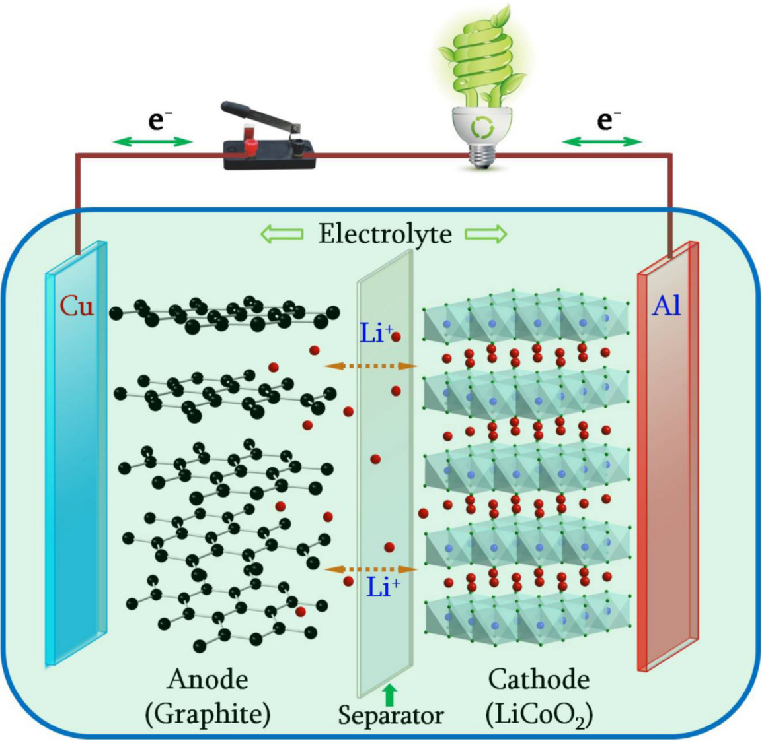
Figure 1. Schematic of the configuration of rechargeable Li-ion batteries. Traditional Li-ion batteries consist of a graphite anode, layered LiCoO2 cathode, and a separator immersed in liquid electrolyte, respectively. Ref ⁷

Many electrode materials that undergo reversible intercalation processes have limits on how much lithium can be extracted before irreversible structural transition or degradation may occur.⁸ For the specific case of LiCoO₂ only half of the Li-ions can be extracted while still maintaining structural stability, enabling a specific capacity of 137 mAhg⁻¹. Deeper charging leads to oxygen evolution from the crystal lattice, which increases the likelihood of decomposition product formation at the cathode | electrolyte interface and significant capacity fade.⁹ This structural instability during high voltage charging, its high price, and cobalt resource constraints have driven the development of alternative cathode active materials (CAM). In particular, substitution of cobalt with other transition metals has led to the development of high nickel-content cathodes of the formula LiNi_{1-y}Mn_{x}Co_{y}O₂ (NMC) over the last few decades.¹⁰ In this class of materials the electrochemically inactive Mn⁴⁺ stabilizes the structure and while Ni^{2+/4+} and Co^{3+/4+} redox couples increase the discharge capacity to (~200 mAhg⁻¹) providing greater energy density than the origin LiCoO₂ structure.¹¹

Traditional LIBs are approaching the theoretical capacity of cathode/anode materials, especially the commonly used graphite anodes. Lithium metal anodes offer the promise of higher energy density batteries due to it having the highest specific capacity (3840 mAhg⁻¹), an order of magnitude higher than graphite, and the lowest reduction potential (-3.04 V versus standard hydrogen electrode (SHE)) among alkali metal anodes.¹² However, the development of lithium metal anodes faces the challenge of dendrite-induced failure mechanisms during cycling. As shown in Figure 2, the sequential stripping plating processes tend to outpace the rate at which lithium can diffuse from the bulk to the surface during the stripping process. This mass transport problem leads to a non-uniform surface on which lithium plating takes place in the subsequent cycling, leading to the growth of a non-uniform layer of lithium (dendrites), which then seeds the eventual failure of the cell.^{13,14} Liquid electrolytes are thermodynamically unstable against reduction by Lithium metal anodes, which leads to the growth of a high resistance solid electrolyte interphase (SEI) and consumption of the liquid electrolyte in the cell. This process eventually leads to the penetration of the separator by lithium metal dendrites and short-circuiting of the cell. Once the cell short circuits large internal generation of heat can drive thermal runaway, combined with the flammable nature of organic liquid electrolytes, leads to explosive failure of the cell and casing.¹⁵
As vehicle transport is increasingly electrified, the need for safer and more energy-dense batteries intensifies. Safety is a particularly large driver of the demand for the shift from liquid-based cells to all solid-state batteries (ASSBs). ASSBs replace the liquid electrolyte and polymer separator in a traditional Li-ion battery with a single solid ionic conductor material. A key driver of the advancement of ASSB development will be the ability to produce high ionic conductivity and electrochemically stable solid electrolytes at scale. These issues, along with the status and existing challenges for ASSBs, will be discussed in the following sections.
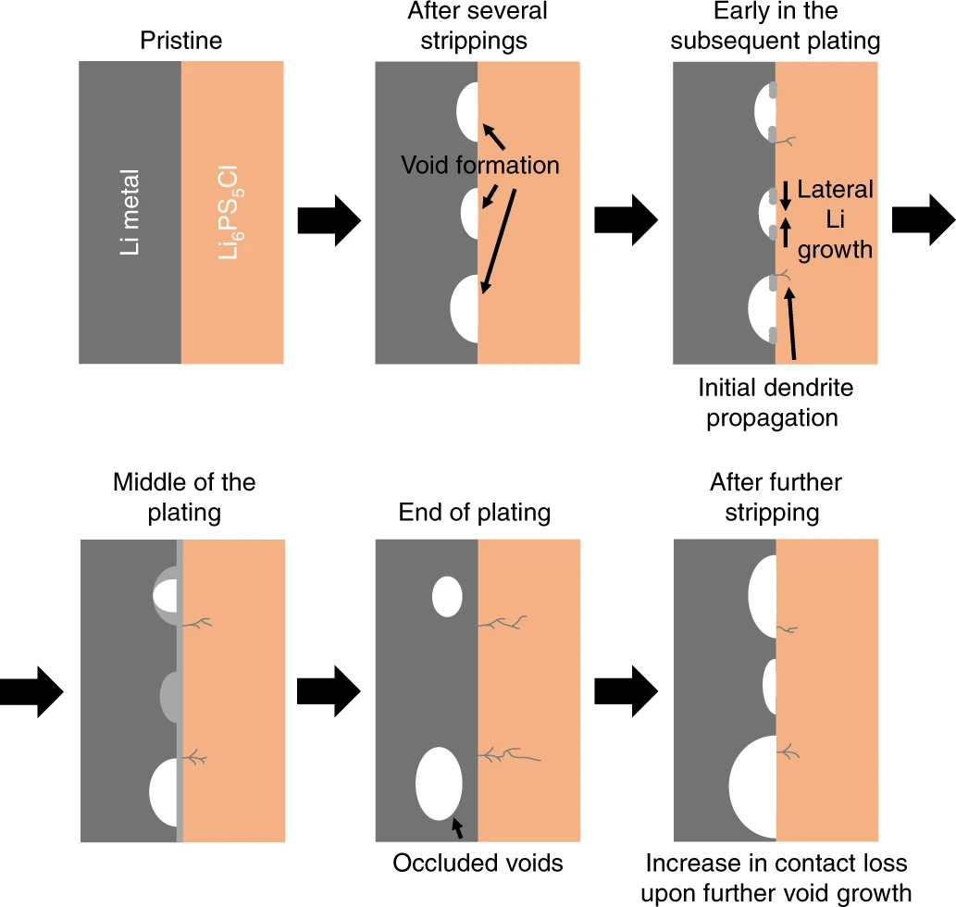
Figure 2 Schematic diagram of void formation at the Lithium Metal | Electrolyte interface leading to lithium dendrite growth. Reproduced with permission from Ref.¹³ Copywrite 2019 Springer Nature.

All-Solid-State Batteries
The landscape of solid electrolytes (SEs) and ASSBs is quite diverse and can lend itself to different methods of classification. Here we refer to ASSBs as devices incorporating an inorganic SE and therefore exclude the discussion of semi-solid type systems employing gel or polymer type electrolytes.¹⁶ This also then excludes hybrid systems that combine solid, liquid, and polymer electrolytes.¹⁷

ASSBs that replace the liquid electrolyte with an inorganic SE and potentially a lithium metal anode has the promise of enabling both high energy density and intrinsic safety even upon failure.¹⁸ An example of the tradeoffs of switching from a traditional LIB to an ASSB featuring a lithium metal anode and a high-voltage cathode is shown in Figure 3. Projections show that there are tradeoffs in making the transition from traditional LIBs to ASSBs. ASSBs require more energy-dense electrode materials to counteract the increase in weight of the electrolyte separator layer in the cell. Hence if a simple one-to-one substitution is made without either a higher voltage cathode or high capacity anode, the net change would likely be a similar volumetric energy density but a drop in the gravimetric energy density.¹⁹ Both specifications are important to increase in order to enable broader adoption of electrified vehicle transport. One can imagine that a heavier cell and the compiled module would lead to more energy expenditure to move a vehicle.²⁰ However, one potential advantage of ASSBs is the ability to enable new packing architectures, such as bipolar stacking, which could increase the energy density of battery packs while reducing the cost.²¹ This architecture allows multiple cells to be connected in series without external wiring, thereby lowering the cell pack volume, weight, and cost, enabling more energy-dense battery packs.

Superionic inorganic SEs (>1mS/cm) are the key component necessary to enable ASSBs, given that many of the inorganic solids have improved thermal stability compared to their flammable organic liquid electrolyte counterparts.²² Unlike polymer and gel electrolytes, most inorganic SEs do not undergo phase transitions in the expected operating temperature range of ASSBs (-10 to 100°C).²³

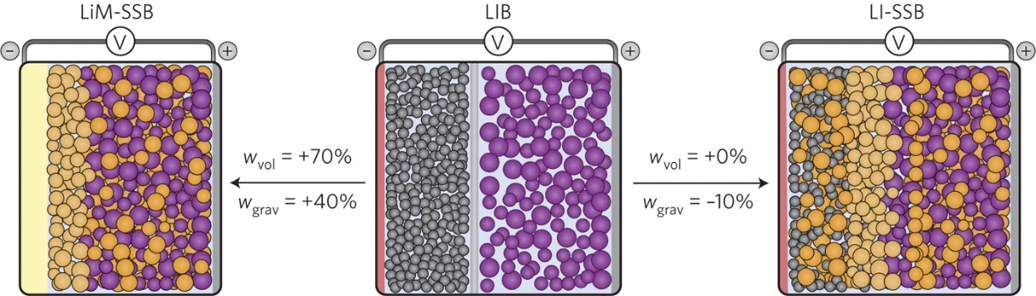
Figure 3. Schematic diagrams showing a typical LIB (middle), Li-ion solid state battery (right), lithium metal solid state battery (left). The Wvol and Wgrav denote the percent changes in volumetric and gravimetric energy densities, respectively. Reproduced with permission from Ref.¹⁹ Copyright 2016, Macmillan Publishers Limited.

Types Of Inorganic Solid Electrolytes
SEs must meet a wide range of criteria to qualify as potential candidates to replace the existing LiPF₆-based liquid electrolytes used in LIBs. These include high room temperature Li-ion conductivity, low electronic conductivity, and good chemical and electrochemical stability against both lithium metal and high voltage oxide CAMs. In addition, they need to be made from low-cost earth abundant materials, have low toxicity, and low energy requirements to produce at an industrial scale.²⁴ Many different types of solid electrolytes have been discovered and investigated heavily over the last few decades, including, Oxides, Sulfides, Halides, Nitrides, and many more.^{25–27}
Oxide solid electrolytes include some of the most well-studied classes materials, including, compositions such as Li₅La₃Zr₂O₁₂ (LLZO), Li_{1.07}Al_{0.69}Ti_{1.46}(PO₄)₃ (LATP), and Li_{3x}La_{2/3-x}TiO₃ (LLTO).²⁸ Oxides have many promising qualities in that some compositions, such as LLZO, are stable against lithium metal and have achieved very high critical current densities (CCD) of 10 mA/cm² at room temperature and under low applied pressures.²⁹ However, some of their drawbacks include time and energy-intensive synthesis routes, high grain boundary resistance, and low conductivities at room temperature. In addition, their mechanical properties make the formation of composite cathodes with oxide solid electrolytes as the ionically conductive additive difficult to optimize.²⁸ Therefore, even recent successful LLZO-based full cells employed other solid electrolytes to act as the catholyte in the composite cathode.³⁰
Common sulfide solid electrolytes include compositions such as Li₃PS₄ (LPS), Li₁₀MP₂S₁₂ (M = Ge, Al, Si, Sn, Sb) (LMPS), and lithium argyrodites of the general formula Li_{7+x-y}M^{v}_{1-x}M^{IV}_{x}Ch_{6-y}X_{y} (M^{V} = P, Sb; M^{IV} = Si, Ge, Sn; Ch = O, S, Se; X = Cl, Br, I, BH₄; 0 ≤ x ≤ 1; 0 ≤ y ≤ 2) ^{31–36}. Due to the lower electronegativity of S²⁻ compared to O²⁻, the S^{2—}Li⁺ bond is weaker compared to O^{2—}Li⁺ bond. The larger ionic radius of S²⁻ leads to the formation of larger lithium diffusion channels in the crystal structure, thereby enabling some sulfides to exhibit room temperature ionic conductivities > 10 mS/cm rivaling that of conventional liquid organic electrolytes.³⁷ These differences in the nature of the lithium-anion bond also drive the softer mechanical properties of sulfides when compared to their oxide analogs.³⁸ Sulfide solid electrolytes are some of the intensely studied materials due to their high ionic conductivity, scalable synthesis routes, and favorable mechanical properties. Some of the downsides of sulfide solid electrolytes include their lack of moisture stability, leading to H₂S formation upon exposure to air.³⁹ They also have relatively narrow electrochemical stability windows requiring the use of coatings or buffer layers to enable high-voltage oxide cathodes.⁴⁰ Other forms of sulfide, particularly glassy compositions in the binary Li₂S – P₂S₅ system, were initially heavily investigated due to their promising room temperature ionic conductivities but typically require milling or quenching as synthesis methods.⁴¹ These are often difficult to scale for commercial applications.
More recently, halide solid electrolytes of the formula Li₃MX₆ (M = In, Y, Yb, Sc, Er X = F, Cl, Br, I) have garnered significant interest due to their high ionic conductivity, exceptional chemical and electrochemical stability, and scalable synthesis routes. Initial work by Li et al. in 2019 showed that Li₃InCl₆ could be synthesized directly in water with the product yielding room temperature ionic conductivities of about 1 mS/cm. The ease of synthesis has prompted heavy research that has expanded the potential phase space to include tetravalent and pentavalent substitutions on the cation site, and a host of additional rare earth compositions have been confirmed since.²⁷ One of the downsides to halide solid electrolytes is their lack of reductive stability. This stems from the ability of lithium metal to reduce the metal cation to its metal form, leading to the general reduction pathway, as shown in Equation 5.⁴²

Li₃MCl₆ + 3Li $→$ 6LiCl + M⁰ (5)

Many recent studies have employed sulfide solid electrolytes as an anolyte to prevent this reaction from occurring and enable a bi-layer configuration that takes advantage of the beneficial properties of each type of solid electrolyte.^{43–45}

Challenges In ASSBs
As briefly discussed above, there are many potential challenges plaguing the development of ASSBs. One of the major hurdles in preventing the commercialization of ASSBs is the lack of understanding regarding composite cathode design and optimization, which has been shown to play a large role in determining ASSB performance. ⁴⁶ The strain induced by CAM expansion and contraction during cycling has been shown to induce large local stress between SE and CAM particles in the composite cathode.⁴⁷ Lab scale reports often utilize high stack pressures during cycling to prevent contact loss and microstructural cracking due to volume changes in the active material.⁴⁸ However, this parameter must be quite low (0.3 MPa or lower) due to limitations imposed by battery pack materials and weight requirements.⁴⁹ In addition, the overall cell architecture will likely require a thin SE separator and a thin high energy density anode. This means that the composite cathode especially in thick configurations will dominate the cell design and likely the resulting performance of the cell.⁵⁰ Thick composite cathodes are needed to enable significant increases in energy density, by increasing the CAM loading.
Thick, porous cathode composite layers require higher ionic conductivity solid electrolytes (>10 mS/cm). This need arises from the decrease in effective ionic conductivity that occurs in the composite cathode due to the increase in porosity and tortuosity when compared to the separator layer.⁵¹ The addition of high-surface area carbon additives and the CAM particles alongside the solid electrolyte material drives this change in tortuosity and porosity. To make ASSBs competitive with traditional Li-ion cells the molar concentration of lithium in solid electrolytes must be reduced. Popular solid electrolyte compositions are often two orders of magnitude higher in molar lithium concentration than those of common liquid electrolytes.⁵²
As previously discussed, solid electrolytes also need to have improved interfacial stability with energy-dense anode materials such as lithium metal and potentially silicon to enable improvements in energy density compared to traditional LIBs.¹⁹ However, some SEs such as LLZO have been shown to potentially be compatible with lithium metal; however, they are quite dense and may lead to significant losses in energy density at the cell level.⁵³
To scale the production of ASSBs for vehicle applications, methods of large-scale production for solid electrolytes need to be proven. Potential scalable synthesis routes include solution based, some types of milling routes, low-temperature solid-state, and sol-gel methods. Synthesis and processing routes for common solid electrolytes are misunderstood. In particular, the effect of different routes on the product properties of solid electrolyte materials is not well understood.⁵⁴

Synthesis And Processing Of SEs For ASSBs
As previously noted, ionic conductivity is a crucial property that must be maximized if ASSBs with high energy density are to be successfully scaled for use in vehicle applications.⁵⁵ Synthetic conditions can have a significant impact on the microstructure and, therefore, the Li-ion conductivity of many solid electrolytes.⁵⁴ This variation in reported ionic conductivity properties across both composition and synthetic route is displayed in Figure 4. For example, LLZO is shown to vary by up to 5 orders of magnitude depending on the chosen synthesis route. While some understanding of the phenomena driving these effects exists, it is not often generalizable across different classes of solid electrolytes. These effects are thought to usually be driven by changes in microstructure, local structure, and phase purity, all of which can be affected by synthetic or processing conditions.
Take, for example, the synthesis of Li₆PS₅X (X = Cl, Br, I), it is understood that materials made from the mechanochemical route compared to class solid-state or solution have greater ionic conductivities. Milling is believed to induce greater anion site disorder between the S²⁻/X⁻ sites within the material, leading to lower activation energies for local Li⁺ transport.⁵⁶ However, it is unclear if the increase in disorder is purely a response to mechanical action, the transfer of mechanical energy into heat, or a combination of the two. This is particularly confounding because work by Kwon et al. shows that 80% of the energy generated during milling is used in heating the surface of the milling media.⁵⁷ Although milling parameters such as duration, speed, media size, and filling ratio have been investigated for the synthesis of Li₆PS₅Cl, the milling method has not been considered. Most milled products within the literature are achieved through planetary milling, a technique with many fundamental constraints, and have been unsuccessful in upscaling attempts. Industrial application will require the transfer of research results achieved in planetary mills to be transferred to other milling types, such as tumbling, vibrating, or stirring.⁵⁸ Therefore, it is important to understand changes correlated with milling methodology within mechanochemical synthesis.
One of the most accessible and well-understood synthesis routes for solid electrolytes is the solid-state method. This method is carried out with the following template: hand mixing of precursors, pelletizing of the mixture, and annealing for a long period of time at a high temperature.⁵⁹ Annealing is typically carried out in a sealed quartz ampoule, but can also be carried out in a flowing gas environment or under a vacuum. Many of the solid electrolytes with the highest reported conductivities were initially synthesized using a solid-state route, e.g., the thioantimonate, Li_{6.6}Si_{0.4}Sb_{0.6}S₅I with a reported Li⁺ conductivity of 14.87 mS/cm, and the superionic sodium solid electrolyte, Na_{2.9}Sb_{0.9}W_{0.1}S_{4,} with a Na⁺ conductivity of 40 mS/cm.^{31,60} Although some

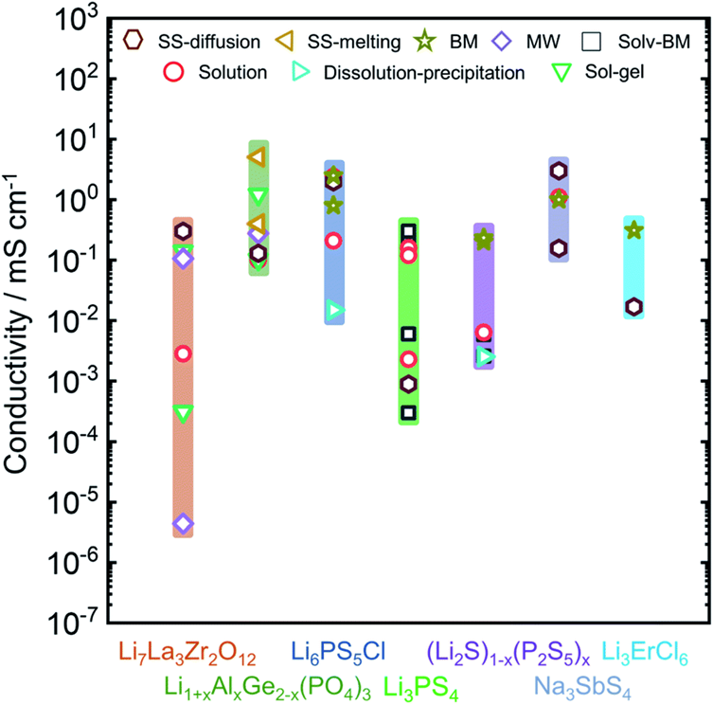
Figure 4. Overview of the observed ionic conductivities for well-known Li-ion and Na-ion solid electrolytes as a function of synthetic condition. Ref⁵⁴

successes have been achieved through this route, it does suffer from some drawbacks that call into question its practicality for up-scaling of material production. The biggest drawback is the high energy and time costs associated with producing superionic conductors through this method.⁵⁴

Solvent-based methods are attractive due to their flexible application as a synthetic medium or as a processing route where solid electrolytes can be suspended/dissolved and infiltrated into composite cathodes or even coat active material particles.⁶¹ One of the benefits of solution-based routes is that they can enable the production of metastable phases such as Li₇P₃S₁₁ that are either difficult or impossible to form from traditional solid-state routes.⁶² In addition, solution-based synthesis can be used to control the morphology of products.⁶³ For all its promise, solution processing and synthesis has major drawbacks, including poorly understood underlying reaction chemistry, irreversible reactions between reactants and solvents, solvent residue, or carbonized solvent can remain in the product. These remnants can impact important solid electrolyte properties, such as electronic conductivity.⁶⁴ High electronic conductivity has been associated with lower critical current densities in solid electrolytes due to the possibility of lithium being oxidized by electrons within grain boundaries.⁶⁵ These factors can compound, making it difficult to reproducibly produce fast ionic conductors (≥1 mS/cm at RT) from solvent routes.⁵⁴

Other promising synthetic routes include the use of sol-gel techniques, which are commonly employed in the synthesis of oxide solid electrolytes such as LATP and LLZO.⁶⁶ Traditionally, many oxide solid electrolytes have been synthesized via classical solid-state routes involving mixing, pelletizing, and annealing at high temperatures. Recent work has shown that sol-gel synthesis of LLZO was comparable in ionic conductivity to materials synthesized through the solid-state route.⁶⁷ However, further research is needed to prevent the formation of large grain boundaries during the synthesis and processing of oxide solid-electrolytes. Grain boundaries have been shown to drive both decreases in ionic conductivity and instability with moisture in oxide solid electrolytes. ⁶⁸

An emerging technique for the synthesis of solid electrolytes is microwave synthesis.⁶⁹ This technique has grown in its use for synthesizing different types of oxide cathode materials.⁷⁰ A few examples of solid electrolytes being synthesized through this route have been reported, such as for LLZO, LATP, and LPS.^{69,71,72} This technique shows promise as a potential avenue for enabling the large-scale production of metastable phases and disordered materials.^{73–75} However, much of the mechanistic understanding present in other methods of material synthesis is lacking for this technique and, therefore, must be further studied. In addition, many of the most promising solid electrolyte compositions, such as Li₆PS₅Cl, LMPS, and the halides (Li₃InCl₆ or Li₃YCl₆) have not yet been explored with this route.

The number of synthesis techniques that could be employed in the scale-up of solid electrolyte materials is quite large. However, a practical candidate for large-scale manufacturing will be low in cost, energy, and time consumption. In addition, the route must enable materials with properties such as high ionic conductivity, phase purity, electrochemical stability, and chemical stability. When considering potential viability of solid electrolyte compositions, their compatibility with scalable synthesis routes that still enable the promising properties studied at the lab scale must be considered.

In addition to synthesis routes, one must consider the effects of processing on solid electrolyte properties. The fabrication and stack pressure has been shown to dramatically impact the amount of porosity in both the separator and composite cathode.⁷⁶ Porosity and tortuosity are often related and directly impact the transport properties of the composite electrode.⁷⁷ While stack pressures must be below ~0.1 MPa or lower for commercial applications, it is possible to employ large fabrication pressures prior to cycling to ensure the maximum density of both the separator and composite electrodes within the cell.⁵⁵

Another factor that has been understudied within the solid electrolyte literature is the mixing of composite cathode components. Mixing of the composite cathode has been shown to directly impact not only active material utilization (maximum discharge capacity) and capacity retention during cycling.⁷⁸ Many of the processing steps utilized in LIB electrode manufacturing steps have not been thoroughly investigated for ASSB composite cathodes. Comparisons between slurry casting and dry mixing of composite cathode components, as well as calendaring, have not been covered for many classes of solid electrolytes.⁷⁹

Scope Of The Thesis
This thesis provides a thorough investigation of the synthesis, characterization, formation mechanism, and processing of halide and sulfide solid electrolytes and their incorporation into ASSBs.

Chapter 1 gives a general introduction and overview of relevant research that has been conducted over the past few decades on Li-ion conductors and ASSBs.

Chapter 2 describes the experimental methods and characterization techniques that are employed in this thesis.

Chapter 3 compares the formation mechanism and material properties of the halide solid electrolyte, Li₃YCl₆, across multiple synthesis routes. We confirm the presence of (NH₄)₃[YCl₆] intermediates via in-situ Neutron Powder Diffraction experiments characterizing the aqueous synthesis route. We also find the existence of a metastable Li₃YCl₆ intermediate observed to our knowledge for the first time in this synthesis route. After melting at 475°C, we find that the intermediate structure is replaced with the trigonal Li₃YCl₆ upon reformation. We confirm the presence of milling-induced Y2-Y3 site disorder in mechanochemically synthesized Li₃YCl₆. We also find that the material becomes ordered as it is annealed in agreement with previous reports. Multiple synthesis routes confirm the role of annealing in inducing increased grain boundary resistance for Li₃YCl₆ products. Our work shows that aqueous synthesis of halide solid electrolytes leads to comparable, if not improved, material properties compared to their mechanochemical or solid-state counterparts.

Chapter 4 investigates the role of the milling method on the phase evolution and product properties of Li₆PS₅Cl through in-situ neutron powder diffraction. We find that in all cases at a lower milling time regime, the P₂S₅ precursor is consumed to form LPS intermediates, which are then converted to Li₆PS₅Cl upon annealing. In addition, we confirm that, as has been shown for Li₆PS₅Br, the anion disorder is controlled by thermal treatments as opposed to either milling motion or the thermal environment during milling.

Chapter 5 investigates the role of both stack pressure and fabrication pressure on the electrochemical performance of Li₃InCl₆ and Li₆PS₅Cl containing bi-layer ASSBs. We show that Li₃InCl₆ shows a greater stack and fabrication pressure dependence. This is driven by reductions in porosity and tortuosity within the composite cathode and separator layer. We also find that even if the two pressure parameters are optimized, cracking and delamination of active material particles still occur during cycling.

Chapter 6 summarizes the work of the entire thesis and proposes potential future directions for the investigation of sulfide and halide solid electrolytes.

Chapter II methods and Techniques

Solid Electrolyte Synthesis

Solid State Route
The focus of this thesis concerns the comparison of the effects of SE synthesis and processing routes across multiple compositions. One of the investigated routes within this thesis is the classical solid-state synthesis method. This method consists of two steps: mixing the precursors, pressing them into pellets, and heating them to elevated temperatures. At high temperatures, the thermal energy drives atomic-level mixing to enable the formation of thermodynamically stable phases.⁸⁰ This route often requires long annealing times due to the limited particle-particle contact induced by hand-mixing in a mortar and pestle. The mechanism of a classical solid-state synthesis route can be controlled by multiple parameters including, the annealing environment, ramp rate, annealing container materials, annealing temperature, annealing time, cooling rate, and the mixing of the precursors. Since both sulfide and halide solid electrolytes are moisture and air-sensitive, samples were annealed under flowing Ar in glove box environments to prevent contamination of the products.

Mechanochemical Synthesis
In this thesis, multiple milling techniques are investigated. Planetary milling is the most common mechanochemical synthesis technique employed in the solid electrolyte literature. This type of milling employs jars that are filled with sample and milling media and are mounted around a rotating disk (Figure 5). The jars are then rotated in a direction normal to the rotating disk. Many parameters can influence the resulting synthesis and product properties, including the speed of the rotating disk, the jar rotation speed, and the powder filling ratio.⁵⁸ It has the benefit of enabling enhanced mixing of precursors and the reduction of particle size.⁸¹ During this thesis, a Pulverisette 7 was used during all planetary milling steps. No signs of zirconia contamination were found when studied by multiple characterization techniques. Other milling techniques utilized in this thesis include vibrational milling and cryomilling. These both represent a different type of motion for the milling chamber (jar) during milling. In addition, as will be discussed in later chapters, they are potentially more scalable than planetary milling due to the difficulty in cooling the milling chamber.

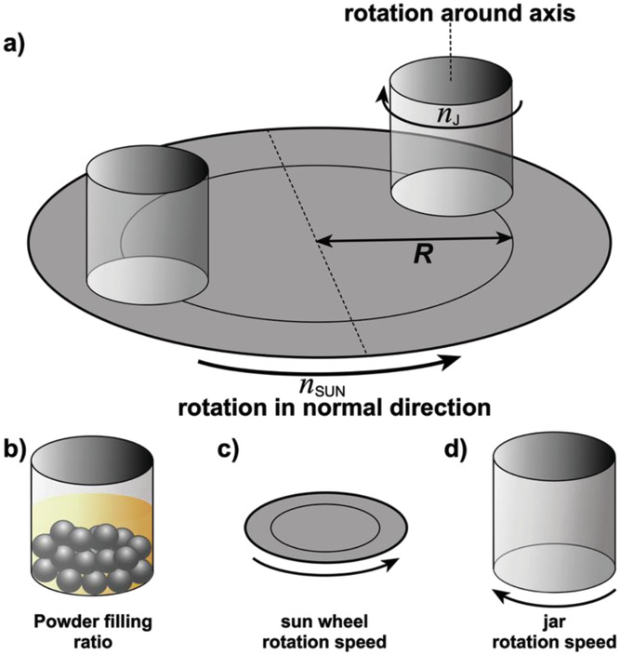
Figure 5 Schematic of the principle of a planetary ball mill (a) two oppositely located jars are attached to a rotating disk with the radius R to the center of one of the jars. (b) the jars rotate around their own axis in normal directions to the disk. Influential factors of the synthesis route are the powder filling ratio (b) the sun wheel rotation speed and (c) the jar rotation speed. Ref⁵⁸

Liquid Phase Synthesis
Liquid phase synthesis involves the dissolution or suspension of precursors in a solvent compatible with the material. Here the largest concern is proper solvent selection. However, drying conditions have also been shown to play a large role in affecting this synthesis route.⁸² In this thesis, all liquid phase routes involved the dissolution of the precursors in either water or alcohol solvents. The dissolution step was typically followed by roto-evaporation using a Buchi Rotovapor. Roto-evaporation has the benefit of quickly drying off solvent but allowing for the capture of any “bumped” sample, minimizing sample loss during synthesis. In some instances, the product of the evaporation step was pelletized and annealed. Further details are provided in their respective chapters.

Diffraction Techniques

Lab Scale X-ray Powder Diffraction
X-ray Powder Diffraction (XRD) is the most common technique used to identify crystalline phases within solid electrolytes. X-rays with wavelengths ranging from 0.01 – 10 nm are diffracted by the repeating atomic planes within a material because it is in the same range as the atomic distances found in crystals. Bragg’s law explains the construction of a unique diffraction pattern corresponding to a specific crystal structure, as shown in Equation 6:

$\text{nλ}\text{=2d∙Sin}\left(\text{θ}\right)$ (6)
where θ is the angle between the incident X-ray and the respective parallel planes, λ is the X-ray wavelength, and d is the interplanar spacing (Figure 6). At an angle θ, X-rays scattered from successive planes will interact constructively and eventually reach the X-ray detector. As polycrystalline powders contain millions of crystallites with different orientations, we eventually get a diffraction pattern. X-rays are scattered by electron clouds around the atoms within a material. The intensity of the diffracted X-rays corresponds to the number and position of electrons within the electron cloud of a given atom. The intensity of the peaks is related to the structure factor (F) via Equation 7:

$\text{ I = A ∙ }{\text{F}}^{\text{2}}$ (7)
A represents experimental contributions that may affect the intensity such as polarization, absorption, and temperature. Lab scale XRD patterns in this thesis were collected using a Malvern PANalytical X’pert Pro MPD diffractometer (45 kV, 40 mA). Air sensitive samples were sealed in Ar glove boxes using Kapton tape to prevent contamination. All lab scale XRD data were collected using a Bragg – Brentano geometry.
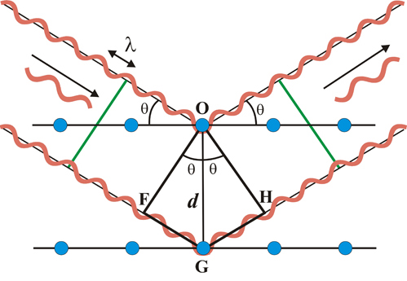
Figure 6. Schematic of Bragg's Law, Reproduced from Ref.⁸³ .CC BY-NC 4.0.

Time-of-Flight Powder Neutron Diffraction
Neutron diffraction can provide structural details that are missed by XRD. As previously discussed, X-rays are diffracted by the electrons of the atom, while neutrons are diffracted by the nuclei of the atoms.⁸⁴ The electron density is very low around light atoms, which produce a weak x-ray diffraction signal. These light atoms can be in the crystal structure by neutron diffraction because the interaction is with the nuclei. The neutron data collected for this thesis were collected at the Spallation Neutron Source (SNS) at Oak Ridge National Laboratory (ORNL). Neutron spallation sources produce pulses of neutrons with a distribution of energies (wavelengths) unlike traditional diffraction experiments which use a constant wavelength. Therefore, these instruments do not operate in angle dispersive modes, measuring the intensity versus 2θ. An Energy dispersive mode is used instead, measuring the energy and direction of diffracted neutrons, which translates into a pattern of intensity versus time-of-flight (TOF).
The relationship between time of flight, t and d-spacing utilizes diffractometer constants A, C, and t₀ as shown in Equation 8.
$\text{t=} \text{Cd+A}{\text{d}}^{\text{2}}\text{+} {\text{t}}_{\text{0}}$ (8)
The parameters are obtained from the refinement of data collected from standard reference materials. The constant A is sample dependent and is refined. t₀ is instrument dependent and must remain at the value of calibration. The constant C is the linear relationship between TOF and d spacing.

The linear relationship between time of flight and the d-spacing can be obtained using the de Broglie equation and Bragg’s law as shown in Equation 9.
$\frac{\text{h}}{\text{m}}\text{ = }\frac{\text{ht}}{\text{mL}}\text{ = 2d }\text{sinθ}$ (9)
Where h is plank’s constant, m is the neutron mass, L is the total flight path from moderator to detector, d is the interplanar spacing , t is the time of flight, and θ is the scattering angle. ⁸⁵ When equation 9 is solved for t it yields equation 10 which relates d-spacing and t.
$\text{t = 2d}\frac{\text{mL}}{\text{h}}\text{ sin(θ)}$ (10)
All neutron data was collected on the POWGEN beamline using both in-situ and ex-situ diffraction environments.⁸⁶

Materials Characterization

Scanning Electron Microscopy And Energy Dispersive X-ray Spectroscopy (EDX)
Scanning Electron Microscopy (SEM) is a technique used to investigate the microstructure, morphology, particle size distribution, and distribution of elements on the surface of a material. A typical SEM uses a focused electron beam with an energy ranging from 0.2 to 40 keV. This beam hits the sample surface and generates secondary, backscattered, and transmitted electrons. In addition, characteristic X-rays (fluorescence) are also generated. As shown in Figure 7, the repeated random scattering and absorption of primary electrons causes a depth-limited interaction with the sample that forms a teardrop volume. These interactions happen simultaneously, secondary electrons are formed from the collision between incident electrons and loosely bound electrons in the sample. These secondary electrons have low energies, so they are only detected near the surface of the sample (~10 nm deep).⁸⁷ While this is occurring, incident electrons from the beam are elastically scattered by the sample, which are termed backscattered electrons (BSE). Heavier elements are stronger scatterers than lighter ones. This allows use to obtain atomic number and phase information from detection of BSEs. Because they are higher in energy, the interactions with the sample at greater depths (1-3 µm) can be detected. But due to the teardrop shape of the interaction volume, the spatial resolution of the resulting image is worse. When secondary electrons are generated, a shell electron with low binding energy is excited, leaving behind an empty electron site. One electron from the outer shell will then jump into the low energy site that has opened, with excess energy being released in the form of X-ray emission. The energy of the X-ray depends on the orbital energies involved, and thus that is used for identifying elements for energy dispersive X-ray spectroscopy (EDX). The SEM data in this thesis were collected using a Zeiss merlin FE-SEM microscope. The accelerating voltage was typically 1 keV.

Raman Spectroscopy
Most light interactions with matter are elastically scattered, also known as Rayleigh scattering. These types of interactions feature no energy transfer. However, some light in the visible spectrum (~200-700 nm) can transfer energy to a molecule within a material leading to excitation of differential vibrational modes, these phenomena are known as Raman scattering.⁹⁰ This scattering event is a rare occurrence and is described to occur in 1 of 10⁶ scattering events. The basics of Raman spectroscopy are that when a monochromatic light source in the visible range illuminates and interacts with a sample, Raman scattering is observed if there is a difference in the energy of the scattered and incident light. The inelastic scattering is filtered from the Rayleigh scattering (elastic) and is known as a Raman shift.⁹¹ These shifts provide information about the normal vibrational, rotational, and other low-frequency transitions in a molecule. This technique is non-destructive and capable of fingerprinting specific molecules in materials.

X-ray Photoelectron Spectroscopy (XPS)
XPS is a technique based on the photoelectric effect, where photons carrying quantized energy are used to eject electrons from the surface of a sample. XPS can be used to characterize the chemical composition of the surface of a sample (~10 nm).⁹² For most XPS instruments, the x-ray source, is produced from Mg (K_{α} = 1253.6 eV) or Al (K_{α} = 1486.6 eV) which are suitable energies for exiting core electrons. The binding energy of the excited electrons in the sample is unique to the specific local environment, which enables XPS to differentiate between similar chemical environments on the sample’s surface
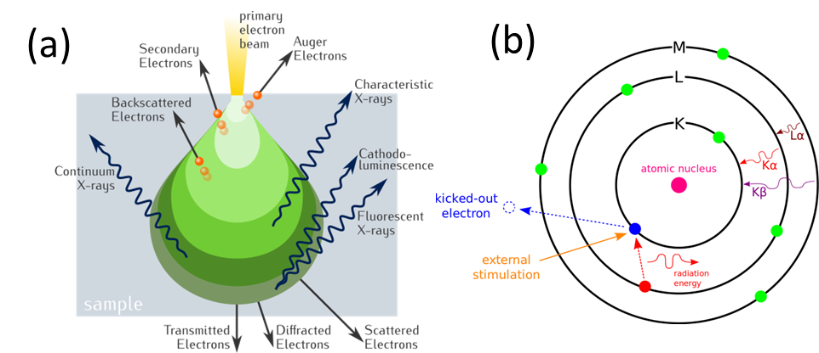
Figure 7. Schematic Diagram of (a) the interaction volume (b) different types of interactions between the incident beam and the sample Ref.^{88,89}

Differential Scanning Calorimetry (DSC)
DSC is the most common thermal analysis technique used for a wide range of applications from new material development to quality control during manufacturing. In this experiment, the sample is scanned dynamically or held isothermally. The heat flow of both sample and reference are monitored as a function of temperature and time.⁹³ The calorimeter measures the heat absorbed or released by the sample when it is subjected to the specific temperatures designated in the experiment. As different processes occur within the sample, the generation of heat is interpreted as an exothermic reaction, while the consumption of heat is interpreted as an endothermic reaction.⁹⁴ A typical cell found in a heat-flow DSC instrument is shown in Figure 8. The DSC instrument used for all data collection in this thesis was a DSC Q100 from TA instruments. Aluminum pans were used as sample containers unless otherwise specified.

Thermogravimetric Analysis (TGA)
TGA is a thermal analysis technique that monitors the mass changes in a sample as a function of temperature and time. Samples are loaded into pans and that can be flat or hanging from a wire as shown in Figure 9. Like DSC, a counterweight pan in a separate thermal chamber is used as the reference for the measurement. The resulting thermogram from the measurement can be used to determine thermal stability, oxidative stability, multi-component composition, product lifetime, decomposition kinetics, and moisture content in a sample.⁹⁶ The TGA data in this thesis were collected using a TA instruments Q500. All experiments were conducted under flowing nitrogen gas, with a flow rate of 50 mL/min.

Electrochemical Techniques

Electrochemical Impedance Spectroscopy (EIS)
The most important screening criteria for evaluating SE materials is their overall ionic conductivity at room temperature. The most common method of measuring this property is EIS. The advantages of EIS are that it is a low cost, fast, and non-destructive technique. Traditional two electrode measurements utilize an ion – blocking electrode configuration to extract the ionic conductivity by:

${\text{σ}}_{\text{ion}}\text{ = }\frac{\text{l}}{{\text{R}}_{\text{total}}\text{ A}}$ (11)
where R_{total} is the total resistance of the electrolyte sample, l is the sample thickness, and A is the cross-sectional area.⁹⁷ In the case of many materials, R_{total} may include contributions from different processes including: the resistance from the grain (bulk), the grain boundary, and any impedance associated with the electrodes and their interfaces will be included in the resulting spectra.⁹⁸

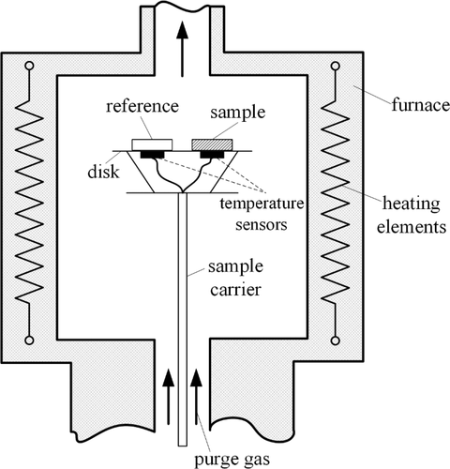
Figure 8. Schematic of a Heat-Flow DSC cell. Reprinted (adapted) with permission from Zheng et al., “Understanding Glass through Differential Scanning Calorimetry.”. Copyright 2019. American Chemical Society. ⁹⁵
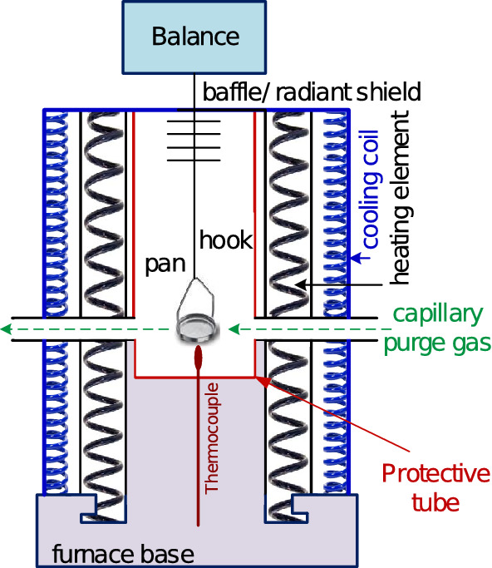
Figure 9. Schematic of a bottom loading or hang down TGA instrument. Reproduced with permission from Ref.⁹⁶ Copyright 2019, Canadian Society for Chemical Engineering.

The impedance of a sample, Z(ω) is a complex quantity that indicates the ratio between the AC voltage of the perturbation applied to the sample, V(ω), and the resulting AC current through the sample, I(ω) as shown in equation 12.
$\text{Z}\left(\text{ω}\right)\text{=}\frac{\text{V}\left(\text{ω}\right)}{\text{I}\left(\text{ω}\right)}$ (12)
The impedance contains both real and imaginary components, Z’(ω) and Z’’(ω) respectively, as written in equation 13. These two components are also frequency dependent.

$\text{Z}\left(\text{ω}\right)\text{=}{\text{Z}}^{\text{'}}\left(\text{ω}\right)\text{+}{\text{iZ}}^{\text{''}}\left(\text{ω}\right)$ (13)
Typically, in the field of SE research, these components are plotted on the X-axis (real) and Y-axis (imaginary) respectively, forming a Nyquist plot. Within the Nyquist plot, we usually observe multiple semicircles corresponding to processes that are associated with different time scales. Fast processes such as ion migration through the bulk of the solid electrolyte occur at high frequencies (low x-axis values) while slow processes such as diffusion through a porous electrode or the separator region occur at low frequencies (high-axis values).

Galvanostatic Cycling
Galvanostatic cycling is a typical electrochemical technique where a constant current is applied to a cell until either a certain amount of charge has been passed or a cutoff voltage has been reached. In the standard configuration, a positive current charge the cell while a negative current is used to discharge the cell. This method allows one to study the specific capacity, rate capability, capacity retention, and cycle life of a battery. When employing a typical intercalation type positive electrode, the electrode is oxidized/reduced with cation de/insertion. As a result, the voltage response could be either a linear or a flat plateau. A linear increase or decrease in the voltage with respect to capacity corresponds to a solid solution de/insertion mechanism. While a flat voltage response with respect to capacity is caused by a two-phase reaction.⁷ Approaching the capacity limit will lead to a dramatically faster voltage increase/decrease. The specific capacity Q for a given material is related to the molar mass (M_{w}) and can be calculated using:
$\text{Q = }\frac{\text{nF}}{\text{3.6}{\text{M}}_{\text{w}}}$ (14)
Where F is the Faraday’s constant, n is the number of electrons transferred. The electrochemical cycling in this thesis was conducted using a two-electrode configuration. The cells consisted of a composite cathode (CAM mixed with SE and Carbon) and an anode (typically a Li-In alloy) and a SE separator layer. These measurements were conducted using either a Biologic VSP (5 channel potentiostat) or an SP-200. Measurements were conducted using a set voltage window and a constant current.

Chapter III Relating synthesis methodology to formation, Li⁺ conductivity, and full cell cycle performance of Li₃YCl₆-based solid state batteries.

Abstract
Lithium halides-based materials have demonstrated high lithium-ion conductivity and can be synthesized through low temperature routes using concentrated aqueous (and certain non-aqueous) solution. While Li₃InCl₆ can be readily synthesized through dehydration of aqueous solutions/hydrates, other lithium halides-based materials such as Li₃YCl₆ cannot. It has been suggested that this is because Y³⁺ is coordinated differently than In³⁺, having x tightly coordinated H2O, which leads to hydrolysis induced formation of YOCl. In this work, multiple methods for synthesizing Li₃YCl₆ are examined using in situ NPD. The data revealed the formation of a complex ammonium halide intermediate is essential in synthesizing Li₃YCl₆ through an aqueous method. We compare this route to an ammonium free and mechanochemical route and find that there are significant differences in phase evolution and reaction kinetics. In examining the Li₃YCl₆ products more carefully, we found that changes in local structure and microstructure follow on to drive significant differences in ionic transport and electrochemical performance. This work provides insight into the reaction mechanisms involved in synthesizing halide solid electrolytes and highlights the importance of considering their synthetic and processing conditions to optimize their performance in ASSBs.

Introduction
An increase in demand for dense, safe, and portable energy storage has led to great interest in all-solid-state batteries (ASSBs) and solid electrolytes.¹ Solid Electrolytes are the key to replacing conventional flammable organic liquid electrolytes and improving the safety and resilience of lithium based batteries.² Many solid electrolytes have been investigated over the past few decades, including polymer³, oxide⁴, sulfide⁵, hydride⁶ and more recently halide solid electrolytes. ⁷ Halide solid electrolytes have shown promise due to their high ionic conductivity, high voltage cathode compatibility, and flexibility in synthesis and processing routes.⁸ Compositions such as Li₃InCl₆ have garnered large interest due to their compatibility with aqueous and organic solvent based synthesis.^{9,10} Direct synthesis of other A₃MX₆ (A = Li, M = Sc, Y, Ho, Yb, Er, etc., X = F, Cl, Br, I) compositions in water or other solvents is limited due to the hydrolysis of MCl₃ ∙ nH₂O intermediates upon heating. This decomposition route leads to the formation of MOCl and LiCl impurities. However, recent reports have shown that it is possible to synthesize these other compositions in water through the use of ammonium halide coordination reagents.^{11,12}

Large scale synthesis and optimization of battery materials is not trivial.^{13,14} It often requires process monitoring and optimization. A key enabler of this chemical engineering is an intimate understanding of the reaction mechanism during synthesis.¹⁵ In addition, many solid electrolyte properties are greatly influenced by the chosen synthesis route.¹⁶ This report provides a detailed examination of the formation pathway for Li₃YCl₆ and establishes synthesis-structure property correlations to guide the optimization of halide solid electrolyte based ASSBs. The formation mechanism of halide solid electrolytes through these novel solvent-based routes is poorly understood. Previous work suggested that the addition of ammonium halides resulted in the formation of a complex halide intermediate of the suspected form (NH₄)₃[MX₆].^{17,18} This intermediate (reaction 3) provided an alternative reaction route away from oxyhalide (reaction 4) formation during the dehydration and the subsequent annealing at high temperatures (350-550 °C)

$\text{Y}{\text{Cl}}_{\text{3}}\text{∙n}{\text{H}}_{\text{2}}\text{O+3 N}{\text{H}}_{\text{4}}\text{Cl}\underset{→}{\text{-n}{\text{H}}_{\text{2}}\text{O}}{\left(\text{N}{\text{H}}_{\text{4}}\text{Cl}\right)}_{\text{3}}\left[\text{Y}{\text{Cl}}_{\text{6}}\right]$ (15) ${\left({\text{NH}}_{\text{4}}\right)}_{\text{3}}\left[\text{YC}{\text{l}}_{\text{6}}\right]\text{+3 LiCl}\underset{→}{\text{ ∆ }}\text{L}{\text{i}}_{\text{3}}\text{YC}{\text{l}}_{\text{6}}\text{+3 N}{\text{H}}_{\text{3}}\text{+3 HCl}$ (16)
${\left(\text{N}{\text{H}}_{\text{4}}\right)}_{\text{3}}\left[\text{YC}{\text{l}}_{\text{6}}\right]\text{+}{\text{H}}_{\text{2}}\text{O→YOCl+3}\left(\text{N}{\text{H}}_{\text{4}}\right)\text{Cl+2HCl}$ (17)
$\text{2 }{\left(\text{N}{\text{H}}_{\text{4}}\right)}_{\text{3}}\left[\text{YC}{\text{l}}_{\text{6}}\right]\text{→}\left(\text{N}{\text{H}}_{\text{4}}\right)\left[{\text{Y}}_{\text{2}}\text{C}{\text{l}}_{\text{7}}\right]\text{+} \text{5 N}{\text{H}}_{\text{4}}\text{Cl }$ (18)

Here, we utilize in situ neutron powder diffraction (NPD) to track the formation of Li₃YCl₆ (LYC) across multiple synthesis routes. NPD is well suited for probing reactions at relevant mass scales due to its high penetrative power and sensitivity to Li. In addition, neutrons are far more sensitive to hydrogen groups within both NH₄Cl and complex halide intermediates when compared with X-ray diffraction (XRD) techniques employed in previous work. To minimize incoherent scattering background of protons, deuterated precursors were used to form (ND₄)₃[YCl₆] for NPD experiments. We confirm the formation of (ND₄)₃[YCl₆] during the wet chemical synthesis of LYC, its decomposition, while providing further insight into its crystal structure. We show that dehydration of the complex prior to reaching elevated temperatures is key even in the wet chemical synthesis route to avoid the formation of LiCl and YOCl impurities. Likewise, we observe in multiple reaction mechanisms that the formation of Li₃YCl₆ and then melting at higher temperatures is crucial to driving proper mixing of precursors and intermediates. This agrees with a previous report by Asano et al. in which LYC was reported to be thermally stable till 450.¹⁹ However, to our knowledge, this is the first instance of providing structural characterization after the melting of the solid electrolyte phase using in-situ diffraction techniques.²⁰ Melting of the LYC phase could be play an important role in separator fabrication through melt infiltration or casting methods.²¹ We characterize the influence of the synthesis route on the ionic conductivity, electronic conductivity, cycling performance, and the interfacial stability of LYC solid electrolytes. In addition, we observe that the formation of grain boundaries plays a significant role in the total ionic conductivity of LYC solid electrolytes that undergo annealing. Wet chemical LYC achieves the highest room temperature ionic conductivity and the best electrochemical performance among the routes investigated.

Experimental

Li₃YCl₆ Synthesis.
The aqueous Ammonium Coordinated (AC) synthesis of Li₃YCl₆ was prepared by weighing out 34 mol% excess of anhydrous YCl₃ (Sigma Aldrich 99.99%, 451363), stoichiometric amounts of LiCl (Sigma Aldrich 99%, 793620) and NH₄Cl (Sigma Aldrich 99.5%, A4514) in a 1:3:3 molar ratio in a glove box. The mixture was then transferred to a round bottom flask and dissolved in DI water, sonicated for 15 minutes, and excess water was evaporated via rotovap. The sample was then dried overnight at 150 °C under vacuum to remove any excess water. The white powder was ground in an agate mortar and pestle, pelletized, placed in an alumina combustion boat, and annealed at 500 °C (heating rate 5 °C/min) for 5 hours under argon flow in a glove box. This exact procedure was used to synthesize the Ammonium Free (AF) sample, the only difference being NH₄Cl was excluded from the initial mixture.
The mechanochemical (MC) synthesis of Li₃YCl₆ was conducted in a Fritsch Pulvirisette 7 planetary ball mill. The LiCl and YCl₃ were loaded into zirconia milling jars (45 mL volume) with ZrO₂ milling media (5 mm diameter) inside a glove box. The ball-to-powder ratio was 30:1. The mixture was milled at 510 RPM for 48 cycles, with 15 minutes of milling and a 15-minute pausing step to allow the sample to cool. After the initial 48 cycles, the jar was taken into a glove box and the sample was scraped off the walls of the jar to prevent the formation of hot zones during milling. This was followed by another 48 cycles under the same conditions. The ball milled powder was later pelletized and annealed at equivalent conditions to the AC and AF samples. This annealed sample was referred to as the Mechanochemical Annealed (MCA) sample.

In-Situ Neutron Powder Diffraction
Large pellets of the post vacuum evaporated AC and AF samples and the MC sample were loaded into quartz baskets along with quartz wool into the AGES gas furnace at POWGEN (BL-11A) diffractometer at the Spallation Neutron Source (SNS) at Oak Ridge National Laboratory.^{86,113} An initial room temperature scan was taken and then ramped to 500 °C at a rate of 5 °C/min under flowing Ar, with holds for 1 hour scans at 100,200,300,400,500 °C. Samples were cooled and monitored in event mode to enable re-binning of data after the experiment. Diffraction data were collected at 1.5 Å wavelength center that covered a d-space range of 0.7 to 8 Å.

DSC And TGA
A TA instruments TGA Q500 and a DSC Q100 were used to measure the thermogravimetry and differential scanning calorimetry (TGA and DSC). The samples were loaded into aluminum pans and heated to 500 °C at a heating rate of 5 °C/min under nitrogen gas flow of 50 mL/min.

Material Characterization
Ex situ XRD patterns were collected using a Malvern PANalytical X’Pert Pro MPD diffractometer (45 kV, 40mA) with a CuK_{α} radiation source. Samples were sealed in a glove box with Kapton tape to prevent exposure to air and moisture. Raman spectra were collected using an Alpha 300 confocal Raman microscope (WITec, GmbH) using a solid-state 532 nm excitation laser. The samples were sealed inside a glove box within an optical cell (EL-Cell) to avoid air and moisture exposure.

Ex situ NPD patterns were collected on POWGEN (BL-11A) at 1.5Å wavelength. The samples were loaded into vanadium cans under an argon atmosphere in a glove box and sealed with copper gaskets and aluminum lids. The patterns were measured at 300K. The samples were absorption corrected after data collection. Rietveld refinements against the neutron diffraction data were performed using GSAS II.⁴⁷ The following parameters were refined (1) background using a Chebyshev polynomial with 10 coefficients, (2) scale factor, (3) peak shape, (4) lattice parameters, (5) atomic positions, (6) isotropic thermal displacement parameters, and (7) occupancies

Conductivity Measurements
The solid electrolyte samples were pelletized at 5.9 t/cm² for 1 min in a 12.7 mm die set with carbon coated aluminum foil on either side to be used as blocking electrodes for the ionic conductivity measurements. The measurements were performed by electrochemical impedance spectroscopy (EIS) at OCV applying an excitation amplitude of 10 mV in a frequency range between 1 MHz and 10 mHz with 6 points per decade using a VSP potentiostat (Biologic).

Battery Assembling And Electrochemical Testing
The battery assembly and electrochemical testing were conducted in a Polyether Ether Ketone (PEEK) mold cell developed in our laboratory, consisting of a cylindrical PEEK cell body, two stainless steel spacers, a stainless-steel piston, and a stainless-steel plate for electrical contact. The composite cathodes were assembled by mixing NMC811(NEI), Li₃YCl₆ (M, PMA, or AC) and VGCF in a 70:27:03 ratio. The mixture was loaded into a 20 mL polyethylene vial with 5 mm Zirconia milling media in a 10 to 1 media to powder ratio and mixed for 1 hour at low speeds in a Turbula 3D shaker mixer (WAB).
The full cells were assembled as follows. 60 mg of indium foil was placed into the peek mold in contact with a stainless-steel spacer, followed by 200 mg of Li₃YCl₆ solid electrolyte, the cell was cold pressed at 1.47 t/cm² for a few seconds and 15 mg of cathode composite powder the stack was once again pressed at 1.47 t/cm² for a few seconds. This was followed by placing a carbon coated aluminum current collector on top of the composite cathode, after which the entire stack was pressed at 5.9 t/cm² for 5 minutes. The cell was then placed in a vice under 5.62 MPa of stack pressure inside a glove box for cycling.
Galvanostatic cycling studies were conducted in the voltage range of 1.97 – 3.67 V versus LiIn/In (2.6 – 4.3 V versus Li⁺/Li) at room temperature. Initial formation of the Li-In alloy anode was done by lithiating Indium foil on the first charge cycle of each cell at 66 µA/cm². This was followed by cycling for 50 cycles at 0.1 mA/cm². All impedance spectra for the full cells were collected with an excitation amplitude of 10 mV in a frequency range between 1 MHz and 10 mHz with 6 points per decade. All electrochemical testing was conducted with a VSP potentiostat (Biologic).

Results And Discussion

Comparison Of Li₃YCl₆ Formation Across Synthesis Routes

In situ NPD was used to track the phase evolution across these different synthesis routes: ammonium coordinated (abbr. AC) in where LiCl, YCl₃, and ND₄Cl were dissolved in D₂O, ammonium free (abbr. AF) in which LiCl and YCl₃ were dissolved in D₂O, and mechanochemical (abbr. MC) in which LiCl and anhydrous YCl₃ were planetary milled and then annealed (abbr. MCA). The deuterated precursors were used to minimize the large proton incoherent scattering cross-section. In addition, in comparison to traditional lab scale XRD is that the deuteron sublattice will contribute to the scattering. This would make it possible to observe the formation of complex halide intermediates during the phase evolution. Generally, speaking, the reactions were conducted by heating the dried precursors under flowing Ar with a temperature ramp rate set to 5 °C min⁻¹ and 1 hour holds at 100, 200, 300, 400, and 500 °C, before cooling down to room temperature (~30 °C).

The in-situ observation of the post vacuum dried AC sample (Fig. 10) reveals that this route is much more complex than either the classical solid-state or mechanochemical routes. At 50 °C, YCl₃ and ND₄Cl precursors are present (readily identified by peaks at 2.76 and 1.58 Å, respectively) and the diffraction intensities begin to fade at 100 °C. This is further supported by the crystalline phase evolution obtained from in situ NPD Rietveld refinement (Fig. 11a). We also initially observe both YCl₃ and YCl₃ · 6 H₂O (peaks at 2.740 and 3.909 Å respectively), as well as small amounts of ND₄Cl and LiCl (1.93 and 2.962 Å respectively). As the guidelines point out, these precursors are consumed and form the (ND₄)₃[YCl₆] complex intermediate, AYC, at 100 °C (Eq 15, identified by the peak at 6.37 Å), which is also accompanied by an intermediate phase (or phases) which we refer to as LYC-I. The formation of intermediates is seen in the thermal analysis (Fig. 11b) which displays an endothermic peak at 100 °C and significant weight loss corresponding to D₂O loss and AYC formation. The AYC intermediate is not long-lived, being consumed at 200 °C and giving way to more intense LYC-I peaks and YCl₃ formation, Fig. 2a. DSC shows an endothermic process at 175 °C that is a convolution of the AYC decomposition and LYC-I formation. Between 200 and 500 °C, the phase fraction of LYC-I increases and YCl₃ decreases, ending with the observed melting of the LYC-I phase also represented in the DSC curve by an endothermic process at 475 °C. Within this range, we also observe an endothermic process with significant mass loss at ~330 °C, which is likely the decomposition of ND₄Cl. ²² We collected NPD in event mode during the cooling step, binning the data into 50 K temperature increments, which showed that crystallization of the melt begins around 475 °C. We were not able to solve the LYC-I phase structure formed during heating, that said, no LiCl phase reforms and the melting temperature (475 °C) is common of all LYC phases formed during ramping leads us to believe that this is an intermediate that is similar in composition to Li₃YCl₆ though may be a metastable phase. The LYC phase that crystallized was the target trigonal LYC phase (P-3m1), with the LYC phase fraction increasing and YCl₃ decreasing during cooling. The YCl₃ impurity is significant and overly representative, likely the result of the LYC melt dripping through the quartz basket bottom.
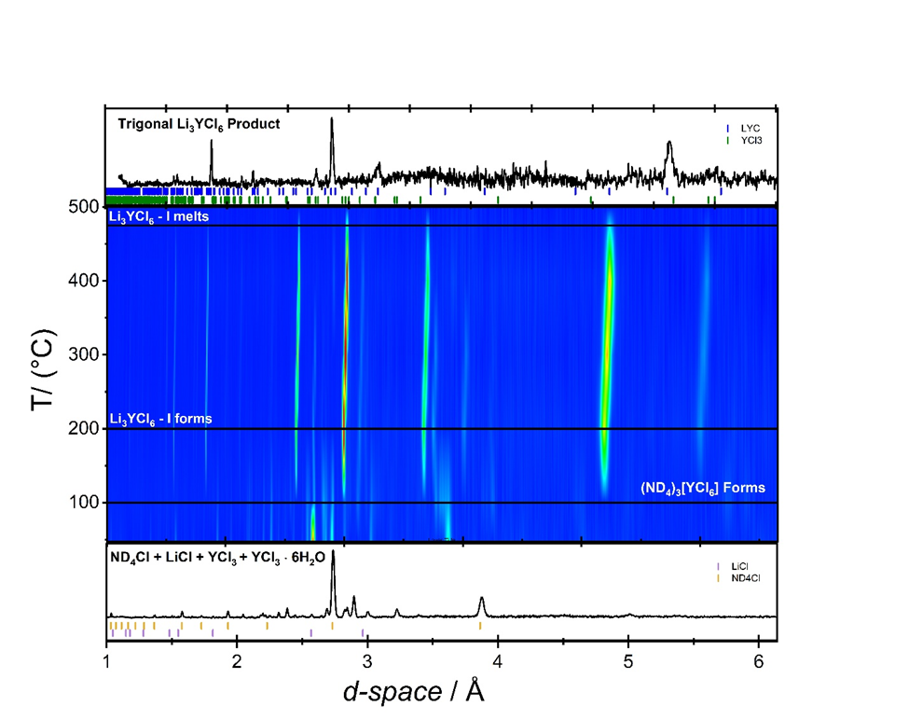

Figure 10. Visualization of the AC synthesis pathway using in situ neutron diffraction. The figures are the intensity contour plots of neutron diffraction patterns during heating from 47°C to 500°C and. The initial NPD pattern is the precursors after dissolution and vacuum drying prior to ramping, the final NPD pattern is the RT product obtained after ramping and cooling.

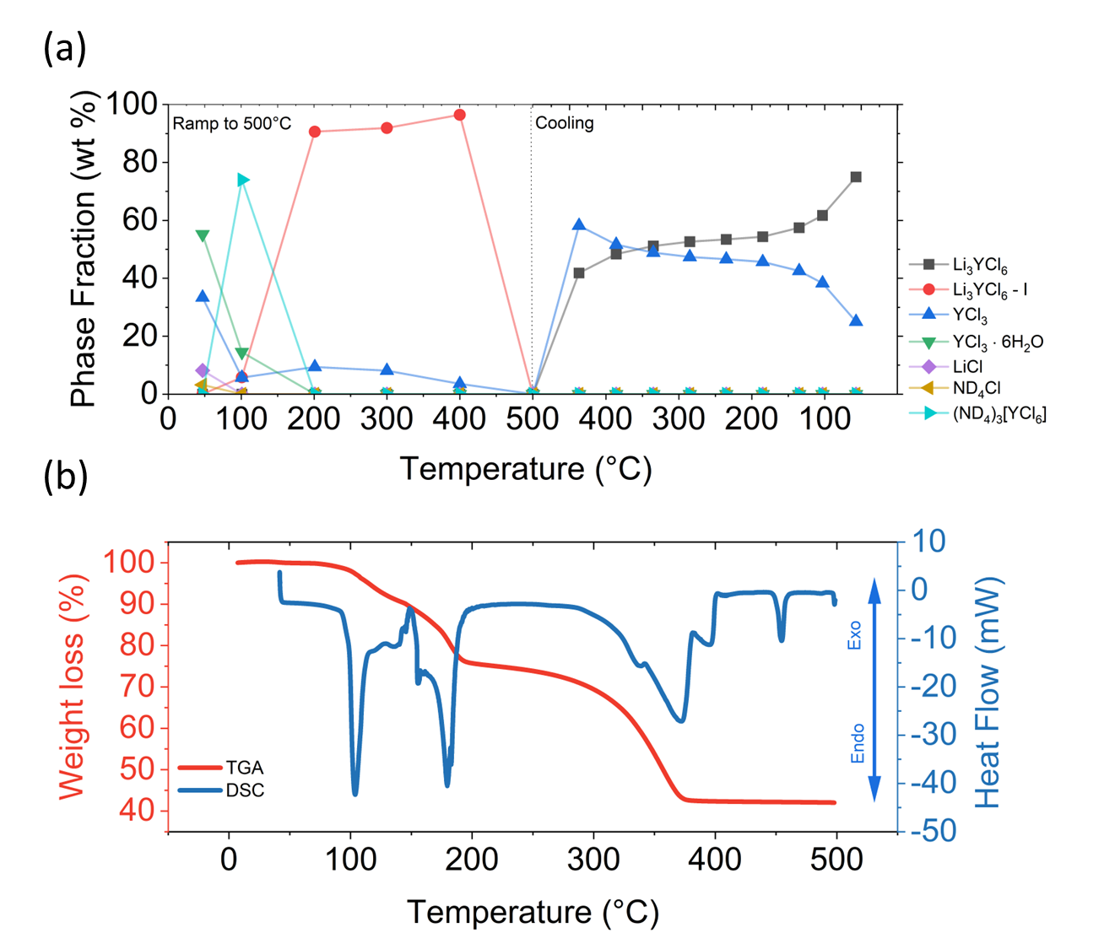
Figure 11. (a) Crystalline phase evolutions for the synthesis of Li3YCl6 through the AC route (b) Thermal analysis of the starting materials after dissolution and drying at 90°C under vacuum upon heating.

Compare this to the AF sample contour plot (Fig. 12) which begins with the presence of LiCl and YCl₃ • 6 D₂O phases present post vacuum drying, while no anhydrous YCl₃ phase is observed in the NPD data. We do not observe a large endothermic process at 100 °C in Fig. 13b associated with the formation of intermediate complexes as observed for the AC route. However, as the sample is heated to 175 °C, the DSC curve shows a large endothermic process (reaction 1). This feature is associated with the consumption of the YCl₃ hydrate as the NPD shows that at 200 °C, YCl₃ hydrate vanishes, and LYC phase forms while LiCl remains (after decreasing in intensity). The consumption of the YCl₃ hydrate also results in the formation of YOCl impurity phase, which is formed around 350 °C (3rd endothermic process) and is in agreement with other reports regarding heating YCl₃ hydrates.²³ The formation of Li₃YCl₆ is captured by the second smaller endothermic process in the DSC (~230 °C). We note that the LYC-I phase in the AC route forms prior to 175 °C, whereas for the AF route, the tetragonal LYC formation occurs during the temperature ramp. This fact demonstrates that the synthesis routes result in differing intermediate phases and reaction kinetics. The LiCl consumption and Li₃YCl₆ phase increase continues until 500 °C, where Li₃YCl₆ melts, leaving behind insoluble YOCl and LiCl phases. DSC shows this melting as a smaller endothermic peak at 475 °C, commensurate with the less efficient Li₃YCl₆ formation from this route. Upon cooling, Li₃YCl₆ is reformed (~475 °C) and LiCl impurities remain in large amounts throughout the process. The Li₃YCl₆ formation from the AF route was significantly less than the AC route (45 and 75 wt.% respectively) is due to the significant consumption of the YCl₃ precursor in the formation of YOCl impurities during heating leading to significant unreacted LiCl. From the above comparison, ammonium chloride is required to protect the YCl₃ precursor from hydrolysis during heating.

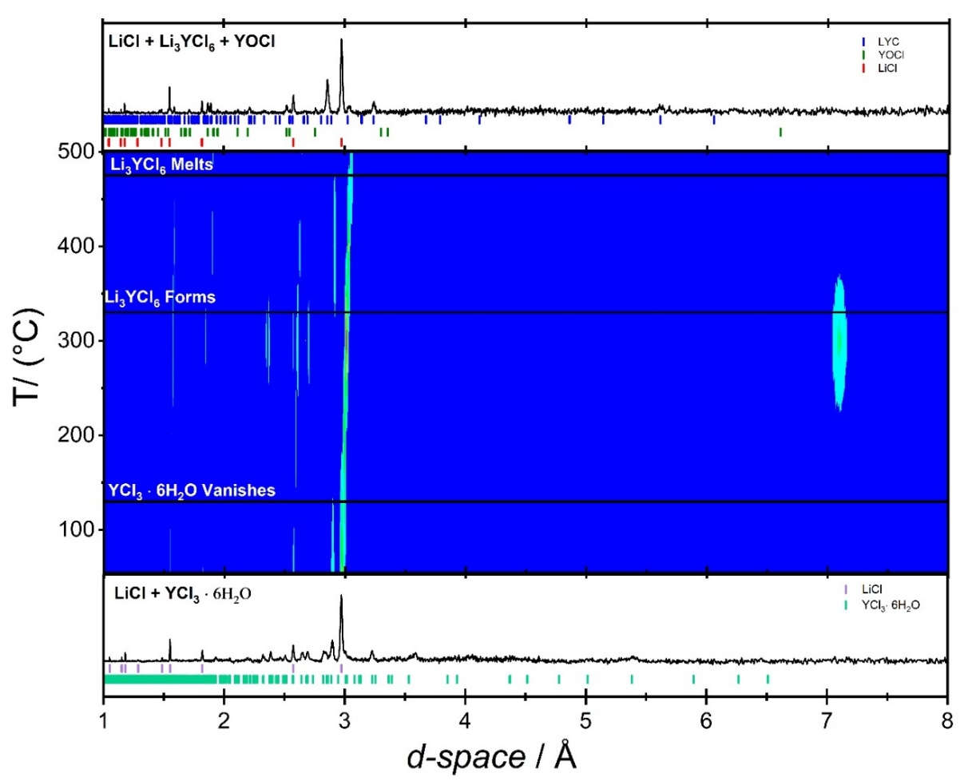
Figure 12. Visualization of the AF synthesis pathway using in situ neutron diffraction. The figures are the intensity contour plots of neutron diffraction patterns during heating from 55°C to 500°C and. The initial NPD pattern is the precursors after dissolution and vacuum drying prior to ramping, the final NPD pattern is the RT product obtained after ramping and cooling.

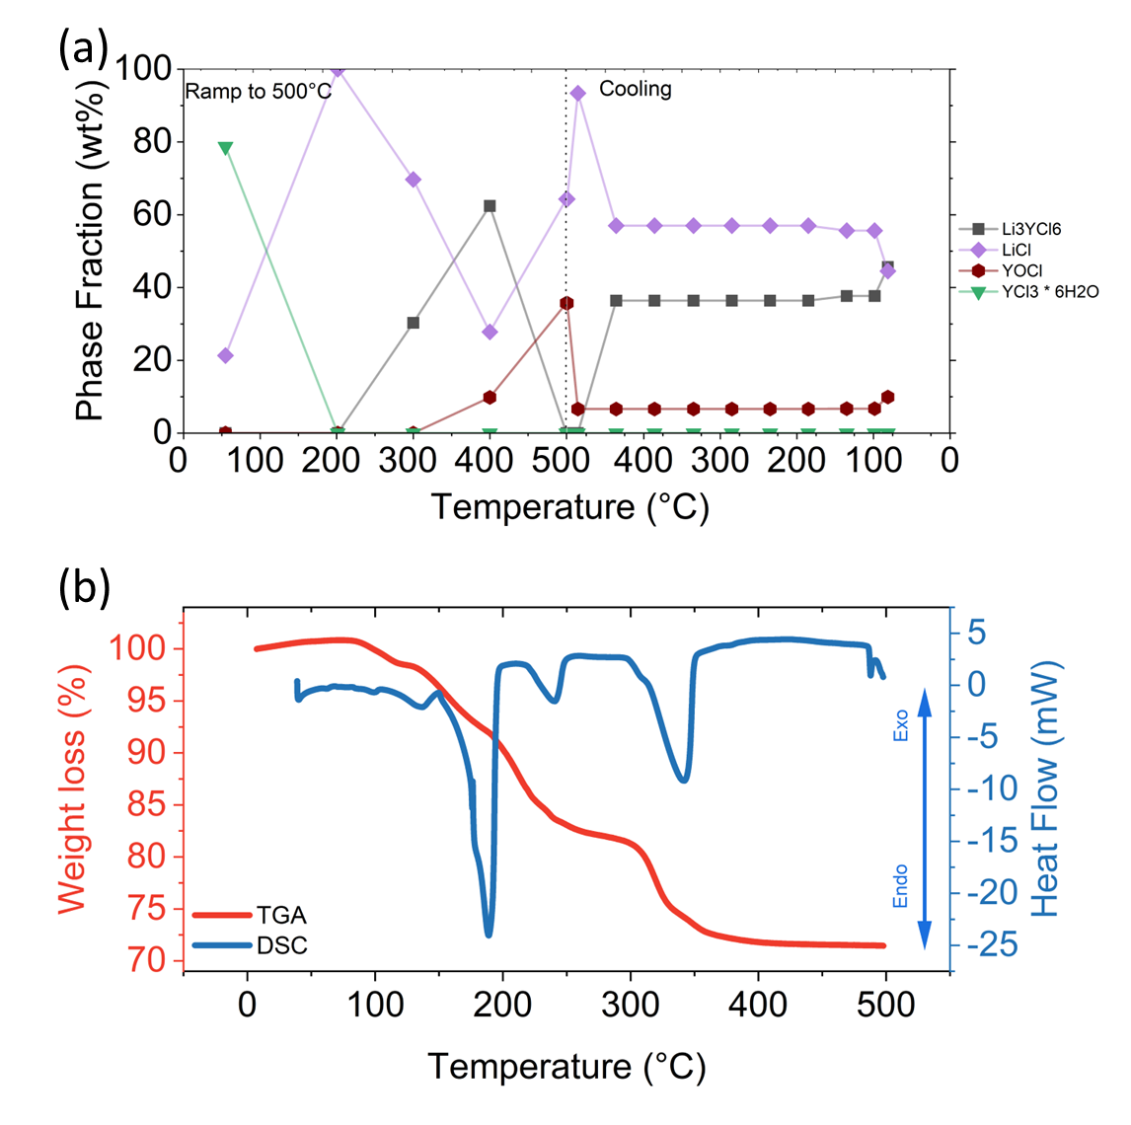
Figure 13. (a) Crystalline phase evolutions for the synthesis of Li3YCl6 through the AF route (b) Thermal analysis of the starting materials after dissolution and drying at 90°C under vacuum upon heating.

Finally, we examine the phase evolution of the MCA sample after planetary milling of LiCl and YCl₃ for 24h. Figure 14 demonstrates that this synthetic route is much less complex than the solution-based routes. After milling, LYC has already formed with LiCl still being present, 68 and 32 wt.% respectively (Fig 15a). Interestingly, no features from YCl₃ are observed, though may be present as an amorphous phase. Heating the sample results in LiCl phase decreasing, which coincides with a small endothermic process seen in the DSC curve (Fig 15b). Crystalline YCl₃ is observed at ~ 200 °C, suggesting its presence as an amorphous phase at the beginning. After 275 °C, an endothermic process is observed and the YCl₃ phase starts to decrease in the NPD plot. At 475 °C, we once again observe LYC melting. As the sample cools, Li₃YCl₆ and residual YCl₃ are present at room temperature, 91 and 9 wt% respectively. This YCl₃ is unreacted because an excess amount was added prior to planetary milling the sample to account for any coordinated water on the starting material. Unlike the AC route, only the trigonal LYC phase is observed during this reaction. However, the initial starting material is likely nanocrystalline in nature and, as will be discussed later, has a significant amount of Y2 – Y3 site disorder in-line with previous reports^{24,25}.

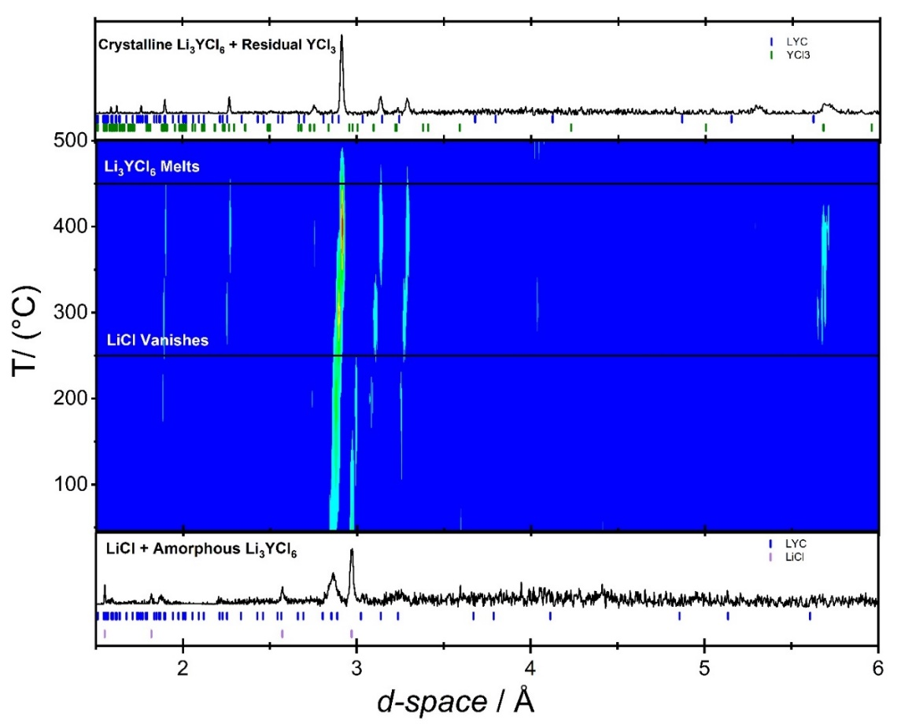
Figure 14. Visualization of the MCA synthesis pathway using in situ neutron diffraction. The first NPD pattern shows the initial scan taken of the precursors after planetary milling prior to ramping. The middle figure is the intensity contour plot of neutron diffraction patterns during heating from 46°C to 500°C. The final NPD pattern shows the product formed after ramping and cooling measured at 83°C.

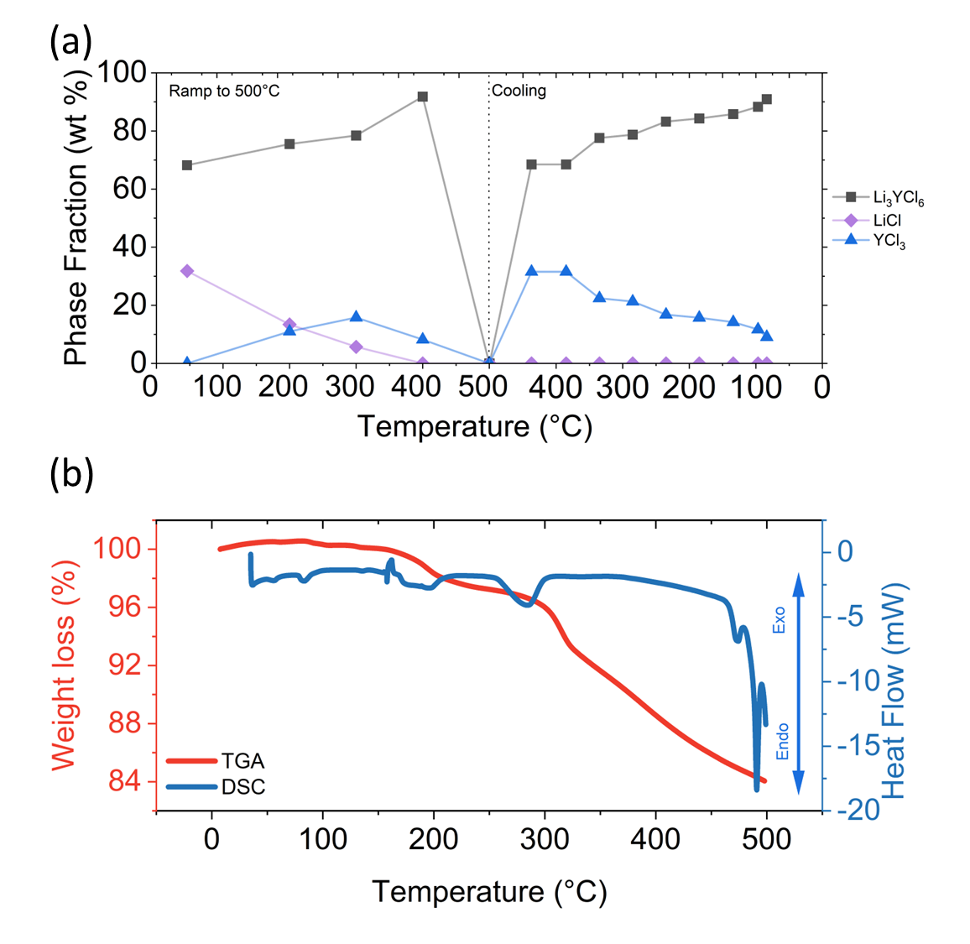
Figure 15. (a) Crystalline phase evolutions for the synthesis of Li₃YCl₆ through the MCA route (b) Thermal analysis of the starting materials after planetary milling.

The formation and structure of the (ND₄)₃[YCl₆] was isolated by mixing ND₄Cl + YCl₃ + D₂O to form the complex halide intermediate and the phase evolution was observed using in situ NPD. The temperature dependent stack plot shown in Fig. 16 shows the initial sample containing both ND₄Cl and YCl₃ peaks. As the temperature reaches 100 °C, the ND₄Cl peaks vanish and the AYC peaks form, being stable up to 250 °C. From the thermal analysis, we see that the initial dehydration and then formation of the complex halide are convoluted between both the 1st and 2nd endothermic processes in the DSC. Interestingly, when the complex halide was observed during the AC phase evolution it was only stable during the dehydration and the peaks vanished as the temperature reached 175 °C. This could signal that the decomposition of the intermediate and formation of LYC is a fast process. This also likely shows that the reaction to form LYC from the complex through replacement of ND₄ (or NH₄) with Li is thermodynamically and kinetically favorable under these conditions. Which is reinforced by the fact that Meyer et al. proposed a decomposition (ND₄)₃[YCl₆] according to reaction in Eq. 5 around 385 °C further decomposing back into the YCl₃ and NH₄Cl at around 425 °C which we do not see an evidence of in the LYC AC route.²⁶ However, we also do not observe the presence of large amounts LiCl during the AC phase evolution prior to forming Li₃YCl₆, which could signal the existence of a distinct (NH₄)₃[YCl₆] • 3 LiCl composite structure.¹¹ We note that when comparing the thermal analysis of all the aqueous processes (Fig 11b, 13b, 17) show an approximate weight loss of 30% from room temperature to 200 °C, corresponding to D₂O being removed from the structure. Ammonium chloride allows water to be removed from YCl₃ ∙ 6 H₂O without hydrolysis to YOCl at lower temperatures by shifting the structure from coordination with water to a hexahedral coordination with Cl⁻. When we consider the last two endothermic processes in Fig. 17, they do not seem to directly correlate to any observed changes in the in-situ NPD data. Some possible explanations for this can be gleaned from a similar process observed in the other samples. For the MCA sample, we observe a similar small endothermic peak coinciding with the crystallization of YCl₃, which could coincide with the YCl₃ observed in the 150 and 250 °C NPD data. Previous work observed a phase transition of NH₄Cl from an alpha to a beta high temperature phase at 180 °C, however we do not see the characteristic strong reflection for this phase in the NPD data (3.298 Å).²⁶ The final small endothermic process ~250 °C (labeled 4 in Fig. 17) could be the consumption of residual YCl3, as observed in the AF reaction route. However, we do not see any YOCl formation in the NPD because we did not proceed to the crystallization temperature of the impurity (~330 °C) during the heating of the complex.
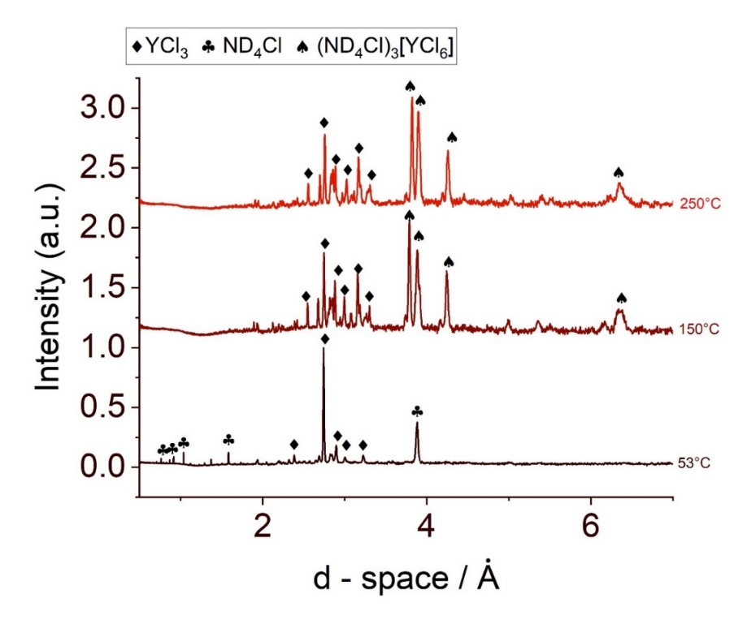
Figure 16. Visualization of the formation of the (ND₄)₃[YCl₆] complex halide intermediate via in situ NPD temperature dependent stack plot of the phase evolution
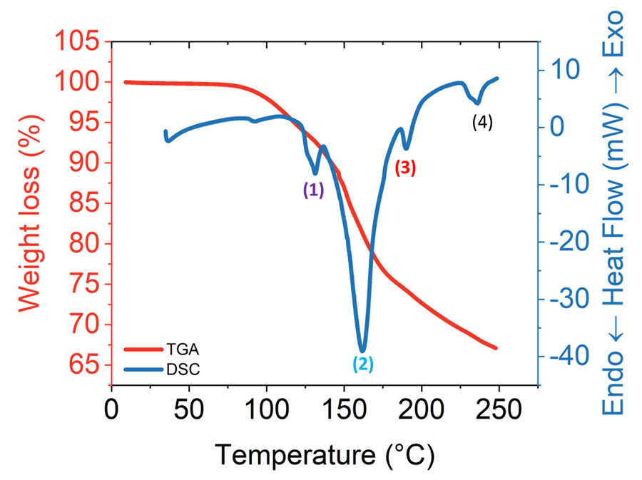
Figure 17. TGA-DSC curves for the formation of the complex halide intermediate

Figure 18 summarizes the results of the Rietveld refinement of the in-situ NPD data and the resulting thermal expansion coefficients for the volume and lattice parameters a and c for the trigonal LYC structure during the cooling step. Figure 19 provides a visualization of the crystal structure obtained from NPD refinement of the LYC-MCA product, as shown in Fig. 20c. The linear fitting functions as summarized in Table 1 (Appendix of this chapter) show similar linear behavior for all three LYC samples as they are cooled from melting (500 °C) to below 100 °C. The values for the liquid derived samples are similar, 1.350 and 1.362 x 10⁻¹ Å³ K⁻¹ for the AC and AF samples respectively, while the MCA value is smaller, 1.288 x 10⁻¹ Å³ K⁻¹. The thermal expansion coefficients along the c direction within the three different samples are quite large following the order of AC > AF > MCA (6.5318, 6.3438, and 5.9297 x 10⁻⁴ Å K⁻¹, respectively). The rate of expansion along the a (a = b) axis deviates from the trends, 5.1345, 5.4362, and 5.1961 x 10⁻⁴ Å K⁻¹ for the AC, AF, and MCA samples. Here, the expansion along the a-direction is similar for the MCA and AC samples. The linear fit for the temperature dependence of the lattice parameters for LYC agrees with a recent study that reported these values, albeit in a lower and narrower temperature range (150-300 K).²⁷ The lattice for mechanochemically synthesized LYC was found to be larger than the product of the classic solid-state route. This expansion in unit cell volume was driven by anisotropic expansion along the c-direction. In addition, the solid-state synthesized sample had more ordering of the Y2-Y3 sites. Furthermore, this was also found to track with microstructural relaxation, indicated by the reduction of the slope in a Williamson – Hall analysis.
In Fig. 31 (appendix), a comparison of the lattice parameter values across synthesis routes is shown. The lattice volume is ordered from AC>MCA>AF, while the a-parameter is MCA>AC>AF, and the c parameter is AC>AF>MCA. Thermal expansion of the LYC MCA sample during ramping (Fig. 34 appendix) was analyzed to understand differences in behavior before and after melting. In both the ramp up and cooling after melting, the differential lattice parameters are larger in the c direction compared to a direction. When compared to the cooling data, the anisotropic expansion in the c-direction occurs faster during ramping. Like the differences cited amongst the solid-state and mechanochemical products in the literature, we observe a difference in values between the AC and mechanochemical products. Previous studies comparing the solid-state and solution-based synthesis of LYC found that the solution synthesized samples experience expansion along the c-axis but contraction along the a and b axes. This was attributed to the localized microstrain caused by small nanosized crystallite and particle sizes compared to the micron sized particles observed for solid-state reaction routes¹¹. Our results show a significant difference in the degree of expansion along either the a or c direction as a function of temperature across synthesis routes, primarily between the solution derived (AC, AF) and solid-state (MC) synthesized samples. Combining this with literature reports, it seems that microstructure and local structure (Y site disorder) both play a role in determining the direction of changes within lattice parameters of the LYC system.

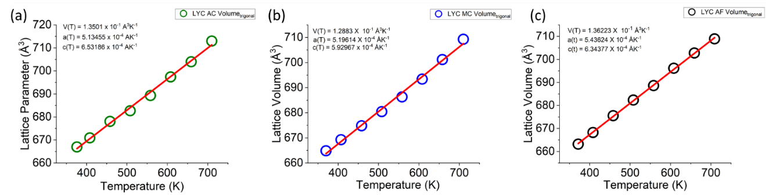
Figure 18. Parametric Fitting of Trigonal LYC during cooling for (a) LYC – AC pathway (b) LYC – MC pathway (c) LYC AF pathway

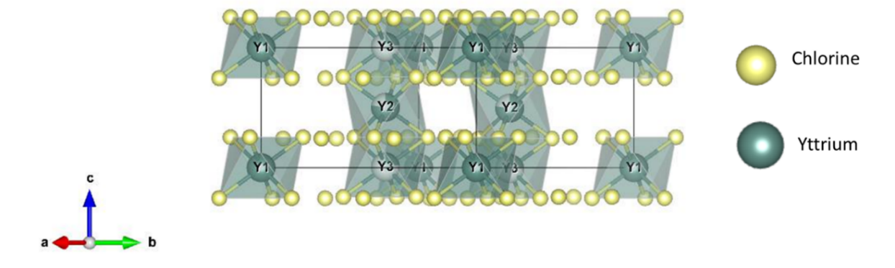
Figure 19. Crystal Structure of LYC-MCA obtained from NPD refinement.

In Fig. 20 the Rietveld refinement results for NPD data collected on each of the three products within sealed vanadium cans at room temperature is shown. We observe similar trends in terms of the phase purity of the samples, in the MC sample we do not observe any YCl₃ after milling but do find some LiCl (2.4 wt%). Both the AC and MCA samples after annealing feature residual YCl₃ (9 and 5.4%) likely due to the excess that was added at the beginning of the synthesis to account for water coordination. Although ex-situ NPD was not collected for the LYC AF product, Fig. 36 (Appendix) compares the ex-situ XRD with the LYC AC product showing small LYC formation and large amounts of YOCl and LiCl impurities and the opposite when the NH₄Cl is incorporated into the synthesis. In Fig. 37 (Appendix) the LYC MCA and MC samples XRD are compared, interestingly prior to annealing, XRD does not show any LiCl differing from the neutron data. However, we do see the presence of residual YCl₃ after annealing, as we do in the ex-situ and in-situ NPD. When comparing the lattice parameters of the MC and MCA samples obtained from NPD, we find that the upon annealing, the lattice volume contracts from 662.128 to 659.022 Å³. While we note that the lattice parameters a and c contract from 11.2348 to 11.2202 Å and 6.0573 to 6.0493 Å respectively. Compared to the AC sample, we find that it has a similar lattice volume to the MCA sample at 659.022 Å³. It is possible for the differences in lattice parameters to be driven by Y2-Y3 site disorder, where zero site disorder would correspond to 100% occupation of the Y2 site. Upon milling, the MC sample starts with 39% site disorder and after annealing this is reduced to 22% site disorder for the MCA sample. This trend of decreasing site disorder as a function of annealing agrees with previous reports.²⁵
The microstructure of both the Cathode Active Material (CAMs) and Solid electrolyte particles has been shown to have a large effect on ASSB performance.²⁸ In composite cathodes, the ratio between the two components is ideally 2 to 1 (CAM:SE), in order to maximize the contact between the two and provide ample ionic and electronic transport at the interface.²⁹ In addition to the composite cathode, SE particle size distribution has been shown to impact the processability and performance of cast SE separators.³⁰ To understand the impact of the synthesis route on microstructure, we used SEM to observe both the morphology of the resulting particles and their size distribution (Figure 21). The leftmost column in this figure shows the 100x magnification of each sample (Fig. 21 a,d and g). Each sample contains a wide distribution of particle sizes ranging from > 100 µm to < 1 µm. The middle column shows the 10kx magnification to show the distribution of particle sizes at the lower end. The LYC AC sample (Fig. 21b) contains smaller platelet shaped particles ranging from 845.4 nm to 2.023 µm in size. While the LYC MC sample (Fig. 21e) has smaller platelet particles ranging from 247.9 nm to 605 nm in size. Finally, the LYC MCA displays that as the MC sample is annealed these smaller particles do increase in size, ranging from 370 nm to 1.458 um in size. The overall distribution obtained from the image analysis supports these trends, giving an average particle size of 15.7, 31, and 40.7 µm for the LYC MC, AC, and MCA samples respectively. From these samples, we can observe that high temperature treatments associated with either the liquid phase or mechanochemical routes tend to increase the average particle size of the resulting LYC. Future work should focus on further exploring the effects of synthesis and processing parameters such as annealing time, temperature, ramp rate, cooling rate,

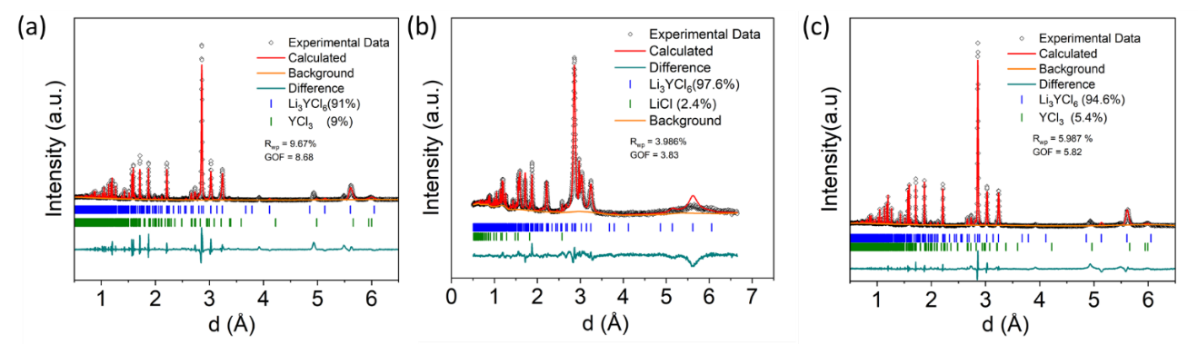
Figure 20. Rietveld refinement against the NPD of (a) LYC-AC (b) LYC-MC (c) LYC-MCA products.
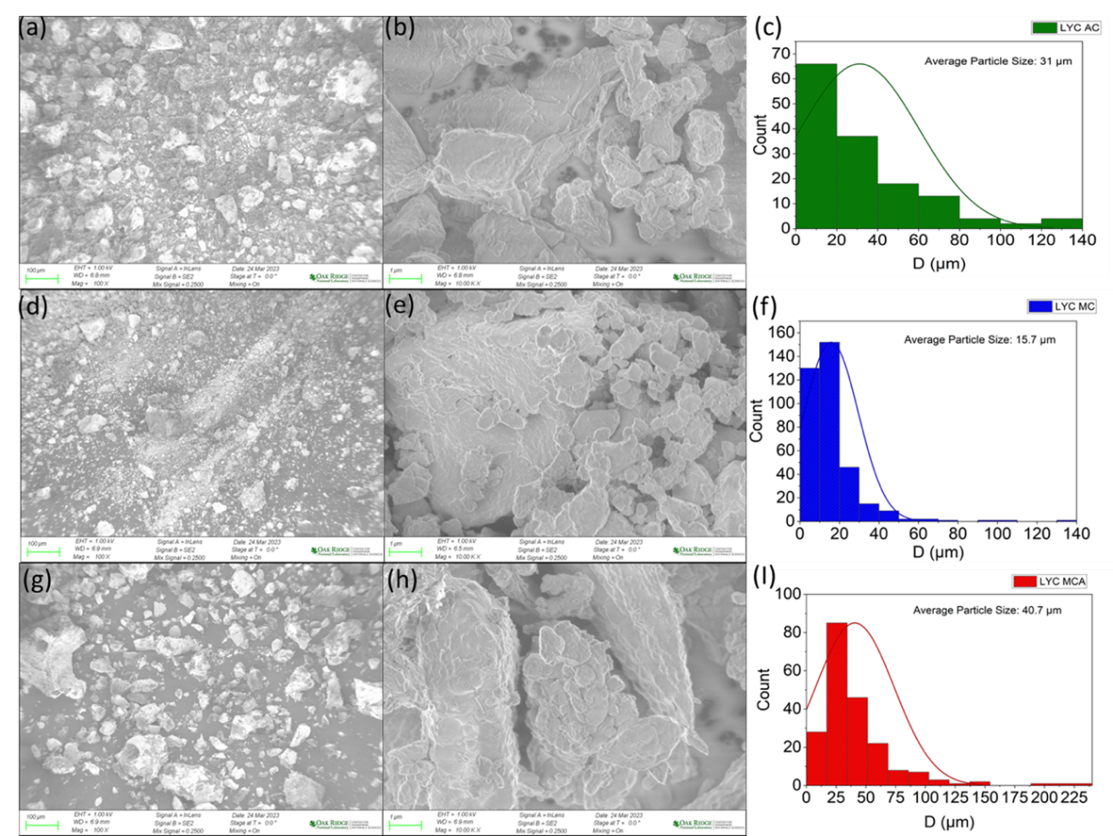
Figure 21. SEM images (100x magnification: a,d,g 10kx magnification: b,e,h) and particle size distributions for (c) AC (f) MC (I) MCA samples.

solvent treatments, hot pressing and other methods on the particle size distribution and morphology of the resulting solid electrolytes.

Synthesis – Structure – Performance Relationship For Li₃YCl₆
Recent literature reviews have established the significant relationship between synthesis route and solid electrolyte properties, ranging from the room temperature ionic conductivity to the electrochemical stability window.^{16,31} We used electrochemical impedance spectroscopy (EIS) to investigate the impact of synthesis route on the ionic conductivity and activation energy. The activation energy is calculated by the Arrhenius Equation 19

${\text{σ}}_{\text{ionic}}\text{=}{\text{σ}}_{\text{0}}\text{exp}\left(\text{-}\frac{{\text{E}}_{\text{a}}}{{\text{k}}_{\text{B}}\text{T}}\right)$ (19)
where $σ_{0}$ , $k_{B}$, and T are the temperature-independent Arrhenius prefactor, the Boltzmann constant, and the absolute temperature respectively. $σ_{0}$represents the frequency of lithium hopping events at a standard carrier concentration within the solid ionic conductor^{32,33}. Figure 22a displays the comparison of the Arrhenius behavior for the total conductivity of the Li₃YCl₆ M, MCA, and AC products. The activation energy for the total conductivity of the MC and MCA samples are 0.347 ± 0.001 and 0.348 ± 0.002 eV, respectively. This is further confirmed by the total conductivity of the MCA sample which is lower than that of the pure mechanochemical sample, this is driven in-some part by annealing induced ordering within the sample. This is in line with previous reports regarding the effect of annealing time on the mechanochemically synthesized Li₃YCl₆ where it was observed that the conductivity decreased as the milled sample was annealed for longer periods of time ranging from 1 minute to 1 hour.²⁵ This was attributed to the large amount of M2-M3 site disorder induced during milling and the subsequent reordering caused by annealing.
To gain more insight into the differences amongst the samples, the bulk, and grain boundary processes were deconvoluted as shown in Fig. 23(a), for the LYC-AC. An example of the equivalent circuit fit used to deconvolute the spectra is shown in Fig 22b. For the LYC AC sample the room temperature bulk conductivity comes out to be 0.568 mS/cm while the grain boundary conduction is 0.0433 mS/cm more than an order of magnitude lower. The activation energy of the grain boundary conduction is 0.394 eV while the bulk process is 0.218 eV, showing a similarly large difference. In addition, when compared to the MC and MCA samples, the grain and bulk processes do not converge in the observed temperature range for the AC sample. Similarly, the bulk process activation energy is higher than for either the MC or MCA samples, which could be correlated to differences in local structure primarily site disorder. For the LYC MCA sample, we see a much smaller difference in the two processes at 35 °C, 0.42 mS/cm for the bulk vs. 0.21 mS/cm for the grain. In Fig. 23c, this manifests at 65 °C as the convergence of the two values. The activation energy for the bulk process is 0.169 eV vs. 0.282 eV for the grain boundary. When we compare this to the LYC MC prior to annealing, we see that the activation energies for both processes are lower 0.150 and 0.225 eV, respectively. The rise in the activation energy for the bulk process signals a slowing down after annealing as previously discussed, this is due in some part to the ordering of the Y2-Y3 sites. The change (a 12.7 % increase in the activation energy) is like the 17% reduction in site disorder observed in the NPD data. However, we also observe an increase of 25.3% in the activation energy corresponding to the grain boundary conduction. This shows that microstructure has an equal if not greater importance in determining the ionic transport properties of LYC and must be optimized during synthesis or processing.

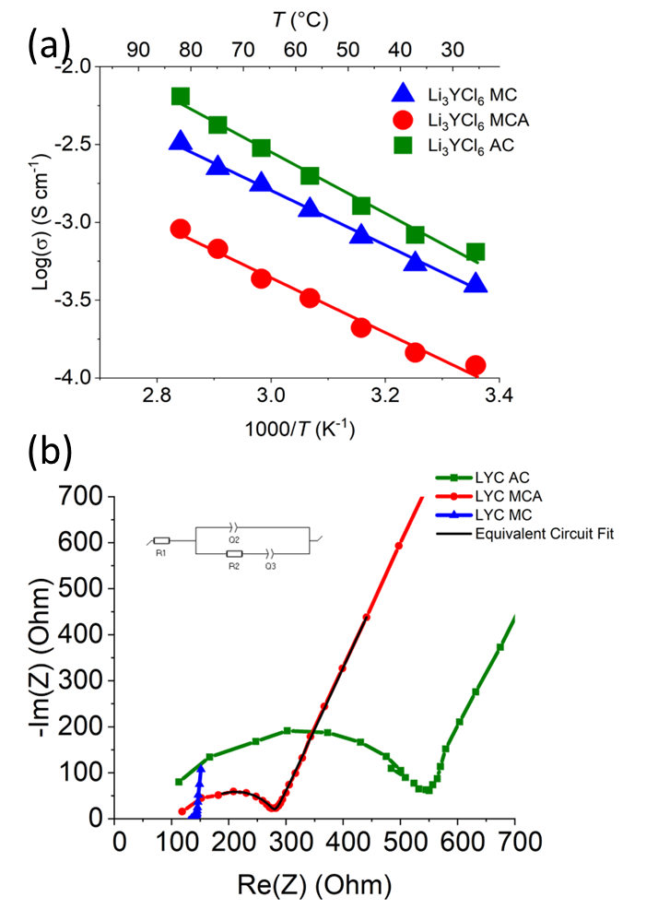
Figure 22. (a) Arrhenius plot comparison for the Li₃YCl₆ M, MCA, and AC samples total conductivity (b) Representative Nyquist plots of each sample at 35°C. (c) Representative fit of the Nyquist plot and equivalent circuit for the LYC MCA sample at 35°C.

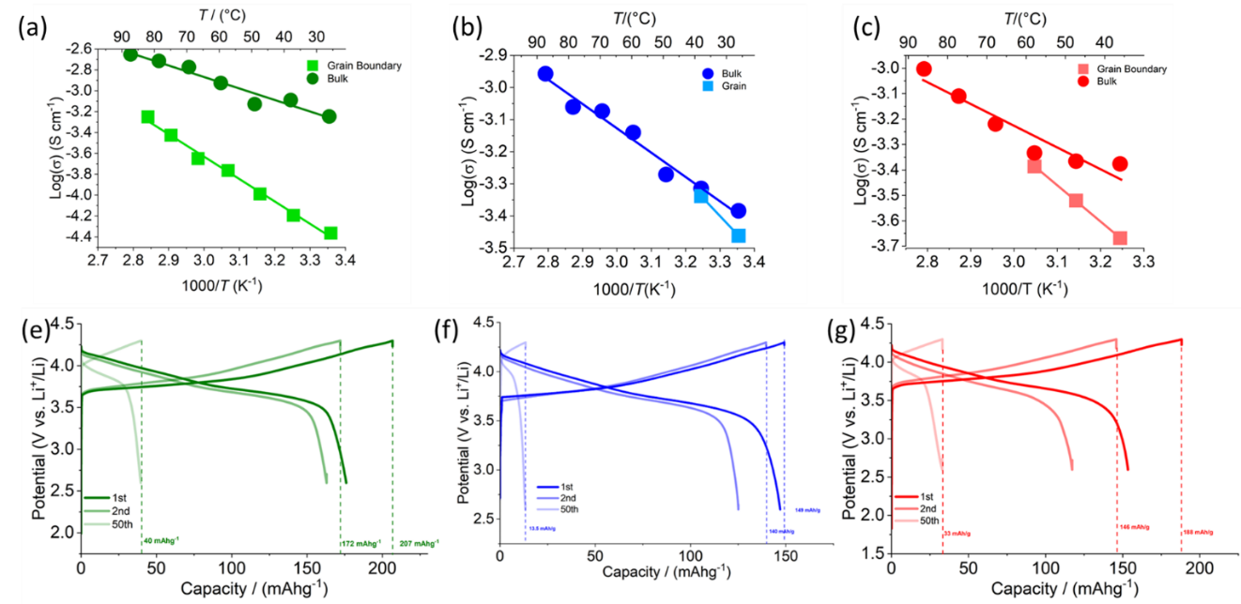
Figure 23. Comparison of the Arrhenius behavior for bulk and grain boundary conduction in: (a) AC (b) MC (c) MCA products. Charge – Discharge Behavior Comparison for: (d) LYC-AC (e) LYC-MC (f) LYC-MCA cells

Recent work has shown that electrochemical performance can be affected by the choice of synthesis route for both sulfide and halide solid electrolytes.³⁴ In order to understand this relationship for Li₃YCl₆ LiNi_{0.8}Mn_{0.1}Co_{0.1}O₂ (NMC811)/Li₃YCl₆/Li-In cells were constructed for the Li₃YCl₆, M, MCA, and AC samples. A lithium indium anode was used in place of lithium metal because Li₃YCl₆ has been shown to be unstable against lithium metal.³⁵ The alloy was formed by lithiating indium foil on the first charge cycle of each cell. Figure 23e-f presents the initial charge-discharge capacities for each cell at 66 µA/cm², in which the Li₃YCl₆-MCA cell has a much higher initial charge capacity, 188 mAh /g compared to just 148 mAh/g for the Li₃YCl₆ -MC but the initial loss between the 1st charge and discharge is also substantially higher for the Li₃YCl₆ -MCA cell, ~29% compared to just 0.7% capacity fade for the Li₃YCl₆ -MC cell. However, the capacity retention for the LYC-AC cell is improved in comparison to the others, and this is likely due to both improvements in particle size distribution and the bulk ionic conductivity. In this instance the first cycle loss was approximately 13%, this is believed to be a function of both the lithiation of indium metal during the first charge to form the Li-In alloy and contact loss within the composite cathode due to volume expansion of the NMC811 active material.³⁶ The improvement in ionic conductivity of the electrolyte within a composite cathode has been shown to have dramatic improvements in cycling stability of halide based ASSBs, this is one factor behind the improvement in capacity retention observed for the LYC-AC based cell³⁷.

The ionic conduction environment of the composite cathode was investigated further through electrochemical impedance spectroscopy, shown in Fig. 25. The LYC -MCA cell experienced a significant change in the high-frequency intercept from 398 ohms prior to cycling to 438 ohms after the 1st cycle, while the LYC-MC cell experienced a much smaller shift of 146 to 156 ohms. For the LYC-AC cell, we observe an intercept prior to cycling of 323 ohms, while after the initial cycle this increases to 356 ohms. This change in resistance before and after the 1st cycle do correlate with losses from 1st cycle charge to discharge, pointing to initial contact loss during expansion and contraction as a source of capacity fade and increasing resistance. After the initial formation of the Li-In alloy anode, the cells were cycled at 0.1 mA/cm² for 50 cycles, the cycling performance for which is compared in Fig 24. The initial capacities of the Li₃YCl₆-M cell are higher to 150 mAh/g compared to 120 mAh/g for the LYC-MCA, however the capacity retention is greater after 50 cycles at 40 mAh/g vs. just 20 mAh/g for the LYC-M sample. After cycling, the high frequency intercept of the Li₃YCl₆-M sample shows an increase from 143 ohms to 155 ohms, while the Li₃YCl₆-MCA experiences a much greater shift from 398 ohms to 510 ohms. The LYC-AC cell not only has the highest initial capacity but also the best capacity retention.
To better understand the impacts of cycling on the state of the cathode/solid electrolyte interface, a Transmission Line Model (TLM) was fit to the data for the LYC MCA cell before cycling and after 50 cycles. TLM can be used to determine valuable parameters relevant to battery performance such as the tortuosity, McMillan number and porosity.^{38,39} The McMillan number relates the ionic conductivity of a solid electrolyte to the effective ionic conductivity of a porous electrode or separator.⁴⁰ The McMillan number is calculated by Eq. 2
${\text{N}}_{\text{m}}\text{ = }\frac{\text{τ}}{\text{ε}}\text{ = }\frac{{\text{R}}_{\text{ion ∙ A ∙ κ }}}{\text{d}}$(20)
Where R_{ion}, A, κ, d are the ionic resistance through the electrode, cross-sectional area of the electrode, intrinsic conductivity of the electrolyte, and thickness of the electrode respectively.³⁸ A representative fit of the TLM to the observed data is shown in Fig. 32 (Appendix). We see for the LYC MCA cell; the composite electrode experiences a significant increase in the McMillan number from 3.3 before cycling to 8.4 after 50 cycles (Table 2). This increase in porosity could be due to a few factors, such as loss of contact between NMC and LYC particles due to cracking or volume change during cycling. This increasing porosity can be interpreted as increasing degradation of the connectivity of the composite cathode, which could explain the significant capacity fade observed during cycling.³⁷

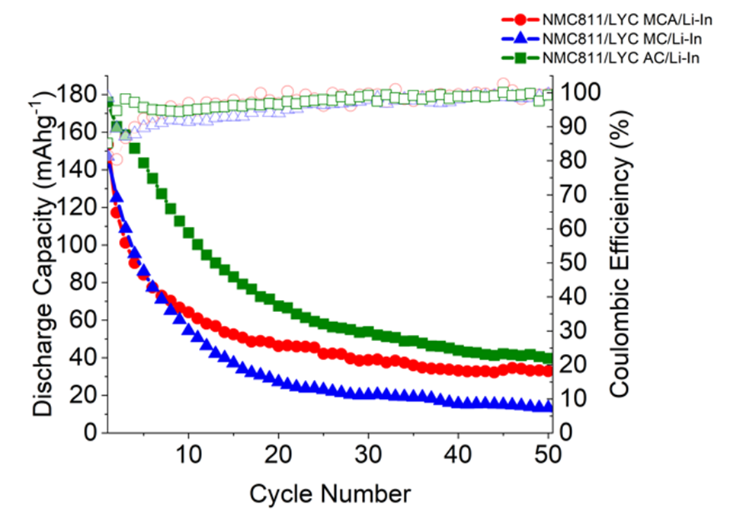
Figure 24. Cycling performance comparison for NMC811/Li₃YCl₆/Li-In Cells.

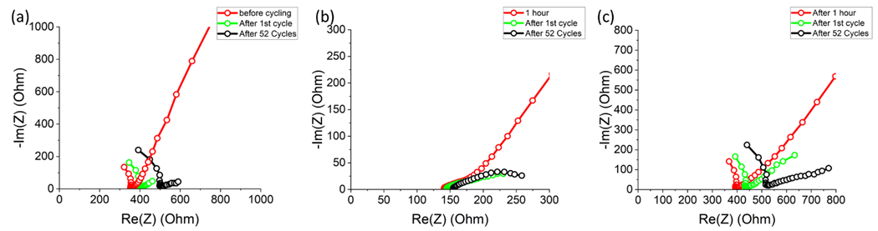
Figure 25. Electrochemical Impedance Spectroscopy Comparison for NMC811/Li₃YCl₆/Li-In cells for pristine, after 1st cycle, and after 52 cycles for: (a) LYC-AC (b) LYC-MC (c) LYC-MCA

To better understand the role of synthesis route on surface chemistry and eventual cell performance, each of the LYC samples were characterized by XPS (Fig. 26). In the initial survey scan, a wide energy range was used to catalog all the elements present in the samples. All the samples show Li, Y, Cl, C, O and F present. We see that the C 1s spectra shows three bonding configurations C-C bonds, C-O bonds, and a small carbonate peak (Fig. 26b), the MCA and AC samples both show more of the C-O bonds present. The O is similar for all samples, with the C-O bond being higher in the MCA and AC samples, corresponding to the similar trend observed for the C 1s spectra (Fig. 26c). The Cl 2p spectra for the MC sample could be fit with one doublet but the spectra for the MCA and AC samples required two doublets (Fig. 26f) signaling multiple chlorine containing phases. We see a similar trend with the Y 3d spectra, where for the MC sample a single peak was sufficient, a double was required for the MCA and AC samples (Fig. 26e). The Li 1s spectra (Fig. 26d) shows that the MC sample had the most well-defined spectra, while it was weak for the MCA and AC samples. It is interesting that the two samples that were annealed had higher C-O bonds present. Based on the peaks present across the narrow spectra (O 1s 531.5 BE, C 1s 290 BE, Li 1s 55.1) this C-O bond seems to be coming from the formation of Li₂CO₃ on the surface of the samples.⁴¹ Although both samples were annealed under flowing Ar in an Ar glove box, it is possible that CO₂ was present in the glove box in small enough amounts and at high temperature especially could have reacted with the lithium, which is mobile at high temperatures to form the impurity.⁴² Another potential source of oxygen could have been water coordinated with the precursors, primarily YCl₃, which is very hygroscopic.⁴³ When we take the changes in the Cl 2p and Y 3d spectra into account with the previously discussed NPD and Raman data, the second Cl and Y peaks are likely due to the formation of YCl₃ impurities upon annealing. Finally, the presence of a more well-defined Li spectra for the MC sample that is less intense for the MCA and AC samples is due to the convolution of spectra from the amorphous Li₃YCl₆ and the crystalline LiCl impurity observed in the NPD. As we observed in both the in-situ and ex-situ NPD data, this impurity is consumed as more crystalline LYC forms at higher temperatures.
Further characterization was focused on understanding the surface chemistry of the upcycled composite electrodes for each of the three cells (Fig. 27). The C 1s spectra (Fig. 27b) shows four potential signals the carbonate, C-O, C-C, and low binding energy shoulder that is likely from carbide groups. The Cl 2p and Y 3d spectra (Fig. 27e,f) once again show the presence of two doublets for the LYC MCA and LYC AC composite cathodes. The Li 1s spectra (Fig. 27d) does not show a large difference for the three samples, with a single peak around 56 eV. This points to the peak likely being due to the presence of LYC on the surface of the composite cathode. Further reinforcement of this possibility is provided by the Ni 2p_{3/2}, Mn 2p, and Co 2p peaks in the survey spectra (Fig. 27a) are very weak and noisy and not clear enough signals to assign to the NMC811 particles. However, this peak position is also associated with many Li containing compounds often found on the surface of cathode materials such as NMC811 like Li₂Co₃, Li₂O, LiOH, and Li₂O₂.⁴¹
The analysis of the cycled cells differs from the composite cathodes in that the survey spectra (Fig. 28a) shows the presence of Ni, Mn, Co peaks to a greater extent and can be attributable to the NMC811 particles. Potential reasons for these significant differences could be the effect of compression during ASSB fabrication or volume expansion over many cycles of the AM, which could make them easier to detect on the surface of the cycled composite cathode. The C 1s spectra (Fig. 28b) shows similar features to the uncycled SEs and the composite cathodes. There is, however, a larger difference between the cells before and after cycling, meaning the presence of the carbide could be influenced by the cycling environment. The O 1s spectra (Fig. 28c) also show some large differences before and after cycling, particularly in the shoulder peak (528-529 eV) which could be due to NMC lattice O or an increase in Li₂O impurities during cycling. In the Cl 2p spectra, we only observe the single doublet 199 eV for each of the cells, signifying the presence of single Cl containing species (Fig. 28f). Likewise, in comparison to the composite cathodes and LYC samples, we only see a single doublet at 158.5 eV consistent with YCl₆ in the Y 3d spectra (Fig. 28e). However, for the LYC AC cell, we do observe a shoulder peak at 157.2 eV consistent with Yttrium-oxygen compounds such as Y₂O₃. Finally, when considering the Ni 2p_{3/2}, Mn 2p, and Co 2p spectra (Fig. 28g-i) we see that they are still noisy after cycling but are much more resolved and clearly indicate the presence of NMC within the cycled cell. Regarding the loss of the second phase previously indicated in the Cl 2p and Y 3d spectra, it is likely that the previous present YCl₃ impurities were consumed during cycling.
Recent work by Kechetkov et al. shows that halide solid electrolytes containing Y (Li_{5/2}Y_{1/2}Zr_{1/2}Cl₆) were susceptible to oxidation against Nickel rich cathodes such as NMC85 and LiNiO₂ forming YOCl and ZrO₂, but could stably cycle with low nickel chemistries such as NMC111.⁴⁴ Further study is required to understand the variety of decomposition products possible when cycling Li₃YCl₆ and related compositions with nickel rich cathodes within high voltages ≥ 4.3 V. For example, work is needed to isolate if the decomposition product was driven by the presence of impurities or electrochemical instability of the main LYC phase. When correlating the presence of the Y-O impurity with our cycling data, we find that LYC AC cell performed the best in terms of initial capacity and capacity retention. This suggests that the difference in performance is determined less by electrochemical stability and more so by differences in ionic conductivity due to differences in local structure and microstructure.

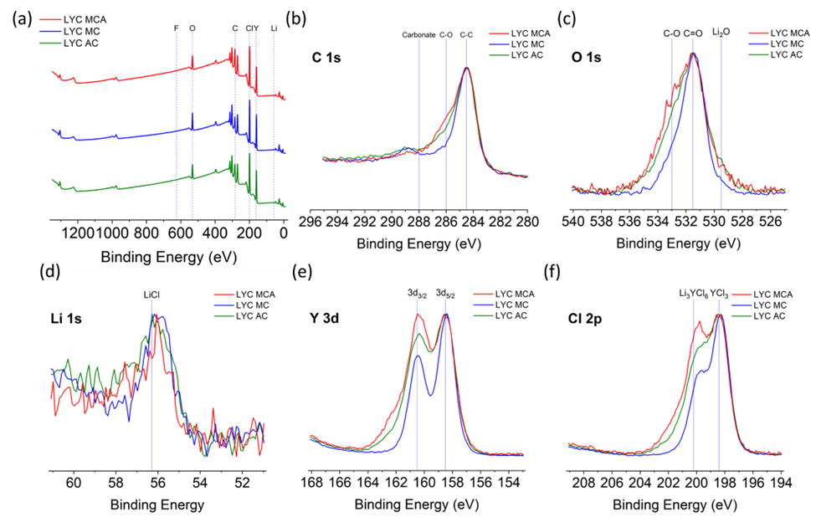
Figure 26. XPS characterization of each of the solid electrolytes (a) Survey spectra (b) C (1s) spectra (c) O (1s) Spectra (d) Li (1s) spectra (e) Y (3d) spectra (f) Cl (2p) spectra
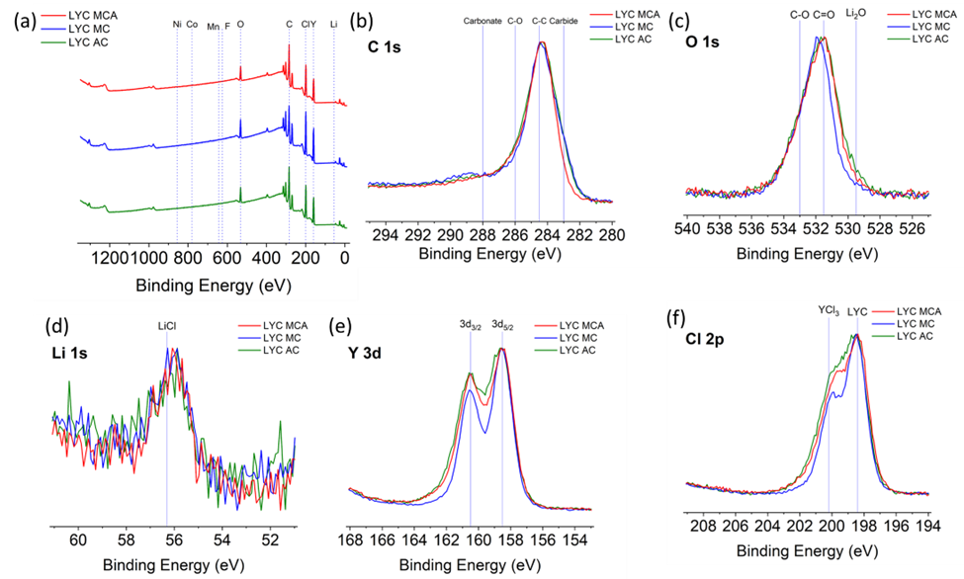
Figure 27. XPS characterization of each of the composite cathodes (a) Survey spectra (b) C (1s) spectra (c) O (1s) Spectra (d) Li (1s) spectra Y(3d) spectra (f) Cl (2p) spectra
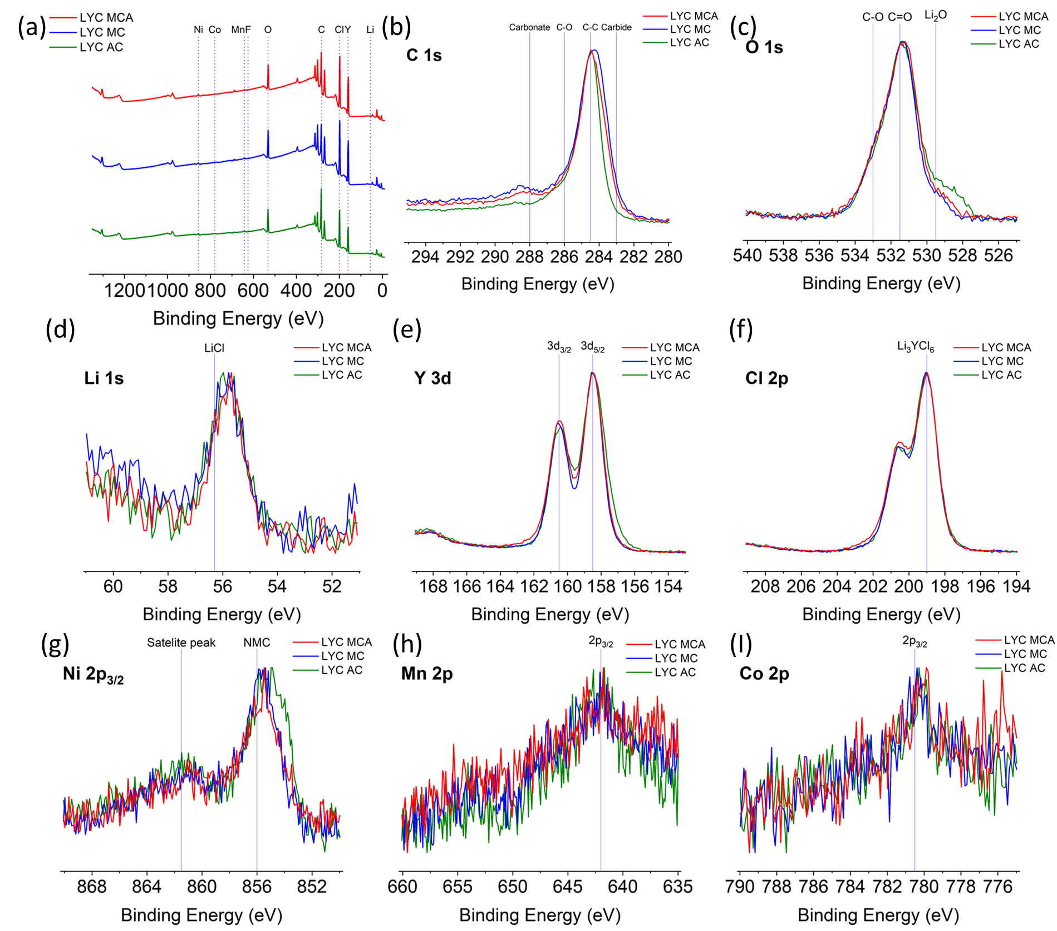
Figure 28. XPS characterization of each of the cycled cells (a) Survey spectra (b) C (1s) spectra (c) O (1s) Spectra (d) Li (1s) spectra (e) Y (3d) spectra (f) Cl (2p) spectra (g) Ni 2p_{3/2} Spectra (h) Mn 2p Spectra (I) Co 2p Spectra

Conclusion
For the Li₃YCl₆ properties to be optimized for use in either halide based, or bilayer based ASSBs careful consideration must be made as to the ideal synthesis route to use for both processing and optimization performance. Aqueous ammonium coordinated routes are a promising strategy for not only optimizing the performance of halide solid electrolytes but also the processing and eventually large-scale production. We present important information on the presence of complex halide intermediates necessary for enabling the synthesis of Li₃YCl₆ through aqueous routes. Control of this intermediate is the key to enabling process control for large batch reactor reaction engineering for halide solid electrolytes. Our work compares the reaction mechanism across multiple synthetic routes, showing that LYC formation differs in terms of intermediate phases and kinetics. LYC products were also found to differ in their ionic transport. These differences are shown to be driven both by changes in local and microstructure. We find annealing of LYC induces grain boundary formation regardless of synthesis route. These large differences in ionic transport manifest in differences in electrochemical performance displayed through Galvanostatic cycling with NMC811. Through a combination of XPS and EIS analysis, we show that the disruption of the percolation network in the composite cathode leads to significant capacity fade. XPS analysis shows evidence of chemical instability of LYC with layered oxide cathodes, consistent with recent reports. This chemical instability is suspected to be driven by oxygen evolution during cycling at the cathode/solid electrolyte interface. Potential future directions include optimization of processing parameters to enable microstructures with smaller grain boundary resistance and favorable particle size distributions, as well as the exploration of novel liquid-phase techniques compatible with higher and lower valence transition metal chlorides such as ZrCl₂ and HfCl₂.

Appendix
Table 1. Linear fit function of the lattice parameters of Li₃YCl₆ from the Rietveld refinements of in-situ NPD cooling data
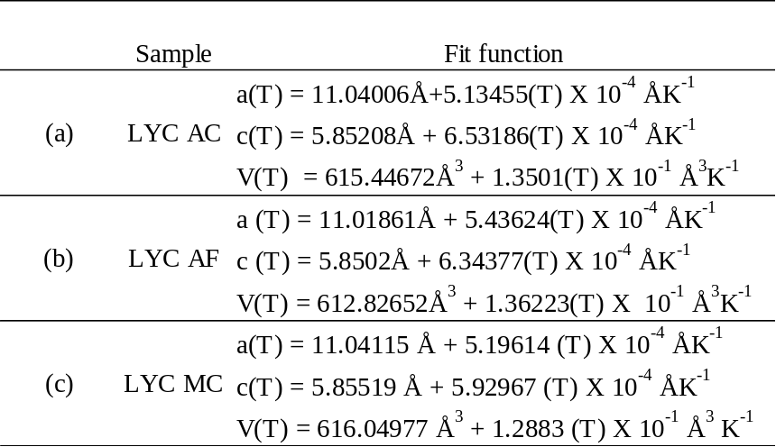

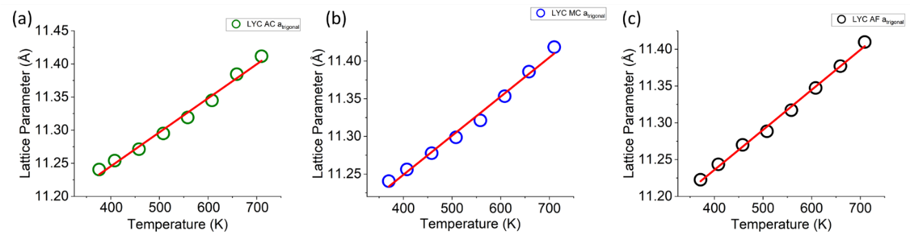
Figure 29. Temperature dependence of the lattice parameter for the trigonal Li₃YCl₆ during cooling for the (a) LYC – AC (b) LYC-MCA (c) LYC-AF synthesis
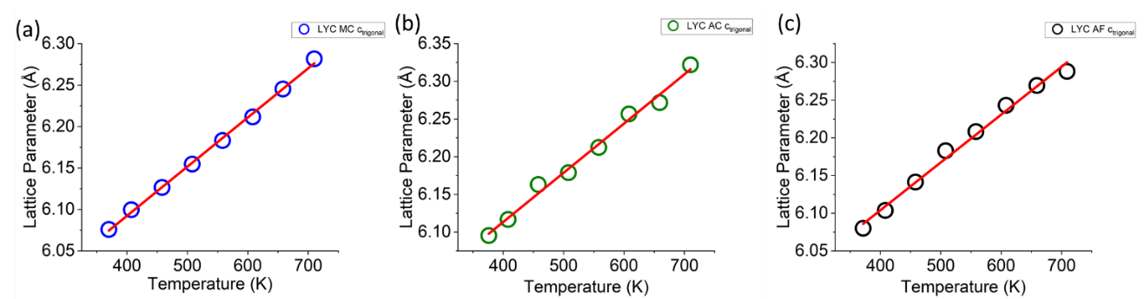
Figure 30. Temperature dependence of the lattice parameter c for the trigonal Li₃YCl₆ during cooling for the (a) LYC – AC (b) LYC-MCA (c) LYC-AF synthesis
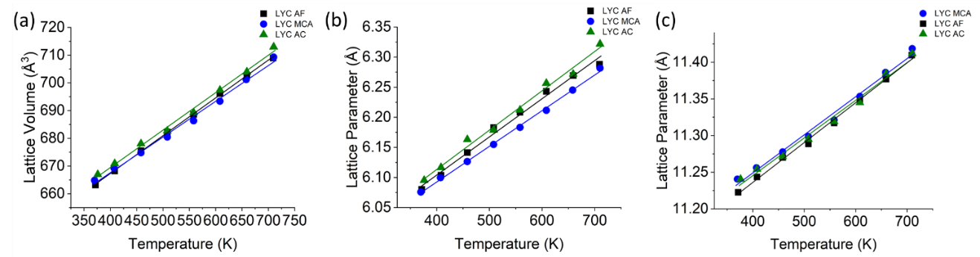
Figure 31. Comparison of the (a) lattice volume (b) c parameters (c) a parameters as a function of temperature across synthesis routes

Table 2. Results from fitting Transmission Line Model Fitting of EIS data during cycling of LYC MCA Full Cell

Spectra | R_{d3} / 3 | R_{t} | R_{h} | R_{ion} | N_{m}
Fabrication | 80.96666667 | 452.4667 | 371.5 | 121.45 | 2.879175
1 hour rest after fabrication | 89.3 | 466.3 | 377 | 133.95 | 3.175508
after 1st cycle | 53.4 | 469.4 | 416 | 80.1 | 1.898904
after 50 cycles | 236.9333333 | 754.5333 | 517.6 | 355.4 | 8.425349
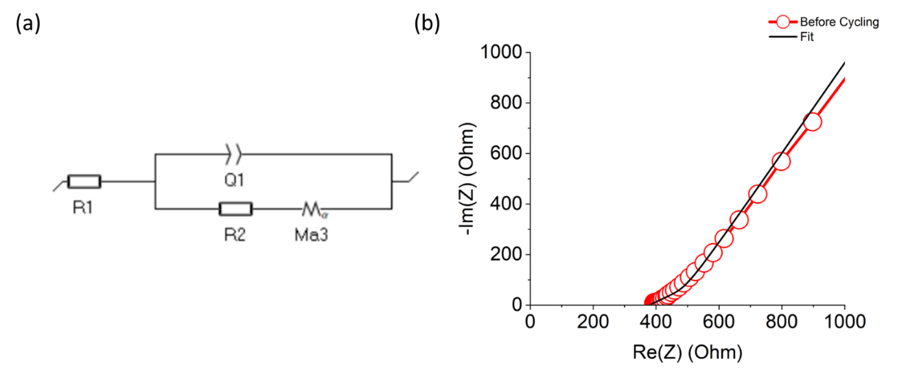
Figure 32. (a) Equivalent TLM Circuit (b) Impedance spectra of the LYC MCA cell prior to cycling and representative TLM model fit.
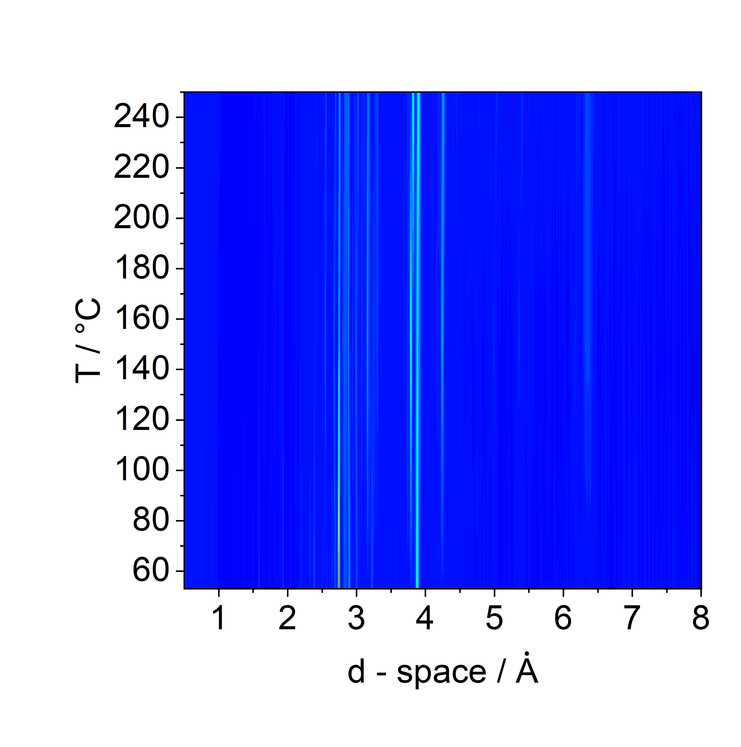
Figure 33. Contour plot showing the formation of (ND₄)₃[YCl₆] complex halide intermediate during ramp from 53°C to 250°C.

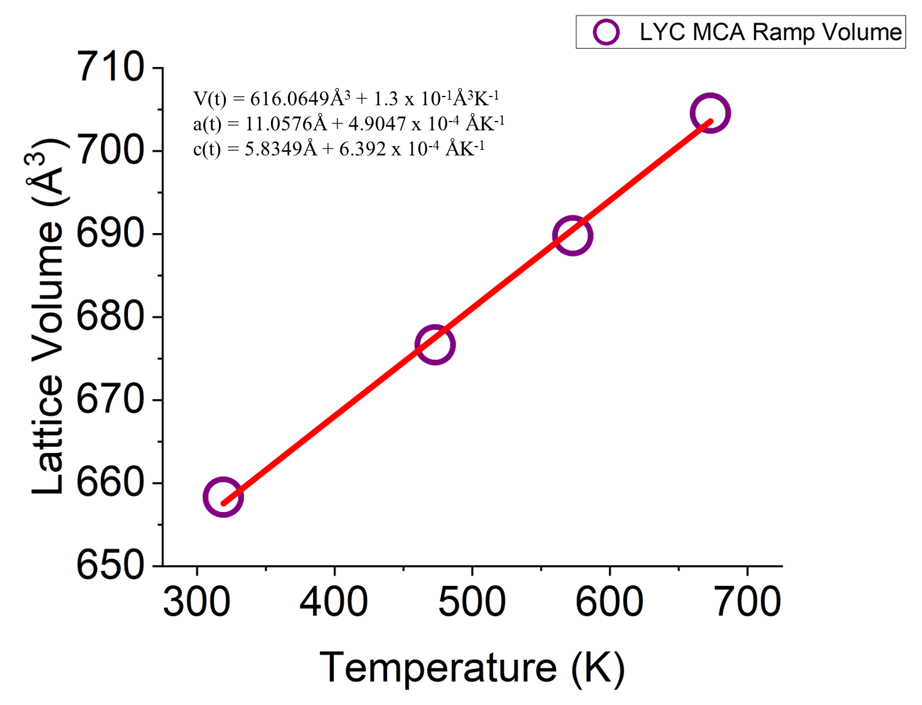
Figure 34. Parametric fitting for the isothermal scans of LYC MCA sample during ramping from 46°C to 400°C.
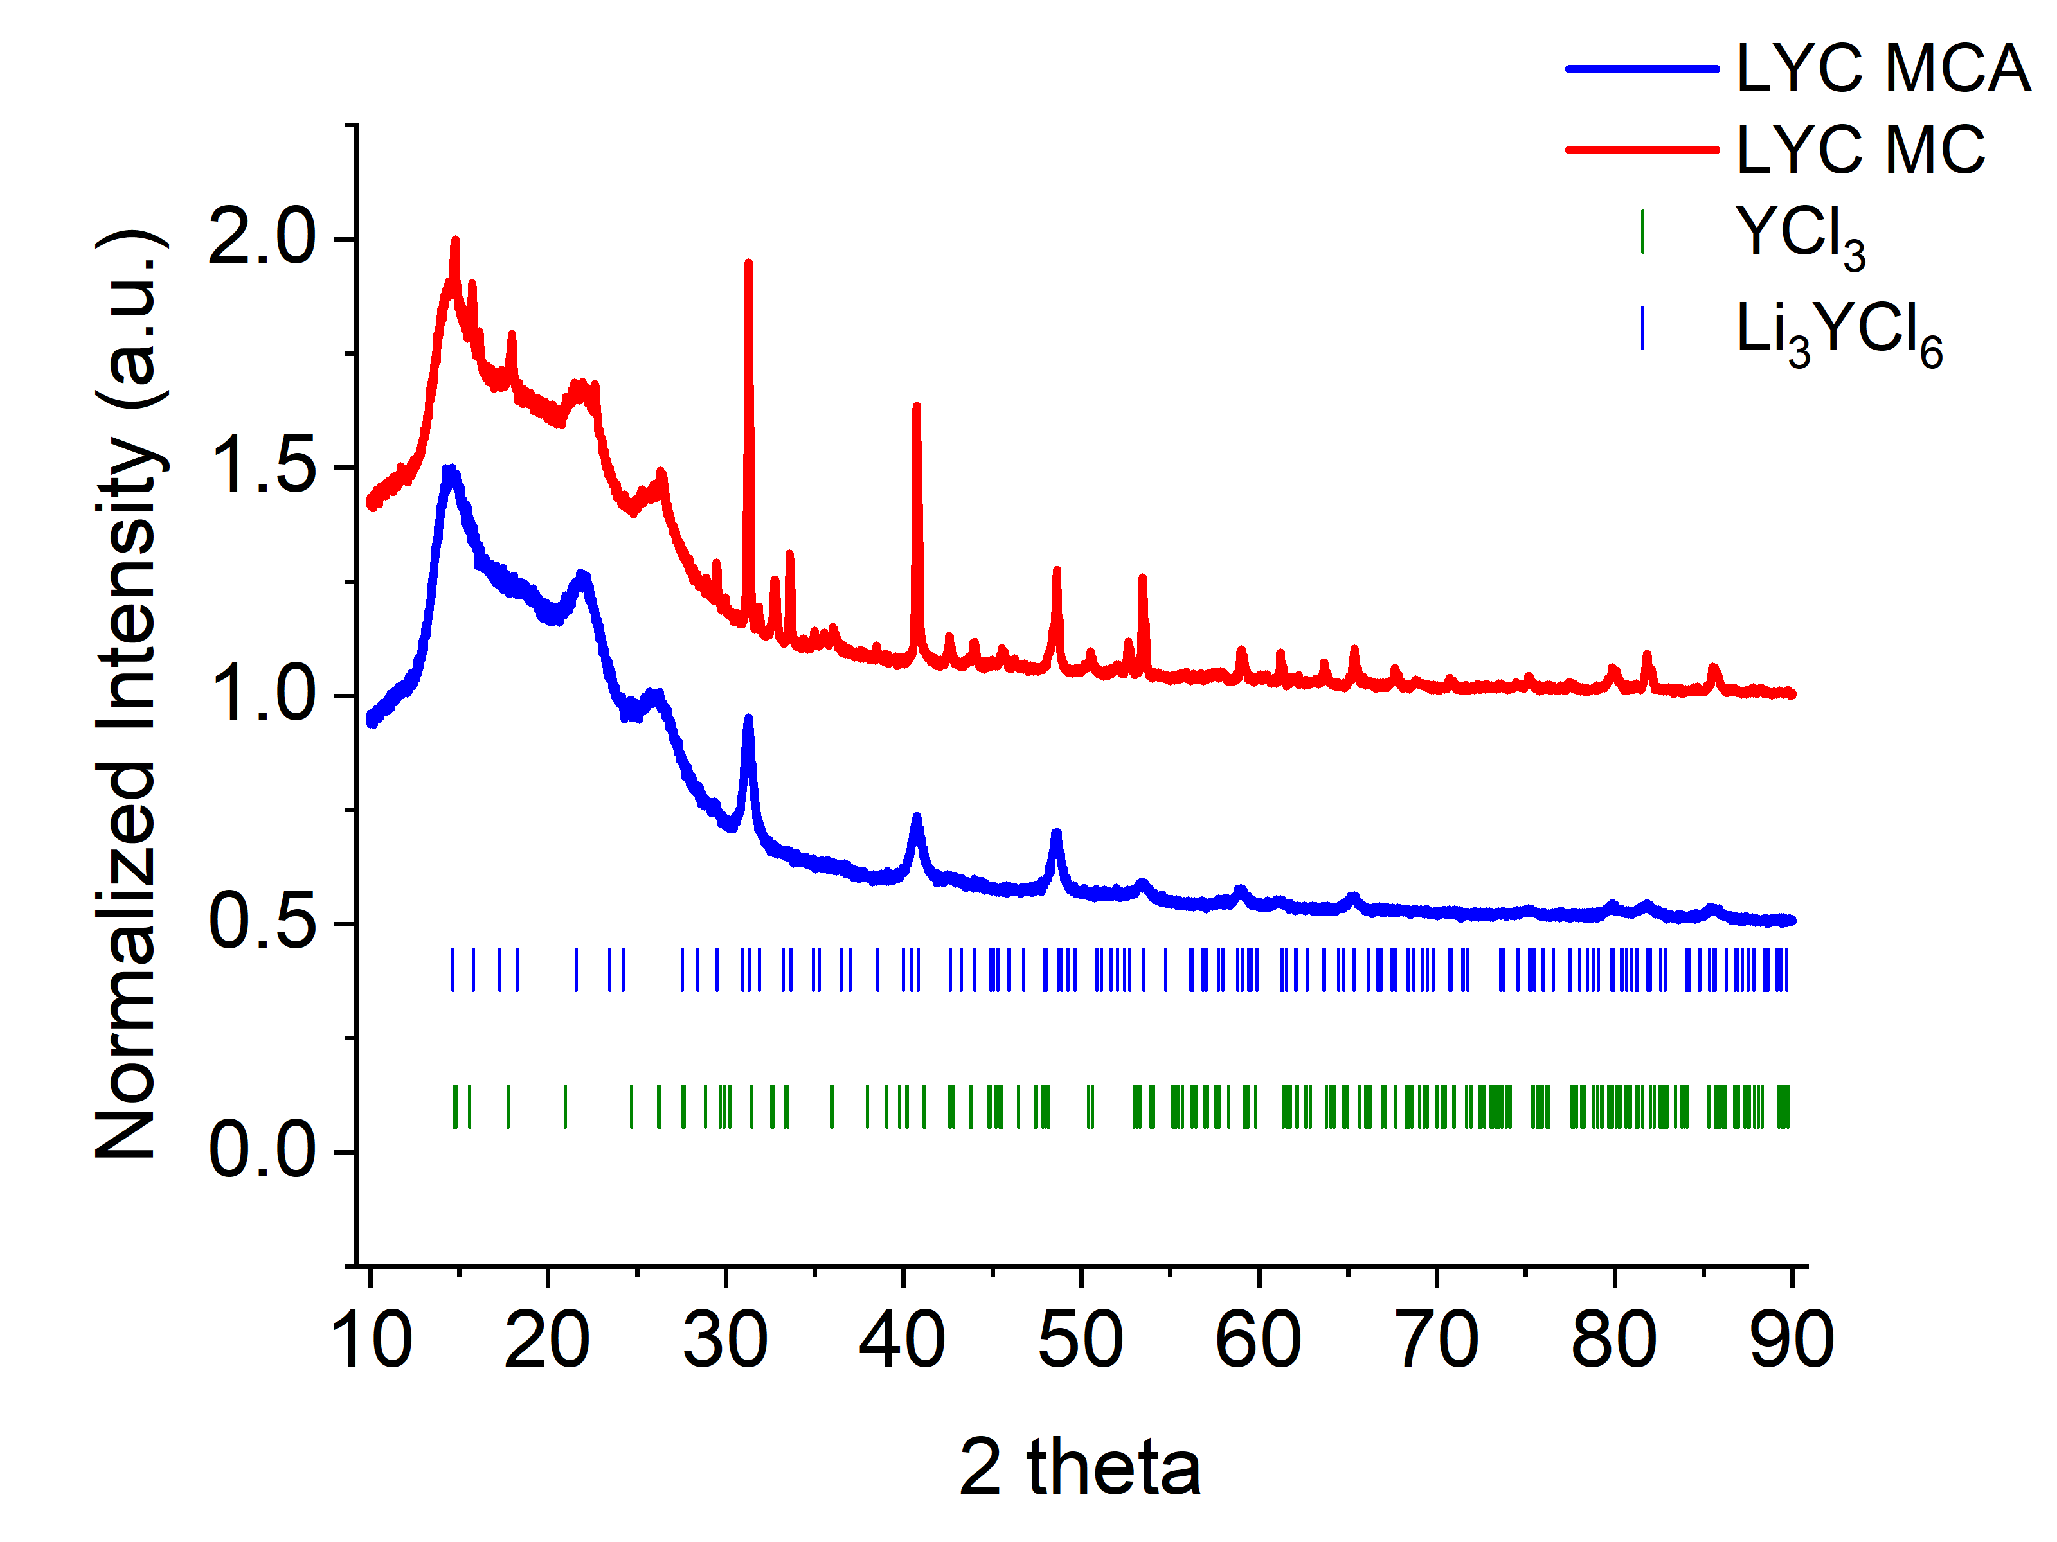
Figure 35. Ex-situ XRD of LYC MC and LYC MCA products of lab scale synthesis
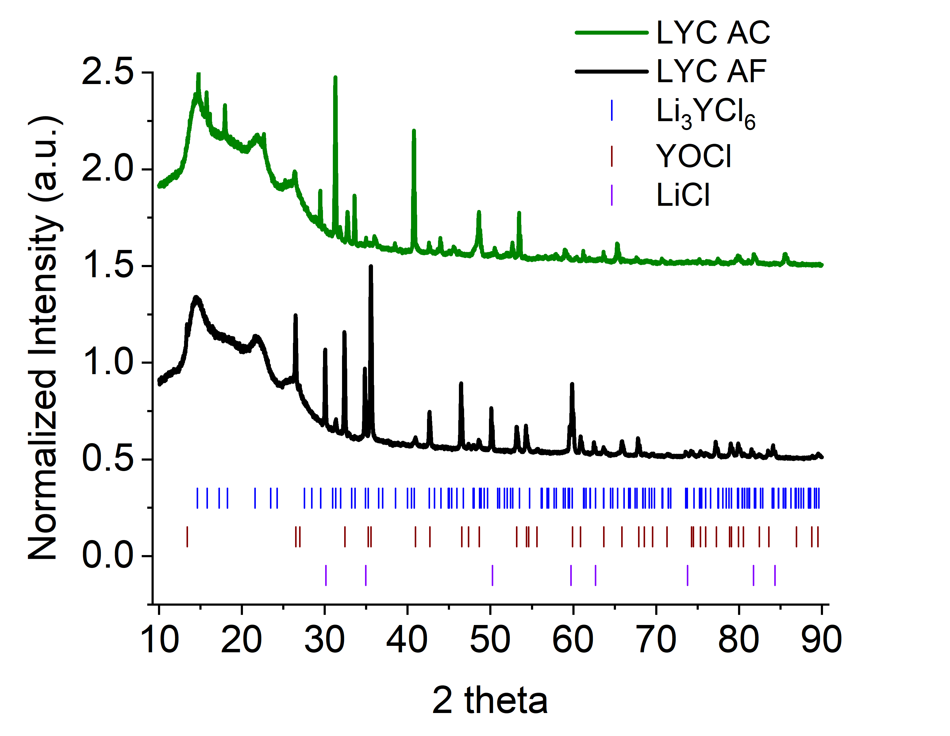
Figure 36. Ex-situ XRD of LYC AC and LYC AF products of lab scale synthesis

The synthesis dependent local structure was studied using Raman spectroscopy as shown in Fig. 37 we do not observe any significant peaks present in the purely mechanochemical Li₃YCl₆, however within the MCA sample two obvious modes at 258 and 278 cm-1 due to Y3+-Cl- vibrations .31–33 These modes are most likely due to the residual YCl₃ left over from the synthesis and not associated with the YCl₆³⁻ octahedra. This is further made evident by the fact that these modes are observed in both the MCA and AC samples but not the MC sample as is the case for YCl₃ in the diffraction data.

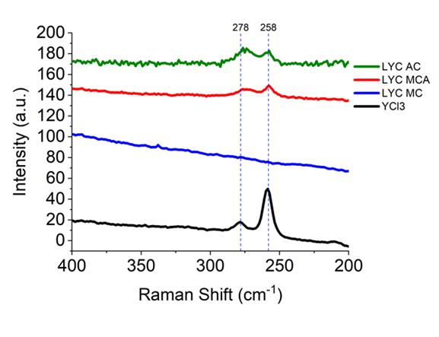
Figure 37. Raman spectra comparison of MC and MCA synthesized Li₃YCl₆

Table 3. Activation Energies for the LYC MC, MCA, AC bulk and grain conductivity processes
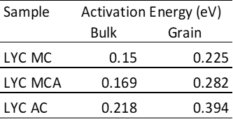

Chapter IV The Impact Of Milling Method On The Reaction Mechanism, Structure, And Electrolyte Properties Of Li₆PS₅Cl

Abstract
The reaction mechanism for the mechanochemical assisted synthesis of Li₆PS₅Cl is outlined. Formation of ß-Li₃PS₄ is shown to be a crucial step in forming Li₆PS₅Cl during the annealing step. A comparison of planetary milling, vibrational milling, and cryomilling shows that the type of milling motion and heat generation during milling do not impact the phase formation of the product. In-situ Neutron Powder Diffraction shows that the anion disorder, which has been shown to impact the conductivity of argyrodites, is controlled by the thermal treatment step for Li₆PS₅Cl. Furthermore, a small difference in the SE properties for the products from each milling route is observed. Showing that more scalable approaches for the mechanochemical or solid-state synthesis of SEs outside the commonly used planetary milling is viable. This study provides valuable insight into the formation mechanism of lithium argyrodites opening the door for further study on related compositions within this important family of materials.

Introduction
Lithium secondary batteries have been widely used as portable power sources since their commercialization by Sony in 1991.¹ The demand for safer and more energy-dense secondary batteries to drive the electrification of vehicle transport has led to increased interest in All – Solid – State Batteries (ASSBs) and solid electrolytes.² Solid electrolytes are the key to replacing conventional flammable organic liquid electrolytes and improving the safety and resilience of lithium-based batteries.³ Many classes of solid electrolytes including polymer, oxide, hydride, halides, and sulfides have been investigated as candidates to enable ASSBs.⁴ The sulfides represent possibly the most intensely studied class of solid electrolytes.⁵ Sulfides are promising due to their high room temperature ionic conductivity, mechanical properties, and ease of processibility.⁶ Lithium argyrodites of the composition Li₆PS₅X (X =Cl, Br, I) have shown impressive performance and have therefore garnered intense research and commercial interest.⁷
One of the biggest obstacles to commercializing these materials is the ability to synthesize them on large scales with favorable properties such as high ionic conductivity, purity, and low electronic conductivities.⁸ Liquid phase synthesis routes are one potential method of scaling these materials for use in EV batteries.⁹ However, some drawbacks to solvent based synthesis routes include lower conductivities, phase purity, and large changes in electronic conductivity likely from residual carbon leftover from residual solvent.¹⁰ These differences have been shown to lead to dramatic changes in the performance of argyrodites in full cells.¹¹ For these reasons, solid-state and mechanochemical synthesis methods remain the most popular in the literature.¹² However, many of the effects of mechanochemical synthesis parameters have not been thoroughly investigated for this system, but also solid electrolytes more generally.¹³ In particular, the feasibility of different milling methods, outside planetary milling, have not thoroughly been examined. Here, we compare the feasibility of using vibration milling and cryomilling in place of planetary milling in the solid-state synthesis of Li₆PS₅Cl (Abbr. LPSCl). In comparison to planetary milling, vibrational and stirred media milling have been identified as scalable alternatives due to the relative ease of temperature control on large scales.¹³
Large scale synthesis and optimization of battery materials is not trivial.^{14,15} It often requires process monitoring and optimization. A key enabler of this reaction engineering is an intimate understanding of the reaction mechanism during synthesis.¹⁶ The formation mechanism of lithium argyrodites has been understudied within the literature. Many solid-state synthesis routes for argyrodite compositions report impurities such as LiCl and Li₂S in the products.^{7,17,18} These impurities have been found to have a negative impact on the moisture stability and electrochemical performance of LPSCl solid electrolytes.⁷ The presence of these impurities signifies a poor understanding and control of the reaction mechanism. The reaction is often cited as the stoichiometric ratios to form the product, insinuating a direct reaction:
$\text{5}{\text{Li}}_{\text{2}}\text{S + }{\text{P}}_{\text{2}}{\text{S}}_{\text{5}}\text{ + 2 LiCl}\underset{→}{\text{∆}}\text{ 2}{\text{Li}}_{\text{6}}\text{P}{\text{S}}_{\text{5}}\text{Cl }$ (21)
Previous work in which the precursors were milled for a much longer time of 20 hours prior to annealing proposed the following reaction mechanism:¹⁹
$\text{5}{\text{Li}}_{\text{2}}\text{S + }{\text{P}}_{\text{2}}{\text{S}}_{\text{5}}\text{ + 2 LiCl}\underset{→}{\text{Milling}} {\text{Li}}_{\text{7}}\text{P}{\text{S}}_{\text{6}}\text{ + LiCl }$ (22)
${\text{Li}}_{\text{7}}\text{P}{\text{S}}_{\text{6}}\text{+ 2 LiCl}\underset{→}{\text{∆}}\text{ 2}{\text{Li}}_{\text{6}}\text{P}{\text{S}}_{\text{5}}\text{Cl }$ (23)
Follow up work by Randrema et al. claimed a different reaction mechanism after 10 hours of milling the precursors:²⁰
$\text{5}{\text{Li}}_{\text{2}}\text{S + }{\text{P}}_{\text{2}}{\text{S}}_{\text{5}}\text{ + 2 LiCl}\underset{→}{\text{milling}} {\text{Li}}_{\text{4}}{\text{P}}_{\text{2}}{\text{S}}_{\text{7}}\text{ + 2LiCl + 3}{\text{Li}}_{\text{2}}\text{S }$ (24)
$\text{3}{\text{Li}}_{\text{2}}\text{S + }{{\text{Li}}_{\text{4}}\text{P}}_{\text{2}}{\text{S}}_{\text{7}}\text{ + 2 LiCl}\underset{→}{\text{∆}}\text{ 2}{\text{Li}}_{\text{6}}\text{P}{\text{S}}_{\text{5}}\text{Cl }$ (25)
The presence of the amorphous Li₄P₂S₇ intermediate was identified by the peak at 405 cm⁻¹ in the Raman spectrum acquired of the milled product. This peak was previously shown by Dietrich et al. to correspond to the amorphous network and is not associated with the product LPSCl phase.^{21,22} Here, we us in situ neutron powder diffraction (NPD) to explore the impact of milling methods on the phase formation of Li₆PS₅Cl and the resulting material properties. NPD is well suited for studying sulfide solid electrolytes due to the difference in scattering lengths between halogen and sulfur anions. This enables us to detect changes in anion disorder as a function of temperature during synthesis, as well as between the different milling approaches. Through the NPD, we find that the formation of LPSCl at lower milling times (2 hours) followed by annealing proceeds as follows:
$\text{5}{\text{Li}}_{\text{2}}\text{S + }{\text{P}}_{\text{2}}{\text{S}}_{\text{5}}\text{ + 2 LiCl}\underset{→}{\text{milling +∆}}\text{ 2}{\text{β-Li}}_{\text{3}}\text{P}{\text{S}}_{\text{4}}\text{ + 2LiCl + }{\text{2Li}}_{\text{2}}\text{S}$ (26)
2${\text{β-Li}}_{\text{3}}\text{P}{\text{S}}_{\text{4}} {\text{+2 Li}}_{\text{2}}\text{S +2LiCl}\underset{→}{\text{∆}}\text{ 2}{\text{Li}}_{\text{6}}\text{P}{\text{S}}_{\text{5}}\text{Cl}$ (27)
Regardless of the milling technique used, the reaction in equation 26 is observed prior to the final reaction in equation 27 to form the LPSCl product.

Experimental

Li₆PS₅Cl Synthesis
The Planetary Mill (PM) Li₆PS₅Cl material was synthesized by weighing stoichiometric amounts of LiCl, Li₂S, and P₂S₅. The precursors were loaded into a 45 mL zirconia with 5 mm ZrO₂ milling media inside a glove box. The ball to powder ratio was kept consistent at 15: 01. The mixture was then milled in a Fritsch Pulverisette 7 planetary ball mill. The sample was milled for 4 cycles of 30 minutes active milling at 600 RPM and 15 minutes rest. The sample was then pelletized and ramped to 550 °C at a rate of 1 °C/min for 5 hours under flowing Argon inside a glove box.
The Vibration Mill (VM) sample was prepared by weighing out the precursors in the same ratio as the PM sample. The precursors loaded into a stainless-steel mixing jar with 5 mm stainless steel media at a 15:01 ball to powder ratio in an argon glove box. The sample was then milled for 30 minutes at the default frequency of 17.66 Hz for 30 minutes with a 15-minute rest step for 4 cycles. After mixing, the resulting powder was pelletized and annealed under the same conditions as the PM sample.
The Cryomilled (CM) sample was prepared by weighing out the stoichiometric ratio of the precursors in the glove box into a 50 mL stainless steel Retsch cryomill jar. The sample was loaded with a ball to powder ratio of 15:01. The sample was mixed at a frequency of 18Hz for four cycles of 30 minutes each with a 15-minute pause. The sample was then taken back into the glove box, pelletized, annealed under the same conditions as mentioned above. To ensure as similar milling conditions as possible, the vial filling factor was kept to 10.85% for all 3 samples⁶¹.

In – Situ Neutron Powder Diffraction And Rietveld Analysis
Each of the samples were pressed into pellets after their respective milling steps and then crushed back into smaller pieces to ensure good physical contact during the in-situ diffraction experiment. The samples were loaded into Vanadium cans (0.8 mm diameter) under argon atmosphere, sealed with titanium lids and copper gaskets. The data were collected at POWGEN using the MICAS vacuum furnace environment.⁶² A single bank wave with a center wavelength of 1.5 Å (d-spacing range 0.50097 – 13.0087 Å) was used. The samples were ramped from ~40 °C to 550 °C at a constant ramp rate of 1 °C/min. Isothermal scans were taken at 40 °C, 100 °C, 200 °C, 300 °C, 400 °C, 500 °C, and 550 °C for 1 hour. The during any ramp or cooling step, data was collected in event mode so that it could be re-binned for further future analysis as described earlier between 200 °C – 300 °C.
The resulting diffraction patterns were refined using GSAS II.⁶³ The Li₆PS₅Cl structure in the space group F-43m was used as a starting point for the refinement.⁶⁴ Refinement constraints that were used were as follows: atomic coordinates and atomic displacement parameters for fixed for the anion sites S1 and Cl1 and S2 and Cl2. The sum of the occupancies was fixed at one for shared sites. Parameters were refined as follows: (1) background, (2) scale factor, (3) peak shape, (4) lattice parameters, (5) atomic positions, (6) isotropic thermal displacement parameters, (7) occupancies.

Differential Scanning Calorimetry (DSC)
A TA instrument DSC Q100 was used to conduct the measurements, ramping to 450 °C at 1 °C/min. The samples were loaded into aluminum pans in an Argon filled glove box to prevent any contamination from the ambient atmosphere and during the experiment nitrogen gas was flowed over the sample at a rate of 50 mL/min.

Materials Characterization
Ex situ XRD patterns were collected using a Malvern PANalytical X’Pert Pro MPD diffractometer (45 kV, 40mA) with a CuK_{α} radiation source. Samples were sealed in a glove box with Kapton tape to prevent exposure to air and moisture. Samples were loaded int an in-house built SEM holder to enable contamination free transfer of the LYC samples from a glove box into the SEM. SEM images were then collected using a Zeiss merlin FE-SEM microscope. The accelerating voltage used was 1 kV. Particle size distributions were obtained from image analysis of the SEM data using Image J.⁶⁵

Conductivity Measurements
The solid electrolyte samples were pelletized at 5.9 t/cm² for 1 min in a 12.7 mm die set with carbon coated aluminum foil on either side to be used as blocking electrodes for the ionic conductivity measurements. The measurements were performed by electrochemical impedance spectroscopy (EIS) at OCV an excitation amplitude of 10 mV was applied in a frequency range between 1 MHz and 10 mHz with 6 points per decade using a VSP potentiostat (Biologic).

Battery Assembling And Electrochemical Testing
The battery assembly and electrochemical testing were carried out in a Polyether Ether Ketone (PEEK) mold cell developed in our laboratory, consisting of a cylindrical PEEK cell body, two stainless steel spacers, a stainless-steel piston, and a stainless-steel plate for electrical contact. The composite cathodes were assembled by mixing NMC811(NEI), Li₆PS₅Cl (PM, VM, or CM) and VGCF (Sigma Aldrich) in a 70:27:03 ratio. The mixture was loaded into a 20 mL polyethylene vial with 5 mm Zirconia milling media in a 10 to 1 media to powder ratio and mixed for 1 hour at low speeds in a Turbula 3D shaker mixer (WAB).
The full cells were assembled as follows. 60 mg of indium foil was placed into the peek mold in contact with a stainless-steel spacer, followed by 200 mg of Li₆PS₅Cl solid electrolyte, the cell was cold pressed at 1.47 t/cm² for a few seconds and 15 mg of cathode composite powder the stack was once again pressed at 1.47 t/cm² for a few seconds. This was followed by placing a carbon coated aluminum current collector on top of the composite cathode, after which the entire stack was pressed at 5.9 t/cm² for 5 minutes. The cell was then placed in a vice under 5.62 MPa of stack pressure inside a glove box for cycling.
Galvanostatic cycling studies were conducted in the voltage range of 1.97 – 3.67 V versus Li-In/In (2.6 – 4.3 V versus Li⁺/Li) at room temperature. Initial formation of the Li-In alloy anode was done by lithiating Indium foil on the first charge cycle of each cell at 66 µA/cm². This was followed by cycling for 50 cycles at 0.1 mA/cm². All impedance spectra for the full cells were collected with an excitation amplitude of 10 mV in a frequency range between 1 MHz and 10 mHz with 6 points per decade. All electrochemical testing was conducted with a VSP potentiostat (Biologic).

Results And Discussion

Comparison Of The Formation Of Li₆PS₅Cl Across Milling Method.
In-situ NPD was used to track the phase evolution across the different milling methods: Planetary Milling (Abbr. PM), Vibration Milling (Abbr. VM), and Cryomilling (Abbr. CM). In all three cases, the precursors were mixed in stoichiometric amounts for 4 total hours of milling time, pelletized, and then annealed. During the In-situ ramping, isothermal scans were taken at ~40 °C, 100 °C, 200 °C, 300 °C, 400 °C, 500 °C, and 550 °C for 1 hour before cooling back down to ~ 80 °C a constant ramp rate of 1 °C /min was used.
The in-situ observation of the annealing of the PM sample, displayed in the stacked contour plot (Fig. 38), reveals that after milling the starting point is crystalline LiCl (2.965Å) and Li₂S (2.861Å). We do not see any evidence of crystalline P₂S₅ (1.736Å) precursor peaks after milling. The wt.% of both precursors, 70 and 30 % for Li₂S and LiCl respectively, stays constant until 200 °C as shown in the crystalline phase evolution (Fig. 39). Upon heating to 200 °C, we observe the start of the formation of ß – Li₃PS₄ (Abbr. LPS) (5.016Å) accounting for 36.7% of the composite sample, with significant Li₂S (43%) and LiCl (19.5%) remaining. The identification of the ß-LPS at 200 °C is lower than the previously reported transition from the γ-LPS to ß-LPS at 573K (300 °C).²³ However, a recent study by Kaup et al. showed that the transition actually begins around 250 °C for the solid-state synthesis of LPS.²⁴ Previous work has also found that depending on the synthesis route or aliovalent substitution, it is possible to isolate ß-LPS at RT.²⁵ Figure 39b shows an exothermic process around 180-190°C during the ramping at 1°C/min which likely corresponds to this initial formation of LPS. Interestingly, it is accompanied by a secondary process at around 225 °C, meaning the formation of LPS could occur in multiple steps. At around 220 °C, we see that the fraction of LPS increases to 49.4%. This increase in LPS and decrease in Li₂S continues until the LPS reaches a maximum at ~260 °C of 60% and the Li₂S and LiCl are left at 25 and 15% respectively. At 280 °C, we note the start of the formation of LPSCl around 3.48Å in the contour plot (Fig. 38). At this temperature most of the sample is still LPS at 51.7% with residual Li₂S (19.6%) and LiCl (10.5%) while LPSCl accounts for 18.2% of the sample. At 295 °C, we note the LPSCl increases significantly to 44.3%, with LPS at 32.9% and residual Li₂S decreasing to 13.5% and LiCl to 9.3%. Once the sample reaches 300 °C, the sample is mostly LPSCl (70.5 %) with LPS being reduced to 19.5% and small amounts of Li₂S (7.8%) and LiCl (2.2%) remaining. Between 300 °C and 400 °C, all intermediates and precursors are consumed and the LPSCl peaks intensify, signifying an increase in crystallinity and mass fraction at 400 °C. The crystallinity and intensity of the LPSCl peaks increase as the sample is ramped initially to 500 °C and then 550 °C, at which it is then cooled back down to ~80 °C. The DSC data of the ramp up (Fig. 39b) shows a broad endothermic process that begins around 275 °C and continues until it stops around 425 °C. This coincides with both the conversion of the intermediates to LPSCl and the enhancement of the crystallinity of LPSCl in the NPD data. Both the final ramping and cooling steps show no additional phase transitions for the LPSCl as noted by the steady phase fraction (Fig 39.). To isolate the role of milling on the formation of LPSCl we compared the DSC results for the LPSCl PM sample to that of a sample hand mixed in an agate mortar pestle for 10 minutes (Abbr. LPSCl – SS). When comparing the two processes we see that process 1 is shifted to a higher temperature, process 2 does not seem to occur, and we observe two distinct processes between 275-300 °C which does not occur in the milled sample. This additional process could be the consumption of P₂S₅ to form LPS or the start of the melting of P₂S₅. We note that we did not see any evidence of Li₇PS₆ formation during the synthesis, thereby showing that at least for lower milling times, the solid-state synthesis of LPSCl does not proceed via reactions 22 and 23. The NPD data confirms that the synthesis of LPSCl proceeds initially through reaction 6 and then 7. Interestingly, we also do not observe any signs of melting at 500 °C, as was previously reported in an In-situ NPD study of the mechanochemical synthesis of LPSCl.¹⁹ As previously mentioned, this study milled the precursors to the point of forming a mechanochemical argyrodite phase prior to annealing, this difference in the synthesis conditions could drive differences in the thermal stability of the resulting solid electrolyte.

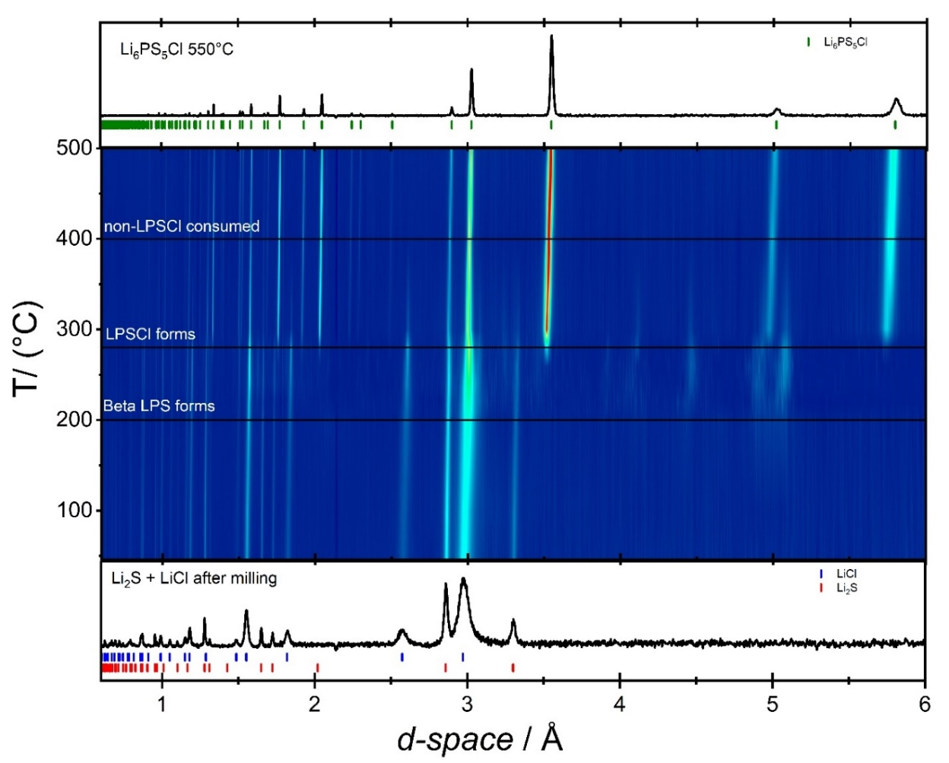
Figure 38. Visualization of the PM synthesis pathway using in-situ diffraction. The figures are the intensity contour plots of neutron diffraction patterns during heating from 40°C to 550°C. The initial NPD pattern is the precursors after planetary milling, the final NPD pattern is the LPSCl phase at 550°C.

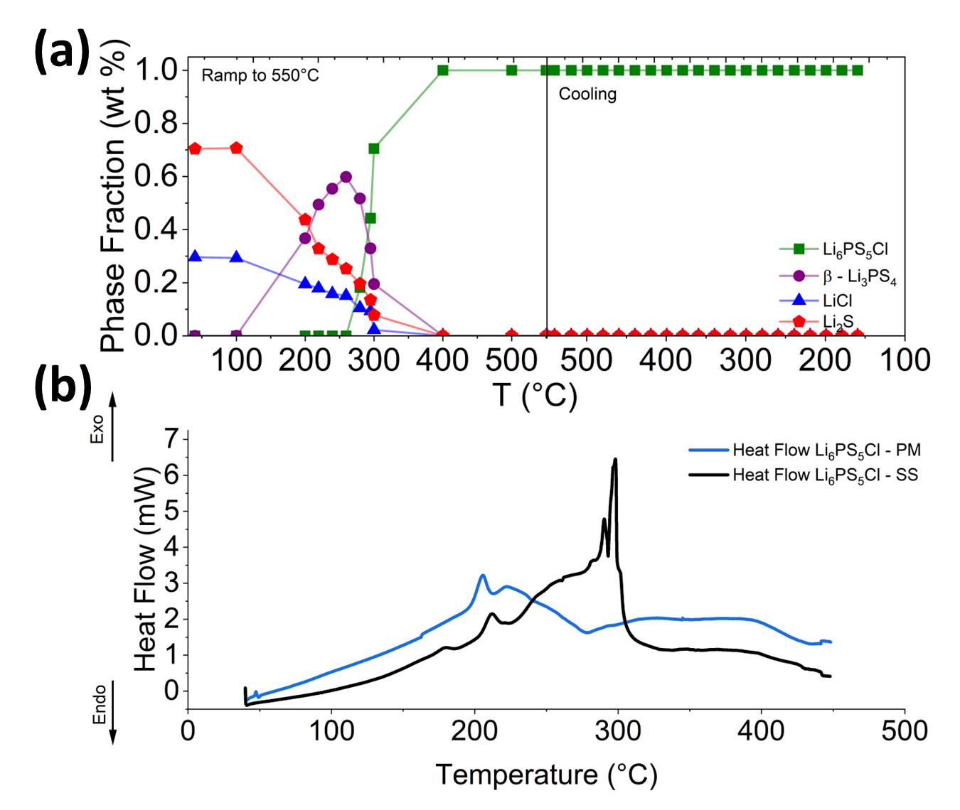
Figure 39. (a) The Crystalline phase evolutions for the synthesis of LPSCl synthesized through PM route (b) the Differential Scanning Calorimetry for the LPSCl - PM Sample after milling compared to the LPSCl – SS sample.

In Fig. 40 the phase evolution for the synthesis of LPSCl through the VM route in which the precursors Li₂S + LiCl + P₂S₅ were mixed in stoichiometric amounts and mixed for a total milling time of 2 hours in a vibration mill is shown. The product of which is the starting point for the reaction. After this short milling time, we note that, like the PM route, large amounts of Li₂S (66.8%) and LiCl (33.2%) are present. Similarly, we don’t observe the presence of any crystalline P₂S₅ precursor post milling. The reaction proceeds similarly, with the formation of LPS occurring at 200 °C. The LPS reaches a maximum at 260 °C of 67 wt% while the residual Li₂S and LiCl account for 20.3 and 12.8% respectively. Like the PM sample, LPSCl begins to form at around 280 °C, initially only account for 14 wt% of the composite sample with the largest portion still being LPS at 60.8% and residual Li₂S 15.9% and LiCl 9.3%. As the temperature is increased to 295 °C, more of the intermediates are consumed to form LPSCl which now accounts for 27.7% of the composite mass. Once the sample reaches 300 °C, LPS and LPSCl are almost equal at 43.5% and 45.7% respectively. Once again, between 300 °C and 400 °C all the intermediates and starting materials are consumed, leaving only LPSCl behind. The contour plot visualized in Fig. 41 shows that the crystallinity and intensity of the LPSCl peaks continues to increase until the sample reaches 550 °C, at which point it is cooled back down to 80 °C. The similarity between the VM and PM reaction routes suggests that milling motion does not affect the formation of LPSCl upon annealing.
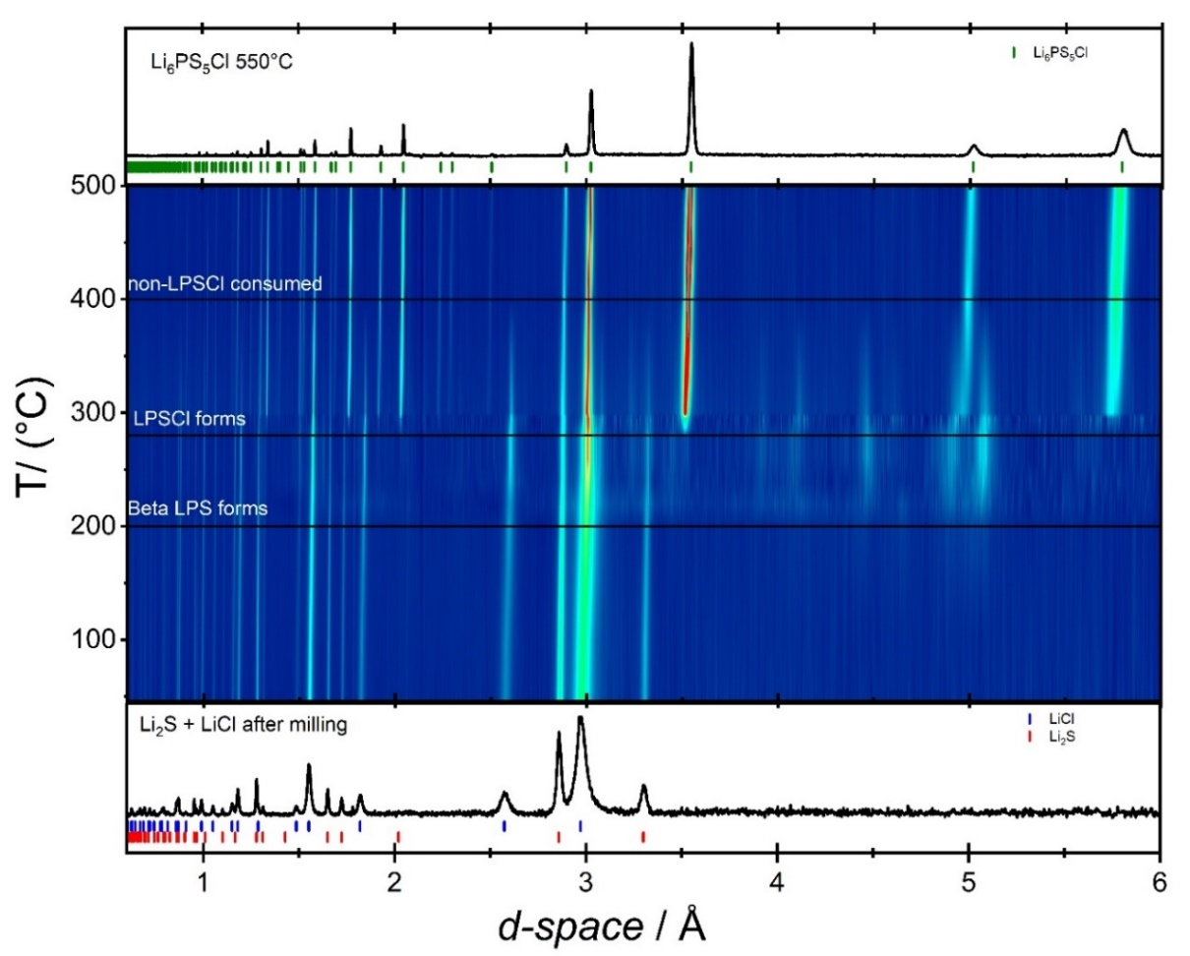
Figure 40. Visualization of the VM synthesis pathway using in-situ diffraction. The figures are the intensity contour plots of neutron diffraction patterns during heating from 40°C to 550°C. The initial NPD pattern is the precursors after planetary milling, the final NPD pattern is the Li₆PS₅Cl phase at 550°C.

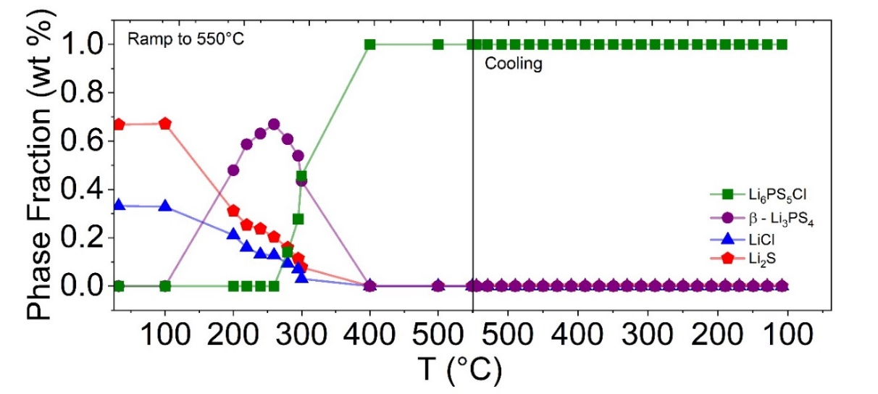
Figure 41. The Crystalline phase evolutions for the synthesis of Li₆PS₅Cl synthesized through VM route.
Figure 42 displays the contour plot of the CM pathway, showing that it proceeds similarly to the CM and PM routes. The starting material after cryomilling is mostly Li₂S (72.4%) and LiCl (27.6%). We note that the fraction of crystalline Li₂S is higher for this route compared to 65% and 70% for the VM and PM routes respectively. We note that the major difference here is that the sample is actively cooled and kept at cryo temperatures during milling. Previous studies have shown that the internal temperatures during milling, particularly the surface of the milling media, can reach 200 °C or greater.²⁶ One possibility for the difference is that the internal temperature experienced by the composite sample that is not present in the CM route actually increases the rate of amorphization during milling.²⁷ Recent work by Hofer et al. showed that in the mechanochemical synthesis of LPS showed that the amorphous phase, as identified by PS₄³⁻ groups via Raman spectroscopy, began to form within 1 hour of milling.²⁸ This could signal that internal heat generation during milling can drive the formation of amorphous LPS intermediates prior to the annealing step.
All three samples show that the formation of LPSCl starts at the same temperature, ~ 280 °C. When we compare this to previous work conducted on the in-situ neutron diffraction, the Li₇PS₆ phase was identified as initially forming between 80 °C and 150 °C.¹⁹ This points the milling time directly affecting the kinetics of converting precursors to intermediates and intermediates to the final product. Typically, this property of the reaction is controlled by very slow ramp rates and long annealing times to produce phase pure, crystalline, high conductivity LPSCl products.²⁹ As wang et al. showed, it is possible to produce similar products with some initial milling, a slow ramp rate, and a low annealing time.³⁰ However, even in this instance, the phase pure product was only obtained once the sample was heated to 550 °C for at least 3 hours. Recent work by Rajagopal et al. showed that addition of excess P₂S₅ could be used to suppress the formation of Li₂S, LiCl, and Li₃PO₄ impurities after annealing.³¹ This points to the thermal stability of P₂S₅ playing a large role in driving the complete formation of LPSCl, as it has a melting point of 285 °C and a boiling point of 514 °C.³² This process is in the same range of temperatures we observe LPSCl formation in during the solid-state synthesis~280 °C. When we take these facts together, it seems that the consumption of P₂S₅ to form LPS or other intermediates is in competition with the melting/boiling of the precursor, which could lead to the formation of residual precursor impurities. In addition, the widespread reported need for slow ramp rates signals that of these two types of reactions, the formation of the intermediate is slower and therefore less kinetically favorable when compared to the melting or boiling of the precursor. At faster ramp rates, the latter process is favored, leading to the loss of significant mass and formation of impurities. A study attempting to make multiple different metal thiophosphates of the formula M₂P₂S₆ found that the addition of excess P₂S₅ provided a flux that served as a reaction medium that shortened the necessary reaction times. It had the added benefit of smaller crystallite sizes for the resulting materials.³³ This understanding of the reaction mechanism could enable much faster solid-state syntheses of argyrodite compositions. Variation of heating profiles to first form the LPS intermediate than the crystalline LPSCl phase may reduce the total synthesis time without sacrificing purity and material properties. Issues with precursors impurities in products have also been reported for halogen rich argyrodites and thioantimonate compositions, which are both promising classes of materials due to their high room temperature conductivities ≥ 10 mS/cm.^{7,34,35} Future directions should investigate the reaction mechanisms for the solid-state synthesis of these solid electrolytes to enable better control of the purity and performance of these materials.

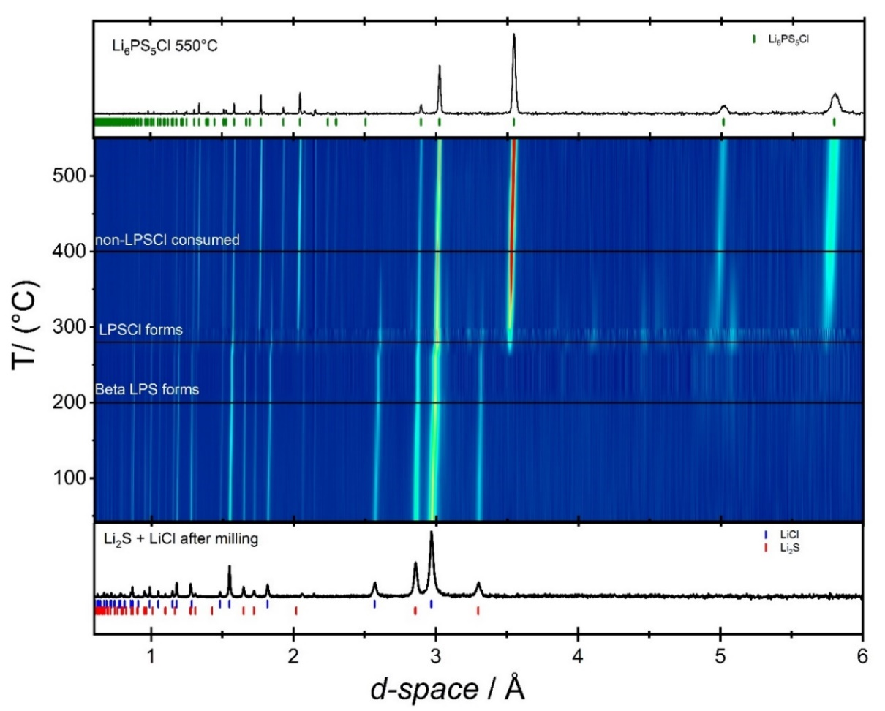
Figure 42. Visualization of the CM synthesis pathway using in-situ diffraction. The figures are the intensity contour plots of neutron diffraction patterns during heating from 40°C to 550°C. The initial NPD pattern is the precursors after planetary milling, the final NPD pattern is the Li₆PS₅Cl phase at 550°C.

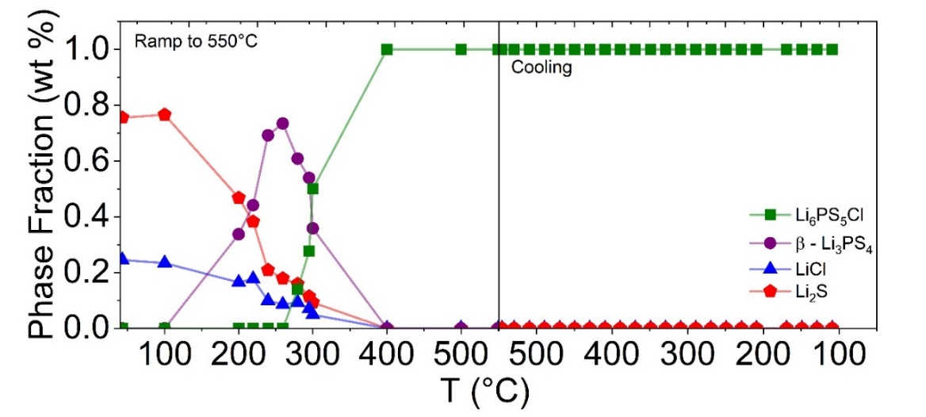
Figure 43. The Crystalline phase evolutions for the synthesis of Li₆PS₅Cl synthesized through CM route.
In Fig. 44 we display the refined structure resulting from NPD of the LPSCl - PM sample after cooling to 80 °C with the shared Cl⁻/S²⁻ sites Cl1(4a) and Cl2(4d) labeled. The parametric fitting of the refined cooling data for each of the three samples, PM, VM, and CM is shown in Fig. 45. All three of the processes had strong linear behavior during cooling. All three samples had similar temperature dependence for the lattice parameter 3.43252, 3.43461, and 3.43461 x 10⁻⁴ ÅK⁻¹. From the temperature dependence of the lattice parameter, we obtain the linear thermal expansion coefficient α for the cubic phase of LPSCl obtained from equation 1 :^{36,37}
${\text{α}}_{\text{T}}\text{ = }{\text{(}\frac{\text{da}}{\text{dT}}\text{)}}_{\text{T}}\text{ ∙ }\frac{\text{1}}{{\text{a}}_{\text{T}}}$ (1)
The average α_{T} is shown in the inset of Fig. 45 3.4436, 3.4493, 3.45168 x 10⁻⁵ K⁻¹ for the PM, VM, and CM samples respectively. Like the lattice parameters, we note that the milling technique employed does not seem to lead to large changes in the linear coefficient of thermal expansion for the LPSCl system. To our knowledge, this is the first report of the linear coefficient of thermal expansion for this system. When we compare this to the reported thermal expansion for another sulfide solid electrolyte, Li₁₀GeP₂S₁₂ was reported to be 3.4 X 10⁻⁵K⁻¹ similar to our calculated values reported here.³⁸ When we compare these values we to those reported for (LLZO) of 13.016 x 10⁻⁶ K⁻¹ LPSCl expands at a faster rate than similarly fast oxide solid electrolytes.³⁹ Because solid electrolytes must be tape, slurry, or melt cast into thin films to be incorporated into ASSBs their thermal expansion behavior must be taken into account.⁴⁰ This would be particularly relevant for devices that undergo high temperature processing such as co-sintering, experience heating/cooling cycles, or have complicated interfacial tolerances.³⁹ For an example, we can look to ß-Al₂O₃ based grid storage batteries which can see significant stresses or displacements that occur due to fluctuations in temperature, a property that must be taken into account when deploying the cells.⁴¹

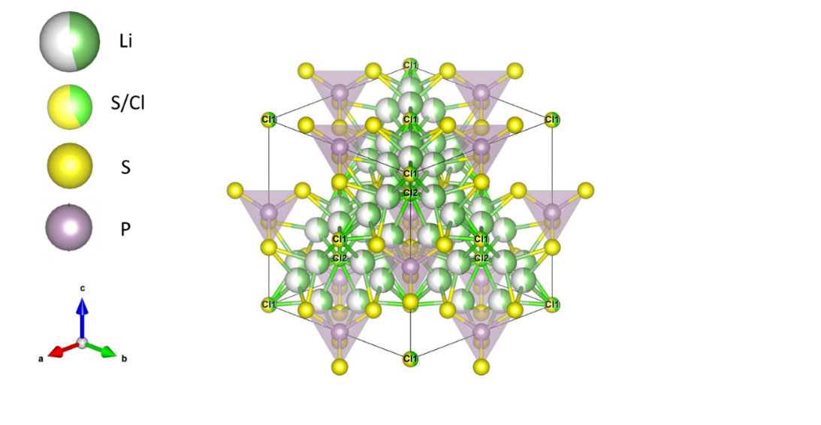
Figure 44. Refined crystal structure of Li₆PS₅Cl (F-43m) synthesized from Planetary Milling at 80°C after cooling.

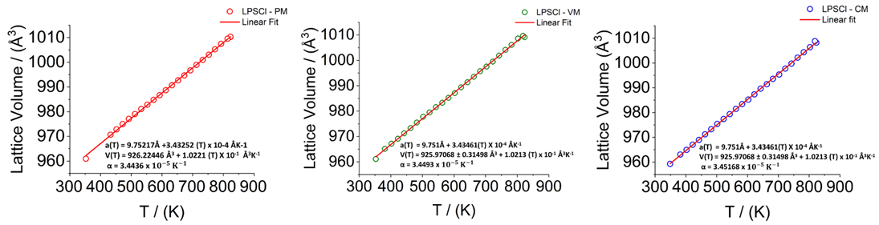
Figure 45. Parametric Fitting of Cubic Li₆PS₅Cl during cooling for (a) LPSCl – PM (b) LPSCl – VM and (c) LPSCl - CM

Compared to other members of the Li₆PS₅X (X = Cl⁻, Br⁻, I⁻) family such as Li₆PS₅I, which has an anion ordered structure in which I⁻ and S²⁻ occupy distinct sites within the crystal structure, LPSCl adopts an anion-disordered structure where the Cl⁻ and S²⁻ anions share the Wyckoff 4a and 4d sites.^{42,43} The degree of anion disorder in this family of materials has been correlated to both the Li-ion concentration in the lithium sublattice and the synthetic route.^{44,45} Previous studies suggest that the anion site disorder is driven by similar sized ionic radii of S²⁻ (1.84Å) and Cl⁻ (1.81Å).⁴⁶ Anion site disorder has been shown to be correlated with Li-ion transport, as the site disorder and room temperature ionic conductivity follow: Li₆PS₅Cl > Li₆PS₅Br > Li₆PS₅I.⁴⁵ Therefore, establishing the connection between synthesis conditions and anion site disorder is important to enable the large-scale production of high Li-ion conductivity solid electrolytes. Neutron diffraction is particularly well suited to observe changes in site disorder between Cl⁻ and S²⁻ because of the difference in their neutron scattering cross-section.⁴⁷ Fig. 46 shows the evolution of the anion site disorder during ramping and then cooling for each of the three samples obtained from Rietveld refinement of the NPD data. Both the PM (Fig. 46a) and VM (Fig. 46b) samples show similar trends during ramping. The PM sample upon formation ~295 °C starts out ordered with 54% site disorder which increases steadily to 61% at 300° and does not show much change even when heated to 550 °C it remains at 61.8%. As the sample is cooled back down, it steadily becomes more ordered, settling at 57.55% at the final temperature of ~80 °C. The VM sample similarly does not show significant change from 295 °C to 550 °C, going from 59.7% to 62.5%. Once the sample is cooled to ~80 °C, the sample becomes more ordered, with only 57.7% anion site disorder present. The CM sample follows a different trend during the ramp from formation to 550 °C, starting at a higher degree of disorder 61.5% eventually rising to 65.49%. However, once cooling begins, it too settles to a value like the other samples at, 58.2%. All three samples had higher degrees of disorder during the ramp stage, however upon cooling, disorder decreased. This agrees with previous work conducted by Gautam et al. which showed the ability to freeze the site disorder in Li₆PS₅Br by instituting different cooling rates, faster cooling rates were associated with greater disorder in the final product and an increase in the conductivity.⁴⁸ This likely means that for the two disordered members of this family, Li₆PS₅Cl and Li₆PS₅Br, that site disorder in the final product is dominated more by thermal treatment conditions than milling conditions. The degree of disorder in the product material may entirely be controlled by thermal treatment conditions and the cooling rate, which was the same for all three samples. This does however contrast with the Li₆PS₅I system, which has been shown to experience milling induced disordering of the anion sublattice.⁴⁹ Future work should consider the role of milling parameters on these systems and their thioantimonate analogues.³⁴

The In-situ NPD and lab scale synthesis differed in a few ways, primarily that the NPD samples were annealed under vacuum in vanadium cans while the lab scale synthesis was conducted under flowing argon. In addition, the lab scale synthesis had a heating profile that went directly from room temperature to 550 °C and was annealed for 5 hours while the in-situ experiment was stopped at intermediate temperatures for 1 hour prior to reaching 550 °C. Ex-situ NPD characterization at room temperature was conducted for each of the LPSCl products synthesized in lab scale conditions (Fig. 47). All three samples show that LPSCl synthesized under these conditions is phase pure, as was expected from the in-situ data. The lattice parameters for each of the samples are 9.84817, 9.84891, and 9.84759 for the PM, VM, and CM samples respectively. The anion site disorder for each sample was refined to be 58.00%, 57.00%, and 57.85% for the PM, VM, and CM samples respectively. This shows that in terms of phase purity, structural parameters, and anion disorder the samples under these different conditions are comparable.

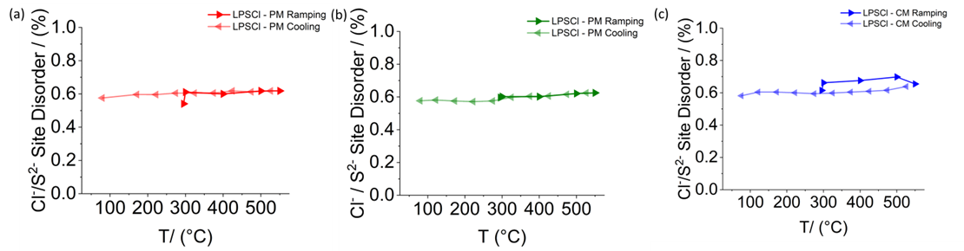
Figure 46. Anion site disorder during ramping and cooling for (a) LPSCl – PM (b) LPSCl – VM (C) LPSCl -CM
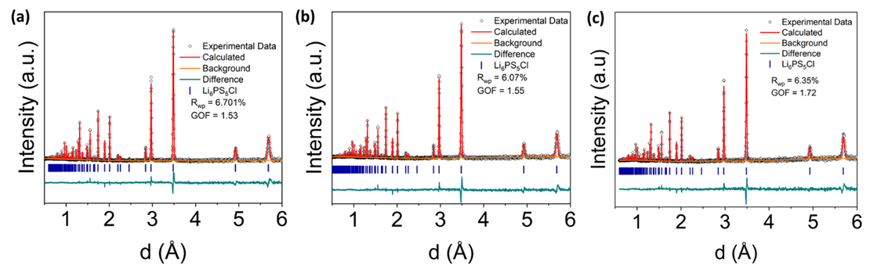
Figure 47. Rietveld Refinement against the NPD of (a) LPSCl – PM (b) LPSCl – VM (c) LPSCl – CM products from lab-scale synthesis conditions.

Optimization of the microstructure of both solid electrolyte and Cathode Active Material (CAM) has been shown to be crucial to enabling good ASSB performance.⁵⁰ In composite cathodes, the ratio between the two components is ideally 2 to 1 (CAM:SE), in order to maximize the contact between the two to provide ample pathways for both ionic and electronic transport at the interface.^{51,52} The particle size distribution of solid electrolytes has also been observed to impact the processability and performance of cast separators.⁵³ In order to understand the impact of the synthesis route on microstructure, we used SEM to observe both the morphology and distribution of the resulting particles (Fig. 48). The left most column of this figure shows the 35x magnification of each sample after annealing (Fig. 48 i, a, d and g). Each sample contains a wide distribution of particle sizes ranging from the order of > 100 µm to < 1 µm. The LPSCl – PM sample contains platelet particles that range in size from a 752 nm to 595 µm in size (Fig. 48c). In comparison, the LPSCl – VM sample has similar morphology and ranges in size from 1.7 to 542 µm (Fig. 48f). Lastly, the LPSCl – CM sample ranges from 2 to 484 µm in size (Fig. 48i). Although the PM sample contains the smallest particles, its average size is closer to that of the VM sample at 57 and 56 µm respectively, while the CM sample has the narrower range of sizes and the smallest average size at 39 µm. The similarities in the distributions of the products points to the annealing step determining the product particle size distribution as opposed to the initial milling step. This is possibly due to the agglomeration of particles during the annealing process, which leads to an increase in the crystallite size.²⁰ This points to the need for low energy and time-consuming particle size reduction after annealing for sulfide solid electrolytes synthesized through solid-state routes.⁵⁴
Ionic conductivity measurements were taken to understand the role of the different milling conditions on the LPSCl products, as shown in Fig. 49. Fig. 49a shows the room temperature Nyquist plots of each sample. The high frequency resistance for the PM sample is approximately 41 Ω corresponding to a room temperature conductivity of 1.89 ± 0.01 mS/cm. While the VM sample has a high frequency resistance of 48.3 Ω translating to 1.57 ± 0.01 mS/cm at room temperature. Finally, the CM sample has a high frequency resistance of 45.4 Ω and a room temperature conductivity of 1.63 ± 0.01 mS/cm. All three samples have room temperature Li-ion conductivities in agreement with the range expected for solid-state synthesized LPSCl.¹⁸ The ionic conductivity measured at 85 °C is 8.00, 7.77, and 6.27 mS/cm for the PM, CM, and VM samples respectively as shown in Fig. 49b. The ordering for the activation energies PM < VM < CM with values of 0.219, 0.223, and 0.256 respectively deviates from the 25 °C and 85 °C conductivity values. However, in all cases, the PM sample is higher in calculated conductivity and has the lowest activation energy. This signifies that the milling route could play a role in determining the ionic conductivity of the product. The activation energies more closely correlate with the particle size distribution, where the two larger particle size distributions matched with the lower activation energies.

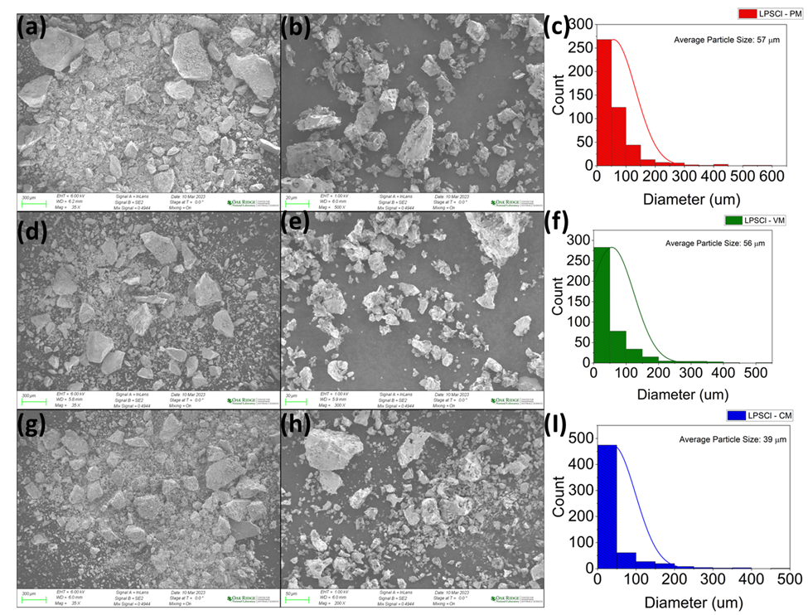
Figure 48. SEM images (35x magnification: a,d,g , 500x magnification , 300x magnification: e , 200x magnification: h) and particle size distributions for (c) PM (f) VM (i) CM samples.
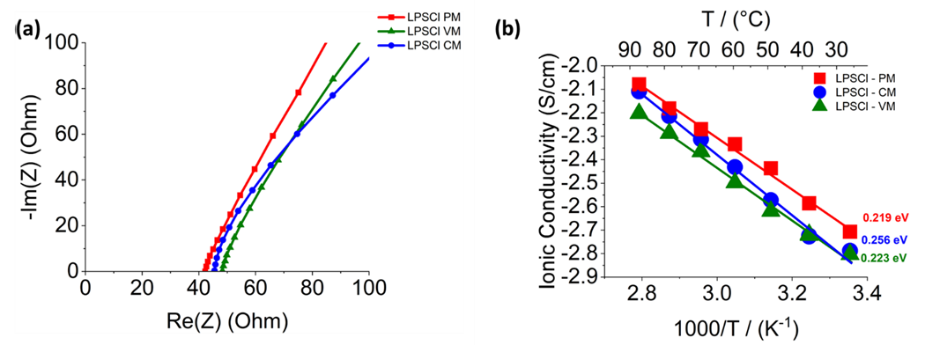Figure 49. (a) Representative Nyquist plots of each sample at 25°C. (b) Arrhenius plots of each sample for data between 25-85°C

Recent reports have shown that synthesis routes can affect the electrochemical performance of the resulting solid electrolytes in ASSBs.⁵⁵ In order to understand this relationship for LPSCl synthesized using different milling methods, LiNi_{0.8}Mn_{0.1}Co_{0.1}O₂ (Abbr. NMC811)@LiNbO₃/LPSCl/Li-In Cells were constructed for LPSCl PM, VM, and CM samples. A lithium indium anode was used in place of lithium metal because LPSCl has been shown to suffer from large interphase growth and dendritic failure.^{56,57} The alloy was formed by lithiating indium foil on the first charge cycle of each cell. The LiNbO3 coating of NMC811 was used to prevent side reactions due to the limited oxidative stability of LPSCl.⁵⁸ The charge-discharge behavior of at 1st, 2nd, and 50th cycle of each cell is shown in Fig. 51. From this we see that the PM sample has the highest initial charge capacity at 186 mAhg⁻¹ followed next by the CM sample with 181 mAhg⁻¹ and finally, the VM sample recorded the lowest initial capacity 159 mAhg⁻¹. All three cells suffer large irreversible losses between the initial charge and discharge processes 25%,25%, and 27% for the PM, CM, and VM cells respectively. One common source of irreversible loss of capacity in the cells is the lithium consumed to form the Li-In alloy anode.⁵⁷ We note that, similarly, the CM and PM samples both degrade to a charge capacity of only 16 mAhg⁻¹. This shows that each of the cells undergoes degradation that leads to the loss of lithium inventory during cycling. The degradation mechanisms are most likely a convolution of oxidative instability and contact loss, leading to a decrease in the partial ionic conductivity of the composite cathode.⁵⁹ Fig 50 shows the similarity in the capacity fade between both the PM and CM samples as a function of cycle number, regardless of the ionic conductivity of the solid electrolyte or particle size and morphology the eventual capacities after 50 cycles settle at low values. This is reinforced by the Nyquist plots of the full cells before and after cycling shown in Fig. 52. The initial HF resistance for the PM sample is approximately 19.92 Ω with a charge transfer resistance of 15.5 Ω, which increases to 63 Ω after cycling (Fig. 52a). While the CM sample starts with an HF resistance of 15.75 Ω and a charge transfer resistance of 26.45 Ω, which grows to 216 Ω after cycling. These significant changes in charge transfer resistance have been correlated with interfacial decomposition of the interface between LPSCl and layered oxide cathodes, such as the NMC811 employed here.⁶⁰

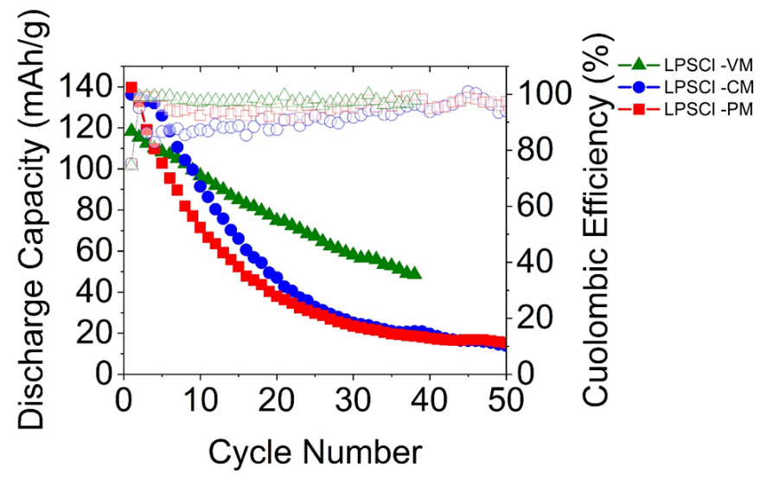
Figure 50. Cycling performance comparison for NMC811/LPSCl/Li-In Cells.

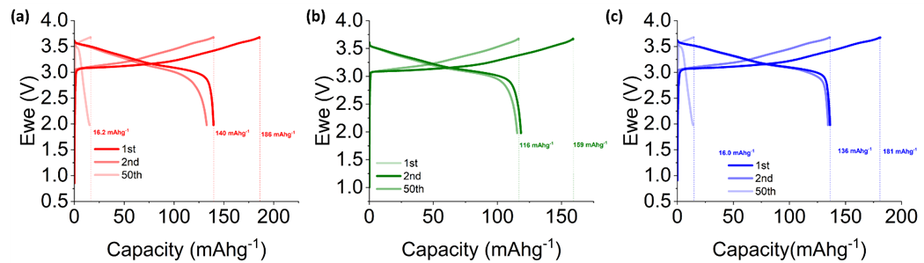
Figure 51. Charge Discharge Behavior Comparison for: (a) LPSCl – PM (b) LPSCl - VM (c) LPSCl – CM.
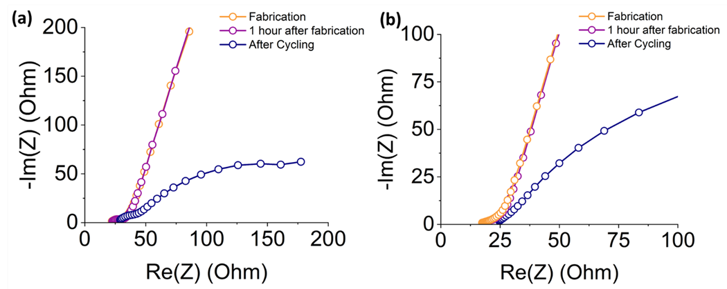 Figure 52. Comparison of Nyquist plots after fabrication, 1 hour of rest, and after cycling for: (a) LPSCl -PM (b) LPSCl – CM.

Conclusion
Using In-situ NPD, the reaction mechanism for the synthesis of LPSCl has been unveiled. LPS is observed as the intermediate phase that precedes the formation of LPSCl at 280 °C. This contrasts with previously proposed reaction mechanisms for the mechanochemical and solid-state synthesis of LPSCl. NPD confirms that like Li₆PS₅Br anion disorder in LPSCl is controlled by thermal treatments as opposed to milling conditions during mechanochemical synthesis. We compare the formation mechanism across milling techniques and find that the motion or heat generation during milling does not impact the formation mechanism or the anion site disorder. NPD data collected during cooling of the samples was used to determine the coefficient of thermal expansion for LPSCl which is like that of other sulfide solid electrolytes reported in the literature. All three milling techniques resulted in similar microstructures and ionic conductivities for the LPSCl products. This opens the door for other milling methods with higher scalability such as vibration milling to be used in place of planetary milling. This study provides valuable insight into the reaction mechanism and scalability of the synthesis of lithium argyrodites.

Appendix
Table 4. Parametric fitting results from In-situ NPD cooling data for each of the PM, VM, and CM samples.
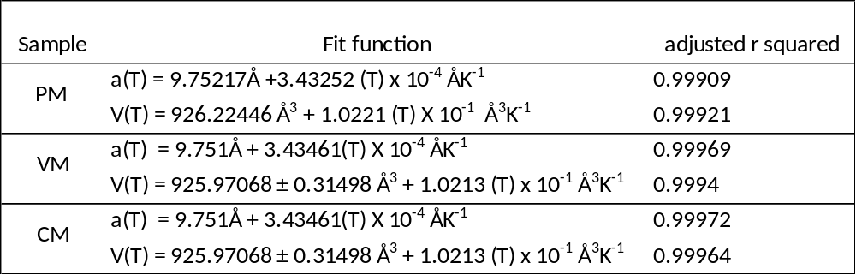
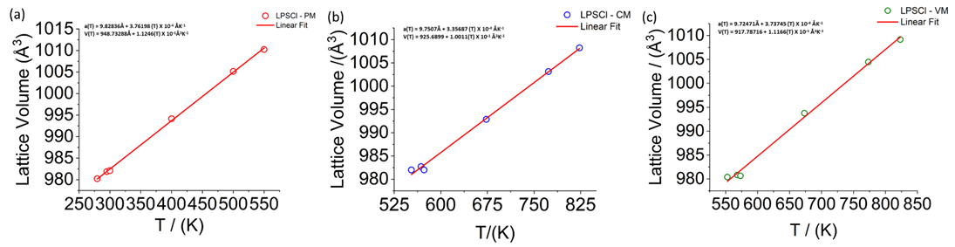
Figure 53. Parametric Fitting of results and fitting functions of LPSCl during ramping up for (a) PM (b) CM (C) VM samples

Chapter V Comparison Of Pressure Effects On Halide And Sulfide Electrolytes For All-Solid-State Batteries

Abstract
Halide and sulfide solid electrolytes have natural synergies due to their differences in electrochemical stability windows. This has led to the proliferation of bi-layer cells in the literature, which show good cycling stability under high stack pressures. While this is encouraging, high stack pressures are not possible in commercial cell form factors, such as pouch cells. Here, we compare the pressure dependence of both halide and sulfide solid electrolytes, to understand if high stack pressure is necessary. Through Galvanostatic cycling and Electrochemical Impedance Spectroscopy (EIS) we show that halide containing cells show a greater pressure dependence in terms of cycling stability. We also show that halide solid electrolytes can protect sulfide solid electrolytes from oxidative decomposition at the cathode| solid electrolyte interface. Finally, we show that even when both stack and fabrication pressures are optimized, cracking and delamination in composite cathode featuring halide solid electrolytes can still occur.

Introduction
The increase in demand for safer, more energy dense energy storage devices has driven interest in the advancement of all-solid-state batteries (ASSBs) and solid electrolytes.¹ Solid electrolytes are crucial in replacing flammable organic liquid electrolytes with a thermally stable, safer alternative.² Many classes of solid electrolytes are currently being investigated as potential alternatives. Of these, sulfide and halide solid electrolytes are two of the more promising classes currently being investigated. Sulfides are known for their high ionic conductivities, favorable mechanical properties, and low cost.³ Halides have garnered more attention recently due to their wide electrochemical stability window, particularly their high oxidative stability and their scalable synthesis routes.⁴ Li₆PS₅Cl (LPSCl) and Li₃InCl₆ (LIC) represent two of the most heavily investigated compositions within each class of solid electrolytes. Their employment in bilayer-based cells has received increased attention recently due to their natural synergies.^{5,6} LPSCl suffers from poor oxidative stability with layered oxide cathodes, while being kinetically stable with low voltage electrodes such as Lithium metal and Lithium alloys.⁷ While LIC suffers from poor reductive stability due to the metal cation center (In, Y, Sc etc.) forming an electronically conductive interphase with lithium metal.⁸ Many of the recent studies employing the bilayer strategy have employed large stack pressures during cycling.⁶ While the impact of stack pressure and fabrication pressure have been investigated for sulfide solid electrolytes independently, the impact of pressure on bilayer cells and more specifically halide solid electrolytes is lacking.^{9,10} In this work, we investigate the impact of stack pressure and fabrication pressure on LPSCl and LIC containing bilayer ASSBs. First, we show that electrochemical performance in LIC containing cells has a strong dependence on stack and fabrication pressure, while stack pressure is deemed to be unimportant for LPSCl based cells. We then investigate the impact of these parameters on the ionic conductivity of each separator material. We find that LIC has a higher stack pressure induced improvement in ionic conductivity due to improvement in contact with the electrode. While this is also observed in LPSCl it is less pronounced and does not correlate to improvements in electrochemical performance. We then show that both pressure effects (stack and fabrication) lead to improvements in partial ionic and electronic conductivity within the LIC containing composite cathode. We then show that LIC is successful in preventing decomposition of the SE|NMC interface. Furthermore, we also show that chemical instability between LPSCl and LIC is not observed by Raman mapping of the interface of the two SEs. Finally, we show that even when both pressure effects (stack and fabrication) are optimized, delamination and cracking of NMC particles in the composite cathode occurs upon cycling.

Experimental

Materials
The LIC was synthesized by weighing out LiCl and Incl₃ in stoichiometric amounts in a glove box and dissolved in 100 mL of water. The resulting solution was roto-evaporated to 65 °C and then dried under dynamic vacuum overnight at 150 °C. The LPSCl solid electrolyte was purchased from NEI as was the NMC811 and carbon nanofibers (VGCF) were purchased from Sigma Aldrich.

Electrochemical Testing Of Solid-State Cells
The battery assembly and electrochemical testing were conducted in a Polyether Ether Ketone (PEEK) mold cell developed in our laboratory, consisting of a cylindrical PEEK cell body, two stainless steel spacers, a stainless-steel piston, and a stainless-steel plate for electrical contact. The composite cathodes were assembled by mixing NMC811, Solid Electrolyte (LIC or LPSCl) and VGCF in a 70:27:03 ratio. The mixture was loaded into a 20 mL polyethylene vial with 5 mm Zirconia milling media in a 10 to 1 media to powder ratio and mixed for 1 hour at low speeds in a Turbula 3D shaker mixer (WAB).
The full cells were assembled as follows 28 mg of indium foil was placed into the peek mold in contact with a stainless-steel spacer, followed by 200 mg of solid electrolyte for the LPSCl based cells and a split bilayer of 100 mg each for the cells containing LIC, the cell was cold pressed at 125 MPa for a few seconds and 15 mg of cathode composite powder the stack was once again pressed at 125 MPa for a few seconds. This was followed by placing a carbon coated aluminum current collector on top of the composite cathode, after which the entire stack was pressed at the designated fabrication pressure for 5 minutes. The cell was then placed in a vice under the designated stack pressure during cycling inside an Ar filled glove box. Stack pressure was applied to a vice using a torque wrench.
Galvanostatic cycling studies were conducted in the voltage range of 1.97 – 3.67 V versus Li-In/In (2.6 – 4.3 V versus Li⁺/Li) at room temperature. Each cell was cycled for 50 cycles at 0.1 mA/cm². All impedance spectra for the full cells were collected with an excitation amplitude of 10 mV in a frequency range between 1 MHz and 10 mHz with 6 points per decade. All electrochemical testing was conducted with a VSP potentiostat (Biologic).

Materials Characterization
All Raman maps were collected on a confocal Raman spectrometer (WITec, GmbH 532 nm, objective = 20×, a grating with 600 grooves/ mm, numerical aperture (N.A.) = 0.42, local power <500 μW). The laser spot diameter was estimated to be 1 μm. The scan region was set 120 × 120 μm², with a step size of 1 μm²/pixel. The integration time was set to 3s for each point.
All Raman mappings were analyzed by using Witec ProjectPlus software and the K-means clustering algorithm integrated into the Scikit-learn platform. ⁴⁷

Results and Discussion
Stack pressure has been shown to play a role in determining the electrochemical performance of SEs in ASSBs. Figure 54(a) shows the effect of stack pressure on the initial charge and discharge capacities of the three identically constructed cells with active material loading of 8.26 g/cm². Each cell was fabricated for 5 minutes at 500 MPa and set to the designated stack pressure prior to cycling. The initial charge capacities are ordered as follows 226, 182, and 157 mAhg⁻¹ for the 30, 5, and 50 MPa cells respectively. In all cells we observe a large capacity loss between the 1st charge and discharge, this is in part due to the lithiation of indium metal to for the Li-In alloy. Although the 5 MPa cell has a high initial charge capacity, we observe that its capacity fade is significantly higher than the 50 MPa cell. Showing that higher stack pressure on average may be important for bi-layer ASSBs. This leads us to believe that improvements in particle – particle contact between the Li₃InCl₆ (Abbr. LIC) solid electrolyte, and the LiNi_{0.8}Mn_{0.1}Co_{0.1}O₂ (NMC) active material enables greater access of the lithium inventory for a given active material.^{11,12} In addition, we observe that capacity retention is greatly improved for LIC based cells cycled at higher stack pressures. However, the increase is not monotonic with increasing stack pressure whereas 5 MPa does not enable improved conduction within the composite cathode the highest tested stack pressure of 50 MPa is not the best performing either. Rather, a local maximum is achieved when the cell is cycled at 30 MPa. This signals that there are multiple effects at play here, while increases in stack pressure during cycling may lead to reductions in porosity, they may also, at high enough values, cause loss of contact due to potential cracking of solid electrolyte or active material particles.¹³ In addition to improvements in densification of components such as the composite cathode, the ionic conductivity of Li₃InCl₆ shows a strong intrinsic pressure dependence.¹⁴ Therefore, improvements in the capacity and cycling performance could also be due to the improved partial ionic conductivity of the composite cathode at the 30 MPa compared to the other values.
These changes in the capacity retention are reinforced by the values of the charge transfer resistance in the midfrequency region of the EIS, collected as a function of cycling.¹⁵ While the 5 MPa and 50 MPa samples show a larger change relative to the starting values and those after cycling, the 30 MPa sample retains much of its initial behavior. Interestingly, for the 50 MPa sample, we do observe a large change in the mid-frequency intercept as a function of rest for 1 hour at OCV at a higher stack pressure. This could be due to inherent chemical instability between the LIC and another component within the composite cathode.¹⁵

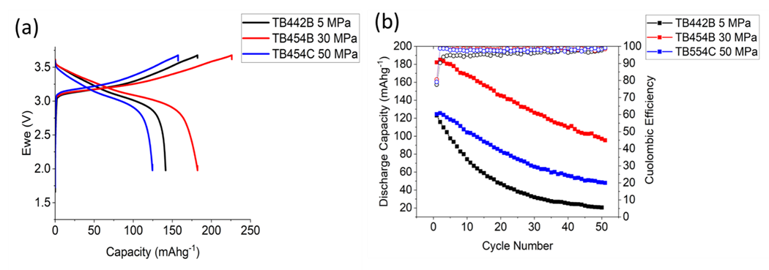
Figure 54. Effect of Stack Pressure on In|LPSCl|LIC|NMC811 cells (a) initial charge discharge behavior (b) cycling performance
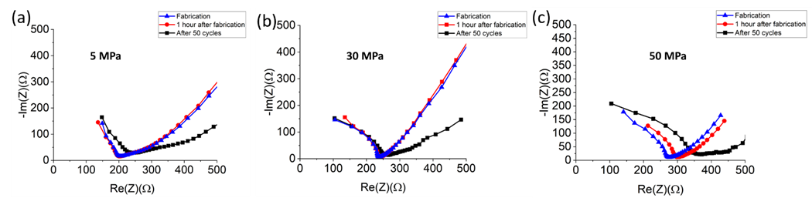
Figure 55. Comparison of EIS spectra as a function of cycling across stack pressures (a) 5 MPa (b) 30 MPa (c) 50 MPa for In|LPSCl|LIC|NMC811 cells

Figure 56 shows the effect of changes in stack pressure on the initial discharge capacity and cycling performance of ASSBs utilizing only Li₆PS₅Cl (LPSCl) in the separator and composite cathode. All cells were fabricated for 5 minutes at 500 MPa. The 30 and 5 MPa cells show large initial charge capacities around 215 mAhg⁻¹ while the 50 MPa sample like what was observed in the LIC based cells shows a lower charge capacity of 163 mAhg⁻¹. The similarly reduced initial charge capacity at high stack pressure for both types of cells could signify the presence of NMC particle deformation. In all three LPSCl cells, significant capacity fade is observed after 50 cycles. These cells do not show any significant change in behavior as the stack pressure is adjusted between 5 MPa and 30 MPa. This data matches findings from the literature that has previously shown that stack pressure was of negligible importance for LPSCl based ASSBs.¹⁰ Instead, previous studies have found that fabrication pressure is of greater importance for sulfide based ASSBs.¹⁰ In addition, we note that the oxidative decomposition process shown during charging of the LPSCl cells with onset ~ 2.6 V (Fig. 56a) is not present in the LIC containing cells of Fig. 54a. The greater stack pressure dependence for LIC compared to LPSCl likely points to the mechanical differences in the electrolytes, showing that LIC and other halides may require larger stack pressures to maintain more intimate contact with composite cathode components during cycling.¹⁴

Similarly, we do not see substantial changes in resistance of the post cycling EIS as a function of stack pressure between the two cells compared in Figure 57. Regarding cycling of ASSBs, halide solid electrolytes have a much stronger stack pressure dependence than sulfide solid electrolytes. Such high stack pressures are not suitable for commercial cells, therefore alternative strategies to enabling ASSBs must be combined such as low or zero strain cathodes, narrower operating windows, optimization of partial ionic and electronic conductivities and tuning of the mechanical properties of solid electrolyte materials. ^{12,14,16,17}

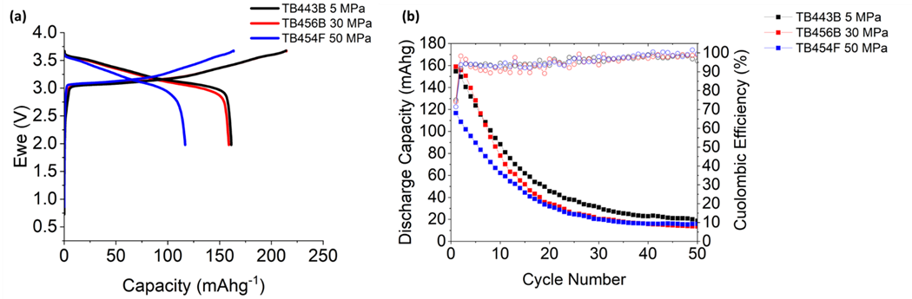
Figure 56. Effect of Stack Pressure on In|LPSCl|NMC811 cells (a) initial charge discharge behavior (b) cycling performance

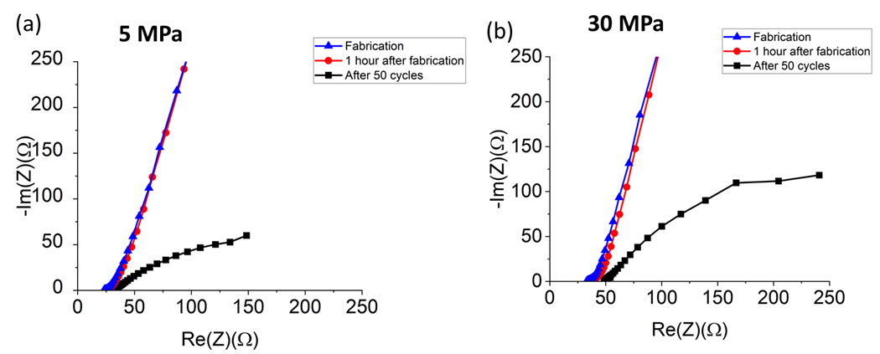
Figure 57. Evolution of EIS spectra as a function of cycling and stack pressure for In|LPSCl|NMC811 Cells.

Although it may not be practical to operate cells at a high stack pressure, it would be feasible to fabricate them at relatively high pressures.^{18,19} In addition, it was previously shown that LPSCl based ASSBs did show dependence on the fabrication pressure.¹⁰ The cycling performance displayed in Fig. 58b compares cells fabricated at difference pressures as noted for 5 minutes in an uniaxial press, while the stack pressure during cycling was kept constant at 30 MPa. We observe here that a higher fabrication pressure results in an increase in the initial charge capacity. The 500 MPa cell has an initial discharge capacity of 226 mAhg⁻¹ while the two lower fabrication pressures 149 and 128 mAhg⁻¹ respectively for the 250 MPa and 375 MPa Cells. The large difference in extractable lithium inventory being connected to the porosity in the composite cathode and the separator layer.²⁰ In Fig 58b. We observe that this improvement in porosity plays a large role in determining the capacity retention as well. After 50 cycles the capacity of the 500 MPa is ~100 mAhg⁻¹, however the lower fabrication pressure each retains 60 and 40 mAhg⁻¹ for the 375 and 250 MPa cells respectively. We observe that for the LIC based cells in this study, both stack pressure and fabrication pressure play a large role in enabling improvements in capacity retention and accessible lithium inventory from the active material. In line with previous findings regarding the effect of fabrication pressure on ASSB performance, we find that relatively high pressures are needed to reduce porosity within halide containing ASSBs.²¹
Reducing the porosity in either the separator or composite cathode would lead to improvements in the bulk and interfacial ionic conduction, both of which are crucial to discharge capacities, capacity retention, and rate performance.⁹ In order to deconvolute the improvements in performance, we studied the effect of both fabrication and stack pressure on the solid electrolytes that make up the separator of the bi-layer cells. In Fig 59a. We observe the impact of fabrication pressure on the room temperature ionic conductivity of LPSCl. We observe that with increasing stack pressure there is an improvement in the relative density of the solid electrolyte, however the improvement in ionic conductivity from 250 MPa to 500 MPa is only ~ 6%. This agrees with recent studies which showed that once the solid electrolyte reached 75% relative density, higher fabrication pressures did not lead to significant improvements in conductivity.¹⁰ We then investigated the effect of stack pressure on the ionic conductivity which showed improvement from 1.86 mS/cm at a low stack pressure of 0.35 MPa and a maximum ionic conductivity of 2.12 mS/cm at 50 MPa a ~14 increase. However, when the stack pressure was relieved back to 0.35 MPa the ionic conductivity recovered back to 1.84 mS/cm (blue left arrow). This also agrees with recent findings that showed a modest stack pressure dependence for the ionic conductivity of LPSCl at room temperature, which was driven by improvements in contact between the electrode surface and the solid electrolyte.²² This limited improvement in the ionic conductivity is supported by the lack of stack pressure dependence on the electrochemical performance of the LPSCl based cells, as previously discussed in Fig. 56.

The effect of fabrication pressure on LIC is shown in Fig. 60a. As the fabrication pressure is increased, the LIC reaches a maximum relative density of ~95% while the conductivity increases from .392 to .405 mS/cm, a modest increase of ~3%. This shows that the increase in ionic conductivity alone from reduction of porosity in the separator layer is not the driver of the observed difference in cycling performance between the LIC containing cells. The effect of stack pressure on the ionic conductivity of LIC is shown in Fig. 60b, which shows a 26% increase, going from .405 mS/cm at 0.35 MPa to .512 mS/cm at 50 MPa. However, like the LPSCl sample, once the stack pressure is relieved to 0.35 MPa the ionic conductivity drops back to .413 mS/cm (blue left arrow). In comparison, LPSCl experienced a slight drop in conductivity once the stack pressure was relieved to 0.35 MPa while here we observe a slight increase with LIC. This could point to either a difference in mechanical properties or microstructure which determines the ability to make and maintain good contact with the electrode surface.²² In the case of LIC, the significant improvement in ionic conductivity induced by increasing the stack pressure may play a role in determining the improvement in capacity retention. However, based on these comparisons, the porosity reduction in the separator layer and the resulting improvements in ionic conductivity are not great enough to explain the improvement in cycling performance.

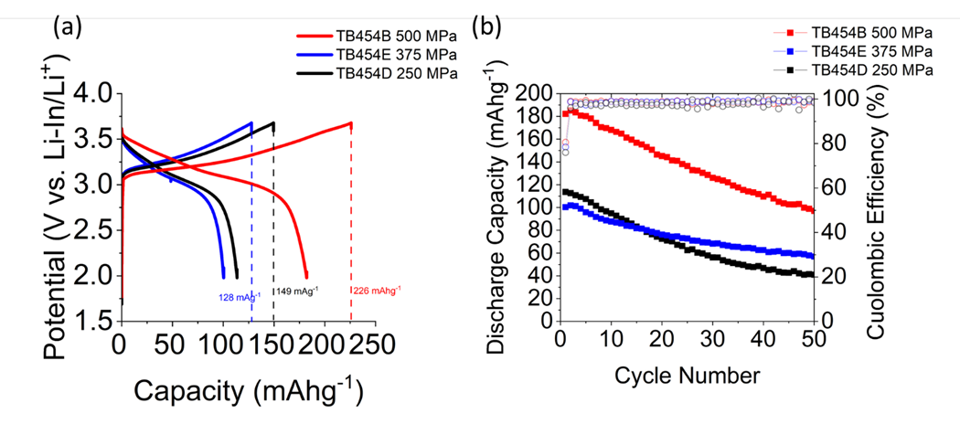
Figure 58. The Effect of Fabrication Pressure on In|LPSCl|LIC|NMC811 Cells (a) initial charge discharge behavior (b) cycling performance.
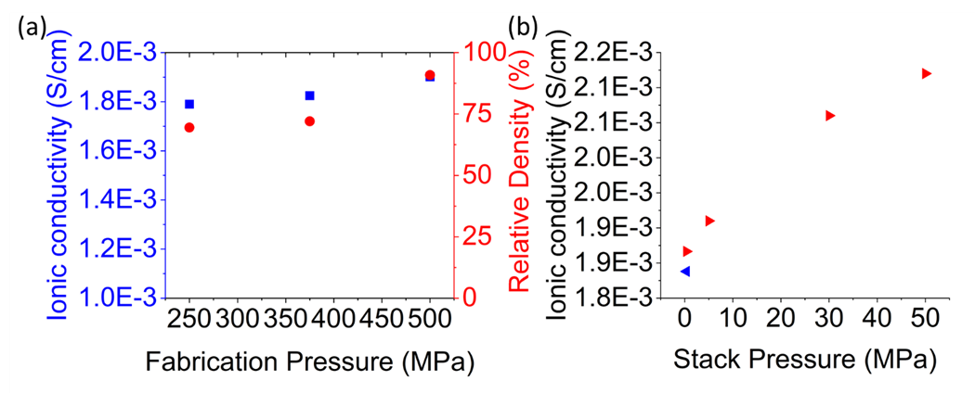Figure 59. Comparison of the Effect of (a) Fabrication Pressure (b) Stack Pressure on LPSCl ionic conductivity, red arrows showing trend with increasing stack pressure, while blue shows the trend after stack pressure was relieved. 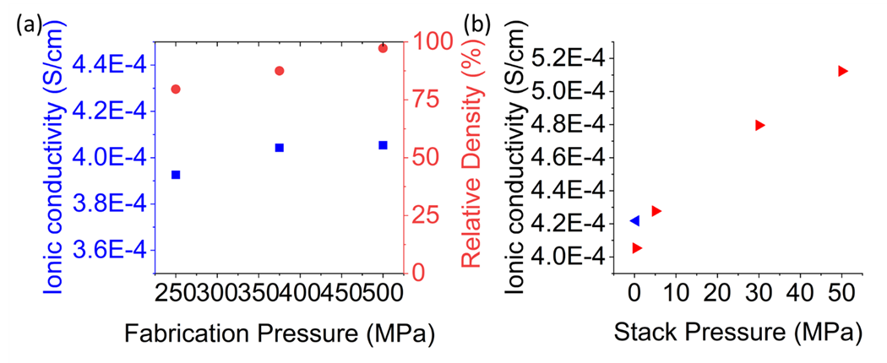
Figure 60. Comparison of the Effect of (a) Fabrication Pressure (b) Stack Pressure on LIC ionic conductivity red arrows showing trend with increasing stack pressure, while blue shows the trend after stack pressure was relieved.
As previously noted, the single layer LPSCl cells show a significantly faster capacity fade when compared to the bi-layer cells containing LIC. One possible reason for this decrease in capacity is the formation of oxidative decomposition products.²³ This is likely due to the narrow electrochemical stability window of LPSCl, where oxidative instability has been observed at ≥ 3.1 V vs. Li⁺/Li.²⁴ In Fig. 61b we observe the results of Raman imaging analysis showing that the NMC|LPSCl interface is quite heterogeneous. From top down, as we move away from the bulk separator region (orange) into the composite cathode, this heterogeneity increases. From the centroid spectra of each of the clusters, we observe that the bulk separator region does feature the expected bands for the LPSCl phase at approximately 199, 272, 425, and 573 cm⁻¹.²⁵ At 272 and 425 we observe the bands corresponding to the S-P-S bending and the symmetric stretching in the PS₄³⁻ tetrahedral.²⁶ As we move towards the composite cathode, the spectra also show the presence of distinct bands at 473 and 705 cm⁻¹ which likely correspond to the S-S bending mode in S₈ and P-S stretching vibration of terminal sulfur in P₂S_{x} (X = 5-7) compounds respectively.²⁷ Previous studies of the LiCoO₂ (LCO) | LPSCl interface also found these decomposition products present when charging between 2.5 and 4.2 V vs. Li⁺/Li.²⁶ Deeper in the composite cathode region we also find peaks at 876 cm⁻¹ which likely correspond to PO₄³⁻ vibrational band. ²⁸ It is possible that these bands originate from Li3PO4, which is a common surface impurity found on LPSCl when exposed to moisture.²⁹ However, the phosphate containing impurities increase in intensity as we move away from the bulk region, signaling that they are likely formed from oxidative decomposition at the NMC|LPSCl interface. This is supported by previous studies of the NMC622|LPSCl interface using XPS and TOF-SIMS, which found the presence of PO_{x}⁻ containing groups and transition metal phosphates such as Mn₃(PO₄)₂ and Ni₃(PO₄)₂ impurities after cycling.^{26,30} As we move farther into the composite cathode layer, we also observe the presence of the VGCF as shown by the G-band at 1590 and D-band at 1340 cm⁻¹ associated with high surface area carbons.³¹
When comparing this to the NMC|LIC interface, we find that the heterogeneity of the interface is less mixed, as shown in Fig. 61e. The clustered spectra show the presence of LIC, as noted by the peaks at ~ 280 cm⁻¹.³² This peak is assigned to the v1 vibrational mode of the InCl₃³⁻ octahedra.³³ Interestingly, the intensity of this peak is varied depending on the position within the composite cathode, which could reflect changes in crystallinity or mechanical integrity as a function of cycling. In this spectrum, we can more clearly confirm the presence of NMC 811 by the 547 cm⁻¹.³⁴ We note that we do not see the presence of peaks corresponding to PO₄³⁻ groups at the NMC|LIC interface. This shows that the LIC is successful in isolating the cathode|SE interface from the less stable LPSCl thereby preventing the formation of its associated decomposition products. This agrees with the charge-discharge results discussed previously which showed the presence of oxidative decomposition processes for the LPSCl cells but was not present in the voltage profile of the LIC containing cells.
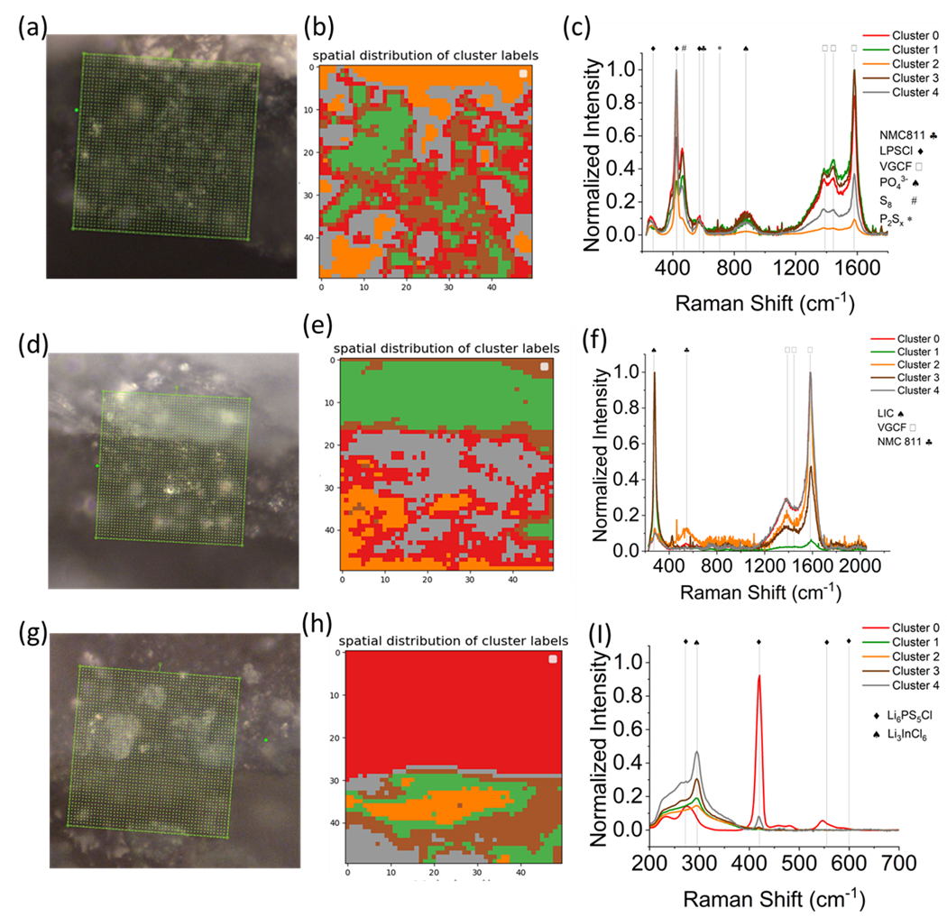
Although the performance of the LIC containing cells is improved compared to those containing only LPSCl we still do observe significant capacity fade even in the best performing cells as previously discussed. One potential reason for this as noted by recent studies could be the chemical instability between LIC and LPSCl.^{35,36} Follow-up studies have confirmed the presence In-S containing decomposition species between the two solid electrolytes.³⁷ Although small amounts of In-S fragments were observed in the separator region between the two solid electrolytes, the larger presence of impurities was found at the three-phase region in which LIC was used as the catholyte in the composite cathode and LPSCl as the sole component of the bulk separator layer. In this instance, decomposition products from the reaction of LPSCl with the cathode active material (CAM) were found to lead possibly lead to the formation of LiInS₂ or In₂S₃ and LiCl type compounds.³⁷ This is further supported by recent computational studies, which show that halide solid electrolytes are not predicted to be stable up against Li₂S CAMs.³⁸ We do not observe the presence of Raman peaks associated with In₂S₃ or LiInS₂ at the interface between the two solid electrolytes (Fig. 61i).^{39,40} The comparison of the three interfaces shows that the differences in capacity retention observed amongst LIC based cells is likely not driven by differences in chemical or electrochemical stability but rather changes in the connectivity between the LIC and other constituent components in the cathode.
Figure 61. presents the cross-sectional optical microscopic images of the (a) NMC|LPSCl interface, (b) NMC|LIC interface and (c) LPSCl|LIC interface. The green box represents the mapping region. Raman imaging (following K-means clustering analysis) of the (b) NMC|LPSCl interface, (e) NMC|LIC interface, and (h) LPSCl|LIC interface is also displayed. Each zone represents a region with similar structure and chemistry, and the corresponding centroid spectra, following the same color-coding, are shown in (c),(f), and (I) respectively.
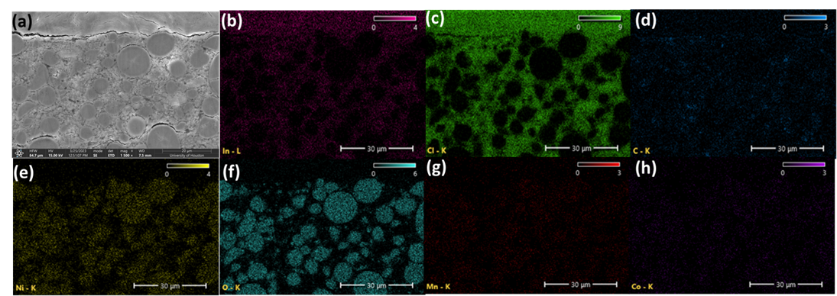
Figure 62. SEM images of the Composite Cathode – Solid Electrolyte Interface after cycling under 30 MPa of stack pressure (a) 1500 x magnification of NMC|LIC interface EDX maps or (b) In (c) Cl (d) C (e) Ni (f) O (g) Mn (h) Co.

To observe the effects of stack and fabrication pressure on cycling we analyzed the NMC|LIC interface, of the cell fabricated at 500 MPa and cycled under 30 MPa of stack pressure, via Scanning Electron Microscopy (SEM) (Fig. 62). In Fig. 62a, we can see that the composite cathode is relatively well mixed with the solid electrolyte, as denoted by the In EDX map (Fig. 62b) surrounds the cathode particles. However, we note that some particles have begun to delaminate after cycling. Furthermore, the interface between the separator region and the composite cathode has also begun to delaminate. This loss of contact is responsible for capacity fade observed even in the best performing cell. For this optimized cell, we note that stack pressure does not prevent the eventual cracking of poly crystalline NMC particles. This has been observed in both solid and liquid electrolyte-based cells, and has been cited as a source of capacity fade for layered oxide cathodes.⁴¹ It has been shown for both sulfide and halide based ASSBs that single crystal oxide cathodes can lead to improvements in capacity retention.⁴² This improvement is believed to be driven by isotropic strain in single crystal morphologies, as opposed to the anisotropic strain observed for polycrystalline materials.⁴³ In addition to the morphology of the active material and solid electrolyte particles, the particle size distribution has been shown to play a large role in determining the capacity retention during cycling.⁴⁴ The cathode particles range in diameter from 10 µm at the largest to 1 µm at the smallest, while the solid electrolyte particles range from 1-3 µm. Further optimization of the solid electrolyte particle size to match a ratio closer to 2 to 1 between the CAM and solid electrolyte has been shown to be optimal for ionic conduction in the composite cathode.⁴⁵ Recent work utilizing freeze-drying during the synthesis of LIC was able to produce a product with the majority of particles being 200 nm in size, resulting in significant improvement in capacity retention with high Nickel NMCs.⁶ As previously discussed, recent reports have cited the possibility of In₂O₃ decomposition products forming when LIC is cycled with LiMn₂O₄ cathodes.¹² When we examine the EDX maps, we observe that the Ni, the strongest signal in the NMC particles, entirely overlaps with the O map and none with the In map. Which points to the lack of In₂O₃ formation in the composite cathode because of cycling. This agrees with the previously discussed Raman mapping of the LIC|NMC interface. And indicates that the instability observed between LIC and other oxide cathodes is likely composition and voltage window dependent.⁴⁶

Conclusion
In this work, the effect of fabrication pressure and operating stack pressure on the performance of halide and sulfide based ASSBs was investigated. We show that halide solid electrolytes show a strong stack and fabrication pressure dependence, the optimization of which leads to significant improvements in electrochemical performance. These improvements are deconvoluted from the reduction of porosity experienced by the separator layer, which shows slight increases in conductivity under high fabrication and stack pressures. While the composite cathode, partial ionic and electronic conductivities show strong fabrication and stack pressure dependence. As the ration between the two values approaches unity at high fabrication pressure and intermediate stack pressures, we observe significant improvement in the electrochemical performance. Furthermore, we show that the Halide solid electrolyte is instrumental in preventing the formation of LPSCl degradation products at the NMC|LPSCl interface through both Raman mapping and EDX of the solid electrolyte | cathode interface. We also show that the Raman mapping does not show evidence of chemical instability in the separator region between the two solid electrolytes, as has been recently reported. Finally, through SEM imaging of the LIC|NMC interface after cycling, we show that the capacity fade observed in the best performing cells is driven by void formation due to the anisotropic strain experienced in the composite cathode by polycrystalline NMC particles during cycling. This strain is shown to drive delamination between particles in the composite cathode and potentially the separator and composite cathode layers within the cell. This work shows that for Halide containing ASSBs to be commercialized, pressure effects (stack and fabrication) need to be considered. We hope these results help standardize pressure testing conditions on the lab scale and drive the development of strategies for enabling low stack pressure bi-layer ASSBs.

Appendix
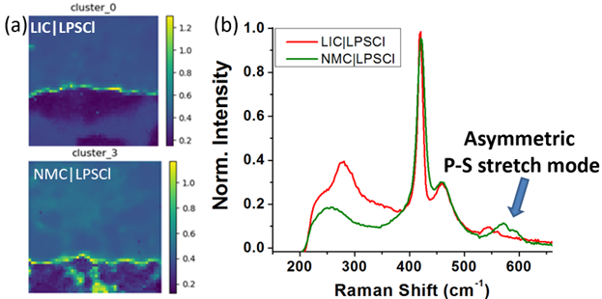
Figure 63. (a) The interfacial similarity loading map of the (upper) LIC|LPSCl interface and (lower) NMC|LPSCl interface. (b) Spectra comparison of the interfacial chemistry of the two interfaces.

Chapter VI: Conclusion And Future Directions

To further advance the development and commercialization of All-Solid-State Batteries (ASSBs) high performance SEs and a greater understanding of their material properties in ASSBs is required. A particular challenge is understanding the effect of synthesis and processing conditions on SE properties. This knowledge is crucial to eventual scale up of SE production and incorporation into ASSBs for vehicle applications. In this dissertation, the effects of synthesis and processing routes were investigated for both halide and sulfide solid electrolytes. An investigation of a novel aqueous synthesis route was carried out for Li₃YCl₆ (LYC). In-situ NPD was employed to understand the phase evolution of the aqueous route, both with and without the NH₄Cl additive. The additive in water was found to complex with YCl₃ to form an intermediate that was crucial to achieving high yields of LYC and preventing the formation of YOCl impurities when synthesized through water. In addition, a novel intermediate phase of LYC was observed during the phase evolution of the ammonium chloride route. This intermediate was not found to exist in the other investigate routes, signaling that this is likely a metastable structure. It was found that ionic conductivities matching or improving upon the products from other synthetic routes was achievable using this technique. The comparison of LYC products from different routes found that not only did the sample synthesized from the aqueous route have the highest ionic conductivity but also the best electrochemical performance. Lastly, we found that regardless of synthesis route, when annealed at higher temperatures, LYC experienced significant grain boundary formation.
Lithium argyrodites are a promising family of sulfide SEs however their formation mechanism is poorly understood. We utilized in-situ NPD to study the formation of Li₆PS₅Cl during annealing. In contrast to the previously proposed reaction mechanism, we observed that P₂S₅ precursors are consumed to form ß-Li₃PS₄ (LPS) as an intermediate phase with residual LiCl and Li₂S. This differs from previous studies, which suggested the formation of Li₇PS₆ as the intermediate upon milling. We also found that the use of different milling techniques and their differences in motion and local heat generation did not affect the reaction mechanism or product properties significantly. This work enables further exploration of mechanochemical techniques outside planetary milling such as vibration milling, which are scalable due to their ease of cooling during operation. In addition, we find that like previous reports regarding Li6PS5Br, the anion site disorder of Li₆PS₅Cl is controlled by heating and cooling profiles rather than milling or mixing parameters during synthesis.
Another promising halide solid electrolyte Li₃InCl₆ (LIC) and multiple sulfide solid electrolytes have been paired together due to the natural synergies that exist between these materials. Bi-layer cells feature these two types of materials have proliferated throughout the literature, showing enhanced cycling performance when compared to single layer separators of either material alone. Many of these reports often utilize high stack pressures during cycling, which is not possible in commercial cell geometries for vehicle applications. Therefore, we investigated the effect of both stack and fabrication pressure on LIC-LPSCl bi-layer cells was investigated. It was found that the introduction of LIC into the separator layer increased the stack and pressure dependence of the cycling performance of the ASSB. Stack pressures were found to improve the contact between LIC and the CAM during cycling, which improved the Li-ion transport properties of the composite cathode. Given its soft nature, LPSCl showed a significantly lower stack pressure dependence in terms of both ionic conductivity and cycling performance.
The performance of SEs in ASSBs still requires significant improvement before the wide-spread adoption of these batteries can be realized for vehicle applications. For Sulfide solid electrolyte, methods of stabilizing both the high voltage and lithium metal interfaces are needed if they are to be successfully incorporated into ASSBs. Some sulfides within the argyrodite family Thio-antimonates and halogen rich argyrodites have shown promising room temperature ionic conductivities of ≥ 10 mS/cm at room temperature.^{36,122} However, both of these materials have shown variations in both phase purity and measured ionic conductivities across the literature. This large degree of variation signals a poor understanding of the reaction mechanism required to form these materials. Further investigation of these materials’ reaction mechanisms is needed to better control the formation of impurities such as LiX (X = Cl, Br, I) and achieve consistent scalable high ionic conductivities. Regarding halogen rich argyrodites, is the LPS intermediate formation mechanism generalizable even in the presence of additional LiX precursors? If so, does the addition of these precursors affect the kinetics or thermodynamics of LPS formation and does this drive the varying degrees of halogen solubility observed in the literature for the Li_{7.0-y}PS_{6.0-y}X_{y}, y = 0-2.0 (X = Cl, Br, I) system? This could also enable new solution synthesis routes, which also often suffer from residual precursor impurities or solvent in the product. In regard to Thio antimonates and other analogues where P is substituted for other pentavalent cations such as Sb, Si, Sn, etc. do their reaction mechanisms also feature analogous LPS intermediates? If so, are these kinetically fast or slow processes? Can synthesis or processing parameters be tuned to drive them in favorable directions to ensure high purity and high conductivity products?

Regarding halide SEs there are many promising future research directions. Recent work has shown that substitution of chalcogenides (S, O, Se, etc.) onto the halogen site in halide SEs may lead to improvement in not only ionic conductivity but also their mechanical properties.¹²³ These new halide compositions of the formula MAlCl_{4-2x}O_{x} (M = Li, Na) were found to have viscoelastic properties that enabled stable electrochemical cycling at low stack pressures (< 0.1 MPa). However, their ionic conductivities were ~1 mS/cm at 30 °C. If these ionic conductivity values can be increased, then these materials could be viable as bulk separator materials and potentially ionically conductivity mediums within composite cathodes of commercial ASSBs. Similarly, a new oxyhalide composition LiMOCl₄ (M = Nb, Ta) was reported recently with a room temperature conductivity ≥ 10 mS/cm.¹²⁴ These materials. These materials also showed good cycling stability in halide-sulfide bi-layer ASSBs. Lastly, the introduction of anion mixing into other halide compositions of the formula Li₃MX₆ (M = In, Y, Yb, Sc, Er, X = F, Cl, Br, I) may yield similar improvements in ionic conductivity. How does the anion substitution in this system including halogens, chalcogenides, and polyanions such as BH₄⁻ affect the electrochemical stability, ionic conductivity, and formability of the resulting SE? Answering these questions will guide the ability to control SE product properties to enable ASSBs stable against both high voltage cathodes and lithium metal.
This dissertation provides insight into the synthesis – structure – property relationships of sulfide and halide solid electrolytes. These studies can serve as a template to guide future investigation of new compositions or potential scalable synthesis routes to enable commercialization of SEs.

References

(1) Jenkins, J. D.; Luke, M.; Thernstrom, S. Getting to Zero Carbon Emissions in the Electric Power Sector. Joule 2018, 2 (12), 2498–2510. https://doi.org/10.1016/j.joule.2018.11.013.
(2) Larcher, D.; Tarascon, J.-M. Towards Greener and More Sustainable Batteries for Electrical Energy Storage. Nature Chem 2015, 7 (1), 19–29. https://doi.org/10.1038/nchem.2085.
(3) Trahey, L.; Brushett, F. R.; Balsara, N. P.; Ceder, G.; Cheng, L.; Chiang, Y.-M.; Hahn, N. T.; Ingram, B. J.; Minteer, S. D.; Moore, J. S.; Mueller, K. T.; Nazar, L. F.; Persson, K. A.; Siegel, D. J.; Xu, K.; Zavadil, K. R.; Srinivasan, V.; Crabtree, G. W. Energy Storage Emerging: A Perspective from the Joint Center for Energy Storage Research. Proc. Natl. Acad. Sci. U.S.A. 2020, 117 (23), 12550–12557. https://doi.org/10.1073/pnas.1821672117.
(4) Bajolle, H.; Lagadic, M.; Louvet, N. The Future of Lithium-Ion Batteries: Exploring Expert Conceptions, Market Trends, and Price Scenarios. Energy Research & Social Science 2022, 93, 102850. https://doi.org/10.1016/j.erss.2022.102850.
(5) Winter, M.; Brodd, R. J. What Are Batteries, Fuel Cells, and Supercapacitors? Chem. Rev. 2004, 104 (10), 4245–4270. https://doi.org/10.1021/cr020730k.
(6) Goodenough, J. B.; Park, K.-S. The Li-Ion Rechargeable Battery: A Perspective. J. Am. Chem. Soc. 2013, 135 (4), 1167–1176. https://doi.org/10.1021/ja3091438.
(7) Liu, C.; Neale, Z. G.; Cao, G. Understanding Electrochemical Potentials of Cathode Materials in Rechargeable Batteries. Materials Today 2016, 19 (2), 109–123. https://doi.org/10.1016/j.mattod.2015.10.009.
(8) Whittingham, M. S. Ultimate Limits to Intercalation Reactions for Lithium Batteries. Chem. Rev. 2014, 114 (23), 11414–11443. https://doi.org/10.1021/cr5003003.
(9) Manthiram, A. A Reflection on Lithium-Ion Battery Cathode Chemistry. Nat Commun 2020, 11 (1), 1550. https://doi.org/10.1038/s41467-020-15355-0.
(10) Li, T.; Yuan, X.-Z.; Zhang, L.; Song, D.; Shi, K.; Bock, C. Degradation Mechanisms and Mitigation Strategies of Nickel-Rich NMC-Based Lithium-Ion Batteries. Electrochem. Energ. Rev. 2020, 3 (1), 43–80. https://doi.org/10.1007/s41918-019-00053-3.
(11) Choi, J. U.; Voronina, N.; Sun, Y.; Myung, S. Recent Progress and Perspective of Advanced High‐Energy Co‐Less Ni‐Rich Cathodes for Li‐Ion Batteries: Yesterday, Today, and Tomorrow. Adv. Energy Mater. 2020, 10 (42), 2002027. https://doi.org/10.1002/aenm.202002027.
(12) Heubner, C.; Maletti, S.; Auer, H.; Hüttl, J.; Voigt, K.; Lohrberg, O.; Nikolowski, K.; Partsch, M.; Michaelis, A. From Lithium‐Metal toward Anode‐Free Solid‐State Batteries: Current Developments, Issues, and Challenges. Adv Funct Materials 2021, 31 (51), 2106608. https://doi.org/10.1002/adfm.202106608.
(13) Kasemchainan, J.; Zekoll, S.; Spencer Jolly, D.; Ning, Z.; Hartley, G. O.; Marrow, J.; Bruce, P. G. Critical Stripping Current Leads to Dendrite Formation on Plating in Lithium Anode Solid Electrolyte Cells. Nat. Mater. 2019, 18 (10), 1105–1111. https://doi.org/10.1038/s41563-019-0438-9.
(14) Krauskopf, T.; Richter, F. H.; Zeier, W. G.; Janek, J. Physicochemical Concepts of the Lithium Metal Anode in Solid-State Batteries. Chem. Rev. 2020, 120 (15), 7745–7794. https://doi.org/10.1021/acs.chemrev.0c00431.
(15) Wu, W.; Wang, S.; Wu, W.; Chen, K.; Hong, S.; Lai, Y. A Critical Review of Battery Thermal Performance and Liquid Based Battery Thermal Management. Energy Conversion and Management 2019, 182, 262–281. https://doi.org/10.1016/j.enconman.2018.12.051.
(16) Sashmitha, K.; Rani, M. U. A Comprehensive Review of Polymer Electrolyte for Lithium-Ion Battery. Polym. Bull. 2023, 80 (1), 89–135. https://doi.org/10.1007/s00289-021-04008-x.
(17) Woolley, H. M.; Vargas-Barbosa, N. M. Hybrid Solid Electrolyte-Liquid Electrolyte Systems for (Almost) Solid-State Batteries: Why, How, and Where To? J. Mater. Chem. A 2023, 11 (3), 1083–1097. https://doi.org/10.1039/D2TA02179J.
(18) Yu, X.; Chen, R.; Gan, L.; Li, H.; Chen, L. Battery Safety: From Lithium-Ion to Solid-State Batteries. Engineering 2023, 21, 9–14. https://doi.org/10.1016/j.eng.2022.06.022.
(19) Janek, J.; Zeier, W. G. A Solid Future for Battery Development. Nat Energy 2016, 1 (9), 16141. https://doi.org/10.1038/nenergy.2016.141.
(20) Yu, X.; Sandhu, N. S.; Yang, Z.; Zheng, M. Suitability of Energy Sources for Automotive Application – A Review. Applied Energy 2020, 271, 115169. https://doi.org/10.1016/j.apenergy.2020.115169.
(21) Jung, K.; Shin, H.; Park, M.; Lee, J. Solid‐State Lithium Batteries: Bipolar Design, Fabrication, and Electrochemistry. ChemElectroChem 2019, 6 (15), 3842–3859. https://doi.org/10.1002/celc.201900736.
(22) Wu, Y.; Wang, S.; Li, H.; Chen, L.; Wu, F. Progress in Thermal Stability of all‐solid‐state‐Li‐ion‐batteries. InfoMat 2021, 3 (8), 827–853. https://doi.org/10.1002/inf2.12224.
(23) Wang, S.; Wu, Y.; Ma, T.; Chen, L.; Li, H.; Wu, F. Thermal Stability between Sulfide Solid Electrolytes and Oxide Cathode. ACS Nano 2022, acsnano.2c04905. https://doi.org/10.1021/acsnano.2c04905.
(24) Li, M.; Wang, C.; Chen, Z.; Xu, K.; Lu, J. New Concepts in Electrolytes. Chem. Rev. 2020, 120 (14), 6783–6819. https://doi.org/10.1021/acs.chemrev.9b00531.
(25) Manthiram, A.; Yu, X.; Wang, S. Lithium Battery Chemistries Enabled by Solid-State Electrolytes. Nat Rev Mater 2017, 2 (4), 16103. https://doi.org/10.1038/natrevmats.2016.103.
(26) Chen, R.; Li, Q.; Yu, X.; Chen, L.; Li, H. Approaching Practically Accessible Solid-State Batteries: Stability Issues Related to Solid Electrolytes and Interfaces. Chem. Rev. 2020, 120 (14), 6820–6877. https://doi.org/10.1021/acs.chemrev.9b00268.
(27) Tuo, K.; Sun, C.; Liu, S. Recent Progress in and Perspectives on Emerging Halide Superionic Conductors for All-Solid-State Batteries. Electrochem. Energy Rev. 2023, 6 (1), 17. https://doi.org/10.1007/s41918-023-00179-5.
(28) Ren, Y.; Danner, T.; Moy, A.; Finsterbusch, M.; Hamann, T.; Dippell, J.; Fuchs, T.; Müller, M.; Hoft, R.; Weber, A.; Curtiss, L. A.; Zapol, P.; Klenk, M.; Ngo, A. T.; Barai, P.; Wood, B. C.; Shi, R.; Wan, L. F.; Heo, T. W.; Engels, M.; Nanda, J.; Richter, F. H.; Latz, A.; Srinivasan, V.; Janek, J.; Sakamoto, J.; Wachsman, E. D.; Fattakhova‐Rohlfing, D. Oxide‐Based Solid‐State Batteries: A Perspective on Composite Cathode Architecture. Advanced Energy Materials 2023, 13 (1), 2201939. https://doi.org/10.1002/aenm.202201939.
(29) Hitz, G. T.; McOwen, D. W.; Zhang, L.; Ma, Z.; Fu, Z.; Wen, Y.; Gong, Y.; Dai, J.; Hamann, T. R.; Hu, L.; Wachsman, E. D. High-Rate Lithium Cycling in a Scalable Trilayer Li-Garnet-Electrolyte Architecture. Materials Today 2019, 22, 50–57. https://doi.org/10.1016/j.mattod.2018.04.004.
(30) Kim, S.; Kim, J.-S.; Miara, L.; Wang, Y.; Jung, S.-K.; Park, S. Y.; Song, Z.; Kim, H.; Badding, M.; Chang, J.; Roev, V.; Yoon, G.; Kim, R.; Kim, J.-H.; Yoon, K.; Im, D.; Kang, K. High-Energy and Durable Lithium Metal Batteries Using Garnet-Type Solid Electrolytes with Tailored Lithium-Metal Compatibility. Nat Commun 2022, 13 (1), 1883. https://doi.org/10.1038/s41467-022-29531-x.
(31) Zhou, L.; Assoud, A.; Zhang, Q.; Wu, X.; Nazar, L. F. New Family of Argyrodite Thioantimonate Lithium Superionic Conductors. J. Am. Chem. Soc. 2019, 141 (48), 19002–19013. https://doi.org/10.1021/jacs.9b08357.
(32) Kraft, M. A.; Culver, S. P.; Calderon, M.; Böcher, F.; Krauskopf, T.; Senyshyn, A.; Dietrich, C.; Zevalkink, A.; Janek, J.; Zeier, W. G. Influence of Lattice Polarizability on the Ionic Conductivity in the Lithium Superionic Argyrodites Li ₆ PS ₅ X (X = Cl, Br, I). J. Am. Chem. Soc. 2017, 139 (31), 10909–10918. https://doi.org/10.1021/jacs.7b06327.
(33) Kraft, M. A.; Ohno, S.; Zinkevich, T.; Koerver, R.; Culver, S. P.; Fuchs, T.; Senyshyn, A.; Indris, S.; Morgan, B. J.; Zeier, W. G. Inducing High Ionic Conductivity in the Lithium Superionic Argyrodites Li _{6+ x} P _{1– x} Ge _{x} S ₅ I for All-Solid-State Batteries. J. Am. Chem. Soc. 2018, 140 (47), 16330–16339. https://doi.org/10.1021/jacs.8b10282.
(34) Deiseroth, H.-J.; Kong, S.-T.; Eckert, H.; Vannahme, J.; Reiner, C.; Zaiß, T.; Schlosser, M. Li6PS5X: A Class of Crystalline Li-Rich Solids With an Unusually High Li+ Mobility. Angew. Chem. Int. Ed. 2008, 47 (4), 755–758. https://doi.org/10.1002/anie.200703900.
(35) Adeli, P.; Bazak, J. D.; Park, K. H.; Kochetkov, I.; Huq, A.; Goward, G. R.; Nazar, L. F. Boosting Solid‐State Diffusivity and Conductivity in Lithium Superionic Argyrodites by Halide Substitution. Angew. Chem. 2019, 131 (26), 8773–8778. https://doi.org/10.1002/ange.201814222.
(36) Peng, L.; Yu, C.; Cheng, S.; Xie, J. Halogen‐Rich Lithium Argyrodite Solid‐State Electrolytes: A Review. Batteries & Supercaps 2023. https://doi.org/10.1002/batt.202200553.
(37) Miura, A.; Rosero-Navarro, N. C.; Sakuda, A.; Tadanaga, K.; Phuc, N. H. H.; Matsuda, A.; Machida, N.; Hayashi, A.; Tatsumisago, M. Liquid-Phase Syntheses of Sulfide Electrolytes for All-Solid-State Lithium Battery. Nat Rev Chem 2019, 3 (3), 189–198. https://doi.org/10.1038/s41570-019-0078-2.
(38) McGrogan, F. P.; Swamy, T.; Bishop, S. R.; Eggleton, E.; Porz, L.; Chen, X.; Chiang, Y.; Van Vliet, K. J. Compliant Yet Brittle Mechanical Behavior of Li ₂ S–P ₂ S ₅ Lithium‐Ion‐Conducting Solid Electrolyte. Adv. Energy Mater. 2017, 7 (12), 1602011. https://doi.org/10.1002/aenm.201602011.
(39) Yu, Z.; Shang, S.-L.; Ahn, K.; Marty, D. T.; Feng, R.; Engelhard, M. H.; Liu, Z.-K.; Lu, D. Enhancing Moisture Stability of Sulfide Solid-State Electrolytes by Reversible Amphipathic Molecular Coating. ACS Appl. Mater. Interfaces 2022, 14 (28), 32035–32042. https://doi.org/10.1021/acsami.2c07388.
(40) Dewald, G. F.; Ohno, S.; Kraft, M. A.; Koerver, R.; Till, P.; Vargas-Barbosa, N. M.; Janek, J.; Zeier, W. G. Experimental Assessment of the Practical Oxidative Stability of Lithium Thiophosphate Solid Electrolytes. Chem. Mater. 2019, 31 (20), 8328–8337. https://doi.org/10.1021/acs.chemmater.9b01550.
(41) Das, A.; Sahu, S.; Mohapatra, M.; Verma, S.; Bhattacharyya, A. J.; Basu, S. Lithium-Ion Conductive Glass-Ceramic Electrolytes Enable Safe and Practical Li Batteries. Materials Today Energy 2022, 29, 101118. https://doi.org/10.1016/j.mtener.2022.101118.
(42) Riegger, L. M.; Schlem, R.; Sann, J.; Zeier, W. G.; Janek, J. Lithium‐Metal Anode Instability of the Superionic Halide Solid Electrolytes and the Implications for Solid‐State Batteries. Angew. Chem. Int. Ed. 2021, 60 (12), 6718–6723. https://doi.org/10.1002/anie.202015238.
(43) Ji, W.; Zheng, D.; Zhang, X.; Ding, T.; Qu, D. A Kinetically Stable Anode Interface for Li ₃ YCl ₆ -Based All-Solid-State Lithium Batteries. J. Mater. Chem. A 2021, 9 (26), 15012–15018. https://doi.org/10.1039/D1TA03042F.
(44) Wang, C.; Liang, J.; Luo, J.; Liu, J.; Li, X.; Zhao, F.; Li, R.; Huang, H.; Zhao, S.; Zhang, L.; Wang, J.; Sun, X. A Universal Wet-Chemistry Synthesis of Solid-State Halide Electrolytes for All-Solid-State Lithium-Metal Batteries. Sci. Adv. 2021, 7 (37), eabh1896. https://doi.org/10.1126/sciadv.abh1896.
(45) Zhou, L.; Zuo, T.-T.; Kwok, C. Y.; Kim, S. Y.; Assoud, A.; Zhang, Q.; Janek, J.; Nazar, L. F. High Areal Capacity, Long Cycle Life 4 V Ceramic All-Solid-State Li-Ion Batteries Enabled by Chloride Solid Electrolytes. Nat Energy 2022, 7 (1), 83–93. https://doi.org/10.1038/s41560-021-00952-0.
(46) Ohno, S.; Rosenbach, C.; Dewald, G. F.; Janek, J.; Zeier, W. G. Linking Solid Electrolyte Degradation to Charge Carrier Transport in the Thiophosphate‐Based Composite Cathode toward Solid‐State Lithium‐Sulfur Batteries. Adv. Funct. Mater. 2021, 31 (18), 2010620. https://doi.org/10.1002/adfm.202010620.
(47) Koerver, R.; Zhang, W.; de Biasi, L.; Schweidler, S.; Kondrakov, A. O.; Kolling, S.; Brezesinski, T.; Hartmann, P.; Zeier, W. G.; Janek, J. Chemo-Mechanical Expansion of Lithium Electrode Materials – on the Route to Mechanically Optimized All-Solid-State Batteries. Energy Environ. Sci. 2018, 11 (8), 2142–2158. https://doi.org/10.1039/C8EE00907D.
(48) Famprikis, T.; Kudu, Ö. U.; Dawson, J. A.; Canepa, P.; Fauth, F.; Suard, E.; Zbiri, M.; Dambournet, D.; Borkiewicz, O. J.; Bouyanfif, H.; Emge, S. P.; Cretu, S.; Chotard, J.-N.; Grey, C. P.; Zeier, W. G.; Islam, M. S.; Masquelier, C. Under Pressure: Mechanochemical Effects on Structure and Ion Conduction in the Sodium-Ion Solid Electrolyte Na ₃ PS ₄. J. Am. Chem. Soc. 2020, 142 (43), 18422–18436. https://doi.org/10.1021/jacs.0c06668.
(49) Gao, X.; Liu, B.; Hu, B.; Ning, Z.; Jolly, D. S.; Zhang, S.; Perera, J.; Bu, J.; Liu, J.; Doerrer, C.; Darnbrough, E.; Armstrong, D.; Grant, P. S.; Bruce, P. G. Solid-State Lithium Battery Cathodes Operating at Low Pressures. Joule 2022, 6 (3), 636–646. https://doi.org/10.1016/j.joule.2022.02.008.
(50) Pasta, M.; Armstrong, D.; Brown, Z. L.; Bu, J.; Castell, M. R.; Chen, P.; Cocks, A.; Corr, S. A.; Cussen, E. J.; Darnbrough, E.; Deshpande, V.; Doerrer, C.; Dyer, M. S.; El-Shinawi, H.; Fleck, N.; Grant, P.; Gregory, G. L.; Grovenor, C.; Hardwick, L. J.; Irvine, J. T. S.; Lee, H. J.; Li, G.; Liberti, E.; McClelland, I.; Monroe, C.; Nellist, P. D.; Shearing, P. R.; Shoko, E.; Song, W.; Jolly, D. S.; Thomas, C. I.; Turrell, S. J.; Vestli, M.; Williams, C. K.; Zhou, Y.; Bruce, P. G. 2020 Roadmap on Solid-State Batteries. J. Phys. Energy 2020, 2 (3), 032008. https://doi.org/10.1088/2515-7655/ab95f4.
(51) Bielefeld, A.; Weber, D. A.; Janek, J. Modeling Effective Ionic Conductivity and Binder Influence in Composite Cathodes for All-Solid-State Batteries. ACS Appl. Mater. Interfaces 2020, 12 (11), 12821–12833. https://doi.org/10.1021/acsami.9b22788.
(52) Nair, J. R.; Imholt, L.; Brunklaus, G.; Winter, M. Lithium Metal Polymer Electrolyte Batteries: Opportunities and Challenges. Electrochem. Soc. Interface 2019, 28 (2), 55–61. https://doi.org/10.1149/2.F05192if.
(53) Kravchyk, K. V.; Zhang, H.; Okur, F.; Kovalenko, M. V. Li–Garnet Solid-State Batteries with LLZO Scaffolds. Acc. Mater. Res. 2022, 3 (4), 411–415. https://doi.org/10.1021/accountsmr.2c00004.
(54) Banik, A.; Famprikis, T.; Ghidiu, M.; Ohno, S.; Kraft, M. A.; Zeier, W. G. On the Underestimated Influence of Synthetic Conditions in Solid Ionic Conductors. Chem. Sci. 2021, 12 (18), 6238–6263. https://doi.org/10.1039/D0SC06553F.
(55) Janek, J.; Zeier, W. G. Challenges in Speeding up Solid-State Battery Development. Nat Energy 2023, 8 (3), 230–240. https://doi.org/10.1038/s41560-023-01208-9.
(56) Li, C.; Zhang, S.; Miao, X.; Wang, C.; Wang, C.; Zhang, Z.; Wang, R.; Yin, L. Designing Lithium Argyrodite Solid‐State Electrolytes for High‐Performance All‐Solid‐State Lithium Batteries. Batteries & Supercaps 2022, 5 (3). https://doi.org/10.1002/batt.202100288.
(57) Kwon, Y.-S.; Gerasimov, K. B.; Yoon, S.-K. Ball Temperatures during Mechanical Alloying in Planetary Mills. Journal of Alloys and Compounds 2002, 346 (1–2), 276–281. https://doi.org/10.1016/S0925-8388(02)00512-1.
(58) Schlem, R.; Burmeister, C. F.; Michalowski, P.; Ohno, S.; Dewald, G. F.; Kwade, A.; Zeier, W. G. Energy Storage Materials for Solid‐State Batteries: Design by Mechanochemistry. Adv. Energy Mater. 2021, 11 (30), 2101022. https://doi.org/10.1002/aenm.202101022.
(59) West, A. R. Solid State Chemistry and Its Applications; John Wiley & Sons, 2014.
(60) Hayashi, A.; Masuzawa, N.; Yubuchi, S.; Tsuji, F.; Hotehama, C.; Sakuda, A.; Tatsumisago, M. A Sodium-Ion Sulfide Solid Electrolyte with Unprecedented Conductivity at Room Temperature. Nat Commun 2019, 10 (1), 5266. https://doi.org/10.1038/s41467-019-13178-2.
(61) Ghidiu, M.; Ruhl, J.; Culver, S. P.; Zeier, W. G. Solution-Based Synthesis of Lithium Thiophosphate Superionic Conductors for Solid-State Batteries: A Chemistry Perspective. J. Mater. Chem. A 2019, 7 (30), 17735–17753. https://doi.org/10.1039/C9TA04772G.
(62) Calpa, M.; Rosero-Navarro, N. C.; Miura, A.; Tadanaga, K. Preparation of Sulfide Solid Electrolytes in the Li ₂ S–P ₂ S ₅ System by a Liquid Phase Process. Inorg. Chem. Front. 2018, 5 (2), 501–508. https://doi.org/10.1039/C7QI00737J.
(63) Hood, Z. D.; Wang, H.; Pandian, A. S.; Peng, R.; Gilroy, K. D.; Chi, M.; Liang, C.; Xia, Y. Fabrication of Sub‐Micrometer‐Thick Solid Electrolyte Membranes of Β‐Li ₃ PS ₄ via Tiled Assembly of Nanoscale, Plate‐Like Building Blocks. Adv. Energy Mater. 2018, 8 (21), 1800014. https://doi.org/10.1002/aenm.201800014.
(64) Jo, Y.-S.; Hong, J.-W.; Choi, I.-H.; Sung, J.; Park, J.-H.; Park, H.; Kim, D.; Kim, B. G.; Ha, Y.-C.; Seo, J.; Chung, W.-Y.; Baeg, K.-J.; Park, J.-W. Engineering Green and Sustainable Solvents for Scalable Wet Synthesis of Sulfide Electrolytes in High-Energy-Density All-Solid-State Batteries. Green Chem. 2023, 25 (4), 1473–1487. https://doi.org/10.1039/D2GC04586A.
(65) Han, F.; Westover, A. S.; Yue, J.; Fan, X.; Wang, F.; Chi, M.; Leonard, D. N.; Dudney, N. J.; Wang, H.; Wang, C. High Electronic Conductivity as the Origin of Lithium Dendrite Formation within Solid Electrolytes. Nat Energy 2019, 4 (3), 187–196. https://doi.org/10.1038/s41560-018-0312-z.
(66) Takano, R.; Tadanaga, K.; Hayashi, A.; Tatsumisago, M. Low Temperature Synthesis of Al-Doped Li7La3Zr2O12 Solid Electrolyte by a Sol–Gel Process. Solid State Ionics 2014, 255, 104–107. https://doi.org/10.1016/j.ssi.2013.12.006.
(67) Shimonishi, Y.; Toda, A.; Zhang, T.; Hirano, A.; Imanishi, N.; Yamamoto, O.; Takeda, Y. Synthesis of Garnet-Type Li7−xLa3Zr2O12−1/2x and Its Stability in Aqueous Solutions. Solid State Ionics 2011, 183 (1), 48–53. https://doi.org/10.1016/j.ssi.2010.12.010.
(68) Jia, M.; Zhao, N.; Huo, H.; Guo, X. Comprehensive Investigation into Garnet Electrolytes Toward Application-Oriented Solid Lithium Batteries. Electrochem. Energ. Rev. 2020, 3 (4), 656–689. https://doi.org/10.1007/s41918-020-00076-1.
(69) Aswathy, P.; Suriyakumar, S.; Kumar, S. A.; Oliyantakath Hassan, M. S.; Vijayan, V.; Shaijumon, M. M. Microwave-Assisted Synthesis of Sulfide Solid Electrolytes for All-Solid-State Sodium Batteries. ACS Appl. Energy Mater. 2022, 5 (10), 12592–12601. https://doi.org/10.1021/acsaem.2c02224.
(70) Wu, V. C.; Evans, H. A.; Giovine, R.; Preefer, M. B.; Ong, J.; Yoshida, E.; Cabelguen, P.; Clément, R. J. Rapid and Energy‐Efficient Synthesis of Disordered Rocksalt Cathodes. Advanced Energy Materials 2023, 13 (10), 2203860. https://doi.org/10.1002/aenm.202203860.
(71) Hallopeau, L.; Bregiroux, D.; Rousse, G.; Portehault, D.; Stevens, P.; Toussaint, G.; Laberty-Robert, C. Microwave-Assisted Reactive Sintering and Lithium Ion Conductivity of Li1.3Al0.3Ti1.7(PO4)3 Solid Electrolyte. Journal of Power Sources 2018, 378, 48–52. https://doi.org/10.1016/j.jpowsour.2017.12.021.
(72) Amores, M.; Ashton, T. E.; Baker, P. J.; Cussen, E. J.; Corr, S. A. Fast Microwave-Assisted Synthesis of Li-Stuffed Garnets and Insights into Li Diffusion from Muon Spin Spectroscopy. J. Mater. Chem. A 2016, 4 (5), 1729–1736. https://doi.org/10.1039/C5TA08107F.
(73) Bhattacharya, M.; Basak, T. A Review on the Susceptor Assisted Microwave Processing of Materials. Energy 2016, 97, 306–338. https://doi.org/10.1016/j.energy.2015.11.034.
(74) Preefer, M. B.; Grebenkemper, J. H.; Schroeder, F.; Bocarsly, J. D.; Pilar, K.; Cooley, J. A.; Zhang, W.; Hu, J.; Misra, S.; Seeler, F.; Schierle-Arndt, K.; Seshadri, R. Rapid and Tunable Assisted-Microwave Preparation of Glass and Glass-Ceramic Thiophosphate “Li ₇ P ₃ S ₁₁ ” Li-Ion Conductors. ACS Appl. Mater. Interfaces 2019, 11 (45), 42280–42287. https://doi.org/10.1021/acsami.9b15688.
(75) Kitchen, H. J.; Vallance, S. R.; Kennedy, J. L.; Tapia-Ruiz, N.; Carassiti, L.; Harrison, A.; Whittaker, A. G.; Drysdale, T. D.; Kingman, S. W.; Gregory, D. H. Modern Microwave Methods in Solid-State Inorganic Materials Chemistry: From Fundamentals to Manufacturing. Chem. Rev. 2014, 114 (2), 1170–1206. https://doi.org/10.1021/cr4002353.
(76) Zhang, F.; Guo, Y.; Zhang, L.; Jia, P.; Liu, X.; Qiu, P.; Zhang, H.; Huang, J. A Review of the Effect of External Pressure on All-Solid-State Batteries. eTransportation 2023, 15, 100220. https://doi.org/10.1016/j.etran.2022.100220.
(77) Pouraghajan, F.; Knight, H.; Wray, M.; Mazzeo, B.; Subbaraman, R.; Christensen, J.; Wheeler, D. Quantifying Tortuosity of Porous Li-Ion Battery Electrodes: Comparing Polarization-Interrupt and Blocking-Electrolyte Methods. J. Electrochem. Soc. 2018, 165 (11), A2644–A2653. https://doi.org/10.1149/2.0611811jes.
(78) Hayakawa, E.; Nakamura, H.; Ohsaki, S.; Watano, S. Dry Mixing of Cathode Composite Powder for All-Solid-State Batteries Using a High-Shear Mixer. Advanced Powder Technology 2022, 33 (8), 103705. https://doi.org/10.1016/j.apt.2022.103705.
(79) Liu, Y.; Zhang, R.; Wang, J.; Wang, Y. Current and Future Lithium-Ion Battery Manufacturing. iScience 2021, 24 (4), 102332. https://doi.org/10.1016/j.isci.2021.102332.
(80) Bianchini, M.; Wang, J.; Clément, R. J.; Ouyang, B.; Xiao, P.; Kitchaev, D.; Shi, T.; Zhang, Y.; Wang, Y.; Kim, H.; Zhang, M.; Bai, J.; Wang, F.; Sun, W.; Ceder, G. The Interplay between Thermodynamics and Kinetics in the Solid-State Synthesis of Layered Oxides. Nat. Mater. 2020, 19 (10), 1088–1095. https://doi.org/10.1038/s41563-020-0688-6.
(81) Zhang, D. L. Processing of Advanced Materials Using High-Energy Mechanical Milling. Progress in Materials Science 2004, 49 (3–4), 537–560. https://doi.org/10.1016/S0079-6425(03)00034-3.
(82) Yamamoto, K.; Takahashi, M.; Ohara, K.; Phuc, N. H. H.; Yang, S.; Watanabe, T.; Uchiyama, T.; Sakuda, A.; Hayashi, A.; Tatsumisago, M.; Muto, H.; Matsuda, A.; Uchimoto, Y. Synthesis of Sulfide Solid Electrolytes through the Liquid Phase: Optimization of the Preparation Conditions. ACS Omega 2020, 5 (40), 26287–26294. https://doi.org/10.1021/acsomega.0c04307.
(83) Scattering and diffraction. The Bragg’s Law. https://www.xtal.iqfr.csic.es/Cristalografia/parte_05_5-en.html.
(84) Ren, Y.; Zuo, X. Synchrotron X‐Ray and Neutron Diffraction, Total Scattering, and Small‐Angle Scattering Techniques for Rechargeable Battery Research. Small Methods 2018, 2 (8), 1800064. https://doi.org/10.1002/smtd.201800064.
(85) Calder, S.; An, K.; Boehler, R.; Dela Cruz, C. R.; Frontzek, M. D.; Guthrie, M.; Haberl, B.; Huq, A.; Kimber, S. A. J.; Liu, J.; Molaison, J. J.; Neuefeind, J.; Page, K.; dos Santos, A. M.; Taddei, K. M.; Tulk, C.; Tucker, M. G. A Suite-Level Review of the Neutron Powder Diffraction Instruments at Oak Ridge National Laboratory. Review of Scientific Instruments 2018, 89 (9), 092701. https://doi.org/10.1063/1.5033906.
(86) Huq, A.; Kirkham, M.; Peterson, P. F.; Hodges, J. P.; Whitfield, P. S.; Page, K.; Hűgle, T.; Iverson, E. B.; Parizzi, A.; Rennich, G. POWGEN: Rebuild of a Third-Generation Powder Diffractometer at the Spallation Neutron Source. J Appl Crystallogr 2019, 52 (5), 1189–1201. https://doi.org/10.1107/S160057671901121X.
(87) Newbury, D. E.; Ritchie, N. W. M. Is Scanning Electron Microscopy/Energy Dispersive X-Ray Spectrometry (SEM/EDS) Quantitative?: Quantitative SEM/EDS Analysis. Scanning 2013, 35 (3), 141–168. https://doi.org/10.1002/sca.21041.
(88) Energy-dispersive X-ray spectroscopy. https://en.wikipedia.org/wiki/Energy-dispersive_X-ray_spectroscopy#.
(89) Scanning electron microscope. https://en.wikipedia.org/wiki/Scanning_electron_microscope.
(90) Raman, C. V.; Krishnan, K. S. A New Type of Secondary Radiation. Nature 1928, 121 (3048), 501–502. https://doi.org/10.1038/121501c0.
(91) Xu, Z.; He, Z.; Song, Y.; Fu, X.; Rommel, M.; Luo, X.; Hartmaier, A.; Zhang, J.; Fang, F. Topic Review: Application of Raman Spectroscopy Characterization in Micro/Nano-Machining. Micromachines 2018, 9 (7), 361. https://doi.org/10.3390/mi9070361.
(92) Bagus, P. S.; Ilton, E. S.; Nelin, C. J. The Interpretation of XPS Spectra: Insights into Materials Properties. Surface Science Reports 2013, 68 (2), 273–304. https://doi.org/10.1016/j.surfrep.2013.03.001.
(93) Gill, P.; Moghadam, T. T.; Ranjbar, B. Differential Scanning Calorimetry Techniques: Applications in Biology and Nanoscience. 2010, 21 (4), 27.
(94) Pignatello, R. Drug-Biomembrane Interaction Studies: The Application of Calorimetric Techniques; Elsevier, 2013.
(95) Zheng, Q.; Zhang, Y.; Montazerian, M.; Gulbiten, O.; Mauro, J. C.; Zanotto, E. D.; Yue, Y. Understanding Glass through Differential Scanning Calorimetry. Chem. Rev. 2019, 119 (13), 7848–7939. https://doi.org/10.1021/acs.chemrev.8b00510.
(96) Saadatkhah, N.; Carillo Garcia, A.; Ackermann, S.; Leclerc, P.; Latifi, M.; Samih, S.; Patience, G. S.; Chaouki, J. Experimental Methods in Chemical Engineering: Thermogravimetric Analysis—TGA. Can J Chem Eng 2020, 98 (1), 34–43. https://doi.org/10.1002/cjce.23673.
(97) Huggins, R. A. Simple Method to Determine Electronic and Ionic Components of the Conductivity in Mixed Conductors a Review. Ionics 2002, 8 (3–4), 300–313. https://doi.org/10.1007/BF02376083.
(98) Vadhva, P.; Hu, J.; Johnson, M. J.; Stocker, R.; Braglia, M.; Brett, D. J. L.; Rettie, A. J. E. Electrochemical Impedance Spectroscopy for All‐Solid‐State Batteries: Theory, Methods and Future Outlook. ChemElectroChem 2021, 8 (11), 1930–1947. https://doi.org/10.1002/celc.202100108.
(99) Wang, J.; Chen, R.; Yang, L.; Zan, M.; Chen, P.; Li, Y.; Li, W.; Yu, H.; Yu, X.; Huang, X.; Chen, L.; Li, H. Raising the Intrinsic Safety of Layered Oxide Cathodes by Surface Re‐Lithiation with LLZTO Garnet‐Type Solid Electrolytes. Advanced Materials 2022, 34 (19), 2200655. https://doi.org/10.1002/adma.202200655.
(100) Yue, L.; Ma, J.; Zhang, J.; Zhao, J.; Dong, S.; Liu, Z.; Cui, G.; Chen, L. All Solid-State Polymer Electrolytes for High-Performance Lithium Ion Batteries. Energy Storage Materials 2016, 5, 139–164. https://doi.org/10.1016/j.ensm.2016.07.003.
(101) Bai, X.; Yu, T.; Ren, Z.; Gong, S.; Yang, R.; Zhao, C. Key Issues and Emerging Trends in Sulfide All Solid State Lithium Battery. Energy Storage Materials 2022, 51, 527–549. https://doi.org/10.1016/j.ensm.2022.07.006.
(102) Pang, Y.; Liu, Y.; Yang, J.; Zheng, S.; Wang, C. Hydrides for Solid-State Batteries: A Review. Materials Today Nano 2022, 18, 100194. https://doi.org/10.1016/j.mtnano.2022.100194.
(103) Kwak, H.; Wang, S.; Park, J.; Liu, Y.; Kim, K. T.; Choi, Y.; Mo, Y.; Jung, Y. S. Emerging Halide Superionic Conductors for All-Solid-State Batteries: Design, Synthesis, and Practical Applications. ACS Energy Lett. 2022, 7 (5), 1776–1805. https://doi.org/10.1021/acsenergylett.2c00438.
(104) Wang, C.; Liang, J.; Kim, J. T.; Sun, X. Prospects of Halide-Based All-Solid-State Batteries: From Material Design to Practical Application. Sci. Adv. 2022, 8 (36), eadc9516. https://doi.org/10.1126/sciadv.adc9516.
(105) Li, X.; Liang, J.; Chen, N.; Luo, J.; Adair, K. R.; Wang, C.; Banis, M. N.; Sham, T.; Zhang, L.; Zhao, S.; Lu, S.; Huang, H.; Li, R.; Sun, X. Water‐Mediated Synthesis of a Superionic Halide Solid Electrolyte. Angew. Chem. Int. Ed. 2019, 58 (46), 16427–16432. https://doi.org/10.1002/anie.201909805.
(106) Luo, X.; Cai, D.; Wang, X.; Xia, X.; Gu, C.; Tu, J. A Novel Ethanol-Mediated Synthesis of Superionic Halide Electrolytes for High-Voltage All-Solid-State Lithium–Metal Batteries. ACS Appl. Mater. Interfaces 2022, 14 (26), 29844–29855. https://doi.org/10.1021/acsami.2c06216.
(107) Shi, X.; Zeng, Z.; Zhang, H.; Huang, B.; Sun, M.; Wong, H. H.; Lu, Q.; Luo, W.; Huang, Y.; Du, Y.; Yan, C. Gram‐Scale Synthesis of Nanosized Li ₃ HoBr ₆ Solid Electrolyte for All‐Solid‐State Li‐Se Battery. Small Methods 2021, 5 (11), 2101002. https://doi.org/10.1002/smtd.202101002.
(108) Palacin, M. R. Battery Materials Design Essentials. Acc. Mater. Res. 2021, 2 (5), 319–326. https://doi.org/10.1021/accountsmr.1c00026.
(109) Jain, R.; Lakhnot, A. S.; Bhimani, K.; Sharma, S.; Mahajani, V.; Panchal, R. A.; Kamble, M.; Han, F.; Wang, C.; Koratkar, N. Nanostructuring versus Microstructuring in Battery Electrodes. Nat Rev Mater 2022, 7 (9), 736–746. https://doi.org/10.1038/s41578-022-00454-9.
(110) Sebastian, V.; Arruebo, M.; Santamaria, J. Reaction Engineering Strategies for the Production of Inorganic Nanomaterials. Small 2014, 10 (5), 835–853. https://doi.org/10.1002/smll.201301641.
(111) Simon, M.; Meyer, G. The Oxidation of Tantalum with Ammonium Chloride as an Example of a Novel Route to Early Transitional Metal–Nitrogen Cluster Compounds. Synthesis and Crystal Structure of (NH ₄ ) ₆ [Ta ₅ (NH) ₄ Cl ₁₇ ]. J. Chem. Soc., Chem. Commun. 1993, No. 5, 460–461. https://doi.org/10.1039/C39930000460.
(112) Meyer, G.; Garcia, E.; Corbett, J. D. The Ammonium Chloride Route to Anhydrous Rare Earth Chlorides-The Example of Ycl ₃. In Inorganic Syntheses; Allcock, H. R., Ed.; John Wiley & Sons, Inc.: Hoboken, NJ, USA, 2007; pp 146–150. https://doi.org/10.1002/9780470132562.ch35.
(113) Kirkham, M.; Heroux, L.; Ruiz-Rodriguez, M.; Huq, A. AGES: Automated Gas Environment System for in Situ Neutron Powder Diffraction. Review of Scientific Instruments 2018, 89 (9), 092904. https://doi.org/10.1063/1.5031432.
(114) Todd, P. K.; McDermott, M. J.; Rom, C. L.; Corrao, A. A.; Denney, J. J.; Dwaraknath, S. S.; Khalifah, P. G.; Persson, K. A.; Neilson, J. R. Selectivity in Yttrium Manganese Oxide Synthesis via Local Chemical Potentials in Hyperdimensional Phase Space. J. Am. Chem. Soc. 2021, 143 (37), 15185–15194. https://doi.org/10.1021/jacs.1c06229.
(115) Schlem, R.; Muy, S.; Prinz, N.; Banik, A.; Shao‐Horn, Y.; Zobel, M.; Zeier, W. G. Mechanochemical Synthesis: A Tool to Tune Cation Site Disorder and Ionic Transport Properties of Li ₃ MCl ₆ (M = Y, Er) Superionic Conductors. Adv. Energy Mater. 2020, 10 (6), 1903719. https://doi.org/10.1002/aenm.201903719.
(116) Li, X.; Liang, J.; Adair, K. R.; Li, J.; Li, W.; Zhao, F.; Hu, Y.; Sham, T.-K.; Zhang, L.; Zhao, S.; Lu, S.; Huang, H.; Li, R.; Chen, N.; Sun, X. Origin of Superionic Li ₃ Y _{1– x} In _{x} Cl ₆ Halide Solid Electrolytes with High Humidity Tolerance. Nano Lett. 2020, 20 (6), 4384–4392. https://doi.org/10.1021/acs.nanolett.0c01156.
(117) Rudolph, W. W.; Irmer, G. Hydration and Ion Pair Formation in Aqueous Y ³⁺ –Salt Solutions. Dalton Trans. 2015, 44 (42), 18492–18505. https://doi.org/10.1039/C5DT02586A.
(118) Sacci, R. L.; Bennett, T. H.; Drews, A. R.; Anandan, V.; Kirkham, M. J.; Daemen, L. L.; Nanda, J. Phase Evolution during Lithium–Indium Halide Superionic Conductor Dehydration. J. Mater. Chem. A 2021, 9 (2), 990–996. https://doi.org/10.1039/D0TA10012A.
(119) Choi, Y. W.; Araujo, C. M.; Lizárraga, R. Amorphisation-Induced Electrochemical Stability of Solid-Electrolytes in Li-Metal Batteries: The Case of Li 3 ClO. Journal of Power Sources 2022, 521, 230916. https://doi.org/10.1016/j.jpowsour.2021.230916.
(120) Koç, T.; Marchini, F.; Rousse, G.; Dugas, R.; Tarascon, J.-M. In Search of the Best Solid Electrolyte-Layered Oxide Pairing for Assembling Practical All-Solid-State Batteries. 2021, 11.
(121) Han, Y.; Jung, S. H.; Kwak, H.; Jun, S.; Kwak, H. H.; Lee, J. H.; Hong, S.-T.; Jung, Y. S. Single‐or Poly‐crystalline Ni‐rich Layered Cathode, Sulfide or Halide Solid Electrolyte: Which Will Be the Winners for All‐solid‐state Batteries? Advanced Energy Materials 2021, 11 (21), 2100126.
(122) Jung, W. D.; Kim, J.; Kim, Y. J.; Jeong, H.; Han, D.; Nam, K.; Ahn, D.; Kwon, D.; Jung, H.; Lee, J.; Kim, H. Annealing‐Free Thioantimonate Argyrodites with High Li‐Ion Conductivity and Low Elastic Modulus. Adv Funct Materials 2022, 2211185. https://doi.org/10.1002/adfm.202211185.
(123) Hu, Y.-S.; Dai, T.; Wu, S.; Lu, Y.; Yang, Y.; Liu, Y.; Chang, C.; Rong, X.; Xiao, R.-J.; Zhao, J.; Liu, Y.; Wang, W.-H.; Chen, L. Discovery of Inorganic Glass Electrolytes with Polymer-like Viscoelasticity; preprint; In Review, 2023. https://doi.org/10.21203/rs.3.rs-2798828/v1.
(124) Tanaka, Y.; Ueno, K.; Mizuno, K.; Takeuchi, K.; Asano, T.; Sakai, A. New Oxyhalide Solid Electrolytes with High Lithium Ionic Conductivity >10 MS Cm ⁻¹ for All‐Solid‐State Batteries. Angewandte Chemie 2023, 135 (13). https://doi.org/10.1002/ange.202217581.

Vita
Teerth Brahmbhatt graduated from the University of North Carolina – Chapel Hill with a B.S. degree in Environmental Science, B.A. degree in Economics, and a chemistry minor in 2016. Upon graduation, Teerth joined Fluence Analytics in New Orleans as an Applications Engineer. In 2017 Teerth began work as an Associate Developer for Borrego Solar. In August 2018, Teerth began his PhD studies under the guidance of Dr. Jagjit Nanda. His research focus has been on solid electrolyte materials for lithium based solid state batteries. He went on to graduate in 2023 under Dr. Robert Sacci.

