The Isotope Effect on Proton Conduction and
Glass Transition in Phosphoric Acid

A Thesis Presented for the
Master of Science
Degree
The University of Tennessee, Knoxville

Maximilian Ferdinand Heres
August 2014

Copyright © 2014 by Maximilian Ferdinand Heres
All rights reserved.

Acknowledgements

Thank you all for your help.
Abstract

It must be 350 words or less, with no special characters.

Table of Contents

Chapter 1: Introduction 1
Chapter 2: Literature Overview 3
2.1. The Glass Transition 3
2.2. Mechanism of Proton Diffusion 3
2.3. Conductivity Relaxation 6
2.4. Isotopes Effect 9
2.5. Theories of the Isotope Effect on Proton Motion 10
2.6. Isotope Effect on Glass Transition 12
2.7. The Model System Phosphoric Acid 14
2.7.1. Isotope Effect on Glass Transition in Phosphoric Acid 15
2.7.2. Isotope effect on Proton conduction in Phosphoric Acid 16
2.8. Research Objectives 18
Chapter 3: Materials and Methods 19
3.1. Phosphoric Acid Nomenclature 19
3.2. Sample Preparation 20
3.3. Measurement Techniques 21
3.4. Dielectric Spectroscopy 21
3.5. Dielectric measurement 24
3.6. Differential Scanning Calorimetry (DSC) 25
3.7. Brillouin Spectroscopy 26
Chapter 4: Results and Discussion 28
4.1. Dielectric Data of Deuterated Phosphoric Acid 28
Glass Transition in Dielectric Spectroscopy 30
4.1.1. Differential Scanning Calorimetry 33
4.1.2. Brillouin Light Scattering 36
4.1.3. Glass Transition - Discussion 38
4.2. Proton Conduction and Conductivity Relaxation Time 41
4.2.1. Dc. Conductivity 46
4.2.2. Discussion of Ionic Conductivity 51
Chapter 5: Conclusions and Recommendations 54
LIST OF FIGURES

Figure 2.1 Transport of hydronium cation (orange) in water (blue) via structural diffusion. In this representation oxygen (red) and hydrogen (white) remain in the initial bond structure within the molecule. 9
Figure 2.2 Grotthuss Mechanism of proton motion in which a proton (white) breaks a hydrogen bond with the oxygen (red) and hops to a neighboring water molecule (blue). When the access proton is bound to a water molecule it forms a hydronium (orange). The proton moves from location A to C in successive jumps. 11
Figure 2.3 Super Arrhenius and Arrhenius behavior of conductivity relaxation time above and below the glass transition, respectively. The red line indicates the glass transition temperature. 13
Figure 2.4 Double harmonic oscillator with classical a) and semi-classical theory b). The ion has to overcome an energy barrier E in order to jump to the neighboring molecule. Semi-classical theory includes ground state energy caused by zero point vibrations which reduce the relative required energy by E_{D} and E_{H} for deuterium (D) and hydrogen (H), respectively. 16
Figure 2.5 Neat Phosphoric Acid $H3PO4$. Symmetric structure and proton donor and acceptor sights allow for excellent proton conduction. 19
Figure 4.1: Dielectric permittivity $ε'$, imaginary dielectric modulus $M"$, and the real part of electric conductivity $σ'$ of $P2O51:1.5D2O$ are plotted versus frequency in the top, center and bottom part respectively. The depicted temperatures range from $-60℃$ to $-30℃$ in increments of $5℃$. (2013PA DielectricDataNovBatch/R1.5) 34
Figure 4.2 Conductivity relaxation time $τσ$ of deuterated phosphoric acid at different concentrations (left) and the comparison to the hydrated counter parts (right) shown in Arrhenius plots. The shown molar ratios correspond to R=1.5 (magenta star), R=2.0 (orange triangle), R=2.5 (green hexagon), R=3.0 (blue diamond), R=4 (red circle) and R=5 (black square) for the deuterated (closed) and hydrated (open) symbols respectively. 36
Figure 4.3 The heat flow of different concentrations of deuterated phosphoric acids as measured on the heating cycle via Differential Scanning Calorimetry (Exo Up). Various concentrations are indicated on the plot). $Tg$ appears as an endothermic process. Ratio R=3 corresponds to neat phosphoric acid $(D3PO4)$ which is most likely to crystalize around 273K. 39
Figure 4.4 Glass transition temperatures of deuterated (red) and hydrated (blue) phosphoric acid are compared to data from literature from Aihara ***citeAih (green) and Angell ***CiteAngell. $Tg$ is plotted versus $w2$ which is the weight fraction of $P2O5$ of the sample for easy extrapolation from zero to one. The lines indicate the Gordon Taylor fit for each data set corresponding to the color. 41
Figure 4.5 Average Brillouin frequency of deuterated (closed) and hydrated (open) phosphoric acid at R=1.5 (blue) and R=5 (green) plotted against temperature. The insert shows the derivative of frequency with temperature across the glass transition. 43
Figure 4.6 Comparison of glass transition temperatures of all measured techniques including DSC (black squares), dielectric spectroscopy (red circles) and Brillouin light scattering (green triangles). Deuterated and hydrated samples are represented by closed and open symbols respectively. The insert shows the difference in glass transition temperatures $∆Tg$. 44
Figure 4.7 Conductivity relaxation time $τσ$ of deuterated phosphoric acid at different concentrations normalized to their glass transition temperatures, indicated by a vertical black vertical line. The shown molar ratios correspond to R=1.5 (magenta star), R=2.0 (orange triangle), R=2.5 (green hexagon), R=3.0 (blue diamond), R=4 (red circle) and R=5 (black square) for the deuterated (closed) and hydrated (open) symbols respectively. 47
Figure 4.8 Conductivity relaxation time at the glass transition of deuterated (blue square) to hydrated phosphoric acid (red circle). The insert shows the ratio of the above $τσ(D)/τσ(H)$ compared to concentration at different ratios. The value of $√2$ is indicated by a red dotted line. 48
Figure 4.9 Activation Energies of deuterated (whole) to hydrated (open) Phosphoric acid extracted from the Arrhenius fit of $τσ$. A minimum in binding energy is observed in both cases around R=2.5. The insert shows the ratio of the activation energies. 50
Figure 4.10 Dc conductivity $στ$ of deuterated phosphoric acid at different concentrations (left) and the comparison to the hydrated counter parts (right) shown in Arrhenius plots. The shown molar ratios correspond to R=1.5 (magenta star), R=2.0 (orange triangle), R=2.5 (green hexagon), R=3.0 (blue diamond), R=4 (red circle) and R=5 (black square) for the deuterated (closed) and hydrated (open) symbols respectively. 52
Figure 4.11 Ratio of $στ$ of hydrated phosphoric acid to deuterated phosphoric acid vs. 1000/T. The red dotted line indicates a value of $√2$. The molar ratios correspond to R=1.5 (magenta star), R=2.0 (orange triangle), R=2.5 (green hexagon), R=3.0 (blue diamond), R=4 (red circle) and R=5 (black square). 54
Figure 4.12 shows $στ$ of deuterated phosphoric acid at Ratios R=1.5, 2.5, 5.0 (indicated on plot). The VFT (red) and Cohen Grest (green) fitting functions are extrapolated to $σT=∞$. The insert shows the ratio of extrapolated $σT=∞$ of hydrated to deuterated phosphoric acids of VFT function (red squares) and Cohen Grest function (black squares). The blue squares denote the same ratio taken from experimental data at $50℃$. 55
Figure 4.13 Normalized derivative of $ε'$ with temperature of deuterated and hydrated phosphoric acids at ratios R=1.5, 3, 5. Ratios R=3, R=5 were shifted up by one and two orders of magnitude respectively. 60

Introduction

A large part of the current trend towards a “green” future lies not only in the development of new ways of harvesting sustainable energy, but also in efficient and environmentally friendly ways of storing this energy where it is needed. In todays automotive industry the prominent method of avoiding the uses of fossil fuels and its environmentally hazardous and wasteful conversion into kinetic energy, is the use of Electric motors as a replacement of the internal combustion motor. Advantages of electric motors above petroleum driven engines include a more favorable power and torque curve, as well as greater efficiency. Vehicles propelled by electric power based on current technology are limited by volume, weight and cost of elaborate energy storage systems. In the case of hydrogen-powered vehicles, oxygen and hydrogen are brought together within a fuel cell, releasing energy, which then powers electric motor propelling the vehicle. Within these cells so called Polymer Electrolyte Membranes (PEM) separate different chambers of the fuel cell, allowing only hydrogen ion transfer. In practical applications the membranes need to exhibit high proton conductivity (on the order of milli-Siemens per Centimeter) and withstand great amounts of physical and thermal stress.
The details of proton conduction mechanisms are a well-studied, yet controversial topic within the community. Phosphoric acid is know to be one of the best and most versatile proton conducting materials, making it a prime system for the study of proton transport mechanisms for energy applications. One way of studying the transfer of ion conducting substances is varying the mass of the conducting isotope. This variance influences both structural and electrical properties by changing conductive as well as glass transition behaviors. The goal of this report is to demonstrate the effect of isotopic substitution of hydrogen with deuterium in phosphoric acid systems. The information thesis is presented in the following structure.
Chapter two reviews the current stand of knowledge of how substitution of isotopes influences proton conduction and glass transition behavior, as well as the underlying theories related to each phenomenon. Phosphoric acid is a well studied, glass forming model-system for proton conduction and will so prove to be the main basis of this study.
Chapter three describes procedure of sample preparation and measurement used. The theory as well as the experimental techniques of broadband dielectric spectroscopy, differential scanning calorimetry and Brillouin light scattering are described.
Chapter four provides a detailed investigation of glass transition and proton conduction in deuterated phosphoric acid. These data are then compared to that of regular hydrated phosphoric acids, and the differences in conductivity, conductivity relaxation time and activation energy are stated.
Chapter five concludes this work by proving that isotopic substitution in phosphoric acid causes a concentration dependent increase in Glass transition temperature as demonstrated by all measurement techniques. The rate of proton conduction is lowered due to the increase of mass of the conducting ion, and the behavior cannot be explained by current classical theories.

Literature Overview

The Glass Transition
Liquids that have the ability to be cooled from a liquid to an amorphous state without crystallizing are called vitreous liquids. The temperature at which this second order phase transition occurs is referred to as the glass transition temperature. At this temperature, $T_{g}$ Molecules rotate and diffuse in the liquid state. Below $T_{g}$, diffusion of individual molecules is frozen in place. The sample is trapped in a glassy, solid state. Amorphous glasses differ from crystalline solids due to the lack of long-range molecular order. The change of molecular dynamics upon vitrification affects the material properties of the sample. The temperature dependence of viscosity, conductivity and other elastic constants exhibit a measurable change when the material is cooled below $T_{g}.$ ***(SiteSasha 2,3,4,5).
The behavior of proton conductivity across a wide temperature range, including the glass transition, is of great importance to the development of proton conducting membranes for hydrogen fuel cells and other industrial applications. The impact of molecular dynamics on proton transport is discussed in the following section.

Mechanism of Proton Diffusion
In order to disentangle ionic conductivity, it is crucial to first understand the mechanisms of proton motion. When the sample is in a liquid state, a particular proton can travel alongside the molecule to which it is bound. The molecule acts as a vehicle to transport the proton, and both the molecule and the proton diffuse through the system together. This method of proton transport is referred to as vehicle mechanism.***(SiteVehicleMech). Water is used as an example to demonstrate the main methods of proton diffusion due to its abnormally high proton conducting properties as well as its simplistic molecular structure. Figure 2.1 depicts a scenario of proton transfer in water where an access proton is bound to a specific water molecule, forming a hydronium, or $H_{3}O^{+}$ molecule. ***(siteH3O) In Figure 2.1, the hydronium molecule is depicted in orange, while surrounding water molecules are represented by blue circles. The access proton uses the water molecule as a vehicle to move through the system. In pure vehicle diffusion the access proton can only move as fast as the hydronium molecule, making molecular diffusion of the hydronium ion through water rate determining.

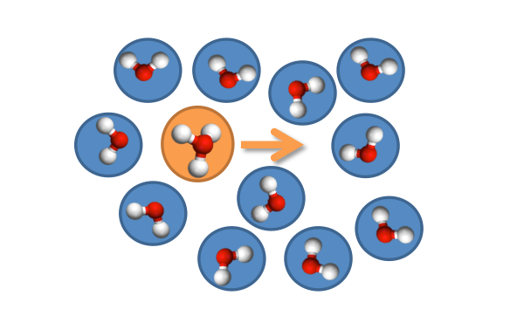
Figure 2.1 Transport of hydronium cation (orange) in water (blue) via structural diffusion. In this representation oxygen (red) and hydrogen (white) remain in the initial bond structure within the molecule.

Proton motion via the vehicle mechanism is strongly influenced by environmental factors such as temperature, density and pressure of the system. Kinetic energy of the molecules decreases with temperature, causing a decrease in diffusion rate. Diffusion is reduced at low temperatures until molecules become stationary. This occurs in glass forming systems below the glass transition temperature. The mechanism of proton conductivity changes when molecular motion is restrained, and protons are limited to local hopping motion.
Another mechanism of proton diffusion is the Grotthuss mechanism.***(SiteGrotthuss) This theory describes proton conduction via a hydrogen-bonding network. Hydrogen bond cleavage and formation permits local proton jumping between neighboring molecules. This process does not require assistance of molecular diffusion, and can therefore occur at a much faster rate. It is commonly accepted that the Grotthuss mechanism is responsible for the abnormally high proton mobility in water.***(siteYYW’sRef) An example of the Grotthuss mechanism of proton motion in water is depicted in Figure 2.2. The figure shows an access proton which is initially bound to a water molecule in location A. In order to jump, the proton has to first cleave its bond with the hydronium cation in order to form a new bond with the neighboring water molecule at location B. Proton motion continues when a proton travels from location B to C in a similar fashion. The continuation of this process leads to the long-range motion of a proton from A to C. This process does not require a specific proton to move throughout a system but rather assumes that once a proton has bonded to it’s destine molecule, another proton continues the journey in the original proton’s place. The proton that arrives at C is a different one then initially departed from location A. Hence Proton transfer via Grotthuss mechanism is much faster then molecular diffusion and can therefore explain the abnormally high proton conduction in water. ***(Site water)
Whether a proton moves via the vehicle or the Grotthuss mechanism is dependent on temperature and viscosity. The distinction between methods of proton motion is important when considering the effects of conductivity relaxation in Section 2.3. and the isotope effects described in Section 2.4.

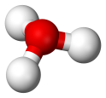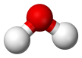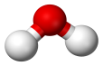

A
B
C
Figure 2.2 Grotthuss Mechanism of proton motion in which a proton (white) breaks a hydrogen bond with the oxygen (red) and hops to a neighboring water molecule (blue). When the access proton is bound to a water molecule it forms a hydronium (orange). The proton moves from location A to C in successive jumps.

Conductivity Relaxation
Structural relaxation is a thermally activated process below $T_{g}$, which follows the Arrhenius equation.***(siteArrhenious) This process occurs in the glassy regime, when the proton has to overcome a potential energy barrier in order to complete bond breaking and formation with the next molecule. Equation 1.1 displays the dependencies of the different factors influencing conductivity relaxation. In the Arrhenius equation conductivity relaxation time is $τ_{σ}$ and exhibits Arrhenius temperature dependence. The minimum required energy that allows the proton to jump is called the activation energy $E_{a}$
 | $$τ_{σ}=τ_{0}e^{\left(\frac{-E_{a}}{k_{B}T}\right)}$$ | (eq. 2.1)
$τ_{0}$ is a pre-factor that resembles the characteristic attempt time of a single ion jump. $k_{B}$ represents the Boltzmann constant and T is the absolute temperature. $E_{a}$ can be extracted from the Arrhenius fit when the logarithm of $τ_{σ}$ is plotted versus inverse temperature, also called an Arrhenius plot. Log₁₀($τ_{σ}$) displays a linear dependence on inverse temperature on the plot, justifying the applicability of the Arrhenius Law.
Above $T_{g}$ , when the sample is in a liquid state, structural and conductivity relaxation exhibit super-Arrhenius behavior, meaning that dynamics show stronger temperature dependence then predicted by the Arrhenius equation. This is due to the fact that proton motion is aided by translational diffusion of the molecules in the liquid state ***(SiteVehicMecPaper). Crossover of Arrhenius to super-Arrhenius temperature dependences at the glass transition has been observed in many other glass forming ionic conductors ***siteYYW26. The phenomenological Vogel-Fulcher-Tammann (VFT) equation***(SiteSasha 7,8,9), displayed below, can be used to describe conductivity relaxation time in the liquid state. ***(Site siteVFTCond)
 | $$τ_{σ}=τ_{0}e^{\left(\frac{B}{T-T_{0}}\right)}$$ | (eq. 2.2)
$τ_{0}$ is again the characteristic attempt time, though it is not necessarily the same value as $τ_{0}$ from the Arrhenius equation. $T_{0}$ corresponds to the VFT approximation of the ideal glass transition temperature, and $B$ is a material specific parameter.
Figure 2.3 is a sketch of conductivity relaxation time as a function of inverse temperature normalized to $T_{g}$. The red line indicates the glass transition temperature. A clear transition from Arrhenius to super Arrhenius temperature dependence is displayed at the glass transition (red line). This figure demonstrates that the temperature dependence of $τ_{σ}$ increases while the sample is cooled, and becomes linear while the sample is arrested in its glassy state.

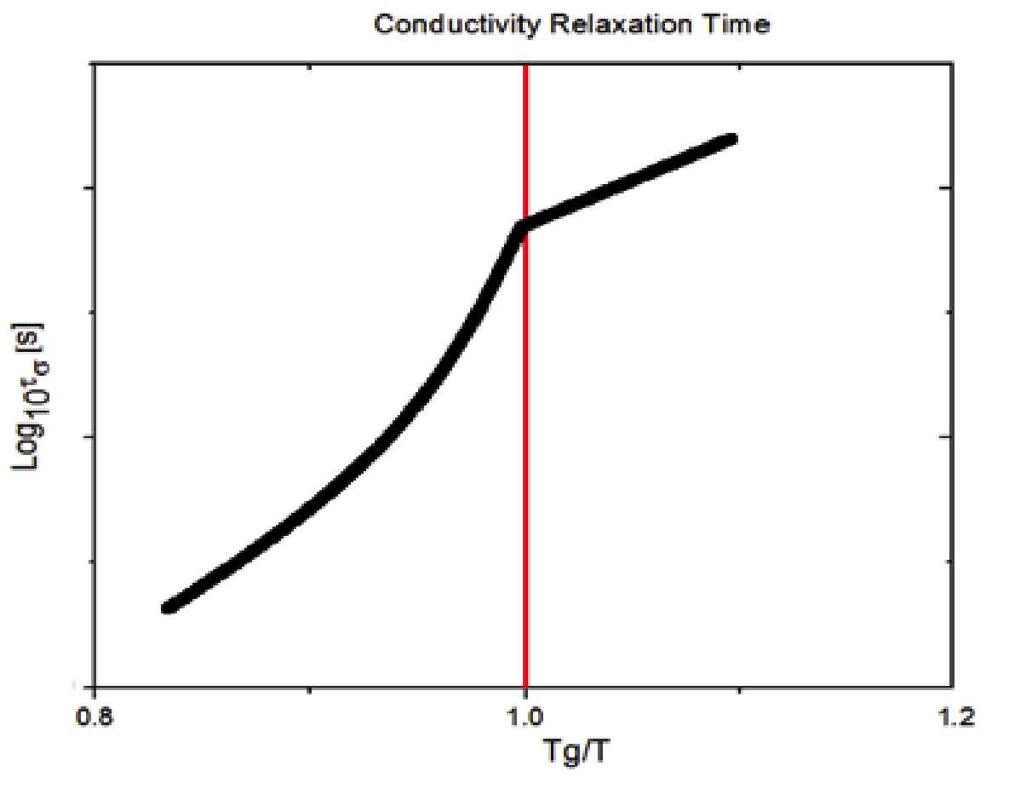

Figure 2.3 Super Arrhenius and Arrhenius behavior of conductivity relaxation time above and below the glass transition, respectively. The red line indicates the glass transition temperature.

Now that we have discussed the dynamics as a function of temperature, it is interesting to determine how a change in mass of the conduction ion will effect proton conduction and glass transition. This is done using isotopic exchange of the hydrogen atom.

Isotopes Effect
Isotopic substitution allows for a change in mass of a chemical element, while retaining the electric charge. The additional mass can cause variation in the dynamics of many material properties such as glass transition temperature and ionic conductivity. The term isotope effect refers to the ratio of transition rates of different isotopes. Hydrogen is the lightest element on the periodic table, consisting of only a proton and an electron. Deuterium is a heavier isotope consisting of an additional neutron bound to the proton in the nucleus. The mass of the electron is small in comparison to that of the proton and neutron, causing the additional neutron to increases the mass of the molecule to nearly twofold. The third naturally occurring isotope of hydrogen, tritium, contains two additional neutrons over hydrogen. Although tritium has been studied in relation to proton conduction, the radioisotope is not a favorable material to due to its unstable state.***(cite Tritium) The focus of this research therefore lies in the comparison of the first two isotopes hydrogen and deuterium.
Since the net charge of the molecule is unaffected by the addition of a neutron, the variations in material properties are exclusively caused by the change in mass. The importance of comparing the isotope effect in hydrogen and deuterium as opposed to isotopes of different molecules lies in the severity that the isotope effect has on the mass change. Due to the light nature of the hydrogen, isotopic substitution with the heavier isotope deuterium presents the greatest relative mass increase of any atom. This is significant because it maximizes the effect that H/D exchange has on the sample. Before we examine the experimental data, it is important to study the theoretical implications of isotopic exchange, presented in the following section.

Theories of the Isotope Effect on Proton Motion
The potential energy landscape of a single one dimensional proton jump can be modeled as a double harmonic oscillator potential well as shown in Figure 2.4. The minima of the potential represent locations of initial and final molecular bonding sights. An activation energy of magnitude greater then the height of the potential barrier is required to induce a proton jump.
The frequency of a proton jump, $ν_{0},$ is described by the harmonic oscillator equation.
 | $$ν_{0}=\frac{1}{2π}\sqrt{\frac{k}{m}}$$ | (eq. 2.3)
In this equation $m$ is the mass of the particle in the well. The force constant $k$ is dependent on the potential energy landscape, which is identical for the two isotopes[1]. ***(Site H:D_IE+others). The isotope effect on the conductivity relaxation time, $τ_{σ}$, should then be proportional to $\sqrt{2}$ through the relation $τ={\left(2πν\right)}^{-1}$.
 | $$\frac{τ_{D}}{τ_{H}}=\sqrt{\frac{m_{D}}{m_{H}}}=\sqrt{2}$$ | (eq. 2.4)
However, experiments done by various researchers ***(Nowick and others) show that the isotope effect in proton conduction is much stronger then $\sqrt{2}$. Since the purely classical theory does not confine with experimental data, the influences of quantum effects can be considered in order to improve the accuracy of the theory..***(site QM) The semi-classical theory incorporates the quantum mechanical concept of zero point vibrations into classical theory. According to a quantum mechanical view, a particle’s lowest possible energy is the ground state energy $E_{0}$ described by Equation 1.5.
 | $$E_{0}=\frac{1}{2}ℏν$$ | (eq. 2.5)
In this equation $ℏ$ is Planck’s constant divided by $2π$ and $ν$ is the frequency of hydrogen or deuterium. Deuterium has higher mass then hydrogen and following the above equation has a slower vibrational frequency ($ν_{D}<ν_{H}$). This indicates that hydrogen, which has less mass than deuterium, has a higher ground state energy then deuterium as depicted in Figure 2.4 b.

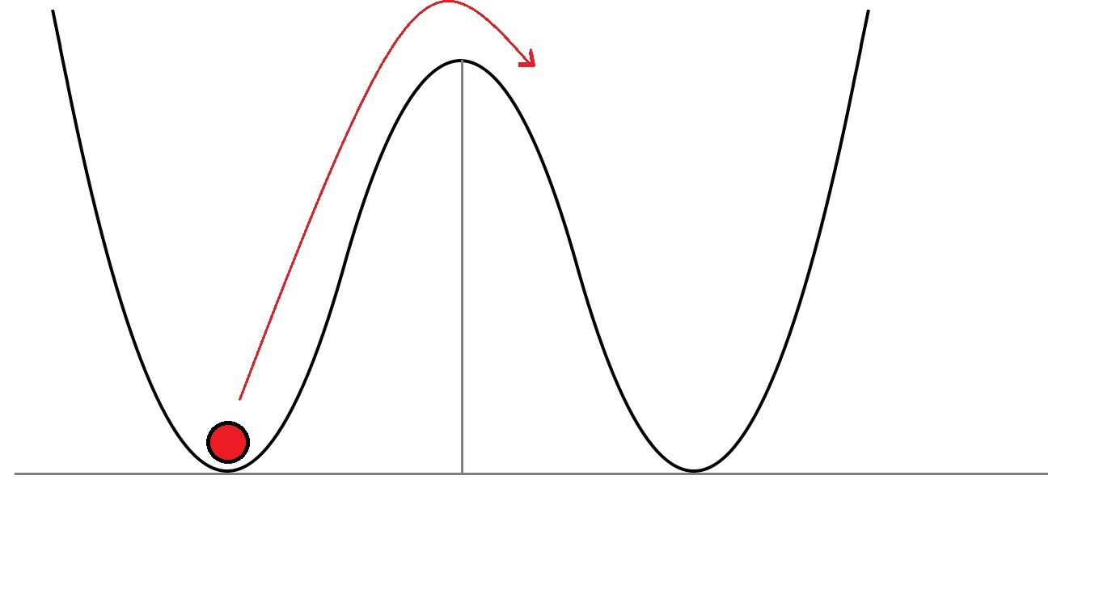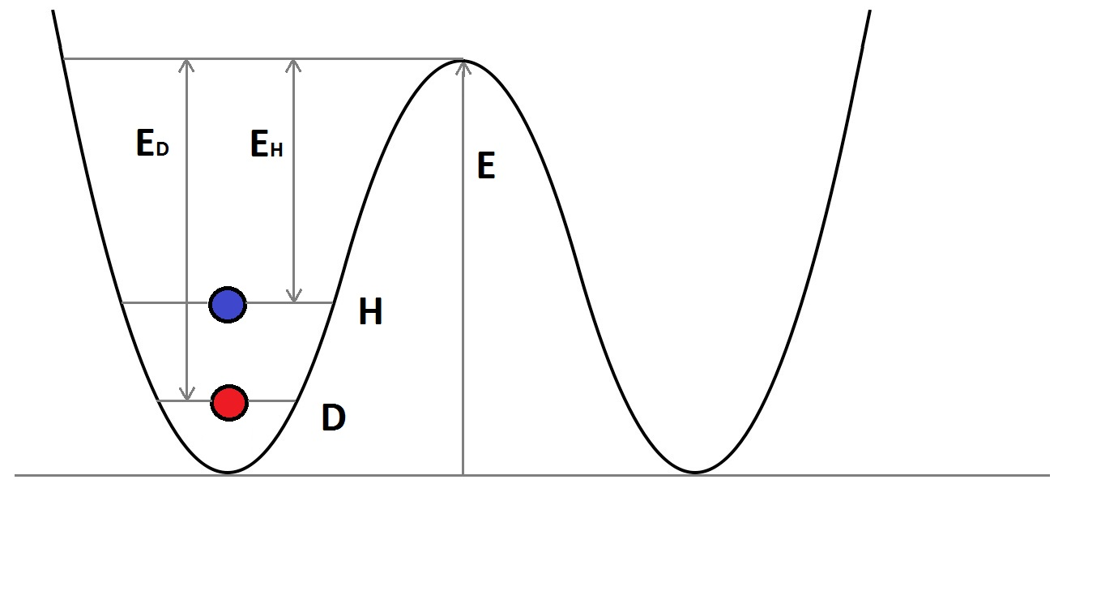
E

Figure 2.4 Double harmonic oscillator with classical a) and semi-classical theory b). The ion has to overcome an energy barrier E in order to jump to the neighboring molecule. Semi-classical theory includes ground state energy caused by zero point vibrations which reduce the relative required energy by E_{D} and E_{H} for deuterium (D) and hydrogen (H), respectively.

The ground state energy assists the jumping particle by reducing the relative height of the energy barrier. Hydrogen has higher ground state energy compared to deuterium, therefore requiring less activation energy. The differences in $E_{a}$between isotopes further increase the isotope effect in proton conduction following the semi-classical theory.
Further expansions of the theory of proton conduction have been made in the attempt of predicting large isotope effect values. Another theory based on quantum mechanics considers tunneling effects as described by Nowick et al. **(siteTunneling). Here the probability wave function has exponential dependence on the proton’s mass, causing even slight modifications to result in an extraordinarily large isotope effects. There is however not enough conclusive evidence to support tunneling effects in proton conducting systems, and so this topic will not be discussed any further.

Isotope Effect on Glass Transition
Now that we have examined how the increased mass of the moving ion affects transport characteristics below the glass transition, we can look at the effects on the glass transition itself. The Glass transition temperature is strongly related to material properties such as density and viscosity. Isotopic substitution alters these material specific properties, therefore altering the glass transition temperature. In order to examine the isotope effect on glass transition, it is favorable to study a material whose composition is greatly altered by deuteration. The comparison of water, $H_{2}O$, at $18\frac{g}{mol}$ with deuterated water, $D_{2}O$, at $20\frac{g}{mol}$ therefore proofs very effective in this case. Although oxygen is much heavier then hydrogen or deuterium, the deuteration of water still causes over 10% increase in mass of the molecule. $D_{2}O$ is therefore commonly referred to as heavy water. The increase of mass causes an increase in density of the atom, which affects the glass transition temperature. Determining the glass transition of water and heavy water presents a challenging task due to the formation of ice below 273K. Different methods such as hyper-quenching, confinement, and addition of impurities to the sample have been developed in order to suppress crystallization in water.
Many researchers have measured the glass transition of super-cooled water over the years. ***(Site Johari, Hallbucker2x, Elaesser). It is generally accepted that the $T_{g}$ of water lays around 137K. Glass transition in deuterated water generally occurs around 140K, showing an isotope effect at the glass transition of ~3-5K depending on the experiment and the phase of the super-cooled water. Recent dielectric relaxation spectroscopy measurements of low density and vapor deposited amorphous water were performed in our group. Results showed that H/D substitution can alter the glass transition as much as $10±2K$ ***(SiteManuscript). Small inconsistencies in sample preparation and variances in measurement techniques complicate data acquisition. Differences in phase states of water at low temperatures can also lead to inconsistent results. Disagreements about the glass transition of hyper-quenched water are therefore still ongoing.
An alternative to hyper-quenching the sample in order to avoid crystallization is the addition of a freezing point suppressing solute such as a salt or an acid. A study done by Kano at al. ***(SiteKano) focuses on the glass transition temperature of LiCl and ZnCl₂ solutions with both non-deuterated and deuterated water as studied via differential thermal analysis. $T_{g}$ of the solutions exhibit concentrational as well as isotopic dependence. Glass transition temperatures decrease with dilution and converge to the value of pure components in the dilute region. The samples prepared with $D_{2}O$ exhibit higher glass transition temperatures then the ones prepared with $H_{2}O$. $∆T_{g}$ increases with dilution to up to 4K for the LiCl samples and up to 1.7K for the ZnCl₂ sample within the measured range. The values for $∆T_{g}$ concur with those found in hyper-quenched sample. Other salts and acids can also be used in order to produce non-crystallizing water solutions***(SiteLiClSources). Phosphoric acid is a prime candidate for this research due to its superb glass transition properties as well as its proton conductivity.

The Model System Phosphoric Acid
Phosphoric acid is a weak acid and has the structure $H_{3}PO_{4}$ in its neat form as presented in Figure 2.5. Phosphoric acid has broad applications such as membrane materials in PEMs of modern hydrogen fuel cells.***(Site PEM). Phosphoric acid has the ability to form compound structures at high concentrations up to $P_{2}O_{5}$, which contains no water molecules at all. The advantage of phosphoric acid lies in its concentrational dependence of $T_{g}$. By varying the concentration of the acid, the $T_{g}$ can be altered by almost 80K within an easily measurable window. Phosphoric acid is therefore ideal for measuring concentrational dependence of $T_{g}$.

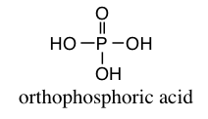

Figure 2.5 Neat Phosphoric Acid $H_{3}PO_{4}$. Symmetric structure and proton donor and acceptor sights allow for excellent proton conduction.

Isotope Effect on Glass Transition in Phosphoric Acid
The glass transition of phosphoric acids has been studied using many different techniques including broad line nuclear magnetic resonance (NMR)[2, 3] differential scanning calorimetry (DSC)[4], and broadband dielectric spectroscopy (BDS)[5]. The Glass transition shows expected temperature dependence by approaching the glass transition of $P_{2}O_{5}$($T_{g}$>590K)[6] in the concentrated region and converging to the glass transition of pure water in the dilute region. Aihara et al. ***(Site Aihara) uses an exponential equation (***eq 1.6) to fit the data of the hydrated phosphoric acid samples to extrapolate the Glass transition temperature of pure water.
 | $$T_{g}={T_{g}^{0}+αe}^{\left(βc\right)}$$ | (eq. 2.6)
Here $T_{g}^{0}$ is the glass transition temperature of pure water, c is the concentration of phosphoric acid and $α$ and $β$ are fitting parameters. In his paper Aihara et al. estimates $T_{g}$ of pure water to be around 159.7K, which is much higher then commonly accepted. Research done by Corti et al.***(SiteAngell) dismisses Aihara’s analysis due to lack of physical meaning of the phenomenological fitting equation. Instead Corti et al. propose the use of the Gordon Tailor equation (GT) [7]to fit the concentrational dependence of $T_{g}$.
 | $$T_{g}=\frac{w_{2}T_{g2}+w_{1}k_{GT}T_{g1}}{w_{2}+w_{1}k_{GT}}$$ | (eq. 2.7)
The Gordon Tailor equation [***eq. 2.7], which is based on free volume theory of liquids[8], uses the parameter $k_{GT}$, to define the ratio of the products of $T_{g}$, and the density at $T_{g}$ of the individual ingredient.$w_{1}$, $w_{2}$ and $T_{g1}$, $T_{g2}$ represent weight ratio and glass transition temperature of $H_{2}O$ and $P_{2}O_{5}$ respectively. In his paper Corti et al. is able to fit DSC data using GT, with concentrations ranging w₂=0.839 to 0.361, which corresponds to R=1.51 to 13.94 of $P_{2}O_{5}$ to $H_{2}O$. Weight percentages are used instead of molar concentration in order to simplify the extrapolation to pure water ($w_{2}$). Though helpful in extrapolation of $T_{g}$, a representation with respect to weight percentage does not allow direct comparison between isotopes due to their mass difference. Corti et al. found the GT to provide a good fit for glass transition data in Phosphoric acid. In the concentrated region at R=1.51, the $T_{g}$=233K, while in the dilute region at R=13.9, $T_{g}$ decreases by 80K to 153K. Neat phosphoric acid displays $T_{g}$ at around 190K. $T_{g}$ data obtained from NMR by Aihara et al. ***(CiteAih) and DSC by Corti et al.***(SiteCorti) follow the same trend when compared with acid concentration. Wang et al. [5] recently characterized hydrated phosphoric acid at various molar concentrations using BDS and rheological measurements in the low temperature regime[5]. $T_{g}$ values are in agreement with those provided in literature, revealing sample R=1.5 to be around 230K and sample R=5 to be around 170K. BDS determines $T_{g}$ by measuring the change in temperature dependence of dielectric properties at the glass transition. Comparing DC conductivity and conductivity relaxation time of hydrogenated and deuterated phosphoric acids at different concentrations can provide information on how the isotope affect alters proton motion.

Isotope effect on Proton conduction in Phosphoric Acid
It is well known that dielectric properties show distinctive thermal dependence. High temperature conductive properties, as well as glass transition behavior of phosphoric acid are extensively studied. Low temperature conductivity measurements above and below the glass transition have however been neglected. Wang at al.[5] found that DC conductivity $σ_{τ}$ and conductivity relaxation time $τ_{σ}$ exhibit a distinctive Arrhenius to super Arrhenius cross over at the glass transition. The activation energy of ionic conductivity below $T_{g}$ derived from the fit of the Arrhenius equation is on the order of 50-60 $\frac{kJ}{mol}$. Typical activation energies of proton conducting materials such as perovskite structured metal oxides***(SitePerovsketeOxides) and protic ionic liquids ***(Site ProtIL) range from 50-100 $\frac{kJ}{mol}$. Lower activation energy means that it is easier for a proton to conduct in a material. It can therefore be said that phosphoric acid is a relatively good proton conducting material.
In a classical view, conductivity should be proportional to the fluidity of the material, since the diffusion of ions is severely inhibited in viscous media. Walden first brought this relationship into perspective***(SiteWaldon). A so-called Walden plot compares molar conductivity to viscosity on a log-log plot. In the high temperature region, viscosity is low and has little restricting effect on ionic conduction. In the high temperature regime, phosphoric acid falls on a reference line of slope m=1, indicating linear relationship between mobility and viscosity. At lower temperatures however, viscosity becomes a limiting to molecular motion. A decoupling of structural relaxation is causes divergence from linear relation into the super ionic region. The slope of the data in the high viscosity region lies between 0.69 and 0.87 for varying ratios. Physically this means that ions conduct faster then allowed by a direct correlation of mobility and viscosity. This indicates that proton motion is not limited to the vehicle mechanism, and suggests Grotthuss type influence. It would be interesting to examine the effects of isotopic exchange on proton/ionic conductivity.

Research Objectives
Phosphoric acid is an extensively studied proton conductor with a wide range of applications. Excellent glass forming and proton conducting properties make it an ideal material for proton conducting membranes in hydrogen fuel cell applications. Phosphoric acid also provides a suitable medium to study mechanisms of proton conduction at low temperatures, a subject which has not jet been extensively explored. The goal of this research is to study the influence of the isotope effect on the glass transition and ionic conductivity of phosphoric acid.
We aim to determine how the isotope effect impacts the glass transition temperature in phosphoric acid at varying concentration. With this, we aim to estimate the maximum difference in glass transition temperature of pure water and deuterated water. Isotopic exchange also alters ionic conductivity. By increasing the mass of the conducting ion by a factor of two, while keeping overall charge constant we can investigate the impact of mass on proton motion. In order to do so, we will compare DC conductivity and conductivity relaxation time of regular and deuterated phosphoric acid at different concentrations. Furthermore we hope to gain understanding of the influence of quantum effects on proton motion.

Materials and Methods

Phosphoric Acid Nomenclature
Pure or ortho-phosphoric acid (H₃PO₄) is a white solid at room temperature with a melting point around 42⁰C. Phosphoric acid can also form compounds of poly-phosphoric acid ranging from the dimer H₄P₂O₇ (pyro-phosphoric acid) and the trimer H₅P₃O₁₀ (tri-phosphoric acid) to the phosphoric anhydride P₄O₁₀ also denoted as P₂O₅ (phosphorus pentoxide). Pyro- and tri-phosphoric acids are the main building blocks of adenosine di-phosphate (ADP) and adenosine tri-phosphate (ATP) respectively, which are compounds that are responsible for energy transfer within biological systems.
Concentrations of phosphoric acids can be indicated using different standards; most common is the weight percentage (wt%) or molar percentage (mol%) of H₃PO₄ or P₂O₅ to that of water or deuterium. While all of these conventions are commonly accepted, it is advantageous to use a nomenclature comparing the molar ratio of phosphorus pentoxide to that of H₂O or D₂O, in order to emphasize a direct comparison of the number of molecules of each isotope. Phosphorus pentoxide is used as a measure in this relation because it is a poly-phosphoric acid containing no hydrogen or deuterium prior to sample preparation. This study will use a notation, where R denotes the number of moles of H₂O or D₂O per mole of P₂O₅.
 | $P_{2}O_{5} \left(1:R\right) H_{2}O$ and $P_{2}O_{5} \left(1:R\right) D_{2}O$ | (eq. 3.1)

Sample Preparation
Twelve samples of different molar concentrations of phosphoric acid (R=1.5, 2, 2.5, 3, 4, 5 of each H-isotope) were prepared by measuring precise amounts of phosphorus pentoxide (purchased from Aldrich) inside of an argon filled glove box. Filtered deionized water (purchased from Fischer Scientific) or deuterium oxide (99.9 atom % D, purchased from Aldrich) was added via a 96-hour timed exposure within a sealed hydration chamber. After the highly hydrophilic P₂O₅ was given opportunity to hydrate, the exact remaining amounts of H₂O and D₂O were added via 10ul micropipette. The samples had to be prepared in this manner to ensure laboratory safety, as adding water directly to a pure acid leads to an uncontrollable exothermic reaction. This procedure also warrants limited exposure to moisture in the atmosphere allowing the highest level of accuracy in sample preparation. The samples were stirred at 180⁰C for 45 minutes immediately after completion of the mixing procedure to insure homogeneity of the sample. The dielectric spectra of the prepared $P_{2}O_{5} \left(1:R\right) H_{2}O$, R=1.5 and R=5 samples were compared to those of 116 wt% and 85 wt % $H_{3}{PO}_{4}$ phosphoric acid solutions respectively, to ascertain that the prepared samples yielded realistic results. Both of these solutions were purchased from Aldrich and used without further preparation. In addition, six more dilute samples were prepared (R=7, 9, 14 of each H-isotope) by adding the above-described $H_{2}O$ and $D_{2}O$ to 85 wt % $H_{3}{PO}_{4}$.

Measurement Techniques
The dielectric behavior such as permittivity, conductivity electric modulus can shed light on to many charge transport phenomena, as well as structural behavior of a material. Temperature dependence of dielectric processes is studied using dielectric spectroscopy over a wide temperature range, though individual measurements are isothermal while frequency is probed over a wide range. Frequency based spectra are then compared amongst temperatures to analyze temperature dependence. Though a clear glass transition can be deduced from electrical measurements, the measured properties are only indirectly related to thermal behavior through the structural effects on electric properties. A more reliable measure of temperature dependence of the structure is achieved by measuring thermal properties directly using differential scanning calorimetry. To confirm the temperature dependence of a systems density, sound velocity is measured using Brillouin light scattering. Due to the complexity of analysis as well as its importance in the investigation of charge transfer processes, the theoretical background of dielectric spectroscopy will be portrayed in additional detail over other experimental methods.

Dielectric Spectroscopy
Dielectric relaxation corresponds to the delay in polarization of a dipolar molecule to an applied electric field. When the probed frequency of the electric field corresponds to the frequency of oscillation of a dipole, a peak in the dielectric spectra is observed. In order to characterize the time scales and frequencies of dielectric processes within the sample, the applied electric field oscillates with varying frequency to probe for dielectric relaxation over a broad frequency range. The dielectric spectrum consists of different electrical processes occurring within the sample at their own characteristic frequencies like ion conduction, alpha beta gamma processes.
It is worth noting that one of the main difficulties of measuring dielectric relaxation occurs in the low frequency regime through electrode polarization. At low frequencies the time scale between reversals of the electric field becomes so large that charges diffuse through the sample and accumulate at the poles of the electrode causing an increase in resistance and therefore lead to an overshadowing of the relaxation processes.
When considering Maxwell’s equations for a weak electric field in a dielectric material, the Dielectric displacement $D$ can be related to the permittivity of the dielectric $ε^{*}$, the permittivity of free space $ε_{0}$, and an external electric field $E$.
 | $$D=ε^{*}ε_{0}E$$ | (eq. 3.2)
Permittivity of a material is defined as the ratio of the capacitances of a capacitor filled with a dielectric, to that of a capacitor with the same dimensions (plate spacing and area) in a vacuum. This quantity resembles the resistance of a dielectric material to an applied external electric field, and can be modeled as a circuit consisting of a parallel plate capacitor and a resistor. A dielectric spectroscope measures the dielectric properties of a sample, including electric potential and resistance to derive Impedance, which in turn relates to permittivity and conductivity. Impedance $Z$ is a measure of the influence of an applied electric potential $V$ on the resistance of the current flow $I$ of a sample.
 | $$Z=\frac{V}{I}$$ | (eq. 3.3)
Both voltage and current have a sinusoidal dependence on frequency $ω$, as can be expressed in complex notation as follows.
 | $$V\left(ω\right)=V_{max}e^{i\left(ωt+ϕ_{V}\right)}$$  $$I\left(ω\right)=I_{max}e^{i(ωt+ϕ_{I})}$$  $$Z=Z_{max}e^{iθ}$$ | (eq. 3.4) (eq. 3.5)  (eq. 3.6)
$V_{max}$ and $I_{max}$ correspond to the maximum amplitude and $ϕ_{V}$ and $ϕ_{I}$ represent the phase of voltage and current respectively, $t$ corresponds to time. The impedance then becomes a function of$θ$, which is the difference in phase of voltage and current as shown in (***eq Z time dep). Alternating current also affects the behavior of capacitance and therefore permittivity of a dielectric material. Frequency dependent permeability is related to the complex dielectric function through Fourier transform. The complex dielectric function $ε^{*}\left(ω\right)$ can then be expressed in its real $ε^{'}\left(ω\right)$ and imaginary $ε"(ω)$ components as
 | $ε^{*}\left(ω\right)=ε^{'}\left(ω\right)-iε"(ω)$ | (eq. 3.7)
The conductivity of the system can be obtained using Ohm’s law in the form of
 | $j=σ^{*}E$ | (eq. 3.8)
Here $j$ is the current density and $σ^{*}$ is the complex electric conductivity. Since current density is equivalent to the time derivative of dielectric displacement, Maxwell’s equations relate $σ^{*}(ω)$ and $ε^{*}(ω)$ as follows.
 | $$σ^{*}(ω)={iωε_{0}ε}^{*}(ω)$$  $σ^{*}\left(ω\right)=σ^{'}\left(ω\right)+iσ"(ω)$ | (eq. 3.9)  (eq. 3.10)
Therefore complex conductivity is of similar form as complex permittivity, where $σ^{'}(ω)$ and $σ"(ω)$ resemble real and imaginary parts of conductivity. The data of $ε^{'}\left(ω\right)$ and $ε"(ω)$, as well as $σ^{'}(ω)$ and $σ"(ω)$ are directly measured by the dielectric spectrometer.
Another important value to consider is the inverse of $ε^{*}\left(ω\right)$, referred to as the complex electric modulus $M^{*}$. This spectra is unaffected by electrode polarization and therefore allows for further analysis in the low frequency regime. The reliability of analysis using modulus spectra is criticized due to the fact that it is a derived quantity, and therefore could cause experimental error to perturb throughout the results
 | $M^{*}\left(ω\right)=M^{'}\left(ω\right)+iM"(ω)$ | (eq. 3.11)
Here $M^{'}\left(ω\right)$ and $M"(ω)$ are the real and imaginary components of the complex modulus.
 | $$M'(ω)=\frac{ε^{'}\left(ω\right)}{{\left[ε^{'}\left(ω\right)\right]}^{2}+{\left[ε"\left(ω\right)\right]}^{2}}$$  $$M"(ω)=\frac{ε"\left(ω\right)}{{\left[ε^{'}\left(ω\right)\right]}^{2}+{\left[ε"\left(ω\right)\right]}^{2}}$$ | (eq. 3.12)  (eq. 3.13)

A peak position of $M"(ω)$ corresponds to the frequency of ionic motion within the system. Mapping the frequency of the maximum imaginary modulus $M"(ω_{max})$ with varying temperature and deuteration can give insight into the time scale of ionic motion $τ_{σ}$.

Dielectric measurement
The dielectric sample cell consists of round electrodes in a parallel plate capacitor set up. Top and bottom electrodes are separated using a Teflon spacer, creating a cylindrical sample volume with a radius of 19mm and a thickness of 0.9mm. The cell design is specifically chosen to minimize electrode polarization by reducing the ratio of thickness of the polarization layer to that of the total volume thickness, while keeping the sample narrow enough to attain accuracy of measurement. Gold plated electrodes are used due to little interaction with the highly concentrated acids. Special precautions have to be taken since the highly ordered atomic structure of gold could cause surface induced crystallization within the sample. The sample and the cell are held at 80⁰C for 10 minutes prior to quenching to the initial temperature of the measurement to erase all thermal history. Measurements were taken with a Dielectric Spectrometer (Novo control alpha analyzer) in a frequency range of 10⁻² to 10⁷ Hz. The cell temperature was equilibrated for 20 minutes after each temperature change. The measurements were conducted over a 35-minute duration for the full frequency range, and shortened to a 10⁻¹ to 10⁷ Hz frequency range (5 minutes per measurement) as possible.

Differential Scanning Calorimetry (DSC)
Differential Scanning Calorimetry (DSC) is a technique that measures the thermal response of a sample as a function of heat input. Phase transitions are processes that either release or absorb latent heat, depending on the direction of temperature change. DSC measures the amount heat flow required in order to increase temperature in the sample in comparison to a reference. Glass transition phenomenon will appear as a step in Heat flow on the heating cycle. The midpoint of the transition was determined by the peak position of the derivative spectra of heat flow with temperature.
The sample cell used for the DSC measurements consists of a 50μl stainless steal cylinder with an o-ring seal and a lid, all purchased from TA Instruments. The cylinder was hermetically sealed using a special T-Zero press and die set, thus creating a fully hermetically sealed pan. The phosphoric acid samples were transported to UT to be analyzed in the Polymer Characterization Lab (PCL) of the chemistry department using a liquid nitrogen cooled TA Instruments Q1000 Calorimeter. Due to the oversized pan size, the samples were loaded into the machine by hand as opposed to the built in auto sampler to insure proper placement. A scan rate of 5⁰C/min was used as opposed to the 10⁰C/min commonly used in literature to avoid issues with the pan falling or moving during the experiment. A slower thermal scanning rate will affect the onset of the glass transition temperature by giving the sample more time to transition once $T_{g}$is reached. In order to properly compare the glass transition to that of the dielectric data, the sample was equilibrated at 80⁰C for five minutes to erase the thermal history prior to the beginning of the measurement cycle. $T_{g}$ was then determined on the heating cycle, by the peak position of the derivative of the heat flow with respect to temperature. No crystallization effects were observed in any of the measurements. All samples (R=1.5-14) were measured with this technique.

Brillouin Spectroscopy
Brillouin Light scattering is an optical measurement technique in which light interacts with regions of fluctuating density due to acoustic modes within the sample. Since density is a temperature dependent quantity that affects the refractive index, a shift in the Brillouin scattering peak can be observed with varying temperature. Plotting the change in scattered frequency versus temperature shows a strong dependence of density to temperature. At the Glass transition temperature a clear change in the temperature dependence of density is observed. Due to the rather broad nature of the glass transition, the derivative spectra are analyzed to provide a clearer picture of the midpoint of the transition. The linear behavior of density above and below $T_{g}$ appear as horizontal trends in the derivative spectra, were as the smooth transition appears as a sloped line whose midpoint is taken as the actual $T_{g}$.
In order to minimize impurities within the sample due to dust, which is crucial in optical measurements, the 1ml cylindrical sample vials were rinsed multiple times with filtered methanol and filtered deionized. The R=5 sample ratios were heated and filtered into the sample vial using a 22um syringe filter, where the R=1.5 samples were unable to be filtered due to high viscosity.

The glass vial was then inserted into a cryostat and the scattered light of a 532nm green laser was analyzed by a tandem Farby-Perot interferometer (Sandercock Model).
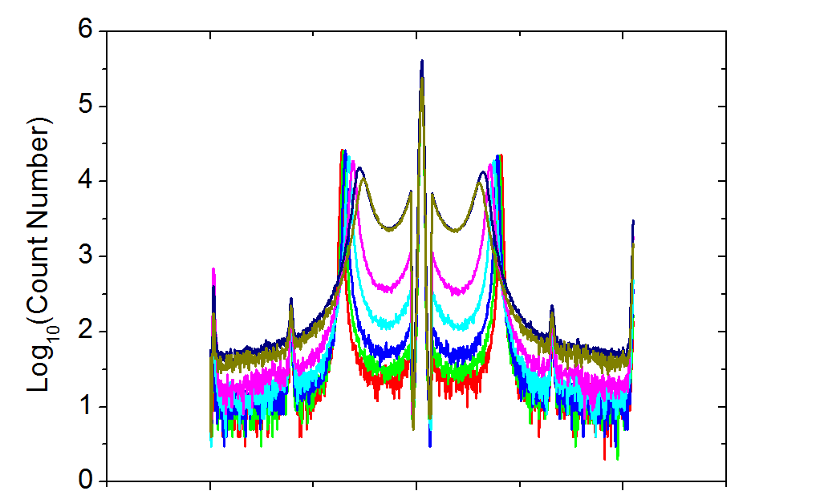
Figure 3.1 *** Raw Data of Brillouin spectroscopy of sample P₂O₅ (1:5) H₂O from temperatures Ti to Tf

Results and Discussion

The glass transition and dielectric properties of deuterated phosphoric acid are discussed in the following chapter. Isotope effects become visible when compared with hydrated phosphoric acid. In the following chapter, these effects will be discussed from a classical and quantum mechanical view.

Dielectric Data of Deuterated Phosphoric Acid
An example of raw dielectric spectra of hydrated phosphoric acid of concentration R=1.5 at temperatures ranging from $-60℃$ to $-30℃$ are shown in Figure 4.1. Here the real part of dielectric permittivity $ε'$, the imaginary dielectric modulus $M"$, and the real part of electric conductivity $σ'$ are plotted versus frequency in a), b), and c), respectively. Ionic conductivity appears as a process in $ε'$, as a peak in $M"$, as well as the onset of frequency dependence of $σ'$. The conductivity relaxation time $τ_{σ}$ was derived from the $M"$ spectra as opposed to $ε'$, due to its immunity to electrode polarization, as explained in the previous chapter. For the concentration R=1.5, the peak frequency of ionic conductivity moves from roughly 0.5Hz to 3000Hz with increase in a temperature of $30℃$. To avoid crystallization the sample was quenched below $T_{g}$ and measured on the heating cycle until the sample crystallized. The measurement was then continued up to 353.15K. From there, the sample was cooled to crystallization while additional data was collected on the cooling cycle. This method of data acquisition allows for the maximum amount of data points in an easily crystalizing sample and assures reproducibility of the data. The data in the room temperature region and above coincided on the heating and cooling cycle.
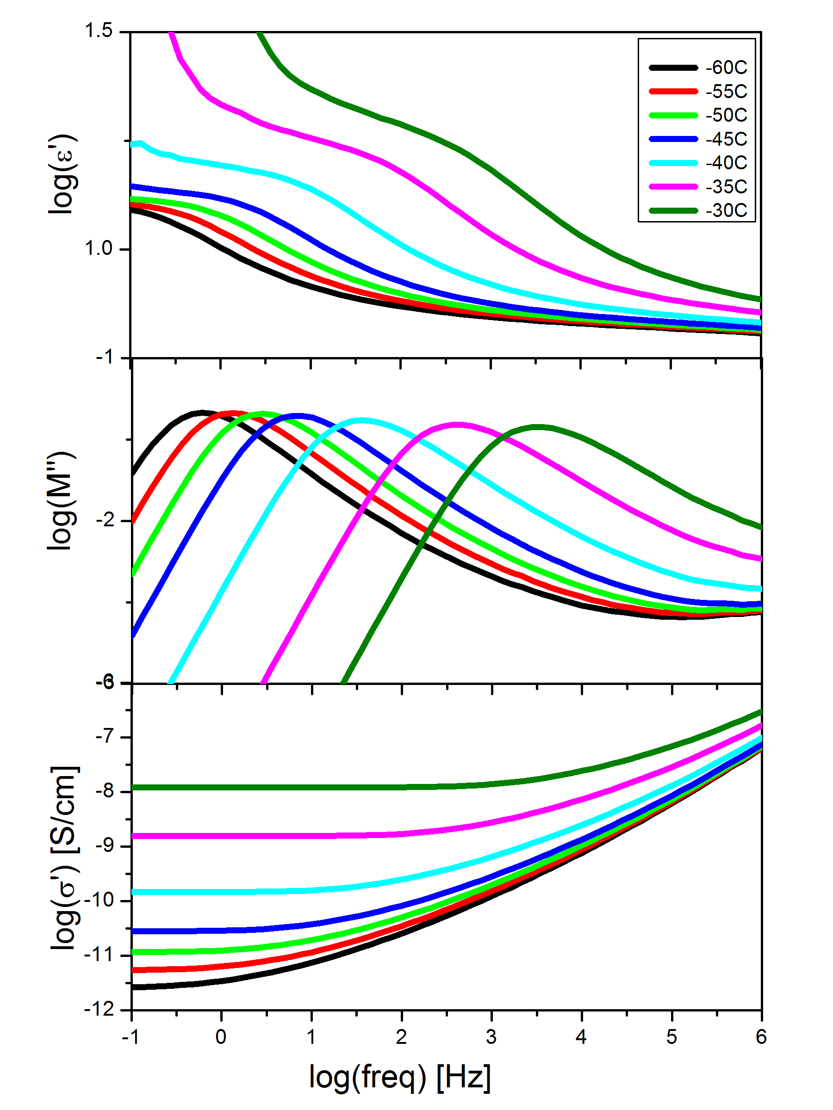

Figure 4.1: Dielectric permittivity $ε'$, imaginary dielectric modulus $M"$, and the real part of electric conductivity $σ'$ of $P_{2}O_{5}\left(1:1.5\right)D_{2}O$ are plotted versus frequency in the top, center and bottom part respectively. The depicted temperatures range from $-60℃$ to $-30℃$ in increments of $5℃$. (2013PA DielectricDataNovBatch/R1.5)

One important characteristic of the glass transition temperature is the change of temperature dependence of the dielectric properties. The temperature dependence of the sample becomes much weaker below the glass transition due to freezing in a non-equilibrium state. To analyze the temperature dependence of ionic conductivity in more detail, the conductivity relaxation time $τ_{σ}$ of $M"$ and the DC conductivity plateau $σ_{τ}$ of a broad range of acid concentrations are represented in Arrhenius plots in Figure 4.2 and Figure 4.10 respectively. These representations underline a clear change in the temperature dependence of both, $τ_{σ}$ and $σ_{τ}$, at the glass transition. In the glass phase region below $T_{g}$, structural dynamics of the phosphorus-pentoxide deuterium mixture is essentially arrested, limiting ionic conduction to intermolecular hopping motions. This retardation of intermolecular structural diffusion is the cause of the alteration in temperature dependence of ionic conductivity.

Glass Transition in Dielectric Spectroscopy
In this case, glass transition is determined from the temperature dependence of $τ_{σ}$, where the glass transition of all ratios is measurable, while only a limited experimental window is available in $σ_{τ}$ (Figs. ….). Conductivity relaxation time decreases with temperature as seen in Figure 4.2. Here $τ_{σ}$ of deuterated phosphoric acid with ratios R=1.5, 2, 2.5, 3, 4, 5 are displayed in Figure 4.2 a), while the deuterated acids are compared to their hydrated counterparts in Figure 4.2 b). Above $T_{g}$ the Super-Arrhenius behavior of $τ_{σ}$ can be described using the Vogel-Fulcher-Tammann (VFT) equation ***EqVFT. Below the glass transition temperature, conductivity behaves as an activated process and follows the Arrhenius equation. The intersection point of these two different regimes marks the midpoint of the glass transition, which is the initial focus of this chapter. Characteristics of the fitting functions as well as concentrational dependence of $τ_{σ}$ will be discussed in further detail in the second part of the chapter.

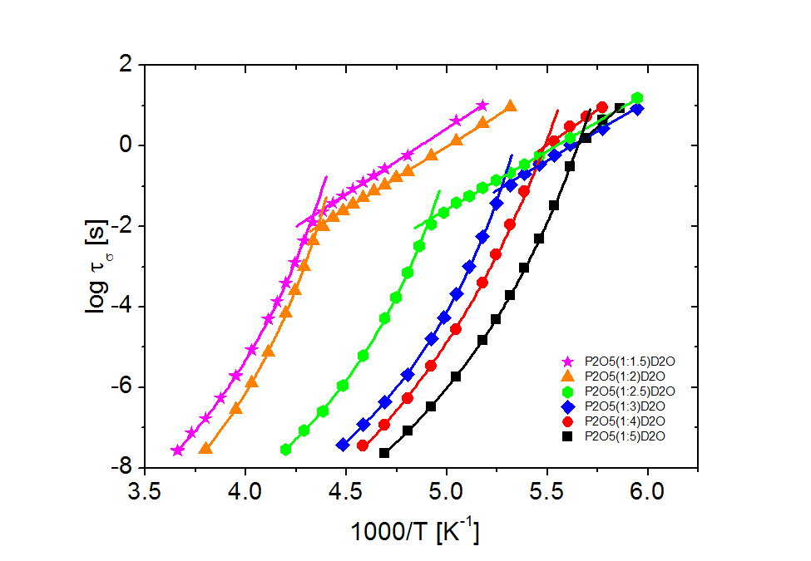
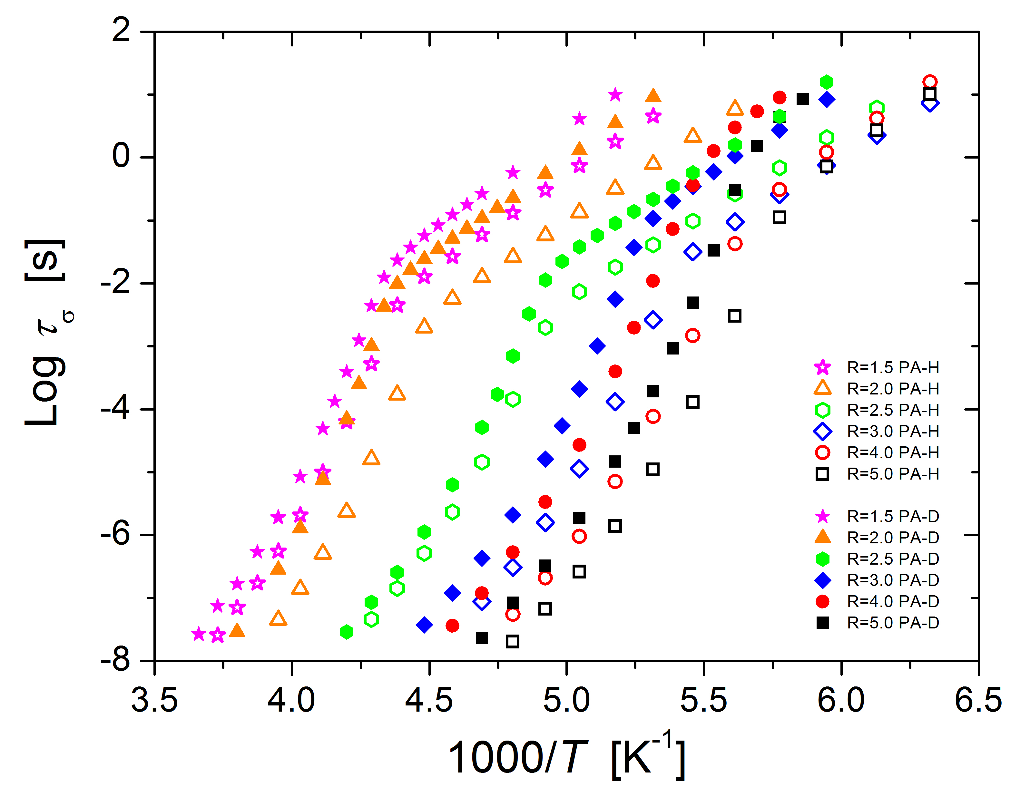
Figure 4.2 Conductivity relaxation time $τ_{σ}$ of deuterated phosphoric acid at different concentrations, a), and the comparison to the hydrated counter parts, b), shown in Arrhenius plots. The shown molar ratios correspond to R=1.5 (magenta star), R=2.0 (orange triangle), R=2.5 (green hexagon), R=3.0 (blue diamond), R=4 (red circle) and R=5 (black square) for the deuterated (closed) and hydrated (open) symbols respectively.

The glass transition temperature of concentrated phosphoric acids R=1.5 and R=2 is 230.7K and 229.5K for the deuterated, and 227.4 and 222.4K for the hydrogenated samples, respectively. With further dilution $T_{g}$ decreases for R=3 ($D_{3}PO_{4}$ or $H_{3}PO_{4}$) to R=5 with 189.7K and 176.9K for deuterated and 185.3K and 172.1K for hydrogenated samples. For this measurement, concentration dependence of the glass transition temperature is expected due to the large difference in $T_{g}$ of the individual components, $D_{2}O$, $H_{2}O$ and $P_{2}O_{5}$ being 140K, 136K, and 590K respectively [any reference?]. Hence, concentrated phosphoric acids are expected to display a higher glass transition temperature compared to the diluted regime. The mixtures used in the experiments approach the $T_{g}$’s of the individual components at the diluted and concentrated regions. Therefore these samples are in agreement with the before mentioned expectations of glass transition behavior.
Measurements of low temperature dynamic properties of diluted systems using dielectric spectroscopy are challenging, since the ionic conductivity processes shift to lower frequencies, and moves outside of the measurable window. The glass transition temperature of PA was therefore further investigated using DSC to allow for a broader range in temperature and concentration.

Differential Scanning Calorimetry
In the DSC measurements, samples with ratios of $P_{2}O_{5}$ to deuterated (?) water R=7,9,14 were measured in addition to the R=1.5, 2, 2.5, 3, 4, 5 samples used in dielectric spectroscopy. $T_{g}$ appears in the calorimetric temperature cycle on the cooling as well as the heating cycle. However only the heating cycle will be considered, in order to allow direct comparison to Dielectric spectroscopy data.
Upon heating, the sample goes from the glassy into the liquid state, causing an initial spike in heat flow rate, followed by immediate enthalpic recovery to the liquid equilibrium state. Figure 4.3 shows the heating cycle of the raw DSC data, where the data were shifted vertically to clarify the behavior and highlight the change in the glass transition temperatures amongst the samples. The midpoint of the glass transition temperature was determined via peak position analysis of the derivative of heat flow with temperature. In Figure 4.3 the sample with the ratio R=3 crystalizes upon heating which is seen as a strong exothermic process.
$T_{g}$ data for both deuterated and hydrated phosphoric acid were collected using DSC measurements and compared to literature values ***cite Angell (black) and Aihara (green) in Figure 4.4. In this research, $T_{g}$ values ranged from 236.0K to 181.8K for deuterated and from 233.5K to 178K for the hydrogenated phosphoric acid samples with R=1.5, 3, 5, respectively. Glass transition temperatures of hydrated phosphoric acid coincide with those collected by the group of Angell in the concentrated region. The $T_{g}$ begins to diverge from Angell’s data in the diluted regime. Similar to the dielectric measurements, the glass transition temperature of the deuterated sample is higher then that of the hydrogenated sample, and the difference in $T_{g}$ increases with increasing water content. Aihara et al measured glass transition of a mixture of

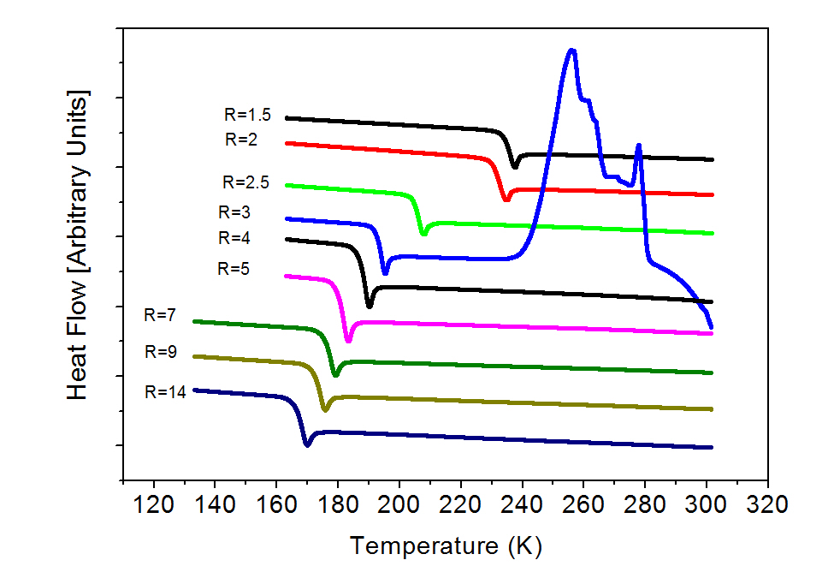
Figure 4.3 The heat flow of different concentrations of deuterated phosphoric acids as measured on the heating cycle via Differential Scanning Calorimetry (Exo Up). Various concentrations are indicated on the plot). $T_{g}$ appears as an endothermic process. The sample with the ratio R=3 corresponds to neat phosphoric acid ${(D}_{3}PO_{4})$ which crystalized at around 273K.

deuterated and hydrated phosphoric acid. As expected, the data falls in between that of pure hydrated and pure deuterated phosphoric acid.
Glass transition temperatures converge to a value which, when extrapolated to the dilute limit, can be assumed to be the $T_{g}$ values of pure hydrogenated or deuterated water. It has been suggested by Angell et al. that the Gordon Tailor equation ***EqGT described in chapter 2 can be used to fit such data. However, in this research the fitting, and so the extrapolation to $T_{g}$ of the pure components, did not yield an accurate fit.
On the concentrated side of the spectra the $T_{g}$ value exhibits an S-shaped behavior due to higher glass transition temperature of the R=2 Ratio. This is also apparent in the conductivity spectra as well as viscosity and NMR measurements ***CiteYYW and can be accounted for by a change in bond structure, which is formed by P2O5 (1:2) H2O. This phenomenon will be further discussed in a later section on conductivity relaxation time of these samples.

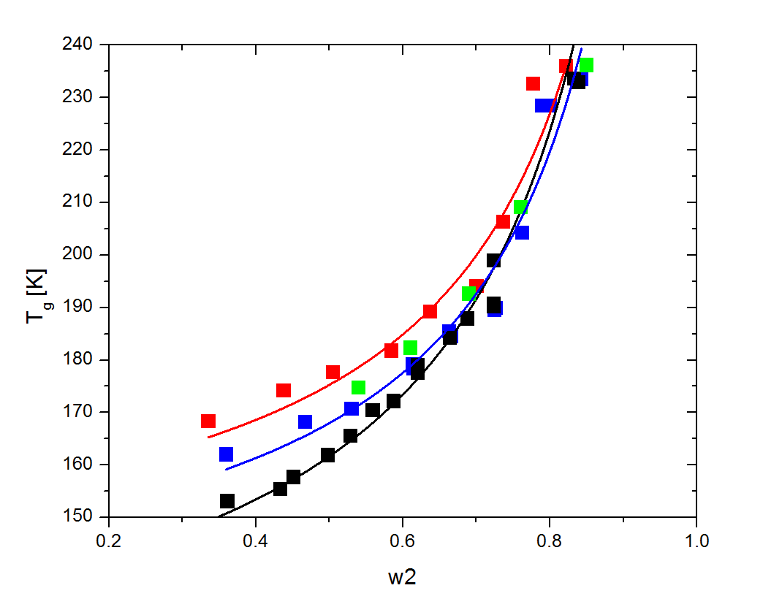

Figure 4.4 Glass transition temperatures of deuterated (red) and hydrated (blue) phosphoric acid are compared to data from literature [Aihara ***citeAih (green) and Angell ***CiteAngell]. $T_{g}$ is plotted versus $w_{2}$ which is the weight fraction of $P_{2}O_{5}$ of the sample for easy extrapolation from zero to one. The lines indicate the Gordon Taylor fit for each data set corresponding to the color.

Brillouin Light Scattering
Measurements of the Glass transition temperature were further verified through Brillouin scattering measurements for selected ratio’s R=1.5, 5. The Brillouin peak in light scattering spectra corresponds to a Doppler shift in frequency, caused by propagating acoustic vibrations within the sample. The Brillouin peak freaquency as a function of temperature is presented in Figure 4.5 for both hydrogenated and deuterated samples. The deuterated samples exhibit a lower Brillouin frequency compared to their hydrogenated counterparts, as expected for the higher oscillating mass.
Furthermore, Figure 4.5 demonstrates a clear change in temperature dependence of the Brillouin frequency at the glass transition. Almost linear trends are observed above and below the transition. In the glassy state, changes of the frequency with temperature are much weaker than in the liquid state, reflecting weaker temperature variations of elastic modulus and density. The mid point temperature of the transition was determined by derivative analysis and smoothing of the data as demonstrated in the inset in Figure 4.5. Horizontal lines indicate linear temperature dependence above and below $T_{g}$, while the midpoint temperature was taken to be at the center of the transition. As in DSC and Dielectric measurements the deuterated samples show a higher glass transition temperature. Due to excessive data manipulation, the error-bars of determining glass transition using this technique was within a few degrees, though a clear trend can be observed through internal consistency of the measurement itself.

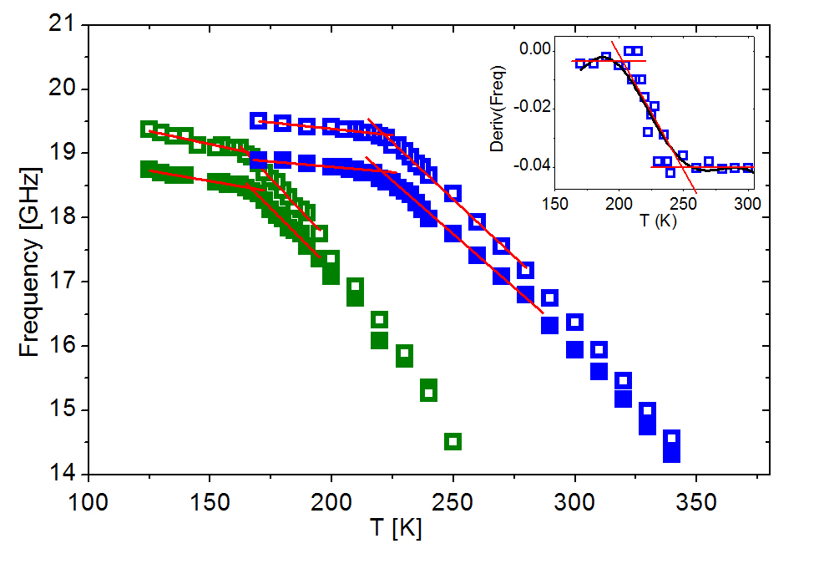
Figure 4.5 Average Brillouin frequency of deuterated (closed) and hydrogenated (open) phosphoric acid at R=1.5 (blue) and R=5 (green) plotted against temperature. The inset shows the derivative of frequency with temperature across the glass transition.

Glass Transition - Discussion
To identify the isotope effect on the glass transition temperatures of phosphoric acid at different concentrations, a variety of experimental methods were utilized in this research. The comparison of glass transition data of the three methods used (Figure 4.6), yields slight differences between experimental methods. Though all methods are internally consistent concerning the difference in glass transition temperature $∆T_{g}$, some variance exists between the results of the different experimental techniques. Brillouin and Dielectric measurements yield lower glass transition temperatures then DSC. This difference in temperature can be explained by vast difference in heating and cooling rate during the measurements. Brillouin light scattering and dielectric measurements were conducted in temperature steps of 2.5k surrounding the glass transition, taking tens of minutes per temperature. DSC measurements were conducted with rates of 5K/min. Due to the fact that the glass transition is a broad transition, the fast heating rate of DSC led to higher indicated $T_{g}$ than the slow heating and cooling rate of the other two methods, resulting in the difference visible in Figure 1.6.

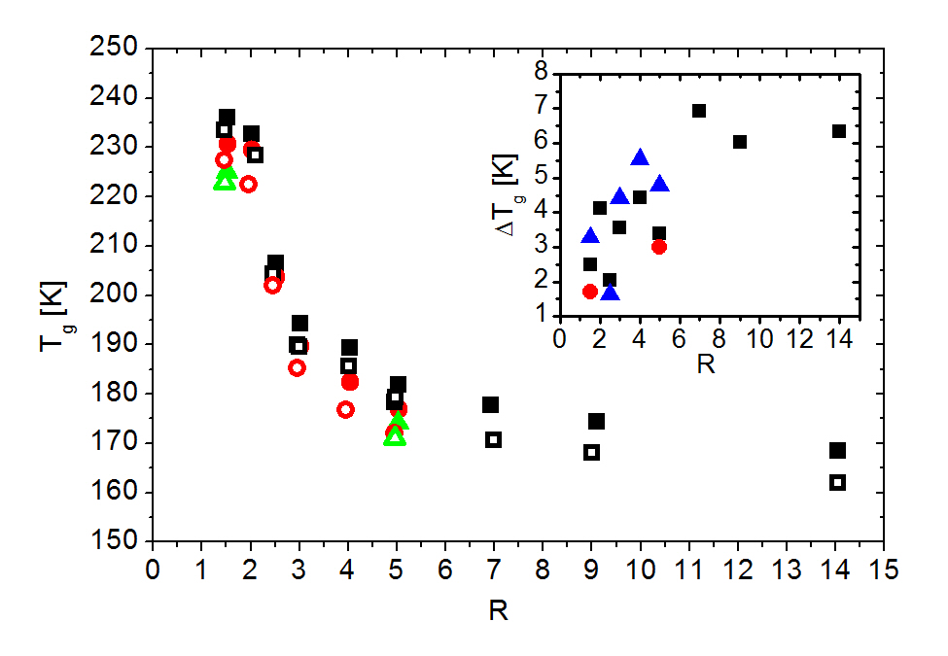
Figure 4.6 Comparison of glass transition temperatures obtained using DSC (black squares), dielectric spectroscopy (red circles) and Brillouin light scattering (green triangles). Deuterated and hydrogenated samples are represented by closed and open symbols, respectively. The insert shows the difference in glass transition temperatures $∆T_{g}$ between deuterated and hydrogenated samples.

Nevertheless, this research aimed to identify the isotope effect in the glass transition temperatures of $D_{2}O-H_{2}O$ of different acid concentrations. The differences between outcomes of the previously described methods used are of insignificant importance for this research. As displayed in Figure 4.6, the measurements show that the $T_{g}$ of $D_{2}O$ – containing samples is always greater then that of $H_{2}O$ - containing ones, and the difference increases with R. This difference in the glass transition temperature increases with water content. The results indicate that the difference in $T_{g}$ between the heavier isotope $D_{2}O$ and the lighter isotope $H_{2}O$ is at least 6K. Variations in the data and accuracy of the Tg estimates complicate the determination of an exact extrapolation of $∆T_{g}$ between the two pure isotopes of water, but the data suggests that it is in the region of 6-8K. This value is higher compared to values suggested by extrapolating $T_{g}$ of other proton conducting materials like $LiCl$ and ${ZnCl}_{2}$.***(CiteLiClpaper) Consequently the results of this paper indicate that the isotope effect on glass transition is stronger than described by previous research. Our estimates for the isotope shift of Tg in water is consistent with ΔTg~10K revealed recently in studies performed in our gorup [].

Proton Conduction and Conductivity Relaxation Time
Now that we have discussed the isotope effect in the glass transition, the question remains how the isotope effect impacts the proton conductivity. In order to study the isotope effect on proton conduction, let’s go back to the Figure 4.2, which presents the conductivity relaxation time of deuterated phosphoric acid. As previously demonstrated (***citeYYW), the dielectric data for $τ_{σ}$ and $σ_{τ}$ greatly differ above Tg, from when the sample is in the glassy state. Since ionic transport is no longer supported by structural relaxation and molecular diffusion (both are frozen below Tg), ionic motion takes place through “Grotthuss type” hopping of protons. In this case, the isotope effect should play a strong role in conductivity due to the mass difference of the proton and deuterium. The known change in mass difference in combination with the measurable change in conductive behavior can lead to a better understanding of the method of proton motion, which is discussed in the following section.
In order to determine dynamics below the glass transition, it is important to analyze the characteristics of ion conduction at $T_{g}$. Figure 4.7 shows the previously mentioned $τ_{σ}$ data for deuterated phosphoric acid vs inverse temperature normalized by $T_{g}$. This representation emphasizes the difference in conductivity relaxation times at the glass transition between the samples. It is important to notice that $τ_{σ}$ at $T_{g}$ spans a range of over two orders of magnitude and does not increase monotonously with water concentration. Furthermore the hydrogenated phosphoric acid samples, show similar behavior shifted to faster time scales. To clarify, the conductivity relaxation times at the glass transition of each ratio are presented in Figure 4.8. The ratio of R=5 is excluded from the analysis in this section due to an inadequate amount of data points below the glass transition in the experimental window.

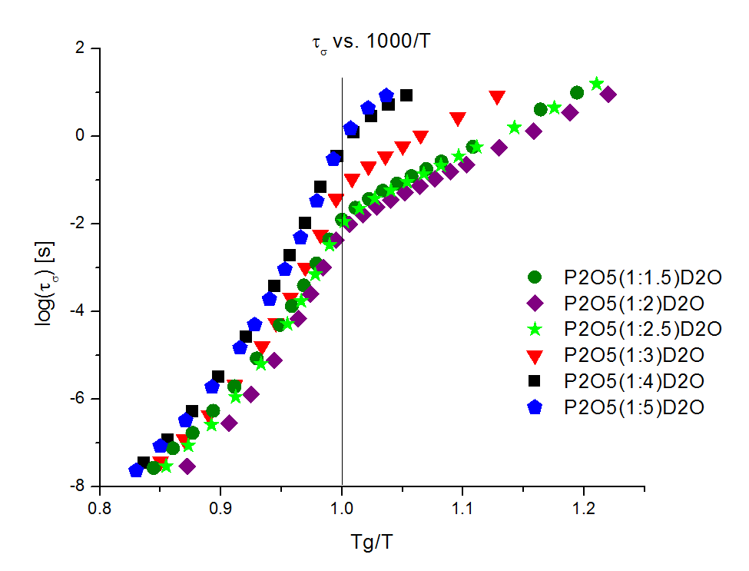

Figure 4.7 Conductivity relaxation time $τ_{σ}$ of deuterated phosphoric acid at different water concentrations vs inverse temperature normalized to their Tg. The shown molar ratios correspond to R=1.5 (magenta star), R=2.0 (orange triangle), R=2.5 (green hexagon), R=3.0 (blue diamond), R=4 (red circle) and R=5 (black square).

The conducted measurements show that the hopping time of ion conduction at $T_{g}$ increases with dilution from $9.88×{10}^{-3}s$ at R=2 to $9.02×{10}^{-1}s$ at R=4, and $3.16×{10}^{-3}s$ at R=2 to $1.26×{10}^{-1}s$ at R=4 for the deuterated and hydrogenated phosphoric acid samples, respectively. At the R=1.5 ratios however the observed ion motion slows to $1.87×{10}^{-2}s$ and $6.31×{10}^{-3}s$ for deuterated and hydrogenated samples respectively. In this representation low values of $τ_{σ}$ resemble fast ion jumps, which are desired in good proton conductors. The collected data suggests that ions transfer at a faster rate in more concentrated acids, reaching optimum at R=2, while increasing amount of water slows the process at Tg by near two orders of magnitude. The structures of phosphoric acid display strong concentrational dependence as discussed in Chapter 2: . The time scale of ion hopping reaches a minimum when twice as many water molecules are present compared to phosphorus pentoxide. This suggests that the ratio of R=2 is favorable for the fast ion transport.

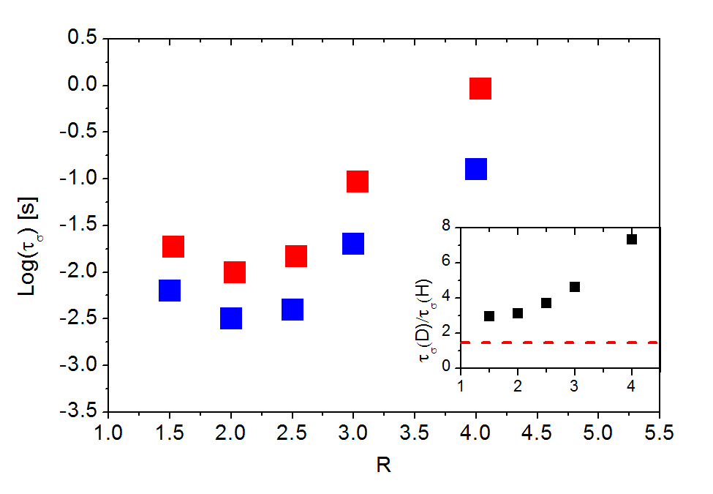
Figure 4.8 Conductivity relaxation time at the glass transition of deuterated (blue square) and hydrogenated phosphoric acid (red square). The insert shows the ratio of the above $τ_{σ}(D)/τ_{σ}(H)$ at their Tg’s vs concentration. The expected value of $√2$ is indicated by a red dashed line.

In order to analyze the impact of the isotope effect on ionic motion, the ratios of $τ_{σ}(D)$ to $τ_{σ}(H)$ at their Tg’s were compared versus molar ratio in the insert in Figure 4.8. In this representation the data show a clear increasing trend with concentration ranging from a factor of 3 for R=1.5 to larger than 7 for R=4.
In a purely classical model the ratio of time scale of ion transport should be constant, and equivalent to √M_{D}/M_{H} = $\sqrt{2}$ across all ratios, as per Hooke’s Law ***Eq.2.5 and various other models (***citeRef2,3 from The Mechanism of the hydrogen Ion). The classical prediction is indicated on the plot by a red dotted line. Our measurements (Figure 1.8) show that even the minimum value of the ratio of relaxation times at R=1.5 is near twice of the expected value of the classical prediction, and the isotope effect only increases with molar amount of water in the sample. This is yet another indication (***citeAllClassicalControv.) that the classical theory is not valid for ion transport, and further modification of the classical theory needs to be taken into consideration.
Molecular dynamics are arrested in the glassy state, causing ion transport to become an activated process below $T_{g}$. A certain activation energy $E_{A}$ is now required in order to initiate ionic motion, which can be determined from the Arrhenius fit of $τ_{σ}$. (***YYW Fig3). Figure 4.9 shows the activation energies of deuterated (red) and hydrogenated (blue) phosphoric acids as determined from the Arrhenius fit at T<Tg. The activation energies within the measured set of ratios shows a distinct U-shape with a minimum centered on R=2.5. The activation energies decline from $62.2\frac{kJ}{mol}$ and $58.7\frac{kJ}{mol}$ at R=1.5 to $55.6\frac{kJ}{mol}$ and $51.4\frac{kJ}{mol}$ for R=2.5 for the deuterated and hydrogenated samples, respectively. Past the minimum the activation energy increases to $67.0\frac{kJ}{mol}$ and $59.5\frac{kJ}{mol}$ at R=4.0. Therefore the energy barrier for a proton jump is less for the sample with R=2.5 then for highly dilute or highly concentrated regions. This is in approximate agreement with earlier findings of $τ_{σ}$ and indicates favorable structures of ion conductivity at certain concentrations of phosphoric acid.

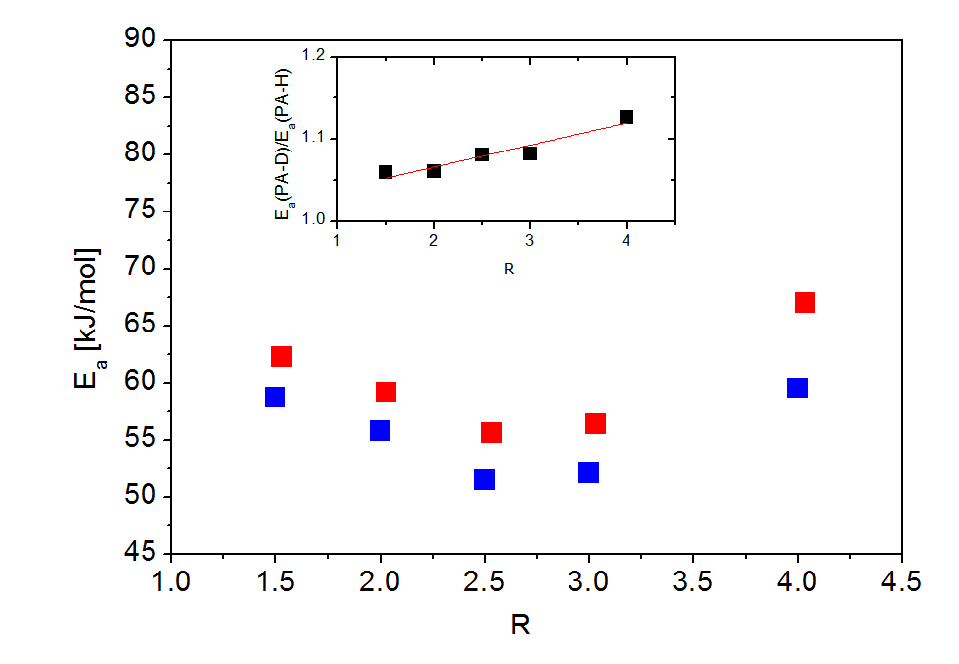
Figure 4.9 Activation Energies of ion conductivity in deuterated (red) and hydrogenated (blue) Phosphoric acid extracted from the Arrhenius fit of $τ_{σ}$ at T<Tg. A minimum in E_{a} is observed in both cases at R=2.5. The insert shows the ratio of the activation energies for deuterated and hydrogenated samples.

Another important finding is that the activation energy of the deuterated samples is always higher than their hydrogenated analogs. To further analyze this phenomenon the ratio of activation energies of deuterated to hydrogenated phosphoric acid is shown in the insert of Figure 4.9. Across the sample range the ratio of the activation energies increases linearly by 6% from 1.06 to 1.13.

Dc. Conductivity
In order to analyze the dynamics of ion motion above the glass transition it is best to focus on DC conductivity, due to a broader data range at higher temperatures. The temperature dependence of DC conductivity $σ_{τ}$, in different samples of deuterated phosphoric acid was obtained by tracking the DC plateau of the real part of conductivity with temperature (Figure 4.10). Conductivity increases with temperature as well as with increasing water content in the sample.

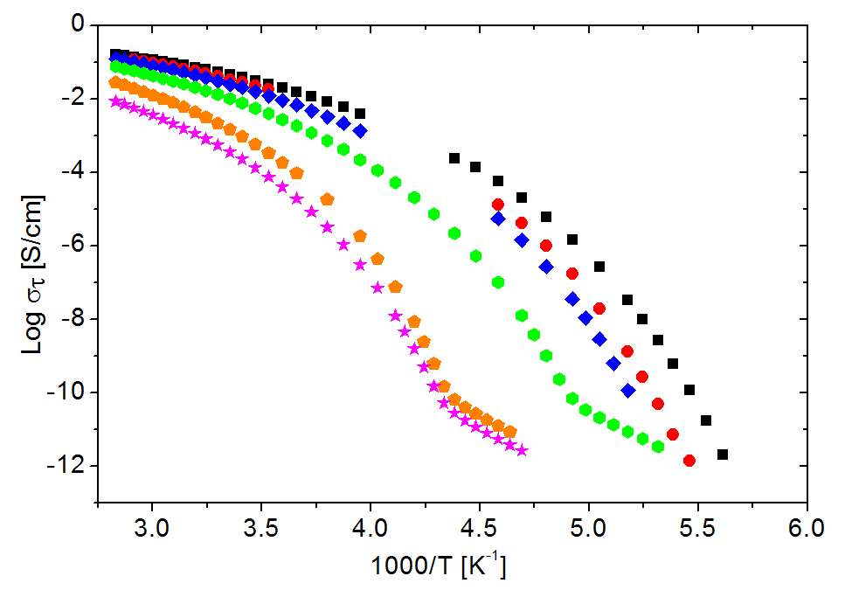
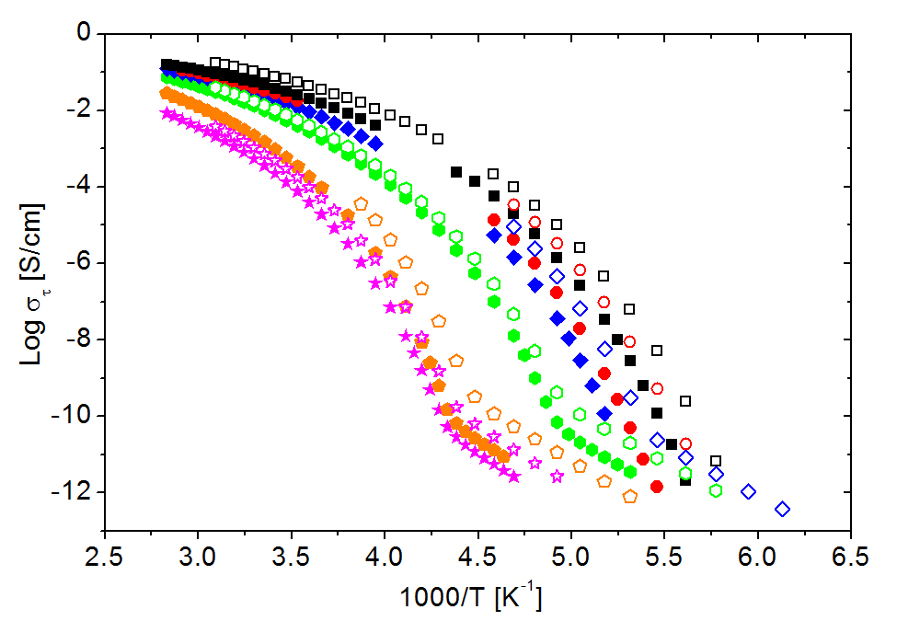
Figure 4.10 DC conductivity $σ_{τ}$ of deuterated phosphoric acid at different concentrations (left) and the comparison to the hydrated counter parts (right) shown in Arrhenius plots. The shown molar ratios correspond to R=1.5 (magenta star), R=2.0 (orange triangle), R=2.5 (green hexagon), R=3.0 (blue diamond), R=4 (red circle) and R=5 (black square) for the deuterated (closed) and hydrogenated (open) samples, respectively.

The conductivity of deuterated phosphoric acid is always lower than that of the hydrated counter part. At $50℃$, which is equivalent to $3.09 \frac{1000}{K}$ on the graph, $σ_{τ}$ Ranges from $2.13×{10}^{-3}\frac{S}{cm}$ and $3.65×{10}^{-3}\frac{S}{cm}$ at R=1.5 to $9.25×{10}^{-2}\frac{S}{cm}$ and $1.71×{10}^{-1}\frac{S}{cm}$ for R=5 for deuterated and hydrogenated samples, respectively. Hence the conductivity in the high temperature region is roughly 50% higher in the hydrated samples then in the deuterated ones. The difference in $σ_{τ}$ between isotopes strongly increases with decreasing temperature when approaching the glass transition temperature. Close to $T_{g}$ the difference extends to nearly one order of magnitude for R=1.5 and more than two orders of magnitude for R=5.
This difference in conductivity between isotopes is even more visible in Figure 4.11, where the ratio of DC conductivity in hydrogenated and deuterated samples is presented. The red dotted line indicates the expected in a simplistic classical model value of $\sqrt{2}$ that. The ratio of conductivities approaches this limit at higher temperatures, but clearly diverges by orders of magnitude at lower temperatures.
This divergence is caused in part by the shift in Tg between hydrogenated and deuterated samples, as was discussed in previous section. The temperature dependence of $σ_{τ}$ strongly increases approaching the glass transition. Slight differences in glass transition therefore cause a significant difference in conductivity data of the deuterated and hydrogenated samples around $T_{g}$. At high temperatures, however, the ratio ${σ_{τ}(H)}/{σ_{τ}(D)}$ converges to values between one and two for R=1.5, 2.5, 5. High temperature data for sample ratios R=2, 3, 4 were not available for hydrated phosphoric acid samples and are omitted in this analysis.

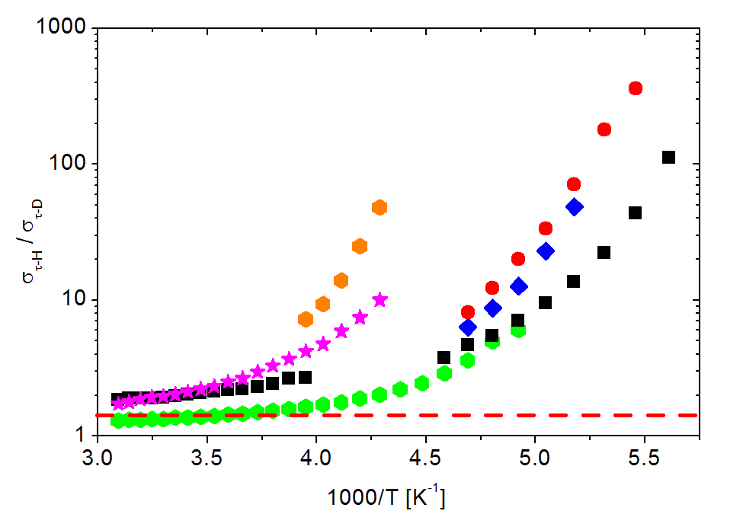
Figure 4.11 Ratio of $σ_{τ}$ in hydrogenated phosphoric acid to $σ_{τ}$ in deuterated phosphoric acid vs. 1000/T. The red dotted line indicates a value of $√2$. The molar ratios correspond to R=1.5 (magenta star), R=2.0 (orange triangle), R=2.5 (green hexagon), R=3.0 (blue diamond), R=4 (red circle) and R=5 (black square).

In order to exclude effects of the glass transition on further data analysis and focus on the high temperature regime, the conductivity data is fit using Vogel-Fulcher-Tammann (VFT) ***(EqVFT) and Cohen Grest (CG) ***(EqCG) functions. Both fitting functions were discussed in detail in the chapter 3. Figure 4.12 depicts conductivity data of deuterated phosphoric acids of ratio R=1.5, 2.5, 5, fitted to the VFT (red) and CG (green) functions above $T_{g}$. While the VFT function fits the data relatively well and is the common method of analyzing these data ***citeYYW+Phil, the CG function provides a more accurate fit at higher temperatures due to an additional fitting parameter (VFT has 3 free fit parameters, while CG has 4). This allows for a more accurate extrapolation of conductivity to infinite temperature $σ_{T=∞}$ with the CG function.

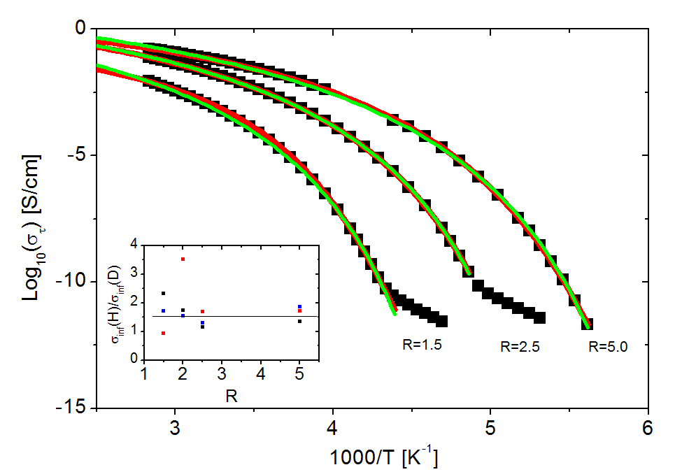
Figure 4.12 shows $σ_{τ}$ of deuterated phosphoric acid at Ratios R=1.5, 2.5, 5.0 (indicated on plot). The VFT (red) and Cohen Grest (green) fitting functions are extrapolated to $σ(T=∞)$. The insert shows the ratio of the $σ(T=∞)$ in hydrogenated to $σ(T=∞)$ in deuterated phosphoric acids obtained from the VFT fit (red squares) and Cohen Grest fit (black squares). The blue squares denote the same ratio taken from the experimental data at $50℃$.

Since conductivity increases with temperature, $σ_{T=∞}$ resembles the maximum possible conductivity of a material. The ratio of this extrapolated $σ_{T=∞}$ of hydrogenated to deuterated phosphoric acid is depicted in the insert in Figure 4.12. Here the ratios of fitting parameters of VFT and Cohen Grest functions are presented by the red and green squares, respectively. In addition, the values of the highest temperature data points are compared as well. Although the data is fairly scattered, they are all around value ~1.5 for all the samples. This is close to the expectations of a classical isotope effect.

Discussion of Ionic Conductivity
The isotope effect has been previously shown to have strong impact on conductivity behavior of proton conducting materials ***(cite all IE in P-Cond). Phosphoric acid has been suggested to be a model system of study due to its excellent glass forming and proton conducting properties. Though well studied at high temperatures, the low temperature region has not been extensively studied ***(IE in PA and YYW).
In the high temperature regime the isotope effect is not as pronounced as it is close to $T_{g}$ (Figure 4.11). DC conductivity of the phosphoric acid samples prepared with H₂O was between 1 to 2 times higher then that of the samples prepared with D₂O. Though scattered, the data corresponds well to that of the classically predicted ratio of $\frac{σ_{τ}(H)}{σ_{τ}(D)}=\sqrt{2}$. These findings are also in agreement with values found in literature.***(Aihara, GrotthussPaper) At high temperatures, molecular motion is not restrained, as it is in the glassy state, and ions can diffuse freely. With decreasing temperature the change in physical properties of the sample have a stronger impact on ion dynamics in the deuterated samples. The decrease in DC conductivity and an increase in conductivity relaxation time are more pronounced in deuterated then in hydrogenated phosphoric acid.
Experimental results on conductivity relaxation time and activation energy indicate that ionic motion does not scale with the square root of the ratio of mass at temperatures close to and below the glass transition. Conductivity relaxation times at the glass transition display a very prominent isotope effect. Deuterated phosphoric acid samples relax a minimum of 3 times slower compared to their hydrated counterparts for concentrated samples. The isotope effect increases to over 7 times within the measured concentration range. The difference in glass transition temperatures of the deuterated and hydrogenated samples has to be taken into account during this evaluation. Due to strong temperature dependence of $τ_{σ}$ directly above the glass transition, small changes in $T_{g}$ can cause vast differences in relaxation times. The ratio of relaxation times at a fixed temperature may, therefore, not be a fair direct comparison due to the $∆T_{g}$ between isotopes discussed in an earlier section. Comparison of $τ_{σ}$ at Tg is better in that case, because it provides comparison of $τ_{σ}$ at the same structural relaxation time. $τ_{σ}$ of the deuterated sample is always higher across the entire measured range, regardless of change in glass transition temperature.
Below the glass transition temperature, ions can only move via the Grotthuss type hopping mechanism. ***(Grotthuss p.459 +others) The classical model of proton transport ***(classical model) is insufficient in describing the isotope effect in this region ***(classical does not work). A comparison of the activation energies of ionic conduction below $T_{g}$ of deuterated and hydrated phosphoric acid also shows a significant Isotope effect. The activation energies of deuterium are 6-7 $\frac{kJ}{mol}$ higher then for proton conduction in phosphoric acids. Additionally the isotope effect increases with increasing water content, with the ratio of activation energies increasing from 1.06 for R=1.5 to 1.13 for R=4.
Semi-classical theories predict that the ion, which is attempting to overcome a certain potential energy barrier, is aided by quantum mechanical ground state energy. ***(kreuerH/D, Nowick, others) This energy originates from zero point vibrations of the proton/ion. Since lighter particles can vibrate faster they possess a greater zero point energy then heavier ones, causing the necessary activation energy to decrease in contrast. The result of such a semi-classical effect would further increase isotopic effects in proton conduction. The difference in ionic conductivity between isotopes has also been analyzed theoretically using quantum-tunneling effects.***(siteQMtunneling) This theory builds on the semi-classical theory and adds a small probability of tunneling under the potential energy barrier. The lighter ion has much greater probability of tunneling, further explaining the isotope effects below the glass transition. Furthermore the increase of the isotope effect in activation energy with decreasing temperature could be explained due to the increased probability of quantum effects at lower temperatures. However no convincing evidence for quantum effects exists in our data.
The general trend in this data is that the isotope effect increases with decreasing acid concentration and decreasing temperature. A greater number of $H_{2}O$ or $D_{2}O$ to phosphorus pentoxide molecules creates a larger difference in properties of the sample. By this logic the highest isotope effect can be achieved in the dilute limit of the phosphoric acid where normal water and heavy water dominate the composition of the sample. The dilution of the phosphoric acid drives the interesting properties to lower and lower temperatures, and one could argue that it is not the increasing molar amount of $H_{2}O$ and $D_{2}O$, but rather the decreasing temperatures that drive the increasing isotope effect. Indeed, all quantum effects are expected to be stronger at lower temperatures where normal over-barrier relaxations are strongly suppressed. It is difficult to determine the exact cause of the increase in isotope effect in this case, due to the interconnected nature of decreasing temperature effects with increasing dilution of the sample.

Conclusions and Recommendations

The goal of this study was to investigate the isotope effect on Glass transition and proton conduction in phosphoric acid to examine possible quantum effects in these processes. Phosphoric acid has a wide range of applications ranging from biology to industry. Some favorable characteristics include excellent glass forming capability upon vitrification, as well as the highest intrinsic proton conduction amongst common acids. It has been shown that the Grotthuss mechanism is responsible for fast proton conductivity, which begs the question whether the process follows a purely classical nature, or if quantum effects become apparent. The isotope effect allows for a variation of mass of the conducting ion while charge remains constant. The mass dependence of charge transport characteristics can then shed light onto the classical or quantum nature of the processes.
It was shown using broadband dielectric spectroscopy, differential scanning calorimetry and Brillouin light scattering, that the isotope effect causes and increase in glass transition temperature and that the difference in $T_{g}$ between the deuterated and hydrated acids increases with molar concentration of $H_{2}O$ and $D_{2}O$.
The isotope effect also causes a decrease in conductivity in the sample containing the heavier isotope and an increase in proton transition time at the glass transition temperature. The ratio of $τ_{σ}$ of the two isotopes not only far exceeds the classically predicted dependence of $\frac{τ_{σ}(D)}{τ_{σ}(H)}∝\sqrt{2}$, but also further increases with the dilution of the acid. The ratios of activation energy of ionic conduction also increase with dilution, which is not predicted by classical theory. These inconsistencies with classical theory could suggest possible influence of quantum effects such as proton tunneling, but no definite conclusions can be made from this data.
Further research is suggested in viscosity measurements for Walden plot analysis which gives rise to the degree of decoupling of ionic transport from structural dynamics. In addition, it would be of interest to measure molecular motion using dynamic light scattering to gain information about molecular dynamics with respect to proton hopping.
Phosphoric acids are widely used in proton conducting polymer electrolytes and membranes, where decoupling of proton conduction from structural relaxation is a desired attribute. Further understanding of decoupling in deuterated phosphoric acids and other proton conducting materials can aid the design of novel materials for industry and energy application.

List of References

1. Mukundan, R., et al., Tritium Conductivity and Isotope Effect in Proton‐Conducting Perovskites. Journal of The Electrochemical Society, 1999. 146(6): p. 2184-2187.
2. ELLIS, B., The glass transition temperatures of phosphoric acids. Nature, 1976. 263: p. 674-676.
3. Aihara, Y., et al., Ion Conduction Mechanisms and Thermal Properties of Hydrated and Anhydrous Phosphoric Acids Studied with 1H, 2H, and 31P NMR. The Journal of Physical Chemistry B, 2006. 110(49): p. 24999-25006.
4. Corti, H.R., F.J. Nores-Pondal, and C.A. Angell, Heat capacity and glass transition in P2O5-H2O solutions: support for Mishima's conjecture on solvent water at low temperature. Phys Chem Chem Phys, 2011. 13(44): p. 19741-8.
5. Wang, Y., et al., Ionic conductivity and glass transition of phosphoric acids. J Phys Chem B, 2013. 117(26): p. 8003-9.
6. Martin, S.W. and C.A. Angell, On the glass transition and viscosity of phosphorus pentoxide. The Journal of Physical Chemistry, 1986. 90(25): p. 6736-6740.
7. Gordon, M. and J.S. Taylor, Ideal copolymers and the second-order transitions of synthetic rubbers. i. non-crystalline copolymers. Journal of Applied Chemistry, 1952. 2(9): p. 493-500.
8. Blander, M., et al., Solubility of Noble Gases in Molten Fluorides. II. In the Lif–NaF–LF Eutectic Mixtures. The Journal of Physical Chemistry, 1959. 63(7): p. 1164-1167.

1. D. Borgis, G. Tarjus and H. Azzouz, Journal of Chemical Physics 97 (2), 1390 (1992).
2. R. Mukundan, E. L. Brosha, S. A. Birdsell, A. L. Costello, F. H. Garzon and R. S. Willms, Journal of The Electrochemical Society 146 (6), 2184-2187 (1999).
3. K. B. Wiberg, Chemical Reviews 55 (4), 713-743 (1955).
1. D. Borgis, G. Tarjus and H. Azzouz, Journal of Chemical Physics 97 (2), 1390 (1992).
2. R. Mukundan, E. L. Brosha, S. A. Birdsell, A. L. Costello, F. H. Garzon and R. S. Willms, Journal of The Electrochemical Society 146 (6), 2184-2187 (1999).

Vita
Max was born in Austin Texas in 1989, but grew up near Bonn, Germany granting him dual citizenship. After the completion of his 10th year of Gymnasium (German highest form of high school), Max moved to America to begin a foreign exchange year in the United States in 2005 but decided to stay once the year had ended. He completed high school in 2007 and began his undergraduate studies at Dalton State College and transferred to the University of west Georgia in fall of 2009 where Max received his Bachelors of Science in Physics in May of 2011. Max joined the group of Dr. Alexei Sokolov at the University of Tennessee Knoxville (UTK) during that summer where he began research prior to starting graduate School in the Physics department. After three years of classwork and research at the University and Oakridge National Laboratories Max will receive his masters’ degree in Physics and move on to further graduate work in the Chemical and Biomolecular Chemistry department at UTK.
(Given example: Mary Smith was born. She went to school. She wrote a thesis. She graduated. This page really is required.)

(Just as a personal note)
Reference:
C. Gainaru, A. L. Agapov, V. Fuentes-Landete, K. Amann-Winkel, A. I. Kolesnikov, V. N. Novikov, R. Richert, H. Nelson, R. Böhmer, T. Loerting, A. P. Sokolov, Nature Physics (submitted).

