Title

ACKNOWLEDGEMENT

ABSTRACT

TABLE OF CONTENTS
ACKNOWLEDGEMENT 2
ABSTRACT 3
CHAPTER 1. INTRODUCTION 6
Rechargeable zinc air battery 10
Development of mechanically rechargeable zinc air battery 14
Zinc anode 15
Zinc slurry Modeling developments 20
Zinc electrochemistry, mechanisms, passivation 20
CHAPTER 2. MATERIALS AND METHODS 29
Methodology 29
Polarization curve 30
Utilization curve 31
Resistance as a function of SOC 32
Symmetric cell testing 32
Conductivity measurement 32
Zinc slurry air full cell components preparation 33
CHAPTER 3. SYMMETRICALLY ELECTROCHEMICAL CHARACTERIZATION TO IMPROVE PERFORMANCE OF MECHANICALLY RECHARGEABLE ZINC SLURRY AIR BATTERY 34
Introduction 35
Methods and materials 38
Cell construction 38
Zinc slurry and air electrode preparation 39
Electrochemical measurements 41
Results and discussion 43
Baseline Study 43
Cell parameters Effects 50
Conclusion 56
CHAPTER 4 – NEW APPROACH TO INVESTIGATE LOW-PERCOLATION SLURRY CHARACTERISTICS TO IMPROVE ZINC UTILIZATION IN MECHANICALLY RECHARGEABLE ZINC SLURRY AIR BATTERY 57
Abstract 57
Introduction 58
1. Materials and methods 60
2. Results and discussion 61
3. Conclusion 77
CHAPTER 5 – PRACTICALLY DEVELOPMENT LAB-CELL MRZAB FOR FUTURE PROTOTYPE TECHNOLOGY AND OTHER CONSIDERATIONS 78
Motivation 78
Design progress towards lab-scale mechanically rechargeable zinc slurry air battery 78
Regeneration of zinc slurry – a test in symmetric cell 81
Corrosion effects 85
CHAPTER 6 – APPLYING POTENTIAL STEP TO CHARACTERIZE MASS TRANSPORT OF POROUS ELECTRODE IN VANADIUM REDOX FLOW BATTERY 88
Abstract 88
Background 89
Fundamentals of VRFB 90
Developments of membrane in VRFB 92
Developments of electrode in VRFB 94
Approach 98
Battery Testing 98
Theory 99
Details of Electrochemical Tests 102
Results and Discussions 102
Impact of work 112
CHAPTER 7. CONCLUSION 113

LIST OF FIGURES
Figure 1: Reproduced comparison of different types of battery in energy density¹⁹. 15
Figure 2: Schematic of an aqueous rechargeable zinc–air battery²⁶. 17
Figure 3: Reproduced types of mechanically rechargeable zinc air battery²⁸. 19
Figure 4: Reproduced diagram of porous electrode compositions⁵⁵. 25
Figure 5: Reproduced galvanostatic discharging profile of zinc electrode with 70 mA/cm² and three passivation steps were presented from Liu et al⁶⁵. 28
Figure 6: Reproduced schematic of development of zinc passivation films. a) zinc dissolution; b) zinc polymerization (due to low zincate diffusivity); c) formation of passivation film type 1; d) formation of passivation film type 2⁶⁸. 30
Figure 7: Reproduced Zn²⁺ as a function of concentration of KOH from Zhang⁶⁹. 32
Figure 8: Pourbaix diagram of Zn, reprinted from Yadav et al⁷². 34
Figure 9: A diagram of house-made zinc slurry air battery. 37
Figure 10: a). Flow design: Modified anode bipolar plate serpentine design with width of 2 mm flow channels and other cell components adapted from alkaline fuel cell; b) Injection design: In-house made 3D printed parts for current collector holder and slurry holders and other cell components adapted from alkaline fuel cell. 47
Figure 11: A schematic of zinc slurry air battery in injection mode to assist demonstrates location of pseudo reference electrode. 50
Figure 12: a) modified serpentine flow field in graphite bi-polar plate; b) flowing zinc slurry; c) polarization curve in zinc slurry air flow battery. 53
Figure 13: a). A photo for newly designed experimental cell; b). Polarization curves, Blue - carbon felt with MPL; Red - carbon felt without MPL. 55
Figure 14: a). Separated polarization curves (in blue Zinc anode polarization, in red Air cathode polarization) with a pseudo reference wire. ; b). Detailed separated losses between each component in the Zinc-air battery. 58
Figure 15: a) gas-through-side, b) gas-through-middle 60
Figure 16: a) non-IR-corrected Cell polarization curves; b). Separated polarization curves by varying the concentration of KOH. 63
Figure 17: Effects of gas flow configuration on performance of cell. 65
Figure 18: An illustration of mechanically rechargeable zinc air battery in semi-batch mode with 1 cm thick high-capacity anode and carbon light-weight air cathode with house-made CLAM. 74
Figure 19: Galvanostatic discharging profile under different conditions, a) pre-screening the membrane and operational mode for the cell utilization testing; investigating effects of b) zinc loading in slurry, c) discharging rate, d) KOH concentration on the cell performance. 77
Figure 20: Discharged zinc slurry in holder view and carbon paper view with 25.3wt%, 33.6wt%, and 37.2 wt% compositions. 78
Figure 21: a) High frequency resistance as a function of thickness measured by house-made slurry symmetric cell. b) The validation analysis of contact resistance through this conductivity measurements. 79
Figure 22:. a) Resistance as a function of (state of charge) SOC in discharging direction with three electrodes assisted to isolate cathode part. b) Derived corresponding specific resistance and conductivity values as a function of SOC. c) Illustration of EIS slurry model, highlighting the three major processes: 1. electron transfer between zinc particles; 2. Ionic transfer from mobility of hydroxide ion; 3. Interfacial charge transfer between zinc particle and KOH. d) Its corresponding equivalent circuit model presents R_{e}, R_{ion}, and R_{ct} to describe these three processes 81
Figure 23: a) SEM images for pristine manufactured Spectrum zinc powders, b) Inverted stage microscope images on pristine zinc slurry with 33 wt% zinc loading in 10x resolution, c) same microscope with focus on ‘virtually closed-enough’ particles on same slurry in 20x resolution, d) Statistical results of simulated zinc particles in slurry with fixed range diameter from 1 um to 60 um, e) The results of 30 Monto Carlos runs for simulated conductivity of zinc slurry based on our developed model, f) a interactive view of repsentitve volume element (RVE in 1 mm x 1 mm x 1 mm) that captured neighbors and isolated particles with different color, g) a slice view of RVE with dimension of 400 um x 400 um x 100 um. 86
Figure 24: A scheme shows the volume expansion of zinc particles during discharging. Assuming no major morphologic change on zinc particle. The expansion is sorely from the zinc oxide layer uniform deposition. 88
Figure 25: Design of device perspective for slurry anode in development practically viable MRZAB, a) serpentine design of flow field adapted from alkaline fuel cell that allows dual phases operation (gas and liquid); b) Modified flow field design with 2 mm width of channel for pumping slurry; c) Initial slurry injection design with 5 cm² and 1 cm thickness; d) Knob assisted injection design for removal purpose manually; e) A illustration of modified nickel plate holder to allow slurry injection through multichannel; f) A modified slurry multichannel holder with 2 mm thickness to hold slurry while operating the cell. 93
Figure 26: A symmetric cell testing with Zn|CLAM|Zn setup plating and stripping under 40 mA/cm², and 100 mA/cm² for 12 mins current holding (6 mins for charging, and 6 mins for discharging) each cycle until 50 cycles. 96
Figure 27: A symmetric cell testing with Zn|CLAM|Zn setup plating and stripping under and 100 mA/cm² for 120 mins current holding (60 mins for charging, and 60 mins for discharging) each cycle until 20 cycles. 97
Figure 28: Discharging profile for air-exposed zinc slurry after 6 hours in full cell testing. 100
Figure 29: A sketch for general lab-scale VRFB 105
Figure 30: A schematic VRFB detailed setup (reproduced)⁷³ 106
Figure 31: A schematic of the battery for a stopped flow experiment 113
Figure 32: A general pathway of electrode electrochemical reactions. 114
Figure 33: E vs. i in 50% SOC uncorrected stopped flow in 39AA (280um) 118
Figure 34: E vs. i in 50% SOC uncorrected stopped flow in 39AA, 36AA, 29AA. 119
Figure 35: A potential step at controlled voltage 1.51 V and monitoring current verses time with fitting after 80 seconds in 39AA (280um). Note that this process V⁴⁺ is electrochemically oxidized to V⁵⁺. 123
Figure 36: A potential step at controlled voltage 1.304 V and monitoring current verses time with fitting after 80 seconds in 39AA (280um). Note that this process V⁵⁺ is electrochemically reduced to V⁴⁺. 123
Figure 37: A potential step at controlled voltage 1.62 V and monitoring current verses time with fitting after 80 seconds in 39AA (280um). Note that this process V⁴⁺ is electrochemically oxidized to V⁵⁺. Higher overpotential allows diffusion-controlled process reaches faster, which benefits our model fitting. 124
Figure 38: A potential step at controlled voltage 1.22 V and monitoring current verses time with fitting after 80 seconds in 39AA (280um). Note that this process V⁵⁺ is electrochemically reduced to V⁴⁺. 125
Figure 39: A potential step at controlled voltage 1.52 V and monitoring current verses time with fitting after 80 seconds in 29AA (180um). Note that this process V⁴⁺ is electrochemically oxidized to V⁵⁺. 126
Figure 40: A potential step at controlled voltage 1.22 V and monitoring current verses time with fitting after 80 seconds in 29AA (180um). Note that this process V⁵⁺ is electrochemically reduced to V⁴⁺. 127

CHAPTER 1. INTRODUCTION

Producing less CO₂ is an important mission in 21st century. However, there exists a contradiction between electricity generation and CO₂ emission. Hydrocarbon resources are often burnt to generate electricity, which emits a considerable quantity of CO₂ into the atmosphere. Therefore, it is critical to deploy renewable energy sources, such as wind energy, solar energy, and other forms of renewable energy sources to substitute for fossil fuels in electricity generation. These sources all have some degree of intermittency—the sun does not always shine and wind is variable. Therefore, energy storage is needed to smooth out the peaks and valleys of available electricity. There are many energy storage system (ESS) technologies available today for storing renewable energy, including pumped hydro, flywheels, fuel cells, redox flow battery, metal air battery, solid state battery, and many more^{1, 2}. ESS technologies can serve as large-scale energy storage system (LSESS), which store and supply the various energy resources into grid power. One important way to manage the variability and intermittency is by using a battery energy storage system (BESS).³ The reliability of the vanadium redox flow battery makes it a notable and well-established energy storage solution for large grid plants. However, its high upfront cost and low energy density compel researchers to seek other technologies, e.g. zinc air battery. In short, electrochemical energy storage systems offer a variety of desired properties, such as CO₂-free operation, high round-trip efficiency, a long-life cycle, minimal maintenance, and energy characteristics such as rapid reaction to satisfy various grid functions in the event of an emergency.

On the other hand, about 15% of global CO₂ emissions are produced by the transportation sector⁴. Most carbon dioxide emissions in this sector are created by conventional gasoline-powered automobiles. The use of electric vehicles is now a highly popular subject and has the potential to resolve this issue at its core. The battery that is applied in EV needs both high energy density and power density. High energy density is advantageous for extended driving range, whereas high power density is excellent for rapid acceleration⁵. Lead acid batteries were the most prevalent kind of battery used in electric cars in the 1990s, despite their poor energy density⁶. Other innovative batteries, including nickel-metal hybrid, lithium-polymer, sodium-sulfur, and sodium chloride, are also being studied for use in electric vehicles^{7, 8}. Lithium-ion batteries are used in most modern EVs because they have a broad working temperature range, low self-discharge rates, high power densities, and excellent capacity retention⁹. However, lithium-ion batteries have a modest energy density of 100-200 Wh/kg, and its estimated driving range is limited of 84-249 miles per charge depending on the cathode material characteristics claimed by different companies⁹⁻¹³. It is well knowledge that one kilogram of gasoline has a theoretical energy density of 13,000 Wh. A vehicle can travel at least 350 miles even though it only has a 12.6% practical efficiency and a real energy density of 1700 Wh/kg which is still much higher than any types of lithium-ion batteries. Consequently, it's very favorable to investigate various new batteries that pack more energy.

In addition to lithium-ion batteries' poor energy density, lithium is neither a common nor cheap metal, despite its commercial dominance in a number of applications for many years, such as large energy storage system (LESS)¹⁴, electrical vehicle (EV)¹⁵, mobile device¹⁶. Metal air batteries use atmospheric oxygen, lightening battery mass and allowing for greater energy storage capacity. Due to the apparent energy density of metal air batteries, researchers have begun examining these devices¹⁷. In addition to possessing double the energy density of lithium ion, as seen in Figure 1, zinc is affordable($1.85/kg compared with $2.75/kg of Mg-air, and $68/kg of Li-air¹⁸), abundant, safe, and ecologically benign in comparison to other metals such as Li, Al, and Mg¹⁹. A lithium air battery has an energy density that is equivalent to that of gasoline (figure 1). However, progress in lithium air is hampered by many obstacles, including crossover of cathode product, intolerance of moisture, electrolyte degradation, and poor electrical efficiency etc^{20, 21}. Both aluminum and magnesium air batteries face the essential problem of metal corrosion, and the Al-air battery is practically irreversible. These two battery types are still in their infancy of development. It has been reported that rechargeable Mg batteries have an operating voltage in the range of 1.0 to 1.2 V and a core energy density of approximately 80 Wh/kg²². However, in terms of energy density and high operational voltage, these Mg-air batteries cannot compare to any types of Li-ion battery.

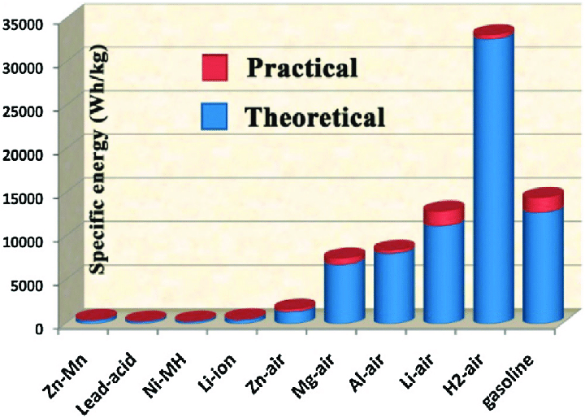
Figure 1: Reproduced comparison of different types of battery in energy density¹⁹.

Among all rechargeable metal air batteries, Zn air is the most commercially viable and suitable for broad application¹⁸. The zinc air battery was first recognized by an invention of Leclanché cell in 1868. It contains a zinc anode and manganese dioxide as a cathode. After a decade of research, the primary zinc-air battery was successfully marketed in numerous applications, such as hearing aid button cells, in 1970²³. The potential energy density of zinc air batteries is 1086 Wh/kg, which is approximately 5 times greater than the energy density of lithium-ion batteries currently in use. They also have the ability to be produced at costs (<$10/kWh²⁴) that are more than an order of magnitude cheaper than lithium ion batteries. They have been hailed as the most technically and ecologically viable option to replace lithium-ion batteries in future electric vehicle applications²⁵. Despite their early origins and commercial maturity of primary cells, zinc air batteries have many such challenges from the zinc anode and air catalyst cathode that inhibits development of the battery.

Rechargeable zinc air battery
Generally, a zinc air battery is an electrochemical cell with four main components (fig. 2): a zinc electrode, an air electrode made with a gas diffusion layer coated with catalysts, alkaline electrolyte, and a membrane as a separator. The cell uses oxygen from the air as its active ingredient and reduces it to hydroxide ions during discharging via the ORR (oxygen reduction reaction, eq. 1). The hydroxide ions moving across the membrane complex with positively charged Zn²⁺ at the zinc electrode surface to produce zincate (Zn(OH)₄²⁻) (eq. 2). As soon as zincate hits its saturation concentration, it decouples into zinc oxide and water (eq. 3). Zinc oxide was formed by discharging Zn and oxygen, as illustrated in eq. 4, which represents the whole cell process.
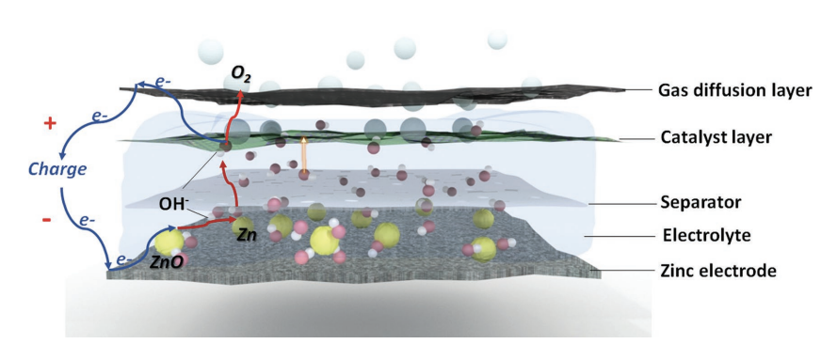
Figure 2: Schematic of an aqueous rechargeable zinc–air battery²⁶.

Cathode reaction: E = 0.4 V
$O_{2}+H_{2}O+4e^{-} →4OH^{-}$ [1]
Anode reaction: E = -1.25 V
$Zn+4OH^{-} →Zn{\left(OH\right)}_{4}^{2-}+2e^{-}$ (Dissolution) [2]
$Zn{\left(OH\right)}_{4}^{2-} →ZnO+H_{2}O+2OH^{-} \left(Precipitation\right)$ [3]
Overall reaction: E = 1.65 V
$2Zn+O_{2}→2ZnO$ [4]

The zinc air battery usually was adopted in alkaline condition because of the following benefits: 1. High conductivity of potassium hydroxide; 2. Stable operating potential; 3. High performance achieved by improving the efficiency of zinc and oxygen reactions; 4. Alternative cheap catalysts (analogy from development of alkaline fuel cell).

Secondary/rechargeable battery can be classified into two categories in more detail: electrically rechargeable and mechanically rechargeable. An electrically rechargeable zinc air battery is recharged by using electricity. This can be achieved by developing the air electrode using bi-functional catalysts. These catalysts need to have the capability of activating both oxygen reduction (discharging) and oxygen evolution (charging). However, poor energy efficiency owing to cathode and unstable zinc reversibility greatly hinders its development in a sealed cell²⁷. A mechanically rechargeable zinc air battery is recharged by mechanically replacing zinc anodes after each discharge cycle. The used zinc anode material can be recycled in a separate charging cell. The recharging or recyle of zinc oxide process is challenging. As-known strategies that successfully handle the zinc oxide rechargeability have been patented and two typical companies in state of art market focus on zinc as energy storage refillable fuel are zinc8 and ezinc. A mechanically/hydraulically rechargeable²⁸ system, as shown in figure 3 below, is unique in metal air batteries. I will focus on this type of battery in the remainder of my paper.

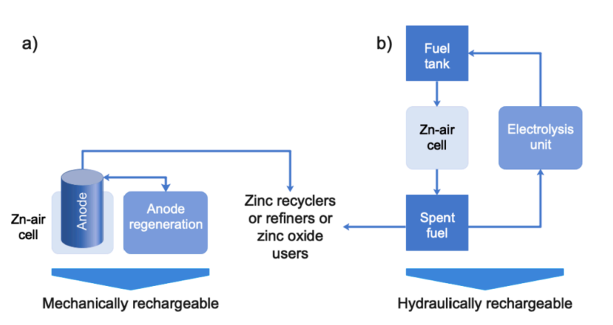
Figure 3: Reproduced types of mechanically rechargeable zinc air battery²⁸.

Development of mechanically rechargeable zinc air battery
The idea of the mechanically rechargeable Zn–Air battery was put forth from early 1986²⁹⁻³². In this kind of battery, the exhausted negative electrodes are replaced at the end of the discharge process. Compared to zinc-air batteries that are electrically rechargeable, this type of battery is capable of addressing the following two main issues: 1. Preventing or avoiding the OER during charging process; 2. avoiding the poor cyclicality of zinc electrodes. In this way, the discharged zinc electrode can be regenerated electrically in a separate cell. The process of replacing the zinc anode in a zinc air battery after discharging has been referred to as a zinc air fuel cell³². Compared with completely changing the entire negative compartment, many companies found it more practical based on this fuel cell concept and developed their own technology. These companies include Compangie Generale d’Electricitie (CGE), Sony, Power air, Metallic Power Inc. (MPI), and Zinc8³³⁻³⁷. However, the volumetric capacities of these technologies are greatly limited by the large excess amount of electrolyte, the solubility of zincate and formation of zinc oxide. Less than 3% of the theoretical volumetric capacity of 5800 Ah/L was actually reached³⁵. Consequently, it is essential to conduct research into innovative patterns that can be included into this technology, allowing for greater energy density for industrial applications.

A semi-solid battery was first proposed by M Duduta et al in a lithium flow battery in 2011. The semi-solid electrode with flowability is often referred to slurry that contains active particles participating redox reactions, electrolyte, and conductive material. Afterwards, many groups have exploited slurry in different redox flow batteries, such as Zn-nickel³⁸, all iron³⁹ and Zn-air,^{40, 41} because of higher energy density of semi-solid electrode compared to that of dissolved ions. The slurry can be tuned from flowable to non-flowable by increasing the active particles loadings, adding more gelling agent for good suspension, and mixing more conductive material to ensure electrical network percolation. A flowable slurry has less capacity and lower utilization but simpler design towards manufacturing. Recent MIT research reveals that 30% of zinc was utilized in a zinc slurry air flow battery for a total discharge time of 30 days⁴¹. Additionally, specific capacity of 40 Ah/L (3% utilization) was reported in a Zn-Nickel semi-solid flow battery by Zhu et al⁴². A non-flowable slurry has higher capacity and utilization because of an optimal percolation network within the slurry but it is not pumpable. Perez-Antolin et al reported non/semi-flowable zinc slurry can achieve 67–77% (546–633 mAh/g_{Zn}) zinc utilization under a discharging value (relative to areal capacity) of 13 mAh/cm² in a stagnant cell⁴³. Due to the reliability and quality of a non-flowable slurry, it is logical to build a novel mode of operation for the non-flowable mechanically rechargeable zinc air battery. This innovation has the potential to significantly expand the scope of industrial applications.

Zinc anode
In this context, a zinc slurry is presently favored for the most promising of practical zinc air mechanically rechargeable batteries. Over several decades, many attempts have been made to build a bifunctional air electrode for zinc air electrically rechargeable batteries. These works were evaluated in comparison to a zinc foil or plate. It should be emphasized that these planar zinc electrodes have a very low discharge capacity, making their use in commercial applications unfeasible. Therefore, it is recommended that future research on bifunctional air electrodes use a more practical or industry-based electrode, such as a zinc porous electrode. The zinc anode of a commercial zinc-air battery is a zinc paste in which the large weight of zinc participates in the electrochemical process. However, this zinc paste must be reformulated into a reasonable structure of porous electrode or a favorable recipe of zinc slurry for rechargeable zinc-air batteries.

Porous electrodes (shown in fig. 4) are composed by active materials, binder/gelling agent, conductive material, and additives. Typically, the term "active material" refers to zinc powder. Nevertheless, secondary batteries are sometimes required to include substantial quantities of ZnO. During the discharging process, Zn (9.15 cm3/mol) is transformed to ZnO (14.5 cm3/mol), which greatly increases the volume of electrode⁴⁴. Thus, adding zinc oxide at initial state of electrode helps to balance the cell's internal pressure. However, there is no conclusion what ratio of Zn:ZnO optimized the system best currently.

On the other hand, the porosity of the zinc anode impacts the performance of the zinc air battery significantly in aspects of electrode reaction kinetics and specific energy density. Changes in zinc morphology, such as shape shifts, dendritic development, and congregation, all of which lower capacity, are known to be linked to variations in porosity during the Zn anode lifetime. Zinc anode morphology changes leading to loss of active surface area are thought to be caused by, for example, uneven current density among the porous structure and concentration gradients in the interphase between electrode and electrolyte^{45, 46}. High surface area is needed to enhance the kinetics and utilization of zinc anode. However, it is usually challenging to optimize the applied current density to link to a specific morphology with highest porosity all the time. Even if this current density can be determined, zinc morphology still varies with discharge time, as previously demonstrated in a SEM study by Faeph et al⁴⁷. They also reported that in a single pass of the discharge process, a zinc anode with a full state of charge has much lower porosity than the state in which the cell has already been discharging for a time. Moreover, during the discharging process, ZnO also forms on the surface of zinc, which may raise the resistance of the electrode and block a significant amount of its active surface area. Therefore, a dynamic fundamental study is needed to investigate the relationship between surface area, porosity, morphology, applied current, and discharging time within a zinc slurry electrode.

Zinc slurry and zinc porous electrode have some similarities in terms of their composition, structure, and electrochemical behavior. The primary distinction between zinc slurry and zinc porous electrode is that the zinc slurry includes the electrolyte whereas a zinc porous electrode allows electrolyte to flow through. Zinc slurries are specifically formulated to include a gelling agent, such as poly acrylic acid (PAA)⁴⁸, polyethylene oxide (PEO)⁴⁹, or carboxymethyl cellulose (CMC)⁵⁰. In comparison with binder, the function of gelling agent is to include zinc powders in a flowable system by suspending the particles in the electrolyte. A binder does not absorb the electrolyte whereas a gelling agent does hold the electrolyte. The gelling agent is a polymeric compound, usually present at around 1 wt%, that raises the viscosity of the electrolyte by a small amount which may greatly decrease the mobility of zinc particles to prevent dendrite formation caused by unequal current density. In addition, the ability of the gelling agent to maintain high ionic and electrical conductivity by stabilizing the zinc electrode is a further benefit. Yet it has been claimed that the gelling agent cannot sustain high current density, which causes the polymeric material to disintegrate⁵¹. In addition, a loading of gelling agent more than 2 wt% may cause the zinc slurry to solidify and lose its flowability⁵².
Zinc slurries are still in the early development, although it is declared as a very promising substitution of lithium-ion. Choi et al performs many studies of zinc slurry in a flow battery to optimize the current or power density. They found inducing carbon additives into slurry can improve the current density from 24 – 38 mA/cm² at 0.6 V and power density from 16 – 23 mW/cm² individually⁴⁰. From an engineering standpoint, they also explore the implications of flow field and current collector material designs on battery performance. A maximum of 194 mW/cm² is produced by the combination of a serpentine flow field and a copper-nickel (70:30 alloy) current collector⁵³. Milian et al. evaluated zinc slurries using a rheology approach, and a 0.4 wt% optimum loading of PAA in zinc air flow batteries with adequate suspension and conductivity was identified⁵⁴. However, a flowable slurry often loads fewer zinc particles due to viscosity limitations and clogging issues, which reduces zinc utilization. Recently, high viscosity zinc slurry was examined in a 3D printing cell, and 85% zinc utilization was achieved at 2 mm zinc anode thickness under 32 mA/cm² of discharging rate⁴³. However, to overcome the limitations of viscous zinc slurry's removability, a systematic engineering strategy is required to overcome repeatability and scalability.

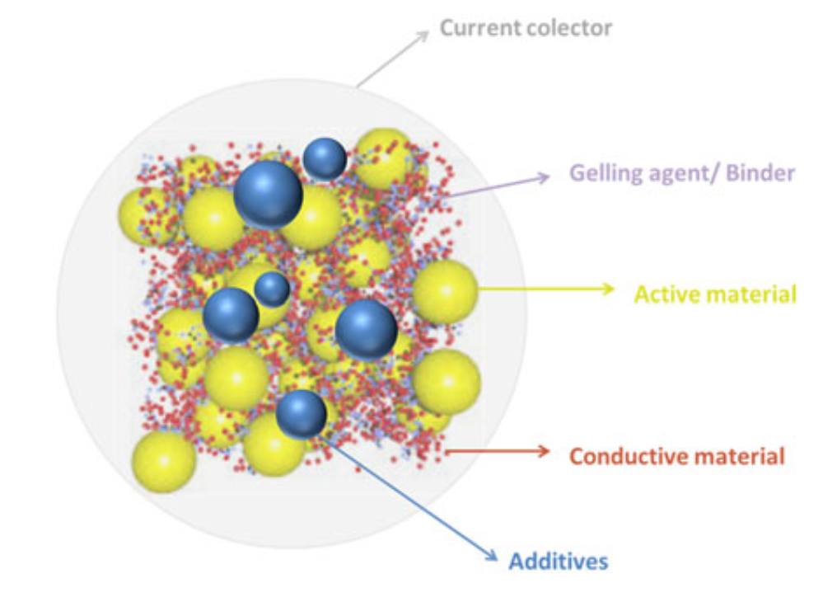
Figure 4: Reproduced diagram of porous electrode compositions⁵⁵.

Zinc slurry Modeling developments
To achieve homogeneous zinc suspension in harsh alkaline solution for better utilization, a high loading of zinc in slurry, above 70wt.% of zinc, was typically observed in zinc-air primary battery. Mao et al firstly proposed a mathematical 2D model to simulate primary zinc-air cell performance⁵⁶, and their model is quietly aligned with experimental observations. Ehsan et al reported operando primary zinc MnO₂ alkaline cell to unveil the different states of zinc particle morphology, and further modeled the conductivity of high percolated zinc slurry anode by commercial software Geodict package⁵⁷. The mathematical model of static slurry anode typically assists percolation theory, such as Bruggeman’s approximation⁵⁸. However, recent advances were centered on the development of secondary zinc air battery, which potentially requires flowing zinc slurry in one side. Wainright et al developed many models regarding flowing slurry behavior in electrochemical cell⁵⁹⁻⁶¹. Experimentally, state of art zinc slurry composition for mechanically rechargeable is far below percolation limit to allow pumping or injection without considering clogging issues. Further model work is needed to assess the low percolated zinc slurry’s conductivity and its intrinsic passivation mechanism during cell operation. Furthermore, developed EIS model to characterize slurry electrode by Petek et al⁶² is also very important to link electrochemistry and slurry material itself.

Zinc electrochemistry, mechanisms, passivation
While the behavior of the zinc anode in alkaline solutions has been investigated for decades, no consensus exists about a particular mechanism. Today, there are two major processes that are used to explain the building of a passivation film: the "dissolution and precipitation" method and the "solid-state” reactions mechanism. The dissolution and precipitation process postulates that the zinc anode enables a reaction to occur until the zincate concentration reaches a threshold level and zinc oxide crystallizes on the electrode surface. The solid-state reaction mechanism argues that the zinc anodic polarization directly occurs with oxidation of zinc. Both mechanisms only explain part of passivation process. For example, the dissolution and precipitation process interpret galvanostatic test findings rationally but is not very useful to explain potentiodynamic^{63, 64} measurements, where the solid-state mechanism seems more applicable. In more details, according to the research of Liu et al, convection can prevent passivation as long as the critical concentration of zincate is not reached. Nonetheless, potential-controlled measurements have demonstrated that passivation films are also produced even when the electrolyte is flowing, and that forming passive films were captured in a very short time. This result is believed to be explained by the solid-state oxidation mechanism, as measurements of controlling onset potential reveal a sudden decrease in current density to zero.

The most important work on dissolution and precipitation mechanism was reported by Liu et al⁶⁵. They suggested that the passivation process can be broken down into three distinct steps (shown in fig. 5). During step A, the zincate starts to form with dissolution of Zn until the zincate reaches the critical saturation point. Afterwards, the aggolomerated zincate transforms to zinc oxide and precipitates in a form of porous passivation film (type 1) during step B. At step C, zinc oxide produces a dense film (type 2) and does not allow the hydroxide ion to enter to the Zn electrode surface, fully restricting the mass transport. Previous groups determine the t_{pass} by recording the time where the potential jumps at the end of passivation process^{66, 67}. However, Liu et al proposed that it is more important to measure the t_{pass} where the passivation process starts to justify their passivation scheme above⁶⁵. They found challenging to determine the time where critical zincate concentration reaches, type 1 and 2 films build up because zinc anode potential increases imperceptibly in the galvanostatic discharging process.

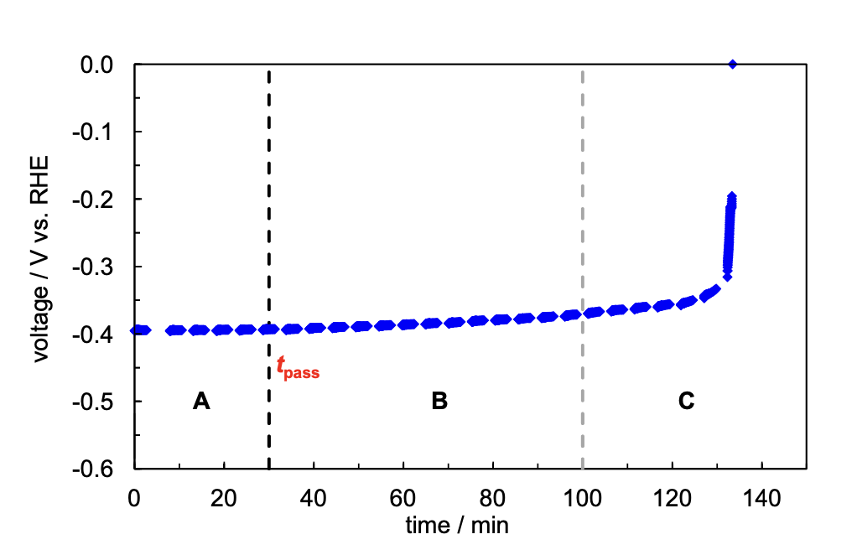
Figure 5: Reproduced galvanostatic discharging profile of zinc electrode with 70 mA/cm² and three passivation steps were presented from Liu et al⁶⁵.

Based on the dissolution and precipitation mechanism, Bockelmann et al visualized the development of the passivation film in the scheme presented in figure 6. By using in situ optical microscopy in conjunction with galvanostatic electrochemical impedance spectroscopy, they were able to determine the length of time required to produce so-called type 1 and 2 passivation films on a zinc planar electrode⁶³. In addition, in the current density range of 10-90 mA/cm2, production of the so-called ‘type 1’ passivation film was shown to be independent of discharge current density. The type 1 film only occurs when zincate ions accumulate to a certain amount of 8.2*10⁻⁴ mol*cm⁻².

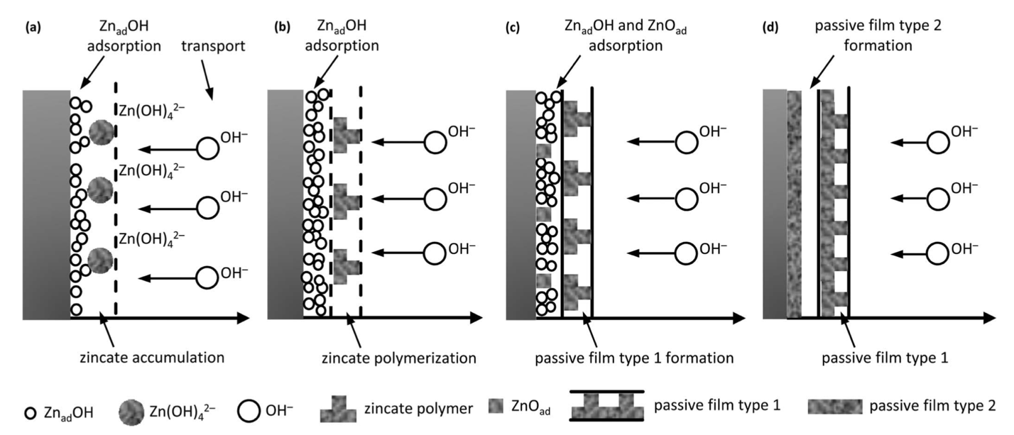
Figure 6: Reproduced schematic of development of zinc passivation films. a) zinc dissolution; b) zinc polymerization (due to low zincate diffusivity); c) formation of passivation film type 1; d) formation of passivation film type 2⁶⁸.

On the other hand, it is crucial to comprehend the general chemistry and electrochemistry governing zinc's behavior in alkaline circumstances. The development of the type 1 film is directly proportional to the maximum zincate concentration in KOH, or the zinc solubility. As seen in the figure 7, the solubility of Zn²⁺ in a 4M KOH solution is around 300 mM, whereas in a 12M KOH solution, it climbs to 1.5 M. By increasing the solubility of zincate, a higher concentration of KOH would delay the formation of so-called type 1 film in primary zinc air batteries, which is often preferred because it promotes high utilization of zinc.

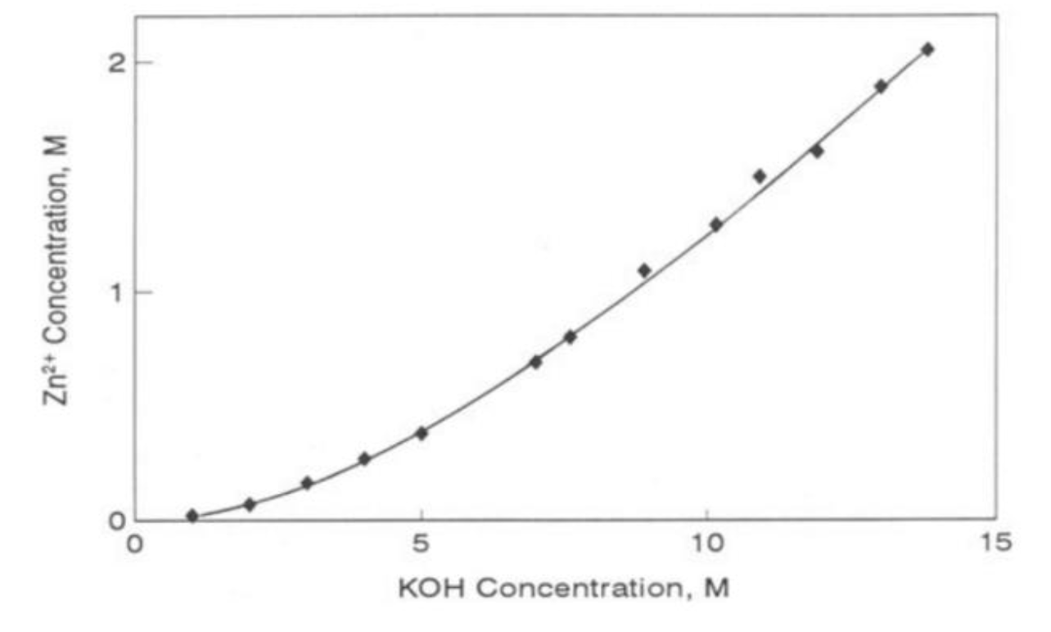
Figure 7: Reproduced Zn²⁺ as a function of concentration of KOH from Zhang⁶⁹.

The zinc Pourbaix diagram provides insight into the various zinc complexes and how they react to different potentials and pH levels (figure 8). At >1M KOH solution (PH>14), the Zn(OH)₄²⁻, called zincate, is the dominant product while zinc dissolves in the KOH, which was also confirmed in Raman spectroscopy by Fordyce and Baum⁷⁰. Thus, it is very important to study zincate in any zinc-based alkaline batteries. An ex-situ method, the rotating disk electrode, was used to evaluate the diffusion coefficient of zincate ion by Pessine et al⁷¹. At room temperature (25 °C), the diffusion coefficient of zincate is 4.8*10⁻⁶ cm²/s at 1M NaOH, which significantly decreases to 2.9*10⁻⁶ cm²/s at 4M NaOH because of the viscosity effect. As the diffusion rate of zincate ion was reported to be much slower than hydroxide ion (by an order of magnitude) the zincate is more likely congregated in the vicinity of electrode, which eventually causes the type 1 film.

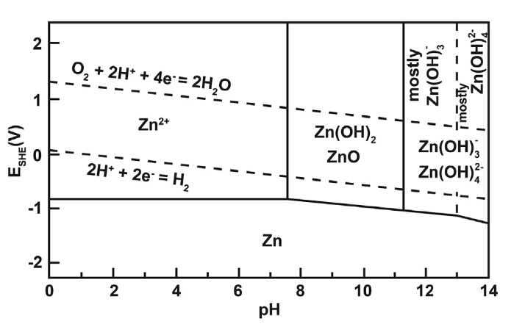
Figure 8: Pourbaix diagram of Zn, reprinted from Yadav et al⁷².

CHAPTER 2. MATERIALS AND METHODS

Methodology
The research plan consists of detailed electrochemical characterization of zinc slurry in terms of power density (polarization curve), utilization (galvanostatic discharging profile), and resistance (Nyquist plot).
- Synthesizing the basic or viable zinc slurry for MRZAB in flow mode.
- Designing a new cell by deploying the injection mode for highly viscous slurry.
- Determine the losses of individual components in the cell by implementing a pseudo reference electrode.
- Determine the effects of KOH concentration and gas flow arrangement into the cell on overall performance of the battery.
- Determine the zinc utilization in a symmetric and full cell under different discharging rate.
- Determine the zinc slurry regeneration in a symmetric cell.
- Determine the zinc slurry’s resistance as a function of state of charge during discharging.

Using the zero-gap cell design as previously shown for a redox flow battery⁷³, a sketch for modified zinc slurry air cell is shown in Figure 9.

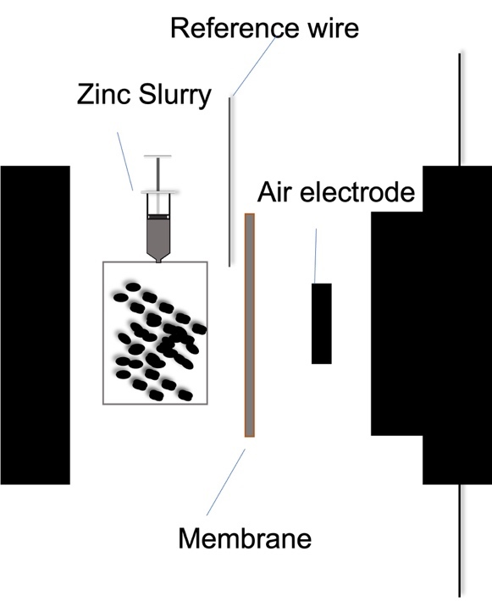
Figure 9: A diagram of house-made zinc slurry air battery.

Polarization curve
To measure the performance of the electrochemical cell, one typical method is the polarization curve, a steady-state determination of cell voltage or electrode potential as a function of applied current density. Experiments using the cell shown in Figure 9 and using the prepared components (electrodes, membrane) were performed using a house-made test stand and single cell hardware. A BioLogic SP-150 potentiostat with a 20 A booster was used to collect polarization curves and Nyquist plots through potentio-electrochemical impedance spectroscopy (PEIS). The cell featured a serpentine flow channel on the cathode and an active area of 5 cm².

The temperature was fixed at room temperature without any control, and no back pressure or relative humidity were controlled for all the experiments. Inlet gas on the cathode, whether oxygen or synthesized air, was fixed by a Masterflex flowmeter to a flow rate of 0.2 L/min. Electrolyte was induced into the cathode side for maintaining membrane wet with a slow flow rate of 6 rpm controlled by a master flex peristaltic pump. The battery was assembled with applied torque of 80 lb.

The polarization testing protocol was the following: A home-made pseudo reference electrode (Cu/Pd wire) was inserted in the cell for a three-electrode testing setup. Compared with traditional two-electrode setup for measuring polarization losses, it can separate the losses between anode and cathode, which makes the in-situ characterization of performance more accurate in each of components of the cell. After the cell was assembled, the cell was attached to probe and connected to computer and potentiostat. The OCV was monitored for 10 mins to ensure the battery’s stability. A polarization curve was obtained by decreasing the potential in steps of 25 mV from OCV to Ewe1 and 50 mV from Ewe1 to Ewe2, and each potential was held constant for 60 seconds for recording the current. Safety control was fixed by a pause when the total cell voltage dropped to 0.1 V.

Utilization curve
In a slurry, access to the full loading of active material is not guaranteed. Therefore, the utilization must be determined experimentally. The utilization testing protocol involved the following steps: After assembling the cell, it was connected to a probe, computer, and potentiostat in a two-electrode testing setup. The open-circuit voltage (OCV) was monitored for 10 minutes to ensure the battery's stability. A utilization curve was obtained by continuously discharging the battery at a constant current density and recording voltage shifts. A safety control was established by pausing when the total cell voltage dropped to 0.1 V.

Resistance as a function of SOC
In a MRZAB, the utilization is strongly connected to behavior of the zinc slurry during discharge. To understand its characteristics, we measure the resistance of slurry as a function of SOC during discharging process to gain more insights of the cell. The resistance testing protocol employed a custom-made pseudo reference electrode (Cu/Pd wire) inserted into the cell for a three-electrode testing setup. After assembling the cell, it was connected to a probe, computer, and potentiostat. The OCV was monitored for 10 minutes to ensure the battery's stability. Resistance profiles were obtained by periodically discharging the battery using Chronopotentiometry (CP) and subsequently measuring the impedance through a frequency scan from 200 kHz to 1 Hz using Potentiostatic Electrochemical Impedance Spectroscopy (PEIS).

Symmetric cell testing
House-customized symmetric cell was applied to measure the reversibility of zinc. The symmetric cell was assembled by 3D printed plastic slurry holder with different thickness from 10 mm to 20 mm and area of 5 cm², two nickel plates serving as current collector, and a membrane as separator. The current density for stripping and plating was fixed at 10 mA/cm², 50 mA/cm², 100 mA/cm² to estimate its columbic efficiency.

Conductivity measurement
Direct modified design from symmetric cell, with no membrane and two nickel plates and one slurry holder for desired thickness was applied to measure the impedance of zinc slurry by EIS with 200 kHz to 1 Hz. The as-acquired Nyquist plot was obtained to calculate the high frequency resistance (R) for zinc slurry. The conductivity of slurry was derived from the following equation.

Zinc slurry air full cell components preparation
Zinc slurry was prepared by mixing zinc powder (Spectrum, 325 mesh (50 µm), ~95% purity), polyacrylic acid (Sigma-Aldrich, viscosity ~40,000-60,000 cP), and 4M KOH solution (Assay 85%) by following a recipe from Choi et al⁴⁰. The experimental procedure involved the following steps: 1) Pipetting 8 ml of 4M KOH into a 12 ml syringe; 2) Adding 0.112 g of polyacrylic acid and homogenizing for 2 minutes at a speed of 10,000 rpm to polymerize the KOH solution; 3) Adding 4.8 g of zinc powder and homogenizing for 2 minutes at the same speed to ensure uniform and stable slurry mixing. The air electrode was fabricated by formulating inks and employing spray painting. The ink was prepared by mixing Pt on carbon powder, binder, polytetrafluoroethylene (PTFE), and isopropanol (IPA). We acknowledge Dr. Shane for providing the poly(phenylene oxide) (PPO)-based crosslinked anion exchange membranes for battery testing.

Note that all measurements were tested under room temperature without controlling.

CHAPTER 3. SYMMETRICALLY ELECTROCHEMICAL CHARACTERIZATION TO IMPROVE PERFORMANCE OF MECHANICALLY RECHARGEABLE ZINC SLURRY AIR BATTERY

This chapter was adapted from paper entitled “Symmetrically Electrochemical Characterization to Improve Performance of Mechanically Rechargeable Zinc Slurry Air Battery” submitted to Journal of power sources under review, 2024.

Introduction

The demand for energy storage continues to escalate in both the transportation sector⁷⁴ and the stationary market⁷⁵. This surge is attributed to the burgeoning market for electric vehicle batteries and the need to establish gigawatt-hours (GWh) of storage capacity for grid-related applications in many global regions. Lithium-ion batteries are used in most modern electrical vehicles that dominates current EV market because they have a broad working temperature range, low self-discharge rates, high power densities, and excellent capacity retention⁹. However, lithium-ion batteries have a modest energy density of 100-200 Wh/kg, and its estimated driving range is limited, depending on the cathode material characteristics claimed by different companies⁹⁻¹³. The significant upfront cost of lithium-ion batteries, priced at $152 per kWh in 2023, challenges their cost efficiency when considered for stationary storage applications. Accordingly, other energy storage devices such as vanadium redox flow batteries⁷⁶, organic redox flow batteries⁷⁷ and metal-air batteries⁷⁸ have been evaluated to for application in long-duration energy storage and high energy density systems are sought for transportation applications.
Metal air batteries use atmospheric oxygen flowed into an open system, decreasing battery mass by removing the need for reagent storage, allowing for higher gravimetric energy storage capacity. Zinc-air batteries possess a theoretical energy density of 1086 Wh/kg, making them candidates for applications requiring high energy density. Also, Zinc-air batteries have been touted as the most technically and ecologically viable option to replace lithium-ion batteries in future electric vehicle applications²⁵, with economic and supply chain advantages.
Zinc-air batteries have evolved considerably over the decades, transitioning from primary to secondary forms. Secondary zinc-air batteries can be categorized into electrically and mechanically rechargeable types²⁸. Extensive research has been dedicated to identifying highly efficient bi-functional catalysts that are active in both the oxygen reduction reaction (ORR) and oxygen evolution reaction (OER) to facilitate the development of electrically rechargeable zinc-air batteries⁷⁹. However, pursuing catalysts for zinc-air batteries presents inherent challenges and can be time-intensive. Additionally, the growth of dendrites within the zinc anode poses a significant challenge, reducing the battery's lifespan during cycling. Based on these considerations, the mechanically rechargeable zinc-air battery (MRZAB) emerges as a more efficient approach because its operation centers primarily on discharge performance using stable ORR catalysts and manually replacing the discharged zinc anode. Many companies developed MRZABs based on this concept, such as Compangie Generale d’Electricitie (CGE), Sony, Power air, Metallic Power Inc. (MPI), and Zinc8³³⁻³⁷. M. Duduta et al introduced a semi-solid electrode (i.e. slurry) in a redox flow battery, which further refined the concept of MRZAB⁸⁰. The slurry comprises active particles engaging in the redox reactions, along with the electrolyte and conductive additives. Several groups have exploited slurries in different redox flow batteries, such as Zn-nickel³⁸, all iron³⁹ and Zn-air,^{40, 41} because of the higher energy density of semi-solid electrode compared to that of dissolved ions. The practical flowability of slurry is directly determined by its rheology. D. Milian et al reported a systematic rheological study of the poly(acrylic acid) (PAA) loading effects on stability of the zinc slurry⁵⁴. They highlighted optimal performing slurry contains 0.4 wt% loading of PAA and its yield stress is 45 Pa. Further increasing binder loading can result in lower conductivity and sacrifice the electrochemical performance in a zinc slurry air flow cell. Thus, it should be emphasized that a flowable slurry with relatively low yield stress has less capacity but a simpler design for manufacturing. Recently, Choi et al found introducing carbon additives into the slurry can improve the current density from 24 to 38 mA/cm² at 0.6 V and the power density from 16 to 23 mW/cm² in zinc slurry-air flow cells⁴⁰. From an engineering standpoint, they also explored the implications of flow field and current collector material designs on battery performance. A maximum of 194 mW/cm² is produced by the combination of a serpentine flow field and a copper-nickel (70:30 alloy) current collector⁵³. Perez-Antolin et al used a cell area of 7 cm² with zinc anode thickness of 0.2 cm to implement an injection mode for a ‘semi-flow’ zinc slurry, and they attained 100 mA/cm² with carbon loading of 80 mg/mL in this configuration⁴³. However, interpreting losses from individual components in the cell remains a challenge, complicating the assessment of zinc slurry performance across various designs.
In this study, we aim to dissect the losses from each component in a zinc slurry-air battery, whether operated in flow or injection mode. Current MRZAB designs utilizing zinc slurries present ambiguous loss contributions within the cell, leaving it uncertain as to which component predominantly contributes to this loss. To address this, we introduce a pseudo reference electrode in the zinc slurry air cell to separate distinct effects. Utilizing this approach, we further examined how various cell parameters, including zinc anode design, KOH concentration, orientation of gas flow, air electrode architecture, and catalyst choices, influence the performance of the cell.

Methods and materials

Cell construction

Two zinc air battery designs, shown in figure 1 a) and b), were used in this work for handling the zinc slurry. The first is a ‘flow design’, which is inspired by the redox flow battery that circulates zinc slurry through zinc anode compartments. To prevent the obstruction of zinc access to a current collector during circulation, the serpentine flow field was enhanced with broader flow channels. A nickel plate, acting as the current collector, was coupled with a graphite bipolar plate. The second is the ‘injection design’. Using Autodesk Inventor®, we designed the current collector and slurry holders. These components were then fabricated using 3D printing with a 100% infill of (acrylonitrile butadiene styrene) ABS material. A precision-cut nickel plate, serving as the current collector, was positioned between the 3D printed parts. On the air side, a graphite bipolar plate was tailored to accommodate dual phases, and this was attached to the Nickel plate current collector. While the battery was in operation, the KOH electrolyte and gas were simultaneously introduced on the channel-side interface of the air electrode. Using the binary electrolyte-gas phase is necessary for supplying water for the ORR and preventing membrane dehydration. To ensure a leak-proof system and facilitate membrane wetting, Viton gaskets were strategically integrated and created a dedicated liquid phase gap.
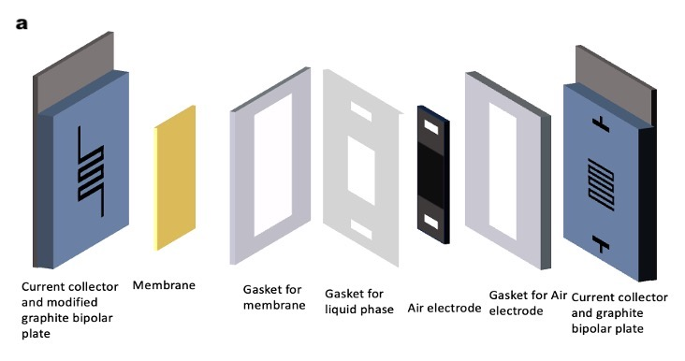
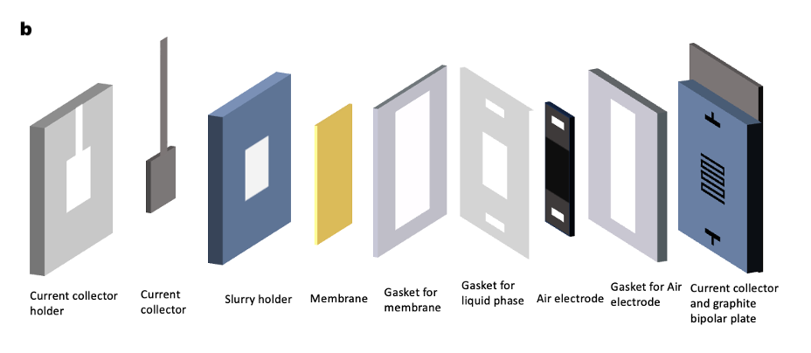
Figure 10: a). Flow design: Modified anode bipolar plate serpentine design with width of 2 mm flow channels and other cell components adapted from alkaline fuel cell; b) Injection design: In-house made 3D printed parts for current collector holder and slurry holders and other cell components adapted from alkaline fuel cell.

Zinc slurry and air electrode preparation
Zinc slurries were prepared by mixing zinc powder (Spectrum, 325 mesh (~50 µm), ~95% purity), polyacrylic acid (Sigma-Aldrich, viscosity ~40,000-60,000 cP), and 4M KOH solution (Assay 85%), following therecipe from Choi et al⁴⁰. The experimental procedure was modified and involved the following steps: 1) Pipetting 8 ml of 4M KOH into a 12 ml syringe; 2) Adding 0.112 g of polyacrylic acid and homogenizing for 2 minutes at a speed of 10,000 rpm to make a gel form of the KOH solution; 3) Adding 4.8 g of zinc powder and homogenizing for 2 minutes at the same speed to ensure uniform and stable slurry mixing.
The air electrode was fabricated by formulating catalyst-containing inks and employing spray painting on a gas diffusion layer (GDL). The ink was prepared by Pt/C (HiSPEC 4000, Alfa Aesar) or an in-house made non-PGM catalyst, polytetrafluoroethylene (PTFE), Dimethyl-Imidazolium poly(p-phenylene oxide) (DmIm-PPO) (5 wt% soln in methanol), and isopropanol (IPA). This non-PGM catalyst is obtained by pyrolysis of an iron salt, a nitrogen source and Kudzu leaves biomass (FeKudzu). Catalyst synthesis details are described in the SI. Additionally, a potential enhancement involved introducing thin carbon layer coated onto the GDL, functioning as a microporous layer (MPL). The spray-painting temperature was held at 80 °C. The details of fabricating steps are given in the SI.
CLAM membranes were prepared in house. A solution of 2-Methylimidazole (0.821 g, 0.01 mol) in NMP (5 mL) was stirred vigorously as NaH (60% wt, 0.02 g, 0.5 mmol) was added. The resulting mixture was stirred at 85 °C for 30 minutes and then further agitated in a sonic bath for 30 minutes. The above solution (2.2 mL) was then added to a stirred solution of bromomethylated polyphenylene oxide polymer in NMP (10% wt. obtained from Akron Polymers, 8 mL, 2.024 mol –Br). The resulting solution was stirred for 3 minutes before being cast onto a glass plate using a doctor blade. The plate was heated in a 95 °C oven for 2 hours and then submerged in a deionized water bath to facilitate isolation of the CLAM membrane (100-110 µm). The membrane was soaked overnight in deionized water and then equilibrated with electrolyte prior to use.

Electrochemical measurements

To measure the performance of the electrochemical cell, a typical method used is the polarization curve, a steady-state determination of cell voltage or electrode potential as a function of applied current density. Experiments using the cell shown in Figure 2 and using the prepared components (electrodes, membrane) were performed using a house-made test stand and single cell hardware. A BioLogic SP-150 potentiostat with a 20 A booster was used to collect polarization curves and Nyquist plots through potentio-electrochemical impedance spectroscopy (PEIS). The cell featured a serpentine flow channel on the cathode and an active area of 5 cm².

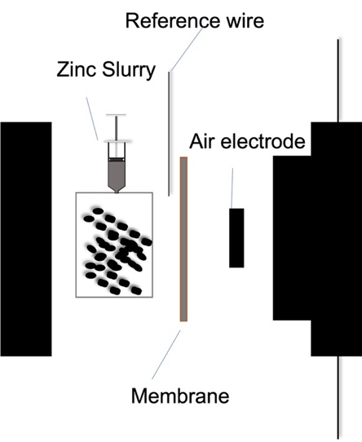
Figure 11: A schematic of zinc slurry air battery in injection mode to assist demonstrates location of pseudo reference electrode.

The battery was operated at room temperature without any control, and neither back pressure or relative humidity were controlled for all the experiments. The inlet gas on the cathode, oxygen, was controlled using a Masterflex flowmeter to a flow rate of 0.2 L/min. Electrolyte was introduced into the cathode side to maintain a wet membrane with a slow flow rate of 6 rpm, controlled by a Masterflex peristaltic pump. The battery was assembled with applied torque of 80 lb.
The polarization testing protocol was as follows: A home-made pseudo reference electrode (Cu/Pd wire) was inserted in the cell for a three-electrode testing setup. Compared with a two-electrode setup for measuring polarization losses, the three-electrode system allows separation of the losses between anode and cathode, which enables the in-situ characterization of performance of each of the components of the cell. The OCV was monitored for 10 mins to ensure the battery’s stability. The polarization curve was generated by reducing the potential in 25 mV increments from the open circuit voltage (OCV) to Ewe1 over 12 data points, and then continuing to decrease the potential in 50 mV steps from Ewe1 to Ewe2, taking 5 data points in this range. Each potential was held constant for 60 seconds, recording the current. A safety control was fixed by a pause when the total cell voltage dropped to 0.1 V.

Results and discussion

Baseline Study

Zinc slurry-air flow batteries provide the same benefits as redox flow batteries and store energy in external tanks. A zinc slurry packs much more energy density compared with traditional aqueous system because solubility of the redox active material is less of a limitation. Learning from the zero-gap design of redox flow batteries⁸¹ and binary phase strategy from alkaline fuel cells, we used a similar approach to combine anode and cathode structures in cells to set up our zinc slurry air flow battery. However, we quickly realized that the channel of a typical serpentine flow field for all vanadium redox flow battery is too small to allow the viscous zinc slurry to flow in, which causes the anode flow channels to clog. We adjusted the channel as shown in Figure 3a, which partially resolved the clogging issues. Roughly 50 ml of zinc slurry (figure 3b) was formulated for circulation inside the cell. Figure 3c depicts the polarization curve of the cell, which shows a reasonable open circuit voltage (OCV) of 1.45 V (thermodynamic potential or theoretical OCV is 1.65 V). In operation, the cell shows a significant kinetic loss (~0.15 V overpotential at 5 mA/cm²). The cell operates at 40 mA/cm2 at 1 V under oxygen. This performance is comparable to that of a recent zinc slurry air flow battery presented by Choi et al⁴⁰. Nonetheless, the zinc slurry may still occasionally clog the cell, limiting the mass transport of Zn and drastically reducing cell performance. The clogging concerns at least partly arise from the stability and viscosity of the slurry during discharge. It is not yet clear how the mechanisms and characteristics of the discharging zinc slurry affect the stability of slurry. Thus, to deal with the viscous slurry, we switched the operating mode from pumping continuously to injection in semi-batch, which necessitates a redesign of the zinc-side cell structure.

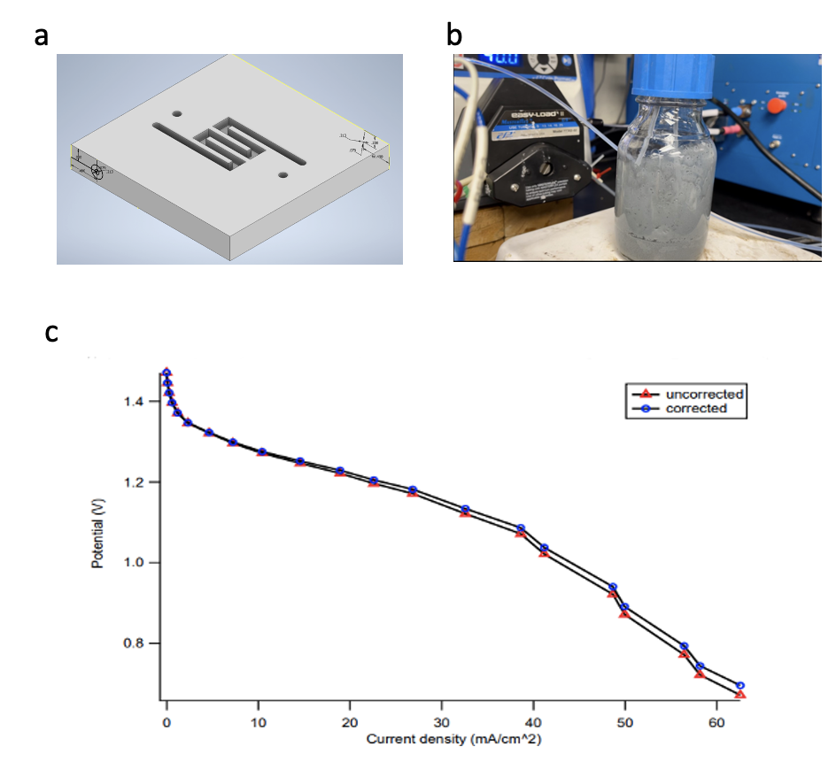
Figure 12: a) modified serpentine flow field in graphite bi-polar plate; b) flowing zinc slurry; c) polarization curve in zinc slurry air flow battery.

For optimizing the injection mode to fully address the clogging issue, a novel and straightforward design for the zinc side of the cell was developed utilizing 3D printing with (acrylonitrile butadiene styrene) ABS material. The two primary components are depicted in Figure 4. The left orange component is the slurry holder, featuring injection holes and channels on the upper left and right sides. The right orange component is the current collector holder, which contains a 1.5 mm thick nickel plate current collector. A rudimentary mechanically rechargeable zinc-air battery was assembled by placing the slurry holder onto the current collector holder. Practical testing demonstrated that the battery does not experience clogging during injection. Nonetheless, this does not allow for the complete removal of slurry at the end of the discharging cycle.
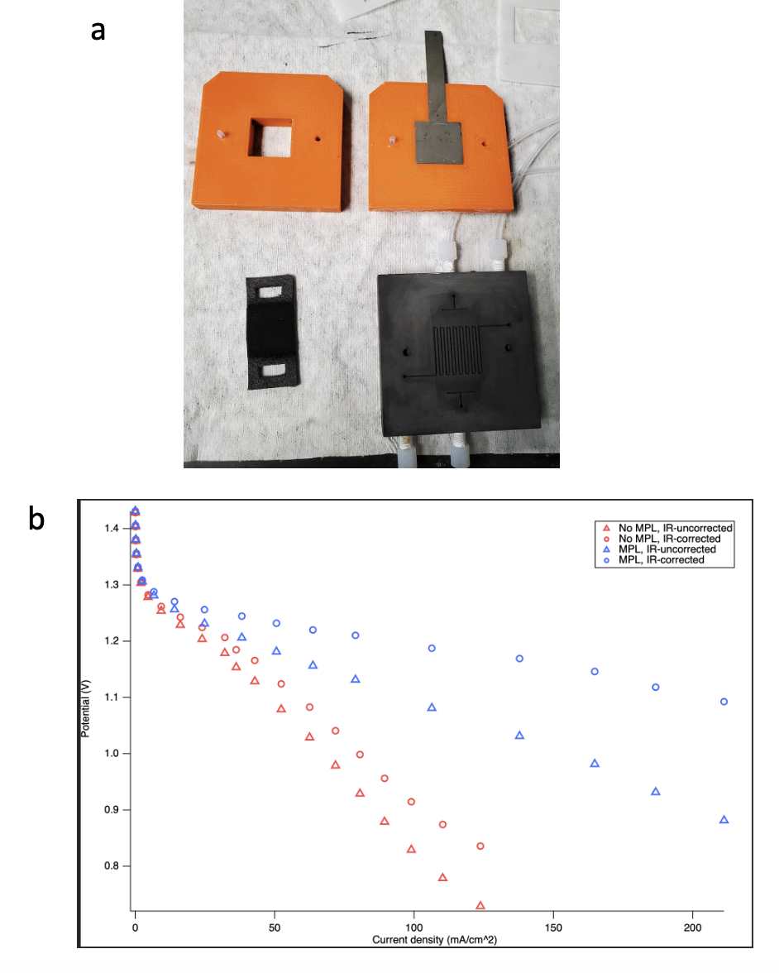
Figure 13: a). A photo for newly designed experimental cell; b). Polarization curves, Blue - carbon felt with MPL; Red - carbon felt without MPL.

Polarization curves were obtained using the same two-electrode testing setup applied to cells with the new design. A comparable open-circuit voltage (OCV) of 1.42 V was observed with this configuration. With the injection design, we achieved a peak power density of 80 mW/cm² (corresponding to 100 mA/cm² at 0.8 V). Using an MPL-coated air electrode led to further increase of the power density, reaching 180 mW/cm² (equivalent to 200 mA/cm² at 0.9 V). In the polarization curve, an initial overpotential of 0.15 V was attributed to kinetic loss. Within a cell voltage range of 1.25 V to 0.8 V, the voltage-current (V-I) curve displays a linear trend. In this region, the primary losses are due to internal resistance and, to a lesser extent, residual mass transport. The ASR of air electrodes were measured as 1 ohm*cm² with MPL, and 0.865 ohm*cm² without MPL. This suggests the blue curve exhibits a larger internal resistance (IR) correction than the red curve, suggesting that the addition of a microporous layer (MPL) significantly enhances oxygen mass transport but also increases the internal resistance of the cathode. This observation is consistent with the fact that carbon felt with an MPL has a greater thickness than carbon felt without an MPL. To further elucidate the contributions of various losses, it is necessary to incorporate a reference electrode into the cell to separgate these factors.

Contributions from the two electrodes to overall polarization were isolated by incorporating a pseudo-reference electrode (Pd coated Cu wire) into the system. Subsequently, polarization curves were obtained using this three-electrode setup. In figure 5a, the red curve represents cathode performance, while the blue curve illustrates the voltage-current (V-I) responses of the zinc anode and membrane. In the region below 5 mA/cm², the red curve exhibits sharp overpotential losses compared to the relatively flat losses observed in the blue curve. This suggests that sluggish oxygen kinetics primarily contribute to the losses. As the current density is increased to 80 mA/cm², losses from the zinc side become more pronounced. According to results from Mao et al⁵⁶, they suggest that the major limiting factor is the depletion of hydroxide ions in the zinc slurry with a zinc loading of 27 vol%. Nonetheless, more tests are required to identify the limiting factors at a zinc loading of 7 vol% (33.6 wt%) in our scenario. In addition, as part of our investigation, we examined the impact of raising the KOH concentration from 4M to 8M on the cell's performance to determine if a higher concentration can counteract the hydroxide ion depletion.

The polarization curve is determined by measuring short-time steady-state steps. During each step, zinc dissolves rapidly to form zincate in the electrolyte. However, it has been reported that the zincate decomposition process (precipitating to ZnO) is considerably slower than dissolution⁵⁶. Consequently, it seems that the local depletion of hydroxide ions could contribute substantial concentration polarization, thus increasing the overpotential of the zinc anode.

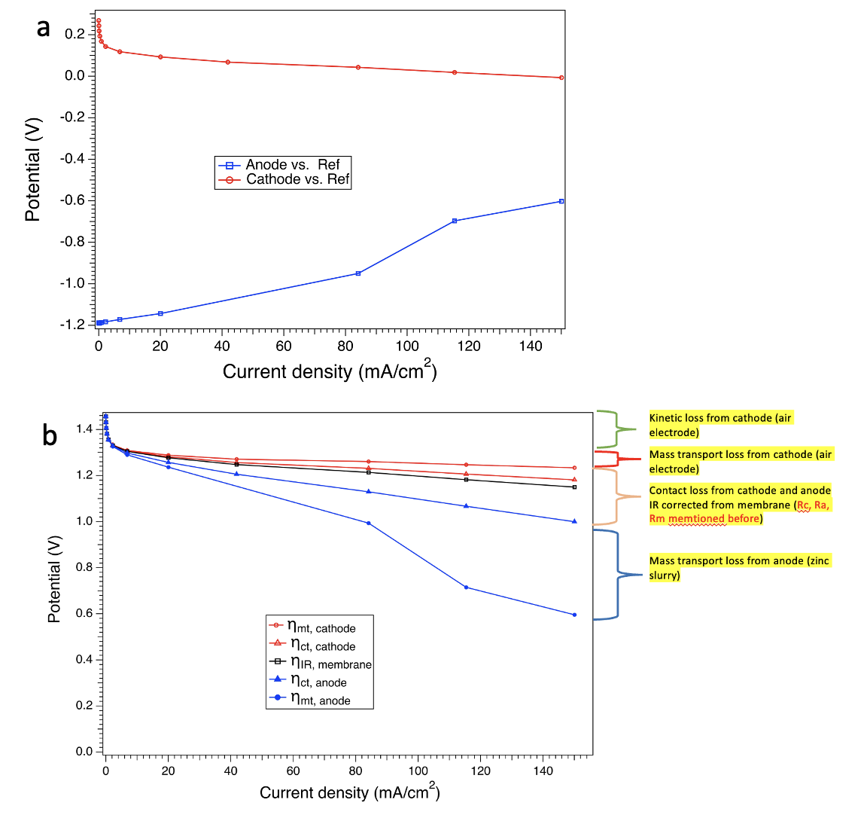
Figure 14: a). Separated polarization curves (in blue Zinc anode polarization, in red Air cathode polarization) with a pseudo reference wire. ; b). Detailed separated losses between each component in the Zinc-air battery.

In a more comprehensive measurement study, the areal-specific resistance (ASR) of each cell component was determined by relocating the reference electrode between compartments in figure 5b. In the legend, η_{mt}, η_{ct}, and η_{IR}, represent the overpotential for mass transport, contact loss, and internal resistance. R_{c}, R_{a}, and R_{m} denote the internal resistance of the cathode, anode, and membrane, respectively. Their respective values are 0.35 Ω⋅cm², 1 Ω⋅cm², and 0.21 Ω⋅cm². Losses were characterized in greater detail, and the findings generally concur with previous results, indicating that mass transport in the zinc slurry is the predominant limiting factor within the typical cell operating voltage range of 0.8-1.2 V.

To enhance the performance of zinc-air batteries, a comprehensive parametric study was conducted to examine the mass transport loss from the zinc slurry and the resistive loss from the air electrode.

Cell parameters Effects

Two independent variables were investigated: the concentration of KOH (4M and 8M), and the orientation of gas flow in this particular design (side and middle) as shown in figure 6. To clarify, the gas flowing through bipolar plate serpentine channels is defined as “gas through side” which is our baseline and is the typical experimental condition in most cases,with KOH flowing through liquid phase gap. Circulating gas through the gap is defined as “gas through middle”. In this study, we compared the air electrode performance of a standard high-performance catalyst to a much less costly alternative. The subsequent figures present polarization curves obtained for both platinum (Pt) on carbon and a in house-made non-pgm catalyst (FeKudzu).
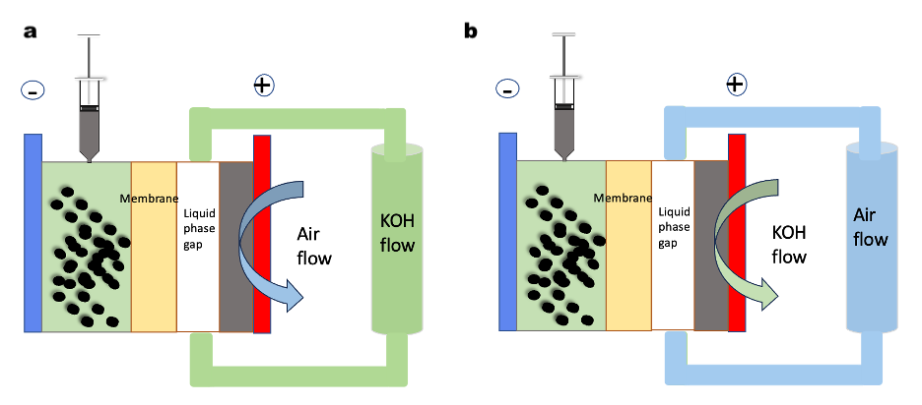
Figure 15: a) gas-through-side, b) gas-through-middle

For the FeKudzu catalyst deposited on carbon felt (depicted by red curves), the KOH concentration displayed no discernible impact on the air electrode performance, as shown in the top portion of the figure 7a. This potentially suggests that the mass transport losses in FeKudzu catalyst layer of air electrode are not sensitive to the concentration of KOH (either 4M or 8M). . However, the 8M KOH polarization was slightly more stable compared to the 4M KOH0n the zinc slurry side, as demonstrated in the bottom portion of Figure 7. This finding implies superior performance of the zinc slurry with 8M KOH, particularly in high current density regions. In the case of Pt-based catalysts on carbon felt (represented by the blue symbols), an increase in the KOH concentration led to a slight increase in overpotential. This suggests that oxygen transport was hindered at higher KOH concentrations due to reduced oxygen solubility and diffusivity. It has been reported that both solubility and diffusion coefficient of oxygen decrease as the KOH concentration increases⁸². The results obtained from both carbon felts qualitatively agree with the expected mass transport losses. No significant performance difference is observed in the total cell polarization upon varying KOH concentration in figure 7b. While literature suggests that 6M-8M KOH offers optimal ionic conductivity⁸³, the ideal KOH concentration for operating a cell truly hinges on the specific components within that cell.

From these polarization curves analyses, we found that the FeKudzu catalysts exhibit an open-circuit voltage (OCV) of approximately 0.45 V vs. the pseudo reference Pd/Cu electrode, while the Pt on carbon (Pt/C) catalysts display an OCV of roughly 0.3 V. Interestingly, both catalysts yield 5 mA/cm² at a potential of 0.15 V. The overpotential observed for the kudzu catalyst is double that of Pt/C in the given cell configuration. The oxygen reduction reaction (ORR) performance of Pt/C slightly outperforms the kudzu-derived catalysts in the kinetic region, but little difference is observed overall. This indicates that the FeKudzu catalysts could potentially replace Pt/C with little performance penalty, especially considering the high cost of this precious metal.

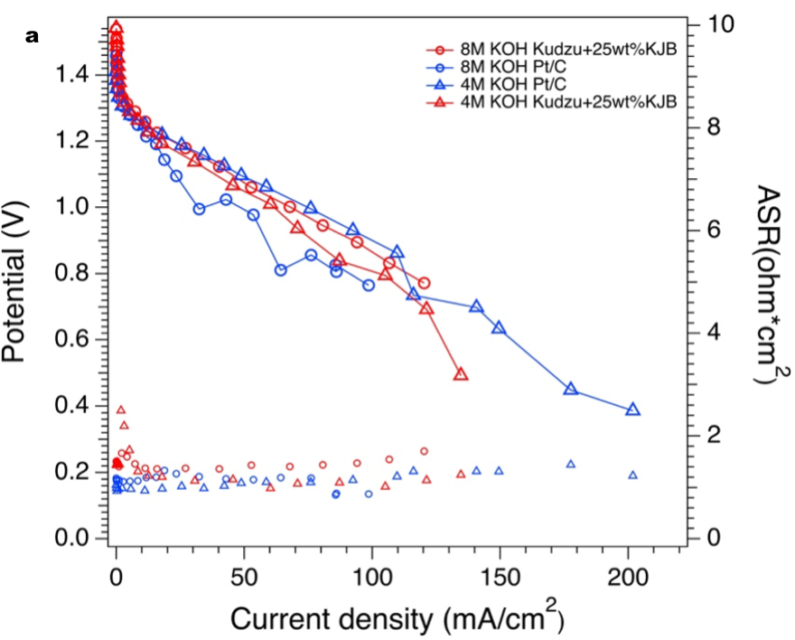
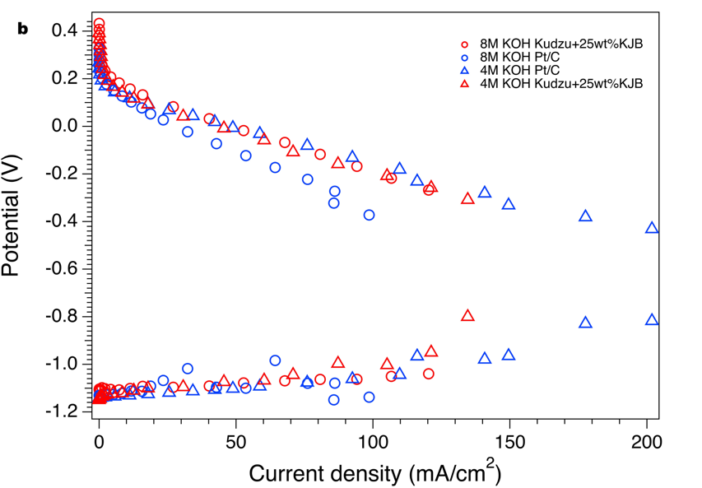
Figure 16: a) non-IR-corrected Cell polarization curves; b). Separated polarization curves by varying the concentration of KOH.

In our typical cell design adapted from alkaline fuel cell, the gas is transported along the serpentine flow field and electrolyte is introduced into middle of the cell to wet the membrane. However, poor wet proofing of air electrodes can cause flooding while introducing electrolyte flowing between membrane and air electrode. This eventually blocks the gas penetrating the carbon felt GDL. One possible way to ameliorate this situation is to switch the flow configuration to deliver gas through the liquid phase gap of the cell. In Figure 8, the red and blue curves below represent Kudzu and Platinum on PTFE-treated carbon felt without MPL, while the green curve represents Platinum on non-PTFE-treated carbon felt with MPL. The comparison of red curves demonstrates that "gas through middle" performs better than "gas through side" in a Kudzu-based PTFE-treated carbon felt. This indicates that the electrode wettability is subpar, as there are significant transport losses on both sides. However, there is no significant relationship observed between PTFE-treated carbon felts without MPL when varying the gas flow configuration in a Pt on carbon electrode. This highlights the excellent morphology of Pt on carbon particles with PTFE coating for a consistent wettability. In comparison to Kudzu catalysts, the morphology of Pt on carbon layer coating ensures that the electrode porosity and the carbon structure of the gas diffusion layer permit efficient oxygen diffusion. Instead of pretreating carbon felt with PTFE, a further possible enhancement of wettability of electrode can be achieved by applying a MPL coating on GDLs. The green curve represents superior performance of the air electrode with MPL. Beyond 120 mA/cm² on this curve, we observe a rise in the overpotential for the zinc slurry when using the gas-through-middle setup compared to the gas-through-side, as illustrated by the lower curves. This rise potentially points to concentration polarization in the slurry, likely stemming from localized depletion of hydroxide ions at elevated current densities.

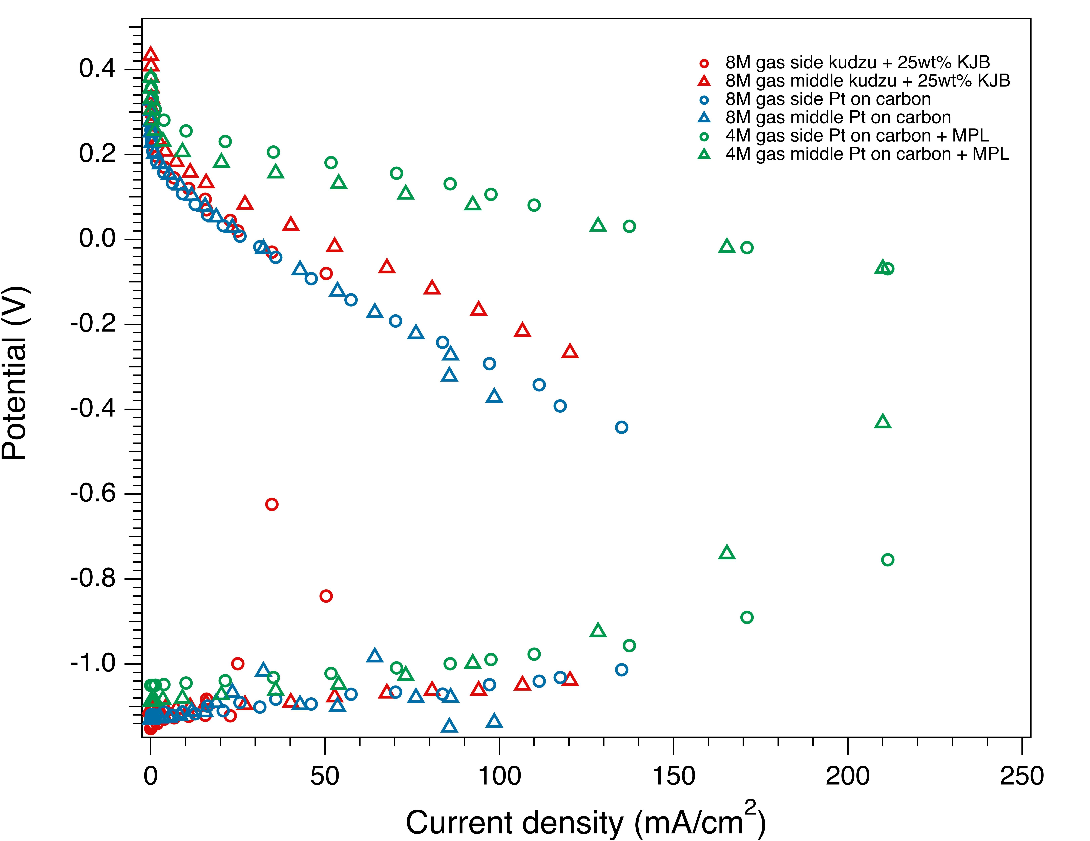
Figure 17: Effects of gas flow configuration on performance of cell.

The role of flowing KOH on the air side is primarily to ensure that the membrane remains hydrated. When gas flows between the air electrode and the membrane, a design referred to as 'gas-through-middle', this hydration is disrupted. This disruption leads to membrane dehydration, consequently restricting the movement of hydroxide ions from the cathode to the anode. Such a condition hampers the performance of the zinc slurry in systems with the ‘gas-through-middle’ configuration. We are still exploring effective methods to reduce the KOH flow on the air side while keeping the membrane well hydrated. The introduction of humidified air has been recognized as a viable solution in numerous alkaline fuel cell applications^{84, 85}. It remains to be determined if this level of humidification can adequately support the high discharge rates and moderate depth of discharge.

Conclusion

In summary, we examined mechanically rechargeable zinc-air batteries as potential successors to Lithium-ion technologies. Our investigations focused on the adoption of a three-electrode configuration with the integration of a pseudo reference electrode, which provided detailed insights into the losses experienced by different cell components. This approach facilitated a thorough assessment of electrodes of kinetics, internal resistances, and mass transport dynamics separately. By fine-tuning parameters such as operational modes, KOH concentrations, orientation of gas flow and air electrode designs, we substantially increased cell power density to 180 mW/cm². Our study underscores the promise of mechanically rechargeable zinc-air batteries as a technology for the next generation.

CHAPTER 4. NEW APPROACH TO INVESTIGATE LOW-PERCOLATION SLURRY CHARACTERISTICS TO IMPROVE ZINC UTILIZATION IN MECHANICALLY RECHARGEABLE ZINC SLURRY AIR BATTERY

We applied majority of parts in entitled manuscript “Systematic Parameters Study to Enhance Accessible Capacity of Low Percolated Zinc Slurry for Development of Mechanically Rechargeable Zinc Air Battery” Under preparation.

Abstract

Mechanically rechargeable zinc-air batteries show great promise as energy storage solutions. However, the flowing system with slurry exhibits low utilization of zinc and lacks systematic study. To enhance accessible zinc capacity and focus on fundamental slurry composition, our investigations compared cell designs, operational modes, KOH concentration, zinc loading, and discharge rates and their effects on practical capacity of the cell. Additionally, we developed a unique model to interpret the conductivity of low-percolation slurry, potentially bridging a significant research gap in the study of flowing and semi-flowing slurries. Our customized cell with 1 cm thickness of anode demonstrates an ultra-high theoretical areal capacity of 456 mA/cm² and achieves 70.7% utilization at a discharge rate of 10 mA/cm² with optimized conditions of 4M KOH and 33.6 wt% zinc loading. The model simulated a conductivity value of 1.02 S/cm in 30 Monte Carlo runs, which closely matches the experimentally measured data of 1 S/cm.

Introduction
The demand for high-capacity energy storage solutions is rapidly increasing. In today's energy landscape, there is a pressing need for efficient and reliable energy storage devices. Currently, lithium-ion batteries dominate the market due to their widespread use and proven performance. However, researchers are actively exploring alternative chemistries beyond lithium^{86, 87}, including solid-state batteries, redox flow batteries, fuel cells, and metal-air batteries. These alternatives aim to reduce the levelized cost of energy (LCOE) below 0.05 $/kWh while enhancing safety and reliability in electricity supply⁸⁷.
Zinc air battery (ZAB) present a promising landscape for energy storage due to their high theoretical energy density at 1086 Wh/kg. Mechanically rechargeable zinc air battery (MRZAB) stands out among different types of ZAB owing to high performance of discharging and intrinsic safety²⁸. This type of cell operates by manually replacing discharged zinc slurry with fresh slurry, and it can function in two modes: flowing or injection. N. H Choi et al studied zinc slurry air battery in flowing system^{40, 53}, with focus on optimizing cell design to increase the power density through polarization curve. Additionally, Tsehaye et al⁸⁸ reported a PO-6CH2-3x anion exchange membrane that performs high ionic conductivity at 19 mS/cm which applied in zinc slurry air flow cell and produce high power density of 153 mW/cm². D Milian synergizes the rheology and power density evaluation in flowing system to further elucidate slurry viscosity effects on performance of cell⁵⁴. However, the practical energy density - utilization of slurry, is overlooked in these reports. MIT demonstrated zinc foil pieces (1 – 5 cm² small-cut) suspension slurry⁴¹ in flowing system achieve 30% utilization of capacity under 25 days continuous discharging current holding in Zinc air battery cell. The inefficient and unpractical utilization of slurry can be also seen in the other semi-solid redox flow battery³⁹, which impedes their further commercialization. Daniel et al use injection mode to operate zinc slurry air battery and achieve a promising high utilization of 85%⁴³, while it is found very challenging to scale up to a stack size.
Many factors, including cell design and slurry composition, can significantly affect the accessible capacity of zinc slurry in MRZAB. A critical aspect influencing this capacity is the conductivity of the slurry. A model that can be used to interpret zinc slurry is extremely helpful to guide experimental direction regarding optimizing compositions of slurry and elucidating mechanisms. J Wainright et al established the EIS slurry model to interpret iron slurry resistance, and they highlighted slurry resistance is comprised by electronic resistance and ionic resistance. In the physics perspective, the conductivity of the composite electrode is often simulated through percolation theory by including Bruggeman’s factor^{58, 89}. Mustain et al. applied GeoDict to simulate slurry conductivity with a high percolated network at 30.5 vol.% zinc loading in operando primary zinc air cell. Their findings indicate that only a few particles are in contact with each zinc particle, demonstrating that the traditional Bruggeman approximation is not accurate for predicting our zinc slurry when particle contact must be considered. Thus, there is a research gap that no existing model can predict conductivity of low percolation zinc slurry.
In this work, we systematically investigated the effects of flow and injection designs on the performance of mechanically rechargeable zinc-air batteries (MRZAB) in terms of utilization. Additionally, we explored two fundamental parameters of slurry composition: the concentration of KOH and the zinc loading, to enhance the performance of MRZAB. By fine-tuning these parameters, we achieved 70.7% utilization at a discharge rate of 10 mA/cm² in an injection cell with 4M KOH and 33.6 wt% zinc loading. Furthermore, we developed an empirical model to simulate the conductivity of the slurry in a low-percolation state, which closely aligns with experimental observations.

Materials and methods

Cell design
Two major cell designs were participated in all electrochemical testing. 1) graphite flow field, 2) 3D printed slurry holder for injection purpose. Cathode was constructed the same with binary flow in graphite plate attached to Nickel plate as current collector. The cells were fastened with torque at 80 lb.

Slurry compositions
For KOH concentration study, the slurry was prepared in 1M, 4M, and 8M KOH with 33.6wt% zinc particles (Spectrum, 325 mesh (~50 µm), ~95% purity) with fixed 33.6 wt% zinc and 0.112 g polyacrylic acid (PAA) from Sigma-Aldrich (viscosity ~40,000-60,000 cP). For zinc loading study, the slurry was prepared in 25.3, 33.6, 37.2 wt.% zinc with fixed 8 ml 4M KOH and 0.112 g PAA. The slurry was prepared in two steps, first mixing PAA and KOH solution and then adding zinc powder for homogenizing the suspension by a high-speed homogenizer.

Electrochemical characterizations
Galvanostatic discharging profile (E-Q), denoted as utilization curve, was obtained through Chronopotentiometry (CP) in EC-Lab with biologic SP-150 with 20A booster. A constant current of 10 mA/cm² was holding until cell’s voltage drops to zero.
Different thickness of slurry holder including 1 cm, 1.5 cm, 2 cm, and 2.5 cm were used measure the resistance or conductivity of zinc slurry for thickness dependent resistance study. Two nickel plate was used as blocking electrode and current collectors. The slurry resistance was measured in this symmetric house-made cell.
SOC-dependent EIS was performed by discharging cell 4 hrs with 1 mins resting periodically and then collect impedance by EIS scans from 100 kHz to 10 Hz at the end of resting step.

Results and discussion
A mechanically rechargeable zinc-air cell was successfully designed and 3D printed using ABS material in our group. We conducted a series of electrochemical characterizations on this cell, with a strong focus on the anode design and implementation in a semi-batch mode through slurry injection. The anode, with a functional area of 5 cm², was designed to match the established cathode side adapted from an alkaline fuel cell. To enable proper functioning of the syringe from the side of the ABS mold, the optimized thickness was determined to be 1 cm. While this thick anode could result in high resistance and practical challenges when mechanically removing used zinc slurry, it also presents new opportunities for large areal capacity applications. Notably, a 1 cm thick zinc slurry with 33 wt.% zinc loading equips the cell with an ultra-high areal capacity of 456 mAh/cm², which is theoretically 2.85 times higher than the highest reported areal capacity of 160 mAh/cm² in zinc-based batteries.
Figure 1 depicts the core components of our cell, including the zinc slurry anode, membrane, and air-breathing cathode. The zinc slurry is prepared simply with three components: zinc particles as the anode active material, polyacrylic acid (PAA) as the binder/gelling agent, and 4M KOH as the electrolyte. While other studies^{40, 43} have incorporated carbon black as an additive to enhance the performance of zinc-based batteries, we have chosen to exclude carbon in our slurry. This decision was made to investigate the baseline performance of the mechanically rechargeable zinc-air battery (MRZAB), given the complex effects of carbon on both the viscosity and conductivity of the slurry.

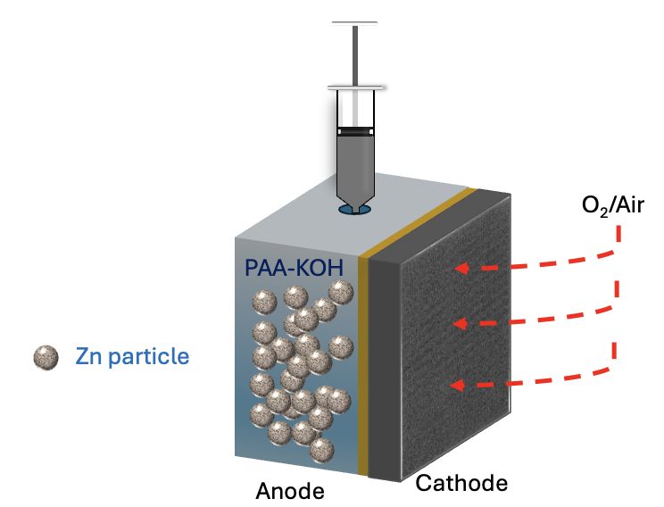
Figure 18: An illustration of mechanically rechargeable zinc air battery in semi-batch mode with 1 cm thick high-capacity anode and carbon light-weight air cathode with house-made CLAM.

MRZAB is primarily recharging battery by manually replacing discharged zinc slurry with fresh filling. Thus, its performance is highly dependent on how much zinc can be discharged once (defined as utilization). Quantitatively, the accessed capacity of zinc slurry is dominating on the efficiency of MRZAB. To investigate the utilization of zinc in slurry of house made cell, galvanostatic discharging was performed within different variables.
Figure 2a shows the cell tested with two different membranes (Celgard 3501 and CLAM) and in two different modes (flow, where the slurry is pumped continuously, and stagnant, where the slurry is injected in a semi-batch mode). The results indicate that the injection mode with the CLAM membrane delivers 568 mAh g_{Zn}⁻¹, which is 57.5% greater than the same mode with the commercial porous membrane Celgard 3501, documented as the benchmark membrane used in MRZAB⁹⁰. Additionally, the injection mode outperforms the flow mode, achieving 336.2% greater utilization. This suggests that leveraging the flow mode with established infrastructure from redox flow batteries presents significant challenges due to the very low utilization of zinc in MRZAB, as also reported in a study by MIT⁴¹. Consequently, our next focus will be on systematically studying the basic composition parameters of the slurry in the injection mode of MRZAB.
Two variables, including loading of zinc and concentration of KOH were selected to study on zinc slurry composition effects on performance of zinc slurry air cell. Fig. b reveals that 33.6% wt% zinc with porosity at 0.922 delivers the highest specific capacity at 580 mAh g_{Zn}⁻¹ (corresponding to 70.7% utilization). However, increasing Zn loading to 37.2 wt% yields 20.7% drop of utilization, which is attribute to thicker slurry with higher viscosity and lower diffusion rate of hydroxide ions. It is also believed that the observed large overpotential fluctuation (red curve) at the beginning is caused by mass transport loss from insufficient mobility of hydroxide ions. Reducing the zinc loading to 25.3 wt% (blue curve) also contributes to massive utilization loss and registered at 15.2 mAh/gZn⁻¹, which is attribute to low percolation network between zinc particles. Note that the percolation threshold for zinc slurry is around 50 wt% loading of zinc²⁸, we are far below that requirement. Additionally, zinc slurry with 50 wt.% is found to be challenging to inject by syringe practically.

On the other hand, we hypothesized that the utilization of zinc is strongly dependent on the depletion of hydroxide ions. We varied the concentration of KOH to 1M, 4M, and 8M (the highest ionic conductivity presented in the literature⁹¹). 4M KOH was found to be the optimal concentration, delivering high utilization at 70.7%. Interestingly, the 1M KOH zinc slurry air cell shows an OCV of 1.2 V, which is lower than the typical zinc-air battery OCV of 1.4 V (at 4M or 8M KOH). This can be partially explained by differences calculated using the Nernst equation. The calculation shows that a 4M KOH zinc-air cell has roughly 0.02 V greater thermodynamic potential than a 1M KOH cell. The other portion of the OCV loss is believed to be caused by low contact between zinc particles and the Ni current collector due to the unstable slurry suspension with low viscosity of the slurry. The 1M KOH zinc slurry instantly short-circuits with a constant discharging current density of 10mA/cm², which is potentially attributed to insufficient hydroxide ion conductivity to allow battery discharging at this rate. In contrast, the 8M zinc slurry air cell produces 17.3% less specific capacity than the 4M KOH cell. This contradicts our hypothesis that 8M KOH improves the solubility of zinc and provides twice as many hydroxide ions for producing capacity. The possible reason behind this is that the 8M KOH slurry's larger viscosity impedes OH⁻ diffusion. Additionally, 4M KOH benefits the cathode performance for the same reason. To further validate the mechanism, a systematic study is needed to synergize rheology and electrochemistry to characterize battery performance which has been done in lithium slurry battery⁹².
We also investigated the impact of different discharge rates on the performance of the zinc slurry air cell. Figure 2c shows that with a large areal capacity of 456 mAh cm⁻², the cell delivers 322.4 mAh cm⁻² (70.7% utilization) under a discharge rate of 10 mA cm⁻². As the discharge rate increases to 40 mA cm⁻², the cell delivers 194.6 mAh cm⁻² (42.6% utilization). The cell experiences low utilization at a discharge rate of 100 mA cm⁻², as indicated by the blue line. In conclusion, although the cell possesses significantly high energy density due to the high thickness of the anode, the practical utilization is strongly dependent on discharging rate. Because the cell’s performance is sensitive to discharging current density, the future direction for this cell is to focus more on stationary energy storage systems, which require lower power density compared to electric vehicle (EV) systems that demand high power density and C rates to meet daily needs.

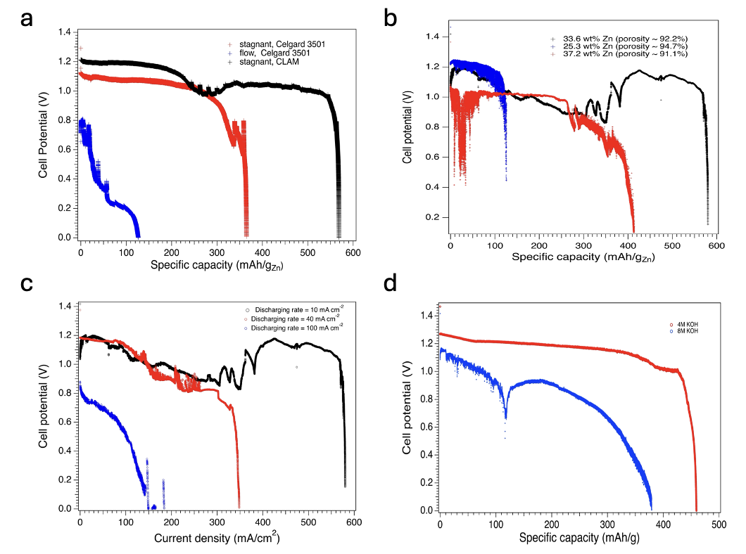
Figure 19: Galvanostatic discharging profile under different conditions, a) pre-screening the membrane and operational mode for the cell utilization testing; investigating effects of b) zinc loading in slurry, c) discharging rate, d) KOH concentration on the cell performance.

Post zinc slurry pictures reveals zinc closed to membrane gets reacted first. - 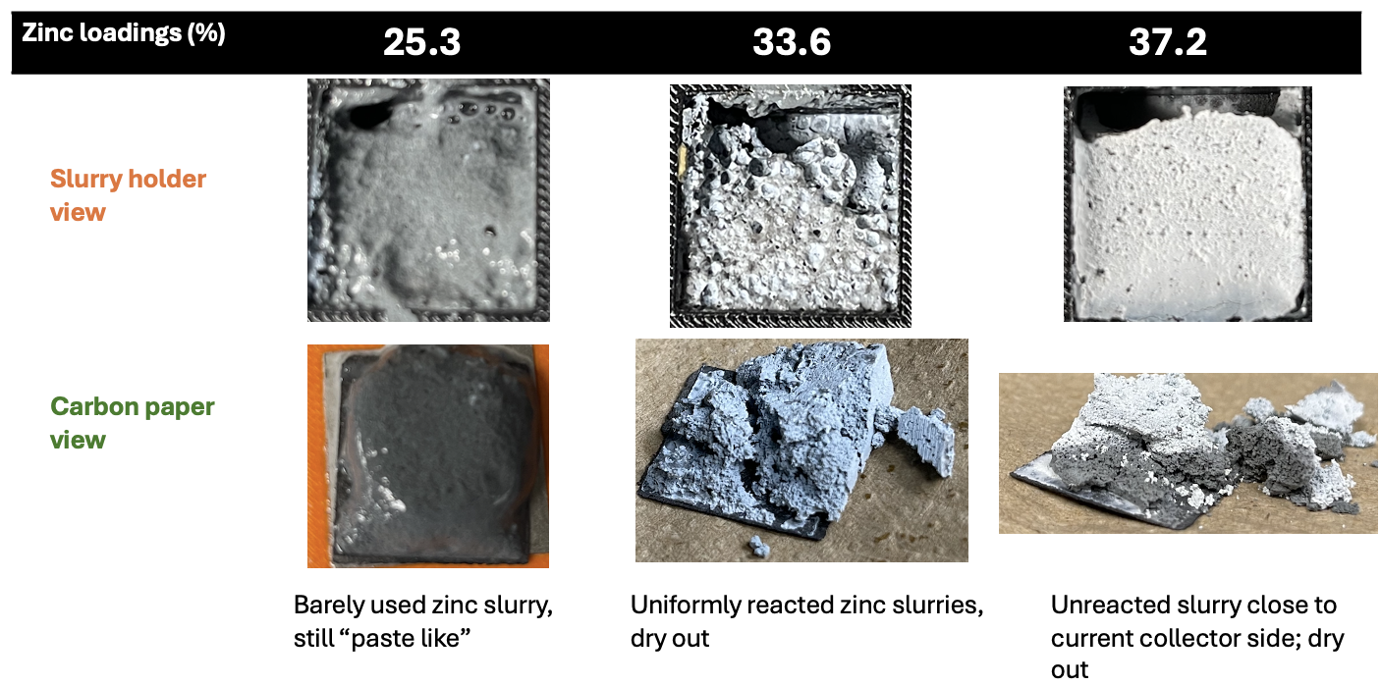
Figure 20: Discharged zinc slurry in holder view and carbon paper view with 25.3wt%, 33.6wt%, and 37.2 wt% compositions.

To characterize the anode resistance, thickness-dependent EIS was conducted to monitor the resistance of slurry as a function of anode thickness. A house-made symmetric cell was employed to measure the impedance of slurry, and its thickness is controlled by the 3D printed slurry holder. As the thickness increases from 1 cm to 2.5 cm, the resistance increases from 0.185 to 0.45 Ohm as shown in Fig 3a. With a linear fitting, we can extract the contact resistance if existing. Fig. 3b reveals that no significant contact resistance was detected, indicating that our custom-made symmetric design provides reliable values for quantifying slurry resistance. Based on this, the specific conductivity of the slurry was calculated using the equation below. The calculated conductivity averages 1.1 S/cm, which aligns with results reported in other studies²⁸ with 33 wt.% zinc in the slurry.

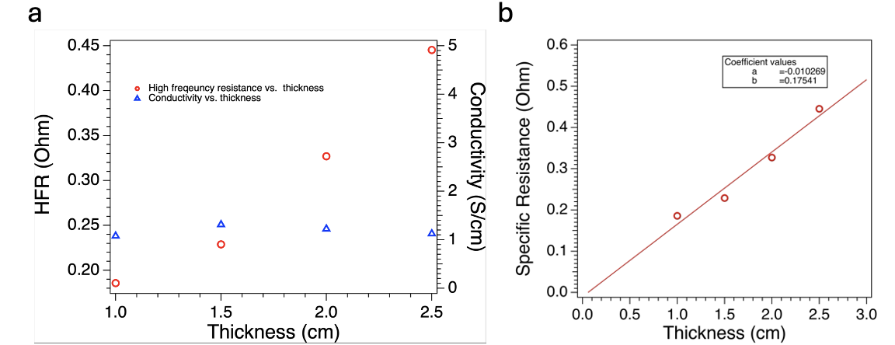
Figure 21: a) High frequency resistance as a function of thickness measured by house-made slurry symmetric cell. b) The validation analysis of contact resistance through this conductivity measurements.

To further understand how zinc slurry resistance evolves during cell discharge, SOC-dependent electrochemical impedance spectroscopy (EIS) was performed. Using a three-electrode setup to isolate the impedance of the anode, we reliably captured the time-resolved resistance of the slurry in the full cell (in-situ EIS). Figure 4a depicts the Nyquist plot under different states of charge (SOC) from 100% to 29.2% (denoted as fully charged and discharged states). Note that the Nyquist plot shifts to the right as SOC approaches 64.9% and shifts back to the left as SOC approaches 29.2%. These overall horizontal shifts reflect a dynamic change in zinc slurry resistance under different SOC. Specifically, Figure 4b extracted the specific resistance of the slurry (Rs) from the x-axis intercept (HFR) and its corresponding specific conductivity (σs). It was found that the resistance of the slurry initially increases, reaching a maximum value of 0.9 Ohms at 70% SOC, then decreases sharply, reaching a low value of resistance at 47.4% SOC; thereafter, the slurry resistance maintains a plateau until SOC drops to 29.2%. The corresponding specific conductivity trend behaves oppositely to the resistance trend because conductivity is the reciprocal of resistance. It is believed that the resistance change is potentially attributed to zinc morphology, particle aggregation, passive layer formation, and changes in slurry viscosity.

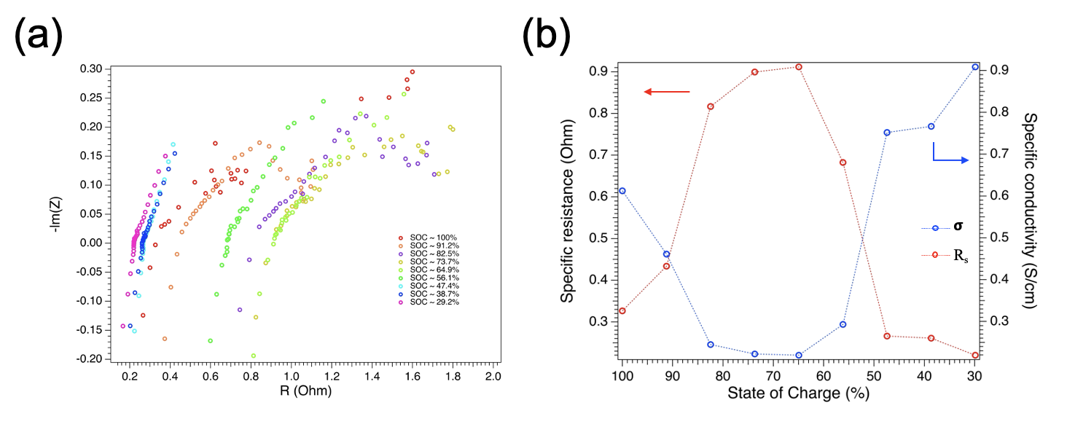
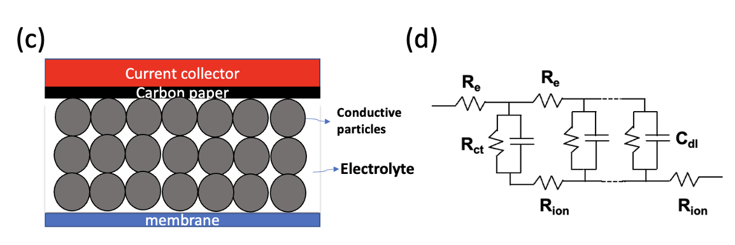
Figure 22:. a) Resistance as a function of (state of charge) SOC in discharging direction with three electrodes assisted to isolate cathode part. b) Derived corresponding specific resistance and conductivity values as a function of SOC. c) Illustration of EIS slurry model, highlighting the three major processes: 1. electron transfer between zinc particles; 2. Ionic transfer from mobility of hydroxide ion; 3. Interfacial charge transfer between zinc particle and KOH. d) Its corresponding equivalent circuit model presents R_{e}, R_{ion}, and R_{ct} to describe these three processes

To further elucidate the mechanism of slurry dynamic change during cell discharge, we first examine the slurry-EIS model developed by Wainright et al⁶². Assuming that the slurry system is macro-homogeneous phase, similar as porous electrode. Its direct derived impedance equation is complex, especially including the low frequency term (Z_{LF}) which is dependent on impedance of interface⁶² (${\hat{Z}}_{ζ}$) as shown below. The first term (high frequency) is solely dependent on intrinsic properties of zinc slurry. The second and third terms are dependent on the impedance of solid liquid interphase. One of key parameter in the interphase impedance is charge transfer resistance (R_{ct}) in eq. 3. Its physical meaning is dependent on surface area or morphologic of zinc particles in our case. When impedance approaches to low frequency, Z_{LF} includes R_{HF}, R_{ct}, and distribution resistance (R_{dist}), where R_{dist} accounts for additional impedance to minimize the overpotential arises when passing ionic or electronic current.

$$Z=\frac{r_{e}r_{ion}}{r_{e}+r_{ion}}δ+\frac{r_{e}r_{ion}}{r_{e}+r_{ion}}\frac{2λ}{\sinh\left(\frac{δ}{λ}\right)}+λ\frac{r_{e}^{2}+r_{ion}^{2}}{r_{e}+r_{ion}}coth⁡\left(\frac{δ}{λ}\right)$$
[1]

$$λ={\left(\frac{{\hat{Z}}_{ζ}}{r_{e}+r_{ion}}\right)}^{1/2}$$
[2]

$${\hat{Z}}_{ζ}=\frac{{\overline{r}}_{ct}}{1+jω{\overline{r}}_{ct}c_{dl}}$$
[3]
$$Z_{LF}=R_{HF}+R_{ct}+R_{dist}$$
[4]
Where $r_{e}$, $r_{ion}$ are the length average resistance of electronic and ionic phases,
$δ$ is slurry electrode thickness,
${\hat{Z}}_{ζ}$ represents interaction between electronic and ionic phase when redox couple exists
${\overline{r}}_{ct}$ is length average charge transfer resistance
$c_{dl}$ is capacitance of double layer

High frequency range specifically interests our attention that can be applied in zinc slurry study. At this range, the impedance of interphase approaches to zero, which simplifies the equation to eq 5. Thus, the specific resistance of slurry at high frequency is represented by parallel equation of ionic resistance (R_{i}) and electronic resistance (R_{e}). These parameters present the mobility of hydroxide ions in the electrolyte and particle to particle contact resistance, respectively. On the other hand, charge transfer resistance and distributed resistance were not specifically applied to zinc slurry testing in full cell due to non-obvious Randle’s semi-circle formed at this frequency range in our case. Thus, R_{HF}, also called R_{s}, should be more of interest to interpret the possible zinc slurry charging mechanisms.

$R_{HF} = R_{s} =\frac{R_{ion} * R_{e}}{R_{ion}+ R_{e}}$
[5]

σ_{s} = σ_{i} + σ_{e}
[6]
Assuming σi = 0.55 S/cm from literature reports⁹¹, and σ_{e} as the electronic conductivity of zinc metal, which is 1.66 *10⁵ S/cm, the derived σ_{s} is five orders of magnitude higher than the experimental value. This large discrepancy is attributed to two factors: 1) the porosity effects on conductivity, and 2) the particle contact. To account for the first factor, researchers apply the Bruggeman approximation to model the porous composite anode. Specifically, Bharatkumar Suthar et al. point out that a Bruggeman coefficient of 1.5 is commonly used for composite anodes with uniform spherical particles⁵⁸. Based on this, our conductivity model equation is developed to include the effects of porosity:
$$σ_{eff}=σ_{Zn}ε_{Zn}^{1.5}+σ_{KOH}ε_{KOH}^{1.5}$$
[7]
The calculated effective conductivity is 3574 S/cm. The error is greatly reduced although there is still three magnitude orders of gap in comparison to the experimental value. To overcome this, the second factor – particle contact must be considered. We propose the slurry (low percolation) composite electrode should adapt the following empirical model:
$$σ_{eff}=σ_{Zn}{(fε)}_{Zn}^{1.5}+σ_{KOH}ε_{KOH}^{1.5}$$
[8]
Where f is the fraction of particles with neighborhood.
To clarify, the slurry we are dealing with contains 33 wt.% zinc loading, which is far below the percolation limit. This indicates that our particles do not all neighbor each other to form a percolation network. To characterize particle contact, we employed Python to simulate a representative volume element (RVE) in 1 mm³ with 7.7 vol.% zinc (33.6 wt.%). Scanning electron microscopy (SEM) was used to determine the particle size distribution of the zinc powder, with a D₅₀ of 44 μm, as shown in Fig. 5a. Furthermore, we assume that particles are distributed in a range of 1 μm to 60 μm with a Gaussian distribution centered at 44 μm. The particles were placed into the unit, and any particles that are 'close enough' (< 50 nm) were assumed to be neighbors, allowing electron transfer through quantum tunneling. Fig. 5d shows the simulated particle size, numbers, and volume fraction of the unit. Fig. 5f visualizes this RVE with red and blue particles to distinguish those that conduct electrons. In 30 Monte Carlo simulations, the average conductivity was found to be 1.02 S/cm, which aligns with our experimental findings. Interestingly, the simulated conductivity ranges from 0.5 to 3 S/cm, which is attributed to the randomness of zinc particles in suspension.
To further validate our findings that zinc particles are highly scattered in the slurry, an inverted microscope was utilized to visualize the zinc particles in the slurry, as shown in Figures 5b and 5c. It was confirmed that the focused particles do not exhibit close contact with each other in either resolution image. The small dots in the background are believed to be PAA media or small zinc particles, which could not be further distinguished. In the model, Fig. 5g also depicts scattered zinc particles in the slide view of the RVE. Thus, we believe that the hypothesized empirical slurry model is aligned with experimental findings, emphasizing that zinc particles are in a scattered distribution.

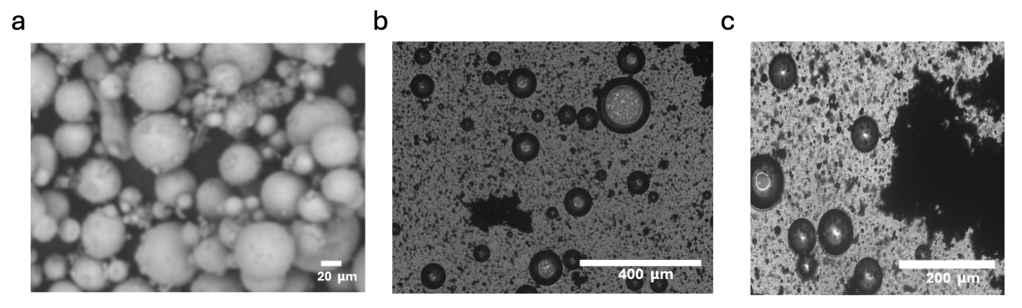

Figure 23: a) SEM images for pristine manufactured Spectrum zinc powders, b) Inverted stage microscope images on pristine zinc slurry with 33 wt% zinc loading in 10x resolution, c) same microscope with focus on ‘virtually closed-enough’ particles on same slurry in 20x resolution, d) Statistical results of simulated zinc particles in slurry with fixed range diameter from 1 um to 60 um, e) The results of 30 Monto Carlos runs for simulated conductivity of zinc slurry based on our developed model, f) a interactive view of repsentitve volume element (RVE in 1 mm x 1 mm x 1 mm) that captured neighbors and isolated particles with different color, g) a slice view of RVE with dimension of 400 um x 400 um x 100 um.

Although the empirical model can be used to stimulate pristine zinc slurry, it has limitability to predict dynamics of resistance change of zinc slurry in discharging process. For example, we found challenge to predict the conductivity of slurry at 70% SOC, which relates to interpret possible reasons contribute to highest resistance (Fig 4b) in the entire discharging process. It has been reported that 4M KOH has 0.3 M saturate zincate solubility⁷². Based on calculation, at 70% SOC, 0.83g zinc in 5 ml 33.6 wt.% zinc slurry was consumed to yield capacity, which is roughly 9 times greater than the saturated zincate solubility at 0.0975g. Thus, the formation and precipitation of zinc oxide in principle happens. Assuming that 1). 30% zinc transforms to zinc oxide during discharging process (zinc to zinc oxide volume expansion is equal to 1.6); 2) considering corrosion rate referenced from Perez-Antolin el al⁴³, 5.46 wt% of zinc depleted due to parasite reaction. The KOH consumption originates from the reaction with zinc particles. Assuming that all formed zinc oxide is well covered on the zinc particle surface without considering precipitation or major morphologic effects. Mathematically, we calculated particles size (D₅₀) expanse from 44 um to 47.6 um at 70% SOC as presented in Fig 6. Through same stimulation, the average conductivity is 1.37 S/cm based on 30 runs, which is against our experimental finding on slurry resistance of 70% SOC. The limitation along this model is that we lack supporting evidence to quantify the conductivity of zinc oxide covered zinc particles, and its morphological impacts. This model can be potentially further evolved and complexed when considering many other factors, such as large quantity of small zinc particles (<1um), aggregation (discharging), introduce Multiphysics, morphologic characterizations.

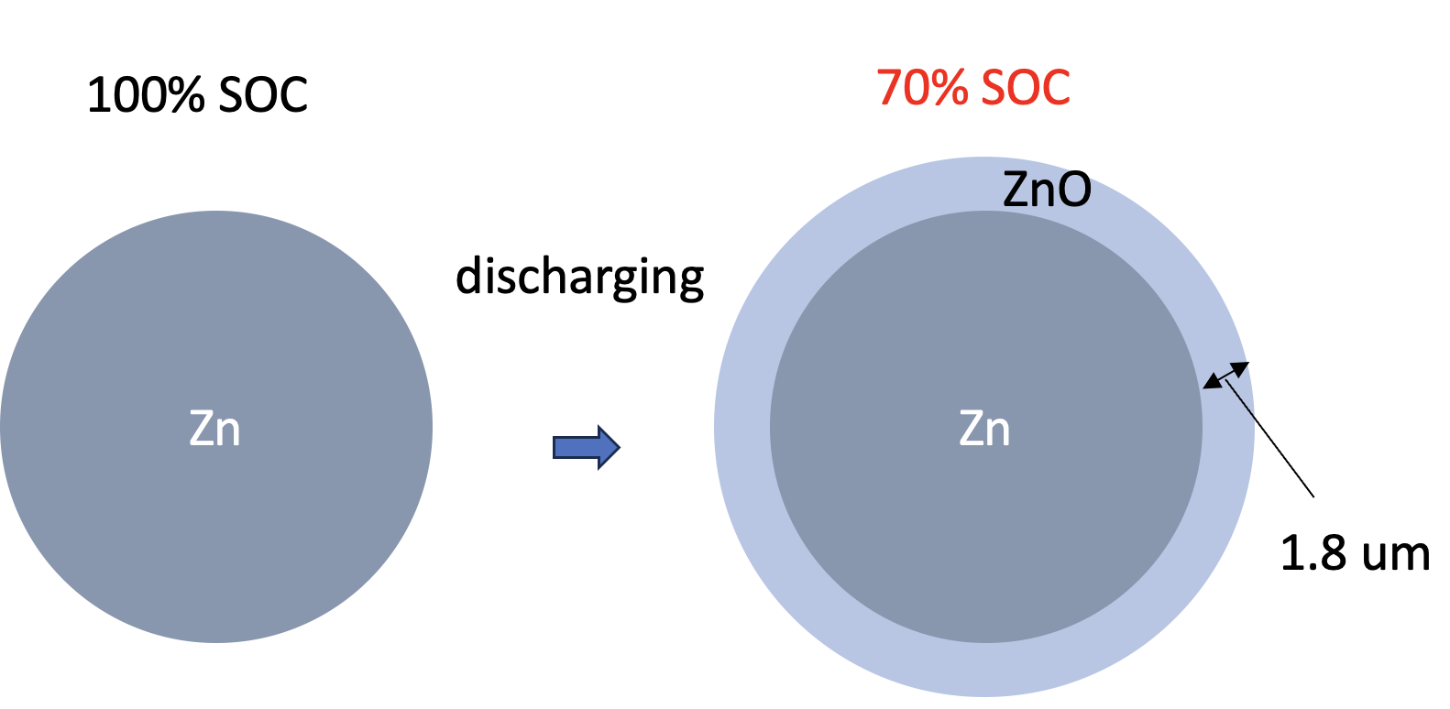
Figure 24: A scheme shows the volume expansion of zinc particles during discharging. Assuming no major morphologic change on zinc particle. The expansion is sorely from the zinc oxide layer uniform deposition.

Conclusion

In this work, we successfully fabricated a zinc slurry air cell with an ultra-high areal capacity of 456 mAh/cm². We systematically studied the effects of zinc slurry compositions on the utilization of the MRZAB. Our findings indicate that a slurry composition of 4M KOH and 33 wt.% zinc achieves optimal utilization of 70.7%. Additionally, we investigated the slurry's conductivity from both experimental and theoretical perspectives. This led to the development of a specific low-percolation slurry empirical conductivity model, which is particularly meaningful to the slurry or semi-solid electrode cell community. This model provides critical insights for considering particles contact, addressing challenges related to explanation of physics of low percolated slurry. By optimizing slurry composition, our study enhances the understanding and efficiency of zinc slurry air cells, paving the way for future innovations in energy storage technology.

CHAPTER 5. PRACTICALLY DEVELOPMENT LAB-CELL MRZAB FOR FUTURE PROTOTYPE TECHNOLOGY AND OTHER CONSIDERATIONS

Motivation
The technical operational mode transaction from flow to semi-batch injection is previously demonstrated as necessary to improve both power density and energy density. However, the design of injection slurry is still in its infancy which does not allow completely removal of discharged zinc slurry. Also, the self-discharging of zinc slurry (corrosion) and the capability of regeneration of fresh zinc slurry from used zinc slurry are also two major challenges which further impedes the development of MRZAB. Thus, in this chapter, we aim to discuss our efforts been done to cope these obstacles.

Design progress towards lab-scale mechanically rechargeable zinc slurry air battery

To fully support the development of injection mode in MRZAB, we systematically designed the following 3D-printed mold using Inventor to demonstrate a ‘completely removable’ prototype. Figure 16a depicts the classical serpentine flow field design widely applied in alkaline fuel cells to handle gas and liquid phases simultaneously. However, this design struggles with viscous zinc slurry due to clogging issues. We observed that zinc slurry immediately became lodged in the flow field and could not be manually injected out, leading to an initial practical failure with this setup. Subsequently, we modified the flow field channel by increasing the width to 2 mm, as shown in Figure 16b. This adjustment successfully mitigated many clogging issues during the initial injection stage, allowing us to obtain initial test results. However, we noticed that clogging could still occur during cell discharge because the zinc slurry slowly dries out and its viscosity increases significantly.

While a pumping slurry system appears more industrially viable for scaling up, as it can leverage the existing infrastructure of redox flow battery stack designs, the inherent problem of clogging remains unresolved. Consequently, we designed an injection mold through 3D printing using 100% infill ABS plastic (Figure 16c). This mold allows for side injection and enables verification that the slurry is fully filled. This design shifts the process from continuous flow to a semi-batch mode, with manual intervention required at the initial and final stages of slurry injection and removal, thereby reducing the risk of clogging during continuous flow. However, we identified a limitation in completely removing the slurry after the end of discharge with this design. Thus, subsequent efforts were focused on optimizing the removal process, which theoretically can be achieved in two ways.

Initially, we considered incorporating a central knob to push the slurry out after use without disassembling the battery (Figure 16d). However, a practical issue quickly emerged: after assembly, the knob-assisted slurry holder was tightly sandwiched between the current collector holder and the gasket with zero gap and secured with high torque. This resulted in impractically high friction between components, leading us to abandon this design.

The second method focused on a multi-channel concept. This design was inspired by the limitations of the baseline design in Figure 16c. Instead of injecting through a single hole, which is inefficient for complete slurry removal, we redesigned the current collector holder to allow slurry to pass through four channels (Figure 16e). Additionally, the upper and lower channels are joined into a single channel to simplify the external connection to tubing. Figure 16f illustrates the thin slurry holder, enabling a practical mechanically rechargeable concept. This multi-channel design successfully addressed the challenge of efficient slurry replacement. However, we observed leakage issues, likely due to the limitations of ABS, the material used for 3D printing. Although marketed as 100% infill, ABS plastic may be too porous during manufacture for this prototype design. Therefore, more advanced materials, such as PEEK, should be considered in future.

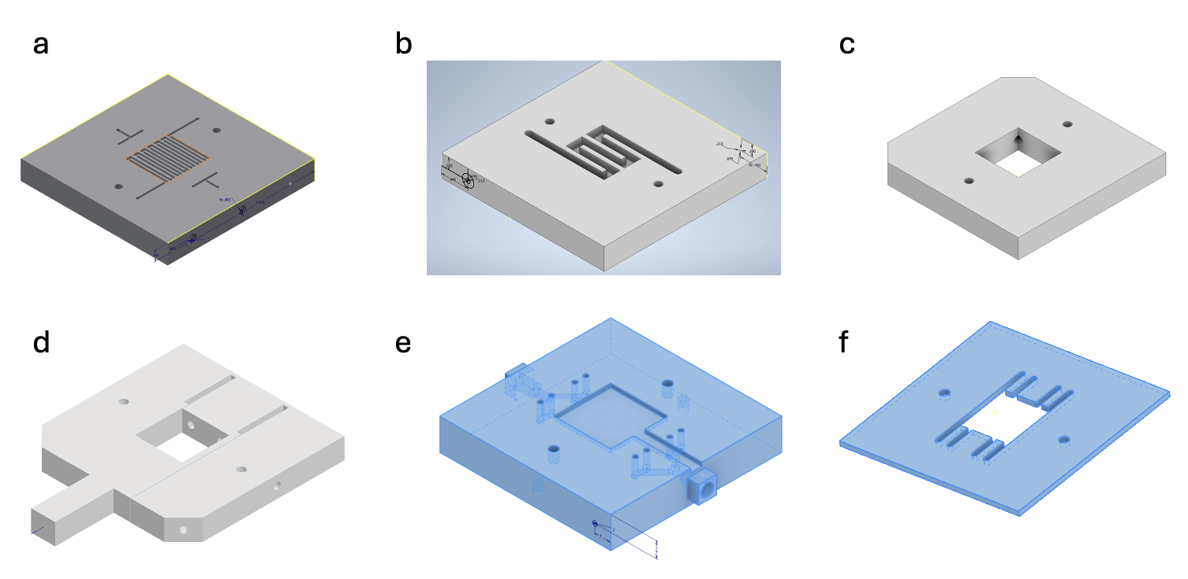
Figure 25: Design of device perspective for slurry anode in development practically viable MRZAB, a) serpentine design of flow field adapted from alkaline fuel cell that allows dual phases operation (gas and liquid); b) Modified flow field design with 2 mm width of channel for pumping slurry; c) Initial slurry injection design with 5 cm² and 1 cm thickness; d) Knob assisted injection design for removal purpose manually; e) A illustration of modified nickel plate holder to allow slurry injection through multichannel; f) A modified slurry multichannel holder with 2 mm thickness to hold slurry while operating the cell.

Regeneration of zinc slurry – a test in symmetric cell
Although major driving force of MRZAB is focus on development of one pass zinc discharging process, the discharged zinc must be technically recyclable. To explore the reversibility of zinc slurry in mechanically rechargeable zinc air battery, symmetric zinc stripping and plating experiment was identified as most effective electrochemical method to characterize the zinc reversibility in terms of columbic efficiency (CE). An informed nature energy paper regarding a discussion of CE of zinc batteries was published by Lin Ma et al. [] They highlighted that standardized galvanostatic protocols should replace cyclic voltammetry (CV) in CE determination because CV lacks control over critical parameters such as current density and areal capacity, leading to inconsistent and unreliable results that don't reflect real battery conditions. Additionally, CV often uses unrealistic potential ranges, resulting in overly optimistic CE values. The ambiguous measurement of electrode surface area in CV further compromises accuracy. Therefore, galvanostatic protocols provide a more reliable and relevant approach to assessing CE. They also reported that many reports have close to 100% CE but unpractical utilization of zinc stripping and plating at below 1%, which is far below the commercial target of rechargeable zinc metal battery at 80% utilization, 5 mAh/cm² of areal capacity, and 10 mA/cm² of current density.

Herein, we utilized our house-designed symmetrical cell with 1 cm thickness of cathode and anode to striping and plating the zinc slurry at 40 mA/cm², and 100 mA/cm². We observed roughly 0.25 V of overpotential at initial two cycles under 100 mA/cm². In contrast, 0.1 V of overpotential was observed when current density decreased to 40 mA/cm². This is reasonable due to larger overpotential originating from IR drop when larger current is applied. Furthermore, we also noticed at roughly one hour cycling, the voltage response stabilizes in both cases. Interestingly, a smaller overpotential was detected at 100 mA/cm² in comparison to 40 mA/cm². This indicates larger current density at formation cycles potentially benefits zinc slurry percolation network formation due to enhanced electrodeposition dynamics. Higher current density accelerates the nucleation and growth of zinc particles. This promotes the formation of a more interconnected, robust percolation network within the slurry. This is crucial for ensuring good electrical conductivity during subsequent cycling. Another possible explanation is that larger current density facilitates more heterogeneous surface of zinc particle, which ensures larger surface area of active material can be utilized for long term cycling. Thus, based on this symmetric cell zinc slurry stripping and plating, we convincedly presented that optimal reversibility of zinc slurry at 98.4% CE and around 2% utilization.

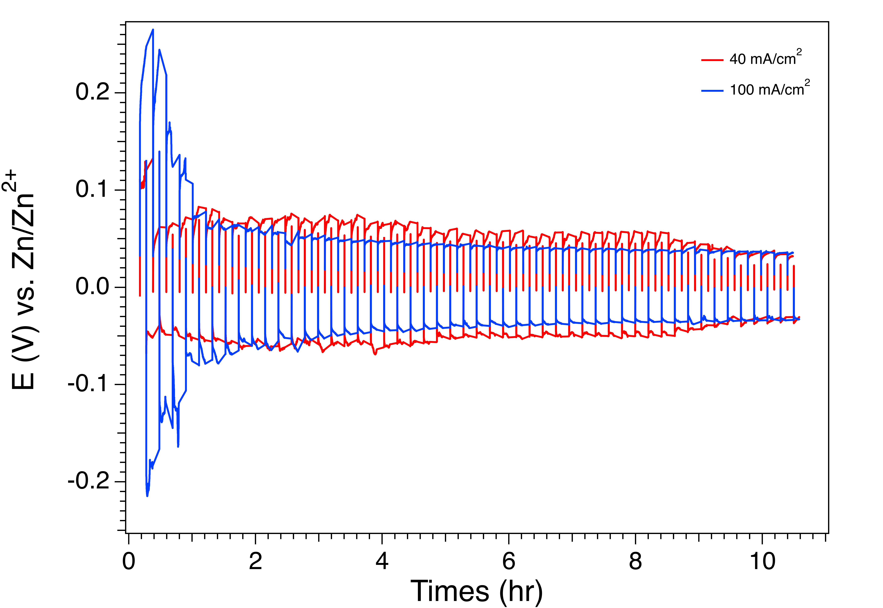
Figure 26: A symmetric cell testing with Zn|CLAM|Zn setup plating and stripping under 40 mA/cm², and 100 mA/cm² for 12 mins current holding (6 mins for charging, and 6 mins for discharging) each cycle until 50 cycles.

To advance the maximum utilization during striping and plating zinc slurry testing, we further investigated whether slurry can be cycled with a deeper utilization under symmetric cell. Fig [ ] proves that 20% zinc utilization cycling was achieved without shortage in this symmetric cell testing for 20 cycles and maintaining 98.4% CE, under 100 mA/cm² current density and practical areal capacity of 91.2 mAh/cm². Recalling the benchmark, we are still far below target of 80% utilization for Zn battery cycling. However, eighteen times higher areal capacity still makes this technology appealing, which benefits from thick slurry anode design. In this symmetric cell testing, we demonstrated comparable CE with 20% utilization of zinc during cycling in symmetric cell. It is still far below the commercial line but the progress of this still shows promising. To improve utilization of zinc during cycling, further experiments will be needed to systematically explore zinc anode parameters, such as the starvation of KOH effects, in-situ measurement of slurry suspension stability, and zinc particles morphologic changes. Similarly, its corresponding OER catalysts or bi-functional catalysts needs to be utilized to achieve the regeneration of used zinc slurry practically. Lastly, the design of this regeneration system also needs to be optimized in a larger stack scale, and usually this is a limiting and challenge step that can be foreseen. All of these must be considered in future development of MRZAB.

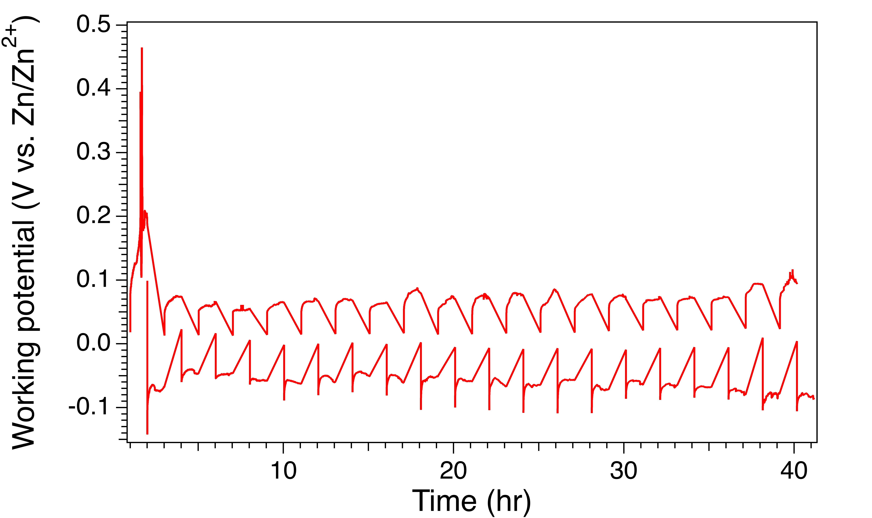
Figure 27: A symmetric cell testing with Zn|CLAM|Zn setup plating and stripping under and 100 mA/cm² for 120 mins current holding (60 mins for charging, and 60 mins for discharging) each cycle until 20 cycles.

Corrosion effects
The corrosion of zinc anodes in ZABs, is primarily driven by the hydrogen evolution reaction (HER), which severely hampers the battery's performance and efficiency. The thermodynamically favorable potential at which these batteries operate exacerbates this issue (HER at -0.83 V vs. SHE; Zn/ZnO at -1.26 V vs. SHE in PH= 14)⁹³. Various strategies have been proposed to mitigate this corrosion, such as incorporating metal oxides or surfactants into the electrolyte. For example, Subramaniam et al⁹⁴ investigated the use of nanofluid electrolytes to mitigate hydrogen evolution reaction and zinc corrosion in electrically rechargeable zinc-air batteries recently, enhancing their cyclic performance and stability. They found nano-size SiO_{x} and ZnO are two effective additives in 6 M KOH electrolyte to increase the HER onset potential. Similarly, In₂O₃ and Bi₂O₃ were also explored to improve the utilization of zinc in other groups^{95, 96}. On the other hand, Hosseini et al reported various surfactants effectively suppressing the zinc corrosion in zinc air flow battery⁹⁷⁻⁹⁹, such as ethanol, sodium dodecyl sulfate, pluronic F-127, and dimethyl sulfoxide.

However, most of these approaches have been tested with solid zinc plates or prefilled zinc granules as the anode. In contrast, the use of zinc slurry, which has a significantly higher surface area, could potentially experience even more severe corrosion which is not explored. To establish a baseline understanding, corrosion behavior in thick slurry anodes was assessed in the absence of additives designed to suppress corrosion, offering insights into future improvement strategies. Fig 28 below exhibited zinc slurry air battery discharging profile after six hours of air exposure for zinc slurry. It almost delivers 70 mAh/g_{Zn} capacity, which is 88% less than benchmark that using as-prepared zinc slurry. This large capacity loss is likely attributed to two major factors. First, different side reactions occurred. For example, the zinc reacts with water to release hydrogen. The intermediate product Zn(OH)₂ further reacts with CO₂ from air to undesired ZnCO₃. These result in the loss of active amount of zinc we can assess during cell discharging. Second, the formation of side products alters the rheology of zinc slurry, which affects the stability of suspension. Although storing the zinc slurry under Argon seems a promising solution, the study of chemo-mechanics of zinc slurry is still at very early stage. It is crucial to optimize slurry stability in different stage: storage stage, cell discharging process, and regeneration.

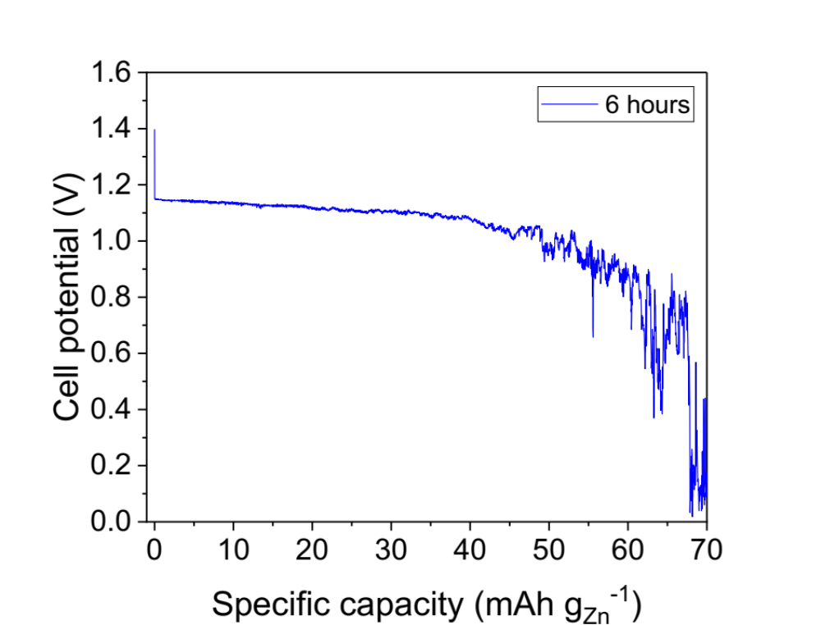
Figure 28: Discharging profile for air-exposed zinc slurry after 6 hours in full cell testing.

CHAPTER 6. APPLYING POTENTIAL STEP TO CHARACTERIZE MASS TRANSPORT OF POROUS ELECTRODE IN VANADIUM REDOX FLOW BATTERY

Abstract

This proposed work is to design a new experimental method to study the flux through electrodes used in redox flow batteries (RFBs). Methods have already been established to study other components in such cells. Permeability and conductivity tests are two essential methods to investigate the performance and intrinsic properties of a membrane. Polarization and cycling are two general methods to study the overall performance and stability of a cell. Although the classical polarization experiment can be applied to investigate the performance of cells, how to explain limiting current, the most important factor in polarization curve, is still a big challenge. To go beyond that, to characterize the flux regarding limiting current in the electrode, a new stopped flow experiment is proposed to be developed to access the fundamental understandings of mass transport phenomena in various materials that serve as electrodes. The new stopped flow experiment is applied to a vanadium RFB and is conducted by combining voltametric techniques and impedance spectroscopy in one cell with only a total of 75 mL vanadium electrolyte needed in each run. The potential benefit of this method is that we will possess a basic quantity that can be analyzed in the diffusion and migration process to characterize the flux in the redox flow battery.

Background

Having access to bountiful cheap energy is always our goal to maintain the quality of human life. However, people were used to exploiting the energy from fossils which caused environmental issues, such as global warming. Recently, there are increasing amounts of sustainable and renewable energy coming from wind power, solar energy, and other non-fossils to which we need have access. An energy storage system (ESS) is needed to store a large amount of ‘clean’ energy. Nowadays, there are many types of ESS technologies: pumped hydro, flywheels, fuel cells, redox flow battery, solid state battery, and ect.^{1, 2} ESS technologies serve as the large-scale energy storage system (LSESS), which store and supply the various energy resources into grid power. However, the renewable energy source has the properties of variability and intermittency, and it can be mitigated using a battery energy storage system (BESS).³ Thus, the BESS has the potential to be applied into the grid power for residential dwelling and commercial houses as a small-scale energy integration.³ Although pumped hydroelectric is now dominant in grid energy storage, there are more opportunities found in the BESS. The redox-flow battery can offer low cost, and the lithium-ion battery serves as ‘mobile energy’ applying into commercial electronics.¹⁰⁰

The all-vanadium redox flow battery (VRFB) serves as our most stable and reliable large-scale energy storage system (LSESS) for many years. At the early stage of development of VRFB, the V²⁺/V³⁺ couple was first investigated with glassy carbon electrode using cyclic voltammetry (CV) by Skyllas-Kazacos's group in 1985.¹⁰¹ VRFB was then proposed by them formally at the University of New South Wales in 1986.¹⁰² VRFB was characterized in construction and performance including the basic cycling hours and fundamentals of the cell in 1987.¹⁰³ VRFB was then shown as an efficient storage unit for photovoltaic systems in 2000.¹⁰⁴ In recent years, manu researchers and engineers were putting efforts to transform the lab-scale cell into the industrial-scale working station as LSESS.¹⁰⁵⁻¹⁰⁷ Recent efforts have dramatically advanced in developing extremely large capacities from VRFB as large storage power applications. The variable generation energy from solar or wind power is possibly averaged out by these applications. Some of the largest vanadium grid batteries were constructed successfully worldwide in the following countries: Japan, Germany, China, USA. An 800 MWh VRFB is expected to finish construction in china by 2018¹⁰⁸. And There are lots of great companies funding and developing VRFB, such as Invinity Energy Systems in USA, Renewable Energy Dynamics Technology in Europe, and Rongke power in China.

Fundamentals of VRFB

Compared with traditional batteries, the VRFB has its unique properties. The energy is stored in the electrolyte, and electrode, porous carbon paper, or carbon felt, provides a large surface area where redox reaction takes place. Nitrogen is pumped in the negative electrolyte tank to avoid oxidation while the battery is working. A membrane serves as a separator and is used to allow proton exchange but prevent vanadium ion crossover functionally.
The critical components of the battery setup include an electrode, membrane, electrolyte solution reservation tanks, and pumps circulating the electrolyte, as is shown in Figure 1. Negative and positive electrolytes were stored in two different small bottles and circulated by the pump flowing through the cell. The membrane for the following measurement was 3M 825 EW (thickness 50 um). The positive half redox reaction is $VO_{2}^{+}+2H^{+}+e^{-}↔VO^{2+}+H_{2}O$. And the negative electrode redox reaction is $V^{3+}+e^{-}↔V^{2+}.$

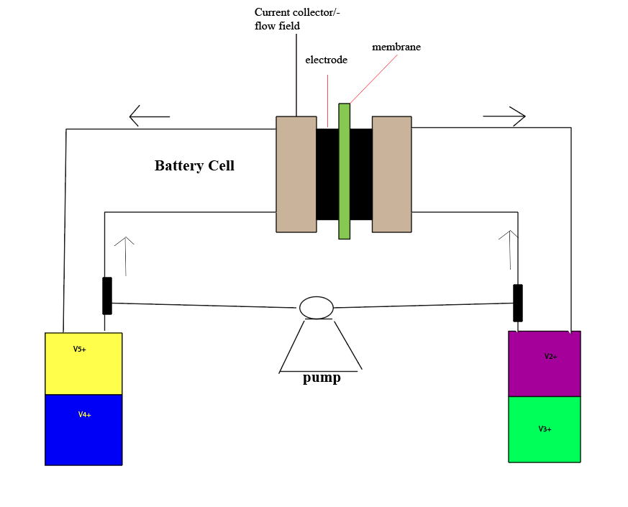

Figure 29: A sketch for general lab-scale VRFB

The most advanced cell was designed in a non-gap structure found in Mench and Zawodzinski groups^{73, 109}, and details of components were shown in Figure 29. The gasket was made with 70% thickness of the electrode to ensure good compression and avoid leakage. The copper wire coated with palladium serves as our reference electrode to isolate the performance of each electrode. It was sandwiched by two pieces of membranes. SGL carbon paper 39AA (280 um) and 29AA (180 um) were conducted in the experiment as the electrode.

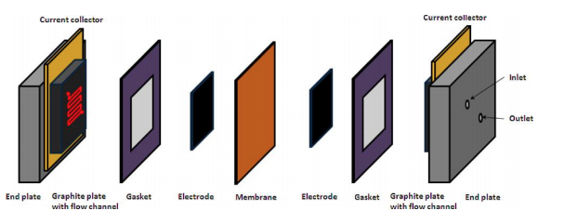
Figure 30: A schematic VRFB detailed setup (reproduced)⁷³

Developments of membrane in VRFB

To improve the performance of VRFB, several components need to be improved. Membranes, serving as a separator, plays an important role in VRFB to allow proton exchange but preventing vanadium or other ions crossover in an ideal case. The ideal membrane should have high conductivity, high ionic exchange capacity, low vanadium ions permeability, low swelling ratio, low area internal resistance, good chemical stability and low cost. To target suitable membranes in different cells, different materials and technologies were developed in recent years.
To determine whether it is a good membrane in the cell, measurements of membrane are inevitably conducted to obtain the membrane performance and properties. In a single cell with discharge and charge experiment, the coulombic efficiency (CE), voltage efficiency (VE), the energy efficiency (EE) can be determined by the equations in the literature¹¹⁰. Ionic exchange capacity can be measured by titration method¹¹¹. Standard experiments were conducted to obtain water uptake¹¹², swelling ratio¹¹², and water transport parameters¹¹³. The internal area resistance can be derived as a part of a polarization experiment while making correction with the V-I curve¹⁰⁹. The proton conductivity can be measured through experiments conducted in a home-made cell in our group¹¹⁴. Permeability and selectivity can be measured through UV-visible spectroscopy in a standard permeability test¹¹⁵. Chemical stability can be tested in several methods¹¹⁶ in a long term.
In the research study of membranes, the fabrication process plays an important role, because it does not only affect the internal structure of the membranes as well as the needed pretreatments before applying in experiments but also impacts the cost of the membranes. VRFB membranes are classified in two large groups: ionic exchange membrane (IEM) and non-ionic exchange membrane (NIEM). In the IEM, cation exchange membrane (CEM) were studied most frequently in the early time till now. Nafion membranes, the famous membrane product by Dupont¹¹⁷, contain the sulfonyl which can ionize the proton and exchange the ions in the solution. There are many preparation methods to change the physical or chemical properties of membranes, such as radiation grafting method¹¹⁸, casting method¹¹⁹, sol-gel method¹²⁰, layer-by-layer self-assembly method¹²¹.
Researchers put a lot of efforts on Nafion series membranes for VRFB over time. Many literature studies compare these membranes including N115, N117, N112, N1135, N1100^{119, 122}. Membranes thickness, the main factor, determines the performance of the cell as they are produced by the same material. The membrane with higher thickness will have higher area resistance but lower permeability. In order to balance these two factors, the N117 was measured to be found that it provides better performance among Nafion series. However, when these membranes apply to the VRFB applications in the long term at all climates, the research showed that N115 was found that it was the best because it had better chemical stability and lower crossover rate.
Although Nafion based membranes provide high chemical stability and great electrochemical properties, it still has high permeability and cost. Sulfonated poly (ether ketone) membrane (SPEEK) and sulfonated polyimide (SPI) are two other types of CEM, which are studied a lot^{123, 124}. SPEEK showed a lower permeability and higher CE, VE, EE than Nafion. SPI, a low-cost polymer, has a lower crossover issue and excellent chemical stability. Both SPEEK and SPI offer a lower permeability but lower conductivity and stability compared to Nafion. Thus, these CEM were studied to be modified to improve the performance of VRFB by adding lower swelling ratio matrix. CEM is still the most used membrane in VRFB.

Developments of electrode in VRFB
Electrodes perform a very important role in providing active sites where redox reactions take place. During any process of VRFB applications, the energy efficiency is mainly dependent on the activation and concentration polarization, which are governed by the electrode. The ideal electrodes require the following characteristics: 1. the electrode must be chemically stable in the highly acidic environment; 2. the electrode must be durable and electrochemically stable in any operative potentials; 3. the electrode must be inert, and it cannot participate in any redox reactions; 4. the electrode must have high conductivity that charge transfer is fast. To fulfill the requirements in VRFB, efforts were advanced in studying the material of electrode and surface treatments for understanding the mechanisms of the reactions and the mass transport of the electrode.
In the research of VRFB electrode, the understanding of mechanism of redox reaction is extremely important, because it not only determines the activation loss but also provides a characterized method for the electrode. There were many mechanisms hypothesized and developed in last 30 years. To best of my knowledge, the general mechanism of VO₂⁺/VO²⁺ and V³⁺/V²⁺ couples can be summarized as following: First, the vanadium ions which diffuses in the electrolyte solution is absorbed to the electrode surface. In the second step, the V ions and protons of functional groups containing nitrogen, carbon, and oxygen are undergoing ion exchange; next, oxygen and electron transfer reactions take place in the positive redox couple. In the final step, an ion exchange process takes place between V ions on the surface of electrode and protons existing in the electrolyte. Then, the produced reactants diffuse back to the bulk solution. In the following paragraph, the detailed summary of developments of VRFB reactions mechanism is completed with several important findings. It is critical to improve the redox reactions that the electrical conductivity of the electrode must be high, and the presence of abundant oxygen or nitrogen functional groups must exist on the surface of the electrode.
In the early stage, Skyllas-Kazacos investigates the kinetics of VO₂⁺/VO2⁺ couple by rotating disc voltammetry and Tafel plots at different types of graphite and carbon electrodes¹²⁵. They found that the kinetics of the VO₂⁺/VO2⁺ is limited by the number of active sites on the graphite and carbon surfaces rather than the surface area. Li et al. indicated that the carbon paper electrode with hydroxyl functional groups had a better performance on the V³⁺/V²⁺ couple reaction kinetics¹²⁶. In a later study, Wu et al. reported that the standard reaction rate constant k was determined by investigating the kinetics of redox couple reactions¹²⁷. Other efforts have been devoted to building the kinetics of the new materials or catalysts such as carbon nanofibers, carbon nanotubes, graphene oxide besides graphite felt and carbon felt electrodes. Zhang et al. offers a nitrogen doping method to modify the GO electrode to create abundant active sites¹²⁸. Moreover, although most of studies refer to the improvements of the VO₂⁺/VO2⁺ redox reaction in cathode, in recent study, Santamaria et al. investigated the importance of preventing hydrogen evolution to further enhance the reversibility of the V³⁺/V²⁺ couple¹²⁹.
In this phase, although many efforts were devoted to investigating the mechanisms of redox reactions on the surface of electrode, many researchers were mainly focused on discovering suitable materials of electrode or the surface treatment method to improve the surface oxide groups shown to provide active sites for VRFB reactions. In the early stage, the carbon cloth electrode material was first studied by Skyllas-Kazacos’s group. During the charging, mechanical degradation was observed, and the vanadium ion diffusion was limited because of low surface area. Next improvement was the study of Carbon-polymer composite electrode. This type of electrode was not suitable to be applied as electroactive material in VRFB, but it can be developed as the electrode substrate. The PAN-type carbon or graphite felt has been used most frequently up to now, because it provides large surface area, high conductivity, and offers excellent chemical and electrochemical stability. Carbon paper electrode leads to the trend that most of researchers have a great of interest in studying it in VRFB, because it has promising property such as porosity, thin thickness, low density, and low electrical resistance. Ever since a non-gap cell architecture^{73, 130} was developed by our group, which significantly improves the battery performance, the thin carbon papers are the top choices in this non-gap cell and studied a lot nowadays.

Researchers also made impressive methods to characterize the battery potential losses and stability of cycle, as known as polarization and cycling experiments.¹⁰⁹ The polarization curve indicates the performance of the battery. This method provides researchers a tool to analyze the losses in the whole process. There are three types of losses such as activation loss, Ohmic loss, and transport loss. The activation loss occurs in the beginning part of polarization in discharging process, which is governed by the mechanisms of the redox reactions and charge transfer on the surface of electrode. The Tafel plot was used as a method to analyze the kinetics in the activation polarization. The Ohmic loss is associated with contact and ionic resistances, and internal resistances. The mass transport loss is related to the reactants in electrolyte delivery to the electrode, where the limiting current reaches because of starvation of reactants on the electrode surface.
Although the polarization method provides an excellent view of performance of the cell, there is still a lack of methods which can tell the stability and durability of the battery. Cycling experiment provides this information, and it can monitor the battery working in many cycles. Cycling experiment indicates whether the battery is suffering severe crossover issue which causes the capacity decay, and whether the battery has the excellent chemical and electrochemical stability in the long-time operation. However, there is a significant gap in the analytical methods to analyze the limiting current governing the transport loss. We seek to fill the gap to allow fundamental understanding of the limiting current where reactants on the electrode surface reaches ‘starvation.’ It is extremely important, because the limiting current affects the ultimate performance of the cell.

Approach
The stopped flow experiment can be outlined in the three aspects: the battery setup, the supporting rationale theory, and the details of electrochemical tests. The battery setup offers the overview of how to design our experiment. The rationale theory provides the analytical reasons behind the measurements we have done. The details of electrochemical tests indicate the general idea of how to measure the information we need.

Battery Testing
To improve our understanding of mass transport through the electrode, we need to isolate that component. This can be achieved, in principle, by adapting the cell in Figure 3 for a ‘stopped flow’ experiment. The core design of this experiment is that we adopt two pieces of membrane, and the reference electrode was inserted in between the two membranes. To isolate the testing electrode or the working electrode in our experiment, we look forward to controlling the working potential only to characterize the testing electrode by various electrochemical techniques. The details of electrochemical techniques and general procedures will be introduced later.

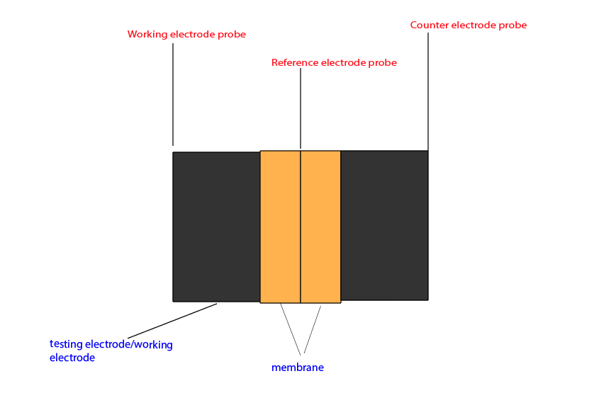
Figure 31: A schematic of the battery for a stopped flow experiment

Theory
There are many factors affecting the electrode reaction rate and current. The rate of processes governs the current or the electrode reaction. The general pathway of processes reaction taking place is shown in Figure 4. Mass transfer, electron transfer, and surface reactions control electrode reaction rate.
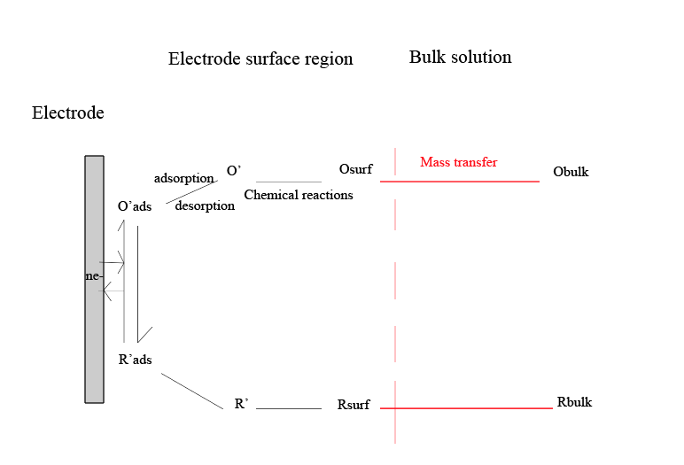
Figure 32: A general pathway of electrode electrochemical reactions.

In VRFB, the kinetics is very fast, so the electron transfer and other surface reactions can be neglected. This process is called reversible or Nernstian process. The limiting current is mainly controlled by the mass transfer in VRFB. Mass transfer includes three factors: migration (electrical gradient), diffusion (concentration gradient), convection (stir velocity).
Mass transfer to the electrode is governed by the Nernst-Plank equation, written in one-dimension as:

$$J_{i}\left(x\right)= -\frac{D_{i}∂C_{i}\left(x\right)}{∂x}-\frac{z_{i}F}{RT}D_{i}C_{i}*\frac{∂ϕ\left(x\right)}{∂x}+C_{i}v(x)$$

Where $J_{i}\left(x\right)$ is the flux of species i, D_{i} is the diffusion coefficient, $∂C_{i}\left(x\right)/∂x$ is the gradient of concentration, $z_{i} C_{i}$ represents the charge, and concentration of species i, $v(x)$ is the convection or stir velocity, F is the faraday’s constant. In this stopped flow experiment, the convection can be neglected because of the stagnant electrolyte solution. Thus, only migration and diffusion contribute to the mass transfer flux.
The diffusion can be analyzed by semiempirical treatment and it was governed by the Nernst equation. When the SOC is not 100%, the oxidant and reductant both exist. The concentrations of both depend on SOC. The equation can be written in the following:

$$E=E^{0^{'}}-\frac{RT}{nF}*ln{\frac{m_{o}}{m_{R}}+\frac{RT}{nF}*ln{\frac{i_{l},c-i}{i-i_{l},a}}}$$

Where $i_{l},c$ and $i_{l},a$ are limiting current when starvation of electrolyte on the electrode surface occurs (eg. $i_{l},a= -nFAm_{R}C_{R}^{*}$), $m_{o}, m_{R}$ are mass transport numbers for the oxide and reductant.
The migration is governed or characterized by the transference number of species ion in the electrolyte. In VRFB, the mobility of $VO_{2}^{+}, V^{2+}, V^{3+}, VO^{2+},SO_{4}^{2-},H^{+}$ can affect the migration. The transference number of vanadium ion, $t_{V}$, is related to the following equation:

$$t_{V}=\frac{u_{V}C_{V}}{ u_{V}C_{V}+u_{-}C_{-}+u_{+}C_{+} }$$

Where $u_{V}, u_{-}, u_{+}$ are the mobility of vanadium ion, sulfate ion, proton, and $C_{V}, C_{-}, C_{+}$ are the concentration of vanadium ion, sulfate ion, proton. The mobilities of ions in VRFB were reported in the paper¹³¹. A similar analysis for migration in the membrane was reported by Elgammal et al¹³². The effect of migration in the electrochemical cell is minimized by the presence of supporting electrolyte. In the VRFB, sulfuric acid is the supporting electrolyte. To minimize the migration effect, we can either increase the concentration of sulfuric acid or decrease the concentration of VOSO₄ in a specific volume of electrolyte, which can be easily analyzed by the transference equation showing above.

Details of Electrochemical Tests
All measurements were conducted in potentiostat/galvanostat SP-150. In the two steps charging process, Chronoamperometry (CA) technique was set at 1.8 V to avoid battery overcharge. Battery capacity (Q) was estimated and modified for a certain SOC in the second charging step. To start our stopped flow experiment, Open circuit voltage (OCV) and Potentiostatic Electrochemical Impedance Spectroscopy (PEIS) techniques were used in the method. The setting for the stopped flow experiment is similar to the polarization experimental.¹⁰⁹ However, the OCV and PEIS were measured while we turned off the pump and the flow was stopped. The general procedure is that we were setting PEIS -0.05 V vs. E_{ctrl} (potential observed in OCV) and then we turned on the pump and to allow flow for 5 sec to make sure the concentration back to the original state. Next, we continued to modify PEIS for different potential steps to various potentials to get observe corresponding limiting currents. As the cell was assembled as a three-electrode system, the working potential was simply controlled, and the testing electrode was isolated.

Results and Discussions

In this experiment, the electrolytes were made by mixing VOSO₄*H₂O (Alfa Aesar,), sulfuric acid, and deionized water. In this experiment, the vanadium electrolyte solution were prepared in 1M VOSO₄ and 4M H₂SO₄. Following the two-step charging protocol, two 25mL electrolytes were transported by the pipette in two different bottles which serves as positive and negative electrolytes and then charged with 1.8 V to a certain state of charge (SOC) which is ready for the following experiment. It was indicated that the battery referred to ‘fully charged’ as the current was below 20 mA. Then 25 mL electrolyte was transported into the third bottle and the charged positive electrolyte bottle was replaced by the third bottle. One more charging step was conducted to ensure the battery reaching to a certain SOC.

Below is the plot for E vs. i in 50% SOC of 1M vanadium/4M sulfuric acid stopped flow experiment as figure 4. The limiting current is approaching as we are running out of the electrolyte reactant on the electrolyte surface. As in 50% SOC, $\left[V^{5+}\right]/[V^{4+}]$ is 1:1. The symmetric shape of the plot proves limiting currents for anolyte and catholyte are the same. In the migration part, a simple calculation for $t_{v}$ was obtained as 0.04. Only 4% of the current is carried by vanadium with these assumptions.
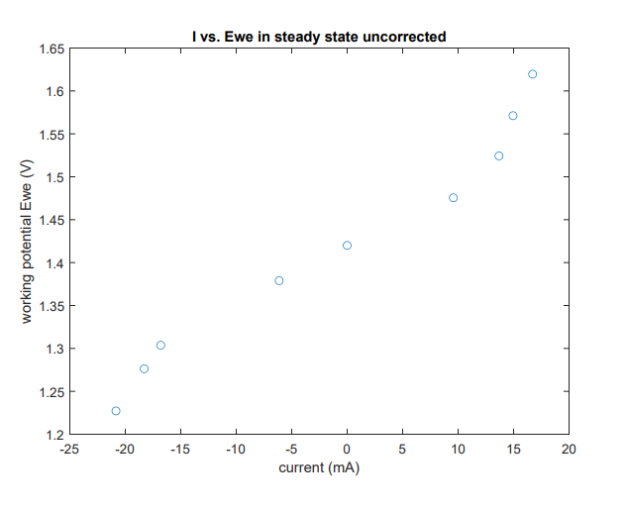
Figure 33: E vs. i in 50% SOC uncorrected stopped flow in 39AA (280um)

Other two carbon papers have the same carbon c-fibers milled from Sigracet manufacture reported size at 80-150 um length and 7 um diameter microtubes. They were tested in the same conditions with different manufactured thickness. Below is the plot of three carbon papers for 50% SOC of 1M vanadium/4M sulfuric acid stopped flow experiment as figure 5, suggesting 0.5 M of VO2- or VO2+ as the catholyte. From the plot, 39AA delivers larger residual current than 36AA and 29AA. Notably, 29AA seems experienced intrinsic issue during this potential holding experiment as observed sharp increasing slope where overpotential is less 0.15V. This possibly indicates 29AA possess limited surface area to hold enough redox electrolyte for allowing rapid current exchange during the potential step at very early stage (< 60 seconds). Figure [] represents an ‘isolated diffusion process’ polarization curve, which helps directly identifying the optimal porous electrode in semi-quantitively. We successfully designed the stopped flow to isolate the convection that contributes to the limiting current. Also based on the optimized vanadium ion to sulfuric acid ratio, we were able to minimize migration effects. However, Nernst-Plank equation has its own limitation to quantify diffusion process: 1. It is differential form; 2. Limiting current is usually challenging to obtain due to stopped flow breaks the equilibrium state that can be achieved during constant flow. Thus, we need seek other model to study interpret diffusion processes among differerent carbon papers more accurately.
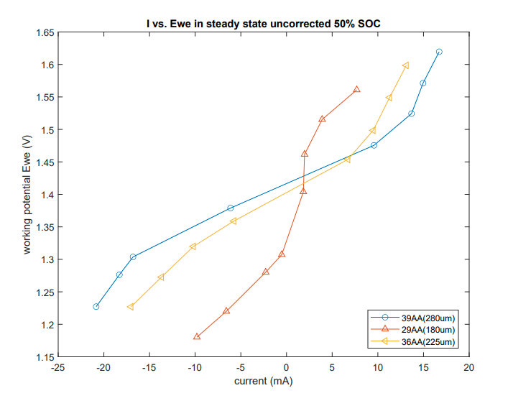
Figure 34: E vs. i in 50% SOC uncorrected stopped flow in 39AA, 36AA, 29AA.

There are many methods to characterize diffusion of electrode, usually the ultimate goal is to quantify the diffusion coefficient. Common ex-situ method, eg. NMR (nuclear magnetic resonance) spectroscopy is powerful due to its ability of deliver absolute diffusion coefficient. Determining apparent diffusion coefficient can be achieved in galvanotactic intermittent titration technique (GITT), cyclic voltammetry (CV), and EIS. However, these techniques are not our focus and have been reported.
To corroborate our stopped flow design, the most efficient analysis method for potential step is Cottrell’s equation for diffusion-controlled process.
$$i=\frac{nFAc_{j}^{0}\sqrt{D_{j}}}{\sqrt{πt}}$$
Where i is the current (A); n is number of electrons transferred during the process; F is Faraday constant, 96485 C/mol; A is the area of electrode in cm², C_{j}⁰ is the initial concentration of species; D_{j} is the diffusion coefficient for species j; t is time (s).

Due to utilizing porous electrode in VRFB, the Cottrell equation transform to eq[].
$$i=\frac{nFAc_{j}^{0}\sqrt{D_{eff}}}{\sqrt{πt}}$$
Where D_{eff} = D/τ​² (this relation can found in Yong et al’s model paper¹³³, where D is the diffusion coefficient across the fluid media, and τ​ is the tortuosity of porous media structure).

As early presented, we applied multiple potential holding in different voltage to extract the current verse time profile. To explore the diffusion coefficient of VO₂⁺ and VO²⁺ (denoted as V⁵⁺ and V⁴⁺) in the stopped flow experiment, we performed the Cottrell equation fitting on the different potential holding profiles and electrodes. Fig [] reveals potential holding for 39AA carbon paper and its corresponding current verse time profile. Before 80 seconds, we believe the sharply current drop is attributed to depletion of local V⁴⁺ species around surface of carbon paper. After 80 seconds, due to concentration gradient of V⁴⁺ forms a distance from bulk to surface of electrode, the residual current is more representative as sorely diffusion-controlled process and mass transport limited. D_{eff} (V⁴⁺) was calculated as 1.33 x 10⁻⁶ cm²/s at E = 1.51 V with R square equals to 89.8%. Similarly, overpotential for quantifying D_{eff} (V⁵⁺), we exhibited 1.93 x 10⁻⁶ cm²/s at E = 1.304 V. Notably, V⁵⁺ has a higher diffusion coefficient than V⁴⁺, which is aligned to literature reported values^{125, 134}, 2.1 x 10⁻⁶ cm²/s for V⁴⁺ and 2.8 x 10⁻⁶ cm²/s for V⁵⁺.

To improve accuracy of fitting, larger overpotential was applied for overcoming two factors: 1. allowing faster time to reach to diffusion-controlled process; 2. stepping further away from kinetics overpotential region. We noticed that 1.84 x 10⁻⁶ cm²/s for V⁴⁺ at E = 1.62V and 2.81 x 10⁻⁶ cm²/s for V⁵⁺ at E = 1.22 V as shown in Fig []. And also higher R square values in these plots were captured, suggesting data is more convincing fit into this model. These values are closer to literatures value.

Fig [] presents the 29AA potential step current versus time profiles. The model fitting is not reliable due to low R square value. However, generally, we observed that much less diffusion controlled limiting current as our fitting. And the calculated diffusion coefficient value suggests that we are at least one magnitude value of D_{eff} for vanadium ions less than 39AA carbon paper. The reason behind this is possibly due to 29AA carbon fiber structure defects. More importantly, 29AA has lower thickness that is more brittle, and will become denser after cell assembly compression. This further makes diffusion path inside of 29AA more challenging, as the tortuosity of carbon fiber electrode is linked to its porosity. Lower porosity of porous electrode can significantly alter its tortuosity.

Figure 35: A potential step at controlled voltage 1.51 V and monitoring current verses time with fitting after 80 seconds in 39AA (280um). Note that this process V⁴⁺ is electrochemically oxidized to V⁵⁺.
Figure 36: A potential step at controlled voltage 1.304 V and monitoring current verses time with fitting after 80 seconds in 39AA (280um). Note that this process V⁵⁺ is electrochemically reduced to V⁴⁺.
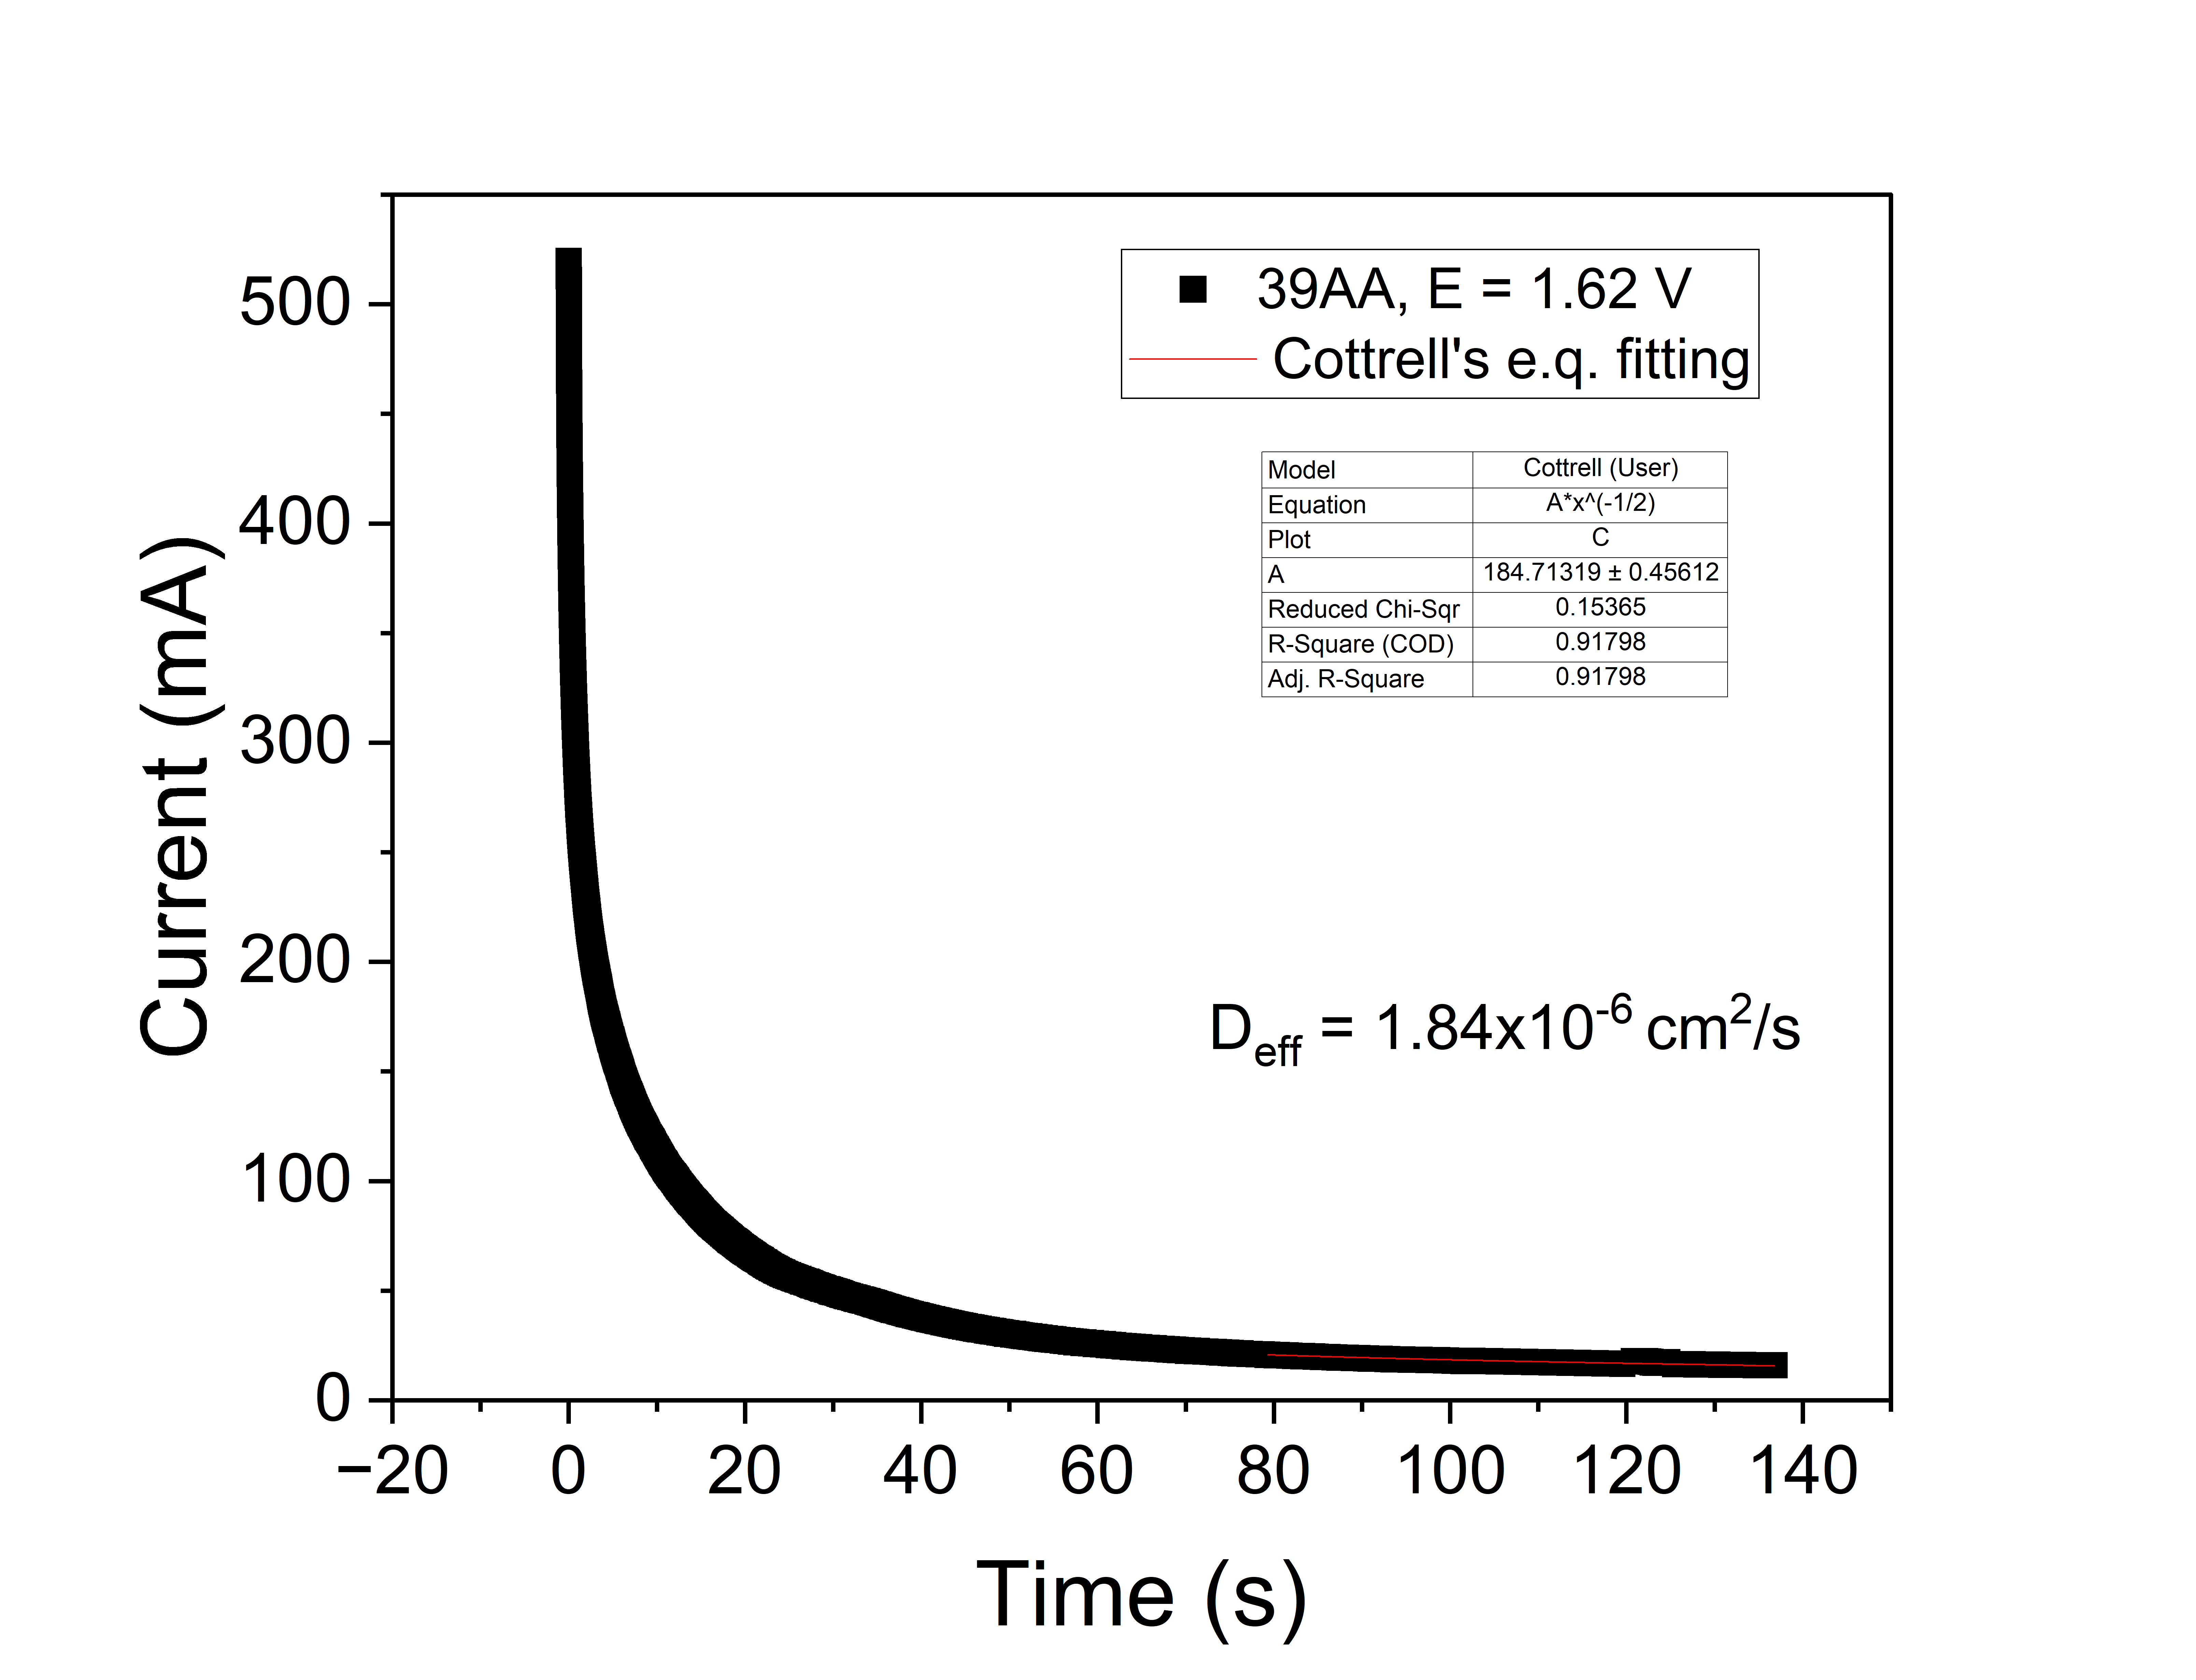
Figure 37: A potential step at controlled voltage 1.62 V and monitoring current verses time with fitting after 80 seconds in 39AA (280um). Note that this process V⁴⁺ is electrochemically oxidized to V⁵⁺. Higher overpotential allows diffusion-controlled process reaches faster, which benefits our model fitting.

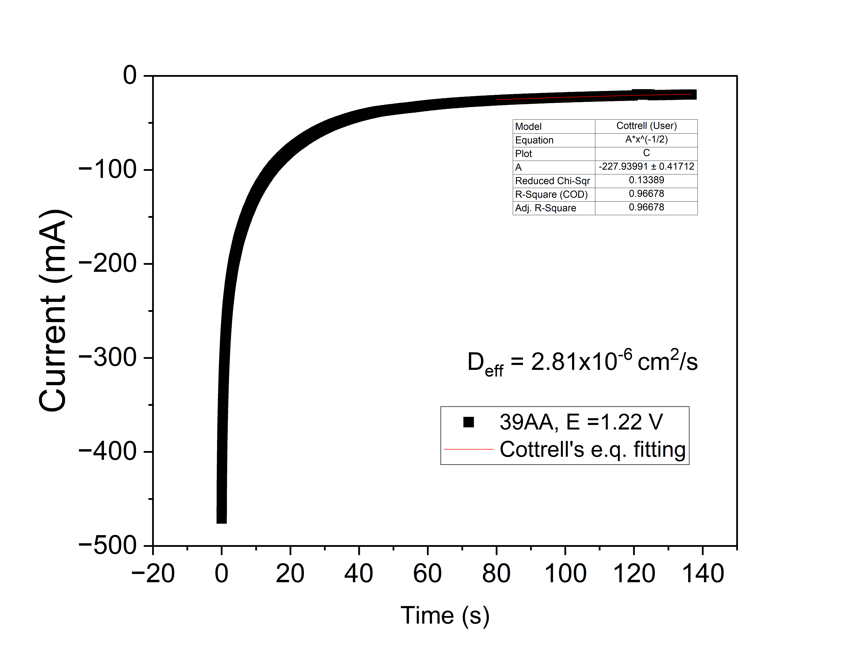
Figure 38: A potential step at controlled voltage 1.22 V and monitoring current verses time with fitting after 80 seconds in 39AA (280um). Note that this process V⁵⁺ is electrochemically reduced to V⁴⁺.

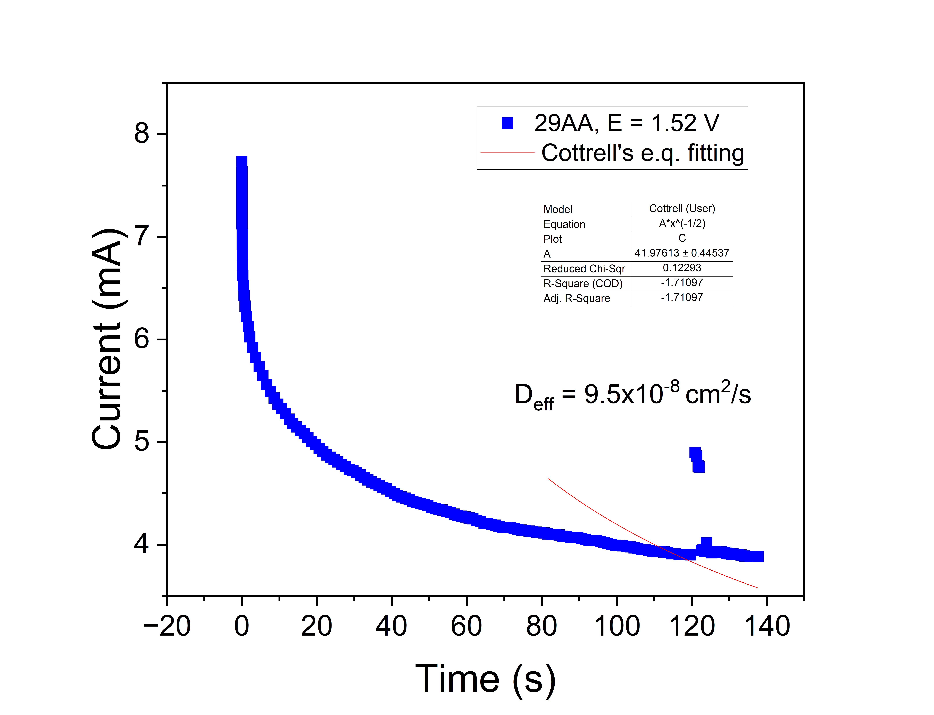
Figure 39: A potential step at controlled voltage 1.52 V and monitoring current verses time with fitting after 80 seconds in 29AA (180um). Note that this process V⁴⁺ is electrochemically oxidized to V⁵⁺.
Figure 40: A potential step at controlled voltage 1.22 V and monitoring current verses time with fitting after 80 seconds in 29AA (180um). Note that this process V⁵⁺ is electrochemically reduced to V⁴⁺.

Impact of work

The ‘stopped flow’ experiment is the general method to characterize the electrode material. It is mainly focused on diffusion controlled current where buck reactants are depleted on the electrode surface and the flux has to come from the bulk species. Porous carbon paper provides large surface area where redox reactions take place. Also, electrochemical accessible surface area is highly important during our experiment. Abundant wettability allows the carbon paper carries more electrolyte solution and reactants, which can significantly improve the performance of battery.

In future application, this method can be applied in other applications, such as organic electrosynthesis, and serve as the initial characterizing method for the electrode material. To improve the efficiency of production of the organics, efforts are devoted to study the mechanisms of various reactions on the electrode surface. The stopped flow experiment can be applied in testing the electrode if it performs well and have an electrochemical stability during electrifying synthesis.

CHAPTER 7. CONCLUSION

1. Dell, R. M.; Rand, D., Energy storage - A key technology for global energy sustainability. Journal of Power Sources 2001, 100, 2-17.
2. Chen, H.; Cong, T. N.; Yang, W.; Tan, C.; Li, Y.; Ding, Y., Progress in electrical energy storage system: A critical review. Progress in Natural Science 2009, 19 (3), 291-312.
3. Nair, N.-K. C.; Garimella, N., Battery energy storage systems: Assessment for small-scale renewable energy integration. Energy and Buildings 2010, 42 (11), 2124-2130.
4. Awan, A.; Alnour, M.; Jahanger, A.; Onwe, J. C., Do technological innovation and urbanization mitigate carbon dioxide emissions from the transport sector? Technology in society 2022, 71, 102128.
5. Chau, K. T.; Wong, Y. S.; Chan, C. C., An overview of energy sources for electric vehicles. Energy conversion and management 1999, 40 (10), 1021-1039.
6. Larminie, J.; Lowry, J., Electric vehicle technology explained. J. Wiley: Chichester, West Sussex, England ;, 2003.
7. Pesaran, A., Battery Thermal Management in EVs and HEVs: Issues and Solutions. Battery Man 2001, 43.
8. Rao, Z.; Wang, S., A review of power battery thermal energy management. Renewable and Sustainable Energy Reviews 2011, 15 (9), 4554-4571.
9. Xiaopeng, C.; Weixiang, S.; Thanh Tu, V.; Zhenwei, C.; Kapoor, A. In An overview of lithium-ion batteries for electric vehicles, 2012; IEEE: pp 230-235.
10. Amine, K.; Chen, C. H.; Liu, J.; Hammond, M.; Jansen, A.; Dees, D.; Bloom, I.; Vissers, D.; Henriksen, G., Factors responsible for impedance rise in high power lithium ion batteries. Journal of Power Sources 2001, 97-98, 684-687.
11. Thackeray, M. M.; David, W. I. F.; Bruce, P. G.; Goodenough, J. B., Lithium insertion into manganese spinels. Materials Research Bulletin 1983, 18 (4), 461-472.
12. Wang, J.; Sun, Z.; Wei, X. In Performance and characteristic research in LiFePO4 battery for electric vehicle applications, 2009 IEEE Vehicle Power and Propulsion Conference, 7-10 Sept. 2009; 2009; pp 1657-1661.
13. Omar, N.; Verbrugge, B.; Mulder, G.; Van Den Bossche, P.; Van Mierlo, J.; Daowd, M.; Dhaens, M.; Pauwels, S., Evaluation of performance characteristics of various lithium-ion batteries for use in BEV application. 2010 IEEE Vehicle Power and Propulsion Conference 2010, 1-6.
14. Steckel, T.; Kendall, A.; Ambrose, H., Applying levelized cost of storage methodology to utility-scale second-life lithium-ion battery energy storage systems. Applied energy 2021, 300, 117309.
15. Pesaran, A. A., Lithium ion batteries in electric drive vehicles. Society of Automotive Engineers: Warrendale, Pennsylvania (400 Commonwealth Dr., Wallendale PA USA), 2016.
16. Quintero-Almanza, D.; Gamiño-Arroyo, Z.; Sánchez-Cadena, L. E.; Gómez-Castro, F. I.; Uribe-Ramírez, A. R.; Aguilera-Alvarado, A. F.; Ocampo Carmona, L. M., Recovery of Cobalt from Spent Lithium-Ion Mobile Phone Batteries Using Liquid–Liquid Extraction. Batteries (Basel) 2019, 5 (2), 44.
17. Rahman, M. A.; Wang, X.; Wen, C., High Energy Density Metal-Air Batteries: A Review. Journal of the Electrochemical Society 2013, 160 (10), A1759-A1771.
18. Li, Y.; Dai, H., Recent advances in zinc-air batteries. Chemical Society reviews 2014, 43 (15), 5257-5275.
19. Zhu, A. L.; Wilkinson, D. P.; Zhang, X.; Xing, Y.; Rozhin, A. G.; Kulinich, S. A., Zinc regeneration in rechargeable zinc-air fuel cells—A review. Journal of energy storage 2016, 8, 35-50.
20. Kraytsberg, A.; Ein-Eli, Y., Review on Li–air batteries—Opportunities, limitations and perspective. Journal of Power Sources 2011, 196 (3), 886-893.
21. Rahman, M. A.; Wang, X.; Wen, C., High Energy Density Metal-Air Batteries: A Review. Journal of The Electrochemical Society 2013, 160 (10), A1759.
22. Aurbach, D.; Gofer, Y.; Lu, Z.; Schechter, A.; Chusid, O.; Gizbar, H.; Cohen, Y.; Ashkenazi, V.; Moshkovich, M.; Turgeman, R.; Levi, E., A short review on the comparison between Li battery systems and rechargeable magnesium battery technology. Journal of Power Sources 2001, 97-98, 28-32.
23. David, L.; Thomas, B. R., Handbook of batteries. United state of America, New York. McGrow-hill companies Inc 2002.
24. Li, Y.; Gong, M.; Liang, Y.; Feng, J.; Kim, J.-E.; Wang, H.; Hong, G.; Zhang, B.; Dai, H., Advanced zinc-air batteries based on high-performance hybrid electrocatalysts. Nature Communications 2013, 4 (1), 1805.
25. Sherman, S. B.; Cano, Z. P.; Fowler, M.; Chen, Z., Range-extending Zinc-air battery for electric vehicle. Aims Energy 2018, 6 (1), 121-145.
26. Fu, J.; Cano, Z. P.; Park, M. G.; Yu, A.; Fowler, M.; Chen, Z., Electrically Rechargeable Zinc–Air Batteries: Progress, Challenges, and Perspectives. Advanced materials (Weinheim) 2017, 29 (7), 1604685-n/a.
27. Liu, Q.; Pan, Z.; Wang, E.; An, L.; Sun, G., Aqueous metal-air batteries: Fundamentals and applications. Energy Storage Materials 2020, 27, 478-505.
28. Mahlendorf, F.; Heinzel, A.; Mueller, C.; Fuchs, D., Chapter 6 - Secondary zinc-air batteries – mechanically rechargeable. In Electrochemical Power Sources: Fundamentals, Systems, and Applications, Arai, H.; Garche, J.; Colmenares, L., Eds. Elsevier: 2021; pp 99-123.
29. Cooper, J. F.; Fleming, D.; Keene, L.; Maimoni, A.; Peterman, K.; Koopman, R. In Demonstration of zinc/air fuel battery to enhance the range and mission of fleet electric vehicles: Preliminary results in the refueling of a multicell module, Presented at the 29th Intersociety Energy Conversion Engineering Conference, August 01, 1994; 1994; pp 7-12.
30. Foller, P. C., Improved slurry zinc/air systems as batteries for urban vehicle propulsion. Journal of Applied Electrochemistry 1986, 16 (4), 527-543.
31. Goldstein, J.; Brown, I.; Koretz, B., New developments in the Electric Fuel Ltd. zinc/air system. Journal of Power Sources 1999, 80 (1), 171-179.
32. Sapkota, P.; Kim, H., Zinc–air fuel cell, a potential candidate for alternative energy. Journal of Industrial and Engineering Chemistry 2009, 15 (4), 445-450.
33. Appleby, A. J.; Jacquier, M., The C.G.E. circulating zinc/air battery - A practical vehicle power source. Journal of Power Sources 1976, 1, 17-34.
34. Smedley, S. I.; Zhang, X. G., A regenerative zinc-air fuel cell. Journal of Power Sources 2007, 165, 897-904.
35. Cherepy, N. J.; Kruegar, R.; Cooper, J. F. In A zinc/air fuel cell for electric vehicles, 1999; IEEE: pp 11-13.
36. Baba, H., A new zinc-air fuel battery system. SAE technical paper series 1971.
37. Zinc8 technology. https://www.zinc8energy.com/technology.
38. Zhu, Y. G.; Narayanan, T. M.; Tulodziecki, M.; Sanchez-Casalongue, H.; Horn, Q. C.; Meda, L.; Yu, Y.; Sun, J.; Regier, T.; McKinley, G. H., High-energy and high-power Zn–Ni flow batteries with semi-solid electrodes. Sustainable Energy & Fuels 2020, 4 (8), 4076-4085.
39. Petek, T. J.; Hoyt, N. C.; Savinell, R. F.; Wainright, J. S., Slurry electrodes for iron plating in an all-iron flow battery. Journal of Power Sources 2015, 294, 620-626.
40. Choi, N. H.; del Olmo, D.; Milian, D.; El Kissi, N.; Fischer, P.; Pinkwart, K.; Tübke, J., Use of carbon additives towards rechargeable zinc slurry air flow batteries. Energies (Basel) 2020, 13 (17), 4482.
41. Fenton, A. M., Jr.; Ashraf Gandomi, Y.; Mallia, C. T.; Neyhouse, B. J.; Kpeglo, M. A.; Exson, W. E.; Wan, C. T.-C.; Brushett, F. R., Toward a Mechanically Rechargeable Solid Fuel Flow Battery Based on Earth-Abundant Materials. ACS Omega 2022, 7 (44), 40540-40547.
42. Zhu, Y. G.; Narayanan, T. M.; Tulodziecki, M.; Sanchez-Casalongue, H.; Horn, Q. C.; Meda, L.; Yu, Y.; Sun, J.; Regier, T.; McKinley, G. H.; Shao-Horn, Y., High-energy and high-power Zn–Ni flow batteries with semi-solid electrodes. Sustainable Energy & Fuels 2020, 4 (8), 4076-4085.
43. Perez-Antolin, D.; Schuhmann, W.; Palma, J.; Ventosa, E., Semi-flowable Zn semi-solid electrodes as renewable energy carrier for refillable Zn–Air batteries. Journal of Power Sources 2022, 536, 231480.
44. Müller, S.; Holzer, F.; Haas, O., Optimized zinc electrode for the rechargeable zinc–air battery. Journal of Applied Electrochemistry 1998, 28 (9), 895-898.
45. Haas, O.; Holzer, F.; Müller, K.; Müller, S., Metal/air batteries: the zinc/air case. Handbook of Fuel Cells 2010.
46. Choi, K. W.; Hamby, D.; Bennion, D. N.; Newman, J., Engineering analysis of shape change in zinc secondary electrodes: II. Experimental. Journal of the Electrochemical Society 1976, 123 (11), 1628.
47. Faegh, E.; Omasta, T.; Hull, M.; Ferrin, S.; Shrestha, S.; Lechman, J.; Bolintineanu, D.; Zuraw, M.; Mustain, W. E., Understanding the Dynamics of Primary Zn-MnO2 Alkaline Battery Gassing with Operando Visualization and Pressure Cells. Journal of The Electrochemical Society 2018, 165 (11), A2528.
48. Lee, S.-M.; Kim, Y.-J.; Eom, S.-W.; Choi, N.-S.; Kim, K.-W.; Cho, S.-B., Improvement in self-discharge of Zn anode by applying surface modification for Zn–air batteries with high energy density. Journal of Power Sources 2013, 227, 177-184.
49. Burchardt, T., Zinc electrode comprising an organic gelling agent and an organic binder. Google Patents: 2006.
50. Phillips, J.; Mohanta, S.; Maske, C.; Bose, D. C.; Wu, J. J.; McKinney, B. L., Pasted zinc electrode for rechargeable nickel-zinc batteries. Google Patents: 2013.
51. Burchardt, T.; Ngamga, R. F., Agglomerated zinc powder anode. Google Patents: 2011.
52. Malone, E.; Berry, M.; Lipson, H., Freeform fabrication and characterization of Zn‐air batteries. Rapid Prototyping Journal 2008, 14 (3), 128-140.
53. Choi, N. H.; Del Olmo, D.; Fischer, P.; Pinkwart, K.; Tübke, J., Development of flow fields for zinc slurry air flow batteries. Batteries (Basel) 2020, 6 (1), 15.
54. Milian, D.; Choi, N. H.; Tsehaye, M. T.; Fischer, P.; Tübke, J.; Iojoiu, C.; Roux, D. C. D.; El Kissi, N., Formulation and characterization of zinc slurries for zinc slurry – Air redox flow battery: A rheological approach. Journal of power sources 2023, 555, 232331.
55. Mainar, A. R.; Colmenares, L. C.; Blázquez, J. A.; Urdampilleta, I., A brief overview of secondary zinc anode development: The key of improving zinc‐based energy storage systems. International journal of energy research 2018, 42 (3), 903-918.
56. Mao, Z.; White, R. E., Mathematical modeling of a primary zinc/air battery. Journal of the Electrochemical Society 1992, 139 (4), 1105-1114.
57. Faegh, E.; Omasta, T.; Hull, M.; Ferrin, S.; Shrestha, S.; Lechman, J.; Bolintineanu, D.; Zuraw, M.; Mustain, W. E., Understanding the Dynamics of Primary Zn-MnO2 Alkaline Battery Gassing with Operando Visualization and Pressure Cells. Journal of the Electrochemical Society 2018, 165 (11), A2528-A2535.
58. Suthar, B.; Northrop, P. W. C.; Rife, D.; Subramanian, V. R., Effect of Porosity, Thickness and Tortuosity on Capacity Fade of Anode. Journal of The Electrochemical Society 2015, 162 (9), A1708.
59. Hoyt, N. C.; Agar, E.; Nagelli, E. A.; Savinell, R.; Wainright, J., Electrochemical impedance spectroscopy of flowing electrosorptive slurry electrodes. Journal of the electrochemical society 2018, 165 (10), E439.
60. Hoyt, N. C.; Wainright, J. S.; Savinell, R. F., Mathematical modeling of electrochemical flow capacitors. Journal of The Electrochemical Society 2015, 162 (4), A652.
61. Hoyt, N. C.; Savinell, R. F.; Wainright, J. S., Modeling of flowable slurry electrodes with combined faradaic and nonfaradaic currents. Chemical Engineering Science 2016, 144, 288-297.
62. Petek, T. J.; Hoyt, N. C.; Savinell, R. F.; Wainright, J. S., Characterizing Slurry Electrodes Using Electrochemical Impedance Spectroscopy. Journal of the Electrochemical Society 2016, 163 (1), A5001-A5009.
63. Bockelmann, M.; Becker, M.; Reining, L.; Kunz, U.; Turek, T., Passivation of zinc anodes in alkaline electrolyte: Part i. determination of the starting point of passive film formation. Journal of The Electrochemical Society 2018, 165 (13), A3048.
64. Bockelmann, M.; Reining, L.; Kunz, U.; Turek, T., Electrochemical characterization and mathematical modeling of zinc passivation in alkaline solutions: A review. Electrochimica Acta 2017, 237, 276-298.
65. Liu, M. B.; Cook, G. M.; Yao, N. P., Passivation of Zinc Anodes in KOH Electrolytes. Journal of The Electrochemical Society 1981, 128 (8), 1663.
66. Powers, R.; Breiter, M., The anodic dissolution and passivation of zinc in concentrated potassium hydroxide solutions. Journal of the Electrochemical Society 1969, 116 (6), 719.
67. Farmer, E.; Webb, A., Zinc passivation and the effect of mass transfer in flowing electrolyte. Journal of Applied Electrochemistry 1972, 2, 123-136.
68. Bockelmann, M.; Becker, M.; Reining, L.; Kunz, U.; Turek, T., Passivation of Zinc Anodes in Alkaline Electrolyte: Part I. Determination of the Starting Point of Passive Film Formation. Journal of the Electrochemical Society 2018, 165 (13), A3048-A3055.
69. Zhang, X. G., Corrosion and Electrochemistry of Zinc. Springer US: Boston, MA, 1996.
70. Fordyce, J. S.; Baum, R. L., Vibrational spectra of solutions of zinc oxide in potassium hydroxide. The Journal of Chemical Physics 1965, 43 (3), 843-846.
71. Pessine, E. J.; Agostinho, S. M.; Chagas, H. C., Evaluation of the diffusion coefficient of the zincate ion using a rotating disk electrode. Canadian journal of chemistry 1986, 64 (3), 523-527.
72. Yadav, G. G.; Wei, X.; Meeus, M., Chapter 3 - Primary zinc-air batteries. In Electrochemical Power Sources: Fundamentals, Systems, and Applications, Arai, H.; Garche, J.; Colmenares, L., Eds. Elsevier: 2021; pp 23-45.
73. Aaron, D. S.; Liu, Q.; Tang, Z.; Grim, G. M.; Papandrew, A. B.; Turhan, A.; Zawodzinski, T. A.; Mench, M. M., Dramatic performance gains in vanadium redox flow batteries through modified cell architecture. Journal of power sources 2012, 206, 450-453.
74. IEA, Global EV Data Explorer. 2023.
75. Henze, V., Energy Storage Investments Boom As Battery Costs Halve in the Next Decade. 2019.
76. Lourenssen, K.; Williams, J.; Ahmadpour, F.; Clemmer, R.; Tasnim, S., Vanadium redox flow batteries: A comprehensive review. Journal of Energy Storage 2019, 25.
77. Leung, P.; Shah, A. A.; Sanz, L.; Flox, C.; Morante, J. R.; Xu, Q.; Mohamed, M. R.; de León, C. P.; Walsh, F. C., Recent developments in organic redox flow batteries: A critical review. Journal of Power Sources 2017, 360, 243-283.
78. Mainar, A. R.; Iruin, E.; Colmenares, L. C.; Kvasha, A.; de Meatza, I.; Bengoechea, M.; Leonet, O.; Boyano, I.; Zhang, Z. C.; Blazquez, J. A., An overview of progress in electrolytes for secondary zinc-air batteries and other storage systems based on zinc. Journal of Energy Storage 2018, 15, 304-328.
79. Fu, J.; Cano, Z. P.; Park, M. G.; Yu, A.; Fowler, M.; Chen, Z., Electrically Rechargeable Zinc–Air Batteries: Progress, Challenges, and Perspectives. Advanced Materials 2017, 29 (7), 1604685.
80. Duduta, M.; Ho, B.; Wood, V. C.; Limthongkul, P.; Brunini, V. E.; Carter, W. C.; Chiang, Y.-M., Semi-Solid Lithium Rechargeable Flow Battery. Advanced energy materials 2011, 1 (4), 511-516.
81. Aaron, D.; Liu, Q.; Tang, Z.; Grim, G.; Papandrew, A. B.; Turhan, A.; Zawodzinski, T. A.; Mench, M. M., Dramatic performance gains in vanadium redox flow batteries through modified cell architecture. Journal of Power Sources 2012, 206, 450–453.
82. Davis, R. E.; Horvath, G. L.; Tobias, C. W., The solubility and diffusion coefficient of oxygen in potassium hydroxide solutions. Electrochimica Acta 1967, 12 (3), 287-297.
83. Gilliam, R. J.; Graydon, J. W.; Kirk, D. W.; Thorpe, S. J., A review of specific conductivities of potassium hydroxide solutions for various concentrations and temperatures. International Journal of Hydrogen Energy 2007, 32 (3), 359-364.
84. Truong, V. M.; Duong, N. B.; Wang, C. L.; Yang, H., Effects of Cell Temperature and Reactant Humidification on Anion Exchange Membrane Fuel Cells. Materials (Basel) 2019, 12 (13).
85. Wang, J.; Wang, B.; Tongsh, C.; Miao, T.; Cheng, P.; Wang, Z.; Du, Q.; Jiao, K., Combining proton and anion exchange membrane fuel cells for enhancing the overall performance and self-humidification. Chemical Engineering Journal 2022, 428, 131969.
86. Zhang, C.; Chou, S.; Guo, Z.; Dou, S.-X., Beyond Lithium-Ion Batteries. Advanced Functional Materials 2024, 34 (5), 2308001.
87. Trahey, L.; Brushett, F. R.; Balsara, N. P.; Ceder, G.; Cheng, L.; Chiang, Y. M.; Hahn, N. T.; Ingram, B. J.; Minteer, S. D.; Moore, J. S.; Mueller, K. T.; Nazar, L. F.; Persson, K. A.; Siegel, D. J.; Xu, K.; Zavadil, K. R.; Srinivasan, V.; Crabtree, G. W., Energy storage emerging: A perspective from the Joint Center for Energy Storage Research. Proc Natl Acad Sci U S A 2020, 117 (23), 12550-12557.
88. Tsehaye, M. T.; Choi, N. H.; Fischer, P.; Tübke, J.; Planes, E.; Alloin, F.; Iojoiu, C., Anion Exchange Membranes Incorporating Multi N‑Spirocyclic Quaternary Ammonium Cations via Ultraviolet-Initiated Polymerization for Zinc Slurry-Air Flow Batteries. ACS applied energy materials 2022, 5 (6), 7069-7080.
89. Sanyal, J.; Goldin, G. M.; Zhu, H.; Kee, R. J., A particle-based model for predicting the effective conductivities of composite electrodes. Journal of Power Sources 2010, 195 (19), 6671-6679.
90. Tsehaye, M. T.; Gebreslassie, G. T.; Choi, N. H.; Milian, D.; Martin, V.; Fischer, P.; Tübke, J.; Kissi, N. E.; Donten, M. L.; Alloin, F.; Iojoiu, C., Pristine and modified porous membranes for zinc slurry–air flow battery. Molecules (Basel, Switzerland) 2021, 26 (13), 4062.
91. Allebrod, F.; Chatzichristodoulou, C.; Mollerup, P. L.; Mogensen, M. B., Electrical conductivity measurements of aqueous and immobilized potassium hydroxide. International Journal of Hydrogen Energy 2012, 37 (21), 16505-16514.
92. Su, P.; Zhang, H.; Yang, L.; Xing, C.; Pan, S.; Lu, W.; Zhang, S., Effects of conductive additives on the percolation networks and rheological properties of LiMn0.7Fe0.3PO4 suspensions for lithium slurry battery. Chemical Engineering Journal 2022, 433, 133203.
93. Davari, E.; Ivey, D. G., Bifunctional electrocatalysts for Zn–air batteries. Sustainable Energy & Fuels 2018, 2 (1), 39-67.
94. Subramaniam, T.; Idris, M. B.; K.S, S.; K.S, R.; S, D., Mitigating hydrogen evolution reaction and corrosion of zinc in electrically rechargeable zinc-air batteries using nanofluid electrolytes. Journal of Energy Storage 2024, 81, 110457.
95. Park, D.-J.; Aremu, E. O.; Ryu, K.-S., Bismuth oxide as an excellent anode additive for inhibiting dendrite formation in zinc-air secondary batteries. Applied Surface Science 2018, 456, 507-514.
96. Zeng, D.; Yang, Z.; Wang, S.; Ni, X.; Ai, D.; Zhang, Q., Preparation and electrochemical performance of In-doped ZnO as anode material for Ni–Zn secondary cells. Electrochimica Acta 2011, 56 (11), 4075-4080.
97. Hosseini, S.; Abbasi, A.; Uginet, L.-O.; Haustraete, N.; Praserthdam, S.; Yonezawa, T.; Kheawhom, S., The Influence of Dimethyl Sulfoxide as Electrolyte Additive on Anodic Dissolution of Alkaline Zinc-Air Flow Battery. Scientific reports 2019, 9 (1), 14958-12.
98. Hosseini, S.; Han, S. J.; Arponwichanop, A.; Yonezawa, T.; Kheawhom, S., Ethanol as an electrolyte additive for alkaline zinc-air flow batteries. Scientific reports 2018, 8 (1), 11273-11.
99. Hosseini, S.; Lao-atiman, W.; Han, S. J.; Arpornwichanop, A.; Yonezawa, T.; Kheawhom, S., Discharge Performance of Zinc-Air Flow Batteries Under the Effects of Sodium Dodecyl Sulfate and Pluronic F-127. Scientific reports 2018, 8 (1), 14909-13.
100. Dunn, B.; Kamath, H.; Tarascon, J.-M., Electrical Energy Storage for the Grid: A Battery of Choices. Science (New York, N.Y.) 2011, 334, 928-35.
101. Sum, E.; Skyllas-Kazacos, M., A study of the V(II)/V(III) redox couple for redox flow cell applications. Journal of power sources 1985, 15 (2-3), 179-190.
102. Skyllas-Kazacos, M., New All-Vanadium Redox Flow Cell. Journal of the Electrochemical Society 1986, 133 (5), 1057-1058.
103. Rychcik, M.; Skyllas-Kazacos, M., Characteristics of a new all-vanadium redox flow battery. Journal of power sources 1988, 22 (1), 59-67.
104. Fabjan, C.; Garche, J.; Harrer, B.; Jörissen, L.; Kolbeck, C.; Philippi, F.; Tomazic, G.; Wagner, F., The vanadium redox-battery: an efficient storage unit for photovoltaic systems. Electrochimica acta 2001, 47 (5), 825-831.
105. You, X.; Ye, Q.; Cheng, P., Scale-up of high power density redox flow batteries by introducing interdigitated flow fields. International Communications in Heat and Mass Transfer 2016, 75.
106. Guarnieri, M.; Trovò, A.; D'Anzi, A.; Alotto, P., Developing vanadium redox flow technology on a 9-kW 26-kWh industrial scale test facility: Design review and early experiments. Applied Energy 2018, 230, 1425-1434.
107. Trovò, A., Battery management system for industrial-scale vanadium redox flow batteries: Features and operation. Journal of Power Sources 2020, 465, 228229.
108. “It’s Big and Long-Lived, and It Won’t Catch Fire: The Vanadium Redox-⁠Flow Battery".
109. Aaron, D.; Tang, Z.; Papandrew, A. B.; Zawodzinski, T. A., Polarization curve analysis of all-vanadium redox flow batteries. Journal of Applied Electrochemistry 2011, 41 (10), 1175-1182.
110. Wei, Z.; Zhao, J.; Xiong, B., Dynamic electro-thermal modeling of all-vanadium redox flow battery with forced cooling strategies. Applied Energy 2014, 135, 1-10.
111. He, S. S.; Frank, C. W., Facilitating hydroxide transport in anion exchange membranes via hydrophilic grafts. Journal of Materials Chemistry A 2014, 2 (39), 16489-16497.
112. Li, Z.; Dai, W.; Yu, L.; Liu, L.; Xi, J.; Qiu, X.; Chen, L., Properties Investigation of Sulfonated Poly(ether ether ketone)/Polyacrylonitrile Acid–Base Blend Membrane for Vanadium Redox Flow Battery Application. ACS Applied Materials & Interfaces 2014, 6 (21), 18885-18893.
113. Zawodzinski, T. A.; Derouin, C.; Radzinski, S.; Sherman, R. J.; Smith, V. T.; Springer, T. E.; Gottesfeld, S., Water Uptake by and Transport Through Nafion® 117 Membranes. Journal of The Electrochemical Society 1993, 140 (4), 1041-1047.
114. Tang, Z.; Svoboda, R.; Lawton, J.; Aaron, D.; Papandrew, A.; Zawodzinski, T., Composition and Conductivity of Membranes Equilibrated with Solutions of Sulfuric Acid and Vanadyl Sulfate. Journal of the Electrochemical Society 2013, 160, F1040-F1047.
115. Tang, Z.; Lawton, J. S.; Sun, C.-N.; Chen, J.; Bright, M. I.; Jones, A. M.; Papandrew, A. B.; Fujimoto, C. H.; Zawodzinski, T. A., Characterization of Sulfonated Diels-Alder Poly(phenylene) Membranes for Electrolyte Separators in Vanadium Redox Flow Batteries. Journal of the Electrochemical Society 2014, 161 (12), A1860-A1868.
116. Park, Y.; Kim, D., Chemical stability enhancement of Nafion membrane by impregnation of a novel organic ·OH radical scavenger, 3,4-dihydroxy-cinnamic acid. Journal of Membrane Science 2018, 566, 1-7.
117. Schwenzer, B.; Zhang, J.; Kim, S.; Li, L.; Liu, J.; Yang, Z., Membrane Development for Vanadium Redox Flow Batteries. ChemSusChem 2011, 4 (10), 1388-1406.
118. Gaylord, N. G.; Adler, G., Radiation chemistry of polymeric systems high polymers, A. Chapiro, ed., interscience, New York, 1962, xvi + 712 pp. $21.00. Journal of Polymer Science Part A: General Papers 1963, 1 (6), 2237-2237.
119. Xing, D.; Zhang, S.; Yin, C.; Zhang, B.; Jian, X., Effect of amination agent on the properties of quaternized poly(phthalazinone ether sulfone) anion exchange membrane for vanadium redox flow battery application. Journal of Membrane Science 2010, 354 (1), 68-73.
120. Roth, W.-M.; Tobin, K.; Ritchie, S., Chapter 1: Introduction. Counterpoints 2001, 177, 1-14.
121. Zhang, X.; Chen, H.; Zhang, H., Layer-by-layer assembly: from conventional to unconventional methods. Chemical Communications 2007, (14), 1395-1405.
122. Jiang, B.; Wu, L.; Yu, L.; Qiu, X.; Xi, J., A comparative study of Nafion series membranes for vanadium redox flow batteries. Journal of Membrane Science 2016, 510, 18-26.
123. Pu, Y.; Huang, X.; Yang, P.; Zhou, Y.; Xuan, S.; Zhang, Y., Effect of non-sulfonated diamine monomer on branched sulfonated polyimide membrane for vanadium redox flow battery application. Electrochimica Acta 2017, 241, 50-62.
124. Winardi, S.; Raghu, S. C.; Oo, M. O.; Yan, Q.; Wai, N.; Lim, T. M.; Skyllas-Kazacos, M., Sulfonated poly (ether ether ketone)-based proton exchange membranes for vanadium redox battery applications. Journal of Membrane Science 2014, 450, 313-322.
125. Zhong, S.; Skyllas-Kazacos, M., Electrochemical behaviour of vanadium(V)/vanadium(IV) redox couple at graphite electrodes. Journal of Power Sources 1992, 39 (1), 1-9.
126. Yue, L.; Li, W.; Sun, F.; Zhao, L.; Xing, L., Highly hydroxylated carbon fibres as electrode materials of all-vanadium redox flow battery. Carbon 2010, 48 (11), 3079-3090.
127. Wu, X. W.; Yamamura, T.; Ohta, S.; Zhang, Q. X.; Lv, F. C.; Liu, C. M.; Shirasaki, K.; Satoh, I.; Shikama, T.; Lu, D.; Liu, S. Q., Acceleration of the redox kinetics of VO2+/VO2+ and V3+/V2+ couples on carbon paper. Journal of Applied Electrochemistry 2011, 41 (10), 1183.
128. Fu, S.; Zhu, C.; Song, J.; Engelhard, M. H.; Du, D.; Lin, Y., Three-dimensional Nitrogen-Doped Reduced Graphene Oxide/Carbon Nanotube Composite Catalysts for Vanadium Flow Batteries. Electroanalysis 2017, 29 (5), 1469-1473.
129. Suárez, D. J.; González, Z.; Blanco, C.; Granda, M.; Menéndez, R.; Santamaría, R., Graphite Felt Modified with Bismuth Nanoparticles as Negative Electrode in a Vanadium Redox Flow Battery. ChemSusChem 2014, 7 (3), 914-918.
130. Liu, Q. H.; Grim, G. M.; Papandrew, A. B.; Turhan, A.; Zawodzinski, T. A.; Mench, M. M., High Performance Vanadium Redox Flow Batteries with Optimized Electrode Configuration and Membrane Selection. Journal of The Electrochemical Society 2012, 159 (8), A1246-A1252.
131. Zhou, X. L.; Zhao, T. S.; An, L.; Zeng, Y. K.; Yan, X. H., A vanadium redox flow battery model incorporating the effect of ion concentrations on ion mobility. Applied Energy 2015, 158, 157-166.
132. Elgammal, R. A.; Tang, Z.; Sun, C.-N.; Lawton, J.; Zawodzinski, T. A., Species Uptake and Mass Transport in Membranes for Vanadium Redox Flow Batteries. Electrochimica Acta 2017, 237, 1-11.
133. Yong, Y.; Lou, X.; Li, S.; Yang, C.; Yin, X., Direct simulation of the influence of the pore structure on the diffusion process in porous media. Computers & Mathematics with Applications 2014, 67 (2), 412-423.
134. Yamamura, T.; Watanabe, N.; Yano, T.; Shiokawa, Y., Electron-Transfer Kinetics of Np3 + ∕ Np4 + , NpO2 + ∕ NpO2 2 + , V2 + ∕ V3 + , and VO2 + ∕ VO2 + at Carbon Electrodes. Journal of The Electrochemical Society 2005, 152 (4), A830.

VITA

