Living on the River: On the Occupational Intensity of Cherokee Farm in the Woodland Period
By: Jackson Long

A Chancellor’s Honors Capstone Project
Advisor: Dr. Kandace Hollenbach

Introduction:
The Woodland Period in North American archaeology represents a period lasting from around 1200 BC to 1000 AD (Anderson and Mainfort 2002). This period can be further divided into Early, Middle, and Late Woodland periods, each of which can be characterized by different trends. These three periods were, respectively, periods which were characterized by “…the first widespread use of pottery across the Southeast, the rise and then decline of a vast panregional ceremonially based interaction network, and, finally, a period of political fragmentation, increasing agricultural intensification, and population growth in many areas” (Anderson and Mainfort 2002: 1).
The site of Cherokee Farm was inhabited by Woodland groups, and it is within this context that I have researched and analyzed the occupational intensity of the site. Even with limited information, we can understand how heavily utilized a landscape was analyzing what was left behind. By analyzing lithic artifact assemblages and the density of fire-cracked rock fragments, I will attempt to contribute to the overall understanding of how Woodland peoples lived in the site now known as Cherokee Farm.

Background:
The Woodland Period
During the Woodland Period, cultural developments in Southeastern societies continued to split from one another, resulting in regional differentiation. In this environment of regionalism, cultural differences led to “partially autonomous communities and distinct traditions across subregions of the Southeast” (Anderson and Sassaman 2012: 113). In the Little Tennessee River valley, this regionalism was displayed in scattered campsites. The pottery in this region was “…tempered with crushed quartz and with surfaces impressed with cord or fabric marks from wrapped paddles” (Chapman 2001: 63). In these settlements, it is believed that both atlatls and bows were in use for hunting, bows particularly by the Late Woodlands; atlatls and bows appear in the archaeological context as lithic artifacts, namely projectile points. In the Middle Woodland, the use of local chert expanded, and we begin to see the emergence of lithic blades. Flint knappers created these artifacts intentionally; blades are representative of the Hopewell culture, which had expanded throughout the eastern North America region in the Middle Woodland (Chapman 2001).
In archaeological work concerning the Woodland period (c.a. 1200 BC – 1000 AD) in the Southeast, three different settlement types are assumed to exist and be reflected in the archaeological record. The first group can be called Base Camps, which reflected a wide range of activities and a pattern of habitation. Logistical Camps, the second group, are smaller, more temporary settlements generally devoted to a limited number of activities. The final group, Activity Loci, are devoted to specific activities, and they have specific artifact assemblages related to their main purpose (Davis 1990). The differences between these settlement patterns can points towards how Woodland groups changed their uses of the landscape.
The adoption of pottery, the emergence of broad cultural movements, and the eventual move towards more sedentary, agricultural lifestyles are all representative of the Woodland Period in the southeastern United States. The Early Woodland, Middle Woodland, and Late Woodland periods contributed to widespread social change in the Southeast, and it is within this time that the midden at Cherokee Farm was likely created.
Cherokee Farm
The site of Cherokee Farm is located in Knox County, Tennessee, and is located within a bend of the Tennessee River (Angst et al. 2007). This part of the river is constricted in the south by the Cherokee Bluffs and the Chapman Ridge. The site is made up of a series of alluvial terraces and upland land surfaces and was also the location of the University of Tennessee-Knoxville Experiment Station, also known as the Cherokee Campus. Between 2005 and 2006, a Phase I survey of the site was conducted as a prerequisite to a redevelopment of the farm on the land for the UT Research Park (Angst et al. 2007).
During this survey, a background review was performed, focusing mainly on the sites 40KN45 and 40KN113. These previous surveys had yielded evidence of an early 19th century cellar at 40KN113, and revealed significant evidence of occupation at 40KN45, making both sites eligible for the National Register of Historic Places. The findings in 40KN45 included a Woodland midden, potential Archaic deposits, a Middle Mississippian Hiwassee Island phase occupation, and a Late Mississippian Dallas phase palisaded village (Angst et al. 2007). The site of 40KN45 is important for both the Phase I survey and the research outlined in this paper because it included the test units analyzed here (Angst et al. 2007).
The Phase I survey of the area employed the use of shovel testing, shoreline surveys, coring, and geophysical study. The results from 40KN45 showed an extensive collection of precontact artifacts. As stated in the report: “The prehistoric artifact assemblage is dominated by debitage, blocky shatter and fire-cracked rock (FCR)” (Angst et al. 2007: 39). Pottery sherds were also recovered, as well as a few examples of cores, bifaces, and a projectile point. The survey also produced evidence for the Woodland midden that formed the main focus of the Cherokee Farm field schools in 2019 and 2021.
Since the Phase I survey was concluded, work at the site continued through a Phase II survey from 2007 to 2012. This work was related to further building development on the land, including the UT Research Park and a greenway path. The report for these Phase II investigations has not yet been completed (Kandace Hollenbach, personal communication 2022).
In May 2019 and May 2020, archaeological field schools were held at the Cherokee Farm site. Dr Kandace Hollenbach, a paleoethnobotanist at the University of Tennessee, Knoxville, was interested in the Woodland midden that had been previously recorded on the site and sought to explore the site’s connection to agriculture. Dr Hollenbach’s research is focused on how Woodland groups in eastern Tennessee transitioned from foraging societies to more settled farmers, and so the field schools targeted the midden in order to gain a better understanding of the foodways of Woodland groups in the area. In these field schools, students from the University of Tennessee, Knoxville, earned credit for an anthropology practicum by excavating at the Cherokee Farm site.
In the 2019 field school, four units were excavated. Units 1 and 4 were excavated at riverside location, while Units 2 and 3 were further north and further inland. In the 2021 field school, these two locations were excavated further and new units were freshly excavated in new locations. Unit 5 was excavated in the inland site, along with Units 2 and 3, while Unit 6 was excavated at the riverside location, beside Units 1 and 4. Two new units were also excavated, but I analyzed no data from Unit 7 or Unit 8 in this project. The location of the site and the layout of the units is shown in Figure 1a and Figure 1b, as seen below. The separation of the two sites that we focused on prevents the drawing of any general conclusions about the site, as erosion and other factors can influence the land differently in those locations. Because of this, I will analyze the riverside site and the inland site as two separate locations.
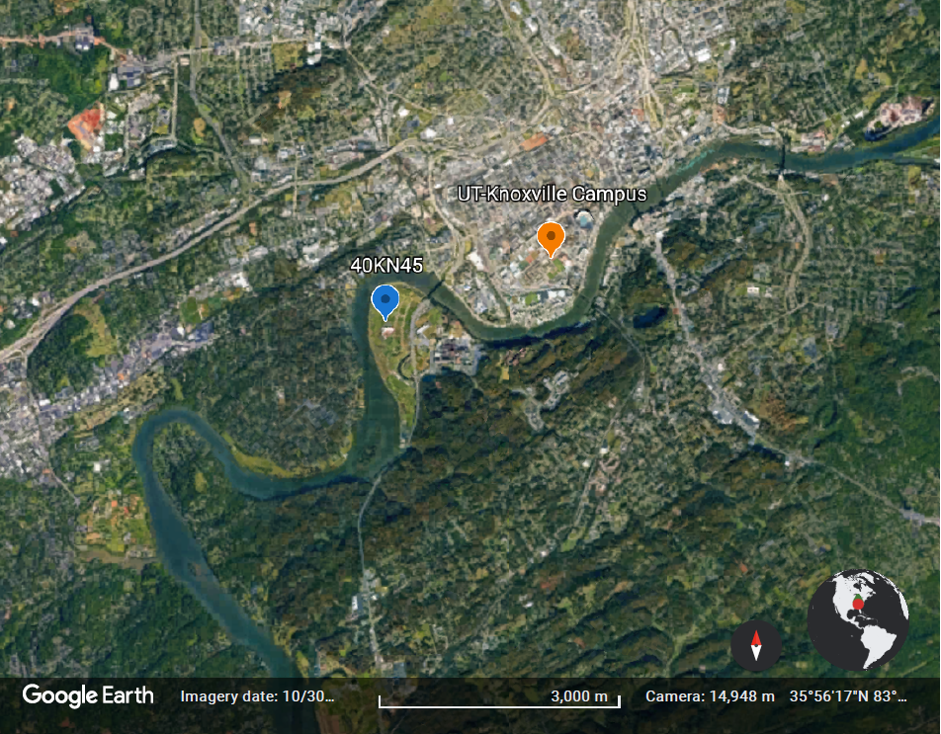
Figure 1a – Aerial view of Cherokee Farm site location

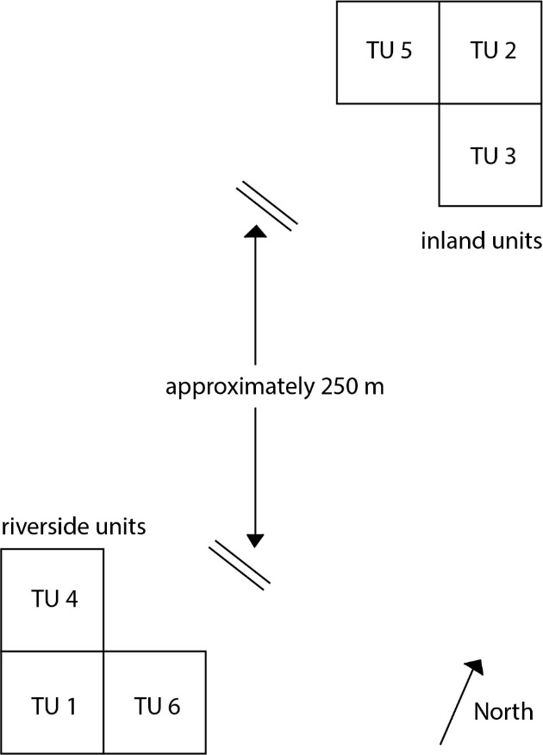

Figure 1b – Approximate mapping of Riverside and Inland sites
Questions:
The primary focus of this research project has been to gain a better understanding of the occupation intensity of the Cherokee Farm site by analyzing the remains of a midden at the site. By recording and analyzing the lithic artifacts and fire-cracked rock fragments located in six different test units, I hoped to get a better understanding of how heavily the land was used in the Woodland period.
Some questions that I will attempt to help answer include: how many lithic artifacts are present at the site? How concentrated were the lithic artifacts in units closer to the water compared to those further inland? What sorts of lithic artifacts are most evident in the units, and are there trends based on their recorded location? Are there any trends between the number of lithic artifacts and the level from which they were excavated?
I also will seek to analyze the concentration of fire-cracked rock at the site. By better understanding the concentrations of these fragments, I will be able to shed light on how they are related to the concentration of lithic artifacts. Is there a direct relationship between the concentration of lithics and the concentration of FCR? Does the relationship show a clear trend over time? What can I conclude about the people who lived in the area in the Woodland period based on my analysis of lithic artifacts and FCR present at the site? Based on which sorts of sites were present in the Woodland period, can Cherokee Farm be identified as a base camp, logistical camp, or activity locus?
Throughout this paper, I will present the findings of my research and attempt to draw conclusions on what the concentration of lithics and FCR means for the Cherokee Farm site, especially in regard to the occupational intensity of the area.

Methods:
Field Methods
The data for this report was collected by Dr. Kandace Hollenbach and a team of students in two separate field schools at the Cherokee Farm site, the first in May of 2019 and the second in May of 2021. The target of these excavations was a midden, or a known deposit of organic debris and generally broken or no longer needed artifacts left behind by Native American settlements. These field schools consisted of the excavation of two sets of 1-m--x--1-m square units, one along the riverbank and another further inland. The riverside excavation included Test Unit 1, Test Unit 4, and Test Unit 6. The inland excavations were located further north than the riverside site, and included Test Unit 2, Test Unit 3, and Test Unit 5. Test Units 1-4 were all begun during May of 2019, while Units 5 and 6 were added during 2021. The 2021 field school also began excavation of Test Units 7 and 8, but no artifacts from these two units were used in this study. Artifacts recovered from shovel test pits or excavated during other visits to the site were also not included.
The first step of the excavation process was site selection. These decisions were driven by previously known information as well as the results of previous shovel testing at the site. Once the location was selected, 1-m--x--1-m square areas were excavated in order to remove the disturbed plow zone above the artifact deposits that the team was looking for. Once the soil showed a shift from disturbed plow zone to undisturbed midden, or Zone A, shovels were traded for trowels. At the start of each level, excavators drew maps and recorded any visible artifacts. The soil of each level was also tested for composition and color, which allowed the levels to be compared across units.
Using the trowels, each unit was excavated in descending 5-cm deep levels, each assigned its own number (Bag Check List Number, or BCL#). In each level, the northwest quarter of the level was left until the rest of the unit was excavated, then it was removed and bagged separately. These portions of each level were processed to collect plant remains and other small remains through flotation analysis. The excavated sections of each level were sifted through a ¼-in screen, and artifacts that were identified were collected and recorded. These artifacts included charcoal pieces, fire-cracked rocks, ceramic sherds, and lithic artifacts. At the conclusion of the field school, the profile stratigraphy of each test unit was recorded and the units were refilled in order to counter the disturbance created by the excavations.

Lab Methods
Once in the lab, the artifacts were washed, sorted into groups, and bagged. For this project, I recorded and analyzed a portion of the lithic artifacts from Cherokee Farm. I then sorted the contents of each individual bag based on the color of the artifact and the lithic type. The categories for lithic type included Flake, Modified Flake, and Blocky Shatter. In order to differentiate between flakes and modified flakes, I used a stereoscopic microscope at 6x-20x magnification to inspect edges for signs of deliberate wear. Two unique artifacts were recorded with their own type, one being a Bifacial Tool and the other being a potential example of a Core. I then sorted each separate grouping through a series of four sieves, with sizes falling into the categories of < ¼-in, ¼-in, ½-in, ¾-in, and 1-in.
Once the color and size of each artifact was recorded, the BCL# of its original bag was recorded along with an Object ID that differentiated each artifact from others in the same bag. If more than one artifact had the same size, lithic type, and color, they were grouped together and the count was recorded in the Count column. Each artifact or set of artifacts was then weighed and checked for thermal alterations. If the artifact was larger than ½-in, it was then measured for length, width, and thickness. These measurements were also applied to modified flakes and the unique artifacts. In the final column, any comments unique to the artifact were recorded.
Once the database for the lithic artifacts was complete, I analyzed the data in order to find patterns in the location or depth of artifact deposits. I also compared this data to pre-existing records for fire-cracked rocks and plant remains. I then used the analysis of the data together to present evidence for occupational intensity at the Cherokee Farm site.

Definitions
Flake – A result of the flaking, or knapping, process, these artifacts showed evidence of flaking off of a worked core. A bulb of percussion, or a point at which two stones were struck during the tool-making process, could be identified in all of these artifacts. Flakes in this data set were generally very thin and had at least one sharp edge. However, artifacts recorded as flakes did not have the signs of use apparent on modified flakes, and so were simply considered as debitage from the knapping process (Hollenbach and Yerka 2018).
Modified Flake – For this study, the term “Modified Flake” was used to describe what has been previously called a “Flake Tool”. This definition states that “flake tools are provisional tools in that each exhibits an area or areas along an edge or edges that has been retouched or modified, exhibiting edge damage” (Hollenbach and Yerka 2018: 196). Because I could not tell for certain that all of these flakes had been used as tools, lithic artifacts fitting this description were designated as being modified.
Blocky Shatter – Another example of debitage from the knapping process, these artifacts did not have the form of a flake but were instead uniquely shaped pieces of a stone that had broken off of the core during the flaking process (Hollenbach and Yerka 2018). These artifacts were generally thicker and lacked an identifiable bulb of percussion, but still showed evidence of having been worked or intentionally broken from another stone.
Bifacial Tool – “Bifaces are generally defined as chipped stone artifacts which have been flaked on each of two faces and for which the analyst can follow a single edge that circumscribes the artifact and delimits those two sides” (Hollenbach and Yerka 2018: 211). The one example of a bifacial tool analyzed in this research can be clearly identified as such, allowing this definition to be used confidently.
Core – These artifacts can be described as “chipped stone artifacts that served as objective pieces from which flakes (or blades) were detached” (Hollenbach and Yerka 2018: 191). As a part of the knapping process, these artifacts represent a base from which flakes and blocky shatter originated. There is one example of a core artifact analyzed in this research.

Results:
Lithic Results
Table 1, shown below, reflects the number of artifacts recorded from each BCL that was analyzed. While this does not account for all of the lithic artifacts recovered from the Cherokee Farm site, it is a substantial portion. This sample was used for the project in order to analyze occupational intensity of the site. As shown above, the bag with the highest number of artifacts recovered was BCL# 2019-26. This bag held 16 artifacts, representing a heavy concentration of lithic material. The low end of the range was represented by BCL #’s 2019-38, 2021-11, and 2021-35, all of which had a single lithic artifact recovered.
Table 1 – Lithic Artifacts Sorted by BCL Number
BCL# | Bifacial Tool | Blocky Shatter | Core? | Flake | Modified Flake | Grand Total
2019-20 |  |  |  | 4 | 3 | 7
2019-26 |  | 1 |  | 13 | 2 | 16
2019-30 |  |  |  | 2 |  | 2
2019-32 |  | 2 |  | 7 | 2 | 11
2019-36 |  | 1 |  | 2 |  | 3
2019-38 |  | 1 |  |  |  | 1
2019-4 |  |  |  | 4 |  | 4
2019-40 |  |  |  | 1 | 1 | 2
2019-42 |  | 4 |  | 1 | 3 | 8
2019-44 | 1 |  |  | 4 | 1 | 6
2019-5 |  | 1 |  | 8 | 2 | 11
2021-11 |  |  |  | 1 |  | 1
2021-13 |  |  |  | 2 |  | 2
2021-15 |  | 2 |  | 1 |  | 3
2021-16 |  |  |  | 2 |  | 2
2021-2 |  | 1 |  | 2 |  | 3
2021-33 |  | 1 |  | 4 |  | 5
2021-34 |  | 2 | 1 | 8 | 1 | 12
2021-35 |  | 1 |  |  |  | 1
2021-36 |  |  |  | 3 | 1 | 4
2021-7 |  |  |  | 2 | 1 | 3
Grand Total | 1 | 17 | 1 | 71 | 17 | 107

Figure 2, the visual representation of Table 1, shows a clearer picture of the distribution of lithic artifacts. As shown below, the highest concentration of lithic remains were associated with Level 3 of TU3, Level 1 of TU 4, and Level 4 of TU 5. Because of the differences in the location of the site, it should be noted that the levels used in the riverside units likely do not match with those used for the inland units. However, the similar plow zone depth and topography of each cluster of sites does allow us to draw some conclusions when analyzing each cluster. This means that the data collected from Test Units 1, 4, and 6 can be analyzed as a group, while the data from Test Units 2, 3, and 5 can be viewed as a separate cluster. These comparisons are not perfect, even within clusters, but they can allow for some possible conclusions to be drawn.

Figure 2 – Lithic Distribution of Cherokee Farms

Lithic Type Breakdown:
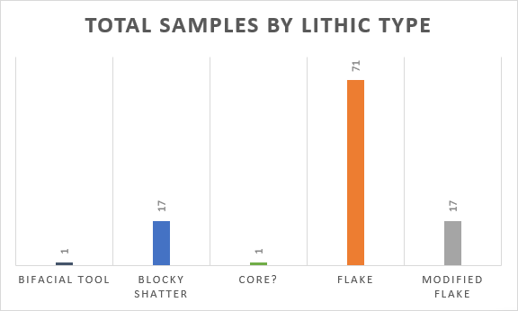
The data collected for the site was also broken into lithic types and context. As shown in Figure 3, the flake style of artifact was found most frequently. With 71 total flakes in the sample analyzed, this form represented nearly two-thirds of the total number of lithic artifacts collected. This higher concentration is to be expected from the excavation of a midden, as the leftover flakes chipped off of stone tools in the making were no longer necessary and could be left behind. Some flakes, however, were modified into usable items. These 17 modified flakes could be identified by their wear patterns along edges, which suggested their use for cutting. While the exact purpose can not be stated, it is likely that the wear patterns are the result of intentional use as opposed to damage over time. Another 17 of the lithic artifacts fall into the classification of blocky shatter, showing evidence of working but not showing the exact percussive bulb generally characteristic of flakes. Finally, the two smallest groups represented contain one artifact each. One of these is a full bifacial tool found in TU3, while the other likely represents an example of a core from the flintknapping process.
Figure 3 – Total Samples by Lithic Type
Lithic Context:
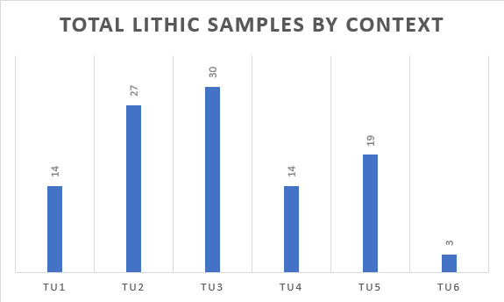
Figure 4 shows the breakdown of lithic artifacts by test unit. In this graph, the size of each bar is representative of the total number of lithic artifacts recovered from each test unit. As shown in the figure, there seems to be a significant correlation between the location of the test unit and the number of lithics recovered in its excavation. Test Units 1, 4, and 6, the units closer to the river, have significantly fewer artifacts than the units further inland. The highest concentration of artifacts was found in Test Unit 3. This unit contained 30 of the 107 total artifacts analyzed, or slightly over 28%. The next largest concentration was found in Unit 2, which had 27 artifacts. Unit 5 contained 19 artifacts, despite not having any recorded data from the 2019 field school. Units 1 and 4 both contained 14 artifacts each, while Unit 6 only held 3. This figure clearly shows a relationship between location and artifact density, with the inland cluster representing over 71% of the artifacts analyzed.
Figure 4 – Total Samples by Context
Riverside Cluster:
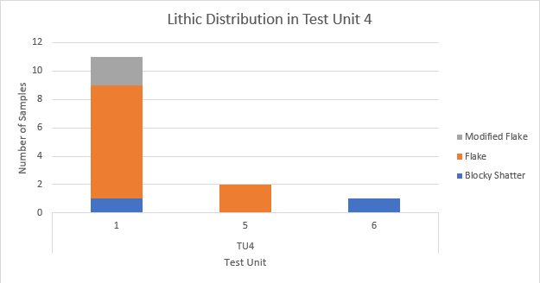
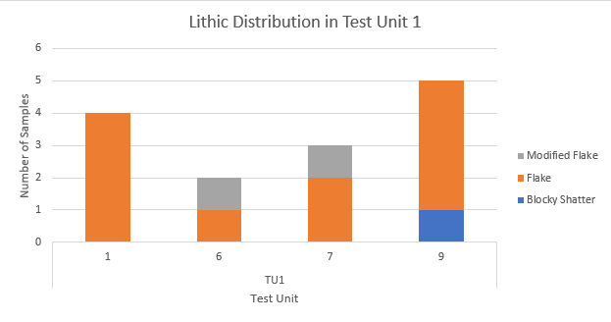
The collection of test units closer to the river yielded mostly flake artifacts. As shown in Figure 5, there is a gap in the records of Unit 1. There are four artifacts recovered in level one of the unit, but then there is a significant gap, with no more lithics recovered until reaching level 6. This gap could potentially be the result of the plow zone or simply missing bags in the data that was recorded and analyzed, but the gap is still a significant one to note. The next set of artifacts only contains two lithics, one being a flake and the next being a modified flake at level 6. In level 7, there is another example of a modified flake and two other flakes. Finally, level 9 sees the highest recorded density of lithic artifacts in this unit, with four flakes and a single piece classified blocky shatter.
Figure 5 – Lithic Artifacts in Unit 1
Unit 4 follows a similar trend in artifact representation to Unit 1. In this unit, there is a heavy concentration of lithic artifacts in level 1. This unit has two modified flakes, eight flakes, and an example of blocky shatter. The heavy concentration in level 1 could again reflect the impact of a plow zone on the artifact assemblage or simply a gap in data, but it could also be reflective of other impacts on this portion of the site. The next artifact in this unit does not appear until level 5, which contains two flakes. The final lithic artifact present is a piece of blocky shatter in level 6.
Figure 6 – Lithic Artifacts in Unit 4
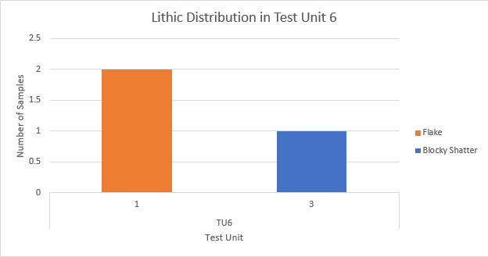
Figure 7 reflects the lithic distribution in Test Unit 6. This unit only has three artifacts, potentially due to the fact that only three levels were excavated during the 2021 field school. Two of the artifacts are located in level 1 and are simple flakes. It is worth noting that, once again, there is a significant gap between the artifacts found in level 1 and the next lithic sample collected. In this case, the next lithic sample is a piece of blocky shatter collected from level 3 of the unit.
Figure 7 – Lithic Artifacts in Unit 6
All three of the riverside units display a similar trend. There is a relatively significant number of artifacts within the first level of each unit, followed by a large gap, with the next artifact only appearing in level 5 or 6. Because these units are located beside one another, they should be relatively even in terms of unit level. For this reason, the artifact gap potentially shows a greater trend within the area: a high level of lithic artifact density in the first level after the plow zone followed by a gap in archaeological record.
Inland Cluster:
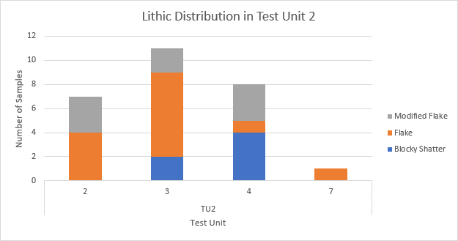
Similar to the cluster of test units near the river, the inland cluster held mostly flakes. However, Units 2, 3, and 5 also held a heavier concentration of modified flakes than the riverside units, as well as a potential example of a partial core. Figure 8 shows the lithic distribution in Unit 2 by level. Following the same pattern as the units by the river, Unit 2 appears to have a gap in the archaeological record between the higher levels and the lower. In this unit, there is a high concentration of lithic artifacts in levels 2-4, then a gap until level 7, where only a single flake was recovered. The concentration of modified flakes in this unit is also significant, as they are found in a much higher concentration than they are in the riverside units. The number of flakes and blocky shatter artifacts is also worth noting, and the concentration within three levels is worth noting.
Figure 8 – Lithic Artifacts in Unit 2
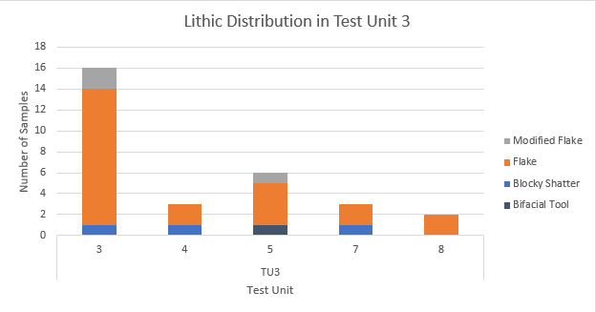
Similar to Unit 2, Unit 3 also shows a high concentration of artifacts in stratigraphic levels closer to the surface. In this unit, level 3 yielded the vast majority of the lithic artifacts, including one piece of blocky shatter, two modified flakes, and thirteen flakes. As shown in Figure 9, the next highest concentration is in level 5, which contained six total artifacts. This level did yield an example of a bifacial tool, which is the only present example of such an artifact in the artifact sample that was analyzed. Once again, the lower levels see a declining number of lithic artifacts present, with levels 7 and 8 having only three and two artifacts retrieved from them, respectively.
Figure 9 – Lithic Artifacts in Unit 3
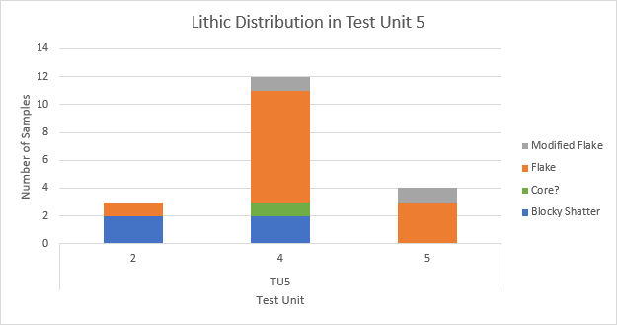
The artifact distribution in Unit 5, displayed in Figure 10, is concentrated in levels 4 and 5. Level 2 held three artifacts: one flake and two examples of blocky shatter. Level 4 held one modified flake, eight flakes, two pieces of blocky shatter, and a potential example of core. Like Unit 6, this unit was only excavated during the 2021 field school to Level 5, which explains the lack of lower levels represented in the artifact assemblage. However, this unit also appears to follow the same trends as the other inland units.
Figure 10 – Lithic Artifacts in Unit 5
The three inland units show similar patterns of artifact distribution, much as the riverside units did. For the inland units, the artifact concentration is closer to the surface, generally clustering around levels 3 and 4. After peaking in these levels, the artifact concentration decreases as levels get further from the surface and further back in time. These units should all have relatively even levels, as they are clustered together, meaning that the similar artifact assemblages likely all point towards the same overall trends in terms of occupational intensity and land use.

FCR Results
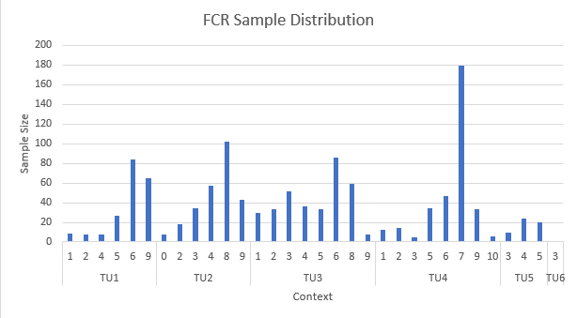
Figure 11 shows the total number of fire-cracked rocks recovered from each level of the analyzed test units. As shown below, the highest concentrations of fire-cracked rock appear in Level 7 of Unit 4, Level 8 of Unit 2, Level 6 of Unit 3, and Level 6 of Unit 1. In a general trend, more artifacts were recovered in lower levels of the test units than near the top of them. Just as with the lithic analysis, the riverside unit cluster and the inland cluster can be analyzed as two separate sub-sites. In this way, the levels can be thought of as being nearly even through the cluster, which will allow for conclusions to be drawn.
Figure 11 – FCR Distribution by Unit

Riverside Cluster:
Figure 12 displays the distribution of FCR recovered from the three units that make up the riverside cluster. As shown below, Unit 1 has relatively few FCR fragments present in shallower levels. In Level 1 through Level 4, there are only 25 total examples of FCR. However, starting in Level 5, the record reveals an increase in the concentration of FCR present, with a peak being reached in Level 6. At this level alone, there are 84 fragments, significantly more than in the levels closer to the surface. Following this spike, the record shows a relatively barren patch, with no more FCR recorded until Level 9 is reached. This level contains 65 fragments of FCR, the second highest number in the unit.
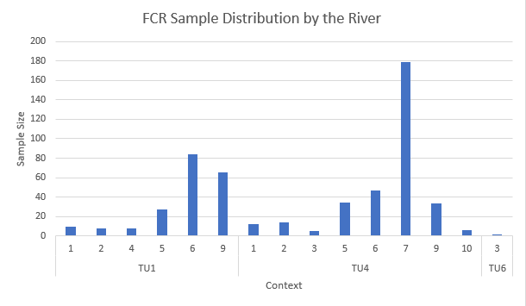
Unit 4 follows a similar trend to Unit 1, with relatively few FCR fragments in the levels near the top of the deposit. Starting in Level 5, there is a clear increase in the concentration of FCR, with 34 fragments present compared to the five samples recorded from Level 3. The largest deposit of FCR in this data set is from Level 7 of Unit 4. In this level, there are 179 FCR fragments, significantly higher than even the second largest deposit from the riverside cluster and any from the inland cluster. This spike is consistent with the trend of increasing depositions in lower stratigraphic levels that is seen in Unit 1. It is worth noting that in Unit 4, the amount of FCR recorded sees a sharp decline after Level 7, returning to approximately the same count as Level 6 in Level 9. In Level 10, there are very few fragments of FCR present.
Figure 12 – FCR Distribution in Riverside Units

Because Unit 6 was only excavated to Level 3, it is difficult to tell if its artifact distribution follows the same trends as Units 1 and 4. The only FCR present was excavated in Level 3, the deepest in the unit.
Inland Cluster:
As seen in Figure 13, the distribution of fire-cracked rock in Unit 2 shows heavier concentrations in lower levels than it does in levels closer to the surface. In this unit, there seems to be a positive relationship between how deep a level extends and the amount of FCR recovered from in the excavation. In Level 2, there were 18 fragments of FCR found, while there were 34 fragments in Level 3. This pattern continues with Level 4 holding 57 fragments. However, after hitting Level 4, there is a substantial gap in FCR deposits until Level 8. At this level, the highest amount of FCR is recovered, with 102 fragments excavated. This high concentration of FCR fragments declines in the next level after reaching this peak. As shown in the gap, this follows a significant trend suggesting that the amount of FCR increased in Unit 2 as the level decreased, showing an overall decrease in the artifact assemblage over time.
This same pattern can be seen in Unit 3, though in a less extreme manner. The number of FCR samples found in the first five levels of Unit 3 is fairly even, with a slight peak at Level 3. In this level, there were 52 fragments recorded, while the Levels 1, 2, 4, and 5 all have around 30 to 35 samples represented. There do seem to be spikes in Level 6 and Level 8, which held 86 and 59 fragments, respectively. The absence of any FCR recovered from Level 7 here seems significant, especially when considering that the two highest levels of FCR concentration for the unit occur in the levels above and below it. Similar to how Unit 2 showed a steep decline after Level 8, Unit 3 shows a significantly lower number of FCR fragments recovered from Level 9 than from Level 8.
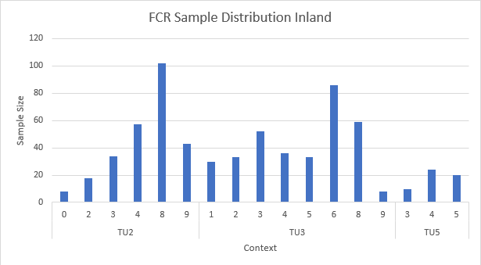
As Figure 13 shows, the levels excavated in Unit 5 held relatively low amounts of FCR samples. This is potentially due to the unit excavations only reaching Level 5 at its lowest. The heaviest concentrations of FCR in Units 2 and 3 are found in lower levels, with their highest counts being excavated from Levels 6 and 8, respectively. Unit 5, in comparison, sees its highest count in Level 4. The twenty-four samples excavated at this level represents the highest concentration for the unit, which is significantly lower than the number of artifacts in the other two inland units.
Figure 13 – FCR Distribution in Inland Units

Analysis:
In the riverside cluster of units, a trend within the concentration of lithic artifacts can be seen. In these units, there is a high concentration of lithics in Level 1, close to the surface, followed by a gap in the record. The next artifacts are recovered in Levels 5 and 6, with Unit 1 seeing a second spike in Level 9. When compared to the FCR distribution, an inverse relationship seems to exist. There seems to be a general trend in FCR distribution becoming less dense as the levels get closer to the surface. This means that Level 1, in which the riverside units see a high concentration of lithic artifacts, there is a relative absence of FCR.
In lower levels, there is generally a lower number of lithic artifacts present and an increasing number of FCR fragments. This is especially apparent in Level 7 of Unit 4, in which there are no lithic artifacts but the most FCR fragments were recovered. The trends suggest that, as time went on, these areas saw less fire creation but more tool making activity. However, Unit 1 Level 9 noticeably does not fit with this trend, showing both a high concentration of lithics and a high concentration of FCR. This could point to a changing use of the landscape over time, with both activities present in Level 9 before differentiation occurs in land use in later periods.
The concentration of lithics and FCR also seems to follow this trend in the inland units. For this cluster, the highest concentration of lithics appears in Level 3, Level 4, and Level 5. In Levels 1 and 2 there is not a substantial artifact assemblage, and after Level 5 there is also a lack of lithic artifacts. Notably, Level 6 yielded no lithics in either of the two units excavated down to that point (Unit 2 and Unit 3). This shows an extensive use of the area for tool making around the period of Levels 3 through 5, but a relative lack of use in earlier or later periods.
When compared to the FCR density, a pattern again emerges. There is a clear correlation between the level and the density of FCR fragments, especially when looking at the data from Unit 2. In this data, there is an increased density of FCR as the level gets lower, with a peak in Level 6 and Level 8. In both Unit 2 and Unit 3, the heavy use of the land for fire making in Level 6 contrasts a complete lack of FCR fragments in Level 7, and we once again see a lower density in Level 8. This could suggest that Woodland groups used the site for food preparation or pottery firing in the time period correlated with these levels. In this case, the gap in Level 7 could be evidence for a period in time in which the area was not occupied, or the site may have been occupied in an area correlated with a different midden. Either way, the trends of FCR density and lithic artifacts in the inland units point to a similarly inverse relationship to the riverside units. The key difference is that there is still a noticeable presence of FCR at the time in which the lithic artifacts are most commonly found.

Conclusion:
Based on the lithic artifact assemblage and the FCR fragment presence in the riverside units, there appears to be a long, consistent use of the land beginning at the time of Level 7. There is a significant number of both lithic artifacts and FCR fragments located in Level 9 of this unit cluster, but there is a complete absence of material from Level 8. This seems to suggest a period of occupation may have ended in the time of Level 9, after which the land was unused until the time of Level 7, at which point it saw mostly cooking or pottery manufacturing occurring. As time went on, this cluster of sites was steadily used, but the purpose shifted away from fire-related activities and moved more towards flint-knapping and tool maintenance.
In the more inland cluster, a similar explanation could be posed. This cluster sees a significant amount of FCR in earlier time periods, those associated with Level 6 and Level 8. However, from this point on, the amount of FCR present slowly falls off, though not as much as the riverside units suggest. This could point towards a less intensive use of fire over time in this area, but a persistent use nonetheless. As time advances, the amount of lithic artifacts also increases, peaking in Levels 3 and 4. The number of modified flakes in this area could also be significant, as it may point towards an area in which food was prepared. This is only a hypothesis, but it is one explanation for why there is both a steady amount of FCR and a spike in modified flakes used for cutting.
When compared with the biological remains of the site, these interpretations maintain their plausibility. The data from flotation column samples analyzed from corresponding 5-cm levels suggest that there was a long and extensive use of the land near the riverside units, while the inland units were utilized for a more concentrated time period (Ruleman 2021). Because of the longer duration trends noticed in the riverside units, the lithic and FCR data collected in this project could support that hypothesis. The tighter concentration of plant remains in the inland units could also point towards changing uses for that area, as is suggested in the lithic and FCR concentrations.
When considering Woodland period habitation, three general types of sites have been proposed. These include the base camp, the logistical camp, and the activity locus (Davis 1990). Because the inland and riverside sites follow slightly different trends, I propose that they should be analyzed separately as well. For the riverside site, the high combination of both lithic artifacts and FCR fragments excavated Unit 1 Level 9 suggests that, at this time, the site was similar to a base camp, in which multiple activities are occurring with substantial remains left behind. However, after the gap in data from Level 8, the riverside units yield primarily FCR fragments, potentially suggesting a shift towards use as a logistical camp or activity locus. As time advances, the focus of this camp seems to move away from fire-based activity and toward flint-knapping and tool maintenance. This would again suggest that the area was focused on one primary activity. Whether this activity was part of a broader camp or represented an activity locus is difficult to tell, but the inverse relationship between FCR and lithic artifacts seems to suggest a change in priorities.
The inland units, on the other hand, suggest that the sites were used for specific functions earlier and broadened activities later. This is reflected in the high number of FCR fragments present in the lower levels of Units 2 and 3 and the lack of lithic artifacts present at this point. In Levels 3, 4, and 5, however, we still see a significant number of FCR fragments present at the same time that we see a spike in lithic artifacts. This could suggest that the inland units were used as an activity locus or a logistical camp in earlier years, but became a more substantial base camp in the times represented by Level 3 through Level 5.
By analyzing only a few units, we have opened the door to only seeing a small sample of what the site really offers. The analysis and conclusions drawn in this paper are limited by the information available and the artifacts that we have found so far, but that does not mean that they are wrong. As with any site seeing future work, it is important to understand that this site is still being analyzed. This is especially relevant when comparing to the plant remains from the flotation tests, which were completed prior to the 2021 field school, to the lithic and FCR data, which includes multiple BCL’s from both field schools. In addition, ceramic artifacts from the fields school are currently being analyzed and will add to the overall data.
Some areas that research could focus on moving forward would be the connection between the inland and riverside clusters. Without a way to determine how the pair are related, it is difficult to draw any significant conclusions about the occupation of the site by Woodland peoples. How long they stayed and how they used the land are questions worth answering, but they will require future analysis. Further research will yield further information, and by necessity replace older interpretations of the site. This being said, the contents of this paper represent my best understandings as it stands now.

Works Cited:

Anderson, David and Kenneth Sassaman
2012. Recent Developments in Southeastern Archaeology: From Colonization to Complexity. The Society for American for American Archaeology, Washington, D.C.

Anderson, David and Robert Mainfort
2002. The Woodland Southeast. The University of Alabama Press, Tuscaloosa, Alabama.

Angst, Michael G. et al.
2007. “PHASE I ARCHAEOLOGICAL SURVEY OF THE UNIVERSITY OF
TENNESSEE-KNOXVILLE EXPERIMENT STATION (CHEROKEE CAMPUS)
WEST OF ALCOA HIGHWAY, KNOX COUNTY, TENNESSEE”. Department of
Anthropology, University of Tennessee, Knoxville, Tennessee.

Chapman, Jefferson
2001. Tellico Archaeology: 12,000 Years of Native American History. The University of
Tennessee Press, Knoxville, Tennessee

Davis, R.P. Stephen
1990. “Aboriginal Settlement Patterns in the Little Tennessee River Valley”. Department
of Anthropology, The University of Tennessee, Knoxville, Tennessee.

Hollenbach, Kandace, and Stephen Yerka
2018. “Archaic and Woodland Occupations in Tuckaleechee Cove, Blount County,
Tennessee. Department of Anthropology, The University of Tennessee, Knoxville,
Tennessee.
Hollenbach, Kandace
2022. Personal communication. 05/06/2022.

Ruleman, Hattie.
2021. “On the Paleoethnobotanical Significance of Cherokee Farm”. Chancellor’s
Honors Program Projects. The University of Tennessee, Knoxville, Tennessee.

