Factors in Alleviating Poverty: the Globalization, Growth, Inequality, and Poverty Nexus

By: Kayla McMurry
Thesis Advisor: Dr. Mohammed Mohsin

2014

Abstract

This study examines the relationship between globalization, inequality and growth and how these factors correlate with poverty reduction. By using data from agencies such as the World Bank, Transparency International, and CIA World Fact book, these factors will be run through a thorough econometric analysis.
This analysis also includes a country case study comparing India and Sri Lanka, starting with their liberation from the British Empire in the late 1940s to current day. It includes both historic and current policy, how it has aided in poverty reduction, and how both countries are moving forward to combat poverty in the future.

Table of Contents

- Abstract………………………………………………………………………….2

- Introduction and Literature Review……………………………………………..4

- Introduction to Model…………………………………………………………...6

- Definition of Variables………………………………………………………….6

- Hypotheses……………………………………………………………………..10

- Methodology…………………………………………………………………...10

- Results………………………………………………………………………….11

- Conclusions…………………………………………………………………….14

- Country Case Study Introduction………………………………………………15

- Land Reform…………………………………………………………………...19

- NGO’s and Non-profits………………………………………………………...21

- Recommendations……………………………………………………………...22

- Appendix……………………………………………………………………….24
Introduction and Literature Review

Currently, 1.22 billion people are living in extreme poverty. Since the World Bank’s establishment in 1944, their mission has been to create “a world free of poverty” (World Bank, 2014). However, countless NGOs, non-profits, countries, and governments have also made eliminating poverty a top goal. But this poses a question, how can countries alleviate poverty? A general understanding of the factors that have gone into poverty alleviation in the past is good place to start.
Headlining the effort of poverty alleviation is the United Nation’s Millennium Development Goals (MDGs). The first goal of the MDGs is to “eradicate extreme poverty and hunger”. The MDGs were founded in 2000 at the United Nations Millennium Summit and the establishment set out to have the goal achieved by 2015. The G8, or the “Group of 8”, indicates the group of eight countries leading the world, six of which are considered permanent members. The finance ministers of each G8 country have pledged to give money to the World Bank, International Monetary Fund (IMF), and the African Development Bank (AfDB) to alleviate poverty. (United Nations, 2014)
The first goal of the MDGs is to “Eradicate extreme poverty and hunger”. This goal is subdivided into three specific targets, including: 1) Halve, between 1990 and 2015, the proportion of people living on less than $1.25 per day; 2) Achieve decent employment for women, men, and young people; 3) Halve, between 1990 and 2015, the proportion of people who suffer from hunger. As of 2013, the first target of this goal has been reached, but the entirety of the first goal still has a long way to go. (United Nations, 2014)
Most of the current literature on this subject is based upon case studies. There are many variables that factor into the alleviation of poverty, so finding data that will decrease poverty under all circumstances is difficult. Even with data, there are also political events to take into consideration, like changes in policy, government, and macroeconomic events.
The main article I used from my literature review considered data available to analyze inequality in countries, written by Gary Fields in the Journal of Development Economics. Fields examined all available data to better evaluate what was happening to income inequality, GINI coefficients, and Lorenz curves. To build a model, Fields uses income, family, and poverty. He stressed picking a good poverty line and for his own research used the poverty headcount ratio to transform the data to make it more comprehensive. Overall, Fields says 70 countries have most of the necessary data but many of them are missing at least one of the components needed to thoroughly investigate what is happening. Fields did a case study on Malaysia.
Another article examined was the Impact of Globalization on the World’s Poor written by Thorbecke and Nissanke in World Development. They looked at three things: effects of trade and technological openness on income distribution and poverty; effects of migration and mobility on inequality and poverty; and pro-poor institutions: labor markets and social protection schemes.
The textbook Development Economics, by Debraj Ray, provided the largest source of information for my thesis. Chapters included information on growth, poverty, inequality and how they are related to each other. Through this textbook, I based and revised my model and developed an outline for the country case studies, so I could thoroughly understand poverty by comparing a set of countries.

Introduction to model
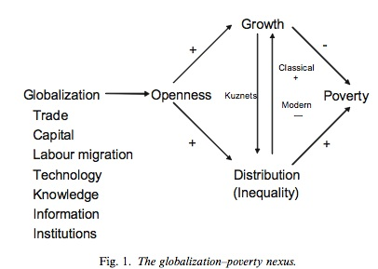
Growth

Globalization Poverty

Inequality
Globalization: (Exports + Imports)/GDP, Net Migration, Literacy Rate, Infant Mortality Rate, Corruption, Economic Freedom
Poverty: Extreme Poverty
Inequality: GINI Index
Growth: GDP per Capita

Defining the Variables
Variable | Expected Sign | Description
ExtremePov | (N/A) | Percentage of the population living below the national poverty line based on population-weighted estimates from household surveys
litrate_youth | (-) | Youth literacy rate in percentage terms
logGDP | (-) | Log of annual GDP per capital in percentage terms based on 2005 dollars
InfantMort | (+) | Number of infants dying before reaching one year of age, per 1,000 live births
NX | (-) | Annual (net imports + net exports)/GDP to view total trade for a country
EconomicFreedom | (-) | Heritage Foundation Index to measure the amount of Economic Freedom in a country based on 10 indices
migrationipl | (-) | Net total of migrants during a 5-year period. Interpolated for all data.
primaryenroll | (-) | Number of students enrolled in primary school per year
Gini | (+) | Uses Lorenz curve plots against a line of perfect equality to measure extent inequality in income and consumption. 0=perfect equality 100=perfect inequality
year | (N/A) | 1960-Present

For econometric analysis, I am using ten variables: extreme poverty, youth literacy rate, GDP per capita, infant mortality, imports and exports as a percent of GDP, economic freedom, migration, primary school enrollment, GINI index, and year.
According to the World Bank, GDP per capita is “gross domestic product divided by midyear population”. Taken yearly, GDP per capita is a measure of either growth or stagnation in an economy. By using this data, we can see relative economic size and productivity. As it is a generally accepted way of measuring growth worldwide, within the framework of the nexus, GDP per capita will represent “growth”.
Economic Freedom Index is taken from the Heritage Foundation. Comprised of ten factors, this index measures the ability for humans “to control his or her own labor and property.” Grouped into four pillars, economic freedom is broadly measured by rule of law, limited government, regulatory efficiency, and open markets. Total economic freedom, an average of the ten factors, is measured from 0 to 100, with 0 being completely barred and 100 being completely free.
As defined by the World Bank, human capital is the knowledge, skills and experience of people that make them economically productive. Ways to increase human capital includes increasing investment in education, health care, and job training. Human capital can be broken up into four subcategories: schooling, literacy, technology, and health and fertility.
Education evaluation includes the process of comparing and characterizing aspects of the educational process. Several standards are commonly used, which provide guidelines and categories in order to facilitate education evaluation including evaluation of students, teachers and programs. The World Bank uses education as a form of impact evaluation with measures such as literacy, primary, secondary and tertiary enrollment rates.
To completely capture education, youth literacy rate and primary enrollment will be used. Youth literacy rate is defined as the percent of people aged 15-24 who can both read and write a simple paragraph. (World Bank) Primary enrollment is the total enrollment in primary education, regardless of student age, expressed as a percentage of population of officially primary education age. When primary enrollment exceeds 100%, this means that over-age and under-age students have been included because of early or late school entrance and grade repetition. (World Bank)
Poverty Headcount, defined by the World Bank, is the share of population whose income or consumption is below the poverty line, that is, the share of the population that cannot afford to buy a basic basket of goods. (WB 2013) The World Bank has data on poverty gaps, poverty headcount and income share by percentage. Extreme poverty, which will be used in the regression analysis, is defined as earning below $1.25 per day, purchasing power parity (PPP). PPP is a technique used to determine the relative value of different currencies to make them more comparable on a worldwide scale (Development Economics, 1998). This indicator will be used in the regression as “poverty.”
The GINI index measures the extent to which the distribution of income or consumption expenditure among individuals or households within an economy deviates from a perfectly equal distribution. It is widely accepted as the measure of inequality. As a numerical value, the GINI index is equal to sum of the area below the Lorenz curve, which is also used to measure inequality. GINI will be used as the sole measure of inequality in the context of the nexus.
Corruption data has been taken from Transparency International, a politically non-partisan, independent organization. Transparency International defines corruption as “the abuse of entrusted power for private gain.” Currently measured in 177 countries yearly, the corruption perception index (CPI) ranks countries and territories based on how corrupt their public sector is perceived to be. A combination of surveys, the CPI is a ranking between 0 and 100, where 0 is highly corrupt and 100 is very clean. The CPI has been recorded since 1989 and is “the most widely used indicator of corruption worldwide” (Transparency International, 2014).
To measure trade, we will be looking at exports plus imports divided by GDP. Exports are all goods and services that a market has produced and shipped out of a country. Imports are all the goods and services that a country or a market has shipping in. Gross domestic product, GDP, is defined as GDP = C + I + G + NX. Where C represents consumption, I represents investment, G represents government spending, and NX represents a nation’s total exports minus the nation’s total imports. By looking at imports + exports / GDP, we can see what percentage of the productive economy is comprised of trade. This will be used as a variable for globalization by looking at the overall willingness to trade. To use GPD per capita as a measure for growth, the natural log of GDP must be taken (Development Economics, 1998).
Infant mortality is the number of infants dying before reaching one year of age, per 1,000 live births. This measure captures health and fertility, two main components of globalization.
Primary enrollment is measured as the percentage of the total youth population enrolled in primary school that is of the age to be in primary school. This measure may exceed 100% because it includes students that are still in primary school because of early or late school entrance or grade repetition. Currently, most developing countries have rates of higher than 100% in primary school enrollment.

Hypotheses
Correlation of Poverty and regression to define poverty
H₀: Poverty is not affected by changes in globalization, growth, and inequality.
H_{A}: Poverty is affected by changes in globalization, growth, and inequality.

Methodology
For the econometric analysis, panel data will be used. Collected from 1960 to 2013, data was collected from individual countries and complied by Transparency International, the World Bank, the United Nations, the Heritage Foundation, and the Worlds Top Incomes Database.
Results
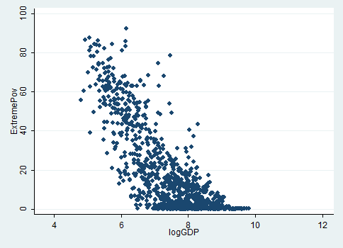
The graph above demonstrates the relationship of extreme poverty and the log of GDP per capita. This panel data, where each data point represents one country in a specific year, easily shows the negative relationship between the two variables.

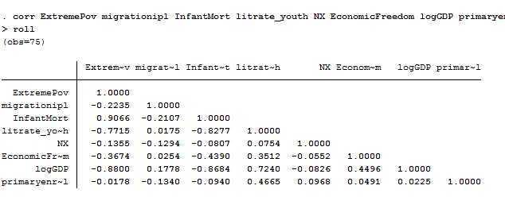
Looking at the correlation between extreme poverty and all other variables in the regression, we can see:
Extreme poverty is negatively correlated with migration, literacy rate, imports and exports, economic freedom, log of GDP, and primary enrollment. It is positively related with infant mortality. The negative correlation means that when one variable like literacy rate increases, extreme poverty decreases. The opposite holds for infant mortality, as extreme poverty and literacy rate move in the same direction. 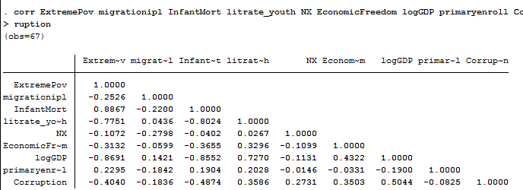
With this correlation, primary enrollment is now positively correlated with extreme poverty. Although this is the opposite of what was predicted, this could be viable. With primary enrollment able to exceed 100 percent, this could be an indicator that higher primary enrollment lead to less poverty in the long run but education, in the form of human capital, doesn’t begin to show payoffs until later and sometimes may take years to realize. Also, by adding corruption, it has a negative correlation with poverty but this seems to be untrue in the previous research. With only 67 observations, this may be a misnomer and would be positively correlated in the future. 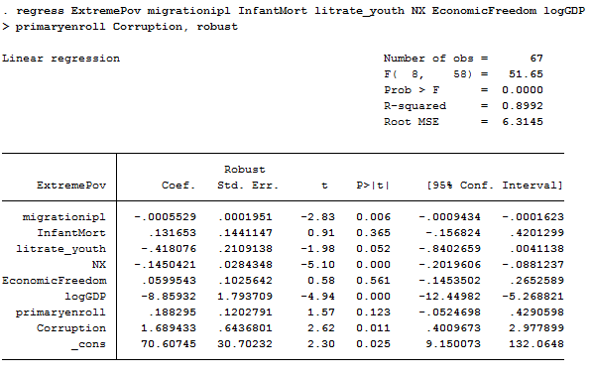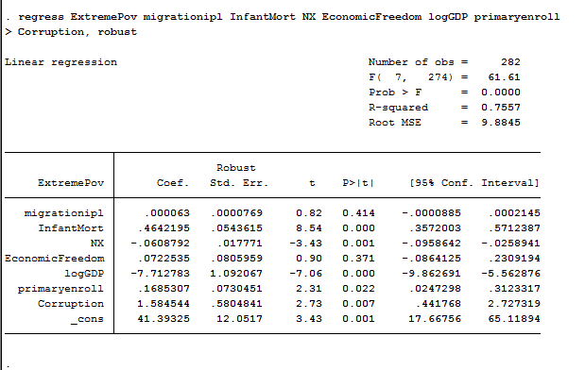
To increase number of observations and decrease the serial correlation in the regression, I removed youth literacy rate. An increase of over 200 observations makes the model more reliable but leaves out an important factor. This model is also missing one the important four factors: the GINI index, which measure inequality. By neglecting this variable, this skews the data and changes the coefficients on the remaining variables. It is impossible to add into the data because of the scarce observations. Without countries recording the GINI index and reporting it to the World Bank, the data doesn’t exist.
Heteroskedasticity still exists in the model but that is because I can’t define all of the variables need to fully define poverty. Although this means the regression is no longer “BLUE”, this is still acceptable. In the end, the regression was run with robust standard errors to alleviate some of the heteroskedasticity. Serial correlation also presents a problem between primary enrollment and literacy rate.

Conclusions
Willing to accept 10% one-tailed and 20% two-tailed significance. With this, the variables that are accepted in this framework include:
Infant Mortality
Net Trade
Log of GDP
Primary Enrollment
Corruption
Country Case Study
Two countries, India and Sri Lanka, will be used as case studies while examining four aspects of tackling the issue of poverty: current economic conditions, polices since both countries gained independence, data on poverty alleviation, and current efforts to lessen poverty in both countries. Why are they comparable? Besides being adjacent, there are many similarities between the two, including their gained political independence, both occurring within a year of each other. But current poverty levels clearly demonstrate a divergence in policy and economic well being, standing at 29.8% poverty in India and 8.9% poverty in Sri Lanka.
To accurately compare Sri Lanka and India, it is necessary to establish an understanding of the background of the two countries. India gained independence in 1947 from the British Empire, and Sri Lanka gained independence from the British Empire in 1948. Besides being neighbors, the two are connected by “Adam’s Bridge”, also known as “Rama’s Bridge”, a chain of limestone 30 km in length that used to be the connection between India and Sri Lanka (Encyclopedia Britannica, 2014). Current populations are vastly different because India has over 1.2 billion people and Sri Lanka has only 21.8 million (CIA World Factbook, 2014). But despite the difference in population size, both countries have rapidly expanding populations, one of the defining characteristics of a developing country, with majority of citizens under the age 40. (Appendix Figure 1).
Current graphs of country data are included in the appendix *** should this be written like this? I want to include graphs but I don’t know how to do that within the framework of a thesis.
According to the Council on Foreign Relations, Sri Lanka had a 20-year civil war ending in 2008 in the east and north that displaced as many as 800,000 civilians.
Recently, the tsunami in 2004 killed about 38,000 people and tore down many of the houses along the coast, leaving those vulnerable in poverty

Current Economic Conditions
The GDP for the respective countries in 2013 was Sri Lanka: $136 billion and India: $4.962 trillion. Sri Lanka posted a GDP growth of 6.3% in 2013, with a figure that is expected to decrease slightly in the next few years (CIA World Factbook, 2014).
India has been implementing “five year plans” since introduction in 1951. They are currently on the 12th plan, with many of the plans not really being a full five years. Some have only been two years; some have been closer to 10 years. For the first five-year plan, they introduced a credit policy that increased investment. With the need for initiating a process of development that will form the baseline of a large-scale effort in the future, on the basis of a close relationship between public and private sectors, special attention being given to areas affected by the war and partition, and a reform of public administration (Twelfth Five Year Plan, 2014).

Data on Poverty Alleviation
One of the most difficult things to account for in poverty is the difference in urban and rural population. In the urban population, standards haven’t been increased from $1.25 per day but the cost of living has significantly increased over the past few years. And although urban poverty looks fairly good with the current data, rural poverty is over-represented for a multitude of reasons, while urban poverty is underestimated because of the higher cost of living that includes the price of food and housing (How to: Measure Urban Poverty, 2012).
In India, according to 11th development plan, the number of poor people is over 300 million. Although this number is steadily decreasing, almost a third of the 1.1 billion people in India still continue to live below the poverty line. For the first time ever, a report on urban poverty was started in 2009, with support of UNDP. (United Nations Development Report, 2013). Urban poverty is currently at over 25%, with close to 81 million people living in poverty in urban areas in India. There is currently a slum population of 42.6 million, which translates to 23.7% of the urban population in the slums. Migration to urban areas has increased drastically in the past few years.
Some of the current proposed solutions in India include greater equity of basic services, for example more access to basic sanitation and health care, with more targeted subsidies to the urban poor (India: Urban Poverty Report, 2009).
For the topic of rural poor, this is a chronic condition for 30% of rural population. The largest number of poor in India is located in the semi-arid tropical region, where there are shortages of water and recurring droughts. Also, lots of rural poverty occurs in flood-prone areas. In rural areas, women are also severely disadvantaged and most vulnerable to getting diseases like HIV and AIDS. Along with health issues, status varies and most rural poor are still affected by the caste system. Historically, lower castes are having more difficulty getting out of poverty (Rural Poverty in India, 2014).
The urban poverty in Sri Lanka has many dimensions, as was demonstrated through a study of the capital Colombo. Currently, the urban poverty line is only 5.3%, which is the lowest rate of poverty in all of Sri Lanka. But this poor might not encompass the poverty occurring in Sri Lankan urban areas. Other ways to measure urban poverty are being looked into, including food energy or the amount of calories eaten per day. According to food energy, urban poverty has increased in the last few years but the percentages of people living on under $1.25 per day have gone down. For example urban poverty in Sri Lanka in 2002 was 7.9%, and in 2006/2007 it was down to 6.7% and current data on 2009/2010 shows urban poverty at 5.3%. The rural poverty has much higher figures; for example, in 2002 it was 24.7%, in 2006/2007 it was 15.7%, and finally in 2009/2010 it was down to only 9.4%. With the introduction of compulsory primary education for primary aged children, educational attainment has increased especially in urban areas to help decrease poverty across society (Romeshun, 2011).
Some of the current efforts to reduce poverty in Sri Lanka include healthcare and education. The country provides free vaccinations, which has led to over 96% of the population in urban areas fully vaccinated, and only 0.4% of the population has never had any vaccinations. With a nationalized healthcare, they also focus on maternal health. Infant mortality rates stand at 21 deaths per 1,000 births, and child mortality rates stand at15 deaths per 1,000 live births. Maternal mortality stands at 92 per 100,000 births. Although this is a well-developed healthcare system, Sri Lanka has the most difficultly providing to citizens that are not able to afford the high cost of associated services, which may include costs like transportation, cost of medicine, and cost of tests. Another main focus of the government is on education. It is compulsory for ages 6-11 and free for students up until university. Nationally, 98% of children are enrolled in primary school (Romeshun, 2011).
India and Sri Lanka, two countries that gained independence within a year of each other, hold drastically different views on how to tackle poverty (Bhavan , 2013). Where do they stand now?

Land Reform
Before Indian independence, British entrepreneurs commandeered farmable land. According to Sethi, the “introduction of private property delegitimized community ownership by tribal societies”, which led to highly concentrated land ownership. Since the British owned monopolies on land, the first few five-year plans focused on allocating resources to implement land reforms (2010). But since then, 54 years according to the paper, it is worse than ever. Land is now even more highly monopolized than it was in 1951, inequalities have increased and landless laborers have increased. Along with that, land reform has faded from the public eye.
Problems today include tenancy rights and access to land for subsistence farming. Starting in the five-year plan of 1966-1971, India began to focus on the commercialization of agriculture that has transformed India to an exporter rather than an importer. With around 58% of India depending on subsistence farming, this poses a problem. The Green Revolution has helped India if you look at agriculture as a business, but regardless of classification of agriculture, most of India is still starving to death. Since the Green Revolution, agriculture production has only increased by 5.4%. It has also changed the crop production. Now, instead of producing chickpeas or millet to provide food for the people of India, commercialized farms are growing sugarcane and cotton for profit.
Policy experts also acknowledge that we need to focus on more than redistribution of land. Another important factor in agriculture is the distribution of water and irrigation. One of the main proponents of irrigation is the World Bank, who is just starting a new water reform program in India (Kerala Acts, 2008).
Sri Lanka has had a few land reform acts in the past 60 years, the first of them being the “Paddy Lands Act of 1958”. This started with a vision of a sustainable farm and agricultural community (Department of Agrarian Development, 2014).
The second major land reform period happened when both the “Land Reform Act of 1972” and “Land Reform (Amendment) Law of 1975” passed. These both brought about sweeping land reform for Sri Lanka. For political purposes, these acts were radical and according to Samaraweera this “represented unprecedented erosion of private property rights in agricultural land”. Although they were sweeping reforms, these acts gave control to a few to maintain the productive estates. The main question with these acts was, what percentage of land was actually going to help the landless? The government of Sri Lanka was focusing on answering high village and youth unemployment, without consensus if this was necessarily the right policy. This changed land ownership from broadly individualized to collective land ownership. The view of Sri Lankans was that redistribution of paddy lands to provide equitable land holding would remove constraints on productive capacities. But as of 1982, this had not been passed through. (Vijaya)
Even though the reforms were not widely accepted among citizens, these land reform acts in Sri Lanka worked surprisingly well. With a redistribution focused on a community aspect, land was not completely given to large land-holding farmers like in India. This is one of the main reasons Sri Lanka currently has less poverty than India.

NGO’s and Non-profits
United Nations and World Bank are the big two international organizations working on poverty alleviation. The UN has developed the Millennium Development Goals and the World Bank has developed a goal for alleviating poverty by 2030.
The MDG’s have advised specific countries to make 3 to 5 year plans that fit within the framework of a 10-year plan after mapping out data on current poverty. Their suggestions include “a key focus on transparency, accountability, human rights, and results-based management.” They also suggest a clear private sector strategy to increase growth in countries; following the previous research that shows that growth and poverty have a strong negative correlation. The knowledge to complete the goals is available; countries just need a concrete plan and implementation strategy to complete these goals. They provide 17 “Quick Wins” that they say should be implemented immediately. For example, countries can introduce the UN’s “Quick Wins” and bring gains within three years including eliminating school uniforms to encourage children, especially girls, to attend school. The UN also provides seven main investment-and-policy clusters: rural development: increasing food output and incomes; urban development: promoting jobs and upgrading slums; health services; education; gender equality; environment; science, technology and innovation. Although they are not country specific, these organizations work closely with developing countries if they request help.
Two of the largest non-profits and NGOs that work in both India and Sri Lanka are CARE and Oxfam. These organizations are mainly focused on reducing poverty through specific campaigns.

Recommendations
I would suggest that India look into, or more widely explore, the possibility of using mobile money. With a large population in Kenya already utilizing this technology, India and Sri Lanka could more quickly transfer funds to rural villages, while also combating the issue of corruption. Using mobile money could also reach to empower women or create jobs for villages and the youth. With programs like mobile money, countries promote private markets and effectively increase the GDP per capita. If these countries decide to pursue this policy, perhaps a country could partner with a company, like Virgin Mobile. By combining private industries with public goals, countries like India can converge and grow to meet the needs of the 1 billion people living there.
When focusing on rural poverty, reforms in agriculture are vital. Land reform in India should be looked into, with a focus on subsidizing food production instead of higher yielding profit crops like sugarcane. After the Green Revolution, this type of policy should be able to decrease hunger, especially in the rural areas of India.

Limitations in Research
It is very difficult to find the statistics for women in poverty, but gender equality also plays a large part in poverty reduction. When looking at panel data for countries, it is impossible to control for differences in gender, since measures are taken at a countrywide level. Some indexes for gender equality were introduced in the late 1990’s and recently, a new gender equality measure, the gender inequality index (GII) was introduced that included maternal health, but even this measure just began in 2010. With only two to three years of data collection, it is impossible to accurately portray what has happened over the last 50 years. As more data is collected, perhaps the correlation will be evident between gender equality and poverty alleviation but as of now, there is simply not enough data.
Another problem that I encountered was the lack of information on the GINI index. Although this is widely accepted as the measure of inequality, the GINI is difficult to measure, and countries often do not report statistics on it. Although frustrating, the world top incomes database has information for some of the largest countries in the world, including India, and they are expanding rapidly for income distribution, which is very close to the GINI index. Through the expansion of this database, I hope to see more information in the future on developing countries and the GINI index.
Appendix
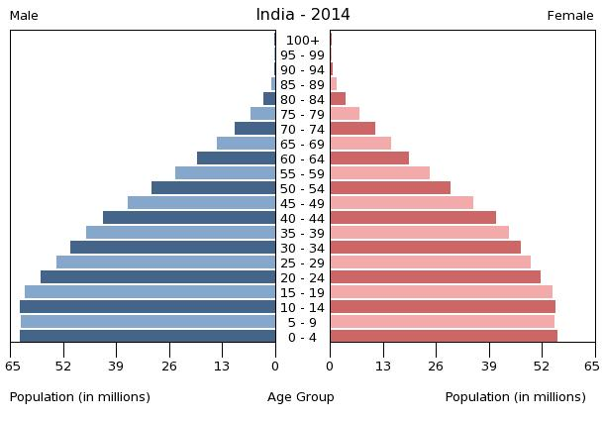
Population of India and Sri Lanka:

School Enrollment:

Fertility Rate:

Literacy Rate:

Bibliography
Bajoria, Jayshree. (2009). The Sri Lankan Conflict. Council on Foreign Relations. Retrieved April 20, 2014 from http://www.cfr.org/terrorist-organizations-and-networks/sri-lankan-conflict/p11407

Bhavan, T. (2013). Policies and Effectiveness of Foreign Aid: the Case of Sri Lanka. Economic and Financial Review, 3(3), 363-376. Retrieved April 7, 2014.

Central Intelligence Agency. (2014) The World Factbook: India.
Central Intelligence Agency. (2014) The World Factbook: Sri Lanka.
Department of Agrarian Development. (2014). Department of Agrarian Development. Retrieved April 20, 2014 from http://www.agrariandept.gov.lk/Agrarian/home.jsp

Fields, Gary. (1994). Data for Measuring Poverty and Inequality Changes in the Developing Countries. Journal of Development Economics, 44, 84-104.

India: Urban Poverty Report 2009. (2009). United Nations Development Programme. Retrieved April 9, 2014 from http://www.citiesalliance.org/node/408.

Kerala Acts. (n.d.). Kerala Conservation of Paddy Land and Wetland Act, 2008. Retrieved March 20, 2014, from http://www3.commonlii.org/in/legis/kl/act/.

Mishkin, Fredrich. (2007). Globalization and Financial Development. Journal of Development Economics, 89, 164-169.

Romeshun, Kulasabanathan and Mayadunne, Geetha. (2011). Appropriateness of the Sri Lanka poverty line for measuring urban poverty: the case of Colombo. Human Settlements Working Paper Series. December 2011.

Rural Poverty in India. (2014). Rural Poverty Portal. Retrieved April 18, 2014 from http://www.ruralpovertyportal.org/country/home/tags/india.

Rural Poverty in Sri Lanka. (2014). Rural Poverty Portal. Retrieved April 18, 2014 from http://www.ruralpovertyportal.org/country/home/tags/srilanka.

Thorbecke, Erik and Nissanke, Machiko. (2006). Introduction: The Impact of Globalization on the World’s Poor. World Development, 34 (8), 1333-1337.

Twelfth Five Year Plan 2012-2017. (2012). Government of India 5 Year Plans Planning Commission. Retrieved April 20, 2014 from http://www.planningcommission.nic.in/plans/planrel/fiveyr/welcome.html

World Bank. (2014). Data Retrieved April 9, 2014, from World DataBank database. http://data.worldbank.org/

World Bank. (2014). Poverty Overview. Retrieved April 9, 2014 from http://www.worldbank.org/en/topic/poverty/overview.

Young, Grace. (2013). Adam’s Bridge. The Encyclopedia Britannica. Retrieved on April 2, 2014 from http://www.britannica.com/EBchecked/topic/5208/Adams-Bridge.

