Text Size Impact of Responsibility Messages
in Magazine Alcohol Advertisements
among College Students

A Thesis Presented for the
Master of Science
Degree
The University of Tennessee, Knoxville

Sumin Shin
August 2013
Copyright © 2013 by Sumin Shin
All rights reserved.
ABSTRACT

Although warning labels on products and in advertising have been much studied and discussed in the past several decades, the effect of text size on recall of these messages has been largely ignored, particularly with regard to alcohol advertising. Guided by the bottom-up model of visual attention processing, this study hypothesizes that a responsibility message with larger text attracts more consumer attention and creates greater message recall. One hundred twenty three magazine alcohol ads were collected in preliminary research, and the average size of their responsibility messages was found to be approximately 6 points. An experimental survey of college students was conducted, using alcohol ads with responsibility messages of three different text sizes: 6 point, 10 point, and 14 point. Analysis of the results of this survey showed that recall of the 10 point messages was significantly greater than that of the 6 point, but that there was not a statistically significant difference between recall of the 10 point and the 14 point messages. This study therefore suggests 10 point of the 3 choices as the minimum text size for responsibility messages in alcohol advertisements.
TABLE OF CONTENTS

CHAPTER I Introduction and General Information 1
CHAPTER II Literature Review 3
College drinking 3
Warning signs 4
Visual attention 6
Message size, visual attention, and recall 8
Message size and recall 8
Hypothesis 9
CHAPTER III Methods 11
Preliminary research 11
Sample 11
Materials 14
Procedures 16
Measurements 17
Statistical analysis 18
CHAPTER IV Results 20
Alcohol drinking behavior 20
Masked recall test results 20
Ad attitude and purchase intention 23
CHAPTER V Discussion 25
CHAPTER VI Limitations and suggestion for future research 28
LIST OF REFERENCES 31
APPENDIX 39
IRB_FORM A 40
Consent Form & Questionnaire 44
Ad materials 49
Vita 52

LIST OF TABLES

Table Page

Table 1. Examples of Responsibility Messages in 2010-2012 GQ Magazine 12
Table 2. Overall Masked Recall Results 21
Table 3. Responsibility Message Recall Rate 21
Table 4. Chi-Square Tests between Groups 23
Table 5. Descriptive Results for Aad and PI 24
Table 6. ANOVA Results 24

LIST OF FIGURES

Table Page

Figure 1. Distribution of Responsibility Message Sizes in 2010-2012 GQ Magazine 13
Figure 2. Three Manipulated Responsibility Messages 15
Figure 3. An Example of Ad Material for Masked Recall Test. 19

CHAPTER I
Introduction and General Information

The American alcoholic beverage market is growing, but only gradually. The combined revenue of the beer, wine, and spirits markets was $57.9 billion in 2012, and $76.7 billion in 2013. But annual growth over the past 5 years has not increased very significantly--0.5% in 2012 and 1.7% in 2013 (Kaczanowska, 2012; Kelly, 2013). This slowly growing market could be thought of as being in the maturity stage of the product life cycle theory (PLC). In this stage, brands usually focus on promoting themselves in particular, rather than the market to which they belong, and their advertising efforts go toward retaining their existing customers and attracting the customers of their competitors (Wilcox, Kim, & Schulz, 2012)
The growth of the alcohol industry would of course benefit the economy, but heavy drinking often leads to serious social problems. In particular, the number of young adults who drink alcohol irresponsibly is increasing. A study on trends in alcohol related problem among college students showed that from 1998 to 2007, alcohol-related unintentional deaths had increased 1% per 100,000 students from 1,442 to 1,870 (Hingson, 2011). As a more recent data, according to the National Institute on Alcohol Abuse and Alcoholism (NIAAA), approximately 1,825 college students die each year because of drunk driving or other alcohol-related accidents (NIAAA, 2012). There has been much media attention on heavy drinking among college students, but the problem grows worse—college students do not drink any less, or drink any more responsibly (M. J. Lee & Shin, 2011).
Various institutions and communities have made efforts to reduce excessive college drinking. The Alcoholic Beverage Labeling Act (ABLA), of the Anti-Drug Abuse Act of 1988, requires all alcoholic beverage containers to carry a government warning indicating the negative effects of alcohol (Mandatory label information, 2013). Many colleges, universities, non-profit institutions, and private companies have conducted outreach programs to educate college students on the dangers of alcohol abuse.
Alcohol companies have also participated in the social movement to prevent excessive drinking. Most alcohol brands include a warning, a so-called responsibility message, in their print advertisements, such as “Drink Responsibly” and “Enjoy Responsibly.” How effective are these responsibility messages among college students? This study starts with that question.
The purpose of this study is to test the recall rate of responsibility messages, and to suggest type sizes for these messages that would best attract the attention of consumers. To do this, the study examines how text size affects recall of responsibility messages that appear in magazine alcohol advertisements. The experimental survey is used as a data collection method.

CHAPTER II
Literature Review

College drinking
Research on alcohol advertising has been conducted, continuously and in great volume, since the end of 1970s. There have been many studies focusing on the effect of alcohol advertising on adolescents (Aitken, Eadie, Leathar, McNeill, & Scott, 1988; Collins, Ellickson, McCaffrey, & Hambarsoomians, 2007; Ellickson, Collins, Hambarsoomians, & McCaffrey, 2005; Grube & Wallack, 1994; Stacy, Zogg, Unger, & Dent, 2004) Most of these studies have warned of the powerful effect such advertising has. Although alcohol abuse among college students has become a serious social issue, the effect alcohol advertising has on that demographic has been comparatively little researched. Only a few studies have investigated the effects of alcohol advertisements on college-aged subjects (Austin et al., 2002; Koordeman, Anschutz, & Engels, 2012; M. J. Lee & Shin, 2011; Petit et al., 2012; Snyder & Blood, 1992).
Alcohol abuse has become a serious problem among college students and in college communities. According to data from the National Institute on Alcohol Abuse and Alcoholism (NIAAA), each year about 696,000 students between the ages of 18 and 24 are assaulted by another drunken student, and an estimated 97,000 students of that age group are victims of alcohol-related sexual assault or date rape (NIAAA, 2012). These facts alone would justify greater research attention to the effects of alcohol advertising on college students.

Warning signs
The United States government requires several industries, such as the tobacco and pharmaceutical industries, to put warning signs on their products’ labels (Krugman, Fox, Fletcher, Fischer, & Rojas, 1994). The effect of these warning signs has been much studied, particularly the effects of cigarette warning signs on adolescents and young adults, as underage smoking has long been considered an issue of great social and legal importance. In addition, The Federal Cigarette Labeling and Advertising Act of 1965 has required cigarette companies to put one of the following four designated warning labels on all their packages and advertisements (15 USC § 1333 – Labeling; requirements; conspicuous statement), to use a minimum of 10 point size of text on their advertisements (Popper & Murrary, 2013; Truitt et al., 2002), and to rotate the label statements quarterly in alternating sequence in advertisements for each brand of cigarettes (15 USC § 1333).
- SURGEON GENERAL'S WARNING: Smoking Causes Lung Cancer, Heart Disease, Emphysema, And May Complicate Pregnancy.
- SURGEON GENERAL'S WARNING: Quitting Smoking Now Greatly Reduces Serious Risks to Your Health.
- SURGEON GENERAL'S WARNING: Smoking By Pregnant Women May Result in Fetal Injury, Premature Birth, And Low Birth Weight.
- SURGEON GENERAL'S WARNING: Cigarette Smoke Contains Carbon Monoxide.
Alcohol beverage containers must include a warning sign apart from all other information, in accordance with the Alcoholic Beverage Labeling Act (1988). That warning reads: GOVERNMENT WARNING: (1) According to the Surgeon General, women should not drink alcoholic beverages during pregnancy because of the risk of birth defects. (2) Consumption of alcoholic beverages impairs your ability to drive a car or operate machinery, and may cause health problems (Mandatory label information, 2013).
Unlike alcohol product containers, alcohol advertisements are not legally obliged to include warning signs. The alcohol industry has voluntarily created its own programs to promote responsible drinking, which have generally included putting “responsible drinking” messages in their advertisements, and distributing brochures to parents, training materials to alcohol servers, and funds to campus programs (Mantel, 2006). Because they are not required by law, the responsibility messages in advertisements are various. They include Gentleman Jack’s “Responsibility is always in season. Please drink responsibly (GQ, Dec. 2009);” Bud Light Platinum’s “Enjoy Responsibly (Esquire, Sep. 2012);” and Heineken’s "www.EnjoyHeinekenResponsibly.com (GQ, Jul. 2008).” These messages are not strictly warnings, but recommendations, and researchers have labeled them variously as “voluntary cautionary messages” (Fox, Krugman, Fletcher, & Fischer, 1998) and “responsibility messages” (Thomsen & Fulton, 2007). This paper will adopt Thomsen and Fulton’s term, “responsibility messages,” to refer to those portions of alcohol advertisements that suggest moderate drinking.
The primary purpose of these messages is to encourage people to drink alcohol responsibly, and to prevent incidents such as drunk driving and assault (Ronznowski & Eckert, 2006; Smith, Atkin, & Roznowski, 2006). Several scholars and commentators have suggested another motive: improving a manufacturer’s or brand’s image (Dejong, Atkin, & Wallack, 1992; Ronznowski & Eckert, 2006). Whatever their real purpose, in order to be effective, the responsibility messages must attract users’ attention.
Fox et al (1998) indicated that a responsibility message attracts less attention than a miniature of a well-known trademark, and that the average time the eye dwells on such a message is less than it dwells on the warning statements of cigarette ads (Fox et al., 1998). But alcohol responsibility messages and cigarette warnings are visually different. Warning statements in cigarette ads are presented in an offset rectangular box, and are large enough to be recognized and read. By contrast, the responsibility messages of alcohol advertisements are designed to be aesthetically pleasing, and their font sizes are generally fairly small. These smaller messages may simply fail to attract consumers’ attention. Thomsen and Fulton, in their 2007 study, found this to be the case: the font size of responsibility messages on alcohol advertisements was too small to be recognized and read (Thomsen & Fulton, 2007).

Visual attention
An average person is typically exposed to several hundred marketing messages per day (Britt, Adams, & Miller, 1972; Haan & Moraga-González, 2011; Milosavljevic & Cerf, 2008; Rosbergen, Pieters, & Wedel, 1997). The human brain has a limited capacity for information processing, creating what is known as attention bottleneck; the brain focuses on a small portion of the information presented to it, and ignores the rest. This is especially true of visual attention, which can only focus on a few visual elements at one time (Ju & Johnson, 2010).
The importance of visual attention is shown by its inclusion in many advertising-processing models, and by the tremendous amounts of money companies have spent to attract it from consumers (Rosbergen et al., 1997). In AIDA (Attention → Interest → Desire → Action), the classic formal advertising model (Dukesmith, 1904), attention is the first stage of the process that a consumer goes through between exposure to advertising and final purchasing. Most hierarchy of effect models similarly include attention as a necessary step (Milosavljevic & Cerf, 2008).
Visual attention has been explained as having two components, described as “where” and “what.” According to Duchowski (2006), the “where” of visual attention is the process of selecting certain stimuli from the entirety of the visual field in order to inspect the detailed visual object. This process mainly involves peripheral vision. The “what” of visual attention is the detailed inspection of the stimuli once it has been selected, using the internal perceptual mechanism. The latter process is considered to be the more active and voluntary of the two (Duchowski, 2006).
The relationship between these components of visual attention has been explained by two models, known as the “bottom-up” model (Pieters & Wedel, 2004) and the “top-down” model (J. Lee & Ahn, 2012). In the bottom-up model, the focus of attention is determined by the stimuli—the attention is “caught” by whatever is most inherently noticeable. The top-down model assumes that visual attention is goal-driven, and that viewers consciously control their own cognition, concentrating on the stimuli they want to look at and ignoring those they do not. These models are not mutually exclusive (J. Lee & Ahn, 2012; Pieters & Wedel, 2004); we may, for example, log onto a website, become briefly distracted by banner ads, and then deliberately ignore them in favor of the content we want to look at.

Message size, visual attention, and recall
Based on the bottom-up model, researchers have investigated which visual elements attract more attention than others. They have found these elements to include color (Lohse, 1997), design complexity (Pieters, Wedel, & Batra, 2010), animation effect (Kuisma, Simola, Uusitalo, & Öörni, 2010), position (Gidlof, Holmberg, & Sandberg, 2012), and size (Pieters & Wedel, 2004; Rayner, Rotello, Stewart, Keir, & Duffy, 2001). The latter has been found to be especially important in advertising.
There has been a long-stand debate about the visual attention of key print ad elements, a brand element (e.g., brand name, trade mark, and logo), pictorial element which is non-textual image, and text element which is all textual elements, excluding the brand element (Pieters & Wedel, 2004). Pieters and Wedel analyzed about 3600 viewers’ eye-movements on 1363 print advertisements, leading visual attention on each ad element increased when others were held constant (Pieters & Wedel, 2004). This study also expects a large-sized responsibility message attracts more visual attention than a small-sized message.

Message size and recall
A number of experimental studies since the end of 1920s have investigated various visual factors in advertising that could affect recall: message size (Newhall & Heim, 1929; Pillai, Katsikeas, & Presi, 2012; Truitt et al., 2002), combination of word and picture (Leong, Ang, & Tham, 1996; Strasser, Tang, Romer, Jepson, & Cappella, 2012), and ad size (Li & Bukovac, 1999; Wakefield, Germain, Durkin, & Henriksen, 2006). When it comes to studies on the text size effect on recall, Newhall & Heim (1929) argued that the size of the brand name is independent of its recall (Newhall & Heim, 1929). Truitt et al. (2002) found the opposite in advertisements for smokeless cigarettes, discovering a significant link between recall and the size of health warnings (Truitt et al., 2002). A 2012 study reached a similar conclusion: that the size of type in carbon (CO2) labeling positively affected objective comprehension of ad messages (Pillai et al., 2012). In addition, Sanchez and Goolsbee examined there was significant positive relationships between recall and character size on a 19" portable device as well as cellphone-sized small device (Sanchez & Goolsbee, 2010). Like those, there have been divergent opinions about the effect of ad message size on recall.
Nevertheless, hierarchy models of advertising assume a positive relationship between visual attention and ad recall. Specifically, high visual attention does not necessarily mean high recall rate, but there is a substantial correlation between the two (Gidlof et al., 2012; Yu, Chan, Zhao, & Gao, 2012). An eye-tracking study showed that gaze duration positively affected viewer’ recall on the brand name on a shampoo print advertising (Rosbergen, 1997). This current study shares that relationship, and expects the largest responsibility messages to be associated with the highest recall rate.

Hypothesis
The relationship between the text size and recall of the responsibility messages is expressed in the following hypotheses.
H1: There is a positive association between the size of responsibility messages on alcohol advertisement and recall of those messages.
H2: There is a negative association between the size of responsibility messages on alcohol advertisement and attitude toward the product and intention to purchase.

CHAPTER III
Methods

Preliminary research
This study’s principal researcher gathered responsibility messages and looked for trends in the point sizes of their text. All responsibility messages came from 2010-2012 issues of the men’s magazine GQ. One hundred and twenty three magazine alcohol advertisements were examined, all of which included responsibility messages. Most of the messages consisted of the phrases “Enjoy Responsibly,” “Drink Responsibly,” or a slight variation of one or the other. Font sizes were very diverse. A graphic arts ruler, made by The C-THRU Ruler Company, was used to measure point size, which is defined as the distance between the top of a type’s highest ascender (e.g., the highest line of ‘l’ and ‘h’) to the bottom of its lowest descender (e.g., the bottom line of ‘p’ and ‘y’). The average point size of the responsibility messages examined was 6.33, the standard deviation was 1.48, and the mode was 1. The smallest size was 4.0, and the largest size was 14.0. Table 1 shows examples of responsibility messages and point sizes, and Figure 1 explains the distribution of the sizes of responsibility message on ads.

Sample
The total sample of this study consisted of 131 college students recruited from summer classes at a major university in the southeast United States. Participants in classes providing research participation credits received extra credits as compensation; otherwise, they voluntarily participated in the experimental survey.
Table 1. Examples of Responsibility Messages in 2010-2012 GQ Magazine
Issue | Brand | Point size | Responsibility messages
August, 2010 | Bud Light | 4 | RESPONSIBILITY MATTERS
April, 2012 | Stella Artois | 4 | ALWAYS ENJOY RESPONSIBLY.
February, 2010 | Bombay Sapphire | 5 | BE BRILLIANT AND INSPIRED. DRINK RESPONSIBLY!
May, 2012 | Kahlua | 5 | DRINK RESPONSIBLY IS MUY DELICIOSO.
May, 2012 | Ketel One | 5 | PLEASE DRINK RESPONSIBLY.
June, 2011 | Maker's Mark | 5 | WE MAKE OUR BOURBON CAREFULLY. PLEASE ENJOY IT THAT WAY.
July, 2012 | Patron | 5 | The perfect way to enjoy Patron is responsibly.
January, 2012 | SKYY | 5 | Please enjoy responsibly.
January, 2011 | Absolut | 6 | ENJOY WITH ABSOLUT RESPONSIBILITY.
August, 2011 | Appleton Estate | 6 | Please sip responsibly.
January, 2012 | Basil Hayden's | 6 | drink smart
June, 2010 | Bombay Sapphire | 6 | Bombay Sapphire. Explore Responsibly.
July, 2012 | Budweiser | 6 | ENJOY RESPONSIBLY
September, 2011 | Corzo | 6 | DRINK RESPONSIBLY.
December, 2010 | Drambuie | 6 | ENJOY OUR GOOD TASTE WITH YOUR GOOD JUDGEMENT.
December, 2010 | Remy martin | 6 | STAY INTERESTING. DRINK RESPONSIBLY.
July, 2010 | Ultimat | 6 | To live ultimately, drink responsibly.
December, 2010 | Belvedere | 7 | Belvedere is a quality choice. Drink responsibly is too.
April, 2012 | Bud Light Platinum | 7 | ENJOY RESPONSIBLY
December, 2010 | Glenmorangie | 7 | Please Drink Responsibly
September, 2010 | Grey Goose | 7 | Sip Responsibly.
April, 2012 | Michelob Ultra | 7 | ENJOY RESPONSIBLY
January, 2012 | The Glenlivet | 7 | Enjoy Our Quality Responsibly.
February, 2012 | Bacardi | 8 | PARTY TOGETHER RESPONSIBLY.
January, 2012 | Gentleman Jack | 8 | DRINKING RESPONSIBLY IS ALWAYS THE RIGHT STEP.
October, 2011 | Heineken | 8 | Enjoy Heineken Responsibly
March, 2010 | Hennessy | 10 | Drink Responsibly
December, 2010 | Dom Perignon | 12 | drink responsibly
June, 2010 | Gentleman Jack | 14 | Enjoy responsibly.
Note. Upper/Lower cases of responsibility messages are the same as those on the real ads.
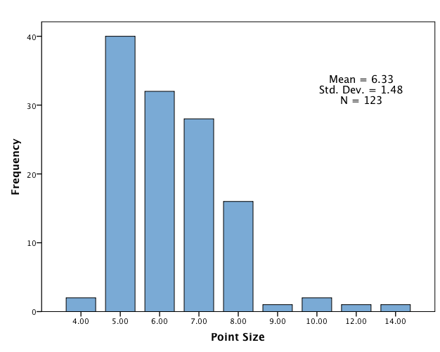
Figure 1. Distribution of Responsibility Message Sizes in 2010-2012 GQ Magazine

The mean age of the participants was 21.6 (SD = 2.3), ranging from 18 to 31. 51.1% were male and 48.9% were female. Ethnicity was diverse: 102 (77.9%) White, 9 (6.9%) Asian, 8 (6.1%) Black, 4 (3.1%) Hispanic, 1 (0.8%) American Indian, and 7 (5.3%) other. Five participants answered that they had seen the ad material before the test; their responses were omitted from the analysis, because familiarity with the ad material could affect attitude toward ad or recall accuracy (Kent & Allen, 1994). A total of 126 subjects were assigned into one of three groups: the small sized message group (N=43), the medium sized message group (N=42), and the large sized message (N=41).

Materials
A full-colored Tommy Bahama advertisement (GQ, July 2008) was used as a base of stimuli. The size of the advertisement was $10\frac{11}{16} in. × 7\frac{11}{16} in.$ which is similar to the size of the pages of most magazines (e.g., GQ= $10\frac{7}{8} in. × 7\frac{7}{8} in.$, Sports Illustrated= $10\frac{7}{8} in. × 7\frac{1}{2} in.$). Three stimuli were used, and all ad elements were controlled except the responsibility message. The responsibility message was manipulated with Adobe Photoshop to three type sizes: small (6 point), medium (10 point), and large (14 point) [see Figure 2]. The small sized message is the same size as the responsibility message in the original ad, and the average size (6.33 point) of responsibility messages that appear in current advertisements. The medium size (10 point) is the legal minimum for warning labels on magazine cigarette ads. The large message is the same size as the largest responsibility message discovered in the preliminary research; its use is exploratory.
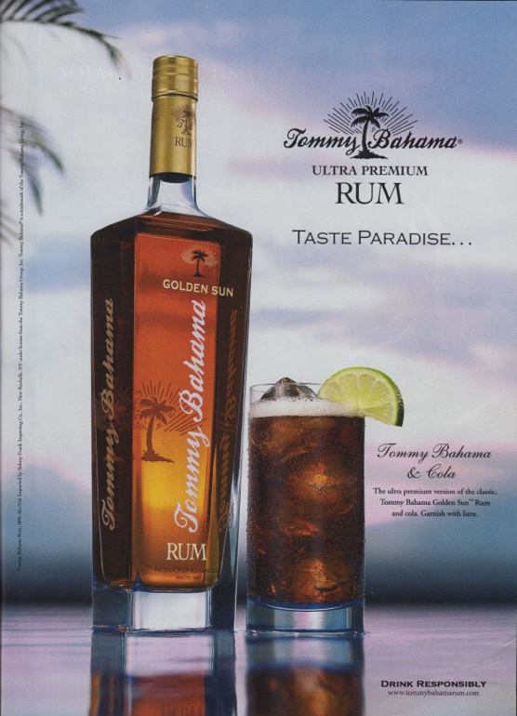 | 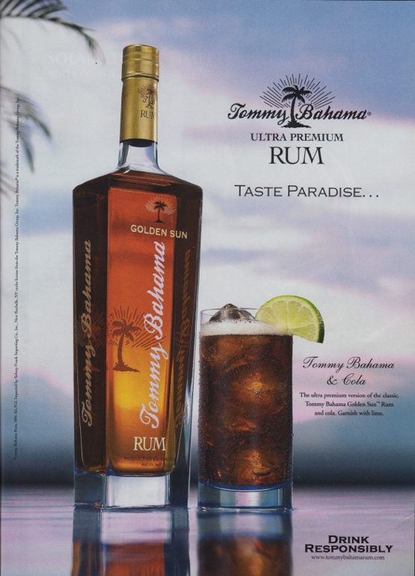
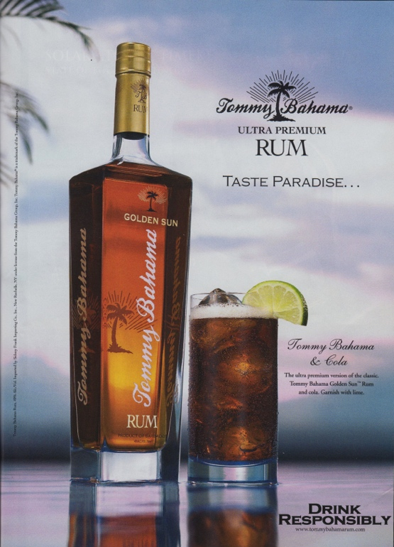
Figure 2. Three Manipulated Responsibility Messages

However, the font type was exactly identical to the font type of the original ad, which was “Copperplate Gothic Bold.”

Procedures
Before recruiting voluntary participants, the IRB (Institutional Review Board) approved the procedures and recruiting approach of this study (Appendix). A pen-and-pencil survey was conducted in pre-test and main-test. The survey measured patterns of alcohol consumption, attitudes toward the ads (Aad), purchase intentions (PI), recall of ad elements, and demographic information. Questions checking for manipulation were only added in the pretest.
Pre-test Before the main test was conducted, a premise was verified empirically in a pre-test. The premise was whether the size of the responsibility message was well-manipulated. Two manipulation check questions were added after the recall test and measured on a 7- point scale.
For this pre-test, 15 graduate and undergraduate students were recruited and randomly assigned to three groups: a group for the small message, a group for the medium-sized message, and a group for the large message. The result of the analysis did not verify the difference in the size of the responsibility message. The sizes of the responsibility message were respectively 6 point, 12 point, and 24 point. Statistical results indicated that there are differences between the small size and the medium size (p=.021) as well as between the small size and the large size (p=.026); but, there is not a mean difference between the medium size and the large size (p=.924). After this pre-test, the sizes of stimuli were changed to 6, 10, and 14.
Main test The participants were told that the purpose of the study was to examine how consumers felt about alcohol advertisements, while the real purpose, having to do with the advertisements’ responsibility messages, was hidden. This was to prevent respondents from looking at the responsibility messages intentionally. The procedure and benefits of the study were also explained. A participant who agreed to the consent statement answered questions about his/her alcohol consumption behavior, was randomly assigned ad material and then returned the advertisement to the instructor. The participant who received the second question pages continuously answered questions. The test took approximately 5-7 minutes to complete per person.

Measurements
Four questions measured alcohol consumption patterns: “Have you ever drunk alcohol?,” “How often do you currently drink alcohol?,” “When you drink, how many drinks do you typically consume?,” and “Do you think you will drink alcohol in the future?” (Morgenstern, Isensee, Sargent, & Hanewinkel, 2011). After these questions, participants looked at and read an ad as they normally would. In the second question pages, the participants answered the questions measuring attitude toward the ad (Aad) and purchase intentions (PI) toward the product. The Aad questions used 7-point likert scale questions (1 point: Strongly disagree – 7 point: Strongly agree) to measure four qualities: how much the participants liked the ad, how much they found it appealing, how much they found it attractive, and how much they found it interesting (S. Kim, Haley, & Koo, 2009). The Cronbach’s Alpha reliability test for the four Aad questions was .908. Three 7-point likert scale questions (1 point: No, definitely not – 7 point: Yes, definitely) measured purchase intentions: “Would you like to try this product?,” “Would you buy this product if you happened to see it in a store?,” and “Would you actively seek out this product in a store in order to purchase it?” (Baker & Churchil, 1977). The Cronbach’s Alpha reliability test for the three PI questions was .884.
A masked test measured recall. Participants were shown a black-and-white copy of the ad material. Three areas of each ad were blacked out [see Figure 3]. One of the three areas included the responsibility messages, and the rest were used as distractors. Subjects were asked to describe, in as much detail as possible, what they recalled about the content of the blackened areas (Thomsen & Fulton, 2007). The responses of the subjects were scored using a three point scale: 1) inaccurate or no recall, 2) recalled general concept, and 3) recalled exact wording of responsibility message (Krugman et al., 1994; Thomsen & Fulton, 2007). At the end of the survey participants filled out brief demographic information, including age, gender, and ethnicity.

Statistical analysis
All data were statistically analyzed by using one-way, within-subjects ANOVA and cross-tabulation.
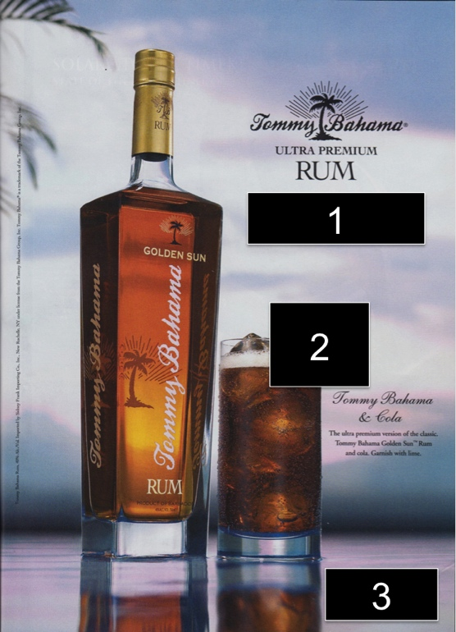
Figure 3. An Example of Ad Material for Masked Recall Test.

CHAPTER IV
Results

Alcohol drinking behavior
The self-reported alcohol drinking status of the participants showed that most of participants (n=121, 96.0%) had consumed alcoholic beverages before. 50 (39.7%) consumed alcohol at least once a week, 31 (24.6%) at least once a month, 24 (19.0%) less than once a month, and 7 (5.6%) were daily drinkers. 37 (29.4%) answered that they typically consumed 2 drinks when they drank, 27 (21.4%) that they consumed 3 drinks, 25 (19.8%) that they consumed 0 or 1 drink, and 24 (19.1%) that they consumed 5 or more. 95 (83.3%) of respondents said they will drink alcohol in the future.
Thirty-nine (31.0%) among the total participants were under age 21. Although people under 21 are prohibited to drink any alcohol beverage by law, 36 (92.3%) of participants who were under age 21 have experienced drinking alcohol, 21 (53.8%) have drunk at least once a month. Furthermore, 30 (76.9%) of minor participants answered that they desired to drink alcohol in the future.

Masked recall test results
This study investigated whether the participants could recall the responsibility messages on the manipulated ad materials. Specifically, the main test examined whether there was any relationship between the size of the responsibility message and accuracy of recall. The results of the masked recall tests for the responsibility messages and other ad elements are summarized in Table 2 and Table 3.
Table 2. Overall Masked Recall Results
Masked Area | Masked recall results
Masked Area | Incorrect or  no recall | Recalled general concept | Recalled exact wording
Headline | 105 (83.3%) | 9 (7.1%) | 12 (9.5%)
Image (Lime) | 65 (51.6%) | 8 (6.3%) | 53 (42.1%)
Responsibility Message | 68 (54.0%) | 6 (4.8%) | 52 (41.3%)
Note. N=126.

Table 3. Responsibility Message Recall Rate
Message sizes | Masked recall results
Message sizes | Incorrect or  no recall | Recalled general concept | Recalled exact wording
Small (6 point size) | 29 (67.4%) | 1 (2.3%) | 13 (30.2%)
Medium (10 point size) | 19 (42.2%) | 4 (9.5%) | 19 (45.2%)
Large (14 point size) | 20 (48.8%) | 1 (2.4%) | 20 (48.8%)
Note. N=126

Table 2 explains the percentage and raw number of the subjects who could recall the responsibility message and other ad elements. The headline ("Taste Paradise") and an image (a small piece of lime) were identical in each ad. Even though the headline consisted of only 2 words, only 16.6% subjects could recall the general concept or exact wording; however, 48.4% subjects recalled the image. More than 44.0% of the subjects could recall either the general concept or the exact wording of the responsibility message.
The size of the responsibility message influenced the recall rate. Table 3 indicates the percentage of the subjects who could recall the general concept of the responsibility message or its exact wording. Only 32.5% of the small sized message group recalled the exact wording or the concept of the responsibility message, but the medium and large sized message groups both showed more than 50.0% recall rate on the general concept or exact wording. There was fairly significant difference of recall rate between the small sized message group and the medium sized message group (Pearson Chi-Square, p=.082 <.10). But there was not a significant difference of recall between the medium sized message group and the large sized message group (Pearson Chi-Square, p=.399) as well as between the small sized message group and the large sized message group (Pearson Chi-Square, p=.213) [see Table 4]. Therefore, these results are partially in support of H1, that there is a positive association between the size of responsibility message on alcohol advertisement and recall.

Table 4. Chi-Square Tests between Groups
 |  | Value | df | p
Between small and medium sizes
 | Pearson Chi-Square | 4.997* | 2 | .082
Between medium and large sizes
 | Pearson Chi-Square | 1.840 | 2 | .374
Between small and large sizes
 | Pearson Chi-Square | 3.092 | 2 | .213
Note. $N_{small}=43, N_{medium}=42, and N_{large}=41.$
*p<.10

Ad attitude and purchase intention
The size difference of the responsibility messages did not affect respondents’ attitude toward the advertisement or intention to purchase the product. One-way ANOVA tests of SPSS indicated that there was no difference in ad attitude (Aad) or purchase intention (PI) among the three different size groups (Aad: F(2,123)=.632, p=.533 / PI: F(2,123)=.456, p=.635). Furthermore, the size of the responsibility message did not affect the mean difference of Aad and PI between the small sized message group and the medium sized message group (Aad: F(1,83)=.977, p=.326 / PI: F(1,83)=.942, p=.335), between the medium sized message group and the large sized message group (Aad: F(1,81)=.942, p=.335 / PI: F(1,81)=.278, p=.600), or between the small sized message group and the large sized message group (Aad: F(1,82)=.000, p=.998 / PI: F(1,82)=.172, p=.680), [see Table 5 and 6]. Therefore, these results are not in support of H2, that there is a negative association between the size of responsibility message on alcohol advertisement and ad attitude and purchase intention.

Table 5. Descriptive Results for Aad and PI
 |  | N | Mean | SD
Attitude toward Advertisement | Small | 43 | 4.04 | 1.26
Attitude toward Advertisement | Medium | 42 | 4.31 | 1.24
 | Large | 41 | 4.04 | 1.32
Purchase Intention | Small | 43 | 2.96 | 1.52
Purchase Intention | Medium | 42 | 3.26 | 1.34
 | Large | 41 | 3.10 | 1.50

Table 6. ANOVA Results
 |  |  | Sum of Squares | df | Mean Square | F | p
Among small, medium, and large
 |  | Aad | 2.054 | 2 | 1.027 | .632 | .533
 |  | PI | 1.925 | 2 | .962 | .456 | .635
Small size vs. medium size
 |  | Aad | 1.535 | 1 | 1.535 | .977 | .326
 |  | PI | 1.921 | 1 | 1.921 | .941 | .335
Medium size vs. large size
 |  | Aad | 1.546 | 1 | 1.546 | .942 | .335
 |  | PI | .560 | 1 | .560 | .278 | .600
Small size vs. large size
 |  | Aad | .000 | 1 | .000 | .000 | .988
 |  | PI | .390 | 1 | .390 | .172 | .680
Note. Aad=Attitude toward advertisement, PI=Purchase intention

CHAPTER V
Discussion

Although message recall is influenced by various factors, this study focused on the role of text size, specifically examining how the size of responsibility messages in alcohol advertisements affected the degree of recall of those messages among college students; and testing which size, among 6, 10, 14 point fonts, created the greatest recall rate. The findings of this study have several implications for how alcohol responsibility messages can be made most effective.

10 point should be a minimum type size for responsibility messages.
The results of the experimental survey indicated that recall rate increased when the point size of responsibility messages increased from 6 to 10 (p=.082), but did not increase when point size changed from 10 to 14 (p=.374) and when point size changed from 6 to 14 (p=.213); recall rates of 10 and 14 type sizes were about the same. This finding is consistent with the previous studies on the effects of product warning labels. One such study tested recall of warning labels on cigarette ads in magazines (Truitt et al., 2002), finding that recall greatly increased when 8 point type was raised to 10, and slightly increased when 10 point type was raised to 14, but decreased when 14 point type was raised to 18, while keeping the color contrast of message type and background high, black-on-white. Another scholar argued that a graph of the relationship between type size on print advertisement and legibility showed an inverted U-shape: 10, 11, and 12 point types are easier to read than smaller or larger sizes if all font types are identical (Wheildon, 1995).
Alcohol manufacturers and advertisers should be encouraged to make responsibility messages in 10 point type. As mentioned in the measures section, most responsibility messages in actual alcohol ads are 5, 6, or 7 point. These point sizes are too small for college students to remember—only 32.5% respondents could recall the small message’s general concept or exact wording. Raising the point size to 10 increases recall rate, however no increase in recall was found when it was raised to 14 points according to the findings of this study. Fourteen point type is not significantly more effective. Moreover, if the responsibility message were too large, it would disrupt the advertisement’s intended message. It is thus necessary that advertisers and ad agencies use approximately 10 point type in responsibility messages, to deliver the responsibility message effectively without frustrating the advertisement’s commercial purpose.

Responsibility messages do not negatively affect young adult consumers’ attitude toward ads and intention to purchase the products.
It is generally known that warning labels have a negative influence on consumers’ purchase intentions and attitudes toward brands and products (Krugman et al., 1994). For example, labels describing cancer risk on diet soft drinks decreased attitude and purchase intention approximately 4% more than expected, and the health warnings on cigarette packages led to a net decrease in cigarette consumption (Torres, Sierra, & Heiser, 2007). However, the government warning on alcohol products did not significantly change alcohol consumption (Snyder & Blood, 1992; Torres et al., 2007).
This study found that the size of responsibility messages did not affect ad attitude (p=.533) or purchase intention toward the product (p=.635) ; this was also consistent with the previous research on alcohol warning labels. Alcohol manufacturers thus should not worry that their sales will suffer from larger responsibility messages. This study therefore strongly recommends that print alcohol advertisements include around 10 point sized responsibility messages, rather than the 6 or less point messages commonly used. This could result in responsibility messages carrying out their purpose more effectively: reminding consumers of the dangers of alcohol abuse (MacKinnon, Nohre, Jeewon, Stacy, & Pentz, 2001).

Responsibility message causes a benefit to alcohol brewers.
Although there is no evidence that the responsibility messages affect consumers’ purchase behavior (Dejong et al., 1992), the messages improve consumers’ opinion and perceived credibility of credibility of alcohol manufacturers (Smith et al., 2006). Improved corporate image does not directly increase sales, but it might in the long run. This is one of the unveiled reasons that alcohol brewers participate in the drink responsibly campaign (Mantel, 2006).

CHAPTER VI
Limitations and suggestion for future research

This experimental study has some limitations. First, this study recruited participants only from a southern university and their total number was only 126. This small, local sample may not be a proper representation of the country’s population. Furthermore, the test condition was very artificial: consumers usually are exposed to advertising in their daily lives such as at home, at doctor’s offices, and beauty shops, but participants in this study directly looked at and read advertisements in a classroom. The gap between the artificial and real conditions could affect the test results. Therefore, future studies should use larger and more varied sample groups and make test conditions more real.
Second, the advertisements collected and analyzed were all taken from issues of the same men’s magazine, GQ. But responsibility messages in women’s magazines could be different from messages on men’s magazines. Future studies will analyze ads from a wider range of vehicles (Jung & Hovland, in progress).
The third limitation is theoretical. This study assumed that message size affects visual attention and the degree of visual attention influenced recall, but the degree of visual attention could not be measured in this study. This limitation could be overcome in future studies by the use of eye-tracking equipment and similar technologies. In addition, this study was designed to see if text size affects message recall, which is a very preliminary way to know message effectiveness. To understand the more advanced effectiveness of the message, subjects’ feedback and behaviors should be examined after they are exposed to ad messages.
As a fourth limitation, this study focused on general-sized magazine ads, but in the real world, various kinds of media exist such as newspaper, billboard, TV, and Internet. By each different media, involvement activities vary (Krugman, 1965). For example, Krugman suggested that viewing TV was a lower involvement activity than reading a magazine, so different media could affect the relationship between the viewer and the message of the medium. Moreover, when it comes to print advertising, the sizes of media also vary from small leaflet to huge billboard. It is obvious that the size of an entire advertisement influences visual attention (Loshe, 1997) and recall (Li & Bukovac, 1999). Also, FTC regulates the minimum point sizes of cigarette warning signs by the size of the package and advertisement. Therefore, a future study needs to examine message recall, Aad, and PI by various media and their sizes.
In the future study, general reading pattern and gaze motion on advertising should be considered. Most people generally look at a center-placed object first, and then move their visual attention to other objects on a print advertisement; thus, a study recommended placing a product or brand front and center when the advertisement needs to be quickly comprehensible (Pieter et al., 2010). However, this study did not consider the viewer’s initial attention on ad, but focused on eye-movement by text sizes. Therefore, the future study needs to consider the layout of ad elements, their sizes, and their interaction effects as a factor influencing message recall.
Lastly, content of the message could be a factor in message recall. Comparing warning labels on ads of alcohol and other product categories, the content of responsibility message on alcohol ads does not include specific consequences from alcohol consumption (e.g., lung cancer, heart disease, and emphysema in a cigarette warning label). As an example including hazards of alcohol abuse in warning label, the government of South Korea regulates putting the following alcohol warning label on every alcohol product (Stockwell, 2006): “Excessive consumption of alcohol may cause liver cirrhosis or liver cancer, and consumption of alcoholic beverages impairs your ability to drive a car or operate machinery, and may increase the likelihood of car accidents or accidents during work.” Therefore, in future studies, size effect of warning messages including words related to health risks needs to be examined.

LIST OF REFERENCES

Aitken, P. P., Eadie, D. R., Leathar, D. S., McNeill, R. E. J., & Scott, A. C. (1988). Television advertisements for alcoholic drinks do reinforce under-age drinking. British Journal of Addiction, 83(12), 1399–1419.
Austin, E. W., Miller, A. C.-R., Silver, J., Guerra, P., Geisler, N., Gamboa, L., et al. (2002). The effects of increased cognitive involvement on college students' interpretations of magazine advertisements for alcohol. Communication Research, 29(2), 155–179.
Baker, M. J., & Churchil, G. A., Jr. (1977). The impact of physically attractive models on advertising evaluations. Journal of Marketing Research, 14(4), 538–555.
Britt, S. H., Adams, S. C., & Miller, A. S. (1972). How many advertising exposures per day. Journal of Advertising Research, 12(6), 3–9.
Collins, R. L., Ellickson, P. L., McCaffrey, D., & Hambarsoomians, K. (2007). Early adolescent exposure to alcohol advertising and its relationship to underage drinking. Journal of Adolescent Health, 40(6), 527–534.
Dejong, W., Atkin, C. K., & Wallack, L. (1992). A critical analysis of "moderation" advertising sponsored by the beer industry: Are “responsible drinking” commercials done responsibly? The Milbank Quarterly, 70(4), 661–678.
Duchowski, A. (2006). Eye Tracking Methodology. London: Springer.
Dukesmith, F. H. (1904). Three natural fields of salesmanship (Vol. 2). Meadville, PA: Salesmanship.
Mandatory Label Information. (2013). e-CFR. Retrieved February 2013, from http://www.ecfr.gov/cgi-bin/text-idx?c=ecfr&SID=7c400da91dbff7fdf2a75db9fbd9b
c1a&rgn=div8&view=text&node=27:1.0.1.1.12.3.45.2&idno=27
Ellickson, P. L., Collins, R. L., Hambarsoomians, K., & McCaffrey, D. F. (2005). Does alcohol advertising promote adolescent drinking? Results from a longitudinal assessment. Addiction, 100(2), 235–246.
Fox, R. J., Krugman, D. M., Fletcher, J. E., & Fischer, P. M. (1998). Adolescents' attention to beer and cigarette print ads and associated product warnings. Journal of Advertising, 27(3), 57–68.
Gidlof, K., Holmberg, N., & Sandberg, H. (2012). The use of eye-tracking and retrospective interviews to study teenagers' exposure to online advertising. Visual Communication, 11(3), 329–345.
Grube, J. W., & Wallack, L. (1994). Television beer advertising and drinking knowledge, beliefs, and intentions among schoolchildren. American of Public Health, 82(2), 254–259.
Haan, M. A., & Moraga-González, J. L. (2011). Advertising for attention in a consumer search model. The Economic Journal, 121(552), 552–579.
Hingson, R. (2011) Magnitude of and trends in alcohol-related morality and morbidity among U.S. college students ages 18 to 24, 1998-2007. Alcoholism-Clinical and Experimental Research: Proceedings of the 34th Annual Scientific Meeting of the Research-Society-on-Alcoholism held in Atlanta, GA, 25-29 June, 2011 (pp.315A-315A). Commerce Place, 350 Main St, Malden 02148, MA USA: Wiley-Blackwell.
Ju, H. W., & Johnson, K. K. P. (2010). Fashion advertisements and young women: determining visual attention using eye tracking. Clothing and Textiles Research Journal, 28(3), 159–173.
Kaczanowska, A. (2012, December 6). Beer wholesaling in the US. IBIS World. Retrieved February 16, 2013, from http://clients1.ibisworld.com.proxy.lib.utk.edu:90/reports/us/industry/default.aspx?entid=991
Kelly, D. (2013, January 28). Wine & spirits wholesaling in the US. IBIS World. Retrieved February 16, 2013, from http://clients1.ibisworld.com.proxy.lib.utk.edu:90/reports/us/industry/ataglance.aspx?entid=992
Kent, R. J., & Allen, C. T. (1994). Competitive interference effects in consumer memory for advertising: The role of brand familiarity. Journal of Marketing, 58(3), 97–105.
Kim, S., Haley, E., & Koo, G.-Y. (2009). Comparison of the Paths From Consumer Involvement Types To Ad Responses Between Corporate Advertising And Product Advertising. Journal of Advertising, 38(3), 67–80.
Koordeman, R., Anschutz, D. J., & Engels, R. C. M. E. (2012). The effect of alcohol advertising on immediate alcohol consumption in college students: an experimental study. Alcoholism: Clinical and Experimental Research, 36(5), 874–880.
Krugman, D. M., Fox, R. J., Fletcher, J. E., Fischer, P. M., & Rojas, T. H. (1994). Do adolescents attend to warnings in cigarette advertising? An eye-tracking approach. Journal of Advertising Research, 34(6), 39–52.
Krugman, H. (1965). The impact of television advertising: Learning without involvement. Public Opinion Quarterly, 29, 349–356.
Kuisma, J., Simola, J., Uusitalo, L., & Öörni, A. (2010). The effects of animation and format on the perception and memory of online advertising. Journal of Interactive Marketing, 24(4), 269–282.
Lee, J., & Ahn, J. (2012). Attention to banner ads and their effectiveness: An eye-tracking approach. International Journal of Electronic Commerce, 17(1), 119–137.
Lee, M. J., & Shin, M. (2011). Fear versus humor: The impact of sensation seeking on physiological, cognitive, and emotional responses to antialcohol abuse messages. The Journal of Psychology, 73–92.
Leong, S. M., Ang, S. H., & Tham, L. L. (1996). Increasing brand name recall in print advertising among asian consumers. Journal of Advertising, 25(2), 65–81.
Li, H., & Bukovac, J. L. (1999). Cognitive impact of banner ad characteristics: An experimental study. Journal & Mass Communication Quarterly, 76(2), 341–353.
Lohse, G. L. (1997). Consumer Eye Movement Patterns on Yellow Pages A dvertising. Journal of Advertising, 26(1), 61–73.
MacKinnon, D. P., Nohre, L., Jeewon, C., Stacy, A. W., & Pentz, M. A. (2001). Longitudinal relationship between the alcohol warning label and alcohol consumption. Journal of Studies on Alcohol, 62(2), 221–227.
Mantel, B. (2006). Drinking on campus. CQ Researcher. Retrieved February 15, 2013, from http://www.cqresearcher.com
Milosavljevic, M., & Cerf, M. (2008). First attention then intention. International Journal of Advertising, 27(3), 381–398.
Morgenstern, M., Isensee, B., Sargent, J. D., & Hanewinkel, R. (2011). Exposure to alcohol advertising and teen drinking. Preventive Medicine, 52(2), 146–151.
Newhall, S. M., & Heim, M. H. (1929). Memory value of absolute size in magazine advertising. Journal of Applied Pshychology, 13(1), 62–75.
NIAAA. (2012, August 8). College drinking. Turning Discovery Into Health. Retrieved February 22, 2013, from http://www.niaaa.nih.gov
Petit, G. R., Kornreich, C., Maurage, P., Noël, X., Letesson, C., Verbanck, P., & Campanella, S. (2012). Early attentional modulation by alcohol-related cues in young binge drinkers: An event-related potentials study. Clinical Neurophysiology, 123(5), 925–936.
Pieters, R., & Wedel, M. (2004). Attention capture and transfer in advertising: Brand, pictorial, and text-size effects. Journal of Marketing, 68(2), 36–50.
Pieters, R., Wedel, M., & Batra, R. (2010). The stopping power of advertising: measures and effects of visual complexity. Journal of Marketing, 74(5), 48–60.
Pillai, K. G., Katsikeas, C. S., & Presi, C. (2012). Print advertising: Type size effects. Journal of Business Research, 65(6), 865–868.
Popper, E. T., & Murrary, K. B. (2013). Communication effectiveness and format effects on in-ad disclosure of health warnings. Journal of Public Policy & Marketing, 8, 109–123.
Rayner, K., Rotello, C. M., Stewart, A. J., Keir, J., & Duffy, S. A. (2001). Integrating text and pictorial information: Eye movements when looking at print advertisements. Journal of Experimental Psychology: Applied, 7(3), 219–226.
Ronznowski, J., & Eckert, J. A. (2006). Exploring what ''drink responsibly“” means to college students. Journal of Current Issue and Research in Advertising, 28(1), 19–30.
Rosbergen, E., Pieters, R., & Wedel, M. (1997). Visual attention to advertising: A segment-level analysis. Journal of Consumer Research, 24(3), 305–314.
Smith, S. W., Atkin, C. K., & Roznowski, J. L. (2006). Are “drink responsibly” alcohol campaigns strategically ambiguous? Health Communication, 20(1), 1–11.
Snyder, L. B., & Blood, D. J. (1992). Caution: Alcohol advertising and the surgeon general's alcohol warnings may have adverse effects on young adults. Journal of Applied Communication Research, 20(1), 37–53.
Stacy, A. W., Zogg, J., Unger, J. B., & Dent, C. W. (2004). Exposure to televised alcohol ads and subsequent adolescent alcohol use. American Journal of Health Behavior, 28(6), 498–509.
Stockwell, T. (2006). A review of research into the impacts of alcohol warning labels on attitudes and behavior. Center for Addictions Research of BC, 1–10.
Strasser, A. A., Tang, K. Z., Romer, D., Jepson, C., & Cappella, J. N. (2012). Graphic warning labels in cigarette advertisements. American Journal of Preventive Medicine, 43(1), 41–47.
Thomsen, S. R., & Fulton, K. (2007). Adolescents’ attention to responsibility messages in magazine alcohol advertisements: An eye-tracking approach. Journal of Adolescent Health, 41(1), 27–34.
Torres, I. M., Sierra, J. J., & Heiser, R. S. (2007). The effects of warning-label placement in print ads: A social contract perspective. Journal of Advertising, 36(2), 49–62.
Truitt, L., Hamilton, W. L., Johnston, P. R., Bacani, C. P., Crawford, S. O., Hozik, L., & Celebucki, C. (2002). Recall of health warnings in smokeless tobacco ads. Tobacco Control, 11(2), 59–63.
Wakefield, M., Germain, D., Durkin, S., & Henriksen, L. (2006). An experimental study of effects on schoolchildren of exposure to point-of-sale cigarette advertising and pack displays. Health Education Research, 21(3), 338–347.
Wheildon, C. (1995). Type & layout: How typography and design can get your message across, or get in the way. Berkeley, CA: Strathmoor Pr.
Wilcox, G. B., Kim, K. K., & Schulz, H. M. (2012). Liquor advertising and consumption in the United States: 1971--2008. International Journal of Advertising, 31(4), 819-834.
Yu, R., Chan, A. H. S., Zhao, P., & Gao, Y. (2012). Enhancing memorability: do remaining duration prompts affect advertising recall? International Journal of Advertising, 31(4), 861-876.

APPENDIX

IRB_FORM A
Certification for Exemption from IRB Review for Research Involving Human Subjects

- PRINCIPAL INVESTIGATOR(s) and/or CO-PI(s):

Sumin Shin, Master Student, School of Advertising and Public Relations
Email: sshin5@utk.edu

Roxanne Hovland, Professor, School of Advertising and Public Relations
Email: rhovland@utk.edu

- DEPARTMENT: School of Advertising and Public Relations

- COMPLETE MAILING ADDRESS AND PHONE NUMBER OF PI(s) and CO-PI(s):

Sumin Shin
476 Communications Building
School of Advertising and Public Relations
College of Communication and Information Science
University of Tennessee, Knoxville, TN 37996
(417) 942-9335

Roxanne Hovland
476 Communications Building
School of Advertising and Public Relations
College of Communication and Information Science
University of Tennessee, Knoxville, TN 37996
(865) 974-3048

- TITLE OF PROJECT: “Effect of Text Size of Responsibility Message on Magazine Alcohol Advertisement”

- EXTERNAL FUNDING AGENCY AND ID NUMBER: None

- GRANT SUBMISSION DEADLINE: None

- STARTING DATE: Upon IRB approval

- ESTIMATED COMPLETION DATE: June 2013

- RESEARCH PROJECT

- Objective(s) of Project:
This study will test whether participants can recall responsibility messages (warning sign) in magazine alcohol advertisement by text sizes of the responsibility message. The objective of this study is to provide suggestions about responsibility messages on alcohol advertisements (1) to make the responsibility message easily recognized (2) to increase the recall rate of the responsibility message.

- Subjects:
A total of 90 students will be recruited from 2013 summer classes in College of Communication and Information where the participants voluntarily agree to take part in the experiment. All participants can receive research participation credits or other option ($5 gift card) as a reward. If the class does not provide the research participation credits, the class students will receive a gift card, but they can refuse to participate in this survey. All participants will be more than 18 years old. The survey will be conducted in the classrooms. To complete all questions in the survey, approximately 5-7 minutes will be required.

- Methods or Procedures:
Before the survey starts, the principal investigator will inform all participants following:
- There is no anticipated risk.
- All responses are strictly anonymous.
- Compensations for participation
- Participation is not forced.

All subjects will be divided into 3 groups: each group will have 30 subjects who we are randomly assigned into one experimental condition. Self-report paper-and-pencil questionnaires will be randomly distributed and the opening instruction of the survey instrument will include the following wording, which notifies participants of their rights as research subjects and obtain their informed consent:

Thank you for your willingness to participate in this study. This study is attempting to better understand college students’ thoughts/feelings about alcohol advertisements.

There are no anticipated risks for study subjects. The participation is based on your willingness to participate (or not to participate). If you do not wish to answer a question, you may skip it. Also, if you wish to quit the project at any time, you can simply close the survey.

If you have questions about the study or the procedures, you may contact the researcher, Sumin Shin, Office 476 at Communications Building, Knoxville, TN 37996, by phone at (417) 942-9335, or by e-mail at sshin5@utk.edu. If you have questions about your rights as a participant, contact Brenda Lawson, in the Office of Research at (865) 974-7697 or at blawson@utk.edu.

The information you provide will be anonymous. You will not be identified individually at any stage of the study. You must be age 18 or older to participate.

If you are age 18 or older, please check here.
By checking the box and completing the survey, you provide your informed consent to participate.

Manipulation test:
After subjects agree to participate in the experiment, three different types of stimuli will be shown to subjects. After that, they will be asked to answer questions about the stimuli they just saw to see if the experimental materials were manipulated as researchers intended. By analyzing the manipulation check results, the stimuli might be going to be refined to be used in the main test.

Main test:
In the main test, the same procedure for informed consent of subjects will be administrated as in the pretest. After that, participants will see an alcohol advertisement. On the next page, main test questionnaire will ask viewers to recall the responsibility message on the alcohol advertisement.

The data resulted from this study will be used for only data analysis. The physical survey questionnaires will remain in a locked file cabinet in the researchers’ offices for 3 years, upon which time they will be destroyed. A draft copy of the survey questionnaire (see Appendix 1) and experiment materials are attached (see Appendix 2, 3, and 4).

- CATEGORY(s) FOR EXEMPT RESEARCH PER 45 CFR 46: (2)
- CERTIFICATION: The research described herein is in compliance with 45 CFR 46.101(b) and presents subjects with no more than minimal risk as defined by applicable regulations.

Principal Investigator:

Sumin Shin
_____________________________ ________________________________ _________________
Name Signature Date

Student Advisor:

Roxanne Hovland
_____________________________ ________________________________ _________________
Name Signature Date

Department Review Committee Chair:

_____________________________ ________________________________ _________________
Name Signature Date

APPROVED:
Department Head:

_____________________________ ________________________________ _________________
Name Signature Date

COPY OF THIS COMPLETED FORM MUST BE SENT TO COMPLIANCE OFFICE IMMEDIATELY UPON COMPLETION.

Rev. 01/2005

Consent Form & Questionnaire

Thank you for your willingness to participate in this study. This study is attempting to better understand college students’ thoughts/feelings about alcohol advertisements.

There are no anticipated risks for study subjects. The participation is based on your willingness to participate (or not to participate). If you do not wish to answer a question, you may skip it. Also, if you wish to quit the project at any time, you can simply close the survey.

If you have questions about the study or the procedures, you may contact the researcher, Sumin Shin, Office 476 at Communications Building, Knoxville, TN 37996, by phone at (417) 942-9335, or by e-mail at sshin5@utk.edu. If you have questions about your rights as a participant, contact Brenda Lawson, in the Office of Research at (865) 974-7697 or at blawson@utk.edu.

The information you provide will be anonymous. You will not be identified individually at any stage of the study. You must be age 18 or older to participate.

If you are age 18 or older, please check here. 

By checking the box and completing the survey, you provide your informed consent to participate.
Instructions: Questions are related to your alcohol consumption behavior. Answer the following questions as carefully as you can.

Q1) Have you ever drunk alcohol?
❑ | ❑
No | Yes
Q2) How often do you currently drink alcohol?
❑ | ❑ | ❑ | ❑ | ❑
Never | Less than once a month | At least once a month, but not every week | At least once a week | Daily
Q3) When you drink how many drinks do you typically consume? (See below chart on one standard drink.)
❑ | ❑ | ❑ | ❑ | ❑ | ❑ | ❑
0-1 | 2 | 3 | 4 | 5 | 6 | More than 6
*Note: One standard drink (source: http://www.niaaa.nih.gov)
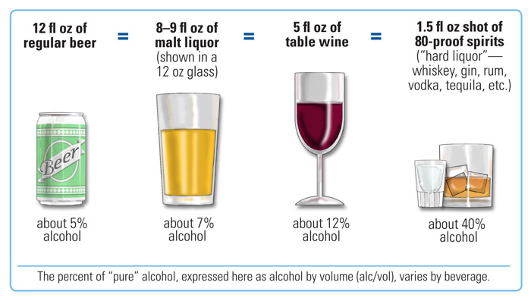
Q4) Do you think you will drink alcohol in the future?
❑ | ❑ | ❑ | ❑ | ❑
Definitely not | Probably not | Not sure | Probably yes | Definitely yes

On the next page, there is a copy of a magazine advertisement.

Please look at and read the advertisement as you normally would.

If you think you have read the advertisement long enough,
please return this paper and receive the next section of questionnaire.
Advertisement

[randomly assigned with one of following three advertisements]
Instructions: Following questions ask about the advertisement you just saw. Answer the following questions as carefully as you can.

Q5) Have you ever seen the advertisement before this test?
❑ | ❑
No | Yes

[AD Attitude]
Q6) I like the advertisement that I saw.
❑ | ❑ | ❑ | ❑ | ❑ | ❑ | ❑
Strongly disagree |  |  |  |  |  | Strongly agree
Q7) The advertisement that I saw is appealing to me.
❑ | ❑ | ❑ | ❑ | ❑ | ❑ | ❑
Strongly disagree |  |  |  |  |  | Strongly agree
Q8) The advertisement that I saw is attractive to me.
❑ | ❑ | ❑ | ❑ | ❑ | ❑ | ❑
Strongly disagree |  |  |  |  |  | Strongly agree
Q9) The advertisement that I saw is interesting to me.
❑ | ❑ | ❑ | ❑ | ❑ | ❑ | ❑
Strongly disagree |  |  |  |  |  | Strongly agree
[Purchase Intention]
Q10) Would you like to try this product?
❑ | ❑ | ❑ | ❑ | ❑ | ❑ | ❑
No, definitely not. |  |  |  |  |  | Yes, definitely.
Q11) Would you buy this product if you happened to see it in a store?
❑ | ❑ | ❑ | ❑ | ❑ | ❑ | ❑
No, definitely not. |  |  |  |  |  | Yes, definitely.
Q12) Would you actively seek out this product in a store in order to purchase it?
❑ | ❑ | ❑ | ❑ | ❑ | ❑ | ❑
No, definitely not. |  |  |  |  |  | Yes, definitely.

Q6) Please describe, in as much as possible, what you recall about the content of the blackened areas.
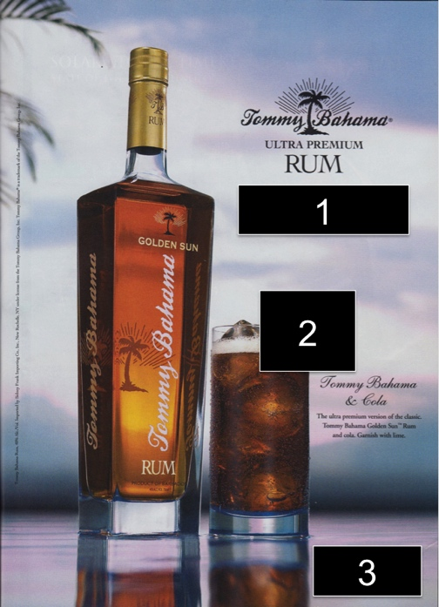

1
2
3

Demographic Information

Age: ______________

Sex: [ ] Male [ ] Female

Ethnic background: [ ] White, not Hispanic [ ] Hispanic, of any race
[ ] Black, not Hispanic [ ] Asian or Pacific Islander
[ ] American Indian, Eskimo, or Aleut
[ ] Other ____________ [ ] Prefer not to answer

Thank you so much
for your participation!

Ad materials
Advertisement 1
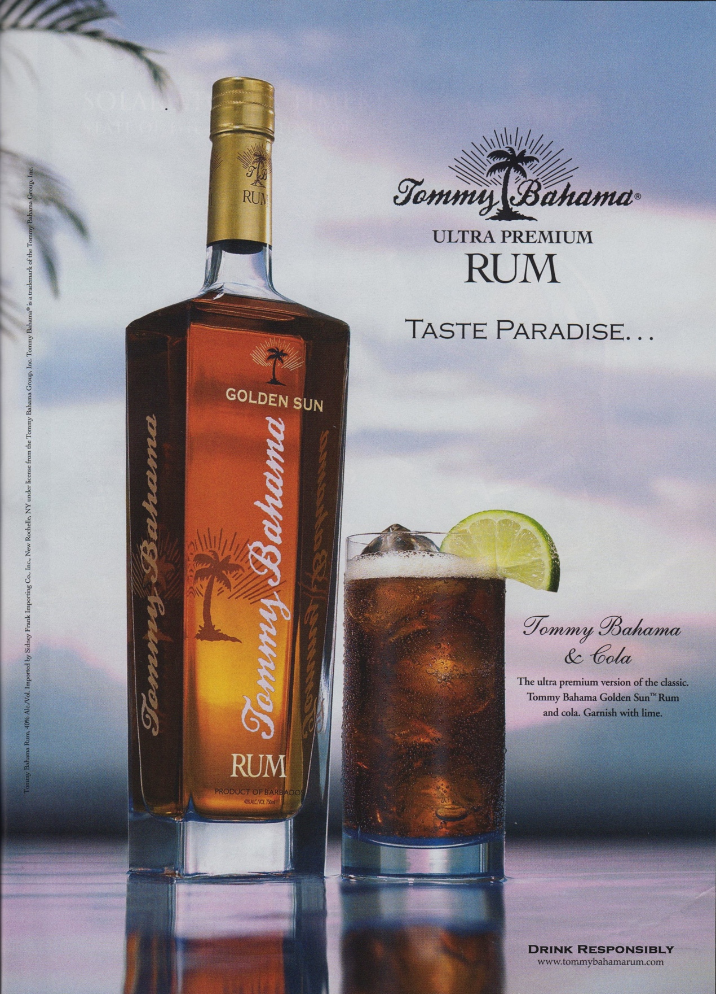
Advertisement 2
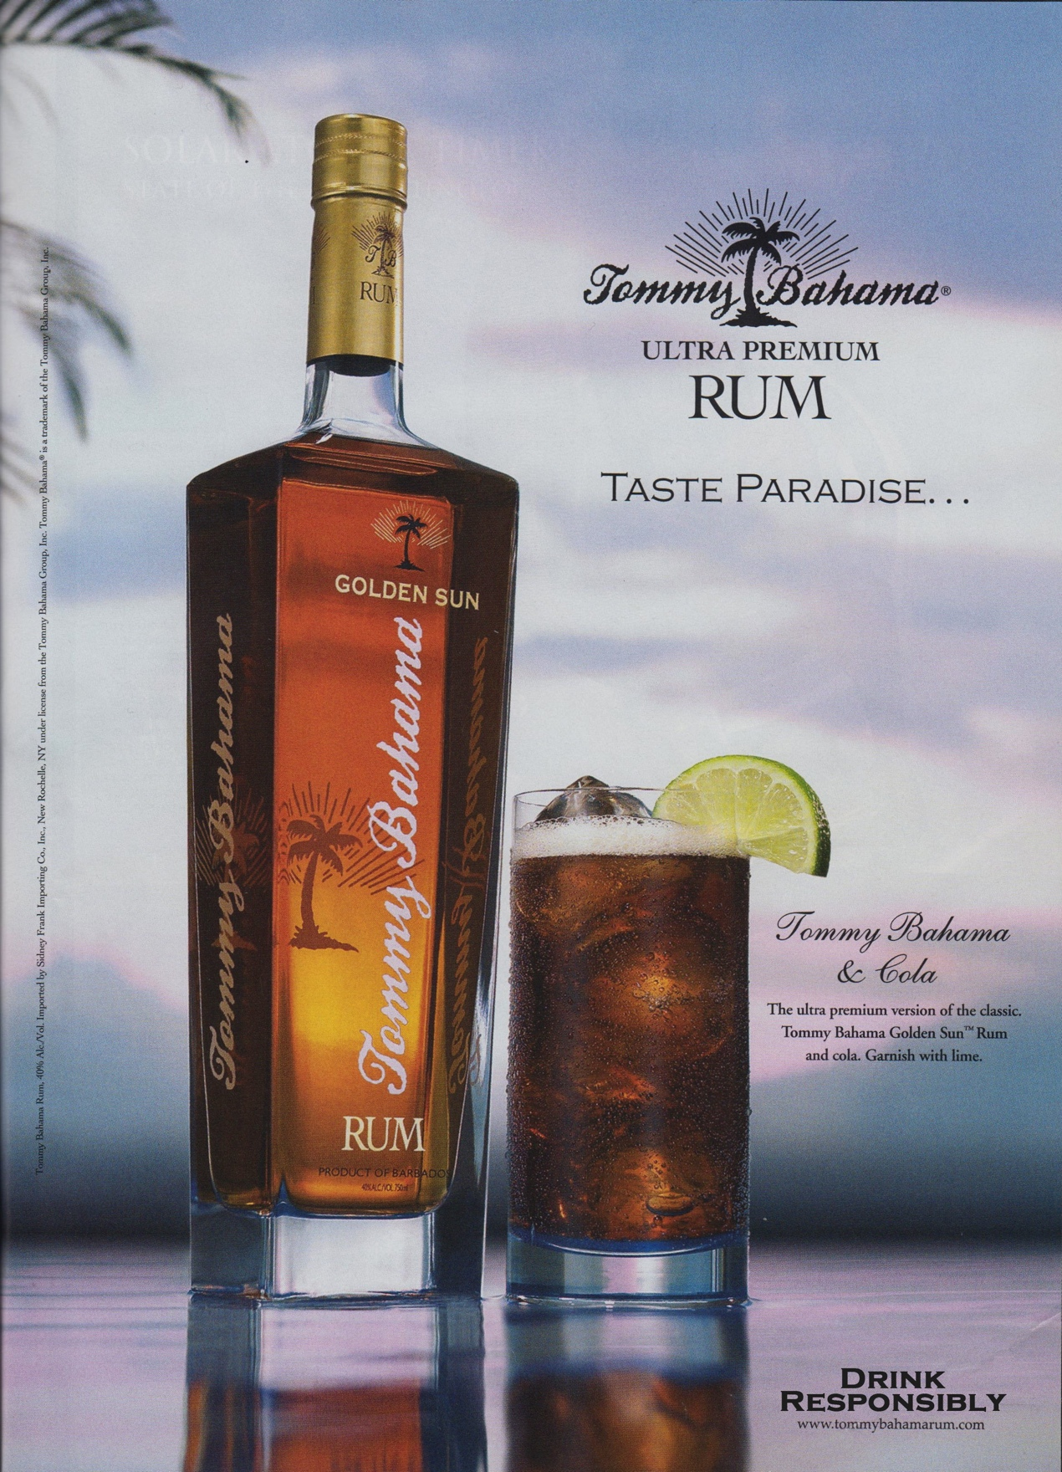
Advertisement 3
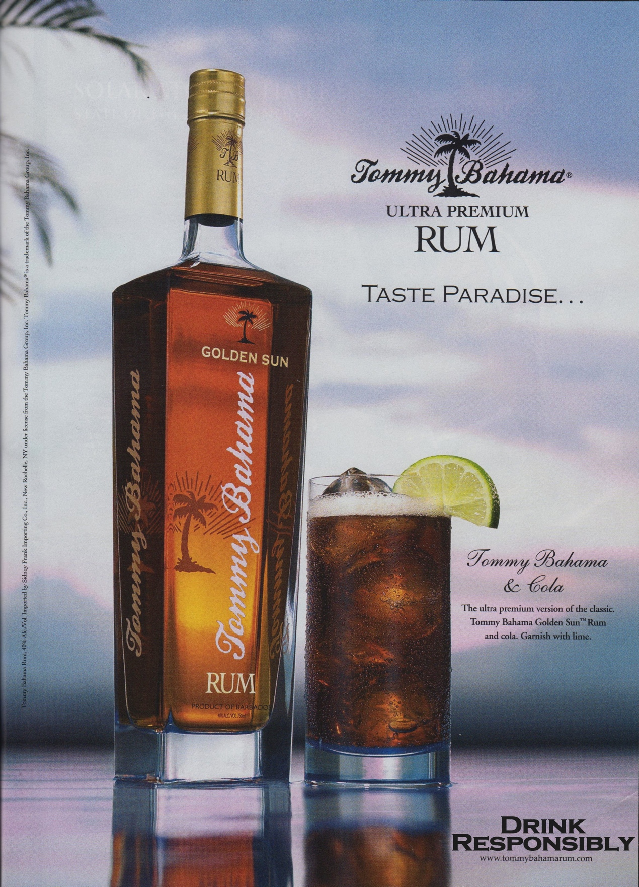

Vita

Sumin Shin was born in Seoul, Korean, in January 2, 1983, an only child to Il-Keun Shin and In-Ja Park. He earned a Bachelor of Science in Business Administration at the Yonsei University. Before coming to the U.S., he worked as an assistant account executive at advertising agencies, Welcomm Publicis Worldwide and Whiteberry. He also served for an international construction company, Daewoo International Corporation as an intern at a overseas sales department. At the University of Tennessee, he studied for a Master's degree in Communication and Information with a concentration in Advertising. His passion for research focuses on marketing communication, corporate social responsibility, and green and alcohol advertising. He will continue his academic education in the Ph.D. program in Communication and Information Science at the University of Alabama from fall, 2013.

