TWO-DIAMETER HELICAL ENDMILL BEAM MODELING WITH APPLICATION TO TOOL TIP DYNAMICS PREDICTION FOR MILLING

A Dissertation Presented for the
Doctor of Philosophy
Degree
The University of Tennessee, Knoxville

Emma D. Betters
November 2023

ABSTRACT

The aim of this dissertation is to describe the dynamic response of helical endmill geometries to enable the use of receptance coupling substructure analysis (RCSA) to predict the tool tip vibration response of a tool-holder-spindle combination. The tool tip vibration response, or receptance, is a key input for milling stability prediction. Currently, a measurement is required to determine the tool tip receptance for each tool-holder-spindle combination, which may not be possible in production environments. In the RCSA approach, the spindle receptances are measured once and archived, while the tool and holder are modeled. Tool tip receptances are predicted by analytically coupling the tool and holder models, described as equivalent diameter Timoshenko beams, to the archived spindle receptances. In this study, a two-diameter Timoshenko beam model approach will be used to predict the dynamic response of the fluted portion of the endmill geometry.

TABLE OF CONTENTS
Chapter One Introduction 1
Chapter Two Literature Review 3
Chapter Three Materials and Methods 17
Milling 17
Stability Maps 19
Fourier Series Approach 19
Cutting Force Coefficients 22
Tool Tip Receptance 24
Chapter Four Test Plan and Initial Results 26
Set Screw Holders 26
Test Sequence 26
Tool Length Repeatability 27
Setup Repeatability 28
Tool-to-Tool Repeatability 35
Tool-Holder Measurement 35
Tool-Holder-Spindle-Machine Measurement 45
Experimental Determination of Cutting Force Coefficients 50
Stability Testing for Parameter Identification 51
Coupling Parameter Comparison 56
Uncertainty 56
Heat-Shrink Holders 56
Chapter Five Timeline to Completion 60
References 61

LIST OF TABLES

Table 4-1. The tool library consists of 36 unique tool geometries. Each tool had a 38° helix angle and 0.76 mm corner radius as defined by the manufacturer. 37
Table 4-2. Segment dimensions for the set screw tool holders. 40
Table 4-3. Segment dimensions for the endmills. 41
Table 4-5. The coupling parameters determined from tool-holder-spindle measurements for each tool-set screw holder assembly on all tested machines. 49
Table 4-6. Measured cutting force coefficients and uncertainty for tools 6, 18, and 27. 54
Table 5-1. Timeline to complete research and dissertation. 60

LIST OF FIGURES

Figure 2-1. RCSA example for a cylinder rigidly coupled to a prismatic cantilever beam to form an assembly. 4
Figure 2-2. Cylinder and prismatic cantilever beam components for RCSA example. 4
Figure 2-3. Receptance coupling model for determining G₁₁ using a rigid connection. (Top) assembly. (Bottom) components. 8
Figure 2-4. Three-component RCSA model with the spindle-machine identified as component III. (Top) assembly. (Bottom) components. 10
Figure 2-5. Artifact-spindle-machine model. (Top) assembly. (Bottom) components. 11
Figure 2-6. Direct and cross artifact-spindle-machine assembly measurement locations used to determine assembly rotation-to-force receptance N_{22.} 11
Figure 3-1. In milling the instantaneous chip thickness is a function of the commanded chip thickness, vibration at the current revolution, and vibration state at the previous revolution [3]. 18
Figure 3-2. Notation for Fourier series stability analysis [3]. 18
Figure 4-1. The cross-sectional view of a set screw holder. The set screw interfaces with a Weldon flat, which is ground on the tool shank. 29
Figure 4-2. A traditional set screw and Weldon flat assembly interacts only on the bottom of the flat and allows the stickout length of the tool to vary. 29
Figure 4-3. A new set screw design produced by Accupro contacts the Weldon flat on three sides, resulting in more repeatable tool stickout lengths. 30
Figure 4-4. The modified set screw design uses an alignment pin and corresponding slot in the holder to orient the screw to the ground flat on the tool. 30
Figure 4-5. Calipers were used to measure the stickout length of each endmill. 31
Figure 4-6. The distribution of 50 stickout length measurements for a single user. 31
Figure 4-7. The distribution of 10 stickout length measurements for three users. 32
Figure 4-8. The combined distribution for 80 total stickout length measurements. 32
Figure 4-9. Three repeated FRF measurements for setup 1. 33
Figure 4-10. Three repeated FRF measurements for setup 2. 33
Figure 4-11. Three repeated FRF measurements for setup 3. 34
Figure 4-12. Elastic bands were used to approximate a free-free boundary condition for impact testing of the tool-holder assembly. 34
Figure 4-13. A GOM structured light scanner was used to measure the external geometry of the tool and holder. The scan was used to create a discretized model of the tool holder. 38
Figure 4-14. Impact testing locations as measured from the holder face for tool 1 were used for mode shape identification of the tool-holder assembly with free-free boundary conditions. 38
Figure 4-15. The imaginary part of the measured tool-holder frequency response function for tools 1-3 with free-free boundary conditions. 39
Figure 4-16. The mode shape corresponding to the lowest measured natural frequency for tools 1-3 is a bending mode. 39
Figure 4-17. The artifact-spindle-machine receptances are measured for each machine spindle in the x and y directions. Inverse RCSA is used to remove the portion of the holder extending past the flange to isolate the spindle-machine dynamics. 47
Figure 4-18. Tool-holder-spindle-machine receptances were measured by impact testing using a modal hammer and low mass accelerometer. 47
Figure 4-19. The section of the holder extending beyond the flange (left) and tool (right) are modeled as discretized beam elements using SPA. Cyan denotes steel and gold denotes carbide material properties. Note that the scales are not the same in both images. 48
Figure 4-20. TXF was used to compare the measured receptances (magenta) to the RCSA receptances (red) and adjust the fit by modifying the stiffness (KTF) and damping (CTF) coupling parameters. The KTF and CTF parameters used in the TXF software correspond to the k_{θf} and c_{θf} parameters in the connection matrix (Eq. 3.29). 48
Figure 4-21. Cutting force coefficients were collected at 50% radial immersion in a down milling direction for all cuts. 52
Figure 4-22. The mean force and linear fit for tool 6 tested over five feedrates at 10650 rpm. 52
Figure 4-23. The mean force and linear fit for tool 18 tested over five feedrates at 8000 rpm. 53
Figure 4-24. The mean force and linear fit for tool 27 tested over five feedrates at 8000 rpm. 53
Figure 4-25. Runout of the tools was measured using a dial indicator. 54
Figure 4-26. Time domain simulation versus measured forces for tool 27 with a spindle speed of 8000 rpm and feedrate of 0.15 mm/tooth. 54
Figure 4-27. A stable cut using a four flute end mill at 9000 rpm and 3 mm axial depth of cut. The tooth passing frequency is 600 Hz. 57
Figure 4-28. An unstable cut using a four flute end mill at 9000 rpm and 6 mm axial depth of cut. The tooth passing frequency is 600 Hz. Content present at 3569 Hz indicates chatter. 57
Figure 4-29. Stability results for tool 6. 58
Figure 4-30. Stability results for tool 18. 58
Figure 4-31. Stability results for tool 27. 59

Introduction
In milling operations, the pre-process selection of spindle speed and depth of cut combinations which produce stable cutting conditions can be the difference between a profit and a loss. The pre-process (before making a cut) prediction of stable parameters has received significant attention in the research community. Three common methods used to determine the stability boundary are: average force method (Tlusty method) [1], Fourier series method (Altintas method) [2], and time domain simulation [3]. The stability boundary varies slightly for each of these models, and each has advantages and disadvantages in different use cases. However, all three predictive methods require knowledge of the tool tip frequency response function (FRF), or receptance.
Traditionally, impact testing is performed using an instrumented hammer and linear transducer (e.g., accelerometer, vibrometer, or capacitance gauge) to measure the tool tip FRF for a specified tool-holder-spindle-machine assembly [3]. The measured FRF is then used to generate a stability map, a diagram that separates spindle speed-axial depth of cut combinations that provide stable machining conditions from those that exhibit chatter, or unstable behavior, for a given radial immersion. The effectiveness of on-machine FRF measurements has been demonstrated in the literature. However, each stability map is unique to a specific tool-holder-spindle-machine assembly with the tool inserted in the holder with a given extension length, or stickout length, from the holder [4]–[6]. This assembly-specific relationship makes the collection of the required data expensive and time consuming. Due to the required capital and time investment, many shops rely on prior experience or iterate through combinations when selecting spindle speed-axial depth combinations. This can result in scrapped parts, underutilization of machine capability, and longer-than-necessary cycle times.
The objective of this project is to enable the selection of stable machining parameters without the need for individual measurements of each tool-holder-spindle-machine assembly. Receptance coupling substructure analysis (RCSA) is used to predict the tool tip receptance [7]. Using this approach, a single on-machine artifact measurement is required for each spindle-machine. Inverse receptance coupling is used to isolate the spindle-machine receptances from the artifact-spindle-machine measurement. The resulting spindle-machine receptances can then be coupled to an arbitrary tool and holder models to determine the tool-holder-spindle-machine receptances. Holder models are typically radially symmetric and can be modeled as a series of cylindrical Timoshenko elements. The fluted section of the tool has widely been described in the literature by a single equivalent diameter beam based on some cross-sectional property of the tool with varying degrees of success. This dissertation will focus on a two-diameter equivalent Timoshenko beam model to more accurately predict the dynamic response of the helical portion of the endmill.

Literature Review
Tool tip receptance is a key input to milling stability analyses in which stable and unstable conditions are separated for combinations of spindle speed and axial depth of cut [2], [3], [8], [9]. Typically, a measurement is required for each tool-holder-spindle-machine combination [3]. In facilities with many machines, limited FRF measurement capability, or lack of time and capital, this tool-holder-spindle-machine specific measurement hinders the ability to use stability maps for optimized parameter selection.
Receptance coupling is a technique where component/substructure receptances, or frequency response functions (FRFs), are joined analytically to predict assembly dynamics. It was first introduced in 1960 by Bishop and Johnson [10] and has become a standard tool in structural dynamics modeling. Schmitz and Donaldson first pioneered the use of receptance coupling substructure analysis (RCSA) in 2000 for the prediction of tool tip frequency response functions in milling [7]. This method provided a shift from on-machine measurements to a modelling-based approach for the determination of tool tip receptances. First, key elements of the RCSA procedure and algorithm are described [7]. Second, a discussion of the implementation and modification of the approach is provided.
The RCSA model includes: 1) transverse deflections, x_{i} and X_{i}, for the components (lower case variables) and assembly (upper case variables) due to internal and external forces, f_{j} and F_{j}; and 2) rotations about lines perpendicular to the beam axis, θ_{i} and Θ_{i}, and bending moments (or couples), m_{j} and M_{j}, to completely describe the transverse dynamic behavior of beams. To describe the procedure, consider the cylinder-prismatic cantilever beam assembly displayed in Figure 2-1. This is representative of a tool (cylinder) rigidly attached to a holder-spindle-machine (prismatic cantilever beam).
X₁
Θ₁
X₂
Θ₂
Figure 2-1. RCSA example for a cylinder rigidly coupled to a prismatic cantilever beam to form an assembly.

x₁
θ₁
x_{2b}
θ_{2b}
x_{2a}
θ_{2a}
Figure 2-2. Cylinder and prismatic cantilever beam components for RCSA example.
To calculate the assembly receptances, all four bending receptances are included in the component (i.e., cylinder and prismatic cantilever beam) descriptions. These four bending receptances include displacement-to-force, h_{ij}, displacement-to-couple, l_{ij}, rotation-to-force, n_{ij}, and rotation-to-couple, p_{ij}, where i is the displacement/rotation coordinate location and j is the location where the force/couple is applied. There are three primary steps followed to predict the Figure 2-1 assembly receptances.
- Define the components and coordinates for the model. In this example, there are two components: a prismatic beam with fixed-free (or cantilever) boundary conditions and a cylinder with free-free (or unsupported) boundary conditions; see Figure 2-2.
- Determine the component receptances. These can be based on measurements or models. For the models, an analytical choice is closed-form receptances for flexural vibrations of uniform Euler-Bernoulli beams with free, fixed, sliding, and pinned boundary conditions [10], [11]. A numerical option is the Timoshenko beam model [12]. For measurements, tap testing may be applied, where the structure is excited using a modal hammer (impact force) or shaker-stinger combination (sinusoidal, chirp, or other force profile) and the response is measured using a linear transducer, such as a low-mass accelerometer [11].
- Based on the model from step 1, express the assembly receptances as a function of the component receptances from step 2. Determine the assembly receptances using the component displacements/rotations, compatibility conditions, and equilibrium conditions.
The procedure for coupling the components in Figure 2-2 to form the assembly in Figure 2-1 requires the component receptances. In Figure 2-2, coordinates are placed at the prediction location (1) and coupling locations (2a and 2b) on the two components. For the cylinder, the direct receptances at the coordinate 1 end are shown in Eq. 2.1.
$h_{11}=\frac{x_{1}}{f_{1}}$ $l_{11}=\frac{x_{1}}{m_{1}}$ $n_{11}=\frac{θ_{1}}{f_{1}}$ $p_{11}=\frac{θ_{1}}{m_{1}}$ | (2.1)
The cross receptances are given by Eq. 2.2.
$h_{12a}=\frac{x_{1}}{f_{2a}}$ $l_{12a}=\frac{x_{1}}{m_{2a}}$ $n_{12a}=\frac{θ_{1}}{f_{2a}}$ $p_{12a}=\frac{θ_{1}}{m_{2a}}$ | (2.2)
At coordinate 2a on the cylinder, the direct and cross receptances are provided in Eqs. 2.3 and 2.4.
$h_{2a2a}=\frac{x_{2a}}{f_{2a}}$ $l_{2a2a}=\frac{x_{2a}}{m_{2a}}$ $n_{2a2a}=\frac{θ_{2a}}{f_{2a}}$ $p_{2a2a}=\frac{θ_{2a}}{m_{2a}}$ | (2.3)
$h_{2a1}=\frac{x_{2a}}{f_{1}}$ $l_{2a1}=\frac{x_{2a}}{m_{1}}$ $n_{2a1}=\frac{θ_{2a}}{f_{1}}$ $p_{2a1}=\frac{θ_{2a}}{m_{1}}$ | (2.4)
Similarly, for the prismatic cantilever beam, the direct receptances at the coupling location 2b are given by Eq. 2.5.
$h_{2b2b}=\frac{x_{2b}}{f_{2b}}$ $l_{2b2b}=\frac{x_{2b}}{m_{2b}}$ $n_{2b2b}=\frac{θ_{2b}}{f_{2b}}$ $p_{2b2b}=\frac{θ_{2b}}{m_{2b}}$ | (2.5)
To simplify notation, the component receptances may be represented in matrix form as shown in Eqs. 2.6 through 2.9 for the cylinder and Eq. 10 for the prismatic cantilever beam. In Eqs. 2.6-2.10 R_{ij} is the generalized receptance matrix that describes both translational and rotational component behavior [13] and u_{i} and q_{j} are the corresponding generalized displacement/rotation and force/couple vectors.
$\left\{\begin{matrix}x_{1} \\ θ_{1}\end{matrix}\right\}=\left[\begin{matrix}h_{11} & l_{11} \\ n_{11} & p_{11}\end{matrix}\right]\left\{\begin{matrix}f_{1} \\ m_{1}\end{matrix}\right\}$ or $\left\{u_{1}\right\}=\left[R_{11}\right]\left\{q_{1}\right\}$ | (2.6)
$\left\{\begin{matrix}x_{2a} \\ θ_{2a}\end{matrix}\right\}=\left[\begin{matrix}h_{2a2a} & l_{2a2a} \\ n_{2a2a} & p_{2a2a}\end{matrix}\right]\left\{\begin{matrix}f_{2a} \\ m_{2a}\end{matrix}\right\}$ or $\left\{u_{2a}\right\}=\left[R_{2a2a}\right]\left\{q_{2a}\right\}$ | (2.7)
$\left\{\begin{matrix}x_{1} \\ θ_{1}\end{matrix}\right\}=\left[\begin{matrix}h_{12a} & l_{12a} \\ n_{12a} & p_{12a}\end{matrix}\right]\left\{\begin{matrix}f_{2a} \\ m_{2a}\end{matrix}\right\}$ or $\left\{u_{1}\right\}=\left[R_{12a}\right]\left\{q_{2a}\right\}$ | (2.8)
$\left\{\begin{matrix}x_{2a} \\ θ_{2a}\end{matrix}\right\}=\left[\begin{matrix}h_{2a1} & l_{2a1} \\ n_{2a1} & p_{2a1}\end{matrix}\right]\left\{\begin{matrix}f_{1} \\ m_{1}\end{matrix}\right\}$ or $\left\{u_{2a}\right\}=\left[R_{2a1}\right]\left\{q_{1}\right\}$ | (2.9)
$\left\{\begin{matrix}x_{2b} \\ θ_{2b}\end{matrix}\right\}=\left[\begin{matrix}h_{2b2b} & l_{2b2b} \\ n_{2b2b} & p_{2b2b}\end{matrix}\right]\left\{\begin{matrix}f_{2b} \\ m_{2b}\end{matrix}\right\}$ or $\left\{u_{2b}\right\}=\left[R_{2b2b}\right]\left\{q_{2b}\right\}$ | (2.10)
The component receptances are written using the generalized notation: $u_{1}=R_{11}q_{1}+R_{12a}q_{2a}$ and $u_{2a}=R_{2a1}q_{1}+R_{2a2a}q_{2a}$ for the cylinder and $u_{2b}=R_{2b2b}q_{2b}$ for the prismatic cantilever beam. For a rigid connection between the two components, the compatibility condition is $u_{2b}-u_{2a}=0$. This indicates there is no relative motion at the coupling location. Additionally, if the component and assembly coordinates are at the same physical locations, then $u_{1}=U_{1}$ and $u_{2a}=u_{2b}=U_{2}$ (due to the rigid coupling). The assembly receptances are written as shown in Eq. 2.11, which again incorporates the generalized notation.
$\left\{\begin{matrix}U_{1} \\ U_{2}\end{matrix}\right\}=\left[\begin{matrix}G_{11} & G_{12} \\ G_{21} & G_{22}\end{matrix}\right]\left\{\begin{matrix}Q_{1} \\ Q_{2}\end{matrix}\right\}$, where $U_{i}=\left\{\begin{matrix}X_{i} \\ Θ_{i}\end{matrix}\right\}$, $G_{ij}=\left[\begin{matrix}H_{ij} & L_{ij} \\ N_{ij} & P_{ij}\end{matrix}\right]$, and $Q_{j}=\left\{\begin{matrix}F_{j} \\ M_{j}\end{matrix}\right\}$ | (2.11)
To determine the four assembly receptances at the free end of the cylinder, G₁₁, the generalized force Q₁ is applied to assembly coordinate U₁ as shown in Figure 2-3, where the generalized U_{i} and u_{i} vectors are shown schematically as “displacements”, although they describe both transverse deflection and rotation. The associated equilibrium conditions are $q_{2a}+q_{2b}=0$ (i.e., the internal forces/couples are balanced) and $q_{1}=Q_{1}$ (because the component and assembly generalized forces are located at the same spatial location).
By substituting the component displacements/rotations and equilibrium conditions into the compatibility condition, the expression for q_{2b} shown in Eq. 2.12 is obtained. The component force q_{2a} is then determined from the equilibrium condition $q_{2a}=-q_{2b}$.
U₁
U₂
u₁
u_{2b}
u_{2a}
Q₁
q₁
q_{2a}
q_{2b}
Figure 2-3. Receptance coupling model for determining G₁₁ using a rigid connection. (Top) assembly. (Bottom) components.

$$u_{2b}-u_{2a}=0 \\ R_{2b2b}q_{2b}-R_{2a1}q_{1}-R_{2a2a}q_{2a}=0 \\ \left(R_{2a2a}+R_{2b2b}\right)q_{2b}-R_{2a1}Q_{1}=0 \\ q_{2b}={\left(R_{2a2a}+R_{2b2b}\right)}^{-1}R_{2a1}Q_{1}$$ | (2.12)
The expression for G₁₁ is given by Eq. 2.13. The (1, 1) location, H₁₁, in the 2×2 matrix, G₁₁, is the displacement-to-force receptance required for milling stability prediction.
$$G_{11}=\frac{U_{1}}{Q_{1}}=\frac{u_{1}}{Q_{1}}=\frac{R_{11}q_{1}+R_{12a}q_{2a}}{Q_{1}}=\frac{R_{11}Q_{1}-R_{12a}{\left(R_{2a2a}+R_{2b2b}\right)}^{-1}R_{2a1}Q_{1}}{Q_{1}}$$$G_{11}=R_{11}-R_{12a}{\left(R_{2a2a}+R_{2b2b}\right)}^{-1}R_{2a1}=\left[\begin{matrix}H_{11} & L_{11} \\ N_{11} & P_{11}\end{matrix}\right]$ | (2.13)
For a non-rigid coupling with energy dissipation (damping) between the tool and holder, Eq. 2.13 is modified to include a connection stiffness matrix, [K], as shown in Eq. 2.14.
$G_{11}=R_{11}-R_{12a}{\left(R_{2a2a}+R_{2b2b}+K^{-1}\right)}^{-1}R_{2a1}=\left[\begin{matrix}H_{11} & L_{11} \\ N_{11} & P_{11}\end{matrix}\right]$ | (2.14)
The complex-valued, frequency-dependent connection stiffness matrix is defined in Eq. 2.15, where k indicates stiffness, c represents viscous damping, and ω is frequency. The subscripts for the 2×2 stiffness matrix entries identify their function. For example, k_{θf} represents resistance to rotation due to an applied force.
$$\left[K\right]=\left[\begin{matrix}k_{xf}+iωc_{xf} & k_{θf}+iωc_{θf} \\ k_{xm}+iωc_{xm} & k_{θm}+iωc_{θm}\end{matrix}\right]$$ | (2.15)

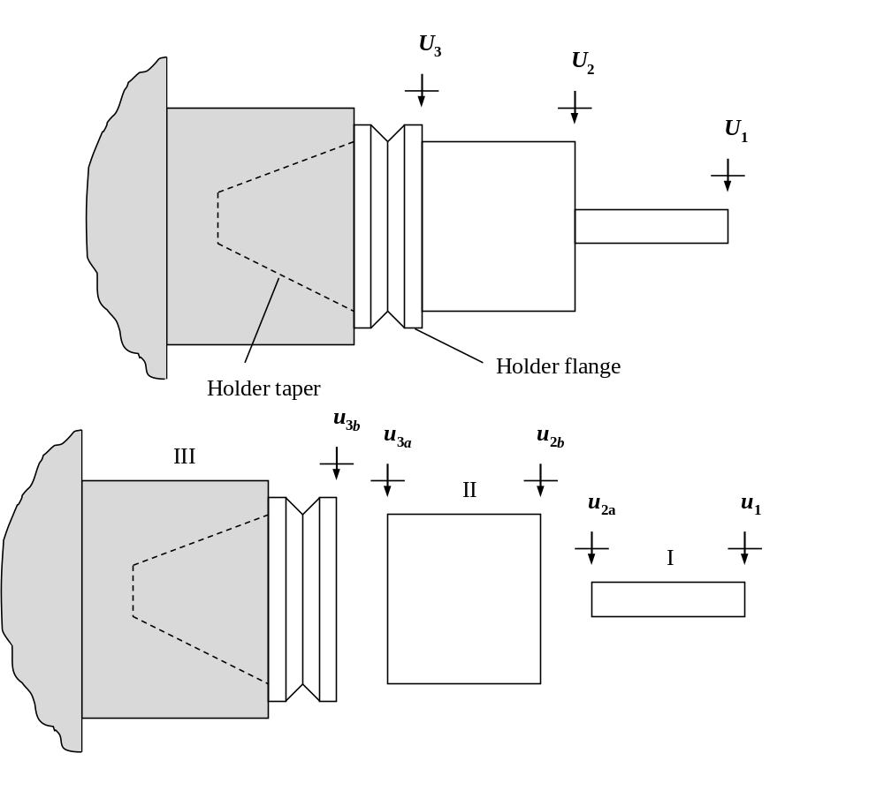
Figure 2-4. Three-component RCSA model with the spindle-machine identified as component III. (Top) assembly. (Bottom) components.
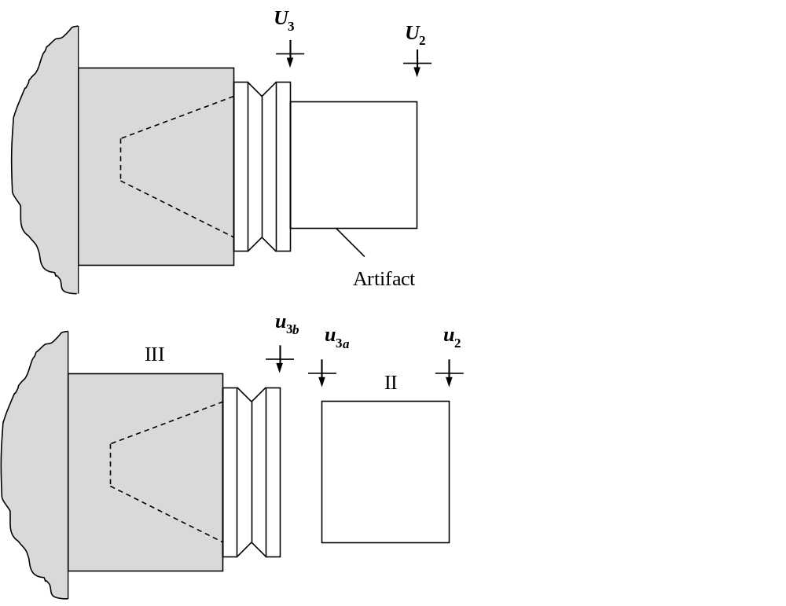
Figure 2-5. Artifact-spindle-machine model. (Top) assembly. (Bottom) components.
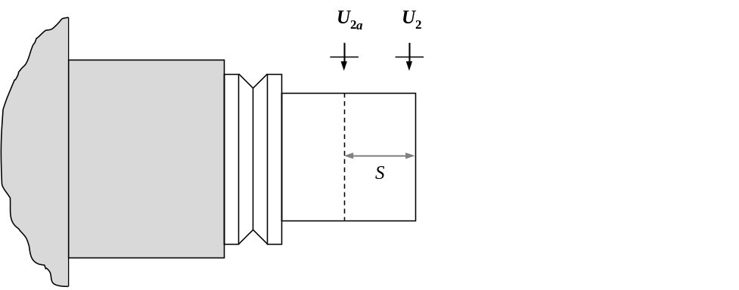
Figure 2-6. Direct and cross artifact-spindle-machine assembly measurement locations used to determine assembly rotation-to-force receptance N_{22.}
In 2005, Duncan and Schmitz [14] expanded the RCSA model, and applied a three-component model. The spindle-machine receptances were identified by impact testing of a standard artifact; see Figure 2-4, where the tool is component I, the holder is component II, and the spindle-machine is component III, which contains the machine, spindle, portion of the holder inside the spindle (i.e., the taper), and the holder flange. This is a convenient separation point for the holder because the flange geometry is consistent for any spindle-holder interface, such as HSK-63A or CAT40. This is required for automatic tool changers to have a uniform geometry to grip.
As shown, the tool (component I) and holder (II) receptances can be modeled using beam theory and the generalized receptance matrices, R_{ij}, can be populated. For the spindle-machine (III), however, measurements are necessary because the required information is not generally available to accurately model this complex component. To enable identification of both the displacement and rotation receptances, a standard artifact is inserted in the spindle. The artifact-spindle-machine model is displayed in Figure 2-5. It is composed of the portion of the artifact beyond the spindle flange (component II) and the spindle-machine (component III), where the spindle-machine receptances are required to predict the tool tip receptances for arbitrary combinations of tools and holders inserted in the selected spindle-machine.
The artifact-spindle-machine receptances are written by modifying Eq. 2.13. By replacing coordinate 1 with 2, coordinate 2a with 3a, and coordinate 2b with 3b, the assembly receptances in Eq. 2.16 are obtained.
$$G_{22}=R_{22}-R_{23a}{\left(R_{3a3a}+R_{3b3b}\right)}^{-1}R_{3a2}=\left[\begin{matrix}H_{22} & L_{22} \\ N_{22} & P_{22}\end{matrix}\right]$$ | (2.16)
Unlike the tool-holder-spindle-machine model, where the desired prediction outcome is the tool tip assembly receptances contained in the generalized matrix G₁₁ (Eq. 2.13), the intent in this case is to determine the component receptances R_{3b3b}. This generalized receptance matrix contains the receptances for the spindle-machine, which are not conveniently modeled or measured. To determine R_{3b3b}, an inverse RCSA approach is applied where Eq. 2.16 is rewritten to solve for R_{3b3b}. See Eq. 2.17.
$$R_{3b3b}=R_{3a2}{\left(R_{22}-G_{22}\right)}^{-1}R_{23a}-R_{3a3a}=\left[\begin{matrix}h_{3b3b} & l_{3b3b} \\ n_{3b3b} & p_{3b3b}\end{matrix}\right]$$ | (2.17)
Here, the G₂₂ assembly receptances are measured, while the R₂₂, R_{23a}, R_{3a2}, and R_{3a3a} component receptances are modeled. As before, either Euler-Bernoulli or Timoshenko beam models may be applied to describe the component receptances. To determine the four G₂₂ receptances, the displacement-to-force direct receptance $H_{22}=\frac{X_{2}}{F_{2}}$ may be measured by tap testing, where an impact hammer is used to excite the artifact-spindle-machine assembly at coordinate 2 and the response is measured at the same location using a low-mass accelerometer or other linear sensor. To find the rotation-to-force receptance $N_{22}=\frac{Θ_{2}}{F_{2}}$, a first-order finite difference approach may be implemented [15]. By measuring both the direct receptance H₂₂ and the cross receptance $H_{2a2}=\frac{X_{2a}}{F_{2}}$, N₂₂ may be calculated using Eq. 2.18. The displacement-to-force cross receptance H_{2a2} is obtained by exciting the assembly at U₂ and measuring the response at coordinate U_{2a}, located a distance S from the artifact’s free end, as shown in Figure 2-6. Equivalently, H_{22a} could be measured, where the linear transducer is placed at U₂ and the force is applied at U_{2a}.
$$H_{22}=\frac{H_{22}-H_{2a2}}{S}=\frac{H_{22}-H_{22a}}{S}$$ | (2.18)
The other off-diagonal term in the Eq. 2.16 G₂₂ matrix term is assigned by reciprocity, L₂₂ = N₂₂. Finally, P₂₂ may be determined by synthesis using Eq. 2.19 [16]. Given a fully populated assembly matrix, G₂₂, Eq. 2.17 may be used to determine the spindle-machine receptances and this result may be archived and used to predict the tool tip receptance for any tool-holder combination.
$$P_{22}=\frac{Θ_{2}}{M_{2}}=\frac{F_{2}}{X_{2}}\frac{X_{2}}{M_{2}}\frac{Θ_{2}}{F_{2}}=\frac{1}{H_{22}}L_{22}N_{22}=\frac{{N_{22}}^{2}}{H_{22}}$$ | (2.19)
Following the initial paper [7], contributions have been made by numerous authors to expand on the RCSA model.
In the first RCSA study [7], the tool was modeled as an Euler-Bernoulli beam. This analytical approximation of transverse bending modes is sufficient for long, slender beams, but loses accuracy for short, non-slender beams [10]–[12]. Additional work using closed-form receptances of Euler-Bernoulli [10] beam to describe the tool tip FRF are presented in [14], [17], and [18]. Models of the tool and holder, and additional applications, using Timoshenko [8] beam theory were presented in [14], [19], [28]–[32], [20]–[27].
Initially [7], the holder-spindle-machine was treated as one structure. This segmentation does not take full advantage of the capability for the RCSA method to predict the resulting tool tip receptance for assemblies with variations in the holder as well as the cutting tool. In [3], [11], [14], [33], and [34] the authors present a three-component model: tool, holder, and spindle-machine. This allowed for a more general solution for modeling any tool-holder combination. Schmitz et al. [35], [36] described the tool, holder, and spindle-machine as "genes" in the “Machine Tool Genome Project” and used RCSA to predict the assembly FRFs (analogous to physical traits in the human genome) for pre-process parameter selection. Wen et al. also modeled the assembly as three substructures: machine-spindle-holder, holder-tool shank, and extended portion of the tool [37], [38].
Due to the difficulty in measurement, Schmitz and Donaldson assumed the rotational receptances to be zero [7]. Despite simplifications, accurate tooltip receptances were made for three different tools in the same holder-spindle-machine substructure using a single connection parameter matrix. Follow-on papers by Schmitz and colleagues [9-11] extended the experimental validation using new tool-holder-spindle combinations with the same simplifications. In 2003, Park et al. [12] extended the RCSA approach to include rotational receptances. Burns and Schmitz [13] followed this work by incorporating rotational receptances in the holder-spindle-machine model to study the tool-holder connection parameters.
Several authors have presented methods for measuring or deriving rotational receptances. Kumar and Schmitz [39], [40] used a single, direct FRF measurement of an artifact mounted in a selected spindle to identify displacement and rotational spindle-machine receptances. Each mode in the direct FRF was fit as a fixed-free beam using a close-form Euler-Bernoulli model [10]. The rotational receptances were then obtained from the same beam models. Additional methods for determining rotational receptances or deriving them from translational receptances have been presented in [19], [41]–[49].
An accurate model of the tool and holder are required for an accurate tool tip receptance prediction. Methods for simplifying the tool and holder geometry have been addressed. Several authors describe an equivalent diameter beam for the fluted portion of the endmill based on cross-sectional moment of inertia [50]–[52]. Kumar [53] described an equivalent diameter beam model based on different cross-sectional properties. Özşahin and Altintas [54] predicted tool tip FRFs using RCSA with helix angle and lag angle considered when defining the fluted section of the endmill. Some authors used spectral- Tchebychev techniques [20], [55]. Zhang et al. coupled Timoshenko beam models of the holder and shank to receptances of the fluted portion of the tool found by FEA [21]. Tunc [56] implemented an STL slicing algorithm to determine the cross-sectional properties of the fluted section of the endmill and used the slices to develop an improved beam model for RCSA.
In general, no connection interface can be considered to be infinitely rigid. The complex-valued, frequency-dependent connection stiffness matrix defined in Eq. 2.15 has been evaluated, and modified, by several authors. Researchers have identified a dependence of the connection parameters on holder type (e.g., thermal shrink fit vs. collet), tool diameter, tool extension length from the holder, and spindle speed [25], [26], [57]–[64]. In addition, the spindle-holder connection stiffness and damping have also been studied for the taper interface (e.g., HSK or CAT) [22], [23], [58], [61], [65]–[69]. Impact testing [26], [61], [64], [65], [70]–[73], finite element analysis [38], [57], [61], [62], [65], [74]–[78], and optimization algorithms and machine learning methods [63], [70], [71], [79]–[84] have all been implemented in connection parameter studies.
Given the predictive capability afforded by RCSA, many research groups have applied the method to assembly dynamics prediction in a wide variety of scenarios including, for example:
- Milling stability prediction [5], [29], [93], [85]–[92]
- Machine tool design, characterization, and evaluation of pose dependent dynamics [31], [94]–[101]
- Tool and tool holder design [102]–[109]
- Sensor filtering and compensation [110], [111], [120], [112]–[119]
- Micro-milling [18], [28], [97], [121], [122]
- Turning (tool and workpiece modeling) [123]–[125]
- Workpiece dynamics [32], [126]–[129]
- Drilling [130], [131]
and others [4], [6], [132]–[138].

Materials and Methods

Milling
Because milling is defined by a rotating tool with discrete cutting edges and the teeth enter and exit the cut on every revolution, a periodic forcing function is produced [3]. This periodic force acts on the flexible tool-holder-spindle-machine assembly. Forced vibrations occur when the periodic force excites the system’s structural dynamics. As the tool vibrates, its displacement from a nominal position results in a variation in chip thickness as shown in Figure 3-1. The result is that the instantaneous chip thickness is a function of the commanded chip thickness and vibration of the tool.
As the teeth rotate past the surface, the cutter vibration leaves a wavy surface on the workpiece. As the next tooth removes material, this may result in a chip thickness variation depending on the phase of vibration between the current tooth and previous tooth. The instantaneous chip thickness, h, can be written as a function of time:
$$h(t)=f_{t}\sin\left(ϕ\right)+n\left(t-τ\right)-n(t)$$ | (3.1)
where n(t - τ) describes the vibration along the surface normal of the previous tooth and n(t) describes the current tooth.
This dependence of the current chip thickness on the deflections of the current and previous tooth and the corresponding cutting force variation is referred to as regeneration [3]. The result of regeneration is a potential for instability, or chatter, in the form of self-excited vibration. The large forces and displacements when chatter occurs can lead to scrapped workpieces, broken tools, and potential damage to the machine.
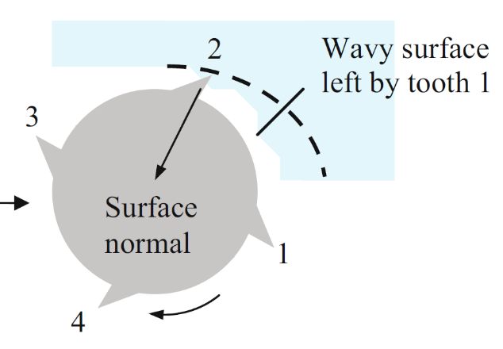
Figure 3-1. In milling the instantaneous chip thickness is a function of the commanded chip thickness, vibration at the current revolution, and vibration state at the previous revolution [3].
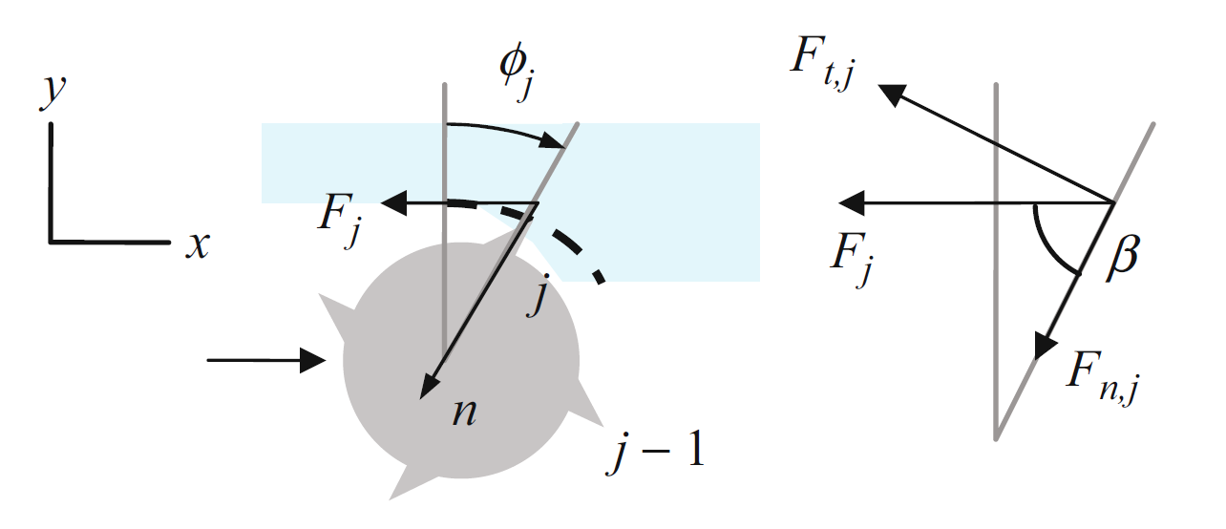
Figure 3-2. Notation for Fourier series stability analysis [3].

Stability Maps
Stability maps define a boundary which separates stable and unstable spindle speed-depth of cut pairs for a given radial depth of cut. The frequency-domain modeling of the stability boundary is described in the following paragraphs.

Fourier Series Approach
The Fourier series approach described by Altintas and Budak [2] is one method used to evaluate the stability boundary for milling operations. In this approach, the dynamic milling equations are transformed into a time invariant form by expanding the time varying coefficients into a Fourier series which is then truncated to only the average component. The model notation is shown in Figure 3-2.
The projection of the x (feed direction) and y vibration into the surface normal, n, or radial [2], direction is:
$$n=-x\sin\left(ϕ\right)-y\cos\left(ϕ\right)$$ | (3.2)
where φ is the tooth angle. The instantaneous chip thickness of tooth j as a function of cutter angle is:
$$h\left(ϕ_{j}\right)= \left(f_{t}\sin\left(ϕ_{j}\right)+n_{j-1}-n_{j}\right)∙g\left(ϕ_{j}\right)$$ | (3.3)
where f_{t} is the feed per tooth and $g\left(ϕ_{j}\right)$ is a switching function equal to one when the tooth is engaged in the cut and zero otherwise.
The tangential and normal force components, F_{t} and F_{n}, can be written as:
$$F_{t,j}=K_{t}bh(ϕ_{j})$$ | (3.4)
$$F_{n,j}={K_{n}F_{t,j}=K_{n}K}_{t}bh(ϕ_{j})$$ | (3.5)
where b is the axial depth of cut, and K_{t} and K_{n} are cutting force coefficients in the tangential and normal directions.
To account for multiple teeth in the cut, the forces are summed over the number of teeth N_{t} in the x and y directions.
$$F_{x}=\sum_{j=1}^{N_{t}}{F_{x,j}} F_{y}=\sum_{j=1}^{N_{t}}{F_{y,j}}$$ | (3.6)
The x and y forces can then be arranged in matrix form:
$$\left(\begin{matrix}F_{x} \\ F_{y}\end{matrix}\right)=\frac{1}{2}bK_{t}\left[\begin{matrix}a_{xx} & a_{xy} \\ a_{yx} & a_{yy}\end{matrix}\right]\left(\begin{matrix}Δx \\ Δy\end{matrix}\right)= \frac{1}{2}bK_{t}\left[A\right]\left(∆\right)$$ | (3.7)
where the components of the A matrix are the time varying directional dynamic force coefficients [2], each of which is a function of time. To remove the time dependence, [A(t)] is expanded into a Fourier series:
$$\left[A\left(t\right)\right]=\sum_{r=-∞}^{∞}{\left[A_{r}\right]e^{irω_{tooth}t}}$$ | (3.8)
Setting r = 0 leads to the desired time invariance. For the Fourier series approach, the model is less accurate for small radial depths of cut. A radial immersion of 50% was used for all cutting tests so that the Fourier stability analysis method would be sufficiently accurate.
To analyze stability, frequency-domain vibrations are equated to the FRF matrix and frequency-domain force representations.
$$\left(\begin{matrix}X_{j} \\ Y_{j}\end{matrix}\right)=\left[\begin{matrix}{FRF}_{xx} & {FRF}_{xy} \\ {FRF}_{yx} & {FRF}_{yy}\end{matrix}\right]\left(\begin{matrix}F_{x} \\ F_{y}\end{matrix}\right)e^{iω_{c}t}= \left[\begin{matrix}{FRF}_{xx} & 0 \\ 0 & {FRF}_{yy}\end{matrix}\right]\left(\begin{matrix}F_{x} \\ F_{y}\end{matrix}\right)e^{iω_{c}t}$$ | (3.9)
The off-diagonal terms are set to zero in (3.9) because the measurement directions are assumed orthogonal with zero-cross talk. The vibrations from the previous tooth period can be written as:
$$\left(\begin{matrix}X_{j-1} \\ Y_{j-1}\end{matrix}\right)= \left[\begin{matrix}{FRF}_{xx} & 0 \\ 0 & {FRF}_{yy}\end{matrix}\right]\left(\begin{matrix}F_{x} \\ F_{y}\end{matrix}\right)e^{iω_{c}t}∙e^{-iω_{c}τ}$$ | (3.10)
Taking the difference in vibrations between the two states yields:
$\left(\begin{matrix}X_{j} \\ Y_{j}\end{matrix}\right)-\left(\begin{matrix}X_{j-1} \\ Y_{j-1}\end{matrix}\right)= \left(1-e^{-iω_{c}τ}\right)\left[\begin{matrix}{FRF}_{xx} & 0 \\ 0 & {FRF}_{yy}\end{matrix}\right]\left(\begin{matrix}F_{x} \\ F_{y}\end{matrix}\right)e^{iω_{c}t}= \left(\begin{matrix}∆X \\ ∆Y\end{matrix}\right)$ | (3.11)
The form on the right-hand side allows substitution into the frequency-domain representation of Eq. 3.7, which can be rearranged to:
$$\left(\begin{matrix}F_{x} \\ F_{y}\end{matrix}\right)e^{iω_{c}t}\left(\left[I\right]-\frac{1}{2}bK_{t}\left(1-e^{iω_{c}τ}\right)\left[A_{0}\right]\left[\begin{matrix}{FRF}_{xx} & 0 \\ 0 & {FRF}_{yy}\end{matrix}\right]\right)=0$$ | (3.12)
which has a non-trivial solution only if:
$$det\left(\left[I\right]-\frac{1}{2}bK_{t}\left(1-e^{iω_{c}τ}\right)\left[A_{0}\right]\left[\begin{matrix}{FRF}_{xx} & 0 \\ 0 & {FRF}_{yy}\end{matrix}\right]\right)=0$$ | (3.13)
This is the characteristic equation of the dynamic milling system [2].
$$\left[A_{0}\right]\left[\begin{matrix}{FRF}_{xx} & 0 \\ 0 & {FRF}_{yy}\end{matrix}\right]=\frac{N_{t}}{2π}\left[\begin{matrix}a_{xx} & a_{xy} \\ a_{yx} & a_{yy}\end{matrix}\right]\left[\begin{matrix}{FRF}_{xx} & 0 \\ 0 & {FRF}_{yy}\end{matrix}\right]=\frac{N_{t}}{2π}\left[\begin{matrix}a_{xx}{FRF}_{xx} & a_{xy}{FRF}_{yy} \\ a_{yx}{FRF}_{xx} & a_{yy}{FRF}_{yy}\end{matrix}\right]=\frac{N_{t}}{2π}\left[{FRF}_{or}\right]$$ | (3.14)
Λ is defined as:
$$Λ=\frac{N_{t}}{2π}\left(-\frac{1}{2}bK_{t}\left(1-e^{iω_{c}τ}\right)\right)$$ | (3.15)
So that the characteristic equation can be re-written as:
$$det\left(\left[I\right]-Λ\left[{FRF}_{or}\right]\right)=0$$ | (3.16)
Solving Eq. 3.16 results in a quadratic equation in Λ. Solving for Λ_{1,2} using the quadratic formula yields two complex eigenvalues which are a function of ω_{c}, the chatter frequency should it occur.
Finally, the simplified expression for the stability limit b_{lim} can be written as:
$$b_{lim}=\frac{-2π}{N_{t}K_{t}}Λ_{Re}\left(1+{\left(\frac{\sin\left(ω_{c}τ\right)}{1-\cos\left(ω_{c}τ\right)}\right)}^{2}\right)=\frac{-2π}{N_{t}K_{t}}Λ_{Re}\left(1+{\left(\frac{Λ_{Im}}{Λ_{Re}}\right)}^{2}\right)=\frac{-2π}{N_{t}K_{t}}Λ_{Re}\left(1+κ^{2}\right)$$ | (3.17)
The frequency dependent spindle speeds are:
$$Ω=\frac{60}{N_{t}τ}$$ | (3.18)
where the tooth passing period, τ, is defined by Eq. 3.19(3.19), and ε is the phase shift in the surface undulations between subsequent tooth passages, see Eq. 3.20.
$$τ=\frac{1}{ω_{c}}\left(ε+2π∙j\right)$$ | (3.19)
$$ε=π-2\tan^{-1}\left(κ\right)$$ | (3.20)

Cutting Force Coefficients
To predict the stability map, both the tool tip receptances and cutting force model are required. The cutting force coefficients required for a complete force model are tool-workpiece specific. Normal, tangential, and axial cutting force coefficients as well as the respective edge coefficients can be determined experimentally. To do so, cutting test are completed at a single spindle speed over a range of feedrates on a workpiece fixed to a dynamometer, which measures the cutting force components in the x, y, and z directions.
To identify the cutting force coefficients, the average of the force signal in each direction is calculated over the range of selected feedrates. A linear regression is then applied to determine the six coefficients k_{n}, k_{t}, k_{a}, k_{ne}, k_{te}, and k_{ae} from the mean of the measured values using the three slope and three intercept values from the best fit lines. In this notion, the coefficient with a single-letter subscript identify shearing, or cutting, coefficients. Coefficients with two-letter subscripts identify edge, or rubbing, effects. In the general case, the forces in each direction can be calculated by Eq. 3.18 through Eq. 3.20.
$$F_{x}= k_{t}bf_{t}\sin\left(ϕ\right)\cos\left(ϕ\right){+k}_{te}b\cos\left(ϕ\right)+k_{n}bf_{t}\sin^{2}\left(ϕ\right)+k_{ne}b\sin\left(ϕ\right)$$ | (3.21)
$$F_{y}=k_{t}bf_{t}\sin^{2}\left(ϕ\right)+k_{te}b\sin\left(ϕ\right)-k_{n}bf_{t}\sin\left(ϕ\right)\cos\left(ϕ\right)-k_{ne}b\cos\left(ϕ\right)$$ | (3.22)
$F_{z}=-k_{a}bf_{t}\sin\left(ϕ\right)- k_{ae}b$ | (3.23)
To calculate the mean force per revolution, all teeth on the cutter must be considered, and a switching function, $g\left(ϕ_{j}\right)$, is incorporated which is non-zero between the cut start (ϕ_{s}) and exit (ϕ_{e}) angles only [3]. The mean force per revolution can be calculated by Eq. 3.21- Eq. 3.23.
$$F_{x}= \sum_{j=1}^{N_{t}}{\left(k_{t}bf_{t}\frac{\sin\left(2ϕ_{j}\right)}{2}{+k}_{te}b\cos\left(ϕ_{j}\right)+k_{n}bf_{t}\frac{\left(1-\cos\left(2ϕ_{j}\right)\right)}{2}+k_{ne}b\sin\left(ϕ_{j}\right)\right)}g\left(ϕ_{j}\right)$$
(3.24)
$$F_{y}=\sum_{j=1}^{N_{t}}{\left(k_{t}bf_{t}\frac{1-\cos\left(2ϕ_{j}\right)}{2}{+k}_{te}b\sin\left(ϕ_{j}\right)-k_{n}bf_{t}\frac{\sin{2ϕ_{j}}}{2}-k_{ne}b\cos\left(ϕ_{j}\right)\right)}g\left(ϕ_{j}\right)$$
(3.25)
$F_{z}=\sum_{j=1}^{N_{t}}{\left(k_{a}bf_{t}\sin\left(ϕ_{j}\right){-k}_{ae}b\right)×g\left(ϕ_{j}\right)}$
(3.26)
The mean force can then be determined by integrating between the start and exit angles as shown in Eq. 3.24 for the x direction.
$${\overline{F}}_{x}=\frac{1}{2π}\int_{ϕ_{s}}^{ϕ_{e}}{F_{x} dϕ}$$ | (3.27)
The best fit line from the linear regression for the x direction is represented by:
$${\overline{F}}_{x,i}= a_{0x}+a_{1x}f_{t,i}+E_{i}$$ | (3.28)
where f_{t,i} and ${\overline{F}}_{x,i}$ are the commanded feed per tooth and resulting average force pairs, a_{0x} is the intercept of the line, a_{1x} is the slope, and E_{i} is the error between the measurement points and the best fit line.

Tool Tip Receptance
As shown in the previous section, the tool tip receptances in the x and y directions are required to generate a stability map using the Fourier series approach. Impact testing is an experimental method used to measure the dynamics of structures. This method is widely used to measure the tool tip FRF directly. In impact testing, a modal hammer containing a force sensor in the tip is used to generate a short duration impact on the object of interest. The impulse excites a wide range of frequencies. This test is typically repeated multiple times and the results averaged to improve the correlation between input force and measured vibration across the range of measured frequencies [3]. The vibration response is simultaneously measured by a transducer which may record displacement (to define the receptance frequency response function), velocity (mobility), or acceleration (accelerance). The receptance is used for stability analysis.
In this dissertation, RCSA is used to predict the tool tip FRF. The RCSA algorithm was presented in Chapter 2 and will not be repeated here, however an update has been made to Eq. 2.15. By reciprocity (i.e., $\frac{X}{M}=\frac{θ}{F}$), the connection parameter matrix can be re-written from 2.15 as:
$$\left[K\right]=\left[\begin{matrix}k_{xf}+iωc_{xf} & k_{θf}+iωc_{θf} \\ k_{xm}+iωc_{xm} & k_{θm}+iωc_{θm}\end{matrix}\right]=\left[\begin{matrix}k_{xf}+iωc_{xf} & k_{θf}+iωc_{θf} \\ k_{θf}+iωc_{θf} & k_{θm}+iωc_{θm}\end{matrix}\right]$$ | (3.29)
where the rotational stiffness and damping due to an applied force (k_{θf} and c_{θf}) and the displacement to moment stiffness and damping ($k_{xm}$ and $c_{xm}$) are equal. For the tool-holder receptance, it can be assumed that because lateral force at the end of the tool causes a rotation at the tool-holder location, the off-diagonal parameters have a greater contribution than the on diagonal terms. In this case, the displacement to force (xf subscripts) and rotation to moment (θm subscripts) are set equal to zero (Eq. 3.30).
$$\left[K\right]=\left[\begin{matrix}0 & k_{θf}+iωc_{θf} \\ k_{θf}+iωc_{θf} & 0\end{matrix}\right]$$ | (3.30)
This method was developed to reduce the need for on-machine measurements of individual tools. First, predicted receptances using the RCSA algorithm will be compared to measured tool tip receptances for a tool-holder with free-free boundary condition to determine the stiffness and damping parameters for the tool-holder connection. Next, the predicted receptance will be compared to tool-holder-spindle-machine measurements performed on several machines to determine the tool-holder connection parameters. Finally, a Monte Carlo simulation will be run for a range of coupling parameters to generate a distribution of predicted receptances. Each of these receptances will be used to generate a stability boundary using the Fourier series approach, and the resulting stability map will be compared to a grid of stable/unstable test points from cutting tests. A score will be assigned to the connection pairs based on the agreement between the measured and predicted process stability.

Results and discussion
A library of 36 tools was selected for RCSA coupling parameter identification. Three diameters [12.7, 15.9, and 19.1] mm were evaluated with four different flute counts [3, 4, 5, and 7] per diameter, D, and three different stickout lengths per flute count [stub (<1.5xD) standard (2xD) long (>2.25xD)]. All of the tools had a 38° helix angle and 0.76 mm corner radius as defined by the manufacturer. One set screw and one heat-shrink tool holder geometry, each with a CAT40 spindle interface, were used for each diameter. The same size set screw was used in each set screw (or side lock) holder, regardless of tool diameter. A torque of 47.5 N-m (35 ft-lb) was used in each set screw assembly. The tool specifications are provided in Table 4-1. The same tool geometries were used for both the set screw and heat-shrink holder tests.

Set Screw Holders
Set screw holders are an economical tool holding solution which require little setup time and a single torque wrench, typically with a hex or Torx attachment. In this arrangement, a set screw mates with a Weldon flat which has been ground on the tool shank as shown in Figure 4-1. This positive mechanical engagement results in higher axial pullout resistance versus collet type holders. However, because the tool is being pushed against one side of the holder by the set screw, measured runout is typically higher than radial clamping designs such as collet, hydraulic, or heat-shrink holders [139].

Test Sequence
This section describes initial repeatability testing, the connection parameter identification test plan, and initial results. First, assembly repeatability testing is presented. Second, free-free impact testing for the tool-holder combinations is described. In this case, the tool and holder models are coupled and compared to the measured receptances. The connection parameters are selected to provide a best match between the RCSA prediction and measurement. Third, the tool-holder is inserted in a machine spindle and tool tip receptances are measured. Models of the tool and holder are coupled to the spindle-machine measurement to predict the tool tip receptances. Again, the connection parameters are selected to provide a best match between the RCSA prediction and measurement. Fourth, milling tests are performed and the stability is determined for each spindle speed-axial depth combination (50% radial immersion in all cases). The RCSA tool tip receptance prediction is used together with the cutting force model to predict the stability limit. In this case, the connection parameters are selected to match the predicted stability boundary to the cutting test results using a scoring metric and rejection sampling.

Tool Length Repeatability
RCSA is used to couple Timoshenko beam elements with defined length, diameter, and material properties that describe the tool and holder. As the tool length changes, the assembly receptance and corresponding stability boundary changes [4], [5], [140], [141]. For the RCSA modeling effort to be effective across multiple machines and between tool setups, the stickout length of the tool should be repeatable. In traditional set screw holders, the bottom of the screw contacts only on the Weldon flat, and the stickout length of the tool varies with the screw location between the tapered edges of the ground section as shown in Figure 4-2. An Accupro modified set screw and holder design was applied here such that the screw would interface at both the Weldon flat and the two tapered edges as shown in Figure 4-3 and Figure 4-4.
Length repeatability tests were completed for one tool-holder pair (tool 13). The tool was inserted into the holder, the set screw was torqued to 47.5 N-m (35 ft-lbs), the stickout length of the tool was measured using calipers as shown in Figure 4-5, the tool-holder assembly was disassembled, and the test was repeated. This was completed 50 times with a single user. The average measured stickout length and standard deviation were 33.26 mm and 0.017 mm. The test was then repeated 10 times each with three different users. Distributions of the collected and combined measurements are shown in Figure 4-6 and Figure 4-7Figure 4-8. The average measured stickout length and standard deviation for the first user (U1) were 33.25 mm and 0.013 mm. The average measured stickout length and standard deviation for the second user (U2) were 33.26 mm and 0.019 mm. The average measured stickout length and standard deviation for the third user (U3) were 33.24 mm and 0.014 mm. For the 80 measurements completed between the four different users, the average measured stickout length was 33.25 mm with a standard deviation of 0.020 mm. This value will be considered representative of the repeatability in length of all tools in the set and will be used in the evaluation of uncertainty of the RCSA predicted stability boundary.

Setup Repeatability
Repeatability in the setup of a single tool was evaluated as a change in the measured FRF in same machine between setups. For each setup, the tool was inserted into the holder, torqued to 47.5 N-m, and the combination was inserted into the spindle of a Makino a51nx milling machine. The FRF was measured by impact testing three times with 10 impacts per test in both the x and y directions. The tool-holder assembly was then removed from the spindle, disassembled, and reassembled for three repeats. The resulting FRFs are shown in Figure 4-9 through Figure 4-11. Additional testing will be performed to determine the cause of the differences.
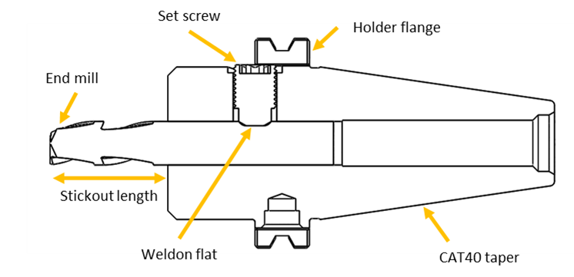
Figure 4-1. The cross-sectional view of a set screw holder. The set screw interfaces with a Weldon flat, which is ground on the tool shank.
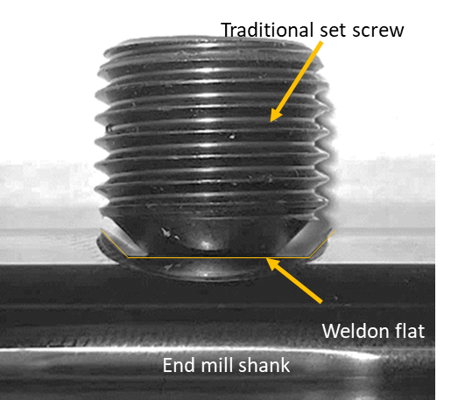
Figure 4-2. A traditional set screw and Weldon flat assembly interacts only on the bottom of the flat and allows the stickout length of the tool to vary.
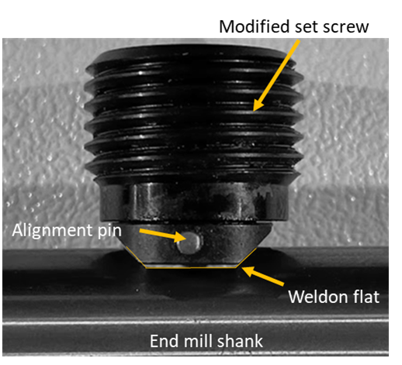
Figure 4-3. A new set screw design produced by Accupro contacts the Weldon flat on three sides, resulting in more repeatable tool stickout lengths.
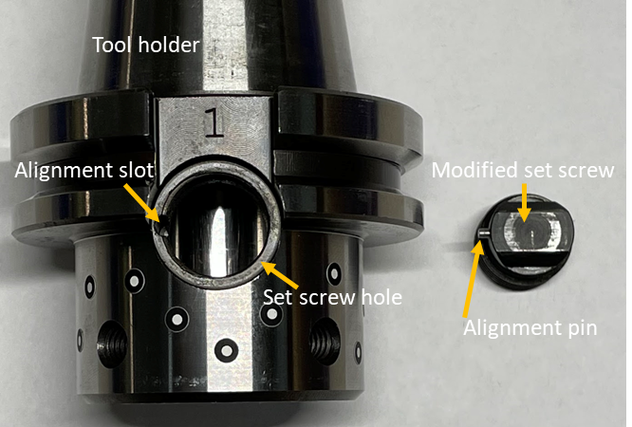
Figure 4-4. The modified set screw design uses an alignment pin and corresponding slot in the holder to orient the screw to the ground flat on the tool.
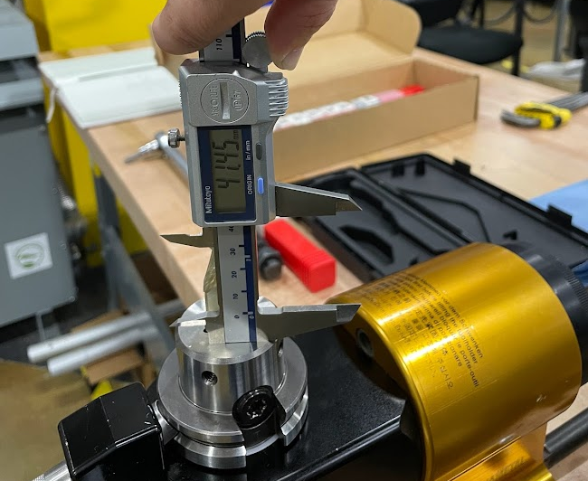
Figure 4-5. Calipers were used to measure the stickout length of each endmill.
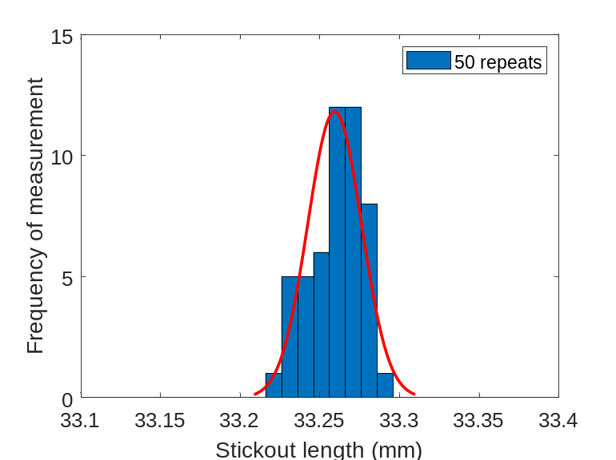
Figure 4-6. The distribution of 50 stickout length measurements for a single user.
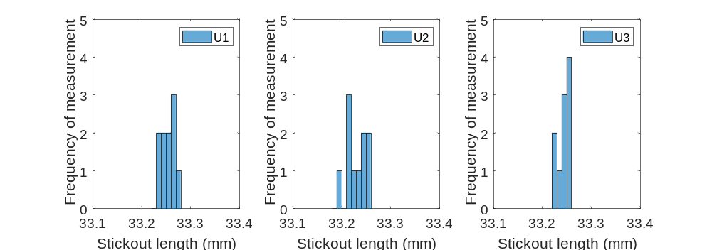
Figure 4-7. The distribution of 10 stickout length measurements for three users.
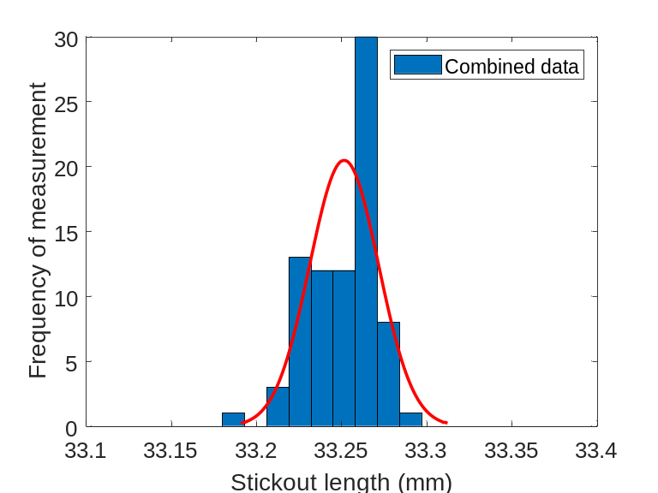
Figure 4-8. The combined distribution for 80 total stickout length measurements.
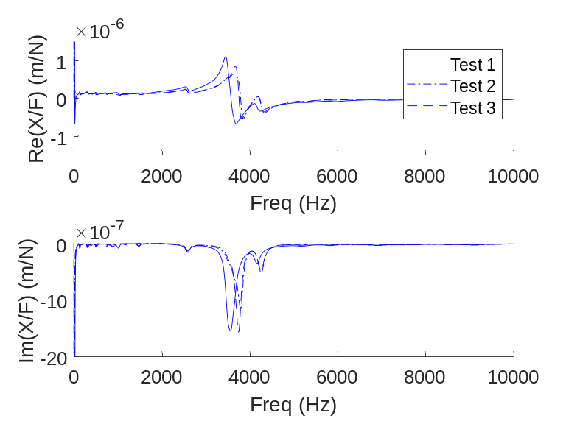
Figure 4-9. Three repeated FRF measurements for setup 1.
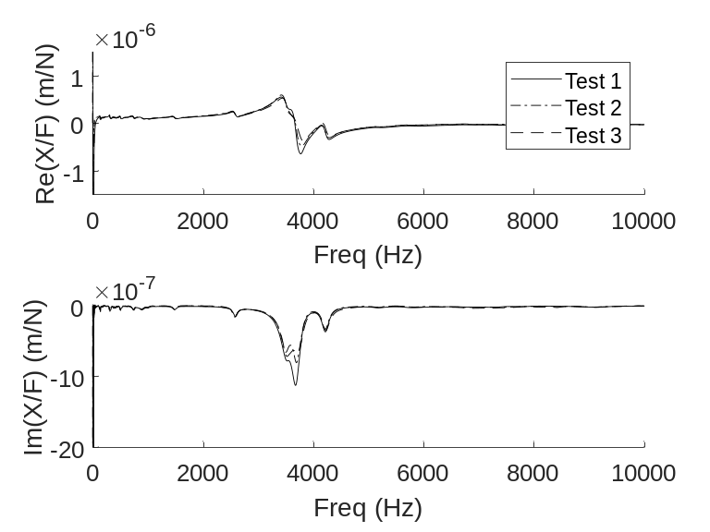
Figure 4-10. Three repeated FRF measurements for setup 2.
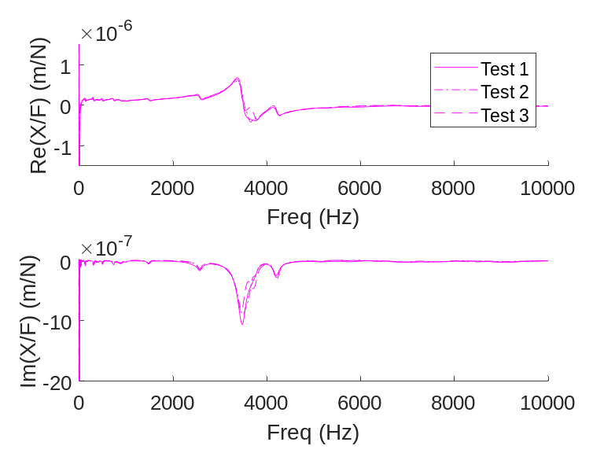
Figure 4-11. Three repeated FRF measurements for setup 3.
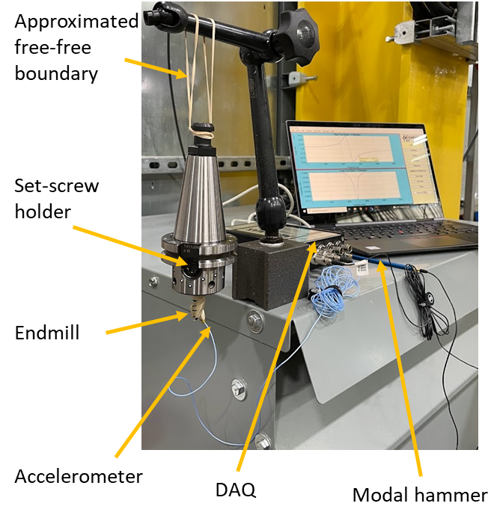
Figure 4-12. Elastic bands were used to approximate a free-free boundary condition for impact testing of the tool-holder assembly.

Tool-to-Tool Repeatability
For the RCSA modeling effort to be effective for this tool library across multiple machines, the tool length must be repeatable for replacement tools of the same geometry (i.e., different tools with the same model number). The repeatability in location of the Weldon flat with respect to the tool tip will be investigated for a specific tool from one manufacturer. Tool 6, which was used to investigate the repeatability of the holder and set screw design, will be used to investigate the tool-to-tool repeatability. The Weldon flat location, stickout length, and corresponding tool-holder-spindle FRF for 10 tools with the same nominal geometry will be compared using a single holder and spindle-machine.

Tool-Holder Measurement
To determine the tool-holder coupling parameters, the assembly was measured using a free-free boundary condition. This boundary condition was approximated using elastic bands attached to the retention knob as shown in Figure 4-12. The tool tip receptances were measured by impact testing using a small modal hammer (PCB 086E80) and low mass accelerometer (PCB 352C23) adhered at the tool tip using wax.
In order to complete the RCSA prediction, the holder and tool models are required. To identify the dimensions required for the holder model, the external geometry of each holder was measured using a GOM ATOS Q structured light scanner. These scans were used to discretize the holder as shown in Figure 4-13. The dimensions for each discretized holder model segment are given in Table 4-2. Each segment is assumed to have material properties of steel (elastic modulus of 207 GPa, density of 7800 kg/m³, and Poisson’s ratio of 0.292). A Timoshenko beam model was used to describe the individual segments, which were then rigidly coupled using RCSA.
For each end mill geometry, the fluted portion of the tool was modeled using an equivalent diameter cylinder, where the equivalent diameter is assigned such that the fluted section and cylindrical beam have the same second moment of area [53]. Tool segments (Table 4-3) are assumed to have carbide material properties (elastic modulus of 611 GPa, density of 15,100 kg/m³, and Poisson’s ratio of 0.280). A Timoshenko beam model was used to describe the individual segments, which were then rigidly coupled using RCSA.
In the RCSA algorithm, tool segments are rigidly coupled to the adjacent section along the length of the tool, and holder segments are rigidly coupled to adjacent holder segments. The interface between the tool and holder is described by a linear stiffness and viscous damping term as shown in Eq. 3.29, which represent the inherent flexibility and energy dissipation at the connection location. These parameters will be identified for each of the 36 tools by visual best fit between the RCSA predicted receptance and the measured free-free receptance.
To ensure the mode used to identify the RCSA parameters was a tool bending mode and not a rigid body mode, the mode shapes for tools 1-3 were measured and taken to be representative of the full tool set. The direct FRF was measured at the tool tip, and cross FRFs were measured at 5 mm intervals along the tool as shown for tool 1 in Figure 4-14. The imaginary portions of the direct FRFs for each tool are shown in Figure 4-15, and the lowest natural frequency for each was used to construct the mode shapes plotted in Figure 4-16.
Table 4-1. The tool library consists of 36 unique tool geometries. Each tool had a 38° helix angle and 0.76 mm corner radius as defined by the manufacturer.
Tool number | Diameter (mm) | Flutes (-) | Length
1 | 12.7 | 3 | Stub
2 | 12.7 | 3 | Standard
3 | 12.7 | 3 | Long
4 | 12.7 | 4 | Stub
5 | 12.7 | 4 | Standard
6 | 12.7 | 4 | Long
7 | 12.7 | 5 | Stub
8 | 12.7 | 5 | Standard
9 | 12.7 | 5 | Long
10 | 12.7 | 7 | Stub
11 | 12.7 | 7 | Standard
12 | 12.7 | 7 | Long
13 | 15.875 | 3 | Stub
14 | 15.875 | 3 | Standard
15 | 15.875 | 3 | Long
16 | 15.875 | 4 | Stub
17 | 15.875 | 4 | Standard
18 | 15.875 | 4 | Long
19 | 15.875 | 5 | Stub
20 | 15.875 | 5 | Standard
21 | 15.875 | 5 | Long
22 | 15.875 | 7 | Stub
23 | 15.875 | 7 | Standard
24 | 15.875 | 7 | Long
25 | 19.05 | 3 | Stub
26 | 19.05 | 3 | Standard
27 | 19.05 | 3 | Long
28 | 19.05 | 4 | Stub
29 | 19.05 | 4 | Standard
30 | 19.05 | 4 | Long
31 | 19.05 | 5 | Stub
32 | 19.05 | 5 | Standard
33 | 19.05 | 5 | Long
34 | 19.05 | 7 | Stub
35 | 19.05 | 7 | Standard
36 | 19.05 | 7 | Long

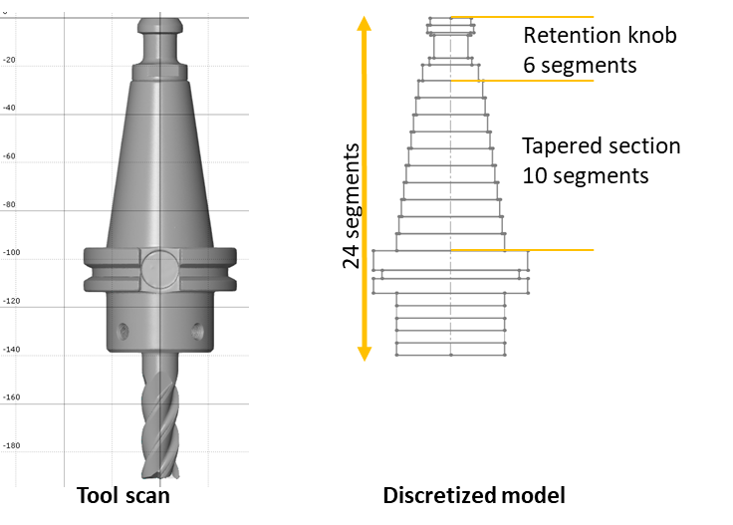
Figure 4-13. A GOM structured light scanner was used to measure the external geometry of the tool and holder. The scan was used to create a discretized model of the tool holder.
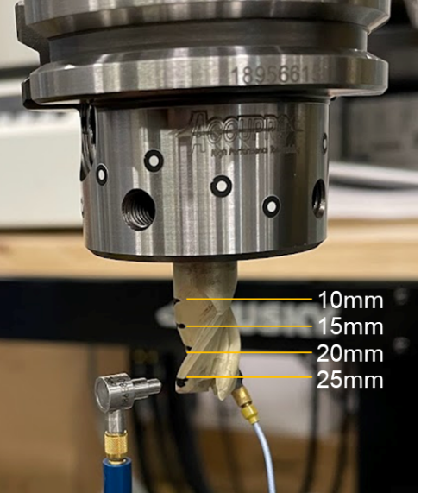
Figure 4-14. Impact testing locations as measured from the holder face for tool 1 were used for mode shape identification of the tool-holder assembly with free-free boundary conditions.
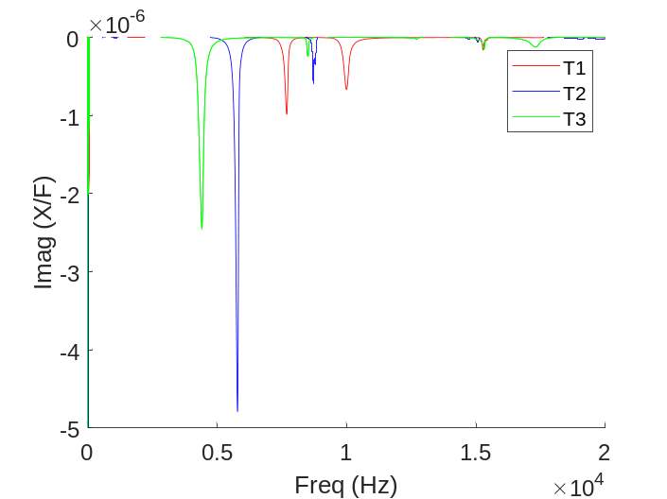
Figure 4-15. The imaginary part of the measured tool-holder frequency response function for tools 1-3 with free-free boundary conditions.
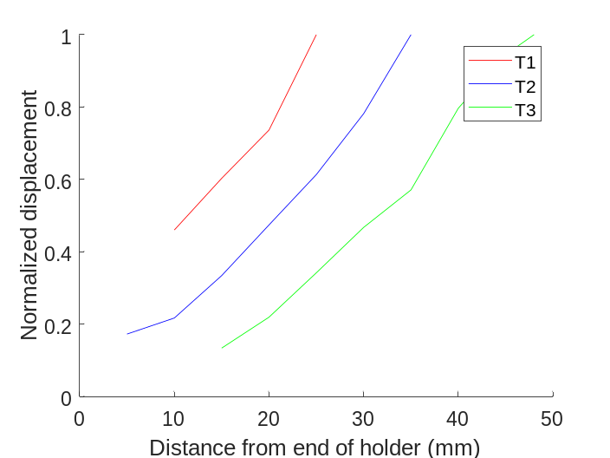
Figure 4-16. The mode shape corresponding to the lowest measured natural frequency for tools 1-3 is a bending mode.
Table 4-2. Segment dimensions for the set screw tool holders.
Segment | Length (mm) | Outer diameter (mm) | Inner diameter (mm)  12.7 mm | Inner diameter (mm)  15.9 mm | Inner diameter (mm)  19.1 mm
1 | 3.00 | 16.75 | 7.1 | 7.1 | 7.1
2 | 3.00 | 19.00 | 7.1 | 7.1 | 7.1
3 | 1.00 | 16.50 | 7.1 | 7.1 | 7.1
4 | 9.50 | 14.00 | 7.1 | 7.1 | 7.1
5 | 2.75 | 17.50 | 7.1 | 7.1 | 7.1
6 | 6.50 | 23.00 | 7.1 | 7.1 | 7.1
7 | 7.00 | 26.50 | 7.1 | 7.1 | 7.1
8 | 7.00 | 28.50 | 13.4 | 13.4 | 13.4
9 | 7.00 | 30.50 | 13.4 | 13.4 | 13.4
10 | 7.00 | 32.50 | 13.4 | 13.4 | 13.4
11 | 7.00 | 34.50 | 13.4 | 13.4 | 13.4
12 | 7.00 | 36.50 | 13.4 | 13.4 | 13.4
13 | 7.00 | 38.50 | 13.4 | 13.4 | 13.4
14 | 7.00 | 40.50 | 13.4 | 15.9 | 19.1
15 | 7.00 | 42.50 | 13.4 | 15.9 | 19.1
16 | 7.00 | 44.50 | 12.7 | 15.9 | 19.1
17 | 8.00 | 63.50 | 12.7 | 15.9 | 19.1
18 | 3.50 | 56.50 | 12.7 | 15.9 | 19.1
19 | 6.00 | 63.50 | 12.7 | 15.9 | 19.1
20 | 5.10 | 44.50 | 12.7 | 15.9 | 19.1
21 | 5.10 | 44.50 | 12.7 | 15.9 | 19.1
22 | 5.10 | 44.50 | 12.7 | 15.9 | 19.1
23 | 5.10 | 44.50 | 12.7 | 15.9 | 19.1
24 | 5.10 | 44.50 | 12.7 | 15.9 | 19.1

Table 4-3. Segment dimensions for the endmills.
 | Tool 1
Segment | 1 | 2 | 3 | 4 | 5 | 6 | 7 | 8 | 9
Length (mm) | 3.03 | 3.18 | 3.17 | 3.18 | 3.17 | 3.17 | 3.18 | 3.18 | 3.15
Diameter (mm) | 12.70 | 12.19 | 12.19 | 12.19 | 8.80 | 8.80 | 8.80 | 8.80 | 8.80
 | Tool 2
Segment | 1 | 2 | 3 | 4 | 5 | 6 | 7 | 8 | 9
Length (mm) | 3.12 | 3.18 | 3.17 | 3.18 | 5.08 | 5.08 | 5.08 | 5.08 | 5.04
Diameter (mm) | 12.70 | 12.19 | 12.19 | 12.19 | 8.80 | 8.80 | 8.80 | 8.80 | 8.80
 | Tool 3
Segment | 1 | 2 | 3 | 4 | 5 | 6 | 7 | 8 | 9
Length (mm) | 3.09 | 3.18 | 3.18 | 3.17 | 6.35 | 6.35 | 6.35 | 6.35 | 6.35
Diameter (mm) | 12.70 | 12.19 | 12.19 | 12.19 | 8.80 | 8.80 | 8.80 | 8.80 | 8.80
 | Tool 4
Segment | 1 | 2 | 3 | 4 | 5 | 6 | 7 | 8 | 9
Length (mm) | 3.10 | 3.33 | 3.17 | 3.02 | 3.33 | 3.17 | 3.18 | 3.18 | 3.02
Diameter (mm) | 12.70 | 12.19 | 12.19 | 12.19 | 9.15 | 9.15 | 9.15 | 9.15 | 9.15
 | Tool 5
Segment | 1 | 2 | 3 | 4 | 5 | 6 | 7 | 8 | 9
Length (mm) | 2.93 | 3.12 | 3.17 | 3.23 | 5.03 | 5.08 | 5.08 | 5.08 | 5.13
Diameter (mm) | 12.70 | 12.19 | 12.19 | 12.19 | 9.15 | 9.15 | 9.15 | 9.15 | 9.15
 | Tool 6
Segment | 1 | 2 | 3 | 4 | 5 | 6 | 7 | 8 | 9
Length (mm) | 3.17 | 3.11 | 3.18 | 3.23 | 6.29 | 6.35 | 6.35 | 6.35 | 6.41
Diameter (mm) | 12.70 | 12.19 | 12.19 | 12.19 | 9.15 | 9.15 | 9.15 | 9.15 | 9.15
 | Tool 7
Segment | 1 | 2 | 3 | 4 | 5 | 6 | 7 | 8 | 9
Length (mm) | 3.10 | 3.33 | 3.17 | 3.02 | 3.33 | 3.17 | 3.18 | 3.18 | 3.02
Diameter (mm) | 12.70 | 12.19 | 12.19 | 12.19 | 9.41 | 9.41 | 9.41 | 9.41 | 9.41
 | Tool 8
Segment | 1 | 2 | 3 | 4 | 5 | 6 | 7 | 8 | 9
Length (mm) | 3.23 | 3.07 | 3.17 | 3.28 | 4.98 | 5.08 | 5.08 | 5.08 | 4.97
Diameter (mm) | 12.70 | 12.19 | 12.19 | 12.19 | 9.41 | 9.41 | 9.41 | 9.41 | 9.41
 | Tool 9
Segment | 1 | 2 | 3 | 4 | 5 | 6 | 7 | 8 | 9
Length (mm) | 3.13 | 3.03 | 3.18 | 3.31 | 6.21 | 6.35 | 6.35 | 6.35 | 6.49
Diameter (mm) | 12.70 | 12.19 | 12.19 | 12.19 | 9.41 | 9.41 | 9.41 | 9.41 | 9.41
 | Tool 10
Segment | 1 | 2 | 3 | 4 | 5 | 6 | 7 | 8 | 9
Length (mm) | 3.14 | 3.33 | 3.17 | 3.02 | 3.33 | 3.17 | 3.18 | 3.18 | 3.05
Diameter (mm) | 12.70 | 12.19 | 12.19 | 12.19 | 10.44 | 10.44 | 10.44 | 10.44 | 10.44
 | Tool 11
Segment | 1 | 2 | 3 | 4 | 5 | 6 | 7 | 8 | 9
Length (mm) | 2.95 | 3.28 | 3.17 | 3.08 | 5.18 | 5.08 | 5.08 | 5.08 | 4.98
Diameter (mm) | 12.70 | 12.19 | 12.19 | 12.19 | 10.44 | 10.44 | 10.44 | 10.44 | 10.44
 | Tool 12
Segment | 1 | 2 | 3 | 4 | 5 | 6 | 7 | 8 | 9
Length (mm) | 3.14 | 3.03 | 3.18 | 3.31 | 6.21 | 6.35 | 6.35 | 6.35 | 6.47
Diameter (mm) | 12.70 | 12.19 | 12.19 | 12.19 | 10.44 | 10.44 | 10.44 | 10.44 | 10.44
 | Tool 13
Segment | 1 | 2 | 3 | 4 | 5 | 6 | 7 | 8 | 9
Length (mm) | 1.44 | 4.23 | 4.24 | 4.23 | 3.81 | 3.81 | 3.81 | 3.81 | 3.89
Diameter (mm) | 15.88 | 15.24 | 15.24 | 15.24 | 11.00 | 11.00 | 11.00 | 11.00 | 11.00
 | Tool 14
Segment | 1 | 2 | 3 | 4 | 5 | 6 | 7 | 8 | 9
Length (mm) | 1.55 | 4.20 | 4.24 | 4.23 | 6.35 | 6.35 | 6.35 | 6.35 | 6.35
Diameter (mm) | 15.88 | 15.24 | 15.24 | 15.24 | 11.00 | 11.00 | 11.00 | 11.00 | 11.00
 | Tool 15
Segment | 1 | 2 | 3 | 4 | 5 | 6 | 7 | 8 | 9
Length (mm) | 1.54 | 4.27 | 4.24 | 4.19 | 7.62 | 7.62 | 7.62 | 7.62 | 7.62
Diameter (mm) | 15.88 | 15.24 | 15.24 | 15.24 | 11.00 | 11.00 | 11.00 | 11.00 | 11.00
 | Tool 16
Segment | 1 | 2 | 3 | 4 | 5 | 6 | 7 | 8 | 9
Length (mm) | 1.52 | 4.19 | 4.24 | 4.27 | 3.77 | 3.81 | 3.81 | 3.81 | 3.85
Diameter (mm) | 15.88 | 15.24 | 15.24 | 15.24 | 11.43 | 11.43 | 11.43 | 11.43 | 11.43
 | Tool 17
Segment | 1 | 2 | 3 | 4 | 5 | 6 | 7 | 8 | 9
Length (mm) | 1.61 | 4.16 | 4.24 | 4.30 | 6.28 | 6.35 | 6.35 | 6.35 | 6.42
Diameter (mm) | 15.88 | 15.24 | 15.24 | 15.24 | 11.43 | 11.43 | 11.43 | 11.43 | 11.43
 | Tool 18
Segment | 1 | 2 | 3 | 4 | 5 | 6 | 7 | 8 | 9
Length (mm) | 1.50 | 4.30 | 4.24 | 4.16 | 7.69 | 7.62 | 7.62 | 7.62 | 7.55
Diameter (mm) | 15.88 | 15.24 | 15.24 | 15.24 | 11.43 | 11.43 | 11.43 | 11.43 | 11.43

 | Tool 19
Segment | 1 | 2 | 3 | 4 | 5 | 6 | 7 | 8 | 9
Length (mm) | 1.52 | 4.20 | 4.24 | 4.26 | 3.78 | 3.81 | 3.81 | 3.81 | 3.84
Diameter (mm) | 15.88 | 15.24 | 15.24 | 15.24 | 11.76 | 11.76 | 11.76 | 11.76 | 11.76
 | Tool 20
Segment | 1 | 2 | 3 | 4 | 5 | 6 | 7 | 8 | 9
Length (mm) | 1.57 | 4.27 | 4.24 | 4.19 | 6.39 | 6.35 | 6.35 | 6.35 | 6.31
Diameter (mm) | 15.88 | 15.24 | 15.24 | 15.24 | 11.76 | 11.76 | 11.76 | 11.76 | 11.76
 | Tool 21
Segment | 1 | 2 | 3 | 4 | 5 | 6 | 7 | 8 | 9
Length (mm) | 1.51 | 4.26 | 4.24 | 4.20 | 7.65 | 7.62 | 7.62 | 7.62 | 7.59
Diameter (mm) | 15.88 | 15.24 | 15.24 | 15.24 | 11.76 | 11.76 | 11.76 | 11.76 | 11.76
 | Tool 22
Segment | 1 | 2 | 3 | 4 | 5 | 6 | 7 | 8 | 9
Length (mm) | 1.53 | 4.18 | 4.24 | 4.28 | 3.76 | 3.81 | 3.81 | 3.81 | 3.86
Diameter (mm) | 15.88 | 15.24 | 15.24 | 15.24 | 11.76 | 11.76 | 11.76 | 11.76 | 11.76
 | Tool 23
Segment | 1 | 2 | 3 | 4 | 5 | 6 | 7 | 8 | 9
Length (mm) | 1.56 | 4.25 | 4.24 | 4.21 | 6.37 | 6.35 | 6.35 | 6.35 | 6.35
Diameter (mm) | 15.88 | 15.24 | 15.24 | 15.24 | 11.76 | 11.76 | 11.76 | 11.76 | 11.76
 | Tool 24
Segment | 1 | 2 | 3 | 4 | 5 | 6 | 7 | 8 | 9
Length (mm) | 1.54 | 4.25 | 4.24 | 4.21 | 7.64 | 7.62 | 7.62 | 7.62 | 7.62
Diameter (mm) | 15.88 | 15.24 | 15.24 | 15.24 | 11.76 | 11.76 | 11.76 | 11.76 | 11.76
 | Tool 25
Segment | 1 | 2 | 3 | 4 | 5 | 6 | 7 | 8 | 9 | 10 | 11 | 12
Length (mm) | 5.46 | 5.29 | 5.30 | 5.07 | 5.08 | 5.09 | 5.07 | 5.09 | - | - | - | -
Diameter (mm) | 18.29 | 18.29 | 18.29 | 13.20 | 13.20 | 13.20 | 13.20 | 13.20 | - | - | - | -
 | Tool 26
Segment | 1 | 2 | 3 | 4 | 5 | 6 | 7 | 8 | 9 | 10 | 11 | 12
Length (mm) | 5.31 | 5.29 | 5.30 | 5.07 | 5.08 | 5.09 | 5.07 | 5.08 | 6.36 | 6.30 | - | -
Diameter (mm) | 18.29 | 18.29 | 18.29 | 13.20 | 13.20 | 13.20 | 13.20 | 13.20 | 13.20 | 13.20 | - | -
 | Tool 27
Segment | 1 | 2 | 3 | 4 | 5 | 6 | 7 | 8 | 9 | 10 | 11 | 12
Length (mm) | 4.63 | 5.33 | 5.30 | 5.07 | 5.08 | 5.09 | 5.07 | 5.08 | 6.36 | 6.35 | 6.35 | 6.34
Diameter (mm) | 18.29 | 18.29 | 18.29 | 13.20 | 13.20 | 13.20 | 13.20 | 13.20 | 13.20 | 13.20 | 13.20 | 13.20

 | Tool 28
Segment | 1 | 2 | 3 | 4 | 5 | 6 | 7 | 8 | 9 | 10 | 11 | 12
Length (mm) | 5.41 | 5.29 | 5.30 | 5.07 | 5.08 | 5.09 | 5.07 | 5.03 | - | - | - | -
Diameter (mm) | 18.29 | 18.29 | 18.29 | 13.72 | 13.72 | 13.72 | 13.72 | 13.72 | - | - | - | -
 | Tool 29
Segment | 1 | 2 | 3 | 4 | 5 | 6 | 7 | 8 | 9 | 10 | 11 | 12
Length (mm) | 5.41 | 5.29 | 5.30 | 5.07 | 5.08 | 5.09 | 5.07 | 5.08 | 6.36 | 6.29 | - | -
Diameter (mm) | 18.29 | 18.29 | 18.29 | 13.72 | 13.72 | 13.72 | 13.72 | 13.72 | 13.72 | 13.72 | - | -
 | Tool 30
Segment | 1 | 2 | 3 | 4 | 5 | 6 | 7 | 8 | 9 | 10 | 11 | 12
Length (mm) | 5.45 | 5.29 | 5.30 | 5.07 | 5.08 | 5.09 | 5.07 | 5.08 | 6.36 | 6.35 | 6.35 | 6.27
Diameter (mm) | 18.29 | 18.29 | 18.29 | 13.72 | 13.72 | 13.72 | 13.72 | 13.72 | 13.72 | 13.72 | 13.72 | 13.72
 | Tool 31
Segment | 1 | 2 | 3 | 4 | 5 | 6 | 7 | 8 | 9 | 10 | 11 | 12
Length (mm) | 18.29 | 18.29 | 18.29 | 14.11 | 14.11 | 14.11 | 14.11 | 14.11 | - | - | - | -
Diameter (mm) | 18.29 | 18.29 | 18.29 | 14.11 | 14.11 | 14.11 | 14.11 | 14.11 | - | - | - | -
 | Tool 32
Segment | 1 | 2 | 3 | 4 | 5 | 6 | 7 | 8 | 9 | 10 | 11 | 12
Length (mm) | 5.21 | 5.29 | 5.30 | 5.07 | 5.08 | 5.17 | 4.99 | 5.08 | 6.36 | 6.21 | - | -
Diameter (mm) | 18.29 | 18.29 | 18.29 | 14.11 | 14.11 | 14.11 | 14.11 | 14.11 | 14.11 | 14.11 | - | -
 | Tool 33
Segment | 1 | 2 | 3 | 4 | 5 | 6 | 7 | 8 | 9 | 10 | 11 | 12
Length (mm) | 5.16 | 5.29 | 5.30 | 5.07 | 5.08 | 5.09 | 5.07 | 5.08 | 6.36 | 6.35 | 6.48 | 6.17
Diameter (mm) | 18.29 | 18.29 | 18.29 | 14.11 | 14.11 | 14.11 | 14.11 | 14.11 | 14.11 | 14.11 | 14.11 | 14.11
 | Tool 34
Segment | 1 | 2 | 3 | 4 | 5 | 6 | 7 | 8 | 9 | 10 | 11 | 12
Length (mm) | 5.16 | 5.29 | 5.30 | 5.07 | 5.08 | 5.09 | 5.07 | 5.01 | - | - | - | -
Diameter (mm) | 18.29 | 18.29 | 18.29 | 15.66 | 15.66 | 15.66 | 15.66 | 15.66 | - | - | - | -
 | Tool 35
Segment | 1 | 2 | 3 | 4 | 5 | 6 | 7 | 8 | 9 | 10 | 11 | 12
Length (mm) | 5.19 | 5.29 | 5.30 | 5.07 | 5.08 | 5.09 | 5.07 | 5.08 | 6.36 | 6.19 | - | -
Diameter (mm) | 18.29 | 18.29 | 18.29 | 15.66 | 15.66 | 15.66 | 15.66 | 15.66 | 15.66 | 15.66 | - | -
 | Tool 36
Segment | 1 | 2 | 3 | 4 | 5 | 6 | 7 | 8 | 9 | 10 | 11 | 12
Length (mm) | 5.34 | 5.29 | 5.30 | 5.07 | 5.08 | 5.09 | 5.07 | 5.08 | 6.36 | 6.35 | 6.30 | 6.30
Diameter (mm) | 18.29 | 18.29 | 18.29 | 15.66 | 15.66 | 15.66 | 15.66 | 15.66 | 15.66 | 15.66 | 15.66 | 15.66

Tool-Holder-Spindle-Machine Measurement
The second method used to determine the RCSA stiffness and damping parameters was spindle-based testing, where the tool-holder was inserted in the spindle-machine and the assembly’s tool tip receptance was measured by impact testing. Because the RCSA tool tip receptance prediction is performed by coupling the tool and holder models to the measured spindle-machine receptances, the spindle-machine receptances needed to be measured using the standard artifact.
In this inverse RCSA step, a standard artifact is selected, clamped in a spindle, and the receptances in the x and y directions are measured by impact testing as shown in Figure 4-17. For these tests, an artifact with a 60 mm extension beyond the flange was selected. Inverse RCSA is then used to remove the effects of the artifact from the measurement, such that the dynamics of the spindle-machine can be isolated. Because the geometry of the holder from the front of the flange to the retention knob is the same for all holders using a CAT-40 interface, only the cylindrical portion of the artifact is required to be removed (in simulation). Additionally, because the flange-taper geometry and contact stiffness/damping are captured in the measured artifact-spindle-machine dynamics, additional coupling parameters for the holder-spindle interface do not need to be identified. New holder geometries can then be modeled and rigidly coupled to the archived spindle-machine receptance.
In this study, seven different machines are included: Makino a51nx (1), Haas TM-1P (1), Haas VF-4 (3), Haas UMC-750 (1), and Haas VF-5XT (1). The three Haas VF-4 machines will be denoted from newest to oldest as VF-4-R, VF-4-L, and VF-4-MS. Artifact measurements were collected for each spindle-machine and archived. Next, each of the 36 tool-holder configurations was clamped in a spindle, and the receptances were measured as shown in Figure 4-18. Each of the tool-holder-spindle-machine and artifact-spindle-machine measurements were collected using a modal hammer (PCB 086C04) and low mass accelerometer (PCB 352C23).
For the tool-holder-spindle-machine coupling parameter identification, two commercially available software products developed by Manufacturing Laboratories, Inc. (MLI) were used [142]. First, SPA was used to separately model the tool and holder as discretized Timoshenko beam elements as shown in Figure 4-19. An equivalent diameter based on the second moment of inertia was again used to represent the fluted portion of the tool (far right), and the relieved section of the tool and shank diameter were modeled based on measured values. In SPA, the elements in each of the two individual models are rigidly connected to one another. Second, using TXF the tool and holder models are coupled using stiffness and damping parameters and this result is rigidly coupled to the archived spindle-machine receptances. The coupling parameters are selected to provide visual agreement between the RCSA prediction and tool tip measurement. An example measured and fit receptance plot for tool 14 is shown in Figure 4-20. Coupling parameters were determined for both the x and y, and the average was recorded. The coupling parameters which have been collected to date are given in Table 4-4.
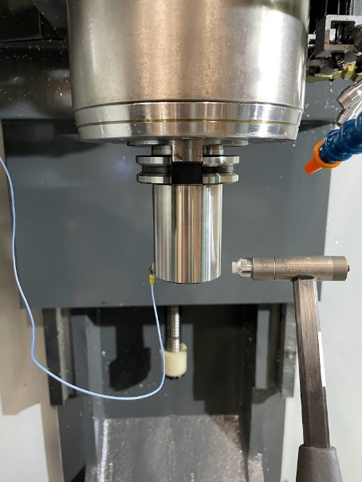
Figure 4-17. The artifact-spindle-machine receptances are measured for each machine spindle in the x and y directions. Inverse RCSA is used to remove the portion of the holder extending past the flange to isolate the spindle-machine dynamics.
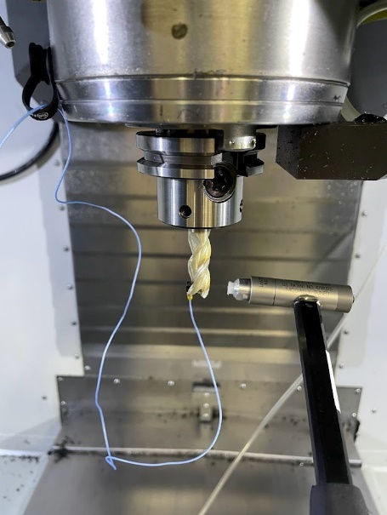
Figure 4-18. Tool-holder-spindle-machine receptances were measured by impact testing using a modal hammer and low mass accelerometer.
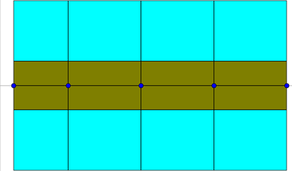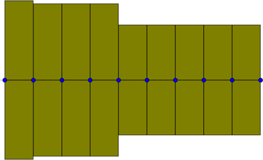
Figure 4-19. The section of the holder extending beyond the flange (left) and tool (right) are modeled as discretized beam elements using SPA. Cyan denotes steel and gold denotes carbide material properties. Note that the scales are not the same in both images.
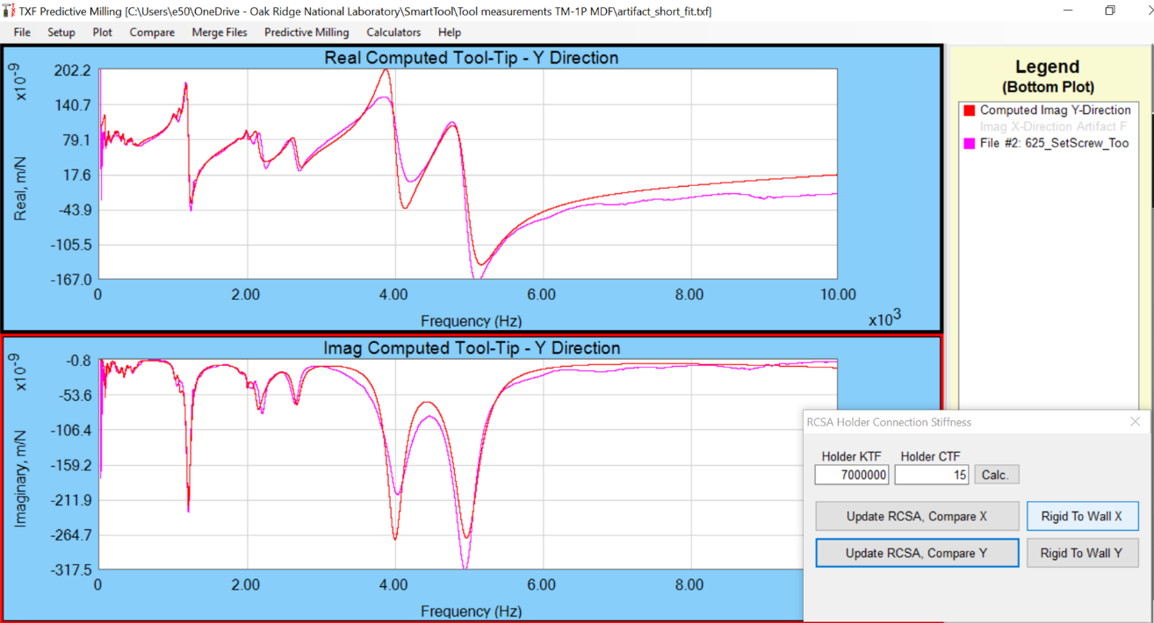
Figure 4-20. TXF was used to compare the measured receptances (magenta) to the RCSA receptances (red) and adjust the fit by modifying the stiffness (KTF) and damping (CTF) coupling parameters. The KTF and CTF parameters used in the TXF software correspond to the k_{θf} and c_{θf} parameters in the connection matrix (Eq. 3.29).
Table 4-4. The coupling parameters determined from tool-holder-spindle measurements for each tool-set screw holder assembly on all tested machines.
 | TM-1P |  | UMC-750 |  | VF-5XT |  | VF-4-L
Tool | KTF (x10⁶)  (N/m) | CTF  (N-s/m) | KTF (x10⁶)  (N/m) | CTF  (N-s/m) | KTF (x10⁶)  (N/m) | CTF  (N-s/m) | KTF (x10⁶)  (N/m) | CTF  (N-s/m)
1 | 6.25 | 75 | 3.50 | 12 | 4.70 | 12.5 | 3.30 | 22
2 | 4.10 | 17.5 | 3.30 | 5 | 3.70 | 18.5 | 3.60 | 10
3 | 3.03 | 13.5 | 2.55 | 11 | 3.05 | 0 | 2.35 | 11
4 | 2.80 | 7.5 | 3.60 | 40 | 3.20 | 14 | 3.27 | 27
5 | 2.15 | 11.5 | 2.20 | 4 | 2.45 | 9 | 3.40 | 4
6 | 2.48 | 7.5 | 1.95 | 8 | 2.45 | 1.5 | 2.05 | 5
7 | 6.50 | 40 | 5.20 | 30 | 5.60 | 40 | 4.80 | 31
8 | 4.20 | 6.5 | 3.35 | 1 | 3.45 | 9 | 2.40 | 6
9 | 2.95 | 6 | 2.20 | 2 | 2.90 | 0 | 2.40 | 3
10 | 7.75 | 22.5 | 4.80 | 25 | 6.15 | 47.5 | 4.80 | 34
11 | 3.65 | 3.5 | 2.75 | 1 | 3.40 | 4 | 3.77 | 9
12 | 1.98 | 7.5 | 2.40 | 6 | 2.15 | 7.5 | 2.55 | 0
13 | 7.65 | 12.5 | 7.50 | 12 | 10.75 | 20 | 8.00 | 50
14 | 7.25 | 25 | 7.20 | 0 | 7.05 | 15 | 7.20 | 0
15 | 7.10 | 2.5 | * | * | 6.50 | 17.5 | * | *
16 | 5.90 | 25 | 6.60 | 25 | 5.75 | 37.5 | 6.60 | 25
17 | 5.70 | 30 | 4.30 | 14 | 4.40 | 8.5 | 4.90 | 15
18 | 4.15 | 15 | 4.40 | 11 | 4.40 | 8.5 | 4.20 | 10
19 | 10.00 | 7.5 | 8.40 | 25 | 13.00 | 20 | 8.20 | 23
20 | 6.25 | 5 | 6.70 | 10 | 5.35 | 7.5 | 6.70 | 10
E21 | 5.70 | 5 | 5.45 | 5 | 5.30 | 0 | 4.80 | 5
22 | 8.35 | 7.5 | 5.80 | 0 | 6.25 | 0 | 6.60 | 24
23 | 5.65 | 17.5 | 5.50 | 10 | 4.85 | 0 | 5.50 | 4
24 | 5.30 | 10 | 5.30 | 5 | 3.90 | 13.5 | 5.10 | 2
25 | 7.85 | 8.75 | 11.00 | 45 | 11.50 | 25 | 12.00 | 75
26 | 8.55 | 7.5 | 8.30 | 40 | 7.00 | 30 | 8.00 | 20
27 | 6.40 | 10 | 7.90 | 35 | 6.00 | 27.5 | 7.90 | 0
28 | 6.65 | 22.5 | 7.90 | 32 | 6.15 | 60 | 7.90 | 30
29 | 6.00 | 17.5 | 6.00 | 24 | 4.20 | 47.5 | 5.70 | 10
30 | 4.35 | 32.5 | 4.60 | 25 | 4.70 | 30 | 4.30 | 20
31 | 9.25 | 7.5 | 8.50 | 0 | 9.30 | 33.5 | 10.00 | 40
32 | 7.50 | 7.5 | 7.50 | 5 | 5.80 | 33.5 | 7.50 | 5
33 | 4.70 | 2.5 | 6.15 | 30 | 5.05 | 6 | 6.15 | 15
34 | 9.50 | 10 | 8.50 | 0 | 6.75 | 17.5 | 8.50 | 0
35 | 7.90 | 2.5 | 7.30 | 0 | 7.35 | 0 | 7.20 | 0
36 | 5.70 | 0 | 5.60 | 10 | 5.40 | 20 | 5.40 | 10
*No data (tool not available)

Experimental Determination of Cutting Force Coefficients
To predict the stability map, both the tool tip receptances and cutting force model are required. The cutting force coefficients required for a complete force model are tool-workpiece specific. Therefore, the normal, tangential, and axial cutting force coefficients as well as the edge coefficients were measured for each of the tools used in the stability testing (tool 6, tool 18, and tool 27). For continuity, tests for stability and determination of cutting force coefficients were completed using the same workpiece.
To measure the cutting force coefficients, tests were completed on a Kistler force dynamometer at 50% radial engagement as shown in Figure 4-21. Forces were collected in the x, y, and z directions. Five feed per tooth values [0.050 0.075 0.100 0.125 0.150] mm/tooth were selected, and three repeats were collected at each feed per tooth value. Spindle speeds were selected such that all cuts were stable. Tool 18 and tool 27 were tested at 8000 rpm with an axial depth of cut of 5.1 mm. Tool 6 was tested at 10650 rpm with an axial depth of cut of 3 mm. All cuts were performed in a down milling (climb milling) orientation.
To extract the six cutting force coefficients, the average of the force signal in each direction was calculated over the range of selected feedrates. The linear regression method described in Chapter 3 was then used to determine the coefficients k_{n}, k_{t}, k_{a}, k_{ne}, k_{te}, and k_{ae} using the slope and intercept of the best fit lines.
For the x, y, and z axis forces measured by the force dynamometer for tools 6, 18, and 27, the average of three cuts was used to calculate the force in each direction and resulting cutting force coefficients as shown in Figure 4-22 through Figure 4-24. Results for the cutting force coefficients are given in Table 4-5.
To determine an uncertainty in the cutting force coefficients, one of the three tests was sampled at random for each feedrate and the linear regression was completed. The slope and intercept were then used to calculate the coefficients. This process was repeated for 150 iterations and the mean and standard deviation for the coefficients for the distributions were calculated. The 95% confidence interval (two standard deviations) is reported in Table 4-5, where σ is one standard deviation of the coefficient over all iterations.
The cutting force coefficients were used in a time domain simulation [3] and compared to the measured forces to verify the linear fit. Inputs to the time domain simulation include the tool diameter, corner radius, number of teeth, helix angle and runout, in addition to the spindle speed and feedrate. Runout was measured as [0 -7.62 -2.54] μm for tool 27 using a dial indicator as shown in Figure 4-25. For all cutting tests, the forces were filtered to remove the effects of the dynamometer dynamics on the measured force [143]. An example comparison for tool 27 with a spindle speed of 8000 rpm and feedrate of 0.15 mm/tooth is shown in Figure 4-26, where TDS is the time domain simulation, F_{x/y} is the unfiltered force in the x/y direction, and F_{x/y} filtered is the filtered force in the x/y direction.

Stability Testing for Parameter Identification
Stability testing is the final method used to determine the tool-holder connection parameters. For this method, three representative tool geometries were selected.
Tool 6: 12.7 mm, 4 flute, 44.44 mm stickout length
Tool 18: 15.9 mm, 4 flute, 52.30 mm stickout length
Tool 27: 19.1 mm, 3 flute, 66.05 mm stickout length

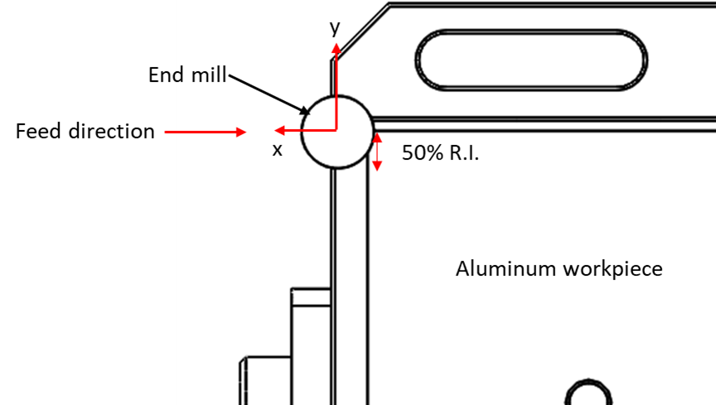
Figure 4-21. Cutting force coefficients were collected at 50% radial immersion in a down milling direction for all cuts.
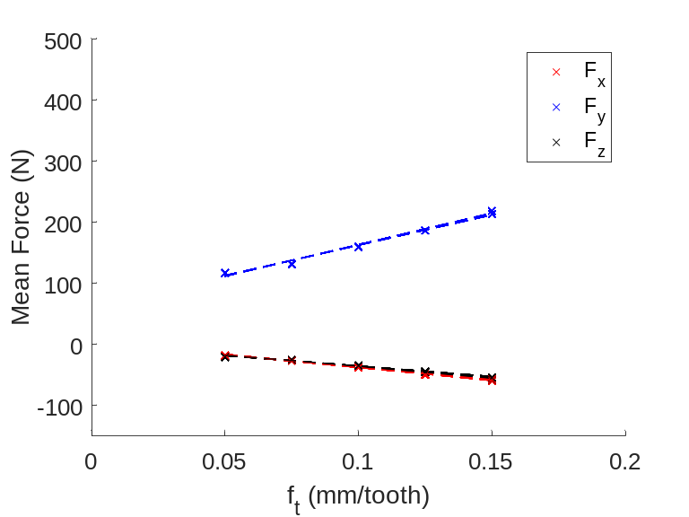
Figure 4-22. The mean force and linear fit for tool 6 tested over five feedrates at 10650 rpm.
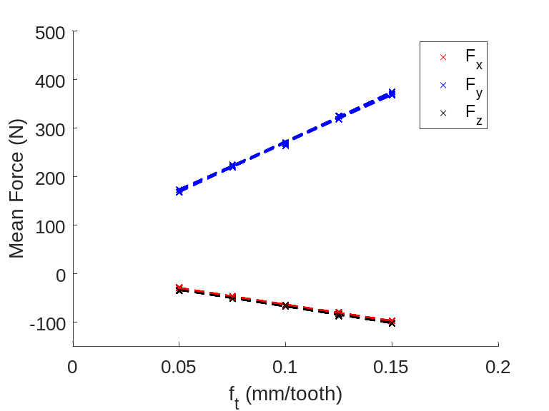
Figure 4-23. The mean force and linear fit for tool 18 tested over five feedrates at 8000 rpm.
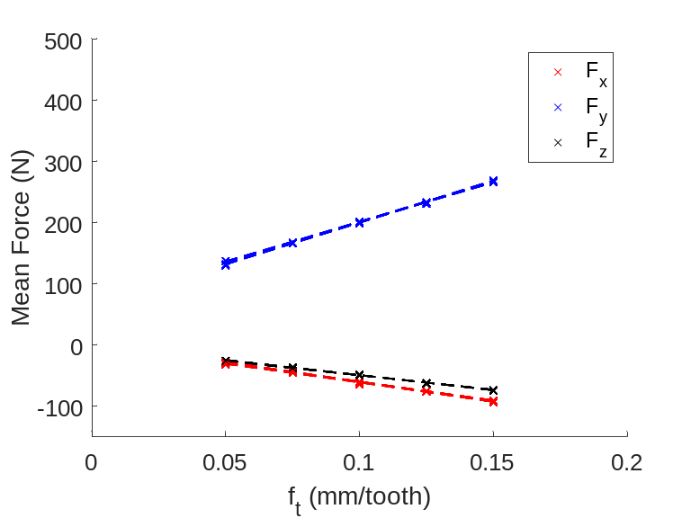
Figure 4-24. The mean force and linear fit for tool 27 tested over five feedrates at 8000 rpm.
Table 4-5. Measured cutting force coefficients and uncertainty for tools 6, 18, and 27.
Tool |  | k_{n}  (N/mm²) | k_{t}  (N/mm²) | k_{a}  (N/mm²) | k_{ne}  (N/mm) | k_{te}  (N/mm) | k_{ae}  (N/mm)
6 | Measured | 107.27 | 602.77 | 187.81 | 16.79 | 15.11 | -0.20
6 | 2σ | 24.40 | 12.30 | 18.74 | 1.36 | 0.41 | 0.94
18 | Measured | 168.89 | 684.81 | 210.80 | 11.25 | 10.039 | 0.08
18 | 2σ | 16.53 | 16.78 | 7.02 | 1.30 | 0.85 | 0.47
27 | Measured | 84.22 | 645.80 | 200.13 | 13.95 | 13.39 | -0.37
27 | 2σ | 9.11 | 26.43 | 9.19 | 0.96 | 1.91 | 0.70
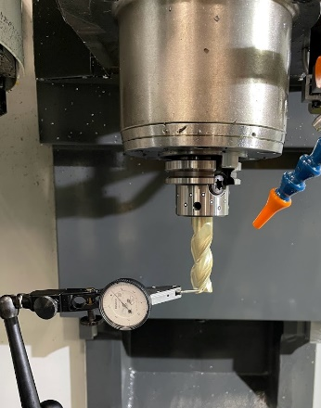
Figure 4-25. Runout of the tools was measured using a dial indicator.
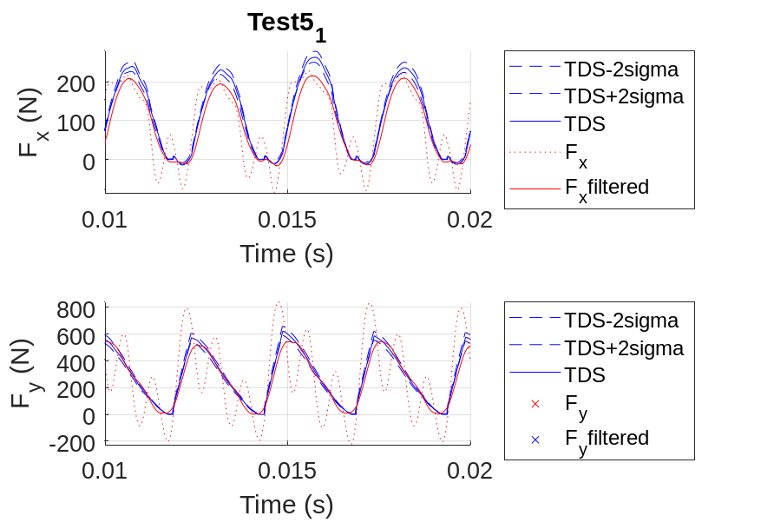
Figure 4-26. Time domain simulation versus measured forces for tool 27 with a spindle speed of 8000 rpm and feedrate of 0.15 mm/tooth.
Stability testing was conducted on a Makino a51nx with an aluminum 6061-T6 workpiece. For each tool, a feed per tooth of 0.1 mm and 50% radial immersion was commanded, and a grid of spindle speed and axial depth of cut combinations were evaluated. The range of spindle speeds was 8000 rpm to14000 rpm in 1000 rpm increments for all tools. The starting axial depth of cut was 1 mm and was increased by 1 mm until an unstable cut was completed.
To determine stability, the cutting sound was measured using a microphone located next to the machine door. The fast Fourier transform (FFT) of the audio signal was used to transform from the time domain to the frequency domain. The tooth passing frequency for each test was calculated by:
$$f_{tooth}= \frac{Ω}{60N_{t}}$$ | (4.1)
where f_{tooth} is the tooth passing frequency in Hertz, Ω is the spindle speed in revolutions per minute (rpm), and N_{t} is the number of flutes on the tool. In the case of a stable cut, frequency content should be present only at the tooth passing frequency and its integer multiples. In an unstable cut, peaks in the frequency plot occur at a chatter frequency which is not a multiple of the tooth passing frequency, in general. Examples of stable and unstable results for tool 6 are shown in Figure 4-27 and Figure 4-28. The results for all three tools are shown in Figure 4-29, Figure 4-30, and Figure 4-31.
A rejection sampling approach will be used to identify best fit coupling parameters. For each of the three tools, a distribution of connection parameters will be selected. A Monte Carlo simulation will be used to predict the tool tip receptance using RCSA and generate stability boundaries for many iterations of randomly sampled stiffness and damping parameters. For each iteration, a score will be assigned for the fit of the RCSA stability boundary to the cutting test results. For each unstable point above the modeled boundary and each stable point below the boundary, one point will be awarded for the selected coupling parameter pair. For each stable point above the boundary or unstable point below the boundary, one point will be deducted. The parameter combinations with the top scores will be identified. If a tie is obtained, the experimental and predicted chatter frequency will be compared for each candidate set of coupling parameters. The best coupling parameters will then be identified as the one with the highest score and best chatter frequency match.

Coupling Parameter Comparison
Once coupling parameters have been identified using all three methods, the values for each of the tools will be compared. The intent is to determine whether the difference methods give the same results.

Uncertainty
Uncertainty in the connection parameters will be assessed as a function of the impact testing receptances, tool length variation, and material properties assigned to the Timoshenko beam elements in the RCSA models. The uncertainty intervals will be used in the coupling parameter comparison to identify statistical differences.

Heat-Shrink Holders
While set screw holders have some advantages in terms of cost and ease of assembly, heat-shrink holders have been shown to provide a stiffer connection versus collet type holders and improved concentricity when compared to set screw designs [139], [144]. The methods used to evaluate the RCSA coupling parameters for the set screw holders presented in the previous section will be applied to heat-shrink holders, the RCSA coupling parameters for both tool types will be compared, and conclusions will be drawn.
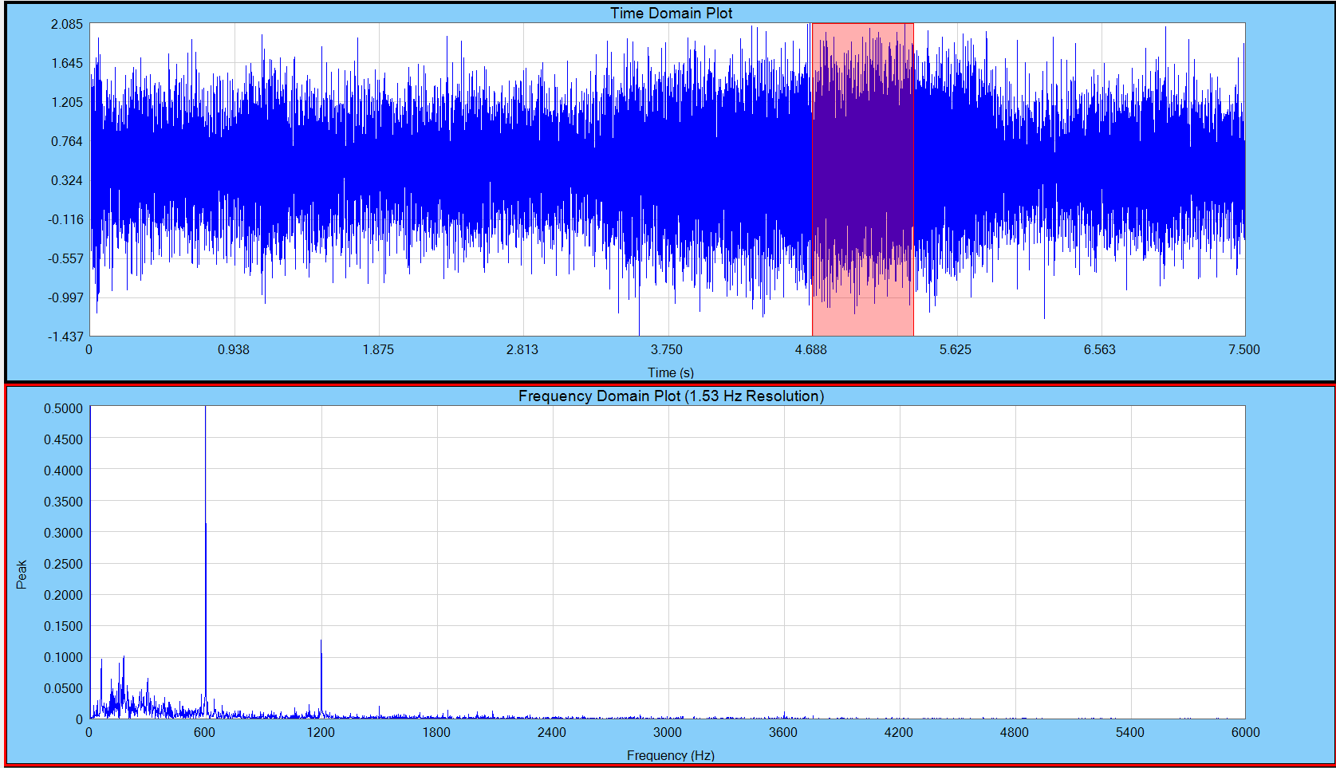
Figure 4-27. A stable cut using a four flute end mill at 9000 rpm and 3 mm axial depth of cut. The tooth passing frequency is 600 Hz.
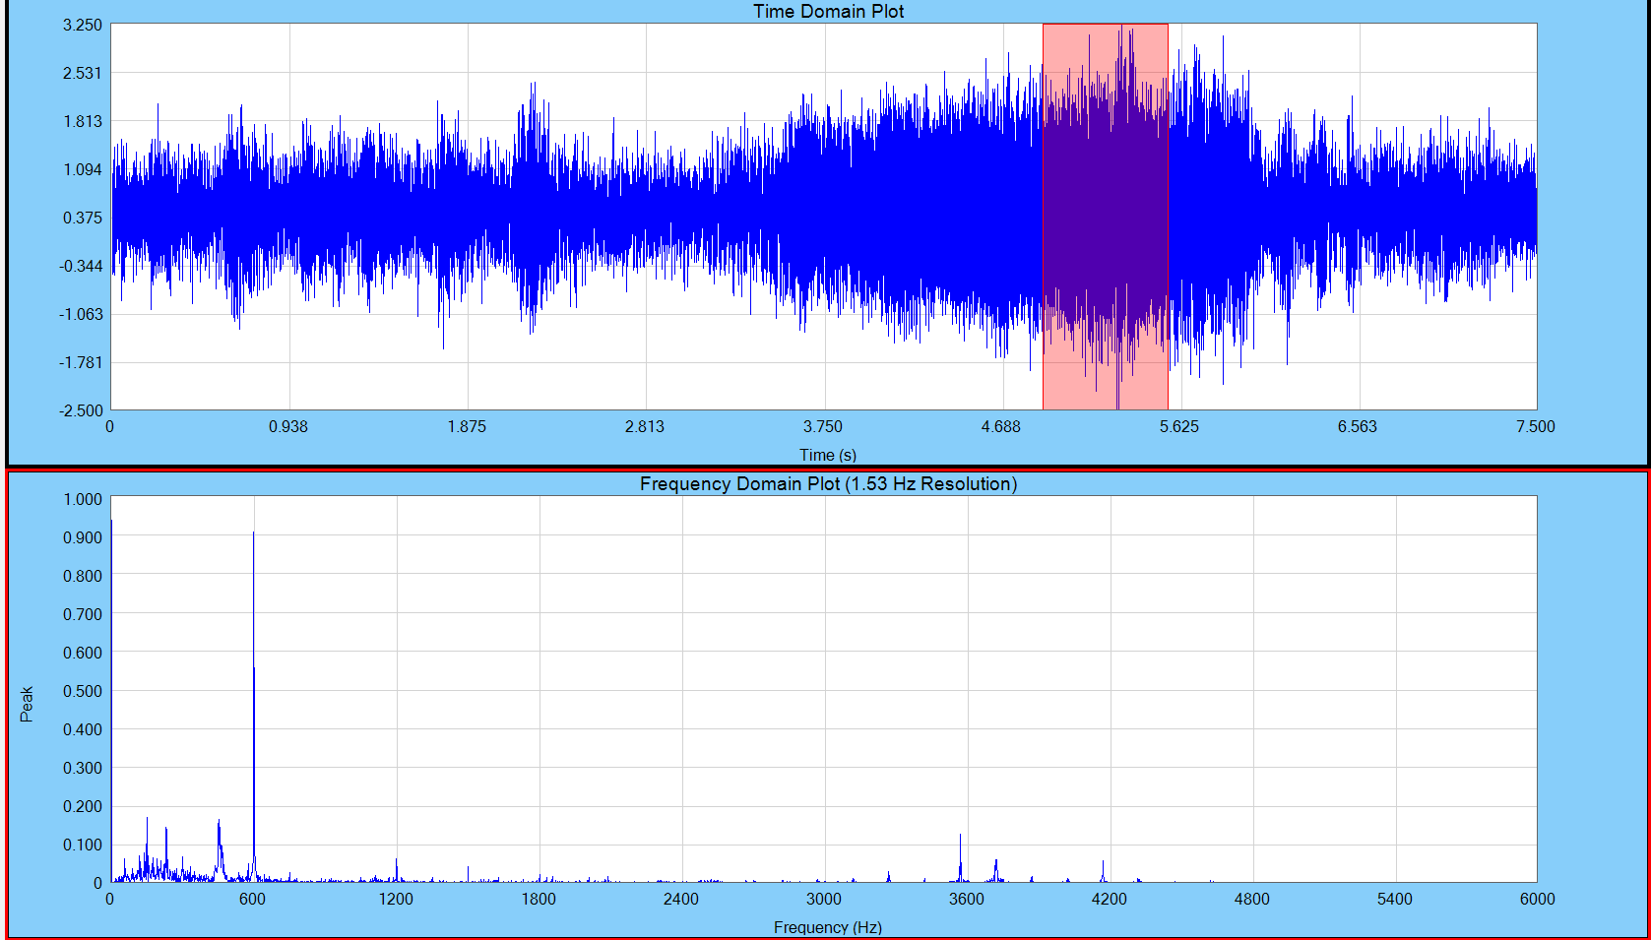
Figure 4-28. An unstable cut using a four flute end mill at 9000 rpm and 6 mm axial depth of cut. The tooth passing frequency is 600 Hz. Content present at 3569 Hz indicates chatter.
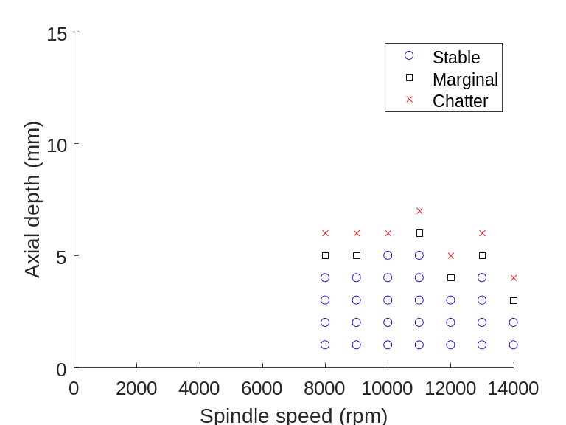
Figure 4-29. Stability results for tool 6.
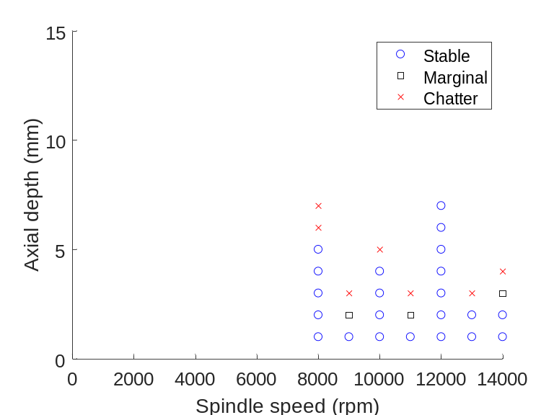
Figure 4-30. Stability results for tool 18.

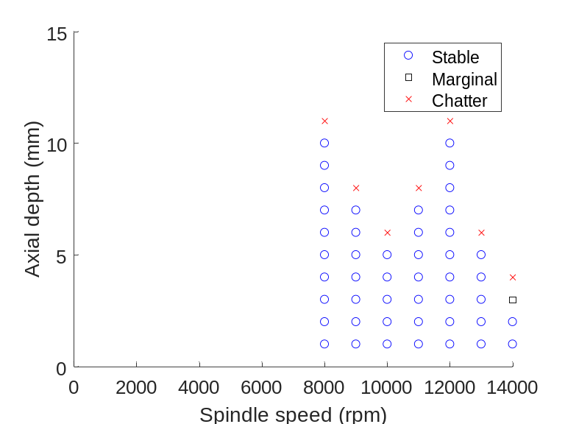
Figure 4-31. Stability results for tool 27.

Conclusions and Recommendations

References
[1] J. Tlusty, W. Zaton, and F. Ismail, “Stability Lobes in Milling,” CIRP Ann., vol. 32, no. 1, pp. 309–313, Jan. 1983, doi: 10.1016/S0007-8506(07)63411-8.
[2] Y. Altintas and E. Budak, “Analytical Prediction of Stability Lobes in Milling,” CIRP Ann., vol. 44, no. 1, pp. 357–362, Jan. 1995, doi: 10.1016/S0007-8506(07)62342-7.
[3] T. L. Schmitz and K. S. Smith, Machining Dynamics, 2nd ed. Cham: Springer International Publishing, 2019.
[4] M. V. Junior, E. A. Baptista, L. Araki, S. Smith, and T. Schmitz, “The role of tool presetting in milling stability uncertainty,” Procedia Manuf., vol. 26, pp. 164–172, Jan. 2018, doi: 10.1016/J.PROMFG.2018.07.023.
[5] T. L. Schmitz, T. J. Burns, J. C. Ziegert, B. Dutterer, and W. R. Winfough, “Tool length-dependent stability surfaces,” Mach. Sci. Technol., vol. 8, no. 3, 2004, doi: 10.1081/MST-200038989.
[6] T. J. Burns and T. L. Schmitz, “Receptance coupling study of tool-length dependent dynamic absorber effect,” in American Society of Mechanical Engineers, Manufacturing Engineering Division, MED, 2004, vol. 15, doi: 10.1115/IMECE2004-60081.
[7] T. L. Schmitz and R. R. Donaldson, “Predicting high-speed machining dynamics by substructure analysis,” CIRP Ann. - Manuf. Technol., vol. 49, no. 1, 2000, doi: 10.1016/S0007-8506(07)62951-5.
[8] Y. Altintas, G. Stepan, E. Budak, T. Schmitz, and Z. M. Kilic, “Chatter Stability of Machining Operations,” J. Manuf. Sci. Eng. Trans. ASME, vol. 142, no. 11, 2020, doi: 10.1115/1.4047391.
[9] Y. Altintas, Manufacturing Automation: Metal Cutting Mechanics, Machine Tool Vibrations, and CNC Design. Cambridge, UK: Cambridge Universtiy Press, 2000.
[10] R. E. D. Bishop and D. C. Johnson, The Mechanics of Vibration. 1960.
[11] T. L. Schmitz and K. S. Smith, Mechanical Vibrations: Modeling and Measurement, 2nd ed. New York: Springer, 2012.
[12] W. Weaver Jr, S. P. Timoshenko, and D. H. Young, Vibration Problems in Engineering, 5th ed. New York: John Wiley and Sons, 1990.
[13] T. Schmitz, M. Davies, and M. Kennedy, “High-speed machining frequency response prediction for process optimization,” in 2nd International Seminar on Improving Machine Tool Performance, 2000, pp. 3–5.
[14] T. L. Schmitz and G. S. Duncan, “Three-component receptance coupling substructure analysis for tool point dynamics prediction,” J. Manuf. Sci. Eng. Trans. ASME, vol. 127, no. 4, 2005, doi: 10.1115/1.2039102.
[15] S. S. Sattinger, “Method for experimentally determining rotational mobilities of structures,” Shock Vib. Bull.;(United States), vol. 50, 1980.
[16] D. J. Ewins, Modal testing: theory, practice and application. John Wiley \& Sons, 2009.
[17] J. Zhu, J. Wang, T. Zhang, and X. Li, “An Improved Tool Point Frequency Response Function Prediction Method Based on RCSA,” China Mech. Eng., vol. 26, no. 3, p. 285, 2015.
[18] L. Xiaohong, J. Zhenyuan, Z. Haixing, L. Shengqian, F. Yixuan, and S. Y. Liang, “Tool Point Frequency Response Prediction for Micromilling by Receptance Coupling Substructure Analysis,” J. Manuf. Sci. Eng. Trans. ASME, vol. 139, no. 7, Jul. 2017, doi: 10.1115/1.4035491.
[19] B. Qi, Y. Sun, and Z. Li, “Tool point frequency response function prediction using RCSA based on Timoshenko beam model,” Int. J. Adv. Manuf. Technol., vol. 92, no. 5–8, pp. 2787–2799, Sep. 2017, doi: 10.1007/s00170-017-0236-y.
[20] S. Filiz, C. H. Cheng, K. B. Powell, T. L. Schmitz, and O. B. Ozdoganlar, “An improved tool-holder model for RCSA tool-point frequency response prediction,” Precis. Eng., vol. 33, no. 1, 2009, doi: 10.1016/j.precisioneng.2008.03.003.
[21] J. Zhang, T. Schmitz, W. Zhao, and B. Lu, “Receptance coupling for tool point dynamics prediction on machine tools,” Chinese J. Mech. Eng. (English Ed., vol. 24, no. 3, pp. 340–345, May 2011, doi: 10.3901/CJME.2011.03.340.
[22] M. Namazi, “MECHANICS AND DYNAMICS OF THE TOOL HOLDER-SPINDLE INTERFACE,” The University of British Columbia, Vancouver, 2006.
[23] M. Namazi, Y. Altintas, T. Abe, and N. Rajapakse, “Modeling and identification of tool holder-spindle interface dynamics,” Int. J. Mach. Tools Manuf., vol. 47, no. 9, pp. 1333–1341, Jul. 2007, doi: 10.1016/j.ijmachtools.2006.08.003.
[24] I. Mancisidor, M. Zatarain, J. Munoa, and Z. Dombovari, “Receptance Coupling for Tool Point Dynamics Prediction,” 2011. [Online]. Available: https://hal.archives-ouvertes.fr/hal-01352695.
[25] I. Mancisidor, M. Zatarain, J. Munoa, and Z. Dombovari, “Fixed boundaries receptance coupling substructure analysis for tool point dynamics prediction,” in Advanced Materials Research, 2011, vol. 223, pp. 622–631, doi: 10.4028/www.scientific.net/AMR.223.622.
[26] I. Mancisidor, A. Urkiola, R. Barcena, J. Munoa, Z. Dombovari, and M. Zatarain, “Receptance coupling for tool point dynamic prediction by fixed boundaries approach,” Int. J. Mach. Tools Manuf., vol. 78, pp. 18–29, Mar. 2014, doi: 10.1016/J.IJMACHTOOLS.2013.12.002.
[27] E. Budak, A. Ertürk, and H. N. Özgüven, “A modeling approach for analysis and improvement of spindle-holder-tool assembly dynamics,” CIRP Ann. - Manuf. Technol., vol. 55, no. 1, 2006, doi: 10.1016/S0007-8506(07)60437-5.
[28] C.-H. Cheng, T. L. Schmitz, N. Arakere, and G. S. Duncan, “An Approach for Micro End Mill Frequency Response Predictions,” in Manufacturing Engineering and Materials Handling, Parts A and B, Feb. 2005, pp. 1139–1145, doi: 10.1115/IMECE2005-81215.
[29] A. Ertürk, E. Budak, and H. N. Özgüven, “Selection of design and operational parameters in spindle-holder-tool assemblies for maximum chatter stability by using a new analytical model,” Int. J. Mach. Tools Manuf., vol. 47, no. 9, pp. 1401–1409, Jul. 2007, doi: 10.1016/j.ijmachtools.2006.08.016.
[30] O. Özşahin, H. N. Özgüven, and E. Budak, “Analytical modeling of asymmetric multi-segment rotor – bearing systems with Timoshenko beam model including gyroscopic moments,” Comput. Struct., vol. 144, pp. 119–126, Nov. 2014, doi: 10.1016/J.COMPSTRUC.2014.08.001.
[31] J. Zhang, J. Li, Z. Xie, C. Du, L. Gui, and W. Zhao, “Rapid dynamics prediction of tool point for bi-rotary head five-axis machine tool,” Precis. Eng., vol. 48, pp. 203–215, Apr. 2017, doi: 10.1016/J.PRECISIONENG.2016.12.003.
[32] A. Honeycutt and T. Schmitz, “Receptance coupling model for variable dynamics in fixed-free thin rib machining,” 2018, vol. 26, pp. 173–180, doi: 10.1016/j.promfg.2018.07.024.
[33] G. S. Duncan and T. L. Schmitz, “An improved RCSA model for tool point frequency response prediction,” Proc. 23rd Int. Modal Anal. Conf., vol. 30, 2005.
[34] G. S. Duncan, “MILLING DYNAMICS PREDICTION AND UNCERTAINTY ANALYSIS USING RECEPTANCE COUPLING SUBSTRUCTURE ANALYSIS,” University of Florida, Gainesville, 2006.
[35] T. Schmitz and B. Dutterer, “MACHINE TOOL GENOME PROJECT CASE STUDY,” 2012.
[36] T. L. Schmitz, “Machine Tool Genome Project: Tool point dynamics prediction for improved milling productivity.”
[37] K. L. Wen and H. J. Qi, “Predicting Tool Point FRF by RCSA in High Speed Milling,” Adv. Mater. Res., vol. 1006–1007, pp. 398–402, Aug. 2014, doi: 10.4028/www.scientific.net/AMR.1006-1007.398.
[38] Y. Yang, M. Wan, Y. C. Ma, and W. H. Zhang, “An improved method for tool point dynamics analysis using a bi-distributed joint interface model,” Int. J. Mech. Sci., vol. 105, pp. 239–252, Jan. 2016, doi: 10.1016/j.ijmecsci.2015.11.014.
[39] U. V. Kumar and T. L. Schmitz, “Spindle dynamics identification for Receptance Coupling Substructure Analysis,” Precis. Eng., vol. 36, no. 3, 2012, doi: 10.1016/j.precisioneng.2012.01.007.
[40] B. Uttara Vijay Kumar, “IMPROVED SPINDLE DYNAMICS IDENTIFICATION TECHNIQUE FOR RECEPTANCE COUPLING SUBSTRUCTURE ANALYSIS,” University of Florida, Gainesville, 2012.
[41] P. Albertelli, M. Goletti, and M. Monno, “A new receptance coupling substructure analysis methodology to improve chatter free cutting conditions prediction,” Int. J. Mach. Tools Manuf., vol. 72, pp. 16–24, Sep. 2013, doi: 10.1016/J.IJMACHTOOLS.2013.05.003.
[42] P. Albertelli, M. Goletti, and M. Monno, “An Improved Receptance Coupling Substructure Analysis to Predict Chatter Free High Speed Cutting Conditions,” Procedia CIRP, vol. 12, pp. 19–24, Jan. 2013, doi: 10.1016/J.PROCIR.2013.09.005.
[43] W. D’Ambrogio and A. Fregolent, “Substructure decoupling without using rotational DoFs: Fact or fiction?,” Mech. Syst. Signal Process., vol. 72–73, pp. 499–512, May 2016, doi: 10.1016/j.ymssp.2015.11.029.
[44] F. Montevecchi, N. Grossi, A. Scippa, and G. Campatelli, “Two-points-based receptance coupling method for tool-tip dynamics prediction,” Mach. Sci. Technol., vol. 21, no. 1, pp. 136–156, Jan. 2017, doi: 10.1080/10910344.2016.1260435.
[45] J. Liao, D. Yu, J. Zhang, P. Feng, and Z. Wu, “An efficient experimental approach to identify tool point FRF by improved receptance coupling technique,” Int. J. Adv. Manuf. Technol., vol. 94, no. 1–4, pp. 1451–1460, Jan. 2018, doi: 10.1007/s00170-017-0957-y.
[46] T. J. Gibbons, E. Öztürk, and N. D. Sims, “Rotational degree-of-freedom synthesis: An optimised finite difference method for non-exact data,” J. Sound Vib., vol. 412, pp. 207–221, Jan. 2018, doi: 10.1016/J.JSV.2017.09.031.
[47] X.-J. Xuan, Z.-H. Haung, K.-D. Wu, and J.-P. Hung, “Prediction of the Frequency Response Function of a Tool Holder-Tool Assembly Based on …,” 2018. [Online]. Available: www.etasr.com.
[48] Y. Ji, Q. Bi, S. Zhang, and Y. Wang, “A new receptance coupling substructure analysis methodology to predict tool tip dynamics,” Int. J. Mach. Tools Manuf., vol. 126, pp. 18–26, Mar. 2018, doi: 10.1016/J.IJMACHTOOLS.2017.12.002.
[49] M. Mehrpouya, M. Sanati, and S. S. Park, “Identification of joint dynamics in 3D structures through the inverse receptance coupling method,” Int. J. Mech. Sci., vol. 105, pp. 135–145, Jan. 2016, doi: 10.1016/J.IJMECSCI.2015.11.007.
[50] E. B. Kivanc and E. Budak, “Modeling Statics and Dynamics of Milling System Components,” in Proceedings of the 36th CIRP International Seminar on Manufacturing Systems, 2003, pp. 433–440.
[51] E. B. Kivanc and E. Budak, “Structural modeling of end mills for form error and stability analysis,” Int. J. Mach. Tools Manuf., vol. 44, no. 11, pp. 1151–1161, Sep. 2004, doi: 10.1016/J.IJMACHTOOLS.2004.04.002.
[52] L. Zhongqun, L. Shuo, and C. Yizhuang, “Receptance Coupling for End Mill Using 2-Section Step Beam Vibration Model,” in 2009 Second International Conference on Intelligent Computation Technology and Automation, 2009, pp. 160–163, doi: 10.1109/ICICTA.2009.276.
[53] B. Uttara Vijay Kumar, “COMPARISON OF EQUIVALENT DIAMETER END MILL MODELS FOR DYNAMICS PREDICTION BY RECEPTANCE COUPLING SUBSTRUCTURE ANALYSIS,” University of Florida, Gainesville, 2009.
[54] O. Özşahin and Y. Altintas, “Prediction of frequency response function (FRF) of asymmetric tools from the analytical coupling of spindle and beam models of holder and tool,” Int. J. Mach. Tools Manuf., vol. 92, pp. 31–40, May 2015, doi: 10.1016/J.IJMACHTOOLS.2015.03.001.
[55] B. Bediz, U. Kumar, T. L. Schmitz, and O. Burak Ozdoganlar, “Modeling and experimentation for three-dimensional dynamics of endmills,” Int. J. Mach. Tools Manuf., vol. 53, no. 1, pp. 39–50, Feb. 2012, doi: 10.1016/j.ijmachtools.2011.09.005.
[56] L. T. Tunc, “Prediction of tool tip dynamics for generalized milling cutters using the 3D model of the tool body,” Int. J. Adv. Manuf. Technol., vol. 95, no. 5–8, 2018, doi: 10.1007/s00170-017-1286-x.
[57] E. B. Kivanc and E. Budak, “DEVELOPMENT OF ANALYTICAL ENDMILL DEFLECTION AND DYNAMIC MODELS,” ASME Int. Mech. Eng. Congr. Expo., vol. 37203, pp. 85–94, 2003.
[58] A. Ertürk, H. N. Özgüven, and E. Budak, “Effect analysis of bearing and interface dynamics on tool point FRF for chatter stability in machine tools by using a new analytical model for spindle-tool assemblies,” Int. J. Mach. Tools Manuf., vol. 47, no. 1, 2007, doi: 10.1016/j.ijmachtools.2006.03.001.
[59] M. M. Rezaei, M. R. Movahhedy, M. T. Ahmadian, and H. Moradi, “Development of Inverse Receptance Coupling Method for Prediction of Milling Dynamics,” 2010. [Online]. Available: http://asmedigitalcollection.asme.org/ESDA/proceedings-pdf/ESDA2010/49194/339/2719491/339_1.pdf.
[60] M. M. Rezaei, M. R. Movahhedy, H. Moradi, and M. T. Ahmadian, “Extending the inverse receptance coupling method for prediction of tool-holder joint dynamics in milling,” J. Manuf. Process., vol. 14, no. 3, pp. 199–207, Aug. 2012, doi: 10.1016/J.JMAPRO.2011.11.003.
[61] M. Faraji Ghanati and R. Madoliat, “New continuous dynamic coupling for three component modeling of tool-holder-spindle structure of machine tools with modified effected tool damping,” J. Manuf. Sci. Eng. Trans. ASME, vol. 134, no. 2, 2012, doi: 10.1115/1.4006094.
[62] N. Grossi, F. Montevecchi, A. Scippa, and G. Campatelli, “3D Finite Element Modeling of Holder-Tool Assembly for Stability Prediction in Milling,” Procedia CIRP, vol. 31, pp. 527–532, Jan. 2015, doi: 10.1016/J.PROCIR.2015.03.031.
[63] J. Zhu, D. He, F. Tian, and Q. Zhao, “A New Prediction Method of Tool Point Frequency Response Function for Milling Cutters,” China Mech. Eng., vol. 27, no. 20, p. 2765, 2016.
[64] W. Matthias, O. Özşahin, Y. Altintas, and B. Denkena, “Receptance coupling based algorithm for the identification of contact parameters at holder–tool interface,” CIRP J. Manuf. Sci. Technol., vol. 13, pp. 37–45, May 2016, doi: 10.1016/J.CIRPJ.2016.02.005.
[65] J. S. Agapiou, “A methodology to measure joint stiffness parameters for toolholder-spindle interfaces,” J. Manuf. Syst., vol. 24, no. 1, pp. 13–20, Jan. 2005, doi: 10.1016/S0278-6125(05)80003-2.
[66] O. Özşahin, A. Ertürk, H. N. Özgüven, and E. Budak, “A closed-form approach for identification of dynamical contact parameters in spindle–holder–tool assemblies,” Int. J. Mach. Tools Manuf., vol. 49, no. 1, pp. 25–35, Jan. 2009, doi: 10.1016/J.IJMACHTOOLS.2008.08.007.
[67] L. J. Zhai, X. L. Song, and L. G. Cai, “Identification of toolholder-spindle joint based on receptance coupling substructure analysis,” in Applied Mechanics and Materials, 2013, vol. 345, pp. 539–542, doi: 10.4028/www.scientific.net/AMM.345.539.
[68] S. Wan, J. Hong, F. Du, B. Fang, and X. Li, “Modelling and characteristic investigation of spindle-holder assembly under clamping and centrifugal forces,” J. Mech. Sci. Technol., vol. 33, no. 5, pp. 2397–2405, May 2019, doi: 10.1007/s12206-019-0438-3.
[69] O. Özşahin, E. Budak, and H. N. Özgüven, “Identification of bearing dynamics under operational conditions for chatter stability prediction in high speed machining operations,” Precis. Eng., vol. 42, pp. 53–65, Oct. 2015, doi: 10.1016/J.PRECISIONENG.2015.03.010.
[70] T. L. Schmitz and T. J. Burns, “Receptance Coupling for High-Speed Machining Dynamics Prediction,” 2003.
[71] E. Budak, “Analytical models for high performance milling. Part II: Process dynamics and stability,” Int. J. Mach. Tools Manuf., vol. 46, no. 12–13, pp. 1489–1499, Oct. 2006, doi: 10.1016/j.ijmachtools.2005.09.010.
[72] B. A. Mascardelli, S. S. Park, and T. Freiheit, “Substructure coupling of microend mills to aid in the suppression of chatter,” J. Manuf. Sci. Eng. Trans. ASME, vol. 130, no. 1, pp. 0110101–01101012, Feb. 2008, doi: 10.1115/1.2816104.
[73] V. Ostad Ali Akbari, M. Postel, M. Kuffa, and K. Wegener, “Improving stability predictions in milling by incorporation of toolholder sound emissions,” CIRP J. Manuf. Sci. Technol., vol. 37, pp. 359–369, May 2022, doi: 10.1016/J.CIRPJ.2022.02.012.
[74] A. Ertürk, H. N. Özgüven, and E. Budak, “Analytical modeling of spindle–tool dynamics on machine tools using Timoshenko beam model and receptance coupling for the prediction of tool point FRF,” Int. J. Mach. Tools Manuf., vol. 46, no. 15, pp. 1901–1912, Dec. 2006, doi: 10.1016/J.IJMACHTOOLS.2006.01.032.
[75] T. L. Schmitz, K. Powell, D. Won, G. Scott Duncan, W. Gregory Sawyer, and J. C. Ziegert, “Shrink fit tool holder connection stiffness/damping modeling for frequency response prediction in milling,” Int. J. Mach. Tools Manuf., vol. 47, no. 9, 2007, doi: 10.1016/j.ijmachtools.2006.08.009.
[76] W. Xiao, K. Mao, M. Zhu, B. Li, S. Lei, and X. Pan, “Modelling the spindle-holder taper joint in machine tools: A tapered zero-thickness finite element method,” J. Sound Vib., vol. 333, no. 22, pp. 5836–5850, Oct. 2014, doi: 10.1016/j.jsv.2014.06.023.
[77] J.-P. Hung, W.-Z. Lin, K.-D. Wu, and W.-C. Shih, “Analyzing the Dynamic Characteristics of Milling Tool Using Finite Element Method and Receptance Coupling Method,” 2019. [Online]. Available: www.etasr.com.
[78] C. Brecher, P. Chavan, and M. Fey, “Efficient joint identification and fluted segment modelling of shrink-fit tool assemblies by updating extended tool models,” Prod. Eng., vol. 15, no. 1, pp. 21–33, Feb. 2021, doi: 10.1007/s11740-020-00999-0.
[79] M. R. Movahhedy and J. M. Gerami, “Prediction of spindle dynamics in milling by sub-structure coupling,” Int. J. Mach. Tools Manuf., vol. 46, no. 3–4, pp. 243–251, Mar. 2006, doi: 10.1016/j.ijmachtools.2005.05.026.
[80] D.-H. Lee and W.-S. Hwang, “An identification method for joint structural parameters using an FRF-based substructuring method and an optimization technique,” 2007.
[81] O. Ozsahin, H. N. Özgüven, E. Budak, O. Özşahin, H. N. Özgüven, and E. Budak, “Estimation of Dynamic Contact Parameters for Machine Tool Spindle-Holder-Tool Assemblies Using Artificial Neural Networks,” Proc. 3rd Int. Conf. Manuf. Eng., pp. 131–144, 2008, [Online]. Available: https://www.researchgate.net/publication/233859351.
[82] E. Wang, B. Wu, Y. Hu, S. Yang, and Y. Cheng, “Dynamic parameter identification of tool-spindle interface based on RCSA and particle swarm optimization,” Shock Vib., vol. 20, no. 1, pp. 69–78, 2013, doi: 10.3233/SAV-2012-0728.
[83] M. Pour and H. Ghorbani, “Improving FEM model of low immersion milling process using multi-objective optimization of tool elastic support dynamic properties,” Int. J. Adv. Manuf. Technol., vol. 92, no. 5–8, pp. 2279–2297, Sep. 2017, doi: 10.1007/s00170-017-0261-x.
[84] Đ. Čiča, M. Zeljković, and S. Tešić, “Dynamical contact parameter identification of spindle-holder-tool assemblies using soft computing techniques,” Facta Univ. Ser. Mech. Eng., vol. 18, no. 4, pp. 565–577, 2020, doi: 10.22190/FUME191014012C.
[85] G. S. Duncan, M. F. Tummond, and T. L. Schmitz, “An investigation of the dynamic absorber effect in high-speed machining,” Int. J. Mach. Tools Manuf., vol. 45, no. 4–5, pp. 497–507, Apr. 2005, doi: 10.1016/J.IJMACHTOOLS.2004.09.005.
[86] H. Ding, Y. Ding, and L. M. Zhu, “On time-domain methods for milling stability analysis,” Chinese Science Bulletin, vol. 57, no. 33. Science in China Press, pp. 4336–4345, Nov. 01, 2012, doi: 10.1007/s11434-012-5499-y.
[87] J. Munoa et al., “Chatter suppression techniques in metal cutting,” CIRP Ann. - Manuf. Technol., vol. 65, no. 2, pp. 785–808, 2016, doi: 10.1016/j.cirp.2016.06.004.
[88] R. E. Vasquez, “On the use of structural dynamics in virtual manufacturing,” Int. J. Interact. Des. Manuf., vol. 11, no. 1, pp. 103–114, Feb. 2017, doi: 10.1007/s12008-014-0240-5.
[89] M. Postel, O. Özsahin, and Y. Altintas, “High speed tooltip FRF predictions of arbitrary tool-holder combinations based on operational spindle identification,” Int. J. Mach. Tools Manuf., vol. 129, 2018, doi: 10.1016/j.ijmachtools.2018.03.004.
[90] G. Yu, L. Wang, J. Wu, and Y. Gao, “Milling stability prediction of a hybrid machine tool considering low-frequency dynamic characteristics,” Mech. Syst. Signal Process., vol. 135, p. 106364, Jan. 2020, doi: 10.1016/J.YMSSP.2019.106364.
[91] M. Postel, B. Bugdayci, and K. Wegener, “Ensemble transfer learning for refining stability predictions in milling using experimental stability states,” Int. J. Adv. Manuf. Technol., vol. 107, no. 9–10, pp. 4123–4139, Apr. 2020, doi: 10.1007/s00170-020-05322-w.
[92] T. Schmitz, “Modal interactions for spindle, holders, and tools,” Procedia Manuf., vol. 48, pp. 457–465, Jan. 2020, doi: 10.1016/J.PROMFG.2020.05.069.
[93] N. Greis, M. Nogueira, S. Bhattacharya, and T. Schmitz, “Physics-Guided Machine Learning for Self-Aware Machining.”
[94] D. Xu, R. Kang, and Q. Liu, “Research on NC machine tool dynamic characteristic considering processing dynamics,” in Proceedings - 2010 International Conference on Intelligent System Design and Engineering Application, ISDEA 2010, 2010, vol. 2, pp. 227–231, doi: 10.1109/ISDEA.2010.176.
[95] M. Law, Y. Altintas, and A. Srikantha Phani, “Rapid evaluation and optimization of machine tools with position-dependent stability,” Int. J. Mach. Tools Manuf., vol. 68, pp. 81–90, 2013, doi: 10.1016/j.ijmachtools.2013.02.003.
[96] M. Law, H. Rentzsch, and S. Ihlenfeldt, “Evaluating Mobile Machine Tool Dynamics by Substructure Synthesis,” Adv. Mater. Res., vol. 1018, pp. 373–380, Sep. 2014, doi: 10.4028/www.scientific.net/AMR.1018.373.
[97] D. Wang et al., “Surface location error prediction and stability analysis of micro-milling with variation of tool overhang length,” Int. J. Adv. Manuf. Technol., vol. 99, no. 1–4, pp. 919–936, Oct. 2018, doi: 10.1007/s00170-018-2446-3.
[98] M. Law, H. Rentzsch, and S. Ihlenfeldt, “Development of a Dynamic Substructuring Framework to Facilitate in Situ Machining Solutions Using Mobile Machine Tools,” Procedia Manuf., vol. 1, pp. 756–767, Jan. 2015, doi: 10.1016/J.PROMFG.2015.09.054.
[99] Y. Yang, W. H. Zhang, Y. C. Ma, and M. Wan, “Generalized method for the analysis of bending, torsional and axial receptances of tool-holder-spindle assembly,” Int. J. Mach. Tools Manuf., vol. 99, 2015, doi: 10.1016/j.ijmachtools.2015.08.004.
[100] M. Law, H. Rentzsch, S. Ihlenfeldt, and M. Putz, “Application of Substructure Decoupling Techniques to Predict Mobile Machine Tool Dynamics: Numerical Investigations,” Procedia CIRP, vol. 46, pp. 537–540, Jan. 2016, doi: 10.1016/J.PROCIR.2016.04.126.
[101] M. Law, H. Rentzsch, and S. Ihlenfeldt, “Predicting mobile machine tool dynamics by experimental dynamic substructuring,” Int. J. Mach. Tools Manuf., vol. 108, pp. 127–134, Sep. 2016, doi: 10.1016/J.IJMACHTOOLS.2016.06.006.
[102] T. L. Schmitz, “Investigation of Retention Knob Geometry on Machining Dynamics,” Procedia Manuf., vol. 1, pp. 578–583, Jan. 2015, doi: 10.1016/J.PROMFG.2015.09.034.
[103] A. Bansal and M. Law, “A receptance coupling approach to optimally tune and place absorbers on boring bars for chatter suppression,” in Procedia CIRP, 2018, vol. 77, pp. 167–170, doi: 10.1016/j.procir.2018.08.267.
[104] A. Yadav, D. Talaviya, A. Bansal, and M. Law, “Design of chatter-resistant damped boring bars using a receptance coupling approach,” J. Manuf. Mater. Process., vol. 4, no. 2, Jun. 2020, doi: 10.3390/jmmp4020053.
[105] T. J. Gibbons, E. Ozturk, L. Xu, and N. D. Sims, “Chatter avoidance via structural modification of tool-holder geometry,” Int. J. Mach. Tools Manuf., vol. 150, p. 103514, Mar. 2020, doi: 10.1016/J.IJMACHTOOLS.2019.103514.
[106] G. Karataş, O. Özşahin, H. N. Özgüven, and E. Budak, “Design optimization of tool holder extension for enhanced chatter stability by using component mode tuning method,” Procedia CIRP, vol. 101, pp. 294–297, 2021, doi: 10.1016/j.procir.2021.02.033.
[107] N. Bertelsen, R. A. Alphinas, and K. B. Ørskov, “A tool tuning approximation method: Exploration of the system dynamics and its impact on milling stability when amending tool stickout,” 2021, doi: 10.25518/esaform21.918.
[108] W. Ma, Y. Yang, and X. Jin, “Chatter suppression in micro-milling using shank-mounted Two-DOF tuned mass damper,” Precis. Eng., vol. 72, pp. 144–157, Nov. 2021, doi: 10.1016/J.PRECISIONENG.2021.04.017.
[109] W. Ma, J. Yu, Y. Yang, and Y. Wang, “Optimization and tuning of passive tuned mass damper embedded in milling tool for chatter mitigation,” J. Manuf. Mater. Process., vol. 5, no. 1, Mar. 2021, doi: 10.3390/jmmp5010002.
[110] S. S. Park and Y. Altintas, “Dynamic compensation of spindle integrated force sensors with Kalman filter,” J. Dyn. Syst. Meas. Control. Trans. ASME, vol. 126, no. 3, pp. 443–452, Sep. 2004, doi: 10.1115/1.1789531.
[111] Y. Altintas and S. S. Park, “Dynamic Compensation of Spindle-Integrated Force Sensors,” CIRP Ann., vol. 53, no. 1, pp. 305–308, 2004, [Online]. Available: http://www.mech.ubc.ca/-ma1.
[112] T. L. Schmitz, “IMPROVED SENSOR DATA UTILITY THROUGH RECEPTANCE COUPLING MODELING,” ASME Int. Mech. Eng. Congr. Expo., vol. 47055, pp. 411–417, 2004, [Online]. Available: https://proceedings.asmedigitalcollection.asme.org.
[113] S. S. Park, “Identification of Spindle Integrated Force Sensor’s Transfer Function for Modular End Mills,” J. Manuf. Sci. Eng., vol. 128, no. 1, pp. 146–153, Aug. 2006, doi: 10.1115/1.2137749.
[114] X. Wang, Y. Guo, and T. Chen, “Measurement research of motorized spindle dynamic stiffness under high speed rotating,” Shock Vib., vol. 2015, 2015, doi: 10.1155/2015/284126.
[115] K. Kiran, H. Satyanarayana, and T. Schmitz, “Compensation of frequency response function measurements by inverse RCSA,” Int. J. Mach. Tools Manuf., vol. 121, 2017, doi: 10.1016/j.ijmachtools.2017.04.004.
[116] H. Satyanarayana, “COMPENSATION OF FREQUENCY RESPONSE FUNCTION MEASUREMENTS BY INVERSE RCSA,” 2017.
[117] C. Wang, B. Qiao, X. Zhang, H. Cao, and X. Chen, “TPA and RCSA based frequency response function modelling for cutting forces compensation,” J. Sound Vib., vol. 456, pp. 272–288, Sep. 2019, doi: 10.1016/J.JSV.2019.05.043.
[118] H. Mostaghimi, C. I. Park, G. Kang, S. S. Park, and D. Y. Lee, “Reconstruction of cutting forces through fusion of accelerometer and spindle current signals,” J. Manuf. Process., vol. 68, pp. 990–1003, Aug. 2021, doi: 10.1016/j.jmapro.2021.06.007.
[119] Y. Ji, Y. Chen, S. Zhang, Q. Bi, and Y. Wang, “Multi-Point Substructure Coupling Method to Compensate Multi-Accelerometer Masses in Measuring Rotation-Related Frequency Response Functions,” J. Manuf. Sci. Eng., vol. 144, no. 1, Jan. 2022, doi: 10.1115/1.4051534.
[120] O. Özşahin, H. N. Özgüven, and E. Budak, “Analysis and compensation of mass loading effect of accelerometers on tool point FRF measurements for chatter stability predictions,” Int. J. Mach. Tools Manuf., vol. 50, no. 6, pp. 585–589, Jun. 2010, doi: 10.1016/J.IJMACHTOOLS.2010.02.002.
[121] M. Malekian, S. S. Park, and M. B. G. Jun, “Modeling of dynamic micro-milling cutting forces,” Int. J. Mach. Tools Manuf., vol. 49, no. 7–8, pp. 586–598, Jun. 2009, doi: 10.1016/j.ijmachtools.2009.02.006.
[122] X. Lu, Z. Jia, S. Liu, K. Yang, Y. Feng, and S. Y. Liang, “Chatter stability of micro-milling by considering the centrifugal force and gyroscopic effect of the spindle,” J. Manuf. Sci. Eng. Trans. ASME, vol. 141, no. 11, Nov. 2019, doi: 10.1115/1.4044520.
[123] M. Jasiewicz and B. Powałka, “Prediction of turning stability using receptance coupling,” in AIP Conference Proceedings, Jan. 2018, vol. 1922, doi: 10.1063/1.5019090.
[124] H. Li, G. Xue, Y. Zhou, H. Li, and B. Wen, “Receptance coupling for frequency response prediction of cylindrical workpiece in CNC lathe,” vol. 17, no. 4, 2015.
[125] M. Jasiewicz and B. Powalka, “Identification of a Lathe Spindle Dynamics Using Extended Inverse Receptance Coupling,” J. Dyn. Syst. Meas. Control. Trans. ASME, vol. 140, no. 12, Dec. 2018, doi: 10.1115/1.4040968.
[126] A. Barrios, S. Mata, A. Fernandez, J. Munoa, C. Sun, and E. Ozturk, “Frequency response prediction for robot assisted machining,” MM Sci. J., vol. 2019, no. November, pp. 3099–3106, 2019, doi: 10.17973/MMSJ.2019_11_2019057.
[127] K. Kiran and M. C. Kayacan, “Effect of material removal on workpiece dynamics in milling: Modeling and measurement,” Precis. Eng., vol. 60, pp. 506–519, Nov. 2019, doi: 10.1016/j.precisioneng.2019.09.003.
[128] T. L. Schmitz and A. Honeycutt, “Analytical solutions for fixed-free beam dynamics in thin rib machining,” J. Manuf. Process., vol. 30, pp. 41–50, Dec. 2017, doi: 10.1016/J.JMAPRO.2017.09.002.
[129] Y. Danylchenko et al., “Dynamic characteristics of ‘tool-workpiece’ elastic system in the low stiffness parts milling process,” in Mechatronic Systems 2: Applications in Material Handling Processes and Robotics, Routledge, 2021, pp. 225–236.
[130] X. Jin and N. G. Koya, “Prediction of coupled torsional–axial vibrations of drilling tool with clamping boundary conditions,” CIRP J. Manuf. Sci. Technol., vol. 13, pp. 24–36, May 2016, doi: 10.1016/J.CIRPJ.2016.02.001.
[131] V. Ostad Ali Akbari and K. Ahmadi, “Substructure analysis of vibration-assisted drilling systems,” Int. J. Adv. Manuf. Technol., vol. 113, no. 9–10, 2021, doi: 10.1007/s00170-021-06777-1.
[132] A. J. Kiefer, “INTEGRATING ELECTROMECHANICAL ACTUATOR HARDWARE,” North Carolina State University, Raleigh, 2004.
[133] M. Malekian, D. Trieu, J. S. Owoc, S. S. Park, and C. J. Hunter, “Investigation of the intervertebral disc and fused joint dynamics through experimental modal analysis and the receptance coupling method,” J. Biomech. Eng., vol. 132, no. 4, Apr. 2010, doi: 10.1115/1.4001114.
[134] Y. Ding, L. Li, A. Krause, and O. Riemer, “Frequency response prediction of spindle-workpiece assemblies for ultra-precision diamond turning based on substructure analysis,” 2012.
[135] J. Su and B. Wang, “Research Progress of Synthesis and Modification Methods Based on Dynamic Substructures,” Shock and Vibration, vol. 2020. Hindawi Limited, 2020, doi: 10.1155/2020/6475716.
[136] X. Li, J. Zhu, F. Tian, and Z. Huang, “An improved rapid prediction method of the milling tool point frequency response function,” Int. J. Adv. Manuf. Technol., vol. 110, no. 3–4, pp. 841–852, Sep. 2020, doi: 10.1007/s00170-020-05929-z.
[137] J. H. SHAIK, J. S. AS, T. S. RAO, K. R. Kotaiah, and B. R. Kumar, “Identification of practical spindle-tool interface parameters using an optimization based statistical approach,” Sādhanā, vol. 46, no. 111, 2021, doi: 10.1007/s12046-021-01635-y.
[138] L. Morelli, N. Grossi, G. Campatelli, and A. Scippa, “Surface location error prediction in 2.5-axis peripheral milling considering tool dynamic stiffness variation,” Precis. Eng., vol. 76, pp. 95–109, Jul. 2022, doi: 10.1016/J.PRECISIONENG.2022.03.008.
[139] Big Daishowa- Americas, “Comparing Tool Holder Performance and Price,” 2019. https://www.bigdaishowa.com/en/blog/comparing-tool-holder-performance-and-price.
[140] Blevins, Formulas for Natural Frequency and Mode Shape. Malabar: Krieger Publishing Company, 1979.
[141] S. Smith1, W. R. Winfoughz, and J. Halleyj, “The Effect of Tool Length on Stable Metal Removal Rate in High Speed Milling.”
[142] “Manufacturing Laboratories, Inc. (MLI) MetalMAX.” https://mfg-labs.com/products.html.
[143] M. F. Gomez, “Displacement-based dynamometer for milling force measurement,” University of Tennessee Knoxville, 2021.
[144] L. N. López De Lacalle, A. Lamikiz, J. Fernández De Larrinoa, and I. Azkona, “Advanced cutting tools,” Mach. Hard Mater., pp. 33–86, 2011, doi: 10.1007/978-1-84996-450-0_2.

