Genomic Analysis and Functional Characterization of the Terpene Synthase Gene Family in Brachypodium distachyon

A Thesis
Presented for the
Master of Science
Degree
The University of Tennessee, Knoxville

Ayla Marie Norris
May, 2013
Acknowledgement

I want to acknowledge several people who have made this research possible. First, I want to thank my PI and mentor, Dr. Feng Chen, for his guidance and encouragement. I thank my committee members, Dr. Albrecht von Arnim, Dr. Jerome Baudry, and Dr. Michael Gilchrist for their advice and feedback. I thank my present and past lab members for their continual professional support and personal friendship: Hao Chen, Xinlu Chen, Gitika Shrivastava, Lori Osburn, Minta Chaiprasongsuk, Jingyu Lin, Nan Zhao, Yifan Jiang, and Guanglin Li. Finally, I owe special thanks to my boyfriend, Chris Ploughe, who has given me unconditional support, encouragement, care and patience.

Abstract

Brachypodium distachyon is a small, temperate grass native to the Mediterranean region. While not agriculturally important, it possesses many characteristics such as rapid generation time, self-pollination, a small genome size, and ease of genetic transformation, that make it an attractive model organism for genetic studies. Brachypodium is closely related to other grasses of economical importance such as rice, sorghum, and especially wheat, and in fact it is the first member of the Pooideae grass sub-family to have its genome fully sequenced. Cereal grasses such as rice, sorghum, and maize have been reported to produce a class of secondary metabolites called terpenes as volatile gases during insect herbivory and after the application of the plant defense signaling molecule, methyl jasmonate (MeJA), as part of an indirect defense mechanism. The terpenes are attractive to predators and parasitoids of the attacking herbivore. The aims of this thesis are to identify the volatile terpenes that Brachypodium plants produce after insect damage and other stresses, to identify the terpene synthases in the Brachypodium genome, and to identify and functionally characterize the particular terpene synthases that are responsible for the production of the volatile products. Upon damage by fall armyworms (Spodoptera frugiperda, a lepidopteran pest of grasses), the plants produce a low number terpenes, and the quantity of each of those terpenes is also low and are not always within the detection limits of the GC-MS. However, upon the application of exogenous MeJA, Brachypodium plants produce seven sesquiterpenes, including β-caryophyllene. 18 putative full-length terpene synthases were identified from the Brachypodium distachyon genome. Amongst the eight putative mono- and sesquiterpene synthases that were cloned, two were found to be functional in in vitro enzyme assays: BdTPS6 and BdTPS7. BdTPS6 produced β-caryophyllene as its major product, and BdTPS7 produced three sesquiterpenes of unknown identity. Therefore, Brachypodium distachyon retains a β-caryophyllene synthase that is important in the indirect defense of other previously studied cereal grasses.

Table of Contents

Chapter I: Introduction and literature review: The involvement the terpenes in plant indirect defense 1
Plant use of volatiles for indirect defense against pests 1
Terpenes and their biosynthesis 3
Terpene synthases from previously studied grasses 5
Model organism: Brachypodium distachyon 9
Objectives 11
Chapter II: Volatile terpenes produced by Brachypodium distachyon during herbivory and other stresses 12
Introduction 12
Methods 15
Results 17
Discussion 20
Chapter III: Identification and comparative analysis of terpene synthase genes in Brachypodium distachyon 23
Introduction 23
Methods 26
Results 28
Discussion 43
Chapter IV: Functional characterization of Brachypodium distachyon mono- and sesquiterpene synthases 46
Introduction 46
Methods 49
Results 51
Discussion 55
Chapter V: Summary and future directions 58
References 59
Vita 64

List of Tables

Table 1.1 Volatile terpenes produced by herbivore-damaged maize, rice, and sorghum, compared with the products of characterized terpene synthases…………... | 10
Table 3.1 The terpene synthase gene family in Brachypodium distachyon.................. | 36
Table 4.1 Primers used for the amplification of full-length terpene synthases by PCR…………………………………………………………………………………… | 51
Table 4.2 Summary of cloning and enzyme assay status of the Brachypodium mono- and sesquiterpene synthases………………………………………………………….. | 53

List of Figures

Figure 1.1 Phylogeny of various grasses…………………………………………… | 10
Figure 2.1 Representative chromatograms showing volatile terpenes produced by each treatment after 24 hours: control (a), mechanical wounding (b), FAW damage (c), MeJA (d)………………………………………………………………………. | 19
Figure 2.2 One of the six replicates for the FAW-damage treatment produced a small amount of β-caryophyllene (2), in addition to caryophyllene oxide (7)……… | 20
Figure 3.1 Phylogeny of putative full-length TPSs from seven sequenced plant genomes and representative characterized TPSs from gymnosperms (from Chen et al. 2011)……………………………………………………………………………… | 24
Figure 3.2 Two gene fragments, Bd4g04980 and Bd4g04987, detected in close proximity to each other in the original annotation………………………………… | 31
Figure 3.3 Bd1g62540 was possibly incorrectly annotated, producing a transcript of a very short length and only five exons instead of the usual seven……………… | 31
Figure 3.4. Phylogenetic tree of the terpene synthase gene family from Brachypodium distachyon, rice (Oryza sativa), and sorghum (Sorghum bicolor)… | 32
Figure 3.5 The TPS-a subfamily in Brachypodium, rice, and sorghum…………… | 33
Figure 3.6 The TPS-b and TPS-g subfamilies in Brachypodium, rice, and sorghum | 34
Figure 3.7 The TPS-c and TPS-e/f subfamilies in Brachypodium, rice, and sorghum | 35
Figure 3.8 Pieces of a multiple sequence alignment showing each motif associated with terpene synthases……………………………………………………………… | 40
Figure 3.9 Domain/motifs for the BdTPS proteins………………………………… | 41
Figure 3.10 Gene structures of the BdTPS family………………………………… | 42
Figure 3.11 Exon-intron structure comparison between the Brachypodium and sorghum members of the TPS-b subfamily and Os02g02930……………………… | 43
Figure 4.1 BdTPS6 is a β-caryophyllene synthase……………………………………… | 54
Figure 4.2 BdTPS7 produces three unknown sesquiterpenes……………………… | 54
Figure 4.3 Semi quantitative RT-PCR gene expression analysis of BdTPS6 and BdTPS7……………………………………………………………………………... | 54
Figure 4.4 Comparison of BdTPS6 major products with the products of its orthologs in rice and sorghum……………………………………………………… | 55
Figure 4.5 Comparison of BdTPS7 products with the products of its orthologs in rice and sorghum…………………………………………………………………… | 56

Chapter I

Introduction and literature review: The involvement the terpenes in plant indirect defense

Plant use of volatiles for indirect defense against pests

Many plants can make and release volatile gases that serve various functions. These gases can have roles in developmental processes (Bleecker and Kende 2000), attraction of pollinators (Reinhard et al. 2004; Pichersky and Gershenzon 2002), repelling herbivores (De Moraes et al. 2001), attracting carnivores (Mumm and Dicke 2010), priming neighboring plants to ramp up their defenses (Frost et al. 2008; Choh et al. 2013), and can have anti-microbial activity (Dudareva et al. 2006). In contrast to a direct defense mechanism, like a plant producing a substance that is toxic or repellant to an herbivore, indirect defense occurs when plants recruit carnivores and/or parasites of the offending herbivore, thus involving three trophic levels. An increasingly well studied mechanism of indirect defense is the use of herbivore-induced plant volatiles (HIPV’s) that attract the natural enemies of the plant (Arimura et al. 2009; Kessler and Baldwin 2001; Dicke and Baldwin 2010; Degenhardt 2009). These volatile gases are not released by the plant until it is damaged by the herbivore or the herbivore’s eggs are oviposited onto its surface. Sometimes the genes that control the biosynthesis of the HIPVs are not constitutively expressed, but instead the volatiles are synthesized de novo, perhaps because they are metabolically and energetically expensive (Heil and Baldwin 2002; Ali et al. 2011). It has been found that several important plant species use HIPV-related indirect defense, including pine, willow, poplar, apple, pear, cabbage, cotton, tomato, tobacco, various beans and peas, and cereals like rice and maize (reviewed by Mumm and Dicke 2010). Understanding and utilizing the HPIV indirect defense mechanism will likely be helpful in protecting agricultural crops from pests. Plants could be genetically manipulated to produce volatiles that are attractive to beneficial predators or the volatile blends could be directly applied, making an ecological and economical form of pest control.
Plants release an array of different compounds in response to different stimuli, and the type and quantity of individual compounds can change depending on a number of factors, including the plant species or even the cultivar within a species, plant part, and developmental stage (Köllner et al. 2004; Goff and Klee 2006). HPIV composition can change depending on the type of insect that is damaging the plant. Different pests inflict different kinds of damage. For example, aphids, mites, thrips, and stinkbugs have piercing mouthparts while caterpillars, planthoppers, beetles, and grasshoppers chew with their mandibles (Pare and Tumlinson 1999). Chemical signals from the pest’s saliva can turn on specific responses in the damaged plant tissues and recruit appropriate predators (Turlings et al. 1998; Turlings et al. 1999). Volatile biosynthesis and release can be localized in the damaged tissues or a systemic signal can cause distant undamaged tissues to produce and release volatiles as well (Howe and Jander 2008). In addition to volatiles released by herbivory, plants can also release volatiles in response to other types of biotic and abiotic stresses (Holopainen and Gershenzon 2010), and the exogenous application of defense signaling molecules such as methyl jasmonate and salicylate (Hare 2008; Degenhardt 2009; Radhika et al. 2012). Volatile compounds released by plants can be made up of one or more of the following chemical types: terpenes, fatty acid derivatives (green leaf volatiles, or GLV, including methyl jasmonate itself), and phenylpropanoids. The largest and most diverse class of volatiles is the terpenes (Dudareva et al. 2006). Terpenes in particular are very attractive to certain predators and parasitoids in rice, sorghum, and maize, and purified synthetic terpenes retain their attractiveness (Köllner et al. 2008; Degenhardt 2009).

Terpenes and their biosynthesis

Terpenes and their derivatives (together called terpenoids) are defined as a type of molecule related by structure and by biosynthesis. Their structure is made up of chains of the five-carbon molecule unit, isoprene, and these isoprenes are linked together to form larger molecules. These larger isoprenoids can are further modified by different cyclization and head/tail rearrangements, catalyzed by a terpene synthase (the second feature of a terpene) (Tholl 2006). Terpenes can be further derivitized by processes such as oxygenation (Degenhardt et al. 2009). Each terpenoid is made up of multiples of five carbons (give or take individual carbons in different derivatives). Isoprenes (5 carbons), the ‘true terpenes’ -monoterpenes (10 carbons), sesquiterpenes (15 carbons), di-terpenes (20 carbons)- and increasingly longer chain categories such as carotenoids, sterols, gibberellins and rubbers are all considered terpenoids. Terpenes are made in higher plants and in lower plants like moss and liverwort, as well as in fungi , bacteria and even some animals. Nearly 50,000 terpenes and terpene-derived compounds have been identified. Many terpenes are of economic value to humans, as they are responsible for many scents and flavors, as well as other uses, like solvents and drugs (Greenhagen and Chappell 2001).
Monoterpenes, sesquiterpenes, and diterpenes are unique in that they are all formed by the final synthesis step catalyzed by a conserved family of enzymes called terpene synthases (TPSs). Other longer terpenoids are made by different, unrelated classes of enzymes, such as caratenoid cleavage deoxygenases (CCDs). Only monoterpenes and sesquiterpenes (and the occasional diterpene or higher terpenoids such as squalene) are of low enough molecular weight and vapor point to be volatile, and so these two types of terpenes are the ones that are largely considered when studying indirect defense. Several isolated monoterpenes and sesquiterpenes are attractive to specific predators and parasitoids, even without the damaged plant itself being present (Köllner et al. 2008; Degenhardt 2009). Understanding how the terpene synthase genes work, how they are regulated, and how they evolved is critical to understanding and possibly controlling the dominant members of the volatile arrays produced in plants after insect damage.
There is already an understanding for how terpenes are synthesized. Terpenes are a diverse class of metabolites that are related by their structure and synthesis: they are made up of the activated forms of the 5-carbon unit isoprene, isopentenyl diphosphate (IPP) and its isomer dimethylallyl diphosphate (DMAPP). The upstream biosynthesis events leading up to the conversion of the direct substrates of terpene synthases into terpenes has been well characterized. Both IPP and DMAPP are products of two independent pathways: the methylerythritol phosphate (MEP) pathway in the plastids and the mevalonate-dependant (MAD) pathway in the cytosol. One unit of DMAPP is chained together with between one and three IPP units in a head-to-tail arrangement to form the substrates for the terpene synthases. Ultimately the substrates for terpene synthases are produced in either the cytosol or the plastids: geranyl diphosphate (GPP) and gernylgeranyl diphosphate (GGPP), which are the substrates for monoterpene and diterpene synthases, are made in the plastids, while farnesyl diphosphate (FPP), the substrate for sesquiterpene synthases, is made in the cytosol. The mechanism of most terpene synthases has been discovered. A highly conserved DDXXD motif houses the Mg²⁺ cofactor which helps cleave the diphosphate group from the substrate (either GPP, FPP, or GGPP), forming an unstable carbocation intermediate, which is then rearranged, often by cyclization, to a final stable product (Davis and Croteau 2000, Chen et al. 2011). Site-directed mutagenesis experiments have shown that the shape of the substrate-binding pocket, dictated by the type and position of the amino acids, determines the type of product(s) the carbocation intermediate turns into (Greenhagen et al. 2006). Some terpene synthases are specific, forming only one terpene product, while others are capable of forming many products. Although most TPSs work in this manner, and the motifs surrounding the active sites are extremely conserved, the sequences of other regions are much less conserved, often times hardly at all. TPSs may have played very important roles in the evolution of the different kinds of plants, and the diversity in the TPS genes themselves reflect this.

Terpene synthases from previously studied grasses

Table 1.1 summarizes the volatile terpene profiles of maize, rice, and sorghum after herbivore damage, as well as characterized terpene synthases from each plant.
Maize releases at least 20 sesquiterpenes upon insect damage. Seven functionally active sesquiterpene synthases have been identified in maize: ZmTPS1, 4, 5, 6, 10, 11, and 23. Of these TPS1, TPS10, and TPS23 are strongly induced upon herbivore damage as well as the application of exogenous jasmonate, and are responsible for most of the terpene volatiles seen in the maize plants under damage (Schnee et al. 2002; Schnee et al. 2006; Köllner et al. 2004; Köllner et al. 2008).
Upon damage by Spodoptera frugiperda (fall armyworm, or FAW), rice produces one monoterpene and an array of 19 sesquiterpenes not found in undamaged control plants. Three terpene synthases from rice were biochemically characterized, and together their products account for most of the terpenes seen in the plant volatile profile. These were Os02g02930 (producing the monoterpene linalool), Os08g04500 (producing primarily β-caryophyllene with four other minor sesquiterpene products), and Os08g07100 (14 sesquiteprene products, with zingiberene being dominant). These genes were upregulated during FAW attack (Yuan, et al., 2008)
Finally, sorghum produces 11 terpenes upon FAW damage, one being the monoterpene linalool, while the remaining 10 are sesquiterpenes. Five functional sesquiterpene synthases have been biochemically characterized from sorghum, and the products produced between them also account for most of the terpene seen in the plant volatile profile (Zhuang, et al. 2012).
There is much similarity in the types of terpenes between the volatile profiles of rice, sorghum, and maize, suggesting that the ability to produce this general set of compounds evolved before the split between these species around 55 MYA (Bremer 2002; Prasad et al. 2005). Amongst the characterized TPSs in these three grasses, there is no redundancy of products rice TPSs, while this is extremely common in sorghum and maize. It would be interesting to see if the TPSs from a species more closely related to rice than to the sorghum or maize, such as Brachypodium or wheat would also lack product promiscuity.

Table 1.1 Volatile terpenes produced by herbivore-damaged maize, rice, and sorghum, compared with the products of characterized terpene synthases. The products are ordered roughly by their retention times in a GC-MS. Shaded cells indicate that the terpene is produced by the plant after herbivore damage. TPS’s marked with an asterisk (*) indicate that one of its dominant products is the compound listed in the same row. The unknown sesquiterpene marked with (**) may not be the same compound found in the rice volatile analysis, the product of Os08g04500, and the product of Os08g07100, but all three had a similar retention time.

Terpene | Maize | Rice | Sorghum
Linalool |  | Os2g02930
4,8-dimethylnona-1,3,7-triene
unknown sesquiterpene
α-copaene
β-macrocarpene | ZmTPS6*, 11*
7-epi-sesquithujene | ZmTPS4*, 5 | Os08g07100 | SbTPS1, 2, 5
sesquithujene | ZmTPS4, 5* | Os08g07100
β-elemene |  | Os08g04500 | SbTPS4
δ-elemene | ZmTPS23
β-caryophyllene | ZmTPS23* | Os08g04500* | SbTPS4*
(Z)-α-bergamotene | ZmTPS4, 5 | Os08g07100
(E)-α-bergamotene | ZmTPS4, 5, 10* | Os08g07100 | SbTPS5*
sesquisabinene A | ZmTPS4, 5 , 10 | Os08g07100 | SbTPS1, 2, 3, 5
sesquisabinene B |  | Os08g07100
(E)-β-farnesene | ZmTPS1*, 4, 5, 6, 10*, 11 | Os08g07100 | SbTPS1, 2, 3, 5
α-farnesene | ZmTPS4, 5
α-humulene | ZmTPS23 | Os08g04500 | SbTPS4*
γ-curcumene | ZmTPS4, 5 | Os08g07100
unknown sesquiterpene** |  | Os08g07100, Os08g04500
zingiberene | ZmTPS4, 5, 10 | Os08g07100* | SbTPS1*, 2
β-bisabolene | ZmTPS4*, 5*, 6, 10, 11 | Os08g07100 | SbTPS1, 2, 5
β-curcumene | ZmTPS4, 5 | Os08g07100
germacrene A |  | Os08g04500
germacrene D
β-sesquiphellandrene | ZmTPS4, 5, 10 | Os08g07100* | SbTPS1*, 2*
(E)-γ-bisabolene | ZmTPS4, 5 | Os08g07100 | SbTPS5
(Z)-γ-bisabolene | ZmTPS4, 5 |  | SbTPS5*
γ-cadinene
δ-cadinene
α-cadinene
(E)-nerolidol | ZmTPS4, 5, 1*
(E,E)-farnesol | ZmTPS1

Model organism: Brachypodium distachyon

While the terpenes and their TPS enzymes have been relatively well studied in 3 of the 6 sequenced grasses (rice, maize, and sorghum), it has remained unstudied in Brachypodium distachyon (purple false-brome, hereafter referred to as Brachypodium).
Brachypodium is a small temperate grass native to the Mediterranean region. It is closely related to wheat whose genome is difficult to sequence and analyze due to its large genome size and extensive polyploidization. Brachypodium, unlike the other sesquenced grasses, is not a food crop or economically important for the biofuel industry like switchgrass, but it has many features that make it an attractive model organism for genetics studies, and so it was chosen to have its genome sequenced so that it may be used for studying monocots like an Arabidopsis thaliana is used as a genetic model for dicots. Like Arabidopsis, Brachypodium has a small genome, easy growth requirements, a fast generation time, and the ability to self-pollinate. Transformation protocols have also been developed for Brachypodium. In addition, there are multiple accessions of Brachypodium from different geographical regions, and some of these accessions are polyploid rather than diploid (Mur et al. 2011; Catalan et al. 2012).

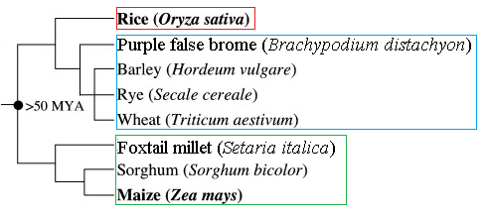
Figure 1.1 Phylogeny of various grasses. Red box, Ehrhartoideae subfamily. Blue box, Pooideae. Green box, Panicoideae.

Brachypodium is the first member of the Pooideae subfamily of grasses to be sequenced, making it closely related to other temperate grasses which are of agricultural importance such as wheat, barley, and rye (The International Brachypodium Initiative 2010). Of the previously sequenced grasses, rice belongs to the Erhardtoideae subfamily while foxtail millet, switchgrass, maize, and sorghum are members of the Panicoideae subfamily (Figure 1.1). The availability of the sequenced Brachypodium genome produces an opportunity to further study the evolution of terpene synthases in grasses in a broader phylogenetic context. The purpose of this thesis is to lay the foundation of these comparative studies by characterizing the terpenoid volatile production of Brachypodium in response to insect damage and other stresses and studying the underlying genomic and biochemical mechanisms. Through this, the evolution of terpene-mediated indirect defense in grasses will be better understood, and the groundwork necessary to continue the study of wheat, barley, rye and other commercially important Pooid grasses will be laid out when their genomes are finished being sequenced.

Objectives

The specific goals of this thesis project are to (1) identify the terpenoids compounds produced in the volatile array of Brachypodium plants after being subjected to insect damage, physical wounding, and methyl jasmonate exposure (2), identify putative monoterpene and sesquiterpene synthase genes in the Brachypodium genome and comparatively analyze Brachypodium TPSs with rice and sorghum TPSs, and (3) select candidate TPS genes to clone and characterize to determine their individual products, and to identify which TPS genes are responsible for the terpene products produced in the live plants under the different stress conditions.

Chapter II
Volatile terpenes produced by Brachypodium distachyon during herbivory and other stresses

Introduction

Many plants species are reported to release volatile organic compounds (VOC’s) into the air, comprising of alkanes, alkenes, alcohols, aldehydes, esters and carboxylic acids. The amount of plant-produced VOC’s is not insignificant: for example, it is estimated that a forest that is 62,000 km² in area (the size of the U.S. state of Pennsylvania) produces 3.4 million kilograms of terpenoids on a typical August day (Behr and Johnen, 2009).
Several important functions have been associated with the volatiles that plants produce, including plant reproduction, the mediation of abiotic stresses, and plant defense to biological attack. Flowers emit volatiles to attract pollinators, and fruits also emit volatiles to attract seed dispersers, and these scents are often used in conjunction with visual cues (Dudareva et al 2006, Goff and Klee 2006). Isoprene and some monoterpenes have been found to promote photosynthetic heat tolerance. Trees that have had their isoprene and monoterpene production impaired by fosmidomycin, an inhibitor of the methylerythritol pathway, have decreased thermotolerance, and the fumigation of the trees with exogenous isoprene and monoterpenes restores it (Copolovici et al. 2005, Sharkey et al. 2001). VOC’s can function as plant defenses in multiple ways. Plant defenses can be divided into two types: direct defense, involving only the plant itself and the attacking herbivore or pathogen, and indirect defense, in which the plant attracts a third party to attack the offender. Many volatiles, especially those produced by floral tissues, have anti-microbial and anti-fungal activity (Friedman et al 2002, Dudareva et al 1996) while others are repellant or outright toxic to herbivores (De Moraes et al., 2001; Kessler and Baldwin, 2001; Howe and Jander, 2008). These are examples of direct defenses. VOC’s can mediate indirect defense as well, attracting predators and parasitoids of the offending herbivore to the damaged plant. A review published in 2010 by Mumm and Dicke includes a table summarizing more than 100 reports of carnivore attraction to plants subjected to herbivore feeding or egg deposition, with most of the cases including chemical evidence for herbivore-induced plant volatiles.
At least 1700 different VOC’s are known to be produced by plants (Dicke and Loreto, 2010), and most of these can be divided into three major chemical classes: terpenoids, fatty acid derivatives, and phenylpropanoids, with terpenoids being the largest class (Dudareva et al 2006). Terpenoids are related by structure and by biosynthesis, being composed of chains of 5-carbon isoprene units that are cyclized or otherwise modified by terpene synthases. Many terpenes have strong odors to humans, and in fact terpenes are the primary constituents of plant essential oils used as perfumes and flavorings, as well as many other commercial uses (Tholl, 2006). Some examples of terpenes are limonene (a cyclic monoterpene that makes up the aroma and flavor of orange fruits), farnesol (an acyclic sesquiterpene alcohol that is a floral scent and natural mitocide), and taxadiene (a diterpene from the Pacific yew tree that is the precursor to the anti-cancer drug, Taxol). The fatty acid derivatives, such as trans-2-hexanal, are produced by damaged leaf tissue by the derivitivization of C18 unsaturated fatty acids in broken plasma membranes in leaves, like linoleic acid, and as such an alternative name for this class are “green leaf volatiles.” This type of volatile is responsible for the smell of fresh-cut grass (Feussner and Wasternack, 2002). The phenylpropanoid category of VOC’s are very diverse in structure, but all are derived from the amino acid-phenylalanine and contain at least one hydroxyl group and one aromatic hydrocarbon ring. Some examples of phenylpropanoids are salicylate (a plant hormone and defense response regulator) and cinnamic acid (an odor component of cinnamon) (Dudareva et al 2006).
This thesis focuses on the biosynthesis of terpenes in Brachypodium distachyon and how the terpenes are implicated in indirect defense. Most of the volatiles released by grasses during insect herbivory are made up of terpenes and fatty acid derivatives. In the case of maize, the volatile response is much greater when the feeding herbivore is a lepidopteran larva as opposed to mechanical wounding of the leave or aphid infestation (Turlings et al., 1998). It was found that volicitin, an elicitor found in the saliva of Spodoptera exigua larva, strongly induces volatile terpene production in maize, and this induction is attractive to the parasitoid wasp Microplitis croceipes (Turlings et al. 1999). Furthermore, volicitin appears to only induce volatiles in grasses, but not dicots (Koch et al., 1999; Degenhardt, 2009). I chose the lepidopteran larva of the fall armyworm (FAW) species (Spodoptera frugiperda) as my herbivore model, since its diet is primarily grasses and it is an important pest of grain crops, and FAW was used as the herbivore model in previous studies by our lab that investigated the herbivore-induced terpene volatiles produce by rice (Yuan et al, 2008) and sorghum (Zhuang, 2012).
Two methods are available for collecting compounds from plants to prepare for identification and quantification through gas chromatography – mass spectrometry (GC-MS). One method is to grind tissues under liquid nitrogen, then extracting compounds with a solvent such as pentane or ethyl acetate. The solvent can then be clarified and used for GC-MS or LC-MS analysis. This approach is ideal when the experimenter is interested in both volatiles and non-volatiles that are stored within the tissues and aren’t released into the air yet, such as those stored in the glandular trichomes of tomatoes or the oil bodies of liverworts (Schilimiller et al., 2010; Asakawa, 2004). The alternative method, and the one more appropriate for this study, is to seal the plant or plant part in a container, and then pump purified air through an inlet and collect volatiles with a filter attached to the air outlet of the otherwise airtight container. The volatiles can then be eluted off of the filter with a solvent, then used for GC-MS analysis.

Methods

Plant and insect materials
Seeds of the inbred diploid accession Bd21.3 of Brachypodium distachyon, the accession used for genome sequencing, were planted 16 seeds per pot filled with soil (2.5 inches in diameter, 3 inches in height with drainage holes) in a 4x4 arrangement. The pots were placed in 4°C in the dark to vernalize for 2 days, then they were transferred to a growth chamber. The plants were grown under long day conditions (16 hr light, 8 hr darkness) at 26°C for 4 weeks, when the plants were mature but have not yet begun to flower. Fall armyworm eggs were obtained from Benzon Research (http://www.benzonresearch.com). The eggs were incubated at 30°C until they hatched, and the newly hatched larvae were placed in small plastic condiment cups. The FAW were given a pinto bean-based general lepidopteran diet and kept at room temperature for 1-2 weeks. Larva less than 1.5 cm in length were used to infest the plants. The plants were subjected to four different treatments. For the FAW treatment, one insect was place on each plant. For the MeJA treatment, 31µL of pure MeJA was pre-dissolved in 500 µL of ethanol, then diluted into 25 mL of water, which was used to water the soil before placing the plants in the volatile collection chamber. For the mechanical wounding treatment, every leaf of each plant was scored longitudinally with a razor blade. Control plants were left untreated.
Plant volatile collection
.Volatiles emitted from treated plant were collected in an open headspace sampling system (Analytical Research Systems). After the application the treatment to each pot, the pots were immediately placed in glass chambers of 10 cm in diameter and 30 cm in height, with removable O-ring snap lids, an inlet port piping in charcoal-purified air via a Teflon® hose, and an outlet port fitted with a removable SuperQ volatile collection trap (Analytical Research Systems). The air was pumped through at a flow rate of 0.6 L/min⁻¹. The SuperQ volatile collection traps were removed at the 4 hr and the 24 hr time-points, and the volatiles were eluted into GC-MS vials with 100 µL of methylene chloride containing nonyl acetate as an internal standard for quantification.
GC-MS analysis
Plant volatiles were analyzed by a Shimadzu 17A gas chromatograph coupled to a Shimadzu QP5050A quadrupole mass selective detector. Compounds separation was performed on a Restek SHR5XLB column (30 m * 0.25 mm internal diameter * 0.25 μm thickness, Shimadzu, Columbia, MD). Helium was used as the carrier gas (flow rate of 5 ml min⁻¹), and a splitless injection (injection temperature 250 ºC) was used. A temperature gradient of 5 ºC/min from 60 ºC (6 min hold) to 300 ºC was applied. Products were identified using the National Institute of Standards and Technology 2005 (NIST 05) mass spectral database and by comparison of retention times and mass spectra with authentic standards if available. Representative single-ion peaks of each compound were integrated and compared with the equivalent response of the internal standard (single-ion method).
Each plant treatment and collection was replicated three times, except the FAW-treatment was replicated six times. Two technical replicates were performed for every GC-MS analysis.

Results

None of the four treatments (control, physical wounding, FAW damage, MeJA application) produced detectable terpenes at the four hour time point (data not shown). At the 24 hour time point, control plants and mechanically wounded plants produced no terpenes (Figure 2.1a, b). FAW-damaged plants produced a very small amount of two sesquiterpenes after 24 hours of treatment: an unknown sesquiterpene and caryophyllene oxide – an oxygenated derivative of caryophyllene (Figure 2.1c). However, the appearance of the terpenes in FAW treated plants was not always consistent. The unknown sesquiterpene was detected amongst five of the six FAW-damaged replicates, and caryophyllene oxide only appeared in half the replicates. The one FAW-damaged replicate that did not produce the unknown sesquiterpene produced a small amount of β-caryophyllene instead (Figure 2.2). We did not possess a verified standard to determine the identity of the unknown sesquiterpene or the caryophyllene oxide.
Upon treatment with MeJA, the Brachypodium plants emit an array of seven sesquiterpenes. In addition to the unknown sesquiterpene (1) and caryophyllene oxide (7) that was identified from FAW-damaged plants, β-caryophyllene (2), α-farnesene (4), two bisabolene species(3 and 5), and trans-farnesol (6) were produced in relative high amounts (Figure 2.1d)

(a)
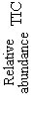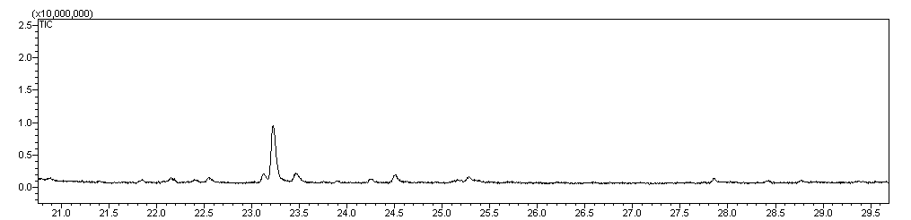
Retention time (min)
(b)
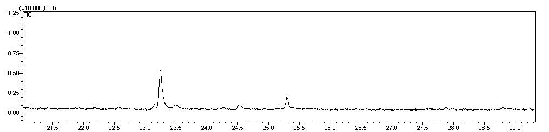
Retention time (min)
(c)
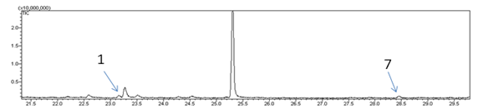
Retention time (min)
(d)
Retention time (min)

Figure 2.1 Representative chromatograms showing volatile terpenes produced by each treatment after 24 hours: control (a), mechanical wounding (b), FAW damage (c), MeJA (d). No terpenes were detected in the control plants or the mechanically wounded plants (a and b). The terpenes found in FAW and MeJA treated are an unknown sesquiterpene (1), β-caryophyllene (2), a bisabolene (3), α-farnesene (4), a bisabolene (5), trans-farnesol (6), and caryophyllene oxide (7).

Retention time (min)

Figure 2.2 One of the six replicates for the FAW-damage treatment produced a small amount of β-caryophyllene (2), in addition to caryophyllene oxide (7).

Discussion

Brachypodium plants were observed to produce very few terpenes under FAW damage but produced an array of at least seven sesquiterpenes when treated with exogenous MeJA. Several of these compounds (namely β-caryophyllene, α-farnesene, farnesol, and the bisabolene species) have been previously identified in other grass species or are products of terpene synthases characterized from these species (Table 1.1). As suspected, no terpenes were produced in control plants or mechanically wounded plants.
It is possible that more terpenes species are produced during FAW treatments, but that their absolute quantity was too far below the detection limit of the GC-MS. This may be because Brachypodium plants are very small, so there is not much leaf tissue to produce terpenes compared to rice, sorghum, and maize. In rice and sorghum models used by our lab, there would be at least several grams of tissue. In this Brachypodium experiment, the total mass of all above ground plant tissue for the control pots was 360 mg per pot, on average. The total mass of above ground parts was reduced to 244 mg per pot after 24 hours of FAW damage because the armyworms ate a portion of the tissue (around 33% eaten). In preliminary studies, several plant density and arrangement options were tested to try and increase the volume of plant material to optimize volatile collection. Planting seeds at a higher density than 16 per pot resulted in stunted growth, bound roots, and yellowing. Therefore, while the small stature of Brachypodium may help make it an ideal model for genetic studies, it may also cause it to not be such a good model for herbivore-induced volatile studies, at least not for herbivores as voracious as armyworms. However, Brachypodium plants still produced β-caryophyllene and an oxidized derivative under FAW damage at least sometimes, and so β-caryophyllene may be an important terpene used in indirect defense just like the other previously reported grasses.
The exogenous application of MeJA was used coax the plants into producing a higher quantity of terpenes. Jasmonate is an important defense signaling molecule in plants, and it can be methylated to produce the volatile methyl jasmonate, which is involved in inter-plant priming (Kost and Heil 2006). After wounding or infection by a pathogen, jasmonate is produced and begins a signal cascade within the cell that ultimately activates transcription factors that turn on stress response genes (Chini et al., 2007). The exogenous application of MeJA induces the expression of the primary terpene synthases in maize that are also induced by herbivory (Degenhardt 2009). Perhaps a certain threshold of JA present in Brachypodium tissues must be reached before the pathways leading to terpene production can be activated, and this threshold was not reached in our FAW experiment (Radhika et al. 2012).
MeJA-treated Brachypodium plants produced an array of 7 sesquiterpenes. Similarly to the case of the FAW-treated plants, there may be more emitted terpene species, but the low mass of plant tissue may have caused the quantities to become below our GC-MS’s detection limit. However, even if it is assumed that this is the complete array of terpenes produced by MeJA signaling, then this data may still fall in line with our predictions. Brachypodium has fewer putative terpene synthases than rice, sorghum, or maize (Brachypodium has 18 putative terpene synthases while the other grasses have around 50 each) and so superficially it may be expected to have a smaller terpene repertoire.
Of the terpenes produced by Brachypodium, probably the most important one in relation to indirect defense is β-caryophyllene. Pure synthetic β-caryophyllene has been shown to be very attractive to parasitic wasps (Köllner et al. 2008). Several transgenic studies have shown how the introduction of a β-caryophyllene synthase increases the attractiveness to herbivore enemies. The β-caryophyllene synthase from maize, TPS10, was transformed into Arabidopsis, granting Arabidopsis the ability to attract parasitic wasps (Schnee et al. 2006). Similarly, an oregano β-caryophyllene synthase was expressed in maize cultivars that are deficient β-caryophyllene production, increasing their attractiveness to beneficial entomopathogenic nematodes (Degenhardt et al., 2009). It is highly likely that one of the functions of β-caryophyllene produced by Brachypodium during herbivory is to mediate indirect defense.

Chapter III
Identification and comparative analysis of terpene synthase genes in Brachypodium distachyon

Introduction

All terpenes, whether they are mono-, sesqui-, or diterpenes, are made by a class of enzymes called terpene synthases (TPSs). TPS genes are homologous, and they share conserved catalytic regions which distinguish them from other types of enzymes. The TPS gene family is very ancient, existing in bacteria as well as bryophytes (mosses, liverworts), primitive vascular plants (spikemosses), gymnosperms and angiosperms. Even amongst plants, the sequence identity between two terpene synthases that make the exact same product can be very low. For example, (-)-limonene synthase in grand fir, a gymnosperm, has only 31% amino acid sequence identity to (-)-limonene synthase in spearmint (Bohlmann et al 1997).
Recent phylogenetic analyses (Chen et al., 2011) have shown that among plants, the TPS gene family is very diverse, and it can also be divided in seven sub-families base on based on sequence identity (Figure 3.1). Each subfamily also happens to possess specific features, such as being comprised of mostly one type of TPS (for example, sesquiterpene synthases) or all members in the sub-family come from one particular branch of the plant kingdom (for example, gymnosperms).

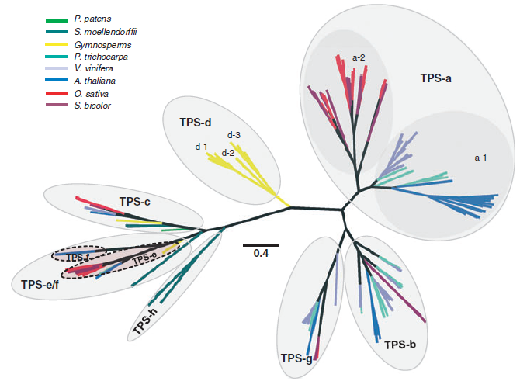
Figure 3.1 Phylogeny of putative full-length TPSs from seven sequenced plant genomes and representative characterized TPSs from gymnosperms (from Chen et al, 2011). Seven TPS subfamilies can be inferred from the phylogeny and functions of the known TPSs in this tree. TPS-a contains mostly sesquiterpene synthases, and can be divided into a monocot specific branch (a-2) and a dicot specific branch (a-1). The TPS-g and TPS-b subfamilies contain angiosperm-specific monoterpene synthases. The TPS-d clade contains gymnosperm-specific terpene synthases of all types: mono-, sesqui-, and diterpene synthases. The TPS-c and TPS-e/f clades contain many diterpene synthases. The TPS-h is spikemoss-specific.

The TPS-a sub-family has the greatest number of TPS members in it. Most of the TPS in the TPS-a clade are sesquiterpene synthases. Also, the TPS-a clade appears to be specific to angiosperms. This clade is further bifurcated into the TPS-a1 clade, containing dicot-specific TPSs, and the TPS-a2 clade, containing monocot-specific TPSs.
Members of the TPS-b family also belong exclusively to angiosperms, but unlike TPS-a genes, the TPS-b genes produce either monoterpenes or isoprene. Being monoterpene synthases, these proteins function in the plastids, and so they possess N-terminal transit peptides that localize them to the chloroplast.
The TPS-c subfamily contains diterpene synthases which convert GGPP to copayl diphosphate (CPP). These genes are thought to have evolved from the most ancient of TPS genes. The original TPS gene was probably a bi-functional enzyme that converted GGPP to CPP with copalyl synthase (CPS) activity, then subsequently converted the CPP into ent-kaurene, the precursor to gibberellins, and important hormone in many plants. Therefore, all gibberellin-using plants should have at least one TPS-c gene.
Gymnosperms lay claims to all of the TPSs in the TPS-d subfamily. This subfamily can be further divided into three smaller clades. The TPS-d-1 clade contains mostly monoterpene synthases, the TPS-d-2 clade contains mostly sesquiterpene synthases, and the TPS-d-3 contains mostly diterpene synthases.
The TPS-e/f subfamily comprises of genes from the TPS-e clade and the TPS-f clade which appear related enough to be combined into a larger clade. The TPS-e subfamily contains ent-kaurene synthases (KPS), which catalyze the conversion of CPP products from the TPS-c genes into the precursor of gibberellins. TPS-f clade is a very closely related sister clade to TPS-e except it is dicot-specific, and genes from this family make a variety of terpenes ranging from diterpenes to monoterpenes.
The TPS-g members are similar to the TPS-b clade in that they comprise only of monoterpene synthases from angiosperms, except that they only make acyclic monoterpenes and are missing an RRX₈W motif that is present in TPS-b and TPS-d-1 clades.
The function of the TPS’s from the TPS-h subfamily are unknown, but putatively they appear to be bi-functional CPS/KS diterpene synthases based on the presence of motifs present that are required for CPS and KS action. The members of the TPS-h all belong to Selaginalla moellendorfii, a spike moss.
Brachypodium is an angiosperm and a monocot. Since all angiosperms require gibberellins to regulate growth and development, it was expected that at least one gene from the TPS-c and TPS-e/f clades to cover the enzymes required for gibberellin production would be present in Brachypodium. Also, since other closely related grasses, such as rice and sorghum, contain terpene synthases belonging to the TPS-a2, -b, and –g clades, some orthologs of rice and sorghum found in these families were expected in Brachypodium.

Methods

BdTPS putative TPS gene identification
A reciprocal BLAST approach was used to identify all of the putative BdTPS genes from the annotated genome retrieved from three databases(NCBI Genbank, Phytozome, and Brachypodium.org) containing the genomic sequence from Brachypodium accession Bd21, starting with three functionally characterized rice TPS protein sequences as initial queries: Os02g02930, Os08g07100, and Os08g04500 (Yuan, et al., 2008). The homologs of these three rice genes were Bd3g02130, Bd3g15956, and Bd3g14710, respectively. These three BdTPS genes were used to perform further BLAST searches within the Brachypodium genome. e x10⁻⁵ was used as the cutoff. Genes that did not appear full-length were manually annotated using FGENESH, an HMM-based gene prediction software (Softberry) using the monocot plant setting.

Phylogenetic tree construction
To further classify the putative BdTPSs into different terpene synthase types and gene sub-families, a phylogenetic tree was constructed. First, a multiple sequence alignment was made with previously identified putative TPSs from rice (Oryza sativa) and sorghum (Sorghum bicolor) and the new BdTPSs. Selaginella moellendorfii microbial terpene synthase-like 1 (SmMTPSL1), a spikemoss terpene synthase that has a microbial TPS-like domain structure, was included as an out-group, for a total of 152 sequences. SmMTPSL1 was chosen as the outgroup because spikemoss is distantly related to the three grasses in the analysis, and this gene also represents a bacterial-like TPS that does not fall into any of the plant TPS subfamilies – it may have been acquired in the spikemoss genome through lateral gene transfer (Li et al. 2012). MAFFT v7 (Katoh and Standley, 2013) was used to construct the alignment, using the L-INS-I method, a method useful for less than 200 sequences with one conserved region and long gaps. The resulting multiple sequence alignment was used to make a phylogenetic tree using FastTree 2 (Price et al. 2010), which uses a heuristic maximum likelihood method with the Jones-Taylor-Thornton + CAT amino acid evolution models. FastTree 2 uses 1000 replicates of bootstrap analysis. After the phylogenetic tree was made, each branch’s TPS-subfamily identity was determined by comparing the rice and sorghum tree positions to previously published data.

Gene structure analysis
Gene structure diagrams were made using the Exon-Intron Graphic Maker (Bhatla, 2012, http://wormweb.org/exonintron). Since mono- and diterpene synthases possess a transit peptide to target them to the plastid, the protein sequences for the putative BdTPSs were checked for the presence of a transit peptide using ChloroP 1.1 (Emanuelsson et al, 1999). Protein domains were identified by searching the Pfam database (Finn et al., 2010). Protein motifs important to terpene synthase activity were identified by examining the multiple sequence alignment. These motifs are the highly conserved motif DDXXD and the less-highly conserved NSE/DTE motif located in the C-terminal domain that is also involved in binding Mg²⁺, and the RRX₈W motif in the N-terminal domain of the TPS-b clade monoterpene synthases just downstream of the transit peptide.
To investigate whether there was an intron-deletion event in the TPS-b clade, regions of the coding sequences from members of the TPS-b subfamily from rice, sorghum, and Brachypodium were color coded based on their homology to the seven exons of Os02g02130, a TPS-c clade gene used as an outgroup because TPS-c is the sister clade to TPS-b, and rice doesn’t possess a TPS-b clade gene.

Results

Identification, manual annotation, and phylogenetic classification
Originally 19 putative terpene synthase genes were identified from the Brachypodium genome, but this number was reduced to 18 after a manual annotation combined two gene fragments. The % identity between the BdTPS protein sequences range from 26% to 43%. The genes were given names based on the physical order of their loci – BdTPS1 through BdTPS18 (Table 2.1).
Two gene fragments were retrieved, Bd4g04980 and Bd4g04987. These fragments are positioned very closely together, and if they were strung together, they would have the usual number of seven exons for a sesquiterpene synthase and the required length of at least 500 amino acids (Figure 3.2). Upon closer inspection of this region using FGENESH, it was hypothesized that these two fragments really belong to one full-length transcript. This was later proven to be the case when a full length transcript was cloned from cDNA using the external primer for each of these genes (See Chapter IV). The full length gene was named BdTPS10. This brought the total number of terpene synthases in Brachypodium to 18 (Table 2.1). Bd1g62540 was also subjected to manual annotation due to its short length and low number of exons. Originally, this gene coding sequence was found to be 510 nucleotides / 170 amino acids long with five exons (Figure 3.3). Submitting this chromosomal region to FGENESH to predict the gene showed that a longer transcript could exist of a length of 1620 nucleotides / 540 amino acids. This new gene shows much higher sequence identity and gene structure homology to the other TPSs, and the start and stop codon positions remain consistent. The confirmation of the existence of this transcript has yet to be confirmed by cloning.
The phylogenetic tree between putative Brachypodium, rice, and sorghum protein sequences indicated that these genes were split into five major clades, with one of the clades (a2) possessing smaller divergent branches (Figure 3.4). The positions of different rice and sorghum TPSs on this tree were compared their positions on the previously published tree depicting the TPS gene family with representatives from additional members of the plant kingdom (Figure 3.1). The largest clade was designated the TPS-a2 subfamily, and it contained nine of the BdTPS genes: BdTPS2, BdTPS6, BdTPS7, BdTPS8, BdTPS9, BdTPS10, BdTPS12, BdTPS13, and BdTPS14. BdTPS1, BdTPS3, and BdTPS11 belong to the TPS-b subfamily. BdTPS5 is the lone representative of the TPS-g subfamily in Brachypodium, while BdTPS4 is the only Brachypodium member of the TPC-c subfamily. The remaining four BdTPSs, BdTPS15-18 were found to be classified into the TPS-e/f subfamily.
Previously characterized TPS-a clade genes from rice and sorghum have been shown to produce sesquiterpene synthases, and so it was inferred that these nine BdTPSs should possess sesquiterpene synthase activity as well. Linalool synthases from different plants belong to the TPS-g clade, and in fact linalool, an acyclic monoterpene alcohol, is the most abundant terpene produced by rice. BdTPS15-18 appeared to have arisen through tandem gene duplication, since they all exist very close to each other on chromosome 5.
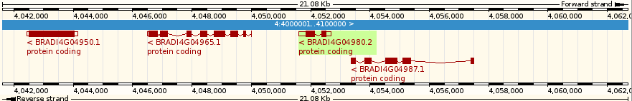
Figure 3.2 Two gene fragments, Bd4g04980 and Bd4g04987, detected in close proximity to each other in the original annotation. This screenshot from GRAMENE illustrates that these two fragments were positioned very close together on the chromosome. Manual annotation predicted that these two fragments belong to one full-length transcript (Figure 3.x) and this was confirmed by the sequencing of a clone.

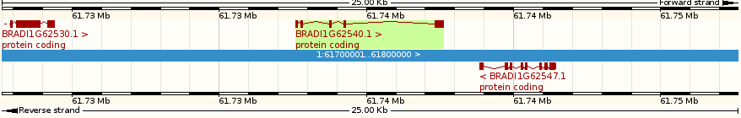
Figure 3.3 Bd1g62540 was possibly incorrectly annotated, producing a transcript of a very short length and only five exons instead of the usual seven. Manual re-annotation predicted that this gene possesses more exonic material, and that this gene is a full length terpene synthase gene 1620 base pairs in length.

Figure 3.4. Phylogenetic tree of the terpene synthase gene family from Brachypodium distachyon, rice (Oryza sativa), and sorghum (Sorghum bicolor). The tree was constructed with all putative TPSs from rice, sorghum, and Brachypodium, both fragments and full-length using a maximum likelihood method. Colored bubbles highlight plant TPS sub-families. SmMTPSL1 served as the out-group.

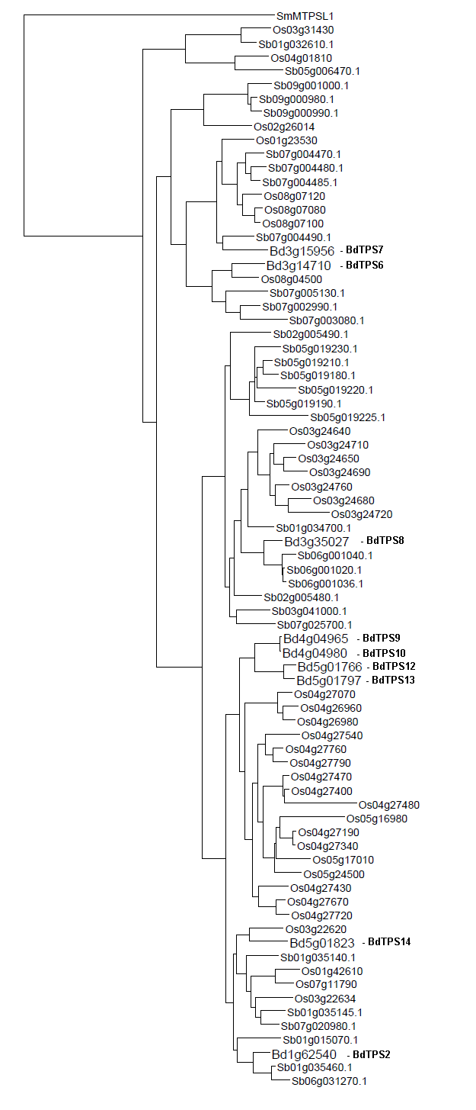
Figure 3.5 The TPS-a subfamily in Brachypodium, rice, and sorghum. Sesquiterpene synthases.

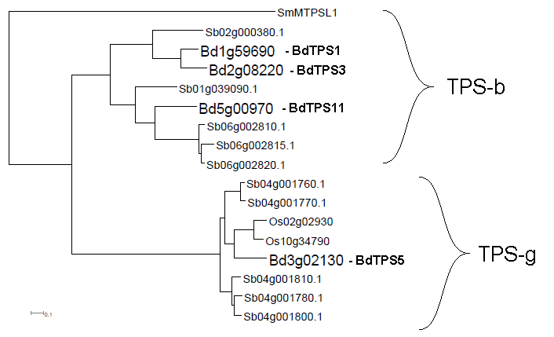
Figure 3.6 The TPS-b and TPS-g subfamilies in Brachypodium, rice, and sorghum. Monoterpene synthases.

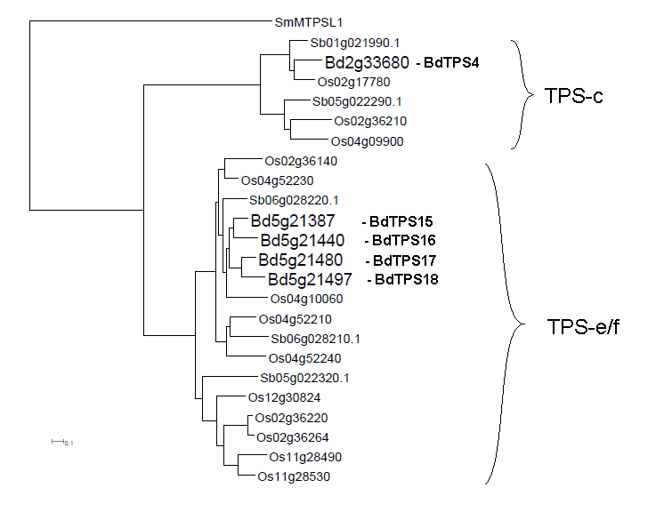
Figure 3.7 The TPS-c and TPS-e/f subfamilies in Brachypodium, rice, and sorghum. Diterpene synthases.

Table 3.1. The terpene synthase gene family in Brachypodium distachyon.

Gene Name | Locus | Size of protein-coding DNA (bp) | Protein length | Exons | Introns | TPS Sub-family | Type
BdTPS1* | Bd1g59690 | 1800 | 600 | 4 | 3 | B | Mono
BdTPS2 | Bd1g62540 | 1620 | 540 | 7 | 6 | A2 | Sesqui
BdTPS3* | Bd2g08220 | 1887 | 629 | 4 | 3 | B | Mono
BdTPS4 | Bd2g33680 | 2517 | 839 | 11 | 10 | C | Di
BdTPS5* | Bd3g02130 | 1650 | 550 | 7 | 6 | G | Mono
BdTPS6* | Bd3g14710 | 1677 | 559 | 7 | 6 | A2 | Sesqui
BdTPS7* | Bd3g15956 | 1659 | 553 | 7 | 6 | A2 | Sesqui
BdTPS8 | Bd3g35027 | 1692 | 564 | 7 | 6 | A2 | Sesqui
BdTPS9* | Bd4g04965 | 1614 | 383** | 8 | 7 | A2 | Sesqui
BdTPS10* | Bd4g04980 | 1632 | 389** | 7 | 6 | A2 | Sesqui
BdTPS11* | Bd5g00970 | 1740 | 580 | 7 | 6 | B | Mono
BdTPS12 | Bd5g01766 | 1761 | 587 | 7 | 6 | A2 | Sesqui
BdTPS13 | Bd5g01797 | 1800 | 600 | 7 | 6 | A2 | Sesqui
BdTPS14 | Bd5g01823 | 1581 | 527 | 7 | 6 | A2 | Sesqui
BdTPS15 | Bd5g21387 | 2577 | 859 | 14 | 13 | E/F | Di
BdTPS16 | Bd5g21440 | 2085 | 695 | 14 | 13 | E/F | Di
BdTPS17 | Bd5g21480 | 2082 | 694 | 12 | 11 | E/F | Di
BdTPS18 | Bd5g21497 | 2406 | 802 | 15 | 14 | E/F | Di
*These eight genes were able to be cloned from cDNA (see Chapter IV), and so their gene and protein sizes are confirmed. The remaining TPSs remain putative.
**BdTPS9 and BdTPS10 were cloned twice independently from cDNA. Both times, they contained a single nucleotide deletion in the same place that causes a frameshift and premature stop codons, leaving them truncated (see Chapter IV on page # for details). The protein lengths depicted for these two genes respresent these clones.

Protein feature and gene structure analysis
The multiple sequence alignment was examined to determine conserved motifs that are important to different TPS functions. The four motifs searched for were (1) the DDXXD, the metal-binding motif found in the C-terminal domain of class II TPSs (subfamilies a, b, d, e/f, g, and h), (2) the alternative metal-binding motif DDXD found in class I TPS (subfamily c), (3) the NSE/DTE motif in the C-terminal domain of class II terpene synthases that also participates in metal binding, and (4) the RRX₈W motif that is typically found in the N-terminal end of TPS-b subfamily monoterpene synthases (Figure 3.6).
All of the BdTPSs contained the DDXXD motif except for BdTPS4 and BdTPS16 (Figure 3.6a). BdTPS4 instead possessed the alternative DDXD motif (sometimes EDXD such as Os02g17780) similar to other TPS-c genes, while BdTPS16 had a gap in this region (Figure 3.6b).
There are four conserved positions within the NSE/DTE motif, which has the pattern (N/D)DXX(S/T)XXX(E/D). Only BdTPS1, 5, 6, 7, and 11 conform to this pattern for all four of the conserved positions. BdTPS4 and BdTPS12 do not possess this motif. BdTPS4 does not have this motif because it is TPS-c clade gene, while BdTPS12 has a gap in this region. The rest of the BdTPSs match at least two conserved positions in this location: the beginning asparagine/aspartate position and the subsequent aspartate position. For the third conserved position in the motif (S/T), nine of the sixteen NSE/DTE-containing genes contain either the standard serine or threonine amino acid, while seven genes deviate from the pattern. BdTPS3 has a glutamate, BdTPS13 and 14 have an alanine, and all four of the TPS-e/f subfamily genes BdTPS15-18 have glycine in place of the (S/T) position. Coincidentally, nine of the sixteen NSE/DTE-containing genes also possessed the standard glutamate in the final position, although not the same nine genes that held to the (S/T) position. BdTPS1 and BdTPS11 from the TPS-b clade, BdTPS6 and BdTPS7 from the TPS-a clade, BdTPS5 from the TPS-g clade, and all of the TPS-e/f clade, BdTPS15-18 have the conserved glutamate. BdTPS3 from the TPS-b clade is the only member that has a phenylalanine. The remaining six TPS-a clade genes all have a glycine, except for BdTPS13, which has an arginene (Figure 3.8c).
The three Brachypoidum TPS-b subfamily members were compared to the other TPS-b subfamily members to check for the presence of the RRX₈W motif. Rice does not possess any genes that fall into the TPS-b subfamily, but there are five sorghum TPS-b genes (Figure 3.6). These were Sb02g000380.1, Sb01g039090.1, Sb06g002810.1, Sb06g002845.1, and Sb002820.1. Sb06g002810.1 and Sb06g002815.1 are gene fragments and were missing the N-terminal region that would have contained the RRX₈W motif, but Sb06g039090.1 and Sb06g002820.1 did possess this region with the intact motif. BdTPS11 contains the standard RRX₈W motif in line with the sorghum genes, but BdTPS1 and BdTPS3 are different. They both possess two extra amino acids between the arginene pair and the tryptophan, therefore they seem to possess an alternative RRX₁₀W motif (Figure 3.8d).
All of the BdTPS contained the two protein domains possessed by all plant terpene synthases. These are the terpene synthase N-terminal domain (Pfam ID PF01397) and the terpene synthase metal binding domain (Pfam ID PF03936). A third less-well functionally characterized domain has been found to lie on the N-terminal end of TPS-d3, -c, and -e/f genes (Cao et al., 2010; Koksal et al., 2010). A third N-terminal prenyltransferase-like domain (Pfam ID 13243) was detected in three of the five genes that would qualify: BdTPS15, 16, and 18 (Figure 3.9).
The diterpene synthases, BdTPS4 and BdTPS15-18, have a variable exon number, ranging from eleven to fifteen. All of the monoterpene and sesquiterpene synthases have the typical gene structure of seven exons and six introns, with the exceptions of BdTPS1, BdTPS3, and BdTPS9. BdTPS1 and BdTPS3 both have just four exons, while BdTPS9 possesses a very small N-terminal eighth exon (Figure 3.10). Exon 3 and exon 4 in BdTPS1 and BdTPS3 are very large in comparison exons from the other mono- and sesquiterpene synthases. This led to the hypothesis that intron-deletion events may have occurred in the TPS-b clade in Brachypodium.
The TPS-b subfamily is split into two major branches. One branch contains BdTPS1 and BdTPS3 (the genes possessing four exons), as well as Sb02g000380.1. The other branch contains BdTPS11, Sb01g039090.1, Sb06g002810.1, Sb06g002815.1, and Sb06g002820.1. There are no rice TPS-b genes (Figure 3.6). Sb06g002810.1 and Sb06g002815.1 are small fragments of less than 200 amino acids in length that appear to be a tandem repeat pieces of the full-length Sb06g002820.1. Color coding each of the exonic regions to indicate to their respective aligned sequence in the Os02g02130 exons revealed that there has been at least two intron-deletion events: introns 3, 4, and 6 were deleted in the branch leading to BdTPS1, BdTPS3 and Sb0sg039090.1, and intron 6 was deleted in the branch leading to Sb02g000380.1.

(a)  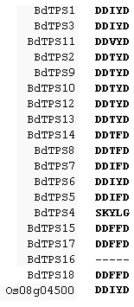 | (c)  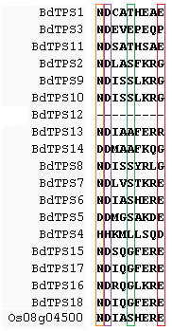
(b)  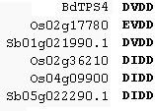 | (d)  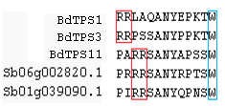

Figure 3.8 Pieces of a multiple sequence alignment showing each motif associated with terpene synthases. Every BdTPS except for BdTPS4 and BdTPS16 possessed the highly conserved Mg²⁺-binding DDXXD motif (a). BdTPS4 is a TPS-c gene, and these genes typically do not have the DDXXD motif. Instead they have a DXDD motif in another location (sometimes EXDD) (b). Most terpene synthases have an additional metal-binding region that conforms to the pattern (N/D)DXX(S/T)XX(T/E), commonly called the NSE/DTE motif. The four conserved positions are encircled. Only BdTPS1, 5, 6, 7, and 11 conform to this pattern for all four of the conserved positions, and all except BdTPS4 and BdTPS12 have at least two conserved positions.. (c). TPS-b clade genes have an RRX₈W motif near the N-terminal region. All three BdTPS genes in this clade possess this motif, except BdTPS1 and BdTPS3 half a slight variation of RRX₁₀W.

TPS-a | BdTPS2
TPS-a | BdTPS6
TPS-a | BdTPS7
TPS-a | BdTPS8
TPS-a | BdTPS9
TPS-a | BdTPS10
TPS-a | BdTPS12
TPS-a | BdTPS13
TPS-a | BdTPS14
TPS-b | BdTPS1
TPS-b | BdTPS3
TPS-b | BdTPS11
TPS-g | BdTPS5
TPS-c | BdTPS4
TPS-e/f | BdTPS15
TPS-e/f | BdTPS16
TPS-e/f | BdTPS17
TPS-e/f | BdTPS18

Domain |   Prenyltransferase-like |  |   TPS – N-terminal |  |   TPS – metal-binding
Motif | DDXXD | NSE/DTE |  | RRX₈W |  | DXDD
 |  | deletion

Figure 3.9 Domain/motifs for the BdTPS proteins. Scale bars = 33 amino acids.
TPS-a | BdTPS2
TPS-a | BdTPS6
TPS-a | BdTPS7
TPS-a | BdTPS8
TPS-a | BdTPS9
TPS-a | BdTPS10
TPS-a | BdTPS12
TPS-a | BdTPS13
TPS-a | BdTPS14
TPS-b | BdTPS1
TPS-b | BdTPS3
TPS-b | BdTPS11
TPS-g | BdTPS5
TPS-c | BdTPS4
TPS-e/f | BdTPS15
TPS-e/f | BdTPS16
TPS-e/f | BdTPS17
TPS-e/f | BdTPS18
Motif |  | DDXXD |  | NSE/DTE | RRX₈W | DXDD
 |  |  |  | deletion

Figure 3.10 Gene structures of the BdTPS family. Scale bars = 100 nucleotides. Thick black bars represent exons, and conjoining lines represent introns.

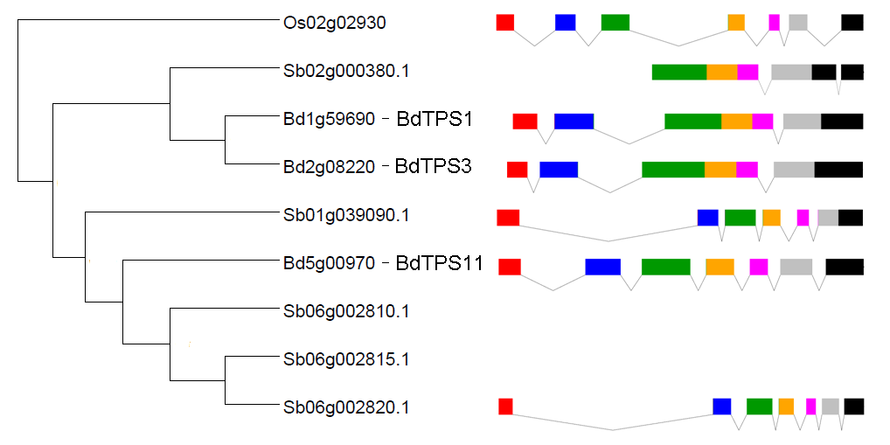
Figure 3.11 Exon-intron structure comparison between the Brachypodium and sorghum members of the TPS-b subfamily and Os02g02930. Each of the seven colors represent homology to the seven exons in Os02g02930, a member of the TPS-c subfamily. Gene structures for Sb06g002810.1 and Sb06g0002815.1 were excluded because they are very short gene fragments of less than 200 amino acids, and have very high sequence identity to the full length Sb06g002820.1.

Discussion

I have systematically identified and manually annotated all of the putative terpene synthases in Brachypodium distachyon. Two genes, BdTPS2 (Bd1g62540) and BdTPS10 (the combination of Bd4g04980 and Bd4g04987) were manually annotated to bring the total number of putative full-length TPS genes to 18. These sequences can be included in future plant terpene synthase phylogenetic and genomic analyses. The Brachypodium TPS genome family does not appear to have as many instances of gene duplication as rice or sorghum. Brachypodium has 18 putative TPSs, rice has 51, and sorghum has 47. To compare genome sizes, Brachypodium houses 26,000 total genes in its 275 Mb genome across 5 chromosomes, rice has 50,000 genes in 460 Mb across 12 chromosomes, and sorghum has genes in 30,000 genes in 730 Mb across 11 chromosomes. Therefore, Brachypodium appears to have proportionally equal or slightly less TPS genes than the other two grass species in comparison to genome size. One of the major differences between Brachypodium TPSs and the other grasses’ TPSs is that Brachypodium does not possess any gene fragments: all the BdTPS appear to be full-length. Also, compared to rice and sorghum, the Brachypodium TPS family has less instances of tandem duplication: tandem duplications appear to be limited to three instances: BdTPS9 and 10 on chromosome 4, 12 and 13 on chromosome 5, and the quartet of TPS-e/f genes BdTPS15-18 on chromosome 5.
The TPS-associated motif conservation seems to be retained for the DDXXD, DDXD, and RRX₈W motifs in Brachypodium, except for the unusual variation of RRX10W in BdTPS1 and BdTPS3 in the TPS-b clade. BdTPS1 and BdTPS3 also are the genes that possess the unusual intron deletions, but these two phenomena are probably not directly related since they occur on opposite ends of the gene. It is unknown whether the RRX₁₀W motif would have been unique to Brachypodium amongst grasses because the sorghum gene that also is missing introns 3, 4, and 6 is missing the N-terminal region that would have contained the RRX_{8/10}W motif. The deletion of these introns must have occurred before the speciation between the line that led to Brachypodium and sorghum. Additional TPS-b genes from other grasses should be analyzed to help determine when the RRX_{8/10}W variation happened in relation to this intron deletion event. A second, independent intron deletion event, in which the sixth intron was deleted, appears to have happened that was limited to Sb01g039090.1.
The BdTPSs have very few members that strictly adhere to the NSE/DTE motif. Only BdTPS1, 5, 6, 7, and 11 conform to this pattern for all four of the conserved positions in the motif. In Brachypodium, alanine and glycine commonly appear in the (S/T) position, but this substitution is not uncommon in rice or sorghum putative TPSs, and likewise the glycine that appears in the terminal glutamate position is very common amongst the other grasses as well. The definition of this motif should be expanded to accommodate these variants.

Chapter IV
Functional characterization of Brachypodium distachyon mono- and sesquiterpene synthases

Introduction

Only the 10-carbon monoterpenes and the 15-carbon sesquiterpenes are of low enough molecular weight to pass through the air as volatiles to be used in volatile-mediated indirect defense. Therefore, the final phase of this work was to functionally characterize the putative mono- and sesquiterpene synthases identified in Chapter III. Among angiosperms, sesquiterpene synthases are primarily from the TPS-a subfamily while monoterpene synthases come from the TPS-g and TPS-b subfamilies. Thus the nine TPS-a genes (BdTPS 2, 6, 7, 8, 9, 10, 12, 13, and 14) and the TPS-g and –b genes (BdTPS5, 1, 3, and 11) were selected as candidate genes for functional characterization, especially the sesquiterpene synthases since no monoterpenes were detected during the plant volatile analyses.
The standard method to functionally characterize a terpene synthase gene begins with the cloning of a full length transcript from cDNA. The cDNA is made from RNA extracted from the tissues of plants that have been subjected to conditions that promote the transcription of the gene of interest. At this point the gene may be cloned into two types of plasmids: either simply a full-length TPS from start to stop codon, or with a His-tag so that the protein can later be purified and used for kinetic measurements. For basic product identification such as what is needed for this work, the former method is appropriate. Either way, the clone is transformed into a protein-producing E. coli strain such as BL21 where sufficient quantities of the protein are produced and then extracted. In the case of basic product identification, the protein can be extracted by sonication, and then the crude extract is used in an enzyme assay.
The two major requirements of the TPS in order to function are the presence of the Mg²⁺ cofactor, which can be supplied to the assay buffer through MgCl₂, and the TPS substrate. Monoterpene synthases require geranyl diphosphate (GPP) while sesquiteprene synthases require farnesyl diphosphate (FPP). These can be mixed together to form the reaction. It has been found that at least in some cases, it does not matter if a crude bacterial extract is used or if the TPS protein is first purified by recombining it with a His-tag: the quantity and relative abundance of different products within a TPS capable of forming multiple products remains the same (Schnee et al. 2002)
Once the substrates are mixed and the reaction is allowed to incubate, the volatiles can be collected in one of two ways. The first method is to use solid phase microextraction (SPME). SPME involves using an absorbent polymer fiber to absorb volatiles. The enzyme reaction mixture is place in a sealed GC-MS vial, and the SPME fiber is suspended in the headspace above the fluid (Figure 3.1). After the SPME fiber has absorbed the volatiles, it is placed in the injection port of the GC-MS where the volatiles are desorbed and are identified.
In the alternative method for collecting products of a TPS enzyme assay, the reaction mixture is overlaid with an organic solvent such as pentane or hexane, and this solvent is injected into the GC-MS instead. The overlay method is required for diterpene synthase enzyme assays, but the SPME method is suited for detecting molecules that are readily volatile, like the targets of this project. The identity of the terpene product is determined by the combination of two components: both the retention time on the gas chromatograph and the mass spectra should match those of a known compound. If a pure standard is available, the TPS can then be definitively identified.
Many mono- and sesquiterpene synthases have been characterized from different plants such as rice, sorghum, maize, Arabidopsis, grape, tobacco, snapdragon, grand fir, spikemoss, magnolia, and soybean using these methods. Half of the known characterized terpene synthases produce one terpene product while the other half have the ability to form multiple products, even though both types only use one substrate (Degenhardt et al 2009). The reason for the specificity or promiscuity of terpene synthase products is still being investigated, but one of the prevailing hypotheses is that once the diphosphate group is cleaved, the carbocation intermediate can be stabilized in multiple ways, and that the shape and flexibility of the active site determines the identity of the product and how many products are formed. Rice and sorghum both contain functional sesquiterpene synthases that produce around half a dozen products each, and such may be the case for the Brachypodium terpene synthases.

Methods

Cloning of Brachypodium mono- and sesquiterpene genes
In an attempt to retrieve a full length cDNA clone of every mono- and sesquiteprene synthase in Brachypodium, regardless if they are expressed during FAW attack or not, different sets of plants were grown to varying developmental stages (1 week old, 4 weeks old, 6 weeks old and flowering) and subjected to different stress treatments (FAW damage, MeJA treatment, alamethicin treatment, salicylate treatment). Total RNA was isolated from plant parts using RNeasy Plant Mini kit Invitrogen, http://www.invitrogen.com/) according to the manufacturer’s protocol. Genomic DNA contamination was removed by DNase I treatment, followed by RNA purification using the Qiagen RNeasy Plant Mini Kit (Qiagen, Valencia, CA, USA). The total RNAs were reverse transcribed into first strand cDNAs in 15μl reaction volume using the First-Strand cDNA Synthesis Kit (GE Healthcare, Piscataway, NJ, USA). cDNA’s from different samples were pooled together, and full-length cDNA clones were amplified by PCR using the primers listed in Table 4.1. PCR products were cloned into the pEXP5-CT/TOPO vector (Invitrogen) and sequenced for confirmation.

Protein expression in E. coli and terpene synthase enzyme assay
Each clone carried in the pEXP5-CT/TOPO vector, was transformed into the E. coli strain BL21 (DE3) CodonPlus (Stratagene, La Jolla, CA). 50 ml of liquid cultures of the transformed bacteria grown in LB media were grown at 37 °C to an OD600 of 0.6. Isopropyl β-D-1-thiogalactopyranoside (IPTG) was added to a final concentration of 500 μM, and the cultures were incubated for 20 h at 18 °C. Then the cells were collected by centrifugation and disrupted by a 6 x 10 sec sonication treatment in chilled extraction buffer (50 mM Mopso, pH 7.0, with 5 mM MgCl2, 5 mM sodium ascorbate, 0.5 mM PMSF, 5 mM dithiothreitol and 10% (v/v) glycerol). The cell fragments were removed by centrifugation at 14,000 g and the supernatant was desalted into assay buffer (10 mM Mopso, pH 7.0, 1 mM dithiothreitol, 10% (v/v) glycerol) by passage through an Econopac 10DG column (Bio-Rad, Hercules, CA, USA). Enzyme assays for recombinant proteins were performed at 30 °C for overnight, using 50 μl of the crude enzymes and 50 μl assay buffer with 10 μM substrate (GPP for monoterpene synthases and FPP for sesquiterpene synthases), 10 mM MgCl2, 0.05 mM MnCl2, 0.2 mM NaWO4 and 0.1 mM NaF in a Teflon-sealed, screw-capped 1 ml GC glass vial. A solid phase microextraction (SPME) fiber made of 100 μm polydimethylsiloxane (Supelco, Bellefonte, PA, USA) was placed in the headspace of the vial for 10 min for absorbing the volatile products (Figure 3.1). The SPME fiber was inserted directly into the injection port of the gas chromatograph for desorption. GC-MS analysis and product identification were performed as described for the plant volatile analysis in Chapter II.

Gene expression analysis
A sample of plant materials used for semi quantitative PCR gene expression analysis was collected from the plants at the end of each time point for the FAW and MeJA treated plants described in Chapter II. Plant materials were flash frozen in liquid nitrogen and stored at -80°C until RNA extraction. Total RNA extraction and cDNA synthesis was done as described above for cloning. Prior to cDNA synthesis, for each sample, the total RNAs were diluted so they were all of equivalent concentrations. The cDNA reaction products were diluted to 60 µL, and then one µL from each was used for each 20 µL PCR reaction using appropriate primers sets for BdTPS6, BdTPS7 (the two BdTPS that were functionally characterized) and a 700 bp fragment of Brachypodium actin gene as a control.

Table 4.1 Primers used for the amplification of full-length cDNA’s of mono- and sesquiterpene synthases from Brachypodium.

Gene | Forward primer | Reverse primer
BdTPS1 | 5’-ATG GCG GCG CCG TTG TTA G -3’ | 5’- TCA CAA TAA TGT CCT GAT TG -3’
BdTPS2 | 5’-ATG GCG CCC CAT GAT GTT CC -3’ | 5’- CTA TAG GGG AAT ATG ATT GAC AAA C -3’
BdTPS3 | 5’- ATG GCG GAT GCT GTG TAC TCG -3’ | 5’- TCA GAA TGA CTG TCT GCA CTG C -3’
BdTPS5 | 5’- ATG GCT GCG GCG CAC AGC TTC -3’ | 5’- CAT TCA TAA GAG GAG CAT CC -3’
BdTPS6 | 5’- ATG GAA GTC ACC GTG GAT GTT C -3’ | 5’- CTA GCC TAT ATA GGA TCA AC -3’
BdTPS7 | 5’- ATG GCA GCA GCA ACG GCA AAT G -3’ | 5’- TTA GTT GGT AGC CTC ATA CAT CTG C -3’
BdTPS8 | 5’- ATG AGG GAA CGG GCG GAG C -3’ | 5’- CTA AAG GGG AAC CGG CTT AAG C -3’
BdTPS9 | 5’- ATG GCG TCA AGA GGG AAG GAG TTC -3’ | 5’- CTA GAT GGG AAT GGG GTT GAT AAA G -3’
BdTPS10 | 5’- ATG GCG TCA AGA GGT ATA GC -3’ | 5’- CTA CAT GGG AAT GGG GTT G-3’
BdTPS11 | 5’- ATG GCC TGG CAA TTA CAA TCG -3’ | 5’- TTA ACG TTT ATC AGC CAT GAA AGG -3’
BdTPS12 | 5’- ATG GGG GGC TTG TCC ACC -3’ | 5’- CTA GAT TGG CTT GAC GAA G -3’
BdTPS13 | 5’ - ATG GAT TGC TTG TTC TAC TTC TGC -3’ | 5’- CTA GAT TGG TTT GAC GAA GAA GC -3’
BdTPS14 | 5’- ATG GCG ACT CCC CAG AGA G -3’ | 5’- CTA GAG GGG TAT AGG CTC GAT G -3’
BdTPS15 | 5’- ATG TCG GGC CCC AAA GTG TCC -3’ | 5- TTA TTC TGA CGA AAC AGT CAC AGG -3’

Results

Eight BdTPS were successfully cloned from the Brachypodium cDNA collection. These were four putative monoterpene synthases (BdTPS5 from the TPS-g subfamily, and all three of the TPS-b subfamily members, BdTPS1, 3, and 11) and four putative sesquiterpene synthases (BdTPS6, 7, 9, and 10) (Table 4.2). BdTPS9 and BdTPS10 were found to each have a single nucleotide deletion which caused premature stop codon and truncated proteins. To rule out that this deletion was not caused by an error introduced by PCR polymerase, the genes were re-cloned again starting from the cDNA material. They still possessed the deletions. The deletion positions can be seen in Figures 3.9 and 3.10. The remaining BdTPSs were not successfully cloned, likely because they were not expressed under the given conditions. Enzyme assays of all full-length clones revealed that BdTPS6 and BdTPS7 were functionally active.
BdTPS6 forms almost exclusively the sesquiterpene, β-caryophyllene, along with four minor sesquiterpene products of unknown identity (Figure 4.2). The retention time and mass spectrum for the enzymatically produced β-caryophyllene from BdTPS matches the β-caryophyllene produced in the plant volatile analysis during FAW attack and MeJA treatments as well as the authentic standard (Figure 4.1 and 4.2). BdTPS7 produces three sesquiterpenes of unknown identity (Figure 4.3). These compounds do not match any of the terpenes produced in the plant volatile analysis. The gene expression analysis suggests that both BdTPS6 and BdTPS7 are constitutively expressed (Figure 4.3). The RNAs used to make the cDNAs for gene expression analysis were checked to see if actin could be PCR-amplified from them, but they were not, therefore there was no genomic DNA contamination.
Table 4.2 Summary of cloning and enzyme assay status of the Brachypodium mono- and sesquiterpene synthases. Gene and protein lengths from these clones were used to amend Table 2.1.
Gene name | Type | Cloning and activity status
BdTPS2 | Sesqui | ---
BdTPS6 | Sesqui | Cloned, functional
BdTPS7 | Sesqui | Cloned, functional
BdTPS8 | Sesqui | ---
BdTPS9 | Sesqui | Cloned, deletion that causes premature stop codon
BdTPS10 | Sesqui | Cloned, deletion that causes premature stop codon
BdTPS12 | Sesqui | ---
BdTPS13 | Sesqui | ---
BdTPS14 | Sesqui | ---
BdTPS1 | Mono | Cloned, non-functional
BdTPS3 | Mono | Cloned, non-functional
BdTPS11 | Mono | Cloned, non-functional
BdTPS5 | Mono | Cloned, non-functional

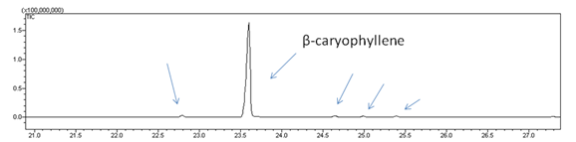
Retention time

Figure 4.1 BdTPS6 is a β-caryophyllene synthase. BdTPS6 also produces four minor unknown sesquiterpene products in very low quantities.

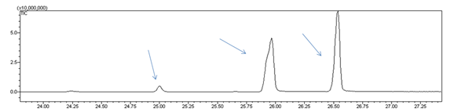
Retention time

Figure 4.2 BdTPS7 produces three unknown sesquiterpenes.

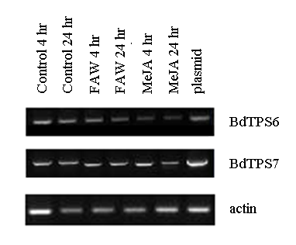
Figure 4.3 Semi quantitative RT-PCR gene expression analysis of BdTPS6 and BdTPS7.

Discussion

Of the eight cloned Brachypodium terpene synthases, only two appeared to be functionally active in in vitro enzyme assays, BdTPS6 and BdTPS7. BdTPS6’s primary product β-caryophyllene, while BdTPS7 makes three unknown sesquiterpenes.
BdTPS6’s closest orthologs in rice and sorghum, Os08g04500 and SbTPS4, are also β-caryophyllene synthases (Figure 4.5). However, products of TPSs don’t always follow phylogeny. The closest ortholog of Os08g04500 and SbTPS4 in maize is ZmTPS10, which does not produce β-caryophyllene. Rather, ZmTPS23 is maize’s β-caryophyllene synthase, and it is more closely related to Os08g07100, which does not produce β-caryophyllene. Os08g01700 and its orthologs in sorghum instead produce zingiberene and β-sesquiphillandrene (Zhuang et al., 2012, Yuan et al., 2008).
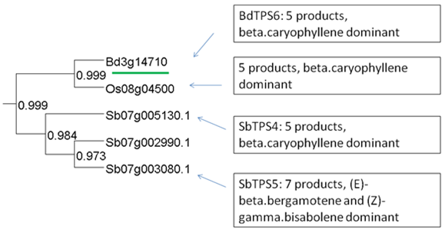
Figure 4.4 Comparison of BdTPS6 major products with the products of its orthologs in rice and sorghum.

The closest ortholog of BdTPS7 is the Sb07g004490.1 (SbTPS7), which is non-functional due to truncation (Zhuang et al., 2012). The identities of the three unknown sesquiterpenes produced by BdTPS7 remains to be investigated, as well as why BdTPS7’s products differ from its closest orthologs in rice and sorghum, which tend to make zingiberene and β-sesquiphillandrene as dominant products (Figure 4.6).

Figure 4.5 Comparison of BdTPS7 products with the products of its orthologs in rice and sorghum. Sb07g0004490.1 is a truncated gene fragment. It is possible BdTPS7 forms novel products since this lineage formed before the speciation of rice, sorghum, and Brachypodium and it has no direct orthologs in rice or sorghum.

It is interesting that the transcription of the BdTPS6 and BdTPS7 genes appear to be constitutive. They do not need herbivory or a downstream defense regulator like MeJA to become active. The production of the actual terpenes themselves relies upon herbivory or MeJA activation, however. This may due to several possible causes. Brachypodium may continually produce BdTPS6 and BdTPS7 transcripts so they are on standby but are not translated into proteins until activated by a defense signal. Alternatively, regulation could happen at the level of terpene synthase substrate production. It has been shown that the application of abscisic acid in Salvia miltiorrhiza (red sage) causes MeJA accumulation, subsequently increasing terpene production. Furthermore, the exogenous application of MeJA upregulated genes in the MAD and MEP pathways, which would lead to an increase in GPP and FPP substrates for the TPSs (Yang et al. 2012).

Chapter V
Summary and future directions

In summary, I have demonstrated that Brachypodium distachyon, like other grasses, produces volatile terpenes upon herbivory and especially upon the application of the defense activator, methyl jasmonate. The terpene volatile profile has similarities with the products found in maize, rice, and sorghum upon herbivory. At least one of these compounds, β-caryophyllene, has been proven previously to be involved in indirect defense, attracting parasitic wasps and beneficial nematodes. β-caryophyllene may have been a useful tool for defending plants from herbivores since before the split between these grasses more than 50 million years ago, and β-caryophyllene synthases may have been retained in grasses, both wild and domesticated, since then. The β-caryophyllene synthase in Brachypodium, named BdTPS6, was in fact identified, cloned and biochemically characterized, as well as one other TPS, BdTPS7, which produced three unknown sesquiterpene products. 16 other putative BdTPSs were identified, but these were either not cloned or not found to be biochemically active in enzyme assays. Future work needs to be done to finish cloning the remaining BdTPS and to find out why some appear to have lost their activity. The TPSs responsible for the six sesquiterpenes produced by MeJA-treated plants have yet to be identified. This study adds to what is known about terpene synthases and their evolution in grasses, and it helps reinforce that β-caryophyllene an important sesquiterpene used by grasses in indirect defense. Because of Brachypodium’s simplistic terpene synthase profile and ease of transformation, it may also serve as an ideal surrogate for functionally characterizing terpene synthases from monocots or other plants. A method has been described for the cloning of terpene synthase genes from the genomic DNA of Arabidopsis into the petunia genome using Agrobacterium-mediated transformation, where the petunia’s transcription machinery can be used to produce mature mRNA’s for functional characterization, regardless if the TPS gene was originally expressed in the Arabidopsis or not (Wu et al 2005).
Brachypodium is the first representative of the Pooideae subfamily of grasses to have its genome sequenced, and so this dataset can serve as a simplistic model and starting point for studying terpene synthase evolution in other Pooid grasses of economical importance such as wheat, barley, rye, and some turfgrasses (for example, creeping bentgrass - Agrostis stolonifera).

References

Ali JG, Alborn HT, Stelinski LL. (2011) Constitutive and induced subterranean plant volatiles attract both entomopathogenic and plant parasitic nematodes. Journal of Ecology 99(1):26-35.
Arimura G, Matsui K, Takabayashi J. (2009) Chemical and molecular ecology of herbivore-induced plant volatiles: proximate factors and their ultimate functions. Plant Cell Physiol. 50(5):911-923.
Asakawa Y. (2004) Chemosystematics of the Hepaticae. Phytochemistry 65(6): 623-669.
Behr A, Johnen L. (2009) Myrcene as a natural base chemical in sustainable chemistry: a critical review. ChemSusChem. 2(12): 1072-1095.
Bleecker AB, Kende H. (2000) Ethylene: a gaseous signal molecule in plants. Annu. Rev. Cell Dev. Biol. 16:1-18.
Bremer K. (2002) Gondwanan evolution of the grass alliance of families (Poales). Evolution 56:1374-1387.
Catalan P, Muller J, Hasterok R, Jenkins G, Mur LA, Langdon T, Betekhtin A, Siwinska D, Pimentel M, Lopez-Alvarez D. (2012) Evolution and taxonomic split of the model grass Brachypodium distachyon. Annals of Botany 109:385-405.
Chen F, Tholl D, Bohlmann J, Pichersky E. (2011) The family of terpene synthases in plants: a mid-size family of genes for specialized metabolism that is highly diversfied throughout the kingdom. Plant Journal 66:212-229
Chini A, Fonseca S, Fernandez G, Adie B, Chico JM, Lorenzo O, Garcia-Casado G, Lopez-Vidriero, Lozano FM, Ponce MR, Micol JL, Solano R. (2007) The JAZ family of repressors is the missing link in jasmonate signaling. Nature 448(7154):666-671.
Choh Y, Ozawa R, Takabayashi J. (2013) Do plants use airborne cues to recognize herbivores on their neighbors? Exp. Appl. Acarol. 59:263-273.
Copolovici L, Filella I, Llusia J, Niinemets U, Penuelas J. (2005) The capacity for thermal protection of photosynthetic electron transport varies for different monoterpenes in Quercuz ilex. Plant Physiol. 139:485-496.
Copolovici LO, Filella I, Llusia J, Niinemets U, Penuelas J. (2005) The capacity for thermal protection of photosynthetic electron transport varies for different monoterpenes in Quercus ilex. Plant Physiol. 139: 485-496.
Davis EM, Croteau R (2000) Cyclization enzymes in the biosynthesis of monoterpenes, sesquiterpenes, and diterpenes. Topics in Current Chemistry 209:53-95.
De Moraes CM, Mescheer MC, Tumlinson JH. (2001) Caterpillar-induced nocturnal plant volatiles repel nonspecific females. Nature 410:577-580.
De Moraes CM, Mescher MC, Tumlinson JH. (2001) Caterpillar-induced nocturnal plant volatiles repel conspecific females. Nature 410: 577-580.
Degenhardt J, Köllner TG, Gershenzon J. (2009) Monoterpene and sesquiterpene synthases and the origiin of terpene skeletal diversity in plants. Phytochemistry 70:1621-1637.
Degenhardt J. (2009) Indirect defense responses to herbivory in grasses. Plant Physiol. 149: 96-102.
Dicke M, Baldwin IT. (2010) The evolutionary context for herbivore-induced plant volatiles: beyond the 'cry for help.' Trends Plant Sci. 15(3):167-175.
Dudareva N, Cseke L, Blanc VM, Pichersky E. (1996) Evolution of floral scent in Clarkia: Novel patterns of S-linalool synthase gene expression in the C. breweri flower. Plant Cell. 8:1137-1148.
Dudareva N, Negre F, Nagegowda DA, Orlova I. (2006) Plant volatiles: recent advances and future perspectives. Critical Reviews in Plant Sciences. 25:414-440.
Dudareva N, Negre F, Nagegowda DA, Orlova I. (2006) Plant volatiles: recent advances and future perspectives. Critical Reviews in Plant Sciences. 25(5):417-440.
Emanuelsson O, Nielson H, von Heijne G. (1999) ChloroP, a neural network-based method for predicting chloroplast transit peptides and their cleavage sites. Protein Science 8:978-984.
Feussner I, Wasternack C. (2002) The lipoxygenase pathway. Annu. Rev. Plant. Biol. 53(1): 274-297.
Finn RD, Tate J, Mistry J, Coggill PC, Sammut JS, Hotz HR, Ceric G, Forsulund K, Eddy SR, Sonnhammer EL, Bateman A. (2010) The Pfam protein families database. Nucleic Acids Research. Database Issue 38:D211-D222
Friedman M, Henika PR, Mandrell RE. (2002) Bactericidal activities of plant essential oils and some of their isolated constituents against Campylobacter jejuni, Escherichia coli, Listeria monocytogenes, and Salmonella enterica. J. Food. Protect. 65:1545-1560.
Frost CJ, Mescher MC, Carlson JE, De Moraes CM. (2008) Plant defense priming against herbivores: getting ready for a different battle. Plant Physiology 146:818-824.
Goff SA, Klee HJ. (2006) Plant volatile compounds: Sensory cues for health and nutritional value? Science. 311: 815-819
Greenhagen B, Chappell J (2009) Molecular scaffolds for chemical wizardry: learning nature's rules for terpene cyclases. Proc Natl Acad Sci USA 98(24):13479-13481.
Greenhagen BT, O'Maille PE, Noel JP, Chappell J. (2006) Identifying and manipulating structural determinates linking catalytic specificities in terpene synthases. Proc Nat Acad Sci USA 103(26):9826-9831.
Hare JD. (2007) Variation in herbivore and methyl jasmonate-induced volatiles among genetic lines of Datura wrightii. J Chem Ecol 33(11):2028-2043.
Heil M, Baldwin IT (2002) Fitness costs of induced resistance: emerging experimental support for a slippery concept. Trends in Plant Sciene 7:61-67.
Holopainen JK, Gershenzon J (2010) Multiple stress factors and the emission of plant VOCs. Trends in Plant Science 15:176-184.
Howe GA, Jander G. (2008) Plant immunity to insect herbivores. Annu. Rev. Plant Biol. 59:41-66.
Katoh K, Standley DM. (2013) MAFFT Multiple sesquence alignment software version 7: improvements in performance and usability. Mol. Biol. Evol. doi:10.1093/molbev/mst010
Kessler A, Baldwin IT. (2001) Defensive function of herbivore-induced plant volatile emissions in nature. Science 291: 2142-2143.
Koch T, Krumm T, Jung V, Engelberth J, Boland W. (1999) Differential induction of platn volatile biosynthesis in the lima ean by early and late intermediates of the octadecanoid-signaling pathway. Plant Physiol. 121:153-162.
Köllner TG, Held M, Lenk C, Hiltpold I, Turlings TCJ, Gershenzon J, Degenhardt J (2008) A maize (E)-b-caryophyllene synthase implicated in indirect defense responses against herbivores is not expressed in most American maize varieties. Plant Cell 20: 482–494.
Köllner TG, Schnee C, Gershenzon J, Degenhardt J (2004) The sesquiterpene hydrocarbons of maize (Zea mays) form five groups with distinct developmental and organ-specific distribution. Phytochemistry 65:1895–1902.
Köllner TG, Schnee C, Gershenzon J, Degenhardt J. (2004) The sesquiterpene hydrocarbons of maize (Zea mays) form five groups within distinct developmental and organ-specific distributions. Phytochemistry 65:1895-1902.
Köllner TG, Schnee C, Li S, Svatos A, Schneider B, Gershenzon J and Degenhardt, J. (2008) Protonation of a neutral (S)-beta-bisabolene intermediate is involved in (S)-beta-macrocarpene formation by the maize sesquiterpene synthases TPS6 and TPS11. J. Biol. Chem. 283:20779–20788.
Kost C, Heil M. (2006) Herbivore-induced plant volatiles induce an indirect defense in neighboring plants. Journal of Ecology 94:619-628.
Li G, Kollner TG, Yin Y, Jiang Y, Chen H, Xu Y, Gershenzon J, Pichersky E, Chen F. (2012) Nonseed plant Selaginella moellendorffii has both seed plant and microbial types of terpene synthases. Proc Nat Acad Sci USA 109(36): 14711-14715
Mumm R, Dicke M. (2010) Variation in natural plant products and the attraction of bodyguards involved in indirect plant defense. Can. J. Zool. 88:628-667.
Mur LA, Allainguillaume J, Catalan P, Jenkins G, Lesniewska K, Homas I, Vogel J. (2011) Exploiting the Brachypodium Tool Box in cereal and grass research. New Phytologist 191:334-347.
Pare PW, Tumlinson JH. (1999) Plant volatiles as a defense against insect herbivores. Plant Physiology 151(2):325-332.
Pichersky E, Gershenzon J. (2002) The formation and function of plant volatiles: perfumes for pollinator attraction and defense. Curr Opin Pl Biol. 5:237-243.
Prasad V, Stromberg CAE, Alimohammadian H, Sahni A. (2005) Dinosaur coprolites and the early evolution of grasses and grazers. Science 310:1177-1180.
Price MN, Dehal PS, Arkin AP (2010) FastTree 2 – approximately maximum-likelihood trees for large alignments. PLoS ONE 5(3): e9490
Radhika V, Kost C, Bonaventure G, David A, Boland W. (2012) Volatile emission in bracken fern is induced by jasmonates but not by Spodoptera littoralis or Strongylogaster multifasciata herbivory.
Reinhard J, Srivivasan MV, Zhang S. (2004) Scent-triggered navigation in honeybees. Nature 427:411.
Schilimiller A, Shi F, Kim J, Charbonneau AL, Holmes D, Jones AD, Last RL. (2010) Mass spectrometry screening reveals widespread diversity in trichome specialized metabolites of tomato chromosomal substitution lines. Plant J 62(3):391-406
Schnee C, Kollner TG, Gershenzon J, Degenhardt J. (2002) The Maize Gene terpene synthase 1 Encodes a Sesquiterpene Synthase Catalyzing the Formation of(E)-alpha-Farnesene, (E)-Nerolidol, and (E,E)-Farnesol after Herbivore Damage. Plant Physiol 130: 2049-2060
Schnee C, Köllner TG, Held M, Turlings TC, Gershenzon J, Degenhardt J. (2006) The products of a single maize sesquiterpene synthase form a volatile defense signal that attracts natural enemies of maize herbivores. Proc. Natl. Acad. Sci. USA 106:1129-1134.
Sharkey TD, Chen X, Yeh X. (2001) Isoprene increases thermotolerance of fosmidomycin-fed leaves. Plant Physiol 125:2001-2006.
Sharkey TD, Chen XY, Yeh S. (2001) Isoprene increases thermotolerance of fosmidomycin-fed leaves. Plant Physiol. 125: 2001-2006.
The International Brachypodium Initiative. (2010) Genome sequencing and analysis of the model grass Brachypodium distachyon. Nature 463:763-768.
Tholl D (2006) Terpene synthases and the regulation, diversity and biological roles of terpene metabolism. Current Opinion in Plant Biology 9:297-304.
Tholl D. (2006) Terpene synthases and the regulation, diversity and biological roles of terpene metabolism. Current Opinion in Plant Biology. 9:1-8.
Turlings TCJ, Alborn HT, Loughrin JH, Tumlinson JH. (1999) Volicitin, an elicitor of maize volatiles in oral secretion of Spodoptera exigua: isolation and bioactivity. Journal of Chemical Ecology. 16(1): 198-202.
Turlings TCJ, Bernasconi M, Bertossa R, Bigler F, Caloz G, Dorn S. (1998) The induction of volatile emissions in maize by three herbivore species with different feeding habitats – possible consequences for their natural enemies. Biol Control. 11:122-129.
Wu S, Schoenbec MA, Greenhagen BT, Takahashi S, Lee S, Coates RM, Chappell (2005) Surrogate splicing for functional analysis of sesquiterpene synthase genes. Plant Physiol 138: 1322-1333.
Yang D, Ma P, Liang X, Wei Z, Liang Z, Liu Y, Liu F. (2012) PEG and ABA trigger methyl jasmonate accumulation to induce the MEP pathway and increase tanshinone production in Salvia miltiorrhiza hairy roots. Physiol Plant. 146(2):173-183.
Yuan JS, Köllner TG, Wiggins G, Grant J, Degenhardt J, Chen F. (2008) Molecular and genomic basis of volatile-mediated indirect defense against insects in rice. Plant J. 55:491-503

Zhuang X, Köllner TG, Zhao N, Li G, Jiang Y, Zhu L, Ma J, Degenhardt J, Chen F (2012) Dynamic evolution of herbivore-induced sesquiterpene biosynthesis in sorghum and related grass crops. Plant J 69:70-80

Vita

Ayla Marie Norris was born in Fairfield, Alabama on July 21, 1987. She moved to Columbia, South Carolina in 1997, where she finished her early education. She received her Bachelor of Science degree in Genetics from Clemson University in Clemson, South Carolina in 2009. She then moved to Knoxville, Tennessee to work as a graduate student in the UT-ORNL Graduate School of Genome Science and Technology at the University of Tennessee. She joined Dr. Feng Chen’s lab in the fall of 2010, where she studied terpene synthases in the context of functional genomics. She received her Master of Science degree in the Life Science major, concentration Genome Science and Technology in 2013.

