In The Shadows Of The Metabolome: Unknown Spectral Features In Soil, Scent, And Disease

A Dissertation Presented for the
Doctor of Philosophy
Degree
The University of Tennessee, Knoxville

Zane Alexander Vickery
December 2025
DEDICATION
For all the work shown here, and all the work unseen, I dedicate this to my family.
To my wife and daughters, parents, brothers, in-laws, and close friends: your steadfast support carried me through the most challenging endeavor of my life. I truly could not have done this without you.

ACKNOWLEDGEMENTS
I would like to start by thanking my advisor, Dr. Shawn Campagna. Over the years I was given many projects, some of them enjoyable and others I would rather forget. I will take some of the blame for the difficult ones because I did not truly learn how to say no until probably my fifth year in the program. Still, those experiences taught me how to be a free thinker, both inside and outside the box, and how to tackle challenges with creativity and resilience. The skills I gained in your lab will serve me well for the rest of my career. I also want to thank my committee members, Dr. Joshua Baccile, Dr. Ziling Xue, and Dr. Jennifer Schweitzer, for their commitment to my training, their participation in my defenses, and their guidance in helping me grow into a competent scientist.
To all my collaborators across various projects, thank you. Not learning to say no early on turned out to be a blessing because it allowed me to meet and work with many brilliant and inspiring people. Some of my favorite projects came in the final years of my graduate career, especially those with Dr. Dawnie Steadman. Working at the Body Farm is something most people dream of but never experience. I am incredibly grateful for the opportunity. Developing methods, analyzing data, and planning future work with your team were some of the most rewarding and enjoyable moments of my time here. I hope the contributions I made were equally valuable.
To my lab mates and friends in the department, you have been a source of support, ideas, and sanity. Justin Kirby and Dr. Aleksandra Antevska started alongside me and made the journey richer. Justin, you have been a great friend both professionally and personally. I will probably never meet someone else as obsessed with Dice Throne as I am, and I dearly miss those game nights. Aleks, your kindness is unmatched. Teaching you Southern was a highlight of grad school. Thank you for loving my kids like family. It means more than you know.
Thank you also to those who helped me think, vent, and stay grounded but a few need to be mentioned specifically. Hector Castro thank you for listening and talking me off the cliff several times. Katarina and Courtney, thank you for always letting me talk through new ideas or half-baked methods. Wesley, your calm presence, and our families’ friendship have meant a lot. Lindsay, you have been an incredible help in my career. Your brilliance with the GC is unmatched, and your advice and friendship are invaluable.
We have made many family friends along the way and some even before we moved to Knoxville. Thank you to our small group at West Park Baptist Church, you guys have prayed for us for years. Frankie, you are still one of the most interesting people I know. I am glad you gave me a chance as a so called “frat boy” to work with you. Your friendship has been constant ever since, and I am grateful for it. JD, Kayla, Malachi, and Mackenzie, God bringing our two families together right after we moved here was the best thing that could have happened to us. You guys are our dearest friends, and I will never forget all our fun game nights and long nights spent simply enjoying each other’s company. Watching both of our families grow has brought so much enjoyment to us.
To Zach and Zephan and their families, all of us having children at nearly the same time has been a wonderful and enjoyable time figuring out fatherhood together. To Papa and Juju, you guys are incredible. Thank you for your candor, your support, and the love you show my family. Thankfully, FaceTime makes us feel much closer than hundreds of miles apart.
To Mom and Dad, thank you for everything. I have learned in recent years what y’all sacrificed for us growing up and what you still do, and I could never thank you enough. Support does not fully describe what you have given me. You both are the best parents I could have ever asked for. I know whatever comes my way, you both will always be in my corner. I love you both dearly and will never forget our countless phone calls on my way home from work. Thank you for loving my girls the way you love me. I hope I have made you both proud for more than just this milestone in my life.
Lastly, to Saylor Ruth, Stella Brooke, and Anna Kate — y’all are my everything. God gave us two perfect girls, and that makes me the luckiest man alive.
Saylor, your infectious smile and big heart can fill a room instantly. I hope you never lose your joy for life or your sassy attitude. Stella, your laugh and playful attitude are starting to show more and more each day. I cannot wait to see you blossom into your full self in these next few years. You girls are my inspiration, motivation, joy, and encouragement every single day.
And thank you, Anna Kate. You know and understand me better than anyone in this world. Your support has been immeasurable, but you have provided me so much more than that. You have given me joy, fun, accountability, entertainment, help, ideas, an everlasting friendship, a home, and most importantly, a family. Without you, I would not be the man I am today. There are not enough words or actions in this world to repay all I owe you. I love you three with everything in me, and this is all for and because of you.

ABSTRACT
Untargeted metabolomics offers a powerful approach for analyzing small molecules in complex biological and environmental samples. This dissertation applies high resolution mass spectrometry to three distinct systems—soil chemistry, forensic residual odor detection, and clinical metabolomics—to explore how spectral features can reveal meaningful chemical differences, even without full structural identification. The first study examined how land management influences soil metabolomes. Despite limited metabolite annotations, spectral data revealed distinct chemical profiles across forested, cultivated, and pasture soils. These patterns suggest that land use alters nutrient cycling and elemental composition in reproducible ways. The second study tested whether cadaver detection dogs can respond to residual scent left on materials exposed briefly to decomposing remains. Untargeted GC HRMS analysis showed clear chemical signatures, including thiols and sulfur containing volatiles, supporting canine alerts to trace level residues even after direct odor emission had ceased. The final study investigated blood serum from individuals with and without neurodegenerative disease. Metabolic differences between groups were observed, highlighting potential chemical markers linked to disease processes. Together, these studies demonstrate the utility of untargeted metabolomics for detecting subtle but meaningful biochemical variation across diverse applications. By focusing on patterns within unknown spectral features, this work shows how mass spectrometry can advance ecological, forensic, and clinical understanding without requiring complete compound identification.

TABLE OF CONTENTS
INTRODUCTION 1
OVERVIEW OF DISSERTATION 3
Chapter 1: UNTARGETED METABOLOMICS REVEALS DISTINCT SOIL METABOLIC PROFILES ACROSS LAND MANAGEMENT PRACTICES 5
1.1 Abstract 6
1.2 Introduction 7
1.3 Materials and Methods 10
1.3.1 Soil Metabolite Extraction 11
1.3.2 UHPLC-HRMS Metabolomics Analysis 12
1.3.3 Known Spectral Features 13
1.3.4 Unknown Spectral Features 14
1.3.5 Elemental Formula Assignment and Stoichiometric Analysis 15
1.3.6 Chemical Classification Utilizing NP Classifier 16
1.4 Results 17
1.4.1 Overview of Identified and Unidentified Metabolites 17
1.4.2 Multivariate Separation by Land Management 17
1.4.3 Elemental Stoichiometry 19
1.4.4 Phosphorus-Related Stoichiometric Variation 23
1.4.5 Overlap and Uniqueness of Unknown Spectral Features 24
1.4.6 Chemical Class Composition of Unidentified Features 24
1.5 Discussion 26
1.5.1 Land Management Shapes Soil Chemistry and Metabolic Profiles 26
1.5.2 Metabolic Profiles are Distinct Across Land Management Practices 29
1.5.3 Shared and Unique Spectral Features Reflect Management History 30
1.5.4 Implications of Elemental Ratios 30
1.5.5 Unidentified Spectral Features Classification 33
1.5.6 Implications and Advantages of Metabolomic Approaches in Soil Science 35
1.6 Conclusions and Future Directions 36
Chapter 2: SMALL MOLECULE CHEMICAL ANALYSIS OF RESIDUAL ODOR FROM ODOR RECOGNITION TESTS BY HUMAN REMAINS CANINE TEAMS 39
2.1 Abstract 40
2.2 Introduction 41
2.3 Materials and Methods 44
2.3.1 Gauze Preparation 44
2.3.2 Decedent and Living Residual Odor Sampling 44
2.3.3 Odor Recognition Test Design and Sample Collection 45
2.3.4 Headspace SPME Analysis via Gas Chromatography-Mass Spectrometry 46
2.3.5 Data Processing 47
2.3.6 Molecular Formula Prediction and Classification 48
2.4 Results 50
2.4.1 Detection of Volatile Profiles Using Untargeted Metabolomics 50
2.4.2 Evaluating Trial-Level Variation 50
2.4.3 Assessing Potential Odor Transfer (“Creep”) 52
2.4.4 VOC Features Characterizing Decomposition Exposure 53
2.5 Discussion 57
2.5.1 Distinction Between Residual and Living Odor 57
2.5.2 Experimental Validity and Trial Effects 58
2.5.3 Core Features Associated with Decomposition 59
2.5.4 Analytical and Methodological Strengths 60
2.5.5 Limitations and Forensic Implications 61
2.6 Conclusion 63
Chapter 3: SPECIFIC BACTERIAL TAXA AND THEIR METABOLITE, DHPS, MAY BE LINKED TO GUT DYSHOMEOSTASIS IN PATIENTS WITH ALZHEIMER’S DISEASE, PARKINSON’S DISEASE, AND AMYOTROPHIC LATERAL SCLEROSIS 64
3.1 Abstract 65
3.2 Introduction 66
3.2.1 Microbial and Metabolic Dysbiosis Associated with NDDs 67
3.2.1.1 Alzheimer’s Disease 67
3.2.1.2 Amyotrophic Lateral Sclerosis 68
3.2.1.3 Parkinson’s Disease 69
3.2.2 Gut Imbalances, Inflammation, Oxidative Stress, and Mitochondrial Dysfunction 70
3.3 Materials and Methods 71
3.3.1 Ethics Statement 71
3.3.2 Study Population 71
3.3.3 Subjects Were in Early Diagnostic Stages 72
3.3.4 Sample Collection, Preservation, DNA Extraction 75
3.3.5 Metabolite Extractions 75
3.3.6 UHPLC-HRMS 76
3.3.7 Metabolomics Data Processing - Knowns 76
3.3.8 Unidentified Spectral Features 77
3.3.9 Statistical Analysis 77
3.3.10 16s rRNA Sequencing 78
3.3.11 16S Data Processing and Analysis 79
3.4 Results 81
3.4.1 Global Metabolomics For Identified Features 81
3.4.2 Alzheimer’s Disease 84
3.4.3 Amyotrophic Lateral Sclerosis 84
3.4.4 Parkinson’s Disease 87
3.4.5 Neurodegenerative Disease Metabolic Markers 88
3.4.6 Sequencing (16s rRNA) 88
3.4.7 Unidentified Spectral Features 90
3.5 Discussion 92
3.5.1 Metabolome Alterations in NDDs 92
3.5.2 Unidentified Metabolites Reflect Disease-Specific Patterns 95
3.5.3 Cryptic Sulfur Metabolism in NDDs 97
3.5.4 DHPS Microbial Metabolism in NDDs 99
3.5.5 Melainabacteria Could Be Associated with DHPS-Mediated Cryptic Sulfur Metabolism in NDDs 100
3.5.6 Potential Physiological Role of DHPS 102
3.5.7 Limitations 103
3.6 Conclusions 104
CONCLUSION 106
REFERENCES 109
APPENDIX 148
VITA 159

LIST OF TABLES
Table 1-1. NPClassifier superclass counts and percentages for each land management type. Categories representing less than 3% of the total features within a group were combined into the “Other” category prior to visualization in pie charts. Counts are based on classified features only; unclassified features were excluded from both counts and percentages. 144
Table 2-1 Predicted molecular formulas and putative compound classifications for the 10 spectral features significantly influenced by exposure to deceased individuals. 56
Table 3-1 Demographics of study participants. 73
Table 3-2 16s Primers and sequences. 80

LIST OF FIGURES
Figure 1.1 Partial least squares discriminant analysis (PLS-DA) showing group separation based on all 41 identified metabolites, with 95% confidence intervals. This analysis displays distinct metabolic profiles for all six groups. 18
Figure 1.2 3D PLS-DA comparing metabolomes based on 4,893 unidentified spectral features. The clear group separation provides stronger evidence than identified metabolites alone that each sample group possesses a distinct metabolic profile. 19
Figure 1.3 Violin plots show distributions of (a) carbon-to-nitrogen (C/N), (b) carbon-to-phosphorus (C/P), and (c) nitrogen-to-phosphorus (N/P) ratios across six soil types. Statistical significance is based on Kruskal–Wallis tests followed by pairwise comparisons against the pasture group only. Asterisks indicate significance levels (p < 0.05, p < 0.01, p < 0.001), and effect sizes are shown in parentheses. Although some C/N comparisons reached significance, most had negligible effect sizes. In contrast, C/P and N/P ratios showed larger and more meaningful shifts relative compared to pasture. 20
Figure 1.4 Each land management strategy is represented as a set, and the plot highlights the overlap between them. Each bar’s size represents the number of unidentified spectral features shared between the different combinations of soil types. 25
Figure 1.5 Unidentified spectral features categorized in superclasses. 26
Figure 2.1 3D PLS-DA of volatile chemical profiles from gauze samples exposed to deceased individuals (red), living subjects (blue), and environmental blanks (green). Ellipses represent 95% confidence intervals for each group. Axes represent the first three PLS-DA components, which explain 7.3%, 24.6%, and 9.5% of the total variance, respectively. 51
Figure 2.2 (A) 3D PLS-DA plot with Trial 2 samples circled in black, showing consistent offset across all exposure groups. (B) Intensity of external standards (2-nitrotoluene and nitrobenzene) across GC-MS batches. Together, these results support the conclusion that Trial 2 variation reflects biological or procedural noise rather than instrumental drift. 52
Figure 2.3 Volcano plot comparing volatile features between blank samples placed near vs. far from odor sources during recognition tests. 54
Figure 2.4 Two-way ANOVA results evaluating the effects of trial and exposure to deceased human odor on VOC profiles. Ten features were significantly associated with decomposition regardless of trial, while 48 others showed significant effects of both class and trial. 55
Figure 3.1 Patients with NDDs have an altered gut metabolic profile. Partial least squares discriminant analysis (PLS-DA) comparing metabolomes associated with NDD and HC and corresponding variable importance in projection (VIP) scores. Individual participants are shown with respective confidence intervals; HC samples are yellow; (a). AD samples are blue; (b). ALS samples are shown in red; (c). PD samples are purple. VIP scores are shown for the corresponding PLS-DA models showing the top 25 metabolites contributing most to the differences in metabolic profiles. 82
Figure 3.2 There were 19 metabolic markers for all NDDs in this study, as well as unique markers for each disease. DHPS was one of the 19 markers for NDDs, as it was significantly decreased in NDD cohorts. DHPS was strongly correlated to acetylated amino acids and taurine. (a–c) Volcano plots showing metabolites significantly different between cohorts. The x-axis is the log₂ foldchange and y-axis is the -log p value. The following cutoffs were used: fold change > |1.5| (p < 0.1). (d). Venn diagram shows unique and shared metabolic markers. These metabolites had fold change > |1.5| (p < 0.1) or VIP score > 1. (e). Metabolites strongly correlated with DHPS in PD. (f). Eight OTUs were significantly correlated with DHPS across all three NDDs. These OTUs were the following: OTU136 (d__Bacteria;p__Firmicutes;c__Clostridia;__;__;__); OUT127 (d__Bacteria;p__Firmicutes;c__Clostridia;o__Clostridia;f__Hungateiclostridiaceae;__); OTU121 (d__Bacteria;p__Firmicutes;c__Clostridia;o__Oscillospirales;f__Oscillospiraceae;g__Oscillospira); OTU091 (d__Bacteria;p__Firmicutes;c__Clostridia;o__Oscillospirales;f__UCG-010;g__UCG-010); OTU045 (d__Bacteria;p__Firmicutes;c__Clostridia;o__Clostridia_vadinBB60_group;f__Clostridia_vadinBB60_group;g__Clostridia_vadinBB60_group); OTU060 (d__Bacteria;p__Bacteroidota;c__Bacteroidia;o__Bacteroidales; f__Marinifilaceae;g__Odoribacter); OTU050 (d__Bacteria;p__Firmicutes;c__Clostridia;o__Oscillospirales;f__Oscillospiraceae;__); and OTU038 (d__Bacteria;p__Firmicutes;c__Clostridia;o__Oscillospirales;f__[Eubacterium]_coprostanoligenes_group;g__[Eubacterium]_coprostanoligenes_group). 85
Figure 3.3 Gut microbial composition is altered in NDDs. (a) Phyla-level differences in microbial composition. (b) Box and whisker plot showing alpha diversity was significantly higher in PD cohort compared to the HC cohort. However, there were no significant differences in the AD and ALS cohort compared to HC. (c) Log₂ fold change of taxa significantly altered across AD, ALS, and PD cohorts. Orange represents higher abundance in disease compared to HC, while blue represents lower abundance in disease compared to HC. 89
Figure 3.4 (a) UpSet plot showing the presence and overlap of unidentified spectral features between Alzheimer’s disease (AD), amyotrophic lateral sclerosis (ALS), and Parkinson’s disease (PD) cohorts. A total of 3,357 features were unique to AD, 2,022 to ALS, and 1,172 to PD. There were 388 features shared between AD and ALS, 410 between ALS and PD, 287 between AD and PD, and 314 features common to all three groups. (b–d) 3D partial least squares discriminant analysis (PLS-DA) plots comparing AD vs. healthy controls (HC), PD vs. HC, and ALS vs. HC based on unidentified features. Shaded ellipses represent 95% confidence intervals. 91
Figure 3.5 Overlap of significantly altered unidentified spectral features across neurodegenerative disease (NDD) cohorts. A Venn diagram displays the number of unidentified features significantly altered (fold change > |1.5|, p < 0.1) in Alzheimer’s disease (AD), Parkinson’s disease (PD), and amyotrophic lateral sclerosis (ALS). While each NDD cohort showed a distinct set of altered features, some overlap was observed between pairs of diseases. No features were significantly altered across all three disease groups. 93
Figure 3.6 DHPS can be obtained through dietary consumption of leafy greens and degraded to H₂S. The abundance of DHPS-producing and -consuming microbes is increased in NDD, while DHPS is decreased in NDD, suggesting the rapid degradation of DHPS to yield H₂S. Other microbes (Enterococcus and Clostridium) can ferment dietary sulfoquinovose (SQ) to H₂S with DHPS as a transient intermediate as well. Figure was created using biorender.com and adapted from Hanson et al..¹⁶² 105
Figure 1.6 VIP scores for the top 15 identified metabolites contributing to group separation among land management practices. Metabolites were selected based on Component 1 of the partial least squares discriminant analysis (PLS-DA), and all shown compounds had VIP scores greater than 1.0. The accompanying heatmap displays the relative abundance of each metabolite across the six soil groups: conventional cultivation (CC), hardwood forest (HF), organic cultivation (OC), pasture, tulip poplar (TP), and white pine (WP). Warmer colors indicate higher normalized abundance. These metabolites include key intermediates in amino acid metabolism (e.g., valine, glutamine), nucleotide turnover (e.g., uracil, thymine), and microbial or plant carbohydrate pathways (e.g., UDP-D-glucose, N-acetyl-glucosamine), highlighting distinct biochemical signatures among land use types. 133
Figure 1.7 PLS-DA scores plot comparing conventional cultivation (CC) and pasture soils based on metabolomic profiles. The first two components explain 35.7% and 20.4% of the total variance, respectively. 134
Figure 1.8 Volcano plot showing differential metabolites between conventional cultivation (CC) and pasture soils. Points represent individual spectral features, with color indicating log₂ fold change and size indicating p-value significance. 135
Figure 1.9 PLS-DA scores plot comparing hardwood forest (HF) and pasture soils based on metabolomic profiles. The first two components explain 30.4% and 18.9% of the total variance, respectively. 136
Figure 1.10 Volcano plot showing differential metabolites between hardwood forest (HF) and pasture soils. Points represent individual spectral features, with color indicating log₂ fold change and size indicating p-value significance. 137
Figure 1.11 PLS-DA scores plot comparing organic cultivation (OC) and pasture soils based on metabolomic profiles. The first two components explain 26.4% and 18.7% of the total variance, respectively. 138
Figure 1.12 Volcano plot showing differential metabolites between organic cultivation (OC) and pasture soils. Points represent individual spectral features, with color indicating log₂ fold change and size indicating p-value significance. 139
Figure 1.13 PLS-DA scores plot comparing pasture and tulip poplar (TP) soils based on metabolomic profiles. The first two components explain 27.6% and 18.6% of the total variance, respectively. 140
Figure 1.14 Volcano plot showing differential metabolites between pasture and tulip poplar (TP) soils. Points represent individual spectral features, with color indicating log₂ fold change and size indicating p-value significance. 141
Figure 1.15 PLS-DA scores plot comparing pasture and white pine (WP) soils based on metabolomic profiles. The first two components explain 24.1% and 20.1% of the total variance, respectively. 142
Figure 1.16 Volcano plot showing differential metabolites between pasture and white pine (WP) soils. Points represent individual spectral features, with color indicating log₂ fold change and size indicating p-value significance. 143

INTRODUCTION
Untargeted metabolomics has enabled the study of small molecules in complex biological and environmental systems. By detecting thousands of features in a single run, without requiring prior compound selection, this approach opened new frontiers for discovery-based science. It remains a cornerstone of exploratory ‘omics research. However, despite its widespread use, a sobering reality has come into sharper focus. The vast majority of chemical signals detected in untargeted datasets remain structurally unannotated. Despite at least two decades of effort to expand compound libraries and spectral databases, it is estimated that fewer than 5% of features in a typical untargeted dataset can be confidently identified using current resources.¹ This means that over 95% of the data falls into the so-called “dark metabolome”, or more broadly, “the dark chemical space”, which includes unknown features from the metabolome, lipidome, and volatilome alike.^{2, 3}
This growing awareness has led to a shift in focus, from disregarding unknowns as unusable unidentified features, to embracing them as sources of potential biological insight. Several factors have contributed to this change. Advances in high-resolution mass spectrometry, particularly platforms like the Orbitrap, have greatly expanded the number and types of features that can be detected with high mass accuracy and sensitivity.^{4, 5} The gap between data acquisition and compound identification has widened, driven by diversity across samples from soil, human tissue, microbiomes, and synthetic environments. Most of these compounds have no representation in existing databases, and even when MS/MS spectra are available, the limited coverage of current spectral libraries prevents confident annotation.^{6, 7}
These challenges are especially pronounced in fields that deal with highly complex or poorly cataloged chemical environments, such as environmental metabolomics, volatilomics, and microbiome research.⁸ Still, lack of identification does not imply lack of significance. Numerous studies now demonstrate that unidentified features can reflect meaningful biological, ecological, or environmental variation.⁹ These unknowns can differentiate sample groups, correlate with exposures or disease states, and reveal novel compound classes or biochemical processes, provided they are treated with the same rigor as identified metabolites.
This dissertation embraces that perspective. Across three different systems, this work shows that unknown spectral features can still reveal important chemical patterns and biological differences. This includes features from metabolites, volatiles, or other small molecules, even when their structures are not known. In Chapter 1, untargeted UHPLC-HRMS is used to differentiate and characterize soil metabolomes across six land management practices. This showed that unannotated features alone could distinguish between different ecological conditions. Chapter 2 shifts focus to the volatilome, applying headspace SPME-GC-MS to profile the chemical residue left on gauze exposed to fresh human remains during forensic canine testing. These unknown volatile compounds were sufficient to distinguish target and distractor groups, supporting the concept of residual odor. Also, ten compounds of interest were found to be significantly influenced by exposure to the deceased group. Chapter 3 explores how unidentified metabolites contribute to the altered gut chemistry observed in patients with Alzheimer’s disease, Parkinson’s disease, and amyotrophic lateral sclerosis, revealing disease-specific patterns and microbial associations.
Together, these studies argue for a more inclusive and flexible approach to chemical data interpretation. By reframing unknowns not as limitations but as opportunities, we can extract meaningful insights from the untapped majority of data in untargeted approaches. This work supports a growing recognition that unknown spectral features can, and should, play a central role in discovery-driven science.

OVERVIEW OF DISSERTATION
Untargeted metabolomics allows researchers to measure thousands of chemical features in a single analysis. This approach does not require a predefined list of compounds and can reveal unexpected chemical patterns. However, most detected features cannot be identified with current databases, leaving a large portion of the data in what is called the “dark metabolome.” Instead of viewing these unknown features as noise, this dissertation examines how they can provide useful and biologically meaningful information.
The research is organized into three studies. The first study looks at environmental samples, using soil from different land management practices to see if unknown features can separate groups with different ecological conditions. The second study focuses on forensic science, testing whether volatile organic compounds left on materials exposed to human remains can be detected and linked to cadaver odor. The third study examines human health, looking at gut microbial metabolites in people with neurodegenerative diseases to see if unknown features can help support chemical differences related to disease.
Together, these studies show that unknown features can capture consistent and important chemical differences across environmental, forensic, and clinical systems. This work supports the idea that unknown features are not just a limitation, but a source of new discoveries. By including them in the analysis, researchers can better understand complex chemical systems and generate new hypotheses for future study.

UNTARGETED METABOLOMICS REVEALS DISTINCT SOIL METABOLIC PROFILES ACROSS LAND MANAGEMENT PRACTICES
A version of this chapter will be submitted to Metabolites in August 2025.
Proposed authors:
Zane A. Vickery, Hector F. Castro, Stephen P. Dearth, Eric D. Tague, Aimée T. Classen, Jessica A. M. Moore, Michael S. Strickland, Shawn R. Campagna
Author contributions:
ZAV extracted and processed known and unknown data and wrote the manuscript, SPD, HFC, and EDT collected and analyzed samples, ATC, MSS, and SRC conceptualized the project.

1.1 Abstract
Land management practices significantly influence soil biochemical processes, yet traditional soil analyses often fail to capture these dynamic molecular changes. This study applied untargeted metabolomics using ultra-high-performance liquid chromatography coupled with high-resolution mass spectrometry (UHPLC-HRMS) to characterize soil metabolic profiles across six distinct land use types: conventional cultivation, organic cultivation, pasture, white pine, tulip poplar, and hardwood forest. Metabolic features, including both identified and unidentified compounds, revealed clear separation between land management systems via multivariate analyses such as PLS-DA.
While traditional elemental ratios such as C/N showed limited variation, phosphorus-related stoichiometric ratios (C/P and N/P) exhibited meaningful trends tied to land use. Structural classification of unknown metabolites using NPClassifier further highlighted group-specific patterns, with forested soils enriched in diverse secondary metabolites, cultivated soils showing simplified profiles, and pasture soils dominated by microbial membrane lipids and alkaloids.
These findings underscore the ability of untargeted metabolomics to detect ecologically relevant chemical differences even without full compound identification. The combination of elemental ratios and biosynthetically informed classification provides a powerful framework for understanding how land use shapes soil chemistry and nutrient cycling. This approach offers a valuable complement to traditional soil metrics and supports future efforts to link metabolite profiles with microbial communities and ecosystem function.

1.2 Introduction
Land management practices play an important role in shaping the health and functionality of soil ecosystems, influencing nutrient cycling, soil structure, and microbial activity. Conventional management often involves synthetic fertilizers, pesticides, herbicides, mechanical tillage, and irrigation. In contrast, organic management restricts synthetic inputs, relying on compost, crop rotation, biological pest control, and other sustainable techniques to support soil fertility and ecological stability.¹⁰ Forest soils, that are shaped by natural plant detritus and minimal disturbance, accumulate organic matter through slower decomposition processes. In fact, soils under hardwood and coniferous forests differ in their chemical and biological profiles, with variations in pH, nutrient availability, and microbial community composition.¹¹ These variations affect nutrient cycling and organic matter turnover, ultimately influencing soil function.
Beyond individual ecosystems, land management practices broadly impact biogeochemical processes, including organic matter decomposition, nutrient cycling, and soil structure.¹² Studies find that different land-use types significantly alter nutrient availability and organic matter dynamics, with downstream effects on soil fertility and ecosystem function.¹³ Similarly, agricultural management practices can modify soil characteristics and reshape biogeochemical cycles.¹⁴ Together, these findings highlight the central role of land management in controlling soil chemistry, nutrient dynamics, and broader ecosystem processes, providing a foundation for exploring soil biochemical variation through metabolomic approaches.
Traditional soil analyses generally rely on physical and chemical measurements, such as bulk elemental composition, soil texture, and microbial community composition, to assess soil health and nutrient pools.¹⁵ While these approaches provide valuable environmental information, they primarily capture broader chemical trends and may overlook dynamic biochemical processes occurring over shorter time periods and at smaller molecular scales.¹⁶ In contrast, metabolomics offers a more detailed view of soil biochemistry by profiling the diverse small molecules involved in nutrient cycling, organic matter turnover, and chemical interactions within the soil matrix.¹⁷ However, soils present challenges for metabolomic analysis. As complex systems composed of organic and inorganic material, diverse chemical inputs, and intricate biogeochemical interactions, soils generate highly complex metabolite profiles. These features make it difficult to fully characterize soil biochemistry using traditional targeted metabolomics approaches, which often focus on limited sets of known compounds. As a result, untargeted methods that capture broad metabolomic variation are essential for uncovering the biochemical diversity within soils.
Untargeted metabolomics enables the simultaneous detection of hundreds to thousands of metabolites spanning a wide array of biochemical pathways. However, even with these advancements, only a small fraction of detected metabolites (less than 5%) can be confidently identified, leaving most of the soil metabolome uncharacterized.² This largely unexplored fraction, often referred to as the “dark metabolome,” holds significant potential for revealing novel biogeochemical patterns and environmental processes.¹⁸ These untapped chemical signatures highlight the importance of continued exploration of soil biochemical complexity beyond known compounds.
For this study, ultra-high performance liquid chromatography coupled with high-resolution mass spectrometry (UHPLC-HRMS) based metabolomics was employed to examine the soil metabolomes of six distinct land management practices: conventional cultivation (CC), organic cultivation (OC), hardwood forest (HF), white pine (WP), tulip poplar (TP), and pastureland. Each management type differentially influences soil properties, potentially resulting in shifts in metabolite composition, particularly among compounds related to nutrient cycling and organic matter turnover.
Pasture soils were selected as a reference baseline due to their minimal anthropogenic disturbance and relatively stable management history. Forest soils, which are also largely undisturbed, differ in that they develop primarily through plant detritus decomposition and closed nutrient cycling, without any active management. In contrast, cultivated soils represent highly managed systems, undergoing regular fertilizer input, mechanical tillage, and other disturbances that can dramatically alter nutrient availability and soil structure. These contrasts in land use and disturbance intensity were expected to drive differences in soil biochemical profiles.
It was hypothesized that significant changes in elemental ratios and metabolite composition would be observed across land management practices, providing insight into their impacts on soil biogeochemistry. Untargeted metabolomics was applied to identify distinct metabolic profiles associated with each land management practice and to broadly classify metabolite groups contributing to variation across systems. By characterizing these soil metabolomes, this research aims to advance understanding of the biogeochemical processes underlying soil health and ecosystem function.

1.3 Materials and Methods
Field soils were collected from six land cover or management types representative of the Ridge and Valley Province of Virginia, USA: conventional cultivation (i.e., inorganic fertilizer and pesticide inputs, typically under corn-soybean rotation), organic cultivation (mixed vegetables), mixed deciduous forest (primarily Quercus sp and Fagus grandifolia), tulip poplar (Liriodendron tulipifera) stands, white pine (Pinus strobus) stands, and pastureland (primarily Festuca arundinacea).
Coordinates for each sampling location were as follows:
– Conventional cultivation: N37° 11.9′, W80° 34.5′
– Organic cultivation: N37° 15.5′, W80° 35.8′
– Deciduous forest: N37° 15.4′, W80° 35.8′
– Tulip poplar stand: N37° 15.3′, W80° 35.8′
– White pine stand: N37° 11.8′, W80° 35.0′
– Pasture: N37° 12.1′, W80° 34.0′
For each experimental group, four random soil cores (10 cm depth) were collected and then sieved (4 mm) and homogenized. Samples from each group were pooled and homogenized in the field. Subsamples were immediately frozen using liquid nitrogen and stored at -80°C until metabolomic analysis. Before metabolomic analysis, subsamples were pulverized and homogenized three times using a mortar and pestle under liquid nitrogen. Grinding, weighing, and extraction of metabolites were carried out inside a cold room at 4°C.

1.3.1 Soil Metabolite Extraction
The homogenized soil samples (n=4) were weighed into 30 mg samples and were analyzed at the Biological and Small Molecules Mass Spectrometry Core at the University of Tennessee, Knoxville, TN (RRID: SCR 021368). The experiment utilized a previously established untargeted metabolomics procedure for extraction of water soluble metabolites and analysis.¹⁹ Ultra-high performance liquid chromatography grade solvents (Fisher Scientific, Hampton, NH) were used during the entirety of the experiment. The extraction solvent, composed of methanol, acetonitrile, and water with formic acid at a final concentration of 0.1 M in a 2:2:1 ratio, was added to each sample at a volume of 1.3 mL in a cold room at 4°C.
Once mixed, the samples were shaken on an orbital platform shaker (Bellco, Vineland, NJ) at 4°C for 20 minutes. The samples were centrifuged at 15,000 RPM for five minutes before collection of the supernatant. Additionally, 200 µL of extraction solvent was added to the remaining pellet, and this mixture was shaken for an additional 20 minutes at 4°C. Then, centrifugation for five minutes at 15,000 RPM occurred prior to collection of supernatants. Both supernatants were then combined and allowed to evaporate under high purity nitrogen. Once dried, 300 µL of water was added to resuspend the samples prior to mass spectral analyses. Samples were immediately placed in autosampler trays at 4°C for mass spectrometric analysis.

1.3.2 UHPLC-HRMS Metabolomics Analysis
The analysis was conducted using an ultra-high-performance liquid chromatography system coupled with a high resolution Orbitrap mass spectrometer (UHPLC-HRMS), and a previously established metabolomics analysis method.²⁰ In short, the chromatographic separation employed a reverse-phase 25-minute water:methanol gradient solvent system with tributylamine (TBA) used as an ion pairing reagent. Resuspended samples were stored at 4°C during analysis. The water-soluble metabolites were separated on a Synergi 2.5 micron reverse-phase Hydro-RP 100 Å, 100 x 2.00 mm LC column (Phenomenex, Torrance, CA) kept at 25°C and ˚using an Ultimate 3000 pump (Dionex, Sunnyvale, CA). The eluent was introduced into the MS via an electrospray ionization source (ESI) coupled to an Exactive™ Plus Orbitrap Mass Spectrometer (Thermo Scientific, Waltham, MA) through a 0.1 mm internal diameter fused silica capillary. The ESI was operated with a spray voltage was 3 kV, nitrogen sheath gas was set to a flow rate of 10 (arbitrary units) with a capillary temperature of 320°C. The mass spectrometer was operated in negative ionization mode using a previously mentioned adapted method.²⁰ Acquisition gain control (AGC) target was set to 3x10⁶ ions. The samples were analyzed with a resolution of 140,000 and a full scan window of 85 to 800 m/z for from 0 to 9 minutes and 110 to 1000 m/z from 9 to 25 minutes. Solvent A consisted of 97:3 (v/v) water:methanol, 10 mM tributylamine, and 15 mM acetic acid. Solvent B was 100% methanol. The gradient was as follows: t=0min 100%A 0%B; t=5 min 80%A 20%B; t=13 min 45%A 55%B; t=15.5 min 5%A 95%B; t=19 min 100%A 0%B; t=25 min 100%A 0%B with a flow rate of 200 µL/min.

1.3.3 Known Spectral Features
Raw spectral files generated by Thermo’s Xcalibur software, were converted to the open
source mzML format by utilizing the msConvert package from ProteoWizard.²¹ After conversion, the mzML files were uploaded to Metabolomic Analysis and Visualization Engine (MAVEN).^{22, 23} This program was used for peak alignment and retention time correction. Metabolites were manually integrated by exact mass (± 5 ppm) and retention times (Δ ≤ 1.5 min), which were compared to an in-house library of 279 metabolite standards. Statistical analyses were performed in MetaboAnalyst 5.0.^{24, 25} The data were normalized by mass, filtered by interquartile range (IQR), log transformed, and Pareto scaled. MetaboAnalyst 5.0 was used to perform partial least squares discriminant analysis (PLS-DA) for both known and unknown spectral data. From the PLS-DA model, variable importance in projection (VIP) scores were calculated for each metabolite to determine the importance of each individual metabolite for the separation between the groups in the PLS-DA. A VIP score threshold of >1 was used to indicate a metabolite contributed significantly to the different metabolic profiles between groups.

1.3.4 Unknown Spectral Features
Raw spectral files were converted to mzML format using the msConvert package from ProteoWizard and then each mzML was zipped individually.²¹ Zipped mzML were uploaded to MetaboAnalyst 5.0.^{24, 25} Within the Spectra Processing tab, the parameters were as follows. UPLC-Orbitrap was selected for the platform. Peak picking used the centWave-auto algorithm with a minFraction of 0.8 for peak alignment in negative mode. Contaminant removal was enabled, and the data were deisotoped, deadducted, and dereplicated during feature alignment and grouping. The resulting feature table was exported as a CSV file for further statistical analysis.
PLS-DA was used to examine how metabolic profiles differ across the various land management practices. To compensate for the increased complexity a 3rd component was utilized for visualization in a 3D PLS-DA. The UpSet plot was created using a free data visualization tool, ChiPlot.²⁶

1.3.5 Elemental Formula Assignment and Stoichiometric Analysis
Molecular formulas were assigned to the unknown features from MetaboAnalyst using the Seven Golden Rules (7GR) software.^{24, 25, 27} Only formulas containing biologically relevant elements such as carbon (C), hydrogen (H), nitrogen (N), oxygen (O), phosphorus (P), and sulfur (S) were permitted, to minimize chemically implausible combinations. Mass accuracy constraints were set at 2 ppm for features with m/z values below 500 Da and 5 ppm for features above 500 Da, in line with typical Orbitrap performance in untargeted workflows.
To enable 7GR’s isotope scoring filter in the absence of curated isotopic data, placeholder values of 5% were entered for A+1, A+2, and A+3 isotopic abundances, with an isotopic abundance error of 5%.²⁸ An additional filtering step retained only formulas with an isotope match score ≥ 30% to exclude low-confidence assignments.²⁹ Internally, 7GR applies multiple heuristic rules to improve chemical plausibility, including checks for element ratio ranges (e.g., H/C, N/C), ring double bond equivalents (RDBE), element probability scoring, and isotope pattern matching.²⁷ These constraints help eliminate implausible or rare combinations while maintaining flexibility for unknown but reasonable organic structures.
When multiple formula assignments were returned for a single m/z feature (up to three), elemental ratios such as C/N, C/P, and N/P were calculated using a weighted average approach, assuming equal probability (1/3) for each candidate formula. This method incorporated structural uncertainty into stoichiometric comparisons by treating all top-ranked formulas equally, rather than assuming a single correct structure.
The resulting molecular formulas were exported to CSV and analyzed in RStudio v1.3.1093 using a custom R script to calculate elemental ratios and generate violin plots.^{30, 31} Statistical analysis of stoichiometric ratios was performed using Kruskal–Wallis tests followed by pairwise comparisons against the pasture group only. Effect sizes were calculated to evaluate the magnitude of observed differences.
The same CSV file was processed through a custom Python 3.9 script using the PubChemPy package to retrieve SMILES strings.³²⁻³⁴
Because the focus of this study is on relative elemental composition rather than exact metabolite identification, this approach provides a consistent and chemically sound basis for comparing unknown spectral features across groups.

1.3.6 Chemical Classification Utilizing NP Classifier
SMILES strings generated from molecular formula assignments were submitted to NPClassifier (V 1.5), a deep neural network-based tool designed for automated structural classification of natural products.³⁵ NPClassifier categorizes molecules according to a biosynthetic classification system, assigning each one to hierarchical groups based on biosynthetic class, superclass, and chemical class using learned structural patterns and curated rules.
In practice, each SMILES string was submitted to NPClassifier using a custom Python script that accessed the chemical query interface. Compounds were classified based on key structural features such as alkyl chains, heterocycles, or aromatic rings. This allowed the compounds to be assigned to classes like “fatty acids and conjugates” or specific alkaloid subclasses. This classification approach is based on how compounds are made in nature, making it more relevant for understanding plant and microbial metabolites than general chemical categories. Classification results were exported into a CSV file for downstream analysis, enabling visualization and comparison of chemical class distributions across land management practices.

1.4 Results

1.4.1 Overview of Identified and Unidentified Metabolites
An untargeted metabolomics method was employed to investigate the global metabolomes associated with different land management practices. This analysis identified 41 metabolites based on exact mass (≤ 5 ppm) and retention time across all land management soils. Additionally, 4,893 unidentified spectral features characterized by retention time and exact mass. These features, considered MS4 compounds, lack structural or class-level annotations at this time.

1.4.2 Multivariate Separation by Land Management
Metabolic profiles across the six land management practices were compared using both 2D and 3D PLS-DA. These results demonstrate that known metabolites are not necessary to clearly distinguish among land management practices. The global metabolic profiles, even without annotation, contain enough information to differentiate complex soil systems. While identified metabolites aid biological interpretation, unidentified features
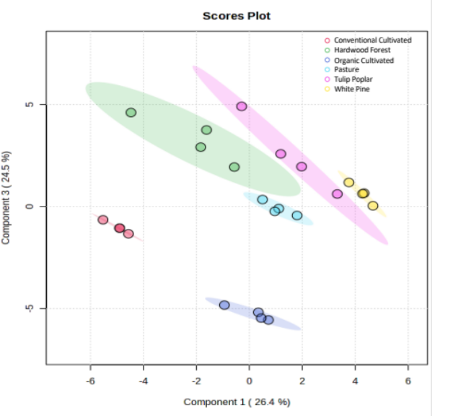
Figure 1.1 Partial least squares discriminant analysis (PLS-DA) showing group separation based on all 41 identified metabolites, with 95% confidence intervals. This analysis displays distinct metabolic profiles for all six groups.

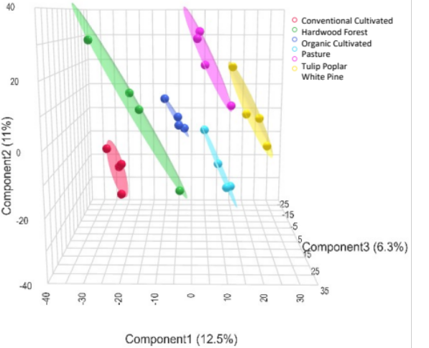
Figure 1.2 3D PLS-DA comparing metabolomes based on 4,893 unidentified spectral features. The clear group separation provides stronger evidence than identified metabolites alone that each sample group possesses a distinct metabolic profile.

The 2D PLS-DA using the identified metabolites revealed clear separation among all groups, indicating unique metabolomes for each (Figure 1.1). A 5-fold cross-validation across 2 components yielded strong model performance (R2= 0.910, Q2 = 0.814).
Even without structural identification, the 3D PLS-DA using only the unidentified spectral features also achieved robust group separation, highlighting that untargeted spectral data alone can distinguish land management practices (Figure 1.2). This model validated using 5-fold cross-validation across 3 components, produced R2 = 0.937 and Q2 = 0.709.
These results demonstrate that known metabolites are not necessary to clearly distinguish among land management practices. The global metabolic profiles, even without annotation, contain enough information to differentiate complex soil systems. While identified metabolites aid biological interpretation, unidentified features alone can still capture meaningful ecological variation making this approach particularly valuable in ecosystems lacking comprehensive metabolite libraries.

1.4.3 Elemental Stoichiometry
To explore nutrient-related variation among soil metabolomes, elemental ratios were calculated from molecular formulas assigned to unknown spectral features. Ratios included carbon-to-nitrogen (C/N), carbon-to-phosphorus (C/P), and nitrogen-to-phosphorus (N/P). These values provide stoichiometric insight into microbial nutrient availability and organic matter composition. Statistical comparisons were conducted using Kruskal–Wallis tests with pairwise comparisons against the pasture group, and effect sizes were calculated to assess the magnitude of group differences.
C/N ratios (Figure 1.3a) exhibited substantial overlap across land use types. Although some comparisons reached statistical significance, nearly all were associated with
Figure 1.3 Violin plots show distributions of (a) carbon-to-nitrogen (C/N), (b) carbon-to-phosphorus (C/P), and (c) nitrogen-to-phosphorus (N/P) ratios across six soil types. Statistical significance is based on Kruskal–Wallis tests followed by pairwise comparisons against the pasture group only. Asterisks indicate significance levels (p < 0.05, p < 0.01, p < 0.001), and effect sizes are shown in parentheses. Although some C/N comparisons reached significance, most had negligible effect sizes. In contrast, C/P and N/P ratios showed larger and more meaningful shifts relative compared to pasture.

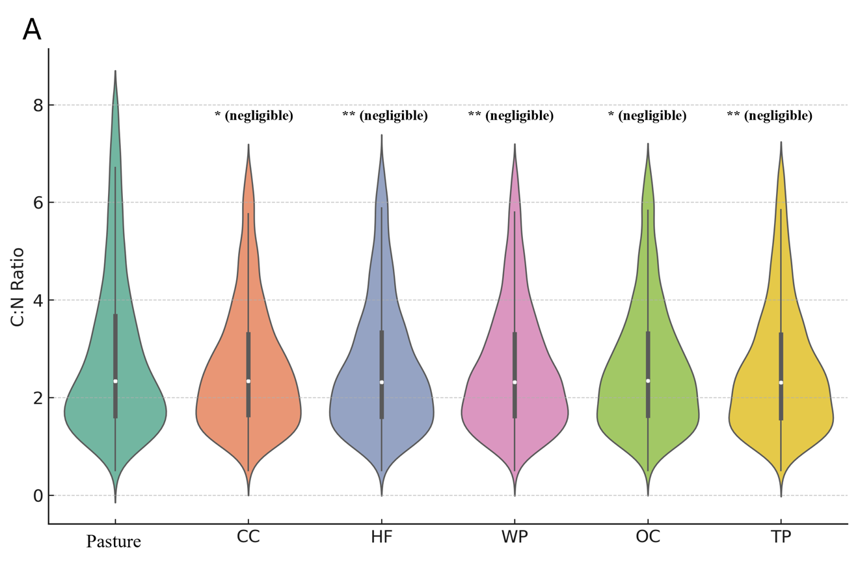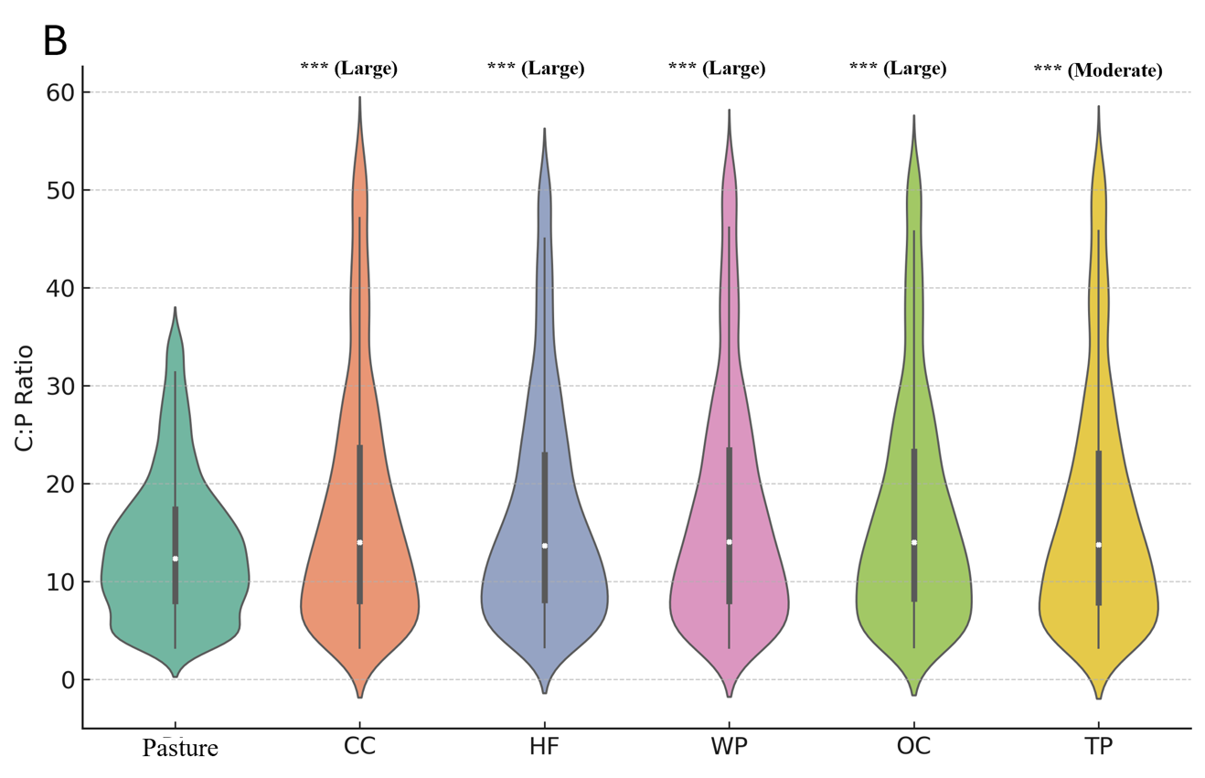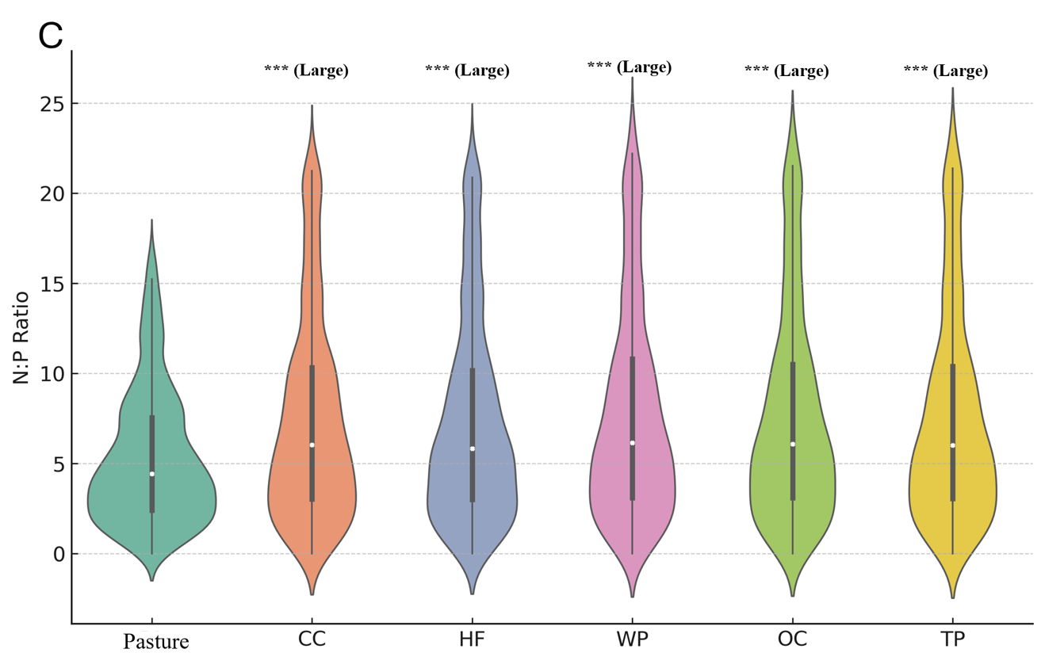

negligible effect sizes, suggesting minimal ecological relevance. Median values fell between ~2.5 and 3.5, and the interquartile ranges were broad and overlapping. This suggests that C/N ratios derived from labile, water-soluble metabolites are relatively insensitive to differences in land management practices.
In contrast, C/P and N/P ratios (Figures 1.3b and 1.3c) revealed statistically robust separation among groups. Both ratios were consistently lowest in pasture soils and significantly elevated across all other land management types. Pairwise comparisons between pasture and the other five groups yielded large or moderate effect sizes.

1.4.4 Phosphorus-Related Stoichiometric Variation
The C/P and N/P ratios were also calculated to evaluate whether phosphorus availability may contribute to stoichiometric differences. Kruskal–Wallis tests indicated significant differences in both C/P (p < 0.05) and N/P ratios (p < 0.05) across land management practices compared to the pasture. C/P and N/P ratios differed significantly across land uses, with white pine consistently exhibiting the lowest values, and hardwood forest and conventional cultivation showing the highest C/P and N/P values, respectively. These findings indicate that, although broad elemental ratios like C/N did not differ significantly These findings indicate that, although broad elemental ratios like C/N did not differ significantly may influence phosphorus availability or microbial nutrient acquisition strategies. Violin plots used to visualize these distributions excluded statistical outliers using the IQR method to improve interpretability, though all statistical analyses were performed on the complete dataset. In contrast to the C/N ratio, which showed negligible effect sizes, differences in C/P and N/P ratios exhibited moderate to large effect sizes across land management groups.

1.4.5 Overlap and Uniqueness of Unknown Spectral Features
To visualize trends in the unidentified spectral data, an UpSet plot was generated (Figure 1.4). The plot highlights the overlap of statistically significant unidentified spectral features across land management practices, further demonstrating that these unknown features contain biochemically meaningful information. CC and OC showed significant overlap in features, with 105 shared features between them. Although several groupings share features, most of the sets are comprised of unique unidentified spectral features. In order of CC, HF, OC, TP, and WP, 248, 276, 90, 55, and 48 unidentified spectral features were unique to their respective land management sets.

1.4.6 Chemical Class Composition of Unidentified Features
Differences in soil metabolomes resulting from the various land management practices were demonstrated through PLS-DA and PCA. However, to assess differences in elemental composition, the chemical class composition of each soil type was analyzed. Pie charts were created to show chemical classifications from the unidentified spectral features for all soil types (Figure 1.5). Classification was determined in a cascade from broad kingdoms, superclasses, classes, to more highly refined subclasses. The individual counts for each category can be found in the Appendix Table 1-1.Even without structural information, these data highlight that differentiation between and among soils can be achieved through unidentified spectral features alone. This is a key advantage of untargeted metabolomics in soil science.

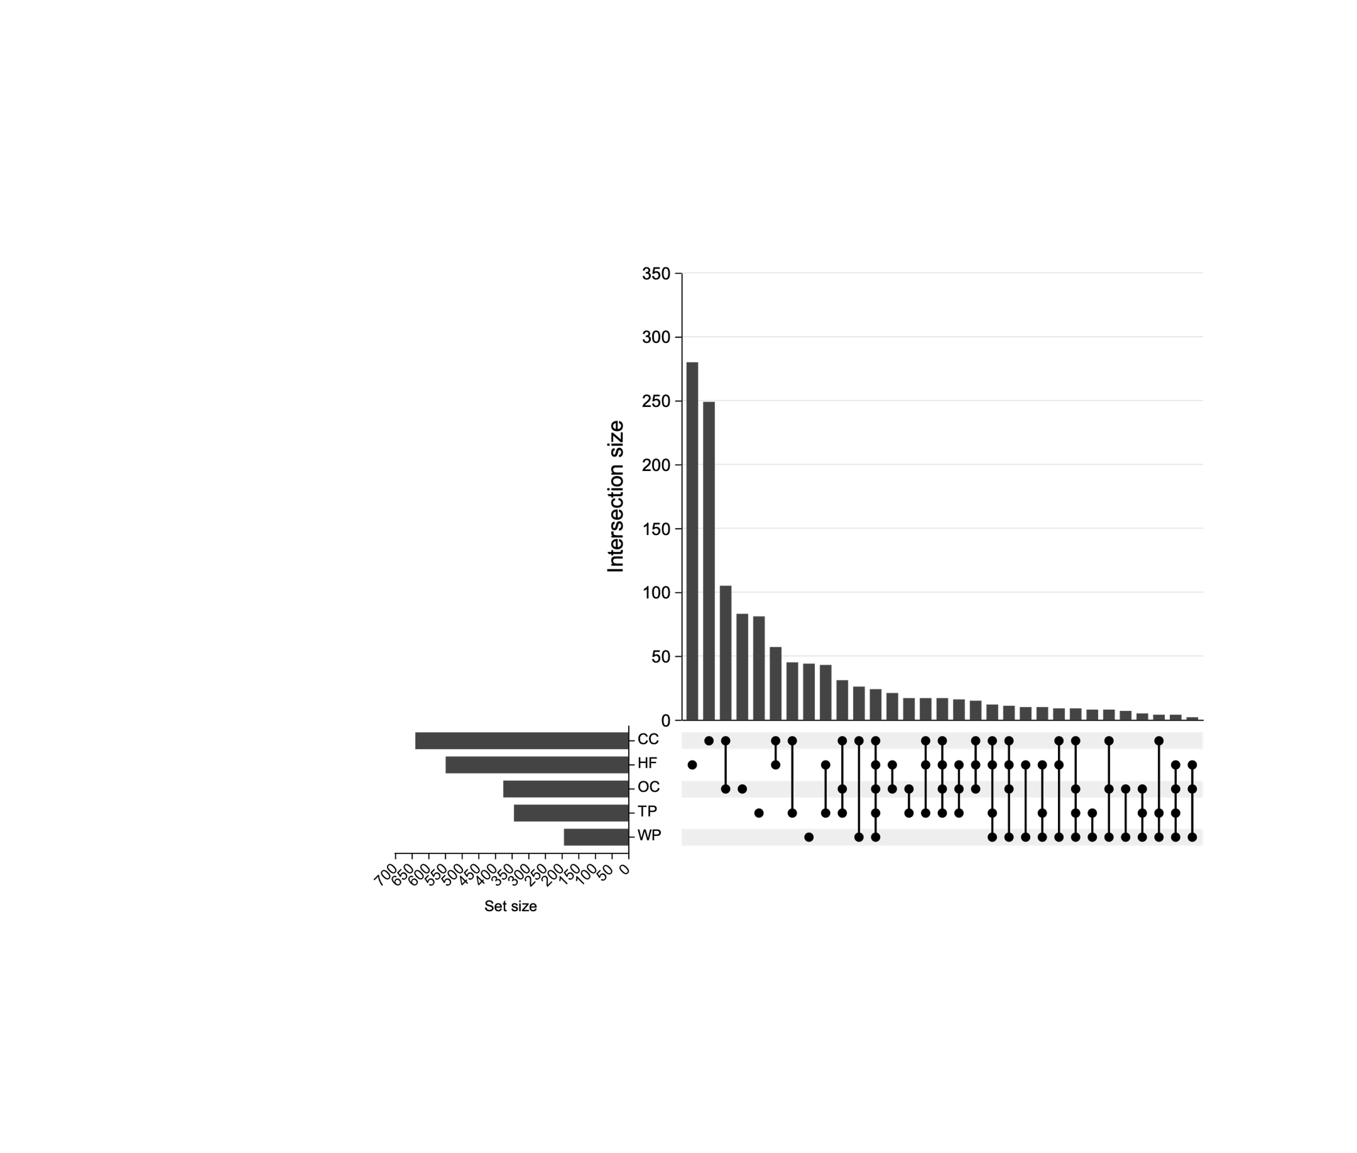
Figure 1.4 Each land management strategy is represented as a set, and the plot highlights the overlap between them. Each bar’s size represents the number of unidentified spectral features shared between the different combinations of soil types.

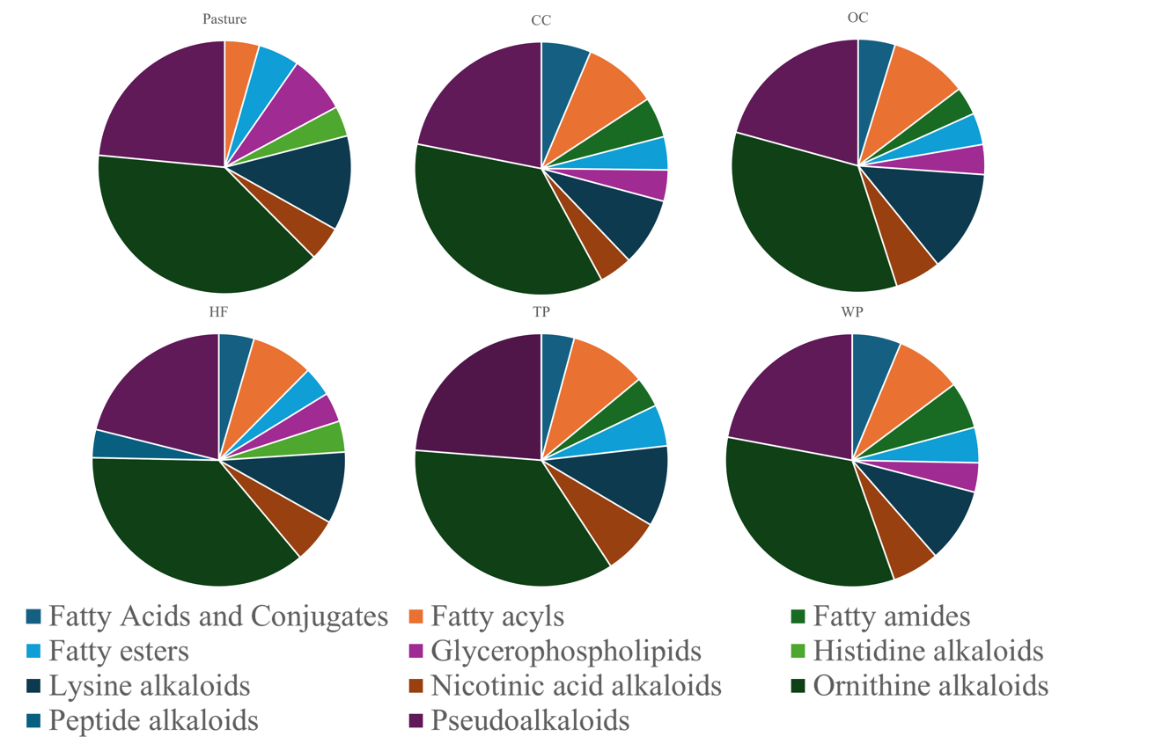
Figure 1.5 Unidentified spectral features categorized in superclasses.

1.5 Discussion

1.5.1 Land Management Shapes Soil Chemistry and Metabolic Profiles
This study showed that untargeted metabolomics can distinguish soil systems under different land management practices, even without structural identification of most metabolites. The unidentified spectral features alone were enough to separate land management groups. This means that spectral data can still capture consistent biochemical differences, even when most compounds are unknown.
Only 41 metabolites were confidently identified using an in-house library that focused mostly on human central carbon metabolism. This limitation did not prevent the detection of meaningful differences between land management strategies. While identification helps with interpretation, it was not necessary for group separation. Both identified and unidentified spectral features revealed distinct metabolic profiles across the soil types. Features shared among groups, along with those unique to specific practices, were examined to better understand compositional trends. In addition, elemental ratios were calculated to explore how land management influences nutrient balance and carbon storage. These data provided useful context for how management strategies such as conventional cultivation or hardwood forest affect nutrient cycling.
The distinct metabolic profiles observed across land management types suggest that land use not only changes the availability of carbon and nitrogen, but also shapes the composition of key compound groups. These include superclasses such as fatty acids and conjugates, fatty acyls, glycerophospholipids, peptide alkaloids, and pseudoalkaloids which were all derived through NPClassifier structural taxonomy. The relative proportions of these classes varied by land management type, reflecting shifts in plant-derived inputs, microbial community function, and metabolic processes across soil systems.³⁶
To better understand which identified metabolites contributed most to the group separation for Figure 1.1, we examined variable importance in projection (VIP) scores from the PLS-DA model. The top ten compounds with the highest VIP scores for Component 1 are listed in Appendix Figure 1.6. These compounds represent different biological processes related to soil function, including microbial respiration, nitrogen metabolism, sulfur cycling, and organic matter degradation. Also, pairwise comparisons of each experimental group compared to the pasture via PLS-DA and volcano plots can be found in Appendix Figures 1.7-1.16.
The top metabolite, 2-oxo-4-methylthiobutanoate, is a product of methionine degradation and is involved in microbial sulfur metabolism. It may be more abundant in soils with redox stress or added organic matter.³⁷ Uracil, a base from RNA, comes from the breakdown of microbial biomass. Its presence suggests high microbial activity and nucleic acid turnover.³⁸ Glutamine is a nitrogen-rich compound used by microbes and plants to store or move nitrogen. It may reflect nitrogen availability or microbial uptake strategies.³⁹
UDP-D-glucose is a sugar used to build structural carbohydrates in microbes and plants. It may come from root exudates or microbial polysaccharide production.⁴⁰ Pyroglutamic acid is linked to oxidative stress and the glutathione cycle. Its presence may reflect shifts in microbial redox environments.⁴¹ Benzoate is a degradation product of lignin and other aromatic compounds. It often appears in forest soils with large plant litter inputs.⁴²
Three central carbon intermediates succinic acid, fumarate, and malate are part of the TCA cycle. These compounds reflect microbial energy metabolism and may change depending on oxygen availability or soil organic inputs.⁴³ Finally, phenylalanine is an aromatic amino acid commonly found in root exudates and plant tissues. It may reflect rhizosphere activity or the breakdown of plant-derived organic matter.⁴⁴
Together, these identified metabolites offer a functional perspective on the broader patterns observed in the untargeted data. Even though most compounds were not identified, these few known features highlight processes like microbial respiration, stress response, and carbon and nitrogen cycling. This supports the conclusion that land management affects soil metabolic profiles in ecologically meaningful ways.

1.5.2 Metabolic Profiles are Distinct Across Land Management Practices
Analysis of statistically significant unidentified spectral features demonstrated clear differentiation among the five land management practices, using pasture as the reference group (Figure 1.4). CC and HF soils had the largest set sizes, 650 and 550, respectively. This pattern suggests either greater chemical complexity or a more diverse array of soil-derived compounds. In CC soils, frequent mechanical tillage, diverse fertilizers, pesticides, and organic amendments (e.g. compost, manure, crop residues) contribute to high organic matter turnover and dynamic chemical inputs and large set sizes.⁴⁵ These factors likely account for the broad and complex metabolite profile observed. Similarly, HF soils exhibit a large set size, likely due to slower natural decomposition processes and a diverse mix of leaves, roots, and woody debris.⁴⁶ Forest soils tend to be more stable, providing a range of complex metabolites due to the slow but steady input of various plant-derived compounds and interactions with fungi and root exudates. This contrasts with the more disturbance-driven complexity seen in CC, highlighting that unique metabolic signatures can arise through different ecological pathways.
In contrast, set sizes decreased in OC (375), TP (350), and WP (200), suggesting a narrower range of detectable metabolic signatures. The lower set size in OC could reflect the absence of synthetic inputs, leading to a more selective but possibly stable pool of metabolites.⁴⁷ WP had the smallest set size, likely due to low organic inputs and reduced microbial activity commonly observed in coniferous ecosystems.⁴⁸ TP soils also exhibited relatively low feature counts; although Tulip Poplar litter decomposes rapidly, other factors such as seasonal inputs, microbial dynamics, or soil structure may contribute to a smaller or more uniform metabolite pool. Despite the lack of compound identification, these consistent differences highlight the practical value of untargeted metabolomics for distinguishing land use types. These findings emphasize how land management shapes soil chemical diversity and drives differences in metabolic composition across practices.⁴⁹

1.5.3 Shared and Unique Spectral Features Reflect Management History
Several common features among groups were observed in the intersections in the UpSet plot (Figure 1.4). The largest overlap of unidentified spectral features (105) was seen between OC and CC, reflecting their similar agricultural inputs and management strategies. However, each group still maintained distinct biogeochemical profiles shaped by specific land management practices. Despite some shared features, each land management group maintained a largely distinct biochemical profile, emphasizing the influence of management history on soil chemistry. These findings emphasize that soil biogeochemical diversity is closely tied to ecological context and land use, with important implications for soil function and sustainability.⁵⁰

1.5.4 Implications of Elemental Ratios
Elemental ratios are commonly used to infer microbial nutrient limitations, organic matter turnover, and biogeochemical cycling in soils. In this study, these ratios were derived from molecular formulas assigned to unknown spectral features, offering stoichiometric insights even in the absence of compound identification.
To visualize broader stoichiometric trends, violin plots of carbon-to-nitrogen (C/N), carbon-to-phosphorus (C/P), and nitrogen-to-phosphorus (N/P) ratios were generated.
To better interpret the practical relevance of these differences, effect size was used to quantify the magnitude of group separation. Unlike p-values, which only indicate whether an effect is likely due to chance, effect size describes how substantially groups differ, independent of sample size. Several comparisons in this analysis yielded medium to large effect sizes (d > 0.5), indicating that the observed stoichiometric shifts are not only detectable but also potentially meaningful in a biological or ecological context.
This distinction is especially important in metabolomics, where large datasets can yield statistically significant results that lack real-world relevance. Effect size provides a more informative measure of group separation by capturing the strength of the relationship, not just its likelihood.⁵¹ By emphasizing effect size, this study avoids overinterpreting minor differences and instead highlights stoichiometric changes that may reflect meaningful variation in soil metabolite composition.
The C/N violin plot showed only limited ability to distinguish land management practices from the pasture reference group. Although some pairwise comparisons against pasture reached statistical significance, the effect sizes were negligible, and distributions overlapped heavily. These findings suggest that C/N ratios derived from labile, water-soluble metabolites are relatively insensitive to land use driven variation.⁵² This is consistent with the interpretation that C/N from metabolomics reflects short-term, bioavailable nutrient pools rather than the broader carbon-nitrogen balance captured in bulk whole soil measurements.^{53, 54}
In contrast, phosphorus-related stoichiometric ratios (C/P and N/P) revealed clearer and more ecologically meaningful differences between land management types. Violin plots showed that cultivated soils, both conventional and organic, had the highest ratios. This pattern may reflect limited microbial access to phosphorus, higher nutrient demand, or leftover effects from past fertilizer use.⁵⁵ The distributions were tight and shifted upward, showing that most samples followed this trend. These results suggest that phosphorus availability is more strongly affected by cultivation than nitrogen.
Forested soils also showed elevated C/P and N/P ratios compared to pasture, though not as high as in cultivated soils. White pine soils had slightly lower ratios than hardwood soils. These patterns may be linked to differences in litter quality, decomposition rates, and microbial nutrient use.⁵⁶ Forest litter often contains more lignin and complex compounds, which slow phosphorus release and make it harder for microbes to access. In white pine systems, cooler temperatures, lower pH, and slower microbial activity may further reduce phosphorus cycling.⁵⁷ In contrast, pasture soils had the lowest C/P and N/P ratios and narrow distributions, suggesting stable phosphorus pools and more efficient phosphorus turnover.^{55, 56} This may be due to consistent root inputs, low disturbance, and microbial communities adapted to recycling available nutrients. Together, these findings show that phosphorus-centered stoichiometry can reveal how land management shapes soil nutrient balance through both chemical inputs and biological processes.
Even without structural identification, untargeted elemental ratios captured meaningful differences in soil chemistry and inferred nutrient cycling.⁵⁸ The strong effect sizes and consistent trends in C/P and N/P suggest that phosphorus availability and microbial nutrient demand vary significantly with land use, and that these differences are reflected in the composition of water-soluble metabolites.
Overall, elemental ratios provide helpful background context, but their ability to detect changes by land use effects may depend on which elements are considered. Future research that combines stoichiometric data with microbial or biochemical markers may better explain how land management influences nutrient cycling.⁵⁹

1.5.5 Unidentified Spectral Features Classification
Soil metabolite composition differed by land use, but some patterns were shared across all systems. Certain chemical classes were widespread, while others were restricted to specific land uses. These differences likely reflect the effects of land management on decomposition, microbial activity, and nutrient cycling.⁶⁰
Across all land-use types, lysine alkaloids, ornithine alkaloids, and pseudoalkaloids were consistently present in moderate to high amounts. These compounds are commonly produced by both plants and microbes and may reflect universal biochemical processes like nitrogen recycling and stress responses in soil ecosystems.⁶¹ For example, lysine and ornithine derived alkaloids are often associated with plant defense and microbial signaling in the rhizosphere.⁶² Their widespread presence suggests they are stable features of soil chemical profiles, regardless of vegetation or management.³⁷
Free lipid-like compounds (fatty acids and conjugates, fatty acyls, fatty amides, and fatty esters) showed strong variation across land uses. All land-use types except pasture had notable levels of these compounds. For example, conventional cultivation soil had over 25 features in the fatty acid class, while pasture had none. This could reflect rapid lipid turnover in pasture soils, where microbes actively degrade labile lipids from plant roots or manure inputs.⁶³ In contrast, forest and pine soils may accumulate more of these compounds due to slower decomposition of leaf waxes and other hydrophobic residues.⁶⁴
One lipid class, glycerophospholipids, showed the opposite trend. Pasture soils had the highest abundance of glycerophospholipids among all sites. These are structural components of microbial membranes and are often used as indicators of microbial biomass.⁶² Their enrichment in pasture suggests a highly active and well-developed microbial community, most likely due to minimal disturbance and continuous plant cover.⁶⁵ In contrast, soils that are regularly tilled or used to grow only one crop may have lower microbial diversity and fewer microbial membrane lipids.⁶⁶
Nitrogen-rich metabolite classes dominated the soil profiles overall, but some subclasses were exclusive to undisturbed systems. For example, histidine alkaloids were detected only in pasture and hardwood forest soils. These compounds are sometimes produced by soil fungi, especially in undisturbed or perennial systems.⁶⁷ The absence of histidine alkaloids in croplands and conifer forests may reflect the loss of fungal diversity due to tillage or simpler plant communities.⁶⁸
Peptide alkaloids were absent from all sites except hardwood forest, where they appeared at low levels. This could be tied to the chemical complexity of deciduous litter or specialized microbial interactions in forest soils.⁶⁹ Their low levels in farmland and pasture suggest these compounds are not often made in disturbed or grass-based ecosystems.⁷⁰
Overall, pasture soil showed a lack of free lipids, high microbial membrane lipids, and unique alkaloids, indicating a fast-cycling and microbially rich environment.⁷¹ Cultivated soils showed signs of lipid breakdown and lacked some microbial or plant-derived alkaloids, pointing to simplified chemical profiles.⁷² Forest soils contained more secondary metabolites like peptide and histidine alkaloids, possibly due to complex litter inputs and fungal contributions.⁷³ Some classes, like ornithine alkaloids and pseudoalkaloids, were shared across all soils. This could suggest that they play a central role in soil chemical cycling regardless of land use.⁷⁴ These metabolite patterns show how land use alters not just the quantity, but the types of biochemicals present in soil. This chemical diversity reflects broader ecological functions, including microbial activity, decomposition pathways, and nutrient retention.⁷⁵

1.5.6 Implications and Advantages of Metabolomic Approaches in Soil Science
In addition to chemical classification, elemental ratios were calculated for unknown molecular formulas, focusing on C/N, C/P, and N/P. These stoichiometric comparisons offer insight into nutrient-related trends in soil chemistry. For example, high C/N ratios may suggest carbon-rich compounds with limited nitrogen availability, while low C/P or N/P ratios could reflect phosphorus enrichment or microbial nutrient demands.
In this study, untargeted metabolomics revealed clear differences in metabolic profiles among land management practices. However, traditional elemental ratios like C/N, H/C, and O/C did not show significant variation. This contrast highlights a key advantage of metabolomics: its ability to detect changes in labile compound composition that bulk compound analyses often miss. While standard methods often reflect more stable, organic matter pools, metabolomic data capture short-term dynamics in nutrient availability and transformation.⁷⁶
Importantly, these metabolic distinctions emerged even without full identification of all the individual metabolites. Given that unknown spectral features still differentiated land management types highlights the power of untargeted metabolomics. It provides a sensitive tool for detecting biochemical patterns and changes that traditional methods may overlook.

1.6 Conclusions and Future Directions
This work demonstrates how untargeted metabolomics can detect meaningful chemical differences in soils under different land management systems. Even without full compound identification, molecular formulas enable the calculation of elemental ratios such as C/N, C/P, and N/P, which revealed stoichiometric patterns linked to land use. These ratios reflect nutrient-related traits that vary with management and offer insight into microbial demand, nutrient availability, and organic matter cycling.
Structural classification tools like NPClassifier provided a broader view of chemical composition based on biosynthetic origin. Pasture soils showed signs of fast microbial cycling, low lipid accumulation, and distinct alkaloid signatures. Cultivated soils exhibited simplified chemical profiles, often lacking fungal or microbially derived metabolites. In contrast, forested systems contained more diverse and complex metabolites, likely reflecting leaf litter inputs and slower decomposition.
While many detected spectral features remain unidentified, their consistent patterns across land management practices underscore their value in differentiating soil systems. Although the lack of structural characterization limits direct links to specific biochemical pathways or ecological functions, these unidentified features still provide a powerful framework for analysis.
Beyond compound identification, future research should explore the functional implications of these metabolic differences by integrating soil microbial community analyses, environmental variables, and elemental ratio data. Examining metabolic profiles across multiple seasons and environmental conditions could also provide deeper insights into the stability and resilience of soil chemical profiles over time.
Overall, this study highlights the power of untargeted metabolomics in soil science, particularly the ability of untargeted approaches to detect meaningful differences in soil chemistry without requiring full metabolite identification. Continued advancements in compound annotation and functional interpretation will further strengthen the connection between soil metabolic patterns and ecosystem processes, supporting more informed and sustainable land management practices.

SMALL MOLECULE CHEMICAL ANALYSIS OF RESIDUAL ODOR FROM ODOR RECOGNITION TESTS BY HUMAN REMAINS CANINE TEAMS

A version of this chapter will be submitted for publication in August 2025.
Proposed authors:
Zane Vickery, Lindsay Brown, Dawnie Wolfe Steadman, Shawn R. Campagna
Author contributions:
ZV extracted and processed the unknown spectral features, ZV and LB developed and validated the GC-MS method, DWS oversaw sample collection and odor recognition test organization, DWS and SRC conceptualized the project.

2.1 Abstract
Human remains detection (HRD) dogs are trained to locate decomposing human bodies based on the detection of volatile organic compounds (VOCs) emitted during decomposition. While canine performance in the field is well documented, the chemical basis of canine alerts, particularly in cases involving trace or residual odor, remains poorly understood. This study applied untargeted headspace solid-phase microextraction gas chromatography–mass spectrometry (SPME-GC-MS) to 162 gauze samples collected during odor recognition tests involving HRD canines. A total of 1,790 unidentified spectral features were detected. After preprocessing and statistical filtering, multivariate analyses were performed to assess differences between target (deceased) and distractor (non-deceased) samples.
Partial least squares discriminant analysis (PLS-DA) demonstrated clear group-level separation, with a third component included to visualize separation in three dimensions. Two-way analysis of variance (ANOVA) revealed 10 features significantly associated with the target group across trials, and an additional 48 features with significant class and trial effects. These features consistently exhibited greater abundance in the deceased condition.
Notably, these unknown VOC features were sufficient to distinguish target and distractor groups without requiring compound identification. This work provides empirical support for the concept of residual odor and highlights the utility of untargeted metabolomics in forensic canine science. The results suggest that residual odor may persist on surfaces even after visible remains are removed, offering a chemical explanation for HRD canine alerts in the absence of physical evidence.

2.2 Introduction
Canis lupus familiaris, or domestic dogs, have long been recognized for their extraordinary olfactory capabilities and are used in a wide range of forensic applications, including the detection of narcotics, explosives, live humans, and human remains.⁷⁷ Human remains detection (HRD) dogs, commonly referred to as cadaver dogs, are trained to locate decomposing remains by detecting volatile organic compounds (VOCs) emitted during decomposition.⁷⁸ While their utility in the field is well established, the scientific basis of HRD canine alerts remains underexplored, particularly in scenarios involving trace or residual odor.⁷⁹
Residual odor is defined as the trace volatiles left behind on surfaces and materials after the removal of human remains, and it presents a unique challenge in forensic investigations. Handler observations suggest that dogs may alert to residual odor even in the absence of visible biological material, indicating a chemical signature that persists after the decedent is no longer present.⁸⁰ This is particularly relevant in cases where no physical evidence is recovered, yet canine alerts are admitted as confirmatory evidence.^{81, 82}The legal framework surrounding HRD canine evidence compounds this issue. Courts in states such as Virginia and Colorado have ruled that HRD dog alerts do not require a scientific foundation, instead classifying them as “experience-based specialized knowledge.”⁸³ In Brooks v. People, the Colorado Supreme Court admitted canine scent evidence without requiring scientific validation.⁸³ Similarly, in State v. Bucki, the Wisconsin Court of Appeals held that HRD canine alerts may be used even when no corroborating physical evidence is present, provided they meet general expert reliability standards.⁸¹ These decisions raise concerns about the acceptance of residual odor alerts as scientifically credible indicators of prior human presence, despite limited empirical validation.
Despite the reliance on HRD canines in the field and in courtrooms, key questions about residual odor remain unanswered. These include its chemical composition, persistence, dissipation rate, concentration thresholds, and how various substrates influence its degradation. Studies of volatile organic compounds emerging from decomposition have documented dynamic, time-dependent shifts in odor profiles, underscoring the challenges of postmortem VOC analysis.^{84, 85} However, these studies primarily focus on active decomposition. The chemical basis of residual odor from freshly deceased individuals, before active decay, remains poorly understood.
Without chemical validation, the reliability of a canine’s alert to residual odor depends heavily on handler experience and training protocols, both of which are subject to cognitive bias.⁸⁶ This disconnect between scientific understanding and courtroom perception has contributed to a state of “mythic infallibility”, a term used to describe how HRD canines are often viewed as inherently accurate by juries and legal professionals.⁸⁶ This perception is particularly problematic in cases involving residual odor, where the target material is no longer present and the alert relies solely on the dog’s training and the handler’s interpretation. Using untargeted headspace SPME-GC-MS, this study provides one of the first chemical assessments of residual odor from freshly deceased individuals, prior to active decomposition. This work offers new insight into HRD canine alerts in the absence of physical remains.
To address these gaps, this study conducted an untargeted chemical analysis of gauze samples collected during odor recognition tests (ORTs) involving HRD canines. These samples included “target” gauze exposed to freshly deceased individuals prior to active decomposition, “distractor” gauze exposed to living individuals, and blanks serving as environmental controls. Gauze was selected as a passive collection substrate due to its widespread use in HRD canine training and its ability to absorb and retain volatile compounds from both human and environmental sources.⁸⁷
Volatile profiles were evaluated using headspace solid-phase microextraction combined with gas chromatography–mass spectrometry (SPME-GC-MS) and a high-resolution Orbitrap mass analyzer. This untargeted approach, widely used in forensic and biological VOC studies, enabled detection of subtle chemical differences between exposure groups in the absence of visible biological residue. ^{88, 89} The resulting data represent an early chemical characterization of residual odor from freshly deceased individuals, and it offers a basis for continued investigation into its relevance for forensic detection.

2.3 Materials and Methods

2.3.1 Gauze Preparation
Residual odor sampling was conducted using multi-ply gauze as the collection medium. Dukal 4x4 12-ply gauze pads were subjected to four successive washes with liquid chromatography mass spectrometry (LC-MS) grade methanol to remove any manufacturing VOC contaminants. Each wash lasted 15 minutes, after which the gauze was transferred to the next methanol bath. Following the final wash, gauze pads were dried under a continuous stream of high-purity nitrogen gas in sterile glass containers. Once fully dried, they were stored in EPA-cleaned glass septa jars. All gauze cleaning procedures were performed at the Biological and Small Molecule Mass Spectrometry Core (BSMMSC) at the University of Tennessee, Knoxville (RRID: SCR_021368).

2.3.2 Decedent and Living Residual Odor Sampling
Donor bodies were provided by the Forensic Anthropology Center at the University of Tennessee, Knoxville. In this study, three human donors (one female, two males) who had died within 1-4 days of sampling were included. Decedent residual odor sampling occurred on April 4th, 2024. Each donor was positioned supine on a stainless steel table, and 15 cleaned gauze pads were placed beneath the torso for 10 minutes for passive exposure. Tables were not treated with stringent cleaners to avoid introducing extraneous volatile compounds. After exposure, gauze pads were immediately transferred into individual glass septa jars.
For comparison, residual odor samples from living individuals were also collected. Three subjects were selected who had no recent exposure to human remains, the Anthropology Research Facility (ARF), or canine teams. Subjects were required to have avoided these environments for at least three days prior to sampling and did not participate in any phase of the odor recognition testing or chemical analysis. Living subjects followed the same 10-minute gauze exposure protocol.

2.3.3 Odor Recognition Test Design and Sample Collection
Volatile samples were collected during double-blind odor recognition tests (ORTs) conducted at the University of Tennessee, Knoxville. Thirty five certified human remains detection (HRD) canine-handler teams participated, each completing three replicates. In each trial, dogs searched a lineup of 18 sealed paint cans with punctured tops arranged in three rows. Dogs were walked past each can twice, and handler reported alerts were recorded by a room monitor. Each lineup contained one “target” sample (gauze exposed to human remains), one “distractor” sample (gauze exposed to living human odor), and 16 “blanks”. Samples were randomly assigned to cans, and the handlers and room monitor were unaware of their positions or the ratios of targets. Following each trial, gauze samples were immediately sealed in 20 mL glass headspace vials and transferred from the ORT team to the analytical team.

2.3.4 Headspace SPME Analysis via Gas Chromatography-Mass Spectrometry
Although chemical analysis extended beyond the testing window, samples were processed in order of collection to minimize volatile loss. A total of 162 gauze samples were analyzed, including 9 from deceased targets, 9 from live human distractors, and 144 blank gauzes used as environmental controls. Volatile organic compounds were extracted from the headspace of each vial using solid phase microextraction (SPME). Sampling was performed at 70 °C for 20 minutes using Supelco DVB/PDMS fibers (120 μm). VOCs were thermally desorbed at 70 °C for 1 minute directly into the gas chromatograph.
Analyses were carried out on a Thermo Scientific Trace 1300 gas chromatograph equipped with a TriPlus RSH autosampler featuring an auxiliary temperature/cryo module and SPME kit. The GC system was coupled to an Exactive™ Plus Orbitrap mass spectrometer (Thermo Fisher Scientific, Waltham, MA) operated in positive atmospheric pressure chemical ionization (APCI) mode. The auxiliary transfer line was maintained at 260 °C.
Chromatographic separation was achieved using a 60 m Agilent J&W DB-624 column (0.32 mm i.d., 1.8 μm film thickness). Helium served as the carrier gas at a constant flow rate of 1.5 mL/min. The oven program was as follows: 35 °C (1 min), ramped at 3 °C/min to 80 °C, 10 °C/min to 120 °C, and 40 °C/min to 260 °C, with a total run time of 23.5 minutes. A DB-624 SPME Arrow liner (DB-624ARRLIN17-Trace1300-1) was used.
Full-scan mass spectra were acquired from m/z 50–750 at a resolution of 140,000 (at m/z 200), using a single microscan per scan. The AGC (automatic gain control) target was set to 1 × 10⁶, and the maximum injection time was 50ms. Sheath gas was set to 10 (arbitrary units), auxiliary gas to 8, and sweep gas to 3. The capillary temperature was maintained at 320 °C, and the vaporizer temperature was 300 °C. Mass calibration was performed twice weekly using a standard calibration mixture to ensure mass accuracy within 5 ppm. Instrument parameters were adapted from previously published methods.⁹⁰

2.3.5 Data Processing
Raw spectral files were converted to the mzML format using the msConvert tool from ProteoWizard and individually zipped prior to being uploaded into MetaboAnalyst 5.0.^{21, 24, 25} Within the Spectra Processing module, data were processed using the UPLC-Orbitrap workflow with the centWave-auto algorithm for peak picking. Alignment was performed in positive ion mode with a minimum fraction threshold of 0.8. Chromatograms were deisotoped, deadducted, and filtered to remove contaminants. To reduce background signal, features present in environmental blanks were subtracted using the built-in blank subtraction tool, resulting in a refined dataset of 562 features. Processed peak tables were exported as .csv files for downstream statistical analysis. Partial least squares discriminant analysis (PLS-DA) was performed in MetaboAnalyst to assess group-level separation, and due to the complexity of the data, a third component was included to generate 3D PLS-DA visualizations and capture additional variance.
Target and distractor control samples were collected in sealed vials without undergoing odor recognition tests. For the two-way ANOVA, they were grouped with their respective experimental categories (Target and Distractor). This decision was based on preliminary PCA and PLS-DA analyses showing no statistically significant differences between control and ORT-exposed samples (permutation p = 1.0). Controls were treated separately in other multivariate comparisons (e.g., PLS-DA) to assess handling effects, but were combined here to increase statistical power and better assess group-level differences attributable to donor status and trial effects. Statistical significance was determined using a p-value threshold of 0.05, with multiple testing correction applied using the Bonferroni step-down method (Holm). This approach was selected to control for family-wise error while maintaining greater power than classic Bonferroni correction.

2.3.6 Molecular Formula Prediction and Classification
To investigate the chemical identity of features strongly influenced by exposure to deceased individuals, a targeted subset of statistically significant spectral features (identified by two-way ANOVA) was selected for molecular formula prediction and tentative compound classification. Due to the lack of standards or MS/MS fragmentation data, all annotations are considered tentative.
High-resolution m/z values for each feature were submitted to the Seven Golden Rules (7GR) algorithm, which applies a cascade of heuristic and chemical constraints to generate a list of plausible molecular formulas.²⁷ These include elemental ratio filters (e.g., H/C, O/C, N/C), valence and bonding rules, and calculations of ring and double bond equivalents (RDBE) to ensure structural feasibility. Orbitrap’s high-resolution mass detection allowed for a narrow mass tolerance of ± 6 ppm, and the elemental search space was restricted to biologically relevant atoms (C, H, N, O, S, P, Cl, Br, and F), excluding improbable elements. Formulas that passed these filters but contained unrealistic element combinations were subsequently discarded during manual review.
If multiple possible formulas were returned for a given m/z, preference was given to the lowest mass error and highest chemical plausibility. This screening process was essential for reducing false positives and avoiding overinterpretation based solely on accurate mass.
Eight of the ten statistically influenced features yielded molecular formulas that passed all plausibility filters. However, only seven of the eight molecular formula were confidently annotated as belonging to a broad chemical class. Tentative classifications were based on comparisons to compound families reported in decomposition and microbial degradation literature. All classifications were made manually based on formula composition and biochemical context. All classifications remain tentative and are intended to support class-level interpretation rather than definitive compound identification.

2.4 Results

2.4.1 Detection of Volatile Profiles Using Untargeted Metabolomics
Untargeted headspace SPME-GC-MS analysis of 162 gauze samples collected during odor recognition tests (ORTs) resulted in the detection of 1,790 unidentified spectral features. To reduce background signal and environmental noise, blank subtraction was applied using MetaboAnalyst, yielding a refined dataset of 562 features. Multivariate analysis using partial least squares discriminant analysis (PLS-DA) revealed distinguishable volatile profiles between exposure groups. Samples exposed to deceased individuals clustered separately from those exposed to living subjects and environmental blanks, indicating chemical differentiation associated with exposure history (Figure 2.1).

2.4.2 Evaluating Trial-Level Variation
While overall clustering patterns were consistent across exposure groups, samples from Trial 2 exhibited a slight but consistent offset across targets, distractors, and blanks (Figure 2.2 A). No procedural anomalies were reported, and external standards (2-nitrotoluene and nitrobenzene) run across all batches demonstrated consistent peak intensities (Figure 2.2 B). As this variation was trial wide rather than group specific, and no evidence of analytical error was observed, Trial 2 was retained in the analysis to reflect realistic operational variability.

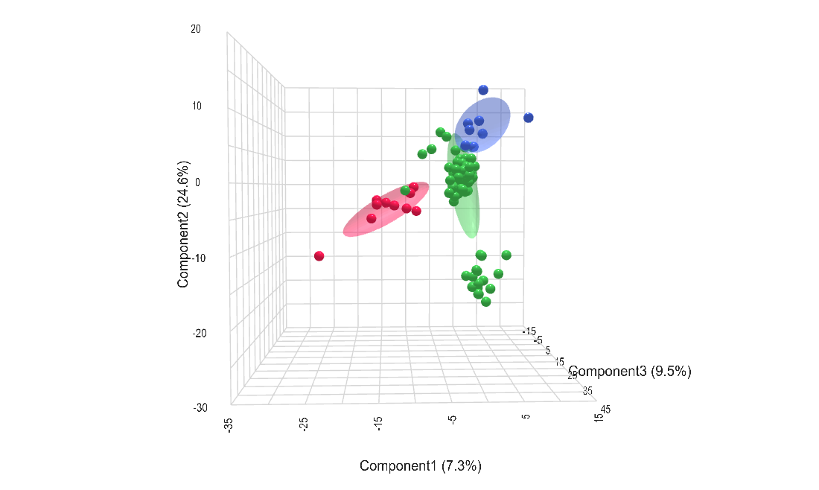
Figure 2.1 3D PLS-DA of volatile chemical profiles from gauze samples exposed to deceased individuals (red), living subjects (blue), and environmental blanks (green). Ellipses represent 95% confidence intervals for each group. Axes represent the first three PLS-DA components, which explain 7.3%, 24.6%, and 9.5% of the total variance, respectively.

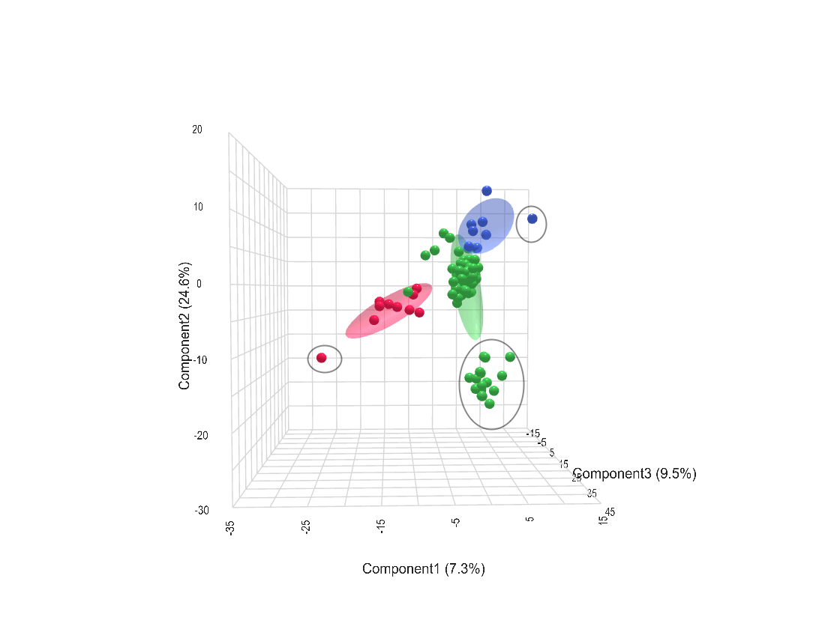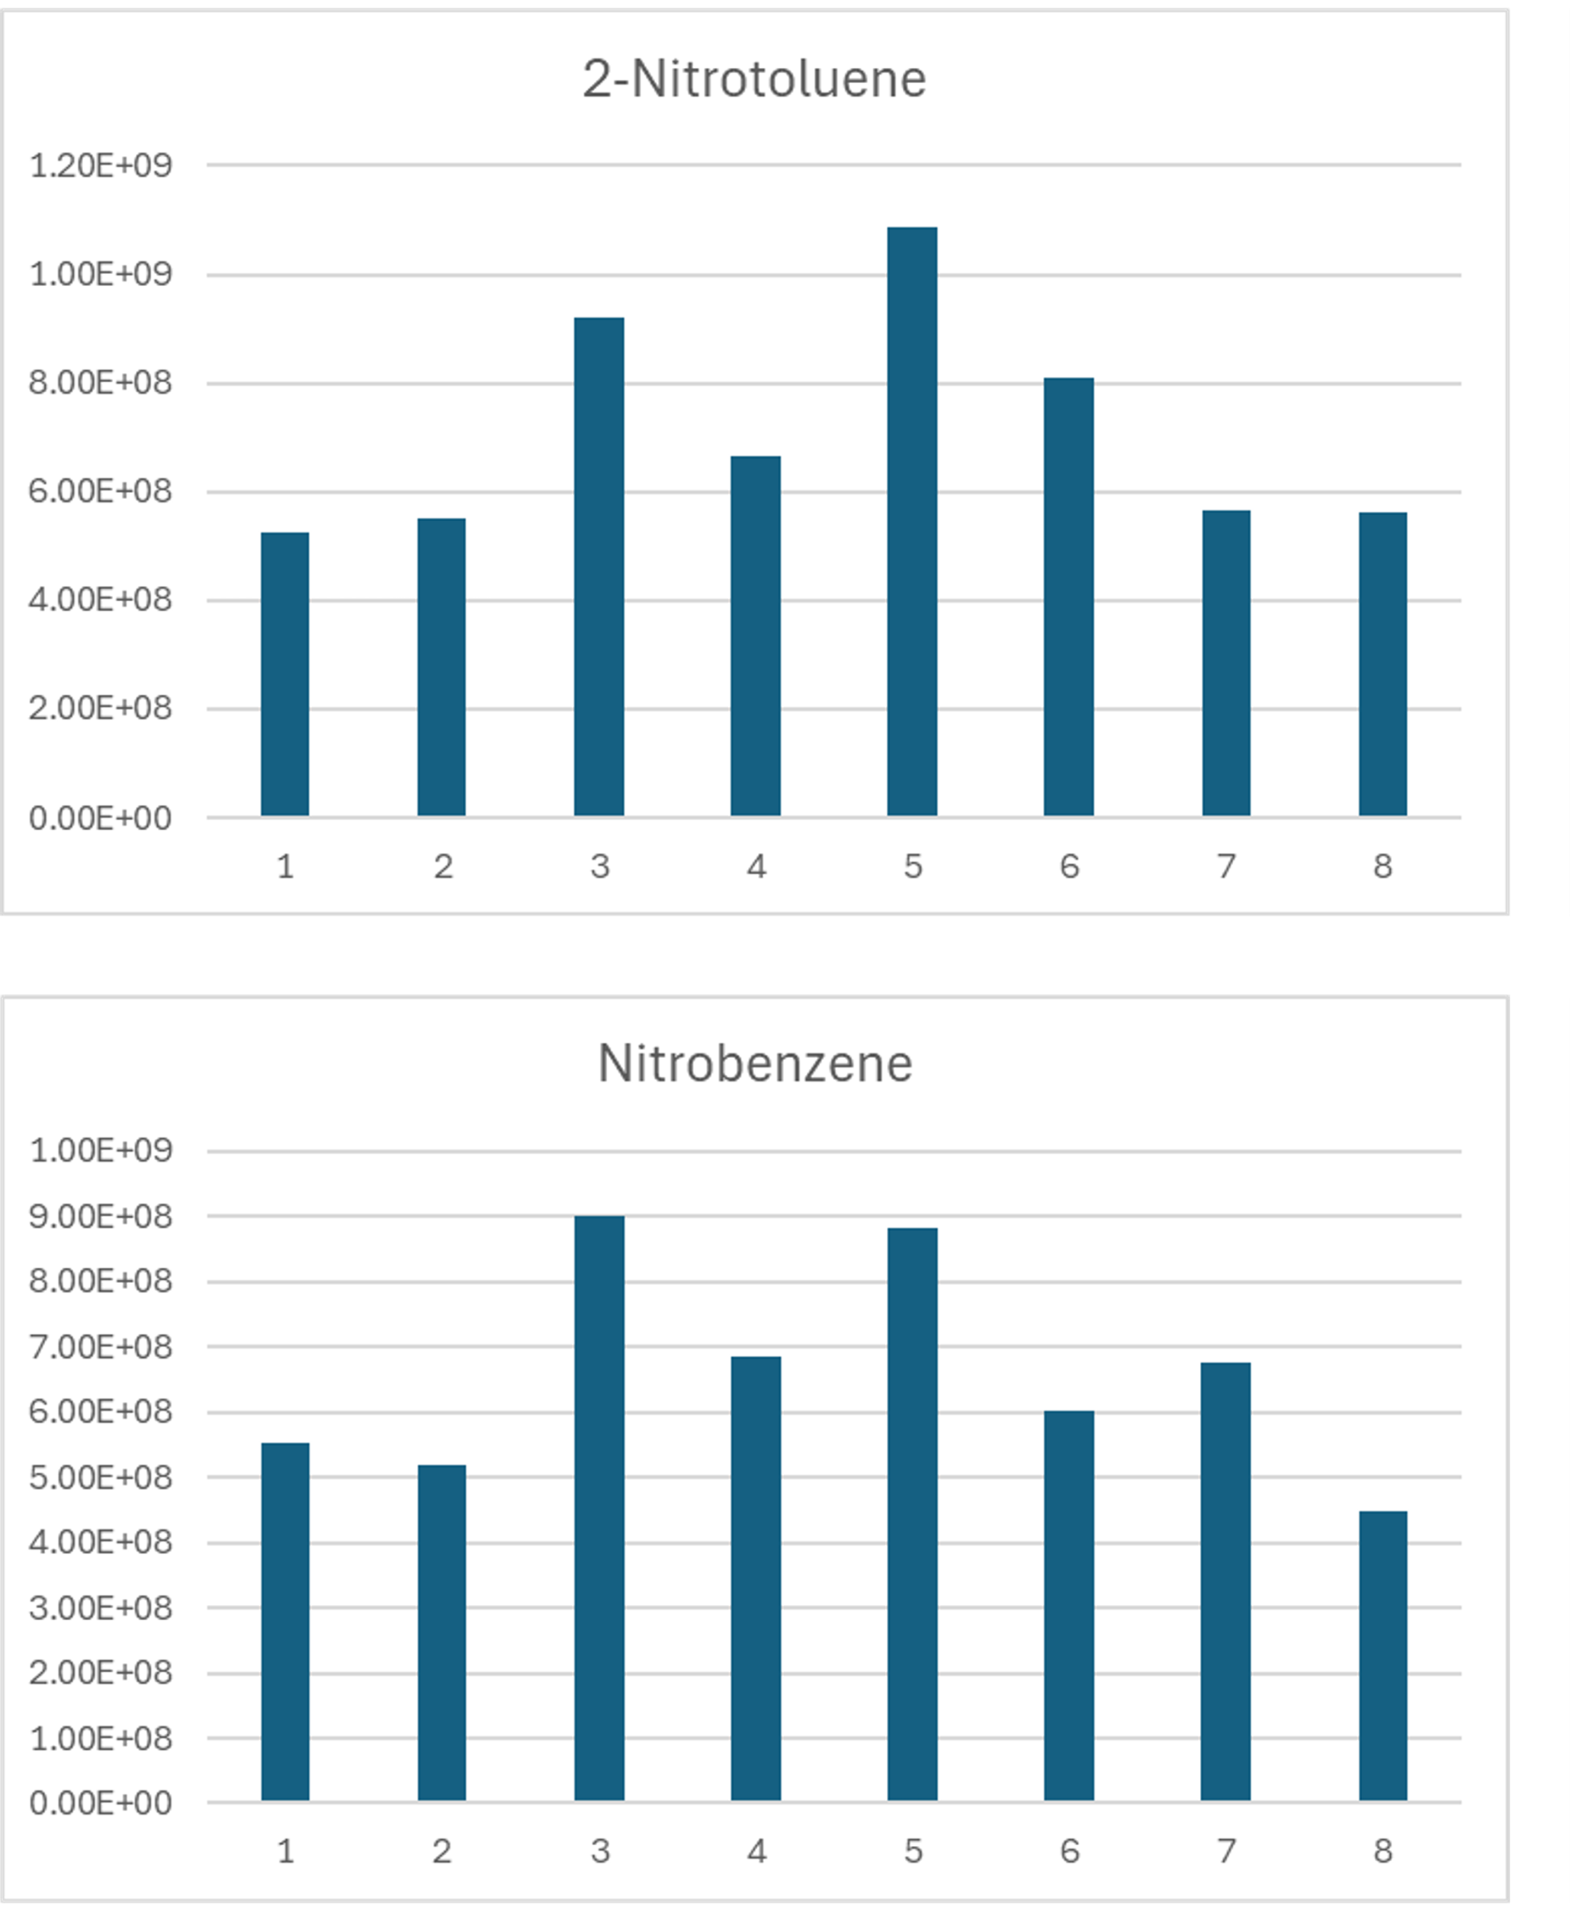
Figure 2.2 (A) 3D PLS-DA plot with Trial 2 samples circled in black, showing consistent offset across all exposure groups. (B) Intensity of external standards (2-nitrotoluene and nitrobenzene) across GC-MS batches. Together, these results support the conclusion that Trial 2 variation reflects biological or procedural noise rather than instrumental drift.

2.4.3 Assessing Potential Odor Transfer (“Creep”)
Handlers raised concerns about the possibility of odor “creep,” where target odor might linger on the testing line due to canine movement between paint cans. To assess whether this type of transfer contributed to chemical or alert differences, its impact was evaluated directly. Blank samples were categorized based on their proximity to target or distractor samples: those placed directly adjacent to an active sample were labeled as “near,” while those placed at least one position away were labeled as “far”. This comparison was used to evaluate whether spatial proximity contributed to unintentional odor transfer. Only two features met the threshold for statistical significance after FDR correction (adjusted p < 0.1), and both exhibited modest fold changes (log₂FC = 1.1314 and -1.4267), indicating that odor “creep” did not meaningfully influence sample composition and confirming the integrity of the blank controls (Figure 2.3).

2.4.4 VOC Features Characterizing Decomposition Exposure
Control samples were included in this analysis by grouping target and distractor controls with their respective experimental groups, as preliminary PCA and PLS-DA showed no significant differences between control and ORT-exposed samples (permutation p = 1.0).
To further examine which features were consistently associated with decomposition, a two-way analysis of variance (ANOVA) was performed to assess the influence of both sample type (deceased vs. distractor/blank) and trial number. Using a Bonferroni step-down correction (Holm) with a significance threshold of adjusted p < 0.05, two-way ANOVA identified 10 features significantly influenced by sample class (Target vs. Distractor/Blank), independent of trial. An additional 48 features showed significant effects of both class and trial, while no features exhibited class-by-trial interaction effects (Figure 2.4). Among these, several features exhibited consistently greater signal intensity in the deceased group across all trials.
A total of 10 features were significantly associated with exposure class (Target vs. Distractor/Blank), independent of trial effects or class-by-trial interactions (adjusted p < 0.05, Bonferroni step-down). High resolution m/z values were submitted to the Seven Golden Rules algorithm to generate predicted molecular formulas, and 7 of the 10 features were successfully annotated (Table 2-1). All classifications remain tentative given the absence of MS/MS fragmentation data or authentic standards and are intended to support class-level interpretation rather than definitive compound identification.
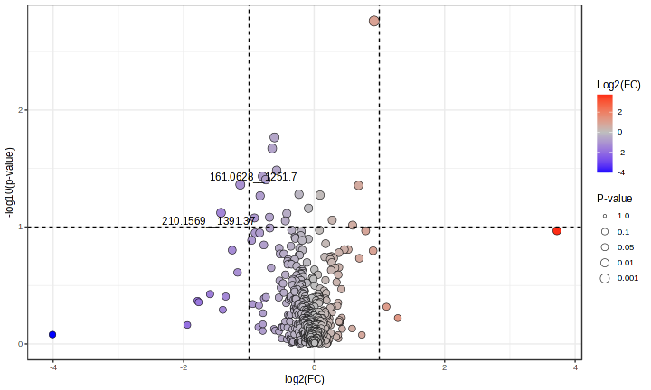
Figure 2.3 Volcano plot comparing volatile features between blank samples placed near vs. far from odor sources during recognition tests.
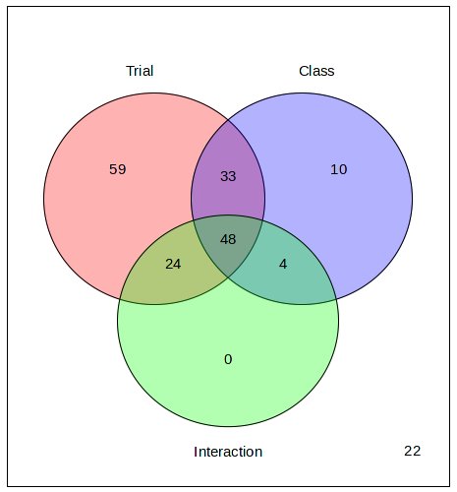
Figure 2.4 Two-way ANOVA results evaluating the effects of trial and exposure to deceased human odor on VOC profiles. Ten features were significantly associated with decomposition regardless of trial, while 48 others showed significant effects of both class and trial.

Table 2-1 Predicted molecular formulas and putative compound classifications for the 10 spectral features significantly influenced by exposure to deceased individuals.
m/z | Retention Time (s) | Molecular Formula (Predicted) | Tentative Compound Class
109.0319 | 678.58 | C3H9O2S | Thiol or thioether
123.0473 | 162.14 | C4H11O2S | Thiol or thioether
137.0629 | 678.84 | C5H13O2S | Thiol or thioether
137.096 | 1319.81 | C9H13O | Oxygenated aromatic
158.0726 | 1330.83 | C9H8N3 | Heterocyclic compound
165.0398 | 421.16 | C5H8O6 | Uncharacterized Compound
183.0504 | 421.43 | C6H15O2S2 | Thiol or thioether
237.0792 | 587.56 | C9H17O5S | Sulfonated ester
97.0123 | 501.04 | - | Unannotated
105.0684 | 442.1 | - | Unannotated

Since no MS/MS data were available, compound classification was based entirely on predicted molecular formulas using a chemically informed framework. This approach relied on evaluating elemental composition, degree of unsaturation, and general structural plausibility. Initial screening included calculating elemental ratios such as oxygen-to-carbon (O/C) and hydrogen-to-carbon (H/C), which help estimate polarity and saturation. High O/C ratios typically indicate polar compounds containing functional groups like hydroxyls, carbonyls, or carboxylic acids.²⁷ The H/C ratio provides additional context for identifying saturated versus unsaturated molecules. Double bond equivalents (DBE) were then calculated to estimate the number of rings or double bonds in each structure. Compounds with low DBE values (0–1) are generally aliphatic, while DBE values of 4 or more often suggest aromaticity or other unsaturated ring systems.⁹¹ Sulfur-containing compounds with low DBE values are commonly classified as thiols or thioethers, whereas those with high oxygen content may indicate sulfonated esters or sulfoalcohols. Nitrogen-containing formulas with moderate to high DBE values often correspond to heterocyclic structures. Formulas with no nitrogen or sulfur but elevated DBE values are frequently associated with oxygenated aromatics.

2.5 Discussion

2.5.1 Distinction Between Residual and Living Odor
This study provides empirical evidence that residual odor can be chemically differentiated from environmental blanks. More importantly, this residual odor is distinct from the odor left behind by living individuals. This reinforces that the chemical features associated with death are not simply variations of normal human scent but are compositionally distinct.^{92, 93}
While the chemical analysis revealed clear differences between deceased and living residual odor, canine performance during the odor recognition tests was inconsistent. Most dog teams did not reliably alert to the gauze exposed to deceased individuals, despite the presence of compositionally distinct volatile profiles. Given that dogs have been shown to detect certain volatile compounds at concentrations as low as 1.1–1.9 parts per trillion in real-world tasks, this inconsistency is unlikely to reflect a limitation in olfactory sensitivity.⁹⁴ Instead, it points to a training discrepancy, suggesting that residual odor may fall outside the range of odor profiles that canines are routinely conditioned to detect. These findings highlight the need to incorporate residual odor scenarios into HRD canine training and certification protocols, particularly given the forensic importance of detections in the absence of visible remains.

2.5.2 Experimental Validity and Trial Effects
Although Trial 2 samples showed a slight but consistent offset across all groups, external standard performance remained stable (Figure 2.2 B). This suggested the variation was likely due to minor handling differences or biological variability rather than instrumental drift. Concerns about odor “creep” from adjacent cans were also evaluated by comparing blank samples based on proximity to odor sources. Only two features differed slightly between near and far blanks (Figure 2.3). This indicated that cross-sample transfer of volatile compounds was minimal. These results support the integrity of the experimental setup and reinforce that observed chemical differences reflect true group-level variation.

2.5.3 Core Features Associated with Decomposition
To isolate chemical features consistently influenced by exposure to deceased individuals, a two-way analysis of variance (ANOVA) was performed using sample class (target vs. distractor/blank), trial, and their interaction as independent factors. This approach was used to separate class-driven variation from batch-related noise and to determine whether any features showed stable, reproducible group differences across experimental runs. A total of 178 features met the significance threshold after Bonferroni step-down correction (adjusted p < 0.05) for at least one factor. Among these, 10 features were significantly associated with exposure class alone, meaning their intensities differed between deceased and living samples in a consistent manner across all trials, without being influenced by trial effects or class-by-trial interaction.
These features were not necessarily exclusive to the deceased samples, but their intensity patterns were consistently and significantly different in the deceased group, suggesting a strong association with postmortem volatile profiles. An additional 48 features showed effects of both class and trial, indicating possible sensitivity to experimental conditions while still reflecting group-level differences. No features exhibited a significant interaction between class and trial, supporting the reproducibility of decomposition-related chemical variation across trials. As visualized in Figure 2.4 his analysis highlights a subset of features whose intensity is strongly influenced by exposure to deceased individuals and minimally affected by procedural variability. These results provide statistical evidence for consistent chemical differences linked to postmortem odor and offer a targeted set of features for further classification and validation.
Previous studies of decomposition odor have documented a wide range of volatile organic compounds emitted during the breakdown of soft tissue, including aldehydes, ketones, sulfides, short-chain fatty acids, and nitrogenous compounds.⁸⁵ These studies, often conducted using sorbent tubes, swabs, or soil sampling near advanced decomposition stages, have demonstrated that decomposition produces a complex and dynamic volatilome influenced by microbial activity, substrate interactions, and environmental conditions.⁹⁵ Additionally, VOC profiles have been shown to vary significantly depending on the biological matrix and sampling method, reinforcing the importance of standardized substrates in volatilome analysis.⁹⁶ The current study adds to this body of work by identifying a specific subset of features that are statistically associated with exposure to deceased individuals and remain stable across donors and trials. Importantly, these features were detected in passive gauze samples exposed to recently deceased individuals prior to active decomposition, highlighting a potential early-phase odor profile that has received limited attention in the literature.

2.5.4 Analytical and Methodological Strengths
This study used headspace SPME GC–MS, unlike many prior analyses that relied on sorbent tubes or tissue sampling. The Orbitrap’s high mass accuracy, full-scan capability, and strong resolving power reduce spectral overlap and improve compound differentiation in complex VOC mixtures, making it well suited for untargeted volatile analysis in forensic and environmental contexts.⁹⁷ The use of a standardized, clean substrate (washed medical gauze) further minimized environmental noise and allowed for clearer differentiation between exposure types. Together, these methodological refinements enabled detection of early-stage decomposition signals that may otherwise be obscured using more complex or contaminated substrates. These findings are particularly relevant in forensic contexts where residual odor may be the only remaining trace of human presence.

2.5.5 Limitations and Forensic Implications
Tentative classification of the 10 features most strongly associated with postmortem groups revealed that several belonged to chemical classes plausibly linked to decomposition processes. These included volatile organosulfur compounds, phenolic derivatives, nitrogen-containing heterocycles, and short- to medium-chain fatty acid-like structures. Organosulfur volatiles, such as thiols and sulfonated alcohols, are consistent with microbial degradation of sulfur-containing amino acids like cysteine and methionine.^{84, 95} Phenolic compounds such as cresols are also well-documented in decomposition and reflect protein catabolism and microbial transformation.^{98, 99} Additionally, multiple fatty acid-like compounds were detected, consistent with lipid breakdown or microbial fermentation.^{92, 100}
These classifications were derived based on predicted molecular formulas generated by Seven Golden Rules and interpreted through manual literature searches of known decomposition-related volatiles.²⁷ No fragmentation data or authentic standards were available, and thus the assignments remain putative. However, the recurrence of biologically plausible classes across multiple features strengthens the interpretation that these compounds reflect underlying biochemical processes specific to decomposition, rather than random environmental or handling artifacts.
While this study demonstrates the utility of untargeted high-resolution metabolomics for chemically characterizing residual human odor, several limitations remain. Compound classifications were made at the molecular formula and chemical class level, without confirmation by authentic standards or MS/MS fragmentation, and therefore remain putative. Additionally, how long these volatiles remains unknown; future work should explore how these profiles change over time and under different environmental conditions. Expanding the scope of materials, substrate types, and decomposition contexts will also be essential for establishing reproducible chemical baselines.
Despite these limitations, this study provides one of the first chemical validations for residual odor linked to human decomposition. The ability to distinguish trace-level volatile features from both environmental blanks and living human scent reinforces the credibility of canine alerts in forensic searches. As analytical techniques continue to improve, integrating chemical profiles into HRD dog training and validation protocols could enhance both reliability and legal defensibility in real-world applications.

2.6 Conclusion
This study provides empirical evidence that target residual odor can be chemically differentiated from both environmental blanks and the VOC profiles of living individuals. Using untargeted high-resolution GC-MS, a subset of statistically significant features was identified and putatively classified into compound classes consistent with known decomposition processes. These results offer chemical validation for the existence of residual human odor detectable by HRD canines, supporting their continued forensic utility. This evidence also points to a potential role for chemical analysis in informing canine training and validation practices, and it underscores the importance of future research to further characterize residual odor across varied conditions. Although canine alerts to residual odor were inconsistent in this study, the presence of distinct chemical profiles suggests that performance variability is more likely due to training limitations than to a lack of olfactory sensitivity.

SPECIFIC BACTERIAL TAXA AND THEIR METABOLITE, DHPS, MAY BE LINKED TO GUT DYSHOMEOSTASIS IN PATIENTS WITH ALZHEIMER’S DISEASE, PARKINSON’S DISEASE, AND AMYOTROPHIC LATERAL SCLEROSIS

This chapter was adapted from a previous publication.
Authors:
Courtney Jayde Christopher, Katherine Hope Morgan, Christopher Mahone Tolleson, Randall Trudell, Roberto Fernandez-Romero, Lexis Rice, Blessing A. Abiodun, Zane Vickery, Katarina A. Jones, Brittni Morgan Woodall, Christopher Nagy, Piotr Andrzej Mieczkowski, Gregory Bowen, Shawn R. Campagna, and Joseph Christopher Ellis
Author contributions:

3.1 Abstract
Neurodegenerative diseases (NDDs) are multifactorial disorders frequently associated with gut dysbiosis, oxidative stress, and inflammation; however, the pathophysiological mechanisms remain poorly understood. We investigated bacterial and metabolic dyshomeostasis in the gut microbiome associated with early disease stages across three NDDs—amyotrophic lateral sclerosis (ALS), Alzheimer’s disease (AD), Parkinson’s disease (PD)—and healthy controls (HC) and discovered a previously unrecognized link between a microbial-derived metabolite with an unknown role in human physiology, 2,3-dihydroxypropane-1-sulfonate (DHPS), and gut dysbiosis in NDDs. DHPS was downregulated in AD, ALS, and PD, while bacteria involved in DHPS metabolism, Eubacterium and Desulfovibrio, were increased in all disease cohorts. Additionally, select taxa within the Clostridia class had strong negative correlations to DHPS, suggesting a potential role in DHPS metabolism. A catabolic product of DHPS is hydrogen sulfide, and when in excess, it is known to promote inflammation, oxidative stress, mitochondrial damage, and gut dysbiosis, known hallmarks of NDDs. These findings suggest that cryptic sulfur metabolism via DHPS is a potential missing link in our current understanding of gut dysbiosis associated with NDD onset and progression. As this was a hypothesis generating study, more work is needed to elucidate the role of DHPS in gut dysbiosis and neurodegenerative diseases.

3.2 Introduction
Neurodegenerative diseases (NDDs) such as Alzheimer’s disease (AD), amyotrophic lateral sclerosis (ALS), and Parkinson’s disease (PD) are among the leading causes of disability and death worldwide, with devastating personal and societal consequences.^{101, 102} In the U.S., the economic burden of these diseases exceeds USD 400 billion annually.¹⁰³⁻¹⁰⁵ Despite decades of research, the cause of NDD, broadly, and of ALS, AD, PD, specifically, remains poorly understood.
In humans and in animal models, AD, ALS, and PD are associated with irregularities in the gut microbiome and its metabolic byproducts (the metabolome), compared to healthy controls (HCs). ¹⁰⁶⁻¹¹⁹ Imbalances in the gut microbiome and metabolome can be greatly influenced by extrinsic epigenetic factors (e.g., chemical exposure).¹²⁰ The human gut harbors millions of microbes whose community composition and metabolic byproducts influence human health and may play a significant role in mediating the onset or progression of neurodegenerative diseases (NDDs). ¹²¹⁻¹²⁴ including inflammatory responses in the body and the brain.¹²⁵ Recent studies have begun comparing gut (fecal) metabolomic profiles across these three diseases.¹²⁶ Of particular interest in the present study was the identification of metabolites produced solely by gut microbiota, and not by the human host, called microbial-derived metabolites. We sought to identify microbial-derived metabolites shared by AD, ALS, and PD, with the potential to identify a common pathway that influences neurodegeneration. These metabolites may offer insight into microbiome–brain interactions, inform biomarker discovery for earlier diagnosis, and help identify targets for intervention in disease-related metabolic pathways.
In untargeted metabolomics, a substantial proportion of detected features remain unidentified due to limitations in spectral databases, insufficient structural information, and the vast chemical diversity of biological samples. This uncharacterized space, often referred to as the “dark metabolome”, represents a major frontier in systems biology and analytical chemistry.^{2, 3} The dark metabolome includes unknown or novel compounds, metabolites without available standards, or molecular features with ambiguous elemental formulas. Despite the lack of full identification, these unknowns often display consistent, biologically relevant patterns across experimental groups and can be used in classification models, statistical testing, and exploratory pathway analysis.^{127, 128} Increasingly, researchers are recognizing that excluding unidentified features can obscure important biological insights, particularly in complex diseases like those involving host–microbiome interactions.^{129, 130} In this study, we incorporated both identified and unidentified spectral features into our analysis to maximize biological signal capture and to better understand the metabolic disruptions associated with AD, ALS, and PD.

3.2.1 Microbial and Metabolic Dysbiosis Associated with NDDs

3.2.1.1 Alzheimer’s Disease
Alzheimer’s disease (AD) is a progressive neurodegenerative disorder characterized by extracellular deposition of amyloid-beta 42 (Aβ-42) and intraneuronal aggregation of hyperphosphorylated tau (p-tau).^{131, 132} These pathologies are believed to occur early in disease progression and may be modulated by genetic factors, neuroinflammation, and synaptic dysfunction, eventually leading to widespread neurodegeneration and cognitive decline.¹³³⁻¹³⁵
In animal models, significant gut metabolomic differences have been observed between AD and healthy controls (HC).¹³⁶⁻¹³⁸ and fecal microbiota transplantation (FMT) from healthy donors has reduced AD pathology.¹³⁹ In humans, the AD gut microbiome differs significantly from controls, with altered abundances of Actinobacteria, Bacteroidetes, Firmicutes, Proteobacteria, and Verrucomicrobia.¹⁴⁰⁻¹⁴⁷ These changes often involve increased pro-inflammatory and decreased anti-inflammatory taxa.¹⁴⁸ AD has also been associated with metabolomic alterations in short-chain fatty acids (SCFAs), tryptophan metabolites, and lithocholic acid, as well as broader shifts in organic acids, lipid metabolism, steroid biosynthesis, and piperidine pathways.^{115, 149} Volatile organic compound (VOC) profiles vary by AD progression, further distinguishing gut chemistry from that of HCs.¹¹⁴

3.2.1.2 Amyotrophic Lateral Sclerosis
Amyotrophic lateral sclerosis (ALS) is a motor neuron disease involving degeneration of upper and lower motor neurons, leading to progressive muscle weakness, spasticity, and impaired bulbar function. The ALS gut microbiome shows increased Bacteroidetes and decreased Firmicutes, including reduced Megamonas abundance.¹¹⁷ These shifts are accompanied by disruptions in metabolic pathways relative to controls. Bacteroidetes and Escherichia have been implicated in multiple studies as potentially contributing to ALS pathology.¹²⁶ Fewer studies have examined the fecal metabolome of ALS, but several suggest disease-related changes. For example, altered bile acid profiles have been reported in ALS patients with cognitive impairment, and other studies found associations with metabolites such as propanoic acid, 3,7-dihydroxy-12-oxochenoic acid, coproporphyrinogen I, and 4-hydroxybenzoylcholine, along with reductions in acylcarnitine.^{116, 117} In the first case study of a female ALS patient who underwent washed microbial transplants, researchers measured improvements in ALS symptomology over 11 months, concurrent with changes in the microbiome and metabolomics.¹⁵⁰

3.2.1.3 Parkinson’s Disease
Parkinson’s disease (PD) is clinically diagnosed by characteristic motor symptoms (e.g., bradykinesia, resting tremor, rigidity), and pathologically by loss of dopaminergic neurons in the substantia nigra pars compacta and the presence of α-synuclein-rich Lewy bodies.¹⁵¹⁻¹⁵⁴ While the etiology is multifactorial, inflammation and gut dysbiosis are increasingly recognized as contributing factors.^{152, 155} Multiple studies report significant alterations in the PD gut microbiome compared to controls.¹⁵⁶ For instance, PD patients on dopaminergic treatment exhibit reduced taxa linked to anti-inflammatory or neuroprotective metabolites, along with altered levels of lipids, vitamins, and amino acids.¹¹⁰ Taxonomic shifts in PD include increased Actinobacteria, Proteobacteria, and Verrucomicrobia, with decreases in Bacteroidetes and Cyanobacteria.¹¹⁰ PD is also marked by a dominance of pathogenic Proteobacteria like Enterobacteriaceae and loss of Firmicutes and Bacteroidetes, correlating with inflammation. Fecal metabolomics in PD has shown substantial differences, some of which correlate with clinical phenotypes and gut inflammatory markers.^{106, 108-112, 119, 157}

3.2.2 Gut Imbalances, Inflammation, Oxidative Stress, and Mitochondrial Dysfunction
The gut maintains constant communication with the rest of the body, and imbalances in the metabolome can contribute to systemic inflammation, oxidative stress, and mitochondrial dysfunction—key mechanisms implicated in the pathology of NDDs.^{158, 159} One relevant example is hydrogen sulfide (H₂S), a metabolite involved in sulfur metabolism with important physiological roles.¹⁶⁰ In the human gut, H₂S is primarily produced by microbial genera such as Desulfovibrio and Bilophila.¹⁶¹⁻¹⁶³. However, excessive endogenous H₂S has been linked to inflammation, oxidative stress, mitochondrial damage, and gut dysbiosis.^{162, 164-168} Dyshomeostasis in sulfur metabolism has been well documented in PD, and excess H₂S has also been implicated in AD pathology.^{107, 169-171} As a result, the microbial regulation of oxidized sulfur compounds is gaining attention in health and disease contexts.^{160, 172}
The objective of this study was to identify microbial and metabolic signatures in the human gut associated with three NDDs (AD, ALS, PD) and healthy controls using 16S rRNA sequencing and untargeted metabolomics in a cross-sectional cohort. To capture early-stage alterations, we enrolled patients in the earlier phases of their respective diagnoses. Our aim was to uncover shared disruptions in microbial communities and metabolomic profiles that may serve as early biomarkers or targets for intervention.

3.3 Materials and Methods

3.3.1 Ethics Statement
This study was approved by the institutional review board (IRB) of the University of Tennessee Health Science Center for the protection of human subjects (IRB#4535).

3.3.2 Study Population
Participants were recruited during their first or second visit to a movement disorder specialist for ALS, AD, or PD who were living in the 21-county regional service area of the University of Tennessee Medical Center, in Knoxville, Tennessee. Participation was voluntary, and only those who were willing and able to complete the study activities (with a caregiver if needed) were included. Participants were excluded if they had received antibiotic or systemic antifungal medications in the previous six months or had a history of bowel cancer or bowel disease. Further inclusion criteria for each cohort were as follows: (1) For AD: 65 years of age or older, met all clinical criteria for mild-to-moderate AD according to the National Institute on Aging-Alzheimer’s Association criteria, were otherwise in good health based on medical history and clinical examination; (2) ALS: age of 30 years or older at enrollment, and met the El Escorial Criteria for definite, probable, or possible ALS; (3) PD: aged 50 to 85 years at enrollment, diagnosed within the last 5 years, absence of PD medications with the exception of MAO-B inhibitors, absence of dyskinesia or motor fluctuations, modified Hoehn and Yahr Stage <2.5 (symptoms ranging from unilateral involvement only [Stage 1] to mild bilateral involvement with recovery on a pull test [Stage 2.5]); and (4) HC: aged 30 or older, who were age matched (±4 years) and sex-matched, and in good health based on medical history and clinical examination. ¹⁷³ ^{174, 175} HC aged 65 years or older completed the Neuropsychological Battery from the National Alzheimer’s Coordinating Center prior to enrollment to demonstrate normal cognition.¹⁷⁶
This study took place in South Central Appalachia in East Tennessee of the United States. On 33 out of 41 health indicators, performance in the rural Appalachian Region is worse than the national performance, including seven of 10 leading causes of death (heart disease, cancer, chronic obstructive pulmonary disease, injury, stroke, diabetes, and suicide).¹⁷⁷ Mortality rates are higher than the national rates in Appalachia, yet there have been few studies conducted in Appalachia. This study offers data and provides insight from an underrepresented and unique region of the USA.

3.3.3 Subjects Were in Early Diagnostic Stages
Participants were recruited early in disease progression (See Table 3-1 for additional demographics) at neurology clinics of the University of Tennessee Medical Center in Knoxville, Tennessee. Participants were non-Hispanic Caucasians (100%). None of the participants had taken antibiotic or systemic antifungal medications in the previous six months. None had a history of bowel cancer or bowel disease. Healthy controls > 65 years of age demonstrated normal cognition without signs of dementia on cognitive tests. The ALS and PD cohorts were not tested for normal cognition. From summer 2021 to spring 2022, 48 participants enrolled, and 45 completed the study. Of these, 40 submitted stool samples (AD = 5, ALS = 11, PD = 13, and HC = 11).
Table 3-1 Demographics of study participants.
 | ALS | AD | PD | HC
Number | 11 | 5 | 13 | 11
Age in years mean (range) | 72.5 (71–74) | 64.5 (43–77) | 65.5 (51–80) | 66.1 (45–87)
Female | 4 | 3 | 9 | 8
Male | 8 | 2 | 4 | 6
BMI mean (range) | 25.4 (17.7–28.8) | 27.7 (19.2–37.8) | 28.3 (22.4–39.5) | 30.1(20–58.4)
Taking medications for NDD | 69% | 100% | 7% | 0
Months from symptom onset: average (range) | 27.2 (6–82) | 35.7 (30–117) | 31.6 (15–57)
Months from diagnosis: average (range) | 16.9 (1–64) | 18.3 (9–68) | 3 (0–20)
MoCA score (average) |  | 19.8 |  | 26.5
Clinical Dementia Rating Scale raw (average) |  | 2.75 |  | 0
Clinical Dementia Rating Scale global (average) |  | 0.42 |  | 0
ALS bulbar | 23%
ALS spinal | 77%
UPDRS-part I (average) |  |  | 6.9
UPDRS-part II (average) |  |  | 6.7
UPDRS-part III (average) |  |  | 33.9
UPDRS-part IV (average) |  |  | 0

Table 3-1 Continued
UPDRS gastrointestinal symptoms (average) |  |  | 0.23
Hoehn and Yahr |  |  | 2.0
ALS = amyotrophic lateral sclerosis, AD = Alzheimer’s disease, and PD = Parkinson’s disease; MoCA = Montreal Cognitive Assessment, where 18–25 = mild cognitive impairment, 10–17 = moderate, and <10 = severe cognitive impairment; NDD = neurodegenerative disease; UPDRS = Unified Parkinson’s Disease Rating Scale. The Clinical Dementia Rating Scale Global tracks a patient’s level of impairment/dementia, where 0 = normal, 0.5 = very mild dementia, 1 = mild dementia, 2 = moderate dementia, and 3 = severe dementia.

3.3.4 Sample Collection, Preservation, DNA Extraction
Samples were collected at home by participants within one week of enrollment. Participants were instructed to place stool from the same specimen into two vials as follows: (1) the DNA Genotek® gut microbiome DNA collection kit (DNA Genotek, Stittsville, ON, USA) and (2) a 50-mL sterile tube, which was immediately frozen at home at −20 °C. Stool samples were delivered frozen on ice by same-day courier service, to the University of Tennessee College of Nursing’s biobehavioral laboratory for nucleic acid extraction. Samples were stored at −80 °C.
From the DNA Genotek® kits, DNA extraction was conducted in batches, using Zymo’s Quick-DNA Fecal/soil Microbe Kit (Zymo Research, Irvine, CA, USA). Extractions were frozen at −80 °C, then shipped on dry ice to the University of North Carolina (UNC) Chapel Hill High Throughput Sequencing Facility (HTSF) for 16s rRNA/DNA sequencing.
From the 50-mL sterile tubes, approximately 50 mg of stool was aliquoted to sterile tubes, kept frozen at −80 °C, then transferred to the Biological and Small Molecule Mass spectrometry Core at the University of Tennessee Knoxville (BSMMSC) for metabolomics extractions and analysis.

3.3.5 Metabolite Extractions
All samples were extracted and analyzed at the BSMMSC at the University of Tennessee Knoxville (RRID: SCR_021368). Stool samples were kept at 4 °C, pre-weighed, and homogenized. The exact mass of stool used for sample was recorded and used for normalization. Roughly 50 mg of stool was aliquoted, and water-soluble metabolites were extracted using an acidic acetonitrile extraction procedure adapted from Rabinowitz and Kimball, using 1.5 mL of 4:4:2 acetonitrile–methanol–water with 0.1 M formic acid.^{178, 179} All solvents were HPLC grade. The supernatant collected from each sample was dried under nitrogen, then 300 µL of LC-MS grade water was added to each sample before mass spectral analysis.

3.3.6 UHPLC-HRMS
A previously described ultra-high performance liquid chromatography high resolution mass spectrometry (UHPLC-HRMS) method was used for untargeted metabolomics analysis, using an UltiMate 3000 RS autosampler (Dionex, Sunnyvale, CA, USA), Synergi 2.6 µm Hydro RP column (100 mm × 2.1 mm, 100 Å; Phenomenex, Torrance, CA, USA), an UltiMate 3000 pump (Dionex), and Exactive Plus Orbitrap mass spectrometer (Thermo Fisher Scientific, Waltham, MA, USA).¹⁸⁰ A previously described 25 min gradient elution, reverse phase ion-paring method with a water–methanol solvent system, and a tributylamine ion pairing reagent was used for chromatographic separation.¹⁸¹ Metabolites were ionized via negative mode electrospray ionization (ESI) prior to full scan mass spectral analysis as previously described.¹⁸⁰

3.3.7 Metabolomics Data Processing - Knowns
Raw mass spectral files were converted to mzML files using a package from ProteoWizard, msConverter.¹⁸² All mzML files were imported into an open-source software, metabolomics analysis, and visualization engine (El-MAVEN), where metabolites were manually identified using an in-house library based on exact mass ($±$5 ppm) and retention time ($±$2 min).^{179, 183, 184} Metabolite peaks were integrated and raw peak intensities for identified metabolites were exported from El-MAVEN to a csv file. Prior to statistical analysis, raw spectral data were normalized by mass of sample used for extraction.

3.3.8 Unidentified Spectral Features
Raw spectral files were converted to mzML format using the msConvert package from ProteoWizard and then each mzML was zipped individually.²¹ Zipped mzML were uploaded to MetaboAnalyst 5.0.^{24, 25} Within the Spectra Processing tab, the parameters were as follows. UPLC-Orbitrap was selected for the platform. Peak picking used the centWave-auto algorithm with a minFraction of 0.8 for peak alignment in negative mode. Also, contaminant removal was allowed from the chromatogram. The data was deisotoped and deadducted and input into a csv for further statistical analysis.

3.3.9 Statistical Analysis
Normalized data were imported into MetaboAnalyst 5.0, where they were filtered using the interquartile range (IQR), log-transformed, and Pareto scaled.¹⁸⁵⁻¹⁸⁷ Partial least squares discriminant analysis (PLS-DA) was used to examine how metabolic profiles differed across neurological disease groups. To account for increased complexity, a third component was included to visualize separation in a 3D PLS-DA. Variable importance in projection (VIP) scores were calculated to assess each metabolite’s contribution to group separation, with VIP > 1 considered significant. Venn diagrams were constructed from metabolites with VIP > 1 across pairwise comparisons, and volcano plots were generated to visualize features with significant fold-changes and p-values between groups. For further chemical characterization, molecular formulas were assigned using the Seven Golden Rules software based on raw data exported from MetaboAnalyst.^{24, 25, 27} The resulting formulas were saved to a CSV file and processed using a custom script in Python 3.9 to generate SMILES strings, available via GitHub.^{34, 188}

3.3.10 16s rRNA Sequencing
In this study, we implemented a detailed two-step protocol for 16S rRNA gene amplification prioritizing high precision and reproducibility across numerous samples.¹⁸⁹ The initial PCR reaction was meticulously configured, utilizing specific volumes of Kapa Enhancer, Kapa Buffer A (KAPA Robust 2G-Roche), forward and reverse Frame Shift Molecular Tags (FSMT) primers (Table 3-2), and other necessary components, culminating in a total reaction volume of 50 µL. The use of KAPA Robust 2G in the initial PCR reaction is necessary to prevent artifacts caused by non-specific extension from imperfectly annealed primers. The FSMT primers, comprising six frames for both 338F and 806R types, were carefully mixed. To streamline the handling of multiple samples, a ‘ready-mix’ comprising essential Kapa components was prepared. This strategy was instrumental in reducing batch effects, particularly when utilizing reagents from different Kapa kits. The ready-mix was then allocated into aliquots, each adequate for a 96-well plate. The first PCR cycle’s conditions were meticulously programmed to include specific durations and steps for denaturation, annealing, and extension, set at 95 °C for one minute, followed by 10 cycles of 95 °C for 15 s, 50 °C for 30 s, and 72 °C for 30 s, then 72 °C for one minute to complete extension for all molecules, and a final indefinite hold at 4 °C. Post-PCR, bead purification was performed to selectively exclude DNA fragments shorter than 300 bp, employing a 0.68:1 bead-to-DNA ratio. The second nested-PCR phase (indexing) followed a similar methodology but with modifications in the reaction components, such as the Kapa HiFi Readymix (KAPA HiFi -Roche, Basel, Switzerland) and specific Adaptor_primer1 and indexing primers. The cycling conditions for this phase were set at 95 °C for one minute, followed by 22 cycles of 95 °C for 15 s, 60 °C for 30 s, and 72 °C for 30 s, concluding with 75 °C for one minute and an indefinite hold at 4 °C. Finally, for 16S sequencing, we used a series of custom-designed primers, chosen for their specificity and amplification efficiency. Prepared libraries were pooled and sequenced on MiSeq Pair End 2 × 300 v2 flowcell (Table 3-2). We generated a minimum of 120,000 paired reads per sample for analysis.

3.3.11 16S Data Processing and Analysis
16S amplicon sequencing was performed using the moving pictures documentation in QIIME2.¹⁹⁰ Briefly, sequences were imported into QIIME2 (version 2023.2). Paired-end sequences were denoised with DADA2. Trimming values were set; p-trim-left was set to 20, p-trim-len was set to 220, and sampling depth was set at 120,000 sequences. Finally, an OTU table was produced for downstream analysis. Traditional microbial ecology analyses, such as alpha diversity and beta diversity, were also performed. In addition, taxonomic classification of the reads was performed in the QIIME2 using Silva 138 99%
Table 3-2 16s Primers and sequences.
Primer | Sequence
338F_f1_bc1 | TCCCTCGCGCCATCAGAGATGTGTATAAGAGACAGNNNNTGANNNNTCACTCCTACGGGAGGCAGCA
338F_f2_bc1 | CCCTCGCGCCATCAGAGATGTGTATAAGAGACAGNNNNTTGANNNNTCACTCCTACGGGAGGCAGCA
338F_f3_bc1 | TCCCTCGCGCCATCAGAGATGTGTATAAGAGACAGNNNNCTTGANNNNTCACTCCTACGGGAGGCAGCA
338F_f4_bc1 | TCCCTCGCGCCATCAGAGATGTGTATAAGAGACAGNNNNACTTGANNNNTCACTCCTACGGGAGGCAGCA
338F_f5_bc1 | TCCCTCGCGCCATCAGAGATGTGTATAAGAGACAGNNNNGACTTGANNNNTCACTCCTACGGGAGGCAGCA
338F_f6_bc1 | TCCCTCGCGCCATCAGAGATGTGTATAAGAGACAGNNNNTGACTTGANNNNTCACTCCTACGGGAGGCAGCA
JMPM_806R_C | GTGACTGGAGTTCAGACGTGTGCTCTTCCGATCTNNNNCTAGGACTACHVGGGTWTCTAAT
JMPM_806R_2T | GTGACTGGAGTTCAGACGTGTGCTCTTCCGATCTNNNNTCTAGGACTACHVGGGTWTCTAAT
JMPM_806R_2A | GTGACTGGAGTTCAGACGTGTGCTCTTCCGATCTNNNNATCTAGGACTACHVGGGTWTCTAAT
JMPM_806R_G | GTGACTGGAGTTCAGACGTGTGCTCTTCCGATCTNNNNGGACTACHVGGGTWTCTAAT
JMPM_806R_A | GTGACTGGAGTTCAGACGTGTGCTCTTCCGATCTNNNNAGGACTACHVGGGTWTCTAAT
JMPM_806R_T | GTGACTGGAGTTCAGACGTGTGCTCTTCCGATCTNNNNTAGGACTACHVGGGTWTCTAAT
Adaptor_prim1 | AATGATACGGCGACCACCGAGATCTACACGCCTCCCTCGCGCCATCAGAGATGTG
PCR Primer, Index X | CAAGCAGAAGACGGCATACGAGATXXXXXXGTGACTGGAGTTCAGACGTGTGCTC
NextF_Read1_seq | GCCTCCCTCGCGCCATCAGAGATGTGTATAAGAGACAG

OTUs full-length sequences.
Relative abundances from operational taxonomic units (OTUs) were analyzed on the phylum, class, order, family, and genus levels. QIIME taxonomy labels with corresponding abundances were uploaded to MicrobiomeAnalyst, and the data were scaled by total sum prior to statistical and meta-analysis of microbiome data.¹⁸⁷ Alpha diversity was accessed at the genus level by Chao, Shannon, and Simpson indexes, with the Mann–Whitney test used to determine if alpha diversity differed across cohorts. Stacked bar graphs were used to visualize OTU relative abundances across cohorts. Pairwise comparisons between cohorts were made using the statistical method EdgeR. OTU correlations were analyzed using either Pearson’s r or Spearman’s rho correlation coefficients.

3.4 Results

3.4.1 Global Metabolomics For Identified Features
Untargeted metabolomics was used to investigate functional alterations in the gut metabolome associated with NDDs. We identified 164 metabolites based on exact mass and retention time and evaluated metabolic profile differences between each NDD and HC using PLS-DA, which revealed that each NDD had a unique gut metabolic profile compared to HC (Figure 3.1a-c). To determine metabolites altered by NDD, metabolites from each pairwise comparison with a fold change > |1.5| (p < 0.1) or variable importance in projection (VIP) score > 1 were used for further analysis. These metabolites were also used to identify unique metabolic signatures for each NDD. This revealed 14, 20, and 9

Figure 3.1 Patients with NDDs have an altered gut metabolic profile. Partial least squares discriminant analysis (PLS-DA) comparing metabolomes associated with NDD and HC and corresponding variable importance in projection (VIP) scores. Individual participants are shown with respective confidence intervals; HC samples are yellow; (a). AD samples are blue; (b). ALS samples are shown in red; (c). PD samples are purple. VIP scores are shown for the corresponding PLS-DA models showing the top 25 metabolites contributing most to the differences in metabolic profiles.

unique markers for AD, ALS, and PD, respectively. Moreover, we identified 19 metabolic markers, which were consistently altered across all three NDDs in this study.

3.4.2 Alzheimer’s Disease
Based on the PLS-DA model between the AD and HC metabolomes, the overall metabolic profile of the gut in AD patients was distinctly different from HC, as seen by the clustering and separation of groups (Figure 3.1a). Metabolites with the highest VIP scores, contributing most to global metabolome differences, were uridine monophosphate (UMP) (2.8), inosine monophosphate (IMP) (2.5), and taurine (2.4). We observed that 29% of identified metabolites in the gut were altered by AD, and 14 of these metabolites were unique to AD. Notably, the primary catabolic product of vitamin B₆ (4-pyridoxate), S-ribosyl-L-homocysteine, 3-methylphenylacetic acid, and metabolites involved in fatty acid and energy metabolism (carnitine, hydroxylysine, FMN) were unique to AD. Metabolic profile differences in AD demonstrated altered sulfur metabolism, with downregulation of cysteine, taurine, methionine, homocysteine, and DHPS, while sulfur containing B vitamins, biotin and pyridoxine, were increased in the AD cohort compared to HC (Figures 3.2a).

3.4.3 Amyotrophic Lateral Sclerosis
Similarly, the ALS cohort also exhibited global gut metabolome differences compared to HC, as shown in Figure 3.1b. Metabolites contributing most to differences between cohorts were N-acetylglucosamine phosphate (VIP = 2.6), cholesterol sulfate (VIP = 2.4), 2-isopropylmalate (VIP = 2.3), and kynurenic acid (VIP = 2.2) (Figure 3.2b).
Figure 3.2 There were 19 metabolic markers for all NDDs in this study, as well as unique markers for each disease. DHPS was one of the 19 markers for NDDs, as it was significantly decreased in NDD cohorts. DHPS was strongly correlated to acetylated amino acids and taurine. (a–c) Volcano plots showing metabolites significantly different between cohorts. The x-axis is the log₂ foldchange and y-axis is the -log p value. The following cutoffs were used: fold change > |1.5| (p < 0.1). (d). Venn diagram shows unique and shared metabolic markers. These metabolites had fold change > |1.5| (p < 0.1) or VIP score > 1. (e). Metabolites strongly correlated with DHPS in PD. (f). Eight OTUs were significantly correlated with DHPS across all three NDDs. These OTUs were the following: OTU136 (d__Bacteria;p__Firmicutes;c__Clostridia;__;__;__); OUT127 (d__Bacteria;p__Firmicutes;c__Clostridia;o__Clostridia;f__Hungateiclostridiaceae;__); OTU121 (d__Bacteria;p__Firmicutes;c__Clostridia;o__Oscillospirales;f__Oscillospiraceae;g__Oscillospira); OTU091 (d__Bacteria;p__Firmicutes;c__Clostridia;o__Oscillospirales;f__UCG-010;g__UCG-010); OTU045 (d__Bacteria;p__Firmicutes;c__Clostridia;o__Clostridia_vadinBB60_group;f__Clostridia_vadinBB60_group;g__Clostridia_vadinBB60_group); OTU060 (d__Bacteria;p__Bacteroidota;c__Bacteroidia;o__Bacteroidales; f__Marinifilaceae;g__Odoribacter); OTU050 (d__Bacteria;p__Firmicutes;c__Clostridia;o__Oscillospirales;f__Oscillospiraceae;__); and OTU038 (d__Bacteria;p__Firmicutes;c__Clostridia;o__Oscillospirales;f__[Eubacterium]_coprostanoligenes_group;g__[Eubacterium]_coprostanoligenes_group).

Overall, 34% of identified metabolites were significantly altered in the ALS cohort: of these, histadinol and CDP-choline were increased, while all other metabolites were decreased. Similar to AD, we observed that ALS caused alterations in tryptophan metabolism, sulfur metabolism, and acetylated amino acids in the gut (Figure 3.2b) There were 19 metabolites unique to ALS, including metabolites involved in tryptophan metabolism (xanthurenic acid, kynurenic acid), vitamin B₆ (pyridoxine), and energy, fatty acid, and amino acid metabolism (creatine, creatinine, arginine, CDP-choline, and glycodeoxycholate). Interestingly, creatine metabolism was unique to the ALS cohort, with no notable alterations in AD or PD cohorts.

3.4.4 Parkinson’s Disease
The most dramatic alterations in the gut metabolome were found when comparing the PD to HC cohort, with 35% of identified metabolites being altered by PD (Figure 3.1c). Phenyllactic acid (2.6), CMP (2.3), 2-isopropylmalate (2.3), sucralose (2.2), and UMP (2.1) had the highest VIP scores, contributing most to the global metabolome differences between the PD and HC cohorts in the PLS-DA model. Similar to both AD and ALS, PD caused alterations in sulfur, tryptophan, vitamin B, and acetylated amino acid metabolism. Other notable differences in the PD gut metabolome include downregulation of taurine, alanine, nicotinate and nicotinamide, and cysteine and methionine metabolism (Figure 3.2c). Conversely, biotin, sucralose, 3-methylthiopropionate, and histidinol were upregulated in PD (Figure 3.2d). There were 10 unique metabolic markers associated with PD, including xylose, lysine, xylitol, and N-acetyl-beta-alanine. The most dramatic alterations in neurotransmitters (5-Hydroxyindoleacetic acid (5-HIAA), dopamine, 3,4-dihydroxyphenylacetate (DOPAC)) were observed in the gut metabolome of PD patients.

3.4.5 Neurodegenerative Disease Metabolic Markers
There were 19 metabolites altered by the three NDDs in the study, serving as metabolic markers for AD, ALS, and PD (Figure 3.2d). Many of these metabolites were involved in sulfur and vitamin B metabolism (DHPS, taurine, 3-methylthiopropionate, cholesterol sulfate, sulfolactate, and biotin). DHPS is a microbial-derived metabolite and was on average 9× lower (p < 0.05) in the NDD cohorts compared to the HC cohort (Figure 3.2e). We also observed that DHPS had strong correlations to acetylated amino acids and metabolites involved in neurotransmitter, bile acid, and vitamin B metabolism (Figure 3.2e).

3.4.6 Sequencing (16s rRNA)
The microbial composition of stool samples from NDD and HC patients was characterized via 16S amplicon sequencing. Differences in alpha diversity (Figures 3.3) were only observed when comparing the PD and HC cohorts, with PD having higher alpha diversity (p = 0.02). The analysis of OTUs revealed phylum-level differences in the abundance of Firmicutes in PD (53%) compared to HC (67%) stool, while Firmicutes displayed minimal differences in ALS and AD cohorts (Figure 3.3). Phylum Actinobacteria was unchanged in AD but increased in PD and ALS compared to HC patients. Differences within the Firmicutes phylum in PD could broadly be attributed to genus Eubacterium. There were six taxa significantly altered across all NDDs compared
Figure 3.3 Gut microbial composition is altered in NDDs. (a) Phyla-level differences in microbial composition. (b) Box and whisker plot showing alpha diversity was significantly higher in PD cohort compared to the HC cohort. However, there were no significant differences in the AD and ALS cohort compared to HC. (c) Log₂ fold change of taxa significantly altered across AD, ALS, and PD cohorts. Orange represents higher abundance in disease compared to HC, while blue represents lower abundance in disease compared to HC.

to HCs: Desulfovibrio, Eubacterium, Akkermansia, Paludicola, Sellimonas, and Enterococcus (Figures 3.3). All of these taxa were more abundant in the NDD cohorts than HC, except for Enterococcus, which was higher in HC.
To assess the relationship between gut microbial composition and function in NDDs, we identified OTUs correlated with metabolites that were significantly different in NDDs. Microbial-derived metabolite DHPS was consistently and significantly altered in NDDs and there were 33, 43, and 15 OTUs significantly correlated with DHPS in PD, AD, and ALS, respectively, all having negative correlations. Of these, eight OTUs were correlated with DHPS across PD, AD, and ALS, and all were part of the Firmicutes phylum (class Clostridia), except for one belonging to the Bacteroidetes phylum (Figure 3.2).

3.4.7 Unidentified Spectral Features
In addition to identified metabolites, we examined the distribution of unidentified spectral features across disease groups to better understand the global composition of the gut metabolome. An UpSet plot (Figure 3.4a) was generated to visualize the presence and overlap of unknown features between cohorts. A total of 3,357 features were uniquely present in the Alzheimer’s disease (AD) group, 2,022 were unique to amyotrophic lateral sclerosis (ALS), and 1,172 were unique to Parkinson’s disease (PD). In contrast, 388 features were shared between AD and ALS, 410 between ALS and PD, and 287 between AD and PD. Notably, 314 features were consistently present across all three disease groups, suggesting a conserved set of unidentified compounds broadly associated with neurodegeneration.
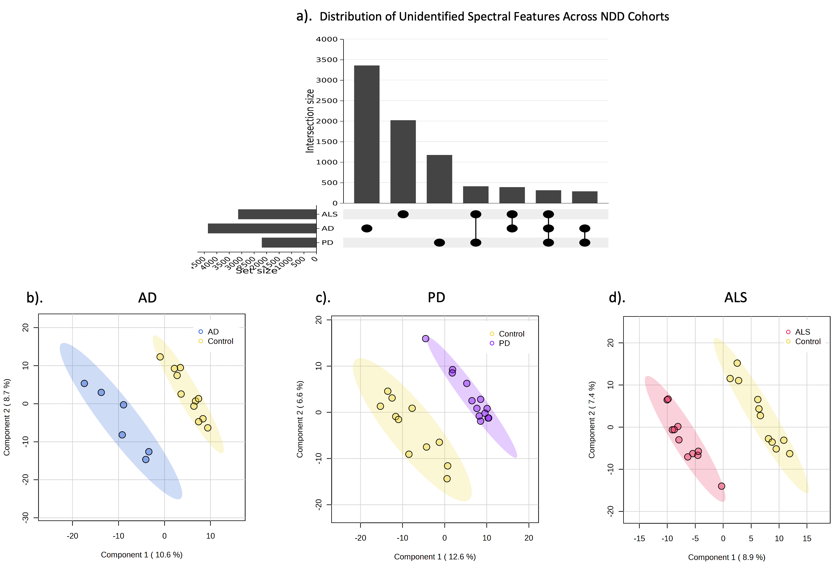
Figure 3.4 (a) UpSet plot showing the presence and overlap of unidentified spectral features between Alzheimer’s disease (AD), amyotrophic lateral sclerosis (ALS), and Parkinson’s disease (PD) cohorts. A total of 3,357 features were unique to AD, 2,022 to ALS, and 1,172 to PD. There were 388 features shared between AD and ALS, 410 between ALS and PD, 287 between AD and PD, and 314 features common to all three groups. (b–d) 3D partial least squares discriminant analysis (PLS-DA) plots comparing AD vs. healthy controls (HC), PD vs. HC, and ALS vs. HC based on unidentified features. Shaded ellipses represent 95% confidence intervals.

In addition to known metabolites, unidentified spectral features exhibited clear metabolic distinctions among NDD cohorts and healthy controls. Using the same processing and statistical thresholds as applied to identified metabolites, we performed PLS-DA, which revealed distinct clustering between each NDD cohort and healthy controls (Figure 3.4b-d). To further assess disease-specific differences, features with a fold change > |1.5| and p < 0.1 were used to construct a Venn diagram highlighting unique and shared alterations across AD, ALS, and PD (Figure 3.5). These results were consistent with the patterns observed in known metabolites, supporting the conclusion that disease-related metabolic shifts extend into the unannotated portion of the gut metabolome.

3.5 Discussion

3.5.1 Metabolome Alterations in NDDs
While it has become widely accepted that gut dysbiosis is a contributing factor in NDDs, the pathophysiological mechanism remains elusive. This is, in part, due to the complexity of the gut microbiome and metabolome and “dark matter” in host–microbiome interactions. This “dark matter” represents the vast amount of detected, but unidentified, small molecules in the metabolome. These analytes likely impact human physiology, highlighting the need for better understanding the small molecules involved in host–microbiome interactions in the gut. To this end, we used an untargeted, hypothesis-generating approach to investigate gut microbiome alterations in NDDs.
As expected, we observed differences in the gut microbiome composition and function in patients with NDDs (AD, ALS, and PD) compared to HCs. The presented data align with
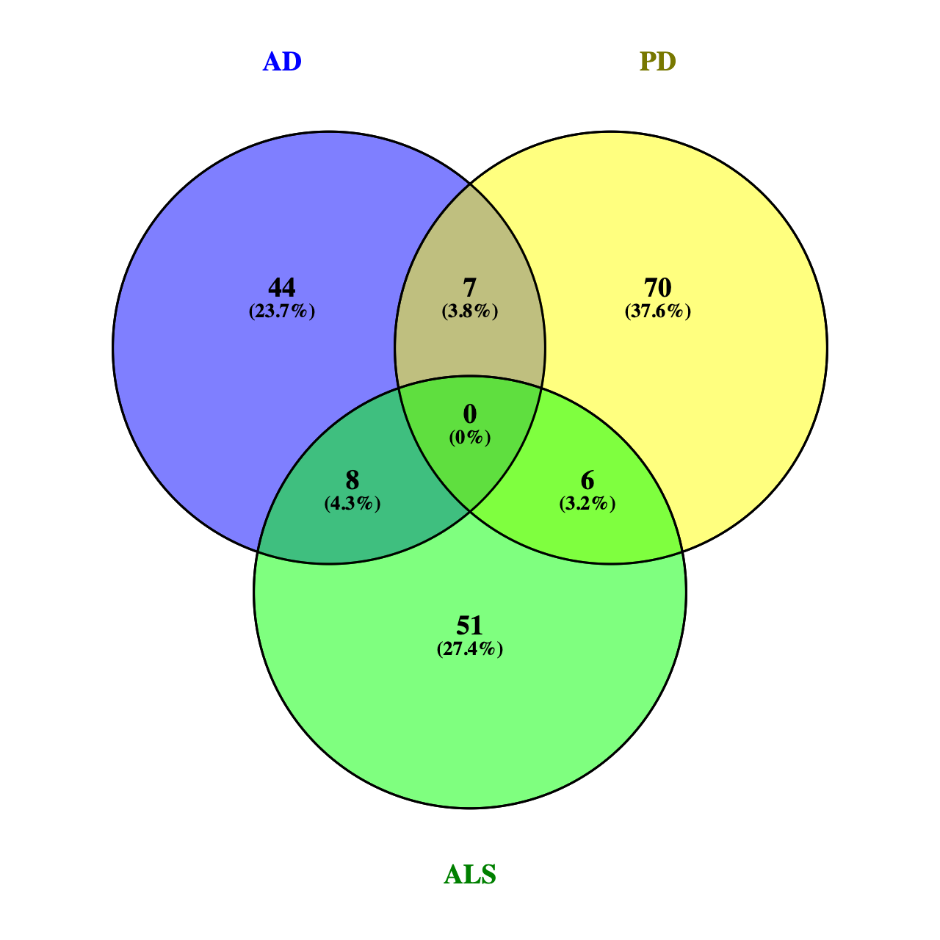
Figure 3.5 Overlap of significantly altered unidentified spectral features across neurodegenerative disease (NDD) cohorts. A Venn diagram displays the number of unidentified features significantly altered (fold change > |1.5|, p < 0.1) in Alzheimer’s disease (AD), Parkinson’s disease (PD), and amyotrophic lateral sclerosis (ALS). While each NDD cohort showed a distinct set of altered features, some overlap was observed between pairs of diseases. No features were significantly altered across all three disease groups.

previous findings in the literature that sulfur metabolism, tryptophan catabolism, bile acids, and amino acids are altered in NDDs.^{109, 191-193} We identified 19 consistent markers for AD, ALS, and PD, as well as metabolic signatures unique to each NDD.
Carnitine was a metabolic signature unique to AD and is known to play a crucial role in energy metabolism and mitochondrial function. Dietary-carnitine supplements have been proposed for prevention or alleviation of AD.¹⁹⁴ In ALS, creatine and creatinine were unique signatures and decreased in ALS. Creatine has been proposed to exhibit protective effects against mitochondrial dysfunction and may also be neuroprotective as it has been linked to increased survival time in an ALS clinical trial.¹⁹⁵
Two of the unique metabolic signatures for PD were decreased xylose and xylitol, indicating impaired sugar metabolism. Xylose and xylitol feed into the pentose phosphate pathway (PPP) resulting in the production of NADPH, pyruvate, and shikimate, which are building blocks for some branched chain and aromatic amino acids and antioxidants. This result is compelling since neurons preferentially use the PPP for sugar metabolism and rely on the metabolic products of the PPP for protection against oxidative stress.¹⁹⁶ Decreased flux through the PPP results in reduced antioxidant capacity and increased oxidative stress, which is a leading hypothesis for pathogenesis of PD.¹⁹⁷
The 19 metabolic markers for NDD showed significant alterations in sulfur, cholesterol, sugar, and vitamin B metabolism. To our surprise, one of these markers was DHPS, a sulfonated microbial-derived metabolite known for its role in sulfur and carbon flux in marine ecosystems, with an unknown role in human physiology.^{198, 199} With this, we have discovered a novel link between microbial-derived metabolite DHPS and NDDs, as DHPS was a significant driver of global metabolome differences when comparing NDD and HC cohorts. To the best of our knowledge, we are the first to provide data linking DHPS to three NDDs—AD, ALS, and PD—thereby demonstrating a potential role of DHPS in human physiology.

3.5.2 Unidentified Metabolites Reflect Disease-Specific Patterns
In addition to annotated metabolites, a substantial number of unidentified spectral features from the "dark metabolome” also demonstrated disease-specific patterns across NDD cohorts.² An UpSet plot revealed thousands of features unique to individual diseases, including 3,357 for AD, 2,022 for ALS, and 1,172 for PD, with 314 features consistently detected across all three NDDs. These consistent patterns suggest the presence of a conserved set of uncharacterized compounds broadly associated with neurodegeneration. Although these features could not be structurally identified, their presence in multiple disease states implies potential biological relevance. Compound identities may still be resolved through continued development of annotation pipelines or complementary fragmentation-based approaches.
Importantly, PLS-DA of these unidentified features revealed clear separation between disease groups and healthy controls, mirroring the patterns observed with known metabolites. Although the unknown features greatly outnumbered the knowns, their biological interpretation remains limited without structural annotation. Notably, most of the identified metabolites in our library are concentrated around central carbon metabolism, which may restrict the breadth of detectable pathway-level alterations. In contrast, the unknowns likely capture a broader range of chemical diversity. The consistent group separation observed with these features suggests they may contain meaningful, yet uncharacterized, disease-associated signals. Their ability to differentiate cohorts reinforces the idea that substantial metabolic information remains embedded in this unannotated fraction of the dataset. These results not only support but also extend the findings from the known metabolite PLS-DAs, demonstrating that disease-specific clustering is not confined to identified compounds alone.
To further evaluate disease-specific differences, significantly altered unknowns (fold change > |1.5|, p < 0.1) were visualized using a Venn diagram. Most altered features were specific to a single disease, with limited overlap between groups. This seems to highlight the specificity of metabolic disruption in each NDD. Notably, no unknown features met significance criteria across all three diseases, in contrast to the 19 shared markers identified among known metabolites. This absence is striking and may reflect higher individual variability in the expression of unannotated features or subtler shifts in abundance that do not meet conventional thresholds for statistical significance. It also raises the possibility that shared unannotated compounds may exist but are altered in opposite directions or inconsistently across patients, which could mask their contribution in group-level comparisons.
These findings align with previous studies showing that unidentified metabolites can reflect meaningful biological variation despite lacking structural annotation.^{1, 200} Incorporating this broader chemical space may offer a more complete view of the metabolic alterations associated with complex, multifactorial disorders such as NDDs. As analytical methods and annotation pipelines improve, the potential to uncover novel biomarkers and mechanistic insights from these currently unknown features remains a promising frontier in untargeted metabolomics.

3.5.3 Cryptic Sulfur Metabolism in NDDs
All detected metabolites in the transsulfuration pathway were decreased in NDD cohorts, except for cystathionine. Rapid conversion of homocysteine to cystathionine could suggest increased fluxes in sulfur metabolism, as previous work using longitudinal metabolome data and constraint-based modeling of gut microbial communities has shown increased flux in the transsulfuration pathway in PD.¹⁰⁷ This pathway generates glutathione and H₂S, which impact redox metabolism. Increased fluxes through sulfur metabolism may be indicative of excess H₂S which, at low concentrations, is neuroprotective and cytoprotective. However, at high levels, H₂S induces mitochondrial damage, oxidative stress, systemic inflammation, and gut dysbiosis. ^{162, 168} ²⁰¹ Although we do not have direct results on mitochondrial bioenergetics, our findings may support the current hypothesis that the increased burden of oxidative stress caused by mitochondrial dysfunction leads to neuroinflammation.²⁰² It has been documented that NDDs share the common feature of defective endoplasmic reticulum (ER)–mitochondria signaling that disrupts the proper function of mitochondria and contributes to pathology of NDDs. Disruptions to effective signaling occur where regions of the ER closely associate with mitochondria through mitochondria-associated membranes (MAMS) as well as proteins.²⁰³ Mitochondria play critical roles in cellular function, not only as the powerhouses of the cell, but also in maintaining Ca²⁺ homeostasis, apoptosis, lipid synthesis, cell growth and differentiation, and the production of reactive oxidative species.^{159, 204-206}
In addition to metabolites in the transsulfuration pathway, other sulfur-containing metabolites, DHPS and taurine, were significantly altered across NDDs. We found this to be intriguing as oxidized sulfur-containing small molecules represent an underappreciated class of unique, biologically relevant metabolites in host–microbiome interactions.¹⁷² It has been discovered recently that these molecules play a significant role in cellular signaling and impact disease-related phenotypes, thereby bringing oxidized sulfur metabolites to the forefront of enhancing our understanding of the pathophysiological impact of host–microbiome interactions.^{172, 207-210} Since the role of DHPS in human physiology and NDDs is unknown, we identified metabolites and OTUs significantly correlated with DHPS. Five metabolites (taurine, vanillin, histidinol, N-acetylornithine, and sucrose/trehalose), and eight OTUs were significantly (p < 0.01) correlated with DHPS in each NDD cohort. All of the significantly correlated OTUs belonged to phylum Firmicutes (orders Clostridia and Oscillospirales) except for one, which belonged to the phylum Bacteroidetes (genus Odoribacter). All of these microbes have been directly linked to metabolizing dietary sulfur to H₂S.^{211, 212} Together, the metabolites and OTUs correlated with DHPS suggest that DHPS is involved in cryptic sulfur host–microbiome metabolism in NDDs.

3.5.4 DHPS Microbial Metabolism in NDDs
Frommeyer and colleagues annotated genes required for a novel bacterial transaldolase pathway by which select gut microbes (Enterococcus, Clostridium, Desulfovibrio, and Eubacterium strains) can ferment dietary sulfoquinovose (SQ) to H₂S with DHPS as a transient intermediate.¹⁶² SQ is obtained through the intake of leafy greens and vegetables containing the lipid sulfoquinovosyl diacylglycerol (SQDG), which is a highly abundant sulfur-containing metabolite common in photosynthetic plants and cyanobacteria. In addition, Hanson and colleagues reported that DHPS contributes to intestinal H₂S production, and that Eubacterium rectale (E. rectale) is the primary DHPS producer, while Desulfovibrio and Bilophila are the primary DHPS consumers, in fecal microcosms from human vegetarians.¹⁶² They identified genes necessary for microbial catabolism of diet-acquired SQ to H₂S and analyzed the expression of these genes across stool metatranscriptomes of 123 healthy, 28 ulcerative colitis, and 50 Crohn’s disease patients to identify the overall impact on health.¹⁶² However, they found no significant differences in the expression of these pathways between cohorts with bowel disease and healthy individuals.¹⁶²
Eubacterium rectale plays a significant role in promoting inflammation and damaging tissue in the gut.²¹³ We found that the genus Eubacterium was increased in PD, ALS, and AD, and it was one of the eight OTUs strongly correlated with DHPS across all three diseases (Figure 3.3). Additionally, sulfate-reducing bacteria (SRB), such as Desulfovibrio, generate H₂S, and have previously been implicated in the development and severity of PD.¹⁶⁹ Here, we observed Desulfovibrio were significantly altered in PD, ALS, and AD and were more abundant in patients with NDDs (Figure 3.3). Additionally, taurine was strongly correlated with DHPS and significantly decreased in NDDs and can also be obtained through dietary sources and degraded by Desulfovibrio and Bilophilia to acetyl-CoA and H₂S. Other studies have also implicated Bilophilia wadsworthia in PD altering microbial sulfur metabolism, yet the etiology remains elusive.^{107, 109, 214, 215} Disrupted sulfur metabolism in NDDs could result in increased flux through DHPS and taurine, promoting overgrowth of SRB and excess H₂S. This may explain why DHPS-producing and -consuming microbes are increased in NDDs, while DHPS is decreased.
While we do not have dietary information from participants, it has become fairly accepted that the gut microbiome composition and function in NDDs are influenced by dietary habits and nutrition.²¹⁶ Since diet-acquired SQDG from leafy greens can be bioconverted to DHPS by select microbes in the gut, we hypothesize that diet corresponds to DHPS and sulfur homeostasis in NDDs. Given this, it is imperative to investigate the outcomes of a plant-based diet in NDDs patients.

3.5.5 Melainabacteria Could Be Associated with DHPS-Mediated Cryptic Sulfur Metabolism in NDDs
In 2013, a novel class of microbes, Melainabacteria, were discovered in the human gut.²¹⁷ Melainabacteria are a non-photosynthetic clade of cyanobacteria and their role in the human gut and physiology is largely unknown.²¹⁷⁻²²⁰ This is of particular interest in our study as SQDG is highly abundant in cyanobacteria. The abundance of Melainabacteria in gut is correlated with diet as the highest abundances of Melainabacteria in stool have been found in herbivore populations, with lower abundances in omnivore and carnivore populations suggesting that Melainabacteria have a role in fermenting dietary plant fibers.²¹⁷ This may also provide another connection of DHPS to diet.
Furthermore, a partial metabolic reconstruction from Soo et al. (2014) of Gastranaerophilales, one of the six major taxonomic orders within the Melainabacteria class, is predicted to use the Embden–Meyerhof pathway to acquire energy by fermenting simple carbohydrates, and DHPS was positively correlated with trehalose in this study suggesting a link between DHPS and Gastranaerophilales.²¹⁹ This metabolic reconstruction also revealed that Gastranaerophilales have the genes required for the biosynthesis of B vitamins (biotin, riboflavin, nicotinamide, and dihydrofolate) and vitamin K, which could demonstrate a beneficial relationship between Melainabacteria and humans.^{217, 219, 221} The basis for the symbiotic relationship between Thalassiosira pseudonana and Roseobacters in aquatic systems was vitamin B₁₂ and DHPS.¹⁹⁸ Given that Melainabacteria are suggested to have a syntrophic H₂-producing niche, it is likely that these microbes can degrade dietary sulfonates. In addition, a previous study has shown that Gastranaerophilales is one of the main producers of microbial-derived indole leading to increased indole in PD.²²² We found that DHPS was negatively correlated with both biotin and metabolites involved in indole metabolism. The majority of preliminary studies show a trend of increased Melainabacteria abundance in patients with metabolic, neurodegenerative, and gastrointestinal disease, though results in the literature are still inconsistent, as understanding the role of Gastranaerophilales in the human gut remains in its infancy.^{221, 223} In this study, we found that the abundance of Gastranaerophilales was increased in PD, ALS, and AD compared to the HC cohort. This contradictory evidence highlights the need to further investigate the role of Melainabacteria. In addition, Gastranaerophilales was strongly correlated to Desulfovibrio. This may suggest that Gastranaerophilales plays a role in DHPS metabolism since Desulfovibrio has the cellular machinery to both produce and degrade DHPS. With this, we propose there could be a relationship between Melainabacteria and DHPS, given the phylogenetic similarity to cyanobacteria and the negative correlation between DHPS and biotin.

3.5.6 Potential Physiological Role of DHPS
Previous studies have laid the foundation for investigating DHPS in human metabolism by elucidating the biochemical mechanism of DHPS production and degradation in the human gut and directly linking dietary sulfonates to H₂S production; however, the data did not demonstrate an association between DHPS, or the genes involved in DHPS metabolism, and human health outcomes.^{162, 199, 212} Recently the first report of direct DHPS detection in human stool samples and highlighted a compelling connection between DHPS and gut metabolic dysregulation.²²⁴ This study investigated the systemic impact of e-cigarette and/or combustible tobacco/marijuana smoking in people living with HIV (PLWH). They observed that DHPS in human stool samples was significantly higher (20×) in the PLWH control cohort compared to the smoking cohorts and noted strong correlations between DHPS and vitamin B, acetylated amino acids, bile acids, and cholesterol metabolism. Both e-cigarette use/smoking and NDDs are associated with gut dysbiosis and inflammation.²²⁵ Although strictly correlative in both studies, DHPS was significantly increased in the control cohorts and decreased in the cohorts associated with gut dysbiosis. This conserved trend across independent datasets may indicate that DHPS abundance in human stool is associated with overall health status or gut dysbiosis and inflammation, rather than being unique to NDDs. Therefore, we hypothesize that DHPS is a missing link in the pathophysiology of inflammation, as it may be a key regulator of gut inflammation and overall human health.

3.5.7 Limitations
This study lays the foundation for future discoveries on the role of specific bacterial taxa and their metabolite DHPS; however, there are some notable limitations. First, all patients were sampled in the same geographic location of Eastern Tennessee and the surrounding Appalachian Mountains, and recruitment during the pandemic was slow, resulting in small sample sizes, particularly in the AD population, who were not seen in person for several months during the pandemic, which explains the lower age distribution of the AD cohort. In addition, all the patients were Caucasian. Combined, this limits the generalizability of the conclusions. Future studies should include measures of dietary intake to better investigate the role of diet and its influence on DHPS production, as well measuring plasma markers of inflammation to see how peripheral inflammation may relate to DHPS. Additionally, DHPS not being included in the metabolite library used for analyte identification is likely why other NDD and human health studies have not reported similar implications of DHPS. Given this, we encourage others to mine previously analyzed datasets for DHPS and include DHPS in the metabolite reference library for future studies to aid in elucidating the physiological role of DHPS. While this study describes a remarkably well-conserved and novel association across different neurodegenerative diseases, this study is limited by not being able to define these findings as causative, given the exploratory nature of untargeted metabolomics.

3.6 Conclusions
In this study, we investigated bacterial and metabolic dyshomeostasis in the gut associated with AD, ALS, and PD using an integrative cross-omics approach. In addition to annotated metabolites, we found that unidentified spectral features also reflected disease-specific patterns, providing further support for global metabolic disruptions in neurodegeneration. Herein, we present the first linkage of DHPS, a microbial-derived metabolite, to gut dysbiosis associated with NDDs, which may contribute to dyshomeostasis in sulfur metabolism. DHPS-consuming and -degrading microbes are more abundant in NDDs, while DHPS is decreased (Figure 3.6). We hypothesize that the decrease in DHPS in NDDs may be a result of increased flux through the recently identified transaldolase pathway in which dietary sulfonates are metabolized to DHPS and H₂S by select gut microbes, including Eubacterium and Desulfovibrio. Excess H₂S, resulting from increased flux through DHPS, may contribute to mitochondrial
Figure 3.6 DHPS can be obtained through dietary consumption of leafy greens and degraded to H₂S. The abundance of DHPS-producing and -consuming microbes is increased in NDD, while DHPS is decreased in NDD, suggesting the rapid degradation of DHPS to yield H₂S. Other microbes (Enterococcus and Clostridium) can ferment dietary sulfoquinovose (SQ) to H₂S with DHPS as a transient intermediate as well. Figure was created using biorender.com and adapted from Hanson et al..¹⁶²

dysfunction, oxidative stress, inflammation, and gut dysbiosis in NDDs. While there is substantial literature on the physiological impacts of H₂S, we have reported a novel link among DHPS, gut dyshomeostasis, and NDDs.^{215, 226, 227} These findings highlight the need for further investigation into the role of cryptic sulfur metabolism via DHPS, as DHPS may serve as a missing link in our current understanding of gut dysbiosis and its association with NDD onset and progression. In conclusion, this study lays the groundwork for developing DHPS-based diagnostic tools and microbiome-modulating therapies to detect and potentially intervene in the early stages of neurodegenerative diseases.

CONCLUSION
The benefits of using untargeted metabolomics in both environmental and biomedical research have been highlighted in this dissertation. Untargeted metabolomics enables detection of thousands of small molecules, many of which remain unidentified, yet still offer powerful insight into biochemical variation across systems. This approach allows for investigation of both known and unknown chemical signals, expanding our understanding of biological and ecological processes without relying solely on compound annotation. While interpretation of unidentified features remains a challenge, the consistent patterns observed across studies reinforce the value of spectral data as a sensitive marker of group-level differences.
In the first chapter of this dissertation, metabolomics was applied to evaluate how land management practices shape soil chemistry. Despite a limited number of identified metabolites, clear separation was observed between soil types based on spectral features alone. These chemical differences reflected changes in nutrient cycling and microbial activity, particularly in relation to organic acids and phosphorus-related elemental ratios. This study demonstrates how metabolomics can capture shifts in soil function that are not always apparent through traditional elemental analysis.
The second chapter examined whether volatile organic compounds (VOCs) associated with deceased human odor could be chemically distinguished from those associated with living individuals or environmental blanks. Headspace SPME-GC-MS analysis of gauze samples revealed a small set of spectral features consistently associated with decomposition exposure. These findings provide one of the first chemical validations of residual human odor and support its relevance in forensic detection by human remains detection (HRD) dogs. The results also emphasize the importance of incorporating chemically validated training aids into HRD protocols.
The third and final chapter of this dissertation explored the gut metabolome in patients with Alzheimer’s disease (AD), amyotrophic lateral sclerosis (ALS), and Parkinson’s disease (PD). Both identified and unidentified metabolites differentiated neurodegenerative disease cohorts from healthy controls. These findings suggest that metabolic dysregulation extends into the unknown fraction of the metabolome, reinforcing the value of untargeted methods in complex diseases where traditional biomarkers are limited.
Together, these three chapters demonstrate the versatility and strength of untargeted metabolomics for capturing chemical variation across diverse biological systems, from soils and scent to neurodegeneration. Despite differences in sample type and analytical platform, each study revealed meaningful biological patterns through spectral data, even when compound identities remained unknown. Future work that bridges these datasets with microbial, functional, or fragmentation analyses will further deepen our understanding of the processes driving chemical diversity across both ecological and biomedical contexts.

REFERENCES
(1) Schrimpe-Rutledge, A. C.; Codreanu, S. G.; Sherrod, S. D.; McLean, J. A. Untargeted Metabolomics Strategies—Challenges and Emerging Directions. Journal of the American Society for Mass Spectrometry 2016, 27 (12), 1897-1905. DOI: 10.1007/s13361-016-1469-y.
(2) Jones, O. A. H. Illuminating the dark metabolome to advance the molecular characterisation of biological systems. Metabolomics 2018, 14 (8), 101. DOI: 10.1007/s11306-018-1396-y.
(3) da Silva, R. R.; Dorrestein, P. C.; Quinn, R. A. Illuminating the dark matter in metabolomics. Proceedings of the National Academy of Sciences 2015, 112 (41), 12549-12550. DOI: doi:10.1073/pnas.1516878112.
(4) Zubarev, R. A.; Makarov, A. Orbitrap Mass Spectrometry. Analytical Chemistry 2013, 85 (11), 5288-5296. DOI: 10.1021/ac4001223.
(5) Hu, Q.; Noll, R. J.; Li, H.; Makarov, A.; Hardman, M.; Graham Cooks, R. The Orbitrap: a new mass spectrometer. J Mass Spectrom 2005, 40 (4), 430-443. DOI: 10.1002/jms.856 From NLM.
(6) Brown, R. W.; Reay, M. K.; Centler, F.; Chadwick, D. R.; Bull, I. D.; McDonald, J. E.; Evershed, R. P.; Jones, D. L. Soil metabolomics - current challenges and future perspectives. Soil Biology and Biochemistry 2024, 193, 109382. DOI: https://doi.org/10.1016/j.soilbio.2024.109382.
(7) Wang, M.; Carver, J. J.; Phelan, V. V.; Sanchez, L. M.; Garg, N.; Peng, Y.; Nguyen, D. D.; Watrous, J.; Kapono, C. A.; Luzzatto-Knaan, T.; et al. Sharing and community curation of mass spectrometry data with Global Natural Products Social Molecular Networking. Nature Biotechnology 2016, 34 (8), 828-837. DOI: 10.1038/nbt.3597.
(8) Kimball, B. A. Volatile Metabolome: Problems and Prospects. Bioanalysis 2016, 8 (19), 1987-1991. DOI: 10.4155/bio-2016-0203.
(9) Bowen, B. P.; Northen, T. R. Dealing with the Unknown: Metabolomics and Metabolite Atlases. Journal of the American Society for Mass Spectrometry 2010, 21 (9), 1471-1476. DOI: https://doi.org/10.1016/j.jasms.2010.04.003.
(10) Reganold, J. P.; Wachter, J. M. Organic agriculture in the twenty-first century. Nature Plants 2016, 2 (2), 15221. DOI: 10.1038/nplants.2015.221.
(11) Gilliam, F. S.; Hargis, E. A.; Rabinowitz, S. K.; Davis, B. C.; Sweet, L. L.; Moss, J. A. Soil microbiomes of hardwood- versus pine-dominated stands: Linkage with overstory species. Ecosphere 2023, 14 (7), e4537. DOI: https://doi.org/10.1002/ecs2.4537.
(12) Das, S.; Pendall, E.; Malik, A. A.; Nannipieri, P.; Kim, P. J. Microbial control of soil organic matter dynamics: Effects of land use and climate change. Biology and Fertility of Soils 2024, 60 (1), 1-3. DOI: 10.1007/s00374-023-01788-4.
(13) Drenovsky, R. E.; Vo, D.; Graham, K. J.; Scow, K. M. Soil Water Content and Organic Carbon Availability Are Major Determinants of Soil Microbial Community Composition. Microbial Ecology 2004, 48 (3), 424-430. DOI: 10.1007/s00248-003-1063-2.
(14) Lauber, C. L.; Strickland, M. S.; Bradford, M. A.; Fierer, N. The influence of soil properties on the structure of bacterial and fungal communities across land-use types. Soil Biology and Biochemistry 2008, 40 (9), 2407-2415. DOI: https://doi.org/10.1016/j.soilbio.2008.05.021.
(15) Stewart, R. D.; Jian, J.; Gyawali, A. J.; Thomason, W. E.; Badgley, B. D.; Reiter, M. S.; Strickland, M. S. What We Talk about When We Talk about Soil Health. Agricultural & Environmental Letters 2018, 3 (1), 180033. DOI: https://doi.org/10.2134/ael2018.06.0033.
(16) Withers, E.; Hill, P. W.; Chadwick, D. R.; Jones, D. L. Use of untargeted metabolomics for assessing soil quality and microbial function. Soil Biology and Biochemistry 2020, 143, 107758. DOI: https://doi.org/10.1016/j.soilbio.2020.107758.
(17) Liu, L.; Wang, T.; Li, S.; Hao, R.; Li, Q. Combined analysis of microbial community and microbial metabolites based on untargeted metabolomics during pig manure composting. Biodegradation 2021, 32 (2), 217-228. DOI: 10.1007/s10532-021-09935-0.
(18) Tautenhahn, R.; Cho, K.; Uritboonthai, W.; Zhu, Z.; Patti, G. J.; Siuzdak, G. An accelerated workflow for untargeted metabolomics using the METLIN database. Nature Biotechnology 2012, 30 (9), 826-828. DOI: 10.1038/nbt.2348.
(19) Rabinowitz, J. D.; Kimball, E. Acidic Acetonitrile for Cellular Metabolome Extraction from Escherichia coli. Analytical Chemistry 2007, 79 (16), 6167-6173. DOI: 10.1021/ac070470c.
(20) Lu, W.; Clasquin, M. F.; Melamud, E.; Amador-Noguez, D.; Caudy, A. A.; Rabinowitz, J. D. Metabolomic Analysis via Reversed-Phase Ion-Pairing Liquid Chromatography Coupled to a Stand Alone Orbitrap Mass Spectrometer. Analytical Chemistry 2010, 82 (8), 3212-3221. DOI: 10.1021/ac902837x.
(21) Chambers, M. C.; Maclean, B.; Burke, R.; Amodei, D.; Ruderman, D. L.; Neumann, S.; Gatto, L.; Fischer, B.; Pratt, B.; Egertson, J.; et al. A cross-platform toolkit for mass spectrometry and proteomics. Nature Biotechnology 2012, 30 (10), 918-920. DOI: 10.1038/nbt.2377.
(22) Melamud, E.; Vastag, L.; Rabinowitz, J. D. Metabolomic Analysis and Visualization Engine for LC−MS Data. Analytical Chemistry 2010, 82 (23), 9818-9826. DOI: 10.1021/ac1021166.
(23) Clasquin, M. F.; Melamud, E.; Rabinowitz, J. D. LC-MS Data Processing with MAVEN: A Metabolomic Analysis and Visualization Engine. Current Protocols in Bioinformatics 2012, 37 (1), 14.11.11-14.11.23. DOI: https://doi.org/10.1002/0471250953.bi1411s37.
(24) Chong, J.; Soufan, O.; Li, C.; Caraus, I.; Li, S.; Bourque, G.; Wishart, D. S.; Xia, J. MetaboAnalyst 4.0: towards more transparent and integrative metabolomics analysis. Nucleic Acids Research 2018, 46 (W1), W486-W494. DOI: 10.1093/nar/gky310 (acccessed 2/4/2025).
(25) Xia, J.; Psychogios, N.; Young, N.; Wishart, D. S. MetaboAnalyst: a web server for metabolomic data analysis and interpretation. Nucleic Acids Research 2009, 37 (suppl_2), W652-W660. DOI: 10.1093/nar/gkp356 (acccessed 2/4/2025).
(26) ChiPlot: UpSet Plot Tool. 2024. https://www.chiplot.online/upset_plot.html (accessed.
(27) Kind, T.; Fiehn, O. Seven Golden Rules for heuristic filtering of molecular formulas obtained by accurate mass spectrometry. BMC Bioinformatics 2007, 8 (1), 105. DOI: 10.1186/1471-2105-8-105.
(28) Schymanski, E. L.; Jeon, J.; Gulde, R.; Fenner, K.; Ruff, M.; Singer, H. P.; Hollender, J. Identifying Small Molecules via High Resolution Mass Spectrometry: Communicating Confidence. Environmental Science & Technology 2014, 48 (4), 2097-2098. DOI: 10.1021/es5002105.
(29) Ruttkies, C.; Schymanski, E. L.; Wolf, S.; Hollender, J.; Neumann, S. MetFrag relaunched: incorporating strategies beyond in silico fragmentation. Journal of Cheminformatics 2016, 8 (1), 3. DOI: 10.1186/s13321-016-0115-9.
(30) Posit, t. RStudio: Integrated Development Environment for R. 2025.
(31) (Zaner0445), G. u. Soil-Metabolomics-Elemental-Analysis. 2025. (accessed 2025 03/03/2025).
(32) Python Software, F. Python 3.9. 2021.
(33) Kim, S.; Thiessen, P. A.; Bolton, E. E.; Chen, J.; Fu, G.; Gindulyte, A.; Han, L.; He, J.; He, S.; Shoemaker, B. A.; et al. PubChem Substance and Compound databases. Nucleic Acids Research 2015, 44 (D1), D1202-D1213. DOI: 10.1093/nar/gkv951 (acccessed 7/30/2025).
(34) (Zaner0445), G. u. Molecular-Formula-to-SMILES. 2025. (accessed 2025 03/04/).
(35) Kim, H. W.; Wang, M.; Leber, C. A.; Nothias, L.-F.; Reher, R.; Kang, K. B.; van der Hooft, J. J. J.; Dorrestein, P. C.; Gerwick, W. H.; Cottrell, G. W. NPClassifier: A Deep Neural Network-Based Structural Classification Tool for Natural Products. Journal of Natural Products 2021, 84 (11), 2795-2807. DOI: 10.1021/acs.jnatprod.1c00399.
(36) Kim, H. W.; Wang, M.; Leber, C. A.; Nothias, L. F.; Reher, R.; Kang, K. B.; van der Hooft, J. J. J.; Dorrestein, P. C.; Gerwick, W. H.; Cottrell, G. W. NPClassifier: A Deep Neural Network-Based Structural Classification Tool for Natural Products. J Nat Prod 2021, 84 (11), 2795-2807. DOI: 10.1021/acs.jnatprod.1c00399 From NLM.
(37) Philippot, L.; Raaijmakers, J. M.; Lemanceau, P.; van der Putten, W. H. Going back to the roots: the microbial ecology of the rhizosphere. Nature Reviews Microbiology 2013, 11 (11), 789-799. DOI: 10.1038/nrmicro3109.
(38) Schimel, J. P.; Weintraub, M. N. The implications of exoenzyme activity on microbial carbon and nitrogen limitation in soil: a theoretical model. Soil Biology and Biochemistry 2003, 35 (4), 549-563. DOI: https://doi.org/10.1016/S0038-0717(03)00015-4.
(39) Kuzyakov, Y.; Xu, X. Competition between roots and microorganisms for nitrogen: mechanisms and ecological relevance. New Phytol 2013, 198 (3), 656-669. DOI: 10.1111/nph.12235 From NLM.
(40) Deangelis, K. M.; Sharma, D.; Varney, R.; Simmons, B.; Isern, N. G.; Markilllie, L. M.; Nicora, C.; Norbeck, A. D.; Taylor, R. C.; Aldrich, J. T.; et al. Evidence supporting dissimilatory and assimilatory lignin degradation in Enterobacter lignolyticus SCF1. Front Microbiol 2013, 4, 280. DOI: 10.3389/fmicb.2013.00280 From NLM.
(41) Jones, D. L.; Dennis, P. G.; Owen, A. G.; van Hees, P. A. W. Organic acid behavior in soils – misconceptions and knowledge gaps. Plant and Soil 2003, 248 (1), 31-41. DOI: 10.1023/A:1022304332313.
(42) Kögel-Knabner, I. The macromolecular organic composition of plant and microbial residues as inputs to soil organic matter. Soil Biology and Biochemistry 2002, 34 (2), 139-162. DOI: https://doi.org/10.1016/S0038-0717(01)00158-4.
(43) Zhalnina, K.; Louie, K. B.; Hao, Z.; Mansoori, N.; da Rocha, U. N.; Shi, S.; Cho, H.; Karaoz, U.; Loqué, D.; Bowen, B. P.; et al. Dynamic root exudate chemistry and microbial substrate preferences drive patterns in rhizosphere microbial community assembly. Nat Microbiol 2018, 3 (4), 470-480. DOI: 10.1038/s41564-018-0129-3 From NLM.
(44) Badri, D. V.; Vivanco, J. M. Regulation and function of root exudates. Plant Cell Environ 2009, 32 (6), 666-681. DOI: 10.1111/j.1365-3040.2008.01926.x From NLM.
(45) Srour, A. Y.; Ammar, H. A.; Subedi, A.; Pimentel, M.; Cook, R. L.; Bond, J.; Fakhoury, A. M. Microbial Communities Associated With Long-Term Tillage and Fertility Treatments in a Corn-Soybean Cropping System. Front Microbiol 2020, 11, 1363. DOI: 10.3389/fmicb.2020.01363 From NLM.
(46) Heděnec, P.; Nilsson, L. O.; Zheng, H.; Gundersen, P.; Schmidt, I. K.; Rousk, J.; Vesterdal, L. Mycorrhizal association of common European tree species shapes biomass and metabolic activity of bacterial and fungal communities in soil. Soil Biology and Biochemistry 2020, 149, 107933. DOI: https://doi.org/10.1016/j.soilbio.2020.107933.
(47) Harkes, P.; Suleiman, A. K. A.; van den Elsen, S. J. J.; de Haan, J. J.; Holterman, M.; Kuramae, E. E.; Helder, J. Conventional and organic soil management as divergent drivers of resident and active fractions of major soil food web constituents. Scientific Reports 2019, 9 (1), 13521. DOI: 10.1038/s41598-019-49854-y.
(48) Devine, S.; Markewitz, D.; Hendrix, P.; Coleman, D. Soil Aggregates and Associated Organic Matter under Conventional Tillage, No-Tillage, and Forest Succession after Three Decades. PLOS ONE 2014, 9 (1), e84988. DOI: 10.1371/journal.pone.0084988.
(49) Rachwał, K.; Gustaw, K.; Kazimierczak, W.; Waśko, A. Is soil management system really important? comparison of microbial community diversity and structure in soils managed under organic and conventional regimes with some view on soil properties. PLOS ONE 2021, 16 (9), e0256969. DOI: 10.1371/journal.pone.0256969.
(50) Van Der Heijden, M. G. A.; Bardgett, R. D.; Van Straalen, N. M. The unseen majority: soil microbes as drivers of plant diversity and productivity in terrestrial ecosystems. Ecology Letters 2008, 11 (3), 296-310. DOI: https://doi.org/10.1111/j.1461-0248.2007.01139.x.
(51) Sullivan, G. M.; Feinn, R. Using Effect Size-or Why the P Value Is Not Enough. J Grad Med Educ 2012, 4 (3), 279-282. DOI: 10.4300/jgme-d-12-00156.1 From NLM.
(52) Fierer, N.; Schimel, J. P. Effects of drying–rewetting frequency on soil carbon and nitrogen transformations. Soil Biology and Biochemistry 2002, 34 (6), 777-787. DOI: https://doi.org/10.1016/S0038-0717(02)00007-X.
(53) Sinsabaugh, R. L.; Lauber, C. L.; Weintraub, M. N.; Ahmed, B.; Allison, S. D.; Crenshaw, C.; Contosta, A. R.; Cusack, D.; Frey, S.; Gallo, M. E.; et al. Stoichiometry of soil enzyme activity at global scale. Ecol Lett 2008, 11 (11), 1252-1264. DOI: 10.1111/j.1461-0248.2008.01245.x From NLM.
(54) Cleveland, C. C.; Liptzin, D. C:N:P stoichiometry in soil: is there a “Redfield ratio” for the microbial biomass? Biogeochemistry 2007, 85 (3), 235-252. DOI: 10.1007/s10533-007-9132-0.
(55) Zechmeister-Boltenstern, S.; Keiblinger, K. M.; Mooshammer, M.; Peñuelas, J.; Richter, A.; Sardans, J.; Wanek, W. The application of ecological stoichiometry to plant–microbial–soil organic matter transformations. Ecological Monographs 2015, 85 (2), 133-155. DOI: https://doi.org/10.1890/14-0777.1.
(56) Turner, B. L.; Haygarth, P. M. Biogeochemistry. Phosphorus solubilization in rewetted soils. Nature 2001, 411 (6835), 258. DOI: 10.1038/35077146 From NLM.
(57) Klimek, B.; Chodak, M.; Jaźwa, M.; Solak, A.; Tarasek, A.; Niklińska, M. The relationship between soil bacteria substrate utilisation patterns and the vegetation structure in temperate forests. European Journal of Forest Research 2016, 135 (1), 179-189. DOI: 10.1007/s10342-015-0929-4.
(58) Schimel, J. P.; Schaeffer, S. M. Microbial control over carbon cycling in soil. Front Microbiol 2012, 3, 348. DOI: 10.3389/fmicb.2012.00348 From NLM.
(59) Myrold, D. D.; Zeglin, L. H.; Jansson, J. K. The Potential of Metagenomic Approaches for Understanding Soil Microbial Processes. Soil Science Society of America Journal 2014, 78 (1), 3-10. DOI: https://doi.org/10.2136/sssaj2013.07.0287dgs.
(60) Kallenbach, C. M.; Frey, S. D.; Grandy, A. S. Direct evidence for microbial-derived soil organic matter formation and its ecophysiological controls. Nat Commun 2016, 7, 13630. DOI: 10.1038/ncomms13630 From NLM.
(61) Roberts, M. F.; Strack, D.; Wink, M. Biosynthesis of Alkaloids and Betalains. In Annual Plant Reviews Volume 40: Biochemistry of Plant Secondary Metabolism, 2010; pp 20-91.
(62) Zelles, L. Fatty acid patterns of phospholipids and lipopolysaccharides in the characterisation of microbial communities in soil: a review. Biology and Fertility of Soils 1999, 29 (2), 111-129. DOI: 10.1007/s003740050533.
(63) Gunina, A.; Dippold, M.; Glaser, B.; Kuzyakov, Y. Turnover of microbial groups and cell components in soil: 13C analysis of cellular biomarkers. Biogeosciences 2017, 14 (2), 271-283. DOI: 10.5194/bg-14-271-2017.
(64) Neha; Bhardwaj, Y.; Sharma, M. P.; Pandey, J.; Dubey, S. K. Response of Crop Types and Farming Practices on Soil Microbial Biomass and Community Structure in Tropical Agroecosystem by Lipid Biomarkers. Journal of Soil Science and Plant Nutrition 2022, 22 (2), 1618-1631. DOI: 10.1007/s42729-022-00758-3.
(65) Bossio, D. A.; Scow, K. M. Impacts of Carbon and Flooding on Soil Microbial Communities: Phospholipid Fatty Acid Profiles and Substrate Utilization Patterns. Microb Ecol 1998, 35 (3), 265-278. DOI: 10.1007/s002489900082 From NLM.
(66) Malik, A. A.; Dannert, H.; Griffiths, R. I.; Thomson, B. C.; Gleixner, G. Rhizosphere bacterial carbon turnover is higher in nucleic acids than membrane lipids: implications for understanding soil carbon cycling. Front Microbiol 2015, 6, 268. DOI: 10.3389/fmicb.2015.00268 From NLM.
(67) Zhu, X.; Jackson, R. D.; DeLucia, E. H.; Tiedje, J. M.; Liang, C. The soil microbial carbon pump: From conceptual insights to empirical assessments. Global Change Biology 2020, 26 (11), 6032-6039. DOI: https://doi.org/10.1111/gcb.15319.
(68) van der Heijden, M. G.; Bardgett, R. D.; van Straalen, N. M. The unseen majority: soil microbes as drivers of plant diversity and productivity in terrestrial ecosystems. Ecol Lett 2008, 11 (3), 296-310. DOI: 10.1111/j.1461-0248.2007.01139.x From NLM.
(69) Kong, A. Y.; Scow, K. M.; Córdova-Kreylos, A. L.; Holmes, W. E.; Six, J. Microbial community composition and carbon cycling within soil microenvironments of conventional, low-input, and organic cropping systems. Soil Biol Biochem 2011, 43 (1), 20-30. DOI: 10.1016/j.soilbio.2010.09.005 From NLM.
(70) Wipf, H. M.; Xu, L.; Gao, C.; Spinner, H. B.; Taylor, J.; Lemaux, P.; Mitchell, J.; Coleman-Derr, D. Agricultural Soil Management Practices Differentially Shape the Bacterial and Fungal Microbiome of Sorghum bicolor. Appl Environ Microbiol 2021, 87 (5). DOI: 10.1128/aem.02345-20 From NLM.
(71) Hartman, K.; van der Heijden, M. G. A.; Wittwer, R. A.; Banerjee, S.; Walser, J.-C.; Schlaeppi, K. Cropping practices manipulate abundance patterns of root and soil microbiome members paving the way to smart farming. Microbiome 2018, 6 (1), 14. DOI: 10.1186/s40168-017-0389-9.
(72) Esperschütz, J.; Gattinger, A.; Mäder, P.; Schloter, M.; Fliessbach, A. Response of soil microbial biomass and community structures to conventional and organic farming systems under identical crop rotations. FEMS Microbiol Ecol 2007, 61 (1), 26-37. DOI: 10.1111/j.1574-6941.2007.00318.x From NLM.
(73) Prescott, C. E. Litter decomposition: what controls it and how can we alter it to sequester more carbon in forest soils? Biogeochemistry 2010, 101 (1), 133-149. DOI: 10.1007/s10533-010-9439-0.
(74) Zhang, Q.; Wu, J.; Yang, F.; Lei, Y.; Zhang, Q.; Cheng, X. Alterations in soil microbial community composition and biomass following agricultural land use change. Scientific Reports 2016, 6 (1), 36587. DOI: 10.1038/srep36587.
(75) Lladó, S.; López-Mondéjar, R.; Baldrian, P. Forest Soil Bacteria: Diversity, Involvement in Ecosystem Processes, and Response to Global Change. Microbiol Mol Biol Rev 2017, 81 (2). DOI: 10.1128/mmbr.00063-16 From NLM.
(76) Nieland, M. A.; Lacy, P.; Allison, S. D.; Bhatnagar, J. M.; Doroski, D. A.; Frey, S. D.; Greaney, K.; Hobbie, S. E.; Kuebbing, S. E.; Lewis, D. B.; et al. Nitrogen Deposition Weakens Soil Carbon Control of Nitrogen Dynamics Across the Contiguous United States. Global Change Biology 2024, 30 (12), e70016. DOI: https://doi.org/10.1111/gcb.70016.
(77) Furton, K. G.; Myers, L. J. The scientific foundation and efficacy of the use of canines as chemical detectors for explosives1Invited paper for the special issue of Talanta ‘Methods for Explosive Analysis and Detection’.1. Talanta 2001, 54 (3), 487-500. DOI: https://doi.org/10.1016/S0039-9140(00)00546-4.
(78) Dargan, R.; Forbes, S. L. Cadaver-detection dogs: A review of their capabilities and the volatile organic compound profile of their associated training aids. WIREs Forensic Science 2021, 3 (6), e1409. DOI: https://doi.org/10.1002/wfs2.1409.
(79) Martin, C.; Diederich, C.; Verheggen, F. Cadaver Dogs and the Deathly Hallows-A Survey and Literature Review on Selection and Training Procedure. Animals (Basel) 2020, 10 (7). DOI: 10.3390/ani10071219 From NLM.
(80) Alexander, M. B.; Hodges, T. K.; Bytheway, J.; Aitkenhead-Peterson, J. A. Application of soil in Forensic Science: Residual odor and HRD dogs. Forensic Science International 2015, 249, 304-313. DOI: https://doi.org/10.1016/j.forsciint.2015.01.025.
(81) State v. Bucki. Wisconsin Court of Appeals: 2020; Vol. No. 2019AP1565-CR.
(82) Hurley, B.; Stanton, S. C. The Use of Cadaver Dogs in Criminal Trials. 2015. (acccessed 2025-06-19).
(83) Brooks v. People. Supreme Court of Colorado: 1999; Vol. 975 P.2d 1105.
(84) Vass, A. A. Odor mortis. Forensic Science International 2012, 222 (1), 234-241. DOI: https://doi.org/10.1016/j.forsciint.2012.06.006.
(85) Vass, A. A.; Smith, R. R.; Thompson, C. V.; Burnett, M. N.; Dulgerian, N.; Eckenrode, B. A. Odor Analysis of Decomposing Buried Human Remains. Journal of Forensic Sciences 2008, 53 (2), 384-391. DOI: https://doi.org/10.1111/j.1556-4029.2008.00680.x.
(86) Lit, L.; Schweitzer, J. B.; Oberbauer, A. M. Handler beliefs affect scent detection dog outcomes. Anim Cogn 2011, 14 (3), 387-394. DOI: 10.1007/s10071-010-0373-2 From NLM.
(87) Prada, P. C., A.; Furton, K. . Characteristic Huan Scent Compounds Trapped on Natural and Synthetic Fabrics as Analyzed by SPME-GC/MS. Journal of Forensic Science & Criminology 2014, I.
(88) Zhang, S.; Raftery, D. Headspace SPME-GC-MS metabolomics analysis of urinary volatile organic compounds (VOCs). Methods Mol Biol 2014, 1198, 265-272. DOI: 10.1007/978-1-4939-1258-2_17 From NLM.
(89) Gherghel, S.; Morgan, R. M.; Arrebola-Liébanas, J.; Romero-González, R.; Blackman, C. S.; Garrido-Frenich, A.; Parkin, I. P. Development of a HS-SPME/GC–MS method for the analysis of volatile organic compounds from fabrics for forensic reconstruction applications. Forensic Science International 2018, 290, 207-218. DOI: https://doi.org/10.1016/j.forsciint.2018.07.015.
(90) Cablk, M. E.; Szelagowski, E. E.; Sagebiel, J. C. Characterization of the volatile organic compounds present in the headspace of decomposing animal remains, and compared with human remains. Forensic Science International 2012, 220 (1), 118-125. DOI: https://doi.org/10.1016/j.forsciint.2012.02.007.
(91) Koch, B. P.; Dittmar, T. From mass to structure: an aromaticity index for high-resolution mass data of natural organic matter. Rapid Communications in Mass Spectrometry 2006, 20 (5), 926-932. DOI: https://doi.org/10.1002/rcm.2386.
(92) Hoffman, E. M.; Curran, A. M.; Dulgerian, N.; Stockham, R. A.; Eckenrode, B. A. Characterization of the volatile organic compounds present in the headspace of decomposing human remains. Forensic Science International 2009, 186 (1), 6-13. DOI: https://doi.org/10.1016/j.forsciint.2008.12.022.
(93) Curran, A. M.; Rabin, S. I.; Prada, P. A.; Furton, K. G. Comparison of the Volatile Organic Compounds Present in Human Odor Using Spme-GC/MS. Journal of Chemical Ecology 2005, 31 (7), 1607-1619. DOI: 10.1007/s10886-005-5801-4.
(94) Walker, D. B.; Walker, J. C.; Cavnar, P. J.; Taylor, J. L.; Pickel, D. H.; Hall, S. B.; Suarez, J. C. Naturalistic quantification of canine olfactory sensitivity. Applied Animal Behaviour Science 2006, 97 (2), 241-254. DOI: https://doi.org/10.1016/j.applanim.2005.07.009.
(95) Statheropoulos, M.; Spiliopoulou, C.; Agapiou, A. A study of volatile organic compounds evolved from the decaying human body. Forensic Sci Int 2005, 153 (2-3), 147-155. DOI: 10.1016/j.forsciint.2004.08.015 From NLM.
(96) Kusano, M.; Mendez, E.; Furton, K. G. Comparison of the volatile organic compounds from different biological specimens for profiling potential. J Forensic Sci 2013, 58 (1), 29-39. DOI: 10.1111/j.1556-4029.2012.02215.x From NLM.
(97) Liu, Y.; Li, N.; Li, X.; Qian, W.; Liu, J.; Su, Q.; Chen, Y.; Zhang, B.; Zhu, B.; Cheng, J. A high-resolution Orbitrap Mass spectral library for trace volatile compounds in fruit wines. Scientific Data 2022, 9 (1), 496. DOI: 10.1038/s41597-022-01594-x.
(98) Forbes, S. L.; Perrault, K. A. Decomposition odour profiling in the air and soil surrounding vertebrate carrion. PLoS One 2014, 9 (4), e95107. DOI: 10.1371/journal.pone.0095107 From NLM.
(99) Dekeirsschieter, J.; Verheggen, F. J.; Gohy, M.; Hubrecht, F.; Bourguignon, L.; Lognay, G.; Haubruge, E. Cadaveric volatile organic compounds released by decaying pig carcasses (Sus domesticus L.) in different biotopes. Forensic Science International 2009, 189 (1), 46-53. DOI: https://doi.org/10.1016/j.forsciint.2009.03.034.
(100) Dent, B. B.; Forbes, S. L.; Stuart, B. H. Review of human decomposition processes in soil. Environmental Geology 2004, 45 (4), 576-585. DOI: 10.1007/s00254-003-0913-z.
(101) Global, regional, and national burden of neurological disorders during 1990-2015: a systematic analysis for the Global Burden of Disease Study 2015. Lancet Neurol 2017, 16 (11), 877-897. DOI: 10.1016/s1474-4422(17)30299-5 From NLM.
(102) Global, regional, and national burden of neurological disorders, 1990-2016: a systematic analysis for the Global Burden of Disease Study 2016. Lancet Neurol 2019, 18 (5), 459-480. DOI: 10.1016/s1474-4422(18)30499-x From NLM.
(103) Yang, W.; Hamilton, J. L.; Kopil, C.; Beck, J. C.; Tanner, C. M.; Albin, R. L.; Ray Dorsey, E.; Dahodwala, N.; Cintina, I.; Hogan, P.; et al. Current and projected future economic burden of Parkinson’s disease in the U.S. NPJ Parkinson's Disease 2020, 6 (1), 15. DOI: 10.1038/s41531-020-0117-1.
(104) Berry, J. D.; Blanchard, M.; Bonar, K.; Drane, E.; Murton, M.; Ploug, U.; Ricchetti-Masterson, K.; Savic, N.; Worthington, E.; Heiman-Patterson, T. Epidemiology and economic burden of amyotrophic lateral sclerosis in the United States: a literature review. Amyotrophic Lateral Sclerosis and Frontotemporal Degeneration 2023, 24 (5-6), 436-448. DOI: 10.1080/21678421.2023.2165947.
(105) 2024 Alzheimer's disease facts and figures. Alzheimers Dement 2024, 20 (5), 3708-3821. DOI: 10.1002/alz.13809 From NLM.
(106) Augustin, A.; Guennec, A. L.; Umamahesan, C.; Kendler-Rhodes, A.; Tucker, R. M.; Chekmeneva, E.; Takis, P.; Lewis, M.; Balasubramanian, K.; DeSouza, N.; et al. Faecal metabolite deficit, gut inflammation and diet in Parkinson's disease: Integrative analysis indicates inflammatory response syndrome. Clin Transl Med 2023, 13 (1), e1152. DOI: 10.1002/ctm2.1152 From NLM.
(107) Hertel, J.; Harms, A. C.; Heinken, A.; Baldini, F.; Thinnes, C. C.; Glaab, E.; Vasco, D. A.; Pietzner, M.; Stewart, I. D.; Wareham, N. J.; et al. Integrated Analyses of Microbiome and Longitudinal Metabolome Data Reveal Microbial-Host Interactions on Sulfur Metabolism in Parkinson's Disease. Cell Rep 2019, 29 (7), 1767-1777.e1768. DOI: 10.1016/j.celrep.2019.10.035 From NLM.
(108) De Pablo-Fernandez, E.; Gebeyehu, G. G.; Flain, L.; Slater, R.; Frau, A.; Ijaz, U. Z.; Warner, T.; Probert, C. The faecal metabolome and mycobiome in Parkinson's disease. Parkinsonism Relat Disord 2022, 95, 65-69. DOI: 10.1016/j.parkreldis.2022.01.005 From NLM.
(109) Baldini, F.; Hertel, J.; Sandt, E.; Thinnes, C. C.; Neuberger-Castillo, L.; Pavelka, L.; Betsou, F.; Krüger, R.; Thiele, I. Parkinson's disease-associated alterations of the gut microbiome predict disease-relevant changes in metabolic functions. BMC Biol 2020, 18 (1), 62. DOI: 10.1186/s12915-020-00775-7 From NLM.
(110) Vascellari, S.; Palmas, V.; Melis, M.; Pisanu, S.; Cusano, R.; Uva, P.; Perra, D.; Madau, V.; Sarchioto, M.; Oppo, V.; et al. Gut microbiota and metabolome alterations associated with Parkinson's disease. mSystems 2020, 5 (5), Article. DOI: 10.1128/mSystems.00561-20 Scopus.
(111) Vascellari, S.; Melis, M.; Palmas, V.; Pisanu, S.; Serra, A.; Perra, D.; Santoru, M. L.; Oppo, V.; Cusano, R.; Uva, P.; et al. Clinical Phenotypes of Parkinson's Disease Associate with Distinct Gut Microbiota and Metabolome Enterotypes. Biomolecules 2021, 11 (2). DOI: 10.3390/biom11020144 From NLM.
(112) Yan, Z.; Yang, F.; Cao, J.; Ding, W.; Yan, S.; Shi, W.; Wen, S.; Yao, L. Alterations of gut microbiota and metabolome with Parkinson's disease. Microb Pathog 2021, 160, 105187. DOI: 10.1016/j.micpath.2021.105187 From NLM.
(113) Chen, T.; Zhou, Y.; Wang, Y.; Yan, S.; Li, J.; Wei, H. Research progress of regulating intestinal flora in the treatment of Alzheimer′s disease. Journal of Xinxiang Medical University 2022, 39 (4), 387-391, Article. DOI: 10.7683/xxyxyxb.2022.04.018 Scopus.
(114) Ubeda, C.; Vázquez-Carretero, M. D.; Luque-Tirado, A.; Ríos-Reina, R.; Rubio-Sánchez, R.; Franco-Macías, E.; García-Miranda, P.; Calonge, M. L.; Peral, M. J. Fecal Volatile Organic Compounds and Microbiota Associated with the Progression of Cognitive Impairment in Alzheimer's Disease. International journal of molecular sciences 2022, 24 (1). DOI: 10.3390/ijms24010707 From NLM.
(115) Wu, L.; Han, Y.; Zheng, Z.; Peng, G.; Liu, P.; Yue, S.; Zhu, S.; Chen, J.; Lv, H.; Shao, L.; et al. Altered Gut Microbial Metabolites in Amnestic Mild Cognitive Impairment and Alzheimer's Disease: Signals in Host-Microbe Interplay. Nutrients 2021, 13 (1). DOI: 10.3390/nu13010228 From NLM.
(116) Gong, Z.; Ba, L.; Tang, J.; Yang, Y.; Li, Z.; Liu, M.; Yang, C.; Ding, F.; Zhang, M. Gut microbiota links with cognitive impairment in amyotrophic lateral sclerosis: A multi-omics study. J Biomed Res 2022, 37 (2), 125-137. DOI: 10.7555/jbr.36.20220198 From NLM.
(117) Zeng, Q.; Shen, J.; Chen, K.; Zhou, J.; Liao, Q.; Lu, K.; Yuan, J.; Bi, F. The alteration of gut microbiome and metabolism in amyotrophic lateral sclerosis patients. Scientific Reports 2020, 10 (1), 12998. DOI: 10.1038/s41598-020-69845-8.
(118) Brenner, D.; Hiergeist, A.; Adis, C.; Mayer, B.; Gessner, A.; Ludolph, A. C.; Weishaupt, J. H. The fecal microbiome of ALS patients. Neurobiol Aging 2018, 61, 132-137. DOI: 10.1016/j.neurobiolaging.2017.09.023 From NLM.
(119) Talavera Andújar, B.; Aurich, D.; Aho, V. T. E.; Singh, R. R.; Cheng, T.; Zaslavsky, L.; Bolton, E. E.; Mollenhauer, B.; Wilmes, P.; Schymanski, E. L. Studying the Parkinson's disease metabolome and exposome in biological samples through different analytical and cheminformatics approaches: a pilot study. Anal Bioanal Chem 2022, 414 (25), 7399-7419. DOI: 10.1007/s00216-022-04207-z From NLM.
(120) Nyangale, E. P.; Mottram, D. S.; Gibson, G. R. Gut Microbial Activity, Implications for Health and Disease: The Potential Role of Metabolite Analysis. Journal of Proteome Research 2012, 11 (12), 5573-5585. DOI: 10.1021/pr300637d.
(121) Claudino Dos Santos, J. C.; Lima, M. P. P.; Brito, G. A. C.; Viana, G. S. B. Role of enteric glia and microbiota-gut-brain axis in parkinson disease pathogenesis. Ageing Res Rev 2023, 84, 101812. DOI: 10.1016/j.arr.2022.101812 From NLM.
(122) Megur, A.; Baltriukienė, D.; Bukelskienė, V.; Burokas, A. The Microbiota-Gut-Brain Axis and Alzheimer's Disease: Neuroinflammation Is to Blame? Nutrients 2020, 13 (1). DOI: 10.3390/nu13010037 From NLM.
(123) Rutsch, A.; Kantsjö, J. B.; Ronchi, F. The Gut-Brain Axis: How Microbiota and Host Inflammasome Influence Brain Physiology and Pathology. Frontiers in immunology 2020, 11, 604179. DOI: 10.3389/fimmu.2020.604179 From NLM.
(124) Mou, Y.; Du, Y.; Zhou, L.; Yue, J.; Hu, X.; Liu, Y.; Chen, S.; Lin, X.; Zhang, G.; Xiao, H.; et al. Gut Microbiota Interact With the Brain Through Systemic Chronic Inflammation: Implications on Neuroinflammation, Neurodegeneration, and Aging. Frontiers in immunology 2022, 13, 796288. DOI: 10.3389/fimmu.2022.796288 From NLM.
(125) Matisz, C. E.; Gruber, A. J. Neuroinflammatory remodeling of the anterior cingulate cortex as a key driver of mood disorders in gastrointestinal disease and disorders. Neurosci Biobehav Rev 2022, 133, 104497. DOI: 10.1016/j.neubiorev.2021.12.020 From NLM.
(126) Rob, M.; Yousef, M.; Lakshmanan, A. P.; Mahboob, A.; Terranegra, A.; Chaari, A. Microbial signatures and therapeutic strategies in neurodegenerative diseases. Biomed Pharmacother 2025, 184, 117905. DOI: 10.1016/j.biopha.2025.117905 From NLM.
(127) Schrimpe-Rutledge, A. C.; Codreanu, S. G.; Sherrod, S. D.; McLean, J. A. Untargeted Metabolomics Strategies-Challenges and Emerging Directions. J Am Soc Mass Spectrom 2016, 27 (12), 1897-1905. DOI: 10.1007/s13361-016-1469-y From NLM.
(128) Gertsman, I.; Barshop, B. A. Promises and pitfalls of untargeted metabolomics. Journal of Inherited Metabolic Disease 2018, 41 (3), 355-366. DOI: 10.1007/s10545-017-0130-7.
(129) Quinn, R. A.; Melnik, A. V.; Vrbanac, A.; Fu, T.; Patras, K. A.; Christy, M. P.; Bodai, Z.; Belda-Ferre, P.; Tripathi, A.; Chung, L. K.; et al. Global chemical effects of the microbiome include new bile-acid conjugations. Nature 2020, 579 (7797), 123-129. DOI: 10.1038/s41586-020-2047-9.
(130) Peisl, B. Y. L.; Schymanski, E. L.; Wilmes, P. Dark matter in host-microbiome metabolomics: Tackling the unknowns–A review. Analytica Chimica Acta 2018, 1037, 13-27. DOI: https://doi.org/10.1016/j.aca.2017.12.034.
(131) Selkoe, D. J. The molecular pathology of Alzheimer's disease. Neuron 1991, 6 (4), 487-498.
(132) Katzman, R.; Saitoh, T. Advances in Alzheimer's disease. FASEB J 1991, 5 (3), 278-286. From NLM Medline.
(133) Kim, J.; Basak, J. M.; Holtzman, D. M. The Role of Apolipoprotein E in Alzheimer's Disease. Neuron 2009, 63 (3), 287-303, Review. DOI: 10.1016/j.neuron.2009.06.026 Scopus.
(134) Akiyama, H.; Barger, S.; Barnum, S.; Bradt, B.; Bauer, J.; Cole, G. M.; Cooper, N. R.; Eikelenboom, P.; Emmerling, M.; Fiebich, B. L. Inflammation and Alzheimer’s disease. Neurobiology of aging 2000, 21 (3), 383-421.
(135) Clark, C. M.; Xie, S.; Chittams, J.; Ewbank, D.; Peskind, E.; Galasko, D.; Morris, J. C.; McKeel, D. W.; Farlow, M.; Weitlauf, S. L. Cerebrospinal fluid tau and β-amyloid: how well do these biomarkers reflect autopsy-confirmed dementia diagnoses? Archives of neurology 2003, 60 (12), 1696-1702.
(136) Cheng, X.; Tan, Y.; Li, H.; Huang, J.; Zhao, D.; Zhang, Z.; Yi, M.; Zhu, L.; Hui, S.; Yang, J.; et al. Fecal 16S rRNA sequencing and multi-compartment metabolomics revealed gut microbiota and metabolites interactions in APP/PS1 mice. Comput Biol Med 2022, 151 (Pt A), 106312. DOI: 10.1016/j.compbiomed.2022.106312 From NLM.
(137) Sun, P.; Zhu, H.; Li, X.; Shi, W.; Guo, Y.; Du, X.; Zhang, L.; Su, L.; Qin, C. Comparative Metagenomics and Metabolomes Reveals Abnormal Metabolism Activity Is Associated with Gut Microbiota in Alzheimer's Disease Mice. International journal of molecular sciences 2022, 23 (19). DOI: 10.3390/ijms231911560 From NLM.
(138) Zheng, Y.; Xu, Q.; Jin, Q.; Du, Y.; Yan, J.; Gao, H.; Zheng, H. Urinary and faecal metabolic characteristics in APP/PS1 transgenic mouse model of Alzheimer's disease with and without cognitive decline. Biochem Biophys Res Commun 2022, 604, 130-136. DOI: 10.1016/j.bbrc.2022.03.048 From NLM.
(139) Kim, M. S.; Kim, Y.; Choi, H.; Kim, W.; Park, S.; Lee, D.; Kim, D. K.; Kim, H. J.; Choi, H.; Hyun, D. W.; et al. Transfer of a healthy microbiota reduces amyloid and tau pathology in an Alzheimer's disease animal model. Gut 2020, 69 (2), 283-294, Article. DOI: 10.1136/gutjnl-2018-317431 Scopus.
(140) Ling, Z.; Zhu, M.; Yan, X.; Cheng, Y.; Shao, L.; Liu, X.; Jiang, R.; Wu, S. Structural and Functional Dysbiosis of Fecal Microbiota in Chinese Patients With Alzheimer's Disease. Front Cell Dev Biol 2020, 8, 634069. DOI: 10.3389/fcell.2020.634069 From NLM.
(141) Zhang, X.; Wang, Y.; Liu, W.; Wang, T.; Wang, L.; Hao, L.; Ju, M.; Xiao, R. Diet quality, gut microbiota, and microRNAs associated with mild cognitive impairment in middle-aged and elderly Chinese population. Am J Clin Nutr 2021, 114 (2), 429-440. DOI: 10.1093/ajcn/nqab078 From NLM.
(142) Liu, P.; Wu, L.; Peng, G.; Han, Y.; Tang, R.; Ge, J.; Zhang, L.; Jia, L.; Yue, S.; Zhou, K.; et al. Altered microbiomes distinguish Alzheimer's disease from amnestic mild cognitive impairment and health in a Chinese cohort. Brain Behav Immun 2019, 80, 633-643. DOI: 10.1016/j.bbi.2019.05.008 From NLM.
(143) Vogt, N. M.; Kerby, R. L.; Dill-McFarland, K. A.; Harding, S. J.; Merluzzi, A. P.; Johnson, S. C.; Carlsson, C. M.; Asthana, S.; Zetterberg, H.; Blennow, K.; et al. Gut microbiome alterations in Alzheimer's disease. Scientific Reports 2017, 7 (1), Article. DOI: 10.1038/s41598-017-13601-y Scopus.
(144) Zhuang, Z. Q.; Shen, L. L.; Li, W. W.; Fu, X.; Zeng, F.; Gui, L.; Lü, Y.; Cai, M.; Zhu, C.; Tan, Y. L.; et al. Gut Microbiota is Altered in Patients with Alzheimer's Disease. J Alzheimers Dis 2018, 63 (4), 1337-1346. DOI: 10.3233/jad-180176 From NLM.
(145) Li, B.; He, Y.; Ma, J.; Huang, P.; Du, J.; Cao, L.; Wang, Y.; Xiao, Q.; Tang, H.; Chen, S. Mild cognitive impairment has similar alterations as Alzheimer's disease in gut microbiota. Alzheimers Dement 2019, 15 (10), 1357-1366. DOI: 10.1016/j.jalz.2019.07.002 From NLM.
(146) Guo, M.; Peng, J.; Huang, X.; Xiao, L.; Huang, F.; Zuo, Z. Gut Microbiome Features of Chinese Patients Newly Diagnosed with Alzheimer's Disease or Mild Cognitive Impairment. J Alzheimers Dis 2021, 80 (1), 299-310. DOI: 10.3233/jad-201040 From NLM.
(147) Guo, M.; Peng, J.; Huang, X.; Xiao, L.; Huang, F.; Zuo, Z. Gut Microbiome Features of Chinese Patients Newly Diagnosed with Alzheimer’s Disease or Mild Cognitive Impairment. Journal of Alzheimer's Disease 2021, 80 (1), 299-310, Article. DOI: 10.3233/JAD-201040 Scopus.
(148) Liang, C.; Pereira, R.; Zhang, Y.; Rojas, O. L. Gut Microbiome in Alzheimer's Disease: from Mice to Humans. Curr Neuropharmacol 2024, 22 (14), 2314-2329. DOI: 10.2174/1570159x22666240308090741 From NLM.
(149) Xi, J.; Ding, D.; Zhu, H.; Wang, R.; Su, F.; Wu, W.; Xiao, Z.; Liang, X.; Zhao, Q.; Hong, Z.; et al. Disturbed microbial ecology in Alzheimer's disease: evidence from the gut microbiota and fecal metabolome. BMC Microbiol 2021, 21 (1), 226. DOI: 10.1186/s12866-021-02286-z From NLM.
(150) Lu, G.; Wen, Q.; Cui, B.; Li, Q.; Zhang, F. Washed microbiota transplantation stopped the deterioration of amyotrophic lateral sclerosis: The first case report and narrative review. J Biomed Res 2022, 37 (1), 69-76. DOI: 10.7555/jbr.36.20220088 From NLM.
(151) Postuma, R. B.; Berg, D.; Stern, M.; Poewe, W.; Olanow, C. W.; Oertel, W.; Obeso, J.; Marek, K.; Litvan, I.; Lang, A. E.; et al. MDS clinical diagnostic criteria for Parkinson's disease. Mov Disord 2015, 30 (12), 1591-1601. DOI: 10.1002/mds.26424 From NLM.
(152) Kalia, L. V.; Lang, A. E. Parkinson's disease. Lancet 2015, 386 (9996), 896-912. DOI: 10.1016/s0140-6736(14)61393-3 From NLM.
(153) Angot, E.; Brundin, P. Dissecting the potential molecular mechanisms underlying alpha-synuclein cell-to-cell transfer in Parkinson's disease. Parkinsonism Relat Disord 2009, 15 Suppl 3, S143-147. DOI: 10.1016/s1353-8020(09)70802-8 From NLM.
(154) Postuma, R. B.; Berg, D.; Stern, M.; Poewe, W.; Olanow, C. W.; Oertel, W.; Obeso, J.; Marek, K.; Litvan, I.; Lang, A. E.; et al. MDS clinical diagnostic criteria for Parkinson's disease. Movement Disorders 2015, 30 (12), 1591-1601, Review. DOI: 10.1002/mds.26424 Scopus.
(155) Liddle, R. A. Parkinson's disease from the gut. Brain Res 2018, 1693 (Pt B), 201-206. DOI: 10.1016/j.brainres.2018.01.010 From NLM.
(156) Tan, A. H.; Chong, C. W.; Lim, S. Y.; Yap, I. K. S.; Teh, C. S. J.; Loke, M. F.; Song, S. L.; Tan, J. Y.; Ang, B. H.; Tan, Y. Q.; et al. Gut Microbial Ecosystem in Parkinson Disease: New Clinicobiological Insights from Multi-Omics. Ann Neurol 2021, 89 (3), 546-559. DOI: 10.1002/ana.25982 From NLM.
(157) Chen, S. J.; Chen, C. C.; Liao, H. Y.; Lin, Y. T.; Wu, Y. W.; Liou, J. M.; Wu, M. S.; Kuo, C. H.; Lin, C. H. Association of Fecal and Plasma Levels of Short-Chain Fatty Acids with Gut Microbiota and Clinical Severity in Patients with Parkinson Disease. Neurology 2022, 98 (8), E848-E858, Article. DOI: 10.1212/WNL.0000000000013225 Scopus.
(158) Ahlawat, S.; Asha; Sharma, K. Gut–organ axis: a microbial outreach and networking. Letters in applied microbiology 2021, 72 (6), 636-668.
(159) Markovinovic, A.; Greig, J.; Martín-Guerrero, S. M.; Salam, S.; Paillusson, S. Endoplasmic reticulum-mitochondria signaling in neurons and neurodegenerative diseases. J Cell Sci 2022, 135 (3). DOI: 10.1242/jcs.248534 From NLM.
(160) Hansen, A. W.; Venkatachalam, K. V. Sulfur-Element containing metabolic pathways in human health and crosstalk with the microbiome. Biochem Biophys Rep 2023, 35, 101529. DOI: 10.1016/j.bbrep.2023.101529 From NLM.
(161) Carbonero, F.; Benefiel, A.; Alizadeh-Ghamsari, A.; Gaskins, H. R. Microbial pathways in colonic sulfur metabolism and links with health and disease. Frontiers in Physiology 2012, 3, Review. DOI: 10.3389/fphys.2012.00448.
(162) Hanson, B. T.; Dimitri Kits, K.; Löffler, J.; Burrichter, A. G.; Fiedler, A.; Denger, K.; Frommeyer, B.; Herbold, C. W.; Rattei, T.; Karcher, N.; et al. Sulfoquinovose is a select nutrient of prominent bacteria and a source of hydrogen sulfide in the human gut. ISME J 2021, 15 (9), 2779-2791. DOI: 10.1038/s41396-021-00968-0 From NLM.
(163) Braccia, D. J.; Jiang, X.; Pop, M.; Hall, A. B. The Capacity to Produce Hydrogen Sulfide (H(2)S) via Cysteine Degradation Is Ubiquitous in the Human Gut Microbiome. Front Microbiol 2021, 12, 705583. DOI: 10.3389/fmicb.2021.705583 From NLM.
(164) Szabo, C.; Papapetropoulos, A. International union of basic and clinical pharmacology. CII: pharmacological modulation of H2S levels: H2S donors and H2S biosynthesis inhibitors. Pharmacological reviews 2017, 69 (4), 497-564.
(165) Li, L.; Bhatia, M.; Zhu, Y. Z.; Zhu, Y. C.; Ramnath, R. D.; Wang, Z. J.; Anuar, F. B.; Whiteman, M.; Salto-Tellez, M.; Moore, P. K. Hydrogen sulfide is a novel mediator of lipopolysaccharide-induced inflammation in the mouse. FASEB J 2005, 19 (9), 1196-1198. DOI: 10.1096/fj.04-3583fje From NLM.
(166) Dilek, N.; Papapetropoulos, A.; Toliver-Kinsky, T.; Szabo, C. Hydrogen sulfide: An endogenous regulator of the immune system. Pharmacol Res 2020, 161, 105119. DOI: 10.1016/j.phrs.2020.105119 From NLM Medline.
(167) Olson, K. R.; Straub, K. D. The Role of Hydrogen Sulfide in Evolution and the Evolution of Hydrogen Sulfide in Metabolism and Signaling. Physiology (Bethesda) 2016, 31 (1), 60-72. DOI: 10.1152/physiol.00024.2015 From NLM Medline.
(168) Ijssennagger, N.; Belzer, C.; Hooiveld, G. J.; Dekker, J.; van Mil, S. W.; Muller, M.; Kleerebezem, M.; van der Meer, R. Gut microbiota facilitates dietary heme-induced epithelial hyperproliferation by opening the mucus barrier in colon. Proc Natl Acad Sci U S A 2015, 112 (32), 10038-10043. DOI: 10.1073/pnas.1507645112 From NLM Medline.
(169) Murros, K. E.; Huynh, V. A.; Takala, T. M.; Saris, P. E. J. Desulfovibrio Bacteria Are Associated With Parkinson's Disease. Front Cell Infect Microbiol 2021, 11, 652617. DOI: 10.3389/fcimb.2021.652617 From NLM.
(170) Murros, K. E. Sulfate reducing gut bacteria and Parkinson's disease. Eur J Neurol 2021, 28 (3), e21. DOI: 10.1111/ene.14626 From NLM.
(171) Munteanu, C.; Iordan, D. A.; Hoteteu, M.; Popescu, C.; Postoiu, R.; Onu, I.; Onose, G. Mechanistic Intimate Insights into the Role of Hydrogen Sulfide in Alzheimer’s Disease: A Recent Systematic Review. International Journal of Molecular Sciences 2023, 24 (20), Review. DOI: 10.3390/ijms242015481 Scopus.
(172) D’Agostino, G. D.; Chaudhari, S. N.; Devlin, A. S. Host–microbiome orchestration of the sulfated metabolome. Nature Chemical Biology 2024, 20 (4), 410-421. DOI: 10.1038/s41589-023-01526-9.
(173) Jack, C. R., Jr.; Albert, M. S.; Knopman, D. S.; McKhann, G. M.; Sperling, R. A.; Carrillo, M. C.; Thies, B.; Phelps, C. H. Introduction to the recommendations from the National Institute on Aging-Alzheimer's Association workgroups on diagnostic guidelines for Alzheimer's disease. Alzheimers Dement 2011, 7 (3), 257-262. DOI: 10.1016/j.jalz.2011.03.004 From NLM.
(174) Brooks, B. R. El Escorial World Federation of Neurology criteria for the diagnosis of amyotrophic lateral sclerosis. Subcommittee on Motor Neuron Diseases/Amyotrophic Lateral Sclerosis of the World Federation of Neurology Research Group on Neuromuscular Diseases and the El Escorial "Clinical limits of amyotrophic lateral sclerosis" workshop contributors. J Neurol Sci 1994, 124 Suppl, 96-107. DOI: 10.1016/0022-510x(94)90191-0 From NLM.
(175) Goetz, C. G.; Poewe, W.; Rascol, O.; Sampaio, C.; Stebbins, G. T.; Counsell, C.; Giladi, N.; Holloway, R. G.; Moore, C. G.; Wenning, G. K.; et al. Movement Disorder Society Task Force report on the Hoehn and Yahr staging scale: Status and recommendations The Movement Disorder Society Task Force on rating scales for Parkinson's disease. Movement Disorders 2004, 19 (9), 1020-1028. DOI: https://doi.org/10.1002/mds.20213.
(176) Besser, L.; Kukull, W.; Knopman, D. S.; Chui, H.; Galasko, D.; Weintraub, S.; Jicha, G.; Carlsson, C.; Burns, J.; Quinn, J.; et al. Version 3 of the National Alzheimer's Coordinating Center's Uniform Data Set. Alzheimer Dis Assoc Disord 2018, 32 (4), 351-358. DOI: 10.1097/wad.0000000000000279 From NLM.
(177) Appalachian Regional Commission. Creating a Culture of Health in Appalachia: Disparities and Bright Spots; 2024. https://healthinappalachia.org/.
(178) Rabinowitz, J. D.; Kimball, E. Acidic acetonitrile for cellular metabolome extraction from Escherichia coli. Anal Chem 2007, 79 (16), 6167-6173. DOI: 10.1021/ac070470c From NLM.
(179) Byerley, L. O.; Gallivan, K. M.; Christopher, C. J.; Taylor, C. M.; Luo, M.; Dowd, S. E.; Davis, G. M.; Castro, H. F.; Campagna, S. R.; Ondrak, K. S. Gut Microbiome and Metabolome Variations in Self-Identified Muscle Builders Who Report Using Protein Supplements. Nutrients 2022, 14 (3), Article. DOI: 10.3390/nu14030533 Scopus.
(180) Lu, W.; Clasquin, M.; Melamud, E.; Amador-Noguez, D.; Caudy, A.; Rabinowitz, J. Metabolomic Analysis via Reversed-Phase Ion-Pairing Liquid Chromatography Coupled to a Stand Alone Orbitrap Mass Spectrometer. Analytical Chemistry 2010, 82 (8), 3212-3221. DOI: 10.1021/ac902837x.
(181) Bazurto, J. V.; Dearth, S. P.; Tague, E. D.; Campagna, S. R.; Downs, D. M. Untargeted metabolomics confirms and extends the understanding of the impact of aminoimidazole carboxamide ribotide (AICAR) in the metabolic network of Salmonella enterica. Microb Cell 2017, 5 (2), 74-87. DOI: 10.15698/mic2018.02.613 From NLM.
(182) Martens, L.; Chambers, M.; Sturm, M.; Kessner, D.; Levander, F.; Shofstahl, J.; Tang, W. H.; Römpp, A.; Neumann, S.; Pizarro, A. D.; et al. mzML--a community standard for mass spectrometry data. Mol Cell Proteomics 2011, 10 (1), R110.000133. DOI: 10.1074/mcp.R110.000133 From NLM.
(183) Clasquin, M. F.; Melamud, E.; Rabinowitz, J. D. LC-MS data processing with MAVEN: a metabolomic analysis and visualization engine. Curr Protoc Bioinformatics 2012, Chapter 14, Unit14.11. DOI: 10.1002/0471250953.bi1411s37 From NLM.
(184) Melamud, E.; Vastag, L.; Rabinowitz, J. D. Metabolomic analysis and visualization engine for LC-MS data. Anal Chem 2010, 82 (23), 9818-9826. DOI: 10.1021/ac1021166 From NLM.
(185) Pang, Z.; Zhou, G.; Ewald, J.; Chang, L.; Hacariz, O.; Basu, N.; Xia, J. Using MetaboAnalyst 5.0 for LC–HRMS spectra processing, multi-omics integration and covariate adjustment of global metabolomics data. Nature Protocols 2022, 17 (8), 1735-1761. DOI: 10.1038/s41596-022-00710-w.
(186) Pang, Z.; Chong, J.; Zhou, G.; de Lima Morais, D.; Chang, L.; Barrette, M.; Gauthier, C.; Jacques, P.-É.; Li, S.; Xia, J. MetaboAnalyst 5.0: narrowing the gap between raw spectra and functional insights. Nucleic Acids Research 2021, 49 (W1), W388-W396. DOI: 10.1093/nar/gkab382.
(187) Chong, J.; Wishart, D. S.; Xia, J. Using MetaboAnalyst 4.0 for Comprehensive and Integrative Metabolomics Data Analysis. Curr Protoc Bioinformatics 2019, 68 (1), e86. DOI: 10.1002/cpbi.86 From NLM.
(188) Summerfield, M. Programming in Python 3: A Complete Introduction to the Python Language; Addison-Wesley, 2010.
(189) Lundberg, D. S.; Yourstone, S.; Mieczkowski, P.; Jones, C. D.; Dangl, J. L. Practical innovations for high-throughput amplicon sequencing. Nat Methods 2013, 10 (10), 999-1002. DOI: 10.1038/nmeth.2634.
(190) Bolyen, E.; Rideout, J.; Dillon, M.; Bokulich, N.; Abnet, C.; Al-Ghalith, G.; Alexander, H.; Alm, E.; Arumugam, M.; Asnicar, F.; et al. Reproducible, interactive, scalable and extensible microbiome data science using QIIME 2. Nature Biotechnology 2019, 37 (8), 852-857. DOI: 10.1038/s41587-019-0209-9.
(191) Giovinazzo, D.; Bursac, B.; Sbodio, J. I.; Nalluru, S.; Vignane, T.; Snowman, A. M.; Albacarys, L. M.; Sedlak, T. W.; Torregrossa, R.; Whiteman, M.; et al. Hydrogen sulfide is neuroprotective in Alzheimer’s disease by sulfhydrating GSK3β and inhibiting Tau hyperphosphorylation. Proceedings of the National Academy of Sciences 2021, 118 (4), e2017225118. DOI: doi:10.1073/pnas.2017225118.
(192) Lohr, K. M.; Frost, B.; Scherzer, C.; Feany, M. B. Biotin rescues mitochondrial dysfunction and neurotoxicity in a tauopathy model. Proc Natl Acad Sci U S A 2020, 117 (52), 33608-33618. DOI: 10.1073/pnas.1922392117 From NLM.
(193) Luan, H.; Wang, X.; Cai, Z. Mass spectrometry-based metabolomics: Targeting the crosstalk between gut microbiota and brain in neurodegenerative disorders. Mass Spectrom Rev 2019, 38 (1), 22-33. DOI: 10.1002/mas.21553 From NLM.
(194) Kepka, A.; Ochocinska, A.; Borzym-Kluczyk, M.; Skorupa, E.; Stasiewicz-Jarocka, B.; Chojnowska, S.; Waszkiewicz, N. Preventive Role of L-Carnitine and Balanced Diet in Alzheimer's Disease. Nutrients 2020, 12 (7), Review. DOI: 10.3390/nu12071987.
(195) Rosenfeld, J.; Ellis, A. Nutrition and dietary supplements in motor neuron disease. Phys Med Rehabil Clin N Am 2008, 19 (3), 573-589, x. DOI: 10.1016/j.pmr.2008.03.001 From NLM.
(196) Bolaños, J. P.; Almeida, A. The pentose-phosphate pathway in neuronal survival against nitrosative stress. IUBMB Life 2010, 62 (1), 14-18. DOI: 10.1002/iub.280 From NLM.
(197) Dunn, L.; Allen, G. F.; Mamais, A.; Ling, H.; Li, A.; Duberley, K. E.; Hargreaves, I. P.; Pope, S.; Holton, J. L.; Lees, A.; et al. Dysregulation of glucose metabolism is an early event in sporadic Parkinson's disease. Neurobiol Aging 2014, 35 (5), 1111-1115. DOI: 10.1016/j.neurobiolaging.2013.11.001 From NLM.
(198) Durham, B. P.; Sharma, S.; Luo, H.; Smith, C. B.; Amin, S. A.; Bender, S. J.; Dearth, S. P.; Van Mooy, B. A.; Campagna, S. R.; Kujawinski, E. B.; et al. Cryptic carbon and sulfur cycling between surface ocean plankton. Proc Natl Acad Sci U S A 2015, 112 (2), 453-457. DOI: 10.1073/pnas.1413137112 From NLM.
(199) Liu, J.; Wei, Y.; Lin, L.; Teng, L.; Yin, J.; Lu, Q.; Chen, J.; Zheng, Y.; Li, Y.; Xu, R.; et al. Two radical-dependent mechanisms for anaerobic degradation of the globally abundant organosulfur compound dihydroxypropanesulfonate. Proc Natl Acad Sci U S A 2020, 117 (27), 15599-15608. DOI: 10.1073/pnas.2003434117 From NLM.
(200) Ebbels, T. M. D.; van der Hooft, J. J. J.; Chatelaine, H.; Broeckling, C.; Zamboni, N.; Hassoun, S.; Mathé, E. A. Recent advances in mass spectrometry-based computational metabolomics. Current Opinion in Chemical Biology 2023, 74, 102288. DOI: https://doi.org/10.1016/j.cbpa.2023.102288.
(201) Libiad, M.; Vitvitsky, V.; Bostelaar, T.; Bak, D. W.; Lee, H. J.; Sakamoto, N.; Fearon, E.; Lyssiotis, C. A.; Weerapana, E.; Banerjee, R. Hydrogen sulfide perturbs mitochondrial bioenergetics and triggers metabolic reprogramming in colon cells. J Biol Chem 2019, 294 (32), 12077-12090. DOI: 10.1074/jbc.RA119.009442 From NLM.
(202) Peggion, C.; Calì, T.; Brini, M. Mitochondria Dysfunction and Neuroinflammation in Neurodegeneration: Who Comes First? Antioxidants (Basel) 2024, 13 (2). DOI: 10.3390/antiox13020240 From NLM.
(203) Csordás, G.; Renken, C.; Várnai, P.; Walter, L.; Weaver, D.; Buttle, K. F.; Balla, T.; Mannella, C. A.; Hajnóczky, G. Structural and functional features and significance of the physical linkage between ER and mitochondria. J Cell Biol 2006, 174 (7), 915-921. DOI: 10.1083/jcb.200604016 From NLM.
(204) Lau, D. H. W.; Hartopp, N.; Welsh, N. J.; Mueller, S.; Glennon, E. B.; Mórotz, G. M.; Annibali, A.; Gomez-Suaga, P.; Stoica, R.; Paillusson, S.; et al. Disruption of ER-mitochondria signalling in fronto-temporal dementia and related amyotrophic lateral sclerosis. Cell Death Dis 2018, 9 (3), 327. DOI: 10.1038/s41419-017-0022-7 From NLM.
(205) Paillusson, S.; Stoica, R.; Gomez-Suaga, P.; Lau, D. H. W.; Mueller, S.; Miller, T.; Miller, C. C. J. There's Something Wrong with my MAM; the ER-Mitochondria Axis and Neurodegenerative Diseases. Trends Neurosci 2016, 39 (3), 146-157. DOI: 10.1016/j.tins.2016.01.008 From NLM.
(206) McBride, H. M.; Neuspiel, M.; Wasiak, S. Mitochondria: more than just a powerhouse. Curr Biol 2006, 16 (14), R551-560. DOI: 10.1016/j.cub.2006.06.054 From NLM.
(207) Sakurai, T.; Uruno, T.; Sugiura, Y.; Tatsuguchi, T.; Yamamura, K.; Ushijima, M.; Hattori, Y.; Kukimoto-Niino, M.; Mishima-Tsumagari, C.; Watanabe, M. Cholesterol sulfate is a DOCK2 inhibitor that mediates tissue-specific immune evasion in the eye. Science signaling 2018, 11 (541), eaao4874.
(208) Wang, F.; Beck-García, K.; Zorzin, C.; Schamel, W. W.; Davis, M. M. Inhibition of T cell receptor signaling by cholesterol sulfate, a naturally occurring derivative of membrane cholesterol. Nature immunology 2016, 17 (7), 844-850.
(209) Lobel, L.; Cao, Y. G.; Fenn, K.; Glickman, J. N.; Garrett, W. S. Diet posttranslationally modifies the mouse gut microbial proteome to modulate renal function. Science 2020, 369 (6510), 1518-1524.
(210) Stewart Campbell, A.; Needham, B. D.; Meyer, C. R.; Tan, J.; Conrad, M.; Preston, G. M.; Bolognani, F.; Rao, S. G.; Heussler, H.; Griffith, R. Safety and target engagement of an oral small-molecule sequestrant in adolescents with autism spectrum disorder: an open-label phase 1b/2a trial. Nature medicine 2022, 28 (3), 528-534.
(211) Nguyen, L. H.; Ma, W.; Wang, D. D.; Cao, Y.; Mallick, H.; Gerbaba, T. K.; Lloyd-Price, J.; Abu-Ali, G.; Hall, A. B.; Sikavi, D.; et al. Association Between Sulfur-Metabolizing Bacterial Communities in Stool and Risk of Distal Colorectal Cancer in Men. Gastroenterology 2020, 158 (5), 1313-1325, Article. DOI: 10.1053/j.gastro.2019.12.029 Scopus.
(212) Frommeyer, B.; Fiedler, A. W.; Oehler, S. R.; Hanson, B. T.; Loy, A.; Franchini, P.; Spiteller, D.; Schleheck, D. Environmental and Intestinal Phylum Firmicutes Bacteria Metabolize the Plant Sugar Sulfoquinovose via a 6-Deoxy-6-sulfofructose Transaldolase Pathway. iScience 2020, 23 (9), 101510. DOI: 10.1016/j.isci.2020.101510 From NLM.
(213) Wang, Y.; Wan, X.; Wu, X.; Zhang, C.; Liu, J.; Hou, S. Eubacterium rectale contributes to colorectal cancer initiation via promoting colitis. Gut Pathogens 2021, 13 (1), 2. DOI: 10.1186/s13099-020-00396-z.
(214) Jo, S.; Kang, W.; Hwang, Y. S.; Lee, S. H.; Park, K. W.; Kim, M. S.; Lee, H.; Yoon, H. J.; Park, Y. K.; Chalita, M.; et al. Oral and gut dysbiosis leads to functional alterations in Parkinson’s disease. npj Parkinson's Disease 2022, 8 (1), 87. DOI: 10.1038/s41531-022-00351-6.
(215) Murros, K. E. Hydrogen Sulfide Produced by Gut Bacteria May Induce Parkinson's Disease. Cells 2022, 11 (6). DOI: 10.3390/cells11060978 From NLM.
(216) Kwon, D.; Zhang, K.; Paul, K. C.; Folle, A. D.; Del Rosario, I.; Jacobs, J. P.; Keener, A. M.; Bronstein, J. M.; Ritz, B. Diet and the gut microbiome in patients with Parkinson’s disease. npj Parkinson's Disease 2024, 10 (1), 89. DOI: 10.1038/s41531-024-00681-7.
(217) Di Rienzi, S. C.; Sharon, I.; Wrighton, K. C.; Koren, O.; Hug, L. A.; Thomas, B. C.; Goodrich, J. K.; Bell, J. T.; Spector, T. D.; Banfield, J. F. The human gut and groundwater harbor non-photosynthetic bacteria belonging to a new candidate phylum sibling to Cyanobacteria. elife 2013, 2, e01102.
(218) Silva, D. F.; Candeias, E.; Esteves, A. R.; Magalhães, J. D.; Ferreira, I. L.; Nunes-Costa, D.; Rego, A. C.; Empadinhas, N.; Cardoso, S. M. Microbial BMAA elicits mitochondrial dysfunction, innate immunity activation, and Alzheimer’s disease features in cortical neurons. Journal of Neuroinflammation 2020, 17 (1), 332. DOI: 10.1186/s12974-020-02004-y.
(219) Soo, R. M.; Skennerton, C. T.; Sekiguchi, Y.; Imelfort, M.; Paech, S. J.; Dennis, P. G.; Steen, J. A.; Parks, D. H.; Tyson, G. W.; Hugenholtz, P. An expanded genomic representation of the phylum cyanobacteria. Genome Biol Evol 2014, 6 (5), 1031-1045. DOI: 10.1093/gbe/evu073 From NLM.
(220) Nunes-Costa, D.; Magalhães, J. D.; M, G. F.; Cardoso, S. M.; Empadinhas, N. Microbial BMAA and the Pathway for Parkinson's Disease Neurodegeneration. Front Aging Neurosci 2020, 12, 26. DOI: 10.3389/fnagi.2020.00026 From NLM.
(221) Hu, C.; Rzymski, P. Non-Photosynthetic Melainabacteria (Cyanobacteria) in Human Gut: Characteristics and Association with Health. Life (Basel) 2022, 12 (4). DOI: 10.3390/life12040476 From NLM.
(222) Rosario, D.; Bidkhori, G.; Lee, S.; Bedarf, J.; Hildebrand, F.; Le Chatelier, E.; Uhlen, M.; Ehrlich, S. D.; Proctor, G.; Wüllner, U.; et al. Systematic analysis of gut microbiome reveals the role of bacterial folate and homocysteine metabolism in Parkinson’s disease. Cell Reports 2021, 34 (9), 108807. DOI: https://doi.org/10.1016/j.celrep.2021.108807.
(223) Heintz-Buschart, A.; Pandey, U.; Wicke, T.; Sixel-Döring, F.; Janzen, A.; Sittig-Wiegand, E.; Trenkwalder, C.; Oertel, W. H.; Mollenhauer, B.; Wilmes, P. The nasal and gut microbiome in Parkinson's disease and idiopathic rapid eye movement sleep behavior disorder. Mov Disord 2018, 33 (1), 88-98. DOI: 10.1002/mds.27105 From NLM.
(224) Zaparte, A.; Christopher, C.; Arnold, C.; Richey, L.; Castille, A.; Mistretta, K.; Taylor, C.; Lin, H.; Nelson, S.; Kirwan, J.; et al. Effects of E-Cigarettes on the Lung and Systemic Metabolome in People with HIV. Metabolites 2024, 14, 434. DOI: 10.3390/metabo14080434.
(225) Sharma, A.; Lee, J.; Fonseca, A. G.; Moshensky, A.; Kothari, T.; Sayed, I. M.; Ibeawuchi, S. R.; Pranadinata, R. F.; Ear, J.; Sahoo, D.; et al. E-cigarettes compromise the gut barrier and trigger inflammation. iScience 2021, 24 (2), 102035. DOI: 10.1016/j.isci.2021.102035 From NLM.
(226) Reekes, T. H.; Ledbetter, C. R.; Alexander, J. S.; Stokes, K. Y.; Pardue, S.; Bhuiyan, M. A. N.; Patterson, J. C.; Lofton, K. T.; Kevil, C. G.; Disbrow, E. A. Elevated plasma sulfides are associated with cognitive dysfunction and brain atrophy in human Alzheimer's disease and related dementias. Redox Biol 2023, 62, 102633. DOI: 10.1016/j.redox.2023.102633 From NLM.
(227) Davoli, A.; Greco, V.; Spalloni, A.; Guatteo, E.; Neri, C.; Rizzo, G. R.; Cordella, A.; Romigi, A.; Cortese, C.; Bernardini, S.; et al. Evidence of hydrogen sulfide involvement in amyotrophic lateral sclerosis. Ann Neurol 2015, 77 (4), 697-709. DOI: 10.1002/ana.24372 From NLM.

APPENDIX
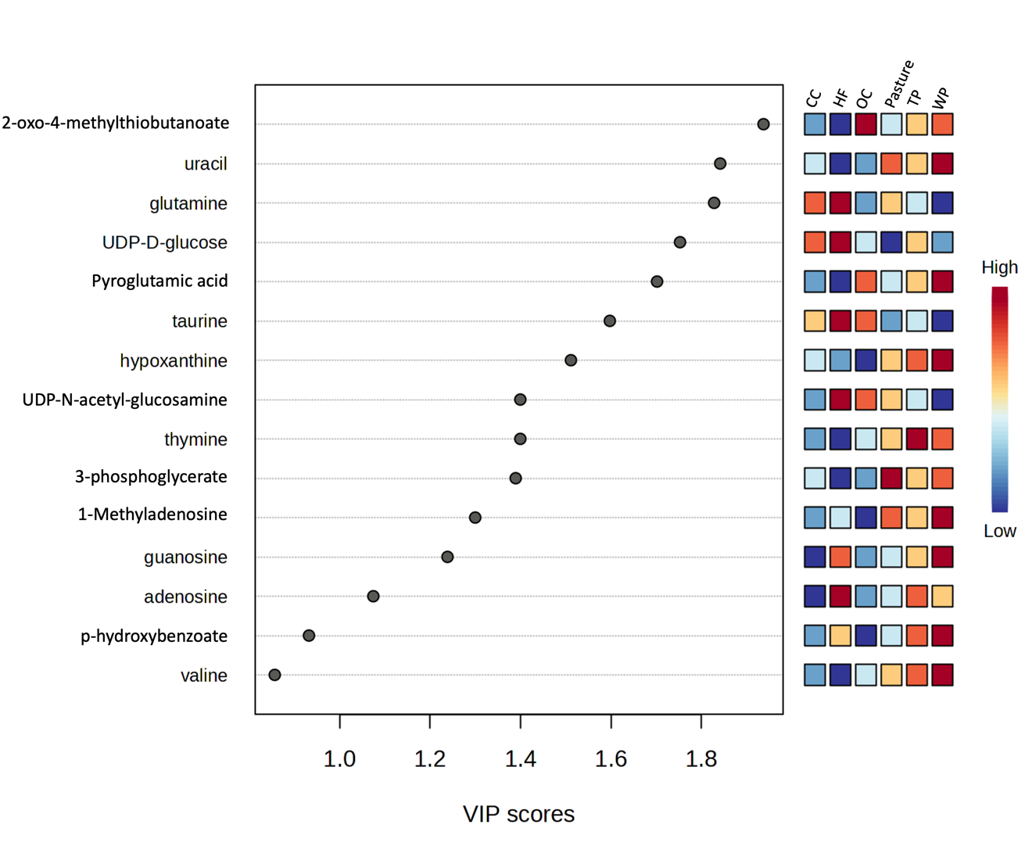
Figure 1.6 VIP scores for the top 15 identified metabolites contributing to group separation among land management practices. Metabolites were selected based on Component 1 of the partial least squares discriminant analysis (PLS-DA), and all shown compounds had VIP scores greater than 1.0. The accompanying heatmap displays the relative abundance of each metabolite across the six soil groups: conventional cultivation (CC), hardwood forest (HF), organic cultivation (OC), pasture, tulip poplar (TP), and white pine (WP). Warmer colors indicate higher normalized abundance. These metabolites include key intermediates in amino acid metabolism (e.g., valine, glutamine), nucleotide turnover (e.g., uracil, thymine), and microbial or plant carbohydrate pathways (e.g., UDP-D-glucose, N-acetyl-glucosamine), highlighting distinct biochemical signatures among land use types.

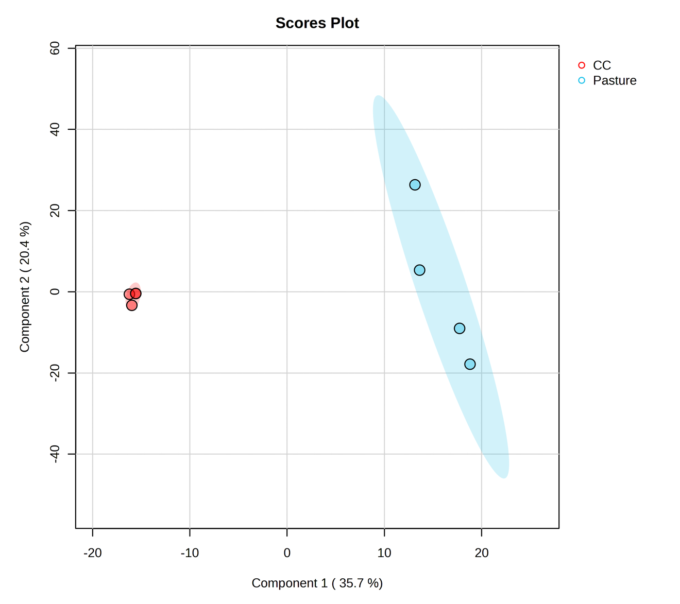
Figure 1.7 PLS-DA scores plot comparing conventional cultivation (CC) and pasture soils based on metabolomic profiles. The first two components explain 35.7% and 20.4% of the total variance, respectively.

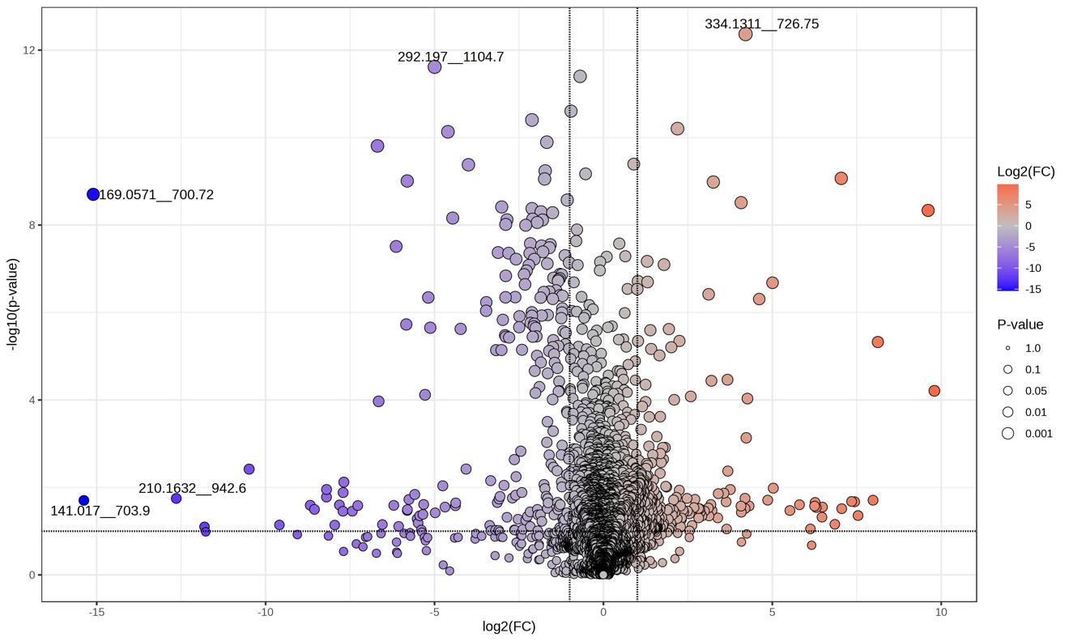
Figure 1.8 Volcano plot showing differential metabolites between conventional cultivation (CC) and pasture soils. Points represent individual spectral features, with color indicating log₂ fold change and size indicating p-value significance.

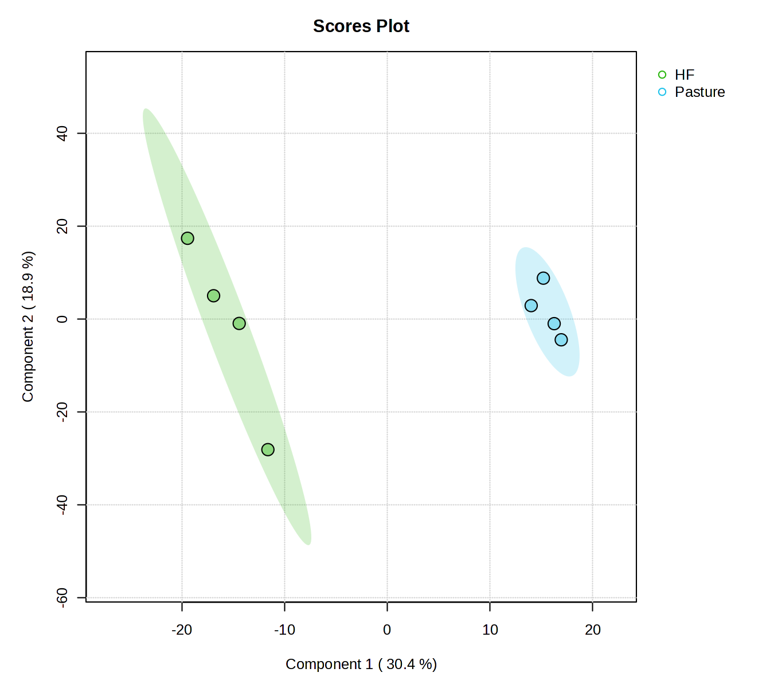
Figure 1.9 PLS-DA scores plot comparing hardwood forest (HF) and pasture soils based on metabolomic profiles. The first two components explain 30.4% and 18.9% of the total variance, respectively.

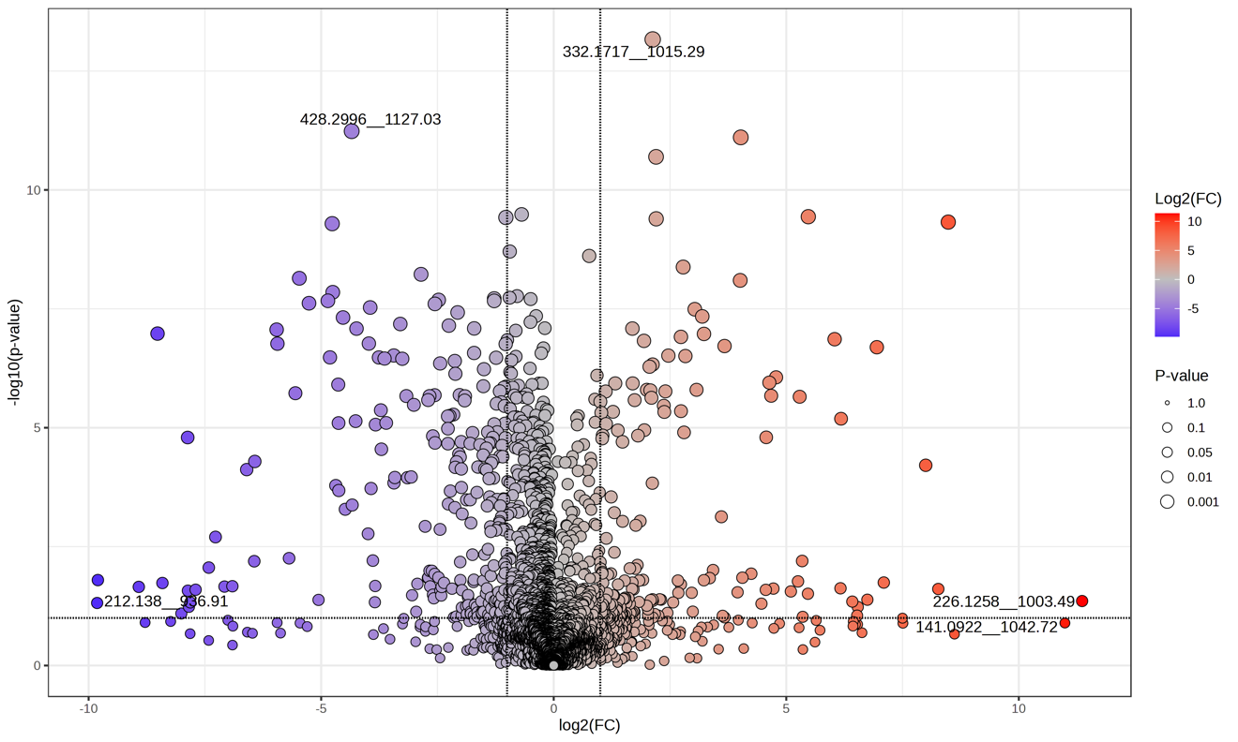
Figure 1.10 Volcano plot showing differential metabolites between hardwood forest (HF) and pasture soils. Points represent individual spectral features, with color indicating log₂ fold change and size indicating p-value significance.

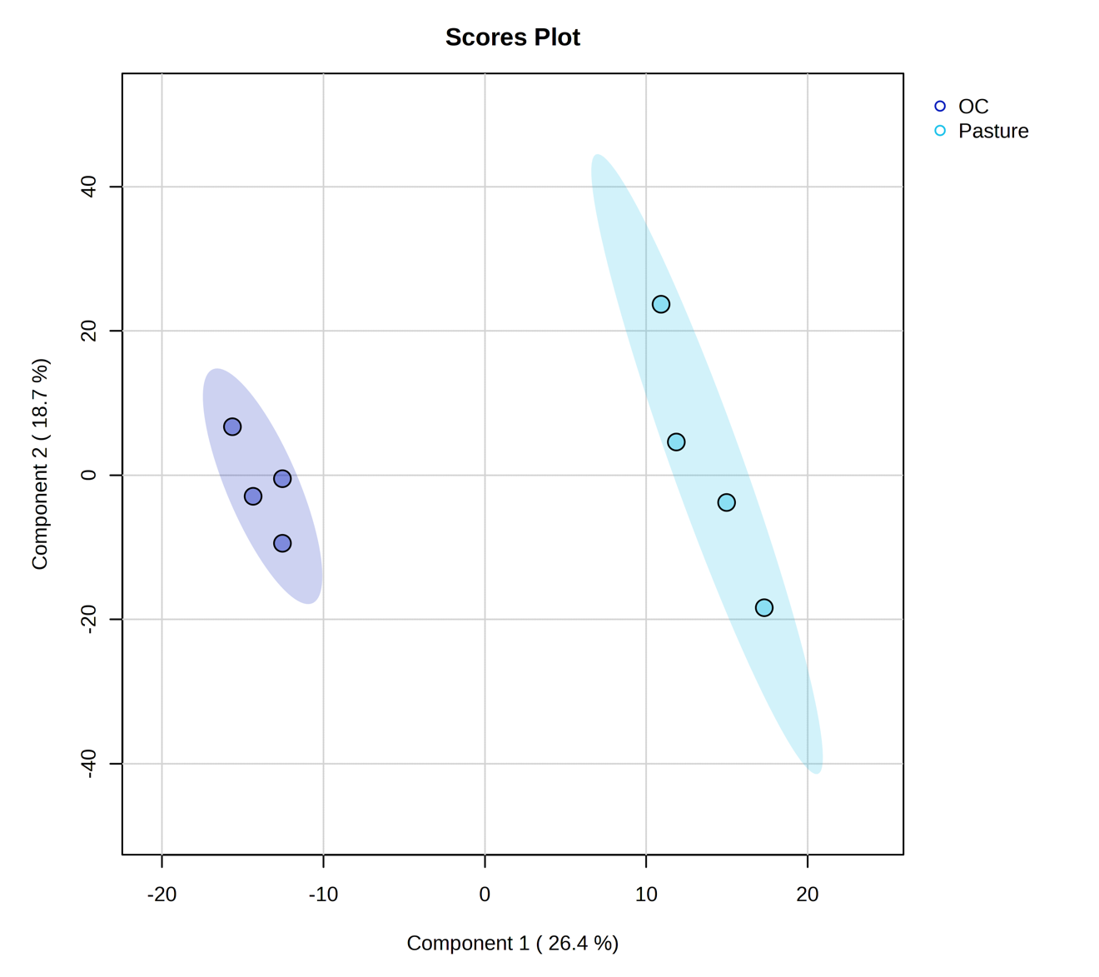
Figure 1.11 PLS-DA scores plot comparing organic cultivation (OC) and pasture soils based on metabolomic profiles. The first two components explain 26.4% and 18.7% of the total variance, respectively.

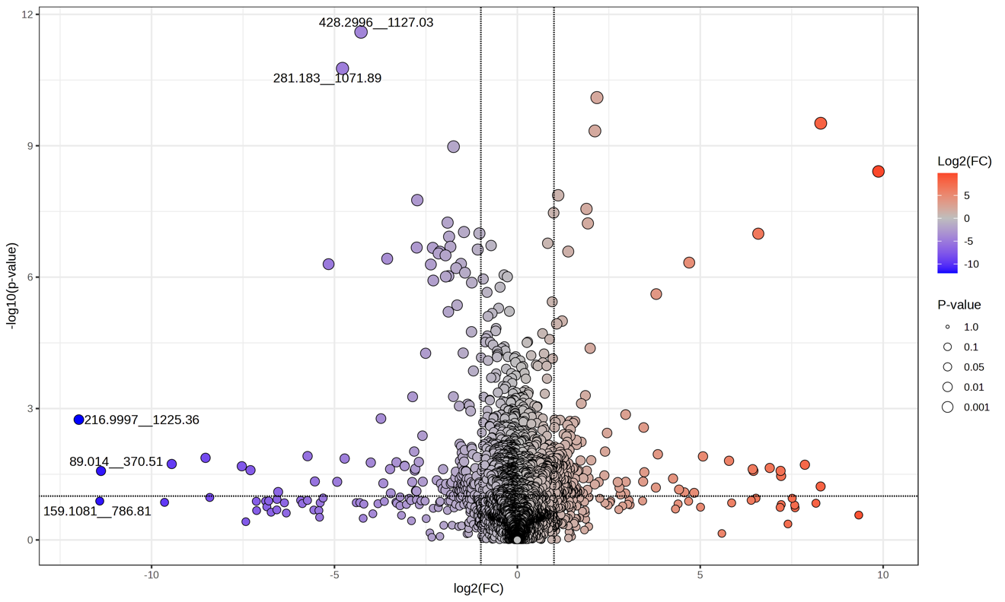
Figure 1.12 Volcano plot showing differential metabolites between organic cultivation (OC) and pasture soils. Points represent individual spectral features, with color indicating log₂ fold change and size indicating p-value significance.

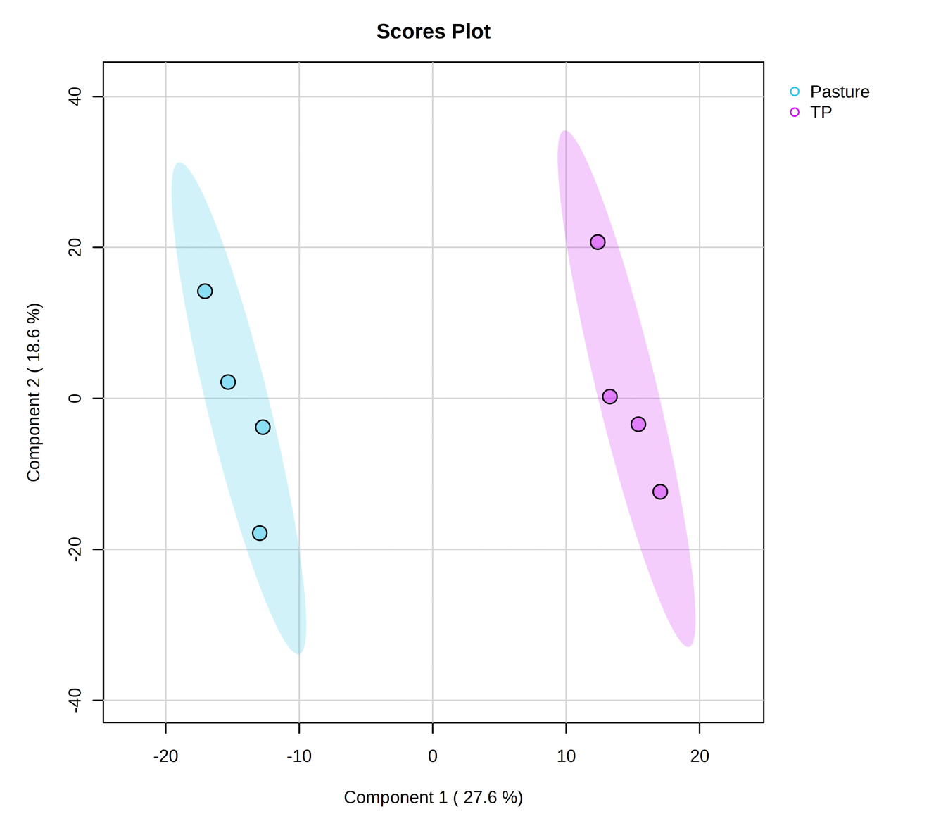
Figure 1.13 PLS-DA scores plot comparing pasture and tulip poplar (TP) soils based on metabolomic profiles. The first two components explain 27.6% and 18.6% of the total variance, respectively.

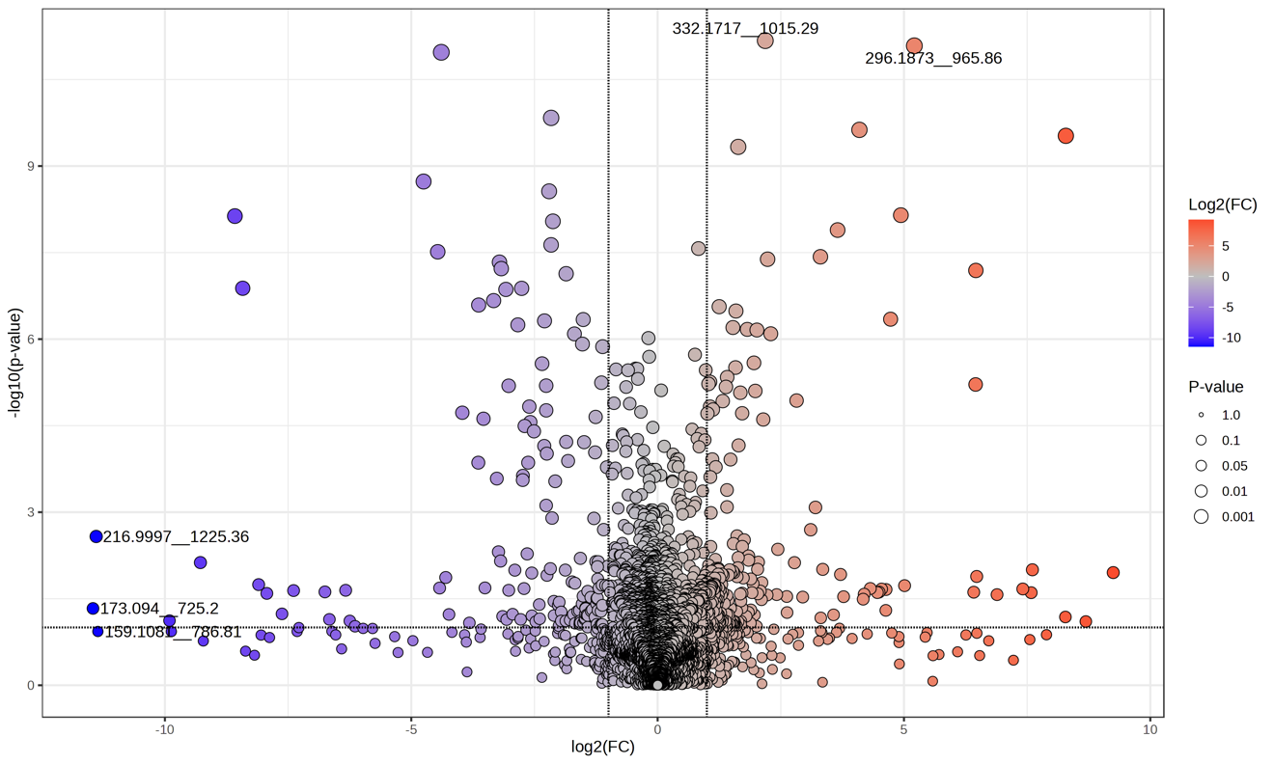
Figure 1.14 Volcano plot showing differential metabolites between pasture and tulip poplar (TP) soils. Points represent individual spectral features, with color indicating log₂ fold change and size indicating p-value significance.

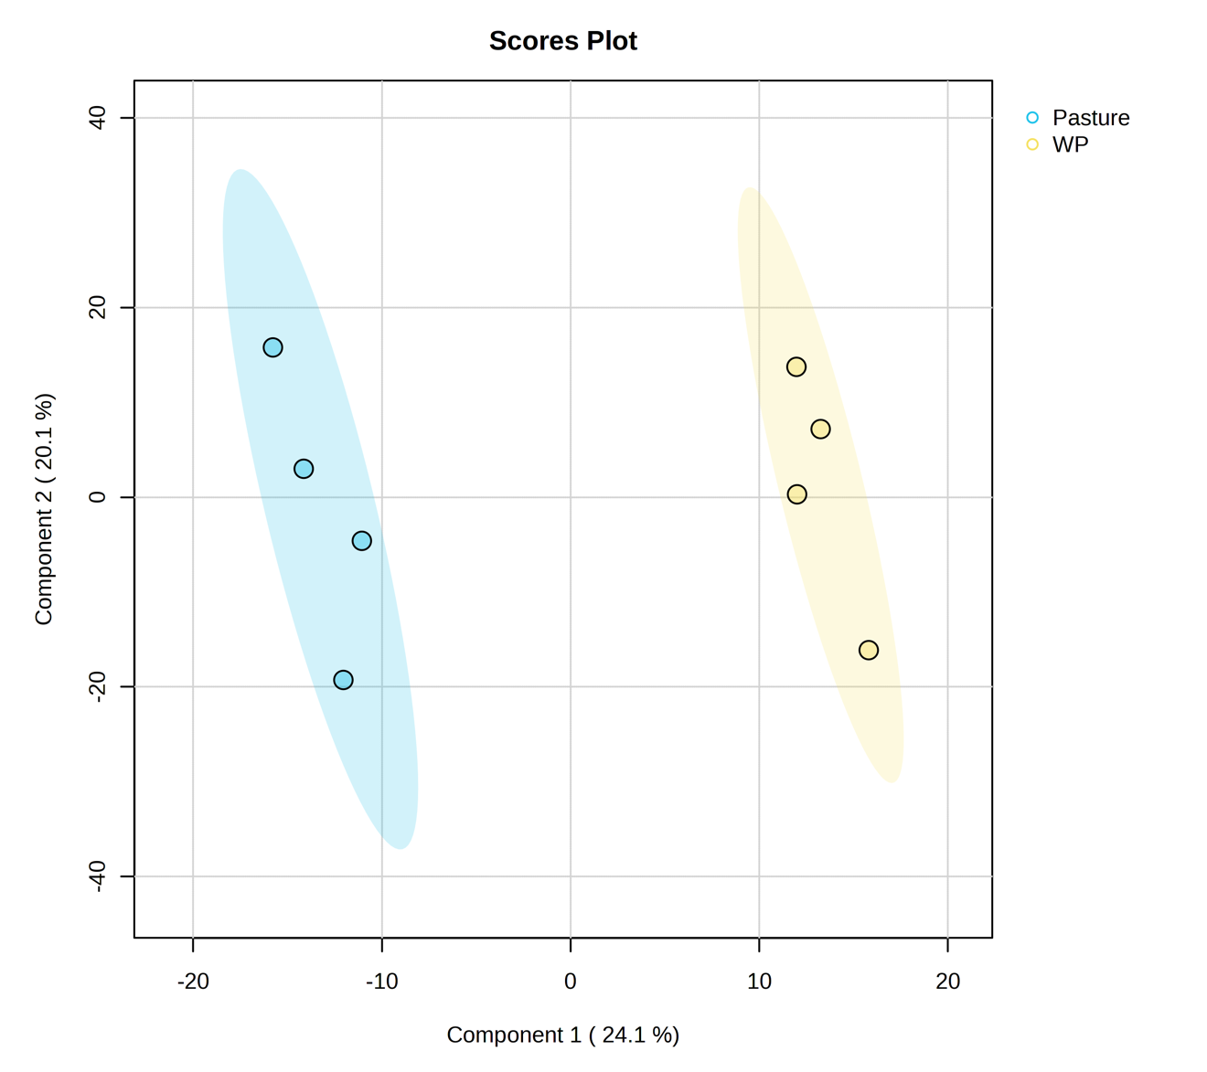
Figure 1.15 PLS-DA scores plot comparing pasture and white pine (WP) soils based on metabolomic profiles. The first two components explain 24.1% and 20.1% of the total variance, respectively.

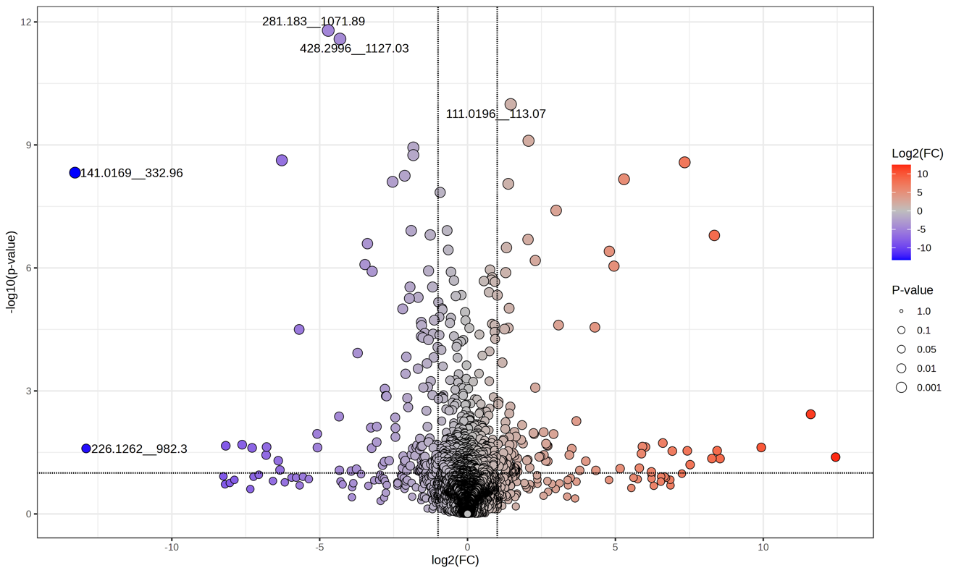
Figure 1.16 Volcano plot showing differential metabolites between pasture and white pine (WP) soils. Points represent individual spectral features, with color indicating log₂ fold change and size indicating p-value significance.

Table 1-1. NPClassifier superclass counts and percentages for each land management type. Categories representing less than 3% of the total features within a group were combined into the “Other” category prior to visualization in pie charts. Counts are based on classified features only; unclassified features were excluded from both counts and percentages.
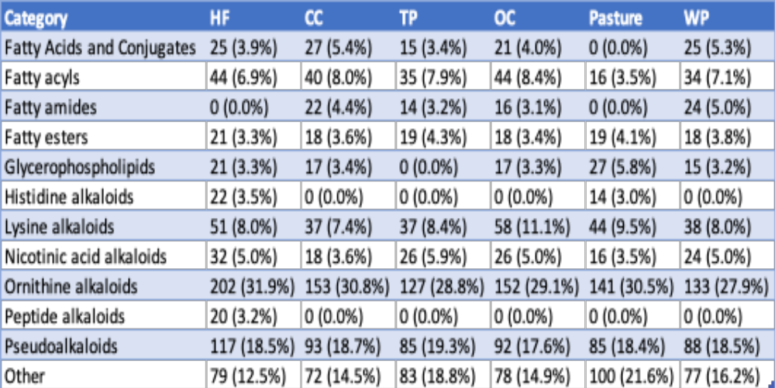

VITA
Zane Vickery grew up in rural southeast Alabama. After graduating high school in 2014, he attended Troy University. It was there he found his love for science and chemistry. Graduate school seemed like the next logical step as his interest in learning was not satisfied with a bachelor’s degree. Zane and his wife, Anna Kate, chose Knoxville to start both of their careers. He entered the chemistry program at the University of Tennessee to obtain his PhD with a concentration in analytical chemistry. His research was widespread until late in his graduate career, collaborating in areas of animal science, ecology, microbiology, forensics, and method development. Later in his graduate career Zane started probing the “dark metabolome” more, and he worked on updating unidentified spectral features processing in the lab. He could not be more thankful for his incredible wife and two precious loving daughters, Saylor and Stella; their love and support follow him into the next stage of his career.

