Localization of chemoreceptors in Azospirillum brasilense.

A Thesis Presented for the
Master of Science
Degree
The University of Tennessee, Knoxville

Anastasia Aksenova
December 2014

Copyright © 2014 by Anastasia De Cerqueira
All rights reserved.

ACKNOWLEDGEMENTS

ABSTRACT

In order to ensure their survival, bacteria must sense and adapt to a variety of environmental signals. Motile bacteria are able to orient their movement in a chemical gradient by chemotaxis. During chemotaxis, environmental signals are detected by chemotaxis receptors and are propagated via a signal transduction cascade to affect bacterial motility. In a model organism Escherichia coli, chemotaxis receptors, also called MCPs (for methyl-accepting chemotaxis proteins) sense changes in concentration gradients by making temporal comparisons about the chemical composition of their surroundings. Decreased attractant concentration or increased repellant concentration results in conformational changes in the MCPs that culminate in autophosphorylation of histidine kinase CheA that in turn phosphorylates response regulator CheY. Phosphorylated CheY interacts with flagellar rotor switch protein FliM and causes it to switch direction of rotation.
In E. coli, MCPs form mixed trimers-of-receptor dimers. Together with CheA and CheW proteins they further organize into large patches at the cell poles called arrays. This architecture is important for signal amplification and propagation and is universally conserved among many bacterial species. In contrast to E. coli, nitrogen-fixing soil bacteria, Azospirillum brasilense, encode four chemotaxis pathways and 41 MCPs. Previous work shows both Che1 and Che4 contribute to chemotaxis and aerotaxis implying that signals detected by chemotactic receptors must be integrated to generate a coordinated motility response. In this work, fluorescent microscopy imaging studies of some A. brasilense MCPs (Tlp1, Tlp2, Tlp4a, and AerC) in various mutant backgrounds demonstrate their localization in respect to each other and to CheA1 and CheA4 proteins.

TABLE OF CONTENTS
CHAPTER I. Introduction 1
Structure of bacterial chemoreceptors 2
Chemotaxis in E. coli 4
Organization of chemoreceptors in E. coli 6
Organization of chemoreceptors in other bacteria 9
CHAPTER II. Materials and Methods 14
Strains and growth conditions 14
Plasmids and strains construction 17
Swimming in semi-soft agar assay 18
Fluorescence microscopy 19
Bacteria-Two Hybrid Assay (BACTH) 19
CHAPTER III. Results and Discussion 21
VITA 27

LIST OF TABLES
Table 1. Summary of measurements of 13 different bacterial species obtained by cryo-ET. 9
Table 2. Plasmids and strains used in this study. 15
Table 3. Primers 18

LIST OF FIGURES

Figure 1. Swimming of E. coli in the absence and presence of chemical gradient . 1
Figure 2. A ribbon diagram and a schematic of a chemoreceptor dimer from E. coli . 2
Figure 3. Classification of MCPs into six different topologies. 3
Figure 4. Schematic representation of MCP cytoplasmic domain features as revealed by a multiple sequence alignment of C-terminal domains. 3
Figure 5. The chemotaxis signaling pathway in E. coli 4
Figure 6. E. coli chemoreceptors and other signaling components 6
Figure 8. The 3D map of receptor arrays derived from subvolume analysis. 7
Figure 9. Model of array assembly. 8
Figure 10. Azospirillum brasilense has four chemotaxis-like operons. 10

CHAPTER I. Introduction

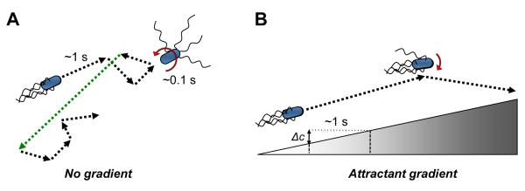
In order to ensure their survival, bacteria must sense and adapt to a variety of environmental signals and to be able to avoid harmful environments and to seek beneficial ones. Movement of bacteria towards chemical attractants and away from chemical repellants is called chemotaxis. Chemotaxis (taxis in gradients of chemical effectors) is one of the most common taxis responses in bacteria but other forms of taxis include aerotaxis (movement in oxygen gradient), phototaxis (movement in gradient of light), and pH taxis (movement in pH gradient) (Wadhams and Armitage, 2004). Chemotaxis in bacteria can be described as a "random biased walk": motile bacteria set off swimming in one direction, and if conditions get better they keep moving (“run”) in that direction. If conditions get worse (decreased attractant concentration or increased repellant concentration), bacteria tend to “tumble”, randomly reorienting by Brownian motion to swim in a new direction (Figure 1). In order to sense changes in the environment and adapt to them, bacteria, like the model organism Escherichia coli use signal transduction system comprised of five chemoreceptors and six chemotaxis proteins (CheA, CheW, CheY, CheZ, CheR, and CheB) encoded within a single operon (Silverman and Simon, 1976; Francis et al., 2004; Wadhams and Armitage, 2004). This is in contrast to many soil and aquatic bacteria, the majority of which contain multiple chemotaxis operons and a large number of receptors (Porter et al., 2011). These features allowed for E. coli to become a model organism for studying chemotaxis signal transduction.
Figure 1. Swimming of E. coli in the absence and presence of chemical gradient (Sourjik and Wingreen, 2012).

Structure of bacterial chemoreceptors
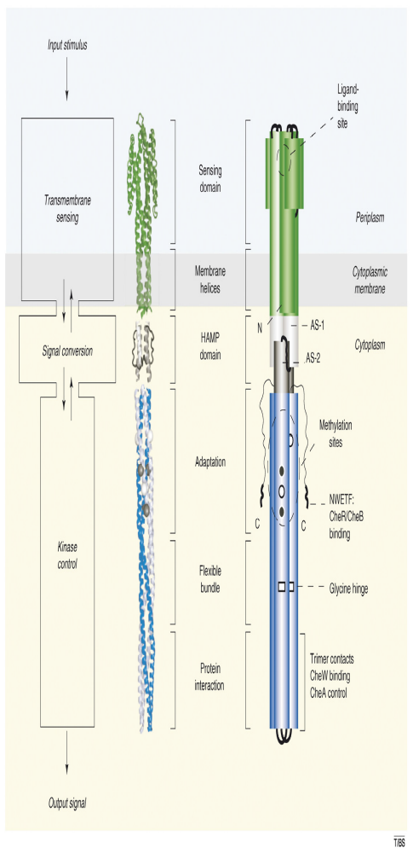
In E. coli, chemotaxis receptors, also called MCPs (for methyl-accepting chemotaxis proteins) sense changes in concentration gradients by making temporal comparisons about the chemical composition of their surroundings (Sourjik and Wingreen, 2012).A functional unit of chemoreceptors is a helical homodimer. Typically, each monomer in a dimer contains a ligand binding region (LBR) at the N-terminus, exposed on the periplasmic side of the membrane and flanked by two transmembrane domains, and a C-terminal signaling region located in the cytoplasm (Figure 2). A typical E. coli chemoreceptor LBR is a four-helix bundle structure arranged in parallel that, in a dimer, forms a cluster of eight helices where ligands bind (Milburn et al., 1991). The LBRs vary greatly in sequence reflecting their role in binding different compounds (Zhulin, 2001). It is noteworthy that 88.7% of LBRs are un-annotated in the SMART database (a database used for the identification, annotation, and prediction of architecture of protein domains; Letunic et al., 2011), suggesting that they are novel domains for which a sensory specificity cannot be predicted from sequence alone (Wuichet et al., 2010). MCPs can be further classified by their topology type into 6 different classes with Class I being the most abundant (Figure 3).
Figure 2. A ribbon diagram and a schematic of a chemoreceptor dimer from E. coli (modified from Hazelabuer et al., 2008).
Ligand binding region (LBR)
Signaling region
Transmembrane domain

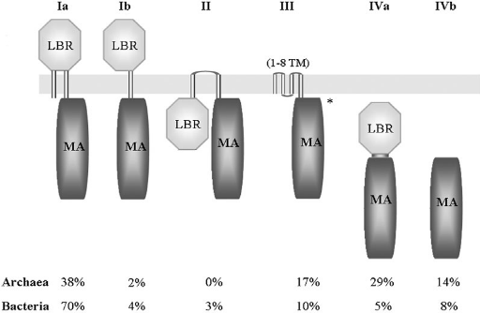
Figure 3. Classification of MCPs into six different topologies. In total 3521 MCP sequences were analyzed. The relative abundance of receptors with a given topology in bacteria and archaea is indicated. MA, methyl-accepting domains; LBR, ligand binding region. The asterisk ‘*’ indicates that in a few cases only an LBR at the C-terminal extension of the TM regions is found (Lacal et al., 2010).

The signaling region of a chemotaxis receptor is highly conserved among MCPs as it interacts with components of the chemotaxis signaling pathway in the cytoplasm (Alexander and Zhulin, 2007). This region consists of a methylation, flexible bundle domain critical for signal transduction, as well as signaling sub-domains implicated in CheA and CheW binding (Falke and Hazelbauer, 2001; Zhulin, 2001; Alexander and Zhulin, 2007). Sequence alignment of 1,915 MCPs from 152 genomes of Bacteria and Archaea showed that MCPs could be organized into 7 major classes based on the sequence conservation and the presence of symmetric seven amino acid-long insertions and deletions, corresponding to two α-helical turns and defined as heptads (H) (Figure 4). In addition, based on sequence conservation chemoreceptors from different classes and organisms form dimers.
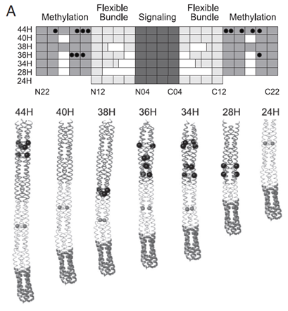
Figure 4. Schematic representation of MCP cytoplasmic domain features as revealed by a multiple sequence alignment of C-terminal domains. The signaling subdomain is shown in dark thick ribbons, the flexible bundle subdomain in light thin ribbons, and the methylation subdomain in dark thick ribbons. The most common methylation sites are shown as dark gray spheres (Alexander and Zhulin, 2007).

B

Chemotaxis in E. coli

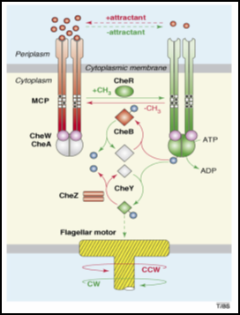
In E. coli, binding of attractants to LBR of MCPs results in the piston-like movement of the transmembrane region towards the cytoplasm which in turn leads to signal conversion and propagation (Parkinson et al., 2010;Figure 2). In the cytoplasm, the C-terminal signaling regions of MCPs interact with a histidine kinase CheA and a coupling protein CheW to form ternary complexes where transduction of the chemotaxis signal is initiated (Maddock and Shapiro, 1993; Studdert and Parkinson, 2004). CheA is a dimeric protein consisting of five structural domains (P1-P5): P1 is a histidine phosphotransfer domain that gets phosphorylated by the P4 kinase domain, P2 binds the response regulator CheY and the methylesterase CheB, P3 is the domain responsible for dimerization, and P5 is a CheW-like domain that binds CheW and the tips of the chemoreceptors (McNally and Matsumura, 1991; Gegner et al., 1992). Signal propagation down the length of the MCPs results in conformational changes in various domains culminating in autophosphorylation of CheA. CheA, in turn, phosphorylates its response regulator CheY (Figure 5). Phosphorylated CheY (CheY-P) gets released from the MCP/CheA/CheW cluster and interacts with the flagellar motor switch protein FliM which causes it to switch the direction of flagellar rotation (Falke et al., 1997). The probability of switching the direction of flagellar rotation increases with increasing number of CheY-Ps binding to FliM subunits (Bai et al., 2010). The signaling stops when CheY-P becomes dephosphorylated by its dedicated phosphatase, CheZ.
Figure 5. The chemotaxis signaling pathway in E. coli (Hazelbauer et al., 2008).

Counter-clockwise rotation of flagellar motor results in the forward movement, while clockwise rotation of one or more flagella motors causes bacteria to tumble (Welch et al., 1993). Binding of attractants and repellants to the LBR of the chemoreceptors allows them to sense current conditions while methylation/demethylation of specific residues located in the cytoplasmic region of chemoreceptors, by the combined activities of CheR (methyltransferase) and CheB (methylesterase), allows the receptors to adapt to changes by adjusting their sensitivity upon sensing a cue (Figure 2 and Figure 5, Wadhams and Armitage, 2004). For example, when attractants concentration decreases, CheA phosphorylates Che-Y (see above) and methylesterase CheB (CheB-P). CheB-P counteracts the constitutive activity of CheR and removes methyl groups from specific glutamate residues in the cytoplasmic domains of the MCPs which eventually decreases CheA autophosphorylation (Figure 5). As the concentration of CheY-P decreases cells become smoother swimming, i.e. tumble less frequently. Differential methylation of chemoreceptors restores the movement bias to the pre-stimulus level and provides the cells with a short term “memory” allowing cells to compare current conditions to the previous ones.

Organization of chemoreceptors in E. coli
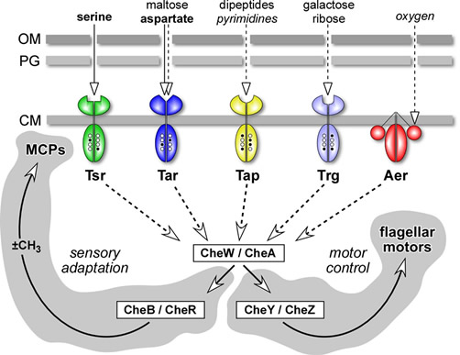
E. coli has four canonical MCPs (Tsr – senses serine, Tar – senses maltose and aspartate, Tap – senses dipeptides and pyrimidines, and Trg – senses galactose and ribose) and an MCP-like receptor Aer for redox potential (Silverman and Simon, 1976; Rebbapragada et al., 1997; Bibikov et al., 2004;Figure 6 ). All five of these receptors form mixed clusters and localize to the cell poles along with CheA and CheW proteins to form large patches (~250 nm average diameter), as evidenced by immunofluorescent microscopy, immunogold labeling, and cryoelectron tomography (cryo-ET) studies (Maddock and Shapiro, 1993; Sourjik and Berg, 2002; Briegel et al., 2009). While the majority of the patches (80%) localizes to the cell pole and remains mobile, the non-polar patches are steady and form next to future division sites (Thiem et al., 2007). Experimental evidence and mathematical modeling indicate that allosteric interactions among receptors in the patches allow for signal amplification up to 36-fold, implying that one receptor may interact with dozens of CheA kinase molecules (Sourjik and Berg, 2002). Signal amplification is critical to chemotaxis, as it enables bacteria to sense and quickly respond to the smallest changes in their environment.
Figure 6. E. coli chemoreceptors and other signaling components (Parkinson lab website).
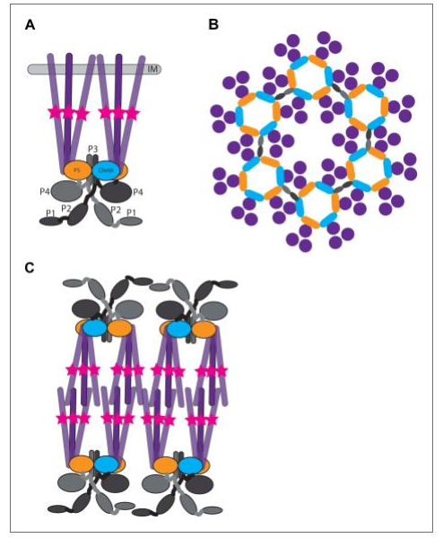
Cryo-ET of E. coli mini-cells revealed that receptors form a hexagonal lattice with a 13.2 nm spacing, each hexagon representing a trimer-of-chemoreceptor dimers (Liu et al., 2012). The neighboring trimers are connected by a continuous density layer comprised of CheA and CheW proteins, forming large patches called receptor arrays (Figure 7 and Figure 8). These patches are stabilized by the interactions between CheW and the P5 domain of CheA, as well as between the cytoplasmic tips of MCPs and the P3 domain of CheA (Figure 8F; Figure 7A; Park et al., 2006; Liu et al., 2012).
Figure 7. Structure of membrane-bound receptor complexes. (A) Schematic showing the topology of receptor-trimers-of-dimers (purple). The methylation region of each receptor dimer is indicated by a pink star. IM = inner membrane. (B) Top-view of the arrangement of the array components showing the interaction sites between the receptors. The colors correspond to the same proteins and protein domains in panel A and B (Briegel et al., 2014).

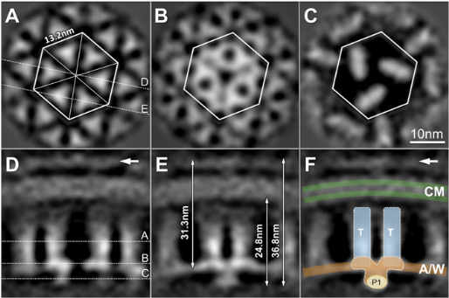
Figure 8. The 3D map of receptor arrays derived from subvolume analysis (modified from Liu et al., 2012).

Six core complexes that consist of one trimer-of-dimers and CheA and CheW proteins form a ring with a hole in the middle (Figure 8B) that could be filled with the CheW proteins interacting with the tips of MCPs and further stabilizing the array (Liu et al., 2012). Fluorescent microscopy studies of E. coli chemoreceptors revealed that in the absence of CheA and CheW proteins, receptors localization appeared to be more diffuse with cap or multiple small clusters at the pole in contrast to the wild type strain, where receptors form compact clusters seen as single foci at the cell poles (Kentner et al., 2006). These evidence suggest that CheA and CheW proteins are not required for cluster formation but assist in stabilization of the clusters in a compact form. In addition, cross-linking studies demonstrated that chemoreceptors of different types form mixed trimers in vivo, even in the absence of CheA and CheW, and with their composition depending on the relative expression of the receptors (Studdert and Parkinson, 2003).
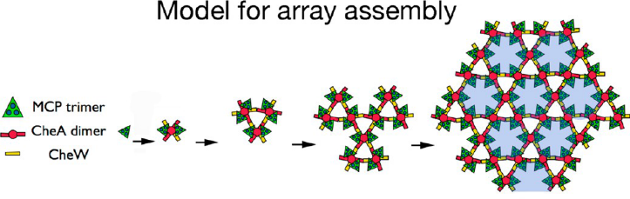
Recent cryo-ET studies of the E. coli Tar chemoreceptor revealed a model for chemoreceptor array assembly (Briegel et al., 2014). The authors propose that, as the receptors are synthesized and inserted into the membrane, they quickly dimerize to form trimers-of-dimers. CheA dimers, in the cytoplasm, then capture the newly assembled trimers-of-dimers to form six-receptor functional units that either attach to existing arrays through CheW or link together (Figure 9). Consistent with this model, in vitro studies in which membranes containing receptors were incubated with purified CheA and CheW revealed that small complexes and small arrays are intermediates in the formation of large native arrays (Briegel et al., 2014). In the absence of CheA and CheW, chemoreceptors form non-native arrays called “zippers” in which two receptor layers interact with each other at their cytoplasmic tips (where CheA and CheW normally bind) causing membrane invaginations (Zhang et al., 2007). Interestingly, the basic unit in a zipper is still a trimer-of-dimers; however, when viewed from the top, these trimers-of-dimers exhibit tighter packing than in native arrays (Briegel et al., 2014).
Figure 9. Model of array assembly. Schematic showing sequential assembly of the core functional unit in E. coli. Empty hexagons without associated CheA are colored blue (Briegel et al., 2014).

Organization of chemoreceptors in other bacteria
Chemotaxis in motile prokaryotes depends on tightly coupled chemoreceptor arrays that are responsible for high sensitivity (Duke and Bray, 1999), signal gain (Sourjik and Berg, 2002), cooperativity (Sourjik and Berg, 2004), and adaptation (Li and Hazelbauer, 2005) of the signal transduction system. Given the major role that chemoreceptor arrays play in signal processing, it is not surprising that this organization is likely universal in motile bacteria and Archaea. Cryo-ET studies of 13 distantly related bacteria (Table 1) from 6 distinct taxonomic groups, which together possess chemoreceptors from 7 signaling domain classes confirmed this assumption. All species analyzed in this study possessed chemoreceptors arrays organized as trimers-of-dimers (Briegel et al., 2009).
Table 1. Summary of measurements of 13 different bacterial species obtained by cryo-ET (modified from Briegel et al., 2009).
Bacterium | Phylum | Location of arrays
Thermotoga maritima | Thermotogae | Polar
Listeria monocytogenes | Firmicutes | Polar
Acetonema longum | Firmicutes | Subpolar
Borrelia burgdorferi | Spirochaetes | Subpolar
Treponema primitia | Spirochaetes | Polar
Caulobacter crescentus | Alpha- proteobacteria | Polar,convex side  (Briegel et al., 2008)
Magnetospirillum magneticum | Alpha- proteobacteria | Polar
Rhodobacter sphaeroides | Alpha- proteobacteria | Polar
Escherichia coli | Gamma-proteobacteria | Mainly polar  (Zhang et al., 2007)
Vibrio cholera | Gamma-proteobacteria | Polar, convex side
Halothiobacillus neapolitanus | Gamma-proteobacteria | Polar
Helicobacter hepaticus | Epsilon-proteobacteria | Polar, “cap”
Campylobacter jejuni | Epsilon-proteobacteria | Polar, “cap”

Most of the trimers-of-chemoreceptor dimers extended in a honeycomb-like lattice with 12 nm spacing (just like in E. coli), except for Listeria monocytogenes and Borrelia burgdorferi where no lattice was visible under the experimental conditions used. The lattice structure was visible the most just above the CheA/CheW baseplate and less ordered near the N-termini of the MCPs, suggesting that the main architectural contacts occur in the signaling subdomain region. A major difference among the species analyzed was in the position of the arrays within a cell. In 6 species (including E. coli), the position of the chemoreceptor arrays was polar, while in 2 other species (Helicobacter hepaticus and Campylobacter jejuni) the arrays completely surrounded the tip of the cell forming a so-called “cap” (Table 1). In Caulobacter crescentus and Vibrio cholerae, chemoreceptors localized to the convex side of the cell (Briegel et al., 2008; Briegel et al., 2009). The arrays in Acetonema longum and B. burgdorferi were subpolar and positioned at varying distances from the cell pole (Briegel et al., 2009).
The bacterial species in the study contained chemoreceptors belonging to 7 different signaling domain classes. However, chemoreceptor arrays visualized by cryo-ET consisted of chemoreceptors belonging to one major signaling class (44H, 40H, 38H, 36H, and 34H). This conclusion was made based on the fact that the physical length of the signaling domain, defined as the distance between the CheA/CheW baseplate and the inner membrane, correlated with its sequence length. For example, chemoreceptors that form arrays analyzed in C. jejuni and H. hepaticus belonged to 40H class only, even though these species also contained receptors of another class (28H) because the distance between the inner membrane and the baseplate could only accommodate the receptors of the 40H class and not the 28H class. The high degree of conservation of chemoreceptor arrays architecture among diverse bacterial species implies that underlying signaling mechanisms may also be conserved.
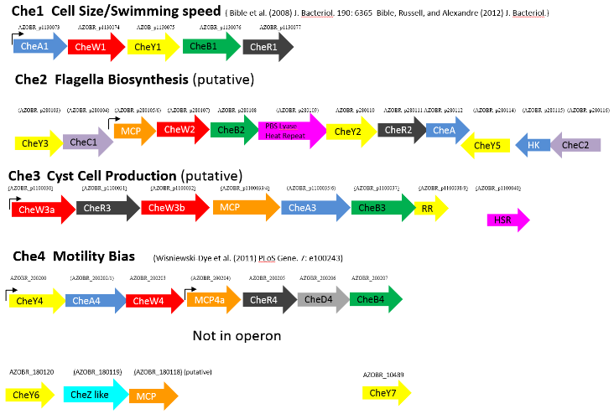
Signal transduction during chemotaxis has been studied in various bacterial species: from enteric E. coli to aquatic T. maritima (Hazelbauer et al., 2008; Perez and Stock, 2007). Even though all known bacteria have chemotaxis proteins similar to those found in E. coli, many of them have multiple chemotaxis operons as well as additional chemotaxis proteins and chemoreceptors (Porter et al., 2011). For example, more than 50% of sequenced genomes from chemotactic bacteria contain more than one cheA (Porter et al., 2008; Wuichet and Zhulin, 2010). One such species is Azospirillum brasilense, a soil alphaproteobacterium that colonizes roots of agronomically important plants (beans, tomatoes, grasses, etc.) and promotes their growth (Dobbelaere and Okon, 2007). The ability of bacteria to become established in the rhizosphere is strongly correlated with their ability to perform chemotaxis. Indeed, non-chemotactic mutants were impaired in plant root colonization when competing with the wild type A. brasilense parental strain (Greer-Phillips et al., 2004).
Figure 10. Azospirillum brasilense has four chemotaxis-like operons. Chemotaxis genes are also spread in the A. brasilense genome in clusters. Most chemotaxis receptors are scattered at various loci on the genome.

The genome of the wild type A. brasilense Sp245 and FP2 strains contains 4 chemotaxis operons and 41 chemoreceptors (Figure 10, Wisniewsky-Dye et al., 2011, Universidade do Parana, 2013). To date, only one out of the four chemotaxis-like pathways (Che1) has been experimentally characterized (Bible et al., 2008). The Che1 pathway in A. brasilense contributes to chemotaxis via an effect on the swimming speed (equivalent to “runs” in E. coli) (Bible et al., 2012). Recent evidence suggest that the Che4 pathway is responsible for controlling the swimming reversal frequency (equivalent to tumbles in E. coli), and that both Che1 and Che4 contribute to chemotaxis and aerotaxis (Alexandre, 2010; Kumar, 2012; Bible et al., 2012; Russell et al., 2013, unpublished data). Moreover, fluorescent imaging data of CheA1-YFP and CheA4-YFP localization in different mutant backgrounds suggest that components of both Che1 and Che4 operons are required for proper localization of CheA1 and CheA4 to the cell poles because CheA1-YFP and CheA4-YFP fluorescence was diffused in Δche1Δche4 background but not in Δche1 or Δche4 (Kumar, 2012).
In addition to multiple Che pathways, the genome of A. brasilense encodes 41 chemotaxis receptors in stark contrast to the 5 chemoreceptors found in the E. coli genome (Hazelbauer et al., 2008; Wisniewski-Dye et al., 2011). The sensory specificity of some of the receptors in A. brasilense (Tlp1 and AerC) has been determined (transducer like protein 1 (Tlp1) - Greer-Phillips et al., 2004; Russell et al., 2013; AerC (transducer for aerotaxis and related responses, cytoplasmic) – Xie at al., 2010) while sensory specificity of other receptors is yet to be investigated. Even though it is known that certain chemoreceptors in A. brasilense interact with more than one Che pathway (Tlp1) and localize to the cell poles (AerC), their exact localization with respect to one another and to other chemotaxis proteins has not been investigated. For example, AerC is a soluble chemoreceptor that localizes to the cell poles under nitrogen-fixing conditions (absence of nitrogen and low oxygen concentrations) (Xie et al., 2010). Interestingly, its localization to the cell poles is affected in the Che1 deletion background suggesting that it interacts with the chemotaxis proteins in this pathway (Xie et al., 2010). AerC also affects reversal frequency controlled by Che4 operon suggesting that it may interact with proteins in this pathway (Xie et al., 2010; Kumar, 2012).
Tlp1 is another energy taxis transducer that is important for plant root colonization, redox taxis, and taxis to oxygen and nitrate (Greer-Phillips et al., 2004; Russell et al., 2013). It was found to regulate swimming velocity and reversal frequency via Che1 as well as another unidentified Che pathway, which is hypothesized to be Che4 suggesting that Tlp1 interacts with the chemotaxis proteins in more than one Che pathway (Russell et al., 2013). Therefore, it is possible that Che1 and Che4 pathways cross-talk at the receptors level which adds to the complexity of studying chemotaxis in this organism.
This work aims to provide insight into localization of chemoreceptors AerC, Tlp1, and Tlp4a within a cell in respect to each other and to CheA1 and CheA4 proteins. To date, it is unknown whether chemoreceptors in A. brasilense form mixed clusters like in E. coli. Moreover, it is unknown whether some receptors preferentially interact with only one type of CheA or both. Fluorescence microscopy data provided in this work suggest that Tlp1 and AerC may form mixed clusters as their localization was affected in ΔaerC and Δtlp1 backgrounds respectively while Tlp4a may not form mixed clusters with the other two since Tlp4a-YFP localization and fluorescence intensity was not affected in ΔaerC and Δtlp1 backgrounds. In addition, CheA1 deletion was found to affect Tlp4a-YFP cluster structure while deletion of CheA4 and both CheA1 and CheA4 affected localization of Tlp4a-YFP suggesting that Tlp4a may interact with both CheA1 and CheA4.

CHAPTER II.
Materials and Methods

Strains and growth conditions
Cells of the following bacterial strains (A. brasilense Table 1) were grown in the liquid MMAB (minimal medium for A. brasilense) with shaking (200 rpm) at 28°C to OD₆₀₀ (optical density at 600 nm) 0.6-1. Liquid MMAB was prepared by adding 3 g K₂HPO4, 1 g NaH₂PO4, 0.15 g KCl, trace amounts of Na₂MoO₄, 5 g of malate (carbon source), and 1 g of NH₄Cl (nitrogen source) to one liter of deionized water and autoclaved for 30 min at 121°C. The following salts were added after autoclaving: 5ml of MgSO₄ (60g/L stock), 500 μl of CaCl₂ (20g/L stock), and 250μl of FeSO4 (0.631g FeSO₄.7H₂0 and 0.592g EDTA in 50ml water). To induce nitrogen fixation, cells grown in MMAB (with carbon and nitrogen) were pelleted and washed 3 times with MMAB without nitrogen, and subsequently incubated in MMAB (supplemented with carbon but not nitrogen) at 28°C without shaking to ensure low aeration for 6 hours-overnight. All culture stocks were routinely maintained on solid MMAB medium lacking nitrogen source.
Table 2. Plasmids and strains used in this study.
Strains/plasmids | Genotype, relevant characteristics | Reference/source
A. brasilense strains
Sp7 | Wild type strain | ATCC 29145
ΔcheA1 | Δ(cheA1), Km | Bible et al., 2008
ΔcheA4 | Δ(cheA4), Gm | Alexandre lab, unpublished
ΔcheA1 ΔcheA4 | Δ(cheA1) Δ(cheA4), Km Gm | Alexandre lab, unpublished
Δ aerC | Δ(aerC), Km | Xie et al., 2010
Δ tlp1 | Δ(tlp1), Km | Greer-Phillips et al., 2004
Sp7 (pRH_Tlp1) | A. brasilense Sp7 expressing a Tlp1-YFP fusion from the pRH005 plasmid; Km Cm | Alexandre lab, unpublished
ΔcheA1 (pRH_Tlp1) | A. brasilense Sp7 mutant derivative deleted for cheA1 and expressing a Tlp1-YFP fusion from the pRH005 plasmid; Km Cm | Alexandre lab, unpublished (this work)
ΔcheA4 (pRH_Tlp1) | A. brasilense Sp7 mutant derivative deleted for cheA4 and expressing a Tlp1-YFP fusion from the pRH005 plasmid; Km Cm | Alexandre lab, unpublished (this work)
ΔcheA1 ΔcheA4 (pRH_Tlp1) | A. brasilense Sp7 mutant derivative deleted for cheA1 cheA4 and expressing a Tlp1-YFP fusion from the pRH005 plasmid; Km Cm | Alexandre lab, unpublished (this work)
Δ tlp1 (pRH_Tlp1) | A. brasilense Sp7 mutant derivative deleted for tlp1 and expressing a Tlp1-YFP fusion from the pRH005 plasmid; Km Cm | Russell et al., 2012
Δ aerC (pRH_Tlp1) | A. brasilense Sp7 mutant derivative deleted for aerC and expressing a Tlp1-YFP fusion from the pRH005 plasmid; Km Cm | Alexandre lab, unpublished (this work)
Sp7 (pRH_Tlp4a) | A. brasilense Sp7 expressing a Tlp4a-YFP fusion from the pRH005 plasmid; Km Cm | Alexandre lab, unpublished
ΔcheA1 (pRH_Tlp4a) | A. brasilense Sp7 mutant derivative deleted for cheA1 and expressing a Tlp4a-YFP fusion from the pRH005 plasmid; Km Cm | Alexandre lab, unpublished (this work)
ΔcheA4  (pRH_Tlp4a) | A. brasilense Sp7 mutant derivative deleted for cheA4 and expressing a Tlp4a-YFP fusion from the pRH005 plasmid; Km Cm | Alexandre lab, unpublished (this work)
pRH_Tlp4a | pRH005 containing a tlp4a promoter region and ORF; Km Cm | Alexandre lab, unpublished
ΔcheA1 ΔcheA4  (pRH_Tlp4a) | A. brasilense Sp7 mutant derivative deleted for cheA1 cheA4 and expressing a Tlp4a-YFP fusion from the pRH005 plasmid; Km Cm | Alexandre lab, unpublished (this work)
Δ tlp1 (pRH_Tlp4a) | A. brasilense Sp7 mutant derivative deleted for tlp1 and expressing a Tlp4a-YFP fusion from the pRH005 plasmid; Km Cm | Alexandre lab, unpublished
Δ aerC (pRH_Tlp4a) | A. brasilense Sp7 mutant derivative deleted for aerC and expressing a Tlp4a-YFP fusion from the pRH005 plasmid; Km Cm | Alexandre lab, unpublished (this work)
Δ aerC (pRH_Tlp2) | A. brasilense Sp7 mutant derivative deleted for aerC and expressing a Tlp2-YFP fusion from the pRH005 plasmid; Km Cm | Alexandre lab, unpublished (this work)

Table 2 (continued)
E. coli strains/plasmids
TOPO 2.1 | PCR cloning vector, Km | Invitrogen
pRH005 | Gateway-based destination vector expressing proteins fused with YFP at their C-terminus; Km Cm | Hallez et al., 2007
pRH_AerC | pRH005 containing an aerC promoter region and ORF; Km Cm | Xie et al., 2010
pRH_Tlp1 | pRH005 containing a tlp1 promoter region and ORF; Km Cm | Russell et al., 2012
pRH_Tlp4a | pRH005 containing a tlp4a promoter region and ORF; Km Cm | Alexandre lab, unpublished
pBBR | pBBR MCS5 cloning vector; Gm | Kovach et al., 1995
pBBR_Tlp1-CFP | pBBR MCS5 expressing Tlp1 fused to CFP at the C-terminus; Gm | Alexandre lab, unpublished
pBBR_Tlp4a-CFP | pBBR MCS5 expressing Tlp4a fused to CFP at the C-terminus; Gm | Alexandre lab, unpublished
pBBR_AerC-CFP | pBBR MCS5 expressing AerC fused to CFP at the C-terminus; Gm | Alexandre lab, unpublished
pUT18 | Derivative of pUC19 plasmid encoding T18 of CyA, Cb | Karimova et al., 1998
pKNT25 | Derivative of pSU40 plasmid encoding T25 of CyA, Km | Karimova et al., 1998
pUT18C-zip | a derivative of pUT18C in which the leucine zipper of GCN4 is genetically  fused in frame to the T18 fragment, Cb | Karimova et al., 1998
pKT25-zip | a derivative of pKT25 in which the leucine zipper of GCN4 is genetically  fused in frame to the T25 fragment, Km | Karimova et al., 1998
pUT18_cheA4 | pUT18 containing cheA4, Cb | Alexandre lab, unpublished
pUT18_cheW4 | pUT18 containing cheW4, Cb | Alexandre lab, unpublished
pUT18_tlp1 | pUT18 containing tlp1, Cb | Alexandre lab, unpublished
pUT18_aerC | pUT18 containing aerC, Cb | Alexandre lab, unpublished
pUT18_tlp4a | pUT18 containing tlp4a, Cb | Alexandre lab, unpublished
pUT18_cheA1 | pUT18 containing cheA1, Cb | Alexandre lab, unpublished
pUT18_cheW1 | pUT18 containing cheW1, Cb | Alexandre lab, unpublished
pKNT25_cheA4 | pKNT25 containing cheA4, Km | Alexandre lab, unpublished
pKNT25_cheW4 | pKNT25 containing cheW4, Km | Alexandre lab, unpublished
pKNT25_tlp1 | pKNT25 containing tlp1, Km | Alexandre lab, unpublished

Table 2 (continued)

pKNT25_aerC | pKNT25 containing aerC, Km | Alexandre lab, unpublished
pKNT25_tlp4a | pKNT25 containing tlp4a, Km | Alexandre lab, unpublished
pKNT25_cheA1 | pKNT25 containing cheA1, Km | Alexandre lab, unpublished
pKNT25_cheW1 | pKNT25 containing cheW1, Km | Alexandre lab, unpublished
pKNT25_aerC | pKNT25 containing aerC, Km | Alexandre lab, unpublished
S17.1 | thi endA recA hsdR with RP4-2Tc::Mu-Km::Tn7 integrated in chromosome | Simon et al., 1983
Top10 | General cloning strain | Invitroegn
BTH101 | F⁻ cya-99 araD139 galE15 galK16 rpsL1  hsdR2 mcrA1 mcrB1 | Karimova et al., 1998
XL-1 Blue | recA1 endA1 gyrA96 thi-1 hsdR17 supE44 relA1 lac [F´ proAB lacIq  Z∆M15 Tn10 (Tet^{r} )]. | Agilent Technologies

Antibiotics used : Km – kanamycin (50 µg/mL or 30 µg/mL), Cm- chloramphenicol (34 µg/mL), Gm – gentamycin (20 µg/mL), Cb – carbenicillin (50 µg/mL), Tet – tetracyclin (10 µg/mL).

Plasmids and strains construction

Fluorescently tagged YFP constructs were previously made in the lab by Gateway cloning and were introduced into Sp7 and other strains (Table 2) by biparental mating as described in Hauwaerts et al., 2002. Fluorescently tagged CFP constructs were made by overlap PCR and were also introduced into Sp7 and other strains (Table 2) by biparental mating. The genes of interest were amplified by PCR using Sp7 genomic DNA as a template while CFP was PCR amplified using pRH004 as a template. The resulting DNA fragments were used as a template in PCR overlap reaction to produce a gene fusion. This DNA fragment was cloned into TOPO 2.1 vector, and the resulting plasmid was sequenced. Once the sequence was confirmed, TOPO 2.1 containing the desired gene fused to CFP was digested with appropriate enzyme pair (Table 3). Vector pBBR MCS5 was digested with the same enzymes, and T4 ligation was performed. The resulting plasmid was transformed into E. coli Top10 competent cells. Colony PCR was performed to confirm that the T4 ligation was successful.
Table 3. Primers
Primer name | Sequence
AerC KpnI For | 5’- ggT ACC Agg Agg AgT CCC TT ATg CCC TTT AAA ACC TTT CTA-3’
AerC OL Rev | 5'- ACg ggC CAg CAC CTT ggC ggC TTC CTT-3'
AerC OL For | 5'CTG GCC CGT gtg agc aag ggc gag gag ctg-3'
Tlp1 EcoRI For | 5’- gAA TTC Agg Agg AgT CCC TT ATg AAT CCC CTC CgC ACg TTC-3’
Tlp1 OL Rev | 5’-CTT gCT CAC ggC gAC CgC CGG-3’
Tlp1 OL For | 5’ - ccg ctt ccg gcg gtc gcc gtg agc aag ggc gag gag -3’
Tlp4a EcoRI For | 5’- gAA TTC Agg Agg AgT CCC TT ATg gCg AAA ggg gTC ggT TCg-3’
Tlp4a OL Rev | 5'-CAC TgC CgC CCg TCC gCg ggC CAg CTC ggg-3'
Tlp4a OL For | 5' - gCC CgC ggA Cgg gCg gCA gTg AgC AAg ggC gAg gAg -3'
CFP XbaI Rev | 5’ – GCT CTA Gat taa gat ctg tac agc tcg tcc atg ccg ag – 3’
CheA4 HindIII For BACTH | 5’-AAG CTT ATG GAC GGG GTG CGC AAC AC-3’
CheA4 EcoRI Rev BACTH | 5’ - GAA TTC GAC CGG TTC GAG TGC GGG GGC – 3’
Tlp4a HindIII For BACTH | 5’ - AAG CTT ATG GCG AAA GGG GTC GGT TCG – 3’
Tlp4a EcoRI Rev BACTH | 5’ - GAA TTC TGC CGC CCG TCC GCG GGC CAG – 3’
CheW4 HindIII For BACTH | 5’ - AAG CTT ATG AGC AGT TCCACCGCGCTC-3’
CheW4 EcoRI Rev BACTH | 5’ - GAA TTC GGA TGC CCG CTC CAG CGC CGG – 3’
Tlp1 HindIII For BACTH | 5’ - AAG CTT ATG AAT CCC CTC CGC ACG TTC – 3’
Tlp1 EcoRI Rev BACTH | 5’ - GAA TTC GGC GAC CGC CGG AAG CGG GTG -3’
AerC HindIII For BACTH  ’ | 5- AAG CTT ATG CCC TTT AAA ACC TTT CTA – 3’
AerC KpnI Rev BACTH | 5’-GGT ACC ACG GGC CAG CAC CTT GGC GGC-3
CheW1 HindIII For BACTH | 5’ – GC AAG CTTG ATG AGC AAC GCC AAG CTG– 3’
CheW1 EcoRI Rev BACTH | 5’ – GC GAA TTCG GGC CGC TTC CAT CGT GGT – 3’
CheA1ΔTM HindIII For BACTH | 5’ – GC AAG CTTA GAC CGC CTG CCC TAC AAC– 3’
CheA1ΔTM KpnI Rev BACTH | 5’-GC GGT ACC TGC GGC ACC TTT CTG CTC -3’

Swimming in semi-soft agar assay

In order to confirm that the YFP and CFP fusion proteins were functional, swimming in semi-soft agar assay was performed. Cells were grown in MMAB medium with 10 mM malate (or 10 mM succinate) as a carbon source and 20 mM NH₄Cl as a nitrogen source to an OD₆₀₀ of 0.6 to 0.8 as described above. Two mL of cells were washed two times with chemotaxis (che) buffer (1.7 g/L K₂HPO4 and 1.36 g/L KH₂PO4) and resuspended in 50 µL of che buffer with 10 mM malate (or 10 mM succinate). Ten microliters of cells were inoculated in the middle of 0.3% semi-soft agar MMAB plates supplemented with 10 mM malate (or succinate) as a carbon source and 20 mM NH₄Cl as a nitrogen source. The plates were incubated at 28 ^{ᵒ}C for 48 hrs. The rings were measured with a ruler, and representative photographs were taken with Nikon Coolpix P5000 camera.

Fluorescence microscopy

One mL of cells grown as described above were pelleted at 5,000 rpm for 2 min. Twenty μL of the pelleted cells were mounted on the microscope glass slide containing a 100 μL agarose pad (1% LMP agarose in 1xPBS buffer – NaCl 8g/L, KCl 0.2 g/L, KH₂PO₄ 0.24 g/L, Na₂HPO₄ 0.144 g/L, pH 7) and covered with a cover slip. The cells were visualized using a Nikon ECLIPSE 80i fluorescence microscope equipped with a Nikon CoolSnap HQ2 cooled CCD camera after 2-3 hours. YFP HYQ filter from Nikon was used (Excitation 490-510 nm, Emission – 520-550 nm, Mirror – 515, exposure – 5s, calibrated gain – 4x) for collecting the images.
The images were quantified using the Nikon NIS-Elements BR program (Nikon) by calculating the ratio of average fluorescence intensity in the polar foci compared to the cell body. The cell lengths and the distances from the pole to the fluorescent foci were measured using straight line tool in ImageJ software (http://imagej.nih.gov/ij/). At least 80 cells from 5 different views (3 independent experiments) were analyzed for each strain, and the results were graphed and analyzed statistically using GraphPad Prism software (http://www.graphpad.com/prism/prism.htm). All graphs display the mean and standard deviation.

Bacteria-Two Hybrid Assay (BACTH)

BACTH was used to investigate protein-protein interactions. Proteins of interest (CheA1, CheA4, CheW1, CheW4, Tlp1, AerC, and Tlp4a) were fused on the C-termini to the T18 and T25 domains of Bordetella pertussis adenylate cyclase in vectors pUT18 and pKNT25, respectively. The genes of interest were PCR amplified and cloned into TOPO 2.1 vector. The resulting vectors were digested with the following enzyme pairs (HindIII and EcoRI for CheA4, CheW1, CheW4, Tlp1, and Tlp4a; HindIII and KpnI for CheA1 and AerC) and ligated into destination vectors (pUT18 and pKNT25) that were digested with the same enzymes. Resulting plasmids were propagated in XL-1 Blue cells. To test for interactions, two plasmids expressing genes of interest were co-transformed into BTH101 competent cells and plated on LB plates (10 g Tryptone, 5 g Yeast Extract, 10 g NaCl, 15% agar) with kanamycin (50 µg/mL) and carbenicillin (50 µg/mL). The plates were incubated for 2 days at 30^{ᵒ}C. Two microliters of overnight LB liquid cultures (4-5 colonies/5 mL LB with kanamycin (50 µg/mL) and carbenicillin (50 µg/mL)) grown with shaking (200 rpm) at 30^{ᵒ}C) were plated onto MacConkey/lactose (Difco™ ref.212123 MacConkey Agar) plates with kanamycin (50 µg/mL) and carbenicillin (50 µg/mL) and incubated at 30^{ᵒ}C for up to 4 days. Empty vectors (pUT18 and pKNT25) were used as negative controls while pUT18-zip and pKT25-zip (Karimova et al., 1998) were used as positive controls. The interaction was considered positive if the colonies turned red above the negative control levels.

CHAPTER III. Results and Discussion

LIST OF REFERENCES

Alexander, R. P., & Zhulin, I. B. (2007). Evolutionary genomics reveals conserved structural determinants of signaling and adaptation in microbial chemoreceptors. Proceedings of the National Academy of Sciences of the United States of America, 104(8), 2885–90.
Alexandre, G. (2010). Coupling metabolism and chemotaxis-dependent behaviors by energy taxis receptors. Microbiology (Reading, England), 156(8), 2283–93.
Bai, F., Branch, R. W., Nicolau, D. V, Pilizota, T., Steel, B. C., Maini, P. K., & Berry, R. M. (2010). Conformational spread as a mechanism for cooperativity in the bacterial flagellar.
Bibikov, S.I., Miller, A.C., Gosink, K.K., Parkinson. J.S. (2004) Methylation-independent aerotaxis mediated by the Escherichia coli Aer protein. J Bacteriol, 186, 3730–3737.
Bible, A. N., Stephens, B. B., Ortega, D. R., Xie, Z., & Alexandre, G. (2008). Function of a chemotaxis-like signal transduction pathway in modulating motility, cell clumping, and cell length in the alphaproteobacterium Azospirillum brasilense. Journal of Bacteriology, 190(19), 6365–75.
Briegel, A., Ding, H., Li, Z., & Werner, J. (2008). Location and architecture of the Caulobacter crescentus chemoreceptor array. Molecular Microbiology, 69(1), 30–41.
Briegel, A., Ladinsky, M. S., Oikonomou, C., Jones, C. W., Harris, M. J., Fowler, D. J., Jensen, G. J. (2014). Structure of bacterial cytoplasmic chemoreceptor arrays and implications for chemotactic signaling. eLife, 3, e02151.
Briegel, A., Li, X., Bilwes, A. M., Hughes, K. T., Jensen, G. J., & Crane, B. R. (2012). Bacterial chemoreceptor arrays are hexagonally packed trimers of receptor dimers networked by rings of kinase and coupling proteins. Proceedings of the National Academy of Sciences of the United States of America, 109(10), 3766–71.
Briegel, A., Ortega, D. R., Tocheva, E. I., Wuichet, K., Li, Z., Chen, S., Jensen, G. J. (2009). Universal architecture of bacterial chemoreceptor arrays. Proceedings of the National Academy of Sciences of the United States of America, 106(40), 17181–6.
Briegel, A., Wong, M. L., Hodges, H. L., Oikonomou, C. M., Piasta, K. N., Harris, M. J., Jensen, G. J. (2014). New insights into bacterial chemoreceptor array structure and assembly from electron cryotomography. Biochemistry, 53(10), 1575–85.
Dobbelaere, S., & Okon, Y. (2007). Associative and Endophytic Nitrogen-fixing Bacteria and Cyanobacterial Associations. (C. Elmerich & W. E. Newton, Eds.) (Vol. 5, pp. 145 – 170). Dordrecht: Springer Netherlands.
Duke, T. A., & Bray, D. (1999). Heightened sensitivity of a lattice of membrane receptors. Proceedings of the National Academy of Sciences of the United States of America, 96(18), 10104–8.
Falke, J. J., Bass, R. B., Butler, S. L., Chervitz, S. A., & Danielson, M. A. (1997). The two-component signaling pathway of bacterial chemotaxis: a molecular view of signal transduction by receptors, kinases, and adaptation enzymes. Annual review of cell and developmental biology, 13, 457–512.
Francis, N. R., Wolanin, P. M., Stock, J. B., Derosier, D. J., & Thomas, D. R. (2004). Three-dimensional structure and organization of a receptor/signaling complex. Proceedings of the National Academy of Sciences of the United States of America, 101(50), 17480–5.
Gegner, J. A., Graham, D. R., Roth, A. F., & Dahlquist, F. W. (1992). Assembly of an MCP receptor, CheW, and kinase CheA complex in the bacterial chemotaxis signal transduction pathway. Cell, 70(6), 975–982.
Greer-Phillips, S. E., Stephens, B. B., & Alexandre, G. (2004). An Energy Taxis Transducer Promotes Root Colonization by Azospirillum brasilense, 186(19), 6595–6604.
Hallez, R., Letesson, J.-J., Vandenhaute, J., & De Bolle, X. (2007). Gateway-based destination vectors for functional analyses of bacterial ORFeomes: application to the Min system in Brucella abortus. Applied and Environmental Microbiology, 73(4), 1375–9. doi:10.1128/AEM.01873-06
Hauwaerts, D., Alexandre, G., Das, S. K., Vanderleyden, J., & Zhulin, I. B. (2002). A major chemotaxis gene cluster in Azospirillum brasilense and relationships between chemotaxis operons in alpha-proteobacteria. FEMS Microbiology Letters, 208(1), 61–7. Retrieved from http://www.ncbi.nlm.nih.gov/pubmed/11934495
Hazelbauer, G. L., Falke, J. J., & Parkinson, J. S. (2008). Bacterial chemoreceptors: high-performance signaling in networked arrays. Trends in Biochemical Sciences, 33(1), 9–19.
Kovach, M. E., Elzer, P. H., Steven Hill, D., Robertson, G. T., Farris, M. A., Roop, R. M., & Peterson, K. M. (1995). Four new derivatives of the broad-host-range cloning vector pBBR1MCS, carrying different antibiotic-resistance cassettes. Gene, 166(1), 175–176.
Kumar, D. (2012). Characterization of the Che4 Signal Transduction Pathway in Taxis Behaviors of Azospirillum brasilense. University of Tennessee.
Lacal, J., García-Fontana, C., Muñoz-Martínez, F., Ramos, J.-L., & Krell, T. (2010). Sensing of environmental signals: classification of chemoreceptors according to the size of their ligand binding regions. Environmental Microbiology, 12(11), 2873–84.
Letunic, I., Doerks, T., & Bork, P. (2012). SMART 7: recent updates to the protein domain annotation resource. Nucleic Acids Research, 40(Database issue), D302–5.
Li, M., & Hazelbauer, G. L. (2005). Adaptational assistance in clusters of bacterial chemoreceptors. Molecular Microbiology, 56(6), 1617–26.
Liu, J., Hu, B., Morado, D. R., Jani, S., Manson, M. D., & Margolin, W. (2012). Molecular architecture of chemoreceptor arrays revealed by cryoelectron tomography of Escherichia coli minicells. Proceedings of the National Academy of Sciences of the United States of America, 109(23), E1481–8.
Maddock, J. R., & Shapiro, L. (2014). Location of the Polar Chemoreceptor Complex in Escherichia coli. Cell, 259(5102), 1717–1723.
McNally, D. F., & Matsumura, P. (1991). Bacterial chemotaxis signaling complexes: formation of a CheA/CheW complex enhances autophosphorylation and affinity for CheY. Proceedings of the National Academy of Sciences of the United States of America, 88(14), 6269–73.
Park, S.-Y., Borbat, P. P., Gonzalez-Bonet, G., Bhatnagar, J., Pollard, A. M., Freed, J. H., Crane, B. R. (2006). Reconstruction of the chemotaxis receptor-kinase assembly. Nature Structural & Molecular Biology, 13(5), 400–7.
Parkinson, J. S. (2010). Signaling mechanisms of HAMP domains in chemoreceptors and sensor kinases. Annual Review of Microbiology, 64, 101–22.
Porter, S., Wadhams, G., & Armitage, J. (2011). Signal processing in complex chemotaxis pathways. Nature Reviews Microbiology.
Rebbapragada, A., Johnson, M. S., Harding, G. P., Zuccarelli, A. J., Fletcher, H. M., Zhulin, I. B., & Taylor, B. L. (1997). The Aer protein and the serine chemoreceptor Tsr independently sense intracellular energy levels and transduce oxygen, redox, and energy signals for Escherichia coli behavior. Proceedings of the National Academy of Sciences of the United States of America, 94(20), 10541–6.
Russell, M. H., Bible, A. N., Fang, X., Gooding, J. R., Campagna, S. R., Gomelsky, M., & Alexandre, G. (2013). Integration of the second messenger c-di-GMP into the chemotactic signaling pathway. mBio, 4(2), e00001–13.
Silverman, M., & Simon, M. (1976). Operon controlling motility and chemotaxis in E. coli. Nature, 264(5586), 577–580.
Simon, L. D., Randolph, B., Irwin, N., & Binkowski, G. (1983). Stabilization of proteins by a bacteriophage T4 gene cloned in Escherichia coli. Proceedings of the National Academy of Sciences of the United States of America, 80(7), 2059–62.
Sourjik, V., & Berg, H. C. (2002). Receptor sensitivity in bacterial chemotaxis.
Sourjik, V., & Berg, H. C. (2004). Functional interactions between receptors in bacterial chemotaxis. Nature, 428(March), 1–4.
Sourjik, V., & Wingreen, N. S. (2012). Responding to chemical gradients: bacterial chemotaxis. Current opinion in cell biology, 24(2), 262–8.
Studdert, C. A., & Parkinson, J. S. (2004). Crosslinking snapshots of bacterial chemoreceptor squads. Proceedings of the National Academy of Sciences of the United States of America, 101(7), 2117–22.
Thiem, S. et al. (2007) Positioning of chemosensory clusters in E. coli and its relation to cell division. EMBO J. 26, 1615–1623.
Universidade Federal do Parana. (2013). Azospirillum brasilense FP2 Genome Sequence. Retrieved September 18, 2014, from http://www.ncbi.nlm.nih.gov/bioproject/182105
Wadhams, G. H., & Armitage, J. P. (2004). Making sense of it all: bacterial chemotaxis. Nature Reviews. Molecular Cell Biology, 5(12), 1024–37.
Welch, M., Oosawa, K., Aizawa, S., & Eisenbach, M. (1993). Phosphorylation-dependent binding of a signal molecule to the flagellar switch of bacteria. Proceedings of the National Academy of Sciences, 90(19), 8787–8791.
Wisniewski-Dyé, F., Borziak, K., Khalsa-Moyers, G., Alexandre, G., Sukharnikov, L. O., Wuichet, K., & Zhulin, I. B. (2011). Azospirillum genomes reveal transition of bacteria from aquatic to terrestrial environments. PLoS Genetics, 7(12), e1002430.
Wuichet, K., & Zhulin, I. B. (2010). Origins and diversification of a complex signal transduction system in prokaryotes. Science Signaling, 3(128), 50.
Xie, Z., Ulrich, L. E., Zhulin, I. B., & Alexandre, G. (2010). PAS domain containing chemoreceptor couples dynamic changes in metabolism with chemotaxis. Proceedings of the National Academy of Sciences of the United States of America, 107(5), 2235–40.
Zhang, P., Khursigara, C. M., Hartnell, L. M., & Subramaniam, S. (2007). Direct visualization of Escherichia coli chemotaxis receptor arrays using cryo-electron microscopy. Proceedings of the National Academy of Sciences of the United States of America, 104(10), 3777–81.

VITA

