Analyzing the Utilization and Trade of Distillers’ Dried Grains with Solubles

A Thesis Presented for the

Master of Science

Degree

The University of Tennessee, Knoxville

Maria Celeste De Matteis

August 2017

Copyright © 2017 by Maria Celeste De Matteis.
All rights reserved.

Acknowledgements

First and for most, I would like to express my gratitude to my advisor Dr. Edward Yu, for his help, guidance and encouragement during my two years as an agricultural economics student at the University of Tennessee. His support made my transition to graduate school very smooth and easy after so many years of working in the industry. I would also want to extend my appreciation to the members of my committee, Dr. Christopher Boyer and Dr. Karen Lewis, for their help and support to carry out my research and for their encouragement to present our research in different meetings and conferences, since it has been a valuable experience for my future career. I am very grateful with Dr. Larson and the staff of the Agricultural Economics Department for their support before and during my studies in the United States. My gratitude goes also to my classmates and friends that I made during these years in Knoxville.
I would also like to thank all the people that have collaborated during the last two years for the completion of this thesis. Firstly, to the Argentinean Fulbright Commission and to the Argentinean government, through the agency Becar, that made it possible for me to come to the United States to pursue a master’s program. Secondly, I would like to thank to Dr. Alvaro Cordero, Dr. Andrew Schmitz, Dr. Ian Sheldon, Dr. Jason Smith, Eng. Raul Picatto and, Dr. Carlos Goñi for their advice and data provided to carry out the two essays that are part of this thesis.
Finally, I want to give a special thanks to my family and friends that are in Argentina, for their love and support during the past two years.

Abstract
The production and consumption of distillers’ dried grains with solubles (DDGS), a co-product of corn-based ethanol, has rapidly grown over the last decade in the United States (U.S.) and lately in other countries that prompt biofuel production, such as Argentina. DDGS has a more concentrated nutritional value relative to traditional feed grains and can be used in feed rations to meet the energy and protein requirements. In the first study, I evaluated the factors that determine the exports of U.S. DDGS, while the second study focused on the effects of the inclusion of DDGS in the feed rations of swine in Argentina.
In the U.S., the feed use of DDGS has grown more than threefold between marketing year (MY) 2004/05 and 2014/15 and, over the same period, the demand for U.S. DDGS from global markets has also quickly risen. Therefore, the objective of this study was to identify the determinants of U.S. DDGS exports through a gravity model and develop a baseline of the DDGS exports to major international buyers up to 2020. This baseline was then used to evaluate the impacts of variation in the key determinants on DDGS exports in the future. Results suggest that importers’ meat production and consumption, importers’ stock of cattle, technical barriers to trade, tariffs, and U.S. ethanol production were influential to U.S. DDGS exports.
In the second part of this thesis the potential cost and phosphorus quantity effects of including DDGS in the feed rations on the Argentinean swine industry were analyzed. A conventional feed ration without DDGS and an alternative feed ration including DDGS were studied using cost and phosphorus minimization models for three different growth categories of swine in their growing and finishing growth stages. Results suggest that incorporating DDGS in a swine feed ration can potentially achieve the goals of minimum cost and minimum phosphorus content simultaneously. My assessment also implies that the Argentinean swine industry could benefit in cost savings of up to US $19.21 million and a reduction in phosphorus by five percent if DDGS was fully adopted in the feed rations for all growth categories of swine.

Table of Contents
Chapter 1: Introduction 1
1.1 Introduction 2
References 4
Chapter 2: Analyzing the Determinants of U.S. Distillers’ Dried Grains with Solubles Exports 5
Abstract 6
2.1 Introduction 7
2.2 Literature Review 9
2.3 Conceptual Framework 11
2.4 Model Specification and Estimation 14
2.4.1 Specification 14
2.4.2 Estimation 17
2.4.3 Baseline and Simulation 19
2.5 Data 20
2.6 Results 21
2.6.1 Regression Results 21
2.6.2 Baseline and Simulation Results 22
2.7 Conclusions 24
References 26
Appendix 33
Chapter 3: Economic and Environmental Implications of Incorporating Distillers’ Dried Grains with Solubles in Feed Rations of Growing and Finishing Swine in Argentina 40
Abstract 41
3.1 Introduction 42
3.2 Conceptual Framework 45
3.3 Methods and Model Specification 46
3.3.1 Optimization Model 46
3.3.2 Estimating Potential Use of DDGS and Feedstock Replacement in Argentinean Swine Industry 48
3.3.3 Sensitivity Analysis 49
3.3.3.1 Sensitivity Analysis of DDGS Price 49
3.3.3.2 Inclusion of a Lysine/Energy Constraint 50
3.4 Data 51
3.5 Results and Discussion 52
3.5.1 Estimated Potential Use of DDGS for Argentinean Swine Industry 53
3.5.2 Estimated Potential Cost and Phosphorus Reduction in the Argentinean Swine Industry 54
3.5.3 Sensitivity Analysis 55
3.5.3.1 Sensitivity Analysis of DDGS Price 55
3.5.3.2 Inclusion of a Lysine/Energy Constraint 57
3.6 Conclusions 57
References 59
Appendix 64
Chapter 4: Conclusions 78
Vita 82

List of Tables
Table 2. 1 Average Quantity of DDGS Imports (in thousands of metric tons) 33
Table 2. 2 Statistics Summary of Dependent and Independent Variables in the Gravity Model of U.S. DDGS Exports 34
Table 2. 3 Poisson Pseudo-Maximum Likelihood Estimation of Gravity Equation Specifications with Importer Fixed Effects 35
Table 3. 1 Argentinean DDGS Production and Corn Used for Ethanol 64
Table 3. 2 Price of Feedstuffs and Supplements in February 2017 at a 90% Dry Matter Basis 65
Table 3. 3 Nutritional Profile of Feedstuffs and Supplements 66
Table 3. 4 Nutritional Composition of the Feed Rations a 90% Dry Matter Basis Without DDGS 68
Table 3. 5 Nutritional Composition of the Feed Rations a 90% Dry Matter Basis With DDGS 69
Table 3. 6 Payoff Table of Feed Rations Excluding and Including DDGS 70
Table 3. 7 Feed Rations for Swine in Three Growth Categories by Minimizing Cost 71
Table 3. 8 Estimated Corn and Soybean Meal Displacement in Argentinean Swine Feed Rations 72
Table 3. 9 Cost Savings and Phosphorus Reduction for the Argentinean Swine Industry if DDGS is used in the Feed Rations 73

List of Figures
Figure 2. 1 Consumption of U.S. DDGS, MY 2004/05 – MY 2014/15 36
Figure 2. 2 Composition of major destination markets of U.S. DDGS in 2000 and 2015 37
Figure 2. 3 Historical and baseline imports of U.S. DDGS in the top six external markets 38
Figure 2. 4 Historical and simulated U.S. DDGS exports to the top six importers under different scenarios 39
Figure 3. 1 Trade-off between cost (US$/kg) and phosphorus content (%) in the feed rations for swine in growth category 1 (20-50 kg) without and with DDGS. 74
Figure 3. 2 DDGS demand from the Argentinean swine industry for each growth category and price of DDGS (February, 2017) 75
Figure 3. 3 Composition of the feed rations for each category of growth of swine given different DDGS price ranges. 76
Figure 3. 4 Effect of the addition of a lysine/energy (L/E) constraint to the cost and phosphorus content in the feed rations of swine by growth category. 77

Chapter 1: Introduction

1.1 Introduction
Distillers’ dried grains with solubles (DDGS) is a co-product from the dry-mill corn-based ethanol production and emerged as a relatively new feedstuff for livestock and poultry. DDGS is a unique mid-protein, high-energy feed ingredient that partially replaces soybean meal, corn and phosphorus supplements in animal feed rations (United States (U.S.) Grains Council, 2012).
The increase in DDGS production has been highly correlated with the expansion of the biofuel sector in the U.S. over the last fifteen years. The implementation of the Renewable Fuel Standard in the Energy Policy Act of 2005 and the Energy Independence and Security Act of 2007 in the U.S. has resulted in a considerable increase in the corn use for ethanol production (Fox, 2009). The total amount of corn used in the U.S. to produce ethanol increased from roughly 16 million metric tons (mmt) in marketing year (MY) 2000/01 to 132 mmt in MY 2014/15, and the ratio of corn used for ethanol to the U.S. corn production went from a five percent in MY 2000/01 to a 33% in MY 2014/15 (United States Department of Agriculture (USDA), World Agricultural Supply and Demand Estimates Report (WASDE), 2016).
DDGS production in the U.S. has increased from seven mmt in MY 2004/05 to 36.1 mmt in MY 2014/15 (USDA Economic Research Service (ERS), 2016), which makes the U.S. the world’s largest producer (Fox, 2008). In addition, the exports of U.S. DDGS grew from one mmt to 11.50 mmt over the same period (USDA ERS, 2016). The renewable fuel mandates and substantial corn production indicate that this country will maintain a key role in the world supply of DDGS. The abundant availability of DDGS, along with the high prices of corn and soybeans after the establishment of the ethanol industry, suggest a research opportunity to identify the determinants of U.S. DDGS exports to the international buyers.
Argentina currently is also developing a corn-based ethanol industry that co-produces DDGS. However, in comparison with the U.S., its DDGS production in the world market is still negligible. The production of Argentinean DDGS increased from almost zero in 2012 to 382,000 metric tons (mt) in 2016 (Rosario Stock Exchange, Personal communication, 2017) and was primarily used as feedstock for the domestic livestock sector (Picatto, Personal communication, 2016). Nevertheless, the economic and environmental impact of using DDGS in animal feed rations in Argentina has yet to be analyzed.
This thesis includes two studies on the demand of DDGS. The first one aimed to identify and quantify the factors that determine the export demand of U.S. DDGS. A gravity model was employed to assess the effects of different variables on the quantity of the DDGS exported from the U.S. to its major trading partners. A baseline of U.S. DDGS exports, based on the estimated gravity coefficients, was also developed to simulate the changes in the demand for U.S. DDGS due to meat production in the key importing countries up to 2020.
The second essay focused on the economic and environmental effects of the inclusion of DDGS in the feed rations of swine in Argentina. To quantify the effects of the use of DDGS in the Argentinean swine industry, a conventional feed ration without DDGS and an alternative feed ration including DDGS were compared. Both feed rations were analyzed using cost and phosphorus minimization for three different growth categories of swine in a multi-objective linear programming framework. The results from the optimization models were utilized to estimate the displacement of soybean meal and corn, and the potential economic and phosphorus savings for the Argentinean swine industry by using DDGS.

References
Fox, J.A. 2008. “The Value of Distillers Dried Grains in Large International Markets.” In Babcock, BA, Hayes, DJ, Lawrence, JD eds. Using Distillers Grains in the U.S. and International Livestock and Poultry Industry. CARD Books. Book 1, pp. 135-153.
Fox, J.A. 2009. "Export Markets for Distillers Grains." Agricultural Experimental Station and Cooperative Extension Service, Kansas State University Chapter 2: Analyzing the Demand of Distillers’ Dried Grains with Solubles in the United States.
Picatto, R. 2016. Head manager of the ethanol plant ACABIO Coop. Lda. Personal communication. March, 10.
Rosario Stock Exchange. 2017. Personal communication. January, 17.
U.S. Department of Agriculture – World Agricultural Supply and Demand Estimates Report (WASDE). 2016. Accessed August, 2016, available at https://www.usda.gov/oce/commodity/wasde/
U.S. Department of Agriculture – Economic Research Service (ERS), U.S. Bioenergy Statistics. 2016. Accessed August, 2016, available at http://www.ers.usda.gov/data-products/us-bioenergy-statistics.aspx.
U.S. Grains Council. 2012. “A Guide to Distiller’s Dried Grains with Solubles (DDGS)". Third Edition. Accessed August, 2016, available at https://www.grains.org/sites/default/files/ddgs-handbook/Chapter-29.pdf.

Chapter 2: Analyzing the Determinants of U.S. Distillers’ Dried Grains with Solubles Exports

Abstract
United States (U.S.) exports of distillers’ dried grains with solubles (DDGS), a by-product of corn ethanol, has grown more than fivefold over the last decade. However, there is limited knowledge on what factors drive U.S. DDGS exports and how those factors could impact future U.S. DDGS exports. The objective of this study was to identify the determinants of U.S. DDGS exports and estimate the growth of DDGS exports to major international buyers. A commodity-specific gravity model was estimated using the Pseudo-Poisson maximum likelihood method for U.S. DDGS exports to 29 countries from 2000-2013. Results suggest that importing country meat production and consumption, technical barriers to trade, and U.S. ethanol production influence U.S. DDGS exports. A baseline outlook for U.S. DDGS exports to the top six importing countries through 2020 was generated. Variations in DDGS exports under the scenarios of high and low meat production in those importing countries were also derived.

2.1 Introduction
The ethanol industry in the United States (U.S.) has quickly expanded since the implementation of the Renewable Fuel Standard in the Energy Policy Act of 2005 and the Energy Independence and Security Act of 2007. As a result, the primary use of corn produced in the U.S. has shifted from being a feedstuff for the livestock industry to ethanol production (U.S. Department of Agriculture Economic Research Service (USDA ERS), 2016a). This shift has resulted in the emergence of distillers’ dried grains with solubles (DDGS), a by-product of corn-based ethanol, as an important feedstuff for the livestock industry.
DDGS are a unique mid-protein, high-energy feed ingredient that partially replaces soybean meal, corn, and phosphorus supplements in animal feed rations (U.S. Grains Council, 2012). On average, one metric ton (mt) of DDGS can supply the equivalent protein and energy content as feeding approximately 1.22 mt ration consisting of a combined 1.03 mt corn and 0.19 mt soybean meal (Hoffman and Baker, 2011). Thus, the feed consumption of DDGS in the U.S. has grown more than threefold from marketing year (MY) 2004/05 to MY 2014/15 (USDA ERS, 2016b) (Figure 2.1). Meanwhile, U.S. DDGS exports have expanded at a much faster rate than domestic feed consumption, increasing from less than one million metric tons (mmt) in MY 2004/2005 to 11.5 mmt in MY 2014/2015 (USDA ERS, 2016b) (Figure 2.1). The growth in U.S. DDGS exports has been primarily related to higher feedstuff prices, increased meat consumption in emerging countries, and the success of using DDGS in feed rations for various livestock (Cheon et al., 2008; Fabiosa et al., 2009; Jewinson and Gale, 2012). For example, Cheon et al. (2008) stated that DDGS could be 20% of the layers’ diet in South Korea without causing any production impacts and potentially reducing the cost of poultry feed, suggesting that the demand for DDGS in South Korea could increase. Similarly, Fabiosa et al. (2009) estimated that China could decrease feed ration expense six percent by incorporating DDGS in finishing hogs, and projected that China could import at least three mmt of DDGS in the future. Their projection has been validated with recent data showing that China’s DDGS imports were over four mmt of DDGS in 2013 and reached more than six mmt in 2015 (USDA Foreign Agricultural Service (FAS), 2016a).
In addition to the surge in U.S. DDGS exports, U.S. DDGS destination markets have changed over the last decade. In the early 2000s, the European market was the primary destination for U.S. DDGS, accounting for 85% of the U.S. DDGS exports (USDA FAS, 2016a). However, the share of European imports decreased substantially in 2006 due to regulations on genetically modified crops and their co-products (Fox, 2008; USDA FAS, 2016a). In 2015, only a four percent of U.S. DDGS exports were shipped to the European market. Meanwhile, China has emerged as the leading importer of DDGS, accounting for more than 50% of U.S. 2015 exports (USDA FAS, 2016a). The surge in China’s DDGS demand was due to higher feedstuff prices, an exemption from the value-added tax and import quotas for DDGS, and an increased meat consumption (Jewinson and Gale, 2012). Other major importers of U.S. DDGS in 2015 included Mexico with a share of 13% of U.S. DDGS exports, Vietnam (5%), South Korea (5%), Canada (4%) and Thailand (3%). These six countries together accounted for more than 80% of total U.S. DDGS exports (Figure 2.2).
Given the importance of U.S. corn-based ethanol production in the world market, the U.S. is anticipated to remain the prevailing supplier of DDGS (Cordero, Personal communication, 2016). Also, meat production and consumption as well as the use of DDGS as a feedstuff is expected to continue expanding in numerous emerging economies. Thus, the U.S. DDGS market could continue to increase, enhancing U.S. agricultural trade. In addition, DDGS sales have become increasingly important for the ethanol industry given strong competition from fossil fuels and a reduction in its profit margins (Dhuyvetter et al., 2005). According to Taheripour et al. (2010), about 16% of a corn-based dry milling ethanol plant’s revenue came from DDGS sales. Thus, marketing U.S. DDGS to international buyers has become more critical for the financial stability of ethanol plants, and increase the exports of U.S. agricultural products.
Therefore, the objective of this study is to identify the determinants of U.S. DDGS exports through a gravity model, and develop a baseline of the DDGS exports to major international buyers for the upcoming years. The baseline is then used to evaluate the impacts of the key determinants on DDGS exports in the future. This information could help inform U.S. trade policy makers to expand DDGS sales and U.S. agricultural exports.

2.2 Literature Review
Many studies have focused on the potential domestic consumption of U.S. DDGS considering the stock of cattle, swine, and poultry as well as the maximum amount of this product that each class of animal can readily digest. Analysts have estimated the potential domestic consumption of this feedstuff between 51.56 and 55 mmt (Dhuyvetter et al., 2005; Dooley, 2008), which supports the idea that the U.S. domestic livestock market could absorb the entire production of DDGS supplied by the ethanol industry. Despite this fact, industry analysts agree on the necessity of developing new markets for U.S. DDGS to provide support to its price (Fox, 2008). In this regard, the USDA along with the U.S. Grains Council have been working in the last decade to develop new markets for the U.S., which has triggered the exports of this feedstuff in recent years.
Despite the increasing importance of DDGS to the U.S. agricultural and biofuel sectors, there is limited literature on what drives the exports of U.S. DDGS and the impact of those factors on the exports in the future. Beghin et al. (2014) analyzed the impact of trade liberalization between the European Union and U.S. on agricultural commodities using a partial equilibrium trade model. Their findings indicated that eliminating trade barriers could increase U.S. exports of DDGS 40% by 2020. While this is an interesting insight into changes in trade policy on DDGS exports, their modeling approach does not provide details on factors that impact the trade of U.S. DDGS.
Another commonly used approach to understanding the determinants of the trade flows of agricultural commodities among different countries is the gravity model. This model predicts that trade flows between two countries are directly proportional to their market size, which is normally measured by their gross domestic products (GDP) and population, and it is inversely proportional to their distance, which is a proxy for transportation costs (Gómez-Herrera, 2013).
Gravity models have been employed to assess a variety of trade analysis. They have been used to determine the effects of the existence of regional free trade agreements on the trade flows. For instance, Zahniser et al. (2002) used a series of gravity models to explore changes in the U.S. agricultural exports to the members of North American Free Trade Agreement (NAFTA) and Southern Common Market (MERCOSUR), both at the aggregate level and for individual commodities. Other studies have focused mainly on the effects of the existence of a monetary union between trading partners on trade, finding that currency unions have a strong positive influence (Glick and Rose, 2002).
The impact of tariffs and non-tariffs barriers on trade have also been assessed using the gravity equation. Jayasinghe et al. (2010) employed a sectoral-type gravity model to evaluate the effect of tariffs, and sanitary and phytosanitary (SPS) regulations on the export demand of U.S. corn seeds. The authors found that there was a strong evidence that trade costs measured by the existence of tariffs and SPS regulations had a negative impact on the exports of U.S. corn seeds. Dreyer and Fedoseeva (2016) also considered tariffs in their study on the determinants of the German beer exports finding that they affect negatively the trade flows of this product.
Other authors have focused on the effect of the variability of the exchange rate on the volume of agricultural exports. Hatab et al. (2010) studied the determinants of Egyptian agricultural exports. They found that there was a strong positive effect of the depreciation of the Egyptian pound and their agricultural exports. The gravity equation was also employed in the literature to analyze the effect of the real exchange rate uncertainty on the agricultural trade (Cho et al., 2002; Arize et al., 2008; Kandilov, 2008; Sheldon et al., 2013). The general conclusion of these studies was that the real exchange rate uncertainty had a significant negative effect on agricultural trade, with a larger effect on developing country exporters.
A gravity model approach could explain how country size and transaction costs/barriers impacts DDGS trade flows between the U.S. and its trading partners. Therefore, in this study a gravity model was employed to find and quantify the factors that determine U.S. DDGS exports.

2.3 Conceptual Framework
In order to analyze DDGS trade, the interregional model of trade was employed. This model assumes there is one product, in this case DDGS, and two countries. In the absence of trade, the supply and demand curves in each country would determine their equilibrium price of the commodity. However, if the price in one country is higher than in the other one, this price gap would give place to trade flows between the countries, from the one in which the price is lower to the one in which the price is higher. Trade would take place until there is no gain from price arbitrage, i.e. that the only price difference between the regions would be the transportation cost, assuming there is free trade and the exchange rate is fixed (Bressler and King, 1970).
According to Prentice et al. (1998), in the interregional trade model, the excess demand curve in the importing country can be derived from the horizontal difference of the domestic demand and supply curves for all prices below the domestic equilibrium price. The excess supply curve for the exporting country, on the other hand, can be obtained from the horizontal difference of the domestic supply and demand curves for all prices above the domestic equilibrium price.
Under the assumptions that there is only one commodity and two countries and following Prentice et al. (1998), the excess supply and demand functions could be represented as follows:
$$Q_{x}= Q_{x}(P_{x}, A_{x})$$ | (2.3-1)
$$Q_{m}= Q_{m}(P_{m}, A_{m})$$ | (2.3-2)
where $Q_{x}$is the quantity of excess supply, $Q_{m}$ is the quantity of excess demand, $P_{x}$is the commodity price in the exporting country, $P_{m}$ is the commodity price in the importing country, $A_{x}$is the vector of exogenous supply and demand shifters in the exporting country and, $A_{m}$ is the vector of exogenous supply and demand shifters in the importing country.
The spatial equilibrium condition is met when the difference between the price in the exporting country ($P_{x}$) and in the importing country ($P_{m}$) equals the transportation cost to ship the good from one country to the other one ($C$):
$C= P_{x}-P_{m}$ | (2.3-3)
If the excess supply in the exporting country equals the excess demand in the importing country, the market clearing condition is met:
$$Q_{x}=Q_{m}$$ | (2.3-4)
From equation (2.3-1) and (2.3-2), the inverse functions with respect to their prices can be derived as follows:
$P_{x}= P_{x}(Q_{x},A_{x})$ | (2.3-5)
$$P_{m}= P_{m}(Q_{m},A_{m})$$ | (2.3-6)
By substituting equations (2.3-5) and (2.3-6) into (2.3-3) the determinants of the transportation demand function are found as follows:
$C= C(Q_{x},Q_{m},A_{m},A_{x})$ | (2.3-7)
When there is equilibrium and the market-clearing condition is satisfied, the following condition is met:
$$Q_{x}= Q_{m}=Q_{e}$$ | (2.3-8)
By substituting (2.3-8) in (2.3-7), the demand function for transportation can be written as:
$$C= C(Q_{e},A_{m},A_{x})$$ | (2.3-9)
From (2.3-9) the inverse demand function can be derived as:
$$Q_{e}=Q_{e}(C,A_{m},A_{x})$$ | (2.3-10)
From equation (2.3-10), when the markets are in equilibrium, trade volume between the two countries will depend on the transportation costs as well as the supply and demand shifters in both the exporting and importing countries. This equation helps to conceptualize the gravity model since it explicitly relates the trade flows to factors that were derived from the interregional trade model (Prentice et al., 1998).

2.4 Model Specification and Estimation

2.4.1 Specification
The standard gravity model defined by Tinbergen (1962) was designed to predict the trade (T) between two countries as a function of the economic sizes (S), and the transaction/transportation costs (TC) between the two countries. The gravity model can also be expanded by including variables that may influence the volume of trade such as the existence of tariffs or non-tariffs measures, a common border, common language, and common religion (e.g. Davis et al. 2014; Serrano and Pinilla, 2014; Ghazalian, 2015). The model can be generally expressed as:
$$T_{ij}=K\frac{S_{i}^{α}S_{j}^{θ}}{{TC}_{ij}^{γ}}$$ | (2.4.1-1)
where $T_{ij}$ is the trade between country $i$ and $j$; α, θ and γ are unknown parameters, $TC_{ij}$ is the transportation/transaction cost between country $i$ and $j$, and K is the constant term. Typically, GDP and population are used as a proxy for economic size and distance is used a proxy for transaction/transportation costs. However, this specification for these proxy variables for economic size may not be relevant for agricultural commodities. Koo et al. (1994) replaced the countries’ GDP with countries’ farm income in the trade analysis of meat. Jayasinghe et al. (2010) showed that total corn production was a better proxy for economic size than GDP when using a gravity model to determine factors impacting corn seed trade. Thus, a commodity-specific gravity model can be developed to incorporate the unique characteristics and policies associated with trade flows of the specific commodity in the exporting and importing countries (Koo et al., 1994).
A commodity-specific gravity model for U.S. DDGS exports that considers several other factors that could impact the volume of trade was developed. Since DDGS is a feedstuff in livestock production, the economic size considering three specifications for the livestock industry size in a country was modeled. In the first model specification (Specification 1), the stock of cattle (number of dairy and beef cattle) was employed as a proxy for the country’s economic size of DDGS use. This variable is a conservative proxy since DDGS use by other livestock, such as hogs, was not considered. That is, this proxy likely underestimates the demand for DDGS for a country. The second model specification (Specification 2) considered a country’s beef and pork consumption as the proxy of economic size of DDGS use. This variable represents a broader demand for U.S. DDGS since meat consumption also incorporates the income of the country. Countries with increasing levels of income might increase their consumption of meat; hence, the demand for feedstuffs such as U.S. DDGS. However, a larger consumption of meat could also signify larger imports of the meat instead of the feedstuff. Finally, Specification 3 included the country’s pork and beef production as a proxy for DDGS economic size. An increase in meat production for either domestic or export demand was assumed to increase DDGS use.
Several other variables that might be important when developing a gravity model for U.S. DDGS exports were also considered. Since DDGS is a co-product of ethanol production, ethanol production was used as a proxy of DDGS production. Increasing production of ethanol production was hypothesized to generate more exports of DDGS to international markets. The inverse real exchange rate (US $/local currency) was considered as a factor since a depreciation of the importing country’s currency might lead to less purchasing power for importing goods. Also, the ad valorem tariff on U.S. DDGS imports was evaluated as a deterrent of trade that would reduce exports if a higher tariff was imposed. In addition, an indicator variable representing technical barriers to trade (TBT), a category of non-tariff barriers to trade, for DDGS was constructed based on the notifications of new regulations submitted to the World Trade Organization (WTO) by U.S. trading partners. The variable was set equal to one if at least one notification in the Harmonized Commodity Description and Coding System was filed related to any of the four selected chapters, including grains, oilseeds and their co-products, and zero otherwise. Countries imposing TBT were assumed to have a higher likelihood of exercising similar restrictions on U.S. DDGS, hence lowering DDGS imports.
Following Hatab et al. (2010) and Sheldon et al. (2013), importer fixed effects were applied to control for country-specific influences on trade flows. The distance variable was thus dropped as it would have been collinear with the importer fixed effects. A reduced-form of gravity equation that explains the determinants of U.S. DDGS exports is thus defined as:
$$X_{1jt}=β_{0}E_{1t}^{β_{1}}{\left(1+z_{1jt}\right)}^{β_{2}}{A_{1t}^{D}}^{β_{3}}{A_{jt}^{W}}^{β_{4}}r_{j1t}^{β_{5}}e^{β_{6}{bt}_{1jt}+{β_{7}I}_{1j}^{ } }μ_{1jt}$$ | (2.4.1-2)
where $X_{1jt}$ is the quantity of DDGS exported from the U.S. (country 1) to country j (j = 2,…,30) in the year t (t = 1,…, 14) in mt; $β_{0}, β_{1,}…, β_{7},$ are the coefficients to be estimated; $E_{1t}$ is the U.S. ethanol production; z_{1jt} is the ad valorem tariff applied to DDGS by country j to U.S. DDGS exports; $A_{1t}^{D}$ represents the market size of DDGS use in the U.S., using variables defined in Specification 1, 2, and 3; $A_{jt}^{W}$ represents the market size of DDGS use in the importing countries, using variables defined in Specification 1, 2, and 3;${ r}_{ijt}$ is the real exchange rate in country j with respect to U.S.; ${bt}_{jt}$ is a binary variable recording a notification of technical barrier to trade from country j; $I_{1j}$ represents importer fixed effect and; $μ_{1jt}$ is the error term.

2.4.2 Estimation
Two common technical issues in the estimation of gravity models are heteroskedasticity in the error term and zero values for the dependent variable (Santos Silva and Tenreyro, 2006; Burger et al., 2009; Gómez-Herrera, 2013). The variance of the error term is generally non-constant, making ordinary least squares (OLS) an inappropriate method of estimation in the log-linearized form (Jayasinghe et al., 2010; Westerlund and Wilhelmsson, 2011; Arvis and Shepherd, 2013). In addition, a sizeable portion of zero values in the dependent variable may lead to a sample selection bias since the logarithm function is not defined at zero (Shepherd, 2013). Thus, the Heckman selection model and the Pseudo-Poisson maximum likelihood (PPML) model are commonly used to deal with these two issues.
The Heckman selection model consists of two steps. In the first step a Probit equation is estimated to define whether two countries trade or not, in the second step, the expected values of the trade flows, conditional on that country trading, are estimated using OLS. This model requires an exclusion variable that affects only the decision process. That is, a variable that should be correlated to the probability of a country to trade but not with the actual level of trade (Gómez-Herrera, 2013). Because in the second step the equation is estimated using OLS, this methodology does not address the heteroskedasticity problem (Shepherd, 2013). A natural way to solve this issue is to estimate the second equation using maximum likelihood (Jayasinghe et al., 2010). However, this type of estimation may result in biased and inconsistent parameter estimates when fixed effects are used (Jayasinghe et al., 2010; Shepherd, 2013).
The PPML method, proposed by Santos Silva and Tenreyro (2006), has been suggested as an approach estimation method to account for the specification issues of the gravity equation. The PPML method has been widely employed in the literature (e.g., Burger et al., 2009; Anderson and Yotov, 2010; Philippidis et al., 2013; Anderson et al., 2015; Ghazalian, 2015; Dreyer and Fendoseeva, 2016) since the estimator is consistent in the presence of heteroskedasticity in the error term, and addresses zero values of the dependent variable in the level-log form (Santos Silva and Tenreyro, 2006). In addition, PPML performs well in small samples (Westerlund and Wilhelmsson, 2011). Furthermore, Fally (2015) showed that the gravity model estimated using PPML approach with fixed effects of trading countries (exporters and importers) is consistent with the approach imposing “multilateral resistance” indexes proposed by Anderson and van Wincoop (2003). Another advantage of using PPML is that the interpretation of the coefficients is straightforward and follows the same pattern as under ordinary least squares (Shepherd, 2013).
The PPML method was applied to estimate the gravity model of U.S. DDGS exports in this study because of numerous zero observations for the dependent variables (~25%) and the presence of heteroskedasticity issue. Also, fixed effects of importing countries were included in the reduced-form of DDGS gravity model to generate a consistent estimator. The econometric model was specified as:
$X_{1jt}=Exp(β_{0}+β_{1}{(\ln{E}}_{1t}) +β_{2}(ln\left(1+z_{1jt}\right))+β_{3}({lnA}_{1t}^{D})+β_{4}({lnA}_{jt}^{W})+β_{5}({ln r}_{j1t})+β_{6}{(bt}_{1jt})+ β_{7}(I_{1j}))+μ_{1jt}$ | (2.4.2-1)
Since the gravity model in equation (2.4.2-1) was estimated in a level-log form, the coefficients of the continuous explanatory variables are the exports elasticities of each variable. For the binary variable, the percentage change in exports was calculated as the exponential of the coefficient minus one, multiplied by 100 (Philipidis et al., 2013).

2.4.3 Baseline and Simulation
Based on the estimated reduced-form of gravity model, a baseline outlook of U.S. DDGS exports was developed for the period 2017−2020. The results and R-squared were compared across the three specifications and the third specification of the model was employed to estimate the baseline. Also, this specification was used to analyze different scenarios because meat production as a proxy for market size of DDGS was likely between the conservative definition (Specification 1) and a more aggressive estimate (Specification 2). Furthermore, meat production in importing countries was significant at the five percent.
The baseline outlook covered the top six importing countries of U.S. DDGS together accounting for the 81% of the U.S. DDGS exports in 2015 − China, Mexico, Vietnam, South Korea, Canada and Thailand. The baseline was used as a benchmark to assess the consequences of introducing variations in the meat production, ceteris paribus, in the importing countries. The projected meat production for the importing countries from 2014-2020 were collected from the Organization of Economic Co-operation and Development (OECD) to estimate U.S. DDGS exports in the baseline (OECD, 2016). For the other policy and macroeconomic variables in the model (i.e., tariffs on DDGS, real exchange rate, TBT), it was assumed that they remain constant at the 2011-2013 average level. U.S. corn-based ethanol production was anticipated to be stagnant in the coming years since the mandated amount of corn-based ethanol production required in the Renewable Fuel Standard in the Energy Policy Act of 2005 and the Energy Independence and Security Act of 2007 has been achieved.

2.5 Data
The data of U.S. DDGS export quantity was obtained from the Global Agricultural Trade System on an annual year basis (USDA FAS, 2016a). A sample of 29 countries that accounted for nearly 95% of total U.S. DDGS exports in the 14 years were selected (USDA FAS, 2016a). This study was concentrated on the period of 2000−2013 because the exports of U.S. DDGS increased steeply after the year 2000 and a shift in the main importing countries occurred during this time span. Table 2.1 presents the average imports of U.S. DDGS of the 29 countries for the two periods 2000-2005 and 2006-2013. A strong growth in imports of U.S. DDGS is shown for many countries in Asia, led by China, and several trading partners in America (Mexico, Canada, Cuba, etc.) and Middle East (Israel and Turkey). The solid growth of exports to Asia, America and Middle East clearly surpassed exports reduction to European countries.
The stock of cattle, meat consumption, and meat production of pork and bovine in the U.S. and the importing countries were taken from the Food and Agriculture Organization of the United Nations statistics (FAOSTAT) from the United Nations (FAOSTAT, 2016). The real exchange rate for each country was obtained from the International Macroeconomic Data Set in the USDA ERS (2016c). The ad valorem tariff applied to U.S. DDGS by each importing country was obtained from the World Integrated Trade Solution (2016). The TBT notifications were obtained from the Technical Barriers to Trade Information Management System (WTO, 2016). The data on the ethanol production quantity in the U.S. was available from the Renewable Fuels Association statistics (2016). Table 2.2 summarizes the descriptive statistics of each variable.

2.6 Results

2.6.1 Regression Results
The results of the gravity model associated with the three specifications in this study are presented in Table 2.3. The elasticity of U.S. ethanol production, a variable that proxies the U.S. DDGS production, was positive and significant (at the 0.01 level) for three estimated models. The elasticity was ranged from 0.81 to 1.10 among the three specifications, suggesting that a one percent increase in ethanol production leads to a near equal increase in U.S. DDGS exports. U.S. ethanol production is projected to be stable in the next few years since the U.S. has reached the mandate of corn-based ethanol production proposed by U.S. Environment Protection Agency. Also, lower crude oil prices may prevent a greater expansion of corn-based ethanol and DDGS. Therefore, growth in DDGS exports may not be driven much in the future by U.S. corn-based ethanol production.
Similar to the literature, tariffs in the importing countries were found to negatively affect U.S. DDGS exports in the first and third specifications. International demand of U.S. DDGS, on average, was inelastic to changes in the ad valorem tariff (with elasticity around -0.25 among specifications). Therefore, a one percent increase in tariffs results in a less than proportional reduction in the DDGS exports. The TBT negatively impacted U.S. DDGS exports in all three specifications (at the 0.01 level). The presence of a TBT would reduce exports of U.S. DDGS to an importing country by 45.07% to 47.64% compared to the countries that do not file a TBT notification to WTO. For example, E.U. used to be the dominant export market for U.S. DDGS between 1995 and 2000 with a share of over 80%. However, as a result of regulations on genetically modified grains and their co-products in 2004, DDGS exports to the E.U. declined to four percent of 2015 U.S. DDGS exports. Similar strategy was applied by China in late 2016 due to their domestic overstock of corn, and DDGS exports to China dropped from over six mmt in 2015 to about two mmt in 2016. Overall, the adverse impact of exercising TBT by importing countries on U.S. DDGS exports was found larger than the effect of ad valorem tariffs. This result is compatible with the recent empirical analysis in Arita et al. (2015) and Dal Bianco et al. (2015). Additionally, the effect of the real exchange rate in the importing country with respect to the U.S. did not significantly impact trade of DDGS.
As expected, the variables that account for the market size (or DDGS demand) of importing countries had a significant positive effect (at the 0.10 level) on U.S. DDGS exports. The export elasticities of the demand for DDGS market size were elastic with coefficients values around three. This implies that a one percent increase in the stock of cattle, consumption of meat, or the production of meat in the importing countries would increase the demand for U.S. DDGS by approximately a three percent. Conversely, domestic demand for U.S. DDGS in each of the specifications was not significant, which suggests that the domestic market could be served by abundant supply of DDGS and presented no impact to DDGS exports.

2.6.2 Baseline and Simulation Results
The historical data of U.S. DDGS exports from 2000 through 2016 and the baseline outlook from 2017 through 2020 are presented in Figure 2.3. A considerable drop is seen in 2016, caused by a sharp reduction in China’s imports from more than six mmt to about two mmt. China imposed the anti-dumping duties and bans on U.S. DDGS because of sizeable carryover of corn (USDA FAS, 2016d, 2016e). Vietnam shows a strong growth of DDGS imports in 2016, driven by the elimination of its value-added tax on animal feed ingredients and the increase in the international price of pork that improved production margins (USDA FAS, 2015, 2016b). Thailand’s DDGS imports also increased by more than 95% from the 2015 level because of shortage of corn production (USDA FAS, 2016c).
After the decrease in the imports of U.S. DDGS in the top six importers in 2016, a steady rise in DDGS exports was anticipated, assuming the overstock issue of corn mitigates over time, and reaches similar 2015 levels by the year 2020. China would remain a major player in the market; however, their policy intervention or TBT could disrupt its imports of U.S. DDGS considerably. The other top five importing countries were projected to increase their imports of U.S. DDGS and possess a higher share of total U.S. DDGS exports since compounders and livestock producers in these importing countries experienced cost reduction after incorporating DDGS in the feed rations of animals.
Since red meat production was identified as the most influential factor to U.S. DDGS exports, it was investigated how changes in annual growth rates of red meat production could impact exports of the U.S. DDGS. The projected annual growth rate for red meat production was around 1.30% (OECD, 2016). Two scenarios were considered with a higher than expected annual growth rate in red meat production (1.80%), and a lower than expected annual growth rate in red meat production (0.50%). These ranges were determined using historical data of red meat production in those six top importing countries from 2005 to 2015 (OECD, 2016).
Figure 2.4 depicts the effect of the growth of red meat production on U.S. DDGS exports. Under a weak growth of red meat production scenario, the exports of U.S. DDGS to the top six importers were projected to be 9.43 mmt for the year 2020, which was about a ten percent lower than the baseline estimation (10.42 mmt). The more optimistic assumption of red meat production growth (1.80% per year) resulted in the estimated exports of U.S. DDGS to be 11.02 mmt, approximately a six percent increase from the baseline. Thus, the estimated exports of U.S. DDGS to the top six importers in 2020 would reach a level between 9.43 and 11.02 mmt under a key assumption that China’s DDGS imports gradually recover as the carryover issue of corn alleviates.

2.7 Conclusions
This study analyzed the exports of U.S. DDGS, a by-product of corn-based ethanol, since marketing of such feedstuff has become increasingly important to both U.S. agricultural and biofuel sectors. A commodity-specific gravity model was estimated using the Pseudo-Poisson maximum likelihood method for a panel data including 29 importing countries from 2001 through 2013 to identify the determinants of U.S. DDGS exports. A baseline derived from the reduced-form gravity model and two scenarios of U.S. DDGS exports related to meat production between 2017 and 2020 were also generated.
Results suggest that U.S. DDGS exports were impacted by U.S. ethanol production, ad valorem tariffs, TBT, and demand for DDGS, such as stock of cattle, red meat production or consumption, in the importing countries. Demand for DDGS in importing countries was the most influential factor to U.S. DDGS exports. Specifically, a one percent increase in demand for DDGS in importing countries leads to about three percent increase in U.S. DDGS exports. Thus, U.S. DDGS exports in the outlook was closely related to the annual growth of red meat production or stock of cattle. The U.S. ethanol production, as a proxy of the supply of DDGS, was also an elastic factor to U.S. DDGS exports. It was also found that TBT adversely impacted the exports of U.S. DDGS to a great extent and had larger negative effects on trade compared to tariffs.
A high growth rate in red meat production (1.80% annually) could lead to an increase of U.S. DDGS exports to the top six importers by six percent from the baseline. However, the projected exports of U.S. DDGS to the top six importers by 2020 would lower by ten percent from the baseline level when considering much lower annual growth rate (0.50% per year) of red meat production in those six countries. With a solid growth of meat production in many emerging economies, the potential to expand U.S. DDGS should remain strong.
Some caveats are associated with the estimation in this study. First, using a binary variable to account for the effect of TBT is a crude indicator. As suggested by Jayasinghe et al. (2010) a better indicator should be constructed by counting the variable utilized as a proxy of TBT weighted by their cost incidence if additional data were available. Also, the reduced-form of DDGS exports does not capture the full interaction of DDGS and other feedstuffs in the market so the estimated baseline outlook is primarily used to evaluate the relative change when meat consumption alters.

References
Anderson, J.E. and E. Van Wincoop. 2003. “Gravity with Gravitas: a Solution to the Border Puzzle.” The American Economic Review, 93(1): 170-192.
Anderson, J.E., and Y.V. Yotov. 2010. “The Changing Incidence of Geography.” American Economic Review, 100(5): 2157-86.
Anderson, J.E., M. Larch and Y. Yotov. 2015. “Estimating General Equilibrium Trade Policy Effects: GE PPML”. CESifo Working Paper Series No. 5592. Available at SSRN: https://ssrn.com/abstract=2701688
Arita, S., L. Mitchell and J. Beckman.2015. “Estimating the Effects of Selected Sanitary and Phytosanitary Measures and Technical Barriers to Trade on US-EU Agricultural Trade”. Economic Research Report, (199).
Arize, A.C., T. Osang and D.J. Slottje. 2008. “Exchange-rate Volatility in Latin America and its Impact on Foreign Trade.” International Review of Economics & Finance, 17(1): 33-44.
Arvis, J.F. and B. Shepherd. 2013. “The Poisson Quasi-Maximum Likelihood Estimator: a Solution to the ‘Adding Up’ Problem in Gravity Models.” Applied Economics Letters, 20(6): 515-519.
Beghin, J.C., J. Bureau, and A. Gohin. 2014. “The Impact of an EU-US Transatlantic Trade and Investment Partnership Agreement on Biofuel and Feedstock Markets.” Economics Working Papers (2002–2016). Accessed November 2016, available at http://lib.dr.iastate.edu/econ_las_workingpapers/31.
Bressler, R. G. and R. A. King. 1970. “Markets, Prices, and Interregional Trade.” New York : John Wiley and Sons.
Burger, M., F. Van Oort and G.J. Linders. 2009. “On the Specification of the Gravity Model of Trade: Zeros, Excess Zeros and Zero-inflated Estimation.” Spatial Economic Analysis, 4(2): 167-190.
Cheon, Y.J., H.L. Lee, M.H. Shin, A. Jang, S.K. Lee, J.H. Lee, B.D. Lee and C.K. Son. 2008. “Effects of Corn Distiller's Dried Grains with Solubles on Production and Egg Quality in Laying Hens.” Asian-Australian Journal of Animal Science, 21(9): 1318-1323.
Cho, G., I. M. Sheldon, and S. McCorriston. 2002. “Exchange Rate Uncertainty and Agricultural Trade.” American Journal of Agricultural Economics, 84(4): 931-942.
Cordero, A. 2016. Personal communication. Manager of Global Trade at U.S. Grains Council. March, 18.
Dal Bianco, A., V.L. Boatto, F. Caracciolo and F.G. Santeramo.2015. “Tariffs and Non-Tariff Frictions in the World Wine Trade.” European Review of Agricultural Economics, p.jbv008.
Davis, C. G., A. Muhammad., D. Karemera and D. Harvey. 2014. “The Impact of Exchange Rate Volatility on World Broiler Trade.” Agribusiness, 30(1): 46-55.
Dhuyvetter, K. C., T.L. Kastens and M. Boland. 2005. “The US Ethanol Industry: Where Will it be Located in the Future?” Agricultural Issues Center, University of California.
Dooley, F. J. 2008. “U.S. Market Potential for Dried Distillers Grain with Solubles.” Working Paper No. 08-12, Department of Agricultural Economics, Purdue University.
Dreyer, H. and S. Fedoseeva. 2016. “Gravity Models and Asymmetric Exchange Rate Effects: Insights from German Beer Exports.” Agribusiness, 32(2): 289-295.
Fabiosa, J. F., J. Hansen, M. Holger, S. Pan and F. Tuan. 2009. “Assessing China's Potential Import Demand for Distillers Dried Grains: Implications for Grain Trade.” Staff report 09-SR 104, Center for Agricultural and Rural Development, Iowa State University.
Fally, T. 2015. “Structural Gravity and Fixed Effects.” Journal of International Economics, 97(1): 76-85.
Food and Agriculture Organization of the United Nations – FAOSTAT - Accessed August 2016, available at http://faostat3.fao.org/home/E
Fox, J. A. 2008. “The Value of Distillers Dried Grains in Large International Markets. Using Distillers Grains in the US and International Livestock and Poultry Industries.” Ames, IA: Iowa State University: 135.
Ghazalian, P. L. 2015. “On the Magnitude of the Geographic Distance Effect on Primary Agricultural and Processed Food Trade.” Agribusiness, 31(2): 148-170.
Glick, R. and A.K. Rose. 2002. “Does a Currency Union Affect Trade? The Time-series Evidence.” European Economic Review, 46(6): 1125-1151.
Gómez-Herrera, E. 2013. “Comparing Alternative Methods to Estimate Gravity Models of Bilateral Trade.” Empirical Economics, 44(3): 1087-1111.
Hatab, A.A., E. Romstad and X. Huo. 2010. “Determinants of Egyptian Agricultural Exports: a Gravity Model Approach.” Modern Economy, 1(3): 134.
Hoffman, L. and A. J. Baker. 2011. “Estimating the Substitution of Distillers' Grains for Corn and Soybean Meal in the US Feed Complex.” Washington, DC: U.S. Department of Agriculture / Economic Research Service, Pub FDS-11-I-01.
Jayasinghe, S., J.C. Beghin, and G. Moschini. 2010. “Determinants of World Demand for US Corn Seeds: the Role of Trade Costs.” American Journal of Agricultural Economics, 92(4): 999-1010.
Jewison, M., and F. Gale. 2012. “China’s Market for Distillers Dried Grains and the Key Influences on its Longer Run Potential.” Washington, DC: U.S. Department of Agriculture / Economic Research Service, Pub FDS-12g-01.
Kandilov, I. T. 2008. “The Effects of Exchange Rate Volatility on Agricultural Trade.” American Journal of Agricultural Economics, 90(4): 1028-1043.
Koo, W. W., D. Karemera, and R. Taylor. 1994. “A Gravity Model Analysis of Meat Trade Policies.” Agricultural Economics, 10(1): 81-88.
Organization for Economic Co-operation and Development (OECD). Database. Accessed October 2016, available at https://data.oecd.org/
Philippidis, G., H. Resano‐Ezcaray, and A.I. Sanjuán‐López. 2013. “Capturing Zero‐trade Values in Gravity Equations of Trade: an Analysis of Protectionism in Agro‐food Sectors.” Agricultural Economics, 44(2): 141-159.
Prentice, B.E., Z. Wang and H.J. Urbina.1998. “Derived Demand for Refrigerated Truck Transport: a Gravity Model Analysis of Canadian Pork Exports to the United States.” Canadian Journal of Agricultural Economics/Revue Canadienne D'agroeconomie, 46(3): 317-328.
Renewable Fuels Association. Industry Statistics. Accessed June 2016, available at http://ethanolrfa.org/resources/industry/statistics/
Santos Silva, J.M.C. and S. Tenreyro. 2006. “The Log of Gravity.” The Review of Economics and Statistics, 88(4): 641-658.
Serrano, R., and V. Pinilla. 2014. “Changes in the Structure of World Trade in the Agri‐food Industry: the Impact of the Home Market Effect and Regional Liberalization from a Long‐term Perspective, 1963–2010.” Agribusiness, 30(2): 165-183.
Sheldon, I.S., M.S. Khadka, D. Pick and S.R. Thompson. 2013. “Exchange Rate Uncertainty and U.S. Bilateral Fresh Fruit and Fresh Vegetable Trade: an Application of the Gravity Model.” Applied Economics, 45(15): 2067-2082.
Shepherd, B. 2013. “The Gravity Model of International Trade: A User Guide.” ARTNeT Books and Research Reports.
Taheripour, F., T.W. Hertel, W.E. Tyner, J.F. Beckman and D.K. Birur.2010. “Biofuels and their By-products: Global Economic and Environmental Implications.” Biomass and Bioenergy, 34(3): 278-289.
Tinbergen, J. 1962. “Shaping the World Economy. Suggestion for an International Economic Policy.” New York: Twentieth Century Found.
U.S. Department of Agriculture (USDA) – Economic Research Service (ERS), Feed Outlook. 2016a. Accessed December, 2016, available at http://usda.mannlib.cornell.edu/usda/current/FDS/FDS-12-14-2016.pdf
U.S. Department of Agriculture – Economic Research Service (ERS), U.S. Bioenergy Statistics. 2016b. Accessed August, 2016, available at http://www.ers.usda.gov/data-products/us-bioenergy-statistics.aspx.
U.S. Department of Agriculture (USDA) – Economic Research Service (ERS), International Macroeconomic Database. 2016c. Accessed July, 2016, available at https://www.ers.usda.gov/data-products/international-macroeconomic-data-set.aspx.
U.S. Department of Agriculture (USDA) – Foreign Agricultural Service (FAS), Global Agricultural Information Network (GAIN). 2015. Vietnam Removes Value Added Tax on Animal Feed Inputs and Products. GAIN report number VM5036. Accessed October, 2016, available at http://gain.fas.usda.gov/Recent%20GAIN%20Publications/Vietnam%20Removes%20Value%20Added%20Tax%20on%20Animal%20Feed%20Inputs%20and%20Products_Hanoi_Vietnam_6-4-2015.pdf
U.S. Department of Agriculture (USDA) – Foreign Agricultural Service (FAS), Global Agricultural Trade System (GATS). 2016a. Accessed August, 2016, available at http://apps.fas.usda.gov/gats/default.aspx.
U.S. Department of Agriculture (USDA) – Foreign Agricultural Service (FAS), Global Agricultural Information Network (GAIN). Grain and Feed Annual. 2016b. GAIN report number VM6024. Accessed October, 2016, available at http://gain.fas.usda.gov/Recent%20GAIN%20Publications/GRAIN%20AND%20FEED%20ANNUAL_Hanoi_Vietnam_4-21-2016.pdf
U.S. Department of Agriculture (USDA) – Foreign Agricultural Service (FAS), Global Agricultural Information Network (GAIN). Grain and Feed Annual. 2016c. GAIN report number TH6029. Accessed October, 2016, available at http://gain.fas.usda.gov/Recent%20GAIN%20Publications/Grain%20and%20Feed%20Annual_Bangkok_Thailand_3-18-2016.pdf
U.S. Department of Agriculture (USDA) – Foreign Agricultural Service (FAS), Global Agricultural Information Network (GAIN). Grain and Feed Annual. 2016d. GAIN report number CH16027. Accessed August, 2016, available at https://gain.fas.usda.gov/Recent%20GAIN%20Publications/Grain%20and%20Feed%20Annual_Beijing_China%20-%20Peoples%20Republic%20of_4-8-2016.pdf
U.S. Department of Agriculture (USDA) – Foreign Agricultural Service (FAS), Global Agricultural Information Network (GAIN). Grain and Feed Update. 2016e. GAIN report number TH6029. Accessed December, 2016, available at http://gain.fas.usda.gov/Recent%20GAIN%20Publications/Grain%20and%20Feed%20Update_Beijing_China%20-%20Peoples%20Republic%20of_11-21-2016.pdf
U.S. Grains Council. A guide to distiller’s dried grains with solubles (DDGS)". Third Edition. 2012. Accessed August, 2016, available at https://www.grains.org/sites/default/files/ddgs-handbook/Chapter-29.pdf.
Westerlund, J. and F. Wilhelmsson. 2011. “Estimating the Gravity Model without Gravity Using Panel Data.” Applied Economics, 43(6): 641-649.
World Bank – World Integrated Trade Solution (WITS). Accessed July 2016, available at http://wits.worldbank.org/.
World Trade Organization (WTO) – TBT Information Management System. Accessed October, 2016, available at http://tbtims.wto.org/web/pages/search/notification/BasicSearch.aspx.
Zahniser, S.S., D. Pick, G. Pompelli and M.J. Gehlhar. 2002. “Regionalism in the Western Hemisphere and its Impact on US agricultural Exports: a Gravity-model Analysis.” American Journal of Agricultural Economics, 84 (3): 791-797.

Appendix
Table 2. 1 Average Quantity of DDGS Imports (in thousands of metric tons)
Country | Years | Average Imports |  | Country | Years | Average Imports
Canada | 2000-2005 | 49.0 |  | Japan | 2000-2005 | 0.7
Canada | 2006-2013 | 614.2 |  | Japan | 2006-2013 | 228.6
China | 2000-2005 | 0.0 |  | Malaysia | 2000-2005 | 7.8
China | 2006-2013 | 1381.7 |  | Malaysia | 2006-2013 | 46.0
Colombia | 2000-2005 | 23.9 |  | Mexico | 2000-2005 | 56.4
Colombia | 2006-2013 | 58.0 |  | Mexico | 2006-2013 | 1241.5
Costa Rica | 2000-2005 | 5.8 |  | Morocco | 2000-2005 | 0.9
Costa Rica | 2006-2013 | 68.6 |  | Morocco | 2006-2013 | 94.8
Cuba | 2000-2005 | 1.7 |  | Netherlands | 2000-2005 | 26.3
Cuba | 2006-2013 | 91.3 |  | Netherlands | 2006-2013 | 8.7
Denmark | 2000-2005 | 78.2 |  | Philippines | 2000-2005 | 2.1
Denmark | 2006-2013 | 0.1 |  | Philippines | 2006-2013 | 105.3
Egypt | 2000-2005 | 0.0 |  | Portugal | 2000-2005 | 70.3
Egypt | 2006-2013 | 65.5 |  | Portugal | 2006-2013 | 10.5
France | 2000-2005 | 5.6 |  | South Korea | 2000-2005 | 0.9
France | 2006-2013 | 8.5 |  | South Korea | 2006-2013 | 270.9
Germany | 2000-2005 | 20.7 |  | Spain | 2000-2005 | 68.4
Germany | 2006-2013 | 1.2 |  | Spain | 2006-2013 | 37.9
Guatemala | 2000-2005 | 5.7 |  | Taiwan | 2000-2005 | 8.3
Guatemala | 2006-2013 | 47.3 |  | Taiwan | 2006-2013 | 178.1
Honduras | 2000-2005 | 2.6 |  | Thailand | 2000-2005 | 2.1
Honduras | 2006-2013 | 27.5 |  | Thailand | 2006-2013 | 193.5
Indonesia | 2000-2005 | 9.7 |  | Turkey | 2000-2005 | 0.0
Indonesia | 2006-2013 | 166.4 |  | Turkey | 2006-2013 | 235.0
Ireland | 2000-2005 | 238.5 |  | United Kingdom | 2000-2005 | 125.7
Ireland | 2006-2013 | 147.7 |  | United Kingdom | 2006-2013 | 66.3
Israel | 2000-2005 | 11.6 |  | Vietnam | 2000-2005 | 3.4
Israel | 2006-2013 | 136.9 |  | Vietnam | 2006-2013 | 262.4
Italy | 2000-2005 | 5.8
Italy | 2006-2013 | 1.7
Source: USDA- FAS, Global Agricultural Trade System

Table 2. 2 Statistics Summary of Dependent and Independent Variables in the Gravity Model of U.S. DDGS Exports
Variable | Unit | Mean | Std. Dev. | Min | Max
U.S. DDGS Exports | Thousand Metric Tons (mt) | 12.6 | 348.7 | 0.0 | 4,441.7
U.S. Ethanol Production | Millions of Gallons | 7,216.5 | 4,718.1 | 1,622.3 | 13,929.1
Tariffs | Ad valorem (%) | 2.8 | 4.8 | 0.0 | 32.5
Real Exchange Rate | US$/local currency | 0.5 | 0.6 | 0.0 | 1.9
Technical barriers to trade (TBT) | 1: imposing TBT; 0: not | 0.1 | 0.3 | 0.00 | 1.0
U.S. Cattle Stock | Millions of Heads | 95.0 | 2.3 | 90.1 | 98.2
Importing Countries Cattle Stock | Millions of Heads | 10.8 | 20.3 | 0.1 | 121.3
U.S. Meat Consumption | Thousand mt | 21,302.9 | 397.1 | 20,396.9 | 21,937.9
Importing Countries Meat Consumption | Thousand mt | 3,195.8 | 8,880.5 | 70.9 | 60,357.7
U.S. Meat Production | Thousand mt | 21,676.9 | 824.1 | 20,437.5 | 22,816.1
Importing Countries Meat Consumption | Thousand mt | 3,156.2 | 88,891.8 | 63.8 | 59,463.0
Note: Total number of observations for each variable is 406.

Table 2. 3 Poisson Pseudo-Maximum Likelihood Estimation of Gravity Equation Specifications with Importer Fixed Effects
 | Specification 1 |  | Specification 2 |  | Specification 3
Intercept | 3.38 | (24.23) | -46.63 | (47.77) | -123.53 | (74.53)*
Ln (U.S. ethanol production) | 1.10 | (0.20)*** | 1.05 | (0.16)*** | 0.81 | (0.25)***
Ln ((Tariff+1)) | -0.31 | (0.15)** | -0.20 | (0.13) | -0.27 | (0.11)**
Ln (Real exchange rate) | 1.03 | (0.96) | 0.29 | (0.89) | 0.29 | (0.87)
Technical barriers to trade | -0.65 | (0.20)*** | -0.60 | (0.20)*** | -0.64 | (0.19)***
Ln (U.S. cattle stock) | -2.24 | (4.73)
Ln (Importers cattle stock) | 2.79 | (0.69)***
Ln (U.S. meat consumption) |  |  | -0.02 | (2.90)
Ln (Importers meat consumption) |  |  | 2.93 | (1.58)*
Ln (U.S. meat production) |  |  |  |  | 4.41 | (4.45)
Ln (Importers meat production) |  |  |  |  | 3.17 | (1.54)**
R² | 0.79 |  | 0.83 |  | 0.82
Number of Observations | 406 |  | 406 |  | 406
Note: Standard errors are in parenthesis. *** Significant at 1%, ** at 5%, and * at 10%.

Figure 2. 1 Consumption of U.S. DDGS, MY 2004/05 – MY 2014/15
Source: USDA ERS, 2016b

Figure 2. 2 Composition of major destination markets of U.S. DDGS in 2000 and 2015
Source: USDA-FAS, Global Agricultural Trade System (GATS)

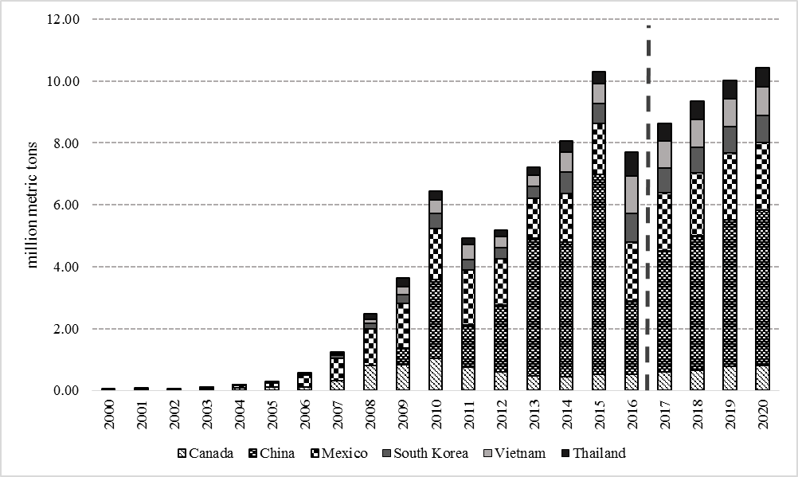
Figure 2. 3 Historical and baseline imports of U.S. DDGS in the top six external markets
Source: USDA-FAS, Global Agricultural Trade System and the baseline generated from the model (2017-2020)

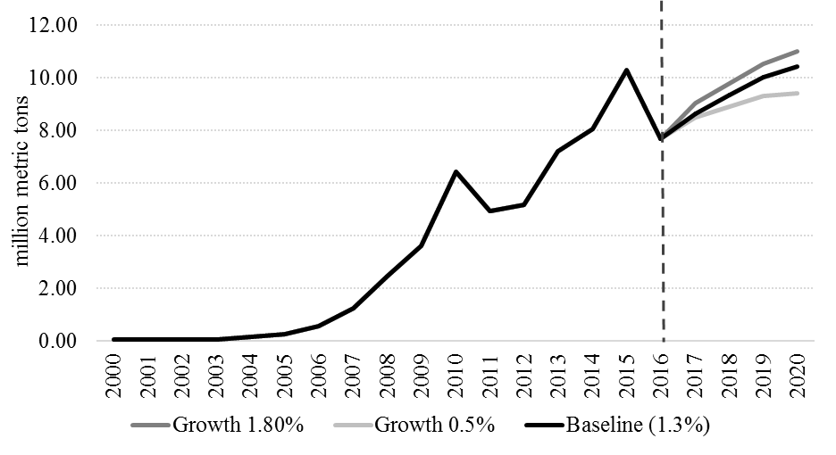
Figure 2. 4 Historical and simulated U.S. DDGS exports to the top six importers under different scenarios
Source: USDA-FAS, Global Agricultural Trade System and model simulation results

Chapter 3: Economic and Environmental Implications of Incorporating Distillers’ Dried Grains with Solubles in Feed Rations of Growing and Finishing Swine in Argentina

Abstract
Argentinean swine industry has quickly expanded over the past decade and generated a strong demand for feedstuffs. The growing supply of distillers’ dried grains with solubles (DDGS) from corn-based ethanol industry in Argentina presents a potential to meet the feedstuff demand from swine producers. This study determines the effects of feeding DDGS to swine on feed rations cost and phosphorus content using optimization models. Results suggest that including DDGS in feed rations of swine in their growing to finishing growth stage can simultaneously minimize the cost and phosphorus content. Feeding DDGS in swine rations was estimated to save the Argentinean swine industry up to US $ 19.21 million annually and reduce phosphorus content up to five percent.

3.1 Introduction
Argentinean pork consumption has significantly increased in the last decade due to an improvement in its price relative to other meat products (La Nacion, 2016). According to the Argentinean Ministry of Agroindustry (2016), domestic annual consumption of pork per capita increased by 45% between 2011 and 2016, from 8.64 to 12.54 kilograms (kg) per person. Additionally, pork exports have also grown by 113% (Argentinean Ministry of Agroindustry, 2016). To meet the rising demand for pork, Argentinean swine production has grown by 72% over the same period (Argentinean Ministry of Agroindustry, 2016).
Corn has been a primary feedstuff for swine production in Argentina. However, the Argentinean biofuels law of 2006, which mandates a blend of ethanol with gasoline of 12%, has resulted in an increased amount of corn being diverted to ethanol production. In 2016, corn-based ethanol accounted for almost 50% of the bioethanol production in Argentina (United States Department of Agriculture (USDA), 2016). The Cordoba province produced the most corn-based ethanol among the nation in 2016 (see Table 3.1) and it is currently the second largest swine producer in Argentina (Argentinean Ministry of Agroindustry, 2016).
Distillers’ dried grains with solubles (DDGS) is a by-product of corn-based ethanol and a potential corn substitute for swine producers in this region. As a livestock feed, DDGS have a more concentrated nutritional value relative to traditional feed grains and can be used to meet the energy and protein requirements (Dooley, 2008). Studies conducted in various countries have shown that incorporating DDGS in swine feed rations can potentially reduce the feed ration costs by 3% to 13% (Fabiosa, 2008; Fabiosa et al., 2009; Skinner et al., 2012). However, the amount of DDGS to be included in the diet of an animal is conditional on the animal’s ability to digest the feedstuff (Hoffman and Baker, 2011). The United States (US) Grains Council (2012) recommends that the DDGS inclusion level of rations for growing and finishing swine should not exceed 20% of the total ration.
Several studies have also evaluated the effects of incorporating DDGS in feed rations on the environment. Hünerberg et al. (2013) found that including DDGS in feed rations for growing beef cattle could mitigate methane gas emissions. As regards the effect of DDGS on swine diets, Trabue et al. (2016) compared the odor and odorous emissions of stored swine manure between a corn-based feed ration with a DDGS-based feed ration, and found that including DDGS significantly lowered odorant emissions in animal units of hydrogen sulfide and ammonia. Additional studies have also found that including DDGS in the diet of growing swine could increase the digestion of the organic phosphorus which can reduce the need of adding inorganic phosphorus in the feed ration (Pedersen et al., 2007; Widmer et al., 2007). Given that inorganic phosphorus is a non-renewable resource, reducing its use in feed rations would have a positive impact on the environment sustainability (Suh and Yee, 2011).
As the potential for replacing corn with DDGS in Argentinean swine production has emerged, research is needed to determine the impact of introducing a novel ingredient on feed ration cost and the environment. Particularly, there is a growing number of countries that have imposed restrictions on nutrient excretion to reduce water pollution (Bridges et al., 1995; Boland et al., 1998). This issue is important in the case of swine since about 75% of the phosphorus that they ingest is in the form of phytate, which is mostly excreted in their manure (Kemme et al., 1999). However, little is known about how incorporating DDGS in swine feed rations will impact the environment. Also, the potential impact of adopting DDGS on Argentinean swine feed rations cost has yet to be analyzed.
Mathematical programming models are commonly used to evaluate the economic and environmental effects of different feed rations (Tozer and Stockes, 2001; Yu et al., 2001; Castrodeza et al., 2005; Pomar et al., 2007; Fabiosa, 2008; Babic and Peric, 2011). Goal programming, or multi-objective linear programming (MOLP) modeling, is commonly used when the cost and environmental measurements of the feed ration cannot be simultaneously optimized. This linear programming (LP) model allows the decision maker to optimize the objectives by assigning weights (preferences) for each objective (Zhang and Rousch, 2002). Solutions can be compared across weights to find how sensitive the results are to the assigned weights (Zhang and Rousch, 2002). A MOLP model would be an appropriate modeling approach to analyze the impact of DDGS on feed ration costs and the phosphorus content ingested by swine.
Therefore, the objective of this study was to estimate the impact of including DDGS on the cost and phosphorus content of the feed ration in the Argentinean swine industry. Feed rations with and without DDGS were formulated for swine in three growth categories. A MOLP model was established to analyze both feed rations using cost minimization and phosphorus minimization. The output from the programing models were used to estimate how incorporating DDGS as a feedstuff in swine production would impact the aggregate cost and phosphorus content ingested by the Argentinean swine industry. Also, sensitivity analysis was performed to derive the demand functions of DDGS for the three growth categories of swine in Argentina and to assess the effect of adding an additional constraint to the model to assure a minimum level of lysine/energy ratio according to standard industry practices.

3.2 Conceptual Framework
The neoclassical theory of the firm assumes that firms choose inputs in the production process that minimize the cost of producing the output (Rubinfeld and Pindyck, 2004). If there are N inputs, the production function, $F(x_{1},…,x_{n})$ describes the maximum output that can be produced for every possible combination of inputs. It is assumed that each of the input factors have positive but decreasing marginal products (Rubinfeld and Pindyck, 2004).
The marginal product (${MP}_{i}$) of each of the N inputs can be defined as follows:
$${MP}_{i}\left(x_{1},…,x_{n}\right)= \frac{∂F\left(x_{1},…,x_{n}\right)}{∂x_{i}}>0 ; \frac{∂{MP}_{i}\left(x_{1},…,x_{n}\right)}{x_{i}}<0;for i=1,... ,n$$ | (3.2-1)
When perfect competition in products and in input factors is assumed, i.e. that the price of the factors ($r_{i}$) are given, the cost-minimization problem can be written as:
$$Minimize C= \sum_{i=1}^{n}{r_{i}x_{i}}$$ | (3.2-2)
Subject to the constraint that a fixed output $Q_{0}$can be produced:
$$F\left(x_{1},…,x_{n}\right)= Q_{0}$$ | (3.2-3)
where $C$ is the cost of producing the fixed level of output $Q_{0}$.
To determine the firm’s demand for each of the inputs, the values of each $x_{i}$ that are minimized (3.2-2) subject to the constraint in (3.2-3) are chosen. This optimization problem can be solved using the Lagrangian method. Solving the optimization problem, the following expression is obtained:
$$\frac{{MP}_{1}(x_{1},…,x_{n})}{r_{1}}=…= \frac{{MP}_{N}(x_{1},…,x_{n})}{r_{n}}$$ | (3.2-4)
Equation (3.2-4) states that when a firm is minimizing costs, it will choose the amount of each input to equate the ratio of the marginal product of each input with its price. This equality also means that in equilibrium, the marginal products of all production inputs must be equal once those marginal products are adjusted by the unit cost of each input, otherwise, the firm could change its inputs to produce the same output at a lower cost.
The Lagrange multiplier (λ) can also be employed to express the equality (3.2-4) in a different way:
$$λ=\frac{r_{1}}{{MP}_{1}(x_{1},…,x_{n})}=…=\frac{r_{n}}{{MP}_{n}(x_{1},…,x_{n)}}$$ | (3.2-5)
In this case, the Lagrangian multiplier represents the marginal cost of production since it shows how much the cost increases if the amount of the output is increased by one unit.
This conceptual framework can also be used to analyze the case in which a firm intends to minimize another variable, such as the total amount of phosphorus in a feed ration. When this is the case, the price of the production factors in the equations are replaced by the percentage of phosphorus content in each ingredient that can be included in the feed ration.

3.3 Methods and Model Specification

3.3.1 Optimization Model
A MOLP model was formed with one objective to minimize the feed ration cost ($C$) and another objective to minimize the total phosphorus ($P$) content in the feed ration for three growth stages categories: 1) 20 to 50 kg; 2) 50 to 80 kg; and 3) 80 to 120 kg. These growth categories were defined following National Research Council (NRC, 1998) recommendations for the nutrient requirements of swine.
The target value for each objective in the MOLP model was first determined for each growth category using two different LP models, which were defined as:
$Minimize C_{m}=\sum_{i=1}^{n}{c_{i}x_{im}}, m=1,2,3$ | (3.3.1-1)
$Minimize P_{m}=\sum_{i=1}^{n}{p_{i}x_{im}}, m=1,2,3$ | (3.3.1-2)
where $c_{i}$ is the cost of the ingredient $i (i=1,…,n)$ in U.S. $/kg for each growth category $m (m=1,2,3$); $p_{i}$ is the % of phosphorus in ingredient $i$, and $x_{im}$ is the % of ingredient $i$ in the feed ration for each growth category. The two sole-objective functions for each growth stage, $m$, were optimized under the following constraints:
$\sum_{i=1}^{n}{x_{im}=1}$ | (3.3.1-3)
${lb}_{jm}≤\sum_{i=1}^{n}{f_{ij}x_{im}}≤{ub}_{jm}, j=1, …, k,$ | (3.3.1-4)
${0≤x}_{im}≤{ub}_{im}, i=1, …, n$, | (3.3.1-5)
where $f_{ij}$ is the proportion of nutrient content $j$ $(j=1, …, k)$ observed in ingredient $i$; ${lb}_{jm}$ and ${ub}_{jm}$ are the lower and the upper bounds of nutrient $j$ in the feed ration for growth category m, respectively. Equation (3.3.1-3) assures the ingredients sum to one. Equation (3.3.1-4) requires that the feed ration comply with the minimum and maximum amount of nutrients necessary for each growth category. Equation (3.3.1-5) limits the maximum amount of ingredient $i$ that can be used in the feed ration for each growth category of swine.
After solving the two separate linear programming models, the target values for cost ($C_{m}^{*}$) and phosphorus content ($P_{m}^{*}$) were obtained, and the following multi-objective programming model was solved using the MINIMAX algorithm for each growth category of swine as shown in Equation 3.3.1-6:
$$Min Q_{m}, m=1, 2, 3$$ | (3.3.1-6)
subject to constraints in Equations 3.3.1-3 to 3.3.1-5 and additional constraints below:
$\frac{w_{C_{m}}(C_{m}-C_{m}^{*})}{C_{m}^{*}}≤Q_{m}$ , | (3.3.1-7)
$\frac{w_{P_{m}}(P_{m}-P_{m}^{*})}{P_{m}^{*}}≤Q_{m}$ , | (3.3.1-8)
$$w_{C_{m}}, w_{P_{m}}≥0$$ | (3.3.1-9)
where $Q_{m}$ is a parameter that ensures the solution minimizes the maximum deviation from the target values for each growth category and, $w_{C_{m}}$ and $w_{P_{m}}$ are the weights (preferences) assigned to each objective. Equations 3.3.1-7 and 3.3.1-8 measure the percentage deviations from the target values, while Equation 3.3.1-9 is a non-negative constraint for the objective weights.
To assess the impact of using DDGS, a feed ration that contained corn and soybean meal, along with typical supplements in swine feed ration for each growth category of growth was formulated. The alternative model included the same ingredients in the baseline model plus DDGS. It was assumed that synthetic phytase was not included in the feed ration to improve the absorption of phosphorus.

3.3.2 Estimating Potential Use of DDGS and Feedstock Replacement in Argentinean Swine Industry
The results from the optimization models in Equations 3.3.1-1 to 3.3.1-9 were used to estimate the displacement of soybean meal and corn in the Argentinean swine industry with the inclusion of DDGS in the feed rations. The total quantity of feedstuffs demanded by the swine industry in a given year was first determined. The total number of swine harvested in Argentina in 2016 (5.99 million head) was used to approximate the total number of finished pigs (Argentinean Ministry of Agroindustry, 2016). The days on feed and daily intake were found following NRC (1998). The assumptions used were that growing swine need to gain 30 kg of live weight, or 26.26 pounds of carcass fat-free lean weight to progress from growth category 1 (20-50 kg) to category 2 (50-80 kg), and from category 2 to category 3 (80-120 kg). The assumption was also made that it would require 37 days on feed for swine within each of the first and second growth categories, and 49 days within the third category. Daily as-fed feed intake quantities were assumed to average 1.855 kg, 2.575 kg, and 3.075 kg for growth categories 1, 2, and 3, respectively (NRC, 1998).
Total annual feed consumption by the Argentinean swine industry was found for each growth category by multiplying the total number of swine in Argentina by the number of days needed for swine to increase their weight to the next growth category and the daily feed intake needed in the current growth category. Then, the composition of the optimal feed rations was calculated for each of the growth categories. In addition, the cost savings and the phosphorus reduction from adding DDGS in feed rations for the Argentinean swine industry were generated. The difference in the cost and phosphorus content in the feed rations with and without DDGS were multiplied by the total feed demand from the industry, assuming a sufficient amount of DDGS were available for all feed rations used in the swine industry.

3.3.3 Sensitivity Analysis

3.3.3.1 Sensitivity Analysis of DDGS Price
DDGS price in Argentina could vary as a result of an expected higher cost of natural gas, which is a key input to corn-based ethanol refinement, and thus the production of DDGS. Raising the price of natural gas has been recently announced by the Argentinean government as part of its plan to deregulate the energy prices after years of subsidizing them (Reuters, 2016; Argentinean Ministry of Energy, 2017). Therefore, a sensitivity analysis was conducted to determine how the changes in DDGS price impacts the demand for DDGS in swine feed rations, while maintaining constant prices for all other feed ingredients. The range of DDGS price in the sensitivity analysis was determined by the allowable increase and allowable decrease for DDGS price obtained from each optimization.

3.3.3.2 Inclusion of a Lysine/Energy Constraint
Standard industry practices suggest that not only the absolute amount of lysine and energy are important to be met in a feed ration, but also their relative values. According to Castrodeza et al. (2005) there is a complementary relationship between the amount of lysine and energy included in the feed rations since both are necessary for the animal growth. If there is an excess of lysine in the feed ration with respect to the energy content, the lysine may not be incorporated and consequently excreted. On the other hand, if there is an excess of energy with respect to the amount of lysine, this excess could provoke an increase in the fat tissue of the animal.
Therefore, a new constraint requiring increasing levels of lysine/energy grams/Megajoules (g/MJ) was added to the models for each of the growth categories of swine,$m$. This new constraint is represented by Equation (3.3.3.2-1).
$$\frac{\sum_{i=1}^{n}{x_{im}}l_{i}}{\sum_{i=1}^{n}{x_{im}e_{i}}}≥\frac{l^{*}}{e^{*}}\frac{g}{MJ}, i=1, …, n$$ | (3.3.3.2-1)
where $x_{im}$ is the proportion of ingredient i in a feed ration of one kg for each of the growth categories of swine, and parameters l_{i} and e_{i} are the lysine (in grams) and digestible energy content (in megajoules) observed in the ingredient i, respectively.
The new constraint required a minimum amount of lysine/energy ($\frac{l}{e}$) in grams per megajoules (g/MJ) to comply with the standard industry practices ($\frac{l^{*}}{e^{*}}$). The optimization models were solved using different levels of $\frac{l^{*}}{e^{*}}$ and were then compared. Given the non-linearity of the new constraint, the models were solved using non-linear programming.

3.4 Data
The prices of Argentinean corn, soybean meal and DDGS were collected from an Argentinean broker of grains and a corn-based ethanol plant (Personal communication with Grimaldi Grassi S.A. and Picatto, 2017). The prices of the other ingredients included in the feed rations (i.e. monocalcium phosphate, calcium carbonate, salt, vitamin and mineral premix and, synthetic L-lysine) were provided by industry sources. It was assumed that the representative compounder was located in Villa Maria (Córdoba, Argentina). Therefore, the prices of the feedstuffs and the supplements were the final prices of these products delivered to this location. The prices included the value-added tax (VAT) and were recorded on February 15th, 2017. The prices in Argentinean Pesos (ARS) were converted to US dollars at the exchange rate of 15.6 ARS per US dollar (Banco Nacion, 2017).
The nutritional attributes of Argentinean DDGS were provided by ACA Bio Coop. Lda. (Picatto, Personal communication, 2016), while the related information of soybean meal and corn was taken from NRC (1998). The nutritional profiles of the supplements were provided by the companies that market these products in Argentina. The nutritional requirements for swine in the three growth categories that were analyzed in this study (i.e. 20-50 kg, 50-80 kg and, 80-120 kg) were taken from NRC (1998). Finally, the annual production of DDGS in Argentina was provided by the Rosario Stock Exchange (Personal communication, 2017) and the number of swine slaughtered in 2016 was recorded from the Argentinean Ministry of Agroindustry (2016).
Table 3.2 shows the ingredients that were included in evaluated swine feed rations along with their price that was estimated at a 90% dry matter basis and Table 3.3 their nutritional profiles.

3.5 Results and Discussion
The trade-off between cost and phosphorus minimization was first examined for the feed ration without DDGS. Figure 3.1a illustrates the conflict relationship between the two objectives using growth category 1 (20-50 kg) as an example. In a feed ration that did not include DDGS, minimizing the cost increased phosphorus content, while minimizing the phosphorus content increased the cost of the feed ration. When DDGS were included in the feed ration, both objectives were simultaneously achieved, hence a single optimization solution observed in Figure 1b. Similar relationships between cost and phosphorus were found for the other growth stages.
Therefore, weights were not assigned to the MOLP model since there were no trade-offs between cost and phosphorus in the feed ration with DDGS. Results from the MOLP model for a ration with DDGS were identical to results from the two separate LP models. This shows that adding DDGS in swine feed rations helps feed ration decision in terms of lowering cost and the potential for surface-water pollution caused by phosphorus excretion in the manure
Table 3.6 shows the cost and phosphorus content from the optimization models by feed rations and growth categories. Comparing the two feed rations when minimizing the cost, the cost and the total phosphorus of the feed rations with DDGS were 3.97−6.36%, and 5.69 −6.59% lower, respectively. Similarly, when minimizing the total phosphorus in swine feed rations, the feed rations with DDGS were 7.97−15.37% cheaper and had 4.36−5.51% less phosphorus content across all growth categories than the feed rations without DDGS. The cost savings in swine feed rations determined in this study are consistent with Fabiosa (2008), which found a saving of 2.64−9.88% in the feed rations for the finishing hogs in the United States.

3.5.1 Estimated Potential Use of DDGS for Argentinean Swine Industry
Table 3.7 presents the proportions of each ingredient in the optimal feed ration without DDGS and with DDGS when the objective was only to minimize the total cost. DDGS were found to reduce soybean meal and corn usage by 10.01−12.54% and 6.56–9.24%, respectively, for the three growth categories.
Given the assumed total number of swine (5.99 million) and the feed intake at each growth category, annual feedstuff demand was estimated to be around 1.87 million metric tons (mmt), which includes 407,061 metric tons (mt) for the growth category 1, 565,057 mt for growth category 2 and, 899,703 mt for growth category 3. If a 20% of DDGS were included in the feed rations of swine in the three growth categories, the annual demand for DDGS for the Argentinean swine industry would be up to 374,364 mt of DDGS. In that case, the use of DDGS could replace approximately 209,434 mt of soybean meal and 147,270 mt of corn (see Table 3.8) assuming the relative prices of the other feedstuffs and supplements remain constant and the supply of DDGS is sufficient to meet the demand of Argentinean swine industry.

3.5.2 Estimated Potential Cost and Phosphorus Reduction in the Argentinean Swine Industry
Table 3.9 summarizes the potential reduction in cost and phosphorus content from including DDGS in feed rations for the Argentinean swine industry. With DDGS in the feed rations for the 20-50 kg growth category of swine, feed costs could be reduced almost US $ 3.4 million (0.0083 US $/kg × 407,061 mt/year × 1,000 kg/mt) under the assumption of stable relative price of feedstuffs and sufficient supply of DDGS for the Argentinean swine industry. Similarly, cost savings could reach more than US $ 4.8 million for swine in growth category 50-80 kg and nearly US $ 11 million in growth category 3. In total, the swine industry could save up to US $ 19.21 million if DDGS was included in the feed rations for the three growth categories of swine.
Similarly, the potential annual reduction in total phosphorus by using DDGS is presented in Table 3.9. Including DDGS in the feed rations for swine between 20-50 kg could lower total phosphorus about 119 mt per year (0.0292% × 407,061 mt/year) or 5.51% of total phosphorus. Phosphorus reduction in feed rations could be nearly 116 mt annually for swine between 50-80 kg, and reach to 196 mt for swine between 80-120 kg. Thus, including DDGS in the feed rations would reduce the phosphorus content in feed by about 430 mt per year (or 5%) relative to rations without using DDGS.
These estimates imply that adopting DDGS in the feed rations of swine in the three growth categories can potentially benefit the Argentinean swine industry in terms of both cost and quantity of phosphorus. The lower feeding costs would further enhance the competitiveness of Argentinean pork production to meet their growing domestic and international demand. In addition, lowering the total phosphorus use could help reducing the consumption of inorganic phosphorus by the swine industry in Argentina and decreasing pollution from swine manure. It would also help the industry comply with environmental regulations. Argentina does not currently regulate the maximum amount of phosphorus that could be excreted; however, there is a possibility that Argentina will impose similar regulations on phosphorus excretion as observed in the European Union and the US (Bridges et al., 1995; Boland et al., 1998) given the projected growth in its pork production.

3.5.3 Sensitivity Analysis

3.5.3.1 Sensitivity Analysis of DDGS Price
Figure 3.2 shows the quantity of DDGS that would be feed in the Argentinean swine industry by growth category under different price scenarios. For swine between 20-50 kg (Figure 3.2a), DDGS was not included in the feed rations when its price was greater than US $ 252.72/mt. When the price was lowered to US $ 240.61-252.72/mt, DDGS consisted of 1% of the feed rations, implying about 4,100 mt of DDGS per year (i.e. 1% × 407,061 mt/year of total feed for swine at 20-50 kg, see Table 3.8) were feed. When the price fell between US $ 239.41−240.60/mt, approximately 10,310 mt of DDGS would be feed annually to swine between 20-50 kg. When prices decreased to range US $ 232.21−239.40/mt, DDGS accounted for 17.5% of the feed ration, which suggests about 72,561 mt of DDGS per year were needed for swine at 20-50 kg. As the price of DDGS was lower than US $ 232.20/mt, a maximum 20% of DDGS that can be digested by swine was included in the feed ration. It implies that a total of 81,412 mt of DDGS would be demanded for swine category 20-50 kg. As the inclusion rate of DDGS in feed rations could not exceed 20%, decreasing the price further from US$ 232.20/mt would not allow the model to feed more DDGS. The price of DDGS in Argentina was about US $198/mt in 2017 (or US $0.198/kg at 90% dry matter basis in Table 3.2), denoted by the dash line in the figure, thus DDGS was used at 20% in the optimal feed rations.
Similarly, Figure 3.2b shows the demand for DDGS for swine at 50-80 kg reached zero when the price was higher than US $ 252.72/mt. As price decreased, the quantity of feed increased similar to the growth category of 20-50 kg. At the current price, annual DDGS feed demand was 113,011 mt for swine weighting 50-80 kg in the Argentinean swine industry.
For the heaviest growth category of swine (80-120 kg), DDGS exited from the feed rations when the price was higher than US $ 325.86/mt (Figure 3.2c). When the price declined to US $ 232.20/mt, the maximum amount of DDGS that could be included in a feed ration was used. This implies that the demand for DDGS in the growth category of 80-120 kg would be less sensitive to increases in the DDGS price.
Changes in DDGS price likely imply that corn and soybean meal prices would also change, thus the use of the corn and soybean meal could also vary as the DDGS price varies. Figure 3.3 shows the use of DDGS, soybean meal and corn for swine feed rations by growth category associated with the optimization output from the sensitivity analysis in DDGS price. For the first growth category, the proportion of DDGS and soybean meal use is quite similar when the price of DDGS was below US $ 232.2/mt. However, when DDGS price fell in the range of US $ 239.41-240.6/mt, DDGS use rapidly decreased from 20% to 2.53% and was mostly replaced with soybean meal use that increased from 15.61% to 24.39% (Figure 3.3a). Similar changes also occurred for the second growth category (Figure 3.3b) and the third growth category (Figure 3.3c). As the price of DDGS increased, both soybean meal and con usage expanded. However, in the third growth category (80-120 kg) (Figure 3.3c), when DDGS price was over US $ 240.60/mt, the lower use of DDGS was compensated with only increases in soybean meal use since the maximum amount of corn (80%) was already included in the feed rations.

3.5.3.2 Inclusion of a Lysine/Energy Constraint
Figure 3.4a shows how the cost reduction observed in a feed ration containing DDGS with respect to a feed ration without DDGS in the three growth categories of swine would be affected by the addition of a constraint that requires increasing levels of lysine/energy. For the first and second growth category of swine there is not a significant deterioration in the cost reduction. However, for the third growth category, increasing levels of lysine/energy required deteriorates the cost reduction from 6.36% to 5.21%. On the other hand, when the reduction in the total phosphorus content was compared across the three growth categories given different levels of lysine/energy required, no changes in their values were found for any of the growth categories (Figure 3.4b).

3.6 Conclusions
This study evaluated the cost and phosphorus advantage of including DDGS in feed rations for growing and finishing swine in Argentina. Results suggest that including DDGS in the feed rations achieved the goals of cost minimization and phosphorus minimization in feed rations concurrently; hence, avoiding the trade-off between cost and phosphorus content of feed rations when DDGS is not used. Also, the cost and the total phosphorus of the feed rations including DDGS were 3.97-6.36% and 5.69-6.59% lower, respectively, compared to the feed rations without DDGS. Using the estimated reduction in cost and phosphorus, along with the amount of feed consumed by swine at different growth categories, it was estimated that the swine industry could potentially achieve cost savings approaching US $19.21 million and a 5% reduction of total phosphorus if DDGS was adopted at 20% in the feed rations for all growing to finishing swine in Argentina.
In addition, including DDGS in the feed rations for the three growth categories in the swine industry could replace the use of corn and soybean meal by 147,270 mt and 209,434 mt, respectively. Given the recent increase in Argentinean corn-based ethanol production, utilization of DDGS can mitigate the price pressure on corn and stabilize the cost of the livestock and poultry industry in Argentina.
The sensitivity analysis of DDGS price suggest that the demand for DDGS in swine feed rations varied by growth category. DDGS demand for swine weighting between (80-120 kg) was less elastic in comparison with the smaller weight categories. Also, the addition of an extra constraint in the model to assure minimum levels of lysine/energy ratios produced not significant changes in the minimum cost of the feed rations for the first and second growth categories. For the heaviest category, however, requiring increasing amounts of lysine/energy deteriorated the cost reduction observed in a feed ration when DDGS was included.
A few caveats are related to this study. The estimated swine industry-wide cost savings or phosphorus reduction reported herein was based on the assumption that there would be sufficient DDGS supply to swine and other livestock industries. Given the current biofuel mandate in Argentina, it is expected that the corn ethanol industry will continue to grow, hence, a greater supply of DDGS. Also, the relative price advantage of DDGS over other feedstuffs may not remain if the natural gas industry undergoes deregulation in the future.

References
Argentinean Ministry of Agroindustry.2016. Pork annual report. Accessed on January, 2017, available at http://www.agroindustria.gob.ar/sitio/areas/porcinos/estadistica/
Argentinean Ministry of Energy. Accessed March, 2017, available at https://www.minem.gob.ar/prensa/26013/audiencia-publica-del-gas.html
Babic, Z. and T. Peric. 2011. “Optimization of Livestock Feed Blend by Use of Goal Programming.” International Journal of Production Economics, 130(2): 218-223.
Banco Nacion. 2017. Quote of U.S. Dollar to ARS Peso. Accessed on February, 16th. Available at http://www.bna.com.ar/.
Boland, M.A., P.V. Preckel, and K.A. Foster.1998. “Economic Analysis of Phosphorus-reducing Technologies in Pork Production.” Journal of Agricultural and Resource Economics 23 (2): 468-82. http://www.jstor.org/stable/40986994.
Bridges, T.C., L.W. Turner, G.L. Cromwell and J.L. Pierce. 1995. “Modeling the Effects of Diet Formulation on Nitrogen and Phosphorus Excretion in Swine Waste.” Applied Engineering in Agriculture, 11:731-731.
Castrodeza, C., P. Lara and T. Peña. 2005. “Multicriteria Fractional Model for Feed Formulation: Economic, Nutritional and Environmental Criteria.” Agricultural Systems, 86(1): 76-96.
Dansa S.A. 2017. Personal communication. Company that markets supplements for the swine industry in Argentina. February, 2017
Dooley, F. J. 2008. “US Market Potential for Dried Distillers Grain with Solubles.” Working Paper No. 08-12, Department of Agricultural Economics, Purdue University.
Fabiosa, J. F. 2008. “Distillers Dried Grain Product Innovation and its Impact on Adoption, Inclusion, Substitution, and Displacement Rates in a Finishing Hog Ration.” Working Paper 08-WP 478, Center of Agricultural and Rural Development, Iowa State University.
Fabiosa, J. F., J. Hansen, M. Holger, S. Pan and F. Tuan. 2009. “Assessing China's Potential Import Demand for Distillers Dried Grain: Implications for Grain Trade.” Staff report 09-SR 104, Center for Agricultural and Rural Development, Iowa State University.
Goñi, C. Personal communication. Specialist in the production of hogs in Argentina, March, 2016.
Grimaldi Grassi S.A Personal communication. Grains broker company, February 2017.
Hoffman, L.A., and A.J. Baker. 2011.“Estimating the Substitution of Distillers’ Grains for Corn and Soybean Meal in the US Feed Complex.” Washington DC: US Department of Agriculture, FDS-11-I-01.
Hünerberg, M., S.M. McGinn, K.A. Beauchemin, E.K. Okine, O.M. Harstad and T.A. McAllister. 2013. “Effect of Dried Distillers Grains Plus Solubles on Enteric Methane Emissions and Nitrogen Excretion from Growing Beef Cattle.” Journal of Animal Science, 91(6): 2846-2857.
Kemme, P.A., A.W. Jongbloed, Z. Mroz, J. Kogut, and A.C. Beynen. 1999. “Digestibility of Nutrients in Growing–finishing Pigs is Affected by Aspergillus Niger Phytase, Phytate and Lactic Acid Levels: 2. Apparent Total Tract Digestibility of Phosphorus, Calcium and Magnesium and Ileal Degradation of Phytic Acid.” Livestock Production Science 58(2): 119-127.
La Nacion. 2016. “El Consumo de Cerdo se Encuentra en un Nivel Récord.” Accessed on April 15th. Available at: http://www.lanacion.com.ar/1911103-el-consumo-de-cerdo-se-encuentra-en-un-nivel-record
National Research Council (NRC). 1998. Nutrient Requirements of Swine, 10th ed. National Academy Press, Washington, D.C.
Pedersen, C., M.G. Boersma, and H.H. Stein. 2007. “Digestibility of Energy and Phosphorus in Ten Samples of Distillers Dried Grains with Solubles Fed to Growing Pigs.” Journal of Animal Science, 85(5): 1168-1176.
Picatto, J. Personal Communication. ACA Bio Coop. Lda., Ethanol Processing Plant. March, 2016 and February 2017.
Pomar, C., F. Dubeau, M.P. Létourneau-Montminy, C. Boucher and P.O. Julien. 2007. “Reducing Phosphorus Concentration in Pig Diets by Adding an Environmental Objective to the Traditional Feed Formulation Algorithm.” Livestock Science, 111(1): 16-27.
Quimica del Oeste. 2017. Company that markets chemical products for pork production in Argentina.
Ragsdale, C.T. 2006. Spreadsheet Modeling & Decision Analysis. Thomson Nelson.
Rosario Stock Exchange. 2017. Personal communication. January, 2017.
Reuters. 2016. “Argentina Announces Gas Price Hikes after Public Hearings.” Available at http://www.reuters.com/article/argentina-utilities-idUSL2N1CD0LY (accessed in March, 2017).
Rubinfeld, D. and Pindyck, R. 2004. Microeconomics. Pearson Education. Sixth edition.
Skinner, S., A. Weersink and C.F. deLange. 2012. “Impact of Dried Distillers’ Grains with Solubles (DDGS) on Ration and Fertilizer Costs of Swine Farmers.” Canadian Journal of Agricultural Economics/Revue Canadienne d'Agroeconomie, 60(3): 335-356.
Suh, S. and S. Yee. 2011. “Phosphorus Use-Efficiency of Agriculture and Food System in the US.” Chemosphere, 84(6): 806-813.
Tozer, P.R. and Stokes, J.R. 2001. “A Multi-Objective Programming Approach to Feed Ration Balancing and Nutrient Management.” Agricultural Systems, 67(3): 201-215.
Trabue, S., Kerr, B., & Scoggin, K. 2016. “Odor and Odorous Compound Emissions from Manure of Swine Fed Standard and Dried Distillers Grains with Soluble Supplemented Diets.” Journal of Environmental Quality, 45(3): 915-923.
United States Department of Agriculture (USDA), Global Agricultural Information Network (GAIN). Argentina Biofuels Annual. 2016. Accessed December 2016, available at https://gain.fas.usda.gov/Recent%20GAIN%20Publications/Biofuels%20Annual_Buenos%20Aires_Argentina_7-21-2016.pdf
U.S. Grains Council. 2012. A guide to distiller’s dried grains with solubles (DDGS). Third Edition, Accessed August 2016, available at https://www.grains.org/sites/default/files/ddgs-handbook/Complete%202012%20DDGS%20Handbook.pdf
Verdol. 2017. Personal communication. Company that markets supplements for pork producers in Argentina.
Widmer, M.R., L.M. McGinnis, and H.H. Stein. 2007. “Energy, Phosphorus, and Amino acid Digestibility of High-Protein Distillers Dried Grains and Corn Germ Fed to Growing Pigs.” Journal of Animal Science, 85(11): 2994-3003.
Yu, T-H., C.P. Baumel, M.J. McVey and J.L. Sell. 2001. “Economics of the Use of Imported US High Oil Corn in Swine and Poultry Rations in Taiwan.” Agribusiness, 17: 539-556.
Zhang, F. and W.B. Roush.2002. “Multiple-Objective (goal) Programming Model for Feed Formulation: an Example for Reducing Nutrient Variation. Poultry Science, 81(2):182-192.

Appendix
Table 3. 1 Argentinean DDGS Production and Corn Used for Ethanol
Corn-based Ethanol Plants | Province | DDGS Production (mt) | Corn Used for Ethanol (mt)
Promaiz S.A. | Córdoba | 108,626 | 350,405
ACA Bio Coop. Lda. | Córdoba | 106,297 | 342,893
Bioetanol Rio IV S.A. | Córdoba | 52,269 | 168,610
Diaser S.A. | San Luis | 67,308 | 217,123
Vicentin S.A.I.C. | Santa Fe | 45,124 | 145,563
Others |  | 2,728 | 8,880
Total |  | 382,352 | 1,233,393
Source: Rosario Stock Exchange (Personal communication, 2017).

Table 3. 2 Price of Feedstuffs and Supplements in February 2017 at a 90% Dry Matter Basis
Ingredient | US $/kg
Soybean meal | 0.315
Corn | 0.165
DDGS | 0.198
Monocalcium phosphate | 0.839
Calcium carbonate | 0.108
Salt | 0.220
Vitamins and minerals premix | 2.758
L-lysine (78%) | 1.857
Source: Picatto, Goñi, Dansa S.A., Grimaldi Grassi S.A., Quimica Oeste and Verdol S.A. (Personal communication, 2017).

Table 3. 3 Nutritional Profile of Feedstuffs and Supplements
Attributes | Unit | Soybean Meal | Corn | DDGS | Monocalcium Phosphate | Calcium Carbonate | Salt | Vitamin and Mineral Premix | L-lysine (78%)
Dry Matter | % | 90.00 | 89.00 | 88.13 | 100.00 | 100.00 | 100.00 | 100.00 | 98.50
Digestible Energy | kcal/kg | 3,685 | 3,525 | 3,322 |  |  |  |  | 4,900
Metabolizable Energy | kcal/kg | 3,380 | 3,420 | 3,156 |  |  |  |  | 3,950
Crude Protein | % | 47.50 | 8.30 | 26.65 |  |  |  |  | 94.50
Dry matter | % | 90.00 | 89.00 | 88.13 | 100.00 | 100.00 | 100.00 | 100.00 | 98.50
Crude fat | % | 3.00 | 3.90 | 10.67
Lysine | % | 3.02 | 0.26 | 0.93 |  |  |  |  | 78.00
Methionine+Cysteine | % | 1.41 | 0.36 | 1.04
Threonine | % | 1.85 | 0.29 | 0.96
Tryptophan | % | 0.65 | 0.06 | 0.23
Calcium | % | 0.34 | 0.03 | 0.01 | 20.50 | 38.60
Phosphorus total | % | 0.69 | 0.28 | 0.76 | 20.00
Phosphorus avail | % | 0.16 | 0.04 | 0.59 | 20.00
Sodium | % | 0.02 | 0.02 | 0.25 |  |  | 38.40
Chlorine | % | 0.05 | 0.05 | 0.20 |  |  | 57.60 |  | 19.30
Magnesium | % | 0.30 | 0.12 | 0.19
Potassium | % | 2.14 | 0.33 | 0.99
Copper | mg | 20.00 | 3.00 | 57.00 |  |  |  | 9,000
Iodine | mg |  |  |  |  |  |  | 250
Iron | mg | 176.00 | 29.00 | 257.00 |  |  |  | 28,000
Manganese | mg | 36.00 | 7.00 | 24.00 |  |  |  | 20,200
Selenium | mg | 0.27 | 0.07 | 0.39 |  |  |  | 150

Table 3. 3 Continued
Attributes | Unit | Soybean Meal | Corn | DDGS | Monocalcium Phosphate | Calcium Carbonate | Salt | Vitamin and Mineral Premix | L-lysine (78%)
Zinc | mg | 55.00 | 18.00 | 41.00 |  |  |  | 61,500
Vitamin A | IU |  | 0.00 | 0.00 |  |  |  | 2,200,000
Vitamin D3 | IU |  | 0.00 | 0.00 |  |  |  | 500,000
Vitamin E | IU |  | 8.30 | 0.00 |  |  |  | 12,000
Vitamin K | mg |  | 0.00 | 0.00 |  |  |  | 1,100
Biotin | mg | 0.26 | 0.06 | 0.78
Choline | mg | 2,731 | 620 | 2,637
Folacin | mg | 1.37 | 0.15 | 0.90 |  |  |  | 200
Niacin | mg | 22.00 | 24.00 | 75.00 |  |  |  | 11,000
Pantothenic acid | mg | 15.00 | 6.00 | 14.00 |  |  |  | 7,000
Riboflavin | mg | 3.10 | 1.20 | 8.60 |  |  |  | 2,200
Thiamin | mg | 3.20 | 3.50 | 2.90
Vitamin B6 | mg | 6.40 | 5.00 | 8.00
Vitamin B12 | mcg | 0.00 | 0.00 | 0.00 |  |  |  | 9,000
Linoleic acid | % | 0.60 | 1.92 | 2.15
Source: National Research Council (1998), Picatto, Goñi, Dansa S.A., Grimaldi Grassi S.A., Quimica Oeste and, Verdol S.A. (Personal communication, 2016, 2017).

Table 3. 4 Nutritional Composition of the Feed Rations a 90% Dry Matter Basis Without DDGS
 |  | Growth Category
 |  | 1 | 2 | 3
Metabolizable Energy | (kcal/kg) | 3268.49 | 3278.38 | 3275.94
Crude Protein | (%) | 18.00 | 15.50 | 14.23
Lysine | (%) | 0.96 | 0.78 | 0.69
Methinine+cystine | (%) | 0.61 | 0.55 | 0.51
Threonine | (%) | 0.68 | 0.58 | 0.53
Tryptophan | (%) | 0.21 | 0.17 | 0.15
Calcium | (%) | 1.43 | 1.38 | 1.33
Phosphorus total | (%) | 0.54 | 0.48 | 0.43
Phosphorus avail | (%) | 0.23 | 0.19 | 0.15
Sodium | (%) | 0.10 | 0.10 | 0.21
Chlorine | (%) | 0.17 | 0.17 | 0.34
Magnesium | (%) | 0.16 | 0.15 | 0.14
Potassium | (%) | 0.78 | 0.66 | 0.61
Copper | mg | 17.23 | 11.46 | 10.91
Iodine | mg | 0.28 | 0.15 | 0.15
Iron | mg | 96.57 | 72.63 | 67.86
Manganese | mg | 36.58 | 24.23 | 23.29
Selenium | mg | 0.29 | 0.19 | 0.19
Zinc | mg | 95.07 | 60.74 | 59.53
Vitamin A | IU | 2444.44 | 1300.00 | 1300.00
Vitamin D3 | IU | 555.56 | 295.45 | 295.45
Vitamin E | IU | 19.16 | 13.47 | 13.73
Vitamin K | mg | 1.22 | 0.65 | 0.65
Biotin | mg | 0.11 | 0.10 | 0.09
Choline | g | 1135.22 | 1000.96 | 932.26
Folacin | mg | 0.68 | 0.50 | 0.46
Niacin | mg | 17.86 | 10.72 | 10.01
Pantothenic acid | mg | 15.84 | 11.63 | 11.33
Riboflavin | mg | 4.08 | 2.82 | 2.76
Thiamin | mg | 3.28 | 3.31 | 3.31
Vitamin B6 | mg | 5.15 | 5.07 | 5.02
Vitamin B12 | mcg | 10.00 | 5.32 | 5.32
Linoleic acid | (%) | 1.50 | 1.59 | 1.63
Note: Growth category 1 is for swine weighting 20-50 kg, category 2 for swine weighting 50-80 kg and category 3 for swine between 80-120 kg.
Table 3. 5 Nutritional Composition of the Feed Rations a 90% Dry Matter Basis With DDGS
 |  | Growth Category
 |  | 1 | 2 | 3
Metabolizable Energy | (kcal/kg) | 3265.00 | 3265.00 | 3265.00
Crude Protein | (%) | 18.00 | 15.50 | 13.20
Lysine | (%) | 0.95 | 0.75 | 0.60
Methinine+cystine | (%) | 0.65 | 0.58 | 0.52
Threonine | (%) | 0.66 | 0.56 | 0.47
Tryptophan | (%) | 0.18 | 0.15 | 0.11
Calcium | (%) | 1.03 | 1.08 | 1.11
Phosphorus total | (%) | 0.50 | 0.45 | 0.40
Phosphorus avail | (%) | 0.23 | 0.20 | 0.17
Sodium | (%) | 0.10 | 0.10 | 0.10
Chlorine | (%) | 0.16 | 0.16 | 0.16
Magnesium | (%) | 0.16 | 0.15 | 0.14
Potassium | (%) | 0.73 | 0.62 | 0.51
Copper | mg | 26.36 | 20.61 | 19.61
Iodine | mg | 0.28 | 0.15 | 0.15
Iron | mg | 127.78 | 103.96 | 95.28
Manganese | mg | 37.16 | 24.83 | 23.11
Selenium | mg | 0.33 | 0.24 | 0.23
Zinc | mg | 96.17 | 61.84 | 59.65
Vitamin A | IU | 2444.44 | 1300.00 | 1300.00
Vitamin D3 | IU | 555.56 | 295.45 | 295.45
Vitamin E | IU | 18.43 | 12.71 | 13.19
Vitamin K | mg | 1.22 | 0.65 | 0.65
Biotin | mg | 0.23 | 0.22 | 0.21
Choline | g | 1334.25 | 1201.28 | 1076.44
Folacin | mg | 0.71 | 0.53 | 0.46
Niacin | mg | 30.66 | 23.55 | 22.25
Pantothenic acid | mg | 16.60 | 12.39 | 11.86
Riboflavin | mg | 5.38 | 4.12 | 4.01
Thiamin | mg | 3.23 | 3.25 | 3.26
Vitamin B6 | mg | 5.67 | 5.58 | 5.49
Vitamin B12 | mcg | 10.00 | 5.32 | 5.32
Linoleic acid | (%) | 1.70 | 1.78 | 1.86
Note: Growth category 1 is for swine weighting 20-50 kg, category 2 for swine weighting 50-80 kg and category 3 for swine between 80-120 kg.
Table 3. 6 Payoff Table of Feed Rations Excluding and Including DDGS
 |  |  |  | Excluding DDGS |  | Including  DDGS |  | Difference
Growth Category |  | Unit |  | Min C | Min P | Min C | Min P | Min C | Min P
1 | C | US $/kg |  | 0.210 | 0.219 | 0.202 | 0.202 | -3.97% | -7.97%
1 | P | % |  | 0.535 | 0.529 | 0.500 | 0.500 | -6.59% | -5.51%
2 | C | US $/kg |  | 0.198 | 0.212 | 0.189 | 0.189 | -4.33% | -10.92%
2 | P | % |  | 0.477 | 0.471 | 0.450 | 0.450 | -5.69% | -4.36%
3 | C | US $/kg |  | 0.192 | 0.212 | 0.180 | 0.180 | -6.36% | -15.37%
3 | P | % |  | 0.428 | 0.422 | 0.400 | 0.400 | -6.44% | -5.16%
Note: C stands for cost, and P stands for phosphorus. Growth category 1 is for swine weighting 20-50 kg, category 2 for swine weighting 50-80 kg and category 3 for swine between 80-120 kg.

Table 3. 7 Feed Rations for Swine in Three Growth Categories by Minimizing Cost
Growth Category | SM | Corn | DDGS | MP | CC | Salt | V&M | L
Feed ration excluding DDGS (%)
1 | 25.62 | 70.25 | - | 0.81 | 3.00 | 0.21 | 0.11 | 0.00
2 | 19.20 | 76.89 | - | 0.65 | 3.00 | 0.21 | 0.06 | 0.00
3 | 15.97 | 80.00 | - | 0.47 | 3.00 | 0.50 | 0.06 | 0.00
Feed ration including DDGS (%)
1 | 15.61 | 61.39 | 20.00 | 0.34 | 2.29 | 0.09 | 0.11 | 0.17
2 | 9.32 | 67.64 | 20.00 | 0.22 | 2.53 | 0.09 | 0.06 | 0.14
3 | 3.43 | 73.44 | 20.00 | 0.09 | 2.73 | 0.09 | 0.06 | 0.15
Note: SM, MP, CC, V&M, L stands for soybean meal, monocalcium phosphate, calcium carbonate, vitamins and minerals and, L-lysine (78%), respectively. Growth category 1 is for swine weighting 20-50 kg, category 2 for swine weighting 50-80 kg and category 3 for swine between 80-120 kg.

Table 3. 8 Estimated Corn and Soybean Meal Displacement in Argentinean Swine Feed Rations
 | Growth Category
 | 1 | 2 | 3 | Total
Days of Feeding§ | 36 19/29 | 36 19/29 | 48 7/8 | 122 12/65
Swine Stock in 2016* | 5,986,561 | 5,986,561 | 5,986,561 | 5,986,561
Feed Intake (kg/day)§ | 1.855 | 2.575 | 3.075
Total Feed (mt/year) | 407,061 | 565,057 | 899,703 | 1,871,821
Soybean Meal Replaced (mt/year) | 40,756 | 55,817 | 112,861 | 209,434
Corn Replaced (mt/year) | 36,065 | 52,227 | 58,978 | 147,270
Source: §NRC (1998), *Argentinean Ministry of Agroindustry (2016). Growth category 1 is for swine weighting 20-50 kg, category 2 for swine weighting 50-80 kg and category 3 for swine between 80-120 kg.

Table 3. 9 Cost Savings and Phosphorus Reduction for the Argentinean Swine Industry if DDGS is used in the Feed Rations
 |  | Growth Category
 | Unit |  | 1 | 2 | 3 | Total
Cost Savings
Cost of Feed Ration without DDGS | US $/kg |  | 0.2099 | 0.1978 | 0.1919
Cost of Feed Ration with DDGS | US $/kg |  | 0.2016 | 0.1893 | 0.1797
Cost Savings from Using DDGS | US $/kg |  | 0.0083 | 0.0086 | 0.0122
Estimated Savings for the Industry | US $ |  | 3,393,126 | 4,838,517 | 10,976,510 | 19,208,153
Phosphorus Reduction
P in the Feed Ration without DDGS | % |  | 0.5292 | 0.4705 | 0.4218
P in the Feed Ration with DDGS | % |  | 0.5000 | 0.4500 | 0.4000
Reduction of P | % |  | 0.0292 | 0.0205 | 0.0218
P in the Feed Ration without DDGS | mt |  | 2,154.04 | 2,658.64 | 3,794.56 | 8,607.24
P in the Feed Ration with DDGS | mt |  | 2,035.30 | 2,542.76 | 3,598.81 | 8,176.87
Reduction of P | mt |  | 118.73 | 115.88 | 195.75 | 430.37
Reduction of P | % |  | 5.51 | 4.36 | 5.16 | 5.00
Note: P stands for Phosphorus. Growth category 1 is for swine weighting 20-50 kg, category 2 for swine weighting 50-80 kg and category 3 for swine between 80-120 kg.

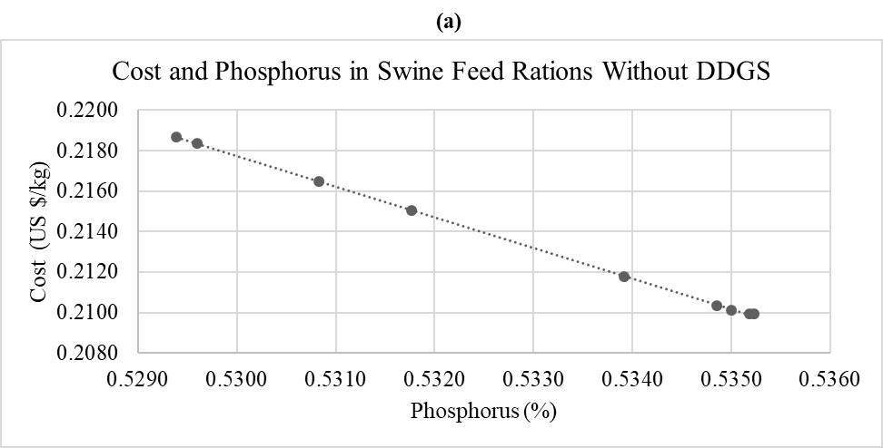
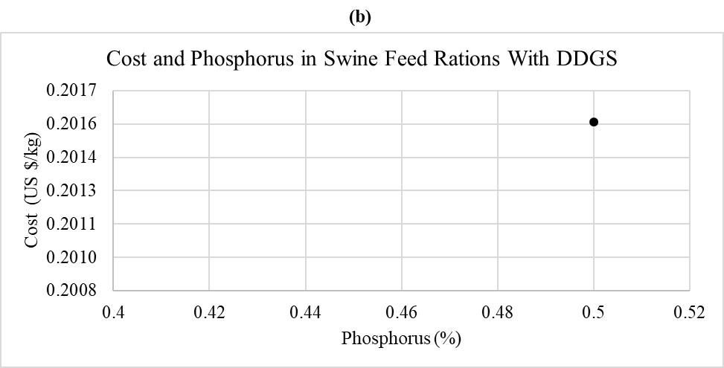
Figure 3. 1 Trade-off between cost (US$/kg) and phosphorus content (%) in the feed rations for swine in growth category 1 (20-50 kg) without and with DDGS.

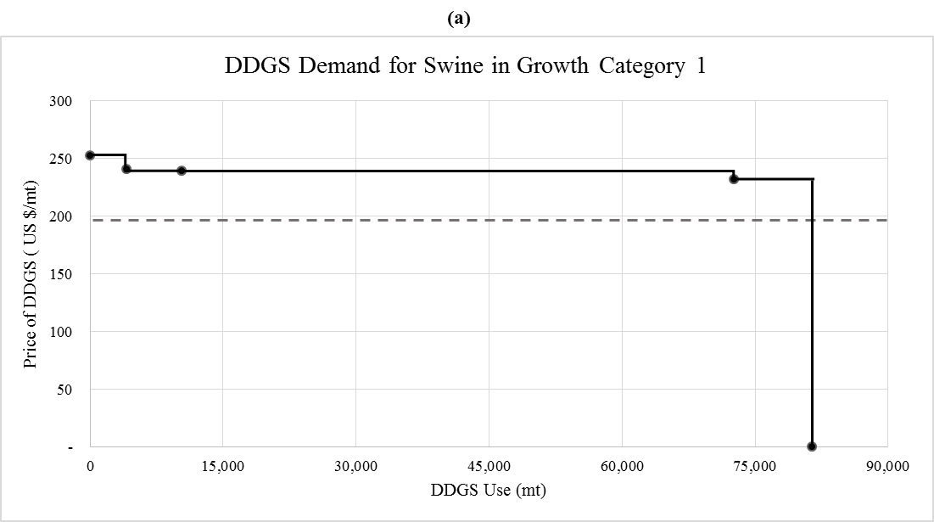

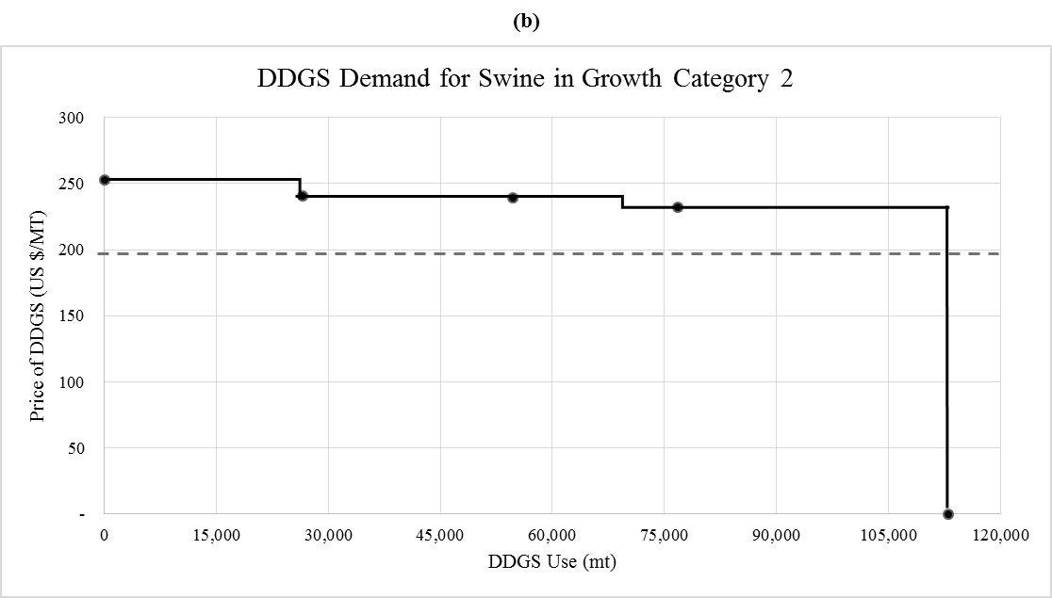

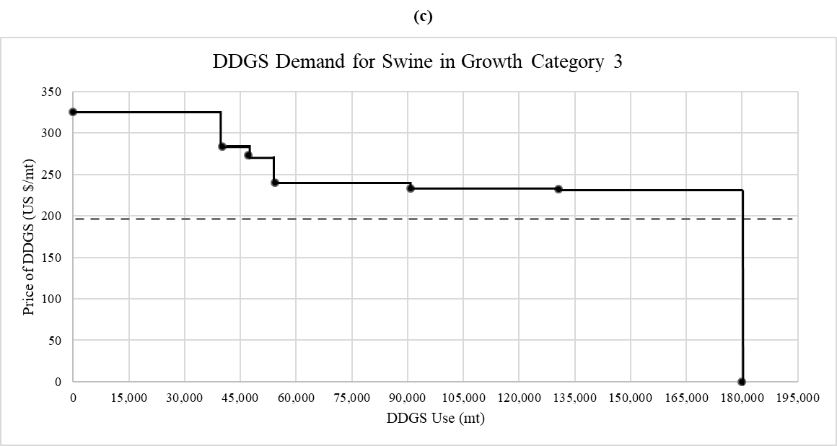
Figure 3. 2 DDGS demand from the Argentinean swine industry for each growth category and price of DDGS (February, 2017)
Note: The dash line shows the current price of DDGS at a 90% dry matter basis (198 US $/mt). Growth category 1 is for swine weighting 20-50 kg, category 2 for swine weighting 50-80 kg and category 3 for swine between 80-120 kg.
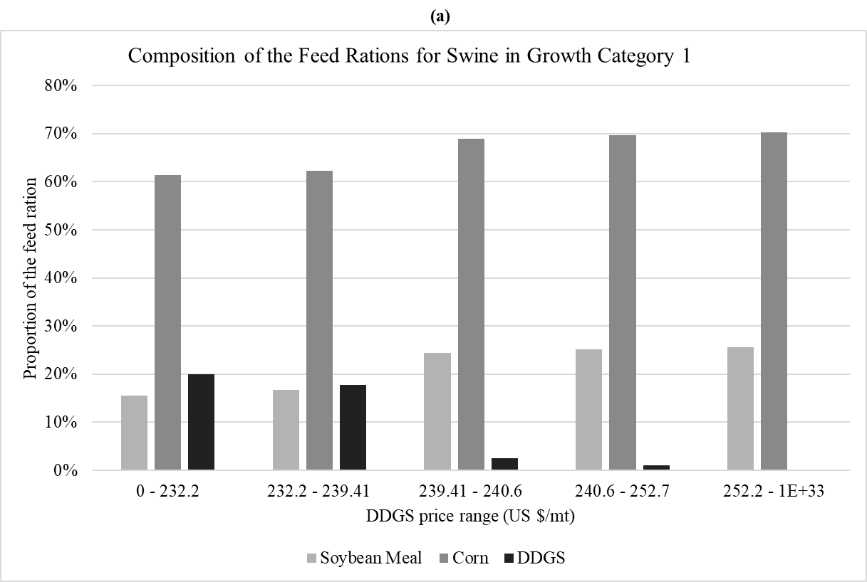
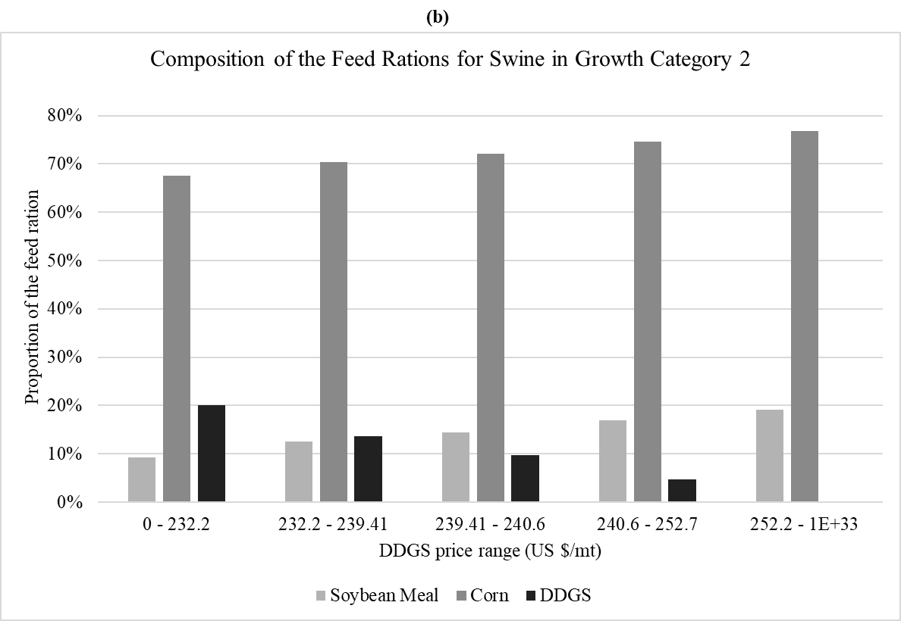
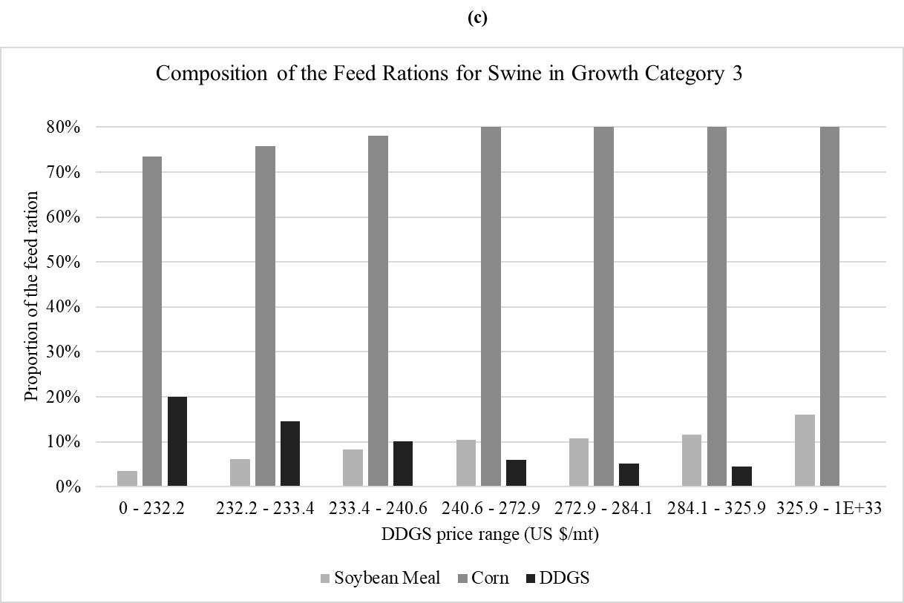
Figure 3. 3 Composition of the feed rations for each category of growth of swine given different DDGS price ranges.
Note: Growth category 1 is for swine weighting 20-50 kg, category 2 for swine weighting 50-80 kg and category 3 for swine between 80-120 kg
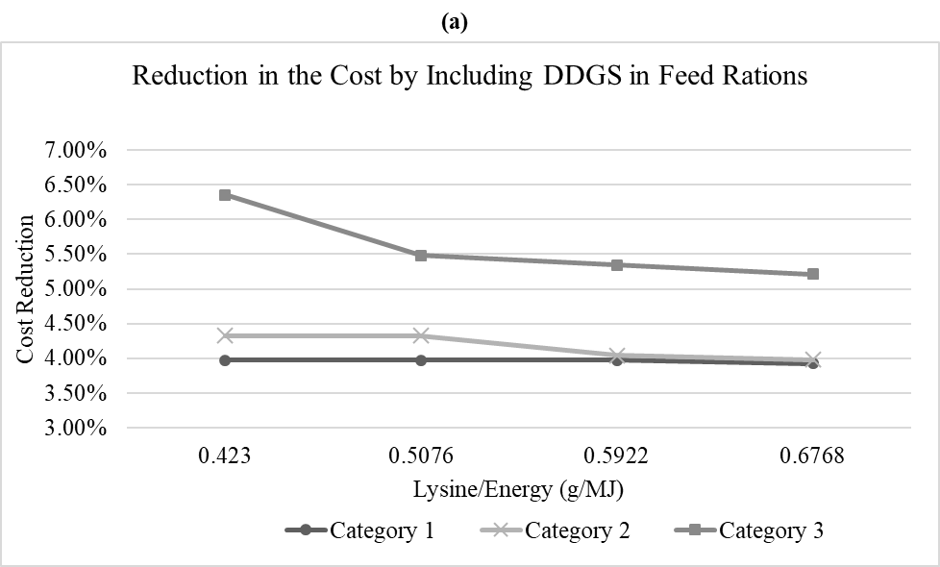
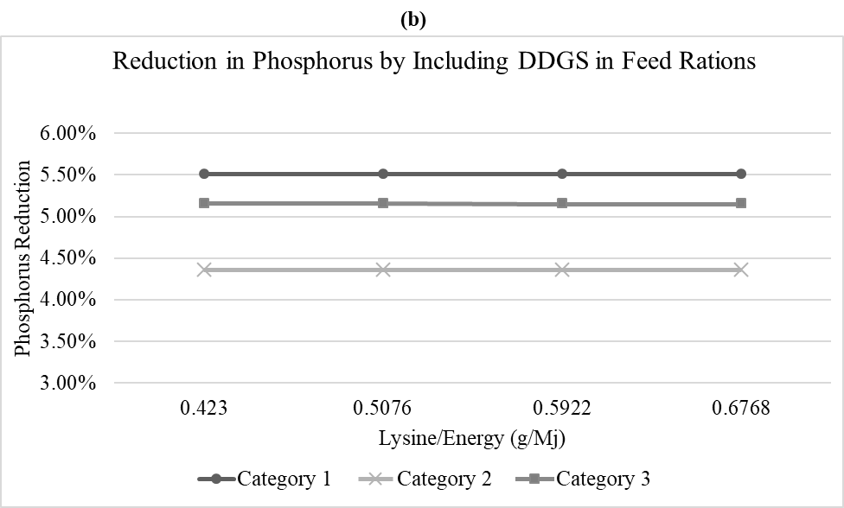
Figure 3. 4 Effect of the addition of a lysine/energy (L/E) constraint to the cost and phosphorus content in the feed rations of swine by growth category.
Note: Growth category 1 is for swine weighting 20-50 kg, category 2 for swine weighting 50-80 kg and category 3 for swine between 80-120 kg

Chapter 4: Conclusions

To support the financial stability of U.S. ethanol industry and enhance the exports of U.S. agricultural products, the determinants of the U.S. DDGS exports were identified using a commodity-specific gravity model. The Pseudo-Poisson maximum likelihood method was applied to a panel data including 29 importing countries from 2001 through 2013. It was found that the variables that account for the market size in the importing countries had a significant positive effect on U.S. DDGS exports. The export elasticities of the demand for DDGS were elastic with the elasticities around three, implying that a one percent increase in the stock of cattle, consumption of red meat, or the production of red meat in the importing countries (proxies of the demand size) would increase the demand for U.S. DDGS by about a three percent. The presence of non-tariffs barriers to trade were also an important factor that affects the U.S. export demand of DDGS. If a country filed a notification of a technical barrier of trade to the WTO, their imports of DDGS were 45−48 percent lower than a country that had not filed any.
The coefficients obtained from the gravity model were also employed to develop a baseline for U.S. DDGS exports to major international buyers. A scenario related to the impact of diverse growing rates of meat production in the importing countries of DDGS exports was also conducted. It was found that a high growth rate in red meat production (1.80 percent annually) could lead to an increase of U.S. DDGS exports to the top six importers by six percent from the baseline. However, the projected exports of U.S. DDGS to the top six importers by 2020 would be lower by ten percent from the baseline level when considering much lower annual growth rate (0.50 percent per year) of red meat production in those six countries. With a solid growth of meat production in many emerging economies, the potential to expand U.S. DDGS is expected to remain strong.
A recent development of the ethanol industry and a surging demand for pork meat have resulted in an opportunity of adopting DDGS in swine feed rations in Argentina. To evaluate the potential economic and environmental advantages of including DDGS in feed rations for growing and finishing swine in Argentina, a mathematical programming model was applied to the optimization of feed rations for three growth stages of swine. The findings suggest that including DDGS achieved the goals of cost and total phosphorus minimization concurrently.
The coefficients obtained from the optimal feed rations that included DDGS were used to calculate the potential economic and phosphorus savings of the Argentinean swine industry if DDGS were fully adopted. It was found that if DDGS were fully adopted in a 20% in the feed rations for growing and finishing swine in Argentina, the industry could experience economic savings of up to 19.21 million dollars and a five percent reduction in total phosphorus intake.
The potential impact of DDGS utilization in feed rations on soybean meal and corn usage in swine feed rations in Argentina was also estimated. It was found that the use of corn and soybean meal would decrease by 147,270 mt and 209,434 mt, respectively, if a full adoption of DDGS at a 20% of the feed rations was applied to three growth categories of swine in Argentina.
Sensitivity analysis was conducted on the impact of DDGS price on its usage in feed rations in Argentina. It was found that the consumption of this feedstuff is relatively stable in a wide range of prices and that the demand of DDGS for the heaviest category of swine was the most inelastic in comparison with the other two growth categories. It was also studied the effect of adding an additional constraint to require increasing levels of lysine/energy content to the model. It was found that demanding higher levels of lysine/energy content mostly deteriorates the cost reduction of feed rations for the third growth category of swine with little effect for the first and second growth categories.
To sum up, this thesis highlighted the importance of a better understanding of the potentials of using DDGS in feed rations and the marketing of DDGS for both agricultural and biofuel sectors. Currently, the world supply of DDGS is continuously growing given the mandate of producing 15 billion gallons of ethanol per year in the U.S, while Argentina has also issued the legislation to increase the production and use of corn-based ethanol. The world demand for DDGS is also likely to increase given the growing world consumption of red meat which translates into a greater demand for feedstuffs for livestock, hence the use of DDGS. For future research, the study of identifying the factors for U.S. DDGS exports could be expanded by including the countries with an emerging corn-based ethanol industry since the supply of DDGS from these countries may have an important role in the future. Also, future study on the impact of DDGS in feed rations can be applied to other livestock in Argentina or other countries prompting corn-based biofuels.

Vita
Maria Celeste De Matteis is from Rosario, Santa Fe, Argentina. She received a bachelor’s degree in Economics from the National University of Rosario in 2007 and a master’s degree in Agribusiness from Austral University. She has been working as a commodity research analyst and, as a commodity trader from 2003 until she started a master’s program in Agricultural Economics at the University of Tennessee. Upon the completion of the master’s program she will return to Argentina where she intends to work in the industry.

China’s DDGS imports plunged to 2.38 mmt in 2016 though due to a policy distortion by Chinese government (USDA FAS, 2016a).
According to the Renewable fuels association, in 2016 the production of U.S. ethanol represented the 57.67% of the world production with 15,330 million of gallons
The chapters that were included in the construction of the non-tariff barriers to trade variable were: 10- Cereals; 11- Products of the milling industry, malt, starches, inulin, wheat gluten; 12- Oil seeds and oleaginous fruits, miscellaneous grains, seeds and fruit, industrial or medicinal plants, straw and fodder; and 22- Residues and waste from the food industries; prepared animal fodder.
The percentage change in the U.S. exports associated with the switch in TBT binary variable from 0 to 1 was calculated as: ($e^{β_{6}}-1)×100$.
The MINIMAX algorithm minimizes the maximum weighted deviation from the objectives (Ragsdale, 2006).
Since the data provided by the Ministry of Agroindustry does not identify the classification of swine, it was assumed that the reported number of swine slaughtered in 2016 was a proxy number of finished pigs.

