Fan and Fracture Formation: Morphologic and Sedimentologic Characteristics of Alluvial Fans on Earth and Mars, and Fracture Population Distributions on Europa

A Dissertation Presented for the
Doctor of Philosophy
Degree
The University of Tennessee, Knoxville

Claire A. Mondro
August 2022
Copyright © 2022 by Claire A. Mondro
All rights reserved.

DEDICATION

To my parents, who always believed I could do anything I put my mind to.
So I did.

ACKNOWLEDGEMENTS

It is impossible to acknowledge and thank every person who made this dissertation possible. From every grade school teacher who encouraged my curiosity, to the professors who taught me how to think critically, to every passing conversation at conferences that sent me off in a new direction, and everyone I’ve ever looked up to as role models, each of them had a role in shaping my path and I would not have gotten to this point without them. This research, this dissertation, this degree would not have been accomplished without each of them. And while I cannot thank every person by name, I would like to specifically acknowledge the following people and the influence that they had.
First, I would like to thank my advisor, Jeff Moersch, and my committee members, Chris Fedo, Josh Emery, and Craig Hardgrove, without whom this research would not exist. They gave me the freedom to follow my own interests and ask big questions while helping me better frame my investigations and contextualize my work. Their collective planetary science expertise provided helpful guidance as I made the jump from terrestrial geology into a new discipline. In addition, I would like to thank Bill Dunne for his invaluable input and expertise on planetary fracture populations. He took a chance on an innovative approach and, through many long conversations sorting through the known and unknown of the outer solar system, helped immeasurably to improve the Europa chapter.
Research requires funding and I was fortunate to receive financial support throughout my degree from both university sources and external grants. Through the University of Tennessee, I was supported by a four-year Chancellor’s Fellowship, a one-year Yates Dissertation Fellowship, and many semesters of Graduate Teaching Assistantships through the Department of Earth and Planetary Sciences. Additional funding for the field work associated with Chapter 1 was provided by a UTK Student-Faculty Research Award. Multiple semesters of Graduate Research Assistantships, along with travel expenses and summer funding, was provided by the Mars Odyssey Thermal Emission Imaging System (THEMIS) Science Team. Within the Department of Earth and Planetary Sciences I would like to extend a special thank you to Angie Staley and all of the office staff, for smoothly managing the financial and administrative tasks and, especially, for always having the grad students’ backs and watching out for us.
Within the University of Tennessee and beyond, I was supported by an entire community of family, friends, and colleagues who made this journey possible. My previous academic advisors, Anne Carey at Ohio State, and Don Fisher at Penn State, set me on this path long ago. They taught me how to ask hard questions and, more importantly, how to answer them. My supervisor at Chevron, Jim Phelps, supported my decision to quit my job and went out of this way to help me navigate the corporate system to be able to leave in my own time and on my own terms.
Ryan Purcell volunteered his time and braved COVID travel to tramp around the Nevada desert to keep me company during field work and give me someone to bounce ideas off of to keep me from wandering the wilderness talking to myself. CJ Leight hauled drone equipment through the desert and assisted in endless troubleshooting to get the drone flying. Sam Gwizd and Helle Skjetne were supportive companions for dog walks and commiserating. Thank you to Nadine and Tyler Grambling for sharing my frustrations and cheering my successes and, most importantly, for the mutual emotional support that helped get all of us through the worst of the pandemic and the hardest part of grad school.
My far flung network of friends have been a constant source of support and encouragement and I could not have gotten here without them. Katie Boyle Zeigenbaum was the first to hear my plan to quit my job and go back to school and encouraged me to take the leap. Kathy, Jen, Jen, Claire, and Emily have been excited for me every step of the way and helped keep me connected to the outside world when the most isolating parts of the pandemic and grad school aligned. The Penn State crew went through grad school with me the first time around and made it such a wonderful experience that I was ready to go through it all again. The Mermaids helped develop my confidence and made me proud to be a smart, assertive, successful woman. They also kept me grounded and kept me from getting consumed by the bubble of academia by providing a connection to the professional world and wider geology community. Thank you especially to Katie Magee, for so very many phone calls.
Grad school can be isolating, lonely, and far too sedentary. I would like to acknowledge my Atomic Rowing teammates for keeping me active, being my local community outside of the university, and for giving me an opportunity to turn my brain off and work towards athletic goals and successes when research progress was stagnating.
Finally, I would like to extent a heartfelt thank you to my family. My sisters knew how important this was to me from the beginning and insisted that this was the right path for me. Sierra has been by my side through it all and it has been wonderful to come home every day to someone who is happy to see me. Sebastian has been a constant source of calm reassurance throughout this last year. He has listened patiently to all my frustrations, given me space to dive into long work hours, and been the reason that I put work aside to stop and smell the coffee, enjoy sunsets, and find adventure in day-to-day experiences outside of the stress of grad school. The final stages of this degree would have been much worse without his steady encouragement. Thank you, lastly, to my parents, for the endless advice, for always being there to listen, for all the ways they have helped and supported me in this journey both small and big, and for always believing in me.
ABSTRACT

Planetary science is inherently limited by the resolution and coverage of the currently available data. What can be observed in person, measured precisely in high-resolution data, or sampled for lab analysis in terrestrial investigations ca only be inferred, modeled, or hypothesized on other planetary bodies. The Earth remains our best tool for understanding the geologic systems of the rest of the Solar System. By applying what is known or can be measured about terrestrial systems, it is possible to determine how large-scale controls and observable features relate to geologic complexity that is beyond the resolution of planetary data. This dissertation presents work in two different geologic regimes – surface sedimentary processes and brittle material structure – and applies contextual relationships developed in terrestrial geologic systems to analogous planetary systems in an effort to gain insight into the smaller-scale complexities that cannot yet be directly measured. Terrestrial sedimentology provides a framework for defining the morphology of depositional features, which is applied to similar features on Mars to differentiate between depositional environments which form during different climatic settings (Chapter 2). Analysis of the primary controls of alluvial fans depositional style in a population of terrestrial fans sourced from basaltic catchments shows a correlation between catchment lithology and sedimentary depositional process that builds the fans (Chapter 1). A more precise understanding of the relationship between depositional environmental controls and the sedimentary characteristics of alluvial fans on Earth provides context for analyzing the sedimentology of alluvial fans on Mars as a potential climatic indicator. Thermal inertia is used as a proxy for analyzing grain size and associated depositional characteristics of alluvial fans on Mars (Chapter 3). In a different geologic system, the size distribution trends observed in fracture populations on Earth are applied to observable fracture populations on Europa to model the abundance of fractures which may be present below the limit of resolution (Chapter 4). By applying terrestrial concepts to remote systems, this dissertation expands our understanding of the complexities of planetary geology on Mars and Europa.

TABLE OF CONTENTS

INTRODUCTION 1
CHAPTER 1 Debris flow depositional styles correlate to catchment lithology in basalt-sourced alluvial fans, independent of catchment morphology 5
Abstract 6
1.1 Introduction 7
1.2 Objectives 8
1.3 Depositional Styles of Alluvial Fans 8
1.4 Geologic Setting 9
1.5 Study Area 9
1.6 Methods 10
1.7 Facies Definitions 13
1.8 Catchment geology and relief 15
1.9 Field Observations and Stratigraphic Interpretations 16
1.10 Controls on Primary Depositional Styles of Alluvial Fans 24
1.11 Conclusions 26
References 27
Appendix 31
CHAPTER 2 An updated global survey of alluvial fans on Mars: distinguishing alluvial fans from other fan-shaped features through morphologic characterization 51
Abstract 52
2.1 Introduction 53
2.2 Background 54
2.3 Methods 56
2.4 Results & Discussion 58
2.5 Conclusions 61
References 62
Appendix 67
CHAPTER 3 Assessing surface grain size of alluvial fans on Mars from thermal inertia as an indicator of depositional style 76
Abstract 77
3.1 Introduction 78
3.2 Background 79
3.3 Methods for analysis of Mars alluvial fans 82
3.4 Results and Discussion 84
3.5 Conclusions 87
References 89
Appendix 92
CHAPTER 4 Regional variations in observed fracture abundance and associated predictions for smaller fractures on Europa with implications for regional plume origins 97
Abstract 98
4.1 Introduction 99
4.2 Background 99
4.3 Methods 100
4.4 Results of Fracture Mapping 103
4.5 Discussion of Fracture Population Distributions 104
4.6 Predicted Fracture Populations 105
4.7 Observed and Predicted Fracture Intensity 106
4.8 Further Implications 106
4.9 Conclusions 107
References 109
Appendix 113
CONCLUSION 118
VITA 120

LIST OF TABLES

Table 1.1: Facies Descriptions. 32
Table 1.2: Catchment relief and geology. 33
Table 1.3: Owens-1 Sedimentology. 35
Table 1.4: Amargosa-1 Sedimentology. 37
Table 1.5: Amargosa-2 Sedimentology. 40
Table 1.6: Amargosa-3 Sedimentology. 43
Table 1.7: Henderson-1 Sedimentology. 45
Table 1.8: Henderson-2 sedimentology. 47
Table 2.1: Feature classifications and morphologic parameters. 69
Table 3.1: Alluvial fan grain size categories. 92
Table 4.1: Fracture population parameters. 117

LIST OF FIGURES

Figure 1.1: Field Locations. 31
Figure 1.2: Catchment Lithology Maps. 34
Figure 1.3: Owens-1 Stratigraphy. 36
Figure 1.4: Amargosa-1 Stratigraphy. 39
Figure 1.5: Amargosa-2 Stratigraphy. 42
Figure 1.6: Amargosa-3 Stratigraphy. 44
Figure 1.7: Henderson-1 Stratigraphy. 46
Figure 1.8: Henderson-2 stratigraphy. 48
Figure 1.9: Facies classification of alluvial fans. 49
Figure 1.10: Depositional Style Controls. 50
Figure 2.1: Characterization and classification of depositional features. 67
Figure 2.2: Examples of radial profiles. 68
Figure 2.3: Map of Mars alluvial fans. 70
Figure 2.4: Small Features. 71
Figure 2.5: Non-alluvial radial features. 72
Figure 2.6: Segmented Features. 73
Figure 2.7: Alluvial Fans. 74
Figure 2.8: Distribution of alluvial fans sizes and slopes. 75
Figure 3.1: Grain size of mars alluvial fans. 93
Figure 3.2: TI spatial patterns on mars alluvial fans. 94
Figure 3.3: Global distribution of TI spatial patterns. 95
Figure 3.4: Correlation between MeanTI and TI spatial patterns. 96
Figure 4.1: Fracture mapping regions. 113
Figure 4.2: Fracture mapping. 114
Figure 4.3: Fracture length distributions. 115
Figure 4.4: Predicted fracture populations. 116

INTRODUCTION

This dissertation is composed of four separate chapters, which collectively address two different geologic systems. Chapters 1 through 3 investigate the depositional style of alluvial fans on Earth and Mars. A sedimentologic analysis of a regional population of terrestrial alluvial fans (Chapter 1) is used to contextualize a remote sensing analysis of possible climate indicators found within sedimentary characteristics of alluvial fans on Mars (Chapter 3). Chapter 2 used morphologic definitions of terrestrial depositional features to better define the various depositional environments represented in analogous features on Mars. Chapter 4 is not directly related to the first three chapters but instead presents an analysis of fracture populations in the ice shell of Europa and discusses the implications that abundant small fractures would have on ice shell properties on Europa.
Chapter 1: Terrestrial alluvial fans
Climate, catchment relief, and catchment lithology have all been shown to play a role in determining the depositional style of individual alluvial fans. However, the complexity of bedrock geology in areas of high relief makes it challenging to control for a single lithology or catchment relief, and, therefore, the relative influence of these factors is still under debate. Catchment lithology influences the sediment that is delivered to the fan and the composition and clast size of the sediment plays a role in how it is transported and deposited. Alluvial fans are primarily built by two depositional processes: debris flows, which transport large clasts within a sediment gravity flow with a muddy matrix; and sheet floods, which are characterized by laterally extensive bedload transport.
The presence of clay minerals is thought to be critical for forming debris flows because phyllosilicates form a muddy matrix and keep water from filtering through the sediment. Clay-producing catchments have been linked to debris-flow alluvial fans and clay-poor catchments have been linked to sheet-flood alluvial fans. Mixed lithology catchments will not accurately represent a catchment lithology control, if one exists, because the range of lithologies within broad categorizations of rock types do not all weather the same way and are not all expected to produce clay minerals from the same processes.
Catchment relief has been shown to correlate with depositional style in some studies of terrestrial alluvial fans. High-relief catchments commonly correlate to debris-flow dominated alluvial fans, and lower relief catchments often produce sheet-flood dominated alluvial fans. However, there is no agreement between regions on the cutoff in relief values which correlates to a change in depositional style, making it difficult to apply catchment relief as a primary control on formation processes. In addition, studies on catchment relief are not always able to control for catchment bedrock, further complicating the determination of a primary controlling factor.
In order to determine whether catchment lithology or catchment relief is the primary control of depositional style, this study analyzes the depositional style of a selection of alluvial fans with basalt-dominated catchments and a range of catchment areas and relief. This study focuses on a single lithology of alluvial fan catchments, specifically basaltic-sourced fans, as a targeted investigation within the more general relationship between depositional style and catchment lithology.
Specifically selecting basalt-sourced alluvial fans also further informs our understanding of depositional environments on Mars, where a global distribution of alluvial fans record the final stages of liquid water activity and habitability. The majority of the Mars crust is expected to be basaltic in composition. Terrestrial basaltic-source alluvial fans can be used as an analog to these Mars alluvial fans to provide insight into formation history and depositional environment conditions during the time of formation in early Mars history. If catchment lithology is the primary control of depositional style, as observed in this study, Mars alluvial fans would be expected to be built by predominantly debris flow processes if formed in similar environments to these alluvial fans. Analysis of Mars alluvial fans in the context of terrestrial analogs will provide important insight into climate and water history of early Mars.
Chapter 2: Morphologic characterization of Mars alluvial fans
Alluvial fans formed on Mars during the late Hesperian to early Amazonian in a climatic transition from a time of regular surface water activity to the current dry and cold climate. Analysis of sedimentary features on Mars is critical in understanding the surface processes and geologic history of the planet, particularly as they relate to habitability and the presence and timing of liquid water at the surface.
From visible remote sensing images and without the context of modern depositional environments, alluvial fans, deltas, and some fluvial systems can be difficult to distinguish from one another without detailed sedimentary analysis, and therefore commonly have been lumped together in surveys of Mars sedimentary features. Identification and analysis of depositional features formed from water-transported sediment help to constrain climatic history by defining when and where water flow was active on the surface. Alluvial fans in particular preserve a sedimentologic record of subaerial deposition during sporadic, high energy, surface water-flow events interspersed with long periods of dry inactivity. In contrast, fluvial and deltaic systems tend to form in environments with persistent runoff, subaqueous deposition, and seasonal flow cycles.
In order to better constrain regional and global depositional environments and further inform the analysis of the sedimentary history of Mars, this study expands the global catalog of alluvial fans on Mars by adding newly identified features and characterizing all new and previously identified features based on morphologic parameters. Using planform shape, radius, average radial slope, and radial profile shape, features are classified as alluvial fans, possible alluvial fans, and non-alluvial radial features (NARFs), based on how closely they fit the morphologic definition of alluvial fans.
Chapter 3: Thermal inertia and sedimentology of Mars alluvial fans
The depositional history of alluvial fans on Mars provides key insight into the climatic conditions during the time of fan formation in the late Hesperian to early Amazonian. However, traditional stratigraphic analysis of the alluvial fan deposits is not possible on Mars short of landing a spacecraft mission on or near one. Based on previous work demonstrating the relationship between depositional style, grain size, and thermophysical properties, this study uses analysis of thermal inertia of Mars alluvial fan surfaces across the global population of fans to make an initial assessment of depositional styles that built the alluvial fans.
The depositional style and associated sedimentary characteristics of alluvial fans can be used to interpret environmental conditions of deposition, including potential climatic conditions. As shown in Chapter 1, alluvial fans sourced from basaltic bedrock in terrestrial settings are composed primarily of coarse-grained debris-flow deposits. These results provide an analog to Mars fans if the alluvial fans on Mars formed in temperate climates. Chemical weathering rates are strongly dependent on temperature, making chemical weathering products a useful climatic indicator. A lack of clay minerals related to low chemical weathering rates of basaltic catchments in colder climates would be expected to form alluvial fans that are not dominated by debris flow deposits.
Determination of primary depositional style in terrestrial fans is typically done through stratigraphic analysis of subsurface layers in order to assess depositional history, as in Chapter 1. In alluvial fan stratigraphy, the average size of gravel clasts within a deposit typically varies with depositional style. Debris-flow deposits contain pebble- to cobble-sized or larger clasts suspended in a fine grain matrix, while sheet flood deposits, formed from bedload transport mechanisms, are typically dominated by sand- to pebble-sized sediment with very little matrix material. The surface expression of remnant debris flow deposits tends to dominated by cobble and boulder clasts.
Grain size of sedimentary surfaces is not directly measurable across most of Mars due to the limited resolution of visible image datasets. In the absence of direct detection of sediment grain size, thermal inertia values derived from THEMIS nighttime infrared images can be used as a proxy for grain size on Mars. Previous studies of terrestrial alluvial fans have shown that thermophysical properties of fan surfaces correlate to sedimentary characteristics of surface deposits, including grain size.
This study analyzes the average and range of thermal inertia values for a global population of alluvial fans on Mars in order to investigate regional and global trends in sedimentary grain size of alluvial fan deposits. Common spatial patterns of TI distribution are also investigated on alluvial fan surfaces to assess potential depositional trends. From the TI spatial patterns and TI-derived grain size, it is possible to infer the likely depositional style of each alluvial fan and discuss the implications for Mars climate during the late Hesperian to early Amazonian, when alluvial fans are thought to have formed.
Chapter 4: Fracture populations in Europa’s ice shell
Large fractures (≳200 km) in Europa’s ice shell have been studied for the insight they provide into the tectonic history of Europa. Investigation of populations of smaller, simple fractures is limited by the currently available image data, as only ~32% of the surface is covered by image data of 1 km/pixel or better. However, if smaller fractures are present and abundant, they have the potential to play a significant role in near-surface ice shell processes. The abundance of open or active fractures would affect bulk ice shell properties such as tensile strength, total porosity and permeability, influencing the distribution and abundance of other surface structures or behaviors such plume eruption.
Detection of the source locations of active plumes is of particular astrobiological interest for future exploration missions because plumes expel material possibly originating from the sub-ice ocean. The mechanisms for delivery of material through Europa’s ice shell to the surface are still a focus of active research. Dense networks of smaller fractures would be a likely and efficient migration pathway to the surface for Europa plumes. Consequently, investigation of the spatial variability of Europa’s fracture populations will help in recognizing regions of potential plume origins for more detailed observation in future missions.
To investigate the possible contribution of smaller fractures to the influence of the fracture network on the behavior of the ice lithosphere, this study measures the fracture-length distributions of five regions on Europa, calculates observed fracture abundance, and extrapolates predicted populations of smaller fractures below the limit of resolution based on the distribution of the measured fractures. Applying a power-law extrapolation for the fracture abundance as a function of length, the predicted fracture abundance characteristics are up to two orders of magnitude higher than abundance of observed fractures and vary by an order of magnitude between regions. Thus, the predicted fracture populations indicate that abundant small fractures would contribute significantly to the mechanical behavior of the ice lithosphere and create regional variations in fracture abundance. Where they are abundant, these smaller fractures could contribute to fracture networks providing localized migration pathways for plume activity on Europa.

CHAPTER 1
Debris flow depositional styles correlate to catchment lithology in basalt-sourced alluvial fans, independent of catchment morphology

Abstract

Climate, catchment relief, and catchment lithology have all been shown to play a role in determining the depositional style of individual alluvial fans. However, the complexity of controlling for a single factor within a population of alluvial fans means that the relative influence of these factors is still debated. Catchment lithology has a strong link to depositional style but many previous studies have included alluvial fans of mixed-lithology catchments, which complicates the conclusions that can be drawn. Catchment relief has been shown to correlate to primary depositional style, but there is not a precise relationship that applies across different regions. In order to determine whether catchment lithology or catchment relief is the primary control of depositional style, this study analyzes the depositional style of a selection of alluvial fans with single-lithology catchments and a range of catchment areas and relief. This study focuses on a single lithology of alluvial fan catchments, specifically basaltic-sourced fans, as a targeted investigation within the more general relationship between depositional style and catchment lithology. Six alluvial fans across the southern Basin and Range in the southwest United States are used as study locations. The proportion of debris flow facies identified in the stratigraphic sections across the alluvial fans roughly correlates to the area percentage of basalt within the fan catchment. Catchment relief, described by Melton’s ruggedness factor, does not correlate with primary depositional style, indicating that catchment relief is not a primary control for this population of fans. The results show that specifically for fans sourced from entirely basaltic catchments in arid, temperate climates, the fans are formed by debris-flow processes regardless of catchment relief.

Introduction
Climate, catchment relief, and catchment lithology influence the depositional style of alluvial fans (Blair, 1999a; Blair and McPherson, 2009; Calvache et al., 1997; de Scally et al., 2010; Hageman, 2012; Levson and Rutter, 2000; Nichols and Thompson, 2005; Ventra and Clarke, 2018). However, the complexity of bedrock geology in areas of high relief makes it challenging to control for a single lithology or catchment relief in order to assess the relative influence of each factor and determine whether there is a primary controlling factor.
Catchment lithology in particular is difficult to control for due to the scarcity of watersheds dominated by a lone source type because of the complexity of the bedrock geology in the regions where alluvial fans commonly form. The presence of clay minerals is thought to be critical for forming debris flows because phyllosilicates keep water from filtering through the sediment and allow for the creation of a high sediment-to-water ratio slurry that is capable of transporting extremely large clasts (Innes, 1983). If the primary requirement for the production of debris flows is the contribution of clay minerals from the catchment, a more general grouping of catchment lithologies into rock types, e.g. “volcanic” (A. M. Harvey and Wells, 2003) or “sedimentary” (De Scally and Owens, 2004) will not accurately represent a catchment lithology control if one exists. Within broad categorizations of rock types exists a range of lithologies which do not all weather the same way and are not all expected to produce clay minerals from the same processes.
This study analyzes the Quaternary, near surface depositional history of alluvial fans in relation to the catchment lithology and relief. Alluvial fans included in this study are sourced from overwhelmingly basaltic catchments within the same climatic region, with a range of catchment relief values, in order to determine whether either catchment lithology or catchment relief act as a primary control on depositional styles. Basaltic bedrock will generate clay minerals from aqueous reactions (Babechuk et al., 2014; Nesbitt and Wilson, 1992), providing a critical component in debris-flow generation in alluvial fan formation. Previously studied alluvial fans in the southern Basin and Range region show evidence of clay generation from volcanic bedrock (Griffiths et al., 2006) and deposition of muddy debris flows (A. M. Harvey and Wells, 2003) from mixed lithology metavolcanics catchments. Clay minerals are also found as common alternation products in a range of basaltic environments (García-Romero et al., 2005; Greenberger et al., 2015). However, the mixed lithology catchments and mixed depositional styles of the previously studied alluvial fans do not give clear insight into the influence of a single-lithology catchment on depositional style.
Specifically selecting basalt-sourced alluvial fans also further informs our understanding of depositional environments on Mars, where a global distribution of alluvial fans record the final stages of liquid water activity and habitability. The majority of the Mars crust is expected to be basaltic in composition (Hamilton and Christensen, 2005; Wyatt et al., 2004; Wyatt and McSween, 2002). Alluvial fans on Mars predominantly form in crater basins, sourced from bedrock catchments along crater rims (Mondro et al., in review). Terrestrial basaltic-source alluvial fans can be used as an analog to these Mars alluvial fans to provide insight into formation history and depositional environment conditions during the time of formation in early Mars history (Holo et al., 2021). If catchment lithology is the primary control of depositional style, Mars alluvial fans would be expected to be built by predominantly debris flow processes if formed in similar environments to these alluvial fans. Analysis of Mars alluvial fans in the context of terrestrial analogs will provide important insight into climate and water history of early Mars.

Objectives
The objective of this study is to determine whether depositional style of a sub-population of alluvial fans correlates more strongly with catchment lithology or catchment relief. If catchment relief is the primary control of depositional style, then the selection of alluvial fans, which have varying catchment relief values, would be expected to include a range of dominant depositional styles. If catchment lithology is the primary control of depositional style, then the selection of alluvial fans, which are sourced from primarily basaltic catchments, would be expected to be dominated by a single depositional style.

Depositional Styles of Alluvial Fans
Alluvial fans occur at topographic breaks where gravity-driven, high-discharge events transport sediment from a high-relief, laterally confined catchment to an unconfined, low-relief plain or basin (Blair and McPherson, 1994). Alluvial fans are almost exclusively built by sporadic discharge events and often experience long dry periods between depositional events, during which the surfaces can be reworked by secondary aeolian and fluvial processes (Beaty, 1990; Blair and McPherson, 1994; D’Arcy et al., 2017; de Haas et al., 2014; McDonald et al., 2003; Miller et al., 2010).
Alluvial fans are primarily built by two different sediment-transport processes: debris flows and sheet floods (Blair and McPherson, 1994). Sheet floods transport sand-to-cobble-sized sediment by bedload transport within a high-energy water flow, which results in a laterally extensive deposit across the top of the alluvial fan (Blair and McPherson, 1994; Ventra and Clarke, 2018). Debris flows are matrix-supported sediment-gravity flows with framework clast sizes ranging from pebble to boulder set in a matrix of silt and clay (Blair and McPherson, 1994).
Climate and water availability was thought to potentially be a major control in the formation processes of alluvial fans (Blair and McPherson, 2009; Nichols and Thompson, 2005; Ventra and Clarke, 2018). However, both debris-flow and sheet flood fans are found in hyper-arid (Hageman, 2012), arid (Blair, 1999a; Ritter et al., 2000; Williams et al., 2006), and semi-arid to humid environments (Calvache et al., 1997; de Scally et al., 2010; Ventra and Clarke, 2018), indicating that the total amount of annual rainfall is not a primary control on the prevalence of sheet flood vs debris-flow processes.
Catchment relief appears to be a major control of depositional processes. High-relief catchments commonly correlate to debris-flow dominated alluvial fans, and lower relief catchments often produce sheet-flood dominated alluvial fans (Calvache et al., 1997; de Scally et al., 2010; Hageman, 2012). However, there is no agreement between regions on the cutoff in relief values which correlates to a change in depositional style, making it difficult to apply catchment relief as a primary control on formation processes in new studies of alluvial fans. In addition, studies on catchment relief are not always able to control for catchment bedrock, and, in some regions, debris-flow fans correlate to both high-relief basins and easily eroded, clay-mineral rich bedrock (Calvache et al., 1997; de Scally et al., 2010; Hageman, 2012; Ventra and Clarke, 2018), further complicating the determination of a primary controlling factor.
Previous work has shown that the bedrock geology of the catchment appears to be a major control of sediment transport and fan formation processes (Blair and McPherson, 1994; Levson and Rutter, 2000; Nichols and Thompson, 2005; Ventra and Clarke, 2018). Debris-flow alluvial fans commonly occur where the catchment bedrock lithology contains either sedimentary rock that is rich in clay minerals (Nichols and Thompson, 2005) or bedrock that produces clay minerals as chemical weathering products (Calvache et al., 1997). The frequency of mixed-lithology catchments makes it difficult to determine a primary control.

Geologic Setting
Selection of a population of basalt-sourced fans focused on a region with extensive basalt deposits associated with high-relief topographic breaks. The southern portion of the Basin and Range Province is an ideal environment for alluvial fan formation due to the combination of topography and climate. The blocks (Lutz et al., 2021; Wernicke, 1981; Wernicke et al., 1988) of the Basin and Range extension create high-relief mountain ranges that intersect low-lying valleys at sharp topographic divides, creating an ideal setting for the formation of alluvial fans.
During early Basin and Range extension (22 - 9 Ma) large volumes of flood basalts were extruded onto the surface as a result of crustal thinning (Glazner and Ussler, 1989). Basalt from this volcanic activity is commonly found at the top of blocks in the Basin and Range in eastern California and southern Nevada, as it has been uplifted and rotated during ongoing extension (DePaolo and Daley, 2000; Wernicke, 1992). In some areas of the southern Basin and Range, the last phases of basalt eruption occurred after the main extensional phase (Fedo and Miller, 1992).
Alluvial fan formation in the central and southern Basin and Range has continued throughout the Pleistocene and Holocene (Blair, 1999b; Ritter et al., 2000; Wells and Dohrenwend, 1985). The Pleistocene to Holocene climatic transition coincides with a period of widespread alluvial fan formation and overall increase in sedimentation rates and production of debris-flow facies (McDonald et al., 2003). Alluvial fan formation into the Holocene shifts to lower sedimentation rates and more sheet flood facies in some areas, although there is still evidence for generation and deposition of muddy debris flows sourced from mixed metavolcanics (A. M. Harvey and Wells, 2003). The alluvial fans examined in this study are sourced from primarily Miocene basalt (Bradshaw et al., 1993; Fleck et al., 1996; Fridrich et al., 2012; Jayko, 2009). Extensive surface channelization, desert varnish on surface clasts, and formation of desert pavement on fan surfaces suggest that the alluvial fans have not been depositionally active in the recent past, but more precise age dating was not performed.
Alluvial fans in Death Valley and Panamint Valley are commonly used as type examples of alluvial fan formation, and have been studied for insight into controls on depositional style (Blair and McPherson, 1994). A study of two adjacent alluvial fans of different depositional styles, one sourced from mixed felsic basement rock and one sourced from shale-rich sedimentary units, ascribed the difference to the catchment lithology (Blair, 1999a).
A population of volcanic-sourced alluvial fans in southwestern California along the eastern flank of the Soda Mountains (A. M. Harvey and Wells, 2003; Williams et al., 2006) found that the fans sourced from Soda Mountain metavolcanics were more likely to be debris-flow dominated compared to fans sourced from Eagle Mountain intrusive igneous rocks. However, many of the alluvial fans contain a mix of depositional styles, and the catchments are commonly composed of a mixture of volcanic rock types, not all of which will weather in the same way. The catchments of the previously studied fans generally include too many diverse lithologies to be able to isolate a relationship between a single lithology and debris-flow dominated alluvial fans.

Study Area
Alluvial fans targeted for this study in southeastern California and southern Nevada were selected where exposed basalt dominates the watershed from which the fan sediment is derived (Figure 1.1). Basalt units were identified from state and regional scale geologic maps (Bishop, 1963; McAllister, 1970; Rogers, 1967; Stewart and Carlson, 1978). The climate in this region provides extensive exposure of fan surfaces with low vegetation coverage, which is helpful for sedimentary analysis. From an initial survey of potential field sites, the target alluvial fans were down-selected based on surface access and land use permissions, as determined from public land use maps, road maps, satellite images, and initial reconnaissance during a different field excursion to the area.
Six alluvial fans sourced from primarily basaltic catchments were selected for the study (Figure 1.1). “Owens-1” is in Owens Valley, just outside the western boundary of Death Valley National Park, sourced from 4 - 6 Ma flood basalts which form the Malpais Mesa (Jayko, 2009). Three alluvial fans were selected in Amargosa Valley, just outside the eastern border of Death Valley National Park, and are sourced from basalt of the Black Mountain Range (McAllister, 1970). “Amargosa-1” and “Amargosa-2” are just south of Death Valley Junction and are two distinct alluvial fan lobes sourced from the same catchment. “Amargosa-3” is west of Death Valley Junction. Two alluvial fans were selected along the McCullough Range just south of Las Vegas, Nevada. Henderson-1 is at the southern point of the range and fan Henderson-2 is along the eastern edge. Both are sourced from the Miocene Colorado River Trough basalt (Bradshaw et al., 1993).

Methods

Catchment mapping and relief

Watershed mapping
Catchment boundaries were mapped from 30 m/pixel digital elevation models (DEMs) using the Watershed Spatial Analyst Hydrology tool in ArcGIS. This tool determines the boundary of the region contributing to flow accumulation at a specific spill point. For the purposes of mapping alluvial fan catchments, a spill point was picked from the flow accumulation map near the apex of the fan, just downstream from where flow from sub-catchment regions accumulates. In some cases, this method included parts of the upper fan in the calculated catchment boundaries. The final catchment polygon was clipped along the fan boundary to ensure that the catchment and fan areas do not overlap.

Catchment Relief
Catchment relief is expressed in three different terms, in order to capture the range of catchment morphologies while accounting for catchments of different sizes and shapes. Absolute relief is defined as the difference between the minimum and maximum elevation within the catchment boundaries. The minimum and maximum elevation values were determined from 30 m/pixel DEMs.
Basin relief ratio is the ratio of absolute relief to basin length (de Scally et al., 2010). The length of the catchments is defined as the lateral distance from the fan apex to the furthest point across the catchment. Melton’s ruggedness factor (Melton, 1965) is calculated by the absolute relief divided by the square root of the area of the catchment. Catchment areas were calculated as the planform areas of the watershed polygons which were created as described in the previous section.

Catchment Lithology
The portion of rock types within each catchment were determined using a combination of state and regional published geologic maps. Basalt units as mapped in geologic maps (Bishop, 1963; McAllister, 1970; Rogers, 1967; Stewart and Carlson, 1978) were overlain on the catchment outlines. For the catchments where the coverage of basalt was < 100% of the total catchment area or where there is a clear non-basaltic color change in satellite images within the catchment, quadrangle geologic maps were used to determine more precise geologic contacts between basalt units and other rock types. For catchments where another rock type makes up some portion of the area, lithology is reported as percent basalt and percent secondary lithology. The planform area of each rock type was measured from the geometry of the associated polygon, trimmed to the catchment area, and used to calculate percent coverage within each catchment.

Field analysis
At each field location, the alluvial fan surface was examined, guided by satellite images, to identify locations where exposure of the upper depositional units, commonly exposed in the walls of incised channels, could be analyzed perpendicular to bedding for meters of thickness. During the initial survey, GPS locations of possible vertical exposure were marked and total height of exposure was recorded. After a ground survey of all major channels, the locations with the most exposed section were revisited for detailed stratigraphic analysis to determine the sediment transport style of depositional units that make up the recent fan building events.
While identifying the locations for stratigraphic section locations, surface morphology of the fan was also described at representative locations. Areas of boulder field, channelization, or desert pavement were noted along with associated approximate clast sizes. The initial ground survey was designed to cover the primary regions of each fan, from the apex to toe and across multiple depositional lobes between the main channels. Locations and numbers of stratigraphic sections on each alluvial fan are constrained by available exposure, but on each fan at least one stratigraphic section was measured above the intersection point and at least one stratigraphic section was measured below the intersection point.

Stratigraphy

Stratigraphic Sections
Outcrop exposures in channel cuts across the fan surface are used to describe vertical sections of fan sediment deposition, focusing on evidence for sheet-flood deposits, debris-flow deposits, and post-depositional processes. Within each section, depositional contacts were identified and described as either erosional, planar, infill, or approximate.
Erosional contacts are identified by either a channel scour shape or broad changes in depositional thickness of the underlying unit. Planar contacts can show small scale irregularities related to large clasts above or below the contacts while appearing as a laterally extensive planar surface at the > 1 m scale (Ritter et al., 2000). Infill contacts are recognized by finer sediment, typically fine pebbles, draping and filling space between cobble and boulder clasts of the underlying unit (A. M. Harvey and Wells, 2003). Where there is an apparent vertical change in sediment characteristics but a precise boundary cannot be defined, the contact was mapped as approximate. Infill contacts can be evidence for debris-flow deposits, especially when associated with inverse grading (Arzani, 2012; A. M. Harvey and Wells, 2003). Planar contacts can be related to either sheet-flood or debris-flow processes (Ritter et al., 2000). Erosional contacts are most commonly associated with debris-flow processes when the erosional surface is laterally extensive, but are evidence for surface reworking from fluvial processes when they appear as a channel cut (de Haas et al., 2014).
Vertical thickness was measured perpendicular to contacts for each depositional unit. The range of clast sizes, sorting, and support style were described for each depositional unit, along with clast composition and any depositional features such as imbrication, grading, and inter-unit bedding. Sorting, roundness, and clast shape were estimated visually in the field using visual estimation guides. For the purposes of this study, references to clasts and measurements of clast sizes include all grains of fine pebble size and larger. Size classifications and descriptions used throughout this study are based on the size chart of pebble to boulder sizes from Blair and McPherson (2009). Sand-sized clasts were not visible in exposed sections except in a few specific locations, which are noted in the descriptions. The majority of units described are dominated by pebble-to-boulder sized clasts. Sand-sized grains are found in some of the matrix samples, but were not included in matrix analysis nor in clast counts in the field.
Average clast size for each unit was calculated from measured clast sizes across an area with height and width dimensions equal to the stratigraphic thickness of the unit. Using a point counting approach and high-resolution photos of depositional units, 2-dimensional clast diameter was measured for all clasts of fine pebble size and larger, based on the scale staff or grain size card included within each field of view. Clasts smaller than ~ 5mm were difficult to distinguish in the photos and were not included in the clast count. Sand sized clasts, if present, were noted in the field descriptions.
Matrix proportion was estimated visually in the field as the approximate percentage of the 2-dimensional outcrop exposure that is composed of silt and clay material. Support style was described in the field based on the amount of visible matrix and spacing between gravel clasts. Units with ≳10% matrix and minimal visible contacts between clasts are described as matrix supported (Boggs, 2006). In many cases, matrix has been removed from between large clasts in the exposed sections by weathering and reworking processes. Therefore it is assumed that amount of matrix is underestimated in units with larger clasts.
General clast composition of depositional units was described in the field. Because the focus of the study is on basalt-sourced alluvial fans, the primary focus of determining clast composition is on determining the proportion of basalt clasts relative to other less common clast compositions. Across a lateral area of width equal to twice the stratigraphic thickness within a single unit, clasts of fine pebble (5 mm) and larger were tallied as “basalt” or “other.” In units where a common clast composition was observed, the non-basalt clasts are categorized based on the specific lithology. Basalt clasts were qualitatively described by the variety of color and proportion of vesicular versus non-vesicular.
In units which show imbrication of large clasts, an average clast orientation was measured from approximately 10 elongated clasts. Elongated clasts are sparse even in units with imbrication, as most of the observed clasts are more spherical, making it difficult to find more clasts on which to measure preferred orientation within a single outcrop section.
Matrix samples were collected from one to two debris-flow units within each measured section. The purpose of collecting samples of matrix material is to check for the presence of clay minerals. The hypothesis that catchment lithology is the primary control of depositional style is based on the link between clay minerals and debris-flow generation (Blair, 1999a). Basalt is expected to produce clay minerals as a chemical weathering product (Nesbitt and Wilson, 1992), which would then appear as a primary component of the matrix material in the debris-flow deposit.
A handheld spectrometer (Spectral Evolution oreExpress) was used to collect near-infrared reflectance spectra of silt and clay samples in the lab, in order to detect common clay minerals by the diagnostic 2.2-µm absorption feature. The illumination target of the spectrometer is a 1 cm diameter spot. To account for potential heterogeneity within the fine-grained matrix, spectra were collected from five different patches of the matrix sample. Samples with show a 2.2-µm absorption feature in the average spectra were designated as “clay-bearing matrix”.

Defining and Classifying Facies
Each depositional unit was interpreted as either debris flow, sheet flood, or channel facies in the field based on diagnostic depositional features as illustrated in previous studies of alluvial fans (Blair, 2002; Blair and McPherson, 2009; A.M. Harvey and Wells, 2003; Ritter et al., 2000; Ventra and Clarke, 2018). After stratigraphic analysis of all fans was complete, more precise facies were defined within the three primary categories. The primary focus of this study is to distinguish between debris-flow and sheet-flood depositional styles. Therefore the facies classifications describe the range of debris-flow and sheet-flood deposits observed in the field. Facies are described based on common depositional characteristics observed in the measured sections.
The uppermost deposits of each alluvial fan are categorized by the most common facies or combination of facies within the measured stratigraphic sections across the fan. Because fluvial facies within alluvial fans have been shown to form from re-working of previously deposited sediment (Blair and McPherson, 2009), fluvial facies are not included in the assessment of fan depositional style. The total measured section of the primary depositional facies categories, debris flow and sheet flood, is used to determine whether an alluvial fan is dominated by a single depositional style. For the purposes of this study, the upper deposits of the alluvial fan are said to be “debris-flow dominated” or “sheet-flood dominated” if more than 80% of the measured section thickness of the primary depositional facies is composed of either debris flow or sheet flood facies. This assessment of depositional style is limited to the recent depositional history of the alluvial fans, as stratigraphic section of the full fan is not accessible. However, it is still possible to investigate the relationship between the catchments and fan sediment, as the recent depositional events are sourced from the current form of the catchment.

Facies Definitions
Within the alluvial fan stratigraphic sections measured and described in this study, seven facies are defined and identified (Table 1.1). These facies are grouped into three primary categories: debris flow, sheet flood, and channel, based on the interpreted style of sediment transport and deposition (Blair, 2002; Blair and McPherson, 2009; A.M. Harvey and Wells, 2003; Ritter et al., 2000; Ventra and Clarke, 2018). The facies in the debris flow and sheet flood categories are defined by differences in clast sizes observed in outcrop. All facies within a depositional style group are defined by common sedimentology characteristics, described below for each group, and are distinguished from other facies within the group by clast size.

Debris flow facies
Individual debris-flow deposits are 10s of cm up to ~1 m thick in vertical section. Estimated matrix percentage of debris flow facies range from 15% up to 80%, based on the observed distribution of clasts within the matrix as seen in stratigraphic section. The matrix material is fine grained, tan to gray, silt and mud. Framework clasts are sub-angular to sub-rounded and can be spherical, elongate, or platy in shape. Clast sizes range from fine pebble to boulder, and clast size distributions within each debris flow unit are poorly to very poorly sorted.
The composition of clasts within a debris flow deposit reflects the general lithology of the associated alluvial fan catchment. In most cases, particularly in alluvial fans sourced from entirely basaltic catchments, a visual survey of clast composition within debris flow facies observed no non-basaltic clasts. There is some variation in the style of basalt from one alluvial fan to another. The most common are gray non-vesicular basalt, dark gray vesicular basalt, and red vesicular basalt.
The processes of sediment transport in debris flows create few internal sedimentary depositional features that can be identified in outcrop. Clasts exhibit no preferred orientation within a single deposit. Inverse grading is diagnostic of debris-flow facies when it is identified, as the buoyancy of large clasts causes them to rise towards the surface of active matrix-supported sediment-gravity flows (Ventra and Clarke, 2018), but it does not occur in all debris flows and was not identified in every debris flow deposit in this study.
The four debris flow facies identified in this study each fit the definition of debris flow deposits as described above and are distinguished from each other by differences in clast size. The pebble debris flow (pDF) facies has an average clast size within the range of fine to coarse pebble and contains few cobble-sized clasts. The cobble debris flow (cDF) facies has an average clast size within the range of fine to coarse cobble and may contain a small proportion of pebble or boulder clasts. The pebble-cobble debris flow (pcDF) facies contains a range of clast sizes from pebble to cobble. The average clast size may be coarse pebble or fine to medium cobble, with an approximately equal proportion of pebble and cobble clasts. The boulder debris flow (bDF) facies has an average clast size in the coarse cobble to fine boulder range and contains numerous boulder-sized clasts.

Sheet flood facies
Sheet flood deposits have planar upper and lower contacts and consistent stratigraphic thickness within the lateral extent of a measured outcrop. Individual sheet flood deposits are typically on the order to 10 cm thick, with a few instances of coarser-grained deposits up to 30 cm thick in vertical section. A single sheet flood unit as identified in stratigraphic section can contain multiple successive sheet flood deposits with similar sediment characteristics (Blair, 2000, 1999b).
Sheet flood facies are defined by a low proportion of matrix (< 10%) and the presence of sedimentary depositional features characteristic of bedload transport. Sheet flood facies are framework supported, with moderately sorted to well sorted clasts that range in size from sand to cobble. Clasts are rounded to sub-rounded and can be spherical, elongate, or platy in shape. Imbrication of platy or elongate clasts and normal grading are diagnostic of bedload transport (Blair and McPherson, 1994). Either imbrication or normal grading are observed in some but not all of the sheet flood units identified in stratigraphic section.
The two sheet- flood facies identified in this study are differentiated from each other by differences in clast size. The pebble sheet flood (pSF) facies has an average clast size in range of fine to coarse pebble and can contain sandy material and sparse cobbles. Individual depositional layers within this facies are ~10 cm thick. The cobble sheet flood (cSF) facies has an average clast size in the cobble range. Imbrication is common in cSF facies units and individual deposits can be up to 30 cm thick.

Channel facies
Channel fill (CH) facies are defined by the shape of the lower stratigraphic contact, changing stratigraphic thickness, and characteristics of the sediment within the deposit. Fluvial channels are comprised of moderately sorted to well sorted sand to pebble sized sediment. The facies is framework supported with very little (< 10%) matrix. Trough or wavy cross-bedding is common within CH deposits. The lower contact of the CH facies units can either be curved, as a channel scour, or planar. In thinner, finer-grained deposits, the stratigraphic thickness of the unit thins along the lateral outcrop exposure, sometimes pinching out entirely. Thicker CH deposits that do not change stratigraphic thickness are distinguished from sheet flood facies by trough cross-bedding. Channel facies are interpreted to be a result of secondary reworking of alluvial fan surfaces, which commonly creates channel cut and fill features across the fan surface in the intervening time between depositional events.

Catchment geology and relief

Catchment geology
Geologic mapping of the alluvial fan catchments shows that all but one of the selected fans have catchments that are at least 90% basalt by area (Table 1.2). The Henderson-1 and Amargosa-3 alluvial fans are sourced from catchments that are 100% basalt (Figure 1.2). These are also the smallest fans and the smallest catchments. The Owens-1 catchment is approximately 90% basalt but the secondary lithology is mapped as “basaltic lapilli tuff” (Stinson, 1977). Therefore, the Owens-1 fan is characterized as completely basalt-sourced in the context of the discussion of alluvial fan depositional styles. The geologic mapping of the Henderson-1, Amargosa-3, and Owens-1 catchments aligns with observed clast lithology in the alluvial fan deposits. In all three cases, all the clasts observed in the measured sections are basalt, with some variation in the color and vesical size of basalt clasts.
The catchments of the Amargosa-1 and Amargosa-2 alluvial fans overlap in area by 95%, and as a result, the fans are interpreted as two separate lobes of an alluvial fan complex sourced from the same general catchment (Figure 1.2). The combined catchment fan complex is approximately 90% basalt, with a secondary lithology of rhyolite covering approximately 10% of the catchment areas (McAllister, 1970). The secondary lithology of the catchment is represented as a small proportion of the clasts observed in the measured stratigraphic sections.
The Henderson-2 catchment is mapped as 55% basalt, with 45% rhyolite as a secondary lithology. The catchment was originally identified as entirely basalt (Bradshaw et al., 1993) but the lithology was further refined in the field based on a visual assessment of the catchment area and the common clasts. The secondary lithology was designated as rhyolite based on the presence of rhyolite clasts within the depositional units. The contact between geologic units in the catchment was re-mapped from satellite images based on the distinct color differences of the basalt and rhyolite units. By area, the basalt is concentrated in the upper portion of the catchment, along the high-relief slopes and cliffs where current erosion is most likely concentrated, while the rhyolite is present in the lower-elevation areas where loose clasts and sediment accumulate between major transport events. Rhyolite clasts are common in the measured stratigraphic section and on the fan surface.

Catchment Relief
Absolute relief of the fan catchments ranges from ~130 m to over 800 m. However, comparing the absolute relief does not account for the size of the catchment. Basin relief ratio is calculated from the basin length and can be interpreted as a representation of the slope of the catchment along the center channel (de Scally et al., 2010). The basin relief ratios of the Henderson-1 and Henderson-2 fans, which are located along the same mountain range, are the highest of the six measured catchments. Amargosa-1 and Amargosa-2 are sourced from a wide, low relief mountain range, which is represented by the low basin relief ratio.
Melton’s ruggedness factor (MRF) is a 3-dimensional version of basin relief ratio which accounts for the full area of the catchment and better illustrates morphologic differences across a range of catchment shapes (Melton, 1965). The Amargosa fans have the lowest MRF values, all < 0.2, while Owens-1, Henderson-1, and Henderson-2 each have MRF values between 0.2 and 0.3 (Table 1.2). There is no precise MRF value that consistently divides debris-flow dominated fans from sheet-flood dominated fans in previous studies (de Scally et al., 2010; De Scally and Owens, 2004; Wilford et al., 2004), although there is often a relative correlation between MRF and depositional style. In previous studies, sheet-flood dominated fans have MRF < 0.5 and debris-flow dominated fans have MRF > 0.5 (de Scally et al., 2010; De Scally and Owens, 2004; Wilford et al., 2004), although there is significant overlap between the two categories . Based on these approximate values, all the fans included in this study would be expected to be dominated by sheet-flood deposits.

Field Observations and Stratigraphic Interpretations

Owens-1 Alluvial Fan

Fan Surface Description
The surface of the Owens-1 alluvial fan is rugged, covered in coarse cobbles to fine boulders in between narrow channels (Figure 1.3B). Extensive channelization exists across the fan surface. Most channels are < 1 m in depth and 1 – 2 m wide. Shallow channelization is more common on the downslope portion of the fan (basin-ward of the intersection point), where low relief (< 10 cm) or no relief channels are distinguished by braided patterns of well-sorted sandy to pebbly sediment between boulder lags. Channel bases commonly contain moderately sorted pebbly sand or sandy pebble gravel, with large cobbles and boulders that have slumped down the channel wall from the main fan surface. These small channels are interpreted as fluvial reworking of the fan surface between debris-flow events (de Haas et al., 2014).

Stratigraphic Sections
Vertical stratigraphic exposures through the fan are difficult to find outside larger incised channels due to cobble and boulder slumping along steep channel edges. Three sections of ~1 – 2 m exposure were measured and described along branches of the main channel from the toe of the fan to just above the midpoint (Figure 1.3A). A fourth < 1 m exposure was measured and described for insight into recent depositional activity. The gravel clasts in all stratigraphic sections within Owens-1 are entirely basalt, which is expected for sedimentary deposits sourced from a basaltic catchment. Gray non-vesicular basalt and dark gray vesicular basalt are the most common clasts, with sparse appearances of reddish-basalt clasts. Table 1.3 includes the sedimentologic characteristics of the measured sections on Owens-1, and Figure 1.3 shows a summary of the alluvial fan stratigraphy.
Section O-1-1 is at the toe of the fan, near where it transitions to the low slope, sandy braid plain that extends into the middle of the valley. Section O-1-1 was compiled from in-place exposure in between slope cover along a ~1.5 m lateral outcrop on a channel wall and vertical measurements of stratigraphic unit thickness are approximate. Within the section, five depositional units were identified (Figure 1.3C). The lower 2 units are separated by covered sections, making it difficult to determine precise thickness and the nature of depositional contacts. All five units are interpreted as debris flow facies. Within the exposed section of Unit 2 there is inverse grading, evidenced by a layer of cobbles along the top of the otherwise pebbly unit, indicating debris-flow transport. Inverse grading is also seen in Unit 4 with an increase in clast size from pebble to cobble from bottom to top. Units 1 and 2 have a high proportion of matrix (> 50%), which is indicative of debris-flow deposits. The fine-grained matrix material of Units 1 and 2 is confirmed to be clay bearing.
Section O-1-2 is along the main channel in the lower half of the fan. This location contained ~2 m of vertical exposure and over 5 m of lateral exposure on both sides of the channel. Figure 1.3D shows photos of both exposure sections. The vertical thickness of each deposit was measured from the north-facing exposure at the location of the scale staff, except for the two lowest depositional units, which were measured at the location of the scale staff in the south-facing exposure. Unit descriptions (Table 1.3) were combined from the correlated deposits on both sides of the channel. This section contains six distinct depositional units. Units 1, 2, and 3 are interpreted as pcDF. Unit 6 also has characteristics of a debris flow deposit but has slightly large clasts and is therefore interpreted as cDF. Unit 4 is interpreted as pSF and Unit 5 is interpreted as cDF. Units 2 shows inverse grading through the section, which is evidence of debris-flow-style sediment transport and deposition. Unit 4 shows evidence of both inverse grading and imbrication of elongated clasts in the upper 10 cm. Unit 4 is interpreted as pSF but could also be pDF with fluvial surface reworking. The average preferred orientation of the dip azimuth of 10 randomly selected clasts in Unit 4 is 239°, which aligns with the approximate downstream channel direction at this location and also aligns with the approximate downslope direction of the alluvial fan. The measurements are likely slightly biased towards the channel wall orientation due to the limited multi-surface exposure of elongated and platy clasts in this unit. However the general orientation is consistent with downslope transport along the fan surface. The clasts in Unit 5 also show slight imbrication, seen in the more platy-shaped clasts.
Section O-1-3 is approximately halfway up the fan, just above the intersection point, along as offshoot of the main channel. Farther up the fan, vertical exposures > 1 m are sparse. The true thickness of the deposits in section O-1-3 are approximate, as the lower contact of Unit 1 is measured from the top of the slumped cobbles covering the lower part of the exposure, and the top contact of Unit 2 is an approximate boundary between the in-place deposit and reworked surface material. Both units are interpreted as pcDF. The contact between Unit 1 and Unit 2 is defined by an increase in the proportion of cobbles and an increase in the largest clasts sizes approximately halfway up the section. The fine-grained matrix material of Unit 1 is confirmed to be clay bearing.
Section O-1-4 is a < 1 m vertical exposure of pcDF along the side of a low-relief channel in the middle of the fan. There are no distinct depositional contacts within the ~80 cm section (Figure 1.3C), suggesting that it represents a single, very poorly-sorted, muddy, matrix-supported depositional event. The matrix proportion is estimated as ~70%, with no visible clast contacts. Apart from surface reworking, section O-1-4 represents the highest stratigraphic depositional event across the center of the Owens-1 alluvial fan. However, the fan surface above this unit contains boulders up to ~40 cm in diameter, indicating that there was a more recent, coarser-grained, boulder-rich depositional event that occurred more recently and has since been mostly weathered away from surface reworking.

Amargosa-1 Alluvial Fan

Fan Surface Description
The surface of the Amargosa-1 alluvial fan is covered in poorly-sorted coarse pebbles to fine boulders, with patches of cobble desert pavement (Figure 1.4). In satellite view, three distinct depositional lobes can be identified (South, North, and East), with wide channel washes defining boundaries between the lobes. The primary channel washes along the northern edge and northeastern depositional lobe have relief up to six meters, but much of the lower channel walls are covered in slumped surface material. Within the wide channel washes, the surface is covered by unconsolidated pebbly sediment, with cobble to boulder lags in the center of the wash. Within each depositional lobe, minor surface channelization is common but channels are mostly low-relief without clearly-defined walls. The channel bottom within these smaller channels on the surface of the depositional lobes is covered by unconsolidated, poorly sorted pebble to boulder clasts.

Stratigraphic Sections
Vertical stratigraphic exposures were measured within the upper, middle, and lower fan regions (Figure 1.4A). Two sections are within the East depositional lobe, two sections are within the North depositional lobe, and two sections are along the northern edge of the South depositional lobe at the edge of the channel wash that defines the boundary between lobes. Exposures of vertical section within the South depositional lobe are difficult to find due to the prevalence of low relief channelization. Across all sections within Amargosa-1, the gravel clasts in the depositional units are primarily basalt, with sparse appearances of tan to pink rhyolite clasts. The predominance of basalt clasts is expected for sedimentary deposits sourced from a primarily basaltic catchment. Table 1.4 includes the sedimentologic characteristics of the measured sections on Amargosa-1, and Figure 1.4 shows a summary of the alluvial fan stratigraphy.
Section Am-1-1 is along a channel in the middle of the North lobe, in the upper fan area. This section contains approximately 1 meter of exposed vertical stratigraphic section along a ~3-m lateral exposure. Four depositional units are identified and measured within Am-1-1 (Figure 1.4C). Units 1 and 3 are interpreted as pcDF based on a high proportion of matrix and poorly sorted pebble to cobble sized clasts. Unit 2 is interpreted as pSF and is a ~10 cm thick, sandy to pebbly, planar deposit (Table 1.4). Unit 4 is interpreted as CH facies. The base of Unit 4 is a channel-scour shape, overlain by moderately sorted pebbly sediment and is interpreted to be a result of surface re-working.
Section Am-1-2 is located along the northern edge of the South depositional lobe, at the edge of the wide channel that separates the South and North lobes. This section is ~ 1 meter of stratigraphic thickness and ~4 m of lateral exposure. There are six deposition units identified and described within this section. Units 1 and 4 are interpreted as pcDF and Unit 6 is interpreted as cDF. The fine-grained matrix material of Unit 1 is confirmed to be clay bearing. Unit 6 shows inverse grading, with coarse cobbles and fine boulders appearing near the top of the unit. Units 2 and 3 are interpreted as sheet flood facies. The elongate clasts in Unit 2 show distinct imbrication, with a general up-dip direction to the east, which correlates to the approximate down-slope direction across the fan surface at this location. Unit 5 is composed of sandy to pebbly, moderately sorted sediment and pinches out laterally about halfway across the exposed section, leading to the interpretation as a Channel facies.
Section Am-1-3 is located in the East depositional lobe, along a channel with ~2 m relief. The section contains ~1 m of vertical exposed stratigraphy that is combined from in-place exposures along ~4 m of lateral exposure. Three depositional units are identified and described within this section. Unit 1 is exposed at the downstream edge of the lateral exposure. Unit 2 can be correlated along the lateral exposure. The boundary between Unit 2 and Unit 3 is identified in the up-stream portion of the lateral exposure, and Unit 3 disappears downstream, eroded from the surface down and replaced by loose boulders, which make up the surface cover in this area. The stratigraphic thicknesses of all units are approximate. Unit 1 and 3 are interpreted as debris flow facies. The fine-grained matrix material of Unit 1 is confirmed to be clay bearing. Unit 2 is interpreted as pSF. Unit 2 is ~15 cm thick where the full stratigraphic thickness can be measured and is composed of moderately sorted sandy to pebbly sediment.
Section Am-1-4 is located about 300 m west of Am-1-3 along the same channel. The section contains ~1.5 m of vertical exposure within a 2 m high channel wall. The units from Am-1-3 could not be correlated up-channel between the sections, although the Am-1-4 units are inferred to be up-section of the Am-1-3 units. There are five depositional units identified and measured within Am-1-4. Units 1, 4, and 5 are interpreted as debris flow facies while Units 2 and 3 are interpreted as sheet flood facies. Unit 4 shows distinct inverse grading up-section, with clast sizes increasing from pebble to boulder within the 75 cm deposit. Unit 2 is only ~5 cm thick with planar upper and lower contacts and is composed of moderately sorted sandy to pebbly sediment. Unit 3 shows imbrication of a small number of elongate fine cobble clasts through the middle of the deposit, surrounded by spherical to elongate clasts with no preferred orientation.
Section Am-1-5 is located at the junction of a smaller channel with the main incised channel that runs along the northern edge of the North lobe. Two depositional units are identified and described in this section. Unit 1 is interpreted as cSF and Unit 2 is interpreted as cDF. Unit 1 is composed of framework supported pebble to cobble sized clasts with < 10% matrix. The platy clasts within Unit 1 are imbricated, with an approximate up-dip direction to the northeast, which correlates to the approximate downslope direction on the fan at this location. Unit 2 shows inverse grading, with fine boulders appearing up section as clast size increases.
Section Am-1-6 is located along the southern edge of the wide channel wash which separates the South and North depositional lobes. Five depositional units are identified and described in this section. The upper 4 units are exposed in one vertical section along the channel wall. The contact between units 1 and 2 is correlated around a small bend in the channel, to where Unit 1 is fully exposed approximately 1 meter to the east. Units 1 and 2 are interpreted as debris-flow facies. Both show distinct inverse grading. The lower contacts of both Units 1 and 2 are primarily pebbly material and clast size increases to coarse cobbles up-section. Unit 3 is a thin, moderately sorted, planar deposit which contains wavy cross-bedding and is interpreted as CH. Unit 4 is interpreted as bDf based on the proportion of matrix and the large, very poorly sorted clasts. Unit 5 is interpreted as cDF and shows distinct inverse grading up-section, which is indicative of a debris-flow deposit.

Amargosa-2 Alluvial Fan

Fan Surface Description
The surface of the Amargosa-2 alluvial fan is covered by poorly-sorted pebble to cobble sized clasts and low relief surface channels containing unconsolidated sandy to pebbly sediment (Figure 1.5D). Overall, the largest surface clasts are slightly finer than on the adjacent Amargosa-1 alluvial fan. Amargosa-2 also lacks high-relief channels. A few prominent channels are found in the center of the upper fan, but the maximum channel relief is ~2 meters. The largest channel through the center of the upper fan becomes a wide, low-relief channel wash below the fan midpoint. Downslope of the midpoint all of the channels become more shallow and do not have sharp boundaries or vertical exposed walls.

Stratigraphic Sections
All measured stratigraphic sections on this alluvial fan are found within the upper fan area (Figure 1.5A). Low relief channels make it difficult to find exposed stratigraphy. Two sections of < 1 m vertical exposure are measured near the north and south edges of the fan. Two sections are within the upper portion of the largest channel through the middle of the upper fan. Across all of the Amargosa-1 sections the gravel clasts in the depositional units are primarily basalt, with sparse appearances of tan to pink rhyolite clasts. The predominance of basalt clasts is expected for a sedimentary deposits sourced from a primarily basaltic catchment. Table 1.5 includes the sedimentologic characteristics of the measured sections on Amargosa-2 and Figure 1.5 shows a summary of the alluvial fan stratigraphy.
Section Am-2-1 is located along a low-relief channel towards the northern edge of the upper fan. The section contains ~1 m of exposure along the channel wall. Four depositional units are identified and described within the section (Figure 1.5B). Units 1, 2, and 4 are interpreted as debris flow facies. Section 4 shows inverse grading up-section and a layer of fine boulders along the top of the deposit. Section 3 is interpreted as pSF and is a moderately sorted, framework supported, sandy to pebbly deposit. Units 2 and 3 both change stratigraphic thickness by ~5 cm across the lateral exposure, but it is unclear from this outcrop whether the changing thicknesses are a result of Unit 3 infilling an uneven upper surface of Unit 2 or Unit 3 scouring into Unit 2.
Section Am-2-2 is located along the highest-relief channel which crosses the center of the upper fan area. Nine depositional units are identified in this section and are measured from correlated segments of exposed section up the channel. Unit thicknesses are approximate because in some places the units change thickness slightly between two correlated outcrops. Moving up-section, the depositional history follows a pattern of debris-flow deposits occasionally interspersed by sheet-flood deposits. Units 1, 2, and 4 are interpreted as pcDF and Unit 8 is interpreted as pDF. Units 3, 5, and 7 are sandy to pebbly, moderately sorted, matrix-poor planar deposits which are interpreted as pSF. Unit 6 is interpreted as CH and contains cross-bedding similar to channel fill, with a single layer of medium cobbles overlain by moderately sorted pebbly material. This pattern is repeated four times within the Unit 6 deposit, suggesting long-lived surface channelization. Two vertical sections of CH facies, separated by ~20 cm of covered section, are collectively interpreted as Unit 9.
Section Am-2-3 is located along the upper portion of the largest channel in the upper fan. The stratigraphy is measured from two adjacent exposures. Five depositional units are described and measured in this section. Unit 2 correlates between the east and west exposures, which are approximately two meters apart. Parts of Units 1 and 3 appear in both exposures, while Unit 4 is only present in the western exposure. Units 1, 3, and 5 are interpreted as pDF. The fine-grained matrix material of Unit 3 is confirmed to be clay bearing. Unit 2, which is interpreted as pSF, contains planar bedding within the depositional layer along with moderately sorted, sandy to pebbly sediment, indicating a bedload transport source. The lower contact of Unit 4, which is interpreted as CH, is a channel scour and is likely a result of surface reworking.
Section Am-2-4 is located along the southern edge of the upper fan section, along a channel wall < 10 m from the contact between alluvial fan depositional units and bedrock exposure outside of the fan boundary. Two depositional units are identified and described within this 65-cm vertical stratigraphic section. Unit 1 is interpreted as pDF. Unit 2 is interpreted as pcDF and shows distinct inverse grading up-section, with fine boulder sized clasts appearing near the top of the deposit. The contact between the units is defined by a change in clast size. Unit 1 is composed of poorly sorted coarse pebbles to fine cobbles while the base of Unit 2 is composed primarily of fine to medium pebbles.

Amargosa-3 Alluvial Fan

Fan Surface Description
The surface of the Amargosa-3 alluvial fan is covered in poorly-sorted, sub-angular clasts ranging in size from cobble to boulder, with a few small patches of moderately sorted cobble desert pavement (Figure 1.6B). The upper section of the fan, towards the apex, is cut by two incised channels which merge into a single main channel about halfway down the fan. The main channel is up to three meters deep at points throughout the middle of the fan. Channelization and channel cuts are sparse across the rest of the fan surface. A few minor channels are found across the lower fan surface, with average relief < 0.5 m and without well-defined channel walls or exposed stratigraphy.

Stratigraphic Sections
All stratigraphic sections were measured along the high-relief channel system that runs through the center of Amargosa-3. Exposed stratigraphic sections are not found outside of this channel. The gravel clasts in all stratigraphic sections within Amargosa-3 are entirely basalt, which is expected for sedimentary deposits sourced from a basaltic catchment. Red vesicular basalt and red non-vesicular basalt are the most common clasts, with sparse appearances of gray non-vesicular basalt clasts. Table 1.6 includes the sedimentologic characteristics of the measured sections on Amargosa-3 and Figure 1.6 shows a summary of the alluvial fan stratigraphy.
Section Am-3-1 is located near the start of the southern channel at the upper edge of the fan. Two meters of exposure were measured and described within a 2.5 m thick section. Three depositional units are identified in this section, although precise unit thickness and contacts are difficult to determine due to slope cover within the section (Figure 1.6C). The approximate contact between Units 1 and 2 is defined by a change in the amount of matrix. Units 1 and 2 are interpreted as pcDf, and Unit 3 is interpreted as cDF. The fine-grained matrix material of Unit 1 is confirmed to be clay bearing. The contact between Units 2 and 3 is covered, but the difference in the units is defined by the appearance of a higher proportion of coarse cobbles and fine boulders in the upper exposed section.
Section Am-3-2 is located ~100 m downslope from Am-3-1, along the same channel. Three depositional units are measured and described in this section. The base of Unit 1 is covered by pebbly channel fill and loose cobbles. The lower contact of Unit 2 is defined by pebbly, muddy material in-filling space between cobbles at the top of Unit 1. Units 2 and 3 are separated by a covered section, making precise stratigraphic thickness difficult to determine. All three units are interpreted as pcDF. Unit 2 shows inverse grading, with more coarse cobbles present in the upper part of the deposit.
Section Am-3-3 is located ~50 m down the channel from Am-3-2. The depositional units measured in Am-3-3 appear to be at a similar stratigraphic level to Units 1 and 2 in section Am-3-2, but covered channel walls and changing channel depth prevent correlation of units between sections. Section Am-3-3 consists of approximately 1 meter of exposed stratigraphy. Two depositional units are identified within this section. The transition between the units is an approximate contact 50 cm up from the channel floor where finer-grained material infills an underlying layer of cobbles. Unit 1 is interpreted as cDF and Unit 2 is interpreted as pcDF. Unit 2 shows slight inverse grading based on the appearance of more cobbles going up-section.
Section Am-3-4 is located near the toe of the fan in the primary incised channel. The section includes approximately 1.5 meters of exposed stratigraphy. Two depositional units are identified and described within this section. The contact between the units is defined by the disappearance of boulder-sized clasts and an increase in the proportion of matrix. Unit 1 is boulder-rich, with multiple clasts up to 50 cm in diameter. Pebble to cobble-sized clasts infill the largest spaces between boulders, supported by a muddy, fine-grained matrix. The contact between Units 1 and 2 changes stratigraphic height by up to 40 cm along a two meter lateral exposure. Unit 1 is interpreted as bDF and Unit 2 is interpreted as pcDF. Unit 2 shows slight inverse grading up-section, with the lower 20 cm containing mostly pebble-sized clasts and the upper portion containing more cobbles.
Section Am-3-5 is located in the northern incised channel near the middle of the fan. This section contains nearly 3 meters of vertical exposure and > 6 m of lateral exposure. Three depositional units are identified within the section, but it is possible that Units 2 and 3 are from the same depositional event. The identified contacts are approximate, and the sediment characteristics are similar throughout the section. The lower contact of Unit 2 is defined by an increase in the proportion of cobble-sized clasts. Although the average clast size is similar for both units, Unit 1 contains more pebble-sized clasts and a few boulder-sized clasts that increase the average, while Unit 2 contains mostly cobble-sized clasts with few pebbles or boulders. The contact between Units 2 and 3 is defined by a slight increase in the overall size of the pebble cobble clasts. Units 1 and 2 are interpreted as pcDF while Unit 3 is interpreted as cFD.

Henderson-1 Alluvial Fan

Fan Surface Description
The surface of Henderson-1 is primarily covered in cobbles and boulders (Figure 1.7B). Minor channelization is present across the surface but is not abundant. Channels typically have relief < 0.5 m with a narrow base containing unconsolidated pebbly sediment. Channel walls offer little exposed stratigraphic section. Most channel walls are eroded and covered in slumped cobbles and boulders. Only one location of in-place vertical stratigraphy was found within the main fan surface. Along the toe of the fan is a sharp transition where the alluvial fan meets the braid plain that runs along the front of the mountain range. The edge of the braid plain cuts across the toe of the alluvial fan sediment and has created an abrupt drop-off with relief that varies from 1 to 5 meters along the fan edge. In most places the vertical exposure along this erosional cut is covered by slumped sediment from the fan surface but one location with exposed vertical stratigraphy was found and measured.

Stratigraphic Sections
One stratigraphic section was measured near the center of the fan and one was measured along the toe of the fan. The lack of incised channels across most of the fan made it difficult to find exposed stratigraphy. The gravel clasts in both stratigraphic sections within Henderson-1 are entirely basalt, which is expected for sedimentary deposits sourced from a basaltic catchment. The clasts are a mix of gray vesicular basalt and gray non-vesicular basalt. Table 1.7 includes the sedimentologic characteristics of the measured sections on Henderson-1 and Figure 1.7 shows a summary of the alluvial fan stratigraphy.
Section H-1-1 is located along the toe of the fan where the alluvial fan deposits meet the braidplain. Along this boundary is 1 to 2 meters of relief, often covered in slumped surface material. Section H-1-1 encompasses nearly 2 meters of stratigraphic section. Four depositional units are identified within this section (Figure 1.7C). The contact between Units 1 and 2 is defined by an increase in clast size. The contact between units 2 and 3 is approximate and is defined by what appears to be an infilling depositional contact, although it is possible that they are the same depositional unit. All four units are interpreted as debris flow facies. Unit 4 is interpreted as pcDf and is distinguished from the underlying cDF unit by a change in clast size. The fine-grained matrix material of Units 2 and 4 are confirmed to be clay bearing.
Section H-1-2 is located near the center of the fan surface, along the edge of a low-relief channel. In this spot, the channel is approximately 6 meters wide with a base of unconsolidated pebbly sediment. The channel wall contains 1 meter of relief and a short area of lateral stratigraphic exposure. Two depositional units are identified and described within this section. Unit 1 is interpreted as cDF while Unit 2 is interpreted as pDF. The contact is between the two units is distinguished by a decrease in clast size and matrix going up section.

Henderson-2 Alluvial Fan

Fan Surface Description
The surface of the Henderson-2 alluvial fan is covered by predominantly pebbly material with scattered cobbles and boulders (Figure 1.8B). The exposure of greatest relief is found along the toe of the fan, where the edge of the braidplain running down the center of the valley has cut into the lower fan deposits. A channel with relief up to 6 meters bounds the north edge of the fan along the upper fan and merges with a wide channel wash about halfway down the fan, which separates Henderson-2 from the adjacent alluvial fan to the north. A wide channel wash runs along the southern edge of the fan. Small-scale channelization is common across the surface of the fan, although nearly all the channels except for the large bounding channels are < 1 m deep, and most are identifiable only as slight depressions on the surface that are free of boulders. Channel cuts within the main fan surface were difficult to find. Instead, erosion of channel walls covers the edges of channels in piles of boulders and slumped material. The surface of this fan is also noticeably more vegetated that other fans investigated. Nearly all the pebbly surface areas are covered in low-lying desert groundcover and small shrubs.

Stratigraphic Sections
Four stratigraphic sections were measured along the edges of the alluvial fan. The lack of high-relief incised channels across most of the fan made it difficult to find exposed stratigraphy. A visual survey of the clasts within all the stratigraphic sections across the Henderson-1 fan shows that approximately 10-15% of the coarse pebble and larger clasts are likely rhyolitic in composition, evidenced by the light pink color. The rest of the clasts are gray vesicular basalt. Rhyolite clasts are found in both debris flow and sheet flood units, with no clear correlation of clast size to depositional style. The mix of clast compositions is expected for an alluvial fan that is sourced from a mixed basaltic and rhyolitic catchment. Table 1.8 includes the sedimentologic characteristics of the measured sections on Henderson-2 and Figure 1.8 shows a summary of the alluvial fan stratigraphy.
Section H-2-1 is located along the toe of the fan at the boundary between alluvial fan deposits and the central valley braidplain. There are approximately 5 meters of vertical relief at this location cutting into the alluvial fan deposits but only the top ~1.5 m was interpreted to be in-place deposits. The lower portion of the channel wall is all slope cover. Four depositional units were identified and described within the exposed section just below the fan surface (Figure 1.8C). The lower contact of Unit 1 is covered by slope material. Therefore the measured stratigraphic thickness is a minimum estimate of true stratigraphic thickness. The upper and lower contacts of Unit 2 are defined by changing clast size. The contact between Units 3 and 4 is approximate, defined by a slight increase in clast size and a decrease in matrix proportion. Units 1 and 2 are interpreted as sheet flood facies. Units 3 and 4 are interpreted as debris flow facies. The cobble-sized platy clasts in Unit 2 are imbricated, with an average up-dip direction towards the southeast, which is consistent with a flow direction downslope across the fan.
Section H-2-2 is located along the northern edge of the fan in a channel that defines the boundary between Henderson-2 and the adjacent fan to the north. Across the channel from section H-2-2, the deposits change to sandy, rhyolite-rich sediment. Two depositional units are identified and described within section H-2-2. The contact between the two units is approximate and is defined based on a decrease in the amount of matrix and an increase in average clast size. Unit 1 contains approximately 60% matrix while Unit 2 contains approximately 40% matrix. The fine-grained matrix material of Unit 1 is confirmed to be clay bearing. Both units are interpreted as pcDF.
Section H-2-3 is located along the edge of a wide channel wash on the southern half of the fan surface. The ~1.5 meters of stratigraphic section was compiled from three adjacent sections of exposure around a bend in the channel (Figure 1.8). The lower units are exposed just downstream and the upper units are exposed just upstream of this photo (Figure 1.8C). As a result, stratigraphic thicknesses for some units are approximate. Five depositional units are identified and described. The lower contact for each unit is defined by a change in clast size. In addition, the transition from Unit 1 to Unit 2 correlates to a sharp increase in the proportion of matrix. Units 1, 2, and 5 are interpreted as debris flow facies. Units 3 and 4 are interpreted as sheet flood facies. The few elongate clasts in Unit 3 are imbricated, with an average up-dip direction to the southeast, indicating imbrication formed as a result of flow downslope across the fan. Unit 4 is composed of a series of four sandy to pebbly, well-sorted, depositional layers of ~10 cm each. Each layer within Unit 4 shows normal grading with the grain size fining upwards.
Section H-2-4 is located along the eastern edge of the fan at the boundary between the alluvial fan deposits and the braidplain. This section is north of section H-2-1, at a point along the toe of the fan that has less vertical relief and therefore less exposed stratigraphy. The vertical exposure contains approximately 70 cm of outcrop. Two depositional units are identified and described within this section. Unit 1 is interpreted as cSF, with low matrix proportion and imbrication of the platy clasts. Unit 2 is interpreted as pSF and is designated as a single unit, although there are four distinct depositional layers within the unit. Each layer is ~10 cm thick and consists of moderately-sorted sandy sediment with normal grading within each layer.

Controls on Primary Depositional Styles of Alluvial Fans

Primary Depositional Styles
The results presented here show a clear correlation between clay-producing catchment bedrock, in this case basalt, and debris-flow dominated alluvial fans. The alluvial fans with entirely basaltic catchments, Amargosa-3 and Henderson-1, contain entirely debris-flow facies in the measured sections (Figure 1.9). Within Amargosa-3 the five measured stratigraphic sections are comprised of mostly pcDF, with a few units of cDF and bDF. Within the two measured sections in Henderson-1, cDF is the most common facies, with a few units of pDF and pcDF. While a lack of exposed vertical section within Henderson-1 limited the number of stratigraphic sections that were measured, other characteristics of the fan, including surface morphology, are similar to what is observed on the other debris-flow dominated alluvial fans.
Owens-1, which is sourced from primarily basalt with sparse patches of lapilli tuff, contains a predominance of debris-flow facies in all four measured sections. Section O-1-2 contains two sheet flood facies units, which comprise < 30% of the measured section in O-1-2 and 11% of the total measured section within the Owens-1 fan. Amargosa-1 and Amargosa-2, which are sourced from a 90% basalt catchment, are categorized as debris-flow dominated with occasional sheet-flood deposits. The sheet flood facies comprise ~18% of the primary depositional facies stratigraphic thickness within the measured section of Amargosa-1 and ~16% of the primary depositional facies stratigraphic thickness in Amargosa-2. Both of these alluvial fans also contain sparse channel facies, which are interpreted as the product of secondary surface reworking and not primary deposition. The stratigraphic thickness of the CH facies is not included in the assessment of dominant depositional style because fluvial processes have been shown to re-work sediment that is already present on the fan surface and does not contribute new sediment.
Henderson-2 is categorized as a mixed depositional style alluvial fan. Of the primary depositional facies within the total measured section, 66% of the stratigraphy is composed of debris flow facies. Henderson-2 is sourced from a catchment that is only 55% basalt and the secondary lithology (rhyolite) present in the Henderson-2 catchment is not expected to weather to clay. With a smaller proportion of the catchment producing clay minerals as a weathering product, it makes sense that debris flow formation would be less common in this alluvial fan. Therefore, the observation of a more mixed depositional style, correlated to the mixed lithology catchment, further supports the conclusion that catchment lithology is the primary control of depositional style. The surface morphology is less rugged and finer grained than the channelized, cobble and boulder rich fans surfaces of the other debris-flow dominated fans, which may suggest that pebbly-sandy sheet floods were more likely in the recent depositional history.

Controls on Depositional Styles
For the alluvial fans analyzed in this study, the catchment lithology is the primary control on depositional style. The proportion of debris flow facies in the stratigraphy roughly correlates to the percentage of basalt in the catchment (Figure 1.10). This observed trend should not be applied as a precise quantitative rule, as the numbers presented here are limited by available stratigraphic exposure. However, the general trend further illustrates the relationship between catchment lithology and depositional style. It should be noted that, due to the scarcity of channel cuts with relief greater than a few meters across the fans, the stratigraphic analysis presented here is restricted to recent deposits (top 5 m or so of stratigraphic section). The interpretations are still valid because the most recent depositional history correlates to recently eroded catchment material. There may be more complexity in the depositional styles further into the subsurface that is not seen in the currently accessible vertical exposures, but older deposits would have been sourced from an earlier version of the catchment, which may have also contained more complexities in lithology beyond what is present at the surface right now. Regardless of the possibility of earlier complexities in depositional style and catchment, the relationship between basalt bedrock in catchments and debris-flow sediment transport is supported by this sedimentary analysis.
In the population of alluvial fans studied here, catchment relief is not a primary control on style in this selection of fans. Previous studies have associated debris-flow dominated fans with relatively high Melton’s ruggedness factor (MRF), commonly > 0.5 (de Scally et al., 2010; De Scally and Owens, 2004; Wilford et al., 2004). By comparison, the fans included in this study would be expected to be dominated by sheet-flood deposits. Instead, the stratigraphy shows a clear trend of debris-flow dominated fans even with relatively low MRF.
Aside from precise values assigned to each depositional style, previous studies have still shown a general correlation between depositional style and MRF, where debris-flow dominated fans have higher relative MRF than sheet-flood dominated fans (de Scally et al., 2010; Wilford et al., 2004). However, the alluvial fans studied here show no correlation between depositional style and MRF. The fans included in this study that have the highest proportion of debris-flow facies within the measured section do not directly correlate with absolute relief, basin relief ratio (BRR), or MRF (Figure 1.10). The only alluvial fan that is classified as mixed facies (Henderson-2) has neither the highest nor lowest BRR or MRF value compared to the other fans studied (Table 1.2). The alluvial fan with the highest basin relief ratio (BRR) is Henderson-1, followed by Henderson-2, both with BRR > 0.2. If BRR is the primary control of depositional style, Henderson-1 and Henderson-2 would both be debris-flow dominated alluvial fans while the Amargosa-1 and Amargosa-2 alluvial fans, both with BRR < 0.1, would be dominated by sheet flood deposits. If MRF is the primary control of depositional style Amargosa-1, Amargosa-2, and Amargosa-3, with MRF < 0.2, would all be dominated by sheet flood deposits.

Conclusions
Previous studies have suggested that both catchment geology and catchment relief affect the primary depositional style of alluvial fans. Various lithologic groupings (i.e. “volcanic”) have been shown to be related to debris-flow dominated alluvial fans. However, this study intentionally controls for catchment lithology within a survey of alluvial fans. The results of this study show that, for a population of alluvial fans in a temperate, arid climate, basaltic catchments produce debris-flow dominated fans. The catchment relief, by any of three measures, of the surveyed alluvial fans is not correlated to primary depositional style. For this population of alluvial fans, catchment lithology is the primary control of depositional style.
In the temperate climate where these alluvial fans form, chemical weathering of basaltic catchments produces clay minerals, which are critical for the initiation of debris flows. While the link between clay minerals and debris flows has been shown previously, the strong correlation demonstrated here between a specific clay-producing catchment lithology and alluvial fans composed almost entirely of debris flow facies suggests that the clay production potential of catchment lithology may be a better indicator of depositional style than rock type alone. For example, a muddy carbonate provenance may be more likely to form debris-flow dominated alluvial fans than a clear reef carbonate, although they may initially be grouped into the same geologic unit. The results presented here suggest that a more detailed analysis of rock composition and weathering products for a wide range of alluvial fan catchments has the potential to reveal a more precise relationship between provenance and depositional style.

References

Arzani, N., 2012, Catchment lithology as a major control on alluvial megafan development, Kohrud Mountain range, central Iran: Earth Surface Processes and Landforms, v. 37, p. 726–740, doi:10.1002/esp.3194.
Babechuk, M.G., Widdowson, M., and Kamber, B.S., 2014, Quantifying chemical weathering intensity and trace element release from two contrasting basalt profiles, Deccan Traps, India: Chemical Geology, v. 363, p. 56–75, doi:10.1016/J.CHEMGEO.2013.10.027.
Beaty, C.B., 1990, Anatomy of a White Mountains debris-flow - the making of an alluvial fan, in Rachocki, A.H. and Church, M. eds., Alluvial Fans: A Field Approach, John Wiley, https://www.researchgate.net/publication/285695509_Anatomy_of_a_White_Mountains_debris-flow_-_the_making_of_an_alluvial_fan (accessed December 2018).
Bishop, C.C., 1963, Geologic Map of California, Needles Sheet.:
Blair, T.C., 1999a, Cause of dominance by sheetflood vs. Debris flow processes on two adjoning alluvial fans, Death Valley, California: Sedimentology, v. 46, p. 1015–1028.
Blair, T.C., 1999b, Sedimentary processes and facies of the waterlaid Anvil Spring Canyon alluvial fan, Death Valley, California: Sedimentology, v. 46, p. 913–940, doi:10.1046/J.1365-3091.1999.00259.X.
Blair, T.C., 2002, Sedimentary processes and facies of the waterlaid Anvil Spring Canyon alluvial fan, Death Valley, California: Sedimentology, v. 46, p. 913–940, doi:10.1046/J.1365-3091.1999.00259.X.
Blair, T.C., 2000, Sedimentology and progressive tectonic unconformities of the sheetflood-dominated Hell’s Gate alluvial fan, Death Valley, California: Sedimentary Geology, v. 132, p. 233–262, doi:10.1016/S0037-0738(00)00010-5.
Blair, T.C., and McPherson, J.G., 1994, Alluvial Fans and their Natural Distinction from Rivers Based on Morphology, Hydraulic Processes, Sedimentary Processes, and Facies Assemblages: SEPM Journal of Sedimentary Research, v. Vol. 64A, p. 450–489, doi:10.1306/D4267DDE-2B26-11D7-8648000102C1865D.
Blair, T.C., and McPherson, J.G., 2009, Alluvial fans processes and forms: 354–402 p., doi:10.1007/978-1-4020-5719-9J4.
Boggs, S., 2006, Principles of Sedimentology and Stratigraphy: Pearson.
Bradshaw, T.K., Hawkesworth, C.J., and Gallagher, K., 1993, Basaltic volcanism in the Southern Basin and Range: no role for a mantle plume: Earth and Planetary Science Letters, v. 116, p. 45–62, https://ac.els-cdn.com/0012821X9390044A/1-s2.0-0012821X9390044A-main.pdf?_tid=91b0dee7-f6d7-42ad-ba55-19bdb977031e&acdnat=1544728287_d9db8133d171df26d1e9493d794c9c84 (accessed December 2018).
Calvache, M.L., Viseras, C., and Fernd́ez, J., 1997, Controls on fan development — evidence from fan morphometry and sedimentology; Sierra Nevada, SE Spain: Geomorphology, v. 21, p. 69–84, doi:10.1016/S0169-555X(97)00035-4.
D’Arcy, M., Whittaker, A.C., and Roda-Boluda, D.C., 2017, Measuring alluvial fan sensitivity to past climate changes using a self-similarity approach to grain-size fining, Death Valley, California (C. Bristow, Ed.): Sedimentology, v. 64, p. 388–424, doi:10.1111/sed.12308.
DePaolo, D.J., and Daley, E.E., 2000, Neodymium isotopes in basalts of the southwest basin and range and lithospheric thinning during continental extension: Chemical Geology, v. 169, p. 157–185, doi:10.1016/S0009-2541(00)00261-8.
Fedo, C.M., and Miller, J.M.G., 1992, Evolution of a Miocene half-graben basin, Colorado River extensional corridor, southeastern California: Geological Society of America Bulletin, v. 104, p. 481–493, doi:10.1130/0016-7606(1992)104<0481:EOAMHG>2.3.CO;2.
Fleck, R.J., Turrin, B.D., Sawyer, D.A., Warren, R.G., Champion, D.E., Hudson, M.R., and Minor, S.A., 1996, Age and character of basaltic rocks of the Yucca Mountain region, southern Nevada: Journal of Geophysical Research: Solid Earth, v. 101, p. 8205–8227, doi:10.1029/95JB03123.
Fridrich, C.J., Thompson, R.A., Slate, J.L., Berry, M.E., and Machette, M.N., 2012, Geologic Map of the Southern Funeral Mountains Including Nearby Groundwater Discharge Sites in Death Valley National Park, California and Nevada:, https://pubs.usgs.gov/sim/3151/SIM3151_map.pdf.
García-Romero, E., Vegas, J., Baldonedo, J.L., and Marfil, R., 2005, Clay minerals as alteration products in basaltic volcaniclastic deposits of La Palma (Canary Islands, Spain): Sedimentary Geology, v. 174, p. 237–253, doi:10.1016/J.SEDGEO.2004.12.007.
Glazner, A.F., and Ussler, W., 1989, Crustal extension, crustal density, and the evolution of Cenozoic magmatism in the basin and range of the western United States: Journal of Geophysical Research, v. 94, p. 7952, doi:10.1029/JB094iB06p07952.
Greenberger, R.N., Mustard, J.F., Cloutis, E.A., Mann, P., Wilson, J.H., Flemming, R.L., Robertson, K.M., Salvatore, M.R., and Edwards, C.S., 2015, Hydrothermal alteration and diagenesis of terrestrial lacustrine pillow basalts: Coordination of hyperspectral imaging with laboratory measurements: Geochimica et Cosmochimica Acta, v. 171, p. 174–200, doi:10.1016/J.GCA.2015.08.024.
Griffiths, P.G., Hereford, R., and Webb, R.H., 2006, Sediment yield and runoff frequency of small drainage basins in the Mojave Desert, U.S.A.: Geomorphology, v. 74, p. 232–244, doi:10.1016/J.GEOMORPH.2005.07.017.
de Haas, T., Ventra, D., Carbonneau, P.E., and Kleinhans, M.G., 2014, Debris-flow dominance of alluvial fans masked by runoff reworking and weathering: Geomorphology, v. 217, p. 165–181, doi:10.1016/J.GEOMORPH.2014.04.028.
Hageman, W.B., 2012, Geomorphic and geologic controls on alluvial-fan processes along the Coastal Cordillera ( northern Atacama Desert , Chile ): Utrecht University, 1–68 p.
Hamilton, V.E., and Christensen, P.R., 2005, Evidence for extensive, olivine-rich bedrock on Mars: Geology, v. 33, p. 433, doi:10.1130/G21258.1.
Harvey, A.M., and Wells, S.G., 2003a, Late Quaternary variations in alluvial fan sedimentological and geomorphic processes, Soda Lake basin, eastern Mojave Desert, California: Paleoenvironments and paleohydrology of the Mojave and southern Great Basin deserts, Geological Society of America Special Paper,.
Harvey, A.M., and Wells, S.G., 2003b, Late Quaternary variations in alluvial fan sedimentology and geomorphic processes, Soda Lake basin, eastern Mojave Desert, California:
Holo, S.J., Kite, E.S., Wilson, S.A., and Morgan, A.M., 2021, The Timing of Alluvial Fan Formation on Mars: The Planetary Science Journal, v. 2, p. 210, doi:10.3847/PSJ/AC25ED.
Innes, J.L., 1983, Debris flows: Progress in Physical Geography, v. 7, p. 469–501, doi:10.1177/030913338300700401.
Jayko, A.S., 2009, Surficial Geologic Map of the Darwin Hills 30’ x 60’ Quadrangle, Inyo County, California:, https://pubs.usgs.gov/sim/3040/ (accessed December 2018).
Levson, V.M., and Rutter, N.W., 2000, Influence of bedrock geology on sedimentation in Pre-Late Wisconsinan alluvial fans in the Canadian Rocky Mountains: Quaternary International, v. 68–71, p. 133–146, doi:10.1016/S1040-6182(00)00039-2.
Lutz, B.M., Ketcham, R.A., Axen, G.J., Beyene, M.A., Wells, M.L., van Wijk, J.W., Stockli, D.F., and Ross, J.I., 2021, Thermo-kinematic modeling of detachment-dominated extension, northeastern Death Valley area, USA: Implications for mid-crustal thermal-rheological evolution: Tectonophysics, v. 808, p. 228755, doi:10.1016/J.TECTO.2021.228755.
McAllister, J.F., 1970, Geologic Map and Sections of the Furnace Creek Borate Area, Death Valley, California.:
McDonald, E. V, McFadden, L.D., Wells, S.G., and McFadden, E., 2003, Regional response of alluvial fans to the Pleistocene-Holocene climatic transition, Mojave Desert, California: Geological Society of America Special Paper, https://pages.uncc.edu/meppes-reu/wp-content/uploads/sites/178/2012/11/mcdonaldetal03.pdf (accessed December 2018).
Miller, D.M., Schmidt, K.M., Mahan, S.A., McGeehin, J.P., Owen, L.A., Barron, J.A., Lehmkuhl, F., and Löhrer, R., 2010, Holocene landscape response to seasonality of storms in the Mojave Desert: Quaternary International, v. 215, p. 45–61, doi:10.1016/J.QUAINT.2009.10.001.
Mondro, C.A., Moersch, J.E., and Fedo, C.M. An updated global surey of alluvial fans on Mars: distinguishing alluvial fans from other fan-shaped features through morphologic characterization: in review,.
Nesbitt, H.W., and Wilson, R.E., 1992, Recent chemical weathering of basalts: American Journal of Science, v. 292, p. 740–777, doi:10.2475/AJS.292.10.740.
Nichols, G., and Thompson, B., 2005, Bedrock lithology control on contemporaneous alluvial fan facies, Oligo-Miocene, southern Pyrenees, Spain: Sedimentology, v. 52, p. 571–585, doi:10.1111/j.1365-3091.2005.00711.x.
Ritter, J.B., Miller, J.R., and Husek-Wulforst, J., 2000, Environmental controls on the evolution of alluvial fans in Buena Vista Valley, North Central Nevada, during late Quaternary time: Geomorphology, v. 36, p. 63–87, doi:10.1016/S0169-555X(00)00048-9.
Rogers, T.H., 1967, Geologic Map of California, San Bernadino Sheet.:
De Scally, F.A., and Owens, I.F., 2004, Morphometric controls and geomorphic responses on fans in the Southern Alps, New Zealand: Earth Surface Processes and Landforms, v. 29, p. 311–322, doi:10.1002/ESP.1022.
de Scally, F.A., Owens, I.F., and Louis, J., 2010, Controls on fan depositional processes in the schist ranges of the Southern Alps, New Zealand, and implications for debris-flow hazard assessment: Geomorphology, v. 122, p. 99–116, doi:10.1016/J.GEOMORPH.2010.06.002.
Stewart, J.H., and Carlson, J.E., 1978, Geologic map of Nevada:, doi:10.3133/70046281.
Ventra, D., and Clarke, L.E., 2018, Geology and geomorphology of alluvial and fluvial fans: current progress and research perspectives: Geological Society of London Special Publication, doi:10.1144/SP440.16.
Wells, S.G., and Dohrenwend, J.C., 1985, Relict sheetflood bed forms on late Quaternary alluvial-fan surfaces in the southwestern United States: Geology, v. 13, p. 512–516, https://pubs.geoscienceworld.org/gsa/geology/article-pdf/13/7/512/3508308/i0091-7613-13-7-512.pdf (accessed December 2018).
Wernicke, B., 1992, Cenozoic extensional tectonics of the U.S. Cordillera, in The Geology of North America, The Geological Society of America, v. G-3, https://static1.squarespace.com/static/54b9bb6fe4b07b4a7d145b55/t/56e78139f8baf34642226877/1458012491907/Wernicke1992.pdf (accessed May 2022).
Wernicke, B., 1981, Low-angle normal faults in the Basin and Range Province: nappe tectonics in an extending orogen: Nature, v. 291.
Wernicke, B., Axen, G.J., and Snow, J.K., 1988, Basin and Range extensional tectonics at the latitude of Las Vegas, Nevada | GSA Bulletin | GeoScienceWorld: GSA Bulletin, v. 100, https://pubs.geoscienceworld.org/gsa/gsabulletin/article/100/11/1738/182062/Basin-and-Range-extensional-tectonics-at-the?casa_token=Pc7LLfwZ6EsAAAAA:dtNJela-mGim-rhPX15ABtJz3Sje_Ms9s6h2MdLRTShTJVZ_MdQZEuL_Y6QSmZcj2oQPRzM2 (accessed May 2022).
Wilford, D.J., Sakals, M.E., Innes, J.L., Sidle, R.C., and Bergerud, W.A., 2004, Recognition of debris flow, debris flood and flood hazard through watershed morphometrics: Landslides, v. 1, p. 61–66, doi:10.1007/S10346-003-0002-0/FIGURES/5.
Williams, R.M.E., Zimbelman, J.R., and Johnston, A.K., 2006, Aspects of alluvial fan shape indicative of formation process: A case study in southwestern California with application to Mojave Crater fans on Mars: Geophysical Research Letters, v. 33, p. 2–5, doi:10.1029/2005GL025618.
Wyatt, M.B., and McSween, H.Y., 2002, Spectral evidence for weathered basalt as an alternative to andesite in the northern lowlands of Mars: Nature 2002 417:6886, v. 417, p. 263–266, doi:10.1038/417263a.
Wyatt, M.B., McSween, H.Y., Tanaka, K.L., and Head, J.W., 2004, Global geologic context for rock types and surface alteration on Mars: Geology, v. 32, p. 645–648, doi:10.1130/G20527.1.

Appendix

Appendix 1: Ch. 1 Figures and Tables

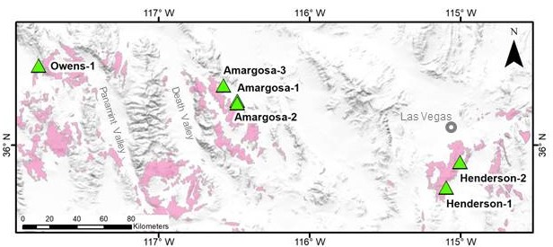

Figure 1.1: Field Locations.
Regional map of locations of alluvial fans used in this study. Pink polygons represent basaltic geologic units as identified on regional and state-level geologic maps (Bishop, 1963; Rogers, 1967; McAllister, 1970; Stewart and Carlson, 1978; Fridrich et al., 2012).

Table 1.1: Facies Descriptions.
Summary of facies used in categorizing depositional styles of alluvial fans. Colors in the Facies Name column correspond to the colors of the stratigraphic sections in Figure 9.
 | Facies Name (abbrev) | Representative Photo | Matrix % | Description
Debris flow facies | Boulder Debris Flow (bDF) | 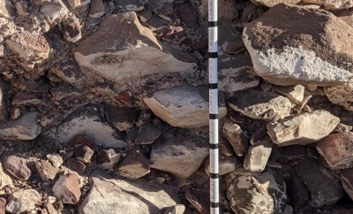 | > 10% | v. poor sorting, matrix-supported, clay-bearing matrix, numerous boulder-sized clasts, sub-rnd to sub-angular clasts
Debris flow facies | Cobble Debris Flow (cDF) | 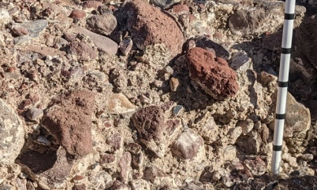 | > 10% | Poor to v. poor sorting, matrix-supported, clay-bearing matrix, avg clast size is cobble, sub-rnd to sub-angular clasts, inverse grading is possible
Debris flow facies | Pebble-Cobble Debris Flow (pcDF) | 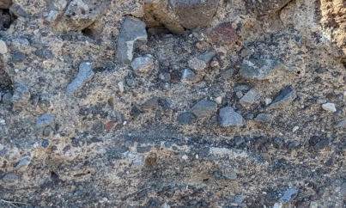 | > 10% | Poor to v. poor sorting, matrix-supported, clay-bearing matrix, range of clast sizes from cobble to pebble, sub-rnd to sub-angular clasts, inverse grading is possible
Debris flow facies | Pebble Debris Flow (pDF) | 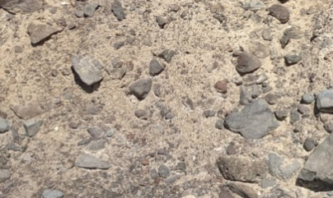 | > 10% | Poor sorting, matrix-supported, clay-bearing matrix, avg clasts size is pebble, sub-rnd to sub-ang clasts, inverse grading is possible
Sheet Flood facies | Cobble Sheet Flood  (cSF) | 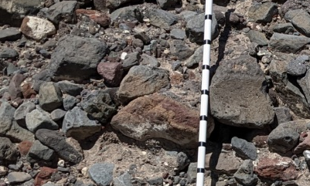 | < 10% | Moderate sorting, framework supported, average clast size is cobble, sub-rnd to sub-ang clasts, imbrication is common
Sheet Flood facies | Pebble Sheet Flood  (pSF) | 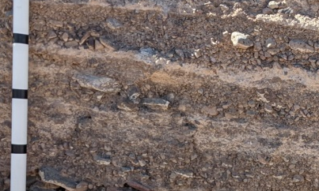 | < 10% | Moderate to well sorted, framework supported, avg clast size is pebble, may contain sandy material, ~10cm units with normal grading
Fluvial facies | Channels (CH) | 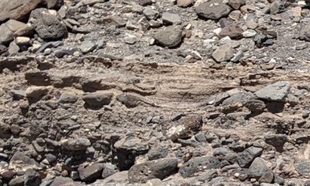 | < 10% | Moderate to well sorted, sandy to pebbly sediment deposited in incised channels, can contain a variety of clasts sizes and shapes, diagnostic channel fill shape

Table 1.2: Catchment relief and geology.
Morphologic and geologic characteristics for each alluvial fan catchment. See Section 6 for details on how values were determined.

Alluvial Fan | Percent Basalt in Catchment | Area (m²) | Length of Basin (m) | Minimum Elevation (m) | Maximum Elevation (m) | Absolute Relief (m) | Basin Relief Ratio | Melton's Ruggedness Factor
Owens-1 | 89.4 | 7598446 | 5939 | 1471.78 | 2289.87 | 818.09 | 0.138 | 0.297
Henderson-1 | 100.0 | 3523149 | 1210 | 705.15 | 1186.07 | 480.92 | 0.397 | 0.256
Henderson-2 | 54.5 | 6385187 | 2969 | 813.99 | 1537.71 | 723.72 | 0.244 | 0.286
Amargosa-3 | 100.0 | 1035546 | 1284 | 855.18 | 990.77 | 135.59 | 0.106 | 0.133
Amargosa-2 | 89.5 | 13474640 | 7997 | 768.53 | 1294.94 | 526.41 | 0.066 | 0.143
Amargosa-1 | 90.4 | 14818090 | 5800 | 782.48 | 1294.94 | 512.46 | 0.088 | 0.133

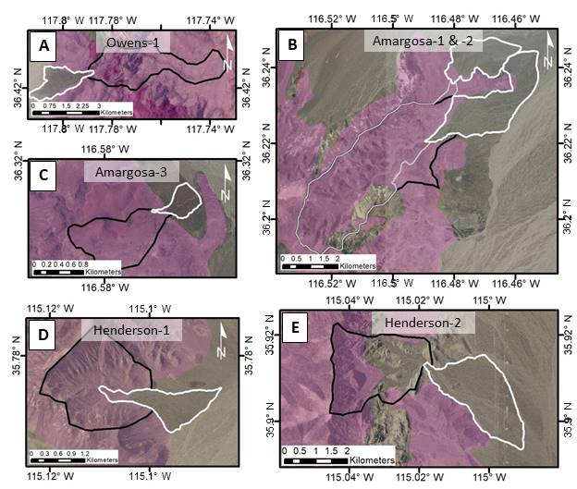

Figure 1.2: Catchment Lithology Maps.
Images of each alluvial fan and associated catchment from satellite image data. The alluvial fan outlines (white) are drawn from visible fan boundaries and confirmed during the initial fan survey in the field. The catchment boundaries were generated using the Watershed analysis tool in ArcGIS. Geologic units from state and regional geologic maps (Bishop, 1963; Rogers, 1967; McAllister, 1970; Stewart and Carlson, 1978; Fridrich et al., 2012) which are defined as basalt are shown as pink. All non-basalt units are left transparent.

Table 1.3: Owens-1 Sedimentology.
Sedimentary characteristics of depositional units of Owens-1 stratigraphic sections as described and measured in the field. This table corresponds to the stratigraphic sections shown in Figure 4. See section 5.3.1 for detail on methods of stratigraphic analysis.
 | Unit | Thickness (cm) | Sorting | Support Style | Min. clast size | Avg. clast size | Max. clast size | % Matrix | Clast shape | Facies
O-1-1  1  1  1  1 | 5 | 30 | poor | matrix | f. pebble | f. cobble | c. cobble | 20 | sub-rnd,  sph-pl | pcDF
O-1-1  1  1  1  1 | 4 | 25 | v. poor | matrix | m. pebble | f. cobble | c. cobble | 30 | sub-rnd,  sph | pcDF
O-1-1  1  1  1  1 | 3 | 35 | mod. | framework | c. pebble | f. cobble | f. cobble | 10-15 | sub-rnd/ang, sph-elong | cDF
O-1-1  1  1  1  1 | 2 | 45 | poor | matrix | m. pebble | c. pebble | f. cobble | 55 | sub-rnd,  sph | pcDF
O-1-1  1  1  1  1 | 1 | 55 | v. poor | matrix | f. pebble | f. cobble | c. cobble | 70 | sub-rnd,  sph | pcDF
O-1-2 | 6 | 30 | v. poor | matrix | m. pebble | f. cobble | c. cobble | 20 | sub-rnd,  sph | cDF
O-1-2 | 5 | 38 | mod. | framework | c. pebble | c. cobble | f. boulder | 10-15 | sub-ang,  sph-plty | cDF
O-1-2 | 4 | 27 | mod. | framework | f. pebble | c. pebble | vc. pebble | 20 | sub-rnd, elong | pDF
O-1-2 | 3 | 41 | poor | matrix | vf. pebble | m. pebble | f. cobble | 45 | sub-rnd,  sph | pcDF
O-1-2 | 2 | 34 | v. poor | matrix | f. pebble | c. pebble | f. boulder | 40 | sub-rnd,  sph | pcDF
O-1-2 | 1 | 26 | poor | matrix | m. pebble | c. pebble | f. cobble | 60 | sub-ang/rnd, sph | pcDF
O-1-3 | 2 | 50 | v. poor | matrix | f. pebble | f. cobble | f. boulder | 20 | sub-ang/rnd, sph-plty | pcDF
O-1-3 | 1 | 34 | poor | matrix | vf. pebble | c. pebble | vc. pebble | 40 | sub-ang/rnd, sph | pcDF
O-1-4 | 1 | 78 | poor | matrix | f. pebble | f. cobble | c. cobble | 70 | sub-rnd,  sph | pcDF

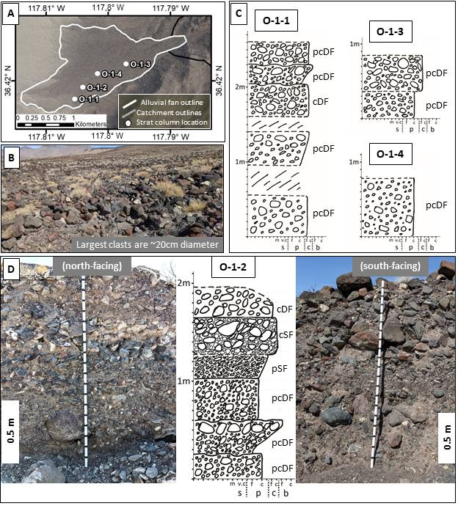

Figure 1.3: Owens-1 Stratigraphy.
A summary of field survey and stratigraphic sections of alluvial fan Owens-1. A) Location of measured sections on the fan surface. B) Representative photo of grain size and morphology of the fan surface. C) Detailed stratigraphic interpretation of Sections 1, 3, and 4. D) Detailed stratigraphic interpretation of Section O-1-2, overlaid on photos of the north channel wall outcrop (right) and south channel wall outcrop (left) from which it was measured. Facies are labeled to the right of each unit in the stratigraphic sections.

Table 1.4: Amargosa-1 Sedimentology.
Sedimentary characteristics of depositional units of Amargosa-1 stratigraphic sections as described and measured in the field. This table corresponds to the stratigraphic sections shown in Figure 5. See section 5.3.1 for detail on methods of stratigraphic analysis.
 | Unit | Thickness (cm) | Sorting | Support Style | Min. clast size | Avg. clast size | Max. clast size | % Matrix | Clast shape | Facies
Am-1-1 | 4 | 5-20 | mod. | framework | m. sand | c. sand | f. pebble | 5 | sub-rnd,  sph | Ch
Am-1-1 | 3 | 25-40 | poor | matrix | m. pebble | f. cobble | c. cobble | 80 | sub-ang/rnd, sph | pcDF
Am-1-1 | 2 | 10 | mod. | framework | m. sand | vc. sand | f. pebble | <5 | sub-rnd,  sph | pSF
Am-1-1 | 1 | 65 | poor | matrix | f. pebble | vc. pebble | c. cobble | 25 | sub-ang, sph/el | pcDF
Am-1-2 | 6 | 30 | v. poor | matrix | m. pebble | f. cobble | f. boulder | 20 | sub-rnd, sph/plty | cDF
Am-1-2 | 5 | <8 | mod. | framework | m. sand | c. sand | m. pebble | <5 | sub-rnd,  sph | Ch
Am-1-2 | 4 | 27 | v. poor | matrix | m. pebble | f. cobble | c. cobble | 15-20 | sub-ang/rnd, sph/pl | pcDF
Am-1-2 | 3 | 8 | mod. | framework | m. sand | f. pebble | m. pebble | 5 | sub-rnd,  sph | pSF
Am-1-2 | 2 | 15-25 | v. poor | framework | c. pebble | f. cobble | f. boulder | <5 | sub-ang/rnd, sph/el | cSF
Am-1-2 | 1 | 30-40 | v. poor | matrix | f. pebble | f. cobble | c. cobble | 15 | sub-ang/rnd, sph/plty | pcDF
Am-1-3 | 3 | 40-60 | poor | matrix | c. pebble | f. cobble | c. cobble | 30 | sub-rnd, sph/plty | pDF
Am-1-3 | 2 | 15 | mod. | framework | m. sand | f. pebble | m. pebble | 5 | sub-rnd,  sph | pSF
Am-1-3 | 1 | 55 | poor | matrix | c. pebble | f. cobble | c. cobble | 25 | sub-rnd, sph/plty | cDF
Am-1-4 | 5 | 15 | poor | matrix | m. pebble | f. cobble | c. cobble | 40 | sub-ang/rnd, sph | pcDF
Am-1-4 | 4 | 75 | v. poor | matrix | f. pebble | f. cobble | f. boulder | 20 | sub-rnd, sph/plty | cDF
Am-1-4 | 3 | 30 | poor | framework | f. pebble | vc. pebble | f. cobble | 10 | sub-ang, sph/plty | pSF
Am-1-4 | 2 | 5 | mod. | framework | m. sand | f. pebble | m. pebble | <5 | sub-rnd, sph/plty | pSF
Am-1-4 | 1 | 25 | poor | matrix | f. pebble | vc. pebble | f. cobble | 30 | sub-ang/rnd, sph/plty | pDF

Table 1.4 continued

 | Unit | Thickness (cm) | Sorting | Support Style | Min. clast size | Avg. clast size | Max. clast size | % Matrix | Clast shape | Facies
Am-1-5 | 2 | 95 | poor | matrix | c. pebble | m. cobble | f. boulder | 20 | sub-rnd/ang, sph | cDF
Am-1-5 | 1 | 25 | poor | framework | c. pebble | f. cobble | c. cobble | 10 | sub-rnd, sph/plty | cSF
Am-1-6 | 5 | 60 | v. poor | matrix | f. pebble | m. cobble | f. boulder | 45 | sub-rnd,  sph | cDF
Am-1-6 | 4 | 25 | poor | framework | c. pebble | f. boulder | f. boulder | 15 | sub-rnd, sph/plty | bDF
Am-1-6 | 3 | 12 | poor | framework | f. pebble | c. pebble | f. cobble | 10 | sub-rnd/ang, sph/plty | pSF
Am-1-6 | 2 | 30 | poor | matrix | f. pebble | vc. pebble | f. cobble | 20 | sub-rnd/ang, sph/el | pcDF
Am-1-6 | 1 | 45 | v. poor | matrix | f. pebble | vc. pebble | c. cobble | 25 | sub-rnd/ang, sph/plty | pcDF

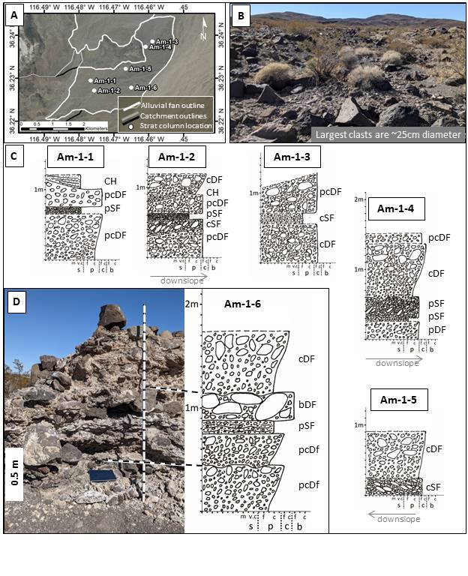

Figure 1.4: Amargosa-1 Stratigraphy.
A summary of field survey and stratigraphic sections of alluvial fan Amargosa-1. A) Location of measured sections on the fan surface. B) Representative photo of grain size and morphology of the fan surface. C) Detailed stratigraphic interpretation of Sections 1 - 5. D) Detailed stratigraphic interpretation of Section Am-1-6, with to a photo of the stratigraphic exposure from which it was measured. Facies are labeled to the right of each unit in the stratigraphic sections.

Table 1.5: Amargosa-2 Sedimentology.
Sedimentary characteristics of depositional units of Amargosa-2 stratigraphic sections as described and measured in the field. This table corresponds to the stratigraphic sections shown in Figure 6. See section 5.3.1 for detail on methods of stratigraphic analysis.
 | Unit | Thickness (cm) | Sorting | Support Style | Min. clast size | Avg. clast size | Max. clast size | % Matrix | Clast shape | Facies
Am-2-1 | 4 | 35 | poor | matrix | m. pebble | m. cobble | f. boulder | 25 | sub-rnd/ang, sph | pcDF
Am-2-1 | 3 | 5-20 | mod. | framework | vc. sand | m. pebble | vc. pebble | <5 | sub-rnd,  sph | pSF
Am-2-1 | 2 | 10-25 | poor | matrix | c. pebble | f. cobble | c. cobble | 20 | sub-rnd/ang, sph/pl | cDF
Am-2-1 | 1 | 20 | poor | matrix | m. pebble | c. pebble | f. cobble | 20 | sub-rnd/ang, sph | pDF
Am-2-2 | 9 | 23 | mod. | framework | m. sand | vc. sand | f. pebble | 5 | sub-rnd,  sph | Ch
Am-2-2 | 8 | 25 | poor | matrix | f. pebble | m. pebble | f. cobble | 20 | sub-rnd, sph/pl | pDF
Am-2-2 | 7 | 5 | mod. | framework | m. sand | vf. pebble | f pebble | 10 | sub-rnd/ang, sph | pSF
Am-2-2 | 6 | 35 | poor | mtrx/fmwk | m. pebble | vc. pebble | f. cobble | 15 | sub-ang/rnd, sph/pl | Ch
Am-2-2 | 5 | 15 | mod. | framework | m. sand | vf. pebble | f. pebble | 10 | sub-rnd/ang, sph | pSF
Am-2-2 | 4 | 60 | poor | matrix | m. pebble | f. cobble | f. cobble | 35 | sub-ang/rnd, sph/pl | pcDF
Am-2-2 | 3 | 10 | poor | framework | c. sand | m. pebble | m. pebble | 10 | sub-rnd,  sph | pSF
Am-2-2 | 2 | 25 | v. poor | matrix | f. pebble | c. pebble | c. pebble | 30 | sub-rnd/ang, sph/pl | pcDF
Am-2-2 | 1 | 15 | poor | matrix | f. pebble | vc. pebble | vc. pebble | 20 | sub-rnd/eng, sph/pl | pcDF
Am-2-3 | 5 | 25 | v. poor | matrix | f. pebble | c. cobble | f. boulder | 15 | sub-ang/rnd, sph/pl | pcDF
Am-2-3 | 4 | <15 | mod. | framework | c. sand | f. pebble | vc. pebble | <5 | sub-rnd, sph/pl | Ch
Am-2-3 | 3 | 35-50 | v. poor | matrix | vf. pebble | vc. pebble | f. boulder | 20 | sub-rnd, sph/pl | pcDF
Am-2-3 | 2 | 20 | mod. | framework | c. sand | f. pebble | c. pebble | <5 | sub-rnd, sph/pl | pSF
Am-2-3 | 1 | 40 | poor | matrix | f. pebble | c. pebble | f. cobble | 20 | sub-ang/rnd, sph/pl | pcDF

Table 1.5 continued

 | Unit | Thickness (cm) | Sorting | Support Style | Min. clast size | Avg. clast size | Max. clast size | % Matrix | Clast shape | Facies
Am-2-4 | 2 | 45 | v. poor | matrix | vf. pebble | m. cobble | f. boulder | 35 | sub-ang/rnd, sph/pl | pcDF
Am-2-4 | 1 | 20 | poor | matrix | m. pebble | c. pebble | f. cobble | 25 | sub-rnd/ang, sph | pDF

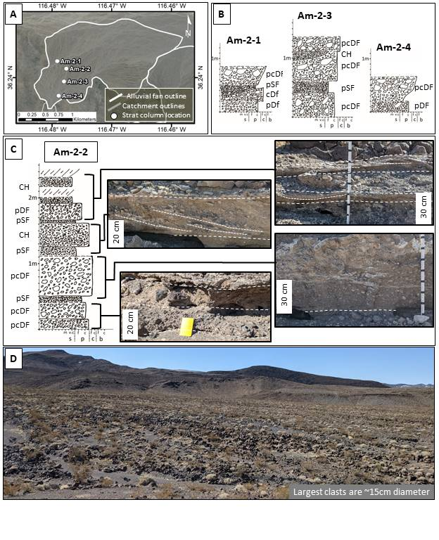

Figure 1.5: Amargosa-2 Stratigraphy.
A summary of field survey and stratigraphic sections of alluvial fan Amargosa-2. A) Location of measured sections on the fan surface. B) Detailed stratigraphic interpretation of Sections 1, 3, and 4. C) Detailed stratigraphic column for section Am-2-2 with representative photos for the depositional units. D) Representative photo of grain size and morphology of the fan surface. Facies are labeled next to each unit in the stratigraphic sections.

Table 1.6: Amargosa-3 Sedimentology.
Sedimentary characteristics of depositional units of Amargosa-3 stratigraphic sections as described and measured in the field. This table corresponds to the stratigraphic sections shown in Figure 7. See section 5.3.1 for detail on methods of stratigraphic analysis.
 | Unit | Thickness (cm) | Sorting | Support Style | Min. clast size | Avg. clast size | Max. clast size | % Matrix | Clast shape | Facies
Am-3-1 | 3 | 80 | v. poor | matrix | m. pebble | c. cobble | f. boulder | 20 | sub-ang, platy/sph | cDf
Am-3-1 | 2 | 52 | poor | matrix | f. pebble | c. pebble | c. pebble | 30 | sub-ang/rnd, plty/sph | pcDf
Am-3-1 | 1 | 68 | v. poor | matrix | f. pebble | f. cobble | f. cobble | 40 | sub-ang/rnd, sph | pcDF
Am-3-2 | 3 | 25 | poor | matrix | m. pebble | vc. pebble | f. cobble | 30 | sub-rnd/ang, sph | pcDf
Am-3-2 | 2 | 37 | v. poor | matrix | f. pebble | f. cobble | f. boulder | 35 | sub-rnd, sph/elng | pcDF
Am-3-2 | 1 | 38 | v. poor | matrix | m. pebble | f. cobble | c. cobble | 30 | sub-rnd, sph | pcDf
Am-3-3 | 2 | 70 | v. poor | matrix | m. pebble | f. cobble | f. boulder | 40 | sub-ang/rnd, sph/elng | pcDf
Am-3-3 | 1 | 50 | poor | matrix | vc. pebble | c. cobble | f. boulder | 20 | sub-ang/rnd, sph/elng | cDf
Am-3-4 | 2 | 30-60 | poor | matrix | m. pebble | vc. pebble | c. cobble | 60 | sub-ang/rnd, sph | pcDF
Am-3-4 | 1 | 70-100 | v. poor | matrix | c. pebble | c. cobble | f. boulder | 40 | sub-ang, sph/plty | bDf
Am-3-5 | 3 | 65 | v. poor | matrix | c. pebble | c. cobble | f. boulder | 30 | sub-ang/rnd, sph/plty | cDF
Am-3-5 | 2 | 140 | v. poor | matrix | c. pebble | f. cobble | f. boulder | 30 | sub-ang/rnd, sph/elng | pcDf
Am-3-5 | 1 | 60 | v. poor | matrix | f. pebble | f. cobble | f. boulder | 25 | sub-ang/rnd, sph | pcDF

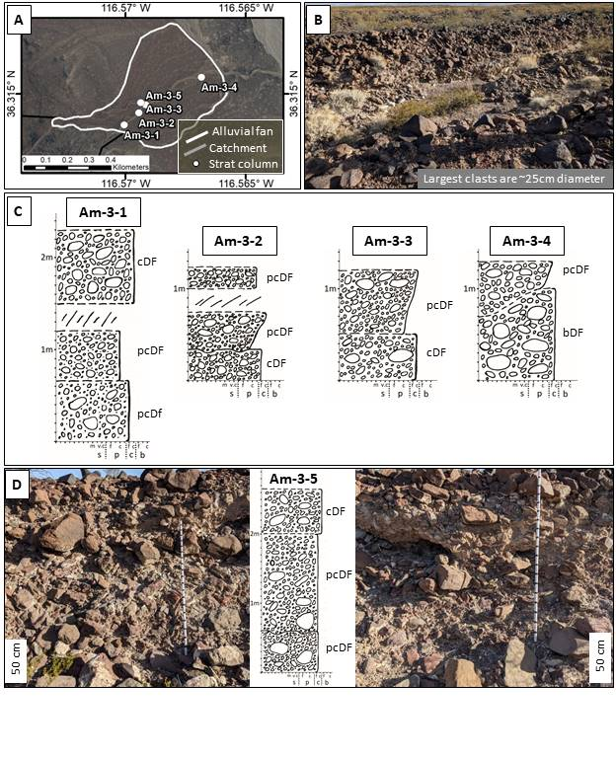

Figure 1.6: Amargosa-3 Stratigraphy.
A summary of field survey and stratigraphic sections of alluvial fan Amargosa-3. A) Location of measured sections on the fan surface. B) Representative photo of grain size and morphology of the fan surface. C) Detailed stratigraphic interpretation of Sections 1 - 4. D) Detailed stratigraphic interpretation of Section Am-1-5, correlated to photos of the stratigraphic exposure from which it was measured. Facies are labeled to the right of each unit in the stratigraphic sections.

Table 1.7: Henderson-1 Sedimentology.
Sedimentary characteristics of depositional units of Henderson-1 stratigraphic sections as described and measured in the field. This table corresponds to the stratigraphic sections shown in Figure 8. See section 5.3.1 for detail on methods of stratigraphic analysis.
 | Unit | Thickness (cm) | Sorting | Support Style | Min. clast size | Avg. clast size | Max. clast size | % Matrix | Clast shape | Facies
H-1-1 | 4 | 34 | v. poor | matrix | m. pebble | vc. pebble | c. cobble | 30 | sub-ang/rnd, sph | pcDF
H-1-1 | 3 | 56 | poor | matrix | c. pebble | m. cobble | f. boulder | 25 | sub-ang, sph/elg | cDF
H-1-1 | 2 | 62 | poor | matrix | vc. pebble | f. cobble | c. cobble | 25 | sub-rnd/ang, sph/elg | cDF
H-1-1 | 1 | 28 | poor | matrix | f. pebble | m. pebble | vc. pebble | 20 | sub-rnd,  sph | pDF
H-1-2 | 2 | 12 | poor | matrix | m. pebble | c. pebble | vc. pebble | 40 | sub-rnd, sph/elg | pDF
H-1-2 | 1 | 70 | v. poor | matrix | vc. pebble | c. cobble | f. boulder | 25 | sub-rnd/ang, sph/elg | cDf

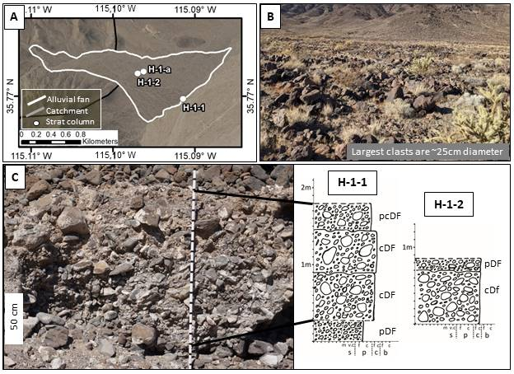

Figure 1.7: Henderson-1 Stratigraphy.
A summary of field survey and stratigraphic sections of alluvial fan Henderson-1. A) Location of measured sections on the fan surface. B) Representative photo of grain size and morphology of the fan surface. C) Detailed stratigraphic interpretation of Sections 1 and 2, with a representative photo of the stratigraphic exposure from which Section 1 was measured. Facies are labeled to the right of each unit in the stratigraphic sections.

Table 1.8: Henderson-2 sedimentology.
Sedimentary characteristics of depositional units of Henderson-2 stratigraphic sections as described and measured in the field. This table corresponds to the stratigraphic sections shown in Figure 9. See section 5.3.1 for detail on methods of stratigraphic analysis.
 | Unit | Thickness (cm) | Sorting | Support Style | Min. clast size | Avg. clast size | Max. clast size | % Matrix | Clast shape | Facies
H-2-1 | 4 | 30 | poor | matrix | m. pebble | vc. pebble | f. cobble | 20 | sub-rnd, sph | pcDF
H-2-1 | 3 | 70 | v. poor | matrix | f. pebble | c. pebble | f. cobble | 30 | sub-rnd, sph/elng | pDf
H-2-1 | 2 | 35 | mod. | framework | m. pebble | f. cobble | c. cobble | 5 | sub-rnd, sph/plty | cSF
H-2-1 | 1 | 15 | mod. | framework | f. pebble | m. pebble | m. pebble | 10 | sub-rnd, sph | pSF
H-2-2 | 2 | 75 | poor | matrix | c. pebble | f. cobble | f. boulder | 40 | sub-ang/rnd, sph | pcDF
H-2-2 | 1 | 95 | v. poor | matrix | c. pebble | vc. pebble | m. boulder | 60 | sub-ang, sph/plty | pcDF
H-2-3 | 5 | 20 | mod. | framework | c. pebble | f. cobble | c. cobble | 15 | sub-rnd, sph/elng | cDF
H-2-3 | 4 | 45 | mod. | framework | f. pebble | c. pebble | vc. pebble | 5 | sub-rnd, sph/elng | pSF
H-2-3 | 3 | 25 | mod. | framework | c. pebble | f. cobble | c. cobble | 5 | sub-rnd, sph/elng | cSF
H-2-3 | 2 | 30 | poor | matrix | f. pebble | c. pebble | f. cobble | 80 | sub-rnd, sph | pDf
H-2-3 | 1 | 40 | poor | matrix | f. pebble | vc. pebble | f. cobble | 40 | sub-ang/rnd, sph/elng | pDf
H-2-4 | 2 | 45 | mod. | framework | f. pebble | c. pebble | vc. pebble | 5 | sub-rnd, sph/elng | pSF
H-2-4 | 1 | 25 | mod. | framework | c. pebble | f. cobble | c. cobble | 5 | sub-rnd, sph/elng | cSF

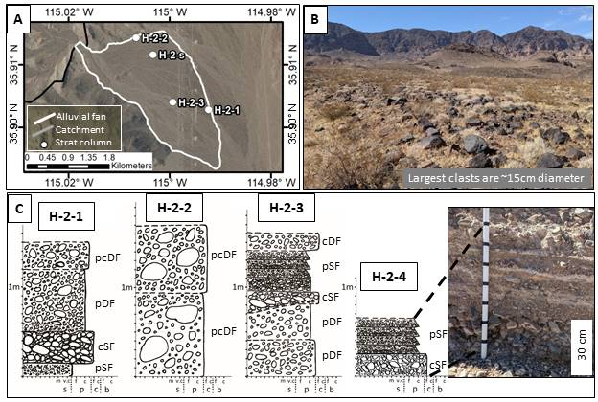

Figure 1.8: Henderson-2 stratigraphy.
A summary of field survey and stratigraphic sections of alluvial fan Henderson-2. A) Location of measured sections on the fan surface. B) Representative photo of grain size and morphology of the fan surface. C) Detailed stratigraphic interpretation of Sections 1 – 4 with a photo of the sheet flood facies in the stratigraphic exposure of Section 4. Facies are labeled to the right of each unit in the stratigraphic sections.
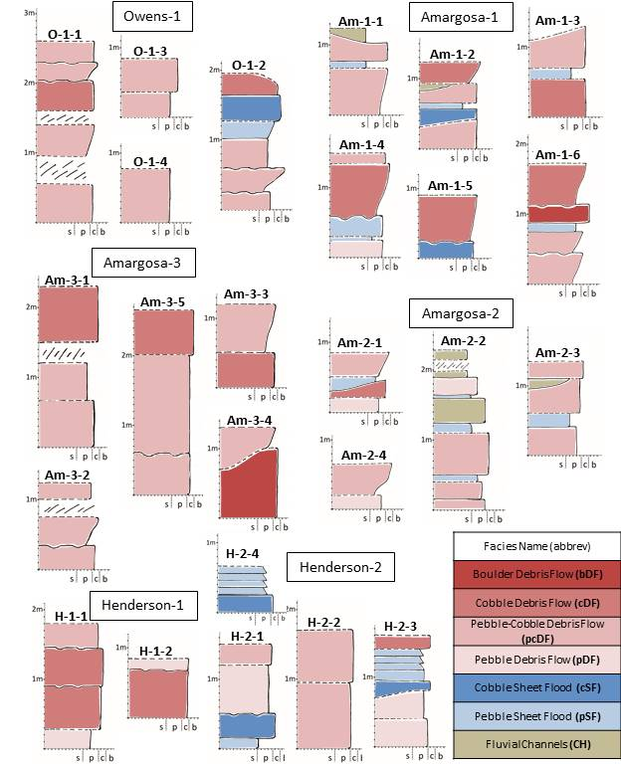

Figure 1.9: Facies classification of alluvial fans.
Simplified stratigraphic columns for all alluvial fans, color coded by facies classification. See Table 1.1 for facies descriptions and corresponding colors.
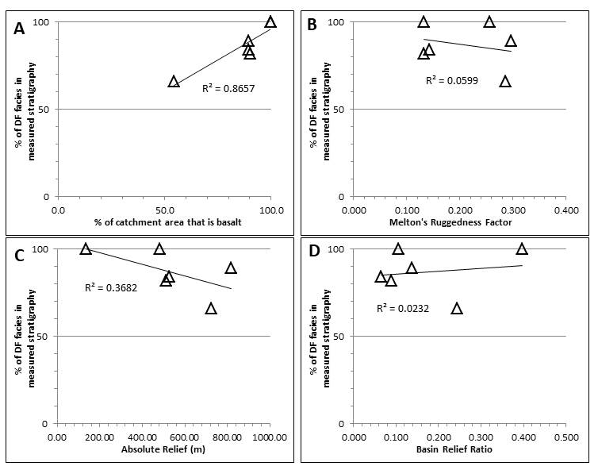

Figure 1.10: Depositional Style Controls.
Scatter plots showing the correlation between depositional style in the measured sections of each alluvial fan (y-axes) and catchment lithology and relief. See Table 1.2 for exact values. Percentage of debris-flow (DF) facies is calculated from all measured section within a single alluvial fan. The depositional style shows a strong correlation with the percentage of the catchment area that is basalt (A) and little to no correlation with catchment relief parameters including Melton’s Ruggedness Factor (B), Absolute Relief (C), or Basin Relief Ratio (D).

CHAPTER 2
An updated global survey of alluvial fans on Mars: distinguishing alluvial fans from other fan-shaped features through morphologic characterization

Abstract

Alluvial fans formed on Mars during the late Hesperian to early Amazonian in a climatic transition from a time of regular surface water activity to the current dry and cold climate. The depositional environments recorded by alluvial fans represent the final era of potential habitability on the Martian surface. Alluvial fan deposits can often look similar to deltaic or fluvial systems in visible remote sensing images but are formed in depositional and climatic environments that are distinct from those that lead to other radial depositional features. In order to better constrain regional and global depositional environments and further inform the analysis of the sedimentary history of Mars, we expanded the global catalog of alluvial fans on Mars by adding newly identified features and characterizing all new and previously identified features based on morphologic parameters. Using planform shape, radius, average radial slope, and radial profile shape, we classified features as alluvial fans, possible alluvial fans, and non-alluvial radial features (NARFs), based on how closely they fit the morphologic definition of alluvial fans. Other radial-shaped depositional features form in more water-rich depositional environments, whereas alluvial fans form by subaerial deposition in arid to hyper arid environments from sporadic high-energy flow events interspersed with long dry periods of inactivity. By identifying new features and distinguishing alluvial fans from other fan-shaped features in the global catalog, we have isolated distinct depositional environments on a local scale and updated the global perspective of the distribution and variety of aqueous depositional environments during the early history of Mars. Newly identified alluvial fans are found as far as 78°S latitude as well as in numerous locations within the Hesperian to Noachian transition unit along the dichotomy and occur both in craters and along non-crater topographic features, expanding the global range of alluvial fan environments into regions that previously have been overlooked.

Introduction
Analysis of sedimentary features on Mars is critical in understanding the surface processes and geologic history of the planet, particularly as they relate to habitability and the presence and timing of liquid water at the surface (Grotzinger et al., 2014; McLennan et al., 2019; Milliken et al., 2010; Squyres et al., 2004). Identification and analysis of depositional features formed from water-transported sediment help to constrain climatic history by defining when and where water flow was active on the surface (Ehlmann et al., 2011; Hoke and Hynek, 2009; Hynek and Phillips, 2003; Malin and Edgett, 2000) as well as the volume of surface water transport. Alluvial fans, in particular, indicate specific depositional environments, distinct from those associated with other radial depositional features such as deltas, fan-deltas, gilbert deltas, or distributive fluvial systems (Blair and McPherson, 1994; McPherson et al., 1987; Nichols and Fisher, 2007). Alluvial fans preserve a sedimentologic record of subaerial deposition during sporadic, high energy, surface water-flow events interspersed with long periods of dry inactivity. In contrast, fluvial and deltaic systems tend to form in environments with persistent runoff, subaqueous deposition, and seasonal flow cycles (Cesta and Ward, 2016; Miall, 1977; Ventra and Clarke, 2018).
From visible remote sensing images and without the context of modern depositional environments, alluvial fans, deltas, and some fluvial systems can be difficult to distinguish from one another without detailed sedimentary analysis, and therefore commonly have been lumped together in surveys of Mars sedimentary features. Valley networks (Fassett and Head, 2008; Howard et al., 2005), deltas (Adler et al., 2019; Goudge et al., 2017), and alluvial fans (Armitage et al., 2011; Grant and Wilson, 2011; Morgan et al., 2014) have all been identified on Mars, indicating that a range of depositional environments existed throughout its geologic history. Our current understanding of the climate history of Mars is that an early, wetter climate through the Noachian gradually transitioned to a colder and drier climate over the course of ~1 Gy (Carr and Head, 2010; Holo et al., 2021; Kite, 2019; Wordsworth et al., 2021). The interpreted relative ages of aqueous sedimentary features reflects this gradual drying out, with lacustrine and valley network formation followed by catastrophic outflow events and later alluvial fan formation (Holo et al., 2021; Kite, 2019; Rodriguez et al., 2005; Warner et al., 2009).
Alluvial fans may represent the final era of potential habitability on the Martian surface during the late Hesperian to early Amazonian. Analysis of the global population of Mars alluvial fans provides critical insight into global and regional climatic changes during the final stages of surface water activity. In order to investigate the small-scale, regional, and global depositional environments and climatic conditions of alluvial fan formation, it is necessary to isolate alluvial fans from other similar-looking features that formed during different eras of Martian history.
Here we present an updated global catalog of alluvial fans and other fan-shaped radial depositional features on Mars. The updated catalog includes 1,063 features from previously published surveys of Mars fan features (Cabrol and Grin, 2001; Di Achille and Hynek, 2010; Fassett and Head, 2008; Goudge et al., 2015a, 2012; Hauber et al., 2009; Irwin et al., 2005; Kraal et al., 2008; Moore and Howard, 2005; Williams and Malin, 2008; Wilson et al., 2021) as well as 333 newly-identified features. Based on the morphologic definition of terrestrial alluvial fans (Blair and McPherson, 2009, 1994), we classified each feature within this global catalog as alluvial fans, possible alluvial fans, or non-alluvial radial features (NARFs).

Background
In previous surveys, alluvial fans and fan-shaped features on Mars were identified visually using images taken from orbital platforms (Goudge et al., 2015a, 2012; Kraal et al., 2008; Moore and Howard, 2005). Recently, Wilson et al. (2021) expanded the inventory of fan-shaped features, although the work focuses on the global and regional distribution of craters that host fans in order to investigate the regional extents of aqueous activity and not details of fan deposits. The catalog of Wilson et al. (2021) clumps alluvial fans and deltas, defining deltas as “scarp-fronted fans” without providing a quantitative slope cutoff for the features. Alluvial fans, fan deltas, and river deltas are entirely separate depositional environments, constructed from different depositional processes that result in facies with distinct three-dimensional geometries. Consequently, the current global catalog of fans on Mars does not properly distinguish between alluvial fans and other fan-shaped features that represent unique depositional environments.
Through detailed analysis of populations of alluvial fans and radial depositional features on Earth, geologists developed a precise morphologic definition of alluvial fans, which can be used to distinguish them from other features without the need for detailed sedimentological field work. Modeling of sediment transport under Mars conditions and investigation of formation processes of individual Mars alluvial fans have shown that alluvial fans on Mars likely form under similar conditions and create similar morphologies to terrestrial alluvial fans (Kleinhans et al., 2010; Kraal et al., 2006; Morgan et al., 2014). Working under these assumptions, we can use what we know of terrestrial features to more confidently identify and precisely analyze alluvial fans on Mars.

Terrestrial fan-shaped features and depositional environments
The combined sediment transport and depositional processes that form alluvial fans are distinct from other sedimentary depositional systems (Blair and McPherson, 1994). Alluvial fans are built by subaerial deposition from sediment transport during ephemeral, high-discharge, high-energy flow events with high sediment load, and each event deposits sediment across large portions of the fan surface (Calvache et al., 1997; Griffiths et al., 2006; Ventra and Clarke, 2018). Alluvial fan catchments have short sediment transport distances compared to fluvial systems which, combined with high-energy transport events, results in less reworking or breakdown of material and larger average clast sizes (Blair and McPherson, 2009). Deposition on terrestrial alluvial fans is almost exclusively from sporadic, high-volume discharge events, and the fan surfaces often experience long, dry periods with minor fluvial-style surface reworking between depositional events (Beaty, 1990; D’Arcy et al., 2017; McDonald et al., 2003).
In contrast, deltas and braided fluvial systems studied on Earth typically have persistent surface water flow with seasonal variations in volume. Deltas are deposited into standing water and have very low (< 0.5°) slopes across the primary depositional surface, with a sharp drop-off at the delta front (Blair and McPherson, 2009). Alluvial fans may have long-lived standing water at the toe but in situations where alluvial fan deposition extends into a standing body of water, it forms a fan-delta, which also has morphology distinct from alluvial fans (McPherson et al., 1987). Terrestrial deltas and braided fluvial systems also typically have a lower sediment to water ratio and significantly longer transport distances than terrestrial alluvial fans (Blair and McPherson, 2009), resulting in smaller average grain size within the depositional system (Bridge, 1993; Miall, 1985, 1977). Distinguishing alluvial fans from similar-looking features allows us to constrain the erosional and sediment transport processes that were active in the depositional environment. Identification of alluvial fans can also be linked to sporadic surface water flow during the time of formation, which is an important climatic indicator.

Morphologic Definition of Alluvial Fans
Alluvial fans on earth are distinguished from deltas, braided fluvial systems, and other radial depositional features based on measurable morphologic characteristics. Alluvial fans have a semi-conical shape emanating from single apex point along a topographic break. The radial profiles of alluvial fans are straight or slightly concave-up. The cross-fan profiles are concave-down, with the central radius of the fan surface as the highest point in the cross-fan profile. Alluvial fans have average radial slopes > 1.0°, in contrast to fluvial and deltaic systems, which have slopes < 1.0° and often < 0.5°. These morphologic parameters were defined in the seminal paper on alluvial fan classification (Blair and McPherson, 1994) and have been confirmed by ongoing work on terrestrial alluvial fans (Blair and McPherson, 2009; Calvache et al., 1997; Williams et al., 2006).
Alluvial fans can also look similar to talus slopes and other mass-wasting features. On Earth, alluvial fans are distinguished from mass wasting deposits by their sedimentary and depositional characteristics. Alluvial fans are formed by water-transported sediment that builds the fan through successive depositional layers, while colluvial talus slopes and other mass-wasting features form from slope collapse that results in a talus cone of undifferentiated, brecciated bedrock material with rock fall chutes across the surface and extending into the scarp (Blair and McPherson, 2009; Turner, 1996). Mass-wasting features build to the angle of repose and can have radial slopes up to approximately 35° in terrestrial examples (Pierson, 1982; Tinkler, 1966), but on the lower end of slope values there is not a clear distinction between the slopes of mass-wasting features and slopes of alluvial fans. This morphologic overlap makes it difficult to differentiate between the two types of features in remote sensing data. Alluvial fans can be smaller than 2 km (Ventra and Clarke, 2018) but mass-wasting scree slopes generally do not grow larger than approximately 2 km (Ventra et al., 2013).

Mars alluvial fans and other fan-shaped features
On Mars, fan-shaped features were first identified in MOLA elevation data (Craddock and Howard, 2002) and subsequent work identified fan-shaped features all around the planet between 35° N and 60° S along the inside walls of craters. Moore and Howard (2005) used 100 m/pixel daytime thermal infrared THEMIS images to identify 31 large fans with radial lengths > 40 km in large highland craters and analyzed the morphology of the fans. This work was expanded to additional highland craters where 13 more large fans were identified (Kraal et al., 2008). Since these earlier surveys, a newly produced and updated global mosaic of ~5 m/pixel CTX visual image data (Dickson et al., 2018) and improved elevation data have made identifying and characterizing fans even easier. Potential fan-shaped deposits have been identified as depositional features in open-basin lakes (Goudge et al., 2012) and closed-basin lakes (Goudge et al., 2015a) across the highlands. Wilson et al. (2021) identified additional fan-shaped features in impact craters from the global CTX mosaic, investigated the size and distribution of the host craters, and described planform morphology of scarp features.
The sedimentology and depositional history of some individual features have been investigated in more detail. In some cases, more detailed analysis confirmed the interpretation of an alluvial fan (Grant and Wilson, 2011; Morgan et al., 2014). In other cases more detailed analysis led to a better understanding of the depositional environment, as in the case of the fan-shaped feature in Jezero Crater, which had been included in catalogs of fans but is now generally thought to be a deltaic deposit (Goudge et al., 2017; Schon et al., 2012).
As discussed in Section 2.2.2, alluvial fans can potentially be confused with mass-wasting features that form without significant volumes of surface water flow. Recent analyses of recurring slope lineae and small-scale gully channels on Mars have shown that these systems are currently active during a time when liquid water is not stable on the surface of Mars (Dundas et al., 2021; Gough et al., 2020; McEwen et al., 2013). In order to isolate alluvial fan features for further analysis of water-transported sediments, mass-wasting features should be excluded from a global catalog of alluvial fans. Because very small alluvial fans cannot confidently be distinguished from mass-wasting features based solely on morphology, the simplest way to eliminate potential mass-wasting features is to impose a lower limit cut-off on radial length of fan-shaped features.
In order to better understand the global and temporal distribution of alluvial fan depositional systems as well as geologic history of individual features, a more precisely-defined global catalog of features is needed. The present work seeks to both expand the existing catalog of identified fan-shaped features and characterize the morphology of features to determine which are most likely to be alluvial fans.

Methods

Identification of fan-shaped features
Fan-shaped features identified by previous studies (Cabrol and Grin, 2001; Di Achille and Hynek, 2010; Fassett and Head, 2008; Goudge et al., 2015a, 2012; Hauber et al., 2009; Irwin et al., 2005; Kite et al., 2019; Kraal et al., 2008; Moore and Howard, 2005; Williams and Malin, 2008) and recently compiled in Wilson et al. (2021) formed the starting point for the global catalog of alluvial fans discussed below. In order to expand these previously published collections, we conducted a global survey to identify any additional potential alluvial fans. To identify new features, we scanned through a lower resolution version of the CTX global mosaic (Dickson et al., 2018) in a grid pattern between the north and south poles, excluding the area of permanent polar ice caps to identify craters of > 5 km diameter. At full resolution, we then individually investigated each > 5 km diameter crater as well as all other visible topographic features, including steep-sided channels, Valles Marineris, the dichotomy boundary, and any other sharp topographic breaks.
In areas where there are gaps in the CTX global mosaic or where the insides of crater rims are either too shadowed or too brightly illuminated, we used THEMIS Day IR images to fill the coverage gap in order to identify new potential alluvial fans and confirm locations of the previously identified features. For all of the features, both new and preciously identified, found in the gaps in the CTX mosaic, we also used the THEMIS Day IR images in the morphologic classification steps when necessary.
We visually identified new potential alluvial fans as radial features that were visibly distinguishable from the surrounding basin floor and that emanated from a single apex point along a topographic break. We marked the apex location of anything that appeared to be a fan-shaped depositional feature with a radius of approximately 2 km or greater. Because this step focused on visual identification rather than precise measurement, we inadvertently included some features with radius < 2 km in the initial collection of features and later filtered them out in the first step of morphologic characterization.

Morphologic classification
Starting with the full catalog of features, both new and previously identified, we characterized the morphology of each feature to determine whether it fits the morphologic definition of alluvial fans according to Blair and McPherson (2009). The morphologic characteristics and the steps in feature classification are shown in Figure 2.1 and described in detail in the section below.
The morphologic definition of alluvial fans describes them as semi-conical (Blair and McPherson, 1994), which incorporates a vertical shape component. Slope and vertical relief were evaluated in subsequent steps, so for shape characterization we used “radial”, which we defined as a shape similar to a partial wedge of a circle. Some features from previously published collections do not have a radial shape. Some of these non-radial features may have looked like potential fans in earlier, lower-resolution image data but higher-resolution imaging show features that are either not radial depositional features, or are too degraded to be described as fan-shaped in their current form. In some cases, previously published catalogs of fan-shaped features identify areas where crater fill seems to be formed of deposited sediment, but there is not a radial depositional shape emanating from a single apex and distinguishable from the surrounding crater floor fill. We classified all of these features as “non-fans” and did not characterize them further. In practice, some features that we describe as radial exhibit more irregular shapes due to lateral confinement by smaller topographic features but still have a general radial shape, so we kept them in the catalog of fan-shaped features for further characterization.
We measured the horizontal radial length of each fan-shaped feature along the central radius, defined as the straight line bisecting the radial shape, for all features with radius > 2 km. Average slope was calculated from the central radius based on elevation values from the Mars HRSC MOLA Blended DEM (Fergason et al., 2018). The HRSC MOLA Blended DEM has a horizontal resolution up to 50 m/pixel and a vertical accuracy of approximately 10 m. Features with an average slope < 1.0°, which does not fit the definition of alluvial fans, we classified as “non-alluvial radial features” (NARFs). Most of these NARFs are likely fluvial or deltaic deposits, but additional work is needed to identify the individual depositional environments. Features with an average slope > 1.0° were carried forward to the next step of characterizing radial profile shapes.
For each feature with an average radial slope > 1.0°, we created an elevation profile from the HRSC MOLA Blended DEM (Fergason et al., 2018) with elevation values extracted every 200 m along the radial profile trace from apex to toe. We visually characterized each fan profile either “smooth” with no terraces or breaks in slope, “terraced” if there is a slope break near the bottom of the profile, or “segmented” if there is a slope break in the middle of the profile (Figure 2.3). “Segmented” features are separated into their own category because a major slope break in the middle of a radial profile is likely to either indicate a major erosional event post-deposition or represent a completely different type of depositional feature.
For fans with terraced or segmented radial profiles, we recalculated the average slope along a shorter segment of the radial profile, which we selected to better represent the depositional surface of the potential fan and avoid possible erosional surfaces that formed after alluvial fan deposition. These shorter segments of the radial profiles included at least half of the full radial length and avoided major slope breaks. The slope values calculated from these shorter radial profiles on terraced and segmented alluvial fans are reported as the “adjusted radial slope” in the full database of features (available in the Supplementary Material). For a subset of segmented and terraced features with an initial average slope > 1.0°, the adjusted average slope is < 1.0°. Because the adjusted slope describes a depositional surface and alluvial fan depositional surfaces are defined as > 1.0°, we re-classified these features as NARFs along with the other low-slope features. The “segmented (reclassified)” example in Figure 2.2 shows the radial profile for one of these features.
The vertical precision of the HRSC MOLA Blended DEM (+/- 10 m) introduces some uncertainty to slope calculations of the smallest and/or lowest slope features. For the features with an average slope within 0.2° of the 1.0° cutoff, we re-examined the radial trace and slope calculation to ensure that the slope value best represented the true extent of the depositional features. We recalculated average slope values from the apex and toe elevations with a relief uncertainty of +/- 20 m to confirm the slope-based characterization parameter.
We classified features with segmented radial profiles and adjusted average slopes > 1.0°, such as the “segmented” example profile in Figure 2.2, as “possible alluvial fans”. Some of these features may be remnants of alluvial fans that were eroded to a point where the feature no longer fits the morphology of an alluvial fan but the features may also be fan-deltas, gilbert deltas, or merely an erosional feature in older crater fill. Some “segmented” fans do not have an adjusted slope value because there was not a segmented of the radial profile at least half the length of the profile that represented a possible depositional surface. Some segmented features have multiple slope breaks or have a surface that is too degraded by cratering and other processes to be representative of a depositional surface. We classified segmented features without an adjusted slope value as possible alluvial fans as long as the overall relief along the feature has an average slope > 1.0°. In the full database, these features are designated with a radial profile shape of “segmented_E”. More detailed analysis of individual features may provide more insight on individual features as a part of future research.
Features with terraced radial profiles where the adjusted average slopes are > 1.0° fit all of the morphologic parameters of alluvial fans, except for the slope break near the toe of the fans. This slope break could be either a depositional feature or post-depositional erosional surface, but, in either case, it does not change the overall fan morphology. We classified features with smooth and terraced radial profiles as alluvial fans. The alluvial fans with smooth radial profiles conform most closely to the full morphologic definition of alluvial fans.
From this sequence of morphologic filters, we produced a set of feature classifications that differentiate between features that fit all the morphologic definitions of alluvial fans, features that may be alluvial fans that have been eroded in some way, and other depositional features that do not fit the definitions of alluvial fans. The classifications and associated morphologic parameters are summarized in Table 2.1.

Results & Discussion
Of the 1,063 previously identified and 333 newly identified fan features, 775 were classified as alluvial fans based on their morphology. The full global catalog of features, color-coded by final classification, is shown on the map in Figure 2.3. There were 110 features that lack a visible radial shape that we therefore classified as non-fans and did not characterize further (Section 3.2). We classified a total of 225 features with radii < 2 km as small features and excluded them from further classification. Of the remaining features, we classified 63 as NARFs based on their low radial slope values. We classified 223 features with segmented radial profiles as possible alluvial fans. There are 265 features from previous surveys that we classified as something other than an alluvial fan or possible alluvial fan, most of which are non-fans or small features. Additionally, 175 of the alluvial fans are new features first identified in this survey.

Small features
Of the 225 small features, 103 were included in previous surveys of fan-shaped features, while 122 were close enough to 2 km in radius that we marked them as potential alluvial fans in our initial survey of newly identified features before measuring the precise radius and excluding them. There are clusters of small fan-shaped features within medium-sized craters in the highlands that previous studies have marked as fans but that look similar to the talus cones where recurring slope lineae and potentially active gullies have been identified. At high latitudes in the southern hemisphere, a population of small fan-shaped features clusters along steep edges of irregularly-shaped basins, which may be related to glacial activity (Figure 2.4). The high-latitude depositional environment of these features is unclear from morphology alone and may have involved either surface flow, dry mast wasting, or groundwater outflow along the basin walls. The collection of small features included in this catalog is far from a full global survey of small fan-shaped features and is presented as a comparison to the classified alluvial fans as well as a starting point for future investigation into highly localized depositional processes.

Non-alluvial radial features (NARFs)
A total of 63 features have an average radial slope <1.0°, which is not consistent with alluvial fan morphology, but do have a radial shape (Figure 2.5). This group includes 26 features with segmented or terraced radial profiles that were reclassified based on the adjusted average slope (Figure 2.6A). These NARFs include some well-known locations, such as the feature near the Perseverance Rover landing site that is widely thought to be a deltaic deposit (Goudge et al., 2015b). Other examples show evidence of fluvial channels, which may be analogous to terrestrial features such as glacial outwash plains or braidplains (Figure 2.5A). Other NARFs lack visible depositional features such as channels or layered deposits on their surface but have a general morphology that is indicative of deposition into standing water. Although not all of the features in this classification have been specifically categorized as fluvial or deltaic, they represent a selection of locations most likely to have direct evidence of long-term standing water at some point during the history of Mars.
The low-slope NARFs are distributed across the oldest regions of the Martian surface, in regions where the surface is mapped as Noachian to Hesperian (Tanaka et al., 2014). If these NARFs are primarily deltaic or fluvial deposits, it makes sense that so few are visible at the surface compared to alluvial fans. According to the current understanding of the climate history of Mars, the Noachian is the most likely time of persistent and abundant liquid water at the surface. This is the time when fluvial and lacustrine depositional systems could form, and it occurred approximately 0.5 – 1 Gy before the time of peak alluvial fan formation (Carr and Head, 2010; Howard et al., 2005; Hynek and Phillips, 2003; Irwin et al., 2005). While fluvial and deltaic deposits may have been more common during the Noachian, later erosion or crater infill likely has obscured visible records of additional features, and the surviving remnants are limited to the oldest craters and basins on the oldest regions of the surface.

Possible alluvial fans
We classified 223 features with significant slope breaks in the middle of the radial profile as possible alluvial fans with segmented profiles because they often look like remnant alluvial fans with an erosional surface cutting through original depositional units (Figure 2.6B). In many of the possible alluvial fans with segmented profiles, the sharp slope break in the radial profile is coincident with surface erosional features. However, in some cases, the features may be other similar depositional features such as fan-deltas or lacustrine shoreline deposits that have coincidentally been eroded into a fan shape. Mars alluvial fans are hypothesized to have formed primarily in late Hesperian, approximately 3.4 Gy (Armitage et al., 2011; Carr and Head, 2010; Grant and Wilson, 2011), and erosional processes have significantly altered the Martian surface since then. While the examples in this cohort are too degraded to fit the precise definition of alluvial fans, we recognize that they may have been alluvial fans at the time of deposition and that, in their present morphology, provide useful insight into the post-depositional erosional processes.

Alluvial fans
For the majority of features in this survey (775), the morphologic parameters confirmed their classification as alluvial fans (Figure 2.7). Of the features confirmed as alluvial fans, 175 are new features that we identified for the first time in this survey. From planform shape alone, some of the fan-shaped features (Figure 2.5a) look similar to the alluvial fans (Figure 2.7a) however the additional characterization by radial profile shape and radial slope confirms that the alluvial fans are formed from vertical accumulation of large volumes of sediment during subaerial deposition.
We found no alluvial fans in the central regions of the northern lowlands, except for one location where 4 alluvial fans are found in a single high-latitude crater. This absence suggests that either the final surfacing of the northern lowlands occurred after the era of alluvial fan formation or the depositional environment in the lowlands was not conducive to alluvial fan formation at the time when the fans were forming. The northern lowlands are also less cratered and lack significant topographic features, which drastically limits the possible environments of alluvial fan formation. We did find alluvial fans and possible alluvial fans along the southern extent of the northern lowlands, near the dichotomy boundary. Very few alluvial fans are found in the volcanic region surrounding Olympus Mons, further indicating that alluvial fan formation is restricted to early in the history of Mars. This lack of alluvial fans in young terrains is consistent with previously published findings suggesting that alluvial fans were formed primarily in the late Hesperian (Armitage et al., 2011; Carr and Head, 2010; Grant and Wilson, 2011).
Newly identified alluvial fans are approximately evenly distributed across the central highlands and southern high latitudes. Given the tedious and time-consuming nature of visually selecting a global database of features, many of these newly identified fans were likely merely overlooked by previous studies. About a dozen new alluvial fans were identified along the edges of large channels or chaos terrain blocks. Previous surveys have been limited to investigating craters, which are the most common terrain for alluvial fans. However, the addition of alluvial fans along other forms of topographic features is worth investigating further as these features may be easier to determine ages for than craters.
The numerous high-latitude alluvial fans identified for the first time in this survey expands the global reach of alluvial fan depositional systems into previously uninvestigated regions. The furthest southern extent of previously identified fan-shaped features was 53°S (Wilson et al., 2021) and most previous studies placed latitude limits on the survey of potential alluvial fans. We identified new features that fit the morphologic definition of alluvial fans as far south as 78°S latitude (Figure 2.3), suggesting that the climatic conditions necessary for alluvial fan formation were not constrained to equatorial and mid-latitudes during the time of fan formation. The example in Figure 2.7B shows a bajada, or population of adjacent alluvial fans, in a 42 km diameter crater at 76°S. This crater hosts a total of 8 alluvial fans with radii ranging from 2.1 km to 9.3 km.
The abundance of alluvial fans across the Noachian and Hesperian surface regions suggests that the conditions necessary for alluvial fan formation existed at a global scale during the early history of Mars. More than half of the alluvial fans and possible alluvial fans are found on regions of the Mars surface that have been identified as Noachian, as mapped in (Tanaka et al., 2014). The bedrock surface ages place an upper limit on the timing of alluvial fan formation but these alluvial fans could have formed anytime post-Noachian. The rest of the alluvial fans occur in medium to large craters in the highlands that have been mapped collectively as Amazonian and Hesperian impacts. A small number of alluvial fans occur in the Hesperian-to-Noachian transition unit along the dichotomy.
Alluvial fans with terraced profiles show localized erosion at the toe of the fan (Figure 2.7C), but are still classified as alluvial fans if the upper part of the profile has an average adjusted slope > 1.0°. Slope breaks near the toe of an alluvial fan can form when subaerial alluvial fan deposition reaches a shallow body on standing water. The terraced alluvial fans identified on Mars could be indicative of presence of shallow crater lakes during or shortly after alluvial fan deposition.
Of the features classified as alluvial fans, most of have radii < 10 km, with the number of features decreasing as the radial distance increases (Figure 2.8B). The average radius of the Martian alluvial fans in this survey is 5.8 km with a standard deviation of 4.69, which is similar to the most well-known type examples of terrestrial alluvial fans (Blair and McPherson, 2009). The largest Mars alluvial fan has a radius of 50 km. The average radial-parallel (down fan) slope of Martian alluvial fans is 4.86° with a standard deviation of 3.06 (Figure 2.8A). These values are slightly lower than for similar-sized terrestrial alluvial fans, which regularly have average slopes of up to 15° (Blair and McPherson, 2009), which is expected due to the lower gravity on Mars (Moore and Howard, 2005).
The updated catalog presented here expands the global distribution of alluvial fans into higher southern latitudes and adds newly identified features along the dichotomy boundary. The newly identified features that fit the morphologic definition of alluvial fans (Figure 2.8B) show that there is still more to discover on the surface of Mars.

Conclusions
We characterized the planform shape, radial slope, and radial profile shape of 1396 potential alluvial fan features, including 333 newly identified fan-shaped depositional features. We classified 775 features with radius > 2 km as alluvial fans and 223 more as possible alluvial fans. There were 63 features with a radial slope < 1.0° that are likely to be fluvial or deltaic deposits, and which we classified as non-alluvial radial features (NARFs).
The newly identified alluvial fans extend into the high northern and southern latitudes, into regions previously uninvestigated by surveys of fan-shaped features. Numerous alluvial fans occur as far south as 78°S, and there is only a single crater in the northern lowlands that hosts 4 alluvial fans. Numerous alluvial fans also occur along the dichotomy. The global extent of the occurrence of alluvial fans shows that the conditions for alluvial fan formation – sporadic, high-energy surface water flow – were widespread across the Martian surface. By confirming the morphology of alluvial fans as compared to other depositional features, we have defined a global database of features that all form in the same specific environment, which provides critical insight into the climatic conditions during formation. Alluvial fans record the final era of surface water activity of Mars and the extent and variability of alluvial fans constrains the regional depositional environments during this time.

References

Adler, J.B., Bell, J.F., Fawdon, P., Davis, J., Warner, N.H., Sefton-Nash, E., Harrison, T.N., 2019. Hypotheses for the origin of the Hypanis fan-shaped deposit at the edge of the Chryse escarpment, Mars: Is it a delta? Icarus 319, 885–908. https://doi.org/10.1016/J.ICARUS.2018.05.021
Armitage, J.J., Warner, N.H., Goddard, K., Gupta, S., 2011. Timescales of alluvial fan development by precipitation on Mars. Geophys. Res. Lett. 38. https://doi.org/10.1029/2011GL048907
Beaty, C.B., 1990. Anatomy of a White Mountains debris-flow - the making of an alluvial fan, in: Rachocki, A.H., Church, M. (Eds.), Alluvial Fans: A Field Approach. John Wiley.
Blair, T.C., McPherson, J.G., 2009. Alluvial fans processes and forms, Geomorphology of Desert Environments. https://doi.org/10.1007/978-1-4020-5719-9J4
Blair, T.C., McPherson, J.G., 1994. Alluvial Fans and their Natural Distinction from Rivers Based on Morphology, Hydraulic Processes, Sedimentary Processes, and Facies Assemblages. SEPM J. Sediment. Res. Vol. 64A, 450–489. https://doi.org/10.1306/D4267DDE-2B26-11D7-8648000102C1865D
BRIDGE, J.S., 1993. Description and interpretation of fluvial deposits: a critical perspective. Sedimentology 40, 801–810. https://doi.org/10.1111/j.1365-3091.1993.tb01361.x
Cabrol, N.A., Grin, E.A., 2001. The Evolution of Lacustrine Environments on Mars: Is Mars Only Hydrologically Dormant? Icarus 149, 291–328. https://doi.org/10.1006/ICAR.2000.6530
Calvache, M.L., Viseras, C., Fernd́ez, J., 1997. Controls on fan development — evidence from fan morphometry and sedimentology; Sierra Nevada, SE Spain. Geomorphology 21, 69–84. https://doi.org/10.1016/S0169-555X(97)00035-4
Carr, M.H., Head, J.W., 2010. Geologic history of Mars. Earth Planet. Sci. Lett. 294, 185–203. https://doi.org/10.1016/J.EPSL.2009.06.042
Cesta, J.M., Ward, D.J., 2016. Timing and nature of alluvial fan development along the Chajnantor Plateau, northern Chile. Geomorphology 273, 412–427. https://doi.org/10.1016/J.GEOMORPH.2016.09.003
Craddock, R.A., Howard, A.D., 2002. The case for rainfall on a warm, wet early Mars. J. Geophys. Res. Planets 107, 21-1-21–36. https://doi.org/10.1029/2001JE001505
D’Arcy, M., Whittaker, A.C., Roda-Boluda, D.C., 2017. Measuring alluvial fan sensitivity to past climate changes using a self-similarity approach to grain-size fining, Death Valley, California. Sedimentology 64, 388–424. https://doi.org/10.1111/sed.12308
Di Achille, G., Hynek, B.M., 2010. Ancient ocean on Mars supported by global distribution of deltas and valleys. Nat. Geosci. 2010 37 3, 459–463. https://doi.org/10.1038/ngeo891
Dickson, J.L., Kerber, L.A., Fassett, C.I., Ehlmann, B.L., 2018. A global, blended CTX mosaic of Mars with vectorized seam mapping: a new mosaicking pipeline using principles of non-destructive image editing. Lunar Planet. Sci. Conf. https://doi.org/10.1029/2010JE003755
Dundas, C.M., Becerra, P., Byrne, S., Chojnacki, M., Daubar, I.J., Diniega, S., Hansen, C.J., Herkenhoff, K.E., Landis, M.E., McEwen, A.S., Portyankina, G., Valantinas, A., 2021. Active Mars: A Dynamic World. J. Geophys. Res. Planets 126, e2021JE006876. https://doi.org/10.1029/2021JE006876
Ehlmann, B.L., Mustard, J.F., Murchie, S.L., Bibring, J.-P., Meunier, A., Fraeman, A.A., Langevin, Y., 2011. Subsurface water and clay mineral formation during the early history of Mars. Nature 479, 53–60. https://doi.org/10.1038/nature10582
Fassett, C.I., Head, J.W., 2008. The timing of martian valley network activity: Constraints from buffered crater counting. Icarus 195, 61–89. https://doi.org/10.1016/J.ICARUS.2007.12.009
Fergason, R.L., Hare, T.M., Laura, J., 2018. HRSC and MOLA Blended Digital Elevation Model at 200m v2, Astrogeology PDS Annex, US Geological Survey. https://doi.org/10.1029/2006JE002735
Goudge, T.A., Aureli, K.L., Head, J.W., Fassett, C.I., Mustard, J.F., 2015a. Classification and analysis of candidate impact crater-hosted closed-basin lakes on Mars. Icarus 260, 346–367. https://doi.org/10.1016/J.ICARUS.2015.07.026
Goudge, T.A., Head, J.W., Mustard, J.F., Fassett, C.I., 2012. An analysis of open-basin lake deposits on Mars: Evidence for the nature of associated lacustrine deposits and post-lacustrine modification processes. Icarus 219, 211–229. https://doi.org/10.1016/J.ICARUS.2012.02.027
Goudge, T.A., Milliken, R.E., Head, J.W., Mustard, J.F., Fassett, C.I., 2017. Sedimentological evidence for a deltaic origin of the western fan deposit in Jezero crater, Mars and implications for future exploration. Earth Planet. Sci. Lett. 458, 357–365. https://doi.org/10.1016/J.EPSL.2016.10.056
Goudge, T.A., Mustard, J.F., Head, J.W., Fassett, C.I., Wiseman, S.M., 2015b. Assessing the mineralogy of the watershed and fan deposits of the Jezero crater paleolake system, Mars. J. Geophys. Res. Planets 120, 775–808. https://doi.org/10.1002/2014JE004782
Gough, R. V., Nuding, D.L., Archer, P.D., Fernanders, M.S., Guzewich, S.D., Tolbert, M.A., Toigo, A.D., 2020. Changes in Soil Cohesion Due to Water Vapor Exchange: A Proposed Dry-Flow Trigger Mechanism for Recurring Slope Lineae on Mars. Geophys. Res. Lett. 47, e2020GL087618. https://doi.org/10.1029/2020GL087618
Grant, J.A., Wilson, S.A., 2011. Late alluvial fan formation in southern Margaritifer Terra, Mars. Geophys. Res. Lett. 38, n/a-n/a. https://doi.org/10.1029/2011GL046844
Griffiths, P.G., Hereford, R., Webb, R.H., 2006. Sediment yield and runoff frequency of small drainage basins in the Mojave Desert, U.S.A. Geomorphology 74, 232–244. https://doi.org/10.1016/J.GEOMORPH.2005.07.017
Grotzinger, J.P., Sumner, D.Y., Kah, L.C., Stack, K., Gupta, S., Edgar, L., Rubin, D., Lewis, K., Schieber, J., Mangold, N., Milliken, R., Conrad, P.G., DesMarais, D., Farmer, J., Siebach, K., Calef, F., Hurowitz, J., McLennan, S.M., Ming, D., Vaniman, D., Crisp, J., Vasavada, A., Edgett, K.S., Malin, M., Blake, D., Gellert, R., Mahaffy, P., Wiens, R.C., Maurice, S., Grant, J.A., Wilson, S., Anderson, R.C., Beegle, L., Arvidson, R., Hallet, B., Sletten, R.S., Rice, M., Bell, J., Griffes, J., Ehlmann, B., Anderson, R.B., Bristow, T.F., Dietrich, W.E., Dromart, G., Eigenbrode, J., Fraeman, A., Hardgrove, C., Herkenhoff, K., Jandura, L., Kocurek, G., Lee, S., Leshin, L.A., Leveille, R., Limonadi, D., Maki, J., McCloskey, S., Meyer, M., Minitti, M., Newsom, H., Oehler, D., Okon, A., Palucis, M., Parker, T., Rowland, S., Schmidt, M., Squyres, S., Steele, A., Stolper, E., Summons, R., Treiman, A., Williams, R., Yingst, A., 2014. A habitable fluvio-lacustrine environment at Yellowknife Bay, Gale crater, Mars. Science (80). 343. https://doi.org/10.1126/SCIENCE.1242777/SUPPL_FILE/PAP.PDF
Hauber, E., Gwinner, K., Kleinhans, M., Reiss, D., Di Achille, G., Ori, G.G., Scholten, F., Marinangeli, L., Jaumann, R., Neukum, G., 2009. Sedimentary deposits in Xanthe Terra: Implications for the ancient climate on Mars. Planet. Space Sci. 57, 944–957. https://doi.org/10.1016/j.pss.2008.06.009
Hoke, M.R.T., Hynek, B.M., 2009. Roaming zones of precipitation on ancient Mars as recorded in valley networks. J. Geophys. Res. 114, E08002. https://doi.org/10.1029/2008JE003247
Holo, S.J., Kite, E.S., Wilson, S.A., Morgan, A.M., 2021. The Timing of Alluvial Fan Formation on Mars. Planet. Sci. J. 2, 210. https://doi.org/10.3847/PSJ/AC25ED
Howard, A.D., Moore, J.M., Irwin, R.P., 2005. An intense terminal epoch of widespread fluvial activity on early Mars: 1. Valley network incision and associated deposits. J. Geophys. Res. Planets 110, 1–20. https://doi.org/10.1029/2005JE002459
Hynek, B.M., Phillips, R.J., 2003. New data reveal mature, integrated drainage systems on Mars indicative of past precipitation. Geology 31, 757–760. https://doi.org/10.1130/G19607.1
Irwin, R.P., Howard, A.D., Craddock, R.A., Moore, J.M., 2005. An intense terminal epoch of widespread fluvial activity on early Mars: 2. Increased runoff and paleolake development. J. Geophys. Res. Planets 110, 1–38. https://doi.org/10.1029/2005JE002460
Kite, E.S., 2019. Geologic Constraints on Early Mars Climate, Space Science Reviews. Springer Nature B.V. https://doi.org/10.1007/s11214-018-0575-5
Kite, E.S., Mayer, D.P., Wilson, S.A., Davis, J.M., Lucas, A.S., Quay, G.S. De, 2019. Persistence of intense , climate-driven runoff late in Mars history. Sci. Adv.
Kleinhans, M.G., van de Kasteele, H.E., Hauber, E., 2010. Palaeoflow reconstruction from fan delta morphology on Mars. Earth Planet. Sci. Lett. 294, 378–392. https://doi.org/10.1016/J.EPSL.2009.11.025
Kraal, E.R., Asphaug, E., Moore, J.M., Howard, A., Bredt, A., 2008. Catalogue of large alluvial fans in martian impact craters. Icarus 194, 101–110. https://doi.org/10.1016/J.ICARUS.2007.09.028
Kraal, E.R., van Dijk, M., Postma, G., 2006. Experimental Alluvial Fan Modeling Related to Large Alluvial Fans on Mars, in: AGUFM. pp. P34B-04.
Malin, M.C., Edgett, K.S., 2000. Sedimentary Rocks of Early Mars. Science (80-. ). 290, 1927–1937. https://doi.org/10.1126/SCIENCE.290.5498.1927
McDonald, E. V, McFadden, L.D., Wells, S.G., McFadden, E., 2003. Regional response of alluvial fans to the Pleistocene-Holocene climatic transition, Mojave Desert, California. Geol. Soc. Am. Spec. Pap.
McEwen, A.S., Dundas, C.M., Mattson, S.S., Toigo, A.D., Ojha, L., Wray, J.J., Chojnacki, M., Byrne, S., Murchie, S.L., Thomas, N., 2013. Recurring slope lineae in equatorial regions of Mars. Nat. Geosci. 2013 71 7, 53–58. https://doi.org/10.1038/ngeo2014
McLennan, S.M., Grotzinger, J.P., Hurowitz, J.A., Tosca, N.J., 2019. The Sedimentary Cycle on Early Mars. https://doi.org/10.1146/annurev-earth-053018-060332 47, 91–118. https://doi.org/10.1146/ANNUREV-EARTH-053018-060332
McPherson, J.G., Shanmugam, G., Moiola, R.J., 1987. Fan-deltas and braid deltas - Varieties of coarse-grained deltas - discussion. Geol. Soc. Am. Bull. 99, 331–340.
Miall, A.D., 1985. Architectural-element analysis: A new method of facies analysis applied to fluvial deposits. Earth-Science Rev. 22, 261–308. https://doi.org/10.1016/0012-8252(85)90001-7
Miall, A.D., 1977. A review of the braided-river depositional environment. Earth-Science Rev. 13, 1–62. https://doi.org/10.1016/0012-8252(77)90055-1
Milliken, R.E., Grotzinger, J.P., Thomson, B.J., 2010. Paleoclimate of Mars as captured by the stratigraphic record in Gale Crater. Geophys. Res. Lett. 37. https://doi.org/10.1029/2009GL041870
Moore, J.M., Howard, A.D., 2005. Large alluvial fans on Mars. J. Geophys. Res. E Planets 110, 1–24. https://doi.org/10.1029/2004JE002352
Morgan, A.M., Howard, A.D., Hobley, D.E.J., Moore, J.M., Dietrich, W.E., Williams, R.M.E., Burr, D.M., Grant, J.A., Wilson, S.A., Matsubara, Y., 2014. Sedimentology and climatic environment of alluvial fans in the martian Saheki crater and a comparison with terrestrial fans in the Atacama Desert. Icarus 229, 131–156. https://doi.org/10.1016/j.icarus.2013.11.007
Nichols, G.J., Fisher, J.A., 2007. Processes, facies and architecture of fluvial distributary system deposits. Sediment. Geol. 195, 75–90. https://doi.org/10.1016/J.SEDGEO.2006.07.004
Pierson, T.C., 1982. Classification and hydrological characteristics of scree slope deposits in the northern Craigieburn Range, New Zealand. Source J. Hydrol. 21, 34–60.
Rodriguez, J.A.P., Sasaki, S., Kuzmin, R.O., Dohm, J.M., Tanaka, K.L., Miyamoto, H., Kurita, K., Komatsu, G., Fairén, A.G., Ferris, J.C., 2005. Outflow channel sources, reactivation, and chaos formation, Xanthe Terra, Mars. Icarus 175, 36–57. https://doi.org/10.1016/J.ICARUS.2004.10.025
Schon, S.C., Head, J.W., Fassett, C.I., 2012. An overfilled lacustrine system and progradational delta in Jezero crater, Mars: Implications for Noachian climate. Planet. Space Sci. 67, 28–45. https://doi.org/10.1016/J.PSS.2012.02.003
Squyres, S.W., Grotzinger, J.P., Arvidson, R.E., Bell, J.F., Calvin, W., Christensen, P.R., Clark, B.C., Crisp, J.A., Farrand, W.H., Herkenhoff, K.E., Johnson, J.R., Klingelhöfer, G., Knoll, A.H., McLennan, S.M., McSween, H.Y., Morris, R. V., Rice, J.W., Rieder, R., Soderblom, L.A., 2004. In Situ Evidence for an Ancient Aqueous Environment at Meridiani Planum, Mars. Science (80). 306, 1709–1714. https://doi.org/10.1126/SCIENCE.1104559
Tanaka, K.L., Skinner, J.A.J., Dohm, J.M., Irwin, R.P.I., Kolb, E.J., Fortezzo, C.M., Platz, T., Michael, G.G., Hare, T.M., 2014. Geologic map of Mars: U.S. Geological Survey Scientific Investigations Map 3292, scale 1:20,000,000.
Tinkler, K.J., 1966. Slope Profiles and Scree in the Eglwyseg Valley, North Wales. Source Geogr. J. 132, 379–385.
Turner, A.K., 1996. Colluvium and talus, in: Landslides Investigation and Mitigation, Special Report. pp. 525–554.
Ventra, D., Clarke, L.E., 2018. Geology and geomorphology of alluvial and fluvial fans: current progress and research perspectives. Geol. Soc. London Spec. Publ. https://doi.org/10.1144/SP440.16
Ventra, D., Dìaz, G.C., De boer, P. l., 2013. Colluvial sedimentation in a hyperarid setting (Atacama Desert, northern Chile): Geomorphic controls and stratigraphic facies variability. Sedimentology 60, 1257–1290. https://doi.org/10.1111/SED.12029
Warner, N., Gupta, S., Muller, J.P., Kim, J.R., Lin, S.Y., 2009. A refined chronology of catastrophic outflow events in Ares Vallis, Mars. Earth Planet. Sci. Lett. 288, 58–69. https://doi.org/10.1016/J.EPSL.2009.09.008
Williams, R.M.E., Malin, M.C., 2008. Sub-kilometer fans in Mojave Crater, Mars. Icarus 198, 365–383. https://doi.org/10.1016/j.icarus.2008.07.013
Williams, R.M.E., Zimbelman, J.R., Johnston, A.K., 2006. Aspects of alluvial fan shape indicative of formation process: A case study in southwestern California with application to Mojave Crater fans on Mars. Geophys. Res. Lett. 33, 2–5. https://doi.org/10.1029/2005GL025618
Wilson, S.A., Morgan, A.M., Howard, A.D., Grant, J.A., 2021. The Global Distribution of Craters With Alluvial Fans and Deltas on Mars. Geophys. Res. Lett. 48. https://doi.org/10.1029/2020GL091653
Wordsworth, R., Knoll, A.H., Hurowitz, J., Baum, M., Ehlmann, B.L., Head, J.W., Steakley, K., 2021. A coupled model of episodic warming, oxidation and geochemical transitions on early Mars. Nat. Geosci. 2021 143 14, 127–132. https://doi.org/10.1038/s41561-021-00701-8

Appendix

Appendix 2: Ch. 2 Tables and Figures

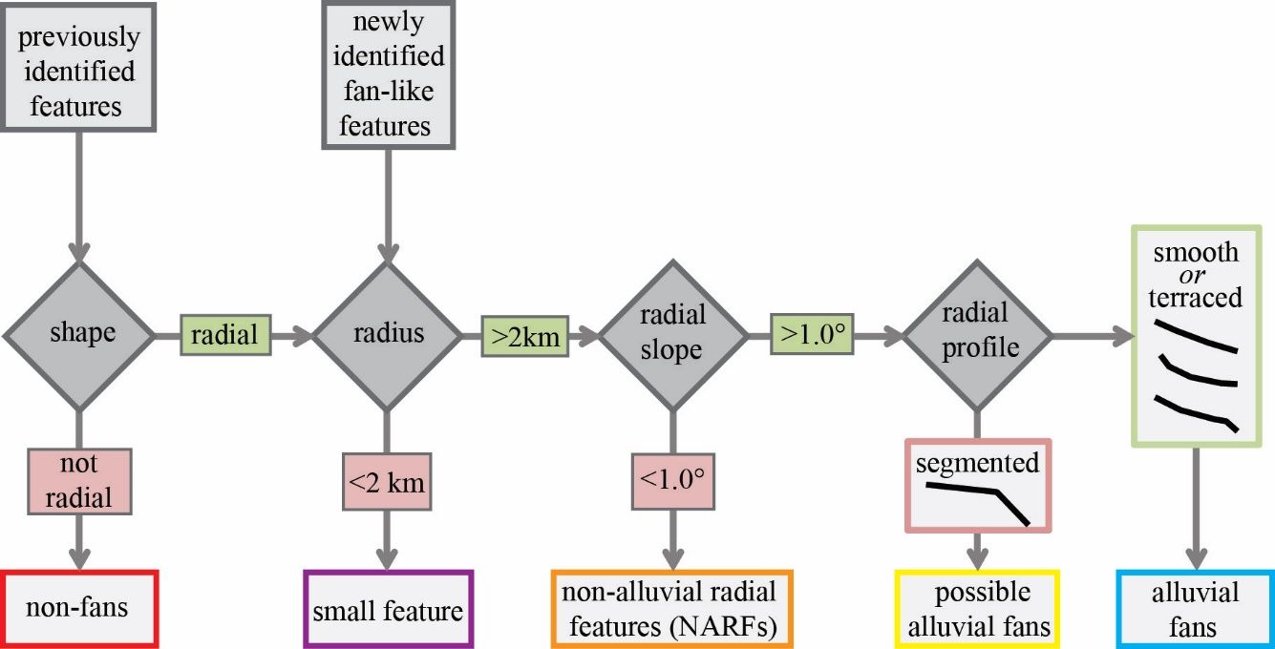

Figure 2.1: Characterization and classification of depositional features.
The blue diamonds indicate characterization parameters. The boxes along the bottom row are the classification categories that we sorted features into based on their parameters at each step and are colored to match the map of features (Figure 3). Segmented radial profiles have one or more major slope breaks in the middle of the profile, while terraced profiles have a slope break near the downslope end. Once a feature did not fit the parameter definition for an alluvial fan, we did not characterize it further. Features with radial profile shapes that are smooth, smooth but concave, or terraced, we classified as alluvial fans.

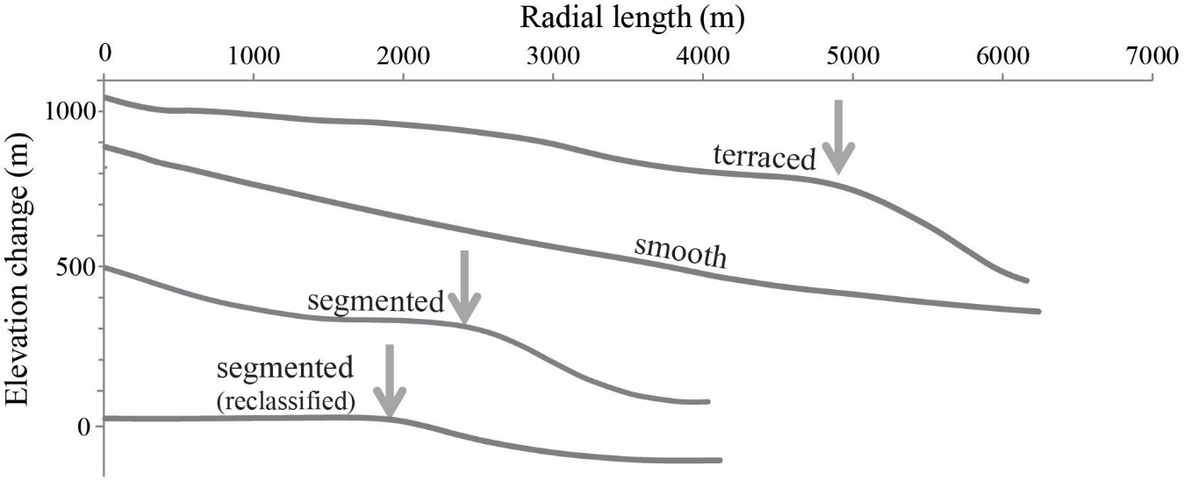

Figure 2.2: Examples of radial profiles.
Radial profiles from Martian depositional features that demonstrate characterizations of the radial profile shape. Profiles are shown to-scale relative to each other, with a 2x vertical exaggeration. “Terraced” profiles are defined as having a slope break near the downslope (distal) end but a consistent depositional surface above the slope break. “Segmented” profiles are defined by one or more slope breaks near the middle of the profile length. For both terraced and segmented profiles, we recalculated the average slope angle up-slope of the major slope break (indicated by arrows). If the adjusted average slope is < 1.0°, as shown in the “segmented (reclassified)” profile, we re-classified the feature as non-alluvial radial features (NARFs). Features with smooth radial profiles we classified as alluvial fans.

Table 2.1: Feature classifications and morphologic parameters.
Parameters in green represent values or qualities that are consistent with the morphologic definition of alluvial fans. Parameters in orange are characteristics that may indicate either a non-alluvial fan feature or alluvial fan degradation. Parameters in red are not consistent with the morphologic definition of alluvial fans and indicate the point where we stopped characterization of those feature classifications.
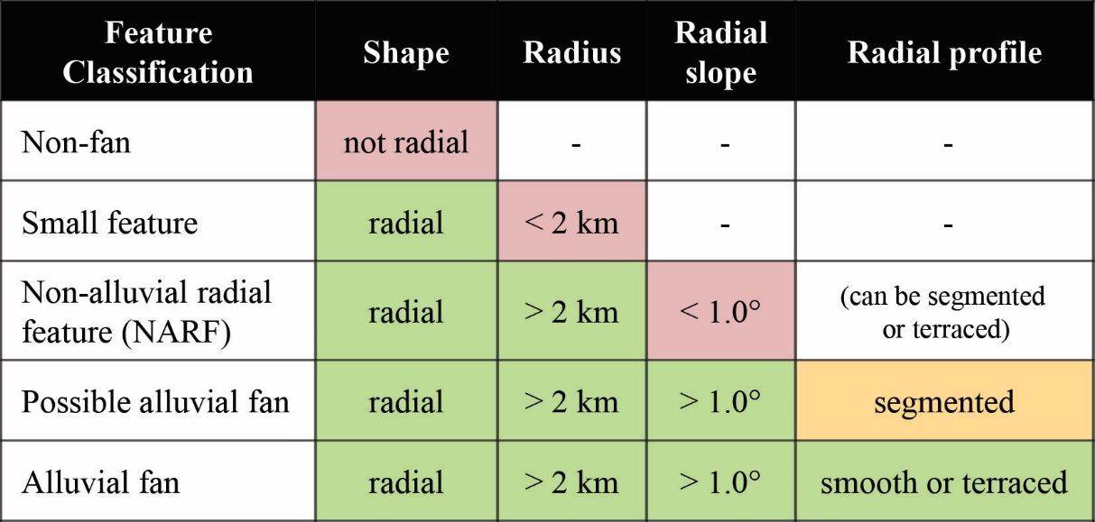

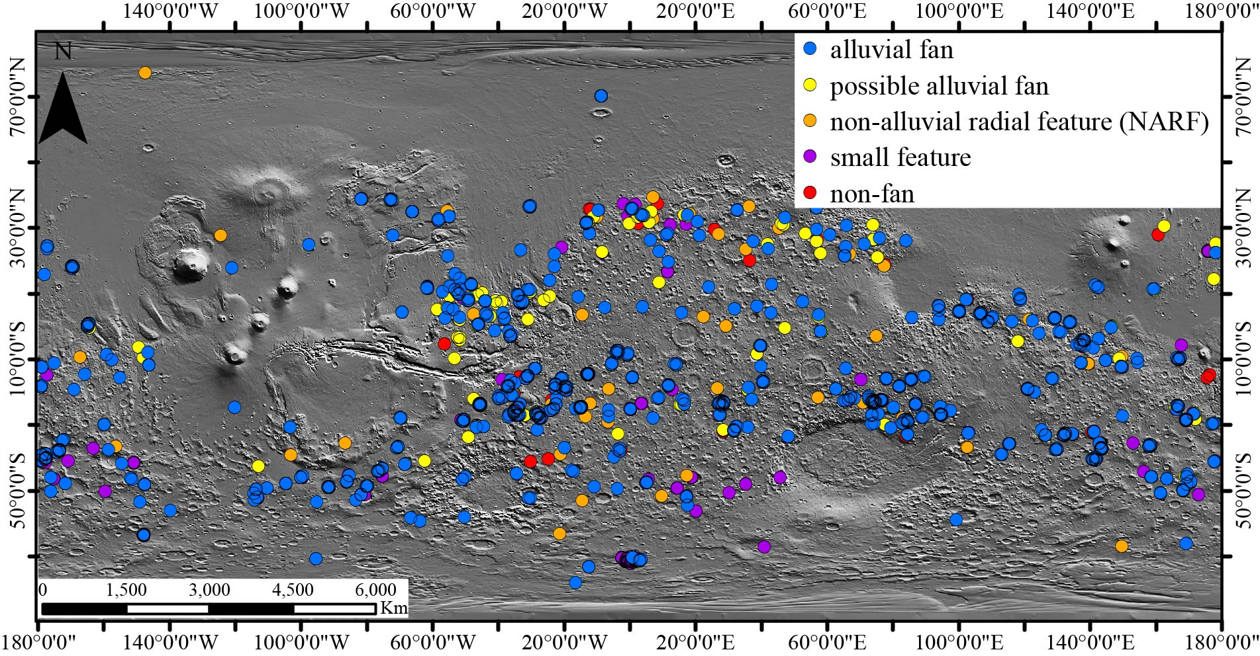

Figure 2.3: Map of Mars alluvial fans.
Alluvial fans and other depositional features, color coded by classification according to morphologic parameters. Because of the close proximity of many of the alluvial fans and to each other especially in multi-fan craters, many of the location dots overlap and appear as a single dot. The base map is Mars MGS MOLA Global Shaded Relief 463m v1.

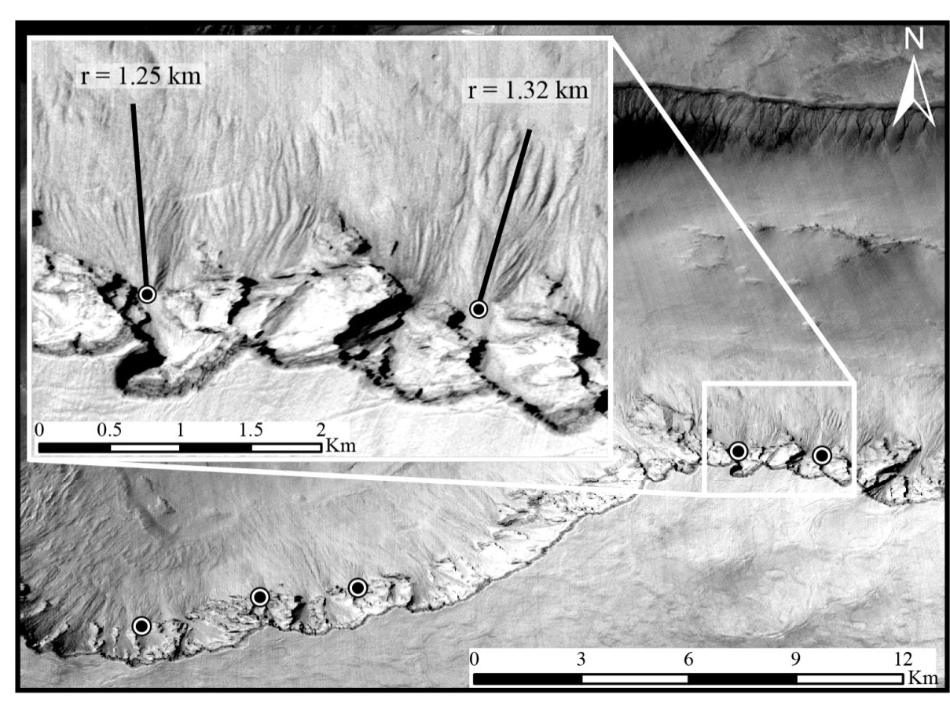

Figure 2.4: Small Features.
Examples of radial depositional features with radii < 2 km that we classified as small features and did not characterize further. Many of the small features such as these are found along the edges of irregularly shaped basins in the high southern latitudes. The origin of these features is unclear without more detailed analysis but they may have formed from rock falls or ground-water driven slope collapse.

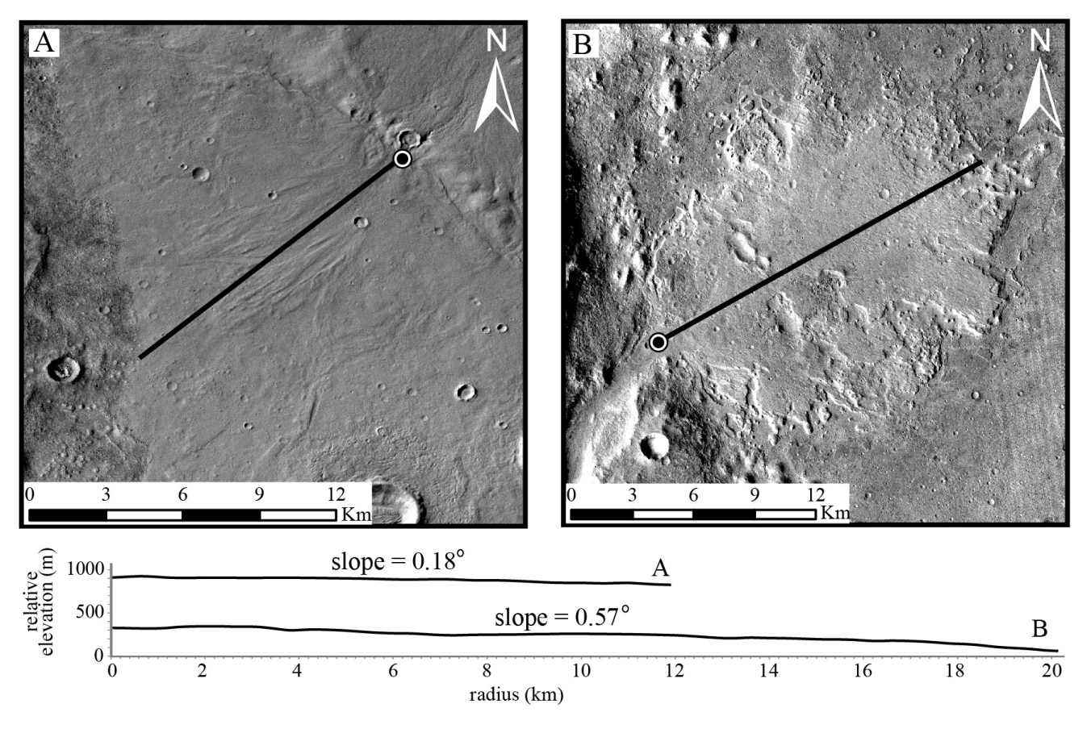

Figure 2.5: Non-alluvial radial features.
Examples of radial depositional features with an average radial slope < 1.0° that we classified as “non-alluvial radial features” (NARFs). Such features are most likely deltaic or fluvial deposits, based on the low surface slope and visible morphology. Radial elevation profiles are plotted with 2x vertical exaggeration, with elevation values extracted from the Mars HRSC MOLA Blended DEM (Fergason et al., 2018).

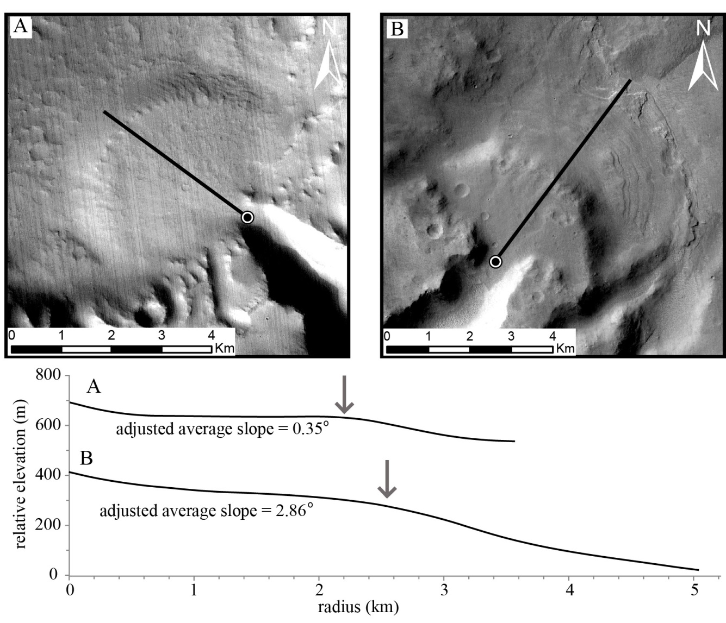

Figure 2.6: Segmented Features.
Examples of radial depositional features with segmented radial profiles. Profiles are plotted at 2x vertical exaggeration with elevation values extracted from the Mars HRSC MOLA Blended DEM (Fergason et al., 2018). A) We re-classified this feature as a NARF based on the adjusted average radial slope. The small segment of higher slope followed by the near-zero slope through the middle of the profile suggests that this may be an example of a fan-delta. B) In this case, the adjusted average slope of the segmented profile is > 1.0° therefore we classified this feature as a “possible alluvial fan”. The slope break may be indicative of an erosional scarp and there are possible depositional layers exposed on the lower slope.

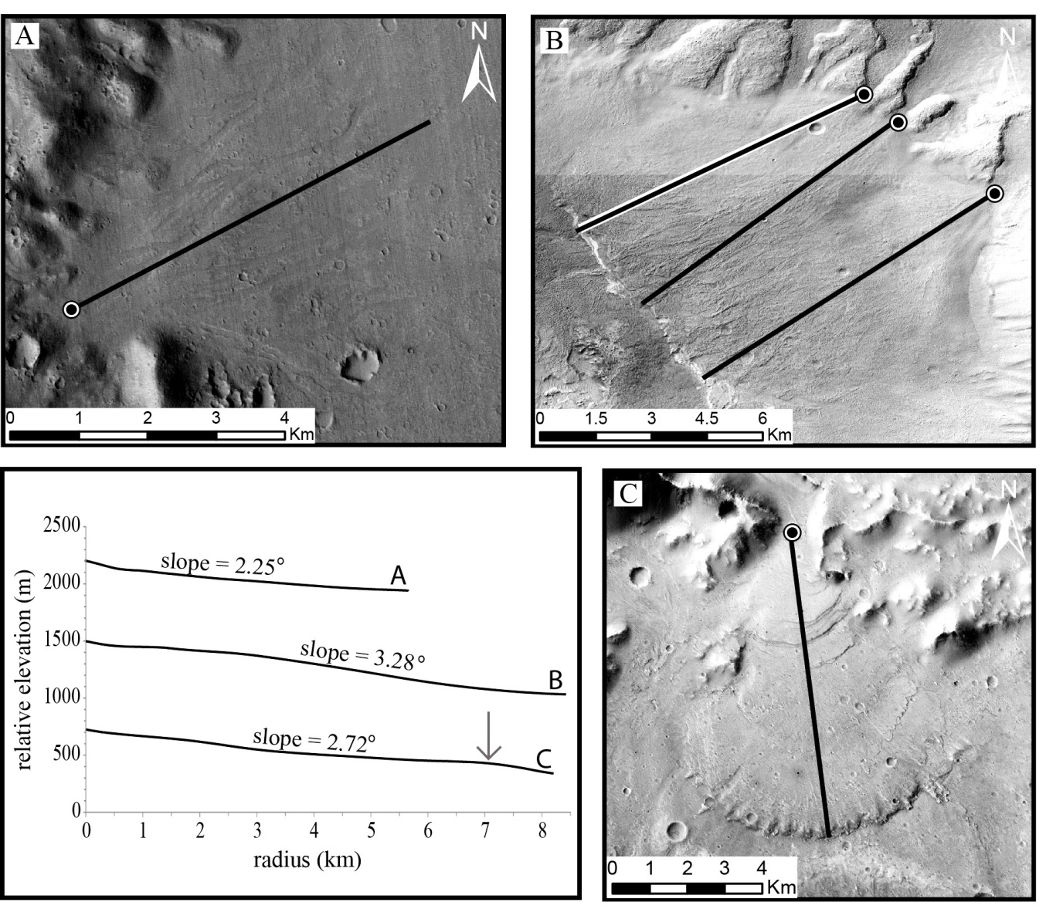

Figure 2.7: Alluvial Fans.
Examples of depositional features that we classified as alluvial fans based on the morphologic parameters. All profiles are shown with 2x vertical exaggeration with elevation values extracted from the Mars HRSC MOLA Blended DEM (Fergason et al., 2018). A) Moderate slope and a smooth radial profile are the defining features of this alluvial fan, which also has a visible network of channels across the surface. B) The alluvial fans forming this bajada are new features first identified in this survey. The radial profile shown is from the northernmost alluvial fan (radial trace outlined in white). The other two alluvial fans have similar-shaped profiles. C) A terraced alluvial fan with evidence of post-depositional erosion. The upper slope indicates that this feature formed as an alluvial fan and the terrace at the toe (indicated by the gray arrow on the profile plot and the visible scarp in the image) indicates erosion of the distal end of the alluvial fan surface.

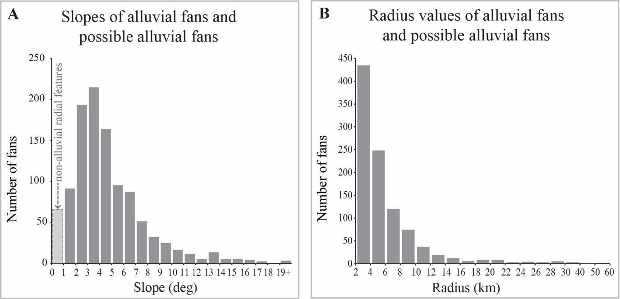

Figure 2.8: Distribution of alluvial fans sizes and slopes.
A) Histogram of average radial slope of all alluvial fans, possible alluvial fans, and NARFs. Features with slope < 1.0° (light gray column with dashed outline) we classified as NARFs. Adjusted average slope was used for the features for which one was calculated. B) Histogram of measured radius values of all alluvial fans and possible alluvial fans.

CHAPTER 3
Assessing surface grain size of alluvial fans on Mars from thermal inertia as an indicator of depositional style

Abstract

The depositional history of alluvial fans on Mars provides key insight into the climatic conditions during the time of fan formation in the late Hesperian to early Amazonian. However, traditional stratigraphic analysis of the alluvial fan deposits is not possible on Mars, short of landing a spacecraft mission on or near one. This study assesses the use of thermal inertia remote sensing as a tool of sedimentologic interpretation of Mars alluvial fans. Based on previous work demonstrating the relationship between depositional style, grain size, and thermophysical properties, this study uses analysis of thermal inertia of Mars alluvial fan surfaces across the global population of fans to make an initial assessment of depositional styles that built the alluvial fans. The results indicate that the global population of fans is primarily composed of sand- to pebble-sized sediment. The average grain size of Mars fans, as indicated by thermal inertia, is finer than is commonly seen on terrestrial alluvial fans, and the variability of grain sizes across the global population is more homogenous than expected based on comparisons to analogous terrestrial alluvial fans. Nearly all Mars alluvial fans have an average thermal inertia that corresponds to pebble and smaller grain size, and < 1% of Mars alluvial fans have an average TI that corresponds to cobble-sized grains. Spatial patterns of TI variability on alluvial fan surfaces show evidence for downslope fining and channelization in a subset of fans, but the majority show no recognizable geologic patterns in surface TI. The results of the thermal inertia analysis suggests that either the thermal inertia-derived grain size is evidence of widespread mantling of unconsolidated sand across the surface of Mars, or that Mars alluvial fans were built by primarily sheet-flood deposits, which is indicative of colder climate during the time of alluvial fan formation.

Introduction
The depositional style and associated sedimentary characteristics of alluvial fans can be used to interpret environmental conditions of deposition, including potential climatic conditions. In terrestrial alluvial fans, the production of clay minerals from the catchment is associated with the creation of alluvial fans built primarily by debris-flow deposits (Innes, 1983; Nichols and Thompson, 2005; Ventra and Clarke, 2018). Chemical weathering rates are strongly dependent on temperature (Dessert et al., 2003; Nesbitt and Wilson, 1992), making chemical weathering products a useful climatic indicator. In terrestrial examples, alluvial fans sourced from basaltic bedrock in temperate climates are composed primarily of coarse-grained debris-flow deposits (Mondro et al., 2021, Chapter 1), which would be analogous to Mars fans formed in temperate climates. On the other hand, if climate conditions on Mars were colder during alluvial fan formation, formation of clay minerals from alteration processes would be inhibited due to low chemical weathering rates, leading to the formation of alluvial fans dominated by sheet-flood deposits.
On Earth, alluvial fans are primarily built by either debris flow or sheet flood processes (Blair, 1999a; Ventra and Clarke, 2018). In alluvial fan stratigraphy, the average size of gravel clasts within a deposit typically varies with depositional style. Determination of primary depositional style in terrestrial fans is typically done through stratigraphic analysis of subsurface layers in order to assess depositional history. Fluvial channelization, which is common across alluvial fan surfaces, functions primarily as a secondary reworking process and can obscure small-scale diagnostic characteristics of sheet-flood and debris-flow deposits at the surface (Blair and McPherson, 2009; de Haas et al., 2014). Debris-flow deposits contain pebble- to cobble-sized or larger clasts suspended in a fine grain matrix, while sheet flood deposits, formed from bedload transport mechanisms, are typically dominated by sand- to pebble-sized sediment with very little matrix material (Blair and McPherson, 2009; Larsen and Steel, 1978; Ventra and Clarke, 2018). On the surfaces of terrestrial alluvial fans, the bimodality of debris flow deposits is rarely preserved in the long term due to winnowing of fine grained material from the surface (Blair and McPherson, 1992; Nishiizumi et al., 2005). Even after reworking, there is at least a weak correlation between surface grain size and depositional style, where the surface expression of remnant debris flow deposits tends to dominated by cobble and boulder clasts and the surface expression of sheet flood deposits tends to be sand to pebble clasts (Beaty, 1990; Blair and McPherson, 1998; Hardgrove et al., 2009).
Grain size of sedimentary surfaces is not directly measurable across most of Mars due to the limited resolution of visible image datasets. The available visible-image CTX data (~5 m/px) is too low resolution to detect individual clasts. Boulder sized clasts are detectable in HiRISE image data but the cobble and smaller clasts are still below the limit of resolution, and the global coverage of HiRISE data is too sparse to use as an analysis tool for a global population of alluvial fans. In comparison, there exists near global coverage of THEMIS infrared data and derived thermal inertia (TI) data products (Christensen et al., 2013; Fergason et al., 2006). TI values derived from THEMIS nighttime infrared images can be used as a proxy for grain size on Mars (Edgett and Christensen, 1991; Edwards et al., 2009; Nowicki and Christensen, 2007). Previous studies of terrestrial alluvial fans have shown that thermophysical properties of fan surfaces correlate to sedimentary characteristics of surface deposits, including grain size (Hardgrove et al., 2010, 2009).
In this study, we analyze the average and range of TI values for a global population of alluvial fans on Mars in order to investigate regional and global trends in sedimentary grain size of alluvial fan deposits. We also investigate common spatial patterns of TI distribution on alluvial fan surfaces to assess potential depositional trends. From the TI spatial patterns and TI-derived grain size we infer the likely depositional style of each alluvial fan and discuss the implications for Mars climate during the late Hesperian to early Amazonian, when alluvial fans are thought to have formed (Holo et al., 2021; Kite, 2019; Rodriguez et al., 2005; Warner et al., 2009).

Background

Alluvial fans on Mars
Alluvial fans are found on Mars across the cratered highlands and the high southern latitudes (Chapter 2; Mondro et al., in review; Wilson et al., 2021). Alluvial fans are formed by sporadic, high-energy sediment transport events interspersed with long periods of inactivity (Beaty, 1990; Blair and McPherson, 1994; D’Arcy et al., 2017; McDonald et al., 2003). Previous work suggests that Mars alluvial fans formed during the late Hesperian to early Amazonian during the final stages of liquid water activity on the surface (Carr and Head, 2010; Holo et al., 2021).
Age dating of alluvial fans on Mars depends on accurate assessment of the surrounding surface. Because the alluvial fan surfaces are typically too small to accurately date by crater counting, previous work has relied on interpretation of cross-cutting relationships in crater floor deposits along with dating fan-hosting craters (Grant and Wilson, 2011; Holo et al., 2021; Palucis et al., 2014). Recent work has focused on refining the age dating of craters by crater counts on ejecta of large craters, which in turn gives a more precise age for the upper limit of fan formation within those craters. At least some alluvial fans were found to be hosted in craters that are < 2.5 Ga, indicating fan formation conditions persisted into the Amazonian in at least some regions (Holo et al., 2021). This is consistent with findings from previous work which used cross-cutting relationships of crater floor deposits to date individual fans (Palucis et al., 2014) and small populations of fans (Grant and Wilson, 2011).
The climate of early Mars and the timing of a proposed climatic transition are a matter of ongoing debate. The uncertainty surrounding Mars’ early climate can be summarized as a debate between a “warm and wet” climate versus a “cold and wet” climate (Bishop et al., 2018; Fairén, 2010; Ramirez and Craddock, 2018). A hypothesized “warm and wet” climate is defined as a global climate with temperatures consistently above the freezing point of water, to allow for long-term liquid water activity (Ramirez and Craddock, 2018). The primary evidence for a climate with temperatures that support liquid water surface activity is the presence of widespread valley networks and lacustrine depositional environments (Craddock and Howard, 2002). A hypothesized “cold and wet” climate describes a scenario where surface temperatures are consistently below the freezing point of water (Bishop et al., 2018; Fairén, 2010), with intermittent periods of warming initiated by impacts, volcanic eruptions, or other sporadic events (Ramirez and Craddock, 2018; Segura et al., 2002).
If alluvial fans formed in intermittent wet periods, there may not have been enough long term chemical weathering during the cold periods to generate clay from the fan catchments. Models of intermittent climate warming from impact events show that impactors up to 250 km in diameter will generate global temperatures above freezing for up to ~100 years at a time (Segura et al., 2002). The impact event would also displace subsurface water into the atmosphere, which would precipitate out over ~40 years, with the highest levels of precipitation occurring soon after the impact event (Segura et al., 2002). Models of denudation and deposition rates on Mars suggest that it would take up to 1 My of consistent flow (Stucky de Quay et al., 2019) or over 20 My of sporadic flow (Kite et al., 2017) to build a single alluvial fan. If the alluvial fans are forming during sporadic warm periods, the deposition rates would be much longer, as the fan would only be active for up to 100 years at a time. During that time of surface water activity, most of the sediment transport and fan building activity would occur soon after the impact, when precipitation rates were highest (Segura et al., 2002). The intervening cold periods would generate only limited bedrock alteration because the chemical weathering rate of basalt is highly dependent on temperature (Nesbitt and Wilson, 1992). As a result, the sediment transport processes building alluvial fans during a “cold and wet” early Mars climate would likely be low in alteration minerals.
Terrestrial studies have found an exponential relationship between chemical weathering rates and temperature, in which the weathering rates drop exponentially as temperatures approach 0°C (Dessert et al., 2003; Li et al., 2016). Below 0°C, the production of chemical weathering products is minimal, due to very low reaction rates and the limited movement of water at the surface. Previous work on terrestrial alluvial fans has shown that in order to create a debris-flow dominated fan, there is typically a significant source of clay minerals in the catchment, either from physical weathering of clay-rich bedrock or alteration of igneous or metamorphic bedrock (Blair and McPherson, 1994; Levson and Rutter, 2000; Nichols and Thompson, 2005; Ventra and Clarke, 2018). When clay minerals are produced from alteration of catchment bedrock, as is the case in basaltic terrain, the rate of clay production can be affected by climate, as temperature strongly affects the rate of the alteration processes (Lasaga et al., 1994; White et al., 1999).
On Mars, the alteration and erosion of the primarily basaltic crust is expected to produce alluvial fans in which the depositional style corresponds to the long-term climatic conditions during the time of formation. A regional or global population of debris-flow dominated alluvial fans on Mars would provide additional evidence for widespread aqueous alteration of basalt by surface runoff to provide clay minerals, supporting a “warm and wet” Mars hypothesis. A regional or global trend of sheet-flood dominated alluvial fans would indicate a lack of widely available clay minerals and minimal alteration of bedrock in the alluvial fan catchments, which would be more likely to represent sporadic fan-building events during short-lived periods of surface water activity during an overall “cold and wet” Mars climate during the time of alluvial fan formation.

Thermal Inertia as a proxy for grain size and depositional style
Surface temperatures inferred from thermal infrared spectral radiance measurements are used to calculate the thermal inertia of sedimentary material (Edgett and Christensen, 1991; Kieffer et al., 1977; Nowicki and Christensen, 2007; M. A. Presley and Christensen, 1997; Marsha A Presley and Christensen, 1997). Thermal inertia values are related to the effective grain-size via a physical and analytical model of radiation transport (Kieffer et al., 1977). A material’s thermal inertia is a measurement of how resistant a material is to changes in temperature. It is defined as TI=(kρC)^{1/2},where k is the thermal conductivity, ρ is the bulk density, and C is the specific heat capacity of the surface (Kieffer et al., 1977). The units of thermal inertia (TI) are [J·m⁻²·K⁻¹·s^{−1/2}] although for simplicity, they are referred to as thermal inertia units (tiu) in this manuscript. For rock and regolith material, thermal inertia is primarily controlled by the thermal conductivity, which is dominated by variations in grain size (Presley and Christensen, 1997). The temperature of fine-grained sediment, which has a low TI, changes rapidly under insolation and cools down faster at night. Coarse-grained sediment or highly indurated surfaces, which have high TI, take much longer to heat up under insolation but are able to retain heat much more effectively at night. High thermal inertia surfaces also experience smaller diurnal temperature swings and reach peak temperature later in the afternoon hours than low thermal inertia surfaces.
Using the framework developed by previous studies on Mars (Edgett and Christensen, 1991; Nowicki and Christensen, 2007; M. A. Presley and Christensen, 1997; Marsha A Presley and Christensen, 1997) which confirms TI values that correlate to specific grain sizes, it is possible to directly relate TI of the alluvial fan surfaces to sedimentary grain size in Mars sedimentary environments. In terrestrial landscapes, apparent thermal inertia (ATI) is used as a proxy for relative TI (Kieffer et al., 1977). An exact quantitative relationship between grain size and TI is not applicable to terrestrial conditions due to the variability of weather, humidity, and presence of water in the atmosphere and at the surface, which drastically affects measurable TI of sedimentary material. However, previous work on terrestrial alluvial fans shows that there is a correlation between relative thermophysical characteristics of alluvial fan surfaces and grain size of the sediment at the surface (Hardgrove et al., 2010, 2009). In a survey of alluvial fans in the Death Valley region, the maximum diurnal change in surface temperature (ΔT) is highest for fine-grained material, while cobble and boulder covered surfaces and indurated features have low ΔT values (Hardgrove et al., 2010, 2009). Apparent thermal inertia is inversely correlated to ΔT in the equation for ATI when albedo is similar across the region of comparison (Gupta, 2018). While these results do not provide a precise quantitative relationship between grain size measurements and ATI values in terrestrial settings, the demonstrated correlation supports the use of TI to determine depositional grain size on Mars alluvial fans based on the established quantitative framework of TI and grain size.
Debris-flow deposits are identified in outcrop as thick sections of matrix-supported material dominated by clasts that are cobble size up to the size of large boulders, with very little sand material (Blair and McPherson, 2009). Across the lateral exposure of alluvial fan surfaces, debris-flow deposits can be identified by accumulations of coarse (cobble or larger) clasts in lobe shaped deposits (Blair and McPherson, 1992). The boundaries of debris flow lobes form debris flow levees, which are often composed of relatively large clasts, up to boulder size, as a result of the buoyancy of large clasts moving towards the outer edges of active debris flow events. While debris flow sediment is typically bimodal, with coarse clasts suspended in a fine-grained matrix, the fine grained sediment has a shorter residence time on fan surfaces post-deposition, as fine grained material is more susceptible to winnowing and downslope transport from reworking (Beaty, 1990; Blair and McPherson, 1992; Nishiizumi et al., 2005).
Sheet-flood deposits are identified in outcrop as planar layers 10s of cm thick composed of sand- to cobble-sized sediment (Blair and McPherson, 2009). Lateral exposure of sheet-flood deposits across alluvial fan surfaces are identified by laterally extensive deposits of well- to moderately-sorted sand to pebble material (Blair, 2002, 1999a). Sheet flood deposits can vary in lateral extent, from a small portion of the fan to covering nearly the entire fan surface in a single depositional event, and do not have clearly defined lateral boundaries. Downslope fining of grain sizes on alluvial fan surfaces is common on sheet flood fans, as finer sediment requires less transport energy and is carried further (de Haas et al., 2014; Ventra and Clarke, 2018).
In the absence of surface exploration at these locations, traditional stratigraphic analysis cannot be duplicated on Mars. As a proxy, we are assessing sedimentary characteristics of alluvial fan surfaces. While surface analysis does not allow for stratigraphic analysis of successive depositional events within a single fan, analysis of surface sedimentary grain sizes across the global population of alluvial fans still provides insight into global trends in fan formation.
The alluvial fans on Mars are thought to be at least 2.5 Gy old and are hypothesized to have been depositionally inactive for that intervening time (Holo et al., 2021). Because of the combination of post-depositional reworking and aeolian erosion of inactive fan surfaces, pristine sheet flood or debris flow features are unlikely to be recognizable on the modern surfaces of Mars alluvial fans. Reworking processes on the fan surface can overprint surface depositional features such as debris-flow lobes and often transport fine-grained material downslope or off of the fan entirely, but generally do not significantly alter the overall range of gravel clast sizes at the surface relative to the most recent depositional events (de Haas et al., 2014; Miller et al., 2010). However if the feature is still recognizable morphologically as an alluvial fan (Chapter 2, Mondro et al., in review), the original depositional sediment can be used to interpret depositional history, even if the pristine surface has been reworked and altered.
In analyzing modern alluvial fan surfaces, we are not necessarily characterizing the most recent fan deposits but instead, are characterizing what is currently at the surface after ~2.5 Gy (Holo et al., 2021) of non-deposition and erosion. Martian alluvial fans are thought to have formed over a span of ~ 0.5 Gy (Holo et al., 2021) but more precise age dating has not yet been achieved. With these uncertainties in mind, there are three possible interpretations we can make about what is currently exposed at the surface of the alluvial fans. Modern fan surfaces are either a) the most recent fan deposits, all formed at similar times, b) the most recent fan deposits that formed at different times within the ~ 0.5 Gy span, or c) different levels of deposits, exposed through post-depositional erosion. After the era of surface water activity and associated reworking, the most common method of post-depositional erosion of alluvial fan surfaces was widespread aeolian erosion. The effects of aeolian erosion may vary from one crater to another, creating differences in the amount of erosion across the global population of fans.
Option a is unlikely as it requires all of the alluvial fans to form simultaneously and to have not experienced any erosion in the intervening ~2.5 Gy. We posit that option c is the most likely scenario as it allows for the mostly complexity within a large global system. From the viewpoint of option c, we would expect to see a mix of grain sizes across the population of fans if there were any significant variability in depositional style and associated sedimentary characteristics either spatially (across the population) or temporally (within the building of a single fan). If the alluvial fans across the global population were fairly homogeneous in depositional style and associated sedimentary characteristics throughout the time of fan formation, then we would expect to see similar grain sizes on the majority of the alluvial fan surfaces.

Methods for analysis of Mars alluvial fans

Selection of alluvial fans
Earlier work produced a catalog of 775 alluvial fans on Mars (Chapter 2, Mondro et al., in review). We mapped the boundaries of each alluvial fan from visible CTX images (Dickson et al., 2018) and THEMIS day IR images. For the purposes of the mapping process, we defined the depositional boundary of an alluvial fan using visible changes in surface texture that follow an approximately radial pattern away from the identified fan apex location.
Starting with the global catalog of Mars alluvial fans, we assessed the availability and quality of THEMIS TI data coverage at each feature. We calculated the average dust cover index (DCI) value (Ruff and Christensen, 2002) for each alluvial fan surface and eliminated those features with an average DCI < 0.95, which is noted as the cutoff between dust-covered areas with high DCI and dust-free areas with low DCI by Ruff and Christensen (2002). As TI variations are most sensitive to grain size differences (Edgett and Christensen, 1991; M. A. Presley and Christensen, 1997), abundant dust covering the fan surfaces will produce TI values that do not accurately represent the sedimentary characteristics of the alluvial fan deposits at the surface.
THEMIS-derived TI data coverage contains small gaps across the surface of Mars and is overall more sparse in high latitudes (Fergason et al., 2006). We eliminated alluvial fans which have no or partial TI coverage in the THEMIS-derived TI Global Mosaic (Fergason et al., 2006). We also eliminated alluvial fans for which the available TI data are inconsistent or unreliable. To determine data reliability, we assessed the TI data covering the fan in comparison to surrounding TI image stamps within the TI mosaic. We eliminated alluvial fans covered by outlier TI image stamps. TI images were considered to be outliers if they contain nearly uniform TI values in either the highest (TI > 670 tiu) or lowest (TI < 50 tiu) TI grain size categories in contrast to all surrounding TI image stamps. We eliminated alluvial fans with inconsistent TI data if the fan spanned more than one TI stamp where the pixel values jumped by more than one TI grain size category between adjacent TI stamps.

Thermal inertia and grain size of alluvial fans
Previous work has established sedimentary grain size ranges that correlate to specific ranges of TI values on Mars (Edgett and Christensen, 1991; Nowicki and Christensen, 2007). Based on the results of these previous studies, we defined sedimentary grain size categories by the associated TI value. Due to the uncertainties of the TI values used in the TI global mosaic, we also defined intermediate grain size categories. The derived TI values have an overall accuracy of 20% globally (Fergason et al., 2006). For the boundary TI values between grain size categories, we calculated an uncertainty window from +10% to -10% of the boundary TI value. The resulting ranges of TI values are categorized as an uncertain grain size range; for example “sand to pebble” for the uncertainty range between the “sand” TI category and the “pebble” TI category (Table 3.1).
On each alluvial fan for which we confirmed TI data coverage, we extracted a raster of TI pixel values within the mapped boundary of the fan from the TI global mosaic. For each alluvial fan TI raster, we calculated the mean and standard deviation of TI values within each fan outline. MeanTI is the average of all TI pixel values within the mapped outline of each alluvial fan and StDv is the standard deviation of the range of TI pixel values that are used to calculate meanTI.
For each alluvial fan, we used the calculated statistics of the extracted TI raster to assign the fan to a grain size category. We designated grain size categories for the mean TI value of each alluvial fan, along with grain size categories for the TI values one standard deviation above and below the mean. We categorized alluvial fan depositional style based on the grain size of the mean TI and the range of grain sizes from the TI values on a single fan surface (Table 3.1). For the purposes of this study, we used both the meanTI of the fan surface and the range of TI, defined as +/- one StDv around the meanTI, to define the likely depositional style. Within this framework, we are generalizing sheet flood deposits as finer grained (sand to pebble) with a smaller range of grain sizes and defining debris flow deposits as coarser grained (pebble to cobble) with a larger range of grain sizes. In analogous terrestrial systems, the sedimentology is more complex than this generalization, but for a first order interpretation of a global population of features, we defined these categories as a way to draw broad conclusions.
In this study, we categorize sheet flood fans as those with meanTI of “sand to pebble” or smaller and TI values +/- one StDv that span two or fewer grain size categories. Because of the inherent uncertainty in defining the grain size cutoffs of specific depositional styles, alluvial fans in which the meanTI is in the range of “pebble” and “pebble to cobble” grain sizes are categorized as a possible mixed style fan and are generally interpreted as uncertain depositional history. Alluvial fans in which the meanTI is in the range of “cobble” or larger grain sizes or in which the TI values +/- one StDv around the meanTI span three or more grain size categories are categorized as likely debris-flow alluvial fans.
We visually assessed the spatial variability of TI values across each fan surface and qualitatively described each alluvial fan based on common TI spatial patterns that are seen within the global population of alluvial fans. Five general patterns are used to describe spatial variability of TI on alluvial fan surfaces. “Gradational” and “channelized” patterns are descriptive of geologic features that have been identified on terrestrial alluvial fans. “Regional” and “distinct” patterns describe the relative TI in comparison to the surrounding surface material when there is no clear spatial pattern within the fan boundaries. The fifth category is used to describe fans with no clear pattern of spatial variation within the fan or relative to its surroundings. We also visually surveyed the full global population of alluvial fan TI values to assess whether there are any global patterns in the distribution of alluvial fan grain sizes or TI spatial patterns correlated to specific geologic regions.

Results and Discussion

Thermal inertia and grain size of alluvial fans
Of the 437 alluvial fans analyzed in this study, 362 have a mean TI value that correlates to sand-sized sediment (Figure 3.1). A total of 25 alluvial fans have mean TI values indicating a finer-grained, dusty to sandy surface, and 13 alluvial fans have mean TI values suggesting pebble to cobble sized sediment (Table 3.1). The highest mean TI of an alluvial fan correlates to the “pebble to cobble” grain size category. The number of alluvial fans in each grain size category, as categorized based on the average TI, forms a narrow normal distribution with sand-sized sediment as the mean and small numbers of outliers above and below. The distribution of TI values within each fan, described by the grain size category of the mean TI +/- one standard deviation, rarely span more than two grain size categories within a single fan. There are 309 alluvial fans that have surface TI values where the mean and +/- 1 standard deviation TI values for the fan surface all fall within the range of sand-sized grains, indicating general homogeneity in the TI-derived grain sizes on many of the alluvial fan surfaces across the global population.
Dusty fans, as indicated by TI-derived grain size, are few in number (Table 3.1) because most of the dust-covered fans were eliminated by DCI. The 5 alluvial fans which have an average TI that falls in the dust grain size category were likely not captured by the DCI filter due to some overlap between the cutoff of high dust coverage in the DCI, which is derived from lower-resolution TES data, and TI-derived sediment grain size, which is derived from relatively higher-resolution THEMIS data.
The 4 alluvial fans which are designated as “pebble to cobble” have average surface TI which fall into the uncertainty range between the pebble and cobble grain size TI categories. All four of these alluvial fans are found in areas where the regional TI values, across the full area of the craters where the fans are found and into the surrounding highlands, are noticeably higher than the surrounding THEMIS image stamps. The TI image stamps that cover these alluvial fans were not different enough from the surrounding stamps to be eliminated as outlier stamps (Section 3.1). They do, however, show some evidence that the high TI values are a regional trend and are not limited to the alluvial fans or confined to particular sedimentary features, suggesting that the “pebble to cobble” grain size designation may be larger than the actual sedimentary grain size of the surface. Of the 9 alluvial fans with average TI values that fall into the “pebble” range, 5 are also found in areas of regionally high TI, similar to the settings of the “pebble to cobble” alluvial fans. The other 4 “pebble” alluvial fans are found in craters where the entire crater floor has relatively high TI values. Uniformly high TI values across the full extent of a crater floor could be indicative of coarse-grained crater fill material, or could be a result of induration or other alteration processes.

Spatial patterns of TI and grain size
The spatial patterns of TI values across individual alluvial fan surfaces are qualitatively defined by whether TI appears to vary in a systematic way and whether the pattern of variation appears to correlate with visible surface features (Figure 3.2). “Channelized” and “gradational” categories both represent patterns in spatial TI variation that are interpreted to be representative of geologic features on the surface. On channelized fans, variations in thermal inertia values follow visible channel features on the alluvial fan surface (Figure 3.2B), and the channels have a slightly lower TI compared to the surrounding fan surface, indicating that the channels have been filled with finer grained material. These patterns are consistent with surface reworking observed on terrestrial alluvial fans of all depositional styles, and, therefore, are not directly indicative of either debris-flow or sheet-flood dominated fans. The alluvial fans that have channelized TI spatial patterns are not the only channelized alluvial fans within the global population of fans. There are more alluvial fans with visible morphologic channel features where the TI of the fan surface does not show noticeable variation correlating to the channel features. This could be because the channel fill and primary fan surface are composed of sediment of similar grain size, or it could be a result of post-depositional diagenesis that alters the TI of the sedimentary surface.
Alluvial fans with gradational TI patterns have one of two related patterns (Figure 3.2A). Some of the gradational patterns show a fining downslope, evidenced by TI values gradually decreasing downslope along the fan surface. A downslope fining of surface grain sizes is also observed on terrestrial alluvial fans and is indicative of deposition from bedload transport as fine-grained material is carried further as transport energy levels drop (Blair and McPherson, 2009; Ventra and Clarke, 2018). Gradational patterns where grain size decreases downslope are often seen on sheet-flood dominated fans as a result of the different transport distances of different grain sizes through bedload transport of sediment during sheet flood events (Blair, 2002). However, downslope fining is also observed on debris-flow dominated fans which experience surface reworking of debris flow sediment (de Haas et al., 2014). Other fans with gradational patterns show a coarsening downslope with TI values gradually increasing along the surface of the fan. This may be a result of post-depositional erosion exposing lower sedimentary layers, which happen to be coarser than the most recent deposits, at the toe of the fan. The increasing TI downslope may also be a result of increasing levels of induration approaching the floor of the crater.
Spatial TI patterns that are described as “unclear” (Figure 3.2E) have some variability of TI across the fan surface that is not correlated with any visible surface feature and that may not be confined to the fan. It may instead be a part of a more regional pattern of variation with no clear source. Spatial TI patterns that are described as “distinct” (Figure 3.2D) have overall TI values which are different from the surrounding crater floor by at least two grain size categories, but which do not show any recognizable variation within the alluvial fan surface. The TI patterns described as “regional” (Figure 3.2C) have TI values with no distinct variation within the fan surface and show little to no contrast with the TI of the surrounding crater floor material. The “regional” TI patterns do not necessarily indicate that the TI is not representative of depositional sediment size, as an entire crater may well be filled with similar sediment from similar sources, but it makes it difficult to interpret depositional features within an individual alluvial fan based on TI.
All five TI spatial patterns are found throughout the global population of alluvial fans (Figure 3.3). A channelized TI spatial pattern is only seen between 30°N and 30°S (Figure 3.3). However, as channelized fan surfaces which are observed in visible morphology yet do not exhibit TI variations are seen at all latitudes (Mondro et al., in review), the restricted extent of the channelized TI patterns is more likely to be a factor of post-depositional alteration rather than depositional trends. The TI spatial patterns show no clear correlation with mean TI or inferred grain size of the fan surfaces (Figure 3.4). The alluvial fans with average TI in the lowest (dust, meanTI < 50 tiu) and highest (pebble and pebble to cobble, meanTI > 484 tiu) grain size categories (Table 3.1) mostly have TI patterns that are described as distinct, regional, or unclear (Figure 3.4), which are not related to any diagnostic depositional characteristics or sedimentary interpretations.

Implications of TI and grain size
The TI analysis of this global population of alluvial fans indicates that the vast majority of alluvial fans on Mars are composed of sand-sized sediment. All but 13 of the alluvial fans included in this study are categorized as likely sheet-flood dominated fans based on the mean TI grain size categories. The other 13 alluvial fans are categorized as possible mixed depositional style fans based on the mean TI grain size categories. There are no alluvial fans with a mean TI in the range of cobble or larger grain size.
Interpretation of TI of sedimentary surfaces on Mars can be contextualized by two different scenarios: either the TI values are representative of original depositional grain size or the TI values are not representative of original depositional grain size. The overall fine-grained alluvial fans and the relatively small range of average grain sizes represented in the global population of fans on Mars have different implications depending on the framing in which TI values are assessed.
If the TI values of the alluvial fan surfaces are not representative of the original depositional grain size, then the most likely interpretation of the overall fine grain size of alluvial fans and small range of grain sizes is that the surface is mantled with aeolian sand deposits or in situ post-depositional breakdown of material across fan surfaces. The analysis of alluvial fans excluded features with high dust coverage, eliminating dust mantling as a likely explanation. The global trend of alluvial fan TI-derived grain size may be indicative of global, long-term, in-place regolith generation, which is breaking down coarser material into sand-sized sediment over a slow timescale. If this is the case, TI is not representative of depositional material and presents limited opportunity for assessing original depositional characteristics.
The more intriguing interpretation is that the TI values are representative of the original depositional grain sizes, in which case there are two potential explanations for a population of sheet-flood dominated alluvial fans. 1) Some sheet-flood dominated fans may be sourced from non-basaltic catchments of lithologies that are unlikely to produce clay minerals as weathering products, hindering the generation of clay-rich debris flows and instead creating alluvial fans built by primarily bedload transport. This scenario is unlikely to fully explain the global population of fine-grained alluvial fans across all geologic units because the crust of Mars is dominantly basaltic. Or, 2) it is possible that the alluvial fans formed during a more glacial climate when chemical weathering rates were suppressed and little to no clay was produced from the fan catchments. This possibility would support the idea of alluvial fans as a climatic indicator and further constrain the timing and conditions of the Mars climatic transition.
Our results for both overall average grain sizes and the range of grain sizes for Mars alluvial fans is somewhat unexpected. Terrestrial alluvial fans span a wide range of grain sizes, and fans dominated by both sand and by cobbles to boulders are not uncommon (Ventra and Clarke, 2018). However, terrestrial alluvial fans are found in a wide range of climates and are often sourced from mixed lithology catchments (Blair and McPherson, 2009). In contrast, alluvial fans on Mars are expected to be primarily basaltic-sourced, which allows us to establish expected constraints on the depositional system, based on potential climate conditions. Basaltic-sourced alluvial fans on Mars would be dominated by coarse clasts of debris flow deposits if formed during temperate climates when clay minerals would be created as a chemical weathering product (Chapter 1). The chemical weathering rate of basalt is highly dependent on temperature (Li et al., 2016; Nesbitt and Wilson, 1992), and drops exponentially as temperatures approach 0°C (Dessert et al., 2003).
Basaltic-sourced alluvial fans on Mars would be expected to be dominated by sandy to pebbly sheet flood deposits if formed during colder climates when clay mineral production from bedrock alteration is suppressed. In the hypothesized “cold and wet” climate models (Bishop et al., 2018; Fairén, 2010), sporadic surface water flow during intermittent warmer periods (Ramirez and Craddock, 2018; Segura et al., 2002) would provide an opportunity for sediment transport and deposition in alluvial fans systems without the accompanying alteration products that would be produced during consistently warm climates.
As more areas of felsic and other non-basaltic crust are discovered on Mars, there also exists the possibility that at least some of the alluvial fans are sourced from non-basaltic catchments. The higher quartz proportions in andesitic and granitic rocks would produce lower overall proportions of clay weathering products relative to the amount of physical weathering products, which would make those catchments less likely to produce debris flows, although they could still produce mixed depositional style alluvial fans.

Conclusions
Thermal inertia analysis of alluvial fan surfaces on Mars provides a way to make a high-level assessment about the sediment that makes up the alluvial fans. Sediment grain size can be used as an indicator of depositional style, which, in basaltic terrain, is influenced by climatic conditions during fan formation. Across the global population, alluvial fans on Mars have mean TI values that indicate that the vast majority are either covered in unconsolidated sand or composed of sand-sized sediment. If the TI values are not representative of the original depositional grain size, it may be indicative of widespread regolith generation across the surface of Mars. If the TI values are truly representative of the original depositional grain size, it indicates that the climate has already started cooling by the time alluvial fans were forming on Mars. In a temperate climate, the basaltic bedrock would weather to clay and generate debris flow deposits containing large clasts, while alluvial fans formed during colder climates would contain little to no clay and would, therefore, primarily be formed by bedload transport of finer-grained sediment.
This study was designed as a global survey and was not meant to include detailed analysis of individual features. However, the rather unexpected results present numerous opportunities for future work that can further investigate the sedimentary characteristics of alluvial fan surfaces through the use of other datasets and analytical methods. The most logical subsequent investigation to come out of the results of this study would be a study to address whether or not alluvial fan surfaces are mantled with unconsolidated sandy material and, if so, determine the origin of the mantling material. Aeolian transported sand would be unlikely to be constrained to only alluvial fan surfaces and, as a result, the detection of a global mantling layer of aeolian sand would affect all surface investigations.
If the sandy material of alluvial fan surfaces can be determined to be original depositional sediment, then the global catalog of alluvial fans represents a surprisingly homogeneous population of depositional environments, with implications for climatic conditions and weathering processes. Determining the origins of surface sediment could be accomplished through analysis of morphology of the surface using HiRISE data. HiRISE data, combined with CTX image analysis, would also be used to assess the level and likely processes of erosion of degradation of individual alluvial fans surfaces. Further investigation into the evolution of alluvial fan surfaces both during and post-deposition, coupled with the interpretations of sedimentary characteristics presented in this study, would enable more precise investigation of the changing depositional environments during the a period of climatic transition on the surface of Mars.

References

Beaty, C.B., 1990. Anatomy of a White Mountains debris-flow - the making of an alluvial fan, in: Rachocki, A.H., Church, M. (Eds.), Alluvial Fans: A Field Approach. John Wiley.
Bishop, J.L., Fairén, A.G., Michalski, J.R., Gago-Duport, L., Baker, L.L., Velbel, M.A., Gross, C., Rampe, E.B., 2018. Surface clay formation during short-term warmer and wetter conditions on a largely cold ancient Mars. Nat. Astron. 2018 23 2, 206–213. https://doi.org/10.1038/s41550-017-0377-9
Blair, T.C., 2002. Sedimentary processes and facies of the waterlaid Anvil Spring Canyon alluvial fan, Death Valley, California. Sedimentology 46, 913–940. https://doi.org/10.1046/J.1365-3091.1999.00259.X
Blair, T.C., 1999. Cause of dominance by sheetflood vs. Debris flow processes on two adjoning alluvial fans, Death Valley, California. Sedimentology 46, 1015–1028.
Blair, T.C., McPherson, J.G., 2009. Alluvial fans processes and forms, Geomorphology of Desert Environments. https://doi.org/10.1007/978-1-4020-5719-9J4
Blair, T.C., McPherson, J.G., 1998. Recent debris-flow processes and resultant form and facies of the Dolomite alluvial fan, Owens Valley, California. J. Sediment. Res. 68, 800–818. https://doi.org/10.2110/jsr.68.800
Blair, T.C., McPherson, J.G., 1994. Alluvial Fans and their Natural Distinction from Rivers Based on Morphology, Hydraulic Processes, Sedimentary Processes, and Facies Assemblages. SEPM J. Sediment. Res. Vol. 64A, 450–489. https://doi.org/10.1306/D4267DDE-2B26-11D7-8648000102C1865D
Blair, T.C., McPherson, J.G., 1992. The Trollheim alluvial fan and facies model revisited [WWW Document]. GSA Bull. URL https://pubs.geoscienceworld.org/gsa/gsabulletin/article/104/6/762/182720/The-Trollheim-alluvial-fan-and-facies-model?casa_token=RmBH3EbZfncAAAAA:e-gfG2snADwATsuAGU1MEucm7a96YMt6W27XwpovdGpV1rCNJlXNRquGpAKU0mNjvRIKQ-WS (accessed 5.7.22).
Carr, M.H., Head, J.W., 2010. Geologic history of Mars. Earth Planet. Sci. Lett. 294, 185–203. https://doi.org/10.1016/J.EPSL.2009.06.042
Christensen, P.R., Fergason, R.L., Edwards, C.S., Hill, J., 2013. THEMIS-Derived Thermal Inertia Mosaic of Mars: Product Description and Science Results - NASA/ADS, in: 44th Lunar and Planetary Science Conference.
Craddock, R.A., Howard, A.D., 2002. The case for rainfall on a warm, wet early Mars. J. Geophys. Res. Planets 107, 21-1-21–36. https://doi.org/10.1029/2001JE001505
D’Arcy, M., Whittaker, A.C., Roda-Boluda, D.C., 2017. Measuring alluvial fan sensitivity to past climate changes using a self-similarity approach to grain-size fining, Death Valley, California. Sedimentology 64, 388–424. https://doi.org/10.1111/sed.12308
de Haas, T., Ventra, D., Carbonneau, P.E., Kleinhans, M.G., 2014. Debris-flow dominance of alluvial fans masked by runoff reworking and weathering. Geomorphology 217, 165–181. https://doi.org/10.1016/J.GEOMORPH.2014.04.028
Dessert, C., Dupré, B., Gaillardet, J., Franc ßois C, L.M., Allègre, C.J., 2003. Basalt weathering laws and the impact of basalt weathering on the global carbon cycle. Chem. Geol. 202. https://doi.org/10.1016/j.chemgeo.2002.10.001
Dickson, J.L., Kerber, L.A., Fassett, C.I., Ehlmann, B.L., 2018. A GLOBAL, BLENDED CTX MOSAIC OF MARS WITH VECTORIZED SEAM MAPPING: A NEW MOSAICKING PIPELINE USING PRINCIPLES OF NON-DESTRUCTIVE IMAGE EDITING. Lunar Planet. Sci. Conf. https://doi.org/10.1029/2010JE003755
Edgett, K., Christensen, P., 1991. The particle size of Martian aeolian dunes. J. Geophys. Res. 96, 22765–22776. https://doi.org/10.1029/91JE02412
Edwards, C.S., Bandfield, J.L., Christensen, P.R., Fergason, R.L., 2009. Global distribution of bedrock exposures on Mars using THEMIS high-resolution thermal inertia. J. Geophys. Res. 114, E11001. https://doi.org/10.1029/2009JE003363
Fairén, A.G., 2010. A cold and wet Mars. Icarus 208, 165–175. https://doi.org/10.1016/J.ICARUS.2010.01.006
Fergason, R.L., Christensen, P.R., Kieffer, H.H., 2006. High-resolution thermal inertia derived from the Thermal Emission Imaging System (THEMIS): Thermal model and applications. J. Geophys. Res. Planets 111, n/a-n/a. https://doi.org/10.1029/2006JE002735
Gupta, R.P., 2018. Remote Sensing Geology, Third Edit. ed. Springer-Verlag.
Hardgrove, C., Moersch, J., Whisner, S., 2010. Thermal imaging of sedimentary features on alluvial fans. Planet. Space Sci. 58, 482–508. https://doi.org/10.1016/j.pss.2009.08.012
Hardgrove, C., Moersch, J., Whisner, S., 2009. Thermal imaging of alluvial fans: A new technique for remote classification of sedimentary features. Earth Planet. Sci. Lett. 285, 124–130. https://doi.org/10.1016/j.epsl.2009.06.004
Holo, S.J., Kite, E.S., Wilson, S.A., Morgan, A.M., 2021. The Timing of Alluvial Fan Formation on Mars. Planet. Sci. J. 2, 210. https://doi.org/10.3847/PSJ/AC25ED
Innes, J.L., 1983. Debris flows. Prog. Phys. Geogr. 7, 469–501. https://doi.org/10.1177/030913338300700401
Kieffer, H.H., Martin, T.Z., Peterfreund, A.R., Jakosky, B.M., Miner, E.D., Palluconi, F.D., 1977. Thermal and albedo mapping of Mars during the Viking primary mission. J. Geophys. Res. 82, 4249–4291. https://doi.org/10.1029/JS082i028p04249
Larsen, V., Steel, R.J., 1978. The sedimentary history of a debris-flow dominated, Devonian alluvial fan–a study of textural inversion. Sedimentology 25, 37–59. https://doi.org/10.1111/J.1365-3091.1978.TB00300.X
Lasaga, A.C., Soler, J.M., Ganor, J., Burch, T.E., Nagy, K.L., 1994. Chemical weathering rate laws and global geochemical cycles. Geochim. Cosmochim. Acta 58, 2361–2386. https://doi.org/10.1016/0016-7037(94)90016-7
Levson, V.M., Rutter, N.W., 2000. Influence of bedrock geology on sedimentation in Pre-Late Wisconsinan alluvial fans in the Canadian Rocky Mountains. Quat. Int. 68–71, 133–146. https://doi.org/10.1016/S1040-6182(00)00039-2
Li, Gaojun, Hartmann, J., Derry, L.A., West, A.J., You, C.F., Long, X., Zhan, T., Li, L., Li, Gen, Qiu, W., Li, T., Liu, L., Chen, Y., Ji, J., Zhao, L., Chen, J., 2016. Temperature dependence of basalt weathering. Earth Planet. Sci. Lett. 443, 59–69. https://doi.org/10.1016/J.EPSL.2016.03.015
McDonald, E. V, McFadden, L.D., Wells, S.G., McFadden, E., 2003. Regional response of alluvial fans to the Pleistocene-Holocene climatic transition, Mojave Desert, California. Geol. Soc. Am. Spec. Pap.
Miller, D.M., Schmidt, K.M., Mahan, S.A., McGeehin, J.P., Owen, L.A., Barron, J.A., Lehmkuhl, F., Löhrer, R., 2010. Holocene landscape response to seasonality of storms in the Mojave Desert. Quat. Int. 215, 45–61. https://doi.org/10.1016/J.QUAINT.2009.10.001
Mondro, C.A., Fedo, C.M., Moersch, J.E., 2021. Depositional styles of alluvial fans sourced from primarily basaltic catchments, in: Geological Society of America Annual Meeting. https://doi.org/https://doi.org/10.1130/abs/2021AM-369260
Mondro, C.A., Moersch, J.E., Fedo, C.M., n.d. An updated global surey of alluvial fans on Mars: distinguishing alluvial fans from other fan-shaped features through morphologic characterization. Rev.
Nesbitt, H.W., Wilson, R.E., 1992. Recent chemical weathering of basalts. Am. J. Sci. 292, 740–777. https://doi.org/10.2475/AJS.292.10.740
Nichols, G., Thompson, B., 2005. Bedrock lithology control on contemporaneous alluvial fan facies, Oligo-Miocene, southern Pyrenees, Spain. Sedimentology 52, 571–585. https://doi.org/10.1111/j.1365-3091.2005.00711.x
Nishiizumi, K., Caffee, M.W., Finkel, R.C., Brimhall, G., Mote, T., 2005. Remnants of a fossil alluvial fan landscape of Miocene age in the Atacama Desert of northern Chile using cosmogenic nuclide exposure age dating. Earth Planet. Sci. Lett. 237, 499–507. https://doi.org/10.1016/J.EPSL.2005.05.032
Nowicki, S.A., Christensen, P.R., 2007. Rock abundance on Mars from the Thermal Emission Spectrometer. J. Geophys. Res. Planets 112, 5007. https://doi.org/10.1029/2006JE002798
Presley, M. A., Christensen, P.R., 1997. Thermal conductivity measurements of particulate materials 2. Results. J. Geophys. Res. 102.
Presley, Marsha A, Christensen, P.R., 1997. The effect of bulk density and particle sorting on the thermal conductivity of particulate materials under Martian atmospheric pressures. J. Geophys. Res. 102, 9221–9229.
Ramirez, R.M., Craddock, R.A., 2018. The geological and climatological case for a warmer and wetter early Mars. Nat. Geosci. | 11. https://doi.org/10.1038/s41561-018-0093-9
Ruff, S.W., Christensen, P.R., 2002. Bright and dark regions on Mars: Particle size and mineralogical characteristics based on Thermal Emission Spectrometer data. J. Geophys. Res 107, 5127. https://doi.org/10.1029/2001JE001580
Segura, T.L., Toon, O.B., Colaprete, A., Zahnle, K., 2002. Environmental effects of large impacts on Mars. Science (80-. ). 298, 1977–1980. https://doi.org/10.1126/SCIENCE.1073586/SUPPL_FILE/SEGURA.SOM.PDF
Ventra, D., Clarke, L.E., 2018. Geology and geomorphology of alluvial and fluvial fans: current progress and research perspectives. Geol. Soc. London Spec. Publ. https://doi.org/10.1144/SP440.16
White, A.F., Blum, A.E., Bullen, T.D., Vivit, D. V., Schulz, M., Fitzpatrick, J., 1999. The effect of temperature on experimental and natural chemical weathering rates of granitoid rocks. Geochim. Cosmochim. Acta 63, 3277–3291. https://doi.org/10.1016/S0016-7037(99)00250-1
Wilson, S.A., Morgan, A.M., Howard, A.D., Grant, J.A., 2021. The Global Distribution of Craters With Alluvial Fans and Deltas on Mars. Geophys. Res. Lett. 48. https://doi.org/10.1029/2020GL091653

Appendix

Appendix 3: Ch. 3 Figures and Tables

Table 3.1: Alluvial fan grain size categories.
Alluvial fans categorized by TI range and grain size classification, based on the mean TI value of each alluvial fan surface. The combined grain size ranges (“sand to pebble”, for example) are defined by the uncertainty of the thermal inertia values, imposed on the TI cutoff value between grain size ranges. For example, using a 10% uncertainty (Christensen et al., 2013), the “sand to pebble” TI range encompasses +/- 10% of the cutoff TI value between sand and pebble grain sizes (Edgett and Christensen, 1991).

# of alluvial fans (by meanTI) | TI range | grain size
5 | 50 - 169.2 | dust
20 | 169.2 - 206.8 | dust to sand
362 | 206.8 - 396.0 | sand
37 | 396.0 - 484.0 | sand to pebble
9 | 484.0 - 603.0 | pebble
4 | 603.0 - 737.0 | pebble to cobble
0 | 737.0 - 810.0 | cobble
0 | 810.0 - 990.0 | cobble to boulder

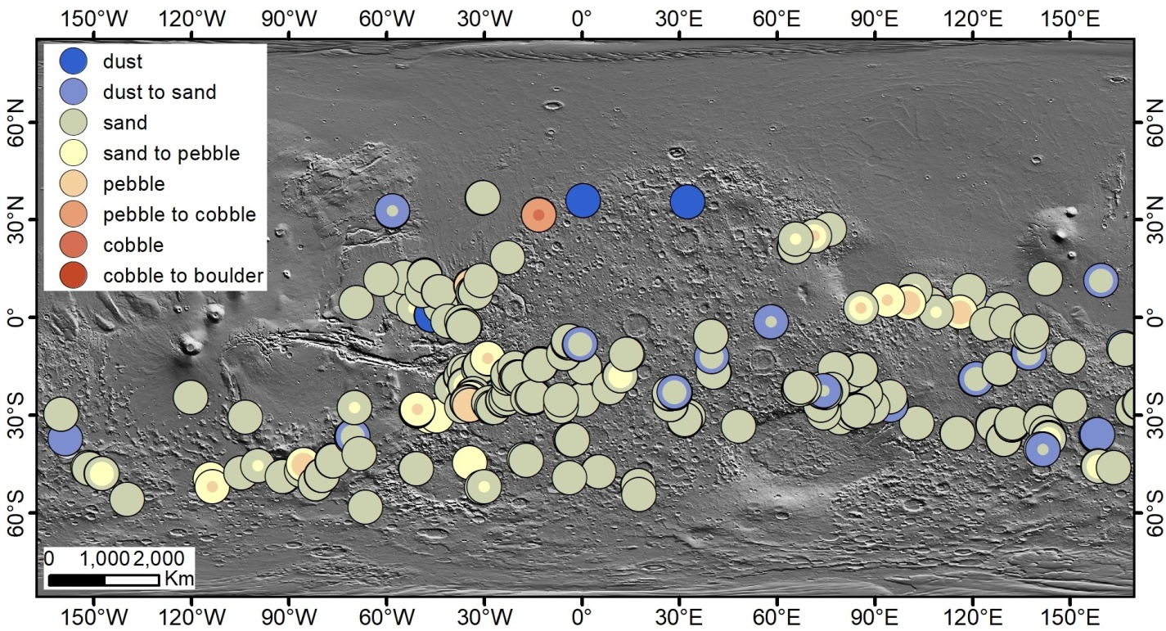
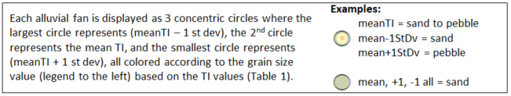

Figure 3.1: Grain size of mars alluvial fans.
Map of the global population of alluvial fans on Mars which were analyzed in this study, displayed by mean TI value across each alluvial fan surface, with outer and inner circles which represent the grain size of the TI values 1 standard deviation below and above the mean TI. The grain size categories in the legend correspond to the TI ranges in Table 3.1. Fans in areas of high dust coverage were eliminated from the initial analysis.
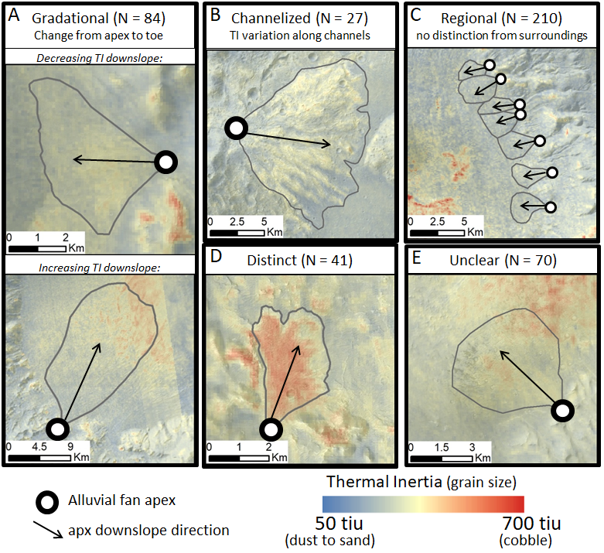

Figure 3.2: TI spatial patterns on mars alluvial fans.
Examples of spatial patterns of TI distribution on Mars alluvial fans. A) Gradational TI patterns can be either increasing or decreasing downslope. B) Channelized patterns show variations in TI values which correlate to morphologic channel features on the fan surface, where the channels correlate to lower TI values. C) Regional TI patterns are indistinguishable from the TI of the surrounding surface and have no variations within the alluvial fan surface. D) TI patterns described as Distinct are clearly distinct from the TI of the surrounding surface but have no variations within the alluvial fan surface. E) Alluvial fans which have no clear TI spatial pattern are described as Unclear.

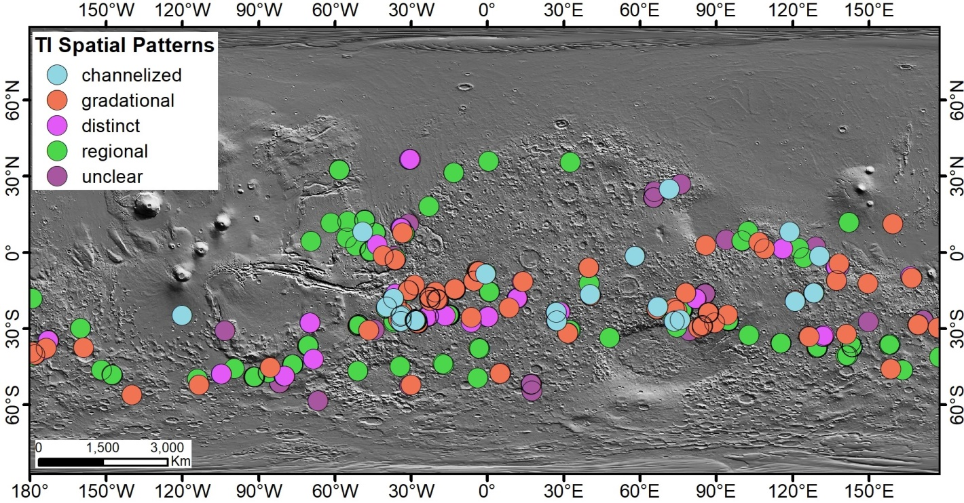

Figure 3.3: Global distribution of TI spatial patterns.
Global distribution of thermal inertia spatial patterns of alluvial fan surfaces. Alluvial fans where the TI values correlate to channelized patterns on the fan surface appear to be restricted to the more central latitudes and do not appear in the high southern latitudes. All other spatial patterns appear throughout the global population of alluvial fans with no clear regional trends. Figure 2 includes more detail about the visual descriptions of each TI spatial pattern.

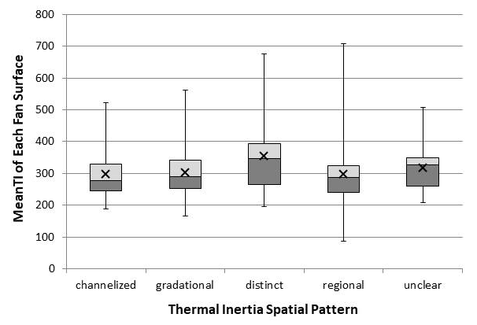

Figure 3.4: Correlation between MeanTI and TI spatial patterns.
Distribution of meanTI of alluvial fan surfaces within each spatial pattern category. Each box and whisker represents all the alluvial fans that were qualitatively described according to the corresponding spatial pattern (x-axis). The global population of alluvial fans shows no clear correlation of meanTI with spatial patterns.

CHAPTER 4
Regional variations in observed fracture abundance and associated predictions for smaller fractures on Europa with implications for regional plume origins

Abstract

Large fractures on Europa’s surface have been extensively studied for the insight they provide into the evolution of the satellite’s ice shell. The presence of small fractures has not been characterized on a global or regional scale because of the resolution limits in the current image data. However, if smaller fractures are present, they could significantly increase the overall fracture abundance and influence the mechanical properties of the ice shell. Regional variability in this abundance would also impact the spatial heterogeneity of ice shell characteristics. To investigate the possible contribution of smaller fractures to the influence of the fracture network on the behavior of the ice lithosphere, we measure the surface length of visible fractures in regions on Europa’s surface and calculate their length distributions and fracture intensities. These outcomes are extrapolated, using best-fit functions, to consider the possible abundance and role of smaller fractures in these networks. The analysis of the visible fractures sampled different geologic terrains and geographic regions to consider the effect of terrain type and location. Fracture abundance in observable populations shows some variation with terrain type. However, observable abundance also changes with image resolution, indicating that current data limit the interpretation of visible fracture populations. Typical log-normal, exponential, and power-law fracture network distributions, based on analysis of terrestrial fracture networks, were considered as methods for extrapolating the observed fracture populations. Power-law was found to be the most appropriate extrapolation choice. It was also found to predict observed fracture abundance in one sample region with a smaller sub-region that had locally higher image resolution. Applying a power-law extrapolation for the fracture abundance as a function of length, we predict fracture abundance characteristics that are up to two orders of magnitude higher than abundance of observed fractures, and which vary by an order of magnitude between regions. Thus, the predicted fracture populations indicate that abundant small fractures would contribute significantly to the mechanical behavior of the ice lithosphere and create regional variations in fracture abundance. For example, where they are abundant, these smaller fractures could contribute to fracture networks providing localized migration pathways for plume activity on Europa. New image data from the Europa Clipper mission should enable fracture mapping at smaller scales to refine the roles of these networks and the smaller fractures on processes in the Europan lithosphere, such as localizing plume activity.

Introduction
Large fractures (> ~200 km) in Europa’s ice shell have been studied for the insight they provide into the tectonic history of Europa (Geissler et al., 1998; Kattenhorn, 2002; Lee et al., 2005; Rhoden and Hurford, 2013). These fractures can be used to constrain the mechanical properties of the ice shell (Nimmo and Schenk, 2006; Rudolph and Manga, 2009). Much of this mapping and modeling on Europa has focused on large fractures and related features such as bands, double ridges, and cycloids. Investigation of populations of smaller, simple fractures is limited by the currently available image data, as only ~32% of the surface is covered by image data of 1 km/pixel or better (Bland et al., 2021; Greeley et al., 2000).
Small fractures, if present and particularly if abundant, have the potential to play a significant role in near-surface ice shell processes. The abundance of open or active fractures would affect bulk ice shell properties such as tensile strength, total porosity and permeability, influencing the distribution and abundance of other surface structures or behaviors such plume eruption (Schulson and Duval, 2009; Richard A Schultz et al., 2010).
Detection of the source locations of active plumes is of particular astrobiological interest for future exploration missions (Howell and Pappalardo, 2020) because plumes expel material possibly originating from the sub-ice ocean (Hansen et al., 2011; Spencer et al., 2018), which is the most likely habitable zone of the icy moons of the solar system (McKay et al., 2014; Reynolds et al., 1987; Sephton et al., 2018). Possible plumes have been detected on Europa (Paganini et al., 2019; Roth et al., 2014), but precise source locations and pathways with related surface features have not yet been identified (Rathbun and Spencer, 2020). Further, the mechanisms for delivery of material through Europa’s ice shell to the surface are still a focus of active research (Manga and Wang, 2007; Vorburger and Wurz, 2021). Dense networks of smaller fractures would be a likely and efficient migration pathway to the surface for Europa plumes. Consequently, investigation of the spatial variability of Europa’s fracture populations will help in recognizing regions of potential plume origins for more detailed observation in future missions.
In this study, we measure the fracture-length distributions of five regions on Europa, calculate observed fracture abundance, and extrapolate predicted populations of smaller fractures below the limit of resolution based on the distribution of the measured fractures. Using these results, we provide recommendations for the use of future, higher resolution image data to better characterize regional variations in observed and predicted fracture abundance and investigate the potential of fracture networks as plume conduits through the Europa ice shell.

Background
Large fractures on Europa have been identified and mapped on a regional scale (Leonard et al., 2018) and are interpreted to be some of the youngest features on the surface (Doggett et al., 2009; Nimmo and Manga, 2009). Fractures are proposed to form as a result of extensional stress related to tidal flexure (Lee et al., 2005), spin pole precession (Rhoden and Hurford, 2013), and nonsynchronous rotation of the ice shell (Geissler et al., 1998; Kattenhorn, 2002). Understanding the observable fracture populations relations to these processes is complicated by nonsynchronous rotation because it moves locations on the ice shell to new positions relative to Jupiter on the surface of Europa. As a result, the locations experience changing stress magnitude and orientation through time, forming a series of overprinted fracture populations.
Older features, specifically double ridges and bands, are hypothesized to originate as simple fractures and evolve over repetitive diurnal stress cycles (Doggett et al., 2009; Han and Showman, 2008; Prockter and Patterson, 2009). The hypothesized formation mechanisms of these features suggest upwelling of material to the near surface through open fractures (Craft et al., 2016). Some hypotheses for the formation of chaos terrain (Collins and Nimmo, 2009; Schmidt et al., 2011) and of pits and domes (Manga and Michaut, 2017; Michaut and Manga, 2014) also rely on vertical movement of melt through open fractures to the near surface.
If these models are correct then open fractures can function as a conduit for liquid water to the near surface. The high abundance of water vapor above the south pole in Hubble observations has been presented as possible evidence of a plume (Roth et al., 2014). Later observations from the Keck Observatory show one instance of a possible plume above the leading hemisphere (Paganini et al., 2019). Repeat observations have not been able to confirm a detectable pattern to potential plume activity (Paganini et al., 2019; Roth et al., 2014), suggesting a more sporadic or long-interval cycle. Investigations of potential thermal anomalies as evidence of regional plume origins, similar to Enceladus, have not returned conclusive results (Rathbun and Spencer, 2020). Europa lacks large open fractures similar to the Enceladus south pole region (Spencer and Nimmo, 2013), as well as significant cryovolcanic features similar to those on Io (Fagents, 2003). In the absence of such large-scale cryovolcanic features, the existence of locally intense fracture networks including abundant smaller fractures can serve as vertical conduits for plume migration and flow onto the Europa surface.
The distribution of fracture abundance as a function of tracelength size for fracture populations can often be described according to a best fit distribution function. In terrestrial examples, fracture populations have been described by exponential, log-normal, and power-law distributions (Bonnet et al., 2001; Chabani et al., 2021; Dichiarante et al., 2020). Exponential distributions have a scale dependency related to a characteristic length scale of the geologic system. Log-normal distributions are typically associated with fracture populations that terminate against layer boundaries, as in bedded sedimentary sequences. Log-normal distributions have also been shown to closely fit fracture populations where smaller fractures are incompletely sampled due to truncation at the limit of resolution and therefore do not accurately represent a full fracture population (Bonnet et al., 2001). Power-law distributions are independent of system-specific scale factors and have been used to describe distributions of both fracture length and aperture (Bonnet et al., 2001; Ortega et al., 2006) on Earth as well as on Mars (Knapmeyer et al., 2006; Schultz et al., 2010).

Methods
In this study, we demonstrate the suitability of defining fracture populations using exponential and power-law functions and then apply those approaches to characterize regional fracture populations on Europa. The objective of this study is to map regional fracture networks on the surface of Europa, determine fracture abundance as a function of fracture size, and extrapolate fracture size distributions to sub-resolution scale to enable discussion of the role of possible smaller fractures in the mechanical behavior of the brittle ice layer of Europa.

Fracture Trace Mapping to Characterize Size Abundance
We selected five regions for mapping fracture abundance (Figure 4.1). The locations sample different geologic units and geographic locations where variations in stress regimes or ice properties may affect fracture abundance. The sizes and extents of the regions are constrained by the resolution and coverage of available image data. In the lowest resolution image data that are available globally (> 1 km/px), fractures are either not detectable or are indistinguishable from other linear features. Each mapped region contains image data of consistent horizontal pixel resolution to ensure that the limit of resolution of mapped fractures is the same throughout the sample window. The regions are named according to their location on Europa’s surface (Figure 4.1). The LeadingHemS_Chaos region is adjacent to the LeadingHemS region and the boundary between the two is defined by the boundary of the mapped chaos terrain surface unit. The AntiJovianN region is underlain by primarily chaos terrain as well, whereas the remaining regions are in the globally extensive Ridged Plains unit (Leonard et al., 2018).
For the purposes of this study, we defined a fracture as a narrow linear feature, typically only a few pixels wide, which crosscuts most or all other surface features and which has no visible infill of other material at the surface. The features we map as fractures have been described as “troughs” or “simple fractures” in previous work in which more complex features are also considered as fractures (Doggett et al., 2009; Prockter and Patterson, 2009). We excluded double ridges, bands, and cycloids in the fracture mapping because they are more complex features that display a variety of additional distinctive characteristics that are absent from simple fractures (Doggett et al., 2009; Prockter and Patterson, 2009). We defined double ridges as three or more parallel brightness shifts (for example, light-dark-light). Bands are wider features where newer or reworked material fills the aperture between remnant fracture planes. Cycloids are curved fractures connected at cusps and propagated over repeat tidal cycles (Rhoden et al., 2021), and therefore, due to shape and history, are not simple fractures.
To characterize fracture abundance as a function of fracture size, we identified fracture surface traces in image data of Europa’s surface and measured the visible length of each trace (referred to as “tracelength”) for all detectable fractures in each region. When characterizing fracture populations from the distribution of tracelengths, the two common sampling biases are: truncation, where tracelengths below a specific size are not measured, and censoring, where the full length of the longest tracelengths are not captured because the trace becomes covered or exits the sampling window (Bonnet et al., 2001; Chabani et al., 2021).
Truncation lengths can be imposed pre-mapping to capture a specific range of fracture samples or can be determined during fracture mapping from the smallest detectable and measureable tracelengths within a mapping region. When truncation is a result of the limit of resolution of the image data, it appears as a flattening effect in the smallest tracelengths on a log-log cumulative distribution plot, indicating that small fractures near the limit of resolution are incompletely sampled (Bonnet et al., 2001; Dichiarante et al., 2020). Overprinting of small fractures by geologic or erosional processes can also contribute to truncation effects by reducing the detectability of small fractures (Knapmeyer et al., 2006). For the purposes of this study, we do not impose an initial truncation limit on the fracture mapping, but rather mapped and measured all visible fracture tracelengths within a region to capture as much of the fracture population as possible. Truncation effects were then considered from the distribution of the smaller fracture sizes.
Censoring effects indicate an underestimate of fractures in the longest measured tracelengths. This sampling bias can be due to part of a long fracture tracelength becoming obscured along its length by a younger geological event, or by the cutoff of tracelength measurements at the mapping or data boundaries (Bonnet et al., 2001; Chabani et al., 2021). Because the longest fractures in a population are likely few in number and distributed throughout the spatial domain of the fracture population, it is likely that a designated mapping area will not intersect multiple large fractures. Censoring of the largest fractures in a mapped population manifests as a graphical artifact of a more vertical trend in the longest tracelengths in a log-log cumulative distribution plot (Dichiarante et al., 2020; Knapmeyer et al., 2006; Marrett, 1996). To mitigate against censoring of large features (Pickering et al., 1995), we traced the length of any fracture that was partially contained within the region to its full extent beyond the mapping boundary, where possible. Some censoring still occurs because image resolution often changes outside of the region boundaries, limiting the traceability of some fractures to their full extent.

Characterizing Length Distributions of Fracture Populations
Quantifying the distribution of tracelengths within a regional fracture population enables extrapolation of the fracture populations beyond the observed fracture network and prediction the contribution of smaller fractures to fracture abundance. Exponential, log-normal, and power-law functions can be used to define fracture length distributions as a function of scale in different geologic settings (Bonnet et al., 2001; Chabani et al., 2021). Log-normal distributions are not considered here as they are typically associated with fracture populations bounded by an abundant number of mechanical layers, such as sedimentary beds on Earth (Dichiarante et al., 2020). Both exponential and power-law will be considered where an important distinction is that exponential behavior has a scale dependence while power-law does not.
From the total population of measured tracelengths within each region, we calculated the cumulative length distribution (N > L) where N is the number of mapped fractures with tracelength greater than or equal to length L. We then normalized the tracelength distribution of each region to a representative standard area size of 100,000 km2 to more directly compare regions of different sizes and plotted the area-normalized cumulative length distributions on log-log plots.
From the cumulative distribution plots of each region, we calculated both a power law and exponential function that is a least squares best-fit of the observed cumulative fracture length distribution N(L), where N(L) is the number of fractures with length greater than or equal to length L. The power law characterization is defined by the equation
N(L) = aL^{-c},
where a is an empirical scaling factor and c is the exponent that defines the slope of the distribution on a log-log plot (Bonnet et al., 2001; Marrett, 1996). The exponential characterization is defined by the equation
N(L) = be^{-(L/L}₀⁾,
where b is an empirical constant related to fracture abundance and L0 is the characteristic length scale specific to the fracture system (Bonnet et al., 2001).
Using the best fit power-law function for each fracture population, we calculate N(L) values using smaller length scales, down to L = ~1 km, based on the smallest fracture tracelengths detected in a sub-region of high-resolution image data. In extrapolating the fracture length distribution, we create a predicted fracture population for each mapping region that accounts for smaller fractures which may exist below the limit of resolution of the current image data. From the predicted fracture populations, we estimate potential regional differences in fracture abundance.

Observed and Predicted Fracture Intensity
Fracture intensity (I), defined as the total length of all fracture traces divided by the total area of exposure in a single sample window, is a way to characterize fracture abundance within a two-dimensional exposure area (Dershowitz and Herda, 1992). We calculated I for each region from the total length of observed fractures.
To investigate the potential contribution of small fractures below the limit of resolution to the regional fracture intensity, we used the extrapolated fracture population to smaller length scales based on the best fit distribution function in each region. From the extrapolated populations we calculated the number (n) of fractures within each length range by N(L1)-N(L2), multiplied n by the mean tracelength (L2-L1)/2, summed the predicted total fracture tracelength for the full extrapolated fracture population, and calculated a predicted I for each extrapolated regional fracture population.

Results of Fracture Mapping
The fractures mapped in each region show a range of tracelengths and orientations (Figure 4.2). In the LeadingHemN, LeadingHemS, LeadingHemS_Chaos, and AntiJovianS regions, fracture tracelengths range from approximately 15 to 300 km. These four regions are mapped from similar resolution image data (~200 m/px) and similar tracelength cutoffs at the lower limit of resolution are expected. The AntiJovianN region is sampled at a lower image resolution (~800 m/px) and does not contain any mapped tracelengths shorter than 30 km, with a maximum tracelength of ~500 km. An expectation is that the lower resolution means that the truncation limit will be higher for this region.
Log-log plots of area-normalized cumulative length distributions for each region are shown in Figure 4.3. The fracture distribution of the AntiJovianN and AntiJovianS regions lacks any apparent frequency decrease for longer traces, and hence, show no evidence of censoring, indicating that we adequately captured the extent of the fracture population in the greatest L values by following traces out of these sample regions. The distribution plots for the LeadingHemN and LeadingHemS regions slightly steepen between their two greatest L values, indicating censoring of the longest tracelengths. The distribution plot for the LeadingHemS_Chaos region shows a slight change in trend between the two greatest L values, which could be interpreted as censoring but is less clear than the other two regions. These three regions have the largest change in image resolution across the mapped area boundary, which made it difficult to trace some large fractures to their full extent and contributed to this censoring effect, unlike with AntiJovianN and AntiJovianS.
Considering truncation, all five regions show a flattening in the cumulative N values for the smallest lengths, indicating that a truncation bias exists for the shortest observed tracelengths. In the AntiJovianN region, mapped at ~800 m/pixel, the flattening of the tracelength distribution occurs at ~70 km. In all other regions, mapped at ~200 m/pixel, the truncation occurs at ~20-30 km. To investigate whether the truncation bias shown in the distribution of mapped fracture length is an indication of a lack of small fractures or an artifact of the limit of resolution of the data, we mapped fracture traces in the one area where we had greater image resolution (25m/pixel) in a small sub-region of LeadingHemN region (Figure 4.2A). These data eliminate the truncation bias for the existing data set from the lower resolution, and not surprisingly have their own truncation bias. The smallest observed fractures in the higher resolution images are ~1 km long and the area-normalized, cumulative tracelength distribution of the high-resolution sub-region also show the “curve-flattening” truncation effect similar to the other fracture-tracelength data sets, but at a much smaller tracelength of about 2 km (Figure 4.3C).
We also mapped fractures using lower resolution (~700 m/px) image data in the LeadingHemN region, which show a truncation effect at ~70 km (Figure 4.3C). The outcome is similar to that seen in the AntiJovianN region, which was mapped at similar resolution. We interpret the general occurrence of truncation bias for all image resolutions as evidence that smaller unobserved fractures are present in these areas, but are not represented in the current image data due to the resolution limits. This interpretation is further reinforced by the results from LeadingHemN where we could use a locally greater image resolution to document the existence of smaller fractures.
To better predict the abundance of smaller fractures that cannot be measured with the existing imagery, we fit the data with power-law and exponential functions (Figure 4.3). When calculating these best-fit functions, we did not include the points at the lower or upper ends of the tracelength distribution if they indicate a truncation or censoring bias. Such exclusion is common practice when there is evidence for bias in the observed fracture population, either from observation bias or geologic overprinting (Knapmeyer et al., 2006; Marrett, 1996).

Discussion of Fracture Population Distributions
In all but one of the mapped regions, the measured fracture data show a close fit to both the power law and exponential best-fit functions (Figure 4.3). In the AntiJovianS region, the mapped fracture data show much less variance from the best-fit power law function compared to the exponential function (Figure 4.3D). More tracelength data points are available to use in the best-fit calculations in the AntiJovianS region, which likely contributed to a more apparent distinction between the exponential and power-law fits. Because data points that show effects of truncation or censoring were not included in the best-fit calculations, only four or five length bin values are used to calculate the best-fit functions in the other regions. With fewer data points to work with, both distributions can be well fit to the available data. R2 values for both exponential and power-law fits are generally high (> 0.95) and small differences in high R2 values are not enough to confidently distinguish between the most appropriate distribution function for the fracture population.
The mapping of tracelengths in different resolution image data in the LeadingHemN region also supports the use of the power-law function rather than an exponential function to describe the fracture length distributions on Europa, and predicting the roles for smaller fractures in the population. The extrapolated best-fit power-law function calculated from the measured fracture distribution in the LeadingHemN region only slightly overestimates the non-truncated, area-normalized fracture length distribution that we mapped using higher resolution image data (Figure 4.3C). By comparison, the exponential best-fit function from the LeadingHemN data would have drastically underestimated the fracture abundance that is observed in high resolution data for smaller fracture traces.
Additionally, the exponential best-fit functions appear to under-estimate the abundance of shorter fractures in the measured populations. This effect is most apparent in the AntiJovianS region (Figure 4.3D) where the calculated exponential function underestimates the smallest observed fractures by almost an order of magnitude. In the AntiJovianN and LeadingHemS_Chaos regions an extrapolation of the exponential functions underestimated the smallest fracture lengths in the observed tracelengths. Our interpretation is that the N(L) values of these smallest measured tracelengths are influenced by truncation effects related to the limit of resolution of the image data. If the exponential function is underestimating measured fracture abundance of tracelengths that are already artificially truncated, it cannot be accurately representing the full fracture population.
Based on these interpretations, we determined that the power-law function provides the better representation of the full fracture populations on Europa. Power law functions have commonly been used to describe fracture populations on other planetary bodies. The cumulative length distribution of fracture populations has also been characterized by a power law function in cases on Earth (Cladouhos and Marrett, 1996; Pickering et al., 1995; Schlische et al., 1996; Yielding et al., 1996) and Mars (Knapmeyer et al., 2006; Schultz, 2000).
The exponent (c) of a power-law function fit to a fracture length distribution indicates the relative abundance of particular fracture sizes within that fracture population. Distinct fracture populations, with different geometric constraints and stress histories, can be differentiated by their power law exponents. For the Europa fracture populations presented here, different power law exponents (Table 4.1) indicate that regional fracture populations on Europa can be treated as distinct populations rather than a uniform global fracture network. Within a distinct fracture population, we infer that the fracture length distribution will follow the same power-law function at all scales for which fractures form, allowing us to predict the distribution beyond the observed tracelengths.

Predicted Fracture Populations
For each region, we used the best-fit power law function to calculate a predicted fracture distribution down to a length of approximately 0.75 km (Figure 4.4). We chose this length based on the smallest observed fractures in the mapped high-resolution LeadingHemN sub-region, although it is likely that even smaller fractures exist. Small differences in the exponent of the power law function result in very different fracture abundances in the extrapolated populations.
The mapped fracture populations plot in three clusters (Figure 4.4). The AntiJovianS, LeadingHemS, and LeadingHemN regions all plot near each other, indicating similar relative fracture abundance. LeadingHemS_Chaos plots slightly below the others, indicating lower overall fracture abundance, and AntiJovianN plots slightly above the other regions, indicating higher overall fracture abundance in the mapped fractures. However, this relative abundance of mapped fractures, illustrated by the clustering on the cumulative distribution plot, is not maintained in the same pattern in the extrapolated fracture populations due to the variability of the c values of each region.
The exponent value (c) in the power law function defines the slope of the cumulative distribution on a log-log plot. The AntiJovianS and LeadingHemN regions each have c = ~2.1 (Table 4.1), which results in a much greater number of small fractures in the extrapolated fracture populations. The cumulative fracture abundance at the smallest lengths (L) in these regions is approximately two orders of magnitude greater than the LeadingHemS and LeadingHemS_Chaos regions (Figure 4.4). In the LeadingHemS region, the fracture abundance of the mapped fractures is similar to the LeadingHemN and AntiJovianS regions, but the lower exponent value results in a lesser overall abundance for smaller fractures in the extrapolated population distribution. The AntiJovianN region plots according to a slightly higher c which, extrapolated from the higher abundance of mapped fractures, produces a predicted fracture population where the abundance of fractures at the smallest length scale is an order of magnitude higher than the next most abundant predicted fracture population.
The 2σ uncertainty cone for each predicted fracture population is defined by a lower bound calculated from the distribution function using a-2σ and c-2σ and an upper bound calculated from the distribution function using a+2σ and c+2σ. The 2σ uncertainty of each a and c is a measure of how much the observed fracture distribution data vary from the least squares best-fit function. In the LeadingHemN region, greater 2σ uncertainty produces a less well-constrained extrapolated fracture population distribution as a function of fracture size. This outcome is likely a result of the small number of points used to calculate best-fit functions, after effects of censoring and truncation were eliminated.

Observed and Predicted Fracture Intensity
As illustrated by Figure 4.4, the exponent of a power law fit alone does not fully characterize fracture abundance of a region. In many geologic considerations, the fracture abundance (i.e. how high on the y-axis the population plots) is the more important parameter. Fracture abundance is encapsulated well by Fracture Intensity (I). We calculate I of both the mapped (I_{map}) and predicted (I_{pred}) fracture populations in each region (Table 4.1). The values of I_{map} are very similar in all regions except for LeadingHemS_Chaos. The lesser I_{map} of LeadingHemS_Chaos is due to less abundance of large fractures and overall less dense fracture network (Figure 4.2).
Values of I_{pred} illustrate much more variability in potential fracture abundance on a regional scale than what we see in the measured data. I_{pred} roughly correlates to c, but not directly (Table 4.1). I_{pred} for AntiJovianN is an extreme outlier, which we interpret as further evidence that the extrapolation from low-resolution mapping overestimated the number of smaller fractures. It is interesting that LeadingHemS has a smaller I_{pred} (and c), given that it lies within a similar latitude and geologic unit type as LeadingHemN. It is interesting that LeadingHemS has a smaller I_{pred} (and c) than LeadingHemN, given that the two units are similar distances from the equator (and should therefore experience similar diurnal stress patterns) and that they are characterized in similar geologic units.

Further Implications

Plume Origins
If Europa plume activity is emanating from fractures, areas of high fracture intensity become important targets in the search for further evidence of plume activity. While there are clear variations by region, I_{pred} values are not noticeably correlated with latitude, hemisphere, or geologic unit, further indicating that fracture patterns contain complexity beyond what can be easily observed in current data. From the acquisition of near-global, high-resolution image data, which is an objective of the upcoming Europa Clipper mission (Howell and Pappalardo, 2020), fracture mapping at high resolution over a large region could be used to calculate I by smaller sub-regions over a global distribution, to further investigate possible magnitudes and spatial distributions of fracture intensity. Mapping from those higher resolution data will enable better characterization of regional variations on a global scale and directly highlight areas for further investigation of evidence for plume activity.

Fracture-Added Porosity
Plume activity related to fracture populations requires at least some of the fractures to be open migration pathways during at least part of the orbital period. In addition, open fractures have implications for ice shell mechanical properties such as permeability and tensile strength (Marrett, 1996). Porosity values of Europa’s ice shell are not well constrained (Black et al., 2001; Craft et al., 2016; Lee et al., 2005; Schmidt et al., 2011) and regional porosity variations even less so. Accurate calculation of fracture-added porosity requires detailed information on fracture surface area and aperture, including precise ranges and uncertainties (Marrett, 1996), which cannot be directly measured or accurately inferred from current image data of Europa.
Acknowledging the uncertainties and assumptions, we present here a framework for calculating potential fracture-added porosity of a predicted fracture population as a way to quantify the discussion of the implications of high fracture abundance for ice shell properties. Fracture area can be estimated based on mechanical models of propagation depths (Lee et al., 2005; Rudolph and Manga, 2009). Fracture depth (d) is assumed to be 2 km, the approximate depth of the brittle layer (Pappalardo et al., 1999), for all fractures where L > 2km. For L < 2km, d is assumed to be equal to L. Vertical area (A) of the fracture surface is generalized as a rectangle of dimensions L x d.
Fracture aperture can generally be described by a power law function of L, assuming that fractures are under tensile stress (Marrett, 1996). Using the approximate surface length and resolvable width of the smallest mapped fractures (L = 1 km, w = ~0.025 km) and 100 km mapped fractures (w = ~0.4 km), we fit a power law to the two points. Aperture is likely largest at the surface and reduces with propagation depth (Rudolph and Manga, 2009), therefore we use half of the calculated surface aperture as an estimate of average aperture value (a).
The resulting generalized fracture volume (A x a) is applied to the number of fractures in each length bin for each predicted regional population. The estimates of fracture-added porosity range from 0.49% to 9% (Table 4.1), except for AntiJovianN where the oversaturation of fracture-added porosity is again the result of over-counting fractures. These values are a maximum estimate of fracture-added porosity but give an idea of the maximum possible contribution from a fracture population with a power-law distribution of fracture sizes as approximated using tracelength as the size proxy. Applying the same aperture generalization to all fractures leads to an overestimate of the total porosity as aperture depends on instantaneous stress, which in turn depends on fracture azimuth relative to the stress field and changes throughout the orbital period. The minimum fracture-added porosity will be zero because, under conditions of no extensional stress, gravitational force on the ice shell creates small compressional stress at depth, closing open spaces (Kattenhorn and Hurford, 2009; Nimmo and Schenk, 2006). However, given the variety of orientations of mapped fractures (Figure 4.2), it is extremely unlikely that all active fractures would close at the same time under any given stress field.
The apertures of open fractures will also vary over the orbital period as tidal stresses change. As fracture porosity is closely tied to fracture aperture, this could mean that added porosity in the outer ice shell is changing on a short timescale. Pumping liquid water through tidally active fractures has been suggested as a mechanism for moving melt towards the surface (Craft et al., 2016). The contribution of abundant small fractures increases the potential open volume for migration and storage of water by at least two orders of magnitude.
Regional variability in fracture-added porosity would have implications for mechanical and thermal properties of the ice shell. Greater porosity lowers the tensile strength (Schulson and Duval, 2009), making it easier to initiate additional fracturing up to a point where stress is fully accommodated along existing fractures. Open fracture porosity would decrease the local density of the ice, while water filled fractures would slightly increase the density. Fracture porosity varying on the timescale of one orbital period means that bulk ice density will also be changing regionally on timescale of one orbital period. Connected fractures drastically also increase the vertical permeability (Marrett, 1996), making it easier to move material through the ice shell.

Conclusions
The tracelength size distribution for fracture populations on Europa’s surface can be characterized by best fit power-law functions. Extrapolation of the observed fracture populations according to the best fit functions demonstrates the potential regional variations in fracture abundance when small fractures are accounted for. A key outcome of this use of power-law fitting for the tracelength population is that the unobserved smaller fractures are significant contributors to the fracture abundance, intensity, and porosity. The truncation seen in the distribution of mapped fractures, occurring at different length bins in different resolution data, indicates that we are not observing the full fracture population in the current image data and that detectability of smaller fractures is limited by data resolution rather than small fractures not being present as a result of ice annealing or other geologic overprinting.
Predicted fracture abundance varies between regions but is not clearly related to geologic or geographic areas. Small variations in the exponents characterizing the populations of large fractures produce much larger differences in fracture abundance between regions, demonstrated by predicted fracture intensity, when the full fracture population is extrapolated down to lengths below the limit of resolution.
Analysis of the contributions of small fractures to fracture networks can provide an estimate of the heterogeneity of mechanical properties of the ice shell, such as porosity, permeability, and tensile strength, which cannot be directly measured with currently available data. In regions of less fracture abundance, fracture-added porosity and influence on these parameters may be minimal compared to highly fractured regions. The possibility that ice shell porosity is changing even by a few percent over the orbital period due to changing fracture aperture has implications for mechanical parameters and migrations pathways.
If plume activity on Europa is localized to conduits provided by fracture networks through the ice lithosphere, this study indicates that further study of populations of smaller fractures is needed so as to more precisely determine regional variations in fracture abundance and to investigate the possible role of these networks in plume localization. Additional global fracture mapping using the higher resolution data that will be available from the Europa Clipper mission has the potential to identify areas of greatest fracture abundance for recent plumes and to offer predictions for future plume activity on the basis of fracture abundance on the surface of Europa.

References

Black, G.J., Campbell, D.B., Nicholson, P.D., 2001. Icy Galilean Satellites: Modeling Radar Reflectivities as a Coherent Backscatter Effect. Icarus 151, 167–180. https://doi.org/10.1006/ICAR.2001.6616
Bland, M.T., Weller, L.A., Archinal, B.A., Smith, E., Wheeler, B.H., 2021. Improving the Usability of Galileo and Voyager Images of Jupiter’s Moon Europa. Earth Sp. Sci. 8, e2021EA001935. https://doi.org/10.1029/2021EA001935
Bonnet, E., Bour, O., Odling, N.E., Davy, P., Main, I., Cowie, P., Berkowitz, B., 2001. Scaling of fracture systems in geological media. Rev. Geophys. 39, 347–383. https://doi.org/10.1029/1999RG000074
Chabani, A., Trullenque, G., Ledésert, B.A., Klee, J., 2021. Multiscale characterization of fracture patterns: A case study of the noble hills range (Death valley, CA, Usa), application to geothermal reservoirs. Geosci. 11. https://doi.org/10.3390/geosciences11070280
Cladouhos, T.T., Marrett, R., 1996. Are fault growth and linkage models consistent with power-law distributions of fault lengths? J. Struct. Geol. 18, 281–293. https://doi.org/10.1016/S0191-8141(96)80050-2
Collins, G., Nimmo, F., 2009. Chaotic terrain on Europa. Eur. Univ. Arizona Sp. … 259–281.
Craft, K.L., Patterson, G.W., Lowell, R.P., Germanovich, L., 2016. Fracturing and flow: Investigations on the formation of shallow water sills on Europa. Icarus 274, 297–313. https://doi.org/10.1016/J.ICARUS.2016.01.023
Dershowitz, W.S., Herda, H.H., 1992. Interpretation of fracture spacing and intensity. Rock Mech.
Dichiarante, A.M., McCaffrey, K.J.W., Holdsworth, R.E., Bjørnarå, T.I., Dempsey, E.D., 2020. Fracture attribute scaling and connectivity in the Devonian Orcadian Basin with implications for geologically equivalent sub-surface fractured reservoirs. Solid Earth 11, 2221–2244. https://doi.org/10.5194/se-11-2221-2020
Doggett, T., Greeley, R., Figueredo, P., 2009. Geologic Stratigraphy and Evolution of Europa ’ s Surface 137–159.
Fagents, S.A., 2003. Considerations for effusive cryovolcanism on Europa: The post-Galileo perspective. J. Geophys. Res. Planets 108. https://doi.org/10.1029/2003JE002128
Geissler, P.E., Greenberg, R., Hoppa, G., Helfenstein, P., McEwen, A., Pappalardo, R., Tufts, R., Ockert-Bell, M., Sullivan, R., Greeley, R., Belton, M.J.S., Denk, T., Clark, B., Burns, J., Veverka, J., 1998. Evidence for non-synchronous rotation of Europa. Nat. 1998 3916665 391, 368–370. https://doi.org/10.1038/34869
Greeley, R., Figueredo, P.H., Williams, D.A., Chuang, F.C., Klemaszewski, J.E., Kadel, S.D., Prockter, L.M., Pappalardo, R.T., Head, J.W., Collins, G.C., Spaun, N.A., Sullivan, R.J., Moore, J.M., Senske, D.A., Tufts, B.R., Johnson, T. V., Belton, M.J.S., Tanaka, K.L., 2000. Geologic mapping of Europa. J. Geophys. Res. E Planets 105, 22559–22578. https://doi.org/10.1029/1999JE001173
Han, L., Showman, A.P., 2008. Implications of shear heating and fracture zones for ridge formation on Europa. Geophys. Res. Lett. 35, L03202. https://doi.org/10.1029/2007GL031957
Hansen, C.J., Shemansky, D.E., Esposito, L.W., Stewart, A.I.F., Lewis, B.R., Colwell, J.E., Hendrix, A.R., West, R.A., Waite, J.H., Teolis, B., Magee, B.A., 2011. The composition and structure of the Enceladus plume. Geophys. Res. Lett. 38. https://doi.org/10.1029/2011GL047415
Howell, S.M., Pappalardo, R.T., 2020. NASA’s Europa Clipper—a mission to a potentially habitable ocean world. Nat. Commun. 2020 111 11, 1–4. https://doi.org/10.1038/s41467-020-15160-9
Kattenhorn, S. a, Hurford, T. a., 2009. Tectonics of Europa 199–236.
Kattenhorn, S.A., 2002. Nonsynchronous Rotation Evidence and Fracture History in the Bright Plains Region, Europa. Icarus 157, 490–506. https://doi.org/10.1006/ICAR.2002.6825
Knapmeyer, M., Oberst, J., Hauber, E., Wählisch, M., Deuchler, C., Wagner, R., 2006. Working models for spatial distribution and level of Mars’ seismicity. J. Geophys. Res. Planets 111, 11006. https://doi.org/10.1029/2006JE002708
Lee, S., Pappalardo, R.T., Makris, N.C., 2005. Mechanics of tidally driven fractures in Europa’s ice shell. Icarus 177, 367–379. https://doi.org/10.1016/J.ICARUS.2005.07.003
Leonard, E.J., Patthoff, D.A., Senske, D.A., Collins, G.C., 2018. THE EUROPA GLOBAL GEOLOGIC MAP, in: Planetary Geologic Mappers Meeting.
Manga, M., Michaut, C., 2017. Formation of lenticulae on Europa by saucer-shaped sills. Icarus 286, 261–269. https://doi.org/10.1016/j.icarus.2016.10.009
Manga, M., Wang, C.Y., 2007. Pressurized oceans and the eruption of liquid water on Europa and Enceladus. Geophys. Res. Lett. 34, 1–5. https://doi.org/10.1029/2007GL029297
Marrett, R., 1996. Aggregate properties of fracture populations. J. Struct. Geol. 18, 169–178. https://doi.org/10.1016/S0191-8141(96)80042-3
McKay, C.P., Anbar, A.D., Porco, C., Tsou, P., 2014. Follow the plume: The habitability of enceladus. Astrobiology 14, 352–355. https://doi.org/10.1089/ast.2014.1158
Michaut, C., Manga, M., 2014. Domes, pits, and small chaos on Europa produced by water sills. J. Geophys. Res. E Planets 119, 550–573. https://doi.org/10.1002/2013JE004558
Nimmo, F., Manga, M., 2009. Geodynamics of Europa’ s Icy Shell, in: Europa, Univ. Arizona pp. 381–404.
Nimmo, F., Schenk, P., 2006. Normal faulting on Europa: implications for ice shell properties. J. Struct. Geol. 28, 2194–2203. https://doi.org/10.1016/j.jsg.2005.08.009
Ortega, O.J., Marrett, R.A., Laubach, S.E., 2006. A scale-independent approach to fracture intensity and average spacing measurement. Am. Assoc. Pet. Geol. Bull. 90, 193–208. https://doi.org/10.1306/08250505059
Paganini, L., Villanueva, G.L., Roth, L., Mandell, A.M., Hurford, T.A., Retherford, K.D., Mumma, M.J., 2019. A measurement of water vapour amid a largely quiescent environment on Europa. Nat. Astron. 2019 43 4, 266–272. https://doi.org/10.1038/s41550-019-0933-6
Pappalardo, R.T., Belton, M J S, Breneman, H.H., Carr, M.H., Chapman, C.R., Collins, G.C., Denk, T, Fagents, S., Geissler, P.E., Giese, B., Greeley, R., Greenberg, R., Head, J.W., Helfenstein, P., Hoppa, G., Kadel, S.D., Klaasen, K.P., Klemaszewski, J.E., Magee, K., Mcewen, A.S., Moore, J.M., Moore, T.W.B., Neukum, G., Phillips, C.B., Prockter, L.M., Schubert, G, Senske, D.A., Sullivan, R.J., Tufts, B.R., Turtle, E.P., Wagner, R., Williams, K.K., 1999. Does Europa have a subsurface ocean? Evaluation of the geological evidence, JOURNAL OF GEOPHYSICAL RESEARCH.
Pickering, G., Bull, J.M., Sanderson, D.J., 1995. Sampling power-law distributions. Tectonophysics 248, 1–20. https://doi.org/10.1016/0040-1951(95)00030-Q
Prockter, L., Patterson, G., 2009. Morphology and evolution of Europa’s ridges and bands. Europa 237–258.
Rathbun, J.A., Spencer, J.R., 2020. Proposed plume source regions on Europa: No evidence for endogenic thermal emission. Icarus 338, 113500. https://doi.org/10.1016/J.ICARUS.2019.113500
Reynolds, R.T., McKay, C.P., Kasting, J.F., 1987. Europa, tidally heated oceans, and habitable zones around giant planets. Adv. Sp. Res. 7, 125–132. https://doi.org/10.1016/0273-1177(87)90364-4
Rhoden, A.R., Hurford, T.A., 2013. Lineament azimuths on Europa: Implications for obliquity and non-synchronous rotation. Icarus 226, 841–859. https://doi.org/10.1016/J.ICARUS.2013.06.029
Rhoden, A.R., Mohr, K.J., Hurford, T.A., Henning, W., Sajous, S., Patthoff, D.A., Dubois, D., 2021. Obliquity, Precession, and Fracture Mechanics: Implications of Europa’s Global Cycloid Population. J. Geophys. Res. Planets 126, e2020JE006710. https://doi.org/10.1029/2020JE006710
Roth, L., Retherford, K.D., Saur, J., Strobel, D.F., Feldman, P.D., McGrath, M.A., Nimmo, F., 2014. Orbital apocenter is not a sufficient condition for HST/STIS detection of Europa’s water vapor aurora. Proc. Natl. Acad. Sci. 111, E5123–E5132. https://doi.org/10.1073/PNAS.1416671111
Rudolph, M.L., Manga, M., 2009. Fracture penetration in planetary ice shells. Icarus 199, 536–541. https://doi.org/10.1016/J.ICARUS.2008.10.010
Schlische, R.W., Young, S.S., Ackerman, R.., Gupta, A., 1996. Geometry and scaling relationships of a population of very small rift-related normal faults. Geology 24, 683–686.
Schmidt, B.E., Blankenship, D.D., Patterson, G.W., Schenk, P.M., 2011. Active formation of ‘chaos terrain’ over shallow subsurface water on Europa. Nature 479, 502–505. https://doi.org/10.1038/nature10608
Schulson, E.M., Duval, P., 2009. Creep and Fracture of Ice. Cambridge University Press.
Schultz, R.A., 2000. Fault-population statistics at the Valles Marineris Extensional Province, Mars: implications for segment linkage, crustal strains, and its geodynamical development. Tectonophysics 316, 169–193. https://doi.org/10.1016/S0040-1951(99)00228-0
Schultz, Richard A., Hauber, E., Kattenhorn, S.A., Okubo, C.H., Watters, T.R., 2010. Interpretation and analysis of planetary structures. J. Struct. Geol. 32, 855–875. https://doi.org/10.1016/J.JSG.2009.09.005
Schultz, Richard A, Soliva, R., Okubo, C.H., Ege, D.M.`, Watters, T.R., 2010. Fault populations, in: Watters, T.R., Schultz, R.A. (Eds.), Planetary Tectonics. Cambridge University Press.
Sephton, M.A., Waite, J.H., Brockwell, T.G., 2018. How to detect life on icy moons. Astrobiology 18, 843–855. https://doi.org/10.1089/AST.2017.1656/ASSET/IMAGES/LARGE/FIGURE5.JPEG
Spencer, J.R., Nimmo, F., 2013. Enceladus: An active ice world in the saturn system. Annu. Rev. Earth Planet. Sci. 41, 693–717. https://doi.org/10.1146/annurev-earth-050212-124025
Spencer, J.R., Nimmo, F., Ingersoll, A.P., Hurford, T.A., Kite, E.S., Rhoden, A.R., Schmidt, J., Howett, C.J.A., 2018. Plume Origins and Plumbing: From Ocean to Surface, in: Schenk, P.M., et al. (Eds.), Enceladus and the Icy Moons of Saturn. University of Arizona Press.
Vorburger, A., Wurz, P., 2021. Modeling of Possible Plume Mechanisms on Europa. J. Geophys. Res. Sp. Phys. 126, e2021JA029690. https://doi.org/10.1029/2021JA029690
Yielding, G., Needham, T., Jones, H., 1996. Sampling of fault populations using sub-surface data: a review. J. Struct. Geol. 18, 135–146.

Appendix

Appendix 4: Ch. 4 Figures and Tables

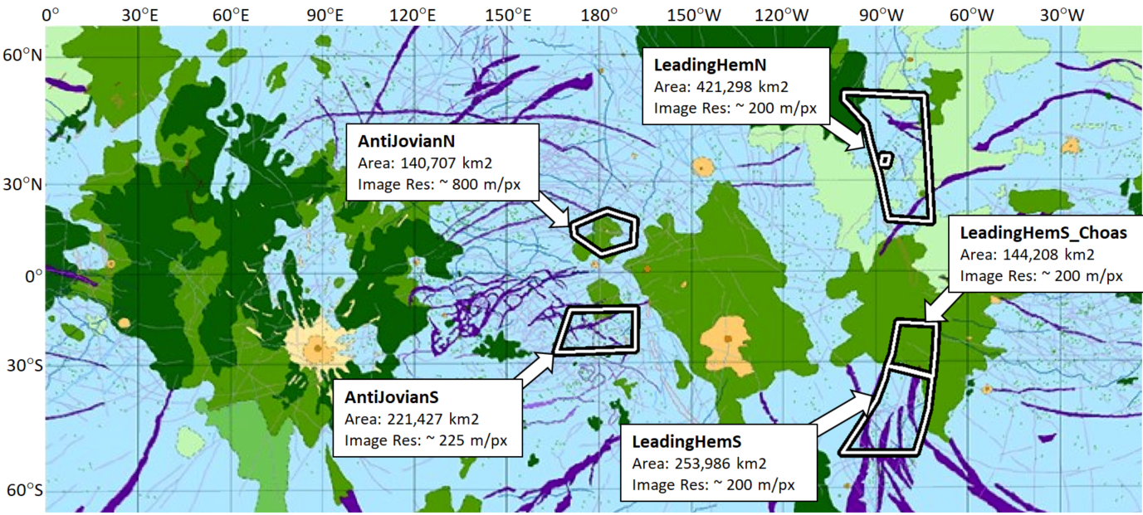

Figure 4.1: Fracture mapping regions.
Regions of mapped fractures, overlaid on a global geologic map of Europa (Leonard et al., 2018). The Ridged Plains surface unit is mapped in blue and underlies most of the LeadingHemN, LeadingHemS, and AntiJovianS mapping regions. The Mottled Chaos unit is mapped in medium green and underlies the LeadingHemS_Chaos and AntiJovianN regions. Other types of chaos terrain are mapped in different shades of green.
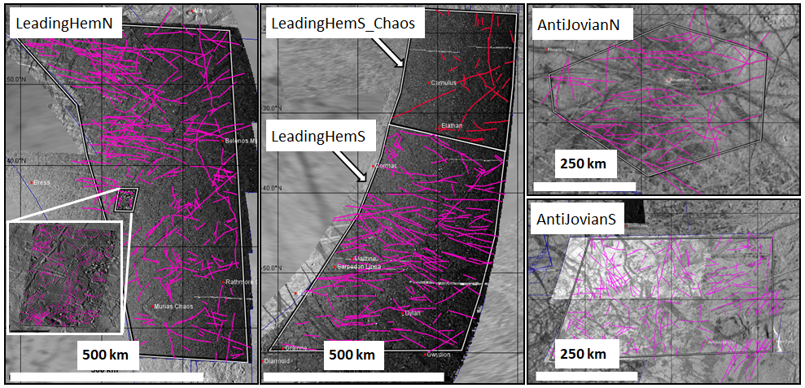

Figure 4.2: Fracture mapping.
Mapped fracture tracelengths within each region. The inset in LeadingHemN shows mapped fractures in a subset region using high-resolution (25 m/px) image data, available only in that area. See Figure 1 for location of sampling regions.
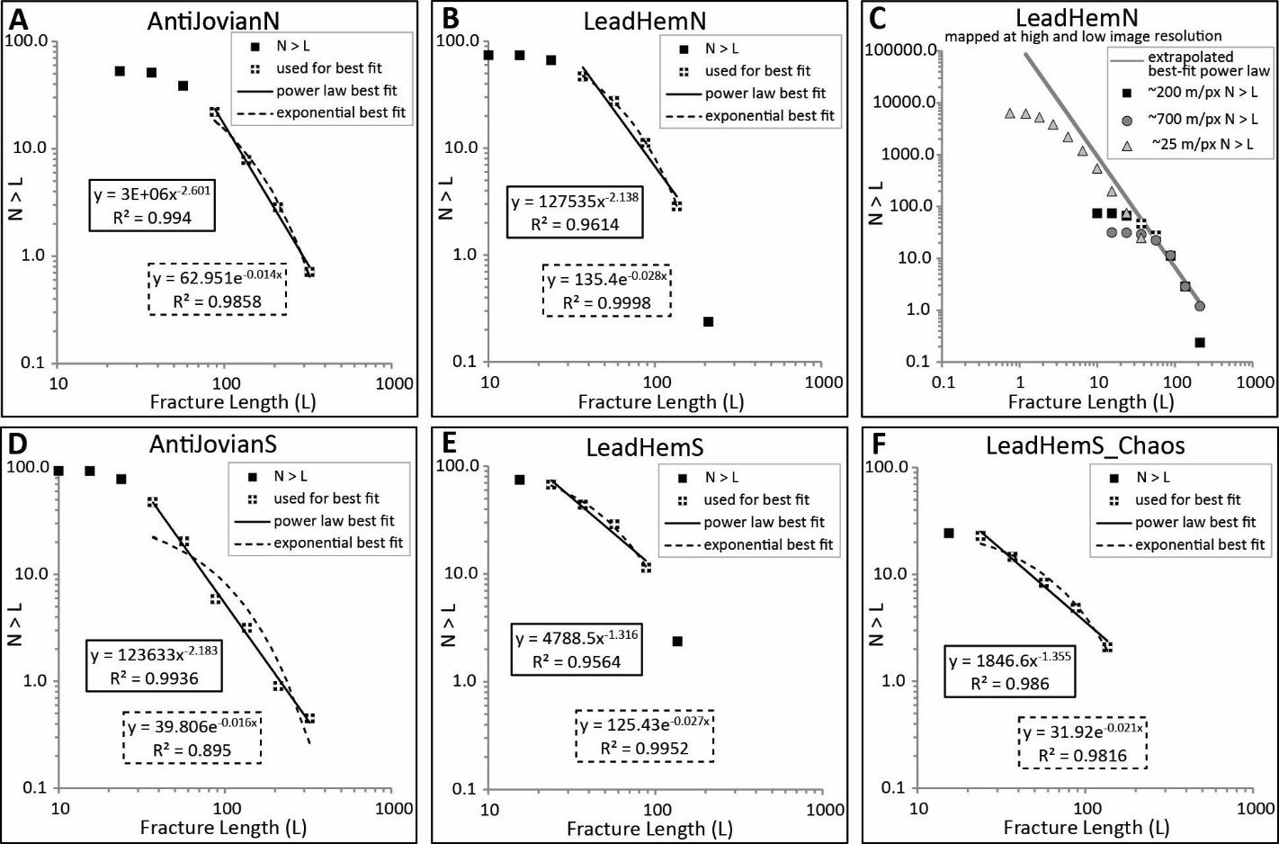

Figure 4.3: Fracture length distributions.
Cumulative length distributions of area-normalized mapped fracture populations. The y-axis value, N > L, is the number of measured fractures with length greater than or equal to length bin L. The data points with a white + indicate points that were used to calculate the best-fit functions. The dashed lines show the best-fit exponential function for each plot. The solid lines show the best-fit power law function for each plot. The calculated best-fit functions and associated R2 values for the exponential and power law equations are shown outlined in dashed or solid boxes, respectively. Plot C shows the best-fit power law function from plot B, extrapolated down to a 1 km tracelength, along with the area-normalized cumulative distribution of fractures in LeadingHemN mapped at both higher and lower resolutions.
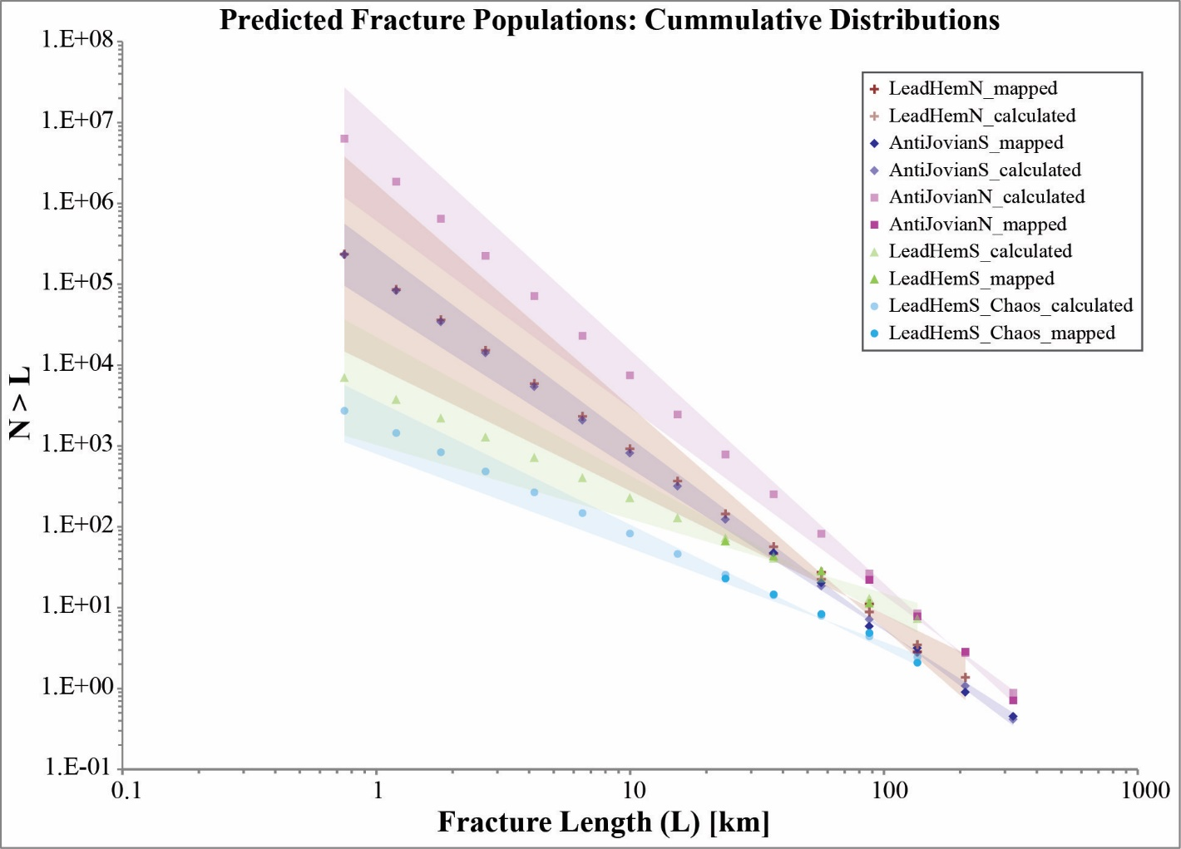

Figure 4.4: Predicted fracture populations.
Log-log plot of the extrapolated fracture populations based on best-fit power laws for each region. Mapped and predicted N > L values are plotted as points. The 2σ uncertainty of each mapped population, based on the calculated uncertainties of both a and c from the best-fit power-law distributions, is extrapolated along the predicted fracture population (shown in a semi-transparent cone around the extrapolated points).

Table 4.1: Fracture population parameters.
Parameters characterizing mapped and predicted fracture populations. Assumptions and limitations of fracture-added porosity estimates are discussed in more detail in Section 8.2. The maximum calculated fracture porosity for the AntiJovianN region is an impossible porosity value, which further suggests that fracture mapping in that region over-counted fracture abundance.
Mapped Region | power law fit |  | Fracture Intensity (I) |  | Maximum Fracture-Added Porosity %
Mapped Region | Exponent (c) | 2-sigma uncert. of (c) | Mapped fracture population (I_{map}) | Predicted fracture population (I_{pred}) | Maximum Fracture-Added Porosity %
AntiJovianN | 2.60 | 0.286 | 0.051 | 81.40 | 157.7
AntiJovianS | 2.18 | 0.175 | 0.044 | 3.37 | 8.47
LeadHemN | 2.14 | 0.606 | 0.042 | 3.49 | 9.02
LeadHemS | 1.32 | 0.398 | 0.041 | 0.19 | 1.38
LeadHemS_Chaos | 1.35 | 0.186 | 0.014 | 0.07 | 0.49

CONCLUSION

The observable and predictable complexities of terrestrial geologic systems provide key insight into planetary geology. Using terrestrial systems as a framework, it is possible to predict the details of planetary systems which exist below the limit of resolution of the currently available data. The research presented here uses the analysis of terrestrial analogs to advance the understanding of the formation of alluvial fans on Mars and of fracture abundance within Europa’s ice shell.
Chapter 1: Terrestrial alluvial fans
This study is the first that intentionally controls for a single catchment lithology within a survey of alluvial fans. The results show that, for a population of alluvial fans in a temperate, arid climate, basaltic catchments produce debris-flow dominated fans. The proportion of debris flow facies identified in the stratigraphic sections across the alluvial fans roughly correlates to the area percentage of basalt within the fan catchment. Catchment relief, described by Melton’s ruggedness factor, does not correlate with primary depositional style, indicating that catchment morphology is not a primary control for this population of fans.
While the link between clay minerals and debris flows has been shown previously, the strong correlation demonstrated here between a specific clay-producing catchment lithology and alluvial fans composed almost entirely of debris flow facies suggests that the clay production potential of catchment lithology may be a better indicator of depositional style than rock type alone. The results presented here suggest that a more detailed analysis of rock composition and weathering products for a wide range of alluvial fan catchments has the potential to reveal a more precise relationship between provenance and depositional style.
Chapter 2: Morphologic characterization of Mars alluvial fans
Presented here is an updated global catalog of alluvial fans and other fan-shaped radial depositional features on Mars, which includes 1,063 features from previously published surveys of Mars fan features as well as 333 newly-identified features. Based on the morphologic definition of terrestrial alluvial fans, each feature within this global catalog was classified as either an alluvial fan, possible alluvial fan, or non-alluvial radial feature (NARF). A total of 775 features fit the morphologic definition of alluvial fans and 223 more fit the morphologic definition of possible alluvial fans. There were 63 features with a radial slope < 1.0° that are likely to be fluvial or deltaic deposits, and which were classified as non-alluvial radial features (NARFs).
Identifying new features and distinguishing alluvial fans from other fan-shaped features in the global catalog is an important step in isolating distinct depositional environments on a local scale. Newly identified alluvial fans are found as far as 78°S latitude as well as in numerous locations within the Hesperian to Noachian transition unit along the dichotomy and occur both in craters and along non-crater topographic features, expanding the global range of alluvial fan environments into regions that previously have been overlooked. The global extent of the occurrence of alluvial fans shows that the conditions for alluvial fan formation – sporadic, high-energy surface water flow – were widespread across the Martian surface. Alluvial fans record the final era of surface water activity of Mars and the extent and variability of alluvial fans constrains the regional depositional environments during this time.
Chapter 3: Thermal inertia and sedimentology of Mars alluvial fans
Thermal inertia analysis of alluvial fan surfaces on Mars provides a way to make a high-level assessment about the sediment that makes up the alluvial fans. Sediment grain size is used as an indicator of depositional style which, in basaltic terrain, is influenced by climatic conditions during fan formation. The results of this study indicate nearly all Mars alluvial fans have an average thermal inertia that corresponds to pebble and smaller grain size, and < 1% of Mars alluvial fans have an average TI that corresponds to cobble-sized grains. The average grain size of Mars fans, as indicated by thermal inertia, is finer than is commonly seen on terrestrial alluvial fans and the variability of grain sizes across the global population is more homogenous than expected based on comparisons to analogous terrestrial alluvial fans. Spatial patterns of TI variability on alluvial fan surfaces show evidence for downslope fining and channelization in a subset of fans, but the majority show no recognizable geologic patterns in surface TI.
If the TI values are not representative of the original depositional grain size, it may be indicative of widespread regolith generation across the surface of Mars. If the TI values are truly representative of the original depositional grain size, this indicates that the climate has already started cooling by the time alluvial fans were forming on Mars. In a temperate climate the basaltic bedrock would weather to clay and generate debris flow deposits containing large clasts, while alluvial fans formed during colder climates would contain little to no clay and primarily be formed by bedload transport of finer-grained sediment. The rather unexpected results present numerous opportunities for future work which can further investigate the sedimentary characteristics of alluvial fan surfaces through the use of other datasets and analytical methods.
Chapter 4: Fracture populations in Europa’s ice shell
The tracelength size distribution for the fracture populations on Europa’s surface which were mapped and measured as a part of this study can be characterized by best fit power-law functions. Extrapolation of the observed fracture populations according to the best fit functions demonstrates the potential regional variations in fracture abundance when small fractures are accounted for. The truncation seen in the distribution of mapped fractures, occurring at different length bins in different resolution data, indicates that the current data does not allow for detection of the full fracture population and that detectability of smaller fractures is limited by data resolution rather than small fractures not being present as a result of ice annealing or other geologic overprinting.
Small variations in the exponents characterizing the populations of large fractures produce much larger differences in fracture abundance between regions, demonstrated by predicted fracture intensity, when the full fracture population is extrapolated down to lengths below the limit of resolution. Analysis of the contributions of small fractures to fracture networks can provide an estimate of the heterogeneity of mechanical properties of the ice shell, such as porosity, permeability, and tensile strength, which cannot be directly measured with currently available data. In regions of less fracture abundance, fracture-added porosity and influence on these parameters may be minimal compared to highly fractured regions. The possibility that ice shell porosity is changing even by a few percent over the orbital period due to changing fracture aperture has implications for mechanical parameters and migrations pathways. If plume activity on Europa is localized to conduits provided by fracture networks through the ice lithosphere, this study indicates that further analysis of populations of smaller fractures using more global coverage of high-resolution image data is needed so as to more precisely determine regional variations in fracture abundance and to investigate the possible role of these networks in plume localization.

VITA

Claire Mondro was born in Cincinnati, Ohio and spent her childhood digging crinoids out of the backyard and coming home from camping trips with pockets full of rocks. Even though her parents knew all along that she was meant to be a geologist, it took Claire until halfway through a freshman chemistry class to come to the same realization. Claire completed a Bachelor of Science in Earth Sciences at the Ohio State University, along with a simultaneous Bachelor of Arts in English (“just for fun”). After undergrad, Claire completed a Master of Science in Geosciences at Penn State University. While at Penn State, she travelled internationally for field work, worked as an intern in the oil industry, and fully cemented her interest in big-picture, interdisciplinary geology projects.
After completing her Masters degree, Claire started a career as an Exploration Geologist with Chevron. Five years into a corporate career, she realized she missed research and teaching and the academic community, quit her job, and went back to school to pursue a PhD. Thanks in part to the public excitement around new images from the Mars rovers, along with a longstanding interest in the newest frontiers of human exploration, Claire decided to take her interdisciplinary geology background and apply it to developing a wide-ranging, big-picture, multi-faceted planetary science research project. The dissertation presented here encompasses the culmination of that journey.

