Synthesize and Characterization of Magnetic Nanowires prepared by Chemical Vapor Deposition

A Dissertation
Presented for the
Doctor of Philosophy
Degree
The University of Tennessee, Knoxville

Siwei Tang
May 2014

DEDICATION

To my wife, my parents, my parents in law and my daughter

ACKNOWLEDGEMENTS

Firstly I want to thank my mentor and advisor Dr. David G Mandrus and Dr. Zheng Gai, for their priceless guidance, inspiring discussion, constant support, and always being encouraging during my graduate career. Excellent examples they set are driving me doing better. I would also like to thank my dissertation committee members, Dr. Bin Hu, Dr. David C. Joy for giving their valuable time to read and advice on my dissertation.
Secondly I would like to thank my collaborator Dr. Ivan I. Kravchenko in Center for Nanophase Materials Science in Oak Ridge National Laboratory, who shared with me his experiences and knowledge in nanofabrication; Dr Jane Howe, Dr MiaoFang Chi and Dr Cheng Ma who helps with Transmission Electron Microscope measurements. Jieyu Yi, who gave me valuable help in many experimental discussions, Dr. Guixin Cao, who help me with several magnetic measurements, Dr Jiaqiang Yan, who gave me helps in vapor growth. I have enjoyed and benefited from working with them. Thanks to Ling Li, Hui Yang, for their valuable friendship. Dr Yueying Wu, who helps with some laser irradiation on my sample. Peizhi Liu and Mengkun Tian, who discuss a lot with me about TEM data.
Thirdly, I would like to thank Dr. Thomas Zac Ward for help with transport measurement. Dr. Dale Hensley, Dr Jihua Chen, Dr Andrew Payzant, Dr. Mingwei Lin, Dr. Kai Xiao, Dr. Anping Li, Dr. Qing Li, Dr. MingHu Pan, Dr Liang Qiao for the help and discussion in data analysis, I appreciate people who work in Center for Nanophase Materials Science in Oak Ridge National Laboratory for helping in my work.
Finally, I would like to thank my wife, my parents, my daughter and my parents in law. I often gain encourage and confidence after talking with them when I am depressed and lonely. My wife tian tang sacrifices her job in China to stay with me in US for almost four years. And she brings me a precious gift, my small angel, my daughter yuxi tang. I am very appreciative the happiness brought by my daughter.

ABSTRACT

Various metal silicide and iron germanide nanowires were prepared in a home-build chemical vapor deposition (CVD) system. Among them, detailed researches on magnetic nanowires (MnSi, FeGe₂) growth morphology and composition as well as magnetic properties were compared by varying parameters like temperature, pressure, time and source-substrate distance.
An Oxide assisted one-dimensional MnSi growth mechanism was proposed and experiments were carried out so as to reach stoichiometry via the oxide layer control. The growth diagram was presented. Also, helimagnetic structure and skyrmion was identified in those nanowires by ac magnetic susceptibility measurement.
FeGe₂ nanowires were integrated into four probe nanodevices, which were fabricated through e-beam lithography system via beam dose correction and double layers geometry. Large differences were observed in transport properties measurements. Ferromagnetism was observed in FeGe₂ nanowire, the bulk form of which is antiferromagnetic. It could be interpreted as nanoscale effect which breaks down antiferromagnetism in nanowires.

TABLE OF CONTENTS

CHAPTER 1 INTRODUCTION 1
CHAPTER 2 THEORETICAL PRINCIPLES AND BACKGROUND 6
2.1 Theory of nanowires prepared by vapor method 6
2.2 Helimagnetic structure and skyrmion 8
2.2.1 Theory of helimagnetic structure 8
2.2.2 Skyrmion and its particularity 12
2.2.3 Skyrmion and domain wall motion 20
2.3 Spin density wave 24
2.3.1 Formation of spin density wave 24
2.3.2 Verification of spin density wave 27
CHAPTER 3 Design of the CVD system for nanowire growth 30
3.1 Nanostructure prepared in chemical vapor deposition with leaks 30
3.2 CVD System setup 35
3.2.1 Tube furnace heating curve 38
3.2.2 Pressure gauge calibration 40
3.2.3 Flow meter calibration 41
3.2.4 Oxide layer growth on silicon wafer 42
3.3 Characterization Tools 42
3.3.1 Morphology, structure and composition 42
3.3.2 Magnetic and electronic properties 45
3.3.3 Device fabrication 47
CHAPTER 4 Optimization of the E-beam nanofabrication process for nanodevices 51
4.1 Standard procedure for device fabrication via e-beam lithography 51
4.1.1 Preparation of transferring wafer 51
4.1.2 Nanowires transferring, measuring and electrodes designed 52
4.1.3 E-beam writing 54
4.1.4 Deposit electrodes and lift off 54
4.2 Problem in the process 58
4.3 E-beam energy dose correction and double layers of e-beam resist 58
CHAPTER 5 Synthesize and characterization of metal silicide nanowires via oxide-assisted growth 65
5.1 Previous preparation of MnSi nanowires 65
5.2 Principle of Oxide layer assisted growth of silicide nanowires 66
5.3 Experiment details and characterization of MnSi nanowires 69
5.4 Magnetic measurement and verification of skyrmion 81
CHAPTER 6 Synthesis and characterization of iron germanide nanowires 87
6.1 Nanostructures synthesized in initial stage 87
6.3 Structure verification and chemical composition of FeGe₂ nanowires 91
6.3 Transport properties and magnetic measurement of FeGe₂ nanowires 97
Chapter 7 Other nanowires prepared by CVD 103
7.1 Fe₂Si and Cr₅Si₃ nanowires 103
7.2 Synthesis of Fe_{2.5}Ge nanowires 106
7.3 Fe₃Ge nanowires 111
CHAPTER 8 CONCLUSION 113
REFERNCES 115
VITA 121

LIST OF FIGURES

Figure 1 The importance of studying Nanomagnetism. 2
Figure 2 Domain wall velocities versus the external field in permalloy nanowires of various diameters [2]. 5
Figure 3 Temperature and supersaturation ratio competition between the one-dimensional and two-dimensional growth. 8
Figure 4 Plot of free energy in left and right hand chiral calculated from quadratic function. 10
Figure 5 (a)Helimagnetic structure with in plane rotation (b) The definition of pitch of helix [23]. 12
Figure 6 (a) Magnetic phase diagram of MnSi [22] (b) Skyrmion is a quantized vortex like magnetic structure [26]. 15
Figure 7 (A)Neutron diffraction data of the helical magnetic ordering in MnSi single crystal at 27K (B) Hexagonal skyrmion diffraction pattern of MnSi single crystal at 26.5K with field of 0.164T [22]. 16
Figure 8 (a) The “A” phase transition in magnetic moments measurements vs temperature and external field [28] (b) (c)Various magnetic susceptibility measured vs temperature measured under different fields (d) AC susceptibility versus field [30]. 19
Figure 9 (a) Skyrmion lattice on thin plate of FeGe under Lorentz TEM (b) Size of a single skyrmion [31]. 20
Figure 10 Current driven domain wall motion [3]. 22
Figure 11 Spin transfer torque at ultra-low current density of MnSi single crystal [34]. 23
Figure 12(a) Charge density wave (b) Spin density wave (c) Comparison of normal metal, CDW and SDW [41]. 26
Figure 13 Conductance measurement of SDW [47]. 27
Figure 14 (a) Resistivity changes when applying current and field along [110], from bottom to up each curve represents a temperature: 260, 263.6, 264, 265,266.1,267,268.5,269K (b) Constructed magnetic phase diagram [51]. 29
Figure 15 Different morphologies observed in CVD when there are leaks in system (a) Three narrow bands (b) Details in narrow bands (c) The detail of outmost band with scattered particles (d) The innermost nanowires band. 31
Figure 16 (a)The "hexagonal roll" structure; (b) The morphology of nanowires prepared in system open to air (c) and the details of Mn head with SiO₂ hairs. 35
Figure 17 Nanowires growing around the melted SiO₂. 35
Figure 18 (a)(b)Two geometry of chemical vapor deposition in nanowires growth, (c)the design of CVD system. 37
Figure 19 Temperature profile vs. position in tube furnace used for CVD. 39
Figure 20 Relation between displayed Ar pressure and real Ar pressure. 41
Figure 21 (a) Powder X-ray diffraction (b) Zeiss Merlin VP SEM equipped with EDS (c) Zeiss Libra 120 TEM. 44
Figure 22 (a) SQUID used for magnetic measurements and (b) PPMS used for transport properties measurements. 46
Figure 23 (a) Multiple speed spin coater (b) Dual electron beam metal evaporator. 49
Figure 24 JEOL 9300FS 100kV Electron beam lithography system. 50
Figure 25 Nanowires transferred in each 31*31 pattern. 53
Figure 26 (a) Distance from the center of the nanowire to gold marks has been measured (a) Designed electrodes by layout software (c) The real PMMA pattern after exposure of e-beam. 56
Figure 27 The procedure of nanowire devices fabrication. 57
Figure 28 (a) Thick nanowire before spin coating (b) Thick nanowire after spin coating (c) Thick nanowire after deposit metal film. 60
Figure 29 Liftoff issue happened after deposit metal layer on pattern. 61
Figure 30 (a) Double layers with PMMA in bottom (b) Copolymer in bottom. 62
Figure 31 Four probe nanowire integrated nanodevice to measure transport properties. 64
Figure 32 Mn-Si phase diagram [58]. 66
Figure 33 (a) The controlled parameter in oxide layer assisted CVD (b)-(d) Morphology comparison of nanowires prepared on substrate with different oxide thickness: 100nm, 300nm, 500nm, 1000nm and (f)their XRD pattern. 70
Figure 34 (a) Morphology of nanowires prepared under optimized parameters and (b)-(e) Chemical composition mapping (f) The Mn/Si composition comparison in different samples (g) The Mn/Si ratio curves change with oxide thickness. 72
Figure 35 (a) EDX comparison and (b) magnetic measurement on nanowires prepared during different time period: 40, 80 and 160 mins. 74
Figure 36(a)-(d) Morphology comparison and (e)Composition comparison (f) magnetic measurement on nanowires prepared during different distance from source to substrate: 100, 500 and 1500 µm. 75
Figure 37 (a)-(d)Morphology comparison and (e)Composition comparison (f) magnetic measurement on nanowires prepared during different reaction temperatures: 750, 850, 900 and 950 °C. 76
Figure 38 (a) Mn-Si nanowires growth phase diagram at various temperature and time (b) Mn-Si nanowires growth phase diagram at various source-substrate distance and time. 78
Figure 39 DC and ac magnetizations of the MnSi nanowires. (a) In and out of the plane anisotropic magnetizations (see text for definition) under DC field of 10 Oe. The kink around 29 K is the signature of helical magnetic. The inset shows the field dependent of the magnetization at 10K. (b) The comparison of the ac susceptibility Re $χac$(blue), Im $χac$(red) with the susceptibility µ₀dM/dB calculated from the field dependence magnetization M (purple, right Y axis) at 28K. The isothermal ac susceptibility as a function of field measured under excitation field of 1 Oe and 8Hz ac magnetic field applied in-plane at 28K. (c) The evolution of the Re $χac$ approaching from 26 K to T_{c} 29 K. The blue and red dash-lines are eye-guiding lines for the B_{c1}, B_{c2} and$BA1-$,$BA2+$. 82
Figure 40 Fe-Ge phase diagram [77]. 88
Figure 41 (a) 9 nm Cr thin film deposited on Ge wafer (b) Nanoparticles prepared after laser irradiation (c) Diameter of a nanoparticle (d) Nanorod structure growth by direct deposit Cr-FeGe on Cr-Ge wafer at 570°C. 90
Figure 42 (a)SEM image show morhology of FeGe₂ layered structure (b)XRD pattern of thick layer prepared on 700°C and 850°C(760 Torr) and 600°C(1200 Torr). 93
Figure 43 Souce-substrate geometry with Ar works as carrier gas 95
Figure 44 Nanowires prepared with the thick FeGe₂ layer in the middle while the latter one has random growth nanowires everywhere. 96
Figure 45 Indexed XRD pattern shows the peaks matching FeGe₂. 97
Figure 46 (a) High resolution TEM images of FeGe₂ nanowires. The inset is the FFT of HRTEM images (b) Growth direction of nanowires is identified as [110]. The inset is the diffraction pattern with zone axis [001]. 98
Figure 47 Relative height of iron peak compared to Ge peak along FeGe₂ nanowires. 99
Figure 48 (a) Four-probe nanodevice (b) Resistivity measured with a magnetic field of 0 and 6 Telsa. Both of them include a cooling and heating process. 102
Figure 49 Resistivity measurement at 0T cooling from 310K to 10K: Two temperature points (10K and 230K) were chosen to compare magnitudes in two separate constant resistivity ranges (0-180K and 218-237K). Each temperature point has two curves with magnetic field rising from 0-9T and returning to 0T. 102
Figure 50 Resistivity measurement at 0T cooling from 310K to 10K: Three temperature points (203K, 208K and 246K) were chosen to compare transition in peak resistivity regimes. Each temperature point has two curves with the magnetic field rising and falling. A smooth fit was used to eliminate noises. 103
Figure 51 (a) The magnetoresistance and magnetic moments reveal two transition temperatures at 205.5K and 252.4K. 104
Figure 52 (a) M-H hysteresis curves at 30K, (b) The enlargement of M-H hysteresis curves from -1500oe to 1500oe. 105
Figure 53 (a) Magnetic field direction and current flow direction in transport measurements (b) Magnetic field direction in magnetic measurement 108
Figure 54 (a) Fe₂Si nanowires (b) Cr₅Si₃ nanowires prepared by metal powder depositing on silicon wafer with oxide layer. 110
Figure 55 Composition of nanowires on carbon tape gives the atomic ratio (a) Fe₂Si (b) Cr₅Si₃. 111
Figure 56 Fe_{2.5}Ge Nanowires prepared with less FeGe₂ layer in middle. 113
Figure 57 (a)Peaks of Fe and Ge measured along the nanowires with atomic ratio at 2.5:1 (b) Magnetic moments versus temperature measured on the whole substrate with magnetic field at 1000 oe. 114
Figure 58 (a) Fe₃Ge nanowires prepared on Ge wafer (b) Composition verified by EDX. 116

LIST OF TABLES

Table 1 Magnetic characteristic length scales 4
Table 2 Composition of Mn:Si in samples prepared by atmosphere CVD 29

CHAPTER 1 INTRODUCTION

Recent 40 years, there were great achievements in the area of Nanoscience and nanotechnology like information storage, computing devices, photovoltaics, sensing. [1]Their blooming is mainly attributed to the change of the nature. Because at least one of the material’s dimensions is nanometer, materials like thin film, nanowires, nanorods, nanoparticles and so on exhibit new physical phenomenon.
Among Nanoscience, nanomagnetism is defined as studying magnetic properties in Nanomaterials. The reasons for new physics emerged here relies on facts that the dimension of Nanomaterials is approximately same as the magnetic characteristic length; its high portion of surface atoms and its high percentage of defects and imperfections. [2] The last two reasons are common properties of the nanomaterial. (Fig 1) When materials are shrinking, the outer surface and the inner imperfection occupy more and more of entireties. To some extent they begin to dominant the properties of the nanomaterial.
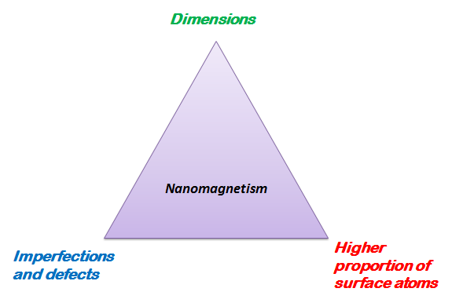
Figure 1 The importance of studying Nanomagnetism.

However, the motivation for our exploration is to study the magnetic characteristic length of Nanomaterials. In table 1, it is clear that almost all of magnetic characteristic lengths are falling in the range of 1-100nm like the domain wall width and the spin diffusion lengths. The problem raised here is what will happen when size of materials is smaller than those characterisitic length [3] [4] ? Therefore, the purpose is mainly focused on preparing magnetic nanowires including ferromagnetic nanowires and antiferromagnetic nanowires which could help with understanding manipulation of spins in nanowires.
A typical example in Fig 2 shows magnetic domain wall motion in Permalloy nanowires by applying a magnetic field. The velocity is linear with applied field. And the velocity of both vortex and transverse domain walls are increasing with the diameter of the nanowire by applying the same magnetic field. It is useful to use the diameter to control the velocity showing great potential in the electronic applications.

Table 1 Magnetic characteristic length scales
Symbol | Length | Typical scale (nm)
d_{a} | Interatomic distance (Fe) | 2.5*10⁻¹
d_{ex} | Range of exchange interaction | ~10⁻¹- ~1
d_{RKKY} | Range of RKKY interaction | ~10⁻¹- ~10
d_{c} | Domain size | 10-10⁴
D_{cr}^{spm} | Superparamagnetic critical diameter | ~1- ~10²
D_{cr} | Critical single-domain size | ~10- ~10³
δ₀ | Domain wall width | ~1- ~10²
l_{ex} | Exchange length | ~1- ~10²
l_{sd} | Spin diffusion length | ~10- ~10²
λ_{mfp} | Electron mean free path | ~1- ~10²
ζ | Superconducting coherence length | ~1- ~10³
λ_{F} | Fermi wavelength/metal | ~10⁻¹
λ_{F} | Fermi wavelength/semiconductor | ~10²

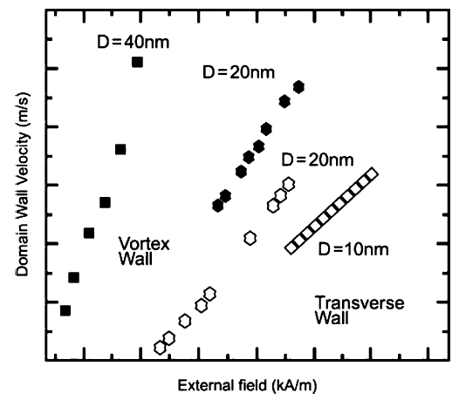
Figure 2 Domain wall velocities versus the external field in permalloy nanowires of various diameters [2].

CHAPTER 2 THEORETICAL PRINCIPLES AND BACKGROUND

Nanostructures were synthesized by many ways. Among them there are two strategies: the bottom-up and the top-down. [5] The way to evaporate atoms and molecules of precursor and then deposit them on the substrate is called bottom-up method. Ways of assembling nanostructure from bottom to up include the vapor method, the solution method and so on. In the fabrication of nanodevice, top-down is employed to shape nanosize electrodes.

2.1 Theory of nanowires prepared by vapor method
The vapor method is used commonly in nanowire’s fabrication, like vapor-liquid-solid method and vapor-solid method. The former often involves the metal catalyst to control the growth; the mechanism of the latter is mainly related to the supersaturation ratio. [6–11]
In the vapor-solid method, it is commonly accepted the two-dimensional nucleation probability on the surface of a whisker is: [12,13]
$$P_{N}=Bexp(-\frac{πσ^{2}}{k^{2}T^{2}In α})$$
B-constant
σ-surface energy of a solid whisker
k-Boltzmann constant
T-absolute temperature
α-supersaturation ratio (p/p₀) where p is actual vapor pressure and p₀ is equilibrium vapor pressure corresponding to T.
In order to achieve one-dimension growth, two-dimensional growth should be suppressed: reducing the two dimensional nucleation in this formula by lowering the temperature and reducing supersaturation ratio α (Fig 3). However, the supersaturation ratio should not be too small to have enough material deposited on the substrate. That is $α_{powder}^{3D growth}>α_{thin film}^{2D growth}>α_{nanowire}^{1D growth}$.
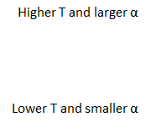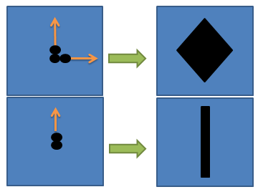

Figure 3 Temperature and supersaturation ratio competition between the one-dimensional and two-dimensional growth.

2.2 Helimagnetic structure and skyrmion

2.2.1 Theory of helimagnetic structure

Based on Landau-Ginzburg equation of free energy in terms of spin density in magnetic materials [14–21]:
$$F\left(r\right)=\frac{1}{2}A\left(S_{x}^{2}+S_{y}^{2}+S_{z}^{2}\right)+bS∙\left(∇×S\right)+\frac{1}{2}B_{1}\left[{\left(∇S_{x}\right)}^{2}+{\left(∇S_{y}\right)}^{2}+{\left(∇S_{z}\right)}^{2}\right]+\frac{1}{2}B_{2}\left[{\left(\frac{∂S_{x}}{∂x}\right)}^{2}+{\left(\frac{∂S_{y}}{∂y}\right)}^{2}+{\left(\frac{∂S_{z}}{∂z}\right)}^{2}\right]+C{\left(S_{x}^{2}+S_{y}^{2}+S_{z}^{2}\right)}^{2}+D(S_{x}^{4}+S_{y}^{4}+S_{z}^{4})$$

The first term is the exchange interaction coupling term resulted in the magnetic moments alignment (ferromagnetism). The second term is the Dzyaloshinsky-Moriya interaction that is trying to twist the magnetic moments. It often happens in a system that has broken inversing symmetry. The third and fourth terms are additional softening of the amplitude of the magnetization. The fifth and sixth terms are spin-orbit coupling anisotropy energy in especially P2₁3 space group (B20 structure). [22]
Near T_{c}, the free energy is generally minimized by periodic structures of the form
$$S\left(r\right)=\frac{1}{\sqrt{2}}[S_{k}\exp\left(ik∙r\right)+S_{k}^{*}exp(-ik∙r)]$$
$$F\left(k\right)=\frac{1}{2}A{\left|S_{k}\right|}^{2}+ibk∙\left(S_{k}×S_{k}^{*}\right)+\frac{1}{2}B_{1}k^{2}{\left|S_{k}\right|}^{2}+\frac{1}{2}B_{2}(k_{x}^{2}{\left|S_{kx}\right|}^{2}+k_{y}^{2}{\left|S_{ky}\right|}^{2}+k_{z}^{2}{\left|S_{kz}\right|}^{2})$$
$$S_{k}=α_{k}+iβ_{k}$$
$$S\left(r\right)=α_{k}\cos\left(k∙r\right)-β_{k}sin(k∙r)$$
F(k) is minimized when choosing α_{k} is perpendicular to β_{k} and |α_{k}|=|β_{k}| and k antiparallel to α_{k} x β_{k} (b>0)
$B_{2}<0$ k is parallel to (111)
$B_{2}>0$ k is parallel to (100)
$$F\left(r\right)=\frac{1}{2}A{\left|S_{k}\right|}^{2}+ibk∙\left({-2α}_{k}×iβ_{k}\right)+…$$
$$F\left(r\right)=\frac{1}{2}A{\left|S_{k}\right|}^{2}+2bk\left(\left|α_{k}\right|\left|β_{k}\right|sin⁡(α_{k}^β_{k})\right)cos⁡(k^(α_{k}×β_{k}))+…$$
$$F\left(r\right)=\frac{1}{2}A{\left|S_{k}\right|}^{2}+ibk∙\left(S_{k}×S_{k}^{*}\right)+\frac{1}{2}B_{1}k^{2}{\left|S_{k}\right|}^{2}+\frac{1}{2}B_{2}(k_{x}^{2}{\left|S_{kx}\right|}^{2}+k_{y}^{2}{\left|S_{ky}\right|}^{2}+k_{z}^{2}{\left|S_{kz}\right|}^{2})$$
$$F=\left(\frac{1}{2}A-\left|b\right|k\right){\left|S_{k}\right|}^{2}+(\frac{1}{2}B_{1}+\frac{1}{6}B_{2})k^{2}{\left|S_{k}\right|}^{2}$$
Which is minimized by
$$k=\frac{\left|b\right|}{B_{1}+\frac{1}{3}B_{2}}$$

Figure 4 Plot of free energy in left and right hand chiral calculated from quadratic function.

After calculation in Fig 4, the free energy in helimagnets could be plotted versus wave vector k. It is clear that the free energy has a minimum value on left and right side which is correlated to two kinds of chiral structure. [20]
In the helical magnetic structure, magnetic moments in each plane are paralleled to each other by exchange interaction coupling but rotate a constant angle in each plane by Dzyaloshinsky-Moriya interaction. Then after rotation over many planes, the magnetic moments go back to their original orientation. The distance between this plane and the original one is called pitch of the helix in helimagnetic materials. It is shown in Fig 5. The pitch of the helix is nanometer size in B20 structure materials. (18nm in MnSi, 90 nm in Fe_{0.5}Co_{0.5}Si and 70 nm in FeGe)

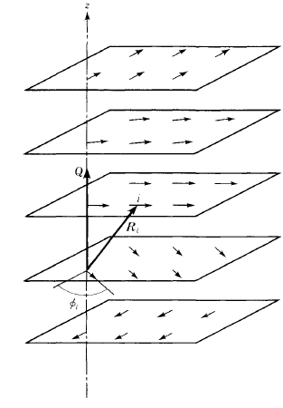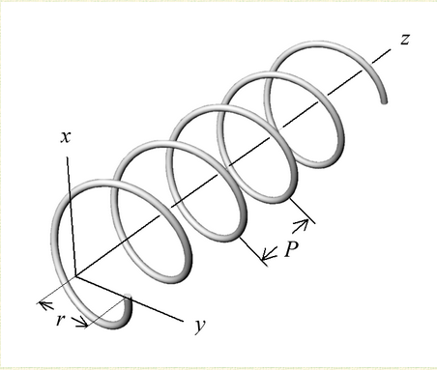

Figure 5 (a)Helimagnetic structure with in plane rotation (b) The definition of pitch of helix [23].

2.2.2 Skyrmion and its particularity

The skyrmion phase is metastable which is formed from helimagnetic structure. Comparing the energy term of body centered cubic formed from liquid [22]:
$$\sum_{q_{1}q_{2}q_{3}}{ρ_{q_{1}}ρ_{q_{2}}ρ_{q_{3}}δ(q_{1}+q_{2}+q_{3})}$$
The energy could be maximized by putting q₁+q₂+q₃ equals to 0 for δ(0)=1. So with q₁,q₂,q₃ are all moment vectors. They must be 120° rotate from each other as they have the same magnitude. In helimagnetic materials, same situation could happen here.
$$\sum_{q_{1}q_{2}q_{3}}{(M_{f}∙m_{q_{1}})(m_{q_{2}}∙m_{q_{3}})δ(q_{1}+q_{2}+q_{3})}$$
So the skyrmion formed from the helimagnetic structure could gain energy from the above equation. So it makes the skyrmion entire hexagonal lattice. (Fig 6(b))
Skyrmion is a quantized vortex like magnetic structure with center magnetic moments parallel or antiparallel and outmost magnetic moments antiparallel or parallel to the external magnetic field.(Fig 6(b)) It is a combination of conical and helical states. [24] So in helimagnetic materials, it is stabilized by a small magnetic field when its temperature is near its magnetic transition point. If the magnetic field is too large, magnetic moments will tilt towards magnetic field resulting in the conical state. Then it will become field polarized if field is large enough to align magnetic moments with a magnetic field [25].(Fig 6(a)) In neutron scattering, helical states align in <111> direction of MnSi could be identified, and pitch of the helix could be calculated by p=2π/q when q is distance between two <111> spots. After field is applied, skyrmion shows a hexagonal lattice pattern. [22](Fig 7) Their existence are similar with bubble memory where a thin film of a magnetic material to hold small magnetized areas, known as bubbles or domains, each storing one bit of data.

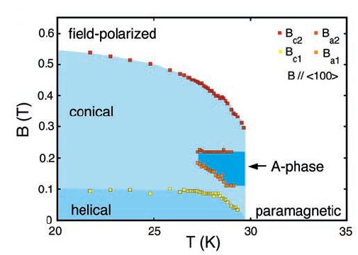
(a)
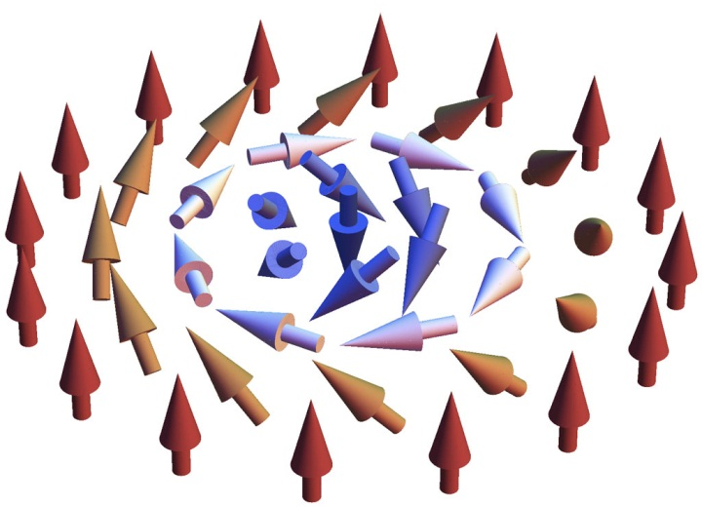
Figure 6 (a) Magnetic phase diagram of MnSi [22] (b) Skyrmion is a quantized vortex like magnetic structure [26].

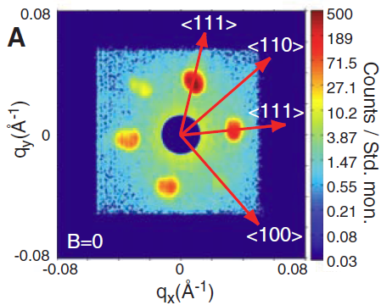
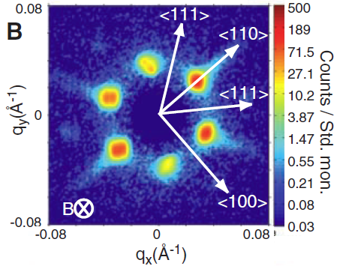
Figure 7 (A)Neutron diffraction data of the helical magnetic ordering in MnSi single crystal at 27K (B) Hexagonal skyrmion diffraction pattern of MnSi single crystal at 26.5K with field of 0.164T [22].

Skyrmion could be characterized using Neutron diffraction, SQUID (Superconducting quantum interference device) and (Lorentz microscopy) TEM [27]. When the magnetization, temperature and magnetic field are plotted as three axis of a coordinate system, the “skyrmion” phase could be drawn as a raised plateux.(Fig 8(a)) In the phase boundary, it is discontinuous first order transition [28] and shows the magnetization of a pocket. Fig 8(b)(c) Magnetization curves vs temperature with kinks at low field is represented of helical magnetic phase.(Fig 8(d)) In magnetization curves vs. field, the pocket area between kinks with a small field shows the boundary of the magnetic structure. Using multiple points’ measurement, AC susceptibility versus field could be plotted at different temperature close to transition point. Three-dimensional curves are plotted to reveal the diversification of A-phase depending on the temperature and the magnetic field. The magnetic phase diagram is plotted also. [29,30] In Lorenz TEM, real images of skyrmion are observed by placing thin plate of FeGe under electron beam. [31] The skyrmion lattice in FeGe is shown in Figure 9.

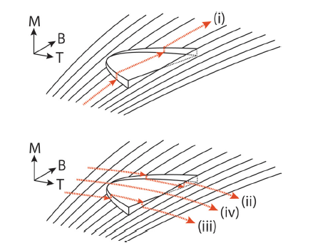
(a)
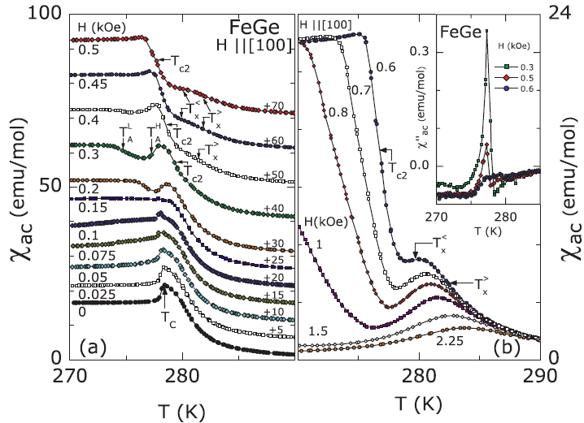
(b) (c)
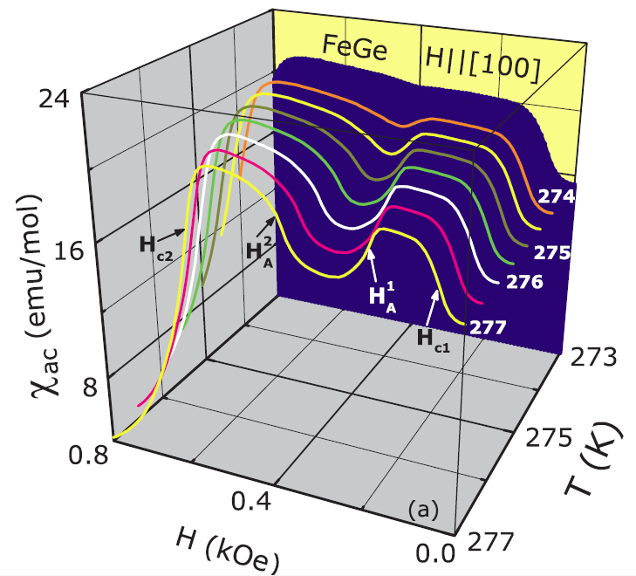
(d)
Figure 8 (a) The “A” phase transition in magnetic moments measurements vs temperature and external field [28] (b) (c)Various magnetic susceptibility measured vs temperature measured under different fields (d) AC susceptibility versus field [30].

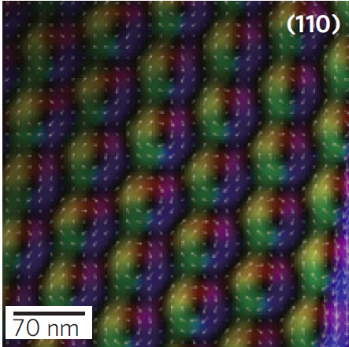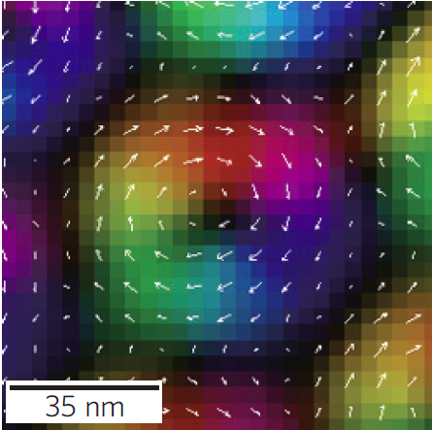
(a) (b)
Figure 9 (a) Skyrmion lattice on thin plate of FeGe under Lorentz TEM (b) Size of a single skyrmion [31].

2.2.3 Skyrmion and domain wall motion

Skyrmion and magnetic domain wall motion share many similarities. Their motion could be driven by the magnetic field or the electrical current. [32–34] In the field driven domain motion, domain wall velocity could be measured by GMR (Giant magnetoresistance) effect. If a field is applied to the right and wires with magnetic moments orients to the left, the domain begins to grow, and the domain wall moves to the right. The total resistance is changing if there is another layer of known magnetization covered. The total resistance will be acted like GMR effect. There is a threshold field named the walker breakdown field. It is the maximum field could be applied in field driven motion of domain walls since above it; the motion become turbulent and oscillation. Below this field, the velocity is almost linearly increased with field strength. [1]
Current driven is another way to move domain wall. It passes spin polarized current to the domain wall and has a torque applied by localized magnetization (Fig 10). And it is also exert a torque on local magnetization (domain).The domain wall is moved by so called spin transfer torque ,and there are several ways to see domain motion like magnetic soft X-ray microscopy, spin polarized scanning electron microscopy and MFM (Magnetic force microscope). [35–37] By injecting a pulsed current around nanosecond, researcher can measure the distance domain wall travels. And then the velocity of domain wall could be calculated.

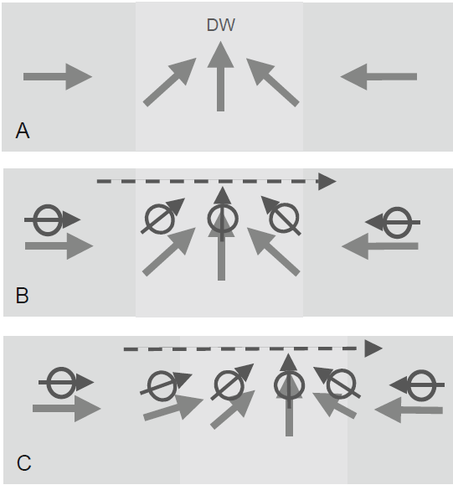

Figure 10 Current driven domain wall motion [3].

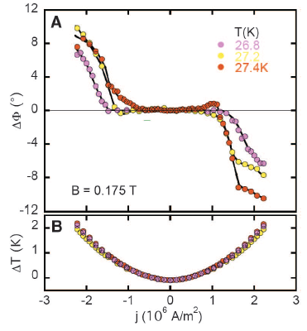
Figure 11 Spin transfer torque at ultra-low current density of MnSi single crystal [34].
In traditional ferromagnetic materials, current density of 10¹¹Am⁻² was required to move domain walls. However, only current density of 10⁶Am⁻² was needed to rotate skyrmion by spin polarized current. [32] [38] It was observed by neutron data. The rotation angles versus current density and threshold current density at different temperatures were shown in Figure 11. It gives a hint to explore the spin transfer torque in nanowires since it avoid much heating when small current passing through. [32,34] Skyrmion could be write and delete by tunneling current [39]. Researchers proposed an idea of aligning domain wall along a nanowire track, and with a reading head to measure its magnetoresistance or writing head to inject current. It shows great potential to be next generation of data storage device. [40] It is cheaper, energy saving and faster. Supposing replacing domain wall with skyrmion, much less energy will be consumed.

2.3 Spin density wave

2.3.1 Formation of spin density wave

Spin density wave (SDW) is a low temperature ordered state in materials such as ferromagnetism, antiferromagnetism and superconductivity. [41–43] It is formed by electron-electron pairs which should repel to each other.
In Fig 12, the normal state, charge density wave and spin density wave state are plotted. In normal metal, number of spin-up electrons equals number of spin-down electrons. Therefore the total spin density is zero and total charge is constant. In charge wave density Fig 12 (a), electrons with opposite spin direction has been paired up with wave distribution of charge density. However, in spin density wave Fig 12 (b), the spin of electrons has been separated which make wave distribution of spin density leaving charge constant. Because the wavelength of spin density is decided by electrons, incommensurate SDW is named for wavelength mismatching with ion spacing-lattice constant. If wavelength of SDW is fit to the lattice constant, it is called commensurate SDW. [43] In FeGe₂, as temperature is lowering, a magnetic curve passes through paramagnetism to incommensurate SDW at 289K, and then reaches commensurate SDW at 263K. [44–46]

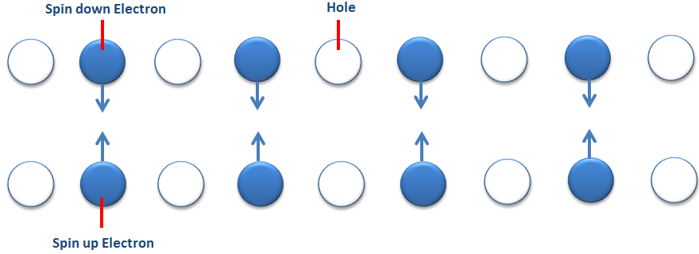
(a)
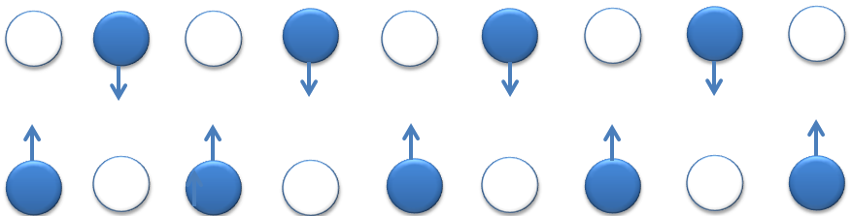
(b)
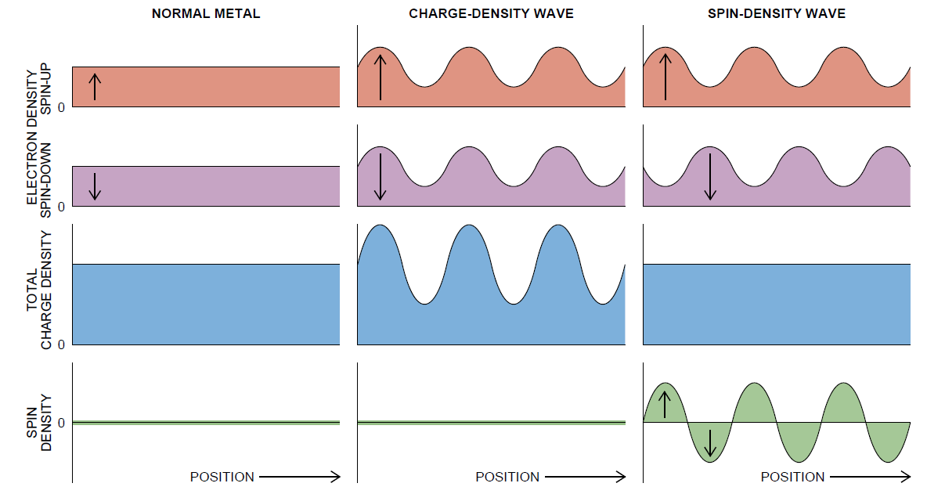
(c)
Figure 12(a) Charge density wave (b) Spin density wave (c) Comparison of normal metal, CDW and SDW [41].

2.3.2 Verification of spin density wave

There were several methods employed to identify the emergence of spin density waves. Those were conductivity measurement [44]; neutron scattering [45–49], nuclear magnetic resonance. In nanowire measurement, it is obvious that conductance is easier to be measured in nanowires.
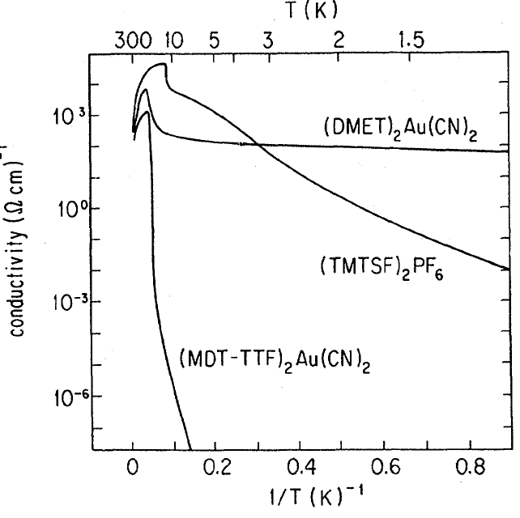
Figure 13 Conductance measurement of SDW [47].

From the Fig 13, when we lower the temperature, first the conductance will increase with decreasing temperature. That could be explained by decreasing metal resistivity with temperature. However, after cooling, the materials will reach the SDW state. Then the electrons have been paired up and refuse to move freely. Then the conductance drops abruptly leading to insulator behavior. [41] So this sudden transition shows a clear sign of SDW.
FeGe₂ is a very special material which has two types of SDW: incommensurate SDW and commensurate SDW. The transition from paramagnetic to incommensurate SDW is at 289K and that from incommensurate to commensurate SDW is at 263K. [45–47,51]In this case, the magnetoresistance is considered the best way to identify the boundary of SDW phase as there is slight shift when it reaches. (Fig 14)

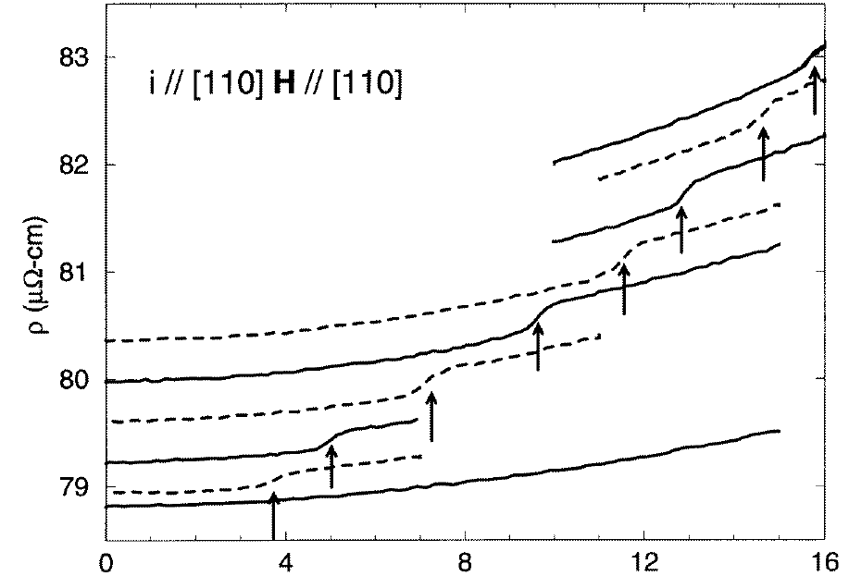
(a)

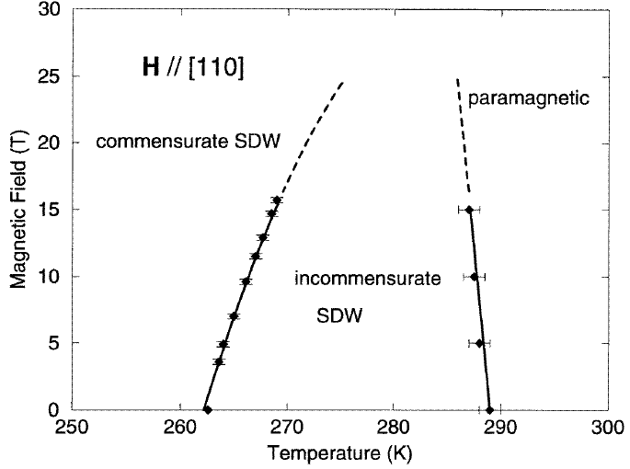
(b)
Figure 14 (a) Resistivity changes when applying current and field along [110], from bottom to up each curve represents a temperature: 260, 263.6, 264, 265,266.1,267,268.5,269K (b) Constructed magnetic phase diagram [51].

CHAPTER 3 Design of the CVD system for nanowire growth

3.1 Nanostructure prepared in chemical vapor deposition with leaks
Nanowires of MnSi compounds could be prepared through direct evaporating Mn powder on a silicon substrate. In my initial exploration, many experiments were attempted in CVD system with leaks because they are sealed by rubber tubes. At the same time Ar gas is kept flowing to avoid too much air in the system. In this case, nanowires begin to grow. However, Mn₄Si₇ crystals are formed on substrate in a well-sealed system.
In those samples with nanowires, usually there are four different morphologies observed: the continuous film, the nanowires, the nanowires plus scattered particle, the particles. The strange phenomenon is that the wires are locating in a narrow area near the edge of sample. It is shown in Fig 15. EDX are applied to measure the relative composition of Mn deposit on different regions. Same size squares are used to get spectrum in different bands.

1 mm
200 µm
(a) (b)
20 µm
20 µm
20 µm
(c) (d)
Figure 15 Different morphologies observed in CVD when there are leaks in system (a) Three narrow bands (b) Details in narrow bands (c) The detail of outmost band with scattered particles (d) The innermost nanowires band.

Table 2 Composition of Mn:Si in samples prepared by atmosphere CVD
Name  (from outside to inside) | Mn % (atomic) | Si % (atomic) | Relative Mn:Si  (Atomic composition)
First band (scattered particles) | 10.15 | 89.85 | 0.113:1
Second band (Nanowires plus scattered particles) | 22.43 | 77.57 | 0.289:1
Third band (Nanowires) | 32.2 | 67.8 | 0.475:1
Inner band (Continuous film) | 30.71 | 69.29 | 0.443:1

The data shows Mn composition is increasing from outside to inside. At the same time, samples have been prepared for the Mn powder directly touching the surface of silicon substrate. There were several Mn-Si multiple symmetric structures formed like “rolls” (Fig 16 (a)); their composition was around 50% of Mn and 30% Si. Comparing to the experiment conducted in pumped CVD system, it is concluded that “something” formed in the substrate edge could help the one dimensional growth. Neither too much Mn nor too much silicon will help nanowire growth.
I have tried to prepare the nanowires with different gas flow directions and there were no differences.
Excluding the flow direction effect, another reason may be considered as the role of oxygen. If oxygen reacts with silicon substrate in the system, it should be near the edge since other places have high percentage of Mn vapor. To verify this mechanism, experiments were conducted with system opening to air. The result is shown in Fig 16 (b)(c).
In this experiment, many octopus structures were formed with Mn head and SiO₂ tentacles. So wire structures do prefer oxygen contained in surroundings. But with too much oxygen contained in system, nanostructures got too much oxidized. Therefore, the amount oxygen should be less and controllable. In this case, proper oxides may be another option to get nanowires growth. To identify it, I have used a thin glass slide (SiO₂) which is 100µm thick to work as substrate in a sealed system. In this case, the SiO₂ melted directly after being deposited of the Mn vapor. However, in the region near the melted SiO₂, the nanowires appeared and located around the melted part (Fig 17). It is highly likely for Mn-Si nanowires growing on the SiO₂ so we tried synthesizing them by substrates with SiO₂ thin film with a well-sealed system.

20 µm
(a)
20 µm
(b)
1 µm
(c)
Figure 16 (a)The "hexagonal roll" structure; (b) The morphology of nanowires prepared in system open to air (c) and the details of Mn head with SiO₂ hairs.

Melted SiO₂
100 µm

Figure 17 Nanowires growing around the melted SiO₂.

3.2 CVD System setup

Our system is a homemade tube furnace chemical vapor deposition system. It has a flow controller, pressure gauge, mechanical pump with a needle valve to control pumping speed, and a tube furnace for temperature control. Substrates are Si wafers with a thermal growth of SiO₂ layer some hundreds of nm thick. Two geometry of source and substrate location are shown in Fig 18 (a)(b). Choosing them depends on evaporate rate of the source material. The design of the whole system is shown in Fig 18 (c).

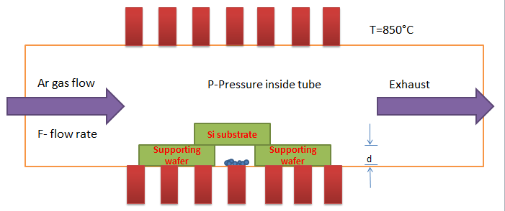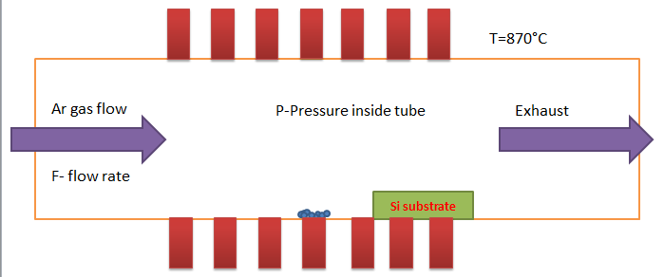
(a) (b)
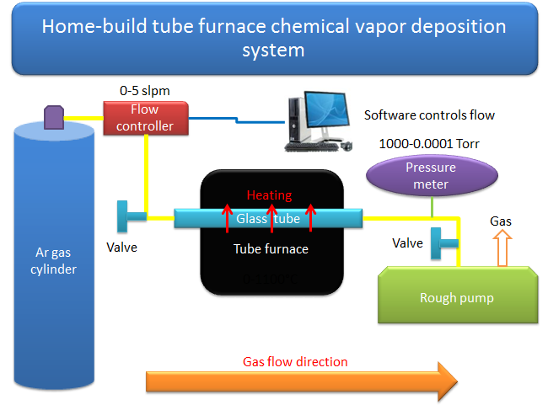
(c)

Figure 18 (a)(b)Two geometry of chemical vapor deposition in nanowires growth, (c)the design of CVD system.

3.2.1 Tube furnace heating curve

Temperature is a critical parameter to control the growth. Usually precursor evaporating temperature is different from that for substrate deposition. Halides are prefered in nanowire synthesize because of low melting and boiling points, however, metal powders require more heat to evaporate. In the place where the substrate locates, temperature should be kept in the range which expected phase is stable. So the temperature curve of our tube furnace is essential to the growing the right phase of the nanowire. Pressure, flow rate, geometry and substrates together could suppress the supersaturation ratio which enables the one-dimensional growth.

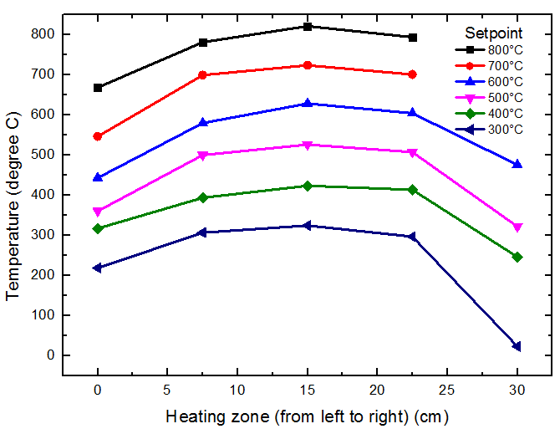

Figure 19 Temperature profile vs. position in tube furnace used for CVD.

In Fig 19, the temperature profile of our tube furnace is shown. Each color represents one set temperature which is displayed in the control panel of tube furnace. The actual temperature was measured by thermocouple each time moving its tip 5 cm towards one direction. Clearly the real temperature is not consistent with set temperature. In the middle of furnace, the actual temperature is 20°C higher than displayed temperature; however, temperature in both sides which is 7.5 cm from middle point is very close to the set one. In the end of the heating zone, temperature drops greatly at 100-200°C. In experiment process, the Argon gas is flowing into the whole tube and carries away heat. So the real temperature gradient should be larger in the side connecting to the gas cylinder. There is situation when there is a temperature competition between the precursor and product. People often used two-zone or even three-zone furnaces to control the both temperature of source material and substrate. By placing the sample and substrate in different location inside the glass tube, temperature could be controlled in the same way.

3.2.2 Pressure gauge calibration

The convection vacuum gauge (KJLC 275i) was purchase from Kurt J Lesker Company. The measurable pressure range is 1 mTorr to 1000 Torr. Its factory setting is calibrated with N₂ and air. The carrier gas employed here is Argon (Ar), thereofre further calibration is required. Based on the table in the manual of this pressure gauge, a curve is plotted and a function is fit with this curve. Any real Ar pressure P_{real} could be calculated from P_{display} (Fig 20). Typically it is 760 Torr when the gauge shows 23.8 Torr when only argon is flowing through the system.
$$P_{real}=104.88×{\left|P_{display}-8.83\right|}^{0.68}+100$$
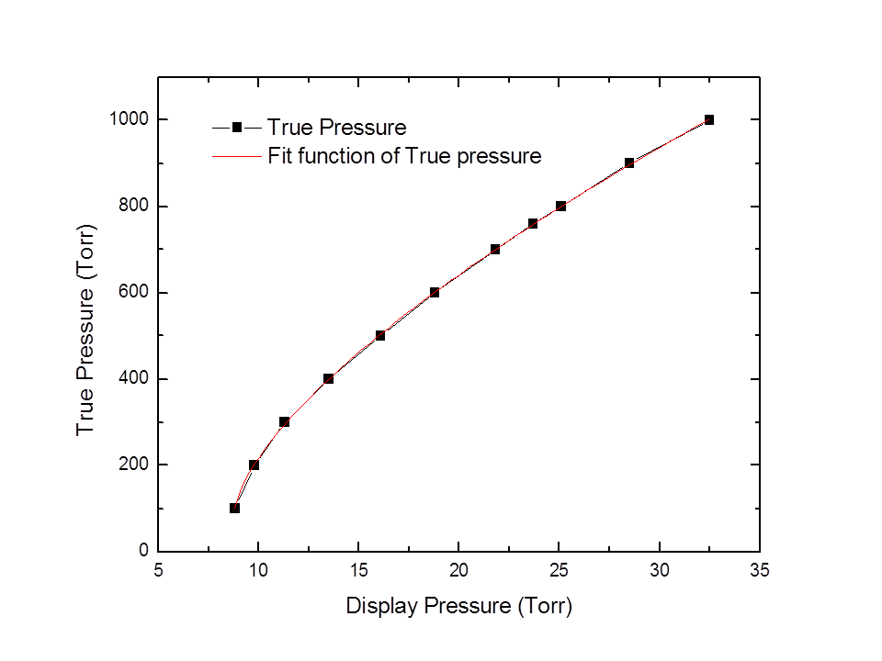

Figure 20 Relation between displayed Ar pressure and real Ar pressure.

3.2.3 Flow meter calibration

The flow meter was purchased from Sierra Instrument company. With cable connecting to computer, we could easily adjust the required flow rate using installed software. For Ar gas, however, the true flow (F_{true}) rate is shown below:
$$F_{true}=1.398×F_{display}$$

3.2.4 Oxide layer growth on silicon wafer

The oxide layer was synthesized in Center for Nanophase Materials Science, Oak Ridge National Laboratory using an atmosphere pressure Chemical Vapor Deposition system. Dry method was using silicon thermal reacting with oxygen slowly, which enabled a thin dense film. However, oxide thickness more than 200 nm often involved wet method, in which water reacted with silicon giving a relative faster growing speed.

3.3 Characterization Tools

3.3.1 Morphology, structure and composition

Most characterizations were conducted in Center for Nanophase Materials Science, Oak Ridge National Lab. Zeiss Merlin VP SEM(Scanning Electron Microscope) equipped with EDS (Energy-dispersive X-ray spectroscopy) were used a lot to identify the growing structures and compositions which guided me to adjust the growth parameters. X-ray powder diffraction with temperature-controlled sample environment was used to tell the main phases on substrate. Soft Matter TEM (Transmission Electron Microscope) (Zeiss Libra 120 TEM) and FEI Titan S aberration-corrected TEM-STEM were exploited to get the diffraction pattern and high resolution image of single nanowire which gave us a structure and detailed morphology. (Fig 21)

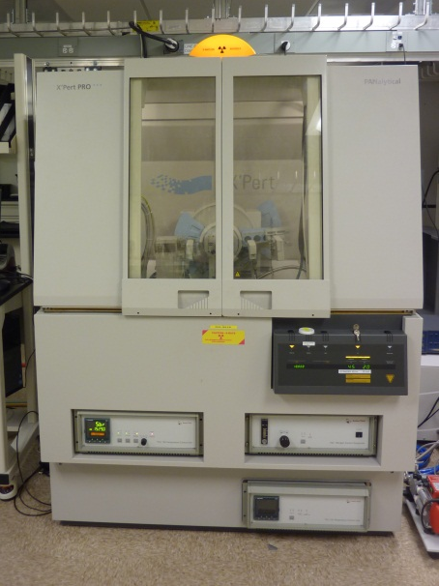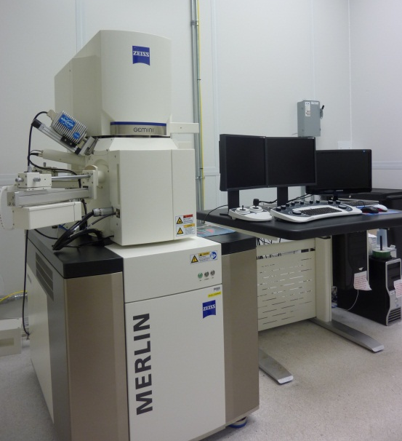
(a) (b)
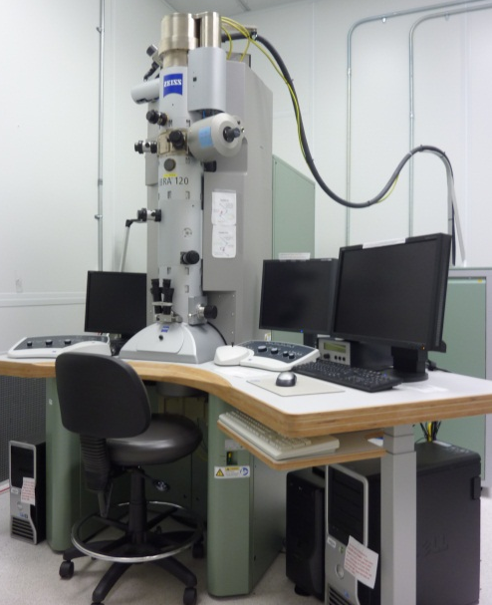
(c)
Figure 21 (a) Powder X-ray diffraction (b) Zeiss Merlin VP SEM equipped with EDS (c) Zeiss Libra 120 TEM.

3.3.2 Magnetic and electronic properties

SQUID (Superconducting quantum interference device) magnetometers in CNMS was utilized to measure the magnetic properties of sample though signal is small. Its capability is for a unique class of sensitive magnetic measurements in key areas such as high-temperature superconductivity, biochemistry, and magnetic recording media.(Fig 22(a)) The equipment could reach as high homogeneity magnet configurations as of ± 7.0 Tesla; its function includes:
1. Continuous low temperature control/temperature sweep with enhanced thermometry and reciprocating sample option (RSO) - DC magnetization absolute sensitivity: 1 x 10⁻⁸ emu at 2,500 Oe;
2. SQUID AC Susceptibility Measurement, 0.1 Hz to 1 KHz;
3. Horizontal & Vertical Sample Rotators
4. Fiber Optic Sample Holder
5. Magnet Reset
In our sample, it was mainly used to measure magnetic transition curves, M-H hysteresis curves, ac susceptibility. All of them have been analyzed to verify the existence of helimagnetic structure and skyrmion and various magnetic properties. PPMS (Physical property measurement system) was employed mainly for low temperature measurement of resistivity of single nanowire device and its Magnetoresistance. (Fig 22(b))
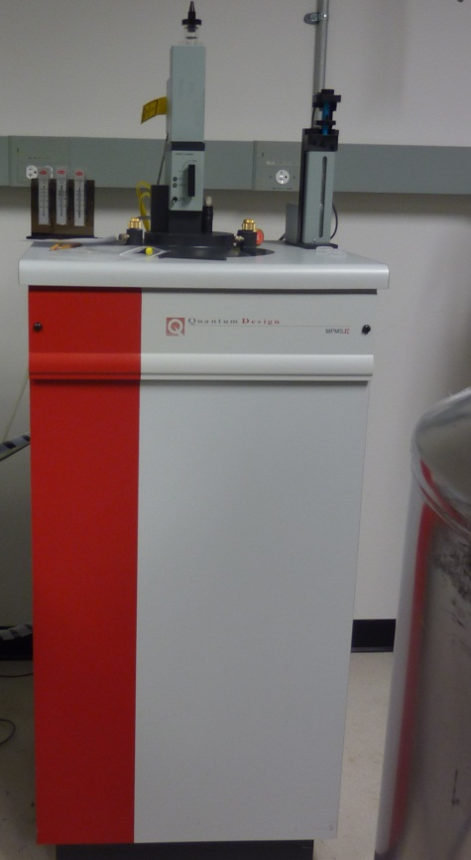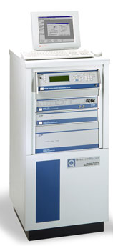
(a) (b)

Figure 22 (a) SQUID used for magnetic measurements and (b) PPMS used for transport properties measurements.

3.3.3 Device fabrication

Spin coater were used to cover the wafer with PMMA or copolymer (e-beam resist) the thickness of which was determined by spin speed. After coating, a baking system was used to bake the layer at 100-200°C. (Fig 23(a))
To write pattern on the surface, JEOL 9300FS 100kV Electron Beam Lithography System was used. It writes at rates up to 50 MHz and has a minimum spot size approaching 4nm. Field sizes up to 1mm can be written without stage movement. Layout BEAMER is used for file conversion and proximity correction. High speed, large area writes with limited beam drift and variations across a wafer are a highlight of this tool. Operation at high energy (100kV) allows writing on insulated substrates with minimal or no dissipation layer. (Figure 24)
Chemicals solutions of PMMA, Copolymers, MIBK+IPA (the volume percentage of MIBK decides the developing aggressiveness and feature size), isopropanol (used to stop develop), acetone, Liftoff strip are used to cover the wafer, develop the pattern and liftoff the gold layer.
A Dual-beam evaporator was used to deposit the metal film such as electrodes such as Cr/Au/Ti/W. Electrons are controlled by magnetic field to hit the target which evaporates the metal on the substrates. The deposit speed is fast but usually is controlled at 1Å/sec. It has smaller grain size and is more uniform than sputtering. (Fig 23(b))

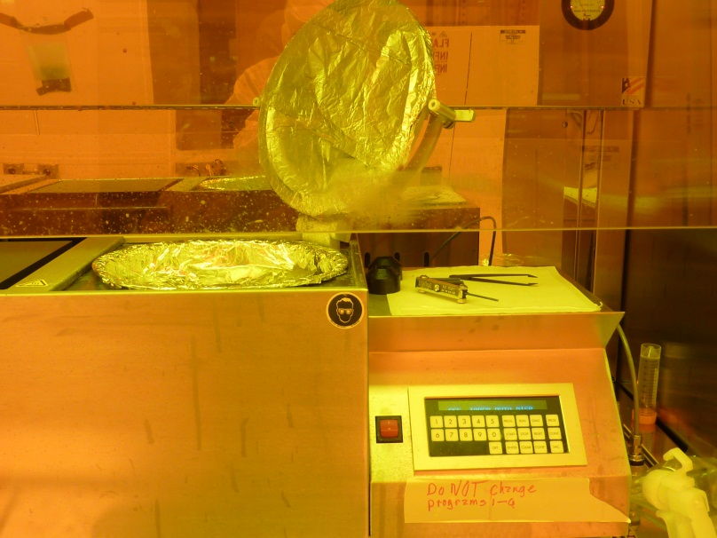
(a)
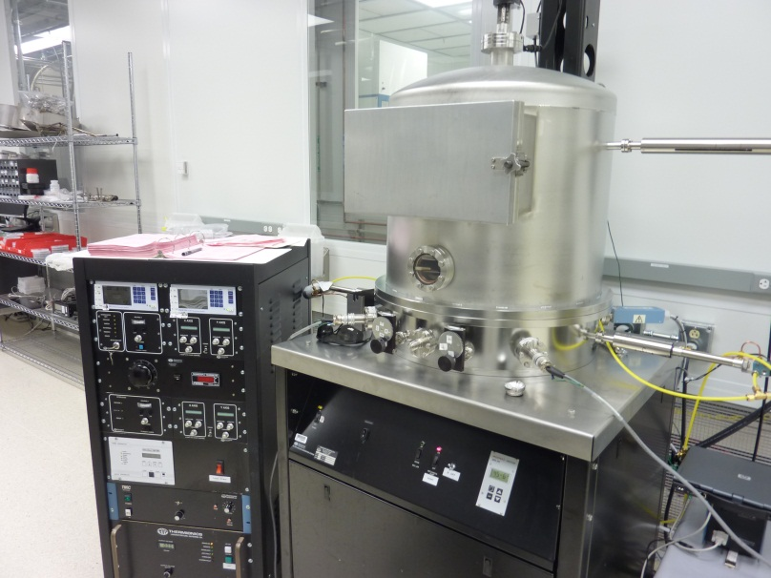
(b)
Figure 23 (a) Multiple speed spin coater (b) Dual electron beam metal evaporator.

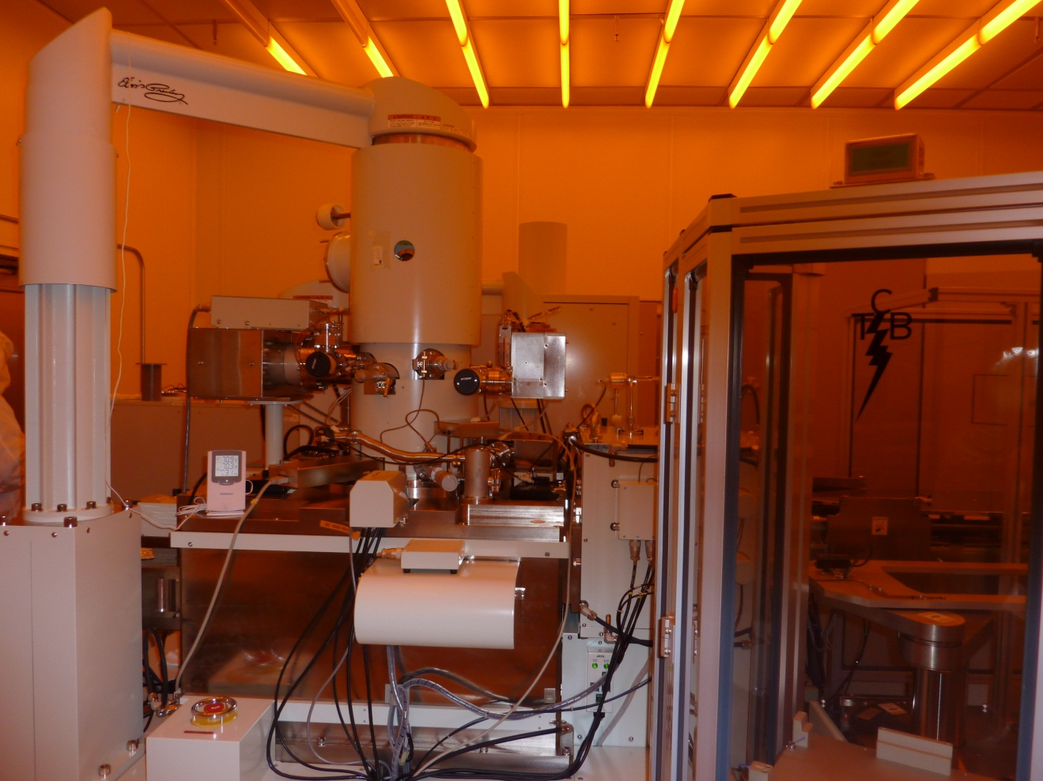

Figure 24 JEOL 9300FS 100kV Electron beam lithography system.

CHAPTER 4 Optimization of the E-beam nanofabrication process for nanodevices

Four probe devices are widely used to measure its physical natures such as electrical or magnetic properties. The process involves several steps including transfer, measure, design, coating, exposure, develop, deposit, liftoff. Each step needs more cautions because it is easy to break comparing to bulk materials.

4.1 Standard procedure for device fabrication via e-beam lithography

4.1.1 Preparation of transferring wafer

A clean silicon wafer was used to grow a thin layer of silicon dioxide (around 200nm). The reason for this step was the silicon dioxide could be used as an insulating intermediate layer between nanowires above and silicon wafers below. Then gold cross markers were designed and deposited beforehand. The process was same as we designed the electrodes, exposed under e-beam and deposit them. In our case, we had 25 patterns in one whole piece of wafer and each pattern contains 31*31 cross markers. Each marker was 60 µm in width and 200 µm from each other. Small dots along different foot of the cross markers were used to identify its own number in total 25 patterns.

4.1.2 Nanowires transferring, measuring and electrodes designed

Nanowires were scratched from growth wafer using a clean blade, and then some Acetone/Ethanol is sprayed onto it. The droplet containing a bunch of nanowires was falling onto each pattern.
Under the scanning electron microscope, it was easy to see that wires were everywhere. Find the straight one and measure the distance between its middle point to surrounding four nearest crosses, then measured the length and the diameter of the nanowire, at last counted the column and row in which the nanowire located so that e-beam could find it easily later (Fig 25).
100µm
Figure 25 Nanowires transferred in each 31*31 pattern.

Based on the measuring coordinates (Fig 26(a)), four probe devices were designed in software named “layout”(Fig 26(b)). It was very tricky to design the electrodes since it should be neither too small nor too big. Electrodes like square shape as big as 500 µm took around 32 hours to run over whole 25 patterns by e-beam system. However, electrodes could be very difficult to attach to outer electric wires for measurements if they were too small. The spacing between contacts also required caution to design. Current contacts should be further to each other and so do voltage contacts. But current contacts should be closer to voltage contact to avoid big error. However, it might cause lift off issue.

4.1.3 E-beam writing

Before exposure, all the designed files should be changed to e-beam system (JEOL 9300FS 100kV Electron Beam Lithography System) read files. Then, a layer about 200-300nm of e-beam resist (PMMA) was spin coated onto the transferring wafer before baking it for 1 mins at 180°C. The thickness depend on the spinning speed. PMMA is a positive e-beam resist which will become soft and soluble in developer after exposure. After loading the wafer, creating the job, calibration, and the system begin to write the electrodes after finding the location of nanowires by measured column and rows. Later, the piece of wafer is taken out and then put into MIBK+IPA (1:3) for develop in 35s by cutting the chains of organic materials. Then the shape of devices is visible under optical microscope. In Fig 26 (c), it shows the designed pattern and the actuall pattern before liftoff.

4.1.4 Deposit electrodes and lift off

Materials like Au and Cr was used for electrode. Dual beam evaporator was employed to deposit fast (usually controlled at 1Å/sec) metal layer on the pattern. For Au, it is soft and does not stick to the wafer so we often first deposit 10 nm Cr before deposit 150-250 nm of gold film.
In the end, Acetone was used for liftoff process. The gold layer deposited on PMMA was cast off leaving the electrodes. The whole process is shown in Fig 27.

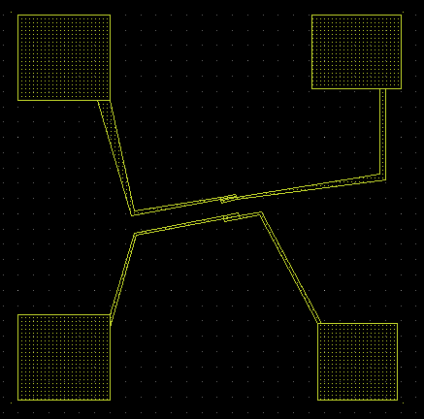
(a) (b)
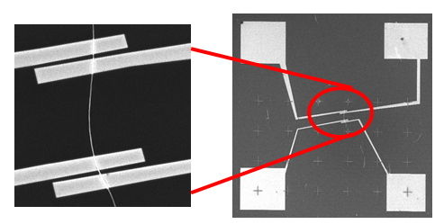
(c)
Figure 26 (a) Distance from the center of the nanowire to gold marks has been measured (a) Designed electrodes by layout software (c) The real PMMA pattern after exposure of e-beam.

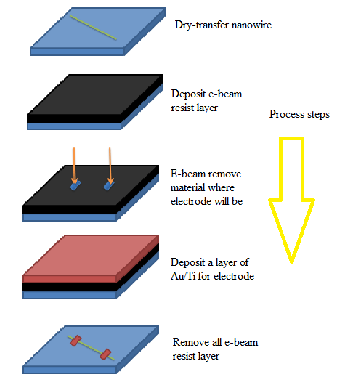

Figure 27 The procedure of nanowire devices fabrication.

4.2 Problem in the process

Since the wires were relatively thick (MnSi wires are 500-800 nm and FeGe₂ wires are 100-300 nm). It became very challenging to fabricate the devices via a single layer of PMMA. The problem lied on the fact the PMMA was so thin comparing to nanowires, that after spin coating, the real thickness on the wires was smaller than other places (Fig 28). So after lithography, the remaining PMMA above nanowires was gone. But PMMA thickness in other places was so thin compared to nanowires. Since firmness of electrodes depends on their thicknesses, we need thick metal layer. So it made the deposited metal film attached each other result in hard liftoff since acetone could not penetrate through the metal film. The SEM images show this kind of problem (Fig 29).

4.3 E-beam energy dose correction and double layers of e-beam resist

The problem ultimately relies on the thickness of PMMA and metal film. That is why two methods were tried at the same time to avoid this situation. By adjusting the dose of electron beam, the best square of electrodes with least residue PMMA could be found. And by adding additional layer on PMMA, we could prevent the attachment of deposited films. Dose means electric charge (D=I_{beam}*T_{dwell}) exposed on the surface per unit area/length/dot. With only PMMA around 200 nm coated on substrate, it wa clear than PMMA residue decreases with increasing dose.
With changing the dose, ordinary steps were followed. After e-beam lithography and develop, the sample was put under optical microscope to see if there was residue inside the places which has been exposed to e-beam. Commonly residue particle will be observed suggesting higher dose.

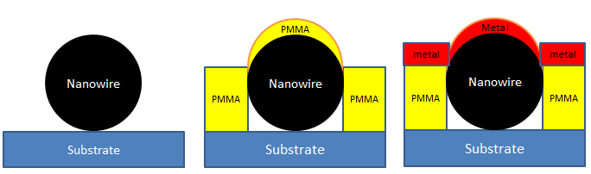
(a) (b) (c)

Figure 28 (a) Thick nanowire before spin coating (b) Thick nanowire after spin coating (c) Thick nanowire after deposit metal film.

20µm
(a)
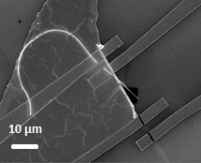

(b)

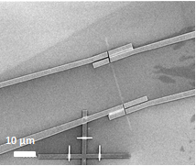

(c)

Figure 29 Liftoff issue happened after deposit metal layer on pattern.

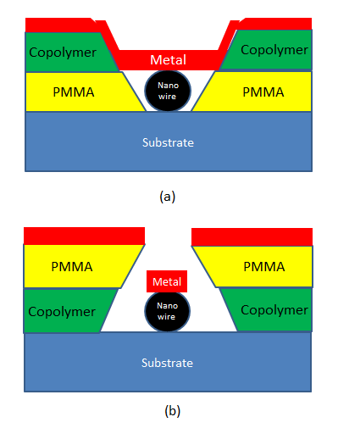

Figure 30 (a) Double layers with PMMA in bottom (b) Copolymer in bottom.

In Fig 30, double layers were employed to increase the total thickness (lithography depth) of resist. Two geometries of these two layers were analyzed. The copolymer is much more sensitive to e-beam and develops faster than PMMA. However, geometry plays another role too. Option in Fig 30 (a) will attach metal film because copolymer will form wider feature than PMMA leading to attachment and coverage of surface. And it forbids Acetone to penetrate. In Fig 30 (b), the PMMA develops slower which is shadowing gold layer to go inside. Saw tooth shape totally avoid the attachment of gold layers. In our case, FeGe₂ nanowires around 100-300 nm was spin coated with double layer with copolymer first and PMMA second. The bake process should be carefully controlled to avoid over bake. Copolymer was baked for 1 min at 150°C and PMMA was baked for 1 min at 180°C. Then MIBK+IPA is used for develop about 35s. Dose was optimized from 1050, 1150,1200,1250,1300. Dose of 1300 was used for the best lithography result. Electrodes of Cr-10nm (for gold is so soft) and Au-200 nm was applied after develop since thickness above 200nm was hard to liftoff. Final device is shown in Fig 31.

2 µm

Figure 31 Four probe nanowire integrated nanodevice to measure transport properties.

CHAPTER 5 Synthesize and characterization of metal silicide nanowires via oxide-assisted growth

5.1 Previous preparation of MnSi nanowires

MnSi nanowires have been synthesized by MnCl₂ with Si wafer in CVD system by two groups [52,53]. In those two groups, one zone and two zone furnaces were employed so different parameters were used. However, both conditions were attempted in my system but still countable nanowires were there besides a thick layer of Mn₄Si₇. Manganese powder was also used to prepare Mn₄Si₇ nanowires [54]. The phase diagram of Mn-Si compounds is shown in Fig 32. MnSi phase is right between Mn₄Si₇ and Mn₅Si₃. So in reports above, the nanowires with high composition of Si have been obtained with Mn vapor. Way of control amount of Si will be an option to get MnSi nanowires.
Different from the MnSi wire growth and the conventional oxide-assisted growth method employed in the growth of Si nanowires [5,55–57], in our experiments, the SiO₂ layer on Si substrate was used to assist and precisely control the growth process. It was found that the thickness of the SiO₂ layer played the key role for the high yield, correct stoichiometric and crystalline growth of the B20 MnSi nanowires.

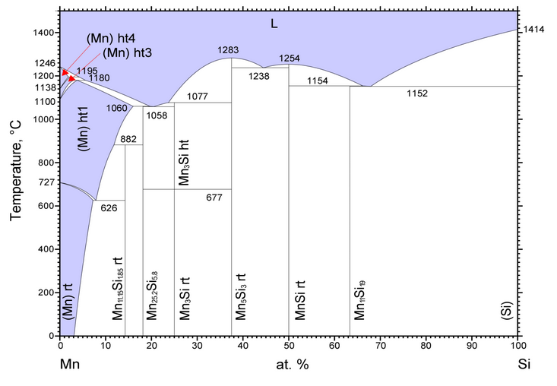
Figure 32 Mn-Si phase diagram [58].

5.2 Principle of Oxide layer assisted growth of silicide nanowires

We have systematically explored the synthesis of free-standing single crystal MnSi nanowires via controlled oxide-assisted chemical vapor deposition and observed a characteristic signature of skyrmion magnetic ordering in MnSi nanowires via magnetic measurements.
The growth of MnSi nanowires was first tried on both Si wafer with natural oxidation layer (few nanometers) and hydrogen terminated Si wafers. Oxidation free Si(001) surface can be achieved after annealing the hydrogen terminated Si wafer to 600°C. Following the optimized procedure from Refs [52,53], we observed that MnSi nanowires can only occasionally be found around the ragged cutting edge of wafers or defected areas. The amount of nanowires on an oxidation-free Si wafer is very small. Furthermore, while somewhat more wires were observed to grow on wafer with a native oxide layer, the yield was still small. Controlled thickness of SiO₂ does give a great enhancement of number of nanowires.
The above-observed existence of an optimum SiO₂ layer thickness for the growth of MnSi nanowires with high yield and correct stoichiometry reveals the significant role of the SiO₂ layer in the growth, which can be understood as oxide-assisted growth. The elemental Si required for the MnSi wires is unlikely to come from the surface of SiO₂ layer for two reasons: the growth behavior is strongly dependent on the thickness of SiO₂ layer, and the reaction temperature (850 °C) is much lower than the dissociation temperature for SiO₂ (1400 °C). It is likely that the Si needed for the MnSi growth comes from the Si underneath of the SiO₂ layer.
At elevated temperature, intermediate product of SiO can be formed by chemical reaction of SiO₂+Si→2SiO at the interface of Si wafer and the adjunct SiO₂ layer [59–61]. The two key roles that SiO plays during the growth are: first, after diffusing from the interface to the surface of wafer, SiO acts as a nucleation site which adsorbs surrounding Si and Mn atoms for the one dimension wire growth. It was observed previously in Si nanowires growth by laser ablation that much higher nanowire yield could be achieved by introducing SiO₂ powder into the Si target to form SiO [62]. Secondly, SiO forms at the Si/SiO₂ interface, and then it subsequently it diffuses through the SiO₂ film; the reverse reaction takes place at the other interface creating the Si interstitials, and the reaction repeats at the interface. This diffusion process not only diffuses SiO from interface to surface, but also largely enhances the self-diffusivity of Si atoms through the SiO₂ layer to the surface [60] to achieve correct Mn and Si stoichiometry. At the surface of SiO₂, the chemical reactions of such as 2SiO+2Mn→2MnSi+O₂ , 2SiO+Mn→MnSi+SiO₂ or Si+Mn→MnSi are needed to form the MnSi nanowires. It is worth to emphasize that this growth process involves an oxidation-reduction reaction, or an oxide assisted synthesis method, to differentiate from other growth method. [63]

5.3 Experiment details and characterization of MnSi nanowires

To quantitatively control the effect of oxygen on the growth of MnSi wires, we choose to vary the thickness of the SiO₂ layer on the Si substrates. The precise control of temperature, gas flow, pressure, distance from sample to precursor and the SiO₂ layer were conducted in a homebuilt system schematically shown in Fig 33(a). The growths were performed on Si wafers with the oxidation layer thicknesses varied from 0 nm up to 1000 nm. The number of wires on the substrate increases dramatically when the
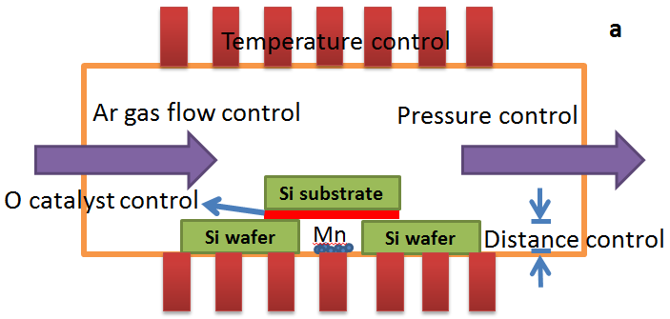
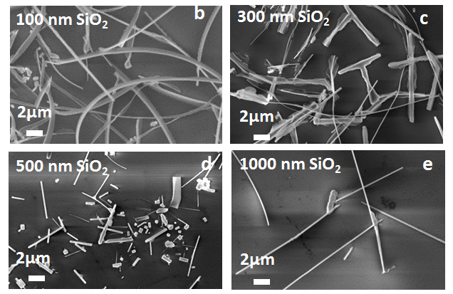
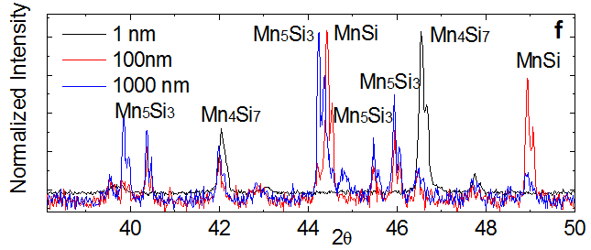
Figure 33 (a) The controlled parameter in oxide layer assisted CVD (b)-(d) Morphology comparison of nanowires prepared on substrate with different oxide thickness: 100nm, 300nm, 500nm, 1000nm and (f)their XRD pattern.

SiO₂ layer is introduced. Fig 33 and Fig 34 show the morphological, crystalline and compositional results from wafers with different oxidation layers. Fig 33(b) to (e) are the SEM images of the wires from Si wafers with 100 nm, 300 nm, 500 nm and 1000 nm SiO₂ layer, respectively. Wires from the 100 nm SiO₂ wafer have the best morphology in terms of amount, size uniformity and distribution on the surface. The crystalline structures of the wires on various SiO₂ thicknesses are very different too (Fig 33 (f)).
The Mn/Si composition ratio of the wires can be found using EDX analysis. Shown in Fig 34 (a) is a SEM image of nanowires grown on 100 nm SiO₂ at 850°C, for 80 minutes. TEM image and electron diffraction pattern confirm the single crystal nature of the wires. Fig 34 (f) shows the comparison of the EDX spectrum (normalized with Si peak) from samples with different oxide layer thicknesses. The quantified atomic ratio of Mn/Si from EDX depends on SiO₂ layer thickness, Mn/Si ratio varies from 0.6 (low oxide thickness) to around 5:3 (thickness of 200nm and above) (Fig 34 (g)). The EDS in SEM results is consistent with EDS in TEM.

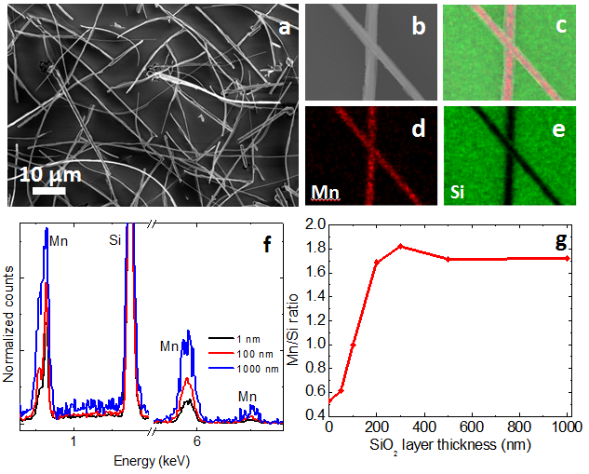
Figure 34 (a) Morphology of nanowires prepared under optimized parameters and (b)-(e) Chemical composition mapping (f) The Mn/Si composition comparison in different samples (g) The Mn/Si ratio curves change with oxide thickness.

Samples were also prepared during different time periods: 40mins, 80 mins and 160 mins. Atomic composition were compared in Fig 35 (a). The magnetization moments were compared in Fig 35 (b). The antiferromagnetic transitio in 70K became weaker as time period was longer.
Samples were prepared at different source-substrate distance: 100µm, 500µm and 1500µm. The distance were controlled by supporting wafers, whose thickness was 500 µm. Therefore, by laying one, two, three pieces of silicon wafers, distances were adjustable. Nanowires become short, smaller and more oxidized.(Fig 36 (a)-(d)) The composition shows higer concentration of Mn when the distance was smaller.(Fig 36(e)) Magnetization did not show any differences with those samples (Fig 36(f)).
Samples were prepared at temperature: 750°C, 800°C, 850°C, 900°C and 950°C. The nanowire’s shape became more crystallized and straight when temperature reached 950°C.(Fig 37(a)-(d)) However, the composition of manganese was increasing. (Fig 37(e)) Magnetization showed transition at 70K decreased and 220K increased with rising reaction temperature (Fig 37(f)).

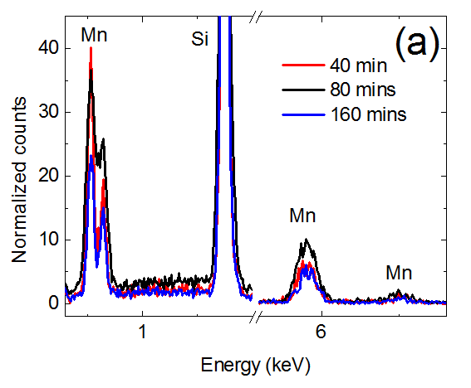
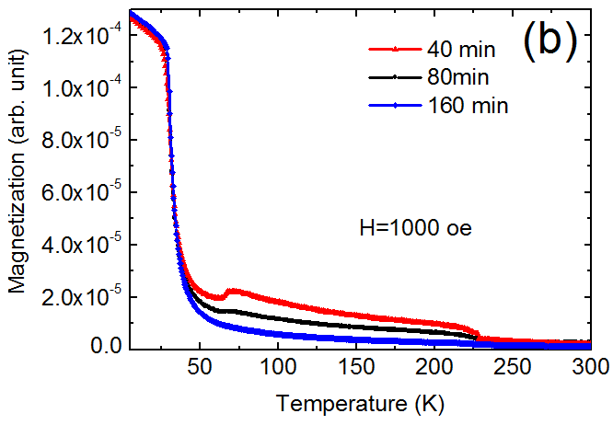

Figure 35 (a) EDX comparison and (b) magnetic measurement on nanowires prepared during different time period: 40, 80 and 160 mins.
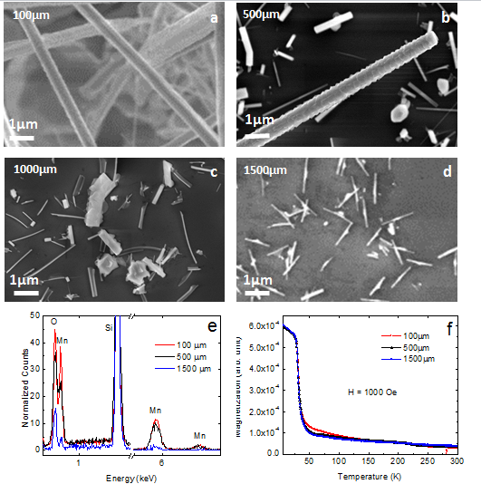

Figure 36(a)-(d) Morphology comparison and (e)Composition comparison (f) magnetic measurement on nanowires prepared during different distance from source to substrate: 100, 500 and 1500 µm.
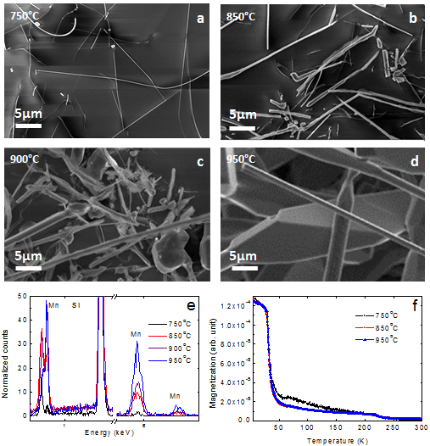
Figure 37 (a)-(d)Morphology comparison and (e)Composition comparison (f) magnetic measurement on nanowires prepared during different reaction temperatures: 750, 850, 900 and 950 °C.

Based on experimetns above, the MnSi nanowires with correct stoichiometry and B20 structure can be grown only under narrow growth conditions; any change of a single parameter leads to the change of the product structure and the composition dramatically because of the complexity of the growth process. A growth diagram (Fig.38 (a) and (b)) which combines multiple tuning parameters is necessary to optimize the growth conditions. Other than the oxidation layer thickness which was discussed above, the growth temperature, reaction time, and the distance between substrate and precursor, the vacuum pressure and gas flow rate were also systematically investigated. From the phase diagram, we can see that the B20 MnSi nanowires can only be grown in the red area. The width of the wires can be tuned from 100 nm to 600 nm by changing the growth temperature within the area.
The high yield one-dimensional growth could be qualitatively explained by the previous supersaturation theory, with the SiO₂ layers acting to control the supersaturation ratio. In order to enhance one-dimensional growth,
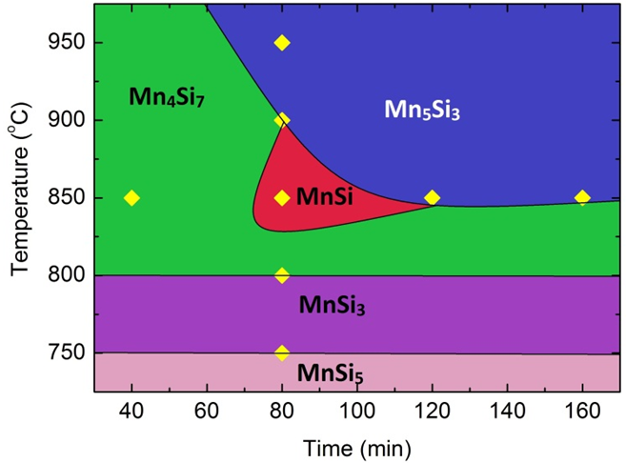
(a)
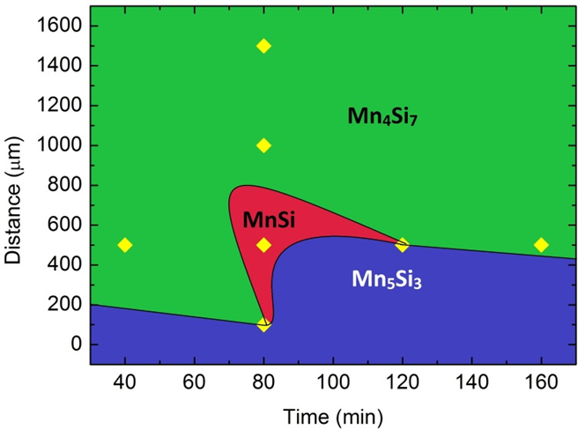
(b)
Figure 38 (a) Mn-Si nanowires growth phase diagram at various temperature and time (b) Mn-Si nanowires growth phase diagram at various source-substrate distance and time.
Reducing temperature and supersaturation ratio could be two options for one-dimensional growth. While the growth temperature cannot be changed too much because of the activation energy of the phase formation, the supersaturation ratio can be tuned by the thickness of the SiO₂ layer. In this case the thicker the SiO₂ layer becomes the lower Si or SiO concentration becomes as these species need to diffuse from bottom to surface.
The exact experiment parameters are as follows: to pump the vacuum of the system down to a fixed pressure (for example, 3×10⁻² torr in this study) before filling with Ar is the indispensable procedure to get reproducible growth. Mn powder was spread flat on the bottom of a porcelain crucible, Si (001) wafer with different SiO₂ thickness (0, 1, 50, 100, 200, 300, 500 and 1000 nm) was placed above (avoid direct contact) and face down to the Mn powder. The distance between the Mn powder and Si wafer was adjusted using layers of supporting wafers of Si to avoid contamination from other elements. The Mn powder was evaporated and deposited onto Si wafer under Ar gas flow. The gas flow rate was varied from 140 to 300 sccm (standard cubic centimeters per minute), and the pressure was maintained at 50 to 625 Torr. The syntheses were carried out at temperature between 750°C and 950°C, lasting from 40 mins up to 160 mins. The hydrogen terminated Si wafers can be produced by HF acid etching which removes the native oxide [64], they are contamination-free and chemically stable for subsequent processing as the surface silicon atoms are covalently bonded to hydrogen. SiO₂ layers were thermally grown on Si substrates. A Zeiss Merlin Scanning electron microscopy (SEM) equipped with a Bruker SDD energy dispersed X-ray spectrometry (EDS) detector were used to characterize the microstructure and composition in this study. Transmission electron microscopy (TEM) was carried out on selected specimens, using a Hitachi HF-3300 TEM/STEM at 300 kV. All the nanowires were confirmed to be single crystal although in some cases wires were covered by an amorphous silicon dioxide layer. X-ray diffraction was used to confirm the primary phase of the samples (peaks of MnSi, Mn₅Si₃ and Mn₄Si₇). As the signal from the wires was very small compared to the substrate, the omega offset was set to 2-3° to minimize the signal from substrates. DC and ac magnetic properties of the synthesized material were characterized with a Quantum Design magnetic property measurement system (MPMS) [65,66].

5.4 Magnetic measurement and verification of skyrmion

The magnetic measurements of the samples support the structural and compositional results. Shown in Fig.39 (a) are the magnetization curves near the 29 K helimagnetic transition plotted on an expanded scale. The transition is clearly apparent for the MnSi wires grown on 100 nm SiO₂ layer measured at 10 Oe. The cusp close to T_{c} is the clear signature of the formation of the helical state, which only exists at small field (the cusp disappears when the field exceeds 1000 Oe) [22] [67]. The magnetic measurements were done with magnetic field parallel and perpendicular to the surface of the wafer (in-plane and out-of-plane).In this case, nanowires grow randomly, but they have been taped off the original growth substrate and then transfered onto another clean silicon wafer to avoid magnetic signals from growth substrate. The tape has been pressed to assure the nanowires locate on the plane of clean wafer so that in plane and out of
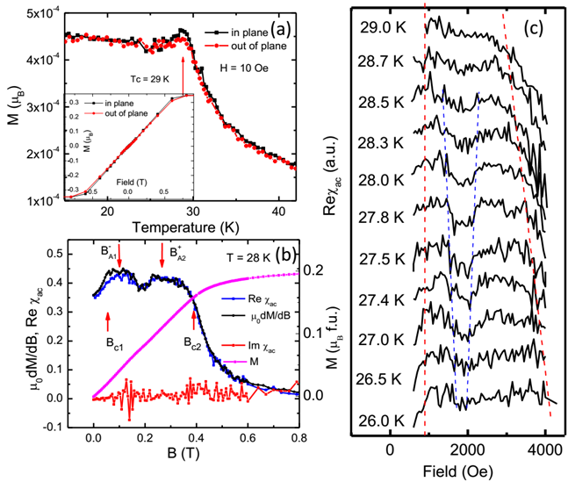
Figure 39 DC and ac magnetizations of the MnSi nanowires. (a) In and out of the plane anisotropic magnetizations (see text for definition) under DC field of 10 Oe. The kink around 29 K is the signature of helical magnetic. The inset shows the field dependent of the magnetization at 10K. (b) The comparison of the ac susceptibility Re $χ_{ac}$(blue), Im $χ_{ac}$(red) with the susceptibility µ₀dM/dB calculated from the field dependence magnetization M (purple, right Y axis) at 28K. The isothermal ac susceptibility as a function of field measured under excitation field of 1 Oe and 8Hz ac magnetic field applied in-plane at 28K. (c) The evolution of the Re $χ_{ac}$ approaching from 26 K to T_{c} 29 K. The blue and red dash-lines are eye-guiding lines for the B_{c1}, B_{c2} and$B_{A1}^{-}$,$B_{A2}^{+}$.

plane data could be measured. We anticipate the anisotropic magnetization of the wires can be indirectly extracted out by thinking that the majority of the wires are aligned on the surface of wafer, so the out-of-plane data show the property perpendicular to the wires; while the in-plane data show the azimuthal average of all wires. From both temperature dependent and field dependent data in Fig. 39 (a), the magnetic behavior in-plane looks a little bit stronger than out-of-plane. The growth direction of the wires is [110] [53,68], the helical domains point out of the (111) face, which is 35° from (110). So the projection of the helical contribution out-of-plane is around 71% of the in-plane contribution. This is likely the reason for the small difference in the two directions although as addressed above the magnetic data is the average of the wires. Further studies using local techniques such as micro SQUID are necessary to fully quantify the magnetic anisotropy.
The isothermal ac susceptibility and DC magnetization as a function of magnetic field confirm the existence of the skyrmion phase (A phase) in the nanowires. The Fig.39 (b) shows the comparison of the ac susceptibility with the susceptibility µ₀dM/dB calculated from the DC magnetization M at 28K, just below the transition temperature. The isothermal ac susceptibility as a function of field was measured under an excitation amplitude of 1 Oe and 8Hz ac magnetic field applied in-plane. Measurements performed as magnetic field is increasing and decreasing show characteristic features which have been shown to be signatures of the A phase [30] [28,69–72]. Other than the reduced value of ac susceptibility, we also observed the extra peaks in the µ₀dM/dB which is the characteritic feature of the phase transition as detailed explained in Ref [28]. The µ₀dM/dB curve shows two lower kink regions (700-1150 Oe and 1150 -2300 Oe) and three transition maxima (700, 1150, 2300 Oe). By increasing the field, magnetic structure goes through helical to conical (from B_{C1} to$B_{A1}^{-}$), then conical to A phase (in between$B_{A1}^{-}$, $B_{A2}^{+}$). At 26.5 K, the first maxima in the µ₀dM/dB which represents the helical to conical transition is still available, but the two peaks relate to the A phase transition almost disappear. Please note that as the mass of the nanowires are much smaller (0.06 mg for the sample shown) than the bulk single crystals, the signal-to-noise ratio of the data is not as good as that of the literature [28]. Other than the extra noise, our data is consistent with the above-mentioned reference.
The field dependence of the ac susceptibility Reχ_{ac} and DC magnetization changes strongly in the narrow temperature window from 26 K to 28.5K and for B ≤ 4000 Oe. Fig. 39(c) shows the evolution of the Reχ_{ac} approaching form low T to T_{c}. The blue and red dash-lines are eye-guiding lines for the B_{c1}, B_{c2} and $B_{A1}^{-}$, $B_{A2}^{+}$. At 26K, there is a shallow dip in the middle; a well-pronounced local minimum has developed near 27.8K. The characteristic feature is present up to 28.5K and by 29K is completely smeared.
In conclusion, the growth conditions of Mn-Si nanowires have been studied. Different Mn-Si compositions can be selected by tuning growth parameters. The key parameter for stoichiometric and crystalline correct high yield growth of B20 MnSi wires is the thickness of the SiO₂ layer. A growth phase diagram was constructed that provides a systematic guide for controllable selective growth of nanowires with different compositions. The dM/dH curve along with ac and DC magnetic properties of MnSi nanowires reveal the presence of helimagnetic and skyrmion magnetic ordering in the one-dimensional wires.

CHAPTER 6 Synthesis and characterization of iron germanide nanowires

6.1 Nanostructures synthesized in initial stage

Several precursors were tried in Fe-Ge nanowires preparations. [73,74] Solution methods were also used to create iron germanide nanowires. [75]
In chemical vapor deposition, the temperature for powder evaporation and product phase stabilization made controlling morphology, composition and structure difficult. The initial purpose was to prepare cubic FeGe phase, which has the same structure as MnSi and exhibit skyrimon near room temperature (280K). [31]
The Fe-Ge phase diagram, shown in Figure40, is much complicated than the Mn-Si phase diagram. When the atomic composition of iron equals germanium, three structures exist: monoclinic, hexagonal and cubic. The temperature boundary between hexagonal and cubic is 630°C. Therefore, the substrate temperature should not exceed 600°C. [76]
Precursors of Fe powder, Ge powder, GeCl₂, GeI₂ and Cr-FeGe powder were tried in a vacuum. These precursors were also applied at atmospheric pressure on a Ge wafer, a Ge wafer covered with Cr thin film, an iron foil and a Si wafer with oxide; however, none of the depositions were successful. The temperature was kept relatively low at 600°C.

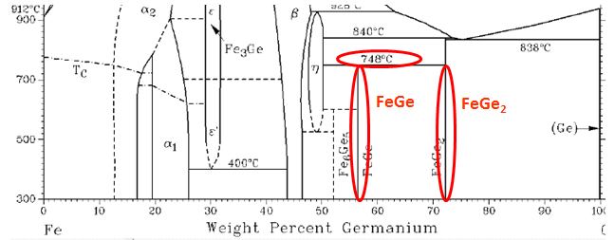
Figure 40 Fe-Ge phase diagram [77].

Our group successfully prepared Cr-FeGe powder, which showed an X-ray diffraction pattern same to that of cubic FeGe by adding a small amount of CrGe to hexagonal FeGe powder before annealing for several weeks. Hexagonal FeGe seems to follow the structure of CrGe, which is the same structure as MnSi and cubic FeGe. Therefore, tried depositing a thin layer approximately 2-9nm on the Ge wafer by using e-beam evaporator, and then melting the layer by using laser irradiation. The purpose of this procedure was to create CrGe nanoparticles on the Ge wafer through laser melting and Ge diffusion. FeGe powder could prefer a growth area where CrGe nanoparticles are located, resulting in longitude one-dimensional growth. In that case, the diameter of cubic FeGe nanowires should be determined by Cr-Ge nanoparticles’ size. For Cr film approximately 9 nm thick (Fig 41 (a)), the substrate after laser irradiation showed that the concentration of Cr in this method could be as high as 10% on nanoparticle and 0.1% elsewhere. The maximum particle diameter was approximately 322 nm.
The real challenge, however, is in determining how to make the concentration exactly 1:1 on nanoparticles. Many experiments have been attempted to deposit Cr-FeGe powder directly onto the substrate with Cr or Cr-Ge nanoparticles (Fig 41 (b)(c)). A wire-like structure (Fig 41(d)) has been observed on the substrate after deposition at 570°C, 600 Torr and 30 mins. Those wires were 200 nm long and 20 nm wide. However, the wire-like structure disappeared after 3 hours of deposition.

200 nm
1 µm
(a) (b)
200 nm
1 µm
(c) (d)

Figure 41 (a) 9 nm Cr thin film deposited on Ge wafer (b) Nanoparticles prepared after laser irradiation (c) Diameter of a nanoparticle (d) Nanorod structure growth by direct deposit Cr-FeGe on Cr-Ge wafer at 570°C.

Metal halide is easy to purchase and prepare contrast to organometallic compounds ,but it lacks stoichiometry control. Ferric chloride (FeCl₃) and ferrous chloride (FeCl₂) were both tried in order to get nanowire growth. They could not be stored in air for moisture absorption. By using Ferric chloride, in atmosphere pressure, it still got too much iron compounds gathering on the substrate which formed a very thick layer of FeGe₂. This layer could transform from FeGe₂ to hexagonal FeGe as reaction temperature lowering from 850°C to 700°C with pressure at 760 Torr. The XRD pattern matched exactly these two phases. (Fig 42)However, the main signal from substrate became FeGe₂ again as inner pressure increased to 2000 Torr at 600°C. This could be explained by mean free path of Fe decreases with more gas molecules. So less Fe reached on Ge wafer forming FeGe₂. The growth boundary between hexagonal FeGe and FeGe₂ was about 550°C with 1200 Torr inner pressure. Based on this fact, lower temperature and higher pressure were required for both cubic phase and one dimensional growing. Though glass tubes and pressure gauge could not sustain too much inner pressure, I have tried to grow overpressure estimated around 935-2000 Torr. Sample prepared at pressure around 1200±50 Torr finally show some nanowire growth. This even caused the malfunction of pressure gauge. I have put Ge wafer in the middle of furnace and FeCl₃ powder in the 1.5cm from opening. The other parameters I used were 600°C, 140 sccm, and 30 mins. The pressure was not stable in this nanowire synthesize.

5 µm
(a)
(b)
Figure 42 (a)SEM image show morhology of FeGe₂ layered structure (b)XRD pattern of thick layer prepared on 700°C and 850°C(760 Torr) and 600°C(1200 Torr).

6.3 Structure verification and chemical composition of FeGe₂ nanowires
FeGe₂ nanowires were synthesized for the first time by CVD at 600°C and at pressure approximately 1800Torr (Fig 43). The morphology showed nanowires growing everywhere (Fig 44(a)). The center of the substrate was totally white, and couldnot reflect light. The nanowires’ diameter was uniform at approximately 200-300nm, and their length was approximately 10µm.(Fig44(b))
In the X-ray diffraction, the peaks were identified as FeGe₂, mainly from the substrate (Fig 45). With nanowires transferred to the copper grid via acetone, TEM was used to identify the nanowires’ structure (Fig 46). Comparing the diffraction pattern, the zone axis matched to FeGe₂ [001]. The atomic plane was indexed by the diffraction pattern and high resolution TEM images. By comparing the relative position of nanowires to the atomic plane, the growth direction was found to be [110]. Researchers from ORNL’s main campus helped me with TEM measurements. Five nanowires were measured, and all of their diffraction patterns were identified as FeGe₂.
The nanowires were measured by EDX, and the atomic composition of Fe:Ge was very close to 1:2. Typical peaks of iron and germanium were plotted in Fig 47.
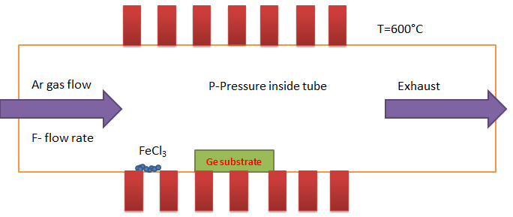
Figure 43 Souce-substrate geometry with Ar works as carrier gas

10 µm
(a)
200 nm
(b)
Figure 44 Nanowires prepared with the thick FeGe₂ layer in the middle while the latter one has random growth nanowires everywhere.

Figure 45 Indexed XRD pattern shows the peaks matching FeGe₂.

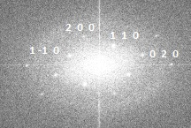
[110]
(a)
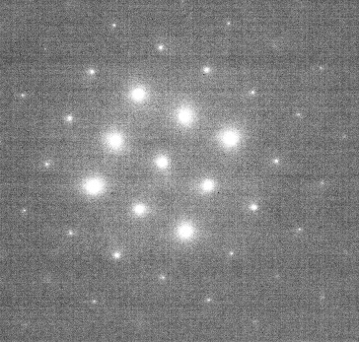
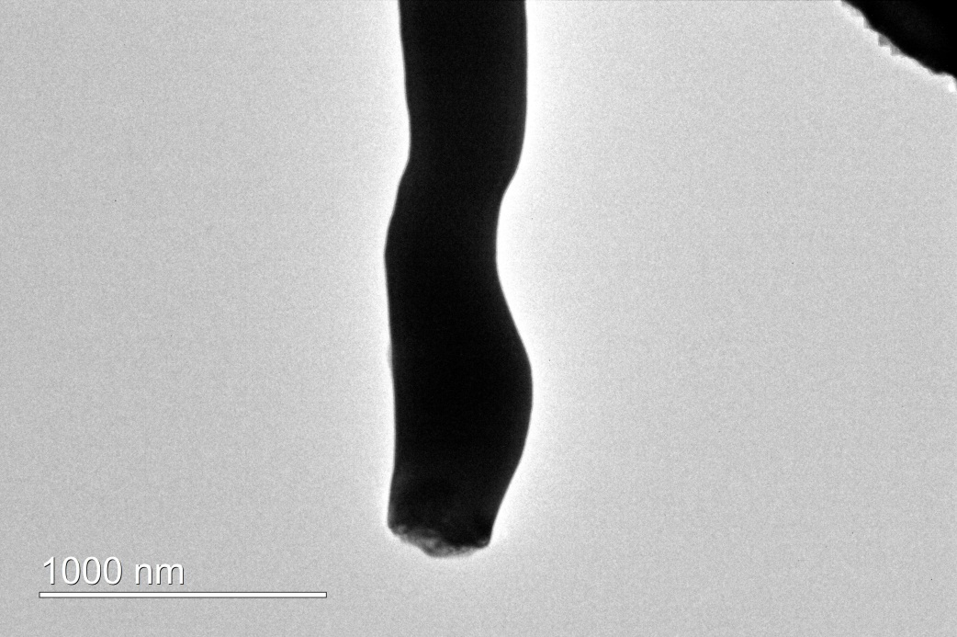
Zone axis [001]
[110]
(b)
Figure 46 (a) High resolution TEM images of FeGe₂ nanowires. The inset is the FFT of HRTEM images (b) Growth direction of nanowires is identified as [110]. The inset is the diffraction pattern with zone axis [001].
Figure 47 Relative height of iron peak compared to Ge peak along FeGe₂ nanowires.

6.3 Transport properties and magnetic measurement of FeGe₂ nanowires

XRD and TEM both verified that the layer and nanowires were FeGe₂. Nanowires’ growth direction was [110]. Therefore, to measure the nanowires’ transport properties, a four-probe single-nanowire device was measured by PPMS at 0 tesla and 6 tesla which are applied along [001] direction. For each magnetic field, resistance was measured with sample cooling from 310K to 10K and then returning the temperature to 310K. The currents of 100nA, 500nA, 1uA were used, but the background noise was excessive. A current of 2 µA was applied along the nanowires.
The resulting resistance was plotted in Fig 48(b). Cooling from 310K to 10K, the resistance showed two peaks at approximately 200K and 250K. By applying a magnetic field to 6 tesla, peaks became lowerer. In the process of warming the sample from 10 to 310K, the peak of 200K appeared at 0T. Both peaks disappeared at 6T.
Furthermore, resistance did not change in two temperature ranges: 0-180K and 218-237K. As a result, to ensure the data was accurate, resistance was measured at several temperature points. As shown in Fig 49, the resistance of 10K was about the same to that of 230K .

2 µm
(a)
Figure 48 (a) Four-probe nanodevice (b) Resistivity measured with a magnetic field of 0 and 6 Telsa. Both of them include a cooling and heating process.

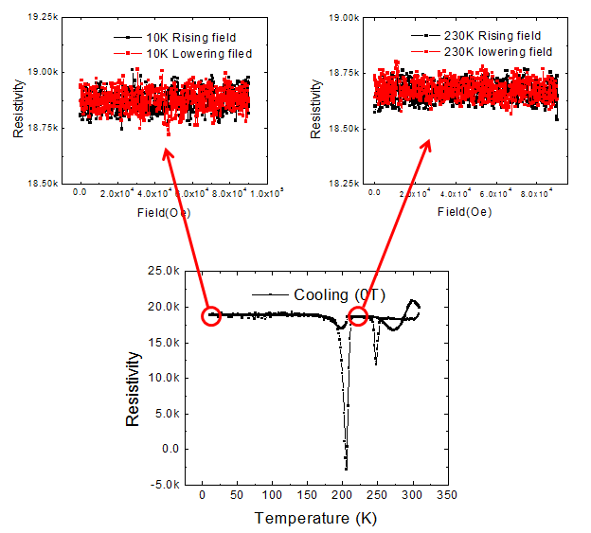

Figure 49 Resistivity measurement at 0T cooling from 310K to 10K: Two temperature points (10K and 230K) were chosen to compare magnitudes in two separate constant resistivity ranges (0-180K and 218-237K). Each temperature point has two curves with magnetic field rising from 0-9T and returning to 0T.

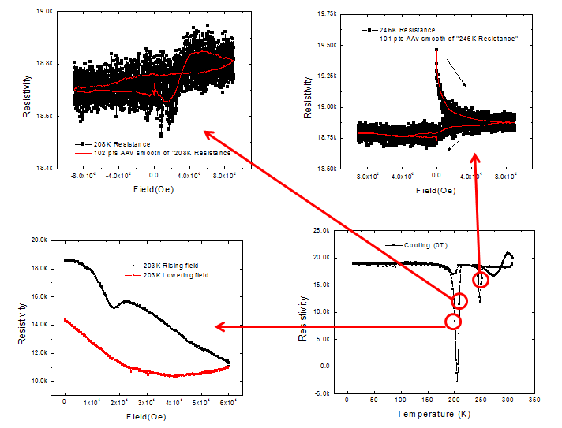

Figure 50 Resistivity measurement at 0T cooling from 310K to 10K: Three temperature points (203K, 208K and 246K) were chosen to compare transition in peak resistivity regimes. Each temperature point has two curves with the magnetic field rising and falling. A smooth fit was used to eliminate noises.

(a)
Figure 51 (a) The magnetoresistance and magnetic moments reveal two transition temperatures at 205.5K and 252.4K.

(a)

(b)
Figure 52 (a) M-H hysteresis curves at 30K, (b) The enlargement of M-H hysteresis curves from -1500oe to 1500oe.

In Fig 50, the resistance shows hysteresis behaviors with changing magnetic field at temperature points of 203, 208 and 246K. In 203K, when rising the magnetic field, a similar shift of resistance was noticed compared to bulk FeGe₂ measurement. It should be caused by SDW transition. However, the tendency of resistance was totally reversed in constrast with bulk.
As shown in Figure 51, magnetoresistance was calculated from previous resistivity measured under 0T and 6T, clearly showing two sharp peaks of resistivity. By aligning their maximum value, two transition temperatures, 205.5 and 252.4K, were identified.
Compared to bulk FeGe₂, it was reasonable to conclude these two temperature mark the boundary of incommensurate SDW and commensurate SDW. Those temperatures in bulk FeGe₂ were 263 and 289K. The resistivity change was due to the fact that they entered a magnetic superzone. The superzone boundaries of magnetic order with periodicity are different from of the atomic lattice’s chemical periodicity. Therefore, the superzone has extra scattering of charge carriers leading to abnormal resistivity change [51]. In our case, the superzone was incommensurate SDW state.
A carbon tape was used to attach the surface of the substrate. Nanowires were mostly attached onto the tape. Then the tape was attached to another clean silicon wafer. Therefore the magnetization sigals could be measured. Magnetic moments versus temperature measured in red lines (Fig 51) represent a ferromagnetic transition around 200K. In Fig 52(a), magnetization was measured with changing magnetic field at 30K. The magetization showed a saturation at magnetic field of 5000 oe confirming the ferromagnetism.
The magetic field was applied parallel the plane of silicon substrate in the magnetic measurement. The nanowires were attached onto this plane, but they are randomly oriented; the magnetic field in the transport measurement was along [001] direction,but the current was flowing along [110] direcion.
Therefore, the transport data showed SDW state in antiferromagentism when measuring along the nanowire’s elongation direction. (Fig 53)The magnetic properties measured here were dominated by signals along the nanowire’s other direction. The elongation direction was in micrometer range because it grew along [110], but other directions were in nanometer range. That meant the cross-section cut by magnetic field was hundred of nanometers. Therefore tt could be explained as nanoscale effect along other directions broke down antiferromagnetism, resulting in ferromagnetism emerged.

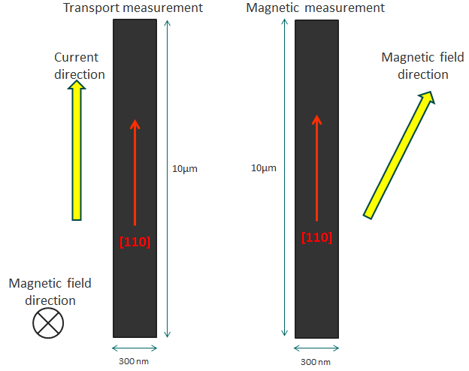
(a) (b)
Figure 53 (a) Magnetic field direction and current flow direction in transport measurements (b) Magnetic field direction in magnetic measurement

Chapter 7 Other nanowires prepared by CVD

7.1 Fe₂Si and Cr₅Si₃ nanowires

In oxide synthesize method; it might become a common way for synthesizing metal silicide nanowires. Iron powder and chromium powder were deposited on SiO₂/Si wafer (850°C, 140 sccm, 80 mins, 650 Torr). 100 nm SiO₂ thin films were used and nanowires of containing Fe-Si and Cr-Si elements were verified. (Fig 54)From EDX data, it was estimated that nanophase of Fe₂Si and Cr₅Si₃was among the sample. (Fig 55)

10 µm
(a)
1 µm
(b)
Figure 54 (a) Fe₂Si nanowires (b) Cr₅Si₃ nanowires prepared by metal powder depositing on silicon wafer with oxide layer.

(a)
(b)
Figure 55 Composition of nanowires on carbon tape gives the atomic ratio (a) Fe₂Si (b) Cr₅Si₃.

7.2 Synthesis of Fe_{2.5}Ge nanowires

Reducing the pressure in FeGe₂ nanowires preparation to 1200 Torr, the morphology of nanowires were: nanowires concentrated at the corners of substrate; and the middle substrate showed a very thin layer of FeGe₂ which could reflect visible light. Nanowires (diameter at 100-250nm) were very straight and long (10-15µm) nanowires. (Fig 56); the composition showed a very high percentage of iron contained along this nanowire. Average atomic ratio of Fe:Ge=2.5:1 (Fig 57(a)). Magnetic measurements showed there was a ferromagnetic transition around 250K in zero field cool, however, people get T_{c} of bulk iron germanide as high as 500K when the composition of iron reached 1.9. Even higher T_{c} was expected with iron reach to 2.5 Fig 57(b) [78,79]

3 µm
(a)
500 nm
(b)
Figure 56 Fe_{2.5}Ge Nanowires prepared with less FeGe₂ layer in middle.

(a)
(b)
Figure 57 (a)Peaks of Fe and Ge measured along the nanowires with atomic ratio at 2.5:1 (b) Magnetic moments versus temperature measured on the whole substrate with magnetic field at 1000 oe.

7.3 Fe₃Ge nanowires

Small amount of nanowires have been synthesized in Ge wafer by directly deposit iron powder onto it. Low pressure around 30-100 mTorr has been applied and temperature is kept at 600°C. (Fig 58(a)) The nanowires were thin (50-150 nm) and short (1-3 µm). The composition verified by EDS was around 3:1 (Fe:Ge),(Fig 58(b))however, its number was small and needed more precisely control to get dense growth.

200nm
2 µm
(a)
(b)
Figure 58 (a) Fe₃Ge nanowires prepared on Ge wafer (b) Composition verified by EDX.

CHAPTER 8 CONCLUSION

Magnetic nanowires were prepared in home-build chemical vapor deposition system and novel magnetic and electronic transport properties are studied.

1. Massive growth of MnSi and FeGe₂ nanowires emphasize the importance of supersaturation ratio. The initial explore usually brought about substrates with thick layer. Combination of source materials and substrate was restricted by adding intermediate SiO₂ layer and reducing amount of evaporated iron, both of which suppressed the supersaturation ratio from two-dimensional to one-dimensional growth. The oxide layer assisted growth of the nanowire has the potential to become a common method to prepare metal silicide nanowires.

2. Based on controlled amount of Si, growth diagram on Mn-Si nanowires via oxide assisted growth was plotted by adjusting other parameters like temperature, pressure, and distance from source to substrate, time and flow rate. Helimagnetic nanowires were identified by low field M-T measurements. Signature of transformation from helimagnetic structure to skyrmion lattice was observed in ac susceptibility measurements.

3. Single FeGe₂ nanowire was fabricated into four probe nanodevices via e-beam lithography. However, lift off problem existed due to large diameter of nanowires. By adjusting the dose and layer geometry in the whole process, successful nanodevice was manufactured.

4. Magnetic properties and transport properties of FeGe₂ nanowires showed significant divergence with its bulk [80,81]: the lowering SDW transition temperature and the broadening of ICSDW phase. When field was applied on [001] direction and current flew in [110] direction [82], SDW was also proven by shift of resistance. The magnetic measurements showed ferromagnetism when field was applied along substrate plane. It could be interpreted as nanoscale effect broke down antiferromagnetism along any directions except [110], resulting in ferromagnetism emerged. SDW could be driven to slide with applying a magnetic field or electric field. It showed an option of manipulate electron spins in antiferromagnetic materials. [83–85]

REFERNCES

[1] Farzad Nasirpouri, NANOMAGNETISM AND SPINTRONICS: Fabrication, Materials, Characterization and Applications (World Scientific Publishing Co. Pte. Ltd, 2009).
[2] A. P. Guimar˜aes, Principles of Nanomagnetism (Springer, 2009).
[3] T. Shinjo, Nanomagnetism and Spintronics (Elsevier Science, 2009).
[4] D. L. Mills, Nanomagnetism (Elsevier Science, 2006).
[5] Y. Xia, P. Yang, Y. Sun, Y. Wu, B. Mayers, B. Gates, Y. Yin, F. Kim, and H. Yan, Adv. Mater. 15, 353 (2003).
[6] X. Fang, J. Mater. Sci. Technol. 22, 1 (2006).
[7] G.W.Sears, Acta Metall. 3, 361 (1955).
[8] S.S.Brenner, Acta Metall. 4, 268 (1956).
[9] V. G. Dubrovskii, N. V. Sibirev, J. C. Harmand, and F. Glas, Phys. Rev. B 78, 235301 (2008).
[10] S. V. N. T. Kuchibhatla, a. S. Karakoti, D. Bera, and S. Seal, Prog. Mater. Sci. 52, 699 (2007).
[11] Y. Hu, J. Phys. Chem. B 109, 4398 (2005).
[12] Z.R.Dai, Adv. Funct. Mater. 13, 9 (2003).
[13] Z. W. Pan, Z. R. Dai, and Z. L. Wang, Science 291, 1947 (2001).
[14] I. Dzyaloshinsky, J. Phys. Chem. Solids 4, 241 (1958).
[15] Toru Moriya, Phys. Rev. 120, 91 (1960).
[16] S. V. Maleyev, J. Magn. Magn. Mater. 310, 1602 (2007).
[17] S. Chutia, M. Friesen, and R. Joynt, 1 (2006).
[18] K. Matan, B. Bartlett, J. Helton, V. Sikolenko, S. Mat’aš, K. Prokeš, Y. Chen, J. Lynn, D. Grohol, T. Sato, M. Tokunaga, D. Nocera, and Y. Lee, Phys. Rev. B 83, (2011).
[19] A. S. T. Pires and M. E. Gouve, J. Magn. Magn. Mater. 212, 251 (2000).
[20] P. B. and M. H. Jensen, J. Phys. C 13, 881 (1980).
[21] Landau L D, Statistical Physics (New York: Pergamon, 1977).
[22] S. Mühlbauer, B. Binz, F. Jonietz, C. Pfleiderer, a Rosch, a Neubauer, R. Georgii, and P. Böni, Science 323, 915 (2009).
[23] Soshin chikazumi, Physics of Ferromagnetism (Oxford University press, 1997).
[24] H. Wong, 43210, 1 (2002).
[25] a. Neubauer, C. Pfleiderer, B. Binz, a. Rosch, R. Ritz, P. Niklowitz, and P. Böni, Phys. Rev. Lett. 102, 186602 (2009).
[26] S. Seki, X. Z. Yu, S. Ishiwata, and Y. Tokura, Science 336, 198 (2012).
[27] X. Yu, J. P. DeGrave, Y. Hara, T. Hara, S. Jin, and Y. Tokura, Nano Lett. 13, 3755 (2013).
[28] a. Bauer and C. Pfleiderer, Phys. Rev. B 85, 214418 (2012).
[29] S. X. Huang and C. L. Chien, Phys. Rev. Lett. 108, 267201 (2012).
[30] H. Wilhelm, M. Baenitz, M. Schmidt, U. K. Rößler, a. a. Leonov, and a. N. Bogdanov, Phys. Rev. Lett. 107, 127203 (2011).
[31] X. Z. Yu, N. Kanazawa, Y. Onose, K. Kimoto, W. Z. Zhang, S. Ishiwata, Y. Matsui, and Y. Tokura, Nat. Mater. 10, 106 (2011).
[32] X. Z. Yu, N. Kanazawa, W. Z. Zhang, T. Nagai, T. Hara, K. Kimoto, Y. Matsui, Y. Onose, and Y. Tokura, Nat. Commun. 3, 988 (2012).
[33] J. Iwasaki, M. Mochizuki, and N. Nagaosa, Nat. Nanotechnol. 8, 742 (2013).
[34] F. Jonietz, S. Mühlbauer, C. Pfleiderer, a Neubauer, W. Münzer, a Bauer, T. Adams, R. Georgii, P. Böni, R. a Duine, K. Everschor, M. Garst, and a Rosch, Science 330, 1648 (2010).
[35] G. Meier, M. Bolte, R. Eiselt, B. Krüger, D.-H. Kim, and P. Fischer, Phys. Rev. Lett. 98, 187202 (2007).
[36] R. Allenspach, in MRS Bull. (2006).
[37] S. S. P. Parkin, M. Hayashi, and L. Thomas, Science 320, 190 (2008).
[38] A. Fert, V. Cros, and J. Sampaio, Nat. Nanotechnol. 8, 152 (2013).
[39] N. Romming, C. Hanneken, M. Menzel, J. E. Bickel, B. Wolter, K. von Bergmann, A. Kubetzka, and R. Wiesendanger, Science 341, 636 (2013).
[40] S. S. P. Parkin, M. Hayashi, and L. Thomas, Science 320, 190 (2008).
[41] L. Angeles, Sci. Am. 50 (1994).
[42] G.Gruner, Rev. Mod. Phys. 60, 1129 (1988).
[43] G.Gruner, Rev. Mod. Phys. 66, 1 (1994).
[44] H. Search, C. Journals, A. Contact, M. Iopscience, and I. P. Address, J. Physics-Condensed Matter 1347, (1997).
[45] T. E. Mason, C. P. Adams, S. A. M. Mentink, E. Fawcett, A. Z. Menshikov, and C. D. F, Phys. B 238, 449 (1997).
[46] L. M. Corliss, J. M. Hastings, W. Kunnmann, R. Thomas, and J. Zhuang, Phys. Rev. B 31, (1985).
[47] A.Z.Menshikov, J. Magn. Magn. Mater. 73, 211 (1988).
[48] E. Fawcett, Rev. Mod. Phys. 66, 25 (1994).
[49] E. Fawcett, Rev. Mod. Phys. 60, 209 (1988).
[50] G.Gruner, Density Waves in Solids (Westview Press, 2000).
[51] C. P. Adams, J. Physics-Condensed Matter 9, (1997).
[52] K. Seo, H. Yoon, S. Ryu, S. Lee, Y. Jo, M. Jung, J. Kim, Y. Choi, and B. Kim, ACS Nano 4, 2569 (2010).
[53] J. M. Higgins, R. Ding, J. P. DeGrave, and S. Jin, Nano Lett. 10, 1605 (2010).
[54] A. Pokhrel, Z. P. Degregorio, J. M. Higgins, S. N. Girard, and S. Jin, (2013).
[55] R.-Q. Zhang, Y. Lifshitz, and S.-T. Lee, Adv. Mater. 15, 635 (2003).
[56] J. Niu, J. Sha, and D. Yang, Phys. E Low-Dimensional Syst. Nanostructures 23, 131 (2004).
[57] L. Z. Pei, Y. H. Tang, Y. W. Chen, C. Guo, W. Zhang, and Y. Zhang, J. Cryst. Growth 289, 423 (2006).
[58] S. A., ASM Alloy Phase Diagr. Database (2008).
[59] G. K. Celler and L. E. Trimble, Appl. Phys. Lett. 54, 1427 (1989).
[60] M. Uematsu, H. Kageshima, Y. Takahashi, S. Fukatsu, K. M. Itoh, and K. Shiraishi, Appl. Phys. Lett. 85, 221 (2004).
[61] M. Uematsu, H. Kageshima, Y. Takahashi, S. Fukatsu, K. M. Itoh, K. Shiraishi, and U. Gösele, Appl. Phys. Lett. 84, 876 (2004).
[62] N. Wang, Y. F. Zhang, Y. H. Tang, C. S. Lee, and S. T. Lee, Appl. Phys. Lett. 73, 3902 (1998).
[63] S. Jin, M. J. Bierman, and S. a. Morin, J. Phys. Chem. Lett. 1, 1472 (2010).
[64] E.Yablonovitch, Phys. Rev. Lett. 57, (1986).
[65] Z. T. Zhang, D. A. Blom, Z. Gai, J. R. Thompson, J. Shen, and S. Dai, J. Am. Chem. Soc. 125, 7528 (2003).
[66] Z. Gai, X.-G. Zhang, I. Kravchenko, S. Retterer, and J. Wendelken, Phys. Rev. B 85, 024401 (2012).
[67] S. M. Stishov, Physics-Uspekhi 54, 1117 (2011).
[68] K. Seo, H. Yoon, S. Ryu, S. Lee, Y. Jo, M. Jung, J. Kim, Y. Choi, and B. Kim, ACS Nano 4, 2569 (2010).
[69] R. Ritz, M. Halder, C. Franz, A. Bauer, M. Wagner, R. Bamler, A. Rosch, and C. Pfleiderer, Phys. Rev. B 87, 134424 (2013).
[70] C. Thessieu, J. Physics-Condensed Matter 6677, (1997).
[71] B. Lebech, P. Harris, J. S. Pedersen, K. Mortensen, C. L. Gregory, N. R. Bemhoeft, M. Jermy, and S. A. Ibrown, J. Magn. Magn. Mater. 144, 119 (1995).
[72] a. Bauer, M. Garst, and C. Pfleiderer, Phys. Rev. Lett. 110, 177207 (2013).
[73] H. Yoon, J. Phys. Chem. Lett. 956 (2011).
[74] H. Yoon, J. Am. Chem. Soc. 17447 (2010).
[75] D. D. V. Ii, D. Sun, J. A. Moyer, A. J. Biacchi, R. Misra, P. Schi, and R. E. Schaak, (2013).
[76] M. Richardson, Acta Chem. Scand. 21, 2305 (1967).
[77] K. E., ASM Alloy Phase Diagr. Database (1990).
[78] K. Kanematsu, J. Phys. Soc. Japan 20, (1965).
[79] K. Kanematsu, J. Phys. Soc. Japan 20, (1965).
[80] T. Sekine, N. Satoh, M. Nakazawa, and T. Nakamura, Phys. Rev. B 70, 214201 (2004).
[81] G. Blumberg, P. Littlewood, a. Gozar, B. S. Dennis, N. Motoyama, H. Eisaki, and S. Uchida, Phys. C Supercond. 388-389, 227 (2003).
[82] R. K. Kummamuru and Y.-A. Soh, Nature 452, 859 (2008).
[83] K. W. Kim, a Pashkin, H. Schäfer, M. Beyer, M. Porer, T. Wolf, C. Bernhard, J. Demsar, R. Huber, and a Leitenstorfer, Nat. Mater. 11, 497 (2012).
[84] S. Tan, Y. Zhang, M. Xia, Z. Ye, F. Chen, X. Xie, R. Peng, D. Xu, Q. Fan, H. Xu, J. Jiang, T. Zhang, X. Lai, T. Xiang, J. Hu, B. Xie, and D. Feng, Nat. Mater. 12, 634 (2013).
[85] J. Chang, E. Blackburn, a. T. Holmes, N. B. Christensen, J. Larsen, J. Mesot, R. Liang, D. a. Bonn, W. N. Hardy, a. Watenphul, M. V. Zimmermann, E. M. Forgan, and S. M. Hayden, Nat. Phys. 8, 871 (2012).

VITA

Siwei Tang was born in Cili, ZhangJiajie city, Hunan province, China. He was the only child in his family. In 1999, he attended the high school of MingZu in Zhangjiajie and then graduated at 2002. He obtained his bachelor degree from Information College of Central South University in 2006. He changed his major to materials science in 2006 and joined the department as a graduate student. In 2009, he went abroad to United States and studied as a graduate research assistant. He got his master of science in 2011 and joined Dr Mandrus group as a Ph.D student. He spent a lot of time doing research with Dr Zheng Gai in Center for Nanophase Materials Science, Oak Ridge National Lab.

