An Analysis of How Consumers Use Best-if-Used-By Dates
As a Cue for Evaluating Food Products

A Thesis Presented for the
Master of Science
Degree
The University of Tennessee, Knoxville

Beth Anne Billie Ray
August 2023

DEDICATION

To my mom, Donna.

ACKNOWLEDGMENTS

I want to start by thanking my advisors Dr. Karen DeLong and Dr. Kim Jensen. I appreciate the opportunity to research with you. You have both taught me so much and the skills I have developed from you will aid me continuously in my future. I am appreciative of Dr. Jensen for starting me on this research as well as supporting me during my first year of graduate school. Your patience and encouragement made me realize I am capable of achieving what I set my sights on. I am appreciative of Dr. DeLong for taking me as a graduate student and supporting me through my second year of graduate school. Your continuous support and guidance helped me finish my second year as a strong woman ready to start the next chapter. I would like to thank the rest of my committee, Dr. Jacqueline Yenerall and Dr. Edward Yu for offering insight and tools to construct this thesis. I would also like to thank Sarah Burns and Curtis Luckett from the Food Sensory Lab in the Department of Food Science for their assistance with the experimental auction.

I would like to thank Jon Walton for all of his support during my undergraduate career as an advisor and teacher at The University of Tennessee. You helped me build a community in the Agricultural and Resource Economics Department that helped me grow. I am appreciative of your support to apply for this master’s degree as I would not be where I am today without it. Thank you to the Agricultural and Resource Economics Department in the Herbert College of Agriculture and all the professors within it who taught me so much in both undergraduate and graduate school.

Finally, I would like to thank my mom Donna Ray for all the love and support she has given me as well as an appreciation for education. Without you, none of this would have been possible. I would also like to thank my grandparents Anne and Charlie Speeckaert and Dave and Linda Clonts for listening to me explain my project every week and supporting me through the good and bad times. A special thank you to Dave and Linda for raising me in UT orange. My desire to attend The University of Tennessee stems from you. Thank you to the rest of my family and friends for your continuous support throughout my life and college career.

ABSTRACT
Food waste is a significant problem in the United States with over 133 billion pounds of food that goes unused or neglected by consumers every year. Consumers use best-if-used-by dates (BUBDs) as a cue in evaluating food and deciding when to throw away food. Using an experimental sensory approach, 183 consumers evaluated the appearance and taste of salads and lunch meat with varying BUBDs. After completing sensory evaluations, participants were then asked to state their willingness to pay (WTP) for each of the varying BUBDs and the percentage of the food product their household would consume, based on their recent consumption habits and its associated BUBD. On average, consumers were willing to pay $0.76 to $1.38 per bag for the varying bagged salads and $1.78 to $2.31 per package for the varying lunch meats. Consumers stated their household would consume on average 57 to 75% of the varying bagged salads and 67 to 75% of the varying lunch meats. Tobit regressions were used to examine factors influencing WTP and household expected consumption of the food products. BUBDs and taste and appearance ratings were significant in determining bagged salad and lunch meat WTP and anticipated consumption. The bagged salad lunch meat nearby and middle BUBDs were discounted significantly when compared to the furthest away BUBD. The furthest away BUBDs increased anticipated consumption compared to the nearby BUBDs. As consumers rated the taste and appearance of the salads and lunch meat higher, they stated they would consume more of the food products. Results provide insight into how BUBDs and sensory evaluation of foods influence expected food waste of lunch meat and salads. Sensory evaluations are preferred to BUBDs to evaluate food; however, consumers will use BUBDs when sensory evaluations are not available.
TABLE OF CONTENTS
CHAPTER ONE INTRODUCTION 1
CHAPTER TWO LITERATURE REVIEW 3
CHAPTER THREE MATERIALS AND METHODS 7
Survey Design 7
Auction Rounds 7
Post-Auction Survey Questions 9
Conceptual Framework 9
Econometric Analysis for Willingness to Pay 11
Econometric Analysis for Analyzing Perceived Consumption Percentage 12
CHAPTER FOUR RESULTS 14
Survey Descriptive Statistics 14
Econometric Results for Willingness to Pay 18
Econometric Results for Consumption Percentage 20
CHAPTER FIVE CONCLUSION 22
Discussion 22
Implications 24
REFERENCES 26
APPENDIX 30
Tables 31
Figures 41
VITA 50

LIST OF TABLES
Table 1. Descriptive Statistics for Bagged Salad and Turkey Lunch Meat Bids (in dollars) 31
Table 2. Descriptive Statistics for Bagged Salad and Turkey Lunch Meat Sensory Analysis 32
Table 3. Descriptive Statistics for Percentage Consumed 33
Table 4. Descriptive Statistics for Consumer Attitudes 33
Table 5. Round 1 Determinants of Bagged Salad WTP (in cents) 34
Table 6. Round 1 Determinants of Turkey Lunch Meat WTP (in cents) 35
Table 7. Round 2 Determinants of Bagged Salad WTP (in cents) 36
Table 8. Round 2 Determinants of Turkey Lunch Meat WTP (in cents) 37
Table 9. Round 3 Determinants of Bagged Salad WTP (in cents) 38
Table 10. Round 3 Determinants of Turkey Lunch Meat WTP (in cents) 39
Table 11. Determinants of Salad and Lunch Meat Stated Consumption Percentage 40

LIST OF FIGURES
Figure 1. Samples of Bagged Salads and Lunch Meat 41
Figure 2. Round 1 Salad Ratings Question 42
Figure 3. Round 1 Bid Question 43
Figure 4. Round 2 Salad Rating Question 44
Figure 5. Information Treatment Panel 45
Figure 6. Knowledge Rating Question 45
Figure 7. Lunch Meat Stated Consumption Question 46
Figure 8. Risk Taker Question 47
Figure 9. Estimated Household Food Waste Average Question 47
Figure 10. Bagged Salad Consumption Frequency Question 48
Figure 11. Product Consumption Question 49

CHAPTER ONE
INTRODUCTION
Food waste and loss is a continuously growing problem not just in the United States, but globally. According to the Food and Drug Administration (FDA), 30 to 40 percent of the U.S. food supply ends up as food waste which equates to 133 billion pounds per year going into the landfill (FDA, 2019). Food waste occurs when perfectly consumable food is thrown away while food loss is when food is not fit for consumption by the time it reaches consumers. A portion of this food waste can be attributed to consumers’ lack of understanding regarding best if used by dating systems. It is possible that consumers throw away perfectly good food if it is past its best if used by date (BUBD). However, BUBDs are only a quality indicator, and do not actually define when a food has reached its expiration date (Food Safety and Inspection Service, 2019). This confusion may cause consumers to throw away food passed a BUBD for fear of contracting a food borne illness from expired products. However, almost all these food items are still safe for consumption but are just not at their peak quality (Food Safety and Inspection Service, 2019).
It has been estimated that more than 80 percent of Americans discard safe, still consumable food due to a misunderstanding of the different date labeling terms such as “best if used by”, “sell by”, “expires on”, “best by”, and “use by”(Neff et al., 2019). None of these terms have the same meaning and out of concern for their wellbeing, many consumers play it safe by discarding food by the date on the packaging (Neff et al., 2019). A 2020 survey examining consumers’ knowledge of food date labels terminology found that although 81.6 percent of respondents reported using date labels, only 57.4 percent could correctly define “best by” and “use by” on the products they consume (Kavanaugh & Quinlan, 2020).
In May of 2019, the FDA wrote a letter to the food industry urging companies to standardize food date labeling to use the terminology “best if used by” across their food products to reduce confusion among consumers about date labels and ultimately to help food waste. In their letter, the FDA recognized research conducted by those in the food packaging industry, the government, and non-profit organizations, has found that consumers understand “best if used by” the best as a quality standard for foods they have purchased. The FDA emphasizes their support of the use of this terminology and for the continuance of educating consumers about date labels that focus on quality and what that means for the food they consume (U.S. Food & Drug Administration, 2019).
Although there are many contributing factors to food waste and loss, food date labeling systems are likely a source of misunderstanding by consumers that may influence the amount of food waste households produce. Identifying and understanding consumers’ misconceptions regarding dating systems will help in developing programs to inform consumers and reduce their overall food waste. While the overall goal of reducing consumers’ food waste is multifaceted, information of consumers’ knowledge regarding food dating systems and how much food dates may influence their purchasing, consumption, and food waste decisions, can be helpful in formulating policies to reduce food waste. The objective of the first model is to determine consumers’ willingness to pay (WTP) for two perishable food products (bagged salads and lunch meats) with varying BUBDs and determine how the products’ respective sensory attributes affect consumer WTP. The study will also examine how consumer demographics and prior knowledge about BUBDs might affect their WTP for bagged salads and lunch meat with varying BUBDs. The objective of the second model is to determine consumers’ perceived consumption percentage (CP) for the aforementioned products. In addition to the demographics and prior knowledge of BUBDs, consumer attitudes towards food waste and consumption habits will be included to better understand consumers’ use of BUBD and their effect on food waste.

CHAPTER TWO
LITERATURE REVIEW
Food waste has been a highly discussed topic in both the United States and internationally, with the U.S. Environmental Protection Agency announcing the first food waste reduction initiative in 2015. Some of these studies have focused on best if used by date labeling and its effect on food waste (e.g., Wilson et al., 2017; Collart and Interis, 2018; and Ellison and Lusk, 2018). Several studies have determined most consumers in the U.S. use date labels as a measure of food safety and will throw away food if it is past the date printed (e.g., Newsome et al., 2014; Kavanaugh and Quinlan, 2020; Sapci and Sapci, 2020; and Neff et al., 2019). Leib et al. (2016) conducted a national survey that found over one-third of respondents discarded food after the printed date and they believe date labeling systems are federally regulated. These are very common misconceptions that other research has confirmed when surveying consumers on specific products such as eggs, deli meats, spaghetti sauce, leftovers and milk. It seems “best if used by” is most preferred and understood by consumers as indicating quality and “use by” is the best for safety control (Wilson et al., 2019).
The history of product dating systems has been long and increasingly complex. What started over 100 years ago to help consumers understand product freshness as they became more removed from the production of their food (Newsome et al., 2014), has developed into confusion and assumptions made by consumers about the safety of consuming food that is still sitting on the shelf past the printed date. Most people do not understand what the labels mean anymore, with less than 45 percent of survey respondents being able to correctly identify the different terms used in date labeling (Kosa et al., 2007). The consequences of these misunderstandings likely contribute to $218 billion a year in food discarded and 40 percent of the food supply thrown away in the U.S. (Newsome et al., 2014).
It is important to determine if date labels even influence consumers food waste and if so, which labels. Wilson et al. (2017) used an experimental auction to compare four different date labels’ (e.g., “Best by”, “Fresh by”, “Sell by”, and “Use by”) effect on consumers’ WTP and food waste. Data was collected from 200 participants who were randomly assigned to one of the four date groups. They then bid on three different products (yogurt, cereal, and salad) of two sizes (small and large) that had 3 different dates (far, middle, and near) to simulate what they would typically see on these products when shopping. Participants placed WTP bids on the various products and how much their household would consume. The WTP bids and perceived waste were calculated to create the willingness to waste (WTW) estimations of the participants which were compared amongst the four date groups to analyze which label is clearer to consumers. Their results showed that “Use by” elicited the greatest WTW and although “Sell by” has the lowest WTW it is suggested to not be shown to consumers as it offers little information. “Fresh by” and “Best by” may be the best options when trying to reduce food waste.
In addition to defining the difference between different labels, it is beneficial to link date labels, food waste, and its environmental impact to reduce food waste overall. Collart and Interis (2018) used a non-hypothetical choice experiment where 150 participants were grouped into one of two treatment groups or the control group and then given different choices of food with different perishability levels and dates that were either before or after the “best before” date. The treatments consisted of the participants receiving information about different date labels meanings or the previous information and further information on the link between date label misperceptions, food waste, and environmental impacts. Their results showed that defining the labels alone was not enough to affect participants’ WTP for foods past their “best before” date. The additional information on misperceptions actually affected their WTP and they were more willing to keep expired frozen foods and recently expired semi-perishable foods.
Ellison and Lusk (2018) found that different food products receive different considerations when consumers are deciding whether to throw them out. They conducted two empirical studies on leftovers and milk using the vignette method, where participants are given hypothetical situations and asked specific questions to reveal their values, to analyze the importance of different attributes on food waste. In each study they conducted a between-subject and within-subject design that had eight total vignette questions. Each scenario presented in the questions could be answered with they would or would not throw out the product and then a follow-up that asked their precise action with regards to discarding the product. The results showed that several factors affect a consumer’s decision to keep or waste a product. It was also found that milk was more likely to be thrown away because of safety concerns while leftovers were more likely to be consumed, however, BUBDs are not always the cause of discarded food. Ellison and Lusk (2018) found that in milk, smell had a significant effect on the decision to throw out milk.
Wilson et al. (2018) followed up the previous research by evaluating the consumers’ perceptions of date labels (“Best by” and “Use by”) for spaghetti sauce and lunch meat while also comparing different attributes (nutrition, quality, safety, and taste). An experiment that consists of an auction, assessment of participants’ ambiguity, risk, and loss, and a survey for socioeconomic information and understanding of the two date labels presented was used to collect data in Auburn, AL and Ithaca, NY. They primarily focused on the Likert questions asked in the survey that asked participants to score how much they agree or disagree with the statement presented that was some combination of the two products, two dates, and four food attributes. Their results showed that consumers do perceive “Use by” and “Best by” differently with the former being more of a safety indicator and the latter being a quality indicator although it is also an indicator of safety. They determined there is confusion over date labels and there is a need for making it clearer to consumers.
Building on Ellison and Lusk’s (2018) research as well as the previous Wilson et al. papers from 2017 and 2018, Wilson et. al (2019) study how date labels and prices affect consumers’ willingness to consume a product past the printed date. A survey was conducted with 206 participants between two laboratories in Auburn, AL and Ithaca, NY. Three vignette questions were posed with one of four combinations of two date labels and two prices where consumers had to decide if they would consume or waste a product such as eggs, lunch meat, and spaghetti sauce. The study compared the choice to consume under the different date labels and different price levels. Results showed consumers were more willing to consume products past the labeled date if it had “best if used by” rather than “use by”. They also found that date labels affected consumption more than the price.
Overall, most of the literature has confirmed that dating systems leave consumers with a lot of confusion over if they should consume a product or not, which leaves them wanting to air on the side of caution and wasting it. In actuality they could consume what they have, not waste more than is necessary. Our study will extend the literature by analyzing how consumers perception about the physical attributes of food products in conjunction with “best if used by” dates affect their WTP. Although date labels are used by many consumers to decide what to buy, they also judge appearances and tastes of products. Our study accounts for all of those criteria when consumers are purchasing products and studies how much of an effect those attributes have on their consumption habits. While previous research has examined how BUBDs affect WTP for food products, this is the first known study that combines sensory attributes (e.g., appearance and taste) of the food products with WTP evaluations. Hence, by including actual sensory evaluation of the food products, this study controls for perceived food quality in the food products’ WTP estimates, which is what BUBDs are supposed to be a cue for, to determine if consumer sensory evaluations are in line with the actual BUBDs chosen by the food manufacturers.

CHAPTER THREE
MATERIALS AND METHODS
Experimental auctions are used to determine consumers’ WTP for products and the variables that affect their decisions. This method discerns consumers’ real WTP as they are to bid exactly what they would pay for the product since the winner is the highest bidder, however, they pay the second highest price (Canavari et al., 2019). Lewis et al. (2015) expanded on experimental auctions by including taste analysis in their research, showing the importance of including sensory evaluations as they include a typical attribute that affects consumers’ decision-making process.

Survey Design
A between-subjects non-hypothetical experimental auction was used to elicit consumer WTP for two products: bagged salads and packaged lunch meat with varying BUBDs. Participants were either assigned to the bagged salad auction or the packed lunch meat auction. In each auction, there were three bidding rounds. Participants’ opinions on food waste and their demographics were also collected through a questionnaire at the conclusion of the auction. The data was collected on the following dates: October 26, 2021 for the bagged salad and November 9, 2021 for the lunch meat. The study was conducted in the Food Science Sensory Lab at the University of Tennessee where all the participants in each auction round could be spaced out from one another and had room for their trays with the samples and the tablet they used to complete the auction. Privacy dividers were set up at each station, so participants were not affected by the reaction of others to the products. When the participants entered the auction room, they were assigned a participant ID number so their responses could not be identifiable. They were also given twenty dollars as compensation for their participation and so they had money for the auction.

Auction Rounds
The participants first bid in a practice round to understand how the experimental auction worked. After completion of the practice bidding round, participants then began the auction for either the bagged salads of the lunch meat following the design:
Bidding Round 1. In bidding round 1 participants were shown either three samples of salad or lunch meat with varying best if used by dates as seen in Figure 1 in the appendix. All tables and figures can be found in the appendix. They ranked the appearance, aroma, and color of the samples (Figure 2). Next, they bid on the salads or lunch meat (Figure 3).
Bidding Round 2. In bidding round 2 participants were asked to consume the three samples with varying best if used by dates. Accompanying the salad samples were a small cup of ranch as a carrier and oyster crackers and water to cleanse their palette between salads. A carrier is any other food that accompanies the one being tested so that they are tasted together (Lawless and Heymann, 2010). Since lettuce is rarely consumed by itself and the sensory evaluation was not analytical in nature, we served the lettuce with optional ranch dressing (Kroger, Cincinnati, OH, USA) to increase ecological validity. The lunch meat also came with oyster crackers and a cup of water to cleanse their palettes in between samples. Participants ranked the taste, freshness, texture, aftertaste, and salad or lunch meat overall (Figure 4). They then bid again on the products.
Bidding Round 3. In bidding round 3 participants were given an information treatment panel about food waste and food date labels (Figure 5). After they read the treatment, they were asked to rate their prior knowledge of BUBDs prior to reading the information treatment (Figure 6). After completing their rankings, participants were asked to bid one more time on all three products with varying best if used by dates.
In the salad auction that took place on October 26, 2021, participants bid on three 10-ounce bags of Kroger brand romaine lettuce that had corresponding nearby, middle, and far away BUBDs. The closest best if used by date was three days after the auction (October 29,2021), the middle date was five days after the auction (October 31, 2021), and the furthest date was 7 days after the auction (November 2, 2021). In the lunch meat auction that took place on November 9, 2021, participants bid on three 9-ounce packages of Oscar Meyer turkey lunch meat with a corresponding “best if used by” date. They were given a tray with the three samples of two slices of turkey meat (about 55 grams) that corresponded to a specific “best if used by” date and a cup of water for cleansing their palette between samples. The closest best if used by date was 31 days after the auction (December 9, 2021), the middle date was 42 days after the auction (December 20, 2021), and the furthest date was 53 days after the auction (January 2, 2022).
A binding round and binding product was chosen at random and then the bids for that specific product were downloaded so a winner could be determined. The winner was the one with the highest bid and would pay the second highest price. The winner then paid the moderator what they owed with the twenty dollars they were given when they first entered the room. Each auction session took approximately 40-45 minutes, although each session was allotted a one-hour time slot to allow participants time to answer all the demographic questions and for the room to be set up for the next round. There were eight sessions that spanned over one day since all the participants needed to bid on the products within the same time frame.

Post-Auction Survey Questions
The consumer’s perceived consumption percentage (CP) was elicited from post-auction survey questions. Consumers were asked in the post-auction survey to indicate how much of each bagged salad or lunch meat with the varying BUBDs they would consume if they were to take it home with them. The survey question can be found in Figure 7 in the appendix. This question was only asked once in the post-auction survey, unlike the WTP questions that were asked at the end of each round. To analyze how consumers use BUBDs as a cue for their food waste, sensory evaluation ratings and consumer attitude questions from the auction are used as independent control variables.
Further, consumer attitude questions were included in these questions such as being a risk taker, waste average, consumption frequency, and when consumers bid. The risk taker question shown in Figure 8 asked consumers to rank how much they are a risk taker on a scale of 0-10 where zero was not willing to take risks at all and ten was very willing to take risks. The waste average question shown in Figure 9 asked consumers when compared to the average U.S. household, how much food does their household waste on average. The consumption frequency question shown in Figure 10 asked how often the participant consumed bagged salad or lunch meat depending on which auction they were participating in. The product consumption question shown in Figure 11 asked when the participants would plan on eating the salads or lunch meat they bid on. Figure 11 includes both the salad and lunch meat questions as the available responses were different for each product as salad is a more perishable product that would be consumed sooner than lunch meat.

Conceptual Framework
The basis for this analysis comes from McFadden’s (1974) random utility model, where a consumer will choose the alternative that provides them with the highest utility. Based on the results from prior literatures (McFadden, 1974), it is hypothesized that the furthest away BUBD would provide the highest utility to consumers, and hence they would bid more for that product, followed by the second furthest away BUBD having the second highest WTP, and lastly the closest date, since it is closest to its BUBD and therefore consumers would bid the least on that product. However, it is expected this utility will vary based on consumer demographics and when the person plans on eating the salad or lunch meat.
We hypothesize that the expected utility for the product with the furthest away BUBD will be more than the expected utility for the closest and second closest BUBDs represented as $E\left(U_{c, Date3}\right)>E\left(U_{c, Date2}\right)>E(U_{c,Date1})$, where U_{c} is consumer’s utilities for products with different BUBDs and Date 3 is the furthest BUBD, Date 2 is the second furthest, and Date 1 is the nearest BUBD.
Participant WTP was elicited directly through a non-hypothetical experimental auction. We hypothesize the following on consumers’ WTP for products based on their best if used by dates.
H₁: WTP_{Date1} < WTP_{Date2}
H₂: WTP_{Date2} < WTP_{Date3}
H₃: WTP_{Date1} < WTP_{Date3}
We expect to see that consumers are willing to pay more for products with a best if used by date that is farther away from when they obtain the product (Wilson et al., 2016). From these we can also assume that consumers will be willing to pay more for the farthest date compared to the nearer date.
Similar to the WTP, participant CP was elicited directly through survey questions from a non-hypothetical experimental auction. We hypothesize the following on consumers’ CP for products based on their best if used by dates.
H₁: CP_{Date1} < CP_{Date2}
H₂: CP_{Date2} < CP_{Date3}
H₃: CP_{Date1} < CP_{Date3}
As with the WTP, we expect to see that consumers have a higher perceived consumption percentage for products with a best if used by date that is farther away from when they obtain the product. We can assume that consumers will consume more of the product with the farthest date than that with the nearer date.

Econometric Analysis for Willingness to Pay
Participants’ bids for the salad and lunch meat during the auctions were used as the dependent variable in this analysis. Both the Tobit and Cragg models were used to analyze the data due to participants’ zero bids (Lusk et al. 2004; Lewis et al. 2015). The Tobit model considers both zero bids and bids greater than zero together being impacted by the independent variables. The Cragg model instead uses a two-step (double-hurdle) process that first creates a binary decision of the participant bidding zero or more than zero which uses a probit model. Then in the second step, on the condition that the participant bids more than zero on the product, a truncated normal model is used for the positive bids (Lewis et al. 2015). A Tobit model is more desirable when the amount of zero bids is low while the Cragg model is more relevant when the amount of zero bids is high. Due to the possibility that the participants’ bids could fall under either the Tobit or Cragg specifications, we estimated both models. Panel specifications were used for both models given that participants bid on three products during each bidding round (Lewis et al. 2015).
We used the Tobit model, first proposed by Tobin (1958), to estimate a random effects panel model to account for the panel data similar to Lusk et al. (2004) and Lewis et al. (2015). In this model, the random effects are incorporated as
(1) $y_{it}^{*}=β_{0}+X_{it}β+v_{i}+μ_{it}$,
where $y_{it}^{*}$ is the auction bid for consumer i on BUBD level t, β₀ is the intercept term, X_{it} is a vector of explanatory variables, and β is a vector of unknown parameters. The random effects, v_{i}, are independent and identically distributed (i.i.d) and distributed normally with mean zero and variance of $σ_{v}^{2}$; and the error term, $μ_{itj}$, is also i.i.d., distributed normally with mean zero and variance $σ_{v}^{2}$, independent of v_{i}. The subscript i = 1, 2, …, N represents the observation from consumer i who is bidding on BUBD level t = nearby, middle, far away. For each bid from individual i = 1, 2, …, N for product t:
(2) $y_{it}^{*}=max⁡(0, y_{it}^{*})$.
The lower bound of the Tobit regression is set to zero to account for zero bids:
(3) $y_{it}=\left\{\begin{aligned}0 & if y_{it}^{*}≤0 \\ y_{it}^{*} if y_{it}^{*}>0.\end{aligned}\right.$

Expanding on the Tobit model in Equation 1 developed the following equation for the bidding rounds in both the salad and lunch meat treatments:
(4) ${Bids}_{it}=β_{0}+β_{1} {NearbyBUBD}_{i}+β_{2}{MiddleBUBD}_{i}+β_{3}{Sensory}_{it}+β_{4}{Age}_{i}+β_{5}{Female}_{i}+β_{6}{Collgrad}_{i}+β_{7}{Householdsize}_{i}+β_{8}{White}_{i}+β_{9}{Income}_{i}+e_{i}$,
where Bids_{i} is the consumer i’s bids, in dollars, for BUBD level t; NearbyBUBD_{i} was equal to one if the bid was for the nearby BUBD and zero otherwise; MiddleBUBD_{i} was equal to one if the bid was for the middle BUBD and zero otherwise; Sensory_{it} is for the sensory ratings of appearance overall, taste overall, and prior knowledge of best if used by dates; Age is equal to the participants’ age; Female_{i} is a binary variable equal to one if the participant was female; Collgrad_{i} is if the participant had at least a bachelor’s degree; Householdsize_{i} is how many members of the household there are; White_{i} is a binary variable equal to one if the participant was white; and Income_{i} is a variable equal to the participant’s approximate income. The furthest away BUBD (FarAwayBUBD) was dropped in each model since it is hypothesized to be the most preferred; thus, the MiddleBUBD and NearbyBUBD were compared to the FarAwayBUBD and expected to be discounted to the FarAwayBUBD.
We also used the Cragg model to analyze consumer bids. The first stage is a probit model that determines the probability of whether or not the participants bid on the product and is given by the equation:
(5) $Prob\left(y_{it}=0\right)= Φ(-α_{1}Z_{it})$,
where y_{it} is participant i’s bid on BUBD level t, $Φ$ is the standard normal distribution function, $Z_{it}$ is a vector of explanatory variables which can be found in Eq. (4), and $α_{1}$ is a vector of coefficients. The second stage is a regression of bids over zero. It determines the impact of the independent variables on the WTP for the salad and lunch meat once the participants have decided to purchase it. It can be illustrated as the following equation:
(6) $f\left(y_{it} | y_{it}>0\right)= \left\{\left(\frac{1}{σ}\right)Φ\left(\frac{{|y}_{it}α_{2}Z_{it}|}{σ}\right)/Φ\left(\frac{α_{2}Z_{it}}{σ}\right)\right\}$,
where the variables are the same as those described in Eq. (5) and $α_{2}$ is a vector of coefficients.

Econometric Analysis for Analyzing Perceived Consumption Percentage
The consumer perceived consumption percentage (CP) model follows the Tobit models as described in the WTP section with equations 1-3. The nearest BUBD was dropped from the regression because the hypothesis is that the nearest BUBD would have the lowest percentage consumed as consumers may perceive they have less time to consume the product before the date and we wanted to see how consumption percentage would increase. Therefore, the middle and far away dates should increase the CP when compared to it. The following equation was developed from expanding on Equation 1 for the stated perceived percentage consumption of both bagged salads and lunch meat treatments:
$\left(7\right) {CP}_{it}=β_{0}+β_{1} {MiddleBUBD}_{i}+β_{2}{FarAwayBUBD}_{i}+β_{3}{Sensory}_{it}+β_{4}{Age}_{i}+β_{5}{Female}_{i}+β_{6}{Collgrad}_{i}+β_{7}{Householdsize}_{i}+β_{8}{White}_{i}+β_{9}{Income}_{i}+β_{10}{RiskTaker}_{i}+β_{11}{FreqCons}_{i}+β_{12}{WasteAvg}_{i}+β_{13}{WhenConsume}_{i}+e_{i}$
where CP_{it} is the consumer i’s stated perceived consumption percentage for BUBD level t, in percent; MiddleBUBD_{i} was equal to one if the bid was for the middle BUBD and zero otherwise; FarAwayBUBD_{i} was equal to one if the bid was for the far away BUBD and zero otherwise; Sensory_{it} is for the sensory ratings of visual overall, taste overall, and prior knowledge of best if used by dates; Age is equal to the participants’ age; Female_{i} is a binary variable equal to one if the participant was female; Collgrad_{i} is if the participant had at least a bachelor’s degree; Householdsize_{i} is how many members of the household there are; White_{i} is a binary variable equal to one if the participant was white; and Income_{i} is a variable equal to the participant’s approximate income. This model also includes consumer attitudes and consumption habits as independent variables and are defined as the following: RiskTaker_{i} is how willing the consumer is to take risks, FreqCons_{i} is how often they consume the product, WasteAvg_{i} is assumed household waste average compared to the average US household, and WhenConsume_{i} is when they would probably consume the products in relation to the auction.

CHAPTER FOUR
RESULTS

Survey Descriptive Statistics
A total number of 110 observations were collected for the bagged salads and 83 observations were collected for the lunch meat. The descriptive statistics of the bagged salad and lunch meat auction bids appear in Table 1 of the appendix. All tables and figures can be found in the appendix. The far away BUBD had the highest average WTP. However, unlike our expectations, the nearby BUBD had the second highest average WTP and the middle BUBD had the lowest average WTP for the bagged salads. This was surprising as much of the literature that has conducted a similar experiment had the expected results. Our study is different though because participants in those other studies did not observe the physical salad attributes and taste when they were bidding on the product. We believe that the middle BUBD was not as desirable in its visual and taste attributes compared to the other salads which can be seen in Table 2. We used the ratings and compared them to one another and in relation to the WTP bids. The average WTP for round one of the salad auctions was $1.15 for the nearby BUBD, $0.76 for the middle BUBD, and $1.34 for the far away BUBD. For round two the average WTP was $1.21 for the nearby BUBD, $0.86 for the middle BUBD, and $1.36 for the far away BUBD. In round three, the results changed even more where $1.91 was the average WTP for the nearby BUBD, $0.89 for the middle BUBD, and $1.38 for the far away BUBD. We used a paired t-test to determine statistical differences at the 5% level for the BUBDs within rounds. In round one and two, the nearby and middle and middle and far away BUBDs are statistically different at the 5% level, however, the nearby and far away dates are not. In the third round only the middle and far away dates are statistically different. We tested for statistical differences between rounds for the same BUBDs, however, there were no statistical differences.
The turkey lunch meat auction followed the expected results for the most part and appear in Table 1. For round one, the average WTP for the nearby BUBD is $1.78, for the middle BUBD was $1.98, and for the far away BUBD was $2.31. Using the paired t-test, we found the nearby and far away and the middle and far away dates are statistically different from each other, but not the nearby and middle dates. Round two was when participants tasted the samples and the average WTP was $1.93 for the nearby BUBD, $1.86 for the middle BUBD, and $2.26 for the far away BUBD. Although the nearby BUBD had a higher average WTP than that of the middle BUBD, it was only a slight difference that could be affected by the taste of the samples. Round two was similar to the first round in that the nearby and far away and middle and far away BUBDs are statistically different from one another. For the third round the average WTP was $1.91 for the nearby BUBD, $1.97 for the middle BUBD, and $2.22 for the far away BUBD. The last round was different from the other two rounds in that the nearby and far away and middle and far away BUBDs were statistically different at the 5% level. These results align with the assumption that consumers are willing to pay more for a product that has a later BUBD. However, the salad auction results show that BUBDs do not necessarily affect consumers’ WTP. Appearance and taste also affect consumers perceptions of freshness and WTP. The turkey auction can also attest to taste affecting consumers’ WTP.
The descriptive statistics for the bagged salad and lunch meat sensory evaluations can be found in Table 2. In the first-round, auction participants evaluated the bagged salads and lunch meat to rate their appearance, aroma, color, and overall visual on a scale of 1-9 with one being dislike extremely and nine being like extremely. A paired t-test was used to determine statistical differences between the BUBD within each round and between rounds for each BUBD. There was no statistical differences between rounds for each of the BUBDs. For the bagged salad, within the first round the nearby and middle BUBD salads, the middle and far away BUBD salads, and the nearby and far away BUBDs were significantly different at the 5% level. It is interesting to note that the middle BUBD salad consistently had the lowest sensory evaluations in the first round. On average, consumers gave the nearby BUBD salad an overall visual rating of 5.70 which can be interpreted as they liked the salad slightly. The middle BUBD received an average rating of 4.93 meaning they did not like or dislike the salad. The far away BUBD received an average rating of 6.50 which means they liked the salad moderately. The turkey lunch meat did not have any BUBDs that were statistically different in the first round. All of the ratings were fairly similar, however, the middle BUBD had a slightly higher rating than the other BUBDs. The average overall visual rating for the nearby BUBD for lunch meat was 6.44, the middle BUBD was 6.63 and the far away was 6.48 which can all be interpreted as liked moderately.
The second round was when the consumers tasted the products and rated the products on taste, freshness, texture, aftertaste, and overall taste on a scale of 1-9 as in the first round. Except for texture, the bagged salad nearby and middle BUBDs and middle and far away BUBDs were statistically different at the 5% level, however the nearby and far away BUBDs were not statistically different. The texture rating was not statistically different between the nearby and middle date either. The nearby and far away BUBDs had similar overall taste ratings with an average rating for the nearby BUBD of 6.64 and an average rating for the far away BUBD of 6.68 and both meaning consumers liked the products moderately. The middle BUBD had the lowest rating with an average overall taste of 5.60 meaning liked slightly. For the turkey lunch meat, the middle and far away BUBDs were statistically different at the 5% level for everything except texture The nearby and far away BUBDs were statistically different only for freshness. The nearby BUBD had an average overall rating of 6.35 and the middle BUBD had an average rating of 6.16, both meaning consumers liked them slightly. The far away BUBD had an average overall rating of 6.70 which meant consumers liked that product moderately. Round three was when consumers rated their prior knowledge of BUBDs on a scale of 1-5 with one being not knowledgeable at all and five being extremely knowledgeable. Consumers of bagged salads had a slightly higher average rating than those of turkey lunch meat with an average of 3.52 and 3.25 respectively.
The number of observations for consumption percentage is the same as from the WTP section. Table 3 displays the descriptive statistics for the participants’ stated consumption percentage for the bagged salad and lunch meat in the appendix. The mean is the average percentage consumed of the bag of salad or the package of lunch meat. Participants indicated on average they would consume 64.56% of the nearby BUBD bagged salad, 56.76% of the middle BUBD bagged salad, and 74.74% of the far away BUBD bagged salad. The nearby and far away BUBD bagged salads and the middle and far away BUBD bagged salads are significantly different at the 5% level of significance, however, the nearby and middle BUBD bagged salads are not statistically significant. Interesting to note is that the middle BUBD has the lowest average consumption. This is unexpected as the nearby BUBD was hypothesized to have the lowest perceived consumption. The turkey lunch meat followed our expectation as the nearby BUBD has the lowest average consumption percentage and the far away BUBD has the highest average percentage consumed. The nearby BUBD lunch meat has an average consumption of 66.87% of the package, the middle BUBD has an average of 69.49% of the package and the far away BUBD has an average of 75.16% of the lunch meat package being consumed. None of the turkey lunch meat BUBDs are statistically different at the 5% level.
Since we are analyzing BUBDs effect on consumers’ consumption and waste habits, we determined how many consumers would not waste any of the salad or lunch meat if they brought it home. This means they indicated they would consume 100% of the bag of salad or the package of lunch meat. For the bagged salad, the middle BUBD has the lowest zero waste as 15.45% of consumers indicated they would consume 100% of the bag of salad. The nearby BUBD has the middle zero waste at 19.09% of consumers would consume the whole bag. The far away BUBD aligned with our hypotheses that it would be the most consumed as 36.36% of consumers indicated they would consume all of the bagged salad. Although the nearby and middle BUBDs do not follow our hypothesis, the far away BUBD does have a considerable higher zero waste percentage compared to the other dates which follow our hypothesis. Lunch meat is as expected with the nearby BUBD having 33.73% of consumers indicating they would consume the whole package, the middle BUBD having 37.35% of consumers indicating they would consume the whole package.
We conducted descriptive statistics for consumer attitudes and consumptions habits which can be found in Table 4 in addition to the descriptive statistics for the sensory evaluations. The consumer attitudes and consumption habits were fairly similar between the consumers of the bagged salad and the lunch meat. When asked how much of a risk taker they were on a scale of 0-10 with zero meaning not willing to take risks at all and ten meaning very willing to take risks, the average response was a 5.54 for bagged salads consumers and a 5.78 for the lunch meat consumers. When asked what their household waste was compared to the average U.S. household, the mean response was 2.12 for the bagged salad and 2.17 for the lunch meat which both correspond to the “below average” response option. The average response to how frequently do they consume the products they were bidding on was “every two weeks” with bagged salad consumers’ average response of 4.56 and lunch meat consumers’ average response of 4.64. The final question of the consumption habits asked when they planned on consuming the products they bid on. Both bagged salad and lunch meat consumers had similar average responses with 1.86 and 1.93 respectively which was the second response option. For the bagged salad that response corresponded to the “2-3 days from now” option and the “not this week, but within this month” option for the lunch meat.

Econometric Results for Willingness to Pay
For each round of the salad and lunch meat auctions, two Tobit and two Cragg models were estimated. The first model for each round was a base model that did not include the sensory ratings and the second model included the sensory ratings. Both models included the nearby and middle BUBDs, age, gender, college graduate status, household size, race, and income level. Throughout the three rounds the nearby and middle BUBDs were significant in certain models depending on the sensory analysis included.
Table 5 displays the results for round 1 of the bagged salads. The results show the middle BUBD is very significant at the 1% level of statistical significance in the base model for both the Tobit and Cragg models and the nearby date is significant at the 5% level for the Tobit and at the 5% level for the first step of the Cragg which indicates they bid significantly less for the nearby and middle dates compared to the farthest date. As seen in Table 5, participants discounted the middle date in the Tobit model and the Cragg model if they decided to bid while discounting the nearby date in the Tobit model and in the first step of the Cragg model. When appearance was included in the models, neither BUBDs were statistically significant which showed participants bid based on their appearance ratings of the salad rather than the BUBDs. None of the demographic variables were significant in this round.
The results were different for the first round of lunch meat which can be seen in Table 6. Participants still bid significantly less for the nearby and middle dates than the far away dates. The nearby date was statistically significant at the 1% level while the middle date was statistically significant at the 5% level in the base Tobit model. In the Cragg model, the second step for the nearby and middle dates were statistically significant both at the 1% level, showing the BUBDs affected their bids for the lunch meat. When the appearance ratings were included, the participants bid significantly more on the product using their appearance ratings while still bidding significantly less on the nearby and middle BUBDs. Interestingly, when the appearance ratings were included in the model the BUBDs did not become less statistically significant. The female variable also became slightly significant for lunch meat, discounting bids in the Tobit base and sensory included models and in the sensory included Cragg model.
Round 2 was when the participants tasted the salad and then bid. As seen in Table 7, the base models showed again that both nearby and middle dates are significant and that the middle date was discounted significantly more at the 1% level than the nearby date at the 10% significance level in the Tobit model. The nearby salad was significantly discounted more at the 5% level in the first step of the Cragg model and not statistically significant in the second step. The middle date remained significant at the 1% level in the first step of the Cragg, however was significant at the 5% level in the second step. Unlike the first round, the BUBDs remain significant, and the nearby date actually increases in significance to the 5% level for the Tobit model when the taste overall variable is included in the model. The second step of the Cragg model lost significance for the middle BUBD. The taste ratings did significantly increase their bids even though the BUBDs significantly decreased them. This shows consumers use BUBDs to evaluate their salad in addition to using their taste sensory evaluation. The age variable became significant at the 10% level in the Tobit and second step of the Cragg models.
Table 8 shows that in the round 2 base model for lunch meat, the nearby and middle dates changed in significance with the nearby date being statistically significant at the 5% level and the middle date being significant at the 1% level. When the taste overall variable was included in the models, their significance was completely lost. This shows the taste ratings significantly affected the consumers’ bids in this round. Demographics also see some significance in the female variable as significantly discounting their bids at the 1% level in the Tobit and Cragg base models and at the 1% level for the Tobit sensory included model and the 10% level for the Cragg model. The household size variable was also significant at the 5% level for the base Tobit and increased in significance to the 1% level in the sensory included model.
The last round was when participants rated their prior knowledge of BUBDs after they read the information treatment panel provided on the screen before. For bagged salad, the nearby date was statistically significant at the 5% level in both Tobit models. The middle date remained very significant in both the base model and the model with the knowledge rating included at the 1% significance level, which can be seen in Table 9. Participants did not like the middle BUBD salad very much, which was reflected in the sensory evaluations and these results as they were discounted significantly more than the nearby date. The nearby date was significant only in the Tobit base model at the 10% level and then at the 5% level in the Tobit sensory included model. Date knowledge did not affect their bidding at all nor did any other demographics. Lunch meat was different in the last round of bidding as well. As seen in Table 10, the nearby date saw significance in the Tobit model at the 5% level and at the 10% level in the Cragg model for both the base and sensory included models. The middle date was significant at the 10% level in both Tobit models and in the second step of the Cragg model at the 1% level for both the base and sensory included models. Like the last round of salad, date knowledge did not affect participants’ bids, however, the female variable was very significant at the 1% level for lunch meat and household size held some significance at the 5% level in the Tobit models.

Econometric Results for Consumption Percentage
The results from the perceived consumption percentage (CP) for the bagged salads and turkey lunch meat can be found in Table 11 in the appendix. Consumers were asked in the post-auction survey how much they would consume of each salad or lunch meat if they were to take it home after the auction which created our CP variable. Two Tobit model regressions were run, one without the sensory evaluation labeled Base Tobit and one with labeled Sensory Included Tobit, to compare how the sensory evaluations affected their consumption percentage. The visual overall ratings, taste overall ratings, and date knowledge rankings were all included in the Sensory Included models since there were not three separate rounds for the CP.
The base model for the bagged salad showed both the middle and far away BUBDs were statistically significant at the 1% level, with the middle date being negative and the far away date being positive. Consumers indicated they would consume less of the middle BUBD bagged salad compared to the nearby date while they would consume more of the far away BUBD when compared to the nearby BUBD salad. Demographics were not statistically significant in the base model for the bagged salad except for if the consumer considered themselves a risk taker and the waste average variable. The risk taker variable was statistically significant at the 1% level and positive meaning the higher the consumer ranked themselves as a risk taker the more they would consume of the bagged salad. The waste average variable was statistically significant at the 10% level and negative meaning the higher the household food waste average, the less the consumer would consume of the bagged salad.
When the sensory evaluations were included in the models the far away BUBD stays statistically significant at the 1% level and positive while the middle BUBD becomes no longer statistically significant indicating that the sensory evaluations are used to evaluate the middle BUBD salad rather than the BUBD. Consumers would still consume more of the far away BUBD bagged salad than the nearby BUBD salad. The visual and taste overall evaluations are statistically significant at the 1% level and indicated consumers would consume more of the bagged salad the higher they ranked the salad; however, the date knowledge rankings are not statistically significant at all. The risk taker variable is still statistically significant at the 1% level; however, the waste average variable is no longer statistically significant.
The middle BUBD for turkey lunch meat is statistically significant at the 5% level and the far away BUBD is statistically significant at the 1% level for the base model. Both are positive indicating consumers are willing to consume more of both compared to the nearby BUBD for the turkey lunch meat. The female variable is statistically significant at the 1% level and is negative meaning women will consume less of the turkey lunch meat. The risk taker variable is also statistically significant at the 1% level and is positive meaning the more of a risk taker the consumer is, the more they will consume of the package of lunch meat. The “when consumed” variable is statistically significant at the 10% level and is negative meaning the further away the consumers plan to consume the lunch meat the less they will consume of it.
When the sensory evaluations are included in the model the middle BUBD loses all statistical significance while the far away BUBD is still statistically significant at the 1% level and is positive. The visual and taste overall variables are statistically significant at the 1% level and positive meaning the higher the ranking for the visual and taste evaluation, the more of the package of lunch meat consumers are willing to consume. The middle BUBD is not considered when the sensory evaluations are included like it was without the sensory evaluations while the far away BUBD is still considered when deciding to consume the lunch meat. Date knowledge is not statistically significant for the lunch meat. The female and risk taker variables are still statistically significant at the 1% level with the female variable still negative and the risk taker variable still positive in the sensory included model. The “when consumed” variable is no longer statistically significant when the sensory evaluations are included in the model.

CHAPTER FIVE
CONCLUSION

Discussion
BUBDs are used by consumers to evaluate their products, however, when given the choice to evaluate their products through sight or taste, sensory evaluation is used primarily and BUBDs secondarily. Results from the WTP model indicate that BUBDs have some effect on consumers’ willingness to pay for bagged salad or lunch, however, their visual and taste evaluation of a product consistently affects their decision more than the dates. Comparing the products across rounds revealed that consumers of bagged salad use visual evaluations more than the BUBDs. During the first round, the statistical significance of the BUBDs was completely eliminated when the visual evaluations were included in the model. In the second round when taste was included in the model, the statistical significance of the BUBDs remained nearly the same as without the taste evaluations. With the BUBDs nearly unaffected by the taste variable and largely affected by the visual variable, consumers rely more on sight to evaluate their bagged salad than taste which would be more useful in a shopping environment as typically one can only evaluate salad from outside the bag.
The turkey lunch meat experienced the opposite effect from the bagged salads. During the first round when consumers evaluated the product visually, consumers were likely to use the BUBDs just as much as their visual evaluation. The BUBDs maintained their statistical significance when the visual evaluations were included in the model. In the second round when the consumers completed taste evaluations, the BUBDs lost their statistical significance meaning consumers would use the taste of the lunch meat over the BUBD. This is not as useful in a shopping environment, however, as one is not able to open a package of lunch meat and taste it before purchasing it. Therefore, the BUBDs may be more useful for consumers when purchasing turkey lunch meat but not as useful for purchasing bagged salad.
Prior knowledge and understanding of BUBDs had no effect on the BUBDs for the bagged salad and turkey lunch meat like the sensory evaluations did. Although the nearby and middle BUBDs were discounted to that of the far away date, when sensory evaluations were included in the models the significance of the dates decreased or disappeared altogether. This may mean that consumers do not use BUBDs in the way they are intended as a freshness indicator due to their lack of understanding. Consumers prefer the farthest BUBD from the date of purchase which could give them more time to consume the product when treating the BUBD as a safety indicator. This in turn can leave products with closer BUBDs to the date of purchase on the shelf, eventually to be discarded by the store, contributing to the food waste issue. If consumers understood that BUBDs should not be treated as expiration dates they could possibly purchase products with closer BUBDs to the day of purchase.
From the consumption percentage model results, BUBDs have an effect on perceived consumption percentage for both bagged salads and turkey lunch meat, however the farthest BUBD was more significant than the middle BUBD when compared to the nearby BUBD. The far away BUBD for bagged salads and lunch meat follows our hypothesis that it would be most preferred compared to the nearby BUBD, however, the middle BUBD for the bagged salad does not follow our hypothesis that consumers would prefer the middle date to the nearby BUBD. Consumers indicated they would consume less of the middle BUBD bagged salad when compared to the nearby date but would consume more of the far away BUBD when compared to the nearby BUBD.
The visual and taste sensory evaluation had an effect on percentage consumed for bagged salads and the turkey lunch meat in different ways. When the visual sensory evaluations were included in the model for the bagged salads, the statistical significance decreased for the middle and far away BUBDs meaning consumers will use visual evaluations over the BUBDs. When the taste evaluation was included in the model, the middle BUBD lost its statistical significance but the far away BUBD remained statistically significant and increased in consumption percentage. Taste may be used to support a consumer’s judgement of a product in conjunction with a BUBD instead of using it in lieu of the BUBD. The turkey lunch meat results were different in that when the visual analysis was included, the statistical significance increased while the statistical significance decreased when the taste evaluations were included. Visual analysis may not be as useful for the lunch meat as there are not always apparent visual markers to determine if they would consume it and BUBDs may be used to evaluate the lunch meat over the visual analysis. Taste analysis may be more useful for evaluating the lunch meat hence why the far away BUBD reduced statistical significance in the sensory included model. Consumers will evaluate lunch meat with taste before they use a BUBD. Prior knowledge about BUBD was not statistically significant and did not affect the BUBD percentage consumed.
The only demographics that affected percentage consumed for bagged salad was the risk taker variable and for the lunch meat was the female and risk taker variable. The risk taker variable indicates that a person’s risk aversion influences their percentage consumption regardless of the attributes of the product. If the consumer was a woman, they would consume less of the turkey lunch meat. When the sensory evaluations were included in the model, women would consume more of the turkey lunch meat than they would without the sensory evaluations. The consumer attitudes and consumption habit questions had little statistical significance on consumers’ estimated percentage consumed of the products. The waste average was the only statistically significant variable in the bagged salad models. Lunch meat had no significant variables from the consumer attitudes. This may mean consumers do not consider their attitudes toward food waste or their consumption habits when deciding to discard a product. The statistically significant waste average variable for bagged salad meant if consumers stated they wasted more food on average, they would consume less of the salad.
Consumers use their sensory evaluation to decide whether to eat a product or discard it. Different sensory skills are used for different products when evaluating them. A more perishable product like bagged salad that may have clear visual differences will be evaluated with a visual analysis instead of using a BUBD. A less perishable product like turkey lunch meat may not have as clear visual differences therefore a consumer may use a BUBD to determine whether to consume or discard. However, consumers will use taste over a BUBD to evaluate their lunch meat. From the differences in these two products evaluation techniques, BUBDs may help consumers decide on products that are not as visually discernable. However, for products that are evaluated with BUBD, a lack of understanding about how to use BUBD may lead to an increase in food waste.

Implications
Consumers may struggle with a lack of understanding about BUBDs and their intended purpose which can contribute to the issue of food waste. Implementing educational programs about the various date labels used on food products is one way in which to alleviate potential food waste. Consumers may be more likely to purchase products with a nearer BUBD to that of when they are purchasing the product which could reduce the potential waste created by the store. They may also increase their consumption of the product they purchased as they no longer treat the BUBD as an expiration date when they know it is a quality indicator. Another strategy is for uniform rules to be developed and implemented by the federal government regarding BUBDs. At this time food manufacturers determine what labels are used. The variety of labels that consumers may come across can contribute to their confusion of what they all mean and how to treat each label. This contributes to the use of most date labels being used as expiration dates and safety indicators when that is not their intended purpose. Uniform rules could reduce the variety of labels a consumer may encounter and reduce their confusion and misunderstanding of product quality and safety.

REFERENCES

Canavari, M., Drichoutis, A. C., Lusk, J. L., Nayga, R. M., 2019. How to run an experimental auction: A review of recent advances. European Review of Agricultural Economics, 46, 862–922. https://doi.org/10.1093/erae/jbz038
Collart, A. J., Interis, M. G., 2018. Consumer Imperfect Information in the Market for Expired and Nearly Expired Foods and Implications for Reducing Food Waste. Sustainability, 10, 3835. https://doi.org/10.3390/su10113835
de-Magistris, T., Gracia, A., 2016. Consumers’ willingness to pay for light, organic and PDO cheese. British Food Journal, 118, 560–571. https://doi.org/10.1108/bfj-09-2015-0322
Ellison, B., Lusk, J. L., 2018. Examining household food waste decisions: A vignette approach. Applied Economic Perspectives and Policy, 40, 613–631. https://doi.org/10.1093/aepp/ppx059
Food Safety and Inspection Service, 2019. Food product dating. U.S. Department of Agriculture. https://www.fsis.usda.gov/food-safety/safe-food-handling-and-preparation/food-safety-basics/food-product-dating#:%7E:text=A%20%E2%80%9CUse%2DBy%22%20date,frozen%20to%20maintain%20peak%20quality (accessed 3 May 2022).
Kavanaugh, M., Quinlan, J. J., 2020. Consumer knowledge and behaviors regarding food date labels and food waste. Food Control, 115, 107285. https://doi.org/10.1016/j.foodcont.2020.107285
Kosa, K., Cates, S., Karns, S., Godwin, S., Chambers, D. H., 2007. Consumer Knowledge and Use of Open Dates: Results of a Web-Based Survey. Journal of Food Protection, 70, 1213–1219. https://doi.org/10.4315/0362-028x-70.5.1213
Lawless, H. T., & Heymann, H., 2010. Sensory evaluation of food: Principles and practices (Vol. 2). Springer, New York.
Lee, J. Y., Han, D. B., Nayga, R. M., Lim, S. S., 2011. Valuing traceability of imported beef in Korea: An experimental auction approach. Australian Journal of Agricultural and Resource Economics, 55, 360–373. https://doi.org/10.1111/j.1467-8489.2011.00553.x
Leib, E. B., Rice, C., Neff, R., Spiker, M., Schklair, A., Greenberg, S., 2016. Consumer perceptions of date labels: National survey. Harvard Food Law and Policy Clinic. https://chlpi.org/wp-content/uploads/2013/12/Consumer-Perceptions-on-Date-Labels_May-2016.pdf (accessed 6 March 2022).
Lewis, K. E., Grebitus, C., Nayga, R. M., 2015. The importance of taste in experimental auctions: Consumers’ valuation of calorie and sweetener labeling of soft drinks. Agricultural Economics, 47, 47–57. https://doi.org/10.1111/agec.12208
Lusk, J. L., Feldkamp, T., Schroeder, T. C., 2004. Experimental auction procedure: Impact on valuation of quality differentiated goods. American Journal of Agricultural Economics, 86, 389–405. https://doi.org/10.1111/j.0092-5853.2004.00586.x
McFadden, D. (1974). Conditional logit analysis of qualitative choice behavior. In P. Zarembka (Ed.), Frontiers in Econometrics (Economic theory and mathematical economics). Academic Press, New York, pp. 105–142.
Neff, R. A., Spiker, M., Rice, C., Schklair, A., Greenberg, S., Leib, E. B., 2019. Misunderstood food date labels and reported food discards: A survey of U.S. consumer attitudes and behaviors. Waste Management, 86, 123–132. https://doi.org/10.1016/j.wasman.2019.01.023
Newsome, R., Balestrini, C. G., Baum, M. D., Corby, J., Fisher, W., Goodburn, K., Labuza, T. P., Prince, G., Thesmar, H. S., Yiannas, F., 2014. Applications and perceptions of date labeling of food. Comprehensive Reviews in Food Science and Food Safety, 13, 745–769. https://doi.org/10.1111/1541-4337.12086
Sapci, O., Sapci, A., 2020. Consumer perception of food expiration labels: “Sell by” versus “Expires on.” Eastern Economic Journal, 46, 673–689. https://doi.org/10.1057/s41302-020-00175-3
Tobin, J., 1958. Estimation of relationships for limited dependent variables. Econometrica, 26, 24. https://doi.org/10.2307/1907382
U.S. Food & Drug Administration. (2019). Date labeling [Press release]. https://www.fda.gov/media/125114/download (accessed 6 March 2022).
Vecchio, R., Annunziata, A., 2015. Willingness-to-pay for sustainability-labelled chocolate: An experimental auction approach. Journal of Cleaner Production, 86, 335–342. https://doi.org/10.1016/j.jclepro.2014.08.006
Wilson, N. L., Rickard, B. J., Saputo, R., Ho, S. T., 2017. Food waste: The role of date labels, package size, and product category. Food Quality and Preference, 55, 35–44. https://doi.org/10.1016/j.foodqual.2016.08.004
Wilson, N. L. W., Miao, R., Weis, C., 2018. Seeing Is Not Believing: Perceptions of Date Labels over Food and Attributes. Journal of Food Products Marketing, 24, 611–631. https://doi.org/10.1080/10454446.2018.1472700
Wilson, N. L. W., Miao, R., Weis, C. S., 2019. When in doubt, throw it out! The complicated decision to consume (or waste) food by date labels. Choices Magazine Online. https://www.choicesmagazine.org/choices-magazine/theme-articles/examining-food-loss-and-food-waste-in-the-united-states/when-in-doubt-throw-it-out-the-complicated-decision-to-consume-or-waste-food-by-date-labels (accessed 5 March 2022).

APPENDIX

Tables
Table 1. Descriptive Statistics for Bagged Salad and Turkey Lunch Meat Bids (in dollars)
 | Bagged Salad Mean | Bagged Salad  % Zero Bids | Lunch Meat Mean | Lunch Meat  % Zero Bids
Round 1
Nearby | $1.15ª  (1.18) | 19.09% | $1.78ª  (1.40) | 14.46%
Middle | $0.76^{ab}  (0.90) | 31.82% | $1.98^{b}  (1.40) | 8.43%
Far Away | $1.34^{b}  (0.99) | 10.00% | $2.31^{ab}  (1.43) | 8.43%
Round 2
Nearby | $1.21ª  (1.26) | 21.82% | $1.93ª  (1.41) | 15.66%
Middle | $0.86^{ab}  (0.96) | 30.91% | $1.86^{b}  (1.39) | 15.66%
Far Away | $1.36^{b}  (0.96) | 9.09% | $2.26^{ab}  (1.51) | 9.64%
Round 3
Nearby | $1.91  (1.18) | 19.09% | $1.91ª  (1.42) | 15.66%
Middle | $0.89^{b}  (0.94) | 27.27% | $1.97^{b}  (1.32) | 9.64%
Far Away | $1.38^{b}  (1.03) | 10.91% | $2.22^{ab}  (1.47) | 10.84%
Nearby is the closest best if used by date to the auction date. Middle is the second closest best if used by date to the auction date. Far Away is the farthest best if used by date to the auction date. Values in parentheses are the associated standard deviations.
^{abc}For salads and lunch meat within rounds, if two best if used by dates contain the same letter, they are significantly different at the 5% level. For example, in Round 1 of salads the Middle date for salad is significantly different from the nearby and far away dates at the 5% level of significance. There was no statistical difference between rounds.

Table 2. Descriptive Statistics for Bagged Salad and Turkey Lunch Meat Sensory Analysis
 | Bagged Salads |  |  | Lunch Meat
 | Nearby  Mean | Middle  Mean | Far Away Mean | Nearby Mean | Middle Mean | Far Away Mean
Round 1
Appearance | 5.61^{ab}  (1.81) | 4.45^{ac}  (2.11) | 6.35^{bc}  (1.84) | 6.40  (1.47) | 6.65  (1.39) | 6.34  (1.61)
Aroma | 5.95^{ab}  (1.35) | 5.45^{ac}  (1.78) | 6.42^{bc}  (1.47) | 6.43ª  (1.52) | 6.58  (1.37) | 6.75ª  (1.30)
Color | 5.54^{ab}  (1.84) | 4.88^{ac}  (1.99) | 6.72^{bc}  (1.59) | 6.49  (1.30) | 6.65  (1.23) | 6.36  (1.53)
Overall | 5.70^{ab}  (1.47) | 4.93^{ac}  (1.74) | 6.50^{bc}  (1.43) | 6.44  (1.17) | 6.63ª  (1.08) | 6.48ª  (1.26)
Round 2
Taste | 6.78ª  (1.32) | 6.06^{ab}  (1.79) | 6.67^{b}  (1.67) | 6.66ª  (1.43) | 6.27^{ab}  (1.68) | 6.78^{b}  (1.47)
Freshness | 6.35ª  (1.76) | 5.15^{ab}  (2.14) | 6.64^{b}  (1.85) | 6.24ª  (1.65) | 6.14^{b}  (1.62) | 6.71^{ab}  (1.47)
Texture | 6.5  (1.73) | 6.05ª  (1.78) | 6.65ª  (1.66) | 6.27  (1.72) | 6.13  (1.74) | 6.42  (1.66)
Aftertaste | 6.22ª  (1.74) | 5.51^{ab}  (1.81) | 6.15^{b}  (1.68) | 6  (1.6) | 5.63ª  (1.67) | 6.35ª  (1.29)
Overall | 6.64ª  (1.58) | 5.6^{ab}  (2.03) | 6.68^{b}  (1.58) | 6.35  (1.56) | 6.16ª  (1.71) | 6.70ª  (1.40)
Round 3
Knowledge | 3.52  (0.83) |  |  | 3.25  (0.88)
Nearby is the closest best if used by date to the auction date. Middle is the second closest best if used by date to the auction date. Far Away is the farthest best if used by date to the auction date. Knowledge is the rating participants gave on their prior knowledge of best if used by dates before the experiment.
^{abc} For salads and lunch meat within rounds, if two best if used by dates contain the same letter, they are significantly different at the 5% level. For example, in Round 1 the Middle date for salad’s overall taste is significantly different from the nearby and far away dates at the 5% level of significance.

Table 3. Descriptive Statistics for Percentage Consumed
 | Salad  Mean (%) | Salad  % Zero Waste | Lunch Meat  Mean (%) | Lunch Meat  % Zero Waste
Nearby | 64.56ª  (31.76) | 19.09% | 66.87ª  (32.65) | 33.73%
Middle | 56.76^{b}  (32.75) | 15.45% | 69.49  (32.85) | 37.35%
Far Away | 74.74^{ab}  (30.19) | 36.36% | 75.16ª  (32.78) | 44.58%
Nearby is the closest best if used by date to the auction date. Middle is the second closest best if used by date to the auction date. Far Away is the farthest best if used by date to the auction date
^{abc} For salads and lunch meat, if two best if used by dates contain the same letter, they are significantly different at the 5% level. For example, for the bagged salads the far away date is significantly different from the nearby and middle dates at the 5% level of significance.

Table 4. Descriptive Statistics for Consumer Attitudes
 | Salad  Mean | Lunch Meat  Mean
Risk Taker¹ | 5.54  (2.12) | 5.78  (2.49)
Waste Average | 2.12  (0.839) | 2.17  (0.834)
Consumption  Frequency | 4.56  (0.596) | 4.64  (0.593)
When Consume Products Bid on | 1.86  (1.31) | 1.93  (1.85)
¹Risk Taker where 0= “not willing to take risks at all” and 10= “very willing to take risks”

Table 5. Round 1 Determinants of Bagged Salad WTP (in cents)
 | Base Models |  |  | Sensory Included Models
Variable | Tobit | Cragg  (Step 1) | Cragg  (Step 2) | Tobit | Cragg  (Step 1) | Cragg  (Step 2)
Dates
Nearby | -0.258**  (0.127) | -0.408**  (0.19) | -0.151  (0.244) | 0.070  (0.010) | -0.062  (0.205) | 0.13  (0.253)
Middle | -0.752***  (0.129) | -0.822***  (0.192) | -0.909***  (0.29) | -0.087  (0.11) | -0.211  (0.233) | -0.321  (0.232)
Sensory
Visual Overall |  |  |  | 0.423***  (0.035) | 0.506***  (0.074) | 0.443***  (0.164)
Demographics
Age | 0.009  (0.008) | 0.0125  (0.008) | 0.010  (0.012) | 0.006  (0.008) | 0.016*  (0.010) | 0.007  (0.012)
Female | -0.263  (0.198) | 0.032  (0.198) | -0.701  (0.604) | -0.143  (0.198) | 0.242  (0.238) | - 0.557  (0.524)
College Grad | -0.177  (0.196) | -0.185  (0.209) | -0.181  (0.43) | -0.111  (0.195) | -0.186  (0.262) | -0.081  (0.375)
Household Size | -0.045  (0.058) | 0.0578  (0.061) | 0.044  (0.108) | -0.013  (0.058) | 0.040  (0.064) | 0.081  (0.128)
White | -0.273  (0.203) | -0.031  (0.208) | -0.707  (0.569) | -0.173  (0.202) | 0.034  (0.238) | -0.517  (0.47)
Income | 2.46E-07  (2.77E-06) | -3.7E-06  (2.71E-06) | 5.43E-06  (5.5E-06) | 5.94E-07  (2.75E-06) | -4.7E-06  (3.36E-06) | 4.89E-06  (5.00E-05)
Constant | 1.244***  (0.339) | 0.998***  (0.349) | 0.897  (0.714) | -1.525***  (0.407) | -2.165***  (0.584) | -1.970*  (1.131)
Observations | n = 330
***P < 0.01, **P < 0.05, *P < 0.10.

Table 6. Round 1 Determinants of Turkey Lunch Meat WTP (in cents)
 | Base Models |  |  | Sensory Included Models
Variable | Tobit | Cragg  (Step 1) | Cragg  (Step 2) | Tobit | Cragg  (Step 1) | Cragg  (Step 2)
Dates
Nearby | -0.579***  (0.135) | -0.316  (0.21) | -0.602***  (0.169) | -0.564***  (0.118) | -0.315  (0.207) | -0.566***  (0.121)
Middle | -0.338**  (0.134) | 0.004  (0.217) | -0.487***  (0.139) | -0.404***  (0.117) | -0.077  (0.224) | -0.491***  (0.123)
Sensory
Visual Overall |  |  |  | 0.516***  (0.065) | 0.285**  (0.104) | 0.617***  (0.139)
Demographics
Age | 0.007  (0.012) | 0.004  (0.011) | 0.011  (0.015) | 0.004  (0.012) | 0.002  (0.012) | 0.006  (0.015)
Female | -0.596*  (0.338) | - 0.408  (0.48) | -0.598  (0.437) | -0.592*  (0.310) | -0.358  (0.509) | -0.664*  (0.386)
College Grad | -0.261  (0.330) | -0.44  (0.332) | -0.025  (0.427) | -0.261  (0.303) | -0.459  (0.356) | -0.080  (0.379)
Household Size | 0.226  (0.165) | 0.042  (0.166) | 0.281  (0.186) | 0.151  (0.152) | -0.031  (0.166) | 0.23  (0.162_
White | 0.071  (0.363) | 0.037  (0.402) | 0.059  (0.435) | -0.024  (0.334) | -0.020  (0.411) | -0.060  (0.404)
Income | -7.13E-08  (4.03E-06) | 5.53E-07  (3.31E-06) | -3E-07  (4.3E-06) | 2.39E-06  (4.72E-06) | 2.66E-06  (3.22E-06) | 2.11E-06  (3.93E-06)
Constant | 2.037***  (0.516) | 1.597***  (0.407) | 1.811***  (0.638) | -1.10*  (0.617) | -0.066  (0.673) | -1.940*  (1.153)
Observations | n = 249
***P < 0.01, **P < 0.05, *P < 0.10.

Table 7. Round 2 Determinants of Bagged Salad WTP (in cents)
 | Base Models |  |  | Sensory Included Models
Variable | Tobit | Cragg  (Step 1) | Cragg  (Step 2) | Tobit | Cragg  (Step 1) | Cragg  (Step 2)
Dates
Nearby | -0.226* (0.123) | -0.564***  (0.214) | 0.116  (0.21) | -0.205**  (0.093) | -0.671***  (0.198) | 0.062  (0.175)
Middle | -0.665*** (0.125) | -0.863***  (0.184) | -0.523**  (0.208) | -0.275***  (0.098) | -0.643***  (0.183) | -0.21  (0.166)
Sensory
Taste Overall |  |  |  | 0.368***  (0.030) | 0.388***  (0.058) | 0.372***  (0.106)
Demographics
Age | 0.015*  (0.008) | 0.013  (0.008) | 0.021*  (0.011) | 0.015*  (0.008) | 0.0142  (0.009) | 0.019*  (0.010)
Female | -0.305  (0.206) | 0.079  (0.194) | -0.831*  (0.484) | -0.271  (0.204) | 0.184  (0.226) | -0.796*  (0.464)
College Grad | -0.168  (0.204) | -0.195  (0.212) | -0.073  (0.349) | -0.217  (0.201) | -0.278  (0.255) | -0.139  (0.332)
Household Size | 0.067  (0.060) | 0.075  (0.069) | 0.066  (0.836) | 0.047  (0.060) | 0.055  (0.082) | 0.059  (0.087)
White | -0.434**  (0.211) | -0.279  (0.205) | -0.681*  (0.439) | -0.301  (0.209) | -0.133  (0.235) | -0.582  (0.362)
Income | 8.13E-07  (2.88E-06) | -1.5E-06  (2.67E-06) | 4.25E-06  (4.9E-06) | -9.7E-07  (2.85E-06) | -3.14E-06  (3.01E-06) | 2.15E-06  (4.51E-06)
Constant | 1.112***  (0.352) | 1.032***  (0.375) | 0.699  (0.638) | -1.313***  (0.402) | -1.299**  (0.527) | -1.790**  (0.808)
Observations | n = 330
***P < 0.01, **P < 0.05, *P < 0.10.

Table 8. Round 2 Determinants of Turkey Lunch Meat WTP (in cents)
 | Base Models |  |  | Sensory Included Models
Variable | Tobit | Cragg  (Step 1) | Cragg  (Step 2) | Tobit | Cragg  (Step 1) | Cragg  (Step 2)
Dates
Nearby | -0.378**  (0.167) | -0.345  (0.236) | -0.273  (0.184) | -0.174  (0.129) | -0.239  (0.216) | -0.146  (0.153)
Middle | -0.443***  (0.167) | -0.352  (0.268) | -0.359**  (0.165) | -0.12  (0.131) | -0.088  (0.241) | -0.173  (0.149)
Sensory
Taste Overall |  |  |  | 0.548***  (0.049) | 0.474***  (0.091) | 0.447***  (0.105)
Demographics
Age | 0.010  (0.011) | 0.009  (0.012) | 0.009  (0.012) | 0.007  (0.010) | -0.004  (0.014) | 0.009  (0.012)
Female | -0.936***  (0.314) | -0.931***  (0.331) | -0.680*  (0.395) | -0.857***  (0.293) | -0.793*  (0.401) | -0.758**  (0.361)
College Grad | -0.467  (0.307) | -0.415  (0.255) | -0.311  (0.412) | -0.504*  (0.288) | -0.473  (0.343) | -0.402  (0.374)
Household Size | 0.385**  (0.154) | 0.208  (0.169) | 0.367**  (0.172) | 0.401***  (0.144) | 0.175  (0.235) | 0.424**  (0.17)
White | 0.099  (0.338) | 0.236  (0.293) | -0.068  (0.425) | 0.061  (0.316) | 0.32  (0.374) | -0.097  (0.402)
Income | -3.2E-06  (3.76E-06) | -2.4E-06  (2.83E-06) | -2.83E-06  (3.7E-06) | 1.72E-07  (3.52E-06) | 1.13E-06  (3.81E-06) | -7.8E-07  (3.48E-06)
Constant | 2.041***  (0.485) | 1.526***  (0.5) | 2.082***  (0.512) | -1.817***  (0.573) | -1.541***  (0.683) | -1.125  (0.957)
Observations | n = 249
***P < 0.01, **P < 0.05, *P < 0.10.

Table 9. Round 3 Determinants of Bagged Salad WTP (in cents)
 | Base Models |  |  | Sensory Included Models
Variable | Tobit | Cragg  (Step 1) | Cragg  (Step 2) | Tobit | Cragg  (Step 1) | Cragg  (Step 2)
Dates
Nearby | -0.246** (0.116) | -0.360*  (0.203) | -0.074  (0.197) | -0.266**  (0.116) | -0.357*  (0.204) | -0.117  (0.195)
Middle | -0.612*** (0.117) | -0.637***  (0.18) | -0.633***  (0.21) | -0.632***  (0.117) | -0.635***  (0.126) | -0.696***  (0.215)
Sensory
Date Knowledge |  |  |  | -0.083  (0.115) | -0.062  (0.126) | -0.216  (0.244)
Demographics
Age | 0.013  (0.008) | 0.013  (0.009) | 0.015  (0.011) | 0.012  (0.009) | 0.012  (0.009) | 0.014  (0.011)
Female | -0.232  (0.208) | 0.172  (0.203) | -0.742  (0.467) | -0.198  (0.211) | 0.196  (0.206) | -0.693  (0.461)
College Grad | -0.178  (0.205) | -0.25  (0.218) | -0.061  (0.337) | -0.154  (0.207) | -0.23  (0.22) | -0.025  (0.339)
Household Size | 0.062  (0.061) | 0.068  (0.075) | 0.059  (0.079) | 0.063  (0.062) | 0.071  (0.076) | 0.056  (0.077)
White | -0.313  (0.213) | -0.055  (0.218) | -0.675*  (0.408) | -0.304  (0.213) | -0.044  (0.215) | -0.666*  (0.402)
Income | 4.97E-07  (2.9E-06) | -6.33E-07  (2.64E-06) | 2.01E-06  (4.4E-06) | 1.06E-07  (2.93E-06) | -9.2E-07  (2.63E-06) | 1.3E-06  (4.32E-06)
Constant | 1.107***  (0.354) | 0.685*  (0.374) | 1.126*  (0.645) | 1.418***  (0.544) | 0.911  (0.588) | 1.916*  (1.158)
Observations | n = 329
***P < 0.01, **P < 0.05, *P < 0.10.

Table 10. Round 3 Determinants of Turkey Lunch Meat WTP (in cents)
 | Base Models |  |  | Sensory Included Models
Variable | Tobit | Cragg  (Step 1) | Cragg  (Step 2) | Tobit | Cragg  (Step 1) | Cragg  (Step 2)
Dates
Nearby | -0.349** (0.15) | -0.243  (0.266) | -0.302*  (0.163) | -0.349**  (0.15) | -0.237  (0.267) | -0.299*  (0.162)
Middle | -0.252*  (0.149) | 0.072  (0.256) | -0.367***  (0.132) | -0.252*  (0.149) | 0.078  (0.256) | -0.364***  (0.13)
Sensory
Date Knowledge |  |  |  | -0.019  (0.153) | -0.177  (0.148) | 0.083  (0.203)
Demographics
Age | 0.008 (0.011) | 0.003  (0.012) | 0.001  (0.013) | 0.009  (0.011) | 0.003  (0.011) | 0.010  (0.012)
Female | -0.932***  (0.31) | -1.12***  (0.311) | -0.659*  (0.397) | -0.928***  (0.311) | -1.108***  (0.299) | -0.674*  (0.388)
College Grad | -0.391  (0.303) | -0.446*  (0.265) | -0.191  (0.378) | -0.388  (0.303) | -0.447*  (0.266) | -0.209  (0.387)
Household Size | 0.368**  (0.152) | 0.244  (0.185) | 0.330*  (0.173) | 0.367**  (0.152) | 0.256  (0.185) | 0.333*  (0.172)
White | 0.23  (0.333) | 0.424  (0.3) | 0.202  (0.454) | 0.225  (0.336) | 0.366  (0.292) | 0.039  (0.465)
Income | -3.1E-06  (3.71E-06) | -3.5E-06  (3E-05) | -2.3E-06  (3.9E-06) | -3.04E-06  (3.72E-06) | -3.1E-06  (3.19E-06) | -2.5E-06  (3.81E-06)
Constant | 1.967**  (0.478) | 1.649***  (0.502) | 1.981**  (0.504) | 2.027***  (0.677) | 2.230***  (0.779) | 1.718*  (0.886)
Observations | n = 249
***P < 0.01, **P < 0.05, *P < 0.10.

Table 11. Determinants of Salad and Lunch Meat Stated Consumption Percentage
 | Bagged Salad |  |  | Turkey Lunch Meat
Variable | Base  Tobit | Sensory Included  Tobit |  | Base  Tobit | Sensory Included Tobit
Dates
Middle | -8.67***  (2.16) | 2.99  (1.89) |  | 5.26**  (2.46) | 3.24  (2.08)
Far Away | 15.87***  (2.24) | 9.90***  (1.97) |  | 14.49***  (2.50) | 10.44***  (2.13)
Sensory
Visual Overall |  | 5.74***  (0.77) |  |  | 7.45***  (1.31)
Taste Overall |  | 6.84***  (0.63) |  |  | 7.28***  (0.73)
Date Knowledge |  | 4.26  (3.16) |  |  | 7.87  (5.15)
Demographics
Age | -0.15  (0.27) | -0.21  (0.22) |  | 0.37  (0.43) | 0.23  (0.36)
Female | -3.75  (6.95) | 1.49  (5.89) |  | -36.82***  (12.90) | -33.38***  (10.91)
College Grad | 8.14  (6.74) | 9.20  (5.67) |  | -14.08  (12.28) | -13.28  (10.27)
Household Size | 2.64  (1.99) | 2.20  (1.68) |  | -1.76  (6.21) | -2.17  (5.17)
White | 4.74  (7.11) | 8.92  (5.93) |  | 15.93  (13.47) | 14.73  (11.32)
Income | 1.87E-05  (9.54E-05) | -3.6E-05  (8.02E-05) |  | 1.35E-04  (1.50E-04) | 1.89E-04  (1.25E-04)
Risk Taker | 5.64***  (1.50) | 3.40***  (1.27) |  | 6.75***  (2.24) | 5.14***  (1.88)
Frequency Consumed | -1.48  (5.29) | -4.73  (4.48) |  | -4.11  (9.18) | -6.59  (7.67)
Waste Average | -6.57*  (3.81) | -4.08  (3.20) |  | -2.57  (6.73) | -2.74  (5.61)
When Consume | -1.48  (2.31) | -0.64  (1.92) |  | -5.62*  (3.08) | -3.78  (2.58)
Constant | 56.16*  (29.22) | -17.62  (25.89) |  | 83.14*  (50.53 | -20.03  (45.26)
Observations | n=990 | n=981 |  | n=747 | n=747
***P<0.01, **P<0.05, *P<0.10.

Figures
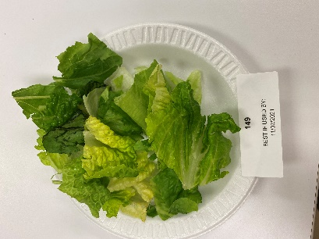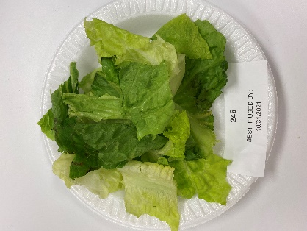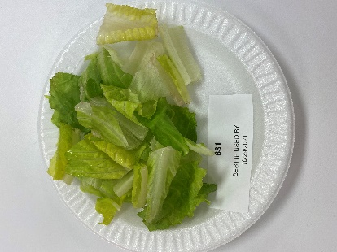
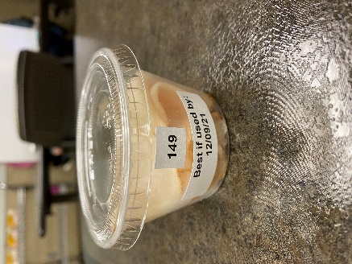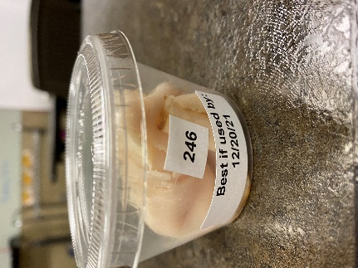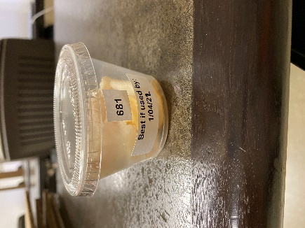
Figure 1. Samples of Bagged Salads and Lunch Meat

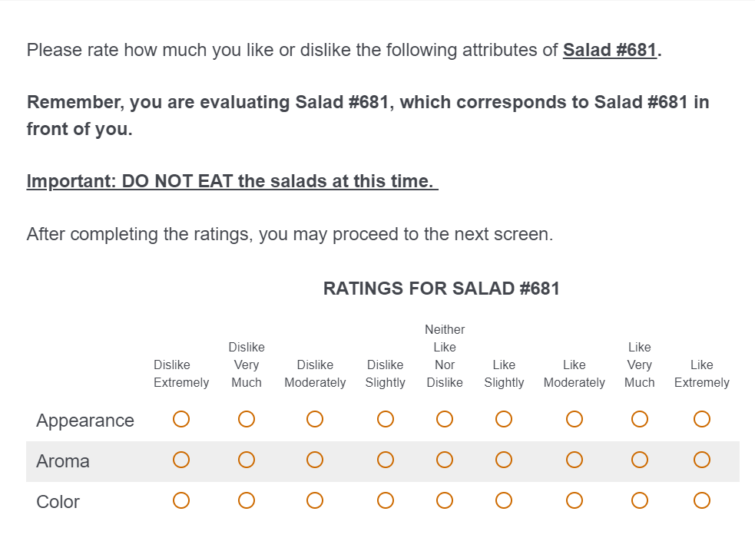
Figure 2. Round 1 Salad Ratings Question
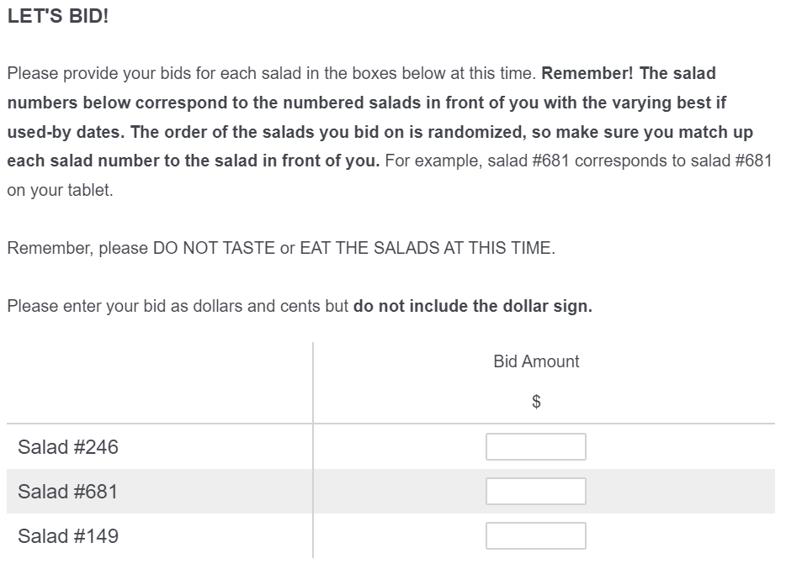
Figure 3. Round 1 Bid Question
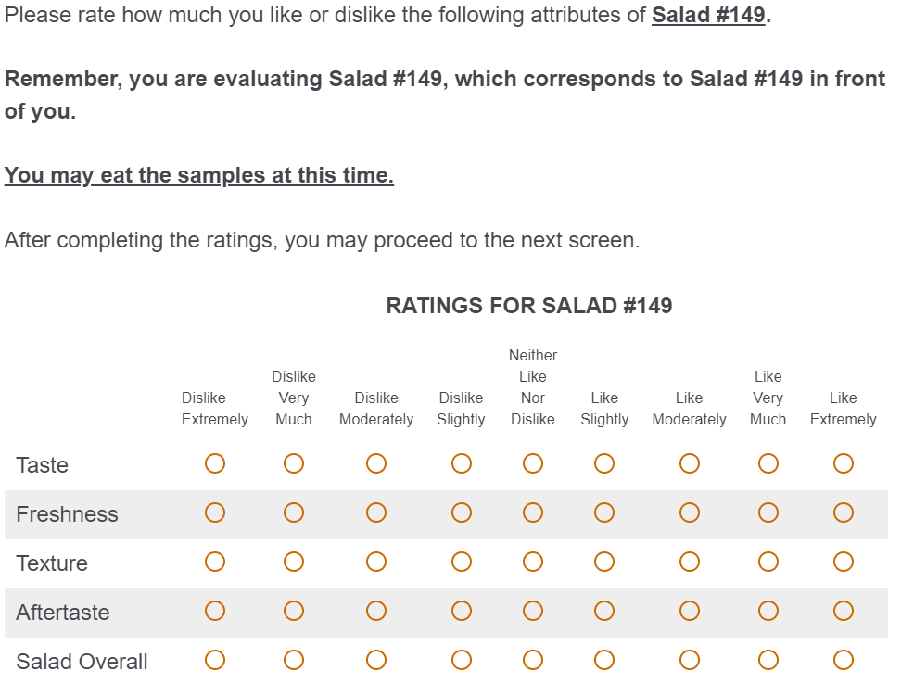
Figure 4. Round 2 Salad Rating Question
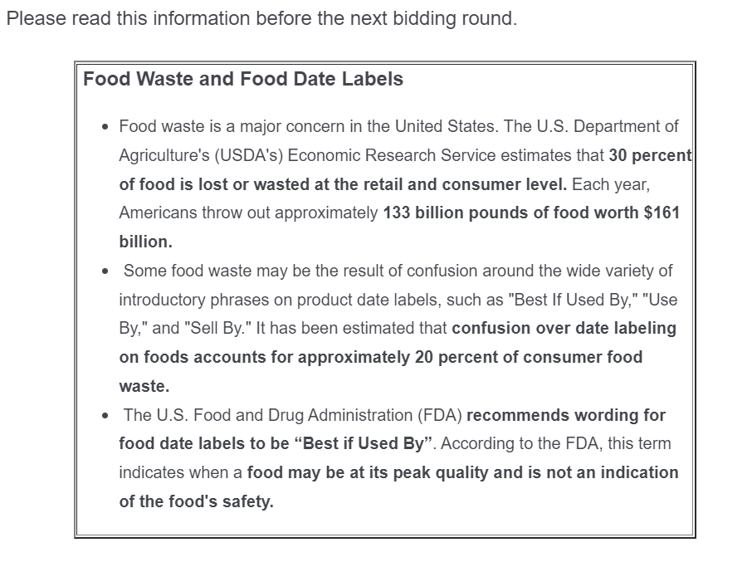
Figure 5. Information Treatment Panel


Figure 6. Knowledge Rating Question
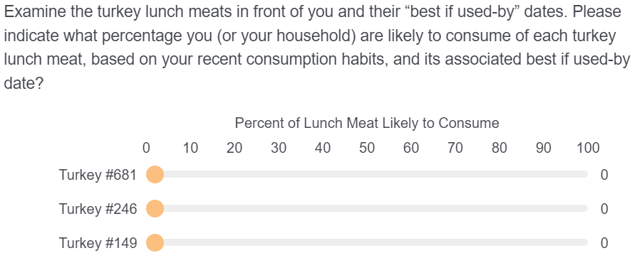
Figure 7. Lunch Meat Stated Consumption Question

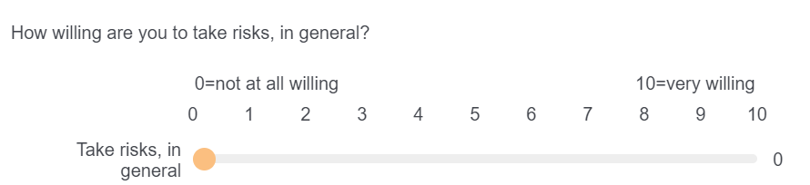
Figure 8. Risk Taker Question

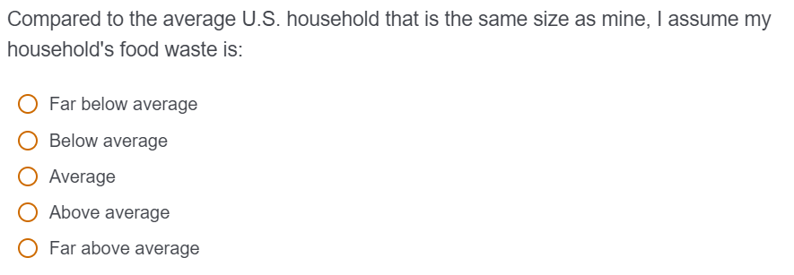
Figure 9. Estimated Household Food Waste Average Question
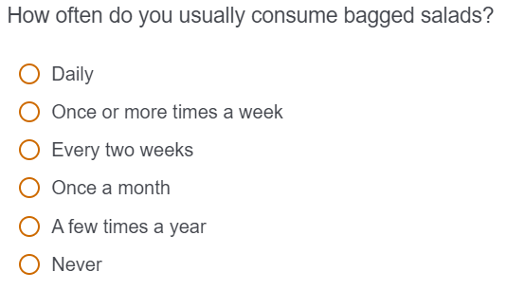
Figure 10. Bagged Salad Consumption Frequency Question

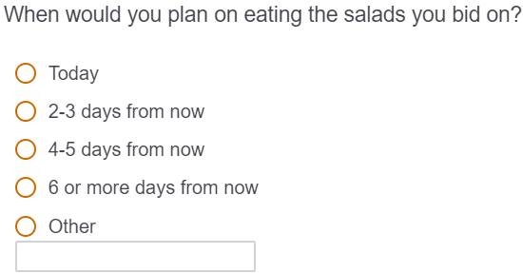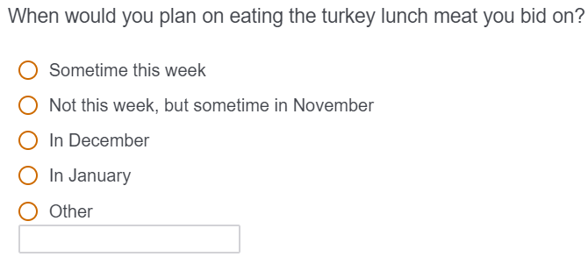
Figure 11. Product Consumption Question

VITA
Beth Anne Billie Ray is from Gaithersburg, Maryland and graduated from Gaithersburg High School in 2017. She graduated cum laude from the University of Tennessee in 2021 with a Bachelor of Science in Agricultural and Resource Economics having majored in Food and Agricultural Business with a concentration in Food Industry Management and minored in Entrepreneurship. She continued at the University of Tennessee, Knoxville to pursue her Master of Science in Agricultural and Resource Economics. Her research area focused on food waste and consumer marketing and demand. After she graduated from the University of Tennessee in 2023, she pursued a career in agricultural policy and education.

