To the Graduate Council:

I am submitting herewith a thesis written by Anastasia Elizabeth Bourne entitled “Stretching with whole body vibration versus traditional static stretches to increase acute hamstring range of motion.” I have examined the final electronic copy of this thesis for form and content and recommend that it be accepted in partial fulfillment of the requirements for the degree of Master of Science, with a major in Kinesiology.

Dixie L. Thompson, Major Professor

We have read this thesis
and recommend its acceptance:

Eugene C. Fitzhugh

Clare E. Milner

Accepted for the Council:

Carolyn R. Hodges
Vice Provost and Dean of the Graduate School

(Original signatures are on file with official student records.)

Stretching with whole body vibration versus traditional static stretches to increase acute
hamstring range of motion.

A Thesis Presented for the
Master of Science
Degree
The University of Tennessee, Knoxville

Anastasia Elizabeth Bourne
August 2011

ACKNOWLEDGEMENTS

I wish to say thank you to Dr. Dixie Thompson, Dr. Eugene Fitzhugh, and Dr. Clare Milner, my committee members, for the guidance, help, and support throughout the process of learning to perform an experiment, analyze the results, and write a thesis. Your encouragement and persistence has helped me become a better writer and student. Our brainstorming sessions provided suggestions for improvement on my study, an understanding of the appropriate tests to run in order to produce quality analysis, and allowed my thesis to develop well.
Thank you to Cynthia Hackney for the time spent analyzing and discussing the statistical aspects of this study. Your excitement for statistics gave me the encouragement to learn, interpret, and discuss the results.
Fellow graduate students and the Lady Vol Sports Medicine Department are also deserving of praise and acknowledgement. Your willingness to provide lots of encouragement and support is very much appreciated. Thank you to Jenny Moshak, MS, ATC, CSCS for agreeing to serve as a courtesy member for my committee. Your insight and athletic training background are invaluable.
Many thanks to my family and friends for kind, reassuring words when I needed them most. Your constant support aided in maintaining my sanity, staying focused on the important things in life, and keeping my faith.

ABSTRACT
PURPOSE The purpose of this study was to determine if performing static active knee extension hamstring stretching using the Pneumex Pro-Vibe vibrating platform increased acute hamstring range of motion (ROM) greater than traditional static active knee extension hamstring stretching. METHODS: A within subject design was utilized with subjects undergoing static stretching with vibration and without vibration (conditions counterbalanced). Pre- and post-test active and passive ROM was measured for the right leg, with subjects first undergoing a 5-minute warm-up on a stationary bicycle. The traditional static stretch consisted of a supine active knee extension on the Pro-Vibe platform with no vibration. The stretch was held at the point of the onset of discomfort 3 times each for 30 seconds, with a 20-second rest period between each stretch. Stretching with whole body vibration (WBV) used the Pneumex Pro-Vibe vibrating platform set at 30 Hz at the “high” amplitude setting, with the same stretching technique. Active hamstring ROM was measured via active knee extension using a goniometer with the leg in 90° of hip flexion, with the opposite leg extended. Passive ROM was measured via clinician-assisted knee extension with the leg in 90° of hip flexion. RESULTS: A 2-way repeated measures ANOVA was performed for passive ROM with the factors condition (vibration vs. non-vibration) and time (pre-test and post-test measurements). Analysis revealed no significant interaction, F (1,23) = 0.621, p = 0.439, but showed a significant main effect for condition, F (1, 23) = 0.5875, p < 0.05, and time, F (1, 23) = 5.029, p < 0.05. Another repeated measures ANOVA was performed for active ROM with the same factors. Analysis revealed a significant time by condition interaction, F (1, 23) = 4.730, p < 0.05, and a significant main effect for pre-test and post-test, F (1, 23) = 18.612, p < 0.001.
A univariate ANOVA was performed with the factors condition and measurement (active and passive ROM). Analysis revealed no main effect for either measurement (p = 0.131) or condition (p = 0.075). Additionally, the analysis showed no significant interaction (p = 0.381).
Post-hoc paired samples t-tests were used to determine the difference between the pre-test and post-test measurements for each condition. No significant differences pre-test vs. post-test were found for either non-vibration active ROM (p = 0.081) or non-vibration passive ROM (p = 0.225). Active ROM showed a significant difference pre-test to post-test for the vibration condition, t (23) = -5.41, p < 0.001. The vibration condition also resulted in significantly different pre-test vs. post-test measurements on passive ROM, t (23) = -2.55, p < 0.05. In both cases the average ROM was higher for the post-test (see Table 2). Additionally, active ROM pre-test in the vibration condition (149.49 ± 11.41) was not significantly different (p > 0.05) from pre-test values in the non-vibration condition (148.81 ± 15.16). Passive ROM pre-test in the vibration condition (159.7 ± 14.2 degrees) was not different (p > 0.05) from pre-test values in the non-vibration condition (157.1 ± 14.9 degrees). DISCUSSION: Three 30-second active knee extension hamstring stretches using a vibrating platform are sufficient to cause significant acute increases in hamstring ROM. These findings suggest this device may be useful when desiring increased hamstring ROM.

Table of Contents
CHAPTER PAGE
Abstract iii
Table of Contents v
List of Figures vii
List of Abbreviations viii
Chapter 1: Introduction 1
Chapter 2: Review of Literature 5
Muscle Anatomy 5
Neurophysiological Basis of Stretching 7
Increasing Range of Motion 10
Stretching Techniques 13
Physiology of Whole Body Vibration 23
Whole Body Vibration and Hamstring Flexibility 24
Whole Body Vibration and Strength and Power 25
Whole Body Vibration and Other Uses 27
Summary 28
Chapter 3: Manuscript 30
Abstracts 30
Introduction 30
Methods 34
Participants 34
Data Collection and Instruments 35
Statistical Analysis 37
Results 37
Discussion 39
Limitations 42
Strengths 42
Implications 43
References 44
Appendices 51
APPENDIX A: Informed Consent 52
APPENDIX B: Physical Activity Readiness Questionnaire (PAR-Q) 55
APPENDIX C: Data Collection Sheet 57
Vita 59

List of Figures
Figure 1: The Pneumex Pro-Vibe 2
Figure 2: Hamstring Stretch 36
Figure 3: Hip Flexion 37
Figure 4: Active ROM 37
Figure 5: Passive ROM 37
Figure 6: Active ROM Change 39
Figure 7: Passive ROM Change 39

List of Abbreviations

Abbreviation | Term | Definition
AKET | Active Knee Extension Test | Measurement where the subject either actively extends the knee, or the examiner passively extends the knee, until the examiner feels slight resistance or the subject reports a strong but tolerable stretch.
DOMS | Delayed Onset Muscle Soreness | Muscle soreness that usually occurs 12-48 hours after a workout and is characterized as a sore, aching pain in the muscle.
GTO | Golgi Tendon Organ | Sensory receptor that responds to tension applied to a tendon.
PNF | Proprioceptive Neuromuscular Facilitation | Stretching techniques that involve combinations of alternating contractions and stretches.
ROM | Range of Motion | A measurement of flexibility.
SLR | Straight Leg Raise | While supine, one hip is flexed, with the knee fully extended, while the other remains on the table.
TVR | Tonic Vibration Reflex | Vibration causes muscles to respond with physiological adaptations due to compensatory reflex contractions which is the result of tissue deformation resulting from vibratory impulses.
WBV | Whole Body Vibration | Vibration transmitted externally to the body through the feet via a platform or a drum.

Chapter 1: Introduction

Vibration therapy is the use of external vibration to elicit physiological changes leading to enhanced performance during sport and exercise. Research dates back to 1932, yet vibration was not consistently investigated until the 1970s when it was used in conjunction with the application of low-frequency vibration to the field of orthopaedics, which later allowed the development of a consistent diagnostic tool for vibration analysis in the late 1980s and early 1990s (Nokes, 1999). However, as Lorenzen (2009) describes, although studies examined the effect of vibration platforms, inconsistencies with methodology and variables of interest reduced the general applicability of results. Additionally, the multitude of tools used to produce the vibratory impulses, such as using a weighted plunger, a tuning fork, an electromechanical vibrator, an electromagnetic shaker (Nokes, 1999), or a vertical or tilting vibrating platform (Lorenzen, 2009) causes further difficulty in finding a uniform treatment protocol or understanding of the technique’s impact.
Despite many investigations, the effects and benefits of vibration therapy are not well understood. At times, results are conflicting. One vibration platform manufacturer claims the massage effect of the vibration relaxes muscles (Pneumex, 1998), and is supported with a study by Peer, Barkley, and Knapp (2009). However, other studies, such as Cronin, Oliver, and McNair (2004) and Dolny and Reyes (2008) show increased tissue stiffness following a bout of vibration therapy. The same manufacturer claims additional benefits can be obtained with strength and flexibility exercises performed on the vibrating platform: a decrease in shoulder, ankle, and foot pain; a positive effect for the treatment of muscle strains and ligamentous sprains; increased range of motion; and a positive effect for improved performance during “osteoporosis/weight-bearing exercises” (Pneumex, 1998). However, not all of these statements are supported by research.
Vibration therapy is characterized by sinusoidal oscillations transmitted externally to the body through the feet via a platform or drum (Dolny & Reyes, 2008). While standards have been established for workplace vibration safety (Griffin, 1998), formalized standards for therapeutic vibration are difficult to formulate due to the complicated characteristics of the parameters involved with treatment sessions (Mester, Kleinoder, & Yue, 2006). Therapeutic uses of whole body vibration (WBV) must be balanced with subject safety. Individuals who experience chronic vibration seem to be at a higher risk of low back pain and other musculoskeletal injuries and disorders (Mattioli, et al., 2011; Piligian, et al., 2000; Seidel & Heide, 1986; Wikstrom, Kjellberg, & Landstrom, 1994). Vibration frequencies that are too low may cause resonance, a strong detrimental vibration that depends on the subject’s body weight and position on the instrument, as well as the stiffness of the muscles (Mester, et al., 2006). Ronnestad (2009) states resonance can lead to injuries ranging from headache to internal bleeding. WBV frequencies should therefore stay within the range of 20 – 50 Hz.
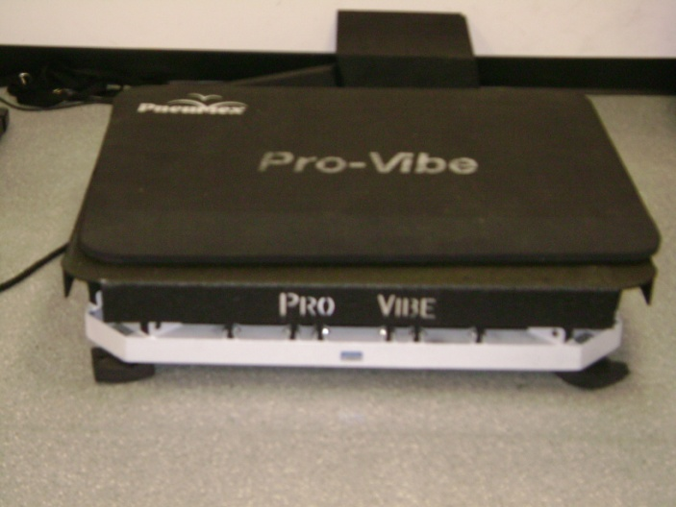
Figure 1: The Pneumex Pro-Vibe is an example of a whole body vibration platform.
Segmental vibration utilizes vibration for only a portion of the body by using a ring (Issurin, Liebermann, & Tenenbaum, 1994) or small drum (J. Cronin, Nash, & Whatman, 2007; Sands, McNeal, Stone, Haff, & Kinser, 2008; Sands, McNeal, Stone, Russell, & Jemni, 2006). However, whole body vibration platforms are much more common and are used in the majority of research studies (Cardinale & Lim, 2003; Cochrane, Legg, & Hooker, 2004; Cochrane & Stannard, 2005; J. Cronin, et al., 2007; Gerodimos, et al., 2010; Issurin, et al., 1994; Jacobs & Burns, 2009; Mester, Spitzenfeil, Schwarzer, & Seifriz, 1999; Rittweger, Beller, & Felsenberg, 2000; Ronnestad, 2004, 2009; van den Tillaar, 2006). Two types of vibration platforms have been studied. One, like the Pro-Vibe Vibration Plate, is a platform that produces vertical and horizontal vibrations. These platforms may be only large enough to stand on, while others accommodate movements requiring more space, such as weight-training exercises. Another is the tilting, or teeterboard, style platform that creates vibration impulses via alternating up-and-down motions about a horizontal anteroposterior central axis (Anderson, 2006; Lorenzen, 2009).
By standing on the platform, a subject experiences WBV. Research has been conducted examining the effects of WBV therapy, including its effects on flexibility, which is defined by Prentice (2003) as the ability to move a joint or series of joints smoothly and easily throughout a full range of motion. WBV was studied extensively in the 1970s and 1980s (Nokes, 1999), but a renewed interest in the potential therapeutic uses of vibration was initiated by Issurin, Liebermann, and Tenenbaum (1994), who investigated the effect of WBV training for maximal force and flexibility.
Low back pain is a significant cause for high primary health care costs in industrialized nations (Becker, et al., 2010). Although some researchers argue the correlation between hamstring flexibility and low back pain is not conclusive (Balague, Troussier, & Salminen, 1999), other studies have found a positive association between decreased hamstring flexibility and low back pain (Balague, et al., 1999; Feldman, Shrier, Rossignol, & Abenhaim, 2001; Hultman, Saraste, & Ohlsen, 1992; Jones, Stratton, Reilly, & Unnithan, 2005).
Poor hamstring flexibility has been associated with low back and lower extremity injuries (Hartig & Henderson, 1999; Worrell, Smith, & Winegardner, 1994). Static stretching is the most popular technique to increase flexibility, (Covert, Alexander, Petronis, & Davis, 2010; Prentice, 2003), and is possibly the safest type of stretching (Prentice, 2003). As a result, this method was chosen to investigate the changes in hamstring ROM.
Due to the inconsistent methodology among previously discussed studies, generalization of the benefits of WBV on joint range of motion is difficult. Therefore, the purpose of this study was to determine if performing static hamstring stretching using the Pneumex Pro-Vibe vibrating platform increases acute hamstring range of motion (ROM) greater than traditional static hamstring stretching. Hypothesis 1 was that the active ROM would have greater increases when static stretching is performed on a WBV platform compared to a non-vibrating surface. Hypothesis 2 was that the passive (examiner-assisted) ROM would have greater increases when static stretching is performed on a WBV platform compared to a non-vibrating surface.

Chapter 2: Review of Literature

MUSCLE ANATOMY
Basic Muscle Anatomy
A muscle is comprised of elongated cells called muscle fibers, which can be up to 30cm in length (Colbert, Ankney, & Lee, 2009). Each muscle fiber is encased in a cell membrane, or sarcolemma. Cells contain myofibrils, the functional units of the muscle fiber (Colbert, et al., 2009). The four major functional properties of muscle include contractility, excitability, extensibility, and elasticity (Seeley, Stephens, & Tate, 2003). Contractility refers to the ability of the muscle to shorten with a force, while extensibility refers to the property of the muscle to lengthen beyond its normal resting length. A related characteristic is elasticity, the muscle’s ability to recoil to its original resting length after it has been stretched. Finally, excitability is the muscle’s ability to respond to a stimulus (Seeley, et al., 2003).
Contraction
Muscles fibers are contractile cells that produce movement. The fibers contain a semifluid substance called sarcoplasm, which acts as the muscle’s cytoplasm (Prentice, 2003). Muscles have the ability to contract because of the presence of several functional contractile units called sarcomeres that contain thick and thin myofilaments (Colbert, et al., 2009; Seeley, et al., 2003). Thick myofilaments are made of myosin that have thick heads that extend laterally, while thin myofilaments are made of actin (Colbert, et al., 2009; Seeley, et al., 2003). Within the sarcomere, actin and myosin are arranged in repetitive units. Sarcomeres are separated by Z lines, with I bands overlapping the Z lines to extend to the ends of the myosin. The A band is a dark band the length of the myosin within a sarcomere. The alternating series of dark and light bands give skeletal muscle a striated appearance (Colbert, et al., 2009; Seeley, et al., 2003).
Contraction occurs as a result of the nervous system releasing the neurotransmitter acetylcholine (Colbert, et al., 2009). Muscle contraction results from the sliding filament model, which includes all the events that result in actin sliding over myosin, creating temporary connections that shorten the sarcomere. The sarcomere shortens due to the myosin crossbridge heads rotating and pulling the actin toward the center of the sarcomere (Colbert, et al., 2009; Seeley, et al., 2003).
Flexibility
Prentice (2003) defines flexibility as the ability to move a joint or series of joints smoothly and easily throughout a full range of motion. Flexibility, determined by measuring ROM, has been considered an integral component to improved performance and potential injury prevention (Depino, Webright, & Arnold, 2000), and is the result of a multitude of factors including the muscle’s viscoelastic properties (Ballantyne, Fryer, & McLaughlin, 2003; Chan, Hong, & Robinson, 2001), stretch tolerance (Ballantyne, et al., 2003; Feland, et al., 2010), age (Feland, et al., 2010), gender (Fasen, et al., 2009; McHugh, Magnusson, Gleim, & Nicholas, 1992), muscle stiffness (Halbertsma, Mulder, Goeken, & Eisma, 1999; Magnusson, Simonsen, Aagaard, & Kjaer, 1996; Marek, et al., 2005; Odunaiya, Hamzat, & Ajayi, 2005; Witvrouw, Danneels, Asselman, D'Have, & Cambier, 2003), joint capsule (Decoster, Scanlon, Horn, & Cleland, 2004), soft tissue characteristics (Decoster, et al., 2004; Prentice, 2003; Sapega, Quedenfeld, Moyer, & Butler, 1981), and bone restrictions (Decoster, et al., 2004; Depino, et al., 2000; Fasen, et al., 2009; Prentice, 2003; Ross, 1999).

NEUROPHYSIOLOGIC BASIS OF STRETCHING
Increasing ROM through any technique requires elongation of the muscle fibers. An elastic stretch is described as a spring-like behavior in which elongation of the muscle is produced by a tensile force that is temporary and causes original muscle length to be recovered once the load is removed (Sapega, et al., 1981; Wright & Johns, 1961). When a constant force is applied further to a fully-elongated muscle, a progressive displacement occurs, called creep, which results in incomplete strain recovery (Wright & Johns, 1961). This elongation leads to increased muscle flexibility because muscles contain viscoelastic characteristics, meaning they exhibit both the viscous and elastic properties, and include contractile and series elastic elements arranged in parallel (Chalmers, 2004; Magnusson, 1998; Sapega, et al., 1981). Muscle fibers respond to a slowly applied stretching force by elongating, called stress relaxation, which occurs through a mechanical property of creep. Stress relaxation occurs when a muscle is held at a constant length, while creep occurs when a muscle is held at a constant force (Ryan, et al., 2010; Taylor, Dalton, Seaber, & Garrett, 1990). Low-force, long-duration stretching enhances permanent, plastic deformation (Sapega, et al., 1981). A high-force, short-duration stretch will result in recoverable, elastic tissue deformation (Sapega, et al., 1981; Taylor, et al., 1990). Performing appropriate stretching techniques allows for stretching of the muscle’s viscoelastic properties without causing damage to the muscle itself. A rapidly applied force that leads to a stretch will be counteracted by an increased resistance by the muscle in order to attempt to protect the muscle from damage (McHugh, et al., 1992).
The protective action within a muscle is the result of muscle spindles, which detect and respond to muscle stretch by sending sensory impulses to the spinal cord. The spinal cord passes along the information to the central nervous system and responds by sending impulses back to the muscle being stretched to reflexively contract, thereby resisting the stretch.
The reflex arc, the most basic functional unit of the nervous system, is responsible for receiving a stimulus and producing a response at the simplest level. Five basic components comprise the reflex arc: a sensory receptor, a sensory neuron, an interneuron, a motor neuron, and an effector organ (Seeley, et al., 2003). The reflex produced by the reflex arc is an automatic response to a stimulus that occurs without conscious thought (Seeley, et al., 2003). Some reflexes involve excitatory neurons that elicit muscular contraction responses, while other reflexes involve inhibitory neurons that cause muscular relaxation (Seeley, et al., 2003). Major spinal cord reflexes include the stretch reflex and the Golgi tendon reflex, among other reflexes.
The stretch reflex has three main components: the muscle spindle that responds to stretch, the afferent nerve fiber that carries the sensory impulse to the spinal cord, and the efferent spinal cord motor neuron that activates the stretched muscle. The reflex “acts as a self-regulating, compensating mechanism” because “excitatory impulses activate synergistic muscles that support the desired movement, while inhibitory impulses flow to motor units that normally counter the movement” (McArdle, Katch, & Katch, 2007). Muscle spindles are contractile only at the ends, innervated by gamma motor neurons, while the noncontractile middle section is innervated by a sensory neuron that synapses directly with the motor neurons of the spinal cord, called alpha motor neurons. These neurons innervate the muscle in which the muscle spindle is embedded. Therefore, the stretch reflex is unique in that the sensory neurons directly synapse with the motor neurons of the spinal cord (Seeley, et al., 2003). When a muscle is stretched, the sensory neurons within the muscle activate the motor neurons to contract the stretched muscle in opposition (Seeley, et al., 2003). Through automatic regulation of the muscles, the stretch reflex allows for quicker responses to stretching by avoiding the slower form of information processing through the central nervous system (McArdle, et al., 2007).
An extended stretch lasting longer than six seconds, such as during static or PNF stretching, causes the Golgi tendon organ (GTO), which responds to the muscle’s change in length and increased tension, to send impulses to the spinal cord that causes a reflexive relaxation of the antagonist muscle (Prentice, 2003). The GTO, a sensory receptor with a protective mechanism for the muscle, detects tension applied to a tendon, and responds by discharging impulses under two conditions: 1) muscle tension created by activation, and 2) muscle tension through passive stretch (Seeley, et al., 2003). When the GTO detects excessive, destructive tension, it initiates reflexive inhibition by sending impulses to the spinal cord which then override the motor neuron’s activation impulses to the muscle (McArdle, et al., 2007). The protective response of the GTO’s sensory receptors inhibits motor neuron activity, reduces force output, and causes muscle relaxation in order to relieve the tension applied to the tendon (McArdle, et al., 2007; Seeley, et al., 2003).
Autogenic inhibition is the result of the GTO stretch, causing decreased muscle excitability after stretching and potentially increasing flexibility through GTO activation and muscle relaxation (Laporte & Lloyd, 1952; Seeley, et al., 2003). Reciprocal inhibition involves contraction of the opposing muscle, for example the quadriceps muscle, to facilitate stretching of the muscle being stretched, the hamstring muscle in this case (Laporte & Lloyd, 1952; Seeley, et al., 2003). The relaxation that results, called autogenic inhibition, is a protective mechanism that allows the muscle to stretch before the extensibility limit is reached, beyond which stretching would cause muscle fiber damage (Prentice, 2003).

INCREASING RANGE OF MOTION
Increasing ROM is the result of plastic deformation in both the muscle and connective tissue (Sapega, et al., 1981). The biomechanical aspects of a muscle during stretching was examined in a study by Magnusson, et al. (1996). Each subject’s knee was passively extended, and remained in a predetermined position for 90 seconds. Measurements examined stiffness, energy, and passive torque in the dynamic and static phases of the stretch maneuver. The authors observed a decline in muscle stiffness, energy, and torque following the five static stretches. However, all variables returned to baseline within an hour following stretching. Additionally, Halbertsma, et al. (1999) examined the response of the hamstring muscle to repeated passive stretching. Subjects completed five successive passive stretches without previous warm-up to extreme end ROM. No significant changes in elongation of the hamstrings, muscle stiffness, or the electrical activity of the muscles were detected, showing the acute effects of stretching were negligible.
One study examined the possible contribution of neurological influences on hamstring flexibility by blocking the neural system at various stages during arthroscopic surgery for unilateral knee injury, including causing spinal anesthesia, epidural anesthesia, general anesthesia, or a femoral nerve block of the injured leg (Krabak, Laskowski, Smith, Stuart, & Wong, 2001). The study, which took place in an operating room setting, determined the spinal anesthesia group showed a greater increase in popliteal angle intraoperatively than the other groups, demonstrating the possible role the neural system plays in determining the intrinsic viscoelastic properties of the muscle. The authors argued a potential exists for a muscle to contain a neural “set point” that controls a muscle’s preferred length, resistance to motion, and sensitivity to length change.
Halbertsma, van Bolhuis, and Goeken (1996) investigated the effects of 10 minutes of stretching on muscle stiffness in subjects with short hamstrings. Subjects performed a standing hamstring stretch for 30 seconds, with a 30-second rest in between stretches, for a total of 10 minutes. The force needed to lift the leg, ROM, pelvic-femoral angle, and the electromyogram of the hamstring muscle were measured. Results indicated that although muscle stiffness was not affected after stretching, ROM and elongation of the muscle significantly increased. The authors argue this increased ROM results from an increase in stretch tolerance by the subjects.
Concern that stretching may cause a decrease in strength and power has challenged the perceived benefits of stretching. Therefore, Unick, Kieffer, Cheesman, and Feeney (2005) examined the effect of static and ballistic stretching on vertical jump for 16 collegiate basketball players. The subjects stretched the muscles primarily responsible for vertical jump, quadriceps, hamstring, and calf muscles, using ballistic and static stretching techniques. Following each intervention, the subjects performed several vertical jumps. The authors determined no significant decrease in vertical jump occurred because of either stretching technique, possibly due to an appropriate resting interval that allowed for recovery of motor neuron excitability or because the acute effects of stretching may not adversely affect power performance in trained female athletes.
Traditionally, a warm-up has been used before stretching to increase body temperature and decrease the risk of musculoskeletal injury. A general warm-up increases overall body temperature and elevates deep muscle temperature more effectively than a passive warm-up, while a specific warm-up also provides a rehearsal of the event that will take place (Shellock & Prentice, 1985). In one study, four stretch protocols were examined to determine the effect of a warm-up protocol on 20-meter sprint performance in rugby players (Fletcher & Jones, 2004). Passive static, active static, passive dynamic, and active dynamic stretching were performed on different occasions, with both static stretching techniques showing significantly slower sprint times. However, active dynamic stretches resulted in faster sprint times, possibly due to a similar movement pattern during stretching as that of the sprint. The authors postulate the slower sprint times occurred during static stretching due to the prolonged isometric static stretching reducing the sensitivity of the neural pathways and reducing muscle spindle sensitivity.
Williford, East, Smith, and Burry (1986) also compared the effect of various warm-up techniques on hamstring flexibility. Hamstring flexibility after jogging and static stretching or static stretching alone was compared to a control group. Both groups showed significant increases in hamstring ROM, leading the investigators to theorize static stretching might possibly produce sufficient warming of the muscles to aid in increases in flexibility. Similarly, another study investigated the effect of static stretching and warm-up exercise on hamstring length over a 24 hour period (de Weijer, Gorniak, & Shamus, 2003). The authors assigned 56 volunteers to one of four groups: static stretch only, warm-up only, warm-up and static stretch, or a control group. Data revealed the static stretching group and the warm-up and static stretch group resulted in significantly greater ROM than warm-up alone or the control group. In contrast, O’Sullivan, Murray, and Sainsbury (2009) investigated the effect of a five minute jog-in-place warm-up and either static or dynamic stretching on hamstring flexibility, and found participating in a warm-up significantly increased hamstring flexibility. The authors found static stretching also significantly increased ROM, while dynamic stretching decreased flexibility in the 36 subjects.
Appropriate flexibility of a joint is critical to injury prevention. In a study examining muscle flexibility as a risk factor, Belgian soccer players were measured for hamstring and quadriceps muscle flexibility during the preseason then monitored throughout the season. The study determined soccer players with less than 90 degrees of hamstring muscle flexibility were at a significantly higher risk of injury (Witvrouw, et al., 2003). Additionally, military basic trainees who underwent three additional hamstring stretching sessions each day had a decreased number of lower extremity overuse injuries (Hartig & Henderson, 1999). Although some researchers argue the correlation between hamstring flexibility and low back pain is not conclusive (Balague, et al., 1999), other studies have found a positive association between decreased hamstring flexibility and low back pain (Balague, et al., 1999; Feldman, et al., 2001; Hultman, et al., 1992; Jones, et al., 2005).

STRETCHING TECHNIQUES
For joints that undergo both flexion and extension, such as the knee, opposing muscles must work in a balanced, coordinated manner. For the knee to extend, the quadriceps muscle group must contract while the hamstring group must relax. The muscle that is contracting is called the agonist muscle. The hamstring muscle, which is relaxing and being stretched in response, is called the antagonist muscle. An imbalance of the agonist and antagonist muscle rhythm increases the risk of a muscle strain (Prentice, 2003).
Static stretching
Static stretching, the most popular technique to increase flexibility, occurs when the individual puts the targeted muscle at its maximal length and maintains this position for a specific amount of time (Covert, et al., 2010; Prentice, 2003). Some have argued static stretching is possibly the safest type of stretching (Prentice, 2003), and has been associated with both decreased muscle soreness after exercise (Shellock & Prentice, 1985) and a significant reduction in musculotendinous injuries after implementation as a stretching program (Magnusson, et al., 1997).
Ballistic stretching
Ballistic stretching, which uses repetitive rapid agonist contractions in a bouncing or jerking manner for increasing antagonist flexibility (Prentice, 2003), has not been well researched and is therefore difficult to determine its efficacy in increasing ROM (Covert, et al., 2010) . In a study comparing several categories of stretching, Lucas and Koslow (1984) included ballistic stretching among the “dynamic” stretches due to the end-range stretch representing a gentle bobbing motion instead of being held still.
Ballistic stretching can be more dangerous than other stretching techniques, and the bouncing motion may not allow time-dependent stress relaxation or creep to occur (Taylor, et al., 1990). Taylor, et al. (1990) argue, that although ballistic stretching can lead to increased flexibility and reduced tensile stress on a stretched musculotendinous unit, the potential increase in flexibility is outweighed by the risk of injury secondary to stretching the muscle beyond the length it can safely handle. Beedle and Mann (2007) compared joint range of motion after static and ballistic stretches as a warm-up tool for the low back, knee, and ankle. Although no subjects reported DOMS or soreness following ballistic stretching, the majority preferred static stretching because ballistic stretching was more awkward or uncomfortable. Additionally, another study stated subjects did not prefer the ballistic stretching technique because they did not feel the stretch, or because they heard the technique was dangerous (Beedle & Mann, 2007)
Ballistic stretching may increase the likelihood of a muscle injury or cause delayed-onset muscle soreness (DOMS) (Shellock & Prentice, 1985), but may also activate the stretch reflex and best simulate sports movements when compared to other types of stretching (Covert, et al., 2010; Fasen, et al., 2009; Prentice, 2003). Some argue ballistic stretches activate the muscle significantly greater than static stretching, which may have beneficial effects on tendon elasticity and the stretch-shortening cycle, a critically important characteristic for athletes performing jumping activities (Covert, et al., 2010).
Proprioceptive neuromuscular facilitation
Proprioceptive neuromuscular facilitation (PNF) provides yet another stretching technique. PNF was developed by Kabat and Knott, based on concepts developed from research at the beginning of the 20th century (Kabat & Knott, 1948). It is considered “a manual procedure that uses controlled, voluntary isometric contractions of a targeted muscle group” in order to increase ROM (Smith & Fryer, 2008). This method’s neurophysiologic effects increase flexibility through autogenic inhibition and reciprocal inhibition (Chalmers, 2004; Davis, Ashby, McCale, McQuain, & Wine, 2005; Smith & Fryer, 2008). The relaxation phase of PNF stretching, during which contraction of the agonist muscle occurs, causes reflexive relaxation of the antagonist muscle. This relaxation, called reciprocal inhibition, allows the antagonist muscle to be stretched and protected from injury. Autogenic and reciprocal inhibition theoretically allows the antagonist muscle to be stretched during PNF stretching techniques further than with static or ballistic stretching techniques (Chalmers, 2004; Laporte & Lloyd, 1952; Prentice, 2003).
Many techniques for PNF exist, causing general comparisons to be difficult. Although several PNF stretching techniques are used, a common one is called the contract-relax technique. For the contract-relax technique, the individual volitionally contracts the antagonist muscle then relaxes while an assistant passively stretches the targeted muscle (Smith & Fryer, 2008; van den Tillaar, 2006). This use of autogenic and reciprocal inhibition aids in the relaxation of the muscle to enhance the stretch (Davis, et al., 2005; Decoster, Cleland, Altieri, & Russell, 2005; Sullivan, Dejulia, & Worrell, 1992), causing PNF techniques to be as or more effective than static stretching alone (Fasen, et al., 2009; Lucas & Koslow, 1984; Smith & Fryer, 2008; Sullivan, et al., 1992).
The slow-reversal-hold-relax technique is also used. As a hamstring stretch, the individual would lie supine with the knee extended. The facilitator would flex the hip to the point of discomfort in the hamstring, the antagonist muscle, at which time the individual would counteract the flexion by extending the hip through hamstring contraction for a certain amount of time against resistance. After this time, the individual relaxes the hamstrings then contracts the agonist muscle while the facilitator applies passive pressure in the same direction. The individual would repeat this cycle at least three times (Prentice, 2003).
Effect of stretching on muscular strength and power
The effect of traditional stretching on muscular strength and power has been debated. LaRoche, Lussier, and Roy (2008), in response to concerns that flexibility training may be detrimental to muscle performance, examined the effects of four weeks of ballistic or static stretching on muscle force, power, and optimal length. The authors determined four weeks of hamstring flexibility training has little effect on peak hamstring force, work capacity, power, or optimal muscle length. Subjects in the stretching groups produced data similar to subjects in the control group. Therefore, although not measured in this study, a moderate stretching routine is recommended in order to maintain muscle flexibility and reduce the risk of injury. Conversely, Marek, et al. (2005) showed static and PNF stretching caused similar deficits in strength, power output, and muscle activation at both slow and fast velocities, the changes were small and possibly context-specific to this study. Further, another study shows increasing hamstring flexibility is an effective method for increasing hamstring muscle performance in select isokinetic conditions (Worrell, et al., 1994). Thus, it is unclear how changes in flexibility affect other measures of musculoskeletal performance.
ROM Studies
Inconsistent parameters when stretching make determining the most effective technique impossible. Bandy, Irion, and Briggler (1997) investigated the effect of time and frequency of static stretching on the flexibility of the hamstring muscles. Subjects performed either three 1-minute static stretches, three 30-second static stretches, one 1-minute static stretch, or one 30-second static stretch five times a week for six weeks. The authors determined increasing the frequency beyond one 30-second static stretch did not significantly increase flexibility. Chan, et al. (2001) examined the effects of long-term static hamstring stretching. Subjects performed a 30-second static stretch for either four weeks or eight weeks. Both groups had significant ROM increases from baseline, but were not significantly different from each other, showing both protocols are effective to increase ROM. Ross (1999) investigated the effects of acute ROM gains following two static stretching protocols on individuals with limited flexibility. The unique stretches for this study included stretching in a position that mimicked the stance and forward swing phases of running. The author determined both static stretches were effective to significantly increase hamstring flexibility, with the stance phase stretch improving flexibility more.
Some studies have determined static stretching to be the only effective stretching technique. Davis, et. al. (2005) investigated three stretching techniques on bilateral hamstring flexibility over four weeks. Each stretching technique was performed once for 30 seconds, three times a week. The static stretch protocol involved actively flexing the hip to 90 degrees and activating reciprocal inhibition through contraction of the quadriceps muscles to cause a stretch of the hamstring muscle group. The manual static stretch involved the subject experiencing the same stretch described above, but in a passive, examiner-assisted manner. A third group used a PNF technique utilizing reciprocal inhibition. After extending the knee with the hip at 90 degrees of hip flexion, the subject was asked to extend the knee against the examiner’s resistance for 10 seconds, and then held the position of a strong but tolerable stretch for 30 seconds. After four weeks, the authors determined that although all techniques increased hamstring flexibility from baseline measurements, static stretching was the only stretching technique that significantly increased hamstring flexibility, with a 30.6 degree increase from baseline.
Brodowicz, Welsh, and Wallis (1996) compared static stretching with heat, with ice, or with no additional modality. The authors determined static stretching on ice was the most effective technique to increase hamstring ROM. However, some researchers state cryostretching should be utilized for limited purposes. For example, Sapega, et al. (1981) recommend using cryostretching when the goal is to tear connective tissue, rather than stretching it, such as in the case of adhesions. Another example is to use cryotherapy when the area is so painful that the analgesic effect is necessary to obtain increased ROM. Finally, cryotherapy may be used when muscle spasticity limits the proper performance of ROM therapy.
Covert, et. al. (2010) compared a 30-second ballistic stretching protocol and a 30-second static stretching protocol with each other and two control groups for three times a week for four weeks. The investigators determined static stretching was a more effective stretching technique to increase hamstring ROM. However, Beedle and Mann (2007) compared static and ballistic stretching, with no significant differences between the two techniques noted in low back, knee or ankle ROM. Additionally, Starring, Gossman, Nicholson, and Lemons (1988) determined five consecutive days of a 15-minute sustained static stretch was equally effective to increase hamstring ROM as 15 minutes of cyclic, or ballistic type, stretching. The cyclic stretching group stretched for repeated bouts of 10 seconds, whereas the sustained stretch group maintained the stretching sensation for 15 minutes. Unlike other studies, the subjects in this study stated a preference for the cyclic method of stretching because it was more comfortable as compared to the sustained stretch.
Meroni, et al. (2010) compared an active hamstring stretching protocol with a static stretching protocol, with subjects performing the stretches independently. For the active stretching protocol, subjects extended their knee to the point of discomfort or tightness in the hamstring muscle from the sitting position, or when they lost the neutral pelvic position. Three repetitions of each stretch were performed twice a day, four days a week, for six weeks. Although both stretching groups showed improvements in flexibility, the authors determined the active stretch group showed greater ROM gains than the static stretching group, possibly because the active stretch was more engaging and encouraged a higher amount of compliance.
In a study compared ballistic stretching techniques and PNF protocols, 47 male subjects were separated into four groups, with three groups of 10 stretching using a modified PNF contract-relax method, and 17 subjects using a traditional ballistic stretching technique (Wallin, Ekblom, Grahn, & Nordenborg, 1985). The authors determined the PNF technique significantly increased flexibility after 30 days, while the ballistic stretching did not significantly improve flexibility until after 60 days of stretching. Additionally, the efficacy of a muscle energy technique has been investigated by Ballantyne, et al. (2003). With the subject’s hip flexed and fixed at 90 degrees, examiners passively extended each subject’s knee until discomfort was felt. At this point, the investigators applied a muscle energy technique, where 75% of maximal isometric contraction was performed for five seconds, after which the subject relaxed for three seconds and the knee extension was repeated. Data results showed PNF increased hamstring ROM following a single application of muscle energy technique.
Funk, Swank, Mikla, Fagan, and Farr (2003) compared five minutes of static stretching and PNF on hamstring flexibility performed with and without exercise. The authors performed a repeated measure, counterbalanced experimental design on 40 undergraduate student-athletes who were tested after 60 minutes of exercise, or without exercise. PNF resulted in a significant increase in hamstring flexibility in both conditions, but static stretching showed no significant improvements.
However, other studies argue several stretching techniques are equally effective to increase hamstring flexibility. In a study comparing PNF, active self-stretch, and static stretching, Davis, et al. (2005) found that all techniques produced statistically significant increased ROM after four weeks. Decoster, et al. (2005) and Ross (1999) found that static stretching through a straight leg raise (SLR) is easier to teach and requires less supervision, but Fasen (2009) determined PNF stretching is more engaging for athletes. These findings may encourage continued participation in stretching programs. LaRoche, et al. (2008) determined both static and ballistic stretching for 4 weeks was effective to increase joint ROM. After investigating the effect of a static, a ballistic, and two PNF stretching techniques over 21 treatment days, Lucas and Koslow (1984) determined all three techniques significantly improved hamstring flexibility.
However, pelvic positioning has shown to be more important to increase ROM than the type of stretching technique used. ROM was significantly increased with an anteriorly rotated pelvic positioning, compared to a posterior rotated pelvic position, during the stretch (Decoster, et al., 2005; Sullivan, et al., 1992). Researchers determined pelvic position can either be manually controlled by the subject during a standing hamstring stretch or can passively occur with supine hamstring stretching (Decoster, et al., 2005; Decoster, et al., 2004; Sullivan, et al., 1992).
Measuring hamstring flexibility
Several techniques exist to measure hamstring flexibility, yet inconsistent parameters for stretching positions and techniques make the most effective measurement technique difficult to determine (Bandy, et al., 1997). Common measurement techniques include the SLR test, the sit-and-reach test, and the active knee extension test. Although very commonly used, the SLR test presents several limitations, including the possibility of stretching the nerves for the leg, stretch of the hip joint capsule, pelvic position inconsistency, contralateral hip flexor tightness, and fascia limiting ROM (Davis, et al., 2005; Davis, Quinn, Whiteman, Williams, & Young, 2008). McHugh, Kremenic, Fox, and Gleim (1998) determined 79% of variability in SLR ROM could be explained by the passive mechanical restraints to motion, the parallel elastic component in relaxed skeletal muscle and the series elastic component in active skeletal muscle.
One study attempted to increase the validity of the SLR stretch by using a Leighton flexometer to measure hip flexion and by having the subjects maintaining the ankle in a neutral position to reduce the risk of variability due to the self-selected amount of plantar flexion or dorsiflexion (Brodowicz, et al., 1996). Although the results were contrary to other studies measuring hamstring flexibility using SLR, the authors recognize differences in protocols, subjects, treatments, and data analysis may have caused differences.
Another common standardized measurement technique is the sit-and-reach test. In a comparison of three different sit and reach tests for hamstring flexibility, the traditional sit-and-reach test and the back saver sit-and-reach test were reasonably accurate and stable measurements that were highly related to hamstring flexibility (Baltaci, Un, Tunay, Besler, & Gerceker, 2003).
One study compared four common clinical tests for flexibility: the knee extension angle test, the sacral angle test, the SLR test, and the sit-and-reach test (Davis, et al., 2008). The authors determined the knee extension angle test, which is performed with the subject supine and one hip flexed to 90 degrees. Also known as the active knee extension test (AKET), the subject either actively extends the knee, or the examiner passively extends the knee, until the examiner feels slight resistance or the subject reports a strong but tolerable stretch. The authors determined the AKET was the most valid technique for hamstring ROM measurement, mainly due to the decreased likelihood of pelvic rotation during measurement with other techniques (Davis, et al., 2008). Sullivan, et al. (1992) further examined the effect of pelvic positioning on hamstring flexibility, and also recommended the AKET for the accurate measurement of hamstring flexibility. In a study with a small amount of change in flexibility, the AKET was a reliable and effective indirect test for assessing hamstring length (Hopper, et al., 2005).
Maintenance of hamstring flexibility
Maintenance of hamstring flexibility following an acute static stretching protocol was examined by Depino, et al. (2000). Thirty male cadets from a collegiate military institute were separated into either a control group or an experimental group. Both groups performed six active knee extensions with a 60-second rest between each extension to obtain baseline measurements of hamstring ROM. After these knee extensions, the experimental group performed four 30-second static stretches before undergoing post-test measurements of hamstring flexibility. The static stretches involved the subject standing, facing a padded evaluation table with the right heel on the table and bending at the waist until a stretch sensation was felt. Both groups were measured at 1, 3, 6, 15, and 30 minutes following cessation of the static stretching protocol. Statistically significant increased ROM occurred after the stretching protocol, with the increased ROM maintained at 1 and 3 minute measurements. For the static stretching group, knee angle at 1 minute was significantly greater than at 6, 9, 15, and 30 minutes. At 3 minutes, knee angle was significantly greater than at 6, 9, 15, and 30 minutes. At 6 minutes, knee angle was significantly greater than at 15 and 30 minutes. Overall, the authors found the increased ROM gained from the static stretches was lost after 3 minutes of inactivity. Contradicting these findings, Ford and McChesney (2007) evaluated flexibility following 3 stretching technique protocols: contract-relax agonist-contract, static stretch, and active control stretch. Following measurements at 0, 3, 7, 12, 18, and 25 minutes, the authors demonstrated significantly increased hamstring ROM was maintained for 25 minutes, even though no specific method of stretching was identifiable as more beneficial than the others.

PHYSIOLOGY OF WHOLE BODY VIBRATION
Vibration causes muscles to respond with physiological adaptations due to compensatory reflex contractions, called a tonic vibration reflex (TVR), which is the result of tissue deformation resulting from vibratory impulses (Bianconi & van der, 1963; Eklund & Hagbarth, 1966). Vibration, particularly the concentrated form of segmental vibration, causes the stimulation of the muscle spindle, and causes a contraction of the vibrated muscle and inhibition of the antagonist muscle group (Peer, et al., 2009). Bishop (1974) also found vibration caused reciprocal inhibition by vibrating two antagonist muscles, canceling each muscle’s facilitation and physiological responses to stretch. Bosco, et al. (1999) postulated the subject’s significant improvement of average velocity, force and power was the result of WBV training’s “dramatic enhancement of the neural traffic regulating neuromuscular behaviour.” Possible neural factors enhanced with vibration training include neural recruitment, synchronization, intermuscular and intramuscular coordination, and the proprioceptors’ responses to vibration (Aminian-Far, Hadian, Olyaei, Talebian, & Bakhtiary, 2011; Cardinale & Lim, 2003; Cochrane & Stannard, 2005; J. Cronin, et al., 2007; Issurin, et al., 1994).
Exposure to chronic vibration has been researched as a possible cause of injury and musculoskeletal disorders in the fingers (Gemne, 1994), distal upper arm (Mattioli, et al., 2011; Piligian, et al., 2000) and low back (Seidel & Heide, 1986; Wikstrom, et al., 1994). “Vibration white fingers” may cause vibration-induced Raynaud’s phenomenon as a result of vibration from hand-held tools (Gemne, 1994). Vibration-induced distal upper arm injuries, typically called Hand-Arm Vibration Syndrome, have been seen in individuals who experience chronic vibration in construction tools (Piligian, et al., 2000), but has also occurred in and individual using a motorcycle for postal service deliveries (Mattioli, et al., 2011). Low back pain from chronic vibration tends to occur in individuals who experience vibration while sitting for long periods of time, possibly due to muscular fatigue and disc compression (Pope, Wilder, & Magnusson, 1998). Prevention of exposure to vibration above recommended limits is critical to preventing chronic disorders from occurring.

WHOLE BODY VIBRATION AND HAMSTRING FLEXIBILITY
Whole body vibration training has shown to be effective to increase hamstring flexibility (J. Cronin, Nash, & Whatman, 2008; Feland, et al., 2010; Jacobs & Burns, 2009; Peer, et al., 2009; van den Tillaar, 2006). One study suggests the stimulation of the agonist quadriceps muscle group through vibration would relax the hamstring muscles and therefore positively affect hamstring stretching exercises (van den Tillaar, 2006). Other possible mechanisms for improved flexibility include enhanced local blood flow following WBV training (Issurin, et al., 1994; Kerschan-Schindl, et al., 2001; Lohman, Petrofsky, Maloney-Hinds, Betts-Schwab, & Thorpe, 2007; Mester, et al., 2006; Rittweger, et al., 2000) and slight inhibition in muscle reflex impulses (Burke, Schutten, Koceja, & Kamen, 1996). Bishop (1974) found subjects experienced a residual vibration sensation in the involved muscle following vibration bouts that decreased static stretch reflexes in the muscle. In a study investigating flexibility changes when subjects used WBV in combination with static stretching, Feland, et al. (2010) divided 34 recreationally active college-age subjects into three groups: a control group, a static stretching only group, and a static stretching with vibration group. After four weeks of five 30-second static stretches per day five days a week, the authors determined WBV allowed greater, non-significant gains in flexibility than the static stretching only group, but showed statistically significant gains in flexibility over the control group. The subjects were followed for three weeks after cessation of the stretching protocol, with the WBV group maintaining higher retention of the gains over a longer period of time compared to the static stretching group, suggesting a slower rate of flexibility loss for the WBV group.

WHOLE BODY VIBRATION AND STRENGTH AND POWER
According to Cardinale and Lim (2003), no current knowledge about effective exercise protocols or measurements exist when prescribing a vibration exercise program. Therefore, comparison between studies is difficult. A common method to determine the effect of WBV on power is by measuring jump height (Cochrane, et al., 2004; Cochrane & Stannard, 2005; J. Cronin, et al., 2008; Rittweger, et al., 2000). However, leg press (Bosco, et al., 1999), sitting bench-pull (Issurin, et al., 1994), agility (Cochrane, et al., 2004), and dynamometers (Aminian-Far, et al., 2011; Jacobs & Burns, 2009) have all been used to measure the effect of WBV on strength and power.
In a study utilizing 10 1-minute bouts of WBV, Bosco, et al. (1999) compared maximal dynamic leg press with extra loads of 70, 90, 110, and 130 kg between the control group and the experimental group. The authors determined the WBV group showed statistically significant improvement in average velocity, force, and power, possibly because of a neurological adaptation as a result of WBV. Similarly, Issurin, et al. (1994) attributed the statistically significant increase in maximal sitting bench-pull force enhancement to the neuromotor effect of vibrating targeted muscle groups.
Two studies, Arminian-Far, et al. (2011) and Jacobs and Burns (2009), utilized dynamometers to determine the effect of WBV on muscular strength. In a study investigating maximal voluntary isometric and isokinetic knee extensor strength following WBV, researchers determined WBV alleviated the effect of DOMS-inducing exercises and increased the sensitivity of the muscle spindles, which allowed less muscle damage and greater muscle performance (Aminian-Far, et al., 2011). Jacobs and Burns (2009) assessed lower extremity muscular strength following WBV as compared to standard cycle ergometry, and determined WBV significantly increased peak and average isokinetic torque of knee extension, as well as average torque of knee flexion. Mester, et al. (2006) found strength training with WBV significantly increases muscular strength when compared to traditional strength training, specifically for three parameters: isometric maximal strength, number of maximal repetitions, and jump height following a drop from a box.
However, other studies found WBV does not influence jump height (J. Cronin, et al., 2008). Cronin, et al. (2008) postulated the lack of change in jump height may have been related to an insufficient stimulation by the segmental vibration machine and 30 second intervals of vibration. Cochrane, et al. (2004) studied non-elite athletes and found WBV did not cause significant differences in sprint time, squat jumps, or counter movement jumps from the control group. The authors also hypothesized a greater exposure duration and recovery time may be required to elicit significant changes.
Rittweger, et al. (2000) investigated the exertion and fatigue effects of WBV exercise. Subjects performed squat exercises with additional weight to exhaustion, and then performed maximal exertion jump height. The authors determined subjects in the WBV group had decreased jump height performance compared to the control group, and hypothesized the cause of fatigue in the WBV group was related to the neuromuscular system fatigue rather than cardiac output insufficiency, as shown in the exhaustive cycle ergometric exercise portion of the study.

WHOLE BODY VIBRATION AND OTHER USES
Whole body vibration has been investigated to a lesser extent for many other uses. WBV has been purported to aid in pain relief, injury recovery, bone healing, DOMS reduction, and as a warm-up tool. Pain sensations vary by individual and have shown to alleviate, have no change, and be dependent on vibration frequency in response to vibration (Aminian-Far, et al., 2011; Feland, et al., 2010; Issurin, et al., 1994; Peer, et al., 2009; Sands, et al., 2008; Sands, et al., 2006). A possible mechanism for pain reduction may be the proprioceptive feedback potentiation that creates an analgesic effect that increases the pain threshold and allows increased flexibility before pain is felt (Feland, et al., 2010; Issurin, et al., 1994).
Whole body vibration has also been studied as a tool for warm-up before training and competition (Cochrane & Stannard, 2005; Jacobs & Burns, 2009). WBV may even be more effective as a warm-up when used in conjunction with a traditional cycling warm-up, as it provides both concentric and eccentric contractions (Cochrane & Stannard, 2005). Jacobs and Burns (2009) believe WBV may cause higher or more efficient muscle activation and excitation if it is used before performance bouts.
Other potential benefits are not well researched or understood. Reduced time for injury recovery has also been touted as a benefit of WBV, possibly due to the increased peripheral circulation (Mester, et al., 2006; Rhea, Bunker, Marin, & Lunt, 2009) or increased oxygen uptake (Rittweger, Schiessl, & Felsenberg, 2001). Segmental vibration has been used to aid in fracture healing and to assist with increasing bone density (Rittweger, et al., 2000; Verschueren, et al., 2004), yet acute fractures are contraindicated for WBV. Finally, WBV has been theorized to reduce the detrimental effects of DOMS sarcomere disruption caused by the high-tension development as the result of eccentric exercise (Aminian-Far, et al., 2011; Bakhtiary, Safavi-Farokhi, & Aminian-Far, 2007; Rhea, et al., 2009). Additionally, WBV may aid in improving muscle performance, thereby allowing an increased workload of a workout without causing DOMS (Bakhtiary, et al., 2007), or by decreasing the level of perceived post workout pain (Rhea, et al., 2009). WBV has also been touted as a recovery tool (Rhea, et al., 2009).

SUMMARY
The effects of whole body vibration have been broadly researched. However, specific recommendations for parameters to improve flexibility, strength, and power have not been established. Determining if whole body vibration acutely affects flexibility while performing a traditional static stretch would be useful to clinicians, athletic trainers, fitness professionals, and strength coaches. Using specific criteria for this study may assist in obtaining a uniform stretching protocol.

Chapter 3: Manuscript

ABSTRACT
PURPOSE The purpose of this study was to determine if performing static active knee extension hamstring stretching using the Pneumex Pro-Vibe vibrating platform increased acute hamstring range of motion (ROM) greater than traditional static active knee extension hamstring stretching. METHODS: A within subject design was utilized with subjects undergoing static stretching with vibration and without vibration (conditions counterbalanced). Pre- and post-test active and passive ROM was measured for the right leg, with subjects first undergoing a 5-minute warm-up on a stationary bicycle. The traditional static stretch consisted of a supine active knee extension on the Pro-Vibe platform with no vibration. The stretch was held at the point of the onset of discomfort 3 times each for 30 seconds, with a 20-second rest period between each stretch. Stretching with whole body vibration (WBV) used the Pneumex Pro-Vibe vibrating platform set at 30 Hz at the “high” amplitude setting, with the same stretching technique. Active hamstring ROM was measured via active knee extension using a goniometer with the leg in 90° of hip flexion, with the opposite leg extended. Passive ROM was measured via clinician-assisted knee extension with the leg in 90° of hip flexion. RESULTS: A 2-way repeated measures ANOVA was performed for passive ROM with the factors condition (vibration vs. non-vibration) and time (pre-test and post-test measurements). Analysis revealed no significant interaction, F (1,23) = 0.621, p = 0.439, but showed a significant main effect for condition, F (1, 23) = 0.5875, p < 0.05, and time, F (1, 23) = 5.029, p < 0.05. Another repeated measures ANOVA was performed for active ROM with the same factors. Analysis revealed a significant time by condition interaction, F (1, 23) = 4.730, p < 0.05, and a significant main effect for pre-test and post-test, F (1, 23) = 18.612, p < 0.001.
A univariate ANOVA was performed with the factors condition and measurement (active and passive ROM). Analysis revealed no main effect for either measurement (p = 0.131) or condition (p = 0.075). Additionally, the analysis showed no significant interaction (p = 0.381).
Post-hoc paired samples t-tests were used to determine the difference between the pre-test and post-test measurements for each condition. No significant differences pre-test vs. post-test were found for either non-vibration active ROM (p = 0.081) or non-vibration passive ROM (p = 0.225). Active ROM showed a significant difference pre-test to post-test for the vibration condition, t (23) = -5.41, p < 0.001. The vibration condition also resulted in significantly different pre-test vs. post-test measurements on passive ROM, t (23) = -2.55, p < 0.05. In both cases the average ROM was higher for the post-test (see Table 2). Additionally, active ROM pre-test in the vibration condition (149.49 ± 11.41) was not significantly different (p > 0.05) from pre-test values in the non-vibration condition (148.81 ± 15.16). Passive ROM pre-test in the vibration condition (159.7 ± 14.2 degrees) was not different (p > 0.05) from pre-test values in the non-vibration condition (157.1 ± 14.9 degrees). DISCUSSION: Three 30-second active knee extension hamstring stretches using a vibrating platform are sufficient to cause significant acute increases in hamstring ROM. These findings suggest this device may be useful when desiring increased hamstring ROM.

INTRODUCTION
Despite many investigations, the effects and benefits of vibration therapy are not well understood. At times, results are conflicting. One vibration platform manufacturer claims the massage effect of the vibration relaxes muscles (Pneumex, 1998), and is supported with a study by Peer, Barkley, and Knapp (2009). However, other studies, such as Cronin, Oliver, and McNair (2004) and Dolny and Reyes (2008) show increased tissue stiffness following a bout of vibration therapy. The same manufacturer claims additional benefits can be obtained with strength and flexibility exercises performed on the vibrating platform: a decrease in shoulder, ankle, and foot pain; a positive effect for the treatment of muscle strains and ligamentous sprains; increased range of motion; and a positive effect for improved performance during “osteoporosis/weight-bearing exercises” (Pneumex, 1998). However, not all of these statements are supported by research.
Vibration therapy is characterized by sinusoidal oscillations transmitted externally to the body through the feet via a platform or drum (Dolny & Reyes, 2008). While standards have been established for workplace vibration safety (Griffin, 1998), formalized standards for therapeutic vibration are difficult to formulate due to the complicated characteristics of the parameters involved with treatment sessions (Mester, et al., 2006). Therapeutic uses of whole body vibration (WBV) must be balanced with subject safety. Individuals who experience chronic vibration seem to be at a higher risk of low back pain and other musculoskeletal injuries and disorders (Mattioli, et al., 2011; Piligian, et al., 2000; Seidel & Heide, 1986; Wikstrom, et al., 1994). Vibration frequencies that are too low may cause resonance, a strong detrimental vibration that depends on the subject’s body weight and position on the instrument, as well as the stiffness of the muscles (Mester, et al., 2006). Ronnestad (2009) states resonance can lead to injuries ranging from headache to internal bleeding. WBV frequencies should therefore stay within the range of 20 – 50 Hz.
Segmental vibration utilizes vibration for only a portion of the body by using a ring (Issurin, et al., 1994) or small drum (J. Cronin, et al., 2007; Sands, et al., 2008; Sands, et al., 2006). However, whole body vibration platforms are much more common and are used in the majority of research studies (Cardinale & Lim, 2003; Cochrane, et al., 2004; Cochrane & Stannard, 2005; J. Cronin, et al., 2007; Gerodimos, et al., 2010; Issurin, et al., 1994; Jacobs & Burns, 2009; Mester, et al., 1999; Rittweger, et al., 2000; Ronnestad, 2004, 2009; van den Tillaar, 2006). Two types of vibration platforms have been studied. One, like the Pro-Vibe Vibration Plate, is a platform that produces vertical and horizontal vibrations. These platforms may be only large enough to stand on, while others accommodate movements requiring more space, such as weight-training exercises. Another is the tilting, or teeterboard, style platform that creates vibration impulses via alternating up-and-down motions about a horizontal anteroposterior central axis (Anderson, 2006; Lorenzen, 2009).
By standing on the platform, a subject experiences WBV. Research has been conducted examining the effects of WBV therapy, including its effects on flexibility, which is defined by Prentice (2003) as the ability to move a joint or series of joints smoothly and easily throughout a full range of motion. WBV was studied extensively in the 1970s and 1980s (Nokes, 1999), but a renewed interest in the potential therapeutic uses of vibration was initiated by Issurin, Liebermann, and Tenenbaum (1994), who investigated the effect of WBV training for maximal force and flexibility.
Low back pain is a significant cause for high primary health care costs in industrialized nations (Becker, et al., 2010). Although some researchers argue the correlation between hamstring flexibility and low back pain is not conclusive (Balague, et al., 1999), other studies have found a positive association between decreased hamstring flexibility and low back pain (Balague, et al., 1999; Feldman, et al., 2001; Hultman, et al., 1992; Jones, et al., 2005).
Poor hamstring flexibility has been associated with low back and lower extremity injuries (Hartig & Henderson, 1999; Worrell, et al., 1994). Static stretching is the most popular technique to increase flexibility, (Covert, et al., 2010; Prentice, 2003), and is possibly the safest type of stretching (Prentice, 2003). As a result, this method was chosen to investigate the changes in hamstring ROM.
Due to the inconsistent methodology among previously discussed studies, generalization of the benefits of WBV on joint range of motion is difficult. Therefore, the purpose of this study was to determine if performing static hamstring stretching using the Pneumex Pro-Vibe vibrating platform increases acute hamstring range of motion (ROM) greater than traditional static hamstring stretching. Hypothesis 1 was that the active ROM would have greater increases when static stretching is performed on a WBV platform compared to a non-vibrating surface. Hypothesis 2 was that the passive (examiner-assisted) ROM would have greater increases when static stretching is performed on a WBV platform compared to a non-vibrating surface.

METHODS

Participants
Subjects, ages 18 to 30 years old and recreationally active, exercising 3 or more times per week, were recruited via posted flyers and word of mouth. Subjects completed the Physical Activity Readiness Questionnaire (see Appendix B) to establish that they were apparently healthy. Only those who answered “No” to all questions were allowed to participate. Additional exclusion criteria included pregnancy; cardiac pacemakers; epilepsy; gallstones; acute inflammation; acute fractures; eye injuries; recent surgeries; hip, knee, or shoulder implants; spinal injuries; any known condition that limits flexibility such as rheumatoid arthritis or lower extremity osteoarthritis; hamstring or low back complaints within the previous 6 months; or previous exposure to whole-body vibration training. Each subject signed a provided informed consent (see Appendix A). This study was approved by the Institutional Review Board for the University of Tennessee at Knoxville.

Data Collection and Instruments
Subjects dressed comfortably, wearing gym shorts, socks, and shoes when they attended an initial training session. Subjects had their height and weight measured at this session in order to calculate BMI, and received instruction on correct positioning for the two protocols. This initial appointment served as a familiarization session for the stretching and measurement procedures used during subsequent sessions. Subjects refrained from maximum-effort or new routines for exercise the day before each treatment. Subjects attended two subsequent sessions, with at least 24 hours between each session. At each session, subjects were randomly assigned to one of two conditions: traditional static stretching or whole body vibration with static stretching. Subjects completed 5-minutes at a warm-up pace on the cycle ergometer prior to stretching or ROM measurements. For each treatment, subjects participated in pre- and post-test active and passive range of motion measurements for the right leg.
The traditional static stretch consisted of a supine active knee extension on the Pro-Vibe platform with no vibration (see Figure 2). The head was held in neutral, and the stretch was held at the point of the onset of discomfort 3 times each for 30 seconds, with a 20 second rest period between each stretch (Fasen, et al., 2009; Ford & McChesney, 2007; Ross, 1999). Ankle dorsiflexion was self-selected for greater generalizability.
Stretching with whole body vibration included using the Pneumex Pro-Vibe vibrating platform with the same stretching technique as the traditional static stretch. Settings for the Pro-Vibe vibrating platform were 30 Hz at the “high” amplitude setting (Cardinale & Lim, 2003). The same stretch and rest periods as the traditional static stretch were used in this condition.
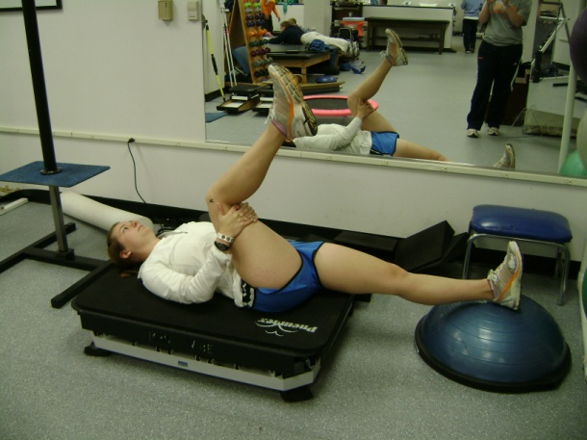
Figure 2: Hamstring Stretch

Hamstring ROM was measured via active knee extension using a goniometer with the leg in 90° of hip flexion, with support provided for the opposite leg to remain extended (J. Cronin, et al., 2007; Decoster, et al., 2004; Depino, et al., 2000; Smith & Fryer, 2008) (see Figure 3). Measurements were taken with the center of the goniometer at the lateral femoral condyle, the proximal arm along the shaft of the femur, in line with the greater trochanter, and the distal arm along the shaft of the fibula, in line with the lateral malleolus (Decoster, et al., 2004). Active ROM (see Figure 4), the amount of movement that can be accomplished through contraction of the muscles that normally act across a joint (Seeley, et al., 2003), was measured for the right leg first, followed by passive ROM, the amount of movement that can be accomplished when the joint is moved by some outside force, such as an the examiner moving the knee through the ROM (Seeley, et al., 2003). Passive knee extension (see Figure 5) consisted of the individual in 90 degrees of hip flexion, maintained by the individual keeping their thigh in contact with the PVC bar positioned by the examiner, and relaxing the lower leg. The examiner then extended the individual’s knee from this position and stopped when the leg began to tremble or the subject requested to stop. Measurement also stopped if either hip lifted off the platform or the thigh moved away the bar. An average of three measurements were recorded and used for statistical analysis (van den Tillaar, 2006).
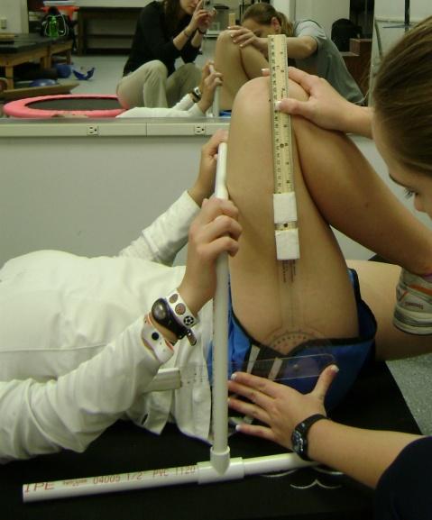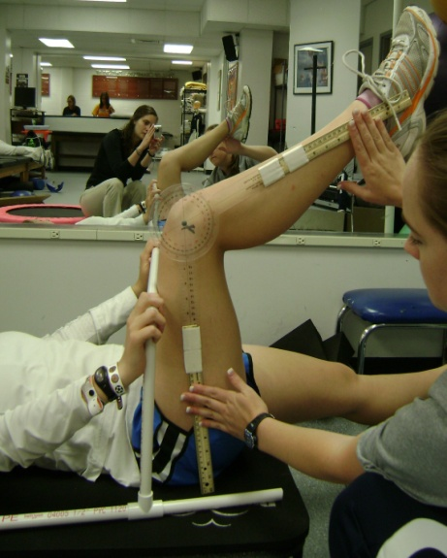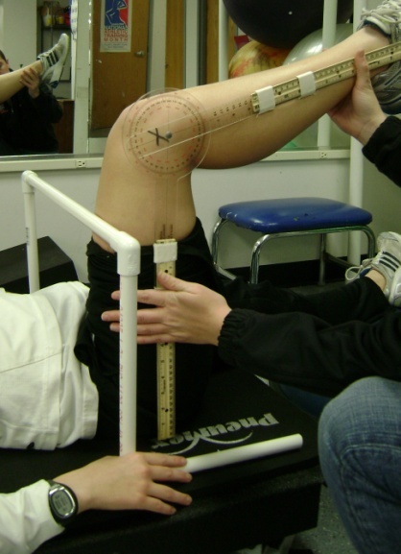
Figure 3: Hip Flexion Figure 4: Active ROM Figure 5: Passive ROM

Statistical Analysis

All statistical analyses were performed using SPSS v. 19. Significance was established at p < 0.05. Descriptive statistics for the subjects were determined and reported in Table 1. A 2-way repeated measures Analysis of Variance (ANOVA) was used to compare ROM measurements resulting from vibration and non-vibration conditions under both passive and active stretching protocols. Additionally, a 2-way repeated measures ANOVA was used to compare the difference between active and passive ROM under each condition. A univariate ANOVA compared the impact of vibration and non-vibration on the pre- and post-test differences for active and passive ROM. Post-hoc comparisons were performed using paired t-tests.

RESULTS
Twenty-seven individuals participated in the first session, with 24 subjects having complete data for both conditions. Participants consisted of undergraduate and graduate students between the ages of 19 and 27 years with 74.9% between the ages of 20 and 23 years old. Approximately 83% of the sample was female (20 out of 24 subjects). Please see Table 1.
Table 1. Descriptive Statistics (n = 24)
 | Minimum | Maximum | Mean | Std. Deviation
Age | 19 | 27 | 22.3 | 2.3
Body Mass (kg) | 50.9 | 81.9 | 68.5 | 7.8
Height (m) | 1.6 | 1.9 | 1.7 | 0.1
BMI | 18.8 | 28.1 | 24.0 | 2.5
A 2-way repeated measures ANOVA was performed for passive ROM with the factors condition (vibration vs. non-vibration) and time (pre-test and post-test measurements). Analysis revealed no significant interaction, F (1,23) = 0.621, p = 0.439, but showed a significant main effect for condition, F (1, 23) = 0.5875, p < 0.05, and time, F (1, 23) = 5.029, p < 0.05. Another repeated measures ANOVA was performed for active ROM with the same factors. Analysis revealed a significant time by condition interaction, F (1, 23) = 4.730, p < 0.05, and a significant main effect for pre-test and post-test, F (1, 23) = 18.612, p < 0.001.
A univariate ANOVA was performed with the factors condition and measurement (active and passive ROM). Analysis revealed no main effect for either measurement (p = 0.131) or condition (p = 0.075). Additionally, the analysis showed no significant interaction (p = 0.381).
Post-hoc paired samples t-tests were used to determine the difference between the pre-test and post-test measurements for each condition. No significant differences pre-test vs. post-test were found for either non-vibration active ROM (p = 0.081) or non-vibration passive ROM (p = 0.225). Active ROM showed a significant difference pre-test to post-test for the vibration condition, t (23) = -5.41, p < 0.001. The vibration condition also resulted in significantly different pre-test vs. post-test measurements on passive ROM, t (23) = -2.55, p < 0.05. In both cases the average ROM was higher for the post-test (see Table 2). Additionally, active ROM pre-test in the vibration condition (149.49 ± 11.41) was not significantly different (p > 0.05) from pre-test values in the non-vibration condition (148.81 ± 15.16). Passive ROM pre-test in the vibration condition (159.7 ± 14.2 degrees) was not different (p > 0.05) from pre-test values in the non-vibration condition (157.1 ± 14.9 degrees).
Table 2. Mean difference within conditions (n = 24)
 | Pre-test | Post-test
Active ROM
Vibration | 149.5 ± 11.4 | 155.6 ± 11.3 *ɸ
Non-Vibration | 148.8 ± 15.2 | 151.4 ± 12.1 Ɨ
Passive ROM
Vibration | 159.7 ± 14.2 | 162.7 ± 11.4 *ɸ
Non- Vibration | 157.1 ± 14.9 | 158.9 ± 13.4
* indicates significant difference from pre-test value (p < 0.05)
Ɨ indicates approaching significance (p = 0.081)
ɸ indicates significant difference from non-vibration value (p<0.05)

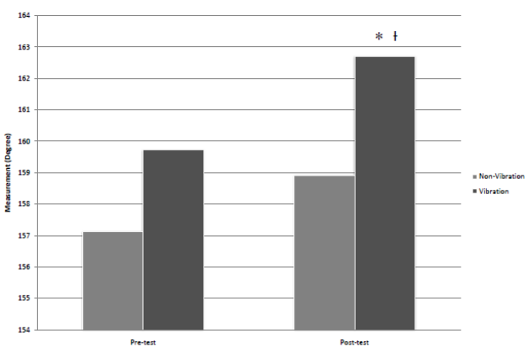Figure 6. Active ROM Change
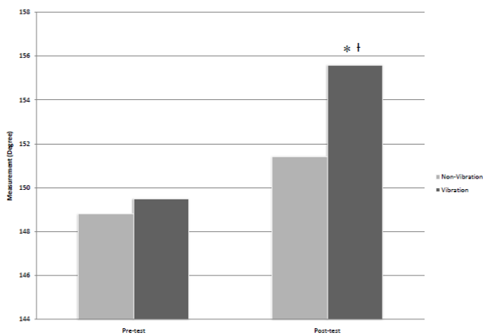Figure 7. Passive ROM Change

* Significantly different from vibration pre-test ROM.
Ɨ Significantly different from non-vibration post-test ROM

DISCUSSION
The purpose of this study was to determine if performing static hamstring stretching using the Pneumex Pro-Vibe vibrating platform increases acute hamstring range of motion (ROM) greater than traditional static hamstring stretching under both active and passive conditions. Hypothesis 1 was that the active ROM would have greater increases for the vibration condition than the non-vibration condition. Hypothesis 2 was that the passive (examiner-assisted) ROM would have greater increases for the vibration condition than the non-vibration condition. The results of this study confirm both hypotheses 1 and 2. To our knowledge, passive ROM, examined in Hypothesis 2, is not frequently measured in studies investigating the acute effects of vibration. Therefore, this study is unique and provides information to aid with future research.
However, several studies have utilized active ROM measurements. Although standardized hamstring ROM is not readily available when the hamstring is positioned in 90° of hip flexion, scores would most likely be similar to standardized scores when the hip is in neutral. Cronin, et al. (2007) investigated ROM changes following 30 seconds of vibration, and determined active ROM, measured with the hip in a fixed position of 90 degrees of flexion, was significantly improved following vibration. Active ROM was also measured through a sit-and-reach test following 6 minutes of WBV by Jacobs and Burns (2009). The sit-and-reach scores after WBV was statistically greater than after 6 minutes of cycle ergometry.
Acute increases in active and passive ROM were most likely due to a combination of reciprocal inhibition of the quadriceps and hamstring muscles (Bishop, 1974) and an increase in the pain threshold (Feland, Myrer, Schulthies, Fellingham, & Measom, 2001; Issurin, et al., 1994) that allows for a greater stretch before pain is felt. Additionally, the 5-minute warm-up on the cycle ergometer and the stretching protocol may cause increased blood flow to the hamstring muscles (Cochrane & Stannard, 2005; Feland, et al., 2001), and result in a temperature increase that could lead to increased flexibility.
The results of no significant difference between the means of active ROM and passive ROM for the non-vibration condition following static stretching are in agreement with the findings of Halbertsma, et al. (1999) and Funk, et al. (2003). However, Ross (1999) found significant acute increases in ROM with static stretching, using 10, 1-minute stretches. A possible explanation for the lack of significance in this study includes the fact that this stretching protocol examined ROM changes after a single session of 3, 30-second stretches. A longer stretching protocol, possibly with an increased duration or amount of stretches, may have elicited greater differences. Additionally, a larger sample size, like that of de Weijer, et al. (2003) who had 56 subjects, may have allowed for detection of smaller differences. Funk, et al. (2003) postulated the lack of significant differences for the study was the result of the population studied, undergraduate student-athletes. Although the subjects in the current study were not elite collegiate athletes, they were young, apparently healthy, recreationally active individuals who may have needed further stimulus to obtain increased acute hamstring ROM following static stretching.
In this study, although while vibration impacted active and passive ROM more than non-vibration, vibration impacted both active and passive ROM similarly. Active ROM refers to the amount of degrees through which a joint can move due to active muscle contraction, and passive ROM refers to the amount of degrees a joint can be passively moved through with no muscle contraction (Arnheim & Prentice, 2002). Passive ROM is important for injury prevention because, especially in sports, situations exist that may require the muscle to stretch beyond its normal active ROM limits, requiring enough elasticity to compensate to prevent musculotendinous unit injury (Prentice, 2003).
Little research has compared active and passive ROM in the same study. Due to the lack of significance in difference in gains between active and passive ROM, future studies may choose to solely investigate the changes in active and passive ROM. Additionally, although both measurements for ROM are important for quanitification of an individual’s flexibility, passive ROM is more difficult to reliably measure than active ROM (Gajdosik & Bohannon, 1987). However, utilizing a single tester to measure ROM increases reliability for passive ROM. Both active and passive ROM were measured in this study to provide increase the body of knowledge with evidence on the effect of vibration on acute hamstring flexibility.
The most important finding of this study is the significant increases in acute hamstring ROM following a bout of static stretching in conjunction with WBV. Enhancement of acute ROM with WBV agrees with the findings of several studies (J. Cronin, et al., 2008; Feland, et al., 2010; Jacobs & Burns, 2009; Peer, et al., 2009; van den Tillaar, 2006).

Limitations
Limitations of this study include the subject population restricted to young, recreationally active, healthy adults, thus results may be different for other groups of individuals. Funk, et al. (2003) had a similar lack of significant differences between pre-test and post-test active ROM for static stretching with a young, active population. Another limitation was the uneven gender balance, due to the large amount of female subjects. The number of subjects could be perceived as a limitation, yet this study included 24 subjects, a higher amount of subjects than many previous studies (J. Cronin, et al., 2007; de Weijer, et al., 2003; Jacobs & Burns, 2009; Kinser, et al., 2008; Sands, et al., 2008; Sands, et al., 2006). ROM measurements were reported in whole degrees, possibly limiting accuracy. Additionally, passively placing the hip into 90 degrees of hip flexion prior to passive ROM measurements may allow the subject to further relax, which would enhance results. Finally, monitoring heart rate during the stationary bike warm-up may allow for quantification of the warm-up. A lack of standardization of a warm-up may have resulted in differences between trials.

Strengths
A limited amount of research exists comparing acute changes in ROM between static stretching on a non-vibrating platform and on a WBV platform. This study is one of the first to investigate both passive and active ROM pre-test and post-test scores with vibration and non-vibration conditions. Therefore, this study adds to and enhances the current body of knowledge about WBV and hamstring stretching. Further, both active and passive ROM were measured in this study. Research including both measurements is rare, and this study allows for further information about the effect of stretching with WBV.

Implications
Due to the limited amount of research on the acute effects of WBV on hamstring ROM, this study adds to the pool of available literature. Future studies should focus on determining the benefits of WBV as applied to conditioning and ROM. Additionally, further examination of the physiological effects of vibration platforms is warranted. Finally, future studies regarding specific training protocols such as frequency and duration for strength, power, flexibility, and injury rehabilitation would be beneficial.
This study shows both active and passive ROM enhancement following acute hamstring stretching with WBV. Inclusion of WBV in muscle flexibility rehabilitation programs and pre- and post-practice flexibility protocols for recreationally active individuals would be beneficial for acute increases in hamstring ROM. Clinicians, athletic trainers, fitness facilities, and strength coaches may be able to utilize the findings from this study to further educate the recreationally active individuals. Future studies should investigate the effect of performing standing stretches on the whole body vibration platform. Additionally, comparing stretching with vibration to stretching with other modalities, such as heat or ice, will assist in determining the extent of vibration effects for increasing pain thresholds.

REFERENCES
References
Aminian-Far, A., Hadian, M. R., Olyaei, G., Talebian, S., & Bakhtiary, A. H. (2011). Whole-body vibration and the prevention and treatment of delayed-onset muscle soreness. J Athl Train, 46(1), 43-49.
Anderson, R. J. (2006). Shake, Rattle, & Roll. Training & Conditioning, 16(7).
Arnheim, D. D., & Prentice, W. E. (2002). Essentials of Athletic Training: 5th Edition. Boston: McGraw Hill.
Bakhtiary, A. H., Safavi-Farokhi, Z., & Aminian-Far, A. (2007). Influence of vibration on delayed onset of muscle soreness following eccentric exercise. Br J Sports Med, 41(3), 145-148.
Balague, F., Troussier, B., & Salminen, J. J. (1999). Non-specific low back pain in children and adolescents: risk factors. Eur Spine J, 8(6), 429-438.
Ballantyne, F., Fryer, G., & McLaughlin, P. (2003). The effect of muscle energy technique on hamstring extensibility: the mechanism of altered flexibility. Journal of Osteopathic Medicine, 6(2), 59-63.
Baltaci, G., Un, N., Tunay, V., Besler, A., & Gerceker, S. (2003). Comparison of three different sit and reach tests for measurement of hamstring flexibility in female university students. Br J Sports Med, 37(1), 59-61.
Bandy, W. D., Irion, J. M., & Briggler, M. (1997). The effect of time and frequency of static stretching on flexibility of the hamstring muscles. Phys Ther, 77(10), 1090-1096.
Becker, A., Held, H., Redaelli, M., Strauch, K., Chenot, J. F., Leonhardt, C., et al. (2010). Low back pain in primary care: costs of care and prediction of future health care utilization. Spine (Phila Pa 1976), 35(18), 1714-1720.
Beedle, B. B., & Mann, C. L. (2007). A comparison of two warm-ups on joint range of motion. Journal of Strength and Conditioning Research, 21(3), 776-779.
Bianconi, R., & van der, M. J. (1963). The response to vibration of the end organs of mammalian muscle spindles. J Neurophysiol, 26, 177-190.
Bishop, B. (1974). Vibratory Stimulation .1. Neurophysiology of Motor Responses Evoked by Vibratory Stimulation. Physical Therapy, 54(12), 1273-1282.
Bosco, C., Colli, R., Introini, E., Cardinale, M., Tsarpela, O., Madella, A., et al. (1999). Adaptive responses of human skeletal muscle to vibration exposure. Clin Physiol, 19(2), 183-187.
Brodowicz, G. R., Welsh, R., & Wallis, J. (1996). Comparison of stretching with ice, stretching with heat, or stretching alone on hamstring flexibility. J Athl Train, 31(4), 324-327.
Burke, J. R., Schutten, M. C., Koceja, D. M., & Kamen, G. (1996). Age-dependent effects of muscle vibration and the Jendrassik maneuver on the patellar tendon reflex response. Arch Phys Med Rehabil, 77(6), 600-604.
Cardinale, M., & Lim, J. (2003). Electromyography activity of vastus lateralis muscle during whole-body vibrations of different frequencies. J Strength Cond Res, 17(3), 621-624.
Chalmers, G. (2004). Re-examination of the possible role of Golgi tendon organ and muscle spindle reflexes in proprioceptive neuromuscular facilitation muscle stretching. Sports Biomech, 3(1), 159-183.
Chan, S. P., Hong, Y., & Robinson, P. D. (2001). Flexibility and passive resistance of the hamstrings of young adults using two different static stretching protocols. Scand J Med Sci Sports, 11(2), 81-86.
Cochrane, D. J., Legg, S. J., & Hooker, M. J. (2004). The short-term effect of whole-body vibration training on vertical jump, sprint, and agility performance. J Strength Cond Res, 18(4), 828-832.
Cochrane, D. J., & Stannard, S. R. (2005). Acute whole body vibration training increases vertical jump and flexibility performance in elite female field hockey players. Br J Sports Med, 39(11), 860-865.
Colbert, B. J., Ankney, J., & Lee, K. T. (2009). Anatomy, Physiology, and Disease: An Interactive Journey for Health Professionals (1 ed.). Upper Saddle River, NJ: Pearson Education, Inc.
Covert, C. A., Alexander, M. P., Petronis, J. J., & Davis, D. S. (2010). Comparison of ballistic and static stretching on hamstring muscle length using an equal stretching dose. J Strength Cond Res, 24(11), 3008-3014.
Cronin, J., Nash, M., & Whatman, C. (2007). The effect of four different vibratory stimuli on dynamic hamstring range of motion. Phys Ther Sport, 8, 30-36.
Cronin, J., Nash, M., & Whatman, C. (2008). The acute effects of hamstring stretching and vibration on dynamic knee joint range of motion and jump performance. Phys Ther Sport, 9(2), 89-96.
Cronin, J., Oliver, M., & McNair, P. (2004). Muscle stiffness and injury effects of whole body vibration. Phys Ther Sport, 5, 68-74.
Davis, D. S., Ashby, P. E., McCale, K. L., McQuain, J. A., & Wine, J. M. (2005). The effectiveness of 3 stretching techniques on hamstring flexibility using consistent stretching parameters. J Strength Cond Res, 19(1), 27-32.
Davis, D. S., Quinn, R. O., Whiteman, C. T., Williams, J. D., & Young, C. R. (2008). Concurrent Validity of Four Clinical Tests Used to Measure Hamstring Flexibility. Journal of Strength and Conditioning Research, 22(2), 583-588.
de Weijer, V. C., Gorniak, G. C., & Shamus, E. (2003). The effect of static stretch and warm-up exercise on hamstring length over the course of 24 hours. J Orthop Sports Phys Ther, 33(12), 727-733.
Decoster, L. C., Cleland, J., Altieri, C., & Russell, P. (2005). The effects of hamstring stretching on range of motion: a systematic literature review. J Orthop Sports Phys Ther, 35(6), 377-387.
Decoster, L. C., Scanlon, R. L., Horn, K. D., & Cleland, J. (2004). Standing and Supine Hamstring Stretching Are Equally Effective. J Athl Train, 39(4), 330-334.
Depino, G. M., Webright, W. G., & Arnold, B. L. (2000). Duration of maintained hamstring flexibility after cessation of an acute static stretching protocol. J Athl Train, 35(1), 56-59.
Dolny, D. G., & Reyes, G. F. (2008). Whole body vibration exercise: training and benefits. Curr Sports Med Rep, 7(3), 152-157.
Eklund, G., & Hagbarth, K. E. (1966). Normal variability of tonic vibration reflexes in man. Exp Neurol, 16(1), 80-92.
Fasen, J. M., O'Connor, A. M., Schwartz, S. L., Watson, J. O., Plastaras, C. T., Garvan, C. W., et al. (2009). A Randomized Controlled Trial of Hamstring Stretching: Comparison of Four Techniques. J Strength Cond Res, 23(2), 660-667.
Feland, J. B., Hawks, M., Hopkins, J. T., Hunter, I., Johnson, A. W., & Eggett, D. L. (2010). Whole body vibration as an adjunct to static stretching. Int J Sports Med, 31(8), 584-589.
Feland, J. B., Myrer, J. W., Schulthies, S. S., Fellingham, G. W., & Measom, G. W. (2001). The effect of duration of stretching of the hamstring muscle group for increasing range of motion in people aged 65 years or older. Physical Therapy, 81(5), 1110-1117.
Feldman, D. E., Shrier, I., Rossignol, M., & Abenhaim, L. (2001). Risk factors for the development of low back pain in adolescence. Am J Epidemiol, 154(1), 30-36.
Fletcher, I. M., & Jones, B. (2004). The effect of different warm-up stretch protocols on 20 meter sprint performance in trained rugby union players. J Strength Cond Res, 18(4), 885-888.
Ford, P., & McChesney, J. (2007). Duration of maintained hamstring ROM following termination of three stretching protocols. J Sport Rehabil, 16(1), 18-27.
Funk, D. C., Swank, A. M., Mikla, B. M., Fagan, T. A., & Farr, B. K. (2003). Impact of prior exercise on hamstring flexibility: a comparison of proprioceptive neuromuscular facilitation and static stretching. J Strength Cond Res, 17(3), 489-492.
Gajdosik, R. L., & Bohannon, R. W. (1987). Clinical measurement of range of motion. Review of goniometry emphasizing reliability and validity. Phys Ther, 67(12), 1867-1872.
Gemne, G. (1994). Pathophysiology of white fingers in workers using hand-held vibrating tools. Nagoya J Med Sci, 57 Suppl, 87-97.
Gerodimos, V., Zafeiridis, A., Karatrantou, K., Vasilopoulou, T., Chanou, K., & Pispirikou, E. (2010). The acute effects of different whole-body vibration amplitudes and frequencies on flexibility and vertical jumping performance. J Sci Med Sport, 13(4), 438-443.
Griffin, M. J. (1998). A comparison of standardized methods for predicting the hazards of whole-body vibration and repeated shocks. J Sound Vib, 215(4), 883-914.
Halbertsma, J. P., Mulder, I., Goeken, L. N., & Eisma, W. H. (1999). Repeated passive stretching: acute effect on the passive muscle moment and extensibility of short hamstrings. Arch Phys Med Rehabil, 80(4), 407-414.
Halbertsma, J. P., van Bolhuis, A. I., & Goeken, L. N. (1996). Sport stretching: effect on passive muscle stiffness of short hamstrings. Arch Phys Med Rehabil, 77(7), 688-692.
Hartig, D. E., & Henderson, J. M. (1999). Increasing hamstring flexibility decreases lower extremity overuse injuries in military basic trainees. Am J Sports Med, 27(2), 173-176.
Hopper, D., Conneely, M., Chromiak, F., Canini, E., Berggren, J., & Briffa, K. (2005). Evaluation of the effect of two massage techniques on hamstring muscle length in competitive female hockey players. Physical Therapy in Sport, 6(3), 137-145.
Hultman, G., Saraste, H., & Ohlsen, H. (1992). Anthropometry, spinal canal width, and flexibility of the spine and hamstring muscles in 45-55-year-old men with and without low back pain. J Spinal Disord, 5(3), 245-253.
Issurin, V. B., Liebermann, D. G., & Tenenbaum, G. (1994). Effect of vibratory stimulation training on maximal force and flexibility. J Sports Sci, 12(6), 561-566.
Jacobs, P. L., & Burns, P. (2009). Acute enhancement of lower-extremity dynamic strength and flexibility with whole-body vibration. J Strength Cond Res, 23(1), 51-57.
Jones, M. A., Stratton, G., Reilly, T., & Unnithan, V. B. (2005). Biological risk indicators for recurrent non-specific low back pain in adolescents. Br J Sports Med, 39(3), 137-140.
Kabat, H., & Knott, M. (1948). Principles of neuromuscular reeducation. Phys Ther Rev, 28(3), 107-111.
Kerschan-Schindl, K., Grampp, S., Henk, C., Resch, H., Preisinger, E., Fialka-Moser, V., et al. (2001). Whole-body vibration exercise leads to alterations in muscle blood volume. Clin Physiol, 21(3), 377-382.
Kinser, A. M., Ramsey, M. W., O'Bryant, H. S., Ayres, C. A., Sands, W. A., & Stone, M. H. (2008). Vibration and stretching effects on flexibility and explosive strength in young gymnasts. Med Sci Sports Exerc, 40(1), 133-140.
Krabak, B. J., Laskowski, E. R., Smith, J., Stuart, M. J., & Wong, G. Y. (2001). Neurophysiologic influences on hamstring flexibility: a pilot study. Clin J Sport Med, 11(4), 241-246.
Laporte, Y., & Lloyd, D. P. (1952). Nature and significance of the reflex connections established by large afferent fibers of muscular origin. Am J Physiol, 169(3), 609-621.
LaRoche, D. P., Lussier, M. V., & Roy, S. J. (2008). Chronic stretching and voluntary muscle force. J Strength Cond Res, 22(2), 589-596.
Lohman, E. B., 3rd, Petrofsky, J. S., Maloney-Hinds, C., Betts-Schwab, H., & Thorpe, D. (2007). The effect of whole body vibration on lower extremity skin blood flow in normal subjects. Med Sci Monit, 13(2), CR71-76.
Lorenzen, C. M., W; Koh, M; Wilson, C. (2009). Inconsistent use of terminology in whole body vibration exercise research. J Sci Med Sport, 12, 676-678.
Lucas, R. C., & Koslow, R. (1984). Comparative study of static, dynamic, and proprioceptive neuromuscular facilitation stretching techniques on flexibility. Percept Mot Skills, 58(2), 615-618.
Magnusson, S. P. (1998). Passive properties of human skeletal muscle during stretch maneuvers. A review. Scand J Med Sci Sports, 8(2), 65-77.
Magnusson, S. P., Simonsen, E. B., Aagaard, P., Boesen, J., Johannsen, F., & Kjaer, M. (1997). Determinants of musculoskeletal flexibility: viscoelastic properties, cross-sectional area, EMG and stretch tolerance. Scandinavian Journal of Medicine & Science in Sports, 7(4), 195-202.
Magnusson, S. P., Simonsen, E. B., Aagaard, P., & Kjaer, M. (1996). Biomechanical responses to repeated stretches in human hamstring muscle in vivo. Am J Sports Med, 24(5), 622-628.
Marek, S. M., Cramer, J. T., Fincher, A. L., Massey, L. L., Dangelmaier, S. M., Purkayastha, S., et al. (2005). Acute Effects of Static and Proprioceptive Neuromuscular Facilitation Stretching on Muscle Strength and Power Output. J Athl Train, 40(2), 94-103.
Mattioli, S., Graziosi, F., Bonfiglioli, R., Barbieri, G., Bernardelli, S., Acquafresca, L., et al. (2011). A case report of vibration-induced hand comorbidities in a postwoman. BMC Musculoskelet Disord, 12, 47.
McArdle, W. D., Katch, F. I., & Katch, V. L. (2007). Exercise Physiology: Energy, Nutrition, and Human Performance (6th Edition). Baltimore: Lippincott Williams & Wilkins.
McHugh, M. P., Kremenic, I. J., Fox, M. B., & Gleim, G. W. (1998). The role of mechanical and neural restraints to joint range of motion during passive stretch. Med Sci Sports Exerc, 30(6), 928-932.
McHugh, M. P., Magnusson, S. P., Gleim, G. W., & Nicholas, J. A. (1992). Viscoelastic stress relaxation in human skeletal muscle. Med Sci Sports Exerc, 24(12), 1375-1382.
Meroni, R., Cerri, C. G., Lanzarini, C., Barindelli, G., Morte, G. D., Gessaga, V., et al. (2010). Comparison of active stretching technique and static stretching technique on hamstring flexibility. Clin J Sport Med, 20(1), 8-14.
Mester, J., Kleinoder, H., & Yue, Z. (2006). Vibration training: benefits and risks. J Biomech, 39(6), 1056-1065.
Mester, J., Spitzenfeil, P., Schwarzer, J., & Seifriz, F. (1999). Biological reaction to vibration--implications for sport. J Sci Med Sport, 2(3), 211-226.
Nokes, L. D. M. (1999). The use of low-frequency vibration measurement in orthopaedics. Proceedings of the Institution of Mechanical Engineers Part H-Journal of Engineering in Medicine, 213(H3), 271-290.
O'Sullivan, K., Murray, E., & Sainsbury, D. (2009). The effect of warm-up, static stretching and dynamic stretching on hamstring flexibility in previously injured subjects. BMC Musculoskelet Disord, 10, 37.
Odunaiya, N. A., Hamzat, T. K., & Ajayi, O. F. (2005). The effects of static stretch duration on the flexibility of hamstring muscles. African Journal of Biomedical Research, 8(2), 79-82.
Peer, K. S., Barkley, J. E., & Knapp, D. M. (2009). The acute effects of local vibration therapy on ankle sprain and hamstring strain injuries. Phys Sportsmed, 37(4), 31-38.
Piligian, G., Herbert, R., Hearns, M., Dropkin, J., Landsbergis, P., & Cherniack, M. (2000). Evaluation and management of chronic work-related musculoskeletal disorders of the distal upper extremity. Am J Ind Med, 37(1), 75-93.
Pneumex. (1998). Pneu-Vibe. Retrieved April 26, 2010, from http://pneumex.com/id70.html
Pope, M., Wilder, D., & Magnusson, M. (1998). Possible mechanisms of low back pain due to whole-body vibration. J Sound Vib, 215(4), 687-697.
Prentice, W. E. (2003). Arnheim's Principles of Athletic Training: A Competency-Based Approach (11 ed.). New York: McGraw-Hill.
Rhea, M. R., Bunker, D., Marin, P. J., & Lunt, K. (2009). Effect of iTonic whole-body vibration on delayed-onset muscle soreness among untrained individuals. J Strength Cond Res, 23(6), 1677-1682.
Rittweger, J., Beller, G., & Felsenberg, D. (2000). Acute physiological effects of exhaustive whole-body vibration exercise in man. Clin Physiol, 20(2), 134-142.
Rittweger, J., Schiessl, H., & Felsenberg, D. (2001). Oxygen uptake during whole-body vibration exercise: comparison with squatting as a slow voluntary movement. Eur J Appl Physiol, 86(2), 169-173.
Ronnestad, B. R. (2004). Comparing the performance-enhancing effects of squats on a vibration platform with conventional squats in recreationally resistance-trained men. J Strength Cond Res, 18(4), 839-845.
Ronnestad, B. R. (2009). Acute effects of various whole-body vibration frequencies on lower-body power in trained and untrained subjects. J Strength Cond Res, 23(4), 1309-1315.
Ross, M. (1999). Effect of lower-extremity position and stretching on hamstring muscle flexibility. J Strength Cond Res, 13(2), 124-129.
Ryan, E. D., Herda, T. J., Costa, P. B., Walter, A. A., Hoge, K. M., Stout, J. R., et al. (2010). Viscoelastic creep in the human skeletal muscle-tendon unit. Eur J Appl Physiol, 108(1), 207-211.
Sands, W. A., McNeal, J. R., Stone, M. H., Haff, G. G., & Kinser, A. M. (2008). Effect of vibration on forward split flexibility and pain perception in young male gymnasts. Int J Sports Physiol Perform, 3(4), 469-481.
Sands, W. A., McNeal, J. R., Stone, M. H., Russell, E. M., & Jemni, M. (2006). Flexibility enhancement with vibration: Acute and long-term. Med Sci Sports Exerc, 38(4), 720-725.
Sapega, A. A., Quedenfeld, T. C., Moyer, R. A., & Butler, R. A. (1981). Biophysical factors in range-of-motion exercise. Phys Sportsmed, 9(12), 57-65.
Seeley, R. R., Stephens, T. D., & Tate, P. (2003). Anatomy & Physiology (Sixth ed.). Boston: McGraw-Hill.
Seidel, H., & Heide, R. (1986). Long-term effects of whole-body vibration: a critical survey of the literature. Int Arch Occup Environ Health, 58(1), 1-26.
Shellock, F. G., & Prentice, W. E. (1985). Warming-up and stretching for improved physical performance and prevention of sports-related injuries. Sports Med, 2(4), 267-278.
Smith, M., & Fryer, G. (2008). A comparison of two muscle energy techniques for increasing flexibility of the hamstring muscle group. J Bodyw Mov Ther, 12(4), 312-317.
Starring, D. T., Gossman, M. R., Nicholson, G. G., & Lemons, J. (1988). Comparison of cyclic and sustained passive stretching using a mechanical device to increase resting length of hamstring muscles. Physical Therapy, 68(3), 314-320.
Sullivan, M. K., Dejulia, J. J., & Worrell, T. W. (1992). Effect of pelvic position and stretching method on hamstring muscle flexibility. Med Sci Sports Exerc, 24(12), 1383-1389.
Taylor, D. C., Dalton, J. D., Jr., Seaber, A. V., & Garrett, W. E., Jr. (1990). Viscoelastic properties of muscle-tendon units. The biomechanical effects of stretching. Am J Sports Med, 18(3), 300-309.
Unick, J., Kieffer, H. S., Cheesman, W., & Feeney, A. (2005). The acute effects of static and ballistic stretching on vertical jump performance in trained women. J Strength Cond Res, 19(1), 206-212.
van den Tillaar, R. (2006). Will whole-body vibration training help increase the range of motion of the hamstrings? J Strength Cond Res, 20(1), 192-196.
Verschueren, S. M., Roelants, M., Delecluse, C., Swinnen, S., Vanderschueren, D., & Boonen, S. (2004). Effect of 6-month whole body vibration training on hip density, muscle strength, and postural control in postmenopausal women: a randomized controlled pilot study. Journal of Bone and Mineral Research, 19(3), 352-359.
Wallin, D., Ekblom, B., Grahn, R., & Nordenborg, T. (1985). Improvement of muscle flexibility. A comparison between two techniques. Am J Sports Med, 13(4), 263-268.
Wikstrom, B., Kjellberg, A., & Landstrom, U. (1994). Health effects of long-term occupational exposure to whole-body vibration: a review. Int J Ind Ergon, 14, 273-292.
Williford, H. N., East, J. B., Smith, F. H., & Burry, L. A. (1986). Evaluation of warm-up for improvement in flexibility. Am J Sports Med, 14(4), 316-319.
Witvrouw, E., Danneels, L., Asselman, P., D'Have, T., & Cambier, D. (2003). Muscle flexibility as a risk factor for developing muscle injuries in male professional soccer players. A prospective study. Am J Sports Med, 31(1), 41-46.
Worrell, T. W., Smith, T. L., & Winegardner, J. (1994). Effect of hamstring stretching on hamstring muscle performance. J Orthop Sports Phys Ther, 20(3), 154-159.
Wright, V., & Johns, R. J. (1961). Quantitative and qualitative analysis of joint stiffness in normal subjects and in patients with connective tissue diseases. Ann Rheum Dis, 20, 36-46.

Appendices

APPENDIX A

INFORMED CONSENT

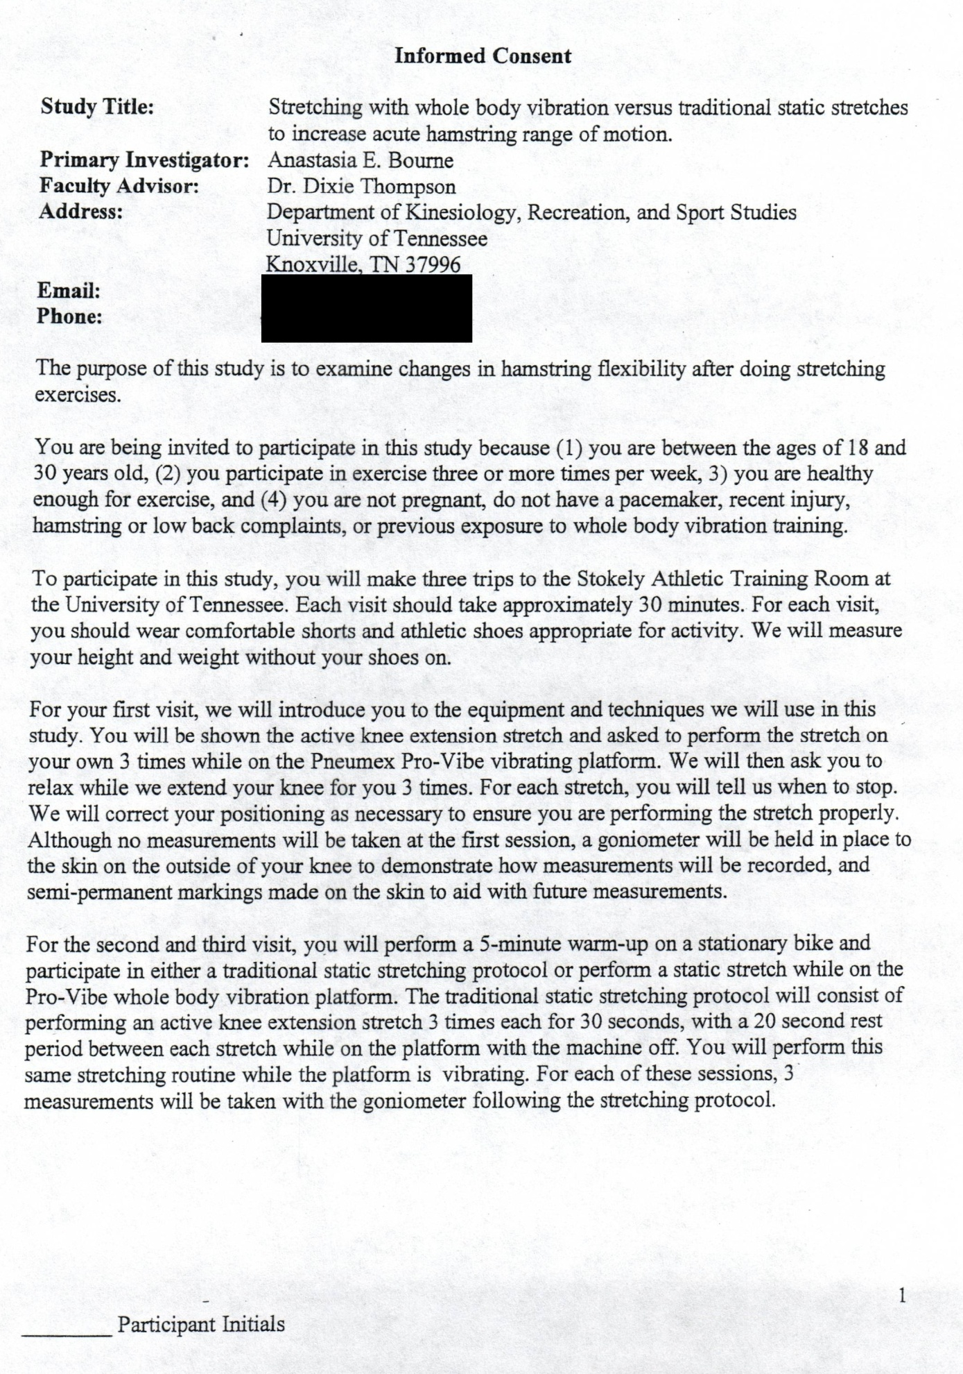


APPENDIX B

PHYSICAL ACTIVITY READINESS QUESTIONNAIRE (PAR-Q)

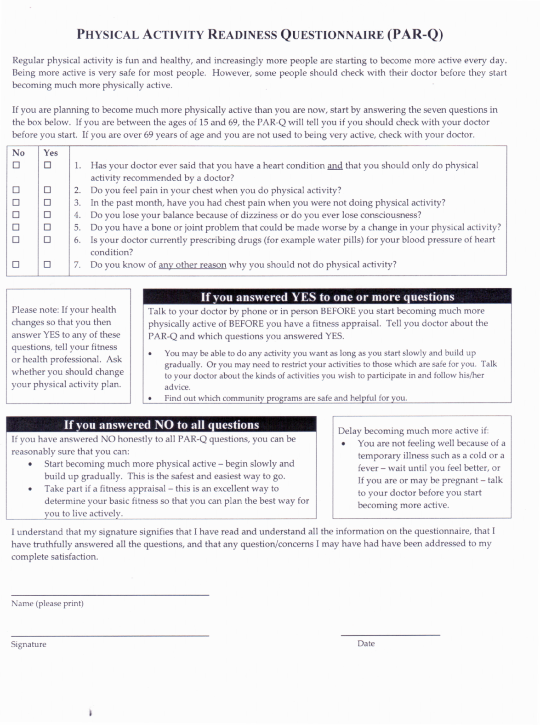

APPENDIX C

DATA COLLECTION SHEET
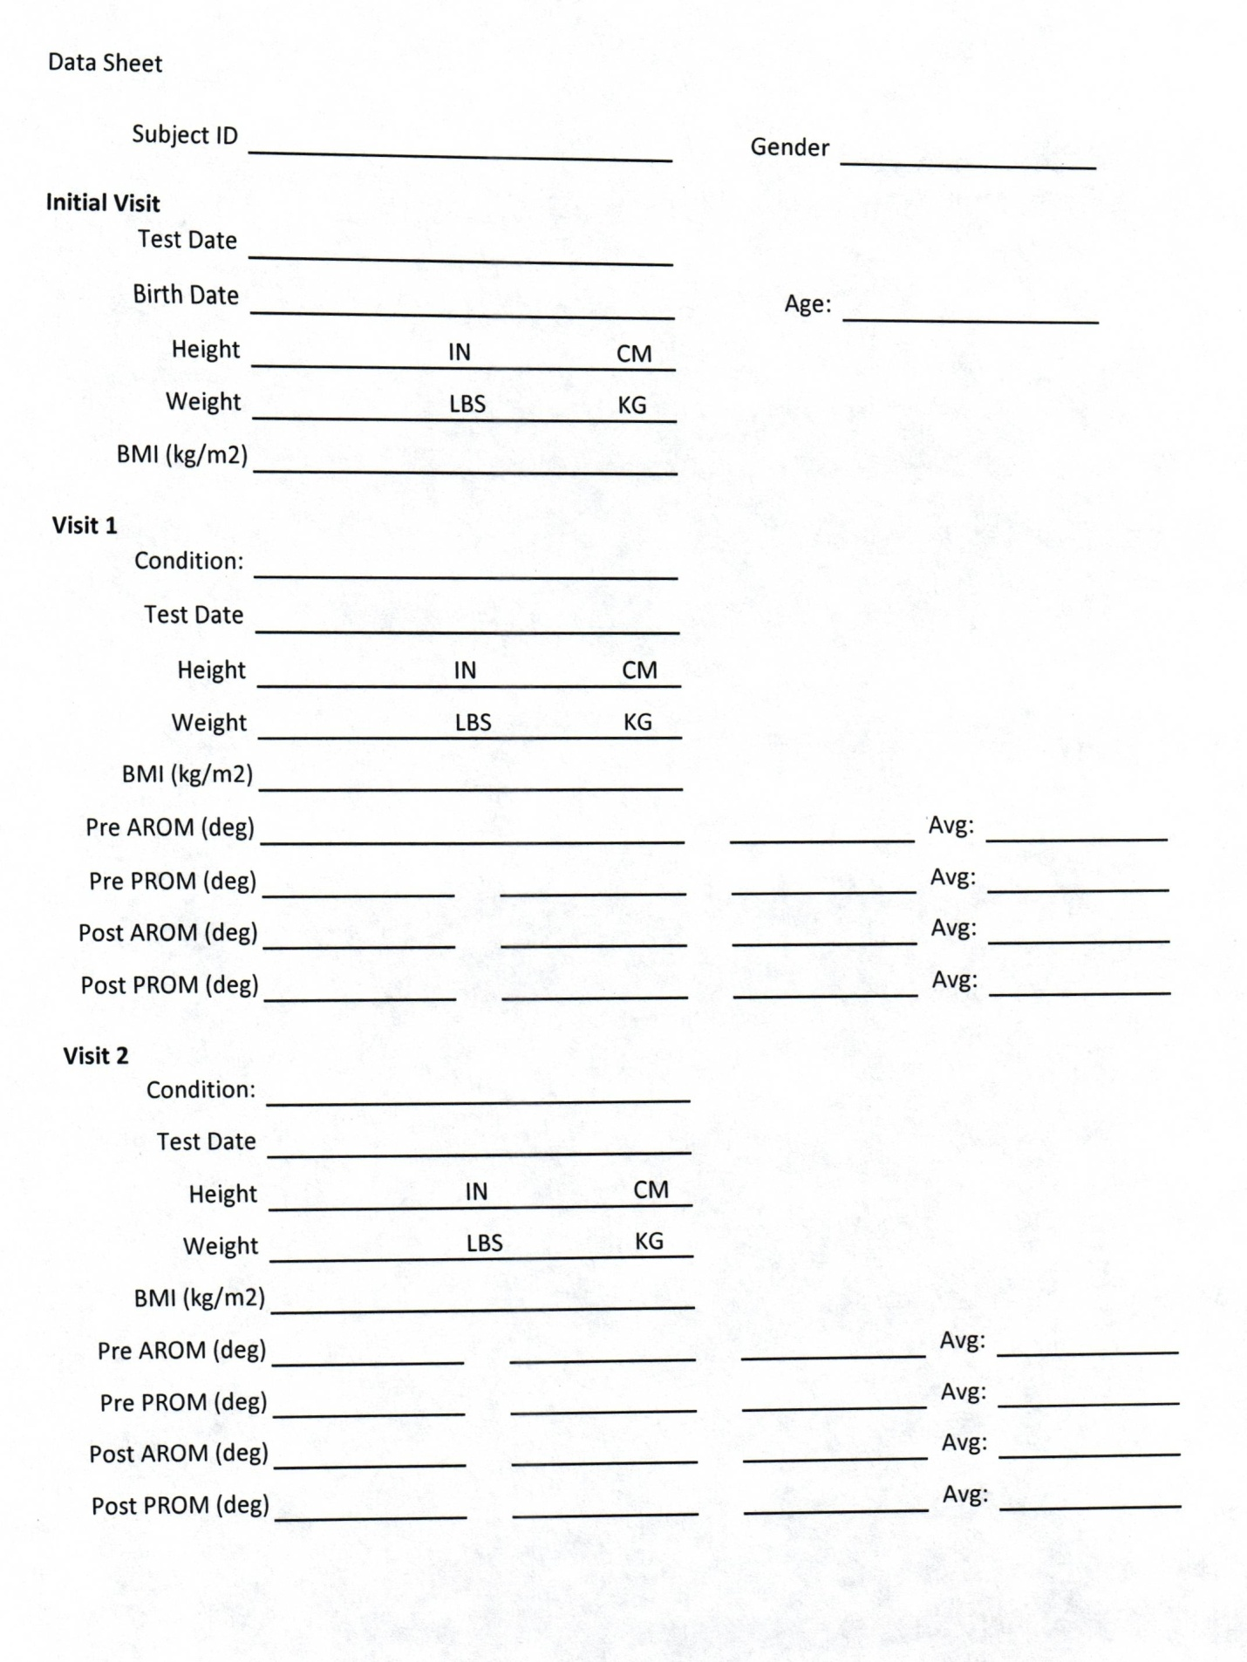

Vita

Anastasia “Stacy” Bourne was born in Fort Worth, Texas, August 17, 1984. She grew up in Fort Worth where she was a student at Fort Worth Country Day School (FWCDS) from first grade to her senior year of high school. During her time in high school, Stacy participated in her school’s volleyball, soccer and softball teams earning 11 varsity athletic letters. She also played club soccer for a team in the Dallas/Fort Worth area. She graduated from FWCDS in May 2002, and enrolled as an undergraduate student at Baylor University in the fall. While pursuing her bachelor’s degree in Athletic Training Sports Medicine with a minor in Religion, she worked as an athletic training student, accompanying the Baylor Lady Bears basketball team to the Sweet 16 of the NCAA Tournament in 2004. In May of 2006, she graduated from Baylor University with a Bachelor of Science in Education. Stacy went on to pursue her master’s degree from the University of Tennessee in kinesiology with a concentration exercise physiology, graduating in August of 2011. While completing her degree she was a Graduate Assistant athletic trainer for the Lady Volunteers Rowing team, where her responsibilities included rehabilitating injured athletes in order to allow them to return to their sport in a safe and timely manner.

