Physiological characterization of Prochlorococcus under abiotic stressors temperature and hydrogen peroxide

A Thesis Presented for the

Doctor of Philosophy

Degree

The University of Tennessee, Knoxville

Lanying Ma

October 2015

Copyright © 2015 by Lanying Ma
All rights reserved.

DEDICATION

For my immediate and extended family

ACKNOWLEDGEMENTS

Dr. Erik Zinser, your mentorship was so important in my completion of this dissertation. I have learned a lot from you not only on the research but also on mentorship. Your knowledge on science was of great value. You always guide me to be on the right track in last 6 years, listening to my confusion and directing me to be close to solution. But most importantly, the way of how to research is the most important lesson I have learned from you. I am honored to be in your lab and will be benefited in my rest of life.

Beside the help of Dr. Erik Zinser, I cannot accomplish this work without the guidance of my committee: Dr. Steven W. Wilhelm, Dr. Elizabeth M. Fozo, Dr. Barry D. Bruce and Dr. Zackary I. Johnson.

Thanks to my best labmates: Jeff Morris, Jeremy Chandler, Marty Szul and Megan Silbaugh. We always talk about our research together and comfort me whenever I have difficulties in my research. You make my graduate life easier. Thanks to Nana Ankrah. We became friend the first day we met in Micro office. This friendship is always with me in last 6 years. Thanks to Charles Budinoff and Nathan Cude, who were patient to help me when I started my first rotation. It is precious to me as a freshly-arrived foreigner.

Jinlyung Choi, thank you for being my side since 2010. Marrying you is the best and luckiest decision I made. You listen to my complaint and give me confidence and never let me give up. You are always there whenever I need you. You embrace me with your love and help me to go through any difficulty. You are the best lover and friend, looking forward to our future life together.

Arielle Youngeun Choi, thank you for being my daughter. You let me know the feeling of purest love. Your smile lightens up my life whenever I am exhausted. You are my best experiment till now.

Thanks a lot to my families and in-law families. Without you, I don't know how to go through these days when I am in a foreign country. Special thanks give to my mom and mother-in-law. Without you, I would have much more difficulties the first month after Arielle’s birth and the last month before my defense.

ABSTRACT

Cyanobacteria of the genus Prochlorococcus are the smallest and most abundant phytoplankters in the ocean. Temperature is a major influence on Prochlorococcus abundance and distribution in the ocean, but the physiological basis for this relationship is not well understood. In other microbes, lipid and fatty acid composition have been shown to be influenced by temperature, and temperature has also been proposed as a relevant factor for setting the elemental allocation in marine phytoplankton. In this study, we found that percentage of fatty acids unsaturation was negatively related with temperature in some Prochlorococcus strains, but this was not universal. Temperature had a significant linear positive effect on nitrogen and carbon cell quotas across all strains. As temperature increased 10˚C, nitrogen and carbon quotas rose by 40.0% and 34.6%, respectively. Individual strains displayed negative relationships between growth rate and phosphorus quota.

Studies in other photosynthetic organisms suggested that HOOH and temperature extremes act together as stressors. Importantly, it also has been shown that Prochlorococcus is highly susceptible to hydrogen peroxide (HOOH) and co-occurring heterotrophs such as Alteromonas sp. facilitate the growth of Prochlorococcus at the ocean surface by scavenging HOOH.

To address the potential synergistic effects of temperature and HOOH on Prochlorococcus, we monitored the growth of environmental-relevant concentrations of cold-adapted (MED4) and warm-adapted (MIT9312) Prochlorococcus strains with different initial concentrations of HOOH under a range of temperatures. While not impacting the temperature optima for growth, higher concentrations of HOOH severely diminished the permissive temperature range for growth of both Prochlorococcus strains. At the permissive temperatures, the growth rates of both Prochlorococcus strains decreased as a function of HOOH, and temperature extremes increased susceptibility of photosystem II to HOOH-mediated damage. While these effects were manifest in both strains, they were more pronounced in the warm-adapted strain. Heterotrophic bacteria, serving as a proxy for the natural community, increased the Prochlorococcus growth rate under these temperatures and increased the growth temperature range (MED4), and this was attributed in part to their ability to remove HOOH from the medium.

TABLE OF CONTENTS

CHAPTER I INTRODUCTION 1
Introduction 2
Objectives of this study 9
CHAPTER II Temperature influence on lipids and elmental content of Prochlorococcus 12
Abstract 13
Introduction 15
Materials and Methods 18
Results 21
Discussion 32
Appendix 37
CHAPTER III Degradation of hydrogen peroxide by the microbial community facilitates the growth of Prochlorococcus at its temperature extremes 39
Abstract 41
Introduction 43
Materials and methods 47
Results 50
Discussion 64
Conclusion 77
Appendix 79
CHAPTER IV Conclusions and Future Directions 83
Temperature and cell composition 84
Interactions between temperature and oxidative stress 85
Reference 87
VITA 97

LIST OF TABLES
Table 1. Overview of strains and temperature treatments 23
Table 2 Effects of temperature, growth rate and strain identity on the elemental composition of six Prochlorococcus strains. 28

LIST OF FIGURES

Figure 1 Lipid composition of 6 strains of Prochlorococous as the function of temperature. 22
Figure 2 Fatty acid unsaturation in 6 Prochlorococcus strains. 24
Figure 3 Influence of temperature and growth on the elemental composition and ratios of across Prochlorococcus strains. 26
Figure 4 Influence of temperature on cell quotas in six Prochlorococcus strains. 29
Figure 5 Influence of temperature on elemental ratio in six Prochlorococcus strains. 31
Figure 6 Growth of ecologically-relevant concentrations of MIT9312 at 24ºC and 26ºC in the presence of different concentrations of HOOH. 51
Figure 7 Growth rate of (A) MIT9312 and (B) MED4 at different temperatures and exogenous HOOH concentrations. 53
Figure 8 Temperature-dependent HOOH degradation and growth of ecologically-relevant concentrations of MIT9312. 55
Figure 9 Flow cytometry profiles of MIT9312 at different temperatures and HOOH concentrations. 59
Figure 10 Fv/Fm of Prochlorococcus as a function of temperature and HOOH concentration. 61
Figure 11 The effects of HOOH on Fv/Fm in MIT9312, in the presence or absence of lincomycin. 63
Figure 12 Maximum growth rate of Prochlorococcus as a function of temperature and HOOH. 74
Figure 13 Potential effect of 400 nM HOOH to the distribution of Prochlorococcus. 76
Figure 14 Degradation of HOOH in the medium by pyruvate or the heterotroph Alteromonas sp. EZ55. 79
Figure 15 Fv/Fm of MIT9312 as the function of time (h) at different temperatures. 80
Figure 16 Fv/Fm of MED4 as the function of time (h) at different temperatures. 81
Figure 17 Growth rate of MIT93123 and MED4 as a function of temperature from Johnson et al 2006 (A) and this study (B). 82

chapter I INTRODUCTION

Introduction

An introduction to Prochlorococcus ecophysiology

Cyanobacteria of the genus Prochlorococcus are the smallest phytoplankton in the oligotrophic open ocean; they are also believed to be the most abundant photosynthetic autotroph on Earth [1, 2]. They are ubiquitous in the open ocean from about 40°N to 40°S latitude including the Pacific, Atlantic, and Indian Oceans, the Mediterranean Sea, and the Arabian Sea [3] [4]. Their vertical distribution typically spans the entire euphotic (sunlit) zone from the surface down to depths of about 200 m [5]. Phylogenetic trees constructed by 16S rDNA and the rRNA internal transcribed spacer (ITS) regions demonstrate that Prochlorococcus has distinct evolutionary lineages [6]. These lineages are considered ecotypes [7], as they have distinct distributions and contributions to the open ocean ecosystem [8, 9].
Several high light (HL) adapted (sub-)ecotypes dominate the upper euphotic zone, with distinct zones of dominance that can be associated with key environmental parameters [10]. eMED4 is a low temperature adapted HL ecotype that dominates the colder high latitudes, and eMIT9312 is a high temperature adapted ecotype that dominates the warmer low latitudes [11, 12]. The abundance of Prochlorococcus falls sharply at high latitude, which indicates that temperature may play an important role in the establishing the habitat range of Prochlorococcus [7]. Other high light lineages are dominant in high nutrient low chlorophyll regions, and are named as “HNLC” [13]. Another HL clade has been found, and appears thus far to be restricted to South China Sea [14]. Other ecotypes of Prochlorococcus - eNATL2A, eMIT9313, eSS120 and eMIT9211 - are low light (LL) adapted ecotypes which are more abundant in deeper waters [11, 15].

Temperature influences Prochlorococcus growth rate
Microbes cannot control their cellular temperature, and thus their enzymes, lipids, and other cellular components are subjected to the environmental temperature they live in. Accordingly, microbes have growth rates that vary significantly with temperature, evident from studies of heterotrophic bacteria [16, 17] as well as phytoplankton [18-20] Given that environmental temperature in the biosphere is variable, it is not surprising that microbes evolve distinct lineages that are optimized for one temperature over another. As with thermophilic cyanobacteria [21], Prochlorococcus has ecotypes whose growth characteristics match the environment they dominate.
Temperature partitions the high light adapted ecotype into a high temperature adapted ecotype (eMIT9312) that dominates the warm low latitudes (~30 °N-30 °S), and a low temperature adapted ecotype (eMED4) that dominates the colder high latitudes (~30-40 °N or S) [11, 12]. Clear relationships between temperature and growth of these ecotypes in culture were found, with eMED4 outperforming eMIT9312 at low temperature and vice versa at high temperature have different temperature preference and temperature range in terms of growth rate [11, 12]. The growth rates of Prochlorococcus strains as a function of temperature has thus been addressed in prior studies, and are consistent with the distributions of the ecotypes they represent. However, the growth of axenic Prochlorococcus has not been investigated. We have no idea how contaminants (possibly other phytoplankton and heterotrophs) influences the growth of these strains, but given their ability to help Prochlorococcus deal with an interacting stress, oxidative stress, it could be significant. In this study, we will address these questions.

The influence of temperature on the physiology of microorganisms
It has been shown that low temperature has a negative effect on membrane fluidity, which can be deleterious to the cell, especially as it can inactivate transmembrane proteins [22]. To maintain fluidity at low temperatures, a common strategy of microbes is to increase the extent of unsaturation in the fatty acids [23, 24] which decreases order in the membrane due to the kinks imposed by the C-C double bonds [25]. The degree to which Prochlorococcus cells change the degree of unsaturation in their fatty acids in response to temperature is not known. However, they do contain several desaturases in their genome [26], suggesting the potential for this response is there. Additionally, other cyanobacteria are known to change their lipids in response to temperature changes [24], and increasing unsaturation led to a significant increase in protection from photoinhibition at low temperature [27].
Temperature can also impact photosynthesis in cyanobacteria, either directly or via its influence on the membranes in which the photosystems are incorporated. The photosynthesis rate has been shown to be enhanced by increase of temperature in Synechocystis [27] to some extent. High temperatures could contribute to a loss in photosynthesis by causing direct damage [28], and/or by inhibiting photosystem II repair, specifically by blocking the processing of protein D1, which contains the reaction center chlorophyll [29, 30]. As for lipid chemistry, the impact of temperature on Prochlorococcus is not well characterized, although in one study it was observed that the efficiency of photosystem II was nor significantly impacted by temperature, although this was only for a single strain and a limited range of temperatures tested [31].
Finally, temperature has also been proposed as a relevant factor for setting the elemental allocation, specifically the C:N:P ratio in cells in marine phytoplankton but we currently have limited understanding and data for the quantitative effect [32-34]. Toseland and co-workers showed that phytoplankton produce more ribosomes at lower temperature; putatively to compensate for lower efficiency [32]. Yvon-Durocher and co-workers detected an increase in C/P and N/P (but not C/N) for eukaryotic phytoplankton cells growing a higher temperature [34]. CNP ratios are known for several strains of Prochlorococcus [35], but as with lipids and photosynthesis, the extent to which these ratios change as a function of temperature is not known.
The influence of reactive oxygen species on the physiology of microorganisms
There are certainly stresses other than temperature for phytoplankton such as Prochlorococcus in the natural world, but one of particular interest is oxidative stress; as discussed below it can have interactive effects with temperature, and can profoundly impact Prochlorococcus viability. Hydrogen peroxide (HOOH) is generated in seawater by the photooxidation of dissolved organic carbon (DOC) by sunlight [36]. It is also enriched in rainwater [37-39]. HOOH has been shown to inhibit the growth of diverse marine algae, including cyanobacteria, macro- and microscopic chlorophytes, diatoms, and coral-associated zooxanthellae [40-45], The primary sink of HOOH in natural waters is decomposition by bacteria [46, 47].
HOOH can oxidize and damage multiple components of the cell [48], but two of particular concern for Prochlorococcus are likely to be their lipids and photosystems. HOOH can oxidize unsaturated lipids to lipid peroxide (LPO). In eukaryotes, a high LPO concentration in the membrane triggers the cell death program by a stress signaling pathway [48, 49]. Prochlorococcus may not have a programmed cell death pathway analogous to eukaryotes, but can nonetheless be damaged via lipid peroxidation, as it is known to have di-unsaturated fatty acids [50], which are uncommon for bacteria but common in photosynthetic organisms [51].
In phytoplankton, reactive oxygen species has also been shown to inhibit the de novo synthesis of D1 protein, thus impact the photosynthesis recovery after photoinhibition [52, 53]. In Synechocystis sp. PCC6803, increased ROS stimulated photodamage of PSII by inhibiting the repair rather than direct photodamage to PSII. HOOH indirectly inhibits the synthesis of D1 protein by inactivating a translation elongation factor; thus the mRNA of the D1-encoding gene psbA gene is not translated into protein [54]. The influence of HOOH on this process is not confirmed for Prochlorococcus, but is likely to be similar to its influence in these other cyanobacteria.

Prochlorococcus is especially sensitive to ROS
Unlike most cyanobacteria and many aerobes, Prochlorococcus lacks a robust defense against reactive oxygen species [55, 56], and has lost its HOOH-degrading catalase during its evolution [57]. As a result, Prochlorococcus is highly sensitive to HOOH, with concentrations as low as 800 nM being lethal for all ecotypes in culture [58]. After 24h of exposure to lethal concentrations of HOOH, axenic Prochlorococcus exhibited profound envelope damage [55] perhaps as a result of lipid peroxidation. In nature, however, HOOH concentrations in the open ocean are not found at levels lethal to Prochlorococcus, and this is due to the role of the microbial community acting as HOOH sinks [55] . It has been shown in culture studies that heterotrophic "helpers" can eliminate the HOOH and facilitate growth of ecologically-relevant concentrations of Prochlorococcus [55, 56]. However, these studies were performed at a single temperature that was optimal for Prochlorococcus growth (24 °C); thus the influence of co-occuring environmental stresses such as temperature on this helping phenomenon, and on the HOOH sensitivity of Prochlorococcus as a pure culture, is unknown.

Interactions between temperature and oxidative stresses in microorganisms
Stresses do not always act in isolation in the natural world, and temperature stress is known to act synergistically with oxidative stress. Like oxidative stress, low temperatures decrease the turnover of D1, in this case by slowing the processing of the precursor protein pD1 [59]. Lower temperatures can also increase the production of reactive oxygen species by slowing the rate of the Calvin Cycle “dark reaction” enzymes while not concomitantly slowing down light harvesting in the “light reaction,” resulting in a buildup of NADPH and diminished regeneration of NADP+ as the terminal electron acceptor of the light reaction [60, 61]. In this situation, excess electrons can reduce molecular oxygen to produce the reactive oxygen species (ROS) superoxide and hydrogen peroxide (HOOH). Consistently, a superoxide dismutase deletion mutant of Synechococcus PCC7942 defective in eliminating superoxide is more sensitive to chilling stress than wild type [62], and in plants and microbes, the concentration of HOOH was higher at lower temperatures [63] [64]. Higher temperatures also generate excessive ROS [64], leading to oxidative stress [65] and cell mortality [66]. In phytoplankton, high temperatures inactivate Rubisco activase, leading to a decline in Rubisco and Calvin Cycle activity, that, as for cold temperatures, can generate an imbalance in NADPH/NADP⁺ which can allow the generation of ROS by the reduction of O₂ by photosystem I [29]. As a result, higher temperatures contribute to a loss in photosynthesis by inhibiting photosystem II repair [29, 30], an in some cases by causing direct photodamage [67].
However, this potential synergistic effect has not been quantitatively studied in cyanobacteria, and the effect of HOOH on the growth of axenic Prochlorococcus strains over temperature ranges has not been stressed. We hypothesize that the growth rate of Prochlorococcus with higher concentration of HOOH is lower than that with lower concentration of HOOH at permissive temperatures; the high concentration of HOOH decreases the temperature range of Prochlorococcus growth; the co-culture with heterotroph may increase the temperature range of Prochlorococcus.

Objectives of this study

With the knowledge that temperature is a major influence on the abundance and growth of Prochlorococcus in the field, and that Prochlorococcus is especially sensitive to HOOH, a major goal of my dissertation is to obtain the information how temperature and HOOH influence the growth and physiology of Prochlorococcus. First, we investigated how the lipid profile, CNP ratio in cells, and metabolite pools vary with temperature, using 6 strains of Prochlorococcus as representatives of the high temperature and low temperature adapted ecotypes. Second, the interactive effect of temperature and HOOH on the growth and physiology of Prochlorococcus was studied, with the hypothesis that high concentration of HOOH would decrease the temperature range of Prochlorococcus, and vice versa. This investigation also addressed the impact of helper heterotrophs on these interactive stressors of Prochlorococcus.

This dissertation describes insights into the following features of Prochlorococcus physiology as a function of temperatures, with the relevant hypotheses indicated:

A. The lipid profile and fatty acid unsaturation in Prochlorococcus as a function of temperature
H1: The percentage of fatty acids unsaturation is higher at lower temperature
H2: The response in fatty acid and lipid composition with respect to temperature is different in the genetically and physiologically distinct high-temperature- and low-temperature-adapted ecotypes
Null: Temperature does not have effect on physiological features of Prochlorococcus and different ecotype strains have same profile of the physiological features.

B. The elemental composition of Prochlorococcus as a function of temperature
H1: The C:N:P ratio varies as a function of temperature
H2: The ratio changes in an ecotype-specific manner due to the genetic differences in the ecotypes
Null: Temperature does not have effect on elemental composition of Prochlorococcos and strains from different ecotypes have same elemental composition.
C. The interactive effects of HOOH and temperature on Prochlorococcus
H1: The concentration of HOOH decreases the temperature range of Prochlorococcus
H2: the heterotroph would increase the growth rate of Prochlorococcus at permissive temperatures with environmental relevantly concentration of Prochlorococcus
Null: The growth rate and growth temperature range is not influenced by temperature or HOOH.
H3: The physiology of Prochlorococcus cultures including Fv/Fm, red chlorophyll is influenced by temperature and HOOH.
Null: The physiology of Prochlorococcus is not affected by temperature and HOOH.

CHAPTER II Temperature influence on lipids and elmental content of Prochlorococcus

This section is a collaborative project between Campagna laboratory in the Department of Chemistry at UTK and Martiny laboratory at UCI. Components of this chapter are preparation for submission as a manuscript with the tentative title:

Adam C. Martiny, Lanying Ma, Celine Mouginot, and Erik Zinser “Interactions between thermal acclimation, growth rate, and phylogeny influence Prochlorococcus elemental stoichiometry”

My contribution to this chapter was the growth of culture, sample collection, lipid extraction, data analysis and literature review and writing.

Abstract
Temperature has been shown to have a major influence on the growth and abundance of the most abundant phytoplankton, Prochlorococcus. Responses of Prochlorococcus to temperature variation are not well understood as they relate to cell biochemistry, but could involve significant shifts in composition of biomolecules and elemental ratios. The two numerically-dominant ecotypes of Prochlorococcus have different temperature adaptations, and these adaptations may involve differences in cell composition as a function of temperature. In this study, we investigated how temperature influences the lipid composition and elemental ratios (C:N:P) among three low temperature adapted strains and three high temperature adapted strains. Lipid composition did not show a clear relationship with temperature or ecotype identity. The main fatty acids were consist of 14 to 18 carbon atoms with mono-, di- and tri-unsaturated double bonds. The unsaturation of fatty acid was negatively related with temperature for some strains but not for others. Temperature had a significant linear positive effect on nitrogen and carbon quotas (QN and QC) across all strains. As temperature increased 10˚C, QN and QC rose by 40.0% and 34.6%, respectively. Individual strains displayed negative relationships between growth rate and phosphorus quote (QP). In addition, temperature also influenced QP on a per strain basis, but there were no systematic differences between strains nor interactions between factors. Temperature had a significant impact on C/P and N/P but the direction varied between strains. There were thus complex interactions between the strain identity and temperature in controlling the elemental ratios in Prochlorococcus.

Introduction

Temperature is a major influence on Prochlorococcus abundance and distribution [11, 12], partitioning the high light adapted ecotypes into a high temperature adapted ecotype (eMIT9312) and a low temperature adapted ecotype (eMED4) [68]. Temperature may have many impacts on the physiology of Prochlorococcus, but at present we have little understanding of these impacts, and how these impacts may or may not translate into ecotype-specific distributions. One cell component known to be heavily influenced by temperature is the membrane[69]. Cell membranes are lipid bilayers with embedded proteins, and their function as semi-permeable layers is essential for the cell [70, 71]. The early processes of photosynthesis including the absorption of light, photochemical reactions, electron transfer, and the synthesis of ATP, all occur in thylakoid membranes in Prochlorococcus cells[72, 73]. The cytoplasmic membrane and outer membrane also protect cells from surrounding environments, and serve to transport essential nutrients into the cell[74]. Therefore, the characteristics of these membranes are obviously important in photosynthetic organisms.
The thylakoid membranes of cyanobacteria contain three glycolipids, namely, monogalactosyl-diacylglycerol (MGDG), digalactosyl-diacylglycerol (DGDG), sulfoquinovosyl-diacylglycerol (SQDG, and one phospholipid, phosphatidyl-glycerol (PG), as major components [24, 75]. The most abundant lipids in Prochlorococcus are MGDG, SQDG, PG, PE (Phosphatidylethanolamines)
and PC (Phosphatidylcholines) [76]. Surprisingly, SQDG dominates membrane lipids in this genus, with levels ranging from 38% to 66% of total lipids, while MGDG and PG account for less than 25% and 10%, respectively, of the total lipids [77]. The dramatic reduction in phospholipids for this species (by replacement with sulfur-containing SQDG) was proposed as an evolutionary adaptation to the low phosphorus-containing open ocean [77]. How the lipid headgroups may change in response to temperature is unknown for Prochlorococcus.
It has been shown the desaturation of fatty acids in membrane lipids is related with temperature [69, 78]. When the temperature goes down, the desaturation of fatty acid goes up, which is related with the fluidity of membrane to keep the membrane functional [75, 79]. This unsaturation is determined by the activity of acyl-lipid desaturases. In cyanobacteria, there are several predicted acyl-lipid desaturases: Δ6, Δ9, Δ12 (Δ counted from carboxyl group) and ω3 (ω counted from methyl group) acyl-lipid desaturases [24, 26, 80]. In a recent study, a Prochlorococcus strain (MED4) was found to contain several types of fatty acids, including C14:0; C16:1, C18:1 and C18:2[50, 81]. However, it has not been addressed that how temperature influences the fatty unsaturation of Prochlorococcus.
Temperature has also been proposed as a relevant factor for setting the elemental allocation in marine phytoplankton [32, 34, 82]. Toseland and co-workers showed that phytoplankton produce more ribosomes at lower temperature; putatively to compensate for lower efficiency. Hence, temperature was hypothesized to influence the elemental ratios in phytoplankton such that a future warming of the oceans would lead to increasing N/P ratios of marine communities [32]. In support using a meta-analysis of eukaryotic phytoplankton lineages, Yvon-Durocher and co-workers detected an increase in C/P and N/P (but not C/N) for cells growing a higher temperature [34]. However, temperature affects many cellular processes beyond translation with unknown outcomes on cellular elemental composition. In addition, the impact of temperature on growth and elemental composition of phytoplankton is likely modulated by the life history of the organism. Important life history traits include the thermal optimum and more broadly adaptation of cellular processes to various temperature conditions. For example, an increase in temperature may have very different physiological effects depending on whether the rise occurs below or above the thermal growth optimum. Thus, the organismal context should be considered for understanding the influence of temperature on the elemental composition of phytoplankton.
Here, we hypothesize that the elemental composition and lipid composition with fatty acid unsaturation of Prochlorococcus are sensitive to changes in temperature. Such temperature effects will be modulated by changes in growth rate as well as the life history of the organisms. To address this hypothesis, we quantified the effect of temperature on the growth rate, elemental composition and lipid composition of six Prochlorococcus strains acclimated to different temperatures. The goal of this study was to provide key information on how temperature influences the elemental composition and lipid composition of this key, abundant lineage and its contribution to global biogeochemical cycles.

Materials and Methods
1 Prochlorococcus strains and culture conditions.
Six Prochlorococcus strains affiliated with the eMED4 and eMIT9312 clades were analyzed in this study (Table 1). Axenic Prochlorococcus strains were cultured in filtered (0.2 μm polycarbonate filter, pressure <10 mm Hg) artificial seawater AMP-J medium [83](per L, 28.1 g NaCl, 6.9 g MgSO₄*7H₂O, 5.49 g MgCl₂*6H2O, 0.67 g KCl. 1.47g CaCl₂, 0.504 g NaHCO₃ with 2 ml 0.5 M TAPS, pH 8.0, 1 ml 0.4 M (NH₄)₂SO₄, 2 ml 0.025 M NaH₂PO₄ pH7.5, 100 μl 10,000 X Pro99 Trace Metal Mix) with 40 µmol quanta m⁻² s⁻¹ light on a 12:12 light:dark cycle using cool white fluorescent bulbs. Axenicity of cultures was monitored by purity test in YTSS and 1/10 ProAC media [56].
2 Quantification of Prochlorococcus
Concentration of Prochlorococcus was measured by flow cytometry with the Guava EasyCyte 8HT cytometer (Millipore), using an established method [58].

3 Lipid collection
The lipid samples were collected with 0.2 μm IsoporeTM membrane filters (Millipore, USA) with high voltage. The filters were flushed with liquid nitrogen right after and stored at -80ºC until samples were extracted.
4 Lipid extraction
The filters with lipid samples were unfolded and put sample-side down into eppendorf tubes. 1 ml of fluid mixed with 95% ethanol:water diethyl ethnol: pyridine: 4.2 N NH₄OH with the ratio to 15:!5:5:1:18 were added into the eppendorf tubes and stood for 15minutess. This solvent was moved to a new eppendorf with 100 μl glass beads and vortex and incubated at 60ºC water bath for 20 minutes. After then, it was centrifuged at 10,000 rpm for 10 minutes. The supernatant was removed to a new drawn vial. The addition and 1ml fluid was repeated to get more supernatant and this supernatant was added to the same vial. 300μl water saturated butanol and 150μl of water was added to the eppendorf with glass beads, vortexed and centrifuged at 10rpm for 2 minutes. The top butanol phase was added into drawn vials. 300 μl water-saturated butanol was added into the aqueous phase in the eppendorf, vortexed and centrifuged at 10,000 rpm for 2 minutes. The top butanol phase was also added into the drawn vials. The drawn vials were dried under N₂ and resuspended in 300μl of MeOH with CHCl₃ (with V/V ratio as 9:1)
5 Samples analysis
Following resuspension, lipid extracts were placed in a Dionex Ultimate 3000 autosampler cooled to 4 ˚C. A 10 µL aliquot was injected through a Kinetex HILIC column (150 mm × 2.1 mm, 2.6 µM) (Phenomenex, Torrance, CA, USA). Mobile phase A consisted of 10 mM aqueous ammonium formate at pH 3 and mobile phase B consisted of 10 mM ammonium formate at pH 3 in 93% (v/v) acetonitrile. All solvents were HPLC grade (Thermo Scientific). The liquid chromatographic separation proceeded for 35 min with a flow rate of 0.2 mL/min. The gradient began with 100% B from 0 to 1 min, 1 to 15 min B decrease to 81%, 15 to 15.1 min decreased B to 48%, 15.1 to 25 min maintained B at 48%, 25 to 25.1 min increased B to 100% where it was maintained for the duration of the run. The column oven temperature was kept at 25 ˚C for the duration of the separation.
The eluent was introduced into an Exactive Plus orbitrap mass spectrometer (Thermo Scientific) via electrospray ionization set to a spray voltage of 4 kV and a heated capillary temperature of 350 ˚C. The nitrogen sheath gas flow was set at 25 psi with an auxiliary gas pressure of 10 psi. Samples were run in full scan mode with a resolution of 140,000, a scan range of 100 – 1500 m/z, and an AGC target of 3e6. Each sample was run in both positive and negative ionization modes.
Files generated by Thermo Scientific’s Xcalibur software during the MS run were converted from their .raw format to the open source mzML format1 via the msconvert software as part of the ProteoWizard package.2 MAVEN3 (Princeton University) was used to automatically correct the total ion chromatograms based on the retention times for each sample. Lipids were manually selected and quantified by mass (± 10 ppm) and retention time for each sample based on known retention times.
Particulate organic matter and data analysis: Particulate organic carbon (POC), nitrogen (PON) and phosphorus (POP) samples were each collected in duplicate from each of three biological replicates (6 total) by filtration of 50 ml of culture onto precombusted (5 h, 500°C) GF/F filters (Whatman, Florham Park, New Jersey) and stored at -20°C. To quantify POC and PON, filter samples were thawed and allowed to dry overnight at 65°C. Filters were then packed into a 30 mm tin capsule (CE Elantech, Lakewood, New Jersey) and analyzed for C and N content on a FlashEA 1112 nitrogen and carbon analyzer (Thermo Scientific, Waltham, Massachusetts) [84]. POC and PON concentrations were calibrated using known quantities of atropine and peach leaves in each run. The amount of POP was determined in each sample using a modified ash-hydrolysis method [85].
All data was plotted using Matlab. Statistical analyses were done using R. To account for non-linear effects of temperature on the elemental content of Prochlorococcus strains, temperature was treated as a factor with four levels.

Results
Lipids composition in 6 strains of Prochlorococcus
To investigate the impact of temperature on lipid composition in Prochlorococcus, we quantified the major lipid percent in cells and fatty acid composition of 6 strains representing the high- and low-temperature-adapted ecotypes (Figure 1, Table 1). We did not observe clear trends for lipid composition as a function of temperature or ecotype identity (Figure 1). However, MGDG and SQDG were generally the most abundant lipids. PC was most abundant in few occasions, such as MIT9515 at 26°C and MIT9215 at 24°C. For low temperature adapted ecotype eMED4, the percentage of MGDG varied from 12% to 59%. Among this ecotype, MED4 had the most MGDG, from 40% to 59%. The percentage of SQDG varied from 6%-59% and Vol29 has the most SQDG from 52%-57%. For high-temperature adapted ecotype eMIT9312, the percentage of MGDG was from 29% to 83% with SQDG from 1% to 35%. UH18301 has the most MGDG from 46% to 83% and MIT9312 had the most SQDG from 10% to 35%.

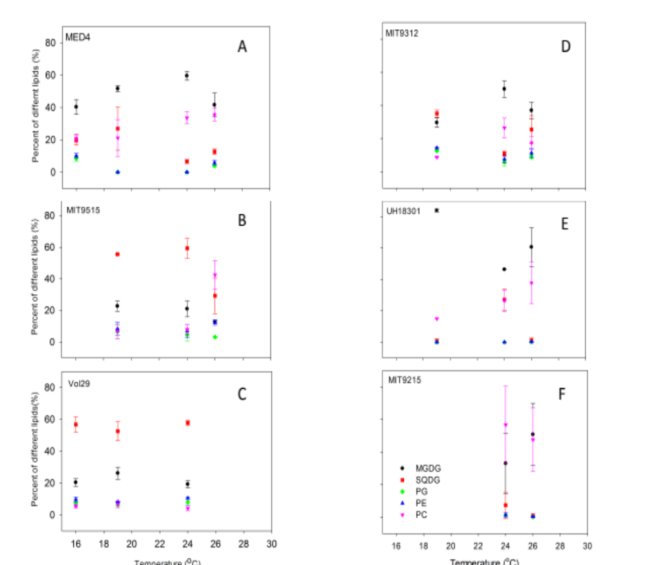
Figure 1 Lipid composition of 6 strains of Prochlorococous as the function of temperature.
Percentage of main lipids MGDG(black circle), SQDG (red square), PG (green hexagon), PE (blue up-triangle) and PC (pink down-triangle) were displayed as the function of temperature in different strains. MED4 (A), MIT9515(B) and Vol29 (C) belong to low temperature adapted ecotypes. MIT9312(D), MIT9215 (E) and UH18301(F) belong to high temperature adapted ecotypes

Table 1. Overview of strains and temperature treatments
Strain name | Derived from | Clade | Origin | T_{opt} (˚C) | T treatments (˚C) | References
MED4 | PCC | eMED4 | Med Sea | 24 | 16, 19, 24, 26 | (Moore et al. 1995)
VOL8 | MIT9515 | eMED4 | Eq. Pacific | 24 | 19, 24, 26 | (Rocap et al. 2002; Morris et al. 2011)
VOL29 | N/A | eMED4 | N. Pacific | ? | 16, 19, 24 | NA
MIT9312 | N/A | eMIT9312 | Gulf Stream | 24 | 19, 24, 26 | (Moore et al. 1998)
MIT9215 | N/A | eMIT9312 | Eq. Pacific | 24 | 24, 26 | (Moore and Chisholm 1999)
UH18301 | N/A | eMIT9312 | N. Pacific | ? | 19, 24, 26 | (Morris et al. 2011)

The fatty acid composition of cyanobacteria membrane lipids has considerable diversity, including saturated fatty acid, mono-and diunsaturated fatty acid [26, 81]. To investigate the main fatty acid composition, the percentage of different fatty acid in 6 strains along with different temperature was investigated. We found that the main fatty acids in Prochlorococcus are C14 to C18, and existed as saturated or mono-, di- or tri-unsaturated fatty acids (see Appendix Table 3).
It has been shown that the unsaturation decreased as temperature went up for UH18301, MIT9515 and Vol29 while it is not the case for MIT9312 and MED4 (Figure 2).
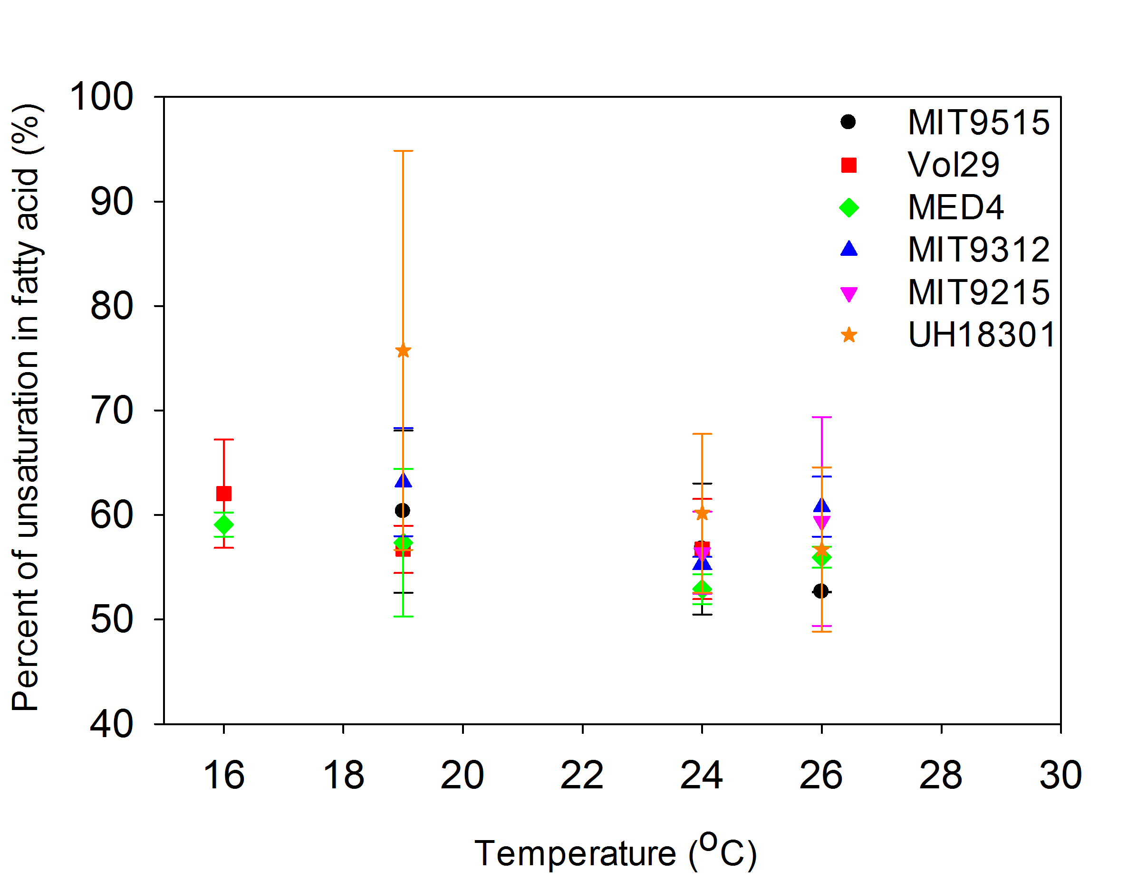
Figure 2 Fatty acid unsaturation in 6 Prochlorococcus strains.
eMED4 has three strains: MED4(green diamond), MIT9515(black circle) and Vol29 (red square); eMIT9312 has three strains: MIT9312(blue up-triangle), UH18301(orange star) and MIT9215 (pink down triangle).

CNP analysis of these 6 strains:

To identify the impact of temperature on the elemental composition of Prochlorococcus, we quantified the carbon, nitrogen, and phosphorus cell quota as well as growth rate of six strains (Table 1). The strains covered both the eMED4 and eMIT9312 clades adapted to different temperatures. Median cell quotas across all strains of 0.44 fg P, 6.4 fg N, and 33 fg C were similar to previously measured levels [35, 86]. Temperature had a significant linear positive effect on QN and QC across all strains (Table 2 and Figure 3A-C). As temperature increased 10˚C, QN and QC rose by 40.0% and 34.6%, respectively. We also examined the elemental ratios. C/N showed little variability and was close to Redfield proportions (median C/N = 6.1) (Figure 3D). In contrast, C/P and N/P were above Redfield proportions (median C/P = 174, median N/P = 29) (Figure 3E-F). Both ratios showed some effect of temperature but there were no significant linear trends across all strains (Table 2). We also determined how changes in growth rate in conjunction with temperature affected the elemental composition of Prochlorococcus (Figure 3). We saw a significant negative effect of growth rate on QP, whereas the other cell quotas and ratios did not display any linear trends (Table 2).

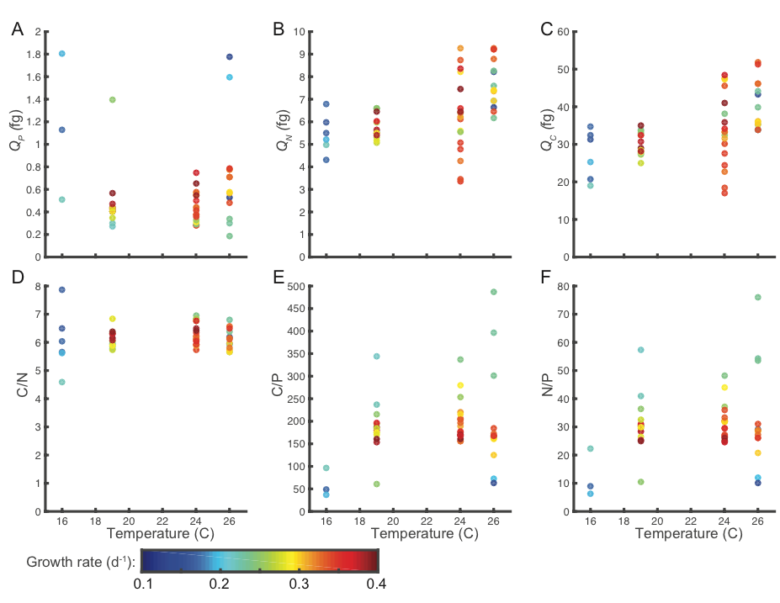
Figure 3 Influence of temperature and growth on the elemental composition and ratios of across Prochlorococcus strains.
Factor measured are (A) phosphorus cell quota (QP), (B) nitrogen cell quota (QN), (C) carbon cell quota (QC), (D) C/N, (E) C/P, and (F) N/P. The color of each sample point indicates the observed growth rate. All ratios are molar based.

We next examined the influence of temperature on the cell quotas in the context of each strain as well as indirectly via changes in growth rate (Table 2 and Figure 4). We observed some similarities as well as difference in the response across the six strains. As seen in the aggregated response for all strains, individual strains displayed negative relationships between growth rate and QP. In addition, temperature also influenced QP on a per strain basis (Figure 4A), but there were no systematic differences between strains nor interactions between factors (Table 2). The Vol8 and Vol 29 strains had higher overall QN and QC and temperature plus growth rate influenced QN and QC across all strains (Figure 4B + C). We also saw some evidence for interactions between strain identity, temperature, and growth rate in setting the overall elemental composition (Table 2).

Table 2 Effects of temperature, growth rate and strain identity on the elemental composition of six Prochlorococcus strains.

 |  | Q_{P} |  | Q_{N} |  | Q_{C} |  | C/N |  | C/P |  | N/P
Linear model |  | Estimate | p-value | Estimate | p-value | Estimate | p-value | Estimate | p-value | Estimate | p-value | Estimate | p-value
 | Intercept | 1.2 | 4.9x10⁻³ | 2.2 | 0.08 | 7.8 | 0.27 | 5.8 | 7.6x10⁻¹⁷ | 53 | 0.6 | 14 | 0.3
 | Temperature | 0.0 | 1.0 | 0.2 | 2.9x10⁻⁴ | 1.2 | 2.3x10⁻⁴ | 0.01 | 0.6 | 6.8 | 0.1 | 0.9 | 0.1
 | Growth rate | -2.0 | 1.2x10⁻² | -1.6 | 0.6 | -3.3 | 0.8 | 0.3 | 0.8 | -65 | 0.7 | -14 | 0.6
ANOVA |  | SS | p-value | SS | p-value | SS | p-value | SS | p-value | SS | p-value | SS | p-value
 | Strain | 1.1 | 0.1 | 22 | 1x10⁻⁴ | 1x10³ | 6x10⁻⁶ | 4.3 | 7x10⁻³ | 2x10⁵ | 2x10⁻⁵ | 4x10³ | 1x10⁻⁴
 | Temperature¹ | 1.4 | 2.3x10⁻² | 41 | 5x10⁻⁷ | 1x10³ | 8x10⁻⁷ | 0.3 | 0.6 | 3x10⁴ | 2.5x10⁻² | 6.2x10² | 4.8x10⁻²
 | Growth rate | 0.6 | 3.0x10⁻² | 6.5 | 1x10⁻³ | 2.8x10² | 3x10⁻⁴ | 0.8 | 5.3x10⁻² | 67 | 0.9 | 10 | 0.7
 | Strain*T | 0.8 | 0.5 | 22 | 1x10⁻³ | 5.7x10² | 3x10⁻³ | 1.8 | 0.4 | 6x10⁴ | 2.6x10⁻² | 1x10³ | 3.9x10⁻²
 | Strain:Gr | 0.1 | 0.9 | 0.9 | 0.8 | 28 | 0.8 | 0.3 | 0.9 | 3x10³ | 0.9 | 1.x10² | 0.9
 | T:Gr | 0.6 | 0.2 | 0.8 | 0.6 | 6.5 | 0.9 | 0.7 | 0.3 | 2x10⁴ | 0.13 | 5.8x10² | 5.7x10⁻²
 | Strain:T:Gr | 0.2 | 0.9 | 8.6 | 7.2x10⁻² | 2.4x10² | 9.6x10⁻² | 0.8 | 0.9 | 5x10³ | 0.9 | 89 | 0.9
¹Temperature was treated as factor in ANOVA

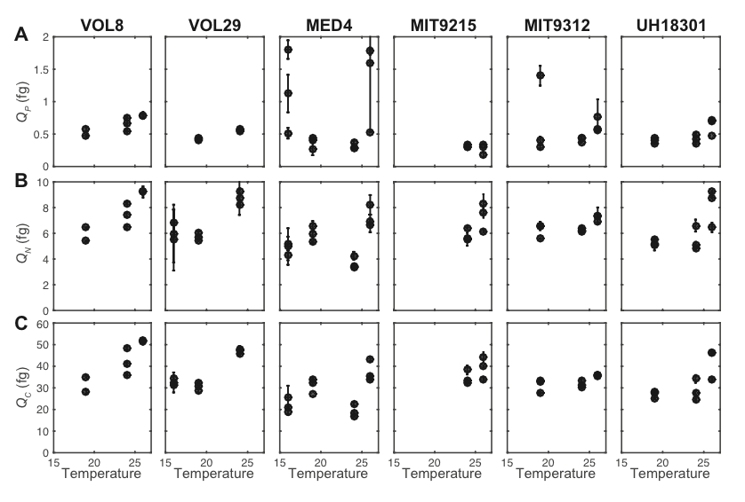
Figure 4 Influence of temperature on cell quotas in six Prochlorococcus strains.
Cell quotas include (A) phosphorus (QP), (B) nitrogen (QN), and (C) carbon (QC). The errorbars represent one standard deviation based on technical duplicate sampling of each strain.

Temperature and growth rate also affected the elemental ratios of each strain in unique ways (Figure 5). For C/N, we observed differences in the overall level across the strains, whereby strain VOL8 showed the highest and MIT9312 the lowest level (Figure 5A). The strain specific C/N was also marginally affect by growth rate but not temperature (Table 2). The strain specific C/P and N/P also varied considerably between strains (Figure 5B + C). Especially MIT9215 had considerably higher ratios compared to the other strains. Temperature had a significant impact on C/P and N/P but the direction varied between strains. C/P and N/P in strains VOL8, VOL29, and MIT9215 were positively affected, MED4 showed more of a unimodal response, UH81301 showed no response, and a negative response was observed in MIT9312. Thus, there were complex interactions between the strain identity and temperature in controlling the elemental ratios in Prochlorococcus.

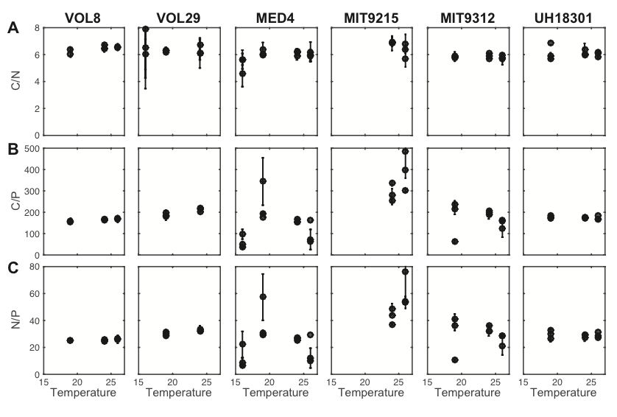
Figure 5 Influence of temperature on elemental ratio in six Prochlorococcus strains.
Elemental ratios include (A) C/N, (B) C/P, and (C) N/P. All ratios are molar based. The errorbars represent one standard deviation based on duplicate sampling of each strain

Discussion
Temperature and lipid chemistry
The physical properties of a biological membrane depend on the fatty acid composition of its component membrane lipids. Unsaturated fatty acids are essential constituents of polar glycerolipids of biological membranes and the unsaturation level of membrane lipids is important in controlling the fluidity of membranes [87]. Our study showed that SQDG and MGDG are dominant lipids in Prochlorococcus, which is consistent with previous studies [76]. In this study we examined how lipid composition and fatty acid composition change in Prochlorococcus due to temperature. While lipid composition varied as a function of temperature, there was no clear trend on this relationship. Notably, the composition of lipid in strain MED4 was different from a previous study of the same strain, at the same temperature (22-24 °C) [76]. In our study, the SQDG content was much lower (6%). The value for the MED4 in the prior study (66%), was however more in line with the other eMED4 ecotypes of our study (6-59%), suggesting that our MED4 24 °C analysis may require additional sampling. MED4 notwithstanding, it was interesting to note that the low-temperature-adapted strains have a higher fraction of SQDG than the high-temperature-adapted strains at 24 °C, suggesting an ecotype-specific difference in lipid chemistry that warrants further investigation. Another difference in our results compared to the prior study is a higher fraction of lipids as PC. This discrepancy likewise warrants further investigation, but it should be noted that our cultures were axenic, while those from the prior study were not, and the impact of heterotrophic bacteria on the lipid concentrations in Prochlorococcus and on the mixed community are not known.

The fatty acids in these Prochlorococcus strains are mainly from C14 to C18 which is consistent from previous study that cyanobacteria contains fatty acid with 16 and 18 carbon atoms as main fatty acid in their membrane lipids [88]. In a very recent paper, they studied the genomes of several strains of Prochlorococcus and found the potential to produce fatty acid with di- and mono-unsaturated 16 and 18 carbon atoms, but not 14 carbon atoms [81]. However, in Biller et al’s paper, they did see fatty acid with 14 carbon atoms in Prochlorococcus [50], as we did, thus the gene(s) responsible for this fatty acid may be novel for this cyanobacterial lineage.
The unsaturation of fatty acid was negatively related with thermal effect for several, but not all, strains in this study. High temperature adapted strain UH18301 had the most unsaturation content and its content sharply decreased with temperature (the R² of linear trend line between unsaturation and temperature as 98.8%), consistent with what has been observed for other cyanobacteria [89]. The reason of this high content of unsaturation from this strain is not clear yet. The increased unsaturation of fatty acid enhances the protection against low-temperature photoinhibition [27]. It also has been that when the growth temperature is suddenly shifted downward, the fatty acid composition of A. variabilis is rapidly altered [23]. The increase in unsaturation in fatty acid also enhanced the tolerance to photosynthetic machinery to salt stress [89]. It was surprising to find that some strains had no significant change in fatty acid unsaturation as a function of temperature, given the presence of desaturase genes in the genome and the trend in cyanobacteria and other bacteria to do so. This strain-strain difference will warrant further investigation in future studies.
Temperature and elemental composition
Multiple studies have put forward a ‘translation-compensation’ hypothesis, whereby cells have lower demand for P-rich ribosomes and associated depressed QP when growing at higher temperature [32, 34]. A lower QP will cause elevated C/P and N/P and such an acclimation mechanism should further explain the high elemental ratios observed in cell growing in the oligotrophic gyres [90, 91]. However, we see mixed support for this hypothesis in Prochlorococcus. The thermal effect is manifested by increasing QN and QC, whereas QP show little change. This points towards other physiological acclimation mechanisms as the primary drivers of elemental changes in Prochlorococcus. The observed elemental changes are likely associated with a cell size increase as QN and QC increase in tandem. Thus, our study adds to an emerging concept, whereby changes in cell size due to physiological responses to different environmental conditions are important for regulating the elemental composition and ratios in marine Cyanobacteria.
QP appear linked to changes in growth rate. This would indicate support for the growth rate hypothesis [92]. However, QP is actually decreasing at elevated growth rates in across all strains as well as for most individual strains. The exact biochemical mechanism cannot be elucidated with the current study but as seen in other marine Cyanobacteria. it is clear the growth rate hypothesis cannot explain the elemental composition of Prochlorococcus strains.
We observed high C/P and N/P, whereas C/N is close to Redfield proportions. The cells are growing under nutrient replete conditions, which should lead to C/P and N/P at the lower end of the range for an organism [93, 94] . Our observations of elevated ratios in Prochlorococcus are consistent with past observations [35, 90, 95] and suggest this lineages have overall high C/P and N/P. As such, the presence of Prochlorococcus in low latitude marine communities will contribute to elevated elemental ratios.
We did not observe a strong phylogenetic structuring of the elemental composition and stoichiometry within Prochlorococcus. However, we do see extensive strain variability in the elemental content and ratios due to thermal acclimation. Thus, the organismal context appears important for the individual response. This is consistent with the thermal response in other phytoplankton lineages. In an analysis across nine eukaryotic phytoplankton lineages, Yvon-Durocher and co-workers observed substantial variability in the link between thermal changes and elemental cellular composition [34]. Furthermore, this meta-analysis as well as our study found little thermal effect on C/N, suggesting C/N being fairly invariant to temperature changes.
The broader environmental growth conditions are important to consider when evaluating the elemental outcome in Prochlorococcus to thermal changes. In this study, the cells were growing under nutrient replete conditions. Multiple studies have shown the possibility for interactions between factors including interactions between nutrient limitation and temperature [34, 96]. Scenedesmus showed stronger thermal responses under nutrient limited vs. replete conditions. Hence, future work studying the interaction between nutrient limitation and thermal conditions would enhance our understanding for how changes in ocean temperature would affect Prochlorococcus elemental stoichiometry.
Our study has important implications for understanding both present day and future biogeochemical functioning. The oceans are projected to undergo substantial changes in temperature and nutrient availability due to a rising CO₂ in the atmosphere. Such environmental changes will likely have a large impact on phytoplankton community structure and physiology. This may further affect the elemental composition and the link between the cycles of carbon, nitrogen, and phosphorus in the ocean. Therefore, we need to understand the biochemical how cycles of key nutrients like nitrogen and understanding current patterns.

Appendix

Table 3 Fatty acid composition in each strain under different growth temperatures
strain | lipid |  | Fatty acid
strain |  |  | 14:0 | 14:1 | 16:0 | 16:1 | 18:0 | 18:1 | 18:2 | 18:3
MED4 | MGDG | 16 | 0.245 | 0.070 | 23.038 | 0.067 | 0.000 | 0.000 | 0.000 | 11.231
MED4 | MGDG | 19 | 0.336 | 0.072 | 44.455 | 0.032 | 0.000 | 0.000 | 0.000 | 1.077
MED4 | MGDG | 24 | 0.101 | 0.004 | 31.532 | 0.007 | 0.000 | 0.000 | 0.000 | 2.845
MED4 | MGDG | 26 | 0.312 | 0.227 | 36.859 | 0.017 | 0.000 | 0.000 | 0.000 | 0.997
MED4 | SQDG | 16 | 18.900 | 5.084 | 0.089 | 0.000 | 0.460 | 0.000 | 0.345 | 0.025
MED4 | SQDG | 19 | 0.000 | 11.947 | 0.035 | 0.000 | 0.056 | 0.000 | 0.014 | 0.007
MED4 | SQDG | 24 | 0.000 | 3.684 | 0.019 | 0.000 | 0.042 | 0.000 | 0.007 | 0.015
MED4 | SQDG | 26 | 13.647 | 1.302 | 0.082 | 0.000 | 0.190 | 0.000 | 0.109 | 0.000
MED4 | PG | 16 | 0.000 | 0.011 | 0.000 | 0.000 | 0.023 | 0.002 | 0.000 | 0.000
MED4 | PG | 19 | 0.000 | 0.000 | 0.000 | 0.000 | 0.032 | 0.000 | 0.000 | 0.000
MED4 | PG | 24 | 0.000 | 0.000 | 0.000 | 0.000 | 0.406 | 0.008 | 0.000 | 0.000
MED4 | PG | 26 | 0.000 | 0.026 | 0.000 | 0.000 | 0.038 | 0.000 | 0.000 | 0.000
MED4 | PC | 16 | 2.608 | 0.030 | 1.073 | 0.000 | 0.417 | 7.421 | 15.170 | 0.038
MED4 | PC | 19 | 1.679 | 0.000 | 12.974 | 0.000 | 0.181 | 2.986 | 16.464 | 6.048
MED4 | PC | 24 | 1.437 | 0.000 | 11.657 | 0.000 | 12.159 | 1.266 | 23.821 | 5.136
MED4 | PC | 26 | 4.354 | 0.014 | 1.982 | 0.000 | 0.244 | 6.562 | 30.402 | 0.161
VOL8 | MGDG | 19 | 5.036 | 0.262 | 5.584 | 0.039 | 0.000 | 0.000 | 0.000 | 2.259
VOL8 | MGDG | 24 | 5.297 | 0.187 | 4.833 | 0.036 | 0.000 | 0.000 | 0.000 | 1.557
VOL8 | SQDG | 19 | 5.391 | 10.808 | 29.600 | 0.000 | 30.195 | 0.000 | 0.518 | 0.077
VOL8 | SQDG | 24 | 4.054 | 6.294 | 33.725 | 0.000 | 34.185 | 0.000 | 0.396 | 0.064
VOL8 | PG | 19 | 0.000 | 0.000 | 0.000 | 0.000 | 0.016 | 0.013 | 0.000 | 0.000
VOL8 | PG | 24 | 0.000 | 0.060 | 0.000 | 0.000 | 1.340 | 0.000 | 0.000 | 0.000
VOL8 | PC | 19 | 1.307 | 0.040 | 1.233 | 0.000 | 0.742 | 1.420 | 2.116 | 2.116
VOL8 | PC | 24 | 0.997 | 0.049 | 1.002 | 0.000 | 0.181 | 1.461 | 2.849 | 2.849
Vol29 | MGDG | 16 | 4.999 | 0.036 | 3.930 | 0.022 | 0.000 | 0.000 | 0.000 | 1.128
Vol29 | MGDG | 19 | 5.273 | 0.059 | 3.830 | 0.047 | 0.000 | 0.000 | 0.000 | 3.440
Vol29 | MGDG | 24 | 4.672 | 0.070 | 4.115 | 0.000 | 0.000 | 0.000 | 0.000 | 0.658
Vol29 | SQDG | 16 | 9.225 | 11.914 | 29.210 | 0.000 | 0.000 | 0.000 | 0.600 | 0.066
Vol29 | SQDG | 19 | 4.967 | 4.395 | 27.185 | 0.000 | 0.000 | 0.000 | 0.078 | 0.009
Vol29 | SQDG | 24 | 4.687 | 5.654 | 29.627 | 0.000 | 0.000 | 0.000 | 0.148 | 0.000
Vol29 | PG | 16 | 0.000 | 0.072 | 0.000 | 0.000 | 0.000 | 0.000 | 0.000 | 0.000
Vol29 | PG | 19 | 0.000 | 0.056 | 0.000 | 0.000 | 0.299 | 0.000 | 0.000 | 0.000
Vol29 | PG | 24 | 0.000 | 0.062 | 0.000 | 0.000 | 0.258 | 0.000 | 0.000 | 0.000
Vol29 | PC | 16 | 0.644 | 0.006 | 0.657 | 0.000 | 0.086 | 1.071 | 2.715 | 0.000
Vol29 | PC | 19 | 0.795 | 0.037 | 1.100 | 0.000 | 5.966 | 1.039 | 8.468 | 0.007
Vol29 | PC | 24 | 0.661 | 0.040 | 1.911 | 0.000 | 6.377 | 0.900 | 7.966 | 0.005
MIT9312 | MGDG | 19 | 0.054 | 0.044 | 11.349 | 0.011 | 0.000 | 0.000 | 0.000 | 14.788
MIT9312 | MGDG | 24 | 0.060 | 0.028 | 16.124 | 0.000 | 0.000 | 0.000 | 0.000 | 21.498
MIT9312 | MGDG | 26 | 0.050 | 0.018 | 14.797 | 0.000 | 0.000 | 0.000 | 0.000 | 12.807
MIT9312 | SQDG | 19 | 24.829 | 12.726 | 0.026 | 0.000 | 0.796 | 0.000 | 0.630 | 0.139
MIT9312 | SQDG | 24 | 7.767 | 1.776 | 0.035 | 0.000 | 0.191 | 0.000 | 0.128 | 0.028
MIT9312 | SQDG | 26 | 24.959 | 6.263 | 0.013 | 0.000 | 0.396 | 0.000 | 0.358 | 0.025
MIT9312 | PG | 19 | 0.000 | 0.020 | 0.000 | 0.000 | 0.031 | 0.002 | 0.000 | 0.000
MIT9312 | PG | 24 | 0.000 | 0.000 | 0.000 | 0.000 | 0.019 | 0.002 | 0.000 | 0.000
MIT9312 | PG | 26 | 0.000 | 0.026 | 0.000 | 0.000 | 0.028 | 0.000 | 0.000 | 0.000
MIT9312 | PC | 19 | 1.628 | 1.488 | 0.408 | 0.000 | 0.058 | 1.929 | 11.318 | 0.034
MIT9312 | PC | 24 | 1.609 | 5.682 | 0.553 | 0.000 | 0.198 | 3.625 | 17.987 | 0.053
MIT9312 | PC | 26 | 0.868 | 4.130 | 0.518 | 0.000 | 0.097 | 1.671 | 18.077 | 0.075
VOL1 | MGDG | 24 | 0.211 | 0.020 | 22.490 | 0.202 | 0.000 | 0.000 | 0.000 | 0.611
VOL1 | MGDG | 26 | 0.072 | 14.357 | 19.809 | 9.884 | 0.000 | 0.000 | 0.000 | 0.393
VOL1 | SQDG | 24 | 0.000 | 5.897 | 0.034 | 0.000 | 0.034 | 0.000 | 0.007 | 0.011
VOL1 | SQDG | 26 | 0.000 | 0.820 | 0.028 | 0.000 | 0.028 | 0.000 | 0.003 | 0.000
VOL1 | PG | 24 | 0.000 | 0.000 | 0.000 | 0.000 | 0.847 | 0.000 | 0.000 | 0.000
VOL1 | PG | 26 | 0.000 | 0.000 | 0.000 | 0.000 | 0.254 | 0.000 | 0.000 | 0.000
VOL1 | PC | 24 | 1.185 | 0.000 | 6.604 | 0.000 | 23.786 | 2.274 | 2.274 | 3.168
VOL1 | PC | 26 | 0.267 | 0.000 | 4.884 | 0.000 | 8.717 | 1.607 | 1.607 | 1.668
VOL6 | MGDG | 19 | 0.051 | 25.918 | 10.117 | 21.439 | 0.000 | 0.000 | 0.000 | 0.144
VOL6 | MGDG | 24 | 0.079 | 0.552 | 37.320 | 0.216 | 0.000 | 0.000 | 0.000 | 0.399
VOL6 | MGDG | 26 | 0.207 | 0.063 | 42.528 | 0.030 | 0.000 | 0.000 | 0.000 | 1.669
VOL6 | SQDG | 19 | 0.006 | 0.830 | 0.013 | 0.000 | 0.015 | 0.000 | 0.001 | 0.002
VOL6 | SQDG | 24 | 0.000 | 16.559 | 0.000 | 0.000 | 0.004 | 0.000 | 0.004 | 0.000
VOL6 | SQDG | 26 | 0.000 | 11.140 | 0.017 | 0.000 | 0.027 | 0.000 | 0.010 | 0.000
VOL6 | PG | 19 | 0.000 | 0.000 | 0.000 | 0.000 | 0.419 | 0.000 | 0.000 | 0.000
VOL6 | PG | 24 | 0.000 | 0.000 | 0.000 | 0.000 | 0.000 | 0.004 | 0.000 | 0.000
VOL6 | PG | 26 | 0.000 | 0.000 | 0.000 | 0.000 | 0.007 | 0.000 | 0.000 | 0.000
VOL6 | PC | 19 | 0.274 | 0.018 | 6.289 | 0.000 | 0.000 | 12.381 | 17.350 | 1.490
VOL6 | PC | 24 | 0.759 | 0.033 | 8.635 | 0.000 | 0.000 | 0.025 | 28.448 | 4.114
VOL6 | PC | 26 | 1.690 | 0.000 | 12.723 | 0.000 | 0.000 | 0.124 | 17.963 | 6.970

CHAPTER III Degradation of hydrogen peroxide by the microbial community facilitates the growth of Prochlorococcus at its temperature extremes

This Chapter is in preparation as a manuscript to be submitted to ISME J / AEM, with the following authors:

Authors: Lanying Ma¹, Zackary I. Johnson², and Erik R. Zinser¹

Address: ¹Department of Microbiology, University of Tennessee, Knoxville, Tennessee, United States of America, ² Nicholas School of the Environment, Duke University Marine Laboratory, Beaufort, North Carolina, United States of America

The work I performed for this chapter included the investigation of growth rate, the Fv/Fm measurement, the red fluorescence measurement of MED4 and MIT9312 in presence /absence of heterotroph with different concentration of HOOH to obtain the growth range of Prochlorococcus stain under these conditions.

Abstract
Cyanobacteria of the genus Prochlorococcus are the smallest and most abundant phytoplankters in the ocean. It has been shown that Prochlorococcus is highly susceptible to hydrogen peroxide (HOOH) and co-occurring heterotrophs such as Alteromonas sp. facilitate the growth of Prochlorococcus at the surface by scavenging HOOH. Temperature is also a major influence on Prochlorococcus abundance and distribution in the ocean, and studies in other photosynthetic organisms suggested that HOOH and temperature extremes act together as stressors. To address the potential synergistic effects of temperature and HOOH on Prochlorococcus, we monitored the growth of a cold-adapted (MED4) and a warm-adapted (MIT9312) Prochlorococcus strain with different initial concentrations of HOOH under a range of temperatures. While not impacting the temperature optima for growth, higher concentrations of HOOH severely diminished the permissive temperature range for growth of both Prochlorococcus strains. At the permissive temperatures, the growth rates of both Prochlorococcus strains decreased as a function of HOOH, and temperature extremes increased susceptibility of photosystem II to HOOH-mediated damage. While these effects were manifest in both strains, they were more pronounced in the warm-adapted strain. Heterotrophic bacteria, serving as a proxy for the natural community, increased the Prochlorococcus growth rate under these temperatures, and this was attributed in part to their ability to remove HOOH from the medium. These studies indicate that in the ocean, the cross-protective function of the microbial community may confer a fitness increase for Prochlorococcus at its temperature extremes, especially near the ocean surface where oxidative stress is highest, and this interaction may play a significant role in defining Prochlorococcus’ habitat range with respect to latitude.

Introduction
Stress is a common state for microbes, and it is becoming clear that biological interactions can augment or ameliorate this condition. One stress that has received much attention in microbial ecology is nutrient stress; most microbes spend the majority of their lives in a nutrient limited or nutrient starved state. Relief from this stress comes from nutrient replenishment, and there are many examples where this is facilitated by cross-feeding from other organisms. Microbes and metazoans can serve as benefactors for microbes limited for carbon, nitrogen, iron, and vitamins [97], and this interaction can be general or highly species-specific.
Microbe-microbe interactions can also potentially mediate relief from non-nutritional abiotic stresses, including temperature, pH, desiccation, oxidative, and osmotic stresses. Facilitation is a widely accepted principle in metazoan ecology ([98-100] but see [101]): at the extremes of environments, positive interactions between organisms tend to dominate over negative ones [100, 102]. This is true for both terrestrial and marine systems, with the former tending to involve intra-trophic interactions between plants and the latter inter-trophic interactions often between primary and secondary producers [103].
Examples of facilitation are less extensive for microbes, but reports indicate that microbes can cross-protect phytoplankton from a number of abiotic stresses, including inorganic carbon limitation and oxygen toxicity [104, 105]. A recent study indicated that by relieving vitamin B₁₂ deficiency, heterotrophic bacteria can improve thermotolerance of the green alga Chlamydomonas reinhardtii [106]. Microbes can also protect other microbes from oxidative stresses by the removal of the reactive oxygen species from the environment. This has been shown to protect heterotrophic microbes [105], Antarctic diatoms [107] and, as we demonstrated in prior studies [55, 56], marine cyanobacteria as well.
Cyanobacteria of the genus Prochlorococcus are the smallest phytoplankton in the oligotrophic open ocean; they are also believed to be the most abundant photosynthetic autotroph on Earth [3] [4]. Prior work by our group has shown that the microbial community can facilitate the growth of the marine cyanobacterium Prochlorococcus in the surface mixed layer by the removal of hydrogen peroxide (HOOH) [55]. In absence of the community the HOOH concentrations exceed the lethal limit of Prochlorococcus (≥800 nM), but in its presence the HOOH concentrations are maintained within a tolerable range for Prochlorococcus, rarely exceeding 200 nM except during rainfall events [55]. Unlike most cyanobacteria and many aerobes, Prochlorococcus lacks a robust defense against reactive oxygen species, and has lost its HOOH-degrading catalase during its evolution [57]. Instead, Prochlorococcus relies upon the extant microbial community to eliminate the HOOH and maintain the concentrations within the tolerable range.
[59, 108][52, 53]
Stresses do not always act in isolation in the natural world, and temperature stress is known to act synergistically with oxidative stress. Both can inhibit the repair of photosystem II of phytoplankton [59, 108], and temperature extremes can generate excess reactive oxygen species (ROS) [64], leading to oxidative stress [65] and cell mortality [66]. [59][60, 61][62][63][64][64][65][66][29][29, 30][67]
Given the potential for synergistic effects of oxidative and thermal stresses on Prochlorococcus growth and photosynthesis, we hypothesized that 1) temperature extremes sensitize Prochlorococcus to HOOH-mediated damage, and that 2) by removing the HOOH threat, the extant microbial community facilitates the survival and growth of Prochlorococcus at these temperature extremes. As temperature plays a key role in establishing the geographical distributions of the numerically dominant lineages (ecotypes), this interaction between oxidative and thermal stress may have important consequences for the ecology of Prochlorococcus.
While multiple ecotypes have been identified, the water column is typically dominated numerically by one of two ecotypes, eMED4 or eMIT9312 (the “e” prefix denotes “ecotype”, named from the type strains MED4 and MIT9312) [68, 109]. These high-light adapted ecotypes partition the surface ocean by latitude, with eMIT9312 dominating the low latitudes, and eMED4 the high latitudes north and south of the equator. Temperature was identified as the key environmental variable correlating with abundance of these two ecotypes [68]. Consistent with the field data, studies with non-axenic cultures of isolated strains confirmed that while both ecotypes share a common temperature optimum (~24 °C), the eMED4 strains grew faster and at a broader range of temperatures below ~19 °C, compared to the eMIT9312 strains, while the opposite held true for cultures grown above the optimum. Collectively, these studies suggested that the different physiological responses to temperature play a significant role in establishing the distribution patterns of these recently-diverged lineages in nature. However, as the culture experiments were performed in the presence of heterotrophic bacterial contaminants [68], the influence of the microbial community on the temperature range of Prochlorococcus is unconstrained, but could be significant due to its impact on the concentration of hydrogen peroxide (HOOH).
In this study we used dilute, ecologically relevant concentrations of representatives of the high- and low-temperature-adapted ecotypes of Prochlorococcus, grown in the presence or absence a heterotrophic helper, to directly test the hypothesis that HOOH acts synergistically with high or low temperature to restrict growth.
Evidence will be provided that elevated HOOH concentrations are even more deleterious to Prochlorococcus cells grown at suboptimal temperature, with impacts on photosynthetic efficiency, and suggest that the activity of the community can facilitate growth of Prochlorococcus at its temperature extremes by eliminating a synergistic stress.

Materials and methods

1 Prochlorococcus strains and culture conditions.
Axenic Prochlorococcus MIT9312 and MED4 were cultured in filtered (0.2 μm polycarbonate filter, pressure <10 mm Hg) artificial seawater AMP-J medium [83](per L, 28.1 g NaCl, 6.9 g MgSO₄*7H₂O, 5.49 g MgCl₂*6H2O, 0.67 g KCl. 1.47g CaCl₂, 0.504 g NaHCO₃ with 2 ml 0.5 M TAPS, pH 8.0, 1 ml 0.4 M (NH₄)₂SO₄, 2 ml 0.025 M NaH₂PO₄ pH7.5, 100 μl 10,000 X Pro99 Trace Metal Mix) with 40 µmol quanta m⁻² s⁻¹ light on a 12:12 light:dark cycle using cool white fluorescent bulbs. Cultures were acclimated to the test temperature for at least three transfers at high cell concentration (> 10⁷cells ml⁻¹), before transferring at low cell concentration (30,000 cells ml⁻¹) for the assessment of temperature and HOOH impacts on growth. HOOH concentration was increased from basal levels in the medium (around 90 nM) where appropriate. Axenicity of Prochlorococcus cultures was monitored by purity test in YTSS and 1/10 ProAC heterotrophic growth media [56].

Heterotrophic bacterium Alteromonas sp. EZ55 was grown 48 hours in 10 ml YTSS medium [110] (per L, 4.0 g tryptone, 2.5 g yeast extract, 15 g sea salts, autoclaved) on a roller drum at 22°C. Cells were then diluted 1:1000 into 10 ml minimal acetate medium (MAM) (per 200 ml, 150 ml Pro99 [111], 50 ml 18 MΩ H₂O, 0.5% acetate, 100 μl 2000 X VA vitamin mix [112] and incubated for 24 hours on the roller drum. Cells were harvested by centrifugation at 4500 g for 5 min, washed twice with sterile AMP-J medium and resuspended in sterile AMP-J medium. About 10⁶ cells ml⁻¹ EZ55 were added 24 h before the addition of Prochlorococcus cultures, and these cultures were maintained at each corresponding incubators during this pre-treatment step.

2 Quantification of Prochlorococcus and Alteromonas sp EZ55
Concentration of Prochlorococcus was measured by flow cytometry with the Guava EasyCyte 8HT cytometer (Millipore), using an established method [58]. Flow cytometric quantification of EZ55 was performed after staining of the cells with SYBR green [113]. Viable count assays for EZ55 were performed by titration of series dilutions of the culture on YTSS plates. Plates were incubated overnight at 22°C and colonies were counted.

3 HOOH quantification and amendments to media
The HOOH concentration in the media and cultures was measured by Orion L Microplate Luminometer (Titertek Instruments Inc) based on established method using acridinium ester [114]. Concentration of HOOH in the culture media was adjusted as needed to 200, 400, or 800 nM, after the basal concentration of the AMP-J medium was determined.
4 Sodium pyruvate scavenging HOOH
Final concentration of 1 mM sodium pyruvate (Sigma) was used to scavenge HOOH in the medium. Sodium pyruvate was added to medium at the same time as Alteromonas sp. EZ55 was added, which is 24 hours before Prochlorococcus was added. 1mM sodium pyruvate has been shown to have the most similar HOOH scavenging ability to EZ55 (Appendix Figure 14); by 24 hours the concentration fell below the limit of detection (10 nM).

5 Measurement of photosynthesis parameters Fv/Fm with lincomycin.
A Fast Induction and Relaxation (FIRE) fluorometer (Satlantic, Halifax, Nova Scotia) was used to measure the photophysiological parameters by the established method [115]. The photosynthetic parameter, Fv/Fm, was obtained by fitting standard models to data in MATLAB [116]. Important values are Fo (initial fluorescence), Fm (maximal fluorescence), Fv (Fm-Fo). Lincomycin (Sigma-Aldrich) was suspended in water and added into tubes with a final concentration of 500 μg ml⁻¹. Higher concentrations had the same impact on Fv/Fm in trial studies (data not shown), so we were confident that maximum inhibition was achieved at this concentration.

Results

Growth of the high temperature-adapted Prochlorococcus strain MIT9312 at different temperatures under oxidative stress
Prior work with dense, non-axenic cultures indicated that the high temperature-adapted MIT9312 strain had a growth optimum at 24ºC, and growth diminished sharply at higher temperatures [117]. Axenic cultures grown at ecologically-relevant cell concentrations confirmed a 24 ºC growth optimum and a sharp decline at increasing temperatures (see Fig. 6), but also revealed the impact of reactive oxygen species and heterotrophic bacterial activity on this growth response. At 24 ºC, increases in medium HOOH concentrations towards the lethal concentration (800 nM, Morris et al. 2011) led to marginal declines in growth rate (Fig. 6A). However, at 26 ºC, a new, lower lethal HOOH concentration was discovered. While MIT9312 exhibited robust growth in the presence of 90 or 200 nM HOOH, the population could not grow in the presence of 400 nM HOOH, and eventually lost cells detectable by flow cytometry (Fig. 6B). Hence, a shift in temperature of only 2 ºC above optimum resulted in at least twice the sensitivity to HOOH in this strain.
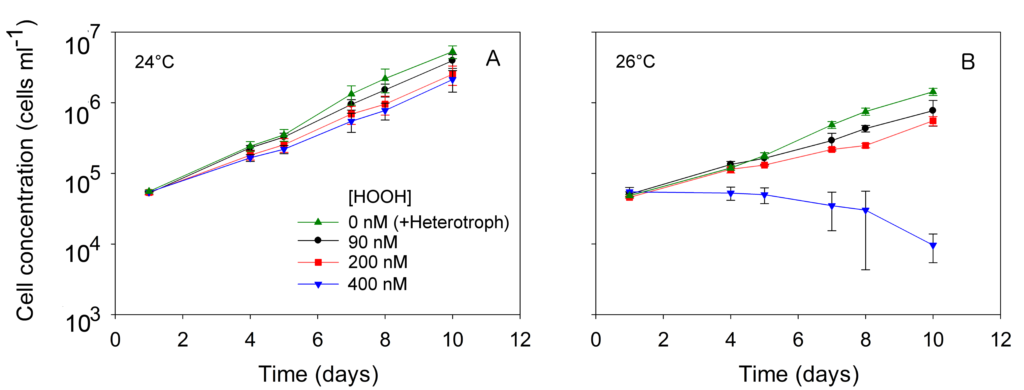
Figure 6 Growth of ecologically-relevant concentrations of MIT9312 at 24ºC and 26ºC in the presence of different concentrations of HOOH.
Cells from temperature-acclimated dense (>10⁷ cells ml⁻¹) mid-log cultures were inoculated into media containing ambient HOOH 90 nM (black circles), 200 nM (red squares), 400 nM (blue down triangles), or in media pre-inoculated with the heterotroph Alteromonas sp. EZ55 (around 0nM HOOH, green up triangles).

Examination of growth along the entire temperature range for MIT9312 confirmed an enhanced sensitivity to HOOH at the suboptimal temperatures (Fig. 7A). At the unadjusted medium HOOH concentrations (90 nM), the permissive temperature range was 19-28 ºC, similar to the prior study with dense non-axenic cultures [68] (Appendix Figure 17). Increasing the HOOH concentration to 200 nM had minimal impact on growth over this temperature range, although the overall trend was a slight decrease in rate. However, at 400 nM, the MIT9312 cells could only grow at (24 ºC) or slightly below (22 ºC) their optimum. In fact, with the initial concentration at ~10,000 cells ml⁻¹ at 19, 26 and 28 ºC, a slow but steady decline in flow cytometry cell counts was oberved, while at the more extreme temperatures tested, no cells could be detected after only 24 hours post-inoculation, indicating that the cells rapidly lost chlorophyll-based red fluorescence and perhaps cell integrity as well (see Discussion).

Figure 7 Growth rate of (A) MIT9312 and (B) MED4 at different temperatures and exogenous HOOH concentrations.
Cells in filtered AMP-J medium containing unamended medium HOOH (90 nM; black dots), 200 nM (red squares), 400 nM (blue down triangles), or in media pre-inoculated with the heterotroph Alteromonas sp. EZ55 (around 0nM HOOH, green up triangles). Asterisks indicate negative growth rates too large to be detected by 24 hours post-inoculation.

Prochlorococcus lacks catalase but can, at slow rates, remove HOOH from the medium[55] . While the degradation rates are too slow to dramatically improve tolerance to HOOH, it was nonetheless notable that the rates of HOOH degradation by MIT9312 varied as a function of temperature and initial concentration of HOOH (Figure 8A). At 400 nM HOOH, degradation was highest at 22 and 24 °C, which is perhaps not surprising since at all other temperatures the population was dying. However, even at lower HOOH concentrations (90, 200 nM), where cultures grew over a more extended temperature range, removal of HOOH was highest at 22 and 24 °C, coincident with the highest growth rates. This trend is coincident with the enzyme kinetics, that the removal of HOOH was high at optimal temperature and decreased at suboptimal tempertures.

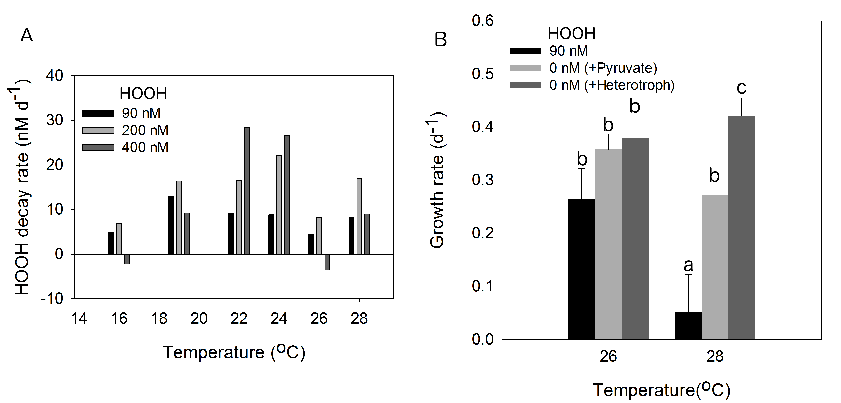
Figure 8 Temperature-dependent HOOH degradation and growth of ecologically-relevant concentrations of MIT9312.
(A) Degradation rates by axenic Prochlorococcus MIT9312 relative to uninoculated controls. Black bar: HOOH concentration in MIT9312 with initial concentration of 90nM HOOH. Light gray bar: HOOH concentration in MIT9312 with initial concentration of 200nM HOOH. Dark gray bar: HOOH concentration in MIT9312 with initial concentration of 400nM HOOH. (B) Growth rates of MIT9312 in AMP-J medium (red), and in AMP-J medium pre-treated with pyruvate (orange) or Alteromonas sp. EZ55 (green). By two way ANOVA, temperature and HOOH both bring significant different to the growth of MIT9312. The p-value for temperature, HOOH and temperature and HOOH overall are 0.001, 0.000002 and 0.001 respectively.

In a prior study it was discovered that heterotrophic bacteria can protect Prochlorococcus from HOOH-mediated oxidative damage by removing HOOH from the medium [55]. As this earlier work was performed exclusively at 24 °C, we investigated if this helping phenomenon can occur throughout the growth range of Prochlorococcus. [55]At all temperatures assayed, media pre-conditioned by the presence of the heterotrophic bacterium Alteromonas sp. EZ55 had undetectable levels of HOOH (limit of detection = 10 nM), indicating that the HOOH-degrading capacity of this helper is not significantly impacted by temperatures within the growth range of Prochlorococcus. At all temperatures, MIT9312 grew at the fastest rate in this heterotroph-conditioned medium, even when compared to growth at low (90 nM) ambient HOOH concentrations (Figs 6 and 7A). This indicates that even 90 nM may be toxic to Prochlorococcus. Alternatively, the growth benefit of the heterotroph could be independent of its HOOH degrading capacity. To address this we used an alternative means of removing HOOH from the medium: pre-conditioning with pyruvate.
Pyruvate has been shown to scavenge HOOH effectively in the medium [118] by a chemical reaction [119]. At 28ºC, the growth rate of MIT9312 in pyruvate-treated medium (0 nM HOOH) was significantly higher than in the untreated control (90 nM) (Figure 8B). Thus, by different chemistries the two treatments employed – live bacteria with enzymes and pyruvate – effectively decreased HOOH below detection, and both lead to an enhancement of MIT9312 growth post-treatment (Fig. 8B). Importantly, cultures given pre-treatment with a heterotrophic helper grew faster than those pre-treated with pyruvate. The implications of this difference are explored in detail in the Discussion. At a less extreme temperature of 26 ºC the trends are similar but not significant.

Growth of the low temperature-adapted strain MED4 under temperature and oxidative stresses
While some strain differences were observed, in general the low temperature-adapted MED4 strain exhibited similar growth responses to HOOH, temperature, and helper treatments. Dilute MED4 cultures grew between 12ºC to 26ºC, which was cold-shifted relative to MIT9312 (16 to 28 °C) and was similar to its reported range for dense cultures [68] (Appendix Figure 17). Of note, however, MED4 could only grow at 12 °C when in the presence of heterotrophs, suggesting that at this cold extreme, even 90 nM HOOH was lethal.
[52]Like MIT9312, growth of pure cultures of MED4 was highly restricted at 400 nM HOOH, in this case only at the growth optimum, 24 °C (Figure 7B). The kinetics of cell loss at the non-permissive temperatures was slow enough that rates of cell loss could be calculated, except at 12 °C, when all cells disappeared by 24 hours. It is interesting to note that the rate of loss increased as a function of distance from optimal temperature, at both temperature extremes. Finally, pre-treatment with heterotroph helpers tended to increase the growth rate or, at lethal temperatures, decrease the death rate of MED4.

Impacts of temperature and HOOH on chlorophyll and photosynthetic efficiency.

Flow cytometry scatterplots used for the quantification of MIT9312 and MED4 cells in the analyses reported above revealed interesting relationships between red fluorescence (a proxy for chlorophyll content cell⁻¹), temperature, HOOH, and heterotrophic bacteria. Whereas forward scatter (a proxy for cell size) did not change as a function of temperature, a distinct increase in red fluorescence was observed in MIT9312 cells grown above the growth optimum (>24 °C) (Fig 9A). Interestingly, this increase was only observed in axenic cultures (Fig. 9A); co-cultures with Alteromonas did not show this temperature-dependent change in chlorophyll fluorescence (Fig. 9B). High HOOH also had an impact on fluorescence: at 19 °C, increasing HOOH concentrations above ambient levels (>90 nM) led to an overall decrease in cellular fluorescence. Depleting the HOOH concentrations from 90 to 0 nM via heterotrophic pre-treatment had no impact on fluorescence (Fig. 9C). Examinations with MED4 cultures revealed the same overall trends (data not shown). Overall, these results indicate that temperature and HOOH can impact chlorophyll-based fluorescence in Prochlorococcus, but this effect is eliminated in the presence of heterotrophs.
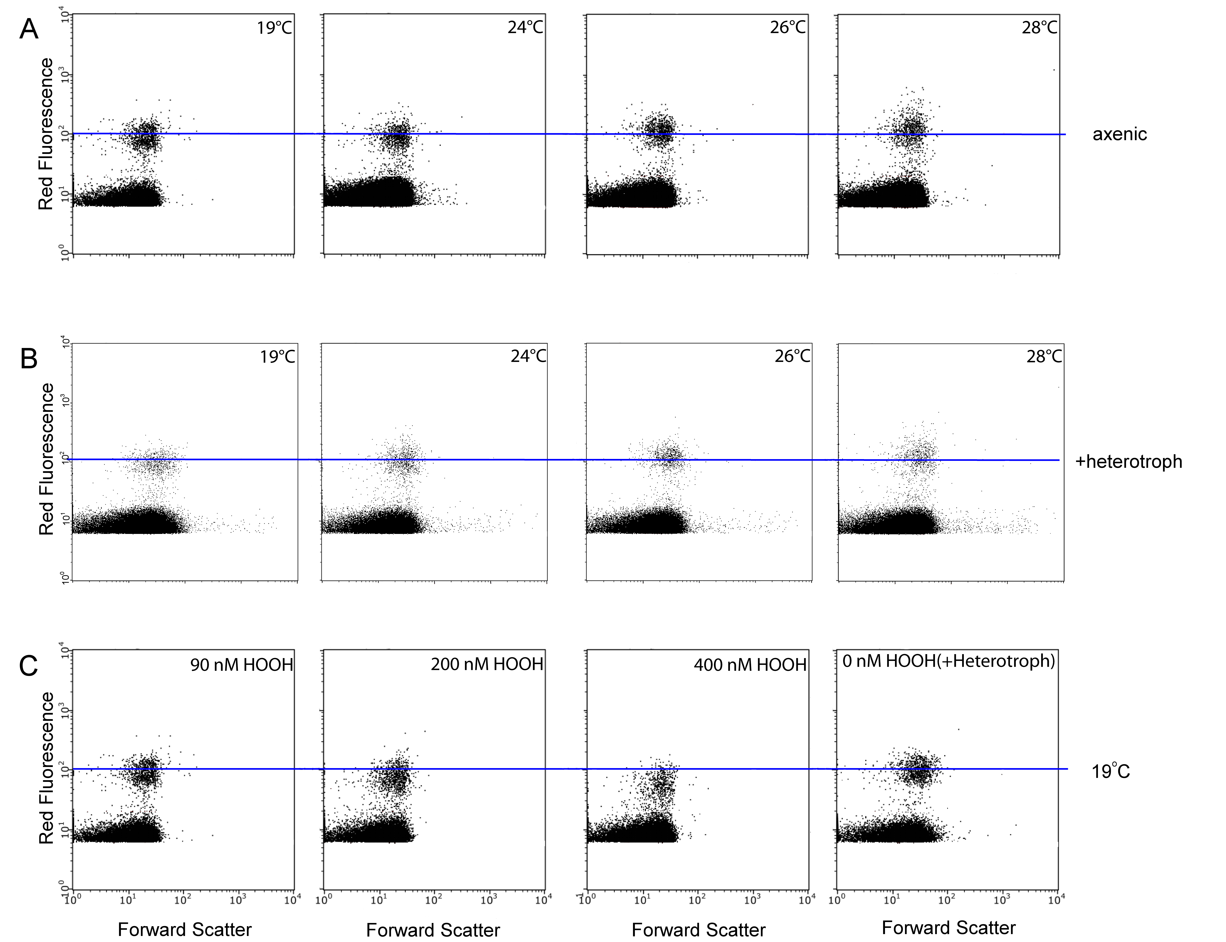
Figure 9 Flow cytometry profiles of MIT9312 at different temperatures and HOOH concentrations.
Forward scatter versus red fluorescence for MIT9312 cells grown axenically (A) or in the presence of Alteromonas sp. EZ55 heterotroph (B). Cells grown in the presence of different concentrations of HOOH or in the presence /absence of heterotroph as indicated (C). The blue line is an arbitrary reference to highlight the change of red fluorescence as a function of temperature, HOOH and/or heterotrophic co-cultures.

Temperature and HOOH both impact photosynthesis by blocking the synthesis and/or processing of nascent D1 protein used to replace damaged protein in the PSII reaction center [53, 59, 105, 108]. To assess the contributions of these stresses on Prochlorococcus, we quantified Fv/Fm, a measure the quantum efficiency of photosystem II.
During growth in low, ambient concentration of 90 nM HOOH, Fv/Fm for MED4 did not vary from a value of 0.6 throughout the range of 16-26 ºC, which is similar to the findings of a previous study [31], but did decrease dramatically at 12 °C (Fig 11A). Similarly, [31]MIT9312 also had an Fv/Fm value of 0.6 for the 19-28 ºC range, but Fv/Fm was lower at 16 ºC (Fig. 11A).
During an 8 hour exposure to elevated HOOH, neither strain experienced a significant decline in Fv/Fm when exposed to 400 nM compared to 90 nM HOOH (data not shown), but did exhibit temperature-dependent responses to 800 nM HOOH (Fig 10, Appendix Figure 15 and 16). This effect was most pronounced for MIT9312, which showed significant temperature-dependent declines in Fv/Fm at 800 compared to 90 nM HOOH (Fig 10A), despite no detectable loss in cell density over the 8 hour period (data not shown). The response was most pronounced at the lower temperatures, but a decline at temperatures above the 24 °C growth optimum was also apparent. This temperature-dependent decline in Fv/Fm was qualitatively shared for MED4 (Fig. 10B), although the trends were less obvious.
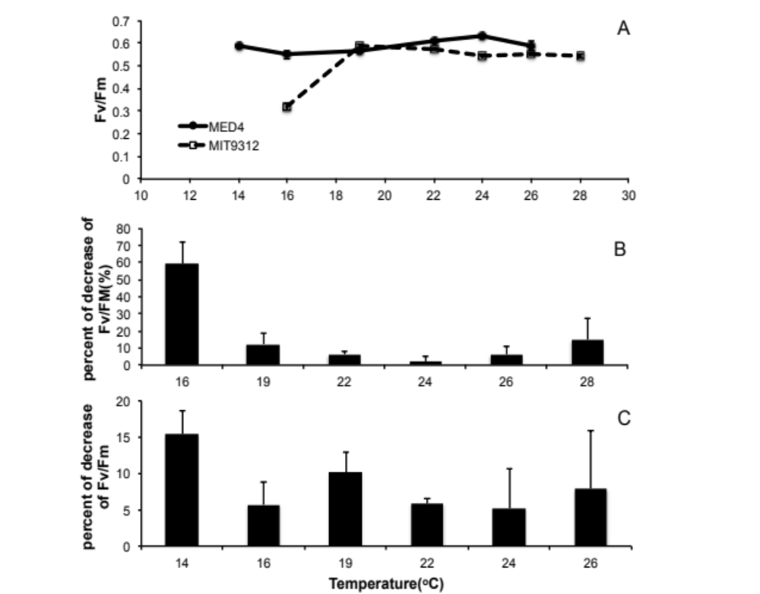
A
B
Figure 10 Fv/Fm of Prochlorococcus as a function of temperature and HOOH concentration.
Percent decrease of Fv/Fm at 800 nM compared to 90 nM HOOH varied strongly (ANOVA p=0.00007) or weakly (ANOVA p=0.12) as a function of temperature for MIT9312 (A) or MED4 (B), respectively

Lincomycin, an effective translation inhibitor in Prochlorococcus [120] and other cyanobacteria [120, 121], was used to calibrate the drop in Fv/Fm for the different temperature and HOOH exposures. In almost every case, the lincomycin treatment led to a significantly larger drop in Fv/Fm over the 8 hour incubation compared to the HOOH treatment (Fig. 11B and Appendix Figure 15 and 16). If lincomycin treatment leads to complete inhibition of D1 replacement, then this indicates that the HOOH (in combination with any temperature effects) led to only partial blockage of this process which could be demonstrated by Figure 11B: lincomycin treatment (at low, 90 nM HOOH) decreased Fv/Fm to a larger extent than treatment with high (800 nM) HOOH. This difference increased as a function of temperature, and was non-significant only at the lowest temperature, 16 °C.
Unexpectedly, these studies indicated that HOOH may be impacting photosynthetic efficiency via mechanisms in addition to blocking D1 replacement. This is evident in comparisons of high and low HOOH treatment in the presence of lincomycin: at most temperatures exposure to 800 nM resulted in greater loss of Fv/Fm compared to exposure to 90 nM HOOH (Fig 11C). Additionally, lincomycin-treated cultures showed enhanced drops in Fv/Fm when also exposed to high HOOH (Fig 11D). In both cases, high HOOH led to decreases in Fv/Fm even when D1 repair was already blocked by lincomycin.

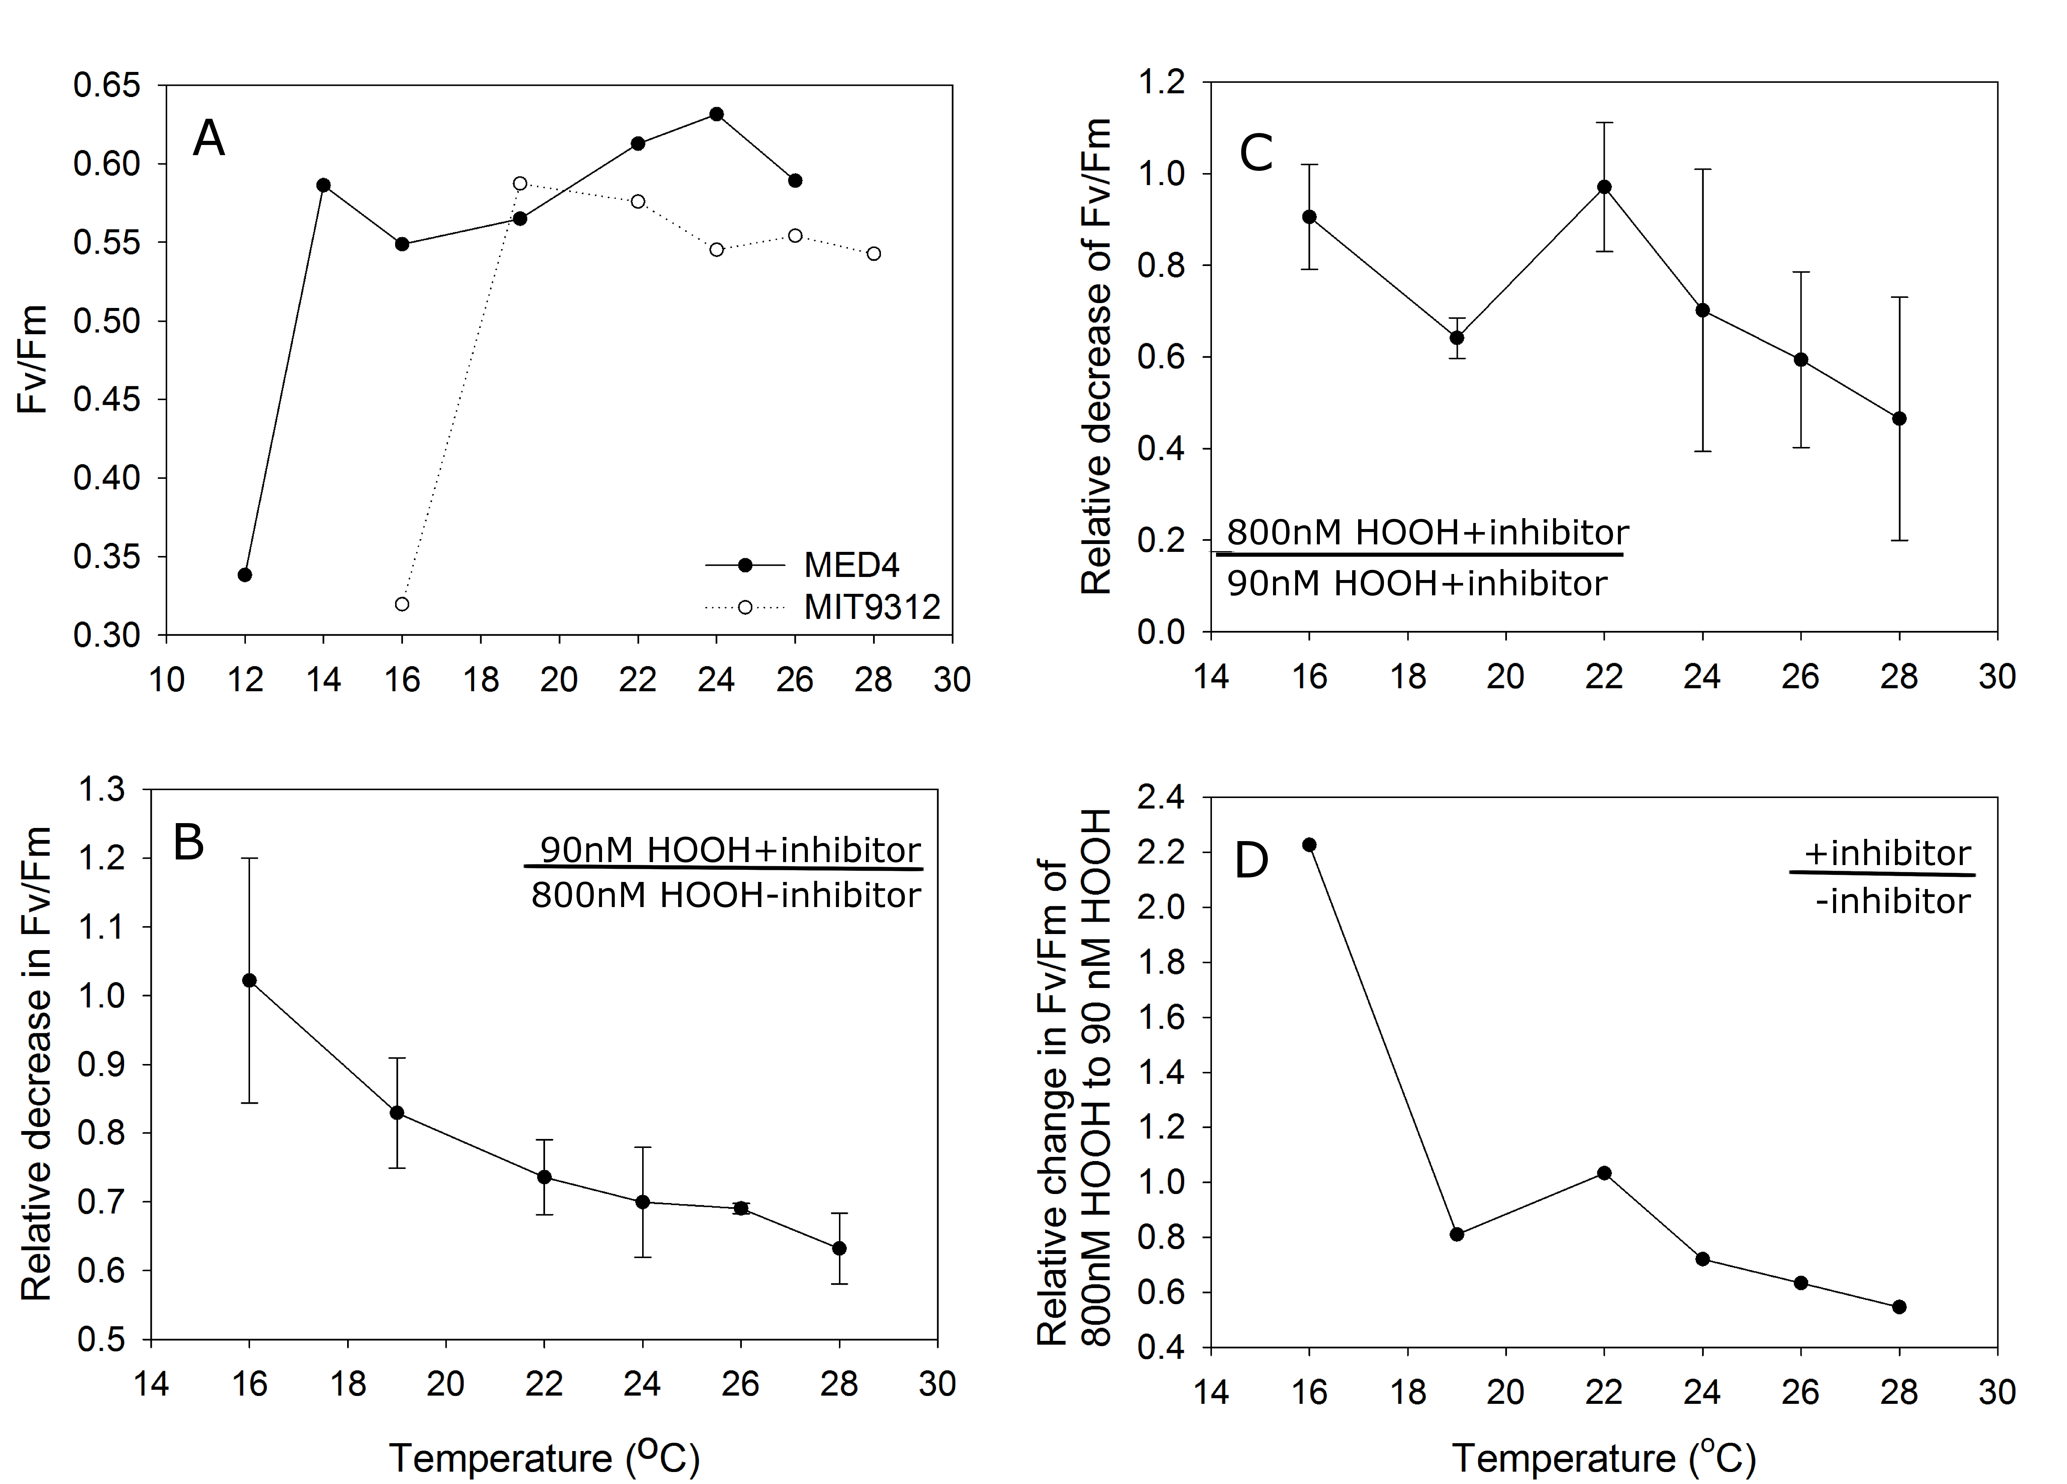
Figure 11 The effects of HOOH on Fv/Fm in MIT9312, in the presence or absence of lincomycin.
Decline in Fv/Fm compared to the ambient 90 nM HOOH, no lincomycin control for the 800 nM HOOH treatment relative to the lincomycin treatment (A). In the presence of lincomycin, the decline in Fv/Fm for the 800 nM HOOH treatment relative to the 90 nM HOOH control (B). The Fv/Fm of MIT9312 at 800nM HOOH with inhibitor relative to that with 90nM HOOH with inhibitor (C). The Fv/Fm of MIT9312 of 800nM HOOH relative to 90nM HOOH in presence of inhibitor over the absence of inhibitor (D)

Discussion

This study confirmed our prediction that growth at temperature extremes would heighten the sensitivity of Prochlorococcus to hydrogen peroxide, and vice versa. This effect was observed in both strains, chosen as representatives of the two numerically-dominant ecotypes of Prochlorococcus in the ocean [7]. While caution must be used in extending these results into natural populations of these and other ecotypes, it is nonetheless encouraging that the overall patterns were the same for the two strains. Three major interactive effects were observed between temperature and HOOH: 1) within the permissive temperature range, growth rate deceased as a function of HOOH concentration, 2) the range of permissive temperature decreases with increasing HOOH, and 3) for the 400 nM treatment, the death rate (measured as the loss of detectable cells) at the lethal temperatures increases with increasing distance from optimal temperature (24 °C).
Damage mechanisms of oxidative and thermal stress in Prochlorococcus
Prior work has demonstrated that oxidative damage from exposure to HOOH can result in diminished photosynthetic efficiency for Prochlorococcus [55, 122] and our results are consistent with these earlier reports.. Temperature alone did not significantly impact Fv/Fm over its growth range, similar to prior findings [31], but dropped considerably at cold lethal temperatures (12 and 16 °C for MED4 and MIT9312, respectively). Hence, under low HOOH conditions, Prochlorococcus appears to maintain photosynthetic efficiency over its permissive temperature range, suggesting only minimal impacts of temperature on the repair of PSII. However, exposure to temperature extremes, particularly lower temperatures, appeared to sensitize Prochlorococcus for a drop in Fv/Fm mediated by oxidative damage. This effect was most pronounced for MIT9312; the reasons why MED4 did not show a strong temperature-dependence of HOOH sensitivity for photosynthetic efficiency are not known.

The mechanism(s) by which temperature and oxidative stress interact to limit growth in Prochlorococcus has not been fully elucidated, but if similar to other cyanobacteria, it includes impeding repair of damaged photosystems. Both temperature and oxidative stress can lower photosynthetic efficiency (Fv/Fm) in cyanobacteria by interfering with the repair of photosystem II via replacement of damaged D1 protein [123, 124]. HOOH inactivates translation elongation factor G, causing a general block in translation [59, 108]. The protein most impacted by this block is D1, which contains the reaction center chlorophyll for photosystem II, and is rapidly turned over during photosynthesis due to continuous photoinactivation [52, 53]. Hence, over short time scales, the primary impact of the HOOH-mediated block in translation is a drop in photosynthetic efficiency. Like oxidative stress, low temperatures decrease the turnover of D1, in this case by slowing the processing of the precursor protein pD1 [59]. Lower temperatures can also increase the production of reactive oxygen species by slowing the rate of the Calvin Cycle “dark reaction” enzymes while not concomitantly slowing down light harvesting in the “light reaction,” resulting in a buildup of NADPH and diminished regeneration of NADP+ as the terminal electron acceptor of the light reaction [60, 61]. In this situation, excess electrons can reduce molecular oxygen to produce the reactive oxygen species (ROS) superoxide and hydrogen peroxide (HOOH). Consistently, a superoxide dismutase deletion mutant of Synechococcus PCC7942 defective in eliminating superoxide is more sensitive to chilling stress than wild type [62], and in plants and microbes, the concentration of HOOH was higher at lower temperatures [63] [64]. Higher temperatures also generate excessive ROS [64], leading to oxidative stress [65] and cell mortality [66]. In phytoplankton, high temperatures inactivate Rubisco activase, leading to a decline in Rubisco and Calvin Cycle activity, that, as for cold temperatures, can generate an imbalance in NADPH/NADP⁺ which can allow the generation of ROS by the reduction of O₂ by photosystem I [29]. As a result, higher temperatures contribute to a loss in photosynthesis by inhibiting photosystem II repair [29, 30], an in some cases by causing direct photodamage [67].
Interestingly, we observed that both temperature and elevated HOOH stress can change the chlorophyll-based red fluorescence in Prochlorococcus. The molecular basis for this phenomenon is entirely unclear, but given that heterotrophs can abolish this relationship, it suggests that there is some link between chlorophyll fluorescence and reactive oxygen species. Since red fluorescence is a common parameter for the quantification of natural populations of Prochlorococcus [125-128], these results might a priori cause concern for the gating of the flow cytometers for such applications, especially in transects through varying temperatures or HOOH concentrations. However, in that heterotrophs remove this effect, and that heterotrophs are always co-existent with Prochlorococcus, this worry is diminished.

[130][65][65]
[59, 108]
[131][132]

[133]
Unexpectedly, we observed evidence of repair-independent damage to PSII upon HOOH exposure. This was observed by the additional decrease in Fv/Fm by elevated HOOH, in cells with lincomycin already blocking the D1 repair pathway. In general, this additional damage occurred at higher, rather than lower temperatures. This might rule out one target of the Prochlorococcus cell that could indirectly influence PSII activity. Microbes are unable to control temperature relative to ambient, and so to maintain membrane fluidity at low temperatures, increase the unsaturation of their fatty acids[25]. HOOH can induce membrane damage for cells with di-unsaturated fatty acids via a process known as lipid peroxidation. Prochlorococcus has di-unsaturated fatty acids in its membrane [50], and these may indeed increase, but if they follow the rule for other microbes, will increase at colder temperatures. Hence, lipids would be more susceptible to peroxidation at low temperatures, while we see in Prochlorococcus an increase in D1-independent PSII efficiency decline at higher temperatures. Hence, the D1 repair-independent target remains elusive. [25][134, 135][136]

[55][126-129]
The role of helper bacteria in protecting Prochlorococcus from interactive thermal and oxidative stresses
Consistent with prior studies [55, 56] we observed a growth benefit to Prochlorococcus during co-cultivation with the heterotroph Alteromonas sp. EZ55. This helping phenomenon has two positive impacts on Prochlorococcus, depending on the temperature: at suboptimal permissive temperatures, helpers generally increase growth rate, relative to the unamended (90 nM HOOH) control; while at the lethal high temperature, helpers slowed the death kinetics of MED4, relative to the unamended control. Using pyruvate as an alternative treatment for HOOH degradation, we observed that the ability of Alteromonas cells to help Prochlorococcus is due, at least in part, to the removal of HOOH from the medium. This consistent with our prior studies [55, 56], and now suggests that this helping ability is even more important for Prochlorococcus cells exposed to temperatures above or below their growth optimum of 24 °C.
The mixed layer of the oligotrophic ocean, especially in the lower latitudes where it is highly stratified, is characterized as a fairly stable environment. In such stable environments, the rate at which the cells die is of minimal consequence to the population at ecological timescales, so long as the rate is greater than zero. However, in the context of HOOH concentration, the mixed layer is not stable: rain is a significant source of HOOH, and rainfall events can provide acute elevations in HOOH concentration. While this additional HOOH is eventually decomposed by the microbial community, it nonetheless can provides a situation in which slower death kinetics at lethal HOOH concentrations would provide a selective advantage for Prochlorococcus, which are eventually decreased to the equilibrium concentrations by the action of the microbial community. Therefore, one important role of the microbial community is to minimize the lethal exposure of Prochlorococcus to HOOH during such events, by decreasing both the dose and time of exposure. And importantly, this impact is of increased magnitude at the temperature extremes, where they are especially sensitive to HOOH.
In interpreting the data presented, it is important to recognize what the values of HOOH selected for this study represent in terms of concentrations found in the ocean. In a sterile ocean, the HOOH concentration in the oligotrophic surface mixed layer could reach 800 nM, which is lethal to all ecotypes of Prochlorococcus in culture [55]. However, the ocean is not sterile, and 90 and 200 nM HOOH treatments represent the typical range of net HOOH concentrations in the natural ocean: set by the balance between production (primarily though photochemistry) and degradation (primarily through microbial enzymes). The intermediate value of 400 nM can be reached transiently during rainfall events (see below). In this study we have used the marine heterotroph Alteromonas as a proxy for the natural mixed community that serves as the microbial sink. However, in the laboratory culture conditions these cells operate without the primary producer of HOOH, the sun, and thus deplete the HOOH below detection, which is more related to waters below the surface mixed layer. As these experiments have demonstrated, the ability of the microbial community to maintain the concentration of HOOH below 800 nM facilitates growth at optimal temperatures, while the ability of the community to maintain HOOH below 400 nM facilitates growth at all other temperatures.

While still in its infancy for microbial interactions, the concept of facilitation is widely accepted in the ecology of macroorganisms. In terrestrial environments, many examples have been observed whereby plants benefit from the presence of co-existing plants in areas of high environmental severity because the positive effects of environmental modification by the neighbors outweigh the negative effects of competition for resources [98, 99]. These observations have led to the development of the stress-gradient hypothesis (SGH), which predicts that the community-wide prevalence of positive interactions is greater under more severe environmental conditions [102, 129]. Facilitation of growth of one plant species by another have been observed at the extremes of altitudinal, topographic, wind exposure, aridity, and temperature gradients [100, 130-133]. Facilitation of growth at the high temperature extremes occurs via shading or otherwise affecting the microclimate of the sensitive species [103, 130]. Fungi have also been shown to facilitate tolerance and growth at elevated temperatures for plants [134-137], showing that in terrestrial systems inter-trophic interactions can also facilitate range expansion. In some cases, cross-protection against oxidative stress has been proposed as the mechanism of fungal facilitation of plant growth [136].
In marine systems, facilitation between plants has been observed, but appears to be dominated by inter-trophic interactions (reviewed in [103]). For instance, in intertidal regions, canopy-forming macroalgae can facilitate the growth of animal species of undergrowth algae by amelioration of thermal stress [138]. In subtidal regions sessile animals can provide grazing defenses for macroalgae by repelling herbivores, while macroalgae can provide camouflage for crabs [139, 140]. Hence, severe conditions for metazoans of terrestrial and marine systems, positive interactions between species appear to be quite common in severe environments.
Facilitation of growth via positive interactions under stressful conditions has been observed between microbes, though fewer examples exist. A recent demonstration of algal thermal range expansion mediated by heterotrophic bacteria involves the green alga Chlamydomonas reinhardtii. This green alga has two isozymes for methionine synthase, which is required for methionine synthesis. The first isozyme (METE), is temperature-sensitive, while the second (METH) is temperature-resistant, but requires vitamin B₁₂, and is the only enzyme in C. reinhardtii with that requirement. B₁₂ is not produced by the algae, but growth in the presence of B₁₂-producing heterotrophic bacteria conferred an increased thermal tolerance for the alga by activating the thermal-tolerant METH enzyme. While the molecule in question, B₁₂, is highly specific, the potential donors were phylogenetically diverse, suggesting that the alga could have multiple interacting partners in nature.
Our study represents a second demonstration of increased thermal range of phytoplankton mediated by heterotrophic bacteria. While the mechanism of interaction is different – removal of a toxic molecule, rather than production of an essential one – the overall impact on the phytoplankton (Prochlorococcus) is similar, as is the non-specific nature of this facilitation: many species of bacteria can eliminate the HOOH in the environment to facilitate Prochlorococcus growth [55, 56], and it is likely that the removal of HOOH from the surface mixed layer of the ocean is a community-wide activity. In contrast to thermal facilitation by metazoans, which can involve direct cooling of sensitive strain via shading, heterotrophs improve growth at temperature extremes for Prochlorococcus by eliminating a synergistic stress: oxidative stress.
The ability of pyruvate to help Prochlorococcus grow at higher temperatures confirmed the importance of HOOH decomposition in the helping phenomenon of the heterotrophic bacteria in co-culture. However, as the help from live bacteria exceeded the help from pyruvate, this indicated additional helping mechanisms might be involved, consistent with the observations we have made in prior studies at optimal temperature [55, 56]. This additional mechanism(s) is tangential to the focus of this investigation (i.e. the interaction between temperature and oxidative stress), but is worthy of some additional attention. In our earlier work we were able to rule out the beneficial effects of helpers of other algae that deplete oxygen, replenish inorganic carbon, stabilize pH, and/or provide an essential vitamin or other growth factor [104] [106, 141, 142] [143] [144] [145]. It is formally possible that these mechanisms, while not involved at optimal temperature, might be important for Prochlorococcus growth at temperature extremes, and should be addressed in future studies.

The meridional range for Prochlorococcus in the oligotrophic ocean is approximately N40° - S40°, survival and growth at higher latitudes are restricted by temperature. Within the permissive range for Prochlorococcus, the concentration of HOOH in the mixed layer varies but rarely exceeds 200 nM. The microbial community maintains this concentration at this low value; in absence of microbes the HOOH concentration exceeds the lethal limit for all known Prochlorococcus ecotypes (≥800 nM) [55]. To better appreciate the importance of the impact of the microbial sink on the ecology of Prochlorococcus, we used our data to model the growth and distribution of Prochlorococcus in the presence of a microbial sink of compromised activity. Applying the growth rate information of both strains, such that the highest growth for either ecotype strain under the conditions tested are used, an upper bound for the growth of the Prochlorococcus genus under various temperature and HOOH conditions is produced (Figure 12). As expected, the curves are a composite of the MIT9312 growth rates at higher temperatures, and MED4 growth rates at lower temperatures. And, notably, the Prochlorococcus genus as a whole is severely restricted in temperature range when exposed to 400 nM HOOH.

Figure 12 Maximum growth rate of Prochlorococcus as a function of temperature and HOOH.
Values were taken as the maximum growth rate for MED4 or MIT9312, which ever was highest under the given condition. Filtered AMP-J media contains ambient HOOH 90 nM (black circles), 200 nM (red squares), 400 nM (blue down triangles), in the presence of EZ55 heterotroph (around 0 nM HOOH, green up triangles), 800nM (cyan cross). The growth rates of Prochlorococcus with 800nM HOOH are assumed to be zero or below zero for all temperatures, based on prior studies at the optimal temperature, 24 °C [13].

Intermediate concentrations of peroxide, between that permissive for all temperatures for Prochlorococcus (200 nM) and restrictive even at optimal temperature (800 nM), if present in the ocean would result in a severe habitat restriction for Prochlorococcus in the mixed layer (Figure 13). At a 400 nM standing stock of HOOH, the Prochlorococcus habitat range would be only 42% as large as it is currently, and would occur in isolated bands in the northern and southern hemispheres. Survival below the mixed layer, where HOOH concentrations are vey low, would still be possible, but growth and survival would be subject to light limitation and other environmental restrictions. While certain caution must be made when extrapolating the results of two strains in culture to model the impacts in natural communities, this model provides population-level metrics for the significance of the ability of the community to facilitate the growth of Prochlorococcus, and it emphasizes the heightened importance of protection from oxidative stress at the temperature extremes, which define the major boundaries of the geographical range of this very large contributor to global carbon cycling.

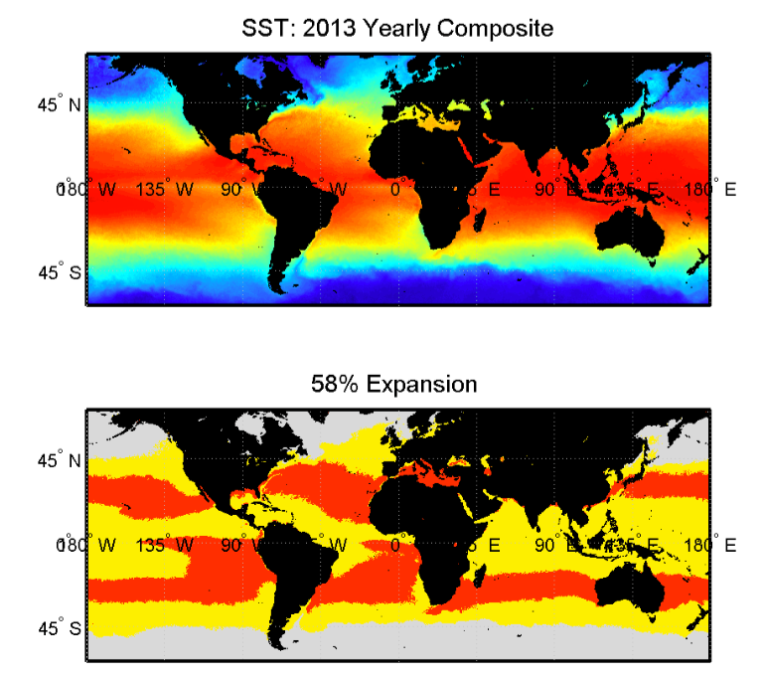
Figure 13 Potential effect of 400 nM HOOH to the distribution of Prochlorococcus.
The upper panel is the Prochlrococcus distribution in 2013 yearly composite. The lower panel is the potential distribution of Prochlorococcus due to 400nM HOOH
.

Conclusion
Prochlorococcus is sensitive to HOOH, and this sensitivity is increased when growing at suboptimal temperatures. As is the case at optimal temperature, the presence of a HOOH-degrading heterotroph – serving as a proxy for the natural microbial community – effectively increases the temperature range at which Prochlorococcus can grow, and in more extreme scenarios slow the death kinetics. This contributes to the growing body of evidence for facilitation at the microbial scale: while microbes may not be able to directly change the temperature of another microbe, they can improve the response to temperature by eliminating concurrent stresses.

Appendix

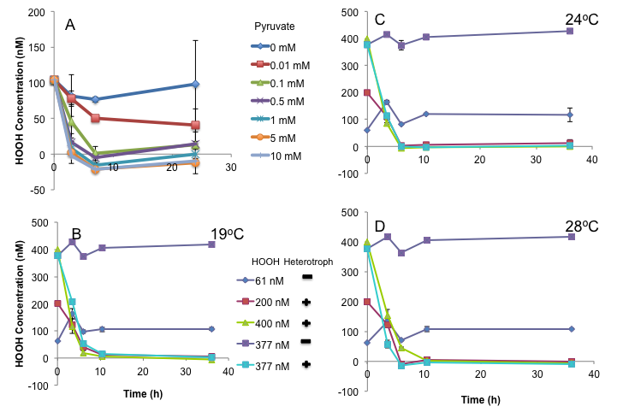
Figure 14 Degradation of HOOH in the medium by pyruvate or the heterotroph Alteromonas sp. EZ55.
HOOH in medium degraded by different concentrations of pyruvate as indicated (A). Removal of HOOH from the medium at 19 (B), 24 (C), or 28 °C (D) at various initial concentrations of HOOH; where indicated EZ55 was added at T=0. Panels B,C, and D have the same legend.

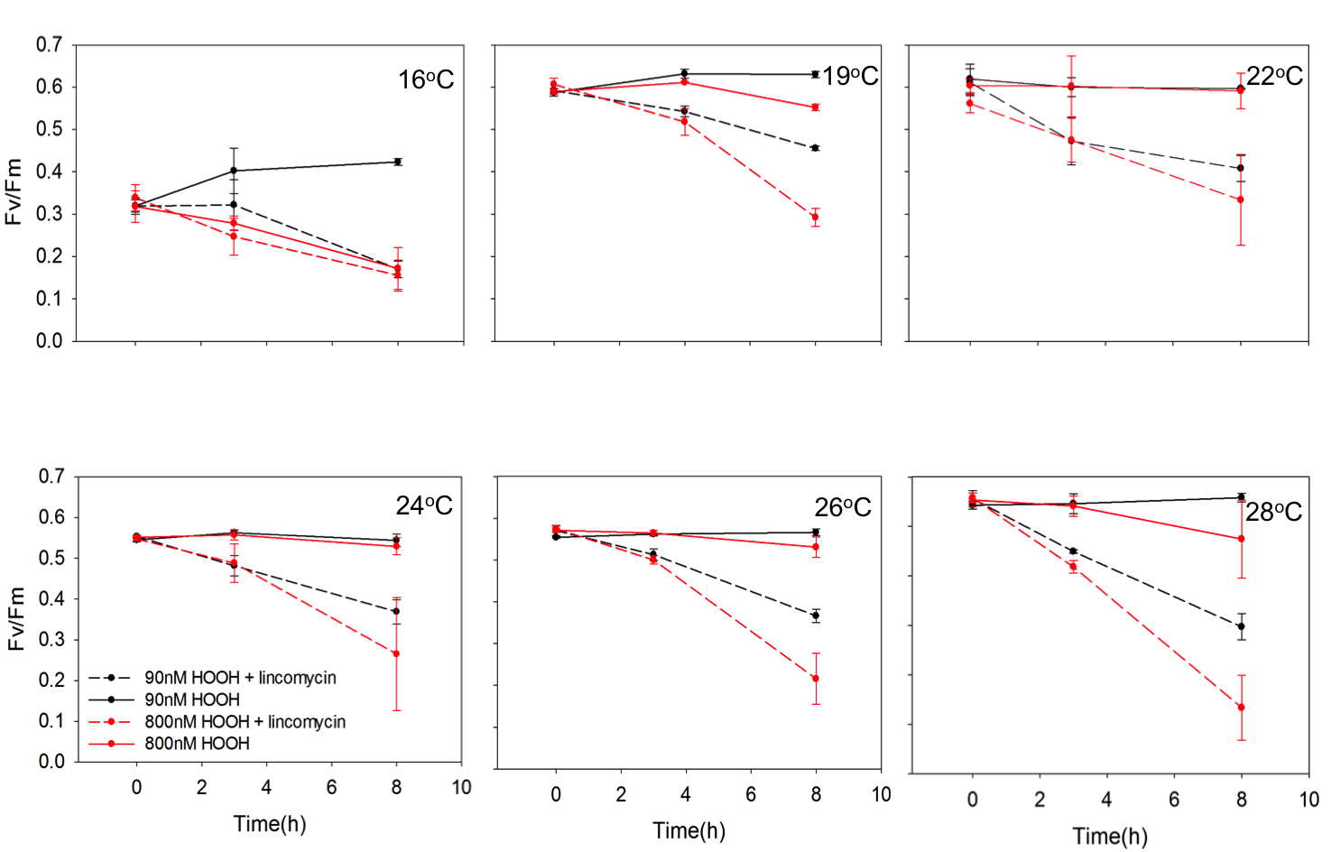
Figure 15 Fv/Fm of MIT9312 as the function of time (h) at different temperatures.

Cells were incubated in the presence (dashed lines) or absence (solid lines) of 500mg ml⁻¹ lincomycin, at ambient HOOH 90nM (black circles) or 800nM HOOH (red triangles).

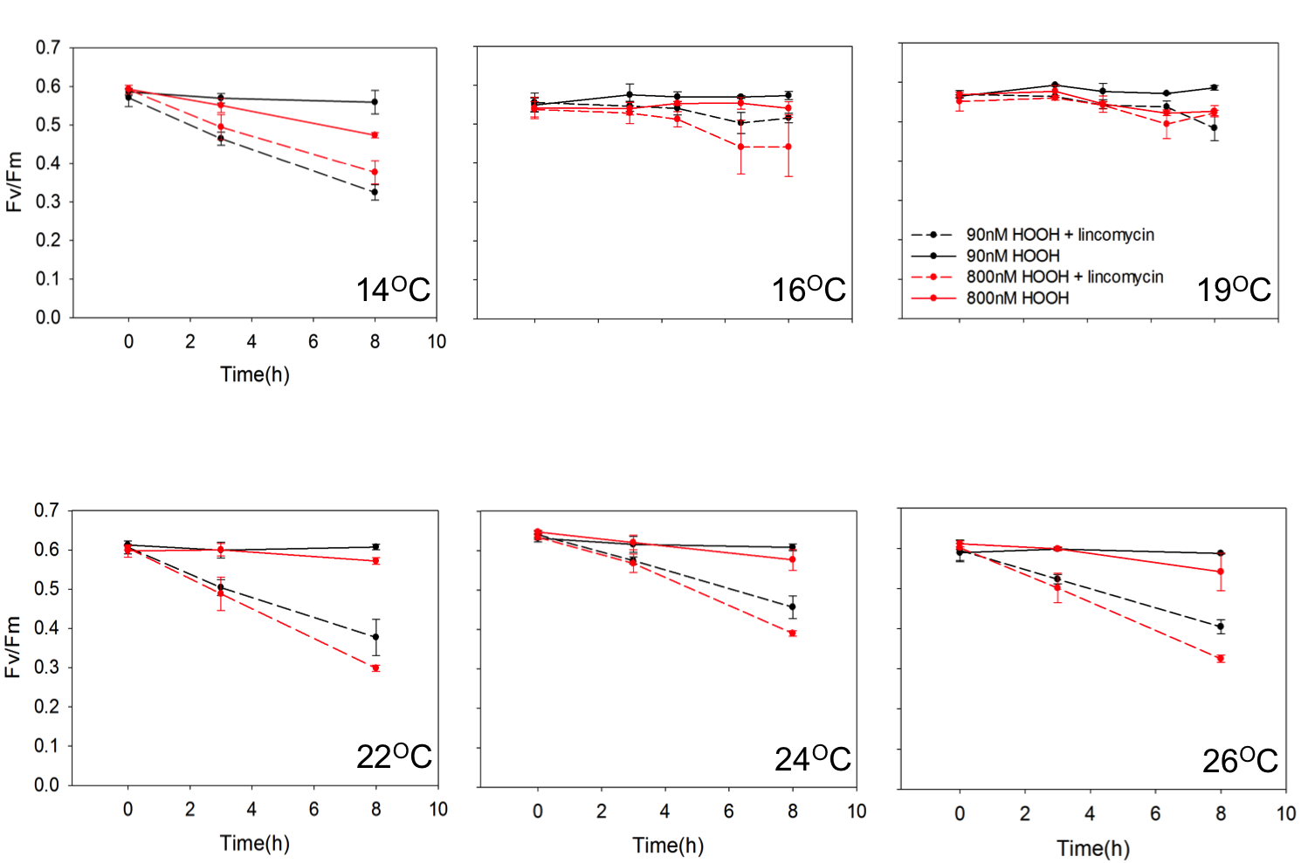
Figure 16 Fv/Fm of MED4 as the function of time (h) at different temperatures.
Cells were incubated in the presence (dashed lines) or absence (solid lines) of 500mg ml⁻¹ lincomycin, at ambient HOOH 90nM (black circles) or 800nM HOOH (red triangles).

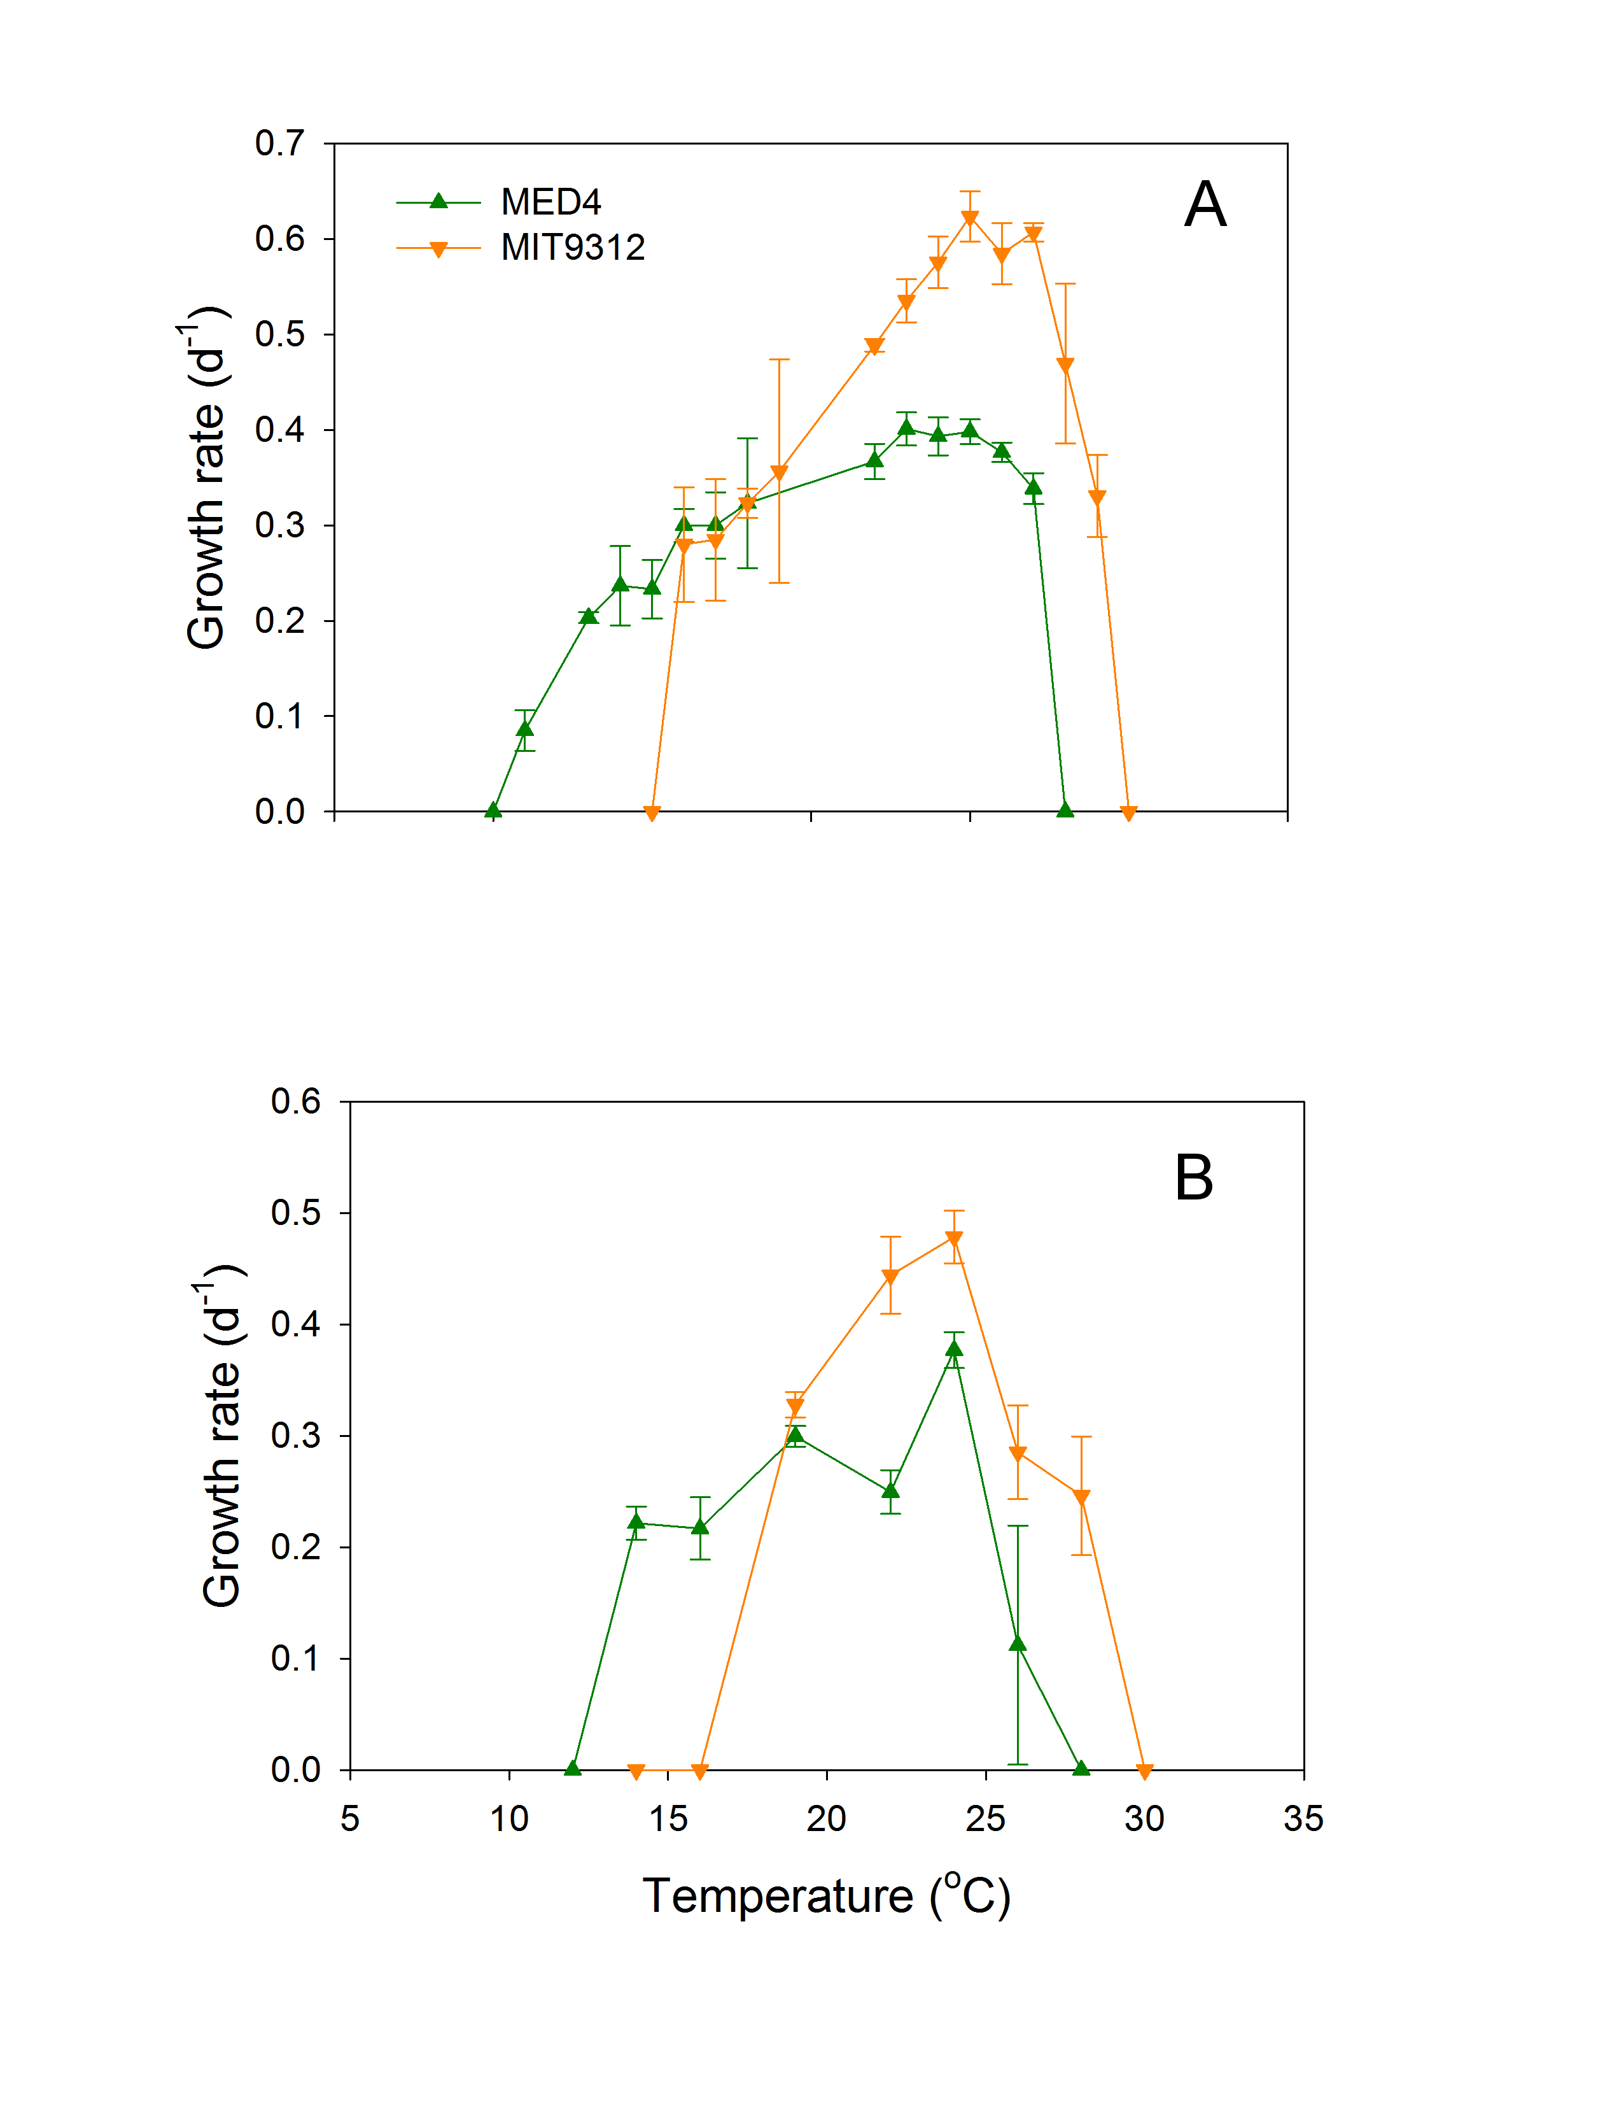
Figure 17 Growth rate of MIT93123 and MED4 as a function of temperature from Johnson et al 2006 (A) and this study (B).
Green up triangle:MED4; Orange down triangle:MIT9312

Chapter IV Conclusions and Future Directions

Temperature and cell composition

A. Conclusions
Temperature was observed to influence lipids, fatty acid composition, and elemental ratios (C:N:P) in Prochlorococcus.
- Although the lipid composition and fatty acid composition were related with temperature, it has not shown a clear negative or positive effect as a function of temperature. Furthermore, this effect was not different between two ecotypes.
- The main fatty acid were 14 to 18 carbon atoms and mono-, di-, and tri-unsaturated fatty acid were found.
- The unsaturation of fatty acid was negatively related with temperature for some strains, but not others.
- Temperature had a significant linear positive effect on QN and QC across all strains. As temperature increased 10˚C, QN and QC rose by 40.0% and 34.6%, respectively.
- Individual strains displayed negative relationships between growth rate and QP. In addition, temperature also influenced QP on a per strain basis, but there were no systematic differences between strains nor interactions between factors.
- Temperature had a significant impact on C/P and N/P but the direction varied between strains.
B. Future Directions:
1) As the lipid composition and fatty composition did not have clear relationship with temperature, we have to make sure our samples were properly collected. Thus, we may need to repeat it.

2) As lipids are related with metabolites, we will investigate the metabolites of these 6 strains.

Interactions between temperature and oxidative stress
A. Conclusions:

Our investigation of the potential relationship between temperature and HOOH on growth and physiology of Prochlorococcus found:
- Temperature and HOOH showed synergistic relationship on the growth of temperature on MIT9312.
- The growth temperature optima were not affect by concentration of HOOH but higher concentration of HOOH diminished the temperature range for growth of Prochlorococcus.
- The co-culturing of heterotroph facilitated the growth of Prochlorococcus and it expanded the temperature range. MED4 was able to grow with heterotrophs at 12 °C while axenic MED4 could not.
- The photosynthesis efficiency, measured as Fv/Fm in this study, under higher concentration of HOOH showed a clear trend with temperature. Under optimal temperature, its decrease was least and higher under suboptimal temperature.
- Red fluorescence, a proxy of chlorophyll concentration, was shown to be change with temperature and HOOH. It was positively related with temperature and negatively related with HOOH concentration.

B. Future Directions:
1) As HOOH reacts with di-unsaturated lipids by the process called lipid peroxidation[146, 147], while temperature affects the fatty acids unsaturation, which further influences the membrane fluidity [22, 27, 59, 148], we propose to study the lipid composition, especially the lipid peroxidation, under the interactive effects of temperature and HOOH.

Reference

1. Shimada, A., et al., Spatial mesoscale patterns of West Pacific picophytoplankton as analyzed by flow cytometry: their contribution to subsurface chlorophyll maxima. Mar. Biol., 1993. 115: p. 209-215.
2. Campbell, L., H.A. Nolla, and D. Vaulot, The importance of Prochlorococcus to community structure in the central North Pacific Ocean. Limnol. Oceanogr., 1994. 39(4): p. 954-961.
3. Partensky, F., W.R. Hess, and D. Vaulot, Prochlorococcus, a marine photosynthetic prokaryote of global significance. Microbiology and Molecular Biology Reviews, 1999. 63(1): p. 106-+.
4. Partensky, F., W.R. Hess, and D. Vaulot, Prochlorococcus, a marine photosynthetic prokaryote of global significance. Microbiol Mol Biol Rev, 1999. 63(1): p. 106-27.
5. Partensky, F., et al., Photoacclimation of Prochlorococcus sp. (Prochlorophyta) Strains Isolated from the North Atlantic and the Mediterranean Sea. Plant Physiol, 1993. 101(1): p. 285-296.
6. Rocap, G., et al., Genome divergence in two Prochlorococcus ecotypes reflects oceanic niche differentiation. Nature, 2003. 424(6952): p. 1042-1047.
7. Rocap, G., et al., Resolution of Prochlorococcus and Synechococcus ecotypes by using 16S-23S ribosomal DNA internal transcribed spacer sequences. Appl. Environ. Microbiol., 2002. 68(3): p. 1180-1191.
8. Koeppel, A., et al., Identifying the fundamental units of bacterial diversity: a paradigm shift to incorporate ecology into bacterial systematics. Proc. Natl. Acad. Sci. USA, 2008. 105: p. 2504-2509.
9. Moore, L.R., G. Rocap, and S.W. Chisholm, Physiology and molecular phylogeny of coexisting Prochlorococcus ecotypes. Nature, 1998. 393: p. 464-467.
10. Ahlgren, N.A., G. Rocap, and S.W. Chisholm, Measurement of Prochlorococcus ecotypes using real-time polymerase chain reaction reveals different abundances of genotypes with similar light physiologies. Environ Microbiol, 2006. 8(3): p. 441-54.
11. Johnson, Z.I., et al., Niche partitioning among Prochlorococcus ecotypes along ocean-scale environmental gradients. Science, 2006. 311(5768): p. 1737-40.
12. Zinser, E.R., et al., Influence of light and temperature on Prochlorococcus ecotype distributions in the Atlantic Ocean. Limnology and Oceanography, 2007. 52(5): p. 2205-2220.
13. West, N.J., et al., A novel clade of Prochlorococcus found in high nutrient low chlorophyll waters in the South and Equatorial Pacific Ocean. Isme Journal, 2011. 5(6): p. 933-944.
14. Huang, S., et al., Novel lineages of Prochlorcoccus and Synechococcus in the global oceans. ISME J, 2012. 6: p. 285-297.
15. Zinser, E.R., et al., Prochlorococcus ecotype abundances in the North Atlantic Ocean as revealed by an improved quantitative PCR method. Appl Environ Microbiol, 2006. 72(1): p. 723-732.
16. Bennett, A.F., R.E. Lenski, and J.E. Mittler, Evolutionary adaptation to temperature. I. Fitness responses of Escherichia coli to changes in its thermal environment. Evolution, 1992. 46: p. 16-30.
17. Caron, D.A., J.C. Goldman, and M.R. Dennett, Effect of temperature on growth, respiration, and nutrient regeneration by an omnivorous microflagellate. Appl. Environ. Microbiol., 1986. 52: p. 1340-1347.
18. Fu, F.X., et al., Effects of increased temperature and CO2 on photosynthesis, growth, and elemental ratios in marine Synechococcus and Prochlorococcus (Cyanobacteria). Journal of Phycology, 2007. 43(3): p. 485-496.
19. Boyd, P.W., et al., Marine phytoplankton temperature versus growth responses from polar to tropical waters--outcome of a scientific community-wide study. PLoS One, 2013. 8(5): p. e63091.
20. Bissinger, J.E., et al., Predicting marine phytoplankton maximum growth rates from temperature: Improving on the Eppley curve using quantile regression. Limnol. Oceanogr., 2008. 53: p. 487-493.
21. Allewalt, J.P., et al., Effect of temperature and light on growth of and photosynthesis by Synechococcus isolates typical of those predominating in the octopus spring microbial mat community of Yellowstone National Park. Applied and Environmental Microbiology, 2006. 72(1): p. 544-550.
22. Bergmann, S., et al., Membrane fluidity of halophilic ectoine-secreting bacteria related to osmotic and thermal treatment. Bioprocess Biosyst. Eng., 2013. 36: p. 1829-1841.
23. Murata, N., Low-temperature effects on cyanobacterial membranes. J Bioenerg Biomembr, 1989. 21(1): p. 61-75.
24. Murata, N. and H. Wada, Acyl-lipid desaturases and their importance in the tolerance and acclimatization to cold of cyanobacteria. Biochem. J., 1995. 308: p. 1-8.
25. Sarcina, M., et al., Lipid diffusion in the thylakoid membranes of the cyanobacterium Synechococcus sp.: effect of fatty acid desaturation. Febs Letters, 2003. 553(3): p. 295-298.
26. Chi, X.Y., et al., Comparative Analysis of Fatty Acid Desaturases in Cyanobacterial Genomes. Comparative and Functional Genomics, 2008.
27. Gombos, Z., H. Wada, and N. Murata, Unsaturation of fatty acids in membrane lipids enhances tolerance of the cyanobacterium Synechocystis PCC6803 to low-temperature photoinhibition. Proc. Natl. Acad. Sci. USA, 1992. 89(20): p. 9959-9963.
28. Warner, M.E., W.K. Fitt, and G.W. Schmidt, The effects of elevated temperature on the photosynthetic efficiency of zooxanthellae in hospite from four different species of reef coral: A novel approach. Plant Cell and Environment, 1996. 19(3): p. 291-299.
29. Takahashi, S. and N. Murata, How do environmental stresses accelerate photoinhibition? Trends Plant Sci., 2008. 13: p. 178-182.
30. Kanesaki, Y., et al., Histidine kinases play important roles in the perception and signla transduction of hydrogen peroxide in the cyanobacterium, Synechocystis sp. PCC 6803. Plant J., 2007. 49: p. 313-324.
31. Kulk, G., et al., Temperature-dependent growth and photophysiology of prokaryotic and eukaryotic oceanic picophytoplankton. Mar. Ecol. Prog. Ser., 2012. 466: p. 43-55.
32. Toseland, A., et al., The impact of temperature on marine phytoplankton resource allocation and metabolism. Nature Climate Change, 2013. 3(11): p. 979-984.
33. Woods, H.A. and R.I. Hill, Temperature-oxygen interactions in developing eggs of a moth, Manduca sexta. Integrative and Comparative Biology, 2003. 43(6): p. 901-901.
34. Yvon-Durocher, G., et al., Temperature and the biogeography of algal stoichiometry. Global Ecology and Biogeography, 2015. 24(5): p. 562-570.
35. Bertilsson, S., et al., Elemental composition of marine Prochlorococcus and Synechococcus: Implications for the ecological stoichiometry of the sea. Limnology and Oceanography, 2003. 48(5): p. 1721-1731.
36. Cooper, W.J., et al., Photochemical formation of H₂O₂ in natural waters exposed to sunlight. Environ. Sci. Technol., 1988. 22: p. 1156-1160.
37. Hanson, A.K., N.W. Tindale, and M.A.R. Abdel-Moati, An equatorial Pacific rain event: influence on the distribution of iron and hydrogen peroxide in surface waters. Mar. Chem., 2001. 75: p. 69-88.
38. Kieber, R.J., et al., Iron speciation and hydrogen peroxide concentrations in New Zealand rainwater. Atmos. Environ., 2001. 35: p. 6041-6048.
39. Yuan, J. and A.M. Shiller, The variation of hydrogen peroxide in rainwater over the South and Central Atlantic Ocean. Atmos. Environ., 2000. 34: p. 3973-3980.
40. Drabkova, M., W. Admiraal, and B. Marsalek, Combined exposure to hydrogen peroxide and light – selective effects on cyanobacteria, green algae, and diatoms. Environ. Sci. Technol., 2007. 41: p. 309-314.
41. Willey, J.D., R.J. Kieber, and G.B. Avery, Jr., Effects of rainwater iron and hydrogen peroxide on iron speciation and phytoplankton growth in seawater near Bermuda. J. Atmos. Chem., 2004. 47: p. 209-222.
42. Dummermuth, A.L., et al., Responses of marine macroalgae to hydrogen-peroxide stress. J. Exp. Mar. Biol. Ecol., 2003. 289: p. 103-121.
43. Xenopoulos, M.A. and D.F. Bird, Effect of acute exposure to hydrogen peroxide on the production of phytoplankton and bacterioplankton in a mesohumic lake. Photochem. Photobiol., 1997. 66(4): p. 471-478.
44. Suggett, D.J., et al., Photosynthesis and production of hydrogen peroxide by Symbiodinium (Pyrrhophyta) phylotypes with different thermal tolerances. J. Phycol., 2008. 44(4): p. 948-956.
45. Samuilov, V.D., et al., Hydrogen peroxide inhibits the growth of cyanobacteria. Biochemistry-Moscow, 1999. 64(1): p. 47-53.
46. Petasne, R.G. and R.G. Zika, Hydrogen peroxide lifetimes in south Florida coastal and offshore waters. Mar. Chem., 1997. 56: p. 215-225.
47. Cooper, W.J. and R.G. Zepp, Hydrogen peroxide decay in waters with suspended soils: evidence for biologically mediated processes. Can. J. Fish. Aquat. Sci., 1990. 47: p. 888-893.
48. Imlay, J.A., Pathways of oxidative damage. Annu. Rev. Microbiol., 2003. 57: p. 395-418.
49. Imlay, J.A., The molecular mechanisms and physiological consequences of oxidative stress: lessons from a model bacterium. Nat Rev Microbiol, 2013. 11(7): p. 443-54.
50. Biller, S.J., et al., Genomes of diverse isolates of the marine cyanobacterium Prochlorococcus. Sci. Data, 2014. 1: p. 140034.
51. Sandmann, G. and P. Boger, Copper-Mediated Lipid-Peroxidation Processes in Photosynthetic Membranes. Plant Physiology, 1980. 66(5): p. 797-800.
52. Nishiyama, Y., et al., Singlet oxygen inhibits the repair of photosystem II by suppressing the translation elongation of the D1 protein in Synechocystis sp. PCC 6803. Biochemistry, 2004. 43: p. 11321-11330.
53. Nishiyama, Y., et al., Oxidative stress inhibits the repair of photodamage to the photosynthetic machinery. EMBO J., 2001. 20: p. 5587-5594.
54. Nishiyama, Y., et al., Oxidative stress inhibits the repair of photodamage to the photosynthetic machinery. EMBO J, 2001. 20(20): p. 5587-94.
55. Morris, J.J., et al., Dependence of the cyanobacterium Prochlorococcus on hydrogen peroxide-scavenging microbes for growth at the ocean's surface. PLoS ONE, 2011. 6: p. e16805.
56. Morris, J.J., et al., Facilitation of robust growth of Prochlorococcus colonies and dilute liquid cultures by "helper" heterotrophic bacteria. Appl. Environ. Microbiol., 2008. 74: p. 4530-4534.
57. Morris, J.J., R.E. Lenski, and E.R. Zinser, The Black Queen Hypothesis: Evolution of Dependencies through Adaptive Gene Loss. Mbio, 2012. 3(2).
58. Morris, J.J., et al., Dependence of the cyanobacterium Prochlorococcus on hydrogen peroxide scavenging microbes for growth at the ocean's surface. PLoS One, 2011. 6(2): p. e16805.
59. Chaloub, R., et al., Phase transition of thylakoid membranes modulates photoinhibition in the cyanobacterium Anabaena siamensis. Photosynth. Res., 2003. 78: p. 143-152.
60. Wise, R.R., Chilling-enhanced photooxidation: The production, action and study of reactive oxygen species produced during chilling in the light. Photosynth. Res., 1995. 45: p. 79-97.
61. Maxwell, D.P., et al., Growth at low temperature mimics high-light acclimation in Chlorella vulgaris. Plant Physiol., 1994. 105: p. 535-543.
62. Thomas, D.J., et al., Iron superoxide dismutase protects against chilling damage in the cyanobacterium Synechococcus species PCC7942. Plant Physiol., 1999. 120: p. 275-282.
63. Prasad, T.K., et al., Evidence for Chilling-Induced Oxidative Stress in Maize Seedlings and a Regulatory Role for Hydrogen-Peroxide. Plant Cell, 1994. 6(1): p. 65-74.
64. Smirnova, G.V., N.G. Muzyka, and O.N. Oktyabrsky, Enhanced resistance to peroxide stress in Escherichia coli grown outside their niche temperatures. J. Thermal Biol., 2007. 32: p. 321-327.
65. Lesser, M.P., Elevated temperatures and ultraviolet radiation cause oxidative stress and inhibit photosynthesis in symbiotic dinoflagellates. Limnol. Oceanogr., 1996. 41: p. 271-283.
66. Davidson, J.F., et al., Oxidative stress is involved in heat-induced cell death in Saccharomyces cerevisiae. Proc. Natl. Acad. Sci. USA, 1996. 93: p. 5116-5121.
67. Warner, M.E., W.K. Fitt, and G.W. Schmidt, Damage to photosystem II in symbiotic dinoflagellates: A determinant of coral bleaching. Proceedings of the National Academy of Sciences of the United States of America, 1999. 96(14): p. 8007-8012.
68. Johnson, Z.I., et al., Niche partitioning among Prochlorococcus ecotypes along ocean-scale environmental gradients. Science, 2006. 311: p. 1737-1740.
69. Kalacheva, G.S., et al., The effect of temperature on the lipid composition of the green alga Botryococcus. Microbiology, 2002. 71: p. 286-293.
70. Tsekos, I., H.D. Reiss, and E. Schnepf, Cell-Wall Structure and Supramolecular Organization of the Plasma-Membrane of Marine Red Algae Visualized by Freeze-Fracture. Acta Botanica Neerlandica, 1993. 42(2): p. 119-132.
71. Yeagle, P.L., Lipid Regulation of Cell-Membrane Structure and Function. Faseb Journal, 1989. 3(7): p. 1833-1842.
72. Felcmanova, K., et al., Regulation of Photosynthesis and Primary Production in Prochlorococcus. European Journal of Phycology, 2015. 50: p. 136-136.
73. Bibby, T., et al., Low-light-adapted Prochlorococcus species possess specific antennae for each photosystem. Nature, 2003. 424(6952): p. 1051-4.
74. Hess, W.R., et al., The photosynthetic apparatus of Prochlorococcus: Insights through comparative genomics. Photosynth. Res., 2001. 70: p. 53-71.
75. Singh, S.C., R.P. Sinha, and D.P. Hader, Role of lipids and fatty acids in stress tolerance in cyanobacteria. Acta Protozoologica, 2002. 41(4): p. 297-308.
76. Popendorf, K.J., M.W. Lomas, and B.A.S. Van Mooy, Microbial sources of intact polar diacylglycerolipids in the Western North Atlantic Ocean. Organic Geochemistry, 2011. 42(7): p. 803-811.
77. Van Mooy, B.A., et al., Sulfolipids dramatically decrease phosphorus demand by picocyanobacteria in oligotrophic marine environments. Proc Natl Acad Sci U S A, 2006. 103(23): p. 8607-12.
78. Kanervo, E., et al., Membrane lipid unsaturation modulates processing of the photosystem II reaction-center protein D1 at low temperatures. Plant Physiol., 1997. 114: p. 841-849.
79. Maslova, I.P., et al., Lipid fatty acid composition and thermophilicity of cyanobacteria. Russian Journal of Plant Physiology, 2004. 51(3): p. 353-360.
80. Sakamoto, T. and D.A. Bryant, Synergistic effect of high-light and low temperature on cell growth of the D12 fatty acid desaturase mutant in Synechococcus sp. PCC 7002. Photosynth. Res., 2002. 72: p. 231-242.
81. Los, D.A. and K.S. Mironov, Modes of Fatty Acid desaturation in cyanobacteria: an update. Life (Basel), 2015. 5(1): p. 554-67.
82. Woods, H.A., et al., Temperature and the chemical composition of poikilothermic organisms. Functional Ecology, 2003. 17(2): p. 237-245.
83. Morris, J.J., et al., Facilitation of robust growth of Prochlorococcus colonies and dilute liquid cultures by "Helper" heterotrophic bacteria. Applied and Environmental Microbiology, 2008. 74(14): p. 4530-4534.
84. Sharp, J.H., Improved Analysis for Particulate Organic Carbon and Nitrogen from Seawater. Limnology and Oceanography, 1974. 19(6): p. 984-989.
85. Lomas, M.W., et al., Sargasso Sea phosphorus biogeochemistry: an important role for dissolved organic phosphorus (DOP). Biogeosciences, 2010. 7(2): p. 695-710.
86. Heldal, M., et al., Elemental composition of single cells of various strains of marine Prochlorococcus and Synechococcus using X-ray microanalysis. Limnology and Oceanography, 2003. 48(5): p. 1732-1743.
87. Chapman, D., Phase-Transitions and Fluidity Characteristics of Lipids and Cell-Membranes. Quarterly Reviews of Biophysics, 1975. 8(2): p. 185-235.
88. Romano, I., et al., Lipid profile: a useful chemotaxonomic marker for classification of a new cyanobacterium in Spirulina genus. Phytochemistry, 2000. 54(3): p. 289-294.
89. Allakhverdiev, S.I., et al., Unsaturated fatty acids in membrane lipids protect the photosynthetic machinery against salt-induced damage in Synechococcus. Plant Physiology, 2001. 125(4): p. 1842-1853.
90. Martiny, A.C., et al., Strong latitudinal patterns in the elemental ratios of marine plankton and organic matter. Nature Geoscience, 2013. 6(4): p. 279-283.
91. Martiny, A.C., et al., Regional variation in the particulate organic carbon to nitrogen ratio in the surface ocean. Global Biogeochemical Cycles, 2013. 27(3): p. 723-731.
92. Sterner, R.W., et al., Stoichiometric patterms at the small and the large scale. Integrative and Comparative Biology, 2002. 42(6): p. 1318-1318.
93. Klausmeier, C.A., et al., Optimal nitrogen-to-phosphorus stoichiometry of phytoplankton. Nature, 2004. 429(6988): p. 171-174.
94. Bonachela, J.A., et al., A model for variable phytoplankton stoichiometry based on cell protein regulation. Biogeosciences, 2013. 10(6): p. 4341-4356.
95. Grob, C., et al., Elemental composition of natural populations of key microbial groups in Atlantic waters. Environmental Microbiology, 2013. 15(11): p. 3054-3064.
96. Rhee, G.Y. and I.J. Gotham, The Effect of Environmental-Factors on Phytoplankton Growth - Temperature and the Interactions of Temperature with Nutrient Limitation. Limnology and Oceanography, 1981. 26(4): p. 635-648.
97. Amin, S.A., M.S. Parker, and E.V. Armbrust, Interactions between diatoms and bacteria. Microbiol Mol Biol Rev, 2012. 76(3): p. 667-84.
98. Bertness, M.D. and R. Callaway, Positive Interactions in Communities. Trends in Ecology & Evolution, 1994. 9(5): p. 191-193.
99. Brooker, R.W. and T.V. Callaghan, The balance between positive and negative plant interactions and its relationship to environmental gradients: a model. Oikos, 1998. 81(1): p. 196-207.
100. Callaway, R.M., et al., Positive interactions among alpine plants increase with stress. Nature, 2002. 417(6891): p. 844-848.
101. Maestre, F.T. and J. Cortina, Do positive interactions increase with abiotic stress? A test from a semi-arid steppe. Proc Biol Sci, 2004. 271 Suppl 5: p. S331-3.
102. Brooker, R., et al., The importance of importance. (vol 109, pg 63, 2005). Oikos, 2005. 111(1): p. 208-208.
103. Bulleri, F., Facilitation research in marine systems: state of the art, emerging patterns and insights for future developments. Journal of Ecology, 2009. 97(6): p. 1121-1130.
104. Chirac, C., et al., Bacterial influence upon growth and hydrocarbon production of the green alga Botryococcus braunii. J. Phycol., 1985. 21: p. 380-387.
105. Ma, M. and J.W. Eaton, Multicellular oxidant defense in unicellular organisms. Proc. Natl. Acad. Sci. USA, 1992. 89: p. 7942-7928.
106. Xie, B., et al., Chlamydomonas reinhardtii thermal tolerance enhancement mediated by a mutualistic interaction with vitamin B₁₂-producing bacteria. ISME J., 2013. 7: p. 1544-1555.
107. Janknegt, P.J., et al., Oxidative stress responses in the marine Anarctic diatom Chaetoceros brevis (Bacillariophyceae) during photoacclimation. J. Phycol., 2008. 44: p. 957-966.
108. Nishiyama, Y., S.I. Allakhverdiev, and N. Murata, A new paradigm for the action of reactive oxygen species in the photoinhibition of photosystem II. Biochimica et Biophysica Acta, 2006. 1757: p. 742-749.
109. Zwirglmaier, K., et al., Global phylogeography of marine Synechococcus and Prochlorococcus lineages reveals a distinct partitioning of lineages among oceanic biomes. Environ. Microbiol., 2008. 10: p. 147-161.
110. Lau, W.W.Y. and E.V. Armbrust, Detection of glycolate oxidase gene glcD diversity among cultured and environmental marine bacteria. Environmental Microbiology, 2006. 8(10): p. 1688-1702.
111. Morris, J.J., et al., Facilitation of robust growth of Prochlorococcus colonies and dilute liquid cultures by "helper" heterotrophic bacteria. Appl Environ Microbiol, 2008. 74(14): p. 4530-4.
112. Song, J., H.M. Oh, and J.C. Cho, Improved culturability of SAR11 strains in dilution-to-extinction culturing from the East Sea, West Pacific Ocean. Fems Microbiology Letters, 2009. 295(2): p. 141-147.
113. Tripp, H.J., et al., SAR11 marine bacteria require exogenous reduced sulphur for growth. Nature, 2008. 452(7188): p. 741-744.
114. Morris, J.J. and E.R. Zinser, Photochemical production of H2O2 in buffered media reduces Prochlorococcus growth. Journal of Phycology, 2007. 43: p. 40-41.
115. Johnson, Z.I., Description and application of the background irradiance gradient-single turnover fluorometer (BIG-STf). Marine Ecology-Progress Series, 2004. 283: p. 73-80.
116. Fuhrman, J.A., K. McCallum, and A.A. Davis, Phylogenetic diversity of subsurface marine microbial communities from the Altlantic and Pacific Oceans. Appl. Environ. Microbiol., 1993. 59: p. 1294-1302.
117. Johnson, Z.I., et al., Niche partitioning among Prochlorococcus ecotypes along ocean-scale environmental gradients. Science, 2006. 311(5768): p. 1737-1740.
118. Long, L.H. and B. Halliwell, Artefacts in cell culture: Pyruvate as a scavenger of hydrogen peroxide generated by ascorbate or epigallocatechin gallate in cell culture media. Biochemical and Biophysical Research Communications, 2009. 388(4): p. 700-704.
119. Giandomenico, A.R., et al., The importance of sodium pyruvate in assessing damage produced by hydrogen peroxide. Free Radical Biology and Medicine, 1997. 23(3): p. 426-434.
120. Six, C., et al., Light variability illuminates niche partitioning among marine picocyanobacteria. PLoS ONE, 2007. 2: p. e1341.
121. Pocock, T.H., et al., Chlamysomonas rausdensis (UWO 241), Chlorophyceae, exhibits the capacity for rapid D1 repair in response to chronic photoinhibition at low temperature. J. Phycol., 2007. 43: p. 924-936.
122. Mella-Flores, D., et al., Prochlorococcus and Synechococcus have evolved different adaptive mechanisms to cope with light and UV stress. Frontiers Microbiol., 2012. 3: p. 285.
123. Takahashi, K., J. Onodera, and Y. Katsurada, Relationship between time-series diatom fluxes in the central and western equatorial Pacific and ENSO-associated migrations of the Western Pacific Warm Pool. Deep Sea Res. I, 2009. 56: p. 1298-1318.
124. Murata, N., et al., Photoinhibition of photosystem II under environmental stress. Biochimica Et Biophysica Acta-Bioenergetics, 2007. 1767(6): p. 414-421.
125. Blanchot, J. and M. Rodier, Picophytoplankton abundance and biomass in the western tropical Pacific ocean during the 1992 El Nino year: results from flow cytometry. Deep-Sea Res. I, 1996. 43(6): p. 877-895.
126. Buitenhius, E.T., et al., Picophytoplankton biomass distribution in the global ocean. Earth Syst. Sci. Data, 2012. 4: p. 37-46.
127. Landry, M.R., J. Kirshtein, and J. Constantinou, Abundances and distributions of picoplankton populations in the central equatorial Pacific from 12 degrees N to 12 degrees S, 140 degrees W. Deep-Sea Research Part Ii-Topical Studies in Oceanography, 1996. 43(4-6): p. 871-890.
128. Price, P.B. and R.C. Bay, Marine bacteria in deep Arctic and Antarctic ice cores: a proxy for evolution in oceans over 300 million generations. Biogeosciences, 2012. 9(10): p. 3799-3815.
129. Callaway, R.M. and L.R. Walker, Competition and facilitation: A synthetic approach to interactions in plant communities. Ecology, 1997. 78(7): p. 1958-1965.
130. Maestre, F.T., S. Bautista, and J. Cortina, Positive, negative, and net effects in grass-shrub interactions in Mediterranean semiarid grasslands. Ecology, 2003. 84: p. 3186-3197.
131. le Roux, P.C. and M.A. McGeoch, Interaction intensity and importance along two stress gradients: adding shape to the stress-gradient hypothesis. Oecologia, 2010. 162(3): p. 733-45.
132. Verdu, M. and P. Garcia-Fayos, Reproductive ecology of Pistacia lentiscus L. (Anacardiaceae): an evolutionary anachronism in the Mediterranean shrubland. Revista Chilena De Historia Natural, 2002. 75(1): p. 57-65.
133. Choler, P., R. Michalet, and R.M. Callaway, Facilitation and competition on gradients in alpine plant communities. Ecology, 2001. 82: p. 3295-3308.
134. Khan, A.L., et al., Mutualistic association of Paecilomyces formosus LHL10 offers thermotolerance to Cucumis sativus. Antonie Van Leeuwenhoek International Journal of General and Molecular Microbiology, 2012. 101(2): p. 267-279.
135. Marquez, L.M., et al., A virus in a fungus in a plant: Three-way symbiosis required for thermal tolerance. Science, 2007. 315(5811): p. 513-515.
136. Redman, R.S., et al., Thermotolerance generated by plant/fungal symbiosis. Science, 2002. 298(5598): p. 1581-1581.
137. Rodriguez, R. and R. Redman, More than 400 million years of evolution and some plants still can't make it on their own: plant stress tolerance via fungal symbiosis. Journal of Experimental Botany, 2008. 59(5): p. 1109-1114.
138. Bertness, M.D., et al., Testing the relative contribution of positive and negative interactions in rocky intertidal communities. Ecology, 1999. 80(8): p. 2711-2726.
139. Stachowicz, J.J. and M.E. Hay, Reduced mobility is associated with compensatory feeding and increased diet breadth of marine crabs. Marine Ecology Progress Series, 1999. 188: p. 169-178.
140. Stachowicz, J.J. and M.E. Hay, Geographic variation in camouflage specialization by a decorator crab. American Naturalist, 2000. 156(1): p. 59-71.
141. Geng, H. and R. Belas, Molecular mechanisms underlying roseobacter-phytoplankton symbioses. Curr Opin Biotechnol, 2010. 21(3): p. 332-8.
142. Croft, M.T., et al., Algae acquire vitamin B12 through a symbiotic relationship with bacteria. Nature, 2005. 438(7064): p. 90-3.
143. Keshtacher-Liebson, E., Y. Hadar, and Y. Chen, Oligotrophic bacteria enhance algal growth under iron-deficient conditions. Appl. Environ. Microbiol., 1995. 61: p. 2439-2441.
144. Mouget, J.L., et al., Algal growth enhancement by bacteria: Is consumption of photosynthetic oxygen involved? FEMS Microbiol. Ecol., 1995. 18: p. 35-44.
145. Schiefer, G.E. and D.E. Caldwell, Synergistic interaction between Anabaena and Zoogloea spp. in carbon dioxide-limited continuous cultures. Appl. Environ. Microbiol., 1982. 44: p. 84-87.
146. Chan, T., et al., Quality control of photosystem II: lipid peroxidation accelerates photoinhibition under excessive illumination. PLoS One, 2012. 7(12): p. e52100.
147. Farmer, E.E. and M.J. Mueller, ROS-mediated lipid peroxidation and RES-activated signaling. Annu. Rev. Plant Biol., 2013. 64: p. 429-450.
148. Gombos, Z., H. Wada, and N. Murata, The recovery of photosynthesis from low-temperature photoinhibition is accelerated by the unsaturation of membrane lipids: a mechanism of chilling tolerance. Proc. Natl. Acad. Sci. USA, 1994. 91(19): p. 8787-8791.

VITA

Lanying Ma was born in Shandong Province, China, the second daughter of Shouchang Ma and Guifen Dong. She stayed in her home town for primary school to high school. In 2002, she attended Shandong University for Biology department and received her Bachelor’s degree in 2006. She received her Master’s degree in the same university in 2009. Later in 2009 she came to University of Tennessee for Ph.D study. In 2010, she met her husband Jinlyung Choi in the University of Tennessee and got married in 2012. In 2014, her daughter Arielle Youngeun Choi was born.

