To the Graduate Council:

I am submitting herewith a dissertation written by Beth Alair Hamper entitled “Nutritional Adequacy and Performance of Raw Food Diets in Kittens.” I have examined the final electronic copy of this dissertation for form and content and recommend that it be accepted in partial fulfillment of the requirements for the degree of Doctor of Philosophy, with a major in Comparative and Experimental Medicine.

_____________________________
Joseph W. Bartges, Major Professor

We have read this dissertation
and recommend its acceptance:

_______________________________
Claudia Kirk

_______________________________
Stephen Kania

_______________________________
Melissa Kennedy

_______________________________
David Bemis

_______________________________
Robert N. Moore

Accepted for the Council

_______________________________
Carolyn R. Hodges
Vice Provost and Dean of the Graduate School

(Original signatures are on file with official student records.)

Nutritional Adequacy and Performance of Raw Food Diets in Kittens

A Dissertation Presented for the
Doctor of Philosophy
Degree
The University of Tennessee, Knoxville

Beth Alair Hamper
August 2012

Copyright © 2012 by Beth Alair Hamper.
All rights reserved.

ACKNOWLEDGEMENTS

I would like to thank all those who helped me complete my Doctor of Philosophy degree in Comparative and Experimental Medicine. It has been a joint effort. I am especially indebted to my mentors Dr. Joseph Bartges and Dr. Claudia Kirk for their guidance and support throughout this process. I also thank Dr. Stephen Kania and Ms. Diane Trent for their support and guidance through the laboratory portion of this dissertation. In addition, I thank the other members of my committee, Dr. Robert Moore, Dr. David Bemis, and Dr. Melissa Kennedy, and Dr. Arnold Saxton and Ms. Ann Reed for their statistical support. I am grateful for financial support from the Winn Foundation and The Milam Center, College of Veterinary Medicine, The University of Tennessee. Lastly, I would like to dedicate this to my parents and my sister for their unwavering support, and to all the cats who have graced me with their beauty and companionship.

ABSTRACT

Feeding raw food diets to domestic cats is controversial. The objective of this study was to determine if raw feline diets were nutritionally adequate for kittens and whether they enhance immune function, reduce oxidative stress and improve digestibility. Twenty-four 9-week-old kittens underwent a 10-week growth feeding trial with two raw diet groups and one control group (commercial heat-processed canned diet) of eight kittens each. Anthropomorphic measurements, feed efficiency, oxidative stress, and blood biomarkers for innate and humoral immune function were evaluated. Additionally, 6 kittens and 4 adults participated in a 14 day digestibility trial using a 3 x 3 latin square design. Composite fecal cultures were periodically monitored for common bacterial pathogens.
Both raw diets passed an American Association of Feed Control Officials (AAFCO) growth trial and had similar growth performance compared to the control diet.
Minimal differences were measured in markers of innate or humoral immune function. Over time, higher lymphocyte and immunoglobulin responses were measured in kittens consuming the raw diets. A trend toward higher IgM levels was noted in one raw diet group. Higher exposure to bacterial degradation products, pathogen exposure, or nutritional differences may have stimulated a more robust immune response in the raw-fed groups.
No differences in levels of oxidative stress were noted among the three groups. All kittens had decreasing levels of urinary isoprostanes over the 10-week testing period.
Significantly higher digestibility of dry matter, organic matter, protein and energy were noted in the raw vs. control groups for both kittens and adult cats, despite similar levels of intake. These changes may be attributed to structural changes in proteins following processing, alterations in gastrointestinal flora, or differences in ingredient quality among diets.
In conclusion, there was neither an advantage nor disadvantage of the two raw feline diets when compared with the commercial heat-processed, control diet and both diets would be deemed nutritionally adequate for feline growth based on AAFCO feeding trials. The raw food diets were associated with higher digestibility and decreased fecal matter. Future research on methods to reduce pathogen load while minimizing processing of animal tissue proteins is recommended.

TABLE OF CONTENTS

INTRODUCTION 1
CHAPTER I 2
LITERATURE REVIEW 2
Unique Nutrient Requirements in Growing Kittens 2
Protein and amino acid requirements 2
Lipid and fatty acid requirements 5
Carbohydrate and energy requirements 5
Other nutrient considerations specific to growth in kittens 6
Normal Parameters for Growth and Development in Kittens 7
Weight gain and body composition 7
Growth and development of intestinal and nutrient transporters 9
Normal feline pediatric hematology and serum biochemistry parameters 10
Normal Immune System Development and Response 13
Early immune responses 13
Mucosal immunity 16
Gastrointestinal microbiota development and functions 19
Oxidative Radicals and Measurement of Oxidative Stress 25
Raw Food Diets 33
Risks .33
Benefits 38
Effects of processing on proteins and amino acids 40
Effects of processing on vitamins 55
Probiotics in Cats 60
Hygiene Hypothesis 64
CHAPTER II 67
EVALUATION OF RAW VS. HEAT PROCESSED DIETS ON FELINE
GROWTH 67
Introduction 67
Materials and Methods 68
Animals 69
Diet 69
Food intake 70
Morphometric measurements 70
Dual-energy X-ray absorptiometry 70
Nutritional adequacy 71
Protein efficiency ratio and feed efficiency ratio 71
Statistical analysis 71
Results 72
Morphometric measurements and body composition 72
Serum biochemistry 82
Complete blood count 84
Feed efficiency ratio, protein efficiency ratio and body composition score 86
Discussion 90
Conclusions 93
CHAPTER III 95
EVALUATION OF RAW VS. HEAT-PROCESSED DIETS ON INNATE
AND HUMORAL IMMUNE RESPONSES IN KITTENS 94
Introduction 94
Materials and Methods 95
Animals 95
Diet 96
Innate immune function 96
Phagocytosis 97
Oxidative burst 97
Flow cytometry 97
Humoral immune function 97
Serum IgG and IgM 98
Herpes Specific IgG Titers 98
Statistical analysis 98
Results 99
Discussion 105
Conclusions 107
CHAPTER IV 109
COMPARISON OF URINARY ISOPROSTANES AS A MARKER OF
OXIDATIVE STRESS IN KITTENS FED RAW VS. HEAT-PROCESSED
DIETS 109
Introduction 109
Materials and Methods 110
Animals 111
Diet 111
Urine collection 111
Urinary creatinine measurement 112
Urinary isoprostane measurement 112
Statistical analysis 113
Results 113
Discussion 116
Conclusions 117
CHAPTER V 118
EFFECTS OF RAW VS. HEAT-PROCESSED DIETS ON DIGESTIBILITY
IN KITTENS 118
Introduction 118
Materials and Methods 120
Animals 120
Diet 120
Food intake 122
Digestibility trial 122
Statistical analysis 122
Results 122
Discussion 125
Conclusions 127
CHAPTER VI 129
FECAL QUALITY IN KITTENS FED RAW VS. HEAT-PROCESSED DIETS 129
Introduction 129
Materials and Methods 130
Animals 130
Diet 130
Fecal collection and scoring 131
Food cultures 131
Fecal cultures 131
Results 131
Discussion 135
Conclusions 136
CHAPTER VII 137
CONCLUSIONS AND RECOMMENDATIONS 137
REFERENCES 139
APPENDIX 163
VITA 168

LIST OF TABLES

Table 1.1 Minimum Crude protein requirements in carnivore and omnivore species 2
Table 1.2 Feline calcium and phosphorus requirements for growth and maintenanc 7
Table 1.3 Published body composition of kittens using DEXA 9
Table 1.4 Comparison of published kitten hematological values for 8- and 18-week old kittens 12
Table 1.5 Comparison of published kitten serum biochemistry values for 7- to 20-weeks kittens 13
Table 1.6 Kitten whole blood lymphocyte phenotypes and concentrations in kittens up to 13-weeks of age 15
Table 1.7 Basal F₂ isoprostane levels in body fluids 31
Table 1.8 Vitamins and commonly used synonyms 57
Table 1.9 Vitamin losses during processing and storage of cat foods 60
Table 2.1 Analyzed nutrient composition of diets 70
Table 2.2 Average daily gain by diet treatment and sex 72
Table 2.3 DEXA lean percentage by diet treatment 78
Table 2.4 DEXA fat percentage by diet treatment 78
Table 2.5 DEXA bone mineral percentage by diet treatment 79
Table 2.6 DEXA lean grams by diet treatment 80
Table 2.7 DEXA fat grams by diet treatment 80
Table 2.8 DEXA bone mineral grams by diet treatment 80
Table 2.9 Serum biochemistry values by diet treatment and week 83
Table 2.10 Hematology values by diet treatment and week 85
Table 2.11 Mean feed efficiency ratio by sex and diet treatment 86
Table 2.12 Mean protein efficiency ratio by sex and diet treatment 86
Table 2.13 Dry matter, protein dry matter, caloric intake and body condition score by diet treatment and sex 89
Table 3.1 Innate immune function by diet treatment and week 100
Table 3.2 Total lymphocytes, IgG and IgM by diet treatment and week 102
Table 3.3 Serum IgG herpes titers at week 5 (before vaccination) and week 10 (after vaccination by diet treatment 104
Table 4.1 Urinary creatinine by diet treatment and week 114
Table 4.2 Urinary isoprostane by diet treatment and week 114
Table 4.3 Urinary isoprostane/creatinine ratio by diet treatment and week 114
Table 4.4 Pearson Correlation Coefficients for urinary isoprostane, urinary
creatinine, and urinary isoprostane/creatinine ratio 115
Table 5.1 Published diet guaranteed analysis (dry matter basis) and diet ingredient lists
121
Table 5.2 Analyzed diet nutrient composition (dry matter basis) 123
Table 5.3 Kitten mean apparent digestibility by diet treatment 124
Table 5.4 Adult mean apparent digestibility by diet treatment 124
Table 5.5 Kitten dry matter and caloric intake, and dry matter fecal output 125
Table 5.6 Adult dry matter and caloric intake and dry matter fecal output 125
Table 6.1 Composite fecal cultures 132
Table 6.2 Individual fecal cultures/treatment from kittens with diarrhea 134
Table 6.3 Aerobic plate count by diet 134
LIST OF FIGURES

Figure 1.1 Colonic microbial protein metabolism 22
Figure 1.2 Sources of free radical generation endogenously produced by cells and key metabolic pathways 26
Figure 1.3 Oxygen dependent killing mechanism and enzymatic antioxidant defense 27
Figure 1.4 Pathways of ROS formation, the lipid peroxidation process, and the role of glutathione 29
Figure 1.5 Formation of 15-F₂ isoprostane from arachidonic acid 32
Figure 1.6 Initial stages of the Maillard reaction 42
Figure 1.7 Pathways in the formation of Advanced Glycation End Products 43
Figure 1.8 Formation of isopeptide crosslinks during processing .45
Figure 1.9 Formation of dehydroproteins and amino acid racemization .46
Figure 1.10 Formation of cross-linked peptides 47
Figure 1.11 Proposed formation of heterocyclic amines (IQ) compounds from Maillard reaction products and creatine 49
Figure 1.12 Methionine, cysteine and cystine oxidation 51
Figure 1.13 Tyrosine oxidation 52
Figure 1.14 Tryptophan derivatives from food processing 53
Figure 1.15 Summary of crosslinking reactions that can occur during food processing 54
Figure 2.1 Mean daily weight gain by sex and treatment 72
Figure 2.2 Mean weekly weight by sex 73
Figure 2.3 Male weekly weight by diet treatment 74
Figure 2.4 Female weekly weight by diet treatment 74
Figure 2.5 Male weekly height by diet treatment .75
Figure 2.6 Female weekly height by diet treatment 75
Figure 2.7 Male weekly length by diet treatment 76
Figure 2.8 Female weekly length by diet treatment .76
Figure 2.9 Mean weekly height by sex 77
Figure 2.10 Mean weekly length by sex 77
Figure 2.11 DEXA body composition percentage by diet treatment and week 79
Figure 2.12 DEXA body composition grams by diet treatment and week 81
Figure 2.13 Feed efficiency by diet treatment and sex 87
Figure 2.14 Protein efficiency ratio by diet treatment and sex 87
Figure 3.1 Oxidative burst response to PMA by diet treatment and week 100
Figure 3.2 Oxidative burst response to E. coli by diet treatment and week 101
Figure 3.3 Phagocytosis response by diet treatment and week 101
Figure 3.4 Serum total lymphocytes by diet treatment and week 103
Figure 3.5 Total IgG by diet treatment and week 103
Figure 3.6 Total IgM by diet treatment and week 104
Figure 3.7 Post vaccination IgG herpes titers by diet treatment 105
Figure 4.1 Urinary isoprostane/creatinine ratio log 10 transformation by
diet treatment and week 115

LIST OF ABBREVIATIONS

AAFCO Association of American Feed Control Officials
ACP acyl carrier protein
AGE advanced glycation end products
AIEC adherent-invasive Escherichia coli
ALK alkaline phosphatase
ANOVA analysis of variance
APC antigen-presenting cell
APP antimicrobial proteins and peptides
AOC American Oil Chemists’ Society
ATP adenosine triphosphate
BARF biologically appropriate raw foods
BCFA branched-chain fatty acid
BCS body condition score
BOSS Biomarkers of Oxidative Stress Study
BSA bovine serum albumin
BUN blood urea nitrogen
CBC complete blood count
CD cluster of differentiation
CFU colony forming unit
CoA coenzyme A
CP crude protein
Cu copper
DC dendritic cell
DEXA dual-energy X-ray absorpiometry
DHA docosahexaenoic acid
DHR dehydrorhodamine
dL deciliter
DM dry matter
DNA deoxyribonucleic acid
DOPA dihydroxyphenylalanine
DSH domestic shorthair
DT definitive type
E.coli Escherichia coli
EAA essential amino acid
EFA essential fatty acid
EAggEC adherent-invasive Escherichia coli
EIEC enteroinvasive Escherichia coli
ELISA enzyme-linked immunosorbent assay
EPEC enteropathogenic Escherichia coli
E:T ratio essential amino acid nitrogen to total nitrogen ratio
ETEC enterotoxigenic Escherichia coli
FABP fatty acid binding protein
Fe iron
FHV feline herpes virus
Fiaf fasting induced adipocyte factor
FISH fluorescent in situ hybridization
fL femtoliters
FITC fluorescein isothiocyanate
FLUTD feline lower urinary tract disease
FPV feline panleukopenia virus
GALT gut-associated lymphoid tissue
GFR glomerular filtration rate
GI gastrointestinal
gm gram
GSH reduced glutathione
GSH-Px glutathione peroxidase
GSH-Red glutathione reductase
GS-MS gas chromatography-mass spectrometry
GSSG glutathione disulfide
HAA heterocyclic amine
HDL high-density lipoprotein
Hgb hemoglobin
HMPS hexose monophosphate shunt
HNE hydroxynonenal
HP high protein
HRP horseradish peroxidase
IEL intra-epithelial lymphocytes
IgG, IgM, IgA Immunoglobulin G/A/M
IL-1/4/5/6/10 interleukin 1/4/5/6/10
IU international unit
Kcal kilocalorie
kg kilogram
LAL lysinoalanine
L-FABP sodium/glucose cotransporter
LCPUFA long-chain polyunsaturated fatty acid
LPS lipopolysaccharide
LT heat-labile
MHC major histocompatibility complex
MCHC mean cell hemoglobin content
MCV mean cell volume
mEq milliequivalent
mg milligram
mL milliliter
MP moderate protein
MPO myeloperoxidase
mRNA messenger ribonucleic acid
N nitrogen
Na⁺/K⁺ ATPase sodium potassium adenosine triphosphatase
NADH reduced nicotinamide adenine dinucleotide
NADPH reduced nicotinamide adenine phosphate dinucleotide
NFE nitrogen-free extract
NF-Kβ nuclear factor kappa-beta
ng nanogram
NIH National Institutes of Health
NHANES National Health and Nutrition Examination Survey
NO nitric oxide
NOD nod-like receptors
NRC National Research Council
OM organic matter
PCR polymerase chain reaction
PCV packed cell volume
PER protein efficiency ratio
PGE prostaglandin
pH negative log of hydrogen ion concentration (measure of acidity)
pIgR polymeric immunoglobulin receptor
PLRP-2 pancreatic lipase-related protein-2
PMA phorbol myristate acetate
PMN polymorphonuclear cells
Prot protein
PSA polysaccaride A
RAGE receptor for advanced glycation end products
RBC red blood cell
ROS reactive oxygen species
RNA ribonucleic acid
RNS reactive nitrogen species
rRNA ribosomal ribonucleic acid
SCFA short-chain fatty acid
SEM standard error of the mean
SOD superoxide dismutase
SPF specific pathogen free
spp. species
sprr2a small protein-rich protein-2
ST heat-stable
TBS tris-buffered saline
TGF-β transforming growth factor beta
Th1 T helper 1 cell
Th2 T helper 2 cell
TLR Toll-like receptor
TNF-α tumor necrosis factor alpha
WBC white blood cell

INTroduction

Project Summary

Cats have evolved as strict carnivores, receiving all of their necessary nutrients in unprocessed animal tissue. It has only been within the last 100 years that commercial heat-processed foods have been made and marketed for domestic felids.[1] A recent study found that 4% of U.S. cat owners or approximately 2.9 million cats are fed raw meat as all or part of their diet.[2] Proponents of raw food diets describe numerous benefits including increased digestibility, improved skin and coat quality, improved stool characteristics, enhanced immune function, and decreased incidence of many medical conditions (i.e. obesity, diabetes mellitus, allergies, FLUTD, arthritis, and cancer).[3, 4] However, raw food diets have raised concerns in two areas, food safety/public health and nutritional adequacy. While several studies have addressed food safety and public health issues [5-8], to date, there have been no published studies examining objective evidence to substantiate any benefits to feeding these diets to domestic cats.
Heat processing is known to alter nutrient and amino acid structure and bioavailability due to amino acid racemization and crosslinking, and formation of Maillard reaction products.[9] Reducing sugars in the presence of heat and moisture readily bind to free amino groups in proteins forming Maillard reaction products. Maillard reaction products alter the nutritive value of foods by altering amino acid structure and reducing protein digestibility. Lysine and arginine are particularly susceptible to damage by heat processing. The presence of Maillard reaction products and decreased protein bioavailability can lead to bacterial overgrowth in the gastrointestinal tract, further reducing nutrient digestion and promoting nutritional deficiencies (i.e. taurine deficiency).[10]
The goal of my dissertation was to evaluate current popular yet unsubstantiated claims of feeding raw food diets to cats. To examine nutritional adequacy and performance, twenty-four 9-week old kittens underwent an AAFCO feeding growth protocol similar to what is used in the pet food industry to determine nutritional adequacy of commercial pet foods. Innate and humoral immune function were evaluated by plasma immunoglobulin levels, vaccine serology and neutrophil function tests. Apparent digestibility was examined by feeding 6 kittens and 4 adult cats in a crossover design. Apparent dry matter, organic matter, protein, fat and energy digestibility was compared between two raw diets and a heat-processed diet.

CHAPTER 1
LITERATURE REVIEW

Unique Nutrient Requirements in Growing Kittens
Cats have evolved as strict carnivores. All of their nutritional requirements can be met by eating animal tissue. As a consequence of all meat diets, they have developed unique adaptations in their metabolism and nutrient requirements when compared with omnivores and herbivores. These include a high requirement for dietary nitrogen and an absolute requirement for taurine besides the 10 other essential amino acids required by most mammals. In addition, felids require preformed Vitamin A, Vitamin D, niacin, and arachidonic acid to be present in their diet due to insufficient in vivo synthesis. These additional requirements have resulted from either deletion or reduction of necessary enzymes required for synthesis of these compounds or increased activity of alternate pathways.[11] All of these compounds are abundant in animal tissue making development of enzyme systems for these redundant.

Protein and amino acid requirements
In young animals, protein is required for maintenance of tissue protein levels and for accrual of tissue associated with growth. Therefore, dietary protein requirements are higher during periods of growth than during maintenance of a steady state. Dietary protein must provide for 1- essential amino acids, 2- nitrogen for synthesis of nonessential amino acids, and 3- nitrogen for synthesis of other nitrogenous compounds such as purines and pyrimidines. Cats, when compared with other species, have higher nitrogen requirements due to their lack of down-regulation of enzymes for nitrogen metabolism.[11] They use amino acids for gluconeogenesis and energy, besides protein synthesis (Table 1).[11]

Table 1.1 Minimum crude protein requirements in carnivores and omnivores (percentage on a dry matter basis)

 | Recommended CP requirement for growth | Recommended CP requirement for maintenance
Carnivore (mink) | 32-38% | 21.8-26%
Carnivore (cat) | 22.5% | 20%
Omnivore (dog) | 17.5-22.5% | 10.0%
Omnivore (rat) | 16.6% | 5.5%
Sources: Data from Nutrient Requirements of Mink and Foxes, National Academy Press (1982), p. 33; Nutrient Requirements of Dogs and Cats, National Academy Press (2006) pp. 357-369; Nutrient Requirements of Laboratory Animals, National Academy Press (1995), p.13.

Cats require 11 essential amino acids. These include arginine, histidine, isoleucine, leucine, lysine, methionine, phenylalanine, threonine, tryptophan,valine and taurine.[12] In determining nutrient requirements, the response to a lack of any of these first 10 amino acids in their diet results in a 30-50% decrease in food intake, weight loss and decreased plasma concentration.[12] In addition, felids have an absolute requirement for taurine due to inadequate synthesis from cysteine and obligate taurine conjugation of bile acids.[12] An all meat diet has a good balance of these essential amino acids.
Felids have a unique response to a deficiency of the amino acid arginine. Dietary arginine is required in the growth stage of most mammals but can be adequately synthesized in adult humans, ruminants, rats, and swine.[12] In mammals, arginine is an essential component of the urea cycle involved in nitrogen metabolism. In other non-strict carnivorous mammals, arginine can be synthesized from citrulline in the kidney. The majority of citrulline is synthesized in the intestine from glutamate with ornithine as an intermediate. The cat has low activities of 2 enzymes in the metabolism of glutamate to ornithine in the intestinal mucosa, pyrroline-5-carboxylate synthase and ornithine aminotransferase. As a consequence, cats produce minimal amounts of ornithine, citrulline and arginine.[13] Any ingested arginine is rapidly depleted in the liver due to high activity of liver arginase. Depletion of urea cycle intermediates during the post absorptive phase conserves nitrogen when food may become scarce.[14] Overnight fasting will result in severe depletion of arginine in the urea cycle. Subsequent feeding of an arginine free diet results in hyperammonemia.[15]
Taurine is an essential amino acid unique to the cat. Many mammals are able to synthesize taurine from the sulfur-containing amino acids methionine and cysteine. Cats are able to synthesize a limited amount of taurine from dietary cysteine/cystine but not enough to maintain normal body concentrations due to low activity of two enzymes in this pathway. These are cysteine sulphinate decarboxylase, the rate-limiting enzyme in taurine synthesis and cysteine dioxygenase.[16] Limited production coupled with obligate conjugation of taurine to bile acids results in its essential requirement.
Taurine differs from other amino acids in that it is a sulfonic rather than a carboxylic amino acid and a β- rather than an α- amino acid. Consequently, it has no aminoacyl tRNA synthase for incorporation with tRNA and protein synthesis. Instead, taurine plays essential roles in maintaining the structural integrity of membranes, osmoregulation, bile acid conjugation, calcium binding and transport, antioxidant, and neuroregulation and development.[17, 18] In many mammals, bile acids can be conjugated to either glycine or taurine. The cat conjugates its bile acids exclusively with taurine, thus increasing taurine requirements. The greatest concentration of taurine levels is found in the brain of newborn animals. Large amounts of taurine are transported along axons before and during synaptogenesis stabilizing these axons until the formation of synapses are complete.[19] A deficiency in taurine affects numerous systems including visual (retinal degeneration), reproductive (spontaneous resorptions, abortions, stillbirths and offspring with abnormal development), cardiac (myocardial failure), and immune suppression.[19] Live kittens born to taurine-deficient queens are significantly smaller with reduced taurine brain levels. Taurine-deficient kittens develop thoracic kyphosis, paresis, and abnormal hind leg development with an abnormal gait.[19] Taurine is so critical for normal development that it has been called a neural growth factor or “vitamin-like molecule.”[19] High concentrations of taurine are found in most animal tissues, some marine algae, arthropods, molluscs, and fish.[18]
Kittens are tolerant of high levels of dietary amino acids with the exception of arginine, methionine, and tryptophan. When arginine was fed at 45 g/kg diet DM, kittens had a small decrease in growth rate.[20] A safe upper limit has not been set but 35 mg/kg diet DM has been recommended.[12] Similarly, when tryptophan was fed at 20 to 60g/kg diet DM, food intake was decreased. Subsequently, the safe upper limit for tryptophan was set at 17 g/kg diet DM.[12] Cats given methionine at 1 gram per kilogram of body weight develop methemoglobinemia and Heinz-body formation.[21] Methylthioproprionate, a product of methionine catabolism, acts as an erythrocyte oxidizing agent.[21] Kittens fed 20g and 30g/kg diet DM have suppressed food intake and growth.[22] These effects are due to a limited ability to upregulate the enzymes necessary for methionine catabolism when compared with the rat.[23] In laboratory animals, excess methionine has been shown to be toxic to liver and brain tissues resulting in neurological signs secondary to accumulation of methanethiol, a toxic product of methionine catabolism.[24] These effects are due to suppression of oxygen consumption in liver and brain mitochondria and inhibition of Na⁺/K⁺ ATPase.[24] Kittens, when fed excess levels of methionine (3 - 4% DM), showed evidence of ataxia which may have been related to a similar mechanism.(Personal communication 2012, CAKirk). NRC has set the safe upper limit for methionine/cysteine at 13 g/kg diet DM.[12] Of these three amino acids, methionine is the only one with levels in prey carcasses close to the safe upper limit. It is felt that the peptide-bound methionine found in meat would be less toxic than if fed the purified amino acid, thus felids would not exceed the maximal requirement.[12]
Besides essential amino acids, mammals have an absolute requirement for nitrogen to support production of dispensable amino acids and other nitrogenous compounds. The minimum level of dietary crude protein in kittens fed purified amino acid diets was found to be 180-200 gm/kg diet DM with close to 100% bioavailability.[12] Commercial cat foods are less digestible than purified diets with the average total digestibility for extruded dry diets being 75% and canned diets 80%.[25] Taking into account these lower digestibilities, the crude protein recommendations for kittens listed in AAFCO is 300 g/kg diet DM or 30% DM.[25] Work in other species has shown that growth rates are optimal when dietary essential amino acids to total nitrogen ratio’s (E:T ratios) are between 0.4 to 0.65.[26] Kittens were found to have maximal growth rates at broader E:T ratio’s (0.3 to 1.0) and wide ranges of crude protein when arginine and methionine were limited to nontoxic levels.[26] The crude protein requirement is higher when only EAA are fed due to high obligatory nitrogen loss as urea (especially arginine) in the conversion of nitrogen from essential amino acids to dispensible amino acids in the liver.[26] The arginine requirement is proportional to the dietary crude protein content in order to maintain adequate urea cycle constituents.[27]

Lipids and fatty acid requirements

Lipids and fatty acids play essential roles as sources of energy, membrane structure, lubrication and signaling molecules.[28] Essential fatty acids (EFA) are those required in the diet due to inadequate in vivo synthesis. EFA are classified into 2 systems of nomenclature depending on the position of the terminal double bond relative to the methyl- or omega- carbon. Mammals synthesize saturated fatty acids and fatty acids of the omega- 9 series (double bond 9 carbons in from terminal methyl carbon). The omega 6 series and omega 3 series have the first double bond 6 carbons and 3 carbons from the methyl carbon end, respectively. Mammals, when compared with plants, are incapable of synthesizing fatty acids of the omega 3 and omega 6 series at 18 carbon chain lengths.[29] Thus, the essential fatty acids for mammals with 18 carbons for each of these series are linoleic acid (18:2n-6) and linolenic acid (18:3n-3).[29] Longer derivatives of these 18 carbon fatty acids are also physiologically essential.[28] These include the omega-6 arachidonic acid (20:4n-6) and omega-3 docosahexaenoic acid (22:6n-3). Many mammals, if fed the 18-carbon parent compounds are able to synthesize these longer-chain polyunsaturated fatty acids (LCPUFA) through desaturase and elongase enzyme systems. Felids are unique in that they have limited activity of the delta-6 desaturase enzyme required for synthesis of both arachidonic and docosahexaenoic acid making them conditionally essential for reproductive (arachidonic acid) and developmental (docosahexaenoic acid) life stages.[30]
Additional dietary arachidonic acid is required for normal reproduction in female cats.[31] Male cats are able to synthesize adequate arachidonic acid within the testicle for normal spermatogenesis.[31] It is unknown whether there is an additional pathway for synthesis of arachidonic acid bypassing the delta-6 desaturase step, thus supplying enough for maintenance but not reproduction.[29]
The human brain and retina are known to contain high levels of docosahexaenoic acid (DHA) particularly during neurological development.[28] Feline maturation of neural tissues continues until 3 months of age.[32] While adult felids are capable of producing DHA from 18-carbon precursors, kittens lack this ability.[33] Kittens from queens fed only omega-6 fatty acids compared to queens fed omega-6 and omega-3 fatty acids had much lower levels of brain and retinal DHA resulting in delayed visual responses within the retina.[34] Therefore, a nutritional source of DHA is required for normal neonatal neurological development. Feline milk provides adequate DHA to nursing kittens for neural development.

Carbohydrates and energy requirements

Cats and kittens have no absolute requirement for carbohydrates; however they do have a requirement for energy. While carbohydrates are a good source of energy via ATP production, feral cats only derive 2% of their energy from carbohydrates.[35] The majority of energy production is from catabolism of protein via gluconeogenesis, and fats. The daily energy requirement for kittens from birth to 10 months of age ranges from 250 kcal/kg body weight/day at birth to 95 kcal/kg of body weight at 10 months of age.[36]
Cats have limited ability to handle high concentrations of carbohydrates in their diet compared with other species. Kittens tolerate up to 6 grams lactose/kg body weight during nursing.[37] Similar to other mammals, kittens have decreased intestinal lactase after weaning.[38] Adult cats tolerate up to 1 gram lactose/kg body weight, while higher amounts result in changes within the intestinal tract i.e. osmotic water flow, increased microbial fermentation.[37] While carbohydrate digestibility in cats is nearly 100% for simple sugars and starches [39], cats have lower levels of pancreatic and intestinal amylase compared to dogs, and no salivary amylase.[40] Glucokinase, an important glycolytic enzyme during high carbohydrate loads is absent in the liver of cats.[41] Due to these metabolic adaptations to a low carbohydrate diet, high carbohydrate commercial diets have been implicated to cause a variety of disorders in cats including obesity and diabetes mellitus.[42]

Other nutrient considerations specific to growth in kittens

Bone growth depends on dietary sources of Vitamin D, calcium and phosphorus. In human beings, Vitamin D is a conditional nutrient depending on the amount of ultraviolet radiation they are exposed to. Ultraviolet radiation to the skin converts the steroid 7-dehydrocholesterol to pre-Vitamin D which is then transported to the liver and kidney for hydroxylation to its active form 1,25-dihydroxyvitamin D. Minimal pre-Vitamin D synthesis occurs in cat skin due to high activity of the enzyme 7-dehydrocholesterol reductase. 7-Dehydrocholesterol reductase catalyzes the conversion of dehydrocholesterol to cholesterol in an alternative pathway limiting availability of skin precursors for Vitamin D synthesis.[43] Thus Vitamin D is a requirement in the diet of felids. A diet of small mammals would supply adequate Vitamin D for the species. A minimum requirement of 250 IU/kg diet was found to support adequate plasma 25-hydroxyvitamin D levels.[43]
Growing animals synthesize bone mineral from circulating calcium and phosphate. Kittens, compared to adults, have higher requirements for calcium and phosphorus due to bone growth. On the basis of bone density determination using dual-energy x-ray absorptiometry (DEXA), a minimum of 5 g calcium/kg DM was determined by feeding kittens varying levels of calcium and phosphorous.[44] Kittens require approximately three times more dietary calcium and phosphorous when compared with adult cats (Table 1.2). Compared with puppies, kittens seem to be relatively insensitive to inverse calcium: phosphorus ratios as long as there is adequate calcium in the diet.[44] Unlike young large breed dogs, young cats are not susceptible to developmental orthopedic disease. Dietary calcium supplementation at 23 g/kg DM fed to 10-week old kittens resulted in hypomagnesemia with clinical signs of generalized weakness and muscle tremors progressing to hyperexcitability, seizures and extensor rigidity.[45]

Table 1.2 Feline calcium and phosphorus requirements for growth
and maintenance (grams per kilogram of dry matter)

 | Minimum for Growth | Minimum for Maintenance
Calcium(grams) | 5.2 | 1.6
Phosphorus(grams) | 4.8 | 1.4
Source: Nutrient Requirements of Dogs and Cats, National Academy Press (2006), pp.364-367.

Hypomagnesemia was thought to occur because of formation of insoluble calcium-magnesium-phosphate complexes in the intestinal lumen reducing the amount of magnesium absorption.[45] With normal levels of calcium (5-6 gms/kg DM diet), the magnesium requirement is 200 mg/kg DM diet. Very high levels of calcium (20-25 grams/kg DM diet) require 500 mg magnesium/kg diet.[45]
Serum inorganic phosphorus used in bone formation is primarily bound to one or two hydrogen ions.[46] The high level of circulating phosphorus required for bone formation results in higher hydrogen ion concentrations in kitten blood. To maintain normal acid-base balance, hydrogen ions are excreted in urine. Kittens have lower urine pH compared to adult cats when fed the same diet.[47] Besides age, urine pH is also dependent on diet and method of feeding (ad-libitum vs. meal-fed). High protein diets (>50% DM protein) can result in aciduria due to production of inorganic sulfur compounds from catabolism of methionine and cysteine.[48] Addition of acidifying minerals such as ammonium phosphate (3% DM) to a basal diet in kittens resulted in depressed weight gains and reduced final body weights when compared with kittens fed less than 3% DM dietary ammonium phosphate.[47] Besides growth retardation, chronic ingestion of highly acidifying diets with 1.5% to 3% ammonium chloride cause bone dissolution with retarded mineralization and abnormal bone remodeling. Bone resorption occurs with release of carbonate and phosphate buffers to reduce systemic acid loads.[49] These same ammonium chloride levels also resulted in systemic metabolic acidosis.[49]
Potassium requirement in young felids is dependent on the level of protein in the diet.[50] The uptake of cation amino acids into the cell is exchanged for intracellular potassium. Urinary potassium excretion increases as protein intake increases. Requirements for the minimal amount of potassium in a kitten growth diet containing 33% DM protein is 2 g/kg DM diet, and 5 g/kg DM diet in a diet containing 68% DM protein.[50]

Normal Parameters for Growth and Development in Kittens

Weight gain and body composition

In a study of 100 domestic short-haired kittens examining weight gain and food intake, average birthweight for male kittens was 117 grams while average birthweight for females was 111 grams.[51] These gender differences were not deemed significant. Growth rates were affected by gender of the kitten and weight of the queen during lactation. Males had higher weight gains than females and larger queens had heavier kittens due to greater body reserves for milk production. Litter size had no effect on growth rate. At 10 weeks of age or 2 weeks after weaning, growth rate differences attributed to queen weight were no longer significant.[51] Male DSH kittens gained between 10 to 16.7 grams/day (average of 13.11 g/day) during the first 9 weeks and 10-22 grams/day (average of 15.84 g/day) during weeks 9-19. Female DSH kittens gained between 9.1 to 13.1 grams/day (average of 11.87 g/day) during the first 9 weeks and between 9.0 and 17 grams/day (average of 12.99 grams/day) during weeks 9-19.[51] Weight gain and growth slows when kittens approach 80% of their adult size at 30 weeks.[36] Most cats reach adult body weight and skeletal maturity at 40 weeks or 10 months of age. Additional weight gain after this age is attributed to muscle development.[36]
For purebred kittens, birthweight was significantly affected by breed, litter size and gestation length.[52, 53] Mean birth weights varied between 72.7 gm for Korats (shortest gestation length of 63 days) to 116.1 gm for Maine Coon kittens (gestation length of 65.5 days).[52] In a second study representing 29 different breeds, mean birth weight was 101 grams ± 18 grams for males and 93 grams ± 31 grams for females.[53] The birthweight of purebred kittens in both of these studies decreased with larger litter sizes.
There have been very few studies evaluating body composition of kittens as they mature. Kienzle analyzed whole body carcass composition for protein, fat, water and mineral and found that total body water decreased from birth (79% water) to 12 weeks (62% water) while total body fat increased from birth (17%) to 12 weeks (31%) of age.[54] Since this study in 1991, there have been 2 additional studies examining body composition of kittens using DEXA for determining percentages of skeletal (bone/mineral), fat and lean tissue (Table 1.3).[55, 56] Comparatively, there are large difference in weight and bone mineral content at 6-8 weeks in these two studies, along with inability in the Lauten study to distinguish fat from lean at this age. Inadequate growth is described as< 7 grams/day.[57] The 6-7 week old kittens in Lauten’s study had average weight gains of 8.8 g/day, above what is considered deficient but still poor. The bone-mineral differences may be due to software or positioning differences but seem exceedingly low in the Lauten study. The level of fat at 8 weeks of age in Munday’s study is very low and not consistent with Kienzle’s previous carcass analysis of at least 17% body fat at birth. Future studies are needed to further define normal bone, fat and lean developmental changes associated with growth in kittens.

Table 1.3 Published body composition of kittens using
dual-energy x-ray absorptiometry

Study | Age of kittens (wks) | Number of kittens | Total weight  (grams) | Bone Mineral % | Fat% | Lean%
Lauten¹ | 6-7 | 7 | 398.4 | 0.62 | 99.40 soft tissue*
 | 16-20 | 12 | 2679.0 | 2.79 | 16.1 | 81.1
 | >6 months | 14 | 3502 | 2.70 | 18.7 | 78.6
Munday² | 8 | 55 | 820 | 2.63 | 5.5 | 92.32
 | 18 | 24 | 1790 | 2.07 | 12.94 | 79.44
 | >6 month | 49 | 4300 | 3.05 | 24.36 | 69.91
*NOTE: Unable to separate fat from lean analysis due to software limitations
Sources:1. Data from Lauten, et al. 2000; 2. Munday, et al. 1994.

Growth and development of intestinal and nutrient transporters

Diet significantly impacts intestinal growth and development. Although the placenta supplies the majority of nutrients during gestation, the fetus swallows amniotic fluid which supplies a small amount of energy and nutrients and other biologically active substances such as growth factors and hormones.[58] At birth, it is essential that the newborn’s intestinal tract be ready to absorb and digest nutrients in mother’s milk. The first intake of milk in the neonate stimulates increases in intestinal motor activity [59], oxygen extraction [60], and surges in hormones associated with digestion.[61] Intestinal growth and development is not seen in starved animals [62] and is more rapid with colostrum fed animals than animals fed mature milk.[63] Another period of rapid change in intestinal development occurs at weaning with the switch from mother’s milk to a post-weaning diet of solid foods. Weaning is associated with the appearance of digestive and transporter functions which are characteristic of adults. These changes include enterocyte proliferation, increases in villous height and crypt depth, loss of ability for macromolar uptake, changes in enzyme and transporter activity levels, and decline of lactase activity.[58] Post-weaning diets are generally more resistant to hydrolysis and result in higher concentrations of nutrients seen in the distal intestine and colon.[58] The type of diet (herbivore, omnivore or carnivore) and species dictates these enzyme and transporter pattern changes.
Cats as strict carnivores have unique patterns of intestinal development. Cat’s nutrient uptake levels are at their maximal level at birth.[64] Their mucosal mass remains unchanged for the first week and mucosal thickness does not change from day 1 to day 35.[64] In contrast, dogs mucosal mass doubles in the first 24 hours after birth. The cat intestine also does not undergo any significant increase in intestinal length or mass during the first week.[64] The ratio of amino acid/sugar uptake increases with age in cats and uptakes of glucose and galactose sharply decline after weaning. Fructose transport is constant but at a low level.[64] Uptake of the basic amino acids arginine and lysine are high at birth and remain high through day 35 compared to other amino acids.[64] This coincides with the cat’s high requirement for arginine and makes arginine readily available at birth to meet the demands of high nitrogen intake.
Apparent digestibility for protein, carbohydrate, organic matter and dry matter increases during weaning until 19 weeks of age, when it plateaus to adult levels. These increases in digestibility are related to increases in enzyme activity rather than to further maturation of the gastrointestinal tract.[65] Adult apparent fat digestibility and lipase activities occur when kittens reach 24 weeks of age.[65] Development of kitten lipase is delayed compared to carbohydrate and protein digestibility due to presence of bile-activated lipase in queen’s milk, and early reliance on the mother’s lipase for fat digestion.[66]
The ability to up or down regulate nutrient transporters is advantageous in species with unpredictable diets. Omnivores such as rodents have this ability. In comparison, cats, with a strict carnivorous diet, are unable to regulate monosaccharide transporters, although they are able to modulate transporters for some amino acids in response to changes in dietary protein.[67] Similar to other metabolic adaptations in the carnivore, the inability to regulate sugar transporters is teleologically advantageous as such nutrients are a minimal part of the natural diet. Elimination of unnecessary metabolic pathways conserve metabolic substrates and energy.

Normal feline pediatric hematology and serum biochemistry parameters

The hematopoietic system matures throughout neonatal, weaning and early post-weaning periods in kittens. Initial packed cell volume (PCV) values in newborns are the same as adults due to presence of larger fetal red blood cells (RBC’s).[68] At birth, blood oxygen tension is much higher than fetal oxygen tension resulting in decreased stimulus for erythropoiesis.[69] Physiological anemia is a normal adaptation to the extrauterine environment. Other factors that contribute to this physiological anemia are rapid expansion of blood volume (without similar increases in RBC), decreased RBC production and shorter life spans of neonatal RBC’s. The transition between fetal RBC’s and neonatal RBC’s occurs at 4 weeks of age and adult levels are reached by 16-18 weeks of age.[69] Iron concentration in queen’s milk decreases over the lactation period.[70, 71] Iron deficiency can be a factor if there is any associated blood loss at this time. The decrease in mean cell hemoglobin content (MCHC) seen throughout the lactation period is secondary to hemoglobin synthesis lagging behind RBC production.[69] White blood cell (WBC) numbers are lowest between birth and 2 weeks, then increase gradually to a high point at 8-9 weeks.[69] Table 1.4 lists various hematological values published for 8- and 18-week old kittens.
Table 1.5 lists serum biochemistry values published for kittens up to 20-weeks of age. Serum phosphorus and calcium concentrations are higher in pediatric animals secondary to skeletal bone modeling and growth. Renal phosphate reabsorption is enhanced by increased levels of growth hormone seen in juveniles.[72] Increases in bone alkaline phosphatase isoenzyme activity will also be seen due to osteoblast activity in growing bone.[68, 73]
Even though puppies and kittens are born with a full complement of nephrons, glomerular and tubular filtration and enzymatic activity are still developing at birth. Glomerular filtration rate (GFR) of human neonates is approximately one-fourth to one-third of mature GFR levels due to reduced permeability of maturing glomerular epithelium and lower systemic blood pressure.[74] Feline endogenous creatinine clearance values reach adult levels by 19 weeks of age.[75] Canine and feline neonates concentrate urine to approximately 1.5X plasma osmolarity compared to 3-4X times plasma osmolarity in adults.[74] Rate of maturation of renal concentrating function is unknown in dogs and cats, but in human beings full renal maturation does not occur until 1 year of age.
As with renal function, rate of maturation of hepatic enzyme and metabolic capabilities in puppies and kittens is unknown. Plasma protein levels increase rapidly
after ingestion of colostrum with absorption of globulins, but return to baseline levels
within 3-4 days.[72] Plasma protein concentration are less than adult until approximately 4-5 months of age.[68] In general, plasma total protein, albumin, BUN, and creatinine levels are lower in pediatric patients compared to adults due to rapid
plasma volume expansion, immature hepatic production and reduced muscle mass.[68, 72]

Table 1.4 Comparison of published hematological values
for 8- and 18-week old kittens

 | Age of Kittens weeks | Anderson*²  (1971) | Meyers-Wallen**²  (1984) | Earle*¹  (1990) | Jain***³  (1993)
Number kitten-study | 8 | 17 | 16 | 340 | 19
 | 18 | 21 | 9 | 340 | 21
Hgb (g/dL) | 8 | 9.7 ± 1.8 | 9.8 ± 0.2 | 9.6 ± 1.5 | 9.4
 | 18 | 10.7 ± 1.2 | 11.0 ± 0.4 | 10.9 ± 1.5 | 10.7
PCV (%) | 8 | 30.0 ± 4.7 | 29.8 ± 1.3 | 31.2 ± 3.8 | 35.6
 | 18 | 33.4 ± 3.3 | 34.9 ± 1.1 | 34.6 ± 3.6 | 35.7
RBC | 8 | 5.9 ± 1.1 | 6.95 ± 0.09 | 6.4 ± 0.8 | 7.10
(x 10³/mm³) | 18 | 7.4 ± 0.7 | 8.14 ± 0.27 | 7.3 ± 0.8 | 8.77
MCV (fl) | 8 | 53.0 ± 7.6 | 47.8 ± 0.09 | 48.8 ± 5.8 | 50.1
 | 18 | 45.0 ± 5.2 | 43.1 ± 1.5 | 48.1 ± 5.1 | 40.7
MCHC | 8 | 32.0 ± 4.8 | 29.5 ± 0.4 | 30.8 ± 4.2 | 26.4
(g/dL) | 18 | 32.0 ± 2.0 | 31.6 ± 0.8 | 31.4 ± 3.2 | 29.9
Total WBC | 8 | 12.4 ± 4.3 | 23.68 ± 1.89** | 11.8 ± 5.2 | 8.42
(x 10³/mm³) | 18 | 15.9 ± 6.0 | 19.70 ± 1.12** | 11.9 ± 7.1 | 9.36
Neutrophils | 8 | 6.94 ± 0.68 | 11.00 ± 1.41 | No Data | No Data
(x 10³/mm³) | 18 | 9.54 ± 0.48 | 9.74 ± 0.92 | No Data | No Data

NOTE: *Data expressed as mean ± one standard deviation, **Data expressed as mean ± one standard error of the mean, ***Data expressed only as mean.
Sources: Adapted from: 1. Earle, KE, et al., Haematology of the weanling, juvenile and adult cat. J Small Anim Pract, 1990. 31(5): p. 225-228. 2. Anderson, L, et al., Hematological values in normal cats from four weeks to one year of age. Res Vet Sci, 1971. 12(6): p. 579-583.. 3. Jain, N.C., The Cat: Normal Hematology with Comments on Response to Disease, in Schalm's Veterinary Hematology, N.C. Jain, Editor 1986. p 128.

Table 1.5 Comparison of serum biochemistry values in published literature
for 7- to 20-week old kittens

 | Age of Kittens  (weeks) | Chandler*  (1992) | Levy**  (2006)
BUN | 7-12 | 31 (25-38) | 16-33
(mg/dL) | 12-20 | 26 (19-34)
Creatinine | 7-12 | 0.6 (0.4-1.0) | 0.6-1.2
(mg/dL) | 12-20 | 0.7 (0.4-0.9)
Total Protein | 7-12 | 5.4 (5.1-5.7) | 4.8-6.5
(g/dL) | 12-20 | 6.0 (5.4-6.8)
Albumin | 7-12 | Values not available | 2.4-3.0
(g/dL) | 12-10 | 3.1 (2.5-3.6)
ALP | 7-12 | Values not available | 60-161
(IU/L) | 12-20 | 71 (39-124)
Calcium | 7-12 | 9.9 (8.8-11.2) | 9.8-11.7
(mg/dL) | 12-20 | 9.9 (8.9-10.9)
Phosphorus | 7-12 | 8.6 (7.7-9.5) | 7.6-11.7
(mg/dL) | 12-20 | 8.2 (6.9-10.9)

NOTE: *Values expressed as mean and range, **Values expressed as range.
Sources: Adapted from 1. Chandler ML. Pediatric normal blood values. In Kirk RW and Bonagura JD (eds.): Current Veterinary Therapy XI Small Animal Practice. Philadelphia: W.B. Saunders, 1992, pp. 981-984. 2. Levy, JK, et al., Effect of age on reference internals of serum biochemical values in kittens. J Am Vet Med Assoc 2006. 228(7): p. 1033-1037.

Normal Immune System Development and Response

Early immune responses

The maintenance of pregnancy is dependent on changes within the maternal immune response. These changes are associated with a bias toward T helper-2 (Th2) cell antibody production and away from T cell helper-1 (Th1) cell-mediated immunity.[76, 77] Placental secretions including transforming growth factor-β, progesterone, and prostaglandin E2, (PGE2) are produced, which inhibit function of potentially abortive Th1 cells and amplify the presence and function of Th2 cells.[78] Helper T cells act to increase the activity of other immune cells by producing signaling molecules called cytokines. Proinflammatory Th1 cytokines, including tumor necrosis factor-α (TNF-α) and interleukin-1 (IL-1), are associated with premature labor and spontaneous abortion.[76] Th2 responses are primarily involved in humoral immunity and antibody production. Th2 cytokines including IL-6 and IL-10, increase the resistance of the early fetus to apoptosis.[79]
At birth, neonate’s shift from the sterile in utero environment to exposure to environmental microbes and antigens. Despite this abrupt transition, ongoing age-dependent maturation of the neonate’s immune system is occuring. Lymphocytes appear in fetal kitten circulation at day 25 of gestation.[80] Cats and dogs have an endotheliochorial placenta which is generally impervious to immunoglobulin transfer, although small quantities of monomeric IgG may be transferred to the fetus. In dogs, 5-10% of maternally derived IgG may be transferred via the placenta.[80] Kittens have no detectable IgG or IgA at birth indicating minimal to no placental transfer.[80, 81] Kittens are able to synthesize IgM shortly before or around the time of birth.[81] Due to minimal endogenous immunoglobulin production and placental transfer, kittens have an essential requirement for ingestion of colostrum at birth.[81]
Passive transfer and concentrations of immunoglobulins in neonates are determined by the quality of the colostrum, the volume ingested and time of ingestion. Intact absorption of immunoglobulins in kittens does not occur 16 hours after birth.[81] Absorption occurs prior to this due to low concentrations of intestinal proteolytic enzymes, and transient expression of an intestinal immunoglobulin receptor for IgG allowing uptake into the blood and lymph.[80, 82] Queens, like other mammals, have both a colostral and milk phase of lactation distinguished by differing concentrations of IgG and IgA.[82] The predominant immunoglobulin in both feline colostrum and milk is IgG.[82] Within the first week, there is a five-fold decrease in IgG concentration and a 10-fold decrease in IgA. While IgG levels continue to steadily decline throughout lactation, IgA concentrations remain at a constant low level.[82] In contrast, canine milk contains significantly more IgA than IgG.[82] Polymeric IgM is not thought to be absorbed well through the GI tract due to its large size.[81] As kittens are able to synthesize endogenous IgM around birth, the lack of colostral transfer would be advantageous. Maternally absorbed IgM would interfere with development of the neonate’s endogenous production. IgG and IgA from maternal colostrum reach peak levels in kittens on day 2. Maternally derived IgG declines to a nadir at 5 weeks of age due to proteolytic catabolism.[82] The half life of maternally derived IgG is 4.4 days in kittens compared to 10 days in puppies. The half life of maternal IgA is 1.9 days in kittens compared to 4-5 days in puppies.[81] Endogenous production of IgG and IgA in kittens begins at approximately 4-5 weeks of age.[81] Significant increases in B-cells are noted in kittens particularly in the first 6 weeks, secondary to antigen exposure.[83]
Two studies have analyzed changes in lymphocyte subsets in kittens as they mature. The first study by Sellon examined changes from late gestation to 8 weeks of age, and a second study by Bortnick looked at lymphocyte subsets in a small group of kittens (n=6) from birth through 13-weeks of age.[83, 84] Table 1.6 lists the phenotype and concentration of lymphocytes in kitten peripheral blood up to 13-weeks of age. Both studies found significant increases in pan-T cells, B cells and decreases in null cells throughout the period studied.[83, 84] In these studies, kittens were born with higher CD4/CD8 ratios (4.4) than adults (1.8, range 1.2 to 2.6)[83] The CD4/CD8 ratio began to decline after birth [83, 85], primarily due to a shift in thymopoiesis toward production of mature CD8 lymphocytes.[83] In peripheral blood, CD8 cells increased 3.9X over 13 weeks compared with increases of 2.4X in CD4 cells. The thymus to body ratio was highest between the 3-6 week period with decreases seen between the 6-13 week period. Even though the thymus to body ratio began to decline after 6 weeks, the overall percentage of pan-T cells continued to increase throughout the 13 week study period indicating the thymus capable of maintaining a stable population of mature thymocytes despite reduction in thymus size.[83] Differences in CD4/CD8 ratios between 13 week old kittens (2.9) and mature one-year old cats (1.9) further suggest maturation beyond the 13 week period. To the author’s knowledge, no studies have evaluated circulating lymphocyte subsets in cats between 13 weeks and 1 year to establish at what point full maturation has occurred. A study looking at mucosal lymphocytes in juvenile (6 month old) and adult cats found significantly reduced numbers of both intraepithelial and lamina propria lymphocytes in juveniles compared to adults.[86] Overall, large ranges in lymphocytes and immunoglobulin levels can be seen due to differences in environmental antigen exposure.
Lymphocytes cannot respond to foreign antigens without assistance from the innate immune system. The innate immune system eliminates or reduces the number and virulence of microorganisms and instructs and coordinates the adaptive immune system.[87] Important innate immune system molecules include toll-like receptors (TLR), cationic membrane-activated antimicrobial proteins and peptides (APP’s), complement and chemokines.[87]
Neutrophils are key players in innate immune function. Neutrophils are recruited into the site of infection to phagocytize pathogens and eliminate infection. The phagocytic process is separated into 4 stages; 1- chemotaxis or migration of phagocytes to site of inflammation, 2- cell surface attachment of phagocytes to bacteria, 3- ingestion or phagocytosis, and 4- intracellular killing by oxygen-dependent and/or oxygen-

Table 1.6 Kitten whole blood lymphocyte phenotypes and
concentration in kittens up to 13-weeks of age

 | Day 1 | Day 23 (week 3-4) | Day 46 (week 6-8) | Day 90 (week 13)
Total lymphocytes | 2,683 | 3,953 | 5,558 | 4,639
Pan-T cells | 990 | 899 | 1,084 | 2,216
CD4 T-cells | 621 | 616 | 766 | 1504
CD8 T-cells | 143 | 188 | 355 | 561
B-cells | 1,042 | 2,292 | 3,544 | 1,859
Null cells | 1408 | 448 | 893 | 498
CD4/CD8 ratio | 4.4 | 3.3 | 2.2 | 2.9
Source: Data from Bortnick, 1999.
independent pathways. In human beings, neutrophil function is immature and suboptimal at birth.[88] Newborn human neutrophils have impaired adhesion and tissue migration abilities due to a decreased surface expression of L-selectin and β 2-integrin.[89] Human infant neutrophils have lower levels of lysozyme and lactoferrin compared to adult neutrophils.[90] Additional studies have determined that human newborn neutrophils are deficient in bactericidal permeability-increasing protein (BPI), a main effector against gram-negative bacteria.[91] Complement activity is also impaired in human newborns.[92] Human newborn neutrophil bactericidal activity is approximately one-third of adult levels.[92] In humans, adult serum added to newborn neutrophils improved the bactericidal activity of newborn neutrophils by 93%. Conversely, neonatal serum blunted adult bactericidal activity by 86%.[92] Deficiencies in neutrophil phagocytosis have been identified in foals [93] and calves [94].
Studies looking at neutrophil function in kittens compared to adult cats have yielded similar results. In a study by Hanel, kitten neutrophils were incubated with Staphylococcus aureus and tested for phagocytosis and oxidative burst.[95] Both neutrophil phagocytosis and oxidative burst were significantly decreased from birth until 4 weeks of age compared to adult levels. Mean average for adult bacterial phagocytosis was 78% compared to 44% in 2 day old kittens. Mean average for oxidative burst in adults was 55% compared to 21% in 2 day old kittens. Adult-levels were achieved by 6-8 weeks of age.[95]
The efficiency of phagocytosis is enhanced by opsonins such as antibodies and complement proteins. In the Hanel study, no differences were found in phagocytosis and oxidative burst between kittens given colostrum or those that were colostrum-deprived.[95] Heat inactivation though significantly decreased the opsonizing activity in both treatment groups suggesting that opsonization for kittens was highly dependent on complement or other heat-labile.[95]

Mucosal immunity

Gut-associated lymphoid tissue (GALT) is a system of diffuse and localized lymphoid tissue found in the gastrointestinal tract. The mucosal immune system can be divided into two compartments,1- organized lymphoid structures such as Peyer’s patches, lymphoid follicles and mesenteric lymph nodes and 2- diffuse lymphocytes and innate immune cells in tissues specialized for other functions i.e. lamina propria or the epithelial layer.[87] The mucosa itself consists of a single layer of intestinal epithelium and the lamina propria, a thin layer of connective tissue supporting the epithelium.
For most pathogens, the first site of entry into the host’s body are at mucosal surfaces. For these reasons, GALT has developed numerous protective mechanisms to prevent barrier invasions and infection. These mechanisms include physical barriers and chemical molecules such as mucus, complement and antimicrobial peptides.[96]
The first line of defense against foreign antigens is the epithelial surface layer. This is a single layer of columnar epithelium with tight junctions (a ring of protein which seals the apical epithelium) between the cells to exclude pathogens, peptides and macromolecules. The apical membrane is covered with microvilli which is in turn covered in a thick layer of membrane-anchored glycoproteins called the glycocalyx.[96] Digested nutrients can pass through the glycocalyx but it is relatively impermeable to macromolecules and bacteria.[96] The glycocalyx’s negative charge repels negatively charged phospholipids on the outer layer of bacterial cell membranes.[87, 96] A further mechanism to minimize invasion of underlying tissues is the rapid surface epithelium cell turnover. Gastrointestinal epithelial cells turnover approximately every 3 days.[87]
Within the columnar epithelium are mucus secreting Paneth cells and goblet cells. Mucus forms a protective lining covering the glycocalyx of the microvilli, protecting underlying cells against harmful digestive enzymes, and acts to trap pathogens through carbohydrate binding sites. Mucus also contains numerous antibacterial molecules including lysozyme, lactoferrin and anti-microbial peptides.[87] Antimicrobial proteins (APP) are cationic granule-associated peptides with a high affinity for anionic phospholipids in microbial membranes resulting in cell lysis.[97] APP’s are secreted from polymorphonuclear cells (PMN), epithelial cells and reproductive glands. Lysozyme, secreted by Paneth cells and PMN’s, break down bacterial cell walls by cleaving β-1,4 linkages between acetylmuramic acid and acetylglucosamine.[97] Lactoferrin, a glycoprotein that is found in saliva, bile, pancreatic fluid and PMN’s, kills or inhibits pathogen growth by binding to the lipid A portion of lipopolysaccharide (LPS), resulting in separation of LPS from Gram-negative bacteria.[87] Lactoferrin also has antimicrobial activity via binding iron, a critical nutrient for bacterial growth.[97] Defensins are an additional group of broadly microbicidal, cationic proteins secreted by Paneth cells and PMN’s.
Interspersed among the epithelial, goblet and Paneth cells, are M-cells. M-cells lack microvilli and a glycocalyx. These are replaced by microfolds at the luminal surface. M-cells use transepithelial vesicular transport to carry sampled antigens from the lumen to the underlying lymphoid cells i.e. macrophages, dendritic cells and lymphocytes. The majority of lymphocytes within lamina propria are IgA positive plasma cells and memory T-cells.[87] In cats, 40-80% of the plasma cells in the lamina propria are IgA-producing cells.[98] IgA is a weak pro-inflammatory immunoglobulin due to minimally binding complement.[98] Peyer’s patches are the major sites of development for IgA positive B-cells. Following stimulation, B cells undergo isotype switching to IgA and then differentiate into IgA secreting plasma cells. This is done through co-stimulatory molecules from both CD4 T-cells and dendritic cells. The cytokines IL-4, IL-5, IL-6, and IL-10 along with transforming growth factor-β (TFG-β) bias toward a Th2 immune response and are important in the differentiation of IgA-committed B cells to plasma cells. TGF-β promotes heavy-chain switching to IgA.[96] IL-4 and IL-5 promote activation of IgA-committed B cells and differentiation into plasma cells, and IL-6 promotes secretion of IgA antibody.[96] IgM and IgG can be found in mucosal secretions, but IgA is the predominant immunoglobulin in mucosal secretions.[87] Although produced in large quantities at mucosal surfaces, significantly less IgA circulates in the vascular system.[96] Systemic IgA circulates as a monomer, whereas mucosal IgA is secreted as a dimer.[96] Secretory IgA is formed by binding of monomeric IgA to the polymeric immunoglobulin receptor (pIgR) on the basolateral surface of enterocytes. This results in the transport of IgA to the apical surface. At the apical surface, a portion of the pIgR is enzymatically cleaved and remains bound to IgA as the secretory component.[87] One function of luminal secretory IgA is to coat mucosal pathogens and block epithelial entry. The secretory component of IgA is negatively charged which repels it from the negatively charged mucosal membrane. If an antigen transverses the epithelial layer and forms an IgA immune complex within the lamina propria, it can be transported back into the lumen via the pIgR. Thus, secretory IgA has a twofold barrier function, both in guarding the epithelium from entry and excreting IgA bound antigens back into the lumen.[96] Although IgA is the predominant mucosal immunoglobulin in cats, cats were found to have a distinct minor population of mucosal intraepithelial cells resembling IgM plasma cells.[99] IgM positive plasma cells in the intra-epithelial compartment have not been found in other species and the biological significance of this is unknown.
If a pathogen penetrates the barriers at the epithelial-mucosal layer, local humoral and cellular responses are generated. These are similar to a systemic immune response and include processing and presentation of antigens to T-cells by antigen-presenting cells, maturation of T-cells into effector cells and B cells into immunoglobulin secreting plasma cells. Macrophages, dendritic cells and B cells are the primary antigen-presenting cells in GALT.[100] They take up antigen, process it and present the processed peptides complexed to major histocompatibility complex (MHC) class II receptors.[100] Antigen-presenting cells are primarily within the lamina propria with some found under the dome of Peyer’s patches and local draining lymph nodes. Lamina propria macrophages are weak activators of T-cells. Dendritic cells (DC), found throughout the lamina propria and beneath the epithelial basement membrane, take up and present antigens and are potent stimulators of T-cells. They also are important regulators of Th1 or Th2 response [101] and their primary role is activation of T-cells in response to antigens.
Intestinal T-cells include intra-epithelial T-cells (IEL) and lamina propria T-cells.[87] Most lamina propria T cells are derived from the thymus. After leaving the thymus, naïve T cells enter the mucosal follicles such as Peyer’s patches where they encounter antigen. Following stimulation, the lamina propria T-cells leave the mucosal follicles, reenter the circulation and hone back to the lamina propria or other mucosal tissue through receptors expressed on endothelial cells.[87] In human beings, T cells comprise from 40-90% of the lymphocytes in the lamina propria.[87] Of these lamina propria T-cells, 65-85% are CD4 phenotype.[87] In contrast, cats have increased numbers of CD8 and reduced numbers of CD4 cells within the lamina propria. Lamina propria feline CD4/CD8 ratios are 1.0 [86] compared to 3.3 in humans [102].
IEL’s are unique in that a substantial portion of these T-cells are believed to undergo maturation within the intestine rather than the thymus.[103] Thymus developed T-cells express CD4 or CD8αβ markers (cluster of differentiation) compared to intestinal derived T-cells which mature and express CD8αα.[103] There is considerable species variation in the numbers of small intestinal IEL and percentage of intestinal vs. thymus matured intraepithelial lymphocytes. Total numbers of intraintestinal lymphocytes range from 10% of epithelial cells in humans [87], 10-20% of epithelial cells in dogs, and 50-80% of epithelial cells in cats.[98] Human IEL’s are predominantly (80-90%) CD8αβ+ cytotoxic T-cells. Feline IEL are primarily intestinal matured CD8αα.[86] It has been suggested that these intestinal-derived T-cells respond to bacterial antigen in the absence of antigen presentation [104], or play a role in removal of stressed cells.[105]
.

Gastrointestinal microbiota development and functions

The mammalian fetal intestine is sterile with the first exposure to microorganisms occurring during passage through the birth canal. The newborn gut is initially colonized by facultative anaerobic bacteria such as Enterobacteriaceae and Streptococcus spp.[106] These initial bacteria consume oxygen and produce metabolites preparing the intestine for the establishment of a stricter anaerobic environment. Early bacterial colonies are dynamic and originate primarily from environmental exposure, particularly microorganisms associated with the mother. In human beings, a broad range of environmental factors including mode of delivery, type of feeding, use of antibiotics, hospitalization, and hygienic practices aimed at reducing pathogenic bacteria influence microbial succession and colonization of the gut.[107] Studies demonstrate that strict hygiene conditions to reduce bacterial exposure have altered the gut microflora colonization patterns in infants with skin-derived staphylococci being the first colonizers instead of fecal Enterobacteriaceae.[106]
The second major stage in gut community colonization occurs at weaning with the introduction to solid food. At this stage the gut microbiota becomes more diversified and enriched in bacteria common to the adult microbiota.[106] It is unknown at what age microbial stabilization occurs in domestic animals but in human beings this occurs at approximately 2 years of age.[108]
In analyzing diversity among mammalian gut microbes using 16S rRNA gene sequences, 17 of the more than 50 bacterial phyla were found.[109] The majority of bacterial sequences belonged to the Firmicutes (65.7%) and Bacteroides (16.3%) phylum. Other phyla represented included Proteobacteria (8.8%), Actinobacteria (4.7%), Verrucomicrobia (2.2%), Fusobacteria (0.67%), Spirochaetes (0.46%) and Cyanobacteria (.20%). Although the mammalian gut microbiota is dominated by only a few phyla, the genera and species diversity is large with human beings estimated to have between 800-1000 different bacterial species.[110] There is greater similarity in bacterial community structure within species than between species.[110] Differences between species reflect differences in gut anatomy and diet type i.e. carnivore, herbivore, or omnivore. Herbivores contain the most diversity (17 phyla), carnivores contain the least (6 phyla) and omnivores are intermediate (12 phyla).[111] For herbivores, adaptation to a plant based diet requires more microbial diversity to be able to access the cellulose and resistant starches in their diet. An adaption for herbivores is the lengthening of the gut resulting in longer retention times along with enlargement of the foregut or hindgut. Carnivores have the shortest intestinal length to body length ratio and consequently the fastest transit times.[111] Even herbivorous carnivores such as pandas are more closely clustered with other carnivores indicating the importance of phylogeny.[109] Both red and giant pandas rapidly transit their food and use plant cell contents rather than plant cell walls for their nutrition.[112]
It is estimated that culturable bacteria represent between 10-50% of the human gut microflora illustrating the disadvantages of using this approach.[113] Molecular techniques using the 16S rRNA gene sequences offer better techniques for examining gut diversity. But this approach is also limited at present by the limited DNA libraries of previously uncultivable species. In studies using conventional culture techniques of duodenal juice in cats, the most common anaerobes isolated were Bacteroides spp., Eubacteria spp., and Fusobacteria spp.[114] Pasturella spp. was the most common aerobic bacterium.[114] Assessment of gut diversity using 16S rRNA gene analysis in the feces of healthy conventionally raised domestic cats found 5 phyla represented.[115] These included Firmicutes, Proteobacteria, Bacteroidetes, Actinobacteria, and Fusobacteria. Similar to other mammals, the predominant taxa belonged to Firmicutes, mainly the class Clostridiales.[115] Analysis of an SPF cat revealed reduced bacterial diversity with 98% belonging to the phylum Firmicutes and the class Clostridiales.[115] The abundance of the different phyla vary between studies.[115, 116] These differences are thought to be due to differences in DNA extraction methods and universal PCR primers used.
The GI microbiota is an ecosystem consisting of different niches and diversified local communities. Species associated with the mucosa are different from those within the lumen or in the feces.[117] Bacterial numbers are lowest in the stomach due to gastric acidity and increase sequentially through the small intestine with the largest numbers found in the large intestine.[110] The small intestine has a large surface area due to the presence of villi and microvilli. It is in the small intestine that most of digestion and absorption occurs. Food is blended with bile, bicarbonate and digestive enzymes. In dogs and humans, duodenal bacterial counts average 10⁴ CFU/mL.[110, 118] Initial studies of duodenal lumen contents in clinically healthy domestic cats fed commercial canned diets found total bacterial counts of 10⁵ – 10⁸ CFU/mL.[114] This study established that clinically healthy cats have an anaerobic flora in the proximal intestine that would be considered small intestinal overgrowth in dogs. Subsequent studies found higher than expected levels of small intestinal volatile fatty acids attributable to higher bacterial numbers.[119] Levels of volatile fatty acids in the other sections of the gastrointestinal tract were similar to other monogastric species. High levels of bacteria in the duodenum could be beneficial and/or detrimental. Detrimental effects would include competition for essential nutrients and bacterial metabolism of intraluminal constituents such as bile acids. Beneficial effects would include competitive exclusion of potentially pathogenic bacteria and production of nutrients such as short chain fatty acids and vitamins.
The large intestine is the most heavily colonized area of the GI tract with bacterial numbers reported of 10¹¹ – 10¹² CFU/mL in humans.[110] Dietary components that are not digested and absorbed in the proximal intestine support the microbiota in the colon with nutrients and energy. Colonic microbiota ferment carbohydrates into carbon dioxide (CO₂), hydrogen gas (H₂) and short chain fatty acids (SCFA) including acetate, butyrate and propionate.[120] In humans, the amount of energy derived from microbial SCFA production accounts for 6-9% of their metabolizable energy requirement.[110] Acetate, propionate, and butyrate are the most abundant SCFA produced in cats with ratios of 70:20:10 in the stomach, 80:10:10 in the small intestine, and 60:25:15 in the colon.[119] It is believed that these SCFA provide minimal energy to cats due to their shorter intestinal length but may provide other benefits such as stimulating intestinal blood flow [121], and promoting water, sodium and chloride absorption [122]. Short chain fatty acids are the predominant anions in the colon and their absorption is coupled with water, sodium and chloride movement.
Figure 1.1 diagrams the main products of microbial protein fermentation including SCFA, branched-chain fatty acids (BCFA), ammonia, amines, phenols, indoles and sulfides. [123] Ammonia, amines, phenols, indoles and sulfides are known to be putrefactants and potentially systemic toxins.[120] Important proteolytic species identified in the human bowel include the genera Bacteroides spp., Propionibacterium spp., Clostridium spp., Fusobacterium spp., Streptococcus spp., and Lactobacillus spp.[120] Dietary protein quality influences colonic microbiota by affecting the amount of protein that reaches the colon. Lower quality protein that is poorly digested provides more protein for the colonic microbes and will increase the number of proteolytic bacteria.
Both dietary constituents and the processing of dietary constituents have been shown to affect intestinal microbiota numbers and composition.[124, 125] By comparing hydrogen gas production, Backus found that commercial canned diets induced a substantially greater hydrogen breath production caused by increased fermentative metabolism.[124] The next highest level of hydrogen production was found in cats consuming canned uncooked diets, followed by extruded diets, and lastly purified diets.[124] Hydrogen production was not found to be different between cats consuming the canned uncooked diet or the same diet irradiated. Thus, any bacteria ingested in the canned uncooked diet were not substantially utilized for bacterial fermentation. A proposed explanation for the increased fermentation associated with the cooked canned in comparison to other diets was that these diets contained higher levels of protein available for fermentation. But the increased hydrogen production from cooked canned compared to uncooked canned diet demonstrates changes in microflora secondary to effects of processing.

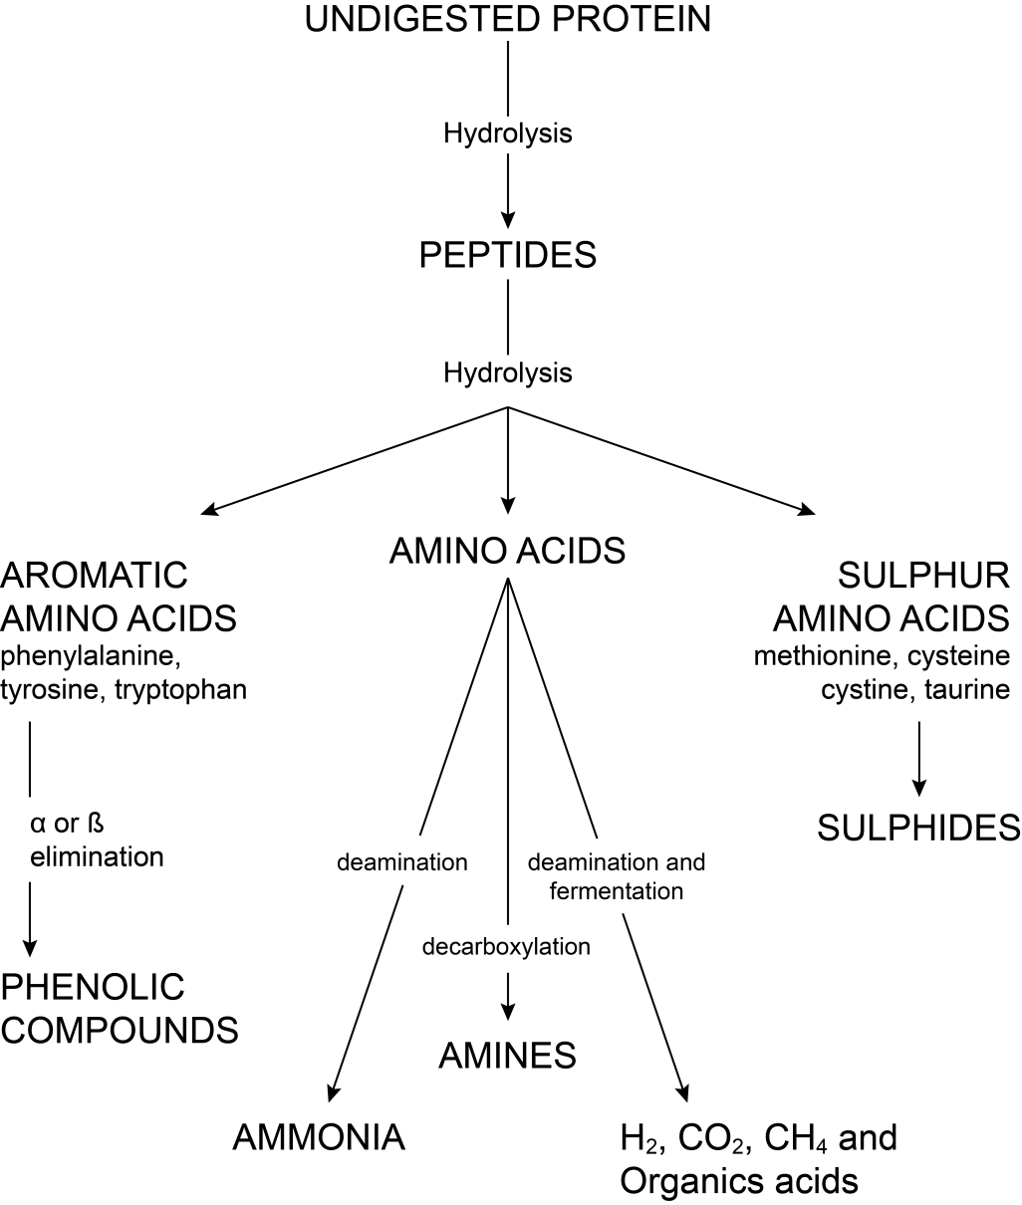

Figure 1.1 Colonic microbial protein metabolism
Source: Reprinted by permission Hughes, R., et al, Protein Degradation in the Large Intestine: Relevance to Colorectal Cancer. Curr Issues Intest Microbiol 2000; 1(2);
p. 52.

Quantity of dietary protein will also affect gastrointestinal flora. Substantial changes were noted in the gastrointestinal flora of adult cats given either moderate protein (MP-30% dry matter) compared to a high protein (HP-50% dry matter) diets.[125] Quantitative polymerase chain reaction was used to measure E.coli, Bifidobacterium spp., Clostridium perfringens, and Lactobacillus spp. populations in feline fecal samples. Bifidobacterium was found to be significantly greater in the moderate protein compared to high protein diets and Clostridium perfringens was found to be significantly higher in high protein vs. moderate protein diets. Microbial species that decreased in the high protein diet feeders included anaerobic carbohydrate fermenters Anaerobiospirillium spp. and Succinivibrio dextrinosolvens.[125] In the HP group, there were marked increases in members of α-proteobacteria, δ-proteobacteria, and clostridia and disappearance of γ-proteobacteria.[125] Marked differences were also found in 8 – 16 week old kittens fed HP vs. MP diets. Kittens fed the high protein diets had significantly decreased Bifidobacteria spp., Lactobacillus spp., and E.coli counts compared to MP fed kittens.[126] There were no differences in Clostridia spp. numbers between kittens fed either high or moderate protein diets.[126]
Most interactions between mammals and microorganism do not result in disease. In exchange for being provided a nutrient-rich protected environment, microorganisms provide nutrients unable to be accessed by host enzyme systems. Microorganisms play important roles in nutrient digestion and synthesis, energy metabolism, epithelial and immune system development and homeostasis, and GI motility.[110, 111] Due to the diversity of biochemical reactions, the gut microbiota has been described as a metabolically active organ.[121] Most of the studies done on metabolic function of the microbiota have been carried out on germ-free (GF) mice. While the presence of intestinal microbes is not essential for life, numerous modulations can be seen in both GF mice’s metabolism and immune system development. Germ-free mice require 30% more energy in their diet indicating that the microbiota play a role in extracting maximum energy from the diet.[127] These effects can be classified into two complementary systems. First, microbial metabolism converts many dietary substances into nutrients that can be absorbed and utilized. Second, microbes can alter gene expression and resultant metabolic machinery resulting in changes in uptake and utilization.
Intestinal bacteria synthesize enzymes that host cells lack for the digestion of various plant polysaccharides. These undigested polysaccharides such as plant cell wall components along with host-derived glycans (mucins), can be fermented by bacteria and produce short chain fatty acids that can be utilized by the host for energy and maintenance of epithelium integrity.[121] Short chain fatty acids are absorbed in the colon by passive diffusion. Acetate, propionate and butyrate are taken up by different organs and have different metabolic fates. Butyrate is metabolized primarily by colonic epithelium where it serves as a primary energy source.[121] Propionate is transported to the liver via the portal system and acetate is taken up primarily by peripheral tissues such as skeletal and cardiac muscle and utilized for lipogenesis.[121]
The microbiome can also contribute to amino acid, and vitamin homeostasis. Amino acid homeostasis is seen primarily in ruminal foregut fermenters where ruminal bacteria can synthesize the complete complement of amino acids from ammonia or urea. In monogastric mammals, this contribution is probably minimal. Studies have shown that 1-20% of circulating plasma lysine and threonine in adult humans are derived from intestinal microbiota.[128] Germ-free mice require Vitamin K in their diet, while conventional mice do not indicating microbial synthesis of this vitamin.[127] Germ-free mice also have additional requirements for certain B vitamins including cobalamin, folic acid, biotin and pantothenate. However, the presence of appreciable quantities of these B vitamins in the feces suggests that these are unavailable in non-coprophagic mammals.
The microbiota can also influence host metabolism through changes in host gene-expression. Colonization in GF mice leads to increased ileal levels of the Na+/glucose cotransporter (L-FABP) mRNA.[129] There are numerous changes seen in gene expression for lipid metabolism in colonized vs germ-free mice. These include increases in expression of pancreatic lipase-related protein 2 (PLRP-2), colipase, liver fatty acid-binding protein (FABP) and apolipoprotein A-IV.[129] Pancreatic lipase-related protein 2 hydrolyzes phospholipids and galactolipids, two fats that are not substrates for pancreatic triglyceride lipase. FABP is an important regulator of fatty acid uptake and intracellular transport while apolipoprotein A-IV transports chylomicrons within the systemic circulation. Colipase is required for optimal activity of pancreatic lipase. Colipase has also been found to be produced in ileal crypt epithelium where microbial colonization increased its expression 10-fold. Colipase expression in crypt epithelium and it’s regulation by intestinal microbes provides an additional method for lipid processing in the intestine. Fasting-induced adipocyte factor (Fiaf) is suppressed in the epithelium with microbial colonization.[130] Fiaf is a circulating lipoprotein lipase inhibitor whose suppression results in increased deposition of triglycerides in adipocytes.[130]
Changes in micronutrient absorption were also found in colonized vs. germ-free mice. Colonization resulted in a 3-fold increase in the epithelial copper transporter (CRT1) and 5-6 fold decrease in expression of metallothionein I and II resulting in increased levels of the minerals zinc, copper and selenium being available to the host.[129]
Besides nutrient absorption and utilization, the GI microbiota is important in development and homeostasis of the host’s gastrointestinal epithelium. The gastrointestinal epithelium of germ-free mice have both morphological and physiological differences compared to conventional colonized mice. The epithelial cell turnover is twice as fast in colonized animals compared to germ-free animals.[131] Colonization increases expression of angiogenin-3, a protein with known angiogenic activity.[129] Induction of an angiogenesis in the epithelium further enhances absorption and distribution of nutrients. Differentiation of epithelial stem cell lineage to Paneth cells is not seen in germ-free mice.[132] These cells are replaced by undifferentiated columnar cells.[132] Paneth cells secrete antimicrobial proteins contributing to compartmentalization of intestinal bacteria.
The gastrointestinal microbiota play a key role in development and maintenance of the mucosal immune response along with mechanical barrier formation. Microbes stimulate mucus production. The mucus layer is twice as thick in conventional colonized mice compared to germ-free mice.[133] A 280-fold increase in small protein-rich protein-2 (sprr2a) is seen in colonized vs. germ-free mice. Sprr2a is important in cross-linking proteins within desmosomes.[129] In germ-free mice, Peyer’s patches are poorly formed and composition of CD4 T-cells and IgA-producing B cells in lamina propria are altered along with decreases in intraepithelial lymphocytes.[134] Commensals induce increased gene expression of the polymeric immunoglobulin receptor[129] The development of follicular T and B-cell areas of the spleen and peripheral lymph nodes are impaired in germ-free mice.[135] The introduction of a single bacterial product, PSA (polysaccaride A) from a common commensal Bacteroides fragilis was shown to correct these splenic and lymph node defects along with restoring CD4 T-cell levels and balance in cytokine production between Th1 cells and Th2 cells.[136] Distinct from the stimulatory effect on the immune system, commensals compete for the same nutrients and attachment sites as pathogenic bacteria providing “colonization resistance.”[137]
Microflora also influence host gut motility. Colonization leads to a 2-5 fold increase in gene expression of the L-glutamate transporter, glutamate decarboxylase, which converts glutamate to gamma-aminobutyric acid, and vesicle-associated protein, a binding protein involved in neurotransmitter release.[129] Glutamate is an excitatory neurotransmitter within the enteric nervous system.

Oxidative Radicals and Measurement of Oxidative Stress

Generation of reactive oxygen species (ROS) and reactive nitrogen species (RNS) is both beneficial and detrimental to the host. Overproduction of ROS results in negative effects due to damage to cell structures including proteins, DNA, lipids and membranes.[138] In contrast, beneficial effects of ROS/RNS include defense against infectious agents. ROS/RNS also function in cell signaling pathways and mitogenesis.[138]
ROS/RNS are products of normal cellular metabolism with their production occurring mainly in the mitochondria. In the process of movement of electrons within the electron transport chain within the inner mitochondrial membrane, small amounts of electrons can “leak” out prematurely forming superoxide radicals when combined with oxygen.[138] Approximately 1-3% of all electrons in the electron transport chain leak out prematurely to generate superoxide instead of reducing oxygen to water and producing ATP.[138] A free radical is defined as any molecule with one or more unpaired electrons in their outer shell.[138] The unpaired electron(s) result in these molecules having high reactivity. Radicals formed from oxygen include superoxide radical, hydroxyl radical, hydrogen peroxide, peroxynitrite, and lipid peroxides. Superoxide is considered the primary ROS and can interact with other molecules to produce secondary ROS.[138] Figure 1.2 diagrams the sources of free radicals generated by cells and key metabolic pathways.
Granulocytes, including neutrophils and eosinophils, generate large amounts of reactive radicals in response to inflammation. Local inflammatory signals recruit granulocytes to leave the circulation, marginate along the endothelium and move into the tissue at the site of infection or trauma.[139] Phagocytosis involves surface attachment of the neutrophil to the foreign particle, engulfment and formation of a phagocytic vesicle or phagosome.[139] Once within the phagosome, 2 killing systems can be implemented, oxygen-dependent and/or oxygen independent.
Respiratory burst is the term used to describe the oxygen-dependent system for generation and release of ROS/RNS within the phagosome. Figure 1.3 illustrates the reactions and products generated during phagocytosis within the cell. During phagocytosis, granulocytes have a burst of metabolic activity with a 2-3 fold increase in oxygen consumption and increased generation of superoxide radical, hydroxyl radical and hydrogen peroxide generated from NADPH oxidase.[139] The hexose monophosphate shunt is the source of both protons and electrons for NADPH oxidase.[140] The superoxide radical is generated within the phagosome membrane. Superoxide can either generate hydrogen peroxide with production of hypochlorous acid via myeloperoxidase or form peroxynitrite using nitric oxide. Peroxynitrite can subsequently degrade to yield additional hydroxyl radicals.[141] If free iron or copper is available, hydroxyl radicals can also be formed from the Fenton reaction. Hypochlorous acid kills via halogenations and deamination and decarboxylation of microbial proteins and nucleic acids. Hydroxyl radicals kill via peroxidation damage of membranes and nucleic acids.[139]. Excess production of these radicals, particularly hypochlorous acid, can lead to local tissue damage. Granulocytes and macrophages protect themselves

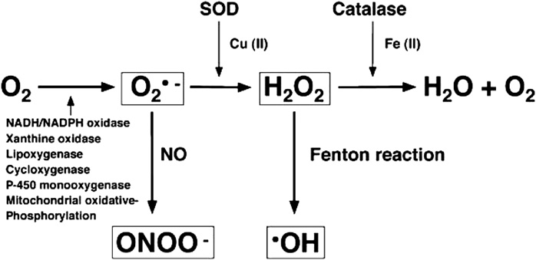

Figure 1.2 Sources of free radical generation endogenously produced by cells and key metabolic pathways. Multiple enzymes may induce free racial generation in various cells, including NADH/NADPH oxidase, xanthine oxidase, lipoxygenase, cyclooxygenase, P450 mono-oxygenase, and the enzymes of mitochondrial oxidative phosphorylation. Superoxide radical = O2•- , Hydrogen peroxide = H2O2, Hydroxyl radical = •OH, Peroxynitrite = ONN- , SOD= Superoxide dismutase, NO = nitric oxide.
Source: Reprinted by permission from Veterinary Clinics of North America, Small Animal 2008; 38: p. 3.

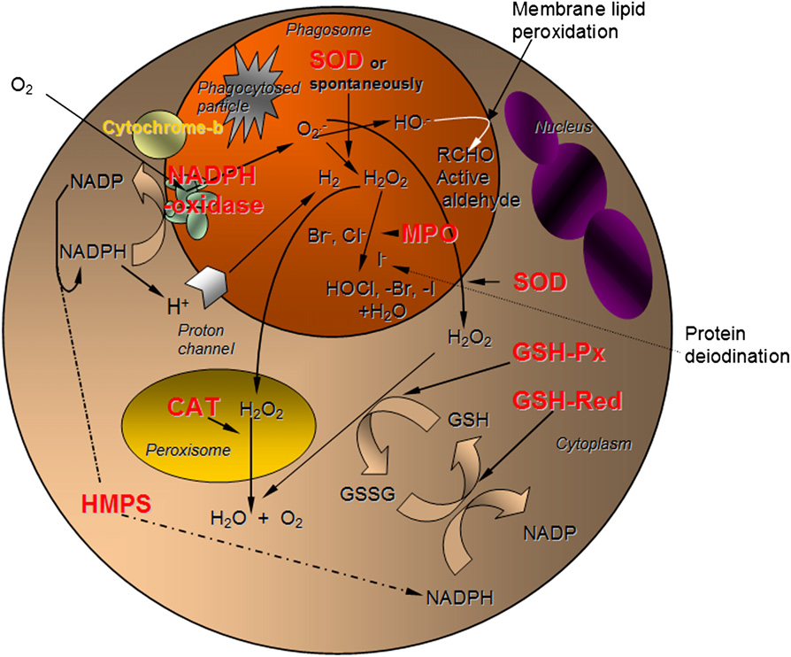

Figure 1.3 Oxygen-dependent killing mechanisms and the enzymatic antioxidant defense. GSH, reduced glutathione; GSH-Px, glutathione peroxidase; GSH-Red, glutathione reductase; GSSG, glutathione disulfide; HMPS, hexose monophosphate shunt; MPO, myeloperoxidase; SOD, superoxide dismutase.
Source: Reprinted by permission from Veterinary Clinics of America, Small Animal 2008; 38: p. 50.

from oxidant damage using the endogenous enzymes superoxide dismutase and catalase, and endogenous glutathione.
Polyunsaturated fatty acids (PUFA) are particularly vulnerable to extraction of electrons from reactive radicals forming a carbon-centered lipid radical (L•). The initial products of PUFA oxidation are peroxyl radicals.[142] Figure 1.4 diagrams the pathways of ROS formation, lipid peroxidation and antioxidants. The lipid radical can further undergo reaction with oxygen to form a lipid peroxide radical (LOO•). L• or LOO• can either be reduced by Vitamin E or extract an electron from a neighboring molecule propagating a chain reaction. Up to 60 molecules of linoleic acid and 200 molecules of arachidonic acid within cell membranes can be damaged in this one initiation event.[142] The major determinant of radical chain damage is the concentration of Vitamin E within the lipid membrane. If the peroxyl radical is in an internal position within the FA chain, cyclization to an adjacent double bond can occur.[138] This internal carbon-centered radical can undergo a second cyclization to form a bicyclic peroxide. Bicyclic peroxides are the common intermediate for the production of isoprostanes and malondialdehyde. Malondialdehyde, the most mutagenic product of lipid peroxidation, reacts with DNA bases forming DNA adducts.[138]
There are 3 approaches to examining levels of oxidative stress in biological systems. These include measurement of levels of the reaction products such as malondialdehyde or DNA adducts, measurement of the free radicals themselves, or measurement of the levels of endogenous antioxidants.[143] If the amount of endogenous antioxidants is low, an increased level of oxidative stress is present.
Levels of the products of oxidant damage can be a reliable marker of oxidant injury. Either lipid peroxidation products or oxidized bases in nucleic acids are the most common substrates quantified. A sensitive technique for assaying DNA damage in single cells is the comet assay or Single Cell Gel Electrophoresis. This procedure involves lysis with a detergent to disrupt cellular membranes, addition of a high molarity salt to disrupt the cytoplasm, nucleoplasm and nucleosomes, with resulting solubilization of the histones. What is left within the cell is the nucleoid, which is a scaffold of DNA, RNA and proteins.[144] Cell contents are then immobilized in an agarose gel for subsequent electrophoresis. The mechanism underlying this assay is that undamaged DNA will retain a highly organized association with the matrix proteins. DNA that is damaged will lose its compact structure and relax, expanding out into the agarose gel. When the electrical field is applied, the undamaged DNA strands are too large and do not move from the central cavity. The damaged DNA in smaller fragments is free to move within the electrical field creating a tail or “comet”. As this method is a highly sensitive assay, anything that can cause DNA damage will affect its reproducibility requiring strict laboratory techniques. Lymphocytes are readily available from blood but have limited survival in vitro unless stimulated by mitogens. [145] There are also large variations from individual to individual regarding their innate ability to repair DNA and to counteract the normal stresses it is exposed to.

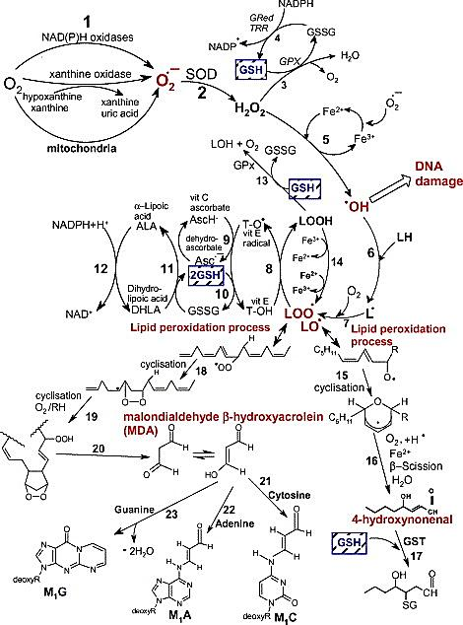

Figure 1.4. Pathways of ROS formation, the lipid peroxidation process and the role of glutathione (GSH) in the management of oxidative stress. Reaction 1: The superoxide anion radical is formed by the process of reduction of molecular oxygen by NAD(P)H oxidases and xanthine oxidase or non-enzymatically by redox-reactive compounds. Reaction 2: Superoxide radical is dismutated by superoxide dismutase (SOD) to hydrogen peroxide. Reaction 3: Hydrogen peroxide is efficiently scavenged by glutathione peroxidase (GPx) which requires GSH as electron donor. Reaction 4: The oxidized glutathione (GSSG) is reduced back to GSH by glutathione reductase (Gred) which uses NADPH as the electron donor. Reaction 5: Some transition metals can breakdown hydrogen peroxide to the reactive hydroxyl radical via the Fenton reaction. Reaction 6: The hydroxyl radical can abstract an electron from polyunsaturated fatty acids (LH) to give rise to a carbon-centered radical (L•). Reaction 7: The lipid radical (L•) can further interact with molecular oxygen to give a lipid peroxyl radical (LOO•). If the resulting lipid peroxyl radical LOO• is not reduced by antioxidants, the lipid peroxidation process occurs (reactions 18-23 and 15-17). Reaction 8: The lipid peroxyl radical (LOO•) is reduced within the membrane by the reduced form of Vitamin E (T-OH) resulting in the formation of a lipid hydroperoxide and a radical of Vitamin E (T-O•). Reaction 9: The regeneration of Vitamin E by Vitamin C. Reaction 10: The regeneration of Vitamin C by GSH. Reaction 11: Oxidized glutathione (GSSG) is reduced back to GSH by dihydrolipoic acid (DHLA). Reaction 12: DHLA is reduced to α-lipoic acid by NADPH. Reaction 13: Lipid hydroperoxides are reduced to alcohols and oxygen by GPx using GSH as the electron donor.
Lipid Peroxidation process: Reaction 14: Lipid hydroperoxides can react quickly with Fe²⁺ to form lipid alkoxyl radicals (LO•) or more slowly with Fe³⁺ to form lipid peroxyl radicals (LOO•). Reaction 15: Lipid alkoxyl radical (LO•) derived from arachidonic acid undergoes cyclisation reaction to form a six-membered ring hydroperoxide. Reaction 16: Six-membered ring hydroperoxide undergoes further reactions for form 4-hydroxy-nonental. Reaction 17: 4-hydroxy is rendered into an innocuous glutathiyl adduct (GST). Reaction 18: A peroxyl radical located in the internal position of the fatty acid can react by cyclisation to produce a cyclic peroxide adjacent to a carbon-centered radical. Reaction 19: This radical can either be reduced (not shown) or can undergo a second cyclisation to form a bicyclic peroxide after coupling to oxygen. Reaction 20: Formed compound is an intermediate product in the production of malondialdehyde. Reactions 21,22,23: Malondialdehyde can react with DNA bases cytosine, adenine and guanine to form adducts.
Source: Reprinted by permission by International Journal of Biochemistry & Cell Biology, 2007. 39(1): p. 46-47.

Lipid peroxidation products proposed for measurement include malondialdehyde, hydroxynonenal and isoprostanes. The thiobarbituric acid reactive substance test is an assay used to measure malondialdehyde in tissues. As much of the malondialdehyde measured is formed following collection during the incubation period, this test is considered to have marginal validity.[143] Malondialdehyde can also form as a result of thromboxane synthesis during platelet activation, as occurs with blood sampling.[143]
The discovery of isoprostanes as lipid peroxidation products has opened up new methods for quantifying lipid peroxidation. Isoprostanes are prostaglandin-like compounds that are produced in vivo independent of cyclooxygenases by free radical-induced peroxidation of arachidonic acid in plasma membranes.[146] In the Biomarkers of Oxidative Stress Study (BOSS), sponsored by the National Institutes of Health (NIH), plasma or urine F2-isoprostanes were found to be the most accurate method to assess in vivo oxidant stress.[147] F2-isoprostanes are stable molecules found in all tissues and fluids. Measurement of urinary isoprostanes is convenient,the least invasive, and represent an accurate index of endogenous production of lipid peroxidation and oxidant stress. Urine samples in particularly have been viewed as an index of whole body oxidant stress over time.[148] Figure 1.5 diagrams formation of isoprostanes from arachidonic acid. Arachidonic acid undergoes extraction of an electron to form a carbon-centered peroxyl radical. Depending on the site of H removal and oxygen addition, 4 regioisomers are formed. These are subsequently reduced to the isoprostane molecule. Levels of isoprostanes can be analyzed by gas chromatography-mass spectroscopy or immunoassays.[148] Normal ranges have been established in humans but to the author’s knowledge, no values have been established for dogs or cats. Table 1.7 lists the basal levels of free F₂-Isoprostanes in various body fluids. Higher levels of urinary isoprostanes are found in obese human beings, confirming obesity being associated with inflammation and increased oxidative burden.[149] Increased levels of urinary isoprostanes have also been found in obese cats compared to lean cats.[150]

Table 1.7 F₂ Isoprostanes levels in body fluids.

Body Fluid | Level (mean ± 1 standard deviation)
Human Plasma* | 35 ± 6 pg ml⁻¹
Human Urine* | 1.6 ± 0.6 ng mg⁻¹ creatinine
Human Cerebrospinal fluid* | 23 ± 1 pg mg⁻¹
Feline Urine (lean cats)** | 3.40 ± 0.89 pg mg⁻¹ creatinine***
Source: * Adapted from Fam, SS and Morrow, J.D. The isoprostanes – Unique products of arachidonic acid oxidation - A Review. Curr Med Chem, 2003. 10(17): p. 1727, Table 2.
** Adapted from Jeusette, I, et al. Increased urinary F2-isoprostane concentration as an indicator of oxidative stress in overweight cats. In J Appl Res Vet M, 2009. 7: p. 36
***Mean ± SEM

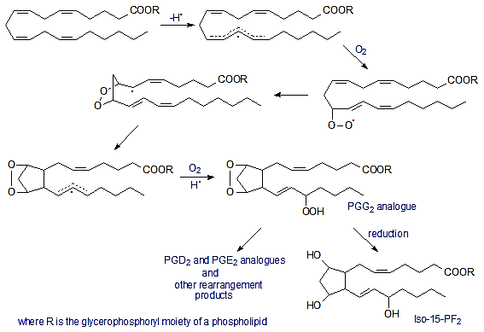

Figure 1.5 Formation of 15- F₂ isoprostane from arachidonic acid. A reactive oxygen species abstracts a hydrogen atom from a methylene group under aerobic conditions. Since this radical generation is not enzymatic, all methylene groups between two cis double bonds can potentially be involved. After hydrogen extraction, the radical formed combines with an oxygen molecule to generate a peroxy radical which rearranges. The bicyclic endoperoxy radical reacts on either face of the side chain with a further oxygen molecule to produce racemic hydroperoxy bicyclic endoperoxy radicals. The radical chain is terminated by abstraction of hydrogen from an appropriate donor. Analogous reactions can occur to produce isoprostanes with the hydroxyl group in positions 5, 8 or 12.
Source: America Oil Chemist’s (AOCS) Lipid library. http://lipidlibrary.aocs.org/lipids/eicisop/index.htm

The second method of assessing oxidative stress is to measure the actual reactive radicals. These measurements have not been used clinically due to their high reactivity and very short half-life.[143]
The third method involves measurement of endogenous antioxidants in tissues or fluids. Species variation can be high with no known baseline data available for the various species. Assessing the ratio of reduced to oxidized glutathione has been used as a method for assessing oxidative stress in dogs and cats.[143, 151] Glutathione is an important endogenous antioxidant in cells. The ratio of reduced to oxidized glutathione in liver tissue of healthy cats was found to be 56.9.[151] Similar to measure of malondialdehyde, this method is very susceptible to oxidation ex vivo, falsely increasing the level of oxidized glutathione.
Each of these methods examines a different component of the antioxidant defense system. Therefore, without a comprehensive evaluation of each component, total body oxidant stress cannot be fully evaluated.

Raw Food Diets

Risks

Three primary risk factors have been reported with consumption of raw diets by pets. These include overall nutritional adequacy, consumption of raw bones leading to dental fractures or gastrointestinal trauma, and consumption of pathogenic bacteria, viruses, and protozoa not killed in the normal cooking process. The most frequently cited concern of these in the veterinary published literature has been food safety.
The source for minimum nutrient requirements in healthy dogs and cats, based on accumulated research and updated periodically, is the National Research Council (NRC) Nutrient Requirements of Dogs and Cats.[12] These nutrient requirements are often based on feeding purified diets rather than commercial foods. To compensate for potential reductions in bioavailability, the Association of American Feed Control Officials (AAFCO) publishes its own nutrient requirements for dogs and cats to account for these bioavailability and potential processing losses.[25] The AAFCO pet profiles are published yearly and claims of nutritional adequacy in pet foods are based on current AAFCO nutrient profiles. Using AAFCO guidelines, a published study examining nutritional adequacy of a small number of homemade and commercial raw diets in dogs has been done.[152] No studies to date have been reported in domestic cats. The canine study evaluated 3 homemade raw diets (BARF [153], Ultimate [4], and Volhard [154]) and 2 commercial complete raw diets. The diet nutrient profiles were compared after analysis to AAFCO minimum requirements.[152] Two of the homemade diets were being fed to adult dogs and the 3rd was being fed to a 4 month-old large breed puppy. In the homemade raw diets, deficiencies were found in calcium, phosphorus, magnesium, potassium, manganese, iron and zinc. The calcium to phosphorus ratios were improper in 2 of the 3 homemade diets.[152] The homemade diet fed to the large-breed puppy had an elevated calcium to phosphorus ratio. Elevated calcium levels increases the risk of developmental orthopedic disease in these breeds.[155] One of the commercial raw diets was found to be low in calcium, phosphorus, and potassium with a low calcium to phosphorus ratio. Very high levels of zinc were found in this diet.[152] High levels of zinc in the diet can reduce intestinal copper absorption through increased production of metallothionein.[156] Metallothionein is a cytosolic protein produced in response to high levels of zinc, copper or toxic heavy metals. High levels of metallothionein in enterocytes bind copper preventing its movement through the cell, limiting absorption and leading to a possible copper deficiency.[156]
The second potential risk factor cited in feeding raw diets is gastrointestinal perforation, impactions or dental fractures from feeding raw bones. Proponents have advised to feed raw uncooked bones claiming they can be more easily digested rather than cooked bones which can splinter and fracture.[4] No scientific studies to date confirm this. There are reports of intestinal obstruction, gastrointestinal perforation, gastroenteritis and dental trauma from feeding raw bones.[152] Subsequently, recommendations have been made to grind all bones used in raw diets.[157]
The third potential risk factor cited with feeding raw foods is food safety, both to the pets being fed the raw diets, and to the owners/family members who are in contact with the pet, pet food and environment. Raw meat harbors microbial growth that is destroyed with application of adequate heat. The incidence of food-borne morbidity and mortality to humans is reported to be 76 million cases with 325,000 hospitalizations and 5,000 deaths annually.[158] Viruses are estimated to account for two-thirds of all food borne illness and known pathogenic bacteria for 30%. Campylobacter spp. associated with poultry account for the majority of bacterial cases.[158] Parasites are believed to account for approximately 3% of food-borne illnesses.[158] In contrast, morbidity from bacteria, viruses or parasites are much different. Seventy-two percent of deaths from food are attributable to bacteria, 21% to parasites and 7% viruses.
The overall prevalence of pathogenic bacterial contamination in raw meat and poultry sold for human consumption varies greatly, with ranges of 1% - 100% depending on the contaminant, the species of animal used to produce the raw ingredient, the amount of processing of the raw ingredient i.e. the number of times the ingredient has been handled, and the facility it is processed in. Overall prevalence of Salmonella spp. in 2002-2003 in poultry used for human consumption was reported to be 9.1%-12.8%, while Campylobacter jejuni was found in 73.6% of samples.[159] In human grade raw beef products, prevalence ranges for pathogenic E.coli O157:H7 have been found to be 0.0-28%, and for Salmonella spp. 0.0-7.5%.[160, 161] Cattle are known to harbor large numbers of E. coli through fecal contamination, with numbers ranging between 10⁵ to 10⁶ CFU/g feces. The same fecal strains of E. coli have been recovered throughout the entire production-processing continuum and in the raw beef products.[162]
Processing standards and laws to minimize microbial contamination of meat products for humans are not mandatory in production of pet foods. The USDA’s Food Safety Inspection Service is responsible for ensuring that the domestic food supply is safe and that contamination of meat products with pathogens is minimal. Unlike food intended for human use, there is no regulatory agency with binding laws to ensure and monitor bacterial contamination in raw foods that can be used for pets. The Food and Drug Administration Center for Veterinary Medicine has guidelines for the manufacture and labeling of raw meat foods for companion and captive noncompanion carnivores and omnivores [157] but these guidelines are not binding and producers can choose to follow or reject them.
There have been several studies evaluating bacterial contamination in raw foods for companion animal consumption. In one study that evaluated bacterial contamination in raw beef fed to racing greyhounds, Salmonella spp. was found in 75% of raw meat diet samples and 93% of fecal samples.[5] All the dogs had normal stools with the exception of one dog with diarrhea.[5] All of the dogs in this study that were ill or had died with salmonellosis were young puppies. No juvenile or adult dogs were ill.[5] Another study that cultured 10 raw meat samples used for feeding dogs based on chicken found 80% of the diets and 30% of stool samples contaminated with Salmonella spp.[6] Since only one fecal sample was cultured, this may be an underestimate since Salmonella spp. is difficult to isolate and shedding can be intermittent.[163] Commercial raw pet diets have been found to contain high levels of bacterial pathogens. In one study, E coli was found in 64% of the diets, but E.coli O157:H7 was not detected.[164] Salmonella spp. was detected in 20% of the diets while Campylobacter spp. was not isolated.[164] A second study evaluating bacterial and protozoal contamination of commercial raw meat diets for dogs found 53% of the samples contaminated with E. coli, 5.9% contaminated with Salmonella spp. and 1% contaminated with Cryptosporidium parvum.[165] Testing for Campylobacter spp. was negative. Testing specific for E.coli O157 was not preformed.[165] It has been speculated that despite the high prevalence of poultry contamination with Campylobacter spp., negative results in these studies have be related to Campylobacter spp. strict anaerobic requirement and intolerance to drying conditions.[165]
The risk to human health with feeding raw meat to pets is another risk factor. In addition to the diet itself being a source of pathogens for humans, food utensils, feeding bowls and areas of possible fecal contamination are also sources of contamination. The same pathogens isolated from raw diets have been found in dog’s feces [6] and subsequently in owners/family members that have become ill.[161, 166, 167] Although E.coli O157 transmission from dogs to humans has been documented, cat-human transmission to date has not been documented. The populations at greatest risk for contracting illness in households feeding raw diets are the very young (infants and children), the elderly, pregnant women, and the immunocompromised.
Pathogen contamination is not unique to unprocessed pet foods. Commercial pet foods have been subject to numerous recalls for Salmonella spp.[168] A recent multi-state outbreak of Human Salmonella Infantis infection has been traced to multiple brands of a dry commercial dog food, leading to illness in 9 individuals.[169]
The parasites of primary concern in feeding raw diets to cats include the protozoan Toxoplasma gondii and nematode Trichinella spp. Neospora spp., Cryptosporidium parvum, and Giardia spp. have also been cited.[170] Since the domestic dog is the definitive host for Neospora, naturally occurring canine infections are common.[171] Tachyzoites become encysted in neural cells and occasionally muscle cells. Dogs become infected from eating infected tissues from the intermediate herbivore hosts.[172] Dogs fed raw meat have a three times higher prevalence of Neospora spp. antibody than dogs on commercial diets.[173] Natural clinical infections with Neospora spp. have not been documented in cats, although antibodies have been reported in domestic and wild felids. Fatal Neospora spp. infection did occur in cats experimentally inoculated with Neospora caninum and subsequently immunosuppressed with methylprednisone acetate.[174]
Giardia spp. and Cryptosporidium parvum both have the potential to cause illness through transfer from water contamination rather than raw meat consumption. In a survey of prevalence of enteric zoonotic organisms in client-owned cats and humane shelter cats, Cryptosporidium parvum, Giardia spp, Salmonella enterica, and Campylobacter spp. were all detected with Cryptosporidium spp. being the most prevalent.[175] Although it is not known how cats become infected with Cryptosporidium parvum, infection through contaminated drinking water or ingestion of infected prey species is suspected.[176, 177]
The two principle parasitic contaminants in muscle meat are Toxoplasma gondii and Trichinella spiralis. Cats are the definitive host for Toxoplasma gondii and therefore capable of shedding oocysts communicable to humans for a short period of time after initial infection and recrudescence.[172] Pregnant women infected with these cysts can give birth to children with deafness, mental retardation and learning disabilities.[178] Like Neospora spp., Toxoplasma bradyzoites encyst in tissue, particularly muscle. Cats ingesting tissue cysts can go on to develop systemic infections. Kittens are particularly sensitive with transplacental exposure or ingestion through lactation resulting in significant morbidity and mortality.[172] In one study, overall seroprevalence of antibodies to Toxoplasma gondii were 53% in cats fed raw meat diets compared to 23% in cats fed commercial heat-processed diets.[179] Undercooked pork, lamb and mutton are the most important sources of meat-borne infections of Toxoplasma spp. together with game meat such as bear and feral swine.[180] Trichinella spp. is a nematode parasite that when ingested encysts in the muscle tissues of its host. Trichinosis in carnivores occurs after ingestion of raw or undercooked meat containing cysts. Trichinosis is most commonly associated with eating raw or undercooked pork, bear meat and horse meat.[180] Clinical trichinosis in cats may result in intestinal mucosal injury from adult worms or the host’s reaction to invasion of skeletal muscle by the larvae.[181]
Exotic cats have a high prevalence of fecal Salmonella spp. Salmonella spp. was isolated in 94% of fecal samples from a zoo and private big cat collection.[182] All exotic cats were clinically healthy and were being fed a raw horsemeat and chicken diet. Prevalence of fecal isolation of Salmonella spp. in apparent clinically healthy domestic cats ranges from 1%-18%.[163, 175, 183, 184] As these values are based on one fecal culture, they probably are underestimates due to the difficulty in isolating and culturing Salmonella spp. and its intermittent shedding in the host. Suspected clinical cases of salmonellosis require 3 negative cultures before ruling out the disease.[163] Susceptibility and severity of infection depends on multiple factors including virulence of the pathogen strain, infectious dose, and host resistance.[183] Host resistance factors include age, immunocompetence, stress, administration of glucocorticoids, and presence of chronic disease. Salmonellosis is most commonly reported in young, aged or immunocompromised cats.[183, 185] Reports of fatal salmonellosis have been documented in a cattery-raised Exotic shorthair kitten fed raw meat [183], a group of cattery-raised Persian kittens immunized with a modified live panleukopenia vaccine living in a household with an adult being fed raw chicken [186], and stillbirths in a Persian queen being fed a raw meat diet positive for Salmonella spp. [187]. Clinical signs of feline salmonellosis include gastroenteritis, bacteremia/endotoxemia with localization to individual or multiple organs, chronic febrile disease with anorexia and lethargy, and conjunctivitis.[163, 183, 187-189] A fatal case of salmonellosis was reported in an adult pure-bred cat being fed raw meat with identical Salmonella spp. found in both the animal’s tissues and its raw diet.[183] Several cases of salmonellosis sepsis have been found in cats with no signs of gastrointestinal disease or isolation of Salmonella spp. from feces. No diet history was given with these sepsis cases.[188, 189]
Most human cases of salmonellosis are due to exposure to contaminated foodstuffs, but cases of human salmonellosis due to direct or indirect contact with animals have been reported.[190] Fecal shedding of Salmonella spp. in cats can last from 3 to 6 weeks and in some cases up to 14 weeks after clinical illness.[163, 191] In cats with salmonellosis, large numbers of bacteria are present in the mouth and their coat can be highly contaminated secondary to their grooming habits.[185] Most domestic cats spend a large amount of time in close proximity to their owners with ample potential for direct or indirect exposure to zoonotic organisms. Of particular concern is the increasing incidence of an antibiotic-resistant strain, Salmonella serovar Typhimurium definitive type (DT)104. This strain has become an important food safety concern because of its increased incidence in both humans and animals and its ability to cause serious disease with resistance to ampicillin, chloramphenicol, streptomycin, sulphonamides and tetracycline. Several studies have identified domestic cats as carriers of multiresistant Salmonella Typhimurium DT 104 along with farm animals, dogs and birds.[190-194]
Escherichia coli is part of the normal commensal microbiota of mammals. Yet certain strains of E.coli are known pathogens to both humans and animals. Some of the pathogenic E. coli strains can be transmitted between different host species and may cause disease in one but not the other species. Pathogenic E.coli are characterized by virulence markers with five groups of enteric pathogenic E.coli established. These include 1- enteropathogenic E. coli (EPEC) which express colonization factors such as pili, 2- enterotoxigenic E. coli (ETEC) expressing heat-stable (ST) or heat labile (LT) enterotoxins, 3- enteroinvasive E. coli (EIEC) with genes for invasion of intestinal epithelium, 4- shiga-toxin producing E.coli (STEC) expressing one or more different types of cytotoxins (Stx1 and Stx2), and 5- enteroaggregative E.coli (EAggEC) showing a distinct aggregative pattern of adherence to epithelial cells.[195]. Strains belonging to EPEC, ETEC, and STEC are known to cause disease in humans and some animals, whereas EIEC and EAggEC are isolated only from humans.[195] A novel class of E.coli, termed adherent-invasive E.coli (AIEC) has been associated with chronic inflammatory disease in humans, dogs and cats.[196, 197]
Verocytotoxic E.coli are responsible for the majority of E. coli associated food-borne illness from raw or undercooked meat in humans.[158] Verocytotoxic E.coli are named because of their ability to cause damage to cultured Vero cells. Vero cells, isolated from the African green monkey, were the first cell lines used to detect E.coli toxins. Many verocytotoxic E.coli strains produce shiga-toxins (Stx1, Stx2, Stx3). Shiga-toxin or STEC strains such as E.coli O157:H7 are considered the most virulent in humans causing hemorrhagic diarrhea and hemolytic uremic syndrome.[161] Cattle, including dairy herds are important sources of STEC isolates.[161] Horses and dogs can also be carriers with one case reported of transmission from an asymptomatic dog to a child.[161, 198] Verocytoxic E.coli have been isolated from both healthy and diarrheic cats but none of these strains have been reported to produce shiga-toxins.[195, 198] These feline verocytotoxic strains produce necrotizing toxins associated with hemolysin and are associated with extra-intestinal infections in cats, but it is unknown the extent of their involvement in intestinal disease. As STEC have not been found in cats to date, it is unknown if ingested whether they would cause disease or possible transmission to humans through shedding.
Enteropathogenic E. coli (EPEC) are known to cause gastroenteritis in young infants and neonatal farm animals. EPEC strains have been isolated from cats but it is unknown to what extent these are potential diarrheic agents or their incidence of shedding.[195]
Enterotoxigenic E.coli produce one or more different types of enterotoxins which stimulate intestinal fluid secretion causing a non-bloody, water diarrhea in humans and young farm animals.[195] The toxins produced by ETEC are divided into two major groups: heat-labile (LT) and heat-stable (ST) toxins. ETEC have been found associated with diarrhea in dogs, particularly young dogs. Very little information or studies have been done on ETEC’s in cats but to date, these strains and toxins have not been found.[195]

Benefits

Improved digestibility has been one of the most consistent benefits to date for feeding raw meat diets to cats. Most of these studies have been done on small exotic feline species. Crissey compared a raw meat diet with a dry kibble diet in Sand cats and found the raw meat diet to have 10% higher digestibility in dry matter, and energy and 15% higher digestibility in crude protein compared to the kibble extruded diet.[199]. Differences in plasma taurine were also examined. Taurine levels in both diets were adequate but plasma taurine levels in the kibble-fed cats were twice as high despite taurine levels in the raw diet being twice as high as the kibble diet. The amount of taurine available from the diet depends on several factors including the amount of protein, quality of protein, processing effects, the animal’s oxidative status and levels of small intestinal bacteria.[200, 201] Taurine is an intracellular osmolite and drip losses can occur in raw muscle meat following osmotic changes associated with slaughter and post-mortem conditions in muscle.[202] The kibble diet had crystalline taurine added during the processing. Plasma beta-carotene levels were 10X higher in the raw diet compared to the kibble diet. Cats have minimal activity of the enzyme 15-15 monooxygenase which converts beta-carotene to Vitamin A but can utilize carotenoids as antioxidants.[203, 204] Plasma retinyl esters were not significantly different between the two diets.
A more recent study looked at feeding the domestic cat’s wild ancestor, Felis lybica, a commercial raw meat vs. an extruded high protein kibble diet. The purpose was to compare apparent nutrient digestibility, fecal characteristics and blood metabolite concentrations.[205] Caloric intake on a dry-matter (DM) basis was not different between the two diets but fecal output was significantly higher in the kibble fed cats. Crude protein digestibility in the raw diet was 8% higher compared to the extruded diet.[205] Blood analyses showed a few differences between the diets. Alanine aminotransferase and bicarbonate were significantly higher on the raw diet compared to the extruded diet. Both of these concentrations were still within the normal reference range. Another study evaluating protein quality of various raw and rendered animal products, found total essential amino acid digestibility and total amino acid digestibility ranged from 93.7 to 96.7 and 90.3 to 95.5% respectively in the raw diets, and 84.0 to 87.7 and 79.2 to 84.8 respectively in the rendered animal meats.[206]
The amino acid lysine is particularly sensitive to heat processing due to formation of Maillard reaction products.[207, 208] Larsen examined the relationship between lysine bioavailability and growth response in kittens fed heat-treated and unheated casein. The bioavailability of the lysine in the untreated casein was 96.2% compared to 56.5% in the heat-treated casein.[209] There was a lower growth rate in the kittens fed heat-treated casein reflecting a decreased bioavailability compared to the raw, unheated casein.
Another benefit attributed to feeding raw food diets is that active enzymes remain intact and thereby improve digestibility and bioavailability of foodstuffs. A consistent argument against this claim is that protein enzymes are denatured and inactivated in the stomach secondary to hydrochloric acid and pepsin secretion.[210] An additional argument states that all of the enzymes dogs and cats need for digestion are already produced in the gastrointestinal tract unless they have an underlying exocrine pancreatic insufficiency.[210, 211] The extent or types of enzyme degradation in the stomach is not completely quantified, but treatment for inadequate pancreatic enzyme secretion secondary to pancreatic insufficiency with raw pancreas is a common practice. Westermarck found in jejunally cannulated dogs, that raw porcine pancreas had the highest level of lipase recovery in the jejunum (39.1%) compared to Viokase powder¹ (26.2%). Dietary amylase and proteases activity levels were still present in the jejunum from the raw pancreas extract and higher than enzyme levels in a subclinical exocrine pancreatic insufficiency cases.[212]
A study sponsored by the Winn Foundation was conducted to develop a “gold standard diet” for domestic cats which then could be used for comparison with commercial diets.[213] Two groups of kittens, 4 weeks-old and 20 weeks-old, were fed either a ground raw rabbit diet or commercial premium cat diet.[213] Cats on the whole ground rabbit diet had significant improvements in stool quality based on a visual stool grading system. They went from soft or liquid stools to formed hard stools. The cats on the commercial canned diet continued to have semi-formed to soft stools. The kittens also ate the raw diet more aggressively and rapidly suggesting a higher palatability. Kittens on the raw diet appeared to have a better coat quality although this was not objectively quantified. There were no differences in rate of growth, amount of intestinal
inflammation or numbers of bacteria in the small intestine between the two groups
although shedding of pathogenic organisms was slightly higher in the kittens on the raw
___________________________________________________________
¹ Viocase-v powder, Boehringer Ingelheim/Fort Dodge Vetmedica, Inc. St. Joseph, MO.
diet.[213] One of the kittens on the raw rabbit diet had a sudden death due to taurine deficient dilated cardiomyopathy. When the other kittens on the raw diet were examined, they were found to have heart muscle changes consistent with taurine deficiency. While the raw rabbit diet was found to contain the minimal requirement for taurine, it was speculated that bacteria in the carcass of the ground rabbit or in the intestine of the cats broke down some of the taurine. This would not be detrimental in diets containing excess levels of taurine but would be problematic if the diet was borderline deficient.[213]
Similar to raw dog and cat foods, there has been very little scientific research on raw diets in humans. Human raw food diets have been variably described as uncooked vegan diets, uncooked vegetable diets, and “living foods” diets. Most exclude all animal products, except one diet which includes raw liver.[214] The amount of actual raw food intake varies between 50-100% of total caloric intake. As compared to mean nutrient intakes of people reported in the National Health and Nutrition Examination Survey (NHANES III), subjects eating a raw foods diet had significantly higher intakes of fiber, Vitamins A, B6, C and E, folate, copper and potassium and significantly lower intakes of protein, total and saturated fat, cholesterol, Vitamin B12, phosphorus, sodium and zinc.[214] Subsequently, raw food diets had higher vitamin antioxidant levels (Vitamin C, E and beta-carotene) but variable mineral antioxidant levels.[215] Humans on raw food diets had lower serum cholesterol and triglyceride levels but higher homocysteine and reduced HDL.[216] Raw food diets have also been associated with subjective improvement of fibromyalgia and rheumatoid arthritis symptoms.[217, 218] Positive effects were attributed to changes within intestinal microflora populations.[219, 220] “Living foods” diets contain fermented products, typically rich in lactobacilli. An uncooked vegan diet resulted in significant decreases in bacterial fecal urease, choloylglycine hydrolase, β-glucuronidase, and β-glucosidase along with lowered serum and urine phenol and p-cresol concentrations.[220] Phenol, cresol, ammonia and the products of various fecal hydrolytic enzymes result in the generation of toxins and potential carcinogens.[220]

Effects of processing on proteins and amino acids

Many factors affect protein quality. These include amino acid composition, presence of any anti-nutritional factors such as trypsin inhibitors, phytates, tannins or fiber, and the storage and processing of the protein itself.[221] The nutritional value of a protein depends on both its distribution of amino acids and their bioavailability. Proteolytic enzymes in the gut may not be able to digest altered proteins if the protein is not recognized by the enzyme’s active site.[9] If the modified amino acid or peptide is hydrolyzed, it may not be transported across the epithelial wall. If the modified amino acid is absorbed, the animal may not be able to convert it back to its native form.[9]
Proteins and amino acids can undergo significant chemical changes during processing. Processing conditions can include both chemical and physical factors such pressure, temperature and water content. Food proteins can react with other food components such as sugars, fats, oxidizing agents, acids, alkali, polyphenols and food additives.[222] The benefits of processing include food preservation, destruction of toxins and microorganisms, improved palatability, and convenience. Processing can also positively and negatively effect the bioavailability of nutrients.[9]
Processing typically results in denaturing of proteins and loss of secondary and tertiary structure with resultant loss of functionality. Denaturing exposes reactive groups to reactions not previously possible when the protein was in its native confirmation.[9] Processing effects on a range of amino acids include proteolysis, protein-crosslinking, amino acid racemization, protein-polyphenol reactions, oxidative reactions, and browning or Maillard reactions.[9]
Heat processing will improve digestibility of some plant proteins due to denaturing protein antinutritional factors. Legumes contain trypsin and chymotrypsin inhibitors which impair protein digestion and reduce protein’s bioavailability.[222] Inhibitors of trypsin and chymotrypsin activity in the gut induce pancreatic overproduction of these enzymes leading to pancreatic hypertrophy.[222]
It is the Maillard reaction that accounts for the majority of protein quality loss with processing.[9] The Maillard or browning reaction was first discovered by L.C. Maillard in 1912.[223] It is responsible for many of the positive flavor, color and textural components of foods. The browning reaction can be broken down into nonenzymatic browning and enzymatic browning.[224] Nonenzymatic browning includes:
- Heat catalyzed protein and/or amino acid-carbohydrate glycosylation reactions
- In vivo protein-carbohydrate reactions i.e. glycosylated hemoglobin or fructosamine
- Protein-oxidized fatty acid reactions
- Heterocyclic amine formation- heat catalyzed reactions of amino acids with glucose and creatinine to form polycyclic amines in cooked meat and fish
Enzymatic browning includes:
- Polyphenol-oxidase catalyzed oxidation of polyphenol compounds in fruits and vegetables to quinones which polymerize to dark melanin pigments
- Reactions of polyphenol-derived quinones with free amino acids and proteins to form dark polymers.

Figure 1.6 diagrams initial stages of the Maillard reaction. Nonenzymatic glycosylation occurs with covalent attachment of a carbonyl group from carbohydrates or fatty acids to an alpha or side chain amino group in amino acids and proteins. The first glycation product is a Schiff base that rearranges to a more stable ketoamine or Amadori compound.[224] Since the initial reaction in formation of a Schiff base is reversible, the modified amino acid is potentially 100% bioavailable at this stage. Formation of Amadori compounds and any further reactions result in 0% bioavailability.[9, 224]
The Maillard reaction does not usually stop at formation of Amadori compounds. Under the right conditions (i.e. high temperature, medium water activity), Amadori compounds degrade into smaller derivatives that can react together or polymerize to produce melanoidins or advanced glycation end products (AGE’s). Melanoidins are high molecular weight, nonreactive brown or black pigments seen in foods. Advanced glycation end products are a heterogeneous group of compounds that have been implicated in numerous diseases.[225, 226] AGE’s can elicit damage to tissues through upregulation of inflammation, cross-linking of proteins and increased oxidative stress. These effects are mediated through the binding of AGE’s to the receptor for advanced glycation end products (RAGE). RAGE activation triggers the induction of increased reactive oxygen species, activates NADPH oxidase, increases expression of adhesion molecules and uprelates inflammation through nuclear factor kappa-beta (NF-Κβ) and other signaling pathways.[225] Inflammatory mediators that are upregulated include TNF-alpha, IL-6 and C-reactive protein.[227] Figure 1.7 illustrates the various pathways to AGE formation from early and intermediate glycation products. Accumulation of AGEs in tissues and cells through highly processed diets has been proposed as a contributor to chronic diseases, particularly diabetes, renal disease, cardiovascular disease, and the phenomenon of aging.[227, 228] AGEs exist in high concentration in processed foods, particularly foods high in fat and protein.[228]

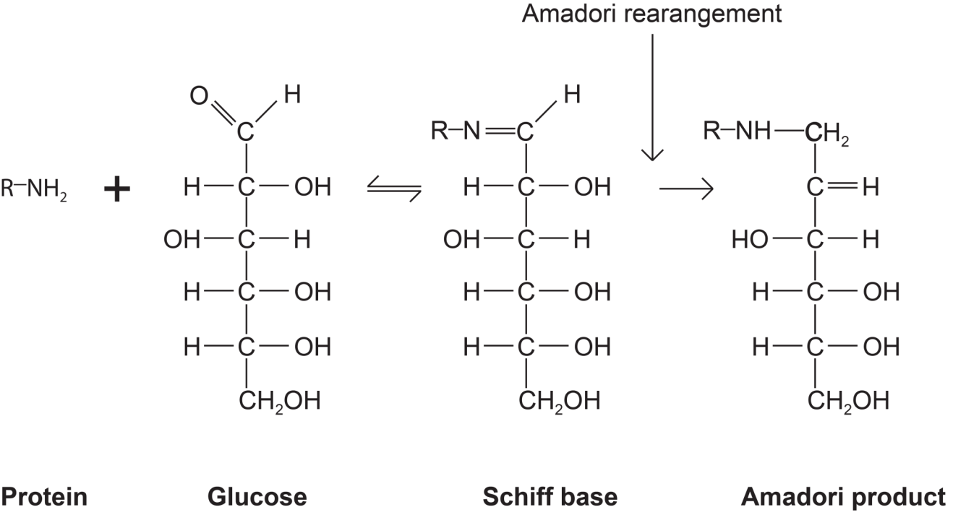

Figure 1.6 Initial stages of the Maillard reaction. The first step of the Maillard reaction occurs when a free amino group, such as a lysine residue in a protein, reacts with a carbonyl group, such as those found in reducing sugars or fat breakdown products to give a Schiff’s base. This then undergoes a rearrangement to form a reasonably stable adduct, the Amadori product.
Source: Adapted from Friedman, M. Food Browning and Its Prevention: An Overview. J. Agric Food Chem. 1996. 44(3): p. 633.

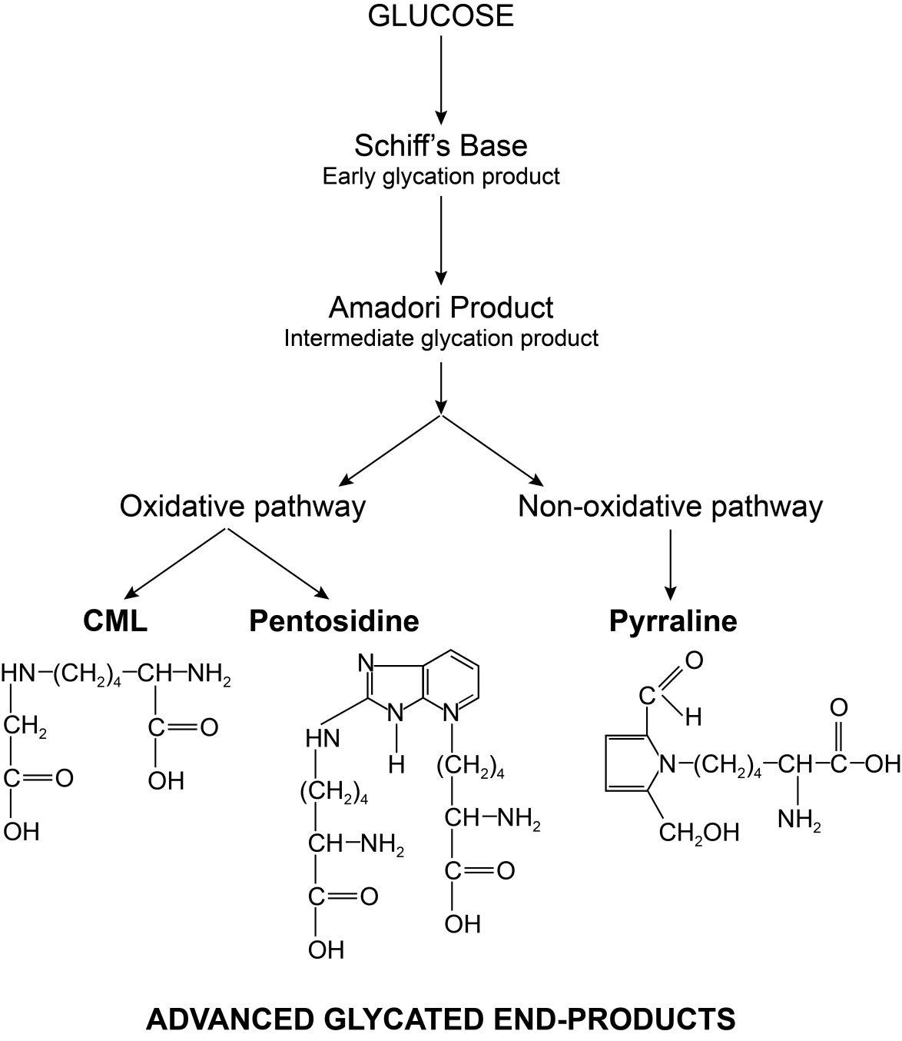

Figure 1.7 Pathways in the formation of Advanced Glycation End Products.
Source: Adapted from Singh, R. Advanced glycation end products – a review. Diabetologia, 2001. 44; p. 131.

Lysine is the most vulnerable to heat processing due to presence of its ε-amino group.[9, 224] Heat catalyzes the interaction between the ε-amino group of lysine and the amide groups of glutamate, glutamine, aspartate and asparagine residues resulting in isopeptide bond formation.[9] Figure 1.8 diagrams the isopeptide bond formation between lysine and glutamine, asparagine, glutamate and aspartate. Glutamyl-lysine is between 80-100% available but aspartyl-lysine has no bioavailability.

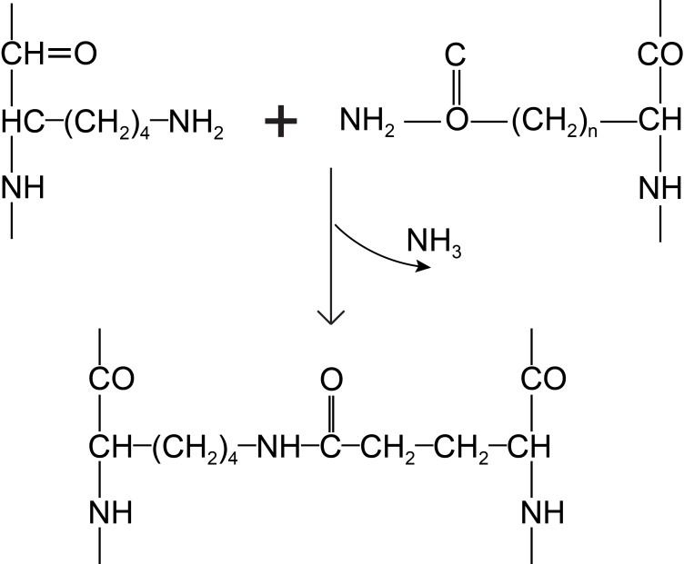
n=1 ; Asparagine residue
n=2 ; Glutamine residue
a.)
Lysine residue
Glutamine/Asparagine residue
Cross-linked peptide

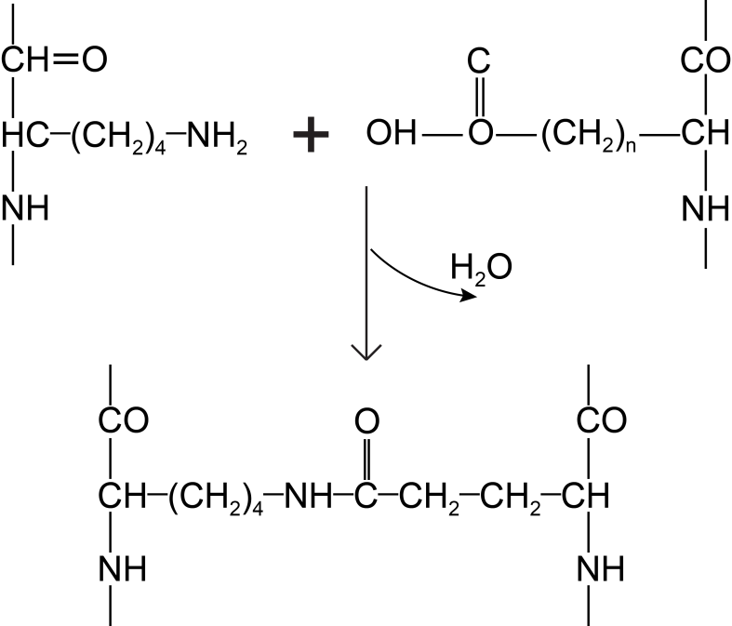
n= 1; Aspartate
n= 1; Glutamate
b.)

Lysine residue
Glutamate/Aspartate residue

Cross-linked peptide

Figure 1.8 The formation of isopeptide crosslinks during processing. a.) condensation of the ε-amino group of lysine with the amide group of an asparagine or glutamine residue, b) condensation ε-amino group of lysine with hydroxyl group of glutamate or aspartate residue.
Source: Adapted from Damodaran, S. Amino Acids, Peptides and Proteins in Food Chemistry 3rd Edition, O.R.Fennema, Editor. 1996, Marcel Dekker, Inc.: New York, NY p. 408.

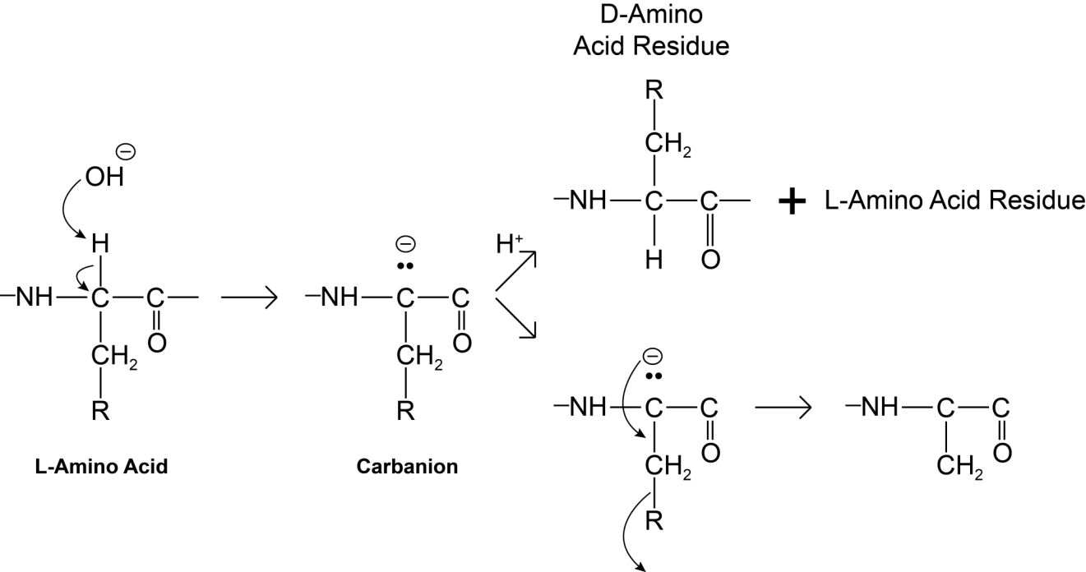
Dehydroalanine

Figure 1.9 Formation of dehydroproteins and amino acid racemization
Source: From Damodaran, S. Amino Acids, Peptides and Proteins in Food Chemistry 3rd Edition, O.R.Fennema, Editor. 1996, Marcel Dekker, Inc.: New York, NY p. 404.

Heat and alkaline conditions can result in amino acid racemization and formation of dehydro and cross-linked amino acids.[9, 222] Figure 1.9 illustrates formation of dehydroproteins and amino acid racemization. The addition of a hydroxyl ion results in a carbanion intermediate and a subsequent carbon-carbon double bond or dehydroprotein.[222] Because addition can take place on either side of the carbon-carbon double bond, the resulting compound is a mixture of L- and D- isomers.[222] D-D, D-L, and L-D dipeptide bonds in proteins are a major factor adversely affecting their bioavailability due to decreased susceptibility to digestion by proteolytic enzymes.[229] If free D-amino acids are absorbed, they must be converted back to their L-form via epimerases or D-amino acid oxidases to be used for protein synthesis.[222] The one exception is D-methionine whose nutritional value has been shown to approach that of L-methionine.[229]
Alkaline and heat can also form cross-linked amino acids including lysinoalanine, ornithinoalanine, histidinoalanine and lanthionine. Figure 1.10 diagrams formation of cross-linked proteins lysinoalanine, ornithinoalanine, histidinoalanine and lanthionine from dehydroalanine.[230] Some of the original L- residues can undergo racemization to the D form before dehydro formation, with 4 potential isomers formed: DL, LL, DD and LD. [230] Formation of the dehydro residue from the carbanion can occur with alanine, cysteine, phospho-serine and threonine and is highly reactive.[230] Once formed, the residue reacts with nucleophilic groups such as the amino group of a lysine, arginine or ornithine, or the thiol croup of cysteine, or histidine.[230] Both nitrogens of the histidine ring can react with the double bond of dehydroalanine leading to the
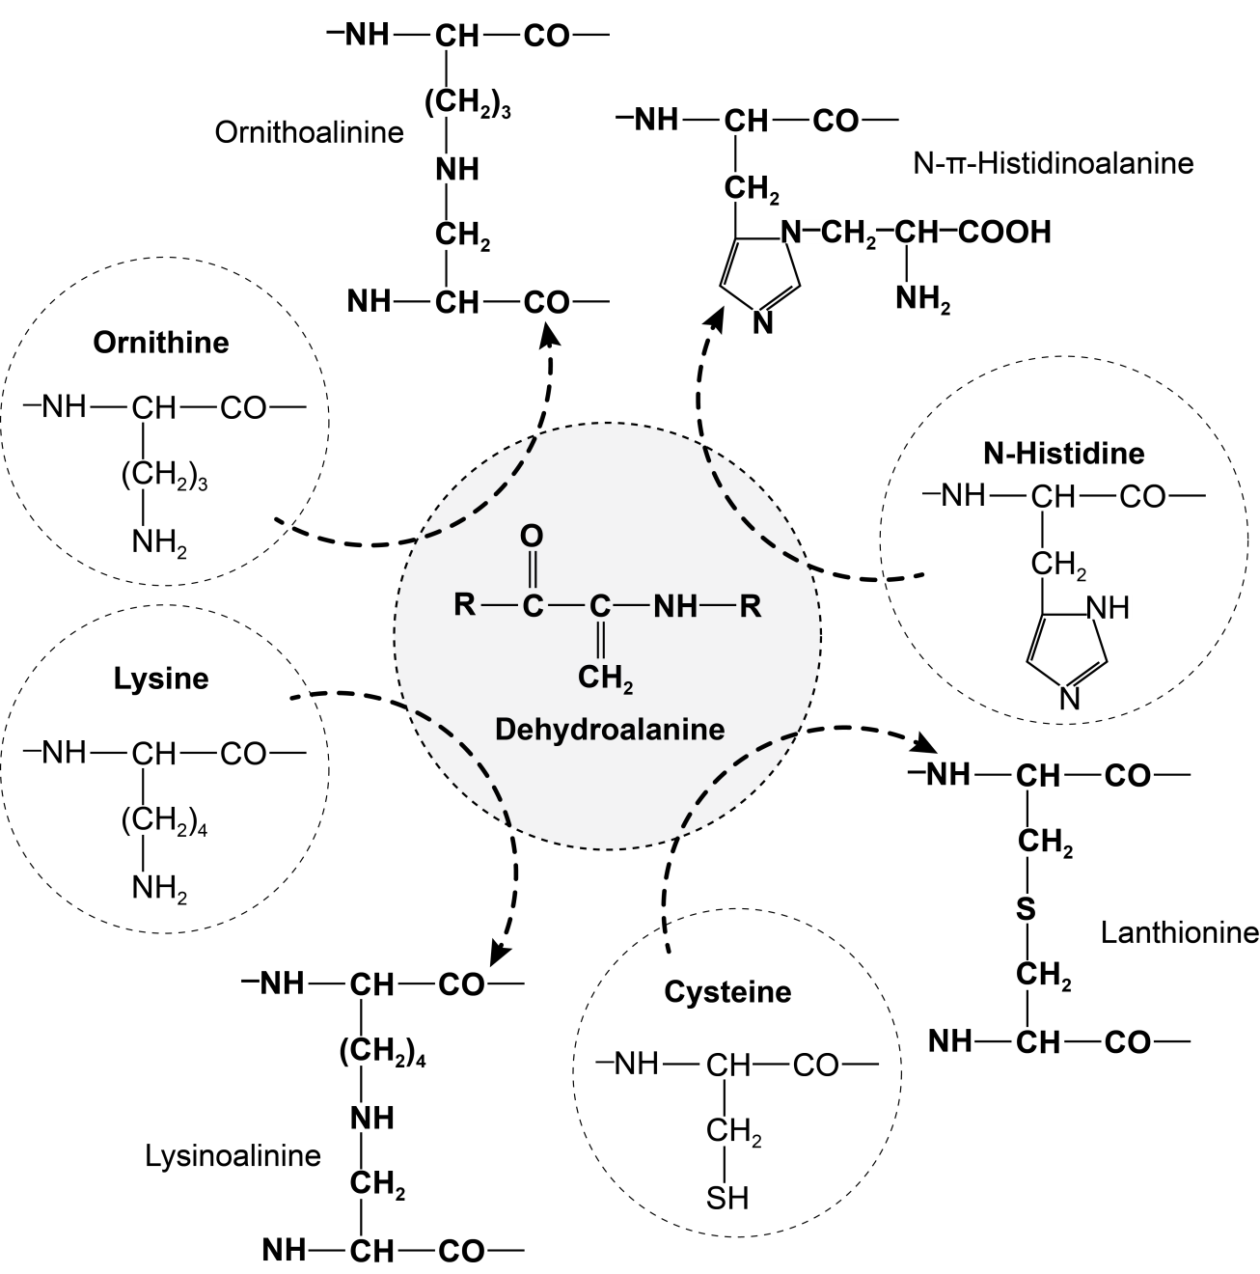

Figure 1.10 Formation of cross-linked peptides.
Source: Adapted from Damodaran, S. Amino Acids, Peptides and Proteins in Food Chemistry 3rd Edition, O.R.Fennema, Editor. 1996, Marcel Dekker, Inc.: New York, NY p. 406.

formation of histidinoalanine. Since histidine is ionized at neutral pH (5.5 compared to 10 for lysine), the formation of histidinoalanine will be more prevalent under neutral pH conditions.[230]
Some microorganisms can utilize lysinoalanine (LAL) as a source of lysine but it has significantly reduced bioavailability in mammals. LAL formation results in a decrease in digestibility due to the inability of trypsin to cleave the peptide bond in the LAL cross-link. Also, steric interference imposed by the cross-links prevents hydrolysis of other peptide bonds in the surrounding area.[230] Any absorbed portion is largely excreted as free LAL in urine.[230] Studies in rats have found that feeding alkaline-treated proteins results in changes in kidney cells characterized by enlargement of the nucleus due to changes in DNA synthesis and mitosis, called “nephrocytomegaly”. The affected cells are principally the epithelial cells of the straight portion of the proximal renal tubules.[231] The mechanism of the underlying pathology is unknown. Because LAL contains 2 amino and 2 carboxyl groups which can serve as potential metal ion chelation sites, it has been speculated that the nephropathy may be due to metal ion chelation.[230] LAL is known to have a high affinity for copper ions resulting in increased copper excretion. The divalent cations iron and zinc are also at increased risk for chelation and loss.[230]
Heterocyclic amines (HAA) found in cooked protein foods are formed by several mechanisms including carbohydrate caramelization, protein pyrolysis, amino acid/creatinine reactions and Maillard reactions producing melanoidins, and carbolines.[232] Heterocyclic amines are generated in protein foods at normal or very high cooking temperatures and have been divided into 2 categories based on precursors and temperature of formation. Those found at moderate cooking temperatures (190-200°C) are formed from the reaction of Maillard reaction products and creatinine.[232] Figure 1.11 diagrams the formation of heterocyclic amines from Maillard products and creatinine. These compounds have been detected in all muscle sources when foods are cooked to a well done but not charred state.[232] No HAA’s have been detected in raw beef prior to processing.[232] HAAs found in cooked proteins are in the parts per billion or ng/gm food. Heterocyclic amines are potent mutagens inducing a variety of tumors in rodents when given at mg/kg of body weight.[233] The melanoidins produced at moderate cooking temperatures are toxic over longer periods and appear to be cumulative in their toxicity.[232] Typical cooking temperatures for extruded pet foods are between 80-200°C and up to 121°C for canned foods.[234]

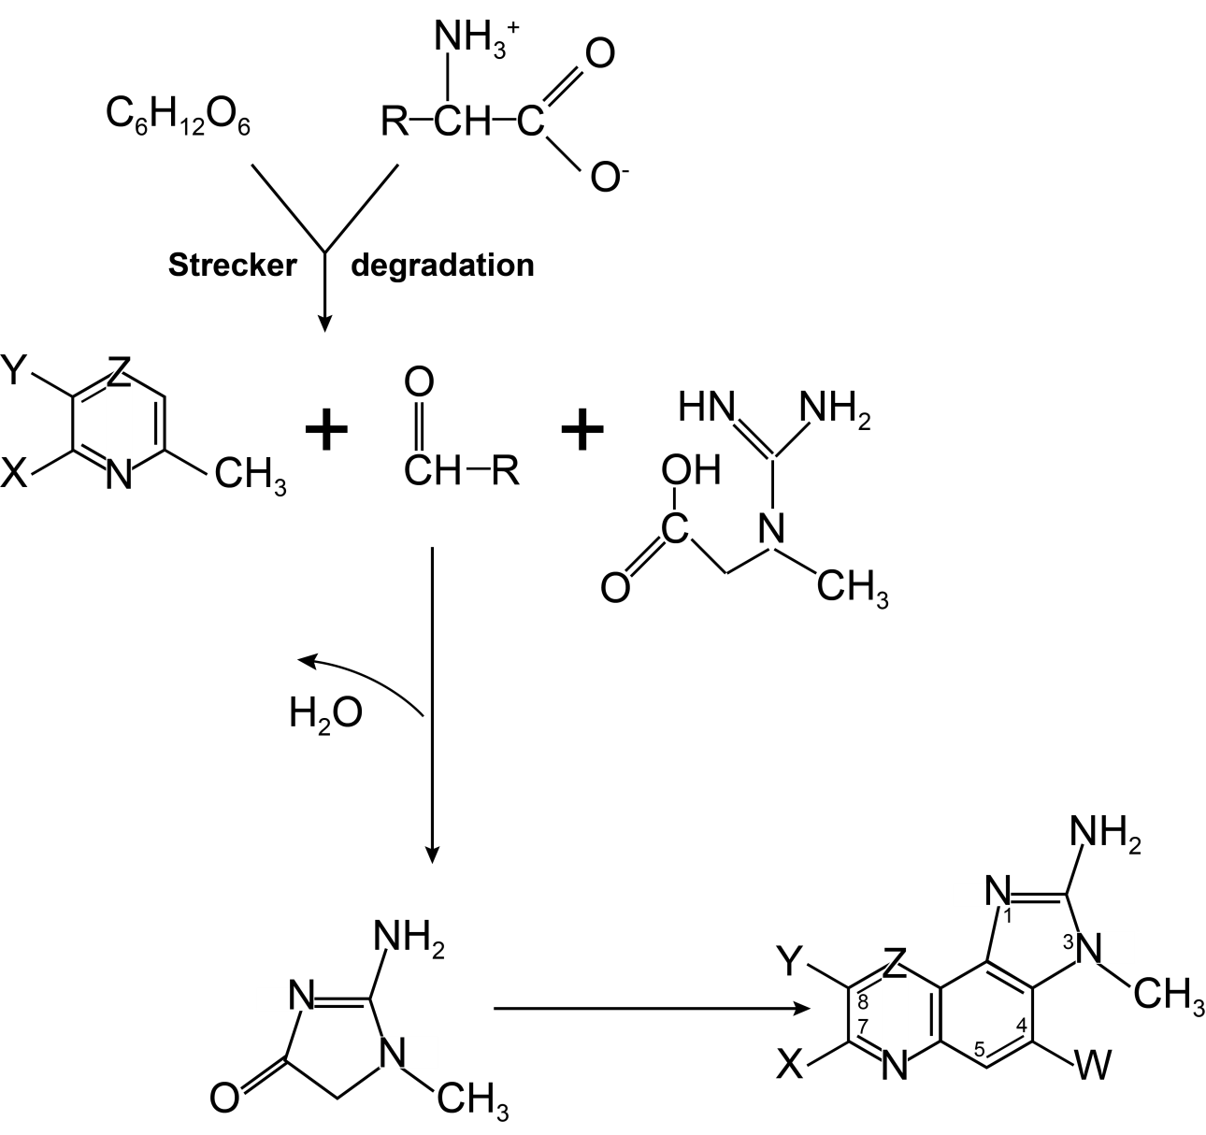
creatine
aldehyde
pyridine
or pyrazine
α Amino Acid
Hexose
IQ compound
creatinine

Figure 1.11 Proposed formation of heterocyclic amines (IQ) compounds from Maillard reaction products (pyridines and pyrazines) and creatinine. W, X, and Y may be hydrogen or methyl groups; Z may be CH or N.
Source: From Jagerstadt, M; Skog, K. Formation of meat mutagens. In Nutritional and Toxicological Consequences of Food Processing; Friedman, M., Ed.; Plenum: New York, 1991; p. 86.

Oxidation in food processing can be caused by a number of different oxidants including oxygen in the presence of catalytic metal ions, photo-oxidation due to light sensitive pigments, and enzymes such as polyphenol oxidases or lipid peroxides.[222] Sterilization of packaging by hydrogen peroxide can cause oxidation of proteins. Unsaturated lipids can undergo oxidation in the presence of heat, light, or catalysts to form hydroperoxides, aldehydes, ketones, and carboxylic and polymerization products.[9] Hydroperoxides can oxidize methionine, cysteine and tryptophan while the aldehydes and ketones can react with lysine residues. Methionine is considered the 1st limiting amino acid in processed cat foods while tryptophan is a limiting amino acid in corn based diets.[12] Figure 1.12 diagrams oxidation of methionine, cysteine and cystine. The first product of methionine oxidation is methionine sulfoxide and further oxidation forms methionine sulfone.[222] Methionine and cysteine becomes biologically unavailable once they are oxidized to sulfones.[222]

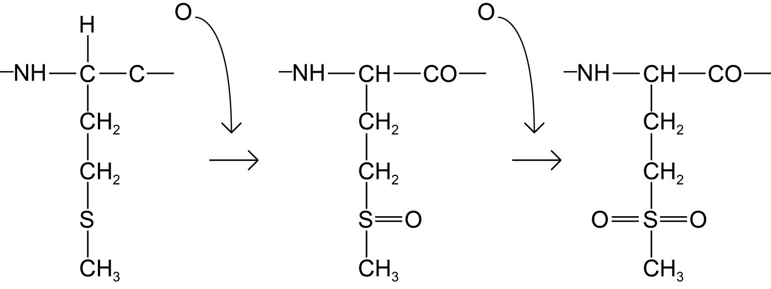
Methionine sulfone
Methionine sulfoxide
Methionine

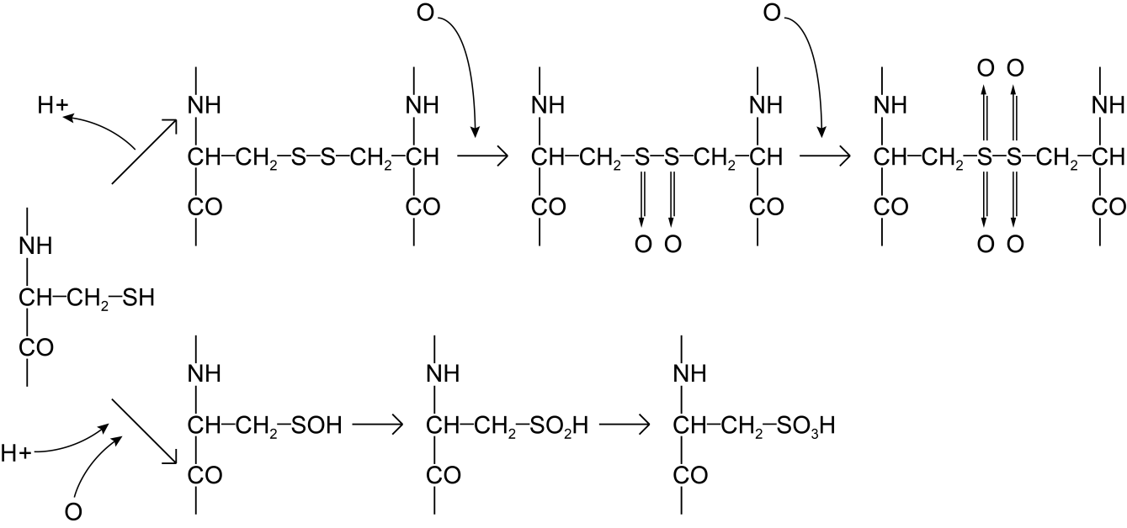
Cystine mono- or
disulfone
Cystine mono- or
disulfoxide
Cystine
Cysteine
sulfinic acid
Cysteine
Cysteine
sulfonic acid
(cysteic acid)
Cysteine
sulfenic acid

Figure 1.12 Methionine, cysteine, and cystine oxidation. Methionine is easily oxidized to methionine sulfoxide by various peroxides. Under strong oxidizing conditions, methionine sulfoxide is further oxidized to methionine sulfone. At acidic pH, oxidation of cysteine and cystine results in formation of several intermediate oxidation products. Cystine mono- or disulfone, cysteine sulfinic acid, and cysteic acid are not biologically available.
Source: From Damodaran, S. Amino Acids, Peptides and Proteins in Food Chemistry 3rd Edition, O.R.Fennema, Editor. 1996, Marcel Dekker, Inc.: New York, NY p. 410

Tyrosine is also susceptible to oxidation. Figure 1.13 diagrams oxidation of tyrosine. Exposure of tyrosine to oxidizing agents results in the formation of dityrosine crosslinks. Exposure of tyrosine to the enzyme polyphenol oxidase results in the hydroxylation of tyrosine to DOPA (dihydroxyphenylalanine) and phenols such as dopaquinones.[224] Quinones can then undergo further oxidation to brown melanin pigments or participate in additional polymerization reactions with protein functional groups to form cross-linked proteins.

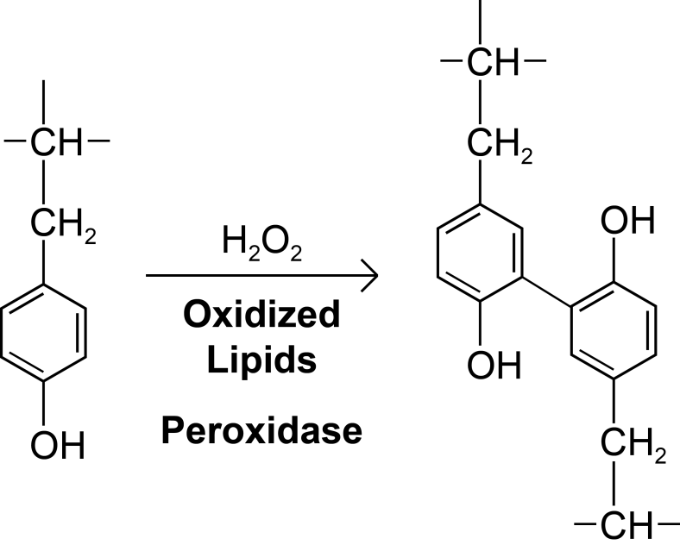
Tyrosine
Dityrosine

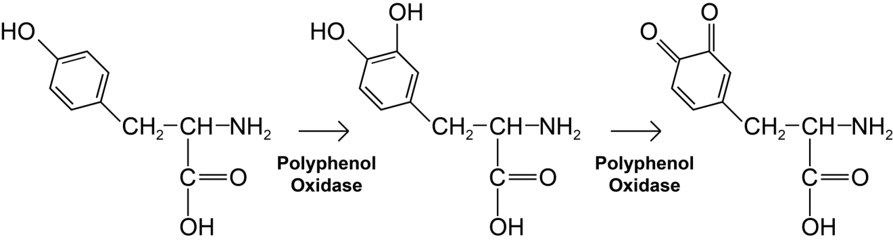
dopaquinone
DOPA
Tyrosine

Figure 1.13 Tyrosine oxidation. a) Exposure of tyrosine to H2O2 or peroxidases results in oxidation of tyrosine to dityrosine. b) The enzyme polyphenol oxidase catalyzes two reactions- hydroxylation of tyrosine to dihydroxyphenylalanine (DOPA) and oxidation of DOPA to quinones.
Sources: Adapted from Damodaran, S. Amino Acids, Peptides and Proteins in Food Chemistry 3rd Edition, O.R.Fennema, Editor. 1996, Marcel Dekker, Inc.: New York, NY p. 412. And Friedman, M. Food Browning and Its Prevention: An Overview. J. Agric Food Chem. 1996. 44(3): p. 638.
Tryptophan is particularly reactive under processing conditions due to the indole ring.[235] Figure 1.14 illustrates oxidation of tryptophan and its derivatives formed during processing. The indole ring is susceptible to oxidative cleavage and substitution, reaction with aldehydes, and formation of heterocyclic amines.[235] Under acidic, mild oxidizing conditions it is oxidized to beta-oxyindolyalanine.[222] Under more severe oxidizing conditions such as peroxidized lipids or hydrogen peroxide, it is oxidized to N-formylkynurenine and kynurenine.[222] Tryptophan can also condense with aldehydes and cyclize to form dihydro-beta carboline.[235] Maillard reactions can also occur between the aldehydes formed during free-radical degradation. Kynurenine is a known carcinogen in animals, while carbolines show significant mutagenic activity and hepatocarcinogenicity.[235] Many commercial cat foods are acidic and subject to oxidation with the potential for oxidative compounds to form.

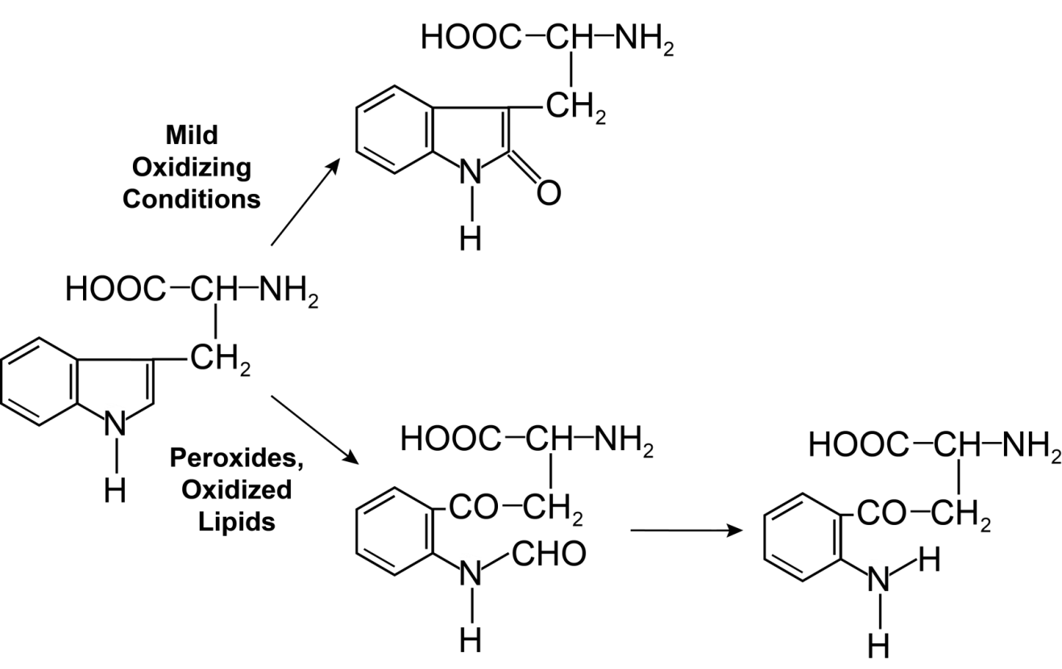
N-formylkynurenine
β-Oxyindolylalanine
Tryptophan
Kynurenine

Figure 1.14 Tryptophan derivatives from food processing. Under mild oxidizing conditions, tryptophan is oxidized to β-Oxyindolylalanine. Under more severe oxidizing conditions, tryptophan is oxidized to N-formylkynurenine and kynurenine.
Source: From Damodaran, S. Amino Acids, Peptides and Proteins in Food Chemistry 3rd Edition, O.R.Fennema, Editor. 1996, Marcel Dekker, Inc.: New York, NY p. 410.

Figure 1.15 summarizes cross-linking reactions that can occur during food processing. Any of the amino acids can undergo racemization and both free and bound D-amino acids result in significant decreases in digestibility. Listed below are the essential amino acids vulnerable to food processing alterations and the potential reactions that can occur.

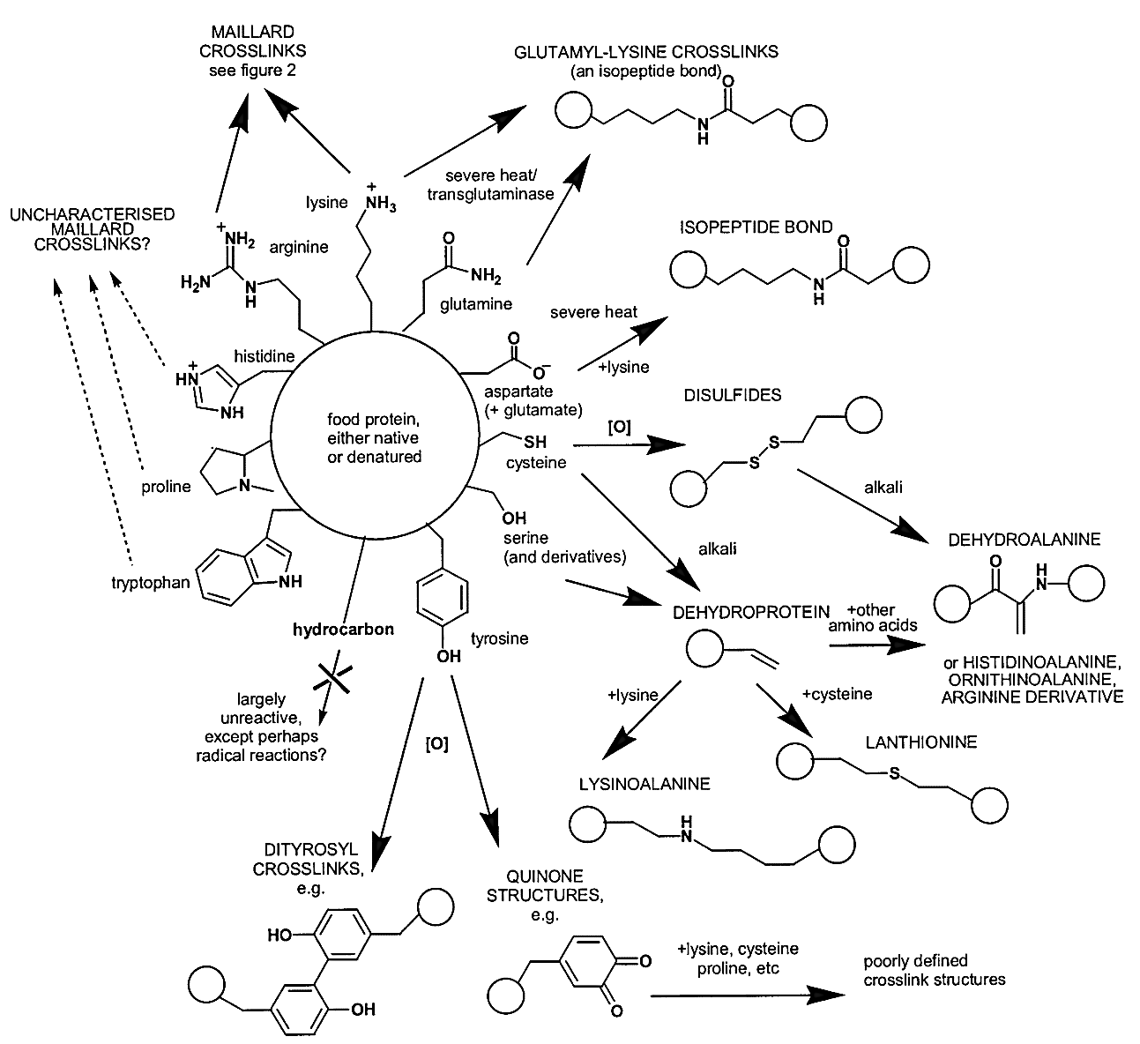

Figure 1.15 Summary of crosslinking reactions that can occur during food processing. Details are given in the text.
Source: Reprinted with permission from Gerrard, J.A., Protein-protein crosslinking in foods: methods, consequences and applications. Trends Food Sci Tech 2002: 13; p 392.

Lysine: Chemical modifications during food processing are dominated by reactions of lysine. Lysine is the most chemically reactive of the amino acids with its ε-amino group particularly vulnerable to damage. Heating in the absence of fats and carbohydrates can lead to reaction of lysine residues with amide side chains forming the isopeptides glutamyl-lysine and aspartyl-lysine, either free or protein-bound. The major cause of lysine degradation in processing is the Maillard reaction i.e. reaction of the amino group with carbonyl groups of sugars and fatty acids. Testing of lysine availability after processing in pet foods has been found to be significantly reduced.[208, 236] Lysine also forms cross-linked proteins such as lysinoalanine.
Arginine and Histidine: Arginine can undergo Maillard reactions and arginine and histidine can undergo formation of cross-linked dehydro residues.
Methionine: Methionine is principally subject to oxidation in food processing forming methionine sulfoxide and methionine sulfone. In one study, methionine bioavailability was reduced by 25% in heat processed casein compared to raw casein.[237]
Cysteine: Cysteine can be oxidized to disulfoxides and disulfones. Cysteine and cystine can undergo elimination to form cross-linked dehydro residues.
Tryptophan: Tryptophan can undergo oxidation to form carcinogenic carbolines and nitroso compounds. It can also under Maillard reactions with aldehydes.
Serine and Threonine: Phospho-serine/threonine can undergo elimination reactions to form a methyldehydroalanine with subsequent cross link formation.
Taurine: The amount of taurine retained after processing depends on the method of food preparation. Taurine is water-soluble and most of the taurine contained in tissues will be released into water if exposed.[238] Taurine losses from processing, in order of least to greatest is: fried with juices retained < frying without juices retained < baking or boiling.[238] Boiling results in the greatest taurine loss because the food is surrounded by water with resultant leeching.[238] A significant loss of bioavailable taurine occurs secondary to the presence of Maillard reaction products within food. Cats fed heat-processed diets were found to have depletion of plasma and whole blood taurine due to increased microbial fecal cholyltaurine hydrolase activity resulting in increased taurine deconjugation and excretion.[239] Giving antibiotics reversed these findings indicating that Maillard reaction products promote an enteric flora that favors degradation of conjugated taurine with decreases in taurine recycling and increase loss in the feces.[10]

Effects of processing on vitamins

There are 13 recognized vitamins divided into 2 categories based on their solubility characteristics. These include 4 fat soluble vitamins and 9 water soluble vitamins. Table 1.8 lists the vitamins and some commonly used synonyms. With the exception of Vitamin C in most mammals, vitamins are essential in the diet and have important metabolic functions. These include acting as 1-coenzymes or their precursors (thiamine, riboflavin, niacin, biotin, pantothenic acid, pyrixidol, cobalamin and folate), 2- antioxidants (Vitamin C and E, carotenoids), 3- factors in gene regulation (Vitamin A, D), 4- specialized functions such as Vitamin A in vision, and Vitamin K in specific carboxylation reactions. Processing causes variable losses of vitamins depending on the temperature, presence of oxygen, light, moisture, pH and duration of heat.
Vitamin A is a group of unsaturated hydrocarbons including retinol and related compounds (retinal and retinoic acid) and carotenoids. Retinol and carotenoids are sensitive to oxidation and loss of activity is usually associated with oxidation and isomerization.[240] Factors that promote oxidation of unsaturated fatty acids enhance degradation of Vitamin A, either by direct effects of oxidation or indirectly via the formation of free radicals. Retinoids and carotenoids are fairly stable during thermal processing, but can be inactivated by light or acid.[240, 241] Studies have shown losses of retinol in processing ranged from 5-43%.[242, 243] The loss of β-carotene in cooked vegetables ranged from 10-59%.[244]
Vitamin D is relatively stable during processing. Like other unsaturated fat-soluble components, Vitamin D is susceptible to oxidation, isomerization, and degradation by light.[240, 241] The level of fat in the food matrix will affect its retention. A high fat content results in greater Vitamin D loss due to fat dripping off. Bennick reported losses of vitamin D in cooked beef ranging from 35-40%.[245]
Vitamin E is the generic term for tocopherols and tocotrienols. When not esterified to other compounds, they function mainly as antioxidants. Tocopherols are relatively stable to heat in the absence of oxygen, but will degrade in oxygen or in the presence of fatty acid peroxides.[241, 246] Bennick observed losses of 33-44% during heat treatment of beef while Leskova found losses of 20-60% in processed meat.[243, 245]
The various forms of Vitamin K are relatively stable to heat and are retained after most cooking processes. Vitamin K can be destroyed by sunlight and decomposed by alkaline treatment.[243] Vitamin K is slowly degraded by atmospheric oxygen. [241]
In general, heating in water will lead to large losses of the water-soluble vitamins due to leaching into the aqeous fluid. Losses depend on the degree of heat and surface area exposed to water. Because of its high solubility in water, Vitamin C or ascorbic acid can have significant losses from leaching. The loss of Vitamin C in vegetables during processing ranges from 1% (steaming) up to 75% (boiling) due to leaching.[243] Ascorbic acid, being an intracellular antioxidant, can readily lose an electron and be subject to oxidation. Trace metals, acting as catalysts for formation of oxygen radicals, increase the degradation of Vitamin C. Copper (Cu⁺² ) is the strongest free radical generator followed by iron (Fe⁺³⁾, and zinc (Cu⁺² > Fe⁺³ > Fe⁺² > Zn⁺²).[241] Copper levels as low as 0.85 ppm are sufficient to catalyze oxidation, resulting in subsequent vitamin loss.[241] While cats do not have an absolute requirement for Vitamin C, it is still an important antioxidant and be conditional in animals that do not have an absolute dietary requirement.

Table 1.8 Vitamins and commonly used synonyms

Vitamin Group | Synonyms
Fat-soluble
Vitamin A | Retinol
 | Retinal
 | Retinoic Acid
ProVitamin A | α,β,γ-Carotene
Vitamin D | Ergocalciferol (D₂)
 | Cholecalciferol (D₃)
Vitamin E | α,β,γ,δ-Tocopherols
 | α,β,γ,δ-Tocotrienols
Vitamin K | Phylloquinone (K₁)
 | Menaquinone (K₂)
 | Menadione (K₃)
Water-soluble
Vitamin C | Ascorbic acid
 | Dehydroascorbic acid
B-Complex
Vitamin B₁ | Thiamine
Vitamin B₂ | Riboflavin
Vitamin B₃ | Niacin
 | Nicotinic acid
 | Nicotinamide
Vitamin B₅ | Pantothenic acid
Vitamin B₆ | Pyridoxine
 | Pyridoxal
 | Pyridoxamine
Vitamin B₁₂ | Cobalamin
 | Cyanocobalamin
Folate | Folate, Folic acid
Biotin | Biotin

Thiamine is one of the least stable of the water-soluble B-vitamins. Thiamine degradation during processing is primarily due to splitting of its methylene bridge resulting in pyrimidine and thiazole.[247] This reaction is influenced by oxidation-reduction, inorganic bases (sulfites and bisulfites), metals, and thiaminases.[247] Leskova found losses of thiamine in meat ranged from 15-80% during processing.[243] Losses during heat treatment of meat (frying, braising, cooking, roasting) varied significantly depending on the water and fat content. Large losses of thiamine can occur secondary to leaching into the surrounding media during heating.[243] Conversely, higher fat content may act as a protective mechanism. Rhee found that thiamine retention was higher in ground beef with higher fat content secondary to less water loss during cooking.[248] Thiamine losses can be seen in processed meat where sulphites and bisulphites are used as preservatives.[241] Ingestion of certain raw fish and shellfish can result in thiamine deficiency due to the presence of thiaminases. In these cases, heat processing improves bioavailability as thiaminases are destroyed by cooking.[249]
Riboflavin is resistant to dry heat, acid solutions and oxygen, but sensitive to light.[241] The mechanism of degradation of riboflavin is photochemical, producing lumiflavin, lumichrome and various free radicals.[240] Riboflavin is a photosensitizer with excitation and degradation in the 420 to 560 µm wavelength range.[241] Milk exposed to light lost between 20-80% of its riboflavin content in 2 hours.[241] Products packaged in transparent packaging can also result in riboflavin degradation. Woodcock found that pasta samples exposed to sunlight lost 57-64% of their riboflavin content within 2 days.[250] Leaching into aqueous medium results in relatively small losses of riboflavin. Leskova found 18% losses in meat when exposed to lengthy boiling.[243]
Niacin is a fairly stable water-soluble vitamin. Niacin is not affected by light and is stable during heating.[240] Losses of niacin are caused mainly by leaching into cooking water. Retention of niacin in meats and legumes was found to be in the range of 45-90% with processing.[243] Niacin complexes with carbohydrates, proteins and phenols in certain cereal products, making it biologically unavailable.[240] Alkaline treatment releases bound niacin making it available.[241]
Pantothenic acid is widely distributed in plant and animal sources and can be found existing in food in both the free form and as part of the compounds acyl carrier protein (ACP) and coenzyme A (CoA). Losses in thermal processing are proportional to the severity of treatment and the extent of leaching.[240] In canned foods of animal origin, losses ranged from 20-25%, and in canned vegetables from 46-78%.[251] Losses are attributed to release of bound form, hydrolytic cleavage and subsequent leaching into water.[241]
Biologically active forms of Vitamin B6 include pyridoxal, pyridoxamine and pyridoxine. All three forms function as coenzymes in over 100 enzymatic reactions involving metabolism of amino acids, carbohydrates, and lipids.[240] Nearly half of these reactions involve transamination of amino acids.[12] Pyridoxine is found primarily in vegetables, legumes, grains and cereals, whereas pyridoxal and pyridoxamine are found in meats, poultry, fish and dairy products. The rate of degradation of Vitamin B6 is dependent on the form of the vitamin, temperature, pH and presence of reactive compounds within the matrix.[240] Pyridoxine has greater stability with processing than either pyridoxal or pyridoxamine.[252] Pyridoxal can bind to lysyl ε-amino groups and protein sulfhydryl groups resulting in reduced activity.[240] Vitamin B6 can also be converted to biologically inactive compounds by reactions with free radicals generated during degradation of amino acids.[240] Overall losses of 20-60% were found in canned meats while canned vegetables resulted in losses of 20-40%.[241]
Vitamin B12 or cobalamin is generally considered to be stable under most food processing conditions, but like all water-soluble vitamins, it can be subject to large losses through leaching into cooking water.[241] Cobalamin can be decomposed by oxidation and is sensitive to light and ultraviolet radiation.[241] Rhee found losses up to 33% in beef, lamb and pork at temperatures of 150° Celsius for 6.5 minutes.[248]
Folic acid and folates are a group of compounds consisting of glutamic acid coupled to para-aminobenzoic acid, which in turn is linked to hydroxypteridine. Folates serve as donors and acceptors of one-carbon units in amino acid and nucleotide metabolism.[12] Naturally occuring folate forms a number of derivatives which contain one or more linked molecules of glutamate. Folic acid synthesized for food fortification contains only one glutamate group. Monoglutamate folic acid has good retention during processing and storage of fortified foods. In contrast, large losses of naturally occuring folate can occur with processing. Folates are susceptible to oxidative degradation and leaching into aqueous cooking media.[240, 243] Folates found in animal tissues had losses of between 20-45%. Processing of vegetables lost up to 56% of folate activity.[243, 253] The presence of reducing agents in the thermal processing can reduce folate losses while the presence of metals can increase folate losses secondary to oxidation.[243]
Biotin is generally regarded as having good stability, being stable in oxygen, heat and light. Biotin can be destroyed by heating in strong acid or alkaline solutions due to hydrolysis of the amide bond of the biotin ring.[240] Dietary biotin generally exists bound to proteins requiring extraction by enzymes or acid hydrolysis. Only the free form is water extractable thus explaining why biotin retention is higher than the other water-soluble vitamins.[243] Avidin, a protein found in raw egg albumen, binds biotin and makes it unavailable.[240] In general, average biotin losses during heat treatment were 20% in meat, 10-15% in milk, 15% in legumes and 30% in fruits and vegetables.[243] Deficiencies of biotin rarely occur in dogs and cats unless they are consuming a diet with raw egg whites.[12]
As a consequence of expected losses during processing, pet food manufacturers commonly add vitamin supplementation to their formulas. In a study examining losses of vitamins in commercial pet food processing, significant losses of Vitamin A, β-carotene, Vitamin C, thiamine and pyridoxine were found.[234] Table 1.9 lists the vitamin losses found during processing and storage of cat foods. Vitamin A, carotenoids, Vitamin E, thiamine, folate and pyridoxine in dry cat foods showed losses of between 9.6-26.3%. Canned processing resulted in losses of cobalamin, thiamine, pyridoxine, Vitamin C and beta-carotene. Significant losses also occurred during storage.[234] Manufacturers typically add sufficient vitamins to account for such processing and storage losses.
Potential processing losses and reduction in bioavailability become a more significant issue when the diet recipient is fed one source or type of food such as infant formula or commercial pet foods. Subsequent to supplementation, numerous reports have been described of thiamine deficiency in cats fed commercial cat foods.[254-257]

Table 1.9 Vitamin losses during processing and storage of cat foods.

 | Dry cat food |  | Moist cat food
Vitamin | Processing** | Storage*** | Processing** | Storage***
Vitamin A | 26.3 | 0.0 | 0.0 | 0.0
Β-carotene | 19.7 | - | 43.7 | -
Vitamin E | 20.6 | 31.6 | 0.0 | 9.2
Vitamin C | 0.0 | 12.4 | 100.0 | -
Thiamine | 11.8 | 34.2 | 51.7 | 0.0
Riboflavin | 0.0 | 21.2 | 0.0 | 38.0
Niacin | 3.3 | 20.0 | 0.0 | 31.7
Pantothenic acid | 0.0 | 4.8 | 0.0 | 0.0
Pyridoxine | 11.5 | 10.0 | 18.5 | 0.0
Cobalamin | 0.0 | 38.0 | 5.7 | 11.3
Folic Acid | 9.6 | 23.1 | 0.0 | 20.0
Biotin | 0.0 | 0.0 | 0.0 | 0.0
NOTE: ** % of vitamin loss during processing, *** % of vitamin loss during 18 months of storage.
Source: Adapted from Cowell, CS, et al., Making Commercial Pet Foods. In: Small Animal Clinical Nutrition, 4th Edition. Topeka: Mark Morris Institute, 2000, p. 133.

Probiotics in Cats

Probiotics are defined as “non-pathogenic microorganisms which, when ingested exert a positive influence on host health or physiology.”[258] Clinically in human beings, probiotic efficacy has been shown in the treatment for inflammatory bowel diseases, diarrhea, irritable bowel syndrome, gluten intolerance, gastroenteritis, allergy, and colon cancer.[259] To qualify as a probiotic, microorganisms need to meet certain criteria including:[260]
- Species identification at the genus, species, and strain level
- Nonpathogenic
- Not carry transferable antibiotic-resistance genes
- Susceptible to antibiotics
- Able to survive intestinal transit, i.e. acid and bile tolerant
- Able to adhere to mucosal surfaces
- Able to colonize the intestine (at least temporarily)
- Produce clinically documented and validated health effects
- Stability during processing and storage.
Bacteria that meet these criteria are generally lactic acid bacteria, most commonly Lactobacillus and Bifidobacterium species, but Lactococcus, Streptococcus and Enterococcus , as well as some nonpathogenic strains of E. coli and certain yeast strains also qualify.[260]
As described earlier, the gastrointestinal microbiome is a complex ecosystem with hundreds of bacterial species, many yet to be identified. Substantial variation exists at the genus and species level between individuals.[261] Responses to probiotics are influenced by an individual’s specific commensal microflora. To complicate matters further, effects of probiotics are known to be strain specific.[262] Despite the difficulty in defining a healthy intestinal microbiota, there are studies indicating differences in gut microbiota composition between individuals with certain intestinal or immune-mediated diseases and healthy controls.[263, 264] Studies from both in vitro and in vivo have shown that probiotics produce specific enzymes and metabolites that directly regulate the intestinal microbial environment and modulate intestinal epithelial cell or immune cell responses.[260, 265] These effects include maintaining microbial balance, inducing protective responses from intestinal epithelial cells and regulating immune function.[260, 265]
Probiotics have known activity against several pathogens, including pathogenic E.coli, Salmonella spp., Helicobacter pylori and rotavirus.[266] At least 2 mechanisms of action are involved in maintenance of microbial balance: production of antimicrobial substances and competitive inhibition of pathogen and toxin adherence to the intestinal epithelium.[265] Lactobacilli produce small antimicrobial peptides called bacteriocins.[267] They have a relatively narrow spectrum of activity and are generally toxic to other Gram-positive bacteria including Streptococcus spp., Staphylococcus spp., Listeria spp. and Mycobacteria. Their primary mechanism of action is pore formation in the cytoplasmic membrane, disrupting cell integrity. Several strains of Bifidobacteria also produce bacteriocin-like compounds toxic to both Gram-positive and Gram-negative.[268]
Probiotic bacteria, including Lactobacillus spp. and Bifidobacterium spp., produce acetic, lactic and propionic acid.[265] These acids decrease local pH leading to growth inhibition of a wide range of gram-negative bacteria. One study found that lactic acid or low pH acted by increasing the permeability of bacterial outer membranes to other antimicrobial substances.[269] Probiotics also decrease adhesion of both pathogens and their toxins to the intestinal epithelium through competition for attachment sites. In some cases, probiotics can displace pathogenic bacteria even after the pathogens have attached to intestinal epithelial cells prior to treatment. These effects are primarily achieved by blockage of carbohydrate binding sites for the pathogens or toxin on the epithelial cells.[270-273]
The intestinal epithelium is the first line of defense and forms a physiological barrier against pathogenic substances in the intestinal lumen. Probiotics stimulate intestinal epithelial cell responses including restitution of damaged epithelial barrier, and production of antibacterial substances and cell-protective proteins in cell cultures. [265] An effective epithelial barrier system requires tight junctions between cells. In mice,

VSL#3¹, a commercial probiotic mixture of 8 bacterial strains, inhibited enteropathogenic E.coli-induced increases in paracellular permeability and prevented Salmonella-induced tight junction dissolution by junctional protein redistribution [265] Probiotics have also been shown to enhance barrier function through upregulation of secretory IgA levels. [274] Heat-shock proteins are constitutively expressed in epithelial cells and induced by stress to maintain intestinal homeostasis and defense. Heat shock proteins, also called molecular chaperones are defined as a “protein that binds to and stabilizes another protein-and by controlled binding and release of the substrate protein, facilitates its correct fate in vivo: be it folding, assembly, transport to a particular subcellular compartment, or controlled switching between active/inactive conformations.”[275] Soluble factors present in Lactobacillus rhamnosus culture supernatant were found to induce heat shock protein synthesis in intestinal epithelial cells. [276]
Activation of nuclear factor kappa beta (NF-Kβ) plays an important role in intestinal inflammation.[277] NF-Kβ, a transcription factor in the cytosol which upon stimulation, translocates into the nucleus, activates numerous genes associated with inflammation.[277] Inducers of NF-Kβ include TNF-α, IL-1, lipopolysaccharide, and oxidative stress. In turn, NF-Kβ activates numerous genes associated with inflammation.[277] Probiotics inhibit NF-Kβ induction resulting in reduced levels of pro-inflammatory cytokines and chemokines by intestinal epithelial cells.[278] Lactic acid bacteria also induce significant levels of IL-10, an inhibitor of pro-inflammatory cytokines.[279]
Mammalian toll-like receptors (TLRs) and nod-like receptors (NODs) comprise a large family of surface and intracellular proteins used in the detection of specific microbial components from bacteria, fungi, protozoa and viruses.[280, 281] These proteins enable the host to detect the presence of infection and to signal an appropriate immune response. Components recognized as ‘ligands’ for TLR’s and NOD’s include lipids, lipoproteins, proteins, and nucleic acids from a wide range of microbes, both pathogenic and commensal.[280, 281] Probiotic bacteria, similar to pathogenic bacteria are ligands for TLR’s and NOD’s. The ability of the immune system to distinguish pathogenic from commensal bacteria and elicit either an inflammatory response or regulatory response is an area of ongoing research. Mechanisms that have been proposed in this differentiation include the cellular locations of TLR’s and NOD’s. Apical but not basolateral stimulation of TLR inhibited NF-Kβ activation in intestinal epithelial cells.[282] A second mechanism proposed was probiotics contain components which pathogenic bacteria do not resulting in differential activation of TLRs.[283] A third mechanism proposed was that probiotic-induced cellular effects may be due to synergistic effects of TLRs, which cannot be or are differentially regulated by pathogenic bacteria.[284] Synergistic responses have been reported between TLR’s such that
multiple ligands produced higher levels of cytokines compared to individual TLR activation.[284]
Lactobacillus acidophilus has been shown to induce immunostimulatory effects in adult dogs [285], and Enterococcus faecium was reported to stimulate immune function
______________________________________________________________________
¹ VSL#3®, VSL Pharmaceuticals, Inc. Gaithersburg, MD
in young dogs [286]. But physiological and dietary differences between dogs and cats do not allow extrapolation of these studies. Three studies have been reported on cats and probiotics.[287-289] One study involved supplementation with Lactobacillus acidophilus in adult cats [287], the other two involved use of Enterococcus faecium (SF68) in kittens and adult cats [288, 289]. In the Lactobacillus study, 15 adult DSH were fed a dry basal diet for 4 weeks, followed by the same diet supplemented with Lactobacillus for 4.5 weeks, and then 5 weeks back on the basal diet. Weight, food intake, CBC, serum biochemistry, serum immunoglobulins and acute phase proteins were analyzed at the end of each period along with percentage and number of bacteria phagocytized using flow cytometry and overall fecal flora diversity using culture and fluorescent in situ hybridization (FISH) techniques.[287] The probiotic strain was recovered from the feces of the cats. There were no significant differences in weight, food intake, serum biochemistry, acute phase proteins, serum immunoglobulins, or percentage of cells undergoing phagocytosis, throughout the 3 periods. Immunomodulatory effects were small. These included significant increases in the number of bacteria phagocytized per granulocyte during the probiotic period and an overall decrease in total lymphocyte and increase in eosinophil numbers over the entire study period. Changes were noted in bacterial diversity during probiotic feeding. Clostridial numbers were significantly reduced during the probiotic feeding phase but increased again following the cessation of probiotic supplementation. Coliform and Enterococcus spp. numbers decreased during the entire course of the study.[287]
Two studies, one with kittens and the other with adult cats, have been published examining the effects of the probiotic bacteria Enterococcus faecium SF68 in domestic felines.[288, 289] The first study had 2 groups of kittens aged 8-28 weeks.[289] One group was supplemented with Enterococcus faecium while the other was the control group. The kittens were vaccinated for feline herpes virus (FHV), calicivirus and feline panleukopenia virus (FPV) with a modified live combination vaccine¹ at 9 and 13 weeks of age. Weight, complete blood counts, biochemistry panels, urinalyses, serum FHV specific IgG and IgA, CD4/CD8 ratios, cell-mediated responses to concanavalin A, and salivary FHV IgG and IgA were analyzed at 7, 9, 15, 21 and 27 weeks of age. Fecal ELISA samples were analyzed for Clostridium perfringens enterotoxins, Clostridium difficile toxin A or B, and cultures for Salmonella spp and Campylobacter spp. were performed. Fecal PCR for Enterococcus faecium was also done to determine whether the probiotic bacteria was found in the kitten’s stools. Feces from seven of the nine treated cats were positive for E. faecium during at least one time point during the study. PCR quantification though does not specify viability. E. faecium was not found in any of the treated cat’s feces one week after supplementation was discontinued (week 28). Neither Salmonella spp. nor Campylobacter spp. were detected in any feces, and the numbers of positive samples for Clostridium difficile toxin or Clostridium perfringens enterotoxin were not significantly different between the 2 groups.[289] There were no significant differences in any of the above parameters with the exception of significantly increased CD4/CD8 ratios in the kittens fed the probiotic at the end of the study.[289] Additional cytokine profiles or cell surface marker
______________________________________________________________________
1.Felocell®, Feline herpesvirus-1, calicivirus, and panleukopenia vaccine, Pfizer Animal Health. New York, NY

characterizations were not done, so it is uncertain whether a Th1, Th2 or T-regulatory response dominated. Overall, probiotic supplementation did not change any developmental parameters and did not alter most of the immune parameters measured.
The most recent study looking at Enterococcus faecium SF68 in cats was done with adult cats known to be chronic carriers of feline herpesvirus.[288] In this study, there were 2 groups of 6 cats each with known chronic FHV infections, one group served as the control while the other was supplemented with Enterococcus faecium SF68. The cats were group housed for 28 days, individually housed for 28 days and then group housed for an additional 84 days. On day 56 of the last group housing period, ovariohysterectomy or neutering was performed. Fecal scoring and clinical signs were monitored daily, and weight weekly. Serum feline herpes virus (FHV) IgG antibody levels were monitored every 2 weeks and lymphocyte response to concanavalin A or FHV antigens were monitored monthly. Feces were collected before supplementation and then throughout the study for PCR analysis of qualitative differences in bacterial populations. All of the cats maintained body weight and had good fecal quality. Cats in the control group had significantly decreased fecal microbiota diversity. There were no statistical differences in clinical signs, FHV IgG antibodies, or lymphocytes responses to concanavalin A or FHV antigens between the groups.[288] There was a trend toward significance in clinical signs between the groups after sterilization, with the supplemented cats having fewer days with signs of conjunctivitis (16.8%) compared to the control cats (30.9%). Small numbers within all these studies limit drawing firm conclusions regarding a beneficial effect of probiotics to gastrointestinal function and immune status.

Hygiene Hypothesis

The hygiene hypothesis proposes that the increased incidence of diseases caused by immune dysregulation within the past 50-100 years is attributable to decreased early life exposure to commensal microbes that have been intimately associated with mammals throughout evolutionary history.[290] The hygiene hypothesis was first proposed in the 1960’s when Leibowitz found that the risk of multiple sclerosis was increased in people who spent their childhood with a high level of sanitation.[291] The 1960’s and 70’s were noted for a rapid rise in atopic diseases in the developed world.[292] In 1978, Strachan found that the risk of atopic disease was inversely linked to birth order and the size of the family. He proposed that infections within households in early childhood reduced the risk of allergic disease later in life.[293] Since then, numerous epidemiologic and experimental studies have sought to clarify and extend the “hygiene hypothesis” to other allergic diseases and autoimmune disorders.
The increased incidence of allergic (asthma, rhinitis, atopic dermatitis) and autoimmune diseases (multiple sclerosis, type-1 diabetes, Crohn’s disease) over the past 50 years has been paired with a decrease in many infectious diseases in developed countries.[292] Decreases in infectious diseases have been attributed to use of vaccination, antibiotics, improved hygiene and improved socioeconomic conditions. The inverse relationship between the incidence of infectious diseases and immune disorders is believed to be due to multiple factors including genetic, environmental, interactions between genes and environment, socioeconomic status and early childhood infection.[292] Allergic disorders arise from excess expression of Th2 cells. A higher standard of hygiene has resulted in decreased exposure to microorganisms and their products. These same microorganisms drive T-helper 1 cell responses; therefore, reduced exposure to Th1-stimulating antigens would create a niche for Th2 cells to proliferate since each T-helper arm is inhibitory on the other.[294-296] The Th1/Th2 imbalance though can not explain a similar dramatic rise in Th1- mediated autoimmune diseases and the fact that helminth infections, which causes a strong Th2 response, are also associated with a significant decrease in atopic disease.[290] A unifying hypothesis put forth to explain the simultaneous increase in autoimmunity and atopy is defective maturation of regulatory T cells and regulatory antigen presenting cells.[297] Therefore, rather than a Th1/Th2 imbalance, the crucial factor is disruption in the T-regulatory cell balance. In the absence of optimal immunoregulation, the individual can develop Th1 or Th2 mediated inflammatory disorders depending on genetic background, and environmental factors such as timing, dose and frequency of exposure to microorganisms or their products.
The initial observation by Strachan [293] that there was an inverse correlation between number of older siblings (a marker for increased childhood disease exposure) and prevalence of allergic disease in the developed world has been confirmed by later studies.[298, 299] Similar effects have been seen for early day-care attendance [300], and childhood residence on a farm with associated exposure to livestock, barns and unpasteurized milk.[301, 302] A cross-sectional study found a significantly inverse relationship between the presence of antibodies to hepatitis A and various measures of atopy.[299] Hepatitis A exposure in this study was used as a hygiene marker as it provided evidence of risk of exposure to fecal-oral pathogens.
Generation of a systemic immune response (with the potential for tissue damage and inflammation or tolerance) depends on antigen-presenting cells (APC) acquiring signals from the microenvironment and conveying these to naïve T-cells. As previously stated, naïve CD4⁺ T cells are activated primarily by dendritic cells to differentiate into Th1 or Th2 cells with resulting polarized cytokine production. APC’s can also induce various subsets of regulatory T cells.[303, 304] Experimentally, a study in mice demonstrated that neonatal exposure to killed bacteria changed the pattern of the host’s immune responses to an allergen in adulthood.[305] This early exposure was shown to inhibit allergic responses in adult life and change allergen driven cytokine profiles with reduced IL-4, IL-5, and IL-13 and significantly higher levels of IL-12 and IL-10.[305] Similarly, although helminth infection results in a Th2 bias response, studies have shown that helminth infection also result in elevated numbers of the regulatory CD24+CD25+Foxp3+ Tcells along with elevated TGF-β and IL-10.[306] Restoration of T-regulatory cells was also transferable. If mesenteric lymph node cells from the exposed mice were transferred to the unexposed mice, T-regulatory cells were generated.[306]
The relationship between infections and autoimmune disease can also be seen in various animal models. Autoimmune diseases in susceptible strains of mice occur earlier and at a higher prevalence rate among animals in pathogen-free environments.[292] Diabetes mellitus can be prevented in susceptible mice by infecting the young mice with mycobacteria, murine hepatitis virus, lactate dehydrogenase virus or schistosoma.[307-310]
Interactions between the host and bacteria are especially important in the gastrointestinal tract. Studies have indicated that priming for aeroallergens may occur in the gut.[311, 312] Particles and microbes introduced into the nasal cavity are largely found in the gut shortly thereafter.[313, 314] Antibiotic use during the first 2 years of life was associated with a significant increase in risk of developing allergic disease,[315, 316] reiterating that alterations in the gut microbiota can play an important role in regulating immune responses in other common mucosal areas of the organism.
The composition of the GI microbiota is different in atopic vs. non-atopic individuals, and in individuals with IBD compared to healthy controls.[317-319] Generally, allergic children have higher numbers of aerobic microorganisms, particularly coliforms and Staphylococcus aureus.[317] Fluorescent in situ hybridization has demonstrated more clostridia and fewer Bifidobacteria in children with atopic dermatitis compared to healthy children.[318] A substantial proportion of the dominant microbiota in patients with active Crohn’s disease belonged to uncommon phylogenetic groups with reduced stability over time.[320] The successful use of probiotics in both Th1 and Th2 mediated diseases further support the significant role of gut microbiota in disease modulation. Ironically, a change or reduction of gut microbiota composition and diversity may have created environmental conditions which favor the development of chronic inflammatory diseases in genetically susceptible individuals.[321]
Studies examining microflora in cats fed commercial heat-processed canned foods suggest that canned foods alter the gut microflora compared to cats eating commercial dry foods.[124] Many feline enthusiasts and veterinarians have suggested that all commercial processing methods and the nutritional profiles of commercial diets alter the feline gut microbiome compared to ancestral diets. These changes in microbiome may be related to the development or exacerbation of chronic diseases in the cat such as alteration in immune function, allergies, and inflammatory bowel disease. Future studies to define changes in the microbiome between cats fed commercial cat foods and feral cats fed a wild-type diet may help uncover the role of dietary influence on the long term health and longevity in domestic cats.

CHAPTER II

Evaluation of raw vs. Heat Processed Diets on Feline Growth

Introduction
Feeding of raw food diets to both cats and dogs has been an area of ongoing controversy and debate between veterinarians, breeders, and owners. Proponents argue that raw meat diets are the ancestral food of dogs and cats and these diets represent the optimal nutritional profile for health and longevity. Cats as obligate carnivores obtain all their necessary nutrients from animal tissues.
From an historical perspective, feeding of raw meat to cats is not a recent phenomenon. Up until the early 20th century, many pet cats were largely self-sufficient and hunted for their food.[1] Selective breeding of cats, primarily for aesthetic appeal, began in the mid-1800’s.[1] One of the first published books related to cat husbandry and feeding in 1903 recommended feeding of raw meat 2-3 times per week.[322] Feeding of raw meat as a portion of the cat’s diet continued to be recommended by general cat fanciers up until the mid-20th century when the switch from homemade to processed convenience foods began to occur.[1]
Few studies have been done examining growth and blood parameters in raw vs. heat-processed fed domestic felids. A study sponsored by the Winn Foundation at University of California-Davis looked at feeding whole ground raw rabbit vs. a heat-processed diet to kittens over a 13 month period.[213] The purpose of the study was to define a “gold standard” natural diet for cats which could subsequently be used to compare to commercial diets. The growth curve of the kittens on the raw or heat processed diets was identical, indicating the raw rabbit diet supported normal growth but was not significantly better than the heat-processed diet. Positive aspects of the raw diet included improved stool quality and coat quality, and improved palatability. A significant negative aspect was the development of taurine deficiency in the raw group feeders resulting in the sudden death of one of the raw fed cats. Another study comparing growth rates in kittens fed heat-treated casein vs. untreated casein found a significantly reduced daily weight gain in kittens fed the heat treated casein compared to the unprocessed casein diets.[209] Methionine bioavailability was determined to be reduced by 25% and lysine bioavailability was reduced by 40% in the heat processed compared to the non-processed diets.[209, 237]
Nutritional adequacy in terms of minimum nutrient requirements for cats is based on cumulated research and updated periodically in the National Research Council (NRC) Nutrient Requirements for Dogs and Cats.[12] These recommendations are typically based on studies using purified diets rather than commercial diets. To compensate for potential reductions in bioavailability, the Association of American Feed Control Officials (AAFCO) publishes its own nutrient profiles for dogs and cats to account for these reductions and potential processing losses.[25] The AAFCO minimum nutrient profiles are published yearly and are what the pet food industry uses as guidelines in formulating dog and cat commercial diets.
Besides setting minimal nutrient requirements, nutritional adequacy claims for commercial pet foods are based on procedures and protocols established by AAFCO.[25] One method of establishing an adequacy claim in the United States is to conduct a feeding trial following AAFCO established protocols. Adequacy claims can also be made from calculated nutrient content of diet formulas using a nutrient data bank or actual chemical analysis of the diets with or without feeding trials. The pet food industry uses ingredients that can have a wide variation in actual nutrient content and bioavailability. Therefore, feeding protocols are considered the “gold standard” in evaluating pet food for nutritional adequacy and performance. But even these procedures have been previously cited as flawed.[323] Adequacy claims through feeding trials are based on performance or growth that is not statistically less than growth or performance of a control diet that may have marginally passed a test with minimal number of animals.[323] Amino acid requirements and adequacy are generally based on weight gain or nitrogen balance for growth and maintenance respectively. Levels of particular nutrients for other optimal functions such as immune function and antioxidant activity are generally not accounted for in NRC or AAFCO profiles. Finally, the time frame for various feeding protocols may be too short to determine some nutritional deficiencies. The time frame for an adult maintenance claim is 26 weeks and for kitten growth claim is only 10 weeks.[25] Some nutrients have depot stores that will not be depleted within these time frames to determine a deficiency. These include vitamins A, D, and B_{12.}
Despite these shortcomings, we used the AAFCO protocol for providing a growth claim to compare a premium high protein heat-processed canned kitten diet to 2 raw meat diets fed to kittens. Anthropologic measurements of weight, length, and height, were measured in addition to blood parameters (complete blood count, complete serum chemistry) and Dual-Energy X-ray Absorptiometry (DEXA). Protein efficiency ratios and feed efficiency ratios were also calculated. PER and feed efficiency are parameters used to measure efficiency in maximizing the conversion of feed into some production parameter such as meat or milk. Although this is not commonly examined in companion animal diets, these values may affect the cost of feeding the diet. My research goal was to determine if two complete raw food diets, a commercial complete raw diet and a homemade raw diet made with raw chicken and a raw meat supplement, were adequate for passing an AAFCO growth claim. The hypothesis was that the raw food diets would pass an AAFCO growth feeding trial. The second hypothesis was that there would be differences in feed efficiency and PER in raw vs. heat-processed diets.

Materials and Methods

All kittens were born and raised at The University of Tennessee Veterinary Medical Center and Research facility and their care was in compliance with the Guide for the Use and Care of Laboratory Animals. The experimental protocol was approved by the Institutional Animal Care and Use Committee.

Animals: Twenty-four 9 to 19 week old domestic short-hair kittens born over a 3 year period (five litters total) were used for the growth feeding trial. The kittens were given physical examinations and were deemed healthy and tested for intestinal parasites one to three days prior to starting the feeding trial. All kittens were born from the same queen and tom. Kittens were weaned at 6-7 weeks of age and eating solid food prior to beginning of the feeding trial at 9 weeks of age. All kittens were weaned on both a canned⁶ and dry extruded growth diet⁷. The kittens were housed in individual metabolism cages during the feeding trial and allowed daily group play. At the end of the study, the kittens were transferred to a permanent feline colony that is used for dietary and other non-invasive research or adopted out to private homes.

Diet: The kittens were randomized to 3 different dietary groups via a random numbers table for the AAFCO growth feeding protocol. Each diet group consisted of 8 kittens. Diet Group A¹ (5 males, 3 females) was fed a commercial heat-processed food that is nutritionally adequate for all life stages as determined by AAFCO guidelines. This diet was a canned food and was chosen to closely match a raw diet moisture and nutrient content. This was the control diet. Treatment Group B² (5 males, 3 females) was fed a commercial frozen raw diet. Treatment Group C^{3,4} (6 males, 2 females) was fed a home-prepared raw food diet. This diet was made with raw chicken⁴ obtained from a local grocery store and mixed, according to manufacturer’s instructions, with a popular commercial food supplement³ designed to balance a raw meat diet. Table 2.1 is an analysis of the macronutrient content of each diet on a dry matter basis as determined by a commercial laboratory.⁵ The homemade diet was prepared every 2 weeks and immediately frozen. All raw foods were kept frozen until 1 day before feeding, when they were transferred to a refrigerator in preparation for feeding the next day. Each group was fed three times daily a quantity of food in excess of daily needs to ensure adequate food intake. In accordance with AAFCO protocols, the length of the feeding trial was 10 weeks. Water was available at all times.

___________________________________________________________________
¹ Evo – Turkey and Chicken Canned Cat and Kitten Cat Food. Natura Pet Foods, Santa Clara, CA
² Wild Kitty Raw All Natural Cat Food – Chicken and Clam frozen raw diet. Wild Kitty Cat Food, Kennebunkport, ME.
³ TCFeline Plus Cat Food Premix with beef liver. TCFeline®, Salt Spring Island, BC, Canada
⁴ Tyson boneless, skinless chicken breast. Tyson Foods Inc., Springdale, AR
⁵ Petfood testing services, Eurofin US. Des Moines, IA.

Table 2.1 Analyzed nutrient composition of diets- (percentage on dry matter basis)

 | Control | Commercial Raw | Homemade Raw
Crude Protein | 46.7% | 49.7% | 78.3%
Crude Fat | 37.8% | 34.2% | 12.2%
Crude Fiber | 0.60% | 0.88% | 0.16%
Ash | 11.0% | 8.1% | 9.3%
NFE | 3.9% | 7.3% | 0.0%
Energy* | 1.76* | 1.85* | 1.17*
Moisture | 71.81% | 70.73% | 78.58%
Taurine | 0.36% | 0.35% | 0.89%
NOTE: *kcal as fed basis

Food intake: To determine food intake, all food was weighed before and after each offering and the difference determined. All food not ingested within 4 hours of presentation was removed to further prevent microbial contamination or proliferation. Feeding bowls and feeding area were sanitized between feedings.

Morphometric measurements: Body weight, BCS (Body Condition Score), height (from bottom of the foot to top of scapula), and length (from tip of nose to base of tail) was recorded weekly by the same individual (BAH). In accordance with AAFCO growth protocols, the average body weight gain was not to be less than the average for the concurrent control group, minus the allowance for normal variation over the 10 week period.

Dual-energy X-ray absorptiometry: Dual-energy X-ray absorptiometry (DEXA) is a noninvasive method for estimating body composition. It utilizes X- rays at two different energy levels (70 and 140 kilovolts peak [kVp]) to differentiate the type and amount of each tissue in the part of the body being scanned. Based on diffential transmission of X-rays by tissues, it differentiates body tissues into bone (mineral), lean and fat tissue mass. It is routinely utilized in human medicine to determine bone density and has been validated in adult dogs and cats.[324-326]
A total of 9 kittens (6 males and 3 females) from the last 2 litters were analyzed for body composition with DEXA using Hologic QDR 45000 whole body program¹. Scans were done before and at the completion of the 10-week feeding trial. A butterfly catheter was placed for venous access and Diprivan®² given to maintain a plane of anesthesia. The kittens were placed in sternal recumbency with posterior limbs pulled caudally and anterior limbs pulled cranially. Scanning time was approximately 2-3 minutes. The entire kitten was scanned and the data analyzed using the proprietary software for grams of bone/mineral, lean and fat mass.
_____________________________________________________
¹ Hologic QDR 45000, Hologic, Inc. Bedford, MA
² PropoFlo™, Abbott Animal Health. Abbott Laboratories, Chicago, IL

Nutritional adequacy: An AAFCO growth protocol for kittens requires hemoglobin, packed cell volume (PCV), whole blood taurine and serum albumin be measured and recorded at the end of the feeding trial. The average final hemoglobin, packed cell volume, whole blood taurine and serum albumin concentrations shall not be less than either:
- Hemoglobin – 10.0 g/dl (no individual <8.0 g/dl)
- PCV – 29% (no individual < 26%)
- Taurine – 300 nmole/mL (no individual <200 nmole/mL)
- Albumin – 2.7 g/dl (no individual <2.4 g/dl) OR
the average for the concurrent control group minus the allowance for normal variation over the 10 week period.
In accordance with AAFCO protocols, these hematologic variables along with a complete blood cell counts (CBC) and complete serum chemistry analysis were assessed to determine nutritional adequacy. Whole blood (2.0 ml) was collected by jugular venipuncture at weeks 0, 5, and 10 of the study. Of the 2.0 mL, 0.5 mL blood was collected in EDTA and 0.5 mL was collected in sodium heparin and submitted for a CBC and complete chemistry analysis at The University of Tennessee Veterinary Medical Center Clinical Pathology Laboratory. The remaining 1.0 mL collected was placed in sodium heparin tube and submitted to the Amino Acid Analysis Laboratory at the University of California/Davis for whole blood taurine analysis.

Protein efficiency ratio (PER) and feed efficiency ratio (FER): Protein efficiency ratio was determined by dividing the overall 10-week weight gain (grams) by the grams of protein dry matter ingested. Feed efficiency was calculated by dividing the overall 10-week weight gain (grams) by the grams of dry matter ingested.

Statistical analysis: A completely randomized design was used to compare mean differences in kitten weight, height, length, DEXA tissue analysis (lean, fat, bone mineral), serum chemistry, whole blood taurine, hematology, feed efficiency and protein efficiency ratio, by diet treatment and week. Twenty-four kittens were randomly assigned to the three diet treatments with eight kittens per treatment. Mixed model ANOVA (SAS, Version 9.2) with repeated measures was used to compare least square means. Mean weight, height, length, feed efficiency and protein efficiency ratios, mean total and body weight corrected (g/kg) dry matter intake, protein dry matter intake, kcal ingested per day, and mean body condition score (BCS) were also compared by sex. The two testable assumptions of ANOVA, normally distributed residuals and equal variances between groups, were tested for all dependent variables. No variables failed to meet these assumptions. Normality was tested using the Shapiro-Wilk test and homogeneity of variance was tested using the Leven’s F test. The limit of statistical significance of the tests performed was defined as p ≤ 0.05 while 0.10 was defined as a trend.

Results
Morphometric measurements and body composition
Table 2.2 lists the average daily gain for males and females on each of the diets. Average daily gain for males on the commercial raw and homemade raw diets was 7% and 14% higher than the control diet. Average daily gain for females was similar for all three diet treatments. Figure 2.1 graphs the mean average daily gain for males and females over the 10-week feeding trial. Males on the homemade raw diet had significantly higher average daily gains (p=0.008) compared to females on the homemade raw diet. There were no significant differences in average daily gain between the 3 diet treatments within the sexes.

Table 2.2 Average daily gain in grams by diet treatment and sex (Mean ± SEM)

 | Control | Commercial Raw | Homemade Raw
Male | 20.05 ± 1.49^{ab} | 22.65 ± 1.49^{ab} | 24.08 ± 1.36ª
Female | 18.57 ± 1.92^{b} | 17.68 ± 1.92^{b} | 17.64 ± 2.36^{b}
NOTE: Different letter superscripts in both rows and columns indicate p values ≤ 0.05

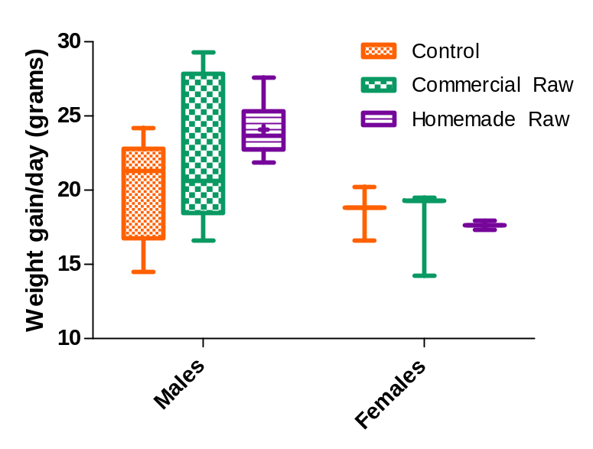
Figure 2.1 Mean Daily weight gain by sex and diet treatment. The top and bottom of the box represent the 25% and 75%, while the band near the middle is the median. Whiskers go from the smallest to the highest value.

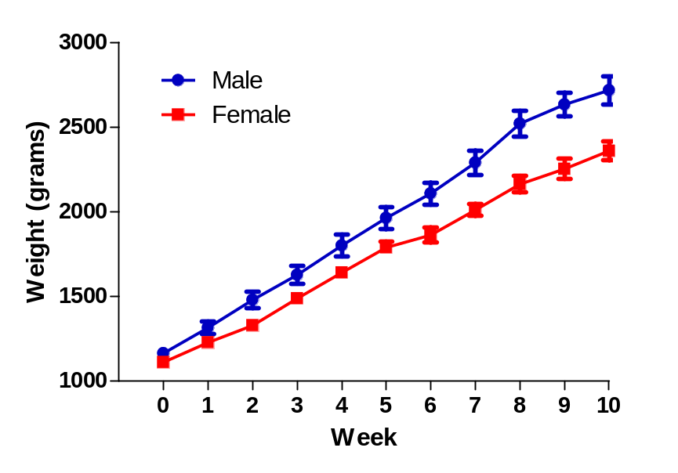
Figure 2.2 Mean weekly weight by sex (Mean ± SEM)

Figure 2.2 shows mean weight gains in males vs. females in all the treatment groups over the 10 week feeding trial. A significant difference in weight (p=0.025) was found between the sexes, with males having higher weight gains than females.
Figure 2.3 and 2.4 show weight gain for each sex by treatment. Male kittens on the control diet had the highest mean weight at the beginning of the feeding trial. As the feeding trial progressed, males on the homemade raw diet consistently had between 100-200 gram higher weights (week 2 through week 10). Male kittens on the commercial raw diet had initial higher weight gains compared to the control diet (between 25-100 grams) but these differences ceased after week 5. None of these weight differences between the 3 treatments were statistically significant.
Female kittens on the homemade raw and control diets had higher weight gains in the first few weeks. The control diet female kittens showed the greatest weight gains during the second half of the feeding trial. None of these weight differences were statistically significant between the 3 diet treatments. Both the of raw diets passed AAFCO guidelines for a growth claim consistent with their weights being equal or no less than 10% of the control diet.
Figures 2.5 - 2.10 graph heights and lengths separated by treatment (Figure 2.5-2.8), and sex (Figure 2.9-2.10) over the 10 week feeding trial. There was a statistically significant difference in height (p=0.020) but not length between males and females throughout the feeding trial with males being taller than females. But no significant differences in height or length were seen between the different diet treatments.

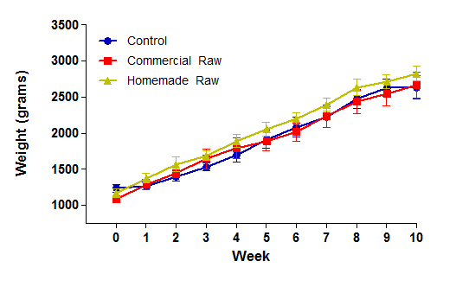
Figure 2.3 Male mean weekly weight by diet treatment (Mean ± SEM)

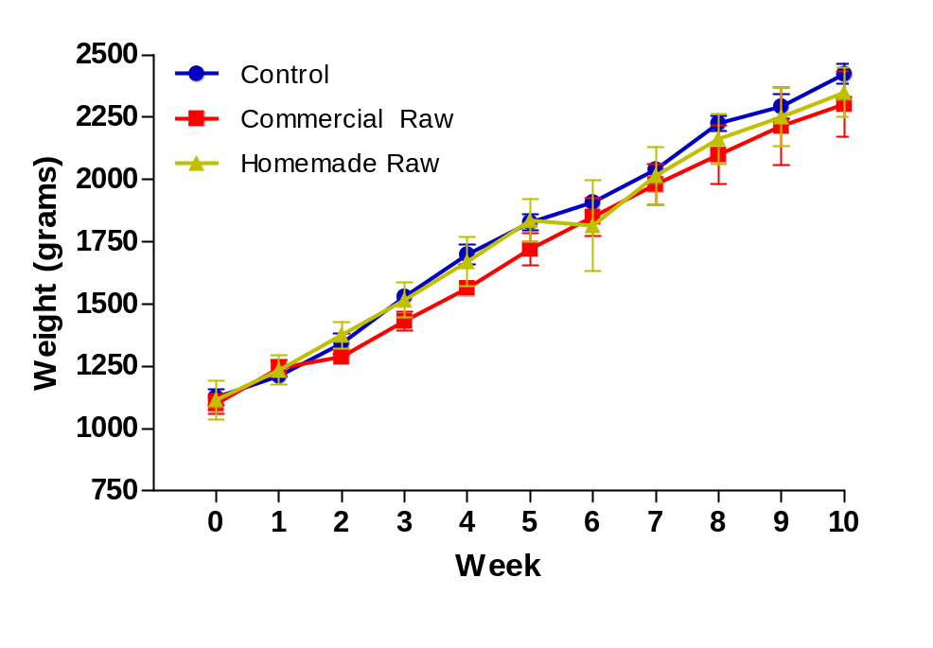
Figure 2.4 Female mean weekly weight by diet treatment (Mean ± SEM)

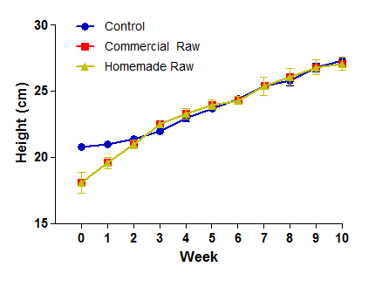
Figure 2.5 Male weekly height by diet treatment (Mean ± SEM)

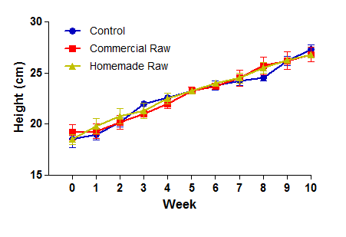

Figure 2.6 Female weekly height by diet treatment (Mean ± SEM)

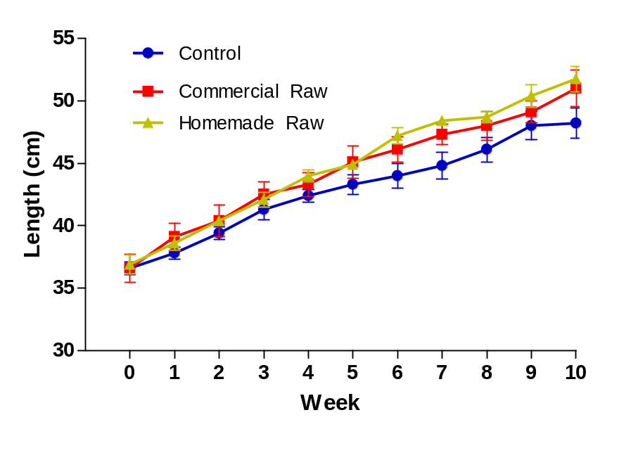

Figure 2.7 Male weekly length by diet treatment (Mean ± SEM)

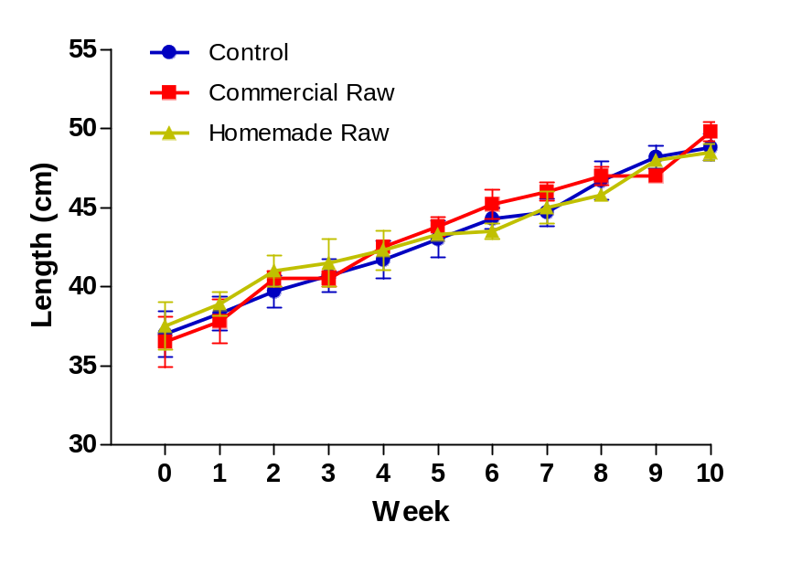

Figure 2.8 Female weekly length by diet treatment (Mean ± SEM)

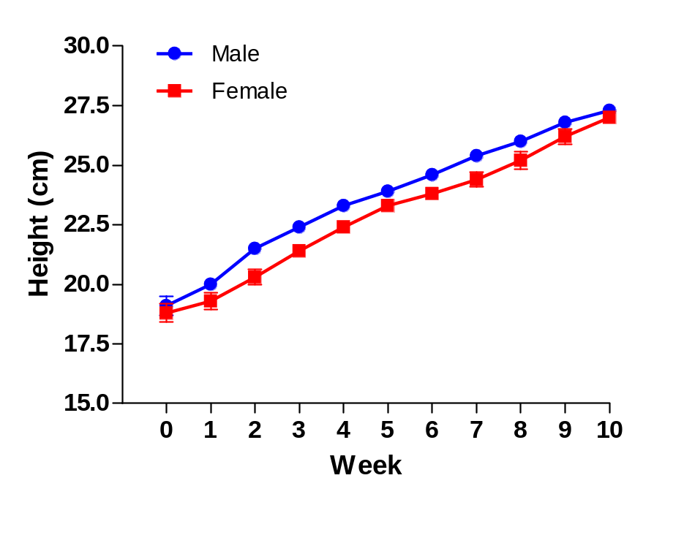
Figure 2.9 Mean weekly height by sex (Mean ± SEM)

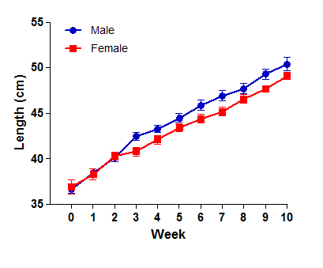
Figure 2.10 Mean weekly length by sex (Mean ± SEM)

The percentage body composition analysis of the nine kittens that underwent DEXA scanning is shown in Tables 2.3-2.5 and Figure 2.11. Changes were noted in all 3 analytes; lean, fat and bone/mineral between week 0 and week 10 associated with growth and development. There were significant decreases in percentage lean (p=0.017) from week 0 to 10 in the control group males and significant increases in percentage of body fat (p=0.029) in both the control and homemade raw group males from week 0 to week 10. All treatments had significant increases in percentage of bone/mineral content (p <0.0001) over the 10 week period along with decreases in lean body mass (p=0.017) between week 0 and week 10 of the feeding trial. No significant differences in lean, fat or bone mineral were found between males and females or between the three treatment groups at individual time points.

The body composition analysis in grams of the nine kittens that underwent DEXA scanning is shown in Tables 2.6-2.8 and Figure 2.12. As expected with growth, significant increases in lean (p < 0.0001) fat (p < 0.0001) and bone/mineral (p < 0.0001) were seen in both females and males over the 10 week period. No significant differences were seen between males and females and between the three diet treatments at individual time points.

Table 2.3 DEXA lean percentage by diet treatment (Mean ± SEM)

Sex/Week | Control | Commercial Raw | Homemade Raw
Male
Week 0 | 80.07 ± 1.85ª | 78.35 ± 2.27ª | 81.40 ± 3.21ª
Week 10 | 69.76 ± 1.85^{b} | 74.76 ± 2.27^{ab} | 73.48 ± 3.21^{ab}
Female
Week 0 | 75.70 ± 3.21^{ab} | 78.20 ± 3.21^{ab} | 79.80 ± 3.21ª
Week 10 | 77.35 ± 3.21^{ab} | 73.70 ± 3.21^{ab} | 71.90 ± 3.21^{ab}
NOTE: Different letter superscripts in both rows and columns indicate p values ≤ 0.05.

Table 2.4 DEXA fat percentage by diet treatment (Mean ± SEM)

Sex/Week | Control | Commercial Raw | Homemade Raw
Male
Week 0 | 18.20 ± 1.85^{b} | 19.50 ± 2.27^{b} | 16.90 ± 3.21^{b}
Week 10 | 27.77 ± 1.85ª | 22.74 ± 2.27^{ab} | 23.98 ± 3.21ª
Female
Week 0 | 22.20 ± 3.21^{ab} | 19.60 ± 3.21^{ab} | 18.30 ± 3.21^{b}
Week 10 | 19.87 ± 3.21^{ab} | 23.50 ± 3.21^{ab} | 25.20 ± 3.21^{ab}
NOTE: Different letter superscripts in both rows and columns indicate p values ≤ 0.05.

Table 2.5 DEXA bone mineral percentage by diet treatment (Mean ± SEM)

Sex/Week | Control | Commercial Raw | Homemade Raw
Male
Week 0 | 1.77 ± 0.08e | 2.10 ± 0.09^{cde} | 1.7 ± 0.13e
Week 10 | 2.47 ± 0.08^{abc} | 2.51 ± 0.09^{ab} | 2.54 ± 0.13^{abcd}
Female
Week 0 | 2.0 ± 0.13de | 2.20 ± 0.13^{bcde} | 1.8 ± 0.13e
Week 10 | 2.78 ± 0.13ª | 2.57 ± 0.13ª | 2.90 ± 0.13ª
NOTE: Different letter superscripts in both rows and columns indicate p values ≤ 0.05.

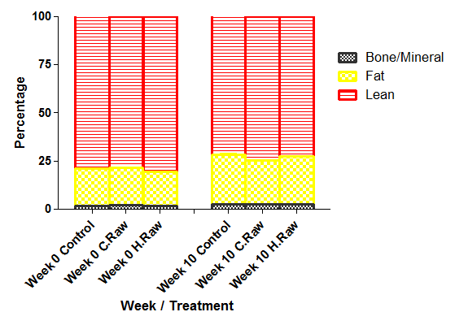

Figure 2.11 DEXA body composition percentage by diet treatment and week (Mean ± SEM).

Table 2.6 DEXA lean grams by diet treatment (Mean ± SEM)

Sex/Week | Control | Commercial Raw | Homemade Raw
Male
Week 0 | 878.92 ± 66.66^{b} | 875.51 ± 81.32^{b} | 855.90 ± 112.43^{b}
Week 10 | 1705 ± 129.35ª | 1947.00 ± 180.94ª | 2065.80 ± 271.36ª
Female
Week 0 | 878.60 ± 115.41^{b} | 837.10 ± 109.62^{b} | 753.70 ± 99.01^{b}
Week 10 | 1783.70 ± 234.31ª | 1513.80 ± 198.85ª | 1593.10 ± 209.27ª
NOTE: Different letter superscripts in both rows and columns indicate p values ≤ 0.05.

Table 2.7 DEXA fat grams by diet treatment (Mean ± SEM)

Sex/Week | Control | Commercial Raw | Homemade Raw
Male
Week 0 | 199.34 ± 24.06^{c} | 217.60 ± 32.17^{c} | 177.80 ± 37.17^{c}
Week 10 | 676.60 ± 81.67ª | 582.83 ± 86.17ª | 674.30 ± 140.98ª
Female
Week 0 | 258.00 ± 53.94^{bc} | 209.40 ± 43.78^{c} | 172.90 ± 36.15^{c}
Week 10 | 458.10 ± 95.78^{ab} | 482.70 ± 100.92^{ab} | 557.60 ± 116.58ª
NOTE: Different letter superscripts values in both rows and columns indicate p values ≤ 0.05.

Table 2.8 DEXA bone mineral grams by diet treatment

Sex/Week | Control | Commercial Raw | Homemade Raw
Male
Week 0 | 19.37 ± 2.15^{b} | 3.16 ± 0.13^{b} | 17.58 ± 3.38^{b}
Week 10 | 59.81 ± 6.64ª | 4.18 ± 0.13ª | 71.30 ± 13.71ª
Female
Week 0 | 23.73 ± 4.56^{b} | 23.97 ± 4.61^{b} | 17.27 ± 3.32^{b}
Week 10 | 64.08 ± 12.31ª | 56.30 ± 10.82ª | 65.47 ± 12.58ª
NOTE: Different letter superscripts values in both rows and columns indicate p values ≤ 0.05.

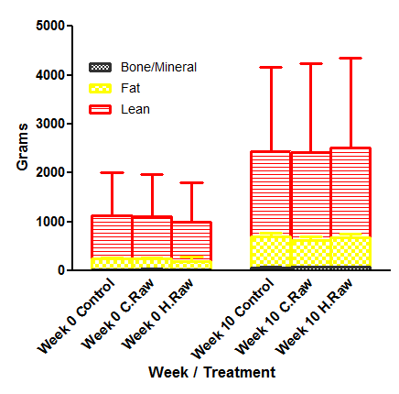

Figure 2.12 DEXA body composition in grams by diet treatment and week (Mean ± SEM).

Serum biochemical values
Serum mean biochemical results from all 3 groups at the three time points are shown in Table 2.9. Serum values for total protein (p < 0.0001) were significantly higher in the control and homemade raw groups at week 5 and 10 compared to week 0. The control group had significant increases in albumin (p=0.003) over the 10 weeks while the homemade raw group had significant increases in globulin (p<0.007) over the 10 week period. At the end of the feeding trial, total protein and taurine levels were highest in the kittens fed the homemade raw diet, with taurine being significantly higher in this group at week 10 compared to the other 2 dietary treatments. While taurine concentrations in the control grouped were similar at all 3 time points, a trend was noted with the commercial raw diet taurine levels decreasing while the homemade raw diet taurine levels increasing over time. Both the homemade raw diet and control diet had additional taurine listed on the ingredient list. Mean serum taurine levels for both the raw diet groups were greater than 300, and mean serum albumin levels were greater than 2.7, thus fulfilling the requirement for an AAFCO growth claim.
There were no significant differences in total protein, or acid-base balance (bicarbonate and anion gap) between the three diets within each time period. Albumin was significantly lower in both the raw diets (p =0.010) at week 5 and 10 compared to the control while globulin was significantly higher in both raw diets compared to the control at week 5, and in the homemade raw diet group at week 10 compared to the control.
Potassium concentrations decreased significantly in the control group from week 0 to week 5. Both raw diets had higher levels of potassium at weeks 5 and 10 with a trend toward significantly higher (p=0.078) levels in the homemade raw group compared to the control group at week 10.
There were no significant differences in creatinine concentrations between the 3 treatment groups but creatinine levels increased significantly (p<0.0001) in all 3 groups over time. Consistent with the very high protein content of the homemade raw diet, blood urea nitrogen was significantly higher (p=0.011) in the homemade raw at week 5 compared to the control diet and at week 10 compared to both the control and commercial raw diets.

Table 2.9 Serum biochemistry values by diet treatment and week (Mean ± SEM)

Analyte/ Week | Control | Commercial Raw | Homemade Raw
Total Protein (gm/dL)
Week 0 | 5.91 ± 0.14^{d} | 6.09 ± 0.14^{bcd} | 6.04 ± 0.14^{cd}
Week 5 | 6.24 ± 0.14^{abc} | 6.30 ± 0.14^{abcd} | 6.39 ± 0.14^{ab}
Week 10 | 6.37 ± 0.14^{abc} | 6.21 ± 0.14^{abcd} | 6.52 ± 0.14ª
Albumin (gm/dL)
Week 0 | 3.64 ± 0.07^{b} | 3.64 ± 0.07^{b} | 3.57 ± 0.07^{b}
Week 5 | 3.99 ± 0.07ª | 3.67 ± 0.07^{b} | 3.67 ± 0.07^{b}
Week 10 | 4.01 ± 0.07ª | 3.65 ± 0.07^{b} | 3.64 ± 0.07^{b}
Globulin (gm/dL)
Week 0 | 2.27 ± 0.12^{d} | 2.45 ± 0.12^{bcd} | 2.46 ± 0.12^{cd}
Week 5 | 2.25 ± 0.12^{d} | 2.625 ± 0.12^{abc} | 2.71 ± 0.12^{ab}
Week 10 | 2.36 ± 0.12^{cd} | 2.56 ± 0.12^{abcd} | 2.89 ± 0.12ª
Taurine (nMol/mL)*
Week 0 | 503.0 ± 47.4^{bc} | 605.9 ± 47.4^{ab} | 524.0 ± 47.4^{bc}
Week 5 | 575.6 ± 47.4^{abc} | 553.6 ± 47.4^{abc} | 652.7 ± 47.4ª
Week 10 | 502.1 ± 47.4^{bc} | 470.5 ± 47.4^{c} | 637.6 ± 47.4ª
BUN** (mg/dL)
Week 0 | 19.12 ± 1.83^{c} | 21.37 ± 1.83^{bc} | 22.50 ± 1.83^{bc}
Week 5 | 17.88 ± 1.83^{c} | 22.75 ± 1.83^{bc} | 28.62 ± 1.83^{ab}
Week 10 | 18.62 ± 1.83^{c} | 19.37 ± 1.83^{c} | 25.12 ± 1.83^{ab}
Creatinine (mg/dL)
Week 0 | 0.587 ± 0.047e | 0.637 ± 0.047de | 0.625 ± 0.047e
Week 5 | 0.937 ± 0.047^{b} | 0.787 ± 0.047^{c} | 0.737 ± 0.047^{cd}
Week 10 | 1.075 ± 0.047ª | 1.012 ± 0.047^{ab} | 1.025 ± 0.047^{ab}
Potassium (mEq/L)
Week 0 | 4.84 ± 0.19^{ab} | 4.82 ± 0.19^{abc} | 5.07 ± 0.19ª
Week 5 | 4.30 ± 0.19^{cd} | 4.40 ± 0.19^{bcd} | 4.70 ± 0.19^{abc}
Week 10 | 4.04 ± 0.19^{d} | 4.39 ± 0.19^{bcd} | 4.67 ± 0.19^{abcd}
Bicarbonate (mMol/L)
Week 0 | 19.0 ± 1.05ª | 18.0 ± 1.25ª | 16.8 ± 1.25ª
Week 5 | 19.3 ± 0.98ª | 18.9 ± 0.98ª | 18.5 ± 0.98ª
Week 10 | 16.5 ± 0.98ª | 18.4 ± 0.98ª | 18.7 ± 0.98ª
Anion Gap
Week 0 | 21.44 ± 1.51ª | 21.98 ± 1.78ª | 21.68 ± 1.78ª
Week 5 | 23.66 ± 1.41ª | 21.15 ± 1.41ª | 24.16 ± 1.41ª
Week 10 | 24.84 ± 1.41ª | 21.56 ± 1.41ª | 22.21 ± 1.41ª
* Whole blood taurine analysis
** BUN= Blood Urea Nitrogen
NOTE: Different letter superscripts in both rows and columns indicate p values ≤ 0.05.

Complete blood cell counts
Hematological mean values for the three treatment groups at weeks 0, 5 and 10 are shown in Table 2.10. Hemoglobin (p=0.0013) at weeks 5 and 10 was significantly higher in the control and commercial raw group compared to week 0 while the homemade raw diet group saw minimal hemoglobin change over the 10 week period. Hematocrit was also significantly higher (p=0.0012) at weeks 5 and 10 compared to week 0 in the control group while both raw diet groups saw no significant changes in hematocrit over the 10 week period. Red cell mean corpuscular volume in the homemade raw diet was significantly lower (p=0.001) at weeks 5 and 10 compared to week 0 and was significantly lower at week 10 (p= 0.0009) compared to the other two diets. There was no statistically significant differences in white blood cell i.e. neutrophil, monocyte or eosinophil, numbers between the three treatment groups. Since mean hemoglobin levels were ≥ 10.0 and mean hematocrit levels were ≥ 29%, both raw diets fulfilled the AAFCO requirements for providing a growth claim.

Table 2.10 Hematology values by diet treatment and week (Mean ± SEM)

Analyte/ Week | Control | Commercial Raw | Homemade Raw
Hemoglobin (g/dL)
Week 0 | 10.28 ± 0.39^{d} | 10.86 ± 0.39^{cd} | 10.81 ± 0.39^{cd}
Week 5 | 11.52 ± 0.39^{abc} | 12.18 ± 0.39ª | 11.35 ± 0.39^{abcd}
Week 10 | 11.94 ± 0.39^{ab} | 11.99 ± 0.39^{ab} | 10.86 ± 0.39^{bcd}
Hematocrit (%)
Week 0 | 31.30 ± 1.13^{d} | 33.09 ± 1.13^{bcd} | 32.10 ± 1.13^{cd}
Week 5 | 35.41 ± 1.13^{ab} | 36.00 ± 1.13^{ab} | 34.61 ± 1.13^{abc}
Week 10 | 36.46 ± 1.13ª | 35.51 ± 1.13^{ab} | 33.51 ± 1.13^{abcd}
MCV* (fL)
Week 0 | 43.62 ± 0.56^{abc} | 44.89 ± 0.56ª | 44.91 ± 0.56ª
Week 5 | 42.99 ± 0.56^{bc} | 43.81 ± 0.56^{abc} | 42.47 ± 0.56^{c}
Week 10 | 44.15 ± 0.56^{ab} | 44.65 ± 0.56ª | 39.54 ± 0.56^{d}
MCHC** (g/dL)
Week 0 | 33.07 ± 0.36ª | 32.84 ± 0.36ª | 33.60 ± 0.36ª
Week 5 | 32.57 ± 0.36ª | 33.81 ± 0.36ª | 32.84 ± 0.36ª
Week 10 | 32.71 ± 0.36ª | 33.75 ± 0.36ª | 32.36 ± 0.36ª
Total WBC
Week 0 | 11,400 ± 1,187ª | 10,437 ± 1,187ª | 10,887 ± 1,187ª
Week 5 | 11,187 ± 1,187ª | 12,012 ± 1,187ª | 10,725 ± 1,187ª
Week 10 | 11,575 ± 1,187ª | 10,887 ± 1,187ª | 13,650 ± 1,187ª
Abs. Neutrophils
Week 0 | 5,641 ± 641ª | 4,900 ± 641ª | 5,444 ± 641ª
Week 5 | 4,637 ± 641ª | 6,075 ± 641ª | 5,150 ± 641ª
Week 10 | 4,086 ± 641ª | 4,446 ± 641ª | 4,920 ± 641ª
Abs. Monocytes
Week 0 | 315 ± 73ª | 304 ± 73ª | 367 ± 73ª
Week 5 | 242 ± 73ª | 246 ± 73ª | 378 ± 73ª
Week 10 | 200 ± 73ª | 278 ± 73ª | 396 ± 73ª
Abs. Eosinophils
Week 0 | 509 ± 90ª | 441 ± 90ª | 574 ± 90ª
Week 5 | 596 ± 90ª | 653 ± 90ª | 491 ± 90ª
Week 10 | 627 ± 90ª | 611 ± 90ª | 652 ± 90ª
*MCV= Mean corpuscle volume
**MCHC= Mean corpuscle hemoglobin concentration
NOTE: Different letter superscripts in both rows and columns indicate p values ≤ 0.05.

Feed efficiency, protein efficiency ratio, and body condition score
Mean feed efficiency ratios for males and females within the three diet treatment groups are shown in Table 2.11 and Figure 2.13. Males on the commercial raw diet had significantly improved feed efficiency (p =0.007) compared to either the homemade raw or control group males and all the female groups.
Protein Efficiency Ratio (PER) is shown for males and females within the three treatment groups in Table 2.12 and Figure 2.14. PER was significantly different for males in all three treatment groups (p < 0.0001) with the commercial raw having the highest protein efficiency, followed by the control and homemade raw diet groups. Males on the commercial raw had significantly higher PER than the females on that diet (p = 0.044), while there was no significant differences between the male and female PER within the other two diet treatments. The homemade raw diet had significantly lower PER (p <0.0001) in both males and females than either the control or commercial raw.

Table 2.11 Feed efficiency ratio (Mean ± SEM)
(weight gain per grams of dry matter ingested)

 | Control | Commercial Raw | Homemade Raw
Male | 0.356 ± 0.019^{b} | 0.485 ± 0.019ª | 0.391 ± 0.017^{b}
Female | 0.389 ± 0.025^{b} | 0.395 ± 0.025^{b} | 0.362 ± 0.030^{b}
NOTE: Different letter superscripts in both rows and columns indicate p values ≤ 0.05.

Table 2.12 Protein efficiency ratios (Mean ± SEM)
(grams weight gain per gram of dry matter protein ingested)

 | Control | Commercial Raw | Homemade Raw
Males | 0.762 ± 0.037^{b} | 1.003 ± 0.033ª | 0.499 ± 0.033^{c}
Females | 0.831 ± 0.047^{b} | 0.841 ± 0.058^{b} | 0.462 ± 0.058^{c}
NOTE: Different letter superscripts values in both rows and columns indicate p values ≤ 0.05.

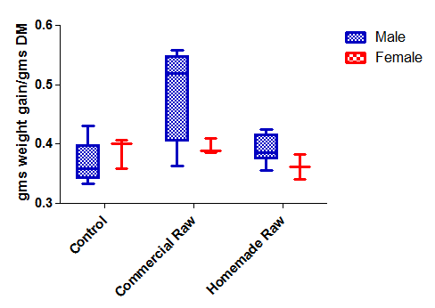

Figure 2.13 Feed efficiency by diet treatment and sex. The top and bottom of the box represent the 25% and 75%, while the band near the middle is the median. Whiskers go from the smallest to the highest value.

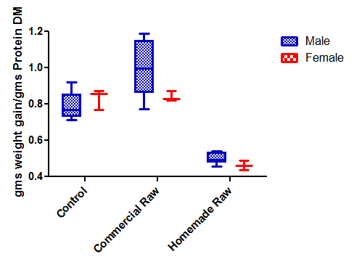

Figure 2.14 Protein efficiency ratio by diet treatment and sex. The top and bottom of the box represent the 25% and 75%, while the band near the middle is the median. Whiskers go from the smallest to the highest value.

Table 2.13 lists the mean total and body weight corrected (gm/kg) dry matter intake, protein dry matter intake and kcal per day along with mean body condition score (BCS). Both the control and homemade raw diets seemed to have greater palatability compared to the commercial raw diet, as these kittens ate in excess of energy needs. Males on the commercial raw diet had significantly less total dry matter intake (p=0.0085) compared to both the control and homemade raw diet males, with a trend toward less dry matter on a weight corrected basis (p=0.101) compared to males on the control diet. Similarly, males on the commercial raw diet had a trend toward less total (p=0.065) and weight-corrected kcal (P=0.098) compared to males on both the control and homemade raw diets. There were no significant differences between females on the three diet treatments with respect to total or weight-corrected dry matter intake or kcal/day. Both absolute and dry matter protein intake was significantly higher in both males and females on the homemade raw diet compared to the other two diet treatments.
There were no significant differences in body condition score between the 3 diet treatments within sex but males on the homemade raw diet had significantly higher BCS compared to the females on either the control or commercial raw diets.

Table 2.13 Dry matter, protein dry matter, caloric intake
and body condition score by diet treatment and sex (Mean ± SEM)

Total | Control | Commercial Raw | Homemade Raw
Kcal/day
Male | 352.13 ± 17.40ª | 284.08 ± 17.40^{b} | 340.60 ± 15.88ª
Female | 301.48 ± 22.46^{ab} | 268.30 ± 22.46^{b} | 268.71 ± 27.51^{b}
DM g/day
Male | 56.37 ± 2.91^{ab} | 45.41 ± 2.91^{c} | 62.65 ± 2.65ª
Female | 48.29 ± 3.75^{bc} | 42.45 ± 3.75^{c} | 49.42 ± 4.60^{bc}
Prot DM g/day
Male | 26.32 ± 1.99^{c} | 22.57 ± 1.99^{c} | 48.99 ± 1.82ª
Female | 22.55 ± 2.57^{c} | 24.76 ± 2.57^{c} | 38.65 ± 3.15^{b}
Weight Corrected (WC)
Kcal/ kg day
Male | 183.96 ± 7.88ª | 149.58 ± 7.88^{ab} | 165.90 ± 7.19^{ab}
Female | 162.77 ± 10.17^{ab} | 156.44 ± 10.17^{ab} | 151.51 ± 12.46^{ab}
DM g/kg day
Male | 29.44 ± 1.67^{ab} | 25.12 ± 1.67^{ab} | 30.94 ± 1.53^{ab}
Female | 26.69 ± 2.16^{ab} | 24.75 ± 2.16^{b} | 27.87 ± 2.64^{ab}
Prot DM g/kg day
Male | 13.75 ± 0.71^{b} | 11.85 ± 0.71^{b} | 23.85 ± 0.64ª
Female | 12.53 ± 0.91^{b} | 12.30 ± 0.91^{b} | 21.66 ± 1.12ª
BCS
Male | 5.47 ± 0.14^{ab} | 5.15 ± 0.14^{ab} | 5.54 ± 0.13ª
Female | 5.06 ± 0.18^{b} | 5.03 ± 0.18^{b} | 5.55 ± 0.22^{ab}
NOTE: Different letter superscripts in both rows and columns indicate p values ≤ 0.05

Discussion
Optimal growth rates in young animals is dependent on supplying adequate amounts of essential amino acids along with crude protein for synthesis of non-essential amino acids. Taylor found that kittens showed maximal weight gains at a wide dietary E:T ratio(essential amino acid nitrogen to total amino acid nitrogen).[27] Compared to previously reported data on weight gain in kittens [51], the kittens in our study on all 3 dietary treatments had weight gains that were at the high end or above these previously reported ranges. Males on the homemade diet had the highest weight gains but neither of the raw diets had significantly higher weight, height or length gains. It is likely that the essential amino acid and total nitrogen required for optimal tissue accrual was maximized at levels of 50% dry matter protein. Thus, the significantly higher protein level of 78% DM in the homemade raw diet did not result in improved growth rates. This is not meant to minimize other potential physiological parameters that may have been influenced by the higher protein level in the homemade raw diet.
In general, mean birth weights for male and female kittens do not differ until six weeks of age when males become heavier than females.[51] Average daily and weekly weight gains were found significantly higher in males compared to females. Androgens stimulate growth hormone secretion, a major regulator of growth and development accounting for increased growth rates seen in males.[327] The average onset of puberty, with associated androgen secretion, in toms occurs at 8-10 months of age or at body weights of 2.5 kg, whichever occurs first.[328] Although some of the male kittens reached this weight toward the end of the feeding trial, it is unlikely that sex steroids played a factor in higher weight gains seen in the males. Coinciding with a lack of testosterone secretion, no differences were found in the amount of muscle tissue between males and females as determined by the DEXA scanning. With the exception of the commercial raw diet, the males ingested more food and energy accounting for their increased weight gains.
Overall, there were minimal differences in body composition as determined by DEXA scanning between the three dietary treatments. Limited number of kittens scanned though, prevent drawing firm conclusions. All the groups had increased percentage and grams of bone tissue associated with linear growth. Fat tissue percentage increased in all 3 diets, particularly the control and homemade raw diet. Both of these diets seemed highly palatable to the kittens due to their rapid consumption and overfeeding. AAFCO growth feeding trials state kittens should be fed ad libitum or to meet energy needs.[25] The kittens in our study were fed ad libitum with the stipulation that there was always a small amount of food left uneaten. Feeding to their energy needs rather than ad libitum may have resulted in differences in muscle and fat tissue acclimation between the diets but this would require additional study. Ad libitum feeding though did dispel the myth that raw fed animals do not become obese.[329] Several of the males on both the homemade raw diet and control diet had body condition scores of 7/9 toward the end of the feeding trial.
Protein-energy nutrition is known to have a direct effect on albumin production Both of the raw diet groups had significantly lower albumin levels at week 5 and 10 compared to the control. As all the albumin values were within previously published normal reference ranges [68], the clinical significance of the different between diet groups is probably negligible. Along with a lower albumin concentration, there was significantly higher globulin concentrations at week 10 in the homemade diet group. Albumin synthesis is primarily influenced by oncotic pressure, but inflammation with associated acute phase proteins and cytokine production, along with metabolic acidosis can inhibit synthesis. No acid-base differences were noted between the groups. Inflammation cannot be ruled out as a source of decreased albumin in the raw diet groups as serum acute phase proteins and cytokines were not analyzed. Neutrophil and monocyte numbers were not significantly different or above reference ranges in the raw fed kittens. It is probable that there was a compensatory reduction in albumin concentration in the raw diet groups to maintain oncotic pressure. Higher globulin concentrations in the homemade raw diet group was traced back to 3 specific kittens, two of which had diarrhea which was not cultured and a third with a known positive Salmonella spp. fecal culture.
High serum creatinine and blood urea nitrogen concentrations have been previously reported in non-domestic felines fed high protein diets.[205] All the groups had creatinine levels higher than previously published reference values.[68] Blood urea nitrogen, a more consistent indicator of dietary nitrogen intake, was significantly higher in the homemade raw diet secondary to its very high protein level (78% DM) compared to the control and commercial raw (47-50% DM).
Serum potassium concentration was found to be significantly lower in the control diet compared to the raw diets at weeks 5 and 10. High protein diets can increase metabolic acid load secondary to the metabolism of methionine and cysteine to hydrogen sulfite and sulfate. With metabolic acidosis, potassium moves from the intracellular to extracellular environment in exchange for hydrogen ions. Because there were no differences in bicarbonate or anion gap between the three diets, acid-base balance does not seem likely as a cause of increased serum potassium seen in the raw diets. Potassium requirement in young felids is dependent on the level of protein in the diet.[50] The uptake of cation amino acids into the cell is exchanged for intracellular potassium. This exchange could account for the different levels found between the control (lower protein) and homemade raw diet (higher protein). The source of potassium in the homemade diet and commercial raw diets were kelp and/or freeze-dried krill compared to potassium iodide in the control diet. Analysis of the actual potassium level and it’s bioavailability may account for the differences noted in serum potassium concentrations between the three diets.
Replacement of large fetal red blood cells by smaller postnatal red cells occurs in the neonate within the first few weeks of life.[330] These changes are associated with reductions in hemoglobin, hematocrit, mean corpuscular volume and mean cell hemoglobin content. Red cell levels reach their nadir at 4 weeks of age. Maturation of red cell indices similar to adult levels occurs by 3-4 months of age. [331] Hemoglobin levels may not reach adult levels until 4-6 months of age, depending on the availability of iron in the diet.[331] As common with other mammals, hemoglobin levels are reduced during the nursing period because of lower concentrations of iron in milk along with lagging hemoglobin production and a rapidly proliferating red cell volume.[331, 332] In our kittens, both hemoglobin and hematocrit continued to rise in the control diet group as would be expected with further maturation of the hematopoietic system. In contrast, both raw diets saw modest increases in hematocrit and hemoglobin which tended to plateau as the feeding trial progressed. Red cell microcytosis, as determined by previously published pediatric reference ranges (43.0-54.2) [333], was also noted in the homemade diet as the feeding trial progressed.
Nutritional factors associated with reduced erythroid cell production and accompanying microcytosis include inadequate levels of pyridoxine, iron or copper. Deficiencies of these nutrients in the homemade diet was unlikely as raw chicken breast has levels of these nutrients 4-10X higher [334] than minimum levels as established by NRC’s Nutrient Requirements of Dogs and Cats.[12] In addition, the homemade diet had additional pyridoxine with inclusion of a B-vitamin supplement. Subclinical infection with associated anemia of inflammation could be a cause of reduced erythroid production in the homemade diet. Inflammation leads to iron retention within cells of the reticuloendothelial system resulting in limited iron availability for erythroid production. Acute phase proteins and cytokines negatively affect proliferation and differentiation of erythroid progenitor cells, along with inhibiting iron uptake. In addition, the direct toxic effects of cytokine induced free radicals including nitric oxide (NO) and superoxide anion negatively affect erythroid cell proliferation. Seven of the eight kittens on the homemade diet had levels of MCV < 43 fL at week 10, with 4 of these also having hematocrits < 33%. Of this group of 7 kittens, 4 had associated diarrhea at some point during the feeding trial.
Feed and protein efficiency is influenced by many factors including amount of muscle fiber present [335], levels of dietary macro- and micronutrients [336], digestibility [337], environmental conditions, acid-base balance [337], overall health of the animal and intestinal microflora [338]. In animal production systems, the most important of these has been found to be nutrient digestibility.[339] As discussed in another chapter, the dry matter, organic matter, energy and protein digestibility in both raw diets was found to be significantly higher compared to the control diet. Improved digestibility could account for the improved feed efficiency and PER in the commercial diet group, but this was found only in the male kittens rather than both sexes. The male kittens on the commercial raw also had lower feed intakes compared to the other treatment groups and sexes. It is likely that the greater palatability and resultant overfeeding in both the control and homemade raw diet resulted in overloading nutrient transporters and decreased feed efficiency.
Lactating dairy cows have decreased feed efficiency if acidosis is present due to an increased amount of heat produced per unit of digestible energy. There were no differences in acid-base balance or amount of muscle tissue accrual between the three diet treatments, and all the kittens were reared in a thermal neutral environment, eliminating these as sources of differences in feed efficiency.
In production animal systems, it is common to add antibiotics to feed to improve feed and protein efficiency. The improved growth response is due to action of the antibiotic on intestinal microbial flora. There are several mechanisms proposed for these improved efficiencies. These mechanisms include 1- reduced competition for dietary nutrients, 2- suppression of mild but unrecognized intestinal infections, 3- suppression of microbial production of growth depressing toxins, and 4- enhanced efficiency of absorption and utilization of nutrients because the intestinal wall is thinner.[338] Mucosal mass and turnover is reduced in germ-free conditions or with antibiotic feeding, with diversion of nutrients for synthesis of other tissues.[338] Increased microbial exposure in both raw diets would be expected to result in higher production of IgA and acute-phase proteins if sub-clinical infections were present. Globulin concentrations were higher in both raw group feeders. This diversion of nutrients for immune proteins may have accounted for the decreased efficiency found in the homemade raw diet compared to the control but this effect would have been expected to also be found in the commercial raw diet feeders and was not. Excess protein in the homemade diet could have been utilized as a source of nutrition for intestinal microbes resulting in increased nutrient competition and mucosal mass production and decreased protein efficiency.

Conclusion
Both raw diets had similar growth performance compared to a premium high-protein canned cat food and both passed an AAFCO growth trial. There were no significant differences in average daily gain or body tissue accrual/composition between the 3 diet treatments. Kittens fed the raw diets did have lower albumin and higher globulin levels compared to the control group but this was not clinically significant as albumin levels were still within normal reference ranges. These differences were felt to be due to a reduction in albumin production to maintain oncotic pressure secondary to higher globulin levels. All of the groups had high creatinine values consistent with a high protein diet while the homemade raw had significantly higher blood urea nitrogen due to its higher protein content. Decreases in red blood cell size were noted in the homemade raw diet group and believed to be associated with subclinical infection.
Males on the commercial raw diet had the highest feed efficiency and protein efficiency ratios. Overfeeding in both the control and homemade raw diet may have resulted in levels of nutrients above maximal levels for tissue synthesis and accrual. Subclinical infections may have also accounted for reduced feed efficiency in the raw homemade diet.

CHAPTER III

EVALUATION OF RAW VS. HEAT-PROCESSED DIETS ON INNATE AND HUMORAL IMMUNE RESPONSES IN KITTENS

Introduction
Numerous benefits have been ascribed to feeding cats’ raw food diets compared to feeding heat-processed cat foods. Reported benefits include improved skin and coat quality, improved digestibility and decreased incidence of many medical conditions including dental disease, diabetes mellitus, allergies, inflammatory bowel disease, feline urinary track disorder (FLUTD), kidney disease, arthritis and cancer.[3, 4, 153, 154] One of the most consistent and primary benefits stated with feeding dogs and cats raw diets is improvement in immune function.[3, 4, 153, 154]
The gut is the largest immune organ in the body containing over 65% of all immune cells.[340] Gastrointestinal lymphoid tissue (GALT) is exposed to a diverse array of antigens from foods and the commensal microorganisms inhabiting the gut. Both diet and intestinal microflora interact with GALT at multiple levels and offer a unique opportunity for immune system modulation. At the most basic level of immunonutrition, high quality proteins are needed for cell proliferation and enzymatic activity. The acute phase of the immune response involves cell activation, proliferation and differentiation. Immunoglobulins, complement, cytokines, receptors and growth factors are all proteins. Additionally, nucleotides, certain vitamins (i.e. Vitamin C and E) and minerals (i.e. zinc, copper, iron, selenium) along with polyunsaturated fatty acids are all critical cofactors in the immune response.
Protein is required for maintenance of gut barrier functions through synthesis of mucus glycoproteins and cellular epithelium. Amino acids are also required for maintenance of cellular proteins within the immune system. Additional levels of protein beyond minimal requirements have shown to enhance cellular immunity.[341] Specifically, the amino acids arginine, glutamine and taurine have been shown to augment immune response. Glutamine is a main energy source for rapidly dividing cells such as lymphocytes and mucosal enterocytes. Supplementation with glutamine has shown to induce increases in B cells and T cell CD4 populations in Peyer’s patches in endotoxin-challenged mice.[342] Glutamine is also a component in the synthesis of Glutathione, a significant intracellular antioxidant and defense against reactive free radicals.[343] Arginine has significant immunomodulating effects. Arginine is key in the synthesis of polyamines which play critical roles in cell division and DNA synthesis. Arginine is also the precursor for synthesis of nitric oxide (NO).[344] NO has important roles in regulation of vascular tone and immune function.[344, 345] Taurine, a beta sulphonated amino acid has numerous roles including membrane stabilization, bile acid conjugation, osmoregulation, calcium homeostasis and vision. Taurine is also an important intracellular antioxidant. Taurine has also been hypothesized to play a role in the downregulation of inflammatory mediators by macrophages and neutrophils when a pathogenic insult has been removed.[346]
Heat processing is known to reduce protein bioavailability.[9, 209, 237, 347] Heat processing also decreases the microbial load in foods. As a result of changes in lifestyle including food processing techniques, improved hygiene, vaccination, and antibiotics, human intestinal microflora has changed.[292] Both dietary constituents and their processing have been shown to affect intestinal microbiota numbers and composition in felines.[124, 125] By comparing hydrogen gas production, Backus found that commercial canned diets induced a substantially greater hydrogen breath production caused by increased fermentative metabolism.[124] The next highest level of hydrogen production was found in cats consuming canned uncooked diets, followed by extruded diets and lastly purified diets.[124] Quantity of dietary protein was also found to affect gastrointestinal flora. Marked differences in fecal flora were found in 8 – 16 week old kittens fed high protein (HP) vs. moderate protein (MP) diets. Kittens fed the high protein diets had significantly decreased Bifidobacteria spp., Lactobacillus spp., and E.coli counts compared to the kittens fed a moderate protein diet.[126]
Newborn and juvenile mammals are at increased risk for infection in early life due to the delayed development of the immune system. Mucosal lymphocytes are found to be significantly reduced in juvenile felines (6 months old) compared to adult felines.[86] Absolute numbers of all lymphocyte subsets except null cells increase with age.[83, 84] Innate immune responses of phagocytosis and opsonization were found to be reduced in neonatal kittens compared to adults.[95] It is unknown at what age full maturation of the immune system in felines occurs.
At the same time that maturation of immune system is occuring, gastrointestinal flora is being established. The first major stage in gut community colonization occurs at birth. The second major stage occurs at weaning with the introduction to solid food. At this stage the gut microbiota becomes more diversified and enriched in bacteria common to the adult microbiota.[106] It is unknown at what age microbial stabilization occurs in domestic animals but in humans this occurs at around 2 years of age.[108] Dietary components fed during these stages may have significant effects on immune system development, gastrointestinal flora development and later susceptibility to disease. The objective of this study was to determine if raw food fed kittens had improved humoral and innate immune function compared to kittens fed a heat-processed diet. The hypothesis was that improvement in these parameters would be seen with raw food feeders secondary to improved protein bioavailability and elevated exposure to microorganisms in raw meat diets.

Materials and Methods

All kittens were born and raised at The University of Tennessee Veterinary Medical Center and Research facility and their care was in compliance with the Guide for the Use and Care of Laboratory Animals. The experimental protocol was approved by the Institutional Animal Care and Use Committee.

Animals: Twenty-four 9- to 19-week old domestic short-hair kittens born over a 3 year period were used for an Association of American Feed Control Officials (AAFCO) growth feeding trial. The kittens were given physical examinations and tested for intestinal parasites one to three days prior to starting the feeding trial and were healthy. All kittens were born from the same queen and tom and had nursed with ingestion of colostrum. Kittens were weaned at 6-7 weeks of age and eating solid food prior to beginning of the feeding trial at 9 weeks of age. All kittens were weaned on a canned and dry extruded growth diet^{1,2}. The kittens were housed in individual metabolism cages during the feeding trial and allowed daily group play. At the end of the study, the kittens were transferred to a permanent feline colony that is used for dietary and other non-invasive research or adopted to private homes.

Diet: The kittens were randomized to 3 different dietary groups via a random numbers table for the AAFCO growth feeding protocol. Each diet group consisted of 8 kittens. Diet Group A was fed a commercial heat-processed canned diet³ that is nutritionally adequate for all life stages as determined by AAFCO guidelines. This diet was chosen to closely match the raw diets moisture and nutrient content. This was the control diet. Treatment Group B was fed a commercial frozen raw diet⁴. Treatment Group C was fed a home-prepared raw food diet^{5,6}. The diet was made with raw chicken⁵ obtained from a local grocery store and mixed, according to manufacturer’s instructions, with a popular commercial food supplement³ designed to balance a raw meat diet. The homemade diet was prepared every 2 weeks and immediately frozen. All raw foods were kept frozen until 1 day before feeding, when they were transferred to a refrigerator in preparation for feeding the next day. Each group was fed three times daily a quantity of food in excess of daily needs to ensure adequate food intake. The length of the feeding trial was 10 weeks. Water was available at all times.

Innate immune function evaluation: On weeks 0, 5 and 10 of the feeding trial, 2.5 mL of whole blood was obtained by jugular venipuncture and placed in a heparin tube. 1.0 mL of blood was analyzed immediately at the University of Tennessee Virology/Immunology Laboratory for quantitative determination of neutrophil phagocytosis and oxidative burst. 1.0 mL of blood was collected in sodium heparin tube and spun down to obtain serum. 0.5 mL of blood was collected in EDTA and submitted for a complete blood cell analysis at the University of Tennessee Clinical Pathology Laboratory.

_____________________________________________________
¹ Science Diet®- Kitten Healthy Development Liver and Chicken Entrée minced. Hill’s Pet Nutrition Inc.®, Topeka, KS
² Science Diet®- Kitten Healthy Development Original dry cat food. Hill’s Pet Nutrition, Inc.®, Topeka, KS
³ Evo – Turkey and Chicken Canned Cat and Kitten Cat Food. Natura Pet Foods, Santa Clara, CA
⁴ Wild Kitty Raw All Natural Cat Food – Chicken and Clam frozen raw diet. Wild Kitty Cat Food, Kennebunkport, ME.
⁵ TCFeline Plus Cat Food Premix with beef liver. TCFeline®, Salt Spring Island, BC, Canada
⁶ Tyson boneless, skinless chicken breast. Tyson Foods Inc., Springdale, AR

Phagocytosis: The test for phagocytosis was carried out by using the Phagotest kit¹ (ORPEGEN Pharma, Heidelberg, Germany). One hundred microliters of whole blood was mixed with 2 × 10⁷ fluorescein isothiocyanate (FITC)-labeled Escherichia coli cells at 0°C. Mixtures of heparinized whole blood and bacteria were incubated in a 37°C horizontal shaking water bath for 10 min. As a control, whole blood and FITC-labeled E. coli were incubated at 0°C to reduce the phagocytic potential to a minimum. The fluorescence of the attached bacteria on the cell surface was quenched by using 100 µl of Coomassie brilliant blue. After two washes, erythrocytes were lysed by adding lysing solution for 20 min at room temperature, after which propidium iodide was added to stain the DNA of the bacteria and the cells.
Oxidative burst: The production of reactive oxygen species (ROS) was determined with the Bursttest kit² (ORPEGEN Pharma, Germany). One hundred microliters of whole blood was mixed with 2 × 10⁷ unlabeled E. coli cells and another 100 microliters was mixed with phorbol myristate acetate (PMA) at 0°C. Mixtures of heparinized whole blood and bacteria or PMA were incubated in a 37°C horizontal shaking water bath for 10 min. As a control, whole blood was incubated with 20 µl of wash solution. Dihydrorhodamine (DHR) was added to the samples at 37°C, and incubation was continued for a further 10 min in order to allow nonfluorescent DHR to convert to fluorescent rhodamine 123 upon the production of ROS. Lysing solution was added for 20 min at room temperature. After washing, 100 µl of propidium iodide was added to stain the DNA of the bacteria and the cells.
Flow cytometry: A minimum of two thousand leukocytes were collected from each sample on an Epics XL flow cytometer (Beckman Inc., Miami, FL). The instrument was calibrated and standardized between each analysis. All sample analysis was performed with Expo 32 ADC software (Beckman Inc. Miami, FL). The granulocyte populations were gated by using their forward- and side-scatter dot plots. During fluorescence-activated cell sorter analysis, free bacteria and aggregates of bacteria were separated from leukocytes due to their much lower DNA content compared to that of eukaryotic cells. Phagocytosis and oxidative burst were monitored by determining the proportion of cells fluorescing.

Humoral immune function evaluation: Feline Viral Rhinotracheitis,Calicivirus, and Panleukopenia virus vaccines³ were given at weeks 5 and 8. Whole blood (1.0 ml) was obtained by jugular venipuncture at weeks 0, 5 and 10 for serum total IgG/IgM determination and specific Herpes IgG levels. The serum was frozen at -20° C. and samples were batched and run at the end of the study.

______________________________________________________________
¹ Phagotest® test kit, Orpegen Pharma. Heidelburg, Germany.
² Bursttest (Phagoburst)® test kit, Orpegen Pharma. Heidelburg, Germany
³ Fel-O-Vax® IV Feline Rhinotracheitis-Calici-Panleukopenia-Chlamydia psittaci vaccine, Boehringer Ingelheim/Fort Dodge Vetmedica, Inc. St. Joseph, MO.

Serum IgG and IgM: Serum IgG, and IgM immunoglobulin concentrations were measured by quantitative sandwich enzyme-linked immunosorbent assay (ELISA)¹. 96 well flat-bottomed plates were coated with the respective capture antibody; goat anti-feline IgM or IgG (Bethyl Laboratories Inc., Montgomery, TX, USA) diluted 1/100. Plates were washed in Tris buffered saline (TBS) 0.05% Tween 20 and blocked with a TBS/1% BSA solution. Serum samples were diluted such that the concentration of sample immunoglobulin was calculated from the optimal portion of the standard curve. Serial two-fold dilutions of reference serum (Bethyl) were made in order to establish the following standard ranges: IgM (1000–15.625 ng/ml), IgG (500–7.8125 ng/ml). An aliquot of 100 μl of each standard or sample was added to the appropriate wells. Samples were run in triplicate. The plates were incubated at room temperature for 1 hour and washed. Horse radish peroxidase (HRP) conjugated detection antibodies, goat anti-feline IgM, or IgG-Fc, diluted 1/50,000, were added and the plates were incubated for a further 1 hour at room temperature. Following a further wash step, 100 μl of TMB peroxidase substrate was added to each well. Plates were left for 20 min at room temperature for full color development to occur. 2 M H₂SO₄ of 100 μl was then added to stop the reaction and absorbances read at 450 nm using an Bio-Tek microplate reader. A standard curve was established from absorbance readings using KCJunior software and sample concentrations were calculated in ng/ml. Average intraassay variation for IgG and IgM were 4.50% and 4.83% respectively. Average interassay variation for IgG and IgM were 6.87% and 11.99% respectively.

Herpesviral IgG titers: Immunofluorescence was used to evaluate IgG herpesviral titers. Serial dilutions of 20, 40, 80, 160 and 320 were made of week 0 and week 5 serum sample with phosphate buffered saline (PBS). Ten week serum samples were serially diluted to concentrations of 20, 40, 80, 160, 320, 640, 1280 and 2560. Twenty-five microliters of diluted samples were placed on glass slide, starting with the most dilute, along with feline serum herpes positive and negative controls². The slides were incubated in a humidity chamber for 30 minutes at 37° C. The slides were then washed with PBS and 25 microliters of fluorescein-labeled antibody to feline IgG were placed on wells and allowed to incubate at 37° C for 30 minutes. The slides were rinsed in PBS and read by the same individual under a fluorescent microscope.

Statistical analysis: A completely randomized design was used to compare mean differences in kitten innate immune function (oxidative burst to PMA and E.coli, phagocytosis) and humoral immune function (total lymphocytes, total IgG, total IgM) by diet treatment and week. Twenty-four kittens were randomly assigned to the three diet treatments with eight kittens per treatment. Mixed model ANOVA (SAS, Version 9.2) with repeated measures was used to compare least square means. Normality was tested using the Shapiro-Wilk test and homogeneity of variance was tested using the Leven’s test. All immune function results passed normality and equal variance

______________________________________________________________________
¹ Cat IgM and IgG ELISA Quantitation Set, Bethyl Laboratories, Inc., Montgomery, TX
² Feline Herpes/Feline Rhinotracheitis, Direct FA Conjugate, VMRD, Inc. Pullman, WA

assumptions with the exception of serum specific IgG herpes titers. Serum specific IgG herpes titers were run using ANOVA on ranks, the equivalent of a non-parametric test. The limit of statistical significance of the tests performed was defined as p ≤ 0.05 while trend was defined as p ≤ 0.10.

Results

Table 3.1 and Figures 3.1- 3.3 diagrams the innate immune function mean values for each of the three diets groups. General reference intervals are lacking for oxidative burst and phagocytosis percentages in kittens. Compared with bacterial exposure, PMA is a strong stimulant for generation of oxygen radicals in cells. No significant differences were seen within the same diet over the 10 week period. Kittens on the commercial raw diet had significantly lower (p=0.018) responses at week 5 compared to the control and homemade raw diets, and at week 10 compared to the homemade raw diet.
Free radical generation to unlabeled E. coli was significantly higher (p=0.0385) at week 0 in the homemade raw diet compared to the other two diets. These differences disappeared by week 5 and 10 with no further significant differences between the three treatment groups. There were no significant changes in free radical generation within groups over time.
The percentage of cells phagocytizing labeled E.coli was less than 52% in all the three groups at all three time points. Overall, there were no significant differences between the groups on phagocytosis.

Table 3.1 Innate immune function by diet treatment
and week(Means ± SEM)

 | Control | Commercial Raw | Homemade Raw
Oxidative burst - PMA %
Week 0 | 74.62 ± 9.50^{ab} | 71.41 ± 11.14^{ab} | 96.58 ± 11.14ª
Week 5 | 92.07 ± 8.93ª | 59.29 ± 10.13^{b} | 92.58 ± 10.12ª
Week 10 | 76.60 ± 8.93^{ab} | 50.90 ± 9.50^{b} | 88.94 ± 9.50ª
Oxidative burst – E.coli %
Week 0 | 37.36 ± 9.11^{bc} | 29.84 ± 9.82^{c} | 68.34 ± 10.75ª
Week 5 | 55.99 ± 8.53^{ab} | 54.59 ± 8.53^{abc} | 47.86 ± 9.08^{abc}
Week 10 | 47.99 ± 8.53^{abc} | 53.40 ± 8.53^{abc} | 69.07 ± 9.11ª
Phagocytosis %
Week 0 | 34.96 ± 7.74ª | 36.53 ± 7.75ª | 39.36 ± 8.49ª
Week 5 | 50.36 ± 7.16ª | 49.47 ± 7.73ª | 43.06 ± 7.73ª
Week 10 | 35.87 ± 7.16ª | 44.03 ± 7.75ª | 47.36 ± 7.74ª
NOTE: Different letter superscripts in both rows and columns indicate p values ≤ 0.05

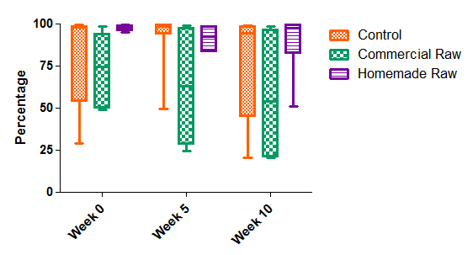

Figure 3.1 Oxidative burst response to PMA by diet treatment and week. The top and bottom of the box represent the 25% and 75%, while the band near the middle is the median. Whiskers go from the smallest to the highest values.

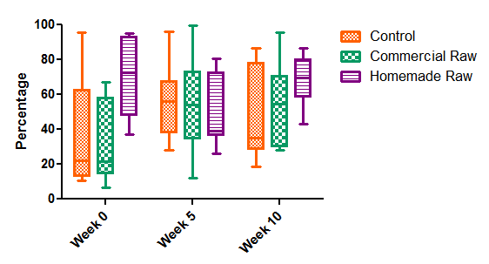
Figure 3.2 Oxidative burst to unlabeled E.coli by diet treatment and week. The top and bottom of the box represent the 25% and 75%, while the band near the middle is the median. Whiskers go from the smallest to the highest value.

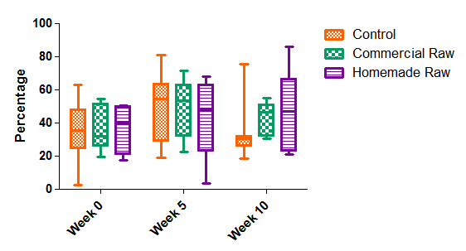

Figure 3.3 Phagocytosis response to labeled E.coli. by diet treatment and week. The top and bottom of the box represent the 25% and 75%, while the band near the middle is the median. Whiskers go from the smallest to the highest value.

Mean total lymphocyte counts along with serum total IgG and IgM are listed in Table 3.2 and Figures 3.4-3.6. There were no significant differences in lymphocyte counts between the three treatments within each time interval. Kittens on the homemade raw diet had significantly increased total lymphocytes at week 10 compared to week 0 and 5. Neither the control or commercial raw fed kittens had any significant changes in total lymphocytes over the 10 week period.
Reference intervals for immunoglobulin concentrations in juvenile kittens have not been published as these can vary considerably depending on environment and antigen exposure. All of the kittens were raised in laboratory setting with the level of environmental antigen exposure across groups expected to be similar. There were no significant differences in IgG concentrations between treatments within each time period. The homemade raw diet did have significantly higher (p=0.0106) levels of IgG at week 5 compared to week 0. There were no significant differences in IgM levels between the three treatment groups within each time period or within each diet group over time. The commercial raw group had the highest mean IgM levels at week 10 with a trend (p=0.055) toward being significantly higher compared to the control diet.

Table 3.2 Total lymphocytes and serum IgG and IgM
by diet treatment and week(Mean ± SEM)

Analyte/ Week | Control | Commercial Raw | Homemade Raw
Total lymphocytes
Week 0 | 4,837 ± 811^{b} | 4,701 ± 811^{b} | 4,464 ± 811^{b}
Week 5 | 5,702 ± 811^{ab} | 5,030 ± 811^{b} | 4,650 ± 811^{b}
Week 10 | 6,627 ± 811^{ab} | 5,480 ± 811^{ab} | 7,600 ± 811ª
IgG (mg/dL)
Week 0 | 416.36 ± 90.30^{abc} | 436.16 ± 90.30^{bd} | 448.81 ± 93.54^{cd}
Week 5 | 453.77 ± 87.79^{abc} | 557.93 ± 87.79^{abc} | 646.48 ± 87.79^{ab}
Week 10 | 494.69 ± 87.79^{abc} | 621.18 ± 87.79^{ac} | 541.94 ± 87.79^{abc}
IgM (mg/dL)
Week 0 | 125.14 ± 18.45^{d} | 162.24 ± 18.45^{cd} | 172.44 ± 19.69^{abcd}
Week 5 | 131.51 ± 17.45^{cd} | 179.83 ± 17.45^{abc} | 172.00 ± 17.45^{abcd}
Week 10 | 157.78 ± 17.45^{bcd} | 212.10 ± 17.45^{ab} | 185.70 ± 17.45^{ab}
NOTE: Different letter superscripts in both rows and columns indicate p values ≤ 0.05

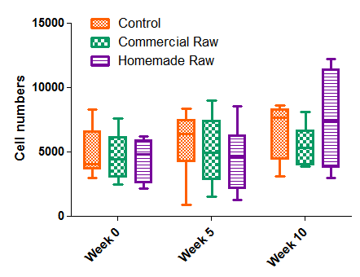
Figure 3.4 Serum total lymphocytes diet by treatment and week. The top and bottom of the box represent the 25% and 75%, while the band near the middle is the median. Whiskers go from the smallest to the highest value.

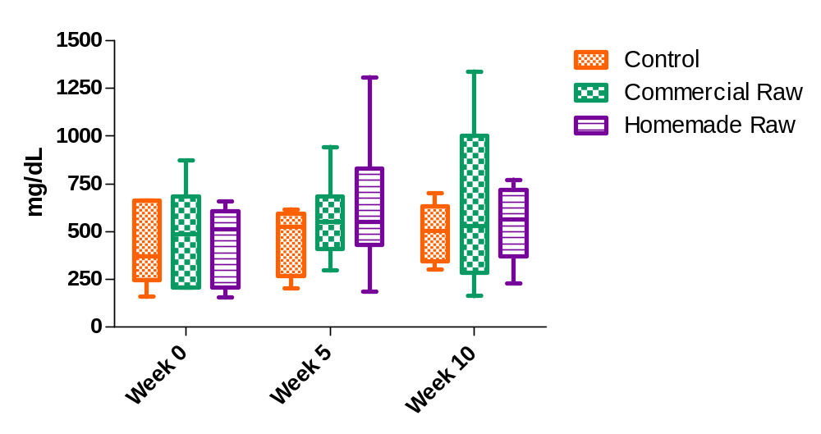Figure 3.5 Total IgG by diet treatment and week. The top and bottom of the box represent the 25% and 75%, while the band near the middle is the median. Whiskers go from the smallest to the highest value.

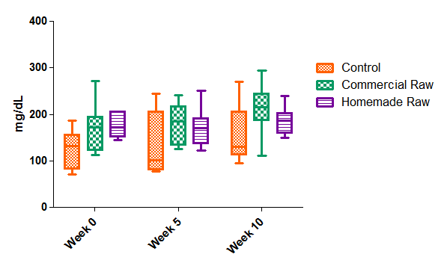

Figure 3.6 Total IgM by diet treatment and week. The top and bottom of the box represent the 25% and 75%, while the band near the middle is the median. Whiskers go from the smallest to the highest value.

Specific IgG serum antibody titers to herpesvirus after vaccination were highly variable within each group. Table 3.3 lists the mean dilution levels at week 5 (before vaccination) and week 10 (after 2 vaccinations at week 6 and 9). Figure 3.7 diagrams the mean dilution levels at week 10 for each diet. Both the control and homemade raw diet groups had titers ranging from 160 to 1280 while the commercial raw had titers ranging from <20 to 160. The commercial raw group had an overall lower 10-week level due to one of the kittens having no seroconversion to the vaccine. Overall, these differences between treatment groups were not statistically significant.

Table 3.3 Serum IgG herpes titers at week 5 (before vaccination)
and week 10 (after vaccination) by diet treatment (Mean ± SEM)

IgG Herpes titers | Control | Commercial Raw | Homemade Raw
Week 5 | 20 ± 72.44ª | 20 ±72.44ª | 20 ± 78.25ª
Week 10 | 520 ± 67.77^{b} | 382 ± 67.77^{b} | 580 ± 67.77^{b}
NOTE: Different letter superscripts in both rows and columns indicate p values ≤ 0.05

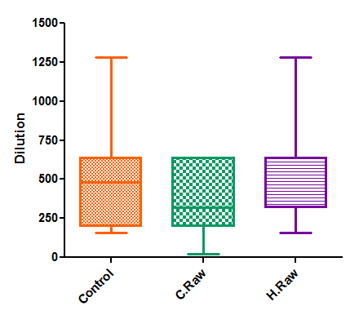

Figure 3.7 Post-vaccination IgG Herpes-specific titers by diet treatment. The top and bottom of the box represent the 25% and 75%, while the band near the middle is the median. Whiskers go from the smallest to the highest value.

Discussion

Differences in stimulation of the immune system between the three dietary groups could be attributed to differing nutrient levels in the diets, processing effects on these nutrients, and differing levels of antigen exposure. Previous studies examining nutrient effects on immune function have focused on nutrient deficiencies.[348, 349] Recently, there has been a growing body of literature demonstrating immune benefits from increasing the intake of specific nutrients.[350, 351] Most of these have focused on micronutrients (Vitamin A, Vitamin C, Vitamin E, selenium, iron, zinc, copper), fatty acids, phytochemicals, and nucleotides. Additional studies have shown that high quality proteins differ in their capacity to support immunocompetence.[349] Whey proteins have been found to support higher antibody responses and cell-mediated immune responses compared to casein.[352-354]. There were minimal differences between the two raw diets and the control diet regarding innate immune function. The commercial raw diet had significantly reduced oxidative burst response to PMA compared with the control and homemade raw diets. Effects due to processing, should have been apparent in both raw diets. All the diets used chicken or turkey as the main protein source, but differences in protein quality (i.e. collagen content) and/or nutritional formulations may have accounted for these oxidative burst differences. The homemade raw diet had additional whey protein as an ingredient which may have accounted for improved neutrophil response to PMA seen in this diet.
Reduced levels of taurine in the diet of cats can have negative effects on oxidative burst and phagocytosis.[355] Taurine is a scavenger of oxidized chlorine and thus may act as a general detoxifier protecting neutrophils from oxidant-induced injury generated from the myeloperoxidase/chloride system. Analyses of levels of taurine on a DM basis were 0.36%, 0.35% and 0.89% for the control, commercial raw and homemade raw diet respectively. The level of taurine in the homemade diet was almost 3 times higher than the other two diets. Increased dietary taurine may have account for the improved oxidative burst to PMA seen in the homemade raw diet compared to the commercial raw diet.
In a study by Hanel [95], phagocytosis in 8 week old kittens was 74% compared with 78% in adult cats. Phagocytosis in our kittens was lower. While their study used a Gram-positive bacteria, Staphylococcus aureus, our study used the Gram-negative organism E. coli as the stimulant for phagocytosis. The activity of neutrophils against Gram-negative bacteria is believed to be highly dependent on the presence of neutrophil granules containing the antimicrobial protein, bactericidal permeability-increasing protein (BPI).[356] Studies in human beings have found newborn neutrophils to be deficient in bactericidal permeability-increasing protein thus increasing their risk of Gram-negative sepsis.[91] The lower response in phagocytosis seen in our kittens may have been related to lower levels of BPI in the kitten’s neutrophils. Further studies examining innate antimicrobial protein production in newborn and juvenile domestic animals may confirm these differences.
Humoral immunoglobulin concentrations differences have been noted between colostrum and colostrum-deprived until 8 weeks of age when these differences are no longer apparent.[95] As all the kittens were 9 weeks of age at the beginning of the study, any differences in colostrum intake would not be expected to have affected humoral immunoglobulin levels. No significant differences in humoral immunity were found between the raw and heat-processed diets at each time point. Over time, higher lymphocytes/immunoglobulin responses were seen in kittens consuming raw diets.. In general, mucosal immune responses to dietary and commensal microorganisms are kept separate from systemic immunity.[357] Increased systemic immune responses to vaccine antigens have been measured in puppies supplemented with probiotics, suggesting probiotic administration increased the priming of naïve B cells.[286] Priming of systemic immunity to commensal bacteria is usually unnecessary because the mucosal innate immune system destroys the few organisms that do penetrate.[358, 359] Increased local secretion of IgA also limits penetration of commensal bacterial. B- and T-cells activated in GALT home back to the intestinal lamina propria where they are needed.[360] Further studies are needed to evaluate specific mucosal immune functions between raw diets and heat-processed diets. These would include evaluating differences in secretory IgA and T-cell function.
Soluble bacterial degradation products reach the systemic circulation affecting secondary-lymphoid tissues. Germ-free rodents fed elemental diets had reduced levels of serum IgG compared with germ-free rodents fed autoclaved foods containing dead bacterial material.[361] The level of exposure of either live microbes or microbial products was higher in the raw diets compared to the control diet. Yet, this increased exposure did not result in differences in systemic priming of IgG or IgM in our kittens. The commercial diet did have the highest aerobic bacterial count numbers (Table 6.3) and there was a trend toward higher IgM levels in the kittens fed this diet. It is unknown whether the increases seen in immunoglobulin concentrations in the raw diets over time were secondary to increased antigen exposure, pathogen exposure, or nutritional formulation differences.
The ‘hygiene hypothesis’ states that a leading cause of the increased incidence of allergy and autoimmune disorders seen over the last 50 years is due to decreased exposure to microorganisms, both pathogenic and nonpathogenic.[293, 321] Reduced bacterial exposures has resulted in alterations in the induction of regulatory T cells that promote tolerance.[290, 362, 363]. An alternative hypothesis has theorized that an increased density of intestinal commensal flora would result in higher penetration of soluble microbial molecules. This would affect T-cell function by facilitating tolerance through activation and clonal deletion of T-cells repeatedly exposed to antigens.[359] Previous studies have shown the influence of diet on gut microflora composition.[364, 365] Differing levels of fat, protein and fiber along with specific dietary components have changed gut flora over time.[364] During the past 50-70 years with the advent of commercial pet foods, diets fed to cats have shifted in terms of relative contributions of macronutrients to total energy intake. Increasing levels of carbohydrate for energy production have replaced higher protein levels. One would also assume decreasing or increasing the quantity and types of microbial antigens from the diet would also alter gut flora over time. Larger diet-microbiome association studies are needed to further define how nutrients and food processing affect the composition of the microbiota and their effects on metabolism and immune function.

Conclusions

Minimal humoral IgG and IgM differences were seen between the two raw diets and the control heat-processed diet at each time point. The homemade raw had significant increases over time in IgG concentration and total lymphocyte counts and the commercial raw had significant increases in IgM concentration over time. A trend was noted for higher serum levels of IgM concentration in the commercial raw diet fed kittens when compared to the control diet group. This diet also had the highest number of bacteria as determined by aerobic plate counts. In general, unless bacterial translocation occurs, higher levels of humoral immunity would not be expected. Systemic immune responses though are responsive to bacterial degradation products and this may explain the higher levels of IgM seen in the commercial diet.
The homemade raw diet was found to have higher oxidative burst responses to the stimulant PMA than the commercial raw diet. The dietary level of taurine in this diet was also three times higher. Taurine, a known scavenger of oxidized chlorine, acts as a general detoxifier protecting neutrophils from oxidant-induced injury generated from the myeloperoxidase/chloride system. Adding higher dietary levels of taurine to pet foods to improve innate immune function would be recommended. In general, phagocytosis was reduced in all the groups compared to previous reported data. Further examination of innate antimicrobial peptides in juvenile animals is warranted, along with the impact of diet and processing on gut microbiota, T cell, and mucosal immune function.

CHAPTER IV

COMPARISON OF URINARY ISOPROSTANES AS A MARKER OF OXIDATIVE STRESS IN KITTENS FED RAW VS. HEAT-PROCCESSED DIETS

Introduction

Generation of reactive oxygen species (ROS) and reactive nitrogen species (RNS) is both beneficial and detrimental to the host. Overproduction of free radicals results in negative effects due to damage to cell structures including proteins, DNA, lipids and membranes.[138] In humans, cumulative effects of free radicals are implicated in numerous diseases including cancer, cardiovascular disease, atherosclerosis, hypertension, ischemia/reperfusion injury, diabetes mellitus, neurodegenerative diseases (Alzheimer's disease and Parkinson's disease), rheumatoid arthritis, and ageing.[138] In contrast, beneficial effects of ROS/RNS include defense against infectious agents. ROS/RNS also function in cell signaling pathways and mitogenesis.[138]
ROS/RNS are products of normal cellular metabolism with their production occurring mainly in the mitochondria. In the process of movement of electrons along the electron transport chain within the inner mitochondrial membrane, small amounts of electrons can “leak” out prematurely forming superoxide radicals when combined with oxygen.[138] Approximately 1-3% of all electrons in the electron transport chain leak out prematurely to generate superoxide instead of reducing oxygen to water and producing ATP.[138] A free radical is defined as any molecule with one or more unpaired electrons in their outer shell.[138] The unpaired electron(s) result in these molecules having high reactivity. Radicals formed from oxygen include superoxide radical, hydroxyl radical, hydrogen peroxide, peroxynitrite, and lipid peroxides. Superoxide is considered the primary ROS and can interact with other molecules to produce secondary ROS.[138]
Neutrophils generate large amounts of reactive radicals in response to inflammation. Local inflammatory signals recruit neutrophils and macrophages to leave the circulation, marginate along the endothelium and move into the tissue at the site of infection or trauma.[139] Phagocytosis is the cellular process of granulocytes engulfing foreign particles to form an internal phagosome.[139] Once within the phagosome, 2 killing systems can be implemented, oxygen-dependent and oxygen independent.
Respiratory burst is the term used to describe the oxygen-dependent system for generation and release of ROS/RNS within the phagosome.[140] During phagocytosis, granulocytes undergo a burst of metabolic activity with a 2-3 fold increase in oxygen consumption and increased generation of superoxide radical, hydroxyl radical and hydrogen peroxide generated from NADPH oxidase.[139] Hydrogen peroxide can subsequently produce hypochlorous acid via myeloperoxidase or form peroxynitrite using nitric oxide. Peroxynitrite can subsequently degrade to yield additional hydroxyl radicals.[141] If free iron or copper is available, hydroxyl radicals can also be formed from the Fenton reaction. Excess production of these radicals, particularly hypochlorous acid, can lead to local tissue damage. Granulocytes and macrophages protect themselves from oxidant damage using the endogenous enzymes superoxide dismutase and catalase, and endogenous glutathione.

Polyunsaturated fatty acids (PUFA) within cell membranes are particularly vulnerable to extraction of electrons from reactive radicals forming lipid radicals.

Lipid radicals can either be reduced by Vitamin E or extract an electron from a neighboring fatty acid molecule propagating a chain reaction. Up to 60 molecules of linoleic acid and 200 molecules of arachidonic acid within cell membranes can be damaged in this one initiation event.[142]

Levels of the products of oxidant damage are a reliable marker of oxidant injury. Either lipid peroxidation products or oxidized bases in nucleic acids are the most common substrates quantified. Lipid peroxidation products proposed for measurement include malondialdehyde, hydroxynonenal (HNE) and isoprostanes. The thiobarbituric acid reactive substance test is an assay used to measure malondialdehyde in tissues. This test though has been considered to have marginal validity as much of the malondialdehyde measured is formed following collection during the incubation period.[143] Malondialdehyde can also form as a result of thromboxane synthesis during platelet activation, as occurs with blood sampling.[143] The discovery of isoprostanes as lipid peroxidation products has opened up new options for quantifying lipid peroxidation.

Isoprostanes are prostaglandin-like compounds produced in vivo, independent of cyclooxygenases, by free radical-induced peroxidation of arachidonic acid in plasma membranes.[146] In the Biomarkers of Oxidative Stress Study (BOSS), sponsored by the National Institutes of Health (NIH), plasma or urine isoprostanes were found to be the most accurate method to assess in vivo oxidant stress.[147] Urine samples in particular have been viewed as an index of whole body oxidant stress over time.[148] Levels of isoprostanes can be analyzed by gas chromatography-mass spectroscopy or immunoassays.[148] Normal ranges have been established in humans but to the author’s knowledge, no values have been established for dogs or cats. My objective was to compare levels of lipid peroxidation and oxidative stress in kittens fed a commercial raw food diet and a home-prepared raw food diet vs. kittens fed a control commercial heat-processed cat food. Urinary isoprostanes were the assay used to measure levels of lipid peroxidation. My hypothesis was that the raw diets would have reduced levels of oxidative stress in kittens compared to kittens fed the control heat-processed diet.

Materials and Methods

All kittens were born and raised at The University of Tennessee Veterinary Medical Center and Research facility and their care was in compliance with the Guide for the Use and Care of Laboratory Animals. The experimental protocol was approved by the Institutional Animal Care and Use Committee.

Animals: Twenty-four 9- to 19-week old domestic short-hair kittens born over a 3 year period were used for an Association of American Feed Control Officials (AAFCO) growth feeding trial. The kittens were given physical examinations and tested for intestinal parasites one to three days prior to starting the feeding trial and were healthy. All kittens were born from the same queen and tom. Kittens were weaned on a canned and dry extruded diet^{1,2} at 6-7 weeks of age and eating solid food prior to beginning of the feeding trial at 9 weeks of age. The kittens were housed in individual metabolism cages during the feeding trial and allowed daily group play. At the end of the study, the kittens were transferred to a permanent feline colony that is used for dietary and other non-invasive research or adopted to private homes.

Diet: The kittens were randomized to 3 different dietary groups via a random numbers table for the AAFCO growth feeding protocol. Each diet group consisted of 8 kittens. Diet Group A was fed a commercial heat-processed food³ that is nutritionally adequate for all life stages as determined by AAFCO guidelines. This diet was a canned food and was chosen to closely match the raw diets moisture and nutrient content. This was the control diet. Treatment Group B was fed a commercial frozen raw diet⁴. Treatment Group C was fed a home-prepared raw food diet^{5,6}. The diet was made with raw chicken⁶ obtained from a local grocery store and mixed, according to manufacturer’s instructions, with a popular commercial food supplement⁴ designed to balance a raw meat diet. The homemade diet was prepared every 2 weeks and immediately frozen. All raw foods were kept frozen until 1 day before feeding, when they were transferred to a refrigerator in preparation for feeding the next day. Each group was fed three times daily a quantity of food in excess of daily needs to ensure adequate food intake. The length of the feeding trial was 10 weeks. Water was available at all times.

Urine collection: Urine was collected non-invasively (free-catch) at weeks 0, 5 and 10 of the study. Urine was subsequently centrifuged and the supernatant was frozen at -80 °C. The samples were batched and run at the end of the study.

___________________________________________________________________
¹ Science Diet®- Kitten Healthy Development Liver and Chicken Entrée minced. Hill’s Pet Nutrition Inc.®, Topeka, KS
² Science Diet®- Kitten Healthy Development Original dry cat food. Hill’s Pet Nutrition, Inc.®, Topeka, KS
³ Evo – Turkey and Chicken Canned Cat and Kitten Cat Food. Natura Pet Foods, Santa Clara, CA
⁴ Wild Kitty Raw All Natural Cat Food – Chicken and Clam frozen raw diet. Wild Kitty Cat Food, Kennebunkport, ME.
⁵ TCFeline Plus Cat Food Premix with beef liver. TCFeline®, Salt Spring Island, BC, Canada
⁶ Tyson boneless, skinless chicken breast. Tyson Foods Inc., Springdale, AR

Urinary creatinine measurement: A commercially available immunoassay kit¹ was used to quantify urine creatinine. Using the Jaffe reaction, urine creatinine reacted with picric acid under alkaline conditions to produce an orange color which was quantified by absorption spectroscopy. Briefly, urine samples were diluted to calculate creatinine concentrations in the optimal portion of the standard curve. 25 microliters were added along with 3 provided standards (1, 3 and 10 mg/dL) to a 96-well microplate. Samples were run in triplicate. One hundred and eighty microliters of alkaline picrate reagent was added and the plate was incubated at room temperature for 10 minutes. Absorbances were read at 490 nm using a Bio-Tek microplate reader. A standard curve was established from absorbance readings using KCJunior software and sample concentrations were calculated in mg/dL. Average intrassay coefficient of variation was 3.54% while average interassay coefficient of variation was 21.37%.

Urinary isoprostane measurement: A commercially available competitive enzyme-linked immunoassay kit² was used to quantify urinary F2-isoprostanes. The F2 isoprostanes in the samples and standards competed with F2-isoprostane conjugated to horseradish peroxidase coated on a microplate. The kit recommended pretreatment with glucuronidase but this was not performed as cats are known to have low levels of glucorosyltransferase activity.[366, 367]
Briefly, the urine samples were diluted at a 1:8 ratio. One hundred microliters of samples and standards were added to the coated plate along with 100 microliters of F2-isoprostane horseradish peroxide conjugate and allowed to incubate at room temperature for 2 hours. Plates were then washed in Tris buffered saline (TBS) 0.05% Tween 20. Two hundred microliters of TMB was then added and the plates were left a room temperature for 20 minutes for full color development to occur. Fifty microliters of 3 M H₂SO₄ was then added to stop the reaction and absorbances were read at 450 nm using a Bio-Tek microplate reader. A standard curve was established from absorbance readings using KCJunior software and sample concentrations were calculated in ng/dL. Average intrassay coefficient of variation was 7.16% while average interassay coefficient of variation was 32.44%.
Urinary creatinine concentration was used to standardize for urine dilution and the urinary isoprostane level was expressed as an F2-isoprostane/urinary creatinine ratio. Six random samples that were tested for isoprostanes and creatinine using the immunoassay kits were also sent to the Eicosanoid Core Laboratory at Vanderbilt University for isoprostane quantification using gas chromatography-mass spectroscopy (GS-MS) and creatinine quantification using colorimetric Jaffe reaction. Vanderbilt University’s method for isoprostane quantification using GC-MS has recently been published in detail.[148] Intra- and inter-assay coefficients of variation for GS-MS isoprostane measurements were 10%.

___________________________________________________________
¹ Colorimetric Creatinine Assay Kit, Oxford Biomedical Research, Inc., Oxford, MI
² Urinary Isoprostane EIA Kit, Oxford Biomedical Research, Inc., Oxford, MI

Statistical analysis: A completely randomized design was used to compare mean differences in kitten urinary creatinine, urinary isoprostanes and urinary isoprostane/creatinine ratio by diet treatment and week. Twenty-four kittens were randomly assigned to the three diet treatments with eight kittens per treatment. Mixed model ANOVA (SAS, Version 9.2) with repeated measures was used to compare least square means. Log10 transformation was required in all variables to meet equal variance and normality. The limit of statistical significance of the tests performed was defined as p ≤ 0.05 while trend was defined as p ≤ 0.10.
Spearman correlation (SAS, Version 9.2) was used to compare six values each of isoprostanes, creatinine, and isoprostane/creatinine ratios using the immunoassay method and the gas chromatography-mass spectrometry method. Correlation between creatinine values using the immunoassay method and colorimetric method was also done. Strong correlation coefficients were defined as R >0.7, moderate 0.3-0.7,and weak <0.3.

Results

Table 4.1 and 4.2 list the mean creatinine and isoprostane values for each diet group at each time point. The moisture content of the homemade raw diet was 78.5% compared to 72% and 71% respectively for the control and commercial raw diet. Higher water intake in the homemade raw diet group resulted in greater urine output and urine dilution as can be seen with lower creatinine and isoprostane levels. Table 4.3 lists the mean isoprostane/creatinine ratio for each diet at each time point. Figure 4.1 diagrams the log10 transformed ratios for each diet treatment. There were no significant differences in isoprostane/creatinine ratios between the raw diets and control diet within each specific time point. Significant effects were noted within the control and homemade raw diets over time. The control diet had a significant decrease in isoprostanes/creatinine ratio from week 0 to week 5, while the homemade raw diet had a significant decrease in the ratio from week 5 to week 10. Although the isoprostane/creatinine ratio in the commercial raw diet also declined over time, the level of decline was not significant over the 10 week period.

Table 4.1 Urinary creatinine by diet treatment and week(Mean ± SEM)

Analyte/Week | Control | Commercial Raw | Homemade Raw
Creatinine (mg/dL)
Week 0 | 295.95 ± 37.89ª | 209.21 ± 37.89^{bc} | 230.06 ± 37.89^{abc}
Week 5 | 325.16 ± 37.89ª | 174.55 ± 37.89^{bc} | 88.68 ± 37.89^{d}
Week 10 | 332.18 ± 37.89ª | 243.66 ± 37.89ª | 158.85 ± 37.89^{c}
NOTE: Different letter superscripts in both rows and columns indicate p values ≤ 0.05. Data are non-transformed means and SEM.

Table 4.2 Urinary isoprostanes by diet treatment and week (Mean ± SEM)

Analyte/Week | Control | Commercial Raw | Homemade Raw
Isoprostanes (ng/mL)
Week 0 | 4.40 ± 0.57ª | 3.77 ± 0.57^{ab} | 4.20 ± 0.57^{ab}
Week 5 | 2.68 ± 0.57^{b} | 2.77 ± 0.57^{ab} | 1.52 ± 0.57^{c}
Week 10 | 3.29 ± 0.57^{b} | 3.62 ± 0.57^{ab} | 1.50 ± 0.57^{c}
NOTE: Different letter superscripts in both rows and columns indicate p values ≤ 0.05. Data are non-transformed means and SEM.

Table 4.3 Urinary isoprostanes/creatinine ratio by diet treatment and week
(Mean ± SEM)

Analyte/Week | Control | Commercial Raw | Homemade Raw
Isoprostanes/creatinine ratio(ng/mg Creatinine)
Week 0 | 1.659 ± 0.372ª | 2.519 ± 0.372ª | 2.185 ± 0.372ª
Week 5 | 0.879 ± 0.372^{bc} | 1.726 ± 0.372^{ab} | 1.758 ± 0.372^{ab}
Week 10 | 0.917 ± 0.372^{c} | 1.603 ± 0.372^{abc} | 0.920 ± 0.372^{c}
NOTE: Different letter superscripts in both rows and columns indicate p values ≤ 0.05. Data are non-transformed means and SEM.

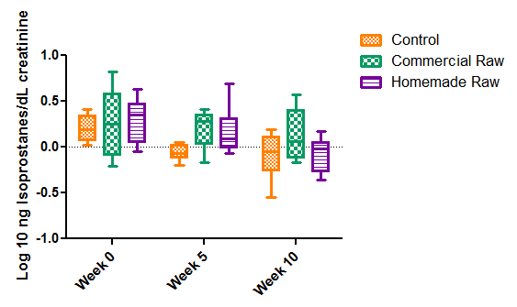

Figure 4.1 Urinary isoprostanes/creatinine ratio log10 transformation by diet treatment and week. The top and bottom of the box represent the 25% and 75%, while the band near the middle is the median. Whiskers go from the smallest to the highest value.

Table 4.4 lists the correlation coefficients for each group of assays. There was a strong correlation (R=0.97) between the immunoassay and colorimetric methods for creatinine concentration levels. A weak correlation level was found between the two methods for analyzing urinary isoprostanes (R=0.38) and a moderate to strong correlation (R=0.76) was found between the two methods for the isoprostane/creatinine ratio.

Table 4.4 Pearson Correlation coefficients for urinary isoprostane, creatinine and isoprostane/creatinine ratio

 | GS-MS Isoprostane | Colorimetric Creatinine | GS-MS Ratio
Immuno Isoprostane | 0.38017
Immuno Creatinine |  | 0.97173
Immuno Ratio |  |  | 0.76597

Discussion

Common causes of increased oxidative stress in mammals include hypoxia, infection, inflammation, neoplasia, phagocytic immune responses, drug metabolism, hyperglycemia, and ultraviolet radiation.[368] Networks of both endogenous and exogenous antioxidants are utilized to combat these oxidative insults. Endogenous compounds include the enzymes superoxide dismutase and catalase along with glutathione.[368] Dietary exogenous antioxidants include Vitamin E, Vitamin C, carotenoids, and selenium.[369] Diet can also increase levels of oxidative stress through ingestion of oxidized lipids and transition metals.[370]
All foods that contain lipids are susceptible to oxidation but especially affected are foods that are cooked to high temperatures and subsequently stored.[371] Severe processing conditions, such as those used in extrusion, can reduce lipid stability resulting in increased levels of lipid peroxide and secondary lipid oxidation products.[372] Peroxidized fats increase the turnover of Vitamin E and consequently increase the requirement for Vitamin E despite dietary nutritionally adequate amounts.[370] Differences in levels of oxidative stress related to diet therefore could be related to processing conditions, and/or levels of endogenous and exogenous pro-oxidants and antioxidants in the diet.
No significant differences were found between treatments at each time point but a trend toward reductions in oxidative stress was seen in all the diets over the 10 week trial. All the kittens were weaned on a canned and dry extruded kitten food prior to entry into the feeding trial. Measurements of oxidized lipids and lipid antioxidant levels in the diets were not done. These overall reductions seen over the 10 week period may have been related to the content and level of antioxidants in each of the diets or the stresses associated with weaning. The transition to independent feeding, greater environmental exposure and decreasing maternal antibodies could result in increased oxidative stress.[373] To the author’s knowledge, no published studies have been performed looking at pre- and post- weaning levels of oxidative stress in kittens.
Another potential cause for the reduction in oxidative stress seen over time could be specific processing conditions. Heat processing can increase or decrease free radical production in foods. Some of the Maillard reaction products produced in heat processing possess antioxidant activity [224] while heat processing disrupts muscle cell structure, inactivates endogenous anti-oxidant enzymes and releases oxygen from oxymyoglobin producing hydrogen peroxide.[374] The kittens went from a canned and extruded diet to a canned heat processed diet or raw diets. Processing through extrusion has been found to increase lipid oxidation.[372] These effects have been attributed to increasing temperature, increase in surface area exposed, and an increase in transition metal content in the food secondary to high pressure on the metal extruder components.[372]
Muscle tissue is a good source of the sulfur amino acids methionine and cysteine.[373] Methionine is used for the production of glutathione. Very high levels of animal protein as seen in the homemade raw diet (78% DM) may have reduced oxidative stress in this diet through higher production of glutathione.
Inflammation and infection will increase systemic levels of oxidative stress through the production of free radicals in granulocytes. [139] Microbial exposure was higher in raw meat diets (Table 6.3) but this did not seem to increase oxidative stress levels in the kittens fed these diets.
There was moderate to weak correlation between the immunoassay method and gas chromatography-mass spectroscopy method for analysis of urinary isoprostanes alone (R=0.38). The isoprostane immunoassay also had large interassay variability (32%). Yet the correlation between the methods for isoprostane/creatinine ratio was strong (R=0.76). While it does not seem reasonable to view any individual data as reliable, group trends in isoprostane level using the immunoassay may be interpreted with some reliability.

Conclusions

No significant differences in levels of oxidative stress were found between a heat-processed canned diet and 2 raw meat diets in kittens. There was a trend toward lower levels of oxidative stress in all of the groups over the 10 week feeding trial period. These reductions may have been attributable to differing levels of antioxidants in each of the diets, stresses associated with weaning, and differences in pro-oxidants in an extruded vs. canned or raw diet. Further studies examining effects of extrusion on oxidation in pet foods is warranted.

Chapter V

Effects of Raw vs. Heat-Processed diets on Digestibility in Domestic Kittens and Cats

Introduction

Nutrient digestibility of raw diets has not been well characterized in domestic felines. Due to their strict carnivorous nature, protein is a key component in the feline diet. Many factors affect protein digestibility. A main effector is protein quality which includes amino acid composition, presence of any anti-nutritional factors such as trypsin inhibitors, phytates, tannins or fiber, and the storage and processing of the protein itself.[221] The nutritional value of a protein depends on both the distribution of amino acids and their bioavailability. Proteolytic enzymes in the gut may not be able to digest altered proteins if the protein is not recognized by the enzyme’s active site.[9] If the modified amino acid or peptide is hydrolyzed, it may not be transported across the epithelial wall. If the modified amino acid is absorbed, the animal may not be able to convert it back to its native form.[9]
Proteins and amino acids can undergo significant chemical changes during processing. Processing conditions include both chemical and physical factors such pressure, temperature, and water content. Food proteins react with other food components such as sugars, fats, oxidizing agents, acids, alkali, polyphenols and food additives.[222] The benefits of processing include food preservation, destruction of toxins and microorganisms, improved palatability, and convenience. Processing can also both positively and negatively affect the bioavailability of nutrients. Heating of certain plant proteins increases nutrient bioavailability secondary to destruction of intrinsic trypsin inhibitors[9], but in general, heat treatment decreases animal protein bioavailability.
Heat processing results in denaturing of proteins. The loss of secondary and tertiary structure results in a loss of functionality. Denaturing exposes reactive groups to reactions not previously possible when the protein was in its native confirmation.[9] Processing effects on a range of amino acids include proteolysis, protein-crosslinking, amino acid racemization, protein-polyphenol reactions, oxidative reactions, and browning or Maillard reactions.[9]
The Maillard reaction is a form of nonenzymatic browning resulting from the reaction between an amino group and reducing sugar with the application of heat.[224] These compounds are responsible for many of the positive flavor, color and textural components of foods. Reduction in bioavailability occurs due to damage to essential amino acid structure, and formation of potentially toxic compounds.
Lysine is the most chemically reactive of the amino acids due to the presence of its side chain ε-amino group. Heating in the absence of fats and carbohydrates can lead to the reaction of lysine residues with amide side chains forming the isopeptides glutamyl-lysine and aspartyl-lysine. Heating, in the presence of reducing sugars, results in Maillard compounds. Testing for lysine availability after processing in pet foods has been found to be significantly reduced.[208, 236] Arginine can also undergo Maillard reactions and formation of cross-linked proteins. Changes to methionine and cysteine are primarily due to oxidation during food processing forming sulfoxides and sulfones. In one study, methionine bioavailability was reduced by 25% in heat processed casein compared to raw casein fed to growing kittens.[237] Lysine, and methionine are the most common limiting amino acids in commercial cat foods.[12]
Heterocyclic amines (HAA) can be found in heat-processed muscle protein foods, formed from reactions of amino acids with creatinine. These compounds not only decrease bioavailability but have been shown to be toxic.[224, 232] Heterocyclic amines have been detected in all muscle sources when foods are cooked to well done or charred state.[232] HAA’s have not been detected in raw meat prior to processing.[232] HAAs found in cooked proteins are in the parts per billions or ng/gm food. Testing in mice fed a pellet diet containing HAA’s in parts per million found that almost all of the HAAs are multisite carcinogens that induce highly significant increases in tumors compared with controls.[232] Heterocyclic amines produced at moderate cooking temperatures may be toxic over longer periods and appear to be cumulative in their toxicity.[232]
The effect of heat-processed vs. raw diets on digestibility has been previously examined in exotic felids. Crissey compared a raw meat diet with a dry kibble diet in Sand cats and found the raw meat diet to have 10% higher digestibility in dry matter, and energy and 15% higher digestibility in crude protein compared to the kibble extruded diet.[199] A more recent study looked at feeding the domestic cat’s wild ancestor, Felis lybica, a commercial raw meat vs. an extruded high protein kibble diet.[205] Crude protein digestibility in the raw diet was 8% higher compared to the extruded diet.[205] Kerr compared energy and macronutrient digestibility in a raw beef based diet and the same diet microwaved to an internal temperature of at least 71° C.[375] No differences were found between the raw and microwaved diets with respect to macronutrient and energy digestibility. Another study evaluating protein quality of various raw and rendered animal products, found total essential amino acid digestibility and total amino acid digestibility ranged from 93.7 to 96.7 and 90.3 to 95.5% respectively in the raw diets, and 84.0 to 87.7 and 79.2 to 84.8 respectively in the rendered animal meats.[206]
A frequently cited benefit to feeding raw food diets is that active enzymes remain intact and thereby improve digestibility and bioavailability of foodstuffs.[4, 153] Arguments against these claims are that protein enzymes are denatured and inactivated in the stomach secondary to hydrochloric acid and pepsin secretion [210], and all the enzymes dogs and cats need for digestion are already produced in the gastrointestinal tract unless they have underlying exocrine pancreatic insufficiency.[210, 211] The extent of enzyme degradation in the stomach is not completely quantified, but treatment for exocrine pancreatic insufficiency with raw pancreas is a common practice. Westermarck found the highest level of supplemental lipase recovery in jejunally cannulated dogs fed raw porcine pancreas (39.1%) compared to Viokase¹ powder (26.2%). Dietary amylase and protease activity levels were still present in the

_____________________________________________________________
¹ Viocase-v powder, Boehringer Ingelheim/Fort Dodge Vetmedica, Inc. St. Joseph, MO.

jejunum from the raw pancreas extract and higher than enzyme levels in a dog with subclinical exocrine pancreatic insufficiency.[212]
The objective of my research was to compare apparent digestibility in kittens and adult cats fed raw diets compared to a premium heat-processed high protein canned diet. My hypothesis was that apparent digestibility of dry matter, organic matter, and protein would be greater in the raw vs. heat-processed diet, in both kittens and adult cats, but there will be no difference in fat or nitrogen free extract (NFE) apparent digestibility between the three treatment groups.

Materials and Methods

All kittens and adult cats were born and raised at The University of Tennessee Veterinary Medical Center and Research facility and their care was in compliance with the Guide for the Use and Care of Laboratory Animals. The experimental protocol was approved by the Institutional Animal Care and Use Committee.

Animals: Six 20-week old kittens (5 males and 1 female) and 4 adult cats (2 males and 2 females) with ages ranging from 1-4 years were used. All kittens and cats were given a physical exam before and after the digestibility trial and were deemed healthy. The kittens had just completed a 10-week AAFCO growth feeding trial and had been randomly chosen to be on one of 3 diets (Diet A¹, Diet B², Diet C^{3,4}) during the growth trial prior to entry in the digestibility trial. The adult cats had been receiving a commercial dry diet⁵ prior to entry in the digestibility study. Body weights were recorded biweekly on all kittens and cats to ensure weight maintenance. The kittens and adult cats were housed in individual metabolism cages during the digestibility trial. At the end of the study, the kittens and adult cats were transferred to a permanent feline colony that is used for dietary and other non-invasive research or adopted to private homes.

Diet: Diet A was a commercial heat-processed canned diet¹ that is nutritionally adequate for all life stages as determined by AAFCO guidelines. This diet was a canned food and was chosen to closely match a raw diet moisture and nutrient content. This was the control diet. Diet B was a commercial frozen raw diet². Diet C was a home-prepared raw diet. The diet was made with raw skinless chicken breast⁴ obtained from a local grocery store and mixed, according to manufacturer’s instructions, with a popular commercial food supplement³ designed to balance a raw meat diet. The homemade diet was prepared every 2 weeks and immediately frozen. All raw foods were kept frozen until 1 day before feeding, when they were transferred to a refrigerator
____________________________________________________________________
¹ Evo – Turkey and Chicken Canned Cat and Kitten Cat Food. Natura Pet Foods, Santa Clara, CA
² Wild Kitty Raw All Natural Cat Food – Chicken and Clam frozen raw diet. Wild Kitty Cat Food, Kennebunkport, ME.
³ TCFeline Plus Cat Food Premix with beef liver. TCFeline®, Salt Spring Island, BC, Canada
⁴ Tyson boneless, skinless chicken breast. Tyson Foods Inc., Springdale, AR
⁵ Science Diet®-Adult Optimal Care™ Original dry cat food. Hill’s Pet Nutrition, Inc.®, Topeka, KS

in preparation for feeding the next day. Table 5.1 compares label guaranteed analysis where available and lists ingredients in each diet. Each kitten/cat was fed twice daily a quantity of food in excess of daily needs to ensure adequate food intake. Water was available at all times.

Table 5.1 Published diet guaranteed analysis (dry matter basis)
and diet ingredient lists

 | Control | Commercial Raw | Homemade Raw*
Crude Protein (Minimum) | 54.5% | 51.8% | *
Crude Fat (Minimum) | 36.4% | 40.7% | *
Crude Fiber (Maximum) | 2.8% | 9.3% | *
Ash (Maximum) | 13.6% | 9.3% | *
Energy | 1.28 kcal/g** | * | *
*Not available
**as fed basis

Diet Ingredient lists
Control Ingredients: Turkey, chicken, turkey broth, chicken broth, chicken meal, herring, carrots, whole egg, salmon meal, natural flavor, carrageenan, tomato flakes, cottage cheese, L-ascorbyl-2-polyphosphate, apples, guargum, Vitamin E supplement, Vitamin A supplement, Vitamin D3 supplement, Vitamin B12 supplement, thiamine mononitrate, niacin supplement, d-calcium pantothenate, pyridoxine hydrochloride, riboflavin supplement, folic acid, biotin, zinc amino acid chelate, cobalt amino acid chelate, copper amino acid chelate, manganese amino acid chelate, potassium iodide, inulin, herring oil, choline chloride, potassium chloride, salt, sunflower oil, taurine, sodium phosphate, beta carotene.

Commercial Raw Ingredients: Free range organic chicken, apples, Atlantic clams, beets, broccoli, carrots, chicken hearts, chicken liver, cod liver oil, dried kelp, dried yeast, flax, flax seed, lecithin, mushrooms, water sufficient for processing, oysters, peas, rice bran, spinach, wheat germ, wheat germ oil.

Homemade Raw Ingredients: Skinless chicken breast⁵, Supplement: Free-dried bovine bone (New Zealand), egg yolk, whey protein isolate, beef liver, freeze-dried krill, taurine, cellulose, kelp, Vitamin E, Vitamin D3, Vitamin A, Vitamin B complex.

Food intake: To determine food intake, all food was weighed before and after each offering and the difference was determined. All food not ingested within 4 hours of presentation was removed to further prevent microbial contamination or proliferation. Feeding bowls and feeding area were sanitized between feedings.

Digestibility trial: Each kitten/cat was rotated through the 3 dietary regimens. The kittens/cats were fed the three diets in random order with a 7 day acclimation period followed by 7 day feces collection period. Feces were scored and recorded daily by the same individual (BAH) during the 7 day collection period. Scoring was done using a 5 point scale as follows: 1 = watery, liquid that can be poured, 2 = soft, unformed stool, 3 = soft, moist, formed stool, 4 = dry, well formed stool, 5 = hard, dry pellets. All feces were collected and weighed daily in individual containers and immediately frozen at -20° C. A composite sample of each diet and all feces were submitted to Eurofin laboratory⁹ for proximate analysis of moisture, protein, fat, ash, crude fiber and energy digestibility. Apparent digestibility was calculated using the equation:
(Intake – Output)/ Intake.

Statistical analysis: A completely randomized design was used to compare mean differences in apparent digestibility (dry matter, organic matter, protein, fat, nitrogen free extract, energy), dry matter food intake, dry matter fecal output, kcal ingested and fecal scores in kittens and adult cats by treatment, with blocking by treatment(diet) and period (week). Mixed model ANOVA (SAS, Version 9.2) was used to compare least square means.
The two testable assumptions of ANOVA, normally distributed residuals and equal variances between groups, where tested for all dependent variables. No variables failed to meet these assumptions. Normality was tested using the Shapiro-Wilk test and homogeneity of variance was tested using the Leven’s F test. Statistical significance was defined as p ≤ 0.05 while trend was defined as p ≤ 0.10.

Results

Table 5.2 lists the analyzed composition of each of the diets fed during the digestibility trial. Protein content of both the control and commercial raw diet were similar but less than the label minimum guaranteed analysis. All protein levels were greater than the National Research Council (NRC) feline growth minimum requirement of 18% dry matter.[12] The homemade raw diet had a substantially higher level of protein and lower level of fat compared to the other 2 diets. The fat content of the commercial raw was less than the label minimum guaranteed analysis but all of the diets had fat contents greater than NRC feline growth minimum requirement of 9% dry matter.[12] There was no detectable carbohydrate in the homemade raw diet while both the control and commercial raw had less than 8% dry matter level of carbohydrate. The moisture level of the homemade raw diet was higher than either control or commercial raw. The kittens on this diet had subsequent higher urine output.

Table 5.2 Analyzed diet nutrient composition
(dry matter basis)

 | Control | Commercial Raw | Homemade Raw
Crude Protein | 46.7% | 49.7% | 78.3%
Crude Fat | 37.8% | 34.2% | 12.2%
Crude Fiber | 0.60% | 0.88% | 0.16%
Ash | 11.0% | 8.1% | 9.3%
NFE | 3.9% | 7.3% | 0.0%
Energy* | 1.76* | 1.85* | 1.17*
Moisture | 71.81% | 70.73% | 78.58%
*kcal as fed basis

Kitten mean apparent digestibility values are shown in Tables 5.3. Kitten apparent total tract dry matter (p<0.0001), organic matter (p<0.0001), protein (p=0.0001), and energy (p<0.0001) digestibility was significantly greater in the homemade raw diet compared to the commercial raw diet and control diet (p<0.0001). The commercial raw diet had significantly greater apparent DM, OM, protein, and energy digestibility compared to the control diet (p<0.0001). A trend toward significantly greater fat digestibility (p=0.056) was found in the commercial raw diet compared to the homemade diet and control diet. The reduced level of fat in the homemade raw diet compared to the other two diets may have affected its digestibility value. Nitrogen-free extract (NFE) apparent digestibility in the commercial raw diet was significantly higher than the control diet but both values were low (< 65%).
Adult mean apparent digestibility values are shown in Table 5.4. The homemade raw diet had greater apparent protein digestibility (p=0.001) compared to both the commercial raw and control diets, and the commercial raw had greater protein digestibility (p=0.001) compared to the control diet. Both raw diets had greater apparent DM digestibility (p=0.001) compared to the control diet. The homemade diet had greater OM (p=0.041), and energy (p=0.021) digestibility compared to the control diet. Fat digestibility (p=0.006) was significantly lower in the homemade raw diet compared to the commercial raw and control diet. As previously stated, the reduced level of fat in the homemade raw diet may have affected its digestibility values. There were no significant differences in NFE digestibility between the diets.
With a few exceptions (i.e. overall NFE, OM and fat in control diet, protein in homemade diet), the kittens overall had higher digestibility values compared to the adults.

Table 5.3 Kitten apparent digestibility values by diet treatment
(Mean ± SEM)

 | Control | Commercial Raw | Homemade Raw
DM % | 83.849 ± 0.642^{c} | 90.627 ± 0.642^{b} | 92.625 ± 0.642ª
OM % | 88.446 ± 0.423^{c} | 93.537 ± 0.423^{b} | 96.540 ± 0.423ª
Protein % | 88.899 ± 0.372^{c} | 94.712 ± 0.372^{b} | 97.719 ± 0.372ª
Fat % | 94.230 ± 0.852ª | 96.952 ± 0.852ª | 93.872 ± 0.852ª
NFE % | 40.510 ± 10.541^{b} | 62.856 ± 10.541ª | *
Energy % | 90.258 ± 0.378^{c} | 94.819 ± 0.378^{b} | 96.706 ± 0.378ª
*None in diet
NOTE: Different letter superscripts in both rows and columns indicate p values ≤ 0.05

Table 5.4 Adult apparent digestibility values by diet treatment
(Mean ± SEM)

 | Control | Commercial Raw | Homemade Raw
DM % | 81.870 ± 1.016^{b} | 88.313 ± 1.016ª | 91.497 ± 1.016ª
OM% | 88.973 ± 1.168^{b} | 91.790 ± 1.168^{ab} | 94.523 ± 1.168ª
Protein % | 87.466 ± 1.087^{c} | 92.873 ± 1.087^{b} | 97.536 ± 1.087ª
Fat % | 94.858 ± 0.812ª | 94.247 ± 0.812ª | 90.266 ± 0.812^{b}
NFE % | 66.879 ± 7.603ª | 82.463 ± 7.603ª | *
Energy % | 88.556 ± 0.905^{b} | 91.187 ± 0.905^{ab} | 93.598 ± 0.905ª
*None in diet
NOTE: Different letter superscripts in both rows and columns indicate p values ≤ 0.05

Table 5.5 and 5.6 lists the mean absolute and weight corrected kitten and adult DM intake, DM fecal output, and kcal ingested during the 7 day collection periods. Dry matter intake (p<0.0001) and kcal ingested (p<0.0001) was significantly greater in kittens compared to adult cats on both an absolute and weight corrected basis. While there were no significant differences in fecal score, absolute fecal output (p=0.0021) and fecal output per gram body weight (p < 0.0001) was significantly less on both raw diets compared to the heat-processed diet despite similar dry matter intake. The ratios for weight corrected DM intake/DM output for the kittens were 6:1, 10:1 and 14:1 for the control heat processed, commercial raw and homemade raw diets respectively. For the adults, the ratio for corrected DM intake/DM output were 6:1, 8:1, 12:1 for the control heat processed, commercial raw and homemade raw diets respectively.

Table 5.5 Kitten dry matter and caloric intake,
and dry matter fecal output (Mean ± SEM)

Absolute | Control | Commercial Raw | Homemade Raw
Total intake g/day | 54.7 ± 3.98ª | 50.66 ± 3.98ª | 60.53 ± 3.98ª
Fecal output g/day | 8.64 ± 0.77ª | 5.22 ± 0.77^{b} | 4.43 ± 0.77^{b}
Kcal/day | 333.33 ± 24.56ª | 319.83 ± 24.56ª | 330.33 ± 24.56ª
Body Weight corrected
Total intake g/kg/day | 19.76 ± 1.20ª | 17.21 ± 1.20ª | 20.58 ± 1.20ª
Fecal output g/kg/day | 3.11 ± 0.21ª | 1.71 ± 0.21^{b} | 1.52 ± 0.21^{b}
Kcal/day | 120.40 ± 7.22ª | 108.61 ± 7.22ª | 112.32 ± 7.22ª
Ratio Intake:Output | 6.48 ± 0.93^{c} | 10.35 ± 0.93^{b} | 14.03 ± 0.92ª
Fecal Score | 3.81 ± 0.08ª | 4.00 ± 0.08ª | 3.94 ± 0.08ª
NOTE: Different letter superscripts in both rows and columns indicate p values ≤ 0.05

Table 5.6 Adult dry matter and caloric intake,
and dry matter fecal output (Mean ± SEM)

Total | Control | Commercial Raw | Homemade Raw
DM food intake g/day | 36.68 ± 3.67ª | 44.22 ± 3.67ª | 47. ± 3.67ª
DM fecal output g/day | 6.59 ± 0.38^{b} | 5.32 ± 0.38^{ab} | 4.15 ± 0.38ª
Kcal/day | 208..25 ± 26.24ª | 279.50 ± 26.24ª | 257.70 ± 26.24ª
Body Weight corrected
Food intake g/kg/day | 8.63 ± 1.48ª | 9.27 ± 1.48ª | 9.92 ± 1.48
Fecal output g/kg/day | 1.53 ± 0.22ª | 1.14 ± 0.22ª | 0.88 ± 0.22ª
Kcal/day | 49.78 ± 9.53ª | 58.58 ± 9.53ª | 54.18 ± 9.53ª
Ratio DM Intake:DM Output | 5.52 ± 1.01^{b} | 8.24 ± 1.01^{b} | 12.01 ± 1.01ª
Fecal Score | 4ª | 4ª | 4ª
NOTE: Different letter superscripts in both rows and columns indicate p values ≤ 0.0

Discussion

Nutrient digestibility can be influenced by many factors including nutrient quality, presence of dietary fiber or phytate, particle size, absolute nutrient amounts, age, associated changes in gut flora, and processing techniques. Digestibility in this study was not influenced by fiber due to the very low levels of dietary fiber in all three diets. Apparent digestibility differences between the three diets were most evident in protein, dry matter, organic matter, and energy with both raw diets having significantly higher digestibility than the control heat processed diet. In kittens, the homemade raw diet was also significantly higher in DM, OM, protein, and energy digestibility than the commercial raw diet.

Protein quality depends on the concentration and distribution of amino acids in the protein. Proteins that are deficient in one or more indispensable amino acids result in poorer quality. All three diets used the same or similar protein sources i.e. chicken or turkey. The homemade diet used exclusively human grade skinless boneless chicken breasts, while the other two diets did not specify which muscle components of the chicken were used which may have affected its quality due to differing quantities of connective tissue. Both raw diets were significantly more digestible in protein than the heat-processed control diet. Interestingly, the homemade raw diet protein content was significantly more digestible than the commercial raw. This may have been due to differences in protein quality, and/or food particle size. Chicken in the homemade diet was ground to a finer particle size (i.e. consistency of oatmeal) compared to the commercial raw (consistency of hamburger). Finer particle size increases the surface area for exposure to digestive enzymes thus increasing digestibility.[376] The differences in digestibility between raw and cooked in our study compared to previous study by Kerr [375] may have been related to the quality of protein sources. Their raw diets contained meat by-products, fish meal, and soybean meal as the 2-4th ingredients. Our raw diets had no by-products or meals. In Kerr’s study, differences may also have been a result of microwaving compared to conventional heat processing. A known difference between the two raw diets and the control diet was the control diet went through commercial processing with application of heat. Previous studies have shown differences in protein digestibility between raw and processed proteins due to alterations in amino acids structure as previously described. Maillard reaction products reduce digestibility of protein by amino acid destruction but also through inhibition of digestive proteases.[377]

Digestibility is also influenced by gastrointestinal flora composition. The higher protein and lower fat in the homemade diet may have resulted in gastrointestinal flora differences between the two raw diets resulting in differences in digestibility. Differences in gut flora have been shown to occur with different dietary treatments and macronutrient proportions.[124, 125] Backus found differing levels of hydrogen gas production in cats fed raw, canned and extruded diets indicating differences in microflora.[124] Maillard compounds are known to affect gastrointestinal microflora. Maillard compounds promote an enteric flora associated with increased taurine deconjugation and loss which is reversed with oral antibiotics.[10] Thus, the requirement for taurine in felines is based not only on food content but also processing effects and intrinsic gastrointestinal flora. The higher protein and lower fat content in the homemade diet resulted in probable gastrointestinal flora differences between the two raw diets. The kittens and cats on the raw diets were known to have exposure to higher microbial levels in their foods (Table 6.3). It is difficult to speculate about differences in digestibility due to microbiota without knowing the specific microbial species and their metabolic activity. Previous studies have shown a reduced microbial diversity in outdoor predatory cats compared to strictly indoor cats on commercial diets.[116] Indoor cats on most commercial diets have higher exposure to carbohydrates than predatory cats thus altering their microflora.
Age has been shown to affect digestibility in felines. Mean apparent digestibility’s in kittens of DM, OM, protein and NFE increase up to 19 weeks of age when they reach adult levels.[65] These increases in digestibility are related to increases in enzyme activity rather than further maturation of the gastro-intestinal tract.[65]. Adult levels of apparent fat digestibility do not occur until kittens are 24 weeks of age.[65] The development of lipase activity in the kitten is delayed due to the presence of bile-activated lipase in queen’s milk and early reliance on mother’s lipase for fat digestion.[66] At the same time enzyme systems are developing, gut colonization is developing. It is unknown at what age microbial stabilization occurs in domestic animals but in humans this occurs at around 2 years of age.[108] Differences in digestibility between the adults and kittens were mainly seen in the raw diet groups. All of the kittens in the study were between 20 and 28 weeks of age during the trial such that levels of protein, DM, OM, and energy should have been similar to the adult. In both the raw diets, DM (p=0.0110) and energy (p<0.0001) where significantly higher in the kittens compared to the adults. Fat digestibility was also higher in the kittens (p=0.0144) compared to the adults contrary to previous studies showing delayed lipase activity in this age group. These differences may be secondary to greater gut microbial mass in adults or differences in microbial diversity between adults and kittens. Clostridium perfringens counts have been found to be lower in young cats compared to adult cats.[378] Lower levels of this proteolytic bacterium may result in reduced protein nutrient competition seen in young vs. adult cats. Use of antibiotics has been shown to improve both protein and energy digestibility’s in pigs secondary to reduced microbial competition for nutrients with the host.[379] In the cat, high bacterial numbers have been found in the small intestine [114] with the potential for increased competition for nutrients. A greater microbial biomass in the adults would also result in increased utilization of NFE by colonic microbes resulting in greater apparent NFE digestibility values. In our study, NFE values were higher in the adults compared to the kittens. Changes in microflora associated with Maillard compounds may have been a factor resulting in similar digestibility between kittens and adults on the heat processed diet.
Improved digestibility should result in decreased fecal output. Decreased feces removal from the litter box would be a significant benefit to many cat owners. While there were no differences in fecal score, dry matter intake or kcal ingested, the kittens and adult cats on the raw diets had significantly less fecal output per DM intake compared to the heat processed diet.

Conclusions

Significantly higher digestibility of dry matter, organic matter, protein and energy were seen in raw vs. heat-processed diets in both kittens and adult cats. This difference resulted in significantly less fecal matter despite similar levels of dry matter intake and kcal ingested. These differences may be due to changes in protein structure secondary to heat or commercial processing, alterations in gastrointestinal flora and protein quality itself.
To the author’s knowledge, no previous published studies have compared digestibility in both kitten and adult cats fed the same diets. In our study, the kittens showed higher digestibility in dry matter, fat and energy compared to the adults. These differences may be attributable to a greater gastrointestinal flora biomass in the adults compared to juveniles and differences in microbial diversity resulting in alterations in nutrient competition.

Chapter VI

FECAL QUALITY IN KITTENS FED RAW VS. HEAT-PROCESSED DIETS

Introduction

The safety of feeding raw meat diets to dogs and cats has been cited as a significant risk factor to both the pets and their owners. Raw meat harbors microbial growth which is destroyed with application of adequate heat. The USDA’s Food Safety Inspection Service is responsible for ensuring that the human domestic food supply is safe and that contamination of meat products with pathogens is minimal. Unlike food intended for human use, there are no regulatory agencies with binding laws to ensure and monitor bacterial contamination in raw foods that can be used for pets. The Food and Drug Administration Center for Veterinary Medicine has guidelines for the manufacture and labeling of raw meat foods for companion and captive noncompanion carnivores and omnivores [157] but these guidelines are not binding and producers can choose to follow or reject them.
While most interactions between mammals and microorganisms do not result in disease, certain pathogenic strains can cause significant morbidity and mortality. The pathogens of primary concern in raw meat products include Salmonella spp., pathogenic E.coli, Clostridium spp., Campylobacter spp., Toxoplasma gondii, and Trichinella spiralis. Studies have found significant levels of pathogenic organisms in raw meat fed to pets.[5-7, 164] These same pathogens pose significant risk factors to humans handling the diets, feeding utensils, food bowls and during fecal collection. Pathogen contamination is not unique to unprocessed pet foods. Commercial heat-processed pet foods have been subject to numerous recalls for Salmonella spp.[168] A recent multi-state outbreak of Human Salmonella Infantis infection has been traced to multiple brands of a dry commercial dog food, leading to illness in 9 individuals.[169] Populations at greatest risk for contracting illness are the very young (infants and children), the elderly, pregnant women and the immunocompromised.
Exotic cats on raw meat diets have a high prevalence of fecal salmonella. Salmonella spp. was isolated in 94% of fecal samples from a zoo and private big cat collection.[182] All the cats were clinically healthy and were being fed a raw horsemeat and chicken diet. Susceptibility and severity of infection depends on multiple factors including virulence of the pathogen strain, infectious dose, and host resistance.[183] Host resistance factors include age, immunocompetence, stress, administration of glucocorticoids, and presence of chronic disease. Salmonellosis is most commonly reported in young, aged or immunocompromised cats.[183, 185] Reports of fatal salmonellosis have been documented in a cattery-raised Exotic shorthair kitten fed raw meat [183], a group of cattery-raised Persian kittens immunized with a modified live panleukopenia vaccine living in a household with an adult being fed raw chicken [186], and stillbirths in a Persian queen being fed a raw meat diet positive for Salmonella [187]. A fatal case of salmonellosis was reported in an adult pure-bred cat being fed raw meat with identical Salmonella spp. found in both the animal’s tissues and its raw diet.[183]
Proponents of raw food diets state these pathogens are less of a risk in domestic dogs and cats and claim improved stool consistency.[380] The objective of this study was to document stool quality in kittens fed commercial raw and homemade raw meat diets compared to a premium heat-processed canned diet. Feces were periodically monitored for the presence of Salmonella spp., Clostridium spp. and Campylobacter spp.. Total aerobic plate counts were also performed on the diets at the end of the study. The hypothesis was that raw food feeders would have improved fecal quality due to potentially higher digestibility while fecal shedding of Salmonella spp. or Campylobacter spp. was also likely in the raw group feeders.

Materials and Methods

All kittens were born and raised at The University of Tennessee Medical Center and Research facility and their care was in compliance with the Guide for the Use and Care of Laboratory Animals. The experimental protocol was approved by the Institutional Animal Care and Use Committee.

Animals: Twenty-four 9- to 19-week old domestic short-hair kittens born over a 3 year period (five litters) were used for an Association of American Feed Control Officials (AAFCO) growth feeding trial. The kittens were given physical examinations and tested for intestinal parasites one to three days prior to starting the feeding trial and were healthy. All kittens were born from the same queen and tom. Kittens were weaned at 6-7 weeks of age and eating solid food prior to beginning of the feeding trial at 9 weeks of age. All kittens were weaned on a canned and dry extruded growth diet^{1,2}. The kittens were housed in individual metabolism cages during the feeding trial and allowed daily group play. At the end of the study, the kittens were transferred to a permanent feline colony that is used for dietary and other non-invasive research or adopted to private homes.

Diet: The kittens were randomized to 3 different dietary groups via a random numbers table for an AAFCO growth feeding protocol. Each diet group consisted of 8 kittens. Diet Group A was fed a commercial heat-processed food that is nutritionally adequate for all life stages as determined by AAFCO guidelines. This diet was a canned food³ and was chosen to closely match the raw diets moisture and nutrient content. This was the control diet. Treatment Group B was fed a commercial frozen raw diet⁴. Treatment
______________________________________________________________________
¹ Science Diet®- Kitten Healthy Development Liver and Chicken Entrée minced. Hill’s Pet Nutrition Inc.®, Topeka, KS
² Science Diet®- Kitten Healthy Development Original dry cat food. Hill’s Pet Nutrition, Inc.®, Topeka, KS
³ Evo – Turkey and Chicken Canned Cat and Kitten Cat Food. Natura Pet Foods, Santa Clara, CA
⁴ Wild Kitty Raw All Natural Cat Food – Chicken and Clam frozen raw diet. Wild Kitty Cat Food, Kennebunkport, ME.

Group C was fed a home-prepared raw food diet^{1,2}. The diet was made with raw chicken² obtained from a local grocery store and mixed, according to manufacturer’s.instructions, with a popular commercial food supplement⁵ designed to balance a raw meat diet. The homemade diet was prepared every 2 weeks and immediately frozen.
All raw foods were kept frozen until 1 day before feeding, when they were transferred to a refrigerator in preparation for feeding the next day. Each group was fed three times daily a quantity of food in excess of daily needs to ensure adequate food intake. The length of the feeding trial was 10 weeks. Water was available at all times.

Fecal collection and scoring: Feces were scored and recorded daily by the same individual (BAH) during the 10-week feeding trial. Scoring was done using a 5 point scale as follows: 1 = watery, liquid that can be poured, 2 = soft, unformed stool, 3 = soft, moist, formed stool, 4 = dry, well formed stool, 5 = hard, dry pellets. Diarrhea was defined as two or more days of fecal scores ≤ 2.

Food cultures: Samples of all three diets were cultured for Salmonella, Campylobacter, Clostridium perfringens, and Clostridium difficile prior to the beginning of the initial feeding trial group by the University of Tennessee Veterinary Medical Center Diagnostic Laboratory. At the end of the study, total aerobic plate counts were done on all the diets. The raw diets were submitted for plate counts immediately from the refrigerator, while the control diet was submitted directly from the can. Total aerobic plate counts were performed by Silliker Laboratory³.

Fecal cultures: Composite feces for each five feeding trial groups were cultured for Salmonella spp., Clostridium spp., Campylobacter spp. at week 0, 5 and 10 of the feeding trial, with the exception of the first feeding trial group when only week 0 and week 10 composite feces were cultured. If a composite culture was positive for Salmonella spp., or Campylobacter spp., all kittens in that group would have individual fecal cultures submitted to determine the source of the infection. Feces were also cultured from individual kittens that developed diarrhea during the feeding trial with the exception of the first feeding trial group. In the last group, week 5 composite cultures were separated by control vs raw feeders and submitted for analysis.

Results

Five groups of kittens were put through the feeding trial over a 3-year period. Table 5.1 lists the results of composite cultures submitted for each group of kittens by week. All of the groups had increases in Clostridium perfringens over the 10 week feeding trial. In the last group when the cultures were separated by control vs raw diet, no increases in C. perfringens were noted in the control group while the raw feeders had increased C. perfringens numbers.
_______________________________________________________
¹ TCFeline Plus Cat Food Premix with beef liver. TCFeline®, Salt Spring Island, BC, Canada
² Tyson boneless, skinless chicken breast. Tyson Foods Inc., Springdale, AR
³ Silliker. Merieux Nutrisciences Corporation, Chicago, IL

Table 6.1 Composite fecal cultures (colonies)

Group / Week | Fecal cultures
Group 1
Week 0 | - 500 E. coli  - No Salmonella spp., Campylobacter spp., Clostridium perfringens, Clostridium difficile
Week 10 | - 500 Clostridium. perfringens  - No Salmonella spp, Campylobacter spp, Clostridium difficile
Group 2
Week 0 | - 100 Clostridium perfringens,  - No Salmonella spp., Campylobacter spp., Clostridium difficile
Week 10 | - 1000 Clostridium. perfringens, positive **Salmonella serotype Enteritidis- all subsequent cultures negative  - No Campylobacter spp. or Clostridium difficile
Group 3
Week 0 | - 500 Clostridium perfringens  - No Salmonella spp., Campylobacter spp., Clostridium difficile
Week 5 | - positive **Salmonella serovar Heidelberg –Homemade raw fed kitten  - No Clostridium perfringens or difficile, Campylobacter spp.
Week 10 | - 1000 Clostridium perfringens  - No Salmonella spp., Campylobacter spp., Clostridium difficile
Group 4
Week 0 | - 500 Clostridium perfringens  - No Salmonella spp., Campylobacter spp., Clostridium difficile
Week 5 | - 1000 Clostridium perfringens  - No Salmonella spp., Campylobacter spp., Clostridium difficile
Week 10 | - 1000 Clostridium perfringens  - No Salmonella spp., Campylobacter spp., Clostridium difficile
Group 5
Week 0 | - 100 Clostridium perfringens  - No Salmonella spp., Campylobacter spp., Clostridium difficile
Week 5-control | - No Salmonella spp., Campylobacter spp., Clostridium perfringens or difficile
Week 5-raw | - 1000 Clostridium perfringens  - No Salmonella spp., Campylobacter spp., Clostridium difficile
Week 10 | - 1000 Clostridium perfringens  - No Salmonella spp., Campylobacter spp., Clostridium difficile

Two composite samples were positive for Salmonella enterica subspecies; at week10 in group 2 and week 5 in group 3. In the second group, S. Enteritidis was found at week 5 but all subsequent individual cultures were negative so we were unable to trace back to a specific kitten or diet. In the third group, S. Heidelburg was cultured and found to be from a kitten on the homemade raw diet. This kitten had no clinical signs and fecal scores of 4 during the feeding trial.
Table 6.2 lists the individual kittens with diarrhea by diet group with number of days of diarrhea, and culture or treatments given. All of the kittens in the first group (8001-8004) had diarrhea. In this group, diarrhea in the control group resolved within 14 days, compared to 6 days in the commercial raw and 15-24 days in the homemade raw feeders. Culture from diarrhea in the control fed Group 2 (8012) and 3 (9126, 9127) kittens found C. perfringens overgrowth and resolved within 1-2 days of treatment with Metrondiazole¹. Control diet kittens in the 5th group had persistent diarrhea that was not responsive to Metronidazole but finally resolved with parental subcutaneous injections of Cefovecin². Clostridium perfringens overgrowth was also noted with diarrhea in the homemade raw diet feeders. One of the kittens on the homemade raw diet was also positive for Clostridium difficile toxin. Both C. perfringes and C.difficule diarrhea resolved within one or two days of treatment with Metronidazole. With the exception of one kitten in the first group, none of the kittens on the commercial raw had any episodes of diarrhea.

_____________________________________________________________________
¹ Metronidazole 100 mg/mL suspension, compounded at University of Tennessee Veterinary Teaching Hospital Pharmacy. Knoxville, TN
² Covenia® (cefovecin sodium), Pfizer Animal Health. Pfizer, Inc., New York, NY

Table 6.2 Individual fecal cultures/treatment from kittens with diarrhea

Control diet kittens | Diarrhea days | Culture | Treatment
#8001 | 14 | No Culture done | No Treatment given
#8012 | 7 | - 1000 C. perfringens | Metronidazole 7 days
#9126 | 12 | - 1000 C. perfringens | Resolved without treatment
#9127 | 11 | - 1000 C. perfringens | Resolved without treatment
#10005 | 25 | - No Salmonella spp., Campylobacter spp.,  Clostridium spp. | Metronidazole, followed by Cefovecin
#10008 | 3 | - No Salmonella spp., Campylobacter spp.,  Clostridium spp. | Resolved without treatment
#10009 | 19 | - No Salmonella spp., Campylobacter spp.,  Clostridium spp. | Metronidazole, followed by Cefovecin
Commercial Raw kittens
#8004 | 6 | No Culture done | No Treatment given
Homemade Raw kittens
#8002 | 24 | No Culture done | No Treatment given
#8003 | 15 | No Culture done | No Treatment given
#8008 | 7 | - 1000 C. perfringens | Metronidazole 7 days
#8009 | 10 | - 1000 C. perfringens, weak C. difficile toxin | Metronidazole 7 days

All of the diets were tested for Salmonella spp., Campylobacter spp., and Clostridium spp. at the beginning of the initial feeding trial and were negative. Table 6.3 lists the total aerobic plate counts for each of the diets. Bacterial counts were highest in the commercial raw, followed by the homemade raw with minimal aerobic bacterial counts in the control diet.

Table 6.3 Aerobic plate counts by diet

Control
Direct from can | < 100 cfu /gm
Commercial Raw
Refrigerated | 770,000 cfu /gm
Homemade Raw
Refrigerated | 180,000 cfu/gm

Discussion

Due to inconsistent approaches in fecal cultures and treatment of diarrhea, no statistical analyses were done. All of the composite fecals had increases in Clostridium perfringens over the 10 week feeding trial. Since the composite cultures were from kittens on all 3 diet treatments, it is difficult to speculate which diet(s) could account for this. In the last group, fecal cultures were separated at week 5 from control and raw feeders. A decrease in Clostridium perfringens was seen in the control group compared to week 0 and the week 5 raw diet feeders. Individual fecal cultures from kittens with diarrhea, on both the control and homemade raw diets, found Clostridium perfringens overgrowth. While Clostridium perfringens has been found to be a normal intestinal inhabitant of felines on canned commercial diets [114], Clostridium spp. relies on mammalian host dietary protein for growth.[381] Previous studies in birds and mammals have shown increases in Clostridium perfringens with increased dietary protein.[125, 382, 383] All of the kittens went from a moderate protein (37.4% DM) to high protein diets (47-78% DM).
The overall incidence of days of diarrhea in all the groups was highest in the control group (91 days) compared to the homemade raw group (56 days) and the commercial raw group (6 days). Changes in diet and levels of macronutrients can lead to diarrhea stools. Most of the diarrhea in both the raw and control groups were believed to be associated with Clostridium perfringens. C. perfringens enterotoxin is the main virulent factor that initiates most gastrointestinal disease. The diarrhea cultures associated with C. perfringens were not tested for enterotoxin which could have distinguished which cases were associated with clinical disease vs. intestinal overgrowth.
Two of the control fed kittens in the last group (10005, 10009) had persistent diarrhea that was not Clostridium perfringens, and was unresponsive to Metronidazole. The other kittens housed in the same room during this time and fed the raw diets had normal stools. While an environmental source of infection may have been the source, it seems likely that diet in this last group played a significant role.
Toxigenic Clostridium difficile has been reported to cause diarrhea in cats.[384] This was likely the cause for diarrhea in kitten 8009 on the homemade raw diet. It quickly resolved with administration of Metronidazole, as previously reported in the literature. But shedding of this organism still would present a risk for transmission to caregivers.[385]
While no cases of diarrhea were associated directly with Salmonella spp., it was found in composite fecals twice over the 3-year period. S. Heidelburg was traced back to a kitten on the homemade raw diet. This kitten had normal stools through the feeding trial and showed no signs of clinical illness but did have elevated lymphocyte and serum IgG levels indicating subclinical infection. Risk of illness to both the animal and provider through shedding are present. S. Enteritidis was not able to be traced back to any specific kitten(s) as all subsequent individual cultures were negative. Salmonella spp. are intermittently shed and difficult to isolate. Both Salmonella serovars isolated are commonly reported in raw poultry.[386]
Neither raw diet was positive for Salmonella spp. or Campylobacter spp. Future evaluations using food industry standards and procedures would be advised. Repeated sampling using enrichment media and PCR quantification may have yielded a higher level of contamination of these pathogens in the raw products. Aerobic bacterial levels were significantly higher in both the raw diets compared to the heat-processed control diet. Future studies examining both quantitative and qualitative effects of dietary microorganisms on established gastrointestinal flora are recommended.

Conclusion

Transitioning the kittens from a moderate to a high protein diet in all the groups resulted in significant increases in Clostridium perfringens and associated diarrhea. With antibiotics these cases resolved, but diarrhea was extended in the first group of kittens who did not receive antibiotics and in the last group of kittens on the control diet. Two composite fecal cultures were positive for Salmonella spp. S. Heidelburg and Clostridium difficile enterotoxin was found in the feces of kittens fed the homemade raw diet. S. Enteritidis was also found, but unable to be traced to an individual kitten or diet(s). Young age made the kittens particularly vulnerable. The two Salmonella spp. serovars cultured were ones commonly reported in raw poultry.
Switching from a moderate to high protein diet along with weaning is stressful. Use of probiotics may be beneficial during these transitions. Owners need to know the risk of pathogen associated illness, particularly in young or immuno-compromised cats and to their caregivers, with feeding raw diets. While the kitten on the homemade raw diet with a positive fecal S. Heidelburg did not show any external signs of illness, elevated lymphocytes, IgG and reduced red cell indices were noted. Individual fecal assessments using polymerase chain reaction (PCR) techniques and increased fecal monitoring may have yielded higher pathogen exposure than was noted.

Chapter VII

Conclusions and Recommendations

Both raw diets passed an AAFCO growth trial and had similar growth performance compared to a premium high-protein canned cat food. There were no significant differences in average daily gain or body tissue accrual/composition between the raw and heat-processed diets. Kittens fed the raw diets had lower serum albumin and higher globulin concentrations but albumin concentrations were still within normal reference ranges. Elevated globulin levels along with red blood cell microcytosis was noted in the homemade raw diet group and believed to be associated with subclinical infection. Decreases in albumin concentrations in the raw diet feeders was felt to be due to a reduction in albumin production to maintain oncotic pressure secondary to higher globulin levels. All of the groups had high creatinine values consistent with a high protein diet while the homemade raw had significantly higher blood urea nitrogen due to its higher protein content (78% DM vs. 50% DM).
A benefit in both the raw diets was increased digestibility with significantly less fecal matter despite similar levels of dry matter intake and kcal ingested. Improved digestibility of dry matter, organic matter, protein and energy were seen in both raw diet feeders compared to the control diet and in both kittens and adult cats. These differences were felt to be due to changes in protein structure secondary to commercial processing, along with alterations in gastrointestinal flora and differences in protein quality.
While improvement in digestibility was noted in both raw diets, differences in humoral immune differences were less apparent between the raw diets and the control diet. Significant increases in total lymphocyte counts and immunoglobulin concentrations were noted in the raw diets over time. The commercial raw diet showed a trend toward increased IgM production at the end of the study compared to the control diet. The commercial raw diet also had the highest aerobic bacteria counts. Increased exposure to live or dead bacterial material from this diet could have resulted in higher IgM production. A few of the kittens on the homemade raw diet with elevated total lymphocyte counts and IgG titers were traced back to kittens with diarrhea. It is unknown whether the increased immunoglobulin concentrations in the raw diet feeders over time were secondary to increased antigen exposure, responses to pathogens, or nutritional formulation differences. The homemade raw diet feeders had higher oxidative burst responses in conjunction with levels of dietary taurine that were three times higher. Increased levels of dietary taurine in the homemade raw diet may have improved oxidative burst responses. Additional taurine supplementation in feline diets to improve oxidative burst would be recommended. Further studies examining specific mucosal immunity and T-cell function are needed to fully access immune function in felines on raw diet vs. heat-processed diets.
There were no differences in levels of oxidative stress between the raw diets and the control diet. A significant reduction in oxidative stress was found in the control and homemade raw diet over the 10-week period using urinary isoprostanes as the biomarker. These reductions may be attributed to stresses associated with weaning or differences in antioxidant and/or pro-oxidant levels in a canned or raw diets compared to the extruded diet fed prior to entry into the feeding trial.
Weaning along with switching from a moderate to high protein diet in kittens is stressful. Increases in fecal Clostridium perfringens numbers were noted and associated with kitten diarrhea. The use of probiotics during weaning and diet changes may be beneficial in reducing diarrhea in young cats during these time periods
The use of intensive farming practices for meat production has increased dramatically over the past 50-100 years.[387] Raising livestock in confinement at high stocking density increases the risk of pathogen contamination in raw meat diets.[5, 160, 162] Owners need to be informed of the risk of pathogen associated illness, particularly in young or immuno-compromised cats and to their caregivers. While the kitten with positive fecal Salmonella serovar Heidelberg in our study did not show any external signs of illness, elevated lymphocyte counts, IgG concentrations and reduced red cell indices were noted. Future research on methods to reduce pathogen load while minimizing processing of animal tissue proteins, and the impact of commercial processing on gastrointestinal flora would be recommended.

LIST OF REFERENCES

1. Hartwell, S. Cats and Cat Care Through the Ages. [Accessed:2011]; Available from: http://www.messybeast.com/retrospective-index.htm.
2. Laflamme, D.P., et al., Timely topics in nutrition - Pet feeding practices of dog and cat owners in the United States and Australia. Javma-Journal of the American Veterinary Medical Association, 2008. 232(5): p. 687-694.
3. Bernard, M.T., Raising cats naturally : how to care for your cat the way nature intended 2004: Aardvark Global Pub.
4. Schultze, K.R., ed. Natural nutrition for dogs and cats : the ultimate diet. 1998, Hay House, Inc.
5. Morley, P.S., et al., Evaluation of the association between feeding raw meat and Salmonella enterica infections at a Greyhound breeding facility. Journal American Veterinary Medical Association, 2006. 228(10): p. 1524-1532.
6. Joffe, D.J. and D.P. Schlesinger, Preliminary assessment of the risk of Salmonella infection in dogs fed raw chicken diets. Canadian Veterinary Journal-Revue Veterinaire Canadienne, 2002. 43(6): p. 441-442.
7. Strohmeyer, R.A., et al., Evaluation of bacterial and protozoal contamination of commercially available raw meat diets for dogs. Javma-Journal of the American Veterinary Medical Association, 2006. 228(4): p. 537-542.
8. Weese, J.S., J. Rousseau, and L. Arroyo, Bacteriological evaluation of commercial canine and feline raw diets. Canadian Veterinary Journal-Revue Veterinaire Canadienne, 2005. 46(6): p. 513-516.
9. Meade, S.J., E.A. Reid, and J.A. Gerrard, The impact of processing on the nutritional quality of food proteins. Journal of Association of Official Analytical Chemists International, 2005. 88(3): p. 904-922.
10. Kim, S.W., Q.R. Rogers, and J.G. Morris, Maillard reaction products in purified diets induce taurine depletion in cats which is reversed by antibiotics. Journal of Nutrition, 1996. 126(1): p. 195-201.
11. Morris, J.G., Idiosyncratic nutrient requirements of cats appear to be diet-induced evolutionary adaptations. Nutrition Research Reviews, 2002. 15(1): p. 153-168.
12. National Research Council Ad Hoc Committee on Dog Cat Nutrition, Nutrient requirements of dogs and cats 2006, Washington, D.C.: National Academies Press.
13. Morris, J.G., Nutritional and Metabolic Responses to Arginine Deficiency in Carnivores. Journal of Nutrition, 1985. 115: p. 524-531.
14. Rogers, Q.R. and J.G. Morris. Nutritional peculiarities of the cat. in Proceedings of the XVI World Congress, World Small Animal Veterinary Association (WSAVA) and VI National Congress. 1991. Vienna, Austria.
15. Morris, J.G. and Q.R. Rogers, Arginine: An Essential Amino Acid for the Cat. Journal of Nutrition, 1978. 108: p. 1944-1953.
16. Knopf, K., et al., Taurine - essential nutrient for the cat. Journal of Nutrition, 1978. 108(5): p. 773-778.
17. Markwell, P.J. and K.E. Earle, Taurine - an essential nutrient for the cat - a brief revew of the biochemistry of its requirement and the clinical consequences of deficiency. Nutrition Research, 1995. 15(1): p. 53-58.
18. Huxtable, R.J., Physiological actions of taurine. Physiological Reviews, 1992. 72(1): p. 101-163.
19. Sturman, J.A., Taurine in development. Physiological Reviews, 1993. 73(1): p. 119-147.
20. Taylor, T.P., Optimizing the pattern of essential amino acids as the sole source of nitrogen supports near-maximal growth in kittens 1995, M.S. Thesis, University of California, Davis.
21. Maede, Y., et al., Methionine toxicosis in cats. American Journal of Veterinary Research, 1987. 48(2): p. 289-292.
22. Fau, D., et al., Effect of excess dietary methionine on weight gain and plasma amino acids in kittens. Journal of Nutrition, 1987. 117(11): p. 1838-1843.
23. Fau, D., J.G. Morris, and Q.R. Rogers, Effects of high dietary methionine on activities of selected enzymes in the liver of kittens (Felis domesticus). Comparative Biochemistry and Physiology, B (Comparative Biochemistry), 1987. 88(2): p. 551-555.
24. Benevenga, N.J. and R.D. Steele, Adverse-Effects of Excessive Consumption of Amino-Acids. Annual Review of Nutrition, 1984. 4: p. 157-181.
25. Association of American Feed Control Officials, 2011 Official publication of Association of American Feed Control Officials Incorporated 2011, Oxford, IN: AAFCO.
26. Taylor, T.P., et al., Maximal growth occurs at a broad range of essential amino acids to total nitrogen ratios in kittens. Amino Acids, 1998. 15(3): p. 221-234.
27. Rogers, Q.R., T.P. Taylor, and J.G. Morris, Optimizing dietary amino acid patterns at various levels of crude protein for cats. Journal of Nutrition, 1998. 128(12): p. 2577S-2580S.
28. Spector, A.A., Essential Fatty Acids, in Biochemical, Physiological, and Molecular Aspects of Human Nutrition, M.H. Stipanuk, Editor 2006, St. Louis : Saunders Elsevier: St. Louis, MO. p. 518-540.
29. Bauer, J.E., Metabolic basis for the essential nature of fatty acids and the unique dietary fatty acid requirements of cats. Javma-Journal of the American Veterinary Medical Association, 2006. 229(11): p. 1729-1732.
30. Rivers, J.P.W., A.J. Sinclair, and M.A. Crawford, Inability of the cat to desaturate essential fatty-acids. Nature, 1975. 258(5531): p. 171-173.
31. Macdonald, M.L., et al., Effects of linoleate and arachidonate deficiencies on reproduction and spermatogenesis in the cat. . Journal of Nutrition, 1984. 114(4): p. 719-726.
32. Villablanca, J.R. and C.E. Olmstead, Neurological development of kittens. Developmental Psychobiology, 1979. 12(2): p. 101-127.
33. Pawlosky, R., A. Barnes, and N. Salem, Essential fatty-acid metabolism in the feline - relationship between liver and brain production of long-chain polyunsaturated fatty-acids. . Journal of Lipid Research, 1994. 35(11): p. 2032-2040.
34. Pawlosky, R.J., et al., Retinal and brain accretion of long-chain polyunsaturated fatty acids in developing felines: The effects of corn oil-based maternal diets. American Journal of Clinical Nutrition, 1997. 65(2): p. 465-472.
35. Plantinga, E.A., G. Bosch, and W.H. Hendriks, Estimation of the dietary nutrient profile of free-roaming feral cats: possible implications for nutrition of domestic cats. British Journal of Nutrition, 2011. 106: p. S35-S48.
36. Gross, K.L., I. Becvarova, and J. Debraekeleer, Feeding Growing Kittens: Postweaning to Adulthood, in Small Animal Clinical Nutrition, 5th Edition, M.S. Hand, et al., Editors. 2010, Mark Morris Institute: Topeka, KS. p. 429-434.
37. Meyer, H., Lactose Intake of Carnivores. Wiener Tierarztliche Monatsschrift, 1992. 79(8): p. 236-241.
38. Kienzle, E., Carbohydrate-metabolism of the cat. 4. Activity of maltase, isomaltase, sucrase and lactase in the gastrointestinal-tract in relation to age and diet. . Journal of Animal Physiology and Animal Nutrition, 1993. 70(2): p. 89-96.
39. Kienzle, E., Carbohydrate-metabolism of the cat. 3. Digestion of sugars. Journal of Animal Physiology and Animal Nutrition, 1993. 69(4): p. 203-210.
40. Kienzle, E., Carbohydrate-metabolism of the cat. 1. Activity of amylase in the gastrointestinal tract of the cat. . Journal of Animal Physiology and Animal Nutrition, 1993. 69(2-3): p. 92-101.
41. Washizu, T., et al., Comparison of the activities of enzymes related to glycolysis and gluconeogenesis in the liver of dogs and cats. Research in Veterinary Science, 1999. 67(2): p. 205-206.
42. Zoran, D.L., The carnivore connection to nutrition in cats. Journal of the American Veterinary Medical Association, 2002. 221(11): p. 1559-1567.
43. Morris, J.G., Vitamin D Synthesis by Kittens. Veterinary Clinical Nutrition, 1996. 3(3): p. 88-92.
44. Morris, J.G. and K.E. Earle, Vitamin D and Calcium Requirements of Kittens. Veterinary Clinical Nutrition, 1996. 3(3): p. 93-96.
45. Howard, K.A., Q.R. Rogers, and J.G. Morris, Magnesium Requirement of Kittens Is Increased by High Dietary Calcium (abstract). Journal of Nutrition, 1998. 128: p. 2601S-2602S.
46. DiBartola, S.P. and M.D. Willard, Disorders of Phosphorus: Hypophosphatemia and Hyperphosphatemia, in Fluid, Electrolyte, and Acid-Base Disorders, S.P. DiBartola, Editor 2006, Saunders Elsevier: St. Louis, Mo. p. 195-209.
47. Buffington, C.A., Q.R. Rogers, and J.G. Morris, Effects of Age and Food Deprivation on Urine pH of Cats. Veterinary Clinical Nutrition, 1994. 1(1): p. 12-17.
48. Stipanuk, M.H. and M. Watford, Amino Acid Metabolism, in Biochemical, Physiological, and Molecular Aspects of Human Nutrition, M.H. Stipanuk, Editor 2006, St. Louis : Saunders Elsevier: St. Louis, MO. p. 360-418.
49. Buffington, C.A., Effects of Diet on the Feline Struvite Urolithiasis Syndrome PhD thesis. University of California, Davis. 1989.
50. Hills, D.L., J.G. Morris, and Q.R. Rogers, Potassium requirement of kittens as affected by dietary-protein. Journal of Nutrition, 1982. 112(2): p. 216-222.
51. Loveridge, G.G. Factors affecting kitten growth. in Nutrition, Malnutrition and Dietetics in the Dog and Cat. Proceedings of an International Symposium. 1987. Hanover, Germany.
52. Sparkes, A.H., et al., A questionnaire-based study of gestation, parturition and neonatal mortality in pedigree breeding cats in the UK. Journal of Feline Medicine and Surgery, 2006. 8(3): p. 145-157.
53. Musters, J., et al., Questionnaire-based survey of parturition in the queen. Theriogenology, 2011. 75(9): p. 1596-1601.
54. Kienzle, E., B. Stratmann, and H. Meyer, Body-composition of cats as a basis for factorial calculation of energy and nutrient-requirements for growth. . Journal of Nutrition, 1991. 121(11): p. S122-S123.
55. Munday, H.S., K.E. Earle, and P. Anderson, Changes in the Body Composition of the Domestic Shorthaired Cat During Growth and Development. Journal of Nutrition, 1994. 124: p. 2622S-2623S.
56. Lauten, S.D., et al., Body composition of growing and adult cats as measured by use of dual energy X-ray absorptiometry. Comparative Medicine, 2000. 50(2): p. 175-183.
57. National Research Council (U.S.) Subcommittee on Cat Nutrition, Nutrient Requirements of cats 1986 Rev. ed., Washington, D.C.: National Academy Press.
58. Buddington, R.K., Nutrition and ontogenic development of the intestine. Canadian Journal of Physiology and Pharmacology, 1994. 72(3): p. 251-259.
59. Berseth, C.L., Neonatal small intestinal motility - motor-responses to feeding in term and pre-term infants. Journal of Pediatrics, 1990. 117(5): p. 777-782.
60. Crissinger, K.D. and D.L. Burney, Postprandial hemodynamics and oxygenation in developing piglet intestine. American Journal of Physiology, 1991. 260(6): p. G951-G957.
61. Lucas, A., Gut Hormones and the Adaptation to Extrauterine Nutrition, in Harries Paediatric Gastroenterology, P.J. Milla and D.P.R. Muller, Editors. 1988, Churchill Livingstone: New York. p. 302-317.
62. Stoddart, R.W. and E.M. Widdowson, Changes in organs of pigs in response to feeding for 1st 24 hours after birth. Biology of the Neonate, 1976. 29(1-2): p. 18-27.
63. Kelly, D., et al., Effect of lactation on the decline of brush-border lactase activity in neonatal pigs. Gut, 1991. 32(4): p. 386-392.
64. Buddington, R.K. and J. Diamond, Ontogenic development of nutrient transporters in cat intestine. American Journal of Physiology, 1992. 263(5): p. G605-G616.
65. Harper, E.J. and C.L. Turner, Age-related changes in apparent digestibility in growing kittens. Reproduction Nutrition Development, 2000. 40(3): p. 249-260.
66. Wang, C.S., et al., Bile-sale activated lipase - effect on kitten growth-rate. . American Journal of Clinical Nutrition, 1989. 49(3): p. 457-463.
67. Buddington, R.K., J.W. Chen, and J.M. Diamond, Dietary-regulation of intestinal brush-border sugar and amino-acid-transport in carnivores. . American Journal of Physiology, 1991. 261(4): p. R793-R801.
68. Chandler, M.L., Pediatric Normal Blood Values, in Current Veterinary Therapy XI, R.W. Kirk and J.D. Bongura, Editors. 1992, WB Saunders: Philadelphia. p. 981-984.
69. Meyerswallen, V.N., M.E. Haskins, and D.F. Patterson, Hematologic values in healthy neonatal, weanling, and juvenile kittens. . American Journal of Veterinary Research, 1984. 45(7): p. 1322-1327.
70. Keen, C.L., et al., Developmental-changes in composition of cat's milk - trace-elements, minerals, protein, carbohydrate and fat. . Journal of Nutrition, 1982. 112(9): p. 1763-1769.
71. Adkins, Y., et al., Changes in nutrient and protein composition of cat milk during lactation. American Journal of Veterinary Research, 1997. 58(4): p. 370-375.
72. Levy, J.K., P.C. Crawford, and L.L. Werner, Effect of age on reference intervals of serum biochemical values in kittens. Journal of the American Veterinary Medical Association, 2006. 228(7): p. 1033-1037.
73. Grundy, S.A., Clinically relevant physiology of the neonate. Veterinary Clinics of North America, Small Animal Practice, 2006. 36(3): p. 443-459, v.
74. Lage, A.L., Neonatal clinical nephrology, in Current Veterinary Therapy, R.W. Kirk, Editor 1980, W.B. Saunders: Philadelphia. p. 1085-1087.
75. Casal, M.L., Feline paediatrics. Veterinary Annual, 1995. 35: p. 210-228.
76. Wegman, T.G., et al., Bidirectional cytokine interactions in the maternal-fetal relationship: is successful pregnancy a TH2 phenomenon? Immunology Today, 1993. 353(14): p. 353-356.
77. Lin, H., et al., Synthesis of T-helper 2-type cytokines at the maternal-fetal interface. . Journal of Immunology, 1993. 151(9): p. 4562-4573.
78. Piccinni, M.P., et al., Progesterone favors the development of human T-helper cells producing Th2-type cytokines and promotes both IL-4 production and membrane CD30 expression in established Th1 cell clones. . Journal of Immunology, 1995. 155(1): p. 128-133.
79. Aschkenazi, S., et al., Differential regulation and function of the Fas/Fas ligand system in human trophoblast cells. Biology of Reproduction, 2002. 66(6): p. 1853-1861.
80. Day, M.J., Immune system development in the dog and cat. Journal of Comparative Pathology, 2007. 137: p. S10-S15.
81. Casal, M.L., P.F. Jezyk, and U. Giger, Transfer of colostral antibodies from queens to their kittens. American Journal of Veterinary Research, 1996. 57(11): p. 1653-1658.
82. Claus, M.A., et al., Immunoglobulin concentrations in feline colostrum and milk, and the requirement of colostrum for passive transfer of immunity to neonatal kittens. Journal of Feline Medicine and Surgery, 2006. 8(3): p. 184-191.
83. Bortnick, S.J., et al., Lymphocyte subsets in neonatal and juvenile cats: Comparison of blood and lymphoid tissues. Laboratory Animal Science, 1999. 49(4): p. 395-400.
84. Sellon, R.K., et al., Changes in lymphocyte subsets with age in perinatal cats: late gestation through eight weeks. Veterinary Immunology and Immunopathology, 1996. 53(1/2): p. 105-113.
85. Dean, G.A., et al., Flow cytometric analysis of lymphocyte-T subsets in cats. . Veterinary Immunology and Immunopathology, 1991. 28(3-4): p. 327-335.
86. Roccabianca, P., J.C. Woo, and P.F. Moore, Characterization of the diffuse mucosal associated lymphoid tissue of feline small intestine. Veterinary Immunology and Immunopathology, 2000. 75(1-2): p. 27-42.
87. Simpson, S. and L.M. Wetzler, Mucosal Immunity, in Immunology, Infection, and Immunity, G.B. Pier, J.B. Lyczak, and L.M. Wetzler, Editors. 2004, ASM Press: Washington, D.C. p. 399-423.
88. Wright, W.C., et al., Decreased bactericidal activity of leukocytes of stressed newborn-infants. . Pediatrics, 1975. 56(4): p. 579-584.
89. Dinauer, M., The phagocyte system and disorders of granulopoiesis and granulocyte function, in Hematology of Infancy and Childhood, D. Nathan and S. Orkin, Editors. 1998, WB Saunders and Co: Philadelphia. p. 889-967.
90. Ambruso, D.R., et al., Oxidative-metabolism of cord blood neutrophils - relationship to content and de-granulation of cytoplasmic granules. Pediatric Research, 1984. 18(11): p. 1148-1153.
91. Levy, O., et al., Impaired innate immunity in the newborn: Newborn neutrophils are deficient in bactericidal/permeability-increasing protein. Pediatrics, 1999. 104(6): p. 1327-1333.
92. Wolach, B., et al., Some aspects of the humoral immunity and the phagocytic function in newborn-infants. . Israel Journal of Medical Sciences, 1994. 30(5-6): p. 331-335.
93. McTaggart, C., et al., A comparison of foal and adult horse neutrophil function using flow cytometric techniques. Research in Veterinary Science, 2001. 71(1): p. 73-79.
94. Higuchi, H., et al., Relationship between age-dependent changes of bovine neutrophil functions and their intracellular Ca2+ concentrations. Journal of Veterinary Medical Science, 1997. 59(4): p. 271-276.
95. Hanel, R.M., et al., Neutrophil function and plasma opsonic capacity in colostrum-fed and colostrum-deprived neonatal kittens. American Journal of Veterinary Research, 2003. 64(5): p. 538-543.
96. Nagler-Anderson, C., Man the barrier! Strategic defences in the intestinal mucosa. Nature Reviews Immunology, 2001. 1(1): p. 59-67.
97. Levy, O., Antimicrobial proteins and peptides: anti-infective molecules of mammalian leukocytes. Journal of Leukocyte Biology, 2004. 76(5): p. 909-925.
98. Stokes, C. and N. Waly, Mucosal defence along the gastrointestinal tract of cats and dogs. Veterinary Research, 2006. 37(3): p. 281-293.
99. Waly, N., et al., The distribution of leucocyte subsets in the small intestine of healthy cats. Journal of Comparative Pathology, 2001. 124(2-3): p. 172-182.
100. Brandtzaeg, P., Nature and function of gastrointestinal antigen-presenting cells. Allergy, 2001. 56: p. 16-20.
101. Neurath, M.F., S. Finotto, and L.H. Glimcher, The role of Th1/Th2 polarization in mucosal immunity. Nature Medicine, 2002. 8(6): p. 567-573.
102. Senju, M., et al., 2-Color immunofluorescence and flow cytometric analysis of lamina propria lympocyte subsets in ulcerative-colitis and Crohs-disease. . Digestive Diseases and Sciences, 1991. 36(10): p. 1453-1458.
103. Guy-Grand, D. and P. Vassalli, Gut intraepithelial lymphocyte development. Current Opinion in Immunology, 2002. 14(2): p. 255-259.
104. Williams, N., T cells on the mucosal frontline. Science, 1998. 280(5361): p. 198-200.
105. Groh, V., et al., Recognition of stress-induced MHC molecules by intestinal epithelial gamma delta T cells. Science, 1998. 279(5357): p. 1737-1740.
106. Kelly, D., T. King, and R. Aminov, Importance of microbial colonization of the gut in early life to the development of immunity. Mutation Research, Fundamental and Molecular Mechanisms of Mutagenesis, 2007. 622(1/2): p. 58-69.
107. Adlerberth, I., et al., Reduced enterobacterial and increased staphylococcal colonization of the infantile bowel: An effect of hygienic lifestyle? Pediatric Research, 2006. 59(1): p. 96-101.
108. Marques, T.M., et al., Programming infant gut microbiota: influence of dietary and environmental factors. Current Opinion in Biotechnology, 2010. 21(2): p. 149-156.
109. Ley, R.E., et al., Evolution of mammals and their gut microbes. Science, 2008. 320(5883): p. 1647-1651.
110. Leser, T.D. and L. Molbak, Better living through microbial action: the benefits of the mammalian gastrointestinal microbiota on the host. Environmental Microbiology, 2009. 11(9): p. 2194-2206.
111. Ley, R.E., et al., Worlds within worlds: evolution of the vertebrate gut microbiota. Nature Reviews Microbiology, 2008. 6(10): p. 776-788.
112. Dierenfeld, E.S., et al., Utilization of bamboo by the giant panda. . Journal of Nutrition, 1982. 112(4): p. 636-641.
113. Inness, V.L., et al., Molecular characterisation of the gut microflora of healthy and inflammatory bowel disease cats using fluorescence in situ hybridisation with special reference to Desulfovibrio spp. Journal of Animal Physiology and Animal Nutrition, 2007. 91(1-2): p. 48-53.
114. Johnston, K., A. Lamport, and R.M. Batt, An unexpected bacterial-flora in the proximal small-intestine of normal cats. . Veterinary Record, 1993. 132(14): p. 362-363.
115. Ritchie, L.E., J.M. Steiner, and J.S. Suchodolski, Assessment of microbial diversity along the feline intestinal tract using 16S rRNA gene analysis. Fems Microbiology Ecology, 2008. 66(3): p. 590-598.
116. Desai, A.R., et al., Characterization and quantification of feline fecal microbiota using cpn60 sequence-based methods and investigation of animal-to-animal variation in microbial population structure. Veterinary Microbiology, 2009. 137(1-2): p. 120-128.
117. Bik, E.M., Composition and function of the human-associated microbiota. Nutrition Reviews, 2009. 67(11): p. S164-S171.
118. Batt, R.M., H.C. Rutgers, and A.A. Sancak, Enteric bacteria: Friend or foe? Journal of Small Animal Practice, 1996. 37(6): p. 261-267.
119. Brosey, B.P., R.C. Hill, and K.C. Scott, Gastrointestinal volatile fatty acid concentrations and pH in cats. American Journal of Veterinary Research, 2000. 61(4): p. 359-361.
120. Hughes, R., E.A.M. Magee, and S. Bingham, Protein degradation in the large intestine: relevance to colorectal cancer. Current Issues in Intestinal Microbiology, 2000. 1(2): p. 51-58.
121. Hooper, L.V., T. Midtvedt, and J.I. Gordon, How host-microbial interactions shape the nutrient environment of the mammalian intestine. Annual Review of Nutrition, 2002. 22: p. 283-307.
122. Hume, I.D., Fermentation in the hindgut of mammals., in Gastrointestinal Microbiology, R.I. Mackie and B.A. White, Editors. 1997, Chapman & Hall: New York. p. 84-115.
123. Macfarlane, G.T. and J.H. Cummings, The colonic flora, fermentation and large bowel digestive function, in The Large Intestine: Physiology, Pathophysiology, and Disease, S.F. Phillips, J.H. Pemberton, and R.G. Shorter, Editors. 1991, Raven Press: New York, NY. p. 51-92.
124. Backus, R.C., et al., Breath hydrogen concentrations of cats given commercial canned and extruded diets indicate gastrointestinal microbial activity vary with diet type. Journal of Nutrition, 2002. 132(6): p. 1763S-1766S.
125. Lubbs, D.C., et al., Dietary protein concentration affects intestinal microbiota of adult cats: a study using DGGE and qPCR to evaluate differences in microbial populations in the feline gastrointestinal tract. Journal of Animal Physiology and Animal Nutrition, 2009. 93(1): p. 113-121.
126. Vester, B.M., et al., Faecal microbial populations of growing kittens fed high- or moderate-protein diets. Archives of Animal Nutrition, 2009. 63(3): p. 254-265.
127. Wostmann, B.S., The germ-free animal in nutritional studies. Annual Review of Nutrition, 1981. 1: p. 257-279.
128. Metges, C.C., Contribution of microbial amino acids to amino acid homeostasis of the host. Journal of Nutrition, 2000. 130(7): p. 1857S-1864S.
129. Hooper, L.V., et al., Molecular analysis of commensal host-microbial relationships in the intestine. Science, 2001. 291(5505): p. 881-884.
130. Backhed, F., et al., The gut microbiota as an environmental factor that regulates fat storage. Proceedings of the National Academy of Sciences of the United States of America, 2004. 101(44): p. 15718-15723.
131. Savage, D.C., et al., Transit-time of epithelial-cells in the small-intestines of germ-free mice and ex-germfree mice associationed with indigenous microorganisms. . Applied and Environmental Microbiology, 1981. 42(6): p. 996-1001.
132. Stappenbeck, T.S., L.V. Hooper, and J.I. Gordon, Developmental regulation of intestinal angiogenesis by indigenous microbes via Paneth cells. Proceedings of the National Academy of Sciences of the United States of America, 2002. 99(24): p. 15451-15455.
133. Szentkuti, L. and M.L. Enss, Comparative lectin-histochemistry on the pre-epithelial mucus layer in the distal colon of conventional and germ-free rats. Comparative Biochemistry and Physiology a-Molecular & Integrative Physiology, 1998. 119(1): p. 379-386.
134. Hooper, L.V., Bacterial contributions to mammalian gut development. Trends in Microbiology, 2004. 12(3): p. 129-134.
135. Artis, D., Epithelial-cell recognition of commensal bacteria and maintenance of immune homeostasis in the gut. Nature Reviews Immunology, 2008. 8: p. 411-420.
136. Mazmanian, S.K. and D.L. Kasper, The love-hate relationship between bacterial polysaccharides and the host immune system. Nature Reviews Immunology, 2006. 6(11): p. 849-858.
137. Bauer, E., et al., Influence of the gastrointestinal microbiota on development of the immune system in young animals. Current Issues in Intestinal Microbiology, 2006. 7(2): p. 35-51.
138. Valko, M., et al., Free radicals and antioxidants in normal physiological functions and human disease. International Journal of Biochemistry & Cell Biology, 2007. 39(1): p. 44-84.
139. Vajdovich, P., Free radicals and antioxidants in inflammatory processes and ischemia-reperfusion injury. Veterinary Clinics of North America-Small Animal Practice, 2008. 38(1): p. 31-123.
140. Borregaard, N., The respiratory burst of phagocytosis - biochemistry and subcellular-localization. . Immunology Letters, 1985. 11(3-4): p. 165-171.
141. Hogg, N., et al., Production of hydroxyl radicals from the simultaneous generation of superoxide and nitric-oxide. . Biochemical Journal, 1992. 281: p. 419-424.
142. Marnett, L.J., Lipid peroxidation - DNA damage by malondialdehyde. Mutation Research-Fundamental and Molecular Mechanisms of Mutagenesis, 1999. 424(1-2): p. 83-95.
143. McMichael, M.A., Oxidative stress, antioxidants, and assessment of oxidative stress in dogs and cats. Javma-Journal of the American Veterinary Medical Association, 2007. 231(5): p. 714-720.
144. Collins, A.R., The comet assay for DNA damage and repair - Principles, applications, and limitations. Molecular Biotechnology, 2004. 26(3): p. 249-261.
145. Collins, A.R., et al., The comet assay: topical issues. Mutagenesis, 2008. 23(3): p. 143-151.
146. Montuschi, P., P. Barnes, and L.J. Roberts, Insights into oxidative stress: The isoprostanes. Current Medicinal Chemistry, 2007. 14(6): p. 703-717.
147. Kadiiska, M.B., et al., Biomarkers of oxidative stress study II. Are oxidation products of lipids, proteins, and DNA markers of CCl4 poisoning? Free Radical Biology and Medicine, 2005. 38(6): p. 698-710.
148. Milne, G.L., et al., Quantification of F-2-isoprostanes as a biomarker of oxidative stress. Nature Protocols, 2007. 2(1): p. 221-226.
149. Furukawa, S., et al., Increased oxidative stress in obesity and its impact on metabolic syndrome. Journal of Clinical Investigation, 2004. 114(12): p. 1752-1761.
150. Jeusette, I., et al., Increased urinary F2-isoprostane concentration as an indicator of oxidative stress in overweight cats. International Journal of Applied Research in Veterinary Medicine, 2009. 7(1/2): p. 36-42.
151. Center, S.A., K.L. Warner, and H.N. Erb, Liver glutathione concentrations in dogs and cats with naturally occurring liver disease. American Journal of Veterinary Research, 2002. 63(8): p. 1187-1197.
152. Freeman, L.M. and K.E. Michel, Evaluation of raw food diets for dogs. Journal American Veterinary Medical Association, 2001. 218(5): p. 705-709.
153. Billinghurst, I., The Barf diet : raw feeding for dogs and cats using evolutionary principles 2001, N.S.W. Australia: Ian Billinghurst.
154. Volhard, W. and K.L. Brown, The holistic guide for a healthy dog 1995, New York: Howell Book House.
155. Richardson, D.C., et al., Developmental Orthopedic Disease of Dogs, in Small Animal Clinical Nutrition 4th Edition, M.S. Hand, et al., Editors. 2000, Mark Morris Institute: Topeka, KS. p. 505-524.
156. Grider, A., Zinc, Copper, and Manganese, in Biochemical, Physiological, & Molecular Aspects of Human Nutrition, M.H. Stipanuk, Editor 2006, Saunders Elsevier: St. Louis, MO. p. 1043-1067.
157. USDA Food and Drug Administration Center for Veterinary Medicine. Guidance for Industry #122 Manufacture and Labeling of Raw Meat Foods for Companion and Captive Noncompanion Carnivores and Omnivores. 2004 [Accessed: April 15, 2010]; Available from: http://www.fda.gov/downloads/animalveterinary/guidancecomplianceenforcement/guidanceforindustry/ucm052662.pdf.
158. Mead, P.S., et al., Food-related illness and death in the United States. Emerging Infectious Diseases, 1999. 5(5): p. 607-625.
159. U.S. Food and Drug Administration Center for Veterinary Medicine, National Antimicrobial Resistance Monitoring System--Enteric Bacteria. NARMS retail meat annual report, 2004.
160. Rhoades, J.R., G. Duffy, and K. Koutsoumanis, Prevalence and concentration of verocytotoxigenic Escherichia coli, Salmonella enterica and Listeria monocytogenes in the beef production chain: A review. Food Microbiology, 2009. 26(4): p. 357-376.
161. Sanchez, S., et al., Zoonosis update - Animal issues associated with Escherichia coli O157 : H7. Journal of the American Veterinary Medical Association, 2002. 221(8): p. 1122-1126.
162. Aslam, M., et al., Origin of contamination and genetic diversity of Escherichia coli in beef cattle. Applied and Environmental Microbiology, 2003. 69(5): p. 2794-2799.
163. Greene, C.E., et al., Enteric Bacterial Infections, in Infectious Diseases of the Dog and Cat, C.E. Greene, Editor 2006, Saunders Elsevier: St. Louis. p. 339-369.
164. Weese, J.S., J. Rousseau, and L. Arroyo, Bacteriological evaluation of commercial canine and feline raw meat diets. Can Vet Journal, 2005. 46: p. 513-516.
165. Strohmeyer, R.A., et al., Evaluation of bacterial and protozoal contamination of commercially available raw meat diets for dogs. Journal American Veterinary Medical Association, 2006. 228(4): p. 537-542.
166. Sato, Y., et al., Salmonella Virchow infection in an infant transmitted by household dogs. Journal of Veterinary Medical Science, 2000. 62(7): p. 767-769.
167. Morse, E.V., et al., Canine Salmonellosis - review and report of dog to child transmission of Salmonella-enteritidis. American Journal of Public Health, 1976. 66(1): p. 82-84.
168. American Veterinary Medical Association. Animal Health Pet Food Safety Recalls and Alerts. 2012 [Accessed: 5/8/2012]; Available from: http://www.avma.org/petfoodssafety/recalls/default.asp.
169. Centers for Disease Control and Prevention. Multistate Outbreak of Human Salmonella Infantis Infection linked to Dry Dog Food. 2012 [Accessed: 5/8/2012]; Available from: http://www.cdc.gov/salmonella/dog-food-05-12/index.html.
170. Dawson, D., Foodborne protozoan parasites. International Journal of Food Microbiology, 2005. 103(2): p. 207-227.
171. Ruehlmann, D., et al., Canine neosporosis - a case-report and literature-review. . Journal of the American Animal Hospital Association, 1995. 31(2): p. 174-183.
172. Lappin, M.R. and J.P. Dubey, Toxoplasmosis and Neosporosis, in Infectious Diseases of the Dog and Cat, C.E. Greene, Editor 2006, Saunders Elsevier: St. Louis. p. 754-775.
173. Kramer, L., et al., Analysis of risk factors associated with seropositivity to Neospora caninum in dogs. Veterinary Record, 2004. 154(22): p. 692-693.
174. Dubey, J.P., D.S. Lindsay, and T.P. Lipscomb, Neosporosis in cats. Veterinary Pathology, 1990. 27(5): p. 335-339.
175. Hill, S.L., et al., Prevalence of enteric zoonotic organisms in cats. Journal of the American Veterinary Medical Association, 2000. 216(5): p. 687-692.
176. Chalmers, R.M., et al., The prevalence of Cryptosporidium parvum and C-muris in Mus domesticus, Apodemus sylvaticus and Clethrionomys glareolus in an agricultural system. Parasitology Research, 1997. 83(5): p. 478-482.
177. Graczyk, T.K., et al., Giardia sp. cysts and infectious Cryptosporidium parvum oocysts in the feces of migratory Canada geese (Branta canadensis). Applied and Environmental Microbiology, 1998. 64(7): p. 2736-2738.
178. Many, A. and G. Koren, Motherisk update - Toxoplasmosis during pregnancy. Canadian Family Physician, 2006. 52: p. 29-30.
179. Lopes, A.P., L. Cardoso, and M. Rodrigues, Serological survey of Toxoplasma gondii infection in domestic cats from northeastern Portugal. Veterinary Parasitology, 2008. 155(3-4): p. 184-189.
180. Slifko, T.R., H.V. Smith, and J.B. Rose, Emerging parasite zoonoses associated with water and food. International Journal for Parasitology, 2000. 30(12-13): p. 1379-1393.
181. Bowman, D.D., Helminths, in Georgis' Parasitology for Veterinarians, D.D. Bowman, Editor 2009, Saunders Elsevier: St. Louis. p. 222-223.
182. Clyde, V.L., E.C. Ramsay, and D.A. Bemis, Fecal shedding of Salmonella in exotic felids. Journal of Zoo and Wildlife Medicine, 1997. 28(2): p. 148-152.
183. Stiver, S.L., et al., Septicemic Salmonellosis in Two Cats Fed A Raw-Meat Diet. Journal of the American Animal Hospital Association, 2003. 39: p. 538-542.
184. Shimi, A. and A. Barin, Salmonella in cats. Journal of Comparative Pathology, 1977. 87(2): p. 315-318.
185. Timoney, J.F., Feline Salmonellosis. Veterinary Clinics of North America, Small Animal Practice, 1976. 6(3): p. 395-398.
186. Foley, J.E., et al., Outbreak of fatal salmonellosis in cats following use of a high-titer modified-live panleukopenia virus vaccine. Journal of the American Veterinary Medical Association, 1999. 214(1): p. 67-70.
187. Reilly, G.A.C., et al., Feline stillbirths associated with mixed Salmonella-typhimurium and Leptospira infection. . Veterinary Record, 1994. 135(25): p. 608.
188. Rodriguez, C.O., M.L. Moon, and M.S. Leib, Salmonella-choleraesuis penumonia in a cat without signs of gastrointestinal-tract disease. . Journal of the American Veterinary Medical Association, 1993. 202(6): p. 953-955.
189. Dow, S.W., et al., Clinical-features of salmonellosis in cats - 6 cases (1981-1986). . Journal of the American Veterinary Medical Association, 1989. 194(10): p. 1464-1466.
190. Sanchez, S., et al., Animal sources of salmonellosis in humans. Journal of the American Veterinary Medical Association, 2002. 221(4): p. 492-497.
191. Wall, P.G., et al., Multiresistant Salmonella typhimurium DT104 in cats: A public health risk. Lancet, 1996. 348(9025): p. 471-471.
192. Bolton, L.F., et al., Detection of multidrug-resistant Salmonella enterica serotype typhimurium DT104 based on a gene which confers cross-resistance to florfenicol and chloramphenicol. Journal of Clinical Microbiology, 1999. 37(5): p. 1348-1351.
193. Van Immerseel, F., et al., Cats as a risk for transmission of antimicrobial drug-resistant Salmonella. Emerging Infectious Diseases, 2004. 10(12): p. 2169-2174.
194. Wall, P.G., et al., Chronic carriage of multidrug-resistant Salmonella-typhimurium in a cat. Journal of Small Animal Practice, 1995. 36(6): p. 279-281.
195. Beutin, L., Escherichia coli as a pathogen in dogs and cats. Veterinary Research, 1999. 30(2-3): p. 285-298.
196. Simpson, K.W., et al., Adherent and invasive Escherichia coli is associated with granulomatous colitis in boxer dogs. Infection and Immunity, 2006. 74(8): p. 4778-4792.
197. Janeczko, S., et al., The relationship of mucosal bacteria to duodenal histopathology, cytokine mRNA, and clinical disease activity in cats with inflammatory bowel disease. Veterinary Microbiology, 2008. 128(1-2): p. 178-193.
198. Beutin, L., et al., Prevalence and some properties of verotoxin (shiga-like toxin) - producing Escherichia-coli in 7 different species of healthy domestic animals. . Journal of Clinical Microbiology, 1993. 31(9): p. 2483-2488.
199. Crissey, S.D., et al., Use of a raw meat-based diet or a dry kibble diet for sand cats (Felis margarita). Journal of Animal Science, 1997. 75(8): p. 2154-2160.
200. Hickman, M.A., Q.R. Rogers, and J.G. Morris, Effect of processing on fate of dietary C-14 taurine in cats. . Journal of Nutrition, 1990. 120(9): p. 995-1000.
201. Seungwook, W.K., Q.R. Rogers, and J.G. Morris, Dietary Antibiotics Decrease Taurine Loss in Cats Fed a Canned Heat-Processed Diet. Journal of Nutrition, 1996. 126: p. 509-515.
202. Lambert, I.H., et al., Cellular model for induction of drip loss in meat. Journal of Agricultural and Food Chemistry, 2001. 49(10): p. 4876-4883.
203. Chew, B.P., et al., Dietary beta-carotene absorption by blood plasma and leukocytes in domestic cats. Journal of Nutrition, 2000. 130(9): p. 2322-2325.
204. Chew, B.P. and J.S. Park, Carotenoid action on the immune response. Journal of Nutrition, 2004. 134(1): p. 257S-261S.
205. Vester, B.M., et al., Influence of Feeding Raw or Extruded Feline Diets on Nutrient Digestibility and Nitrogen Metabolism of African Wildcats (Felis lybica). Zoo Biology, 2010. 29(6): p. 676-686.
206. Cramer, K.R., et al., Protein quality of various raw and rendered by-product meals commonly incorporated into companion animal diets. Journal of Animal Science, 2007. 85(12): p. 3285-3293.
207. Hendriks, W.H., et al., Heat Processing Changes the Protein Quality of Canned Cat Foods as Measure with a Rat Bioassay. Journal of Animal Science, 1999. 77: p. 669-676.
208. Rutherfurd, S.M., K.J. Rutherfurd-Markwick, and P.J. Moughan, Available Lysine in Selected Pet Foods. J. Agric. Food Chem., 2007. 55: p. 3517-3522.
209. Larsen, J.A., C.C. Calvert, and Q.R. Rogers, Processing of dietary casein decreases bioavailability of lysine in growing kittens. Journal of Nutrition, 2002. 132(6): p. 1748S-1750S.
210. Wortinger, A. Raw food diets - fact versus fiction. in Veterinary technicians and practice managers. Proceedings of the North American Veterinary Conference, Volume 20, Orlando, Florida, USA, 7-11 January, 2006. 2006. The North American Veterinary Conference.
211. Freeman, L.M. Top ten myths about raw meat diets. in Small animal and exotics. Proceedings of the North American Veterinary Conference, Orlando, Florida, USA, 17-21 January, 2009. 2009. The North American Veterinary Conference.
212. Westermarck, E., Treatment of pancreatic degenerative atrophy with raw pancreas homogenate and various enzyme preparations. . Journal of Veterinary Medicine Series a-Physiology Pathology Clinical Medicine, 1987. 34(10): p. 728-733.
213. Glasgow, A.G., et al. A Winn Feline Foundation Report on..... Role of diet in the health of the feline intestinal tract and in inflammatory bowel disease. Winn Feline Foundation Report [Accessed:2010]; Available from: http://replay.waybackmachine.org/20080509094234/http://www.cfa.org/articles/health/role-of-diet.html.
214. Hobbs, S.H. Raw Food Diets Review of the Literature. [Accessed: November 15, 2010]; Available from: http://www.vrg.org/journal/vj2002issue4/rawfoodsdiet.htm.
215. Rauma, A.L. and H. Mykkanen, Antioxidant status in vegetarians versus omnivores. Nutrition, 2000. 16(2): p. 111-119.
216. Koebnick, C., et al., Long-term consumption of a raw food diet is associated with favorable serum LDL cholesterol and triglycerides but also with elevated plasma homocysteine and low serum HDL cholesterol in humans. Journal of Nutrition, 2005. 135(10): p. 2372-2378.
217. Kaartinen, K., et al., Vegan diet alleviates fibromyalgia symptoms. Scandinavian Journal of Rheumatology, 2000. 29(5): p. 308-313.
218. Nenonen, M.T., et al., Uncooked, lactobacilli-rich, vegan food and rheumatoid arthritis. British Journal of Rheumatology, 1998. 37(3): p. 274-281.
219. Peltonen, R., et al., Faecal microbial flora and disease activity in rheumatoid arthritis during a vegan diet. British Journal of Rheumatology, 1997. 36(1): p. 64-68.
220. Ling, W.H. and O. Hanninen, Shifting from a conventional diet to an uncooked vegan diet reversibly alters fecal hydrolytic activities in humans. . Journal of Nutrition, 1992. 122(4): p. 924-930.
221. Gilani, G.S., K.A. Cockell, and E. Sepehr, Effects of antinutritional factors on protein digestibility and amino acid availability in foods. Journal of Aoac International, 2005. 88(3): p. 967-987.
222. Damodaran, S., Amino Acids, Peptides and Proteins, in Food Chemistry 3rd Edition, O.R. Fennema, Editor 1996, Marcel Dekker, Inc.: New York, NY. p. 321-429.
223. Maillard, A.C., Action des acides amines sur les sucres. Formation des melanoidines par voie methodologique. C.R. Acad. Sci, 1912. 154: p. 66-68.
224. Friedman, M., Food browning and its prevention: An overview. Journal of Agricultural and Food Chemistry, 1996. 44(3): p. 631-653.
225. Bengmark, S., Advanced Glycation and Lipoxidation End Products Amplifiers of Inflammation: The Role of Food. JPEN J Parenter Enteral Nutr, 2007. 31(5): p. 430-440.
226. Baynes, J.W. and S.R. Thorpe, Glycoxidation and lipoxidation in atherogenesis. Free Radical Biology and Medicine, 2000. 28(12): p. 1708-1716.
227. Semba, R.D., E.J. Nicklett, and L. Ferrucci, Does Accumulation of Advanced Glycation End Products Contribute to the Aging Phenotype? Journals of Gerontology Series a-Biological Sciences and Medical Sciences, 2010. 65(9): p. 963-975.
228. Van Nguyen, C., Toxicity of the AGEs generated from the Maillard reaction: On the relationship of food-AGEs and biological-AGEs. Molecular Nutrition & Food Research, 2006. 50(12): p. 1140-1149.
229. Friedman, M., Origin, Microbiology, Nutrition, and Pharmacology of D-Amino Acids. Chemistry & Biodiversity, 2010. 7(6): p. 1491-1530.
230. Friedman, M., Chemistry, biochemistry, nutrition, and microbiology of lysinoalanine, lanthionine, and histidinoalanine in food and other proteins. Journal of Agricultural and Food Chemistry, 1999. 47(4): p. 1295-1319.
231. Woodard, J.C. and D.D. Short, Renal toxicity of NE-(DL-2-amino-2-carboxyethyl)-L-lysine (lysinoalanine) in rats. . Federation Proceedings, 1975. 34(3): p. 929-929.
232. Deshpande, S.S., Handbook of food toxicology 2002, New York: Marcel Dekker.
233. Stavric, B., Biological Significance of Trace Levels of Mutagenic Heterocyclic Aromatic-Amines in Human Diet - A Critical Review. Food and Chemical Toxicology, 1994. 32(10): p. 977-994.
234. Cowell, C.S., et al., Making Commercial Pet Foods, in Small Animal Clinical Nutrition 4th Edition, M.S. Hand, et al., Editors. 2000, Mark Morris Institute: Topeka, KS. p. 127-146.
235. Friedman, M. and J.L. Cuq, Chemistry, analysis, nutritional-value, and toxicology of tryptophan in food - a review. . Journal of Agricultural and Food Chemistry, 1988. 36(5): p. 1079-1093.
236. Williams, P.A., et al., Lysine Content in Canine Diets Can Be Severely Heat Damaged. J. Nutr., 2006. 136(7): p. 1998S-2000.
237. Larsen, J., C. Calvert, and Q. Rogers, Processing of dietary protein decreases methionine bioavailability in growing kittens. Compendium on Continuing Education for the Practicing Veterinarian 2003. 24(9; SUPP/A): p. 85.
238. Spitze, A.R., et al., Taurine concentrations in animal feed ingredients; cooking influences taurine content. Journal of Animal Physiology and Animal Nutrition, 2003. 87(7-8): p. 251-262.
239. Seungwook, W.K., Q.R. Rogers, and J.G. Morris, Maillard Reaction Products in Purified Diets Induce Taurine Depletion in Cats Which Is Reversed by Antibiotics. Journal of Nutrition, 1996. 126(195-201).
240. Gregory, J.F., Vitamins, in Food Chemistry 3rd Edition, O.R. Fennema, Editor 1996, Marcel Dekker, Inc.: New York, NY. p. 531-616.
241. Ottaway, P.B., The stability of vitamins during food processing, in Nutrition Handbook for Food Processors, C.J.K. Henry and C. Chapman, Editors. 2002, Woodhead Publishing: Cambridge. p. 247-264.
242. Sungpuag, P., et al., Retinol and beta carotene content of indigenous raw and home-prepared foods in Northeast Thailand. Food Chemistry, 1999. 64(2): p. 163-167.
243. Leskova, E., et al., Vitamin losses: Retention during heat treatment and continual changes expressed by mathematical models. Journal of Food Composition and Analysis, 2006. 19(4): p. 252-276.
244. Nagra, S.A. and S. Khan, Vitamin A (beta-carotene) losses in pakistani cooking. Journal of the Science of Food and Agriculture, 1989. 46(2): p. 249-251.
245. Bennink, M.R. and K. Ono, Vitamin B-12, Vitamin E and Vitamin D content of raw and cooked beef. Journal of Food Science, 1982. 47(6): p. 1786-1792.
246. Murcia, M.A., et al., Proximate composition and vitamin E levels in egg yolk: losses by cooking in a microwave oven. Journal of the Science of Food and Agriculture, 1999. 79(12): p. 1550-1556.
247. Dwivedi, B.K. and R.G. Arnold, Chemistry of thiamine degradation in food products and model systems - review. . Journal of Agricultural and Food Chemistry, 1973. 21(1): p. 54-60.
248. Rhee, K.S., H.A. Griffith-Bradle, and Y.A. Ziprin, Nutrient composition and retention in browned ground beef, lamb, and pork. Journal of Food Composition and Analysis: 6 (3) 268-277, 1993. 6(3): p. 268-277.
249. McCormick, D.B., Niacin, Riboflavin, and Thiamin, in Biochemical, Physiological, Molecular Aspects of Human Nutrition, M.H. Stipanuk, Editor 2006, Saunders Elsevier: St. Louis, MO. p. 665-692.
250. Woodcock, E.A., J.J. Warthesen, and T.P. Labuza, Riboflavin Photochemical Degradation in Pasta Measured by High-Performance Liquid-Chromatography. Journal of Food Science, 1982. 47(2): p. 545-549.
251. Schroede.Ha, Losses of vitamins and trace minerals resulting from processing and preservation of foods. . American Journal of Clinical Nutrition, 1971. 24(5): p. 562-573.
252. Gregory, J.F. and M.E. Hiner, Thermal-stability of vitamin B-6 compounds in liquid model food systems. . Journal of Food Science, 1983. 48(4): p. 1323-1327.
253. McKillop, D.J., et al., The effect of different cooking methods on folate retention in various foods that are amongst the major contributors to folate intake in the UK diet. British Journal of Nutrition, 2002. 88(6): p. 681-688.
254. Everett, G.M., Observations on the behavior and neurophysiology of acute thiamin deficient cats. American Journal of Physiology, 1944. 141(4): p. 0439-0448.
255. Penderis, J., J.F. McConnell, and J. Calvin, Magnetic resonance imaging features of thiamine deficiency in a cat. Veterinary Record, 2007. 160(8): p. 270-272.
256. Studdert, V.P. and R.H. Labuc, Thiamin deficiency in cats and dogs associated with feeding meat preserved with sulfur-dioxide. . Australian Veterinary Journal, 1991. 68(2): p. 54-57.
257. Loew, F.M., et al., Naturally-occurring and experimental thiamin deficiency in cats receiving commercial cat food. . Canadian Veterinary Journal, 1970. 11(6): p. 109-113.
258. Marteau, P., P. Seksik, and R. Jian, Probiotics and intestinal health effects: a clinical perspective. British Journal of Nutrition, 2002. 88: p. S51-S57.
259. Walker, W.A., et al., Progress in the science of probiotics: from cellular microbiology and applied immunology to clinical nutrition. European Journal of Nutrition, 2006. 45(Supplement 1): p. 1-18.
260. Borchers, A.T., et al., Probiotics and immunity. Journal of Gastroenterology, 2009. 44(1): p. 26-46.
261. Eckburg, P.B., et al., Diversity of the human intestinal microbial flora. Science, 2005. 308(5728): p. 1635-1638.
262. Makras, L., et al., Kinetic analysis of the antibacterial activity of probiotic lactobacilli towards Salmonella enterica serovar Typhimurium reveals a role for lactic acid and other inhibitory compounds. Research in Microbiology, 2006. 157(3): p. 241-247.
263. Ouwehand, A.C., et al., Differences in Bifidobacterium flora composition in allergic and healthy infants. Journal of Allergy and Clinical Immunology, 2001. 108(1): p. 144-145.
264. Mah, K.W., et al., Distinct pattern of commensal gut microbiota in toddlers with eczema. International Archives of Allergy and Immunology, 2006. 140(2): p. 157-163.
265. Yan, F. and D.B. Polk, Mechanisms of Probiotic Regulation of Host Homeostasis, in Probiotics in Pediatric Medicine, S. Michail and P. Sherman, Editors. 2009, Humana Press: New York. p. 53-68.
266. Yan, F. and D.B. Polk, Probiotics as functional food in the treatment of diarrhea. Current Opinion in Clinical Nutrition and Metabolic Care, 2006. 9(6): p. 717-721.
267. Makarova, K., et al., Comparative genomics of the lactic acid bacteria. Proceedings of the National Academy of Sciences of the United States of America, 2006. 103(42): p. 15611-15616.
268. Collado, M.C., M. Hernandez, and Y. Sanz, Production of bacteriocin-like inhibitory compounds by human fecal Bifidobacterium strains. Journal of Food Protection, 2005. 68(5): p. 1034-1040.
269. Alakomi, H.L., et al., Lactic acid permeabilizes gram-negative bacteria by disrupting the outer membrane. Applied and Environmental Microbiology, 2000. 66(5): p. 2001-2005.
270. Mukai, T., et al., Binding of Bifidobacterium bifidum and Lactobacillus reuteri to the carbohydrate moieties of intestinal glycolipids recognized by peanut agglutinin. International Journal of Food Microbiology, 2004. 90(3): p. 357-362.
271. Sun, J., et al., Factors involved in binding of Lactobacillus plantarum Lp6 to rat small intestinal mucus. Letters in Applied Microbiology, 2007. 44(1): p. 79-85.
272. Paton, A.W., et al., Recombinant probiotics for treatment and prevention of enterotoxigenic Escherichia coli diarrhea. Gastroenterology, 2005. 128(5): p. 1219-1228.
273. Focareta, A., et al., A recombinant probiotic for treatment and prevention of cholera. Gastroenterology, 2006. 130(6): p. 1688-1695.
274. Bakker-Zierikzee, A.M., et al., Faecal SIgA secretion in infants fed on pre- or probiotic infant formula. Pediatric Allergy and Immunology, 2006. 17(2): p. 134-140.
275. Hendrick, J.P. and F.U. Hartl, Molecular chaperone functions of heat-shock proteins. Annual Review of Biochemistry, 1993. 62: p. 349-384.
276. Tao, Y., et al., Soluble factors from Lactobacillus GG activate MAPKs and induce cytoprotective heat shock proteins in intestinal epithelial cells (vol 290, pg C1018, 2006). American Journal of Physiology-Cell Physiology, 2006. 291(1): p. C194-C194.
277. Schreiber, S., S. Nikolaus, and J. Hampe, Activation of nuclear factor kappa B in inflammatory bowel disease. Gut, 1998. 42(4): p. 477-484.
278. Jijon, H., et al., DNA from probiotic bacteria modulates murine and human epithelial and immune function. Gastroenterology, 2004. 126(5): p. 1358-1373.
279. Smits, H.H., et al., Selective probiotic bacteria induce IL-10-producing regulatory T cells in vitro by modulating dendritic cell function through dendritic cell-specific intercellular adhesion molecule 3-grabbing nonintegrin. Journal of Allergy and Clinical Immunology, 2005. 115(6): p. 1260-1267.
280. Takeda, K., T. Kaisho, and S. Akira, Toll-like receptors. Annual Review of Immunology, 2003. 21: p. 335-376.
281. Fritz, J.H., et al., Nod-like proteins in immunity, inflammation and disease. Nature Immunology, 2006. 7(12): p. 1250-1257.
282. Lee, J., et al., Maintenance of colonic homeostasis by distinctive apical TLR9 signalling in intestinal epithelial cells. Nature Cell Biology, 2006. 8(12): p. 1327-U7.
283. Hajjar, A.M., et al., Human Toll-like receptor 4 recognizes host-specific LPS modifications. Nature Immunology, 2002. 3(4): p. 354-359.
284. van Heel, D.A., et al., Synergistic enhancement of Toll-like receptor responses by NOD1 activation. European Journal of Immunology, 2005. 35(8): p. 2471-2476.
285. Baillon, M.L.A., Z.V. Marshall-Jones, and R.F. Butterwick, Effects of probiotic Lactobacillus acidophilus strain DSM13241 in healthy adult dogs. American Journal of Veterinary Research, 2004. 65(3): p. 338-343.
286. Benyacoub, J., et al., Supplementation of food with Enterococcus faecium (SF68) stimulates immune functions in young dogs. Journal of Nutrition, 2003. 133(4): p. 1158-1162.
287. Marshall-Jones, Z.V., et al., Effects of Lactobacillus acidophilus DSM13241 as a probiotic in healthy adult cats. American Journal of Veterinary Research, 2006. 67(6): p. 1005-1012.
288. Lappin, M.R., et al., Pilot study to evaluate the effect of oral supplementation of Enterococcus faecium SF68 on cats with latent feline herpesvirus 1. Journal of Feline Medicine and Surgery, 2009. 11(8): p. 650-654.
289. Veir, J.K., et al., Effect of supplementation with Enterococcus faecium (SF68) on immune functions in cats. Veterinary Therapeutics, 2007. 8(4): p. 229-238.
290. Guarner, F., et al., Mechanisms of disease: the hygiene hypothesis revisited. Nature Clinical Practice Gastroenterology & Hepatology, 2006. 3(5): p. 275-284.
291. Leibowit.U, et al., Epidemiological study of multiple sclerosis in Israel. 2. Multiple sclerosis and level of sanitation. Journal of Neurology Neurosurgery and Psychiatry, 1966. 29(1): p. 60-68.
292. Bach, J.F., Mechanisms of disease: The effect of infections on susceptibility to autoimmune and allergic diseases. New England Journal of Medicine, 2002. 347(12): p. 911-920.
293. Strachan, D.P., Hay-fever, hygiene and household size. . British Medical Journal, 1989. 299(6710): p. 1259-1260.
294. Vercelli, D., Mechanisms of the hygiene hypothesis - molecular and otherwise. Current Opinion in Immunology, 2006. 18(6): p. 733-737.
295. Garn, H. and H. Renz, Epidemiological and immunological evidence for the hygiene hypothesis. Immunobiology, 2007. 212(6): p. 441-452.
296. Rook, G.A.W., Review series on helminths, immune modulation and the hygiene hypothesis: The broader implications of the hygiene hypothesis. Immunology, 2009. 126(1): p. 3-11.
297. Sakaguchi, S., et al., Regulatory T cells: how do they suppress immune responses? International Immunology, 2009. 21(10): p. 1105-1111.
298. Bodner, C., et al., Family size, childhood infections and atopic diseases. Thorax, 1998. 53(1): p. 28-32.
299. Matricardi, P.M., et al., Sibship size, birth order, and atopy in 11,371 Italian young men. Journal of Allergy and Clinical Immunology, 1998. 101(4): p. 439-444.
300. Ball, T.M., et al., Siblings, day-care attendance, and the risk of asthma and wheezing during childhood. New England Journal of Medicine, 2000. 343(8): p. 538-543.
301. Kilpelainen, M., et al., Farm environment in childhood prevents the development of allergies. Clinical and Experimental Allergy, 2000. 30(2): p. 201-208.
302. Downs, S.H., et al., Having lived on a farm and protection against allergic diseases in Australia. Clinical and Experimental Allergy, 2001. 31(4): p. 570-575.
303. Rook, G.A.W., et al., Mycobacteria and other environmental organisms as immunomodulators for immunoregulatory disorders. Springer Seminars in Immunopathology, 2004. 25(3-4): p. 237-255.
304. Higgins, S.C., et al., Toll-like receptor 4-mediated innate IL-10 activates antigen-specific regulatory T cells and confers resistance to Bordetella pertussis by inhibiting inflammatory pathology. Journal of Immunology, 2003. 171(6): p. 3119-3127.
305. Jiao, L., et al., Imprinted DC mediate the immune-educating effect of early-life microbial exposure. European Journal of Immunology, 2009. 39(2): p. 469-480.
306. Wilson, M.S., et al., Suppression of allergic airway inflammation by helminth-induced regulatory T cells. Journal of Experimental Medicine, 2005. 202(9): p. 1199-1212.
307. Martins, T.C. and A.P. Aguas, Mechanisms of Mycobacterium avium-induced resistance against insulin-dependent diabetes mellitus (IDDM) in non-obese diabetic (NOD) mice: Role of Fas and Th1 cells. Clinical and Experimental Immunology, 1999. 115(2): p. 248-254.
308. Wilberz, S., et al., Persistent MHV (Mouse Hepatitis-Virus) Infection Reduces the Incidence of Diabetes-Mellitus in Nonobese Diabetic Mice. Diabetologia, 1991. 34(1): p. 2-5.
309. Takei, I., et al., Suppression of Development of Diabetes in NOD Mice by Lactate-Dehydrogenase Virus-infection. Journal of Autoimmunity, 1992. 5(6): p. 665-673.
310. Cooke, A., et al., Infection with Schistosoma mansoni prevents insulin dependent diabetes mellitus in non-obese diabetic mice. Parasite Immunology, 1999. 21(4): p. 169-176.
311. Wilson, A.F., et al., Deposition of inhaled pollen and pollen extract in human airways. . New England Journal of Medicine, 1973. 288(20): p. 1056-1058.
312. Noverr, M.C. and G.B. Huffnagel, Does the microbiota regulate immune responses outside the gut? Trends in Microbiology, 2004. 12(12): p. 562-568.
313. Eyles, J.E., et al., Tissue distribution of radioactivity following intranasal administration of radioactive microspheres. Journal of Pharmacy and Pharmacology, 2001. 53(5): p. 601-607.
314. Pickett, T.E., et al., In vivo characterization of the murine intranasal model for assessing the immunogenicity of attenuated Salmonella enterica serovar typhi strains as live mucosal vaccines and as live vectors. Infection and Immunity, 2000. 68(1): p. 205-213.
315. Farooqi, I.S. and J.M. Hopkin, Early childhood infection and atopic disorder. Thorax, 1998. 53(11): p. 927-932.
316. Wickens, K., et al., Antibiotic use in early childhood and the development of asthma. Clinical and Experimental Allergy, 1999. 29(6): p. 766-771.
317. Bjorksten, B., et al., The intestinal microflora in allergic Estonian and Swedish 2-year-old children. Clinical and Experimental Allergy, 1999. 29(3): p. 342-346.
318. Kalliomaki, M., et al., Distinct patterns of neonatal gut microflora in infants in whom atopy was and was not developing. Journal of Allergy and Clinical Immunology, 2001. 107(1): p. 129-134.
319. Marteau, P., et al., Review article: gut flora and inflammatory bowel disease. Alimentary Pharmacology & Therapeutics, 2004. 20: p. 18-23.
320. Seksik, P., et al., Alterations of the dominant faecal bacterial groups in patients with Crohn's disease of the colon. Gut, 2003. 52(2): p. 237-242.
321. Sironi, M. and M. Clerici, The hygiene hypothesis: an evolutionary perspective. Microbes and Infection, 2010. 12(6): p. 421-427.
322. Simpson, F., The book of the cat 1903, London; Paris; New York; Melbourne: Cassell and company, limited.
323. Morris, J.G. and Q.R. Rogers, Assessment of the nutritional adequacy of pet foods through the life cycle. Journal of Nutrition, 1994. 124(12 SUPPL.): p. 2520S-2534S.
324. Speakman, J.R., D. Booles, and R. Butterwick, Validation of dual energy X-ray absorptiometry (DXA) by comparison with chemical analysis of dogs and cats. International Journal of Obesity, 2001. 25(3): p. 439-447.
325. Mawby, D.I., et al., Comparison of various methods for estimating body fat in dogs. Journal of the American Animal Hospital Association, 2004. 40(2): p. 109-114.
326. Son, H.R., A. d'Avignon, and D.P. Laflamme, Comparison of dual-energy x-ray absorptiometry and measurement of total body water content by deuterium oxide dilution for estimating body composition in dogs. American Journal of Veterinary Research, 1998. 59(5): p. 529-532.
327. Meinhardt, U.J. and K.K.Y. Ho, Modulation of growth hormone action by sex steroids. Clinical Endocrinology, 2006. 65(4): p. 413-422.
328. Root-Kustritz, M.V., Sexual Differentiation and Normal Anatomy of the Tom Cat, in Canine and Feline Theriogenology, R. Kersey, Editor 2001, W.B. Saunders Company: Philadelphia. p. 497-507.
329. Marsden, S. and S. Messonnier. Raw food diets for dogs and cats. 2004 [Accessed: 2-26-2012]; Available from: http://www.dogsandcatsrule/pdf/raw-food-diets.pdf.
330. Dial, S.M., Hematology, chemistry profile, and urinalysis for pediatric patients. . Compendium on Continuing Education for the Practicing Veterinarian, 1992. 14(3): p. 305-309.
331. Jain, N.C., The Cat: Normal Hematology with Comments on Response to Disease, in Schalm's Veterinary Hematology, N.C. Jain, Editor 1986, Lea & Febiger: Philadelphia. p. 103-125.
332. Dobenecker, B., et al., Milk yield and milk composition of lactating queens. Journal of Animal Physiology and Animal Nutrition, 1998. 80(2-5): p. 173-178.
333. Earle, K.E., et al., Hematology of the weanling juvenile and adult cat. Journal of Small Animal Practice, 1990. 31(5): p. 225-228.
334. USDA Department of Agriculture Agricultural Research Service. USDA National Nutrient Database for Standard Reference, Release 24. 2012 [Accessed]; Available from: http://www.ars.usda.gov/Services/docs.htm?modecode=12-35-00.
335. Dwyer, C.M., J.M. Fletcher, and N.C. Stickland, Muscle cellularity and postnatal-growth in the pig. Journal of Animal Science, 1993. 71(12): p. 3339-3343.
336. Bailleul, P.J., et al., The Utilization of Prediction Models to Optimize Farm Animal Production Systems: the Case of a Growing Pig Model, in Modeling Nutrient Utilization in Farm Animals, J.P. McNamara, J. France, and D.E. Beever, Editors. 2000, CABI Publishing: New York. p. 379-392.
337. Casper, D.P. and D.R. Mertens, Feed efficiency of lactating dairy cows is related to dietary energy density. Journal of Dairy Science, 2007. 90: p. 407-407.
338. Visek, W.J., Mode of growth promotion by antibiotics. Journal of Animal Science, 1978. 46(5): p. 1447-1469.
339. Casper, D.P., et al., Feed efficiency is driven by dry matter digestibility. Journal of Dairy Science, 2004. 87: p. 462-462.
340. Salminen, S., et al., Functional food science and gastrointestinal physiology and function. British Journal of Nutrition, 1998. 80: p. S147-S171.
341. Coop, R.L. and P.H. Holmes, Nutrition and parasite interaction. International Journal for Parasitology, 1996. 26(8-9): p. 951-962.
342. Manhart, N., et al., Oral feeding with glutamine prevents lymphocyte and glutathione depletion of Peyer's patches in endotoxemic mice. Annals of Surgery, 2001. 234(1): p. 92-97.
343. Roth, E., et al., Regulative potential of glutamine - Relation to glutathione metabolism. Nutrition, 2002. 18(3): p. 217-221.
344. Evoy, D., et al., Immunonutrition: The role of arginine. Nutrition, 1998. 14(7-8): p. 611-617.
345. MacMicking, J., Q.W. Xie, and C. Nathan, Nitric oxide and macrophage function. Annual Review of Immunology, 1997. 15: p. 323-350.
346. Redmond, H.P., et al., Immunonutrition: The role of taurine. Nutrition, 1998. 14(7-8): p. 599-604.
347. Friedman, M., Dietary impact of food-processing. Annual Review of Nutrition, 1992. 12: p. 119-137.
348. Semi, C., et al., Evaluation of the Immune Function in the Nutritionally At-Risk Patient, in Handbook of Nutrition and Immunity, M.E. Gershwin, P. Nestel, and C.L. Keen, Editors. 2004, Totowa, N.J. : Humana Press: Totowa, N.J. p. 1-18.
349. Woodward, B., Protein, calories, and immune defenses. Nutrition Reviews, 1998. 56(1): p. S84-S92.
350. Bradford, P.G. and A.B. Awad, Phytosterols as anticancer compounds. Molecular Nutrition & Food Research, 2007. 51(2): p. 161-170.
351. Grimble, R.F., Symposium on 'evidence-based nutrition' - Nutritional modulation of immune function. Proceedings of the Nutrition Society, 2001. 60(3): p. 389-397.
352. Bounous, G. and P. Gold, The biological activity of undenatured dietary whey proteins - role of glutathione. . Clinical and Investigative Medicine-Medecine Clinique Et Experimentale, 1991. 14(4): p. 296-309.
353. Bounous, G., et al., Whey proteins as a food supplement in HIV-seropositive individuals. . Clinical and Investigative Medicine-Medecine Clinique Et Experimentale, 1993. 16(3): p. 204-209.
354. Wong, C.W. and D.L. Watson, Immunomodulatory effects of dietary whey proteins in mice. . Journal of Dairy Research, 1995. 62(2): p. 359-368.
355. Schullerlevis, G., et al., Immunological consequences of taurine deficiency in cats. . Journal of Leukocyte Biology, 1990. 47(4): p. 321-331.
356. Canny, G. and O. Levy, Bactericidal/permeability-increasing protein (BPI) and BPI homologs at mucosal sites. Trends in Immunology, 2008. 29(11): p. 541-547.
357. MacPherson, A.J. and T. Uhr, Compartmentalization of the mucosal immune responses to commensal intestinal bacteria, in Oral Tolerance: New Insights and Prospects for Clinical Application, H.L. Weiner, L. Mayer, and W. Strober, Editors. 2004. p. 36-43.
358. Duerkop, B.A., S. Vaishnava, and L.V. Hooper, Immune Responses to the Microbiota at the Intestinal Mucosal Surface. Immunity, 2009. 31(3): p. 368-376.
359. Macpherson, A.J. and N.L. Harris, Interactions between commensal intestinal bacteria and the immune system. Nature Reviews Immunology, 2004. 4(6): p. 478-485.
360. Macpherson, A.J. and T. Uhr, Induction of protective IgA by intestinal dendritic cells carrying commensal bacteria. Science, 2004. 303(5664): p. 1662-1665.
361. Hooijkaas, H., et al., Isotypes and specificities of immunoglobulins produced by germ-free mice fed chemically defined ultrafiltered antigen-free diet. European Journal of Immunology, 1984. 14(12): p. 1127-1130.
362. Yazdanbakhsh, M., P.G. Kremsner, and R. van Ree, Immunology - Allergy, parasites, and the hygiene hypothesis. Science, 2002. 296(5567): p. 490-494.
363. Gale, E.A.M., A missing link in the hygiene hypothesis? Diabetologia, 2002. 45(4): p. 588-594.
364. Wu, G.D., et al., Linking Long-Term Dietary Patterns with Gut Microbial Enterotypes. Science, 2011. 333(6052): p. 105-108.
365. Turnbaugh, P.J., et al., The Effect of Diet on the Human Gut Microbiome: A Metagenomic Analysis in Humanized Gnotobiotic Mice. Science Translational Medicine, 2009. 1(6).
366. Court, M.H. and D.J. Grenblatt, Molecular basis for deficient acetaminophen glucuronidation in cats. Biochemical Pharmacology, 1997. 53(7): p. 1041-1047.
367. Shrestha, B., et al., Evolution of a Major Drug Metabolizing Enzyme Defect in the Domestic Cat and Other Felidae: Phylogenetic Timing and the Role of Hypercarnivory. Plos One, 2011. 6(3).
368. Finkel, T. and N.J. Holbrook, Oxidants, oxidative stress and the biology of ageing. Nature, 2000. 408(6809): p. 239-247.
369. Fang, Y.Z., S. Yang, and G.Y. Wu, Free radicals, antioxidants, and nutrition. Nutrition, 2002. 18(10): p. 872-879.
370. Kubow, S., Routes of formation and toxic consequences of lipid oxidation-products in foods. . Free Radical Biology and Medicine, 1992. 12(1): p. 63-81.
371. Addis, P.B., Occurrence of lipid oxidation-products in foods. Food and Chemical Toxicology, 1986. 24(10-11): p. 1021-1030.
372. Rao, S.K. and W.E. Artz, Effect of extrusion on lipid oxidation. Journal of Food Science, 1989. 54(6): p. 1580-1583.
373. Kirk, C.A., J. Debraekeleer, and P.J. Armstrong, Normal Cats, in Small Animal Clinical Nutrition 4th Edition, H. MS, et al., Editors. 2000, Mark Morris Institute: Topeka, KS. p. 291-340.
374. Kanner, J., Oxidative processes in meat and meat-products - quality implications. . Meat Science, 1994. 36(1-2): p. 169-189.
375. Kerr, K.R. and K.S. Swanson, Nitrogen metabolism, macronutrient digestibility, and fecal fermentative end-products in domestic cats fed extruded, raw beef-based and cooked beef-based diets, 2010, PhD Thesis, Division of Nutritional Sciences, University of Illinois at Champaign Urbana: Urbana, IL.
376. Wondra, K.J., et al., Effects of particle-size and pelleting on growth-performance, nutrient digestibility, and stomach morphology in finishing pigs. Journal of Animal Science, 1995. 73(3): p. 757-763.
377. Pitotti, A., A. Dalbo, and M. Stecchini, Effect of Maillard reaction-products on proteases activity in-vitro. Journal of Food Quality, 1994. 17(3): p. 211-220.
378. Patil, A.R., G. Czarnecki-Maulden, and K.E. Dowling, Effect of advances in age on fecal microflora of cats. Faseb Journal, 2000. 14(4): p. A488-A488.
379. Dibner, J.J. and P. Buttin, Use of organic acids as a model to study the impact of gut microflora on nutrition and metabolism. Journal of Applied Poultry Research, 2002. 11(4): p. 453-463.
380. Puotinen, C.J., The encyclopedia of natural pet care 2000, Los Angeles: Keats Pub.
381. Shimizu, T., et al., Complete genome sequence of Clostridium perfringens, an anaerobic flesh-eater. Proceedings of the National Academy of Sciences of the United States of America, 2002. 99(2): p. 996-1001.
382. van der Steen, I., et al., Dietary effects on the occurrence of Clostridium perfringens and its enterotoxin in the intestine of dogs. Kleintierpraxis, 1997. 42(11): p. 871-+.
383. Drew, M.D., et al., Effects of dietary protein source and level on intestinal populations of Clostridium perfringens in broiler chickens. Poultry Science, 2004. 83(3): p. 414-420.
384. Weese, J.S., et al., Suspected Clostridium difficile-associated diarrhea in two cats. Journal of the American Veterinary Medical Association, 2001. 218(9): p. 1436-1439.
385. Borriello, S.P., et al., Household pets as a potential reservoir for Clostridium difficile infection. Journal of Clinical Pathology, 1983. 36(1): p. 84-87.
386. United States Department of Agriculture Food Safety and Inspection Service. Salmonella Serotype Quarterly Results from Meat and Poultry Products: January–June 2011 2011 [Accessed: February 8, 2012]; Available from: http://www.fsis.usda.gov/Science/Q1-2_2011_Salmonella_Serotype_Results/index.asp.
387. Nierenberg, D., Happier Meals Rethinking the Global Meat Industry, 2005, Worldwatch Institute: Washington D.C.

APPENDIX

Table A-1 Male weekly weight (grams) over 10 week feeding trial
by diet treatment (Mean ± SEM)

Week | Control | Commercial Raw | Homemade Raw
0 | 1237 ± 53.37 | 1083 ± 49.53 | 1172.5 ± 58.77
1 | 1268.6 ± 50.76 | 1293.6 ± 72.20 | 1375 ± 66.19
2 | 1398.4 ± 59.93 | 1450.8 ± 64.71 | 1570.8 ± 102.89
3 | 1536 ± 56.61 | 1644.6 ± 139.23 | 1691.5 ± 63.84
4 | 1696.6 ± 100.66 | 1795.6 ± 145.17 | 1893.3 ± 94.37
5 | 1919.2 ±128.33 | 1895 ± 135.03 | 2056 ± 94.94
6 | 2083.4 ± 141.98 | 2017 ± 126.76 | 2204.3 ± 81.14
7 | 2222.8 ± 140.88 | 2236 ± 152.53 | 2394 ± 92.67
8 | 2470.8 ± 133.67 | 2434.8 ± 163.07 | 2636.83 ± 109.09
9 | 2627.2 ± 122.03 | 2542.4 ± 169.58 | 2714.5 ± 92.36
10 | 2633.6 ± 161.00 | 2668.6 ± 180.72 | 2828.7 ± 101.38

Table A-2 Female weekly weight (grams) over 10 week feeding trial
by diet treatment (Mean ± SEM)

Week | Control | Commercial Raw | Homemade Raw
0 | 1124.3 ± 32.63 | 1098.33 ± 41.55 | 1114 ± 78
1 | 1210.7 ± 22.60 | 1242.33 ± 34.04 | 1235 ± 58
2 | 1341 ± 41.88 | 1288 ± 21.36 | 1375 ± 54
3 | 1529.3 ± 20.46 | 1431 ± 36.29 | 1516.5 ± 70.5
4 | 1699.3 ± 40.27 | 1562 ± 19.83 | 1670 ± 98
5 | 1828 ± 31.64 | 1720.67 ± 63.37 | 1836 ± 86
6 | 1908.7 ± 4.84 | 1850 ± 77.10 | 1815.5 ± 182.5
7 | 2040.3 ± 38.39 | 1980 ± 80.87 | 2015.5 ± 115.5
8 | 2225.3 ± 31.46 | 2099.67 ± 118.07 | 2163.5 ± 100.5
9 | 2293.7 ± 48.58 | 2214.67 ± 154.79 | 2252 ± 118
10 | 2424 ± 41.10 | 2302 ± 130.61 | 2349 ± 99

Table A-3. Male weekly height (cm) over 10 week feeding trial
by diet treatment (Mean ± SEM)

Week | Control | Commercial Raw | Homemade Raw
0 | 20.8 ± 0.12 | 18.1 ± 0.76 | 18.58 ± 0.51
1 | 21 ± 0.0 | 19.6 ± 0.43 | 19.58 ± 0.33
2 | 21.4 ± 0.19 | 21 ± 0.35 | 21.33 ± 0.31
3 | 22 ± 0.16 | 22.5 ± 0.22 | 22.58 ± 0.30
4 | 23 ± 0.32 | 23.3 ± 0.37 | 23.58 ± 0.30
5 | 23.7 ± 0.12 | 24 ± 0.35 | 24 ± 0.22
6 | 24.4 ± 0.19 | 24.3 ± 0.30 | 25 ±0.22
7 | 25.4 ± 0.24 | 25.4 ± 0.70 | 25.33 ± 0.17
8 | 25.6 ± 0.37 | 26.1 ± 0.62 | 26.08 ± 0.15
9 | 26.8 ± 0.40 | 26.8 ± 0.56 | 26.75 ± 0.11
10 | 27.3 ± 0.30 | 27.1 ± 0.48 | 27.5 ± 0.29

Table A-4 Female weekly height (cm) over 10 week feeding trail
by diet treatment (Mean ± SEM)

Week | Control | Commercial Raw | Homemade Raw
0 | 18.5 ± 0.76 | 19.17 ± 0.73 | 18.5 ± 0.5
1 | 19 ± 0.58 | 19.33 ± 0.73 | 19.75 ± 0.75
2 | 20.17 ± 0.44 | 20.17 ±0.67 | 20.75 ± 0.75
3 | 22 ± 0.0 | 21 ± 0.29 | 21.25 ± 0.75
4 | 22.67 ± 0.17 | 21.17 ± 0.44 | 22.5 ± 0.5
5 | 23.33 ± 0.33 | 23.33 ± 0.33 | 23.25 ± 0.25
6 | 23.83 ± 0.44 | 23.67 ± 0.33 | 24 ± 0.0
7 | 24.17 ± 0.44 | 24.5 ± 0.76 | 24.5 ± 0.5
8 | 24.5 ± 0.29 | 25.67 ± 0.88 | 25.5 ± 0.5
9 | 26.17 ± 0.44 | 26.17 ± 0.88 | 26.25 ± 0.25
10 | 27.33 ± 0.44 | 26.83 ± 0.73 | 26.75 ± 0.25

Table A-5 Male weekly length (cm) over 10 week feeding trial
by diet treatment (Mean ± SEM)

Week | Control | Commercial Raw | Homemade Raw
0 | 36.6 ± 0.51 | 36.6 ± 1.13 | 36.92 ± 0.73
1 | 37.8 ± 0.49 | 39.1 ± 1.11 | 38.58 ± 0.55
2 | 39.4 ± 0.51 | 40.4 ± 1.28 | 40.42 ± 0.30
3 | 41.3 ± 0.83 | 42.3 ± 0.98 | 42.08 ± 1.43
4 | 42.4 ± 0.51 | 43.3 ± 0.97 | 44 ± 0.46
5 | 43.3 ± 0.77 | 45.1 ± 1.29 | 44.92 ± 0.32
6 | 44 ± 1.0 | 46.2 ± 1.01 | 47.25 ± 0.63
7 | 44.8 ± 1.07 | 47.3 ± 0.83 | 48.42 ± 0.37
8 | 46.1 ± 0.98 | 48 ± 1.15 | 48.75 ± 0.46
9 | 48 ± 1.14 | 49.1 ± 0.86 | 50.42 ± 0.89
10 | 48.2 ± 0.3 | 51 ± 1.47 | 51.75 ± 1.00

Table A-6 Female weekly length (cm) over 10 week feeding trial
by diet treatment (Mean ± SEM)

Week | Control | Commercial Raw | Homemade Raw
0 | 37 ± 1.44 | 36.5 ± 1.61 | 37.5 ± 1.5
1 | 38.33 ± 1.09 | 37.83 ± 1.36 | 38.75 ± 0.75
2 | 39.67 ± 1.01 | 40.5 ± 0.5 | 41 ± 1.0
3 | 40.67 ± 1.01 | 40.5 ± 0.5 | 41.5 ± 1.5
4 | 41.67 ± 1.20 | 42.5 ± 0.29 | 42.25 ± 1.25
5 | 43 ± 1.15 | 43.83 ± 0.60 | 43.25 ± 0.25
6 | 44.33 ± 0.67 | 45.17 ± 0.93 | 43.5 ± 0.5
7 | 44.67 ± 0.88 | 46 ± 0.58 | 45 ± 1.0
8 | 46.67 ± 1.20 | 47 ± 0.58 | 45.75 ± 0.25
9 | 48.17 ± 0.73 | 47 ± 0 | 48 ± 0.0
10 | 48.83 ± 0.83 | 49.83 ± 0.60 | 48.5 ± 0.5

Table A-7 Weekly weight for male vs female kittens by week
(Mean ± SEM)

 | Male | Female
0 | 1164.7 ± 33.5125 | 1112 ± 23.0465
1 | 1316.3 ± 36.6222 | 1228.6 ± 18.1057
2 | 1479.4 ± 48.3161 | 1239.6 ± 22.6778
3 | 1628.3 ± 51.7208 | 1489.3 ± 25.6485
4 | 1801.3 ± 64.4565 | 1640 ± 33.1661
5 | 1963.1 ± 66.1077 | 1789.8 ± 34.8164
6 | 2108.1 ± 65.2558 | 1863.4 ± 45.0595
7 | 2291.2 ± 71.3528 | 2011.5 ± 36.4432
8 | 2521.8 ± 75.7344 | 2162.8 ± 48.8221
9 | 2633.4 ± 71.0037 | 2253.6 ± 59.03024
10 | 2717.7 ± 81.6835 | 2359.5 ± 52.5628

Table A-8 Mean Weekly height for male vs female kittens
(Mean ± SEM)

Week | Males | Females
0 | 19.1 ± 0.4121 | 18.8 ± 0.3779
1 | 20.0 ± 0.2392 | 19.3 ± 0.3527
2 | 21.5 ± 0.1646 | 20.3 ± 0.3125
3 | 22.4 ± 0.1479 | 21.4 ± 0.2397
4 | 23.3 ± 0.1875 | 22.4 ± 0.1990
5 | 23.9 ± 0.1386 | 23.3 ± 0.1619
6 | 24.6 ± 0.1529 | 23.8 ± 0.1875
7 | 25.4 ± 0.2213 | 24.4 ± 0.3098
8 | 26.0 ± 0.2189 | 25.2 ± 0.3772
9 | 26.8 ± 0.1935 | 26.2 ± 0.3265
10 | 27.3 ± 0.1983 | 27 ± 0.1983

Table A-9 Weekly length for male vs female by week
(Mean ± SEM)

Week | Males | Females
0 | 36.7 ± 0.4448 | 36.9 ± 0.7759
1 | 38.5 ± 0.4233 | 38.2 ± 0.6050
2 | 40.1 ± 0.4287 | 40.3 ± 0.4623
3 | 42.5 ± 0.4383 | 40.8 ± 0.4904
4 | 43.3 ± 0.3952 | 42.1 ± 0.4887
5 | 44.5 ± 0.4926 | 43.4 ± 0.4507
6 | 45.9 ± 0.5831 | 44.4 ± 0.4574
7 | 46.9 ± 0.5680 | 45.2 ± 0.4532
8 | 47.7 ± 0.5475 | 46.6 ± 0.4765
9 | 49.3 ± 0.5809 | 47.7 ± 0.3125
10 | 50.4 ± 0.7627 | 49.1 ± 0.4091

Vita

Beth Alair Hamper was born in St. Paul, Minnesota on March 6, 1955. She attended the University of Minnesota and received a Bachelor of Nursing degree in 1980, a Bachelor of Science in Animal Science in 1985, a Bachelor of Music in Piano Performance in 1995 and her doctorate in veterinary medicine in 2003. After spending a year in private feline exclusive practice, she completed an internship at a veterinary specialty practice in Indianapolis. In 2007, she came to the University of Tennessee Veterinary Teaching Hospital and completed a residency in small animal nutrition and PhD in Comparative Medicine. She is a diplomate in the American College of Veterinary Nutrition. Her goal’s are to pursue further research in the role that diet and commercial food processing play in alterations in gut flora and its effect on nutrient bioavailability, metabolism, and immune function.

