Development of
Cross Laminated Timber
in the United States of America

A Thesis Presented for the
Master of Science
Degree
The University of Tennessee, Knoxville

Karl Konstantin Grasser
August 2015

Acknowledgments
First and foremost I would like to express my gratitude to my major professor and advisor Dr. Timothy M. Young who has supported me throughout my master thesis project and during my studies at the University of Tennessee. I further would like to thank Dr. Adam M. Taylor, Dr. Alexander Petutschnigg and Dr. Terry Lilies for being part of the committee and their constructive inputs and valuable suggestions during my studies.
My gratitude is also expressed towards Dr. Keith Belli, Professor and Head of the Department of Forestry, Wildlife and Fisheries and Dr. Timothy G. Rials, Professor and Director of the Center for Renewable Carbon.
In addition I want to thank my colleagues and friends from University of Tennessee for their constant support and encouragements. Above all, I want to say thank you to Mr. Domink Kaestner who has been a great friend and sparring partner during the time in Knoxville. Furthermore, I want to thank Mrs. Ann Ryan and Mr. Chris Helton for their constant support and their friendship.
Last but not least, I want to thank my mother Helene and my girlfriend Katharina as well as the rest of my family for being there for me when I needed their support and advice.

Abstract
This research focuses on the establishment of Cross Laminated Timber (CLT) ventures in the United States of America (USA) and provides interested stakeholders knowledge about the product and the existing CLT industry. This research is designed to improve knowledge of CLT and manufacturing technologies for potential investors of CLT capacities in the USA.
The invention of CLT in Austria led to a paradigm change in European wood construction as it allowed the woodworking industry to enter new construction markets such as multi-story residential and non-residential buildings. The CLT industry has experienced tremendous growth in Europe. The United States is a large market for wood construction and CLT expansion in USA is anticipated in the next decade.
The thesis summarizes the historical development of CLT, its field of application, and the current status of the industry. Detailed information on the production processes of CLT from the input of raw material to the final product based on the information of the European industry is presented. A possible layout for a CLT mill in the USA is described. The concept of a capability analysis and potential input process parameters for CLT manufacturing are also presented.
Keywords: CLT, wood construction, manufacturing, capability analysis, USA

Table of contents
CHAPTER 1 INTRODUCTION 1
1.1 Research objectives 2
1.2 Thesis organization 3
CHAPTER 2 LITERATURE REVIEW 5
2.1 Principles of CLT 5
2.2 Solid timber construction with CLT 6
2.3 A historical brief 8
2.4 Status of the CLT industry 10
2.4.1 Status of the European industry 10
2.4.2 Status of the North American industry 14
2.4.3 Rest of the world 18
2.5 Applications of CLT 19
2.5.1 Joints and connections 20
2.5.2 Physical principles 21
2.5.3 Forté - a best practice example for CLT construction 34
CHAPTER 3 PRODUCTION OF CLT 40
3.1 Raw lamella selection 41
3.2 De-stacking, MC checking, visual grading, E-rating (optional), and trimming of raw lamellas 41
3.3 Finger-jointing of lamellas 42
3.4 Planing and cutting to length of lamellas 45
3.5 CLT layer formation 46
3.6 CLT forming and adhesive application 48
3.7 CLT pressing 49
3.8 CLT finishing and matching 53
3.9 Product marking, packaging and shipping 56
CHAPTER 4 Requirements of ANSI/APA 320 57
4.1 Component requirements 57
4.2 CLT performance requirements 60
4.3 CLT qualification requirements 62
4.4 Quality assurance for CLT manufacturing 64
CHAPTER 5 EXEMPLARY CLT PRODUCTION LINEs 65
5.1 General information 65
5.2 CLT line with finger-jointing 67
5.2.1 Line layout – Stage I 70
5.2.2 Line layout – Stage II 73
5.2.3 Line layout – Stage III 81
5.2.4 Line layout – Stage IV 85
5.2.5 Line layout – Stage V 86
5.3 CLT line without finger jointing 90
CHAPTER 6 Capability Study 92
6.1 Capability analysis 96
6.1.1 Process range and specification limits 96
6.1.2 Long-term capability indices 97
6.1.3 Short-term capability indices 98
6.1.4 Schematic approach for capability analysis 98
6.2 Capability Study for CLT 99
6.2.1 Material passed variability sources in CLT manufacturing 99
6.2.2 Variability parameters Stage I 100
6.2.3 Variability parameters Stage II 101
6.2.4 Variability parameters Stage III 103
6.2.5 Variability parameters Stage VI and V 103
6.3 Feasibility of Yellow Poplar for CLT manufacturing 104
6.3.1 North American CLT standard and yellow poplar feedstock 107
6.3.2 Manufacturing CLT with yellow poplar feedstock 109
CHAPTER 7 Conclusion 111
LIST OF REFERENCES 112
VITA 117

List of tables
Table 1: Common lumber board and CLT panel dimensions (Karacabeyli et al., 2011). 5
Table 2: CLT manufacturers in Central Europe 2014 (laminated products) (Plackner, 2014a) & (Plackner, 2013). 12
Table 3: CLT plants and production in Central Europe 2014 (mechanically fastened) (Plackner, 2014a). 13
Table 4: CLT plants in North America (Structurlam, 2014, Nordic, 2013, SmartLam, 2015, Sterling, 2015). 15
Table 5: CLT plants in Asia and the Pacific Rim (Plackner, 2015a). 18
Table 6: Sound insulation of bare CLT floors & walls (HU as cited in (Karacabeyli et al., 2011). 22
Table 7: Sound insulation of bare CLT floors & walls measured on field (Hu as cited in (Karacabeyli et al., 2011). 22
Table 8: IBC minimum requirements for sound performance (ICC, 2009) (Karacabeyli et al., 2011). 22
Table 9: STC of CLT wall assembly (Karacabeyli et al., 2011). 23
Table 10: STC & ICC of CLT floor assembly (Karacabeyli et al., 2011). 23
Table 11: Finger-joint profiles, geometric measures and loss in cross section (Brandner, 2013). 43
Table 12 CLT press systems (Brandner, 2013) (Verbek, 2015). 50
Table 13: Requirements for CLT components according ANSI/APA PRG 320 (ANSI, 2012, APA, 2015a) 59
Table 14: Requirements on CLT performance according to ANSI/APA PRG 320 (ANSI, 2012, APA, 2015a). 61
Table 15: Required characteristic test values for ANSI/APA PRG 320 CLT (ANSI, 2012, Karacabeyli et al., 2011). 61
Table 16: Requirements for qualification according to ANSI/APA PRG 320 (ANSI, 2012, APA, 2015a) 62
Table 17: Requirements on quality assurance according AMSI/APA PRG 320 (ANSI, 2012, APA, 2015a). 64
Table 18: Production stages and investment costs of CLT line with finger-jointing (Fill, 2015a) 67
Table 19: Production stages and investment costs of CLT line without finger-jointing (Fill, 2015a) 90
Table 20: Examples of causes for common-cause and special-cause variations (Young, 2014). 95
Table 21 Overall facility specification requirements. 99
Table 22 Raw material in-feed specification requirements. 100
Table 23: Finger-joint specification requirements. 101
Table 24: Planing specification requirements. 102
Table 25: Single-layer formation specification requirements. 102
Table 26: Face-bonding specification requirements. 103
Table 27: CLT specification requirements. 104
Table 28: Strength and mechanical properties of yellow poplar (Bendtsen and Ethington, 1975, HMS, 2013). 106
Table 29: General requirements of North American CLT standards on timber species. 107

List of figures
Figure 1: Massive wood structure. Courtesy of Michael Green Architecture 1
Figure 2: CLT panel configuration (Karacabeyli et al., 2011). 6
Figure 3: Comparison of lightweight (left) and solid timber (right) wall structure (Augustin, 2008). 6
Figure 4: Solid timber construction (STC) – innovation based on tradition (Schickhofer, 2013). 7
Figure 5: CLT production development from 2008-2014 in Austria, Germany, Switzerland and Czech Republic (Plackner, 2014a). 11
Figure 6: Production share per country 2014 (Plackner, 2014a) (Plackner, 2013). 12
Figure 7: Production share, adhesive bonded vs. mechanically fastened CLT (Plackner, 2014a) 13
Figure 8: US housing start permits from 1960 to 2015 at seasonal adjusted annual rate (United States Census Bureau, 2015). 17
Figure 9: Images of platform construction (Augustin, 2008). 20
Figure 10: Illustration of CLT connections (Augustin, 2008). 21
Figure 11: Rainwater management strategy for CLT wall assemblies (Karacabeyli et al., 2011). 27
Figure 12: CLT exterior wall assembly with exterior insulation and ventilated cladding, showing material sequencing and schematic window flashing details (Karacabeyli et al., 2011). 29
Figure 13: schematic of CLT wall assembly and concrete foundation at grade (Karacabeyli et al., 2011). 30
Figure 14: Top view of a sloped CLT roof assembly showing material sequencing and transition to a CLT exterior wall with exterior insulation and ventilated cladding (Karacabeyli et al., 2011). 31
Figure 15: Bottom view of a sloped CLT roof assembly showing material sequencing and transition to a CLT exterior wall with exterior insulation and ventilated cladding (Karacabeyli et al., 2011). 32
Figure 16: Low-slope CLT roof detail showing material sequencing of a conventional roofing assembly with tie-in to CLT parapet wall (Karacabeyli et al., 2011). 33
Figure 17: Forte - the currently highest residential building in the world (Lend Lease, 2013). 34
Figure 18: Structural organization of “Forté” (Lend Lease, 2013). 35
Figure 19: Construction work ‘Forté’ (Lend Lease, 2013). 35
Figure 20: Construction work ‘Forté’ (Lend Lease, 2013). 36
Figure 21: Lift shaft realized with CLT (Lend Lease, 2013). 36
Figure 22: Matchings on pre-fabricated panels (Lend Lease, 2013). 37
Figure 23: Modular bathrooms (Lend Lease, 2013). 37
Figure 24: Vertical finger-joint (left) and horizontal finger joint (right) (Brandner, 2013). 43
Figure 25: Edge bonded single CLT layer (Augustin, 2008). 47
Figure 26: Checks caused by swelling and shrinkage in CLT with edge bonded layers (left) and without edge bonding (right) (Brandner, 2013). 48
Figure 27 Hydraulic CLT Press from Minda (left), CLT layup (right). Courtesy of MINDA. 51
Figure 28 Pneumatic CLT press concept of Ledinek, Courtesy to: Ledinek Engineering 51
Figure 29: Vacuum press with adhesive application devise (left) adhesive applicator (right). Courtesy of Woodtec Fankhauser. 52
Figure 30: CLT layup in vacuum press (right) sealing with vacuum sheet (right). Courtesy of Woodtec Fankhauser. 52
Figure 31: CLT panels after surface bonding with adhesive residues and unleveled edges. Courtesy of Dr. Timothy Young. 53
Figure 32: Multiple processing center. Courtesy of Hans Hundegger AG. 54
Figure 33: Tools of multiple processing center (A). Courtesy of Hans Hundegger AG. 55
Figure 34: Tools of multiple processing center (B). Courtesy of Hans Hundegger AG. 55
Figure 35: Finished panels after multiple processing center. Courtesy of Dr. Timothy Young. 55
Figure 36: Loctite HB E-Line, assembly and curing times (Loctite, 2014). 66
Figure 37: Layout CLT line with finger-jointing. Courtesy of Fill GmbH. 68
Figure 38: Production flowchart of CLT line with finger-jointing. 69
Figure 39: Line layout part 1, de-stacking – lamella puffer warehouse. Courtesy of Fill GmbH. 70
Figure 40: Raw material in-feed, de-stacking and lamella separation. Courtesy of Fill GmbH. 71
Figure 41: Visual grading and marking, optimization saw. Courtesy of Fill GmbH. 72
Figure 42: Paternoster warehouse. Courtesy of Fill GmbH. 72
Figure 43: Line layout part 2, lamella finger-jointing – single layer formation. Courtesy of Fill GmbH. 73
Figure 44: Milling of finger-joints and adhesive application. Courtesy of Fill GmbH. 74
Figure 45: Finger-joint milling, adhesive application and feed-in to crowder. Courtesy of Fill GmbH. 75
Figure 46: Crowder for finger-jointing. Courtesy of Fill GmbH. 75
Figure 47: Pressure requirements of Loctite adhesives for finger jointing (Purbond, 2011). 76
Figure 48: Four side planer machine. Courtesy of Fill GmbH. 76
Figure 49: Flying saw to cut lamellas for longitudinal layers. Courtesy of Fill GmbH. 77
Figure 50: Curing paternoster. Courtesy of Fill GmbH. 77
Figure 51: Chop saw and separation of parallel and longitudinal layers. Courtesy of Fill GmbH. 78
Figure 52: Lamella separation for parallel and longitudinal layers. Courtesy of Fill GmbH. 79
Figure 53: Longitudinal single layer formation with hot melt edge bonding. Courtesy of Fill GmbH. 80
Figure 54: Parallel single layer formation with hot melt edge bonding. Courtesy of Fill GmbH. 80
Figure 55: Line layout stage III, CLT layup – CLT pressing. Courtesy of Fill GmbH. 81
Figure 56: CLT press with preceding layer station and adhesive distribution device, vacuum gantry crane and puffer area for single layers. Courtesy of Fill GmbH. 82
Figure 57: Pneumatic CLT press with continuous belt conveyor. Courtesy of Fill GmbH. 84
Figure 58: CLT Press feed out and consignation to a rolling conveyor. Courtesy of Fill GmbH. 84
Figure 59: Line layout stage IV, multiple processing center for CLT trimming and matching. Courtesy of Fill GmbH. 85
Figure 60: Multiple processing center. Courtesy of Fill GmbH. 86
Figure 61: Line layout part 5, sanding, packaging and labeling. Courtesy of Fill GmbH. 86
Figure 62: CLT finishing line. Courtesy of Fill GmbH. 87
Figure 63: One side CLT Sanding unit. Courtesy of Fill GmbH. 88
Figure 64: CLT flipping unit. Courtesy of Fill GmbH. 88
Figure 65: CLT wrapping unit. Courtesy of Fill GmbH. 89
Figure 66: Line layout for CLT plant without finger jointing. Courtesy of Fill GmbH. 91
Figure 67: Variation pattern over time and control chart of stable process (Young, 2014). 93
Figure 68: Variation pattern over time and control chart of unstable process (Young, 2014). 93
Figure 69: Estimation of natural cause variation and special-cause variation (Young, 2014). 94
Figure 70: Variability charts with specification limits (Winton, 1999). 96
Figure 71: Geographic range of yellow poplar in North America (USDA, 2015). 105
Figure 72: Annual growth and harvest rate of yellow poplar by U.S. states (Slavid, 2013). 105
Figure 73: 5-layer CLT from yellow poplar feedstock at Virginia Tech (Beagley et al., 2014). 108
Figure 74: Project 'Endless Stair’ London Design Festival 2013. 108

List of abbreviations
$ Dollar
€ Euro
°C Degree Celsius
°F Degree Fahrenheit
1K-PUR One Component Polyurethane Adhesives
AITC American Institute of Timber Construction
ANSI American National Standards Institute
APA Engineered Wood Association
APA/ANSI PRG 320 American National Standard for Performance Rated Cross Laminated Timber
ASCL American Lumber Standards Committee
ASTM American Society for Testing and Materials
AT Austria
AWC American Wood Council
BC British Columbia
CAN Canada
CEN European Committee for Standardization
CH Switzerland
CLSAB Canadian Lumber Standards Accreditation Board
CLT Cross Laminated Timber
cm Centimeter
CSA Canadian Standard Association
CWC Canadian Wood Council
CZ Czech Republic
DE Germany
e.g. example given
EN European Standard
EPI emulsion polymer isocyanates
et al. et alii
ETA European Technical Approval
(F)IIC (Field) Impact Sound Insulation Class
(F)STC (Field) Sound Transmission Class
g Gramm
GmbH Gesellschaft mit beschraenkter Haftung (engl. Limited Liability Company)
GmbH Co KG Gesellschaft mit beschraenkter Haftung & Compagnie Kommanditgesellschaft
HMI Housing Market Index
IBC International Building Code
IBC International Building Code
IL Illinois
in. inch
IT Italy
JP Japan
LEED Leadership in Energy & Environmental Design
Ltd. Limited
LVL Laminated Veneer Lumber
m Meter
m² Square meter
m³ Cubic Meter
MC Moisture Content
Min minute
mm Millimeter
mm² Square millimeter
MSR Machine Stress Rated
MT Montana
MUF Melamine urea formaldehyde
MUF Melamine-Urea-Formaldehyde
n/a not available
n/s not specified
NBCC National Building Code of Canada
NDS National Design Specification for Wood Construction
No. Number
NZ New Zealand
OSB Oriented strand board
perp. Perpendicular
PRF Phenol-resorcinol formaldehyde
PUR Polyurethane
QC Quebec
R-value measure of thermal resistance
SAAR Seasonally Adjusted Annual Rate
SCL Structural Composite Lumber
SPF Spruce-Pine-Fir
STC Solid Timber Construction
US United States
USA United States of America

INTRODUCTION
This thesis focuses on the “Development of Cross Laminated Timber (CLT) in the United States of America” and may serve as a resource for interested stakeholders to improve their knowledge of CLT. CLT, also referred to ‘massive timber’ or ‘X-lam’, is a wooden building material with high structural capabilities. The invention changed the paradigm of wood construction since CLT opens the doors to multistory construction for the wood industry. This thesis outlines the current economic climate for CLT in Europe and the United States. It defines the production process for CLT and assesses the development of CLT in the U.S. market. A possible layout of a modern CLT mill is illustrated followed by an analysis of the key input process parameters relevant for Statistical Process Control (SPC).

Figure 1: Massive wood structure. Courtesy of Michael Green Architecture.
In Europe, where CLT was developed in the 1990s, the construction material has undergone a very positive development over the last 25 years, with exponentially increasing production outputs and efforts towards the evolvement of wood construction in contrast to steel and concrete. The new fields of application for CLT, e.g., building of multi-story objects can also be seen as one reason for the positive development of CLT in Europe. Another evidence for further positive development is the fact that a legal standard for the production of CLT might be passed in 2015. This could further enhance the reputation and usage of CLT in the European construction market. In addition, the increased usage of CLT in construction takes account of the current green building movement.
Due to the strong and established position of the CLT industry in the European construction market, investors are always searching for new market entry possibilities and growth opportunities. The facts that the United States of America is a large market for wood construction and the expansion potential for CLT in the U.S. market is significant, this thesis may also be of interest to different stakeholders, e.g., investors, proprietaries, real estate developers, etc.

Research objectives
This thesis is a business case and industrial engineering study to encourage and facilitate entrepreneurial activity supporting production and sales of CLT in the USA. The thesis presents information for present and future stakeholders in the CLT industry. It focuses on CLT production based on hardwood and softwood feedstock. The specific objectives are:
- Thoroughly review the literature for CLT;
- Develop a mill layout plan for a ‘green field’ CLT facility;
- Conduct a capability study for a CLT mill based on yellow poplar feedstock.

Thesis organization
The first chapter gives a short introduction to the topic of the “Development of Cross Laminated Timber in the United States of America”, defines the aim and main research objectives of the study.
In Chapter 2, the main principles of CLT are described and a summary of CLT’s historical development is given. The status-quo of the European and the North American CLT industries are explained in detail which includes the production development of CLT, description of the main firms in the market and the largest consuming countries. Finally, the various application fields of CLT and its physical principles are described and a best practice example for CLT construction is presented.
The third chapter of the thesis describes the general production processes of CLT. It defines the different panel-sizing and the various requirements for components and structure. CLT production is divided into nine major processing steps from the selection of raw lamellas to the correct layer formation of CLT to the final pressing and finishing. Each step is described in detail in the sections of Chapter 3.
In Chapter 4, the requirements of CLT production according to the North American CLT Standard are presented.
In Chapter 5, two exemplary CLT production lines are illustrated and described. The layouts were developed in cooperation with the Austrian Fill GmbH - a global leading mechanical engineering and plant construction company. The five different stages of the CLT production line layout are described including pictures and figures of all parts of the production mill.
The sixth chapter of the thesis gives a general introduction to the concept of a capability study. Also presented is an analysis of the major sources of variation in CLT production. Finally, the feasibility of yellow poplar as a feedstock for CLT is assessed.

LITERATURE REVIEW

Principles of CLT
As defined by the American National Standard, “Cross-Laminated Timber” (CLT), also known as ‘X-lam’ and ‘massive timber’, is “a prefabricated solid engineered wood panel made of at least three orthogonally bonded layers of solid-sawn lumber or a structural composite lumber (SCL) that are laminated by gluing of longitudinal and transverse layers with structural adhesives to form a solid rectangular-shaped, straight and plane timber intended for roof, floor, or wall applications (ANSI, 2012).”
In Figure 2 a typical CLT panel configuration is displayed. Usually, a CLT panel consists of an odd number of layers (3, 5, 7 or more) which are stacked orthogonally to each other and bonded with structural adhesives or less commonly mechanically with dowels or nails. For special structural purposes, consecutive layers may not alternate orthogonally to meet special structural requirements. Depending on the application, the orientation of the outer layers may vary (Karacabeyli et al., 2011). “Panels used as walls are normally oriented up and down, parallel to gravity loads, to maximize the wall’s vertical load capacity. Likewise, for floor and roof systems, the outer layers run parallel to the major span direction (Karacabeyli et al., 2011).”
CLT is a large sized building material. Size and number of layers vary with its application. In Table 1, common dimensions of lumber boards which are used to assemble a CLT panel as well as the common dimensions of the final CLT panels are presented (Karacabeyli et al., 2011).
Table 1: Common lumber board and CLT panel dimensions (Karacabeyli et al., 2011).
 | Length | Width | Thickness
Lamellas | Finger-jointed to desired length | 60 mm - 240 mm | 16-51 mm
CLT panel | up to 18 m | 0.6 m - 3 m | up to 508 mm

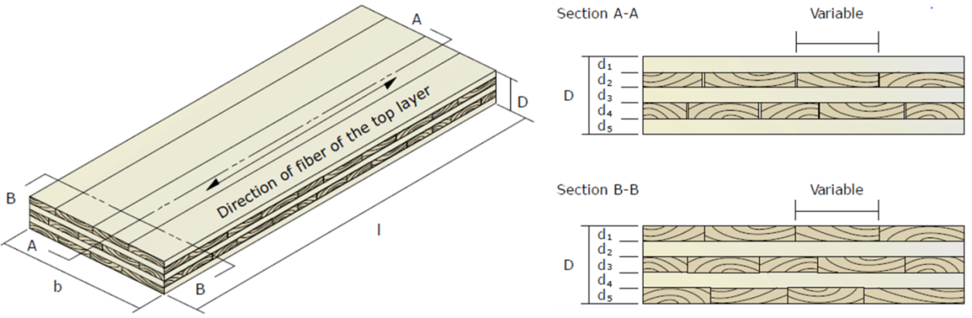
Figure 2: CLT panel configuration (Karacabeyli et al., 2011). Courtesy of FPInnovations.

Solid timber construction with CLT
In general, in wood construction one can differentiate between lightweight construction and massive timber construction (Figure 3). Lightweight construction such as timber frame construction and half-timbered buildings, transfer loads via their framework. There is no separation between insulation and the load-carrying structure. In contrast, solid timber constructions with CLT separates the insulation from the load carrying plane-like structure (Schickhofer et al., 2010). Advantages of solid timber construction compared to lightweight construction are “the low air permeability, the distinctive specific storage capacity for humidity and temperature, the independence of modular dimensions in arranging window and door openings, as well as advantages in fastening of services and furniture” (Brandner, 2013).
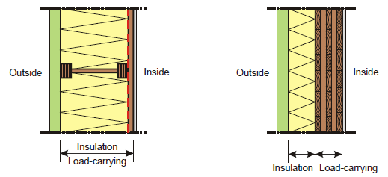
Figure 3: Comparison of lightweight (left) and solid timber (right) wall structure (Augustin, 2008).
Solid timber construction is not a new building technique but rather one of the oldest construction types in the world. Traditional solid timber constructions not only includes timber bar construction parallel to the grain as it is and was used in Scandinavia, e.g., to build stave churches but also timber log construction perpendicular to the grain as it is and was used in the alpine areas to build log houses. As shown in Figure 4, CLT is an innovation of these building techniques which combines the traditional bar like construction types to an adhesive-bonded, rigidly connected slab-like building material (Schickhofer et al., 2010).
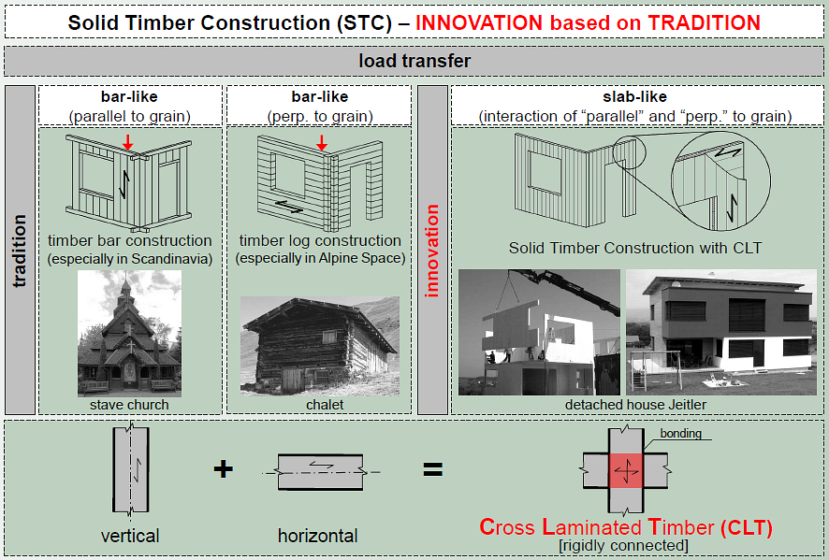
Figure 4: Solid timber construction (STC) – innovation based on tradition (Schickhofer, 2013).

CLT is a wooden building material that gives engineers and architects the opportunity to realize timber structures in scales that have been restricted to mineral-based building materials such as brick, reinforced concrete and steel (Brandner, 2013). With CLT, timber construction can be used to build multi-story objects up to 30 stories (Green and Karsh, 2012). Currently, the highest wooden building out of CLT was built in 2012 and is located in Australia. It is ten stories high (32.17 m) and comprises 23 apartments (Lend Lease, 2013). A 14-story timber building realized with a combination of glulam and CLT is currently under construction in Bergen, Norway and will be completed in 2015 (Abrahamsen and Malo, 2014). North America’s tallest timber object is six stories high and was erected in British Columbia, Canada (Mah, 2014).
Construction with CLT offers various advantages (Brandner, 2013):
- Factory prefabrication of application-tailored elements under controlled conditions,
- dry, clean and fast modular on site construction technique,
- high dimensional stability and stiffness,
- bearing capacity against in-plane and out-of-plane stresses,
- ability to transfer loads two dimensional,
- suitability for applications in earthquake zones,
- low mass, making CLT particularly suitable for reconstruction and upgrading of existing buildings.

A historical brief
The development of CLT began in the early 1990s in Switzerland, Germany and Austria. However, the development of layered timber structures goes back to the late 19th and early 20th century. In those times, two layered timber structures were used for roofing system of an exhibition hall and two airplane hangars in Russia. In the 1960s, numerous timber-based hyper shells were built all over the world such as an exhibition hall in Dortmund, Germany, where a three-layered mechanically interlinked roof supporting structure out of timber was applied in 1969 (Schickhofer et al., 2010). Subsequently, academia started to investigate the field. In 1974, E. Cziesieski wrote a subchapter on “timber roof structures” out of “multi-layer composite structure of boards and beams” in a wood construction book. The author also mentioned that adhesive-based jointing might lead to better static properties than mechanical linkage. In 1981, G. Dröge und K. H. Stoy wrote in their book “Basics of modern timber engineering” about CLT. The authors described the product as a three-layered plane element for usage as solid-web girders. They also mentioned planking as a possible application. In 1985, N. Lischke published his dissertation about the anisotropy of three-layered board plates and described the differences between rigid and yielding bonds. In 1989, A. Steurer used the term CLT as slap- and plate- stressed deck-bearing structure (as cited in Schickhofer et al., 2010). In the year 1994, G. Schickhofer finished his dissertation on “rigid and flexible composition in area-covering laminated wood structures”. Parallel to this academic research, the first CLT buildings were built between 1993 and 1995 in Switzerland and Germany. These buildings can be seen as the first prototypes of today’s solid timber construction with CLT (Schickhofer et al., 2010). In 1996, joint research of industry and academia was focused on development of weak market for side-boards from sawmilling. The joint effort resulted in the development of modern CLT (Crespell and Gagnon, 2010, Brandner, 2013). Since 2000, several institutions in Germany, Switzerland and Austria have dedicated their efforts to CLT, which has resulted in several publications and dissertations on the topic. In 1998, the first two companies received official national product accreditation and became approved suppliers of CLT. These companies are KLH Massivholz GmbH in Austria and Merk-Holzbau GmbH CO KG in Germany. Since then, numerous other producers have received accreditation and started production. In 2006, the first European Technical Approval (ETA) was issued for CLT and in 2008 a work item to develop a European CLT Standard was established (Schickhofer et al., 2010). Currently (2015), there is a draft of a European Standard in preparation (CEN, 2011).

Status of the CLT industry

Status of the European industry
Europe is by far the biggest producer of CLT. After a few years of inhibited progress, the capacity and production output has increased exponentially since the year 2000. The main drivers for the positive developments are the green building movements, changes in building codes, consistent marketing efforts and the development of distribution channels (Crespell and Gagnon, 2010). “Until recently, the producers of CLT building systems were unable to compete with steel and concrete for high-rise building applications because the majority of regulations and codes did not allow wood as a structural material. Building codes are now evolving in Europe in favor of wood. Some of the most important European Committee for Standardization (CEN) standards for construction are undergoing a five-year review. In 2013, for example, the European Standard (EN) 1995 “Design of timber structures” (Eurocode 5) was updated. CLT is no longer a niche product and is therefore being addressed specifically by the review. Nine workgroups for future development have been established and will be looking into, for example, the use of CLT in the event of fire (not currently dealt with by EN 1995-1-2) and the reinforcement of CLT elements (rolling shear)” (Pahkasalo et al., 2014). In addition, a European standard for the production of CLT is expected to be implemented in 2015.
In recent year’s annual CLT production experienced tremendous growth in Europe. In the geographical area of Austria, Germany, Switzerland and Czech Republic, production output more than doubled from 2008 to 2013 and reached 456,000 m³. From 2013 to 2014 production was expected to increase additional 10% to a total of 503,000 m³ (Figure 5). The growth in the period after 2011 is mainly a result of plant upgrades and modernization (Plackner, 2014a).
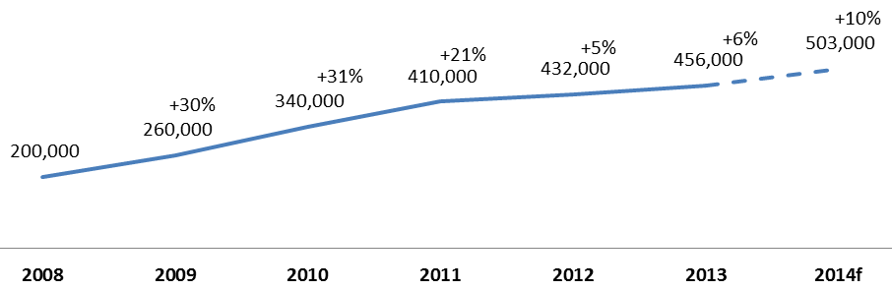
Figure 5: CLT production development from 2008-2014 in Austria, Germany, Switzerland and Czech Republic (Plackner, 2014a).

There are about 25 production facilities located in Central Europe that produce CLT with adhesive based fasteners. In 2014, these producers had an estimated production output of 519,700 m³ (Table 2). The companies manufacture CLT from all kind of domestic conifers specious. Most use polyurethane (PUR) adhesives; however, melamine-urea-formaldehyde (MUF) is also used in some production lines (Plackner, 2013, 2014a).
Most CLT is produced in Austria (Figure 6) where the largest companies are ‘Stora Enso’ followed by ‘Binderholz’ and ‘KLH Massivholz’ In Germany, ‘Merk Timber’, ‘Eugen Decker’ and ‘Lignotrend’ have the highest production output (Plackner, 2013, 2014a). From a market perspective, the biggest consumer markets for CLT are Germany, Austria, Switzerland, United Kingdom and Italy which comprise about 70 percent of the European CLT production output. Additionally, France is a promising market. However, liability requirements harm sales quantity in this market. Positive signs for further development can also be seen in the Nordic sub region. Further growth in CLT sales is expected to be 10 percent in the foreseeable future in this region (Pahkasalo et al., 2014).

Table 2: CLT manufacturers in Central Europe 2014 (laminated products) (Plackner, 2014a) & (Plackner, 2013).
Company | Plant Location | Mills | Production  2013 | Production  Plan 2014 | Edge Bonding | Surface Adhesive | Maximum  Format in meter
Agrop Nova | CZ | 1 | 6,000 m³ | 6,000 m³ | yes | PUR,MUF | 2.95 x 12
Artuso Legnami | IT | 1 | 5,000 m³ | 5,000 m³ | no | PUR | 3 x 10
Bettoni Legnami | IT | 1 | 6,000 m³ | 6,000 m³ | n/s | n/s | n/s
Binderholz | AUT | 1 | 80,000 m³ | 95,000 m³ | on dem | PUR | 1.25 x 24  3.5 x 22
Eugen Decker | DE | 1 | 25,000 m³ | 25,000 m³ | No | PUR | 3.3 x 16
Essepi | IT | 1 | n/s | n/s | No | PUR | 3.15 x 12.8
Haas Group | CZ | 1 | n/s | n/s | Yes | PUR | 16.5 x 2.95
Hasslacher Norica | AUT | 1 | 30,000 m³ | 30,000 m³ | on dem. | MUF | 3.2 x 20
Holzbau Unterrainer | AUT | 1 | - | 6,000 m³ | no | PUR | 2.95 x 13.5
KLH Massivholz | AUT | 1 | 78,000 m³ | 90,000 m³ | on dem. | PUR | 2.95 x 16.5
Kurt Huber | DE | 1 | 5,000 m³ | 5,000 m³ | no | PUR | 3.8 x 19
Lignotrend | DE | 1 | 27,000 m³ | 27,000 m³ | n/s | PUR | 0.625 x 18
Lobis Elements | IT | 1 | 700 m³ | 700 m³ | no | PUR | 3.25 x 14
Mayr-Melnhof Holz | AUT | 1 | 50,000 m³ | 50,000 m³ | no | MUF | 3 x 16.5
Merk Timber | DE | 1 | 29,000 m³ | 29,000 m³ | no | PUR,MUF | 4.8 x 20
Merkle Holz | DE | 1 | 1,000 m³ | 1,000 m³ | no | MUF | 0.72 x 18
Moser Holzbau | IT | 1 | 5,000 m³ | 5,000 m³ | no | PUR | 3.5 x 16
Pius Schuler | CH | 1 | n/s | n/s | n/s | n/s | 3 x 9
Schilliger Holz | CH | 1 | 13,000 m³ | 13,000 m³ | yes | PUR | 3.4 x 13.7
Stephan/Züblin | DE | 1 | 6,000 m³ | 6,000 m³ | on dem. | PUR | 4 x 20
Stora Enso | AUT | 2 | 95,000 m³ | 105,000 m³ | yes | PUR | 2.95 x 16
W. u. J. Derix | DE | 1 | 8,500 m³ | 10,000 m³ | 50% | MUF | 3.5 x 18
Weinberger Holz | AUT | 1 | 2,000 m³ | 5,000 m³ | yes | PUR | 1.2 x 13.5
Xlam Dolomiti | IT | 1 | n/s | n/s | no | PUR | 3.5 x 13.5
Total |  | 25 | 472,200 m³ | 519,700 m³

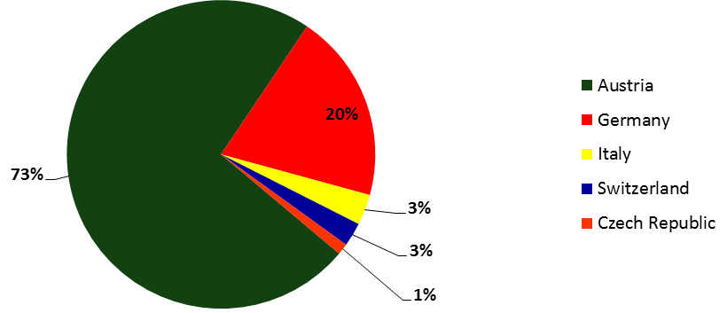
Figure 6: Production share per country 2014 (Plackner, 2014a) (Plackner, 2013).
In addition to adhesive-bonded CLT producers, there are also companies that fasten CLT elements with beech screws or dowels as well as aluminum nails. Those manufacturers produced about 61,000 m³ in 2014 (Table 3). In terms of production quantity, adhesive-bonded CLT is bigger than mechanically fastened CLT as the chart illustrates in Figure 7 (Plackner, 2014a).
Table 3: CLT plants and production in Central Europe 2014 (mechanically fastened) (Plackner, 2014a).
Company | Plant  Location | Mills | Production  2013 | Production  Plan 2014 | Fastener | Maximum  Format
Rombach nur Holz | DE | 1 | 6,000 m³ | 6,000 m³ | beech screws | 3.2 m x 12 m
Thoma Holz 100 | DE/AT | 2 | 15,000 m³ | 15,000 m³ | beech dowels | 3 m x 8 m
GT Systemfertigung | AT | 1 | 35,000 m³ | 40,000 m³ | aluminum nails | 4 m x 6 m
Sägew. Melssnitzer | AT | 1
Abbundzentrum Dahlen | DE | 1
Hou In Form | DE | 1
Herrmann Masslvholzbau | DE | 1
Zimmerei Sieveke | DE | 1
MHM Abbund-Zentrum | DE | 1
Inholz | DE | 1
Holzbau Bendler | DE | 1
Holzbau Koch | DE | 1
Zimmerei Mayr+Sonntag | DE | 1
Holzbau Binz | DE | 1
Gauye & Dayer | CH | 1
MHM Schwelz | CH | 1
Total |  | 17 | 56,000 m³ | 61,000 m³

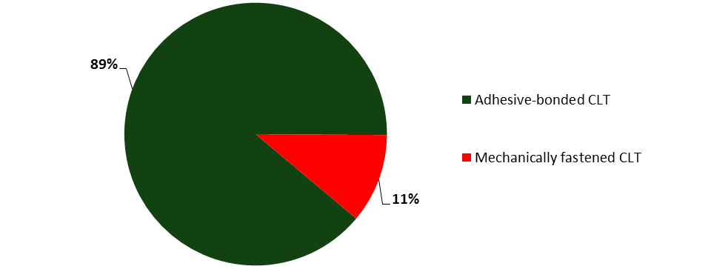
Figure 7: Production share, adhesive bonded vs. mechanically fastened CLT (Plackner, 2014a)

Status of the North American industry
Interest in CLT as a new wood engineered product in North America is in the early stages of development. Demand for CLT in U.S. and Canada is driven by architects and engineers asking for wood-based building products and building systems (Mohammad et al., 2012). While the classic timber frame construction with OSB or plywood sheathing will still be a sound option for smaller construction such us single-family and multi-family construction, CLT creates an opportunity for the North American wood industry to build larger residential and non-residential structures out of wood. However, development is tempered by building regulations governing a new engineered wood product.
In the U.S., the International Building Code (IBC) limits wooden buildings to four stories. However, local jurisdictions can approve objects on a case-by-case basis (Cain, 2014). In order to facilitate CLT usage in the U.S. and Canada, the building material has to be implemented into North America’s regulatory systems. Therefore, a multi-level strategy was developed in a CLT product standard (level 1) and a material design standard (level 2). Subsequently, these standards need to be adapted to the building codes (level 3) (Mohammad et al., 2012). Meanwhile, the first phase is accomplished and the APA/ANSI PRG 320 - American National Standard for Performance-Rated Cross-Laminated Timber, valid for Canada and the U.S., has been published (ANSI, 2012). The second level – the material design level – was initiated in Canada by the Canadian Wood Council (CWC) to include CLT in the Canadian Standard Association (CSA) O86 Engineered Design of Wood Standard. In the U.S., the American Wood Council (AWC) took the same steps to include CLT into the National Design Specification for Wood Construction (NDS). The third level, adaptation of the CLT in the building codes of Canada (NBCC) and U.S. (IBC), has already started. A petition for changes was submitted in 2012 and should be included in the codes by 2015. Additionally, U.S. and Canadian versions of the CLT handbook have been published by FPInnovations to assist the regulatory authorities with the code proposal and the producers and users with their designs. These efforts to prompt CLT in North America have already paid off. Currently, there are four CLT producers in North America (Mohammad et al., 2012). Two companies are located in Canada and two manufacturers are operating in the U.S. (Table 4). Both Canadian producers focus on structural end-use of the panels and are CLT certified members of the APA (Nordic, 2013, Structurlam, 2014). The U.S. based companies produce matting CLT panels for temporary access roads and working platforms in the oil & gas and heavy construction industry (SmartLam, 2015, Sterling, 2015). SmartLam recently announced plans to expand their CLT capacity to about 113,000 m³ per year. This would make the plant the largest CLT mill in the world. (Plackner, 2015b). Further growth in North America is forecasted by numerous potential investors which are either in the process of assessment or in the pilot production phase (Mohammad et al., 2012). Also European CLT companies see North America as a promising market. KLH, for instance, recently started a sales joint venture with the Idaho Forest Group. A production mill might be realized with this joint venture in the future (Plackner, 2014b).
Table 4: CLT plants in North America (Structurlam, 2014, Nordic, 2013, SmartLam, 2015, Sterling, 2015).
Company | Plant  Location | Mills | Adhesive | Wood Species | Maximum  Format | APA-certified
Structurlam | BC (CAN) | 1 | PUR | SPF No. 1/No. 2 | 3 m x 12.2 m | Yes
Nordic | QC (CAN) | 1 | PUR | SPF | 2.4 m x 19.5 m | Yes
SmartLam | MT (US) | 1 | PUR | - | 2.4 m x 12 m | No
Sterling Lumber | IL (US) | 1 | PUR | - | 2.4 m x 12 m | No

From a market perspective, CLT in the United States differs significantly from Europe. In North America, the majority of single-family housing and multi-family housing are already constructed using well-developed timber frame construction systems. Thus, growth for CLT applications is expected for commercial and industry buildings, large public buildings, and other tall wooden structures for multiple purposes (Pahkasalo et al., 2014). First showcase projects have already been developed: North America’s tallest wooden building was erected in British Columbia, Canada. It is the six stories tall Wood Innovation and Design Centre in Prince George which was built to LEED Gold status. It is a wood hybrid building realized with a wide range of engineered wood products including glulam and CLT (Mah, 2014). Likewise in British Columbia, a building is planned which might be even taller. An agenda item of the University of British Colombia stipulates the erection of a 52m high (16-18 stories) wooden student residence on campus (UBC, 2014).
In the opinion of the author, future prospects for the North American CLT construction will be positive for several reasons:
- First, the North American industry has chosen a very structured way of implementing CLT to the market environment. Unlike Europe, the industry successfully introduced a standard for the production of CLT already. Subsequently this is followed by a strategic way of implementing the material to the North American building jurisdictions and building codes. These efforts will reap awards in future. For instance, the revision of the 2018 International Building Code (IBC) considers already two proposals which address tall wooden buildings. The first proposal would address legal admissibility of residential wood buildings up to 9-stories. The second proposal addresses fire performance and would allow a three-hour fire rated podium realized with massive timber (Random Length, 2015).
- Second, U.S. construction industry is on its way of recovery from the great recession of 2009-2012. This is shown by the constant and steady development of the North American housing starts since the economic downturn which started in 2007 (Figure 8). While single-family permits are still below the level of prior to the recession, multi-family permits are already fully recovered (United States Census Bureau, 2015). The recovery is supported by the development of the U.S. labor market where nearly 9 million jobs have been created since 2012 and attractive mortgage rates at 3.9% for 2015 and 4.4% for 2016 are expected. In addition, the positive development can also be seen by the Housing Market Index (HMI) which quantifies sentiments of U.S. builders. Since July 2015 the HMI moves over 50 which indicates positive sentiments (Crowe, 2015).

Figure 8: US housing start permits from 1960 to 2015 at seasonal adjusted annual rate (United States Census Bureau, 2015).

In the authors view, low price structures will mostly stay in the realm of the more economic timber frame construction in North America. However, CLT has shown competitiveness for application in mid- to high-rise structures (Crespell and Gaston, 2011). Therefore CLT has great potential in segments such as multi-family residential construction as well as in the segment of institutional and commercial construction. However, it will be crucial to gain further awareness of CLT in the architecture and design community as they are important decision makers in building projects. Therefore further showcase and pioneer projects need to be developed with CLT. Furthermore, the positive environmental effects of CLT need to be used as an important marketing tool as this issue gains importance in the North American society.

Rest of the world
In addition to Europe and North America, there is development of CLT in Asia and the ‘Pacific Rim’. In Asia, the main development is in Japan. Currently, there are three CLT producers in the country manufacturing approximately 10,000 m³ per year (Table 5). Recently, the Japanese government announced an action plan with three objectives to foster the CLT industry in the country (Plackner, 2014c):
- “Preparation of building regulations;
- collection of case studies; and
- development of a CLT-production chain.”
Subsequently, the ministry of agriculture and forestry supported the development of eight CLT projects in the country to promote construction with CLT. These efforts should lead to a production capacity of 50,000 m³ in 2016 and 500,000 m³ in 2024 in Japan (Plackner, 2014c).
CLT development is underway in Australia and New Zealand (Plackner, 2015a). One realized project is the highest CLT building in the world (Lend Lease, 2013). Market experts forecast multiple production plants in Australia in three to five years. In New Zealand, the first line is already in production (Table 5) (Plackner, 2015a).
Table 5: CLT plants in Asia and the Pacific Rim (Plackner, 2015a).
Company | Plant Location | Mills
Length Cooperative | JP | 1
Meiken Lamwood | JP | 1
Yamasa Mokuzai | JP | 1
XLam NZ | NZ | 1

Applications of CLT
Cross-laminated timber can be used for a wide variety of construction. Small-scale projects like single and double-family housing, as well as large-scale multi-story objects for residential, commercial or public purposes can be realized. Bridges, towers and other special constructions are also feasible. The load-carrying CLT elements are generally used for wall, ceiling and roof construction (Studiengemeinschaft Holzleimbau, 2011). In addition, CLT is used for hybrid buildings where CLT panels are used in combination with other wood products like Glulam, LVL and OSB but also non-wood products such as concrete (Karacabeyli et al., 2011).
Due to its simplicity in design and erection, platform construction (Figure 9) is the most frequently used CLT construction technique. Multiple CLT buildings all over the world have been realized with this method. When applying this construction technique, the CLT panels are used for both, walls and floors. In a first step, the CLT walls are erected on a foundation (Karacabeyli et al., 2011). In the second step, the floor elements are put on the top of the walls, thus, a platform is built for following stories. Therefore the CLT elements transfer both vertical and horizontal loads (Augustin, 2008). The platform construction method can be compared with the light frame construction method. One significant difference is that instead of stud wall frames, CLT elements are used for walls. Platform construction can be used for hybrid buildings as well as for exclusive CLT buildings. There are four major advantages of this construction technique namely an easy story by story erection with connection systems, simple erection of upper stories, use of simple connection systems and well-defined load paths (Karacabeyli et al., 2011).
In addition to the commonly used platform construction method, there is also balloon construction with CLT. In balloon construction systems, walls continue over several stories without a platform. Intermediate floors are attached to the walls. The connection systems for balloon systems are more complex than for platform constructions. Due to limitations in structural designs and dimensions of CLT panels, balloon systems are usually applied for low-rise, commercial and industrial buildings rather than for multi-story objects (Karacabeyli et al., 2011).
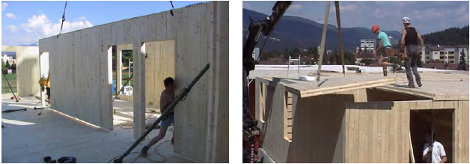
Figure 9: Images of platform construction (Augustin, 2008).

Joints and connections
“Connections in heavy timber construction, including those built with CLT, play an essential role in providing strength, stiffness, stability, and ductility to the structure; consequently, they require careful attention by designers” (Karacabeyli et al., 2011). Post-disaster analyses have shown that structural failure is often caused by inadequate connection design (Karacabeyli et al., 2011). According to Augustin (2008) there are four major connection assemblies for CLT buildings, those are:
- Wall-to-Foundation Connections;
- Wall-to-Wall Connections;
- Wall-Floor-Wall Connections;
- Floor-Floor Connections.
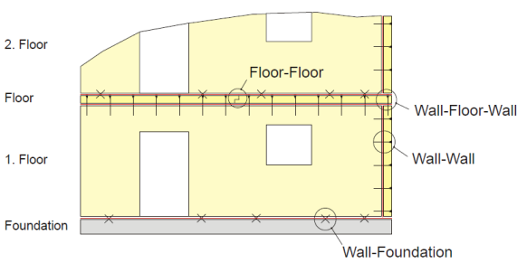
Figure 10: Illustration of CLT connections (Augustin, 2008).

In CLT buildings, large-sized CLT elements are preferred because this minimizes the number of connections and joints. However, given the dimension’s limitations in transport and production, this is not always possible (Augustin, 2008). Connections are mainly done with two types of mechanical fasteners. Those are dowel type fasteners like nails, screws (self-tapping and traditional), glulam rivets, dowels and bolts. Bearing-type fasteners such as split rings and shear plates are also used. In addition, other innovative proprietary connection systems like glued-in rods have been developed (Crespell and Gagnon, 2010). Structural adhesives can also be used in combination with mechanical fasteners to increase rigidity of the connection (Karacabeyli et al., 2011). The choice of the final connection system depends on the type of assemblies and the structural requirements of each object (Stora Enso, 2012). Connections and joints need to be sealed with sealing bands and rubber profiles to ensure an air- and dust-tight connection (Augustin, 2008).

Physical principles

Acoustic Performance
“Adequate levels of noise/sound control in multi-family buildings are mandatory requirements of most building codes in the world. In many jurisdictions, these requirements are strictly enforced as those for structural sufficiency and fire safety. Much effort has been spent on evaluation of sound transmission class (STC) and impact sound insulation class (IIC) of floor and wall assemblies and on studying flanking transmissions…” (Mohammad et al., 2012).
Among other factors, mass has the highest impact on acoustic performance of CLT panels. The higher the mass of a CLT panel, the better is its acoustic performance (Karacabeyli et al., 2011). Research conducted by FPInnovations on both wall and floor CLT, have delivered measurements of STC and IIC as well as FSTC and FIIC which are presented in Table 6 and Table 7. The performance of bare CLT panels on acoustics does not meet the minimum requirements of the IBC 2009 which are presented in Table 8 (ICC, 2009).
Table 6: Sound insulation of bare CLT floors & walls (HU as cited in (Karacabeyli et al., 2011).
Number of Layers | Thickness | Assembly Type | STC | IIC
3 | 95 mm | Wall | 32 | n/a
3 | 115 mm | Wall | 34 | n/a
5 | 135 mm | Floor | 39 | 23
5 | 146 mm | Floor | 39 | 24

Table 7: Sound insulation of bare CLT floors & walls measured on field (Hu as cited in (Karacabeyli et al., 2011).
Number of Layers | Thickness in. (mm) | Assembly Type | FSTC | FIIC
3 | 105 mm | Wall | 28 | n/a
7 | 208 mm | Floor | n/a | 25

Table 8: IBC minimum requirements for sound performance (ICC, 2009) (Karacabeyli et al., 2011).
Assembly Type | Airborne Sound |  | Structure-borne Sound
Wall | STC | 50 | n/a
Wall | FSTC | 45
Floor | STC | 50 | IIC | 50
Floor | FSTC | 45 | FIIC | 45

CLT constructions are generally built with different sound insulating assemblies. Typically, assemblies are realized by applying materials like mineral wool or rock wool, gypsum board, honeycomb, etc. in combination with CLT. FPInnovations tested several different assemblies which have matched the requirements of the IBC (Karacabeyli et al., 2011). An example for a tested wall assembly (Table 9) and an example for a tested floor assembly (Table 10) are illustrated below.
Table 9: STC of CLT wall assembly (Karacabeyli et al., 2011). Courtesy of FPInnovations.
 | Assembly description | STC | Illustration
1 | Gypsum board 15 mm | 55 or above depending on CLT thickness | 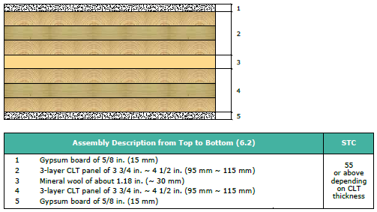
2 | 3-layer CLT panel of 95-115 mm | 55 or above depending on CLT thickness
3 | Mineral wool 30 mm | 55 or above depending on CLT thickness
4 | 3-layer CLT panel of 95-115 mm | 55 or above depending on CLT thickness
5 | Gypsum board of 15 mm | 55 or above depending on CLT thickness

Table 10: STC & ICC of CLT floor assembly (Karacabeyli et al., 2011). Courtesy of FPInnovations.
 | Assembly description | STC | IIC | Illustration
1-2 | Concrete topping 20 mm  Kraft paper underlayment | 64 | 60 | 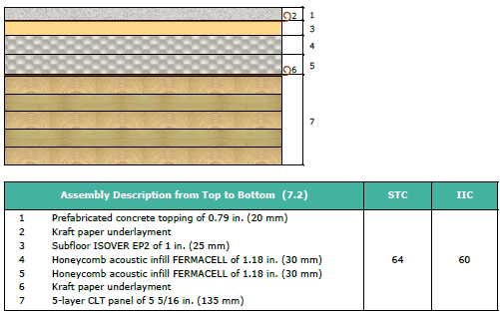
3 | Subfloor ISOVER EP2 25 mm | 64 | 60
4-6 | Honeycomb acoustic infill 30 mm  Kraft paper underlayment | 64 | 60
7 | 5-layer CLT panel of 135 mm | 64 | 60

Fire Performance of CLT
CLT has “the potential to provide good fire resistance, often comparable to typical massive assemblies of non-combustible construction. This is due to the inherent nature of thick timber members to slowly char at a predictable rate allowing massive wood systems to maintain significant structural capacity for extended durations” (Mohammad et al., 2012). Research was conducted by Frangi et al. (2009) investigating fire behavior in respect of char rates of CLT elements. It was found that CLT is similar to homogenous timber panels. However, bonding adhesives can have a significant impact on the fire behavior of CLT. This occurs because the insulating char layers fall off after they are completely charred and thus the protection mechanism of the unburned wood is lost. Furthermore, it was found out that CLT panels consisting of thicker timber panels have a better fire performance than vice versa. Additionally, Frangi et al. (2008) conducted a full-fire experiment where a residential dwelling in a 3-story CLT building was exposed to a fire load of 790 MJ/m² for an hour. The building was constructed with 85 mm wall panels and 142 mm floor panels. In addition, the walls were protected with fire-rated gypsum board and the ceiling with a mineral-wool insulation and fire-rated gypsum board. After 40 minutes, a flashover occurred and after 55 minutes fire severity declined. Post fire analysis of the buildings showed char rates of 5-10 mm on the CLT elements. During the experiment, no temperature increase and no smoke was detected in the upper story. Therefore, the conducted experiment showed, “that CLT buildings can be designed to limit fire spread beyond the point of origin, even when massive timber construction is used” (Karacabeyli et al., 2011). In addition, CLT assemblies typically have a low amount of concealed spaces which helps to reduce the risk of fire spread (Crespell and Gagnon, 2010).

Seismic performance of CLT buildings
CLT structures are increasingly popular with architects and developers in areas of high seismic risk like Italy and Japan. This is mostly due to the attractive weight-to-strength-ratio of timber based buildings. However, explicit knowledge in this field was limited. Joint research activities in Italy and Japan were conducted on a three-story and a seven-story CLT building. The tests showed that construction with CLT in areas of high seismic activities is feasible. It turned out that connections and joint designs influence the performance of CLT buildings exposed to seismic forces significantly. The elements remained rigid and showed little deformation (Ceccotti et al., 2010).
Shear wall tests conducted by FPInnovations also showed promising results on the seismic behavior of CLT structures when nails and slender screws in combination with metal brackets are used to facilitate the wall-to-floor connection. This occurs because this type of connection ensures “ductile failure of connection instead of brittle failure of the panel” (Mohammad et al., 2012). Additionally, half-lapped joints in walls can be a sound option for areas with seismic activity to reduce stiffness and thus reduce the seismic input load, but also to improve wall ductility (Mohammad et al., 2012).

Building Enclosure Design
As with other structural products, building enclosure design is a very important factor for the overall long-term durability of the object. CLT is not designed for direct exposure to the external environment. Therefore, the CLT structure should be protected from rain and high humidity with a carefully-designed building enclosure. Cladding systems like overhangs and drained and ventilated rain screen walls, as used for other wood constructions in North America, are sound options for CLT structures. Insulation materials, air and vapor controls, as well as ground moisture control measures are needed for a CLT building’s enclosure design to ensure an adequate service life of the building (Mohammad et al., 2012).
The major objectives of enclosure design are “to keep out liquid water, stop airflow between the interior and exterior, manage vapor diffusion, and manage heat flow. These functions are important because heat, air, and moisture impact energy performance, durability, indoor air quality, and occupant comfort in buildings” (Karacabeyli et al., 2011)
An adequate CLT building enclosure is designed and constructed to keep the moisture out of the structure. Therefore, thoughtful moisture management is important. The first step of moisture avoidance management is the correct production of CLT. Lumber panels with a moisture content of about 12% are used for manufacturing. Thus, a limited amount of moisture is brought to the structure (Karacabeyli et al., 2011).
CLT elements have to be protected from moisture during transport, storage and construction. Well-functioning moisture avoidance management systems are based on deflection, drainage, drying and durable materials. Deflection means that as much water as possible has to be kept away from the building. Therefore, roof overhangs, kick-out flashings at roof-wall intersections, drip edges and sloping surfaces are used to direct water away from the structure. A carefully planned drainage pathway system directs the water, which was not deflected, out of the building in order to prevent building material from water absorption. In addition, the building enclosure should be designed with materials which can dry. Furthermore, ventilated cavity between the cladding system and the building increases the drying capacity. Finally, durable wood materials are used for the assemblies. Optionally, preservative-treated wood can also be used for CLT manufacturing (Karacabeyli et al., 2011).
A best practice enclosure design for a CLT building is illustrated in Figure 11. The enclosure implements the above described water management strategies.
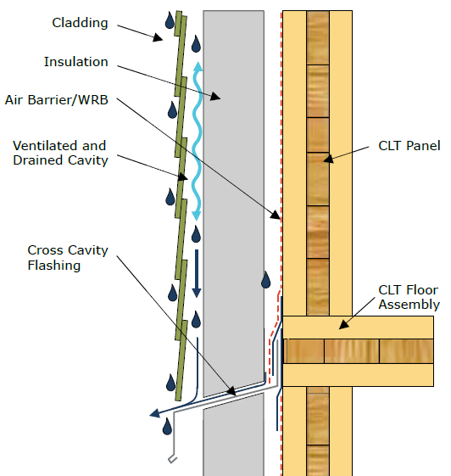
Figure 11: Rainwater management strategy for CLT wall assemblies (Karacabeyli et al., 2011). Courtesy of FPInnovations.

Another important factor of building enclosure design is to eliminate airflow. Airflow transports heat and water vapor, so a holistic air barrier system needs to be established for the building. This is usually achieved by the usage of low air-permeance materials. CLT itself is a material with low air permeance and can be used to eliminate air flow. However, in this case special attention has to be paid to the sealing of the connections and joints. Furthermore, CLT elements can lose permeance over time through board checking and dimensional changes (Karacabeyli et al., 2011). “Considering that CLT panels must be protected with a water-resistive barrier, it is recommended that water resistive barriers serve as the primary air barrier as well” (Karacabeyli et al., 2011).
In addition, vapor diffusion is important for wetting and drying. CLT is a low vapor permeance material. Therefore vapor permeable materials should be used for the water-resistive barrier, the insulation and the interior finish (Karacabeyli et al., 2011).
Finally, the building enclosure has to manage heat flow. In general, thermal insulation is used to reduce heat loss in CLT buildings. However, CLT itself offers a fair amount of thermal resistance. 2.5 cm of typically used softwood CLT provides an R-value of about 1.25. However, CLT buildings require additional insulation to meet local energy codes or energy performance goals of a particular building. Usually, thermal insulation is applied to the exterior of the CLT panel (Karacabeyli et al., 2011). Various building enclosure assemblies used for the construction with CLT are illustrated in Figure 12 to Figure 16.

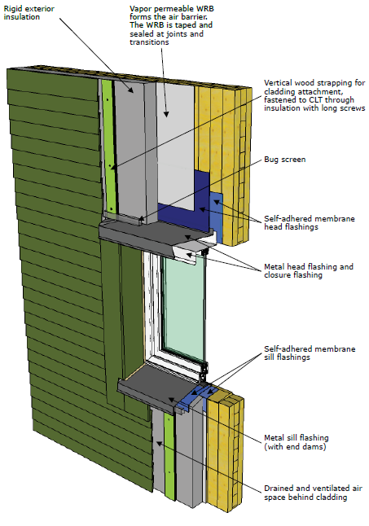
Figure 12: CLT exterior wall assembly with exterior insulation and ventilated cladding, showing material sequencing and schematic window flashing details (Karacabeyli et al., 2011). Courtesy of FPInnovations.
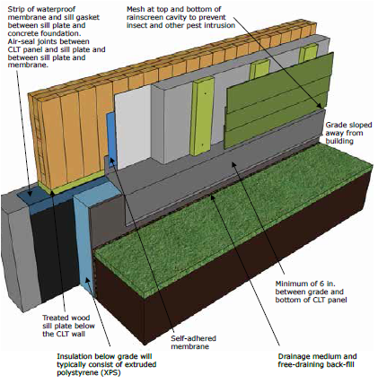
Figure 13: schematic of CLT wall assembly and concrete foundation at grade (Karacabeyli et al., 2011). Courtesy of FPInnovations.

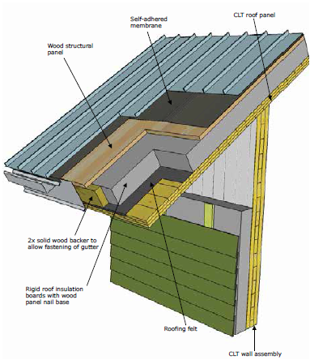
Figure 14: Top view of a sloped CLT roof assembly showing material sequencing and transition to a CLT exterior wall with exterior insulation and ventilated cladding (Karacabeyli et al., 2011). Courtesy of FPInnovations.

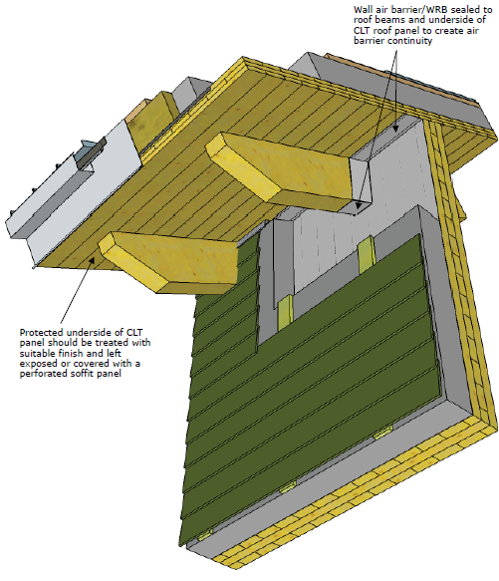
Figure 15: Bottom view of a sloped CLT roof assembly showing material sequencing and transition to a CLT exterior wall with exterior insulation and ventilated cladding (Karacabeyli et al., 2011). Courtesy of FPInnovations.

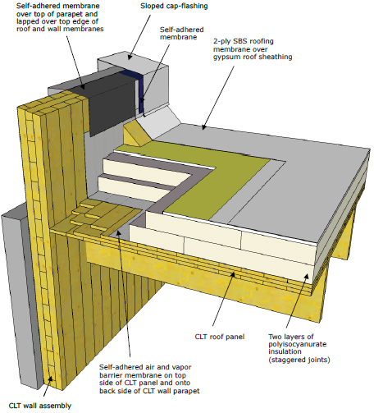
Figure 16: Low-slope CLT roof detail showing material sequencing of a conventional roofing assembly with tie-in to CLT parapet wall (Karacabeyli et al., 2011). Courtesy of FPInnovations.

Forté - a best practice example for CLT construction
A best practice example for a CLT construction is the world’s tallest timber apartment building named ‘Forté’ (Figure 17) located at Victoria Harbor in Melbourne, Australia (Lend Lease, 2013).
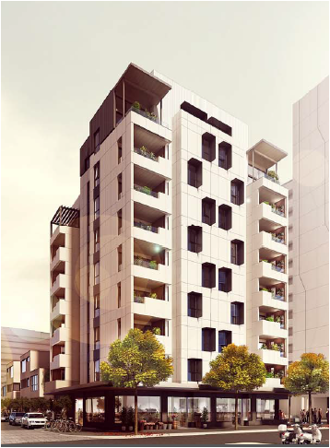
Figure 17: Forte - the currently highest residential building in the world (Lend Lease, 2013).

The building is nine stories high and gives room for 23 apartments. The CLT panels were produced in Austria by the CLT manufacturer ‘KLH’. ‘Forté’ was designed and developed by the company ‘Lend Lease’. The building is 32.17 meters high and consists of 759 CLT panels or 485 tons of timber which were shipped in 25 containers from Austria to Australia. ‘Lend Lease’ split the building into three structural parts. The structure stands on deeply driven piles. The first story of the building consists of a concrete frame and a transfer slab. The apartments are erected with CLT elements (Figure 18).
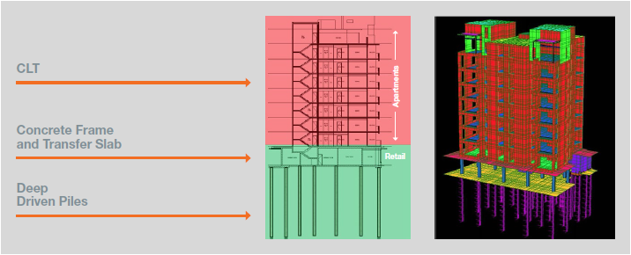
Figure 18: Structural organization of ‘Forté’ (Lend Lease, 2013).

Construction on site started in February 2012. The erection phase with CLT started in June 2012 and the CLT structure was completed by August 2012. Building completion was achieved in December 2012. The connections were facilitated with 5,500 brackets and 34,550 screws (Lend Lease, 2013).
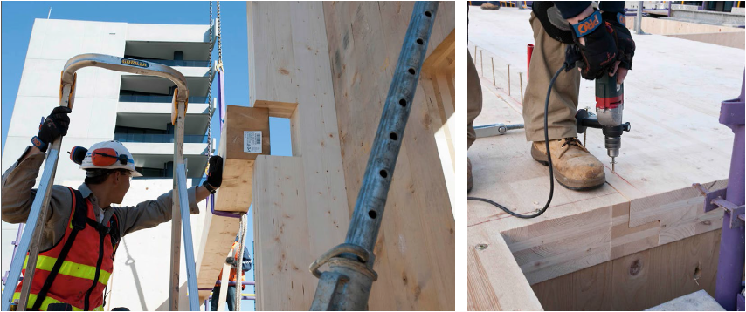
Figure 19: Construction work ‘Forté’ (Lend Lease, 2013).
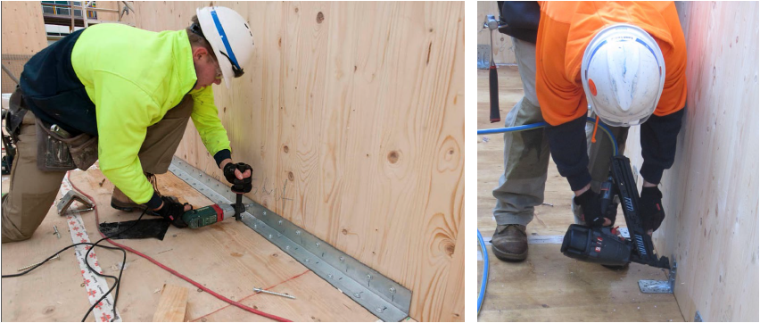
Figure 20: Construction work ‘Forté’ (Lend Lease, 2013).

In addition, the elevator of ’Forté’ is installed in a timber shaft build with CLT (Figure 21). Standard lift doors and frames were used which were adapted to the timber shaft with coach bolts. A fire test was also passed (Lend Lease, 2013).
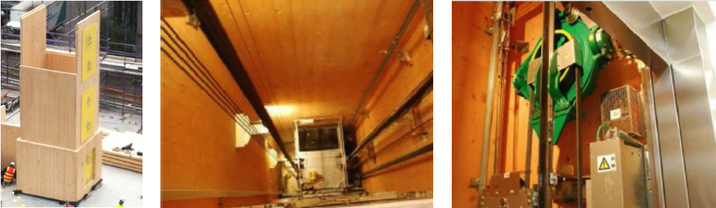
Figure 21: Lift shaft realized with CLT (Lend Lease, 2013).

Matching for electronics and for housing technique was done off-site (Figure 22) (Lend Lease, 2013).
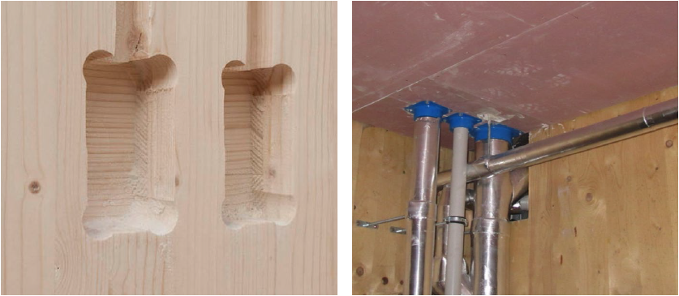
Figure 22: Matchings on pre-fabricated panels (Lend Lease, 2013).

Modular bathrooms were used for wet rooms, which were prefabricated and installed in the object later (Figure 23) (Lend Lease, 2013).
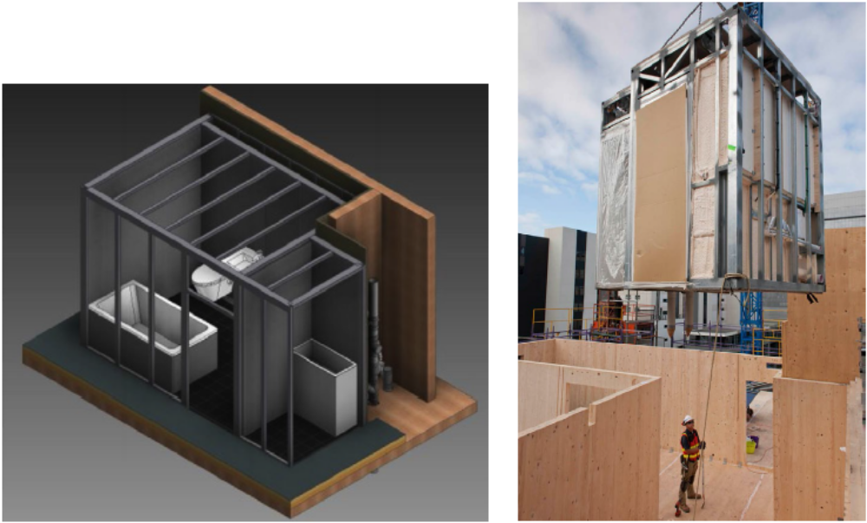
Figure 23: Modular bathrooms (Lend Lease, 2013).
During the development of the ‘Forté’, ‘Lend Lease’ developed a list of potential challenges which had to be solved in order to build the apartment complex successfully. First, the building developers had to receive approvals from regulatory authorities. In addition, a plan for fire protection of the structure and its services had to be developed. In Australia, building codes do not consider any timber buildings above three stories high. Therefore, ‘Land Lease’ had to find an alternate solution for fire protection. They argued that CLT is a highly predictable building material which chars at 0.7 mm/min. In addition, sacrificial layers and supplementary materials were used. ‘Lend Lease’ decided to use a combination of protection and sacrificial (Lend Lease, 2013).
The next hurdle for ‘Lend Lease’ was the acoustic performance of CLT. The developers had a focus on low frequency. Therefore, they added mass via floor build-ups during construction. With these measures, the requirements of the code on acoustics were fulfilled (Lend Lease, 2013).
In addition, ‘Land Lease’ needed to ensure that the building was durable. Therefore, the developers installed a rain screen facade. The CLT elements were protected by sparking and cladding. Ventilation cavities draw heat away from the timber structure. Finally, there were rod detectors strategically distributed over the building (Lend Lease, 2013).
‘Lend Lease’ took vermin protection into consideration since the building code required timber structures to be protected from termites. To meet the necessary requirements, the CLT structure was erected on a concrete podium to separate the podium from the ground. Additionally, chemical free physical termite barriers were introduced. A committee conducts an annual inspection of the building to make sure that there are no termites in the structure (Lend Lease, 2013).

‘Forté’ is the first CLT building in Australia and is seen as a prototype CLT construction. To summarize, objectives of the developers were,
- Create a market facing product
- Achieve a 5 Star Green Star building
- Achieve authority approvals for the CLT structure
- Resolve technical detailing
- Achieve a fit-for-purpose product
- Demonstrate CLT as viable alternative
- Prove the constructability with its impact on design process and impact on other buildings
- Find a base case to leverage step change improvement’s in future CLT projects (Lend Lease, 2013)
With the erection of ‘Forté’, ‘Land Lease’ illustrated that building with CLT is feasible in Australia. The project demonstrated that building with CLT is,
- Fast
- Clean and safe
- Robust, high quality result
- Potential to be cost competitive (Lend Lease, 2013)

PRODUCTION OF CLT
In 2012, The Engineered Wood Association (APA) published the ANSI/APA PRG 320, which is the ‘Standard for Performance-Rated Cross-Laminated-Timber’. The standard regulates the requirements for CLT in North America and was approved by the American National Standards Institute (ANSI, 2012). At present, two North American producers are APA certified and manufacture CLT according to the standard. These two Canadian producers are ‘Nordic Engineered Wood’ and ‘Structurlam Products Ltd.’ (APA, 2015b).
In general, the production of CLT is quite similar to the production of glulam. Based on the knowledge generated in Europe, the production of CLT can be divided into the following major steps:
- Raw lamella selection,
- De-stacking, MC checking, visual grading, E-rating (optional) and trimming of raw lamellas,
- Finger-jointing of lamellas,
- Planing and cutting to size of finger-jointed lamellas,
- CLT layer formation,
- CLT forming and adhesive application,
- Assembly pressing,
- CLT matching,
- Product marking, packaging and shipping,
The above mentioned production steps of CLT are described in detail in the following subchapters.

Raw lamella selection
Consistent lumber properties and quality are of high importance in the production process of CLT. Usually, lumber arrives at the production facility pre-graded and kiln-dried to meet the desired quality and moisture content (Karacabeyli et al., 2011). The moisture content for lumber should be 12% ± 3% at the time of manufacturing. If SCL is used, the moisture content should be 8% ± 3% (ANSI, 2012). Moisture content has to match the adhesive requirements. Some adhesive systems are more sensitive to moisture content than others (Karacabeyli et al., 2011). In addition, a low variation in moisture content is important “to minimize the development of internal stresses between pieces due to differential shrinkage, which is dependent on differential MC, growth ring orientation and species” (Karacabeyli et al., 2011). The lumber grades have to fulfill all structural requirements (ANSI, 2012). In addition, wood temperature has an impact on the adhesive bond. Thus, stable temperature and climate has to be guaranteed in the production facility and lumber storage. Generally, a temperature of 15°C is recommended. Beside moisture content and temperature, lamella warp and wane characteristics have an impact on the adhesive bond. These characteristics can affect the effective bond line area and thus have to be taken into account when producing CLT. Finally, sufficient storage capacity should be available on the manufacturing site to guarantee a steady material in-feed of conditioned lumber lamellas to the production. Usually, the lumber packages are stickered to facilitate air circulation (Karacabeyli et al., 2011).

De-stacking, MC checking, visual grading, E-rating (optional), and trimming of raw lamellas
Lumber lamellas enter the production line at a feed-in station, where they are first de-stacked. After de-stacking, the MC of each individual lamella is measured. If a lamella does not meet the required specifications, it is sorted out of the production flow. Subsequently the lamellas are either visually or machine graded. If done visually, an operator can mark wood defects and failure, e.g., with a fluorescent pen which will later be recognized by a saw and will be cut out. If machine graded, lamellas not meeting specifications are expelled from the production system.

Finger-jointing of lamellas
After the trimming saw, the lamellas are of random length. Therefore, the lamellas are connected to the desired length for parallel and longitudinal CLT layers. This is facilitated by means of finger-joints which are an efficient way to connect lamellas in longitudinal direction (Brandner, 2013). According to Jokerst (1981), the production steps to manufacture finger-jointed lamellas can be broken down into:
- “Selection and preparation of material,
- formation of joint profile,
- application of adhesive,
- assembly of joint, and
- curing of adhesive.”
The profile’s geometry is optimized (Brandner, 2013) “by maximizing the bond surface and minimizing longitudinal losses of board material.” In Europe, finger-joints with a finger length (l_{FJ}) 15-20 mm are used to manufacture CLT (Brandner, 2013). The geometric measures which are common in Europe’s CLT industry are presented in Table 11.
The joints are milled in a clear wood area of the lamella where no wood failures like wane or knots are located. If manufacturing is done correctly, finger-joints exceed strength properties of the lamella segments they connect (Brandner, 2013).
Table 11: Finger-joint profiles, geometric measures and loss in cross section (Brandner, 2013).
l_{FJ} | p | b_{t} | b_{n} | l_{t} | α | v(b_{n}) | Illustration
mm | mm | mm | mm | mm | mm | % | 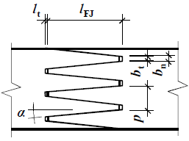
15 | 3.8 | 0.5 | 0.5 | 0.5 | 5.6 | 13.6
20 | 5 | 0.6 | 0.6 | 0.5 | 5.7 | 12.0
20 | 6.2 | 1.1 | 1.1 | 0.5 | 6 | 17.8
l_{FJ} = finger length
p = pitch
b_{t} = tip width
b_{n} = base width
l_{t} = tip gap
α = flank angle
v(b_{n}) = loss in cross section

Producers of CLT in Europe utilize two kinds of finger-joints. These are the traditional vertical joints which are also used for the production of glulam and horizontal joints. In contrast to the vertical finger-joints, horizontal finger-joints are harder to identify on the lamella face and thus, it is more difficult to detect them on the outer layers of the finished CLT panels. This adds visual quality to the panel. In addition, horizontal connections can also be advantageous for the building physics of the CLT element, e.g., airtightness (Brandner, 2013). In Figure 24, an edgewise and a flatwise finger-joint are illustrated.
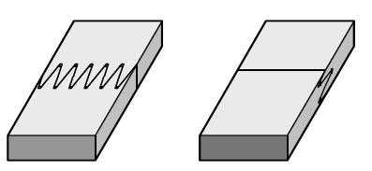
Figure 24: Vertical finger-joint (left) and horizontal finger joint (right) (Brandner, 2013).

Jokerst (1981) stated that “any adhesive suitable for bonding wood technically could be used for bonding finger joints. However, certain factors limit choices. Factors that may be considered are intended use of a product, mechanically and physical properties of an adhesive, speed at which a bond must be formed, curing method, cost, and sometimes color of the adhesive.” In Europe, finger-joints in CLT productions are mainly facilitated with the melamine-urea-formaldehyde (MUF) or one component polyurethane adhesives (1K-PUR). Those adhesives establish an almost colorless bond line. Furthermore, they are characterized by resistance to exposure of sunlight, humidity and hydrolysis. Both adhesive systems have strengths and weaknesses (Brandner, 2013).
1K-PUR adhesives have a high flexibility. System changes relating to reactivity and curing time of the adhesives to meet individual production requirements are feasible. In addition, 1K-PUR system has no formaldehyde emissions. However, inadequately modified 1K-PUR is vulnerable when exposed to temperatures above 60°C. Another problem is gas cavities which increase with the bond line thickness. Therefore, consistency in lamella thicknesses within a CLT layer is an important factor (Brandner, 2013).
MUF adhesives have a higher temperature resistance than 1K-PUR systems. This can have positive effects on fire performance. In addition, the gap-filling and penetrating properties are advantageous. Utilization of high-frequency devices or heat treatment accelerates the curing time of MUF adhesives. However, there are also disadvantages. MUF adhesives emit Formaldehyde. In addition 1K-MUF systems have limited storage stability and 2K systems require a resin hardener with a strict mixing ratio (Brandner, 2013).
After adhesive application, the joints have to be aligned by means of bonding or mating pressure. As Marian stated, this is generally done by using a ‘crowder’ system, the stop-and-go system, or the Mini-Joint system (as cited in Jokerst, 1981). In Europe, the ‘crowder’ system is usually used for finger-jointing in CLT manufacturing. Regardless of which system is used, according to Schmutzler, enough pressure force has to be applied to ensure a solid alignment of the lamellas (as cited in Jokerst, 1981). As listed by Brandner (2013), the following parameters have to be taken into account to find the adequate pressure forces:
- “finger-joint profile,
- timber species,
- moisture content of the adherents, and
- cross-section dimensions.”
In addition, the technical data sheet of the adhesive supplier should be taken into account for specific information about, e.g., pressure magnitude and curing time.
According to the North American CLT Standard (ANSI, 2012) “the strength, wood failure and durability of lamination end joints shall be qualified in accordance with Section 5.5.1 and 5.5.2 of ANSI/AITC A190.1 and meet the requirements specified in Section 4.5.4.2, 4.5.4.3 and 5.5.1.3 of that standard in the U.S., or shall be qualified in accordance with Section 9.5 of CSA O177 and meet the requirements specified therein in Canada.”

Planing and cutting to length of lamellas
After finger-jointing, the CLT lamellas are planed. Commonly, this is done on all four sides of the lamella to ensure all lamella specifications in terms of width and thickness are met. Usually, 3.8 mm is taken from the width and 2.5 mm is taken from the thickness. The planing process conditions the lamella for the face bonding of the CLT panels since it reduces oxidation and thus activates the wood surface for better bonding (Julien, 2010 as cited in Karacabeyli et al., 2011). There is a potential that recently kiln-dried lamellas might show a higher MC after planing. This problem may come up due to variations in drying efficiency and wood characteristics. Thus, it may be necessary to recondition lamellas before bonding (Karacabeyli et al., 2011).
After the planing and curing procedure, the laminations are cut to desired length. This is usually determined by the size and length of the CLT press and the end purpose of the lamination. If used for longitudinal layers, the maximum length of the finger-jointed lamellas is the length of the press. If used parallel layers, the lamella is cut to the width of the press (Karacabeyli et al., 2011).

CLT layer formation
Brandner (2013) stated that “the producers of CLT aim to reduce the width of gaps. This is done in respect of building physic aspects (in particular in regard to fire design, airborne sound and airtightness) but also in regard to joining techniques, in particular considering pin-shaped fasteners such as nails, screws or dowels. A further reason is due to aesthetics, if the surface of CLT is left visible in final use.”
Based on the European example, the CLT layer formation can be done in two ways. Some of the producers manufacture single layers by using means of adhesives for edge bonding to limit gaps to an absolute minimum. Then, these layers are further processed to form the final CLT panels. Others form the CLT panels straight from single lamellas without the intermediate step of edge bonding (Brandner, 2013). Both manufacturing options are discussed in the following paragraphs.
Production of single layers has several advantages. As already mentioned, edge bonding can have positive effects on physical properties since it reduces gaps between lamellas in a single layer. In addition, pre-manufactured layers are already smooth and equalized in thickness. Therefore, the pressing pressure for face bonding of the final CLT elements can be reduced (Brandner, 2013). In addition, single CLT layers are easy to manipulate with vacuum lifting devices. However, single layer pre-manufacturing is an intermediate production step which is not necessarily needed to manufacture CLT. If it is included in the manufacturing line, it may increase initial investment cost since more production equipment is needed. In general, the single layers can be manufactured in two different ways. One approach is the manufacturing through edge bonding of the lamellas. A second approach is the axial splitting of glulam with the utilization of a band saw. For the bonding of lamella edges, the same adhesive systems can be used as for finger-jointing (Brandner, 2013).
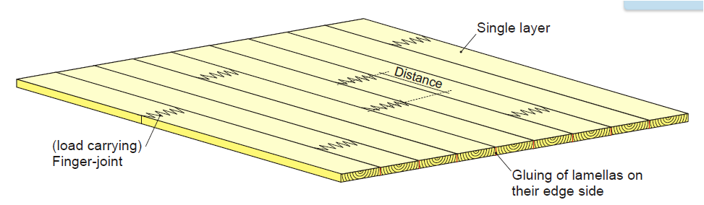
Figure 25: Edge bonded single CLT layer (Augustin, 2008).

In contrast, edge bonding can be omitted in the production process of CLT. Instead edgewise, un-bonded lamellas can be used for the single layer formation and assembly. Following this approach, the lamella edges are also sporadically connected during face bonding (Brandner, 2013). Whether or not edge bonding is included into the production line of a CLT plant, it has an impact on the application of the end product. Internal stresses in a CLT element which are the result of swelling and shrinkage due to climate changes lead to unavoidable checks on the surface and within the element. This effect also harms the previously discussed advantages of edge bonded CLT elements in terms of physical properties over time. Moreover, checks on edge bonded CLT panels occur usually in undefined areas of the surface. In contrast, on CLT panels without edge bonding, swelling and shrinkage takes place between the board and thus checks can be avoided to a certain extend (Brandner, 2013). Certainly, this has an impact on the visual appearance of the panels. As in Europe, edge bonding is not particularly necessary when CLT is manufactured according to the North American Standard (ANSI, 2012).
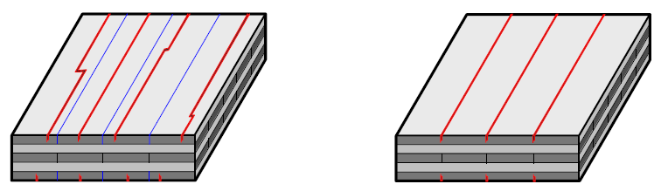
Figure 26: Checks caused by swelling and shrinkage in CLT with edge bonded layers (left) and without edge bonding (right) (Brandner, 2013).

CLT forming and adhesive application
The CLT layer forming is realized in several ways and depends on the production line design and capacity. In Europe, e.g., band conveyors or vacuum lifting devices are used. In low capacity plants, CLT layups can also be done by human operators.
The assembling technique is comparable to plywood production where adjacent layers are also assembled perpendicular to each other (Karacabeyli et al., 2011). Between each layer, adhesive is spread. As for finger-jointing and edge bonding, MUF or PUR adhesive systems are often used. The adhesive application is in general utilized mechanically (Brandner, 2013). According to Brandner (2013), this is done “on single lamellas in a continuous through-feed device or in a positioning or press bed on pre-positioned CLT layers. A line-wise application is preferred.”

CLT pressing
After the layup of the CLT element, the panel is finally face bonded with a pressure device. Pressure is necessary due to several reasons. Brandner (2013) defines the required surface bonding pressure “as a function of the (i) adhesive system, (ii) the timber species, (iii) the geometry of the adherents in regard to roughness and flatness of the surface and allowed tolerances in thickness, (iv) the adhesive application system and (v) the applied quantity of adhesive. The applied quantity itself depends on the roughness of the adherent’s surface and consequently on the timber species.” Those parameters are discussed in the following paragraphs.
The pressing force has to meet the requirements of the adhesive related parameters. Regardless of which system is used to manufacture CLT, the recommendations of the adhesive supplier need to be respected. Adhesives sides, enough pressure is important to equally distribute the line-wise applied adhesive over the whole CLT layer surface and to guarantee a consistent and defined bond line thickness. Furthermore the adhesive type and quantity has to be considered to achieve a defined bond line (Brandner, 2013). As Brandner (2013) stated, “types of adhesives can be differentiated first into close contact and gap-filling adhesives and secondly into swelling (e.g., polyurethane adhesives) and shrinking adhesives (e.g., aminoplast- and phenoplast-adhesives).” According to Kairi these characteristics have a significant impact on the required pressure force. Phenol and melamine based adhesive system require pressure force of 203-290 psi where polyurethane bonding can theoretically be done with 1.5-14.5 psi (Kairi, 2009 as cited in Brandner, 2013).
In addition the applied pressure for face bonding needs to take lumber characteristics and lumber species into consideration. Although the lamellas are finger-jointed and planed, there is natural variation in, e.g., lamella thickness. In addition, lamellas can still have characteristics like ‘cups’ and ‘twists’. Therefore enough pressure in face bonding is necessary to smooth those characteristics out. However, too much pressure can also lead to damage of the wood cell structure and thus to a lower adhesive penetration and reduced shear resistance. The wood species must also be taken into account when pressure force is chosen (Brandner, 2013).
In general, there are four press systems available in CLT manufacturing at present. Those are listed in Table 12. The pressure range this systems can reach goes from 0.1 N/mm² to 1.5 N/mm² (Brandner, 2013).
Table 12 CLT press systems (Brandner, 2013) (Verbek, 2015).
Press System | N/mm²
Hydraulic press system | ≤ 1.5
Pneumatic press system | ≤ 1.0
Vacuum press system | ≤ 0.1

It can be noted that hydraulic (Figure 27) and pneumatic presses (Figure 28) are usually used for mid- to large-scale CLT production line designs because they can be integrate in automatic production processes more easily. Usually the layup including adhesive application is done directly in front of the press before the panel enters it with a conveying system. In addition, some of those presses can also apply side pressure to reduce gaps within the panel. Depending on the adhesive system used for the production, also press setup and features can alter in regards of hot and cold pressing and high frequency pressing. Various vendors offer different solutions (Brandner, 2013).
In general, all big producers in Europe use hydraulic or pneumatic press systems. Hydraulic devices can achieve higher pressing pressure than pneumatic devices. However, in practice European producers usually apply pressure forces of 87-116 psi and both systems are capable of that. This forces range makes these two types of presses capable of processing also thick single lamellas which makes the whole CLT panel stronger in stiffness. In addition, also hardwood CLT panels can be manufactured with those presses (Brandner, 2013).
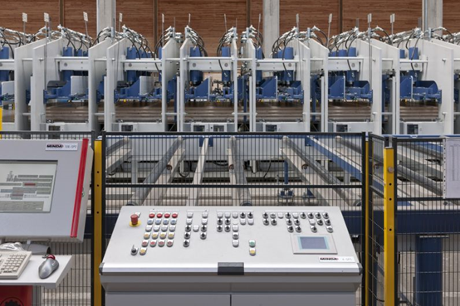
Figure 27 Hydraulic CLT Press from Minda. Courtesy of MINDA.

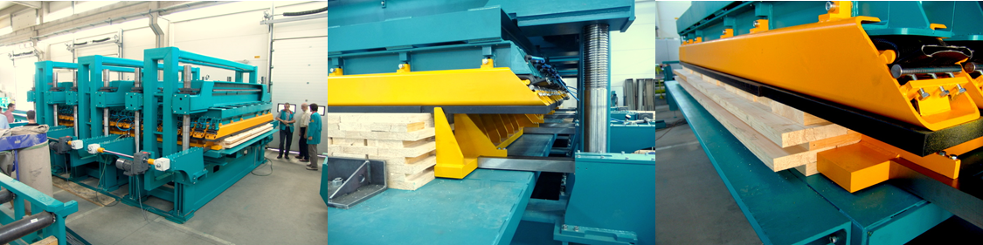
Figure 28 Pneumatic CLT press concept of Ledinek, Courtesy to: Ledinek Engineering

Another approach for face bonding of CLT elements is the utilization of a vacuum press. Vacuum presses offer pressure forces of 1.5 psi to 14.5 psi. Due to the lower pressure forces, the requirements on timber surface quality, thickness tolerances and wood characteristics like warp, cup and twist are stricter and more important in order to guarantee an appropriate defined bond line of CLT elements. Furthermore, the relatively low pressure force leads to limits in applicable layer thickness but also for applicable wood species. However, utilizing a vacuum press for CLT production allows flexibility in production. For instance, CLT panels with cutouts, curvature or other 3 dimensional shapes can be produced with those devices since irregular structures are processable. In addition, the investment costs and yearly production capacity (2,000 to 5,000 m³ per shift and press) is lower compared to pneumatic and hydraulic presses. Therefore it can be a sound option for market entry strategies in new markets or product portfolio extension for small to medium-size enterprises. The production process is usually semi-automatic. However, also large scale ventures are feasible with this technology if various presses are utilized (Brandner, 2013, woodtec Fankhauser).
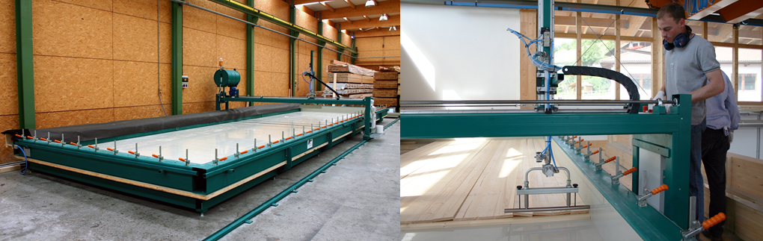
Figure 29: Vacuum press with adhesive application devise (left) adhesive applicator (right). Courtesy of Woodtec Fankhauser.
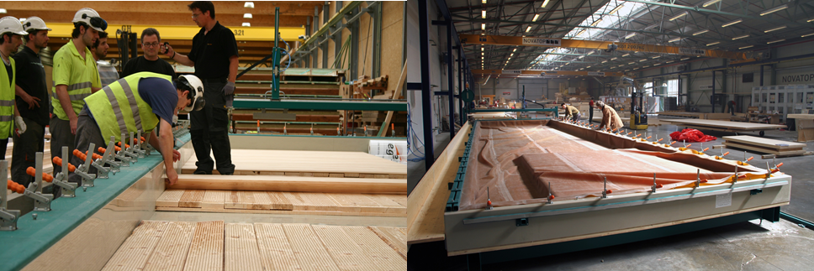
Figure 30: CLT layup in vacuum press (right) sealing with vacuum sheet (right). Courtesy of Woodtec Fankhauser.

CLT finishing and matching
During the face bonding, adhesive resigns and occurs on the CLT edges. In addition, the edges are not leveled equality (Figure 31). Therefore CLT panels get a finish after surface bonding. Usually standard panels are edge trimmed to eliminate adhesive residues and to level edges. In addition, the panels may also be planed or sanded. Moreover layers of engineered wood panels, gypsum or acoustic boards may be applied depending on the end use of the CLT (Brandner, 2013).
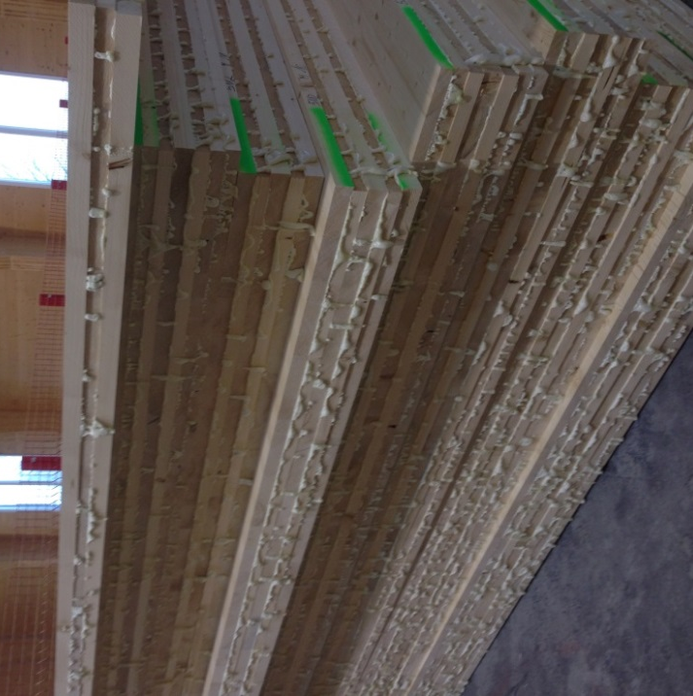
Figure 31: CLT panels after surface bonding with adhesive residues and unleveled edges. Courtesy of Dr. Timothy Young.

However, CLT is usually produced as a predesigned structure, e.g., a family house or a multi-story building. Usually a production planning department reprocesses architectural plans and converts them to specific production orders. Therefore each panel has a specific position in a structure and may have window and door openings as well as details for connections and joints. Moreover house technique pathways for electrical wiring and drain piping may be considered (Brandner, 2013).
The above described details are established facilitating a multiple processing center. Those devices ensure precise dimensioning and customizing for every end application by means of trimming, cutting, milling and drilling. The tools of the portal consist out of a chain saw unit, a vertical milling unit, markers, 5-axis milling unit, and a circular saw unit. In addition, a tool changing unit is incorporated. The processing can be done on both surfaces as well as on all 4 edges. Processing centers of different sizes and capacities are available which can process panels of any length, a width up to 8m and a thickness up to 48cm (Brandner, 2013, Hundegger, 2015). An example of a multiple processing center can be seen in Figure 32. Examples of tools are given in Figure 33 and Figure 34 and finished customized CLT panels are shown in Figure 35.
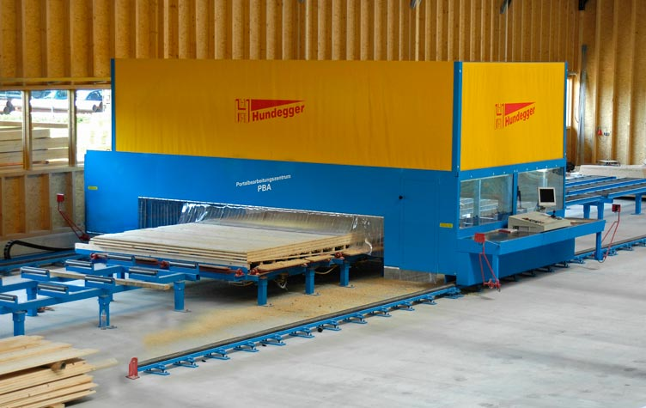
Figure 32: Multiple processing center. Courtesy of Hans Hundegger AG.
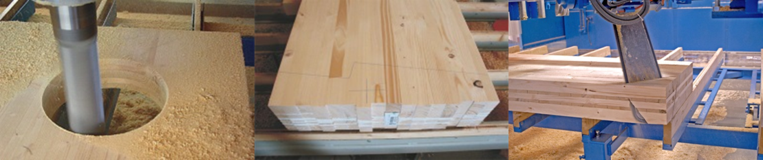
Figure 33: Tools of multiple processing center (A). Courtesy of Hans Hundegger AG.
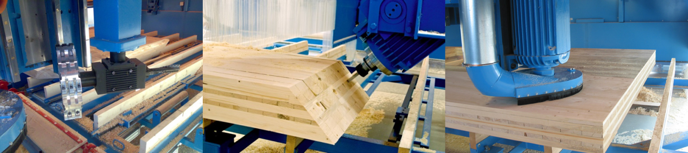
Figure 34: Tools of multiple processing center (B). Courtesy of Hans Hundegger AG.
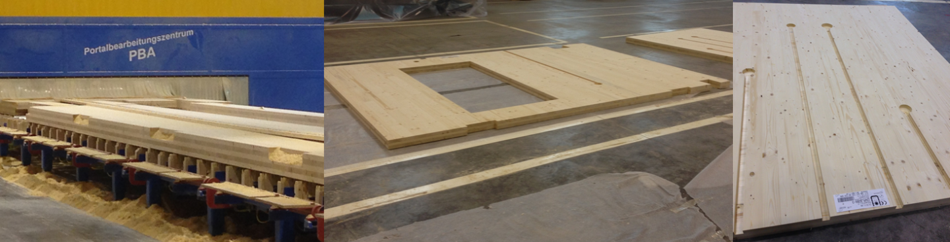
Figure 35: Finished panels after multiple processing center. Courtesy of Dr. Timothy Young.

Product marking, packaging and shipping
The product marking ensures the customer, that the product was produced according to the North American standard and that the manufacturer was certified by an approved agency (ANSI, 2012). According to ANSI (2012) certified producers are required to mark the end product with the following information:
- “CLT grade qualified in accordance with “ANSI/APA PRG 320”;
- The CLT thickness or identification;
- The mill name or identification number;
- The approved agency name or logo;
- The symbol of “ANSI/APA PRG 320” signifying conformance to this standard;
- Any manufacturer’s designations which shall be separated from the grade-marks or trademarks of the approved agency by not less than 152 mm; and
- ‘Top” stamp on the top face of custom CLT panels used for roof or floor if manufactured with an unbalanced layup.”
As desired, the end product can be packaged in foil to protect from harsh weather conditions. Afterwards, the finished product can be shipped to the customer.

Requirements of ANSI/APA 320
To produce CLT according to the North American Standard, the manufacturing plant has to be qualified according to the standard ANSI PRG 320. The qualification is granted by an approved agency like the APA – The Engineered Wood Association (ANSI, 2012). A producer who applies for certification has to fulfill various requirements such as “evaluation of the product to appropriate standards, inspection and approval of the manufacturer's facility and quality system, and subsequent monitoring of the production and quality system by surveillance audits” (APA, 2014) The requirements for the certification of CLT are presented in this chapter.

Component requirements
In general, the production of CLT has two principal components namely laminations and adhesives which are used for finger-jointing and face bonding. The laminations are usually out of lumber. The North American CLT Standard considers all softwood lumber species with a published specific gravity of at least 0.35 which are recognized by the American Lumber Standards Committee (ASCL) under PS 20 or the Canadian Lumber Standards Accreditation Board (CLSAB) under CSA O141. The lumber grades have to meet 1200f-1.2E MSR or visual grade No. 2 for the parallel layers as a minimum requirement. Lumber for the perpendicular layers need to meet visual grade No. 3. Within a layer, the same lumber species or species combination has to be used. However, wood species can alter by different layers. In addition, the moisture content of the raw lamellas needs to meet 12% ± 3% when entering the production line. Furthermore, the lamellas need to be plant on all face bonding surfaces. Variations across the width shall not be more than ± 0.2 mm and variations across the length shall not be more than ± 0.3 mm. Instead of timber lamellas, SCL can be used for the production when they meet ASTM D5456 requirements (ANSI, 2012).
As an adhesive, multiple structural adhesives can be used for the manufacturing of CLT elements. Usually, Phenol-resorcinol formaldehyde (PRF), emulsion polymer isocyanates (EPI) and polyurethane (PUR) adhesives are used (Karacabeyli et al., 2011). The adhesive used for production needs to fulfill specific requirements. For applications in the U.S., the adhesive needs to meet the requirements of AITC 405 except chapter 2.1.6. In addition, the adhesives need to fulfill heat performance requirements specified in chapter 6.1.3.4 of DOC PS1. For applications in Canada, requirements of CSA O112.10 and chapter 2.1.3 and 3.3 of AITC 405 need to be fulfilled. Like in the U.S., the adhesives need to fulfill heat performance requirements of chapter 6.1.3.4 of DOC PS1 (Karacabeyli et al., 2011).
Subsequently, the North American CLT standard regulates the requirements for strength, wood failure, durability of lamella finger-joints as well as face and edge joints. In the U.S., finger-joints have to be qualified in accordance with chapter 5.5.1 and 5.5.2 of ANSI/AITC A190.1 and have to fulfill the requirements of the chapters 4.5.4.2, 4.5.4.3 and 5.5.1.3. In Canada, finger-joints have to be qualified in accordance with Chapter 9.5 of CSA O177 and have to meet requirements specified in there (ANSI, 2012).
In the U.S., edge and face joints have to be qualified in accordance with chapter 4.5.4.1, 4.5.4.3 and 5.5.2 of ANSI/AITC A190.1 and have to fulfill all requirements specified in chapter 4.5.4.1 and 4.5.4.3 except the shear strength. In Canada, joints have to be qualified and meet requirements in accordance of Chapter 9.2 and 9.3 of CSA o177 except of shear strength (ANSI, 2012).

Table 13: Requirements for CLT components according ANSI/APA PRG 320 (ANSI, 2012, APA, 2015a)
Element | Criteria | Demonstration of compliance
Lumber |  | List of specific layups, CLT grades and lumber grades
Lumber species | - Softwood lumber recognized under  - ALSC under PS 20 in the U.S  - CLSAB under CSA O141 in Canada  - Specific gravity of 0.35 as published in NDS | List of specific layups, CLT grades and lumber grades
Lumber grades | - Longitudinal layer  - MSR 1200f-1.2E or visual grade No. 2  - Parallel layer  - Visual grade No. 3 | List of specific layups, CLT grades and lumber grades
Lamination sizes | - Thickness  - 16-51 mm  - Major Strength Direction  - not less than 1.75 x thickness  - Minor Strength Direction  - Not less than 3.5 x thickness or less when evaluated according ASTM D6815 | List of specific layups, CLT grades and lumber grades
Moisture content | - 12% ± 3% at the time of manufacturing | List of specific layups, CLT grades and lumber grades
Adhesive |  | Provision of adhesive specifications and/or documented test report from adhesive supplier
- In the US
  - Meet AITC 405 except section 2.1.6 on heat performance
  - Meet heat performance according DOC PS1 section 6.1.3.4
- In Canada
  - Meet CSA O112.10
  - Meet AITC 405 section 2.1.3 and 3.3
  - Meet heat performance according DOC PS1 section 6.1.3.4
Joints
Face bonding surface | - Planed prior to manufacturing and mainly free of deviations  - Thickness variation  - Across width not more than ± 2 mm  - Along length not more than ± 3 mm | Documented in Quality Manual
Finger-joint strength, wood failure and durability | - In the US  - Meet qualification of ANSI/AITC A 190.1 section 5.5.1 and 5.5.2  - Meet requirements of ANSI/AITC A 190.1 section 4.5.4.2, 4.5.4.3 and 5.5.1.3  - In Canada  - Meet qualification and requirements of CSA O177 section 9.5 | Provision of test results
Face- and edge-joints Wood failure and durability | - In the US  - Meet qualification of ANSI/AITC A 190.1 section 4.5.4.1, 4.5.4.3 and 5.5.2  - Meet requirements of ANSI/AITC A 190.1 section 4.5.4.1, 4.5.4.3 except shear strength  - In Canada  - Meet qualification and requirements of CSA O177 section 9.2 and 9.3 except shear strength | Provision of test results

CLT performance requirements
In terms of sizing, width and length of CLT panels are not specified with a maximum format in the North American CLT standard (ANSI, 2012). Nonetheless, panels typically have a width between 0.6-3 m and a length of up to 18 m. Large scale elements with a width up to 5.5 m and a length up to 30 m are uncommon but possible to produce (APA, 2015b). However, the maximum thickness for CLT panels in accordance with ANSI/APA PRG 320 is 508 mm (ANSI, 2012). In addition tolerances for dimension are regulated and presented in Table 14.
Furthermore requirements on layups and structural performance are stated in the North American CLT Standard, which are also listed in Table 14. Overall, seven structural performance classes are specified. In addition, custom CLT grades are permitted if they meet qualification and mechanical test requirements and are approved by an authorized agency. The structural performance requirements include bending strength, modulus of elasticity, tensile strength, compressive strength, shear strength and rolling shear strength. The above mentioned performance classes were developed based on lumber species and grades which are commonly used in North America. In Table 15, strength and moduli of elasticity requirements for the manufacturing of CLT are presented. The classes E1 to E4 contain mechanically graded lumber in the parallel layers and visually graded lumber in the perpendicular layers. The classes V1 to V3 contain visually graded lamellas in both directions (ANSI, 2012).

Table 14: Requirements on CLT performance according to ANSI/APA PRG 320 (ANSI, 2012, APA, 2015a).
Element | Criteria | Demonstration of compliance
CLT Dimensions and Tolerances |  | Documented in Quality Manual
Thickness | - 508 mm | Documented in Quality Manual
Dimension Tolerances | - Thickness: ± 1.6 mm or 2% of thickness  - Width: ± 3.2 mm of panel width  - Length: ±6.4 mm of panel width | Documented in Quality Manual
Squareness | - Differ not more than 3.2 mm unless specified differently | Documented in Quality Manual
Straightness | - Differ not more than 1.6 mm unless specified differently | Documented in Quality Manual
Layup and Structural Performance
Layup | - Arrangement of layers needs to be specified in the manufacturing standard | Documented in Quality Manual
Structural performance | - Evaluated for each CLT layup of the manufacturer according to Table 1 of ANSI/APA PRG 320 (Table 15 in this document)  - Custom layups are feasible when approved by a certified agency and qualified according to section 8.4 and 8.5 of ANSI/APA PRG 320 | Provision of test results or analytical analysis

Table 15: Required characteristic test values for ANSI/APA PRG 320 CLT (ANSI, 2012, Karacabeyli et al., 2011).
 | Major Strength Direction |  |  |  |  |  |  | Minor Strength Direction
CLT Grades | f_{b,0} | E₀ | f_{t,0} | f_{c,0} | f_{v,0} | f_{s,0} |  | f_{b,90} | E₉₀ | f_{t,90} | f_{c,90} | f_{v,90} | f_{s,90}
CLT Grades | psi | 10⁶ psi | psi | psi | psi | psi |  | psi | psi | psi | psi | psi | psi
E1 | 4,095 | 1.7 | 2,885 | 3,420 | 425 | 140 |  | 1,050 | 1.2 | 525 | 1,235 | 425 | 140
E2 | 3,465 | 1.5 | 2,140 | 3,230 | 565 | 190 |  | 1,100 | 1.4 | 680 | 1,470 | 565 | 190
E3 | 2,520 | 1.2 | 1,260 | 2,660 | 345 | 115 |  | 735 | 0.9 | 315 | 900 | 345 | 115
E4 | 4,095 | 1.7 | 2,885 | 3,420 | 550 | 180 |  | 1,205 | 1.4 | 680 | 1,565 | 550 | 180
V1 | 1,890 | 1.6 | 1,205 | 2,565 | 565 | 190 |  | 1,100 | 1.4 | 680 | 1,470 | 565 | 190
V2 | 1,835 | 1.4 | 945 | 2,185 | 425 | 140 |  | 1,050 | 1.2 | 525 | 1,235 | 425 | 140
V3 | 2,045 | 1.6 | 1,155 | 2,755 | 550 | 180 |  | 1,205 | 1.4 | 680 | 1,565 | 550 | 180
For SI: 1 psi = 6.895 kPa
The characteristic values may be obtained from the published allowable design values for lumber in the U.S. as follows:
fb= 2.1 x published allowable bending stress (Fb)
ft= 2.1 x published allowable tensile stress (Ft)
fc= 1.9 published allowable compressive stress parallel to grain (Fc)
fv= 3.15 x published allowable shear stress (Fv)
fs= 1/3 x calculated fv
El: 1950f-1.7E Spruce-pine-fir MSR lumber in all parallel layers & No. 3 Spruce-pine-fir lumber in all perpendicular layers
E2: 1650f-1.5E Douglas fir-Larch MSR lumber in all parallel layers & No. 3 Douglas fir-Larch lumber in all perpendicular layers
E3: 1200f-12E Eastern Softwoods, Northern Species, or Western Woods MSR lumber in all parallel layers & No. 3 Eastern Softwoods, Northern Species, or West ern Woods lumber in all perpendicular layers
E4: 1950f -1.7E Southern pine MSR lumber in all parallel layers & No. 3 Southern pine lumber in all perpendicular layers
VI: No. 2 Douglas fir-Larch lumber in all parallel layers & No. 3 Douglas fir-Larch lumber in all perpendicular layers
V2: No. 1/No. 2 Spruce-pine-fir lumber in all parallel layers & No. 3 Spruce-pine-fir lumber in all perpendicular layers
V3: No. 2 Southern pine lumber in all parallel layers & No. 3 Southern pine lumber in all perpendicular layers

CLT qualification requirements
Among the factors already listed in Table 13 and Table 14, there are criteria which address particular requirements concerning the manufacturing plant and testing performance of the end product. Those requirements are listed in Table 16.
Table 16: Requirements for qualification according to ANSI/APA PRG 320 (ANSI, 2012, APA, 2015a)
Element | Criteria | Demonstration of compliance
Plant pre-qualification
General | - Pre-qualification panels shall be prepared at the certification applying facility  - 2 replicates  - Sizing major strength direction: 610 mm or more  - Sizing minor strength direction: 457 mm or more  - Characteristics mill equipment and components such as assembly time, lumber moisture content and temperature, adhesive spread rate, clamping pressure should be used for production  - Adhesive needs to be fully cured before further testing | Provision of test results
Specimens testing | - 6 specimens need to be prepared out of the pre-qualification panels. Specimens need to be tested according to the requirements of section 6.4.3 of ANSI/APA 320 | Provision of test results
Qualification of effective bond area |  | Documented in Quality Manual
Define effective bond area | - Manufacturer have to establish visual grading rules for bond area  - 80% bond area or more need to be assured | Documented in Quality Manual

Table 16 continued: Requirements for qualification according to ANSI/APA PRG 320 (ANSI, 2012, APA, 2015a)
Element | Criteria |  | Demonstration of compliance
Qualification of structural CLT performance |  |  | Certified agency provides sampling plan based on manufacturers product plans defined in Quality Manual
General |  | - CLT panel testing for qualification on structural performance in major and minor strength direction for all available layups on  - Bending stiffness (EI)  - Bending moment (F_{b}S)  - Interlinear shear capacity (V_{s)}  - Criteria are presented in Table 1 of ANSI/APA PRG 320
Sample size |  | - Sample size for stiffness capacities  - Enough to estimate the population mean within 5% precision with 75% but at least 10 samples  - Sample size for strength capacities  - Enough to estimate the characteristic value with 75% in accordance with ASTM D2915 | Provision of test data, engineering analysis and report
Sample conditioning |  | - Stored indoors for at least 24h until adhesive has cured  - MC not less than 8% at time of testing | Provision of test data, engineering analysis and report
Bending test method and requirements |  | - Test methods:  - Flatwise, according to the third-point load method of ASTM D198 or ASTM D4761 section 4 to 12  - Specimens width at least 305 mm and on-center span equal to 30 times specimens depth  - Requirements:  - Average bindings stiffness (EI) and characteristic bending moment (f_{b}S) equal or higher the published allowable bending stiffness and bending moments times 2.1 | Provision of test data, engineering analysis and report
Shear test method and requirements |  | - Test methods:  - Flatwise, according the center-point load method of ASTM D198 or ASTM D4761 section 4 to 12  - Specimens width: at least 305 mm an on center span equal to 5 to 6 times the specimen depth  - Requirements:  - Characteristic interlaminar shear capacity (V_{s}) equal or higher the published allowed interlaminar shear capacity time 3.15 | Provision of test data, engineering analysis and report
Mill Specification
 |  | - A specification standard, unique to the applying manufacturer’s production has to be developed for use of the manufacturer and the certification granting agency. | Certified agency issues mill specification for use in conjunction with quality manual

Quality assurance for CLT manufacturing
Once the CLT plant is qualified for trademarking in compliance with ANSI PRG 320 by a certified agency, continuous process control has to be performed to ensure consistent and reliable CLT quality and compliance to the standard requirements (ANSI, 2012). The requirements on continuous quality assurance are presented in Table 17.
Table 17: Requirements on quality assurance according AMSI/APA PRG 320 (ANSI, 2012, APA, 2015a).
Element | Criteria | Demonstration of compliance
Quality Assurance
General | - A process control manual which includes sampling methods and testing procedures has to be established to continuously document and monitor product quality. The documentations of process control are audited by an approved agency. | Provision of methods in quality manual
Finger-, Face- and Edge-joints | - According to the relevant sections of ANSI/AITC A190.1 | Provision of documented quality assurance test results
Effective bonding area, lamination grade limits & glue skip | - Effective bonding area of at least 80% of surface  - Grading rules should be developed to meet criteria | Mill Quality Manual defines lumber grading and gluing limits to meet the standard.
Finished product inspection | - Dimensions & shape of CLT panel  - Bonding quality and product layup  - Appearance classification and moisture content | Provision of documented quality testing results

The development of an internal quality manual is a major part of the certification process. After approval from the certifying agency, the manual serves as an important tool for the manufacturer’s quality assurance. Therefore, the quality manual considers specific information such as the key production processes, personal duties, testing and documentation procedures, frequency of testing, and data control (APA, 2012).

EXEMPLARY CLT PRODUCTION LINEs
This chapter represents a key contribution of the thesis. General principles for successful CLT manufacturing are introduced. This is followed by a description of two modern CLT production lines and its components. The first line layout includes a preceding finger-jointing unit as it is common for mid- and large-sized production facilities. The second layout omits finger-jointing. This was done because there are companies which have existing finger-jointing plants in the USA which might be interested in an extension of their product portfolio with CLT.
The company “Fill GmbH”, a worldwide leading mechanical engineering and plant construction company with its headquarter in Austria (www.fill.co.at) had significant input into the development of this production line (Fill, 2015b). All illustrations in this chapter were provided by Fill GmbH during personal visits to company headquarters in 2014 and 2015.

General information
Successful production of high-quality CLT panels requires some general principles. It is important that the plant workforce is trained in the manufacturing of CLT to ensure that quality requirements are achieved (Purbond, 2012).
Further important factors are depending on the adhesive system used for CLT production. The proposed facilities use one-component polyurethane (1K-PUR) provided from Loctite® (former Purbond®)(Henkel AG, 2015). The company was involved in the CLT process technology development since the market launch of the material in the 1990s and thus has great experience (Purbond, 2012). In North America, the Loctite® HB E-Line meets the regulatory requirements for CLT production (Loctite, 2014). In the proposed plant layouts it is used for finger-jointing and face-bonding.
PUR systems have an assembly and curing time. The assembly time starts with the application of the adhesive on the adherents. The pressure force must be applied at the end of the assembly time (at the latest) to facilitate adequate bonding quality. Then, the curing phase begins. At the end of the curing phase further material processing starts. A wide range of varying assembly and curing time exists in the HB E-Line (Figure 36). This allows flexible production designs and changes since the same processing equipment can be used (Loctite, 2014).
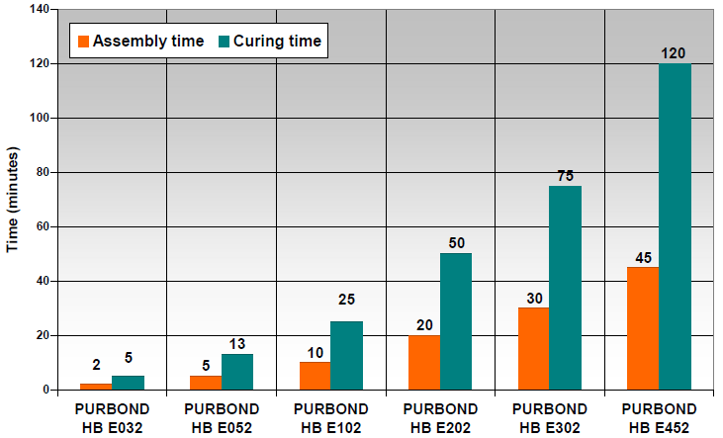
Figure 36: Loctite HB E-Line, assembly and curing times (Loctite, 2014).

The reaction of Loctite 1K PUR adhesives is initialized by moisture. In CLT manufacturing, the adherent moisture and the plant climate cause the curing. Thus, the production facility needs to have a controlled indoor climate to facilitate accurate adhesive curing. The relative air humidity is ideally between the ranges of 45-75%. Temperature in the facility has to meet 15°C as a minimum requirement. European production producers have in general a temperature target of 20°C. The adherents should be conditioned to the same temperature when entering the production line. A moisture content of 12% is ideal for adhesive reaction (Loctite, 2014).

CLT line with finger-jointing
The overall CLT production line with finger-jointing is illustrated in Figure 37. The layout consists of five stages. A production flowchart of the major production steps is illustrated in Figure 38. The production line has total investment costs of $ 9,254,421 (Table 18). The total capacity of the CLT production line of this chapter is from 15,000 to 30,000 m³ per shift and year. This represents the typical capacity of a modern CLT plant. The size of the area required for this type of CLT facility is 5,500 m². The production line described in this chapter could produce CLT from either hardwood, softwood or a combination of softwood/hardwood.
Table 18: Production stages and investment costs of CLT line with finger-jointing (Fill, 2015a)
Production Stages | Description | Units | Price per unit | Investment costs in Euro (€) | Investment costs in US Dollars ($)¹
Stage I | De-stacking and grading | 1 | € 965,147 | € 965,147 | $ 1,077,876
Stage II | Finger-jointing and single-layer formation | 1 | € 2,392,731 | € 2,392,731 | $ 2,672,200
Stage III | CLT pressing | 1 | € 2,070,214 | € 2,070,214 | $ 2,312,014
Stage IV | Matching | 2 | € 876,888 | € 1,753,775 | $ 1,958,614
Stage V | Sanding and packaging | 1 | € 1,104,690 | € 1,104,690 | $ 1,233,717
Total |  |  |  | € 8,286,558 | $ 9,254,421
¹ Euro/Dollar exchange rate from the 27th of June 2015: € 1 = $ 1.1168

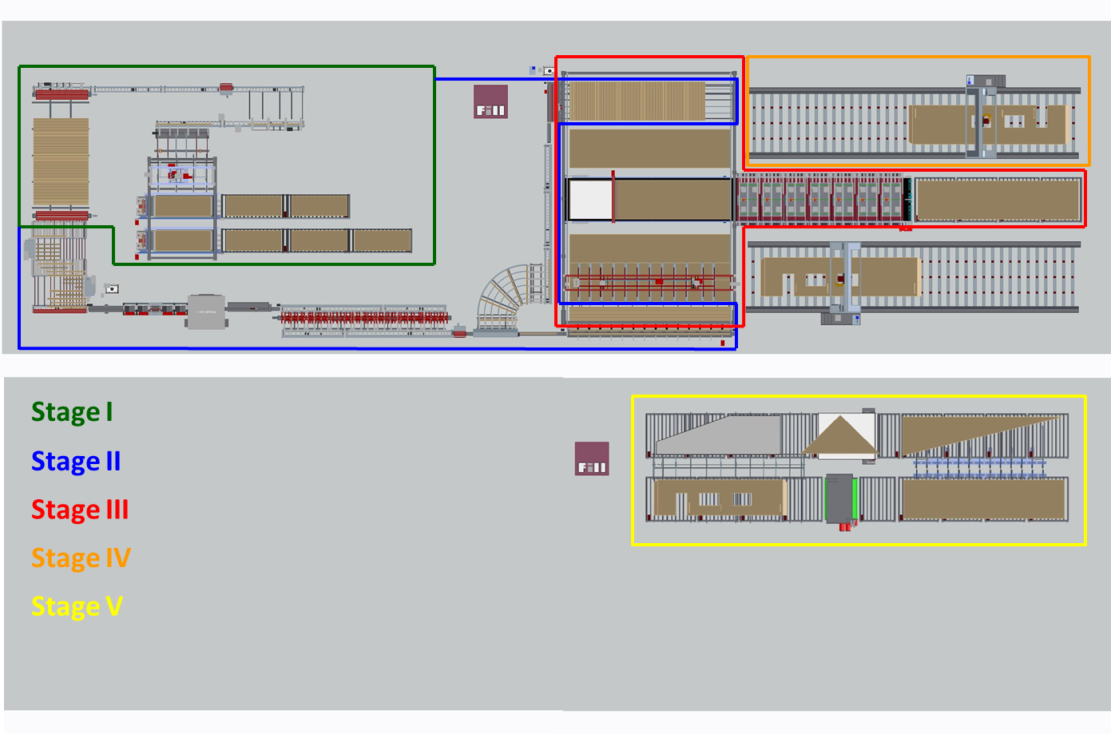
Figure 37: Layout CLT line with finger-jointing. Courtesy of Fill GmbH.

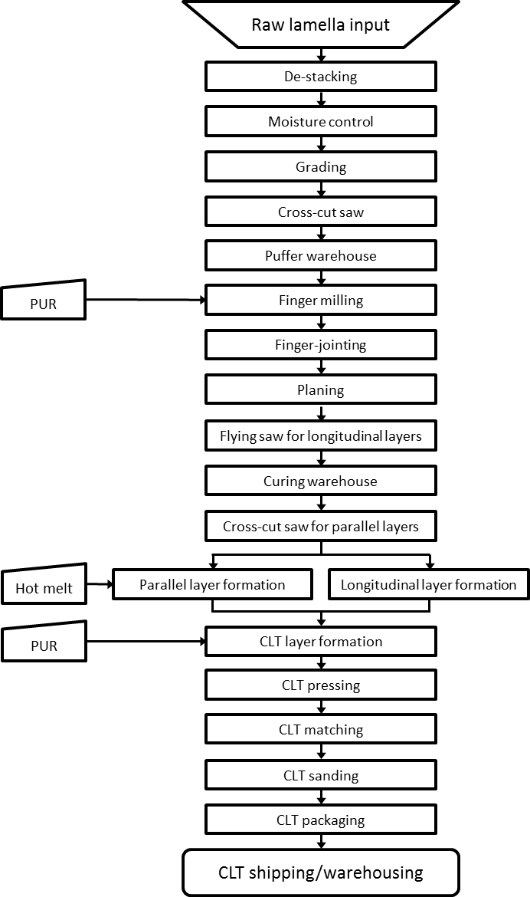
Figure 38: Production flowchart of CLT line with finger-jointing.

Line layout – Stage I
The first part of the production line consists of a de-stacking unit, lamella grading area, an optimization saw and a paternoster puffer warehouse where the lamellas are stored before they are further processed (Figure 39). A specific description of the single components of stage I is provided in this section.
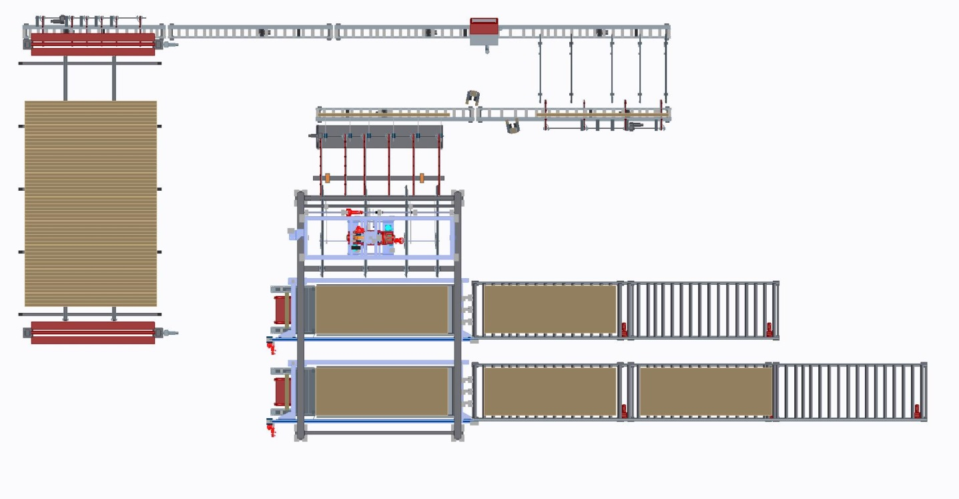
Figure 39: Line layout part 1, de-stacking – lamella puffer warehouse. Courtesy of Fill GmbH.

The raw material in-feed is illustrated in Figure 40. The lumber piles are fed into the system with a fork lift. Roller conveyors transport the pile to the de-stacking device. The de-stacking process is organized by means of a vacuum lifter which transports the timber layer by layer to a chain conveyor. Since the packages are stacked, a remover device skims the sticks into the red bins. Afterwards, the whole timber package is lifted by means of a lifting table and the next lamella layer is unstacked.
The chain conveyor consigns the lamellas to a ‘carriage-dog’ where they are separated. The moisture content of each single lamella is measured at this stage. If a lamella is above or below specification, it is discharged automatically to a discard bin. Those lamellas are reconditioned to specification and then fed back into production line.
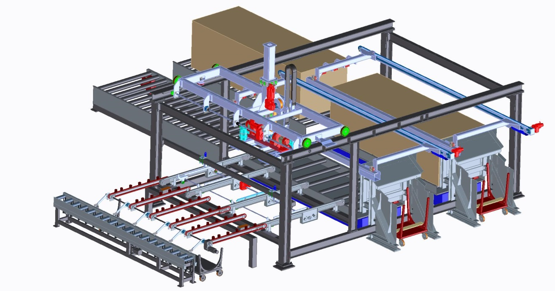
Figure 40: Raw material in-feed, de-stacking and lamella separation. Courtesy of Fill GmbH.

The grading area and the optimization saw are illustrated in Figure 41. After moisture content control, the lamellas enter the grading area piece-by-piece along rolling conveyors. At this stage the workforce visually grades and marks failure areas which do not fulfill requirements for finger-jointing and CLT production with fluorescent markers. This process step could be further automated by using a failure scan device and mechanical grading equipment. In a next stage, the lamellas are passed on a cross chain conveyor utilizing a carriage dog. The cross chain conveyer consigns the lamellas to a rolling conveyor which feeds an optimization cross-cut saw. This cross-cut saw detects fluorescent marks and cuts out previously marked lamella failures. The lamellas exit the saw with random lengths and are further conveyed to a temporary paternoster warehouse.
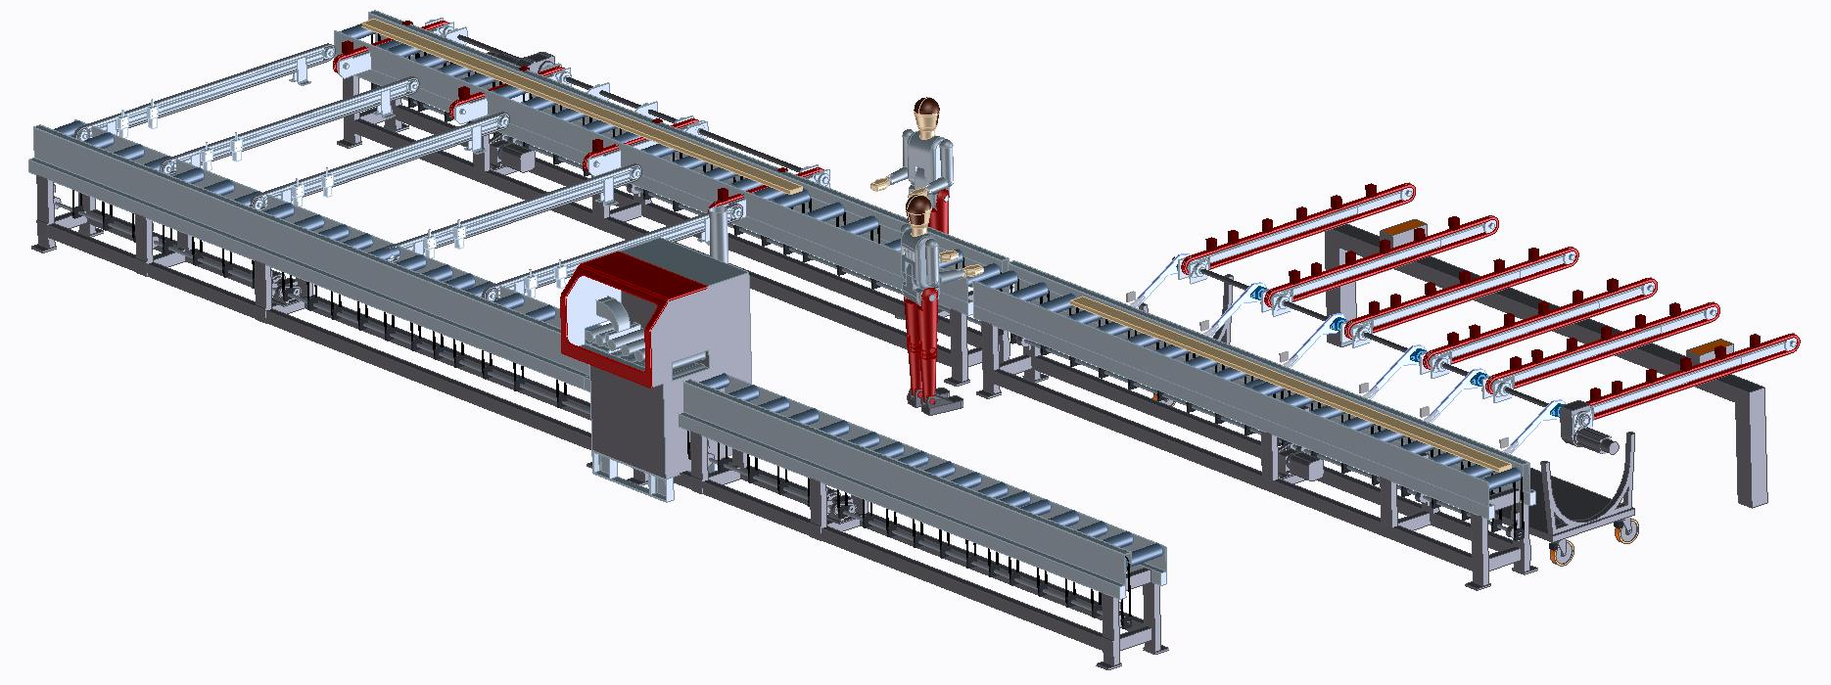
Figure 41: Visual grading and marking, optimization saw. Courtesy of Fill GmbH.

After the lamellas exit the optimization saw, rolling conveyors forward them to a paternoster warehouse (Figure 42) which has a buffer function for the rest of the manufacturing process. Thus, a constant in-feed of lamellas is guaranteed. The transfer from the rolling conveyor to the paternoster bins is facilitated by dog conveyors. The lift carries the lamellas to one of the warehouse levels. The buffer warehouse is organized by lamella grade and thus by lamellas used for parallel or longitudinal layers of the end product.
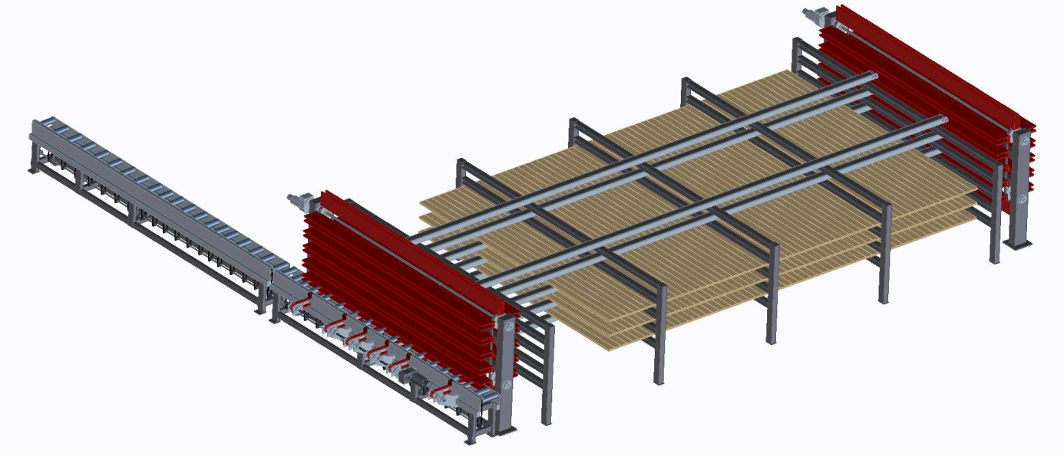
Figure 42: Paternoster warehouse. Courtesy of Fill GmbH.

Line layout – Stage II
Stage II of the CLT production line is illustrated in Figure 43. It consists of a finger-jointing and pressing unit, planer, flying saw, curing paternoster, and the layer forming equipment for parallel and longitudinal single layers. A detailed description of the components for this production stage is provided in this section.
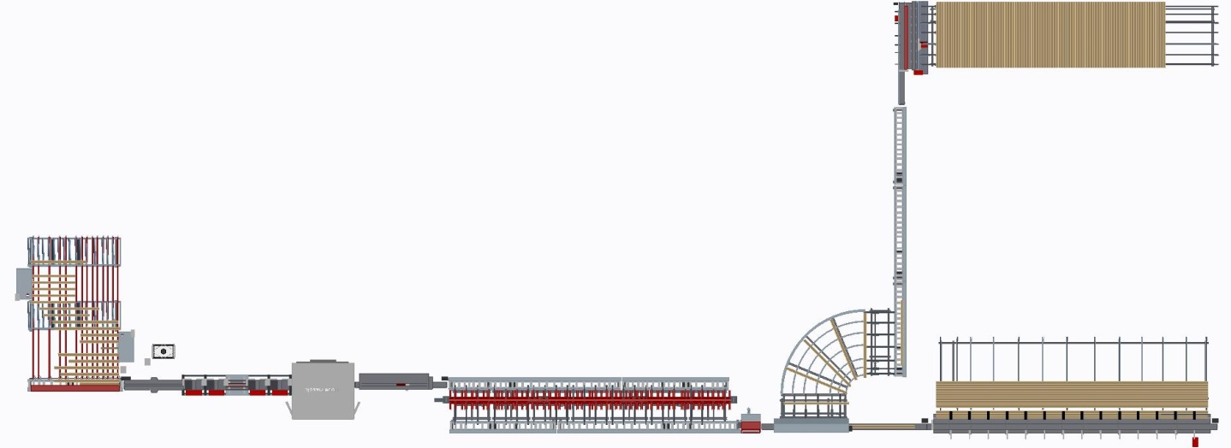
Figure 43: Line layout part 2, lamella finger-jointing – single layer formation. Courtesy of Fill GmbH.

A schematic illustration of the finger-joint milling process and the adhesive application is provided in Figure 44. The finger-jointing system is directly fed from the paternoster warehouse. The lift consigns the lamellas to a dog conveyor, which transfers the lamellas in parallel direction to the grain through the entire finger-milling and adhesive application process. Parallel to the dog conveyor transport, a rolling conveyor moves the lamellas in longitudinal direction towards the first finger-joint miller and aligns them with the alignment edge. Subsequently, the finger-joints are milled to the lamella. Immediately after the first finger-joint profile is established another rolling conveyor shifts the lamellas to the other side where the second finger-joint profile is established. In the next step, the structural adhesive is applied to the finger joint-profile. After that, the dog conveyors forward the profiled and adhesive applied lamellas to a rolling conveyor which then transfers the lamellas to the ‘tuck-in’ station of the ‘cruncher’.
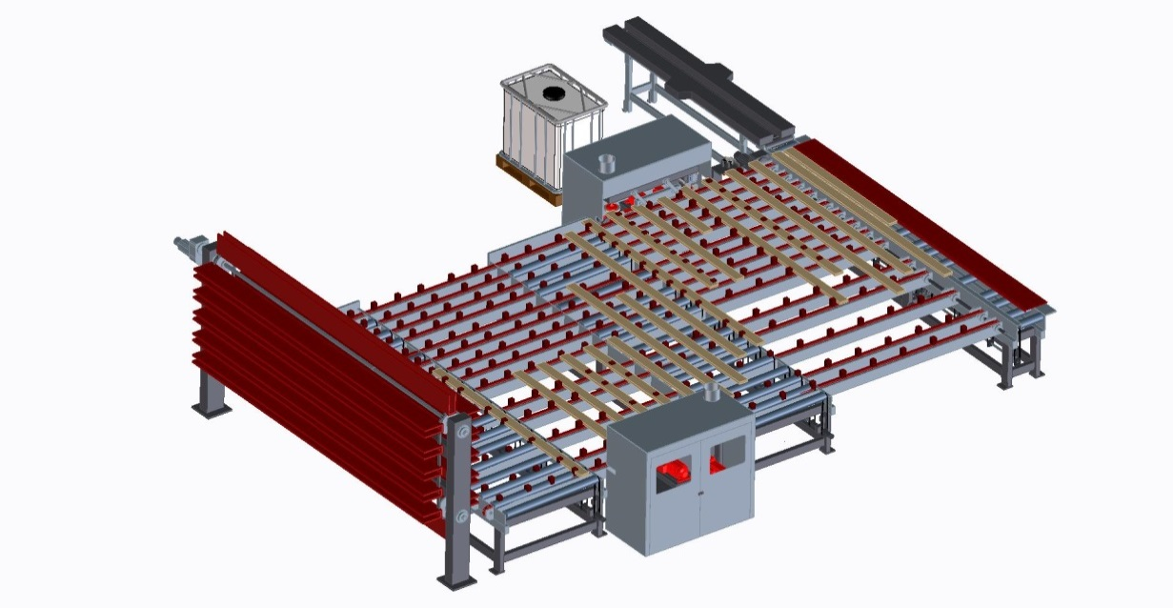
Figure 44: Milling of finger-joints and adhesive application. Courtesy of Fill GmbH.

In this production line both, horizontal and vertical finger-joints are feasible. However, horizontal profiles request special attention in establishing finger-joints. If a lamella has, e.g., a twist, there is a chance that the finger-joint profile of this lamella will be slanted (Fill, 2014). This can lead to failure in joints. As an adhesive for finger-jointing, Loctite HB E032 is used. This adhesive system has an assembly time of two minutes and a curing time of five minutes. The application amount ranges between a rate of 125g/m² to 200g/m² (Loctite, 2014). The PUR adhesive enables a one-sided mechanical adhesive application, if it is documented that adhesive is distributed over the whole finger joint surface. However, a control system with luminescence-sensor is recommended to monitor adhesive application (Purbond, 2011).
Figure 45 shows an illustration of the finger-jointing miller, the adhesive application and the feed-in to the ‘crowder’.
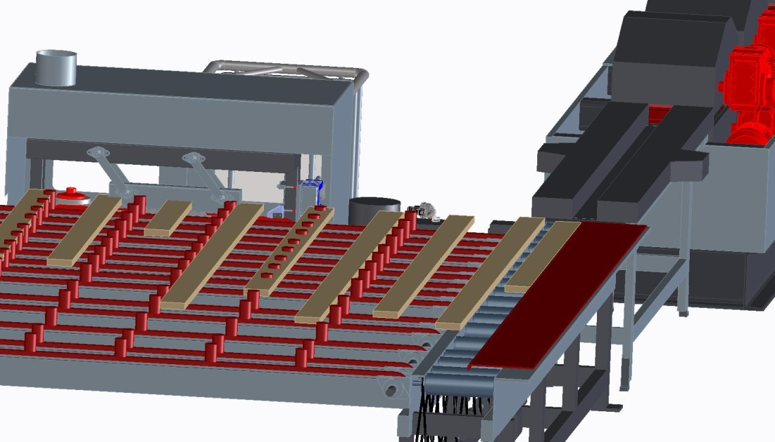
Figure 45: Finger-joint milling, adhesive application and feed-in to crowder. Courtesy of Fill GmbH.

The ‘crowder’ which is used for the final creation of the finger-joints under pressure is illustrated in Figure 46. In a ‘crowder’ system, the in-feed is designed with a faster rate than the out-feed from the system. Thus, pressure is applied to the finger-joint (Jokerst, 1981). The required pressure for finger-joints facilitated with PUR adhesives is illustrated in the chart in Figure 47. Finger-joints with a finger length of 15 mm require a pressure of about 9 N/mm². During pressure application, some adhesive should be squeezed out of the joint (Purbond, 2011).
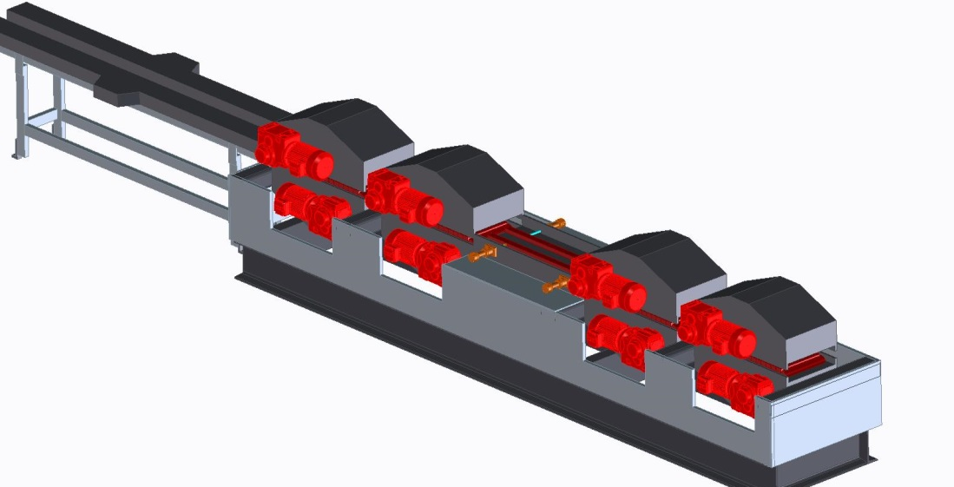
Figure 46: Crowder for finger-jointing. Courtesy of Fill GmbH.
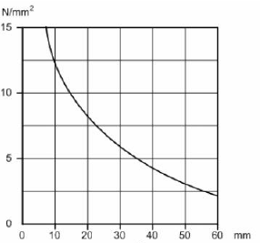
Figure 47: Pressure requirements of Loctite adhesives for finger jointing (Purbond, 2011).

Right after pressure application, a four-sided planer (Figure 48) mills the lamellas to the required specification. High accuracy is required for this production step in order to guarantee consistency of lamella thickness and width. A consistent tolerance of 0.1 mm is required for effective and fast CLT face bonding. Thus, high-quality planing equipment is needed to keep scrap and waste to a minimum. Therefore, hard chrome-plated planing tables and pressure elements have to be used (Fill, 2014).
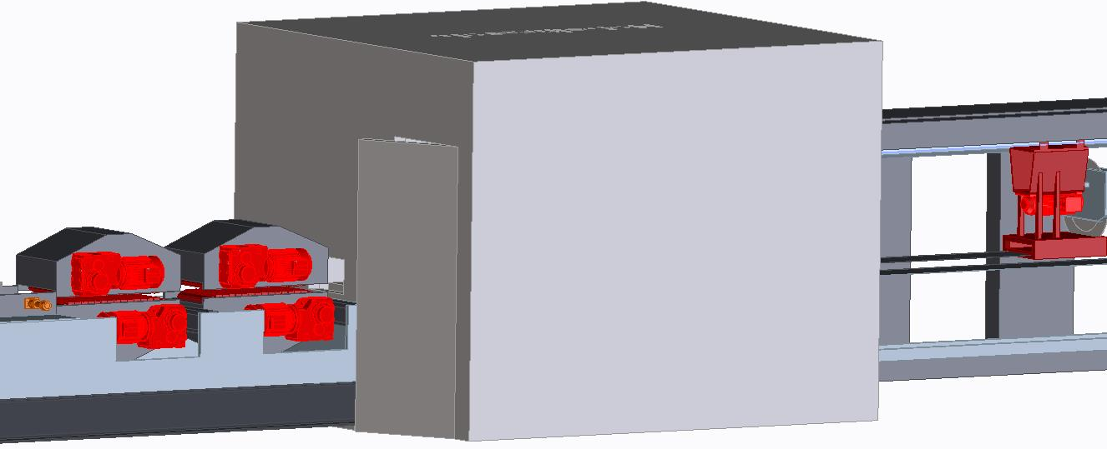
Figure 48: Four side planer machine. Courtesy of Fill GmbH.

Immediately after planning, a flying saw is installed to facilitate on-line cut-to-size of the lamellas (Figure 49). Here the lamellas are cut to length of the CLT press.
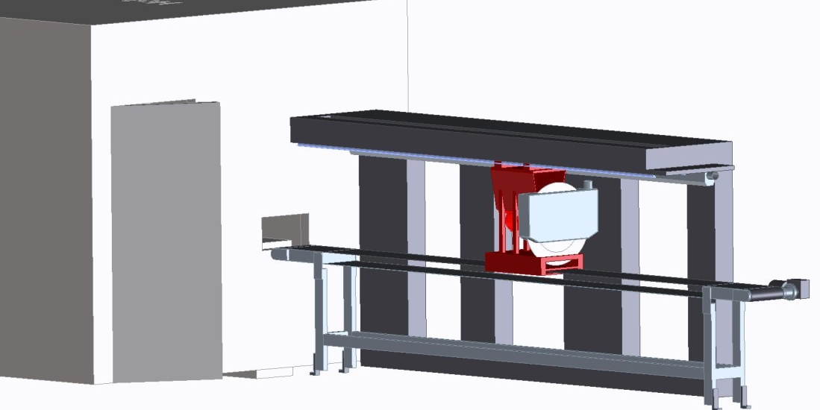
Figure 49: Flying saw to cut lamellas for longitudinal layers. Courtesy of Fill GmbH.

After the lamellas are cut to size, they are transferred by rolling conveyors to a paternoster lift (Figure 50) storage for curing of the adhesive used for finger jointing. Conveyor dogs lift the lamellas from the rolling conveyors. The chosen adhesive system has a curing time of five minutes. During those five minutes the lamellas move clockwise in the paternoster storage. Then the dog conveyors pass the cured lamellas to rolling conveyors which transport them to the next production step.
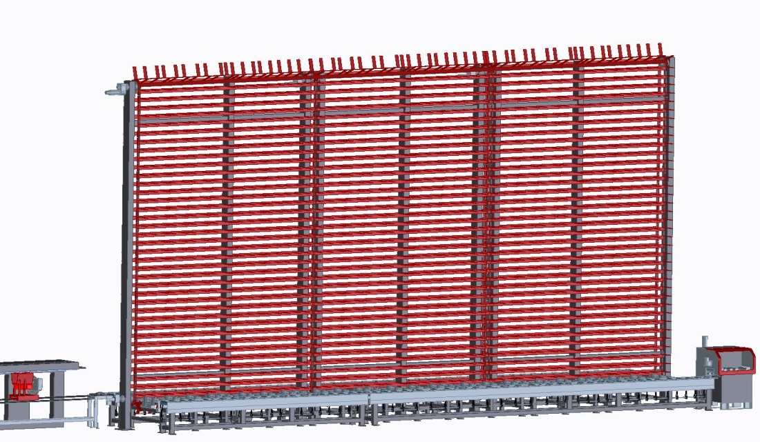
Figure 50: Curing paternoster. Courtesy of Fill GmbH.
Right after the lamellas leave the paternoster, conveyors transport them to the CLT layer formation. Here all lamellas are forwarded through a chop saw (Figure 51). Chop saw actuation is dependent on the purpose of lamella. Lamellas for the longitudinal layer section pass the saw unprocessed and move with full length to longitudinal CLT single layer formation. If the lamella is purposed for application in the parallel layer, it is chopped to press width by the saw. Immediately after trimming, the boards are pushed to a curve conveyor. Then the lamellas are forwarded to the parallel layer formation. If lamella residues occur, they are expelled from the process at the chop saw.
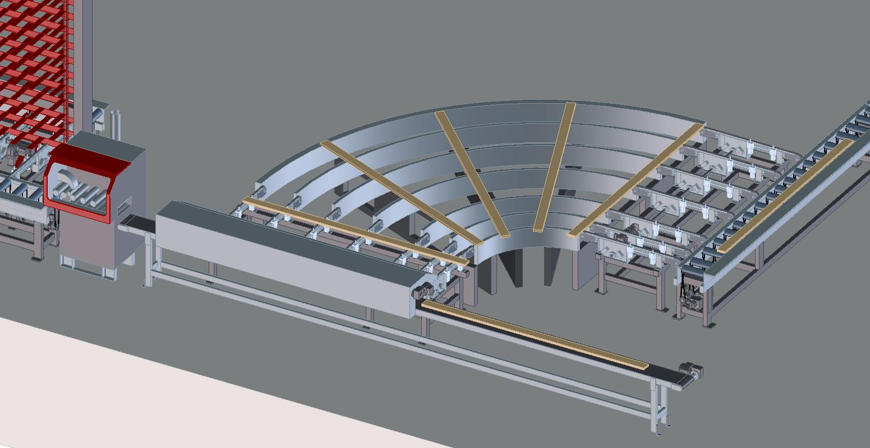
Figure 51: Chop saw and separation of parallel and longitudinal layers. Courtesy of Fill GmbH.

The lamella separation for parallel and longitudinal layers is shown in Figure 52. In both layer assemblies, hot melt is used for edge bonding of the lamellas. The application is facilitated by means of hot melt nozzles which apply the adhesive on selective spots of the lamella edges. Every 100 cm, a 5 cm line of hot melt is applied. The hot melt application amount should stay on a minimum. In the following the lamellas are edge-bonded to single layers by means of pneumatic press shoes and press cylinders. The bond line thickness should not be thicker than 0.1-0.2 mm after edge-bonding. This method ensures that gaps between the lamellas are kept on a minimum in the finished CLT panel. Moreover, it allows ease and smooth manipulation of the single layers with a vacuum lift for the crosswise CLT layer formation (Fill, 2014).

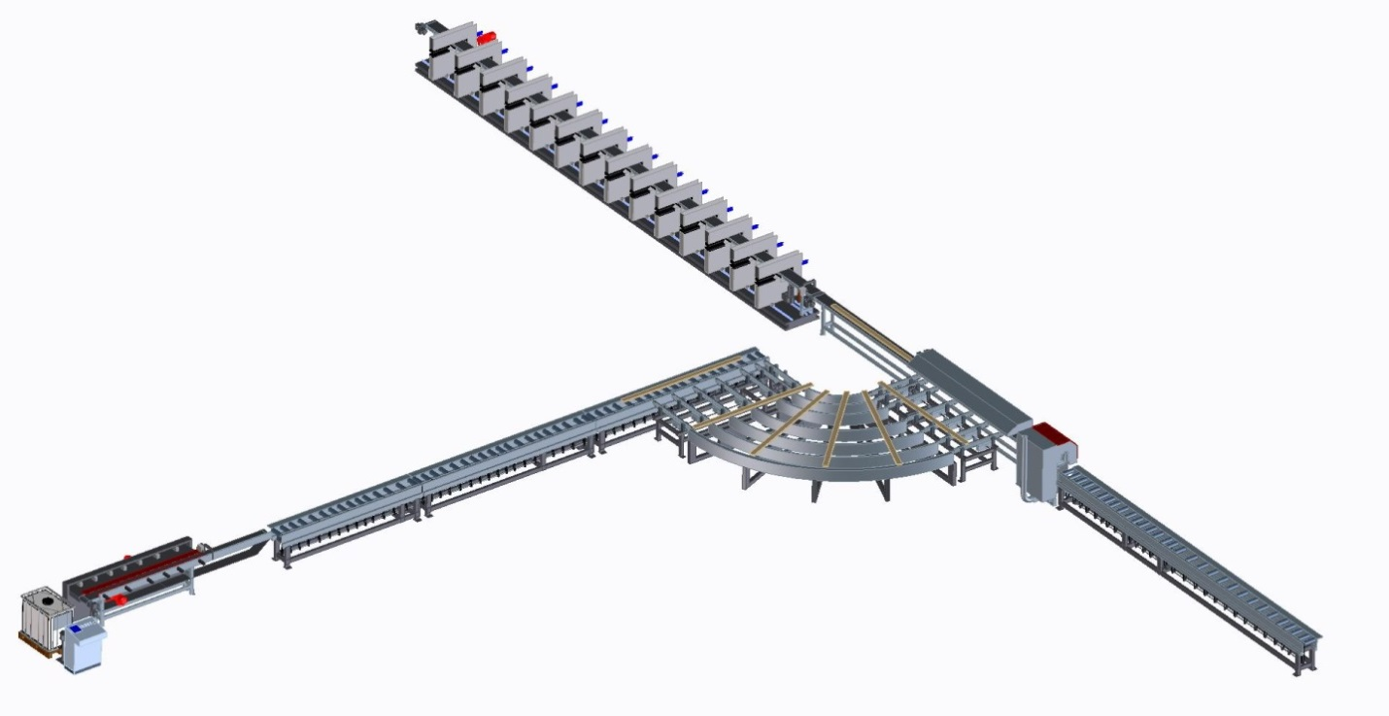
Figure 52: Lamella separation for parallel and longitudinal layers. Courtesy of Fill GmbH.

In Figure 53 and Figure 54 the layer formation of longitudinal and parallel layers is illustrated. After assembling of a single layer, a vacuum gantry crane lifts them to the CLT assembly table.

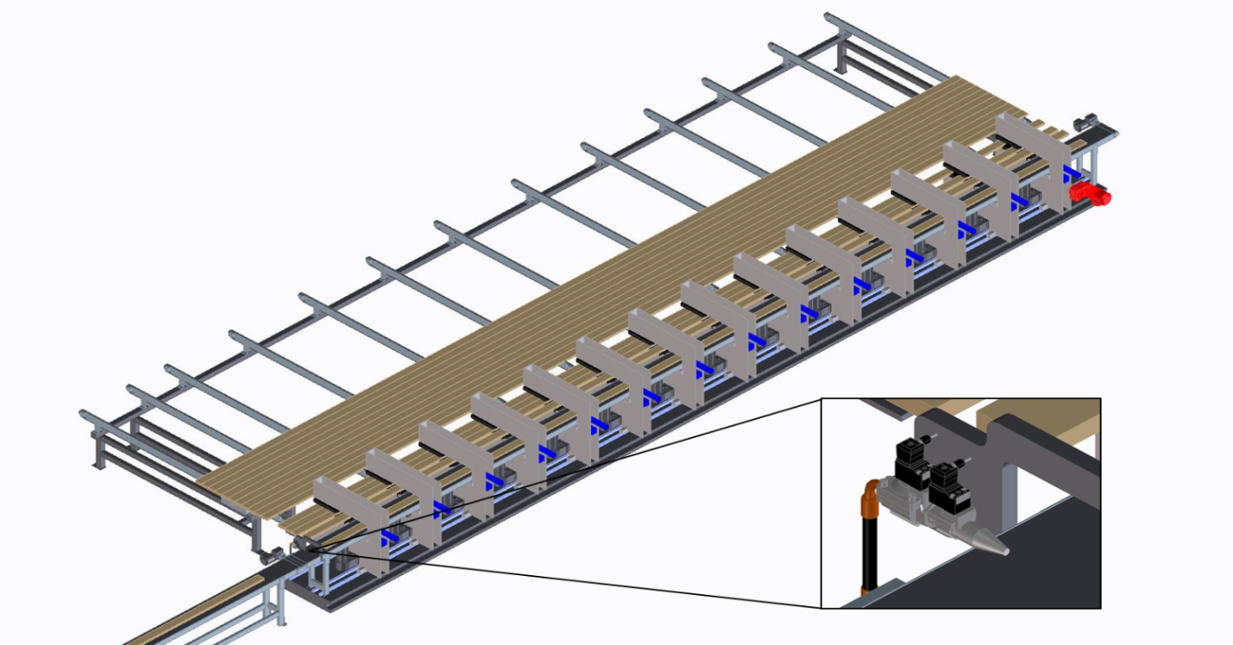
Figure 53: Longitudinal single layer formation with hot melt edge bonding. Courtesy of Fill GmbH.
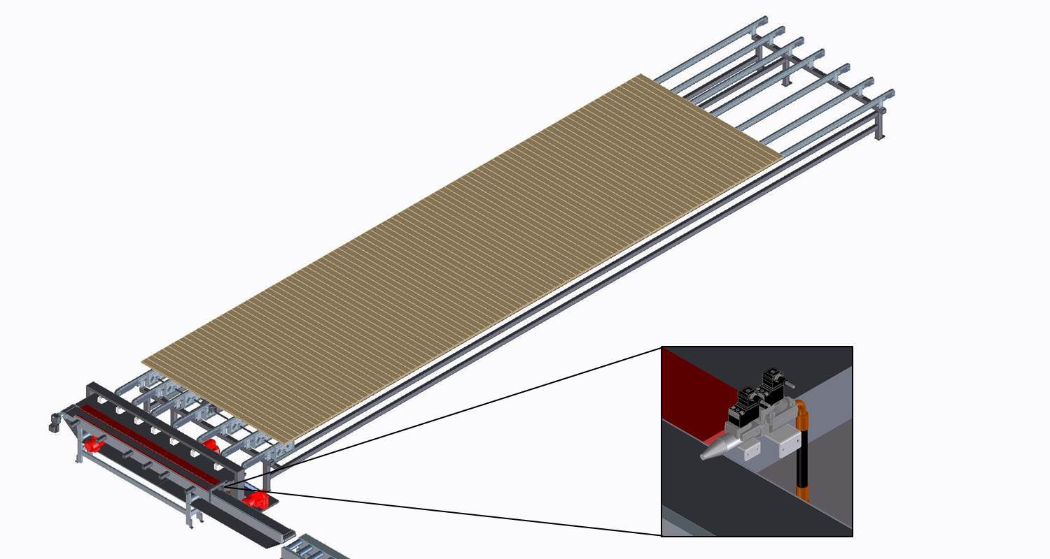
Figure 54: Parallel single layer formation with hot melt edge bonding. Courtesy of Fill GmbH.

Line layout – Stage III
Figure 55 is an illustration of stage III of the CLT production line. It consists of a vacuum gantry crane for parallel and longitudinal single layer manipulation, pneumatic CLT press with a CLT layup station, adhesive distribution device, and rolling conveyor for the panel output after pressing. A detailed description of the single components is provided in this section.
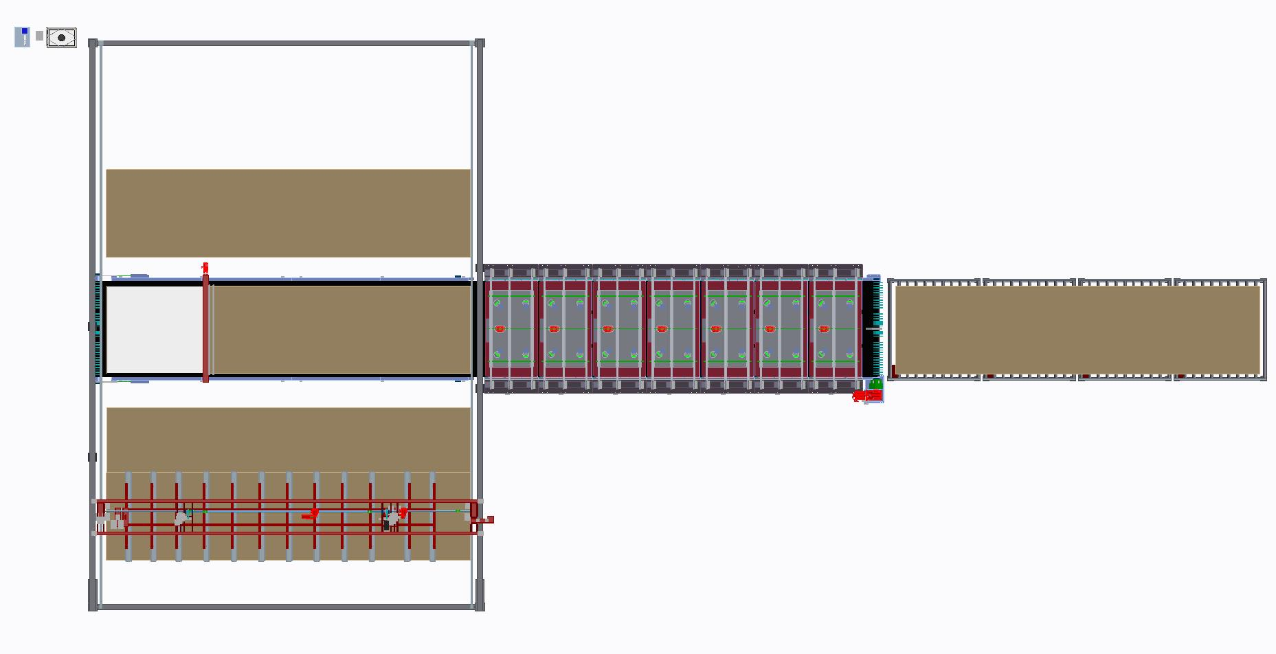
Figure 55: Line layout stage III, CLT layup – CLT pressing. Courtesy of Fill GmbH.

After the single layers are formed, a vacuum lifter moves them to the next CLT production step (Figure 56). The edge-bonding guarantees a smooth transport of the layers with the vacuum handling device since it facilitates that single lamellas do not lose contact to the vacuum device and drop to the ground. The lifter moves the layers either directly to the layup station or to the interim buffer storage. The buffer storage for the parallel layers is located left of the lay-up station for the parallel layers and right of it, for the longitudinal layers. After the first CLT layer is located at the lay-up station, an adhesive distribution device applies the 1K PUR on the layer face. Then the next layer is lifted to the lay-up station and placed directly on the preceding layer. Usually, the CLT element is laid up in a crosswise fashion. However, also special panel designs with a uniform succeeding layer are feasible. Moreover, two CLT elements can be formed in one batch. This is done if no adhesive is applied between two layers.
In successful CLT production, face-bonding is very important. To facilitate fast pressing times, a bond thickness of 0.1 mm should be targeted as it is standard in European CLT manufacturing. This can be achieved by means of high accuracy and consistency of lamination tolerances. If this is not achieved in the production, more adhesive quantities have to be applied to compensate inaccuracy. This in turn has an impact on pressing times and production costs. Pressing times get out of specification and can easily triple if the targeted bond line of 0.1 mm is not achieved (Fill, 2014).
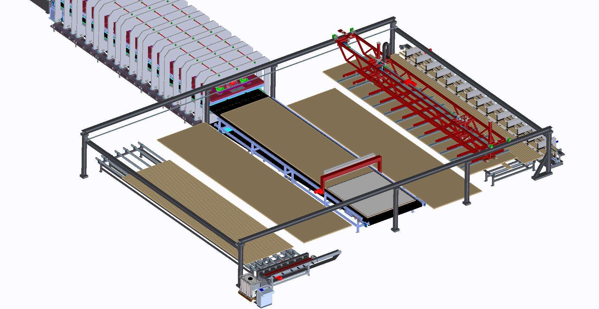
Figure 56: CLT press with preceding layer station and adhesive distribution device, vacuum gantry crane and puffer area for single layers. Courtesy of Fill GmbH.

In Figure 57, a pneumatic CLT press is illustrated. The press structure is reinforced by a heavy duty steel framework and is anchored to the ground by means of steel I-beams and threaded rods. The press is modular. One press module segment consists of three steel plate frames. Therefore, infinite press length is theoretically possible. Within the press a heavy duty steel plate serves as a bolster for CLT pressing. The press pressure is provided from above by pressure units. The height adjustment of the pressure units is facilitated by means of four mechanically operated screw driven elevators. The screw driven elevators lower the pressure units mechanically until they have full contact to the CLT element. The press opening ranges from a minimum of 70 mm to a maximum of 400 mm. Only after the pressure units have complete contact with the CLT element, pneumatic air cushions start to inflate and thus create pressure force. The cushions are fed by a pneumatic system. This system consists of a pressure tank with a pressure capacity of 16 bar and the press cushions. A pressure valve separates the two components. The pressure tank builds up pressure to full capacity. When the CLT element is prepared for pressing, the delivery valve opens and releases the pressure from the pressure tank and distributes it to the cushions. After that, the release pressure equalization takes place between the tank and the air cushions. Thus, the pressure drops from 16 bar to 8 bar. Therefore, the CLT elements are pressed with 0.8 N/mm². Once the pressure is fully released to the air cushions, the delivery valve closes again and the pressure tank starts to build up pressure for the next CLT elements.
Another essential point of the press concept illustrated in Figure 57 is the feed-in after the CLT element is assembled and ready for pressing. The press is mainly fed by a continuous pressure resisting belt conveyor. Therefore, there is no gap between CLT layup station and press in-feed. Thus, also panels with parallel lamellas on the outer layers are feasible since the panels cannot exit at the press in-feed.
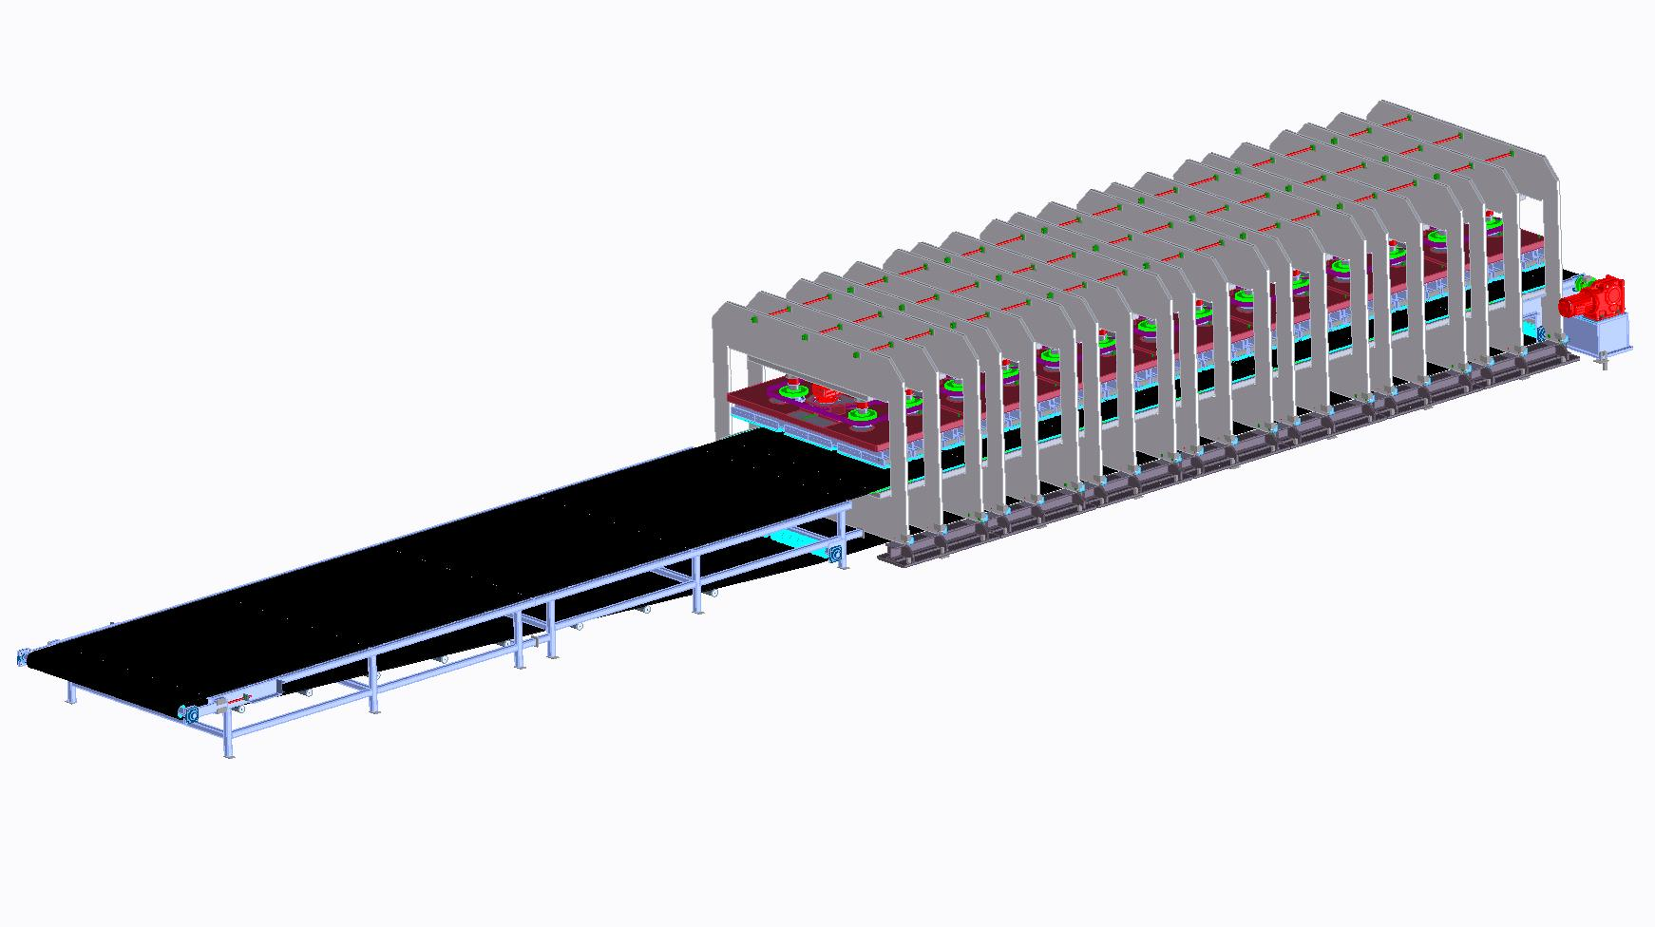
Figure 57: Pneumatic CLT press with continuous belt conveyor. Courtesy of Fill GmbH.

Figure 58 is an illustration of the press feed out. The final pressed CLT panel is consigned to a rolling conveyor from where it is further processed for trimming and matching.
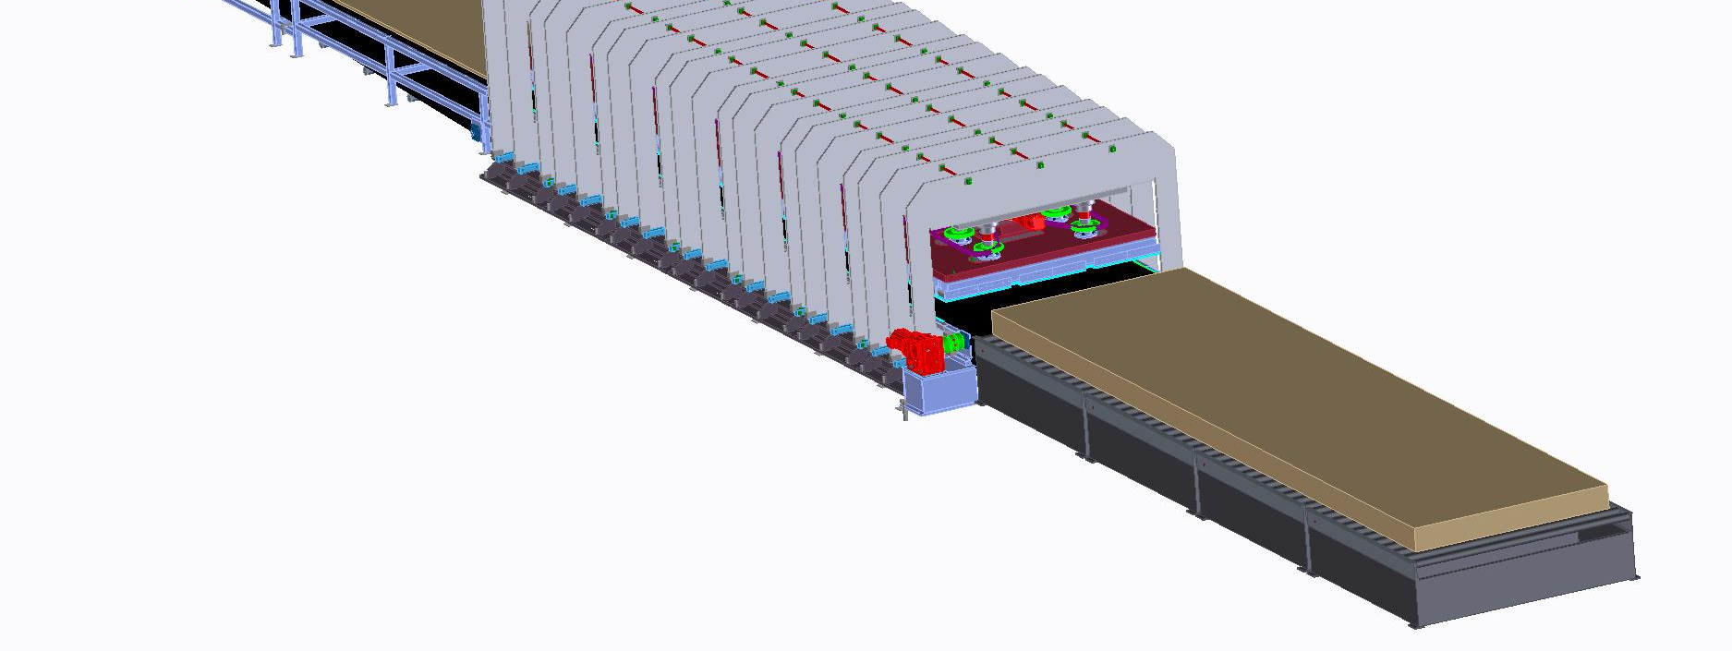
Figure 58: CLT Press feed out and consignation to a rolling conveyor. Courtesy of Fill GmbH.

Line layout – Stage IV
Figure 59 is a layout illustration of stage IV of the CLT production line. It consists of a multiple processing center for trimming and matching. Depending on CLT production capacity, one or two processing centers are needed. A description of the processing center is provided in this section.
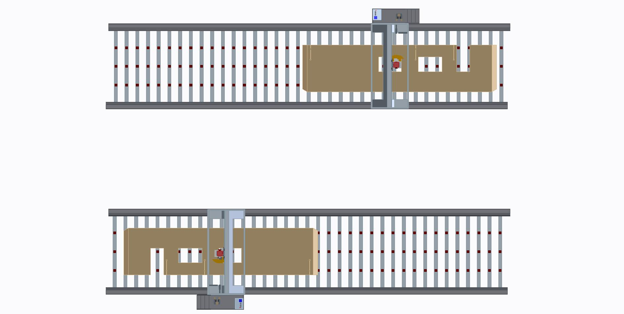
Figure 59: Line layout stage IV, multiple processing center for CLT trimming and matching. Courtesy of Fill GmbH.

The multiple processing center (Figure 60) is used for the overall matching and trimming of the CLT panels. As standard treatment, glue residues which occur on the element sides are removed. In addition, the panels are matched to specific dimensions. Also, ‘miter-cuts’, holes for connections, and installation pathways are milled in the panel at this stage. Window and door openings are also cut to the panel. Finally, multiple processing centers can also be used for nesting, where panels are split to two, or even more final CLT elements.
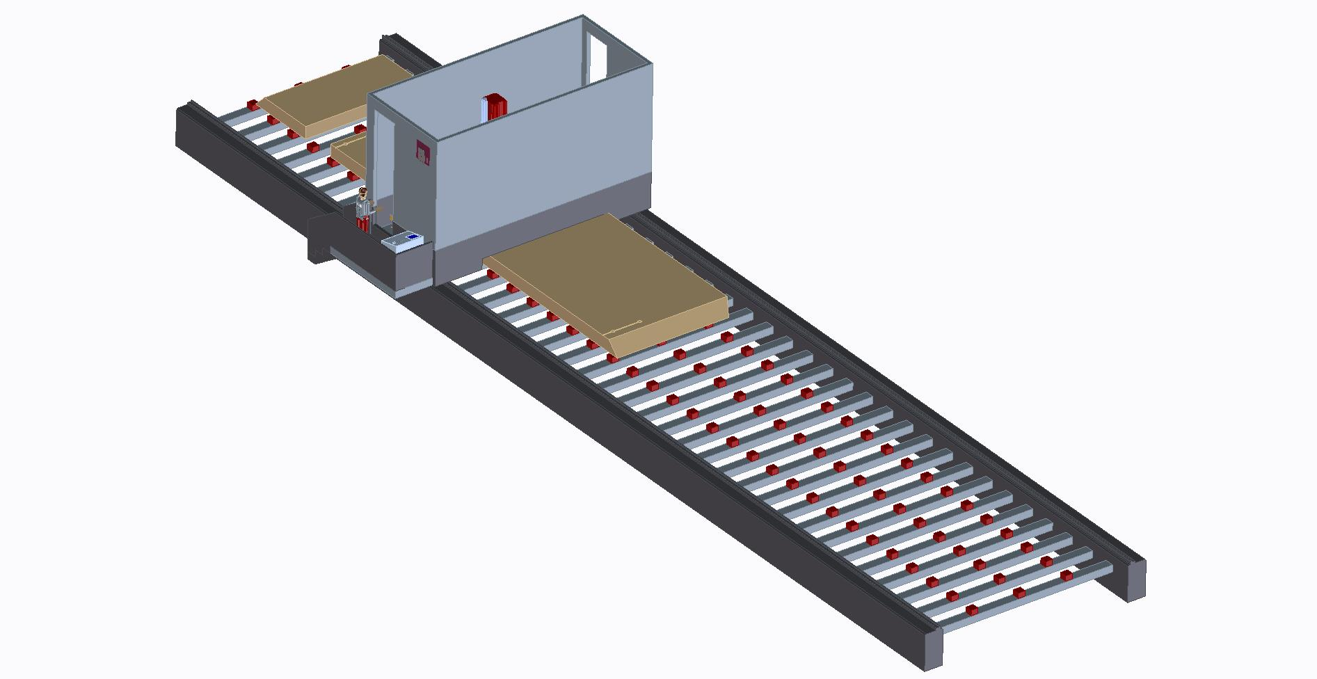
Figure 60: Multiple processing center. Courtesy of Fill GmbH.

Line layout – Stage V
Figure 61 is a layout illustration of stage V of the CLT production line. It is the finishing stage and consists of sanding and packaging of the CLT panels. A detailed description of the single components is provided in this section.
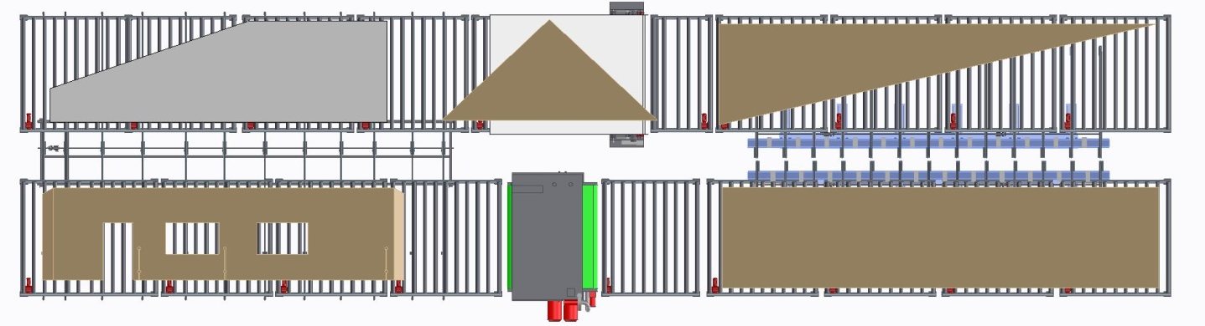
Figure 61: Line layout part 5, sanding, packaging and labeling. Courtesy of Fill GmbH.

After the matching, the final CLT panels can be sanded and packaged by a finishing line as it is illustrated in Figure 62. This adds visual quality. In addition, wood failures are repaired. The elements are moved via rolling conveyors. The CLT elements are sanded by means of a broad belt sander. This device is capable of one-sided sanding. After sanding, the element is moved to the flipping station (Figure 64), where the element is turned. Afterwards the un-sanded face can be processed by the sander. As a final step of the CLT manufacturing process, the panel is packaged and labeled (Figure 65). The CLT elements are now ready for shipping to the construction site.

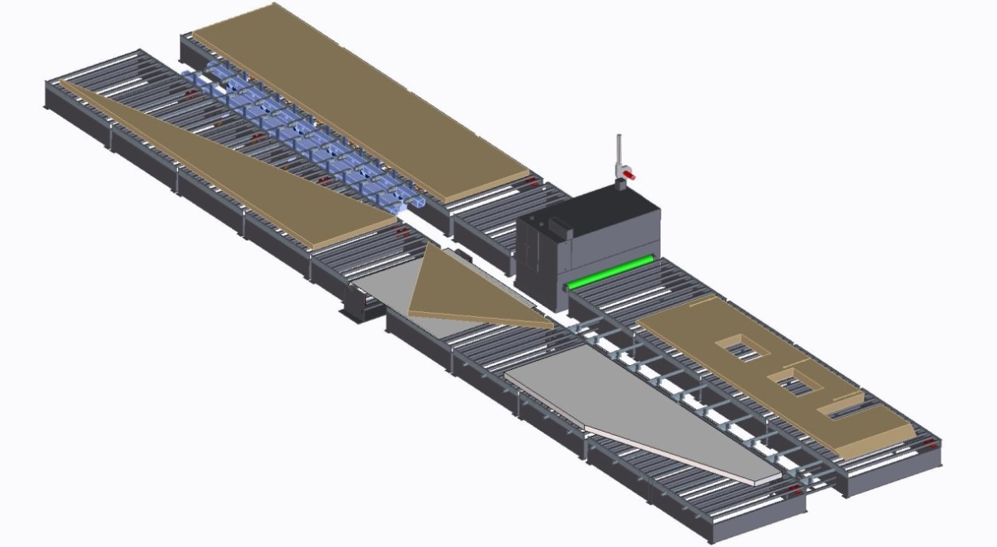
Figure 62: CLT finishing line. Courtesy of Fill GmbH.

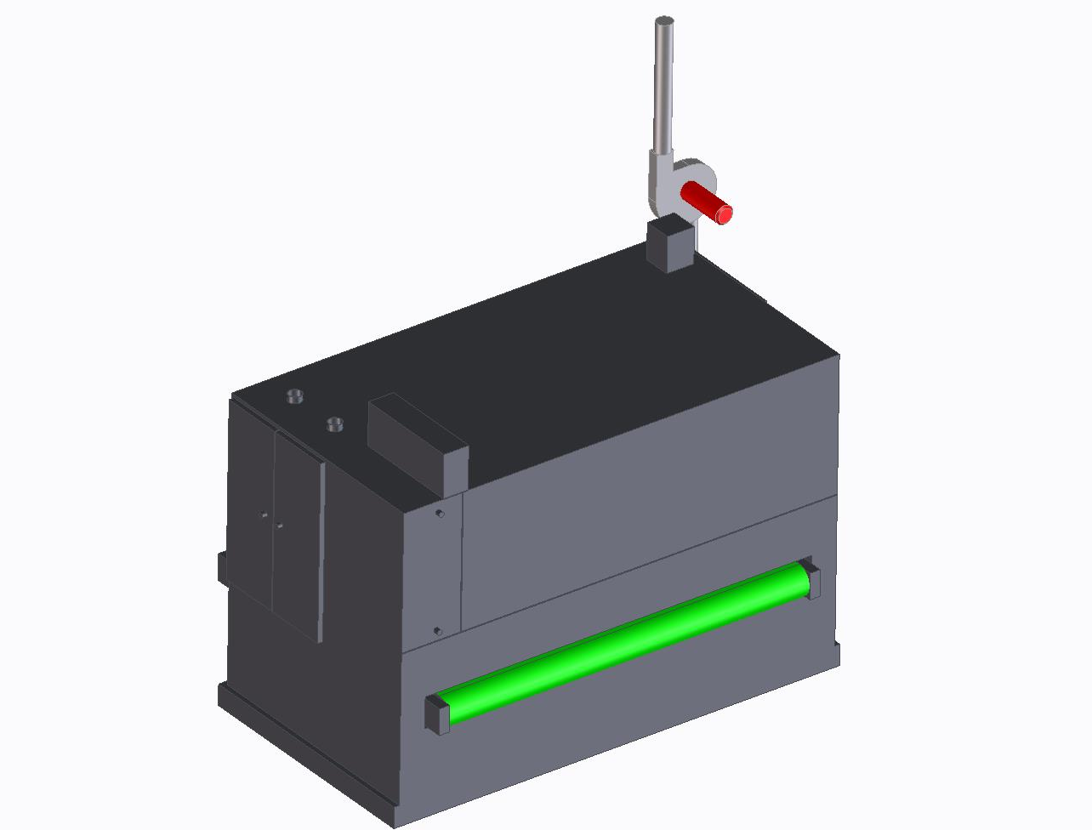
Figure 63: One side CLT Sanding unit. Courtesy of Fill GmbH.

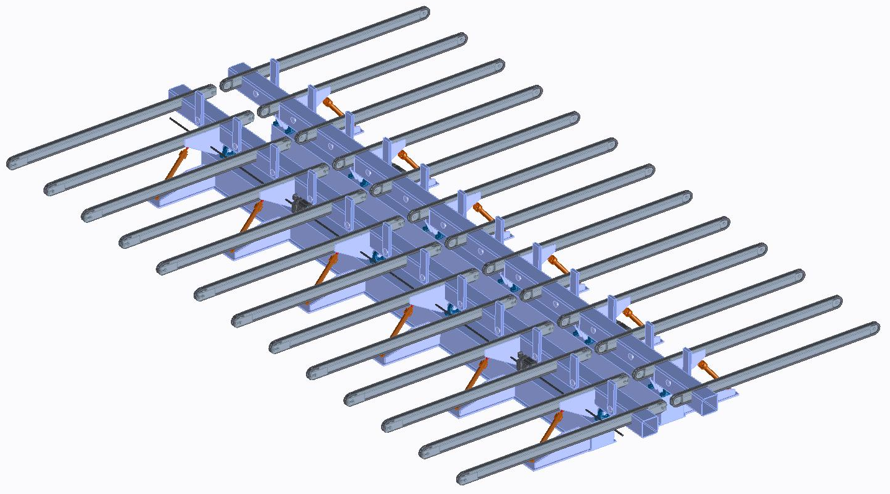
Figure 64: CLT flipping unit. Courtesy of Fill GmbH.

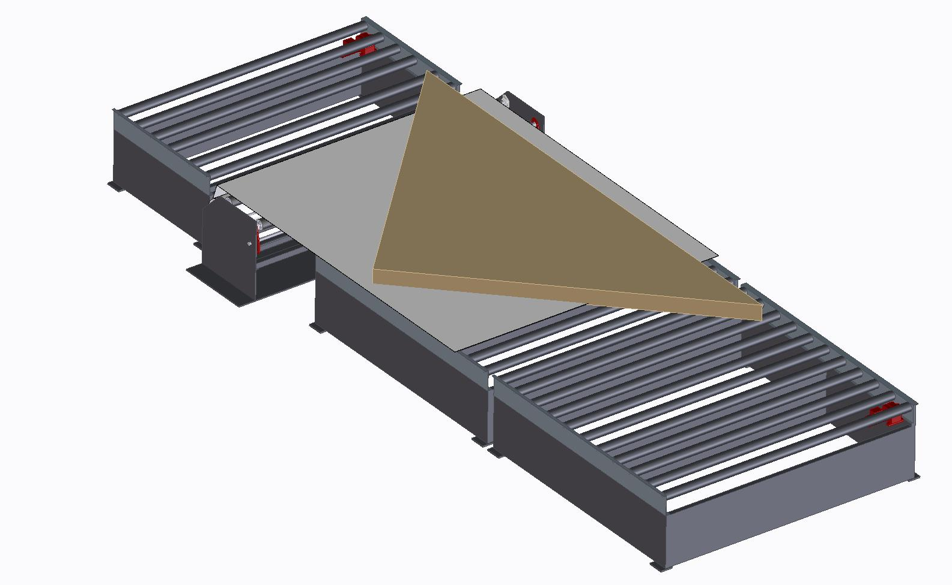
Figure 65: CLT wrapping unit. Courtesy of Fill GmbH.

CLT line without finger jointing
This smaller version of a CLT plant does not include an upfront finger jointing unit. Instead, two de-stacking devices for the parallel and longitudinal devices are located in front of the CLT lay-up stations and the CLT press. This section is included in order to give industries with existing finger-jointing equipment in North America a reference of how a CLT plant could be integrated into an existing facility in order to upgrade their manufacturing capabilities by CLT.
The main manufacturing process is the same as it is described in Chapter 4.2, however, instead of the finger jointing, this line considers two in-feed stations for already planned and finger jointed lamellas. In addition, the sanding and wrapping unit is not included to this line. These alterations also affect investment costs. The investment costs for the layout presented in Figure 66 are $ 5,793,361 (Table 19). The land area required for this CLT facility is 2,975 m². The production line could produce CLT from either hardwood, softwood or a combination of softwood/hardwood.
Table 19: Production stages and investment costs of CLT line without finger-jointing (Fill, 2015a)
Production Stages | Description | Units | Price per unit | Investment costs in Euro (€) | Investment costs in US Dollars ($)¹
Stage I | De-stacking and longitudinal single layer formation | 1 | € 732,713 | € 732,713 | $ 818,293
Stage II | De-stacking and parallel single layer formation | 1 | € 1,507,653 | € 1,507,653 | $ 1,683,746
Stage III | CLT pressing | 1 | € 2,070,214 | € 2,070,214 | $ 2,312,014
Stage IV | Matching | 1 | € 876,888 | € 876,888 | $ 979,308
Total |  |  |  | € 5,187,467 | $ 5,793,361
¹ Euro/Dollar exchange rate from the 27th of June 2015: € 1 = $ 1.1168

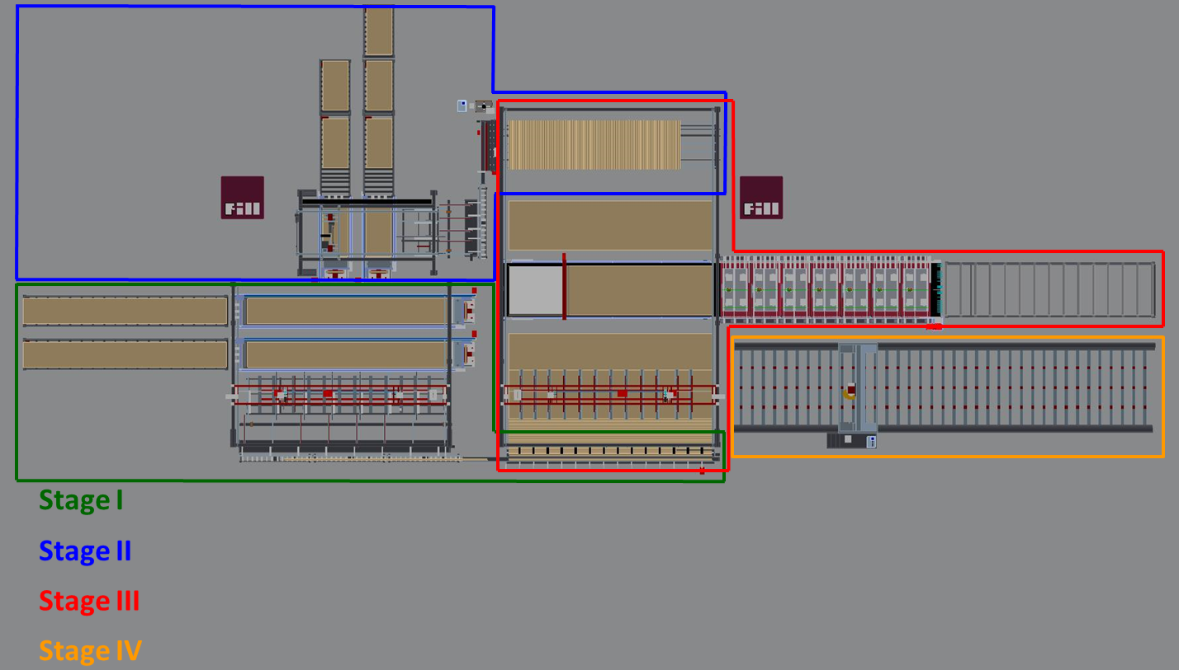
Figure 66: Line layout for CLT plant without finger jointing. Courtesy of Fill GmbH.

Capability Study
Capability analysis is a statistical tool within the field of industrial statistics and statistical process control (SPC). It is a key method in modern quality control and continuous improvement (core principle of ‘Six-Sigma Quality’, see Harry and Schroeder (2005). In a capability study the natural variation (i.e., ‘natural tolerance’) of a process is compared with specification limits (i.e., ‘engineering tolerance’). It defines the state of a system and the systems capability of producing a product or product component to desired specification. Successful companies use capability analysis as a metric driven guide for improvement to gain competitive advantage and excellence through providing value at minimum costs (Winton, 1999).
A capability study is usually performed once a process is in a state of statistical control. If a process is in state of statistical control, only natural variation is present in the process, i.e., no special-cause variation is present (StatSoft, 2015). The theory of process control goes back to the studies of Dr. Shewhart (Shewhart, 1931) who differentiated between “controlled variation” and “uncontrolled variation”. He considered controlled variation routine to the process and thus making the process predictable over time. Contrary, Shewhart considered uncontrolled variation as changing over time (‘special-cause’ variation) and thus being unpredictable (Wheeler and Chambers, 2010).
As stated by Wheeler and Chambers (2010) an example for a controlled process can be described by a “manufacturing process making a series of discrete parts, each with a measurable dimension or characteristic. Some of these parts are periodically selected and measured. These measurements vary because the materials, machines, operators and methods all interact to produce variation. Such “chance” variation is relatively consistent over time because it is the result of many contributing factors.” An illustration of a stable process over time with a control chart example is provided in Figure 67.
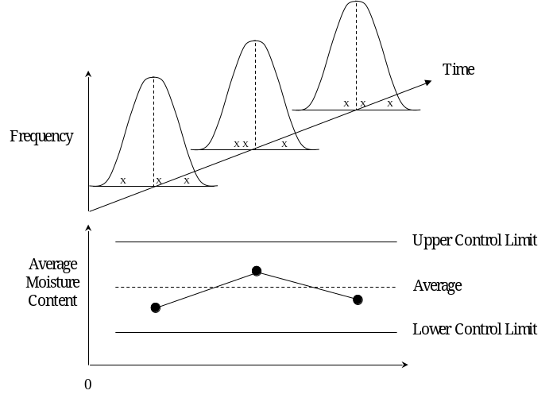
Figure 67: Variation pattern over time and control chart of stable process (Young, 2014).

As Wheeler and Chambers (2010) furthermore stated, “there are special factors that have a large impact on the product values. These factors might be machines out of adjustment, materials that are slightly different, methods that may be slightly altered, differences between workers, or differences in the environment created by inconsistency on the part of management. Shewhart argued that such factors were identifiable and that the impact of such “Assignable Causes” would be sufficient to create a marked change in the pattern of variation.” An illustration of an unstable process over time with a control chart example is provided in Figure 68.
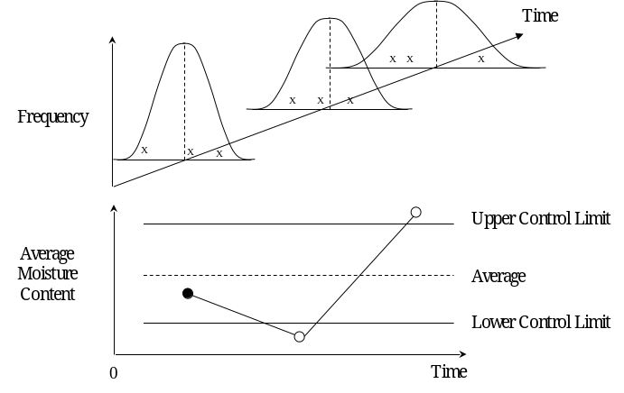
Figure 68: Variation pattern over time and control chart of unstable process (Young, 2014).
In a Gaussian or Normal distribution the variation within plus or minus three standard deviations from the sample mean (or process center line) is considered to be natural or common-cause variation. This common-cause variation defines 99.73% of the total variation of the system. Control limits are set at plus or minus three standard deviations, i.e., LCL (Lower Control Limit) and UCL (Upper Control Limit) in control charts (Figure 69).
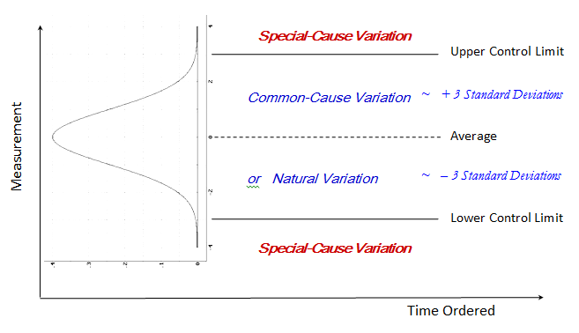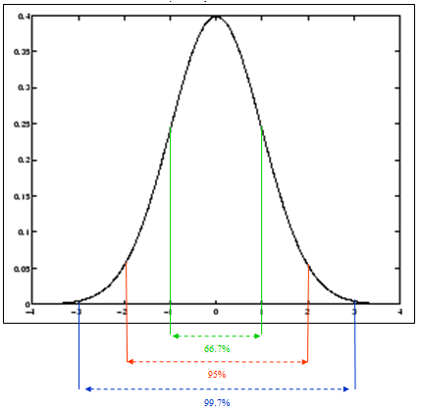
Figure 69: Estimation of natural cause variation and special-cause variation (Young, 2014).

If a process is not in a state of statistical control, initial investigations on sources of assignable variation (‘events’) should be performed. The detected reasons for special-cause variation should identified and root-case analysis with action plans should be developed to eliminate future occurrence of these events. Chance variation (‘natural variation’) can only be improved by altering the process itself (Wheeler and Chambers, 2010). Several methods like a fishbone diagram can help to detect causes of variation (Young, 2014). Examples for chance variation and assignable variation are given in Table 20.
When conducting a capability analysis it is important that no special-cause variation is contained in the data set being analyzed. If present, the resulting of the capability study does not represent predictions of product quality over time (PQ Systems, 2014).
Table 20: Examples of causes for common-cause and special-cause variations (Young, 2014).
Causes for common-cause cariation | Causes for special-cause variation
Raw material variation | Part failure, machine stop
Flake thickness variation | Damper stuck
Moisture variation | Shift change
Product change | Over-adjustment

When a process is in the state of statistical control a capability analysis will produce key capability indices (e.g., C_{p}, C_{pk}, C_{pm}, etc.). In other words, the natural tolerance of the process is compared to the engineering tolerance (NIST/SEMATECH, 2003). Specifications are engineering metrics defining product quality and where the process should operate. Specifications can have various origins and be defined externally or internally to the firm, e.g., customer, certifying association, technical management, equipment vendors, etc. Specification limits should not be confused with control limits (PQ Systems, 2014).
Typically, the outcome of a capability study is capability indices which measures whether or not a process is capable of producing parts to specification. Based on this information production processes can be targeted for improvement. If a production step is capable, statistical process control (SPC) should be applied for sustaining control and monitoring process events. This is important since capable processes can become incapable due to an increase in variability or shifting of process means (Winton, 1999). The chart in Figure 70 illustrates natural tolerance from two hypothetical processes. The specification limits are indicated by LSL (Lower Specification Limit) and USL (Upper Specification Limit). The distribution in bold black shows a capable process, i.e., the variation spread is within the range of specifications. The distribution in gray shows an incapable process. Here the variation spreads goes beyond the specification limit. Thus a certain amount of the product is manufactured outside of specification and may generate rework and/or scrap.
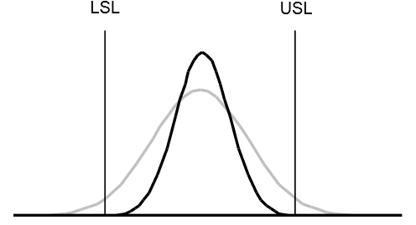
Figure 70: Variability charts with specification limits (Winton, 1999).

Capability analysis
Several statistical indices help to identify and quantify the capability of a process. The most important indices are P_{p}, P_{pk} and P_{pm} for long-term analysis and C_{p}, C_{pk} and C_{pm} for short term analysis. All of the mentioned indices have the assumption that the data are normally distributed and in a state of statistical control.

Process range and specification limits
Process range
“It is customary to establish the ± 3 sigma ($\hat{σ}$) limits around the nominal specification. The sigma limits should be the same as those on a Shewart control chart. These limits define the natural tolerance of the process” (StatSoft, 2015). Assuming a process that has a Gaussian or Normal distribution, approximately 99.7% of the produced product should be within ± 3 sigma as a limit (StatSoft, 2015).
Specification limits
Specification limits usually consist of a lower specification limit (LSL) and an upper specification limit (USL) and define acceptable process or product performance. The engineering tolerance is the difference between the USL and LSL (StatSoft, 2015).

Long-term capability indices
In this section, the key long-term capability indices are presented. For the calculation of meaningful long-term capability indices, a large number of samples is required (n > 100) (Young, 2014).
Potential Capability (P_{p})
The P_{p} index is the ratio of the engineering tolerance divided by the natural tolerance (Winton, 1999). A P_{p} = 1 refers to a process that is considered capable based on its variation only. A shortfall of this index is that it does not use the process mean, i.e., a process may make every product out of specification if its process mean is much greater (or smaller), this indices only compares the tolerances, and does accommodate the mean (StatSoft, 2015).
$P_{p}=\frac{Specification Range}{6∙s} = \frac{\left(USL-LSL\right)}{6∙s}$ [1]
where s is defined as the process standard deviation.
Lower/upper potential capability (P_{pk})
The P_{p} index must be used in conjunction with the P_{pk} index. The higher the computed ratio of that index is the lower is the amount of product outside of the specification limit. If the process is centered between the specification limits, the P_{pk} = P_{p} (Young, 2014).
$P_{pk}=min\left[\frac{USL-\overline{X}}{3s}, \frac{\overline{X}-LSL}{3s}\right]$ [2]
Potential Capability II (P_{pm})
Taguchi’s Ppm-index is based on Taguchi’s theory that a process should be run at the target and variation should be minimized around the target (see Taguchi Loss Function and his approach of reducing variation around the target), see Taguchi et al. (2005). This index penalizes the process if it is not run to target (Young, 2014). If $\overline{X}=T$, the Ppm-index reduces to the Pp-index.
$P_{pm}= \frac{USL-LSL}{6∙\sqrt{s^{2}+(\overset{̿}{X}-{T)}^{2}}}$ [3]

Short-term capability indices
The short term capability indices Cp, Cpk and Cpm compute the same ratios as their fellow indices of the long-term capability analysis. However instead of using the process sigma, $\overline{R}/d_{2}$ is used as an unbiased estimator of $σ$given that these indices are used for small sample sizes representative of short-term variation (Young, 2014).

Schematic approach for capability analysis
The general steps in process capability study are (Winton, 1999):
- Select critical process or product parameters,
- Collect data,
- Verify data quality,
- Establish statistical control over the process,
- Analyze sources of variation for key process or product parameters,
- Initiate root-cause analysis,
- Establish process monitoring system using SPC.

Capability Study for CLT
Certainly, SPC and process capability is of particular interest for CLT plants. Unreliable product output below specification could lead to disastrous consequences such as structural failure. Furthermore a modern CLT plant has to incorporate SPC techniques to be cost effective and competitive.
As in any field of product manufacturing, CLT has a broad range of potential sources for variability. It starts with the raw material input and ends at the output of the finished product. This analysis of parameters for a capability study on CLT uses the layouts of the mill presented in Chapter 5. The analysis of critical parameters is targeted on the raw material inputs as well as on the production stages which were presented in Chapter 5.2 ‘CLT line with finger jointing’. The analysis does not focus on one particular wood species and is relevant for both, softwoods and hardwoods.

Material passed variability sources in CLT manufacturing
The principal raw material components for a CLT plant are the laminations and the adhesive which is used for bonding. The general specification limits for CLT raw materials are mainly set by the North American CLT Standard (ANSI, 2012) and by the requirements of the 1K PUR adhesive (Loctite, 2014). An overview of the climate requirements of the production facility are shown in Table 21. The critical process parameters concerning the raw material inputs are provided in Table 22.
Table 21 Overall facility specification requirements.
Overall facility requirements | LSL | Target | USL | Source
Temperature in the facility | 15°C | 20°C |  | (Loctite, 2014) | I
Relative air humidity in the facility | 45% | 75% |  | (Loctite, 2014) | I
I= Internal requirement due to production process efficiency; E= External requirement due to standard regulation

Table 22 Raw material in-feed specification requirements.
Lamellas | LSL | Target | USL | Source
Recognized by ALSC or CLSAB |  |  |  | (ANSI, 2012) | E
Moisture content (between adherents not more than 5%) | 9% | 12% | 15% | (ANSI, 2012) | E
Temperature | 15°C | 20°C |  | (Loctite, 2014) | I
Parallel lumber grades | 1200f-1.2MSR/No.2 |  |  | (ANSI, 2012) | E
Perpendicular lumber grades | No.3 |  |  | (ANSI, 2012) | E
Thickness | 16 mm |  | 51 mm | (ANSI, 2012) | E
Width major strength direction | 1.75 x thickens |  |  | (ANSI, 2012) | E
Width minor strength direction | 3.5 x thickness |  |  | (ANSI, 2012) | E
PUR Adhesive | LSL | Target | USL | Source
Temperature | 15°C | 20 °C |  | (Loctite, 2014) | I
Relative air humidity |  | 65% |  | (Loctite, 2014) | I
Assembly time | depends on type |  |  | (Loctite, 2014)
Curing time | depends on type |  |  | (Loctite, 2014) | I
Application quantity finger-jointing | 125 g/m² |  | 200 g/m² | (Loctite, 2014) | I
Application quantity face-bonding | 100 g/m² |  | 180 g/m² | (Loctite, 2014) | I
Adhesive Storing | 20°C |  | 22°C | (Fill, 2014) | E
I= Internal requirement due to production process efficiency; E= External requirement due to standard regulation

Variability parameters Stage I
The key-sources for variability of the production Stage I are moisture content, lumber grade, and lamella temperature. The required lamella specifications at time of in-feed are presented in Table 21. The lamella moisture content has an important impact on the quality of the final product as it activates the curing procedure of the adhesive; the same is valid for the temperature. The ideal condition for the smooth adhesive curing is a lamella moisture content of 12% and a lamella temperature of 20 °C (Loctite, 2014). In addition, the variation spread of the lamella moisture content should stay at a minimum and be consistent. If the lamellas within and between the CLT layer have huge difference in moisture content, internal stresses occur in the panel which lead to shakes in the panel (Karacabeyli et al., 2011). At CLT mills, lumber is usually purchased kiln-dried. Thus, the lumber moisture content should already be monitored at time of delivery. In addition, appropriate stacked and covered storing is important to keep lumber conditioned.
Grades for lumber have minimum requirements for the application in longitudinal and parallel layers (Table 22). Usually lumber lamellas are purchased graded according to the specifications. At the lamella in-feed, workforce can mark wood characteristics which are below specification. Later, they are cut out by means of the chop-saw.

Variability parameters Stage II
The sources for variability for key parameters in production Stage II are: finger-jointing; planing process; and edge-bonding. The specific requirements of finger-joint manufacturing are listed in Table 23. The finger-jointing has various parameters which can cause variation in product quality and thus should be taken into account for a capability study.
Table 23: Finger-joint specification requirements.
 | LSL | Target | USL | Source
Profile milling | Dependent on profile geometry |  |  | (Purbond, 2011) | I
Assembly time (HB E032) |  |  | 2 minutes | (Loctite, 2014) | I
Application quantity finger-jointing | 125 g/m² |  | 200 g/m² | (Loctite, 2014) | I
Cramping of finger joints | Dependent on profile geometry |  |  | (Purbond, 2011) | I
Adhesive distribution on profile |  | 100% |  | (Purbond, 2011) | I
Bond line thickness |  | 0.1 mm | 0.3 mm | (Purbond, 2011) | I
Curing time (HB E032) | 5 minutes |  |  | (Loctite, 2014) | I
Adherent moisture difference | 0% |  | 5% | (Loctite, 2014) | I
Performance requirements | Sections 5.5.1; 5.5.2; 4.5.4.2; 4.5.4.3 of ANSI/AITC A190.1 (2007) |  |  |  | E
I= Internal requirement due to production process efficiency; E= External requirement due to standard regulation

Planing is another highly important factor which should be considered for a capability study. The planing accuracy has tremendous impact on the face-bonding and the final bond-line thickness of the CLT panel. This is because inaccuracy between layers is balanced with adhesive amount. The maximum deviation tolerance for lamella thickness after planing is listed in Table 24.
Table 24: Planing specification requirements.
Planing | LSL | Target | USL | Source
Lamella thickness tolerance |  |  | 0.1mm per m | (Purbond, 2011) | I
I= Internal requirement due to production process efficiency; E= External requirement due to standard regulation

Other important factors when performing a capability study are the single layer formations of longitudinal and parallel layer. Crucial points of variability which have to be taken into consideration are listed in Table 25. The hot melt usage must stay on a minimum to facilitate a small bond line. In addition, the assembly time must be complied.
Table 25: Single-layer formation specification requirements.
 | LSL | Target | USL | Source
Longitudinal lamella length matching | To length of the press |  |  |  | I
Parallel lamella length matching | To width of press |  |  |  | I
Hot melt application | As less as possible |  |  |  | I
Hot melt assembly time |  |  | 1 minute | (Fill, 2014) | I
Hot melt edge bond-line |  | 0.1 mm | 0.2 mm | (Fill, 2014) | I
I= Internal requirement due to production process efficiency; E= External requirement due to standard regulation

Variability parameters Stage III
The sources for variability for key parameters of production Stage III are: duration of the lay-up time and CLT face-bonding (Table 26). The lay-up time cannot exceed the maximum assembly time. Pressure has to be applied when the assembly time ends. A pressure force of at least 87 psi should be applied to guarantee a consistent bond-line target of 0.1 mm. At the time of pressing, the planing accuracy requirements (Table 25) will pay off in order to facilitate an effective bond-line. After the curing time ends, the panel can be further processed. However, the environmental temperature needs to be at a target of 20°C to ensure complete curing of adhesive.
Table 26: Face-bonding specification requirements.
 | LSL | Target | USL | Source
Assembly time (HB E102) |  |  | 10 minutes | (Loctite, 2014) | I
Application quantity face bonding | 100 g/m² |  | 180 g/m² | (Loctite, 2014) | I
Face-bonding pressure | 87 psi | 100% | 116 psi | (Fill, 2014) | I
Adhesive distribution on face |  | 100% |  | (Purbond, 2011) | I
Bond line thickness |  | 0.1 mm | 0.3 mm | (Purbond, 2011) | I
Effective bond line | 80% |  |  | (ANSI, 2012) | E
Curing time (HB E032) | 25 minutes |  |  | (Loctite, 2014) | I
Adherent moisture difference | 0% |  | 5% | (Loctite, 2014) | I
Performance requirements | Sections 5.5.2; 4.5.4.1; 4.5.4.3 (ANSI/AITC A190.1, 2007) |  |  |  | E
I= Internal requirement due to production process efficiency; E= External requirement due to standard regulation

Variability parameters Stage VI and V
The finishing of the pressed CLT panel is done in production Stages VI and V. After pressing, the panel is further processed immediately. However, since the adhesive is still curing, temperature requirements must be fulfilled. At the matching center and the sander, the panels have to be matched with the specifications listed in Table 27.
Table 27: CLT specification requirements.
CLT Specifications | LSL | Target | USL | Source
Climate after face-bonding | 2 hours | 20 °C |  | (Loctite, 2014) | I
Thickness |  |  | 508 mm | (ANSI, 2012) | E
Tolerances in thickness |  | ± 1.6 mm |  | (ANSI, 2012) | E
Tolerances in Width |  | ± 3.2 mm |  | (ANSI, 2012) | E
Tolerances in Length |  | ± 6.4 mm |  | (ANSI, 2012) | E
Squareness |  |  | 3.2 mm | (ANSI, 2012) | E
Straightness |  |  | 1.6 mm | (ANSI, 2012) | E
Structural requirements | North American CLT Standard |  |  | (ANSI, 2012) | E
I= Internal requirement due to production process efficiency; E= External requirement due to standard regulation

Feasibility of Yellow Poplar for CLT manufacturing
According to SLMA, Yellow poplar (Liriodendron tulipifera) “is also known as poplar and tulip poplar and grows from Connecticut and New York southward to Florida and westward to Missouri (Figure 71). The greatest commercial production of yellow poplar lumber is in the South. The sapwood is white and frequently several inches thick. The heartwood is yellowish-brown, sometimes streaked with purple, green, black, blue, or red. These colorations do not affect the physical properties of the wood. The wood is generally straight-grained and comparatively uniform in texture. It has moderately large shrinkage when dried from green condition, but is not difficult to season and stays in place after seasoning.“
American forests are rich on hardwoods, from 1953 – 2007 the hardwood in forest increased from 5 billion m³ to 11.4 billion m³ (Slavid, 2013). Therefore, the annual growth rate exceeds its utilization. This is also the case for yellow poplar as it can be seen in the in the chart of Figure 72. Over all yellow poplar accounts for 11.2% of the total U.S. hardwood market (HMS, 2013).
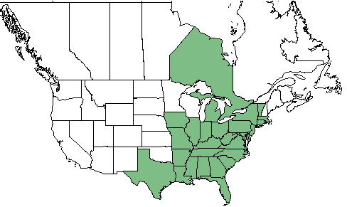
Figure 71: Geographic range of yellow poplar in North America (USDA, 2015).

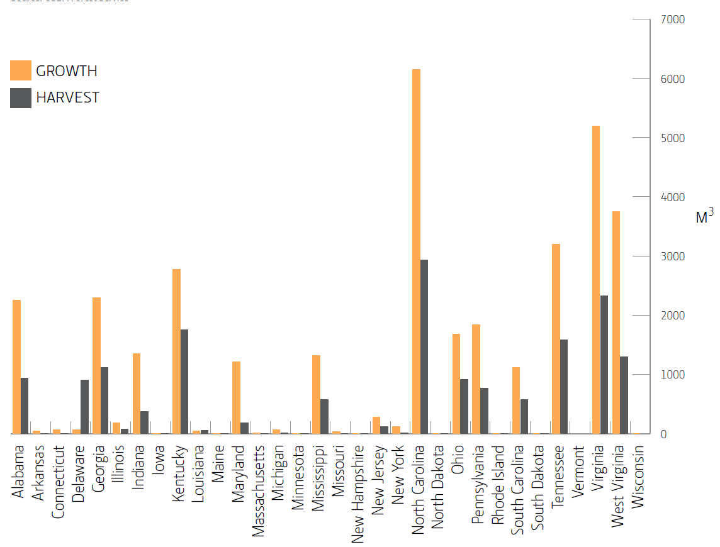
Figure 72: Annual growth and harvest rate of yellow poplar by U.S. states (Slavid, 2013).

Yellow poplar lumber is used for furniture and interior applications as well as for siding and structural end uses. Low grade yellow poplar is also used for packaging (SLMA). In North America structural applications are traditionally dominated of softwood species, although hardwood species have been included when grading procedures for structural timber have firstly been introduced. However, due to low margins in the field of commodity lumber, hardwoods have never been successfully placed to the 2-inch-thick structural dimension lumber. The only hardwood which occasionally appeared on the structural market is yellow poplar (Green, 2005). This may be the reason, why North American hardwoods are not standardized and are usually available in random width and random length (AHEC, 2008).
The strength and mechanical properties of yellow poplar have been well described in the literature (Table 28). Furthermore, yellow poplar is considered as easy to machine and plane. In addition, it has profound bonding and finishing properties (HMS, 2013).
Table 28: Strength and mechanical properties of yellow poplar (Bendtsen and Ethington, 1975, HMS, 2013).
MC | Specific Gravity | Static Bending |  |  | Impact Bending to Grain | Compression Parallel to Grain | Compression perpendicular to Grain | Shear Parallel to Grain | Tension Perpendicular to Grain | Side Hardness
MC | Specific Gravity | MoR | MoE | Work to Maximum Load
 |  | psi | 10⁶ psi | in-lbf/in³ | in | psi | psi | psi | psi | Lb
Green | 0.4 | 6,000 | 1.22 | 7.5 | 24 | 2,660 | 270 | 790 | 510 | 440
12% | 0.42 | 10,100 | 1.58 | 8.8 | 26 | 5,540 | 500 | 1,190 | 540 | 540
a) Results of tests on small clear specimens in the green and air-dried conditions. Definition of properties; impact bending is height of drop that causes complete failure, using 0.71-kg (50 lb.) hammer; compression parallel to grain is also called maximum
crushing strength; compression perpendicular to grain is fiber stress at proportional limit; shear is maximum shearing strength; tension is maximum tensile strength; and side hardness is hardness measured when load is perpendicular to grain.
b) Specific gravity is based on weight when ovendry and volume when green or at 12% moisture content
c) Modulus of elasticity measured from a simply supported, center-loaded beam, on a span depth ratio of 14/1. To correct for shear reflection, the modulus can be increased by 10%.

North American CLT standard and yellow poplar feedstock
General requirements for CLT timber species of the North American CLT standard are listed in Table 29. Although yellow poplar would fulfill the requirements on specific gravity and lamination grades, a utilization of the species according to the standard is not achievable at this point. This is because the standard does not consider any hardwoods.
Table 29: General requirements of North American CLT standards on timber species.
Requirements Standard | Yellow Poplar | Source
Recognized by the ALSC under PS 20 | No | (ALSC, 2010, ANSI, 2012)
Specific Gravity above 0.35 | Yes  (0.42) | (Bendtsen and Ethington, 1975, ANSI, 2012)
Minimum lamination grade major strength direction:  1200f-1.2E MSR; Visual No. 2 | Yes  (Visual No.2) | (AWC, 2014, ANSI, 2012)
Minimum lamination grade minor strength direction:  Visual No.3 | Yes | (AWC, 2014, ANSI, 2012)
CLT Grade for yellow poplar  (not available at this point, an approved custom grade from an agency would theoretically be necessary) | No | (ANSI, 2012)

However, research activities at Virginia Tech utilized yellow poplar as feedstock for CLT. Six 5-layer CLT beams (101” x 6” x 3.13”) have been fabricated and were tested non-destructively. The research pursued to investigate on four mechanical based stiffness computing methods and its applicability for prediction on hardwoods. The non-destructive test data showed, that yellow poplar CLT is capable of meeting strength requirements on effective bending stiffness (EI_{eff}) and effective shear stiffness (GA_{eff}) of the current North American CLT standard (Beagley et al., 2014).
Further positive information on the structural performance of CLT from yellow poplar was provided by the University of Trento. There researchers investigated into strength properties for CLT to provide data for ‘Endless Stair’(Figure 74), a show case project which was realized for the ‘London Design Festival 2013’ (Slavid, 2013). With strength tests on three yellow poplar CLT panels the University of Trento demonstrated (Slavid, 2013) “that tulipwood was approximately three times stronger and stiffer in rolling shear than softwood. This evidenced … that tulipwood was an ideal material to use for CLT.”
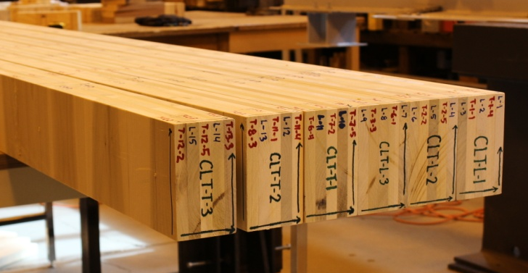
Figure 73: 5-layer CLT from yellow poplar feedstock at Virginia Tech (Beagley et al., 2014).

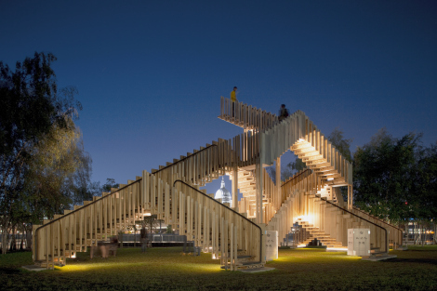
Figure 74: Project 'Endless Stair’ London Design Festival 2013.

Manufacturing CLT with yellow poplar feedstock
CLT manufacturing with yellow poplar feedstock is generally feasible as research and pilot projects have already proven (Beagley et al., 2014, Slavid, 2013). However, feasibility of industrial scale manufacturing has not been proven at this point. To facilitate a continuous on line CLT production with yellow poplar feedstock a few aspects have to be considered:
It is commercial practice in the U.S. that yellow poplar is treated in random length and random width (AHEC, 2008). This trade practice should be considered in CLT manufacturing. One way to take this fact in consideration is, to incorporate a split saw in the manufacturing process of CLT, which trims the lamellas to width in longitudinal direction. However, this approach would lead to higher investment costs and lower raw material yield. Another approach would be to make the production line flexible and adjustable to lamella width. However, this will be challenging in industrial medium to large scale production lines.
In addition, it might be necessary, to incorporate the kiln-drying to the manufacturing process of CLT when utilizing yellow poplar feedstock for CLT production. Hardwood sawmills have usually small- to mid-size capacities and process a wide range of hardwoods. Therefore it is not feasible to purchase yellow popular from a few big suppliers. More likely small quantities would be purchased from a wide range of suppliers. Therefore it will be challenging to get consistency in the lumber moisture content. Thus, it might be necessary to integrate drying equipment to the manufacturing site in order to have control over lumber moisture content. However, this would also lead to higher initial investment costs.
From an adhesive side, it is feasible to produce CLT from yellow poplar with the utilization of 1K PUR. This was tested by Loctite, former Purbond, at their competency center in Switzerland (Slavid, 2013). However, a major concern on the utilization of yellow poplar as a feedstock for CLT is the raw material price. The weighted average price of all available grades in the Appalachian Area of the USA is $ 689/MBF for green yellow poplar (Hardwood Review, 2015). The weighted average price for the Random Length softwood framing lumber composite index is approximately $ 360/MBF at the same time (Random Length, 2015). This reflects a significant economic disadvantage for CLT with yellow poplar feedstock.
To summarize, yellow poplar as a feedstock for CLT manufacturing has been proven feasible due to research initiatives and pilot projects. However, at this point industrial manufacturing has not been realized. Due to higher investment costs and higher raw material cost, CLT out of yellow polar seems to be disadvantageous compared to softwood species. A hybrid CLT panel with a combination of softwood and yellow poplar may be more of a feasible solution.

Conclusion
Cross-laminated timber (CLT) has arrived to North America and future prospects for further positive development of the building material are looking promising. This is mostly due to extensive joint efforts of academia and industry. So far, most of the research has been conducted in the fields of structural and physical properties. The results eventuated in the first big milestone which was the introduction of the performance-rated North American CLT standard ‘ANSI/APA PRG 320’ which lays the basis for further regulatory development. Since the standard was introduced, two companies have been certified to produce according to its requirements.
This study should contribute to further development of the CLT industry in North America, by giving interested readers information on the principles of CLT and most important, by showing a procedure how the material can be produced in an online, semi-automated production scale. This is supported by a presentation of the key-requirements for certification process of a CLT manufacturing plant, and a presentation on some of the most important variability factors which should be taken into consideration for a Capability Study as a tool of Statistical Process Control (SPC).
For additional research following this study, the performance of various Statistical Process Control (SPC) tools with real data from a CLT manufacturing plant is suggested. As a first part of this analysis, a general investigation on sources of variability could be performed. Once this variability factors are analyzed, data for a capability study can be collected and performed. Moreover, a Taguchi Loss Function can be performed to analyze the most critical cost factors of a CLT mill. A second suggestion for further research is the investigation on CLT manufactured with industrial equipment out of North American hardwood and softwood/hardwood combinations. Here the structural properties as well as the feasibility for industrial production utilizing North American hardwood species should be analyzed.

LIST OF REFERENCES

BSP Special.
ABRAHAMSEN, R. B. & MALO, K. A. 2014. STRUCTURAL DESIGN AND ASSEMBLY OF “TREET”-A 14-STOREY TIMBER RESIDENTIAL BUILDING IN NORWAY. WCTE Quebec.
AHEC 2008. Guide to American Hardwood Products. Washington: American Hardwood Export Council.
ALSC 2010. Voluntary Product Standard PS 20-10. American Softwood Lumber Standard. Washington: U.S. Department of Commerce.
ANSI 2012. Standard for Performance-Rated Cross-Laminated Timber. Tacoma, WA: APA - The Engineering Wood Association.
ANSI/AITC A190.1 2007. Structural Glued Laminated Timber. American National Standard for wood products. Centennial, CO: American Institute of Timber Construction.
APA 2012. Quality Manual (QM) Review. Tacoma, WA: APA - The Engineered Wood Association.
APA 2014. APA Product Certification. Tacoma, WA: APA – The Engineered Wood Association.
APA 2015a. Checklist for CLT evaluation to ANSI/APA PRG 320 Washington: APA - The Engineered Wood Association.
APA. 2015b. Cross-Laminated Timber (CLT) [Online]. http://www.apawood.org: APA – The Engineered Wood Association. Available: http://www.apawood.org/cross-laminated-timber [Accessed 3/7/2015 2015].
AUGUSTIN, M. 2008. Wood Based Panels. Handbook 1 - Timber Structures; Educational Materials for Designing Testing of Timber Structures
Graz: Institute of Timber Engineering and Wood Technology, Graz University of Technology.
AWC 2014. National Design Specification (NDS) Supplement: Design Values for Wood Construction 2015 Edition ed. Leesburg: American Wood Council.
BEAGLEY, K. S., LOFERSKI, J. R., HINDMAN, D. P. & BOULDIN, J. C. 2014. INVESTIGATION OF HARDWOOD CROSS-LAMINATED TIMBER DESIGN. World Conference on Timber Engineering. Quebec, Canada.
BENDTSEN, B. A. & ETHINGTON, R. L. 1975. Mechanical properties of 23 species of eastern hardwoods, US Dept. of Agriculture, Forest Service, Forest Products Laboratory.
BRANDNER, R. Production and Technology of Cross Laminated Timber (CLT): A state-of-the-art Report. COST Action FP1004, Focus STS–European Conference on Cross-Laminated Timber (CLT), 2013. 2-36.
CAIN, S. 2014. Standing Tall, Cross-Laminated Timber Use Increasing in Mid-Rise Structures. Engineered Wood Journal, Volume 17, No. 2, 12-19.
CECCOTTI, A., SANDHAAS, C. & YASUMURA, M. Seismic Behaviour of Multistory Cross-laminated Timber Buildings. International Convention of Society of Wood Science and Technology, Geneva, Switzerland CSA S-16.(2009). Design of Steel Structures. Ottawa: Canadian Standards Association, 2010.
CEN 2011. prEN 16351 Timber structures - Cross laminated timber - Requirements. Brussels: European Committee for Standardization.
CRESPELL, P. & GAGNON, S. 2010. Cross laminated timber: A primer. FP Innovations.
CRESPELL, P. & GASTON, C. 2011. The Value Proposition for Cross-Laminated Timber. FBInnovation.
CROWE, D. 2015. Economic and Housing Outlook - Wells Fargo Webinar. Available: http://www.nahb.org/en/find/meetings-and-events/nahb-wells-fargo-housing-market-index-webinars.aspx.
FILL 2014. Bericht über Keilzinktechnik, HotMelteinsatz und Flächenbeleimtechnik in der CLT-Fertigung. FILL GmbH.
FILL 2015a. Kostenaufstellung und Anlagenkomponenten. Gurten: Fill GmbH.
FILL. 2015b. Welcome to Fill [Online]. http://www.fill.co.at/en/fill/1065.html: Fill GmbH. [Accessed 4/1/2015 2015].
FRANGI, A., BOCHICCHIO, A., CECCOTTI, A. & LAURIOLA, M. P. 2008. Natural full-scale fire test on a 3-storey X-Lam timber building. World Conference on Timber Engineering. Miyazaki, Japan.
FRANGI, A., FONTANA, M., HUGI, E. & JÜBSTL, R. 2009. Experimental analysis of cross-laminated timber panels in fire. Fire Safety Journal, 44, 1078-1087.
GREEN, D. W. 2005. Grading and properties of hardwood structural lumber. Undervalued hardwood for engineered materials and components. Madison, WI: Forest Products Society.
GREEN, M. & KARSH, J. 2012. The case for tall wood buildings. MGB Architecture+ Design: Vancouver, Canada.
HARDWOOD REVIEW. 2015. Appalachian Pricing. Hardwood Review weekly.
HARRY, M. J. & SCHROEDER, R. R. 2005. Six Sigma: The Breakthrough Management Strategy Revolutionizing the World's Top Corporations, Currency.
HENKEL AG 2015. Streamlined brand structure for Henkel’s industrial adhesives business. Purbond Rebranded as Loctite. Düsseldorf, Germany: Henkel AG & Co. KGaA.
HMS. 2013. Species Guide - Poplar [Online]. Pittsburgh: Hardwood Manufacturers Association. Available: http://www.hardwoodinfo.com/articles/view/pro/24/315.
HUNDEGGER. 2015. Panel Cutting Machine (PBA) [Online]. www.hunegger.de: Hans Hundegger AG. Available: http://www.hundegger.de/en/machine-building/products/panel-cutting-machine-pba.html [Accessed 3/21/2015 2015].
ICC 2009. 2009 International Building Code International Code Council, Inc.
JOKERST, R. W. 1981. Finger-Jointed Wood Products. DTIC Document.
JULIEN, F. 2010. Manufacturing Cross-Laminated Timber (CLT): Technological and Economic Analysis. Quebec, Canada: Report to Quebec Wood Export Bureau.
KARACABEYLI, E., DOUGLAS, B. & FPINNOVATIONS 2011. CLT Handbook: Cross-laminated Timber, Pointe-Claire, QC, FPInnovations.
LEND LEASE 2013. Forté - Creating the World's Tallest CLT Apartment Building. Lend Lease.
LOCTITE 2014. Single-component polyurethane adhesive for the manufacture of engineered wood products. Technical Data Sheets Loctite HB E-Line (HB E032, HB E052, HB E102, HB E202, HB E302, HB E452).
MAH, C. 2014. Reaching New Heights - The Wood Innovation and Design Centre is the tallest modern all-wood building in North America. Construction Business. British Columbia & Alberta: Construction Business.
MOHAMMAD, M., GAGNON, S., K., D. B. & L., P. 2012. Introduction to Cross Laminated Timber. Wood Design Focus, 22, 3-12.
NIST/SEMATECH. 2003. e-Handbook of Statistical Methods [Online]. NIST an agency of the U.S. Commerce Department. Available: http://www.itl.nist.gov/div898/handbook/index.htm 2015].
NORDIC. 2013. Technical Note T22. Available: http://nordicewp.com/literatures/T-T22_Technical_Data.pdf.
PAHKASALO, T., AURENHAMMER, P., BARTLOMÉ, O. & GASTON, C. 2014. Value-Added Wood Products. UNECE/FAO Forest Products Annual Market Review, 2013-2014. Geneva: UNECE/FAO Forestry and Timber Section.
PLACKNER, H. 2013. BSP Pläne revidiert. Available: http://www.timber-online.net/?id=2500,5238828 [Accessed 2/9/2015].
PLACKNER, H. 2014a. Brettsperrholz Special - Markt und Trends. Holzkurier. Vienna: Österreichische Agrarverlag.
PLACKNER, H. 2014b. Cross-laminated timber conquers America. Available: http://www.timber-online.net/?id=2500,5329805 [Accessed 2/18/2015].
PLACKNER, H. 2014c. Japan intends to build up its own CLT industry. Available: http://www.timber-online.net/?id=2500,5416391 [Accessed 2/20/2015].
PLACKNER, H. 2015a. Cross-laminated timber goes global. Available: http://www.timber-online.net/?id=2500,5423601 [Accessed 2/18/2015].
PLACKNER, H. 2015b. World’s largest CLT plant planned in Montana. Available: http://www.timber-online.net/?+World+&id=2500%2C5419044%2C%2C%2CY2Q9NDY%3D.
PQ SYSTEMS. 2014. Capability analysis [Online]. Dayton, Ohio: Productivity-Quality Systems, Inc. Available: http://www.pqsystems.com/qualityadvisor/DataAnalysisTools/capability_analysis.php 2015].
PURBOND 2011. Checklist - Cross-Laminated Timber Production. Purbond Fact Sheet. Switzerland: Purbond Center for Competence.
PURBOND 2012. Purbond Guideline. In: COMPETENCE, P. C. O. (ed.). Switzerland.
RANDOM LENGTH. 2015. Through a Knothole - The Weekly Report on North American Forest Products Markets. Random Length, 06/26/2015.
SCHICKHOFER, G. CLT – European Experience, Idea & Development, Technology & Applications. CLT Forum 2013 in Tokyo, 10-24-2013 2013 Tokyo. 40.
SCHICKHOFER, G., AUGUSTIN, M. & GRAZ, T. U. 2010. BSPhandbuch: Holz-Massivbauweise in Brettsperrholz ; Nachweise auf Basis des neuen europäischen Normenkonzepts, Verlag d. Technischen Universität Graz.
SHEWHART, W. A. 1931. Economic Control of Quality of Manufactured Product, New York, D. Van Nostrand Company, Inc.
SLAVID, R. 2013. Endless Stair - Atowering Escher-like structure made from American tulipwood CLT fot he London Design Festival 2013.
SLMA The Hardwood Handbook. An Illustration Guide to Appalacian and Southern Lumber. Tyrone, GA: Southeastern Lumber Manufacturers Association, Inc.
SMARTLAM. 2015. UltiMATS with CLT core Technology. Version January 2015.
STATSOFT. 2015. Process (Machine) Capability Analysis [Online]. StatSoft Inc. Available: http://www.statsoft.com/Textbook/Process-Analysis#pintroductory.
STERLING. 2015. TerraLam CLT Mats [Online]. Phoenix: Sterling Lumber Company. Available: http://www.sterlingcranemats.com/products/terralamtm-clt-mats [Accessed 2/17/2015 2015].
STORA ENSO 2012. Stora Enso Building and Living - Building Solution. Stora Enso.
STRUCTURLAM. 2014. Cross Laminated Timber Design Guide. Vers. 9. Available: http://structurlam.com/wp-content/uploads/2014/09/Design-Guide-Metric-Sept-Low-Res.pdf [Accessed 02/16/2015].
STUDIENGEMEINSCHAFT HOLZLEIMBAU, E. V. 2011. Building with Cross Laminated Timber. 2nd ed. Wuppertal: Studiengemeinschaft Holzleimbau e.V.
TAGUCHI, G., CHOWDHURY, S. & WU, Y. 2005. Taguchi's Quality Engineering Handbook, Wiley.
UBC 2014. Tall Wood Student Residence - Report to the Board of Governors. British Columbia: The University of British Columbia.
UNITED STATES CENSUS BUREAU. 2015. Building Permits Survey - Seasonally Adjusted Annual Rate (monthly since 1960) [Online]. Washington, D.C.: U.S. Department of Commerce. Available: http://www.census.gov/construction/bps/uspermits.html [Accessed 7/5/2015 2015].
USDA 2015. Natural Resources Conservation Service. Washington: United States Department of Agriculture.
VERBEK, J. 2015. 4.0 X-Press 16 - Technical Data Sheet. Hoce, Slovenia: Ledinek Engineering.
WHEELER, D. J. & CHAMBERS, D. S. 2010. Understanding Statistical Process Control, SPC Press.
WINTON, D. 1999. Process Capability Studies. Available: http://elsmar.com/pdf_files/CPK.pdf.
WOODTEC FANKHAUSER. Vaccum Press, Number One in CLT Production.
YOUNG, T. M. 2014. Continuous Improvement using Statistical Process Control and Lean Statistical Methods - A Practical and Applied Course for Manufacturers In: TENNESSEE, T. U. O. (ed.). Knoxville, TN.

VITA
Karl Konstantin Grasser was born on the 25th of January 1987 in Judenburg, Austria. Karl earned his undergraduate degree at University of Applied Sciences Joanneum Graz in 2011, where he studied International Management with a concentration on Finance and Accounting. Following his studies in Graz, he proceeded to attend the University of Applied Sciences Salzburg where he earned his Master of Science degree in January 2015. In addition, to his studies in Europe, Karl joined the University of Tennessee in Knoxville in 2014, where he works on a graduate degree in Forestry with a concentration in Bio-Based Products & Wood Science & Technology.

