Prevalence of rats and rodent borne pathogens across post-Katrina New Orleans

A Dissertation Presented for the

Doctor of Philosophy

Degree

The University of Tennessee, Knoxville

Bruno Marco Ghersi Chavez

December 2020

DEDICATION

I would like to dedicate this dissertation to the New Orleans community, especially to the people in the Lower 9th Ward as their perseverance keeps this city moving forward. They are a beacon of hope and resiliency.

ACKNOWLEDGEMENTS

Quisiera primero agradecer a mi familia, sin su apoyo incondicional durante mi desarrollo profesional no habría podido completar este trabajo.
Additionally, I would like to thank the following people for supporting the work presented in this dissertation. My dissertation advisor Dr. Michael Blum and my committee: Dr. Monica Papes, Dr. Joseph Clark and Dr. Benjamin Fitzpatrick. I would also like to thank my past and current lab-mates: Dr. Anna Peterson, Dr. Erick Gagne, Dr. Rebecca Hazen, Dr Kristine Moody, Dr. Rosalyn Rael, Dr. Fernando Alda, Dr Candice Lumibao, Dr. Avery Schrer, Nathaniel Gibson and Jennifer Summers. Members of the CNH team, including Dr. Amy Lesen, Dr. Wayne Zipperer, Dr. Josh Lewis, David Baker, Dr. Kevin Gotham, Dr. Richard Campanella, Dr. Jamie Childs, Dr. Elsio Wunder, and Shelley Meaux. As well as all of those from the City of New Orleans Mosquito, Termite and Rodent Control Board, including: Dr. Claudia Riegel, Timmy Madere, Friede Bauder, Tatiana Barre, Abby Balliviero, and Phil Smith. This work would not have been possible without the support of multiple undergraduate students: Alex Gulachenski, Harry Rahn, Stephanie Piper, Evan Ruda, Amanda Tun, Sarah Sugarman, Rebecca Wang, Hevin Patel, Shanice Triplett, and James Haydel and multiple others that helped us with the field and lab work in the best and worst conditions.
This would not have been possible without funding support. I would like to acknowledge the Tulane-Xavier Center for Bioenvironmental Research, the Tulane ByWater Institute, the National Science Foundation (BCS-0948993, BCS-1313703), and the Louisiana Board of Regents for funding this work.
This work was conducted in accordance with Tulane University IACUC approved protocols 0451 and 0160.

Abstract

Disasters are happening at an increasingly higher rate and intensity a trend that is expected to continue as more humans migrate to coastal urban areas. Disasters, and as importantly, disaster recovery can affect how native and pest populations will recover. My aim was to improve understanding of disease risk by evaluating the socioecological conditions that have shaped commensal rat recovery and distribution, as well as the pathogens they carry, across New Orleans after Hurricane Katrina. I first estimated relative abundance and distribution of commensal rats from rodent trapping conducted between mid-2014 and early-2017 across 96 sites in 10 areas of the city that represent different flooding levels and policy-driven post disaster abandonment. Additional rats were obtained from supplemental sites sampled by the city rodent control board as part of control programs. All Norway rats were then genotyped at 236,971 ddRAD generated SNPs to infer if their abundance was a result of resilience, in-situ population recovery, immigration from un-flooded areas or a combination of them. Blood of all sampled rodents also was tested for the presence of Trypanosoma cruzi, the causative agent of Chagas disease, one of the many zoonotic pathogens rodents can carry and transmit to humans. A total of 1428 rodents, representing 5 species (380 norway rats, 629 roof rats, 394 house mice, 20 cotton rats and 7 rice rats) were trapped across the study area. Roof rats were more abundant and more widely distributed than Norway rats. Overall rat occurrence and abundance were higher in flooded areas with more vacant lots and abandonment. We observed patterns of inbreeding in flooded areas as well as signatures of population structure and limited movement, supporting the hypothesis that Norway rats suffered a population collapse and recovered by in situ reproduction and population growth. T.cruzi was detected in 11% of tested rodents, in all species tested and in all study areas across New Orleans indicating that transmission is local and widespread across the city and thus that exposure risk is much higher than has previously been recognized.

TABLE OF CONTENTS

Introduction 1
Disaster Socioecology 1
Post-disaster reassembly and human disease risk 2
Post-disaster rodent distributions and demography 2
Post-disaster pathogen prevalence and distribution. 4
References 6
CHAPTER I Flooding and abandonment have shaped rat demography across post-Katrina New Orleans 9
ABSTRACT 10
INTRODUCTION 10
METHODS 12
Study area, site selection & trapping. 12
Measurement of individual attributes. 14
Estimates of occupancy and abundance. 14
Characterization of socio-environmental conditions. 14
Spatiotemporal variation in individual attributes, occupancy and abundance. 15
Predictors of individual attributes, occupancy and abundance. 15
RESULTS 16
Trapping. 16
Estimates of individual attributes. 16
Estimates of occupancy and abundance. 17
Socio-environmental predictors of individual attributes, occupancy and abundance. 18
DISCUSSION 19
REFERENCES 22
APPENDIX 27
CHAPTER II Genomic signatures of survival and demographic recovery of Norway rats following a catastrophic disaster 45
ABSTRACT 46
INTRODUCTION 46
METHODS 49
Study species. 49
Sample collection. 50
DNA extraction, genomic library development and SNP genotyping. 50
Genetic diversity, inbreeding and effective population size. 50
Genetic structure and movement potential. 52
Historical demography. 53
RESULTS 54
Genetic diversity, inbreeding, and effective population size. 54
Genetic structure and movement potential. 54
Historical demography. 55
DISCUSSION 55
References 60
APPENDIX 67
CHAPTER III In the heart of the city: Trypanosoma cruzi infection prevalence in rodents across New Orleans 79
ABSTRACT 80
INTRODUCTION 81
METHODS 82
Study area and rodent trapping. 82
Site characterization. 82
Infection assay. 83
Statistical analysis. 83
RESULTS 84
Prevalence of T. cruzi infection by species and location. 84
Environmental and individual predictors of infection. 84
DISCUSSION 85
REFERENCES 89
APPENDIX 94
CONCLUSION 100
VITA 101

List of Tables

CHAPTER I
Table 1.1. Mean trap rate and population size estimates with standard deviations (in parenthesis) by season and trapping area…………………………………………………………………………………………....……. 27
Table 1.2. Coefficients and significance of socio-environmental variables included in the 5 top models of rat occurrence………………………………………………………………………………………………………... 28
Table 1.3. Coefficients and significance of socio-environmental variables included in the 5 top models of Norway rat occurrence………………………………………………………………………………………..... 29
Table 1.4 Coefficients and significance of socio-environmental variables included in the 5 top models of roof rat occurrence………………………………………………………………………………………………… 30
Table 1.5 Coefficients and significance of socio-environmental variables included in the top models of rat abundance……………………………………………………………………………………………………….. 31
Table 1.6 Coefficients and significance of socio-environmental variables included in the top models of Norway rat abundance. ……………………………………………………………………………………….… 32
Table 1.7 Coefficients and significance of socio-environmental variables included in the top models of roof rat abundance. ………………………………………………………………………………………………. 33
Table 1.8 Coefficients and significance of socio-environmental variables included in the top models of rat SMI…………………………………………………………………………………………………………………… 34
Table 1.9 Coefficients and significance of socio-environmental variables included in the top 5 models of Norway rat SMI……………………………………………………………………………………………………… 35
Table 1.10 Coefficients and significance of socio-environmental variables included in the top 5 models of roof rat SMI…………………………………………………………………………………………………………… 36

CHAPTER II
Table 2.1. Measures of genetic diversity and N_{e} estimates for the entire study region and by study area ……………………………………………………………………………………………………………………………………….. 67
Table 2.2. Coefficients and significance of socio-environmental variables included in the top 5 models of Ho values…………………………………………………………………….………………………………………….. 68
Table 2.3. Coefficients and significance of socio-environmental variables included in the top 5 models of Fis values ……………………………………………………………………………………………………………….. 69

CHAPTER III
Table 3.1. Prevalence of T. cruzi infection (number positive / number tested, followed by % in parentheses) in rodents by species and across all species sampled in New Orleans and Baton Rouge (Louisiana). …………………………………………………………………………………………………………………. 94
Table 3.2 Coefficients and significance of socio-environmental variables included in the top 5 models of rodent infection with T. cruzi ……………………………………………………………..…………………. 95

List of Figures

CHAPTER I
Figure 1.1. (Top) Spatial distribution of population estimates for each trapping site by species. (Bottom) Spatial clustering of high and low abundance of each species based on Getis-Ord GI* analysis…………………………………………………………………………………………………………………………………… 37
Figure 1.2. Relationship between lot vacancy on the probability of rat occurrence relative to flooding and season, as well as the proportion of unmaintained vegetation- an indicator of abandonment- and rat abundance per site relative to vacancy and season……………………………. 38
Figure 1.3. Overall trap rate by season and year with reference to Katrina-related flood depth.39
Figure 1.4. Distribution of body mass (top) and SMI (bottom) of Norway rats by sex. ……………. 40
Figure 1.5. Distribution of body mass (top) and SMI (bottom) of roof rats by sex....………………… 41
Figure 1.6. Body mass of Norway and roof rats by study area..…………………………………….…………. 42
Figure 1.7. SMI of Norway rats and roof rats by study area….…………………………………………………. 43
Figure 1.8. Age distribution of Norway rats (top) and roof rats (bottom) by season and year of trapping………………………………………………………………………………………………………………………………….. 44

CHAPTER II
Figure 2.1: The location of Norway rat trapping sites across the New Orleans study region in relation to vacancy levels and flood depth one week after Hurricane Katrina struck the city in 2005……………………………………………………………………………………………………………………………………….. 70
Figure 2.2: Comparisons of genetic variation (H_{e}, H_{o}, F_{is}) with the minimally filtered dataset among well-sampled neighborhoods across the study region according to flooding history……………….. 71
Figure 2.3.- Association between Ho and Fis and vacancy (model results) and correlation between Ne (bottom left) and Fis (bottom right) and census trap numbers……………………………………..…… 72
Figure 2.4: PCA of Norway rat genomic variation according to the stringently filtered dataset and minimally filtered dataset according to geographic location. STRUCTURE bar plots (bottom) of genotype assignments for k =2 to k = 5, based on the stringently filtered dataset, with reference to location…………………………………………………………………………………………………………….………………… 73
Figure 2.5: fineRADstructure heatmap of individual genotype assignments for the stringently filtered dataset and minimally filtered dataset according to location……………………….…………….. 74
Figure 2.6. Mantel correlograms for Norway rats sampled across the New Orleans study region versus rats sampled in the Lower 9th Ward, the French Quarter and the Upper 9th Ward, based on the stringently filtered dataset. Filled points are statistically significant relationships of genetic distance with spatial distance…………………………………………………………………………………………….…… 75
Figure 2.7: Stairway plot of demographic history for well-sampled neighborhoods included in the stringently filtered dataset…………………………………………………………………………………………..…………. 76

Figure 2.8. Mantel correlograms for Norway rats sampled across the New Orleans study region, the Lower 9th Ward, the French Quarter and the Upper 9th Ward, based on the minimally filtered dataset. Filled points are statistically significant relationships of genetic distance with spatial distance……………………………………………………………………………………………………………………………………77
Figure 2.9. All sites where rodents were trapped across the New Orleans study region………… 78

CHAPTER III
Figure 3.1: (A) Map of T. cruzi infection prevalence by rodent species across Orleans Parish and St Bernard Parish, with Tomahawk-only trapping areas outlined in red and Tomahawk + Sherman trapping areas outlined in blue (B) T. cruzi infection prevalence in each host species by study area, where color indicates species, bars represent the first and third quartiles, vertical lines represent the minimum and maximum range relative to the quartiles, and dots are outliers………………….. 96
Figure 3.2. Probability of infection of A) all rodents B) Norway rats C) roof rats and D) house mice. Shaded areas correspond to 95% confidence intervals……………………………………………………………. 97
Figure 3.3. Infection prevalence across all rodent species by study area with individual sites noted as jitter dots……………………………………………………………………………………………………………………………. 98
Figure 3.4. Variation in T. cruzi infection prevalence according to the number of host species at Tomahawk + Sherman trapping sites……………………………………………………………………………….……… 99

Introduction

Disaster Socioecology

Concern about the outcomes of disasters is on the rise, due to global trends in demography and the frequency of disasters (Kerle and Alkema, 2011). Since 1950, there has been more than a ten-fold increase in the number of disasters per year (Leaning and Guha-Sapir, 2013). This largely reflects growing populations and the increasing concentration of property in coastal cities (e.g., New Orleans, New York, Shanghai) that are becoming susceptible to extreme weather (Leaning and Guha-Sapir, 2013).

Disasters are disruptive events with technological, atmospheric, geologic, and hydrologic origins (Watson et al., 2007). Like disturbances, disasters disrupt ecosystem, community, or population structure and that may change resources, substrate availability, or the physical environment (Pickett et al. 1989, Pickett & White 1985). Disturbances can occur over a variety of scales (Pickett & White 1985), where conditions change abruptly or gradually due to repetitively, stochastically or continuously acting events (Borics et al. 2013). Even for a single affected area and disturbance event, effects may vary across different levels of biological organization depending, in part, on conditions prior to the disturbance (Pickett & White 1985). In contrast to disturbances, biotic and human communities are subjected to trauma when a disaster strikes (Schultz et al., 2007). Disasters consequently encompass complex human and ecological dynamics including thresholds and non-linear reciprocal feedback loops (Berkes et al., 2003; Norris, 2006). Disasters may thus result in state-change shifts, where systems progress to an alternate stable state or novel configuration (Beisner et al., 2003). Sometimes referred to as a progression to ‘new normal’ conditions, shifts to alternate socioecological states can be stochastic or deterministic and are not necessarily dependent on the size of a disruptive event (Petraitis & Dudgeon, 1999; Bertness et al., 2002).

Ecological disturbance theory continues to serve as the principal lens for studying post-disaster outcomes (Rael et al., 2016), even though many of the causes and consequences of disasters do not readily conform to ecological models of disturbance (Rael et al., 2016), especially in human-dominated urban landscapes. Disturbance theory aims to explain and characterize shifts in demography, community composition and ecosystem functioning captured by ecological indicators such as diversity indices (Tilman et al., 1997; Wallace & Wallace, 2008). It does not account for concurrent shifts in socioeconomic and cultural conditions corresponding to changes in population return rates, housing, governmental and commercial operations, employment and finances, environmental health concerns, and cultural functions (Vale & Campanella, 2005). Consequently, disturbance theory does not circumscribe how post-disaster reassembly of coupled socioecological landscapes can be influenced not only by natural processes, but also by decisions and management practices instituted in response to a disaster. New theory, approaches, and empirical studies are thus warranted to define and characterize ‘disaster socioecology’.

Post-disaster reassembly and human disease risk
Remarkably little work has been done to describe socioecological outcomes of disasters (Adger, 2000), including whether response efforts intended to reduce public health threats (e.g. removal of debris) instead defer or inflate risks by influencing ecological re-assembly (e.g. by creating habitat for commensal pests like rodents).

Disasters can result in deleterious public health consequences by influencing vector borne disease transmission (Watson et al., 2007). Outbreaks of leptospirosis (a zoonotic bacterial disease associated with rodents), for example, have been reported after flooding events in Taiwan, the Republic of China; Mumbai, India; Argentina; and Russia (Watson et al., 2007), as increased contact with contaminated standing water can facilitate transmission of bacteria (Gaynor et al., 2007; Dechet et al., 2012). In India, increases in malaria also have been linked to flooding, which can produce more habitat favorable to mosquito reproduction (Krishnamoorthy et al., 2005). Similarly, an increase in transmission of Rift valley fever was detected in Tanzania following excessive rainfall that flooded mosquito breeding habitats (Sindato et al., 2011).

When disaster strikes, abating or ameliorating public health threats is often the principal focus of response and recovery efforts (Shultz, 2014). However, post-disaster decision-making related to resource and land management can inadvertently give rise to conditions that are deleterious to resident communities, including outbreaks of infectious disease from zoonotic pathogens (Rael et al., 2016). For instance, relief efforts may concentrate refugees and resources, which can promote pest outbreaks and pathogen transmission. Intentional abandonment or neglect of affected areas also can increase disease risk by increasing harborage of pathogen hosts (Rael et al., 2016). Thus, understanding socioecological outcomes of disasters (Gotham et al., 2014; Rael et al., 2016) can potentially reduce zoonotic disease risk in affected areas (Ezenwa et al., 2015).

Post-disaster rodent distributions and demography
Information on commensal rat distributions and demography in post-disaster urban landscapes can provide valuable perspectives on socioecological reassembly and disease risk (Battersby & Greenwood, 2004). Norway rats (Rattus norvegicus) and roof rats (Rattus rattus) are two of the most widespread commensal pests that spread zoonotic diseases- including leptospirosis, plague, hantavirus, and capillariasis- in urban environments (Himsworth et al., 2013a). Although many pathogens are carried by both species (e.g., Leptospira), some diseases are more strongly associated with one rodent species or the other. For example, strains of hantavirus appear to be carried only by Norway rats in New Orleans (Cross et al., 2014), and Trypanosoma cruzi (the causal agent of Chagas disease) has been linked to roof rats in Panama, Guatemala and Venezuela (Edgcomb & Johnson, 1970; Herrera & Urdaneta-Morales, 1997; Bustamante et al., 2014). Differences in the distribution and abundance of Norway and roof rats may thus result in differences in pathogen transmission risk to humans. Accordingly, understanding the distribution and demography of both species after a disaster can improve understanding of pathogen prevalence and transmission, which could in turn improve approaches to reduce zoonotic disease risk.

Species responses to disasters and post-disaster interventions (e.g., landscape management) can be inferred from distributional patterns and demographic variation (Williams et al., 2002). Species regional distributions (i.e., the fraction of an area used by a species) generally reflect occupancy (and absence thereof) according to habitat structure and resource availability (Ricklefs & Schluter, 1993). Demography generally reflects organismal attributes like growth rates, age and body size at maturity, number of offspring, and life length (Williams et al., 2002). Like species distributions, demography following a disaster may be determined by ecological and extrinsic conditions. For example, the time required for a population to recover to pre-disturbance densities can be determined by factors like age at reproduction, reproduction strategies, inbreeding and genetic bottlenecks, as well as feeding strategies and co-occurrence with competitors (Gardmark et al., 2003). Therefore habitat structure and resource availability also can be important determinants of population recovery (Adler, 1987).

The effects of disasters and post-disaster responses on commensal rats have not yet been carefully evaluated, but natural variability and demographic responses to extreme natural events suggest how post-disaster recovery of urban rodent populations might proceed. The abundance of small mammals often naturally fluctuates among seasons and across multi-annual cycles (Korpim et al., 1996; Oli & Dobson, 1999; Lambin et al., 2000; Ims et al., 2008; Burthe et al. 2010). Extreme events like severe flooding, droughts, and wildfires can elicit population collapses (Hein & Jacob, 2015). Responses of rodents to extreme events, like flooding, can vary depending on the magnitude of the event; short term or small scale flooding, for example, doesn’t appear to affect rodent populations, whereas large scale and severe flooding can adversely affect populations (Zhang et al., 2007). Responses also can depend on mobility, site attachment and the ability to find refuge (Zhang et al., 2007)

Disasters and post-disaster interventions may give rise to distinct shifts in distributions and patterns of demography in urban rodents. The nature of responses may be determined by how a disaster and subsequent management interventions (re)structure habitat conditions and resource availability (Adler & Wilson, 1987), where distributional and demographic outcomes reflect in situ survival and/or (re)colonization of affected areas (Hein & Jacob, 2015). For example, a spike in the number of abandoned and damaged buildings following Hurricane Katrina might have facilitated rodent (re)colonization in flooded areas of New Orleans (Sarkar, 2006). Aggregation and disposal of building and infrastructure debris also might have attracted commensal rodents (Sarkar, 2006). Unfavorable habitat shifts also might have arisen because trees were removed and cut back to restore power and to allow the flow of aid into flood-affected areas of the city (Gotham et al., 2014). Associated management interventions during recovery resulting in the loss of landscape diversity (Gotham et al., 2014) might also have reduced the availability of habitat preferred by commensal rats. Consistent with this, population densities of native small rodents have been found to be significantly higher in undisturbed compared to disturbed urban habitat, possibly due to vegetation change and predation by domestic cats (Dickman & Doncaster, 1989).

Post-disaster pathogen prevalence and distribution.
Rodents are among the most widespread and abundant pathogen reservoirs in cities (Himsworth et al., 2013), and thus often serve as indicators of transmission risk across urban landscapes. It has been hypothesized that areas that have undergone disaster-driven counter-urbanization can support a greater diversity of host species as well as larger and more diverse pool of pathogens (Gulachenski et al. 2016, Rael et al. 2016, Lewis et al. 2017, Eskew and Olival 2018). Consistent with this hypothesis, a recent assessment of assemblage structure in post-Katrina New Orleans found that commensal rodents are more abundant and more diverse in flood-affected areas burdened with greater levels of abandonment and infrastructure decline (Peterson et al. 2020). A positive relationship also has been found between abandonment and Leptospira infection across post-Katrina New Orleans, reflecting concordant shifts in rodent abundance and richness (Peterson 2019). Prior studies of other pathogens (e.g., viruses) suggest, however, that greater host diversity may not elevate pathogen diversity in disaster-affected environments (Mills 2005, Dearing et al. 2015). Rather, pathogen infections may instead decline with increasing host diversity in affected areas (Mills 2005, Dearing et al. 2015). Further work is thus warranted to better understand the relative influence of environmental and host assemblage characteristics on pathogen distributions and diversity in order to clarify risk of transmission to humans following disasters.

Trypanosoma cruzi -the causative agent of Chagas disease- is known to circulate in commensal pests, but its occurrence in urban environments is not well understood and even less is known about how disasters might influence infection prevalence in hosts. Chagas disease is arguably the most prevalent and widespread parasitic disease in the Western Hemisphere (Kirchhoff, 2011), and while most of the disease burden occurs in Central and South America (Bern et al., 2009; Bern et al.,2011), there is growing concern that it will soon become widespread in the United States due to shifting climate conditions and ongoing land use change (Short et al., 2017). More than a dozen wildlife species inhabiting the US have been identified as carriers of T. cruzi (Kjos et al., 2009; Charles et al., 2013; Montgomery et al., 2014). ), including commensal rodents like Norway rats (Rattus norvegicus), roof rats (Rattus rattus) and house mice (Mus musculus). Remarkably little is known, however, about infection prevalence in urban rodent populations, particularly within the US (Herrera et al., 2015; Hodo & Hamer, 2017). Accordingly, assays of infection prevalence would offer valuable insight into the distribution and prevalence of T. cruzi infection in urban populations of commensal and wild rodents across New Orleans (Louisiana, US). Finding evidence that T. cruzi is widespread and abundant in New Orleans would suggest that transmission risk in the US is greater than is currently recognized. Likewise, finding evidence that infection prevalence trends with disaster-driven counter-urbanization would illustrate that there is disproportionate risk of transmission in historically underserved communities, which could further reinforce long-standing legacies of socioecological disparities in New Orleans and elsewhere (Gulachenski et al., 2016; Lewis et al., 2017; Peterson et al., 2020).

Dissertation research objectives.
My aim was to improve understanding of disease risk by evaluating the socioecological conditions that have shaped commensal rat recovery and distribution, as well as the pathogens they carry, across New Orleans after Hurricane Katrina. I first set out to estimate relative abundance and distributions of commensal rats based on rodent trapping conducted between mid-2014 and early-2017 across 96 sites in 10 areas of the city that represent different flooding levels and policy-driven post disaster abandonment. I also incorporated information from additional rats that were obtained from supplemental sites sampled by the city rodent control board as part of control programs. I then genotyped all Norway rats at 236,971 ddRAD generated SNPs to infer if their abundance was a result of resilience, in-situ population recovery, immigration from un-flooded areas or a combination of them. Finally, I tested blood from all sampled rodents to determine the prevalence of infection by Trypanosoma cruzi across the city.

References
Adger, W. N. (2000). Social and ecological resilience: are they related? Progress in Human Geography 24:347-364.
Adler, G. H. (1987). Influence of Habitat Structure on Demography of 2 Rodent Species in Eastern Massachusetts. Canadian Journal of Zoology-Revue Canadienne De Zoologie 65:903-912.
Adler, G. H., & Wilson, M. L. (1987). Demography of a Habitat Generalist, the White-Footed Mouse, in a Heterogeneous Environment. Ecology 68:1785-1796.
Battersby, J. E., & Greenwood, J. J. D. (2004). Monitoring terrestrial mammals in the UK: past, present and future, using lessons from the bird world. Mammal Review 34:3-29.
Beisner, B. E., Haydon, D. T., & Cuddington, K. (2003). Alternative stable states in ecology. Frontiers in Ecology and the Environment 1:376-382.
Berkes, F., Colding, J., & Folke, C. (2003). Navigating social-ecological systems : building resilience for complexity and change. Cambridge University Press, Cambridge ; New York.
Bern, C. & Montgomery S.P. (2009) An Estimate of the Burden of Chagas Disease in the United States. Clinical Infectious Diseases.
Bern, C, Kjos, S, Yabsley, M. J. & Montgomery, S. P. (2011) Trypanosoma cruzi and chagas’ disease in the united states. Clinical Microbiology Reviews.
Bertness, M. D., Trussell, G. C., Ewanchuk, P. J., & Silliman, B. R.. (2002). Do alternate stable community states exist in the Gulf of Maine rocky intertidal zone? Ecology 83:3434-3448.
Borics, G., Várbíró, G., & Padisák, J. (2013). Disturbance and stress: different meanings in ecological dynamics? Hydrobiologia 711:1-7.
Burthe, S. J., Lambin, X., Telfer, S., Douglas, A., Beldomenico, P., Smith, A., & Begon, M. (2010). Individual growth rates in natural field vole, Microtus agrestis, populations exhibiting cyclic population dynamics. Oecologia 162:653-661.
Bustamante, D. M., De Urioste-Stone, S. M., Juarez, J. G., & Pennington, P. M. (2014). Ecological, social and biological risk factors for continued Trypanosoma cruzi transmission by Triatoma dimidiata in Guatemala. PLoS One 9:e104599.
Charles, R.A., Kjos, S., Ellis, A.E., Barnes, J.C. & Yabsley, M.J. (2013) Southern plains woodrats (Neotoma micropus) from Southern Texas are important reservoirs of two genotypes of trypanosoma cruzi and host of a putative novel trypanosoma species. Vector-Borne and Zoonotic Diseases.
Cross, R. W., Waffa, B., Freeman, A., Riegel, C., Moses, L. M., Bennett, A., Safronetz, D., Fischer, E. R., Feldmann, H., Voss. T. G., & Bausch, D. G. (2014). Old World hantaviruses in rodents in New Orleans, Louisiana. American Journal of Tropical Medicine and Hygene 90:897-901.
Dearing MD, Clay C, Lehmer E, Dizney L (2015) The roles of community diversity and contact rates on pathogen prevalence. J Mammal 96: 29–36. doi: 10.1093/jmammal/gyu025
Dechet, A. M., Parsons, M., Rambaran, M., Mohamed-Rambaran, P., Florendo-Cumbermack, A. , Persaud, S., Baboolal, S. , Ari, M. D. , Shadomy, S. V. , Zaki, S. R., Paddock, C. D., Clark, T. A., Harris, L., Lyon, D. & Mintz, E. D. (2012). Leptospirosis Outbreak following Severe Flooding: A Rapid Assessment and Mass Prophylaxis Campaign; Guyana, January-February 2005. PLoS One 7
Dickman, C. R., & Doncaster, C. P. (1989). The Ecology of Small Mammals in Urban Habitats .2. Demography and Dispersal. Journal of Animal Ecology 58:119-127.
Edgcomb, J. H., & Johnson, C. M. (1970). Natural infection of Rattus rattus by Trypanosoma cruzi in Panama. American Journal of Tropical Medicine and Hygene 19:767-769.
Ezenwa, V. O., Prieur-Richard, A. H., Roche, B., Bailly, X., Becquart, P., Garcia-Pena, G. E., Hosseini, P. R., Keesing, F. , Rizzoli, A., Suzan, G., Vignuzzi, M., Vittecoq, M., Mills, J. N. & Guegan, J. F. (2015). Interdisciplinarity and Infectious Diseases: An Ebola Case Study. Plos Pathogens 11.
Hein, S., & Jacob, J. (2015). Recovery of small rodent populations after population collapse. Wildlife Research 42:108-118.
Herrera, L., & Urdaneta-Morales, S. (1997). Synanthropic rodent reservoirs of Trypanosoma (Schizotrypanum) cruzi in the valley of Caracas, Venezuela. Revista do Instituto de Medicina Tropical de São Paulo 39:279-282.
Gardmark, A., Enberg, K., Ripa, J., Laakso, J. & Kaitala, V. (2003). The ecology of recovery. Annales Zoologici Fennici 40:131-144.
Gaynor, K., Katz, A. R., Park, S. Y., Nakata, M., Clark, T. A., & Effler, P. V. (2007). Leptospirosis on Oahu: An outbreak associated with flooding of a University Campus. American Journal of Tropical Medicine and Hygiene 76:882-885.
Gotham, K. F., Blum, M. J. & Campanella, R. (2014). Toward a New Normal: Trauma, Diversity, and the New Orleans Urban Long-Term Research Area Exploratory (ULTRA-Ex) Project. Cities and the Environment (CATE) 7.
Himsworth, C., Feng, A. T., Parsons, K., Kerr, T. & Patrick, D. (2013). Using experiential knowledge to understand urban rat ecology: A survey of Canadian pest control professionals. Urban Ecosystems 16:341-350.
Himsworth C.G., Parsons K.L., Jardine C., Patrick D.M. (2013) Rats, cities, people, and pathogens: a systematic review and narrative synthesis of literature regarding the ecology of rat-associated zoonoses in urban centers. Vector Borne Zoonotic Diseases 13: 349–359. doi: 10.1089/vbz.2012.1195
Ims, R. A., Henden, J. A. & Killengreen, S. T. (2008). Collapsing population cycles. Trends in Ecology & Evolution 23:79-86.
Kerle, N., & Alkema, D. (2011). Flooding and climate adaptation. Page 300 in M. Richter and U. Weiland, editors. Applied Urban Ecology: A Global Framework. John Willey & Sons.
Kjos, S.A., Snowden, K.F., & Olson, J.K.( 2009) Biogeography and Trypanosoma cruzi infection prevalence of chagas disease vectors in Texas, USA. Vector-Borne and Zoonotic Diseases.
Korpim, xe, Ki, E. & Krebs, C. J. (1996). Predation and Population Cycles of Small Mammals. BioScience 46:754-764.
Krishnamoorthy, K., Jambulingam, P., Natarajan, R., Shriram, A. N., Das, P. K., & Sehgal, S. C. (2005). Altered environment and risk of malaria outbreak in South Andaman, Andaman & Nicobar Islands, India affected by tsunami disaster. Malaria Journal 4.
Lambin, X., Petty, S. J. & MacKinnon, J. L. (2000). Cyclic dynamics in field vole populations and generalist predation. Journal of Animal Ecology 69:106-118.
Leaning, J. & Guha-Sapir, D. (2013). Natural disasters, armed conflict, and public health. N Engl J Med 369:1836-1842.
Mills JN (2006) Biodiversity loss and emerging infectious disease: An example from the rodent-borne hemorrhagic fevers. Biodiversity 7: 9–17. doi: 10.1080/14888386
Montgomery, S.P., Starr, M.C., Cantey, P.T., Edwards, M.S., & Meymandi, S.K. (2014) Neglected parasitic infections in the United States: Chagas disease. American Journal of Tropical Medicine and Hygiene.
Norris, F. H. (2006). Disaster research methods: past progress and future directions. J Trauma Stress 19:173-184.
Oli, M. K., & Dobson, F. S. (1999). Population Cycles in Small Mammals: The Role of Age at Sexual Maturity. Oikos 86:557-565.
Petraitis, P. S., & Dudgeon, S. R. (1999). Experimental evidence for the origin of alternative communities on rocky intertidal shores. Oikos 84:239-245.
Pickett, S. T., & White, P. S.. (1985). The ecology of natural disturbance and patch dynamics. Academic Press, Orlando, Fla.
Pickett, S. T. A., Kolasa, J., Armesto, J. J., & Collins, S. L. (1989). The Ecological Concept of Disturbance and Its Expression at Various Hierarchical Levels. Oikos 54:129-136.
Rael, R. C., Peterson, A. C., Ghersi, B. M., Childs, J., & Blum, M. J. (2016). Disturbance, Reassembly, and Disease Risk in Socioecological Systems. Ecohealth.
Ricklefs, R. E., & Schluter, D. (1993). Species diversity in ecological communities : historical and geographical perspectives. University of Chicago Press, Chicago.
Sarkar, R. (2006). Post Earthquake Debris Management - An Overview. Advances in Geosciences 9: Solid eath, Ocean Science & Atmospheric Science:11.
Short, E.E., Caminade, C., & Thomas, B.N. (2017) Climate Change Contribution to the Emergence or Re-Emergence of Parasitic Diseases. Infectious Diseases: Research and Treatment.
Shultz, J. M. 2014. Perspectives on disaster public health and disaster behavioral health integration. Disaster Health 2:69-74.
Sindato, C., Karimuribo, E., & Mboera, L. E. (2011). The epidemiology and socio-economic impact of rift valley fever epidemics in Tanzania: a review. Tanzan J Health Res 13:305-318.
Tilman, D., Knops, J., Wedin, D., Reich, P., Ritchie, M., & Siemann, E. 1997. The influence of functional diversity and composition on ecosystem processes. Science 277:1300-1302.
Vale, L. J., & Campanella, T. J. (2005). The resilient city : how modern cities recover from disaster. Oxford University Press, New York.
Wallace, D., & Wallace, R.. (2008). Urban Systems during Disasters: Factors for Resilience. Ecology and Society 13.
Watson, J. T., Gayer, M., & Connolly, M. A. (2007). Epidemics after natural disasters. Emerg Infect Dis 13:1-5.
Williams, B. K., Nichols, J. D., & Conroy, M. J. (2002). Analysis and Management of Animal Populations. Elsevier Science.
Zhang, M., Wang, K., Wang, Y., Guo, C., Li, B., & Huang, H. (2007). Recovery of a rodent community in an agro-ecosystem after flooding. Journal of Zoology 272:138-147.

CHAPTER I
Flooding and abandonment have shaped rat demography across post-Katrina New Orleans

A version of this chapter by Bruno M. Ghersi Ch, Anna C. Peterson, Claudia Riegel, Richard Campanella, James E. Childs and Michael J. Blum is in review for publication in the journal Landscape and Urban Planning.

This article was reformatted from the submitted version as part of this dissertation M. Blum, C. Rigel, R. Campanella, J. Childs and B. Ghersi conceived of the study. B. Ghersi and A. Peterson collected rodent samples. R. Campanella contributed GIS analyses. B. Ghersi conducted all other analyses and wrote the manuscript. All authors provided edits and comments to the manuscript.

ABSTRACT
Catastrophic disasters that unfold in urban environments can reconfigure resident human and commensal communities. Post-disaster demography of urban rodent populations can be determined not only by the nature of the disaster but also by the decisions and actions taken during recovery and rebuilding. My aim was to improve understanding of disease risk by evaluating the socioecological conditions that have shaped commensal rat populations in post-Katrina New Orleans, LA, USA. Rats were captured between mid-2014 and early 2017 across 96 sites in 10 study areas that stratified flooding gradients and policy-driven mosaics of post-disaster abandonment. A total of 944 rats were captured representing two species: Norway rats (Rattus norvegicus) and roof rats (Rattus rattus). Contrary to expectation, roof rats were far more abundant and more widely distributed across the city. Overall rat occurrence and abundance were higher in areas with more vacant lots, particularly during winter. The abundance of both species also was greater at flood-affected sites. Clusters of elevated roof and Norway rat abundance were detected in the lower-income neighborhoods, which sustained particularly severe flood damage and extensive abandonment. Consistent with this, we found that the physical condition of roof rats was higher in flooded areas and the condition of Norway rats was higher in lower-income areas. These results illustrate that catastrophic disasters can leave indelible socioecological signatures in affected areas. Our findings also highlight how policy-driven differences in post-disaster resettlement and rebuilding can fortify legacies of sociocultural disparity by elevating rather than alleviating potential risks to human well-being.

INTRODUCTION
Interest in disaster recovery is on the rise, in part because the magnitude and occurrence of natural disasters are expected to escalate, with extreme weather-related events becoming more severe and more frequent, and with the population of vulnerable coastal cities projected to double over the coming decades (Elsner, Kossin, & Jagger, 2008; Leaning & Guha-Sapir, 2013; Rahmstorf & Coumou, 2011; Small & Nicholls, 2003; Webster, Holland, Curry, & Chang, 2005). As work on disaster recovery has grown, so has appreciation for the possibility that response efforts can result in unanticipated and undesirable outcomes, including amplification- rather than mitigation- of public health risks (R. C. Rael, Peterson, Ghersi, Childs, & Blum, 2016).

It is well understood that disasters can result in deleterious public health outcomes (Leaning & Guha-Sapir, 2013). By disturbing developed and natural environments, disasters can result in conditions that promote transmission of vector-borne pathogens responsible for debilitating and potentially fatal zoonotic diseases including leptospirosis (Watson, Gayer, & Connolly, 2007), malaria (Krishnamoorthy et al., 2005) and Rift Valley fever (Sindato, Karimuribo, & Mboera, 2011). Concurrent displacement of pathogens, hosts, and affected human populations can magnify transmission risk by increasing the likelihood of interactions (Murray & Daszak, 2013; R. C. Rael et al., 2016; Watson et al., 2007). Shifts in habitat and resource availability also can increase the abundance of pathogen hosts and vectors. For instance, it has been shown that storm-driven flooding can accelerate the growth of mosquito populations by producing conditions favorable to reproduction (Weaver & Reisen, 2010).

Reducing public health threats is often a principal focus of disaster response and recovery efforts (Shultz, 2014), but well-intentioned response efforts can inadvertently produce or exacerbate post-disaster public health threats. For instance, relief operations can unintentionally introduce pathogens, as illustrated by the cholera outbreak after the 2010 earthquake in Haiti (Chin et al., 2010; Orata, Keim, & Boucher, 2014; Piarroux et al., 2011). Disturbance-driven ecological outcomes may also be mediated by resettlement and policy-driven disparities in post-disaster landscape management (Lewis et al., 2017). For example, relief organizations can concentrate refugees and resources, which can promote pest outbreaks and potentially increase contact with pathogen hosts or vectors (Connolly et al., 2004). Intentional abandonment or neglect of affected areas may also elevate disease risk by augmenting harborage of pathogen hosts and vectors (Kumari, Joshi, Lal, & Shah, 2009; Ligon, 2006; Linscott, 2007; Peterson et al., 2020). Thus greater understanding of social-ecological conditions associated with post-disaster zoonotic disease risk could better ensure that policies and interventions safeguard rather than worsen human well-being in affected areas (Gotham, Blum, & Campanella, 2014; Rael et al., 2016).

Studying the demography of commensal rats can provide valuable perspectives on post-disaster disease risk, particularly in disaster-stricken cities (Battersby & Greenwood, 2004). Norway rats (Rattus norvegicus) and roof rats (Rattus rattus) are habitat-dependent pathogen reservoirs with near-global distributions (Cavia, Cueto, & Suarez, 2009; Himsworth, Feng, Parsons, Kerr, & Patrick, 2013; Himsworth et al., 2013). Demographic attributes like occurrence, abundance, and size structure of both species correspond to sociocultural conditions that govern local habitat suitability and resource availability (Sinclair & Krebs, 2002; Williams, Nichols, & Conroy, 2002) Similarly, individual attributes like body size and condition that are correlated with survival and reproduction (Burthe et al., 2010) may track shifts in habitat and resource availability (Villafañe Isabel, Cavia, Victoria Vadell, Suárez Olga, & Busch, 2013). Norway and roof rats can harbor diverse assemblages of parasites and pathogens (hereafter ‘pathogens’), including those that cause leptospirosis, plague, hantavirus, and capillariasis (C. Himsworth et al., 2013). Some pathogens are more strongly associated with one or the other species. Strains of hantavirus, for example, appear to be carried only by Norway rats in New Orleans (Cross et al., 2014). Thus, when both species are present, assessing the demography of Norway and roof rats may offer broader insight into post-disaster pathogen transmission risk.

Disaster-driven disturbance and post-disaster interventions can elicit demographic responses that depart from seasonal and multi-annual cycles often exhibited by rodents (Burthe et al., 2010; Ims, Henden, & Killengreen, 2008; Korpim, xe, ki, & Krebs, 1996; Lambin, Petty, & MacKinnon, 2000; Oli & Dobson, 1999). Responses may vary, however, depending on whether shifts in prevailing conditions result in distress, opportunity, or a combination thereof. For example, severe flooding might result in an acute spike in rodent mortality and thus elicit local population collapse (Zhang et al., 2007), which might be followed by a wave of immigration driven by a rise in the number of abandoned buildings or aggregation of debris and refuse in flood-affected areas (Sarkar, 2006). Efforts to rebuild, which sometimes involve clearing debris and removing damaged trees to restore services (e.g., electrical power), may also reduce the availability of preferred habitat of one species or another (Lewis et al., 2017; Peterson et al., 2020; R. C. Rael et al., 2016). Thus intra- and interspecific demographic variation might arise across affected areas due to organismal factors like habitat preferences and differences in mobility among species (Zhang et al., 2007) as well as sociocultural factors like disparities in disturbance, resettlement and rebuilding (Dickman & Doncaster, 1989; Eskew & Olival, 2018).

In this study, we examined the demography of commensal rats across areas of New Orleans affected by Hurricane Katrina in 2005. Catastrophic flooding followed by a decade of uneven recovery has resulted in a natural laboratory for studying how public health risks are shaped by disturbance and disaster response (Lewis et al., 2017; Peterson et al., 2020; R. C. Rael et al., 2016). We conducted a city-wide, trap-based survey to characterize commensal rat demography across the city, with the aim of drawing comparisons among areas that have experienced marked differences in flooding, resettlement and post-disaster landscape management. We hypothesized that demographic variation corresponds to policy-driven differences in resettlement and rebuilding as much as or more than flooding disturbance (Lewis et al., 2017). We predicted that flood-stricken areas harbor more rats as a result of social-ecological disparities in abandonment and municipal differences in vacant lot management (sensu (LaDeau, Leisnham, Biehler, & Bodner, 2013)). Accordingly, studying conditions across post-Katrina New Orleans not only shed further light on the urban ecology of commensal rats, it also offered valuable perspective on sociocultural disparities in public health risks that could guide the development of more equitable policies and practices intended to ensure human well-being after disasters.

METHODS

Study area, site selection & trapping.
Hurricane Katrina devastated the City of New Orleans on 29 August 2005. Nearly 70% of all occupied housing units suffered damage from hurricane winds or flooding following 50 breaches in drainage canal and navigational levees. Over 80% of the east bank of the city flooded, with water rising to over 15-foot depths in some areas (Plyer, 2014). Mass exodus from the city reduced the human population from ~485,000 (April 2000) to ~230,000 (July 2006) inhabitants. Though the population has since returned to >85% of pre-Katrina residency, resettlement has been uneven across the city, with some areas exhibiting little to no recovery (Fussell, Curtis, & Dewaard, 2014; Lewis et al., 2017). As has been documented in other cities affected by hurricane-driven flooding (e.g., areas of New York City affected by Super Storm Sandy in 2012 (Savage et al., 2018)), Katrina-related wind and flooding also reshaped ecological communities across New Orleans. For example, a sequence of biotic surveys showed that the abundance of urban birds and mammals was lower following the storm (P. H. Yaukey, 2008), and that demographic recovery was relatively slow and uneven, with concordant shifts in dominance arising in the years following the storm (P. Yaukey, 2012). Remote-sensing based comparisons of land cover also indicate that Katrina-related flooding reduced landscape diversity across the city (Gotham et al., 2014), though vegetation surveys found that plant community composition reflected municipal differences in post-disaster landscape management as much or more than Katrina-related flooding (Lewis et al., 2017). Notably, post-Katrina management has given rise to a mosaic of abandonment and ‘green blight’ that have fortified long-standing legacies of sociocultural disparities across the city (Lewis et al., 2017; Peterson et al., 2020).

To characterize the distribution and demography of commensal rats, we trapped animals at 96 sites distributed across eight neighborhoods in Orleans parish, an adjacent neighborhood in St Bernard Parish, and an adjacent natural area (Figure 1). The study areas were chosen to capture variation in Katrina-related flooding, income, abandonment, and post-Katrina vacant lot management (described in (Lewis et al., 2017; Peterson et al., 2020)). In each study area, we trapped at a random subset of eight to ten sites distributed across a base network of 500+ plots previously used for complementary surveys of land use, vegetation and microhabitat conditions (Gotham et al., 2014; Lewis et al., 2017). Because rats do not typically move >200 m from a nesting site (Heiberg, Sluydts, & Leirs, 2012), trapping sites within residential areas corresponded to city blocks, and trapping sites in the natural area were equivalent to an average-sized city block across our residential study areas (Peterson et al., 2020). Except for the French Quarter, St Bernard Parish and the natural area, we trapped at all sites twice a year (summer and winter) in 2014-2015, 2015-2016, and 2016-2017 (Table 1.1). We trapped in the French Quarter once in 2014-2015 and twice in both 2015-2016 and 2016-2016, whereas we trapped in the natural area in 2015-2016 and 2016-2017, and St Bernard Parish in 2016-2017 (Table 1.1).

During each trapping period, traps were set outside in yards, alleys and vacant lots in areas exhibiting signs of potential or observed rodent activity. We set 30 tomahawk traps at each site for a minimum of three continuous nights, with trapping sustained until the trap rate reached an asymptote (i.e., we “trapped out” a site). Traps were baited and set at dusk and checked early the following morning. Non-target species were immediately released (with the event recorded to correct estimates of trapping effort), whereas all rats were transported to the City of New Orleans Mosquito, Termites and Rodent Control Board facilities to be euthanized and necropsied in accordance with Tulane-approved IACUC protocols 0451 and 0460.

Measurement of individual attributes.
After euthanasia, we determined species identity and measured mass and length attributes (e.g., full body length, tail length, hind limb and ear length). We also recorded sex, sexual maturity (determined based on visible scrotal testes in male and a perforate vagina in females) as well as parity (i.e., the presence of placental scarring/active pregnancy) and the number of embryos present in pregnant females (Aplin, 2003). Age classes were defined by body mass for both sexes and species (King et al., 2011; McGuire, Pizzuto, Bemis, & Getz, 2006). Roof rat males with a mass <110 g and females with a mass <80 g were classified as juveniles, males between 110 g and 140 g and females between 80 g and 120 g were classified as subadults, whereas males >140 g and females >120 g were classified as adults. All Norway rats <80 g were classified as juveniles whereas males between 80 g and 200 g and females between 80 g and 180 g were classified as subadults, and males >200 g and females >180 g were classified as adults. Body condition was estimated for all individuals using a Standard Mass Index (SMI) based on body mass and full body length (Peig & Green, 2009).

Estimates of occupancy and abundance.
A site was considered occupied if at least one individual from either species was captured during a sampling period. Because measuring absolute abundance was not feasible (Blackwell, Potter, & McLennan, 2002), we relied on two methods to estimate relative abundance: (1) trap success; and (2) hierarchical models based on removal counts. Trap success was inferred from the number of animals caught per unit of sampling effort (i.e., trap-nights), correcting for sprung but empty traps and non-target species (Beauvais & Buskirk, 1999). Relative abundance also was determined from removal counts using the functions “gmultmix” and “multinomPois” in the Unmarked package of R, which estimates the super population size at a site despite imperfect detection by fitting hierarchical models (Dénes, Silveira, & Beissinger, 2015; Fiske & Chandler, 2011). We used a generalized mixed model with random effects to estimate site abundance for each species at each site based on capture-removal data standardizing to the first four days of trapping (Peterson et al., 2020). Unmarked also was used to assess within-site abundance by season and year using a Poisson model with random effects.

Characterization of socio-environmental conditions.
Surface elevation – a proxy for flooding depth - was estimated from LIDAR with reference to water level data from Lake Pontchartrain (Gesch, 2006). As described elsewhere (Gotham et al., 2014; Lewis et al., 2017; Peterson et al., 2020), land cover classification was performed on three multispectral 0.5-m resolution satellite images of the study area taken in mid-to-late March 2014, 2015 and 2016. Using ESRI ArcGIS 10.3.1, we completed a supervised classification of five land cover categories: mature trees, open grass, urban surface/bare soil, buildings, and open water (Gotham et al., 2014; Lewis et al., 2017). Using US Census block boundaries for residential areas and 250- x 250-m polygons for the natural area, we validated and improved classifications for each trapping site through visual inspection and by referencing GIS layers delineating building footprints and open water bodies. We also referenced parcel boundaries (htpps://www.gis.nola.gov and https://gis-stbernard.opendata.arcgis.com) and a corresponding time-series of Google Earth images to determine the number and proportion of vacant lots (i.e., a lot without a built structure) on each residential trapping block. All trapping sites outside of residential areas (all sites in the natural area, one location within a city park, and one area fully located in a roadside) were considered to be 100% vacant. Additionally, during each trapping bout we counted the number of unmaintained buildings and debris piles as well as estimated the proportion of coverage within each area that corresponded to unmaintained vegetation (grass > 6 inches high and bushes < 6 inches from the ground) at each site. Finally, we used the 2010 decennial American Community Survey (ACS) data base as another source of block level information on vacancy and the number of residents, and we used the 5-year block group projection of household income from the 2011 ACS.

Spatiotemporal variation in individual attributes, occupancy and abundance.
We used chi-square tests to compare the proportion of individuals in each age class between seasons, whereas we used t-tests to determine whether log transformed body mass and SMI differed between males and females for each species. We used chi-square tests to determine whether the proportion of occupied sites differed by each species and to determine which species exhibited a broader distribution across the study area. We also used ArcGIS to visualize variation in the overall estimated number and distribution of rats across the study area. Getis-Ord Gi* was used to identify clusters of high and low estimates of rat abundance with trapping site (i.e., city block or equivalent) serving as the unit of analysis. Additionally, we conducted ANOVAs with post-hoc Tukey tests to determine whether individual attributes (e.g., age class, gender, log transformed SMI values, etc.), species occurrence, trapping rate and relative abundance differed among study areas. Paired t-tests also were conducted to assess whether each parameter categorically differed according to mean household income (above or below the city average: US$42196), flooding (flooded versus unflooded), and species co-occurrence (one versus two species present). For all tests, significance was determined when α was ≤0.05.

Predictors of individual attributes, occupancy and abundance.
We used generalized linear mixed modeling (glmm) with a Poisson distribution to determine whether SMI and body mass (respectively) reflect (Jackson, Turner, Pearson, & Ives, 2012) a set of variables that have proven to be informative in past studies of urban rats (e.g., Peterson et al., 2020). Prior to completing the analysis, we checked all potential predictors for collinearity. We removed the remotely-sensed estimates of grass cover and building cover as they were correlated with the proportion of vacant lots at a trapping site (r = 0.48, and -0.61, both p < 0.05). We also removed the remotely-sensed measure of impervious surface cover as it was correlated with the remotely-sensed measure of tree cover (r = -0.53, p < 0.05). Thus for overall and species-level measures of SMI and body mass, global models included measures of year, flooding depth, median household income, number of residents, remotely-sensed estimates of tree cover and the proportion of vacant lots at each study site (hereafter ‘vacancy’), as well as survey-based estimates of unmaintained buildings, debris, unmaintained vegetation, and the interactions of household income x flooding depth, unmaintained buildings x flooding depth, vacancy x flooding depth, vacancy x season, and vacancy x unmaintained vegetation as fixed effects. All predictor variables were standardized to a mean of 0 and a variance of 1, which allows for the assessment of effect size through direct comparison of coefficients (Jackson et al., 2012). We included site as a random effect to account for the uneven distribution of individuals. For each analysis, all possible models were generated and ranked according to AICc score using the package MuMin. The top-selected model was determined according to the lowest AICc score. Competitive models had a score ≤2 greater than the top-selected model.

We also used a glm approach to determine predictors of overall, Norway rat, and roof rat model-determined occurrence and relative abundance with the same set of explanatory variables used in glms of SMI and body mass. Due to a strong correlation between super population estimates and trapping rates per site (r = 0.97 for roof rats and r = 0.94 for Norway rats, both p < 0.05), we focused on estimated population sizes in our regression analysis of abundance. All predictor variables were standardized to a mean of 0 and a variance of 1 (Jackson et al. 2012), and while the glms for occupancy had a binomial error distribution, the glms for abundance had a negative binomial error distribution. AICc model selection was then undertaken as described above.

RESULTS

Trapping.
A total of 943 rats (Norway rats, n = 314; roof rats, n = 629) were trapped over 50,566 trap-nights during the study period. Rats were captured in all 10 study areas and at 77 of the 96 trapping sites (Figure 1.1). The overall trap success rate was 1.9%, although rates varied between sites, study areas and seasons (Table 1.1, Figure 1.3). Besides capturing Norway and roof rats, we trapped a number of non-target species, including: cotton rats, rice rats, raccoons, opossums, house cats, and an assortment of birds, toads, squirrels, turtles, and snakes.

Estimates of individual attributes.
Of the Norway rats trapped, 153 were discernibly male and 157 were discernibly females. Of the roof rats trapped, 291 individuals were discernibly male and 330 were discernibly females. The proportion of males and females did not differ by season, study area, or by species (all, p > 0.05). The mean body mass of Norway rats was 226.1 g (se = 5.9) and the mean SMI was 214 (se = 5.19) (Figure 1.4). The mean body mass of roof rats was 117.3 g (se = 1.9), and the corresponding mean SMI was 114.1 (se = 1.48) (Figure 1.5). While there were no significant differences in the average body mass of Norway rats among study areas (all, f= 1.5, p > 0.05), the average body mass of roof rats captured in the natural area was higher than for those trapped in the Lower 9th Ward, Lakeshore and Lakeview (f = 3.5, p < 0.01 ) (Figure 1.6). Consistent with this, body mass did not categorically differ by income (t= -0.8, p = 0.4; t = - 0.3, p = 0.8), flooding (t = -0.2, p = 0.8; t = -0.7, p = 0.5) or species co-occurrence (t = 1, p = 0.3; t = -1.2, p = 0.2) for either species (roof rats and Norway rats respectively). Likewise, there were no significant differences in mean SMI of Norway rats among study areas (f = 0.8, p > 0.05), but the mean SMI of roof rats captured in Gentilly was higher than for those trapped in Lakeshore (f = 2.1, p < 0.05) (Figure 1.7). Roof rats also categorically exhibited a higher SMI at flooded sites (mean = 117.5, se = 1.91) than at non-flooded sites (mean = 105.1, se = 1.39) (t = -5.4, p < 0.001), while Norway rats exhibited a higher SMI at lower income sites (mean = 220.97, se = 7.73) than at higher income sites (mean = 203.3, se = 3.53) (t = -2.1, p < 0.05).

According to sex and body mass measurements, 8.7% of the trapped Norway rats were juveniles, 26.8% were subadults and 64.5% were adults (Figure 1.8). There was no difference in the proportion of Norway rats in each age class between summer and winter trapping bouts (all, χ² <0.13, p > 0.05), but the proportion of juvenile Norway rats in the Upper 9th Ward was higher than in the Lower 9th Ward (χ² = 28.2, p < 0.02) (Figure 1.8). Sex and body mass measurements indicated that 34% of roof rats were juveniles, 25.6% were subadults and 40% were adults (Figure 1.8). While juvenile and adult individuals were evenly sampled in summer and winter (both, p > 0.05), there was a greater proportion of subadult roof rats trapped during winter (χ² = 8.3, p = 0.004) (Figure 1.8). We did not observe any difference in the proportion of age classes for roof rats among study areas (χ² > 14, p > 0.05) or in categorical comparisons (all p > 0.05).

Estimates of occupancy and abundance.
Contrary to expectation, roof rats were far more prevalent than Norway rats across the study region (Figure 1.1). Roof rats also were trapped at more sites (71 of 96; 74% sites) than Norway rats (38 of 96; 40% sites) (χ² = 21.7, df = 1, p < 0.001). Consistent with this, roof rats were more broadly distributed across the study region (Figure 1.1); they were captured at more sites across all study areas except in the French Quarter (p < 0.05). Though Norway rats were present in all study areas, they were only abundant in three residential neighborhoods: the French Quarter, a tourist area with high concentrations of restaurants, bars, stores and residents; the Upper 9th Ward, an area that sustained extensive Katrina-related flooding and that exhibits a relatively high amount of abandonment; and the Lower 9th Ward, which also sustained heavy flooding and which exhibits a higher amount of abandonment than the Upper 9th Ward (Peterson et al., 2020). Despite prior work suggesting that Norway rats outcompete roof rats when in syntopy, both species were found at 34 sites and were consistently trapped (i.e., over at least three seasons) at ten sites across the study area (Figure 1.1). Overall rat occurrence was categorically greater at sites that did not flood than sites that did (χ² =4.4, p < 0.04), although no differences were found for species-level comparisons (χ² = 1.3 & 9.6 , p > 0.05), or according to mean household income (χ² = 2.5, p > 0.05).

Roof rats also were more locally abundant than were Norway rats. Estimated population sizes for roof rats ranged from 5 to 30 individuals (mean = 9.18, mode = 7), while estimated population sizes for Norway rats ranged from 0 to 16 individuals at a site (mean = 1.78, mode = 0). Geographic clusters of high and low population densities were observed for both species (Figure 1.1), with Norway rats exhibiting fewer and smaller clusters. Roof rats were more abundant in the Lower 9th ward than in the Bywater, French Quarter, Lakeview, Uptown, and St Bernard neighborhoods, as well as the natural area (f = 5.4, p < 0.05). Roof rats also were more abundant in the Upper 9th Ward than in the French Quarter. Norway rats were more abundant in the Lower 9th and Upper 9th wards than in any other neighborhood but the French Quarter (f = 14.8, p < 0.05). Overall trap rate was higher at sites that flooded (2.4%) than sites that did not (1.1%) (χ² = 99.1, p < 0.01). Overall trap rate also was higher at lower-income sites (2.5%) than higher-income sites (1.3%) (χ² = 105, p < 0.01). Similarly, estimated per sampling period population sizes of Norway and roof rats were higher at sites that flooded (0.58, 1.14 respectively) than sites that did not (0.33, 0.70 respectively) (p < 0.05, p < 0.005), and were higher at lower-income sites (0.79, 1.23 respectively) than higher-income sites (0.25, 0.76 respectively) (p < 0.001, p < 0.01).

Socio-environmental predictors of individual attributes, occupancy and abundance.
The top selected models for body mass, SMI, occurrence and abundance were >2 ΔAICc than the next best models, and thus are the only models for which results are presented (Tables 1.2 -1.8).

Tree cover (coef. =-0.08, p < 0.01), unmaintained vegetation (coef. = -0.08, p < 0.001), vacancy (coef. = 0.07, p < 0.01) and the interactions of vacancy x season (coef. = 0.02, p<0.01) and vacancy x unmaintained vegetation (coef. = -0.04, p < 0.01) were significant predictors of overall body mass, whereas vacancy (coef. = 0.09, p < 0.001), unmaintained vegetation (coef. =-0.07, p<0.01), season (winter; coef. = -0.05, p < 0.01) and unmaintained buildings (coef. = 0.03, p < 0.01) were significant predictors of overall SMI. Vacancy (coef. = 0.03, p < 0.01) was a predictor of roof rat body mass, whereas number of residents (coef. = -0.47, p < 0.001) was a predictor of Norway rat body mass. Similarly, vacancy (coef. = 0.03, p < 0.01) was a predictor of roof rat SMI (Table 1.10), while flood depth (coef. = -0.04, p < 0.05), tree cover (coef. = 0.03, p < 0.05), and income (coef. = -0.002, p < 0.05) were predictors of Norway rat SMI (Table 1.9).

The fixed effects variables included in the top selected model for rat occurrence were: season, flood depth, vacancy, debris, and the interactions of vacancy x flood depth, and vacancy x season (Table 1.2). Season was the strongest predictor of overall rat occurrence (coef. = -0.51, p = 0.01)- though there was some variability among neighborhoods (Figure 1.2), total rat, Norway rat, and roof rat occurrences were lower in winter (Table 1.1)- which was followed by the vacancy x flood depth interaction term (coef. = 0.44, p = 0.01) (Table 1.2). Different socio-environmental variables predicted individual species occurrence (Table 1.3 and 1.4). The vacancy x flood depth interaction term was the strongest predictor of roof rat occurrence (coef. = 0.53, p < 0.003), followed by the vacancy x season interaction term (coef. = 0.44, p < 0.04) and tree cover (coef. = 0.37, p < 0.05). The number of residents was the strongest predictor of Norway rat occurrence (coef. = -3.90, p < 0.00) followed by flood depth (coef. = 1.17, p < 0.05) and season (coef. = -0.63, p < 0.05) (Table 1.3). This indicates that roof rats were more than twice as likely to be detected in vacant flood-affected areas, and Norway rats were six times more likely to be detected in less populated flood-affected areas during the summer.

The fixed effects variables included in the top selected model for total rat abundance were: season, flood depth, vacancy, debris, unmaintained vegetation, unmaintained buildings and the interaction of vacancy x flood depth, and vacancy x season (Table 1.5). Season was the strongest predictor of overall rat abundance (coef. = -0.41, p < 0.01) (Table 1.5)- though there was some variability among neighborhoods (Table 1.5), total rat, Norway rat, and roof rat abundances were lower in winter (Table 1.5, 1.6 and 1.7)- which was followed by the vacancy x season (coef. = 0.35, p < 0.05) and the vacancy x flood depth (coef. = 0.32, p < 0.05) interaction terms. Different socio-environmental variables predicted individual species abundances (Table 1.6 and 1.7). Roof rat abundance was higher in areas with greater flood depth (coef. = 0.59, p < 0.01) and unmaintained vegetation (coef. = 0.27, p < 0.05), whereas Norway rat abundance decreased with increasing numbers of human residents (coef. =-2.3, p < 0.05), but was positively associated with the vacancy x flood depth interaction term (coef. = 0.78, p < 0.05) (Table 1.7) and unmaintained buildings (coef. = 0.15, p < 0.05). This indicates that roof rats were about twice as abundant in flooded areas with more unmaintained vegetation, while Norway rats were as much as five times more abundant in flooded areas with more vacancy and fewer residents.

DISCUSSION
It is becoming clear that disaster response and recovery can inadvertently create conditions that reinforce or inflate public health risks, particularly in historically underserved communities (Lewis et al., 2017; R. C. Rael et al., 2016; Shultz, 2014). Here we examined whether flooding disturbance from Hurricane Katrina has been mediated by uneven resettlement and post-disaster landscape management across New Orleans. We hypothesized that a combination of Katrina-related flooding and policy-driven disparities in abandonment of affected areas (Lewis et al., 2017) has augmented harborage for commensal rats that can host pathogens of human concern (Kumari et al., 2009; Ligon, 2006; Linscott, 2007; Peterson et al., 2020). While we cannot fully discount the possibility that there were comparable disparities in the prevalence and distributions of rats prior to Katrina (in part because records of pre-Katrina rodent abundance are unavailable), our findings suggest that this is an unlikely possibility. Interviews of neighborhood residents also indicate that the abundance of rats has increased in flood-affected areas since the storm (Lewis et al., 2017).
Consistent with this, city-wide trapping recovered evidence that rats are more abundant and in better condition in flood-affected areas burdened with more abandonment, substantiated by greater prevalence of vacant lots, debris, and unmaintained vegetation. This, along with evidence that abandonment is disproportionately concentrated in lower income, historically marginalized communities (Gulachenski, Ghersi, Lesen, & Blum, 2016; Lewis et al., 2017), illustrates that disparities in post-disaster resettlement and response can reinforce legacies of environmental injustice. Global parallels in social geography (e.g., (Anderson et al., 2020; Gulachenski et al., 2016) suggest that these findings can be instructive for other cities and regions that are recovering from catastrophic natural and technical disasters (e.g., Fukushima Prefecture, Japan), and perhaps socio-economic trauma (e.g., economic decline) that can elicit counter-urbanization (Eskew & Olival, 2018; LaDeau et al., 2013; R. C. Rael et al., 2016).

Surveying conditions across post-Katrina New Orleans offered valuable perspectives on urban populations of commensal rats. To our knowledge, we have completed one of the most comprehensive quantitative trap-based studies of urban rat demography that has ever been attempted. This effort yielded unexpected findings, such as evidence that roof rats are more widely distributed and more abundant than Norway rats in New Orleans. Roof rats were trapped at more sites and were more abundant in every study area excepting the French Quarter. And, while it has long been assumed that Norway rats outcompete and displace roof rats (Barnett & Spencer, 1951), we found clear evidence of co-occurrence. This finding is consistent with the results of a trap-based study (Peterson et al., 2020) of rodent assemblage structure in New Orleans indicating that there is no negative association between the two species. It is also consistent with a recent report suggesting that temporal and dietary niche partitioning allows for species co-occurrence in a peri-urban greenway (Mori, Ferretti, & Fattorini, 2019), though evidence that co-occurrence is concentrated in areas with more abandonment (i.e., the Upper and Lower 9th wards) supports the premise that unmanaged green spaces (i.e., green blight) offer sufficient habitat and resources to allow for species co-existence (Cavia et al., 2009; Peterson et al., 2020). This is well illustrated by the finding that debris and unmaintained vegetation were predictors of rat occurrence and abundance, particularly during winter when resources are more limited (Tables 1.2 & 1.5, Figure 1.2) (Masi et al., 2010; Peterson et al., 2020).

We found indelible signatures of demographic responses to Katrina-related flooding across New Orleans. While this finding is not especially surprising, as prior studies of New Orleans and elsewhere (e.g., New York City) have found that catastrophic flooding can reshape ecological communities in affected areas (Lewis et al., 2017; Savage et al., 2018; P. Yaukey, 2012), we did not expect to find more rats in flood-affected areas. Catastrophic flooding can decimate rodent populations, with the magnitude of loss and time to recovery contingent on flooding severity (Zhang et al., 2007). Thus we expected that commensal rats would be less abundant in neighborhoods at the lowest elevations and nearest to levee breaches that exhibit the highest rates of Katrina-related flooding disturbance (Gotham et al., 2014; Lewis et al., 2017). To the contrary, our results indicate that both Norway and roof rats have instead been flourishing in some of the most severely flooded areas of the city, including the Upper and Lower 9th Wards (Figures 1.1 & 1.2).

The unexpected finding of more and fitter (i.e., in better condition) rats in a particular subset of flood-affected areas parallels evidence from vegetation surveys that vacancy and landscape management have shaped the ecology of the city as much or more so than flooding disturbance (Lewis et al., 2017). Our results indicate that commensal rat condition, occurrence and abundance correspond to the prevalence of vacant unmaintained properties (Figures 1.1 &1.2), which are unevenly distributed across flood-affected areas of the city (Gulachenski et al., 2016; Peterson et al., 2020). Notably, Lewis et al. (2017) showed that severe and prolonged flooding did not always translate into higher rates of vacancy or abandonment. The distribution of vacancy instead resulted from discriminatory implementation of resettlement and recovery programs that reinforced historically persistent income and racial disparities across the city (Campanella, 2018; Gulachenski et al., 2016; Lewis et al., 2017; Talarchek, 1990). Legacies of disinvestment combined with a policy of determining grants to homeowners based on pre-Katrina property value inhibited population return in lower-to-middle income black-majority areas of the city, even in neighborhoods with high levels of home ownership before the storm (Campanella, 2007, 2018; Gotham et al., 2014; Gotham & Campanella, 2011; Gotham & Greenberg, 2014). Our findings indicate, however, that vacancy alone is not sufficient to elevate rat abundance. Rather, abundance appears to increase as a result of neglect or limited maintenance of vacant lots (Figure 1.2). This is well illustrated by the striking difference in rat abundance between the Lower 9th Ward and adjacent areas of St Bernard Parish. Even though both areas exhibit similar levels of vacancy, the well-curated landscapes of St Bernard Parish harbor significantly smaller rat populations than the ruderal mosaics found in the Lower 9th Ward (Table 1.1, Figures 1.1 & 1.3). This, along with the recovery of broader relationships between rat abundance and indicators of landscape maintenance (Tables 1.2 & 1.5) that reflect disparities in housing recovery (Lewis et al., 2017), illustrates that post-disaster land management has acted in conjunction with vacancy and flooding to structure commensal rat demography across post-Katrina New Orleans.

This study demonstrates that careful consideration of social-ecological outcomes of disaster-driven disturbance, (re)settlement and land use can improve disaster planning and recovery. Our findings highlight how discriminatory and neglectful policies can coalesce to increase disparities in public health risk, where historically underserved communities become burdened with abandoned properties harboring rats that can carry pathogens of human concern (Eskew & Olival, 2018; Peterson et al., 2017; Rael et al., 2018). Our work also points to the possibility that taking proactive measures like removing debris, razing blighted buildings, and mowing vacant lots can reduce pathogen exposure risk. Further inquiry and development of ‘disaster ecology’ theory and tools (Rael et al., 2016) could similarly guide the progression of decision-making across the disaster cycle, from first-responders to municipal entities (Corrigan, 2006), to establish successive lines of defense against public health threats. This will better ensure that policies and responses not only safeguard well-being, but also address legacies of sociocultural disparity days to decades after a disaster.

REFERENCES
Anderson, P., Charles-Dominique, T., Ernstson, H., Andersson, E., Goodness, J., & Elmqvist, T. (2020). Post-apartheid ecologies in the City of Cape Town: An examination of plant functional traits in relation to urban gradients. Landscape and Urban Planning, 193, 103662. doi: https://doi.org/10.1016/j.landurbplan.2019.103662
Aplin, K. P., Brown, P.R., Jacob, J., Krebs, C.J. & Singleton, G.R. (2003). Field methods for rodent studies in Asia and the Indo-Pacific.
Barnett, S. A., & Spencer, M. M. (1951). Feeding, Social Behaviour and Interspecific Competition in Wild Rats. Behaviour, 3(3), 229-242. doi: 10.2307/4532728
Battersby, J. E., & Greenwood, J. J. D. (2004). Monitoring terrestrial mammals in the UK: past, present and future, using lessons from the bird world. Mammal Review, 34(1-2), 3-29. doi: 10.1046/j.0305-1838.2003.00023.x
Beauvais, G. P., & Buskirk, S. W. (1999). Modifying estimates of sampling effort to account for sprung traps. Wildlife Society Bulletin, 27(1), 39-43.
Blackwell, G. L., Potter, M. A., & McLennan, J. A. (2002). Rodent density indices from tracking tunnels, snap-traps and Fenn traps: do they tell the same story? New Zealand Journal of Ecology, 26(1), 43-51.
Burthe, S. J., Lambin, X., Telfer, S., Douglas, A., Beldomenico, P., Smith, A., & Begon, M. (2010). Individual growth rates in natural field vole, Microtus agrestis, populations exhibiting cyclic population dynamics. Oecologia, 162(3), 653-661. doi: 10.1007/s00442-009-1495-6
Campanella, R. (2007). An Ethnic Geography of New Orleans. Journal of American History, 94(3), 704-715. doi: 10.2307/25095131
Campanella, R. (2018). Chapter 2 - Settlement shifts in the wake of catastrophe. In M. J. Zakour, N. B. Mock & P. Kadetz (Eds.), Creating Katrina, Rebuilding Resilience (pp. 25-44): Butterworth-Heinemann.
Cavia, R., Cueto, G. R., & Suarez, O. V. (2009). Changes in rodent communities according to the landscape structure in an urban ecosystem. Landscape Urb Plan, 90(null), 11.
Chin, C.-S., Sorenson, J., Harris, J. B., Robins, W. P., Charles, R. C., Jean-Charles, R. R., Waldor, M. K. (2010). The Origin of the Haitian Cholera Outbreak Strain. New England Journal of Medicine, 364(1), 33-42. doi: 10.1056/NEJMoa1012928
Connolly, M. A., Gayer, M., Ryan, M. J., Salama, P., Spiegel, P., & Heymann, D. L. (2004). Communicable diseases in complex emergencies: impact and challenges. Lancet, 364(9449), 1974-1983. doi: 10.1016/S0140-6736(04)17481-3
Corrigan, B. M. (2006). A Profile of the Norway rat, Rattus norvegicus, in New York City: Its Impact on City Operations and the Need for Collaborative Interagency Rat Management Programs. Proceedings of the Vertebrate Pest Conference, 22. doi: http://dx.doi.org/10.5070/V422110040
Cross, R. W., Waffa, B., Freeman, A., Riegel, C., Moses, L. M., Bennett, A., . . . Bausch, D. G. (2014). Old World hantaviruses in rodents in New Orleans, Louisiana. Am J Trop Med Hyg, 90(5), 897-901. doi: 10.4269/ajtmh.13-0683
Dénes, F. V., Silveira, L. F., & Beissinger, S. R. (2015). Estimating abundance of unmarked animal populations: accounting for imperfect detection and other sources of zero inflation. Methods in Ecology and Evolution, 6(5), 543-556. doi: 10.1111/2041-210x.12333
Dickman, C. R., & Doncaster, C. P. (1989). The Ecology of Small Mammals in Urban Habitats .2. Demography and Dispersal. Journal of Animal Ecology, 58(1), 119-127. doi: Doi 10.2307/4989
Elsner, J. B., Kossin, J. P., & Jagger, T. H. (2008). The increasing intensity of the strongest tropical cyclones. Nature (London), 455(7209), 92-95.
Eskew, E. A., & Olival, K. J. (2018). De-urbanization and Zoonotic Disease Risk. Ecohealth, 15(4), 707-712. doi: 10.1007/s10393-018-1359-9
Fiske, I., & Chandler, R. (2011). unmarked: An R Package for Fitting Hierarchical Models of Wildlife Occurrence and Abundance. 2011, 43(10), 23. doi: 10.18637/jss.v043.i10
Fussell, E., Curtis, K. J., & Dewaard, J. (2014). Recovery Migration to the City of New Orleans after Hurricane Katrina: A Migration Systems Approach. Popul Environ, 35(3), 305-322. doi: 10.1007/s11111-014-0204-5
Gesch, D. B. (2006). Topography-based Analysis of Hurricane Katrina Inundation of New Orleans. In G. Farris, G. Smith, M. Crane, C. Demas, L. Robbins & D. Lavoie (Eds.), Science and the Storms: the USGS Response to the Hurricanes of 2005: U.S. Geological Survey.
Gotham, K. F., Blum, M. J., & Campanella, R. (2014). Toward a New Normal: Trauma, Diversity, and the New Orleans Urban Long-Term Research Area Exploratory (ULTRA-Ex) Project. Cities and the Environment (CATE), 7(1).
Gotham, K. F., & Campanella, R. (2011). Coupled Vulnerability and Resilience: the Dynamics of Cross-Scale Interactions in Post-Katrina New Orleans. Ecology and Society, 16(3). doi: 10.5751/ES-04292-160312
Gotham, K. F., & Greenberg, M. (2014). Crisis Cities: Disaster and Redevelopment in New York and New Orleans. doi: - 10.1093/acprof:oso/9780199752225.001.0001
Gulachenski, A., Ghersi, B. M., Lesen, A. E., & Blum, M. J. (2016). Abandonment, Ecological Assembly and Public Health Risks in Counter-Urbanizing Cities. Sustainability, 8(5).
Heiberg, A. C., Sluydts, V., & Leirs, H. (2012). Uncovering the secret lives of sewer rats (Rattus norvegicus): movements, distribution and population dynamics revealed by a capture-mark-recapture study. Wildlife Research, 39(3), 202-219. doi: 10.1071/WR11149
Himsworth, C., Feng, A. T., Parsons, K., Kerr, T., & Patrick, D. (2013). Using experiential knowledge to understand urban rat ecology: A survey of Canadian pest control professionals. Urban Ecosystems, 16(2), 341-350. doi: 10.1007/s11252-012-0261-4
Himsworth, C. G., Bidulka, J., Parsons, K. L., Feng, A. Y., Tang, P., Jardine, C. M., . . . Patrick, D. M. (2013). Ecology of Leptospira interrogans in Norway rats (Rattus norvegicus) in an inner-city neighborhood of Vancouver, Canada. PLoS Negl Trop Dis, 7(6), e2270. doi: 10.1371/journal.pntd.0002270
Ims, R. A., Henden, J. A., & Killengreen, S. T. (2008). Collapsing population cycles. Trends in Ecology & Evolution, 23(2), 79-86. doi: 10.1016/j.tree.2007.10.010
Jackson, M. M., Turner, M. G., Pearson, S. M., & Ives, A. R. (2012). Seeing the forest and the trees: multilevel models reveal both species and community patterns. Ecosphere, 3(9), art79. doi: 10.1890/es12-00116.1
King, C. M., Innes, J. G., Gleeson, D. M., Fitzgerald, N., Winstanley, T., O’Brien, B., . . . Cox, N. R. (2011). Reinvasion by ship rats (Rattus rattus) of forest fragments after eradication. Biological Invasions, 13(10), 2391-2408. doi: DOI:10.1007/s10530-011-0051-6
Korpim, xe, ki, E., & Krebs, C. J. (1996). Predation and Population Cycles of Small Mammals. BioScience, 46(10), 754-764. doi: 10.2307/1312851
Krishnamoorthy, K., Jambulingam, P., Natarajan, R., Shriram, A. N., Das, P. K., & Sehgal, S. C. (2005). Altered environment and risk of malaria outbreak in South Andaman, Andaman & Nicobar Islands, India affected by tsunami disaster. Malaria Journal, 4.
Kumari, R., Joshi, P. L., Lal, S., & Shah, W. (2009). Management of malaria threat following tsunami in Andaman & Nicobar Islands, India and impact of altered environment created by tsunami on malaria situation of the islands. Acta Tropica, 112(2), 204-211. doi: https://doi.org/10.1016/j.actatropica.2009.07.028
LaDeau, S. L., Leisnham, P. T., Biehler, D., & Bodner, D. (2013). Higher mosquito production in low-income neighborhoods of Baltimore and Washington, DC: understanding ecological drivers and mosquito-borne disease risk in temperate cities. Int J Environ Res Public Health, 10(4), 1505-1526. doi: 10.3390/ijerph10041505
Lambin, X., Petty, S. J., & MacKinnon, J. L. (2000). Cyclic dynamics in field vole populations and generalist predation. Journal of Animal Ecology, 69(1), 106-118. doi: DOI 10.1046/j.1365-2656.2000.00380.x
Leaning, J., & Guha-Sapir, D. (2013). Natural disasters, armed conflict, and public health. N Engl J Med, 369(19), 1836-1842. doi: 10.1056/NEJMra1109877
Lewis, J. A., Zipperer, W. C., Ernstson, H., Bernik, B., Hazen, R., Elmqvist, T., & Blum, M. J. (2017). Socioecological disparities in New Orleans following Hurricane Katrina. Ecosphere, 8(9). doi: ARTN e0192210.1002/ecs2.1922
Ligon, B. L. (2006). Infectious Diseases that Pose Specific Challenges After Natural Disasters: A Review. Seminars in Pediatric Infectious Diseases, 17(1), 36-45. doi: https://doi.org/10.1053/j.spid.2006.01.002
Linscott, A. J. (2007). Natural disasters — a microbe's paradise. Clinical Microbiology Newsletter, 29(8), 57-62. doi: https://doi.org/10.1016/j.clinmicnews.2007.04.001
Masi, E., Pino, F. A., Santos, M. D., Genehr, L., Albuquerque, J. O., Bancher, A. M., & Alves, J. C. (2010). Socioeconomic and environmental risk factors for urban rodent infestation in Sao Paulo, Brazil. Journal of Pest Science, 83(null), 228.
McGuire, B., Pizzuto, T., Bemis, W. E., & Getz, L. L. (2006). General Ecology of a Rural Population of Norway Rats (Rattus norvegicus) Based on Intensive Live Trapping (Vol. 155): BIOONE.
Mori, E., Ferretti, F., & Fattorini, N. (2019). Alien war: ectoparasite load, diet and temporal niche partitioning in a multi-species assembly of small rodents. Biological Invasions, 21(11), 3305-3318. doi: 10.1007/s10530-019-02048-z
Murray, K. A., & Daszak, P. (2013). Human ecology in pathogenic landscapes: two hypotheses on how land use change drives viral emergence. Curr Opin Virol, 3(1), 79-83. doi: 10.1016/j.coviro.2013.01.006
Oli, M. K., & Dobson, F. S. (1999). Population Cycles in Small Mammals: The Role of Age at Sexual Maturity. Oikos, 86(3), 557-565. doi: 10.2307/3546660
Orata, F. D., Keim, P. S., & Boucher, Y. (2014). The 2010 cholera outbreak in Haiti: how science solved a controversy. PLoS Pathog, 10(4), e1003967. doi: 10.1371/journal.ppat.1003967
Peig, J., & Green, A. J. (2009). New perspectives for estimating body condition from mass/length data: the scaled mass index as an alternative method. Oikos, 118(12), 1883-1891.
Peterson, A. C., Ghersi, B. M., Alda, F., Firth, C., Frye, M. J., Bai, Y., . . . Blum, M. J. (2017). Rodent-Borne Bartonella Infection Varies According to Host Species Within and Among Cities. Ecohealth, 14(4), 771-782. doi: 10.1007/s10393-017-1291-4
Peterson, A. C., Ghersi, B. M., Campanella, R., Riegel, C., Lewis, J. A., & Blum, M. J. (2020). Rodent assemblage structure reflects socioecological mosaics of counter-urbanization across post-Hurricane Katrina New Orleans. Landscape and Urban Planning, 195, 103710. doi: https://doi.org/10.1016/j.landurbplan.2019.103710
Piarroux, R., Barrais, R., Faucher, B., Haus, R., Piarroux, M., Gaudart, J., . . . Raoult, D. (2011). Understanding the cholera epidemic, Haiti. Emerging Infectious Diseases, 17(7), 1161-1168. doi: 10.3201/eid1707.110059
Plyer, A. (2014). Facts for Features: Katrina Impact. Retrieved September 28, 2014, from http://www.datacenterresearch.org/data-resources/katrina/facts-for-impact/
Rael, R. C., Peterson, A. C., Ghersi-Chavez, B., Riegel, C., Lesen, A. E., & Blum, M. J. (2018). Rat Lungworm Infection in Rodents across Post-Katrina New Orleans, Louisiana, USA. Emerging Infectious Diseases, 24(12), 2176-2183. doi: 10.3201/eid2412.180056
Rael, R. C., Peterson, A. C., Ghersi, B. M., Childs, J., & Blum, M. J. (2016). Disturbance, Reassembly, and Disease Risk in Socioecological Systems. Ecohealth. doi: 10.1007/s10393-016-1157-1
Rahmstorf, S., & Coumou, D. (2011). Increase of extreme events in a warming world. Proceedings of the National Academy of Sciences of the United States of America, 108(44), 17905-17909.
Sarkar, R. (2006). Post Earthquake Debris Management - An Overview. Advances in Geosciences, 9: Solid eath, Ocean Science & Atmospheric Science, 11.
Savage, A. M., Youngsteadt, E., Ernst, A. F., Powers, S. A., Dunn, R. R., & Frank, S. D. (2018). Homogenizing an urban habitat mosaic: arthropod diversity declines in New York City parks after Super Storm Sandy. Ecol Appl, 28(1), 225-236. doi: 10.1002/eap.1643
Shultz, J. M. (2014). Perspectives on disaster public health and disaster behavioral health integration. Disaster Health, 2(2), 69-74. doi: 10.4161/dish.24861
Sinclair, A. R. E., & Krebs, C. J. (2002). Complex numerical responses to top-down and bottom-up processes in vertebrate populations. Philosophical Transactions of the Royal Society of London Series B-Biological Sciences, 357(1425), 1221-1231.
Sindato, C., Karimuribo, E., & Mboera, L. E. (2011). The epidemiology and socio-economic impact of rift valley fever epidemics in Tanzania: a review. Tanzan J Health Res, 13(5 Suppl 1), 305-318.
Small, C., & Nicholls, R. J. (2003). A global analysis of human settlement in coastal zones. Journal of Coastal Research, 19(3), 584-599.
Talarchek, G. M. (1990). THE URBAN FOREST OF NEW ORLEANS: AN EXPLORATORY ANALYSIS OF RELATIONSHIPS. Urban Geography, 11(1), 65-86. doi: 10.2747/0272-3638.11.1.65
Villafañe Isabel, E. G., Cavia, R., Victoria Vadell, M., Suárez Olga, V., & Busch, M. (2013). Differences in population parameters of Rattus norvegicus in urban and rural habitats of central Argentina Mammalia (Vol. 77, pp. 187).
Watson, J. T., Gayer, M., & Connolly, M. A. (2007). Epidemics after natural disasters. Emerg Infect Dis, 13(1), 1-5. doi: 10.3201/eid1301.060779
Weaver, S. C., & Reisen, W. K. (2010). Present and future arboviral threats. Antiviral Research, 85(2), 328-345.
Webster, P. J., Holland, G. J., Curry, J. A., & Chang, H. R. (2005). Changes in tropical cyclone number, duration, and intensity in a warming environment. Science (Washington D C), 309(5742), 1844-1846,1838.
Williams, B. K., Nichols, J. D., & Conroy, M. J. (2002). Analysis and Management of Animal Populations: Elsevier Science.
Yaukey, P. (2012). Population changes of urban land birds in the three years following the hurricane Katrina flood. Natural Hazards: Journal of the International Society for the Prevention and Mitigation of Natural Hazards, 61(3), 14. doi: 10.1007/s11069-011-9972-8
Yaukey, P. H. (2008). Effects of Hurricane Katrina on the urban resident landbirds of New Orleans, Louisiana. Condor, 110(1), 158-161. doi: 10.1525/cond.2008.110.1.158
Zhang, M., Wang, K., Wang, Y., Guo, C., Li, B., & Huang, H. (2007). Recovery of a rodent community in an agro-ecosystem after flooding. Journal of Zoology, 272(2), 138-147. doi: 10.1111/j.1469-7998.2006.00248.x

APPENDIX
Table 1.1. Mean trap rate (top) and population size estimates (bottom) with standard deviations (in parenthesis) by season and trapping area.

 | 2014-2015 |  | 2015-2016 |  | 2016-2017
Trapping Area | Summer | Winter | Summer | Winter | Summer | Winter
Bywater | 0.76 (1.75) | 0.46 (0.59) | 1.51 (1.69) | 0.67 (0.94) | 0.22 (0.47) | 0.46 (1.45)
 | 0.60 (1.58) | 0.40 (0.52) | 1.60 (1.90) | 0.60 (0.83) | 0.40 (0.52) | 0.40 (1.26)
French Quarter | -- | 1.17 (1.55) | 1.61 (1.82) | 1.33 (2.65) | 2.19 (4.47) | 2.50 (3.40)
 | -- | 1.00 (1.31) | 1.63 (1.69) | 1.25 (2.37) | 1.63 (3.11) | 2.25 (3.06)
Gentilly | 1.65 (1.92) | 0.84 (1.14) | 1.21 (1.83) | 1.33 (2.20) | 2.08 (2.86) | 0.56 (0.95)
 | 1.80 (2.04) | 0.90 (1.29) | 1.20 (1.99) | 1.50 (2.72) | 1.70 (2.00) | 0.50 (0.85)
Lakeshore | 1.70 (2.25) | 0.99 (1.35) | 2.35 (2.06) | 1.34 (2.33) | 1.00 (0.98) | 0.31 (0.50)
 | 1.70 (2.21) | 1.00 (1.33) | 2.10 (1.79) | 1.20 (2.10) | 0.90 (0.88) | 0.30 (0.48)
Lakeview | 0.45 (1.08) | 0.11 (0.36) | 0.45 (1.08) | 0.85 (1.02) | 2.63 (8.32) | 0.34 (0.75)
 | 0.50 (1.27) | 0.10 (0.32) | 0.50 (1.27) | 0.80 (1.03) | 1.20 (3.79) | 0.30 (0.67)
Lower 9th Ward | 4.26 (4.83) | 3.05 (3.72) | 4.56 (3.95) | 3.68 (3.24) | 2.00 (1.80) | 3.91 (3.62)
 | 5.50 (7.11) | 2.70 (3.23) | 4.80 (5.29) | 4.00 (3.89) | 2.00 (2.11) | 4.00 (3.86)
Natural area | -- | -- | 1.03 (1.71) | 1.16 (2.09) | 0.88 (1.21) | 0.48 (0.98)
 | -- | -- | 0.63 (1.41) | 1.00 (2.45) | 0.25 (0.46) | 0.50 (1.07)
Upper 9th Ward | 3.58 (3.68) | 3.24 (2.21) | 3.87 (3.97) | 2.23 (3.16) | 1.04 (1.48) | 0.78 (1.49)
 | 3.00 (3.16) | 3.30 (2.45) | 3.40 (3.44) | 2.60 (4.09) | 0.90 (1.29) | 0.70 (1.34)
Uptown | 0.69 (1.02) | 0.27 (0.62) | 0.70 (0.81) | 0.75 (0.99) | 1.50 (1.78) | 1.46 (2.85)
 | 0.60 (0.84) | 0.30 (0.67) | 0.60 (0.70) | 0.80 (1.03) | 1.40 (1.29) | 1.60 (3.44)
St Bernard Parish | -- | -- | -- | -- | 0.35 (0.77) | 0.24 (0.77)
 | -- | -- | -- | -- | 0.30 (0.67) | 0.20 (0.63)
All | 1.87 (2.93) | 1.27 (2.05) | 1.95 (2.65) | 1.49 (2.31) | 1.38 (3.24) | 1.09 (2.21)
 | 1.96 (3.54) | 1.22 (1.95) | 1.86 (2.81) | 1.55 (2.65) | 1.07 (1.94) | 1.06 (2.27)

Table 1.2. Coefficients and significance of socio-environmental variables included in the 5 top models of rat occurrence ranked based on AICc values. Terms in bold are statistically significant (p < 0.05).
 | Constant | Unmaintained Building | Debris | Flood Depth | Vacancy | Season (winter) | Vacancy: season | Total population | Flood depth: vacancy | AICc | AIC
Model 1 | -0.03 |  | 0.23 | -0.04 | 0.15 | -0.51 | 0.39 |  | 0.44 | 653.5 | 653.2
Model 2 | -0.02 |  | 0.23 | -0.04 | 0.35 | -0.53 |  |  | 0.43 | 654.9 | 654.7
Model 3 | 0.04 |  | 0.22 |  | 0.07 | -0.52 | 0.39 |  |  | 655.9 | 655.6
Model 4 | -0.02 |  | 0.24 | -0.02 | 0.39 | -0.53 |  | 0.13 | 0.43 | 656.4 | 656.1
Model 5 | -0.02 | 0.1 | 0.21 | -0.04 | 0.35 | -0.53 |  |  | 0.42 | 656.5 | 656.1

Table 1.3. Coefficients and significance of socio-environmental variables included in the 5 top models of Norway rat occurrence ranked based on AICc values. Terms in bold are statistically significant (p < 0.05).
 | Constant | Unmaintained Building | Flood Depth | Income | Vacancy | Season (winter) | unmaintained Vegetation | Flood depth: income | Total population | Tree cover | AICc
Model 1 | -3.31 |  | -0.42 | -1.11 |  | -0.62 | 0.33 | -1.27 | -3.88 | -0.62 | 368.9
Model 2 | -3.41 |  | -0.36 | -1.25 |  | -0.67 |  | -1.35 | -4.13 | -0.57 | 369.3
Model 3 | -3.26 | 0.16 | -0.41 | -1.07 |  | -0.63 | 0.32 | -1.24 | -3.76 | -0.58 | 370
Model 4 | -3.15 |  | -0.42 | -0.96 | 0.35 | -0.62 | 0.32 | -1.19 | -3.22 | -0.72 | 370.1
Model 5 | -3.21 |  | -0.36 | -1.07 | 0.4 | -0.67 |  | -1.26 | -3.35 | -0.69 | 370.3

Table 1.4 Coefficients and significance of socio-environmental variables included in the 5 top models of roof rat occurrence ranked based on AICc values. Terms in bold are statistically significant (p < 0.05).
 | Constant | Unmaintained Building | Debris | Flood Depth | Vacancy | Season (winter) | Unmaintained Vegetation | Vacancy: Season | Total population | Tree cover | Flood depth: Vacancy | AICc
Model 1 | -0.47 |  | 0.21 | 0.14 | -0.1 | -0.37 |  | 0.44 |  | 0.37 | 0.53 | 645.9
Model 2 | -0.46 |  | 0.21 | 0.17 | -0.02 | -0.37 |  | 0.44 | 0.2 | 0.31 | 0.5 | 646.7
Model 3 | -0.46 |  | 0.19 | 0.12 | -0.15 | -0.36 | 0.14 | 0.45 |  | 0.35 | 0.5 | 647.2
Model 4 | -0.43 |  | 0.18 | 0.18 | 0.13 | -0.37 |  | 0.44 | 0.27 |  | 0.39 | 647.4
Model 5 | -0.47 | -0.09 | 0.22 | 0.14 | -0.09 | -0.37 |  | 0.44 |  | 0.36 | 0.53 | 647.7

Table 1.5 Coefficients and significance of socio-environmental variables included in the top 5 models of rat abundance ranked based on AICc values. Terms in bold are statistically significant (p < 0.05).
 | Constant | Unmaintained Building | Debris | Flood Depth | Income | Vacancy | Season (winter) | Unmaintained Vegetation | Flood depth: income | Vacancy: season | Flood depth: vacancy | AICc
Model 1 | -0.07 | 0.11 | 0.11 | -0.01 |  | 0.18 | -0.41 | 0.16 |  | 0.35 | 0.32 | 1518.1
Model 2 | -0.02 | 0.12 | 0.14 | 0.08 | -0.04 | 0.2 | -0.43 |  | -0.41 | 0.34 |  | 1518.4
Model 3 | -0.07 | 0.11 | 0.13 | 0.01 |  | 0.24 | -0.43 |  |  | 0.35 | 0.35 | 1518.8
Model 4 | -0.09 |  | 0.12 | -0.02 |  | 0.19 | -0.38 | 0.15 |  | 0.33 | 0.34 | 1519.8
Model 5 | -0.08 | 0.12 |  | -0.02 |  | 0.19 | -0.41 | 0.17 |  | 0.35 | 0.32 | 1519.8

Table 1.6 Coefficients and significance of socio-environmental variables included in the top 5 models of Norway rat abundance ranked based on AICc values. Terms in bold are statistically significant (p < 0.05).

 | Constant | Unmaintained Building | Debris | Flood Depth | Income | Vacancy | Season (winter) | Flood depth: income | Vacancy: season | Total population | Tree cover | Flood depth: vacancy | AICc
Model 1 | -2.29 | 0.15 |  | -0.35 | -0.47 | 0.28 | -0.67 |  | 0.42 | -2.3 |  | 0.78 | 693.41
Model 2 | -2.87 | 0.15 |  | -0.34 |  | 0.4 | -0.67 |  | 0.42 | -2.49 |  | 0.77 | 693.44
Model 3 | -2.81 | 0.15 | 0.14 | -0.33 |  | 0.38 | -0.65 |  | 0.42 | -2.4 |  | 0.74 | 693.57
Model 4 | -2.73 | 0.16 |  | -0.27 |  | 0.5 | -0.68 |  | 0.43 | -2.37 | -0.27 | 0.64 | 694.34
Model 5 | -2.79 | 0.12 |  | -0.29 | -0.89 | 0.44 | -0.44 | -1.01 |  | -2.4 | -0.47 |  | 694.66

Table 1.7 Coefficients and significance of socio-environmental variables included in the top 5 models of roof rat abundance ranked based on AICc values. Terms in bold are statistically significant (p < 0.05).

 | Constant | Debris | Flood Depth | Income | Vacancy | Season (winter) | Unmaintained Vegetation | Flood depth: income | Vacancy: season | Total population | Tree cover | Flood depth: vacancy | AICc
Model 1 | -0.36 | 0.07 | 0.59 | 0.001 | -0.02 | -0.36 | 0.27 | -0.01 | 0.35 |  |  |  | 1279.25
Model 2 | -0.37 |  | 0.15 | 0.06 | -0.03 | -0.34 | 0.28 | -0.35 | 0.35 |  |  |  | 1279.33
Model 3 | -0.37 |  | 0.17 | 0.04 | 0 | -0.35 | 0.28 | -0.34 | 0.35 | 0.13 |  |  | 1280.03
Model 4 | -0.38 |  | 0.15 | 0.03 | -0.08 | 0.34 | 0.27 | -0.36 | 0.35 |  | 0.12 |  | 1280.54
Model 5 | -0.39 |  | 0.14 | 0.07 | -0.01 | -0.34 | 0.27 | -0.3 | 0.35 |  |  | 0.11 | 1280.69

Table 1.8 Coefficients and significance of socio-environmental variables included in the top 5 models of rat SMI ranked based on AICc values. Terms in bold are statistically significant (p < 0.05).

 | Constant | Unmaintained Building | Debris | Vacancy | Season (winter) | Unmaintained Vegetation | Vacancy: season | Total population | Tree cover | Vacancy: Unmaintained vegetation | AICc
Model 1 | 4.95 | 0.03 |  | 0.09 | -0.05 | -0.07 | 0.03 |  |  | -0.05 | 20956.2
Model 2 | 4.95 | 0.02 | 0.01 | 0.09 | -0.05 | -0.07 |  |  |  | -0.05 | 20972.9
Model 3 | 4.95 | 0.02 |  | 0.1 | -0.05 | -0.07 |  |  | -0.02 | -0.05 | 20975.1
Model 4 | 4.96 | 0.02 |  | 0.09 | -0.05 | -0.07 |  | -0.04 |  | -0.05 | 20977.1
Model 5 | 4.95 | 0.02 |  | 0.1 | -0.05 | -0.07 |  |  |  | -0.05 | 20978

Table 1.9 Coefficients and significance of socio-environmental variables included in the top 5 models of Norway rat SMI ranked based on AICc values. Terms in bold are statistically significant (p < 0.05).

 | Constant | Unmaintained Building | Flood Depth | Income | Unmaintained Vegetation | Total population | Tree cover | AICc
Model 1 | 5.31 |  | -0.04 | -0.08 |  |  | 0.03 | -49.45
Model 2 | 5.31 |  |  | -0.07 | -0.04 |  | 0.02 | -49.34
Model 3 | 5.29 |  | -0.05 | -0.08 |  | -0.06 | 0.03 | -48.92
Model 4 | 5.31 |  |  | -0.05 |  |  |  | -48.9
Model 5 | 5.31 | 0.01 | -0.04 | -0.07 |  |  | 0.03 | -48.52

Table 1.10 Coefficients and significance of socio-environmental variables included in the top 4 models of roof rat SMI ranked based on AICc values. Terms in bold are statistically significant (p < 0.05).
 | Constant | Unmaintained Building | Flood Depth | Vacancy | Unmaintained Vegetation | Flood depth: vacancy | AICc
Model 1 | 4.71 |  | 0.01 | 0.03 | 0.02 |  | 56.7
Model 2 | 4.71 |  | 0.01 | 0.03 |  |  | 57.2
Model 3 | 4.7 | -0.03 | 0.02 | 0.03 |  |  | 57.7
Model 4 | 4.71 |  | 0.01 | 0.03 |  | -0.01 | 58.1

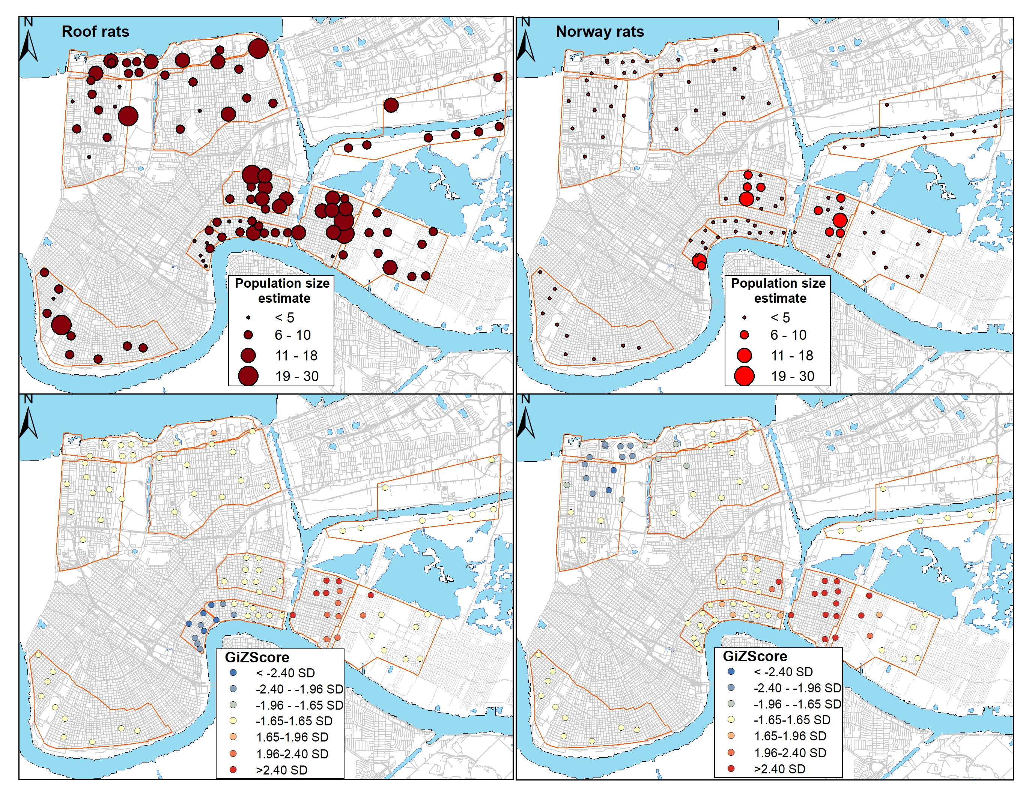
Figure 1.1 (Top) Spatial distribution of population estimates for each trapping site by species. (Bottom) Spatial clustering of high and low abundance of each species based on Getis-Ord GI* analysis. Study areas are delineated by orange boundaries.

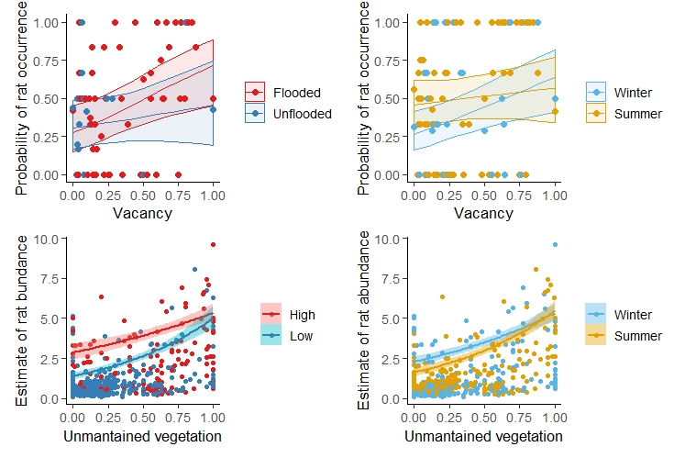
Figure 1.2. Relationship between lot vacancy on the probability of rat occurrence relative to flooding (top left) and season (top right, winter versus summer trapping bouts), as well as the proportion of unmaintained vegetation- an indicator of abandonment- and rat abundance per site relative to vacancy (bottom left; high, >50%; low, <50%) and season (bottom right, winter versus summer trapping bouts). Rat occurrence more sharply increased with vacancy at flooded sites than unflooded sites, and similarly with vacancy during winter versus summer trapping bouts. We also observed greater abundance relative to unmaintained vegetation in areas with higher vacancy, more so during winter than summer.
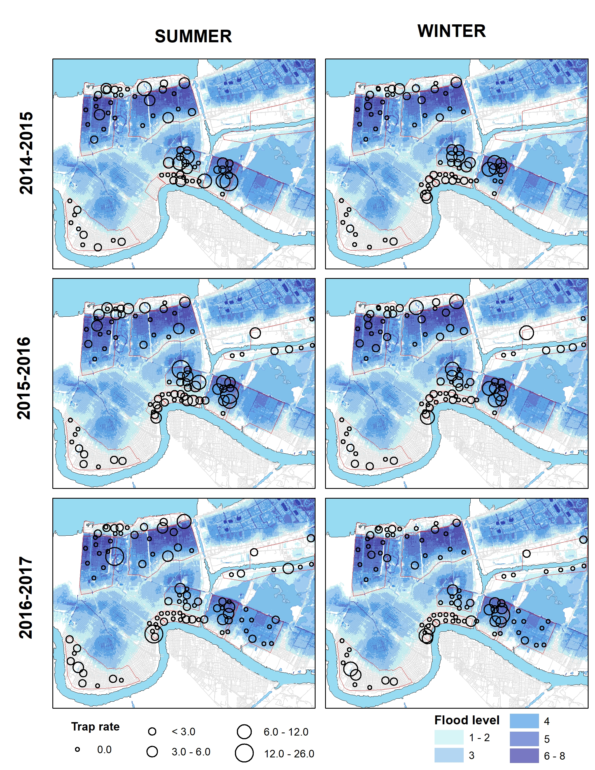
Figure 1.3. Overall trap rate by season and year with reference to Katrina-related flood depth.

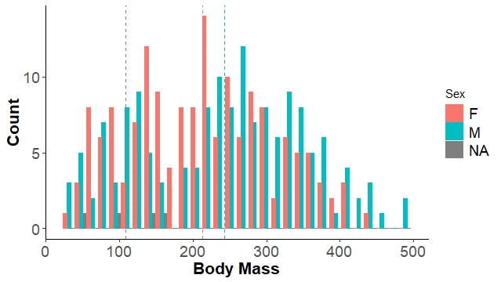
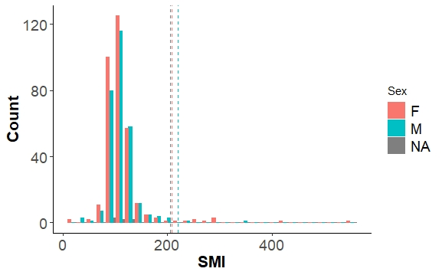

Figure 1.4. Distribution of body mass (top) and SMI (bottom) of Norway rats by sex. NA = sex not assigned. Dashed line represents the mean of each group

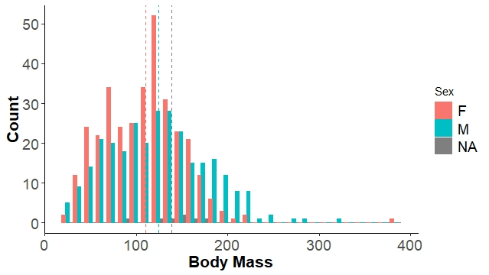
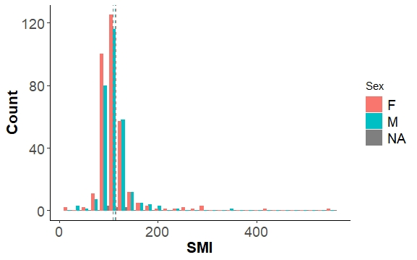

Figure 1.5. Distribution of body mass (top) and SMI (bottom) of roof rats by sex. NA = sex not assigned. Dashed line represents the mean of each group

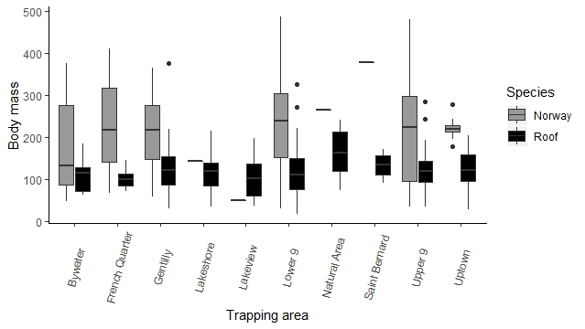

Figure 1.6. Body mass of Norway and roof rats by study area. Roof rats in the natural area had a higher body mass than roof rats in the Bywater, the Lower 9th and the Upper 9th ward.

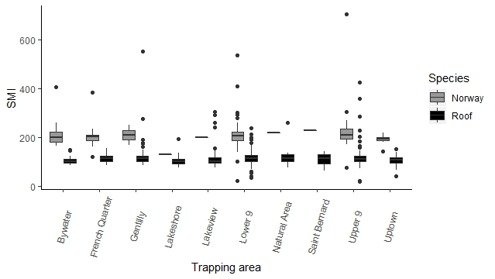

Figure 1.7. SMI of Norway rats and roof rats by study area. Norway rats have a higher SMI than roof rats.

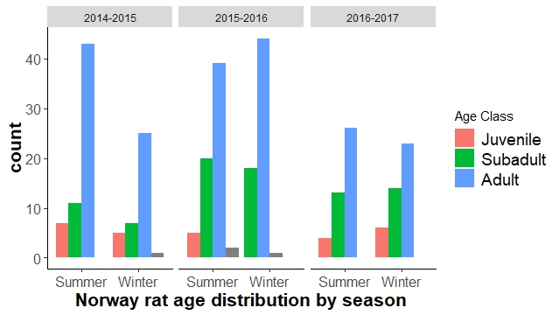
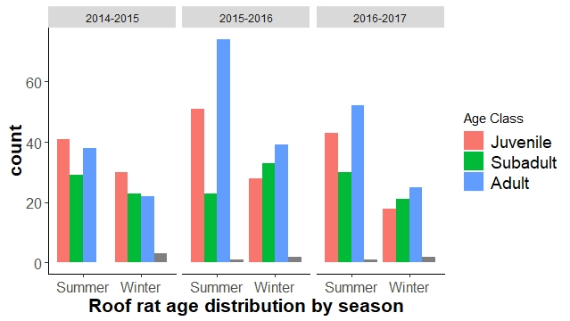
Figure 1.8. Age distribution of Norway rats (top) and roof rats (bottom) by season and year of trapping.

CHAPTER II
Genomic signatures of survival and demographic recovery of Norway rats following a catastrophic disaster

A version of this chapter by Bruno M. Ghersi Ch, Rachel Offutt, Anna C. Peterson, William Rosenthal, Matthew Combs, Daniel Bausch, Jason Munshi-South Claudia Riegel, Scott Emrich and Michael J. Blum has been prepared as an article for peer-review publication.

This article was reformatted from the peer-review version as part of this dissertation M. Blum, C. Rigel, and B. Ghersi conceived of the study. B. Ghersi and A. Peterson collected rodent samples. De Bausch contributed rodent samples. R. Offutt, W. Rosenthal and S. Emrich conducted some of the analyses. B. Ghersi conducted all other analyses and wrote the manuscript. All authors provided edits and comments to the manuscript.

ABSTRACT
Catastrophic disasters can manifest punishing forces, yet some species appear to be little affected, and in some instances favored, by the resulting destruction of built and natural environments. Understanding how species survive and flourish after disasters can help improve response efforts, particularly those taken to constrain the prevalence of commensal pests that transmit pathogens of concern. In this study, we characterized patterns of population genomic variation in Norway rats to infer whether elevated abundance in flood-affected areas of post-Katrina New Orleans reflects resilience to severe disturbance, in situ population recovery, immigration from areas that did not flood, or some combination thereof. Genotyping 439 specimens at ~237k ddRAD-generated SNPs yielded evidence of neighborhood-scale population structure and signatures of limited movement indicating that elevated abundance in flood-affected areas is not the result of recolonization. Consistent with this, reconstructions of historical demography provided evidence of longstanding independence of populations in flood-affected areas. Significantly higher levels of inbreeding in flood-affected areas also indicate that post-disaster abundance is more likely a result of population collapse followed by in situ recovery rather than resilience to disturbance. Evidence that genetic diversity parallels resource availability tied to flooding disturbance and post-disaster landscape management is consistent with the premise that Norway rat populations can exhibit rapid growth under favorable conditions, even after a severe bottleneck. These findings indicate that commensal pests like Norway rats can survive and quickly rebound following catastrophic disturbances, affirming public health concerns that motivate disaster response efforts intended to reduce risk of pathogen transmission in affected areas. Evidence of little to no recolonization also illustrates that post-disaster pathogen transmission risk is more likely to be ameliorated by localized and sustained eradication campaigns.

INTRODUCTION
Concern about the outcomes of disasters is on the rise, in part because of troubling conditions arising from the intersection of global trends in demography, climate conditions, and zoonotic disease risk (Kerle & Alkema, 2011; Rael et al., 2016). Since 1950, there has been more than a ten-fold increase in the number of disasters per year (Leaning & Guha-Sapir, 2013), largely reflecting growing populations and the increasing concentration of property in coastal cities (e.g., New Orleans, New York, Shanghai) that are more susceptible to extreme weather events (Leaning & Guha-Sapir, 2013). Trends of increasing human contact with disease reservoirs (Wilcox & Gubler, 2005) also suggest that commensal pests that frequent urban landscapes will increasingly become primary agents of novel zoonotic diseases (Meerburg et al., 2009; Han et al., 2015). Consequently, it is possible that infection risk is progressively increasing for an expanding segment of the world’s population, especially if disaster-driven transformation of built and natural environments promotes vector borne disease transmission (Watson et al., 2007; Rael et al., 2016).

The potential for zoonotic disease emergence following catastrophic disasters is well recognized (Rael et al., 2016). Disasters can create conditions favorable to the success of commensal pests that are known to carry pathogens of human concern, like Norway rats (Rattus norvegicus). Wholesale or selective changes in ecological communities can eliminate competition and predation, while habitat modification can enhance resource availability (Ostfeld & Holt, 2004; Wilcox & Gubler, 2005; Peterson et al., 2020). Plentiful resources and no controls can result in some species becoming hyper-abundant (Rael et al., 2016; Peterson et al., 2020; Ghersi et al., in review), which can increase the potential for disease emergence and transmission by engendering greater contact with humans. This is of particular concern in urban areas where commensal species and humans live in close proximity (Eskew & Olival, 2018).

Strategies for managing the recovery of post-disaster urban landscapes, often aim to prevent disease outbreaks and public health disparities (Wilcox & Gubler, 2005), but it is becoming clear that well-intentioned management interventions can inadvertently reinforce or exacerbate pathogen transmission risk. Following Hurricane Katrina, for example, municipal programs were implemented to remove debris and maintain vegetation in flood-damaged neighborhoods of St. Bernard Parish immediately adjacent to New Orleans. While this helped constrain the diversity and abundance of commensal rodents in the area, it elevated the diversity and burden of pathogenic Leptospira bacteria (Peterson, 2019) by promoting the dominance of house mice, which are highly competent hosts (Peterson et al., 2020). More passive policies that led to the neglect of vacant and abandoned properties also enhanced pathogen exposure risk by elevating the abundance of commensal rats (Rael et al., 2016; Ghersi et al., in review), which host Leptospira and other pathogens of human concern (Cross et al., 2014; Peterson et al., 2017; Peterson, 2019). This illustrates that advancing knowledge of post‐disaster response and recovery of pathogen reservoirs like commensal rodents can help ensure that management interventions intended to foster human well-being do not instead lead to conditions that increase disease risk or perhaps shift the burden of risk to more vulnerable populations.

Surprisingly little is known about demographic trajectories of commensal rodents in post‐disaster urban environments, particularly during early response and recovery stages. Some evidence suggests that catastrophic disturbances can trigger the collapse of commensal rodent populations (Zhang et al., 2004; Zhang et al., 2007; Hein & Jacob, 2015). Work in New Orleans, for example, has demonstrated that Katrina-related flooding depressed populations of arboreal squirrels (Yaukey, 2008). Parallel outcomes were observed for birds and plants in flood-affected areas of New Orleans (Yaukey, 2008; Gotham et al., 2014; Lewis et al., 2017) as well as arthropods across areas of New York City following Hurricane Sandy (Savage et al., 2018). Anecdotal reports suggest that Superstorm Sandy-related flooding also displaced Norway rats in New York City, although other reports indicate that flooding was too rapid for rats to avoid drowning (Buckley, 2013). Notably, city-wide quantitative surveys of commensal rats across post-Katrina New Orleans have found that flood-damaged areas harbor the largest populations in the city (Rael et al., 2016; Peterson et al., 2020; Ghersi et al., in review), raising the possibility that rats were little affected by catastrophic flooding.

Despite the potential gains that it could help realize (e.g., improved understanding of pathogen transmission risk (Tamayo-Uria et al., 2014), reconstructing post-disaster commensal rodent demography has proven to be remarkably challenging. In part this is because before-after comparisons are often limited by the absence of quantitative information on demography prior to and immediately after a disaster. In New Orleans, for example, all municipal incident records were destroyed by Katrina-related flooding, and no new reports were logged for more than a year following the storm due to the unprecedented displacement and exodus of residents from the city (Riegel, unpublished). Notably, incident reports collected and archived after 2007 by the New Orleans Mosquito, Termite and Rodent Control Board suggest that rat populations progressively increased in flooded areas of the city (Riegel, unpublished). While this trend may simply reflect the return of residents and a concordant rise in reporting, it is also possible that flooding triggered demographic collapse followed by rapid in situ recovery from a handful of survivors. Alternatively, neighborhoods purged by flooding may have been rapidly recolonized from less affected populations in nearby areas.

Impediments imposed by incomplete records like incident reports can potentially be overcome by taking indirect approaches, such as population genomic analysis, to reconstruct demographic responses to disasters. The progressive development of next generation sequencing has engendered increasingly powerful platforms for inferring recent demographic history (Narum et al., 2013). Genome-wide analysis of single nucleotide polymorphisms (SNPs), for example can provide exceptional power and resolution for characterizing variation among individuals and (sub)populations (Shastry, 2009). Building on the principle that genome-wide variation at putatively neutral loci is shaped by population attributes like size and growth as well as related processes like immigration (Luikart et al., 2003), analysis of genome-wide SNPs can serve as a powerful spotlight capable of revealing the processes underlying demographic outcomes of catastrophic disturbance and disasters (Shinzato et al., 2016; Poff et al., 2018; Parvizi et al., 2020).

In this study, we used population genomic approaches to infer demographic responses of Norway rats to catastrophic flooding resulting from Hurricane Katrina. We assessed genome-wide SNP variation for specimens collected from throughout New Orleans to estimate population genomic attributes including spatial population structure, effective population size and inbreeding that can offer insight into demographic responses to catastrophic disturbance (Shinzato et al., 2016; Poff et al., 2018). This enabled us to infer whether the elevated abundance of Norway rats in flood-affected areas of post-Katrina New Orleans (Rael et al., 2016; Ghersi et al., in review) reflects resilience to severe disturbance, in situ rapid expansion following population collapse, immigration from areas that did not flood, or some combination thereof. Drawing comparisons to quantitative estimates of relative abundance and land use (Peterson et al., 2020; Ghersi et al., in review) allowed us to assess whether post-disaster demography reflects landscape management rather than (or alongside) flooding (Lewis et al., 2017). Accordingly, we were also able to draw inferences about socioecological conditions that can contribute to the rise and maintenance of public health disparities following catastrophic disasters.

METHODS
Study system.
Hurricane Katrina struck the northern Gulf Coast in August 2005, triggering more than 50 levee breaches across New Orleans resulting in catastrophic flooding that affected over 80% of the city (figure 2.1). Some areas were flooded for nearly a month at a depth of ≥5 meters. Approximately 70% of occupied housing units suffered wind or flooding damage (Plyer, 2014). Mass exodus of residents from the city resulted in the resident population precipitously dropping from approximately 485,000 (April 2000) to approximately 210,000 inhabitants (July 2006) (Plyer, 2014). Flooding also affected ecological communities in the city (Yaukey, 2008; Gotham et al., 2014; Lewis et al., 2017). For example, before-and-after surveys indicate that bird and squirrel populations declined precipitously after the storm (Yaukey, 2008). Plant communities exhibited varying levels of disturbance and recovery reflecting flooding extent and duration as well as land abandonment and municipal management that promoted the emergence of ruderal vegetation (Lewis et al., 2017). Quantitative trapping demonstrated that rodent diversity and distributions parallel the mosaic of abandonment across the city, with greater species richness and overall abundance occurring in flood-affected areas burdened by greater abandonment (Peterson et al., 2020).

Study species.
As a habitat‐dependent reservoir of zoonotic pathogens, Norway rats can serve as indicators of post‐disaster health outcomes, including causal outcomes of disaster response efforts and management interventions that alter ecological communities (Rael et al., 2016). Norway rats (Rattus norvegicus) are one of the most widespread commensal pests that contribute to the spread of zoonotic diseases— including leptospirosis, plague, hantavirus, and capillariasis— in urban environments (Himsworth et al., 2013). Norway rat population size, growth and connectivity often correspond to socioeconomic conditions that govern habitat suitability and resource availability (Peterson et al., 2020). For example, in Vancouver (British Columbia, Canada), Baltimore (Maryland, USA) and New Orleans, the relative abundance of Norway rats is related to abandonment, which trends with median household income (Easterbrook et al., 2005; Himsworth et al., 2014; Gulachenski et al., 2016; Peterson et al., 2020; Ghersi et al., in review). Accordingly, as socioecological conditions change in post‐disaster urban environments, so should the demography of Norway rats and the concomitant risks of human exposure to rodent‐associated pathogens.

Sample collection.
As described in detail elsewhere (Peterson et al., 2017; Rael et al., 2018; Peterson, 2019), replicated sets of tissue samples were obtained from specimens of Norway rats that were collected as part of a study on the effects of Katrina related flooding and post disaster management on rodent assemblage structure and demography as well as rodent-borne pathogens (Rael et al., 2016; Peterson et al., 2020; Ghersi et al., in review). For this study, we used tissues from 314 Norway rats trapped at a subset of 37 sites distributed across eight neighborhoods in Orleans parish, an adjacent neighborhood in St Bernard Parish, and an adjacent natural area (Figure 2.1). Trapping sites in residential areas corresponded to city blocks, and sites in the natural area were equivalent in size to an average-sized city block. Supplemental tissues were also obtained from a study investigating the prevalence of hantavirus in rats throughout the city (Cross et al., 2014), and from rodent control operations executed by the City of New Orleans Mosquito, Termite and Rodent Control Board. The availability of additional samples allowed us to gain further information about Norway rats in several of the primary study areas as well as information about additional areas across the city like the Central Business District (CBD) (Figure 2.1).

DNA extraction, genomic library development and SNP genotyping.
We extracted genomic DNA and prepared ddRADseq libraries for paired-end sequencing as detailed in Puckett et al. (2016) and Combs et al. (2018a). We used STACKS v2.2 (Catchen et al., 2013) to align the sequences to a de-novo reference genome for the Norway rat using the approach described by Konar et al. (2017) and we called SNPs using the process radtags script to create fastq files for each individual. We filtered the SNPs using a combination of samtools v0.1.18 (Li et al., 2009), bwa 0.7.17 (Li & Durbin, 2009), and bcftools v0.1.17-dev (Li et al., 2009) which yielded a preliminary dataset of 688 individuals encompassing 511 adult rats and 177 embryos from New Orleans and 12 reference samples from New York City and Baton Rouge (Combs, et al., 2018a). The preliminary set of SNPs were then analyzed to assess genotype quality and depth (GQ and DP, respectively) for each sample with the aim of determining appropriate filtering thresholds. Vcftools v0.1.16 (Danecek et al., 2011) was used to filter the data according to two sets of criteria: one with a GQ > 34 and a DP > 15, with SNPs present in ≥90% of the samples (i.e. max-missing 0.9), and a second with GQ > 34 and a DP > 15, with SNPs present in ≥80% of the samples. The first set of criteria yielded a preliminary dataset of 103,070 SNPs for 162 adults from New Orleans, and the second criteria yielded a preliminary dataset of 270,284 SNPs for 439 adults from New Orleans. We then removed all non-variant SNPs (i.e., SNPs where all samples matched the reference, or all samples differed from the reference but matched each other), resulting in two final datasets of 67,443 SNPs for 162 individuals and of 237,021 SNPs for 439 individuals. Hereafter these are referred to as the stringently filtered dataset and the minimally filtered dataset, respectively. Unless otherwise noted, all subsequent analyses were done using both datasets.

Genetic diversity, inbreeding and effective population size.
To gain insight into the mechanism(s) underlying post-Katrina demographic variation, we first estimated measures of genetic diversity for each site and neighborhood and according to flooding history (i.e., flooded, unflooded). We estimated expected (H_{e}) and observed (H_{o}) heterozygosity, where H_{e} is the expected frequency of alleles under random mating calculated according to the formula presented by Weir (1996), and H_{o} is the percentage of heterozygous SNPs observed in each sample. We also calculated Wright’s F_{is} which serves as a measure of non-random mating according to the presence of excess of homozygotes in a population as follows: F_{is}= (H_{e} - H_{o}) / H_{e} (Wright, 1951). Here we use F_{is} as a proxy measure of inbreeding, a form of non-random mating that can reflect low vagility (i.e., limited dispersal) as well as shifts in population size than can result from founding events and bottlenecks (Frankham et al., 1999; Hoarau et al., 2005; Durrant et al., 2009).All three measures were estimated for both datasets, but limited to only sites and neighborhoods with ≥8 individuals to avoid possible bias from small sample sizes. Using the minimally filtered data set, we ran an Analysis of Variance (ANOVA) and post-hoc Tukey test to determine whether site-level measures of heterozygosity and inbreeding differed among neighborhoods. Likewise, using the minimally filtered dataset, we performed a two sample t-test to determine if site level estimates differed according to flooding history. Demographic decline followed by in situ population recovery should result in lower H_{o} than H_{e} and thus higher F_{is}, whereas the opposite outcome might result if recolonization resulted in admixed populations (i.e., if immigrants originated from several source pools). To gain further insight into how measures of genetic variation related to demography, we drew comparisons to Norway rat census population size (i.e., number of animals trapped and trapping rate, (Ghersi et al., in review)) by running pairwise Pearson correlation tests using H_{o}, H_{e}, and F_{is} estimates from both the minimally and stringently filtered datasets.

We ran linear models to assess site-level socioecological predictors of genetic variation, focusing on H_{o} and F_{is} estimated from the minimally filtered dataset. We used a set of predictors that have been found to be informative in past studies of rodent demography and assemblage structure in New Orleans (Peterson et al., 2020; Ghersi et al., in review). The global models for both dependent variables included site level information on elevation (a proxy for flooding depth), median household income, number of residents, remote-sensing based estimates of tree cover, the proportion of vacancy at a site, as well as site-based estimates of unmaintained vegetation. All possible models were generated and ranked according to AICc score with the top model selected according to the lowest AICc score (Burnham & Anderson, 2004; Peterson et al., 2020; Ghersi et al., in review).

We calculated effective population size (N_{e}) with 95% confidence interval (C.I.) for each site and neighborhood with ≥8 samples using the linkage disequilibrium method in NeEstimator v2.1 (Do et al., 2014). For computational simplicity, estimates were derived from a genotype matrix of 10,000 randomly chosen SNPs generated with PGDspider v.2.1.1.5 (Lischer & Excoffier, 2012). We used a two sample t-test to determine whether there were differences between flooded and unflooded sites according to estimates of N_{e} derived from the minimally filtered dataset. N_{e} values can be affected by factors like fluctuating population sizes, breeding sex ratio, differences in reproductive success among individuals, overlapping generations, and immigration (Hartl, 2000). Demographic surveys (Ghersi et al., in review) have shown that there is a consistent balance of males and females in New Orleans Norway rat populations. Although Norway rats present promiscuous patterns of copulation and multiple paternity is common, females prefer to mate with dominant males (Carr et al., 1982), increasing their reproductive success. Norway rat populations also exhibit overlapping populations, as individuals reach maturity at an early age (i.e., 2-3 months) (Schweinfurth, 2020). While these factors would be expected to affect estimates of N_{e}, demographic assessments (Ghersi et al., in review) indicate that relative effect sizes should not differ between sites due to flooding history. On the other hand, migration and fluctuation in population size might very well result in differences among sites. Accordingly, lower N_{e} values might be expected at flooded sites due to a demographically-driven increase in non-random mating (i.e., greater inbreeding following a bottleneck), as compared to higher values reflecting larger and more stable populations at sites that did not flood. Higher N_{e} values might be expected if recolonization resulted in admixed populations in flooded areas of the city.

To strengthen inferences drawn from estimates of N_{e}, we also ran pairwise Pearson correlation tests to assess how N_{e} relates to measures of Norway rat census population size (Ghersi et al., in review) with both SNP datasets.

Genetic structure and movement potential.
We used several methods to evaluate and illustrate population genomic differentiation and spatial relatedness among Norway rats captured across the study region. We first used principal components analysis (PCA) to identify general trends in genomic differentiation. We undertook a complementary Bayesian analysis of genotypic variation and population structure, as implemented in STRUCTURE v2.3.4 (Malinsky et al., 2018) and fineRADstructure (Martikainen et al., 2018). We also conducted Mantel tests to assess relationships between pairwise estimates of genetic dissimilarity and Euclidean distances for individuals and trapping sites (Falush et al., 2007).

We conducted a PCA using the --pca option in PLINK v.1.90b6.9 (Lischer & Excoffier, 2012). This generated a list of eigenvectors for each of the individuals in the minimally and stringently filtered datasets. We then elected to visually present patterns of variation according to the first two principle components (PC1 and PC2) recovered in each analysis, which explained a combined total of 77.6% and 23% of variance in the two datasets, respectively. If flooding had little to no effect on Norway rats, we expected to observe distinct clusters with variation reflecting the spatial configuration among sampled areas. We also expected to observe clustering if populations experienced a bottleneck, but variation would not necessarily parallel underlying geography due to stochastic changes in population composition. We expected that recolonization would reduce or eliminate clustering, and potentially reveal overlap among areas that have recently exchanged migrants.

We ran STRUCTURE v2.3.4 (Falush et al., 2007; Pritchard et al., 2000) using files for both sets of samples that were generated with PGDspider v.2.1.1.5 (Lischer & Excoffier, 2012). For each dataset, we completed 5 separate runs with a burn-in of 4,000 and a subsequent run length of 10,000 with k values ranging from 1 to 10. We used the Evanno method (2005) to infer the optimal number of clusters according to delta k values. We used Structure Plot 2.0 (Ramasamy et al., 2014) to visualize the inferred population structure across the study region. For comparison, we ran FineRADstructure v.0.3.1 (Malinsky et al., 2018), which is a complementary tool for inferring population structure from SNP variation (Lawson et al., 2012). For both datasets, we first generated a haplotype matrix that was used as an input file to run both the painter executable as well as the finestructure executable with default parameters (http://cichlid.gurdon.cam. Ac.uk/fineRADstructure.html). We used the FineRADStuctureLibrary v0.3 R script to visualize coancestry heatmaps generated by fineRADstructure. Signatures of population structure and configuration were expected to follow those revealed by PCA. Notably, we also expected that recolonization of flooded site might result in signatures of admixture and recent immigration, like the presence of individuals exhibiting mismatched genotypes (i.e., an individual trapped at site X exhibits a genotype corresponding to the population located at site y).

Mantel tests can shed light on how population connectivity relates to movement potential, based on the strength and nature of correlations between geographic distance and genetic distance (Manel & Holderegger, 2013). Accordingly, we ran Mantel tests using the package vegan 2.5 in R 4.0 (Oksanen et al., 2016) using matrices of individual-level pairwise genetic distances generated by VCF2Dis (https://github.com/BGI-shenzhen/VCF2Dis) and pairwise Euclidean geographic distances. We ran tests based on pair-wise dissimilarity for the study region and for the three most extensively sampled neighborhoods using both datasets. We constructed complementary mantel correlograms to gain greater perspective on movement potential. We expected to recover a strong correlation if rats were little affected by flooding or if in situ recovery followed a bottleneck, whereas we expected that recolonization of flooded areas would result in a weak correlation or perhaps no relationship. Finding signatures of limited movement in the correlograms would also suggest that there has been little to no recolonization of flooded areas.

Historical demography.
Inferring demographic history from genomic variation can help illustrate whether and how disasters (re)shape populations in affected areas. Depending on the magnitude and duration of inundation, flooding can result in local extinction and collapse or have no discernible effect on populations in affected areas (Zhang et al., 2004, 2007). Instead of relying on available methods that are considered to be model constrained (Liu & Fu, 2015), we constructed ‘stairway plots’ to describe recent changes in population size according to a multi-epoch model based on calculations of the expected composite likelihood of the SNP frequency spectrum (Gutenkunst et al., 2010). We focused on the most extensively sampled neighborhoods included in the stringently filtered dataset, as follows: Gentilly, the Lower 9th Ward, the Upper 9th Ward, the Central Business District, and the French Quarter. We used dadi (Liu & Fu, 2015) to create folded SNP frequency spectra for each neighborhood, which were then used to generate input files for stairway plot v2.1 (Slate et al., 2004). All analyses were based on a generation time of one year and a conservative mutation rate estimate of 1.2 x 10⁻⁸ mutations per nucleotide per generation. Median, upper, and lower harmonic means were also calculated to provide a point estimate of N_{e} with 95% confidence intervals for each neighborhood.

RESULTS

Genetic diversity, inbreeding, and effective population size.
Across the study region, we estimated global values of H_{o} = 0.09, H_{e} = 0.28 and F_{is} = 0.69 based on the stringently filtered dataset and global values of H_{o} = 0.08, H_{e} = 0.19 and F_{is} = 0.59 based on the minimally filtered data set. Analyses of both datasets recovered higher values of H_{e} than H_{o} across all sites and neighborhoods, as well as evidence of differences among neighborhoods (Table 2.1). Pairwise comparisons based on the more inclusive, minimally filtered dataset indicate, for example, that rats from the Upper 9th Ward exhibited higher H_{e} versus rats from the CBD (f = 3.5, p = 0.05) and higher F_{is} than rats from Gentilly (f = 4.34, p = 0.03) (Table 2.1). Rats from flooded sites also exhibited higher H_{e} (f = 7.4, p < 0.02) and H_{o} (f = 5.8, p < 0.05) in comparison to rats from sites that did not flood (Figure 2.2). Though not statistically significant, a similar difference was recovered in a comparison of F_{is} (f = 3.9, p = 0.06) values for flooded and unflooded sites based on the minimally filtered dataset (Figure 2.2). A nearly significant negative trend was recovered between site-level measures of F_{is} and estimates of census population size (r = -0.47, p = 0.06) (Figure 2.3).

Regression models based on the minimally filtered dataset identified similar predictors of H_{o} and F_{is} (Table 2.2-2.3). The top selected model for H_{o} was <1 ΔAICc than the next best model so both models are presented here. The top two models each included a single predictor of H_{o}; the top model included unmaintained vegetation (coef. = 0.02, p < 0.05), whereas the alternative model included vacancy (coef. = 0.03, p < 0.05) (Figure 2.3). Likewise, the top model for F_{is} only included vacancy (coef. = -0.13. p < 0.05) as a predictor variable (Figure 2.3).

Across the study region, we estimated a global N_{e} of 51.5 (51.4-51.6) based on the stringently filtered dataset and a global N_{e} of 51 (50.9-51.1) based on the minimally filtered dataset. Analyses of both datasets recovered evidence of differences among neighborhoods across the city (Table 2.1). For example, comparisons based on the minimally filtered dataset indicate that estimated values of N_{e} for the Lower 9th Ward and Upper 9th Ward are considerably higher than the estimated value for the French Quarter (Table 2.1). Higher N_{e} estimates (t=-1.3, p < 0.2) also were recovered for sites that flooded (N_{e} = 62.6, 62.5-62.8) than sites that did not flood (N_{e} = 31.9, 31.8-31.9). A consistent negative association was recovered between site-level (e.g., r = 0.79, p = 0.05; minimally filtered dataset) and neighborhood-level (e.g., r = 0.94, p = 0.06; stringently filtered dataset) measures of N_{e} relative to census population size (Figure 2.3).

Genetic structure and movement potential.
While evidence of nominal geographic structure was recovered in analyses of the minimally filtered dataset, analyses of the stringent filtered dataset revealed clear signatures of spatial differentiation across the study region (Figures 2.4 & 2.5). Distinct clusters were recovered in the PCA according to neighborhood and groups of nearby neighborhoods (Figure 2.4). A parallel pattern was found in Bayesian assignments at the optimal k-value (Figure 2.4). Both analyses identified five clusters that appear to reflect spatial proximity and the influence of urban infrastructure like the industrial canal between the Lower 9th Ward and other areas of the city, as well as the overpass highway between the CBD and the Uptown neighborhood (Figures 2.1 & 2.4). No evidence of mismatched genotypes, was detected in either analysis (Figure 2.4). The fineRADstructure heat map based on the stringently filtered dataset also provides evidence of clustering by proximity (i.e., neighborhood), while clustering was not evident in the heatmap based on the minimally filtered dataset (Figure 2.5).

Mantel tests recovered strong associations between pairwise spatial distances and pairwise genomic distance among individuals included in the stringently (r = 0.46, p < 0.01) and minimally filtered (r = 0.17, p < 0.001) datasets. The correlograms also reflected a pattern of localized spatial genetic structure (Figure 2.6, Figure 2.8). For example, we observed a positive and significant spatial autocorrelation for distances ≤2000 m in the city-wide correlogram based on the stringently filtered dataset, with the strongest correlation recovered for the smallest geographical distances (r = 0.5, p < 0.001) (Figure 2.6). Similar patterns of localized structure were recovered for neighborhood-specific analyses. A significant correlation was found for distances ≤1000 m (r = 0.69, p < 0.01) for rats in the Upper 9th Ward, ≤500 m for rats from the Lower 9th ward (r = 0.67, p < 0.01) and ≤200 m for rats from the French Quarter (r = 0.32, p < 0.01) based on the stringent dataset. Similarly, significant correlations were recovered for distances ≤1500m (r = 0.17, p < 0.01) for rats in the Upper 9th Ward, ≤500m for rats from the Lower 9th Ward (r = 0.18, p<0.01) and 150m for rats from the French Quarter (r = 0.17, p < 0.01) based on the minimally filtered dataset.

Historical demography.
Stairway plots illustrated that recent declines in N_{e} have occurred in all four focal study neighborhoods, but the declines do not appear to coincide with Hurricane Katrina (i.e., approximately 15 years before present) (Figure 2.7). Rather, the shifts are staggered over a period spanning the past two and a half centuries (Figure 2.7), with the Lower 9th Ward exhibiting the most recent shift (ca. 50-75 years ago), followed by the CBD (ca. 100 years ago), the Upper 9th Ward (ca. 150-200 years ago), and the French Quarter (ca. 200-225 years ago). Median N_{e} estimates ranged from 10.56 for the Lower 9th Ward to 6,903.66 for the Gentilly neighborhood, with intermediate values of 16.97 for the Upper 9th Ward and 60.75 for the French Quarter.

DISCUSSION

Catastrophic disasters can manifest punishing forces, yet some species appear to be little affected, and in some instances favored, by the consequent transformation of built and natural environments. Understanding how species survive and flourish after disasters can help improve response efforts, particularly those taken to constrain the prevalence of commensal pests that transmit pathogens of concern. Evidence of elevated rodent richness and abundance in historically underserved, flood-affected neighborhoods in post-Katrina New Orleans (Peterson et al., 2020) highlights the importance of understanding the progression and balance of factors that shape public health outcomes of catastrophic disasters. In this study, we reconstructed the demography of Norway rats following Hurricane Katrina to shed further light on the origins and nature of pathogen exposure risk across the city (Rael et al., 2016). We used population genomic approaches to assess whether Norway rats were little affected by catastrophic flooding or whether populations instead rebounded after contracting in flooded areas. Evidence of elevated levels of inbreeding suggests that populations declined and recovered in flood-affected areas. Evidence of neighborhood-scale population structure, longstanding demographic independence, and limited movement indicates that recovery was not a result of recolonization. Evidence that genetic diversity parallels resource availability tied to flooding disturbance and municipal land management (Lewis et al., 2017; Peterson et al., 2020) is also consistent with the premise that favorable conditions allowed for rapid population regrowth following Hurricane Katrina. Together, our findings indicate that Norway rats can survive and quickly rebound following catastrophic disturbances, affirming public health concerns that motivate disaster response efforts intended to reduce risk of pathogen exposure in affected areas. Yet indications that abandonment has contributed to the demographic success of a menacing pathogen reservoir (Han et al., 2015; Meerburg et al., 2009) affirms concerns that response efforts intended to safeguard human well-being can instead inflate, defer and prolong public health risks, highlighting the possibility that disease outbreaks may consequently arise and persist for years or even decades after a disaster (Fair et al., 2007; Leitmann, 2007; Rael et al., 2016).

Our results align with prior findings showing that catastrophic disturbances can trigger the collapse of rodent populations (Zhang et al., 2004; Zhang et al., 2007; Hein & Jacob, 2015), followed by rapid recovery under conditions that favor survival and reproduction (Feng & Himsworth, 2014). Previous studies have illustrated that large scale flooding can devastate populations of rodents in rural areas (Zhang et al., 2004, 2007). Evidence that squirrel populations declined by as much as 76% as a result of Hurricane Katrina (Yaukey, 2008) and anectodal reports that Norway rats were drowned by Sandy-related flooding in New York City (Buckley, 2013) suggest that urban populations of commensal rats exhibit comparable responses to catastrophic flooding. Consistent with this, we found genomic signatures indicating that Norway rats passed through a demographic bottleneck in flood-affected areas of post-Katrina New Orleans. Estimates of inbreeding, for instance, were on average 20% higher in flooded areas of the study region. As our measure of inbreeding might have been subject to factors other than shifts in demography (e.g., a concomitant shift in the propensity for dispersal), it would be prudent to confirm this inference through other means, such as estimating relatedness among individuals at a site. Notably, contrary to the expectation that mean heterozygosity should also decline as a result of a bottleneck (Luikart et al., 1998), we found that H_{e} and H_{o} were significantly higher in flooded areas (Figure 2.2). It is possible that rapid growth resulting in large populations (Ghersi et al., n.d.; Peterson et al., 2020; Rael et al., 2016) elevated heterozygosity in flooded areas. Support for this inference comes from evidence of elevated N_{e} across flooded areas and strong but marginally significant correlations of N_{e} with census population size estimates (Figure 2.4). It is also possible, however, that it is a reflection of population substructuring, where neighborhood-scale estimates are aggregate measures of several distinct groups (i.e., colonies) that exhibit divergent allelic profiles due to genetic drift, akin to allele surfing during population range expansion (Excoffier & Ray, 2008). Accordingly, further work detailing genomic variation and substructure of Norway rats within flooded and unflooded neighborhoods harboring the largest populations (e.g., the Lower 9th Ward versus the French Quarter) could shed light on the importance of substructure and drift in contributing to the observed pattern of elevated heterozygosity in flooded areas of the city.

We did not find evidence that populations of Norway rats in flooded areas were reconstituted as a result of recolonization. Work on corals and stream macroinvertebrates indicates that immigration from unaffected areas can drive post-disaster population recovery (Shinzato et al., 2016; Poff et al., 2018). Unlike corals and aquatic insects that have highly vagile life stages (e.g., marine and riverine current-dispersing larvae), urban Norway rats exhibit little propensity for movement and dispersal (Byers et al., 2019). For example, trapping and tag-based estimates indicate that daily movement is on the order of ≤25 m, and population genomic inferences indicate that mean dispersal distances between parents and offspring are ≤45 m (Combs, et al., 2018b), although distances of ≤353 m have been estimated between putative parents (Costa et al., 2016; Glass et al., 2016). Consistent with this, we found genomic evidence of localized population structure and limited movement indicating that there was little to no recolonization of flooded areas. Analyses of our stringently filtered dataset consistently recovered geographic patterns of genomic structure across the study region, with differences between neighborhoods or clusters of adjacent neighborhoods (Figure 2.4). Additionally, we did not detect signatures of recent immigration, such as mismatched genotype assignments (Figure 2.4). These findings align with a multi-city genomic assessment illustrating that urban Norway rats exhibit spatially-defined population structure (Combs, et al., 2018a). Likewise, city-wide and neighborhood-scale Mantel tests revealed that there is significant spatial autocorrelation at the shortest distance classes, probably owing to limited dispersal. Similar city-wide patterns of spatial autocorrelation have been found across comparable study areas in New York City (New York, USA) and Salvador (Bahia, Brazil) (Richardson et al., 2017; Combs, et al., 2018a; Combs, et al., 2018b). Mirroring our estimates of spatial autocorrelation across distances of 200-500 m in the Lower 9th Ward and French Quarter (Figure 2.4), findings from intensive neighborhood-scale surveys of Salvador and Vancouver (British Columbia, Canada) suggest that movement is limited to ≤100 and ≤300 m respectively (Richardson et al., 2017; Combs et al., 2018a),perhaps reflecting genomic differentiation between nearby colonies. While it is certainly possible that recolonization of flooded areas occurred as a result of an influx from areas that we did not sample, this seems unlikely given the extent and intensity of rodent trapping that we conducted throughout the city (Figure 2.9; Peterson et al., 2020; Ghersi et al., in review).

We reconstructed patterns of historical demography with the expectation that populations in flooded areas would exhibit signatures of passing through a recent bottleneck (i.e., a temporary decline in N_{e}) around the time Hurricane Katrina struck New Orleans. Contrary to expectation, we did not find clear signatures of response to Katrina-related flooding. None of the exemplar populations included in the analysis exhibited a shift in N_{e} dating to ca. 2005 (Figure 2.7). This result might very well indicate that Norway rats were little affected by Katrina-related flooding, although it also may reflect limitations of the analysis to resolve outcomes of very recent events (Liu & Fu, 2015). Notably, we found that shifts in demography were distinct among study areas, with the timing of changes in N_{e} staggered over approximately a century and a half (Figure 2.7). The estimated timing and sequence of changes in demography are broadly consistent with the history of urban expansion across the New Orleans metro area. For example, it appears that Norway rats from the French Quarter experienced a decline in N_{e} 200+ years ago, which is consistent with a scenario of initial colonization following the establishment of the neighborhood (the oldest residential area of the city) in the 18th century. Similarly, it appears that Norway rats from the Lower 9th Ward experienced a decline in N_{e} approximately 50-75 years ago, which is consistent with the establishment of the neighborhood in the mid 20th century (Campanella, 2002). It is also possible that the inferred demographic histories have been shaped by other events that affected rat populations in the city, like the flooding of the Lower 9th Ward after Hurricane Betsy in 1964 and an unprecedented eradication campaign undertaken in 1914 to contain a plague outbreak (Campanella, 2014). This possibility is well illustrated by an intensive eradication campaign recently conducted in Salvador (Bahia, Brazil) that resulted in a severe bottleneck, with affected populations exhibiting 85-91% reductions in N_{e} (Richardson et al., 2019). While the analysis of historical demography did not shed further light about demographic responses to Katrina-related flooding, it nonetheless indicates that there has been long-standing demographic independence of Norway rat populations across the city, offering further support for the inference that recolonization did not contribute to the recovery of populations in flooded areas.

As has been found for other elements of the urban landscape across post-Katrina New Orleans (Lewis et al., 2017; Peterson et al., 2020; Potter, 2020), there are indications that genomic variation in Norway rats has been shaped by a combination of flooding disturbance and actions taken since the storm. Akin to rodent diversity and abundance (Peterson et al., 2020; Ghersi et al., in review), we found that heterozygosity increases with the prevalence of vacant unmaintained properties (Figure 2.4), which are unevenly distributed across the city as a consequence of flooding, resettlement policies, and municipal land management (Lewis et al., 2017). Importantly, flooding did not necessarily translate into higher rates of post-Katrina vacancy or abandonment (Lewis et al., 2017). This is clearly illustrated by the two-orders of magnitude greater percentage of blighted properties in the Lower 9th Ward compared to the Lakeview neighborhood, which were both severely flooded following Hurricane Katrina (Blum et al., 2018). Such striking disparities are a reflection of Federal and State resettlement policies that inhibited population return in lower-to-middle income black-majority neighborhoods like the Lower 9th Ward (Campanella, 2007; Fussell et al., 2014; Gotham & Greenberg, 2014; Campanella, 2018;), as well as neglectful municipal land management policies that engendered the growth of unmaintained vegetation on vacant properties (Lewis et al., 2017). Our findings offer further evidence that resulting conditions have given rise to larger, more robust populations of Norway rats (Peterson et al., 2020; Ghersi et al., in review), affirming concerns that post-disaster interventions have put historically underserved communities at greater risk of exposure to rodent-borne pathogens (Lewis et al., 2017). Lessons learned from this are globally relevant, as the near-cosmopolitan distribution of Norway rats and comparable socioecological distributions of abandonment (Gulachenski et al., 2016) suggest that public health disparities similar to those found in post-Katrina New Orleans may very well arise in many other cities worldwide.

It is widely held that understanding the underlying conditions of zoonotic disease emergence will better prepare societies to anticipate, mitigate, and manage the socioeconomic and environmental consequences of future disasters. Our findings illustrate that greater knowledge can be gained by examining how disasters can give rise to complex socioecological feedbacks that shape pathogen exposure risk across affected areas. Recognizing the real possibility that disaster response can elevate rather than alleviate risk can help prevent unnecessary injury and mortality. It could, for example, avert actions that may potentially do more harm than good, and speed responses to address inadvertent complications like the introduction of cholera by a United Nations peacekeeping mission after the 2010 earthquake in Haiti (Chin et al., 2010; Piarroux et al., 2011). Our results indicate that the fallout from decisions and policies can persist for years to decades following a catastrophe like Hurricane Katrina. Our findings also indicate, however, that steps can readily be taken to correct course. Evidence of spatially structured populations and limited potential for recolonization (Figures 2.4 & 2.5) indicates, for example, that localized eradication could substantively alleviate exposure risk in at-risk neighborhoods like the Lower 9th Ward (Richardson et al., 2017; Richardson et al., 2019). Rodent control, combined with regular maintenance of vegetation on vacant lots, might be enough to eliminate problematic infestations by concurrently reducing survival and fecundity. No doubt, there are local and regional idiosyncrasies that might mitigate outcomes, but broad adoption of a dual prescription (i.e., population and habitat control) might very well stave off pathogen transmission following catastrophic disasters and thus help check the rise of rodent-borne disease risk worldwide (Meerburg et al., 2009; Han et al., 2015).

References
Blum, M. J., Gotham, K. F., Lesen, A. E., Lewis, J. A., Campanella, R., Riegel, C., Peterson, A. C., Ghersi, B. M., Powers, B., & Lauve-moon, K. (2018). Risk perceptions parallel policy-driven socioecological disparities across post-Katrina New Orleans. ESA Annual Meeting. https://eco.confex.com/eco/2018/meetingapp.cgi/Person/92158
Buckley, C. (2013). Storm’s toll creeps inland, 4 tiny feet at a time. The New York Times. http://www.nytimes.com/2013/02/07/nyregion/after-storm-rats-creep-inland.html
Burnham, K. P., & Anderson, D. R. (2004). Multimodel inference: Understanding AIC and BIC in model selection. In Sociological Methods and Research. 33(2), 261–304. Sage Publications : Thousand Oaks, CA. https://doi.org/10.1177/0049124104268644
Byers, K. A., Lee, M. J., Patrick, D. M., & Himsworth, C. G. (2019). Rats about town: A systematic review of rat movement in urban ecosystems. Frontiers in Ecology and Evolution, 7, 13. https://doi.org/10.3389/fevo.2019.00013
Campanella, R. (2002). Time and Place in New Orleans: Past Geographies in the Present Day. https://pelicanpub.com/proddetail.php?prod=1565549910#.XxUenChKiUk
Campanella, R. (2007). An Ethnic Geography of New Orleans. Journal of American History, 94(3), 704–715. https://doi.org/10.2307/25095131
Campanella, R. (2014). The battle against bubonic plague: 100 years ago, New Orleans waged war on rats | Home/Garden | nola.com. The Times-Picayune. https://www.nola.com/entertainment_life/home_garden/article_c7026c11-bf29-51fc-8e9a-f785e8acccd9.html
Campanella, R. (2018). Chapter 2 - Settlement shifts in the wake of catastrophe. In M. J. Zakour, N. B. Mock, & P. Kadetz (Eds.), Creating Katrina, Rebuilding Resilience. 25–44. Butterworth-Heinemann. https://doi.org/https://doi.org/10.1016/B978-0-12-809557-7.00002-8
Carr, W. J., Kimmel, K. R., Anthony, S. L., & Schlocker, D. E. (1982). Female rats prefer to mate with dominant rather than subordinate males. Bulletin of the Psychonomic Society, 20(2), 89–91. https://doi.org/10.3758/BF03330090
Catchen, J., Hohenlohe, P. A., Bassham, S., Amores, A., & Cresko, W. A. (2013). Stacks: an analysis tool set for population genomics. Molecular Ecology, 22(11), 3124–3140. https://doi.org/10.1111/mec.12354
Chin, C.-S., Sorenson, J., Harris, J. B., Robins, W. P., Charles, R. C., Jean-Charles, R. R., Bullard, J., Webster, D. R., Kasarskis, A., Peluso, P., Paxinos, E. E., Yamaichi, Y., Calderwood, S. B., Mekalanos, J. J., Schadt, E. E., & Waldor, M. K. (2010). The origin of the haitian cholera outbreak strain. New England Journal of Medicine, 364(1), 33–42. https://doi.org/10.1056/NEJMoa1012928
Combs, M., Byers, K. A., Ghersi, B. M., Blum, M. J., Caccone, A., Costa, F., Himsworth, C. G., Richardson, J. L., & Munshi-South, J. (2018a). Urban rat races: Spatial population genomics of brown rats (rattus norvegicus) compared across multiple cities. Proceedings of the Royal Society B: Biological Sciences, 285(1880). https://doi.org/10.1098/rspb.2018.0245
Combs, M., Puckett, E. E., Richardson, J., Mims, D., & Munshi-South, J. (2018b). Spatial population genomics of the brown rat (Rattus norvegicus) in New York City. Molecular Ecology, 27(1), 83–98. https://doi.org/10.1111/mec.14437
Costa, F., Richardson, J. L., DIon, K., Mariani, C., Pertile, A. C., Burak, M. K., Childs, J. E., Ko, A. I., & Caccone, A. (2016). Multiple paternity in the norway rat, Rattus norvegicus, from urban slums in Salvador, Brazil. Journal of Heredity, 107(2), 181–186. https://doi.org/10.1093/jhered/esv098
Cross, R. W., Waffa, B., Freeman, A., Riegel, C., Moses, L. M., Bennett, A., Safronetz, D., Fischer, E. R., Feldmann, H., Voss, T. G., & Bausch, D. G. (2014). Old world hantaviruses in rodents in New Orleans, Louisiana. American Journal of Tropical Medicine and Hygiene, 90(5), 897–901. https://doi.org/10.4269/ajtmh.13-0683
Danecek, P., Auton, A., Abecasis, G., Albers, C. A., Banks, E., DePristo, M. A., Handsaker, R. E., Lunter, G., Marth, G. T., Sherry, S. T., McVean, G., & Durbin, R. (2011). The variant call format and VCFtools. Bioinformatics, 27(15), 2156–2158. https://doi.org/10.1093/bioinformatics/btr330
Do, C., Waples, R. S., Peel, D., Macbeth, G. M., Tillett, B. J., & Ovenden, J. R. (2014). NeEstimator v2: Re-implementation of software for the estimation of contemporary effective population size (Ne) from genetic data. Molecular Ecology Resources, 14(1), 209–214. https://doi.org/10.1111/1755-0998.12157
Durrant, C.J., Beebee, T.J., Greenaway, F. and Hill, D.A., 2009. Evidence of recent population bottlenecks and inbreeding in British populations of Bechstein’s bat, Myotis bechsteinii. Conservation Genetics, 10(2), 489-496.
Easterbrook, J. D., Shields, T., Klein, S. L., & Glass, G. E. (2005). Norway rat population in Baltimore, Maryland, 2004. Vector-Borne and Zoonotic Diseases, 5(3), 296–299. https://doi.org/10.1089/vbz.2005.5.296
Eskew, E. A., & Olival, K. J. (2018). De-urbanization and Zoonotic Disease Risk. Ecohealth, 15(4), 707–712. https://doi.org/10.1007/s10393-018-1359-9
Evanno, G., Regnaut, S., & Goudet, J. (2005). Detecting the number of clusters of individuals using the software STRUCTURE: A simulation study. Molecular Ecology, 14(8), 2611–2620. https://doi.org/10.1111/j.1365-294X.2005.02553.x
Excoffier, L., & Ray, N. (2008). Surfing during population expansions promotes genetic revolutions and structuration. Trends in Ecology and Evolution, 23(7), 347–351. https://doi.org/10.1016/j.tree.2008.04.004
Fair, J., Jentes, E., Inapogui, A., Kourouma, K., Goba, A., Bah, A., Tounkara, M., Coulibaly, M., Garry, R. F., & Bausch, D. G. (2007). Lassa virus-infected rodents in refugee camps in Guinea: A looming threat to public health in a politically unstable region. Vector-Borne and Zoonotic Diseases, 7(2), 167–171. https://doi.org/10.1089/vbz.2006.0581
Falush, D., Stephens, M., & Pritchard, J. K. (2007). Inference of population structure using multilocus genotype data: Dominant markers and null alleles. Molecular Ecology Notes, 7(4), 574–578. https://doi.org/10.1111/j.1471-8286.2007.01758.x
Feng, A. Y. T., & Himsworth, C. G. (2014). The secret life of the city rat: A review of the ecology of urban Norway and black rats (Rattus norvegicus and Rattus rattus). Urban Ecosystems, 17(1), 149–162. https://doi.org/10.1007/s11252-013-0305-4
Frankham, R., Lees, K., Montgomery, M.E., England, P.R., Lowe, E.H. and Briscoe, D.A., 1999. Do population size bottlenecks reduce evolutionary potential?. Animal Conservation, 2(4), 255-260.
Fussell, E., Curtis, K. J., & DeWaard, J. (2014). Recovery migration to the City of New Orleans after Hurricane Katrina: a migration systems approach. Population and Environment, 35(3), 305–322. https://doi.org/10.1007/s11111-014-0204-5
Ghersi, B. M., Peterson, A. C., Riegel, C., Campanella, R., Childs, J. E., & Blum, M. J. (n.d.). Flooding and abandonment have shaped rat demography across post-Katrina New Orleans. Landscape and Urban Planning, in review.
Glass, G. E., Klein, S. L., Norris, D. E., & Gardner, L. C. (2016). Multiple paternity in urban Norway rats: Extended ranging for mates. Vector-Borne and Zoonotic Diseases, 16(5), 342–348. https://doi.org/10.1089/vbz.2015.1816
Gotham, K. F., Blum, M. J., & Campanella, R. (2014). Toward a new normal: trauma, diversity, and the New Orleans urban long-term research area exploratory (ULTRA-Ex) project. Cities and the Environment (CATE), 7(1). http://digitalcommons.lmu.edu/cate/vol7/iss1/4/
Gotham, K. F., & Greenberg, M. (2014). Crisis Cities: Disaster and redevelopment in New York and New Orleans. Oxford University Press. https://doi.org/10.1093/acprof:oso/9780199752225.001.0001
Gulachenski, A., Ghersi, B. M., Lesen, A. E., & Blum, M. J. (2016). Abandonment, ecological assembly and public health risks in counter-urbanizing cities. Sustainability, 8(5), 491. https://doi.org/https://doi.org/10.3390/su8050491
Gutenkunst, R., Hernandez, R., Williamson, S., & Bustamante, C. (2010). Diffusion approximations for demographic inference: DaDi. Nature Precedings. https://doi.org/10.1038/npre.2010.4594.1
Han, B. A., Schmidt, J. P., Bowden, S. E., & Drake, J. M. (2015). Rodent reservoirs of future zoonotic diseases. Proceedings of the National Academy of Sciences of the United States of America, 112(22), 7039–7044.
Hartl, D. L. (2000). A primer of population genetics. In Sinauer (Third).
Hein, S., & Jacob, J. (2015). Recovery of small rodent populations after population collapse. Wildlife Research, 42(2), 108–118. https://doi.org/10.1071/WR14165
Himsworth, C. G., Parsons, K. L., Feng, A. Y., Kerr, T., Jardine, C. M., & Patrick, D. M. (2014). A mixed methods approach to exploring the relationship between Norway rat (Rattus norvegicus) abundance and features of the urban environment in an inner-city neighborhood of Vancouver, Canada. PLoS One, 9(5), e97776. https://doi.org/10.1371/journal.pone.0097776
Himsworth, C. G., Parsons, K. L., Jardine, C., & Patrick, D. M. (2013). Rats, cities, people, and pathogens: A systematic review and narrative synthesis of literature regarding the ecology of rat-associated zoonoses in urban centers. Vector-Borne and Zoonotic Diseases, 13(6), 349–359. https://doi.org/10.1089/vbz.2012.1195
Hoarau, G., Boon, E., Jongma, D.N., Ferber, S., Palsson, J., Van der Veer, H.W., Rijnsdorp, A.D., Stam, W.T. and Olsen, J.L., 2005. Low effective population size and evidence for inbreeding in an overexploited flatfish, plaice (Pleuronectes platessa L.). Proceedings of the Royal Society B: Biological Sciences, 272(1562), 497-503.
Kerle, N., & Alkema, D. (2011). Flooding and climate adaptation. In M. Richter & U. Weiland (Eds.), Applied Urban Ecology: A Global Framework (p. 300). John Willey & Sons.
Konar, A., Choudhury, O., Bullis, R., Fiedler, L., Kruser, J. M., Stephens, M. T., Gailing, O., Schlarbaum, S., Coggeshall, M. v, Staton, M. E., Carlson, J. E., Emrich, S., & Romero-Severson, J. (2017). High-quality genetic mapping with ddRADseq in the non-model tree Quercus rubra. BMC Genomics, 18(1), 417. https://doi.org/10.1186/s12864-017-3765-8
Lawson, D. J., Hellenthal, G., Myers, S., & Falush, D. (2012). Inference of population structure using dense haplotype data. PLoS Genetics, 8(1), e1002453. https://doi.org/10.1371/journal.pgen.1002453
Leaning, J., & Guha-Sapir, D. (2013). Natural disasters, armed conflict, and public health. New England Journal of Medicine, 369(19), 1836–1842. https://doi.org/10.1056/NEJMra1109877
Leitmann, J. (2007). Cities and calamities: Learning from post-disaster response in Indonesia. Journal of Urban Health, 84(SUPPL. 1). https://doi.org/10.1007/s11524-007-9182-6
Lewis, J. A., Zipperer, W. C., Ernstson, H., Bernik, B., Hazen, R., Elmqvist, T., & Blum, M. J. (2017). Socioecological disparities in New Orleans following Hurricane Katrina. Ecosphere, 8(9), e01922. https://doi.org/https://doi.org/10.1002/ecs2.1922
Li, H., & Durbin, R. (2009). Fast and accurate short read alignment with Burrows-Wheeler transform. Bioinformatics, 25(14), 1754–1760. https://doi.org/10.1093/bioinformatics/btp324
Li, H., Handsaker, B., Wysoker, A., Fennell, T., Ruan, J., Homer, N., Marth, G., Abecasis, G., & Durbin, R. (2009). The sequence alignment/map format and SAMtools. Bioinformatics, 25(16), 2078–2079. https://doi.org/10.1093/bioinformatics/btp352
Lischer, H. E. L., & Excoffier, L. (2012). PGDSpider: An automated data conversion tool for connecting population genetics and genomics programs. Bioinformatics, 28(2), 298–299. https://doi.org/10.1093/bioinformatics/btr642
Liu, X., & Fu, Y. X. (2015). Exploring population size changes using SNP frequency spectra. Nature Genetics, 47(5), 555–559. https://doi.org/10.1038/ng.3254
Luikart, G., England, P. R., Tallmon, D., Jordan, S., & Taberlet, P. (2003). The power and promise of population genomics: from genotyping to genome typing. Nature Reviews Genetics, 4, 981.
Luikart, G., Sherwin, W. B., Steele, B. M., & Allendorf, F. W. (1998). Usefulness of molecular markers for detecting population bottlenecks via monitoring genetic change. Molecular Ecology, 7(8), 963–974. https://doi.org/10.1046/j.1365-294x.1998.00414.x
Malinsky, M., Trucchi, E., Lawson, D. J., & Falush, D. (2018). RADpainter and fineRADstructure: population inference from RADseq data. Molecular Biology and Evolution, 35(5), 1284–1290. https://doi.org/10.1093/molbev/msy023
Manel, S., & Holderegger, R. (2013). Ten years of landscape genetics. Trends in Ecology and Evolution, 28(10), 614–621. https://doi.org/10.1016/j.tree.2013.05.012
Martikainen, K., Sironen, A., & Uimari, P. (2018). Estimation of intrachromosomal inbreeding depression on female fertility using runs of homozygosity in Finnish Ayrshire cattle. Journal of Dairy Science, 101(12), 11097–11107. https://doi.org/10.3168/jds.2018-14805
Meerburg, B. G., Singleton, G. R., & Kijlstra, A. (2009). Rodent-borne diseases and their risks for public health. Critical Reviews in Microbiology, 35(3), 221–270. https://doi.org/10.1080/10408410902989837
Narum, S. R., Buerkle, C. A., Davey, J. W., Miller, M. R., & Hohenlohe, P. A. (2013). Genotyping-by-sequencing in ecological and conservation genomics. Molecular Ecology, 22(11), 2841–2847. https://doi.org/10.1111/mec.12350
Oksanen, J., Kindt, R., Pierre, L., O’Hara, B., Simpson, G. L., Solymos, P., Stevens, M. H., Wagner, H., Blanchet, F. G., Kindt, R., Legendre, P., Minchin, P. R., O’Hara, R. B., Simpson, G. L., Solymos, P., & Wagner, H. (2016). vegan: Community Ecology Package, R package version 2.4-0. In R package version 2.2-1 (Vol. 1). http://vegan.r-forge.r-project.org
Ostfeld, R. S., & Holt, R. D. (2004). Are predators good for your health? Evaluating evidence for top-down regulation of zoonotic disease reservoirs. Frontiers in Ecology and the Environment, 2(1), 13–20. https://doi.org/Doi 10.2307/3868290
Parvizi, E., Fraser, C. I., Dutoit, L., Craw, D., & Waters, J. M. (2020). The genomic footprint of coastal earthquake uplift. Proceedings of the Royal Society B: Biological Sciences, 287(1930), 20200712. https://doi.org/10.1098/rspb.2020.0712
Peterson, A. C. (2019). Rodent assemblages and rodent associated pathogens in a counter-urbanizing landscape. Doctoral Dissertation. University of Tennessee – Knoxville https://trace.tennessee.edu/utk_graddiss/5409
Peterson, A. C., Ghersi, B. M., Alda, F., Firth, C., Frye, M. J., Bai, Y., Osikowicz, L. M., Riegel, C., Lipkin, W. I., Kosoy, M. Y., & Blum, M. J. (2017). Rodent-borne bartonella infection varies according to host species within and among cities. EcoHealth, 14, 771–782. https://doi.org/10.1007/s10393-017-1291-4
Peterson, A. C., Ghersi, B. M., Campanella, R., Riegel, C., Lewis, J. A., & Blum, M. J. (2020). Rodent assemblage structure reflects socioecological mosaics of counter-urbanization across post-Hurricane Katrina New Orleans. Landscape and Urban Planning, 195, 103710. https://doi.org/10.1016/j.landurbplan.2019.103710
Piarroux, R., Barrais, R., Faucher, B., Haus, R., Piarroux, M., Gaudart, J., Magloire, R., & Raoult, D. (2011). Understanding the cholera epidemic, Haiti. Emerging Infectious Diseases, 17(7), 1161–1168. https://doi.org/10.3201/eid1707.110059
Plyer, A. (2014). Facts for features: Katrina impact. http://www.datacenterresearch.org/data-resources/katrina/facts-for-impact/
Poff, N. L., Larson, E. I., Salerno, P. E., Morton, S. G., Kondratieff, B. C., Flecker, A. S., Zamudio, K. R., & Funk, W. C. (2018). Extreme streams: species persistence and genomic change in montane insect populations across a flooding gradient. Ecology Letters, 21(4), 525–535. https://doi.org/10.1111/ele.12918
Potter, C. (2020). Vegetation cover changes in neighborhoods of New Orleans following catastrophic flooding from Hurricane Katrina. Applied Spatial Analysis and Policy, 1–14. https://doi.org/10.1007/s12061-020-09350-7
Pritchard, J. K., Stephens, M., & Donnely, P. (2000). Inference of population structure using multilocus genotype data. Genetics, 155(2), 945–959.
Puckett, E. E., Park, J., Combs, M., Blum, M. J., Bryant, J. E., Caccone, A., Costa, F., Deinum, E. E., Esther, A., Himsworth, C. G., Keightley, P. D., Ko, A., Lundkvist, Å., McElhinney, L. M., Morand, S., Robins, J., Russell, J., Strand, T. M., Suarez, O., Yon, L. & Munshi-South, J. (2016). Global population divergence and admixture of the brown rat (Rattus norvegicus). Proceedings of the Royal Society B: Biological Sciences, 283(1841). https://doi.org/10.1098/rspb.2016.1762
Rael, R. C., Peterson, A. C., Ghersi, B. M., Childs, J., & Blum, M. J. (2016). Disturbance, reassembly, and disease risk in socioecological systems. Ecohealth, 13, 450–455. https://doi.org/10.1007/s10393-016-1157-1
Rael, R. C., Peterson, A. C., Ghersi, B. M., Riegel, C., Lesen, A. E., & Blum, M. J. (2018). Rat lungworm infection in rodents across post-Katrina New Orleans, Louisiana, USA. Emerging Infectious Diseases, 24(12), 2176–2183. https://doi.org/10.3201/eid2412.180056
Ramasamy, R. K., Ramasamy, S., Bindroo, B. B., & Naik, V. G. (2014). STRUCTURE PLOT: A program for drawing elegant STRUCTURE bar plots in user friendly interface. SpringerPlus, 3(1), 1–3. https://doi.org/10.1186/2193-1801-3-431
Richardson, J. L., Burak, M. K., Hernandez, C., Shirvell, J. M., Mariani, C., Carvalho-Pereira, T. S. A., Pertile, A. C., Panti-May, J. A., Pedra, G. G., Serrano, S., Taylor, J., Carvalho, M., Rodrigues, G., Costa, F., Childs, J. E., Ko, A. I., & Caccone, A. (2017). Using fine-scale spatial genetics of Norway rats to improve control efforts and reduce leptospirosis risk in urban slum environments. Evolutionary Applications, 10(4), 323–337. https://doi.org/10.1111/eva.12449
Richardson, J. L., Silveira, G., Medrano, I. S., Arietta, A. Z., Mariani, C., Pertile, A. C., Pereira, T. C., Childs, J. E., Ko, A. I., Costa, F., & Caccone, A. (2019). Significant genetic impacts accompany an urban rat control campaign in Salvador, Brazil. Frontiers in Ecology and Evolution, 7, 115. https://doi.org/10.3389/fevo.2019.00115
Savage, A. M., Youngsteadt, E., Ernst, A. F., Powers, S. A., Dunn, R. R., & Frank, S. D. (2018). Homogenizing an urban habitat mosaic: arthropod diversity declines in New York City parks after Super Storm Sandy. Ecological Applications, 28(1), 225–236. https://doi.org/10.1002/eap.1643
Schweinfurth, M. K. (2020). The social life of Norway rats (Rattus norvegicus). In eLife (Vol. 9). eLife Sciences Publications Ltd. https://doi.org/10.7554/eLife.54020
Shastry, B. S. (2009). SNPs: Impact on Gene Function and Phenotype. In Methods in Molecular Biology (Vol. 578, pp. 3–22). https://doi.org/10.1007/978-1-60327-411-1_1
Shinzato, C., Mungpakdee, S., Arakaki, N., & Satoh, N. (2016). Genome-wide SNP analysis explains coral diversity and recovery in the Ryukyu Archipelago. Scientific Reports, 5(1), 18211. https://doi.org/10.1038/srep18211
Slate, J., David, P., Dodds, K. G., Veenvliet, B. A., Glass, B. C., Broad, T. E., & McEwan, J. C. (2004). Understanding the relationship between the inbreeding coefficient and multilocus heterozygosity: Theoretical expectations and empirical data. Heredity, 93(3), 255–265. https://doi.org/10.1038/sj.hdy.6800485
Tamayo-Uria, I., Mateu, J., Escobar, F., & Mughini-Gras, L. (2014). Risk factors and spatial distribution of urban rat infestations. Journal of Pest Science, 87(1), 107–115.
Watson, J. T., Gayer, M., & Connolly, M. A. (2007). Epidemics after natural disasters. Emerging Infectious Diseases, 13(1), 1–5. https://doi.org/10.3201/eid1301.060779
Wilcox, B. A., & Gubler, D. J. (2005). Disease ecology and the global emergence of zoonotic pathogens. Environmental Health and Preventive Medicine, 10(5), 263. https://doi.org/10.1007/bf02897701
Wright, S. (1951). The genetical structure of populations. Annals of Eugenics, 15, 323.
Yaukey, P. H. (2008). Effects of Hurricane Katrina on the urban resident landbirds of New Orleans, Louisiana. Condor, 110(1), 158–161. https://doi.org/10.1525/cond.2008.110.1.158
Zhang, M., Wang, K., Wang, Y., Guo, C., & Li, B. (2004). Population dynamics of rodents after flood in middle reaches of the Yangtze River. Chinese Journal of Applied and Environmental Biology, 10(2), 184–188.
Zhang, M., Wang, K., Wang, Y., Guo, C., Li, B., & Huang, H. (2007). Recovery of a rodent community in an agro-ecosystem after flooding. Journal of Zoology, 272(2), 138–147. https://doi.org/10.1111/j.1469-7998.2006.00248.x

APPENDIX

Table 2.1. Measures of genetic diversity and N_{e} estimates for the entire study region and by study area. * The specimen from Lakeshore was excluded from analyses because of low quality genomic data.

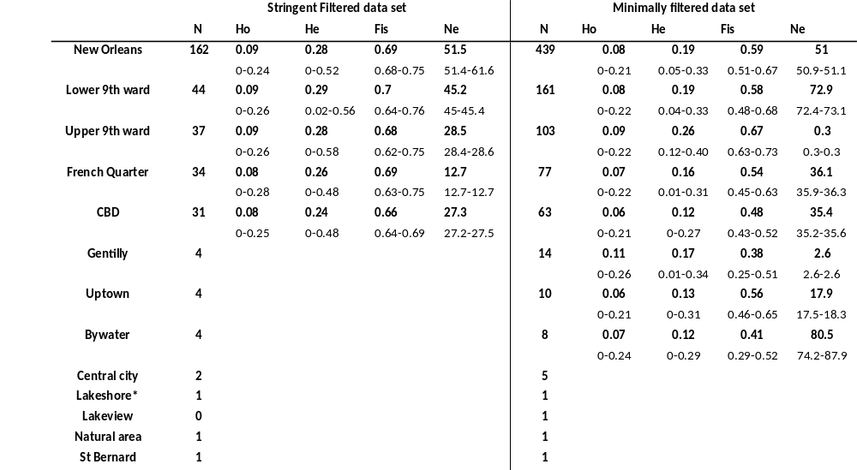

Table 2.2. Coefficients and significance of socio-environmental variables included in the top 5 models of Norway rat H_{o} ranked based on AICc values. Terms in bold are statistically significant (p < 0.05).
 | Constant | Unmaintained Vegetation | Vacancy | Tree Cover | AICc
Model 1 | 0.07 | 0.03 |  |  | -66.4
Model 2 | 0.07 |  | 0.03 |  | -65.86
Model 3 | 0.08 |  |  |  | -65.46
Model 4 | 0.06 | 0.02 | 0.03 |  | -65.28
Model 5 | 0.08 | 0.04 |  | -0.05 | -64.61

Table 2.3. Coefficients and significance of socio-environmental variables included in the top 5 models of Norway rat F_{is} ranked based on AICc values. Terms in bold are statistically significant (p < 0.05).
 | Constant | Unmaintained Vegetation | Vacancy | Human Population size | AICc
Model 1 | 0.65 |  | -0.13 |  | -26.01
Model 2 | 0.57 |  |  |  | -25.6
Model 3 | 0.55 |  |  | 0.002 | -24.71
Model 4 | 0.61 | -0.07 |  |  | -23.59
Model 5 | -2.88 |  | -0.11 | 0.001 | -23.16

Figure 2.1: The location of Norway rat trapping sites across the New Orleans study region in relation to vacancy levels and flood depth one week after Hurricane Katrina struck the city in 2005.

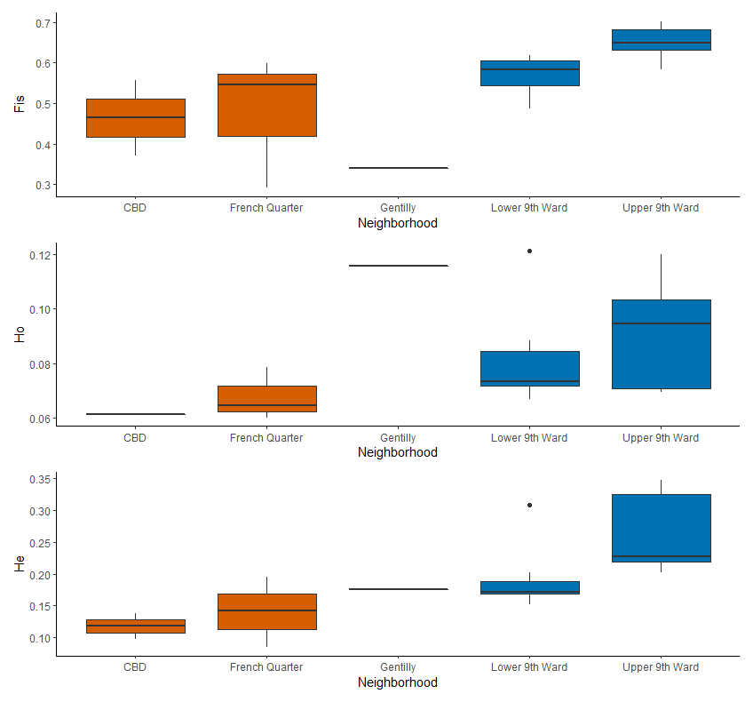

Figure 2.2: Comparisons of genetic variation (H_{e}, H_{o}, F_{is}) with the minimally filtered dataset among well-sampled neighborhoods across the study region according to flooding history (red = unflooded; blue = flooded).

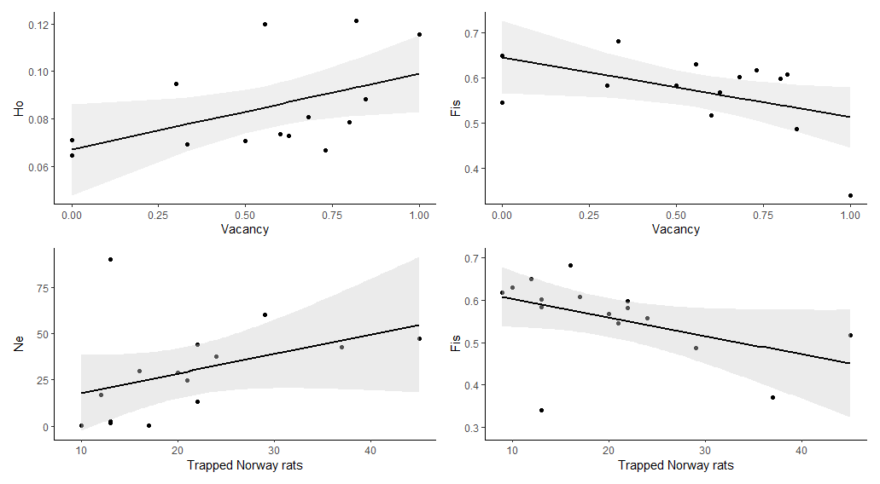

Figure 2.3.- Association between Ho (top left)_and Fis (top right) and vacancy (model results) and correlation between Ne (bottom left) and Fis (bottom right) and census trap numbers

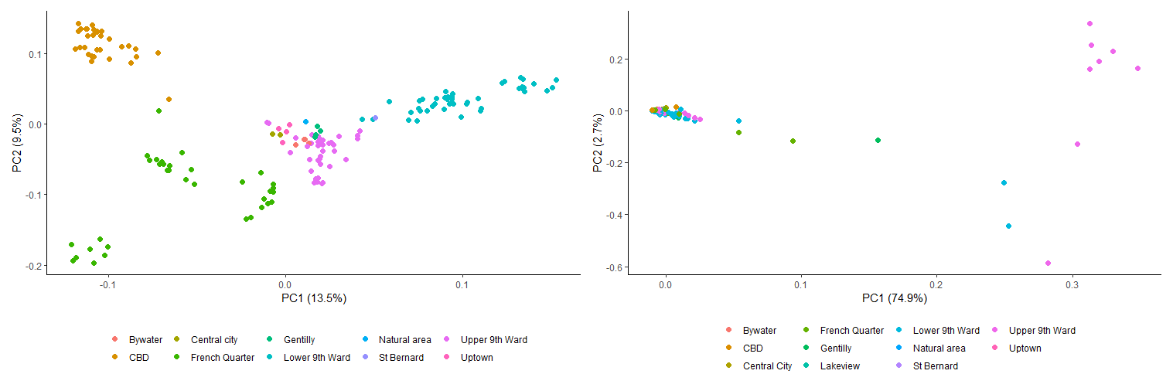
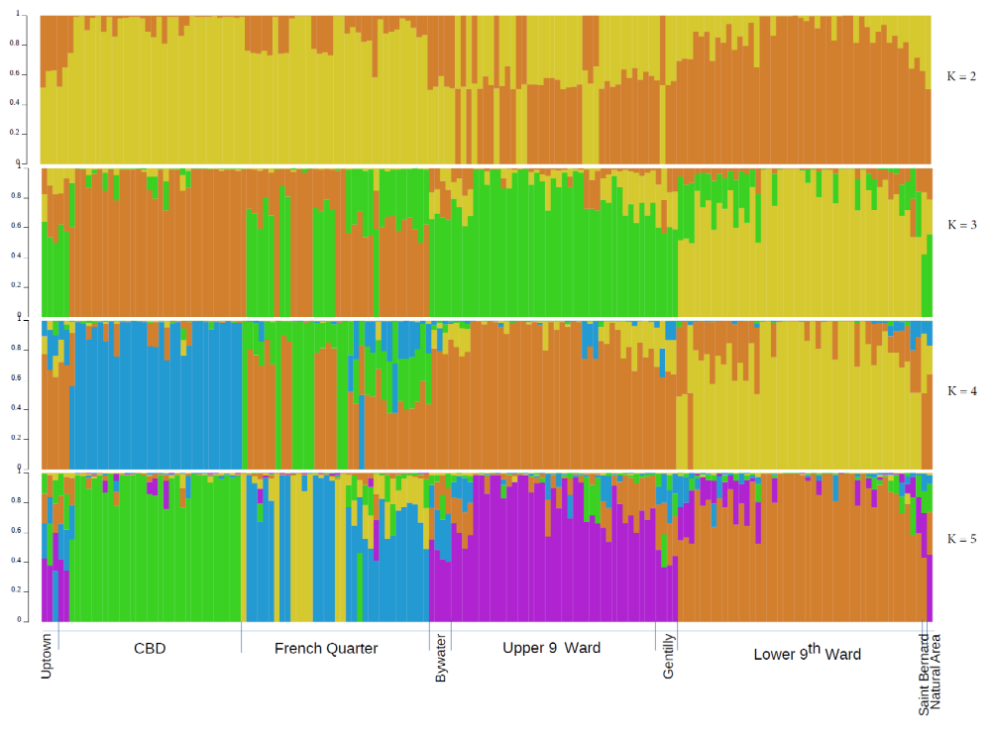
FIGURE 2.4: PCA of Norway rat genomic variation according to the stringently filtered dataset (top left) and minimally filtered dataset (top right) according to geographic location. STRUCTURE bar plots (bottom) of genotype assignments for k =2 to k = 5, based on the stringently filtered dataset, with reference to location.

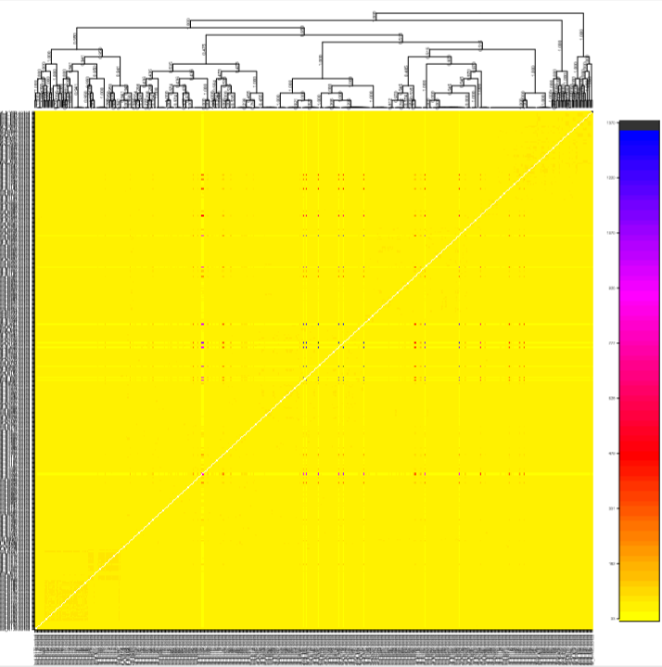
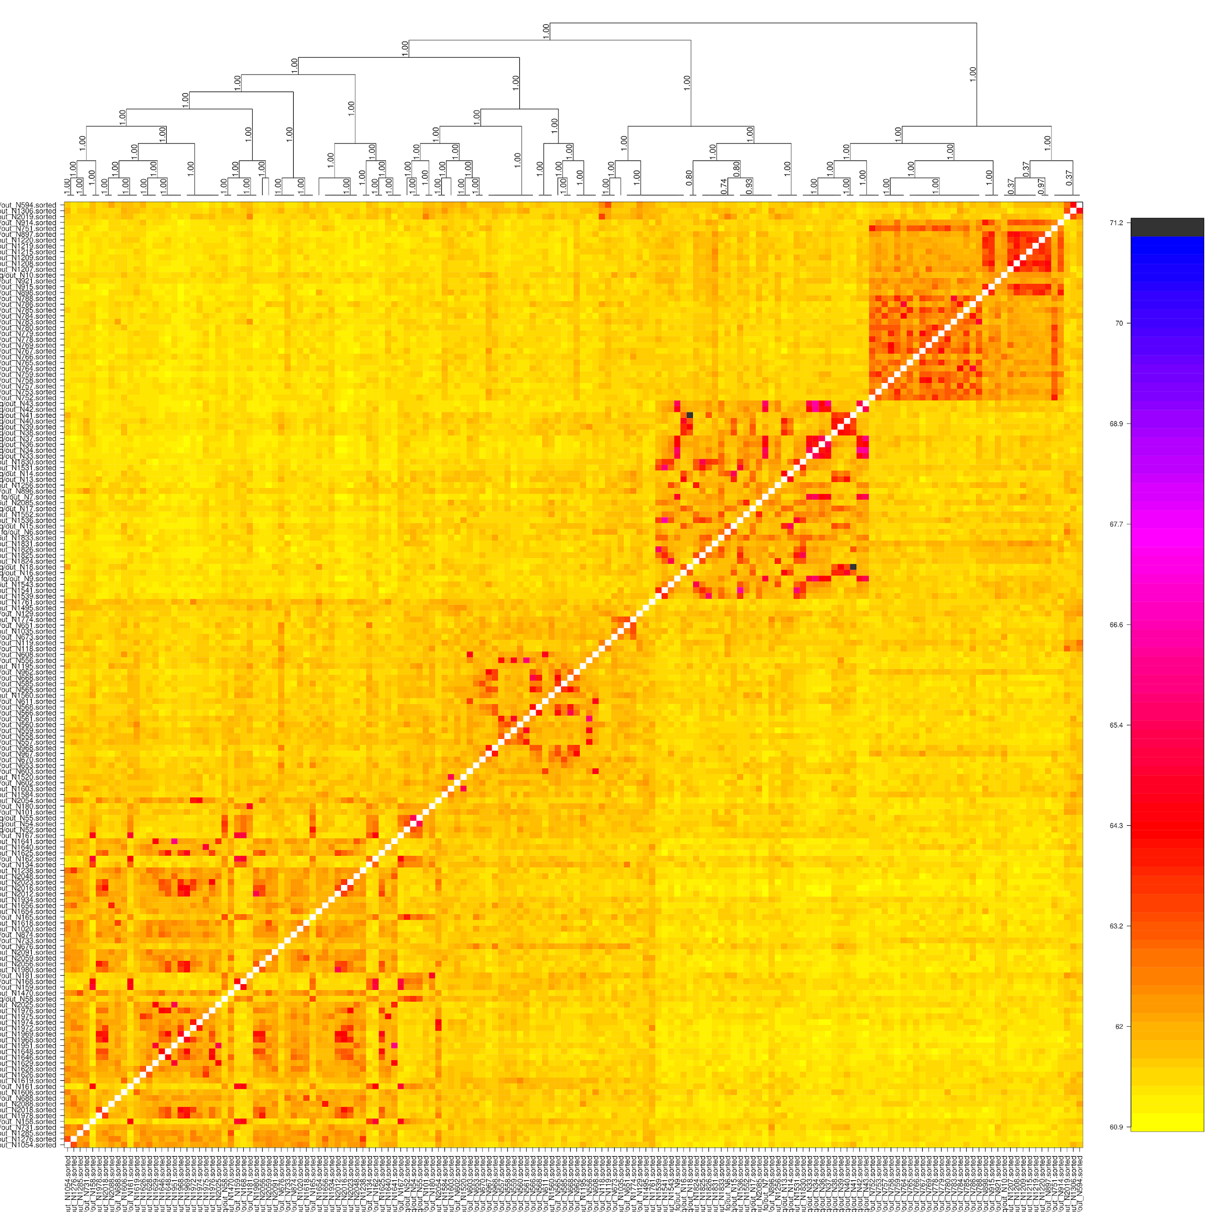

FIGURE 2.5: fineRADstructure heatmap of individual genotype assignments for the stringently filtered dataset (left) and minimally filtered dataset (right) according to location.

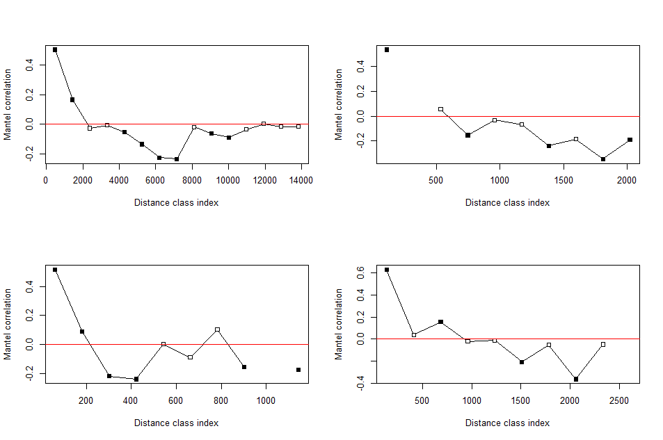

Figure 2.6. Mantel correlograms for Norway rats sampled across the New Orleans study region (upper left) versus rats sampled in the Lower 9th Ward (upper right), the French Quarter (lower left) and the Upper 9th Ward (lower right), based on the stringently filtered dataset. Filled points are statistically significant relationships of genetic distance with spatial distance.

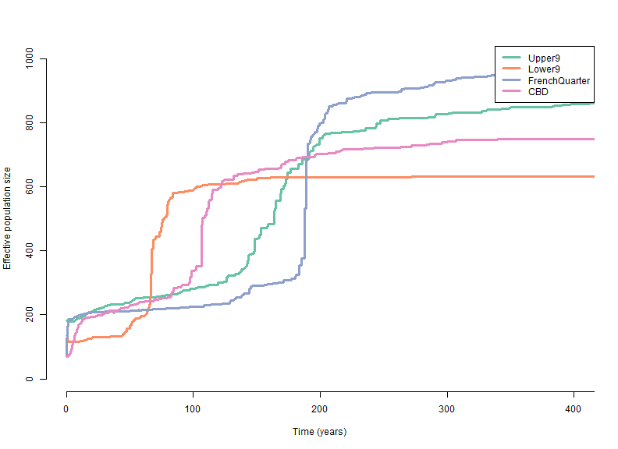
Figure 2.7: Stairway plot of demographic history for well-sampled neighborhoods included in the stringently filtered dataset.

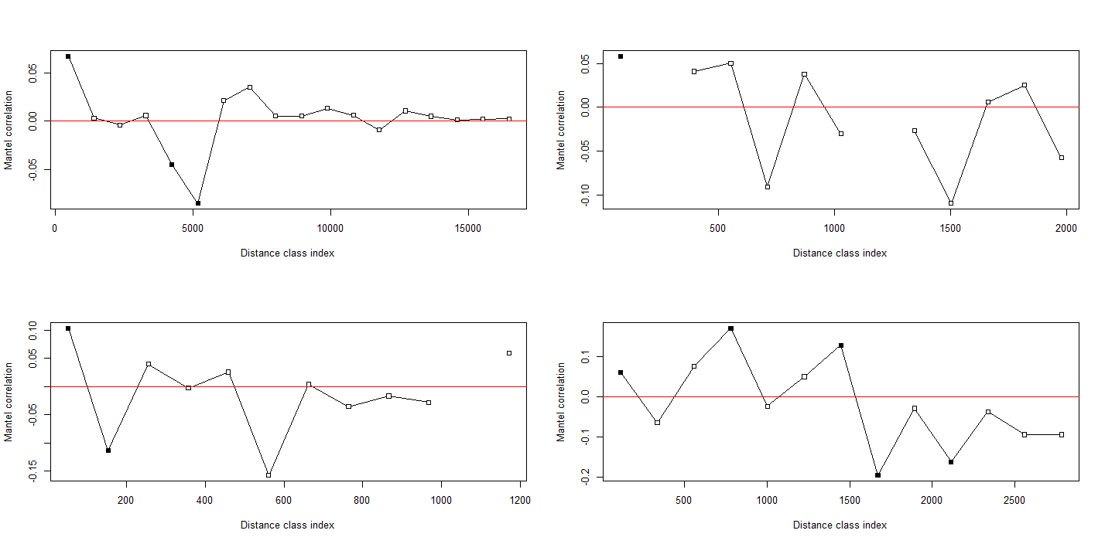
Figure 2.8. Mantel correlograms for Norway rats sampled across the New Orleans study region (upper left), the Lower 9th Ward (upper right), the French Quarter (lower left) and the Upper 9th Ward (lower right), based on the minimally filtered dataset. Filled points are statistically significant relationships of genetic distance with spatial distance.

Figure 2.9. All sites where rodents were trapped across the New Orleans study region.

CHAPTER III
In the heart of the city: Trypanosoma cruzi infection prevalence in rodents across New Orleans

A version of this chapter by Bruno M. Ghersi Ch, Anna C. Peterson, Nathaniel L. Gibson, Asha Dash, Ardem Elmayan, Hannah Schwartzenburg, Weihong Tu, Claudia Riegel, Claudia Herrera and Michael J. Blum is in review for publication in the journal Parasites & Vectors.

This article was reformatted from the submitted version as part of this dissertation M. Blum, C. Herrera, C. Rigel, and B. Ghersi conceived of the study. B. Ghersi, N. Gibson and A. Peterson collected and prepared rodent samples. A. Dash, A. Elmayan, H. Schwartzenburg, W. Tu ran the lab tests. N. Gibson conducted some analyses and B. Ghersi conducted all other analyses and wrote the manuscript. All authors provided edits and comments to the manuscript.

ABSTRACT
Trypanosoma cruzi- the causative agent of Chagas disease- is known to circulate in commensal pests, but its occurrence in urban environments is not well understood. We addressed this deficit by determining the distribution and prevalence of T. cruzi infection in urban populations of commensal and wild rodents across New Orleans (Louisiana, US). We assessed whether T. cruzi prevalence varies according to host species identity and species co-occurrences, and whether T. cruzi prevalence varies across mosaics of abandonment that shape urban rodent demography and assemblage structure in the city.
Leveraging city-wide quantitative population and assemblage surveys, we tested 1428 rodents comprising 5 species (Cotton rats, house mice, Norway rats, rice rats and roof rats) captured at 91 sites in 9 neighborhoods in Orleans Parish, one neighborhood in St. Bernard Parish, and an adjacent natural area. For further comparison, we also assayed Norway rats at one site in Baton Rouge (Louisiana, US). We used χ2 tests to determine whether infection prevalence differed among host species, among study areas, and among sites according to the number of host species present. We used generalized linear mixed models to identify individual and socioecological predictors of T. cruzi infection for all rodents and each host species, respectively.
We detected T. cruzi in all host species in all study areas in New Orleans, but not in Baton Rouge. Though overall infection prevalence was 11%, it varied by study area and trapping site. There was no difference in prevalence by species, but roof rats exhibited the broadest geographic distribution of infection across the city. Infected rodents were trapped in densely populated neighborhoods, including tourist areas like the French Quarter. Notably, infection prevalence increased with greater levels of abandonment in summer, whereas lower levels were observed during winter.
Our findings illustrate that T. cruzi can be widespread in urban landscapes, suggesting that transmission and disease risk is greater than is currently recognized. Our findings also suggest that there is disproportionate risk of transmission in historically underserved communities, which could further reinforce long-standing legacies of socioecological disparities in New Orleans and elsewhere.

INTRODUCTION
Chagas disease, caused by the zoonic protozoan Trypanasoma cruzi, is arguably the most prevalent and widespread parasitic disease in the Western Hemisphere (Kirchhoff, 2011). Most of the disease burden occurs in Central and South America, where there are 8M+ current infections and 30K+ new infections reported per year (Bern et al., 2011; Bern & Montgomery, 2009). There is growing concern that the disease will become prevalent in the United States (US) with shifting climate conditions and continuing land use intensification (Short et al., 2017). Though only 28 autochthonous cases have so far been reported in the US (Montgomery et al, 2016), wildlife surveillance has detected T. cruzi in over two dozen mammal species, raising the possibility that T. cruzi is already endemic and widespread (Kjos et al., 2009; Charles et al., 2013; Montgomery et al., 2014; Herrera et al., 2015; Hodo & Hamer, 2017).

The occurrence of all autochthonous cases of T. cruzi infection in rural and semi-rural areas of the US has sustained long-standing interest in transmission risk associated with sylvatic and peri-urban ecotonal habitats rather than urban landscapes. A growing body of evidence suggests, however, that there is risk of transmission within densely populated cities. A number of hosts are commensal pests that frequently occur in urban areas (Bern et al., 2011). Some triatomine vectors carrying T. cruzi have been detected in major city centers (Carvalho et al., 2014; Khatchikian et al., 2015; Leite Dias et al., 2016; Ribeiro et al., 2016; Ceretti-Junior et al., 2018), and others are known to have become adapted to urban habitats (Kjos et al., 2009; Herrera et al., 2015). Evidence of interactive connectivity between reservoirs and vectors (Ramsey et al., 2012) has reinforced concerns that T. cruzi can readily invade cities from peri-urban or peripheral natural areas (Berry et al., 2019; Berry et al., 2020). Reports of infected commensal and peri-domestic mammals (e.g., opossums, raccoons, rodents) in urban areas of the Caracas Valley of Venezuela and southeastern Louisiana support the supposition that Chagas disease is an emergent urban zoonosis (Herrera & Urdaneta-Morales, 1992; Herrera & Urdaneta-Morales, 1997; Urdaneta-Morales, 2014; Majeau et al., 2020), highlighting the need for further understanding of infection prevalence in hosts that reside within US cities (Ramsey et al., 2012; Majeau et al., 2020).

Rodents are among the most widespread and abundant pathogen reservoirs in cities (Himsworth et al., 2013), and thus often serve as indicators of transmission risk across urban landscapes. Though it is well understood that commensal species like Norway rats (Rattus norvegicus), roof rats (Rattus rattus) and house mice (Mus musculus) can carry T. cruzi, remarkably little is known about infection prevalence in urban populations, particularly within the US (Herrera et al., 2015; Hodo & Hamer, 2017). Small scale assays conducted in South America (e.g., Brazil, Venezuela) have illustrated that urban rodents can carry T. cruzi and that infection prevalence can be quite high in some species, including Norway rats (Herrera & Urdaneta-Morales, 1997; Panzera et al., 2004). Likewise, a recent assay of rodents from southeastern Louisiana detected T. cruzi in house mice from an urban site in New Orleans (Pronovost et al., 2019), raising the possibility that it might occur elsewhere in the city.

Here we report findings from a geographically extensive survey of T. cruzi infection in urban and peri-urban populations of rodents captured from New Orleans, with reference to a site in Baton Rouge (Louisiana, US). Our aim was to address long-standing concerns about transmission risk in the area; one of the first autochthonous cases of Chagas disease in the US occurred near New Orleans (Dorn et al., 2007), and surveys of rodents in proximate sylvatic and rural areas have found evidence of high levels of T. cruzi infection prevalence (e.g., 76%) (Herrera et al., 2015). Recent surveys also have found evidence that other rodent-borne pathogens of human concern (e.g., Angiostrongylus cantonensis, Bartonella spp., Leptospira spp.) are widespread throughout the city (Peterson et al., 2017; Rael et al., 2018; Peterson, 2019), and that pathogen transmission risk has been shaped by discriminatory public policies executed in the wake of Hurricane Katrina that have reinforced long-standing legacies of socioecological disparities (Lewis et al., 2017; Peterson et al., 2020; Ghersi et al., in review). Accordingly, to better understand T. cruzi transmission risk, we assessed (Kirchhoff, 2011) infection prevalence in urban and peri-urban rodent populations; and whether T. cruzi prevalence varies according to host species identity and species co-occurrences; and whether T. cruzi prevalence varies across mosaics of abandonment that shape urban rodent demography and assemblage structure in the city.

METHODS

Study area and rodent trapping.
We conducted quantitative population and assemblage surveys of rodents from May 2014 to February 2017 (following Tulane University IACUC protocols #0451 and #0460). We systematically trapped for larger rodents (i.e., rats) at 96 sites in 8 neighborhoods in New Orleans, an adjacent natural area in Orleans Parish and an adjacent neighborhood in St. Bernard Parish (Figure 3.1) (Rael et al., 2018; Peterson et al., 2020). The trapping sites corresponded to city blocks or the equivalent, and were selected to capture contrasting levels of income, flooding, and post-disaster landscape management after Hurricane Katrina in 2005 (Rael et al., 2018; Peterson et al., 2020). During each trapping bout, 30 Tomahawk live traps (Tomahawk Live Trap, Hazelhurst, WI, US) were set per site. At a subset of 48 sites (Figure 3.1), an equal number of Sherman traps (H.B. Sherman Traps, Inc., Tallahassee, FL, US) were set to capture smaller rodents (i.e., mice) (Peterson et al., 2020). To enable further comparisons, additional sites were opportunistically sampled in coordination with the City of New Orleans Mosquito, Termite, and Rodent Control Board, including a Norway rat colony in Baton Rouge. We measured standard weight and length of all trapped individuals, as well as species identity, sex, sexual maturity, and parity in females. We categorized all Norway rats and roof rats into 3 age classes (juvenile, subadult, adult) according to body weight (McGuire et al., 2006; King et al., 2011). Blood, urine, lung, liver, spleen, kidney, and tail tissues were sampled and archived in −80°C freezers.

Site characterization.
As described by Peterson et al. (2020), flooding history, land use and socio-demography were characterized for each trapping site in the New Orleans metro area. Surface elevation– a proxy for flooding depth– was estimated from LiDAR with reference to water level data from Lake Pontchartrain (Gesch, 2006). We used Google Earth to estimate the proportion of vacant lots (i.e., vacancy) at each site. We also conducted plot-based assays of abandonment to document unmaintained vegetation, unmaintained buildings, and debris piles at each site. Additionally, land cover classification of tree cover, open grass, urban surface/bare soil, buildings, and open water was performed on three multispectral 0.5 m resolution satellite images taken in mid-to-late March 2014, 2015 and 2016. We used 2010 US Census data to derive information on block-level human population size and household income.

Infection assay.
Infection prevalence was determined according to a diagnostic PCR-based assay (Moser et al., 1989). Following the manufacturer's protocol, we used Qiagen blood and tissue kits to extract genomic DNA from blood samples premixed with the same volume of guanidine HCL 6M and EDTA 0.2M (pH 8). DNA was also extracted from 4 different laboratory-maintained reference strains of T. cruzi, for use as positive controls. All DNA extractions were tested for the presence of T. cruzi through PCR amplification of highly repetitive nuclear satellite DNA (satDNA) using primers TcZ1 and TcZ2 (Moser et al., 1989). Infection status was determined based on electrophoresis of PCR products on an ethidium bromide stained 2.0% agarose gel run for 50 minutes at 100 V, with the presence of a 188-bp band qualifying a sample as positive for T. cruzi (Majeau et al., 2020).

Statistical analysis.
We characterized the prevalence of T. cruzi infection for all trapped species to report occurrence and distribution across all study sites, but all subsequent statistical analyses focused on Norway rats, roof rats and house mice due to low sample sizes for other species. We conducted all statistical analyses using R version 3.6.0 (R Core Team, 2019).

Following Rael et al. (2018), we used χ2 tests to determine whether infection prevalence differed among rodent host species. Pairwise tests were run to compare prevalence among hosts, correcting for multiple comparisons. Likewise, we used χ2 tests to determine whether infection prevalence differed among study areas and among sites according to the number of host species present. A subset of pairwise tests were run to compare prevalence among study areas and according to host species richness, correcting for multiple comparisons.

Following Peterson et al. (2020), we used generalized linear mixed models (glmm) with a binomial distribution to assess individual level and socioecological predictors of T. cruzi infection for all rodents and each host species, respectively. We used a set of predictors that have been found to be informative in past studies of rodents in New Orleans (Peterson et al., 2020). The global model of infection status included year, season, species (for the model describing infection in all rodents), gender, flooding depth, median household income, number of residents, remotely-sensed estimates of tree cover and the proportion of vacancy at each study site, as well as survey-based estimates of unmaintained buildings, debris, unmaintained vegetation, and the interactions of household income x flooding depth, unmaintained buildings x flooding depth, vacancy x flooding depth, vacancy x season, and vacancy x unmaintained vegetation as fixed effects. We included site as a random effect to account for the uneven distribution of individuals. For each analysis, all possible models were generated and ranked according to AICc score using the package MuMin in R. The top-selected model was determined according to the lowest AICc score.

RESULTS

Prevalence of T. cruzi infection by species and location.
We found that 158 (11%) of 1,428 rodents tested positive for T. cruzi. The protozoan was detected in all host species; of the 627 roof rats tested, 66 (11%) were positive for T. cruzi, whereas 32 (8%) of 380 Norway rats, 54 (14%) of 394 house mice, 5 (25%) of 20 Cotton rats (Sigmodon hispidus), and 1 (14%) of 7 Rice rats (Oryzomys palustris) tested positive. Infection prevalence was not significantly different between species (χ² = 9.7, p > 0.23). Infected individuals were found in all of the Orleans and St. Bernard Parish study areas, but not at the Baton Rouge site (Figure 3.1; Figure 3.3; Table 3.1). Overall infection prevalence was significantly higher (χ² = 74.5, df = 4, p =0.001) in St. Bernard Parish (38.6%) than in the Central Business District (CBD) (6.7%), Gentilly (10.1%), Lower 9th Ward (6.9%) and Upper 9th Ward (7.4%) neighborhoods in Orleans Parish (Figure 3.1). Overall prevalence also was higher in the ByWater (25.7%) than in the Lower 9th Ward neighborhood (6.9%) (Figure 3.1). Prevalence in the natural area did not differ from levels observed in other study areas (Table 3.1) (all, p > 0.05). Prevalence of infection in Norway rats did not differ among the study areas (χ² = 12.9, p > 0.29), whereas roof rats exhibited higher prevalence in the Lakeview neighborhood compared to the Lower 9th Ward ((χ² = 22.65, p < 0.02) (Figure 3.1, Table 3.1). House mice exhibited higher infection prevalence in the St. Bernard Parish neighborhood compared to individuals captured in the Lower 9th Ward (χ² = 37.7, p < 0.001) and the natural area (p < 0.02) (Figure 3.1, Table 3.1).

Environmental and individual predictors of infection.
Individual level characteristics were not especially informative predictors of infection. Infection status did not differ according to sex overall (χ² = 0.94, p = 0.33) or by species (Norway rat: χ² = 1.35, p = 0.25; roof rat: χ² = 0.11, p = 0.74; house mice: χ² = 0.07, p = 0.79). Infection status did not vary by body mass for roof rats or house mice, although smaller Norway rats were more likely to be infected (t = 2.03, p = 0.049). Infection also did not differ by age group for Norway rats or roof rats (χ² = 3.10, p = 0.21; χ² = 1.99, p = 0.37, respectively).

Total infection prevalence varied according to the presence of different host species at trapping sites. Considering sites with both Sherman and Tomahawk traps (Figure 3.1), average prevalence of T. cruzi was higher (χ² = 18.23, p = 0.001) at sites with two species (22%) than sites with 3 species (9%) (Figure 3.4). When looking at different combinations of species at a site, there was higher (χ2 = 9.93, p = 0.001) average prevalence at sites with Norway rats and house mice (42%) than sites with roof rats and house mice (14%). Notably, no relationship was found between total host abundance and infection prevalence at a site. When evaluating data from just Tomahawk traps, we found that average prevalence of T. cruzi was similar (χ² = 33.73, p = 0.21) at sites with 1 species (10%) and with 2 species of rat (15%), and there was no relationship between the number of animals trapped and infection prevalence.

The top selected model of overall infection status was >2 ΔAICc (Table 3.2) than the next best model, and thus it is the only model for which results are presented(Peterson et al., 2020). For all species, year of sampling (coef. = 0.97, p = 0.001), vacancy (coef. = 1.02, p = 0.01), season (coef. = 1.33, p < 0.001), flood depth (coef. = -0.12, p < 0.05), and the interaction of season x vacancy (coef. = -2.47, p < 0.001) were significant predictors of infection. The model indicates that animals trapped during winter in areas with higher vacancy were two times less likely to test positive for T. cruzi, whereas animals trapped during summer in areas with higher vacancy were two times more likely to test positive (Figure 3.2A). When looking at each species independently, human population (coef. = 0.04, p < 0.01), unmaintained vegetation (coef. = -4.19, p < 0.01) and year (coef. = 1.37, p < 0.02) were predictors of infection in Norway rats (Figure 3.2B); season (coef. = 1.34, p < 0.001), unmaintained vegetation (coef. = -0.86, p < 0.05), year (coef. = 0.99, p < 0.01) and the interaction of vacancy x season (coef. = -2.1, p < 0.01) were predictors of infection in roof rats (Figure 3.2C); whereas debris (coef. = -0.36, p < 0.05) was the only significant predictors of infection in house mice (Figure 3.2D). Overall infection prevalence was significantly lower during 2014 than during 2015 and 2016, which reflects variation in Norway and roof rats, as mice were only sampled during 2015 and 2016.

DISCUSSION
Here we present the most comprehensive report, thus far, of T. cruzi infection prevalence across an urban landscape, providing support for the supposition that Chagas disease is an emerging urban zoonosis (Bayer et al., 2009; Levy et al., 2014; Urdaneta-Morales, 2014). Despite evidence of transmission risk within densely populated cities elsewhere ((Herrera & Urdaneta-Morales, 1992; Herrera & Urdaneta-Morales, 1997; Urdaneta-Morales, 2014; Majeau et al., 2020), work describing the prevalence of T. cruzi in the US has largely focused on natural and peri-urban areas (Hodo & Hamer, 2017) like those where autochthonous cases of Chagas disease have been detected (Manne-Goehler et al., 2016). Our results demonstrate that T. cruzi is circulating in urban rodent populations across New Orleans at an overall prevalence of 11%. We detected T. cruzi in all host species in all study areas in New Orleans, including densely populated tourist areas like the French Quarter. Whereas infection prevalence did not differ by host species, it did vary by study area and trapping site, in part because of variation in the rodent assemblage structure across the city (Peterson et al., 2020). Prevalence also appears to be mediated by features of disaster-driven counter-urbanization in the study area (Rael et al., 2018; Peterson et al., 2020; Ghersi et al., in review). Evidence that T. cruzi can be widespread and abundant in urban landscapes suggests that transmission risk in the US is greater than is currently recognized. Our findings also indicate that it is likely there is disproportionate risk of transmission in historically underserved communities, which could further reinforce long-standing legacies of socioecological disparities in New Orleans and elsewhere (Gulachenski et al., 2016; Lewis et al., 2017; Peterson et al., 2020).

There are some notable similarities in the epidemiology of T. cruzi infection in New Orleans and urban areas where the T. cruzi is considered to be endemic. For example, we detected T. cruzi in all five of the rodent host species found in New Orleans (Ghersi et al., in review), which parallels reports of T. cruzi infections in multiple rodent and other mammalian host species trapped in residential neighborhoods in the Yucatan (Panti-May et al., 2017) and Caracas Valley (Herrera & Urdaneta-Morales, 1992; Herrera & Urdaneta-Morales, 1997). We also found a comparable level of overall infection prevalence in New Orleans (Herrera & Urdaneta-Morales, 1997; Panti-May et al., 2017; Trüeb et al., 2018). It is notable, however, that we did not find differences in prevalence among host species. Greater variation has been found elsewhere, including among urban populations of commensal rodents. For example, surveys in the Yucatan and Caracas Valley found that T. cruzi was more prevalent in roof rats than in house mice (Herrera & Urdaneta-Morales, 1997; Panti-May et al., 2017). Likewise, no evidence of infection was found in rodents trapped in forest fragments in Salvador (Brazil), where only Didelphis opossums were found to carry T. cruzi (Trüeb et al., 2018). More extensive surveys of urban hosts in endemic areas might reveal greater parity in infection prevalence, however, as most prior work has involved comparisons among a much smaller number of trapped individuals than the number of rodents assayed from New Orleans (Herrera & Urdaneta-Morales, 1992; Herrera & Urdaneta-Morales, 1997; Panti-May et al., 2017; Carhuallanqui et al., 2017; Trüeb et al., 2018).

Detection of infected rodent hosts in all of our study areas indicates that transmission is local and widespread across New Orleans. Though the possibility of local transmission has been raised by prior work on other urban commensal and domestic mammal species (Urdaneta-Morales, 2014), it has been difficult to exclude alternatives like geographic transience and interactive connectivity between reservoirs and vectors (Ramsey et al., 2012) located in peripheral habitats (Trüeb et al., 2018). In part, this is because limited trapping as well as a focus on hosts with large range sizes and high mobility has prevented identification of the point(s) of infection. This is well illustrated by a recent study (Majeau et al., 2020) conducted in New Orleans and Baton Rouge that found evidence of high infection prevalence (23-43%) in raccoons (Procyon lotor), which can readily travel between urban and nearby natural areas (Gross et al., 2012). Commensal rodents, on the other hand, typically move < 200 m from their nest (Heiberg et al., 2012). Accordingly, infected individuals must have acquired T. cruzi close to the respective trapping location, indicating that at least one vector is also likely in the area. Surveys have not yet been conducted to assay the incidence of known vectors in New Orleans, but the possibility of local transmission is supported by surveys that have detected the vector Triatoma sanguisuga in urban areas in Texas and Tennessee (Newsome & McGhee, 2006; Dye-Braumuller et al., 2019). Prior work elsewhere also indicates that other vectors (e.g., Triatoma infestans) can migrate from rural environments and subsequently become endemic to urban areas (Delgado et al., 2013). Determining the incidence of vectors in New Orleans would offer a more complete characterization of local transmission cycle(s) and thus clarify the risk of transmission to humans across the city. Likewise, further assessment of conditions in Baton Rouge would help resolve apparent inconsistencies between our results and evidence from prior studies showing that racoons harbor high levels of infection across the city(Majeau et al., 2020)

Our findings indicate that biotic and landscape features shape infection prevalence in rodent hosts across the New Orleans metro area. With little exception, the likelihood of infection did not differ according to individual level host attributes. On the other hand, we found evidence indicating that infection was likelier at sites with greater host richness, dependent on the particular host species present. This result highlights the need for further understanding of how host co-occurrence and abundance influences T. cruzi transmission in cities. Prevalence also appears to be mediated by disaster-driven counter-urbanization that has progressed in the study areas since Hurricane Katrina in 2005 (Rael et al., 2016; Peterson, 2019; Ghersi et al., in review.). Catastrophic flooding, discriminatory resettlement and rebuilding policies, and municipal differences in land management have given rise to a socioecological mosaic of abandonment across New Orleans (Lewis et al., 2017; Peterson et al., 2020). Overall and individual species-level prevalence strongly reflected elements of abandonment including the severity of flooding disturbance (i.e., depth), vacancy, and debris at trapping sites. The same factors also appear to shape rodent demography and assemblage structure in the city (Peterson et al., 2020; Ghersi et al., in review), raising the possibility that the recovered relationships with T. cruzi infection prevalence are simply a secondary phenomenon (i.e., a byproduct of variation in rodent demography and assemblage structure). However, we also found that the influence of counter-urbanization (i.e., vacancy) varies by season (Figure 3.2), which is consistent with indications from surveys of other mammalian hosts in New Orleans (Majeau et al., 2020) that infection prevalence is seasonally dynamic. This illustrates that the likelihood of infection is not just a function of rodent host responses to habitat or resource availability. Rather, it also probably reflects habitat-mediated variation in vector occurrence (Carvalho et al., 2014; Leite Dias et al., 2016) or interactions between hosts, vectors, and T. cruzi parasites (López-Cancino et al., 2015). Further work is thus warranted to better understand how socioecological factors shape the urban epidemiology of T. cruzi.

Disparities in disaster-driven abandonment across New Orleans (Gulachenski et al., 2016; Lewis et al., 2017; Peterson et al., 2020) indicate that there is likely greater risk of pathogen transmission in historically underserved communities (Rael et al., 2018). Our findings suggest, however, that transmission risk is highly heterogeneous within and among neighborhoods due to variation in site-level characteristics that govern infection prevalence. This is well illustrated by comparisons of the Lower 9th Ward to adjacent areas in St. Bernard Parish (Figure 3.1). Both neighborhoods are burdened by comparably high levels of disaster-driven vacancy but exhibit contrasting habitat characteristics and rodent assemblages, reflecting differences in post-Katrina municipal land management (Lewis et al., 2017; Peterson et al., 2020). The overall prevalence of T. cruzi infection also differs between the neighborhoods (Figure 3.1, Table 3.1), indicating that transmission risk is not simply a function of vacancy, but that it also depends on local habitat conditions (e.g., maintained versus unmaintained vegetation, the occurrence of favored plant species, etc.) that may govern tritrophic interactions. Further study that reveals the scale of associations would better define transmission risk and shed light on whether proactive measures (e.g., rodent control, removing debris, maintaining vegetation) can be taken to reduce infection prevalence(Levy et al., 2010). Likewise, understanding variation in infection intensity and the diversity of T. cruzi carried by vectors and hosts (Herrera et al., 2015; Pronovost et al., 2019) could help alleviate potential risks to human well-being in cities across the US and elsewhere (Bern et al., 2011; Eskew & Olival, 2018; Urdaneta-Morales, 2014).

REFERENCES
Carhuallanqui, A., Chávez A., & Pinedo, R. (2017). Trypanosoma spp in rats (Rattus rattus and Rattus norvegicus) from two environmentS: Food markets and pig farms. In Revista de Investigaciones Veterinarias del Peru, 28(4), 958–968. https://doi.org/10.15381/rivep.v28i4.13880
Bayer, A. M., Hunter, G. C., Gilman, R. H., del Carpio, J. G. C., Naquira, C., Bern, C., & Levy, M. Z. (2009). Chagas disease, migration and community settlement patterns in Arequipa, Peru. PLoS Neglected Tropical Diseases, 3(12), e567. https://doi.org/10.1371/journal.pntd.0000567
Bern, C., Kjos, S., Yabsley, M. J., & Montgomery, S. P. (2011). Trypanosoma cruzi and chagas’ disease in the united states. In Clinical Microbiology Reviews. 24(4), 655–681. https://doi.org/10.1128/CMR.00005-11
Bern, C., & Montgomery, S. P. (2009). An Estimate of the Burden of Chagas Disease in the United States. Clinical Infectious Diseases, 49(5), e52–e54. https://doi.org/10.1086/605091
Berry, A. S. F., Salazar-Sánchez, R., Castillo-Neyra, R., Borrini-Mayorí, K., Arevalo-Nieto, C., Chipana-Ramos, C., Vargas-Maquera, M., Ancca-Juarez, J., Náquira-Velarde, C., Levy, M. Z., & Brisson, D. (2020). Dispersal patterns of trypanosoma cruzi in Arequipa, Peru. PLoS Neglected Tropical Diseases, 14(3). https://doi.org/10.1371/journal.pntd.0007910
Berry, A. S. F., Salazar-Sánchez, R., Castillo-Neyra, R., Borrini-Mayorí, K., Chipana-Ramos, C., Vargas-Maquera, M., Ancca-Juarez, J., Náquira-Velarde, C., Levy, M. Z., & Brisson, D. (2019). Immigration and establishment of Trypanosoma cruzi in Arequipa, Peru. PLoS ONE, 14(8). https://doi.org/10.1371/journal.pone.0221678
Carvalho, D. B., Almeida, C. E., Rocha, C. S., Gardim, S., Mendonça, V. J., Ribeiro, A. R., Alves, Z. C. P. V. T., Ruellas, K. T., Vedoveli, A., & da Rosa, J. A. (2014). A novel association between Rhodnius neglectus and the Livistona australis palm tree in an urban center foreshadowing the risk of Chagas disease transmission by vectorial invasions in Monte Alto City, São Paulo, Brazil. Acta Tropica, 130, 35–38. https://doi.org/10.1016/j.actatropica.2013.10.009
Ceretti-Junior, W., Vendrami, D. P., de Matos-Junior, M. O., Rimoldi-Ribeiro, A., Alvarez, J. V., Marques, S., Duarte, A. N., da Silva, R. A., da Rosa, J. A., & Marrelli, M. T. (2018). Occurrences of triatomines (Hemiptera: Reduviidae) and first reports of Panstrongylus geniculatus in urban environments in the city of Sao Paulo, Brazil. Revista Do Instituto de Medicina Tropical de Sao Paulo, 60(e33). https://doi.org/10.1590/S1678-9946201860033
Charles, R. A., Kjos, S., Ellis, A. E., Barnes, J. C., & Yabsley, M. J. (2013). Southern plains woodrats (Neotoma micropus) from Southern Texas are important reservoirs of two genotypes of trypanosoma cruzi and host of a putative novel trypanosoma species. Vector-Borne and Zoonotic Diseases, 13(1), 22–30. https://doi.org/10.1089/vbz.2011.0817
Delgado, S., Ernst, K. C., Pumahuanca, M. L. H., Yool, S. R., Comrie, A. C., Sterling, C. R., Gilman, R. H., Náquira, C., & Levy, M. Z. (2013). A country bug in the city: Urban infestation by the Chagas disease vector Triatoma infestans in Arequipa, Peru. International Journal of Health Geographics, 12(48). https://doi.org/10.1186/1476-072X-12-48
Dorn, P. L., Perniciaro, L., Yabsley, M. J., Roellig, D. M., Balsamo, G., Diaz, J., & Wesson, D. (2007). Autochthonous transmission of Trypanosoma cruzi, Louisiana. Emerging Infectious Diseases, 13(4), 605–607. https://doi.org/10.3201/eid1304.061002
Dye-Braumuller, K. C., Gorchakov, R., Gunter, S. M., Nielsen, D. H., Roachell, W. D., Wheless, A., Debboun, M., Murray, K. O., & Nolan, M. S. (2019). Identification of Triatomines and Their Habitats in a Highly Developed Urban Environment. Vector-Borne and Zoonotic Diseases, 19(4), 265–273. https://doi.org/10.1089/vbz.2018.2352
Eskew, E. A., & Olival, K. J. (2018). De-urbanization and Zoonotic Disease Risk. Ecohealth, 15(4), 707–712. https://doi.org/10.1007/s10393-018-1359-9
Gesch, D. B. (2006). Topography-based Analysis of Hurricane Katrina Inundation of New Orleans. In G. S. Farris, G. J. Smith, M. P. Crane, C. R. Demas, L. L. Robbins, & D. L. Lavoie (Eds.), Science and the Storms: the USGS Response to the Hurricanes of 2005. U.S. Geological Survey.
Ghersi, B. M., Peterson, A. C., Riegel, C., Campanella, R., Childs, J. E., & Blum, M. J. (n.d.). Flooding and abandonment have shaped rat demography across post-Katrina New Orleans. Landscape and Urban Planning, in review.
Gross, J., Elvinger, F., Hungerford, L. L., & Gehrt, S. D. (2012). Raccoon use of the urban matrix in the Baltimore Metropolitan Area, Maryland. Urban Ecosystems, 15, 667–682. https://doi.org/10.1007/s11252-011-0218-z
Gulachenski, A., Ghersi, B. M., Lesen, A. E., & Blum, M. J. (2016). Abandonment, ecological assembly and public health risks in counter-urbanizing cities. Sustainability, 8(5), 491. https://doi.org/https://doi.org/10.3390/su8050491
Heiberg, A. C., Sluydts, V., & Leirs, H. (2012). Uncovering the secret lives of sewer rats (Rattus norvegicus): movements, distribution and population dynamics revealed by a capture-mark-recapture study. Wildlife Research, 39(3), 202–219. https://doi.org/10.1071/WR11149
Herrera, C. P., Licon, M. H., Nation, C. S., Jameson, S. B., & Wesson, D. M. (2015). Genotype diversity of Trypanosoma cruzi in small rodents and Triatoma sanguisuga from a rural area in New Orleans, Louisiana. Parasites and Vectors, 8(1). https://doi.org/10.1186/s13071-015-0730-8
Herrera, L., & Urdaneta-Morales, S. (1992). Didelphis marsupialis: A primary reservoir of Trypanosoma cruzi in urban areas of Caracas, Venezuela. Annals of Tropical Medicine and Parasitology, 86(6), 607–612. https://doi.org/10.1080/00034983.1992.11812716
Herrera, Leidi, & Urdaneta-Morales, S. (1997). Synanthropic rodent reservoirs of Trypanosoma (Schizotrypanum) cruzi in the valley of Caracas, Venezuela. Revista Do Instituto de Medicina Tropical de Sao Paulo, 39(5), 279–282. https://doi.org/10.1590/S0036-46651997000500006
Himsworth, C. G., Parsons, K. L., Jardine, C., & Patrick, D. M. (2013). Rats, cities, people, and pathogens: A systematic review and narrative synthesis of literature regarding the ecology of rat-associated zoonoses in urban centers. Vector-Borne and Zoonotic Diseases, 13(6), 349–359. https://doi.org/10.1089/vbz.2012.1195
Hodo, C. L., & Hamer, S. A. (2017). Toward an ecological framework for assessing reservoirs of vector-borne pathogens: Wildlife reservoirs of trypanosoma cruzi across the southern United States. ILAR Journal, 58(3), 379–392. https://doi.org/10.1093/ilar/ilx020
Khatchikian, C. E., Foley, E. A., Barbu, C. M., Hwang, J., Ancca-Juárez, J., Borrini-Mayori, K., Quıspe-Machaca, V. R., Naquira, C., Brisson, D., & Levy, M. Z. (2015). Population Structure of the Chagas Disease Vector Triatoma infestans in an Urban Environment. PLoS Neglected Tropical Diseases, 9(2). https://doi.org/10.1371/journal.pntd.0003425
King, C. M., Innes, J. G., Gleeson, D. M., Fitzgerald, N., Winstanley, T., O’Brien, B., Bridgman, L. J., & Cox, N. R. (2011). Reinvasion by ship rats (Rattus rattus) of forest fragments after eradication. Biological Invasions, 13(10), 2391–2408. https://doi.org/DOI:10.1007/s10530-011-0051-6
Kirchhoff, L. v. (2011). Epidemiology of American Trypanosomiasis (Chagas Disease). In Advances in Parasitology (Vol. 75, pp. 1–18). https://doi.org/10.1016/B978-0-12-385863-4.00001-0
Kjos, S. A., Snowden, K. F., & Olson, J. K. (2009). Biogeography and Trypanosoma cruzi infection prevalence of chagas disease vectors in Texas, USA. Vector-Borne and Zoonotic Diseases, 9(1), 41–49. https://doi.org/10.1089/vbz.2008.0026
Leite Dias, J. V., Mota Queiroz, D. R., Rodrigues Martins, H., Eladio Gorla, D., Rocha Pires, H. H., & Diotaiuti, L. (2016). Spatial distribution of triatomines in domiciles of an urban area of the Brazilian Southeast region. Memorias Do Instituto Oswaldo Cruz, 111(1), 43–50. https://doi.org/10.1590/0074-02760150352
Levy, M. Z., Barbu, C. M., Castillo-Neyra, R., Quispe-Machaca, V. R., Ancca-Juarez, J., Escalante-Mejia, P., Borrini-Mayori, K., Niemierko, M., Mabud, T. S., Behrman, J. R., Naquira-Velarde, C., Malaga-Chavez, F., Catacora, A., Oppe, K., Levy, K., Hillyard, M., Christenson, M., Mollesaca-Riveros, L., Ylla-Velásquez, J., … Carrion, O. (2014). Urbanization, land tenure security and vector-borne Chagas disease. Proceedings of the Royal Society B: Biological Sciences, 281(1789). https://doi.org/10.1098/rspb.2014.1003
Levy, M. Z., Malaga Chavez, F. S., Cornejo Del Carpio, J. G., Vilhena, D. A., McKenzie, F. E., & Plotkin, J. B. (2010). Rational spatio-temporal strategies for controlling a Chagas disease vector in urban environments. Journal of the Royal Society Interface, 7(48), 1061–1070. https://doi.org/10.1098/rsif.2009.0479
Lewis, J. A., Zipperer, W. C., Ernstson, H., Bernik, B., Hazen, R., Elmqvist, T., & Blum, M. J. (2017). Socioecological disparities in New Orleans following Hurricane Katrina. Ecosphere, 8(9), e01922. https://doi.org/https://doi.org/10.1002/ecs2.1922
López-Cancino, S. A., Tun-Ku, E., de la Cruz-Felix, H. K., Ibarra-Cerdena, C. N., Izeta-Alberdi, A., Pech-May, A., Mazariegos-Hidalgo, C. J., Valdez-Tah, A., & Ramsey, J. M. (2015). Landscape ecology of Trypanosoma cruzi in the southern Yucatan Peninsula. Acta Tropica, 151(1), 58–72. https://doi.org/10.1016/j.actatropica.2015.07.021
Majeau, A., Pronovost, H., Sanford, A., Cloherty, E., Anderson, A. N., Balsamo, G., Gee, L., Straif-Bourgeois, S. C., & Herrera, C. (2020). Raccoons As an Important Reservoir for Trypanosoma cruzi: A Prevalence Study from Two Metropolitan Areas in Louisiana. Vector-Borne and Zoonotic Diseases. https://doi.org/10.1089/vbz.2019.2559
Manne-Goehler, J., Umeh, C. A., Montgomery, S. P., & Wirtz, V. J. (2016). Estimating the Burden of Chagas Disease in the United States. PLoS Neglected Tropical Diseases, 10(11). https://doi.org/10.1371/journal.pntd.0005033
McGuire, B., Pizzuto, T., Bemis, W. E., & Getz, L. L. (2006). General Ecology of a Rural Population of Norway Rats (Rattus norvegicus) Based on Intensive Live Trapping. 155(1). BIOONE. https://doi.org/10.1674/0003-0031(2006)155[0221:GEOARP]2.0.CO;2
Montgomery, S. P., Parise, M. E., Dotson, E. M., & Bialek, S. R. (2016). Perspective piece what do we know about chagas disease in the United States? American Journal of Tropical Medicine and Hygiene, 95(6), 1225–1227. https://doi.org/10.4269/ajtmh.16-0213
Montgomery, S. P., Starr, M. C., Cantey, P. T., Edwards, M. S., & Meymandi, S. K. (2014). Neglected parasitic infections in the United States: Chagas disease. American Journal of Tropical Medicine and Hygiene, 90(5), 814–818. https://doi.org/10.4269/ajtmh.13-0726
Moser, D. R., Kirchhoff, L. v., & Donelson, J. E. (1989). Detection of Trypanosoma cruzi by DNA amplification using the polymerase chain reaction. Journal of Clinical Microbiology, 27(7), 1477–1482. https://doi.org/10.1128/jcm.27.7.1477-1482.1989
Newsome, A. L., & McGhee, C. R. (2006). Trypanosoma cruzi in triatomes from an urban and a domestic setting in middle Tennessee. Journal of the Tennessee Academy of Science, 81(3–4).
Panti-May, J. A., de Andrade, R. R. C., Gurubel-González, Y., Palomo-Arjona, E., Sodá-Tamayo, L., Meza-Sulú, J., Ramírez-Sierra, M., Dumonteil, E., Vidal-Martínez, V. M., Machaín-Williams, C., de Oliveira, D., Reis, M. G., Torres-Castro, M. A., Robles, M. R., Hernández-Betancourt, S. F., & Costa, F. (2017). A survey of zoonotic pathogens carried by house mouse and black rat populations in Yucatan, Mexico. Epidemiology and Infection, 145(11), 2287–2295. https://doi.org/10.1017/S0950268817001352
Panzera, F., Dujardin, J. P., Nicolini, P., Caraccio, M. N., Rose, V., Tellez, T., Bermúdez, H., Bargues, M. D., Mas-Coma, S., O’Connor, J. E., & Pérez, R. (2004). Genomic Changes of Chagas Disease Vector, South America. Emerging Infectious Diseases, 10(3), 438–446. https://doi.org/10.3201/eid1003.020812
Peterson, A. C. (2019). Rodent assemblages and rodent associated pathogens in a counter-urbanizing landscape. Doctoral Dissertation. https://trace.tennessee.edu/utk_graddiss/5409
Peterson, A. C., Ghersi, B. M., Alda, F., Firth, C., Frye, M. J., Bai, Y., Osikowicz, L. M., Riegel, C., Lipkin, W. I., Kosoy, M. Y., & Blum, M. J. (2017). Rodent-Borne Bartonella Infection Varies According to Host Species Within and Among Cities. EcoHealth, 14(4), 771–782. https://doi.org/10.1007/s10393-017-1291-4
Peterson, A. C., Ghersi, B. M., Campanella, R., Riegel, C., Lewis, J. A., & Blum, M. J. (2020). Rodent assemblage structure reflects socioecological mosaics of counter-urbanization across post-Hurricane Katrina New Orleans. Landscape and Urban Planning, 195, 103710. https://doi.org/10.1016/j.landurbplan.2019.103710
Pronovost, H., Peterson, A. C., Ghersi, B. M., Blum, M. J., Dumonteil, E., & Herrera, C. P. (2019). Deep sequencing reveals multiclonality and new discrete typing units of Trypanosoma cruzi in rodents from the southern United States. Journal of Microbiology, Immunology and Infection. https://doi.org/10.1016/j.jmii.2018.12.004
Rael, R. C., Peterson, A. C., Ghersi, B. M., Childs, J., & Blum, M. J. (2016). Disturbance, reassembly, and disease risk in socioecological systems. Ecohealth, 13, 450–455. https://doi.org/10.1007/s10393-016-1157-1
Rael, R. C., Peterson, A. C., Ghersi, B. M., Riegel, C., Lesen, A. E., & Blum, M. J. (2018). Rat lungworm infection in rodents across post-Katrina New Orleans, Louisiana, USA. Emerging Infectious Diseases, 24(12), 2176–2183. https://doi.org/10.3201/eid2412.180056
Ramsey, J. M., Gutiérrez-Cabrera, A. E., Salgado-Ramírez, L., Peterson, A. T., Sánchez-Cordero, V., & Ibarra-Cerdeña, C. N. (2012). Ecological Connectivity of Trypanosoma cruzi Reservoirs and Triatoma pallidipennis Hosts in an Anthropogenic Landscape with Endemic Chagas Disease. PLoS ONE, 7(9). https://doi.org/10.1371/journal.pone.0046013
Ribeiro, A. R., de Oliveira, R. C., Ceretti Junior, W., Lima, L., de Almeida, L. A., Nascimento, J. D., Teixeira, M. M. G., & da Rosa, J. A. (2016). Trypanosoma cruzi isolated from a triatomine found in one of the biggest metropolitan areas of Latin America. Revista Da Sociedade Brasileira de Medicina Tropical, 49(2), 183–189. https://doi.org/10.1590/0037-8682-0366-2015
Short, E. E., Caminade, C., & Thomas, B. N. (2017). Climate Change Contribution to the Emergence or Re-Emergence of Parasitic Diseases. Infectious Diseases: Research and Treatment, 10, 1–7. https://doi.org/10.1177/1178633617732296
Trüeb, I., Portela, R. D., Franke, C. R., Carneiro, I. O., Ribeiro, G. J., Soares, R. P., & Barrouin-Melo, S. M. (2018). Trypanosoma cruzi and Leishmania sp. infection in wildlife from urban rainforest fragments in northeast Brazil. Journal of Wildlife Diseases, 54(1), 76–84. https://doi.org/10.7589/2017-01-017
Urdaneta-Morales, S. (2014). Chagas’ disease: An emergent urban zoonosis. The Caracas Valley (Venezuela) as an epidemiological model. Frontiers in Public Health, 2(265). https://doi.org/10.3389/fpubh.2014.00265

APPENDIX
TABLES
Table 3.1. Prevalence of T. cruzi infection (number positive / number tested, followed by % in parentheses) in rodents by species and across all species sampled in New Orleans and Baton Rouge (Louisiana).

Study area | Norway rat | Roof rat | House mouse | Cotton rat | Rice rat | TOTAL
Bywater | 3/9 (33) | 6/26 (23) | -- | -- | -- | 9/35 (26)
CBD | 3/44 (7) | -- | 0/1 (0) | -- | -- | 3/45 (7)
French Quarter | 7/52 (13) | 1/8 (13) | -- | -- | -- | 8/60 (13)
Gentilly | 2/14 (14) | 6/89 (7) | 8/55 (15) | -- | -- | 16/158 (10)
Lakeshore | 0/1 (0) | 10/71 (14) | -- | -- | -- | 10/72 (14)
Lakeview | 0/1 (0) | 16/77 (21) | -- | -- | -- | 16/78 (21)
Lower 9th Ward | 10/159 (6) | 9/177 (5) | 21/239 (9) | 0/4 (0) | -- | 40/579 (7)
Natural area | 0/2 (0) | 2/22 (9) | 4/43 (9) | 5/16 (31) | 1/7 (14) | 12/90 (13)
St Bernard Parish | 0/1 (0) | 1/4 (25) | 21/52 (40) | -- | -- | 22/57 (39)
Upper 9th Ward | 5/78 (6) | 8/98 (8) | -- | -- | -- | 13/176 (7)
Uptown | 2/13 (15) | 7/45 (16) | 0/4 (0) | -- | -- | 9/72 (13)
Baton Rouge | 0/6 (0) | -- | -- | -- | -- | 0/6 (0)
TOTAL | 32/380 (8) | 66/627 (11) | 54/394 (14) | 5/20 (25) | 1/7 (14) | 158/1428 (11)

Table 3.2 Coefficients and significance of socio-environmental variables included in the top 5 models of rodent infection with T. cruzi ranked based pm AICc values. Terms in bold are statistically significant (p < 0.05).

 | Constant | Debris | Flood Depth | Vacancy | Season (winter) | Sex (Male) | Year (2015) | Year (2016) | Unmaintained Vegetation | Vacancy: season | Total population | AICc
Model 1 | -3.17 |  | -0.12 | 1.02 | 1.33 | 0.21 | 0.97 | 0.85 |  | -2.46 |  | 917.2
Model 2 | -3.19 |  |  | 1.02 | 1.22 | 0.21 | 0.96 | 0.78 | -0.57 | -2.32 |  | 918.8
Model 3 | -3.23 | -0.1 |  | 0.85 | 1.27 | 0.2 | 0.93 | 0.77 |  | -2.33 |  | 918.9
Model 4 | -3.41 |  |  | 0.85 | 1.28 | 0.2 | 0.97 | 0.82 |  | -2.37 |  | 919
Model 5 | -3.53 |  |  | 0.96 | 1.28 | 0.2 | 1 | 0.85 |  | -2.36 | 0.01 | 920.2

FIGURES
Figure 3.1: (A) Map of T. cruzi infection prevalence by rodent species across Orleans Parish and St Bernard Parish, with Tomahawk-only trapping areas outlined in red and Tomahawk + Sherman trapping areas outlined in blue (B) T. cruzi infection prevalence in each host species by study area, where color indicates species, bars represent the first and third quartiles, vertical lines represent the minimum and maximum range relative to the quartiles, and dots are outliers.

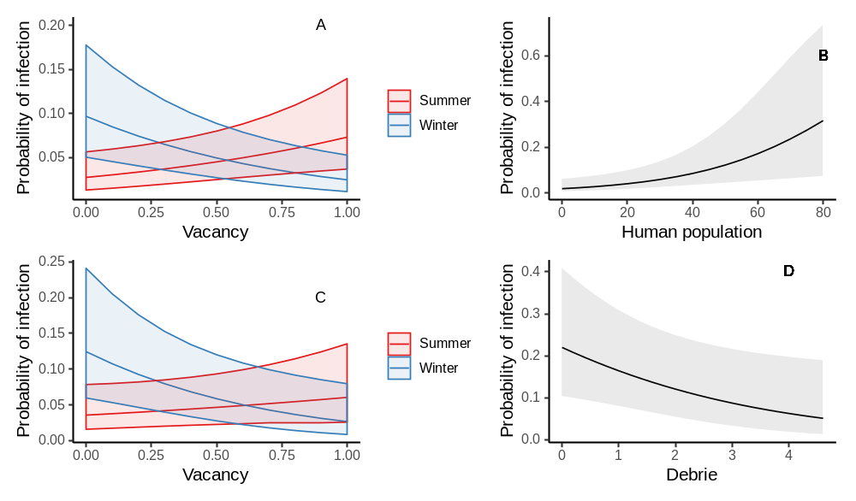
Debris piles

Figure 3.2. Probability of infection of A) all rodents B) Norway rats C) roof rats and D) house mice. Shaded areas correspond to 95% confidence intervals.

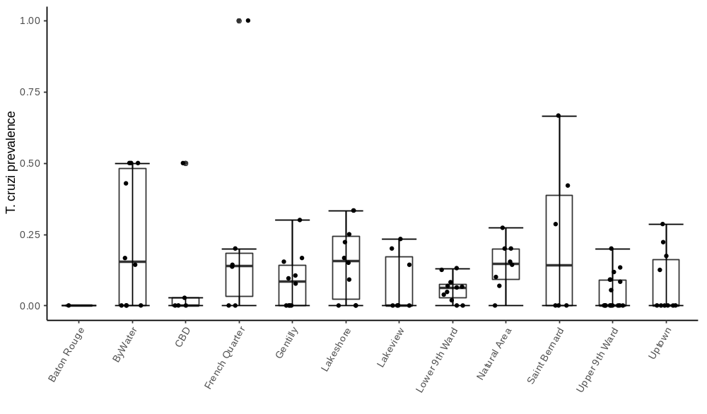
Figure 3.3. Infection prevalence across all rodent species by study area with individual sites noted as jitter dots.

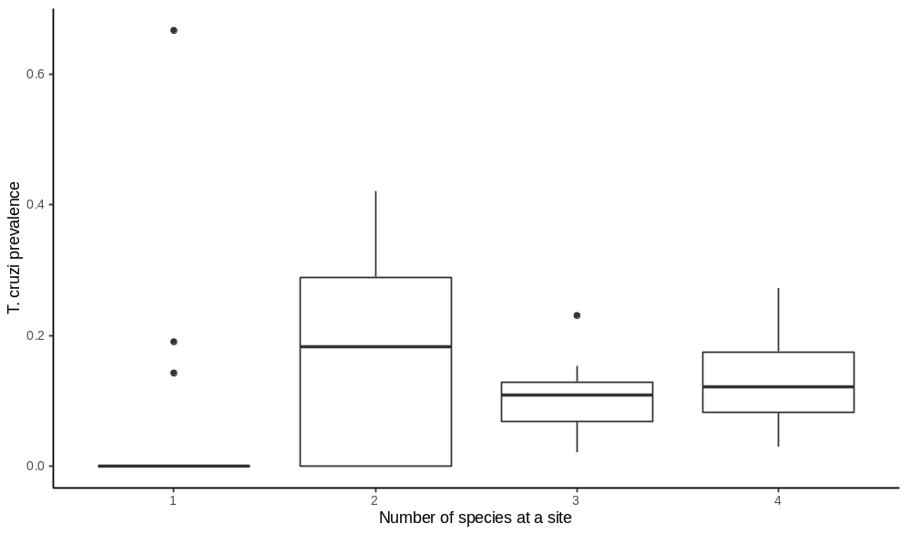
Figure 3.4. Variation in T. cruzi infection prevalence according to the number of host species at Tomahawk + Sherman trapping sites.

CONCLUSION
My aim was to improve understanding of disease risk by evaluating the socioecological conditions that have shaped commensal rat recovery and distributions, as well as the pathogens they carry, across New Orleans after Hurricane Katrina.

Contrary to expectation, roof rats were found to be far more abundant and more widely distributed than Norway rats across this city. Overall rat occurrence and abundance were higher in areas with more vacant lots, particularly during winter. The abundance of both species also was greater at flood affected sites. Clusters of elevated roof and Norway rat abundance were detected in the lower-income neighborhoods, which sustained particularly severe flood damage and extensive abandonment. Consistent with this, the condition of roof rats was higher in flooded areas and the condition of Norway rats was higher in lower-income areas. These results illustrate that catastrophic disasters can leave indelible socioecological signatures in affected areas. These findings also highlight how policy-driven differences in post-disaster resettlement and rebuilding can fortify legacies of sociocultural disparity by elevating rather than alleviating potential risks to human well-being.
Neighborhood-scale population structure and signatures of limited movement indicated that elevated abundance in flood-affected areas is not the result of recolonization. Consistent with this, reconstructions of historical demography provided evidence of longstanding independence of populations in flood-affected areas. Significantly higher levels of inbreeding in flood-affected areas also indicated that post-disaster abundance is more likely a result of population collapse followed by in situ recovery rather than resilience to disturbance. Evidence that genetic diversity parallels resource availability tied to flooding disturbance and post-disaster landscape management is consistent with the premise that Norway rat populations can exhibit rapid growth under favorable conditions, even after a severe bottleneck. These findings illustrate that commensal pests like Norway rats can survive and quickly rebound following catastrophic disturbances, affirming public health concerns that motivate disaster response efforts intended to reduce risk of pathogen transmission in affected areas. Evidence of little to no recolonization also illustrates that post-disaster pathogen transmission risk is more likely to be ameliorated by localized and sustained eradication campaigns.

Evidence of infection of rodents by T. cruzi throughout New Orleans affirms that Chagas disease is an emerging urban zoonosis. Though overall infection prevalence was 11%, it varied by study area and trapping site. There was no difference in prevalence by species, but roof rats exhibited the broadest geographic distribution of infection across the city. Infected rodents were trapped in densely populated neighborhoods, including tourist areas like the French Quarter. Notably, infection prevalence increased with greater levels of abandonment in summer, whereas lower levels were observed during winter. Evidence illustrating that T. cruzi is widespread in New Orleans suggests that transmission risk in the US is greater than is currently recognized. Evidence that infection prevalence parallels abandonment also indicates that there is disproportionate risk of transmission in historically underserved communities, which could reinforce long-standing socioecological disparities in the US and elsewhere.

VITA

Bruno M Ghersi Chavez was born in Lima, Peru. He obtained his degree in Veterinary Medicine from Universidad Nacional Mayor de San Marcos in 2008. He then worked at the Naval Medical Research Unit 6 in Lima, Peru as a research veterinarian doing epidemiological research on zoonotic diseases until 2014, when he came to the USA to start his PhD in Ecology and Evolutionary Biology at Tulane University in New Orleans. In 2017, he, and the rest of the Blum lab moved to the University of Tennessee, where he completed his dissertation work, as presented in this document. He is now undertaking a postdoctoral research at the One Health Institute at the University of California Davis.

