Improving the Biocompatibility of the Bio-Inorganic Interface for Enhanced Photosystem I-Based Biophotovoltaic Device Performance

A Dissertation Presented for the

Doctor of Philosophy

Degree

The University of Tennessee, Knoxville

Alexandra Heather Teodor

May 2022

Copyright © 2022 by Alexandra Heather Teodor.
All rights reserved.

DEDICATION

“I was born not knowing and have had only a little time to change that here and there. “
- Richard P. Feynman

“It actually doesn’t take much to be considered a difficult woman. That’s why there are so many of us. “
- Jane Goodall

ACKNOWLEDGEMENTS

To my family – thank you for your support, love, and encouragement so far – promise I’m finally done with school!
I would like to thank my mentors along the way who’ve believed in me and given me a chance to find my path in science – my undergraduate mentors Dr. Glenda Gillaspy, Dr. David Bevan and Dr. Ed Smith and others. Thank you for taking a chance on a young woman trying to find her passion and let her chase it.
This undertaking would not have been possible without my advisor Dr. Barry D. Bruce, and the opportunity to work in his lab. I would like to thank my doctoral committee members, Dr. Gladys Alexandre, Dr. Paul Frymier, Dr. Michael Vaughn, and Dr. Jerry Parks for their time and encouragement all these years. Your advice and support has been invaluable.
To my labmates along the way: Jyotirmoy Mondal, Maddie Davis, Nate Brady, my undergraduate mentees, and many others – you’ve been an extended family away from home. From insightful discussions and long days of lab work, to adventures and exploration as we’ve traveled to conferences - it’s been an incredible ride. I’m so grateful for our time together and for all that you have all taught me – about science and life. To the extended Bruce Lab family, it’s been a pleasure to get to meet you all along the way and be welcomed into a broader scientific community. In particular, thanks to Stephanie Monge – a true and steadfast friend and a great scientist, even though we only got to work together for a few months.
To the friends: Katherine Stefanski, Jennifer Childers, Sterling Field, Anwesha Dasgupta, Scott Carlew, and many others. Your support, kindness and thoughtfulness have left a lasting impression on me. Getting through graduate school wouldn’t have been possible without the many coffee breaks, lunches, writing, and studying together.
And finally –to my partner, Nathan Pierce. Thank you. Your support has meant the world. Your patience, encouragement, and good humor are some of the most valuable gifts I’ve ever been lucky enough to receive. Thank you for believing in me even when I struggled to myself. This wouldn’t have been possible without your help. I love you.

ABSTRACT

The world’s energy demands are projected to increase by nearly 50% by the year 2040, and consumption of carbon-based fuels continues to release greenhouse gases such as carbon dioxide and methane into the atmosphere. This has been causally linked with climate change and increased extreme weather events, which has been further linked to adverse health outcomes and negative effects on biodiversity, food security, and increased disease transmission. Clearly, there is a need for a sustainable, carbon-free, and cost-effective method of energy production to meet growing energy production demands. The sun irradiates Earth’s surface annually with ~80,000 terawatts (TW), making solar energy conversion (photovoltaics) a probable part of any plan to meet our growing needs. The biological process of photosynthesis is responsible for the annual generation of ~130 TW of energy through solar energy conversion to drive essentially all primary production on Earth. Photosynthesis does so with widely available elements and with a quantum efficiency approaching unity, both of which are challenges to current commercially available photovoltaic devices. The growing field of applied photosynthesis hopes to utilize the biological process of photosynthesis to help meet these growing energy demands through the development of bio-hybrid electronic and photovoltaic devices. The study of the bio-inorganic interface in these devices remains one of the largest areas for improving the outputs and efficiencies of these devices while simultaneously allowing for more detailed insight into fundamental biological photosynthetic processes.

TABLE OF CONTENTS
INTRODUCTION 1

1. General information on photosynthesis and the oxygenic light reactions 1
2. Photosystem I, a remarkably stable and efficient oxidoreductase 7
3. Introduction to dye-sensitized solar cells 10
4. Historical incorporation of Photosystem I into DSSCs 15
5. Current challenges and strategies to improve biophotovoltaic devices 18
5.1. Advances in electrode materials, integration strategies, and device architecture 21
5.1.1 Electrode materials 21
5.1.2 Optimizing directional orientation of PSI on nonbiological surfaces 25
5.1.3 Three-dimensional TiO₂ semiconductor architectures 27
5.1.4 Alternative carbon-based semiconductor materials 29
5.2 PSI stability enhancement on surfaces and in solution 30
5.3 Light absorption, optoelectronic considerations, and improving optical cross-sections of reaction centers 31
5.4 Redox mediators and electrolyte considerations 36

CHAPTER I MATERIALS AND METHODS 40

1.1 Abstract 41
1.2 Methodology for Chapter II 42
1.3 Methodology for Chapter III 47
1.4 Methodology for Chapter IV 51

CHAPTER II “AQUEOUS-SOLUBLE BIPYRIDINE COBALT(II/III) COMPLEXES ACT AS DIRECT REDOX MEDIATORS IN PHOTOSYSTEM-I BASED BIOPHOTOVOLTAIC DEVICES” 55

2.1 Acknowledgements 56
2.2 Abstract 57
2.3 Introduction 57
2.4 Results 60
2.4.1 Cobalt redox mediator synthesis and spectroscopic characterization 60
2.4.2 Electrochemical characterization of cobalt redox mediators 62
2.4.3 Structural stability of PSI in organic solvent 68
2.4.4 Cobalt redox mediator donate electrons directly to PSI 72
2.4.5 Effect of organic solvent on PSI reduction rates 74
2.4.6 Photocurrent generation by Co-based biophotovoltaic devices 75
2.5 Discussion 80

CHAPTER III “PHOTOSYSTEM I INTEGRATED INTO MESOPOROUS MICROSPHERES HAS ENHANCED STABILITY AND PHOTOACTIVITY IN BIOHYBRID SOLAR CELLS” 85

3.1 Acknowledgements 86
3.2 Abstract 87
3.3 Introduction 87
3.4 Results 90
3.4.1 Synthesis and manipulation of microsphere characteristics 90
3.4.2 Spectral and Optical Analysis of PSI incorporation in CCMs 94
3.4.3 Retainment of PSI photoactivity and mesoporous nature in CCMs 97
3.4.4 Incorporation of PSI-CCMs in a biophotovoltaic device 101
3.5 Discussion 103

CHAPTER IV “PEDOT-CARBON NANOTUBE COUNTER ELECTRODES AND BIPYRIDINE COBALT(II/III) MEDIATORS AS UNIVERSALLY COMPATIBLE COMPONENTS IN BIOSENSITIZED SOLAR CELLS USING PHOTOSYSTEM I AND BACTERIORHODOPSIN” 106

4.1 Acknowledgements 107
4.2 Abstract 108
4.3 Introduction 108
4.4 Results 115
4.4.1 Counter Electrode characterization 115
4.4.2 Comparison of liquid and gel electrolyte composition on PSI-SSC output and efficiency 121
4.4.3 Aqueous Co^{II/III} Redox Mediator Gel Electrolytes and PEDOT/CNT Counter Electrodes Are Compatible with Multiple Proteins 123
4.5 Discussion 127

CONCLUSIONS AND POTENTIAL FUTURE DIRECTIONS 132

REFERENCES 135

VITA 161

LIST OF TABLES

INTRODUCTION 1
1. Photocurrent analysis of higher-plant PSI-based BSSCs 19
2. Photocurrent analysis of cyanobacterial PSI-based BSSCs 20

CHAPTER II “AQUEOUS-SOLUBLE BIPYRIDINE COBALT(II/III) COMPLEXES ACT AS DIRECT REDOX MEDIATORS IN PHOTOSYSTEM-I BASED BIOPHOTOVOLTAIC DEVICES” 55

2.1. Comparison of PSI-based electrode and photovoltaic device current densities 61
2.2. Cobalt redox mediators donate directly to PSI in vitro 72

CHAPTER IV “PHOTOSYSTEM I INTEGRATED INTO MESOPOROUS MICROSPHERES HAS ENHANCED STABILITY AND PHOTOACTIVITY IN BIOHYBRID SOLAR CELLS” 106

4.1. Properties of the pigment-protein complexes bacteriorhodopsin and Photosystem I 110
4.2. Electrochemical parameters of aqueous Co^{II/III} redox mediator with varying electrodes 118
4.3. PSI-senstized solar cells (PSI-SSC) performance using different counter electrodes and a liquid-based aqueous Co^{II/III} electrolyte 120
4.4. PSI-sensitized solar cells (PSI-SSC) performance using liquid and gel-based electrolytes using aqueous-soluble Co^{II/III} redox mediators 122
4.4. Bio-sensitized solar cells (BSSCs) performance using different proteins 125

LIST OF FIGURES

INTRODUCTION 1
1. Timeline of life on Earth 3
2. Global distribution of oxygenic photosynthesis on Earth 3
3. Insolation spectrum of solar energy irradiating Earth 4
4. Linear flow of electrons through the protein-pigment complexes central to the light reactions of oxygenic photosynthesis 6
5. The light reactions of photosynthesis catalyze some of the most oxidizing and reducing reactions found in Nature 6
6. The subunit and internal ET cofactor structure of Photosystem I from a cyanobacterium 8
7. Historical world primary energy consumption by fuel source 11
8. Total innsolation of the Earth 12
9. Historical solar cell efficiencies 14
10. General schematic showing the key components of a DSSC 16
11. Progress of PSI-based BSSC generated photocurrent 22
12. A selection of areas for PSI-based BSCC device improvement 23
13. Photosystem I (PSI) electrode and semiconductor wiring strategies 26
14. 3D semiconductor archictectures 28
15. Optical cross-sections of reaction centers and dyes 33

CHAPTER II “AQUEOUS-SOLUBLE BIPYRIDINE COBALT(II/III) COMPLEXES ACT AS DIRECT REDOX MEDIATORS IN PHOTOSYSTEM-I BASED BIOPHOTOVOLTAIC DEVICES” 55

2.1. Structure of a PSI-Based DSSC 61
2.2. Synthetic schemes for the preparation of tris(4,4’-di-tert-butyl-2,2’-bipyridine) cobalt(II) and tris(4,4’-di-methoxy-2,2’-bipyridine) cobalt (II) complexes 63
2.3. UV-Vis oxidized and reduced spectra of bipyridine cobalt redox mediator complexes 64
2.4. UV-Vis redox difference spectra of bipyridine cobalt redox mediator complexes
64
2.5. Electrochemical analysis of Co bipyridine redox mediator complexes 66
2.6. Solubility of cobalt redox mediators in acetonitrile:H₂O binary solvent systems 67
2.7. Organic solvent effects on PSI structural stability 71
2.8. Rate of PSI-P₇₀₀⁺ reduction increases linearly with mediator concentration 73
2.9. Effect of organic solvent on PSI-P₇₀₀⁺ reduction kinetics by DCPIP 76
2.10. Organic solvent slows PSI-P₇₀₀⁺ reduction kinetics by Co complexes 76
2.11. Organic solvents slow rates of PSI-P₇₀₀⁺ reduction by redox mediators 77
2.12. Photocurrent densities from PSI-sensitized devices 79

CHAPTER III “PHOTOSYSTEM I INTEGRATED INTO MESOPOROUS MICROSPHERES HAS ENHANCED STABILITY AND PHOTOACTIVITY IN BIOHYBRID SOLAR CELLS” 85

3.1. Fabrication of mesoporous PSI microspheres 92
3.2. Control of PSI microsphere characteristics during the fabrication process 93
3.3. Incorporation of PSI into template CaCO₃ microspheres is stable and uniform 95
3.4. Electron micrographs of PSI-containing microspheres to reveal surface characteristics 98
3.5. PSI photoactivity is retained after incorporatiion into microspheres, and microspheres retain photoactivity after lyophilization 99
3.6. PSI stabilized in microspheres is capable of generating photocurrent in a biophotovoltaic device 102

CHAPTER IV “PHOTOSYSTEM I INTEGRATED INTO MESOPOROUS MICROSPHERES HAS ENHANCED STABILITY AND PHOTOACTIVITY IN BIOHYBRID SOLAR CELLS” 106

4.1. Structure of Bacteriorhodopsin and Photosystem I 110
4.2. Schematics of PSI or bR sensitized DSSCs 114
4.3. Surface characteristics of photoanodes and counter electrodes 116
4.4. Counter electrode characterization 118
4.5. Chemical structure of aqueous-soluble Co^{II/III} redox mediator 119
4.6. Design and performance of PSI-sennsitized solar cells (PSI-SSCs) with variable counter electrodes 120
4.7. Electrochemical analysis and performance of PSI-SSCs using liquid and gel aqueous-soluble bipyridine Co^{II/III} -based electrolytes 122
4.8. PEDOT/CNT counter electrodes and a gel-based Co^{II/III} electrolyte are also compatible with bR-SSCs 125
4.9. Directional illlumination effects on photocurrent density generation and stability of photocurrent response of PSI- and bR-SSCs 126

INTRODUCTION

Portions of this chapter were originally published by Alexandra Teodor as first author and Barry D. Bruce as corresponding authors in the following review articles:

Teodor, A.H. and Bruce, B.D. “Putting Photosystem I to Work: Truly Green Energy.” Trends in Biotechnology 38(12): 1329-1342.

Teodor, A.H., et al. and Bruce, B.D. “Green Catalysts: Applied and Synthetic Photosynthesis.” Catalysts 10(9): 1016.

Alexandra Teodor is the first author of both published reviews. She performed conceptualization, reference organization and analysis, figure making, initial draft writing and was involved in the manuscript editing and review process at the journals Trends in Biotechnology and Catalysts. Coauthors Eu-Jee Ooi and Zeah Ison were involved in figure making, writing, and reference organization. Benjamin Sherman aided in conceptualization and the manuscript writing and editing process. Jesse J. Bergkamp aided in conceptualization, and the manuscript writing and editing process. Barry D. Bruce provided conceptualization, supervision, and aided in the manuscript writing, review, and editing process.

1. General Information on Photosynthesis and the Oxygenic Light Reactions

Photosynthesis is the general term for a biological process where solar photonic energy is converted into other forms of energy that are biocompatible and then stored for future use. The term photosynthesis literally translates to “synthesis of light”, and is more broadly applicable than the oxygenic photosynthesis that is typically thought of [1]. Photoconversion to power biological processes were among the first adaptations in ancient bacteria over 3.5 billion years ago, shown in Figure 1. These original phototrophs were typically anaerobic, and did not perform oxygen evolution. They are often found in extreme environments, such as the haloarchea that thrive in high salinity environments, and the purple and green bacteria that utilize bacteriochlorophyll pigments to harvest light. An example of these include Halobacterium salinarum, an archeal halobacterium that produces the protein bacteriorhodopsin (bR) that undergoes photoisomerization of its single light harvesting retinal pigment to power proton pumping across its plasma membrane. As such, H. salinarum is typically classified as a non-photosynthetic phototroph as it does not perform carbon fixation coupled to its light reactions. A second example is Rhodobacter sphaeroides, an anoxygenic photosynthetic purple bacterium that produces the canonical example of a purple bacterial reaction center. Oxygenic photosynthesis seems to have first developed approximately 3-3.2 billion years ago, and has since been adapted to nearly all environments on Earth, shown in Figure 2. [2].

The process of oxygenic photosynthesis is responsible for nearly all primary production on Earth (excluding that done by more unusual phototrophs), generating nearly 130 terawatts of energy annually [3]. Phototrophic organisms such as cyanobacteria, plants, purple bacteria, and more do so by harnessing the photonic energy that the Sun irradiates the Earth with. The Sun irradiates the Earth with a particular subset of wavelengths of light, the spectra of which can be seen in Figure 3 [1]. Certain wavelengths of light get absorbed by the gases of the Earth’s atmosphere, and phototrophic organisms then utilize the rest that reach the Earth’s surface through variable light harvesting pigments to inhabit different optical niches to power their metabolisms. This can be seen in Figure 2 with the absorbance spectra of whole Rhodobacter sphaeroides and Synechocystis PCC 6803 cells, which differ due to the variances in light harvesting pigments by the two different bacteria.

In oxygenic photosynthetic organisms, this photonic energy is converted into bioavailable electrochemical energy through processes referred to as the “light reactions”, which are then used for carbon fixation through processes typically referred to as the “dark reactions”.

The light reactions of oxygenic photosynthesis are driven by a series of membrane-bound protein-pigment complexes, often termed reaction centers. A representation of these
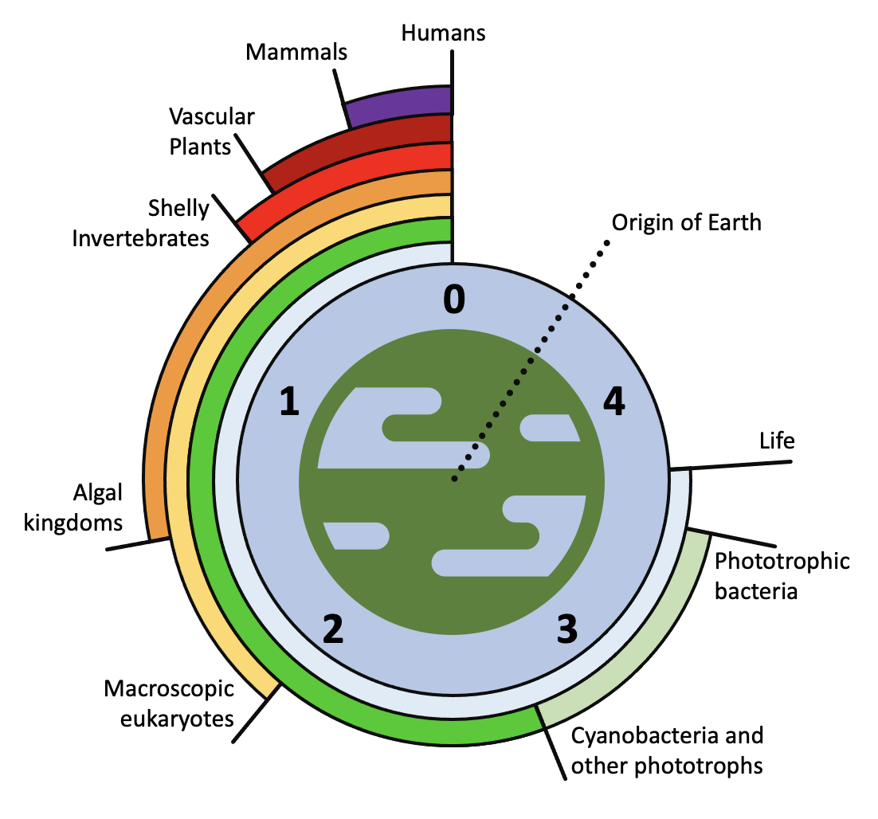
Figure 1. Timeline of life on Earth. Scale of numbered years is billions of years ago (BYA).


Figure 2. Global distribution of oxygenic photosynthesis on Earth. Image showing photosynthetic distribution on Earth, both marine and terrestrial. Red and dark green colored regions denote significant photosynthetic activity in the ocean and land, respectively. Provided by the SeaWiFS Project, NASA/Goddard Space Flight Center and ORBIMAGE.
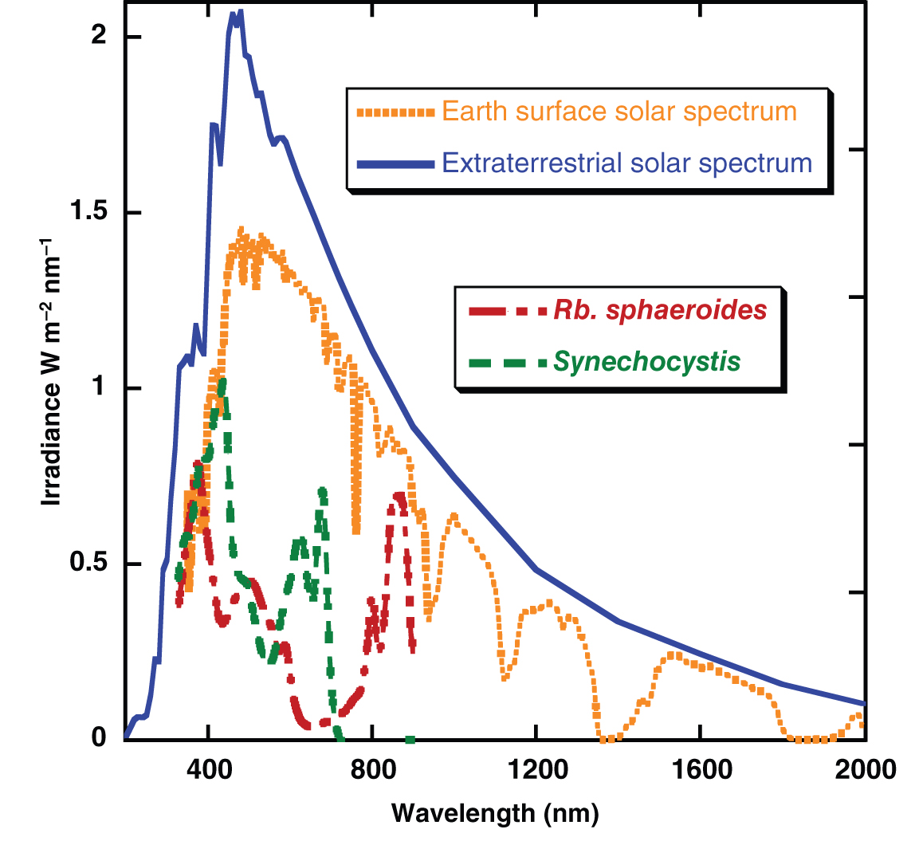
Figure 3. Insolation spectrum of solar energy irradiating Earth. Solar irradiance spectra above and below Earth’s atmosphere are shown in blue and yellow, respectively. The absorbance spectrum of an anoxygenic purple photosynthetic bacterium, Rhodobacter sphaeroides, is shown in red and the absorbance spectrum of an oxygenic photosynthetic cyanobacterium, Synechocystis PCC 6803, is shown in green. Figure from [1].

Protein complexes found in the thylakoid membranes of oxygenic photosynthesis can be seen in Figure 4. These reactions are among the most oxidizing and reducing found in biology, and are plotted in Figure 5 relative to the standard hydrogen electrode (SHE) as reference. These significant oxidizing and reducing potentials are what allow for the unique water splitting capability of PSII and the ability to generate electrons of a sufficiently negative potential by PSI to power photosynthetic primary metabolisms across the entire planet.

The linear electron transfer (ET) chain of oxygenic photosynthesis begins with light harvesting by the chlorophyll antenna systems of Photosystem I (PSI) and Photosystem II (PSII). Both PSI and PSII perform light-activated charge separation across the membrane [1]. Linear electron flow in oxygenic photosynthesis beings with the first reaction center, PSII, and the photoexcitation of its special pair of chlorophyll, P₆₈₀ [4, 5]. PSII performs four successive charge separations upon photooxidation, which allows for its oxygen evolving complex (OEC) to perform water splitting, generating four protons and two ½ O₂ and freeing four protons on the lumenal side of the thylakoid membrane and four electrons to start the ET reactions. Two electrons exit PSII to the first soluble carrier, plastoquinone (PQ), which also accepts two protons from the stroma to form plastoquinol (PQH₂).

PQ/PQH₂ is lipid-soluble and after reduction to PHQ₂ diffuses through the interior of the thylakoid membrane in pairs over to the cytochrome b₆f (cyt b₆f) complex. The cyt b₆f complex is the second protein complex of oxygenic photosynthesis. It is not photoactive, yet it catalyzes the movement of electrons from the first mobile carrier PQ/PQH₂ to the second, plastocyanin (PC) or cytochrome c₆ (cyt c₆), depending on the organism, and the protons across the membrane to the lumenal side [6-9]. The series of ET events within the cyt b₆f complex are proton-coupled, transferring an additional proton across the membrane per electron transfer to PC/cyt c₆. Both PC/cyt c₆ are soluble, mobile proteins in the thylakoid lumen that utilize either a copper atom (PC) or an iron-based heme group (cyt c₆) to catalyze their redox capabilities.

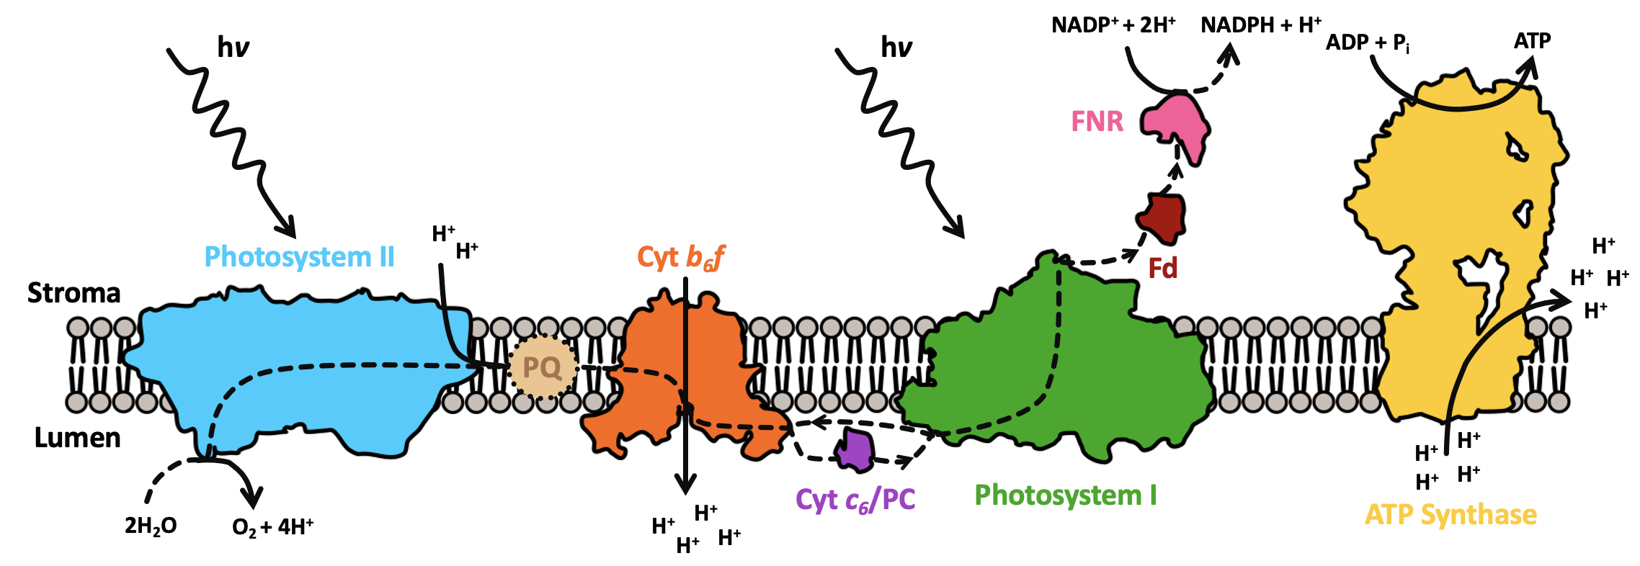 Figure 4. Linear flow of electrons through the protein-pigment complexes central to the light reactions of oxygenic photosynthesis. Linear ET in photosynthesis starts with photoexcitation of Photosystem II (PSII), which allows its oxygen evolving complex (OEC) to perform water splitting into 2H⁺ and ½ O₂. PSII is shown in light blue. The electrons liberated during water splitting are transferred to the first of the two mobile carriers of the light reactions, plastoquinone (PQ).

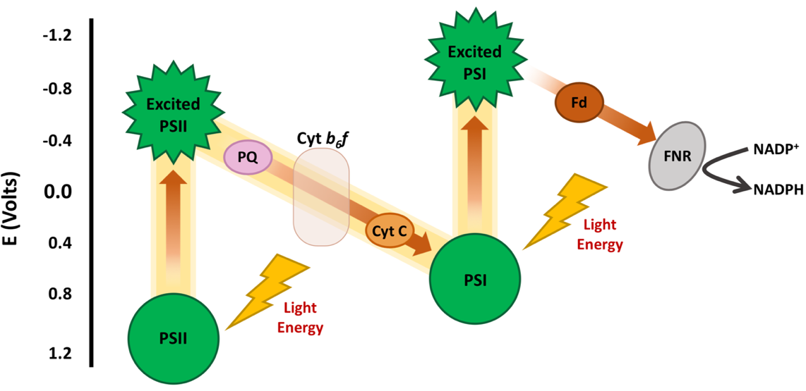
Figure 5. The light reactions of photosynthesis catalyze some of the most oxidizing and reducing reactions found in Nature. The “Z-scheme” of photosynthesis reveals how the reaction centers central to oxygenic photosynthesis catalyze some of the most oxidizing and reducing reactions found in biological systems.
PC/cyt c₆ then shuttles an electron at a time through the aqueous lumenal space from the cyt b₆f complex to Photosystem I (PSI), the second reaction center driving the light reactions of oxygenic photosynthesis. Upon photoexcitation, the special pair of PSI, P₇₀₀, is raised to an excited state and charge separation occurs generating an electron with a high reducing potential. This electron undergoes unidirectional ET through PSI until reaching the terminal [4Fe-4S] cofactors on the stromal side of the reaction center. Ferredoxin (Fd), a small iron-sulfur cluster protein, is a soluble mobile carrier in the thylakoid stroma (cytosol in cyanobacteria) that acts as a hub for cellular metabolism, moving the highly reducing electrons generated into nitrogen metabolism, sulfur metabolism, carbon fixation and many other metabolic pathways [10]. One highly utilized pathway by Fd is to transport electrons to Ferredoxin-NADP⁺ reductase (FNR) to synthesize NADPH to power a variety of metabolic pathways and cycles.

Finally, the electrochemical gradient generated by the light reactions is used by ATP synthase, also embedded in the thylakoid membranes, to synthesize ATP from ADP and P_{i} via a rotary mechanism driven by the proton gradient (ΔpH) and the transmembrane electrical potential (ΔΨ) [1, 11, 12]. This ATP, along with the NADPH generated by FNR, then is used to drive the “dark reaction” Calvin-Benson-Bassham cycle of photosynthesis where carbon fixation occurs.

2. Photosystem I, a remarkably stable and efficient oxidoreductase

Photosystem I (PSI) is one of the largest, most complex protein complexes found in Nature, and it has been well characterized biochemically and optically since its existence was first hypothesized back in 1960 [13-15]. PSI is also highly abundant in Nature, with photosynthetic thylakoid membranes being the most abundant biological membrane system found on Earth [16]. It has been estimated that one single m² of plant leaves contains up to 25,000 m² of thylakoid membranes. The thylakoid membranes are not only highly abundant, they are also one of the most protein-dense membranes found in Nature, with estimates of over 70% of membrane volume being filled by various proteins [17]. Of this
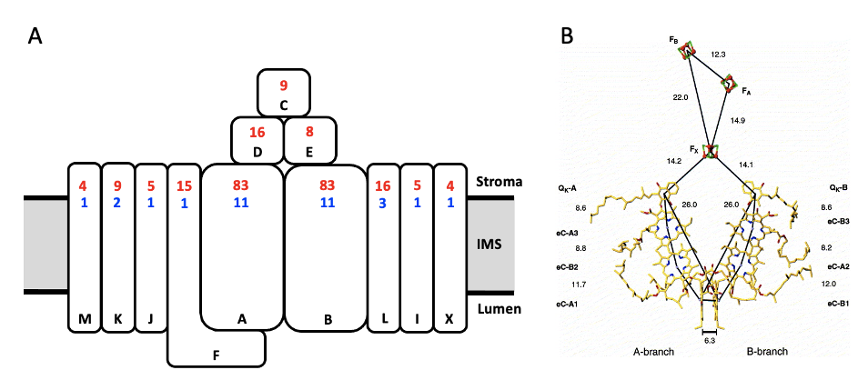Figure 6. The subunit and internal ET cofactor structure of Photosystem I from a cyanobacterium. The subunit composition (A) and internal cofactor ET chain (B) of PSI from the cyanobacterium Thermosynechococcus elongatus BP-1. The typical protein subunit composition is shown with black letters denoting each individual subunit, with subunits PsaA and PsaB forming the heterodimeric core of the complex. Subunit weights in kilodaltons (kDa) are shown in red, and number of transmembrane helices in each subunit are shown in blue. (B) The internal ET cofactors of PSI are shown, highlighting the two symmetrical branches, A, and B, present within PSI. Each is identical in cofactor composition and orientation. The final electron acceptor, the F_{B} [4Fe-4S] cluster is present within PsaC on the stromal face of PSI. Panel B reproduced from [18].
high protein volume, the ratios of different reaction centers varies, with plants having approximately 2 PSII per PSI, with cyanobacteria have anywhere 0.2-0.5 PSII per PSI [19]. PSI is also remarkably photostable, with in vivo half-life times estimated for 48-75 hours as compared to less than 10 hours for PSII [20].

Each monomer of PSI, depending on the species, is comprised of anywhere from 12-16 proteinaceous subunits, typically fewer in primitive cyanobacterial species with increased numbers of subunits in plants and alga. The typical subunit composition of monomeric PSI is shown in Figure 5A, along with the weight of each subunit in kilodaltons (kDa). The majority of PSI subunits are also transmembrane (the number of transmembrane helices is shown in Figure 5A) and embedded in the thylakoid membrane, with only subunits PsaC, D, and E sitting on the stromal surface of the complex, where they are accessible to serve as interacting sites for Fd. PsaF has an extension along the lumenal-exposed face of PSI, and in algal and plant species this lumenal extension plays a role in electrostatic docking of PC/cyt c₆ for reduction of the P₇₀₀ special pair. In cyanobacteria, PSI further oligomerizes into trimers and even tetramers, reaching up to 1.6 megadaltons (Mda) in size [18, 21-24]. In algal and plant species, PSI is overwhelmingly monomeric, approximately 400 kDa in size [25-28]. The protein subunits of PSI act primarily as a scaffold to immobilize and orient the chlorophyll antenna of the reaction center, composed of approximately 100-120 chlorophyll a moieties.

The chlorophyll a light harvesting antenna system present in PSII and PSI acts much like a satellite dish to absorb photonic solar energy, transferring it between the chlorophyll molecules down a thermodynamic energy gradient until it reaches a unique pair of chlorophylls referred to as the “special pair”. The special pair are uniquely coordinated with their chlorin rings parallel to each other and only separated by approximately 6 Ängstroms distance. Through absorption of this photon of energy, P₇₀₀ is excited to P₇₀₀*. Charge separation then occurs, and a high energy electron is generated and transferred from P₇₀₀* via chlorophylls A_{cc} to A₀, then to a phylloquinone and then to the [4Fe-4S] clusters, F_{X}, F_{A}, and F_{B} in turn, the terminal iron-sulfur clusters of PSI. From there, the soluble protein ferredoxin (Fd) can dock to the PsaD and E subunits of PSI to accept electrons from F_{A} and F_{B} to then act as a metabolic hub for the cell [10]. This charge separation of PSI is remarkable among photo-catalyzed reactions found in Nature, as it occurs with a quantum efficiency near unity; i.e. essentially every single photon that is able to be absorbed by the reaction center is able to generate a highly reducing electron.

3. Introduction to dye-sensitized solar cells

The world’s anthropocentric energy demands have been increasing year over year, and are predicted to increase nearly 40% by the year 2040 [29-32]. To fill those demands, the overwhelming majority of fuel has historically come from nonrenewable sources, such as natural gas, coal and oil, shown in Figure 7. However, by their very nature supplies of fossil fuels are limited; it has been estimated that there is approximately only enough coal remaining on Earth at current consumption rates for 114 years, and enough natural gas and oil for approximately 50 years. Further, consumption of fossil fuels at increased rates has led to significant warming of the Earth’s atmosphere. Minimization of this atmospheric heating has been shown to be crucial to prevent drastic changes to climate, sea levels, economies, human, and ecosystem health among others [33-39]. As such, the need to identify carbon-neutral, sustainable, and resource-available methods of energy production to meet growing anthropocentric demands is clear.

Annually, the sun irradiates the Earth with 172,500 TW of photonic energy, enough to power yearly anthropocentric demands nearly 8,800 times over. While not all of this total insolation penetrates through Earth’s atmosphere or strikes the lithosphere, a significantly large portion does, shown in Figure 8. As such, this large magnitude of the photonic energy available makes solar energy conversion (i.e. photovoltaics technologies) a likely portion of any sustainable plan to meet future energy needs [29, 30, 32, 40-42].

The ability of certain materials to have changes in conductivity upon photonic irradiation was first noted back in 1874, with the first solar cell being developed in 1883 by Charles
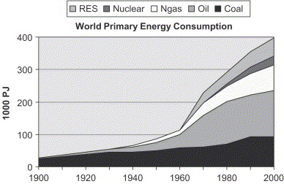
Figure 7. Historical world primary energy consumption by fuel source. Renewable energy sources are denoted as “RES”. Y axis is in petajoules (10¹⁵ joules), PJ of energy. Figure reproduced from [32].

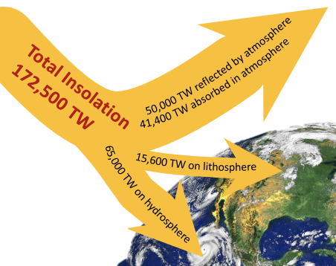
Figure 8. Total insolation of the Earth. Amounts of solar energy reaching varying portions of the Earth annually. Data from [43], figure adapted from [41].
Fritts [44]. Today, the photovoltaics (PV) market has shown remarkable 33% annual growth since 1997, with even more rapid predicted growth [45, 46]. Most of the PV on the market to date, commercial or residential, is crystalline silicon solar cell-based, part of the first generation of photovoltaic technologies. These utilize toxic, rare, and expensive elements in their components that are hard to source and are often geopolitically limited beyond just elemental scarcity [47]. Further, end-of-life waste of these first generation PV technologies is nontrivial, and is expected to generate over 78 million tons of waste by 2050 due to inability to recycle components easily [48]. As such, even though current available technologies have high photon-to-electricity conversion efficiencies, as shown in Figure 9, there is a clear need to develop alternative PV technologies with more sustainable, eco-friendly materials.

One such emerging technology is the dye-sensitized solar cell (DSSC). First developed in 1991 by Michael Grätzel [49, 50], they are part of the emerging third generation of PV technologies. In contrast to conventional PV systems where the semiconductor (typically silicon) assumes both tasks of light absorption and charge carrier transport, DSSCs instead take inspiration from the biological process of photosynthesis [42]. DSSCs utilize a sensitizer that is placed on the surface of a semiconductor. The sensitizer performs the task of light absorption and typically charge separation as well, while the semiconductor support performs charge carrier transport. There are significant advantages to DSSCs over traditional Si-based solar cells, including but not limited to simple and low-cost manufacturing protocols, better performance under low light and higher temperature conditions, and in particular the ability to fabricate DSSCs out of a wide variety of materials that are amenable for modification and optimization.

All conventional DSSCs are comprised of five primary components, which are: (i) a photosensitive sensitizer molecule (often referred to as a dye), (ii) a transparent photoanode to allow for illumination, (iii) a semiconductor coating on the photoanode, (iv) a redox electrolyte for dye regeneration, and (v) a counter electrode. A schematic of a general device architecture is shown in Figure 10. DSSCs operate in the following manner :
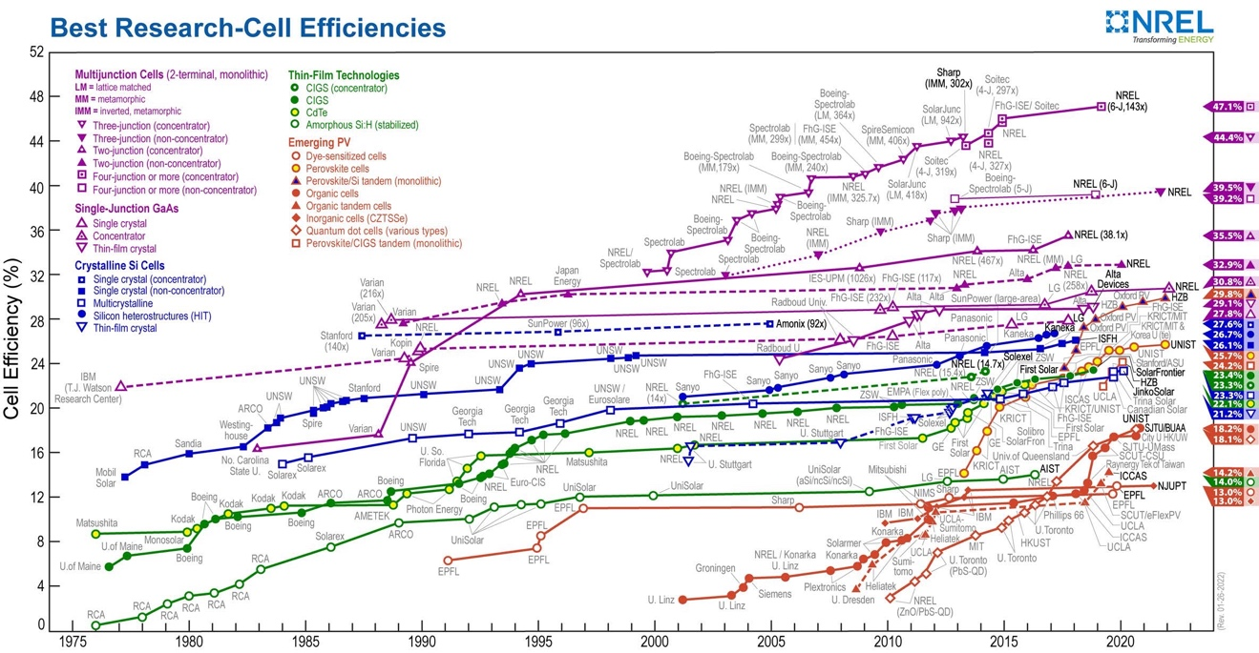

Figure 9. Historical solar cell efficiencies. Photon-to-electricity conversion efficiency (Cell Efficiency) for historical and current photovoltaic technologies. Current commercial cells are the Crystalline Si Cells, shown in blue. Emerging generation III cell technologies are shown in orange. This plot is courtesy of the National Renewable Energy Laboratory, Golden, CO.

After photonic excitation, the dye molecules are excited from their ground state to a higher energy state, and the electrons are promoted from the HOMO orbital to the LUMO orbital, generating electron–hole pairs [51, 52]. Then, effective charge separation is achieved by oxidation of the excited sensitizer molecule, and the generated electron is injected to the conduction band of the semiconductor or photoanode, and the hole remains behind in the oxidized dye molecule [7]. The electrons then diffuse through the semiconductor to the photoanode substrate where they then travel through an external circuit and perform work before arriving at the cathode, generating the current. During that time, the redox mediators in the electrolyte regenerate the sensitizer molecule [53, 54]. In return, the oxidized redox mediator diffuses to the counter electrode (CE) and gets regenerated [51]. As previously stated, within this basic operational outline, there is great flexibility in the selection and design of materials, along with many different interfaces to optimize for device improvement. A general device schematic is shown in Figure 10.

4. Historical incorporation of Photosystem I into DSSCs

One such area for DSSC improvement is through the identification and incorporation of novel sensitizer materials. Dyes for single-junction DSSCs would, ideally, have the following traits: (i) highly absorbing below a threshold wavelength (λ) of approximately 920 nm, (ii) have some type of surface chemistry property to firmly link it to the semiconductor surface, (iii) a quantum yield approaching unity for electron injection into the semiconductor, (iv) the energy level of the dye’s excited state should be well matched to the conduction band of the oxide to minimize energetic losses, (v) redox midpoint (E_{m}) potential should be sufficiently high to allow for regeneration by the redox mediator present in the electrolyte, and finally, (vi) it should be stable enough to sustain approximately 10⁸ turnover cycles, equivalent to approximately 20 years of exposure to sunlight under natural lighting conditions [49, 55].

Historically, inorganic complexes with redox-active metal centers have been utilized as dyes, using elements such as ruthenium or zinc which are scarce in abundance in the Earth’s
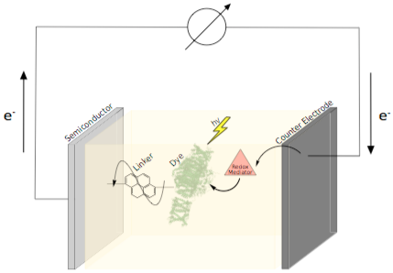
Figure 10. General schematic showing the key components of a DSSC. This figure shows the five primary components of a dye-sensitized solar cell. The semiconductor layer is shown on top of the photoanode. In this example schematic, a biological molecule is incorporated as the sensitizer. Figure reproduced from [42].

crust [56]. As such, the availability, environmental toxicity, and cost of these dyes has influenced researchers to work on identifying possible alternatives. As DSSCs take inspiration from the biological process of photosynthesis for their operating scheme, it is logical that scientists have attempted to incorporate the same light harvesting pigments from biology as sensitizers in DSSCs [57-60]. The first report on a semiconductor sensitized with chlorophyll molecules came out in 1971 by Tributsch, well before sensitized semiconductors were adapted for emerging solar cell technologies such as DSSCs, and only a decade after the existence of a two reaction center system for the light reactions of photosynthesis was theorized [61]. The first report on biological sensitizers being incorporated into a DSSC came in 1997, six years after the first publication on DSSCs by Grätzel and O’Regan [50, 62]. Since that first report, there have been multiple others on use of simple biological dyes as organic photosensitizers in DSSCs [58, 63-65]. However, these simple molecular sensitizers often fail on the ideal characteristics of stability, quantum yield, and gaps in their absorbance spectra.

To more fully match all the ideal sensitizer characteristics while using low-cost eco-friendly materials, researchers have been moving towards making bio-hybrid sensitized solar cells (BSSCs) utilizing entire reaction centers such as PSII, PSI, bacteriorhodopsin (bR), the purple bacterial reaction center entire photosynthetic membranes, and other more complex photoactive bio-sensitizers [66]. PSI has in particular many qualities that make it attractive for use in BSSCs.

These include a remarkable internal quantum efficiency (IQE) approaching unity (100%) and the generation of the greatest reducing power found in Nature at −1.2 V versus the standard hydrogen electrode (SHE) upon photoexcitation. Further, many photosynthetic organisms that have become model systems for biohybrid electronics work have their genome sequences and have also exhibited genetic tractability, allowing engineering of the biological material in vivo [67-71]. This has allowed for the availability of high-quality three-dimensional PSI crystal structures enabling high-resolution molecular studies [5, 18, 23, 25-27, 72-76]. PSI is generally relatively easy to purify with standardized protocols in the literature [77, 78]. Additionally, PSI from the thermophilic cyanobacterium Thermosynechococcus elongatus BP-1 is quite thermostable, a highly favorable characteristic for integration into solar devices due to high operating temperatures from solar irradiation [78]. PSI has also been shown to be highly resistant to losses of photoactivity post-purification and integration into electronic devices, with cyanobacterial PSI showing no loss of photoactivity over at least 280 days [79] and plant PSI over 90 days [77].

A historical overview of PSI-based BSSCs detailing electrode surface/immobilization strategies, redox mediator used in the electrolyte, and photocurrent output are given in Tables 1 and 2. Table 1 is focused on devices using PSI from the plant Spinacia oleracea, and Table 2 on devices incorporating PSI from the cyanobacterium Thermosynechococcus elongatus BP-1. In Figure 11, photocurrents obtained from some of these historical results are plotted against year obtained, revealing the impressive annual increases that have been obtained, yielding a near order of magnitude increase over the last decade for research-scale devices. Since this reproduced figure has been published, higher photocurrent density results have been obtained up to nearly 4 mA/cm² [80]. However, further improvements in device design need to taken into account for more consistent and reliable results that have a chance of becoming commercially competitive. It has been estimated that a single acre of fertile land could yield over 45,000 kg of spinach biomass, and with current PSI isolation protocols could produce nearly 7x10²⁰ PSI molecules. This would allow for 17 km² of solar cells with a uniform PSI monolayer deposited on the semiconductor surface. This suggests that biomass is not the primary limiting factor for commercial viability, so other improvements are needed [81].

5. Current challenges and strategies to improve biophotovoltaic devices

There are many challenges that face emerging photovoltaics technologies, especially PSI based BSSCs. While they have a distinct advantage over traditional bioenergy/biofuel

Table 1. Photocurrent analysis of higher plant PSI-based BSSCs †.
Electrode Surface/Immobilization | Redox Mediators | Photocurrent  (µA cm⁻²) | J  (µA cm⁻²mW⁻¹) | Ref.
Terephthalic-dialdehyde SAM on nanoporous gold | ascorbate;  DCPIP | 0.3 | 0.08 | [82]
Bare gold | ascorbate;  DCPIP | N/A | 0.1 | [83]
PSI-based biohybrid cells | ascorbate;  DCPIP | 2 | 0.138 | [79]
PSI films/p-doped silicon | Methyl viologen | 875 | 4.6 | [84]
PSI multilayer/reduced graphene oxide | [Fe(CN)₆]³⁻; methylene blue; ascorbate; methyl viologen; DCPIP; ruthenium(II) hexamine | 1.2 | N/A | [85]
PSI multilayer film on gold | [Fe(CN)₆]³ | 0.9 | N/A | [86]
Polyaniline–PSI film on gold surface | ascorbate | 5.7 | N/A | [87]
PSI–polyaniline/titanium dioxide | Methyl viologen | 72 | N/A | [88]
Solid-state unetched p-doped silicon/PSI | Methyl viologen | Non-etched: 21  Etched: 127 | N/A | [89]
PSI multilayer film/SAM on gold-coated silicon | Osmium-based redox hydrogel | ~8 | N/A | [90] ª
PSI–PEDOT: PSS/FTO | N/A | 960 | N/A | [91]
PSI multilayer film/gold/SAM/AET | [Fe(CN)6]⁴⁻; [Fe(CN)6]³⁻ | 0–0.84 for PSI film thickness 0–1.3 µm | N/A | [92]
PSI–p-doped silicon | Methyl viologen; polyviologen | N/A | N/A | [93]
† PSI-based biohybrid solar cell component information with its respective generated photocurrent. PSI source is the spinach plant. Electron donors and acceptors are indicated under the redox mediators category. The photocurrents are reported in µA cm⁻². Any unavailable, multiple, or estimated data is indicated with (N/A). ª Reference did not report current density.

Table 2. Photocurrent analysis of cyanobacterial PSI-based BSSCs ‡.
PSI Source | Electrode Surface/Immobilization | Redox Mediators | Photocurrent (µA cm⁻²) | J  (µA cm⁻² mW⁻¹) | Ref.
T. elongatus | PSI/SAM on gold surface | ascorbate | 0.088 | N/A | [94] ª
T. elongatus | PSI/Nafion film | Osmium bis(2,2′-bipyridine)chloride; methyl viologen | 4 | N/A | [95]
T. elongatus | PSI/osmium complex-modified polymer | Methyl viologen; osmium-based redox hydrogel | N/A | 322 | [96] ª
T. elongatus | PSI/thiol-modified gold | Ascorbate-reduced DCPIP; methyl viologen | 1 | 0.97 | [97] ª
T. elongatus | PSI/pi system-modified graphene | Methyl viologen | 135 | N/A | [98] ^{b}
HT3 cells | PSI/1D nanostructured titanium dioxide thin films | ascorbate;  DCPIP | 4150 | N/A | [99]
T. elongatus | ZOBiP–PSI- or TOBiP-Fd–PSI-based biohybrid dye-sensitized solar cells | Cyt c₆ | N/A | N/A | [100] ª
T. elongatus | PSI/transparent mesoporous indium tin oxide | N/A | 150 | N/A | [101]
T. elongatus | PSI on C₉ alkanethiolate SAM/Au | Methyl viologen | 0.006 | N/A | [102]
T. elongatus | PSI/pi system-modified graphene | Methyl viologen | 4.5 | N/A | [103]
T. elongatus | PSI/carboxylated pyrene derivative multiwalled carbon nanotubes | ascorbate; methyl viologen | No cyt c: 0.8  Cyt c present: 18 | N/A | [104]
‡ PSI-based biohybrid solar cell component information with its respective generated photocurrent. PSI source came from the cyanobacteria Thermosynechococcus elongatus (orange) and Rhodobacter sphaeroides (blue). The HT3 cells are from genetically PSII-modified Synechocystis sp. PCC 6803 strain. Electron donors and acceptors are indicated under the redox mediators category. The photocurrents are reported in µA cm⁻². Any unavailable, multiple, or estimated data is indicated with (N/A). ª Reference was conducted to improve the photocurrent performance of PSI-based biohybrid cells. ^{b} Reference reported other estimated photocurrent values observed in different conditions or solar cell composition.

solutions in that they are “grow once and use many” compared to biomass driven energy production strategies, this is still a novel emerging field with many more facets of device design to engineer. The interdisciplinary nature of the field of applied photosynthesis adds an extra layer of complexity to understand all the different materials and processes present in BSSCs. Biological-hybrid BSSCs have historically performed below the outputs and efficiencies of traditional DSSCs, which similarly have not yet become competitive with traditional silicon-based PV technologies. In this section, a variety of different emerging approaches and considerations to improve PSI-SSCs will be discussed, with Figure 12 showing a pictorial representation of various interfaces being studied currently.

5.1 Advances in Electrode Materials, Integration Strategies, and Device Architecture

There are two different methods by which electron transfer between an electrode and a biological electron transfer complex such as PSI can occur: (i) direct electron transfer (DET) between the two, and (ii) mediated electron transfer (MET) where electron transfer between the electrode and the bio- logical enzyme is performed by a mediator [105]. Because the electron transfer that PSI catalyzes is unidirectional from the lumenal to the stromal face of the complex, and PSI readily undergoes charge recombination, rational design and bioengineering to optimize PSI–electrode interactions are especially critical for enhancing device performance. This can be achieved in several ways: modification/ biofunctionalization of electrode surfaces, utilization of different semiconductor materials and architectures, and enhancement of PSI coverage and orientation on the electrode surface.

5.1.1. Electrode Materials

The choice of electrode and semiconductor materials is of paramount importance for any
electrochemical experiment or device, including photobioelectrochemical devices such as PSI-based BSSCs, as proper orientation of redox-active enzymes without perturbing their structure or activity is crucial [106] for achieving optimal activity. For this reason, one area
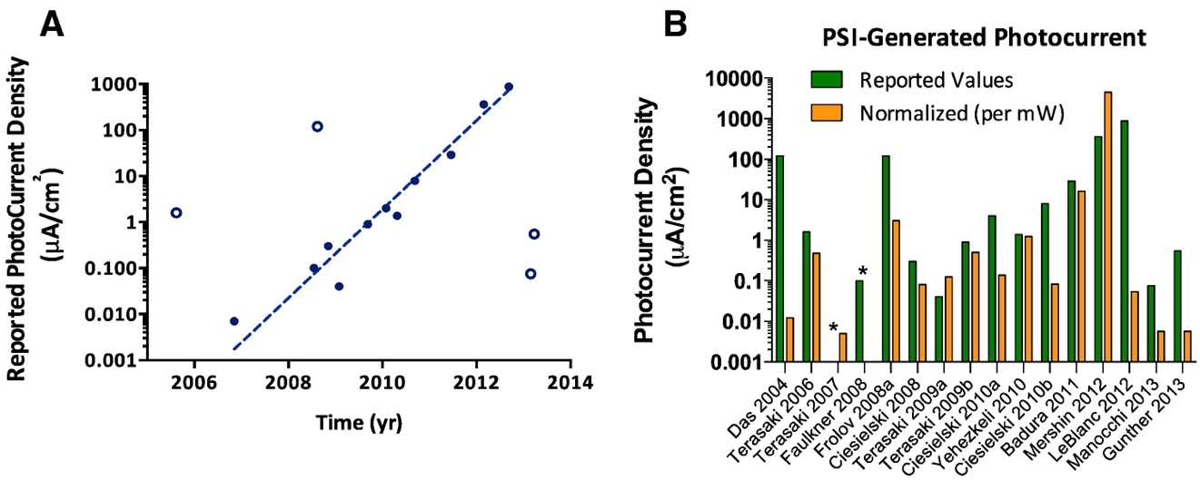
Figure 11. Progress of PSI-based BSSC generated photocurrent. (A) Photocurrent density reported from PSI-BSSC studies from 2005 to 2013. Approximately a 10 fold increase in rate of photocurrent density generation (μA cm⁻ ²) is seen annually with the fitted trend line (open points excluded). (B) A comparison between the reported maximal current density and when normalized to 1 mW cm⁻ ² of applied excitation intensity. *Unable to extrapolate both values due to lack of reported data. Figure reproduced from [81].

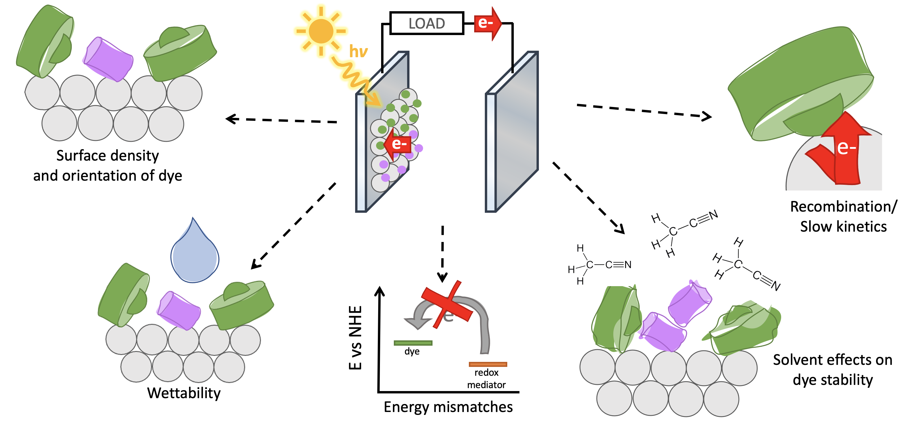
Figure 12. A selection of areas for PSI-based BSSC device improvement. There are multiple interfaces of PSI-based BSSCs that require further careful characterization for more complete understanding. However, certain aspects of device design have been focused on in the research community: (i) surface orientation and density of PSI sensitizer on the semiconductor surface, which also affects (ii) electron recombination and electron transfer kinetics, (iii) mismatches of biological sensitizer energy levels with electrolyte redox mediators and semiconductor/electrode materials, (iv) wettability affecting stability of sensitizers like PSI and their contact with the semiconductor surface, and (v) compatibility of solvents used for electrolytes on PSI stability.

of recent interest has been the effect on PSI of immobilization onto conductive surfaces, and how to improve PSI photoactivity on these surfaces. The most commonly used electrode materials in PSI-based biophotovoltaics for the photoactive electrode are either Au or indium-tin oxide (ITO)/fluorine-doped tin oxide (FTO)-coated optically transparent glass, owing to the optically transparent nature of the conductive glass and the highly conductive and biologically inert nature of gold [50, 82, 83, 107-109]. Several desirable properties are necessary for PSI-based biophotoelectrode materials, including optical transparency to allow photoexcitation, high electroactivity for photocurrent collection, biocompatibility, and ideally the potential to reduce charge recombination.

Several advances have been made in electrode and semiconductor material choices, as outlined below. Compared with being free in solution, cyanobacterial PSI immobilized on a conductive glass surface displays acceleration of the excitation decay of its antenna chlorophyll [110-112] from 16 to 11 ps. This was suggested to result from a high packing density of PSI on the surface, and not from effects due to protein hydration. This was corroborated by studies on a different photosynthetic protein–pigment complex present in green algae and plants, light-harvesting complex BII (LHCBII), where both accelerated excitation decay and red-shifted absorption spectra of a subsection of the chlorophyll antenna were seen [113]. To our knowledge, there are currently no reports on the effects of hydration states on energy transfer in PSI, although a dense network of hydrogen bonds through water molecules in the crystal structure of PSI is involved in antenna chlorophyll and protein subunit coordination, suggesting that proper hydration is necessary for optimal PSI activity [26].

Carbon-based materials for electrodes are one of the newest emerging areas for improving biohybrid device performance. These include the potential of graphene as an alternative material for PSI photobioelectrodes [98, 114]. The desirable properties of graphene include high electrical conductivity, optical transparency, and mechanical strength, although graphene affinity for proteins is low. It has been shown to be possible to obtain significant improvements in the generated photocurrents specifically by utilizing covalent binding modifications on graphene, and pyrene- based functionalization yielded an exclusively unidirectional cathodic photocurrent. Another electrode material of interest is p-doped silicon [89, 115]. Utilization of p-doped Si electrode material has reduced charge recombination, a highly desirable characteristic. Isolated Spinacia oleracea plant PSI immobilized using an Os-modified poly(1-vinylimidazole-co-allylamine) polymer to integrate PSI in a hydrogel on a p-doped Si electrode yielded further decreases in PSI charge recombination and generated photocurrent densities in excess of 0.3 mA/cm² [116].

5.1.2. Optimizing directional orientation of PSI on nonbiological surfaces

As PSI catalyzes unidirectional electron transfer from its lumenal to its stromal side, it is necessary to develop methods for directional binding of the protein to electrode and semiconductor surfaces, as well as to enhance its affinity for interaction at the biological–inorganic interface. Examples of some of the different methods of PSI interaction with the electrode are shown in Figure 13. Possibly the simplest method of orientation has been to use the asymmetry of the PSI structure itself [1, 26]. PSI has a strong dipole moment due to the differential charge of its lumenal and stromal surfaces, particularly PSI from green algal and plant species. Utilization of this dipole results in oriented attachment of a PSI self-assembled monolayer (SAM)-coated gold surface [98, 114]. In this work it was clear that the surface properties of the SAM were crucial, and carboxy- or hydroxy- terminated thiols performed best [83]. Earlier work also used bioengineering of PSI to add exposed thiols to attach directly to an Au surface without the need for SAMs [117]. These efforts have largely resulted in attachment of the lumenal surface to the electrode surface, as shown in Figure 13. Another method involves the use of small affinity tags of short amino acid chains that can selectively bind to metals. These short peptides can be selected using phage display and are specific for different metal oxides including ZnO and TiO₂. These peptides can then be bioengineered as a fusion protein onto exposed surfaces of the PSI stromal surface. Specific TiO₂- and ZnO-binding peptides have been recombinantly fused onto either the stromal subunits of PSI (PsaD and PsaE) or onto the native electron acceptor protein for PSI, ferredoxin (Fd) [100]. Although this could be performed in vivo, the ability
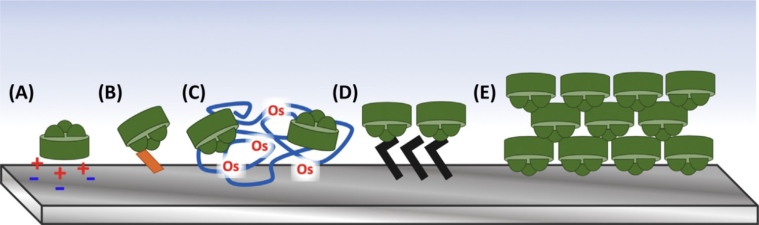
Figure 13. Photosystem I (PSI) electrode and semiconductor wiring strategies. Different strategies to improve PSI activity with electrode and semiconductor surfaces are shown. (A) Use of native electrostatic regions on the stromal or lumenal faces of modified graphene electrodes. (B) Use of metal-binding peptides fused to subunits of PSI to orient and noncovalently bond PSI to the surface. (C) Redox polymer hydrogels, such as those utilizing Os-based complexes with PSI embedded within. (D) Thiol-modified surfaces on gold electrodes to covalently link proteins such as PSI to the electrode surface. (E) Thin-film dried monolayers of PSI to generate multilayers and improve PSI total coverage. Reproduced from [118].

to ‘rebuild’ the stromal surface of PSI in vitro using Escherichia coli-expressed proteins offers a simpler and more well-controlled path for bioengineering [119, 120]. This replacement of native PSI subunits with the recombinant peptide-tagged subunits has yielded incorporation efficiencies of up to 90%, high affinities for nanostructured semiconductors [100], and has been utilized in a device yielding one of the highest photocurrent densities to date by orienting the stromal face of PSI towards the photoelectrode.

5.1.3 Three-dimensional TiO₂ semiconductor architectures

On ITO/FTO electrode surfaces, semiconductor layers are often utilized for multiple reasons. These include collection of photosensitizer-derived charge, improved electron injection into the electrode and thus through the cell circuit, and the ability to create 3D architectures to enhance photosensitizer coverage. The most commonly used semiconductor material in biologically based solar cells is TiO₂ due to its abundance, nontoxicity, and stability [121]. The dye or plant pigment such as PSI utilized as the photosensitizer is then typically adsorbed onto the semiconductor surface to create a photobioelectrode [57, 121].

The development of three-dimensional (3D) semiconductor architectures has attracted interest for improving device performance to increase sensitizer loading in devices. These novel architectures can dramatically increase the surface area of the electrode and permit several orders of magnitude improvement in coverage of the photosensitizer dye (PSI). In addition to increasing the surface area, contact with redox electrolytes in wet electrochemical cells will also be improved [121]. Increased PSI coverage would yield more available photosensitizer to generate larger photocurrents in a biophotovoltaic device. 3D structures used include nanotubes, nanoparticles, and nanopyramids, and most recently several papers with impressive photocurrent densities have been published that utilize an inverse opal design [122-125]. Inverse opal designs involve the use of self-assembling

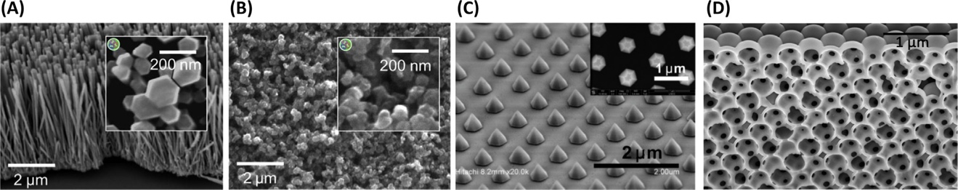
Figure 14. 3D semiconductor architectures. 3D architectures used to improve photosensitizer (photosystem I, PSI) coverage on working electrode surfaces are shown. (A) nanotubes, (B) nanoparticles, (C) nanopyramids, and (D) inverse opal designs. These 3D architectures are also compatible with the different approaches shown in Figure 1 for improved PSI wiring. Panels (A) and (B) are reproduced from Mershin et al. under license (https://creativecommons.org/licenses/by-nc-sa/3.0/). Panel (C) was adapted, with permission, from [126]. Panel (D) was reproduced from [127] under a CC-BY license. The composite figure is reproduced from [118].

monodispersed colloidal spherical particles embedded in the TiO₂; these are then removed typically through the sintering process, creating a 3D ordered porous structure with a very
large surface area and adjustable pore structure and size [128]. These different 3D architectures are shown in Figure 14 [126, 127, 129]. One particularly interesting new study utilized Spinacia oleracea Photosystem II (PSII) and a tungsten trioxide (WO₃) nanoparticle film on FTO, and yielded high photocurrents and enhanced electron transfer through the WO₃ layer into the electrode. Beyond 3D architectures, multiple methods have recently been employed to enhance PSI coverage, including deposition of multiple PSI thin films [130], crosslinking to stabilize PSI films on the electrode surfaces [90], and the use of redox polymers to create a hydrogel with embedded PSI [116, 125]. Redox polymers have the added benefit not only of stabilizing multilayers, allowing greater concentrations of PSI deposition, and reducing charge recombination, but also of electronically connecting the reaction centers while allowing less stringent unidirectional binding. The use of redox polymers in PSI-based biophotovoltaic devices is likely to increase in future studies because of their simplicity and improved protein stability and activity when embedded in these redox hydrogels.

5.1.4 Alternative carbon-based semiconductor materials

In addition to the commonly studied metal oxides (TiO₂ and ZnO) as common semiconductor materials for DSSCs, there has been interest in studying alternative semiconductor materials. Specifically, carbon-based semiconductor materials have been a burgeoning area of interest for enhancing the output and efficiency of PSI-based biophotovoltaics. Multiple studies have been published on pi-system modified graphene as a semiconductor for PSI-based devices as well as enhancing photocurrent production [98, 114]. Carboxy-modified C70 fullerenes can improve electrical interaction of a PSI monolayer with an Au electrode, generating photocurrent densities up to 15 μA/cm². Carbon-based semiconductor materials are attractive for multiple reasons, including the abundance and sustainability of carbon-based systems, attractive strength/ mechanical properties, and the ability to design nanostructures with the increased surface area of various carbon architectures [131]. Further work may improve the protein affinity and optical properties of these alternative carbon-based semiconductor materials and enable PSI interaction in the proper orientation relative to the electroactive surface, greatly facilitating electron injection to the electrode.

5.2 PSI stability enhancement on surfaces and in solution

Although PSI immobilization and interaction with the electrode are of great importance for enhancing device performance, the effects of both purification and device integration on PSI stability must also be considered [132]. The effect of the microenvironment on the stability of proteins, especially membrane proteins, is well documented [133-138]. Both the structure and function/activity of proteins are known to be affected by environmental factors such as pH, ionic strength, and lipid environment for membrane proteins. Further, the immobilization of membrane proteins such as PSI on surfaces has proved to be difficult owing to issues such as aggregation that lead to lower protein activity. Multiple methods have been studied to improve protein stability, including electrospray deposition [99], the use of peptide surfactants and lipids to stabilize detergent micelles [129, 139, 140], encapsulation of PSI in microparticles[141], and novel nondetergent-based purification methods.

Nano- and micro-particle encapsulation is a commonly used method for drug delivery and improved biocargo stability in vivo. Recently, the encapsulation of PSI in polymer-based microparticles has been studied as a way to potentially stabilize PSI in a protective environment [141]. Upon encapsulation in poly(lactic-co-glycolic acid) (PLGA) microparticles, both the stability and photoactivity of PSI were improved post-lyophilization as compared with purely detergent-purified PSI. The ability to make larger micron-sized structures also would likely simplify handling for use in device fabrication. Designer peptide surfactants, specifically those with increased positive charges, have been shown to similarly stabilize and enhance the photoactivity of cyanobacterial PSI [139]. A different approach that has also been used focuses instead on reducing the concentration of detergent or lipid, and takes advantage of the hydrophobic regions of PSI for linker-free deposition of the protein on TiO₂ semiconductor surfaces, and yielded even coverage over the semiconductor surface and decreased aggregation through electrospray deposition [99].

One final issue relevant to protein stability that affects the lifetime of PSI-based BSSCs concerns the potential generation of reactive oxygen species (ROS). Photoexcitation of chlorophyll can yield a triplet chlorophyll excited state, which readily reacts with molecular oxygen to form ROS. ROS are highly damaging to proteins and will likely lead to degradation of a PSI-SSC device over time. It has been shown that buildup of ROS and other highly oxidizing species does in fact occur on PSI-based electrodes [116, 142-144]. The incorporation of either biological or synthetic oxygen radical scavengers, or the development of anaerobic cells [102], is likely to help with improving the long-term stability of devices and lowering photocurrent density drops over time [142]. However, several studies already that indicate that PSI can remain photochemically active for many months, suggesting that device lifetime may be promising [77, 79].

5.3 Light absorption, optoelectronic considerations, and improving optical cross-sections of reaction centers

It has been previously shown that optimal energetics of electron transport pathways occur when bio-hybrid energy harvesting constructs (such as BSSCs) involve PSI interacting with a soluble carrier, a solid-state electrode, or bound catalysts [102]. PSI, PSII, and LHCs I and II are biological supercomplexes composed of both proteinaceous subunits along with pigments and other redox-active cofactors. These protein–pigment complexes function as light absorbers and energy converters that are active over large specific regions of the UV–visible spectrum based on the primary pigments present in their light-harvesting antennas. There is a general consensus in the applied photosynthesis field that PSI can further be modified for optimal energy conversion by modification of absorption wavelengths, which is a property of the biohybrid material, and through the incorporation of selective biocompatible electrodes, mediators, and composite matrices in systems for solar energy conversion, or photocatalysis [86].

As mentioned previously, an ideal sensitizer for any DSSC should exhibit high light absorbance below a threshold wavelength (λ) of approximately 920 nm. As such, enhancement of the optical cross section of photosensitizers to extend their photoexcitation capabilities is one strategy of interest for increasing the output of these photocatalysts. These modifications have also evolved in nature, with photosynthetic organisms utilizing novel forms of chlorophyll pigments with unique optoelectronic properties to make use of the portion of the UV–visible spectrum that is available to them, or with additional antenna proteins with differing pigments [1, 145]. In this section, we will focus on the progress made in the studies that include information on, or involve, modification to light absorption and electronic considerations of reaction centers for bio-hybrid electronic devices such as BSSCs. In Figure 15, we show the optical cross sections of the biological reaction centers and synthetic dyes discussed in this section.

One research group studied the photoelectrochemistry of PSI immobilized on a photoelectrode surface and found that upon illumination with a 676 nm band-pass filtered light at 1.4 mW cm⁻², a photocurrent of 4 µA cm⁻² is obtained [95]. This 676 nm light is near the optimal excitation wavelength for PSI. However, the efficiency of PSI electron generation through the absorption of incident photons is limited by its poor absorption in the “green gap” of its absorption spectrum [146]. One approach to increase the optical cross-section of reaction centers is the incorporation of synthetic dyes that absorb in different regions of the UV-Vis spectrum, enabling a transfer of energy from the dyes to the reaction center [146]. Dye-modified PSI activity has been shown to be enhanced even in solid-state devices as evident via surface photovoltage (SPV) experiments [146].

Dyes have also been conjugated to photosynthetic reaction centers and light-harvesting antennas beyond PSI in attempts to enhance their optical cross-sections, and thus, their ability to be photoactivated. The use of dyes to fill in the “green gap” of chlorophyll-based
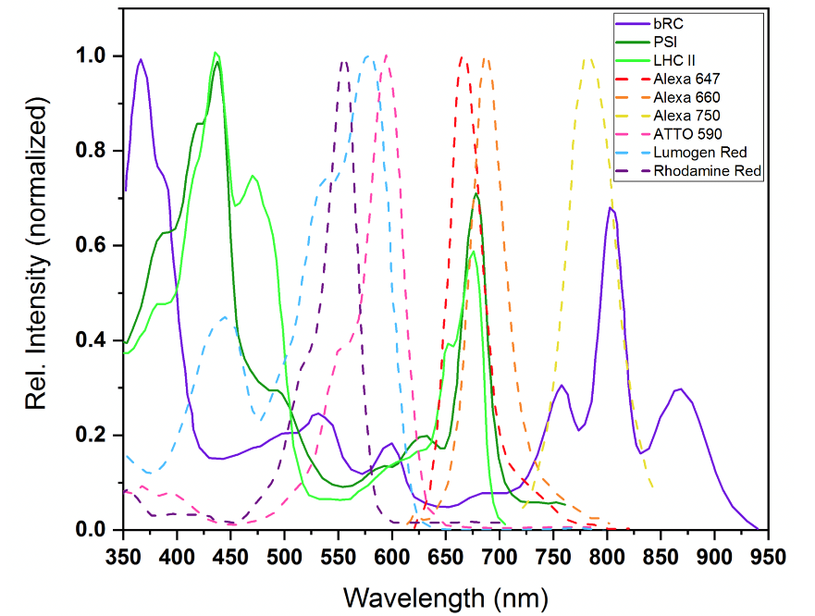
Figure 15. Optical cross-sections of reaction centers and dyes. The UV–Visible absorption spectra of commonly studied biological reaction centers and dyes used to extend their optical cross-sections are shown. The maxima of each spectra were normalized to 1.0 for comparison. Reproduced from [42].

protein–pigment complexes has been studied for the last decade. One of the earlier reports on modulating optical cross-sections assessed synthetic porphyrin and chlorin dyes with a variety of side groups and their spectral properties and ability to self-assemble into biomimetic light-harvesting antenna systems [147]. The highly ordered nature of these dyes, similar to the order of pigments in biological protein–pigment complexes, allowed for photoexcitation even when aggregated and the photochemical efficiency was unaffected [148]. The ability to couple together different dyes in synthetic biomimetic systems to enhance light-harvesting capabilities led to interest in the conjugation of dyes to biological reaction centers such as PSI to similarly supplement their optical cross-section.

One report on dyes conjugated with a biological protein–pigment complex used recombinant LHC II, a PSI and PSII light-harvesting antenna complex and either one or three Rhodamine Red dyes covalently attached via cysteine residues on the protein [149]. Dye addition did not affect the assembly, stability or activity of LHC II. While labelling efficiencies were low, electron transfer efficiency to LHC II was near 100%. Other dyes that have been similarly utilized include Alexa Fluor 660, 647, and 750 dyes, yielding similarly improved photogeneration of charge separated species while maintaining protein stability [150]. To date, the dyes Lumogen Red and ATTO 590 have been utilized to fill in the “green gap” of PSI. The coupling of approximately 30 ATTO 590 dye molecules to PSI increased the oxygen consumption activity of PSI by over 4-fold, and the addition of Lumogen Red allowed for greater energy transfer to PSI via Förster resonance energy transfer. Expanding the light-harvesting capabilities of PSI through conjugation of dyes [146, 151] is likely to be an area of further focus for improving outputs of future reaction center-based biohybrid devices.

Artificial metal nanoparticle antennas can also be used to enhance PSI light absorption and PSI circular dichroism over the protein’s entire absorption band as opposed to the utilization of spherical metal nanoparticles (NP), which enhances only specific plasmon resonance wavelengths [152]. Metal NP aggregates, due to the high dielectric constant of the metal, and NP–PSI–NP antenna junctions cause broad-resonant and non-resonant electronic field enhancements, as well as enhancing PSI’s light absorption capabilities [152]. Some researchers were able to achieve a 100% quantum efficiency with an integrated photoexcited PSI in solar energy conversion devices as the photoactive electrode [93]. Ag NPs have been found to enhance chlorophyll fluorescence up to 18-fold in peridinin-chlorophyll-protein assemblies, and 5- to 20-fold for thin films of cyanobacterial PSI [153, 154]. Similarly, incorporation of Au NPs in leaves and chloroplasts in vivo increased reaction center reduction rates [108]. While metal NPs may not directly expand optical cross-sections, enhancement of the photoelectrochemical activity of reaction centers, including PSI, should lead to improved photocurrent outputs of devices. The use of metal nanostructures, such as nanopyramids [124], and NPs has been suggested to enhance photochemical activity through plasmonic coupling, and further engineering to enhance interactions of this biotic–abiotic interface is likely to be studied for further biohybrid device improvement [155].

Quantum dots (QDs) have also been incorporated with photosynthetic reaction centers in attempts to enhance their photoelectrochemical properties and activities. The optoelectronic properties of QDs are as a function of both size and shape [156], allowing for fine tuning to enhance their optical cross-section. QDs have previously been shown to be capable of transferring their photoexcitation energy to reaction centers, including PSI [157, 158]. Reaction center charge separation has been found to increase anywhere from 3–5-fold upon QD conjugation. A study assessing the interaction of CdTe QDs with the R. sphaeroides reaction center found that use of a polyhistidine tag on the reaction center allowed for targeted binding of the QD to the tag, and up to ~95% QD labeling efficiency was achieved as well [159]. The ability to now fine tune the optoelectronic as well as binding properties of QDs makes this an area with great potential for further enhancement of biological photosynthetic reaction centers as light-activated catalysts.

5.4. Redox mediators and electrolyte considerations

Beyond electrode materials and architectures, the performance of biologically-based electronic devices can be improved with careful selection of the electrolyte, which assists in both directing electrons to the biological photosensitizer and in enhancing conductivity between the electrodes. An electrolyte for a DSSC is typically comprised of a redox mediator in a supporting conductive electrolyte. The supporting electrolyte is typically liquid, yet there has been emerging interest in gel- or solid-state electrolytes as well. Liquid electrolytes typically have improved wettability, redox mediator solubility, and generally faster ionic mobility, yet they can also increase desorption of the photoactive dye off the sensitizer and are more susceptible to leakage and loss out of a fully fabricated device. Gel-based electrolytes have multiple advantages over fully liquid electrolyes, including improved interfacial contact and mechanical strength, and reduced charge recombination and electrolyte volatility and leakage [160].

Upon photo-oxidation, it is necessary for the photosensitizer (such as PSI) to be reduced for another photo-oxidation event to occur. As such, judicious matching of the redox mediator in the electrolyte with the sensitizer dye and with the counter electrode material is crucial for improving device performance – it has been predicted that there are two methods of improvement for DSSC efficiencies: extension of the light-harvesting region of the dye into the near-infrared, or lowering the redox potential of the electrolyte redox mediator to increase the open circuit potential (V_{OC}) of the device assuming all other parts of the device design are compatible [56].

Clearly, not all redox mediators are suitable for biohybrid photoelectrochemical devices. The traditional DSSC I⁻/I₃⁻ redox mediator is corrosive to both protein and metal, has a midpoint potential similar to PSI, intensely absorbs light in the visible spectrum, and generation of reactive radical species that can be highly damaging [161]. Generation of reactive species in devices, and particularly ROS for cells operated under aerobic operation compromises the long-term stability of photosynthetic biophotoelectrodes, even though molecular oxygen has been shown to help decrease PSI charge recombination rates [162]. Under anaerobic conditions, the operation of a PSI-based photocathode using an electron acceptor that enables photocurrent generation can substantially improve stability and allow for exposure to higher light intensities [162].

Further, the transfer of electrons to and from reaction centers is much slower than the primary charge separation events of these photosensitizers, and the ability and rate of electron donation/acceptance of mediators with photosensitizers plays a key role in biohybrid device performance at the solution–electrode interface as governed by Butler–Volmer kinetics [92]. Publications on research involving redox mediators include small organic-based molecules, such as methyl viologen (MV), 2,6-dichlorophenolindophenol (DCPIP), and ferricyanide complexes. Organometallic redox mediators include cobalt-, ruthenium-, and osmium-based complexes typically coordinated by bipyridine ligands. Solid-state electrons can be shuttled and be donated to a secondary acceptor via organic polycationic polymers, such as polyviologens [93]. Many of the organometallic mediators utilized to date use utilize rare elements as their redox-active cofactors. This makes them less than ideal candidates for incorporation of sustainable energy technologies such as BSSCs due to low abundance and geopolitical limitations. While protein-based mediators such as cyt c₆ may be more sustainable from an elemental abundance consideration and have been used in some studies, recombinant expression and purification of proteins is time intensive and can be expensive, and the stability of the protein component and electron transfer rates may be less than desired to improve device performance. However, this area of redox mediator choice one of the least-studied areas of biohybrid photoelectrochemical electrodes and devices and is likely an area where significant improvements in performance could be made.

One commonly used class of molecules as diffusible sacrificial electron mediators in PSI-based systems are MV [93]. MV can also be used as a charge carrier for the collection of electrons at the reduced F_{B} PSI site, as it can act as an acceptor of electrons from PSI [116]. Photoexcited PSI has also been shown to interact with polyviologens in solid-state devices. PSI–polyviologen protein surfaces immobilized in Nafion polymer have been shown to significantly enhance photocurrent, aid in electron transfer, stabilize PSI through immobilization, and enhancing electrolyte conductivity [93]. Lower Nafion concentrations have been shown to increase redox mediator diffusivity with both Os(bpy)₂Cl₂ and MV redox mediators [95]. As another alternative redox mediator, cobalt complexes can be used in PSI biohybrid solar cells because they are not corrosive and they offer more negative redox potentials to drive the reduction of PSI [161].

PSI has also been integrated within a redox hydrogel polymer that can act as a conductive matrix for the transfer of electrons from electrode surfaces to the photo-oxidized PSI [116]. Oxygen drives MV to initiate a light-induced unidirectional electron transfer, which results in photocurrent from an electron donor Au surface via surface assembled PSI trimers. PSI wet cells typically use MV and either ferrocyanide mediators or osmium-based mediators. In PSI/SAM/Au systems, dissolved oxygen in solution forms a complex intermediate species with MV to mediate redox pathways [102]. Gel- and solid-based conductive electrolytes have been an area of much interest to try and address these deficiencies and have also been shown to aid in the reduction of charge recombination at TiO₂/dye/electrolyte interfaces [118, 163, 164], and to improve the mechanical strength of the fabricated cells.
The use of organic solvents in the liquid heterojunction of DSSCs has been found to be unfavorable for a number of reasons, including the high volatility, toxicity, and/or explosive nature of many of these solvents[165]. A goal of DSSCs in terms of predicted performance is thin, flexible, aqueous-based devices [165-168]. The movement of device design towards aqueous-based electrolytes is also particularly important for stability of biological proteinaceous components in BSSCs. Organic solvents can extract chlorophyll and lipophilic cofactors from PSI, potentially altering light-harvesting and photochemistry capabilities. While numerous studies have been performed on pigment extraction, to date there has not been significant studies to determine the upper limit of solvents that will not significantly alter the cofactor composition of PSI or other photoactive proteins[169-171]. This is also crucial for synthetic redox mediators due to their historically low solubility in aqueous solutions that are native for PSI [129, 172]. From a more pragmatic perspective, solar cells are also sensitive to contamination by water during both the fabrication process and during real outdoor use. This would have significant effects on performance and long-term stability of the device, and it has been estimated that water content in a DSSC’s electrolyte may be greater than 10% after one year of real outdoor use [165].

CHAPTER I

MATERIALS AND METHODS

A version of this chapter was originally published by Alexandra Teodor as first author and Barry D. Bruce as senior corresponding author in sections of the following articles:

Teodor, A.H. et al. “Aqueous-soluble bipyridine cobalt(ii/iii) complexes act as direct redox mediators in Photosystem-I based biophotovoltaic devices.” RSC Advances 11(18): 10434-10450.

Teodor, A.H. et al. “Photosystem I integrated into mesoporous microspheres has enhanced stability and photoactivity in biohybrid solar cells” Materials Today Bio 11(2021): 100122.

Teodor, A.H. et al. “PEDOT-Carbon Nanotube Counter Electrodes and Bipyridine Cobalt(II/III) Mediators As Universally Compatible Components in Biosensitized Solar Cells using Photosystem I and Bacteriorhodopsin” International Journal of Molecular Sciences (2022) 23, 3865.

Alexandra Teodor is the first author of these published research article. She performed conceptualization, experimental design and performance, data collection and analysis, figure making, initial draft writing and was involved in the manuscript editing and review process at each journal.

1.1 Abstract
The following experimental methodologies and techniques were published as “Materials and Methods” sections in each manuscript listed above. The methods were used following standard protocols for the Bruce laboratory, except when modified as needed. Each chapter’s materials and methods is clearly delineated based on publication, even though there is overlap in methods used between chapters.

1.2 Methodology for Chapter II

Isolation of Photosystem I

PSI was isolated and purified from T.elongatus BP-1 as previously reported. Briefly, frozen T. elongatus frozen cells were resuspended in wash buffer (20 mM MES, 10 mM CaCl₂, 10 mM MgCl₂, pH 6.4) and Dounce homogenized. Lysozyme was added and the suspension was incubated to allow for cell wall degradation. The suspension was pelleted and washed with fresh wash buffer before being passed twice through a French press for cell lysis. The lysate was centrifuged, and the pelleted membrane fragments were washed again. N-dodecyl β-D-maltoside (β-DDM) was added to the resuspended pellet, which was then incubated for 30 min at 37 °C. The insoluble material was removed via centrifugation and the solubilized material from the membrane pellet was then separated using sucrose density gradient ultracentrifugation, after which the lowest band containing trimeric PSI was harvested. Harvested PSI was then purified using HPLC before aliquoting and storage.

Cobalt redox mediator complex synthesis

Two bipyridine cobalt complexes bearing methoxy groups and two bipyridine cobalt complexes bearing tert-butyl groups were synthesized, using perchlorate, hexafluorophosphate, or chloride counterions. Synthetic schemes to form the six cobalt redox media mediator complexes are shown in Figure 2.2. Complexes 1 and 2 were formed by using 3 molar equivalents of 4,4’-dimethoxy- 2,2’-bipyridine which was reacted with 1 molar equivalent of cobalt chloride hexahydrate in methanol for 3–4 hours at 55 °C. The solution was divided into two separate batches, and two subsequent reactions were performed for counterion addition. Complexes 3 and 4 utilized 4,4’-di-tert-butyl-2,2’-bipyridine as coordinating ligands. To obtain complexes 5 and 6, 3 molar equivalents of ligand was reacted with 1 equivalent of cobalt chloride hexahydrate using methanol as solvent and was stirred at 55 °C for 3 hours. After which, methanol was evaporated and the resulting solid was washed with cold diethyl ether to yield the chloride salts in quantitative yield. Bi-pyridyl (tert-butyl and methoxy) ligands were purchased from Sigma-Aldrich and used without purification. The preparation was performed following protocols in the literature [172-174].

MALDI-TOF product synthesis confirmation

Matrix-assisted laser desorption ionization time-of-flight (MALDI-TOF) mass spectrometry was performed for synthesis product confirmation. Each of the four complexes was dissolved in a 60% acetonitrile 0.1% trifluoroacetic acid (TFA) solution containing the carrier species sinapinic acid at a concentration of 20 mg mL⁻¹. Samples were spotted onto an MSP96 target polished steel microSCOUT Target sample plate and ran on a Bruker Daltonics microflex MALDI-TOF mass spectrometer with a Bruker microSCOUT ion source. Spectra were normalized based on relative abundance before peak picking and analysis was performed.

Solubility quantitation of Cobalt redox mediators

Complexes 1–4 and 6 were initially dissolved in 60% acetonitrile and 40% ethylene carbonate w/v. Complex 5 was measured in 100% DI H₂O. Samples were chemically oxidized with the addition of potassium ferricyanide to a concentration of 1.5 mM, with complex concentration at 300 mM. To determine the minimum concentration of organic solvent needed, the change in absorbance at the 295 nm peak in the oxidized spectra of complexes 1–4 was measured before and after centrifugation sedimentation for 2 min at 21, 000 g. Large ΔAbs295 nm values were taken to be indicative of the complex not being in solution, and ΔAbs295 nm less than 0.05 a.u. as indicative of the complex being solubilized. Absorbance measurements were measured on a NanoDrop One C. Measurements reported were taken in technical triplicate.

UV-Vis spectra and redox difference spectra

For the UV-Vis oxidized and reduced spectra, redox difference spectra for complexes 1–4 and 6 were recorded in 33% acetonitrile, while the oxidized and reduced spectra were recorded in 50% acetonitrile. Complex 5 was measured in 100% DI H₂O. The method for generating redox difference spectra is based on the initial chemical redox method published by Ke for PSI [175]. Quartz split cuvettes were used to generate physically subtracted redox difference spectra while avoiding artifacts from either the oxidant or reductant species. The concentration of cobalt complex used was 0.2 mM, and 30 mL of either 25 mM potassium ferricyanide or sodium ascorbate was spiked in as the oxidant and reductant, respectively. Samples were brought up to 750 mL total volume in 50% acetonitrile. Baseline correction was performed using the MES buffer used in flash photolysis experiments and described below before sample spectra were taken. Spectra were taken using an Evolution 300 spectrophotometer after an hour incubation of samples in the dark at room temperature.

Cyclic voltammetry/midpoint potential determination

Cyclic voltammetry was performed to determine midpoint potentials, stability after multiple redox events, and diffusional control analysis of these complexes. A glassy carbon electrode was used as the working electrode, a pseudo Ag|AgCl electrode was used as the reference (a true Ag|AgCl reference electrode was used for any aqueous measurements), and a platinum counter electrode was used. Measurements were taken using a Bio-Logic SP-50 potentiostat in acetonitrile and matching 0.1 M either tetrabutylammonium hexafluorophosphate (TBAPF), tetrabutylammonium perchlorate (TBAP), except for complex 5 which was measured in deionized H₂O with NaCl supporting electrolyte. Each complex was added to a final concentration of 2.5 mM, and measurements were taken at scan rates of 10, 20, 50, 100, 150, 175, 200, and 250 mV s⁻¹ for each cobalt complex. The software package QSOAS v2.2 was used for electrochemical data processing and analysis [176]. For diffusional control analysis, the Randles–Sevcik equation [177] was used to examine the effect of slew rate on peak currents. Cathodic peak heights were measured and plotted against both the scan rate and square root of the scan rate and linear regression on these plots was performed using GraphPad Prism 8.

Organic solvent effects on PSI stability

PSI stability in various organic solvents was tested via 77K chlorophyll fluorescence emission spectroscopy. Solvents were made up using appropriate volumes of neat acetonitrile or ethylene carbonate and 50 mM MES buffer, pH 6.4 with 0.03% β-DDM and 25 mM MgSO₄ for dilution to the desired concentration of organic solvent. PSI was added, samples were thoroughly mixed and incubated in the dark at room temperature (23 °C), and measured after both 1 and 24 hours. Samples were transferred into glass EPR tubes and were slowly frozen in liquid nitrogen. Chlorophyll fluorescence spectra were measured using a PTI Quantamaster Dual-channel fluorometer. The excitation light was set to 430 nm for excitation of chl a with a slit width of 0.75 nm and emission was scanned using 1 nm steps from 600–800 nm. Each spectrum was averaged from 3 traces. Baseline correction, peak maxima and areas were computed using Gaussian peak fitting in Origin Pro 2019.

Spectral measurement of photo-oxidized P700+ PSI reduction kinetics

To assess the ability of the complexes to act as electron donors to PSI, single-pulse LED flash photolysis was performed using a JTS-100 spectrometer. The pulse sequence used was 20(D 50ms)G[150000 mA]30ms HT200ms{20 ms, 500, 2500ms, D} for initial assessment of redox mediator donation to photo- oxidized PSI-P₇₀₀⁺. PSI-P₇₀₀⁺ was monitored at 705 nm and the actinic LED was “Actinic 1” which has a FWHM centered at 630 nm. For titration of cobalt complex #2, the timescale was increased to 120 seconds. Measurements were performed using 30 nM P₇₀₀ of PSI per sample in a ternary solvent system that was 60% 50 mM MES buffer containing 25 mM MgSO₄ and 0.03% β-DDM at pH 6.4, 24% ethylene carbonate, and 16% acetonitrile, or fully in the MES buffer for aqueous experiments. Methyl viologen was added to a concentration of 1 mM as an electron acceptor, and sodium ascorbate was added to a concentration of 1 mM to act as a sacrificial electron donor. A 20 ms baseline was measured before the 630 nm actinic light was turned on to maximum intensity for 10 ms to photo-oxidize all the PSI present in the sample. Reduction of PSI-P₇₀₀⁺ was monitored using a second pulsed 705 nm wavelength probe beam. Twenty traces per sample were averaged to generate reduction curves. Monophasic exponential association curve fitting with 1000 iterations was used to model the Co #2 and DCPIP titration series and residuals plotting was also performed in GraphPad Prism 7. For comparison to the cobalt complexes in both organic solvent and aqueous solution, reduction of photo-oxidized PSI-P₇₀₀⁺ by a commonly used small molecule redox mediator 2,6- dichlorophenolindophenol (DCPIP) was performed.

Biophotovoltaic device fabrication and measurement

Conductive FTO glass electrodes were doctor bladed with a TiO₂ suspension and then sintered at 475 °C to generate FTO glass electrodes with a TiO₂ nanoparticle semiconductor layer. Photoanodes were stored in Dri-Rite dessicant until use. PSI-utilizing devices had concentrated 3 mg mL⁻¹ chl a PSI that was isolated as previously described above drop-casted onto the TiO₂ and allowed to dry to the eye. Counter electrodes were generated by carbon deposition on the conductive side of a second FTO glass electrode. The 2 electrodes were then offset and mechanically compressed together, with dual clamps on opposing sides holding the device together, and electrolyte was introduced. Mediators were present at a concentration of 30 mM when included in the electrolyte. The fully aqueous electrolyte used was 40% 50 mM MES buffer, pH 6.4 with 0.03% β-DDM, 25 mM MgSO₄, and 60% ethylene carbonate. The ternary electrolyte is the same as described for kinetic experiments above, with acetonitrile present at 16%. Devices were allowed to sit to allow for electrolyte integration for approximately 30 minutes before device testing and measurements. Device illumination was performed using a Schott KL-2500 light source with inset filter holder and Schott red light filter (MOS-258-303) for all red actinic light experiments. All pho- tochronoamperometric measurements were taken using a Bio- Logic SP-50 potentiostat for data collection. Data plotting was done in Origin Pro 2019 and Graphpad Prism 8.

1.3 Methodology for Chapter III

PSI purification and microsphere synthesis

Salt solutions of 0.05 M sodium carbonate (Na₂CO₃), 0.5 M calcium chloride (CaCl₂), BSA at 10 mg mL⁻¹ in MES buffer, PSI at 1 mg mL⁻¹ chlorophyll a in 50 mM MES buffer with 25 mM MgSO₄ and 0.03% β-dodecyl maltoside (DDM), and 0.05 M MES buffer at pH 6.4 with 0.03% DDM were used for synthesis. PSI was isolated and purified as described by Iwuchukwu et al. [77]. Solution ‘A’ was composed of 400 μL CaCl₂, 100 μL BSA, and 28 μL PSI. Solution ‘B’ was composed of 400 μL Na₂CO₃, 100 μL BSA, and 28 μL PSI. Solution ‘A’ was pipetted into solution ‘B’ while being vortexed at lowest speed on a Fisher vortexer. An apparatus was constructed to help stabilize the microcentrifuge tube while the solutions were being mixed. The newly made microspheres are then centrifuged at 1500xg for 2 min. The supernatant was then removed, and the microsphere pellet was washed using MES buffer. This process of centrifugation and washing was then repeated 2 more times. After the final wash, the supernatant is removed, and a solution of 0.025% glutaraldehyde in MES buffer is added and then left with gentle stirring for 2 h to cross-link the proteins within the template CCM. After this, 0.25 M glycine is added to quench the cross-linking process. Once the microspheres are quenched, they are centrifuged and washed three times using MES buffer. The sample is then resuspended in EDTA on the final wash and left to chelate overnight; this process helps remove the CaCl₂ template around each microsphere. PSI concentration was kept constant for varying protein composition samples, and BSA was increased accordingly.

Size distribution analysis

Size distribution analysis was performed using template microspheres made using BSA, Na₂CO3, CaCl₂, and MES buffer. Once the microspheres were combined and vortexed, they were let to sit for varying amounts of time from 0 s to 300 s before being centrifuged and washed. Samples were then taken and put onto glass slides to be imaged using a differential interference contrast (DIC) microscope. Image J analysis [178] was used to collect data on the size distribution on the microsphere sample. Images taken from the microscope were converted to grayscale 16 bit, and then the ‘threshold’ function was used to highlight the microspheres that needed to be counted. Diameter data from image analysis were then binned to form a histogram of particle size (bin size 1⁄4 0.1 μm), which was then fit with a single Gaussian curve using GraphPad Prism 8 (1000 iterations, no constraints on fitting or outliers excluded). To determine whether protein composition (BSA:PSI ratio) had an effect on the size of synthesized microspheres, samples at ratios of 250:1, 500:1, and 1000:1 BSA:PSI were synthesized as described previously, and samples were run on a Wyatt Technologies DynaPro NanoStar DLS instrument. Samples were run to an n = 1,000,000 for accurate measurements of diameter with technical replicates n = 10 for each sample.

UV-Vis spectroscopy

UV-Vis spectroscopy was used to measure the absorbance of PSI in the microspheres. Samples were transferred to cuvettes, and a blank of MES buffer was used. Samples were run on a Thermo V-Vis Evolution 300 Spectrophotometer. Samples were normalized to maximum absorbance values measured, with scattering from the template (non-protein containing CCMs formed at the same salt concentrations listed previously) subtracted out as a baseline.

Scanning electron microscopy (SEM)

Samples were prepared as described previously at varying concentrations and aliquoted at various points of the synthesis process. The samples were rinsed and resuspended in deionized water before imaging. Samples were then imaged on the Zeiss Auriga Crossbeam FIB/SEM at EHT = 2 kV under vacuum after sputter-coating with Au to improve image quality.

Low-temperature fluorescence emission spectroscopy

Samples were loaded into EPR tubes and flash-frozen by lowering into a vacuum-insulated Dewar flask which was filled with liquid N2. Each tube was slowly immersed to allow for full freezing. Microsphere samples were taken at three stages during the synthesis for quantification of PSI stability: before cross-linking, after cross-linking, and after chelation. Samples were also synthesized and quantified at three BSA-to-PSI ratios: 250:1, 500:1, and 1000:1. Samples were measured using a PTI QuantaMaster dual-channel fluorometer (PTI/Horiba, NJ). Samples were excited at a wavelength of 430 nm and a slit width of 0.75 nm. Emission was then acquired from 600 to 800 nm. Three replicate spectra were acquired for each sample.

Laser scanning confocal microscopy (LSCM)

LSCM of PSI chlorophyll autofluorescence was analyzed using a Leica TCS-NT laser confocal microscope. Chlorophyll autofluorescence was visualized using 488 nm excitation and a 660 LP filter (chlorophyll autofluorescence). A 100 x 1.4 NA oil immersion lens at an Airy disc setting of 0.91 was used. The microspheres were vertically sectioned using Z 1⁄4 steps of 60 nm. The fluorescence intensity cross-section was derived directly from image analysis of each Z-slice using ImageJ (Ver. 1.53).

Flow cytometry

Samples were prepared as described previously at BSA:PSI ratios of 250:1, 500:1, and 1000:1 with PSI concentration fixed. Samples were cross-linked and chelated for fluorescence-activated single-cell sorting. Chlorophyll autofluorescence (excitation at ~480 nm, emission at ~690 nm using PerCP tracking) was used for microsphere detection in the instrument. Samples were run on a BD LSR II flow cytometer (BD Biosciences) to 50,000 counts per sample, repeated in biological duplicates. Data were evaluated using FlowJo Mac software, version 10.1.
Pump-probe spectroscopy

Pump-probe spectroscopy was used to assess the ability of the mi- crospheres to act as electron donors. Spectroscopy was performed using a SpectroLogiX JTS-100, using the Bio-Logic USA P₇₀₀ detection LED lamp which measures absorbance changes at 705 nm for tracking PSI reduction. Excitation was performed using the built-in actinic source at 630 nm. The pulse sequence used as defined in the JTS software was 20(D50 ms)G[150000 μA]30msH T10μs{20 μs,400,5000 ms,D}. Addition of the electron donor, 2,6-dichlorophenolindophenol (DCPIP), was titrated into PSI at different concentrations noted in figures. Final chelated samples of PSI were diluted 2:5 in 0.05 M MES buffer at pH 6.4 with 0.03% DDM. Methyl viologen was added to a concentration of 1 mM as a sacrificial electron acceptor and ascorbate to 1 mM as a sacrificial low level for reduction of PSI on the many minutes’ timescale to ensure PSI in the dark was fully reduced. A 1 s baseline was taken before the actinic source was turned on for 30 ms to fully photo-oxidize the PSI present, and the reduction in the dark was tracked for 5 s using an exponential clock. Five traces per sample were averaged. Monophasic exponential association curve fitting with 1000 iterations in Prism 8 (GraphPad Software, San Diego, CA) was used to fit the reduction data to a single exponential equation to calculate observed reduction rates (Kobs, units ms⁻¹). Linear fitting of Kobs vs. [DCPIP] was performed using simple linear regression in Prism 8 (GraphPad Software, San Diego, CA).

Biophotovoltaic device fabrication and testing

Indium Tin Oxide (ITO)-coated conductive glass electrodes (~25 mm²) were doctor-bladed with Solaronix T/SP TiO₂ nanoparticle paste to deposit a transparent mesoporous semiconductor layer on the conductive side of the electrode. Electrodes were then sintered after a ramp up from 23 °C to 475 °C and held for 30 min at 475 °C before allowing cooling. Electrodes were stored in airtight containers with desiccant before use. PSI microspheres with a BSA:PSI ratio of 250:1 were synthesized and chelated overnight before being drop coated onto an ITO/TiO₂ electrode. Counter electrodes were generated by carbon deposition on the conductive side of the electrode. The 2 electrodes were then offset and mechanically compressed together, with dual clamps on either side holding the device together. The liquid junction electrolyte using an aqueous bipyridine-based Co(II/III) redox mediator at a concentration of 10 mM was then introduced, prepared as described previ- ously in the same MES buffer used throughout analysis with 0.03% DDM [54]. Devices were allowed to sit for approximately 30 min to allow for electrolyte integration before device testing. Device illumination was performed using a Schott KL-2500 light source with an inset filter holder and Schott red light filter (MOS-258-303) for all red actinic light experiments. All experiments were performed under no applied bias. All photochronoamperometric measurements were taken using a Bio-Logic SP-50 potentiostat and EC-Lab software for data collection. Data plotting was carried out in Origin 2020 and GraphPad Prism 9.

1.4 Methodology for Chapter IV

Counter Electrode Fabrication

Platinitzed counter electrodes were fabricated by doctor blading Platisol T/SP from Solaronix (ref. no. 41211) onto conductive FTO glass electrodes (~25x25x2mm) that were masked off using Scotch tape to define active electrode area. The FTO coated unpolished float glass was from Delta Technologies (Loveland, CO) and had Rs= 5-10 ohm. Tape was then removed and platinized counter electrodes were then sintered starting in a cold furnace up to 450 °C where they were held for 1h. Graphene counter electrodes (~25x25x2mm) were a gift from General Graphene (Knoxville, TN) with a four layer-thick deposition of graphene on FTO glass. The PMMA coating on the graphene electrodes was removed by washing with acetone, followed by intensive rinsing with MilliQ H₂O. The multiwall carbon nanotubes (MWCNTs) were purchased from CheapTubes.com (SKU #030106). PEDOT/CNT electrodes were electropolymerized from water dispersion using SDS as surfactant at the CMC (CMC = 8.2 mM) and 0.35% mass concentration of MWCNTs. SDS/CNT emulsions were sonicated before and after the addition of the monomer, EDOT (10 mM). The dispersion was deposited on the electrode surface using galvanostatic conditions on an Autolab Potentiostat. Conductive glass electrode was used as working electrode, platinum foil as counter electrode, and Ag|AgCl (KCl 3.0 M) was used as reference electrode. The electrical polymerization was carried out with a current density: 1 mA/cm² using a potential limit of 1.9 V for 240 s (ca. 120 mC/cm² of charge density). Following the PEDOT:SDS:MWCNT deposition, the electrodes were intensively rinsed with deionized water.

Protein Isolation

The bacteriorhodopsin protein was purified from H. salinarum as described in [179]. In brief, H. salinarum frozen cells were resuspended in 250 mL of basal salt without peptone. The cells were then dialyzed overnight in 2 L of 0.1 M NaCl to lyse the cells. The lysate was centrifuged and the membrane pellet was resuspended and Dounce homogenized, and then centrifuged again. The membrane pellet was then separated using sucrose density gradient ultracentrifugation and the lower purple band was harvested. This purple membrane was then solubilized using Triton X-100 detergent followed by gel filtration in deoxycholate solution to yield pure delipidated bR protein. The protein was then lyophilized and then resuspended in 20 mM HEPES, 200 mM KCl, 0.06% Triton X-100 pH 8.0 prior to use.

PSI trimer was isolated from T. elongatus as described in [77]. Briefly, T. elongatus frozen cells were resuspended in wash buffer (25 mM MES, 20 mM MgCl₂ pH 6.4) and Dounce homogenized. Lysozyme was added and the suspension was incubated to allow for cell wall degradation. The suspension was pelleted and washed with fresh wash buffer before being passed twice through a French press. The lysate was centrifuged and the pelleted membrane fragments were washed again. N-dodecyl β-D-maltoside (β-DDM) was added to the resuspended pellet to 0.4%, which was then incubated for 1 h at 37 °C. The insoluble material was removed via centrifugation and then the solubilized material from the membrane pellet was separated using sucrose density gradient ultracentrifugation for 14 h, after which the lowest band containing trimeric PSI was harvested. The harvested PSI was then purified using HPLC before aliquoting and storage.

Cobalt Redox Mediator Synthesis

Aqueous bipyridine-based cobalt redox mediators were synthesized as described previously in [54]. Briefly, a bipyridine cobalt complexes bearing methoxy functional groups were synthesized using chloride as counterion. 3 molar equivalents of 4,4′-dimethoxy-2,2′-bipyridine was reacted with 1 molar equivalent of cobalt(II) chloride hexahydrate in methanol for 3–4 hours at 55 °C. Afterwards, the methanol was evaporated under reduced pressure and the resulting solid was washed with cold diethyl ether to yield the chloride salts in quantitative yield. Bi-pyridyl (tert-butyl and methoxy) ligands were purchased from Sigma-Aldrich and used without purification. The preparation was performed following protocols in the literature [172-174].

Scanning Electron Microscopy

Electrode samples were prepared as described previously. A Zeiss Auriga Crossbeam FIB/SEM was used for all scanning microscopy images. All counter electrodes were imaged at EHT=5 kV and TiO₂ coated electrodes were imaged at EHT=2 kV to improve image quality.

Device Fabrication

A TiO₂ suspension comprised of 0.8g anatase TiO₂ (9-12 nm particle size), 1.2 mL 0.1 M HNO₃, 0.024 g polyethylene glycol 8,000, and 0.06 mL Triton X-100 (Anatrace, Maumee, OH) was sonicated for one hour and then stirred overnight. Conductive FTO glass electrodes (~25x25x2mm) were masked off using Scotch tape to denote active electrode area and then the TiO₂ suspension was doctor bladed on. The electrodes were air-dried, tape removed, and then sintered at 450 °C for 1h to the bare photoanodes. Photoanodes were stored in Dri-Rite until use. Cured polydimethylsiloxane (PDMS) was used to create a ~1 cm² active area for drop-coating photoanodes. Precise surface area was calculated using ImageJ (Ver. 1.53). Protein-containing devices were drop coated with 20 µL of each respective protein (PSI at ~12 µM, bR at ~50 µM due to different light harvesting abilities). The 2 electrodes were then offset and mechanically compressed together with the PDMS spacer in between, with dual clamps on opposing sides holding the device together, and electrolyte was introduced using the 0.5 mm drilled holes in the CE active area and then the holes were sealed with a PDMS patch on top. Liquid electrolyte for PSI devices consisted of 0.03 M Co^{II/III} mediator, 50 mM MES, 0.03% β-DDM at pH 6.4. Liquid electrolyte for bR devices consisted of 0.03 M Co^{II/III} mediator, 20 mM Tris, 200 mM KCl at pH 8.0. All gel electrolytes were the same composition as the liquid electrolyte with the addition of 25% w/v PEG 10,000 (Sigma CAS# 25322-68-3).
Device Testing

Devices were allowed to equilibrate for wetting and electrolyte integration for 30 minutes prior device testing and measurements. Device illumination was performed using a Schott KL-2500 LED light source with inset filter holder and Schott red light filter (MOS-258-303) for all red actinic light experiments, and a Knight Optical dichroic bandpass filter 525 nm (#525FDC25, Maidstone, United Kingdom) for all green actinic light experiments. All photochronoamperometric measurements were taken using a Bio-Logic SP-50 potentiostat and EC-Lab software for data collection. Data plotting and analysis was done in Origin Pro 2019, QSOAS [176], and GraphPad Prism (Ver. 9.3.1).

CHAPTER II
Aqueous-soluble bipyridine Cobalt(II/III) complexes act as direct redox mediators in Photosystem-I based biophotovoltaic devices

A version of this chapter was originally published by Alexandra Teodor as first author and Jesse J. Bergkamp and Barry D. Bruce as corresponding authors:

Teodor, A.H. et al. “Aqueous-soluble bipyridine cobalt(ii/iii) complexes act as direct redox mediators in Photosystem-I based biophotovoltaic devices.” RSC Advances 11(18): 10434-10450.

Alexandra Teodor is the first author of this published research article. She performed all conceptualization, data collection and analysis, figure making, initial draft writing and was involved in the manuscript editing and review process at the journal RSC Advances. Coauthors Eu-Jee Ooi, Jackeline Medina, and Miguel Alarcon were all involved in sample preparation. Michael D. Vaughn, Jesse J. Bergkamp, and Barry D. Bruce all provided conceptualization, supervision, and aided in the manuscript review and editing process.

2.1 Acknowledgements

JJB would like to thank CSUB and NSME Dean’s office for start-up funds. We also acknowledge the CSUB Chemistry Stockroom staff members for their support. JJB thanks Dr. Sam Hudson for insightful conversations regarding cobalt chemistry. AHT has been supported as a PEER fellow from an NIH R25 Award (R25GM086761). Support to BDB and AHT has been provided from the Gibson Family Foundation, the Tennessee Plant Research Center, and the Dr. Donald L. Akers Faculty Enrichment Fellowship. This work was also supported by National Science Foundation support to BDB (DGE-0801470 and EPS 1004083), and the Army Research Laboratory (ARL Contract #W91 1NF-11-2-0029).

2.2 Abstract

Sustainable energy production is critical for meeting growing worldwide energy demands. Due to its stability and reduction potential, photosystem I (PSI) is attractive as the photosensitizer in biophotovoltaic devices. Herein, we characterize aqueous and organic solvent soluble synthetic bipyridine-based cobalt complexes as redox mediators for PSI-based biophotovoltaics applications. Cobalt-based complexes are not destructive to protein and have appropriate midpoint potentials for electron donation to PSI. We report on PSI stability in organic solvents commonly used in biophotovoltaics. We also show the effects of a mixed organic solvent phase on PSI reduction kinetics, slowing reduction rates approximately 8–38 fold as compared to fully aqueous systems, with implications for dye regeneration rates in PSI-based biophotovoltaics. Further, we show evidence of direct electron transfer from cobalt complexes to PSI. Finally, we report on photocurrent generation from Co mediator-PSI biophotovoltaic devices. Taken together, we discuss the development of novel Co complexes and our ability to fine-tune their characteristics via functional groups and counteranion choice to drive interaction with a biological electron acceptor on multiple levels from redox midpoints, spectral overlap, and solvent requirements, among others. This work suggests that fine-tuning of redox active species for interaction with a biological partner is possible for the creation and improvement of low cost, carbon-neutral energy production in the future.

2.3 Introduction

One of the greatest problems facing the planet today is the development of sustainable energy sources. The world’s energy demand is predicted to increase nearly 40% by 2040, and supplies of fossil fuels are by their nature limited [29]. As such, there is a need for carbon-neutral, sustainable, and inexpensive methods of energy production to help meet this growing demand. The development of photovoltaic technologies utilizing abundant, sustainable resources and manufacturing methods is of great interest. One such type of photovoltaic device is the dye-sensitized solar cell (DSSC), using relatively abundant titanium dioxide as semiconductor [50].
Though DSSCs have only achieved an external quantum efficiency (EQE) approximately one-third that of current single-junction PV cells, they have some unique advantages that include the ability to be constructed out of readily available materials and their amenability for modification and optimization. All DSSCs are comprised of five primary components: a photoexcitable dye, a counter electrode, a transparent electrode enabling photoexcitation of the dye, a conductive semiconductor, and one or more redox mediators in an electrolyte solution [50]. Although many plant pigments have been shown to function in DSSCs [58, 118, 180], the field of applied photosynthesis offers the potential of using the highly abundant and stable photosynthetic reaction center photosystem I (PSI) as the photosensitive dye in bio-hybrid DSSCs [42, 81]. Compared to simple plant pigments, PSI is a reaction center that utilizes pigments as a light harvesting antenna coordinated by a protein scaffold, yet also coordinates charge separation via a specially oriented pair of pigments. A diagram demonstrating incorporation of PSI into a DSSC can be seen in Figure 2.1, where the photosensitive dye PSI is bound onto a transparent conductive glass electrode with a TiO₂ semiconductor layer and oriented for forward electron injection into the anode using a metal-binding peptide crosslinked onto the native PSI electron acceptor protein, ferredoxin.

In photosynthetic reaction centers, chlorophyll pigments absorb photons and are excited to a higher energy state, and pass exciton energy to a pair of closely oriented chlorophyll known as a “special pair” where charge separation occurs with an internal quantum efficiency approaching 100% [181, 182]. In PSI, this special pair is referred to as P₇₀₀ [181]. A large amount of applied photosynthesis research has focused on PSI from the thermophilic cyanobacterium Thermosynechococcus elongatus BP-1 (T. elongatus). The selection of this organism is in part due its relatively high thermostability, early availability of a sequenced and annotated genome, a robust and straight forward isolation procedure, the ability to be genetically transformed [68, 77, 183] and most importantly the first availability of a high- resolution 3D PSI structure [18]. Although all PSI complexes can generate a powerful reducing potential of approximately -1.2 V [1, 77], prior work has shown that PSI from T. elongatus can remain photoactive after isolation for well over 90
days [77].

An abbreviated summary of photoelectrochemical electrodes and devices made utilizing PSI and the various properties of these are listed in Table 2.1 below, with focus on the redox mediators and solvents used for each. Wiring of PSI to the electrode surface is performed via a number of methods including drop-casting, oriented binding of PSI/PSI electron acceptors via a metal-binding peptide or molecular wire, self-assembly of mono- or multi-layers, or chemical crosslinking onto functionalized electrode surfaces. The redox mediator described herein and for the rest of this manuscript refers solely to the component in the electrolyte used for reducing PSI from its photo-oxidized state, closing the circuit between half-reactions.

However, current designs still function well below the internal quantum efficiency shown for PSI and photosynthetic charge separation in general [182, 184], suggesting room for device improvement. There are many different approaches being studied for the improvement of PSI-based biohybrid devices, including improving the unidirectionality of deposited PSI on electrodes [100, 185], improvement of the optical cross-section of PSI to increase light harvesting capabilities [146, 151], and interest in creation of solid-state devices [186-188]. A key area of improvement is in PSI reduction rates to help increase dye regeneration rates. Reduction of T. elongatus PSI by its native biological redox mediator, the one-electron shuttle protein cytochrome c₆, has been shown to be slow relative to the same process in other cyanobacteria and algae, and approximately 1000 times slower when compared to higher plants [189-191].The long-lived charge separated state caused by this slow reduction step allows for charge recombination to take place, wasting photonic energy. Furthermore, the modification of cytochrome c₆ to enhance electron transfer rates to PSI has proven to be less straightforward than expected; an exact reaction mechanism for PSI-cytochrome c₆ interaction and electron transfer remains elusive, hindering point mutations and other modifications to enhance electron transfer rates [190-199]. Switching from protein-based mediators to organometallic complexes will allow enhanced stability and more fine control of functional groups, as well as bypassing any protein docking steps that may be rate limiting. Herein, we present characterization of multiple cobalt-based redox mediators based on bipyridine ligands and their ability to reduce PSI in solution, along with optimization for complementing the needs of these synthetic redox mediators with the biological PSI to retain and enhance activity. We show results suggesting decreased structural stability of PSI in the organic solvent acetonitrile, with leaching of approximately 20% of the chlorophyll out of the PSI complex. We also show an approximately 8-fold increase in PSI reduction rates when moving from a buffer system utilizing organic solvents to a fully aqueous buffer system when the small molecule 2,6-dichlorophenolindophenol (DCPIP) is used, and a nearly 38-fold increase in PSI reduction rates for one of our cobalt complexes when moving from organic solvent to fully aqueous buffer systems. Finally, we also present data on PSI- specific photocurrent generation in photovoltaic devices utilizing our aqueous-soluble mediator and comparison to the ternary solvent-based electrolyte system reported on previously in the literature.

2.4 Results

2.4.1 Cobalt redox mediator synthesis and spectroscopic characterization

A diagram of the synthesis scheme of all six complexes can be seen in Figure 2.2. MALDI-TOF mass spectroscopy was performed for all six complexes to confirm product characterization. Chemically oxidized and reduced UV-Vis spectra taken in 50% acetonitrile for all but the bipy di-methoxy Cl complex (Co #5) can be seen in Fig. 2.3 and are similar to those previously reported for other cobalt complexes [172, 200, 201]. This was necessary to confirm that these synthetic complexes would not compete with PSI for light absorption, which would reduce dye excitation efficiency in a bio- photovoltaic device utilizing these complexes and PSI. There are two characteristic primary peaks present in the spectra at 250 and 295 nm. This indicates that the absorbance spectra of the redox mediator should not compete with the absorbance spectra of PSI. While both primary peaks are present in both the Co²⁺ and Co³⁺ oxidation states, the 250 nm peak dominates in the
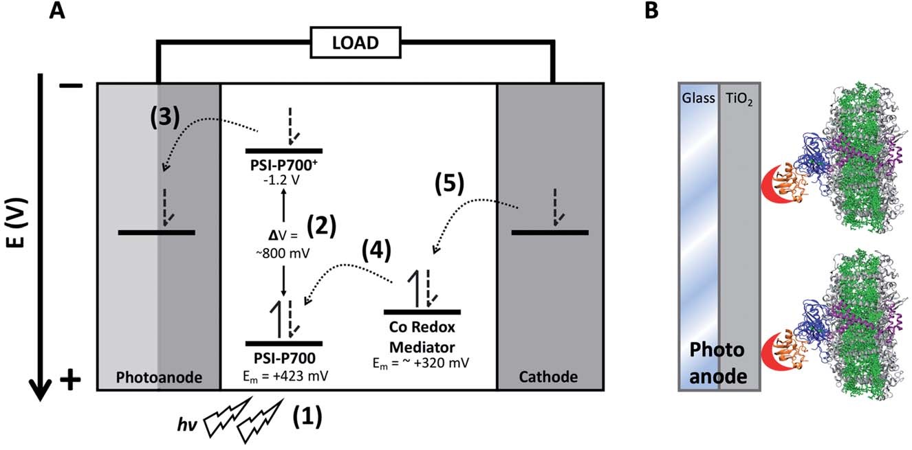
Figure 2.1. Structure of a PSI-based DSSC. Diagram of electron transfer in a PSI-based DSSC. (A) Numbers in parenthesis denote electron transfer steps: (1) PSI absorbs a photon, (2) which then promotes the special chlorophyll pair PSI-P700 to an excited state. (3) Charge separation occurs and the electron is injected into the anode (composed of transparent conductive glass and TiO2) occurs. (4) The redox mediator reduces the oxidized PSI-P700+ back to the ground state. (5) The mediators then undergo reversible reduction at the cathode, completing the circuit. (B) Schematic showing the design of a PSI-based photoanode. Incorporation of PSI onto the TiO2 photoanode surface of a DSSC, the TiO2 is shown in gray. PSI subunit PsaF which promotes the receiving of electrons from redox mediators in algae and higher plants is shown in purple, and subunits PsaC, D, and E are shown in blue and are chemically crosslinked to ferredoxin, shown in orange. A modified metal-binding peptide on the end of ferredoxin is shown in red that binds onto the TiO2 surface on the anode, allowing for directional, constructive electron transfer to occur.

Table 2.1.Comparison of PSI-based electrode and photovoltaic device current densities. Comparisons between a representative sample of PSI- based half-cells and full photoelectrochemical devices. Current densities were normalized to intensity of the excitation light. EtCarb – ethylene carbonate, ACN – acetonitrile
Electrode or Full Device | PSI-Electrode Surface | Redox Mediator | Solvent | Current Density (µA cm⁻² MW⁻¹) | Ref.
Device | TiO₂/ZnO-PsaD/E-PSI | Z813 Co(II/III) | 60% EtCarb, 40% ACN | 4469.1 | [129]
Electrode | Au | Os(bpy)Cl2 embedded in redox polymers P1, P2, P3 | Aqueous | 16.1 | [202]
Electrode | Au on ITO TiO₂ | Os(bpy)Cl₂ embedded in Nafion | Aqueous | 1.07 | [95]
Electrode | Au NP/SAM/MPS/PSI | Ascorbate/DCPIP | Aqueous | 0.48 | [203]
Electrode | NQC15EV on Au | Ascorbate/DCPIP | Aqueous | 0.125 | [204]
Device | Au on Si support | Ascorbate/DCPIP | Aqueous | 0.032 | [79]
Electrode | NQC15S-Au NP on Au | Ascorbate/DCPIP | Aqueous | 0.007 | [205]
oxidized Co³⁺ state, while in the reduced Co²⁺ state the two primary peaks contribute approximately equally. When oxidized, all complexes also exhibited a low, broad absorption region from approximately 525–725 nm in addition to the two primary peaks. The absorbance spectra of both the oxidized and reduced forms of the complexes assayed do not have any significant overlaps with the absorbance spectrum of chlorophyll a, which is good from a device integration perspective, as these redox mediators should not be competing with PSI for dye photoexcitation energy.

The reduced minus oxidized difference spectra were also taken for all six complexes and can be seen in Fig. 2.4, the di-methoxy complexes in Fig. 2.4A and the di-tert-butyl complexes in Fig. 2.4B. All six complexes have a peak in their redox difference spectra at 335 nm, and a low broad peak from 360–440 nm. These results are in line with previously reported spectra, where the 250 and 195 nm peaks that are seen in the sub-350 nm region were assigned based on the onset of the ligand-based p–p* transition associated with the electron transfer capabilities of these complexes [172].

2.4.2 Electrochemical characterization of cobalt redox mediators

Cyclic voltammetry was performed to determine midpoint potentials, assess the reversibility, and calculate diffusion coefficients of these synthetic Co complex redox mediators. The cyclic voltammograms, diffusion control analysis plots, and calculated midpoint potentials (Em) and diffusion coefficients are given in Fig. 2.4. The midpoint potential of T. elongatus PSI has been measured as 423 mV vs. SHE, though PSI from various species has been shown to exhibit a large window (~80 mV) of species dependence [206, 207]. Cytochrome c₆ from T. elongatus, the native in vivo electron donor to PSI, has a midpoint potential (E_{m}) of 329 millivolts (mV) vs. SHE, which is in line with the 320–350 mV vs. SHE reported values for cytochrome c₆ from other cyanobacterial and algal species [208]. The E_{m} for all six cobalt redox mediator complexes, shown in Figure 2.5 were between 125–443 mV vs. SHE. Most are similar or slightly more negative than cytochrome c₆. Interestingly, the di-tert-butyl bipyridine complex with a Cl counterion is
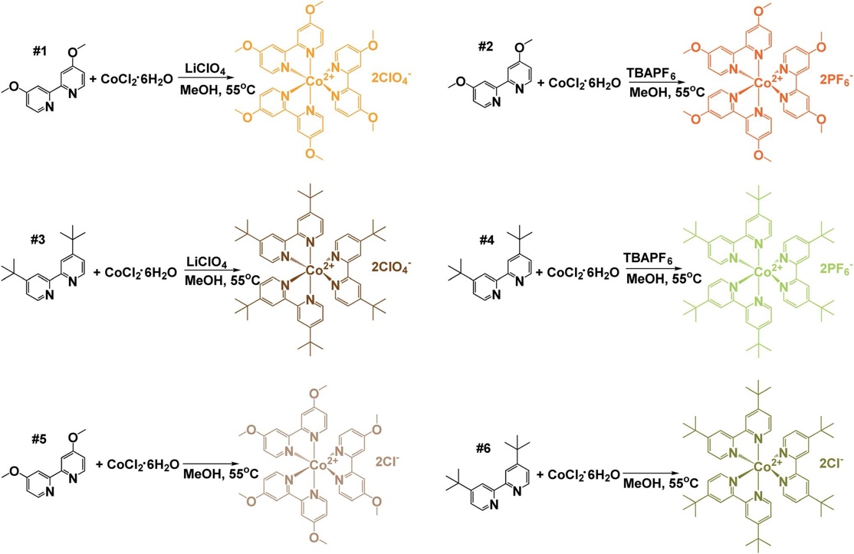
Figure 2.2. Synthetic schemes for the preparation of tris(4,40-di-tert-butyl-2,20-bipyridine)cobalt(II) and tris(4,40-di-methoxy-2,20-bipyridine) cobalt(II) complexes. Three equivalents of each indicated bipyridine ligand was reacted with one equivalent of cobalt chloride hexahydrate in methanol at 55 °C for approximately 3 h. The resulting solution containing the Co(bpy-R₂)₃Cl₂ complex was split into two round-bottom flasks and the corresponding counteranions were introduced. Ten equivalents of tetrabutylammoniumhexafluorophosphate (TBAPF₆) or lithium perchlorate (LiClO₄) were added to the designated flask. The resulting solid was isolated via vacuum filtration and washed with cold methanol followed by cold ethyl ether. To obtain the chloride salt, the original reaction was evaporated under reduced pressure and resulting solid washed with cold ethyl ether.

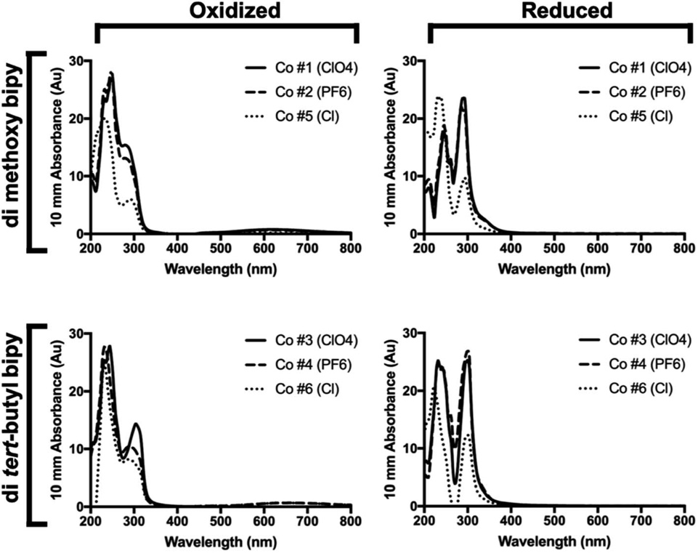
Figure 2.3. UV-Vis oxidized and reduced spectra of bipyridine Co redox mediator complexes. Shown are chemically oxidized and reduced UV-Vis spectra of all six di-methoxy and di-tert-butyl complexes at a concentration of 0.3 mM complex.

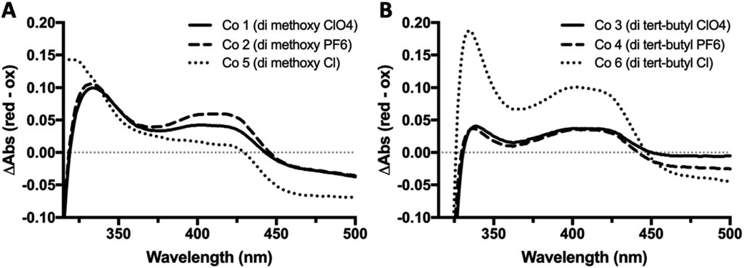
Figure 2.4. UV-Vis redox difference spectra of bipyridine Co redox mediator complexes. UV-Vis reduced minus oxidized difference spectra for all six complexes were obtained using quartz split cuvettes for physical spectral subtraction. Ferricyanide was used as a chemical oxidant, and ascorbate as reductant. Samples were prepared in a 1 : 3 acetonitrile : H2O and incubated in the dark for 1 h at 22 C before taking spectra.
considerably more positive by approximately 100 mV, however the chemical basis of this
shift is not clear. This suggests that at least 5 of the 6 complexes assayed here should have sufficient driving potentials for electron donation to PSI. The measured E_{m} for complexes 1–6 were, in order: 365, 314, 362, 371, 125, and 443 mV vs. SHE.

Cyclic voltammetry was then performed as a function of scan rate to reveal details about reversibility, thermodynamic potential for electron donation to PSI, and the interactions between the cobalt redox mediators and electroactive surfaces. All cyclic voltammograms showed peak separations close to the ideal 57 mV, suggesting the reversibility of the electrochemical reaction being assayed. A linear relationship between peak height and the square root of the scan rate (Fig. 2.5D) indicate reversible diffusion-controlled processes according to the Randles–Sevcik equation, as well as the electrochemical species being studied not adsorbing to the electrode surface. This is a necessary characteristic for a redox mediator to be used in a biophotovoltaic device, to keep the photosensitive PSI dye free and available for further photoexcitation events. Diffusion coefficients were also calculated using the Randles–Sevcik equation [177] and are given in the table in Fig. 2.5D.

Next, the minimal concentration of acetonitrile needed for complex solubilization had to be determined in order to minimize the amount of organic solvent needed to keep PSI in as much of an aqueous environment as possible. To this effect, solubility of the cobalt complexes in increasing concentrations of acetonitrile was measured. Acetonitrile was specifically focused on instead of ethylene carbonate as acetonitrile has previously been identified as being key for redox mediator solubility while ethylene carbonate is commonly used to increase the ionic conductivity of electrolytes due to its high dielectric constant. To assess this, the change in the amplitude of the 295 nm peak in the reduced spectra was monitored by measuring pre- and post-centrifugation as a solubility indicator. A larger ΔAbs value was understood to mean that less of the complex was in solution, and a smaller ΔAbs value that the complex was well-solubilized.
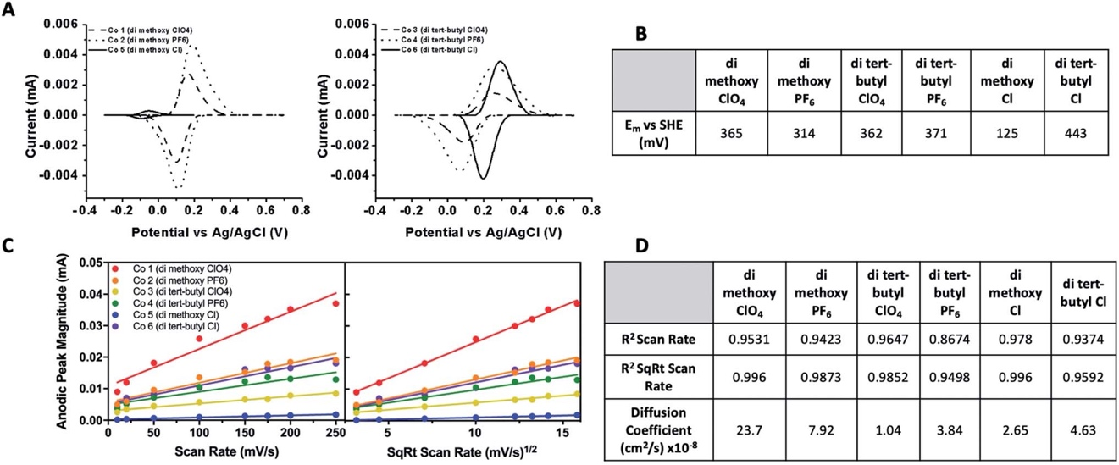

Figure 2.5. Electrochemical analysis of cobalt bipyridine redox mediator complexes. (A) Cyclic voltammograms with non-faradaic processes subtracted of cobalt complexes 1–6 vs. Ag/AgCl taken at a slew rate of 10 mV s1. CVs were run on a glassy carbon electrode at 8 slew rates varying from 10–250 mV s1. Complexes 1–4 and 6 were measured in acetonitrile, 5 in aqueous solution. (B) Midpoint potentials vs. SHE for all complexes. (C) Plots of anodic peak current vs. both scan rate and square root of scan rate. (D) Goodness of fit of linear regression of plots in 5C given as R² values, along with calculated diffusion coefficients.

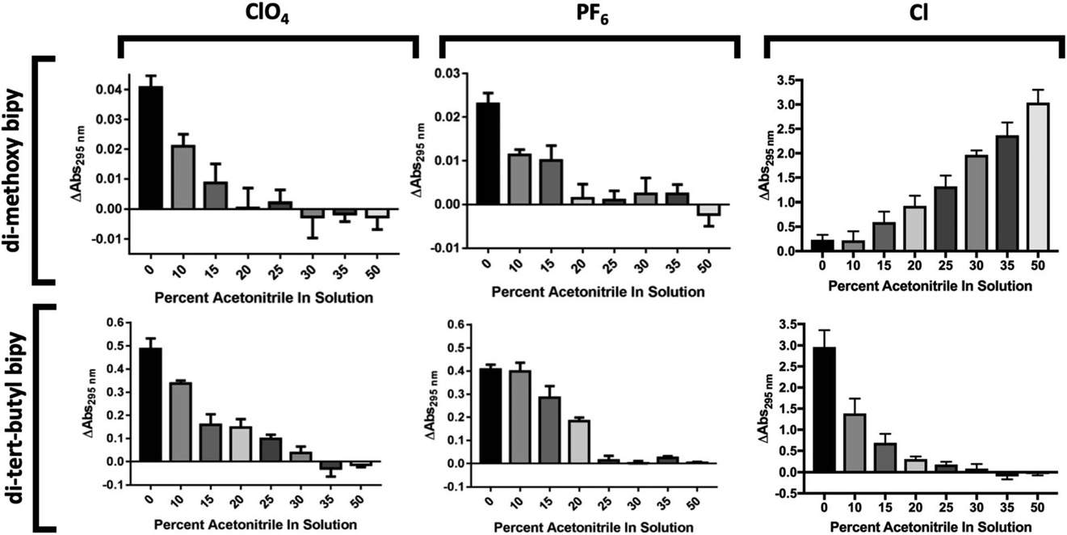
Fig. 2.6. Solubility of cobalt redox mediators in acetonitrile : H2O binary solvent systems. The solubility of all six complexes in increasing percentages of acetonitrile was assessed to determine minimum concentration of acetonitrile needed for solubility. All samples were chemically oxidized prior to measurement. Error bars represent SEM.

Results are shown in Figure 2.6. Any insoluble material should contribute to absorbance pre-centrifugation but not post-centrifugation. The results of the acetonitrile solubility analysis can be seen in Figure 5. The di-methoxy complexes with PF₆ and ClO₄ counterions were determined to be soluble in water-acetonitrile mixed solvents with at least 20% v/v acetonitrile while the di-tert-butyl complexes with PF₆ and ClO₄ counterions were determined to be soluble in a mixed aqueous solvent with at least 25% v/v acetonitrile. The di-methoxy complex with Cl as counterion proved to be soluble in water, starting to crash out at concentrations of approximately 20% and the di-tert-butyl complex with Cl as counterion proved to be soluble in concentrations of acetonitrile exceeding approximately 20%.

2.4.3 Structural stability of PSI in organic solvent

A significant challenge for utilizing synthetic redox mediators with a biological dye such as PSI is their low solubility in aqueous solutions that are native for PSI. Initially, it was necessary to identify a solvent system that would allow for further characterization of these cobalt redox mediator complexes. The ratio of organic solvent used was systematically varied to optimize the simultaneous solubility of PSI and the cobalt mediators. In addition to the solubility of PSI, stability was another concern since organic solvents can extract chlorophyll and lipophilic cofactors from PSI, potentially altering light-harvesting and photochemistry capabilities. While numerous studies have been performed on pigment extraction, we are not aware of any studies to determine the upper limit of solvents that will not significantly alter the cofactor composition of PSI [169-171].

Although a synthetic Co complex has been incorporated once before in a PSI-based biophotovoltaic device as the redox mediator, the solvents used for that complex may not have been optimal for sustained stability and activity of PSI [129]. The stability of PSI was tested using low temperature fluorescence spectroscopy in the organic solvents required by the majority of the cobalt complexes for solubility and electrochemical activity. Low temperature fluorescence (LTF) spectroscopy reveals the local environment of non-covalently attached chlorophyll molecules in both PSII and PSI to be evaluated [209]. To assess the structural stability of PSI in various concentrations of organic solvents, 77 K low-temperature fluorescence spectra were taken after both 1- or 24-hour incubations in varying concentrations of acetonitrile and ethylene carbonate, as seen in Fig. 2.7. At 77 K, upon excitation in the chlorophyll a Soret band (420–450 nm), intact cyanobacterial PSI has a characteristic fluorescence emission peak at approximately 720 nm. Free chlorophyll that is not bound in a reaction center like PSI or a light-harvesting antenna protein has a characteristic emission peak at approximately 660 nm upon similar excitation in the Soret band. The presence of a 660 peak in a fluorescence spectrum of purified PSI indicates decomposition and loss of pigments and other lipophilic cofactors.

In up to 25% v/v acetonitrile in solution, no measurable chlorophyll was extracted from PSI over the 24-hour treatment (Fig. 2.7A, left and center panels). However, as the acetonitrile concentration was increased up to 30–40% solvent in solution, approximately 20% of the chlorophyll in the PSI was extracted. This extraction seemed to reach completion, as measurements of the same sample after 24 hours revealed no further increase in free chlorophyll was seen, shown in the right panel of Fig. 2.7A. Together these results suggest the presence of a labile pool of chlorophyll that can be removed from PSI using acetonitrile with minimal structural effects to the overall protein–pigment complex. Peak position of the 720 nm PSI peak was also measured, and a blue shift of nearly 2 nm after 1 hour and approximately 5 nm after 24 hours was noted, and quantification is shown in Fig. 2.7A, right panel. This blue shift suggests that in increasing amounts of acetonitrile the local environment of the far-red chlorophylls associated with PSI [24, 74, 210] may be altered by possibly removing either bound lipids or detergent molecules from the complex beyond leaching out chlorophyll.

Similarly, the effects of ethylene carbonate on PSI structural stability were performed. Ethylene carbonate is an organic solvent commonly used in the liquid electrolytes of DSSCs, utilized to promote electrolyte conductivity due to its high dielectric constant. PSI remained stable in ethylene carbonate solutions up to 60% w/v over 24 hours, seen in Fig. 2.7B left and center panels. Both 20 and 40% ethylene carbonate in solution led to no more chlorophyll loss from PSI than aqueous MES buffer with 0.03% DDM for detergent exchange. When 60% ethylene carbonate in solution was reached, only approximately 10% of total chlorophyll was lost from PSI, seen in Fig. 2.7B right panel. Upon performing peak fitting to assess PSI 720 nm peak position shift, there was a moderate red shift of approximately 2 nm that was stable up to 24 hours in solution.

Interestingly, when assessing the structural stability of PSI in a ternary solvent system of 30% acetonitrile, 50% ethylene carbonate, and 20% aqueous MES buffer containing 0.03% b- DDM, the two organic solvents had a synergistic destructive effect on PSI, shown in Fig. 6C. This ternary system was of interest as a 40% ethylene carbonate and 60% acetonitrile binary solvent system has been used previously by Mershin et al. for integration of Co-based redox mediators in a PSI biophotovoltaic device [129]. While neither organic solvent was disruptive to the chlorophyll bound to PSI on their own, our results show that they have a much more pronounced effect on the structural destabilization of the PSI complex together in solution. However, in the previous study, PSI was already deposited on a semiconductor-coated electrode, and the effect of the 40% ethylene carbonate, 60% acetonitrile solvent system in that context on PSI stability over time remains unknown. After 1 hour of incubation in this solvent system, nearly 25% of chlorophyll had been leached out of the PSI, and after 24 hours over 60% of the chlorophyll had been pulled out of the bound light harvesting antenna chlorophyll, shown in the right panel of Fig. 2.7C. So much chlorophyll loss suggested severe destabilization of the PSI structure, and also that this ternary system at such a high concentration of organic solvent would not prove useful in future biophotovoltaics research for integration of PSI into devices. For kinetics experiments performed next, it was determined based on the binary solvent system titrations in Fig. 2.7 that a ternary solvent system of 60% aqueous MES buffer, 24% ethylene carbonate, and 16% acetonitrile would be sufficient to minimally affect PSI stability while still retaining enough of the organic solvent to keep the cobalt redox mediators in solution.
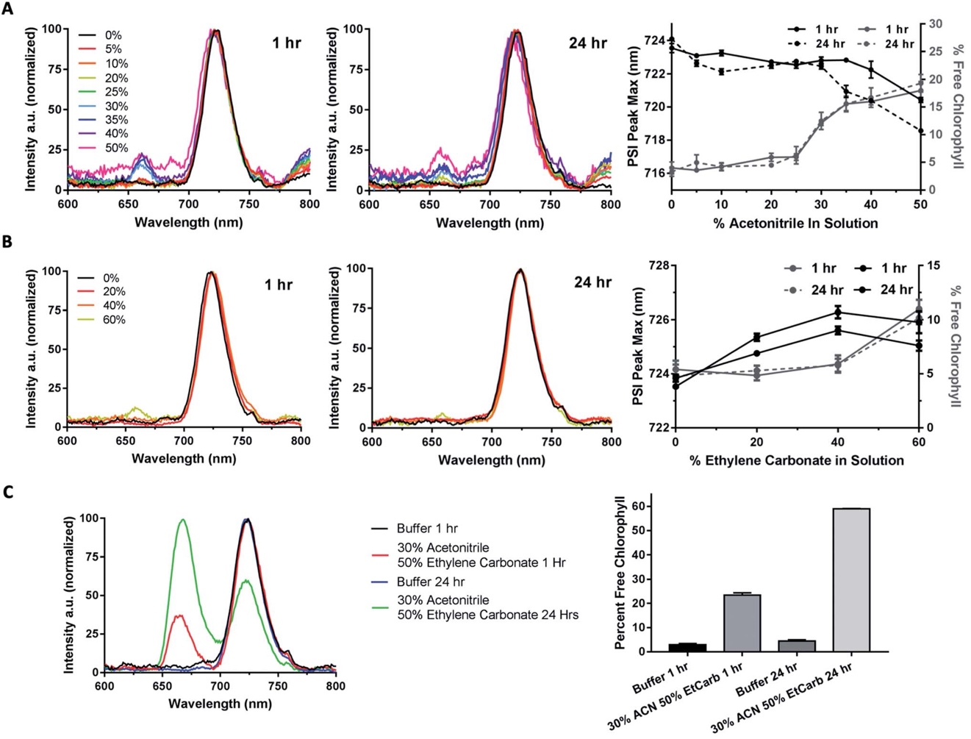Figure 2.7. Organic solvent effects on PSI structural stability. Organic solvent effects on PSI stability were assessed using 77 K low temperature chlorophyll fluorescence emission spectra. Baseline correction was performed, peak intensities of the PSI peak were normalized, and percent free chlorophyll (660 nm) along with PSI-bound chlorophyll (720 nm) shift were calculated at 1 and 24 hour timepoints from Gaussian curve fitting. All spectra shown are the average of triplicate results. (A) 77 K chlorophyll fluorescence emission spectra of 1 and 24 hour timepoint of PSI in 0–50% acetonitrile. Left panel 1 h timepoint, center 24 h timepoint, right panel PSI peak shift and chlorophyll loss quantification. (B) 77 K chlorophyll fluorescence emission spectra of 1 hour and 24 hour timepoint of PSI in 0–60% ethylene carbonate. Left panel 1 h timepoint, center 24 h timepoint, right panel PSI peak shift and chlorophyll loss quantification. (C) 77 K chlorophyll fluorescence emission spectra of 1 hour and 24 hour timepoint of PSI in 30% acetonitrile + 50% ethylene carbonate, 20% aqueous buffer. Right panel is chlorophyll loss quantitation.

2.4.4 Cobalt redox mediators donate electrons directly to PSI

Using the same solvent system that was both compatible with PSI and able to solubilize the cobalt redox mediators over a period of at least 24 hours, the ability of the cobalt complexes to donate electrons to PSI directly was next investigated. Although cobalt-based redox mediators have been used once previously in a PSI-based biophotovoltaic device by Mershin et al. [129], that work did not test for either complex solubility, PSI stability, or verify that the cobalt redox mediators in the device were in fact directly reducing PSI. To track PSI reduction kinetics, flash photolysis using a Joliot-type spectrophotometer (JTS-100, Bio- Logic, Grenoble). In a flash photolysis experiment to track PSI reduction kinetics, a 630 nm actinic pulse(s) is used to photo- oxidize all the PSI present in the sample, and then a second beam (either 705 or 810 nm) is used to measure and track the reduction of P700+ as a function of time. We have developed this assay for the previous generation JTS-10 instrument and described it in detail in previous work [211]. Kinetics were tested over 2.5 seconds at first to initially assess ability to donate to PSI. The resulting kinetic traces were fit with a monophasic exponential association equation, and the resulting observed rates are shown in Table 2.2. A general equation of monophasic exponential association is shown in Equation 1 ,where Y₀ is the value of Y when X=0, Y_{max} is the maximal amplitude of the phase, k is the observed rate, and t is time.

$Y=Y_{max} × (1-e^{-kt}$ )

Equation 1. Monophasic exponential association general equation.

As shown in the kinetics fitting results in Table 2, when tested in the 60% aqueous, 24% ethylene carbonate and 16% acetonitrile ternary solvent system showed that the first four complexes (di- methoxy ClO₄ and PF₆, di-tert-butyl ClO₄ and PF₆) do in fact donate electrons to PSI in vitro.

Table 2.2 Cobalt redox mediators donate directly to PSI in vitro. The initial results assessing the ability of these cobalt complexes to directly donate to photo-oxidized P₇₀₀⁺ PSI was assessed over a timescale of 2.5 s. When no donor was present, no recovery of photo-oxidation was seen and a long-lived P₇₀₀⁺ signal was seen. All complexes were present at 10 mM concentration.
 | Co #1  di-methoxy ClO₄ | Co #2  di-methoxy PF₆ | Co #3  di-tert-butyl ClO₄ | Co #4  di-tert-butyl PF₆
k_{obs} (s-¹) | 0.014 | 0.028 | 4.0 x 10⁻⁵ | 4.6 x 10⁻⁵

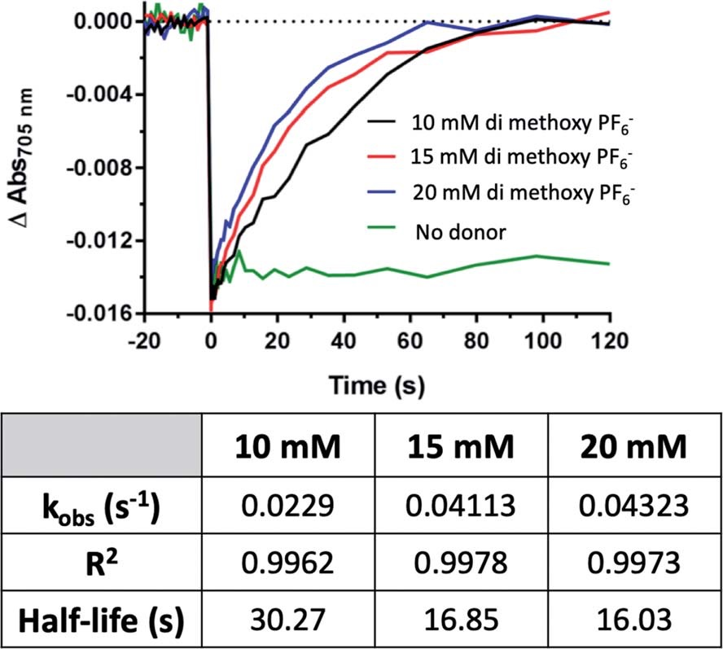

Figure 2.8. Rate of PSI-P₇₀₀+ reduction increases linearly with redox mediator concentration. Above concentrations of 10 mM, rates of electron transfer increased linearly with the addition of Co redox mediator #2, the di-methoxy PF₆ variant. Kinetics traces were fit to single-phase exponential association equations, the observed rates, R² and calculated half-lives of which can be seen in the table inset.

The di-methoxy PF₆ Co#2 variant of these bipyridine complexes was selected for further kinetics studies as it had the greatest initial observed rate (k_{obs}). Kinetics were measured at concentrations of donor (Co #2) at 10, 15, and 20 mM, and monitored over 120 s until return to baseline was achieved (Fig. 2.8). A linear increase in the rate of electron transfer to PSI-P₇₀₀⁺ was observed when rates were plotted against donor concentration, plotted in Fig. 2.11. At concentrations above 20 mM, the Co complexes crashed out of solution and multiple attempts at keeping the high concentration of redox mediator in solution did not prove successful, even with the ternary solvent system that was being used to try and balance the needs of both PSI and these Co redox mediators.

2.4.5 Effect of organic solvent on PSI reduction rates

While the synthetic cobalt-based complexes acted as redox mediators to reduce PSI in a dose-dependent manner, the effect of organic solvents on the reduction remained to be determined. Buffer composition has been shown to have effects on PSI-P₇₀₀⁺ reduction kinetics even in aqueous solution [211]. To initially assess the effects of organic solvent on PSI-P₇₀₀⁺ reduction kinetics, a commonly used synthetic small molecule PSI electron donor, 2,6-dichlorophenolindophenol (DCPIP) [194, 212-215] that is soluble in both aqueous and organic solvent systems was utilized for direct comparison in both strictly aqueous and ternary buffer systems. In the ternary solvent system with a 40% organic solvent component (24% ethylene carbonate, 16% acetonitrile, 60% aqueous buffer) utilizing DCPIP concentrations of 50–250 mM, similar rates were observed as approximately 100-fold higher concentration of the di-methoxy PF₆ Co complex #2 was used, as seen in Fig. 8A. PSI-P₇₀₀⁺ reduction kinetics of an identical titration series of DCPIP in fully aqueous buffer is shown in Fig. 8B. Next, observed rates were plotted against redox mediator concentration to generate a rate plot, and observed bimolecular rate constants were taken from the slopes of the rate plot in Fig. 10. Shifting from a ternary to a fully aqueous solvent system yielded an ~7.9 fold increase in the observed bimolecular rate constant: 0.19 s-¹ L mmol⁻¹ for reduction in the ternary solvent system as compared to 1.50 s⁻¹ L mmol⁻¹ in the fully aqueous MES buffer.

Our results on the effects of the ternary buffer on the stability of the chlorophyll pigments in PSI and on PSI-P₇₀₀⁺ reduction kinetics by DCPIP led us to assess the PSI-P700⁺ reduction kinetics of Co #5 – the di-methoxy Cl variant. This complex was fully soluble in water as indicated by the spectra and lack of precipitate. PSI-P₇₀₀⁺ reduction kinetics by this complex in fully aqueous solution were measured at donor concentrations of 10, 15, and 20 mM. A comparison of the data in Fig. 2.8 of the organic solvent-soluble Co #2 – di-methoxy PF₆ to the kinetics was performed. The traces for these experiments can be seen in Fig. 2.10, along with donor concentration used, observed rates, and the goodness of the monophasic exponential fitting performed. However, by comparison of the two complexes PSI-P₇₀₀⁺ reduction kinetics, the bimolecular rate constant of PSI-P₇₀₀⁺ reduction is approximately 38-fold greater for the di- methoxy Cl Co#5 complex than the PF₆ counteranion Co#5 complex. All observed rates were plotted against concentration of donor used to generate a comprehensive rate plot for DCPIP and the di-methoxy complexes tested in both the aqueous and ternary solvent systems, shown in Fig. 2.11.

2.4.6 Photocurrent generation by Co redox mediator biophotovoltaic devices
Both direct electron donation to PSI by our synthetic Co mediators and stability of PSI in organic solvent have been demonstrated in vitro; subsequently, biophotovoltaic devices were assembled and tested. We utilized a white light illumination source capable of photoexcitation of both PSI and TiO₂ semiconductor, and a Schott red light filter (MOS-258-303) to generate PSI-specific actinic light. The spectral irradiance of both light sources overlapped with the PSI absorption spectrum at RT is shown in Fig. 2.12A to show the specificity of the red actinic illumination.
Devices with the aqueous mediator, complex Co#5 present in the electrolyte but no PSI present as the photosensitive dye showed photocurrent generation under white light which
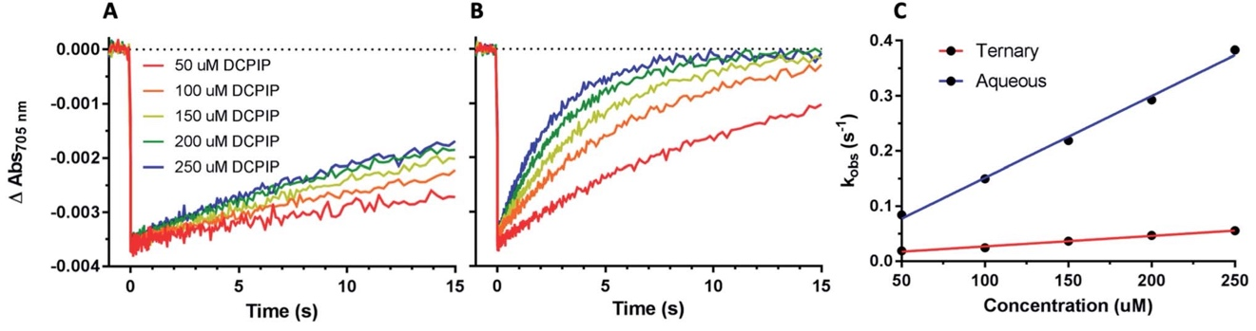
Figure 2.9. Effect of organic solvent on PSI-P₇₀₀⁺ reduction kinetics by DCPIP. (A) DCPIP titrations were performed in the ternary 60% aqueous, 24% ethylene carbonate, and 16% acetonitrile solvent system. Concentrations are increasing from 50 mM (red)–250 mM (blue). (B) DCPIP titrations were performed in fully aqueous MES buffer. (C) Observed rates of PSI-P700⁺ reduction plotted against concentration of DCPIP.

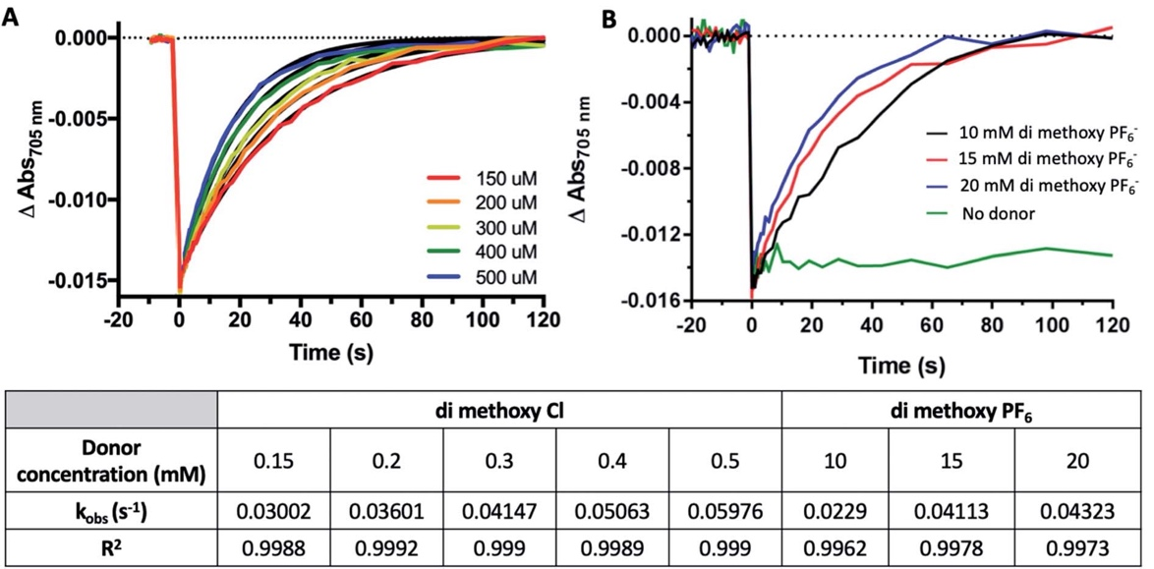Figure 2.10. Organic Solvent Slows PSI-P₇₀₀+ Reduction Kinetics by Co complexes. (A) Co #5 di-methoxy Cl PSI-P₇₀₀+ reduction kinetics from 150 mM (red) to 500 mM (blue). (B) Co #2 di-methoxy PF₆ PSI-P₇₀₀+ reduction kinetics from 10–20 mM. Observed first order rate constants (k_{obs}) are given in the table below for each trace along with R² of monophasic exponential fitting.
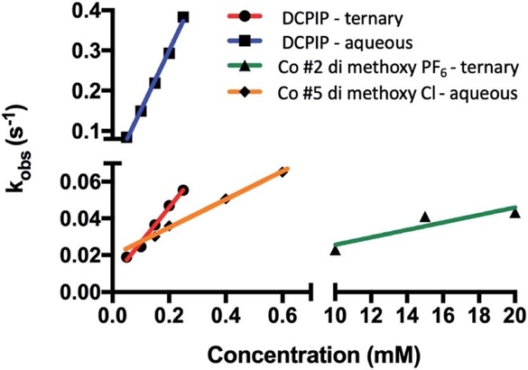
Figure 2.11. Organic solvents slow rates of PSI-P700⁺ reduction by redox mediators. Observed rates were plotted against concentration of redox mediator used in each trace. Linear regression was then per- formed, and bimolecular rate constants were taken from the slopes of the linear regression.

is capable of TiO₂ photoexcitation, but no photocurrent in the same device was observed when using PSI-specific red light for device illumination, shown in Fig. 2.12B. When PSI is present as the dye with the aqueous mediator Co#5 in the electrolyte, increased photocurrent density is measured under white light illumination, but there is still 0.5 µA/cm² current density generated under low levels of red light illumination for the same cell. When PSI was present, and mediator was absent in the electrolyte, no photocurrent was generated under either white or red light illumination, shown in Fig. 2.12C, as expected if the device circuit is not completed. When the Co#2 mediator in the ternary electrolyte buffer described previously was used along with PSI as the photosensitive dye in a device, photocurrent was only observed under white light illumination, as shown in Fig. 2.12C. This suggests that either interaction of PSI with the TiO₂ semiconductor was interrupted, or the photoactivity of PSI was lost due to use of the ternary electrolyte containing organic solvents.
Generally, a slow rise and fall in the current is seen in the photocurrent data reported, which may be due to the need for optimized electrode interaction for both the photoanode and the cathode where the mediator accepts electrons. Previous work has shown the use of PEDOT cathodes can help to improve the output of Co redox mediator – based devices and that electrode interaction optimization is key to performance improvement [216].
Photocurrent density as a function of light dependence of a biophotovoltaic device with PSI and the aqueous Co#5 mediator in the electrolyte was also measured, shown in Fig. 2.12D. Photocurrent densities increased linearly with respect to increasing photon flux density, generating up to 14.5 µA/cm² under nearly 4500 mmol m² s⁻¹ red photon flux density (PFD), and up to nearly 25 µA/cm² under white light illumination. The exact values and light intensities are given in Fig. 2.12E. TiO₂ only devices with no PSI present as the photosensitive dye were similarly measured, and essentially no photocurrent was seen under red light illumination, and white light illumination did not yield as much photocurrent at all light intensities measured as compared to PSI-containing devices. Also seen in Fig. 2.12E is a steeper increase in photocurrent densities in devices at the highest
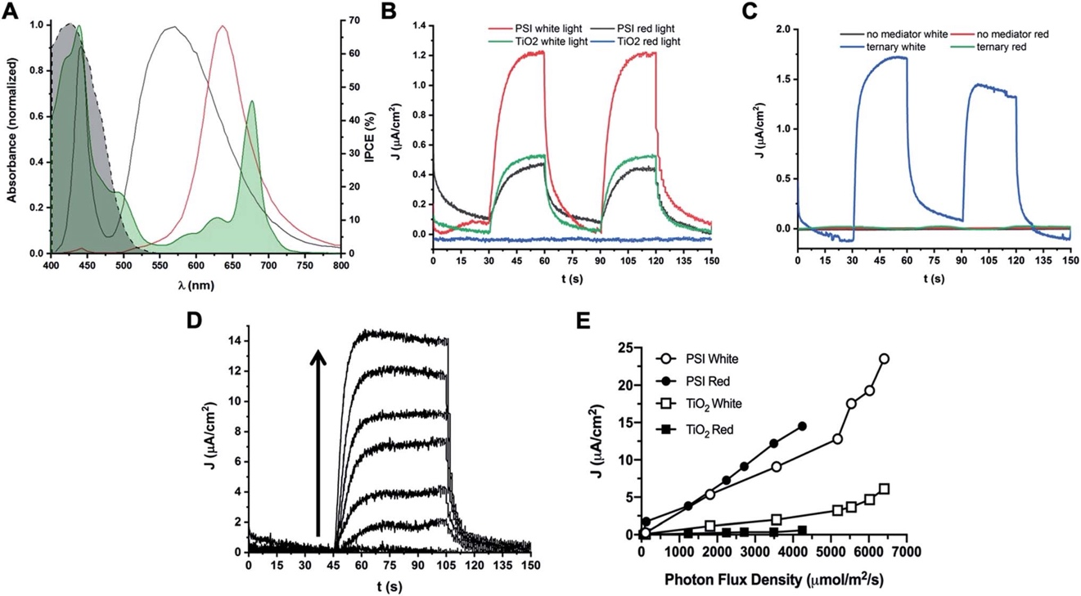
Figure 2.12. Photocurrent densities obtained from PSI-sensitized biophotovoltaic devices. Photocurrent densities of PSI-sensitized devices are reported. (A) Spectral irradiance of white and red illumination sources used. White light used for photocurrent experiments is shown in black, red light is shown in red. The UV-Vis absorbance spectrum of PSI is shown overlaid in green and is partially filled in. The dashed black line represents the percent Incident Photon-to-electron Conversion Efficiency (IPCE) of TiO₂ semiconductor. (B) Photocurrent densities of cells with Co di-methoxy Cl mediator #5 in fully aqueous electrolyte with and without PSI as sensitizer. Photocurrent densities in both white and red (PSI- specific) light are reported. Light was at 10% capacity of illumination source for all traces (1800 mmol m² s⁻¹ for white light, 125 mmol m² s⁻¹ for red light). (C) Photocurrent density generation with no mediator present in electrolyte, or the Co di-methoxy PF₆ mediator # 2 in the ternary buffer mixture (blue and green) described in previous experiments. (D) Photocurrent density of PSI-Co di-methoxy Cl mediator #5 device as a function of red light intensity measured immediately after device fabrication. Arrow shows direction of increasing light intensity for each trace. Data is quantified in (E). (E) Photocurrent density plotted against PFD of light used for illumination. Data for cells with the aqueous Co di-methoxy Cl mediator #5 and with or without PSI present under both red and white light illumination are shown.

light PFDs tested, a trend that is not seen in the PSI- specific red light illumination values. This may be due to increased current coming from the semiconductor at high light intensities as the same trend is seen in devices with and without PSI.
Overall, this increase in PSI-specific photocurrent density for our aqueous mediator along with comparison to the loss of PSI- specific photocurrent and previously shown effects to PSI stability upon exposure to organic solvents suggests that development of bio-compatible and aqueous-soluble redox mediators is key for further improvement the future.
Taken together, this work suggests that previous work done on incorporating PSI into DSSCs that utilized organic solvents in their electrolytes may very well have decreased rates of PSI reduction as well as PSI and redox mediator stability. A much greater increase in the bimolecular rate constant was noted for the di-methoxy complexes than for DCPIP when moving from a ternary organic solvent system to a fully aqueous system, and in a biophotovoltaic device, no photocurrent was measured when using the Co #2 redox mediator that required organic solvent in the electrolyte. Furthermore, the ease of synthesis of these cobalt complexes and the ability to relatively easily adjust the functional groups and surface chemistry surrounding the active Co center as compared to traditional small molecule PSI donors such as DCPIP points to these cobalt complexes being a suitable system for further development and research to improve interactions with both the photoactive dye and the counter electrode. For example, these include potentially synthesizing scaffolds that these complexes can be inserted into in addition to the ability to modulate midpoint potentials through the electron-withdrawing/donating nature of functional groups as well as ligand backbone structure. These results point to the development of abundant transition metal based redox mediators as a continued area of interest for optimization in biophotovoltaics development.

2.5 Discussion

An emerging technology in solar energy based on sustainable low-cost materials, relatively simple manufacturing processes, and high functionizability is dye-sensitized solar cells (DSSCs). An increasing number of DSSCs are in fact biophotovoltaic devices [58, 118], utilizing biological proteins such as PSI due to the high abundance of material, the near unity internal quantum efficiency of the PSI reaction center, and the low environmental impact of material production. However, reduction rates remain low for the cyanobacterial PSI commonly used in these devices and are an impedance to increasing photocurrent densities and efficiencies of these devices.
The most commonly used DSSC redox mediator for photo- sensitizer reduction, the iodide/triiodide (I⁻/I₃⁻) couple, is incompatible with biophotovoltaics as it is corrosive to most metal as well as protein (potentially from UV-generated I₂⁻ and I⁻ radical species) [217], has a redox potential close to PSI giving low driving potentials, and has significant absorption in the visible region of the electromagnetic spectrum, reducing the energy available for photoexcitation of the PSI photosensitizer. As such an area of interest has been the incorporation of synthetic redox mediators using other transition metals as redox-active centers, such as cobalt. Previous work has identified cobalt complexes to try and replace the canonical iodide/triiodide pair, with focus on polypyridine-based coordinating ligands [218, 219]. Nearly all cobalt-based synthetic redox mediators published to date have required organic solvents for solubility, utilizing a 60:40 ethylene carbonate/acetonitrile solvent system [129, 172, 200, 201]. However, studies have not attempted to reconcile the incompatible solubility and activity requirements for both synthetic redox mediators and PSI in a manner that also promotes greater IPCEs and photocurrent densities.
The work presented here focuses on the synthesis and characterization of cobalt-based redox mediator complexes and their ability to donate electrons to PSI. We have explored the effect of organic solvents and optimized a solvent system that balances the solubility and stability requirements of both the dye and PSI complex for biophotovoltaic device integration. The use of organic solvents in the liquid heterojunction of DSSCs is unfavorable for a number of reasons, including the high volatility, toxicity, and/or explosive nature of many of these solvents [217] along with leaking of water into the device either during manufacturing or during usage. A goal of DSSCs in terms of predicted performance is thin, flexible, aqueous-based devices [165-168, 220]. Though some work has been done on adjusting the properties of cobalt-based polypyridyl complexes to make them compatible with aqueous electrolytes, this remains an area of research where more work is needed [168].
There is a need to further investigate the effects of organic solvents on PSI stability and electron transfer kinetics for biophotovoltaics, beyond just the recent interest in the field in moving away from organic solvents in liquid heterojunctions as electrolyte carriers for all DSSCs, not just biologically-based ones [165]. Of particular interest are two reports [204, 205], where a nearly 20-fold increase in current density was obtained when moving from a 50% diethyl ether to a fully aqueous liquid heterojunction. One of the highest reported photocurrent densities utilizing PSI as the dye in a DSSC have used cobalt- based synthetic redox mediators that require organic solvent electrolytes. However, the effects these electrolytes have on PSI were not assayed [129]. Here, our results showed that the electrolyte used in PSI-based biophotovoltaics plays a significant role in PSI dye stability and activity as well as PSI reduction rates.
Key solubility conditions were investigated which enabled both PSI and synthetic redox mediators to be stabilized in solution in tandem. It was found that a 60% aqueous, 24% ethylene carbonate and 16% acetonitrile solution allowed for both PSI and PF₆ or ClO₄ counteranion-based complexes to be soluble and retain enough activity to function together constructively for kinetics assays and for future biophotovoltaic integration. In binary solvent systems of acetonitrile up to 50%, a labile pool of up to 20% total chlorophyll was leached out of the protein–pigment complex. This imparts a twofold negative effect: the chlorophyll molecules not bound within the PSI complex reduce light harvesting capabilities of the complex, and free chlorophyll in solution competes for light with PSI, leading to more light that is not efficiently funneled into performing charge separation. However, in ethylene carbonate binary systems up to 60%, there was an approximate increase in free chlorophyll of only 5% over 24 hours. There are 201 water molecules in the crystal structure of T. Elongatus PSI [18] involved with coordination of antenna chlorophyll and protein subunits, of which the majority are coordinated with core protein PsaA and PsaB that also bind the internal cofactors used for electron transfer through the complex. Organic solvents may be disrupting this network of water-based hydrogen bonding, leading to the leaching of chlorophyll and slowed PSI reduction rates reported here.
Herein, we have demonstrated that synthetic cobalt complexes are able to directly donate electrons to PSI, as no PSI reduction was seen in the absence of donor over 120 s, and is consistent with previous work using PSI in vitro for energy conversion. In the previous work, no electron donation to PSI was observed when 1 mM ascorbate and no cytochrome c₆ was present in a hydrogen producing cell [77]. The electron transfer kinetics between PSI and Co#5, the tris(4,4’-di-methoxy-2,2’-bipyridine)cobalt(II) chloride mediator are faster than the other cobalt complexes studied here, presumably due to solvation, structural and counteranion properties. We have shown that this occurs in a linear dependence on concentration of donor when measuring PSI-P₇₀₀⁺ reduction kinetics in solution, further supporting the claim of direct electron transfer from these cobalt complexes to PSI. Experiments testing effects on mediator concentration on photocurrent generation in bio- photovoltaic devices are the subject of future work. Moving to a fully aqueous system increased PSI reduction rates approximately 8-fold for DCPIP, and approximately 38-fold for the di-methoxy Cl⁻ Co#5 variant of the cobalt complexes presented here.
We also report differential photocurrent generations for PSI- and Co-based redox mediator biophotovoltaic devices, with photocurrent under PSI-specific red light illumination seen for the aqueous di-methoxy Cl⁻ mediator Co#5, and no photocurrent generated with the di-methoxy PF₆ mediator Co#2 present in the ternary electrolyte described. This may be due to either interruption of PSI’s photoactivity or its ability to interact with the TiO₂ semiconductor, though further studies are needed to assess this. Increased photocurrents up to 25 µA/cm² were seen in PSI – Co di-methoxy bipy Cl⁻ Co#5 devices. Also of note is an early study on Co-based DSSC redox mediators, where the authors found that bulkier counteranions yielded lower photocurrent densities in devices [200, 221]. Further work by Masconi et al. on Co redox mediators found that these mediators often form ion pairs with the very common ruthenium-based dyes used in DSSCs, leading to high levels of charge recombination and further decrease in photocurrents, which further strengthened our interest in pairing Co redox mediators with a biological dye like PSI [222]. Future work will aim to help improve the electrode interfaces of these devices now that more information is known on dye/electrolyte interactions in our PSI-based biohybrid devices, as previous work on fully inorganic systems found significant improvements when modifying the cathode material [216].
To date, this is the first report on the stability and reduction kinetics of PSI by synthetic cobalt-based redox mediators in non-organic solvents with relevance for biophotovoltaic applications, many of which are commonly used to enhance exciton and hole generation in devices such as solar cells. This is also, to our knowledge, the first report focused on the design of Co redox mediators as PSI electron donors that allows for optimization in multiple areas including solvent compatibility, redox midpoint matching, reduction kinetics, avoidance of spectral overlap, cost and stability of both the redox mediator and PSI. Further efforts for fine-tuning both solubility and increased affinity for PSI for synthetic redox mediators via introducing new functional groups and counteranions is clearly needed and ongoing, along with cathodic modifications in devices. Overall, this work suggests that one of the primary limitations for PSI-based biophotovoltaic devices utilizing synthetic redox mediators is solubility and incompatible solvent systems rather than any innate incompatibility between the synthetic redox mediators and PSI, and that bio-inorganic devices may yield improvements in device stability over time. Further research and improvements on PSI-based biophotovoltaics may yield more feasible bio-hybrid devices in the future with more competitive efficiencies and production costs.

CHAPTER III
Photosystem I integrated into mesoporous microspheres has enhanced stability and photoactivity in biohybrid solar cells

A version of this chapter was originally published by Alexandra Teodor as first author and Barry D. Bruce as corresponding author:

Teodor, A.H. et al. “Photosystem I integrated into mesoporous microspheres has enhanced stability and photoactivity in biohybrid solar cells” Materials Today Bio 11(2021): 100122.

Alexandra Teodor is the first author of this published research article. She performed conceptualization, data collection and analysis, figure making, initial draft writing and was involved in the manuscript editing and review process at the journal Materials Today Bio. Coauthors Lucas B. Thal, Shinduri Vijayakumar, Madison Chan, and Gabriela Little were all involved in sample preparation and data collection. Barry D. Bruce provided conceptualization, supervision, and aided in the manuscript review and editing process.

3.1 Acknowledgments
AHT has been supported as a PEER fellow from an NIH R25 Award (R25GM086761). Support to B.D.B. and AHT has been provided from the Gibson Family Foundation, the Tennessee Plant Research Center, and the Dr Donald L. Akers Faculty Enrichment Fellowship. L.B.T. was supported via the TN-SCORE program and NSF EPSCoR Grant for Tennessee. GL was supported by a US Department of Education Award to the UTK Trio Educational Advancement Program (EAP) and the UTK Provost’s Office for Summer Research Institute. This work was also supported by National Science Foundation support to B.D.B. (DGE-0801470 and EPS 1004083) and the Army Research Laboratory (ARL Contract #W91 1NF-11-2- 0029). A.H.T., M.C., and B.D.B. would like to thank Joseph J. Jackson for his assistance with FACS. A.H.T., M.C., L.B.T., and B.D.B. would like to thank John Dunlap at the UTK/ORNL Joint Institute for Advanced Materials for his assistance and kindness in collecting the SEM images. A.H.T. would like to thank Jyotirmoy Mondal for his general laboratory assistance and helpfulness in discussing results.

3.2 Abstract
Isolated proteins, especially membrane proteins, are susceptible to aggregation and activity loss after purification. For therapeutics and biosensors usage, protein stability and longevity are especially important. It has been demonstrated that Photosystem I (PSI) can be successfully integrated into biohybrid electronic devices to take advantage of its strong light-driven reducing potential (-1.2V vs. the Standard Hydrogen Electrode). Most devices utilize PSI isolated in a nanosize detergent micelle, which is difficult to visualize, quantitate, and manipulate. Isolated PSI is also susceptible to aggregation and/or loss of activity, especially after freeze/thaw cycles. CaCO₃ microspheres (CCMs) have been shown to be a robust method of protein encapsulation for industrial and pharmaceutical applications, increasing the stability and activity of the encapsulated protein. However, CCMs have not been utilized with any membrane protein(s) to date. Herein, we examine the encapsulation of detergent-solubilized PSI in CCMs yielding uniform, monodisperse, mesoporous microspheres. This study reports both the first encapsulation of a membrane protein and also the largest protein to date stabilized by CCMs. These microspheres retain their spectral properties and lumenal surface exposure and are active when integrated into hybrid biophotovoltaic devices. CCMs may be a robust yet simple solution for long-term storage of large membrane proteins, showing success for very large, multisubunit complexes like PSI.
3.3 Introduction

Recombinant or purified proteins have been utilized in many applied areas of biotechnology including pharmaceutical use, industrial enzymatic applications, and more recently biohybrid devices [118, 223, 224]. However, numerous issues must be overcome for successful integration of any biomaterial, including proteins, for biotechnological applications. These issues include decreased stability outside of the cellular environment, loss of activity, difficulties in manipulating/engineering the bio/- inorganic interface, and the low molecular weight and size of most proteins making them difficult to quantitate and disperse uniformly.

The use of microspheres, specifically CaCO₃ microspheres (CCMs), as stabilization matrices for therapeutic and industrial use has been previously documented [225-227]. CCMs are of particular interest to research communities because of (i) a facile and inexpensive fabrication process, (ii) the large degree of control over their properties to generate uniform particles with diameters in the nano- to micro-meter range, and (iii) the material is biologically inert and non-toxic [228]. CCMs also have mild conditions for decomposition and removal of the template while preserving the encapsulated biological material after cross-linking, along with high porosity and surface area making them even more attractive for applications where catalytic activity enhancement is desired [227, 229]. Herein, we describe a fabrication protocol yielding uniform, non-aggregating CCM templates for the encapsulation of membrane proteins, specifically the protein-pigment complex, photosystem I (PSI).

PSI is one of the two multisubunit protein-pigment complexes, known as reaction centers, central to the light reactions of oxygenic photosynthesis [1]. The other reaction center central to oxygenic photosynthesis, photosystem II (PSII), has previously been studied using a CCM template coated in a proteoliposome with ATPase present for ATP production [230]. However, PSII is remarkably unstable and is known to degrade after approximately only a dozen photoexcitation events, and the authors of this study did not investigate the stability of their system or long-term storage possibility. These reaction centers are responsible for the conversion of light into high-energy electrons needed for downstream carbon fixation in most photosynthetic organisms. PSI in most photosynthetic organisms comprises approximately 12–15 protein subunits, ~100 chlorophyll molecules, 20 carotenoids, 2 phylloquinones, and 3 Fe₄S₄ clusters and even takes on higher oligomeric states, putting it among the most complex protein complexes in Nature and reaching sizes of 1.2 Mda for its trimeric form [18, 21, 25, 26, 73, 231, 232]. PSI generates the greatest reducing potential in biological electron transfer (-1.2 V vs. SHE) on photoexcitation, catalyzing an electron transfer across the reaction center from its lumenal to its stromal face [118]. After isolation and incorporation into biohybrid electronic devices, PSI shows no significant loss in activity for over 90 days for cyanobacterial and at least 280 days for higher plant PSI [77, 79]. Furthermore, the most commonly used biological sources of PSI for biotechnology applications, Thermosynechococcus elongatus BP-1, Chlamydomonas reinhardtii, and Spinacea oleracea, are all amenable to genetic modification of their reaction centers to engineer in desirable characteristics [180]. PSI, in particular, has been of interest for the development of biohybrid technologies [233-237], particularly photovoltaic devices based on dye-sensitized solar cells [42, 54, 77, 81, 85-87, 89, 94, 107, 115, 118, 139, 180, 186, 224, 238-245], with current densities in PSI-based photovoltaic devices improving over 6 orders of magnitude over the last decade and continuing to rise [81, 118].

Yet, PSI as a membrane protein-pigment complex is susceptible to degradation under unfavorable conditions and is unable to withstand freeze-thaw cycles or lyophilization without aggregation and/or loss of activity. Furthermore, the relatively small size of PSI and other membrane proteins are hindrances for ease of handling for biotechnology applications, and the ability to generate larger super- structures such as microspheres will allow for greater ease of handling and manipulation, such as addition or removal from reaction vessels, microfluidics devices, or novel electrode architectures [101, 246, 247]. How- ever, many researchers in this field have focused on studying novel electrode materials and architectures including mesoporous inverse opal configurations to improve device performance and outputs [101]. Multiple strategies that have been proposed for stabilization of the protein component for biohybrid devices are based on the use of surfactant peptides. Previous work on engineering poly lactic-co-glycolic acid (PLGA) microparticles with PSI was shown to help keep PSI stable and retained photochemical properties [141]. These microparticles, similar to CCMs, provide a protective three-dimensional matrix to stabilize PSI from the outside environment. However, PLGA is relatively expensive, and picking the right polymer by average size and chemical functionalization for a protein of interest may be difficult and may affect protein activity in unknown ways [248].

Herein, we utilize CCMs as a method of generating a three- dimensional template that has embedded PSI and a passive bridging protein, bovine serum albumin (BSA). After precipitation of the CaCO₃ as a micron-sized spherical template, the two proteins are chemically crosslinked together with glutaraldehyde, forming intermolecular and intra- molecular covalent linkages between the surface exposed amino acids of PSI and BSA. Glutaraldehyde is one of the most widely used bifunctional cross-linking reagents [249]. After cross-linking, the CaCO3 template is chelated with addition of ethylenediaminetetraacetic acid (EDTA). After the CaCO₃ template is chelated away, it leaves relatively similar sized, mesoporous proteinaceous microspheres with an aqueously accessible interior. After fabrication, it is expected that the PSI encapsulated in microspheres is in a stable state similar to free PSI, maintaining its photochemical properties while being immobilized into comparatively large and uniform microspheres that are easy to visualize and manipulate. To test PSI microsphere stability and performance as well as measure various parameters, particles were tested by low temperature fluorescence, pump-probe spectroscopy, dynamic light scattering (DLS), as well as SEM imaging and UV-vis spectroscopy. We also incorporated PSI microspheres into a biophotovoltaic device and report obtained photocurrents, showing the utility of the stabilized protein for in vitro applications.

3.4 Results

3.4.1 Synthesis and manipulation of PSI-CCM characteristics

We have developed a simple, scalable, easily modifiable fabrication method for highly uniform, non-aggregating CCMs that have the capacity for membrane proteins to be readily incorporated and accessible to substrates, i.e. redox mediators or catalytic substrates. A functional protein, such as PSI, can be incorporated along with a bulk, inert filler protein such as BSA to help further stabilize the microsphere. To best illustrate the structure of these PSI-based microspheres, a brief diagram of the fabrication protocol is given in Fig. 3.1A, with the complete fabrication protocol given in the Materials and Methods chapter. This protocol helps to minimize alternative crystallization patterns of the CaCO₃ template, allowing for formation nearly exclusively of the spherical vaterite crystal pattern and very little of the cubic calcite crystal pattern.

The uniformity of particles produced can be seen easily by light microscopy even at relatively low magnifications as shown in the DIC microscopy in Figure 3.1B, where it is also clear that the particles are well dispersed and are not prone to self-association or aggregation, making them easier to observe, characterize, and manipulate. Further investigation at much higher magnification, by scanning electron microscopy (SEM), revealed the smooth surface of the CCM template surface before overnight chelation, in Figure 3.1C. Focused ion beam dissection of the same microsphere sample from Figure 3.1C shows that the microspheres produced are typically solid and uniform throughout, although there are rare cases of hollow particles forming, as seen in Figure 3.4F.

The ability to control the physical properties and characteristics of these proteinaceous microspheres during the fabrication protocol is key in changing their properties to better suit specific applications and uses. In this work, we use BSA as a benign, space-filling protein to increase the number of protein cross-linking sites between the two macromolecules. There are multiple methods for controlling the characteristics of produced microspheres [250, 251]. However, by varying either the MW of this space-filling protein or the relative protein concentrations of the two starting protein solutions
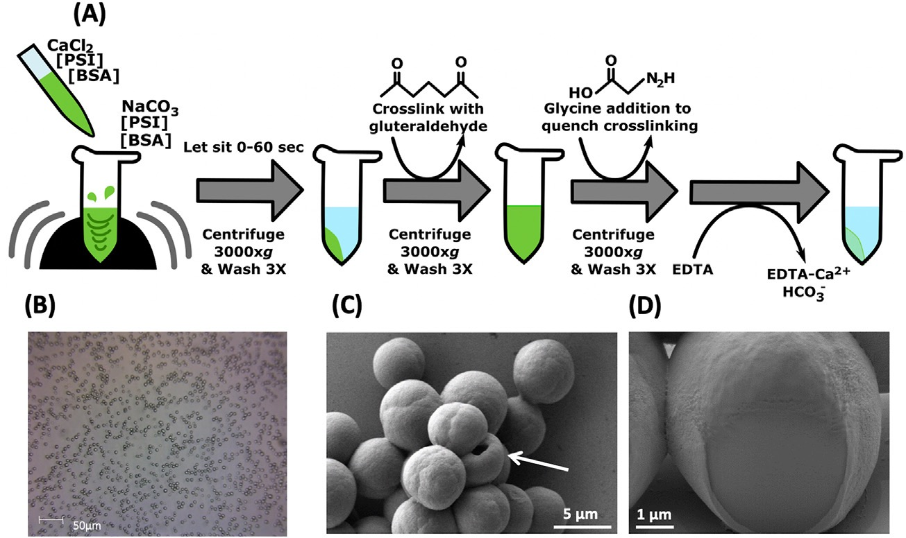
Figure 3.1. Fabrication of mesoporous PSI microspheres. A. The fabrication protocol for uniform, dispersed microspheres showing the change in appearance before the CaCO₃ template is removed by chelation. B. The DIC image of fabricated template microspheres with no PSI, showing their monodispersion and uniform size. C. The scanning electron microscopy (SEM) image of a cluster of PSI-containing microspheres at a ratio of 500:1 BSA:PSI at the pre–cross-linking stage shows the smooth CaCO₃ template surface. A rare hollow microsphere is pointed out with a white arrow. D. Focused ion beam dissection of the same pre-chelation sample in 3.1C reveals that the microspheres are solid and uniform throughout.

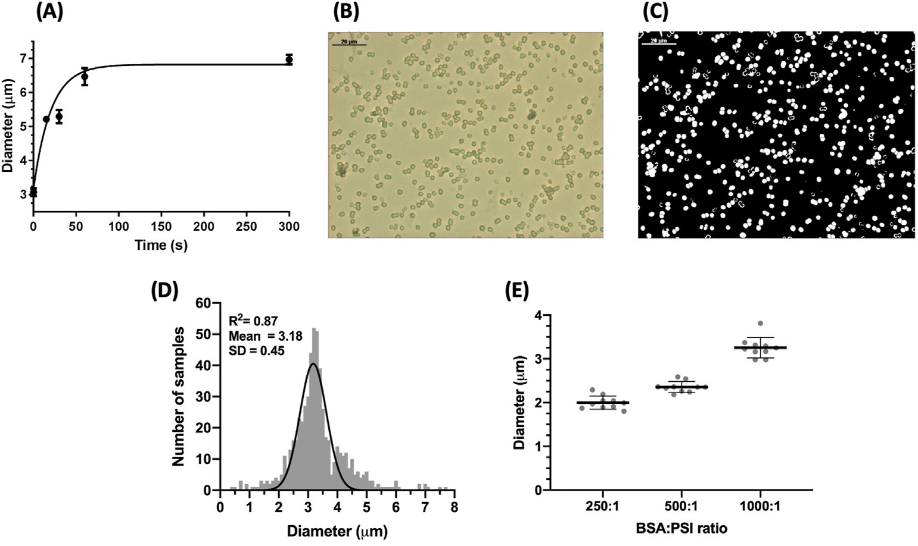

Figure 3.2. Control of PSI microsphere characteristics during the fabrication process. A. Size of microspheres can be controlled during the fabrication process as a function of time. BSA-only containing template microspheres were fabricated and allowed to sit for various times immediately after initial vortexing. Size was measured via differential interference contrast (DIC) microscopy image analysis using ImageJ. B. A representative DIC microscopy image used for size analysis of PSI-containing microspheres after chelation, BSA:PSI ratio 500:1 and initial particle incubation of ~5 s. C. A representative image analysis showing the particles analyzed using ImageJ macros for size analysis measurement. All white particles are those automatically detected by the software and analyzed for shape and size. Samples here and analyzed in panel D contain only BSA protein. D. A histogram showing the size distribution of the particles in C including other images of the same sample, n = 576; bin size = 0.25 μm. E. The inclusion of PSI in template microspheres at increasing concentration (lower BSA:PSI ratios) leads to decreased diameter of microspheres after chelation. The diameter of particles was measured using DLS. The data represent 10 different full measurements of DLS of each sample, each to an n = 1,000,000.

highlighted in Fig. 3.2, microsphere characteristics such as size can be controlled as shown in Figure 3.2E. Other researchers have noted that other characteristics such as porosity and rigidity of the produced CCMs can also be controlled by other factors of the synthesis process [252]. By varying the length of precipitation time the particles are allowed to ‘grow’ during this initial period before the first washing to remove excess Ca²⁺ and CO₃²⁻ ions present in the solution, it is possible to control the diameter and size of the particles produced. We found increases in size of over 200%, from approximately 3 μm which formed very rapidly (<5 s) on mixing the Ca²⁺ and CO₃²⁻ ions to approximately 7 μm in particle diameter after 5 min. The range of sizes observed in the pre-washed samples was analyzed via quantitative image analysis in Fig. 3.2A. The particle size quickly increased during the first 75 s before reaching a relatively stable plateau in particle diameter. However, by quenching the reaction by dilution, it is possible to achieve relatively uniform particles after a defined time. The size distribution of these particles is shown by light microscopy and image analysis in Fig. 3.2B and C. The analysis of these particles was performed using ImageJ software to detect, measure, and allow graphing of the size distribution shown in Fig. 3.2C. By performing analysis on multiple images to get a larger sample size (N > 500 particles), we observed a Gaussian distribution of particle size centered on 3 μm as predicted from initial testing results. One additional factor that was found to affect the size of the fabricated microspheres was the ratio of BSA filler protein to PSI in the incorporated protein microparticles. The concentration of PSI used was kept constant while BSA was increased to fabricate particles with BSA:PSI ratios of 250:1, 500:1, and 1000:1. As the ratio of BSA:PSI increased and overall protein concentration increased, the diameters of the microparticles produced similarly increased in size, with an increase of over 1 μm in size noted going from the 250:1 to the 1000:1 ratio.

3.4.2 Spectral and Optical Analysis of PSI incorporation in CCMs

To test whether PSI is destabilized during microsphere synthesis, the incorporation of PSI into the template CCMs was more closely investigated via UV-vis spectroscopy, shown in Fig. 3.3). Because of the large abundance of chlorophyll present bound in PSI that functions
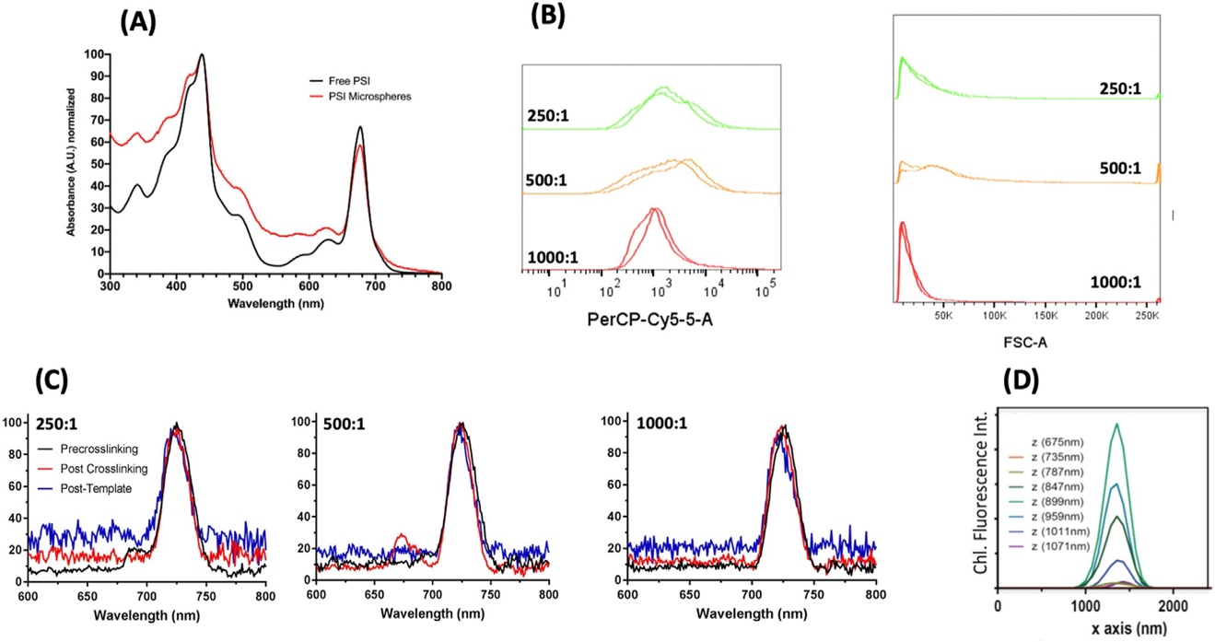
Figure 3.3. Incorporation of PSI into template CaCO₃ microspheres is stable and uniform. A. Room temperature UV-vis absorbance spectra of free PSI as compared with PSI encapsulated in microspheres are shown. Free PSI is shown in black, and PSI microspheres with template BSA-only microsphere scattering subtracted are shown in red. Spectra were normalized to their maximum absorbance values. Microspheres were fabricated with a BSA:PSI ratio of 500:1. B. Flow cytometry of PSI- containing microspheres. Ratios indicate molar ratio of BSA to PSI. Two replicate sets of samples were run at n = 50,000 for accurate comparison. The panel on the left shows fluorescence distribution of PSI embedded within the particles due to chlorophyll autofluorescence. C. Low-temperature fluorescence of PSI microspheres. Ratios indicate the molar ratio of BSA to PSI. Samples were assessed at three stages of the microsphere fabrication process to assess the stability of encapsulated PSI during the fabrication process. PSI has a characteristic 77K fluorescence emission peak at 720 nm, and free chlorophyll has a characteristic emission peak at 660 nm. D. Z-stack confocal fluorescence microscopy of PSI microspheres at a ratio of 500:1 reveals uniform chlorophyll fluorescence throughout the microsphere.

as a light-harvesting antenna, PSI has a significant and characteristic absorbance pattern in the UV-visible region of the electromagnetic spectrum. After washing the particles post-chelation to remove the CaCO₃ template, the absorbance of PSI-containing microspheres was compared with free PSI, the spectra of which can be seen in Fig. 3.3A. Spectra of the free and microsphere-bound PSI were quite similar, with some increased absorbance from the PSI bound in microspheres, indicating that chlorophyll was successfully captured and cross-linked into the fabricated microspheres.

To further assess the presence of chlorophyll and uniformity of PSI incorporation in microspheres, flow cytometry was performed, the results of which can be seen in Fig. 3.3B. This method allows tens of thou- sands of particles to be quickly analyzed to build a statistically significant histogram of both the chlorophyll fluorescence and the light scattering properties. These two parameters reflect the amount of PSI integrated per particle, and the light scattering yields a signal that is directly proportional to the particle diameter. Interestingly, microspheres formed at a BSA:PSI ratio of 1000:1 were found to have the most uniform chlorophyll fluorescence (PerCP 695/40 emission) (Fig. 3.3B) as well as tightest size distribution based on forward angle light scattering in Fig. 3.3C. This suggests that the ratio of filler protein to protein of interest plays a role not only in the size of microspheres but also in the degree of incorporation of the protein of interest in the final product. The uniformity of chlorophyll incorporation in PSI-containing microspheres was further confirmed by three-dimensional confocal fluorescence microscopy as seen in Fig. 3.3D, revealing maximal fluorescence was collected at the center z-slice, as well as consistent Gaussian emission spectra throughout the z-stack.

While flow cytometry and UV-vis absorbance spectroscopy are both informative on the micron scale, PSI is a complex multisubunit protein complex with many internal cofactors bound, and a complete characterization requires these data to be complemented with nanoscale observations and activity assessment. To assess the integrity of the PSI complex captured in microspheres, low-temperature fluorescence (LTF) spectroscopy was performed. Chlorophyll bound in its native conformation in PSI has a signature LTF spectrum compared with free chlorophyll, with PSI-bound chlorophyll producing a characteristic emission peak at 720 nm. The lack of additional peaks at ~665 and ~680 nm indicates very little free chlorophyll or uncoupled chlorophyll within the PSI complex. Samples of microspheres at BSA:PSI ratios of 250:1, 500:1, and 1000:1 were assessed by LTF at three separate stages of the fabrication process, results of which are shown in Fig. 3.3C. All samples at all BSA:PSI ratios showed the peak characteristic of chlorophyll bound stably in its native conformation in PSI, with a small amount of free chlorophyll present in the 500:1 post–cross-linking sample. These results suggest that the CCMs act as a stable template for membrane protein complexes such as PSI with minimal loss or disruption of the chlorophyll pigments during fabrication.

After investigating the size distribution and uniformity of the fabricated particles, the surface characteristics were next investigated through the use of SEM. Representative electron micrographs captured of samples are shown in Fig. 3.4. Fig. 3.4A shows the difference in crystallization patterns between the vaterite and calcite crystallization patterns of the CCM template, generating spherical and cubic particles, respectively. An image of a sample of PSI-containing particles before cross-linking can be seen in Fig. 3.4B. After cross-linking, the particles can be seen in Fig. 3. 4C with distinct delineations between the CaCO₃ template appearing smoother on the surface and the PSI and BSA proteins included in the microsphere appearing rougher underneath the surface. Fig. 3.4D is a zoomed-in view of the same sample in Fig. 3.4C and more clearly shows the difference in surface texture between the CaCO₃ salt template and the rougher proteinaceous surface. In Fig. 3.4E, samples were imaged after chelation and removal of the CaCO₃ template, revealing the textured mesoporous surface of the proteinaceous microspheres. Finally, in Fig. 3.4F, another example of a rare hollow microsphere can be seen.

3.4.3 Retainment of PSI photoactivity and mesoporous nature in CCMs

To assess the photoactivity of the PSI-containing particles, pump-probe spectroscopy was performed. In pump-probe spectroscopy, the sample is excited with one beam, ‘pumping’
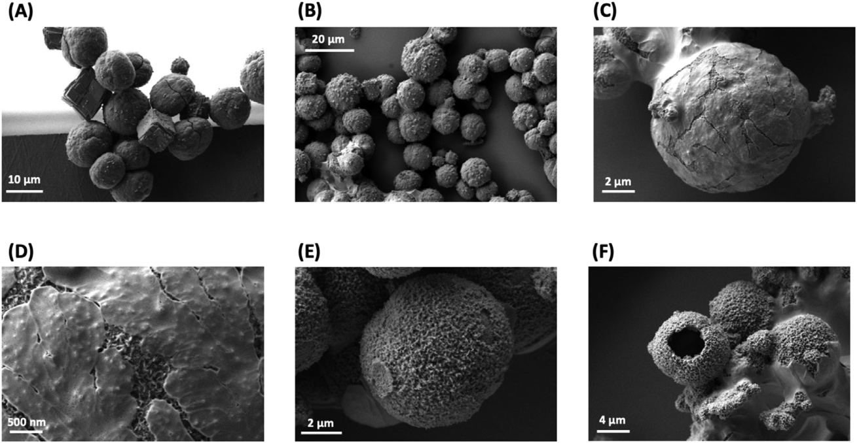
Figure 3.4. Electron micrographs of PSI-containing microspheres reveal surface characteristics. All images were captured using the Zeiss Auriga Dual Beam FIB/SEM, and all samples were sputter-coated with Au before imaging. All samples were at a BSA:PSI ratio of 500:1. A. An electron micrograph showing the difference between cubic calcite and spherical vaterite CaCO₃ particles. B. PSI-containing microspheres before cross-linking. C. PSI-containing microspheres after cross-linking. D. A close-up of the same sample from D showing the difference in texture between the CaCO₃ template and the protein encased. E. PSI- containing microspheres after chelation of the CaCO₃ template. F. An example of a rare hollow microsphere after chelation. Nearly all microspheres are solid throughout as shown in Fig. 3.1.

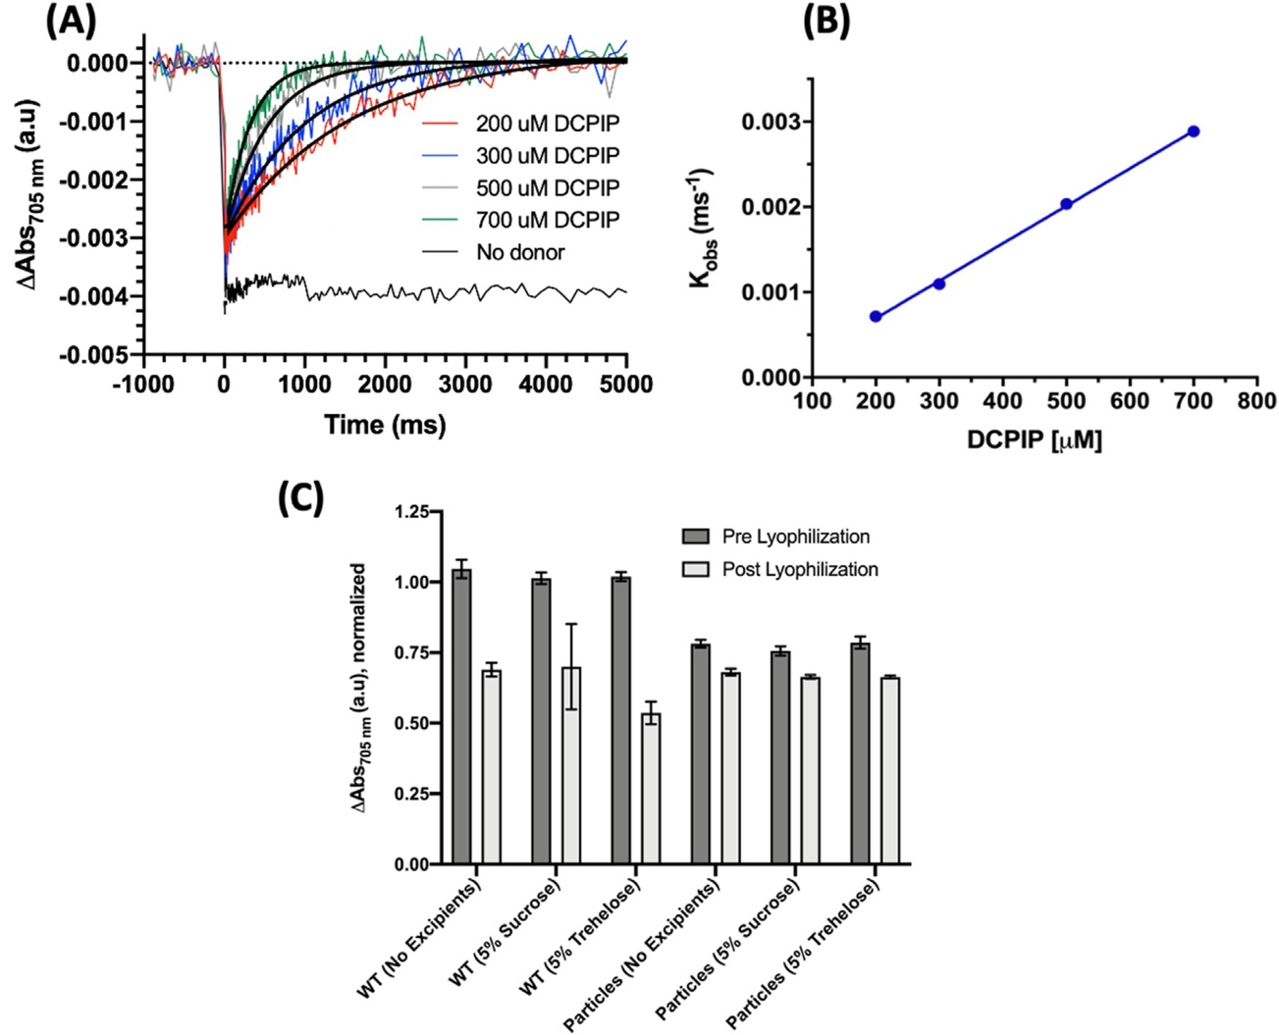
Figure 3.5. PSI photoactivity is retained after incorporation into microspheres, and microspheres retain photoactivity after lyophilization. Chelated microspheres containing PSI at a ratio of 500:1. A. Pump-probe spectroscopy was performed to assess PSI electron transfer capability after encapsulation in CaCO₃ microspheres. B. Observed PSI reduction rates (k_{obs}) are plotted against the concentration of the donor during titration. C. PSI microsphere photoactivity was assessed before and after lyophilization to test long-term stability and compared with WT (free) PSI. Excipients sucrose and trehalose at 5% w/v were also included to assess their effects on lyophilization stability.

the sample, and the second beam ‘probes’ the sample to assess spectral changes of the sample at particular wavelengths. After photo-oxidation, no reduction of the sample was seen when there was no electron donor in the form of DCPIP present, shown in Fig. 3.5A. However, as DCPIP was titrated in at increasing concentrations while the 500:1 BSA:PSI
microsphere concentration was kept constant, an increasing rate of reduction was similarly seen in Fig. 3.5A. The observed data were fit to a one-phase exponential association function to calculate observed rates (k_{obs}), which were then plotted against the concentration of the donor for each measured sample. As demonstrated in Fig. 3.5B, a linear trend in the observed PSI reduction rate was observed. Furthermore, all traces of PSI titration with DCPIP showed that all PSI photoexcitation signal was reduced back to the baseline, suggesting that all of PSI present in the microspheres was accessible to the DCPIP reductant, otherwise the signal would plateau before reaching the baseline. Taken together, these results suggest that the activity of PSI is both retained and stable after incorporation into the CCMs. These results also reveal that after cross- linking and template removal, the synthesized microspheres remain porous for exogenous addition of small molecule substrates to diffuse through and access the entirety of the protein bound within, a beneficial characteristic for industrial applications where high surface area for greater reactivity is desired.

The use of CCMs for long-term storage of PSI was also tested to see if CCMs are a viable long-term storage solution for proteins of interest, the results of which are seen in Fig. 3.5C. PSI-containing microspheres were lyophilized overnight with either no excipients or with 5% sucrose or trehalose purposed as cryopreservation agents [253-257]. Once the lyophilized samples were resuspended in buffer, we tested the photo- activity retention of the particles by comparing the photo-oxidation magnitude of post-lyophilized samples to the pre-lyophilization control. Interestingly, we see a reduction of ~25% of the P₇₀₀⁺ photo- bleaching signal relative to the free PSI with or without excipients; we suspect that some of this may be due to the slow settling of microspheres during the measurement. However, less than five percent of the photoactivity of all microspheres was lost during the lyophilization process. Even though PSI captured in CCM-templated microspheres has some reduction in photoactivity signal, the protein microspheres retained more activity after lyophilization with or without the addition of cryopreservants, which did not produce a significant preservative effect.

3.4.4 Incorporation of PSI-CCMs in a biophotovoltaic device

Once greater retainment of PSI photoactivity than that with free PSI after lyophilization was confirmed, we next wanted to test the application of these microspheres in a biophotovoltaic device to assess their ability to perform in one of the imagined biotechnology applications of these particles. Biophotovoltaic devices were fabricated, and 500:1 BSA:PSI ratio microspheres were chelated overnight and then drop- coated on the semiconductor-coated electrode. A carbon-coated counter electrode and an aqueous synthetic cobalt-based electrolyte [54] were used to finish fabrication of the device.

PSI microsphere–containing biophotovoltaic devices were capable of generating photocurrent under not only broad-spectrum white light but also red light specific for PSI photoexcitation, as seen in Fig. 3.6A and B. The PSI contained in microspheres was capable of constructive interaction via electron injection into the TiO₂ semiconductor to allow for current to flow through the device. At 500 μmol photons/m²/s of PSI-specific red actinic light, the microsphere-containing photovoltaic device produced stable photocurrent densities of 5 μA/cm². Under white light at nearly 2000 μmol photons/m²/s, photocurrent densities of ~60 μA/cm² were able to be obtained, with an initial spike over 90 μA/ cm². Shown in Fig. 3.6C, this photocurrent produced was dependent on light intensity, with increasing photocurrent as the photon flux density increased. Under the broad-spectrum white light, there is a much steeper increase in photocurrent density generated at high light intensities before leveling off, likely due to the slight photoactivity of the TiO2 semiconductor itself.

The stability of PSI microspheres and their electronic output were then assessed over multiple light-dark cycles, shown in Fig. 3.6D and E. The steady-state photocurrent density
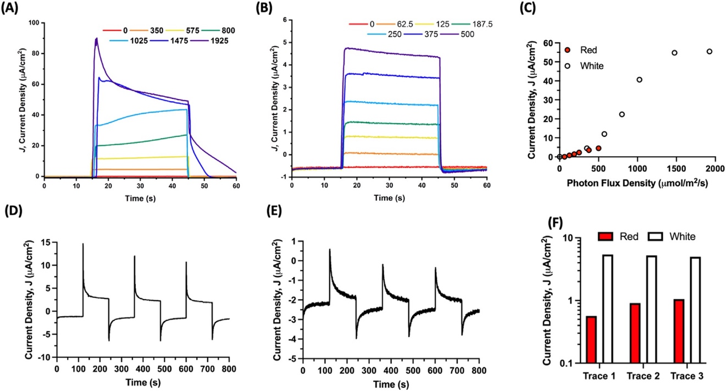
Figure 3.6. PSI stabilized in microspheres is capable of generating photocurrent in a biophotovoltaic device. PSI microspheres in a biophotovoltaic device are capable of undergoing charge separation and injecting electrons into a semiconducting TiO₂ layer on an electrode. A. Photocurrent density dependence on light intensity of full-spectrum white light is reported. Light intensity is reported in photon flux density, PFD (μmol/m²/s). B. Photocurrent density dependence on light intensity for PSI-specific red actinic light is reported. Light intensity units are the same as panel A. C. Average photocurrent density was plotted against PFD to show the linearity of the response. D, E. Photocurrent density response is consistent over multiple light/dark cycles for both white (panel D) and PSI-specific red (panel E) light, respectively. The light intensity was 62.5 μmol photons/m²/s for the PSI-specific red actinic light and 350 μmol photons/m²/s for the broad-spectrum white light. F. The steady-state photocurrent density during light-on from panels D and E is quantified in panel F, with baseline current subtracted.

output for each light/dark cycle was plotted with baseline dark current subtracted in Fig. 3.6F. Under white light, the steady-state photocurrent density produced was stable over multiple cycles and did not degrade. Interestingly, for the PSI-specific red light, the photocurrent density output increased between all traces, suggesting that PSI contained in the microspheres in the device was able to more efficiently fill the electron holes of the semiconductor, resulting in greater photocurrent density yields.

3.5 Discussion

Biotechnology is an emerging area of research, and a growing industry worldwide, defined as the use of living organisms, systems, and processes for the benefit of society, industry, and the environment [258]. The United States is the current world leader in the development of a biotechnology industry, with annual revenues from companies totaling over $300 billion USD in 2012. This is estimated to further grow over 10% each year, making it one of the fastest growing economic areas [259]. However, there are numerous challenges to continued growth and development of novel biotechnology applications, many of which are related to longevity and stability of the biomaterial of interest [139, 260]. More generally, many biotechnologies rely on the use of proteins, which are susceptible to aggregation, degradation, and loss of activity along with issues of long-term storage exacerbating many of those issues. PSI specifically has been shown to have promise for the development of bioelectronic electrodes and biohybrid photovoltaic devices. There has been some work interested in the stabilization of PSI for biotechnology applications, including design of designer surfactant peptides and fully aqueous electrolyte systems, but the successful stabilization of proteins for long-term usage in vitro remains a burgeoning research area [54, 139, 260]. Herein, we describe applications of calcium carbonate microspheres, CCMs, as templates for the encapsulation of the protein-pigment complex PSI, forming aqueous, mesoporous non-aggregating proteinaceous microspheres. CCMs have been described previously as drug delivery vehicles in the pharmaceutical industry because of their biocompatible nature and ability to be facilely functionalized and modified [226]. We modified existing synthesis protocols for CCMs to accommodate the encapsulation of cyanobacterial PSI, a membrane bound protein-pigment complex while retaining photoactivity and improving its long-term storage capabilities.

We have developed a method of synthesizing and using CCMs to encapsulate PSI without loss of structural stability or protein activity, which can likely be modified as needed for other membrane proteins. This synthesis protocol yields highly uniform particles in both size distribution and protein distribution within the fabricated microspheres. The size of these microspheres was found to be dependent on both length of salt precipitation during initial formation and on the amount of inert filler protein added as well. These uniform particles are also non-aggregating and monodispersed, making them ideal candidates for use in flow cytometry or microfluidics applications. Chelation with EDTA after cross-linking of the protein of interest with filler BSA went essentially to completion, leaving behind proteinaceous mesoporous micro- spheres. After chelation to remove the CaCO₃ template, we have shown that the final mesoporous microspheres are porous and their interiors are accessible to small molecules, as our PSI-containing particles are able to be exogenously reduced by treatment with DCPIP. This may prove beneficial for further biopharmaceutical development to help target activation of encapsulated proteins after delivery.

Although some fraction of total PSI photoactivity was lost during the encapsulation and fabrication process, the majority was retained. This further suggests the structural integrity of the membrane protein encapsulated was retained, as PSI utilizes a complex series of internal cofactors for electron transfer and must coordinate a large chlorophyll antenna that is highly specifically placed in the complex for optimal light-harvesting capabilities. The encapsulated PSI also proved to be more resistant to freeze-thaw stress and the lyophilization process, retaining a greater fraction of its photoactivity than free PSI. Most interestingly, the synthesized PSI microspheres maintained their photoactivity when in- tegrated into a biophotovoltaic device. This produced photocurrent was dependent on the light intensity as expected, with increasing photocurrent density as light intensity increased. Photocurrent was produced even under PSI-specific red actinic light, suggesting that this photocurrent is being driven from the encapsulated reaction center. The biophotovoltaic devices were also stable over multiple traces, with no loss of photocurrent under broad-spectrum white light and a slight increase under the PSI-specific light. This may be due to PSI filling more of the electron holes of the semiconductor over time. This device design confirms the ability of PSI to simultaneously inject electrons into the TiO₂ semiconductor and also accept electrons from the water soluble, Co^{II/III} electron donor. These concurrent properties are most probably derived from the mesoporous nature of the microspheres, confirm the ability of PSI to interact very closely with the semiconducting material, and potentially demonstrate the ability for exciton transfer between adjacent, cross-linked PSI complexes. The role of BSA acts as spacer protein yet does not seem to block electron transfer at either surface or act as an insulator, potentially driving the photocurrent down or preventing forward electron injection from the PSI into the TiO₂ semiconductor. Future work will try other spacer proteins besides BSA to further optimize the composition and porosity of the microspheres for future bioelectronics applications, and other avenues of interest include addition of various light-harvesting antennas to increase the wavelengths of light available for PSI photoexcitation.

Taken together, this work suggests that CCM encapsulation may be a viable strategy for improved activity, longevity, and storage of membrane proteins of interest for various biotechnology applications. This is, to our knowledge, not only the first report of a membrane protein being encapsulated utilizing CCMs but also the largest protein to be stabilized by this method. This is also, to our knowledge, the first report of microsphere-encapsulated proteins being incorporated into a biohybrid electronic device.

CHAPTER IV
PEDOT-Carbon Nanotube Counter Electrodes and Bipyridine Cobalt(II/III) Mediators As Universally Compatible Components in Biosensitized Solar Cells Using Photosystem I and Bacteriorhodopsin

A version of this chapter was originally written by Alexandra Teodor as co-first author and Barry D. Bruce and Claudia Villareal as corresponding authors:

Teodor, A.H. et al. “PEDOT-Carbon Nanotube Counter Electrodes and Bipyridine Cobalt(II/III) Mediators As Universally Compatible Components in Biosensitized Solar Cells using Photosystem I and Bacteriorhodopsin” International Journal of Molecular Sciences (2022) 23, 3865.

Alexandra Teodor is the co-first author of this published research article. She performed conceptualization, data collection and analysis, figure making, initial draft writing and is involved in the manuscript editing and review process at the journal International Journal of Molecular Sciences. Stephanie Monge is the co-first author and was involved in all the same portions of preparing this manuscript. Coauthors Dariana Aguilar and Alexandra Tames were involved in data curation. Coauthors Jesse J. Bergkamp, Roger Nunez, Elaine Gonzalez, Ricardo Starbird, and Renugopalakrishnan Venkatesan were involved in resource management and availability. Coauthors Juan J. Montero Rodriguez, Jesse J. Bergkamp, Renugopalakrishnan Venkatesan, Ricardo Starbird, Barry D. Bruce, and Claudia Villareal were involved in the supervision, manuscript editing and review process.

4.1 Acknowledgments

S.M. and A.H.T. would like to thank Dr. Neal Evans for his assistance with the scanning electron microscopy at the Institute for Advanced Materials and Manufacturing. A.H.T. would like to thank Dr. Michael Vaughn and Dr. Enrique Quiroga for their insightful and educational help with electrochemistry and solar cell analysis discussions. B.D.B and A.HT. would like to thank General Graphene for their generous gift of graphene electrodes.

4.2 Abstract

In nature, solar energy is captured by different types of light harvesting protein-pigment com-plexes. Two of these photoactivatable proteins are bacteriorhodopsin (bR), which utilizes a retinal moiety to function as a proton pump, and Photosystem I (PSI) that uses a chlorophyll antenna to catalyze unidirectional electron transfer. Both PSI and bR are well characterized biochemically and have been integrated into solar photovoltaic (PV) devices built from sustainable materials. Both PSI and bR are some of the best performing photosensitizers in the biosensitized PV field, yet relatively little attention has been devoted to development of more sustainable, biocompatible alternative counter electrodes and electrolytes for biosensitized solar cells. Careful selection of the electrolyte, and counter electrode components is critical to designing biosensitized solar cells with more sustainable materials and improved device performance. This work explores use of poly(3,4-ethylenedioxythiophene) (PEDOT) modified with carbon nanotubes as counter electrodes and aqueous-soluble bipyridine cobaltII/III complexes as direct redox mediators for both PSI and bR devices. We report a unique counter electrode and redox mediator system that remarkably can perform well for both bio-photosensitizers that have evolved independently over millions of years. Such compatibility of disparate proteins with common mediators and counter electrodes may further the improvement of biosensitized PV design in a way that is more universally biocompatible for device outputs and longevity.

4.3 Introduction

Current annual energy demands worldwide are increasing greatly, and current technologies based on carbon fuel combustion has led to significant increases in atmospheric CO2 levels worldwide [29]. Renewable energy harvesting from the environment is an attractive alternative, such as solar energy conversion through photovoltaic devices (PVs) which aim to harness a portion of the nearly 175,000 terajoules of solar photonic energy striking the Earth annually [41, 261]. Current PV technologies on the market are made of inorganic materials including toxic heavy metals and rare-earth elements, and also have prohibitive manufacturing processes, costs, and limited mobility post-installation. Further, current first-generation PVs are estimated to generate nearly 80 million metric tons of waste by 2050 due to specific recycling requirements [48]. As such, it is clear further improvement on current PV technologies is needed to address future energy demands. Biosensitized solar cells (BSSCs) offer a promising way of addressing these issues, with simple manufacturing processes with less-toxic and earth-abundant elements. BSSCs are based on dye-sensitized solar cells first developed by Grätzel and O’Reagan, which pioneered the design of a photosensitizing dye incorporated in a thin-layer style device utilizing much more relaxed manufacturing requirements and the ability to incorporate many different types of materials in device fabrication [50]. The construction and development of devices incorporating the main components of natural biological photosynthesis – mainly the solar-to-electrical energy converting protein-pigment complexes – has emerged as an area of research interest over the past few years. These biosensitized devices could be used for potential future applications such as photo-switchable biosensors, solar-to-chemical or solar-to-electrical energy converting systems and establish the basis towards a renewable energy economy [42, 118, 164, 180, 262].

Two protein-pigment complexes that have shown great promise in this area of biologi-cally-based electronic devices are bacteriorhodopsin (bR) and photosystem I (PSI). PSI is one of the primary reaction centers that is central to oxygenic photosynthesis, and is comprised of approximately 12-14 protein subunits, 100 chlorophyll molecules, 2 phyl-loquinones, 3 [4Fe-4S] clusters and 20 carotenoids. Further, PSI is able to form higher oligomeric states in many different photosynthetic organisms, reaching sizes of 1.4 Mda, making it among the most complex protein complexes found in nature [18, 21, 22, 25, 26, 231]. PSI in vivo acts as a photoactivated cytochrome c:ferredoxin oxidoreductase, catalyzing a light dependent unidirectional electron transfer across the thylakoid membrane [1]. bR is a membrane-bound protein-pigment complex found in archaebacteria such as Halobacte-rium salinarum, and is comprised of a single 27 kDa subunit and a single Schiff
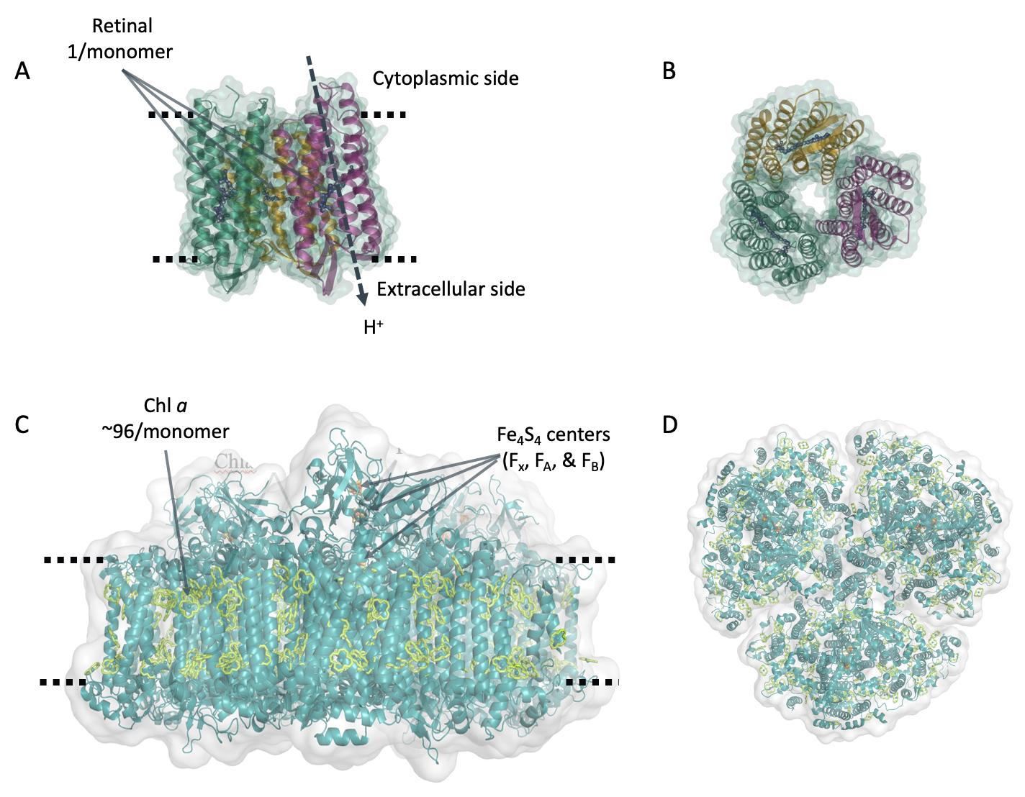
Figure 4.1. Structure of bacteriorhodopsin and Photosystem I. Three-dimensional structure of pigment-protein complexes: (A) bacteriorhodopsin side view and (B) top view. (C) Photosystem I side view and (D) top view. The three subunits of bR are shown in orange, purple, and green respectively with retinal shown in blue. In PSI, all the protein is shown in teal with the chlorophyll light harvesting antenna shown in green. For both proteins, the dashed line represents position of the membrane each complex is embedded in vivo.

Table 4. 1. Properties of the pigment-protein complexes bacteriorhodopsin and photosystem I.
Protein | Pigment | Pigments per monomer | MW per  monomer | Abs. Max. (nm) |  | Ext. Coeff. At Abs. Max. (mM⁻¹ cm⁻¹) | Organism Source | in vivo  Function
Bacteriorhodopsin (bR) | Retinal | 1 | 27 kDa |  | 560 (green) | 63 | H. salinarum S9 | H⁺ pump
Photosystem I (PSI) | Chlorophyll a | ~100 | ~400 kDa |  | 680 (red) | 57 | T. elongatus BP-1 | unidirectional e⁻ transfer
base linked retinal pigment. Intriguingly, bR forms a trimeric structure in vivo similar to PSI [263]. The three-dimensional structure of both proteins and locations of their pigment moieties are shown in Figure 4.1 , and Table 4.1 summarizes the structural and optical properties of both as well as the organismal source of both proteins used in this study. However, bR uses photoexcitation to catalyze the transfer of protons across the membrane it is embedded in [264]. Both of these protein-pigment complexes have shown remarkable thermal stability and their structural, biochemical, and photophysical properties have been extensively studied [42, 265]. Similarly, both PSI and bR have also been widely used in a variety of biotechnological applications, most notably in BSSCs [42, 54, 79, 81-83, 85-89, 91, 92, 95, 104, 114-118, 129, 130, 162, 163, 179, 202, 204, 238, 239, 243, 244, 262, 266-295].

BSSCs consist of a biological pigment immobilized on a semiconductor photoanode, connected to a cathode through a redox system solution and supporting electrolyte [5]. The conventional architecture of a BSSC consists of four primary components, which are: (i) a photosensitive biological dye, (ii) a transparent photoanode (iii) a redox electrolyte for dye regeneration and finally (iv) a counter electrode [42, 51, 52, 118, 296].

A majority of BSSCs also Incorporate a fifth component, (v) a semiconductor coating on the photoanode [50, 118]. After photonic excitation, the dye molecules are excited from their ground state to a higher energy state, and the electrons are promoted from the HOMO orbital to the LUMO orbital, generating electron–hole pairs [51]. Then, effective charge separation is achieved by oxidation of the excited sensitizer molecule, and the generated electron is injected to the conduction band of the semiconductor or photoanode, and the hole remains behind in the oxidized dye molecule [50]. The electrons then diffuse through the semiconductor to the photoanode substrate where they then travel through an external circuit and perform work before arriving at the cathode, generating the current. During that time, the redox mediators in the electrolyte regenerate the sensitizer molecule. In return, the oxidized redox mediator diffuses to the counter electrode (CE) and gets regenerated [92]. Within this basic operational outline, there is great flexibility in the selection and design of materials, along with many different interfaces to optimize for device improvement.

In BSSCs, the CE catalyzes the reduction of the electrolyte after electron injection. The CE is expected to be both highly conductive and highly catalytic. Large surface areas and small particle sizes are preferred to generate more active sites and enhance the electrocatalytic activity of the CE [297, 298]. In most cases, platinum-coated conductive glass has been used for CEs due to its high conductivity and catalytic activity. However, Pt is expensive and is susceptible to corrosion and irreversible redox reactions [299], making it a poor material choice for incorporation into some sustainable devices, especially BSSCs, which strive to utilize more abundant resources for CE materials. Different forms of carbon allotropes, inorganic materials, and conductive polymers are emerging as promising CEs, and among the most promising are poly (3,4-ethylene dioxythiophene) (PEDOT) and alternative carbon nanomaterials [168, 300-306]. PEDOT is a conductive polymer with desirable physical properties including optical transparency, smooth surface morphology, solution processability, light weight, low cost, electrochemical stability, mechanical flexibility, and a high work function [307]. However, due to the acidity and extremely hygroscopic nature of PEDOT films, it is often modified during the electrodeposition process to incorporate additives that tune its properties for specific systems and enhance its performance as a CE in BSSCs. These include carbon nanostructures such as carbon nanotubes (CNTs), which have many advantages such as high surface area, exceptional charge carrier mobility, and remarkable mechanical strength and stability, beyond the abundance of carbon on Earth [308]. Considering the many beneficial physical properties of PEDOT and CNTs, it can be predicted that the composites of PEDOT and carbon nanostructures may be more efficient in enhancing the performance of BSSCs compared to other materials that have already been reported for transparent charge transport layer applications [309]. Other commonly used carbon allotropes for CEs include graphene-based systems. Pi-system modified graphene-based CEs have already been reported on for use in PSI-sensitized solar cells with photocurrent densities of 135 µA/cm² [114]. Graphene has excellent conductivity compared to certain other carbon allotropes and is highly abundant, both of which are desirable characteristics for sustainable BSSC designs [310].

In BSSCs, the electrolyte is responsible for reduction of the photosensitizer back to its ground state and selection of a proper electrolyte and redox mediator are crucial to device performance and longevity. As such, careful selection of the redox mediator is crucial for the alignment of its midpoint potential E_{m} for donation to the HOMO of the dye after photoexcitation, as depicted in step 4 in Figure 2B. This allows for the minimization of overpotential losses in BSSCs. BSSCs have historically used the canonical I⁻/I₃⁻ redox mediator pair, yet this system has multiple drawbacks including high corrosivity and toxicity, generation of radical species, significant absorption in the same region of the UV-visible spectrum as biological photosensitizers, and an unfavorable midpoint potential (E_{m}) as compared to the HOMO of many biological materials giving low driving potentials for improved electron transfer rates [217]. Further, the iodide/tri-iodide pair is also commonly dissolved in organic solvents which are undesirable in BSSCs due to their high volatility, toxicity, and/or explosive nature of many of these solvents, along with water leakage into the device either during fabrication or while being used [165]. As such, the development of aqueous, biocompatible electrolytes and redox mediators is key. Most work in the field of DSSCs has focused on the use of cobalt-based redox mediators to try and replace the I⁻/I₃⁻ pair [168, 200, 201, 218, 219, 221, 222] due to the high abundance of cobalt and its stable, reversible redox properties. Previous work from our group has described the synthesis and characterization of novel aqueous-soluble cobalt-based redox mediators and their ability to directly reduce PSI in vitro and the fabrication of fully aqueous BSSCs using the same mediator [54].

In this study we describe a facile technique of fabrication of a CE based on highly con-ducting PEDOT doped with multi wall carbon nanotubes (MWCNTs), and the use of these PEDOT/CNT counter-electrodes with an aqueous bipyridine-based cobalt redox mediator to fabricate BSSCs using both PSI and bR. A schematic of the energy levels and device design is shown in Fig. 4.2A and 2B, along with an overlaid visible absorbance spectrum
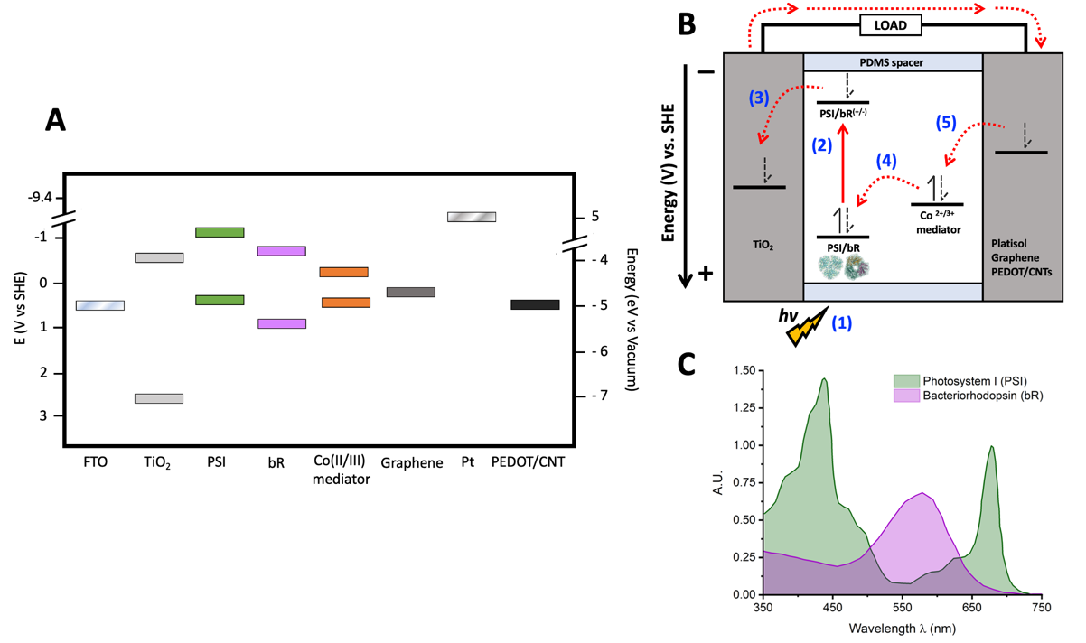
Figure 4.2. Schematics of PSI or bR sensitized BSSCs. A. Energy diagram of all device components used in this study. Other values and conversions used come from references [40, 41] B. Fundamental processes and constituent components of a biosensitized solar cell (BSSC). C. UV-vis absorbance spectra of PSI and bR.

of these complexes (Fig 4.2C) showcasing the potential for devices with multiple biological photosensitizers to utilize a greater optical cross-section for photocurrent generation. The compatibility of this novel counter-electrode and redox mediator scheme with more than one biological photosensitizer is remarkable and may serve as a platform for developing more broadly biocompatible BSSC components to improve the biological-inorganic interface.
4.4 Results

4.4.1 Counter Electrode characterization

The performance and characteristics of three different electrode materials, PEDOT/CNT, platinum nanoparticles (Pt NPs), and graphene, prepared on FTO glass substrates, was analyzed. Then the performance of BSSCs using these substrates as counter electrodes was assessed. The morphology and surface characteristics of the photoanodes and all counter electrodes used in this study were analyzed using scanning electron microscopy (SEM). The resulting micrographs can be seen in Figure 4.3. In Figure 4.3A, the surface topography of the PEDOT/CNT counter electrode can be observed in this top-down image of the electrode face. The spherical structures, ca. 400–500 nm in size, are likely the PEDOT polymer, while the small protrusions are where the doped carbon nanotubes have integrated into the polymeric structure during electropolymerization. The rough surface area of the spherical polymer particles may allow for an improved contact to reduce the mediator in the electrolyte.

In Fig. 4.3B, an edge view of the sintered TiO₂ layer on the photoanode is depicted showing the even thickness of the deposited semiconducting layer. The nanoparticles of TiO₂ produced in our fabrication process are quite homogenous and smaller than the ultrastructure of the PEDOT/CNT nanoparticles, with an approximate average size of ~200-300 nm diameter for the larger spherical particles produced. The highly porous three-dimensional nature of the sintered semiconductor TiO₂ layer is especially notable in the top-down view of the electrode surface in Fig. 4.3C, which allows for improved adsorption
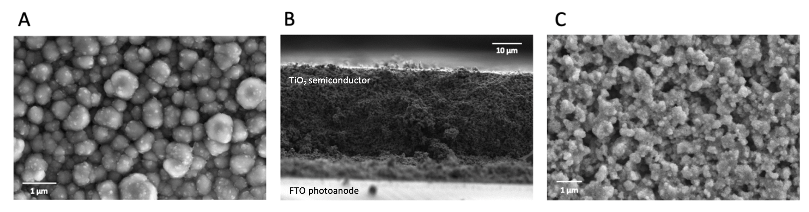
Figure 4.3 Surface characteristics of photoanodes and counter electrodes. SEM micrographs of A. PEDOT/CNT B. cross-section edge view and C. top view of sintered TiO₂ all on FTO.

of photosensitzers such as PSI and bR. The graphene- and Pt NP-coated counter electrodes were also imaged by SEM, yet due to the atomically thin nature of the graphene layers used and the small size of the platinum particles in Platisol, those samples were essentially visually identical to the bare FTO electrodes. As such, those micrographs were not included. The macroscopic surface characteristics of all counter electrodes and PSI deposited on the TiO₂-coated photoanode can be seen in Fig. 4.4A.

The ability of PEDOT/CNT, graphene, and Pt NPs to interact constructively with our aqueous-soluble Co^{II/III} redox mediator was then tested by cyclic voltammetry, using the variable counter electrodes as the working electrode in an analytical electrochemical setup. The resultant voltammograms are shown in Figure 4B, with glassy carbon and Pt wire used as standard working electrodes for comparison. Each voltammogram was normalized for peak height to take into account variable working electrode area. The specific redox reaction measured in Figure 4B is described in Equation (1) and Figure 4.5 below [54, 172], where R = tris(4,4′-di-methoxy-2,2′-bipyridine).

Equation 1: ${{[Co(bpy-R_{2})}_{3}{Cl}_{2 }] }^{3+}+ e^{-}⇌{{[Co(bpy-R_{2})}_{3}{Cl}_{2 }] }^{2+}$

The oxidation potential E_{ox}, reduction potential E_{red}, and midpoint potential E_{m}, of the Co^{II/III} redox mediator were measured using each electrode and the obtained values are reported in Table 2. The aqueous-soluble Co^{II/III} redox mediator was able to interact electrochemically with each eletrode material, displaying quasi-reversibility. The E_{m} measured (−0.045–0.236 V vs. NHE) was higher than the HOMO of both PSI and bR with all electrodes tested. The E_{m} of the mediator being more negative than the HOMO of bR [311] and of PSI [206] indicates that electron transfer from the Co^{II/III} redox mediator to either PSI or bR is thermodynamically favorable, and a closer E_{m} value to those of the protein–pigment complexes represents lower overpotential losses [221].

The varying counter electrodes were next used for functional comparison by incorporation in PSI-sensitized solar cells (PSI-SSCs) and testing for photovoltaic performance and
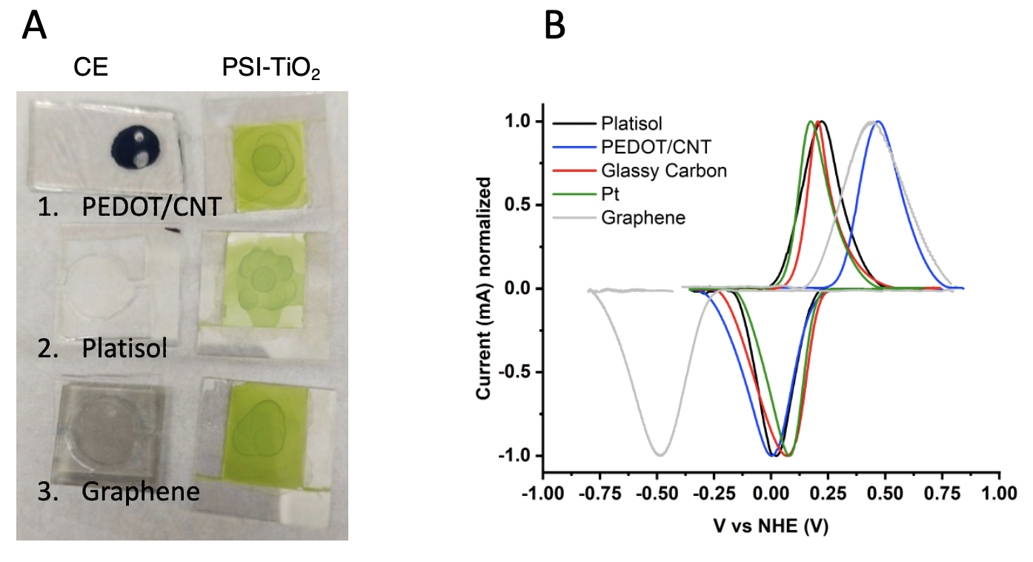
Figure 4.4. Counter electrode characterization. A. Photograph of the three PSI-SSC with different counter electrodes (left) and PSI-sensitized TiO2 photoanodes (right) on FTO glass. B. Cyclic voltammograms of the of aqueous-soluble bipyridine Cobalt(II/III) redox mediator using different working electrodes. All voltammograms were measured at 100mV/s, baseline corrected and current was normalized to account for variation in working electrode surface area. Pt wire and a saturated calomel electrode were used in all measurements as the counter and reference electrodes, respectively.

Table 4.2. Electrochemical parameters of aqueous Co^{II/III} redox mediator with varying electrodes.
Electrode Material | E_{ox}  (V vs NHE) | E_{red}  (V vs NHE) | E_{m}  (V vs NHE)
Graphene | 0.448 | -0.493 | -0.045
PEDOT/CNT | 0.468 | 0.003 | 0.236
Platisol | 0.221 | 0.023 | 0.122
Pt wire | 0.173 | 0.081 | 0.127
Glassy Carbon | 0.205 | 0.069 | 0.137

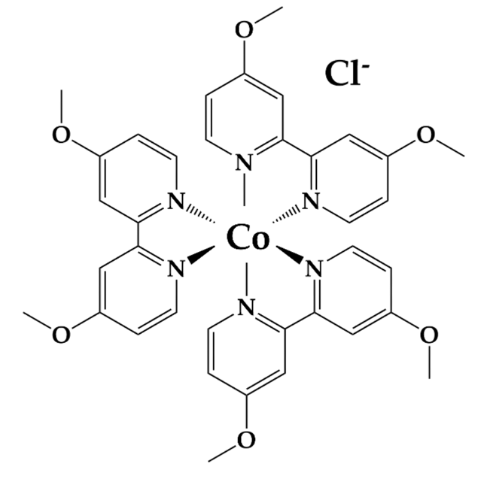
Figure 4.5. Chemical structure of aqueous-soluble Co^{II/III} redox mediator.

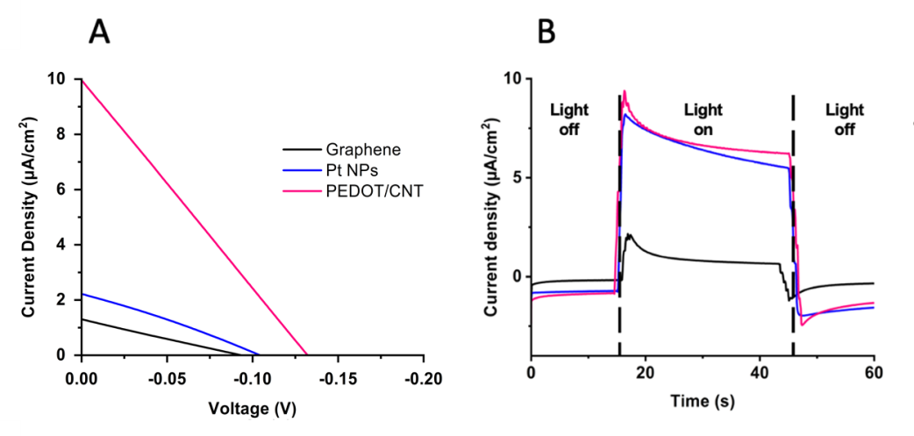
Figure 4.6 Design and performance of PSI-sensitized solar cells (PSI-SSC) with variable counter electrodes. A.Representative chronoamperometry curves of the three PSI-SSCs illuminated with white light. B. White light-illuminated current density-voltage (J-V) curves of the three PSI-SSCs.

Table 4.3. PSI-sensitized solar cells (PSI-SSC) performance using different counter electrodes and a liquid-based aqueous Co^{II/III} electrolyte.
 | V_{OC} (mV) | J_{SC} (µA/cm²) | FF % | PCE %
PEDOT/CNTs | −132 | 10.00 | 25 | 0.33
Pt NPs | −104 | 2.22 | 28 | 0.06
Graphene | −93 | 1.30 | 24 | 0.03
output. The resulting photochronoamperometry and current density-voltage (J-V) curves can be seen in Figure 4.6. The photovoltaic parameters of the three devices, short-circuit current (J_{sc}), open-circuit voltage (V_{OC}), fill factor (FF), and power conversion efficiency (PCE) are summarized in Table 4.3. The greatest V_{OC}, J_{sc} and PCE were obtained with the PEDOT/CNT-based PSI-SSC, outperforming both the graphene and Platisol counter electrodes. The V_{OC}, J_{sc} and PCE of the PEDOT/CNT device were -132 mV, 10.0 µA/cm² and 0.33%, respectively. The photocurrent density response of the PEDOT/CNT PSI-SSC was nearly five times larger than that of Platisol (2.22 μA/cm²) and eight times greater than graphene’s (1.3 μA/cm²). The photocurrent response of the PSI-SSCs at the V_{OC} is plotted in Fig. 4.6A. All the PSI-SSCs exhibit a current increase in response to illumination, with PEDOT/CNT and Platisol giving similar photocurrent greater than that of the graphene counter electrode.

4.4.2 Comparison of liquid and gel electrolyte composition on PSI-SSC output and efficiency

Once the PEDOT/CNT counter electrode was determined to be the best performing with the aqueous Co^{II/III} mediator and PSI as photosensitizer, the electrolyte was next varied to compare gel vs liquid consistencies for BSSC device performance. Previous studies on gel-based electrolytes have reported on their abilities to overcome some of the largest issues of liquid electrolyte-containing devices, such as sealant failure, volatile solvent evaporation, greater electron recombination, and device leakage over time [279, 312]. In Figure 4.7, a gel-based electrolyte system was compared to the liquid electrolyte to compare their performances with the PEDOT/CNT counter electrode in PSI-SSCs. J-V curves comparing gel and liquid electrolytes can be seen in Figure 4.7A, with the calculated photovoltaic parameters reported in Table 4.4. The V_{OC} of the gel electrolyte-based device was improved by -60 mV relative to the liquid electrolyte device. The gel and liquid electrolyte devices had comparable fill factors of 26 and 25%, and J_{sc} of 9.67 and 9.94 (µA/cm²) respectively, yet the gel electrolyte device had improved an PCE of 0.48% compared to
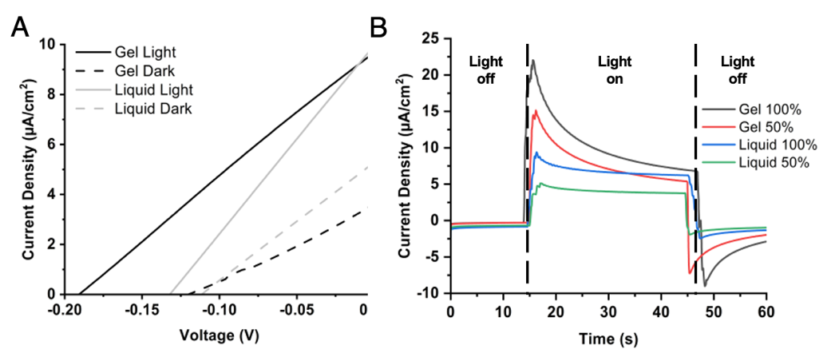
Figure 4.6. Electrochemical analysis and performance of PSI-sensitized solar cells (PSI-SSC) using liquid and gel aqueous-soluble bipyridine Co^{II/III}-based electrolytes. A. Dark and white light-illuminated J-V curves of the fabricated devices using liquid and gel electrolytes. B. Representative chronoamperometry experiments measured at different white light illumination intensities.

Table 4.4 PSI-sensitized solar cells (PSI-SSC) performance using liquid and gel-based electrolytes using aqueous-soluble Co^{II/III} redox mediators.
 | V_{OC} (mV) | Jsc (µA/cm²) | FF % | PCE %
Gel | -190 | 9.67 | 26 | 0.48
Liquid | -132 | 9.94 | 25 | 0.33

0.33% for the liquid electrolyte device. Based on the improved V_{OC} and PCE of the gel electrolyte device, the gel-based system was able to reduce resistance losses and improve device performance. The J_{sc} is unchanged as light absorption and transduction into current should not be affected by the electrolyte composition.

Photochoronamperometry experiments were next performed to measure the photocurrent as a response to illumination and the results are shown in Figure 5B. Both liquid- and gel electrolyte-based devices showed improved current as illumination was increased, as expected. The gel electrolyte-based device generated a larger photocurrent than the liquid-based device, and even upon stabilization of the photocurrent the gel-based device had comparable current density output to the liquid-based device under 50% less irradiance. Taken together, the gel electrolyte with PEDOT/CNT counter electrode-based device has the best performance of all systems tested in this study for PSI-sensitized BSSCs.

4.4.3 Aqueous Co^{II/III} Redox Mediator Gel Electrolytes and PEDOT/CNT Counter Electrodes Are Compatible with Multiple Proteins

Once an improved counter electrode and electrolyte system for PSI-SSCs was able to be identified, the suitability of this novel device fabrication scheme for other biological sensitizers was tested by utilization of the protein bacteriorhodopsin (bR) instead of PSI. While PSI essentially behaves as a biological diode, bR in vivo performs activity as a light-activated proton pump. Similarly, while both protein-pigment complexes are membrane-bound and are typically purified using detergents, they have significantly different buffer requirements for photoactivity retainment and stability of their protein-pigment complex [169, 170, 211, 293, 313, 314]. This is generally true for any biological components that may be incorporated in BSSCs, and to date improvement of biocompatibility remains a research area of much interest.

To test how generally biocompatible our electrolyte and counter electrode scheme were, a series of BSSCs were fabricated that all utilized the same gel-based electrolyte using the aqueous Co^{II/III} redox mediator and PEDOT/CNT counter electrodes, but were sensitized with either PSI, bR, or a mixture of both proteins. For these devices, J-V curves and photocurrent density under different illumination regimes were measured, due to the different absorption spectra of the two protein-pigment complexes (Figure 2C). The irradiance spectra from the illumination source with different filters is shown in Figure 4.8D. The photochronoamperometry experiments showing light response are shown below in Figure 4.8B-C. The calculated V_{OC}, J_{sc}, FF, and PCE for each cell based on the J-V curves in Figure 4.8A are summarized in Table 4.5 below. The bR-SSC had the best overall performance, with a V_{OC} nearly 40 mV more negative than the PSI-based device, and nearly 2.4 more µA/cm² photocurrent density, The PCE was also markedly improved in the bR-SSC by approximately 0.3% compared to the PSI-SSC.

The photocurrent response to varying light regimes for differing photoactivation of the devices was next tested, as the two protein–pigment complexes are optimally excited by differing wavelengths of light. For the PSI-SSC, the photocurrent density reached ~1 µA/cm² under green illumination (~525 nm) and ~0.15 µA/cm² under red light illumination (~620 nm). The bR-SSC had similar photocurrent densities under the green light illumination, despite its improved photoactivation. PSI likely still had significant photocurrent compared to the blank cell due to its greater number of pigment per PSI monomer (~100) [18] than bR (1) allowing for more efficient light harvesting. As PSI absorbs lower energy wavelengths more readily than bR, the PSI-SSC yielded an improved photocurrent density as compared to the bR-SSC under red light illumination (~620 nm) (Figure 7C). Both sensitized cells yielded improved photocurrent densities upon illumination as compared to the blanks, suggesting that the PEDOT/CNT counter electrode and aqueous gel Co^{II/III} electrolyte fabrication scheme is compatible with both membrane protein–pigment complexes and allows for direct reduction of bR by the bipyridine-based mediator we have previously reported on for PSI-SSCs [54].

The differing photocurrent response to illumination on either the anodic or cathodic side of the PSI- and bR-sensitized devices was also tested, shown in Figure 4.98A. Measured
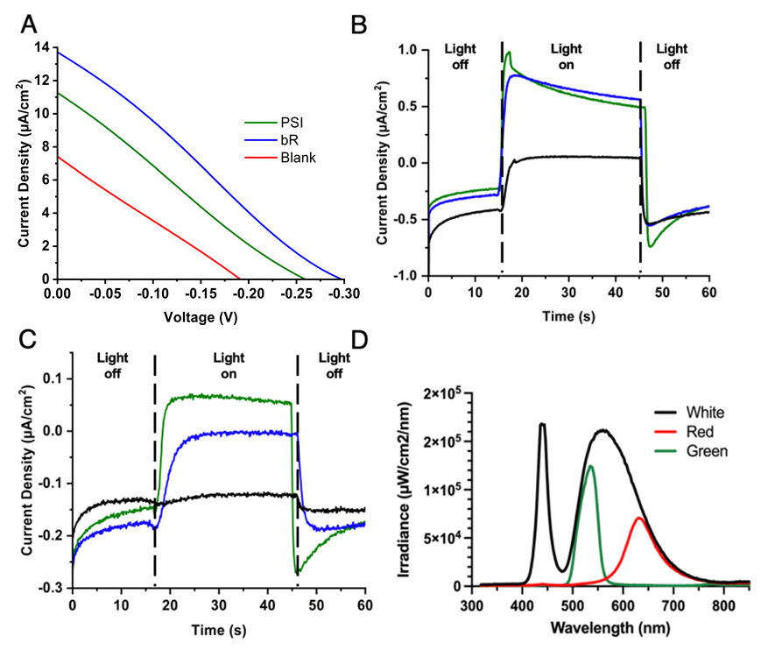
Figure 4.8. PEDOT/CNT counter electrodes and a gel-based Co^{II/III} electrolyte are also compatible with bR-SSCs. A. J-V curves of different BSSCs illuminated under white irradiance at 100% lamp intensity output. Chronoamperometry measured at 0 V under B. 50% green light and C. 50% red light illumination. Black traces in B and C are blank cells, with green traces showing PSI-SSC data and blue traces showing bR-SSC data. D. Plot showing the spectral irradiance of the LED illumination source at 10% intensity.

Table 4.5. Bio-sensitized solar cells (BSSCs) performance using different proteins.

 | V_{OC} (mV) | J_{sc} (µA/cm²) | FF % | PCE %
bR | -298 | 13.67 | 26 | 1.04
PSI | -259 | 11.25 | 24 | 0.70
Blank | -192 | 7.44 | 25 | 0.35
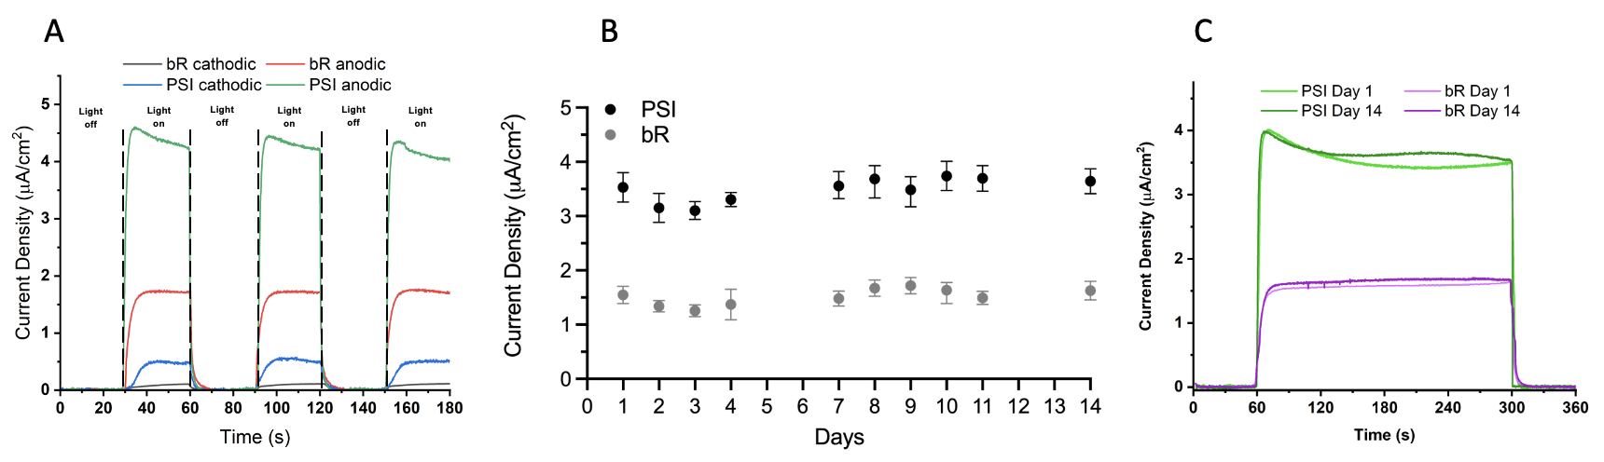
Figure 4.9. Directional illumination effects on photocurrent density generation and stability of photocurrent response of PSI- and bR-SSCs. A. Comparison of photocurrent densities generated by cathodic or anodic illumination of PSI- or bR-sensitized devices. Traces were baseline corrected using QSOAS software. B. Photocurrent response was measured over two weeks under the same white light illumination regime at 10% light intensity. Each data point is the mean photocurrent from three individual traces, and error bars represent the standard deviation of the mean. C. The average of three individual photocurrent density traces for the PSI-SSC and bR-SSC on days 1 and 14 are shown.

photocurrent densities generated were over 10-fold greater upon illumination through the back of the anodic surface for both the PSI- and bR-SSCs, and consistent over multiple illuminations in the same photochronoamperometry trace. This may be due to the highly scattering nature of our regular TiO₂ semiconductor layer and the relatively high UV-Visible light absorption of the PEDOT/CNT CE.

The stability of the PSI- and bR- sensitized devices were tested over a period of two weeks to assess the longevity of the devices. The devices were illuminated for 5 minutes total for 3 total repetitions each day over 15 days. The average photocurrent density obtained each day along with standard deviation is plotted in Figure 8B. The average photocurrent density trace is reported for days 1 and 14 in Figure 8C for both the PSI-SSC and bR-SSC tested. Interestingly, both the bR- and PSI-SSCs showed robust photocurrent densities over the entire two weeks of testing with no significant losses. The bR-SSC had an average photocurrent density of ~1.7 µA/cm² and the PSI-SSC had an average photocurrent density of ~3.6 µA/cm² for the entire tested period. The compatibility of the PEDOT/CNT cathode and aqueous gel-based electrolyte with the aqueous Co^{II/III} redox mediator with the two
protein-pigment complexes is further proven here by the performance stability tests of both devices.

4.5 Discussion

Biologically-derived light harvesting components for photovoltaic applications have commercial potential due to the wide availability and ease of directed growth of different organisms, more environmentally friendly production, and lower cost of device fabrication. One such technology is the fabrication of sensitized solar cells based on biological proteins as sensitizers, also known as bio-sensitized solar cells (BSSCs). However, BSSC technology faces many challenges to become commercially competitive, including the enhancement of photocurrent generation, improvement of conversion efficiencies, flexibility, scaling, and long-term stability [164, 168, 315, 316]. Many BSSC studies only report the photocurrent of the cells studied, and do not include more detailed studies on conversion efficiencies, and rarely demonstrate stability over time. One other significant factor in BSSC development that is often not carefully considered in device fabrication schemes is the stability of the biological component. In this report, we describe a systematic testing of multiple counter electrodes and compare a liquid-based vs a gel-based electrolyte system that is compatible with two unique biological protein–pigment complex photosensitizers, PSI and bR. The best photocurrent and efficiency results obtained in our studies were from PSI- and bR-sensitized solar cells using a device design incorporating an aqueous gel-based electrolyte with a Co^{II/III} redox mediator and a PEDOT/CNT counter electrode.

We have previously reported the fabrication of PEDOT/CNT CEs for biosensors [317, 318], yet this is the first report of their use in BSSCs and with cobalt-based redox mediators. Our PEDOT/CNT CEs were similar in morphology to those manufactured in previous studies from our group, with all samples exhibiting continuous, well-coated electrode surfaces. Granular morphologies of ca. 500 nm diameter particles could be seen, comparable to results reported by other groups for PEDOT films [319]. The obtained rough surface pattern is likely a result from the micellar system used for electrochemical deposition allowing for increased surface area for the redox mediator to interact. The results of the improved output and efficiencies of SSCs using PEDOT/CNT CEs with our aqueous bipyridine-based Co^{II/III} redox mediator is consistent with other published studies, where it has been reported that a PEDOT-based CE was able to generate greater FF and PCE than Pt based electrodes [320]. This was attributed to the ability of PEDOT/CNT films to more effectively suppress carrier recombination and promote carrier extraction, improving photocurrent generation in the device [321], and the ability to mitigate the diffusional limitation of Co species which has been reported to affect similar chemical species [172]. Previous groups have reported on the incorporation of PEDOT-based CEs with cobalt-based redox mediators in inorganic DSSCs with similar results [216]. This improvement of the electrochemical response of PEDOT/CNT CEs has been attributed to their excellent electrical conductivity [308, 318], intrinsic electrocatalytic activity [322], and the high heterogeneous electron transfer rates of the embedded MWCNT, where unique hollow structure and edge-plane-like defects of MWCNTs, such as open ends, enhance these characteristics [323]. This improved conductivity can also contribute to the restriction of recombination events, prolonging the lifetime of active species in the electrolyte [324].

Further, the work function of MWCNTs (~4.5–5.1 eV) is closer to that of PEDOT (~5.0 eV), which may aid in the reduction of overpotential losses and improved device output and efficiency [324, 325]. Our bipyridine-based Co^{II/III} redox mediator had an E_{m} closest to the HOMO of both biological protein–pigment complex used when measured using the PEDOT/CNT electrode as the working electrode, likely aiding in further reducing overpotential losses in the devices. On the other hand, the platinum work function is located at a more positive potential vs NHE (0.66–1.46 V vs. NHE) [326] than the E_{m} of the Co^{II/III} redox mediator (0.05–0.34 V vs. NHE), therefore the energy alignment is not thermodynamically favorable for catalyzing this electron transfer event [327]. In the case of graphene fabricated by CVD, it mostly interacts with the electrolyte through the basal plane, which has the lowest heterogeneous electron transfer constant of the different carbon allotropes and displays a very poor electrocatalytic activity for the mediator redox reaction [328]. Overall, the reduction of the Co^{II/III} redox mediator devices with PEDOT/CNT counter electrodes is taking place with reduced energy losses than with the Pt NPs and graphene, contributing to its overall improved photovoltaic performance in the BSSCs studied.

Dye-sensitized solar cells have traditionally utilized liquid electrolytes and have achieved some of the greatest efficiencies reported with them [55]. While liquid electrolytes have certain desirable characteristics such as improved wettability of the cell, redox mediator solubility, and greater electrode surface contact, there are many practical issues such as leakage, desorption of the sensitized dye (or protein), and toxicity of many of the most common liquid electrolytes used, along with increased rates of recombination events leading to decreased amounts of electrons available to reduce the photosensitizer [53, 202, 279, 312, 314, 329]. Gel- and solid-based conductive electrolytes have been an area of much interest to attempt to address these deficiencies and have also been shown to aid in the reduction of charge recombination at TiO₂/dye/electrolyte interfaces [118, 163, 164] and to improve the mechanical strength of the fabricated cells. In the results of this study, we found that utilization of a PEG-based gel electrolyte yielded a greater V_{OC} and PCE than a liquid-based system. We also report that this electrolyte system is stable for at least 15 days with no losses of photocurrent density response upon device illumination. A similar gel-based electrolyte system has been reported to provide better interaction of the photosensitizer with the redox-active components of the electrolyte system, which may explain the improved longevity we have reported for our bR- and PSI-SSCs.

The comparative performance of the bR- and PSI-SSCs was also evaluated as a function of irradiance spectra, as both proteins have preferential wavelengths for photoexcitation and differing quantities of pigments for light harvesting. Both sensitized devices performed better than the blank cell, which is due to the incorporation of the biological photosensitizer and proving their constructive photoactivity in the device. Both devices yielded similar photocurrent density response under green light illumination, yet unsurprisingly, the PSI-SSC outperformed the bR-SSC under red light illumination as it is more efficient at utilization of lower-energy photons for photocurrent generation. Interestingly, combining both proteins in the same device through simple drop casting yielded a device with reduced performance, likely due to the need for more directed orientation for forward electron injection through the device. The difference in photocurrent density output between the two photosynthetic proteins may be explained by a variety of factors such as the improved pigment density per unit of photosystem I as compared to bR or perhaps the function of bR as a proton pump is adding another layer of complexity to the system behavior by affecting the local environment near the TiO₂ semiconductor layer.

Once the performance of the BSSCs sensitized with either protein was analyzed, the long-term photocurrent stability of fabricated devices was investigated. The operational stability was assessed by monitoring photocurrent response over the course of 15 days under the same repeated illumination scheme for multiple traces each day. No loss in photocurrent density was noted over the tested period, suggesting that device longevity is likely longer than this period tested as well. This indicates the viability of both PSI- and bR-based quasi-solid state devices for real world settings where lighting will not always consistent and go through light–dark cycles, and that the photoactivity of the cell is able to be stabilized and retained for improved longevity. PSI-SSCs had generally larger photocurrent density generation in our studies than bR-SSCs, likely due to the improved pigment–protein ratio of PSI, the greater UV-Visible absorption of chlorophyll pigments compared to retinal, and the terminal electron transfer cofactor in PSI being closer to the protein’s surface as compared to the buried retinal of bR being more insulated by its protein environment. However, upon analysis of the J–V curves of the two gel-based BSSCs, bR had a calculated J_{SC} photocurrent density of 13.67 µA/cm², slightly outperforming the PSI-sensitized device. The bR device also exhibited a PCE 48% greater than the PSI-sensitized device, 1.04%, as compared to 0.7%.

Taken together, these results effectively demonstrate the robustness of the designed BSSC TiO₂(bR/PSI)/PEDOT/CNT device fabrication scheme and demonstrates its compatibility with multiple biological protein–pigment sensitizers in a manner that preserves their photoactivity. The development of more compatible device designs, and ideally more universally biocompatible device designs is critical for further improvements of bio-sensitized solar cells and is hopefully an area of increased research focus in future studies. This work, and others in the field, help to showcase the importance of further development of bio-sensitized photovoltaics from low-cost and sustainable materials to help meet growing energy demands worldwide.

CONCLUSIONS AND POTENTIAL FUTURE DIRECTIONS
While PSI-based BSSCs have had remarkable improvements in photocurrent density outputs over the last decade, the field of applied photosynthesis is still only newly emerging. Further, the interdisciplinary nature of the work makes a more complete understanding of both part and entire device behavior difficult to obtain due to the wide breadth of knowledge in divergent fields needed. Most researchers to date in the bio-sensitized solar cell research field have come from a materials science/photovoltaics background, and have not given as much thought to the biocompatibility of the different device components used. Further, many of the historical device components are resource-limited/geopolitically scarce, or are toxic and corrosive and not eco-friendly. This defeats the overarching goal of creating a sustainable, carbon-neutral method of renewable energy production that could become economically viable. The work presented in this dissertation is aimed towards the development and identification of more biocompatible and sustainable BSSC components, with an aim towards improved performance and longer-term stability of PSI-based SSCs.
The first paper presented methodical work on the modification of bipyridine-based Co-based redox mediators to make them aqueous-soluble and thus biocompatible. A series of redox mediators with varying functional groups and counterions were synthesized by collaborators, and their spectroscopic and electrochemical properties were characterized, along with identification of the minimal amount of acetonitrile necessary for the mediators to be in solution. The effects on PSI stability of two commonly used organic solvents used in BSSCs, acetonitrile and ethylene carbonate, were assessed using low temperature fluorescence (LTF) spectroscopy, showing that acetonitrile at concentrations greater than 20% v/v were destabilizing to PSI, leaching out antenna chlorophyll. Ethylene carbonate up to 60% v/v concentration had no noticeable effect on PSI structural stability, yet a binary mixture of both organic solvents had a synergistic damaging effect worse than either solvent on their own. The ability of the synthesized bipyridine Co redox mediators to directly reduce PSI was also shown, and was shown to be dose-dependent. It was also shown that organic solvent presence slowed PSI reduction kinetics anywhere from 8- to over 38-fold. Finally, it was shown that the aqueous-soluble Co mediators were able to interact constructively with PSI in a PSI-based BSSC, and the presence of acetonitrile organic solvent in the electrolyte caused the photocurrent in the BSSC to be eliminated.
In the second paper presented, a facile method to develop larger macromolecular structures of PSI to stabilize the protein-pigment reaction center complex was described. We characterize the ability of this synthesis method to yield homogenous microspheres by image analysis, fluorescent assisted cell sorting (FACS), and dynamic light scattering (DLS). We also describe how varying ratios of active PSI protein to inert linker BSA protein affects the properties of the microspheres produced, and how adjusting timepoints during the synthesis can affect the size of particles produced. After removal of the rigid calcium carbonate template, it was shown that the mesoporous microspheres generated are porous and their interiors are accessible to small molecules such as mediators. The PSI-CCMs were also shown to be resistant to loss of photoactivity post-lyophilization, unlike free PSI which is susceptible to aggregation and loss of chlorophyll and other electron transfer cofactors. Finally, the ability of the microspheres to interact constructively with a semiconductor surface and generate photocurrent in a BSSC is demonstrated, and the resultant photocurrent density obtained was shown to be PSI specific and light dose-dependent.
In the third paper presented, a series of counter electrode materials were systematically compared for their ability to perform as a suitable counter electrode material for the same aqueous-soluble Co redox mediator first published in the manuscript comprising Chapter II of this dissertation. It was found that all three counter electrodes were able to interact with the cobalt redox mediator, yet upon comparison of photocurrent and efficiency performance in PSI-based BSSCs, a PEDOT conductive polymer based-electrode doped with multiwalled carbon nanotubes (MWCNTs) performed best. It had similar photocurrent density outputs as compared to the platinized commercially available Platisol electrodes, yet both its open circuit potential (V_{OC}) and short circuit current (J_{SC}) were markedly improved, yielding improved device efficiencies and fill factors. This is in agreement with previously published reports from other groups on the improved behavior of cobalt-based mediators in DSSCs with PEDOT-based counter electrodes. A gel-based electrolyte system was also shown to further improve device performance parameters for PSI-based BSSCs Most interestingly, the same device fabrication scheme was also shown to be compatible with a bacteriorhodopsin-sensitized device with no loss in photocurrent for over two weeks for both devices, suggesting the potential for developing a universally biocompatible BSSC device scheme using low-cost, sustainable, ecologically-friendly materials.
Taken together, the work presented for this dissertation showcases the ability to identify and systematically improve upon biologically compatible inorganic materials to improve their performance and robustness in BSSCs without significant losses, and the ability to stabilize biological components of bio-hybrid electronic devices to improve device lifetimes. The results presented here are in line with photocurrents obtained in other typical studies in the field, yet they do so using low-cost, abundant, non-toxic materials that can help make BSSC technologies more commercially viable from both a cost and longevity perspective, and act as a beginning framework for other research groups in the field to further improve and build upon.

REFERENCES

1. Blankenship, R.E. (2014) Molecular mechanisms of photosynthesis, Second edition. edn., Wiley/Blackwell.
2. Cardona, T. (2016) Reconstructing the Origin of Oxygenic Photosynthesis: Do Assembly and Photoactivation Recapitulate Evolution? Front Plant Sci 7, 257.
3. Wütscher, F. (2005) Sustainable Development and Innovation in the Energy Sector.
4. Durrant, J.R. et al. (1995) A Multimer Model for P680, the Primary Electron-Donor of Photosystem-Ii. Proceedings of the National Academy of Sciences of the United States of America 92 (11), 4798-4802.
5. Zouni, A. et al. (2001) Crystal structure of photosystem II from Synechococcus elongatus at 3.8 angstrom resolution. Nature 409 (6821), 739-743.
6. Diaz-Moreno, I. et al. (2014) The dynamic complex of cytochrome c6 and cytochrome f studied with paramagnetic NMR spectroscopy. Biochim Biophys Acta 1837 (8), 1305-15.
7. Haddadian, E.J. and Gross, E.L. (2006) A Brownian dynamics study of the interactions of the luminal domains of the cytochrome b6f complex with plastocyanin and cytochrome c6: the effects of the Rieske FeS protein on the interactions. Biophys J 91 (7), 2589-600.
8. Kovalenko, I.B. et al. (2017) Multiparticle Brownian dynamics simulation of experimental kinetics of cytochrome bf oxidation and photosystem I reduction by plastocyanin. Physiol Plant 161 (1), 88-96.
9. Whitelegge, J.P. et al. (2002) Full subunit coverage liquid chromatography electrospray ionization mass spectrometry (LCMS+) of an oligomeric membrane protein - Cytochrome b6f complex from spinach and the cyanobacterium Mastigocladus laminosus. Molecular & Cellular Proteomics 1 (10), 816-827.
10. Mondal, J. and Bruce, B.D. (2018) Ferredoxin: the central hub connecting photosystem I to cellular metabolism. Photosynthetica 56 (1), 279-293.
11. Cruz, J.A. et al. (2001) Contribution of electric field (Delta psi) to steady-state transthylakoid proton motive force (pmf) in vitro and in vivo. control of pmf parsing into Delta psi and Delta pH by ionic strength. Biochemistry 40 (5), 1226-37.
12. Kanazawa, A. et al. (2017) Chloroplast ATP Synthase Modulation of the Thylakoid Proton Motive Force: Implications for Photosystem I and Photosystem II Photoprotection. Front Plant Sci 8, 719.
13. Du Ysens, L.N. (1989) The discovery of the two photosynthetic systems: a personal account. Photosynth Res 21 (2), 61-79.
14. Duysens, L.N.M. and Amesz, J. (1962) Function and identification of two photochemical systems in photosynthesis. Biochimica et Biophysica Acta 64 (2), 243-260.
15. Govindjee et al. (2017) Evolution of the Z-scheme of photosynthesis: a perspective. Photosynth Res 133 (1-3), 5-15.
16. Bastien, O. et al. (2016) New Insights on Thylakoid Biogenesis in Plant Cells. Int Rev Cell Mol Biol 323, 1-30.
17. Kirchhoff, H. (2008) Significance of protein crowding, order and mobility for photosynthetic membrane functions. Biochem Soc Trans 36 (Pt 5), 967-70.
18. Jordan, P. et al. (2001) Three-dimensional structure of cyanobacterial photosystem I at 2.5 A resolution. Nature 411 (6840), 909-17.
19. Luimstra, V.M. et al. (2019) Exploring the low photosynthetic efficiency of cyanobacteria in blue light using a mutant lacking phycobilisomes. Photosynth Res 141 (3), 291-301.
20. Yao, D.C.I. et al. (2012) Lifetimes of photosystem i and II proteins in the cyanobacterium Synechocystis sp. PCC 6803. FEBS Letters 586 (2), 169-173.
21. Li, M. et al. (2019) Physiological and evolutionary implications of tetrameric photosystem I in cyanobacteria. Nat Plants 5 (12), 1309-1319.
22. Li, M. et al. (2014) Characterization and evolution of tetrameric photosystem I from the thermophilic cyanobacterium Chroococcidiopsis sp TS-821. Plant Cell 26 (3), 1230-45.
23. Krauss, N. et al. (1996) Photosystem I at 4 A resolution represents the first structural model of a joint photosynthetic reaction centre and core antenna system. Nature structural biology 3 (11), 965-973.
24. Riley, K.J. et al. (2007) Red antenna states of photosystem I from cyanobacteria Synechocystis PCC 6803 and Thermosynechococcus elongatus: single-complex spectroscopy and spectral hole-burning study. J Phys Chem B 111 (1), 286-92.
25. Ben-Shem, A. et al. (2003) Crystal structure of plant photosystem I. Nature 426 (6967), 630-5.
26. Caspy, I. and Nelson, N. (2018) Structure of the plant photosystem I. Biochem Soc Trans 46 (2), 285-294.
27. Qin, X. et al. (2019) Structure of a green algal photosystem I in complex with a large number of light-harvesting complex I subunits. Nat Plants 5 (3), 263-272.
28. Webber, A.N. and Lubitz, W. (2001) P700: the primary electron donor of photosystem I. Biochim Biophys Acta 1507 (1-3), 61-79.
29. Cronshaw, I. (2015) World Energy Outlook 2014 projections to 2040: natural gas and coal trade, and the role of China. Australian Journal of Agricultural and Resource Economics 59 (4), 571-585.
30. Sun, J.W. (2016) The IEA's Data on Combustible Renewables and Waste from 1973 to 2000. Energy Exploration & Exploitation 22 (1), 65-69.
31. Sun, W. et al. (2015) Forecasting Fossil Fuel Energy Consumption for Power Generation Using QHSA-Based LSSVM Model. Energies 8 (2), 939-959.
32. Lund, H. (2007) Renewable energy strategies for sustainable development. Energy 32 (6), 912-919.
33. Mitchell, D. et al. (2016) Realizing the impacts of a 1.5 °C warmer world. Nature Climate Change 6 (8), 735-737.
34. Pecl, G.T. et al. (2017) Biodiversity redistribution under climate change: Impacts on ecosystems and human well-being. Science 355 (6332).
35. Doyon, B. et al. (2008) The potential impact of climate change on annual and seasonal mortality for three cities in Québec, Canada. International journal of health geographics 7, 23-23.
36. Edenhofer, O. et al. (2012) Renewable energy sources and climate change mitigation : special report of the Intergovernmental Panel on Climate Change, Cambridge University Press.
37. Ito, A. (2011) A historical meta-analysis of global terrestrial net primary productivity: are estimates converging? Global Change Biology 17 (10), 3161-3175.
38. Patz, J.A. et al. (2014) Climate Change Challenges and Opportunities for Global Health. Jama-Journal of the American Medical Association 312 (15), 1565-1580.
39. Rockstrom, J. et al. (2009) A safe operating space for humanity. Nature 461 (7263), 472-475.
40. Shafiee, S. and Topal, E. (2009) When will fossil fuel reserves be diminished? Energy Policy 37 (1), 181-189.
41. Sherman, B.D. et al. (2014) Evolution of reaction center mimics to systems capable of generating solar fuel. Photosynth Res 120 (1-2), 59-70.
42. Teodor, A.H. et al. (2020) Green Catalysts: Applied and Synthetic Photosynthesis. Catalysts 10 (9), 1016.
43. Sørensen, B. (2011) Renewable Energy.
44. Adams, W.G. and Day, R.E. (1887) IX. The action of light on selenium. Philosophical Transactions of the Royal Society of London 167, 313-349.
45. Hoffmann, W. (2006) PV solar electricity industry: Market growth and perspective. Solar Energy Materials and Solar Cells 90 (18-19), 3285-3311.
46. Płaczek-Popko, E. (2017) Top PV market solar cells 2016. Opto-Electronics Review 25 (2), 55-64.
47. Wedepohl, K.H. (1995) Ingerson Lecture: The composition of the continental crust. Geochimica et Cosmochimica Acta 59 (7), 1217-1232.
48. Chowdhury, M.S. et al. (2020) An overview of solar photovoltaic panels' end-of-life material recycling. Energy Strategy Reviews 27.
49. Grätzel, M. (2003) Dye-sensitized solar cells. Journal of Photochemistry and Photobiology C: Photochemistry Reviews 4 (2), 145-153.
50. Oregan, B. and Gratzel, M. (1991) A Low-Cost, High-Efficiency Solar-Cell Based on Dye-Sensitized Colloidal Tio2 Films. Nature 353 (6346), 737-740.
51. Kumara, N.T.R.N. et al. (2017) Recent progress and utilization of natural pigments in dye sensitized solar cells: A review. Renewable and Sustainable Energy Reviews 78, 301-317.
52. Devadiga, D. et al. (2021) Dye-Sensitized Solar Cell for Indoor Applications: A Mini-Review. Journal of Electronic Materials 50 (6), 3187-3206.
53. Abisharani, J.M. et al. (2021) Incorporation of organic additives with electron rich donors (N, O, S) in gelatin gel polymer electrolyte for dye sensitized solar cells. Solar Energy 218, 552-562.
54. Teodor, A.H. et al. (2021) Aqueous-soluble bipyridine cobalt(ii/iii) complexes act as direct redox mediators in photosystem I-based biophotovoltaic devices. RSC Advances 11 (18), 10434-10450.
55. Gratzel, M. (2001) Photoelectrochemical cells. Nature 414 (6861), 338-44.
56. Hardin, B.E. et al. (2012) The renaissance of dye-sensitized solar cells. Nature Photonics 6 (3), 162-169.
57. Ludin, N.A. et al. (2014) Review on the development of natural dye photosensitizer for dye-sensitized solar cells. Renewable & Sustainable Energy Reviews 31, 386-396.
58. Narayan, M.R. (2012) Review: Dye sensitized solar cells based on natural photosensitizers. Renewable & Sustainable Energy Reviews 16 (1), 208-215.
59. Vohra, V. (2018) Natural Dyes and Their Derivatives Integrated into Organic Solar Cells. Materials (Basel) 11 (12).
60. Wrobel, D. (2016) From natural photosynthesis to molecular photovoltaics. Molecular Crystals and Liquid Crystals 627 (1), 4-22.
61. Tributsch, H. (2008) Reaction of Excited Chlorophyll Molecules at Electrodes and in Photosynthesis*. Photochemistry and Photobiology 16 (4), 261-269.
62. Cherepy, N.J. et al. (1997) Ultrafast Electron Injection: Implications for a Photoelectrochemical Cell Utilizing an Anthocyanin Dye-Sensitized TiO2 Nanocrystalline Electrode. The Journal of Physical Chemistry B 101 (45), 9342-9351.
63. Hao, S. et al. (2006) Natural dyes as photosensitizers for dye-sensitized solar cell. Solar Energy 80 (2), 209-214.
64. Musazade, E. et al. (2018) Biohybrid solar cells: Fundamentals, progress, and challenges. Journal of Photochemistry and Photobiology C-Photochemistry Reviews 35, 134-156.
65. Zhang, D. et al. (2008) Betalain pigments for dye-sensitized solar cells. Journal of Photochemistry and Photobiology A: Chemistry 195 (1), 72-80.
66. Sekar, N. and Ramasamy, R.P. (2015) Recent advances in photosynthetic energy conversion. Journal of Photochemistry and Photobiology C-Photochemistry Reviews 22, 19-33.
67. Billi, D. et al. (2001) Gene transfer to the desiccation-tolerant cyanobacterium Chroococcidiopsis. J Bacteriol 183 (7), 2298-305.
68. Iwai, M. et al. (2004) Improved genetic transformation of the thermophilic cyanobacterium, Thermosynechococcus elongatus BP-1. Plant Cell Physiol 45 (2), 171-5.
69. Niu, Y.-F. et al. (2012) Transformation of diatom Phaeodactylum tricornutum by electroporation and establishment of inducible selection marker. BioTechniques, 1-3.
70. Tolonen, A.C. et al. (2006) Genetic manipulation of Prochlorococcus strain MIT9313: Green fluorescent protein expression from an RSF1010 plasmid and Tn5 transposition. Applied and Environmental Microbiology 72 (12), 7607-7613.
71. Nakamura, Y. et al. (2002) Complete genome structure of the thermophilic cyanobacterium Thermosynechococcus elongatus BP-1 (supplement). DNA Res 9 (4), 135-48.
72. Busch, A. and Hippler, M. (2011) The structure and function of eukaryotic photosystem i. Biochimica et Biophysica Acta - Bioenergetics 1807 (8), 864-877.
73. Coruh, O. et al. (2021) Cryo-EM structure of a functional monomeric Photosystem I from Thermosynechococcus elongatus reveals red chlorophyll cluster. Commun Biol 4 (1), 304.
74. El-Mohsnawy, E. et al. (2010) Structure and function of intact photosystem 1 monomers from the cyanobacterium Thermosynechococcus elongatus. Biochemistry 49 (23), 4740-51.
75. Kubota-Kawai, H. et al. (2018) X-ray structure of an asymmetrical trimeric ferredoxin-photosystem I complex. Nat Plants 4 (4), 218-224.
76. Pan, X. et al. (2018) Structure of the maize photosystem I supercomplex with light-harvesting complexes I and II. Science 360 (6393), 1109-1113.
77. Iwuchukwu, I.J. et al. (2010) Self-organized photosynthetic nanoparticle for cell-free hydrogen production. Nature Nanotechnology 5 (1), 73-79.
78. Shubin, V.V. et al. (2017) Thermostability of photosystem I trimers and monomers from the cyanobacterium Thermosynechococcus elongatus. Spectrochim Acta A Mol Biomol Spectrosc 179, 17-22.
79. Ciesielski, P.N. et al. (2010) Photosystem I - Based biohybrid photoelectrochemical cells. Bioresource Technology 101 (9), 3047-3053.
80. Zeynali, A. et al. (2017) Organic solar cell based on photosystem I pigment-protein complex, fabrication and optimization. Organic Electronics 51, 341-348.
81. Nguyen, K. and Bruce, B.D. (2014) Growing green electricity: progress and strategies for use of photosystem I for sustainable photovoltaic energy conversion. Biochim Biophys Acta 1837 (9), 1553-66.
82. Ciesielski, P.N. et al. (2008) Functionalized nanoporous gold leaf electrode films for the immobilization of photosystem I. ACS Nano 2 (12), 2465-72.
83. Faulkner, C.J. et al. (2008) Rapid assembly of photosystem I monolayers on gold electrodes. Langmuir 24 (16), 8409-12.
84. LeBlanc, G. et al. (2012) Enhanced photocurrents of photosystem I films on p-doped silicon. Adv Mater 24 (44), 5959-62.
85. Darby, E. et al. (2014) Photoactive films of photosystem I on transparent reduced graphene oxide electrodes. Langmuir 30 (29), 8990-4.
86. LeBlanc, G. et al. (2014) Photosystem I Protein Films at Electrode Surfaces for Solar Energy Conversion. Langmuir 30 (37), 10990-11001.
87. Gizzie, E.A. et al. (2015) Electrochemical preparation of Photosystem I-polyaniline composite films for biohybrid solar energy conversion. ACS Appl Mater Interfaces 7 (18), 9328-35.
88. Gizzie, E.A. et al. (2015) Photosystem I-polyaniline/TiO2 solid-state solar cells: simple devices for biohybrid solar energy conversion. Energy & Environmental Science 8 (12), 3572-3576.
89. Beam, J.C. et al. (2015) Construction of a Semiconductor-Biological Interface for Solar Energy Conversion: p-Doped Silicon/Photosystem I/Zinc Oxide. Langmuir 31 (36), 10002-7.
90. Yang, S.Y. et al. (2016) Effect of Cross-linking on the Performance and Stability of Photocatalytic Photosystem I Films. Electrochimica Acta 222, 926-932.
91. Kazemzadeh, S. et al. (2017) Novel Approach of Biophotovoltaic Solid State Solar Cells Based on a Multilayer of PS1 Complexes as an Active Layer. Acs Sustainable Chemistry & Engineering 5 (11), 9836-9840.
92. Robinson, M.T. et al. (2018) An Electrochemical Reaction-Diffusion Model of the Photocatalytic Effect of Photosystem I Multilayer Films. J Phys Chem B 122 (1), 117-125.
93. Dervishogullari, D. et al. (2018) Polyviologen as Electron Transport Material in Photosystem I-Based Biophotovoltaic Cells. Langmuir 34 (51), 15658-15664.
94. Yamanoi, Y. et al. (2012) Enhanced photocurrent production by photosystem I with modi fi ed viologen derivatives. Thin Solid Films 520 (16), 5123-5127.
95. Baker, D.R. et al. (2014) Photoelectrochemistry of photosystem I bound in nafion. Langmuir 30 (45), 13650-5.
96. Kothe, T. et al. (2014) Engineered electron-transfer chain in photosystem 1 based photocathodes outperforms electron-transfer rates in natural photosynthesis. Chemistry 20 (35), 11029-34.
97. Stieger, K.R. et al. (2014) Advanced unidirectional photocurrent generation via cytochrome c as reaction partner for directed assembly of photosystem I. Physical Chemistry Chemical Physics 16 (29), 15667-15674.
98. Feifel, S.C. et al. (2015) High photocurrent generation by photosystem I on artificial interfaces composed of pi-system-modified graphene. Journal of Materials Chemistry A 3 (23), 12188-12196.
99. Shah, V.B. et al. (2015) Linker-Free Deposition and Adhesion of Photosystem I onto Nanostructured TiO2 for Biohybrid Photoelectrochemical Cells. Langmuir 31 (5), 1675-1682.
100. Simmerman, R.F. et al. (2015) Engineering Photosystem I Complexes with Metal Oxide Binding Peptides for Bioelectronic Applications. Bioconjug Chem 26 (10), 2097-105.
101. Stieger, K.R. et al. (2016) Biohybrid architectures for efficient light-to-current conversion based on photosystem I within scalable 3D mesoporous electrodes. Journal of Materials Chemistry A 4 (43), 17009-17017.
102. Bennett, T. et al. (2016) Elucidating the role of methyl viologen as a scavenger of photoactivated electrons from photosystem I under aerobic and anaerobic conditions. Phys Chem Chem Phys 18 (12), 8512-21.
103. Feifel, S.C. et al. (2015) Unidirectional Photocurrent of Photosystem I on pi-System-Modified Graphene Electrodes: Nanobionic Approaches for the Construction of Photobiohybrid Systems. Langmuir 31 (38), 10590-10598.
104. Ciornii, D. et al. (2017) Construction of photobiocathodes using multi-walled carbon nanotubes and photosystem I. Physica Status Solidi a-Applications and Materials Science 214 (9).
105. Milton, R.D. et al. (2016) Tailoring Biointerfaces for Electrocatalysis. Langmuir 32 (10), 2291-301.
106. Jeuken, L.J.C. (2016) Structure and Modification of Electrode Materials for Protein Electrochemistry. Adv Biochem Eng Biotechnol 158, 43-73.
107. Miyachi, M. et al. (2010) A photosensing system composed of photosystem I, molecular wire, gold nanoparticle, and double surfactants in water. Chem Commun (Camb) 46 (15), 2557-9.
108. Torres, R. et al. (2018) Effects of gold nanoparticles on the photophysical and photosynthetic parameters of leaves and chloroplasts. Photochem Photobiol Sci 17 (4), 505-516.
109. Yaghoubi, H. et al. (2012) The Role of Gold-Adsorbed Photosynthetic Reaction Centers and Redox Mediators in the Charge Transfer and Photocurrent Generation in a Bio-Photoelectrochemical Cell. Journal of Physical Chemistry C 116 (47), 24868-24877.
110. Szewczyk, S. et al. (2020) Photovoltaic activity of electrodes based on intact photosystem I electrodeposited on bare conducting glass. Photosynth Res.
111. Szewczyk, S. et al. (2018) Acceleration of the excitation decay in Photosystem I immobilized on glass surface. Photosynth Res 136 (2), 171-181.
112. Szewczyk, S. et al. (2017) Comparison of excitation energy transfer in cyanobacterial photosystem I in solution and immobilized on conducting glass. Photosynth Res 132 (2), 111-126.
113. Andreeva, A. et al. (2009) Model for fluorescence quenching in light harvesting complex II in different aggregation states. Eur Biophys J 38 (2), 199-208.
114. Feifel, S.C. et al. (2015) Unidirectional Photocurrent of Photosystem I on pi-System-Modified Graphene Electrodes: Nanobionic Approaches for the Construction of Photobiohybrid Systems. Langmuir 31 (38), 10590-8.
115. LeBlanc, G. et al. (2012) Enhanced Photocurrents of Photosystem I Films on p-Doped Silicon. Advanced Materials 24 (44), 5959-+.
116. Zhao, F. et al. (2017) Interrogation of a PS1-Based Photocathode by Means of Scanning Photoelectrochemical Microscopy. Small 13 (26).
117. Carmeli, I. et al. (2007) Photovoltaic activity of photosystem I-based self-assembled monolayer. J Am Chem Soc 129 (41), 12352-3.
118. Teodor, A.H. and Bruce, B.D. (2020) Putting Photosystem I to Work: Truly Green Energy. Trends Biotechnol.
119. Antonkine, M.L. et al. (2003) Assembly of protein subunits within the stromal ridge of photosystem I. Structural changes between unbound and sequentially PS I-bound polypeptides and correlated changes of the magnetic properties of the terminal iron sulfur clusters. J Mol Biol 327 (3), 671-97.
120. Jagannathan, B. et al. (2010) The assembly of a multisubunit photosynthetic membrane protein complex: a site-specific spin labeling EPR spectroscopic study of the PsaC subunit in photosystem I. Biochemistry 49 (11), 2398-408.
121. Hagfeldt, A. et al. (2010) Dye-sensitized solar cells. Chem Rev 110 (11), 6595-663.
122. Kondo, M. et al. (2014) Immobilization of photosystem I or II complexes on electrodes for preparation of photoenergy-conversion devices. Research on Chemical Intermediates 40 (9), 3287-3293.
123. Ciornii, D. et al. (2017) Bioelectronic Circuit on a 3D Electrode Architecture: Enzymatic Catalysis Interconnected with Photosystem I. Journal of the American Chemical Society 139 (46), 16478-16481.
124. Niroomand, H. et al. (2018) Tuning the photocurrent generations from photosystem I assembled in tailored biotic-abiotic interfaces. Mrs Communications 8 (3), 823-829.
125. Riedel, M. et al. (2018) Light as Trigger for Biocatalysis: Photonic Wiring of Flavin Adenine Dinucleotide-Dependent Glucose Dehydrogenase to Quantum Dot-Sensitized Inverse Opal TiO2 Architectures via Redox Polymers. Acs Catalysis 8 (6), 5212-5220.
126. Du, C. et al. (2013) Size-controllable nanopyramids photonic crystal selectively grown on p-GaN for enhanced light-extraction of light-emitting diodes. Opt Express 21 (21), 25373-80.
127. Coll, A. et al. (2018) Al2O3/TiO2 inverse opals from electrosprayed self-assembled templates. Beilstein J Nanotechnol 9, 216-223.
128. Yu, J. et al. (2018) TiO2 inverse opal photonic crystals: Synthesis, modification, and applications - A review. Journal of Alloys and Compounds 769, 740-757.
129. Mershin, A. et al. (2012) Self-assembled photosystem-I biophotovoltaics on nanostructured TiO2 and ZnO. Scientific Reports 2.
130. Ciesielski, P.N. et al. (2010) Enhanced Photocurrent Production by Photosystem I Multilayer Assemblies. Advanced Functional Materials 20 (23), 4048-4054.
131. Chen, M. and Shao, L.-L. (2016) Review on the recent progress of carbon counter electrodes for dye-sensitized solar cells. Chemical Engineering Journal 304, 629-645.
132. Yu, D. et al. (2019) The in vitro synergistic denaturation effect of heat and surfactant on photosystem I isolated from Arthrospira Platensis. Photosynth Res 141 (2), 229-243.
133. Kovacs, H. et al. (1995) The effect of environment on the stability of an integral membrane helix: molecular dynamics simulations of surfactant protein C in chloroform, methanol and water. J Mol Biol 247 (4), 808-22.
134. Orwick-Rydmark, M. et al. (2016) The Use of Detergents to Purify Membrane Proteins. Curr Protoc Protein Sci 84, 4 8 1-4 8 35.
135. Klibanov, A.M. (1997) Why are enzymes less active in organic solvents than in water? Trends Biotechnol 15 (3), 97-101.
136. Mitaku, S. et al. (1988) Denaturation of bacteriorhodopsin by organic solvents. Biophys Chem 30 (1), 69-79.
137. Pace, C.N. et al. (2004) Protein structure, stability and solubility in water and other solvents. Philos Trans R Soc Lond B Biol Sci 359 (1448), 1225-34; discussion 1234-5.
138. Wolfe, A.J. et al. (2017) Quantification of Membrane Protein-Detergent Complex Interactions. J Phys Chem B 121 (44), 10228-10241.
139. Matsumoto, K. et al. (2009) Designer peptide surfactants stabilize functional photosystem-I membrane complex in aqueous solution for extended time. J Phys Chem B 113 (1), 75-83.
140. Noji, T. et al. (2018) Lipid-Controlled Stabilization of Charge-Separated States (P(+)Q(B)(-)) and Photocurrent Generation Activity of a Light-Harvesting-Reaction Center Core Complex (LH1-RC) from Rhodopseudomonas palustris. Journal of Physical Chemistry B 122 (3), 1066-1080.
141. Cherubin, A. et al. (2019) Encapsulation of Photosystem I in Organic Microparticles Increases Its Photochemical Activity and Stability for Ex Vivo Photocatalysis. ACS Sustain Chem Eng 7 (12), 10435-10444.
142. Zhao, F. et al. (2018) Light-induced formation of partially reduced oxygen species limits the lifetime of photosystem 1-based biocathodes. Nat Commun 9 (1), 1973.
143. Vopel, T. et al. (2015) Simultaneous measurements of photocurrents and H2O2 evolution from solvent exposed photosystem 2 complexes. Biointerphases 11 (1), 019001.
144. Hajdu, K. et al. (2018) Detection of Singlet Oxygen Formation inside Photoactive Biohybrid Composite Material. Materials 11 (1).
145. Nurnberg, D.J. et al. (2018) Photochemistry beyond the red limit in chlorophyll f-containing photosystems. Science 360 (6394), 1210-1213.
146. Gordiichuk, P.I. et al. (2016) Filling the Green Gap of a Megadalton Photosystem I Complex by Conjugation of Organic Dyes. Bioconjug Chem 27 (1), 36-41.
147. Balaban, T.S. (2005) Tailoring porphyrins and chlorins for self-assembly in biomimetic artificial antenna systems. Acc Chem Res 38 (8), 612-23.
148. Linke-Schaetzel, M. et al. (2004) Self-assembled chromophores for hybrid solar cells. Thin Solid Films 451, 16-21.
149. Gundlach, K. et al. (2009) Filling the "green gap" of the major light-harvesting chlorophyll a/b complex by covalent attachment of Rhodamine Red. Biochimica Et Biophysica Acta-Bioenergetics 1787 (12), 1499-1504.
150. Dutta, P.K. et al. (2014) Reengineering the optical absorption cross-section of photosynthetic reaction centers. J Am Chem Soc 136 (12), 4599-604.
151. Nagakawa, H. et al. (2019) Efficient hydrogen production using photosystem I enhanced by artificial light harvesting dye. Photochem Photobiol Sci 18 (2), 309-313.
152. Carmeli, I. et al. (2010) Broad band enhancement of light absorption in photosystem I by metal nanoparticle antennas. Nano Lett 10 (6), 2069-74.
153. Mackowski, S. et al. (2008) Metal-enhanced fluorescence of chlorophylls in single light-harvesting complexes. Nano Lett 8 (2), 558-64.
154. Kim, I. et al. (2011) Metal nanoparticle plasmon-enhanced light-harvesting in a photosystem I thin film. Nano Lett 11 (8), 3091-8.
155. Antonacci, A. and Scognamiglio, V. (2019) Photosynthesis-based hybrid nanostructures: Electrochemical sensors and photovoltaic cells as case studies. Trac-Trends in Analytical Chemistry 115, 100-109.
156. Murray, C.B. et al. (2000) Synthesis and characterization of monodisperse nanocrystals and close-packed nanocrystal assemblies. Annual Review of Materials Science 30, 545-610.
157. Jung, H. et al. (2010) Optical and Electrical Measurement of Energy Transfer between Nanocrystalline Quantum Dots and Photosystem I. Journal of Physical Chemistry B 114 (45), 14544-14549.
158. Nabiev, I. et al. (2010) Fluorescent Quantum Dots as Artificial Antennas for Enhanced Light Harvesting and Energy Transfer to Photosynthetic Reaction Centers. Angewandte Chemie-International Edition 49 (40), 7217-7221.
159. Liu, J.T. et al. (2019) Mechanisms of Self-Assembly and Energy Harvesting in Tuneable Conjugates of Quantum Dots and Engineered Photovoltaic Proteins. Small 15 (4).
160. Tsai, C.-H. et al. (2013) Efficient gel-state dye-sensitized solar cells adopting polymer gel electrolyte based on poly(methyl methacrylate). Organic Electronics 14 (11), 3131-3137.
161. Ooi, E.J. et al. (2018) Cobalt redox mediators for integration in photosystem I biohybrid solar cells. Abstracts of Papers of the American Chemical Society 255.
162. Zhao, F. et al. (2019) Extended Operational Lifetime of a Photosystem-Based Bioelectrode. J Am Chem Soc 141 (13), 5102-5106.
163. Chellamuthu, J. et al. (2016) Enhanced photocurrent generation in bacteriorhodopsin based bio-sensitized solar cells using gel electrolyte. J Photochem Photobiol B 162, 208-212.
164. Villarreal, C.C. et al. (2022) Bio-sensitized solar cells built from renewable carbon sources. Materials Today Energy 23.
165. Bella, F. et al. (2015) Aqueous dye-sensitized solar cells. Chem Soc Rev 44 (11), 3431-73.
166. Fayad, R. et al. (2016) High photo-currents with a zwitterionic thiocyanate-free dye in aqueous-based dye sensitized solar cells. Dalton Transactions 45 (13), 5622-5628.
167. Wu, J. et al. (2015) Electrolytes in dye-sensitized solar cells. Chem Rev 115 (5), 2136-73.
168. Ellis, H. et al. (2016) Development of high efficiency 100% aqueous cobalt electrolyte dye-sensitised solar cells. Phys Chem Chem Phys 18 (12), 8419-27.
169. Zhang, Y. et al. (2008) Spectroelectrochemistry of P700 in native photosystem I particles and diethyl ether-treated thylakoid membranes from spinach and Thermosynechococcus elongatus. FEBS Lett 582 (7), 1123-8.
170. MacKinney, G. (1941) Absorption of light by chlorophyll solutions. Journal of Biological Chemistry 140 (2), 315-322.
171. Arnon, D.I. (1949) Copper Enzymes in Isolated Chloroplasts - Polyphenoloxidase in Beta-Vulgaris. Plant Physiology 24 (1), 1-15.
172. Sapp, S.A. et al. (2002) Substituted polypyridine complexes of cobalt(II/III) as efficient electron-transfer mediators in dye-sensitized solar cells. J Am Chem Soc 124 (37), 11215-22.
173. Feldt, S.M. et al. (2010) Design of Organic Dyes and Cobalt Polypyridine Redox Mediators for High-Efficiency Dye-Sensitized Solar Cells. Journal of the American Chemical Society 132 (46), 16714-16724.
174. Gibson, E.A. et al. (2011) Cobalt Polypyridyl-Based Electrolytes for p-Type Dye-Sensitized Solar Cells. Journal of Physical Chemistry C 115 (19), 9772-9779.
175. Ke, B. (1964) Light-Induced Rapid Absorption Changes during Photosynthesis .5. Digitonin-Treated Chloroplasts. Biochimica Et Biophysica Acta 88 (2), 297-&.
176. Fourmond, V. et al. (2009) SOAS: A free program to analyze electrochemical data and other one-dimensional signals. Bioelectrochemistry 76 (1-2), 141-147.
177. Bard, A.J. and Faulkner, L.R. (2001) Electrochemical methods : fundamentals and applications, 2nd edn., Wiley.
178. Schneider, C.A. et al. (2012) NIH Image to ImageJ: 25 years of image analysis. Nat Methods 9 (7), 671-5.
179. Das, S. et al. (2019) Bacteriorhodopsin Enhances Efficiency of Perovskite Solar Cells. ACS Appl Mater Interfaces 11 (34), 30728-30734.
180. Elshan Musazade, R.V., Nathan Brady, Jyotirmoy Mondal, Samaya Atashova, Sergey K. Zharmukhamedov, Irada Huseynova, et al. (2018) Biohybrid solar cells: Fundamentals, progress, and challenges
. Journal of Photochemistry and Photobiology C: Photochemistry Reviews 35, 134-156.
181. Golbeck, J. (2014) The Biophysics of Photosynthesis.
182. Wraight, C.A. and Clayton, R.K. (1974) The absolute quantum efficiency of bacteriochlorophyll photooxidation in reaction centres of Rhodopseudomonas spheroides. Biochim Biophys Acta 333 (2), 246-60.
183. Nakamura, Y. et al. (2002) Complete genome structure of the thermophilic cyanobacterium Thermosynechococcus elongatus BP-1. DNA Res 9 (4), 123-30.
184. Laisk, A. et al. (2014) Action spectra of photosystems II and I and quantum yield of photosynthesis in leaves in State 1. Biochim Biophys Acta 1837 (2), 315-25.
185. Gordiichuk, P. et al. (2017) Orientation and Incorporation of Photosystem I in Bioelectronics Devices Enabled by Phage Display. Adv Sci (Weinh) 4 (5), 1600393.
186. Das, R. et al. (2004) Integration of Photosynthetic Protein Molecular Complexes in Solid-State Electronic Devices. Nano Letters 4 (6), 1079-1083.
187. Gordiichuk, P.I. et al. (2014) Solid-State Biophotovoltaic Cells Containing Photosystem I. Advanced Materials 26 (28), 4863-+.
188. Olmos, J.D.J. et al. (2017) Biofunctionalisation of p-doped silicon with cytochrome c(553) minimises charge recombination and enhances photovoltaic performance of the all-solid-state photosystem I-based biophotoelectrode. Rsc Advances 7 (75), 47854-47866.
189. Bottin, H. and Mathis, P. (1985) Interaction of Plastocyanin with the Photosystem-I Reaction Center - a Kinetic-Study by Flash Absorption-Spectroscopy. Biochemistry 24 (23), 6453-6460.
190. Hervas, M. et al. (1995) Laser-Flash Kinetic-Analysis of the Fast-Electron Transfer from Plastocyanin and Cytochrome C(6) to Photosystem-I - Experimental-Evidence on the Evolution of the Reaction-Mechanism. Biochemistry 34 (36), 11321-11326.
191. Hervas, M. et al. (1995) Mechanism of electron transfer from plastocyanin and cytochrome c6 to photosystem I in a number of evolutionarily differentiated organisms. Photosynthesis: From Light to Biosphere, Vol Ii, 63-66.
192. Bernal-Bayard, P. et al. (2013) Photosystem i reduction in diatoms: As complex as the green lineage systems but less efficient. Biochemistry 52 (48), 8687-8695.
193. Hervas, M. and Navarro, J.A. (2011) Effect of crowding on the electron transfer process from plastocyanin and cytochrome c6 to photosystem I: a comparative study from cyanobacteria to green algae. Photosynth Res 107 (3), 279-86.
194. Medina, M. et al. (1992) A laser flash absorption spectroscopy study of Anabaena sp. PCC 7119 flavodoxin photoreduction by photosystem I particles from spinach. FEBS Lett 313 (3), 239-42.
195. Haehnel, W. et al. (1971) On the reaction between chlorophyll-a, and its primary electron donors in photosynthesis. Z Naturforsch B 266 (11), 1171-4.
196. Haehnel, W. et al. (1980) Evidence for complexed plastocyanin as the immediate electron donor of P-700. Biochim Biophys Acta 593 (2), 384-99.
197. Hippler, M. et al. (1998) The N-terminal domain of PsaF: Precise recognition site for binding and fast electron transfer from cytochrome c(6) and plastocyanin to photosystem I of Chlamydomonas reinhardtii. Proceedings of the National Academy of Sciences of the United States of America 95 (13), 7339-7344.
198. Sommer, F. et al. (2006) Identification of precise electrostatic recognition sites between cytochrome c(6) and the photosystem I subunit PsaF using mass spectrometry. Journal of Biological Chemistry 281 (46), 35097-35103.
199. Sigfridsson, K. et al. (1996) A comparative flash-photolysis study of electron transfer from pea and spinach plastocyanins to spinach Photosystem 1. A reaction involving a rate-limiting conformational change. Photosynth Res 50 (1), 11-21.
200. Nusbaumer, H. et al. (2003) An alternative efficient redox couple for the dye-sensitized solar cell system. Chemistry 9 (16), 3756-63.
201. Nusbaumer, H.M., J. E.; Zakeeruddin S.; Nazeeruddin M.; Gratzel, M. (2001) CoII((dbbip)2)2+ Complex Rivals Tri-iodide/Iodide Redox Mediator in Dye-Sensitized Photovoltaic Cells. J. Phys. Chem. B 105 (43), 10461-10464.
202. Badura, A. et al. (2011) Photocurrent generation by photosystem 1 integrated in crosslinked redox hydrogels. Energy & Environmental Science 4 (7), 2435-2440.
203. Terasaki, N. et al. (2006) Fabrication of novel photosystem I-gold nanoparticle hybrids and their photocurrent enhancement. Thin Solid Films 499 (1-2), 153-156.
204. Terasaki, N. et al. (2009) Plugging a Molecular Wire into Photosystem I: Reconstitution of the Photoelectric Conversion System on a Gold Electrode. Angewandte Chemie-International Edition 48 (9), 1585-1587.
205. Terasaki, N. et al. (2007) Bio-photosensor: Cyanobacterial photosystem I coupled with transistor via molecular wire. Biochim Biophys Acta 1767 (6), 653-9.
206. Nakamura, A. et al. (2011) Species dependence of the redox potential of the primary electron donor p700 in photosystem I of oxygenic photosynthetic organisms revealed by spectroelectrochemistry. Plant Cell Physiol 52 (5), 815-23.
207. Setif, P. and Leibl, W. (2007) Functional Pattern of Photosystem I in Oxygen Evolving Organisms. Primary Processes of Photosynthesis, Pt 2: Principles and Apparatus 9, 147-+.
208. Cho, Y.S. et al. (1999) Extinction coefficients and midpoint potentials of cytochrome c(6) from the cyanobacteria Arthrospira maxima, Microcystis aeruginosa, and Synechocystis 6803. Biochimica Et Biophysica Acta-Bioenergetics 1413 (2), 92-97.
209. Lamb, J.J. et al. (2018) Chlorophyll fluorescence emission spectroscopy of oxygenic organisms at 77 K. Photosynthetica 56 (1), 105-124.
210. Schlodder, E. et al. (2014) Long-wavelength limit of photochemical energy conversion in Photosystem I. J Am Chem Soc 136 (10), 3904-18.
211. Nguyen, K. et al. (2017) In vitro kinetics of P700 + reduction of Thermosynechococcus elongatus trimeric Photosystem I complexes by recombinant cytochrome c 6 using a Joliot-type LED spectrophotometer. Photosynthesis Research 131 (1), 79-91.
212. Alexey Yu. Semenov, I.R.V., Art van der Est, Mahir D. Mamedov, Boris Zybailov, Gaozhong Shen, Dietmar Stehlik (2000) Recruitment of a Foreign Quinone into the A1 Site of Photosystem I. Altered Kinetics of Electron Transfer In Phylloquinone Biosynthetic Pathway Mutants Studied By Time-Resolved Optical, EPR, and Electrometric Techniques. Journal of Biological Chemistry 275 (31), 23429-23438.
213. Ort, D.R. and Izawa, S. (1974) Studies on the Energy-coupling Sites of Photophosphorylation: V. Phosphorylation Efficiencies (P/e(2)) Associated with Aerobic Photooxidation of Artificial Electron Donors. Plant Physiol 53 (3), 370-6.
214. Shinkarev, V.P. et al. (2002) Modeling of the P700+ charge recombination kinetics with phylloquinone and plastoquinone-9 in the A1 site of photosystem I. Biophys J 83 (6), 2885-97.
215. Cassan, N. et al. (2005) Ferredoxin-NADP+ reductase. Kinetics of electron transfer, transient intermediates, and catalytic activities studied by flash-absorption spectroscopy with isolated photosystem I and ferredoxin. J Biol Chem 280 (28), 25960-72.
216. Tsao, H.N. et al. (2011) Influence of the interfacial charge-transfer resistance at the counter electrode in dye-sensitized solar cells employing cobalt redox shuttles. Energy & Environmental Science 4 (12).
217. Boschloo, G. and Hagfeldt, A. (2009) Characteristics of the iodide/triiodide redox mediator in dye-sensitized solar cells. Acc Chem Res 42 (11), 1819-26.
218. Mathew, S. et al. (2014) Dye-sensitized solar cells with 13% efficiency achieved through the molecular engineering of porphyrin sensitizers. Nat Chem 6 (3), 242-7.
219. Gregg, B.A. et al. (2001) Interfacial recombination processes in dye-sensitized solar cells and methods to passivate the interfaces. Journal of Physical Chemistry B 105 (7), 1422-1429.
220. Bella, F. et al. (2016) Cobalt-Based Electrolytes for Dye-Sensitized Solar Cells: Recent Advances towards Stable Devices. Energies 9 (5).
221. Saygili, Y. et al. (2019) Metal Coordination Complexes as Redox Mediators in Regenerative Dye-Sensitized Solar Cells. Inorganics 7 (3).
222. Mosconi, E. et al. (2012) Cobalt electrolyte/dye interactions in dye-sensitized solar cells: a combined computational and experimental study. J Am Chem Soc 134 (47), 19438-53.
223. Gartland, K.M. et al. (2013) Progress towards the 'Golden Age' of biotechnology. Curr Opin Biotechnol 24 Suppl 1, S6-13.
224. Yoon, J. et al. (2020) Nanobiohybrid Material-Based Bioelectronic Devices. Biotechnol J 15 (6), e1900347.
225. Petrov, A.I. et al. (2005) Protein calcium- carbonate coprecipitation – a tool for protein encapsulation Abstract. 85-85.
226. Trofimov, A.D. et al. (2018) Porous Inorganic Carriers Based on Silica, Calcium Carbonate and Calcium Phosphate for Controlled/Modulated Drug Delivery: Fresh Outlook and Future Perspectives. Pharmaceutics 10 (4).
227. Volodkin, D. (2014) CaCO(3) templated micro-beads and -capsules for bioapplications. Adv Colloid Interface Sci 207, 306-24.
228. Fakhrullin, R.F. and Minullina, R.T. (2009) Hybrid cellular-inorganic core-shell microparticles: encapsulation of individual living cells in calcium carbonate microshells. Langmuir 25 (12), 6617-21.
229. Feoktistova, N. et al. (2016) Controlling the Vaterite CaCO3 Crystal Pores. Design of Tailor-Made Polymer Based Microcapsules by Hard Templating. Langmuir 32 (17), 4229-4238.
230. Feng, X. et al. (2016) Coassembly of Photosystem II and ATPase as Artificial Chloroplast for Light-Driven ATP Synthesis. ACS Nano 10 (1), 556-61.
231. Netzer-El, S.Y. et al. (2018) Crystal Structure of Photosystem I Monomer From Synechocystis PCC 6803. Front Plant Sci 9, 1865.
232. Golub, M. et al. (2017) Solution structure of monomeric and trimeric photosystem I of Thermosynechococcus elongatus investigated by small-angle X-ray scattering. Photosynth Res 133 (1-3), 163-173.
233. Greenbaum, E. et al., Nanoscale photosynthesis, the photophysics of neural cells, and artificial sight, Proceedings of the IEEE-EMBS Special Topic Conference on Molecular, Cellular and Tissue Engineering, 2002, pp. 83-85.
234. Greenbaum, E. et al., Application of photosynthesis to artificial sight, 2001 Conference Proceedings of the 23rd Annual International Conference of the IEEE Engineering in Medicine and Biology Society, 2001, pp. 4089-4091 vol.4.
235. Jo, M. et al. (2018) Protein-Based Electronic Skin Akin to Biological Tissues. ACS Nano 12 (6), 5637-5645.
236. Saha, A. et al. (2017) Cancer Cell Specific Delivery of Photosystem I Through Integrin Targeted Liposome Shows Significant Anticancer Activity. ACS Applied Materials & Interfaces 9 (1), 176-188.
237. Hajdu, K. et al. (2017) Functional Nanohybrid Materials from Photosynthetic Reaction Center Proteins. International Journal of Photoenergy.
238. Gunther, D. et al. (2013) Photosystem I on graphene as a highly transparent, photoactive electrode. Langmuir 29 (13), 4177-80.
239. LeBlanc, G. et al. (2013) Biohybrid electrodes based on Photosystem I for solar energy conversion. Abstracts of Papers of the American Chemical Society 246.
240. Miyachi, M. et al. (2007) INOR 825-Preparation of new molecular wires for photovoltaic cell using photosystem I. Abstracts of Papers of the American Chemical Society 233, 271-271.
241. Miyachi, M. et al. (2009) Surface Immobilization of PSI Using Vitamin K-1-Like Molecular Wires for Fabrication of a Bio-Photoelectrode. Journal of Nanoscience and Nanotechnology 9 (3), 1722-1726.
242. Nishiori, D. et al. (2019) Photosensing System Using Photosystem I and Gold Nanoparticle on Graphene Field-Effect Transistor. ACS Appl Mater Interfaces 11 (45), 42773-42779.
243. Baker, D.R. et al. (2012) Photosystem I based solar cell for on-site hydrogen production. Abstracts of Papers of the American Chemical Society 243.
244. Manocchi, A.K. et al. (2013) Photocurrent Generation from Surface Assembled Photosystem I on Alkanethiol Modified Electrodes. Langmuir 29 (7), 2412-2419.
245. Mershin, A. et al. (2012) Self-assembled photosystem-I biophotovoltaics on nanostructured TiO(2 )and ZnO. Scientific reports 2, 234-234.
246. Stieger, K.R. et al. (2016) Engineering of supramolecular photoactive protein architectures: the defined co-assembly of photosystem I and cytochrome c using a nanoscaled DNA-matrix. Nanoscale 8 (20), 10695-705.
247. Donmez, S. et al. (2017) Glucose biosensor based on immobilization of glucose oxidase on a carbon paste electrode modified with microsphere-attached l-glycine. Biotechnol Appl Biochem 64 (5), 745-753.
248. Dinarvand, R. et al. (2011) Polylactide-co-glycolide nanoparticles for controlled delivery of anticancer agents. Int J Nanomedicine 6, 877-95.
249. Barbosa, O. et al. (2014) Glutaraldehyde in bio-catalysts design: a useful crosslinker and a versatile tool in enzyme immobilization. RSC Adv. 4 (4), 1583-1600.
250. Gower, L.B. (2008) Biomimetic model systems for investigating the amorphous precursor pathway and its role in biomineralization. Chem Rev 108 (11), 4551-627.
251. Hwang, E.T. et al. (2013) CO2 bioconversion using carbonic anhydrase (CA): effects of PEG rigidity on the structure of bio-mineralized crystal composites. J Biotechnol 168 (2), 208-11.
252. Lee, C.H. et al. (2020) Immobilization and Stabilization of Enzyme in Biomineralized Calcium Carbonate Microspheres. Front Bioeng Biotechnol 8, 553591.
253. Santarius, K.A. (1990) Freezing of isolated thylakoid membranes in complex media. V. Inactivation and protection of electron transport reactions. Photosynth Res 23 (1), 49-58.
254. Jain, N.K. and Roy, I. (2010) Trehalose and protein stability. Curr Protoc Protein Sci Chapter 4, Unit 4 9.
255. Jovanovic, N. et al. (2006) Distinct effects of sucrose and trehalose on protein stability during supercritical fluid drying and freeze-drying. Eur J Pharm Sci 27 (4), 336-45.
256. Kaushik, J.K. and Bhat, R. (2003) Why is trehalose an exceptional protein stabilizer? An analysis of the thermal stability of proteins in the presence of the compatible osmolyte trehalose. J Biol Chem 278 (29), 26458-65.
257. Hauptmann, A. et al. (2018) Impact of Buffer, Protein Concentration and Sucrose Addition on the Aggregation and Particle Formation during Freezing and Thawing. Pharm Res 35 (5), 101.
258. Barcelos, M.C.S. et al. (2018) The colors of biotechnology: general overview and developments of white, green and blue areas. FEMS Microbiol Lett 365 (21).
259. Carlson, R. (2016) Estimating the biotech sector's contribution to the US economy. Nat Biotechnol 34 (3), 247-55.
260. Kiley, P. et al. (2005) Self-assembling peptide detergents stabilize isolated photosystem I on a dry surface for an extended time. PLoS Biol 3 (7), e230.
261. Lewis, N.S. and Nocera, D.G. (2007) Powering the planet: Chemical challenges in solar energy utilization. Proceedings of the National Academy of Sciences of the United States of America 104 (50), 20142-20142.
262. Ashwini, R. et al. (2017) Photonic Potential of Haloarchaeal Pigment Bacteriorhodopsin for Future Electronics: A Review. Curr Microbiol 74 (8), 996-1002.
263. Hasegawa, N. et al. (2018) X-ray structure analysis of bacteriorhodopsin at 1.3 A resolution. Sci Rep 8 (1), 13123.
264. Subramaniam, S. (1999) The structure of bacteriorhodopsin: an emerging consensus. Curr Opin Struct Biol 9 (4), 462-8.
265. Lanyi, J.K. (2004) Bacteriorhodopsin. Annu Rev Physiol 66, 665-88.
266. Bhardwaj, R. et al. (1981) A Photosystem-I-Phenosafranine Solar-Cell. Photochemistry and Photobiology 34 (2), 215-222.
267. Cardoso, M.B. et al. (2011) Supramolecular assembly of biohybrid photoconversion systems. Energy & Environmental Science 4 (1), 181-188.
268. Carter, J.R. et al. (2016) Enhanced photocurrent from Photosystem I upon in vitro truncation of the antennae chlorophyll. Photosynthesis Research 127 (2), 161-170.
269. Chen, W.L. et al. (1992) A Photoelectrochemical Cell Using Electrodes Modified by Photosystem-I Particles of Spinach. Botanical Bulletin of Academia Sinica 33 (1), 9-15.
270. Ciesielski, P.N. et al. (2011) Kinetic model of the photocatalytic effect of a photosystem i monolayer on a planar electrode surface. Journal of Physical Chemistry A 115 (15), 3326-3334.
271. Das, R. et al. (2004) Integration of photosynthetic protein molecular complexes in solid-state electronic devices. Nano Letters 4 (6), 1079-1083.
272. Eliza, S.A. et al. (2011) Isolated photosystem I reaction centers on a functionalized gated high electron mobility transistor. IEEE Trans Nanobioscience 10 (3), 201-8.
273. Gerster, D. et al. (2012) Photocurrent of a single photosynthetic protein. Nat Nanotechnol 7 (10), 673-6.
274. Gross, E.L. et al. (1980) Fmn-Photosystem-I Solar-Cell. Journal of the Electrochemical Society 127 (3), C119-C119.
275. Gross, E.L. and Winemiller, S.L. (1977) Photosystem-I Photovoltaic Cell. Biophysical Journal 17 (2), A229-A229.
276. Kiliszek, M. et al. (2018) Orientation of photosystem I on graphene through cytochrome c553 leads to improvement in photocurrent generation. Journal of Materials Chemistry A 6 (38), 18615-18626.
277. Molamohammadi, S. et al. (2018) Photosystem I application in biohybrid polymer solar cells. Aip Advances 8 (9).
278. Nikandrov, V.V. et al. (2012) Photochemical properties of photosystem 1 immobilized in a mesoporous semiconductor matrix. High Energy Chemistry 46 (3), 200-205.
279. Passantino, J.M. et al. (2020) Photosystem I Enhances the Efficiency of a Natural, Gel-Based Dye-Sensitized Solar Cell. ACS Appl Bio Mater 3 (7), 4465-4473.
280. Tsukada, J. et al. (2010) Photosystem I Bio-Photosensor Integrated with Complementary Metal-Oxide-Semiconductor Source-Drain Follower on a Chip. Japanese Journal of Applied Physics 49 (1).
281. Wenzel, T. et al. (2018) Porous translucent electrodes enhance current generation from photosynthetic biofilms. Nat Commun 9 (1), 1299.
282. Yaghoubi, H. et al. (2017) A ZnO nanowire bio-hybrid solar cell. Nanotechnology 28 (5).
283. Yu, D. et al. (2015) Enhanced photocurrent production by bio-dyes of photosynthetic macromolecules on designed TiO2 film. Sci Rep 5, 9375.
284. Allam, N.K. et al. (2011) Bacteriorhodopsin/TiO2 nanotube arrays hybrid system for enhanced photoelectrochemical water splitting. Energy & Environmental Science 4 (8).
285. Chu, L.K. et al. (2010) Bacteriorhodopsin-based photo-electrochemical cell. Biosens Bioelectron 26 (2), 620-6.
286. Devi, P. et al. (2020) Boosting photoelectrochemical performance of GaN nanowall network photoanode with bacteriorhodopsin. International Journal of Hydrogen Energy 45 (1), 103-111.
287. Jin, Y.D. et al. (2008) Bacteriorhodopsin as an electronic conduction medium for biomolecular electronics. Chemical Society Reviews 37 (11), 2422-2432.
288. Johnson, K.E. et al. (2018) Development and Characterization of Titanium Dioxide Gel with Encapsulated Bacteriorhodopsin for Hydrogen Production. Langmuir 34 (25), 7488-7496.
289. Li, Y.T. et al. (2018) A Review on Bacteriorhodopsin-Based Bioelectronic Devices. Sensors (Basel) 18 (5).
290. Mohammadpour, R. and Janfaza, S. (2015) Efficient Nanostructured Biophotovoltaic Cell Based on Bacteriorhodopsin as Biophotosensitizer. ACS Sustainable Chemistry & Engineering 3 (5), 809-813.
291. Renugopalakrishnan, V. et al. (2014) Engineering a Robust Photovoltaic Device with Quantum Dots and Bacteriorhodopsin. J Phys Chem C Nanomater Interfaces 118 (30), 16710-16717.
292. Thavasi, V. et al. (2009) Study on the feasibility of bacteriorhodopsin as bio-photosensitizer in excitonic solar cell: a first report. J Nanosci Nanotechnol 9 (3), 1679-87.
293. Toth-Boconadi, R. et al. (2000) Buffer effects on electric signals of light-excited bacteriorhodopsin. Biophys J 78 (6), 3170-7.
294. Wise, K.J. et al. (2002) Optimization of bacteriorhodopsin for bioelectronic devices. Trends Biotechnol 20 (9), 387-94.
295. Zhang, Q.Q. et al. (2015) Photocurrent generation in a light-harvesting system with multifunctional artificial nanochannels. Chemical Communications 51 (61), 12286-12289.
296. Ghernaout, D. et al. (2020) Electrochemical Engineering in the Core of the Dye-Sensitized Solar Cells (DSSCs). OALib 07 (03), 1-12.
297. Ngidi, N.P.D. et al. (2019) Heteroatom-doped graphene and its application as a counter electrode in dye-sensitized solar cells. International Journal of Energy Research 43 (5), 1702-1734.
298. Yoon, C.H. et al. (2008) Enhanced performance of a dye-sensitized solar cell with an electrodeposited-platinum counter electrode. Electrochimica Acta 53 (6), 2890-2896.
299. Ghanem, M.A. (2007) Electrocatalytic activity and simultaneous determination of catechol and hydroquinone at mesoporous platinum electrode. Electrochemistry Communications 9 (10), 2501-2506.
300. Kumarasinghe, K.D.M.S.P.K. et al. (2019) Activated coconut shell charcoal based counter electrode for dye-sensitized solar cells. Organic Electronics 71, 93-97.
301. Balraju, P. et al. (2009) Dye sensitized solar cells (DSSCs) based on modified iron phthalocyanine nanostructured TiO2 electrode and PEDOT:PSS counter electrode. Synthetic Metals 159 (13), 1325-1331.
302. Chen, J.G. et al. (2007) Using modified poly(3,4-ethylene dioxythiophene): Poly(styrene sulfonate) film as a counter electrode in dye-sensitized solar cells. Solar Energy Materials and Solar Cells 91 (15-16), 1472-1477.
303. Mukherjee, S. et al. (2014) Solution-Processed Poly(3,4-ethylenedioxythiophene) Thin Films as Transparent Conductors: Effect of p-Toluenesulfonic Acid in Dimethyl Sulfoxide. Acs Applied Materials & Interfaces 6 (20), 17792-17803.
304. Ravi, S.K. et al. (2017) Enhanced Output from Biohybrid Photoelectrochemical Transparent Tandem Cells Integrating Photosynthetic Proteins Genetically Modified for Expanded Solar Energy Harvesting. Advanced Energy Materials 7 (7).
305. Robinson, M.T. et al. (2017) Photocatalytic photosystem I/PEDOT composite films prepared by vapor-phase polymerization. Nanoscale 9 (18), 6158-6166.
306. Wei, W. et al. (2014) A review on PEDOT-based counter electrodes for dye-sensitized solar cells. International Journal of Energy Research 38 (9), 1099-1111.
307. Rudd, S. and Evans, D. (2022) Recent advances in the aqueous applications of PEDOT. Nanoscale Advances 4 (3), 733-741.
308. Gupta, N. et al. (2019) Carbon nanotubes: synthesis, properties and engineering applications. Carbon Letters 29 (5), 419-447.
309. Subramanyam, B.V.R.S. et al. (2019) Improved stability and performance of organic photovoltaic cells by application of carbon nanostructures and PEDOT:PSS composites as additional transparent electrodes. Solar Energy 186, 146-155.
310. Wang, H. and Hu, Y.H. (2012) Graphene as a counter electrode material for dye-sensitized solar cells. Energy & Environmental Science 5 (8).
311. Ueno, S. et al. (2003) Redox potentials of the oriented film of the wild-type, the E194Q-, E204Q- and D96N-mutated bacteriorhodopsins. Biochimica et Biophysica Acta (BBA) - Biomembranes 1609 (1), 109-114.
312. Sonai, G.G. et al. (2017) Long-Term Stability of Dye-Sensitized Solar Cells Assembled with Cobalt Polymer Gel Electrolyte. The Journal of Physical Chemistry C 121 (33), 17577-17585.
313. Liu, S.Y. et al. (1991) Effect of pH buffer molecules on the light-induced currents from oriented purple membrane. Biophys J 60 (1), 204-16.
314. Al-Mohsin, H.A. et al. (2017) Tuning the performance of aqueous photovoltaic elastomer gels by solvent polarity and nanostructure development. Journal of Polymer Science Part B-Polymer Physics 55 (1), 85-95.
315. Huang, K.-T. et al. (2020) Green poly-lysine as electron-extraction modified layer with over 15% power conversion efficiency and its application in bio-based flexible organic solar cells. Organic Electronics 87.
316. Han, J. et al. (2020) A Universal Method to Enhance Flexibility and Stability of Organic Solar Cells by Constructing Insulating Matrices in Active Layers. Advanced Functional Materials 30 (38).
317. Roy Zamora, F.M.s.-M.n., Hayden Phillips, Luis A. Alvarado-Marchena, Ricardo Starbird (2018) Development of Poly(3,4- ethylenedioxythiophene(PEDOT)/carbon Nanotube Electrodes for Electrochemical Detection of Mancozeb in Water. International Journal of Electrochemical Science, 1931-1944.
318. Zamora-Sequeira, R. et al. (2019) Electrochemical Characterization of Mancozeb Degradation for Wastewater Treatment Using a Sensor Based on Poly (3,4-ethylenedioxythiophene) (PEDOT) Modified with Carbon Nanotubes and Gold Nanoparticles. Polymers (Basel) 11 (9).
319. Martin, D.C. et al. (2010) The Morphology of Poly(3,4-Ethylenedioxythiophene). Polymer Reviews 50 (3), 340-384.
320. Marchini, E. et al. (2021) On the Use of PEDOT as a Catalytic Counter Electrode Material in Dye-Sensitized Solar Cells. Applied Sciences 11 (9).
321. Fan, Q. et al. (2017) Novel approach to enhance efficiency of hybrid silicon-based solar cells via synergistic effects of polymer and carbon nanotube composite film. Nano Energy 33, 436-444.
322. Kouhnavard, M. et al. (2020) Highly conductive PEDOT films with enhanced catalytic activity for dye-sensitized solar cells. Solar Energy 211, 258-264.
323. Beitollahi, H. et al. (2018) A Review on the Effects of Introducing CNTs in the Modification Process of Electrochemical Sensors. Electroanalysis 31 (7), 1195-1203.
324. Yang, L. et al. (2019) Enhanced photocatalytic activity of hierarchical titanium dioxide microspheres with combining carbon nanotubes as "e-bridge". J Hazard Mater 367, 550-558.
325. Khatri, I. et al. (2013) Green-tea modified multiwalled carbon nanotubes for efficient poly(3,4-ethylenedioxythiophene):poly(stylenesulfonate)/n-silicon hybrid solar cell. Applied Physics Letters 102 (6).
326. (1979) Solid Surface Physics.
327. Wu, J. et al. (2017) Counter electrodes in dye-sensitized solar cells. Chem Soc Rev 46 (19), 5975-6023.
328. Villarreal, C.C. et al. (2017) Carbon allotropes as sensors for environmental monitoring. Current Opinion in Electrochemistry 3 (1), 106-113.
329. Mandal, P. et al. (2016) Energy transfer cascade in bio-inspired chlorophyll-a/polyacrylamide hydrogel: towards a new class of biomimetic solar cells. Rsc Advances 6 (93), 90280-90289.

VITA

Alexandra Heather Teodor was born in Florida in 1995. She grew up in California and graduated from high school in Virginia in 2012. She received a Bachelor of Science in Biochemistry, focusing her studies on analytical and physical biochemistry, from Virginia Polytechnic Institute and State University in 2016. Upon conclusion of her undergraduate studies, Alexandra enrolled in the doctoral program of the joint University of Tennessee, Knoxville/Oak Ridge National Laboratory Graduate School of Genome Science and Technology. She then joined the laboratory of Dr. Barry Bruce to pursue her doctoral research, furthering her interests in spectroscopy, physical, and electrochemical sciences. Upon graduation, Alexandra accepted a job offer as a Space Photovoltaics Scientist in California. She hopes to continue doing impactful work that will give back to the community.

