Automated Fragmentary Bone Matching

A Thesis Presented for the

Master of Science

Degree

The University of Tennessee, Knoxville

Ali S. Mustafa

December 2013

Copyright © 2013 by Ali S. Mustafa
All rights reserved

DEDICATION

I dedicate my work to my father, mother, sister, brothers, spouse, and kids for their continuous support and encouragement

ACKNOWLEDGEMENTS

I would like to thank my advisor, Dr. Mohamed Mahfouz, through this course of knowledge acquisition, as well as for his continued support of my research. I would like to extend my gratitude to CMR as a whole, including Emam-ElHak Abdelfattah, Lyndsay Bowers and Rebecca Robertson. I am also very appreciative of the assistance extended to me by my CMR colleagues, Hatem El Dakhakhni and Nicholas Battaglia.

I am particularly grateful for all my committee members’ willingness to participate in acquiring this honored degree, including Dr. Richard Komistek and Dr. William Hamel.

After all of these recognitions, my endeavors were unquestionably encouraged by my father, mother, spouse, sister and brothers and I will be forever thankful for their commitment to me.

ABSTRACT

Reconstruction and matching of fragmentary bones are basic tasks required to accomplish quantification, analysis, and identification of fragmentary human remains derived from forensic contexts. Appropriate techniques for three-dimensional surface matching have received great attention in computer vision literature, and various methods have been proposed for matching fragmentary meshes; however, many of these methods lack automation, speed and/or suffer from high sensitivity to noise.

The study introduces an automated technique for matching of fragmentary human skeletal remains for improving forensic anthropology practice and policy. The proposed technique involves creation of surfaces models for the fragmentary elements which can be done using computerized tomographic scans followed by segmentation or using laser scans. Upon creation of the fragmentary elements models, the fracture sites of these bone fragments are identified by measuring surface roughness map of each element using mean curvature. Surfaces above certain specified thresholds are denoted as fracture sites. A multi-resolution technique is used to accomplish site matching, wherein boundary curves are first extracted, then matched to one another and used to generate sets of matched pairs. The process of full fracture site matching is done by calculating the error between matching fracture sites and finding the rigid transformations that align the two surfaces together while minimizing the matching error and minimizing penetration between the two surfaces. Probability scores are calculated to verify the matching step. Anisotropic iterative closest point is used for fine alignment of the matched surfaces, and for alignment of the matched multi-piceses bone with the template bone, an average mold that captures the primary shape variations created using statistical atlas bone modeling.

TABLE OF CONTENTS

1. Chapter I: Introduction 1
1.1 Motivation 2
1.2 Background 3
1.3 Overview 7
2. Chapter II: Surface Properties 10
2.1 Surface Curvature 11
2.1.1 Principal Curvatures 11
2.1.2 Gaussian and Mean Curvatures 12
2.1.3 Curvedness 13
2.1.4 Shape Index 13
2.2 Surface Roughness 14
2.3 Surface Features 18
2.3.1 Feature Detection 20
2.3.1.1 Differential-based Methods 21
2.3.1.2 Integral-based Methods 29
2.3.2 Feature Description 35
2.3.2.1 Shape context 35
2.3.2.2 Mesh HOG 35
2.3.2.3 Heat Kernel Signatures 37
2.3.2.4 Spin Images 38
3. Chapter III: Surface Matching and Alignment 41
3.1 Surface Matching 42
3.2 Surface Alignment 43
4. Chapter IV: Proposed Method 44
4.1 Surface Models Generation 45
4.2 Fracture Surfaces Extraction 45
4.3 Boundary Curves Extraction 45
4.4 Boundary Curves Matching 45
4.5 Fracture Surfaces Matching 46
5. Chapter V: Results and Discussion 47
5.1 Results 48
5.2 Discussion 48
References 49
6. Chapter VI: Conclusion and Future Work 53
6.1 Conclusion 54
6.2 Future Work 54
Vita. 55

LIST OF TABLES

No table of figures entries found.

LIST OF FIGURES
Figure ‎1-1: Bone Samples from James Mellaart excavation, [2] 2
Figure ‎1-2: A high level overview of feature-based algorithms, [3] 4
Figure ‎1-3: Proposed framework 9
Figure ‎2-1: Saddle surface with normal planes in directions of principal curvatures, [10] 12
Figure 2-2: Local shape variations based on shape index, Eq. 2-6, [12] 14
Figure 2-3: Overview of mesh roughness algorithm, [13] 16
Figure 2-4: (a) Noisy sphere, (b) Bunny and (c) & (d) their roughness profiles, [14] 18
Figure 2-5: Shape Image Example, [19] 24
Figure 2-6: Volume and Surface Area Integral Invariant, [29] 31
Figure ‎2-7: (a) Orthogonal Planes, (b) 8-Bin Projected 3D Histogram Orientation Slices, (c) 4-Spatial Polar Slices With 8 Orientation Slices Each, [18] 36
Figure 2-8: Spin Image Illustration, [34] 38
Figure ‎2-9: The Spin Image Generation Process, [37] 39

Chapter I
Introduction

Motivation
Mass disasters, cremation litigation, human rights investigations and many other types of modern cases raise questions such as “How many individuals are represented in a group of remains?” and “How can remains of single individual be identified within collection of remains from multiple individuals?” [1]. Cases and questions involving commingling issues are highly valuable and answering to these questions is highly valuable too. From a forensic anthropologist’s perspective, commingled remains confound the application of standard methods for the determination of the minimum number of individuals, MNI, and complicate the accurate assessment of the biological profile [2]. The refinement of methods and development of new tools focusing on fragmentary and commingled human remains are critical to enable forensic scientists to deal with individual fragmentary cases, issues surrounding mass disasters, and commingled mass graves. Figure ‎1-1 shows bone samples from James Mellaart excavation of skeletal remains of around 500 individuals at Çatalhöyük, Turkey [3].

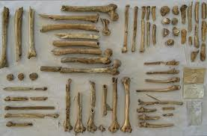
Figure ‎1-1: Bone Samples from James Mellaart excavation, [3]

Since the quantification, analysis, and identification of fragmentary human remains derived from forensic contexts is of that importance, the reconstruction and matching of fragmentary human remains is the primary step to accomplish. Appropriate techniques for three-dimensional surface matching have received much attention in computer vision literature, and various methods have been proposed for matching fragmentary meshes; however, many of these methods lack speed and suffer from high sensitivity to noise. In order to address these issues, we used a hybrid multi-scale technique for fragment matching.

Background
Different techniques for three-dimensional surface matching have been proposed for matching fragmentary meshes. Although most of the feature-based methods follow the same pipeline to achieve the goal, they have different methodologies. Generally, in order to solve the 3D surface matching problem using feature-based approaches, a feature extraction step, including detection and/or description, follows the data segmentation step. These features are then used to match surfaces either in pair-wise or multi-piece matching step. Figure ‎1-2 shows the general outline of feature-based algorithms, [4].
Data Segmentation
Feature Selection
Pairwise Matching
Multi-piece Matching
Figure ‎1-2: A high level overview of feature-based algorithms, [4]

A geometric matching algorithm is proposed to reassemble generic fractured objects [4]. The algorithm first segments the fragments into a set of surfaces bounded by sharp curves using multiscale edge extraction which is constrained to return cycles of edges. The algorithm then uses graph cut algorithm to partition the set of surfaces into original and fracture surfaces. Integral invariant descriptors are used to produce a set of fracture surface features (volume and volume distance) and a set of fracture edge features (deviation). In order to allow for fast retrieval of matching parts a relatively low dimension of features is used for fracture surface features as well as fracture edge features. The used features in [4] are position, principal components, principal directions and integral invariant descriptor at the position of the feature cluster. These features are calculated to represent fracture surface features, and then used for rough and fine registration of surface features. For pairwise matching, shape and topological pruning is used based on the features parameters to discard redundant and false correspondences and to verify the correct ones. Forward search method is then used to find possible matches between fracture surfaces. Since forward search method needs a noise-free initial subset, some consistency tests are performed on pairs of correspondences including geometric and registration consistency. The set of possible matches between the fragments along with a quality rating for each match are used to iteratively compute a global multi-piece matching, perform a local multi-piece registration and merge matched fragments until the object is reassembled.

A fractured surfaces matching algorithm is proposed to reassemble broken solids [5]. The algorithm uses mutliscale integral invariants of the fractured surface points to pick surface feature points. The matching process then is performed in two stages. An initial matching is done by comparing the multiscale integral invariants of the surface feature points using distance metric. As a result, an initial matching point pairs are established. To increase the accuracy and speed up the matching process, some spatial compatibility constraints are used as surface similarity measures to discard the outliers and select an effective matching point set. In the second stage, hierarchal alignment greedy algorithm [6] is used to coarsely align the two fractured surfaces using the effective matching point sets. ICP is then used for fine alignment as the final step in the registration process.

A similar problem was addressed in the context of solving three-dimensional puzzle of comminuted articular fractures [7]. The algorithm is developed to be used as a pre-operative planning procedure for reconstructing highly comminuted articular fractures in order to reduce the difficult surgical challenge of solving a complicated three-dimensional puzzle. A semi-automatic fragment reconstruction approach is used to solve the puzzle problem. The algorithm first segment fracture surfaces into discrete patches using region growing algorithm based on surface normal direction that uses input seed points to propagate patches up to boundaries of high curvature. A facet whose normal deviated from the seeded region by greater than a threshold angle is classified as an edge, and not analyzed in future iterations. An iterative registration function is used to bring fragments surfaces into rough alignment with template, by aligning centers of mass and principal axes. The platform allows the user to adjust the alignment manually if the alignment algorithm fails. As a final step, ICP is used for fine alignment.

A semi-automatic algorithm is proposed for bone fracture reconstruction [8]. The algorithm enables the user to specify matching surface regions between fragment pairs, and initiate a pairwise and global fragment alignment. The algorithm then merges iteratively individual fragments into a group of aligned fragments using graph-based model, where the graph nodes correspond to fragments and the edges represent the user-specified surface match or correspondence between fragments. A variant of ICP algorithm is used to align fragments; where (1) the error metric is defined as the sum of point-to-plane distances instead of point-to-point distances and (2) the surfaces are selectively subsampled using significant geometric surface variations.
However, the majority of the presented methods lack either speed, sensitivity to noise or automation in local and/or global matching. The core of the presented work is to introduce a robust fully-automated method for matching fracture surfaces of fragmentary bones, and matching of grouped fragments with the template bone. Using statistical bone atlas, missing parts can further be interpolated to generate the complete bone that can be used for extracting measurements and assessment of biological profile.

Overview
The purpose of this research is designed to work on single skeletal element fragments. The work can then be extended to include multiple skeletal elements. The first step involves generation of surfaces models for the fragmentary elements. This can be done using CT or laser scanner. In the case of CT scanning, a segmentation step is performed to generate the surface models. Upon creation of the fragmentary elements models, the next step is to extract fracture surfaces from each bone fragment by measuring surface roughness. Surfaces with roughness above certain specified threshold values are denoted as fracture surfaces. A hybrid multi-resolution technique is then used to match these bone fragments to their corresponding pieces, where boundary curves are first extracted, then matched to one another and used to generate sets of matched pairs. While these boundary curves do not include all of the bony detail present in the fracture site, this initial step serves to limit the search space and thus speed up the subsequent process of full surface matching, in which the full bony detail is re-introduced. Once this preliminary step is done and possible matching sets are identified, full fracture site matching can proceed. The process of full fracture site matching is done by calculating the error between matching fracture sites and finding the rigid transformations that align the two surfaces together while minimizing the matching error and minimizing penetration between the two surfaces. The final step in the process of fragment matching is placing the grouped fragments in the relative correct anatomical position using size and shape information in the bone atlas.

In order to globally assemble the grouped fragments into their exact bone locations, we employ a technique based on using a 3D statistical bone template (i.e. atlas) proposed in [9]. Statistical bone atlas is an average mold that captures the primary shape information in a skeletal element. Three dimensional statistical bone atlases are constructed from large datasets of bones. The atlas guarantees point-to-point and surface correspondence across the entire sample, which allows for an accurate calculation of an average template. This template bone captures the global shape characteristics for each bone across an entire population which can then be used to guide the placement of the fragmentary pieces into anatomically correct space and to estimate missing fragments.

The document is organized as follows. Chapter 2 covers surface properties and methods used for feature extraction in the literature, while chapter 3 covers matching and alignment methods. Chapter 4 introduce the proposed frameword, while chapter 5 presents the results and discussion, and finally chapter 6 state the conclusion and future work.

Figure ‎1-3 highlights the proposed framework where fragmentary pieces are first CT or laser scanned and segmented to generate surface models. The resultant surface models are then used to extract fracture surfaces of fragmentary bones, followed by extraction of surfaces boundary curves. A three matching steps are followed starting by matching boundary curves, then matching fracture surfaces and finally matching grouped surfaces with template bone.

Generate Fragmentary Bones Surface Models
Extract Fracture Surfaces
Extract Boundary Curves
Match Boundary Curves
Match Fracture Surfaces
Match Groups with Template
Figure ‎1-3: Proposed framework

Chapter II
Surface Properties

Surface Curvature
A spherical surface is different from plane in which it is curved while the plane is flat. In Riemannian geometry there is a way of making this general concept into a mathematical concept, which is called curvature [10]. A sphere and a plane both have a constant curvature value, i.e. the curvature at every point is the same. The difference is that the sphere has a non-zero curvature value at all points while the plane has a zero curvature value.

Principal Curvatures
Surface curvature at point, which describe the local shape behavior, can be expressed in terms of the two principal curvatures, $k_{1}$, $k_{2}$. The principal curvatures are the eigenvalues of the matrix notation, ${F_{1}}^{-1}F_{2}$, Eq. 2-2, of the first and the second fundamental forms of the surface, Eq. 2-1, [11]. The two principal curvatures characterize the rate of the maximum and the minimum bending of the surface and the tangent direction in which they occur. The two principal curvatures at any point on a surface can, according to Euler’s formula [11], determine the rate of surface bending along any tangent direction at the same point.

$$E{du}^{2}+2Fdudv+G{dv}^{2} and L{du}^{2}+2Mdudv+N{dv}^{2}$$ | Eq. 2-1
$$F_{1}= \left(\begin{matrix}E & F \\ F & G\end{matrix}\right) and F_{2}= \left(\begin{matrix}L & M \\ M & N\end{matrix}\right)$$ | Eq. 2-2

[10]Figure 2-1 shows one example of surfaces with normal planes in the direction of the principal curvatures, [12].

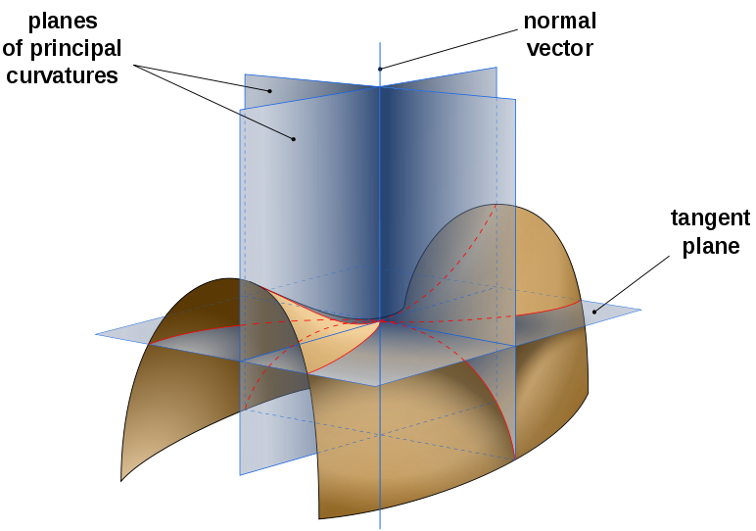
Figure 2-1: Saddle surface with normal planes in directions of principal curvatures, [12]

Gaussian and Mean Curvatures
Gaussian and mean curvatures, Eq. 2-3, Eq. 2-4, are another two measures of the surface curvature. They have greater geometrical significance than the principal curvatures, and can also be used to describe the local behviour of the surface.

$$K=k_{1}k_{2}$$ | Eq. 2-3
$$H=\frac{k_{1}+k_{2}}{2}$$ | Eq. 2-4

Curvedness
A different formula for representing surface curvature is proposed in [13] based on the principal curvatures. Curvedness, Eq. 2-5, measures the intensity of the surface curvature and describes how strongly curved the surface.

$$C= \sqrt{\frac{{k_{1}}^{2}+ {k_{2}}^{2}}{2}}$$ | Eq. 2-5

Shape Index
A quantitative measure of surface shape is proposed also in [13], which describes different surfaces shape by assigning different values except for planar points, which have indeterminate value. Based on shape index, Eq. 2-6, local surface shapes can be classified into cup, cap ($|S_{I}\left(p\right)|=1$), rut, ridge ($0<\left|S_{I}\left(p\right)\right|<1$) and saddle ($S_{I}\left(p\right)=0$). Figure 2-2 shows different local shape variations based on the definition of shape index.

$$S_{I}\left(p\right)= \frac{2}{π}\arctan\left(\frac{k_{1}+k_{2}}{k_{2}- k_{1}}\right)$$ | Eq. 2-6

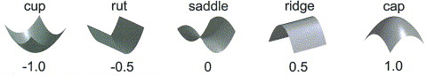
Figure 2-2: Local shape variations based on shape index, Eq. 2-6, [14]

Surface Roughness
Surface roughness is one of the surface properties and it is generally used to describe the level of noise presented on the surface. A new roughness measure is proposed in [15] to be used for 3D visual masking, based on the idea that rough region can hide some geometric distortions with quite similar frequencies. Surface roughness is used in a geometric matching scheme for reassembling fractured objects [4] to classify the faces of the fractured objects into original, which come from the boundary surface of the unbroken object, and fracture faces, which were created when the object broke.

Different methods have been proposed to measure surface roughness. In [16], surface roughness is defined as the root mean square of the difference between the mean curvature and the average mean curvature of L-ring neighborhood where L is the neighborhood level at which the surface roughness is being computed, Eq. 2-7. Mean curvature at point is calculated by averaging all directional curvatures at object’s point, Eq. 2-8. A normalization step is done, by resizing the model so that the average distance between the centroid and all vertices is a unit sphere, before calculating the mean curvature in order to compare two different models on the same ground and removing the scale factor.

$$σ=\sqrt{\frac{1}{N}\sum_{i=1}^{N}{{(k\left(x_{i}\right)- k^{L}\left(x_{i}\right))}^{2}}}$$ | Eq. 2-7
$$k^{L}(x_{i})=\frac{1}{|N(x_{i})|}\sum_{x_{j} ∈ N(x_{i})}{k(x_{j})}$$ | Eq. 2-8

A different roughness measure is proposed [15] for visual masking applications, and is calculated by adaptively smoothing the 3D object, and calculating the curvature of each point of the smoothed version and the original version of the object. An average curvature value is processed for each point which corresponds to the mean of the curvature of all points from its local window. Roughness map is then constructed by processing an asymmetric difference between each point’s average curvature values on the original and the smoothed version of the object, Eq. 2-9. Figure 2-3 shows an overview of the presented algorithm in [15].

Model
Average Curvature Map
Asymmetric Difference
Mesh Roughness
Average Curvature Map after Smoothing
Figure 2-3: Overview of mesh roughness algorithm, [15]

$$R\left(v_{i}\right)=\left\{\begin{aligned}AC\left(v_{i}\right)-AC\left(v_{i}^{s}\right) if AC\left(v_{i}\right)>AC\left(v_{i}^{s}\right) \\ 0 else\end{aligned}\right.$$ | Eq. 2-9

Surface roughness is incorporated in generating surface curvature information instead of integral invariants in [4] because the latter is more expensive in the sense of computations and unstable at the small scales. Roughness is calculated as the integration of bending energy $e_{k}\left(p\right)$ over the local neighborhood, Eq. 2-10, where the bending energy is defined in terms of squared differences of normal vectors at the local neighborhood, Eq. 2-11.

$$e_{k}\left(p\right)= \frac{1}{k} \sum_{i=1}^{k}{\frac{{|\left|n_{p}-n_{q_{i}}\right||}^{2}}{{|\left|p-q_{i}\right||}^{2}}}$$ | Eq. 2-10
$${\overline{e}}_{k,r}\left(p\right)= \frac{1}{\left|N_{r}(p)\right|} \sum_{q ∈ N_{r}(p)}{e_{k}\left(q\right)}$$ | Eq. 2-11

Concepts of local and global roughness are introduced in [16], where the local roughness is described as the average behavior of all vertices in their local region, generally one neighborhood, whereas the global roughness is described as the average behavior of all vertices with respect to larger region, generally a complete surface. In this sense, a roughness profile or local-to-global roughness plot can be generated which captures the information about the roughness of the object from local region around vertices to global region which is the entire object. Figure 2-4 shows an example of the roughness profile for a sphere with 14% random noise added in the radial direction, and for bunny using roughness measure proposed in [16].

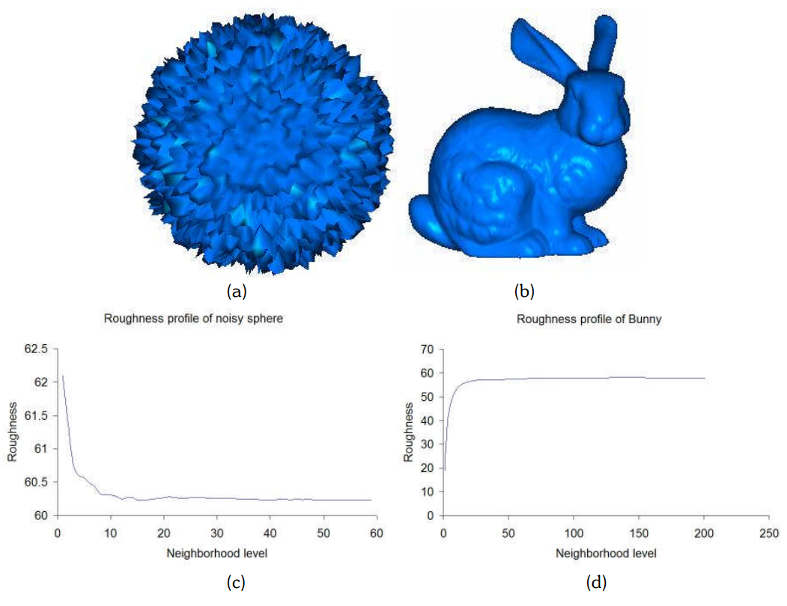
Figure 2-4: (a) Noisy sphere, (b) Bunny and (c) & (d) their roughness profiles, [16]

Surface Features
Features is a term often used to refer to prominent elements that capture most of the relevant shape information such as corners or sharp edges. Feature-based methods have become a broadly used paradigm in shape representation, retrieval, matching and other applications due to their excellent performance in practice [17]. In matching 3D shapes, correspondance problem is one of the important challenges where the goal is to find matches between point in two 3D shapes. The advantage of using features-based methods for correspondence problems is the ability to identify similar points on two shapes, therfore reducing the set of potential correspondence candidates. Similarity problem is another challenge in which a quantification critera has to be established to deremine the degree of similarity between two shapes. Feature-based methods allow to represent the shape as a collection of primitive elements that simplify the solution of the problem.

Feature-based methods can be divided into two main stages. The first stage is feature detection, where the goal is to find the location of stable point that capture most of the relevant shape information (features). The second stage is feature description, where the goal is to find a way to represent (describe) the shape properties at these feature points [17]. In order to adopt for differences in position, direction and scaling, feature detectors and descriptors should be affine-invariant, to insure stability under transformation that an object can undergo.

Thus, one of the main challenges of a general feature-based 3D shape analysis method is to find a set of features that are invariant to shape transformations and carry sufficient information to allow using these features for finding correspondence and similarity.

Feature Detection
One of the basic requirements of any feature detector is robustness. In other words, the feature detector should be able to detect the same set of corresponding points in two instances of a shape. Although there is no single way to define a feature, there is a common sense in selecting a feature; detected feature points should contain sufficient information to distinguish a shape from the others.

Usually feature detection is achieved via local curvature analysis [18]. Different shape encoding methods have been used to detect feature points. A valuable survey of surface curvature calculation methods is presented in [19] along with a suite of test cases that has been developed to evaluate the accuracy of these methods. The survey categorizes the developed mesh curvature calculation methods into two groups. The first group, surface fitting methods, involves ﬁnding a function that ﬁts the mesh locally, either by interpolation or by approximation, and calculating the curvature of the ﬁtting function. If the function is interpolating, then the function goes through each vertex, and in this case a specific relationship between the number of vertices and the number of coeﬃcients is required in order to solve the problem for the fitting function coefficients. If the function is approximating, then the function minimizes some measure of distance from the vertices, and a minimum number of vertices is required to compute the function coeﬃcients as a solution to a least square minimization. The second group, discrete methods, involves developing discrete approximations based on the deﬁnition of curvature. These methods do not use an intermediate analytical ﬁt of the surface. Discrete methods often approximate an integral equation around a vertex by a summation of contributions attributed to each face or edge adjacent to the vertex.

Differential-based Methods
Differential surface properties are used heavily in the previous work to describe the local characteristics of the surface at point, either in the form of first order differential properties representing face normal or tangent plane, or in the form of second order differential properties representing principal curvatures, or in the form of third order differential properties representing directional derivatives of the principal curvatures [20].

In [21], a generalized feature extraction approach is proposed for 2D and 3D objects in mesh representation whenever the feature to be calculated can be written as a signed sum of features of the elementary shape (triangle in the 2D case and tetrahedron in the 3D case), and the feature of the elementary shape can be derived in an explicit form. As a proof of concept, mesh area (for 2D objects) and volume (for 3D objects) are first introduced and then the work extended to calculate shape moments and Fourier transform.

A 3D feature detector is proposed in [22] to extract features from uniformly triangulated meshes by extending the difference of Gaussian, DoG, operator to non-planar surfaces instead of dealing with volumetric grids. Feature detection is done in three steps. First, the extrema of the function’s Laplacian (DoG) are found across scales using a one-ring neighborhood. The scale space representation of scalar function $f$ defined on a mesh can be built progressively as:

$$f_{0}=f, f_{1}=f_{0}*g_{σ}, f_{2}=f_{1}*g_{σ}, …$$ | Eq. 2-12

where $g_{σ}$ is the Gaussian kernel defined as

$$g_{σ}(x)= \frac{e^{-({-x^{2}}/2σ^{2})}}{σ \sqrt{2π}}$$ | Eq. 2-13

and the discrete convolution operator $*$ is defined as

$$\left(f*k\right)\left(v_{i}\right)=\frac{1}{K}\sum_{v_{j}∈N(v_{i})}{k(|\left|\vec{v_{i}v_{j}}\right||)f(v_{j})}$$ | Eq. 2-14
$$K=\sum_{v_{j}∈N(v_{i})}{k(|\left|\vec{v_{i}v_{j}}\right||)}$$ | Eq. 2-15

Convolved functions are subtracted in order to obtain the difference of Gaussian operator.

$${DoG}_{1}= f_{1}-f_{0}, {DoG}_{2}= f_{2}-f_{1}, …$$ | Eq. 2-16

Second, the extrema are thresholded, by selecting the top 5% of the maximum number of vertices, sorted by magnitude. Third, the unstable extrema are eliminated, thus retaining those mesh locations exhibiting some degree of cornerness using Hessian operator.

Mean curvature is used in a different framework [23] that concerned about describing the 3D surface in 2D image, named shape image. This way, the problems of detecting features, building descriptors and matching surfaces are reduced from 3D space to 2D space and hence become simpler. Shape image, the proposed 2D representation, is developed in [23] using conformal mapping which create a conformal surface representing image, $I_{C}$, calculated by minimizing the harmonic energy over the surface. A one-to-one correspondence is supposed to exist between the vertices in the surface patch, $M$, and the vertices in its conformal image, $I_{C}$. Shape attributes at each vertex of the surface patch, $M$, are used to interpolate and compute the corresponding attributes values at each pixel of the conformal image.

Conformal representation surface $S(u, v)$ is represented by conformal factor function, $λ(u, v)$, and mean curvature function, $H(u, v)$. Figure 2-5 shows the human neocortical surface (a) and its corresponding mean curvature (b) and conformal factor (c). The composite shape image is shown in (d), [23]. In order to extract feature points from the shape image, a diffusion-based algorithm is used to extract distinctive features which are then used for matching purpose.

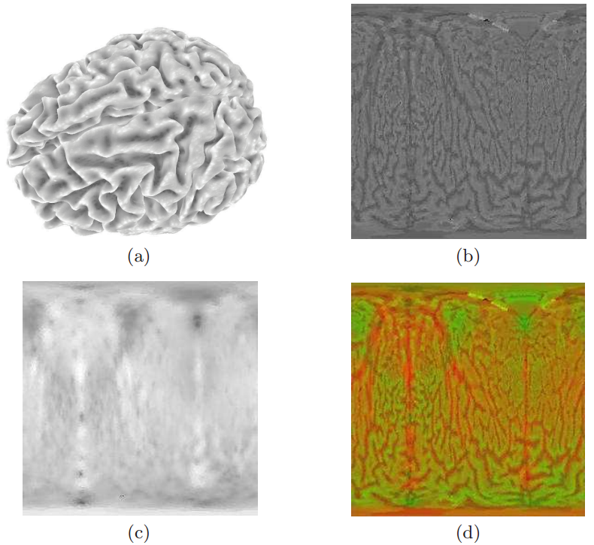
Figure 2-5: Shape Image Example, [22]

In order to avoid the blurring effect of Gaussian smoothing, inhomogenous linear diffusion filtering, Eq. 2-19, is used instead in [23] to generate a set of diffusion images at different scales.

$$\frac{∂I_{i}}{∂t}= div\left(g\left( {\left|∇f_{I_{i}}\right|}^{2}\right)∇I_{i}\right)$$ | Eq. 2-17

where $div$ is the divergence operator, $∇$ is the gradient operator, $f_{I_{i}}$ is the original image, $I_{i}$ is the resulting image at a specific scale and $g$ is a common diffusivity which combines information from the conformal factor function,$λ\left(u, v\right),$ and the mean curvature function, $H(u, v)$. Peronal-Malik’s model is used as a numerical solution for Eq. 2-19. To extract extrema, difference of diffusion is used instead of difference of Gaussians, Eq. 2-20.

$${DoD}^{t_{i}}= I^{t_{i+1}}- I^{t_{i}}, i= 1,2, …, n-1$$ | Eq. 2-18

Feature points are identified as local minima/maxima of the $DoD$ images across scales, which is done by comparing each pixel in the $DoD$ images to its eight neighbors at the same scale and nine corresponding neighboring pixels in each of the neighboring scales. If the pixel value is the maximum or minimum among all compared pixels, it is selected as a candidate keypoint. This algorithm is carried out through all the channels of the
vector image: ${DoD}_{i}, (i=1,...,m)$. The maximum and minimum which are found in every channel are considered as the interest points, which are used then for matching purpose.

Local shape variations are used in a multi-scale feature extraction algorithm to sample a representative set of feature points to be used for registration of 3D surfaces [24]. Shape index, one of the representations for local shape variations, is used to estimate local curvature at a point on the surface, Eq. 2-6. Local shape variation at a point is estimated by calculating the standard deviation of the shape index values of the points’ neighbors, Eq. 2-19, Eq. 2-20, based on the assumption that the distribution is Gaussian, and points on the surface with high local shape variations are selected as feature points. The size of a point’s neighborhood is defined as its scale, which is practically chosen to be the number of rings surrounding the point.

$$σ_{N_{p}}= \sqrt{\frac{\sum_{p_{j}ϵN_{p}}{{(S_{I}\left(p_{j}\right)- μ_{N_{p}})}^{2}}}{n}}$$ | Eq. 2-19
$$μ_{N_{p}}= \frac{\sum_{p_{j}ϵN_{p}}{S_{I}\left(p_{j}\right)}}{n}$$ | Eq. 2-20

Local shape variation is also used for detecting and extracting line-type features on point-sampled surfaces at multiple scales [25]. Surface variation parameter is calculated at each point as a ratio of Eigen-values, Eq. 2-22, of the covariance matrix, C, constructed from the k-nearest neighbors of that point, Eq. 2-21, and as long as the parameter $k$ changes, they could obtain the parameter value at different scale. In these equations $\overline{p}$ is the centroid of the local neighborhood, and$λ_{0}≤λ_{1}≤λ_{2}$ are the Eigen-values of the covariance matrix. An automatic scale selection method is used to determine feature weights by selecting the strongest local maximum in the surface variation at all points across the scale axis. The feature weight is then calculated as the summation of number of times that the surface variation exceeds a certain threshold across all the scales in order to account for the persistence of features over all scales.

$$C= \frac{1}{k}{\left[\begin{matrix}p_{i_{1}}-\overline{p} \\ ⋮ \\ p_{i_{k}}-\overline{p}\end{matrix}\right]}^{T}.\left[\begin{matrix}p_{i_{1}}-\overline{p} \\ ⋮ \\ p_{i_{k}}-\overline{p}\end{matrix}\right] , i_{j}∈N_{p}$$ | Eq. 2-21
$$σ_{n}\left(p\right)= \frac{λ_{0}}{λ_{0}+λ_{1}+λ_{2}}$$ | Eq. 2-22

A similar method is presented in [26] to extract feature lines from a surface point cloud. The work classifies the surface behavior at point to one of four patterns, named crease, border, corner or junction, and typical surface pattern. The crease pattern consists of crease lines that either terminates in junctions or singleton ends or they close to form a loop. The border pattern consists only of border loops. Input points that lay on a crease are called crease points, points on the border loops are border points. At a junction the corresponding data point is called a corner or junction point and at singleton ends the corresponding data point is called end points. In order to classify the points, the algorithm uses the centroid and the correlation matrix of a set of neighbors around the point to define a correlation ellipsoid that adopts the general form of the neighbor points. Based on the eigenvalues of the correlation matrix, they estimate the curvature,$k$, and defined four penalty functions for each point; the curvature penalty function that encapsulate the curvature information, Eq. 2-23, the crease and the border vector valued penalty functions which encapsulate the information of how well the eigenvalues fit to the crease case or the border case, Eq. 2-24, Eq. 2-25, and a corner penalty function, Eq. 2-26, where${ λ}_{0}≤ λ_{1} ≤ λ_{2}$, and ${{\{e}_{0}, e_{1}, e}_{2}\}$ are the covariance matrix Eigenvalues and Eigenvectors respectively. Given these penalty functions, a minimum spanning pattern is computed on a subset of the neighbor graph and the short branches of the minimum spanning pattern are removed in a second step to construct the surface feature lines.

$$ω_{k}\left(p\right)=1-\frac{k(p)}{k_{max}}$$ | Eq. 2-23
$${\vec{ω}}_{cr}\left(p\right)= \frac{\max\left\{λ_{1}\left(p\right)-λ_{0}\left(p\right), \right|λ_{2}\left(p\right)-(λ_{0}\left(p\right)+λ_{1}(p))|\}}{λ_{2}(p)}. e_{2}(p)$$ | Eq. 2-24
$${\vec{ω}}_{b}\left(p\right)= \frac{|λ_{2}\left(p\right)-{2λ}_{1}\left(p\right)|}{λ_{2}(p)}. e_{2}(p)$$ | Eq. 2-25
$$ω_{co}\left(p\right)= \frac{λ_{2}\left(p\right)-λ_{0}\left(p\right)}{λ_{2}(p)}$$ | Eq. 2-26

Automatic detection of intrinsic geometric features is also addressed in [27] using faces normal vectors. A novel notion of relative edge strength is introduced which indicates whether two edges are likely to compose a feature curve. The concept is extended to define strong curves and strong vertices that are used then in the detection algorithm.

Geometric snakes have been used in [28] to extract feature lines based on normal variation of adjacent triangles. This system requires user interaction to specify an initial feature curve, which is then evolved under internal and external forces and re-projected onto the surface using a local parameterization.

Integral-based Methods
Despite differential surface properties play a central role in geometry processing, they are sensitive to noise and cannot be directly computed on multiple scales. On the other hand, integration of geometric functions over the neighborhood diminish or eliminate these obstacles. Recently, integral invariants have been proved to be more stable, less sensitive to noise and can be directly computed and used on muliple scales [29].

Integral invariants were first introduced in [30], [31] along with integral distance and area invariants as examples, to show the superior performance of integral invariants on noisy data, especially for the reliable retrieval of shapes. This open the door to define different integral invariants like integral volume invariants which were proposed in [4], [5], [29], [32] for local analysis of surfaces in 3D space.

Integral invariants are defined by integrating spatial functions over moving domains centered at surface points [4]. As we are dealing with surfaces in 3D space, we are interested in presenting proposed integral invariants descriptors in the literature that is related to surfaces in 3D space.

Volume integral invariant, $V_{r}(p)$, of a point $p$ on boundary surface of a domain $D$ is proposed in [5], [29] as:

$$V_{r}\left(p\right)= \int_{B_{r}\left(p\right)}{1_{D}\left(x\right) dx}$$ | Eq. 2-27

assuming that a surface in $R^{3}$ is the boundary of a domain $D$, $1_{D}\left(x\right)=1$ if the point x is contained in $D$, and 0 otherwise. $B_{r}\left(p\right)$ denotes a ball with radius $r$ and center $p$. In other words, $V_{r}\left(p\right)$ is the volume of the intersection of ball with radius $r$ centered at $p$ with the domain, $B_{r}\left(p\right)\bigcap{D}$, Figure 2-6. If the patch of surface contained in $B_{r}\left(p\right)$ is planar, then the integration result will be the volume of half ball, or $V_{r}\left(p\right)=\frac{2}{3}πr^{3}$.

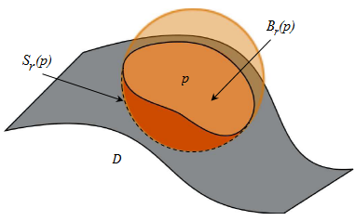
Figure 2-6: Volume and Surface Area Integral Invariant, [33]

In [4], volume integral invariants are defined as a scaled version of the previous definition, Eq. 2-27, in order to normalize the integration results, so that the planar patch around the point $p$ will have a value of 0.5.

$$V_{r}\left(p\right)= \frac{3}{4πr^{3}}\int_{B_{r}\left(p\right)}{1_{D}\left(x\right) dx}$$ | Eq. 2-28

Volume distance integral invariant, ${VD}_{r}\left(p\right)$, defined in [4] as the weighted integral of the squared distance function over the entire ball $B_{r}\left(p\right)$.

$${VD}_{r}\left(p\right)= \frac{15}{4πr^{5}}\int_{B_{r}\left(p\right)}{d^{2}\left(x,φ\right) dx}$$ | Eq. 2-29

Surface area integral invariant, $SA_{r}(p)$, of a point $p$ on boundary surface of a domain $D$ is proposed in [29] as:

$${SA}_{r}\left(p\right)= \int_{S_{r}\left(p\right)}{1_{D}\left(x\right) dx}= \frac{dV_{r}\left(p\right)}{dr}$$ | Eq. 2-30

In other words, ${SA}_{r}\left(p\right)$ is the surface boundary of the intersection of sphere with radius $r$ centered at $p$ with the domain, ${SA}_{r}\left(p\right)\bigcap{D}$, Figure 2-6. Here, if the patch of surface contained in ${SA}_{r}\left(p\right)$ is planar, then the integration result will be the surface area of half sphere, or ${SA}_{r}\left(p\right)=2πr^{2}$. It is worth to note, as known, that the surface area integral is the derivative of the volume integral.

Volume integral, $V_{r}\left(p\right)$, based on the definition in Eq. 2-27, and surface area integral, ${SA}_{r}\left(p\right)$, are related to mean curvature $H$ at $p$ as $r→0$ as in Eq. 2-31, Eq. 2-32 [29].

$$V_{r}\left(p\right)= \frac{2π}{3}r^{3}- \frac{π}{4}r^{4} H+O(r^{5})$$ | Eq. 2-31
$${SA}_{r}\left(p\right)= 2πr^{2}- πr^{3} H+O(r^{4})$$ | Eq. 2-32

And volume distance integral, ${VD}_{r}\left(p\right)$, is related to the difference of the principal curvatures $k_{1}, k_{2}$ at $p$ as $r→0$ as in Eq. 2-33 [4].

$${VD}_{r}\left(p\right)= 1-{\left(k_{1}-k_{2}\right)}^{2} \frac{r^{2}}{28}+O(r^{3})$$ | Eq. 2-33

Integral invariants are particularly suited for multi-scale representation since the scale is given by the radius of the kernel, $r$ and because features smaller than radius $r$ hardly influence the result of computation, therfore integral invariants, for relatively larger scales, are robust to noise.

To select feature points, the term point bumpiness, Eq. 2-34, is defined in [5] based on the volume integral invariant.

$$S\left(p\right)={\left[\frac{1}{N}\sum_{i=1}^{N}{{(V_{r_{i}}-\frac{2}{3}π{r_{i}}^{3})}^{2}}\right]}^{\frac{1}{2}}$$ | Eq. 2-34
$$r_{i}=r_{min}+i.\frac{(r_{max}-r_{min})}{N-1}$$ | Eq. 2-35

$N$ is selected to be 6, $r_{max}$ is 0.1 times the average size of all fragments, $r_{min}={r_{max}}/2$. The feature points are selected as the points with bumpiness above a pre-defined hard threshold, Eq. 2-36.

$$ε_{bump}≈\frac{1}{12N}\sum_{i=1}^{N}{\frac{4}{3}}π{r_{i}}^{3}$$ | Eq. 2-36

In [4], volume and volume distance integral invariants are used with different scales in the feature points selection process. For each invariant at some scale, its range of values, say $[0,b]$, is divided into 32 levels. For each pair of levels, $l_{i}<l_{j}$, an arbitrary point whos value is in between is used in depth first search on $K$-nearest neighbors to cluster the points and extract connected components. A dense set of overlapping feature clusters is produced to be used in the matching process.

Feature Description
Given a set of feature points, a shape descriptor, representation or description, at these feature points can then be computed. Construction of shape descriptor depends very much on the representation in which the shape is given and the kind of information available, and the desired invariance properties [17].

Shape context
The concept of shape context descriptor is introduced in [34] to describes the structure of the shape as relations between a reference point and the rest of the shape points. Given the coordinates of a point $x$ on the shape, the shape context descriptor at point $x$ is constructed as a log-polar histogram of the directional vectors from $x$ to the rest of the points, $y-x$. The descriptor is generic and applicable to any shape representation in which the point coordinates are explicitly given including mesh representation, point cloud representation or volume representation.

Mesh HOG
Mesh HOG, Mesh Histogram of Gradients, is introduced in [22] as a shape descriptor assuming the shape is defined in mesh representation and there is some given function $f$ defined at the mesh vertices, maybe a geometric quantity such as curvature. The descriptor at point $x$ is computed by creating a local histogram of gradients of $f$ in the neighborhood of $x$.

The gradient $∇f$ is defined as a vector in the 3D space projected onto the 3 orthonormal planes, describing the local coordinate system at $x$, which is created based on the normal vector and the tangent plane. For each of the three planes, the plane is divided in 4 polar slices, starting with an origin and continuing in the direction dictated by the right hand rule with respect to the other orthonormal axis vector. When projected onto the plane, each vertex $v_{i}$ falls within one of the spatial slices, Figure ‎2-7, (b). For each spatial slice, orientation histograms are computed with 8 bins for each of the projected gradient vectors $∇f(v_{i})$ of the vertices $v_{i}$ that projected onto that spatial slice, Figure ‎2-7, (c). The final descriptor is obtained by concatenating histogram values for each of the three planes.

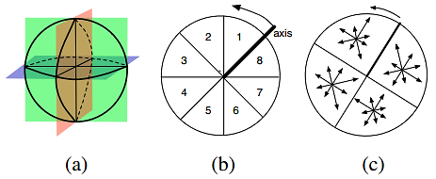
Figure 2-7: (a) Orthogonal Planes, (b) 8-Bin Projected 3D Histogram Orientation Slices, (c) 4-Spatial Polar Slices With 8 Orientation Slices Each, [22]

Like Mesh HOG, local gradient orientation histograms are used in [23] as the key entries of the descriptor. The feature descriptor is computed as a set of orientation histograms on 4×4 pixel neighborhoods, which are relative to the keypoint orientation. Histograms contain 8 bins each, and each descriptor contains an array of 4×4 histograms around the keypoint. This leads it to be a feature vector with 4×4×8 = 128 elements.

Heat Kernel Signatures
The heat kernel signature, HKS, is proposed in [35] based on heat diffusion equations and defined as the diagonal of the heat kernel, which reflect the stability property of point under the diffusion process. Given some fixed time values $t_{1},…, t_{n}$, for each point $x$ on the shape, the HKS is an n-dimensional descriptor vector,

$$p(x) = (K_{t_{1}}\left(x,x\right),…,K_{t_{n}}(x,x))$$ | Eq. 2-37

In order to adapt for the dependence of HKS on the global scale of the shape, a scale-invariant HKS, based on local normalization is proposed in [36].

Spin Images
The idea of spin images is introduced in [37], [38] and defined as a rotation invariant representation of surface variation that is obtained by projecting part of the surface, S, at a vertex $p$ into the local coordinate system defined by the surface normal $\vec{n}(p)$ at $p$. By varying the projection area, it is possible to control the representation continuously from local to global [39]. The projection of a point $q$ to the Spin image of $p$ uses a reminiscent of cylindrical coordinates. That is, the x-coordinate of the Spin image corresponds to the distance from $q$ to the line in direction $\vec{n}(p)$ passing through $p$ and the y-coordinate of the spin image corresponds to the signed distance from $q$ to the tangent plane of $p$, Figure 2-8 [40], [41].
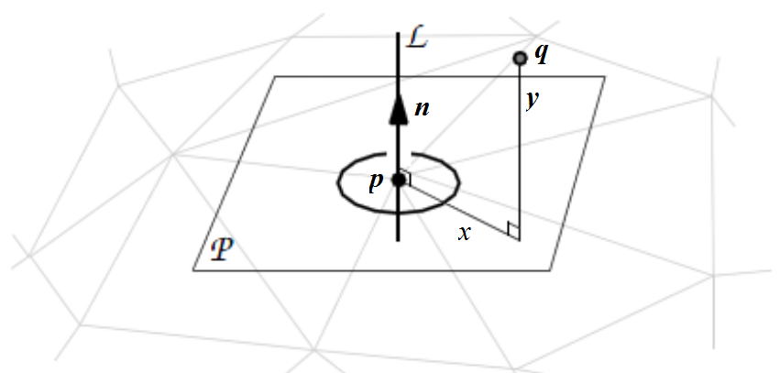
Figure 2-8: Spin Image Illustration, [40]
The part of S to be projected to the spin image of $p$ depends on three parameters:
- The width $w$ of the spin image,
- The bin size $b$ of the spin image,
- The support angle

A vertex $q$ of S is projected to the spin image of $p$ if and only if:

$||q – p|| < wbr$ and $∠\left(\vec{n}\left(p\right), \vec{q}-\vec{p}\right)<α$ | Eq. 2-38

where $||q – p||$ denotes the Euclidean distance between $p$ and $q$, $r$ denotes the resolution of the mesh, and $∠\left(\vec{n}\left(p\right), \vec{q}-\vec{p}\right)$ denotes the angle between the two vectors $\vec{n}\left(p\right)$ and $\vec{q}-\vec{p}$. Spin images have a variety of desirable properties, they are invariant with respect to rotation, translation, and scaling and robust with respect to noise and clutter. By adjusting $w$ or $b$, Spin images can go from a local representation at $p$ to a global representation of S. Figure ‎2-9 shows eight frames of an animation that motivate the name spin-image, [40]. The spin-image generation process can be visualized as a sheet spinning around the oriented point basis, accumulating points as it sweeps space.

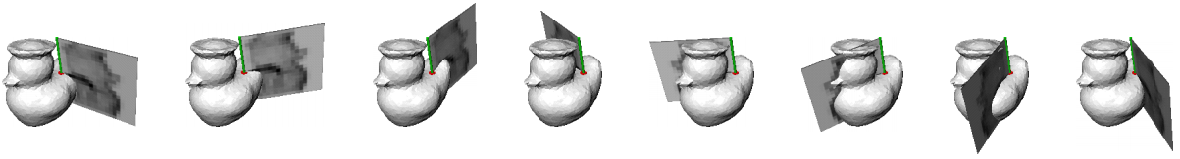
Figure ‎2-9: The Spin Image Generation Process, [40]

Spin images are used as local descriptors at the identified feature points for 3D registration in [24]. A modified version of spin images is proposed in [39], folded spin images, where the spin images of a cannical form of the surface are used as surface discriptors instead of using spin images of the oriented surface. This modification is done to obtain a surface descriptor that is invariant to isometric deformations. The dependence on orientation is eliminated by setting the support angle α to 180º and by folding the spin image along the median y-coordinate, such that the y-axis corresponds to the unsigned distance.

Chapter III
Surface Matching and Alignment

Surface matching and alignment are two fundamental issues in computer vision and of both theoretical interest and practical importance as they are closely related to many applications such as shape recognition, classification, and registration. Given two surfaces in 3D space, the goals of surface registration are to:
- Determine whether the two surfaces are similar in terms of shape through using some similarity measure or shape distance metric, similarity problem
- Establish correspondences between the two surfaces, correspondence problem
- Find the rigid transformation between the two surfaces, alignment problem

Surface Matching
Surface matching is the process of determining whether two surfaces are equivalent in terms of shape, and if so, how to establish a a coresspondance between these two surfaces. One of the important requirements of any surface matching algorithm, in addition to the accuracy and efficiency, is the robustness to noise and surface resolution. Many 3D surface matching methods have been proposed in the area of shape recognition, classification and registration including appearance-based methods, object silhouettes-baed methods, exhaustive search methods, 3D correlation methods and feature-based methods. Despite the variance of the matching methods presented in the literature, feature-based methods become the most effective, and hence the most used, methods for matching partial 3D surfaces, which is the focus of the present work.

Given two surfaces, their shape distance is a scalar that quantifies the similarity of these two surfaces.

Surface Alignment

Chapter IV
Proposed Method

We will consider in particular uniformly sampled triangulated meshes whose facets are triangles of approximately the same area and whose vertices’ valence is close to 6. We notice that such an uniform mesh can be obtained from a non-uniform mesh through simple mesh operations, as proposed in [42].

Surface Models Generation

Fracture Surfaces Extraction

Boundary Curves Extraction

Boundary Curves Matching

Fracture Surfaces Matching

Chapter V
Results and Discussion

Results

Discussion

References

1. Byrd, Bradley J. Adams and John E. Recovery, Analysis, and Identification of Commingled Human Remains. s.l. : Springer, 2008.
2. Mohamed Mahfouz, Natalie R. Shirley and Nicholas P. Herrmann. Computerized Reconstruction of Fragmentary Skeletal Remains. 2011.
3. Haddow, Scott D. http://scotthaddow.wordpress.com/tag/osteology-2/. scotthaddow.wordpress.com. [Online]
4. Qi-Xing Huang, Simon Flory, Natasha Gelfand, Michael Hofer and Helmut Pottmann. Reassembling Fractured Objects by Geometric Matching.
5. Fractured Surfaces Matching for Reassembling Broken Solids. Qunhui Li, Mingquan Zhou and Guohua Geng. 2012.
6. Robust global registration. N. Gelfand, N. J. Mitra, L. J. Guibas and H. Pottmann. 2005. the third Eurographics symposium on Geometry processing. pp. 197–206.
7. A Computational/Experimental Platform for Investigating ThreeDimensional Puzzle Solving of Comminuted Articular Fractures. Thaddeus P. Thomas, Donald D. Anderson, Andrew R. Willis, Pengcheng Liu, Matthew C. Frank, J. Lawrence Marsh and Thomas D. Brown. 2011.
8. Virtual 3D Bone Fracture Reconstruction via Inter-fragmentary Surface. Beibei Zhou, Andrew Willis, Yunfeng Sui, Donald D. Anderson, Thomas D. Brown and Thaddeus P. Thomas.
9. Statistical Bone Atlas. Abdelfattah, Emam. Knoxville, TN : s.n., 2012.
10. Curvature. Wikipedia. [Online] http://en.wikipedia.org/wiki/Curvature.
11. Jia, Yan-Bin. Gaussian Curvature. 2012.
12. surface curvature planes. Wikipedia. [Online] http://en.wikipedia.org/wiki/File:Minimal_surface_curvature_planes-en.svg.
13. Surface Shape and Curvature Scales. J. J. Koenderink and A. J. Vandoorn. 1992, Image and Vision Computing, Vol. 10, pp. 557-564.
14. Computer-Aided diagnosis for CT colonography. Dachman, Hiroyuki Yoshida and Abraham H. 5, October 2004, Seminars in Ultrasound, CT and MRI, Vol. 25, pp. 419 - 431.
15. A Roughness Measure for 3D Mesh Visual Masking. Lavoue, Guillaume. Lyon : s.n.
16. Roughness as a Shape Measure. Rakesh Kushunapally, Anshuman Razdan and Nathan Bridges. 2007, Computer-Aided Design & Applications, Vol. 4, pp. 295-310. 1-4.
17. Alexander M. Bronstein, Michael M. Bronstein and Maks Ovsjanikov. 3D features, surface descriptors, and object descriptors. 2010.
18. U. Clarenz, M. Rumpf and A. Telea. Robust Feature Detection and Local Classification for Surfaces based on Moment Analysis.
19. Estimating Curvature on Triangular Meshes. T.D. Gatzke and C.M. Grimm. 2006, International Journal of Shape Modeling.
20. Fatah, Emam ElHak Abdel. Three Dimensional Nonlinear Statistical Modeling Framework for Morphological Analysis. 2012.
21. Efficient Feature Extraction For 2D/3D Objects In Mesh Representation. Cha Zhang and Tsuhan Chen. Pittsburgh, PA : s.n.
22. Surface Feature Detection and Description with Applications to Mesh Matching. Andrei Zaharescu, Edmond Boyer, Kiran Varanasi and Radu Horaud. 2009, International Conference on Computer Vision and Pattern Recognition.
23. Zhaoqiang Lai and Jing Hua. 3D Surface Matching and Registration through Shape Images. Medical Image Computing and Computer Assisted Intervention. NY : Springer Berlin Heidelberg, 2008, pp. 44-51.
24. Multi-scale Feature Extraction for 3D Surface Registration using Local Shape Variation. Huy Tho Ho and Danny Gibbins. s.l. : IEEE, 2008.
25. Mark Pauly, Richard Keiser and Markus Gross. Multi-scale Feature Extraction on Point-Sampled Surfaces. s.l. : EUROGRAPHICS, 2003. Vol. 22.
26. Feature Extraction from Point Clouds. Stefan Gumhold, Xinlong Wang and Rob MacLeod. Salt Lake City, Utah : s.n.
27. Xiangmin Jiao and Michael T. Heath. Feature Detection for Surface Meshes.
28. Yunjin Lee and Seungyong Lee. Geometric Snakes for Triangular Meshes. s.l. : EUROGRAPHICS, 2002. Vol. 21.
29. Integral Invariants for Robust Geometry Processing. Helmut Pottmann, Qi-Xing Huang, Yong-Liang Yang and Stephan K¨olpl. Computer Aided Geometric Design.
30. Siddharth Manay, Byung-Woo Hong, Anthony J. Yezzi and Stefano Soatto. Integral Invariant Signatures. Computer Vision - ECCV 2004. s.l. : Springer Berlin Heidelberg, 2004, pp. 87-99.
31. Integral Invariants for Shape Matching. Siddharth Manay, Daniel Cremers, Byung-Woo Hong, Anthony J. Yezzi and Stefano Soatto. 10, October 2006, IEEE Transaction on Pattern Analysis and Machine Intellegence, Vol. 28.
32. Mara, Hubert. Multi-Scale Integral Invariants for Robust Character Extraction from Irregular Polygon Mesh Data. Natural Sciences and Mathematics, Ruprecht-Karls-Universitat Heidelberg. 2012.
33. Levallois, Jeremy. Integral Invariant Curvature Estimator 2D/3D. DGtal. [Online] http://libdgtal.org/doc/nightly/moduleIntegralInvariant.html.
34. Shape Matching and Object Recognition Using Shape Context. Serge Belongie, Jitendra Malik and Jan Puzicha. 24, April 2002, IEEE Transaction On Pattern Analysis and Machine Intelligence, Vol. 24.
35. A Concise and Provably Informative Multi-Scale Signature Based on Heat Diffusion. Jian Sun, Maks Ovsjanikov and Leonidas Guibas. 2009. Eurographics Symposium on Geometry Processing . Vol. 28. 5.
36. Scale-invariant heat kernel signatures for non-rigid shape recognition. Michael M. Bronstein and Iasonas Kokkinos. 2010. IEEE conference on Computer Vision and Pattern Recognition.
37. Johnson, Andrew E. Spin-images: a representation for 3-D surface matching. The Robotics Institute, Carnegie Mellon University. 1997. Ph.D. Dissertation.
38. Using Spin Images for Efficient Object Recognition in Cluttered 3D Scenes. Andrew E. Johnson and Martial Hebert. 5, 5 1999, IEEE TRANSACTIONS ON PATTERN ANALYSIS AND MACHINE INTELLIGENCE, Vol. 21.
39. Posture Invariant Surface Description and Feature Extraction. Stefanie Wuhrer, Zouhour Ben Azouz and Chang Shu. 2010. IEEE Conference on Computer Vision and Pattern Recognition.
40. Surface Matching for Object Recognition in Complex 3-D Scenes. Andrew Edie Johnson and Martial Hebert. 1998.
41. Papadimitriou, Georgios. Spin Images. The University of Edinburgh, School of Informatics. [Online] http://homepages.inf.ed.ac.uk/rbf/CVonline/LOCAL_COPIES/AV0910/SpinImages.pdf.
42. Multiresolution shape deformations for meshes with dynamic vertex connectivity. L. Kobbelt, T. Bareuther, and H.-P. Seidel. 2000, Eurographics.

Chapter VI
Conclusion and Future Work

Conclusion

Future Work

Vita

Ali S. Mustafa was born in Cairo, Egypt, in 1985. He received the bachelor degree in systems and biomedical engineering from Cairo University in 2007. He worked as a software engineer at Diagnosoft where he was involved in developing medical software tool to help physicians better understands and assesses the health of cardiac muscle in order to improve diagnosis, prognosis, and treatment. In 2009, he was chosen to be a teaching and research assistant at Cairo University, and in parallel he worked as Research and Development Engineer at IBE Tech where he was involved in building a library for real-time speckle reduction in ultrasound images. He worked as a senior software engineer at Diagnosoft from 2010 to 2012 before joining the research team at the Center for Musculoskeletal Research at the University of Tennessee. He received the Master of Science degree in biomedical engineering from the University of Tennessee in 2013. His current research interests include medical imaging, image processing and computer vision.

