A COMPREHENSIVE ANALYSIS OF SOYBEAN AND CORN DISTRIBUTION IN TENNESSEE

A Thesis Presented for the
Master of Science
Degree
The University of Tennessee, Knoxville

Priya Barua
August 2025
ACKNOWLEDGEMENTS

I am incredibly grateful to Dr. S. Aaron Smith for his guidance and support throughout my studies. His encouragement and advice have helped me grow both academically and professionally. Working under his direction has been an invaluable experience, shaping my understanding of agricultural economics and research.
I would like to extend my heartfelt thanks to all the professors, especially my committee members, Dr. Ricky Chen and Dr. Le Chen, as well as my classmates in the Department of Agricultural and Resource Economics. Their support, collaboration, and insights have made this journey possible. I'm deeply thankful to my parents for their unwavering support and to my fiancé, Rishi, for his constant encouragement throughout this journey.

ABSTRACT

Efficient transportation and facility planning are critical components of agricultural supply chains, particularly for high-volume crops such as soybeans and corn. In states like Tennessee, where these commodities play a major economic role, optimizing distribution networks can significantly reduce costs and improve logistical performance. However, factors such as spatial production variability, infrastructure limitations, and market dynamics complicate optimization and efficiency.
This paper is divided into three chapters. Chapter 1 develops a linear programming model to minimize soybean transportation costs under multiple market scenarios, including capacity constraints, facility-specific price premiums, and regional cost adjustments. The results highlight how price premiums and regional capacities influence routing decisions, with cost savings achieved through adaptive reallocation of supply. Chapter 2 introduces a Mixed-Integer Linear Programming (MILP) model to identify optimal locations for soybean handling or processing facilities, using production and transportation data. The optimal facility locations cluster around high-output areas in West Tennessee, and sensitivity analysis confirms the robustness of site selection under variable conditions. Chapter 3 applies a similar linear programming approach to corn distribution, analyzing cost-efficient flows under diverse production and demand scenarios across Tennessee. The analysis finds that West Tennessee maintains the lowest transportation costs due to proximity to barge terminals, while facility premiums and industry concentration scenarios can increase costs by over 500% in some regions, particularly in Middle and East Tennessee.
These models establish a comprehensive framework for optimizing crop transportation and strategic facility placement, enhancing efficiency across agricultural supply chains in the state of Tennessee? The findings support data-driven decision-making for infrastructure investment and supply chain planning and offer a replicable methodology for improving agricultural logistics in other regions and commodities.

TABLE OF CONTENTS

CHAPTER I 1
INTRODUCTION 1
References 4
CHAPTER II Transportation Modeling for Soybean Distribution in Tennessee 5
Abstract 6
Introduction 7
Overview of the U.S. Soybean Industry 7
Overview of Tennessee Soybean Supply and Demand 9
Data 12
Methodology 13
Results 19
Conclusion 22
References 24
Appendix 29
Figures 29
Tables 44
CHAPTER III Optimizing Soybean Facility Locations: A Mixed-Integer Linear Programming (MILP)-Based Approach 54
Abstract 55
Introduction 56
Literature Review 57
Methodology 59
Data Collection 59
Data Integration 60
Model Formulation 60
Sensitivity Analysis 62
Results 62
Optimal Facility Locations 62
Sensitivity Analysis Results 63
Cost Reduction Analysis 64
Conclusion 64
References 66
Appendix 68
Figures 68
Tables 69
CHAPTER IV Tennessee Corn Distribution: A Cost Minimization Analysis 72
Abstract 73
Introduction 74
Data 78
Methodology: Linear Programming Approach 79
Results 82
Regional Cost Distribution 83
Scenario Comparisons 85
Conclusion 87
References 90
Appendix 92
Figures 92
Tables 98
VITA 108

LIST OF TABLES

Table 2.1 U.S. Soybeans Exports in 2023……………………………………………….44

Table 2.2 Tennessee Soybeans Primary Destinations…………………………………...45

Table 2.3 Example Soybean Basis………………………………………………………46

Table 2.4 Average and Total Transportation Costs for All Scenarios…………………..47

Table 2.5 Optimal Transportation Costs for Tennessee (Scenarios 1, 2, 3)…………….48

Table 2.6 Optimal Transportation Costs for Tennessee (Scenarios 4, 5, 6)…………….51

Table 3.1 County-Level Soybean Production, Transportation Costs, and Potential Cost Savings in Tennessee……………………………………………………………………69

Table 4.1 Corn Destinations in East Tennessee………………………………………...98

Table 4.2 Corn Destinations in Middle Tennessee……………………………………..99

Table 4.3 Corn Destinations in Middle Tennessee (Continued)……………………….100

Table 4.4 Corn Destinations in West Tennessee……………………………………….101

Table 4.5 Corn Destinations in West Tennessee (Continued)………………………….102

Table 4.6 Corn Destinations in Adjacent States………………………………………..103

Table 4.7 Corn Destinations in Adjacent States (Continued)…………………………..104

Table 4.8 Corn Destinations in Adjacent States (Continued)………………………….105

Table 4.9 Average Transportation Cost ($) per MT……………………………………106

Table 4.10 Percentage Change in Average Transportation Cost ($) per MT…………..107

LIST OF FIGURES
Figure 2.1: U.S. Soybean Production by County and State, Three-Year Average (2021-2023)……………………………………………………………………………………..29
Figure 2.2 U.S. Average Soybean Yield, 2014/2015 to 2024/2025……………………..30

Figure 2.3 U.S. Soybean Planted and Harvested Area, 2015 to 2024…………………...31

Figure 2.4 Tennessee Soybean Production (10-Year Average), 2014-2023……………...32
Figure 2.5 Tennessee Soybean Production Region……………………………………....33

Figure 2.6 Soybean Usage in the United States………………………………………….34
Figure 2.7a Primary Destinations for Tennessee Soybeans……………………………...35
Figure 2.7b Primary Facility Locations for Tennessee Soybeans………………………..36

Figure 2.8 Example of Regional Soybean Basis………………………………………....37

Figure 2.9 Cost per bushel for the base model with no capacity/demand constraints (scenario 1)……………………………………………………………………………….38

Figure 2.10 Cost per bushel for the base model (scenario 2)…………………………….39

Figure 2.11 Cost per bushel for the price premium model (scenario 3)………………....40

Figure 2.12 Cost per bushel for the relative basis model (scenario 4)………………….. 41

Figure 2.13 Cost per bushel for the base model with minimum demand requirement (scenario 5)………………………………………………………………………………42

Figure 2.14 Cost per bushel for base model for industry concentration model (scenario 6)…………………………………………………………………………………………43

Figure 3.1 Optimal Facility Locations Based on Trucking Costs & Production………...68

Figure 4.1 United States Corn Production (2014-2023)………………………………....92

Figure 4.2 United States Corn Production…………………………………………….....93

Figure 4.3 U.S. Average Corn Yield, 2014/2015 to 2024/2025………………………....94

Figure 4.4 U.S. Corn Planted and Harvested Area, 2014 to 2023……………………….95

Figure 4.5 Usage of Corn in the U.S.…………………………………………................96

Figure 4.6 Tennessee Corn Production, 10-Year Average(2014-2023)……………..…..97

CHAPTER I

INTRODUCTION
The agricultural sector is a cornerstone of the United States (U.S.) economy, with crops such as soybeans and corn playing pivotal roles in both domestic and global markets. In Tennessee, soybeans (Glycine max (L.) Merr.) and corn (Zea mays L.) are among the most economically important crops, contributing substantially to the state's agricultural output and economic activity. In 2023, Tennessee's soybean production reached approximately 2.2 million metric tons, contributing nearly $991 million in cash receipts (USDA ERS, 2025). Concurrently, corn production averaged 132.9 million bushels from 2014 to 2023, underscoring the importance of these crops to state and regional economies (USDA NASS, 2024). Efficient farm-to-market distribution systems for these crops are paramount due to the complexity of supply chains, geographical production patterns, and evolving market demands.
The U.S. holds a dominant position globally, as one of the world’s largest producers and exporters of both soybeans and corn. In 2023alone, U.S. soybean production was approximately 113 million metric tons, representing 29% of world production, while corn production reached nearly 390 million metric tons, accounting for 32% of global output (USDA FAS, 2025). The majority of these crops come from the Midwest and Mississippi Portal regions, with Tennessee playing a significant role within the latter region. Notably, Tennessee’s soybean and corn are critical inputs for animal feed industries, biofuel production, and export markets, making transportation logistics a vital factor for economic efficiency (USDA ERS, 2025; USDA AMS, 2025).
This research explores soybean and corn distribution in Tennessee through three interconnected analyses. Chapter 2 introduces a linear programming model to minimize transportation costs for soybean producers across various scenarios, accounting for supply constraints, price premiums, regional basis differences, and industry concentration. This quantitative approach exposes spatial dynamics crucial for improving transportation efficiency to crushing facilities, elevators, and barge points. The model developed can be used to inform Tennessee agricultural policy makers and other stakeholders by providing a systematic approach to evaluating potential changes to supply, demand, and infrastructure.
Chapter 3 extends the investigation by applying a Mixed-Integer Linear Programming (MILP) model to identify optimal soybean storage or processing facility locations in Tennessee. This model integrates county-level production data, transportation cost metrics, and capacity constraints, thereby revealing potential cost savings and enhanced supply chain resiliency through strategic infrastructure placement. Sensitivity analyses demonstrate the robustness of this methodology under varying operational and economic conditions.
Chapter 4 utilizes a cost-minimization linear programming model to analyze Tennessee’s corn distribution, evaluating six scenarios including demand, production fluctuations, industry concentration, and facility-specific price premiums. The study underscores how these factors influence transportation patterns toward ethanol plants, feed mills, and grain elevators across distinct Tennessee regions. These insights offer improved planning and investment strategies in corn logistics networks.
The significance of this research aligns with recent investigations on agricultural logistics and grain transportation networks. For instance, USDA Agricultural Marketing Service’s Grain Transportation Report highlights evolving trends in domestic soybean crushing and exports, emphasizing transportation cost impacts (USDA AMS, 2024). Similarly, Flores and Janzen (2023) detail the spatial distribution of soybean markets and the economic distances influencing movement patterns. Moreover, key research offers comprehensive insights into multimodal transportation pathways that are crucial for enhancing supply chain efficiency (Soy Transportation Coalition, 2016).
By integrating these methods and drawing on detailed county-level production, transportation, and facility data, this body of work contributes to advancing corn and soybean supply chain optimization in Tennessee with a framework developed for other locations. It offers practical decision frameworks supporting infrastructure investment, transportation planning, and policy formulation aimed at enhancing supply chain resilience in Tennessee and potentially beyond.

References
Flores, F., and J. Janzen. 2023. "Physical and Economic Distance in US Soybean Markets." University of Illinois. Available at: https://ace.illinois.edu/sites/default/files/2023-11/Flores_Janzen_2023.pdf
Soy Transportation Coalition. 2016. "Farm to Market: A Soybean's Journey from Field to Consumer." Available at: http://www.soytransportation.org/FarmToMarket/FarmToMarketStudy0816Study.pdf
USDA Agricultural Marketing Service (AMS). 2024. "Grain Transportation Report." Available at: https://www.ams.usda.gov/sites/default/files/media/GTR01252024.pdf
USDA Economic Research Service (ERS). 2025. "Agricultural Commodities: Soybeans." Available at: https://www.ers.usda.gov/topics/crops/soybeans-oil-crops/
USDA Foreign Agricultural Service (FAS). 2025. "World Agricultural Production." Available at: https://www.fas.usda.gov/data
USDA National Agricultural Statistics Service (NASS). 2024. "Quick Stats Database." Available at: https://www.nass.usda.gov/Quick_Stats/

CHAPTER II
Transportation Modeling for Soybean Distribution in Tennessee

Abstract
Soybeans (Glycine max (L.) Merr.) are the most important row crop produced in Tennessee, accounting for $991.3 million in cash receipts in 2023 (USDA ERS, 2025). The agricultural sector in Tennessee and neighboring states significantly depends on efficient distribution networks to transport soybeans from the field to markets. Due to the complexity of transportation systems, regional crop production, and infrastructure, optimizing the flow of soybeans is challenging. Considering factors such as crop production, distances, transportation costs, and infrastructure type, this study seeks to develop a cost-minimizing linear programming model. This approach will provide valuable insights into the most cost-efficient ways to move soybeans to markets. Our analysis is structured around five distinct scenarios: i) a base model optimizing transportation costs from counties to delivery points without capacity constraints; ii) a refined base model incorporating supply and capacity constraints; iii) a price premium model that adjusts transportation costs based on the type of facility to which soybeans are delivered; iv) a relative basis adjustment model that accounts for regional basis differences affecting transportation expenses; v) a minimum demand requirement model; and vi) an industry concentration model ensuring each destination receives a specified minimum quantity of soybeans. The results of this analysis can inform decisions on infrastructure investments, highlight areas where transportation and infrastructure capacity may need to be increased, and guide producers and distributors in making market choices, ultimately enhancing the efficiency of the agricultural supply chain in the region.

Introduction

Overview of the U.S. Soybean Industry
Supply
The United States (U.S.) is the world's largest soybean (Glycine max (L.) Merr.) producer and ranks second globally in terms of soybean exports (USDA ERS, 2025). Approximately 90% of oilseeds produced in the United States are soybeans (USDA ERS, 2025). A total of 113.27 million metric tons of soybeans were produced in the United States during the 2023–2024 market year, accounting for 29% of global production (USDA FAS, 2025). Some counties produce over 150,000 metric tons per year on average. The Midwest states—Iowa, Illinois, and Indiana in particular—are major producers of soybeans, while states like Minnesota, Nebraska, and Ohio also significantly contribute to production (Figure 2.1, all figures are provided in the Appendix). Soybean yields in the U.S. fluctuate year-to-year. Soybean yields peaked in 2016–17 at 3.2 metric tons per hectare and have averaged 3 metric tons per hectare from 2014/15 to 2024/25 marketing years (Figure 2.2, USDA FAS, 2025). Soybean acreage in the U.S. has ranged from 30 to over 36 million hectares over the last ten years (2015 to 2024), underscoring the importance of this crop in both agriculture and rural economies (Figure 2.3; USDA NASS, 2025). Key U.S. production regions are the northern plains (North Dakota, South Dakota, and Minnesota), Corn Belt (Iowa, Nebraska, Illinois, Indiana, and Ohio), and the Mississippi Portal (Missouri, Kentucky, Tennessee, Arkansas, Mississippi, and Louisiana) (Figure 2.1).
Demand
Demand
In the U.S., there are 64 operating crush plants with a daily processing capacity of 210,000 metric tons of soybeans, with the top four crushers—Archers Daniels Midland (ADM), Cargill, Ag Processing Inc (AGP), and Bunge—responsible for nearly 75% of this capacity (Iowa Soybean Association, 2024). For the five-year average, from 2020/2021 to 2024/25, U.S. crush accounted for 52% of U.S. soybean production (USDA FAS, 2025). The U.S. has accounted for an average of 19% of global soybean crush over the past five marketing years (2020/21 to 2024/25) (USDA FAS, 2025). Overall, around 70% of U.S. soybeans are used for animal feed, with poultry being the largest consumer, followed by hogs, dairy, beef, and aquaculture; about 15% goes into human consumables, and 5% goes towards biodiesel (USDA Coexistence, 2013).
The U.S. ranks second globally, behind Brazil, in terms of soybean production and exports (USDA ERS, 2025). The five-year marketing year average (2020/21 to 2024/25) percentage of soybean, soybean oil, and soybean meal produced in the U.S. that was exported to foreign markets was 46%, 5%, and 28%, respectively (USDA FAS, 2025). 46.13 million metric tons of soybeans were exported from the U.S. to foreign markets in 2023, representing 26% of total global soybean exports (USDA FAS). Rising global demand for soybeans has been driven by increased protein consumption among consumers and a growing middle class, most notably in Asian countries (Smith, 2021). This trend is evident in the top U.S. soybean export destinations, where most of the leading importers are in Asia (USDA FAS, Table 2.1, all tables are provided in the Appendix). Nearly 60% of U.S. grain exports, such as corn (Zea mays L.), soybeans, and wheat (Triticum aestivum L.), are transported from the Midwest to the Gulf region primarily via the Mississippi River System (USDA AMS, 2023). Typically, a farmer trucks soybeans to a grain elevator or barge point, where soybeans are graded, unloaded, and mixed with soybeans from other farms, and then moved to a different mode of transportation (rail or barge) (U.S. Soybean Export Council, 2006).

Overview of Tennessee Soybean Supply and Demand
Soybeans are an important contributor to Tennessee's agricultural economy. In Tennessee, soybeans are the most widely cultivated and economically significant crop, with 2023 production estimates reaching 2.2 million metric tons (USDA NASS, 2024) and producer cash receipts of $991.3 million (USDA ERS, 2025). Tennessee typically ranks in the top 14-17 soybean-producing states nationally. In Tennessee, major soybean-producing counties are primarily located in west and middle Tennessee (Figure 2.4); however, soybean production occurs in all three Tennessee production regions (east, middle, and west) and has been reported production by USDA in 77 of 95 counties (Figure 2.5). West Tennessee counties contribute the largest production of soybeans due to favorable conditions such as fertile soils, topography, and a subtropical climate. East Tennessee counties face more challenges due to limited suitable land availability.
Soybean is a significant economic contributor to the region's agricultural sector, with far-reaching implications for animal production, biofuel production, and industrial applications. Soybeans are crushed to produce two main components: meal, which constitutes approximately 80% and is mostly used for animal feed (97%) and food products like protein alternatives and soybean milk (3%), and oil, making up approximately 20%, of which 61% is used for food applications, 31% for biodiesel and bioheat, and 8% for industrial purposes (United Soybean Board, 2021, Figure 2.6). Similar to production, soybean demand in Tennessee is regionalized. In east and southern middle Tennessee, soybean demand is driven by crushing facilities in North Georgia and Alabama, which in turn provide meal for the region’s large poultry industries. In 2024, Georgia, Alabama, North Carolina, and Tennessee produced 3,776.6 million broilers (Georgia: 1,364.9 million, Alabama: 1,168.4 million, North Carolina: 964.8 million, and Tennessee: 282.5 million), which represents 40% of the total U.S. production of 9.41 billion broilers (USDA NASS, 2025). In west and north-middle Tennessee, soybean demand is driven by access to the Cumberland, Tennessee, and Mississippi river systems, which facilitates the distribution of Tennessee soybeans to export markets and crushing facilities outside of Tennessee. Barges efficiently transport soybeans to export markets from Tennessee because of the Mississippi River's proximity to the key west Tennessee production region. Along with the Mississippi River, there are barge points on the Cumberland and Tennessee rivers that move soybeans to the Mississippi River via the Ohio River to export terminals or crushing facilities located on the Mississippi River and other tributaries. The Mississippi River transports soybeans to ports located in Southern Louisiana, where they are exported to international markets.
Regional variation in Tennessee soybean production and demand underscores the importance of spatial analysis in understanding and optimizing the distribution of soybeans to different market types. The soybean transportation chain begins at the farm, with soybeans being transported by truck from field or farm storage to one of three broad location types (crush facilities, grain elevators, or barge points) for processing, temporary storage, or movement to a terminal /export market (Figure 2.7a, Table 2.2). Tennessee has several advantages and challenges for marketing soybeans. Access to the Cumberland, Tennessee, and Mississippi Rivers provides Tennessee access to barge transportation, which provides substantial cost savings compared to rail transport at approximately half the cost per ton-mile (Tennessee Department of Transportation, 2024). Tennessee does not have a commercial crushing facility located in the state, however, there are four crushing facilities that Tennessee producers deliver soybeans to in Alabama (2), Georgia, and Illinois. Crushing facilities in Georgia and Alabama provide soybean meal to the substantial poultry industry in the multi-state region. Given its geographic location, lower-middle Tennessee accesses northern Alabama and Georgia markets, leading to the transport of soybeans from Tennessee to commercial soybean crushing facilities. Additionally, one of the crushing plants in Illinois can be a market for west Tennessee soybean producers. Tennessee soybeans are transported to over 20 different grain elevators located within Tennessee and Alabama. Tennessee farmers haul soybeans to eight barge points, including two located in Alabama and six in Tennessee.
The objective of this Chapter is to assess the optimal distribution of Tennessee soybeans to the primary destinations and how various factors impact this spatial flow. Price premiums, differences in basis, and transportation costs affect grain movement to different markets. A price premium refers to the additional amount that buyers are willing to pay for a product or service over the prevailing market price. In the grain industry, price premiums based on facilities can greatly impact the price received by producers. Based on the three facilities discussed above, our analysis assumes a crushing facility is more likely to offer a higher price premium than an elevator or a barge point. A crushing plant (C) emphasizes uninterrupted operation to prevent expensive downtime, providing competitive price premiums to secure a consistent soybean supply from producers. Conversely, barges (B) are crucial for moving large volumes of soybeans to export markets or to out-of-state crushing facilities. Elevators (E) mainly act as delivery points and storage centers for producers that do not have the on-farm storage infrastructure or trucking capacity to access more distant or time-specific locations. Thus, elevators can assist in seasonal storage and intermediate soybean movement but in general may not provide the same price premiums as crushing plants or barge points. In summary, while the crushing plant concentrates on achieving operational efficiency through incentives, barges, and elevators serve supportive functions in the soybean supply chain through transportation and storage as they are not final markets for soybeans rather, they are intermediaries between farmers and terminal markets. This suggests that these three purchasers of soybeans will have differences in demand and price that will affect soybean movement. Basis also provides important insights into the demand for soybeans and transportation costs. Basis is defined as the difference between the cash price at a location and the futures price. Stronger (positive) basis levels are linked to greater demand, lower supply, or higher transportation costs to the destination (USDA AMS, 2017). A lower (negative) basis is linked to areas with abundant production, low demand, or lower transportation costs. Using our cost-minimization model, we compare the base scenario with a price premium scenario and a relative basis scenario to determine how the movement of soybeans changes in the optimal solution. Our model provides the flexibility to modify key variables such as transportation costs, basis/price premiums, and supply to determine the optimal distribution of soybeans in Tennessee.

Data
The datasets collected include county-level soybean production, geospatial information on soybean destinations (crush facilities, grain elevators, and barge points) and origins (standardized county locations (courthouses)), distances, destination-specific soybean demand, cost per unit for hauling soybeans to the primary destinations via truck, price premiums based on the facility type, and relative soybean basis by delivery location. Annual production data from 2014 to 2023 is from the United States Department of Agriculture's (USDA) National Agricultural Statistics Service (NASS) Quick Stats database and converted into a 10-year average. Out of the 95 counties in Tennessee, the USDA reported soybean production data for 77 counties. These counties’ courthouse locations are considered as the standardized county location in this study. Producer delivery points were obtained from the Tennessee Department of Agriculture, the Tennessee Soybean Board, and internet searches (4 crushing facilities, 8 barge points; and 21 elevators for a total of 33 delivery points were included) (Figure 2.7b). Distances between counties and delivery points were determined through Google Maps. Also, we have considered the trucking cost of $1.86 per kilometer in our analysis. Demand for certain destinations is determined from proximity to rivers, proximity to intensive livestock and poultry production, and access to rail. Smaller demand centers are estimated based on on-site storage capacity and utilization and are deemed consistent over the years. Premium estimates were determined in consultation with the Tennessee Soybean Promotion Board and industry experts. Basis (Table 2.3) was obtained from USDA AMS daily grain market reports for elevators and barge points in Tennessee (USDA AMS, 2025) and surrounding states and Rabo Agrifinance (Figure 2.8, RaboAg, 2024).

Methodology
Linear Programming Approach
We employed a linear programming model to minimize transportation costs for soybeans, identifying the cost-minimizing solution for each county and market location. This mathematical technique allowed us to determine the cost-minimizing solution while satisfying the specified constraints. Our analysis modeled five scenarios:
- Scenario 1 (base model with no capacity/demand constraints)
The base model without capacity constraints uses linear programming to optimize transportation costs for soybeans by establishing the least cost way to move soybeans from one county to the market. The goal is to minimize overall transportation costs while allowing for the supply quantity from the originating county to dictate the transportation process, without restrictions on the quantity demanded or capacities by the market. The base model with no capacity constraints allows for analysis of cost minimizing transportation costs that could assist with expanding existing infrastructure when compared to the base model.
- Scenario 2 (base model)
The base model employs linear programming to minimize transportation costs for soybeans by identifying the cost-minimizing solution to move soybeans from each county to markets. The objective function minimizes total transportation costs while adhering to supply constraints from production areas and capacity constraints at various destinations. Comparing scenario 2 with scenario 1 can provide guidance on improving or expanding existing infrastructure (elevators, barge points, crushing facilities).
- Scenario 3 (price premium for facility type)
In the price premium scenario, the base model is modified to adjust the transportation costs by factoring in price premiums associated with different facilities (crushing plants, elevators, or barge points). The objective function reflects an implied price premium, enhancing the analysis to determine cost-effective distribution strategies while considering the impact of facility-specific premiums.
- Scenario 4 (relative basis adjustment)
The relative basis scenario further alters the base model to refine the transportation cost analysis by incorporating relative basis values deducted from transportation costs based on destination locations. This adjustment maintains the same constraints as the Base Model, aiming to identify the optimal distribution of soybeans by factoring in the differences in basis that influence transportation costs.
- Scenario 5 (minimum demand requirement)
The minimum demand scenario builds upon the base model by adding an additional constraint that each destination receives a minimum amount of soybean, while other things remain the same.
- Scenario 6 (industry concentration)
The industry concentration scenario considers only crushing facilities and barge points as long-term delivery points for Tennessee soybean producers. This scenario reduces the number of farmer delivery points to twelve.
Constraints:
- Supply constraint: The total amount of soybeans shipped from each origin cannot exceed its production capacity (10-year average).
$$\sum{x_{ij}}≤S_{i}$$
where x_{ij} is the quantity of soybeans in metric tons from county i (counties where i=1, 2, 3,….., 77) delivered to location j (soybean delivery locations: elevators, barge points, and crushing facilities; j=1, 2, 3,….., 33), and S_{i} is the total supply of soybeans (10-year average) in county i.
[Applies to all scenarios]
- Total supply constraint: Given that Tennessee soybeans are moved to the 33 locations, the total quantity transported must equal the total supply available across all origins.

$$\sum{\sum{x_{ij}}}=\sum{S_{i}}$$
where ∑∑x_{ij} is the sum of the quantity of soybeans in metric tons from county i delivered to all locations j and ∑S_{i} is the sum of the total supply of soybeans (10-year average) from all counties i.
[Applies to all scenarios]
- Non-negativity constraints: All shipment quantities must be non-negative.
$$x_{ij}≥0$$
for all i, j where x_{ij} is of the quantity of soybeans in metric tons from county i delivered to all locations j
[Applies to all scenarios]
- Maximum capacity constraints: As some elevators have storage and handling limitations, the total amount received at those destinations must not exceed their capacities. Capacities were determined for each location based on data provided by the Tennessee Soybean Association and inquiries at individual locations.
$$\sum{x_{ij}}≤C_{j}$$
where ∑x_{ij} is the sum of the quantity of soybeans in metric tons from county i delivered to location j, and C_{j} is the capacity at location j.
[Note: As every destination does not have a specific demand, destination-specific capacity constraints have been considered]
[Applies to all scenarios except Scenario 1]
- Minimum demand constraints: The total amount received at each destination must meet or exceed a minimum amount of soybeans.
$$\sum{x_{ij}}≥D_{j}$$
for all j where x_{ij} is the sum of the quantity of soybeans in metric tons from county i delivered to all location j, and D_{j} is the minimum demand at destination j
[Applies only to Scenario 5]
Scenarios 1, 2
The objective function is expressed as:
$$\text{Min }Z=\sum{\sum{c_{ij}x_{ij}}}$$
Where Z is the total transportation cost, c_{ij} is the cost in dollars per metric ton to transport soybeans by truck from county i to location j and x_{ij} is the quantity of soybeans in metric tons transported from county i to location j.
Scenario 3
Variables and constraints in scenario 3 are the same as scenario 2, except that a price premium has been subtracted from the per unit costs based on the type of facility. Thus, the objective function becomes:
$$\text{Min }Z=\sum{\sum{\left(c_{ij}-p_{jk}\right).x_{ij}}}$$
Where c_{ij} is the cost in dollars per metric ton to transport soybeans from county i to location j, p_{jk} is the price premium from destination j based on the type of facility k (k = crush facility (price premium $0 per metric ton), elevator (price premium of -$12.86 per metric ton), or barge (price premium of -$3.674 per metric ton) and x_{ij} is the quantity of soybeans in metric tons transported from county i to location j.
Scenario 4
In scenario 4, the relative basis values have been deducted from the transportation costs per unit depending on the destination locations. All variables and constraints are the same with the objective function modified as:
$$\text{Min }Z=\sum{\sum{\left(c_{ij}-b_{j}\right).x_{ij}}}$$
Where c_{ij} is the cost in dollars per metric ton to transport soybeans from county i to location j, b_{j} represents the relative basis in location j, and x_{ij} is the quantity of soybeans in metric tons transported from county i to location j.
Scenario 5
In scenario 5, a minimum quantity delivered is imposed across 33 locations. Minimum delivery to all locations is set at 2,722 metric tons. The objective function remains the same as scenarios 1 and 2:
$$\text{Min }Z=\sum{\sum{c_{ij}x_{ij}}}$$
where Z is the total transportation cost, c_{ij} is the cost in dollars per metric ton to transport soybeans by truck from county i to location j and x_{ij} is the quantity of soybeans in metric tons transported from county i to location j.
However, a constraint is added that all x_{j} must be greater than or equal to 2,722 metric tons.

Results
Our model allows analysis of trucking cost, price, and location assumptions to be modeled to determine the change in total transportation costs. The model can be utilized to inform decision makers on infrastructure expansion, changes in soybean distribution due to facility closures, and to estimate the impact of price premiums by location on the distribution of soybeans. Our results highlight six scenarios to demonstrate the functionality of the model. The analysis of transportation costs across six scenarios reveals variations attributable to different operational conditions and constraints (Table 2.4).
Scenario 1
In scenario 1, which serves as the base model without demand or capacity constraints, the average transportation cost is $1.932 per metric ton (MT), for a total cost of $3,677,306 based on a 10-year average Tennessee soybean production. As depicted in Figure 2.9 and Table 2.5, the model shows a relatively uniform distribution of transportation costs across Tennessee, with most counties experiencing costs between $1.97-3.94 per MT. The map reveals minimal regional variation, though there's a slight increase in costs moving eastward, with only a few counties in the eastern region displaying moderately higher costs in the $6.30-7.87 per MT range and the western region maintains the lowest transportation costs.
Scenario 2
Scenario 2 estimates an average transportation cost of $2.56 per mt for a total transportation cost of $4,884,064 based on a 10-year average production. The capacity constraint does not change the estimated transportation cost per metric ton in 47 out of 77 counties. This is primarily due to access to barge points and crushing facilities with large capacities. Transportation costs remain low in the western region with gradual increases in transportation costs moving eastward (Figure 2.10 and Table 2.5). Most notably, once the capacity constraint is realized in Blount County (Ag Central Co-Op; Figure 2.7a), transportation costs increase dramatically with the delivery of soybeans from East Tennessee counties to facilities in Middle Tennessee or Northern Alabama. For Cocke, Greene, Washington, Hawkins, Hamblen, and Jefferson Counties, higher transportation costs (exceeding $13.78 per MT) are incurred compared to scenario 1.
Scenario 3
A price premium by facility type is included in Scenario 3, increasing the average transportation cost to $7.60 per MT and the total transportation cost to $14,463,812. Figure 2.11 and Table 2.5 depict that western counties maintain relatively lower costs while clusters of higher costs appear scattered throughout the state, particularly in the central and eastern regions. This pattern reflects how price premiums offered by different facility types (crushing plants compared to elevators and barge points) affect transportation decisions. For example, in scenario 3, due to the price premium provided by crushing facilities, country elevators that are closer in proximity, such as Ag Central Co-Op in Blount County, do not obtain supplies. In Blount, Chester, Claiborne, Knox, and Loudon Counties, the cost of transportation rises above $10 per MT, reflecting a notable increase relative to scenario 2.
Scenario 4
Scenario 4, which uses a relative basis approach, records the highest transportation costs, with an average of $12.56 per MT and a total cost of $23,933,415, reflecting the effects of dynamic geographical market conditions. It is important to note that scenarios 4 and 3 provide similar incentives (premiums). The difference is that scenario 3 provides premiums based on the type of facility, and scenario 4 based on geographic location. This scenario showcases the most extreme cost variations among all scenarios, revealing an intense concentration of high-cost transportation in northern and eastern Tennessee, while even traditionally low-cost western regions show elevated costs (Figure 2.12, Table 2.6). Blount and Knox Counties see transportation costs exceeding $16.35 per MT, demonstrating the cost increase from Scenario 2. The striking regional differences highlight how basis values dramatically impact transportation costs.
Scenario 5
Scenario 5 institutes a minimum demand constraint. A notable aspect of the results is the similarity between scenario 2 and scenario 5. The latter incorporates a minimum demand requirement, resulting in additional transportation costs in only seven counties. Scenario 5 results in an average cost of $2.60 per MT and a total cost of $4,942,502, indicating that the impact of the minimum demand constraint is limited compared to scenario 2. Figure 2.13 and Table 2.6 also demonstrate consistent low-cost areas in western Tennessee, with gradually increasing costs moving eastward for Scenario 5. Transportation costs increased in only five counties compared to Scenario 2.
Scenario 6
Scenario 6, which considers only crush and barge facilities, results in an average transportation cost of $4.78 per MT and a total transportation cost of $9,098,658. Compared to Scenario 2, transportation costs remain unchanged in 23 counties. However, counties without direct access to these facility types experience increased costs. Figure 2.14 and Table 2.6 illustrate that western Tennessee maintains lower costs, while central and eastern regions show noticeable cost increases. Compared to Scenario 2, transportation costs in Loudon and Knox Counties rise beyond $10 per MT.

Conclusion
This study provides a comprehensive analysis of soybean distribution dynamics in Tennessee, with a focus on minimizing transportation costs through linear programming. By evaluating different scenarios—ranging from a base model without capacity constraints to scenarios incorporating price premiums, regional basis adjustments, and minimum demand requirements—we gain valuable insights into the spatial flow of soybeans from production regions to primary destinations such as crushing facilities, elevators, and barge points.
The various scenarios examined reveal how factors such as price premiums, demand constraints, and regional basis values significantly influence transportation dynamics. While the base scenarios indicate relatively stable costs, the inclusion of price premiums and basis adjustments leads to substantial increases in transportation expenses, particularly in East Tennessee. Additionally, the limited impact of minimum demand requirements compared to operational conditions in transportation costs suggests a complex interplay between market expectations and logistical realities.
The findings underscore the significant role of Tennessee’s geography and transportation infrastructure in facilitating cost-effective soybean distribution. The incorporation of price premiums and basis adjustments highlights the variability in market incentives across destination types and their impact on optimizing soybean movement. Furthermore, the regionalized nature of production and demand underscores the importance of spatial analysis in formulating strategies that enhance efficiency and profitability for producers.
This research contributes to the broader understanding of agricultural supply chain logistics, offering a practical framework for optimizing transportation costs while meeting market constraints. Policymakers, producers, and industry stakeholders can leverage these insights to improve distribution strategies, address regional disparities, and strengthen Tennessee’s role in the soybean industry. Future research could explore the integration of multiple transportation modes, seasonal variations in production and demand, and the environmental implications of transportation strategies to further enhance supply chain resilience and sustainability.

References
Agricultural Marketing Service. 2023a. "Analysis of Grain Basis Behavior: Transportation Disruptions Summary." Washington DC: U.S. Department of Agriculture. Available at: https://www.ams.usda.gov/sites/default/files/media/AnalysisofGrainBasisBehaviorTransportationDisruptionsSummary.pdf
Agricultural Marketing Service. 2023b. "Grain Transportation Report, October 5, 2023." Washington DC: U.S. Department of Agriculture. Available at: https://www.ams.usda.gov/sites/default/files/media/GTR10052023.pdf
Agricultural Marketing Service. 2025a. "Grain Transportation Report." Available at: https://www.ams.usda.gov/sites/default/files/media/GTR02202025.pdf
Agricultural Marketing Service. 2025b. "Tennessee Daily Grain Bids." Available at: https://www.ams.usda.gov/mnreports/ams_3088.pdf
Cafarelli, P., and A. Sparger. 2017. "Analysis of grain basis behavior during transportation disruptions (Summary)." U.S. Department of Agriculture, Agricultural Marketing Service. Available at: https://www.ams.usda.gov/sites/default/files/media/AnalysisofGrainBasisBehaviorTransportationDisruptionsSummary.pdf
Economic Research Service. 2008. "Corn prices near record high, but what about food costs?" Available at: https://www.ers.usda.gov/amber-waves/2008/february/corn-prices-near-record-high-but-what-about-food-costs
Ellis, D., B. Glover, J. Kruse, C. Morgan, J. Kuzio, J. Rebello, and M. Steadman. 2019. "Identifying Transportation Costs Associated with Soybeans, Corn, and Related Agricultural Products." College Station TX: Texas A&M Transportation Institute.
FreightWaves. 2020. "Understanding total operating cost per mile for truckload carriers." Available at: https://www.freightwaves.com/news/understanding-total-operating-cost-per-mile
Henderson, R., J. Gastelle, and P. Caffarelli. 2024. "Transportation of U.S. Grains: A Modal Share Analysis." U.S. Dept. of Agriculture, Agricultural Marketing Service. Available at: http://dx.doi.org/10.9752/TS049.09-2024
Indiana Corn and Soybean Alliance. n.d. "Corn and soybean uses for consumers." Available at: https://incornandsoy.org/for-consumers/corn-and-soybean-uses/
Institute for Feed Education and Research. 2025. "IFEEDER releases new animal feed consumption data." Available at: https://www.ifeeder.org/news/releases/ifeeder-releases-new-animal-feed-consumption-data/
Iowa Soybean Association. 2023. "U.S. Soy Needs You More than Ever: Ag Consultant Tells Buyers in Bogotá." Available at: https://www.iasoybeans.com/newsroom/article/us-soy-needs-you-more-than-ever-ag-consultant-tells-buyers-in-bogota
Rabobank Agriculture Research. 2023. "Soybean Basis Map, November 13." Available at: https://www.raboag.com/mm/images/Basis%20Maps/November13-SoybeanBasis.png
Smith, S.A. 2021. "Soybean outlook: Southern outlook conference." University of Tennessee, Department of Agricultural and Resource Economics. Available at: https://arec.tennessee.edu/wp-content/uploads/sites/17/2021/10/Soybean-Outlook-September-22-2021.pdf
Tennessee Department of Agriculture. 2018. "Corn checkoff referendum." Available at: https://www.tn.gov/agriculture/news/2018/10/22/corn-checkoff-referendum.html
Tennessee Department of Transportation. 2024. "Research Report RES2023-07." Available at: https://www.tn.gov/content/dam/tn/tdot/research/final-reports/2023-final-reports-and-summaries/RES2023-07%20Final%20Report%20Approved%2008.21.2024.pdf
U.S. Department of Energy, Alternative Fuels Data Center. n.d. "Ethanol production and distribution." Available at: https://afdc.energy.gov/fuels/ethanol-production
United Soybean Board. 2021. "US soy: Soaring renewable diesel not food-versus-fuel issue." Available at: https://unitedsoybean.org/hopper/us-soy-soaring-renewable-diesel-not-food-versus-fuel-issue/
United States Department of Agriculture. 2015. "Coexistence soybeans factsheet." Available at: https://www.usda.gov/sites/default/files/documents/coexistence-soybeans-factsheet.pdf
United States Department of Agriculture. 2021. "Livestock and poultry outlook." Available at: https://www.usda.gov/sites/default/files/documents/livestock-poultry-outlook.pdf
United States Department of Agriculture. 2023. "Quick Stats: Tennessee Agricultural Overview." Available at: https://www.nass.usda.gov/Quick_Stats/Ag_Overview/stateOverview.php?state=TENNESSEE
United States Department of Agriculture, Economic Research Service. 2023a. "Grain Prices, Basis, and Transportation." Available at: https://agtransport.usda.gov/stories/s/Grain-Prices-Basis-and-Transportation/sjmk-tkh6/
United States Department of Agriculture, Economic Research Service. 2023b. "USDA ERS Soybean Data Reports." Available at: https://data.ers.usda.gov/reports.aspx?ID=4058#Pbdea6fa1be7f4ea99435e5c871057229_2_251iT0R0x115
United States Department of Agriculture, Economic Research Service. 2025a. "Corn and other feed grains - Feed grains sector at a glance." Available at: https://www.ers.usda.gov/topics/crops/corn-and-other-feed-grains/feed-grains-sector-at-a-glance
United States Department of Agriculture, Economic Research Service. 2025b. "Farm Income and Wealth Statistics - Cash Receipts by State." Available at: https://data.ers.usda.gov/reports.aspx?ID=4052
United States Department of Agriculture, Economic Research Service. 2025c. "Soybeans and Oil Crops." Available at: https://www.ers.usda.gov/topics/crops/soybeans-and-oil-crops/
United States Department of Agriculture, National Agricultural Statistics Service. 2024a. "Broiler production map." Available at: https://www.nass.usda.gov/Charts_and_Maps/Poultry/brlmap.php
United States Department of Agriculture, National Agricultural Statistics Service. 2024b. "Soybean county estimates - 2023." Available at: https://www.nass.usda.gov/Statistics_by_State/Tennessee/Publications/County_Estimates/2023/SOY23_TN.pdf
United States Department of Agriculture, National Agricultural Statistics Service. 2025a. "Broiler Production by State, Million Head, 2024." Available at: https://www.nass.usda.gov/Charts_and_Maps/Poultry/brlmap.php
United States Department of Agriculture, National Agricultural Statistics Service. 2025b. "Soybean acreage charts and maps." Available at: https://www.nass.usda.gov/Charts_and_Maps/Field_Crops/soyac.php
United States Soybean Export Council. 2015. "Buyer's Guide." Available at: https://ussec.org/wp-content/uploads/2015/10/buyers-guide-1.pdf
University of Tennessee Institute of Agriculture. 2023. "Soybean Information, University of Tennessee Crops." Available at: https://utcrops.com/soybean/

Appendix

Figures
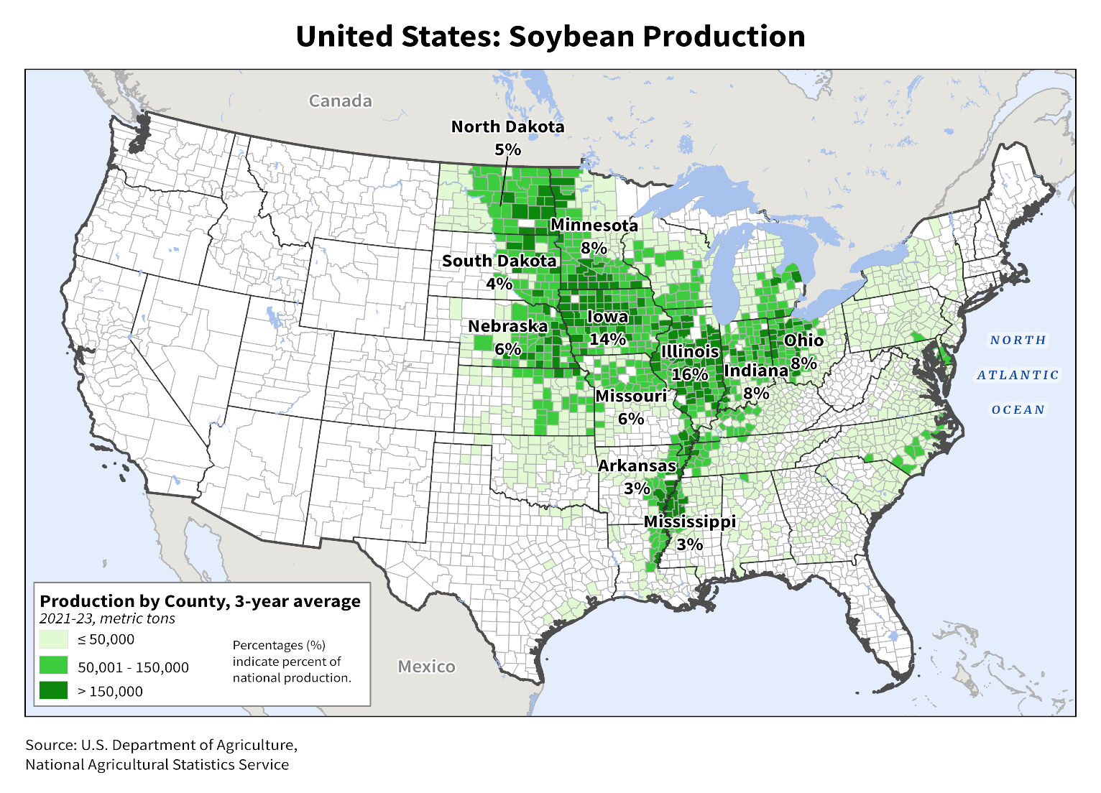
Figure 2.1 U.S. Soybean Production by County and State, Three-Year Average (2021-2023). Source: USDA NASS

Figure 2.2 U.S. Average Soybean Yield, 2014/2015 to 2024/2025. Data Source: USDA FAS

Figure 2.3 U.S. Soybean Planted and Harvested Area, 2015 to 2024. Data Source: USDA NASS

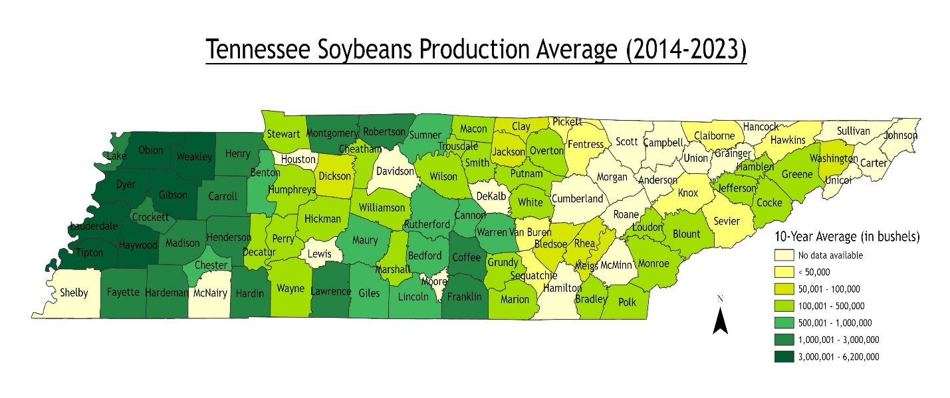
Figure 2.4 Tennessee Soybean Production (10-Year Average), 2014-2023. Data Source: USDA NASS

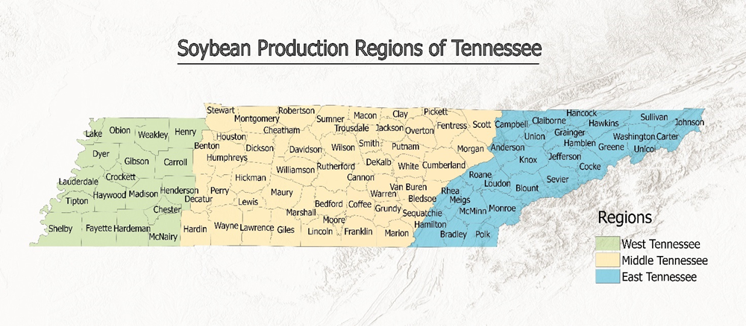
Figure 2.5 Tennessee Soybean Production Region

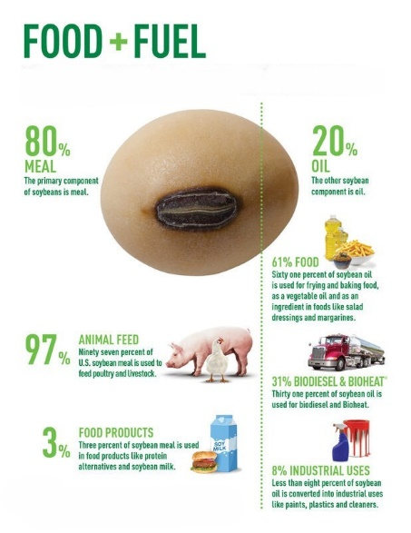
Figure 2.6 Soybean Usage in the United States. Source: United Soybean Board, 2019

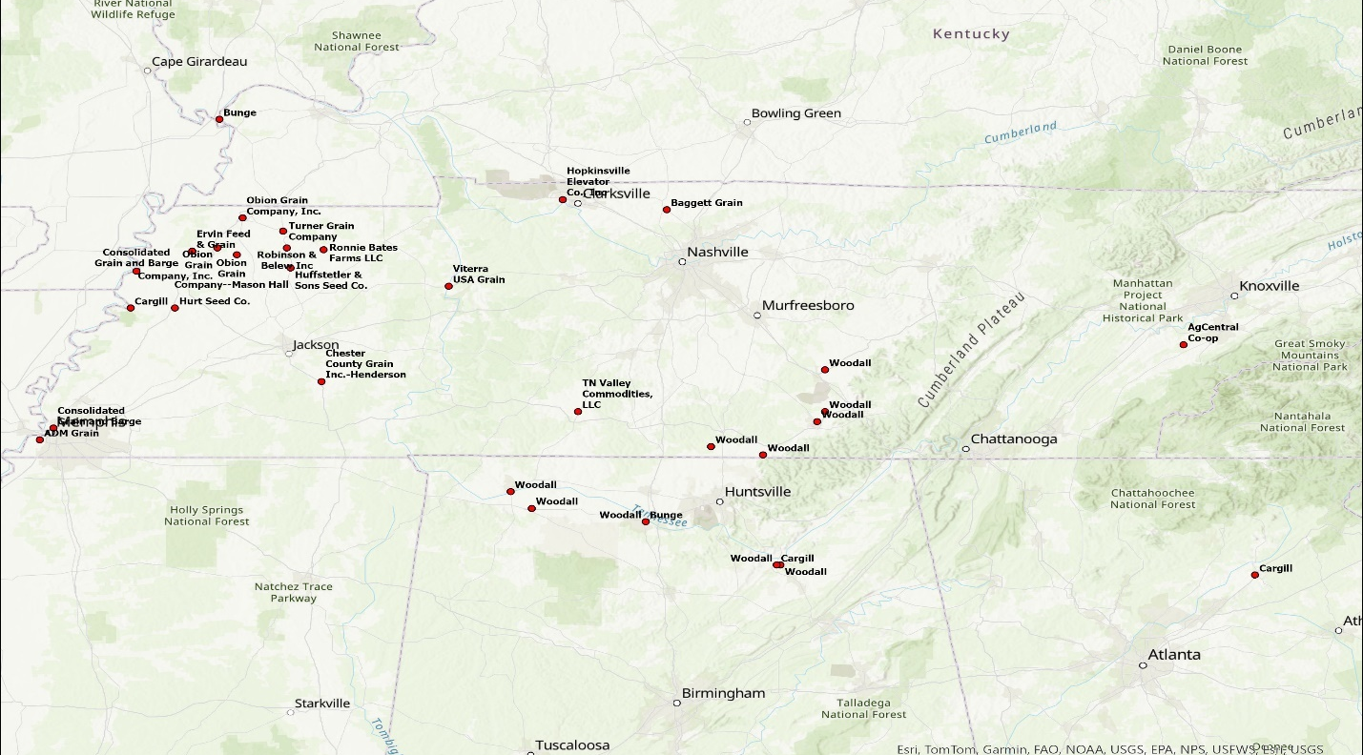Figure 2.7a Primary Destinations for Tennessee Soybeans

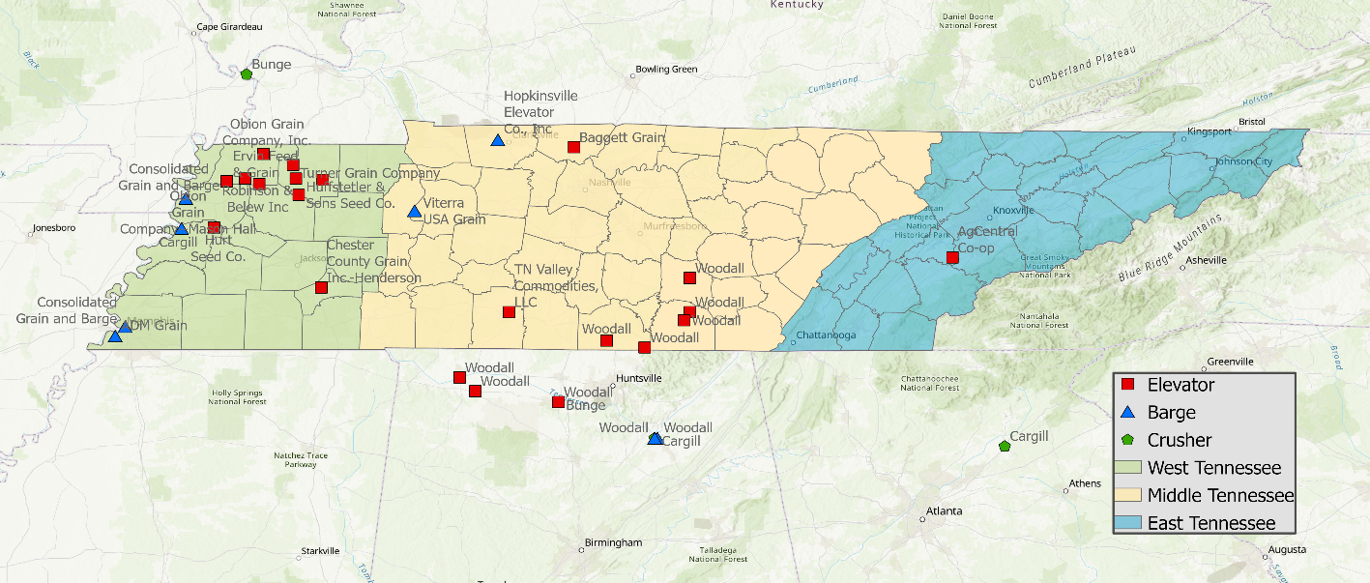
Figure 2.7b Primary Facility Locations for Tennessee Soybeans

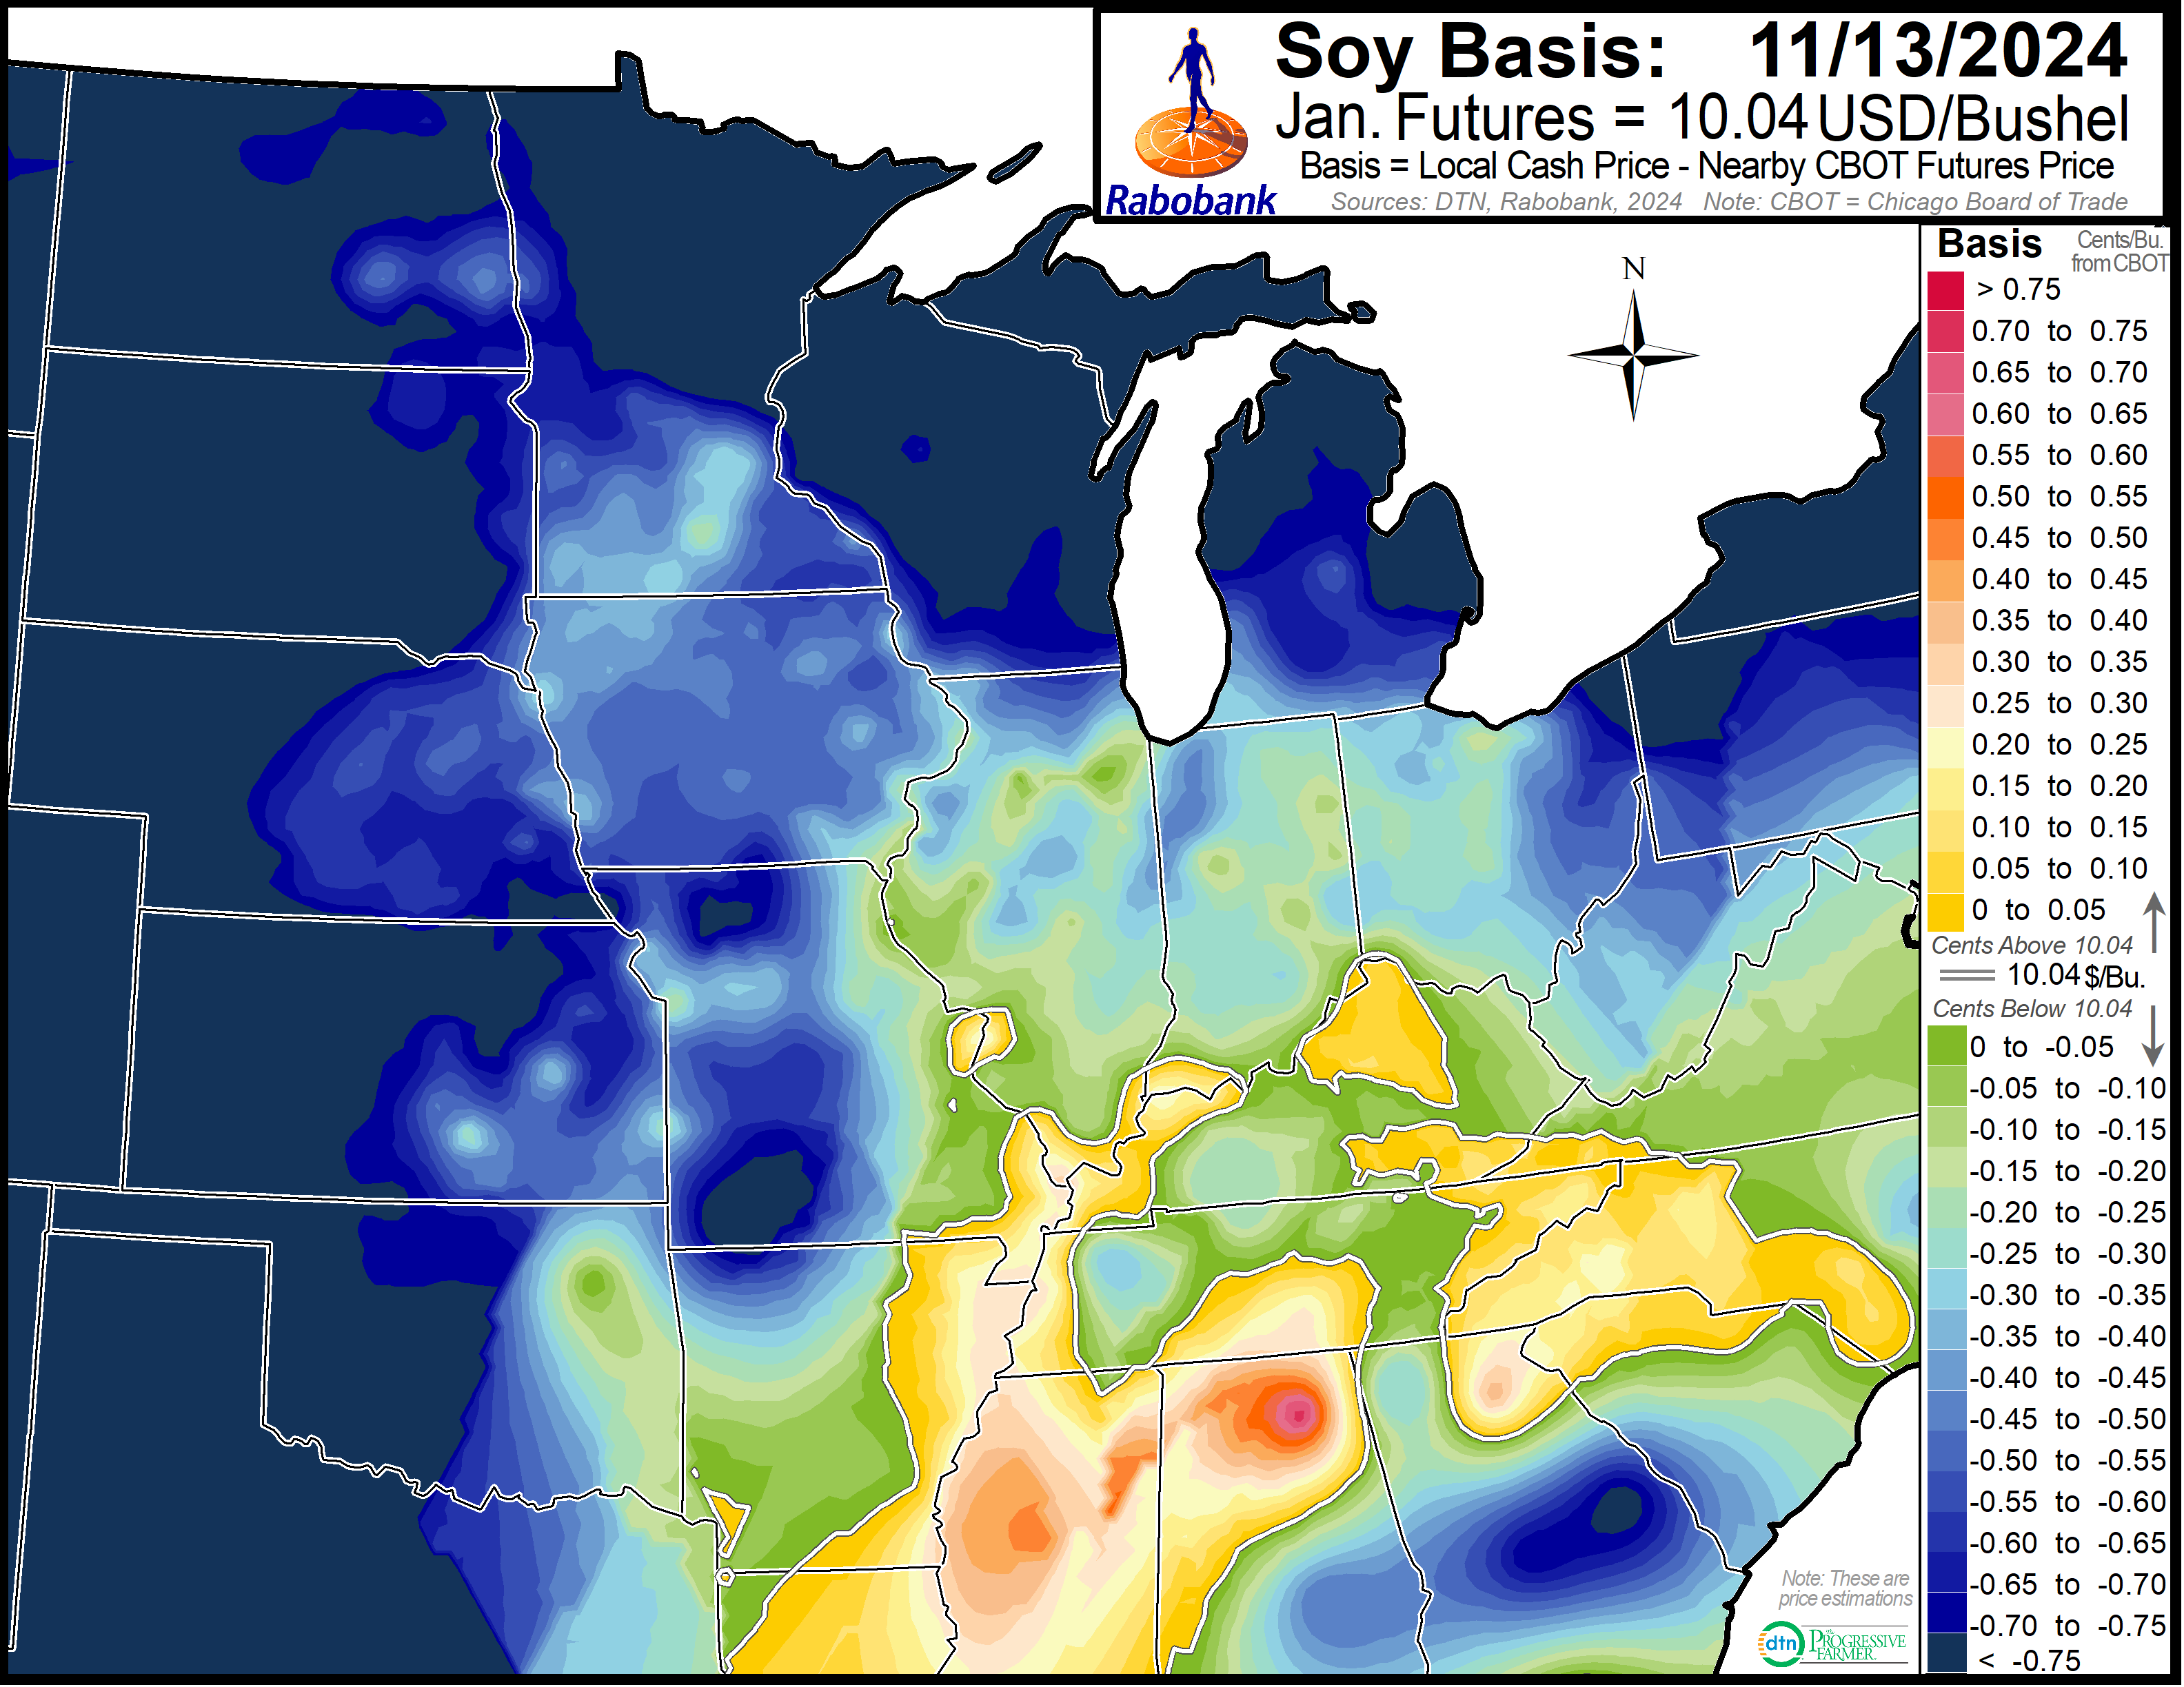
Figure 2.8 Example of Regional Soybean Basis. Source: Rabo Agrifinance

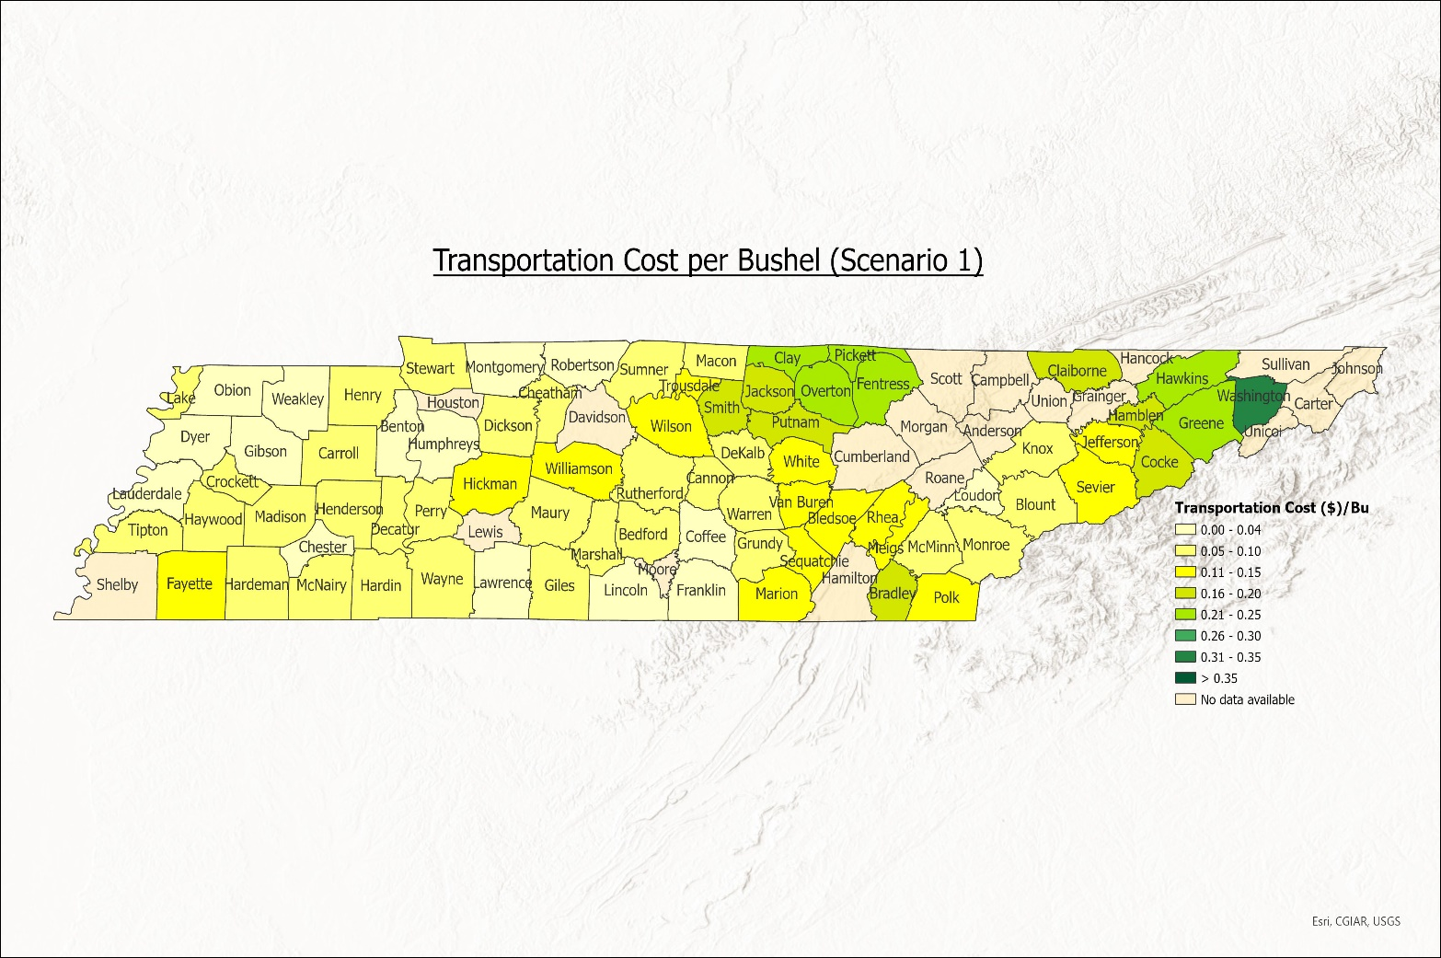
Figure 2.9 Cost per bushel for the base model with no capacity/demand constraints (scenario 1)

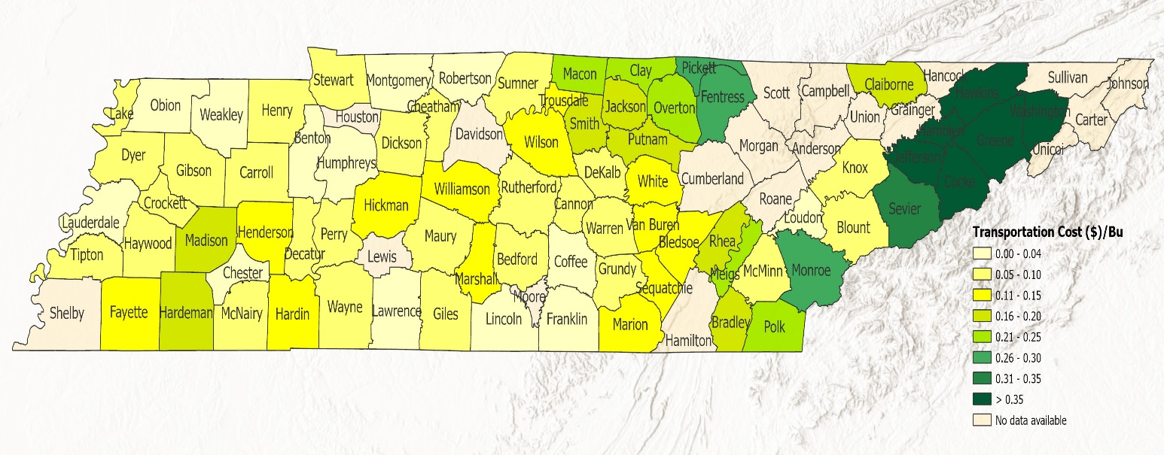
Figure 2.10 Cost per bushel for the base model (scenario 2)

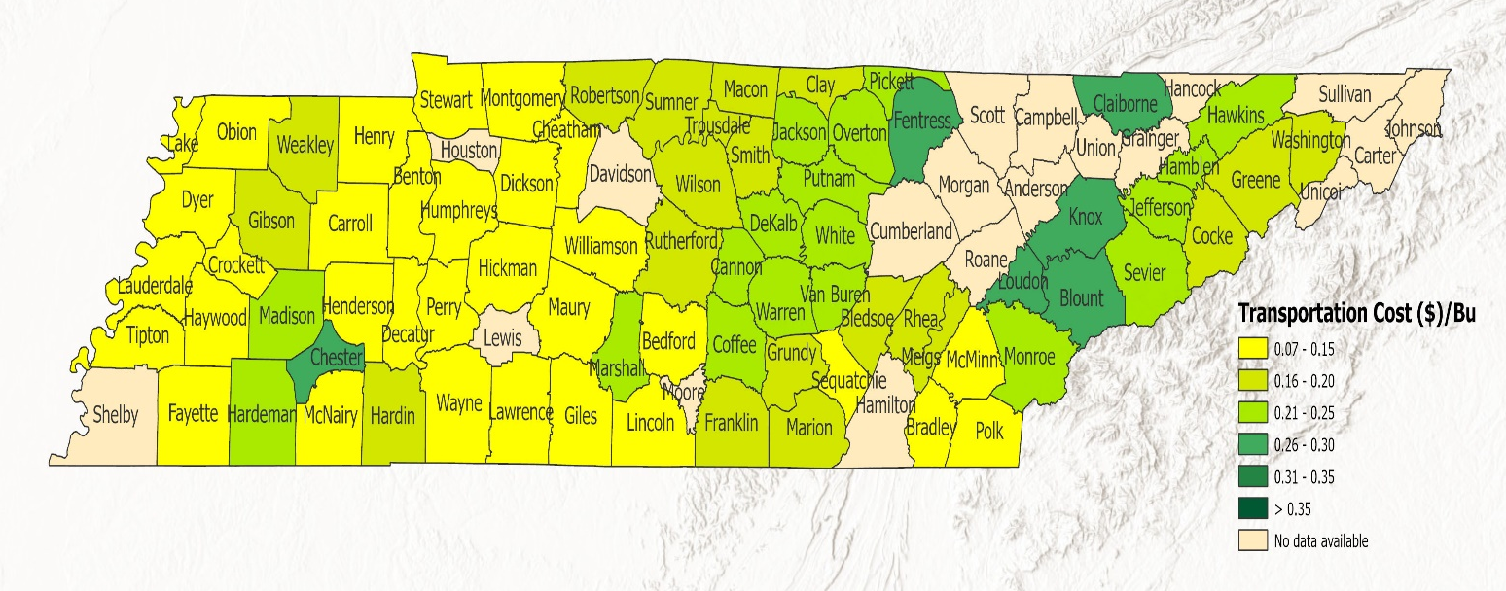
Figure 2.11 Cost per bushel for the price premium model (scenario 3)

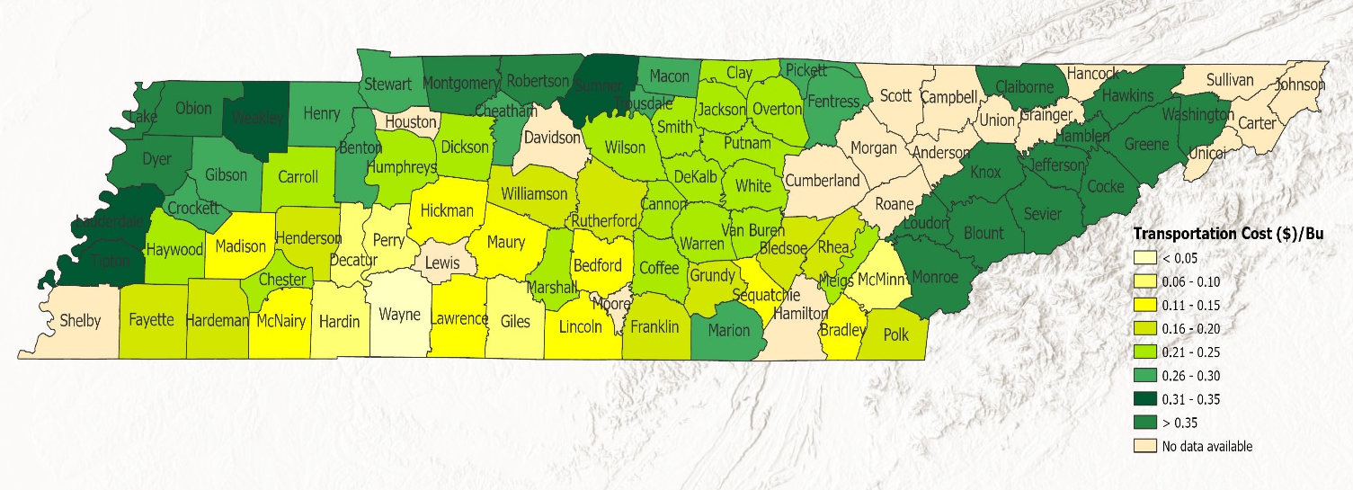
Figure 2.12 Cost per bushel for the relative basis model (scenario 4)

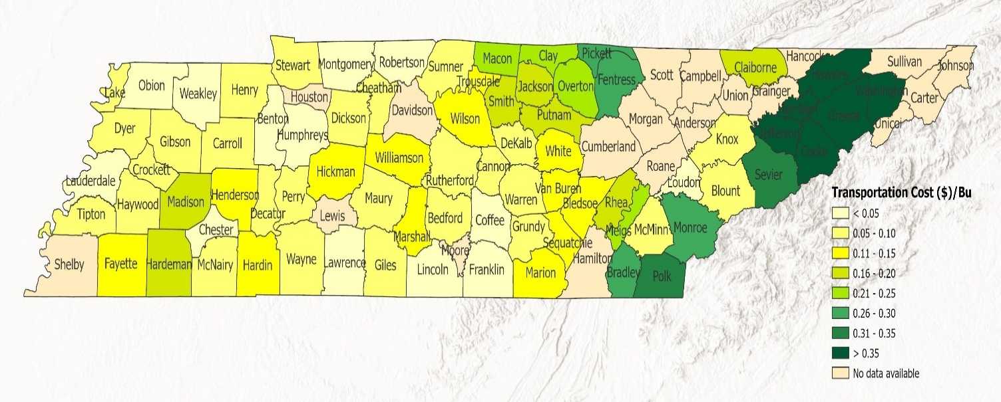
Figure 2.13 Cost per bushel for the base model with minimum demand requirement (scenario 5)

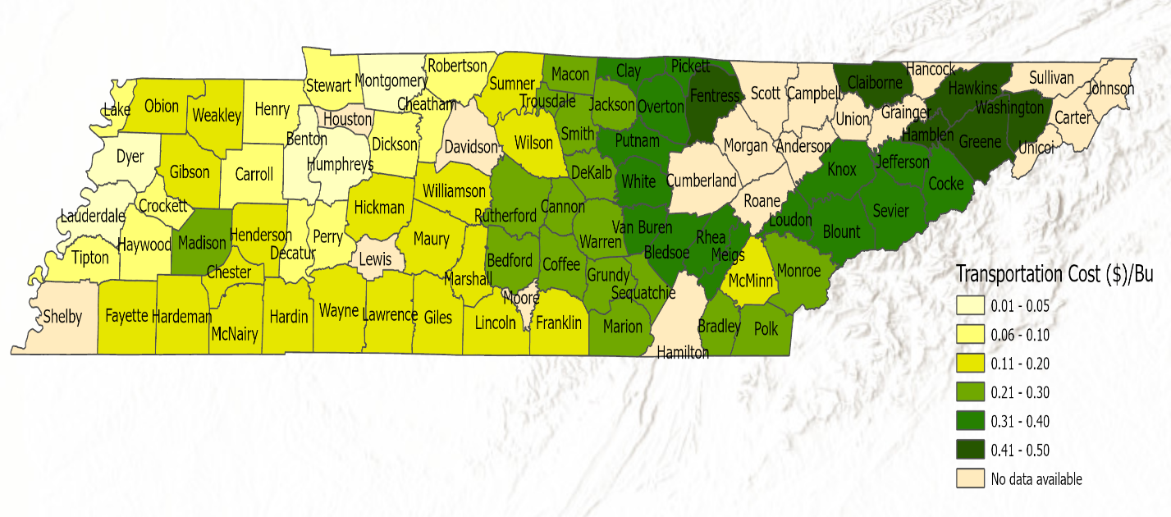
Figure 2.14 Cost per bushel for base model for industry concentration model (scenario 6)

Tables
Table 2.1 U.S. Soybeans Exports in 2023. Source: U.S. Department of Agriculture, Foreign Agricultural Service, Soybeans.

Market | Total Value (USD)
China | $15.06 Billion
European Union | $3.45 Billion
Mexico | $2.79 Billion
Japan | $1.37 Billion
Indonesia | $1.25 Billion
Taiwan | $622.07 Million
Egypt | $477.85 Million
Vietnam | $410.75 Million
South Korea | $320.1 Million
Bangladesh | $302.95 Million

Table 2.2 Tennessee Soybeans Primary Destinations

Region | Company | Type
West Tennessee | Obion Grain Company, Inc. (Union City) | Elevator
West Tennessee | Obion Grain Company (Kenton) | Elevator
West Tennessee | Obion Grain Company, Inc. (Obion) | Elevator
West Tennessee | Ervin Feed & Grain | Elevator
West Tennessee | Turner Grain Company | Elevator
West Tennessee | Robinson & Belew Inc | Elevator
West Tennessee | Huffstetler & Sons Seed Co. | Elevator
West Tennessee | Ronnie Bates Farms LLC | Elevator
West Tennessee | Consolidated Grain and Barge (Dyersburg) | Barge
West Tennessee | Hurt Seed Co. | Elevator
West Tennessee | Cargill (Halls) | Barge
West Tennessee | Consolidated Grain and Barge (Memphis) | Barge
West Tennessee | ADM Grain | Barge
West Tennessee | Chester County Grain Inc. | Elevator
Middle Tennessee | Hopkinsville Elevator Co., Inc | Barge
Middle Tennessee | Baggett Grain | Elevator
Middle Tennessee | Viterra USA Grain | Barge
Middle Tennessee | TN Valley Commodities, LLC | Elevator
Middle Tennessee | Woodall (Manchester) | Elevator
Middle Tennessee | Woodall (Decherd) | Elevator
Middle Tennessee | Woodall (1st Ave. N., Decherd) | Elevator
Middle Tennessee | Woodall (Elora) | Elevator
Middle Tennessee | Woodall (Fayetteville) | Elevator
East Tennessee | AgCentral Co-op | Elevator
Alabama | Woodall (Florence) | Elevator
Alabama | Woodall (Leighton) | Elevator
Alabama | Woodall (Decatur) | Elevator
Alabama | Woodall (Signal Point, Guntersville) | Barge
Alabama | Woodall (Brown St., Guntersville) | Barge
Alabama | Bunge (Decatur) | Crusher
Alabama | Cargill (Guntersville) | Crusher
Georgia | Cargill (Gainesville) | Crusher
Illinois | Bunge (Cairo) | Crusher
[Note: Some company names in the table include locations in parentheses to differentiate between various locations of the same company.]

Table 2.3 Example Soybean Basis

Company | Address | Basis | Relative Basis
Bunge | 1400 Market St NE, Decatur, AL 35601 | 0.6 | 0
Cargill | 2930 Lake Guntersville Park Dr, Guntersville, AL 35976 | 0.6 | 0
Cargill | 862 W Ridge Rd. Gainesville, Georgia | 0.4 | -0.2
AgCentral Co-op | 4065 Highway 95 N, Greenback, TN 37742 | 0.1 | -0.5
Woodall | 1805 Penile Hill Rd, Decherd, TN | 0.1 | -0.5
Woodall | 800 Market Street NE, Decatur, AL | 0.6 | 0
Woodall | 406 1st Ave, North Decherd, TN | 0.1 | -0.5
Woodall | 1090 South Court Street, Florence, AL | 0.6 | 0
Woodall | 3827 McMinnville Hwy, Manchester, TN | 0.1 | -0.5
Woodall | 1208 Sockwell Lane, Leighton, AL | 0.4 | -0.2
Woodall | 62 Old Huntland Rd, Elora, TN | 0.3 | -0.3
Woodall | 117 Signal Point Road, Guntersville, AL | 0.6 | 0
Woodall | 643 Ardmore Hwy, Fayetteville, TN | 0.3 | -0.3
Woodall | 2414 Brown Street, Guntersville, AL | 0.6 | 0
ADM Grain | 1811 Dock Street, Memphis, TN | 0.06 | -0.54
Consolidated Grain and Barge | 1079 N. Second Street, Memphis, TN | 0.06 | -0.54
Cargill | 215 Hales Point Grainery Road, Halls, TN | 0.08 | -0.52
Consolidated Grain and Barge | 4344 Everett Lake Road, Dyersburg, TN | 0.08 | -0.52
Hurt Seed Co. | 1210 Industrial Road, Halls, TN | -0.27 | -0.87
Ervin Feed & Grain | 4851 Jim Carver Road, Obion, TN | -0.27 | -0.87
Obion Grain Company, Inc. | 328 E Main St, Obion, TN | -0.27 | -0.87
Obion Grain Company--Mason Hall | 4898 Mason Hall Grain Rd., Kenton, TN | -0.27 | -0.87
Obion Grain Company, Inc. | 315 Dr Martin Luther King Dr, Union City, TN | -0.27 | -0.87
Turner Grain Company | 106 South Lindell St, Martin, TN | -0.27 | -0.87
Robinson & Belew Inc | 240 Park Avenue, Sharon, TN | -0.27 | -0.87
Huffstetler & Sons Seed Co. | 484 Hwy 45S; Greenfield, TN | -0.27 | -0.87
Ronnie Bates Farms LLC | 2010 Bynum Road, Dresden, TN | -0.27 | -0.87
Viterra USA Grain | 305 Herbert Rd, New Johnsonville, TN | -0.03 | -0.63
Chester County Grain Inc.-Henderson | 198 W Third Street, Henderson, TN | 0.1 | -0.5
TN Valley Commodities, LLC | 1010 Lillian Crews Rd, Lawrenceburg, TN | 0.1 | -0.5
Hopkinsville Elevator Co., Inc | 720 Barge Point Rd, Clarksville, TN | -0.03 | -0.63
Baggett Grain | 3900 Memorial Blvd., Springfield, TN | -0.03 | -0.63
Bunge | 203 34th St, Cairo, IL 62914 | 0.1 | -0.5

Table 2.4 Average and Total Transportation Costs for All Scenarios

Model | Average Transportation Cost ($)/ Bu | Total Transportation Cost ($)
Scenario 1 | 0.049 | 3,677,306
(Base without capacity constraints) | 0.049 | 3,677,306
Scenario 2 | 0.065 | 4,884,064
(Base) | 0.065 | 4,884,064
Scenario 3 | 0.193 | 14,463,812
(With price premium) | 0.193 | 14,463,812
Scenario 4 | 0.319 | 23,933,415
(With relative basis) | 0.319 | 23,933,415
Scenario 5 | 0.066 | 4,942,502
(With minimum demand requirement) | 0.066 | 4,942,502

Table 2.5 Optimal Transportation Costs for Tennessee (Scenarios 1, 2, 3)

 | Scenario 1 |  | Scenario 2 |  | Scenario 3
County | Total Cost ($) | Cost($)/MT | Total Cost ($) | Cost($)/MT | Total Cost ($) | Cost($)/MT
Bedford | 52,028 | 2.81 | 52,028 | 2.81 | 145,842 | 7.88
Benton | 11,443 | 0.80 | 11,443 | 0.80 | 67,983 | 4.73
Bledsoe | 13,341 | 5.70 | 13,341 | 5.70 | 29,639 | 12.66
Blount | 7,526 | 1.60 | 7,526 | 1.60 | 56,338 | 11.97
Bradley | 16,429 | 6.25 | 20,484 | 7.79 | 26,559 | 10.11
Cannon | 36,348 | 2.54 | 36,348 | 2.54 | 166,501 | 11.64
Carroll | 103,483 | 2.40 | 125,520 | 2.91 | 295,200 | 6.85
Cheatham | 8,896 | 2.16 | 8,896 | 2.16 | 29,123 | 7.08
Chester | 2,044 | 0.11 | 2,044 | 0.11 | 200,579 | 10.34
Claiborne | 3,154 | 7.43 | 3,154 | 7.43 | 7,479 | 17.63
Clay | 12,215 | 8.88 | 12,215 | 8.88 | 22,473 | 16.34
Cocke | 19,137 | 7.06 | 38,895 | 14.36 | 38,895 | 14.36
Coffee | 20,445 | 0.47 | 20,445 | 0.47 | 404,668 | 9.23
Crockett | 142,035 | 2.09 | 182,466 | 2.68 | 508,786 | 7.48
Decatur | 36,698 | 3.68 | 36,852 | 3.70 | 76,102 | 7.63
DeKalb | 43,768 | 3.90 | 43,768 | 3.90 | 150,997 | 13.47
Dickson | 5,879 | 2.97 | 5,879 | 2.97 | 13,679 | 6.90
Dyer | 180,768 | 1.15 | 250,108 | 1.59 | 868,219 | 5.53
Fayette | 308,560 | 4.64 | 308,560 | 4.64 | 570,290 | 8.58
Fentress | 9,089 | 7.88 | 11,984 | 10.39 | 21,841 | 18.93
Franklin | 9,314 | 0.26 | 9,314 | 0.26 | 251,096 | 6.97
Gibson | 204,203 | 1.50 | 287,697 | 2.11 | 1,158,414 | 8.49
Giles | 36,985 | 2.02 | 36,985 | 2.02 | 88,654 | 4.84
Greene | 58,624 | 9.82 | 99,642 | 16.69 | 99,642 | 16.69
Grundy | 7,123 | 2.25 | 7,123 | 2.25 | 30,404 | 9.61

[Note: Scenario 1 refers to the Base model with no capacity/demand constraints, Scenario 2 refers to the Base model, and Scenario 3 refers to the price premium scenario]

Table 2.5 (Continued) Optimal Transportation Costs for Tennessee (Scenarios 1, 2, 3)

 | Scenario 1 |  | Scenario 2 |  | Scenario 3
County | Total Cost ($) | Cost($)/MT | Total Cost ($) | Cost($)/MT | Total Cost ($) | Cost($)/MT
Hamblen | 23,498 | 7.30 | 51,640 | 16.05 | 51,640 | 16.05
Hardeman | 96,032 | 2.75 | 234,956 | 6.72 | 372,628 | 10.66
Hardin | 95,933 | 3.26 | 153,978 | 5.24 | 291,716 | 9.92
Hawkins | 7,203 | 9.81 | 13,302 | 18.12 | 13,302 | 18.12
Haywood | 301,520 | 2.65 | 400,708 | 3.52 | 849,498 | 7.45
Henderson | 88,628 | 2.38 | 149,783 | 4.02 | 296,493 | 7.96
Henry | 115,988 | 2.10 | 162,928 | 2.95 | 394,404 | 7.14
Hickman | 27,698 | 4.02 | 27,698 | 4.02 | 54,835 | 7.96
Humphreys | 10,720 | 1.35 | 10,720 | 1.35 | 42,045 | 5.28
Jackson | 14,851 | 7.31 | 14,851 | 7.31 | 31,426 | 15.47
Jefferson | 20,933 | 5.77 | 52,368 | 14.44 | 52,368 | 14.44
Knox | 1,525 | 2.93 | 1,525 | 2.93 | 7,114 | 13.66
Lake | 105,243 | 1.62 | 113,388 | 1.74 | 363,773 | 5.59
Lauderdale | 140,502 | 1.36 | 140,502 | 1.36 | 548,382 | 5.29
Lawrence | 9,638 | 0.28 | 9,638 | 0.28 | 197,306 | 5.71
Lincoln | 21,120 | 0.84 | 21,120 | 0.84 | 130,179 | 5.16
Loudon | 7,799 | 1.21 | 7,799 | 1.21 | 79,987 | 12.37
Macon | 27,110 | 3.31 | 79,186 | 9.67 | 88,060 | 10.75
Madison | 127,042 | 2.32 | 349,811 | 6.39 | 644,470 | 11.78
Marion | 32,491 | 5.46 | 32,491 | 5.46 | 76,946 | 12.93
Marshall | 15,992 | 1.73 | 39,319 | 4.25 | 91,019 | 9.84
Maury | 54,119 | 3.19 | 54,119 | 3.19 | 125,009 | 7.37
McMinn | 28,194 | 3.36 | 28,194 | 3.36 | 58,460 | 6.97
McNairy | 88,733 | 3.38 | 88,733 | 3.38 | 214,572 | 8.18
Meigs | 8,784 | 4.23 | 17,245 | 8.31 | 24,905 | 12.00
Monroe | 12,618 | 1.71 | 73,664 | 10.00 | 78,878 | 10.70

[Note: Scenario 1 refers to the Base model with no capacity/demand constraints, Scenario 2 refers to the Base model, and Scenario 3 refers to the price premium scenario]

Table 2.5 (Continued) Optimal Transportation Costs for Tennessee (Scenarios 1, 2, 3)

 | Scenario 1 |  | Scenario 2 |  | Scenario 3
County | Total Cost ($) | Cost($)/MT | Total Cost ($) | Cost($)/MT | Total Cost ($) | Cost($)/MT
Montgomery | 7,091 | 0.27 | 7,091 | 0.27 | 108,613 | 4.21
Obion | 10,704 | 0.08 | 10,704 | 0.08 | 650,421 | 4.96
Overton | 28,910 | 8.49 | 28,910 | 8.49 | 60,174 | 17.67
Perry | 9,539 | 3.42 | 9,539 | 3.42 | 20,534 | 7.35
Pickett | 9,416 | 9.66 | 10,208 | 10.47 | 18,356 | 18.84
Polk | 23,461 | 5.15 | 41,661 | 9.14 | 41,661 | 9.14
Putnam | 21,320 | 6.33 | 21,320 | 6.33 | 52,832 | 15.70
Rhea | 10,801 | 5.71 | 12,971 | 6.85 | 23,955 | 12.66
Robertson | 19,200 | 0.31 | 19,200 | 0.31 | 445,341 | 7.29
Rutherford | 52,915 | 3.56 | 52,915 | 3.56 | 161,264 | 10.84
Sequatchie | 4,536 | 4.41 | 4,536 | 4.41 | 10,583 | 10.29
Sevier | 2,544 | 4.36 | 7,588 | 13.01 | 7,588 | 13.01
Smith | 42,328 | 6.09 | 42,328 | 6.09 | 96,414 | 13.87
Stewart | 12,377 | 2.92 | 12,377 | 2.92 | 29,077 | 6.85
Sumner | 55,460 | 2.79 | 55,460 | 2.79 | 204,458 | 10.30
Tipton | 272,485 | 2.70 | 272,485 | 2.70 | 670,275 | 6.63
Trousdale | 15,404 | 4.59 | 15,404 | 4.59 | 40,605 | 12.11
Van Buren | 2,503 | 4.29 | 2,503 | 4.29 | 7,427 | 12.71
Warren | 55,059 | 2.22 | 55,059 | 2.22 | 283,046 | 11.41
Washington | 27,373 | 12.36 | 41,328 | 18.66 | 41,328 | 18.66
Wayne | 16,510 | 2.96 | 16,510 | 2.96 | 43,751 | 7.85
Weakley | 61,489 | 0.57 | 99,150 | 0.92 | 729,444 | 6.74
White | 30,082 | 5.00 | 30,082 | 5.00 | 84,185 | 14.00
Williamson | 35,513 | 4.58 | 35,513 | 4.58 | 78,312 | 10.09
Wilson | 16,837 | 4.35 | 16,837 | 4.35 | 45,349 | 11.72

[Note: Scenario 1 refers to the Base model with no capacity/demand constraints, Scenario 2 refers to the Base model, and Scenario 3 refers to the price premium scenario]

Table 2.6 Optimal Transportation Costs for Tennessee (Scenarios 4, 5, 6)

 | Scenario 4 |  | Scenario 5 |  | Scenario 6
County | Total Cost ($) | Cost($)/MT | Total Cost ($) | Cost($)/MT | Total Cost ($) | Cost($)/MT
Bedford | 145,842 | 7.88 | 52,028 | 2.81 | 145,842 | 7.88
Benton | 154,572 | 10.76 | 11,443 | 0.80 | 11,443 | 0.80
Bledsoe | 29,458 | 12.58 | 13,341 | 5.70 | 29,458 | 12.58
Blount | 90,469 | 19.22 | 7,526 | 1.60 | 56,338 | 11.97
Bradley | 30,059 | 11.44 | 30,348 | 11.55 | 26,559 | 10.11
Cannon | 166,501 | 11.64 | 36,348 | 2.54 | 150,439 | 10.51
Carroll | 478,643 | 11.11 | 125,520 | 2.91 | 125,520 | 2.91
Cheatham | 52,477 | 12.75 | 8,896 | 2.16 | 12,923 | 3.14
Chester | 162,507 | 8.38 | 2,044 | 0.11 | 124,229 | 6.41
Claiborne | 10,497 | 24.75 | 3,154 | 7.43 | 7,479 | 17.63
Clay | 25,553 | 18.58 | 12,215 | 8.88 | 17,059 | 12.41
Cocke | 60,229 | 22.23 | 38,895 | 14.36 | 38,895 | 14.36
Coffee | 404,668 | 9.23 | 20,445 | 0.47 | 404,668 | 9.23
Crockett | 861,419 | 12.66 | 182,466 | 2.68 | 240,866 | 3.54
Decatur | 70,975 | 7.12 | 36,852 | 3.70 | 36,852 | 3.70
DeKalb | 150,997 | 13.47 | 43,768 | 3.90 | 128,869 | 11.50
Dickson | 22,915 | 11.57 | 5,879 | 2.97 | 5,879 | 2.97
Dyer | 2,400,495 | 15.29 | 250,108 | 1.59 | 250,108 | 1.59
Fayette | 786,232 | 11.83 | 309,986 | 4.66 | 308,560 | 4.64
Fentress | 22,057 | 19.12 | 11,984 | 10.39 | 18,750 | 16.25
Franklin | 250,302 | 6.95 | 9,314 | 0.26 | 250,302 | 6.95
Gibson | 1,758,627 | 12.89 | 287,697 | 2.11 | 621,134 | 4.55
Giles | 88,654 | 4.84 | 51,306 | 2.80 | 88,654 | 4.84
Greene | 146,642 | 24.57 | 99,642 | 16.69 | 99,642 | 16.69
Grundy | 30,238 | 9.56 | 7,123 | 2.25 | 30,238 | 9.56

[Note: Scenario 4 refers to the relative basis scenario, Scenario 5 refers to the base model with the minimum demand requirement, and Scenario 6 refers to the industry concentration model]

Table 2.6 (Continued) Optimal Transportation Costs for Tennessee (Scenarios 4, 5, 6)

 | Scenario 4 |  | Scenario 5 |  | Scenario 6
County | Total Cost ($) | Cost($)/MT | Total Cost ($) | Cost($)/MT | Total Cost ($) | Cost($)/MT
Hamblen | 76,974 | 23.92 | 51,640 | 16.05 | 51,640 | 16.05
Hardeman | 336,735 | 9.63 | 234,956 | 6.72 | 234,956 | 6.72
Hardin | 153,978 | 5.24 | 153,978 | 5.24 | 198,835 | 6.76
Hawkins | 19,082 | 26.00 | 13,302 | 18.12 | 13,302 | 18.12
Haywood | 1,421,066 | 12.47 | 400,708 | 3.52 | 400,708 | 3.52
Henderson | 317,198 | 8.51 | 149,783 | 4.02 | 149,783 | 4.02
Henry | 723,199 | 13.09 | 162,928 | 2.95 | 176,944 | 3.20
Hickman | 56,580 | 8.21 | 27,698 | 4.02 | 27,698 | 4.02
Humphreys | 84,136 | 10.57 | 10,720 | 1.35 | 10,720 | 1.35
Jackson | 34,022 | 16.74 | 14,851 | 7.31 | 23,426 | 11.53
Jefferson | 80,924 | 22.31 | 52,368 | 14.44 | 52,368 | 14.44
Knox | 10,663 | 20.48 | 1,525 | 2.93 | 7,114 | 13.66
Lake | 1,152,798 | 17.70 | 122,027 | 1.87 | 154,107 | 2.37
Lauderdale | 1,520,574 | 14.68 | 140,502 | 1.36 | 140,502 | 1.36
Lawrence | 148,120 | 4.29 | 9,638 | 0.28 | 197,306 | 5.71
Lincoln | 130,179 | 5.16 | 23,592 | 0.94 | 130,179 | 5.16
Loudon | 111,209 | 17.19 | 7,799 | 1.21 | 79,987 | 12.37
Macon | 117,555 | 14.35 | 79,186 | 9.67 | 88,060 | 10.75
Madison | 377,290 | 6.90 | 352,450 | 6.44 | 438,029 | 8.01
Marion | 100,007 | 16.81 | 32,491 | 5.46 | 53,521 | 9.00
Marshall | 94,290 | 10.19 | 39,319 | 4.25 | 54,585 | 5.90
Maury | 123,651 | 7.29 | 55,927 | 3.30 | 123,651 | 7.29
McMinn | 58,460 | 6.97 | 28,194 | 3.36 | 58,460 | 6.97
McNairy | 208,435 | 7.95 | 88,733 | 3.38 | 188,561 | 7.19
Meigs | 28,570 | 13.77 | 17,245 | 8.31 | 24,905 | 12.00

[Note: Scenario 4 refers to the relative basis scenario, Scenario 5 refers to the base model with the minimum demand requirement, and Scenario 6 refers to the industry concentration model]

Table 2.6 (Continued) Optimal Transportation Costs for Tennessee (Scenarios 4, 5, 6)

 | Scenario 4 |  | Scenario 5 |  | Scenario 6
County | Total Cost ($) | Cost($)/MT | Total Cost ($) | Cost($)/MT | Total Cost ($) | Cost($)/MT
Monroe | 117,682 | 15.97 | 73,664 | 10.00 | 78,878 | 10.70
Montgomery | 370,387 | 14.36 | 7,091 | 0.27 | 7,091 | 0.27
Obion | 2,122,968 | 16.20 | 10,704 | 0.08 | 579,142 | 4.42
Overton | 60,462 | 17.75 | 28,910 | 8.49 | 46,764 | 13.73
Perry | 19,201 | 6.88 | 9,539 | 3.42 | 9,539 | 3.42
Pickett | 19,158 | 19.66 | 10,208 | 10.47 | 14,519 | 14.90
Polk | 58,227 | 12.77 | 58,458 | 12.82 | 41,661 | 9.14
Putnam | 52,683 | 15.65 | 21,320 | 6.33 | 43,353 | 12.88
Rhea | 23,784 | 12.57 | 12,971 | 6.85 | 23,784 | 12.57
Robertson | 914,317 | 14.98 | 19,200 | 0.31 | 204,971 | 3.36
Rutherford | 161,264 | 10.84 | 52,915 | 3.56 | 129,737 | 8.72
Sequatchie | 10,503 | 10.21 | 4,536 | 4.41 | 10,503 | 10.21
Sevier | 12,181 | 20.88 | 7,588 | 13.01 | 7,588 | 13.01
Smith | 105,334 | 15.15 | 42,328 | 6.09 | 69,048 | 9.93
Stewart | 59,107 | 13.93 | 12,377 | 2.92 | 12,377 | 2.92
Sumner | 296,777 | 14.95 | 55,460 | 2.79 | 126,292 | 6.36
Tipton | 1,479,416 | 14.64 | 272,485 | 2.70 | 272,485 | 2.70
Trousdale | 51,918 | 15.48 | 15,404 | 4.59 | 27,405 | 8.17
Van Buren | 7,393 | 12.66 | 2,503 | 4.29 | 7,393 | 12.66
Warren | 282,051 | 11.37 | 55,059 | 2.22 | 282,051 | 11.37
Washington | 58,765 | 26.54 | 41,328 | 18.66 | 41,328 | 18.66
Wayne | 24,365 | 4.37 | 16,510 | 2.96 | 32,990 | 5.92
Weakley | 1,518,604 | 14.04 | 99,622 | 0.92 | 560,046 | 5.18
White | 83,878 | 13.95 | 30,082 | 5.00 | 81,788 | 13.60
Williamson | 82,739 | 10.66 | 35,513 | 4.58 | 47,754 | 6.15
Wilson | 53,525 | 13.83 | 16,837 | 4.35 | 30,116 | 7.78

[Note: Scenario 4 refers to the relative basis scenario, Scenario 5 refers to the base model with the minimum demand requirement, and Scenario 6 refers to the industry concentration model]

CHAPTER IIi
Optimizing Soybean Facility Locations: A Mixed-Integer Linear Programming (MILP)-Based Approach

Abstract
Optimizing the location of soybean handling and processing facilities can improve the efficiency of agricultural supply chains and minimize transportation costs. This chapter introduces a comprehensive, data-driven approach using Mixed-Integer Linear Programming (MILP) to examine the complexities associated with soybean handling and processing facility placement decisions in Tennessee. By integrating detailed county-level production data, transportation cost metrics, and specific operational constraints, our model aims to examine the transportation costs for farmers to current soybean delivery locations and identify optimal facility locations that maximize transportation cost savings while adhering to real-world supply, demand, and capacity limitations. The research highlights the significant challenges faced by agricultural supply chains, where strategic facility placement can directly influence transportation expenses, operational efficiency, and overall economic viability. To ensure the robustness of our model, sensitivity analyses are conducted, allowing for an evaluation of how variations in economic and operational conditions impact the stability of the identified facility locations. The findings underscore the potential of quantitative optimization methods to inform strategic decision-making processes in agricultural operations, ultimately leading to substantial cost reductions and improved supply chain efficiency.

Introduction
In Tennessee, soybean logistics rely on a network of critical infrastructure, including processing facilities, grain elevators, and barge points, all of which play a vital role in maintaining efficient agricultural supply chains. Soybean processing facilities transform raw soybeans into soybean meal and oil. Soybean meals are typically used in livestock and poultry rations and soybean oil for human consumption, biofuels, and industrial products. Soybean processing facilities serve as key hubs for converting harvested soybeans into value-added commodities that support food production, animal feed industries, and renewable energy initiatives. The National Oilseed Processors Association (NOPA) reports that soybean crushing plants utilize solvent extraction techniques to separate oil from meal, ensuring efficient utilization of soybean components.
Beyond processing, storage facilities are essential for maintaining soybean quality and minimizing post-harvest losses. Soybean storage can be on-farm, at processing facilities, or intermediate soybean handling and storage, such as barge points and elevators. Soybeans require controlled storage conditions to prevent spoilage, mold growth, and degradation due to moisture fluctuations. According to Klarenbach (2024), maintaining moisture levels between 13% and 14% is critical for long-term storage, as excessive moisture can lead to fungal contamination and reduced seed viability. Additionally, temperature control and aeration systems in storage silos help prevent condensation and pest infestations, ensuring the stability of stored soybeans. Metal silos, commonly used for soybean storage, must be regularly inspected for structural integrity and airflow efficiency to prevent spoilage (Silos Córdoba, n.d.). According to U.S. Soy (2018), grain elevators are vital storage hubs that help soybean farmers manage supply fluctuations and ensure consistent grain delivery throughout the year.
Despite Tennessee’s annual soybean production averaging over 2 million metric tons (about 76 million bushels) from 2014 to 2023, the state lacks commercial crushing facilities, requiring transportation to neighboring states for processing. This logistical challenge underscores the importance of optimizing facility placement to enhance cost efficiency and streamline supply chain operations. Building upon the seminal work of Collins and Wang (2019) in supply chain optimization and Snoussi et al. (2021) in sustainable logistics networks, our research extends MILP applications specifically to agricultural contexts. Mixed-Integer Linear Programming (MILP) provides a structured approach to facility location optimization, enabling data-driven decision-making that balances transportation costs, production volumes, and market accessibility. This study applies MILP modeling techniques to determine optimal soybean processing facility locations, aiming to improve economic efficiency and reduce transportation expenses within Tennessee’s agricultural supply chain. By integrating production data, transportation costs, and spatial constraints, the research contributes to enhanced facility planning strategies that support sustainable agricultural logistics.

Literature Review
Mixed-Integer Linear Programming (MILP) has proven instrumental in optimizing facility location decisions across logistics and supply chain domains. Collins and Wang (2019) demonstrated MILP’s effectiveness in last-mile delivery networks, where strategic facility additions reduced transportation costs by 14% while maintaining operational flexibility through scenario-based constraints. Their integration of center-of-gravity analysis with MILP aligns with agricultural supply chain challenges, where spatial production clusters and transportation cost differentials drive facility placement. Similarly, Snoussi et al. (2021) have applied robust MILP formulations to sustainable logistics networks, minimizing hub establishment and transportation costs under capacity constraints, emphasizing scalable solutions for complex supply chains. These studies collectively validate MILP’s ability to balance discrete facility selection variables with continuous cost parameters. MILP has been extensively applied in agricultural optimization, particularly for facility location and resource allocation. Palomino et al. (2023) have developed an MILP-based facility location and allocation model, optimizing logistics operations by integrating distance constraints and cost minimization while leveraging Google Maps-based distance calculations for improved demand fulfillment. Amin-Tahmasbi et al. (2022) have formulated a multi-objective MILP-based optimization model for facility location and order allocation in a two-echelon supply chain network, integrating cost minimization, delivery reliability, and supplier assessment to enhance decision-making efficiency.
The integration of diverse datasets, such as production data, facility location data, and transportation cost data, is crucial for creating a comprehensive analytical framework. Carletto (2021) and Weraikat et al. (2024) have shown how recent advancements in agricultural data systems have significantly improved the availability and quality of data, enabling more accurate and comprehensive analysis.
The primary goal of MILP models in agricultural facility location optimization is to minimize transportation costs and maximize economic benefits. Li et al. (2024) demonstrated that MILP-based optimization models significantly reduce supply chain costs while improving operational efficiency in agricultural logistics, highlighting their economic advantages for informed decision-making. Nunes et al. (2024) explored the use of MILP models to optimize the collection and transportation of vineyard pruning biomass, achieving cost reductions while enhancing operational efficiency and resource utilization. According to Butterworth (1985), these models not only maximize transportation cost savings but also contribute to enhanced efficiency across the soybean supply chain, demonstrating their effectiveness in facilitating informed decision-making in agricultural operations.
The objective of our MILP analysis is to identify optimal soybean facility locations in Tennessee that maximize trucking transportation cost savings while operating within realistic capacity and infrastructure constraints. The model strategically selects counties that provide the greatest cost reduction potential by minimizing the differential between current transportation costs and achievable minimum costs across the supply chain.

Methodology

Data Collection
This study utilized three primary datasets critical to optimizing the placement of soybean processing facilities in Tennessee via Mixed-Integer Linear Programming (MILP):
- Soybean Production Data: This dataset includes detailed information regarding soybean production volumes across counties, sourced from USDA NASS QuickStats. County courthouses serve as designated origin points, with their geographical coordinates (latitude and longitude) obtained via Google Earth. This assumption facilitates consistent spatial referencing in our analysis.
- Transportation Cost Data: This dataset documents the cost of transporting soybeans from each county to processing facilities, measured in dollars per metric ton (MT). The transportation costs were obtained from the previous LP model (chapter 2).

Data Integration
The datasets were integrated to establish a comprehensive analytical framework. A left join was performed on county identifiers to create a unified dataset, denoted as (D):
$$D={\left(County_{i},Production_{i},Cost_{i},{Location}_{j}\right)}_{i, j=1}^{n}$$
Where:
- $County_{i}$ = Name of county (i),
- $Production_{i}$ = Soybean production volume in MT for county (i),
- $Cost_{i}$= Transportation cost per MT from county (i) to location (j),
- n = Total number of counties.
This integration allowed for accurate correlation of production levels and associated transportation costs, which formed the foundation for analysis.

Model Formulation
The MILP model was formulated to strategically identify optimal facility locations aimed at maximizing transportation cost savings in soybean truck transportation. The objective function is mathematically expressed as:
$$\text{Maximize }Z=\sum_{i=1}^{n}{\left(Cost_{i}-\min\left(Cost\right)\right)}⋅Production_{i}⋅x_{i}$$
Where:
- $Cost_{i}$represents the transportation cost per MT from county (i),
- $\min\left(Cost\right)$ denotes the minimum transportation cost across all counties,
- $Production_{i}$ reflects the soybean production volume (10-year average) for county (i),
- $x_{i}$ is a binary decision variable defined as: $x_{i}=$ $\left\{\begin{aligned}1, if a facility is placed in county i \\ 0, otherwise\end{aligned}\right.$
Constraints
The model is constrained by several operational parameters that reflect real-world limitations:
- Total Facility Capacity Constraint:
$$\sum_{i=1}^{n}{Production_{i}}⋅x_{i}≤10,000,000$$
This constraint ensures that the total soybean facility capacity does not exceed 10 million bushels (about 272,000 MT).
- Facility Selection Constraint:
$$\sum_{i=1}^{n}{x_{i}}≤3$$
This limits the establishment of new facilities to a maximum of three, reflecting practical logistical considerations.
- Binary Decision Variable Constraint:
$$x_{i}∈0,1 ∀i$$
This ensures that each county can either host a facility or not.
The MILP model was implemented in R using the lpSolve package, allowing for efficient resolution of the formulated optimization problem.

Sensitivity Analysis
To rigorously assess the robustness of the model and the stability of the chosen facility locations, three sensitivity analyses were conducted:
- Transportation Cost Sensitivity: The transportation costs were varied through a ±20% range around the baseline costs to evaluate how selected counties would change under different cost scenarios. Each modified cost scenario was run through the MILP model to observe variations in facility placement.
- Production Capacity Sensitivity: A sequence of production capacities was tested, ranging from 30,000,000 to 70,000,000 bushels (about 816,000 to 1,905,000 MT). The model’s performance was evaluated under these different capacity constraints to determine how changes in overall processing capability influenced optimal county selections.
- Maximum Number of Facilities Sensitivity: The maximum permissible number of facilities was varied from 1 to 5. Analyzing how the model's recommended facilities changed in response to this constraint provided insights into the flexibility and adaptability of the model concerning operational limits.

Results

Optimal Facility Locations
The optimization process, guided by the MILP model, culminated in identifying Fayette, Haywood, and Madison as the most favorable locations for new soybean facilities. These selections maximize trucking transportation cost savings through strategic infrastructure investment, while adhering to the established facility capacity constraints. Under the optimal solution, the selection of these counties was determined not only by their production volumes but also by their relative transportation costs, highlighting their logistical advantages. The results indicate that these counties present a favorable balance of production capabilities combined with lower transportation costs compared to other regions.

Sensitivity Analysis Results
- Transportation Cost Sensitivity:
The sensitivity analysis for transportation costs, where costs were adjusted within a ±20% range, revealed that the facility selection remained stable under moderate cost variations. For cost multipliers ranging from 0.8 to 1.2, the selected counties consistently included Fayette, Haywood, and Madison as optimal locations. This suggests that while the model is robust to moderate changes in transportation costs, significant fluctuations can affect the optimal facility placements.
- Production Capacity Sensitivity:
The analysis examining varying total production capacities did not change optimal selections. As the production capacity increased from 30,000,000 to 70,000,000 bushels, the selected counties consistently were Fayette, Haywood, and Madison. Further increments in capacity did not lead to changes in selections, affirming the strong production profiles of these counties under higher capacity limits.
- Maximum Number of Facilities Sensitivity:
The analysis of varying the maximum number of facilities showed dynamic changes in county selections. With a maximum of one facility, Haywood is selected for its strategic logistical advantage. When the model allows two facilities, it identifies Haywood and Madison. At three, the chosen locations expand to Fayette, Haywood, and Madison. Increasing the limit to four leads to the selection of Fayette, Gibson, Haywood, and Madison. Finally, with five facilities permitted, Tipton is added, resulting in the selection of Fayette, Gibson, Haywood, Madison, and Tipton.

Cost Reduction Analysis
The computed cost reduction for each county was expressed as follows:
$$CostReduction_{i}=\left(Cost_{i}-\min\left(Cost\right)\right)×Production_{i}$$
This equation quantifies the savings achieved by placing facilities in specific counties. The computed cost reductions, displayed in Table 3.1 (provided in the Appendix), highlight the significant economic benefits of strategic facility placement. The aggregated results indicate that optimal facility locations not only maximize transportation cost savings but also contribute to enhanced efficiency across the soybean supply chain.
For example, the table reveals that counties like Madison and Haywood yield high savings, reflecting their advantageous positions from both logistical and economic perspectives. The cumulative cost savings realized through this optimization process demonstrate the effectiveness of the MILP model in facilitating informed decision-making in agricultural operations.

Conclusion
The strategic placement of soybean processing facilities plays a pivotal role in optimizing agricultural supply chains, reducing transportation costs, and improving overall efficiency. By integrating county-level production volumes, trucking cost metrics, and operational constraints, the MILP model successfully identifies facility locations—specifically Fayette, Haywood, and Madison counties—that maximize trucking cost savings and enhance supply chain efficiency. Sensitivity analyses further validate the robustness of the proposed framework, demonstrating its resilience to fluctuations in cost structures, production capacities, and infrastructure constraints, while also highlighting the adaptability of optimal locations under more extreme scenarios.
The findings underscore the significant economic benefits of strategic facility placement, with quantifiable reductions in transportation expenses and improved operational efficiency across the soybean supply chain. The model’s flexibility in accommodating varying operational parameters further supports its applicability for real-world decision-making in agricultural logistics. Ultimately, this research validates the use of quantitative optimization methods as essential tools for guiding infrastructure investments and policy decisions, contributing to the long-term sustainability and competitiveness of agricultural supply chains in Tennessee and beyond. Future research could extend this methodology by incorporating dynamic market conditions, additional infrastructure considerations, and environmental sustainability factors to refine facility placement strategies. Ultimately, this study contributes to the broader discourse on agricultural logistics optimization, providing a foundation for informed resource allocation and strategic infrastructure planning.

References
Amin-Tahmasbi, H., S. Sadafi, B.Y. Ekren, and V. Kumar. 2022. "A multi-objective integrated optimisation model for facility location and order allocation problem in a two-level supply chain network." Annals of Operations Research 324:993–1022.
Butterworth, K. 1985. "Practical application of linear/integer programming in agriculture." The Journal of the Operational Research Society 36(2):99–107.
Carletto, C. 2021. "Better data, higher impact: Improving agricultural data systems for societal change." European Review of Agricultural Economics 48(4):719–740.
Collins, B.C., and H. Wang. 2019. "Facility location optimization for last-mile delivery." Massachusetts Institute of Technology. Available at: https://ctl.mit.edu/sites/ctl.mit.edu/files/theses/43822318-Wang_Collins-Executive_Summary-20190516v3.pdf
Klarenbach, T. 2024. "Soybean storage and conditioning: Best practices for longevity." Available at: https://www.klarenbach.ca/blog/soybean-storage-and-conditioning-best-practices-for-longevity
Li, X., X. Ji, and X. Zeng. 2024. "Optimizing supply chain networks using mixed integer linear programming (MILP)." Theoretical and Natural Science 41:139-144.
National Oilseed Processors Association. n.d. "Oilseed processing." Available at: https://www.nopa.org/oilseed-processing/
Nunes, L.J.R., E. Canale, and P. Sartor. 2024. "Application of Mixed-Integer Linear Programming Models for the Sustainable Management of Vine Pruning Residual Biomass: An Integrated Theoretical Approach." Logistics 8(4):131.
Palomino, K., D. Garcia, and C. Berdugo. 2023. "A MILP facility location model with distance value adjustments for demand fulfillment using Google Maps." Journal of Engineering Research 10(2):10473.
Silos Córdoba. 2024. "Soybeans and soybean meal storage." Available at: https://www.siloscordoba.com/wp-content/uploads/2024/09/02.SOYA_STORAGE.pdf
Snoussi, I., N. Hamani, N. Mrabti, and L. Kermad. 2021. "A robust mixed-integer linear programming model for sustainable collaborative distribution." Mathematics 9(18):2318.
U.S. Soy. 2018. "Elevators play role in marketing crop at harvest and year-round." Available at: https://ussoy.org/elevators-play-role-in-marketing-crop-at-harvest-and-year-round/
Weraikat, D., K. Šorić, M. Žagar, and M. Sokač. 2024. "Data analytics in agriculture: Enhancing decision-making for crop yield optimization and sustainable practices." Sustainability 16(17):7331.

Appendix

Figures
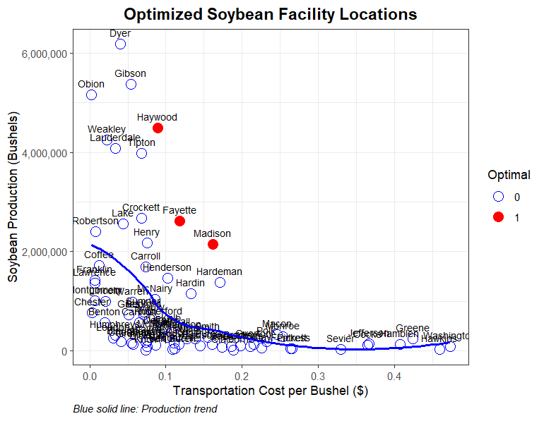
Figure 3.1 Optimal Facility Locations Based on Trucking Costs & Production

Tables
Table 3.1 County-Level Soybean Production, Transportation Costs, and Potential Cost Savings in Tennessee

County | Transportation Cost ($) per MT | Production Volume (MT) | Cost Reduction ($)
Bedford | 2.609 | 18,500 | 50,253
Benton | 0.735 | 14,362 | 10,177
Bledsoe | 5.328 | 2,342 | 13,185
Blount | 1.506 | 4,707 | 7,227
Bradley | 7.275 | 2,628 | 20,279
Cannon | 2.388 | 14,308 | 35,488
Carroll | 2.719 | 43,101 | 122,170
Cheatham | 2.021 | 4,115 | 8,586
Chester | 0.110 | 19,394 | 764
Claiborne | 6.945 | 424 | 3,123
Clay | 8.304 | 1,375 | 12,127
Cocke | 13.411 | 2,709 | 38,720
Coffee | 0.441 | 43,853 | 17,264
Crockett | 2.499 | 68,055 | 176,827
Decatur | 3.454 | 9,970 | 36,110
DeKalb | 3.638 | 11,209 | 42,805
Dickson | 2.756 | 1,981 | 5,694
Dyer | 1.470 | 157,008 | 234,882
Fayette | 4.336 | 66,483 | 303,607
Fentress | 9.700 | 1,154 | 11,899
Franklin | 0.257 | 36,037 | 7,094
Gibson | 1.984 | 136,475 | 279,386
Giles | 1.874 | 18,329 | 35,358
Greene | 15.579 | 5,969 | 99,170
Grundy | 2.094 | 3,162 | 6,848

Table 3.1 (Continued) County-Level Soybean Production, Transportation Costs, and Potential Cost Savings in Tennessee

County | Transportation Cost ($) per MT | Production Volume (MT) | Cost Reduction ($)
Hamblen | 14.991 | 3,217 | 51,427
Hardeman | 6.283 | 34,970 | 232,665
Hardin | 4.887 | 29,415 | 151,698
Hawkins | 16.902 | 734 | 13,236
Haywood | 3.270 | 113,998 | 390,447
Henderson | 3.748 | 37,266 | 146,710
Henry | 2.756 | 55,237 | 158,746
Hickman | 3.748 | 6,893 | 27,138
Humphreys | 1.249 | 7,957 | 10,024
Jackson | 6.834 | 2,032 | 14,720
Jefferson | 13.485 | 3,627 | 52,114
Knox | 2.719 | 521 | 1,476
Lake | 1.617 | 65,129 | 107,688
Lauderdale | 1.249 | 103,606 | 130,522
Lawrence | 0.257 | 34,541 | 6,799
Lincoln | 0.772 | 25,218 | 18,863
Loudon | 1.139 | 6,469 | 7,385
Macon | 9.039 | 8,190 | 78,676
Madison | 5.952 | 54,709 | 344,608
Marion | 5.107 | 5,950 | 32,092
Marshall | 3.968 | 9,254 | 38,619
Maury | 2.976 | 16,974 | 52,790
McMinn | 3.123 | 8,391 | 27,418
McNairy | 3.160 | 26,234 | 86,753
Meigs | 7.753 | 2,075 | 17,072

Table 3.1 (Continued) County-Level Soybean Production, Transportation Costs, and Potential Cost Savings in Tennessee

County | Transportation Cost ($) per MT | Production Volume (MT) | Cost Reduction ($)
Monroe | 9.333 | 7,370 | 73,116
Montgomery | 0.257 | 25,788 | 5,076
Obion | 0.073 | 131,022 | 0
Overton | 7.937 | 3,406 | 28,697
Perry | 3.197 | 2,793 | 9,346
Pickett | 9.774 | 975 | 10,129
Polk | 8.525 | 4,560 | 41,285
Putnam | 5.916 | 3,366 | 21,068
Rhea | 6.393 | 1,892 | 12,814
Robertson | 0.294 | 61,057 | 14,422
Rutherford | 3.307 | 14,871 | 51,519
Sequatchie | 4.115 | 1,029 | 4,455
Sevier | 12.125 | 583 | 7,533
Smith | 5.695 | 6,951 | 41,871
Stewart | 2.719 | 4,242 | 12,024
Sumner | 2.609 | 19,855 | 53,935
Tipton | 2.499 | 101,043 | 262,541
Trousdale | 4.299 | 3,353 | 15,180
Van Buren | 4.005 | 584 | 2,461
Warren | 2.058 | 24,810 | 52,743
Washington | 17.417 | 2,215 | 41,152
Wayne | 2.756 | 5,574 | 16,018
Weakley | 0.845 | 108,186 | 89,441
White | 4.666 | 6,015 | 29,600
Williamson | 4.262 | 7,762 | 34,835
Wilson | 4.079 | 3,869 | 16,604

CHAPTER IV
Tennessee Corn Distribution: A Cost Minimization Analysis

Abstract

This chapter examines the cost minimizing transportation and distribution patterns of corn in Tennessee using a linear programming approach that minimizes transportation costs across multiple scenarios. The United States, as the world's largest corn producer and exporter, relies heavily on efficient distribution systems, with Tennessee playing an important role in the national corn market. Effective transportation planning informs broader agricultural policy and investment in infrastructure development, making the optimization of corn distribution networks essential for sustaining agricultural competitiveness and economic viability. The research analyzes corn transportation flows from Tennessee counties to destination markets, including grain elevators, ethanol plants, barge terminals, and feed mills throughout the state and neighboring regions. The analysis employs five distinct scenarios: an initial base model, a demand-threshold model, minimum and maximum production scenarios, and a facility-specific price premium model. Transportation costs are evaluated across East, Middle, and West Tennessee regions, considering the unique geographic and economic characteristics of each area. By comparing these scenarios, the study provides insights into how production fluctuations, demand thresholds, and economic incentives influence distribution patterns in agricultural supply chains. The methodological framework established in this research offers valuable guidance for transportation planning, agricultural policy development, and infrastructure investment to enhance corn logistics networks. This cost-minimization approach has implications beyond Tennessee, potentially serving as a model for optimizing agricultural commodity transportation in other regions.

Introduction
The United States (U.S.) occupies a dominant position in the global corn (Zea mays L.) market, serving as the largest producer, consumer, and exporter of corn (USDA ERS, 2025). In the 2023/2024 market year, U.S. corn production reached approximately 390 million metric tons, representing 32% of total global production (USDA FAS, 2025). From 2014 to 2023, U.S. corn production varied year-to-year, with a peak occurring at 389.6 million metric tons in 2023 (Figure 4.1, all figures are provided in the Appendix). The production of corn in the U.S. is predominantly concentrated in the Midwest, with states such as Iowa, Illinois, and Nebraska playing pivotal roles and collectively contributing a substantial share of the national output (Figure 4.2). From the 2014/2015 to the 2024/2025 market years, U.S. corn yields have generally trended upward, albeit with annual variability. Notably, the 2019/2020 marketing year saw a significant decline in yields; however, by the 2024/2025 marketing year, yields rebounded to a peak of 11.3 tons per hectare (Figure 4.3). Additionally, corn acreage in the U.S. has fluctuated between approximately 35.69 and 38.28 million hectares in recent years (2014-2023), highlighting the crop's critical role in both agricultural production and economic activity (Figure 4.4).
U.S. corn usage is divided primarily among animal feed, ethanol and fuel production, exports, and other uses such as food and industrial products (Figure 4.5). Animal feed accounts for the largest portion of corn consumption at 39%, with ethanol and fuel making up 27%, exports 16%, and the remaining 18% allocated to food, industrial uses, and residuals (Indiana Corn and Soybean Board, n.d.). Within the feed category, poultry and beef each consume roughly a quarter of the corn, followed by swine and dairy. This distribution highlights the significant role of livestock sectors in driving corn demand. Effective transportation planning that informs broader agricultural policy and investment in infrastructure development becomes essential for maintaining efficient distribution systems that support these diverse market segments.
Corn is the dominant feed grain in the U.S., accounting for approximately 95% of total feed grain production (USDA ERS, 2025). Livestock feed demand, particularly from poultry and hogs, drives a significant portion of domestic corn consumption. Approximately 40% of U.S. corn is used for livestock feed, with poultry and swine operations relying heavily on corn-based diets due to its high-energy content and digestibility (USDA ERS, 2025). The demand for corn in animal feed fluctuates based on livestock population trends, feed cost variations, and market conditions. In 2023, U.S. livestock, poultry, and aquaculture collectively consumed nearly 284 million tons of feed, with corn and its derivatives comprising a substantial portion of total compound feed (IFEEDER, 2025). As feed prices rise, producers adjust formulations by incorporating alternative ingredients, but corn remains a staple in poultry and hog nutrition due to its efficiency in weight gain and feed conversion ratios (USDA ERS, 2008).
Tennessee plays a significant role in U.S. corn production, ranking among the top 20 states in terms of harvested area and yield. From 2014 to 2023, the state’s corn production averaged about 3.4 million metric tons (USDA NASS QuickStats), with yields fluctuating due to weather conditions and market dynamics. The majority of Tennessee’s corn is grown in the western part of the state, where counties such as Obion, Weakley, and Dyer consistently report the highest production levels, exceeding 250,000 metric tons on average (Figure 4.6). Middle Tennessee accounts for a moderate share of Tennessee's corn production, contributing approximately 40% of the state's 10-year average output. In contrast, East Tennessee produces a comparatively smaller volume, around 2%, primarily due to limitations in land availability and soil quality. Tennessee's corn supply faces regional deficits, particularly in East and Middle Tennessee, where production levels are constrained by land availability and soil conditions. While West Tennessee remains the state's primary corn-producing region, fluctuations in yield and market conditions often create gaps in supply for feed mills, ethanol plants, and poultry operations. Due to Tennessee's proximity to key agricultural markets, corn can be efficiently transported to adjacent states such as Kentucky, Alabama, Georgia, and North Carolina, helping to stabilize regional feed demand and supply-chain logistics.
The state’s transportation network relies heavily on truck shipments, which facilitate movement from farms to grain elevators, feed mills, and ethanol plants. Trucks are the primary mode of transportation for domestically used corn, accounting for 83.3% of total domestic corn movements in the U.S. between 2013 and 2022, with usage peaking at 85% in 2019 and 2021 (USDA AMS, 2024). This reliance on trucking is largely due to the proximity of ethanol plants to corn-producing areas (U.S. DOE, n.d.), as most ethanol facilities are located within 80.5 kilometers of production sites, making trucks the most cost-effective option for short-distance transport. Additionally, trucks are generally more efficient than rail for distances up to 402.3 kilometers between origin and destination. According to FreightWaves (2020), total operating expenses in trucking range from $1.16 to $3.05 per mile (approximately $0.72 to $1.90 per kilometer), depending on various cost categories such as driver compensation, fuel, and equipment financing.
In Tennessee, corn transportation follows similar patterns, with trucks facilitating movement from farms to grain elevators, feed mills, and ethanol plants. In Tennessee, farm storage has increased over time, resulting in many producers storing corn for delivery to end users after the harvest interval. This has changed the capital investment in farm infrastructure and machinery. The state’s infrastructure supports short-haul trucking, ensuring direct delivery to processing facilities and feed mills or livestock feeding operations. While barge and rail transport play a role in long-distance shipments and accessing export markets, most corn produced in Tennessee and consumed within Tennessee and adjacent states is transported by truck, reflecting national trends in domestic grain movement (USDA AMS, 2014). In Tennessee, grain elevators, ethanol plants, and barge terminals serve as key distribution points. The Mississippi, Cumberland, and Tennessee Rivers provide essential barge terminals for interstate shipments, supporting exports and feed mills in neighboring states. In adjacent states like Kentucky, Alabama, Georgia, and North Carolina, Tennessee corn is a crucial feed component for poultry and hog farms, shaping transportation flows and demand dynamics. Counties with high livestock concentrations depend on Tennessee’s corn supply due to its accessibility and established trucking routes. According to USDA NASS (2025), Georgia led broiler production in 2024 with 1.36 billion head, followed by Alabama with 1.17 billion, North Carolina with 964.8 million, and Kentucky with 281.5 million. Due to this substantial poultry inventory, these states have strong demand for corn-based feed, much of which could be efficiently supplied from neighboring Tennessee. According to the 2024 Agricultural Census, poultry inventory in adjacent states includes 1.74 billion broilers in Georgia, 368 million layers in North Carolina, Infrastructure improvements, such as highway expansions and rural road maintenance, continue to enhance trucking efficiency, reducing transportation costs and ensuring timely delivery to markets.
This chapter utilizes a cost-minimization model to evaluate the optimal distribution of Tennessee corn, comparing multiple scenarios to understand spatial flow adjustments. The analysis compares six scenarios, including a base case, a price premium scenario, a minimum production scenario, a maximum production scenario, and an industry concentration scenario, to determine shifts in transportation patterns and market allocation. The analysis examines how changes in production levels and pricing incentives affect supply chain efficiency, influencing movements toward grain elevators, ethanol plants, barge terminals, and regional feed mills. Additionally, the research identifies how fluctuations in production influence corn distribution relative to adjacent states, particularly regions with high poultry and hog feed demand. By comparing these scenarios, the study provides insights into transportation cost efficiencies and necessary supply chain adaptations to enhance Tennessee's corn logistics network.

Data
County-level corn production and destination-specific demand form the foundation of this study's dataset, alongside geospatial information on ethanol facilities, grain elevators, and barge terminals. Standardized county origins are represented by courthouse locations, ensuring consistency in spatial analysis. Transportation costs, including per-unit hauling expenses, were incorporated to evaluate logistical efficiency, while price premiums were assigned based on facility type. For adjacent states, courthouse locations serve as county destinations, with poultry and hog feed demand averages factored into the distribution framework. Annual production data from 2014 to 2023 were sourced from the USDA National Agricultural Statistics Service (NASS) Quick Stats database and consolidated into a 10-year average. Producer delivery points within Tennessee were obtained from the Tennessee Department of Agriculture, the Tennessee Corn Board, and supplementary internet searches. The Tennessee Corn Board operates the corn checkoff for Tennessee corn producers. The checkoff collects 1 cent per bushel at the first point of delivery from the farm. Our analysis utilizes the remittance data to assist with instate facility capacities and demand. To enhance clarity in transportation modeling and due to the regionalization of corn production and markets, Tennessee has been categorized into East, Middle (including the Cumberland Plateau), and West. Regions with deficits have been assigned an external source, assuming this source brings in the exact deficit amount. Table 4.1-4.8 (all tables are provided in the Appendix) outlines the primary destinations for corn shipments from each region, considering poultry production, feed mills, grain elevators, ethanol plants, and barge terminals. Distance calculations relied on Google Maps to ensure routing accuracy, while price premium estimates were refined through consultation with the Tennessee Corn Promotion Board and industry experts, enhancing the economic assessment of Tennessee corn distribution.

Methodology: Linear Programming Approach
To optimize the transportation logistics for corn, we implemented a linear programming model designed to minimize transportation costs while adhering to key constraints. This model evaluates multiple scenarios to determine the most efficient distribution for corn from production areas to market destinations.
- Scenario 1: Initial Base Model
The initial base model aims to minimize transportation costs for corn by identifying the most cost-effective routes from each county to market locations. This scenario does not impose any additional constraints beyond the basic supply and demand constraints.
- Scenario 2: Base Model
The base model builds on the initial scenario by only considering destinations with a demand of more than 2540 MT (100,000 bushels). This model ensures that only market locations demanding more than 2540 MT are included in the optimization process.
- Scenario 3: Minimum Production
This scenario models a 35% reduction in production across counties based on previous production trends. The model incorporates this reduced production (representing a production year with below normal production) into the base model (Scenario 2), adjusting the supply constraints accordingly to reflect the lower availability of corn.
- Scenario 4: Maximum Production
Conversely, this scenario models a 35% increase¹ in production at origins based on previous production trends. The model integrates this increase into the base model (representing a production year with above normal production), modifying the supply constraints to account for the greater availability of corn.
- Scenario 5: Facility Type Price Premium
This scenario introduces price premiums associated with different types of facilities, such as ethanol plants, feed mills, and grain elevators. The model adjusts transportation costs to reflect these premiums, providing a more nuanced analysis of cost-effective distribution strategies that consider the economic impact of facility-specific premiums.
- Scenario 6: Industry Concentration
The industry concentration scenario focuses on barge points, ethanol plants, and poultry feed mills as primary delivery destinations for Tennessee soybean producers. By narrowing the focus to these specific destinations, the scenario refines transportation flows, optimizing distribution strategies within the base model framework.
Constraints:
- Supply Constraint: The total amount shipped from each origin cannot exceed its production capacity.
$$∑{ x}_{ij}≤S_{i}$$
where x_{ij} is the quantity of corn in metric tons from county i (where i=1, 2, 3,…..,21 for East Tennessee, i=1, 2, 3,…..,45 for Middle Tennessee, i=1, 2, 3,…..,18 for West Tennessee) delivered to location j (corn delivery locations: elevators, poultry feed mills, barge points, and crushing/ethanol facilities), and S_{i} is the total supply of corn (10-year average) in county i.
- Demand Constraint: The total quantity transported to each destination must meet or exceed its required demand.
$$∑x_{ij}≥D_{j}$$
for all j where x_{ij} is the sum of the quantity of corn in metric tons from county i delivered to all location j, and D_{j} is the demand at destination j
- Non-negativity constraints: All transported quantities must be non-negative.
$$x_{ij}≥0$$
for all i, j where x_{ij} is the of the quantity of corn in metric tons from county i delivered to all locations j

Scenarios 1, 2, 3, 4, and 6
The objective function is expressed as:
$$Minimize Z = ∑∑c_{ij}⋅x_{ij}$$
where Z represents total transportation cost, c_{ij} is the cost in dollars per metric ton to transport corn by truck from county i to location j, and x_{ij} is the quantity of corn in metric tons transported from county i to location j.
Scenario 5
Ceteris paribus, a price premium adjustment is incorporated to reflect facility-specific advantages, modifying the equation as follows:
$$Minimize Z = ∑∑\left(c_{ij}- p_{jk}\right)⋅x_{ij}$$
where c_{ij} is the cost in dollars per metric ton to transport corn from county i to location j, p_{jk} is the price premium from destination j based on the type of facility k (k = crushing/poultry/ethanol facility (price premium $0 per metric ton), elevator (price premium of -$19.684 per metric ton), or barge (price premium of -$7.874 per metric ton) and x_{ij} is the quantity of corn in metric tons transported from county i to location j.

Results
The linear programming model provided insights into the cost-minimization strategies for Tennessee corn transportation under multiple scenarios. The results (Tables 4.9 and 4.10) highlight the variations in transportation costs across regions—East, Middle, and West Tennessee—and demonstrate the impact of supply constraints, production fluctuations, and facility-specific price premiums on distribution patterns.

Regional Cost Distribution
The cost-per-MT analysis (Table 4.9) across Tennessee’s regions further illustrates the economic implications of transportation optimization. The baseline transportation costs averaged $4.01 per MT in East Tennessee, $2.44 in Middle Tennessee, and $2.11 in West Tennessee. As scenario adjustments were applied, costs fluctuated in response to production changes and facility premiums, demonstrating the flexibility required for an efficient corn supply chain.
- East Tennessee
East Tennessee established the highest baseline transportation cost at $4.01 per MT in scenario 1. The demand threshold in scenario 2 caused an 11.07% cost increase to $4.45 per bushel, indicating heavy reliance on smaller market destinations that were excluded by the threshold. Under production reduction (scenario 3), costs rose modestly by 3.83% to $4.16 per MT, suggesting limited production capacity forced less efficient routing. Production increases in scenario 4 created substantial pressure with a 16.35% cost escalation to $4.66 per MT, demonstrating limited capacity for surplus handling. The facility premium scenario (scenario 5) dramatically transformed costs with a 352.95% increase to $18.15 per MT, highlighting the region's geographical disadvantage in accessing premium-paying facilities. Scenario 6 resulted in a 181.05% increase to $11.26 per MT, representing a moderate impact compared to the extreme premium scenario when the industry is concentrated.
- Middle Tennessee
Middle Tennessee demonstrated moderate baseline costs at $2.44 per MT in scenario 1, positioning it as an intermediate performer with balanced geographical access to markets. The demand threshold (scenario 2) produced a modest 3.70% increase to $2.53 per MT, suggesting less dependence on smaller destinations compared to East Tennessee. Production reduction (scenario 3) yielded the most significant benefit with a 22.99% cost decrease to $1.88 per MT, indicating that excess production typically creates routing inefficiencies in this region. Production increases (scenario 4) severely impacted costs with a 44.78% escalation to $3.54 per MT, showing that while efficient at moderate volumes, the region quickly becomes overwhelmed. The facility premium scenario (scenario 5) produced the highest regional impact with a 673.07% increase to $18.89 per MT, indicating that premium facilities are poorly positioned relative to Middle Tennessee's production areas. Without the elevators in consideration, scenario 6 generated a 250.87% cost increase to $8.57 per MT, demonstrating substantial but more manageable impacts compared to the premium scenario.
- West Tennessee
West Tennessee achieved the lowest baseline cost at $2.11 per MT in scenario 1, demonstrating superior logistical efficiency likely due to proximity to major transportation infrastructure, including Mississippi River barge terminals. The demand threshold (scenario 2) showed remarkable stability with only a 0.05% increase, suggesting an optimal configuration around high-demand destinations. Production reduction (scenario 3) improved efficiency with a 21.64% decrease to $1.66 per MT, indicating surplus production typically creates suboptimal routing. Despite baseline efficiency, production increases (scenario 4) caused the most severe regional escalation at 70.78% to $3.61 per MT, showing that increased volumes quickly exhaust efficient options. The facility premium scenario (scenario 5) increased costs by 520.83% to $13.11 per MT, though this was less severe than other regions, suggesting better access to premium-paying facilities through strategic location near major transportation corridors. Scenario 6, with only barge points, ethanol, and poultry feed mills, resulted in a 96.42% cost increase to $4.15 per MT, maintaining West Tennessee's relative advantage with the smallest absolute cost impact among all regions.

Scenario Comparisons
The initial base model (scenario 1) established the foundational transportation cost structure without additional constraints. In this model, cost-minimization directed shipments toward destinations with substantial demand, optimizing route efficiency while maintaining balanced distribution across the three Tennessee regions.
In scenario 2, incorporating a demand threshold of 2540 MT (100,000 bushels) reshaped transportation flows by excluding smaller market locations. This adjustment resulted in an 11.1% increase in transportation costs for East Tennessee, a 3.7% rise for Middle Tennessee, and a negligible change for West Tennessee (0.05%). The concentration of deliveries toward high-demand markets enhanced logistical efficiency while slightly elevating the cost per bushel.
A 35% reduction in corn production in scenario 3 led to supply limitations at origin counties, significantly impacting cost dynamics. The Middle and West Tennessee regions exhibited notable cost reductions of 23% and 21.6%, respectively, as lower production levels constrained excess shipments. Meanwhile, East Tennessee experienced a modest 3.8% increase, reflecting the need for adjusted routing strategies that maintained supply-chain stability despite production shortfalls.
Conversely, in scenario 4, when production increased by 35%, transportation costs escalated due to higher volumes requiring allocation to expanded destination markets. The results revealed a 16.4% cost increase for East Tennessee, a 44.8% rise for Middle Tennessee, and a 70.8% surge for West Tennessee, indicating intensified logistical challenges in accommodating surplus supply. These findings underscore the sensitivity of transportation costs to production variations and highlight the necessity of adaptive routing strategies.
In scenario 5, the introduction of facility-specific price premiums significantly altered cost distributions. Ethanol plants, poultry facilities, grain elevators, and barge terminals exhibited substantial cost differentials, with transportation costs increasing by 352.9% in East Tennessee, 673.1% in Middle Tennessee, and 520.8% in West Tennessee. This result underscores the financial impact of facility location preferences and the importance of price incentives in shaping optimal transport routes.
The industry concentration scenario (scenario 6) focused exclusively on barge points, ethanol plants, and poultry feed mills as primary delivery destinations. This targeted approach resulted in cost increases of 181.1% for East Tennessee, 250.9% for Middle Tennessee, and 96.4% for West Tennessee. By limiting destination options to these strategic facilities, the model revealed the trade-offs between destination flexibility and specialized market access, with West Tennessee maintaining its competitive advantage due to superior access to barge terminals along the Mississippi River corridor.

Conclusion
This study highlights cost-minimization strategies in Tennessee corn transportation, demonstrating how supply, demand, and facility-specific price premiums shape distribution patterns. By applying a linear programming approach, the analysis identifies key economic influences on transportation efficiency and underscores the importance of adaptive logistical frameworks. The findings reinforce that optimizing transportation routes and factoring in demand-driven distribution strategies can lead to measurable cost savings, particularly in regions with concentrated production or proximity to high-demand markets.
A primary takeaway from the scenario analysis is that demand-constrained routing improves efficiency but introduces regional disparities. While targeting destinations with at least 2540 MT of demand streamlines shipments, it can also increase overall transportation costs for certain regions. Production fluctuations significantly impact transportation cost structures, with reductions lowering instate expenditures due to supply limitations but requiring additional corn to be brought into Tennessee from other corn-producing states, while surpluses increase cost but displace out-of-state production. Industry concentration scenarios, which focus distribution exclusively on strategic facilities such as barge points, ethanol plants, and poultry feed mills, reveal the trade-offs between destination flexibility and specialized market access. This targeted approach creates substantial cost increases across all regions but demonstrates how strategic facility selection can optimize distribution efficiency for specific market segments. This variability reinforces the need for dynamic transportation models that adjust based on projected state-level production.
Facility-specific price premiums present the most substantial financial influence on distribution patterns. The sharp cost increases observed when factoring in ethanol plants, grain elevators, feed mills, and barge terminals indicate that economic incentives drive transportation and distribution decisions. Regions with concentrated feed operations, such as West Tennessee, exhibit heightened sensitivity to price premiums, reinforcing the necessity of strategic routing decisions based on facility advantages. The industry concentration analysis further confirms West Tennessee's strategic advantage, as its proximity to Mississippi River barge terminals provides superior access to specialized transportation infrastructure compared to other regions.
The implications of these findings extend beyond cost optimization. Effective transportation planning informs broader agricultural policy and investment in infrastructure development. Enhancing trucking networks, maintaining rural roads, and strategically allocating resources for logistics support will be essential for sustaining efficient corn distribution. Additionally, producers and industry stakeholders must weigh facility-based price premiums when determining delivery routes, ensuring that economic incentives align with transportation costs. Furthermore, the concentration of deliveries to specific facility types highlights the importance of developing specialized transportation corridors that connect production areas to strategic market destinations, particularly barge terminals and processing facilities.
Future research may examine how changes in market conditions, fluctuations in fuel prices, and evolving corn demand in the poultry and ethanol industries influence transportation cost structures. By refining cost modeling approaches and integrating geospatial analytics, further improvements can be made to optimize Tennessee’s agricultural logistics network.
Ultimately, this study underscores the necessity of adaptive transportation frameworks that balance cost efficiency with changing market dynamics. Implementing refined logistical strategies can enhance supply-chain resilience and provide producers with stable, economically viable distribution options. These insights contribute to ongoing discussions in agricultural logistics, supporting improved transportation decisions that benefit both industry stakeholders and regional economies.

References
Agricultural Marketing Service (AMS). 2014. "Corn Transportation Profile." Available at: https://www.ams.usda.gov/sites/default/files/media/Corn%20Transportation%20Profile.pdf
Agricultural Marketing Service (AMS). 2025. "Grain Transportation Report." Available at: https://www.ams.usda.gov/sites/default/files/media/GTR02202025.pdf
Economic Research Service. 2008. "Corn prices near record high, but what about food costs?" Available at: https://www.ers.usda.gov/amber-waves/2008/february/corn-prices-near-record-high-but-what-about-food-costs
FreightWaves. 2020. "Understanding total operating cost per mile for truckload carriers." Available at: https://www.freightwaves.com/news/understanding-total-operating-cost-per-mile
Henderson, R., J. Gastelle, and P. Caffarelli. 2024. "Transportation of U.S. Grains: A Modal Share Analysis." U.S. Dept. of Agriculture, Agricultural Marketing Service. Available at: http://dx.doi.org/10.9752/TS049.09-2024
Indiana Corn and Soybean Alliance. n.d. "Corn and soybean uses for consumers." Available at: https://incornandsoy.org/for-consumers/corn-and-soybean-uses/
Institute for Feed Education and Research. 2025. "IFEEDER releases new animal feed consumption data." Available at: https://www.ifeeder.org/news/releases/ifeeder-releases-new-animal-feed-consumption-data/
Tennessee Department of Agriculture. 2018. "Corn checkoff referendum." Available at: https://www.tn.gov/agriculture/news/2018/10/22/corn-checkoff-referendum.html
U.S. Department of Energy, Alternative Fuels Data Center. n.d. "Ethanol production and distribution." Available at: https://afdc.energy.gov/fuels/ethanol-production
United States Department of Agriculture (USDA). 2021. "Livestock and poultry outlook." Available at: https://www.usda.gov/sites/default/files/documents/livestock-poultry-outlook.pdf
United States Department of Agriculture Economic Research Service (USDA ERS). 2025. "Corn and other feed grains - Feed grains sector at a glance." Available at: https://www.ers.usda.gov/topics/crops/corn-and-other-feed-grains/feed-grains-sector-at-a-glance
United States Department of Agriculture National Agricultural Statistics Service (USDA NASS). 2024a. "Broiler production map." Available at: https://www.nass.usda.gov/Charts_and_Maps/Poultry/brlmap.php
United States Department of Agriculture National Agricultural Statistics Service (USDA NASS). 2024b. "Tennessee Agricultural Overview." Available at: https://www.nass.usda.gov/Quick_Stats/Ag_Overview/stateOverview.php?state=TENNESSEE

Appendix

Figures

Figure 4.1 United States Corn Production (2014-2023). Data Source: USDA NASS QuickStats

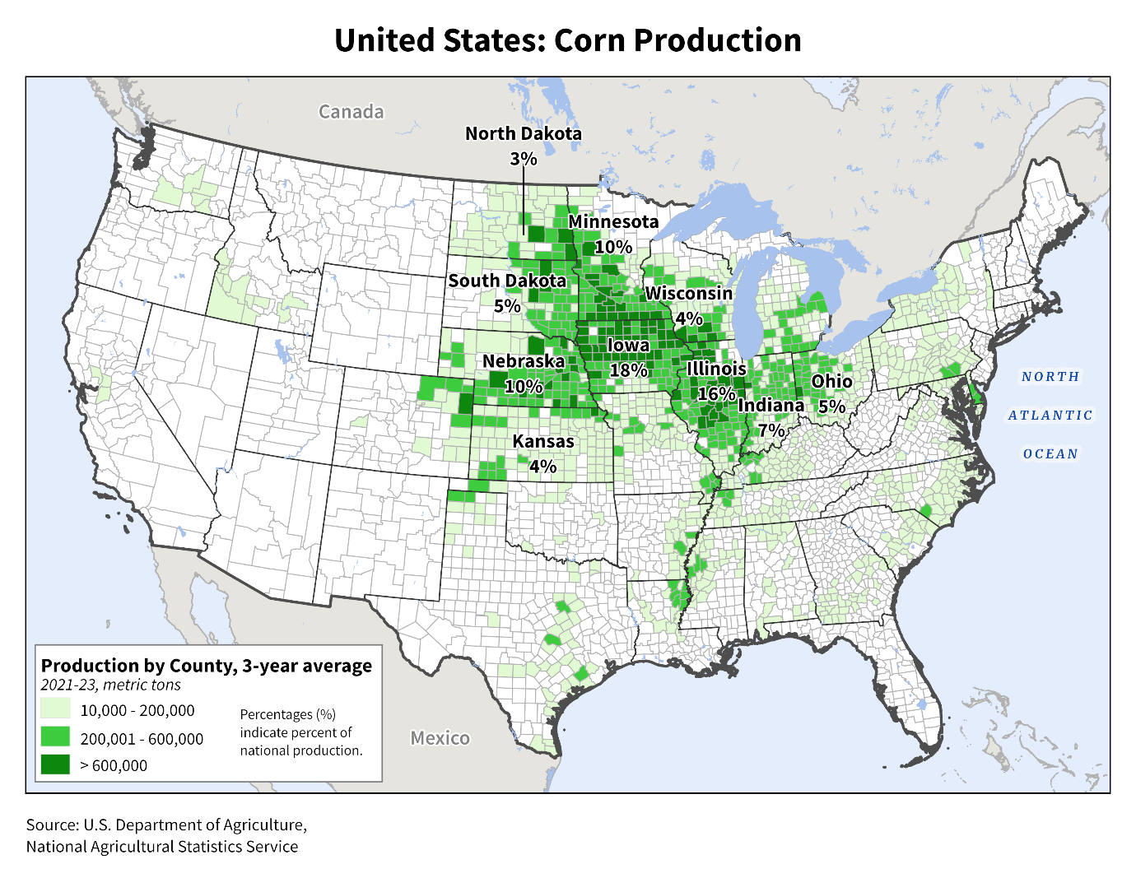
Figure 4.2 United States Corn Production. Source: USDA FAS

Figure 4.3 U.S. Average Corn Yield, 2014/2015 to 2024/2025. Data Source: USDA FAS

Figure 4.4 U.S. Corn Planted and Harvested Area, 2014 to 2023. Data Source: USDA NASS QuickStats
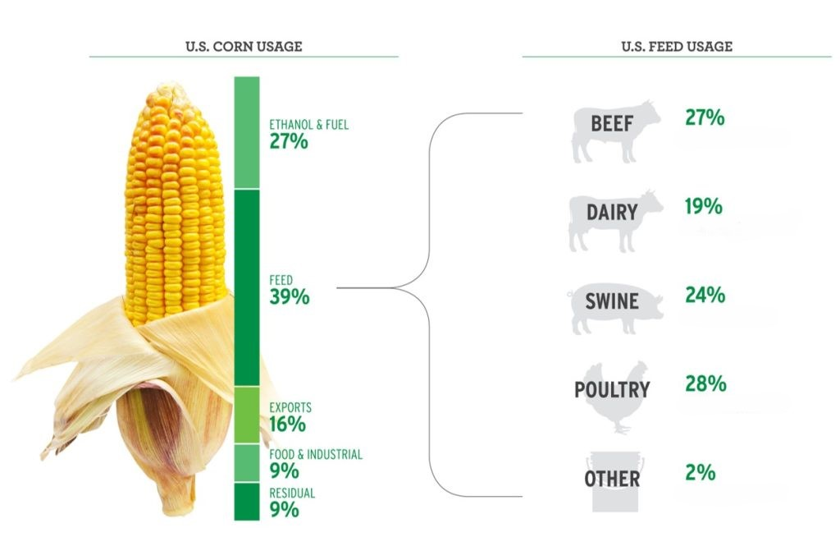
Figure 4.5 Usage of Corn in the United States (Source: Indiana Corn and Soybean Board, n.d.)

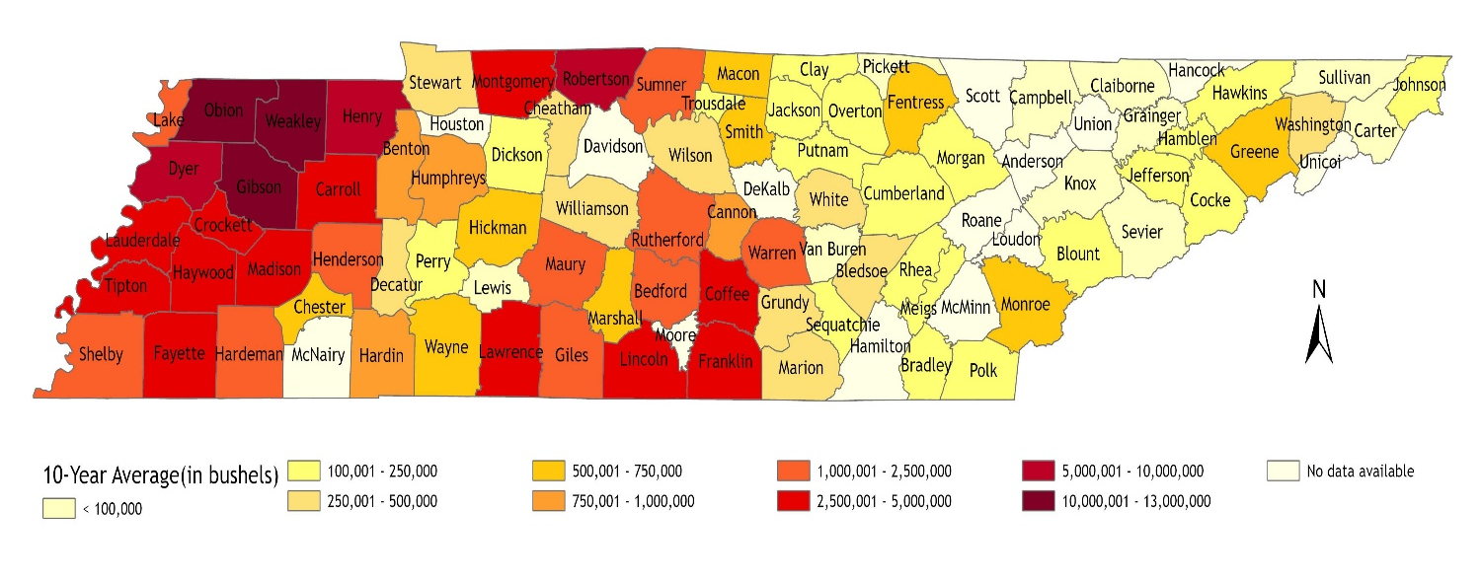
Figure 4.6 Tennessee Corn Production, 10-Year Average (2014-2023). Data Source: USDA NASS

Tables
Table 4.1 Corn Destinations in East Tennessee

Destination (East Tennessee) | County
Ag Central Farmers Cooperative | Blount
Ag Central Farmers Cooperative | Blount
Ag Central Farmers Cooperative | Loudon
Ag Central Farmers Cooperative | Loudon
Ag Central Farmers Cooperative | Roane
Ag Central Farmers Cooperative | Monroe
Ag Central Farmers Cooperative | Mcminn
Ag Central Farmers Cooperative | Monroe
Ag Central Farmers Cooperative | Mcminn
Ag Central Farmers Cooperative | Meigs
Archer-Daniels-Midland (ADM) | Hamilton
Archer-Daniels-Midland (ADM) | Hamilton
Archer-Daniels-Midland (ADM) | Bradley
Ardent Mills, LLC | Hamilton
Cargill | Loudon
East Tennessee Feed & Seed | Monroe
Hansen- Mueller Co. | Bradley
HDC, LLC - Pennine Farm Supply | Roane
HDC, LLC - Pennine Farm Supply | Rhea
Koch Foods | Hamilton
M&M Farm Supply | Washington
Morristown Milling Co | Hamblen
Mossy Creak Mining LLC | Jefferson
Pilgrims Pride Corp | Hamilton
Primary Products Grain LLC | Loudon
ProTrition Feeds | Blount
The Andersons Inc. | Union

Table 4.2 Corn Destinations in Middle Tennessee

Destination (Middle Tennessee) | County
Ag1 Farmers Coop | Putnam
Ag1 Farmers Coop | Overton
Agmark Intermodal Systems Inc | Davidson
Archer-Daniels-Midland (ADM) | Davidson
Aviagen Feed Mill | Bledsoe
Baggett Grain | Robertson
Baggett Grain | Robertson
Cargill | Davidson
Chester County Grain | Hardin
Coffee Farmers Cooperative | Coffee
Cumberland Farmers Co-op | Cumberland
Fandrich Farm Supply | Franklin
FBN CM LLC | Davidson
Fentress Farmers Cooperative | Fentress
First Farmers Co-op | Decatur
First Farmers Co-op | Hardin
Franklin Farmers Coop | Franklin
Franklin Farmers Coop | Franklin
Gavilon Grain | Humphreys
General Hardware & Supply | Perry
Hopkinsville Elevator Co. Inc. | Montgomery
Humphreys Farmers Co-Op | Humphreys
Kennessee Elevator | Montgomery
Lewisburg Farm Center | Marshall
Lynchburg Grain Co | Moore
Macon Trousdale Farmers Coop | Macon
Martin Daniel Farms | Cannon
Maury Farmers Cooperative | Maury
Nick Harrell Farms | Warren
Performance Feeds, LLC | Macon

Table 4.3 Corn Destinations in Middle Tennessee (Continued)

Destination (Middle Tennessee) | County
Pine Dell Feed Mill | Van Buren
ProTrition Feeds | Rutherford
Rutherford Farmers Co-op | Cannon
Rutherford Farmers Co-op | DeKalb
Rutherford Farmers Co-op | Rutherford
Rutherford Farmers Co-op | Rutherford
Shenandoah Mills | Wilson
Smith Farmers Co-op | Smith
Smith Grain Inc. | Warren
Summitville Grain and Feed | Coffee
Tennessee Farmers Co-Op | Rutherford
TN Valley Commodities, LLC. | Lawrence
TN Valley Commodities, LLC. | Giles
TN Valley Commodities, LLC. | Lawrence
TN Valley Commodities, LLC. | Lincoln
Tyson | Davidson
Tyson | Bedford
Tyson | Franklin
United Farm & Home Cooperative | Humphreys
United Farm & Home Cooperative | Maury
United Farm & Home Cooperative | Maury
Viterra USA Grain | Humphreys
Wayne Farmers Coop | Wayne
Wills Commodities Trading, LLC | Sumner
White County Farmers Co-op | White
Williamson Farmers Cooperative | Williamson
Williamson Farmers Cooperative | Williamson
Wilson Farmers Co-Op | Wilson
Woodall Grain Company | Coffee
Woodall Grain Company | Franklin
Woodall Grain Company | Franklin
Woodall Grain Company | Lincoln
Woodall Grain Company | Lincoln

Table 4.4 Corn Destinations in West Tennessee

Destination (West Tennessee) | County
Archer-Daniels-Midland (ADM) | Shelby
Archer-Daniels-Midland (ADM) | Shelby
Archer-Daniels-Midland (ADM) | Shelby
Archer-Daniels-Midland (ADM) | Madison
AG&N Ag Supply | Mcnairy
Cargill | Lauderdale
Cargill | Shelby
Cargill | Shelby
Cargill | Shelby
Chester County Grain | Chester
Consolidated Grain and Barge Co. (CGB) | Dyer
Consolidated Grain and Barge Co. (CGB) | Shelby
Dyersburg Elevator | Dyer
Ervin Feed & Grain | Obion
Faulkner Family Grain, LLC. | Chester
First Farmers Co-op | Chester
First Farmers Co-op | Henderson
Green Plains Grain Obion | Obion
Huffstetler & Sons Seed Co. | Weakley
Hurt Seed Company, INC | Lauderdale
Mason Hall Grain | Obion
Obion Farmers Co-op | Obion
Obion Grain Co. | Gibson
Obion Grain Co. | Obion
Obion Grain Co. | Obion
ProTrition Feeds | Madison
Robinson & Belew, Inc. | Weakley
Rogers Farm Supply | Henderson
Ronnie Bates Farm, LLC | Weakley
Spain Brothers Milling Co. LLC | Weakley
Tosh Farms | Henry
Tosh Farms | Henry
Turner Grain Company | Weakley

Table 4.5 Corn Destinations in West Tennessee (Continued)

Destination (West Tennessee) | County
Tyson | Gibson
Tyson | Obion
Tyson | Dyer
Tyson | Obion
Tyson | Dyer
Tyson | Gibson
Tyson | Gibson

Table 4.6 Corn Destinations in Adjacent States

Destination | County | Destination | County
North Carolina | Alamance | North Carolina | Lee
North Carolina | Alexander | North Carolina | Lincoln
North Carolina | Alleghany | North Carolina | McDowell
North Carolina | Anson | North Carolina | Macon
North Carolina | Ashe | North Carolina | Madison
North Carolina | Avery | North Carolina | Mecklenburg
North Carolina | Buncombe | North Carolina | Mitchell
North Carolina | Burke | North Carolina | Montgomery
North Carolina | Cabarrus | North Carolina | Moore
North Carolina | Caldwell | North Carolina | Orange
North Carolina | Caswell | North Carolina | Person
North Carolina | Catawba | North Carolina | Polk
North Carolina | Chatham | North Carolina | Randolph
North Carolina | Cherokee | North Carolina | Richmond
North Carolina | Clay | North Carolina | Rockingham
North Carolina | Cleveland | North Carolina | Rowan
North Carolina | Davidson | North Carolina | Rutherford
North Carolina | Davie | North Carolina | Stanly
North Carolina | Durham | North Carolina | Stokes
North Carolina | Forsyth | North Carolina | Surry
North Carolina | Gaston | North Carolina | Swain
North Carolina | Graham | North Carolina | Transylvania
North Carolina | Guilford | North Carolina | Union
North Carolina | Haywood | North Carolina | Watauga
North Carolina | Henderson | North Carolina | Wilkes
North Carolina | Iredell | North Carolina | Yadkin
North Carolina | Jackson | North Carolina | Yancey

Table 4.7 Corn Destinations in Adjacent States (Continued)

Destination | County | Destination | County
Alabama | Blount | Georgia | Banks
Alabama | Calhoun | Georgia | Barrow
Alabama | Cherokee | Georgia | Bartow
Alabama | Cleburne | Georgia | Carroll
Alabama | Colbert | Georgia | Catoosa
Alabama | Cullman | Georgia | Chattooga
Alabama | DeKalb | Georgia | Cherokee
Alabama | Etowah | Georgia | Clarke
Alabama | Fayette | Georgia | Cobb
Alabama | Franklin | Georgia | Dade
Alabama | Jackson | Georgia | Dawson
Alabama | Jefferson | Georgia | DeKalb
Alabama | Lamar | Georgia | Douglas
Alabama | Lauderdale | Georgia | Elbert
Alabama | Lawrence | Georgia | Fannin
Alabama | Limestone | Georgia | Floyd
Alabama | Madison | Georgia | Forsyth
Alabama | Marion | Georgia | Franklin
Alabama | Marshall | Georgia | Fulton
Alabama | Morgan | Georgia | Gilmer
Alabama | Pickens | Georgia | Gordon
Alabama | St. Clair | Georgia | Gwinnett
Alabama | Shelby | Georgia | Habersham
Alabama | Talladega | Georgia | Hall
Alabama | Tuscaloosa | Georgia | Haralson
Alabama | Walker | Georgia | Hart
Alabama | Winston | Georgia | Jackson

Table 4.8 Corn Destinations in Adjacent States (Continued)

Destination | County | Destination | County
Georgia | Lumpkin | Kentucky | Calloway
Georgia | Madison | Kentucky | Carlisle
Georgia | Murray | Kentucky | Christian
Georgia | Oconee | Kentucky | Clinton
Georgia | Oglethorpe | Kentucky | Cumberland
Georgia | Paulding | Kentucky | Fulton
Georgia | Pickens | Kentucky | Graves
Georgia | Polk | Kentucky | Hickman
Georgia | Rabun | Kentucky | Hopkins
Georgia | Rockdale | Kentucky | Livingston
Georgia | Stephens | Kentucky | Logan
Georgia | Towns | Kentucky | Lyon
Georgia | Union | Kentucky | McCracken
Georgia | Walker | Kentucky | Marshall
Georgia | Walton | Kentucky | Metcalfe
Georgia | White | Kentucky | Monroe
Georgia | Whitfield | Kentucky | Muhlenberg
Kentucky | Adair | Kentucky | Russell
Kentucky | Allen | Kentucky | Simpson
Kentucky | Ballard | Kentucky | Todd
Kentucky | Barren | Kentucky | Trigg
Kentucky | Butler | Kentucky | Warren
Kentucky | Caldwell

Table 4.9 Average Transportation Cost ($) per MT

Average $ per MT |  | Region
 |  | East | Middle | West
Scanario | 1 | 4.006 | 2.444 | 2.112
Scanario | 2 | 4.450 | 2.534 | 2.113
Scanario | 3 | 4.160 | 1.882 | 1.655
Scanario | 4 | 4.662 | 3.538 | 3.607
Scanario | 5 | 18.147 | 18.892 | 13.113
Scanario | 6 | 11.260 | 8.574 | 4.149

Table 4.10 Percentage Change in Average Transportation Cost ($) per MT

% change in average $ per MT |  | Region
 |  | East | Middle | West
Scanario | 2 | 11.067 | 3.699 | 0.048
Scanario | 3 | 3.828 | -22.993 | -21.642
Scanario | 4 | 16.352 | 44.782 | 70.780
Scanario | 5 | 352.952 | 673.067 | 520.829
Scanario | 6 | 181.050 | 250.874 | 96.416

VITA

Priya Barua is from Chattogram, Bangladesh, and earned both her bachelor’s and master’s degrees in Economics from the University of Chittagong. She continued her academic journey at the University of Tennessee, Knoxville, where she pursued a Master of Science in Agricultural and Resource Economics. Upon graduation, Ms. Barua will begin her Ph.D. in the Department of Economics at the University of Tennessee’s Haslam School of Business. She would like to thank her advisor, Dr. S. Aaron Smith, for his invaluable mentorship and encouragement.

Soybean marketing year is September 1 through August 31.
77 out of 95 counties in Tennessee have production reported by USDA NASS.
A 35% adjustment was chosen as the average 10-year (2014 to 2023) production in Tennessee fluctuated between -35% and +70% across different counties.
The number of j varies for different scenarios.

