A Low-Power Approach for Front End

Biological Signal Conditioning

A Thesis Presented for the
Master of Science Degree
The University of Tennessee, Knoxville

Logan Smith Taylor
December 2014

Copyright © 2014 by Logan Taylor
All rights reserved.

Dedication

This thesis is dedicated to my grandmother, Viola Siebenthal Ergen, who departed this life, May 21, 2013. She is greatly missed by all of her family. Without her wise words and support this would never have become what it is.
Acknowledgements

Thanks to all of those who help and supported me during this endeavor. I would first like to thank the faculty and staff of the Department of Electrical and Computer Engineering for their support and efforts in this project. Specifically I would like to thank my mentor and professor Dr. Syed Islam for his constant assistance in completing this project, also for his teaching efforts in CMOS design. A special thank you to Dr. Charles Britton for his adamant guidance, and insight into charge amplifiers and ultimately the overall outcome of this design. Additionally a big thank you to Dr. Benjamin Blalock for teaching me the fundamentals of analog circuit design, which sparked my interest in this field of study. Also to soon to be Ph.D(s) Farhan Quaiyum, Ifana Mahbub, and Terence Randall, thank you for putting up with my questions and constantly needing your assistance on design or calculations. And my constant lab companions, Jake Shelton and Kelly Griffin for keeping me company in the laboratory for coursework and design questions.

I am especially grateful for the Graduate Teaching Assistantship I was accepted into for the duration of my Masters work. Without the GTA I would not have been able to pursue my Master of Science degree in a timely manner. My fellow students and colleagues deserve thanks as well for providing different viewpoints on many of the issues that were encountered during the project. I believe that family and friends deserve the most thanks for the support during my graduate studies. Without their interest in my work the completion of this project could be far off in the future. I want to thank my parents for making education a very high priority for me. And finally thanks to my brother, Mason, for his help and editing contributions in this work.

For me, completing a project like this thesis was only possible because I had excellent guidance, insightful wisdom and constant support and encouragement from everyone mentioned above. I am deeply thankful for the opportunity to work with such a great group of people.

Abstract

In a lab-on-a-chip application, the measurement of small analog signals such as local temperature variation often involves the detection of very low-level signals in a noisy micro-scale environment. This is true for other biomedical monitoring systems. These systems observe various physiological parameters or electrochemical reactions that need to be tracked electrically. For temperature measurement pyroelectric transducers represents an efficient solution in terms of speed, sensitivity, and scale of integration, especially when prompt and accurate temperature monitoring is desired.

The ability to perform laboratory operations on a small scale using miniaturized lab-on-a-chip (LOC) devices is a promising biosensing technique. The advantages of LOC are the small time of analysis, the low reagent costs, and the reduced amount of chemical wastes. The application of portable, easy-to-use, and highly sensitive LOC biosensors for real-time detection could offer significant advantages over current analytical methods.

This thesis presents the design and analysis of a low frequency charge amplifier suited for biological sample applications, with a wide window for signal size and speed. The charge amp has been fabricated in a commercial 180nm CMOS process. The design has been tested for signals in 100Hz-100kHz range with a max charge of 250nC.
This thesis begins with a study of the transducer that produce the charge for the charge amplifier. Next it moves into the design of low power charge sensitive amplifiers, along with an analysis of various components essential to the makeup of the design. The charge amp is then characterized using simulation results. Finally, the test setup is presented and the measurement results are compared with those from simulation.

Table of Contents

Chapter 1 Introduction and Basic of Amplifiers 1
1.1 Motivations 1
1.2 Research Goals 4
1.3 Overview 4
Chapter 2 Literature Review 6
2.1 Introduction to Lab-on-a-chip (LOC) 6
2.1.1 Operating Principles of Electrochemical Biosensors 7
2.1.2 Amperometric devices 9
2.1.4 Piezoelectric devices 11
2.1.7 Pyroelectric devices 14
2.2 System Electronics 17
2.2.1 Signal Formation 18
2.2.2 Sensing Circuit 20
2.3 Charge Sensitive Amplifiers 23
2.3.1 Theory of Conversion 24
2.3.3 Design Problems with Charge Amplifiers 26
2.4.5 Conclusion 27
Chapter 3 Design of Front-End Electronics 28
3.1 Preamplifier 28
3.2 Feedback 30
3.3 Current Attenuator 37
3.4 Final Design 43
3.5 Layout Techniques 45
Chapter 4 Results and Discussion 47
4.1 Breadboard results 51
4.2 Current Divider design 54
Chapter 5 Conclusions and Recommendations 60
5.1 Conclusion 60
List of References 61
Appendix 66

List of Tables

Table 1: Various Effects in Ferroelectric Materials 15
Table 2: Component Values of Circuit Parameters 44
Table 3: Values for Test Board and Charge Amplifier Circuit 47
Table 4: Component Values for Test Board Parameters 47
Table 5: Current Output from the Test Board Varying the Pulse Width. 51
Table 6: Comparing the Different Designs and Simulation. 59

List of Figures

Figure 1.1 Schematic of an optical lab-on-a-chip system, for the analysis of enzymes within a biological sample. 2
Figure 1.2 Examples of implantable and lab-on-a-chip technology. Top 3
Figure 2.1: Flow chart of a biosensor. 7
Figure 2.2: Electrochemical biological sensor using the Three Electrode System [12]. 8
Figure 2.3: Equivalent Circuit Representation of Three Electrode System. 9
Figure 2.4: Amperometric biosensor with transduction element. 10
Figure 2.5: Clark Oxygen Sensor and example of an amperometric sensor. 10
Figure 2.6: Piezoelectric crystal as a capacitor 12
Figure 2.7: Forward Piezoelectric Effect (a) and Reverse Piezoelectric Effect (b) 13
Figure 2.8: Poling of pyroelectric crystal in a strong electric field. (a)randomly oriented (b) dipoles aligning with electric field (c) dipoles frozen at high temperature. 14
Figure 2.9: General Pyroelectric Detector Schematic. 18
Figure 2.10: Equivalent Circuit of Pyroelectric Transducer. 19
Figure 2.11: General Charge Amplifier Circuit 20
Figure 2.12: General Transimpedance Charge Amplifier Circuit 21
Figure 2.13: The Basic Sensing Circuit using Charge Integrator 22
Figure 2.14: Equivalent Circuit model 23
Figure 2.15: Example circuit of pyroelectric sensor with preamplifier connected. 23
Figure 2.16: Equivalent circuit of pyroelectric transducer connected with preamplifier 25
Figure 2.17: Amplifier input pair noise model. 27
Figure 3.1: Block view of implemented amplifier design 30
Figure 3.2: Basic feedback with capacitive and resistive element. 30
Figure 3.3: Single MOSFET feedback network. 31
Figure 3.4: Feedback network as presented in [6]. 32
Figure 3.5: Functional view of implemented amplifier design 33
Figure 3.6: Pseudo-resistor implemented on charge amplifier. 35
Figure 3.7 : Circuit schematic of a basic current mirror. 37
Figure 3.8 : A basic current mirror with currents. 38
Figure 3.9 : A basic PMOS current mirror. 39
Figure 3.10: Cascode current mirror. 40
Figure 3.11: A Wide Swing Current Mirror. 41
Figure 3.12: Implemented Current mirror. 42
Figure 3.13: Circuit Schematic of the Final Design. 44
Figure 3.14: Simulation of proposed circuit, response is 50mV peak for 50nC signal. 45
Figure 3.15: Layout of the final design. 46
Figure 3.16: Micrograph of Chip 46
Figure 4.1: Discrete test circuit for converting voltage signals to current. 48
Figure 4.2: Photograph of the Test board. 49
Figure 4.3: Current Output from test board. 50
Figure 4.4: Work as presented in [25]. 51
Figure 4.5: Schematic diagram of the implemented circuit, composed of a charge amplifier, which detects charge variations above PVDF surfaces followed by a buffer used to separate the stages. [25] 52
Figure 4.6: Response of discrete charge amplifier with 25° C temperature change. [25] 53
Figure 4.7: Response of Chip 1 and Chip 2 with 100nC charge on the input 55
Figure 4.8: Response of circuit with 100nC charge on the input. Line is the average value of the closest two data points, this provides a line to model the signal with. 55
Figure 4.9: Response of circuit measuring the dynamic range of the transducer 10nC to 100nC 56
Figure 4.10: Response of small charge signals between 10nC and 2nC unstable response occurs. . 57
Figure 4.11: Response of larger charge signal than designed for. 58

Chapter 1
Introduction and Basic of Amplifiers

1.1 Motivations
Human life can become more comfortable with the integration of technology. Elderly patients in hospitals, the terminally ill, even diabetic patients, can regain their independence through the use of sensors and monitoring technology. The increasing presence of monitoring devices in everyday life has brought many benefits to the patients. With biomolecule detection methods the ability to monitor glucose, lactose, oxygen, and pH levels are allowing healthcare providers to follow diseases more closely and prescribe a more appropriate plan of care. [1] Not only do these new monitoring techniques allow for more individual treatment, they are also safer for the patient. Previously the methods of obtaining the samples allowed for increased risk of infection due to the invasive nature of collection [1]. Aside from being more sanitary, implantable devices are capable of processing advanced measurements. The primary target of such devices is the diabetic patient. The ability to accurately and continuously monitor blood chemistry results in better control the treatment of the disease.
A refocusing of biomedical research and improvement of CMOS processing technologies has led to the realization of minimally invasive, implantable biosensors monitoring devices. With a reduced risk of infection and the ability to continuously monitor a patient, the realization of this lab-on-a-chip (LOC) advancement will undoubtedly result in better health outcomes. LOC is a multidisciplinary research field that combines different analysis techniques carried out using integrated circuits (IC), integrated sensors and, more general micro electro-mechanical devices on the same chip [2]. LOC offer advanced diagnostics capabilities for continuous monitors. While most are not currently implantable, LOC remain minimally invasive, and are characterized by the small blood volume sample needed for complex tests.
Development of continuous monitoring systems offers a substantial advancement over conventional measurement devices. Through the use of lab-on-a-chip and continuous monitors, doctors and other medical personal are able to examine patient’s data almost in real time. By decreasing the intervals between sample collection and test results, doctors are able to provide more timely medical intervention. In addition to this time benefit, data recorded from the devices allow for up to date medical history on the go.
In addition to the benefit for healthcare in first world countries, LOC will soon be an important combatant to terminal illness in other parts of the world. Through humanitarian organizations and philanthropic corporations, LOC can be made cheap enough to build and transport to countries where clean water is still not an everyday reality. By using the lab-on-a-chip systems, detection of HIV/AIDS, Human African Trypanosomiasis (HAT), or everyday pathogens can be done on site increasing the chances that medical care can be administered early enough to save lives. [3,4]

Wearable and implantable devices have the potential to provide significant saving in terms of human life and dollars. In order for this technology to be successful, the design must be directed to inexpensive reproducible devices as well as maintaining accuracy and reliability. CMOS technologies have advantages such as small volume and reliable operation, in addition to manufacturing repeatability. Through the use of CMOS design more individualized methods can be constructed. Fig. 1.1 offers a scheme for how an integrated circuit lab on chip could be implemented as a portable platform.

Figure 1.1 Schematic of an optical lab-on-a-chip system, for the analysis of enzymes within a biological sample.

Figure 1.2 shows examples of how implantable devices and lab-on-a-chip design can be integrated into the human body. Going from top to bottom, the first example is a contact lens that will measure the glucose concentration in tears for diabetic monitoring. It connects wirelessly to a smart phone or designated wireless receiver to display and record the values. The second example is a microfluidic chamber that can be built to monitor the concentration of multiple biological enzymes or molecules. It would require about a micro liter of blood to operate, which is significantly less than using manual techniques. The third is an illustration of an electrochemical biosensor integrated on a microfluidic chip.

Figure 1.2 Examples of implantable and lab-on-a-chip technology. Top
to bottom: Contact Lens Glucose sensor, Beta cell glass lab on a chip, and generic integrated circuit lab on a chip.

From the illustrations above, design of these systems emphasizes small size and easy maneuverability, while again maintaining the precision and accuracy of much larger systems. The last system above is broken down into three main sections the microfluidic chamber, then the processing and the power supply. A selling point of microfluidic is there is no need for a power supply, however for some more complicated measurements the integrated CMOS circuitry does. However, CMOS technology has allowed both power supply and processing circuitry to scale down. This can be explained by Koomey’s Law and Moore’s Law. By optimizing power distribution on chip we are able to minimize the overall size of the system. The first place to start in optimization is to make more efficient topologies that make use of less complex power schemes. By minimizing the power requirements of the circuit the larger power circuits can be minimized or removed. In order to minimize the power circuits, smaller technologies can be implemented. The second step in reducing the area of a chip is realizing topologies that lump performance and accuracy into smaller circuits, which then goes back to having less of a power requirement. Therefore using smaller technologies allows for better power performance and power efficiency. [5]
Through this trend recent achievements include moving from the printed circuit board (PCB) design with discrete components to the application specific integrated circuit (ASIC), or microchip, design. [6] However, some systems are more easily employed through PCB design and discrete devices. The application of this thesis will be to hurdle the barriers of large component design and move to an ASIC system. In this thesis a pyroelectric sensor that outputs a large amount of charge with be analyzed and a preamplifier for converting the charge to voltage will be presented.

1.2 Research Goals
The purpose of this research is to develop a low-voltage and low-power preamplifier for integration with pyroelectric and piezoelectric sensors, which will be used in lab-on-a-chip platforms similar to the systems shown in Fig. 1.2. These systems differ from the traditional application of charge amplifier due to the slow signal and large amount of charge. The final design will be capable of preforming the conversion from charge to voltage at readable level in the hundreds of milliamps. The final design demonstrates the capability of ASIC design to be implemented in place of traditional discrete systems.

1.3 Overview
In Chapter 1, a lab-on-a-chip system and the corresponding circuit compositions are introduced. This is followed by a discussion on the importance of the low-voltage and low-power design and it implications for the overall system. A low-voltage charge sensitive pre-amplifier for current to voltage conversion is set to be the research goal of this thesis. In Chapter 2, various topologies are introduced, which is followed by the discussion the merits. In Chapter 3, the low-voltage design techniques use in this work will be explained. Following the selection of the appropriate preamplifier design technique, problems associated with the selected topology are discussed. To provide novel circuit design techniques for solving these problems, the details for the implementations of the Charge amplifier are presented in the later part of Chapter 3 along with simulation results. Experimental measurements of the proposed design are shown in Chapter 4. And finally in Chapter 5, conclusions and future work are presented.

Chapter 2
Literature Review
In this chapter, different types of biomedical systems, both implantable and portable lab-on-a-chip, and their working principles are introduced in Section 2.1. Lab-on-a-chip systems are designed to translate a biological signal into a digital signal that can be interpreted by trained individuals. The biological signal is commonly read using electrodes connected to a transducer, which creates a charge that can be altered by electronics to achieve a reliable accurate output. Section 2.2 will explain the flow from signal creation to signal output. In order to do this many different components that make up a detector system will be discussed. The components of detector system are the detector or sensor itself, a charge sensitive preamplifier, a pulse shaper, a discriminator, and other stages that allow for the signal to amplified and filtered for user interaction. The main focus of this work will be the charge sensitive preamplifier and the signal input.

2.1 Introduction to Lab-on-a-chip (LOC)

Since the introduction of soft lithography in the late 1990s, microfluidic and Lab-on-a-chip technologies have given rise to vast numbers of scientific and technological developments [3]. The most well know is the glucose sensor. However, the devices span a broad platform of biological testing concepts, including blood separation, chemical reactions, and integration with various sensing/detecting components. The last category includes working in combination with optics sensing, electrochemical signal sensing, field effect transistors (FET), and nuclear magnetic resonance (NMR) [3]. A lab-on-a-chip system in general consists of two main components, namely, the sensing component, and the microelectronics processing unit [7].
The sensing component is typically, a biosensor consisting of receptors that can sense changes in the sample, an interface architecture where a specific biological or biochemical signal is generated, and the transducer element converting the signal to another form of signals for detection [8]. Biosensors are divided into categories based on the method of signal transduction such as mass, electrochemical, thermal, or optical. Furthermore, biosensors can be classiﬁed as either direct-detection or indirect-detection systems. Direct-detection biosensors are designed such that the specific biochemical reaction, or target analyte, is measured directly by the transducer. In contrast, indirect-detection biosensors are those in which a preliminary biochemical reaction takes place and the products of this reaction are detected by the transducer[9]. Each of these is designed to detect certain biological elements and its concentration at the site of testing. Some recognition elements used in biosensors are: enzymes, nucleic acids, antibodies, whole cells, and receptors. Of these, enzymes are among the most common [10].

2.1.1 Operating Principles of Electrochemical Biosensors

This section attempts to describe operating principles of electrochemically-based biosensors by reviewing the structure and theory. The theory transcends the electrochemical approach, as it is applicable to other transducer types as they are responding to biostimuli and converting it to electrical signals.

Figure 2.1: Flow chart of a biosensor.

As figure 2.1 demonstrates there are a vast number of combinations for biological sample collection and measurement. The primary means of transduction is electrochemical. By the natural of being electrochemical, the transduction element is served by a bioelectrochemical component. As mentioned above the bioelectrochemical components, include enzymes, nucleic acids, antibodies, whole cells, and receptors. Enzymes due to their specific binding capabilities and biocatalytic activity are often the predominant choice in implemented technique. [11]
Characteristically in electrochemistry, the reaction under investigation would either generate a measurable current (amperometric), a measurable potential or charge accumulation (potentiometric) or measurably alter the conductive properties of a medium (conductometric) between electrodes [9]. Each method will be introduced in this section. However something common to each case is that the reactions are generally detected only in close proximity to the electrode surface. Therefore the electrodes themselves are responsible for the performance of the biosensors. Detection ability and sensitivity are based on the chosen function, the electrode material, its surface modification, and its dimensions. Electrochemical sensing usually requires a three electrode system. An example of the electrode system is shown in Figure 2.2.

Figure 2.2: Electrochemical biological sensor using the Three Electrode System [12].

First a reference electrode, commonly made from Ag/AgCl, is kept at a distance from the reaction site in order to maintain a known and stable potential. Second a counter or auxiliary electrode, establishes a connection to the electrolytic solution so that a current can be applied to the working electrode. Lastly the working electrode, also known as the sensing or redox electrode, serves as the transduction element in the biochemical reaction. These electrodes should be both conductive and chemically stable. Therefore, platinum, gold, carbon (e.g. graphite) and silicon compounds are commonly used, depending on the analyte [12]. Most modern amperometric-based sensing methodologies typically employ a three-electrode sensor system, due to the difficulty for the system to control an electrode by supplying a constant voltage and a varying current at the same time. The three-electrode electrochemical cell can also be modeled by physical resistors and capacitors as shown in Fig. 2.3.
Here, the value of resistors RWE, RRE and RCE represent the Faradic resistances of the working, reference and counter electrodes, respectively, while the value of resistors RS1 and RS2 represent the solution (analyte) resistances.

The resistance of RWE can be calculated in Eq.(2.1) as,

$R_{WE}=\frac{E_{i}}{I_{F}}$ (2.1)

The resistance of RCE is much smaller than that of RWE since the size of the counter electrode is normally developed to be much smaller than that of the working electrode. The resistances of RS2 and RS1 are even more negligible compared to the rest. The value of capacitors CWE and CCE correspond to the electrode double-layer capacitances. They are proportional to the surface areas of each electrode.

Figure 2.3: Equivalent Circuit Representation of Three Electrode System.

2.1.2 Amperometric devices

The potentiostat system mentioned above is considered an amperometric device. Amperometric devices continuously measure current resulting from the oxidation or reduction of an electro active species in a biochemical reaction [3]. The purpose of such sensors is to generate a potential difference E_{i} between the working and reference electrodes such that specific analyte can be detected.

Another example of amperometric sensing is the Clark oxygen electrode. This is the most basic form of amperometric biosensors, where a current is produced in proportion to the oxygen concentration. This is measured by the reduction of oxygen at a platinum working electrode in reference to an Ag/AgCl reference electrode at a given potential [13]. The system is seen below in Figure 2.5 along with the chemical reaction occurring in the biosensor.

Figure 2.4: Amperometric biosensor with transduction element.

Ag anode 4Ag + 4Cl⁻ → 4AgCl + 4e⁻
Pt cathode O₂ + 4H⁺ + 4e⁻ → 2H₂O

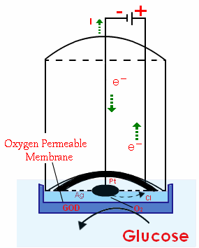

Figure 2.5: Clark Oxygen Sensor and example of an amperometric sensor.

The rate of electrochemical reduction depends on the rate of diffusion of the oxygen from the bulk solution, which is directly related to the concentration gradient and the bulk oxygen concentration. The reduction allows a current to flow; this creates a potential difference, which is recorded by the transducer. Despite the disadvantage of this often indirect sensing system, it is claimed that amperometric devices maintain sensitivity superior to many other devices [14].

2.1.4 Piezoelectric devices

Biosensors are not limited to the detection of purely biological substances, some sensors measure physical characteristics such as luminescence, stress, or heat. Piezoelectric behavior is where an electric potential may be induced in the material through the application of a force and vice versa. Examples of naturally occurring materials that exhibit this type of behavior are quartz crystals and Rochelle salt. There are many artificial piezoelectric materials such as polyvinylidene fluoride (PVDF), barium titanate (BaTiO3), lithium sulphate (LS), and lead zirconium titanate (PZT). The conversion of electrical pulses to mechanical movement and the conversion of mechanical movement back into electrical energy is the basis for piezoelectric crystals. The active element is the heart of the transducer as it converts the electrical energy to mechanical energy and vice versa. The active element is basically a piece of polarized material (i.e., some parts of the molecule are positively charged, while other parts of the molecule are negatively charged) with electrodes attached to two of its opposite faces. When an electric field is applied across the material, the polarized molecules will align themselves with the electric field, resulting in induced dipoles within the molecular or crystal structure of the material. This alignment of molecules cause the material to change dimensions. This phenomenon is known as electrostriction. In addition, a permanently polarized material, such as quartz (SiO2) or barium titanate (BaTiO3), will produce an electric field when the material changes dimensions as a result of an imposed mechanical force. This phenomenon is known as the piezoelectric effect.[15]
In order to utilize this physical principle to make a sensor to measure force, we must be able to measure the surface charge on the crystal. A common method of using a piezo-electric crystal to make a sensor is to use two metal plates to sandwich the crystal, thus making a capacitor. This capacitor is seen in the figure below.
As mentioned previously, an external force causes a deformation of the crystal and results in a charge that is a function of the applied force. In its operating region, a greater force will result in more surface charge. This charge results in a voltage.

$V= \frac{Q_{f}}{C}$ (2.2)

Figure 2.6: Piezoelectric crystal as a capacitor

Where Q f is the charge resulting from a force f, and C is the capacitance of the device. In the manner described above, piezoelectric crystals act as transducers that turn force or mechanical stress into electrical charge, which, in turn, can be converted into a voltage. Alternatively, if one were to apply a voltage to the plates of the system described above, the resultant electric field would cause the internal electric dipoles to realign, which would cause a deformation of the material. An example of this, reverse piezoelectric effect is speakers.

Figure 2.7: Forward Piezoelectric Effect (a) and Reverse Piezoelectric Effect (b)

Figure 2.9 shows two possible configurations in which the piezoelectric sensor can be operated. In the first case, the force axis and the voltage difference that is being measured are both longitudinal, whereas in the second case, they are transverse. [14]
To model the piezoelectric sensors, one can take into account the following sets of relationships. The charge induced in the crystal is directly proportional to the deformation in the crystal and the voltage induced is similarly proportional to the force applied. So the relationships can be written as,
$Q=n_{tr}∆x$(2.3)
$F=n_{tr}V$ (2.4)
where ntr is the transformer modulus (or the proportionality factor). Relating force to stress and subsequently to strain and displacement this same equation can be modified such that:

$n_{tr}=\frac{nd_{33}AE}{x}$ (2.5)

where d33 is the piezoelectric charge constant, also know as piezoelectric coefficient, along the 3-3 direction or the longitudinal direction. If the force were perpendicular to the direction of voltage measurement, the constant would be different and we would represent it using the symbol d31. Finally, on the electrical side, the voltage and the charge are related through the capacitance in the piezo crystal in a similar manner. Where n is the number of layers [15]. The important thing to note here is the charge residing in the capacitor. The later sections of this chapter will describe how to remove this charge and use it as an electrical signal.

2.1.5 Pyroelectric devices

Similar to piezoelectric devices in operation principals, pyroelectric devices sense heat change instead of motion. Heat monitoring is especially useful for enzymatic reactions, the generation of heat (enthalpy change) can be used easily and generally. The enzyme provides the selectivity and the reaction enthalpy cannot be confused with other reactions from species in a typical biologic mixture. The ideal aim is to measure total evolved heat. In real systems there is always heat loss. As a result, temperature difference before and after evolution is measured most often. It has to be assumed that the heat capacity of the specimen and container is constant over the small temperature range usually measured. The simplest transducer is a thermometer coated with the enzyme that permits the selected reaction to proceed. Thermistors are used rather than thermometers or thermocouples due to the sensitivity of heat change required for these measurements [3]. The evolving leader in temperature measurement however is the pyroelectric transducer.
As with the piezoelectric case above a pyroelectric material can be considered a composition of a large number of minute crystallites, where each behaves as a small electric dipole. All these dipoles are randomly oriented, however, along a preferred direction. Above a certain temperature, known as the Curie point, the crystallites have no dipole moment. This is emphasized by the figure below.

Figure 2.8: Poling of pyroelectric crystal in a strong electric field. (a)randomly oriented (b) dipoles aligning with electric field (c) dipoles frozen at high temperature.

Table 1: Various Effects in Ferroelectric Materials

 | Output |  | Charge | Magnetization |  | Temperature
Input |  |  | Current |  | Strain |  | Light
Electric field |  |  | Permittivity Conductivity | Electro magnetic effect | Converse piezoeffect | Electric caloric effect | Electro-optic effect
Magnetic field |  |  | Magnetic electric effect | Permeability | Magnetostriction | Magnetic caloric effect | Magnetic optic effect
Stress |  |  | Piezoelectric effect | Piezomagnetic effect | Elastic contant | ---- | Photoelastic effect
Heat |  |  | Pyroelectric effect | ---- | Thermal expansion | Specific heat | ----
Light |  |  | Photovoltatic effect | ---- | Photostriction | ---- | Refractive Index
 |  |  |  | Diagonal coupling |  | Actuator
 |  |  |  |  |  | Sensor

When temperature of a pyroelectric material changes, the material becomes polarized. In other words, an electric charge appears on its surface. It should be clearly understood that the polarization occurs not as a function of temperature but only as function of a change in temperature of the material. Temperature changes can cause shortening or elongation of individual dipoles. It can also affect the randomness of the dipole orientations due to thermal agitation. These phenomena are called primary pyroelectricity. There is also secondary pyroelectricity, which, in a simplified way, can be described as a result of the piezoelectric effect, that is, a development of strain in the material due to thermal expansion. [17] Therefore some material can be both piezoelectric and pyroelectric.
The dipole moment, M, of the bulk pyroelectric sensor is

$M = μAh$ (2.6)

Where μ is the dipole moment per unit volume, A is the sensor’s area, and h is the thickness. The charge, Qa, which can be picked up by the electrodes, develops the dipole moment across the material:

$M_{0}=Q_{a}h$ (2.7)

M must be equal to M₀ so that

$Q_{a}= μA$ (2.8)

As the temperature varies, the dipole moment also changes, resulting in an induced charge. Thermal absorption can be related to a dipole change so that μ must be considered a function of both temperature, T_{a}, and an incremental thermal energy, ΔW, absorbed by the material:

${∆Q}_{a}= Aμ(T_{a},∆W$ (2.9)

As the temperature varies, the dipole moment also changes, resulting in an induced charge. Thermal absorption can be related to a dipole change so that μ must be considered a function of both temperature, T_{a}, and an incremental thermal energy, ΔW, absorbed by the material:

${∆Q}_{a}= Aμ(T_{a},∆W)$ (2.10)

The aforementioned equation shows the magnitude of electric charge resulting from absorption of thermal energy. To pick up the charge, the pyroelectric materials are fabricated in the shapes of a flat capacitor with two electrodes on opposite sides and the pyroelectric material serving as a dielectric, similar to figure 2.8. How the produced charge will again be described below.

2.2 System Electronics

In this section we will be focusing a specific design for a pyroelectric transducer and preamplifier. Lab-on-a-chip-based analysis has made significant progress towards acceptance as a viable tool for use in biomedical investigation. As far as microbiological systems are concerned, sensor technology plays a key role in measurement accuracy and, as the scale of integration increases, the realization of higher performance sensors becomes an essential requirement. In applications such as micro-electrophoresis and polymerase chain reaction (PCR), in which thermal monitoring of a biological fluid is required, conventional equipment is replaced by the lab-on-a-chip thanks particularly to its high surface-to-volume ratio and the short thermal path [18]. Different transducer technologies, such as those based on thermocouples, thin-film-on-silicon and bolometers were investigated for temperature and heat-flux monitoring. Then infrared (IR) radiation was used for non-intrusive measurements of local temperature [18]. Finally, techniques based on a temperature gradient were employed for the separation of analytes into microchannels through the use of the fluorescence thermometer. In the case of microelectrophoresis, the application of strong electric fields creates the local heating, especially in the reservoirs, and thus the degradation of biological samples. It is in this degradation of samples that monitoring becomes difficult. One approach to gaining the ability to monitor the sample’s temperature is through the use of pyroeletric transducers. They are again composed of a material that does not require any electric source to work only the signal itself requires electronics, making sample monitoring a good fit.
The main advantages of employing the pyroelectric transducer are faster response, greater flexibility in terms of shape and layout, and again the lack of an energy supply. The drawback concerning its use as a temperature transducer is depolarization at relatively high temperatures and its dynamic response as compared to other devices.
In previous work [18] investigation into the application of the ferroelectric polymer polyvinylidene fluoride (PVDF) was done for the monitoring of temperature variations of biological substances in a microchannel system. The development of a polymertransducer allows the use of active elements having reduced dimensions for localized temperature measurement. The result of the paper was a pyroelectric transducer that will monitor the temperature change in biological systems. The work also consisted of a readout circuit which will be the focus of this paper. The system will be broken down in the sections below.

2.2.1 Signal Formation

When a change in temperature is detected by a pyroelectric detector, ions are created. This change in temperature event creates an accumulated charge which is proportional to the detector physical properties.
Electronically, a Polyvinylidene fluoride (PVDF) pyroelectric detector is essentially a capacitor that can be charged by an influx of heat. The detector does not require any external electrical bias (excitation signal). It needs only an appropriate electronic interface circuit to measure the charge. Figure 2.11 shows a pyroelectric detector (pyrosensor) connected to a resistor Rb that represents either the internal leakage resistance or a combined input resistance of the interface circuit connected to the sensor. The equivalent electrical circuit of the sensor is shown in Figure 2.12.

Figure 2.9: General Pyroelectric Detector Schematic.

The circuit consists of three components: (1) the current source generating a heat-induced current, i (remember that a current is a movement of electric charges); (2) the sensor’s capacitance, C; and (3) the leakage resistance, R_{b}. Since the leakage resistance is very high and often unpredictable, an additional bias resistor is often connected in parallel with the pyroelectric material. The value of that resistor is much smaller than the leakage resistance, yet its typical value is still on the order of 10¹⁰ Ω (10 GΩ).
The output signal from the pyroelectric sensor can be taken in the form of either charge (current) or voltage, depending on the application. Being a capacitor, the pyroelectric device is discharged when connected to a resistor, Rb Electric current through the resistor and voltage across the resistor represent the heat flow–induced charge. [17]From the thermal point of view, the pyroelectric element can be modeled by an equivalent circuit, as shown in Fig. 2.12, where W [W/m2] is the heat flux [19].

Figure 2.10: Equivalent Circuit of Pyroelectric Transducer.
Its response is characterized by the thermal time constant τ_{th}, which is the time needed by the detector to electrically respond when a thermal input flux occurs. It can be defined as follows,

$τ_{th}= C R$ (2.11)

so in the design of a temperature sensor, a reduction in thickness of the transducer element leads to a faster temperature transducer. By taking into account the temperatures of the lower TL(t) and upper TU (maintained at constant room temperature) surfaces of the sensor, their difference T_{P}(t)=T_{L}(t)-T_{U}, is deduced by the transfer of energy into the sensor. Since the response is directly related to the thermal behavior of the device and the main transduction mechanism is the energy conversion due to variations in temperature along the channel, the theoretical response describing the thermal evolution onto the transducer surface can be expressed as,

$W=C_{th}\frac{dT_{p}(t)}{dt}+\frac{T_{p}(t)}{R_{th}}$ (2.12)

The temperature response which produces pyroelectric activity when the temperature through the sensing area changes, is obtained by solving (2.14) as,

$T_{p}\left(t\right)=T_{f}(1-e^{\frac{-t}{τ_{th}}})$ (2.13)

where T_{f} is the steady-state over-temperature experienced by the transducer. As a thermal variation occurs it responds within a time characterized by a constant τ_{th}, generating, respectively, a variation of spontaneous polarization and an electric field. Compared to that of other thermal transducers, the time response of pyroelectric materials is much less because they do not need to reach thermal equilibrium as is the case for thermistors and thermocouples [19].This charge or voltage typically takes a sensing circuit to detect.

2.2.2 Sensing Circuit

The charge amplifier can be implemented in many topologies. The simplest is shown below in Figure 2.11. This configuration is just a sensing capacitor in parallel with the detector capacitor. This design would allow the charge to build in the capacitor C_{A} creating a voltage V_{out} across the leads of the capacitor. This design is bad because you want to see the total charge at your output. With the topology such as in figure 2.11 you share the charge so you would never be able to get the whole signal.

Figure 2.11: General Charge Amplifier Circuit

In order to fix this problem most designers gravitate to using a transimpedance configurations. This is considered the archetypal design for a charge sensitive amplifier. One simple version is shown in figure 2.18. It works by having a virtual ground at the input with a resistor pulling the charge from the input. It can also be observed that a device used in this manner is acting as an integrator, which for the equation above results in voltage. Due to most transducers acting as differentiators the two functions, amp and transducer, cancel out. What this means is the name charge amplifier is misleading, as the signal is not amplified only converted from charge to voltage.

Figure 2.12: General Transimpedance Charge Amplifier Circuit

The charge from temperature variation can be estimated either by analyzing the charge or the voltage generated by the transducer, which, from the electrical point of view, can be modeled by a pyroelectric current generator Ip(t), a capacitor with losses C0, and a resistance R0, connected in parallel as shown in Fig. 2.13.

Figure 2.13: The Basic Sensing Circuit using Charge Integrator

A charge amplifier is designed to convert the temperature-dependent charge generated on the metal electrodes to a proportional voltage. The low input impedance of the charge amplifier is advantageous because C0, R0, and the connecting cable do not affect the signal even if they are subjected to thermal variations. Moreover, it is less sensitive to electromagnetic interference and the frequency response is linear at higher frequencies The charge generated, Qp(t) is forced to transfer itself from C0 into the feedback capacitor Cf, which generates a proportional voltage across its terminals. The feedback capacitance is designed to be much larger than C0 in order to make the transfer process independent from the transducer and any other stray capacitances. In order to render the charge generated by the pyroelectric effect suitable for further processing, an operational amplifier with a high gain bandwidth- product (GBW), a high signal-to-noise ratio (SNR) and a slew-rate (SR) is preferable. Moreover, the chief requirements of importance for the operational amplifier circuit are high input impedance for obtaining efficient charge transfer and a very large open loop gain [20].

Figure 2.14: Equivalent Circuit model

2.3 Charge Sensitive Amplifiers
This section will discuss the subtleties in converting the signal produced in previous chapters to a usable voltage that can be processed. It will introduce the archetypal charge amplifier used for many circuit applications. Figure 2.13 is a simplified circuit of an entire preamplifier sensing and amplifying network. Below is an example of a full pyroelectric system.
Figure 2.15: Example circuit of pyroelectric sensor with preamplifier connected.
In the circuit above there are three section described, a transducer element, a connecting medium and the preamplifier. The nomenclature is as follows.

Q_{a}: Charge generated by the pyroelectric transducer
R_{a:} Resistance of the transducer
C_{a:} Capacitance of the transducer
R_{b:} Resistance between the cable and center conductor (not always present)
C_{c:} Capacitance of cable
R_{p:} Resistance of the preamplifier
C_{p:} Capacitance of preamplifier
R_{f:} Feedback resistor
C_{f:} Feedback capacitance
A: Gain of operational amplifier
V_{o:} Voltage output of preamplifier

Using this model and analysis approach the conversion of charge to voltage will be described.

2.3.1 Theory of Conversion

The sensing circuit more often than not is a charge amplifier configured as seen in figure 2.15. The charge amplifier at is core has an operation amplifier. The amplifier is used to enhance the signal to noise ratio and for converting the charge into a useable voltage signal. Using the circuit above and microelectronic theory an understanding can be reach on how charge is converted.
Taking the circuit in figure 2.15 and simplifying it to the base elements allows for simpler means of analysis. The figure below is the equivalent circuit of figure 2.15. Where the equations and the meanings are now:

Q_{a}: Charge generated by the pyroelectric transducer
R_{t:} Total resistance
C_{t:} Total Capacitance
R_{f:} Feedback resistor
C_{f:} Feedback capacitance
A: Gain of operational amplifier
V_{o:} Voltage output of preamplifier
I: Total current flowing out of transducer
I_{c}:current in feedback loop
I_{i}: current from total capacitive element.
V_{c}: Voltage across feedback resistance

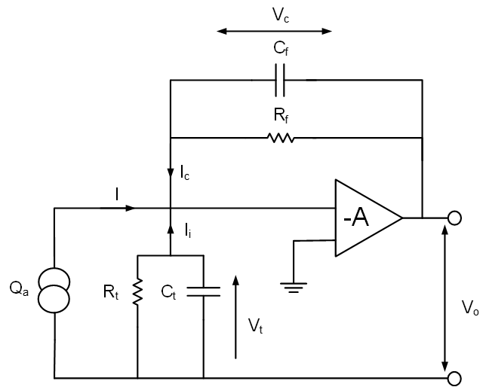
Figure 2.16: Equivalent circuit of pyroelectric transducer connected with preamplifier

$\frac{1}{R_{t}}=\frac{1}{R_{a}}+\frac{1}{R_{b}}+\frac{1}{R_{p}}$ (2.14)
$V_{o}=-AV_{i}$ (2.15)
$V_{c}=\left(1+\frac{1}{A}\right)V_{o}$ (2.16)
$I_{c}=C_{f}\frac{{dV}_{c}}{dt}+\frac{V_{c}}{R_{t}}=\left(1+\frac{1}{A}\right)\left[C_{f}\frac{{dV}_{o}}{dt}+\frac{V_{o}}{R_{f}}\right]$ (2.17)
$I_{i}=C_{f}\frac{{dV}_{i}}{dt}+\frac{V_{i}}{R_{t}}=\left(\frac{1}{A}\right)\left[C_{t}\frac{{dV}_{o}}{dt}+\frac{V_{o}}{R_{t}}\right]$ (2.18)
$\frac{{dQ}_{a}}{dt}=-\left(1+\frac{1}{A}\right)\left[C_{f}\frac{{dV}_{o}}{dt}+\frac{V_{o}}{R_{f}}\right]-\left(\frac{1}{A}\right)\left[C_{t}\frac{{dV}_{o}}{dt}+\frac{V_{o}}{R_{t}}\right]$ (2.19)

The final equation above can be further solved using integration and the final result comes out to be equation 2.21.

$V_{o}=-\frac{Q_{a}}{\left(1+\frac{1}{A}\right)\left[C_{f}+\frac{1}{{jwR}_{f}}\right]+\left(\frac{1}{A}\right)\left[C_{t}+\frac{1}{{jwR}_{t}}\right]}$ (2.20)

This is very helpful in coming up with how the conversion is done. It also allows you to size the resistor and capacitor to fit the needs of your circuit.

2.3.3 Design Problems with Charge Amplifiers

When dealing with charge there are some design constraints that have to be considered. Noise is a major concern for LOC systems. Past work has been done on optimizing the noise of any detector system. In the conventional topology results have shown that the input MOSFET in the first front end electronic system needs to dominant the noise of the entire system. Therefore the noise sources that contribute to the input MOSFET noise need to be modeled and defined and then optimized for each detector system. Figure 2.16 shows the noise model for the input MOSFET of the preamplifier. The input MOSFET contributes thermal and flicker noise to the system which can be optimized by the designer. The detector and feedback resistor contribute parallel noise sources as well.
Since it is highly desirable to have only the input device of the preamplifier be the dominant noise source of the system, the feedback resistor must be very large, typically in the range of GΩs. Equation 2.7 describes the thermal noise which is characterized by a parallel current generator associated with the resistor [21].

$\sqrt{\overline{i^{2}}}= \sqrt{\frac{4kT}{R}}$ (2.21)

It can be seen that a larger resistance value would yield a lower noise contribution than a smaller value. Unfortunately, a resistor on the order of GΩs would be very impractical to fabricate on silicon, therefore a CMOS feedback network must be implemented to emulate a large resistor. This discussion is continued below.

Figure 2.17: Amplifier input pair noise model.

Typically for LOC systems this is the end of the detector and we move into the processing and compensation portion. The components are outside the scope of this work.

2.4.5 Conclusion

Two topologies were mentioned above in this chapter. Both of these designs have there draw backs. In chapter 3 a different topology that operates in a similar way will be introduced.

Chapter 3
Design of Front-End Electronics
As discussed in the previous chapters front-end electronics are how the signal is introduced into the signal processing system. However the signal itself requires many constraints as well. This chapter will detail on the design and working of this work. This will include a small background of the signal, preamplifier, feedback networks, and CMOS layout techniques. The fabrication process is 180nm [22] using the MOSIS [16] foundry service the final design in figure 3.7 is realized and tested in chapter 4.

3.1 Preamplifier
Many different charge sensitive preamplifier topologies have been designed according to the detector and system they will be operating in [23,24]. As with most charge sensitive amplifiers or preamplifiers the core of the circuit is an operational amplifier. The most basic schematic is noted in figure 2.12 Using a similar approach the preamplifier designed for this project had to meet a variety of specifications mostly based around the temperature detector interface. The specifications include the following:

- Low power
- Low voltage
- Low noise
- Low frequency
- Large amount of charge injection
- Small area

As described in the previous chapter the charge amplifier of choice for most applications is an operational amplifier with high impedance feedback. This topology is considered the classic approach for converting charge to voltage. The work that this paper is based off of used such a devices. In [18] discussion of the charge is presented. Ultimately with temperature change the transducer can provide a charge based on the physical size of the device.
The charge produced by the PVDF transducer is proportional to the area. This is shown in the equation below.

${dQ}_{P}=p_{Q}AdT$ (3.1 )
Where the the pyroelectric charge is represented by dQ_{p}, and p_{Q} is the charge pyroelectric coffecient and A is the area of the transducer. This is all with respect to change in temperature dT. [18]

Although the work done in [18] has a good result. The application can never move into field use as the circuit is large and require laboratory equipment to set up. The application of this work, monitoring biological sample temperature variation, means that the operational amplifier is not the most well suited method for the monitoring in PVDF transducers.
The limit factor is the feedback loop components. A large capacitor such as the one implanted on the original design would not fit on an integrated circuit. In order to elimate this constraint there are a few options. The goal is to convert charge to voltage. Chapter 2 shows how this is done. Because this application has a large amount of charge coming from the transducer. We are able to analyze the operating principles of the transimpedance amplifier. Following to approach explained in chapter 2, the most important feature for the signal is the feedback and the virtual ground on the inverting node of the operational amplifier.

An active virtual ground circuit is sometimes called a rail splitter. A circuit as shown In figure 2.12. uses an op-amp to achieve this concept. Since an operational amplifier has very high open-loop gain, the potential difference between its inputs tend to be very close to zero when a feedback network is implemented. To achieve a reasonable voltage at the output, the output supplies the inverting input or the minus side via the feedback network, R and C, with enough voltage to reduce the potential difference between the inputs to microvolts. The non-inverting or plus input of the operational amplifier is grounded; therefore, its inverting input, although not connected to ground, will assume a similar potential, becoming a virtual ground if the operational amplifier is working in its linear region. This effect allows for the voltage to peak and fall using the RC time constant of the feedback loop.

The charge created in the transducer for this work required a large feedback capacitor, due to the large amount of charge. Although the traditional design could have been implemented by using an off chip capacitance, as done in [20]. Due to necessity for this system to be on a single chip, we needed to reduce the amount of capacitor to a value suitable for CMOS implementation. Steps to reduce the feedback capacitor could have been taken such as using an attenuator to reduce the signal to a value that could be implemented on chip. However, this does not help since the resistance also plays a role in the decay time. Therefore by reducing the capacitance the resistance must go up. Large capacitance and resistance is impractical on chip so an alternate topology must be used. In order to maintain the response and fit it on a chip consideration of the original work had to be taken in to account. The system needed to have high impedance, gather the charge signal and hold it, and overall the design needed to fit on a single chip. The resulting target design is shown in the figure below.

Figure 3.1: Block view of implemented amplifier design

Since the signal is set from the selected transducer the next step is to come up with a topology that will allow for the conversion of charge to voltage.

3.2 Feedback
Again the feedback network for a charge sensitive preamplifier consists of a charge collecting capacitor and a resistive feedback network that allows charge in the feedback capacitor to dissipate. The charge gain needs to be low enough to keep the preamplifier output from saturating. Saturating the output would cause ballistic deficit which is a reduction in amplitude because the bandwidth has been degraded by the gain. However since this application is low bandwidth to begin with the issue is negligible.
One solution for the charge bleed off would be to apply a resistor in parallel to the feedback capacitor. This is shown in Figure 3.2. Consequently the resistor adds a noise source to the input MOSFET described in equation 2.21. In order to reduce the noise contribution, the resistance value would have to be large which is not practical in terms of chip area, therefore an active feedback network will allow for less area and can behave as a very large passive resistive element. This section explores different active feedback topologies and describes the design that was chosen.

Figure 3.2: Basic feedback with capacitive and resistive element.
The charge mode amplifier will operate to balance the charge injected into the negative input by charging feedback capacitor C_{f}. Resistor R_{f} bleeds the charge off capacitor C_{f} at a low rate to prevent the amplifier from drifting into saturation. Figure 3.5 illustrates one possible topology for the feedback network which is based on previous work [6].
Figure 3.3: Single MOSFET feedback network.

The single MOSFET feedback network provides minimum thermal noise and high linearity, requires baseline stabilization, and can also be realized in multiple stages [6]. A second possible feedback network topology is shown in Figure 3.8. This is the basis of the work presented in [6]. The circuit shown in figure 3.9 is the complete setup of a charge sensitive amplifier for neutron detection.

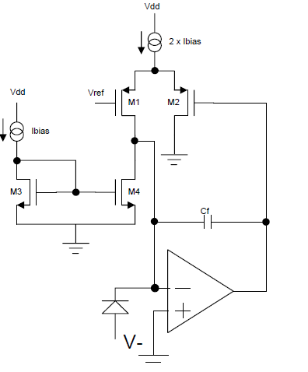

Figure 3.4: Feedback network as presented in [6].

The basic operation of the feedback network in Figure 3.6 is when a charge pulse is introduced to C_{f} then there is a change in voltage on the gate of M2 which in turn will introduce a change in current between the drains of M1 and M4. The gate of M2 will stabilize back to the V_{ref} voltage on the gate of M1 because of the differential pair action of M1 and M2. This is effectively a resistor since a change in voltage gives a proportional change in current. The drawback of design is the nonlinearity of the pseudo resistor. Aside from the nonlinearity the design proposed in [6] uses and off chip capacitance a key point of this paper.
By implementing the function of the system above we can design a charge amplifier that operates similar to the transimpedance amplifier and its virtual ground. In order to model the system above the different components had to be simplified. Below is a simplified version of the final system. Where the current, I_{in}, is meant to simulate the charge coming from the transducer.

Figure 3.5: Functional view of implemented amplifier design

The design highlighted above shows why each component is necessary and what we are trying to achieve by this design that mimic the classic charge amplifier in figure 2.16. The equation below offer some insight as they represent how the above circuit will work.

In order to analyze the system the transfer function has to be analyzed. First the current or charge into the system will exit the system through a ground. Using Kirchhoff laws the system is solved in the following manner.
$I_{in}=I_{1}+I_{2}$ (3. 1)
The current will be divided by the two paths we have created. The voltage V₂ is a multiplied voltage of the voltage at the node V₁.

$V_{2}=H\left(s\right)*V_{1}$ (3. 2)
This allows for solving the current through the I₂ branch as such,
$I_{2}=g_{m}*V_{2}$ (3. 3)
Leaving the V₁ voltage to be,

$V_{1}=I_{1}*Z$ (3. 4)
Now that the relationship between the different components is established the relationship of input signal and output voltage can be explores. In equations 3.5 through 3.10 this is done in a step wise manner. First the signal, I_{in} is isolated,

$I_{in}=\frac{V_{1}}{Z}+g_{m}*V_{2}=\frac{V_{1}}{Z}+g_{m}*(H\left(s\right)*V_{1})$ (3. 5)
Since the desire is to see how the output voltage will respond to the components the output signal is isolated as well.

$\frac{I_{in}}{V_{1}}=\frac{1}{Z}+g_{m}*H\left(s\right)$ (3. 6)
Rearranging the factors allows the form signal out over signal in with relation to the circuit,
$\frac{V_{1}}{I_{in}}=\frac{1}{\frac{1}{Z}+g_{m}*H\left(s\right)}=\frac{Z}{1+g_{m}*Z*H\left(s\right)}$ (3. 7)

The using the realtion,
$Z=\frac{1}{S*C}$ (3. 8)

The final result looks as below,
$\frac{V_{1}}{I_{in}}=\frac{\frac{1}{S*C}}{1+\frac{g_{m}}{S*C}*H\left(s\right)}*\frac{S*C}{g_{m}}$ (3. 9)
$\frac{V_{1}}{I_{in}}=\frac{\frac{1}{g_{m}}}{\frac{S*C}{g_{m}}+H\left(s\right)}$ (3. 10)
From the equation above we see that the capacitance is only a small part of the circuit and is pretty much set. The resistance factor, H(s), is where the focus of the design will begin. H(s) relation to the effective resistance is below in equation 3.11.

$R=R_{eff}=\frac{1}{g_{m}H(s)}$ (3. 11)

The knowledge taken away from the above is the transconductance of a device will greatly affect the effective resistance you can get out of a circuit such as the one in figure 3.2. Below this design is realized with circuit elements.

The design implemented in this work is similar to that of Figure 3.6. A feedback loop is implemented to mimic a high resistance. The feedback loop is considered a pseudo-resistor. The implemented pseudo-resistor is shown in figure 3.10.

Figure 3.6: Pseudo-resistor implemented on charge amplifier.

This pseudo resistor is made up of a source follower (M2) and a resistor to bias said follower as well as a path for current to travel (M1). The source follower is there to control the gate of the current path. It will behave by taking in the input voltage which may have a relatively large Thevenin resistance and replicates the voltage at the output port, which has a low output resistance. This output resistance in series with the resistor create a voltage divider at the gate of M1. The source follower works under conservation. If the voltage increases then since the current cannot change with it the voltage at the source of M2 must increase. This will then drive the gate of M1 creating a path to ground for the current.

From the work done in [6] a similar approach was taken to biological signals. The main difference between the signals is speed. Neutrons tend to be incidence on sensing material at a rate of 10⁹ particle per/sec while in the biological signal community the typical frequency can be from 1 Hz to 1500 Hz. This drastic change however does not mean that processing circuits need to be dramatically different. The principles still apply allowing for the circuit presented in this paper to use the same concepts as the work done in [6].

Once the design highlighted above was simulated and the response was characterized as a possible approach for the intended signal, optimizing the system began.
The goal of the design is the total charge of the temperature change from 0 to 25 degrees Celsius. This has a peak charge of 100nC and a minimal detectable charge of 2nC. In order to create a voltage on the output node a capacitor was selected. In order to keep the final footprint to a minimum 20pF was selected to be the preamplifier capacitance. By selecting the capacitor was are able to set the value of the effective resistance, R_{eff}, on the pseudo resistor needed.

From the equation 3.10 a transistor can be selected however due to the nonlinearity of the pseudo resistor decision have to be made in order to size M1 and M2 to operate in the regions designed. By referencing the original design we saw the decay time was 2.3ms, a rather long decay time. With a reduced capacitor in order to get the same decay time a resistance of 115GΩ would be needed. After many attempts to bias the network to attain this resistance, an examination of the peak signal resulted in only needing a resistance of 100MΩ. This resistance would make the decay time much much greater than the collection time allowing for the signal to peak before it decays. This avoids the ballistic deficit prone to applications involving large signals and small capacitors.

Now that we have a set resistance to attain careful consideration of the size of M1 and M2 can begin. Since these devices will be operating in weak inversion the W/L is related as such in subthreshold

$I_{D}=I_{D0}\frac{W}{L}e^{{q(V_{GS}-V_{THN})}/{n*kT}}$ (3. 12)

This combined with the desire for a large transconductance which is

$g_{m}=KP_{N}\frac{W}{L}(v_{gs}+V_{GS}-V_{THN})$ (3. 13)

We can elicit that large narrow devices are going to work best for the purpose of large resistance. Now that we have a large resistance and a set capacitance. Manipulating the signal is the only step left. The size of M1 is shown in table 2 below. In setting the signal the biasing of the devices becomes important. There are two currents moving through the attenuator explained below. The first is a DC bias current, I_{bias}. The second is the signal being attenuated. In order for the circuit to operate the bias current needs to set the point of operation of the circuit. This means that a set basing current has to be selected. During simulations a biasing current on the order of uA was used. The result was being able to see the effect of the bias current in setting the effective resistance. By having a 1uA bias current the effective resistance on the selected W/L ratio was 166MΩ. The effect of reducing the bias current affect the effective resistance as shown above in equation 3.12. the effect of the signal also has some effect on the resistance. As you pump more signal into the circuit the lower the resistance gets.

After deciding the W/L ration of M1 the size of M2 also needed to be decided. The gate of this device needed to be wide so that a large amount of voltage on the gate would turn the transistor on only after the initial biasing current is set. The signal spike will cause this to turn on. When this transistor turns on the gate of M! is moved up, which means that it turns on as well. This effect gives the current the path to ground.

3.3 Current Attenuator
As the design shifted from an operational amplifier to a current mirror the design became easier, but not trivial. The amount of charge in our signal allows for use to decrease the signal in order to use a smaller capacitance. In order to reduce the charge an attenuator or step down current mirror was designed. There were two designs deliberated with the chosen design being better suited for low power consumption. The first is a traditional current mirror. A basic current mirror can be composed of as little as two MOSFETs. The figure below is the most basic design for an NMOS current mirror. This approach was used on the final design as a way of including two separate current sources on the same node.

Figure 3.7 : Circuit schematic of a basic current mirror.

The basic current mirror is formed as shown above. Assuming the length and width of the MOSFETs are the same, this would also assume that V_{GS1}=V_{DS1}= V_{GS2}. Since the MOSFETs have the same gate to source voltages, we can also assume them to have the same drain current. If R1= R2 in the figure above then the drain of both FETs will be at the same potential. Therefore by matching the size, V_{GS1} , and I_{D} of the two transistors we can be assured that the two MOSFETs have the same drain to source voltage, meaning that V_{GS1} = V_{DS1} = V_{GS2} = V_{DS2.}

Figure 3.8 : A basic current mirror with currents.

By connecting the gate to the drain in M1 we are forcing the MOSFET to operate in the saturation region. The equation to describe the current moving through M1 is:

$I_{D1}=\frac{1}{2}k_{n}^{'}\frac{W_{1}}{L_{1}}{\left(V_{GS}-V_{t1}\right)}^{2}$ (3.1)

With a zero gate current,
$I_{REF}= I_{D1}$ (3.2)
Where the reference current can be seen to be

$I_{REF}=\frac{V_{DD}-V_{GS}- \left(-V_{SS}\right)}{R}$ (3.3)
Again as mentioned earlier the two MOSFETs have the same V_{GS} therefore the current was the same. The equation would look as follows.
$I_{D2}=\frac{1}{2}k_{n2}^{'}\frac{W_{2}}{L_{2}}{\left(V_{GS}-V_{t2}\right)}^{2}$ (3.4)
Additionally, if they were perfectly matched then the k values and V_{t} values would be equal. When setting the current in secondary stages assume the k values are equal, given the following.

$I_{D2}={\frac{W_{2}}{L_{2}}}/{\frac{W_{1}}{L_{1}}}I_{D1}= {\frac{W_{2}}{L_{2}}}/{\frac{W_{1}}{L_{1}}}I_{REF}$ (3.5)
A mirror operating in this manner is considered a current sink. The PMOS version is similar in design but would source the current. A PMOS mirror is shown in Figure 3.3. [21]

Figure 3.9 : A basic PMOS current mirror.

After understanding the basic current mirror a lower power approach was taken. The current mirror in figure 3.4 is a small improvement on the simple current mirror in figure 3.3. Cascode current mirrors provide an improvement of output resistance over simple current mirrors. The small-signal output resistance (R_{o}) of the cascade current source in Figure 3.4 is given by

$R_{o}=r_{o2}\left(1+g_{m2}r_{o4}\right)+r_{o4}$ (3.6)

This then simplifies to

${Ro≈g}_{m2}r_{o}^{2}$ (3.7)
where r_{o} = r_{o2} = r_{o4} are the MOSFET small-signal output resistance and g_{m} is the MOSFET small-signal transconductance. If M₁ and M₂ were removed from Figure 3.4, a simple current mirror would be left whose small-signal output resistance would be equal to r_{o4}.
Although this cascode current mirror provides high output impedance, it does not allow for a high output voltage swing. The dynamic range of this cascode current mirror with respect to V_{DD} is limited to less than

$V_{OUT}=V_{DD}-2_{SD,Sat}-\left|V_{THP}\right|≈V_{DD}-1.3V$ (3.8)

where V_{SD,Sat} is the saturation voltage of a pMOS transistor and V_{THP} is the pMOS threshold voltage.
Figure 3.10: Cascode current mirror.

Alternate schemes of biasing cascode current mirrors for wide-swing or low-voltage applications exist [21]. One of the suggestions is shown below in figure 3.5.

Figure 3.11: A Wide Swing Current Mirror.

A typical wide-swing, low-voltage cascode current mirror is presented in Figure 3.5. For this wide-swing current mirror to work efficiently, V_{Bias} must be set at V_{DD} – 2V_{SD,Sat} – |V_{THP}|, leaving a V_{SD,Sat} across mirror devices M₃ and M₄. This is called a wide-swing current source because the minimum voltage across the current source for proper operation is 2V_{SD,Sat} [21], which is one threshold voltage drop less than the regular cascode mirror shown in Figure 3.1. This current mirror is dependent on the voltage of V_{Bias} remaining constant and only works well for a small variation of input current. For a large change of the input current, additional circuitry is required to track the V_{SG} of the cascode devices M₁ and M₂, so that current mirror’s output characteristics do not vary.
The current mirror used in this operational amplifier is a wide-swing cascode circuit. Figure 3.6 shows implemented current mirror. The major advantages of using this current mirror is the elimination of the possibility of mismatch between the two branch currents and thus reducing power consumption. Power is scarce in CMOS design inherently, but especially with the LOC design The reduced power consumption is achieved by maintaining the desired difference between the gate voltages of P7 and P8 of one overdrive voltage, Vov. In order to achieve this, it is required to bias M1 at the active region and subsequently requiring gate voltages of P7 and P8 to be Vt + Vov and Vt + 2Vov respectively. As shown in Figure 3.1, since P12 is diode connected, it operates in the saturation region. Since the gate-source voltage of P12 is equal to the gate-drain voltage of P11, a channel exists at the drain of P11 when it exists at the source of P12. In other words, P12 forces P11 to operate in the triode region.
To obtain the drain-source voltage of P11 to be Vov, we need to design the aspect-ratio of the transistors appropriately. Since P12 operates in the active region, the equation for the bias current is shown in 3.1.

$I_{BIAS}=\frac{k^{'}}{2}{\left(\frac{W}{L}\right)}_{12}{\left(V_{GS12}-V_{t}\right)}^{2}$(3.91)

Figure 3.12: Implemented Current mirror.

Since P11 operates in the triode region the bias current equation is shown in 3.2,

$I_{BIAS}=\frac{k^{'}}{2}{\left(\frac{W}{L}\right)}_{11}\left(\left(V_{GS12}-V_{t}\right)\left.V_{DS11}-{\left(V_{DS11}\right)}^{2}\right.\right)$(3.102)

The goal is to set
${ V}_{DS11}=V_{ov}$ (3.11)

When
${ V}_{GS12}=V_{t}+V_{ov}$ (3.123)
From eqn. (3.3) and (3.4),
$V_{GS11}=V_{GS12}+V_{DS11}=V_{t}+{2V}_{ov}$ (3.13)

Substituting eqn. (3.2) – (3.5) into eqn. (3.1) gives,

$\frac{k^{'}}{2}{\left(\frac{W}{L}\right)}_{12}{\left(V_{ov}\right)}^{2}=\frac{k^{'}}{2}{\left(\frac{W}{L}\right)}_{11}\left.\left(2\right.\left(2V_{ov}\right)V_{ov}-{\left(V_{ov}\right)}^{2}\right)$ (3.14
which is further simplified to ,

${\left(\frac{W}{L}\right)}_{11}=\frac{1}{3}{\left(\frac{W}{L}\right)}_{12}$ (3.15)

After implementing a low power current mirror the charge is then transferred at a reduced value to the feedback loop. Using the method above the current divider uses a 10:1 ratio for the charge division.
The current mirror replace the need for an operational amplifier at the core of the circuit. However the other novelty to this approach is the use of feedback to drive a resistance to bleed the current off the capacitor.

3.4 Final Design

The previous sections describe the components of the final design. The circuit is shown below.

Figure 3.13: Circuit Schematic of the Final Design.

The table below has the values for the different components.

Table 2: Component Values of Circuit Parameters

Transistor | W/L  (µm/ µm) | Transistor | W/L  (µm/ µm)
M1 | 1/1 | M5 | 2/1
M2 | 1/1 | M6 | 2/1
M3 | 20/1 | M7 | 8/2
M4 | 20/1 | M8 | 3/0.7
After settling on a design the circuit was simulated. The results are shown below in figure 3.8.

Figure 3.14: Simulation of proposed circuit, response is 50mV peak for 50nC signal.

Once the simulation was on the magnitude above noise the layout of the circuit still needed to be completed.

3.5 Layout Techniques
Designing a circuit to be fabricated on a silicon chip requires knowledge about parasitic elements that can greatly affect the performance of the circuit. Some of these parasitics include capacitances, inductances, resistances, latch up, parasitic transistors, etc. Fortunately there are some CMOS IC circuit layout techniques exist which can greatly reduce the effects of these parasitics. The key parasitic element in this work is the matching between MOSFETs on the current mirrors. MOS transistor matching is an important design parameter in many CMOS applications. MOS transistor matching in analog CMOS applications deals with statistical device differences between pairs of identically designed and identically used transistors. In analog circuit blocks, like A/D converters, threshold voltage differences of millivolts or less can determine the performance and/or yield of a product. The performance of amplifiers depends on the assumption that the transistor will behave identically. However, in manufacturing the IC variations occur, which affect the performance. The other parasitics mentioned above were minimized during design and will not greatly affect the performance of this work.
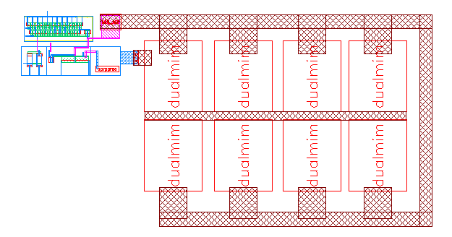

Figure 3.15: Layout of the final design.

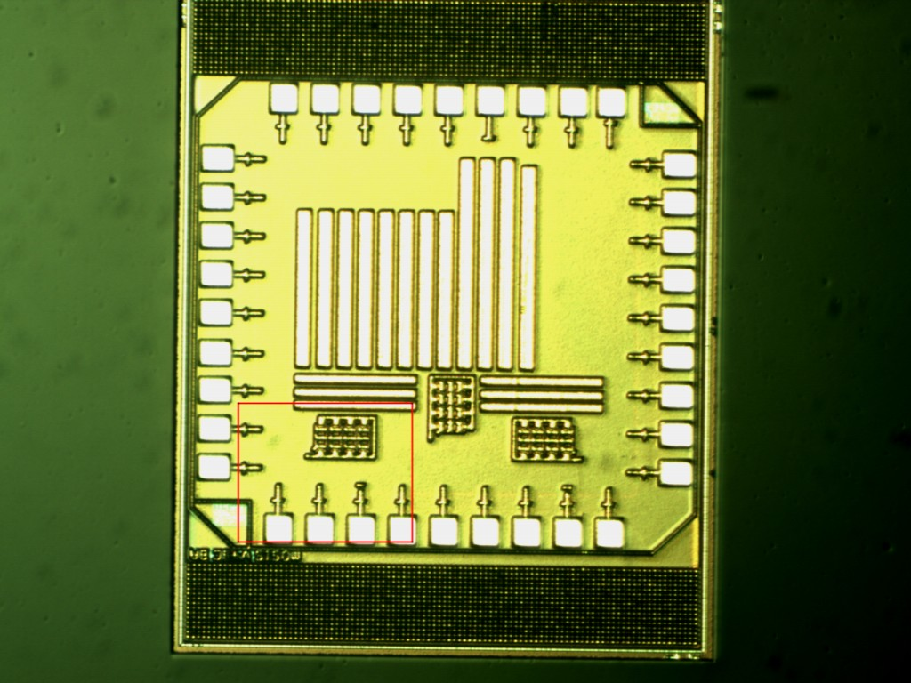
Figure 3.16: Micrograph of Chip

Chapter 4
Results and Discussion
This chapter presents the measured results of multiple preamplifiers and the merits of each. All measurements were taken with an active FET oscilloscope probe with 2 pF input capacitance, 1GHz bandwidth, 10 attenuation, and 1MΩ input impedance. Simulation were carried out within the cadence environment using SPECTRA analysis for real world interaction results. The models used were provided by MOSIS [22]. Three different designs were analyzed for comparison. The first one is a discrete board fabricated using off the shelf commercial devices. The second is the work presented in [6], and finally the design presented in this paper. The test generator and power supplies were as follows.

Table 3: Values for Test Board and Charge Amplifier Circuit
Generator Signal or Supply | Value | Units
Board level V_{dd} | 5 | Volts
Board level V_{ss} | 0 | Volts
GND | 0 | Volts
Chip level V_{dd} | 1.8 | Volts
Chip level V_{ss} | 0 | Volts
I_{bias} | 1 | uA

The input current signal varies for the testing. The lab equipment for testing these circuits was not capable of providing a consistent test current signal. Therefore, a test board was built for the purpose of analyzing two of the designs. The circuit used on the test board is a TI AD811ANZ operational amplifier and a 2N7000 N- channel MOSFET. The topology and board are shown below.
Table 4: Component Values for Test Board Parameters
Device | Value
R1 | 100MΩ
M1 | 2N7000
VDD | 5V
VSS | 0
OP1 | AD811ANZ
Vin | Function Generator

Figure 4.1: Discrete test circuit for converting voltage signals to current.

From the circuit you can find that:

$V_{in-}=V_{SS}+I_{out}+R_{1}$(4.1)
But if the Opamp is in the high-gain region, we can ideally have:
$V_{in-}= V_{in+}=V_{in}$ (4.2)

Therefore comparing the right term of both equations one can obtain:

$V_{in}= V_{SS}+I_{out}+R_{1}$ (4.3)

$I_{out}=\frac{V_{in}}{R_{1}}$ (4.4)

The transistor is meant to drive the output current depending on the gate voltage. The operational amplifier will try to make its input equals, and this will in turn supply a voltage so that R1*I_{out} is equal to V_{in}. The relation between I_{out} and the output of the operational amplifier will be set by the transistor. Therefore the transistor will perform the real V-I conversion, creating a feedback loop with the op-amp. Using this circuit allows for the conversion of a voltage signal to current. Using this current we can emulate the charge that would be produced by a transducer. A picture of the test circuit with no connections to any power or signal sources is shown below.

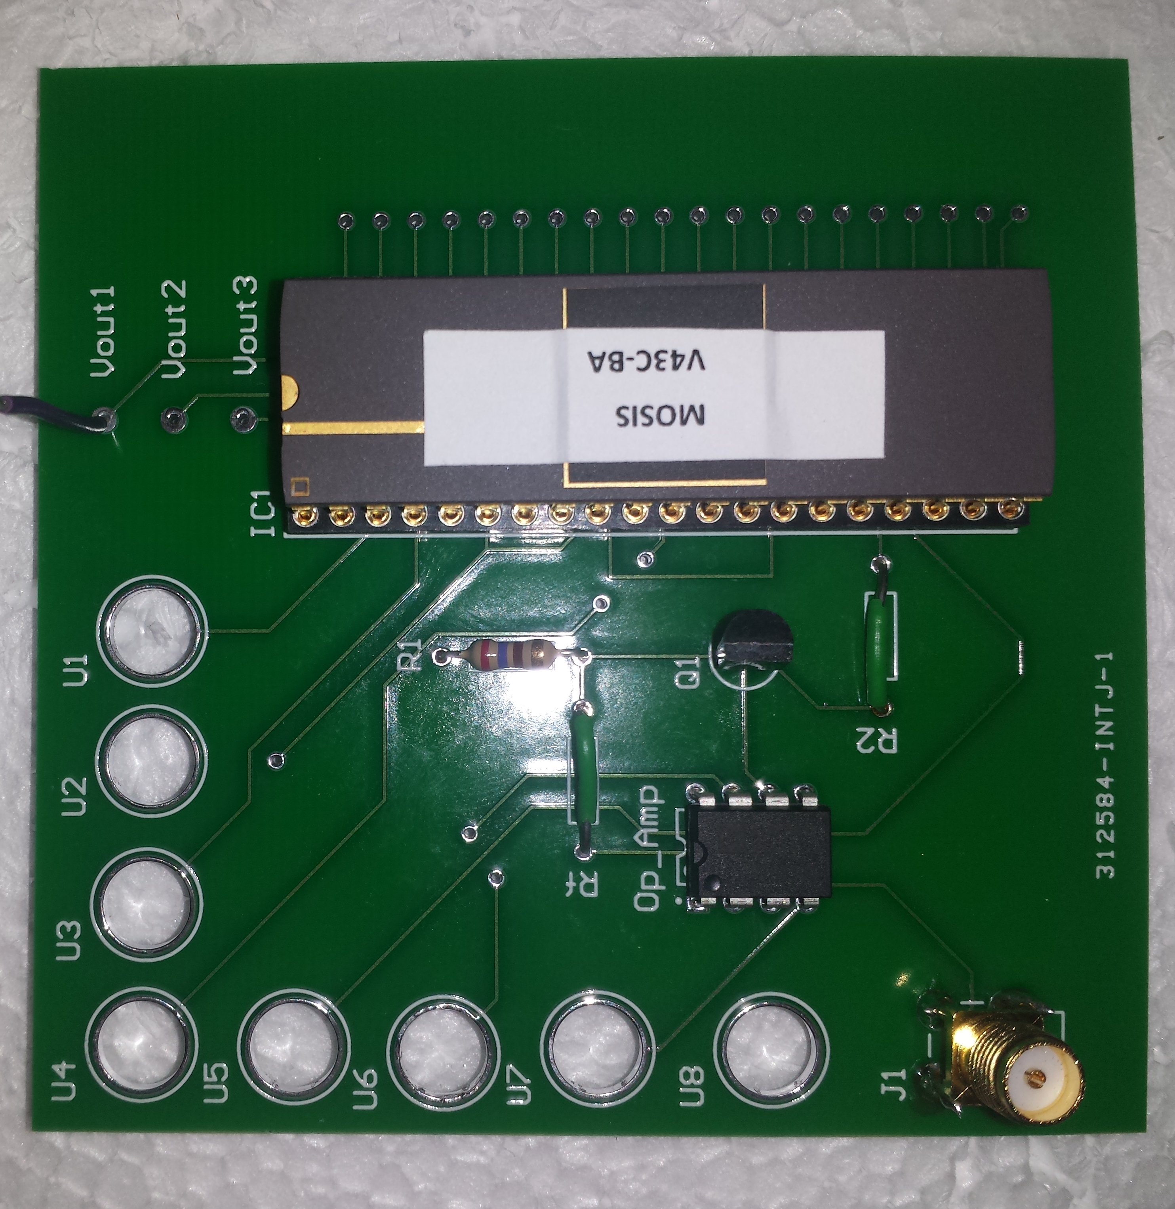

Figure 4.2: Photograph of the Test board.

This board was tested under various input signals to verify that it was producing the expected current and therefore charge. The figure below is the result of modulating the pulse width and taking the current waveform.

Figure 4.3: Current Output from test board.

Table 5: Current Output from the Test Board Varying the Pulse Width.

Frequency (kHz) | Peak Voltage (mV) | Voltage Pulse width (ns) | Current Pulse Width (ns) | Peak Current (mA) | Charge (C )
100 | 100 | 100 | 275 | 10 | 2.75E-09
100 | 100 | 200 | 301 | 14.1 | 4.24E-09
100 | 100 | 500 | 700 | 16.6 | 1.16E-08
100 | 100 | 1000 | 1200 | 16.8 | 1.99E-08
100 | 100 | 4000 | 4200 | 16.6 | 6.97E-08
100 | 100 | 9000 | 9190 | 16.6 | 1.53E-07

4.1 Breadboard results
The breadboard design is the original design that this project was attempting to mimic using ASIC design. As with most first attempt devices this is the basis for our power consumption and speed. However, functionality and conversion of the intended signal are also important. The fabricated working device is pictured below in Figure 4.2. The board is 2 layers with discrete devices that can be identified in the Appendix of this paper.

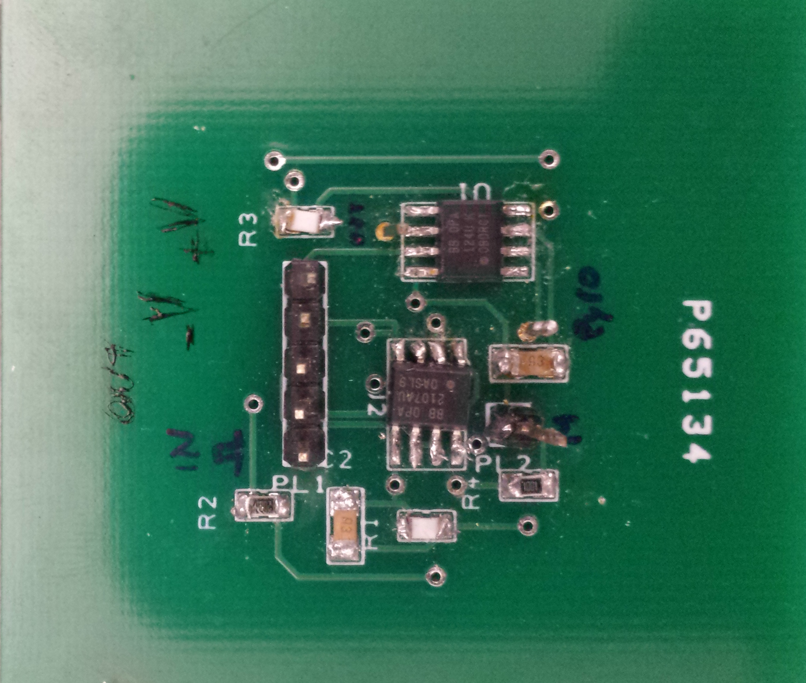

Figure 4.4: Work as presented in [25].
The design of the board is based on the material presented in chapter 3. This design is based loosely on the presented material from chapter 3. An equivalent circuit of the picture above is given below.

Figure 4.5: Schematic diagram of the implemented circuit, composed of a charge amplifier, which detects charge variations above PVDF surfaces followed by a buffer used to separate the stages. [25]

This system is the core means of transferring the signal, to a readable form. This circuit is the charge amplifier. The first stage is that of the basic charge amplifier designed in the previous chapters. The first measurements that needed to be made was how the charge amplifier preformed so that the ASIC design could try to meet the same specifications. Figure 4.5 shows the results of the preamplifier with an average biological signal. The signal was to mimic temperature change in biological samples. This means that the signal is very slow with a time constant of 5ms. The resulting charge on average with the discrete setup was on the order of 9V.

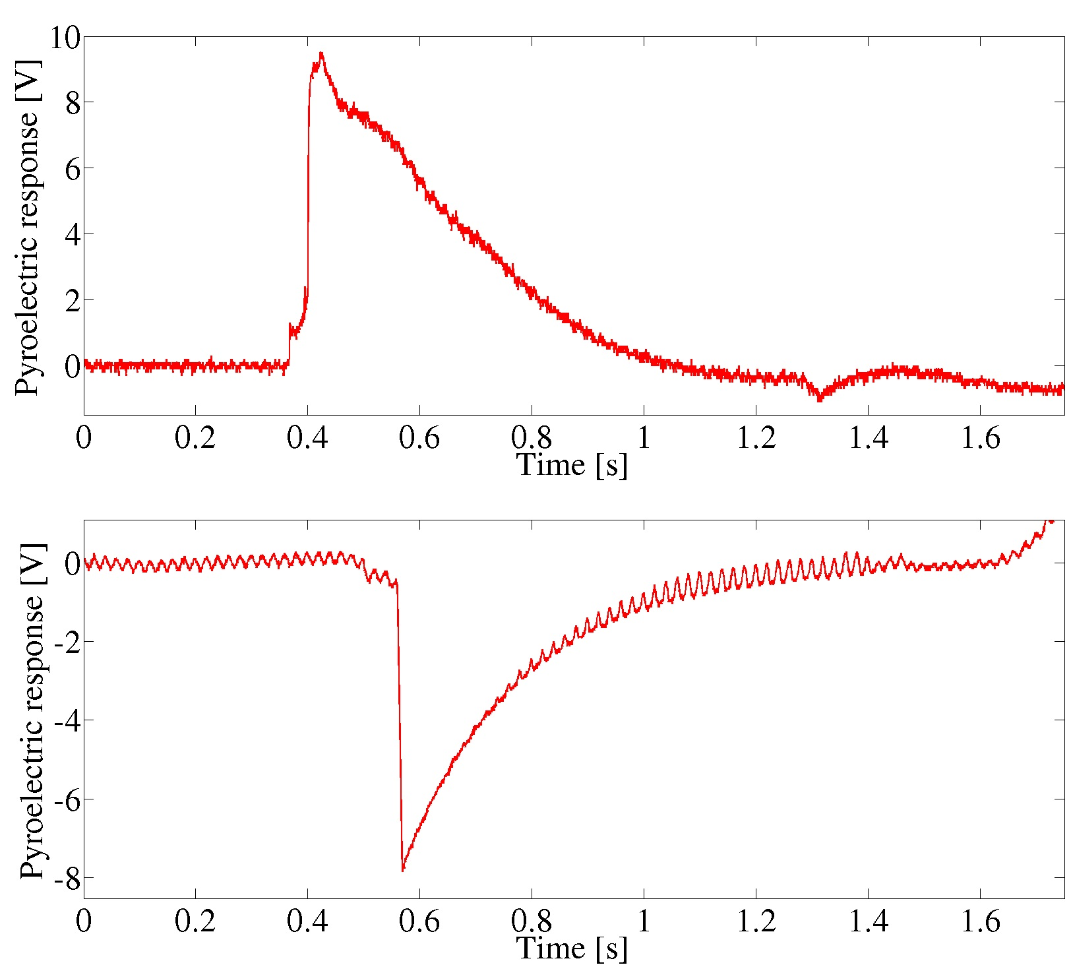

Figure 4.6: Response of discrete charge amplifier with 25° C temperature change. [25]

The resulting charge can be calculated to be 9nC. 9nC is a large amount of charge. For the purpose of this design the peak value is only used to set a regression for the actual temperature. Therefore we can use this knowledge in the material presented in chapter 3 to test the final design against two other works. The comparison will be analyzed in section 4.3.

4.2 Current Divider design
As was done with the previous design the first measurement taken into account was that of how the amplifier, or in this case the current mirror, would be affected by different signal inputs. Both the previous designs implemented an off chip capacitance, due to the goals of this design the internal capacitance was again only 20pf. The design was highlighted in chapter 3.
The preamplifier measurements that needed to be made were how rise time, gain, and noise were affected by preamplifier bias current. This is important because all of these parameters are dependent on the value of the bias current for the input MOSFET. Figure 4.8 shows the results of the preamplifier rise time with changes in bias current. As you increase the current the output of the charge amp also increases. As the preamplifier bias current is increased, the rise time remains fairly constant at 2.6µs. This result is expected because the input MOSFET changes from weak inversion to strong inversion saturation operation. Also, the input charge polarities were changed between positive and negative input that show there is not much change in the rise time with either input polarity. It is also expected that as the gain is decreased, the rise time should increase because the gain bandwidth product (GBP) should remain constant.

The rise time of the preamplifier shown in Figure 4.1 was expected to be approximately 75µs according to simulation results. The measured results show that at -1μA bias current the rise time is approximately 100µs respectively. The slower rise times are most likely caused by scope loading and/or circuit board capacitance.
The rise time was calculated by the 90-10% rule. The figure below shows the results highlighting the different rise time from different chips. The signal across multiple chips shows the variation in manufacturing processes. This test was done on 2 different charge amplifiers with a 100µs signal at 2Vpp equivalent to about 100nC from the test highlighted above. The amplifier was biased using -1µA bias current.

Figure 4.7: Response of Chip 1 and Chip 2 with 100nC charge on the input

From the chart above, two different chips are taking the signal and giving a voltage on the output with a magnitude of about 100mV across a time range of about 100µs. This circuit is of the same shape as the target circuits response.

Figure 4.8: Response of circuit with 100nC charge on the input. Line is the average value of the closest two data points, this provides a line to model the signal with.

The final test of this charge amplifier was to try and meet the original specification presented in above. The signal is a 0.1ms wide pulse at variations of rise time that depend on temperature variation on average the peak current output is 100nA. Through testing of biological sample in work [25] the signal that is input to this works charge amplifier is 9nC. The charge represents the temperature variation of a biological sample from 0 to 25 degrees Celsius. The test signal in the figure below is 0.1ms wide with the equivalent peak voltage to set the charge to 9nC at the input. The following test results represent the signal dynamic range from 2nC to 200nC. Simulating the different values of charge a transducer would put off.

Figure 4.9: Response of circuit measuring the dynamic range of the transducer 10nC to 100nC

From the graph above you see that the circuit is able to handle signals down to 10nC but it becomes unstable. The upper end of the range is 100nC but the circuit is able to perform with larger charges as the figure below demonstrates. The figure below shows the results of the circuit at 10nC and 2nC.

Figure 4.10: Response of small charge signals between 10nC and 2nC unstable response occurs. .

Even though the lower end of the range is under designed the upper end is over designed.
The response in the graph below is for a larger charge than expected.

Figure 4.11: Response of larger charge signal than designed for.

This design was tested with the constraints of the transducer. The overall comparison is summed in the table below.

Table 6: Comparing the Different Designs and Simulation.
 | This work | This work Simulation | [4] | [44]
Process | 180nm | - | 0.35µm | Discrete
Power Consumption (µW) | 1.8µW | 165µW | 0.84µW | 1mW
Max Input Signal | 8µA | 10µA | -- | 1A
Rise Time | 2.6µs | 1.5µs | 260ns | --
Chip area | .03301mm² | -- | 10mm² | --
Capacitor Size | 20pF | 20pF | 0.2pF | 1nF

Chapter 5
Conclusions and Recommendations

5.1 Conclusion

In the future bioelectronics will be used to manage the population’s health. Circuits such as the one described in this paper will have to be implemented, in order to maintain a balance between performance and size. The ultimate direction is to move into implantable circuits that run off body heat. In order to reach the goal of implantable devices smaller integrate circuit process must be utilized. Novel approaches to avoid using larger circuits will drive the production of such circuits.

Front end signal acquisition is the most important stage in signal analysis, because it is the interface with the real world. This designs main purpose is to convert input charge from a ferroelectric transducer into a voltage output signal. In order to achieve high signal integrity, it is critical that the preamplifier not introduce much noise into the signal and also dominate the noise of the system.

Special design considerations were made to ensure stability of the preamplifier and to maintain the low design profile mentioned in chapter 3. The active resistive feedback network used in this project is a revised approach to large effective resistors.
The measurement results shown in Chapter 4 are very encouraging, especially for the breadboard testing setup. The testing prototype chip for charge detections had a few more problems due to the low voltage levels produced. However the preamplifier successfully performed as it was designed.

List of References

[1] Cutler, Alan F., Suzanne Havstad, Chen K. Ma, Martin J. Blaser, Guillermo I. Perez-Perez, and Timothy T. Schubert. "Accuracy of invasive and noninvasive tests to diagnose Helicobacter pylori infection." Gastroenterology 109, no. 1 (1995): 136-141.

[2] G. Perozziello, G. Simone, P. Candeloro, F. Gentile, N. Malara, R. Larocca, M.L. Coluccio, S.A. Pullano, L. Tirinato, O. Geschke, and E. Di Fabrizio,“ A fluidic motherboard for multiplexed simultaneous and modular detection in microfluidic systems for biological application,” Micro and Nanosystems, vol. 2, 2010, pp. 227-238.

[3] SuEun Chung, Wook Park, SeungAh Lee, SungEun Choi, Jisung Jang, SungHoon Lee, and Sunghoon Kwon. “Lab-on-a-Chip.” In Handbook of Optofluidics, 7–1–7–33. CRC Press, 2010. http://dx.doi.org/10.1201/9781420093551-c7.
[4] "Wearable & Implantable Technologies." - IEEE Engineering in Medicine & Biology Society. Engineering in Medicine & Biology Society, June 1999. Web. 16 Oct. 2014.
[5] Taylor, Clive. "Understanding Low-Power IC Design Techniques." Electronic Design Home Page. N.p., 11 July 2013. Web. 26 Mar. 2014.

[6] Bunch, Steven C. "A Low Noise CMOS Charge-sensitive Preamplifier with Pole/zero Compensation for a Neutron Detection System." Thesis. University of Tennessee, Knoxville, 2006. Print.

[7] Delizia, P.; D'Amico, S.; Baschirotto, A., "A readout circuit in 0.35μm CMOS technology for Lab-on-a-Chip applications," Advances in Sensors and Interface, 2007. IWASI 2007. 2nd International Workshop on , vol., no., pp.1,6, 26-27 June 2007

[8]Yuxin Liu, and Xiang Li. “Microfluidic and Lab-on-Chip Technologies for Biosensors.” In Biosensors Based on Nanomaterials and Nanodevices, 443–78. Nanomaterials and Their Applications. CRC Press, 2013. http://dx.doi.org/10.1201/b16234-23.

[9] Joseph D Bronzino, and JohnW Goethe. “Design Issues in Developing Clinical Decision Support and Monitoring Systems.” In The Biomedical Engineering Handbook, Second Edition. 2 Volume Set. Electrical Engineering Handbook. CRC Press, 1999. http://dx.doi.org/10.1201/9781420049510.ch180.

[10] Eggins, B. Chemical sensors and biosensors. Analytical Techniques in the Sciences. John Wiley & Sons, West Sussex, 2002.
[11] Grieshaber, Dorothee, Robert Mackenzie, Janos Vörös, and Erik Reimhult. "Electrochemical Biosensors - Sensor Principles and Architectures." Sensors 8.3 (2008): 1400-1458. PMC. Web. 12 May 2014.

[12] Ben, A. M.; Korpan, Y.; Gonchar, M.; El’skaya, A.; Maaref, M. A.; Jaffrezic-Renault, N.; Martelet, C. Formaldehyde assay by capacitance versus voltage and impedance measurements using bi-layer bio-recognition membrane. Biosensors & Bioelectronics 2006, 22(5), 575–581.

[13] Chaubey, Asha, and B. D. Malhotra. "Mediated biosensors." Biosensors and Bioelectronics 17, no. 6 (2002): 441-456.

[14] Wang, J. Electrochemical biosensors: Towards point-of-care cancer diagnostics. Biosensors & Bioelectronics 2006, 21(10), 1887–1892.

[15] RosemaryL Smith. “Sensors and Transducers.” In The Engineering Handbook, Second Edition. Electrical Engineering Handbook. CRC Press, 2004. http://dx.doi.org/10.1201/9781420039870.sec22.

[16] Richard P. Buck. “Bioanalytic Sensors.” In The Biomedical Engineering Handbook, Second Edition. 2 Volume Set. Electrical Engineering Handbook. CRC Press, 1999. http://dx.doi.org/10.1201/9781420049510.ch51.

[17] Fraden, Jacob. Handbook of modern sensors: physics, designs, and applications. Springer, 2004.

[18] S.A. Pullano, S.K. Islam, A.S. Fiorillo “Pyroelectric Sensor for Temperature Monitoring of Biological Fluids in Microchannel Devices

[19] Eggins, Brian R. Chemical sensors and biosensors. Vol. 28. John Wiley & Sons, 2008.

[20] A.S. Fiorillo, “Noise analysis in air-coupled PVDF ultrasonic sensors,” IEEE Transactions on Ultrasonics Ferroelectrics and Frequency Control, vol. 47, pp. 1432-1437, 2000.

[21] R.J. Baker, H.W. Li, and D.E. Boyce, CMOS Circuit Design, Layout, and Simulation, IEEE Press, 1998. ISBN 0-7803-3416-7.

[22] The MOSIS Service, https://www.mosis.com/vendors/view/ibm/7rf

[23] B. Razavi, “Design of Analog CMOS Integrated Circuits”, McGraw-Hill, 2001.
[24] P. E. Allen, D. R. Holberg, “CMOS Analog Circuit Design”, Oxford University Press, New York, 2002.
[25] Pullano, S. A., and G. Perozziello. "PVDF Pyroelectric Transducer for Temperature Measurements in Fluidic Micro-Channels." Proceedings of the 3rd International Conference on E-Health and Bioengineering(2011): n. pag. Print.

[26] Buerk, D. Biosensors. Theory and Applications. Technomic Publishing, Lancaster, 1993.

[27] Caras, S.; Janata, J. Field-effect transistor sensitive to penicillin. Analytical Chemistry 1980, 52(12), 1935–1937.

[28] D’Orazio, P. Biosensors in clinical chemistry. Clinica Chimica Acta 2003, 334(1-2), 41–69.

[29] Cullen, D. C.; Sethi, R. S.; Lowe, C. R. Multianalyte miniature conductance biosensor. Analytica Chimica Acta 1990, 231(1), 33–40.

[30] FahmidaS Tulip, SyedK Islam, AshrafB Islam, KimberlyC MacArthur, KhandakerA Mamun, and Nicole McFarlane. “Carbon Nanofibers as Amperometric Biosensors on a Silicon-Compatible Platform.” In Technologies for Smart Sensors and Sensor Fusion, 61–74. Devices, Circuits, and Systems. CRC Press, 2014. http://dx.doi.org/10.1201/b16746-6.

[31] Chung-Chiun Liu. “Electrochemical Sensors.” In Handbook of Chemical and Biological Sensors. Taylor & Francis, 1996. http://dx.doi.org/10.1201/9781420050486.ch16.

[32] KwangPill Lee, AnanthaIyengar Gopalan, and Shanmugasundaram Komathi. “Glucose Sensors Based on Functional Nanocomposites.” In Nanotechnology and Nanomedicine in Diabetes, 98–119. Science Publishers, 2012. http://dx.doi.org/10.1201/b11775-9.

[33] Rahman Jamal, and Robert Steer. “Filters.” In Electrical Measurement, Signal Processing, and Displays, 22–1–22–29. Principles and Applications in Engineering. CRC Press, 2003. http://dx.doi.org/10.1201/9780203009406.ch22.

[34]Gianluigi De Geronimo, Paul O’Connor, “MOSFET Optimization in Deep Submicron Technology for Charge Amplifiers,” Nuclear Science Symposium Conference Record, Vol. 1, pp. 25-33, 2004.

[35] D. Bhatta, A.A. Michel, M. Marti Villalba, G.D. Emmerson, I.J.G. Sparrow, E.A. Perkins, M.B. McDonnell, R.W. Ely, G.A. Cartwright, Optical microchip array biosensor for multiplexed detection of bio-hazardous agents, Biosensors and Bioelectronics, Volume 30, Issue 1, 15 December 2011, Pages 78-86, ISSN 0956-5663,

[36] Eren, Halit. Electronic portable instruments: design and applications. Boca Raton, FL: CRC Press, 2003. Print.
[37] http://nanobio.snu.ac.kr/?mid=a_08
[38] N. Chaniotakis and M. Fouskaki, 7 - Bio-chem-FETs: field effect transistors for biological sensing, In Biological Identification, edited by R. Paul Schaudies, Woodhead Publishing, 2014, Pages 194-219

[39] Kellett, Michael. "Charge Amplifiers for Piezo Electric Accelerometers." (2012): n. pag. MK Electronics Ltd. Web. 29 May 2014.

[40] Seung-Ro Lee, Mohammed Muzibur Rahman, Makoto Ishida, Kazuaki Sawada, Makoto Ishida, Kazuaki Sawada, Development of a highly-sensitive acetylcholine sensor using a charge-transfer technique on a smart biochip, TrAC Trends in Analytical Chemistry, Volume 28, Issue 2, February 2009, Pages 196-203

[41] M. J. M. Pelgrom et al, “Matching properties of MOS Transistors”, IEEE JSSC,
Vol. 24, No. 5, pp. 1433-1440, Oct. 1989.

[42] J. F. Duque-Carrillo, “Continuous-time common-mode feedback networks for
fully-differential amplifiers: a comparative study”, ISCAS, Vol. 2, pp.1267-1270,
May 1993.

[43] P. M. Van Peteghem et al, “A General Description of Common-Mode Feedback in
Fully Differential Amplifiers”, ISCAS, pp.3209-3212, May 1990.

[44] System on a chip: http://en.wikipedia.org/wiki/System_on_a_chip

[45] Pelgrom, Marcel, and Hans Tuinhout. "Transistor Matching in Analog CMOS Applications." IEEE IEDM (1999): 98-915. Print.

[46] Carter, Bruce. Understanding Op Amp Parameters. Tech. Ch. 11 ed. N.p.: TI, 2005. Print. SLOA083.

[47] Brian, B. (2007). A/D and D/A Conversion. Mechatronic System Control, Logic, and Data Acquisition, CRC Press: 1-9.

[48] The MOSIS Service, http://www.mosis.org.

Appendix

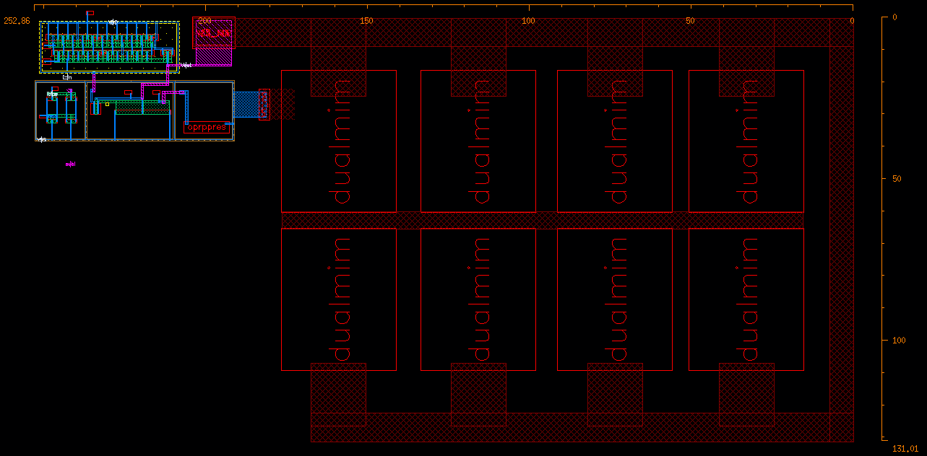
FigureA1: Chip size ( 131.01µm x 252 µm)

Vita

Logan Taylor was born in Nashville, Tennessee, to the parents of Mary and Chris Taylor. He is the oldest of three children: Mason and Juliana. He grew up in the north Nashville city of Goodlettsville. He attended Beech Elementary School until his third year, being rezoned for Madison Creek Elementary, following matriculation into T.W. Hunter Middle school in Hendersonville, TN. During his eighth year, he tested and was admitted to Pope John Paul II High School. During his time there he was very active in sports and academic clubs. Upon his graduation, and admission to the University of Tennessee, he was introduced to Engineering Fundamentals and quickly found a passion for electronics and computer aided design (CAD). During his sophomore year, Logan, was given the opportunity to learn from professionals, at Denso Manufacturing Tennessee, in a 15 month long internship. Not wanting his studies to fall by the wayside, he enrolled in night classes each semester of his internship. After receiving excellent tutelage in manufacturing Logan thought to explore electrical engineering with a focus on power , at TVA where he work through his junior year as an intern in their Knoxville headquarters. Favoring to expand his horizons, he enrolled in a study abroad in Barcelona Spain, to acquire a take on Spanish culture and language. During his senior year Logan worked on a SMART HOME device for the University of Tennessee CURENT conglomerate, as his senior design project. His teams work on this project allowed him, to accept a summer internship in Texas working for L-3 Communications. His performance in the classroom allowed him to graduate in the Spring of 2013, and enroll in the 1 year Master of Science in Electrical Engineering. With admission into this program he was also awarded a graduate assistanceship with the Fundamental of Engineering Dept. Logan Graduated in December of 2014 and is currently looking to continue his education with a Master of Business Administration.

