Implementing the Eat, Sleep, Console Approach for Infants with Neonatal Abstinence Syndrome

Mary E. Ritter and Ashlyn B. Vecrumba
Dr. Pamela Hardesty
Dr. Erin Morgan
Dr. Stephanie Abbu, Lauren Presley, PNP, Jessica Darnell, MSN, CENP
The University of Tennessee, Knoxville
College of Nursing, Graduate School

Table of Contents
Abstract ………………………………………………………………………………….…………………………………………………………......6
Background and Introduction …………………………………………………………….…………………………………..………………7
Problem Significance …………………………………………………………………………………………………….………………………..8
Epidemiology ……………………………………………………………………….…………………………………………………....8
Financial Impact …………………………………………………………………….……………………………………................8
Treatment ………………………………………………………………………………………….…………………….………………10
Project Development …………………………………………………………………………………………………………………………...11
Purpose and Goals ………………………………………………………………………………………….………………………..11
Guiding Frameworks ………………………………………………………………………….…………………………………….12
PICOT Question Component Development ………………………………………………………….…………………..13
PICOT ……………………………………………………….……………………………………………………………………………...15
Evidence ……………………………………………………………………………………………………………………………….................15
Literature Search Strategies …………………………………………………………………………………………………....15
Critical Appraisal of the Literature …………………………………………………………………………….................17
Synthesis of the Evidence ……………………………………………………………………………………………………………………..30
Research Evidence ……………………………………………………………………………………………………………………30
Clinical Expertise ……………………………………………………………………………………………………………………...30
Patient and Family Preferences ………………………………………………………………………………………………..31
Strength of Recommendations for Practice Change………………………………………………….……………………………31
Project Design ………………………………………………………………………………………………………………………………………40
Setting ……………………………………………………………………………………………………………………………………..40
Participants ……………………………………………………….…………………………………………………………………....40
Barriers and Facilitators ………………………………………………………………………………………………………..………………41
Barriers and Mitigation Strategies………..…………………………………………………………………………………..41
Facilitators………………………………………………………………………………………………………………………………..46
Stakeholders and Project Team…………………………………………………………………………………………………49
Intervention Implementation……………………………………………………………………………………………………51
Ethical Considerations ………………………………………………………………………………………………………………53
Outcomes and Evaluation Plan………………………………………………………………………………………….…………………..53
Outcome Measures ………………………………………………………………………………………………………………….53
Data Collection and Security …………………………………………………………………………………………………….54
Data Analysis Plan …………………………………………………………………………………………………………………….55
Significance and Implication of the Project ……………………………………………………………………………………..…...56
Sustainability…………………………………………………………………………………………………………………………….56
Alignment with the DNP Essentials…………………………………………………………………………………………...57
Dissemination Plan……………………………………………………………………………………………………………………60
Results…………………………………………………………………………………………………………………………………………………..62
Discussion………………………………………………………………………………………………………………………………………………65
Implications for Practice Change………………………………………………………………………………………….…..66
Limitations…………………………………………………………………………………………………………………………..……66
Conclusion……………………………………………………………………………………………………………………………………..……..67
References ……………………………………………………………………………………………………………………………………………68
Appendices ………………………………………………………………………………………………………………………..…………………76
Appendix A: Eat, Sleep, Console Tool, 1st Edition……………………………………………………………………….76
Appendix B: Letters of Support………………………………………………………………………………………………….78
Appendix C: JHNEBP Guides………………………….………………….……………………………………………………….79
Appendix D: JHNEBP Tools…………….………………………………………………………………………………………….80
Appendix E: Eat, Sleep, Console RN Education Slides………………………………………………..…………..….86
Appendix F: IRB Determination Letters VUMC …………………………………………………………………….….91
Appendix G: IRB Determination Letters UTK …………………………………………………………………………….92
Appendix H: VUMC Opioid-Exposed Neonate Care Pathway Clinical Practice Guideline……………93
Appendix I : Parent ESC Information Packet……………………………………………………..……………………….95
Appendix J : EMPATHIC Questionnaire…………………………………………………………………………..…….…100

Tables
- Evaluation Table ……………………………………………………….……………………………………………………………..18
- Synthesis Table Outcomes ……………………………………………………………………………………………………….33
- Table of Recommendations for Practice Change ………………………………………………………………………36
- Table of Strength of Recommendations …………………………………………………………………………………..39
- Barriers for Implementation …………………………………………………………………………………………………….44
- Facilitators for Implementation ………………………………………………………………………………..………………47
- Stakeholders, Responsibilities, and Affiliated Agencies …………………………………………………………….50

Figures
- Adapted PRISMA Diagram…………………………………………………………………………………………………….…..16
- RN Education Scores…………………………………………………………………………………………………………….…..62
- Morphine Rates Pre- and Post- Intervention………………………………………..………………….………….……63
- Length of Stay Pre- and Post- Intervention ……………………..………………………..……………..………………64

Abstract

Newborn Opioid-Exposure and Neonatal Abstinence Syndrome (NAS) has become a prevalent problem, particularly in Tennessee (Shearer et al., 2019). Often a result of maternal opioid use during the antenatal period, NAS creates challenges to the growth and development of children that persist far beyond their initial exposure. The current management protocol, the Finnegan Neonatal Abstinence Scoring System (FNASS), has been shown to be ineffective due to its subjectivity (Schiff & Grossman, 2020). FNASS often leads to unnecessary pharmacologic treatments, resulting in lengthy hospitalizations, heavy financial burden, and further opioid exposure (Wachman et al., 2020). The literature supports an improved approach to the care of NAS infants and families during hospitalization. A novel approach, The Eat, Sleep, Console Approach, has recently been considered the superior protocol for this population, according to several experts (Grisham et al, 2019; Grossman et al., 2018). It has been shown to improve neonatal outcomes, reduce pharmacotherapy rates and length of stay, and improve parental participation and satisfaction with care, by utilizing the parent as a first-line treatment for their infant (Grossman et al., 2018). Therefore, the aim of this scholarly project was to implement this new paradigm within two hospitals in Nashville, TN. The outcomes measured in this evidence-based practice project included rates of morphine use, length of stay, and maternal satisfaction; in addition, RN education scores were obtained regarding the ESC Approach in the care of the opioid-exposed newborn. Overall, ESC offers a sustainable solution to the hospitalized treatment of NAS infants and families to improve outcomes for neonates despite opioid exposure and withdrawal.
Keywords: Neonatal Abstinence Syndrome; NAS; Eat, Sleep, Console; ESC; Opioid Use Disorder

Implementing the Eat, Sleep, Console Method for Infants with Neonatal Abstinence Syndrome
Background and Introduction
Maternal opioid use has widespread consequences on neonates which impacts their development. Likely stemming from the nation’s opioid epidemic, over 30% of women of childbearing age have filled an opioid prescription (CDC, 2020). This creates profound consequences for the unborn child, leading to higher rates of Neonatal Abstinence Syndrome (NAS) (CDC, 2021). NAS occurs when maternal substance consumption is passed to the fetus, causing the infant to be born dependent on that same substance (US National Library of Medicine, 2019). Now considered a public health epidemic, NAS creates lasting obstacles to the normal growth, development, and function of infants far beyond their initial drug exposure (Shearer et al., 2019).
According to Shearer et al. (2019), NAS has been known to produce a substantial increase in hospitalizations of neonates, financial burdens, and poor developmental outcomes. The state of Tennessee is the third most opioid prescribed state in the nation (NIH, 2020). Consequently, Tennessee continues to be a core contributor to the opioid crisis on neonates, with NAS rates in certain counties documented ten times the national average (Shearer et al., 2019).
While NAS can produce variable signs and symptoms, most often neonates initially present as exceedingly irritable, with high-pitched crying, sleep disturbances and feeding intolerances. These often contribute to a lengthy Neonatal Intensive Care Unit (NICU) or Special Care Nursery (SCN) admission, where a variety of treatments, both non-pharmacologic and pharmacologic, are initiated. The administration of Morphine is sometimes required for severe withdrawal symptoms such as tremors, mottled skin, diarrhea, irritability, hypertonicity, poor feeding, and seizures (US National Library of Medicine, 2019).
Hospital management of NAS often utilizes the Finnegan Neonatal Abstinence Score System (FNASS). The FNASS, which was introduced in 1975, quickly became the standard of care (Schiff & Grossman, 2020). However, the tool has recently be questioned due to its subjectivity in assessing withdrawal symptoms and questionable pharmacologic interventions (Schiff & Grossman, 2020).
The identification and awareness of NAS as a substantial clinical problem incentivizes the implementation of changes to care management during hospitalization.
Problem Significance
Epidemiology
The state of Tennessee reports the third highest rate of opioid use compared to national statistics, which can be attributed to the surge of prescription opioid use in the last decade (Agarwal et al., 2018; NIH, 2020). In the midst of the opioid crisis, prescribed opioids have become the primary abused substance in the United States, which evokes a sense of urgency for healthcare providers to identify solutions to this substantial problem (Shearer et al., 2019). More specifically, the use of opioids, including morphine, hydrocodone, and oxycodone, has become more prevalent in women who are pregnant, and is complicated by several factors such as limited education, poor prenatal care, limited resources, and increased stress levels (Agarwal et al., 2018). As a result, from 1999 to 2013, the United States has seen a 380% increase in NAS diagnoses stemming from maternal opioid use (Shearer et al., 2018).
Financial Impact
Profound financial impacts result with an increased incidence of NAS as a consequence of the increase in opioid use and sales nationwide. In 2009, an estimated $730 million accounted for the national expenditure related to NAS care management, with one infant being born hourly with NAS (Patrick, Dudley et al., 2015). By 2014, the estimated national NAS expenditure increased to approximately $2.5 billion annually, with one opioid-exposed neonate born every 15 minutes (Flannery et al., 2020). In addition, hospital care for NAS is typically longer and significantly more expensive when compared with other hospital births, subsequently impacting state Medicaid programs which provide coverage for the majority of NAS infants nationwide (Patrick, Davis, et al., 2015). TennCare, Tennessee’s state Medicaid program, has seen a substantial increase in the number of opioid prescriptions filled for pregnant women enrolled in the program, as well as climbing rates of NAS coverage in the last decade (Martin & Finlayson, 2015). Patrick, Dudley et al. (2015), estimates that TennCare provides coverage to an estimated 80% of NAS infants, a statistic that is also applicable to nationwide NAS rates. The impact on Medicaid is an important discussion to consider when addressing NAS related care costs, both locally, and nationally.
The increasing NAS incidences represent upwards of 15% of NICU admissions in various areas of the United States and therefore results in rapid utilization of available NICU resources. (Loudin et al., 2017). However, according to Corr &Hollenbeak (2017), when considering hospital cost and treatment strategies, the NICU may not be the most appropriate environment for NAS care. The average cost of a NAS hospitalization is estimated to be upwards of $45,000 and can vary significantly depending on a variety of factors including treatment method, severity of illness, and parental involvement in care (Grossman et al., 2017). For the typical NICU admission, such costs can be attributed to nursing care, resources, utilities, supplies, medications, and nutrition services (Zainal et al., 2019). Given the wide variability of these costs, treatment methods and lengths of hospitalization are most often used to account for NAS related admission costs, which demonstrates the need for a standardized assessment tools and treatment protocols to cut unnecessary cost related to length of admissions (Corr & Hollenbeak, 2017).
The use of pharmacologic interventions to alleviate symptoms of withdrawal is a clear indicator of not only treatment cost, but also of increased length of stay (LOS), when accounting for weaning protocols of medications such as morphine and methadone for severe withdrawal management (Agarwal et al., 2018). The average LOS for NAS infants requiring pharmacologic care is estimated to be nearly 23 days, significantly longer than those requiring only non-pharmacologic care (Grisham et al., 2019). As a result, the increased NICU LOS seen with pharmacologically treated NAS infants consumes resources at a staggeringly high rate and jeopardizes the developing maternal-infant bond as a result of prolonged hospitalization and separation (Flannery et al., 2020). This demonstrates a major societal crisis and requires changes to care management protocols during hospitalization to improve neonatal outcomes, facilitate the maternal-infant bond, and limit the need for pharmacologic treatments.
Treatment
Treatment of NAS in the NICU and SCN demands for an interdisciplinary approach to evaluate the need for pharmacologic intervention. Most notably, this involves meticulous, periodic scoring on a standardized NAS scoring scale, the most popular of which is the Finnegan Neonatal Abstinence Scoring System (FNASS), which “assigns points to the 21 most common neonatal opioid withdrawal symptoms based on perceived severity” (Grisham et al., 2019, p. 138). According to Mangat et al., (2019) a Finnegan score > 8 indicates more severe NAS symptoms and may necessitate the need for pharmacologic therapy. The administration of these medications during the neonatal period can have profound impacts of the development of several body systems throughout childhood and as such, are typically reserved for severe symptom management (Mangat et al., 2019).
While nursing assessment tools, such as FNASS are helpful in establishing the severity of symptoms and level of withdrawal, the accuracy of this tools has not been formally evaluated and its use is subjective to the evaluator (Grossman et al., 2017). Consequently, the validity of the FNASS to guide pharmacotherapy has also been questioned by many experts (Wachman et al., 2020). In fact, many studies have shown the need for an improved assessment tool, which better focuses on the functionality of the newborn to complete activities of daily living appropriate to their age, such as feeding and sleeping (Grisham et al., 2019). From this outlook, the Eat, Sleep, Console (ESC) Approach has been recommended as a new model of care to decrease the need for pharmacologic interventions, thereby decreasing LOS, cost of hospitalization, and rates NAS related readmissions (Wachman et al., 2020). In addition, an improved model of care, such as the ESC approach, can create a working relationship between parents and staff, increasing parental participation rates through a family-centered approach that utilizes the parent as a first-line treatment for their infant during the initial period of withdrawal (Grossman et al., 2017).
Project Development
Purpose and Goals
The purpose of this DNP scholarly project was to implement a new, evidence-based model of care for opioid-exposed newborns, the ESC approach, within 2 southeastern hospitals’ Special Care Nursery (SCN) and Newborn Nursery (NBN). The ESC approach has been found to lessen the length of hospitalization, in days, by 74%, with significant reduction in the proportion of infants receiving morphine administration for NAS treatment-from 98% to 14% (Grossman et al., 2017). Additionally, the implementation of ESC has shown improvement in the development of the maternal-infant bond as well as optimization of the parent as an active member of the treatment team (Grossman et al., 2017). This novel approach has also been successful in various facilities, with a drastic decrease in the economic burden and an estimated $34,535 per patient in cost savings (Grossman et al., 2017). The aims and goals for the implementation of this project were a reduction in the proportion of infants receiving pharmacologic treatment methods by 5%, shorter average hospital admissions by 1 day, and improved parent participation and satisfaction with care.
With these goals in mind, this required a thorough education session for nurses and staff, to improve their knowledge of this novel approach and how to apply it in these settings. It was essential to ensure that the nurses understood the ESC approach so that they were able to educate the parents/guardians of the infants sufficiently and were able to answer and address any questions or concerns that might arise. This team sought to ensure families also understood ESC as a family-oriented approach, to reduce judgement and stigma related to their substance use. The RN education was recorded and made accessible to staff via QR code/weblink for viewing. This included a Pre- and Post-test in an effort to assess their understanding of the presented material.
Guiding Framework
This scholarly project was guided by the first five steps of the evidence-based practice (EBP) process as defined by Melnyk and Fineout-Overholt (2019). Step zero was the cultivation the spirit of inquiry, in which current practice were questioned and a clinical problem was recognized (Melnyk & Fineout-Overholt, 2019). Next, step one was the formulation of a compelling clinical question, the PICOT question, which was utilized to “yield the most relevant and best evidence from the search of the existing literature” (Melnyk & Fineout-Overholt, 2019, p. 17). Then in step two, the systematic search of the literature was conducted in an effort to answer the PICOT question and comprise a collection of the best evidence available to be used in the critical appraisal process. In step three, the evidence was critically appraised using the John’s Hopkins Nursing Evidence-Based Practice appraisal tools, each receiving a level and quality grade (Dang & Dearholt, 2018). Finally, in step four: the evidence was synthesized to organize findings and integrate with clinical expertise and patient and family preferences to develop strong recommendations for practice changes (Melnyk & Fineout-Overholt, 2019).
The implementation phase of this scholarly project was guided by Kurt Lewin’s Theory of Planned Change (TPC). The elements of this theory occurred in three phases: Unfreezing; Moving or Transitioning; Refreezing (Shirey, 2013). Unfreezing occurred with the recognition of the need for a change in the current processes. More specifically, the recognition of the need for improvements to the models of care for opioid-exposed infants. Additionally, this involved creating a sense of urgency to evoke these changes at our project sites. The body of literature was shared with stakeholders and represented a call to action for EBP change.
Moving or transitioning was the second stage of this EBP project, based on the TPC. This was the time in which changes were implemented, and barriers and facilitators were addressed and mitigated. "Transitioning is the inner movement that individuals make in reaction to change and requires unfreezing or moving to a new way of being. This stage necessitates creating a detailed plan of action and engaging people to try out the proposed change” (Shirey, 2013, p.70). The formation of a detailed implementation plan guided the project to meet the goals that were jointly created with project stakeholders, based on the compelling body of evidence and strong recommendations for practice changes. A group of ‘NAS champions’ acted as the core work group for the implementation of this project, to successfully transition the organization towards sustainable change (Grisham et al., 2019).
Finally, the refreezing phase allowed for the proposed changes to become established practices (Shirey, 2013). This involved re-structuring the policies and cultural practices among organizations in order to ensure sustainability in the future (Shirey, 2013). Of note, one hospital in which ESC was piloted chose to update their clinical practice guideline for the care of opioid-exposed newborns and have made ESC the standard of care based on the results of this project. Overall, Lewin’s Theory of Planned Change guided the implementation of this project and focused on creating lasting changes to the methods of care for opioid-exposed infants and their families.
PICOT Question Component Development
The initial development of one PICOT question began with identifying the patient population (P) as neonates, infants less than 4 weeks old, with a diagnosis of NAS as a result of opioid exposure in the antenatal period. The interventions of interest (I) were the non-pharmacological treatments for NAS, some of which included tight swaddling, low stimuli environment, non-nutritive sucking, breastfeeding, and skin to skin contact; and how these compared (C) to pharmacologic treatment methods, such as Morphine, Methadone, or Clonidine administration. The outcomes (O) of interest regarded the achievement of developmental milestones as a measure of neurological function. These milestones related to the emotional, educational, visual, auditory, behavioral, and cognitive development of the infant, and were considered within the first 6 months of life (T). The development of this PICOT question led a systematic search of the literature to generate information regarding best practice. Throughout the review, it became apparent that there was not enough current research available to discuss the effect of pharmacotherapy on developmental outcomes for children with NAS. Upon further review and appraisal, the literature revealed the ESC approach as a pertinent evidence-based strategy with potential to improve neonatal outcomes, which guided the development of the project.
Structuring the care of the opioid-exposed newborn with the ESC model, assesses the critical functions of the neonate and engages the parent as the first-line treatment, thereby supporting a decreased need for pharmacotherapy, decreased LOS, and improved parental participation and satisfaction with care (Grisham et al., 2019; Grossman et al., 2017). As previously indicated, the effects of NAS and pharmacologic treatment methods are profound and can follow a child well past the initial diagnosis and hospitalization. Improving the quality of care for these infants remained the goal, which required evidence-based changes to methods of care for the NAS population to ensure success.
Further development of the PICOT question, which ultimately guided this project began with identifying the patient population (P) as opioid-exposed neonates, of at least 34 weeks’ gestation. The intervention of interest (I) was the implementation of the Eat, Sleep, Console Approach in caring for infants with opioid exposure; and how this approach compared (C) to the Finnegan Neonatal Abstinence Scoring System (FNASS). The outcomes (O) of interest focused on newborn morphine rates, length of stay, parent satisfaction and RN understanding of the ESC process. The timeline (T) was 4 months for the implementation period. The development of this PICOT question led to a systematic search of the literature to generate information regarding best practices, and ultimately guided this project to address this clinical problem within the proposed project sites.

Statement of the PICOT Question
The proposed PICOT question, which guided the literature review and implementation of this DNP scholarly project is: “In opioid-exposed neonates with Neonatal Abstinence Syndrome (NAS) (P) how does the Eat, Sleep, Console Approach (I) compared with the Finnegan Scale (C) affect morphine rates (O) within four months (T)?
Evidence
Literature Search Strategies
In conjunction with the University of Tennessee, Knoxville Health Science Librarians, a literature search was conducted, in an attempt to answer the evidence-based PICOT question. This literature search was conducted across the PubMed, CINAHL, and Cochrane databases. The key words used were “Neonatal Abstinence Syndrome OR Neonatal Withdrawal Syndrome OR NOWS OR NAS OR Neonate* OR newborn* OR infant* OR babies*” AND “Eat, Sleep, Console OR ESC OR Eat OR Sleep* OR Consol* OR Comfort* OR swaddle* OR nonpharmacologic* OR non-pharmacologic* OR Substance Abuse OR Substance Use OR Drug Abuse OR Drug Use OR Drug Addiction”. The limits placed on this search were English language, peer-reviewed, and date range of 2011-2021. Initially, this search in PubMed and CINAHL produced 82 articles; 54 abstracts were screened, 24 full-text articles were reviewed, and 8 articles were saved for critical appraisal, evaluation, and synthesis. Finally, the Cochrane database search utilized the same Boolean connectors, and yielded 28 Cochrane reviews, two Cochrane Protocols, and eight Trials, however none of these were retained for the critical appraisal process.
The inclusion criteria that were applied included a NAS or NOWS diagnosis, and ESC approach. The exclusion criteria were studies that did not address NAS/NOWS, and treatment methods other than ESC. In addition, any studies with known opioid exposure and subsequent NAS/NOWS diagnosis resulting from iatrogenic withdrawal (such as for post-operative pain, mechanical ventilation, or procedures), rather than maternal substance exposure were eliminated. A PRISMA Flow Diagram (Figure 1), provides a breakdown of the literary search in figure format.
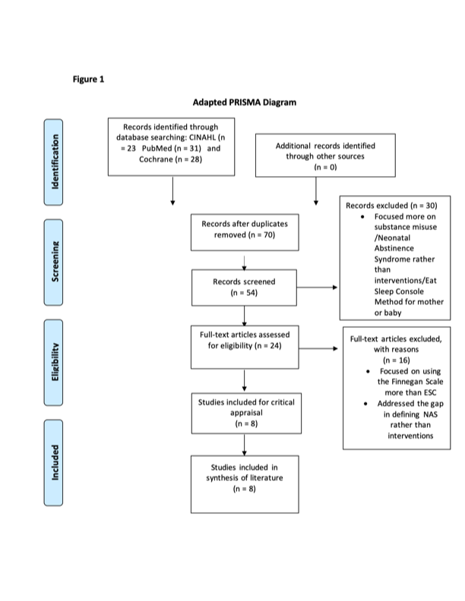
Critical Appraisal of the Literature
The appraisal of the literature, including both research and non-research, utilized Dang and Dearholt’s (2018) Johns Hopkins Nursing Evidence-Based Practice (JHNEBP) critical appraisal tools. More specifically, JHNEBP Research Evidence Appraisal Tool, guided the appraisal of each study, beginning with the study methods and design. The method of study- qualitative, quantitative, or mixed-method- was determined by the data collection techniques, analysis, and reporting of findings. Identifying the method of study was the first step in understanding study design and ensured the following steps of the critical appraisal process were correctly preformed.
In order to assign a level of evidence to each study included in the appraisal process, the manipulation of an independent variable and the presence of a control group was considered, as was a randomized study design (Dang & Dearholt, 2018). Using JHNEBP Evidence Level and Quality Guide, the students leveled each study based on design, and subsequently attached a quality rating to determine each study’s value in answering the evidence-based practice question. Of the eight studies included in the critical appraisal process, the following level and quality ratings were assigned using the evidence level and quality guide: Level I, Quality B (Flannery et al., 2020); Level II, Quality A (Wachman et al., 2020); Level II, Quality A (Grossman et al., 2017); Level II, Quality B (Grisham et al., 2019); and Level II, Quality B (Bakhireva et al., 2019); Level II , Quality B (Grossman et al., 2017); Level II, Quality A (Ryan et al., 2021); Level II, Quality A (Miller & Willier, 2021). See evaluation Table 1. These studies were later synthesized to identify similar themes that answered the PICOT question and supported evidence-based recommendations for changes to pertinent clinical practices.

Table 1

Evaluation Table
Citation  Author/Year | Purpose | Design/  Method | Sample/  Setting | Variables | Measurement | Data Analysis | Findings | Worth to Practice
Flannery et al., 2020 | Purpose: to develop an index to determine severity of NAS for opioid-exposed infants | Design: Randomized clinical trial  Level: I  Quantitative  Quality  Grade: B  Good Quality | N=116 full-term neonates with NAS requiring pharmacologic treatment  Characteristics: 58 infants allocated to receive methadone; 58 infants to receive morphine for NAS symptom treatment.  Neurodevelopmental outcomes were assessed using the NNNS at d/c, Bayley-III and CBCL at 18 months of age.  Setting: 8 sites in US: (Tufts Medical Center, Boston; Baystate Children’s Hospital, Springfield MA; Boston Medical Center, Boston; Maine Medical Center, Portland, ME; UF Health, Jacksonville, FL; University of Pittsburgh, Pittsburgh, PA; Vanderbilt University Medical Center, Nashville, TN; and Women & Infants Hospital of Rhode Island, Providence, RI).  Attrition: None noted | IV: Morphine or Methadone assignment  DV: Severity of NAS symptoms, Neurobehavioral outcomes, LOS, LOT, Max FNASS score, Total # of doses administered, adjunct treatment needs (Phenobarbital) | LOS  Max Finnegan Scores  LOT  Bayley-III scores at 18 months  CBCL scores at 18 months  NNNS scores at hospital discharge  NAS Severity (High vs Low)  Total # of drug doses  Need for adjunct treatment with Phenobarbital | SPSS  ANCOVA (to adjust for covariates using Bonferroni correction)  One-Way ANOVA (Continuous measures)  Chi-Squared Test (Categorical measures)  Cluster Analysis  Latent Profile Analysis (NNNS)  Significance was considered at P < 0.05 | Higher severity cluster n=21: longer LOS (P< 0.001); longer LOS r/t NAS (P < 0.001); longer LOT  (P < 0.001); higher total dose of study drug (P< 0.001); increased likelihood of adjunct phenobarbital therapy (P< 0.001); treatment with morphine (P< 0.020); atypical NNNS profile (P< 0.005).  Low severity cluster @ 18 months n=77: higher Bayley-III Cognitive (P< 0.013), Language (P< 0.001), & Motor scores (P< 0.041); less total behavior problems on CBCL (P< 0.028). | Strengths: randomized study design; variables are studied in combination rather than individually, which could increase the validity & reliability of indicators at risk  Weaknesses: Small sample size; index cannot be used to identify high-risk neonates in practice  Conclusion/  Feasibility: The higher NAS severity, the longer the LOS, LOT, higher total dose of study drug (methadone or morphine), likelihood of phenobarbital administration, and atypical NNNS profile. These measures can be used to develop an index to predict developmental and behavioral outcomes at 18 months of age. There was no difference in max FNASS scores between the high-and low-severity clusters.
Wachman et al., 2020 | Purpose: Summarize a new approach to NAS/NOWS care- the Eat Sleep Console approach, and support MA hospital in the adoption of this approach for NAS/NOWS care management and assess hospital outcomes for this population. | Design: Quasi-Experimental; Statewide Quality Improvement Study  Level: II  Quantitative  Quality  Grade: B  Good Quality | N= 11 hospitals in MA  Pre-ESC: N=753  Post-ESC: N=475  Characteristics:  Statewide implementation of the ESC within the PNQIN collaborative, focusing on the ESC approach to NAS/NOWs care management in place of the FNASS  Setting: Massachusetts; 8 community and 3 tertiary care academic hospitals in the PNQIN collaborative within the NICU and SCN.  Attrition: None noted | IV: Opioid-Exposure in-utero; Use of the ESC model vs. FNASS management for NAS care  DV: Primary outcome measured was the proportion of infants who received pharmacotherapy.  Secondary outcome measure was LOS. Other measures: opioid treatment days, readmissions r/t NOWS, ER visits within 30 days of d/c. | “a structured ESC NOWS Care Tool was developed as an objective method to document the use of the ESC approach, using age-based definitions for what defines adequate oral intake, sleep, and consolablity in an infant with NOWS”  % of infants treated with pharmacologic methods  LOS (days)  % of readmissions r/t NAS/NOWS  ER visits within 30 days r/t NAS/NOWS  # of adverse events r/t NAS/NOWS | Statistical Process Control (SPC) charts used to compare Pre-and Post-ESC outcome measures and analyze quarterly performance over time for pharmacotherapy and LOS.  Multivariable mixed-effect regression models were used to measure the association of ESC implementation on pharmacotherapy. Those with p < 0.05 were included. A multivariable mixed-effects Poisson regression model for LOS and Opioid Days was used to account for the non-normally distributed continuous outcomes. | SPC charts indicate a significant and sustainable shift in pharmacotherapy from 54.8 to 35% and LOS from 14.2 days to 10.9 days post-ESC, and fewer NICU admissions r/t NAS/NOWS. Post- ESC cohort had lower rates of pharmacotherapy and opioid treatment days. Readmission rates within 30 days r/t NAS/NOWS were 1.2% in the Pre-ESC cohort, compared to 0.4% in the post-ESC cohort. 30-day ER visit rate decreased from 1.6% to 0.8% (p>0.3) post intervention. No reported adverse events | Strengths: Largest study to examine ESC to date and was the first multi-centered study of ESC published. This study produced sustained changes in a variety of settings and demonstrated improved outcomes for infants in the post-ESC cohort. Other improvements noted were improved rates of BF, SSC, and decreased NICU admissions.  Weaknesses: Lacks detailed information on implemented interventions at each hospital, including site-specific differences in care management methods; missing data r/t readmission rates for 6 hospitals; no long-term follow-ups; did not assess neurodevelopmental/behavioral outcomes; more rigorous comparison studies are needed before formal practice recommendations can be made.  Conclusion/  Feasibility: the ESC NOWS care tool was successfully implemented and can influence infant outcomes including LOS, pharmacotherapy use, and rates of readmission/ER visits within 30 days of d/c.
Grossman et al., 2017 | Purpose: Summarize a new approach to NAS care- the Eat Sleep Console approach, with the goal aimed at reducing the average LOS for infants with NAS by 50% at this particular hospital. | Design: Quasi-Experimental; Quality Improvement  project  Level: II  Quantitative  Quality  Grade: A  Good Quality | N= 287 infants  Characteristics:  Studies included:  Comparison of outcomes for ESC vs. FNASS  Setting: Yale New Haven Children’s Hospital, New Haven, Connecticut.  Attrition: None noted | IV: Opioid-Exposure in-utero; Use of the ESC model vs. FNASS management for NAS care  DV: Length of Stay (LOS), proportion of infants treated with morphine, overall hospital costs. | 8 PDSA Cycles  LOS (Days)  Number of infants requiring the use of adjunct pharmacotherapy  Cost of  hospitalization (dollars)  ESC or FNASS care management methods  ICD codes (779.5 and 760.72; P04.49 and P96.1) | Statistical Process Control (SPC) charts used to evaluate the impact of the intervention.  ALOS decreased from 22.4 to 5.9 days; proportion of infants treated with morphine decreased from 98% to 14%; costs decreased from $44824 to $10289 per infant; no readmissions for NAS treatment; no adverse events. | This intervention led to substantial and sustainable decreases in ALOS, substantially reduced use of morphine and average cost of hospitalization | Strengths: Study included all methadone/opioid-exposed infants, with special attention given to those infants who are likely to develop withdrawal  Weaknesses: Implementation of intervention evolved over 5-year period; changes to staffing model during implementation phase making it difficult to implement this new model of care based on ingrained practices; lack of rooming-in space; lack of data regarding readmissions to other local hospitals; need more research to assess NAS impacts of neonatal growth, development and behavioral outcomes.  Conclusion/  Feasibility: the optimization of non-pharmacologic interventions in the ESC approach that focuses on the infant’s functionality rather than FNASS scores dramatically and sustainably reduced ALOS and resulted in fewer doses of morphine.
Grisham et al., 2019 | Purpose: summarize and critically review a new model of NAS care-the Eat, Sleep, Console (ESC) Approach. | Design: Evidence-Based Practice brief, Retrospective Study  Level: II  Quantitative  Quality  Grade: B  Good Quality | N=3 articles  Characteristics:  -Studies included: Grossman et al., (2018a)  N=287  Opioid-Exposed infants  Wachman et al., (2018)  N=240  Opioid-Exposed infants  Boston Medical Center  Grossman et al., (2018b)  N=50  Opioid-Exposed infants at Yale New Haven Children’s Hospital  -Comparison across 3 studies included:  Comparison of ESC outcomes for NAS infants  Comparison of outcomes to FNASS outcomes  Setting: Banner University, Tucson, AZ  Attrition: None noted | IV: Opioid-Exposure in-utero; Use of the ESC model vs. FNASS management for NAS care  DV: Length of Stay (LOS), exposure to pharmacotherapy as treatment method, overall cost of treatment | LOS (Days)  Use of Adjunct Pharmacotherapy (doses-PRN, scheduled)  Cost of Hospitalization (dollars)  ESC  Eat: PO or BF, amount measured based on age (0.5-1 oz)  Sleep: Undisturbed sleep minimum of 1 hour  Console: whether the newborn can be consoled within 10 minutes; If inconsolable after 10 minutes, this indicates the potential need for pharmacotherapy | Grossman et al., (2018a)  PDSA cycles; Average LOS decreased from 22.4 days to 5.9 days with ESC; # of neonates requiring morphine decreased from 98% to 14% with ESC (p<0.01); Cost of hospitalization decreased by $34,535 per infant; No reported readmissions r/t NAS.  Wachman et al., (2018)  PDSA QI project; Pre-intervention group: FNASS approach to NAS care (cycle 1); staff education on ESC (cycle 2); implementation of ESC (cycle 3); LOS decreased from 17.4 to 11.6 days; pharmacologic treatments decreased 87.1% to 40%; use of adjunct pharm therapy decreased from 33.5% to 2.4%; caregiver presence improved from 55.6% to 79.9% with ESC.  Grossman et al., (2018b)  Retrospective review.  Only 12% of infants required morphine using ESC compared to 62% who would have received it based on FNASS; LOS decreased 10 days. | ESC was found to decrease LOS, significantly reduce the need for pharmacotherapy (morphine), and decrease costs of NAS care. In addition, ESC has the potential to reduce NAS related readmission, and improve parental involvement in care interventions | Strengths: Study design, summary of findings across 3 studies, ease of ESC implementation; ESC encourages a family-centered approach to NAS care  Weaknesses: ESC as a relatively new NAS treatment modality (limited quantity of current research available); Lack of research regarding long-term developmental outcomes across all three studies  Confounding factors: environment, postnatal opioid administration, socioeconomic circumstances  Conclusion/  Feasibility: The use of ESC approach to NAS care management has the potential to improve outcomes in the areas of LOS, costs, caregiver participation, and use of pharmacologic therapy in the treatment of NAS; the proposed recommendation is to utilize ESC rather than FNASS to guide care in the hospitalized setting.
Bakhireva et al., (2019) | Purpose: longitudinally assess the effects of prenatal opioid exposure and substance use on infants neurodevelopmental and behavioral outcomes at 5-8 months of age; examine the effect of NOWS severity measures & pharmacotherapy on infant development at 5-8 months of age compared to infants with no mild/no NOWS not necessitating pharmacotherapy. | Design: Quasi-Experimental  Level: II  Quantitative  Quality  Grade: B  Good Quality | N=78 maternal-infant pairs  HC: n=36; MAT: n=42  Characteristics: ENRICH study consisted of 4 visits: 1) Baseline prenatal visit; 2) maternal/newborn evaluations at delivery/birth; 3) 5–8-month postpartum assessment; 4) 20-month postpartum assessment. Based on visit 1, participants were enrolled in either the HC or MAT groups to assess impacts on infant development and treatment including pharmacologic NOWS treatment, LOS, time to initiation of pharmacologic interventions, cumulative medication dosing, and use of adjunct therapy  Setting: University of New Mexico; ENRICH Birth Cohort  Attrition: None noted | IV: Prenatal Opioid Exposure (POE); Treated-for NOWS vs not-Treated-for-NOWS  DV: Neurodevelopmental and behavioral outcomes  Control group: no POE (HC) | LOS  BSID-III scores  PSI-SF scores  IBQ-R scores  ITSP scores  SFP Results  Cumulative dose of morphine/methadone received (in morphine equivalents)  Need for adjunct treatment with Clonidine/Phenobarbital | T-test  Chi-Squared Test  Linear mixed-effect model  Logistic Regression  Significance was considered at P < 0.05 | Increased LOS in treated for NOWS group (11.0-33.9 days compared to 4.2-5.3 days in not treated for NOWS group, p<0.001)  Lower self-regulation scores for NOWS vs HC (p= 0.015)  Fewer typical sensation-seeking scores for NOWS infants vs HC (p=0.007)  No significant differences were detected between treated for NOWS and Not treated for NOWS groups | Strengths: presence of control group; ethnic diversity of ENRICH cohort; includes discussion of SES and financial impacts on development; inclusion of SFP to assess infant stress reactivity in addition to standard neurodevelopment test allowing for comprehensive evaluation methods.  Weaknesses: Small sample size; index cannot be used to identify high-risk neonates in practice; studies of NOWS treatment modalities and their impact on long-term childhood development are scarce; confounding variables such as polysubstance use; need more studies to assess specific medications, and executive fx, school and behavioral performances.  Conclusion/  Feasibility: little to no effects found in neurodevelopment at 5-8 months for MAT and pharmacologically treated infants compared to HC; no observable differences between treated for NOWS and not treated for NOWS groups with respect to evaluated outcomes; a higher proportion of infants in MAT groups scored higher in sensation seeking, which shows they are more likely to look for sensory information such as touching, biting, and mouthing objects. NOWS severity measures were associated with higher parenting stress scores which may linger long past d/c. Special attention should be given to ESC to decrease need pharmacotherapy and improve family bonding.
Grossman et al., 2018 | Purpose: Improve the management of care of infants with Neonatal Abstinence Syndrome | Design: Retrospective non-experimental study  Level: II  Quality Grade: B  Good quality | Setting/ Participants: 50 opioid- exposed infants at or greater than 35 weeks’ gestation inpatient at Yale New Haven Children’s Hospital  Attrition: none | IV: assessing infants using the ESC method  DV: morphine use, proportion of days that required differed or same dose of morphine | Average FNASS scores analyzed and used for pharmacologic treatment decisions; weight loss, RAR, adverse events, and ICU admissions were measured as well | Microsoft Excel version 14.4.5  Categorical variable: $x^{2}$ or Fisher’s exact test  Continuous variable: t tests | Morphine use with ESC = 12%  Morphine use with FNASS = 62% (p < 0.001)  Morphine dose started or increased with ESC = 2.7%  Morphine dose started or increased with FNASS = 25.7% (P < 0.001)  ALOS decreased with ESC  Weight loss at admission 8.7% (SD, 2.6)  Weight loss at discharge 7.2% (SD, 3.3) | Strengths: Showed that FNASS scores improved when following the ESC method  Limitations: No long-term effects are discussed; patients were not randomly assigned to either group
Ryan et al., 2021 | Purpose: Compared M-FNASS with ESC in an inpatient setting | Design: Retrospective non-experimental study  Level: II  Quality Grade: A  Good quality | Setting/ Participants: 158 infants and their mothers at 2 community sites  Attrition: none | IV: ESC method  DV: interventions required in caring for infants | ESC methods were compared to M-FNASS assessment models to determine interventions needed for infants with NAS | 12B2 Cohort Discovery Tool  M-FNASS  ESC Scores  $x^{2}$ test/ Fisher’s exact test for categorical variables  Mann-Whitney U test for continuous variables | ESC ALOS = 5 days  M-FNASS ALOS = 9.5 ( p = 0.0002)  ESC morphine use = 33%  M-FNASS morphine use = 53% (P = 0.018)  Duration of morphine with ESC = 7 days  Duration of morphine with M-FNASS = 11 days (P = 0.0042)  ESC LOS = 10 days  M-FNASS LOS = 15 days (P = 0.0002) | Strengths: Combined the most well-known ESC studies into one research article for easy understanding  Limitations: Reduced time spent discussing the statistical analysis of findings
Miller & Willier, 2021 | Purpose: Reviewed the literature to emphasize the importance of ESC and form a new hospital initiative called Baby Strength, which highlights ESC | Design: Retrospective non-experimental study  Level: II  Quality Grade: B  Good quality | Setting/ Participants: 34 mother-infant dyads pre-ESC and 37 post-ESC  Attrition: none | IV: ESC method  DV: breastfeeding rates, morphine use, LOS, and weight loss on day 5 of life | The ESC method was compared pre and post intervention regarding breastfeeding, morphine doses, LOS, and weight loss on day 5 of life | 2- samples t test  Chi-square test  SAS | Breastfeeding pre- ESC = 41.18%  Breastfeeding post-ESC = 64.86% (p = 0.0456)  Morphine use pre- ESC = 58.8%  Morphine use post-ESC = 2.7 (P < 0.0001)  LOS pre-ESC = 17.7  LOS post-ESC = 5.9 (P < 0.0001)  Weight loss on day 5 of life pre- ESC = 5.76  Weight loss on day 5 of life post-ESC = 7.36 (P = 0.0614) | Strength: Took into consideration weight loss with ESC, discussed subjective findings of parental involvement improving along with breastfeeding statistics  Limitations: Small sample size
______________________________________________________________________________________________________________________
Note. NAS: Neonatal Abstinence Syndrome. NOWS: Neonatal Opioid Withdrawal Syndrome. PNQIN: Perinatal-Neonatal Quality Improvement Network of Massachusetts. IV: independent variable. DV: dependent variable. ESC: eat, sleep, console method/approach. SPC: Statistical Process Control. RAR: Readmission Rate. FNASS: Finnegan Neonatal Abstinence Scoring System. ALOS: average length of stay. SAS: Statistical Analysis System. LOS: length of stay. SD: standard deviation. M-FNASS: Modified Finnegan Neonatal Abstinence Scoring System. HC: Healthy Control. MAT: Medication Assisted Therapy. ENRICH: Ethanol, NeuRodevelopment, Infant, and Child Health. POE: Prenatal Opioid Exposure. BSID-III: Bayley Scale of Infant and Toddler Development. PSI-SF: Parenting Stress Index-Short Form. IBQ-R: Infant Behavioral Questionnaire-Revised. ITSP: Infant/Toddler Sensory Profile. SFP: Still Face Paradigm. BDI: Beck Depression Inventory. SES: Socioeconomic status. d/c: discharge. Fx: Function. NNNS: NICU Network Neurobehavioral Scale. Bayley-III: Bayley Scales of Infant and Toddler Development, Third Edition. CBCL: Child Behavior Checklist. LOT = Length of treatment. R/T: Related to. QI: Quality Improvement. NICU: Neonatal Intensive Care Unit. SCN: Special Care Nursery. ER: emergency room. BF: breastfeeding. SSC: Skin-to-Skin contact. PDSA: Plan, DO, Study, Act. ICD: International Classification of Diseases. PO: By Mouth.

Synthesis of the Evidence
Research Evidence
While the initial PICOT question focused on developmental impacts resulting from pharmacologic management of NAS, most sources determined the need for more research to assess NAS impact on long-term infant growth, behavioral, developmental, and neurodevelopmental outcomes before recommendations can be made (Grisham et al., 2019, Grossman et al., 2017, & Wachman et al., 2020). As a result, the direction of this scholarly project followed the common theme among the articles included in the critical appraisal process- a need for an improved approach to the management of NAS in the hospitalized setting to decrease the need for pharmacotherapy and length of hospital stay.
Currently, the most common tool for evaluating the severity of symptoms and the need for pharmacologic interventions, the Finnegan Neonatal Abstinence Scoring System (FNASS), relies on frequent nursing assessments which categorize and numerically score neonatal symptoms of withdrawal (Grisham et al., 2019). Despite the popularity of FNASS in the United States, the validity of this tool has been questioned by many experts, due to subjectivity of scoring parameters and the lack formal evaluation on its utility in improving NAS outcomes (Grossman et al., 2017). In fact, using FNASS to guide the pharmacologic management of NAS often leads to unwarranted pharmacologic treatments, further neonatal opioid exposure, as well as a lengthy NICU admission (Grisham et al., 2017). This prompted the recommendation of a new in-patient assessment tool, The Eat, Sleep, Console (ESC) Approach, to better manage and treat opioid exposure without medications.
Clinical Expertise
The proposal of this new NAS paradigm- ESC- has been suggested by several experts as the superior method to assess the infant’s functionality in the setting of opioid exposure (Grossman et al, 2017). In addition, the ESC approach has been found to improve parental participation rates, decrease average LOS, and optimize non-pharmacologic interventions as priority for NAS treatment (Wachman et al., 2020). Other subsequent benefits of the implementation of this approach include decreased costs of hospitalization and decreased NAS-related readmission rates (Grossman et al., 2017). The synthesis of this body of evidence prompted the recommendation of discontinuing the FNASS in favor of implementing the ESC approach as the basis for the scholarly project to be piloted within Ascension Saint Thomas Midtown Hospital’s Newborn Nursery and VUMC’s Special Care Nursery. A synthesis table (table 2) displays outcomes of literature findings and provides the sources of evidence for which recommendation are made.
Patient and Family Preferences
The implementation of ESC encompassed a crucial component of the EBP process-patient, and family preferences. The ESC approach sought to honor a family-centered approach to care and convey an empowering message to parents of their active role in the care of their opioid-exposed infant (Grossman et al., 2017). This method placed increased responsibility and sense of purpose into the family’s hands. This created a non-judgmental partnership between the family and the healthcare team, allowing for improved communication regarding treatments, continuity of care, and facilitation of family resources (Grisham et al., 2019). An inclusive, family-centered ESC approach honors the important role of parents in the treatment of NAS infants and adequately affirms the patient-family values in the application of a sustainable EBP change.
Strength of Recommendations for Practice Change
The level and quality grade assigned in the critical appraisal process, corresponded to the strength of recommendation for practice change and the body of evidence found to be in support. The higher the level and quality grade of the evidence, the stronger the recommendation for practice change (Dang & Dearholt, 2018). The table of recommendations for practice change (Table 3) displays practice change recommendations from single studies after critical appraisal. Additionally, the strength of recommendation table (Table 4) depicts the strength of the recommendations for practice change based on the synthesized studies, which was determined using the JHNEBP Synthesis Process and Recommendation Tool (Dang & Dearholt, 2018).
The recommended implementation of the ESC approach as the superior model for NAS care is supported by a strong and compelling body of evidence based on JHNEBP level and quality rating (Dang & Dearholt, 2018; Grisham et al., 2019; Grossman et al., 2017; & Wachman et al., 2020,). Similarly, a good and consistent body of evidence supports the second recommendation to optimize non-pharmacologic interventions in an effort to increase parental participation rates (Grossman et al., 2017 & Wachman et al., 2020). Finally, there is a strong and compelling body of evidence to support the discontinuation of the FNASS in favor of the ESC approach (Flannery et al., 2020; Grisham et al., 2019; Grossman et al., 2017, & Wachman et al., 2020). Overall, these recommendations targeted an enriched family-centered model of care, supporting a more global aim of improved parental participation during hospitalization, decreased incidence of pharmacotherapy, and fewer admission days for NAS infants.

Table 2

Synthesis Table Outcomes

Outcomes | Flannery et al., 2020 | Wachman et al., 2020 | Grossman et al.,  2017 | Grisham et al., 2019 | Bakhireva et al., 2019 | Grossman et al., 2018 | Ryan et al., 2021 | Miller & Willer, 2021
Length of Stay | - In high NAS severity group  - with morphine use | ESC   | ESC | with ESC | — | ESC | ESC | ESC
Cost of Hospitalization | — | with ESC  with Pharmacologic treatment | with ESC  with Pharmacologic treatment | with ESC | — | — | — | —
Rate of Readmission | — | with ESC | with ESC | No reported readmissions r/t NAS within 30 days | — | — | — | —
Use of Adjunct Medication Therapy (i.e., morphine, phenobarbital, clonidine) | - in high NAS severity group  - with morphine use | with ESC | with ESC | with ESC | — | ESC | ESC | ESC
Parental involvement | — |  |  | — | — | — | — | —
FNASS Validity when compared to ESC |  |  |  |  | —
Breastfeeding Rates | — | — | — | — | — | — | —
Developmental Outcomes | Higher language, cognition, and motor scores, fewer behavior problems in low NAS severity group | —  More research needed to assess NAS impact on long-term infant neurodevelopmental outcomes before recommendations can be made. | —  More research needed to assess NAS impact on growth, development, and behavioral impacts. | —  More research needed to assess NAS impact on long-term developmental outcomes.  Study limitation | Results show no effect of MAT and pharmacologic treatments on neurodevelopmental and behavioral outcomes for infants with NOWS at 5-7 months of age  Measurement tools: BSID-III, PSI-SF, IBQ-R, ITSP, SFP | — | — | —
Level of Evidence | I | II | II | II | II | II | II | II
Quality of Evidence | B | A | A | B | B | B | A | A
Sample Size | RCT  N=116 infants*  n=58-methadone  n=58-morphine | N=1228 infants  Pre-ESC cohort 753 infants.  Post-ESC cohort 475 infants | 287 infants | 50 infants | 78 maternal-infant pairs  HC n=36  MAT n=42 | 50 infants with NAS | 158 infants with their Mother | 34 mother-infant groups pre-test and 37 post-test
Note. NAS = Neonatal Abstinence Syndrome; NOWS = Neonatal Opioid Withdrawal Syndrome; * = randomized assignment; RCT= randomized clinical trial; — = not addressed; FNASS = Finnegan Neonatal Abstinence Scoring System; = statistical significance; r/t =Related to;= decreased; =increased; ESC = Eat, Sleep, Console Approach; HC = healthy control; MAT = medication assisted therapy; BSID-III = Bayley Scales of Infant and Toddler Development; PSI-SF = Parenting Stress Index-Short Form; IBQ-R = Infant Behavior Questionaire-Revised; ITSP = Infant/Toddler Sensory Profile; SFP = Still Face Paradigm

Table 3

Table of Recommendations for Practice Change
Recommendation | References in Support of Recommendation | Rationale | JHNEBP Level of Evidence Rating  (Dang & Dearholt, 2018) | JHNEBP Quality Rating  (Dang & Dearholt, 2018)
- Implementation of the Eat, Sleep, Console (ESC) Approach to improve outcomes in the areas of LOS, cost of hospitalization, use of pharmacotherapy, and rates of readmission in infants hospitalized with NAS or NOWS. | Wachman et al., 2020 | The utilization of the ESC approach to NOWS treatment resulted in decreased LOS (from 14.2 days to 10.9 days), decreased use of pharmacotherapy for symptom management (from 54.8% to 35%), and decreased NOWs readmission rates (from 1.2% to 0.4%). | II | A
 | Grossman et al., 2017  Grossman et al., 2018 | With the implementation of the ESC approach to improve the quality of care for NAS infants, average LOS decreased from 22.4 to 5.9 days; Pharmacologic treatment with morphine decreased from 98% to 14%; hospital costs decreased from $44924 to $10289; with no reported readmissions related to NAS treatment. | II | A
 | Grisham et al., 2019  Ryan et al., 2021 | The ESC model has been shown to decrease LOS by 73%; with significant reduction in the use of opioid treatment methods for NAS (from 33.6% to 2.4% use); financial savings to healthcare industry could be substantial ($34,535 per patient). | II | B
- Optimizing non-pharmacologic interventions for treatment of NAS and NOWS to increase parental involvement in the treatment plan. | Grossman et al., 2017 | Initiation of non-pharmacologic interventions prior to the development of clinical manifestations of withdrawal prepared parents for the critical role they play in the care of their child.  Utilizing parents to provide comfort measures for their infants encourages the use of non-pharmacologic measures as a first-line treatment method. | II | A
 | Wachman et al., 2020 | Involving the parent as a key component of the treatment plan demonstrates the value of maternal-infant bonding and a family-centered approach and has the potential to decrease the need for pharmacologic treatment methods. | II | A
- Discontinuation of Finnegan Neonatal Abstinence Scoring System (FNASS) in favor of the ESC approach to NAS and NOWS management. | Grisham et al., 2019 | “ESC is superior for assessing and managing NAS as compared to FNASS and regularly scheduled opioid dosing” (p. 143)  Although the FNASS is the most commonly tool used in the United States, it does not assess how the symptoms affect the newborn’s functionality, and “its validity and reliability are not well established” (p. 138). Likewise, the LOS often increases with this approach, as does the use of opioids for NAS symptom management. | II | B
 | Grossman et al., 2017 | “Despite the wide acceptance of the FNASS, its utility in improving outcomes for infants with NAS has not been formally evaluated” (p. e2).  The accurate scoring with the FNASS requires that the infant be unswaddled and disturbed, potentially resulting in increased scores in several of the 21 clinical categories.  The FNASS is used to guide pharmacologic management of NAS, rather than optimizing non-pharmacologic management. | II | A
 | Flannery et al., 2020 | “Current tools used to measure NAS, such as the Finnegan scale, have been characterized as highly variable and subjective, and alternative assessment tools are needed to more accurately determine when an infant with NAS requires treatment” (p. 105). | I | B
 | Wachman et al., 2020 | Despite the popularity of the Finnegan scoring system, it’s consistency and validity are questionable and “has never validated to guide pharmacotherapy” (p. 1561).  In contrast, the ESC approach is aimed at improving non-pharmacologic care through a family-centered approach resulting in shorter hospital stays and decreased pharmacologic management for NOWS. | II | A

Table 4

Table of Strength of Recommendations

Recommendation | Strength of Evidence for Recommendation | References in Support of Recommendation
- I strongly recommend implementing the ESC approach in the management of NAS and NOWS infants in the hospitalized setting in an effort to decrease LOS, improve parental involvement, and improve infant outcomes. | Based on the JHNEBP level of evidence and quality rating, a strong and compelling body of evidence was found to support this practice change (Dang & Dearholt, 2018). | Wachman et al., 2020  Grisham et al., 2019  Grossman et al., 2017  Grossman et al., 2018  Ryan et al., 2021  Miller & Willier, 2021
- I recommend the optimization of non-pharmacologic interventions as the first-line treatment approach in an effort to encorage parental participation as an active member of the treatment team. | Based on the JHNEBP level of evidence and quality rating, a good and consistent body of evidence was found to support this practice change (Dang & Dearholt, 2018). | Grossman et al., 2017  Wachman et al., 2020
- I strongly recommend discontinuing the use of the Finnegan Neonatal Abstinence Scoring Scale (FNASS) as a measurement tool for NAS severity and instead utilizing the ESC approach, which assesses the functionality of the infant with NAS or NOWS and optimizes the use of non-pharmacologic interventions. | Based on the JHNEBP level of evidence and quality rating, a strong and compelling body of evidence was found to support this practice change (Dang & Dearholt, 2018). | Wachman et al., 2020  Grisham et al., 2019  Grossman et al., 2017  Flannery et al., 2020

Project Design
Setting
This project was conducted within two nationally ranked hospitals located in the southeastern United States. More specifically, the units that was included in this project were the Special Care Nursery (SCN) at Hospital 1, and the Newborn Nursery (NBN) at Hospital 2. The NBN at Hospital 2 has an available 63 newborn beds, and is staffed by nurses, social workers, pediatricians, and 24/7 lactation consultants. This unit utilizes couplet care in an effort to foster the maternal-infant bond. If pharmacotherapy is needed for withdrawal treatment, the infant is transferred to NICU for advanced level of care.
Similarly, the SCN at Hospital 1 is housed within the adult hospital, in an effort to keep infants in close proximity to their mothers in postpartum units. This unit is staffed by the NICU, which is comprised of nearly 300 nurses cross trained for newborn care immediately following delivery. The SCN has approximately 20 neonatal beds and provides care for late-pre-term (34 weeks, 0 days to 36 weeks, 6 days gestation) and term (> 37 weeks’ gestation) newborns who may require care that is more specialized than the well-baby newborn nursery but does not require a NICU admission. Opioid-exposed infants and those diagnosed with NAS are commonly admitted first to the SCN, to assess the severity of withdrawal symptoms and determine if a NICU admission is necessary for higher level of care. As a result, this project focused on these units as the setting for piloting the implementation of this new model of care.
Participants
The participants of this project consisted of maternal-infant dyads, and bedside nurses working in the NBN and SCN. More specifically, the neonates included were at least 34 weeks’ gestation with a diagnosis of NAS not originating from iatrogenic origins. Additionally, these neonates were otherwise healthy, without respiratory, cardiac, or metabolic conditions requiring an advanced level of care, thereby impacting length of stay and treatment methods. At Hospital 2 in the NBN, 13 infants were included in the implementation phase of this project. At Hospital 1 in the SCN, 32 infants were included in this project during the implementation phase, which occurred over four-months’ time.
Barriers and Facilitators
Barriers and Mitigation Strategies
The opioid crisis has resulted in an overwhelming number of infants affected by NAS (Shearer et al., 2019). As a result, this posed a barrier to the changing the model of care for this population due to the high volume of impacted infants. With this barrier in mind, the decision was made to pilot this project on a smaller population of opioid-exposed infants to allow for tests of change to occur prior to encompassing the entirety of this population in other settings, such as the Neonatal Intensive Care Unit. In addition, families impacted by the opioid crisis and NAS were provided with resources and community support services to reinforce positive, sustainable changes for this population, and encourage improved rates of parental participation in care, a main tenet of ESC. Other pertinent project barriers included economic, time, staff resistance, parent participation and stigma.
The DNP students sought to overcome these barriers with the implementation of a diligent multidisciplinary approach, utilizing dynamic mitigation strategies. Concerns were mitigated by creating a partnership with stakeholders and organizational groups focused on improving the care of the opioid-exposed newborn. At Hospital 1, the Firefly program provided support and treatment to pregnant mother who use opioids and sought to improve outcomes both prenatally and postpartum (Vanderbilt University Medical Center, 2021). This program worked closely with mothers to treat their addiction, reduce infant withdrawal after birth, and improve their overall outcomes. The DNP student worked closely with this program during the implementation phase to engage mothers as the first line treatment for their infant.
The intense workload of this EBP project required a serious time commitment, as well as multidisciplinary collaborative efforts to clearly define project goals, meet the workload demands, and honor each team member’s time contribution. The DNP students frequently reassessed goals, demands and implementation plans to ensure a balanced workload and efficient time management. Likewise, the DNP students created a thorough implementation plan following the steps of the EBP process and a detailed projected timeframe for each phase of this project, making revisions as needed. The original plan for this EBP project was to implement over a 3-month timeline. However, this timeline was revised to include an addition month in an effort to include a larger volume of participants in the project and ensure a sizeable body of data was obtained for analysis.
The staff’s contribution and support in changing the current NAS processes was another potential barrier that was addressed. It was anticipated that there may be resistance to evidence-based changes as a result of knowledge deficit, attitude, or stigma. The application of Lewin’s Theory of Planned Change was used to prepare staff for changes, close the knowledge gap, encourage staff participation, and provide a safe space for staff to voice their concerns with the changes prior to implementation at the bedside (Shirey, 2013). Surprisingly, the DNP students were met with little staff resistance, likely owing to the overwhelming concurrence for an improved model of care for this population. The staff acquired an active role in the ESC process, acting as NAS unit ‘champions’ and advocates for this population of infants and their families. The development of this core group of NAS champions is supported by the literature to result in transformational changes (Grisham et al., 2019). Likewise, providers adopted the ESC model as a superior model of care, which likely allowed for transformational changes to continue beyond the implementation phase of this project.
The barrier of stigma continues to impact the care of opioid-exposed newborns and their families. With regard to substance abuse during pregnancy and NAS, the literature supports that neonatal nurses tend to hold negative attitudes towards these families, which can impact the nurse-patient relationship, establishment of rapport, and overall infant outcomes (Maguire, 2014). The effort was made to combat the harmful effects of stigma through staff education, engagement, and discussion. The use of unit champions allowed for peer education regarding the value of family-centered care for families impacted by opioid exposure and withdrawal, to allow for a smooth ESC implementation period.
Finally, parental participation became a significant barrier during the implementation phase of this project, likely owing to overwhelming emotions among parents, custody concerns, and desire. Parent engagement is a substantial component of the ESC approach during hospitalization (Grossman et al., 2017). The expectation that parents should remain with their infant during admission to provide the first line treatment of non-pharmacologic interventions was shared upon admission to the NBN and SCN in collaboration with nurses and providers. A welcome packet was to be provided, detailing the ESC approach, outlining the expectations regarding the parent’s role, and concluding with a survey accessible via QR code. This survey, the EMpowerment of PArents in THe Intensive Care (EMPATHIC) questionnaire, was planned to be used to determine the parent’s level of satisfaction with the ESC approach, as well as its impact on maternal-infant bonding, and a family-centered treatment plan. The goal was to have each parent complete this survey prior to discharge, however, no responses were collected. An outlined table of barriers and mitigation strategies can be found in Table 5.

Table 5

Barriers for Implementation

Category | Description of Barrier | Mitigation of Barrier | Stakeholder
Resources | Financial: Funding is a necessary component to consider in the implementation of a unit based EBP project. | Developed a cost-analysis for this project to ensure the availability of funds and resources; collaborate with management to set realistic goals related to budget for the implementation of this project. | DNP students, SCN and NBN Directors
 | Time: This project and its intense workload will require the student & staff to meet necessary deadlines in addition to usual daily tasks and workload. | Utilized a collaborative and descriptive approach to goal setting, objectives, and deadlines; Observe a balanced workload to ensure no one member of the team is overwhelmed and unable to meet tasks and specified deadlines; routinely schedule meetings to reassess and amend these deadlines throughout project implementation. | DNP Students, Project Team, SCN Management & Staff
Knowledge & Skills | Knowledge Deficit: Staff is unaware of the best EBP processes for target population. | Provided unit-based educational opportunities to allow staff to comprehend the severity of NAS, as well as proposed changes to methods of care for this population; consider utilizing a smaller group of unit champions to close the knowledge gap and provide peer education; provide staff with critically appraised literature regarding best practices. | DNP students, SCN and NBN Directors and staff
 | Resistance to Change: Some staff may lack the desire to change current care processes for target population. | Used theoretical frameworks, such as Lewin’s Theory of Change (Shirey, 2013), to encourage staff to participate in the process of changing patient care methods with the goal of improving outcomes; Provide opportunities for staff to voice their concerns, ask questions and acquire an active role in this process. | DNP students, SCN and NBN staff
Social Influences | Attitude/Stigma: With regard to substance abuse during pregnancy and NAS, the literature supports that NICU nurses tend to hold negative attitudes towards these families, which can impact the nurse-patient relationship, establishment of rapport, and overall infant outcomes (Maguire, 2014). | Provided education to staff regarding the value of the nurse-patient relationship and the literature that supports the use of the parent as a treatment modality for NAS infants. Allow staff the opportunity to voice their concerns, ask questions, and engage as part of the interdisciplinary team; utilize unit champions to educate and spread awareness of the harmful effects of stigma. | DNP students, SCN and NBN staff
 | Parental Participation: Engaging parents in the care of their infant with NAS can be difficult due to transportation issues, lack of rooming-in availability, and poor community support strategies. | Collaborated with management to better utilize rooming-in space for parents with NAS infants; provide a supportive environment for parents to acquire an active role in their child’s care and better prepare for discharge. | SCN and NBN Directors, Management & Staff
 | Opioid Crisis: Tennessee remains at the center of the nation’s opioid crisis, resulting in high prevalence of NAS impacted infants and families (Agarwal et al., 2018). | Provided ongoing support for families impacted by the opioid crisis; connect families with resources to facilitate sobriety and improved infant outcomes. | SCN and NBN Directors, Management & Staff, DNP Students

Facilitators
Despite the described barriers, many facilitating factors within this organization supported the development and implementation of this EBP project. The organizational culture supports evidence-based changes as a means to continually seek improvements in the care of patients and families through a personalized, family-centered approach. This DNP project was in alignment with these missions and values, as ESC specifically focused on the development of the maternal-infant bond and couplet care to improve outcomes, ensure a family-centered approach, and encourage patient satisfaction.
Additionally, the NBN and SCN leadership teams recognized the value of ESC and the EBP process, showing strong interest in collaborating to complete this project for this target population. Newborn opioid-exposure and NAS were identified as priority problems for these institutions, in discussion with stakeholders. This resulted in a multidisciplinary collaboration to implement this new model of care and proved to be crucial to the sustainability of ESC within these organizations beyond the pilot. An outlined table of project facilitators can be found in Table 6.

Table 6

Facilitators for Implementation

Category | Description of Facilitator | Facilitator Aid | Stakeholder
Organizational Culture | Leadership Support: SCN director, management team, and physicians recognize NAS as a priority, and see the value of applying EBP to improve the outcomes for target population. Leadership in the NICU and SCN show interest in collaborating with the DNP student to complete this scholarly project. | Engaging with organizational leaders will encourage the adaptation of EBP improvement to the care of the target population. | SCN and NBN Directors, Management & Staff
 | Mindset and Mission: this organization focuses on continually improving the care of patients and families through a personalized, family-centered approach. | The project goals align with this mindset, with a specific focus on the improved health outcomes of NAS infants and their families. | SCN and NBN Directors & Management
 | This organization’s commitment to ensuring quality patient care includes the collaboration with a nationally recognized NAS expert as part of the care team, who leads the organization towards improved practices and outcomes for the target population. | The project goals align with current initiatives and research conducted by stakeholders and experts. | SCN and NBN Staff
Social Influences | Priority Problem: NAS in an ongoing problem in Tennessee & nationally; this organization consistently provides care for infants and families impacted by NAS and the opioid crisis. | Developing the project to specifically address a pertinent priority problem such as NAS allows for the utilization of the EBP process and results in lasting change for this population and improved outcomes long-term. | DNP Students, SCN and NBN Directors & Management
 | Sustainability: With the knowledge that NAS is a priority problem, this presents the potential for improvements to patient care models, as well as the creation of a lasting impact on this population. | This proposed project utilizes the steps of the EBP process, & is supported by the literature and key stakeholders, with the goal of improving care processes and outcomes for NAS infants and families; Creating an improved approach to the care of NAS infants that is supported by the literature is likely to be sustainable for the institution for years to come. | SCN and NBN Directors, Management & Staff

Stakeholders and Project Team
The DNP students acted as the project leaders at these prospective sites, directing all aspects of project development, literature review, data collection, analysis, and defense of the overall project outcomes to the University. Further formation of the project teams included stakeholders from both NBN and SCN. As such, community members from both units were chosen to assist the students in completing the project in these settings. These community members coordinated care and acted as mentors for the student during the planning and implementation phases of the project.
Other members of the project team included the DNP project chair, who was the student’s mentor throughout the planning, implementation, and evaluation phases. The students remained in consistent communication will the DNP project chair and consistently utilized feedback throughout all phases of the project. The bedside nurses were significant members of the project team, as these were the individuals providing the direct care of this target population. University statisticians offered statistical consulting for the students to analyze and interpret the data collected during the implementation phase of the project. A table outlining the stakeholders and associated project responsibilities can be found on Table 7.
Title/Role | Responsibilities | Agency
DNP Students | Project leaders; conducts review of literature; applies steps of EBP process; completes data collection and analysis; disseminates results and outcomes; presents/defends results to the university. | University of Tennessee, Knoxville
DNP Committee & Project Chair | Assists DNP student in the completion of project; provides constructive feedback to improve processes; provides supportive strategies and collaboration; engages with DNP student to ensure success. | University of Tennessee, Knoxville
Community Members (NBN/ SCN)/Managers of Care Coordination | Act as mentors and direct supervisors for project implementation at project site; approves new procedures for project implementation with staff; assists in the creation of new care procedures for this population within the unit systems. | NBN & SCN
Ancillary Staff | Provides supportive care for patients, families, and staff; assists in ancillary tasks. | NBN & SCN
Statistician | Supports DNP student in applying statistical methods to analyze and interpret data; provides statistical consulting. | University of Tennessee, Knoxville
SCN Director | Approves, supervises, and streamlines changes to unit improvements and department changes. | SCN
Bedside RNs | Engages in carrying out the care of this target population in conjunction with implementation of project and new unit procedures. | SCN & NBN
Health Science Librarians | Assists DNP student with conducting literature searches, locating sources, & documenting references in citation management application; provides research consultation and tools to ensure successful literature review and project implementation | University of Tennessee, Knoxville
Table 7

Stakeholders, Responsibilities, Affiliated Agencies

Intervention Implementation
This project followed the first six steps of the EBP process as defined by Melnyk and Fineout-Overholt (2019). This included recognizing the clinical problem, formulating the PICOT question, completing the literature review, critically appraising the evidence, synthesizing the evidence, and selecting the changes based on the best evidence (Melnyk &Fineout-Overholt, 2019). In addition, the three phases of Lewin’s Theory of Planned Change-Unfreezing, Movement, Refreezing- were integrated into the steps of EBP process and utilized for the implementation and evaluation phases of the project (Shirey, 2013). This allowed the students to mitigate the barriers previously defined and complete a project that creates a stable and sustainable change for the target population.
This evidence-based practice project piloted the implementation of the Eat, Sleep, Console (ESC) approach as the new model for the care of the opioid-exposed newborn. Registered nurses (RNs) in the prospective settings were educated on the ESC approach through an online-based education presentation, utilizing pre- and post-test scores as a means for analyzing the success of the education. This education described the ESC approach as a new method of care in which parents are utilized as an active treatment for their infant. Nurses were also provided with the literature in support of this change.
This teaching encouraged RNs to optimize non-pharmacologic interventions and assess the infant’s functionality based on gestational age and symptom severity. Below, the criteria for measuring the infant’s functionality status are defined (Grisham et al., 2019).
- Eat: the infant should be able to eat consistently and appropriately based on age, either by bottle or breast. For example, newborns less than two days may consume less than an ounce per feed, due to small stomach size; However, by three days of age an infant should tolerate feeds of at least one ounce with each feeding (Grisham et al., 2019). If breastfeeding, nurses, and parents alike should assess for quality of feed, strength of latch, and overall time spent at the breast in order to best quantify each feeding. Nurses were encouraged to engage with the multidisciplinary team, utilizing certified lactation counselors (CLC) if further assistance was needed in establishing breastfeeding. These resources were communicated with nurses as part of the ESC education.
- Sleep: the infant’s ability to sleep undisturbed for at least one hour between feeds was assessed by RNs. To encourage infant rest, the need for therapeutic touch, limited stimuli environment, and minimal disturbances from staff were employed by the RNs. The family and nursing staff were encouraged to cluster care and were educated on best ways to support undisturbed sleep in the NBN and SCN.
- Consolablity: the infant should be consolable within ten minutes, utilizing and optimizing non-pharmacologic interventions as necessary. If the infant remains inconsolable after ten minutes, the use of a second caregiver may make these same attempts to soothe the infant (Grisham et al., 2019). Further inconsolability should be communicated with the medical team, as this may indicate the need for introduction of pharmacologic intervention, such as morphine administration. The RNs in these settings would be educated on the optimization of non-pharmacologic interventions to enhance consoling efforts and would be provided with the literature that supports these interventions and this new model of care.
In comparison to traditional and popular NAS assessment tools such as Finnegan Neonatal Abstinence Scoring Scale (FNASS), the ESC approach to the hospitalized treatment of NAS offered a much simpler method in which nurses can assess and treat withdrawal. As a result, this method has been shown to decrease the need for pharmacologic intervention, which can significantly reduce length of stay (LOS), treatment costs, and rates of readmission (Grisham et al., 2019). In addition, engaging the parents as part of the treatment for their child can improve the maternal-infant bond, empower, and inspire parents to care for their child, which promotes family-centered care (Grossman et al., 2017). Nurses in the SCN were educated on the potential success and value of ESC as the preferred model of care for NAS.
Ethical Considerations
The Institutional Review Board (IRB) was utilized to ensure human subjects’ protection with regard to research activities such as this EBP project. Determination from the IRB was sought prior to the implementation phase of this project and exemption was granted from both The University of Tennessee, Knoxville, Hospital 1, and Hospital 2. The University’s IRB provided a letter of exemption, as did Hospital 1. Hospital 2 deferred to the University’s IRB determination for this EBP project. The IRB letters depicting the IRB exemption of this project has been included in the appendices of this document (See Appendix F and G).
Outcomes and Evaluation
Outcome Measures
To measure the success of the ESC approach, the outcome measures chosen related to the ability of bedside nurses in the SCN and NBN to implement this approach in the care of their patients. First, the nurses were educated on this new approach and its benefits to the target population. A pre-test was administered, and education was completed via a via a voice-over PowerPoint presentation. This presentation was uploaded to a private YouTube account and was accessible only via a private invitation links embedded in Qualtrics. The pertinent topics of ESC that comprised the education plan included the defining characteristics of opioid-exposure and NAS, pre-intervention management protocols (FNASS), characteristics and definitions of the ESC approach, implementation plan, and goals and expectations for this pilot project. Nurses then completed a post-test to quantify their understanding of the implementation differences of ESC when compared to the pre-intervention care management approach, FNASS. Morphine rates and LOS (in days) were the final outcomes measured in this project. The aim was to decrease morphine rates for this population by a measure of five percent. Additionally, the aim for LOS was to decrease by one day with the implementation of the ESC approach. These outcomes were measured and compared to the morphine rates and LOS with the FNASS model from the year prior at both organizations.
The original plan was to measure parent satisfaction regarding the ESC approach with the EMpowerment of PArents in THe Intensive Care (EMPATHIC) survey, for which permission for use in this project was granted by Dr. Eileen Lake, principal investigator and developer of this survey. This tool was selected for this project as it is offers a holistic measure of parent satisfaction, which is instrumental to the growth and development of infants in conjunction with the ESC approach (Lake et al., 2020). This is a validated survey tool in both the English and Spanish languages, which extended the reach to a minority population (Lake et al., 2020). The plan for the use of the data collected with this survey was to be shared only as qualitative data to provide parents the opportunity to share their narrative responses regarding ESC.
Data Collection and Security
Data collection for this project occurred during and after the implementation phase. After project implementation, the post-intervention data was compared to the baseline data to determine the impact of ESC on rates of morphine use and LOS. The Qualtrics system was used through the University of Tennessee Office of Information Technology (OIT) and was password-protected and accessible only for the DNP students, the DNP project chair and the UTK Statistician. This platform had several security tools in place to ensure confidentiality, data encryption, and secure data management (Qualtrics, 2021). This platform also provided a secure data exportation to other software programs to aid in the data analysis.
To meet privacy and patient protection requirements, all data collected was stripped of patient identifiers, such as medical record numbers (MRN), date of birth, and name. In addition, data collected from chart reviews and surveys did not contain patient or parent identifying information and has been reported in aggregate. Keeping data secure and complying with Health Insurance Portability and Accountability Act (HIPAA), Family Educational Rights and Privacy Act (FERPA), and protected health information (PHI) certification remained of utmost importance through the entirety of this project. Data were only accessible on password protected computers, which required annually updated passwords. In addition, when transferring data to project chair or statistician, this was done securely and was also password protected.
Data Analysis
The Office of Information Technology offered statistical consulting, which proved to be a pertinent resource for analyzing data and conducting appropriate statistical tests. Data from the Qualtrics platform was exported to Statistical Package for the Social Sciences (SPSS) version 26, which was utilized for data analysis. The statistical tests that were used for this project were determined, applied, and updated in collaboration with Christina Peterson, a consulting statistician for the University of Tennessee, Knoxville, College of Nursing.
To measure the pre- and post-test scores from the RN education aspect of this project, a paired t-test was completed and analyzed. Individual questions were reviewed to gauge RN understanding of the content. Descriptive statistics for the rates of morphine use and LOS were reported and compared to prior years’ rates of morphine use and lengths of stays (in days) for this population. This included measures of central tendency (mean, median, mode), and percentages, as well as an independent samples t-test. The data analysis plan for the EMPATHIC survey results was to assess survey questions individually, using the Qualtrics system, in order to focus on the questions that best related to ESC and its impact on overall satisfaction with care.
Significance and Implication
Newborn opioid exposure and NAS rates are now considered a public health epidemic (Shearer et al., 2018). The number of hospitalized opioid-exposed newborns continues to rise annually, resulting in lengthy hospital admissions (Patrick, Dudley et al., 2015). Most commonly, the model that guides the care of NAS infants during hospitalization is the FNASS, which has been critiqued by experts for its subjectivity, lack of formal evaluation, and poor reliability and validity (Grisham et al., 2019; Grossman et al., 2017). In contrast, the newly proposed NAS care management model, ESC, has the potential to maximize the parent as an active member of the treatment team, thereby improving infant outcomes and encouraging a family-centered model of care during a fragile time. The implementation of this EBP project within these organizations remained in alignment with organizational goals and culture and was supported by key stakeholders who participate in the daily care of the opioid-exposed newborn and their families. Given the severity of NAS rates in Tennessee specifically, improving care for this population demonstrated a movement towards holistic and family-centered care.
Sustainability
The implementation of this EBP change to benefit the families impacted by NAS required a consideration of how to sustain this improved care process. Given that key organizational stakeholders consider this a priority problem, their support in sustaining lasting changes to unit procedures regarding NAS care was a strong facilitator. Likewise, to ensure sustainable changes as a result of the implementation of ESC, provider education should continue as part of ongoing annual education and for new hires as part of the orientation process. This will encourage this improved model of care to continue beyond the project implementation period.
In accordance with Lewin’s Theory of Planned change, the refreezing phase requires stabilizing the change, so it becomes embedded into daily practice (Shirey, 2013). It is in this phase that the formation of new unit policies and procedures can be created and implemented, guiding the unit’s culture towards restructuring their current practices. Consequently, the organizational stakeholders have favored ESC as the superior model of care for NAS and opioid-exposed newborns. As a result, these stakeholders have strongly considered restructuring their current policies and continuing with ESC as their unit’s new guiding framework for opioid-exposed newborns.
Additionally, the organizations included in this project are both active participants in Tennessee Initiative for Perinatal Quality Care (TIPQC). The initiatives of this project are in alignment the goals of TIPQC, specifically the initiation of ESC as the superior model of care for opioid-exposed newborns and their families (TIPQC, n.d.). Finally, the formation and utilization of a core group of NAS champions with multidisciplinary representation will encourage future sustainability and address cultural barriers among organizational staff members.
Alignment with DNP Essentials
According to the American Association of Colleges of Nursing (AACN), the DNP project must adhere to eight Essentials for Doctoral Education of Advanced Nursing Practice. These essentials should guide the development, implementation, and dissemination of the scholarly project, in an effort to distinguish the DNP graduate from other professionals. The following eight essentials are listed according to the AACN (2006), with brief description of how this project has met these objectives.
Essential I: Scientific Underpinnings for Practice
This project has met this essential by ensuring the knowledge and evidence base from a variety of sources and specialties was utilized to guide the project’s development, implementation, and sustainability. As it is necessary to ensure a strong scientific foundation to guide practice changes, this project followed a review of the literature and a strong and compelling body of evidence to support this EBP change. Additionally, this project addressed the three tenets of the EBP process, that is-research evidence, clinical expertise, and patient and family preferences, as defined by Melnyk and Fineout-Overholt (2019).
Essential II: Organizational and Systems Leadership for Quality Improvement and Systems Thinking
This DNP essential was met by ensuring the project addressed a priority problem for the organization and instigated a change process that aligned with their goals. The DNP students acted as the project leaders at each site, conducting the development and implementation of the project from start to finish. This sense of leadership development and organizational collaboration led to improvements for the target population with the implementation of a new model of care for NAS infants and families.
Essential III: Clinical Scholarship and Analytical Methods for Evidence-Based Practice
This DNP essential was met beginning with the critical appraisal of the evidence, followed by the development and implementation of a newly proposed model for NAS care, ESC, that was supported by the literature. This met the goal of applying new knowledge for the stake of improving patient care and translated research into practice, thereby setting the DNP graduates apart from other disciplines. Technological advancements aided in conducting a thorough analysis of the data, which were utilized to assess the impact of the project, guide future changes, ensure sustainability, and advance the profession of nursing as a whole with dissemination of project outcomes.
Essential IV: Information Systems/Technology and Patient Care Technology for the Improvement and Transformation of Health Care
This DNP essential was met with the use of technology to advance the knowledge and evidence base, and successfully implement and disseminate the results of this DNP scholarly project, while ensuring patient safety and improved outcomes were the highest priority. The DNP students remained the leaders in all aspects of the project including design, development, implementation, analysis, evaluation, and dissemination of results.
Essential V: Health Care Policy for Advocacy in Health Care
This DNP essential was met as the goals of this project focused on implementing a new model of care for opioid-exposed infants. As a result, the NAS care methods, policies, and procedures within the organizations required revision to modify and improve the current standards of care. This project provided a framework for ensuring appropriate changes to organizational policies and procedures can be implemented in order to create an improved care environment for the target population. This ongoing process of policy development also aligned with the organizations’ mission.
Essential VI: Interprofessional Collaboration for Improving Patient and Population Health Outcomes
This DNP essential was successfully met as the project team itself honored the multidisciplinary representation, including nurses, managers, advanced practice nurses, physicians, physical and occupational therapists, unit directors, certified lactation consultants and ancillary staff. The AACN (2006) states “today’s complex, multi-tiered healthcare environment depends on the contribution of highly skilled and knowledgeable individuals from multiple professions.” This collaborative approach utilized input from a variety of sources and allowed for the development of a project that is sustainable. This additionally allowed the DNP students to develop communication and leadership skills throughout the entirety of the project.
Essential VII: Clinical Prevention and Population Health for Improving the Nation’s Health
This DNP essential was met with the development of educational material for parents of children impacted by the opioid crisis and NAS. In addition, the implementation of the ESC approach honored a family-centered approach. It also instilled an empowering message to parents of their advocacy responsibility as their child grows and encounters future needs. Implementing evidence-based care, as described in the goals of this project has the ability to influence a reduced impact of NAS for children, thereby improving the health and wellbeing of the community as a whole.
Essential VIII: Advanced Practice Nursing
This DNP essential was met with the development of this project and requiring the DNP students to maintain leadership roles, conduct the project, develop relationships with key stakeholders, bedside RNs, and parents involved in the implementation phase, and guide the outcomes towards sustainability. These skills were developed through the DNP program, but this project specifically offered an opportunity to advance the profession of nursing towards excellence and better representation in healthcare.
Overall, these essentials were the framework for the development of this project and ensured the improved quality of patient care, better outcomes, and sustainable practice changes that demonstrated exceptional nursing care. The DNP students are uniquely suited to accomplish these essentials with the development, implementation, and analysis of an EBP project to improve the care of NAS infants with a new approach that is supported by a strong and compelling body of literature and organizational stakeholders alike.
Dissemination Plan
The dissemination of these project results has the potential to contribute to translational EBP changes regarding the care of the opioid-exposed newborn. The dissemination options for this scholarly project include the following:
- Present an abstract for consideration to present at TIPQC annual conference 2024
Tennessee Initiative for Perinatal Quality Care (TIPQC) seeks to improve the care of both the mother and infant across the state. This organization has recognized the value of the Eat, Sleep, Console approach in the care of the opioid-exposed newborn for several years.
TIPQC offers a session for hospitals to present their quality improvement projects and initiatives for discussion of outcomes, potential for future process changes, and further dissemination beyond the scope of this organization (TIPQC, n.d.).
- 4th annual opioid conference at University of Tennessee Health Science Center, Memphis, TN.
The DNP students have attended this conference in previous years and believe their DNP Project outcomes would be of educational value for those that have attended in previous years. The DNP students will submit an abstract for poster presentation in order to be considered to present at the next annual opioid conference in 2024.
- Publish updated clinical practice guideline for the opioid-exposed neonate at Hospital 1.
This hospital has begun the process of updating the clinical practice guideline for the care of the opioid-exposed newborn with Neonatal Abstinence Syndrome. This is based off the education provided to the staff and the results of the DNP scholarly project. (See Appendix G).

Results
All collected data for this project was analyzed through SPSS Version 26. The RN education pre- and post-test scores regarding the implementation of ESC were collected using the Qualtrics system. A paired samples t-test was completed. The pre-test mean scores were 66.9 with a standard deviation (SD) of 22.8. The post-test mean scores were 86.8 with a SD of 20.6. The p value for RN education pre- and post-test scores was less than 0.001, indicating statistical significance. The final question of the RN pre- and post-tests included a Likert scale for which RNs could rate their level of satisfaction with each of the approach-FNASS and ESC. This revealed a mean satisfaction score of 57 for FNASS and mean of 71.7 for ESC, indicating that RNs believe ESC to be more effective in the care of the opioid-exposed newborn.
Figure 2: RN Education Scores

The rates of morphine use were compared pre- and post-intervention in order to assess the impact of ESC on rates of pharmacologic therapy for NAS infants. The pre-intervention median percentage of opioid exposed newborns who received at least one dose of morphine for NAS treatment was approximately 15.4% in the SCN and 44.4% in the NBN. Post-intervention, the median percentage of opioid-exposed newborns who received at least one dose of morphine was 6.4% in SCN and 38% in NBN. The goal of this EBP project was for to decrease rates of morphine use by 5% from baseline data. An independent samples t-test was completed in conjunction with UTK statistician, Christina Peterson. The t-test revealed a p-value of <0.001. P < 0.05 is considered statistically significant, indicating statistically significant results for reduction of morphine use.
Figure 3: Pre- and Post-Intervention Morphine Rates

Lengths of stay (days) for infants included in this project were analyzed and compared to pre-intervention data. Measures of central tendency were collected, and a t-test was completed. Prior to the implementation of ESC, the average LOS was 5 days in the SCN and 11.5 days in the NBN. Post-intervention, the average LOS in the SCN was found to be 4.9 days, with a median and mode of 5 days. The average LOS post-intervention in the NBN was found to be 10.8 days, with a median of 9 days and a mode of 4 days. The t-test revealed a p-value < 0.001, indicating statistically significant results for length of stay.
Figure 4: Pre- and Post-Intervention Length of Stay (days)

In an effort to involve the parents more readily, an information packet (Appendix H) related to ESC was provided to the parents at time of admission. This packet also contained a satisfaction survey for parents to complete prior to discharge, called the EMPATHIC survey (Appendix I). Unfortunately, the DNP students did not receive any EMPATHIC survey responses, and therefore cannot provide results for parent satisfaction regarding ESC. Further discussion of the lack of parent satisfaction result is outlined in the limitations section of this document.

Discussion
Newborn opioid exposure and NAS have become significant problems in nurseries across the country, as a result of increased maternal opioid use (Patrick, Dudley et al., 2015). The most common model used to guide the care of these infants during hospitalization is the FNASS. Despite its popularity, the validity and reliability of this model has been questioned due to its subjectivity; and often leads to unnecessary pharmacologic treatments, lengthy hospitalization admissions, and further opioid exposure to treat neonatal withdrawal. As a result of these concerns, the use of the FNASS has been challenged in the literature and has created a call to action among neonatal and pediatric providers to improve protocols surrounding the care these infants.
The Eat, Sleep, Console Approach is a novel approach that has recently been considered the superior protocol for this population, according to several experts (Grossman et al., 2018; Grisham et al., 2019). The basic tenets of this approach aim to optimize non-pharmacologic interventions and assess the infant’s functionality based on gestational age and symptom severity. The criteria for measuring the infant’s functionality consist of eating, sleeping, and consolablity (Grisham et al., 2029). The infant should be able to eat consistently and appropriately based on age, either by bottle or breast, every 3-4 hours. Nurses should be encouraged to engage with the multidisciplinary team, utilizing certified lactation counselors (CLC) for further assistance if needed. The infant’s ability to sleep undisturbed for at least one hour between feeds should be assessed, utilizing non-pharmacologic methods to enhance a restful environment. These include therapeutic touch, limited stimuli, non-nutritive sucking, and skin-to-skin contact with the parent. Additionally, staff should be encouraged to cluster care to support undisturbed sleep in the SCN and NBN. Finally, the infant should be consolable within ten minutes, utilizing and optimizing non-pharmacologic interventions as necessary. If the infant remains inconsolable after ten minutes, the use of a second caregiver may make these same attempts to soothe the infant (Grisham et al., 2019). Further inconsolability should be communicated with the medical team, as this may indicate the need for introduction of pharmacologic intervention to treat withdrawal symptoms.
Implications for Practice Change
In comparison to traditional and popular NAS assessment tools such as Finnegan Neonatal Abstinence Scoring Scale (FNASS), the ESC approach to hospitalized treatment of NAS offers a much simpler method in which nurses can assess and treat withdrawal. As a result, this method has been shown to decrease the need for pharmacologic intervention, which can significantly reduce length of stay (Grisham et al., 2019). As a result of these evidence-based recommendations, this scholarly project aimed to pilot the implementation of the ESC approach in the NBN at Hospital 1 and the SCN at Hospital 2. The outcome measures chosen included LOS, morphine rates and RN education scores related to ESC. The data collected for these measures produced statistically and clinically significant results, as previously described.
Limitations
As with any scholarly project of this caliber, there were several limitations throughout the implementation phase. One of the main limitations, which impacted these project results, was the lack of parent participation with the satisfaction surveys. Additionally, the charting system was updated to include ESC documentation at Hospital 1, however no changes to the charting system were made during the implementation phase at Hospital 2, resulting in paper charting of ESC and computer documentation of FNASS. Additionally, the projected number of NAS and opioid-exposed infants to be included in the project’s planned 3-month implementation phase did not produce the expected volume of participants. As a result, the decision was made to extend the implementation phase by an additional month to ensure an adequate sample size was utilized.
Despite these limitations, both organizations found ESC valuable in the care of the opioid-exposed newborn and their family. The clinical practice guideline is being updated to utilize ESC as the standard of care at Hospital 2. At Hospital 1, nurses are still implementing this model of care in their daily practices in a multidisciplinary approach. Educational packets for parents are also still available for distribution to parents of opioid-exposed newborns at both organizations. Finally, the RN education voiceover PowerPoint is still available for new onboarding RNs to be educated in the ESC approach.
Conclusion
Implementing the Eat, Sleep, Console Approach as a guide for caring for opioid-exposed infants and infants with NAS has been shown to have positive effects on both the infant and family (Grossman et. al, 2018). This DNP project implemented this novel approach in the SCN at Hospital 1 and the NBN at Hospital 2. The care provided to the infants has been shown to be less invasive and uses the mother as the first line of defense. The Johns Hopkin’s Nursing Evidence Based Practice Model and Lewin’s Theory of Planned Change Model assisted in guiding and successfully implementing this approach. The goal for this project was to create a better environment for the infant during hospitalization resulting in reduced LOS, and decreased rates of morphine administration. Overall, this project was successful and produced both statistically and clinically significant results.

References
Agarwal, P., Bailey, B., Hall, J., Devoe, M., Wood, D. (2018). Factors associated with maternal drug use and the severity of neonatal abstinence syndrome. International Public Health Journal, 10(3), 265-274. https://searchebscohostcom.proxy.lib.utk.edu/login.aspx?direct=true&amp;db=ccm&amp;AN=134956488&amp;scope=site
Agency for Healthcare Research and Quality. (2011, June 10). Engaging stakeholders to identify and prioritize topics for future research: Recommended activities and reporting practices. Effective Health Care Program. https://effectivehealthcare.ahrq.gov/products/stakeholders-engagement-others/research-2011
Alexander Otto, M. (2018, September 4). Eat/sleep/console approach almost eliminates morphine for NAS. The Hospitalist. https://www.the-hospitalist.org/hospitalist/article/173972/neonatal-medicine/eat/sleep/console-approach-almost-eliminates-morphine
American Academy of Pediatrics. (2017, May 4). Alternative treatment approach for neonatal abstinence syndrome may shorten hospital stay. American Academy of Pediatrics. https://www.aappublications.org/news/2017/05/04/PASNAS050417.
The American Association of Colleges of Nursing. (2006). The essentials of doctoral education for advanced nursing practice.
Ascension. (2020). Facts and Statistics. Ascension. https://www.ascension.org/About/Facts-and-Stats
Bemker, M. A., & Ralyea, C. (2018). Population health and its integration into advanced nursing practice. DEStech Publications.
Carter, L.C., Read, M.A., Read, L., Nicholas, J.S., Schmidt, E. (2019). Opioid use disorder during pregnancy: An overview. American Academy of Physician Assistants, 32(3), 20-24. https://doi.org/10.1097/01.JAA.0000553378.44766.1d
Centers for Disease Control and Prevention. (2021, March 17). Understanding the epidemic. Centers for Disease Control and Prevention. https://www.cdc.gov/drugoverdose/epidemic/index.html
Centers for Disease Control and Prevention. (2020, August 13). About opioid use during pregnancy. https://www.cdc.gov/pregnancy/opioids/basics.html
Committee on Fetus and Newborn. (2012). Levels of neonatal Care. PEDIATRICS, 130(3), 587–597. https://doi.org/10.1542/peds.2012-1999
Corr, T. E., & Hollenbeak, C. S. (2017). The economic burden of neonatal abstinence syndrome in the United States. Addiction, 112(9), 1590–1599. https://doi.org/10.1111/add.13842
Dang, D., & Dearholt, S. L. (2018). Johns Hopkins nursing evidence-based practice: model and guidelines (3rd ed.). Sigma Theta Tau International
FDA. (n.d.). (IRBs) and Protection of Human Subjects. U.S. Food and Drug Administration. https://www.fda.gov/about-fda/center-drug-evaluation-and-research-cder/institutional-review-boards-irbs-and-protection-human-subjects-clinical-trials.
Flannery, T., Davis, J.M., Czynski, A.J., Dansereau, L.M., Oliveira, E.L., Camardo, S.A., Lester, B.M. (2020). Neonatal abstinence syndrome severity index predicts 18-month neurodevelopmental outcomes in neonates randomized to morphine or methadone. Journal of Pediatrics, 227, 101-107. https://doi.org/10.1016/j.jpeds.2020.08.034
Ford, M. (2021). [Unpublished raw data on the prevalence of NAS in Ascension Saint Thomas Midtown’s NICU]. Ascension.
Grisham, L. M., Stephen, M. M., Coykendall, M. R., Kane, M. F., Maurer, J. A., & Bader, M. Y. (2019). Eat, sleep, console approach: A family-centered model for the treatment of neonatal abstinence syndrome. Advances in Neonatal Care, 19(2), 138–144. https://doi.org/10.1097/anc.0000000000000581

Grossman, M. R., Berkwitt, A. K., Osborn, R. R., Xu, Y., Esserman, D. A., Shapiro, E. D., & Bizzarro, M. J. (2017). An initiative to improve the quality of care of infants with neonatal abstinence syndrome. Pediatrics, 139(6). https://doi.org/10.1542/peds.2016-3360
Grossman, M. R., Lipshaw, M. J., Osborn, R. R., & Berkwitt, A. K. (2018). A novel approach to assessing infants with neonatal abstinence syndrome. Hospital Pediatrics, 8(1), 1–6. https://doi.org/10.1542/hpeds.2017-0128
Hughes, T. (2020, June 16). UNC children's named to U.S. news' "best children's hospitals" for 12th straight year. Newsroom. https://news.unchealthcare.org/2020/06/unc-children2019s-named-to-u-s-news2019-201cbest-children2019s-hospitals201d-for-12th-straight-year/
Lake, E.T., Smith, J.G., Staiger, D.O., Schoenauer, K.M., &amp; Rogowski, J.A. (2020). Measuring parent satisfaction with care in the neonatal intensive care units: The EMPATHIC-NICU-USA questionnaire. Frontiers in Pediatrics, 8, 1-12. https://doi.org/10.3389/fped.2020.541573
Loudin, S., Werthammer, J., Prunty, L., Murray, S., Shapiro, Jl., &amp; Davis, TH. (2017). A management strategy that reduces NICU admissions and decreases charges from the front line of the neonatal abstinence syndrome epidemic. Journal of Perinatology, 35, 1108-1111. https://doi.org/10.1038/jp.2017.101
Maguire, D. (2014). Care of the infant with neonatal abstinence syndrome. Journal of Perinatal and Neonatal Nursing, 28(3), 204-211. https://doi.org/10.1097/JPN.0000000000000042
Manchester, J., Gray-Miceli, D.L., Metcalf, J.A., Paolini, C.A., Napier, A.H., Coogle, C.L., Owens, M.G. (2014). Facilitating Lewin’s change model with collaborative evaluation in promoting evidence based practices of health professionals. Evaluation and Program Planning, 47, 82-90. https://dx.doi.org/10.1016/j.evalprogplan.2014.08.007
Mangat, A. K., Schmölzer, G. M., &amp; Kraft, W. K. (2019). Pharmacological and non-pharmacological treatments for the Neonatal Abstinence Syndrome (NAS). Seminars in fetal &amp; neonatal medicine, 24(2), 133–141. https://doi.org/10.1016/j.siny.2019.01.009
Martin, P.R., &amp; Finlayson, A.J.R., (2015). Opioid use disorder during pregnancy in Tennessee: Expediency vs. science. The American Journal of Drug and Alcohol Abuse, 41(5), 367-370. https://doi.org/10.3109/00952990.2015.1047502
Melnyk, B. M., & Fineout-Overholt, E. (2019). Evidence-based practice in nursing & healthcare: A guide to best practice (4th ed.). Wolters Kluwer.
Metro Public Health Department. (2021). Drug overdose report quarter 1, 2021. Metro Public Health Department. https://www.nashville.gov/Health-Department/Drug-Overdose-Information.aspx
McRae, K., Sebastian, T., Grossman, M., & Loyal, J. (2021). Parent perspectives on the eat, sleep, console approach for the care of opioid-exposed infants. Hospital Pediatrics, 11(4), 358–365. https://doi.org/10.1542/hpeds.2020-002139
Miller, P. A., & Willier, T. (2021). Baby strength. Advances in Neonatal Care, 21(2), 99–106. https://doi.org/10.1097/anc.0000000000000840
Moncur, M. (Host). (2020). FDA insight (No. 11) [Audio podcast episode]. The opioid epidemic and the COVID-19 pandemic. FDA. https://www.fda.gov/news-events/fda-insight/fda-insight-opioid-epidemic-and-covid-19-pandemic
National Institute on Drug Abuse. (2020, July 02). Tennessee: opioid-involved deaths and related harms. https://www.drugabuse.gov/drug-topics/opioids/opioid-summaries-by-state/tennessee-opioid-involved-deaths-related-harms
Neonatology Solutions. (n.d.). Saint Thomas Midtown. Neonatology Solutions. https://neonatologysolutions.com/nicu/saint-thomas-midtown/

NICHQ. (2019, December 6). A mother-centered approach to treating neonatal abstinence syndrome. NICHQ. https://www.nichq.org/insight/mother-centered-approach-treating-neonatal-abstinence-syndrome.
North Carolina Pregnancy & Opioid Exposure Project. (n.d.). Neonatal abstinence syndrome (NAS). NCPOEP. https://ncpoep.org/guidance-document/neonatal-abstinence-syndrome-overview/neonatal-abstinence-syndrome-nas/
Patrick, S.W., Davis, M.M., Lehmann, C.U., &amp; Cooper, W.O., (2015). Increasing incidence and geographic distribution of neonatal abstinence syndrome: United States 2009 to 2012. Journal of Perinatology, 35, 650-655. https://doi.org/10.1038/jp.2015.36
Patrick, S.W., Dudley, J., Martin, P.R., Harrell, F.E., Warren, M.D., Hartmann, K.E., Ely, E.W., Grijalva, C.G., &amp; Cooper, W.O. (2015). Prescription opioid epidemic and infant outcomes. Pediatrics, 135(5), 842-850. https://doi.org/10.1542/peds.2014-3299
Petiprin, A. (2020, July 19). Lewin's Change Theory. Nursing Theory. https://nursing-theory.org/theories-and-models/lewin-change-theory.php.
Qualtrics. (2021). Qualtrics security and compliance: Ultimate data protection. https://www.qualtrics.com/platform/security/
Rees, P., Stilwell, P.A., Bolton, C., Akillioglu, M., Carter, B., Gale, C., &amp; Sutcliffe, A. (2020). Childhood health and educational outcomes after neonatal abstinence syndrome: A systematic review and meta-analysis. The Journal of Pediatrics, 226, 149-156. https://doi.org/10.1016/j.jpeds.2020.07.013
Ryan, K., Moyer, A., Glait, M., Yan, K., Dasgupta, M., Saudek, K., & Cabacungan, E. (2021). Correlating scores but contrasting outcomes for eat sleep console versus modified finnegan. Hospital Pediatrics, 11(4), 350–357. https://doi.org/10.1542/hpeds.2020-003665

Schiff, D. M., & Grossman, M. R. (2019). Beyond the finnegan scoring system: Novel assessment and diagnostic techniques for the opioid-exposed infant. Seminars in Fetal and Neonatal Medicine, 24(2), 115–120. https://doi.org/10.1016/j.siny.2019.01.003
Schiff, D. M., Nielsen, T., Hoeppner, B. B., Terplan, M., Hansen, H., Bernson, D., … Taveras, E. M. (2020). Assessment of racial and ethnic disparities in the use of medication to treat opioid use disorder among pregnant women in Massachusetts. JAMA Network Open, 3(5). https://doi.org/10.1001/jamanetworkopen.2020.5734
Shearer, J. N., Davis, S. K., Erwin, P. C., Anderson, J. G., & Lindley, L. C. (2018). Neonatal abstinence syndrome and neurodevelopmental health outcomes: A state of the science. Journal of Neonatal Nursing, 24(5), 242–246. https://doi.org/10.1016/j.jnn.2018.06.002
Shearer, J.N., Erwin, P.C., Davis, S.K., Anderson, J.G., Lindley, L.C. (2019). Implications for Tennessee’s opioid legislation for neonatal abstinence syndrome. Policy, Politics, and Nursing Practice, 20(3), 153-162. https://doi.org/10.1177/1527154419864540
Shirey, M. R. (2013). Lewin’s theory of planned change as a strategic resource. JONA: The Journal of Nursing Administration, 43(2), 69–72. https://doi.org/10.1097/nna.0b013e31827f20a9
Stuteville, J. (2019, December 18). Eat sleep console program in central indiana helps babies with neonatal abstinence syndrome. Franciscan Health. https://www.franciscanhealth.org/about/news-and-media/eat-sleep-console-program-in-central-indiana-helps-babies-with-neonatal-abstinence-syndrome
The University of Tennessee Knoxville. (n.d.). The University of Tennessee, Knoxville. Institutional Review Board. https://irb.utk.edu/
TIPQC. (2020, August 27). Von neonatal abstinence syndrome. TIPQC. https://tipqc.org/von-neonatal-abstinence-syndrome/
United States Census Bureau. (n.d.). Race. United States Census Bureau. https://www.census.gov/quickfacts/fact/note/US/RHI625219#:~:text=OMB%20requires%20that%20race%20data,report%20more%20than%20one%20race
U.S. National Library of Medicine. (2019). Neonatal abstinence syndrome: MedlinePlus medical encyclopedia. MedlinePlus. https://medlineplus.gov/ency/article/007313.htm.
Vanderbilt University Medical Center. (n.d.). Clinical practice guidelines: neonatal abstinence syndrome (NAS). Clinical Practice Guidelines: Neonatal Abstinence Syndrome (NAS) Children's Hospital Quality and Patient Safety. https://www.vumc.org/childrens-quality-safety/clinical-practice-guidelines-neonatal-abstinence-syndrome-nas.
Vanderbilt University Medical Center (2020). Neonatology. Vanderbilt Children’s Hospital Nashville, TN. https://www.childrenshospitalvanderbilt.org/service-line/neonatology?rd=1
Vanderbilt University Medical Center (2021). Firefly: Lighting the path for moms in recovery and their babies. The Center for Child Health Policy. https://www.vumc.org/childhealthpolicy/firefly
Wachman, E. M., Grossman, M., Schiff, D. M., Philipp, B. L., Minear, S., Hutton, E., Saia, K., Nikita, F. N. U., Khattab, A., Nolin, A., Alvarez, C., Barry, K., Combs, G., Stickney, D., Driscoll, J., Humphreys, R., Burke, J., Farrell, C., Shrestha, H., & Whalen, B. L. (2018). Quality improvement initiative to improve inpatient outcomes for neonatal abstinence syndrome. Journal of Perinatology, 38(8), 1114–1122. https://doi.org/10.1038/s41372-018-0109-8
Wachman, E. M., Houghton, M., Melvin, P., Isley, B. C., Murzycki, J., Singh, R., Minear, S., MacMillan, K. D., Banville, D., Walker, A., Mitchell, T., Galimi-Hayes, R., Jorgensen, S., Gomes, D. R., Hodgins, F., Whalen, B. L., Diop, H., & Gupta, M. (2020). A quality improvement initiative to implement the eat, sleep, console neonatal opioid withdrawal syndrome care tool in Massachusetts’ PNQIN collaborative. Journal of Perinatology, 40(10), 1560–1569. https://doi.org/10.1038/s41372-020-0733-y
Wills, N. (2021). [Unpublished raw data on Ascension Saint Thomas Midtown’s NAS rates]. Ascension Saint Thomas Midtown.
World Health Organization. (2020, August 28). Opioid overdose. https://www.who.int/news-room/fact-sheets/detail/opioid-overdose
Zaccagnini, M. E., & Pechacek, J. M. (2021). The doctor of nursing practice essentials: A new model for advanced practice nursing. Jones & Bartlett Learning.
Zainal, H., Dahlui, M., Soelar, S.A., &amp; Su, T.T. (2019). Cost of preterm birth during initial hospitalization: A care provider’s perspective. PLoS ONE, 14(6), 1-12. https://doi.org/10.1371/journal.pone.0211997

Appendix A: Eat, Sleep, Console Tool 1st Edition
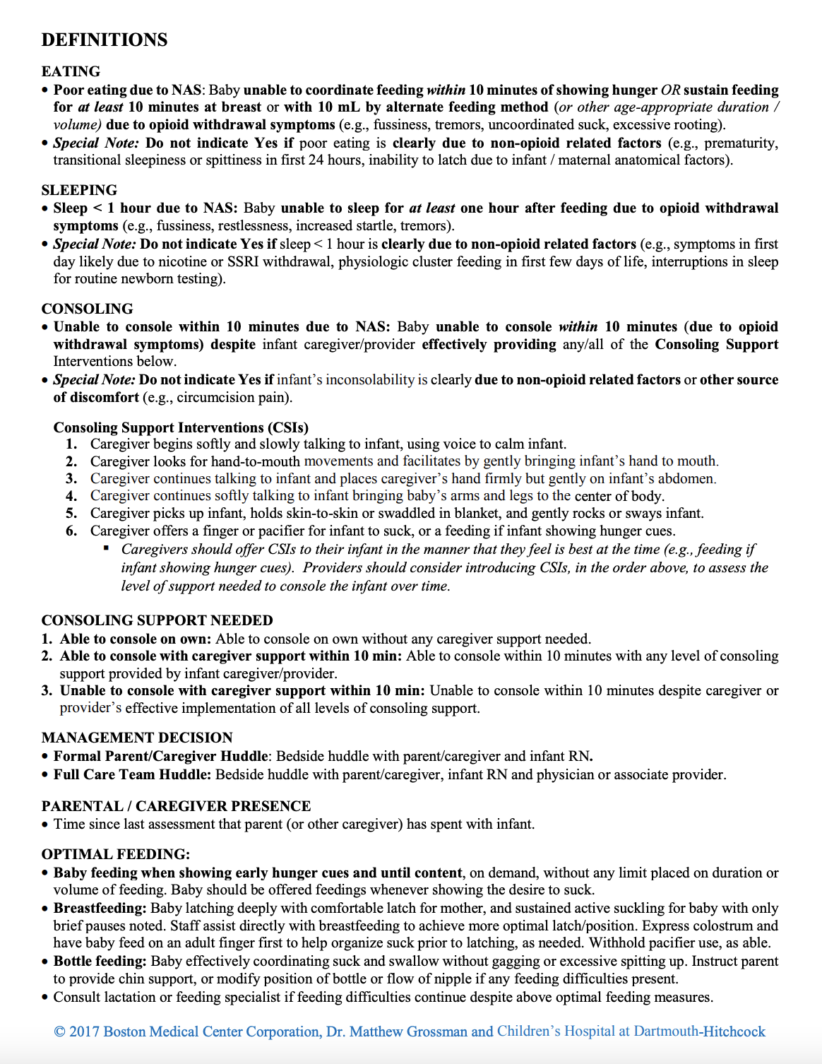

Appendix B: Letter of Support-Ascension Saint Thomas Midtown Hospital

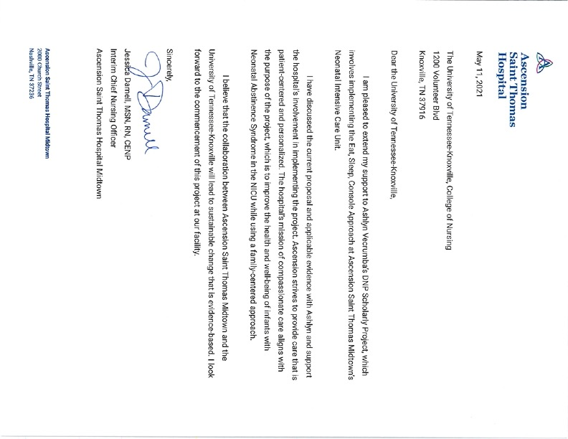

Appendix C: Letter of Support- Vanderbilt University Medical Center
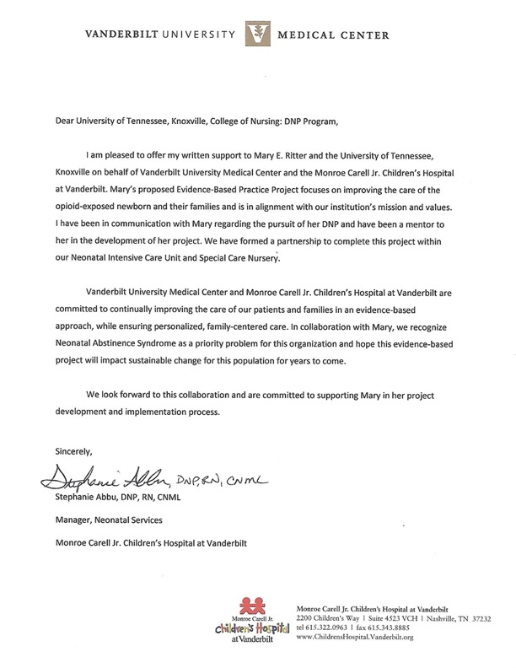

Appendix D: JHNEBP Guides
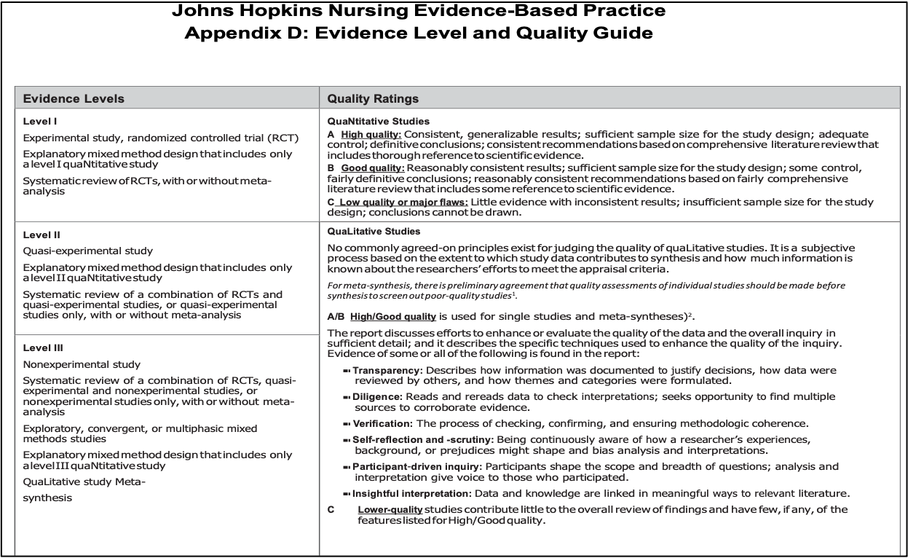
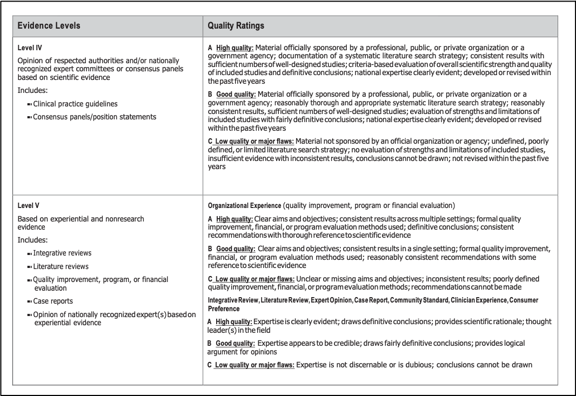

Appendix D: JHNEBP Tools

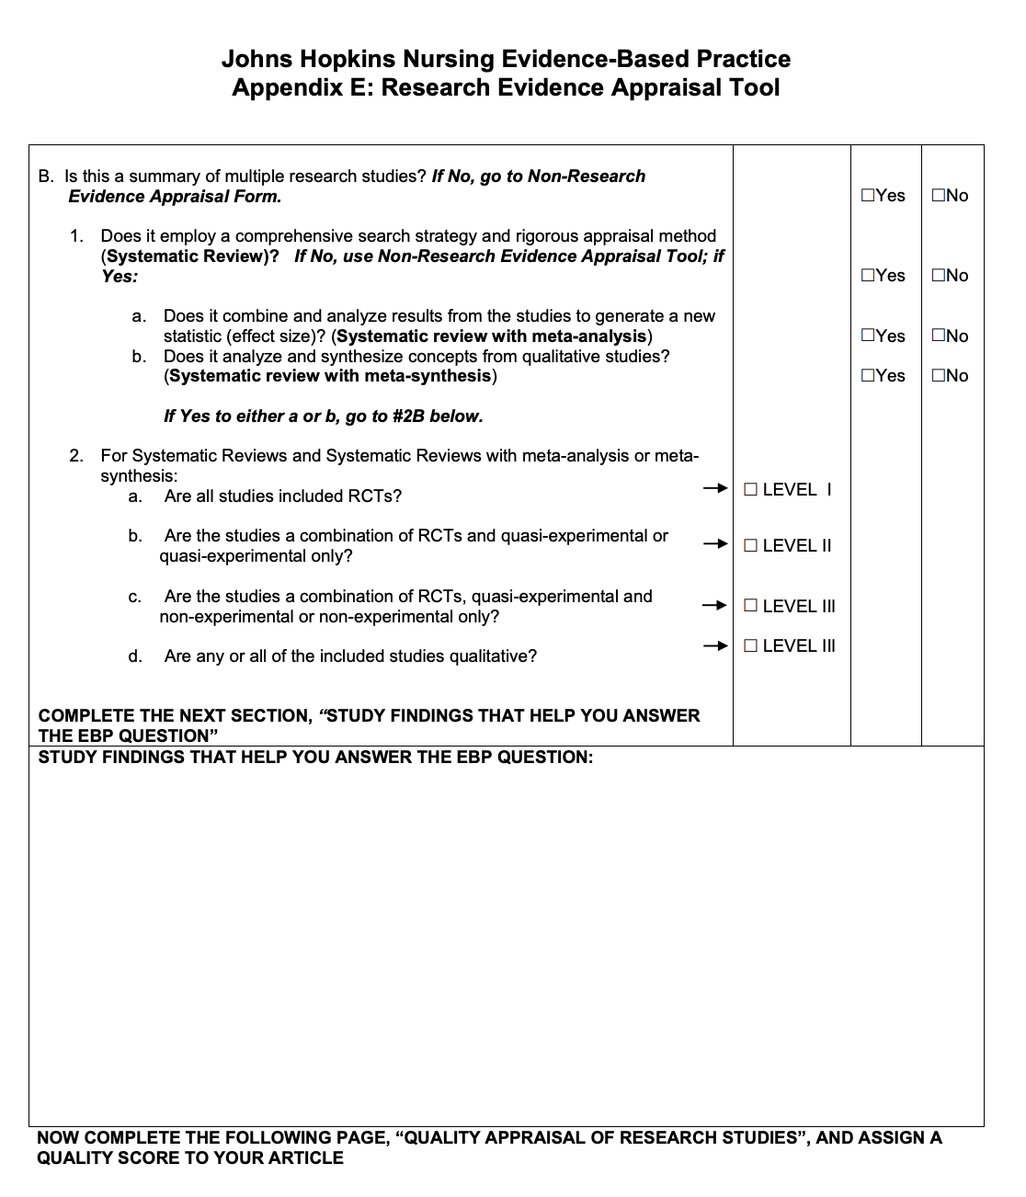

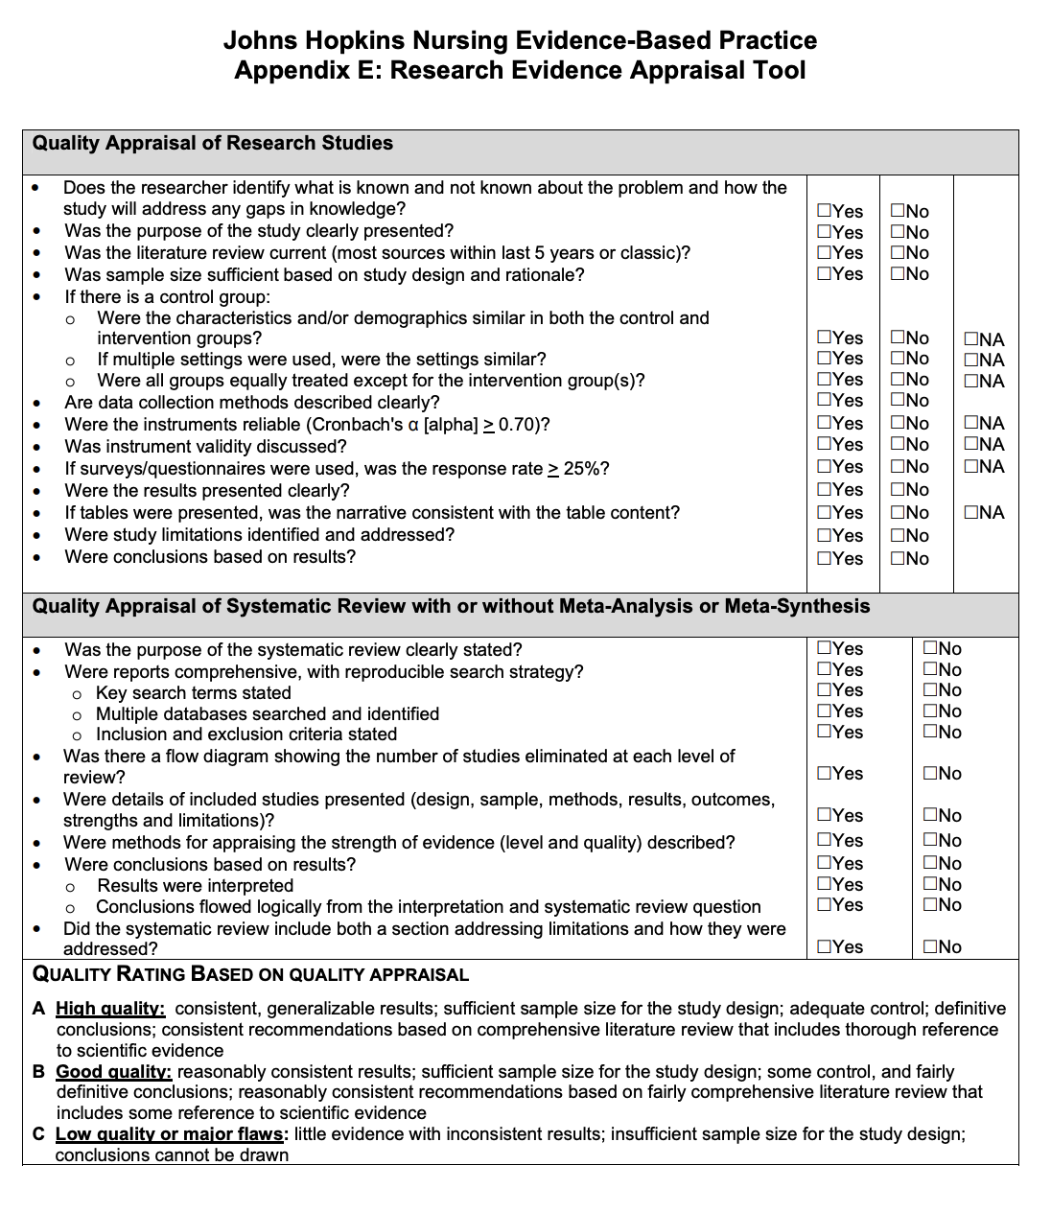

Appendix E: Eat, Sleep, Console Approach RN Education Slides
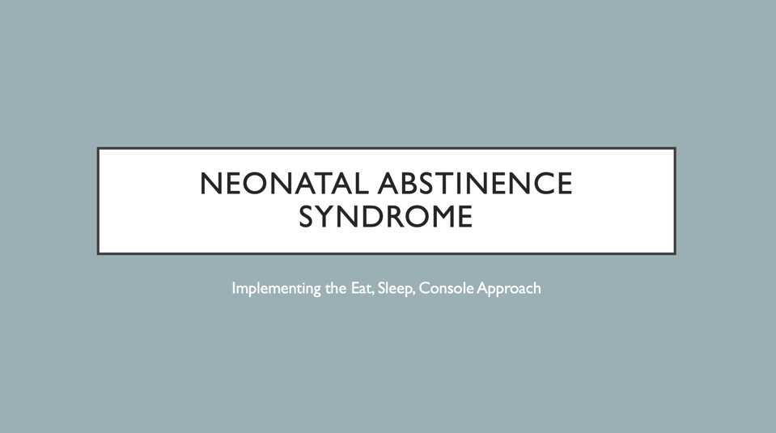
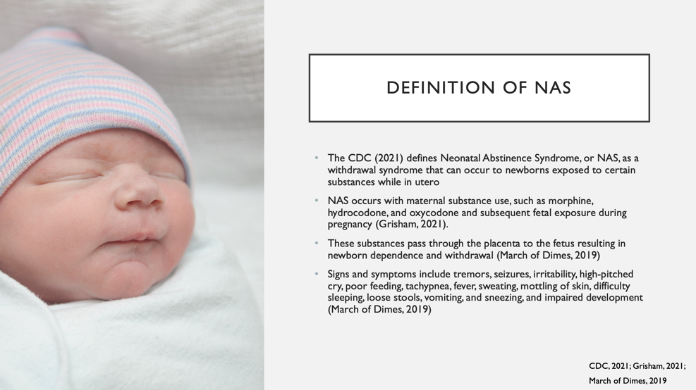
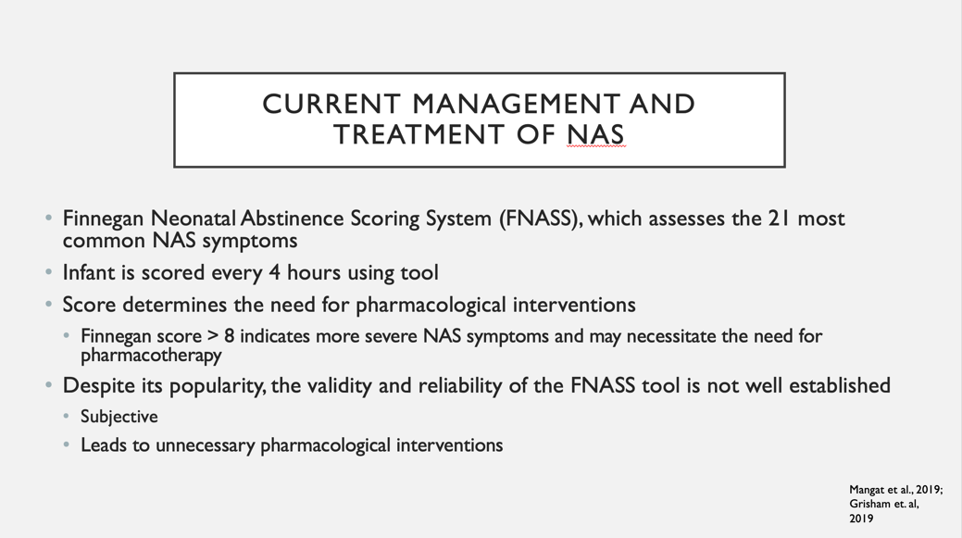
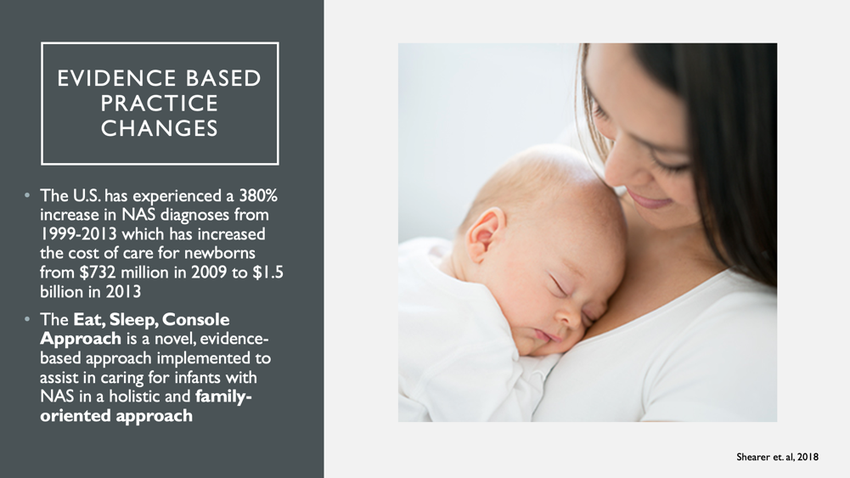
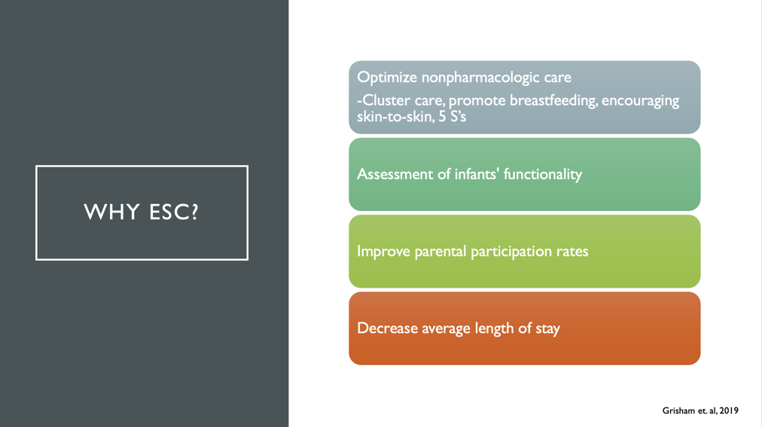
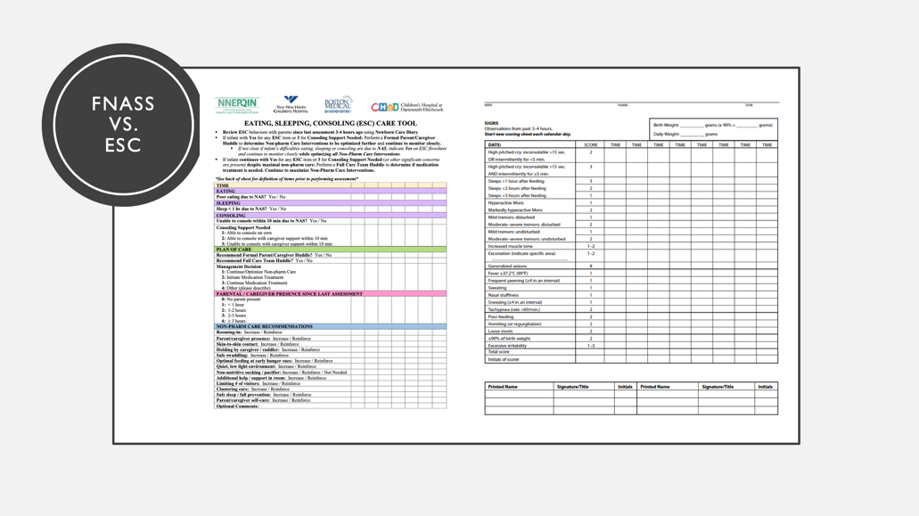

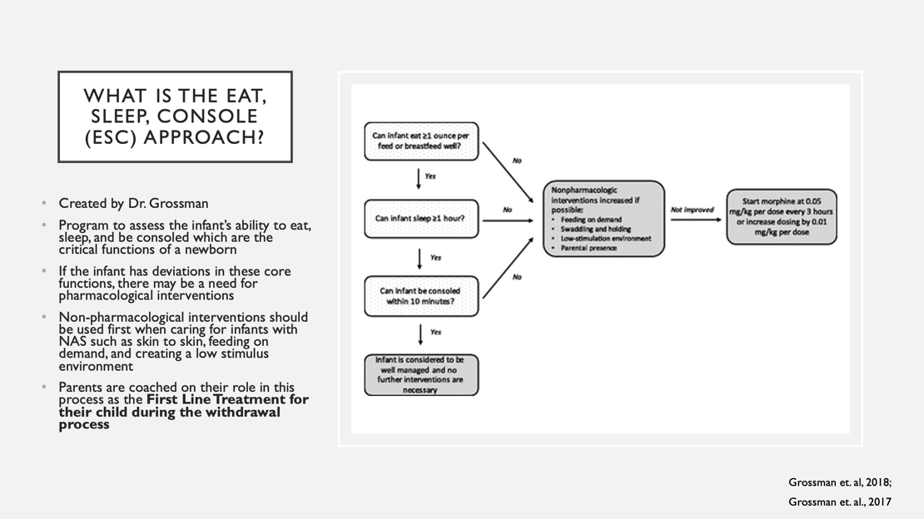
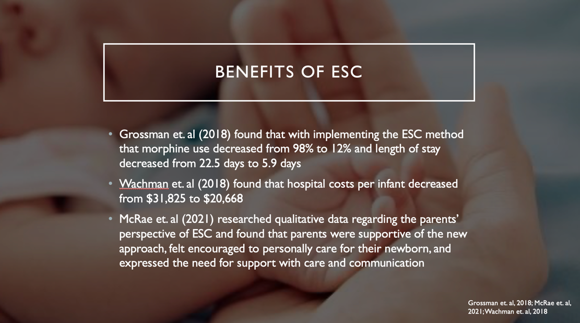
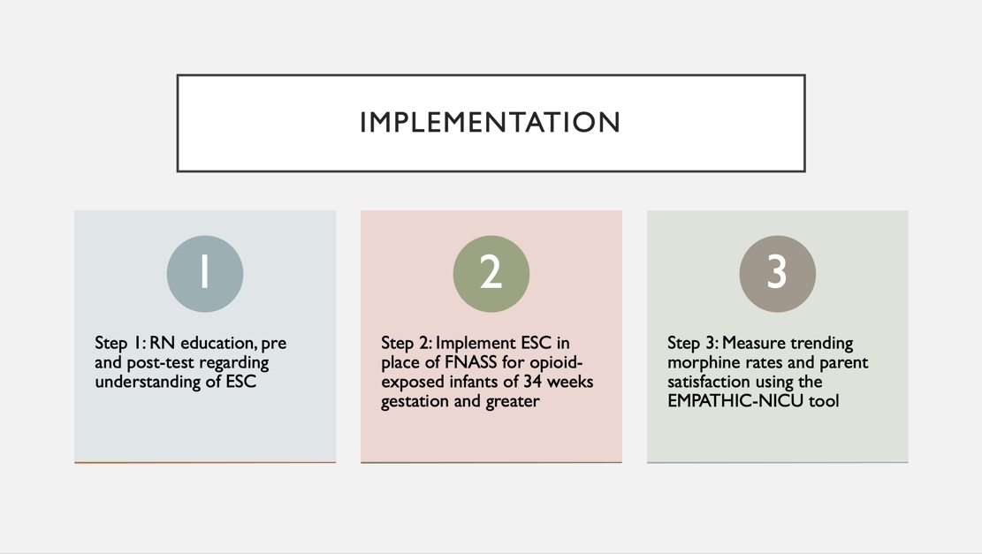
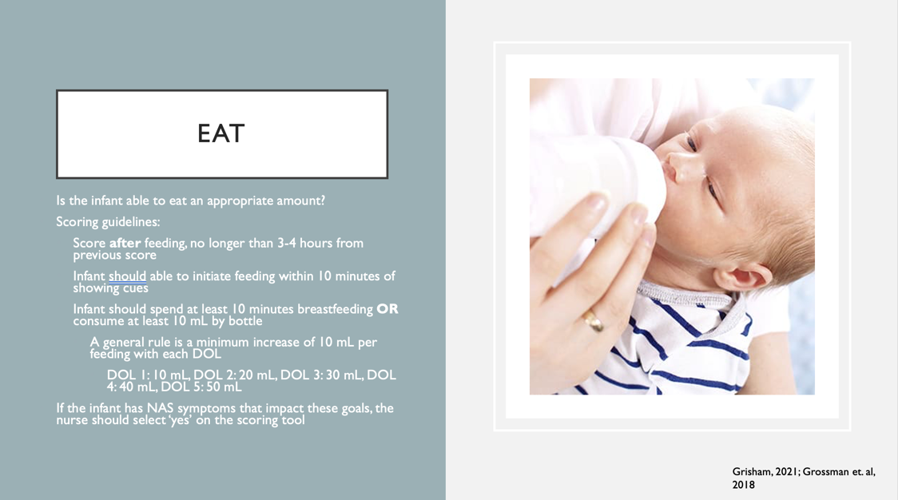
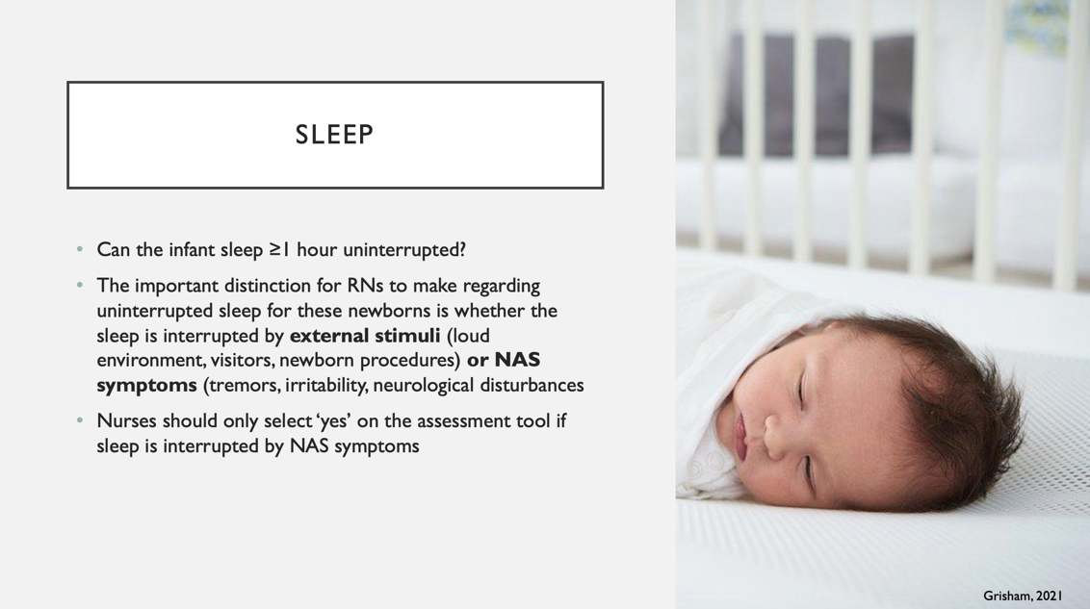
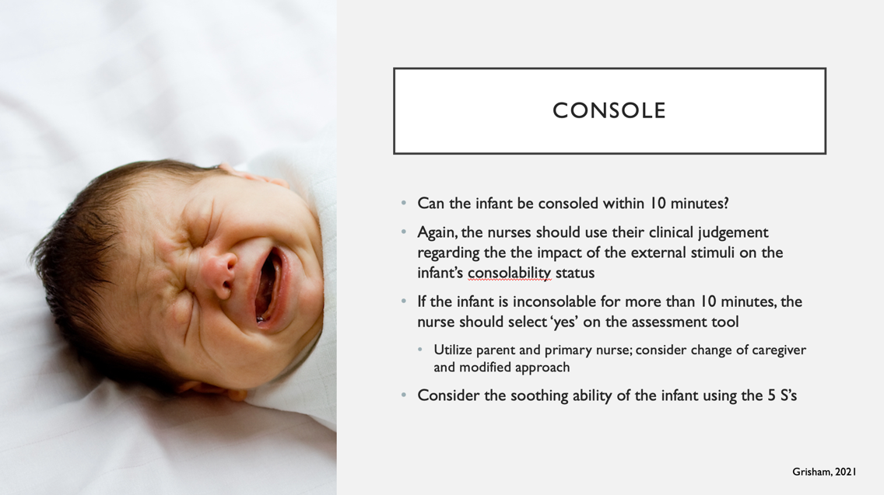
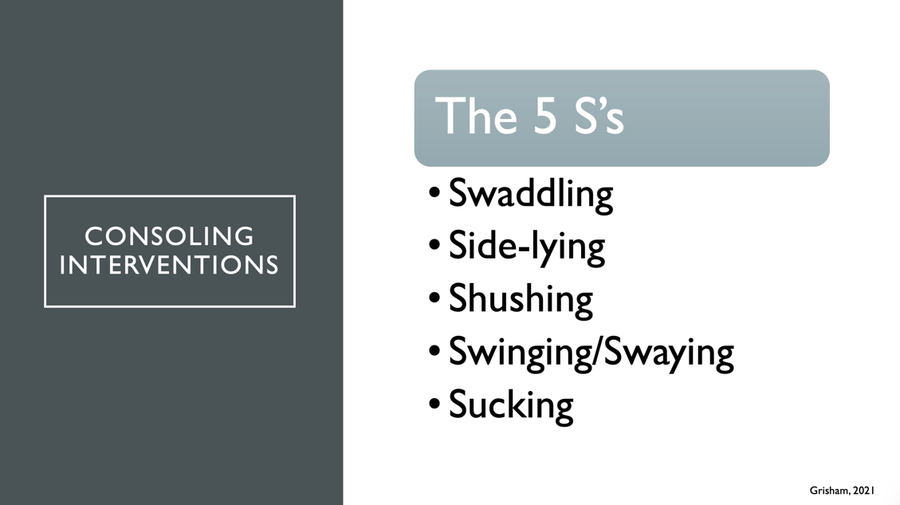
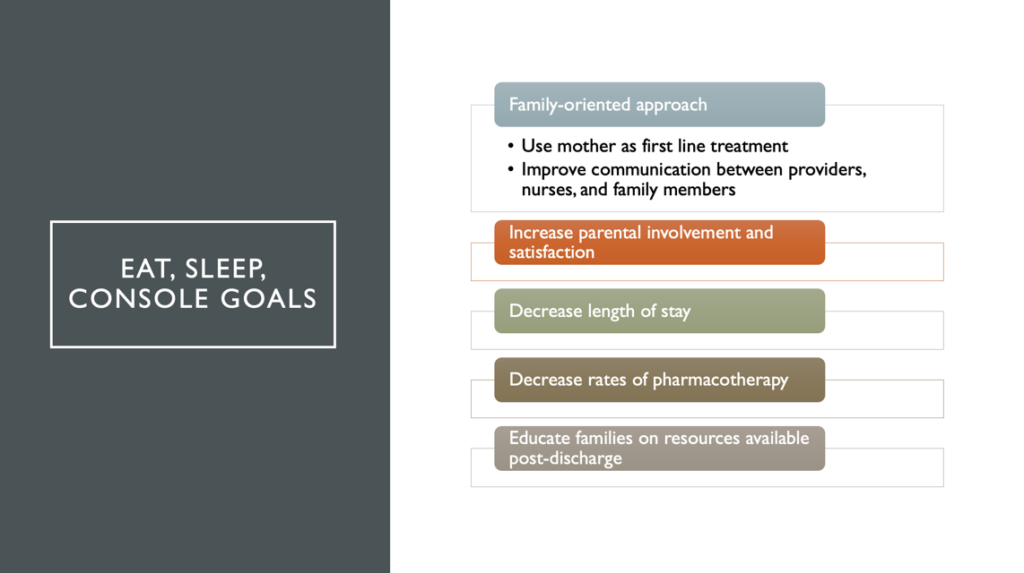
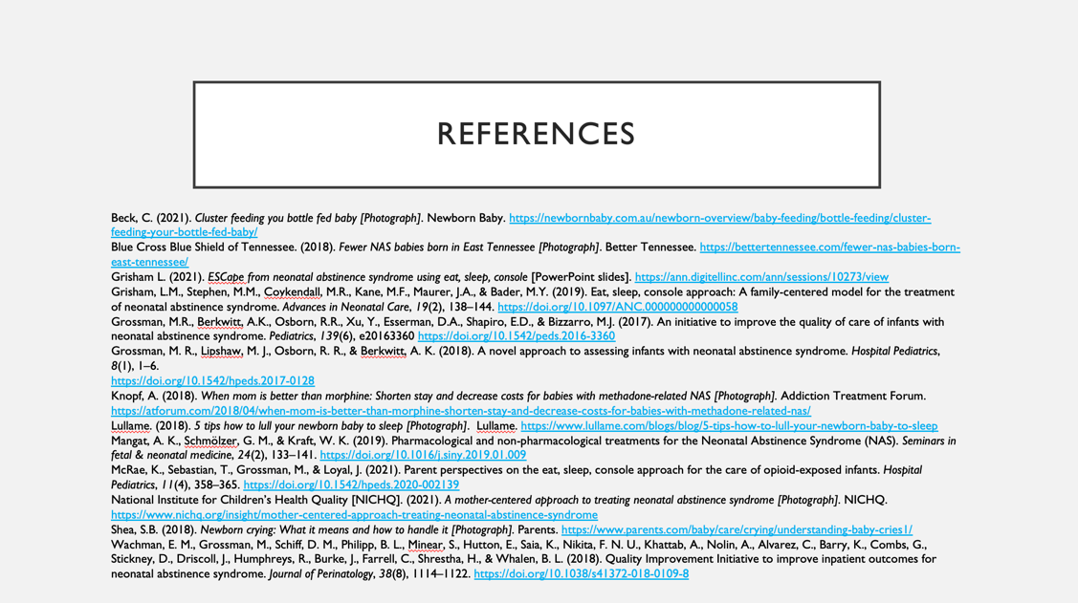
Appendix F: IRB Determination Letter-Vanderbilt University Medical Center
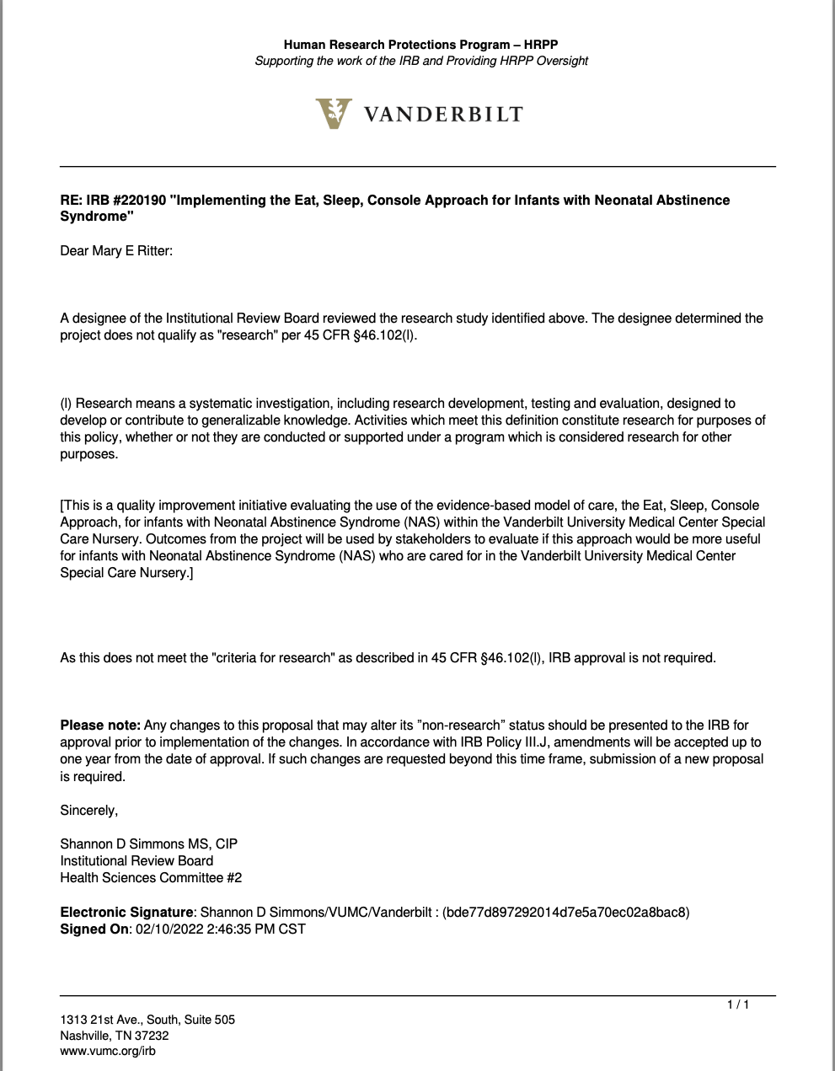
Appendix G: IRB Determination Letter- The University of Tennessee, Knoxville 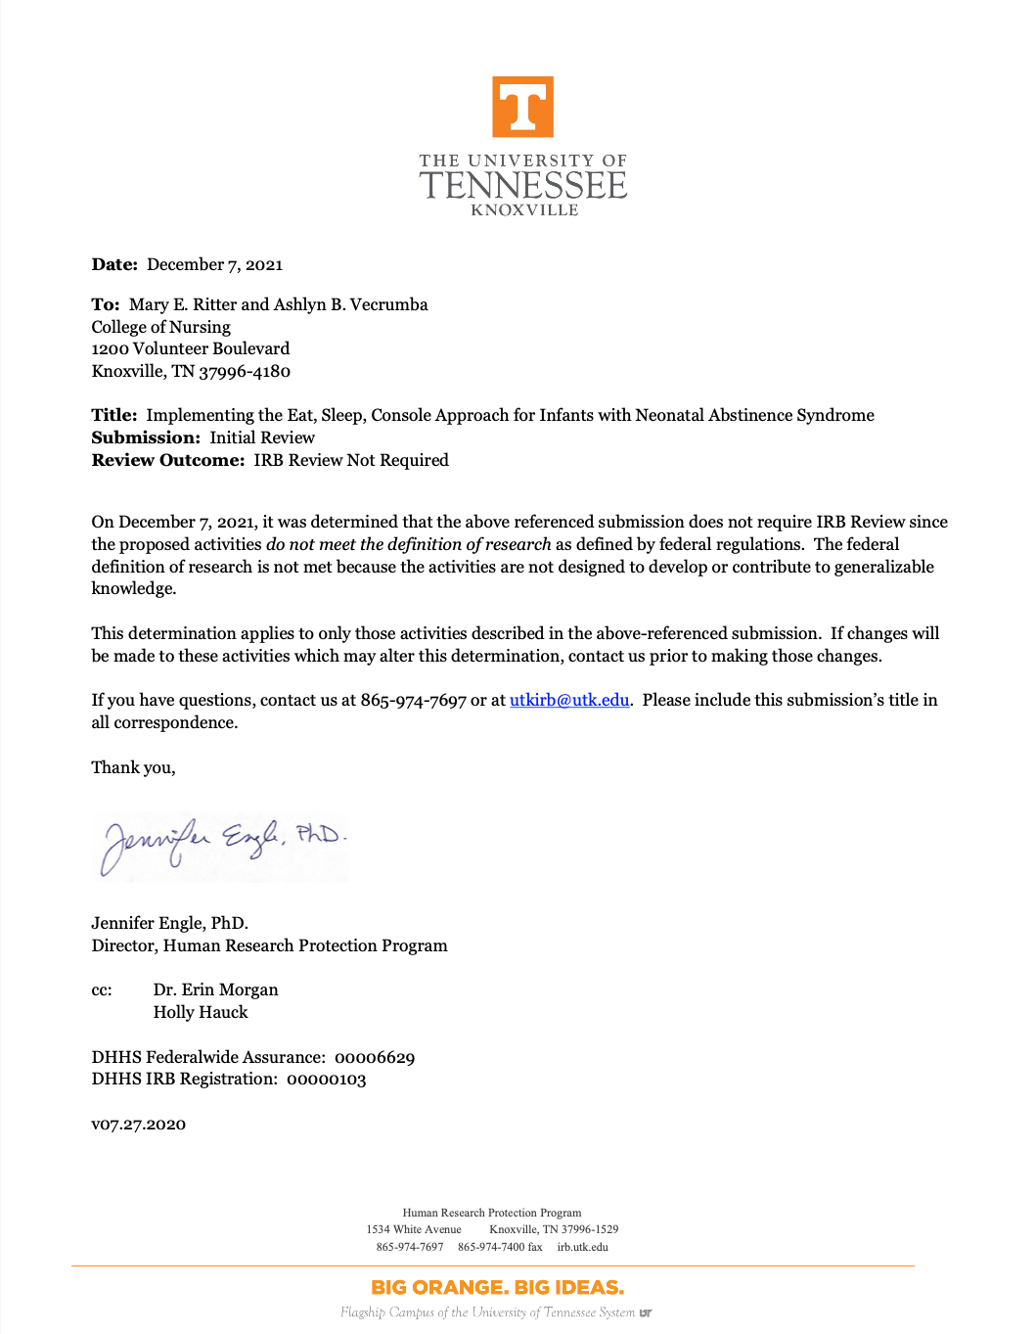
Appendix H: VUMC Opioid-Exposed Neonate Care Pathway Clinical Practice Guideline
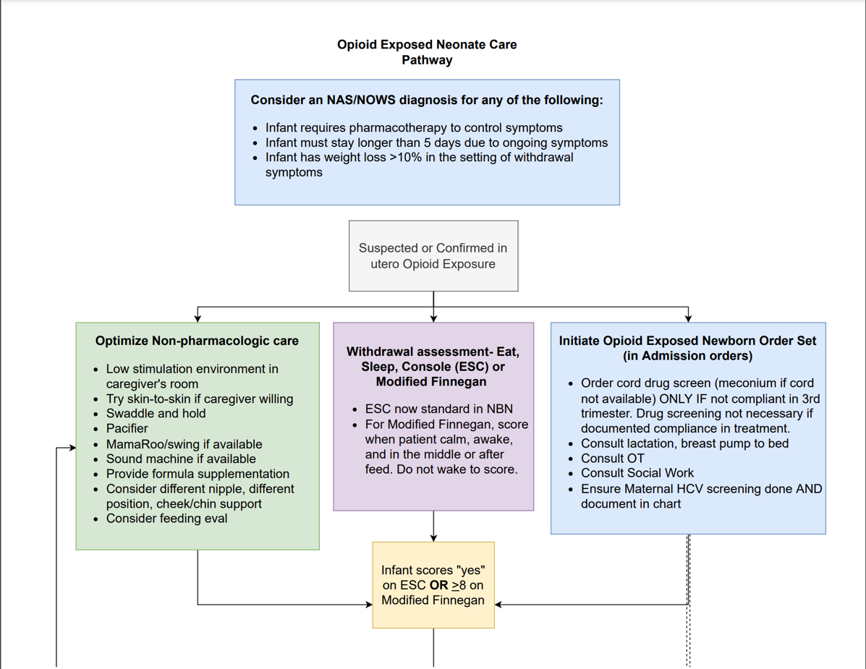
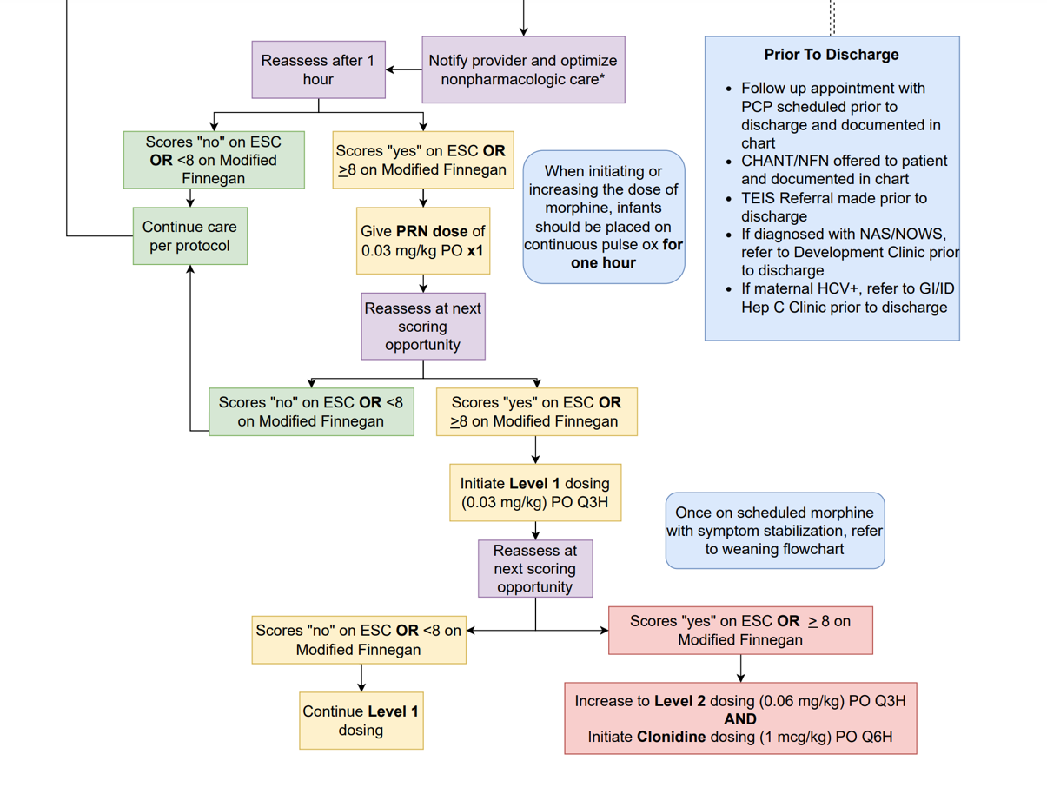
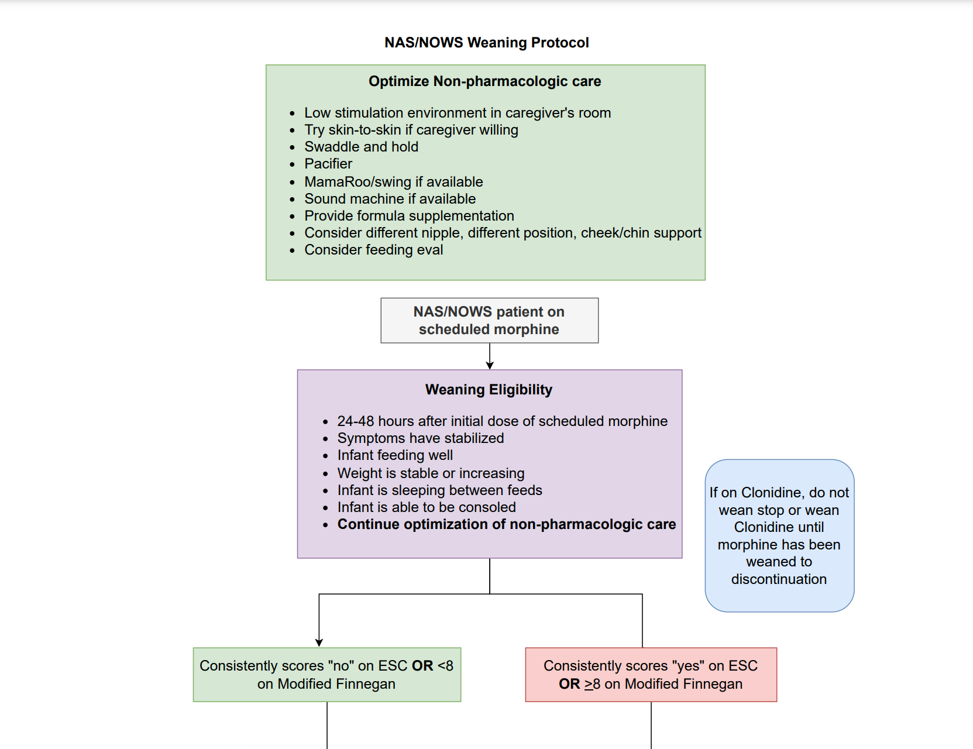
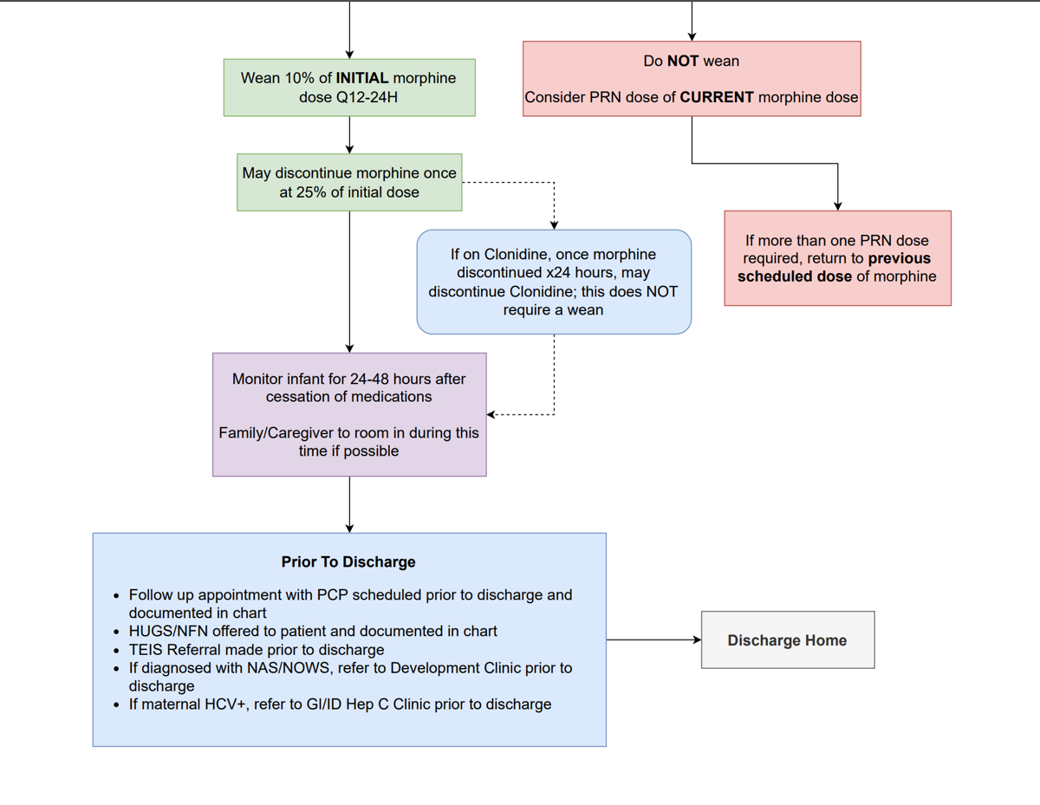

Appendix I: Parent ESC Information Packet

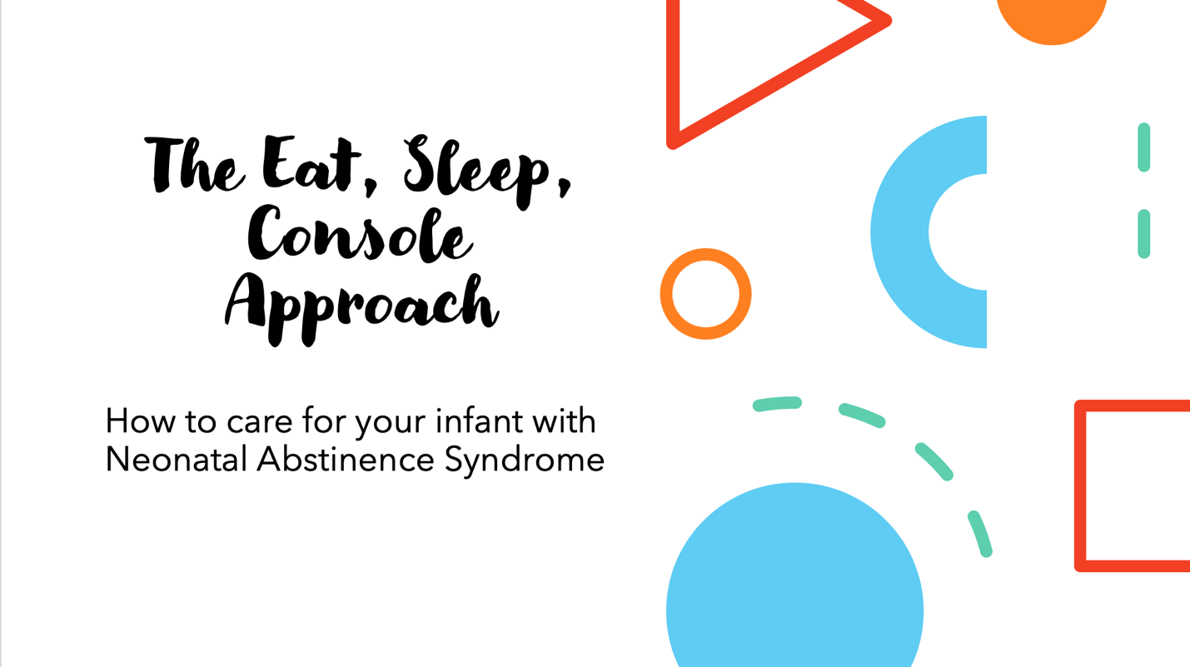
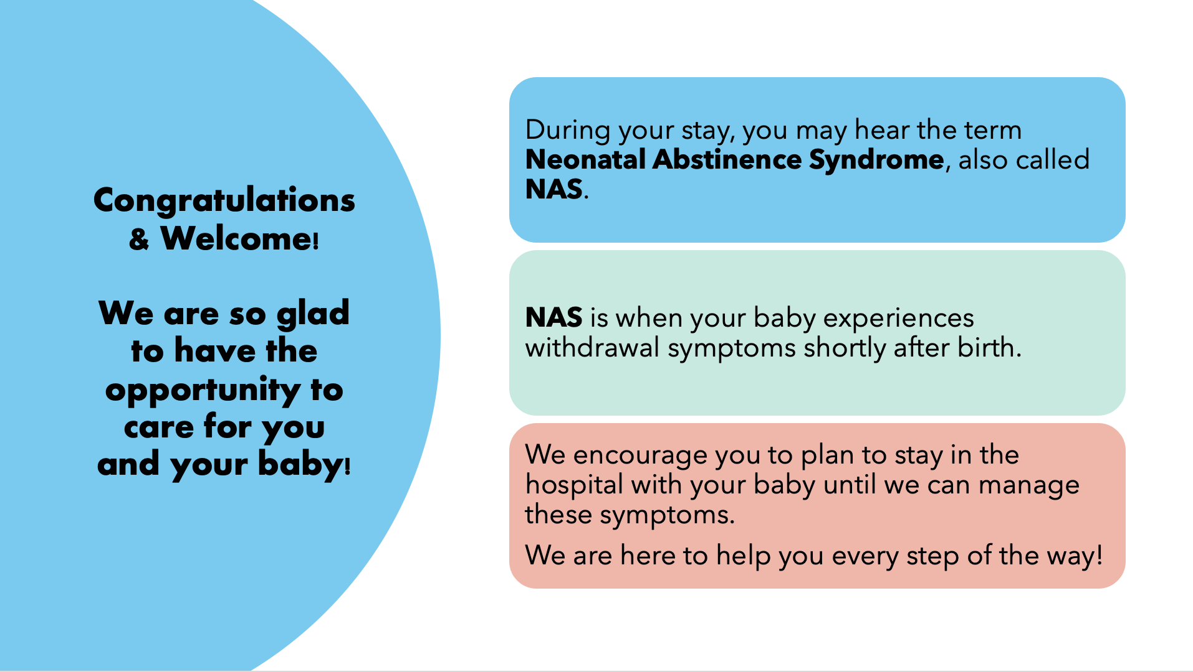
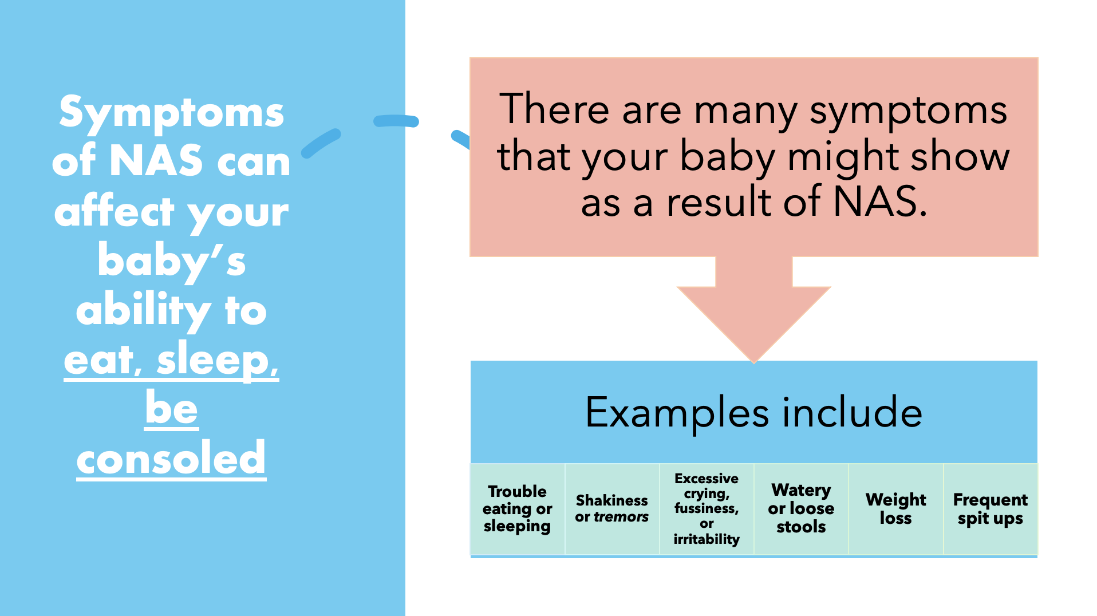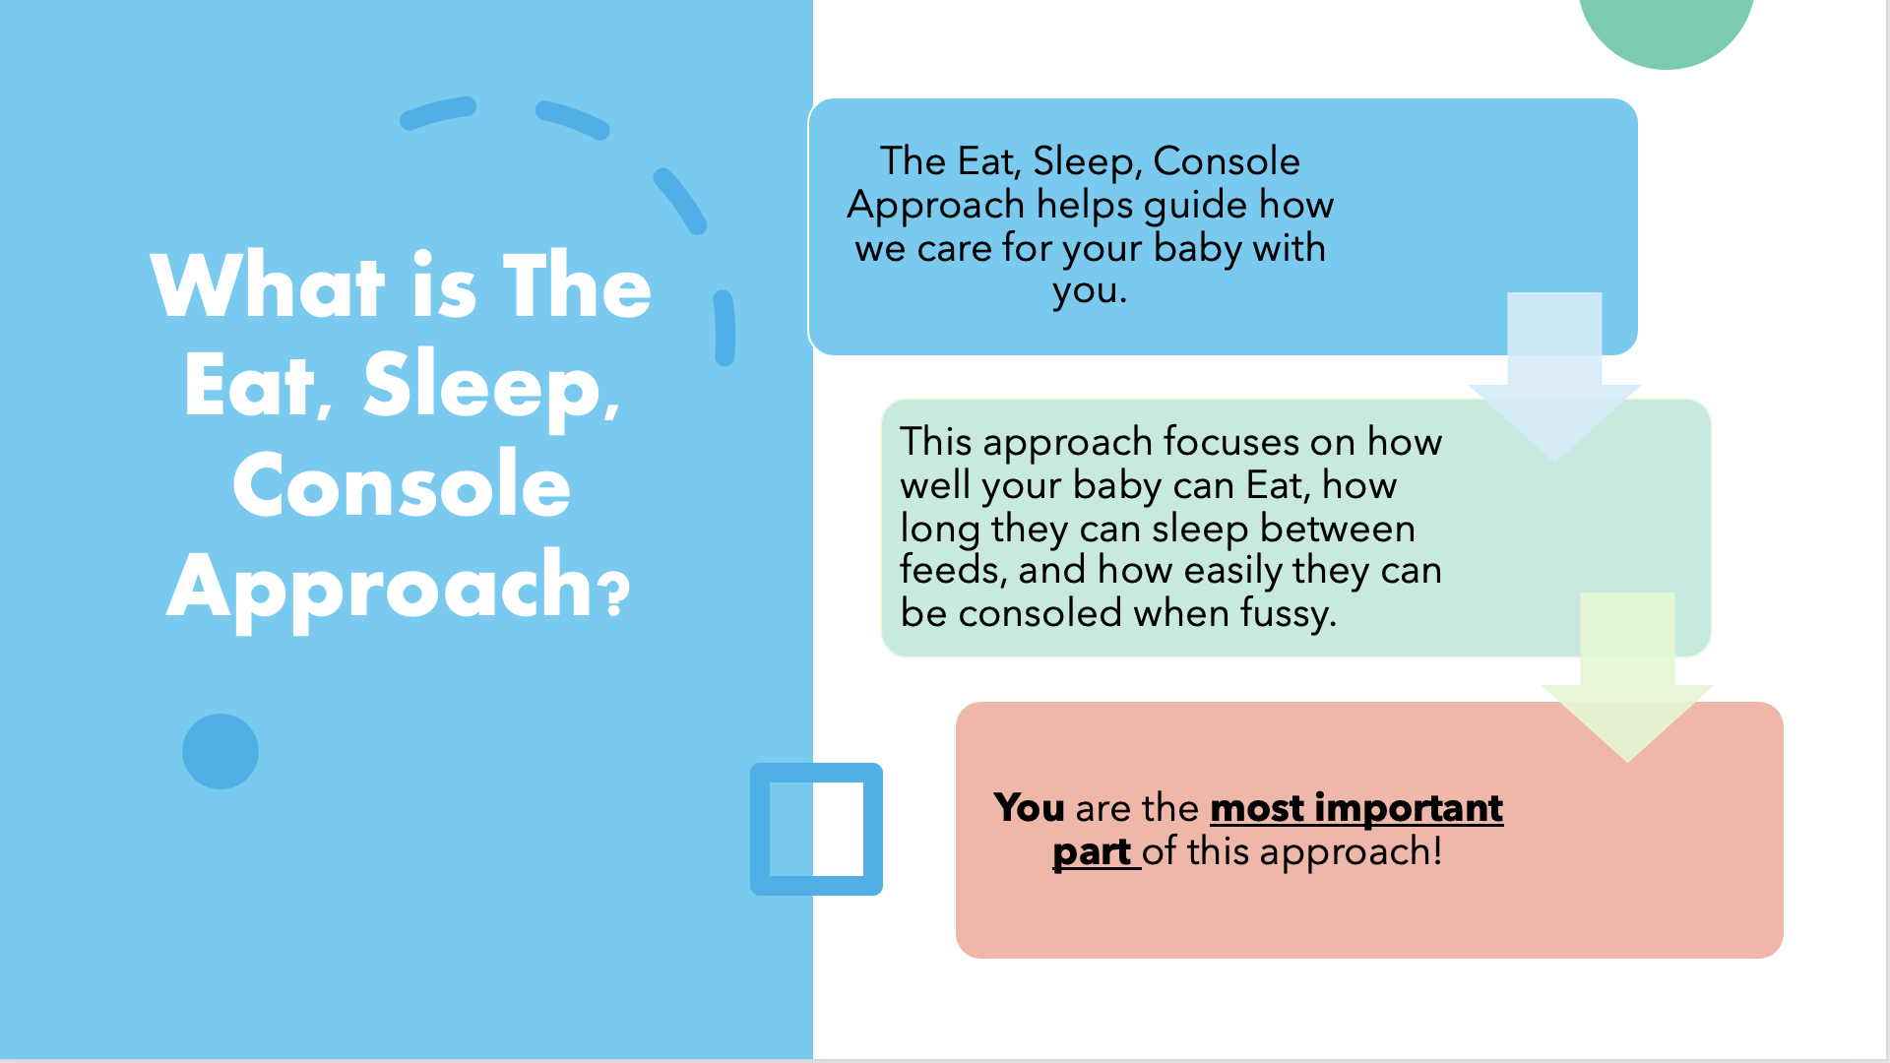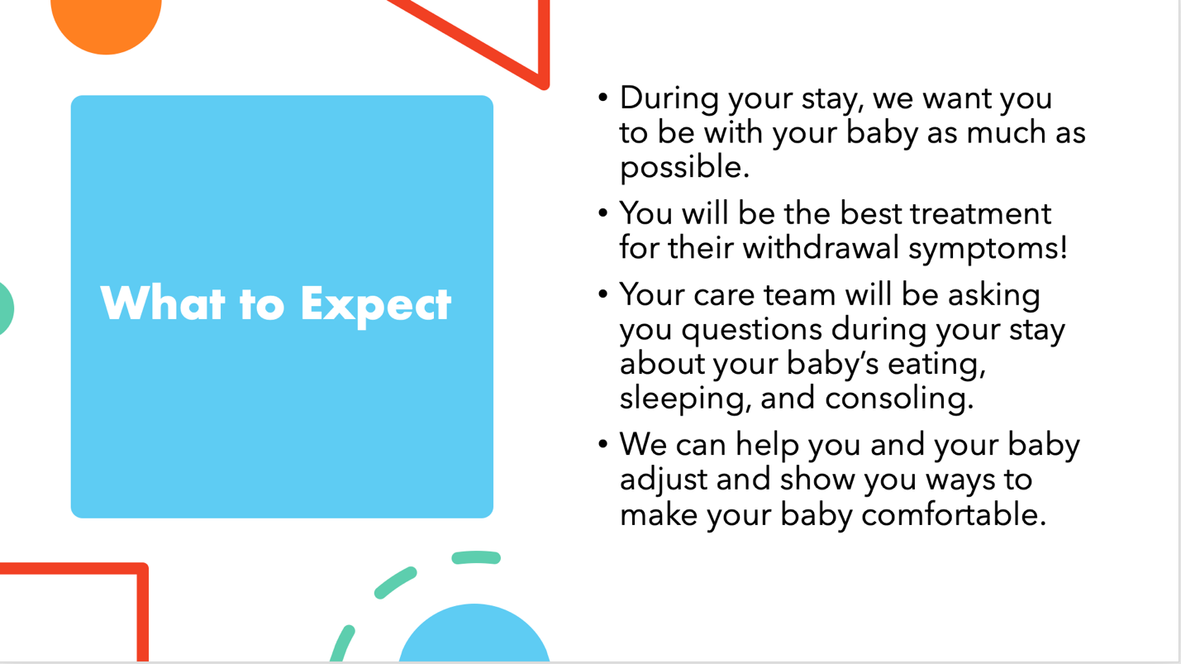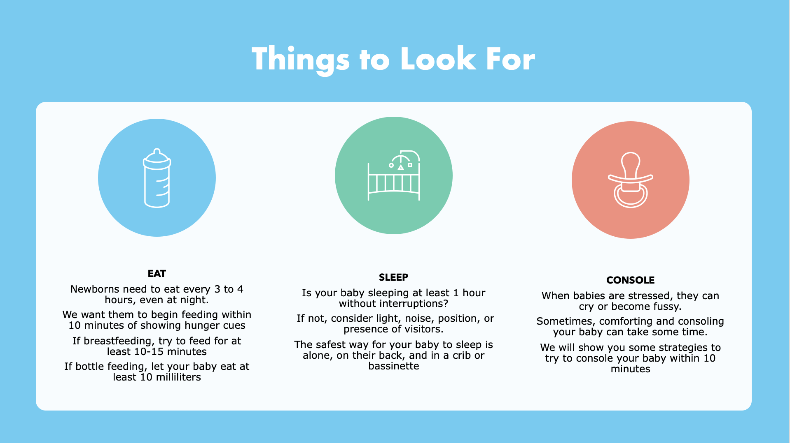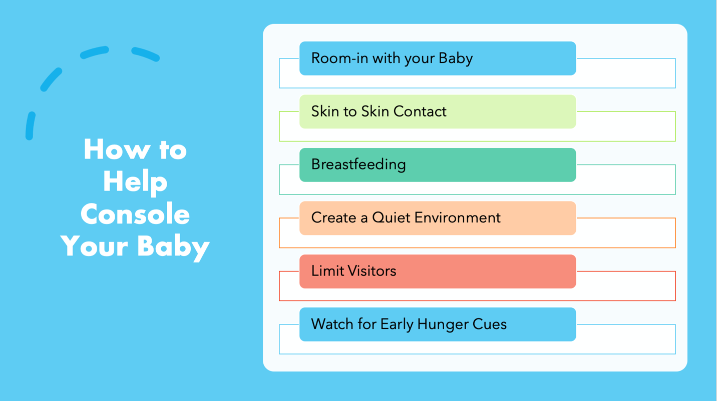
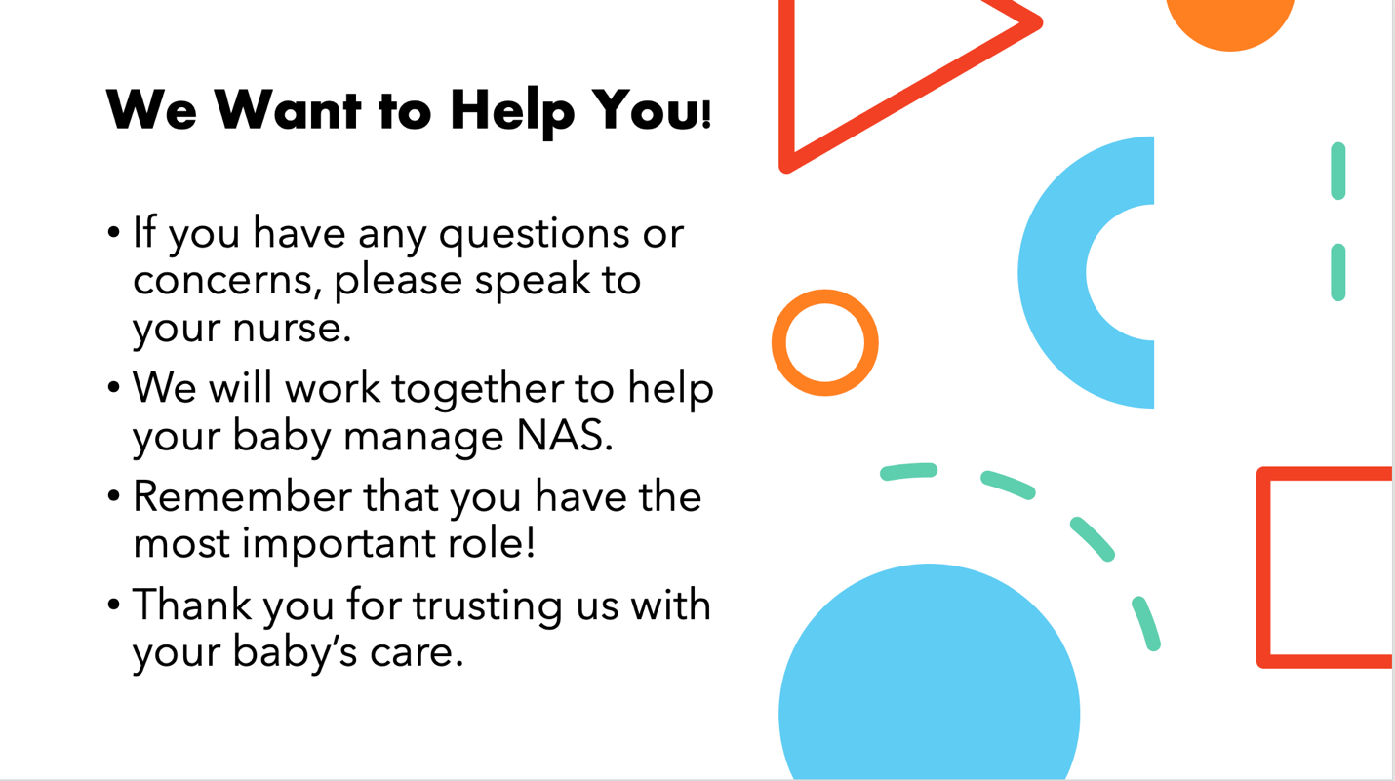
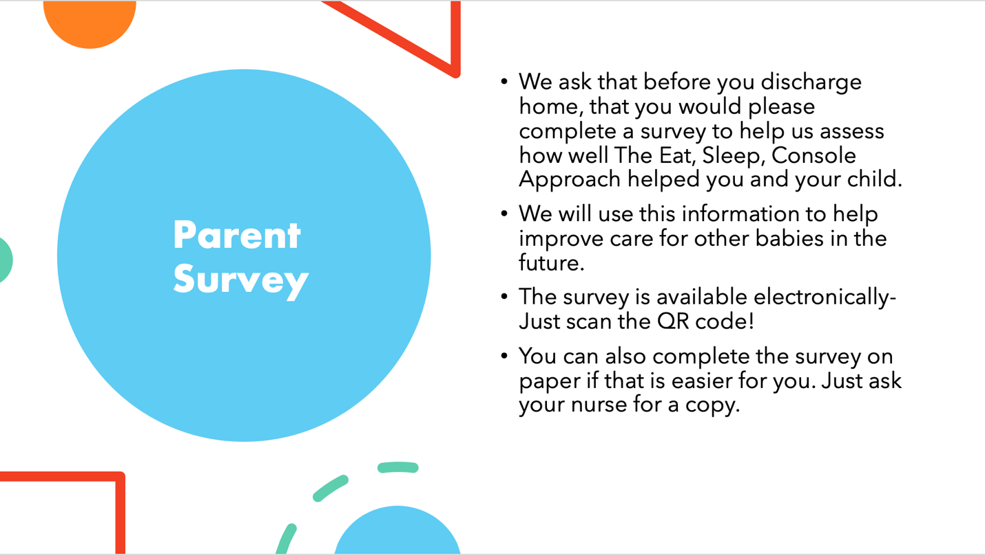

Appendix J : EMPATHIC Questionnaire
Your experience counts
Dear Parent/Guardian,
With this questionnaire ‘Your experience counts’ we would like to learn how you experience your child’s stay in our neonatal nursing unit.
You will be asked to respond to statements concerning the care of your child and yourself during your stay in our neonatal nursing unit.
If you agree with a statement, you should check a box more to the right. If not, you should check a box more to the left (see example).
Certain statements may not apply to your situation. If so, please check the box in the ‘not applicable’ column.
Example:
INFORMATION | Certainly No |  |  |  |  | Certainly Yes | Not Applicable
We were given a cup of coffee every day

We could always lock away our valuables

We could always find a space in the parking lot

On the final page you are invited to write your experiences and make suggestions for improvements.
On behalf of all nurses, nurse practitioners and doctors in the neonatal nursing unit we thank you for your cooperation.
Eileen Lake
Principal Investigator

INFORMATION | Certainly NO |  |  |  |  | Certainly YES | Not applicable
The doctors talked to us daily about the care and treatment of our child.
The nurses talked to us daily about the care and treatment of our child.
The doctors clearly informed us about the consequences of our child’s treatment.
We received clear information about the effects of the medications.
CARE AND TREATMENT
The doctors and nurses worked closely together.
The doctors prepared us well for our child’s discharge.
The nurses prepared us well for our child’s discharge.
The team was attentive to the prevention and treatment of pain in our child.
Our child’s comfort was taken into account by the doctors.
Our child’s comfort was taken into account by the nurses.
Each day we knew which doctor was responsible for our child’s care.
Each day we knew which nurse was responsible for our child’s care.
The nurses supported us emotionally.
The doctors supported us emotionally.
The doctors took action immediately when our child’s condition worsened.
The nurses took action immediately when our child’s condition worsened.
ORGANIZATION
The NICU team worked efficiently.
The NICU could be reached easily by telephone.
There was enough space around our child’s bed.
The NICU was clean.
In the NICU, noise was kept to a minimum.
PARENTAL PARTICIPATION
During our child’s NICU stay the staff regularly asked about our experience in the NICU.
We were actively involved in decision-making about our child’s care and treatment.
We were encouraged to stay close to our child.
We had confidence in the doctors.
We had confidence in the nurses.
Even during intensive procedures, we could always stay present with our child.
The nurses encouraged us to help in the care of our child.
The nurses trained us in the specific aspects of our child’s care.
PROFESSIONAL ATTITUDE
We received sympathy from the doctors.
We received sympathy from the nurses.
The team was attentive about maintaining hygiene.
The team respected the privacy of our child and of us.
The team showed respect for our child and for us.
We felt welcomed at the time of our child’s admission to the NICU.
In spite of the workload, sufficient attention was paid to our child and to us by the team.
Our cultural background was taken into account.

