To the Graduate Council:

I am submitting herewith a dissertation written by Chad Christopher Black entitled “Methicillin Resistance in Staphylococcus pseudintermedius.” I have examined the final electronic copy of this thesis for form and content and recommend that it be accepted in partial fulfillment of the requirements for the degree of Doctor of Philosophy, with a major in Comparative and Experimental Medicine.

Stephen A. Kania, Major Professor

We have read this dissertation
and recommend its acceptance:

David A. Bemis

Robert N. Moore

John C. New, Jr.

Accepted for the Council
Carolyn R. Hodges
Vice Provost and Dean of the Graduate School

(Original signatures are on file with official student records.)

Methicillin Resistance in Staphylococcus pseudintermedius

A Dissertation Presented for the

Doctor of Philosophy Degree
The University of Tennessee, Knoxville

Chad Christopher Black
August 2010

Copyright © 2010 by Chad Christopher Black,
All rights reserved.

Dedication
For Belinda and in spite of the cat.

“An ocean in a drop of water – and unknown, uncharted, unexplored by man! By man, who gives all his time to the Africas and the poles, with this unsearched marvelous world right at his elbow.” – Mark Twain, “The Great Dark”¹
Acknowledgments
Thanks to Robert E. Black and Robert D. Black for their example; to Belinda Black and Susan Black for their patience and understanding; to Stephen Kania and David Bemis for their sound guidance throughout this process; to the members of my graduate committee and the many fine people at the at the University of Tennessee College of Veterinary Medicine who have created a rich and supportive learning environment.
Abstract
Staphylococcus pseudintermedius affecting dogs is analogous to S. aureus on humans, acting as both normal flora and opportunistic pathogen. Methicillin resistance in S. pseudintermedius is recent, with the first documented occurrence of an isolate bearing the methicillin resistance gene, mecA, in 1999. This gene encodes penicillin binding protein 2a, which renders all β-lactam drugs ineffective and functions as a “gateway” antibiotic resistance determinant. In the presence of ineffective antibiotics, opportunities for mutational events and acquisition of mobile genetic elements increase as microbial densities increase, often leading to multi-drug resistance. MRSP infections have become increasingly common. For example, approximately 30% of the S. pseudintermedius isolates tested by the UTCVM Diagnostic Bacteriology service are resistant to methicillin. An increasing number of MRSP isolates are also resistant to most clinically useful antibiotics available to veterinarians except for chloramphenicol, and resistance to this antibiotic is common among European MRSP isolates. Chloramphenicol resistance has begun to appear in the US and if this trend continues there may soon be few viable antibiotic treatment options.
Compared with the arrival of MRSA in the 1960s, the opportunity currently exists to apply advanced molecular methods early in this recognized emergence of MRSP. To that end I have pursued projects utilizing multilocus sequence typing, pulsed-field electrophoresis, and SCCmec characterization of both susceptible and resistant S. pseudintermedius. The initial result was the detection of a clonal population of MRSP in the southeastern United States. Further characterization of this and other clonal lineages using genomic sequencing and real-time RT-PCR expression analysis of antibiotic resistance and quorum sensing genes revealed a marked difference in the regulation of antibiotic resistance between regional clones. These discoveries have interesting epidemiological implications and provide a foundation for the development of novel therapeutics to circumvent the expanding antibiotic resistance repertoire of MRSP. Potential targets identified by this work include membrane-bound beta-lactamase receptors responsible for the regulation of mecA, non-cognate auto-inducing peptides, and synthetic antisense oligonucleotides.

Table of Contents

Chapter 1: Literature Review 1

Overview 1
The Taxonomic History of Staphylococcus pseudintermedius 2
The History of Methicillin Resistance in S. pseudintermedius 5
The Utility of Genotypic Methods for Staphylococcal Population Analysis 6
Staphylococcal Cassette Chromosome (SCCmec) Typing 7
Methods for Sub-Typing S. aureus and S. pseudintermedius 9
Pulsed-Field Gel Electrophoresis 9
Multilocus Variable Number Tandem Repeat Analysis (MLVA) and spa Typing 10
Multilocus Sequence Typing 11
Quorum-sensing in S. pseudintermedius 12
Summary Statement 12
Chapter 2: Identification of a predominant multilocus sequence type, pulsed-field gel electrophoresis cluster, and novel staphylococcal chromosomal cassette in clinical isolates of mecA-containing, methicillin-resistant Staphylococcus pseudintermedius 14

Abstract 14
Introduction 15
Materials and Methods 16
Bacterial strain selection 16
DNA isolation 16
SCCmec typing and characterization 17
Multilocus Sequence Typing 17
Pulsed-field Gel Electrophoresis 17
Results 18
SCCmec typing and characterization 18
Multilocus Sequence Typing 19
Pulsed-field Gel Electrophoresis 20
Discussion 24
Chapter 3: Variation in mecA expression among regional clones of methicillin-resistant Staphylococcus pseudintermedius and characterization of mecA and blaZ regulatory elements. 26

Abstract 26
Introduction 27
Materials and Methods 29
Bacterial Isolate Selection and Identification 29
DNA Extraction 30
PCR Primers and Conditions 30
Sequence analysis 32
MLST and PFGE 32
Bacterial Growth and RNA Extraction – Time Point mecA Expression Assay 32
Bacterial Growth and RNA Extraction – Oxacillin Curve mecA Expression Assay 33
Realtime RT-PCR – Measurement of mecA Induction and Copy Number 33
Estimation of 16S Endogenous Control Copy Number 36
RNAIII Expression in Conjunction with mecA Expression 36
Statistical Analysis 36
Results 37
Screening for mecA, mecI, mecR1, blaZ, blaI, and blaR1 Initial mecA Expression Assay 37
Sequence Type Selection for Further Analyses 39
mec Sequence Analyses 43
bla Sequence Analyses 43
Relative Quantitation of mecA Expression – ∆∆Ct Method 46
Quantitation of mecA Expression – Standard Curve 48
Effect of Increasing Oxacillin Concentration on mecA Expression 50
RNAIII Expression in Conjunction with mecA Expression 52
Discussion 54
Chapter 4: Conclusions and Application of Findings 56

List of References 58

Vita 68
List of Tables

TABLE 2.1. Allelic profiles and agrD types of novel Staphylococcus pseudintermedius sequence types. 21
TABLE 2.2. Nucleotide sequence variations and alleles in five housekeeping genes. 22
TABLE 3.1. Primers used with conventional PCR. 31
TABLE 3.2. Realtime RT-PCR primers and probes. 34
TABLE 3.3. mec and bla elements present in study isolates. 38

List of Figures
FIGURE 2.1. Pulsed field gel electrophoresis and multilocus sequence typing dendrogram 23
FIGURE 3.1. Two timepoint mecA expression assay 40
FIGURE 3.2a. blaI nucleotide and peptide variation between ST116 and STs 68 and 71. 41
FIGURE 3.2b. PFGE of study isolates. 42
FIGURE 3.3. mecA promoter region polymorphisms of MRSP 44
FIGURE 3.4. mecR1 peptide dissimilarity – STs 71 and 73. 44
FIGURE 3.5. blaR1 peptide dissimilarity – ST 116 and STs 71 and 73. 45
FIGURE 3.6. ∆∆Ct quantitation of mecA expression 47
FIGURE 3.7. Standard curve quantitation of mecA expression 49
FIGURE 3.8. mecA transcript production at increasing concentrations of oxacillin. 51
FIGURE 3.9. RNAIII vs. mecA expression. 53

List of Abbreviations

agrD – accessory gene regulator, locus D, encodes AIP and serves as one of the genes for Bannoehr et al. MLST
AIP – auto-inducing peptide
ATCC – American Type Culture Collection
blaZ – gene encoding β-lactamase
CA-MRSA – community-acquired methicillin-resistant Staphylococcus aureus

CoNS – coagulase-negative staphylococci
cpn60 – chaperonin 60, gene for Bannoehr et al. MLST
HA-MRSA – hospital-acquired methicillin-resistant Staphylococcus aureus
HGT – horizontal gene transfer
mecA – gene encoding penicillin-binding protein 2α
MGE – mobile genetic element
MLST – multilocus sequence type(ing)
MLVA – multiple-locus variable-number tandem-repeat analysis
MRS(P)I – methicillin-resistant Staphylococcus pseudintermedius originally reported as intermedius but isolated from dogs
MRSA – methicillin-resistant Staphylococcus aureus
MRS – methicillin-resistant staphylococci
MRSP – methicillin-resistant Staphylococcus pseudintermedius

MSSA – methicillin-susceptible Staphylococcus aureus
MSSP – methicillin-susceptible Staphylococcus pseudintermedius
PBP2a – penicillin-binding protein 2a
PFGE – pulsed-field gel electrophoresis
pta – phosphate acetyltransferase gene, gene for Bannoehr et al. MLST

RT-PCR – reverse transcriptase polymerase chain reaction
SIG – S. intermedius group (S. delphini, S. intermedius, and S. pseudintermedius)
ST – sequence type, refers to MLST
sodA – superoxide dismutase
spa – staphylococcal protein a
tuf – elongation factor tu, gene for Bannoehr et al. MLST
UTCVM – University of Tennessee College of Veterinary Medicine

Chapter 1: Literature Review

Overview

A synthetic form of penicillin, methicillin, was introduced in 1959 to treat Staphylococcus aureus resistant to β-lactam antibiotics. Within a year the first methicillin-resistant S. aureus (MRSA) isolates began to appear in hospital settings.² Methicillin-resistance is a “gateway” antibiotic resistance determinant. It causes penicillins and cephalosporins to become ineffective, establishing a MRSA foothold in the hospital environment and on the patient repeatedly exposed to first-line antibiotics. From that foothold, the organism has the opportunity to acquire mutations and further transmissible elements that increase its multi-drug resistance repertoire. Methicillin-resistance often leads to multi-drug resistance. In the fifty years since methicillin resistance appeared in S. aureus, MRSA infection has become the sixth-leading cause of death in hospitalized human patients in the United States, with costs estimated to be between 4 and 6 billion dollars annually.^{2,3}
Staphylococcus pseudintermedius on dogs is analogous to S. aureus on humans, acting as both normal flora and opportunistic pathogen. It is the primary cause of pyoderma, the most common dermatologic disease seen in dogs, and is also frequently associated with urinary tract infections and wound and surgical site infections.⁴ The first documented isolate of S. pseudintermedius bearing the methicillin resistance gene mecA occurred in 1999.⁵ Since that discovery, methicillin-resistant S. pseudintermedius (MRSP) infections have become increasingly common. Approximately 30% of the staphylococcal isolates tested by the University of Tennessee College of Veterinary Medicine (UTCVM) Bacteriology Service are resistant to methicillin.⁶⁻⁸ These bacteria also carry resistance to almost all clinically useful antibiotics except for chloramphenicol and the ones reserved for use in humans. Resistance to chloramphenicol is now beginning to appear, leaving no viable therapeutic options.
Methicillin resistance in S. aureus has been studied in far greater detail than in S. pseudintermedius; despite significant dissimilarities in genomic sequence the two species share a natural history, as well as many of the same regulatory, antimicrobial, and virulence determinants. Biochemical and molecular techniques used in the study of S. aureus can and have often been adapted to S. pseudintermedius. Therefore, much of the literature regarding S. aureus is applicable to the study of staphylococci as a whole. The following is a review of the nomenclature, phenotype, genetic characterization of methicillin resistance, and typing methodologies for S. pseudintermedius.

The Taxonomic History of Staphylococcus pseudintermedius

The defining characteristics of bacterial species have changed with advances in technology. With the proliferation of molecular characterization techniques and the increased accessibility of genomic sequencing platforms, the inevitable taxonomic trend is toward diversification within the bacterial genus. The 19th century Scottish physician Alex Ogston was an early proponent of the role of microscopic spherical organisms (“micrococci”) in acute inflammation and suppuration associated with abscess formation in skin. He was also one of the first to make the leap connecting microbial abscessation with the circulatory phenomena of septicemia and pyemia.^{9,10} These foundational observations hold true in the clinical presentation of staphylococcal infection today. In 1882 he coined the term Staphylococcus – from the Greek staphulê for bunch of grapes – to differentiate cluster-forming micrococcus from the chain-forming variety then known as Billroth’s streptococci.¹¹ Rosenbach further subdivided staphylococci in 1884 on the basis of color on culture media – S. aureus and S. albus for gold and white colony formation respectively.¹² For the next ninety years the Staphylococcus genus was widely held to have only three distinct species. During this period gram-positive, coagulase-positive, hemolytic isolates with variable colony coloration and associated with disease in both humans and animals were presumed to be S. aureus; whereas non-pathogenic, coagulase-negative staphylococci (CoNS) with white colony coloration were classified as either S. epidermidis (formerly albus) or S. saprophyticus and considered to be environmental contaminates.¹²⁻¹⁴
Review of veterinary microbiology textbooks from the 1930s through the late 1960s supports the bias towards S. aureus as the catchall designation for pathogenic gram-positive and coagulase-positive clustering cocci. Variations in S. aureus microscopic size, hemolytic ability, and colony coloration were often noted, prompting calls for greater research into the validity of species designation.¹⁵⁻¹⁸ From Merchants 1968 edition of Veterinary Bacteriology and Virology the follow observation is made concerning the use of pigmentation as the sole criteria for staphylococcal differentiation,
(S. Epidermidis) has been considered by many to be only a non-pigmented variant of the aureus strains. It is readily apparent to those who study the staphylococci that numerous non-pigmented strains can be isolated. In fact, unless isolation is made upon special media, such as no. 110, colonies of staphylococci are sometimes white.
The designation of strains of any organism, one variety or another, on the basis of colony color without specification of growth is most confusing, not only to the student but to anyone interested in taxonomy. . . .
It is quite apparent that additional research must be done on the genus Micrococcus (Staphylococcus) in order to clarify many of the interrelationships of the members of this genus.¹⁵

This admonition in a standard veterinary text of the time suggests that as late as the early 1970s some veterinary practitioners were dismissing the as yet uncharacterized S. intermedius as nonpathogenic based primarily on colony color.
In the latter half of the 20th century, spurred by the emergence of new hospital-acquired and antibiotic-resistant infections, both human and veterinary medical microbiologists began to actively pursue a better understanding of which organisms were associated with specific types of infections and hosts. The improvements made in both phenotypic biochemical testing and genotypic molecular tests resulted in the diversification of both coagulase-positive and negative staphylococcal species.^{13,16,19} At the time of writing there are 41 species and 24 subspecies cited in the genus Staphylococcus.²⁰
The earliest call for a more precise designation for coagulase-positive staphylococci of canines came in 1947, with Smith’s observation that not all suspected pathogenic strains from canines reacted uniformly in tube, slide and plate agglutination tests; and that canine isolates were discernable from those of other animals by cultural characters and toxin formation.²¹ Based upon confirmation of Smith’s work, a 1967 report proposed the name S. aureus var. canis and described biochemical and staining differences between isolates from different host species. The study showed that canine isolates consistently failed to coagulate human serum, pigmentation lacked the characteristic golden hue, and crystal-violet staining, fibrinolysin production, hemolysis type and phage type did not consistently match between human and canine isolates.²² A series of cross-reactivity experiments by I. Live of Pennsylvania and V. Hajek of Czechoslovakia further explored the coagulase and fibrinolysis disconnect observed when isolates of one background were exposed to blood components of the other. Not only did these findings have bearing on speciation, they were an early suggestion that staphylococci of canine origin may be more host-adapted than the human equivalent, S. aureus.²³⁻²⁵ In 1976 Hajek reported the results of a battery of additional biochemical tests that when applied to coagulase-positive staphylococci of animal origin (pigeon, canine, mink, and horse) justified a new species name, S. intermedius. The name was chosen to indicate the group’s intermediate phenotypic position between the coagulase-positive S. aureus and the white colony formation of S. epidermidis. Despite evidence of biochemical differences between isolates from the different animals within the study, a pigeon isolate became the type strain for S. intermedius.¹⁶ With the biochemical profile established for species identification, reports from the 1980s through 2007 consistently demonstrated S. intermedius to be the primary staphylococcal normal flora and opportunistic pathogen of canines.²⁶⁻³⁰
The improvement of molecular typing methods in the 1980s and 90s provided additional tools for the description of bacterial species. In 2005 Devriese et al. described a novel staphylococci based on 16S rRNA gene sequence analysis and confirmed by DNA-DNA hybridization its dissimilarity with S. intermedius, S. delphini and S. schleiferi subsp. schleiferi type strains. The name S. pseudintermedius was chosen because the new species was difficult to distinguish from S. intermedius with standard phenotypic tests.³¹ Because 16S rRNA gene sequence differed so little (>99% homology) among the S. intermedius group (SIG includes S. intermedius, S. delphini, and S. pseudintermedius), subsequent research expanded phylogenetic analysis with sodA and hsp60 gene sequences. Whereas the Devriese group based its findings on four isolates, one each from a cat, dog, horse and parrot, Sasaki et al. analyzed 117 isolates with the S. intermedius phenotype and primarily of canine and pigeon origin. They found that all canine isolates (n=78) were S. pseudintermedius and that all pigeon isolates were not. The ATCC S. intermedius type strain (acquired from the Hajek 1976 study) clustered only with isolates from wild pigeons. This finding was the first strong indication that the newly identified S. pseudintermedius was inherently linked to the canine host.³²
Further evidence for replacing S. intermedius with S. pseudintermedius as the opportunistic staphylococcal pathogen of canines was given by Bannoehr et al. in 2007. The group created a four-component multilocus sequence typing (MLST) analysis using chaperonin 60 (cpn60), phosphate acetyltransferase (pta), elongation factor tu (tuf), and accessory gene regulator locus D (agrD) in addition to 16S rRNA. They tested 105 SIG isolates from various hosts and from ten countries in North America, Europe, and Asia. Their findings mirrored those of Sasaki et al. in that all S. pseudintermedius isolates identified with this method were found on dogs.³³ Based upon these studies the current consensus for SIG nomenclature is to categorize as S. pseudintermedius all canine isolates that have the S. intermedius phenotype. Therefore, the following terms and abbreviations are a convenient method of classification^{31,34,35}:
- S. (pseud)intermedius when isolates previously identified as S. intermedius are likely S. pseudintermedius (obtained from a canine host)
- MRS(P)I for methicillin-resistant S. (pseud)intermedius (formerly classified as MRSI but obtained from a canine host)
- MRSP for isolates identified as S. pseudintermedius via methods that have appeared in more recent literature. ^{34,35}

The History of Methicillin Resistance in S. pseudintermedius

In studies from the 1980s, all veterinary staphylococcal isolates tested were susceptible to methicillin.^{36,37} The first report of methicillin resistance in S. (pseud)intermedius confirmed by PCR detection of mecA occurred in 1999 from a single isolate in a survey of 25 staphylococcal isolates of canine origin. In that study, both coagulase-positive and negative isolates were screened; but interestingly, all other coagulase-positive methicillin-resistant isolates were found to be S. aureus. This occurred at the University of Illinois, and the sample set had been collected from 1995 forward. Several possible explanations exist for the detection and/or emergence of a single and novel MRS(P)I at this time. The first is that a confluence of events provided the necessary elements for acquisition of a SCCmec by S. (pseud)intermedius:
- A high prevalence of MRSA among staphylococci responsible for hospital-acquired infections (>50%) meant that the raw numbers of mobile genetic elements (MGE) bearing mecA were high relative to the past.³⁵
- The emergence of CA-MRSA infections not linked to HA-MRSA indicated that MGEs had made the intra-species transition from one set of lineages to another – mecA and SCCmec was on the move.³⁸
- The use of β-lactam antibiotics and cephalosporins in human and animal medicine, as well as in food animal production may have reached a critical mass, facilitating not only the acquisition, but also the maintenance of the SCCmec in S. (pseud)intermedius.^{39,40}

While all these elements were certainly in place, another reason for the late arrival of methicillin resistance in the S. intermedius literature relative to its arrival in S. aureus may simply be due to the sensitivity of speciation and screening methodologies. The Spanish group Piriz et al. reported an apparently novel and large proportion of methicillin-resistant isolates in a sampling of S. (pseud)intermedius collected between 1988 and 1992; however, they did not verify the presence of mecA and found widely varying levels of methicillin resistance when adjusting the culture alkalinity for canine physiology.⁴¹ It is important to consider that the speciation of coagulase-positive staphylococci was nebulous prior to the mid-1970s, and that appropriate standards for speciation and methicillin resistance determination in staphylococci of animal origin continue to evolve through the present.⁶ When molecularly screening UTCVM isolates and samples submitted by collaborators for species identity, the Bacteriology and Immunology Services often find S. aureus, S. pseudintermedius, S. intermedius, S. delphini and S. schleiferi coagulans phenotypically misidentified. Perhaps S. intermedius lineages bearing the mecA gene existed for some time prior to the mid-1990s and were misclassified as MRSA or expressed mecA at less detectable levels when tested using S. aureus standards. The exact point in time where S. pseudintermedius acquired mecA is not vital to present treatment and control of MRSP expansion. However, historical review of the literature provides a foundation and informs upon how mecA might move from one organism to another, and from what ecological repositories resistance genes like mecA arise. Understanding the frequency and mode of SCCmec horizontal transfer, through in-depth molecular population analysis, enables the identification of clinically relevant MRSP lineages and sheds light on the frequency at which novel lineages appear.

The Utility of Genotypic Methods for Staphylococcal Population Analysis

Horizontal gene transfer (HGT) incidence is an important part of determining zoonotic potential of MRSP. As yet there is no evidence that SCCmec from canine normal flora S. pseudintermedius can transfer to human S. aureus or vice versa. Interspecies SCCmec transfer is likely a rare event in that no research group has yet demonstrated such movement experimentally. However, there is compelling evidence from a 2001 Dutch case report concerning a premature infant treated with potentiated amoxicillin while in a neonatal intensive care unit. Prior to antibiotic therapy a mecA negative MSSA was cultured. Following antibiotic treatment failure ten days later, a MRSA was isolated with the same genetic background as the previously identified MSSA, as well as CoNS with an identical SCCmec to that of the MRSA.⁴² The neonatal intensive care unit had strict infection control procedures in place, and cultured at all stages of treatment. One plausible explanation for the appearance of this novel MRSA was that the SCCmec transferred from CoNS to MSSA and the antibiotic given insured selection of the newly formed MRSA.
Investigations of MRSA genotype in large populations are essentially attempting to replicate the findings on the Dutch baby at the regional or national level. Understanding the movement of SCCmec requires that researchers adopt a consistent typing scheme. Prior to the molecular age, tools for bacterial characterization included phenotypic speciation, antibiogram profile, and phage typing. Over the past two decades methodologies have been developed that allow investigators to apply numerical values to genetic relatedness within a species. Molecular techniques have also been developed that describe the relatedness of resistance cassettes SCCmec. The following is a summary of genotypic methods applied to staphylococci. These are some of the approaches that can demonstrate associations between bacterial lineages and resistance determinanants.

Staphylococcal Cassette Chromosome (SCCmec) Typing

Known SCCmecs are relatively large for MGEs, ranging in size from 30 to 55KB. The essential components used to characterize SCCmec are the genetic sequences of the mec and ccr gene complexes. The mec operon is composed of mecA, a promoter region, and some or all of the regulatory genes mecI (promoter inhibitor) and mecR1 (membrane-bound β-lactam sensor). The ccr gene complex encodes the recombinases responsible for cassette excision from and integration into the bacterial chromosome.⁴³ To date sequence analysis has identified five classes of mec complex (A, B, C1, C2, and E based upon the completeness of the operon) and five ccr allotypes (ccrAB1 to ccrAB4 and ccrC) in major MRSA lineages. SCCmec type is designated by a roman numeral (I-VIII) and represents a combination of mec class and ccr allotype.⁴⁴ Because the cassettes are so large, extensive sequencing would be required to fully characterize each one. To bypass this laborious process, numerous multiplex PCR schemes have been described, amplifying sequences specific to each mec and ccr region by SCCmec type. The inherent drawback to these PCR-based techniques is that any novel cassette type is either misclassified because the small regions amplified by the assay are by chance similar to the described cassette type, or it is untypeable and must be fully sequenced and a new multiplex approach developed. Low frequency untypeable cassettes are often reported in large surveys of methicillin-resistant staphylococci. The greatest utility of the cassette-typing multiplex PCR approaches are their ability to identify the most common SCCmecs in the predominant MRSA clonal lineages. As will be discussed in proceeding studies, the multiplex PCR developed by Zhang et al. for MRSA is sufficient to classify MRSP SCCmec types II-III and V_{T} in predominant clonal lineages ST 71 and ST 68 respectively.^{45,46}
The MRSA SCCmec typing nomenclature has been used for characterization of SCCmec in other staphylococci. Cassettes are likely similar across species; SCCmec is a MGE believed to be restricted to staphylococci, and similar cassette types would presumably be interchangeable between S. aureus, S. pseudintermedius and the CoNS. Three cassettes associated with S. pseudintermedius have been fully characterized.^{47,45} Descloux et al. described two cassettes. SCCmec type II-III was identified in 14 of 15 MRSP isolates screened, and SCCmec type VII in a single isolate. SCCmec II-III was found to be a hybrid of S. aureus SCCmec III and S. epidermidis SCCmec II, and associated with the most common European MRSP sequence type, ST 71. MRSP SCCmec VII had novel ccr regions, some similarity to MRSA SCCmec III, but an incomplete mec operon. The “take-home” message from the Descloux study is that even though the emergence of methicillin-resistance in S. pseudintermedius is recent, the movement of cassettes between staphylococci is not a simple transaction whereby the recipient receives an exact copy from the donor. No MRSP has yet been shown to carry an exact copy of a MRSA SCCmec. Something about the as yet unidentified mechanism of cassette transfer between staphylococci causes some level of recombination or deletion. An alternative explanation could be that direct MRSA to MRSP cassette transfer does not occur, and the genetic shuffling of the cassettes happens in a reservoir species, such as a commensal nonpathogenic CoNS.
The third known MRSP SCCmec type (type V_{T} associated with ST 68) was sequenced and described by Eberlein and Kania at UTCVM, and will be part of the study described in chapter two.⁴⁵

Methods for Sub-Typing S. aureus and S. pseudintermedius

Because SCCmec is mobile, cassette typing alone is insufficient to characterize MRS and incapable of describing susceptible lineages. Therefore, typing methods have been developed that focus on areas of genetic variability shared by all isolates. Depending upon the desired resolution of the bacterial population picture, the following strategies have been used to type staphylococcal isolates (listed in order from highest to lowest specificity): pulsed-field gel electrophoresis (PFGE), multiple-locus variable-number tandem-repeat analysis (MLVA), spa typing, and multilocus sequence typing (MLST).⁴⁸

Pulsed-Field Gel Electrophoresis

PFGE is among the most discriminative of the typing methods, and is the foundation of the Center for Disease Control (CDC) Pulsenet initiative for standardized molecular subtyping of foodborne disease-causing bacteria such Escherichia coli O157:H7, Salmonella, Shigella, Listeria, or Campylobacter.⁴⁹ No PCR amplification is required. Chromosomal DNA is isolated and then digested with a restriction enzyme; for staphylococci the enzyme most often used is SmaI. Depending upon the number and location of restriction sites within the genome, a characteristic number of fragments are produced. Those fragments range from >100KB to <5KB and are separated on agarose gel by alternating voltage across an electric field. The gel banding patterns are then assessed by statistical software and assigned a percent similarity relative to one another.⁵⁰ Because the frequency of point mutations that can add or delete restriction sites is high, pulsed-field patterns change relatively quickly through successive bacterial generations. PFGE is most useful when comparing isolates within a close population, such as within a single hospital or between a series of patients. The primary impediment to wide scale use of PFGE is difficulty with reproducibility between laboratories. It is a labor-intensive process, and the banding patterns vary greatly depending upon the agarose gel, power supply settings, and analysis software used. Attempts to standardize PFGE for S. aureus have occurred at the federal level in the United States and Europe, with its addition to Pulsenet by the CDC and the European Union Harmony protocol respectively.^{51,52} No such attempt has been made to standardize S. pseudintermedius PFGE. Researchers of animal staphylococci typically use PFGE to add validity to the results of less discriminating typing methodologies (MLST or spa typing)^{45,46,53}, or to track closely related isolates in carriage studies between animals or on different locations of a single animal.^{54,55}

Multilocus Variable Number Tandem Repeat Analysis (MLVA) and spa Typing

MLVA and spa typing fall between PFGE and MLST in their discriminatory ability, and are therefore used where appropriate for study focus, sample size and cost-effectiveness. Like MLST, both are PCR-based techniques that have the advantage of being highly reproducible between facilities. MLVA is a multiplex PCR analyzing the variation in number of repeats in seven individual S. aureus genes (sspA, spa, sdrC, sdrD, sdrE, clfA, and clfB).⁵⁶ In several MRSA studies MLVA was found to be comparable in discriminatory power with PFGE.^{48,57} Due to reduced need for expensive single-purpose equipment and specialized training, MLVA may eventually replace PFGE as the method of choice for CDC Pulsnet.⁵⁸⁻⁶⁰ Unlike PFGE however, MLVA requires an extensive genus and species-specific survey and validation of candidate genes with tandem repeat regions exhibiting appropriate levels of variability. To date MLVA has not been developed for sub-typing of S. pseudintermedius.
spa typing is an older single locus technique and subset of MLVA developed by Frenay et al.; the sequence variation in a highly polymorphic region of the S. aureus protein A is measured and typed, and statistical software determines relatedness between isolates.⁶¹ Its primary advantage is that only one PCR and sequencing reaction are required to characterize each isolate. The polymorphic region is classified by number of 24bp repeats and point mutations. Some hospitals use spa typing as their high throughput baseline MRSA typing modality, monitoring for unusual homogeneous spikes in spa types that might require PFGE or MLVA for finer characterization. Among its disadvantages include this need for verification by other methods, and the potential for mischaracterization of an isolate due to a recombination event that includes spa.⁶² Within the last two years the spa locus has been characterized for S. pseudintermedius and used in conjunction with PFGE⁵³ and MLST⁴⁶ to illustrate clonality in large regional samples of MRSP. This technique appears promising as a tool to gather information on sample sizes in the hundreds or thousands, and could be invaluable for an as yet unperformed comprehensive survey of MSSP and MSRP on a national scale.

Multilocus Sequence Typing

The resolution provided by PFGE is more in step with the parsing of small differences between isolates. On the other end of the sub-typing spectrum, for measurement of bacterial genomic variation through time and over great distances, MLST is the method of choice.^{63,64} MLST for S. aureus requires seven individual PCRs (400-500bp) and sequence analyses in the housekeeping genes: carbamate kinase (arcC), shikimate dehydrogenase (aroE), glycerol kinase (glp), guanylate kinase (gmk), phosphate acetyltransferase (pta), triosephosphate isomerase (tpi), and acetyl coenzyme A acetyltransferase (yqiL).⁶⁵ S. aureus allelic profiles and STs are assigned by comparing sequence data for each locus to the MLST repository at http://saureus.mlst.net/. Variations between loci in different isolates are designated as numbered alleles. A distinct sequence type is made up of a unique combination of arbitrarily numbered alleles, e.g. MRSA ST5 has the assigned allelic profile 1-4-1-4-12-1-10.
Essentialness of gene function is the primary selection criteria for MLST loci. All isolates of a species must have all loci. The loci should be areas of genes that are not prone to recombination, and should exhibit an average rate of point mutation through time. The Feil et al. phylogenetic analysis of MLST showed that S. aureus alleles are at least 15-fold more likely to change by point mutation than by recombination; indicating recombination at these sites is rare, that they are stable enough to maintain function, but not too conserved either.⁶³ Sequence differences between isolates at just one locus indicate a closer phylogenetic relationship than isolates sharing three or fewer alleles. eBURST analysis is a graphical representation alleles shared between sequence types.
The four loci MLST developed for SIG by Bannoehr et. al has been described previously in this review. Of the seven gene loci used in the standard S. aureus MLST, only the pta locus is shared between the two methods.³³ S. pseudintermedius MLST has proven valuable in the examination of isolates collected over large geographic areas and through many bacterial generations, enabling broader associations than can be made with other methods. In the proceeding studies MLST will be the primary tool used for the characterization of the emergence of MRSP in the southeastern United States.

Quorum-sensing in S. pseudintermedius

As one of the gene loci examined for sequence typing, the accessory gene regulator (agr) quorum-sensing locus D serves a dual purpose as both a molecular target and a phenotypic driver of species selection in a mixed species environment. The agrD locus encodes auto-inducing peptides (AIP) capable of modulating virulence under stress and in the presence of competing bacteria. These peptides are seven to nine amino acids in length, and are constitutively expressed and deposited into the surrounding environment. Once a threshold density of AIP is reached in the immediate bacterial environment (wound, biofilm, lysosome, etc.) the expression of RNA III is triggered, and a cascade of virulence-enhancing genes is activated. AIPs of one agr type have been shown to inhibit the RNA III expression and virulence of staphylococci with a different agr type. The agr system is thought to have evolved along lines of speciation within the genus; the assumption being that dominant AIPs have the ability to inhibit the SOS response in other bacteria within the species, genus, and potentially across genus boundries.^{66,67} However, in the case of S. pseudintermedius the four elucidated AIP variants are shared with S. delphini, and S. intermedius. This suggests that the SIG shares common quorum-sensing capacity that has been conserved in spite of species differentiation with tropism towards fairly distinct ecological niches.
SIG isolates encode AIPs structurally different than those of S. aureus. While a majority of staphylococcal quorum sensing research has focused on interaction among different types of S. aureus AIPs, some evidence exists that S. aureus AIP may also dampen S. pseudintermedius virulence expression.⁶⁶ Little is known about AIP interaction among different S. pseudintermedius agr types. Recent evidence suggests that expression of methicillin resistance may be triggered by the RNA III-mediated SOS response.⁶⁸ These findings suggest that staphylococcal quorum-sensing cross-reactivity may inhibit the signally cascade responsible for the expression of virulence and methicillin resistance.

Summary Statement

At its inception the goal of this doctoral project was to clarify the population genetics of MRSP in the United States. This is largely unexplored territory. Prior to this work MLST had been performed on only five methicillin resistant isolates from the United States as part of the broader SIG multi-country analysis³³, but no in-depth analysis of a specific referral center population had yet been undertaken. To that end a molecular characterization scheme focusing on both the whole genome and the mecA cassette was implemented as the foundational study for this project. Methicillin-resistant and susceptible isolates from the UTCVM collection were analyzed using mecA cassette sequencing and typing, PFGE, and MLST. Our key findings (Chapter 2) are that the spread of methicillin-resistance within S. pseudintermedius is clonal (vertical), and that the southeastern US clone bears a cassette type similar to that of a Taiwanese MRSA lineage and wholly different than that of the European clonal MRSP.
The next step was to capitalize on this population genetic information. By segregating isolates according to clonal lineage, applying an external stimulus, and analyzing mecA expression as a response variable, the effect of genotype was correlated with antibiotic resistance behavior. Our external stimuli (Chapter 3) include oxacillin over different lengths of time and different concentrations, as well as quorum-sensing AIPs.
The problem as well as the study of methicillin-resistance in S. pseudintermedius is relatively new. Defining the movement and activity of resistance genes and the isolates that carry them has both intrinsic and clinical value. We hypothesize that the expansion of MRSP is proceeding in a clonal manner, analogous to the early expansion of MRSA. During this nascent phase of expansion there may be as few as two predominant regional clones. The over-arching theme for this work is that once characterized, the clonality of methicillin-resistant staphylococcal lineages can be exploited by linking genotype with expression characteristics. Clonality allows the molecular researcher to inform the clinician of conserved characteristics. These discovered characteristics will in turn inform decisions on antibiotic therapy choice and infection control strategies.

Chapter 2: Identification of a predominant multilocus sequence type, pulsed-field gel electrophoresis cluster, and novel staphylococcal chromosomal cassette in clinical isolates of mecA-containing, methicillin-resistant Staphylococcus pseudintermedius

C. C. Blackª, S. M. Solymanª, L. C. Eberleinª, D. A. Bemisª, A. M. Woron^{b}, S. A. Kaniaª
ªDepartment of Comparative Medicine, College of Veterinary Medicine, University of Tennessee, Knoxville, TN.
^{b}Tennessee Department of Health, Nashville, TN.
This chapter is a revised paper co-authored by S.M. Solyman and published in the journal Veterinary Microbiology, appearing in November 2009, volume 139.
My primary contributions to this paper include: (i) assisting with experiment design and isolate selection, (ii) development of the pulsed-field gel electrophoresis protocol and processing of S. pseudintermedius samples, (iii) most of the gathering and reviewing of literature, (iv) analysis of data and formulation of discussion topics, (v) pulling various contributions into a single paper, (vi) most of the writing.

Abstract

Methicillin resistance encoded by the mecA gene is increasingly observed in Staphylococcus pseudintermedius. Little is known about the population genetics of veterinary staphylococci bearing methicillin resistance. The aim of this study was to determine the relatedness of resistant bacteria and to compare them with methicillin-susceptible isolates. Multilocus sequence typing (MLST) and pulsed-field gel electrophoresis (PFGE) fragment profiling were performed on methicillin-resistant S. pseudintermedius (MRSP) and methicillin-susceptible S. pseudintermedius (MSSP) isolates obtained from canine samples submitted to the veterinary teaching hospital bacteriology service between 2006 and 2008. Multilocus sequence typing detected 20 different sequence types, 16 of which were not previously described. Methicillin-resistant isolates were predominantly ST68, possessed the Staphylococcus aureus-associated staphylococcal chromosomal cassette mec (SCCmec) type VT and fell within the largest PFGE cluster; whereas methicillin-susceptible strains were more genetically diverse. This suggests that most methicillin resistance within the population of isolates tested originated from a single source, which has persisted and expanded for several years.

Introduction

Coagulase-positive hemolytic Staphylococcus species, particularly S. pseudintermedius, are associated with clinically important infections in dogs. The prevalence of MRSP in dogs is rising. Prior to 1999 reported frequencies of MRSP isolates from dogs were low (<5%); in several surveys from the 1980s, all veterinary staphylococcal isolates tested were susceptible to methicillin.^{5,36,37} An increasing number of multidrug-resistant isolates from dogs have been associated with MRSP.^{8,35}
Little is known about the population genetics of MRSP. Epidemic MRSA lineages have emerged through horizontal transfer of SCCmec into successful methicillin-susceptible lineages. Once established, MRSA clonal complexes typically dominate specific geographic regions.⁶⁹ It is likely that this has occurred with MRSP, and that S. pseudintermedius gained SCCmec through horizontal transmission within recent history.³³
The purpose of this study was to use standard MLST, PFGE, and SCCmec typing techniques to explore relationships among a collection of geographically linked, MRSP and MSSP isolates.

Materials and Methods

Bacterial strain selection

S. pseudintermedius isolates were obtained from clinical samples submitted to the University of Tennessee College of Veterinary Medicine Clinical Bacteriology Laboratory. A total of 60 non-duplicate isolates from dogs were arbitrarily selected from nine groups, and then were sorted by year of isolation and by presumptive categories of relative in vitro susceptibility to oxacillin. Samples included 20 from 2006, 21 from 2007, and 19 from 2008. Isolates with oxacillin zone diameters equal to or less than 10 mm were categorized as high-level-resistant (n=19), isolates with zone diameters from 11 to 17 mm were categorized as low-level-resistant (n=21) and isolates with zone diameters equal to or greater than 18mm were categorized susceptible (n=20).⁷⁰ Each group contained six to eight isolates. Bacterial isolation and identification procedures were those routinely used in the laboratory as previously described.⁸ Isolates phenotypically identified as “S. intermedius” were presumed to be S. pseudintermedius. Species identity of S. pseudintermedius was confirmed by partial 16S rRNA and pta gene sequencing associated with the MLST process (Bannoehr et al., 2007). The type strain of S. intermedius isolated from a pigeon (ATCC 29663) and S. pseudintermedius (ATCC 51874, isolated from a dog and originally designated S. intermedius) served as reference strains for this study.

DNA isolation

Isolates were grown on blood agar plates overnight at 37°C and bacteria derived from a single colony were suspended in 0.5 ml of TE buffer mixed with an equal volume of glass beads. DNA was extracted by cell disruption following pulsed vortexing.

SCCmec typing and characterization

Multiplex PCR designed for characterization of SCCmec types I-V in S. aureus was used to characterize all MRSP cassette types.⁴³ A representative ST68 was chosen for full cassette sequencing using a primer walking strategy. Sequences were obtained from PCR products at the University of Tennessee Molecular Biology Resource Facility. Overlapping contiguous sequences were aligned using DNA analysis software (Lasergene Sequence Manager). PCR primers for the detection of the ccrC2 sequence in SCCmec type V_{T} were used to confirm the similarity of the type V cassettes associated with ST68 isolates.⁷¹

Multilocus Sequence Typing

Oligonucleotide primers specific for tuf, mecA, 16s rRNA, cpn60, pta and agrD genes were designed in previous studies.^{33,72} PCR was performed as previously described.³³ PCR products of expected sizes were treated to destroy single-stranded DNA (ExoSap-IT, USB Corp., Cleveland, OH) and submitted to the University of Tennessee Molecular Biology Resource Facility for DNA sequencing. PCR primers were used for direct DNA sequencing of PCR amplification products. STs were assigned using the method established by Bannoehr et al. Briefly, this involved matching pta, cpn60, tuf, and agrD sequences determined from study isolates with corresponding reference sequences available in GenBank. Designations for each allele correspond to a code used to assign ST. For alleles that were not previously reported, new STs were assigned beginning sequentially and following the previous designations.

Pulsed-field Gel Electrophoresis

Pulsed-field gel electrophoresis (PFGE) was performed using the protocol described by McDougal et al. with minor modifications.⁵² Briefly, a single colony from each catalogued isolate was grown aerobically on a blood agar plate for 24 hours at 37°C. From the plate a cell suspension in saline was made to a reading of 0.50 using the MicroScan turbidity meter, (Dade Behring Inc., Deerfield, IL). Plugs were formed in disposable ~ 100 μl molds by mixing equal amounts of cell suspension with 1.2% SeaKem Gold agarose (FMC, Rockland, Maine). Formed plugs where incubated in a solution of TE buffer (2.8 ml, 10 mM Tris HCl, 1 mM EDTA [pH 8]), Lysozyme (200 μl, 10 mg/ml) and Lysostaphin (20 μl, 10 mg/ml) for two hours at 37°C. The previous solution was poured off. The plugs were then incubated in 5 ml of cell lysis buffer (1M Tris HCL, 0.5M EDTA, 10% Sarcosyl solution, Sterile Type 1 water) and 10U proteinase K at 54°C for two hours in a shaking water bath. Plugs were washed twice with Type 1 water for 5 minutes and four times with TE buffer for 15 minutes each. All washes took place in the 54°C shaking water bath. Plugs were cut in half and digested using 2 μl BSA, 20 μl of buffer 4 New England BioLabs (NEB, Ipswich, MA), 40U SmaI (NEB) and 176 μl of Type 1 water per section. Digestion was achieved over a minimum of two hours in a 25°C water bath. Restriction fragments were separated by PFGE using a CHEF Mapper (Bio-Rad Laboratories, Hercules, CA). Running conditions consisted of 6.0 V/cm, optimized for separation of 30 kb low molecular weight to 600 kb high molecular weight fragments, and 40 second initial switch time and 45 second final switch time for 18 hours. Isolates unable to elicit a distinct band pattern with SmaI were restricted with ApaI using the same protocol.
Gels were stained with ethidium bromide, destained in deionized water and the images were digitally captured using a GelDoc 2000 UV transilluminator and Quantity One software (Bio-Rad Laboratories, Hercules, CA). The Salmonella Braenderup H9812 global standard was used for gel normalization using BioNumerics software (Applied Maths, Sint-Martens-Latem, Belgium) and banding patterns were compared in the normalized view using PulseNet E. coli scripts. PFGE DNA fingerprint types were assigned using the Tenover criteria.⁷³

Results

SCCmec typing and characterization

Identical mecA gene sequences were obtained from all methicillin-resistant strains, matching S. pseudintermedius (accession no. AM 904732) and S. aureus (accession no. EU 790490). Thirty-seven of 38 MRSP SCCmec types characterized via multiplex PCR⁴³ corresponded with S. aureus type V. Thirty-seven of 38 MRSP SCCmec types characterized via ccrC2 PCR⁷¹ corresponded with S. aureus SCCmec type V_{T}. A single MRSP isolate was untypeable by either method.
Sequence of a representative type V S. pseudintermedius cassette (GenBank accession no. FJ544922.1) was homologous, with the exception of one deleted section of a gene, to SCCmec type V_{T} (accession no. AB462393) first described in a community-associated methicillin-resistant S. aureus (CA-MRSA) from Taiwan.⁷⁴

Multilocus Sequence Typing

A total of 600 fragment sequences including forward and reverse reactions, representing five genes (16S rRNA, pta, tuf, cpn60 and agrD) from 60 strains, were analyzed. 16S rRNA gene sequences were identical among all isolates in this study and matched those reported for S. pseudintermedius (accession no. EU157264).
Thirty-seven of 38 methicillin-resistant isolates belonged to ST68, while a single methicillin-resistant isolate, from 2007 and phenotypically classified as low-level resistant, had a novel ST pattern (TABLE 2). No apparent association was found between oxacillin disk zone diameter for methicillin-resistant isolates and ST. Fifteen of the novel sequence types were detected among 19 of the 22 methicillin-susceptible strains examined.
The pta sequences examined had five different alleles (TABLE 1). The sequences of four alleles were identical to S. pseudintermedius pta sequences previously reported.³³ A novel pta sequence, representing a fifth allele, with a single nucleotide difference, was identified (accession no. FJ170820).
Eight variable sites were detected in cpn60 sequences and were identical to those reported previously.³³ A novel cpn60 sequence was found in the same isolate that contained a novel pta sequence (accession no. FJ170819).
One variable site occurred in tuf sequences with two alleles. These sequences were identical to S. pseudintermedius sequences reported previously.³³
agrD sequencing revealed the presence of the four previously described alleles and known agrD (auto-inducing peptide) types.³³ MRSP ST68 was type IV; as were eight of
the MSSP isolates. Type ІІІ was found in six of 20 MSSP isolates, as well as in the novel MRSP ST105. Type II was found in seven of 20 MSSP isolates. Type I was found in only one novel susceptible strain.

Pulsed-field Gel Electrophoresis

A dendrogram of percent similarity, calculated with Dice coefficients revealed a single major cluster of methicillin-resistant isolates containing all 37 that were ST 68 (FIGURE 1). Within the pulsed-field cluster that contained ST 68, 22 subtypes were identified with 79.7% similarity. Three ST68 isolates, representing two subtypes, were positioned outside the 80% cutoff for close relatedness by the Tenover criteria.⁷³

The single MRSP isolate with the novel sequence type ST105, and containing an SCCmec type other than MRSA SCCmec type V_{T}, exhibited a pulsed-field pattern unrelated to any other isolates tested.
All methicillin-susceptible isolates exhibited unique pulsed-field patterns. Three susceptible groups were closely related – one group with three isolates, two groups with two isolates each. All isolates within >80% similarity groupings, other than the group containing all ST68 isolates, had distinct sequence types.

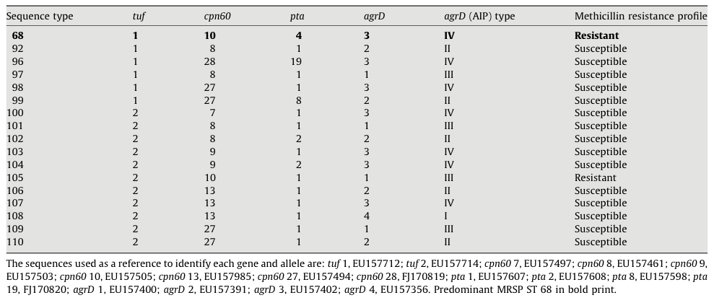TABLE 2.1. Allelic profiles and agrD types of novel S. pseudintermedius sequence types (ST) isolated from dogs compared to the predominant MRSP ST68.

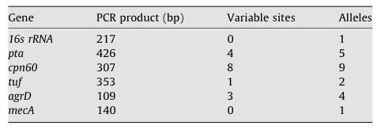

TABLE 2.2. Nucleotide sequence variations and alleles in five housekeeping genes and mecA of S. pseudintermedius.

FIGURE 2.1. Dendrogram based on pulsed-field gel electrophoresis analysis of 60 S. pseudintermedius. Shaded rows represent isolate groupings that are methicillin-resistant and contain the mecA gene.

Discussion

MLST and PFGE are both highly discriminatory methods for characterizing bacterial isolates.^{52,65} In contrast to single locus classification systems, whole genome or multilocus identification methods provide more clarity concerning bacterial relatedness and can be applied to both susceptible and resistant strains. MLST was used in a multi-country survey to determine the population genetic structure of S. pseudintermedius; however, in that study only five methicillin-resistant samples from the United States were included.³³ Other recent surveys using PFGE have demonstrated relatedness amongst MRSP isolates in small sample sizes from specific geographic regions.^{53,75}
Results from our study add strength to the horizontal transmission and geographic clonal dissemination model of methicillin-resistant staphylococci.⁶⁹ Our most notable finding is that 37 of 38 methicillin-resistant isolates in this regional sampling were of a single sequence type, ST68, and demonstrated relatedness in pulsed-field type. This finding parallels the Bannoehr European sample wherein seven methicillin-resistant isolates from dogs with clinical infections in Germany and Sweden were also from a single clone, ST71, while a single canine commensal isolate from Sweden was of a different clonal group, ST69.³³
The 37 ST68 isolates appeared to carry a type V cassette when tested with the S. aureus multiplex PCR typing described by Zhang et al., but DNA sequencing of the cassette revealed that it was a truncated version of SCCmec type V_{T}.⁷⁴ This cassette was first reported in a successful multidrug-resistant CA-MRSA lineage from Taiwan, and has recently been reclassified as SCCmec type VII.⁷¹ SCCmec types II, III and V were previously described in S. pseudintermedius using multiplex PCR procedures used in the present study, and the complete cassette sequence from two isolates that were characterized as having type III cassettes by the multiplex PCR method revealed a new hybrid sequence that has been called type II-III.⁴⁷ The SCCmec cassette associated with the ST105 isolate has not yet been characterized, as this cassette is untypeable using the methods employed for this study. However, the presence of mecA in ST105 has been confirmed using PCR, and the ST105-associated cassette has been differentiated from the ST 68-associated cassette by applying primers used for type V sequencing. The circumstances and mechanism by which the ST68 S. pseudintermedius lineage in the present study acquired a cassette associated with a disease-causing human S. aureus lineage are unknown. The finding implies, however, that inter-species transfer of antibiotic resistance between human and canine pathogens may have occurred.
A single methicillin-resistant isolate with a different and novel ST and pulsed-field type was found – ST105. Only five MRSP sequence types have been described – STs 29, 68, 69, 70 and 71.³³ ST 105 differed from ST 68 at three alleles, indicating a distant phylogenetic relationship. This genetic dissimilarity supports the independent acquisition of mecA by each lineage.³³ Sequence type 105 may represent an emerging MRSP lineage, or it may be a transient cassette carrier that will fail to successfully compete with the predominant ST68. Collectively these data indicate that clonal expansion, regional selection and maintenance of the more successful clone have occurred.
Only three previously reported MSSP sequence types, STs 15, 17 and 19, were identified from one isolate each. Sixteen novel sequence types were identified among clinical isolates of S. pseudintermedius from dogs; all but one were from methicillin-susceptible isolates. Among methicillin-susceptible strains in our study 19 of 22 (86%) belonged to novel STs and all had distinct pulsed-field patterns. This broad range of clonal diversity amongst MSSP contrasts with the limited number of MRSP lineages seen in the United States and Europe, where ST68 and ST71 predominate respectively.³³
It is not known if the apparent tendency of antibiotic resistance cassettes to remain in so few lineages is due to the rarity and relative difficulty of cassette transfer, or is a function of the ability of an MSSP lineage to successfully incorporate the mobile genetic element into its genome. Based upon the variety of MSSP isolates observed, this question warrants further investigation.
In this study, we report an association between ST 68, PFGE type and SCCmec type V_{T} in contemporary clinical isolates of S. pseudintermedius from dogs in the southeastern United States. The known genetic diversity among canine isolates of S. pseudintermedius was increased by the discovery of 16 novel sequence types and a strain that contained novel sequences for both pta and cpn60 genes. Regional, national and global sharing of molecular surveillance data generated for MRSP strains through the use of techniques such as single and multi-locus gene sequencing and PFGE will help determine the epidemiological significance and patterns of spread for these newly emerging strains.

Chapter 3: Variation in mecA expression among regional clones of methicillin-resistant Staphylococcus pseudintermedius and characterization of mecA and blaZ regulatory elements.

C. C. Blackª, L. C. Eberleinª, S. M. Solymanª, D. A. Bemisª, S. A. Kaniaª

ªDepartment of Comparative Medicine, College of Veterinary Medicine, University of Tennessee, Knoxville, TN.
This chapter is a manuscript that will be submitted to an appropriate journal in summer 2010.
My contributions to this paper include: (i) experiment design and isolate selection, (ii) preliminary PCR and RT-PCR expression data collection, (iii) the gathering and reviewing of literature, (iv) sample processing, (v) analysis of data and formulation of discussion topics, (v) all of the writing except statistical analysis in the Materials and Methods section.

Abstract

Regional clones of methicillin-resistant Staphylococcus pseudintermedius (MRSP) affecting veterinary clinical practice have recently been identified in Europe and North America – multilocus sequence types (MLST) 71 and 68 respectively. One notable difference between the two clones is a deletion in the mecI/mecR1 regulatory apparatus of the staphylococcal chromosome cassette (SCCmec) carried by ST68. This deletion in analogous methicillin-resistant Staphylococcus aureus (MRSA) results in more responsive and greater expression of the mecA encoded penicillin-binding protein 2a, a characteristic associated with community-acquired MRSA lineages. The aim of this study was to characterize mec and bla regulatory apparatuses in MRSP. Seventeen wild-type S. pseudintermedius isolates representing nine methicillin-resistant lineages were screened via PCR for the presence of the repressors blaI and mecI and sensors blaR1 and mecR1. The bla and mec operons for each isolate were sequenced and compared for homology between the repressor open-reading frames (ORF), sensor ORFs, and mecA promoter regions. A real-time reverse transcriptase PCR expression assay was developed, validated and applied to nine isolates determining the effect of low-level oxacillin induction and quorum-sensing reporter RNAIII on mecA transcript production. Comparisons of the induction of mecA expression were made between isolates with a full regulatory complement (mecI/mecR1 and blaI/blaR1) and those with truncated and/or absent regulatory elements.

Introduction

Staphylococcus pseudintermedius on dogs is analogous to S. aureus on humans, acting as both normal flora and opportunistic pathogen. It is the primary cause of pyoderma, the most common dermatologic disease seen in dogs, and is also frequently associated with wound, urinary tract and surgical site infections.⁴ The first finding of S. pseudintermedius bearing the mecA methicillin resistance gene occurred in 1999.⁵ In the decade since its discovery, methicillin-resistant S. pseudintermedius (MRSP) has become increasingly common, reaching prevalence as high as 30% in studies of referral center isolates.^{6,35,76}
Recent multilocus sequence typing (MLST) studies have established geographic clonal emergence of two MRSP lineages.^{33,45,77,46} Sequence type 71 predominates in Europe, bears the hybrid resistance cassette SCCmec II-III, and has acquired resistance to all clinically useful veterinary antimicrobial drugs expect lincosamides.^{77,47} Whereas ST68 is the most common MRSP sequence type in the United States and Canada, bears SCCmec V_{T}, and has acquired resistance to all clinically useful veterinary antimicrobial drugs except chloramphenicol.^{45,77}
As is the case with MRSA, methicillin resistance in S. pseudintermedius results most commonly from the acquisition of the mecA gene encoding penicillin-binding protein 2a (PBP2a). PBP2a contains an altered beta-lactam binding site, preventing antibiotics of that class from disrupting gram-positive cell wall metabolism. In addition to synthetic beta-lactam resistance mediated by mecA, all isolates characterized as ST68 and ST71 have thus far also demonstrated penicillin resistance through blaZ-encoded beta-lactamase.^{33,45,77,46}
The controlling mechanisms for bla and mec systems are different from other bacterial signal transduction pathways in that they lack a kinase-based system for signal transduction.⁷⁸ Instead they are modulated by two-component systems consisting of the analogous repressors mecI and blaI and sensors mecR1 and blaR1 respectively. BlaR1 and MecR1 represent transmembrane spanning and signal transducing proteins. Acylation of BlaR1/MecR1 subsequent to external interaction with beta-lactam antibiotics is followed by their autoproteolytic cleavage on the cytoplasmic side of the cell membrane. This separated intracellular portion of BlaR1/MecR1 travels to the bacterial chromosome and removes its cognate repressor BlaI/MecI via proteolysis. Once the repressor dissociates from its promoter-region binding site, transcription of the blaZ/blaR1/blaI and mecA/mecR1/mecI genes begins. The structure and function of MecI and BlaI are similar but not identical; they share approximately 60 percent sequence homology.^{79,80} The repressors can act interchangeably, binding to the promoter-operator region of either the blaZ or mecA operon. However, mecA induction occurs only through the cognate sensor; the intracellular peptidase portion of transmembrane BlaR1 only has activity on BlaI, and MecR1 only cleaves MecI.⁸¹
The mec promoter region consists of ~100 nucleotides situated between the mecA and mecR1 open reading frames. The mec operator is a subset of the promoter region and is a 30 bp palindrome covering mecA -10 and mecR1 -35 promoter sequences. Within the palindrome lies two 4 bp inverted repeats (TACA/TGTA) that serve as binding motifs for the repressors MecI and BlaI.^{79,82} Others have shown that mutations within this operator region can affect the ability of the repressors to bind appropriately, and thereby account for differences in mecA expression.⁸³
In MRSA it has been demonstrated that mecI/mecR1 and blaI/blarR1 configuration has a significant impact on the speed and character of mecA induction. While a majority of epidemic strains are blaZ positive with functional blaI/blaR1 elements, many have deletions of mecI and varying levels of truncation in mecR1; the completeness of the mecA operon has become a defining characteristic of MRSA SCCmec type. Clinical MRSA isolates as well as transformed laboratory strains with only mecI/mecR1 induced mecA expression more slowly than those with complete blaI/blaR1 and without functional mecI/mecR1. Those isolates with both regulatory apparatuses, with both MecI and BlaI available for promoter binding, appear to be even more tightly controlled.^{84,85}
Methicillin resistant staphylococcal isolates cured of their SCCmec have improved growth rates relative to their mecA containing counterparts.⁸⁶ This discovery and the presence of some level of bla and mec regulatory apparatus in all successful and widely-disseminated methicillin-resistant lineages suggests a metabolic cost is associated with unregulated expression of mecA. The exact benefit derived from differing levels of mecA control is unclear. However, a recent historical examination of antibiotic resistance in S. aureus by Chambers and DeLeo demonstrates four waves in MRSA evolution beginning with blaZ in response to penicillin therapy, followed by three mecA acquisitions with differing levels of mecA control. The initial Iberian clone and subsequent healthcare-associated MRSA lineages bearing SCCmec types II and III have functioning mecI and mecR1; whereas more recent community-associated MRSA bear cassettes with mecI deletions and rely on blaI/blaR1 to regulate mecA expression.⁸⁷⁻⁸⁹
In addition to mec-specific regulatory genes, staphylococci also carry the more generalized accessory gene regulator (agr) complex, which produces one of four potential quorum-sensing auto-inducing peptides (AIP) characteristic of its lineage. The peptides are seven to nine amino acids in length, and are constitutively expressed and deposited into the surrounding environment by the bacteria. Once a threshold density of AIP is reached, the expression of RNAIII is triggered, and a cascade of potential virulence-enhancing genes is activated.⁶⁶ Recent expression studies with MRSA have suggested that mecA may fall under the broader control of agr.⁶⁸ The agr locus of MRS(P)I has been described⁶⁷, but its relationship to mecA has yet to be investigated.
The emergence of MRSP is recent relative to that of MRSA and thus far restricted to two known geographic clones bearing distinct cassette types. These SCCmec types differ in the mecI/mecR1 regulatory apparatus of mecA, and are analogous with the two types of cassette structures found in HA and CA-MRSA. Here we inventory the mecA/mecI/mecR1, blaZ/blaI/blaR1, and mecA promoter region status of both major and minor MRSP lineages and apply a real-time RT-PCR mecA expression assay to correlate regulatory gene presence or absence with speed and abundance of transcript production.

Materials and Methods

Bacterial Isolate Selection and Identification

S. pseudintermedius isolates were obtained from clinical samples submitted to the University of Tennessee College of Veterinary Medicine Clinical Bacteriology Laboratory as well as from European and North American collaborators through previous clonality studies.^{45,77} A total of 17 non-duplicate isolates from dogs were selected representing nine MLST lineages associated with methicillin resistance as an initial pool to screen for blaI/blaR1 and mecI/mecR1 variation. Bacterial isolation and identification procedures were those routinely used in the laboratory as previously described.⁸ Isolates phenotypically identified as ‘‘S. intermedius’’ were presumed to be S. pseudintermedius. Multilocus sequence typing provided definitive species identity of S. pseudintermedius with partial 16S rRNA and pta gene sequencing. The type strain of S. intermedius isolated from a pigeon (ATCC 29663) and S. pseudintermedius (ATCC 51874, isolated from a dog and originally designated S. intermedius) served as reference strains for this study.

DNA Extraction

Isolates were grown on blood agar plates overnight at 37°C and bacteria derived from a single colony were suspended in 0.5 ml of TE buffer mixed with an equal volume of glass beads and vortexed for ten minutes. Supernantant in the centrifuged cell lysate was used as template DNA for traditional PCR amplification of mec and bla regulatory genes.

PCR Primers and Conditions

Olignucleotide primers specific for S. pseudintermedius mecA promoter and blaI/blaR1 were based upon MRSP SCCmec type V cassette (GenBank accession no. FJ544922.1) and unpublished ST68 genomic data respectively (TABLE 3.1), and designed using IDT SciTools application (Integrated DNA Technologies, Coralville, IA).⁹⁰ Primers for mecI/mecR1 were adapted from Hiramatsu et al.⁹¹ Primers for RNAIII were adapted from Sung et al.⁶⁷ Conventional PCR was performed using the following parameters: 95º for 90 seconds followed by 35 cycles of 55° for 30 seconds, 68º for 120 seconds, and 94º for 30 seconds.

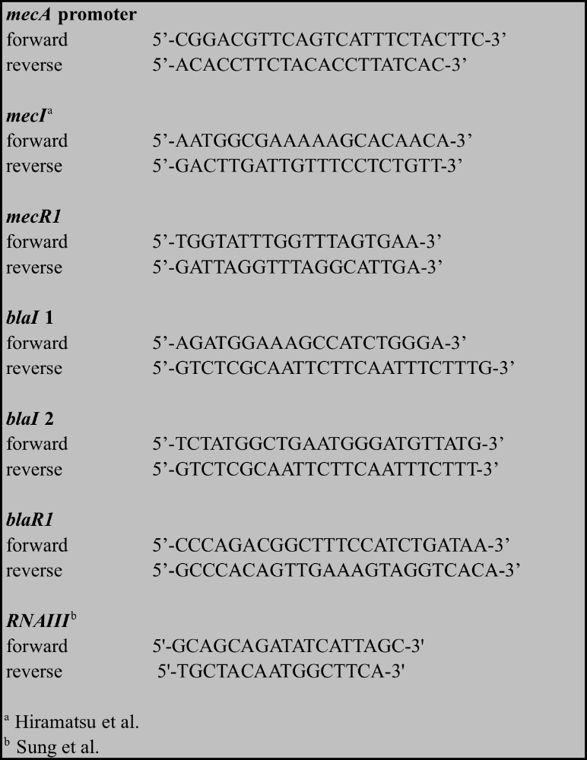

TABLE 3.1. Primers used with conventional PCR.

Sequence analysis

PCR products of expected sizes were treated to destroy single-stranded DNA (ExoSap-IT, USB Corp., Cleveland, OH) and submitted to the University of Tennessee Molecular Biology Resource Facility for DNA sequencing. PCR primers were used for direct DNA sequencing of PCR amplification products. Open reading frames for blaI, blaR1, mecI, mecR1 and mecA promoter were compared between isolates using Lasergene® SeqMan Pro software (DNASTAR, Inc., Madison, WI).

MLST and PFGE

Genetic diversity of S. pseudintermedius was determined by MLST of five genes (16S rDNA, tuf, cpn60, pta and agrD) and by SmaI-PFGE as previously described.^{33,45} MLST sequences were compared with allele sequences present in the NCBI nucleotide database in order to determine the allele number. Sequence type numbers were assigned using the key table for MLST typing of S. intermedius group isolates. New sequence types were assigned by the curator, Vincent Perreten (vincent.perreten@vbi.unibe.ch).⁷⁷

Bacterial Growth and RNA Extraction – Time Point mecA Expression Assay

For each isolate a 5 ml vial of BBL™ Trypticase™ soy broth (TSB, Becton, Dickinson and Co., Sparks, MD) was inoculated with a single colony grown on blood agar and then incubated overnight at 37°C and 225 rpm. Fifty microliters of overnight growth was used to inoculate four additional 5 ml soy broth vials, which were subsequently incubated at 37°C and 225 rpm for four hours. Oxacillin (Sigma Aldrich, St. Louis , MO) was added to a single vial at four, two, and one hours prior to RNA extraction. The oxacillin concentration was 0.01 µg/ml for all induction vials; this concentration was chosen because in preliminary testing it represented the minimum amount at which the type strain ST68 (06 3228) reproducibly increased mecA expression greater than five-fold over baseline. One of the four vials was incubated without oxacillin induction to serve as the baseline for mecA expression.
Following four hours of growth RNA was extracted using UltraClean™ Microbial RNA Isolation Kit (MO BIO Laboratories, Carlsbad, CA). Contaminating DNA was removed using TURBO DNA-free™ DNase (Ambion, Inc., Austin, TX). The resulting RNA template was stored in aliquots suspended in DNase RNase free water at -80.0°C.

Bacterial Growth and RNA Extraction – Oxacillin Curve mecA Expression Assay

For each isolate a 5 ml vial of BBL™ TSB (Becton, Dickinson and Co., Sparks, MD) was inoculated with a single colony from growth on blood agar and was then incubated overnight at 37°C and 225 rpm. Fifty microliters of overnight growth was used to inoculate seven additional 5 ml soy broth vials, which were incubated at 37°C and 225 rpm for four hours. Oxacillin (Sigma Aldrich, St. Louis , MO) was added to six vials in a fivefold dilution series at concentrations 0.0016, 0.0080, 0.0400, 0.2000, 1.0000 and 5.0000 µg/ml. One of seven vials was incubated without oxacillin induction to serve as a mecA expression baseline.
Following four hours of growth RNA was extracted using UltraClean™ Microbial RNA Isolation Kit (MO BIO Laboratories, Carlsbad, CA). Contaminating DNA was removed using TURBO DNA-free™ DNase (Ambion, Inc., Austin, TX). Resulting RNA template was stored in aliquots suspended in DNase RNase free water at -80.0°C.

Realtime RT-PCR – Measurement of mecA Induction and Copy Number

Primers and probes (TABLE 3.2) for target mecA and endogenous control 16S were designed using Primer Express® software and constructed as custom TaqMan® Gene Expression Assays (Applied Biosystems, Foster City, CA). Applied Biosystems reagents TaqMan® 2X Universal PCR Master Mix and Multiscribe™ Reverse Transcriptase were used in a 10 µl one-step RT-PCR protocol in the following amounts per well: 5.00 µl Taq polymerase, 2.75 µl water, 1.50 µl template RNA, 0.50 µl primer and probe mix, and 0.25 µl reverse transcriptase. Each sample was analyzed in triplicate. Template RNA was diluted either 1 to 100 or 1 to 1000. All time point or differing oxacillin concentration samples for each isolate were analyzed together in one run per isolate on a 48-well plate in a StepOne™ Real-Time PCR System (Applied Biosystems, Foster City,

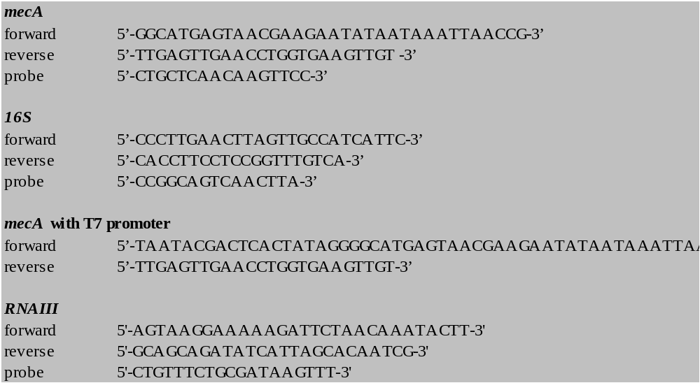

TABLE 3.2. Realtime RT-PCR primers and probes.

CA). Thermocycler parameters were as follows: 48°C for 30 minutes, 95°C for 10 minutes, 40 cycles: 95°C for 15 seconds and 60°C for 1 minute.
The mecA mRNA for standard curve analysis was produced by adding a T7 promoter to the sequence of the mecA forward primer utilized in the real-time assay (TABLE 3.2). This primer coupled with the reverse primer from the real-time assay was applied to genomic DNA of 06 3228 under the following thermo-cycling conditions: 95º for 90 seconds followed by 35 cycles of 55º for 30 seconds, 68º for 120 seconds, and 94º for 30 seconds. The resulting T7 mecA DNA template was electrophoresed on an 0.8% agarose gel. The single band 117 bp product was excised and extracted (QIAquick® Gel Extraction Kit, Germantown, MD). Following manufacturer’s recommendations for DNA <500 bp in length, 1.0 µg served as template in a 16 hour transcription reaction (MEGAscript® T7, Ambion Inc., Austin, TX). The 97 bp RNA product was treated with 4 U TURBO DNase (Ambion Inc., Austin, TX) at 37ºC for 30 min, and filtered to remove all non-RNA elements (MEGAclear™, Ambion Inc., Austin, TX). The copy number per µl was calculated using µg/ml measurements from a NanoDrop 3300 fluorospectrometer (ThermoScientific Inc., Wilmington, DE). The transcripts were used to create standard curves for absolute quantitation of mecA mRNA transcripts isolated from the samples. The numbers of RNA copies were estimated based on the molecular weights of the RNA standards and the RNA concentrations. Ten-fold serial dilutions were prepared, and aliquots of each dilution were stored at –80°C and used only once.

The efficiency of the real-time RT-PCR assay to amplify the mecA standard mRNA was evaluated with the equation: Efficiency = [10^{(–1/slope)}] – 1.⁹² Slope is a value derived from the constructed standard curves. To insure equal amplification efficiency in tested isolates, four ten-fold serial dilutions of RNA extracted from wild-type MRSP were tested against the standard curve. The efficiencies were comparable. Quantitiation of mecA copy number was calculated by transforming Ct values to the relative number of RNA molecules. The quantity of cDNA for each experimental gene was normalized to the quantity of 16S cDNA in each sample as previously described.⁹³

Estimation of 16S Endogenous Control Copy Number

Multiple 16S genes appear in the bacterial chromosome of S. aureus, usually ranging from six to eight copies.⁹⁴ To insure that mecA transcript measurement was not compromised by significant disparities in 16S copy number between S. pseudintermedius sequence types, comparison of 16S DNA relative to that of single copy mecA was made using real-time PCR.
Genomic DNA from one isolate each representing STs 68, 71, 73, and 116 was extracted using UltraClean™ Microbial DNA Isolation Kit (Mo Bio Laboratories, Inc., Carlsbad, CA). The purified DNA amount was measured and adjusted to equal µg/ml concentrations. Real-time PCR was performed as previously described without reverse transcriptase using 16S rRNA and mecA primers and probes. Based upon the assumptions that both primer sets are equally efficient (achieved with validation for ∆∆Ct mecA expression assay) and that mecA is represented in the genome as a single copy, 16S rRNA Ct values arising before that of mecA indicate that multiple 16s genomic copies are present. Fold change calculations can then show 16s copy number relative to that of mecA.

RNAIII Expression in Conjunction with mecA Expression

For each isolate a 5 ml vial of BBL™ TSB (Becton, Dickinson and Co., Sparks, MD) was inoculated with a single colony from growth on blood agar and was then incubated overnight at 37°C and 225 rpm. Fifty microliters of overnight growth was used to inoculate five additional 5 ml soy broth vials, which were incubated at 37°C and 225 rpm for one, three, five, seven, and nine hours. RNA extraction and realtime RT-PCR was performed as previously described using mecA and RNAIII specific primers and probes. Each reaction was performed in triplicate with one primer set per well. ∆∆Ct fold-change over baseline comparisons were made against the one hour measurement.

Statistical Analysis

A mixed model ANOVA (SAS, version 9.2, SAS Institute Inc, Cary, NC) was used to estimate the effect of sequence type (68 verses 71) and time on inverse log of mecA expression. Isolate, sequence type and time were modeled as class variables and isolate was included as a random factor in the model. Independent variables sequence type, time and the interaction of sequence type and time were evaluated for an effect on the dependent variable log of mecA copy number. A second and similar model was used to assess the effect of blaI regulation alone verses functional mecI regulation, time and the interaction of blaI and mecI status on the inverse log of mecA copy number. In the second model isolate, gene status (blaI vs. mecI) and time were included as class variables. A multiple range test according to the method of Tukey was used to adjust for multiple comparisons in both models. The fit of the both models to the data was evaluated by assessing the degree to which the residuals from the models fit a normal distribution using the Shapiro-Wilk test statistic. An a priori adjusted p-value of < 0.05 was used to determine statistical significance for all tests.

Results

Screening for mecA, mecI, mecR1, blaZ, blaI, and blaR1 Initial mecA Expression Assay

Twelve isolates representing nine sequence types comprised the initial mec and bla regulatory element survey of MRSP isolates (TABLE 3.3). All were phenotypically methicillin resistant and confirmed mecA positive. All but one isolate (ST73) were phenotypically beta-lactamase positive and contained blaZ, blaI and blaR1 elements. Sequence types 71 and 73 were the only MRSP backgrounds that screened positive for the repressor mecI. The two ST71 isolates (one European and one North American) contained both repressors mecI and blaI. No American isolates other than NA18 (ST71) had a complete mecI sequence.
The initial twelve isolates chosen for mec and bla regulatory element detection were grown with and without 0.01 µg/ml oxacillin for four hours and the relative level of mecA transcript production was measured by realtime RT-PCR using the ∆∆Ct method (FIGURE 3.1). Error bars indicate the standard error of the mean and relative quantitation of mecA expression is represented on a log scale.

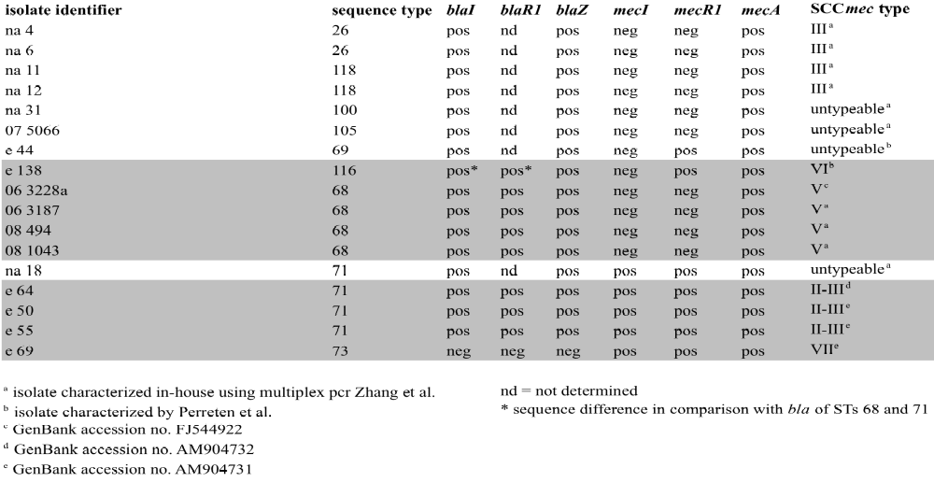

TABLE 3.3. Isolates used in study – presence/absence of mec and bla elements. Shaded rows represent isolates that were further characterized by time point mecA expression assay.

Those isolates screening positive for blaI only (represented by North American STs 26, 68, 69, 105, 116, and 118) increased mecA expression to a greater extent than the ST71s containing both mecI and blaI. Sequence type 73 bearing mecI alone increased mecA expression at four hours to a level similar to that of the blaI-only isolates.

Sequence Type Selection for Further Analyses

Based upon the initial mecA expression assay and the presence or absence of mec and bla elements, STs 73 and 116 were selected to contrast the regulatory apparatuses of the predominant geographic clones ST68 (North America) and ST71 (Europe). Sequence type 73 lacks a bla operon but has a complete mec operon resulting in a -blaI/-blaR1 +mecI/+mecR1 configuration with regard to mecA expression control. Whereas ST68 has +blaI/+blaR1 -mecI/^{mut}mecR1 (absent mecI and mutation/truncation of mecR1) and ST71 has both complete repressor/sensor systems in +blaI/+blaR1 +mecI/+mecR1. Sequence type 116 was chosen because the original blaI 1 forward and reverse primers (TABLE 3.1) were unable to elicit a PCR product. A region internal to the previous blaI target was amplified using blaI 2 forward and reverse primers. Sequence type 116 blaI genomic sequence compared with that of STs 68 and 71 had multiple nucleotide and translational dissimilarities (FIGURE 3.2a). Therefore ST116 was classified as ^{mut}blaI/+blaR1 -mecI/+mecR1 (the mutation designation for blaI is relative to that of STs 68 and 71).
Sequence types 73 and 116 contain only one known characterized isolate each. However, additional wild-type clinical ST68 (n=3) and ST71 (n=2) isolates were added to subsequent analyses to show reproducibility of mecA expression within sequence type background. In total four North American ST68s, three European ST71s, and one each of STs 73 and 116 were fully characterized by MLST, PFGE (FIGURE 3.2b), mec and bla regulatory gene sequencing, and mecA expression analysis at four time points.

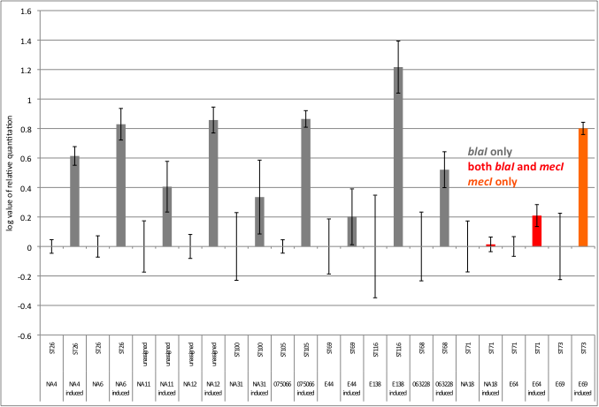

FIGURE 3.1. Relative mecA expression measured with and without 0.01 µg/ml oxacillin induction at 4.0 hours growth.

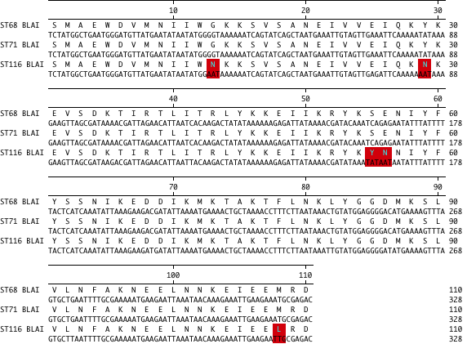

FIGURE 3.2a. blaI nucleotide and peptide variation between ST116 and STs 68 and 71.

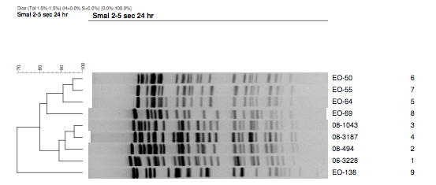

FIGURE 3.2b. PFGE of nine MRSP isolates. EO-50, EO-55, and EO-64 are European ST71 and closely related by the Tenover et al. criteria. 08-1043, 08-3187, 08-494, and 06-3228 are southeastern US ST68 and closely related by the Tenover et al. criteria. EO-69 and EO-138 are sequence types 73 and 116 respectively.

mec Sequence Analyses

Promoter sequences for ST68 and ST71 were identical. There was a mecA promoter single bp polymorphism between ST73 and STs 68 and 71 at mecA -10; this was adjacent to a mecI/blaI TACA binding motif (solid boxes FIGURE 3.3). Sequence type 116 differs from STs 68 and 71 by a single base pair difference at the mecA ribosomal binding site (dashed box FIGURE 3.3).
Repressor mecI sequence was complete and presumed functional in only STs 71 and 73, SCCmec types II-III and VII respectively.⁴⁷ In the isolates sequenced for this study, there was complete homology between ST71 and ST73 in the mecI open reading frame (data not shown).
Sensor mecR1 sequence was similar between STs 71, 73, and 116, sharing 97% nucleotide homology. The significance of the slight dissimilarity is unknown. However, because only mecR1 and not blaR1 can inactivate mecI, mecR1 is presumably a non-essential remnant in ST116. mecR1 in ST71 differs from ST73 by a single bp deletion, resulting in a frame shift mutation at the C-terminal end of the peptide sequence (FIGURE 3.4).

bla Sequence Analyses

As was previously reported in “Sequence type selection for further analyses”, ST116 blaI genomic sequence compared with that of STs 68 and 71 had multiple nucleotide and translational dissimilarities (FIGURE 2). The sensor blaR1 was 100% homologous between STs 68 and 71. However, peptide composition of BlaR1 between STs 68 and 71 and ST116 was as different as that observed for peptide composition of BlaI (FIGURE 3.5).

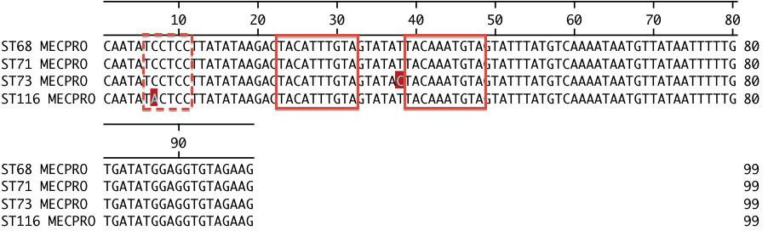

FIGURE 3.3. mecA promoter region polymorphisms of MRSP sequence types. blaI/mecI binding motifs represented within solid boxes, mecA ribosomal binding site in dashed box.

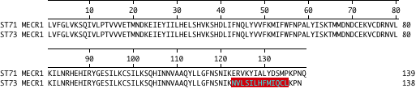

FIGURE 3.4. mecR1 peptide dissimilarity between STs 71 and 73.

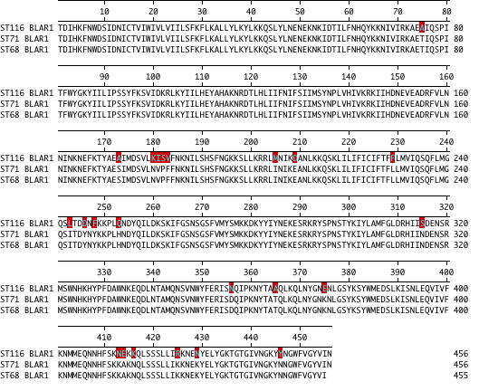
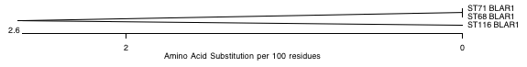

FIGURE 3.5. blaR1 peptide dissimilarity between ST 116 and STs 71 and 73.

Relative Quantitation of mecA Expression – ∆∆Ct Method

Each RT-PCR value for the nine isolates below was the result of the analysis of a single RNA sample. However, growth experiments with RNA extraction and RT-PCR were performed at least twice with each isolate.
Measurements of mecA mRNA copy number relative to that of the 16S RNA endogenous control allowed intra-isolate comparisons at differing time points. This method was useful in illustrating the direction of mecA expression (FIGURE 3.6).
Sequence type 73, which lacked the blaI repressor, showed a stepwise increase in mecA expression over four hours. Sequence types 68 and 116, each lacking the mecI repressor, showed induction immediately at one hour, and then maintained elevated mecA expression at two and four hours. Sequence type 71, which possessed both blaI and mecI repressors, did not increase mecA expression at any time point at the 0.01 µg/ml oxacillin level.

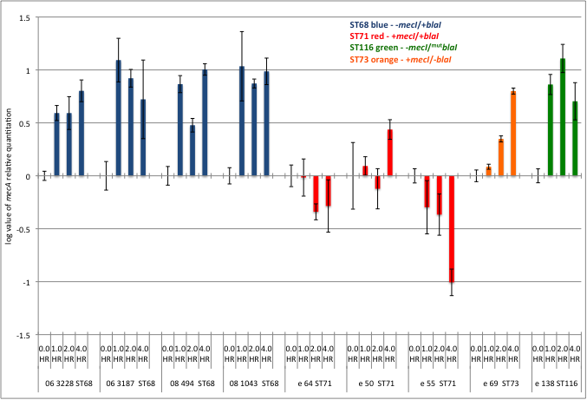

FIGURE 3.6. Influence of repressor gene presence or absence on relative mecA expression, measured at one, two and four hours of growth following exposure to 0.01 µg/ml oxacillin.

Quantitation of mecA Expression – Standard Curve

Transcript copy number tied to absolute measurements of known mecA mRNA in a standard curve make possible inter-isolate comparisons at the different time points tested. In addition to illustrating the direction of mecA expression, the method allows a copy production number to be applied to the population of cells producing mecA under varying oxacillin exposures (FIGURE 3.7).
At four hours growth in 5.0 ml TSB with no oxacillin, mecA copy numbers were 5.39 million to 1.12 million for ST 68s and 71s respectively; though a 4.81 fold difference, this was not statistically significant (p = 0.6475). However, significance in mecA copy number disparity between ST68 (+blaI/+blaR1 -mecI/^{mut}mecR1) and ST71 (+blaI/+blaR1 +mecI/+mecR1) isolates were noted at all subsequent induced time points. At one hour induction, mecA expression was 34.71 million to 0.97 million for ST 68s and 71s respectively (~35 times greater mecA expression, p = 0.0114). At two hours induction, mecA expression was 23.76 million to 0.71 million for ST 68s and 71s respectively (~33 times greater mecA expression, p = 0.0158). At four hours induction, mecA expression was 38.34 million to 0.65 million for ST 68s and 71s respectively (~59 times greater mecA expression, p = 0.0046).
Sequence type 116 (^{mut}blaI/+blaR1 -mecI/+mecR1) produced mecA transcript in amounts equivalent to ST71 (10⁵-10⁶) at all time points. Whereas ST73 (-blaI/-blaR1 +mecI/+mecR1) while increasing mecA output in a time-dependant manner, maintained the tightest control of mecA expression of the isolates tested.

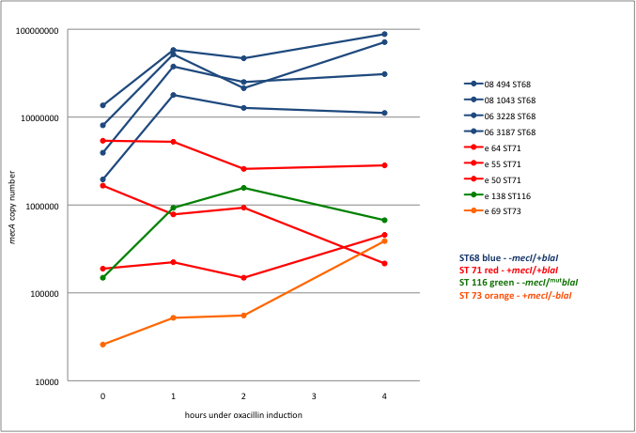

FIGURE 3.7. Influence of repressor gene presence or absence on absolute mecA expression, measured at one, two and four hours of growth following exposure to 0.01 µg/ml oxacillin.

Effect of Increasing Oxacillin Concentration on mecA Expression

One isolate from each sequence type was exposed to increasing amounts of oxacillin to determine if and at what level mecA copy number induction occurred (FIGURE 3.8). Absolute measurement of mecA copy number revealed a one to two log difference between ST68 (06 3228) and ST71 (e 64) at every oxacillin concentration at which both isolates grew. No clear mecA induction level was noted for ST71; mecA copy number or expression did not increase with increased oxacillin concentration. Sequence type 73 showed no mecA induction until a two-log change in copy number at 1.0 µg/ml oxacillin. Sequence type 116 exhibited a dose-dependent mecA copy increase in response to increasing oxacillin pressures.

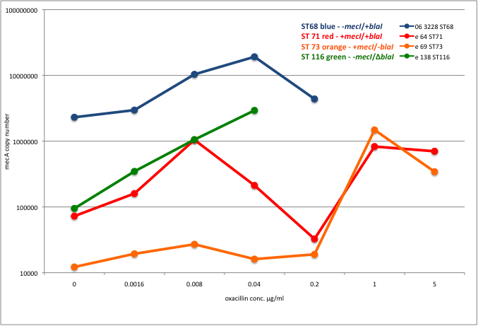

FIGURE 3.8. Absolute mecA transcript production over four hours at increasing concentrations of oxacillin.

RNAIII Expression in Conjunction with mecA Expression

Measurement of RNAIII at two-hour intervals during log phase growth revealed an expected sequential increase in RNAIII as population density within the growth chamber intensified. mecA expression for the ST68 isolate shown (FIGURE 3.9) also increased with increasing population density for the first five hours, and then reached a plateau with high-level expression that was maintained through hours seven and nine.

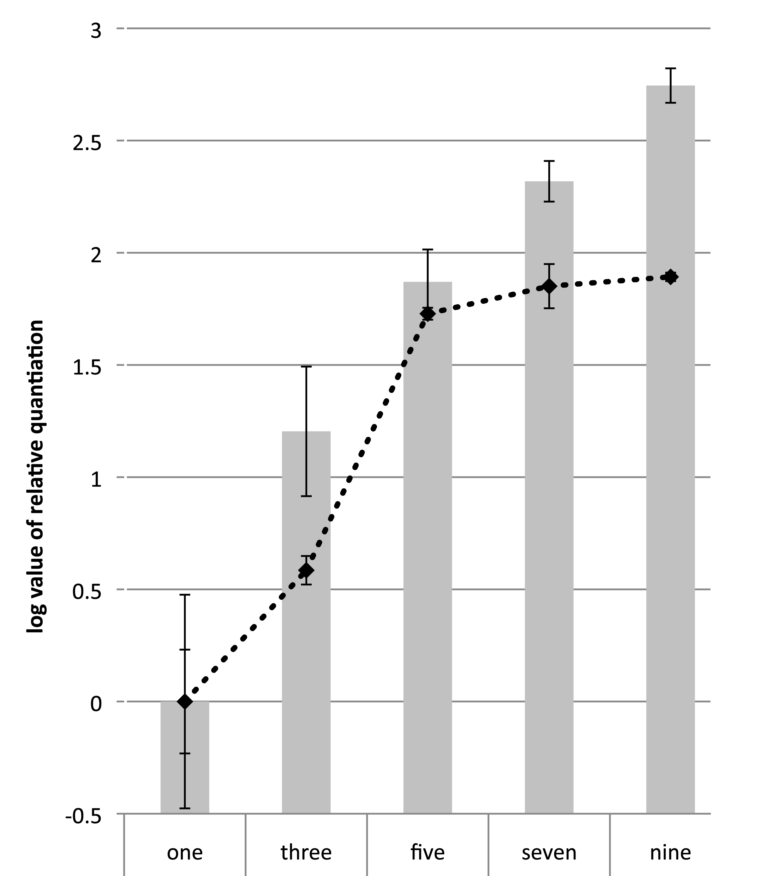

FIGURE 3.9. Gray columns represent RNAIII expression. The black dashed line represents mecA expression over nine hours. Error bars for columns and dashed line represent standard error of the mean of technical replicates.

Discussion

The pattern of mecA expression observed in this MRSP study in part parallels previous reports of how mec and bla regulatory elements contribute to mecA repression in MRSA – BlaI is more permissive at the mecA promoter than MecI.^{84,85} However, because the acquisition of mecA by S. pseudintermedius was recent, relative to that which occurred in S. aureus, the identification of prevailing mec regulatory strategies in regional clones provides more convincing evidence as to the level of mecA regulation is required for successful clonal expansion. For MRSP it appears that some level of bla regulatory control is needed to efficiently express methicillin resistance.
The exclusively MecR1-controlled system (ST73) was slower than the exclusively BlaR1-controlled systems (STs 68 and 116) to respond to oxacillin, taking hours to achieve a comparable response. Sequence type 73 also had the lowest level of constitutive mecA expression in the absence of oxacillin exposure. It is difficult to extrapolate these and other in vitro assessments (mecA expression, antimicrobial susceptibility tests, etc. Kirby-Bauer disc diffusion, MIC) to how infections caused by these isolates will behave in the patient. However, tight control of mecA by MecI-only systems likely puts these MRSP and MRSA lineages at a disadvantage in the clinical setting, as induction may not be rapid enough to prevent cell death when faced with therapeutic levels of beta-lactam antibiotics.^{81,95} The paucity of successful mec-only controlled methicillin-resistant lineages for both S. aureus and S. pseudintermedius suggests that some level of bla control in mecA expression is necessary for geographic clonal expansion.
Despite having similar bla and mec regulatory apparatuses (blaI repression without mecI), sequence types 68 and 116 are genetically dissimilar when analyzed by MLST and PFGE, and contain the distinct SCCmec types V and VI respectively. BLAST analysis of blaI and blaR1 sequence reveals differing origins for beta-lactamase. Sequence type 116 bla sequence is identical to S. aureus plasmid pWBG748 (GenBank accession no. GQ915265); whereas ST68 bla sequence matches most closely with beta-lactamase-containing S. aureus plasmid pWBG756 (GenBank accession no. GQ900472). Both sequence types respond to oxacillin induction at one-hour post induction and maintain increased mecA expression at two and four hours. However, mecA transcript copy number differs between the two sequence types by one to two logs at all time points and at all oxacillin concentrations measured, suggesting that either the blaI/blaR1 of ST68 is more permissive than the blaI/blaR1 of ST116, or that additional factors are affecting mecA expression.
With the singleton comparator strains (STs 73 and 116) removed from the analysis, the one to two log difference in mecA expression between the North American MRSP ST68s and European ST71s at all induced time points and at all levels of antibiotic exposure suggests there exists at least two divergent pathways to geographic clonal success with regard to control of PBP2a metabolism. Sequence types 68 and 71 are not genetically similar when analyzed with MLST and PFGE.⁷⁷ However, sequence analysis revealed complete homology in all shared mec and bla regulatory elements – mec promoter, blaI and blaR1. Sequence type 68 induces at one hour and maintains induction throughout the assay. Whereas ST71 does not induce in the presence of 0.01 µg/ml oxacillin and maintains essentially the same level of constitutive mecA expression at all time points measured. Presumably BlaI and MecI compete for access to the mec operator in ST 71. This competition could account for the variability observed in the direction of mecA expression. With increasing oxacillin concentrations ST 71 appears to have a biphasic response with increased mecA copy number at 0.08 µg/ml and then again at 1.0 µg/ml. This pattern should be further explored to determine whether BlaR1 and MecR1 differ in response to oxacillin concentration as well as time.
As of yet there is no known overlap in the geographic areas affected by STs 68 and 71. These predominant sequence types emerging in North America and Europe with their distinct mec regulatory strategies are either the product of chance, or are a reflection of unique environmental pressures. Sequence type 68 has only BlaI/BlaR1 regulation of mecA, has high constitutive mecA expression, and responds rapidly to small concentrations of oxacillin. Sequence type 71 has both BlaI/BlaR1 and MecI/MecR1 regulation of mecA, and has less constitutive and induced expression of mecA than ST68. Because uncontrolled PBP2a production is deleterious⁸⁶, it has been suggested that MRSA lineages require some level of bla regulatory control to stabilize the mecA gene in the absence of beta-lactam antibiotic exposure.^{85, 91} MecI/MecR1 alone is likely too restrictive of mecA expression to adequately respond to beta-lactam treatment. MecI/MecR1 coupled with BlaI/BlaR1 represents a middle ground with ST71 where a lineage could call on mecA expression if needed; this conformation may indicate that these isolates evolved in an environment in which antibiotic perturbations were less frequent. The BlaI/BlaR1 of ST 68 represents the least stringent mecA control, and the apparent success of this lineage in the United States may indicate a constant need for some level of PBP2a, possibly due to presence of low-level beta-lactam in the environment in which they evolved.

Chapter 4: Conclusions and Application of Findings

The molecular characterization study is now part of a collection of similar investigations^{33,45,46,77} that have firmly established ST71 and ST68 MRSP clonal expansion in Europe and US respectively. The follow-up study is the first to utilize comparative regulatory gene sequencing and gene expression in MRSP to compare the two regional clones with regard to differences in gene expression. The approach used in measuring mecA copy number gave unique insight into not only fold change over baseline expression, but absolute copy number of mecA mRNA produced in MRSP.
Sequence type 68 exhibited a significantly different mecA response relative to ST71 in quickness, duration, and number of transcripts when exposed to very small amounts of oxacillin. This presumably translates to greater PBP2a in ST68 relative to ST71 within the first few hours of oxacillin exposure. Earlier MRSA studies have not been able to detect a correlation between beta-lactam mean inhibitory concentration (phenotype) and cellular concentrations of PBP2a.^{96,97} We too observed that high and low mecA production response did not correspond to phenotype. Isolates of ST68 and ST71 exhibited a full range of phenotypic oxacillin resistance, from low-level measurements near 17 mm by Kirby-Bauer disc diffusion and 0.5 µg/ml by broth microdilution to high-level resistance ≤ 10 mm and ≥ 4.0 µg/ml respecitively.^{77,98} This discrepancy between reproducible amounts of mecA transcript production (measured at one, two and four hours of oxacillin exposure) and variable disc diffusion phenotype (typically measured at 24 hours of bacterial growth) suggests that expression analysis may be more indicative of in vivo MRSP response to antibiotic therapy than more traditional measurements. Clinicians select antibiotics and dosage based upon phenotypic measurements. But these finding perhaps indicate more aggressive empirical beta-lactam protocols could be beneficial against clonal lineages like ST71 in Europe that demonstrate more stringent mecA regulatory control. Further research would be required to bear this out.
In 2003 Rosato et al performed a similar analysis of clinical MRSA isolates, sequencing regulatory genes and the mecA promoter, and performing mecA expression analysis. They reported a synergism in isolates with both MecI and BlaI, with lower mecA transcription than isolates containing either one alone.⁸⁴ Our observations of MRSP in Chapter 3 conflict with the Rosato assessment – ST71 with both BlaI and MecI was intermediate to the high mecA production of ST68 and the low mecA production of MecI-only ST73. The less-diversified MRSP genetic evolutionary picture may explain this difference. Heterogeneous resistance is a strategy in many successful MRSA lineages, whereby a small subset of bacterial cells in pure culture express high-level methicillin resistance in response to selection. Multiple genetic factors (in addition to those examined in these studies) have been shown to affect mecA production in MRSA. We have been unable to demonstrate heterogeneous methicillin resistance thus far in MRSP. Perhaps this early less complicated stage of mecA regulatory evolution in MRSP can be exploited. We’ve demonstrated that some level of beta-lactamase control likely contributes to the success of STs 68 and 71. Our findings suggest that the membrane-bound receptor BlaR1 as a prime target for therapeutic control of methicillin-resistant isolates.
The most lasting aspect of this work will likely be the development of a highly reproducible MRSP mecA expression assay as an in vitro model to analyze novel antibiotic approaches. New antibiotics from the traditional development pipelines are slow in coming and quick to select for resistance. Our model can be used in conjunction with any approach that could hinder the production of mecA and reinstate the effectiveness of synthetic beta-lactam antibiotics. The development of a BlaR1- and/or PBP2a-specific vaccine, the effect of non-cognate auto-inducing peptides, and the activity of synthetic antisense oligonucleotides on mecA regulatory genes could all readily be assessed using the mecA expression assay.
MRSP was first identified in 1999.⁵ UTCVM has been at the forefront of research institutions in tracking the proliferation of this emerging pathogen from phenotypic, molecular, and clinical perspectives. At the beginning of this project in 2007 the first publication hinting at regional clonality had just been published.³³ In the time since, this dissertation project has contributed to the MRSP knowledge-base with the identification of ST68 as the regional clone associated with our collection and the United States, and has brought to light the significant differences in mecA expression strategies between the European and American regional clones.

List of References

1. Twain, M. The Devil's race-track : Mark Twain's great dark writings : the best from Which was the Dream? and Fables of man. (University of California Press: Berkeley, 1980).
2. Boyce, J.M. et al. Meticillin-resistant Staphylococcus aureus. The Lancet Infectious Diseases 5, 653-663 (2005).
3. Klein, E., Smith, D.L. & Laxminarayan, R. Hospitalizations and deaths caused by methicillin-resistant Staphylococcus aureus, United States, 1999-2005. Emerging Infect. Dis 13, 1840-1846 (2007).
4. May, E.R. Bacterial Skin Diseases: Current Thoughts on Pathogenesis and Management. Veterinary Clinics of North America: Small Animal Practice 36, 185-202 (2006).
5. Gortel, K. et al. Methicillin resistance among staphylococci isolated from dogs. Am. J. Vet. Res 60, 1526-1530 (1999).
6. Bemis, D.A., Jones, R.D., Frank, L.A. & Kania, S.A. Evaluation of susceptibility test breakpoints used to predict mecA-mediated resistance in Staphylococcus pseudintermedius isolated from dogs. J Vet Diagn Invest 21, 53-58 (2009).
7. Kania, S.A. et al. Methicillin resistance of staphylococci isolated from the skin of dogs with pyoderma. Am. J. Vet. Res 65, 1265-1268 (2004).
8. Jones, R.D., Kania, S.A., Rohrbach, B.W., Frank, L.A. & Bemis, D.A. Prevalence of oxacillin- and multidrug-resistant staphylococci in clinical samples from dogs: 1,772 samples (2001-2005). J. Am. Vet. Med. Assoc 230, 221-227 (2007).
9. Ogston, A. Micrococcus Poisoning. J Anat Physiol 16, 526-567 (1882).
10. Newsom, S. Ogston's coccus. Journal of Hospital Infection 70, 369-372 (2008).
11. Ogston, A. Micrococcus Poisoning. J Anat Physiol 17, 24-58 (1882).
12. Götz, F., Bannerman, T. & Schleifer, K. The Genera Staphylococcus and Macrococcus. The Prokaryotes 5-75 (2006).at <http://dx.doi.org/10.1007/0-387-30744-3_1>
13. Huebner, J. & Goldmann, D.A. Coagulase-negative staphylococci: role as pathogens. Annu. Rev. Med 50, 223-236 (1999).
14. Buddingh, G.J. Bergey's Manual of Determinative Bacteriology: 8th edition, edited by R. E. BUCHANAN and N. E. GIBBONS. xxvii + 1,246 pages, illustrated. The Williams and Wilkins Company, Baltimore, Maryland. 1974. No price. Am J Trop Med Hyg 24, 550 (1975).
15. 1898, I.A.M. Veterinary bacteriology and virology. (Ames, Iowa State University Press, 1967).
16. Hájek, V. Staphylococcus intermedius, a New Species Isolated from Animals. International Journal of Systematic Bacteriology, Vol. 26, 401-408 (1976).
17. Kelser, R.A. Manual of veterinary bacteriology, (Baltimore, The Williams & Wilkins company, 1938).
18. 1898, I.A.M. Veterinary bacteriology, (Ames, Ia., The Iowa State College Press, 1940).
19. Kloos, W.E. & Schleifer, K.H. Simplified scheme for routine identification of human Staphylococcus species. J. Clin. Microbiol 1, 82-88 (1975).
20. Euzéby, J. List of Prokaryotic names with Standing in Nomenclature LPSN (formerly List of Bacterial names with Standing in Nomenclature LBSN). LPSN at <http://www.bacterio.cict.fr/>
21. Smith, H.W. The examination of staphylococci of animal origin with particular regard to the determination of criteria of pathogenicity. Journal of Comparative Pathology 57, 98-115 (1947).
22. Meyer, W. A proposal for subdividing the species Staphylococcus aureus. Int J Syst Bacteriol 17, 387-389 (1967).
23. Live, I. Agglutinating serum for distinguishing Staphylococcus aureus of human biotype. Infect. Immun 12, 443-445 (1975).
24. Live, I. Relationship of antigen k to Staphylococcus aureus bacteriophage type 187, of human and of canine origins. Infect. Immun 7, 473-475 (1973).
25. Hájek, V. & Marsálek, E. Variability of the production of fibrinolysin in staphylococci of animal origin. Folia Microbiol. (Praha) 14, 421-424 (1969).
26. Biberstein, E.L., Jang, S.S. & Hirsh, D.C. Species distribution of coagulase-positive staphylococci in animals. J Clin Microbiol 19, 610-615 (1984).
27. Cox, H.U., Hoskins, J.D., Roy, A.F., Newman, S.S. & Luther, D.G. Antimicrobial susceptibility of coagulase-positive staphylococci isolated from Louisiana dogs. Am. J. Vet. Res 45, 2039-2042 (1984).
28. Cox, H.U. et al. Temporal study of staphylococcal species on healthy dogs. Am. J. Vet. Res 49, 747-751 (1988).
29. Fazakerley, J. et al. Staphylococcal colonization of mucosal and lesional skin sites in atopic and healthy dogs. Vet. Dermatol 20, 179-184 (2009).
30. Talan, D.A. et al. Staphylococcus intermedius in canine gingiva and canine-inflicted human wound infections: laboratory characterization of a newly recognized zoonotic pathogen. J Clin Microbiol 27, 78-81 (1989).
31. Devriese, L.A. et al. Staphylococcus pseudintermedius sp. nov., a coagulase-positive species from animals. Int. J. Syst. Evol. Microbiol 55, 1569-1573 (2005).
32. Sasaki, T. et al. Reclassification of phenotypically identified staphylococcus intermedius strains. J. Clin. Microbiol 45, 2770-2778 (2007).
33. Bannoehr, J. et al. Population genetic structure of the Staphylococcus intermedius group: insights into agr diversification and the emergence of methicillin-resistant strains. J. Bacteriol 189, 8685-8692 (2007).
34. Devriese, L.A., Hermans, K., Baele, M. & Haesebrouck, F. Staphylococcus pseudintermedius versus Staphylococcus intermedius. Vet. Microbiol 133, 206-207 (2009).
35. Weese, J.S. & van Duijkeren, E. Methicillin-resistant Staphylococcus aureus and Staphylococcus pseudintermedius in veterinary medicine. Vet. Microbiol 140, 418-429 (2010).
36. Medleau, L., Long, R.E., Brown, J. & Miller, W.H. Frequency and antimicrobial susceptibility of Staphylococcus species isolated from canine pyodermas. Am. J. Vet. Res 47, 229-231 (1986).
37. Phillips, W.E. & Williams, B.J. Antimicrobial susceptibility patterns of canine Staphylococcus intermedius isolates from veterinary clinical specimens. Am. J. Vet. Res 45, 2376-2379 (1984).
38. Naimi, T.S. et al. Epidemiology and clonality of community-acquired methicillin-resistant Staphylococcus aureus in Minnesota, 1996-1998. Clin. Infect. Dis 33, 990-996 (2001).
39. Umber, J.K. & Bender, J.B. Pets and antimicrobial resistance. Vet. Clin. North Am. Small Anim. Pract 39, 279-292 (2009).
40. Schwarz, S., Kehrenberg, C. & Walsh, T.R. Use of antimicrobial agents in veterinary medicine and food animal production. Int. J. Antimicrob. Agents 17, 431-437 (2001).
41. Piriz, S. et al. In vitro activity of fifteen antimicrobial agents against methicillin-resistant and methicillin-susceptible Staphylococcus intermedius. Journal of Veterinary Pharmacology and Therapeutics 19, 118-123 (1996).
42. Wielders, C. et al. Evidence for in-vivo transfer of mecA DNA between strains of Staphylococcus aureus. The Lancet 357, 1674-1675 (2001).
43. Zhang, K., McClure, J., Elsayed, S., Louie, T. & Conly, J.M. Novel Multiplex PCR Assay for Characterization and Concomitant Subtyping of Staphylococcal Cassette Chromosome mec Types I to V in Methicillin-Resistant Staphylococcus aureus. J. Clin. Microbiol. 43, 5026-5033 (2005).
44. Chen, L. et al. Multiplex real-time PCR for rapid Staphylococcal cassette chromosome mec typing. J. Clin. Microbiol 47, 3692-3706 (2009).
45. Black, C.C. et al. Identification of a predominant multilocus sequence type, pulsed-field gel electrophoresis cluster, and novel staphylococcal chromosomal cassette in clinical isolates of mecA-containing, methicillin-resistant Staphylococcus pseudintermedius. Vet. Microbiol 139, 333-338 (2009).
46. Ruscher, C. et al. Widespread rapid emergence of a distinct methicillin- and multidrug-resistant Staphylococcus pseudintermedius (MRSP) genetic lineage in Europe. Veterinary Microbiology In Press, Corrected Proof,
47. Descloux, S., Rossano, A. & Perreten, V. Characterization of new staphylococcal cassette chromosome mec (SCCmec) and topoisomerase genes in fluoroquinolone- and methicillin-resistant Staphylococcus pseudintermedius. J. Clin. Microbiol 46, 1818-1823 (2008).
48. Malachowa, N. et al. Comparison of Multiple-Locus Variable-Number Tandem-Repeat Analysis with Pulsed-Field Gel Electrophoresis, spa Typing, and Multilocus Sequence Typing for Clonal Characterization of Staphylococcus aureus Isolates. J Clin Microbiol 43, 3095-3100 (2005).
49. Swaminathan, B., Barrett, T.J., Hunter, S.B. & Tauxe, R.V. PulseNet: the molecular subtyping network for foodborne bacterial disease surveillance, United States. Emerging Infect. Dis 7, 382-389 (2001).
50. Bannerman, T.L., Hancock, G.A., Tenover, F.C. & Miller, J.M. Pulsed-field gel electrophoresis as a replacement for bacteriophage typing of Staphylococcus aureus. J. Clin. Microbiol 33, 551-555 (1995).
51. European Centre for Disease Prevention and Control (ECDC) - Health Comunication Unit - Eurosurveillance editorial team HARMONY – the International Union of Microbiology Societies’ European Staphylococcal Typing Network. (2008).at <http://www.eurosurveillance.org/ViewArticle.aspx?ArticleId=18860>
52. McDougal, L.K. et al. Pulsed-field gel electrophoresis typing of oxacillin-resistant Staphylococcus aureus isolates from the United States: establishing a national database. J. Clin. Microbiol 41, 5113-5120 (2003).
53. Moodley, A., Stegger, M., Ben Zakour, N.L., Fitzgerald, J.R. & Guardabassi, L. Tandem repeat sequence analysis of staphylococcal protein A (spa) gene in methicillin-resistant Staphylococcus pseudintermedius. Vet. Microbiol 135, 320-326 (2009).
54. Sasaki, A. et al. Characteristics of Staphylococcus intermedius isolates from diseased and healthy dogs. J. Vet. Med. Sci 67, 103-106 (2005).
55. Wakita, Y., Shimizu, A., Hájek, V., Kawano, J. & Yamashita, K. Characterization of Staphylococcus intermedius from pigeons, dogs, foxes, mink, and horses by pulsed-field gel electrophoresis. J. Vet. Med. Sci 64, 237-243 (2002).
56. Sabat, A. et al. New method for typing Staphylococcus aureus strains: multiple-locus variable-number tandem repeat analysis of polymorphism and genetic relationships of clinical isolates. J. Clin. Microbiol 41, 1801-1804 (2003).
57. Tenover, F.C., Vaughn, R.R., McDougal, L.K., Fosheim, G.E. & McGowan, J.E. Multiple-Locus Variable-Number Tandem-Repeat Assay Analysis of Methicillin-Resistant Staphylococcus aureus Strains. J Clin Microbiol 45, 2215-2219 (2007).
58. Hyytiä-Trees, E., Smole, S.C., Fields, P.A., Swaminathan, B. & Ribot, E.M. Second generation subtyping: a proposed PulseNet protocol for multiple-locus variable-number tandem repeat analysis of Shiga toxin-producing Escherichia coli O157 (STEC O157). Foodborne Pathog. Dis 3, 118-131 (2006).
59. Pei, Y. et al. Molecular characterization of enterohemorrhagic Escherichia coli O157:H7 isolates dispersed across Japan by pulsed-field gel electrophoresis and multiple-locus variable-number tandem repeat analysis. Jpn. J. Infect. Dis 61, 58-64 (2008).
60. Sperry, K.E.V., Kathariou, S., Edwards, J.S. & Wolf, L.A. Multiple-locus variable-number tandem-repeat analysis as a tool for subtyping Listeria monocytogenes strains. J. Clin. Microbiol 46, 1435-1450 (2008).
61. Frénay, H.M. et al. Molecular typing of methicillin-resistant Staphylococcus aureus on the basis of protein A gene polymorphism. Eur. J. Clin. Microbiol. Infect. Dis 15, 60-64 (1996).
62. Deurenberg, R.H. & Stobberingh, E.E. The evolution of Staphylococcus aureus. Infection, Genetics and Evolution 8, 747-763 (2008).
63. Feil, E.J. et al. How Clonal Is Staphylococcus aureus? J Bacteriol 185, 3307-3316 (2003).
64. Robinson, D.A. & Enright, M.C. Multilocus sequence typing and the evolution of methicillin-resistant Staphylococcus aureus. Clin. Microbiol. Infect 10, 92-97 (2004).
65. Enright, M.C., Day, N.P., Davies, C.E., Peacock, S.J. & Spratt, B.G. Multilocus sequence typing for characterization of methicillin-resistant and methicillin-susceptible clones of Staphylococcus aureus. J. Clin. Microbiol 38, 1008-1015 (2000).
66. Novick, R.P. & Geisinger, E. Quorum sensing in staphylococci. Annu. Rev. Genet 42, 541-564 (2008).
67. Sung, J.M.L., Chantler, P.D. & Lloyd, D.H. Accessory gene regulator locus of Staphylococcus intermedius. Infect. Immun 74, 2947-2956 (2006).
68. Tattevin, P., Basuino, L. & Chambers, H.F. Subinhibitory fluoroquinolone exposure selects for reduced beta-lactam susceptibility in methicillin-resistant Staphylococcus aureus and alterations in the SOS-mediated response. Res. Microbiol 160, 187-192 (2009).
69. Enright, M.C. et al. The evolutionary history of methicillin-resistant Staphylococcus aureus (MRSA). Proc. Natl. Acad. Sci. U.S.A 99, 7687-7692 (2002).
70. Clinical and Laboratory Standards Institute (CLSI) Performance Standards for Antimicrobial Disk and Dilution Susceptibility Tests for Bacteria Isolated From Animals; Approved Standard—Third Edition. CLSI document M31-A3 (ISBN 1-56238-659-X). (2008).
71. Takano, T. et al. Novel characteristics of community-acquired methicillin-resistant Staphylococcus aureus strains belonging to multilocus sequence type 59 in Taiwan. Antimicrob. Agents Chemother 52, 837-845 (2008).
72. Jonas, D., Speck, M., Daschner, F.D. & Grundmann, H. Rapid PCR-based identification of methicillin-resistant Staphylococcus aureus from screening swabs. J. Clin. Microbiol 40, 1821-1823 (2002).
73. Tenover, F.C. et al. Interpreting chromosomal DNA restriction patterns produced by pulsed-field gel electrophoresis: criteria for bacterial strain typing. J. Clin. Microbiol 33, 2233-2239 (1995).
74. Boyle-Vavra, S., Ereshefsky, B., Wang, C. & Daum, R.S. Successful multiresistant community-associated methicillin-resistant Staphylococcus aureus lineage from Taipei, Taiwan, that carries either the novel Staphylococcal chromosome cassette mec (SCCmec) type VT or SCCmec type IV. J. Clin. Microbiol 43, 4719-4730 (2005).
75. Loeffler, A. et al. First report of multiresistant, mecA-positive Staphylococcus intermedius in Europe: 12 cases from a veterinary dermatology referral clinic in Germany. Vet. Dermatol 18, 412-421 (2007).
76. Sasaki, T. et al. Methicillin-resistant Staphylococcus pseudintermedius in a veterinary teaching hospital. J. Clin. Microbiol 45, 1118-1125 (2007).
77. Perreten, V. et al. Clonal spread of methicillin-resistant Staphylococcus pseudintermedius in Europe and North America: an international multicentre study. J Antimicrob Chemother (2010).doi:10.1093/jac/dkq078
78. Fuda, C.C.S., Fisher, J.F. & Mobashery, S. Beta-lactam resistance in Staphylococcus aureus: the adaptive resistance of a plastic genome. Cell. Mol. Life Sci 62, 2617-2633 (2005).
79. Safo, M.K. et al. Crystal Structures of the BlaI Repressor from Staphylococcus aureus and Its Complex with DNA: Insights into Transcriptional Regulation of the bla and mec Operons. J Bacteriol 187, 1833-1844 (2005).
80. García-Castellanos, R. et al. Three-dimensional structure of MecI. Molecular basis for transcriptional regulation of staphylococcal methicillin resistance. J. Biol. Chem 278, 39897-39905 (2003).
81. McKinney, T.K., Sharma, V.K., Craig, W.A. & Archer, G.L. Transcription of the gene mediating methicillin resistance in Staphylococcus aureus (mecA) is corepressed but not coinduced by cognate mecA and beta-lactamase regulators. J. Bacteriol 183, 6862-6868 (2001).
82. Sharma, V.K., Hackbarth, C.J., Dickinson, T.M. & Archer, G.L. Interaction of Native and Mutant MecI Repressors with Sequences That Regulate mecA, the Gene Encoding Penicillin Binding Protein 2a in Methicillin-Resistant Staphylococci. J. Bacteriol. 180, 2160-2166 (1998).
83. Ender, M., McCallum, N. & Berger-Bächi, B. Impact of mecA promoter mutations on mecA expression and beta-lactam resistance levels. Int. J. Med. Microbiol 298, 607-617 (2008).
84. Rosato, A.E., Craig, W.A. & Archer, G.L. Quantitation of mecA Transcription in Oxacillin-Resistant Staphylococcus aureus Clinical Isolates. J Bacteriol 185, 3446-3452 (2003).
85. Rosato, A.E. et al. mecA-blaZ Corepressors in Clinical Staphylococcus aureus Isolates. Antimicrob. Agents Chemother. 47, 1460-1463 (2003).
86. Noto, M.J., Fox, P.M. & Archer, G.L. Spontaneous Deletion of the Methicillin Resistance Determinant, mecA, Partially Compensates for the Fitness Cost Associated with High-Level Vancomycin Resistance in Staphylococcus aureus. Antimicrob. Agents Chemother. 52, 1221-1229 (2008).
87. Chambers, H.F. & Deleo, F.R. Waves of resistance: Staphylococcus aureus in the antibiotic era. Nat. Rev. Microbiol 7, 629-641 (2009).
88. Furuya, E.Y. & Lowy, F.D. Antimicrobial-resistant bacteria in the community setting. Nat. Rev. Microbiol 4, 36-45 (2006).
89. Katayama, Y., Robinson, D.A., Enright, M.C. & Chambers, H.F. Genetic Background Affects Stability of mecA in Staphylococcus aureus. J Clin Microbiol 43, 2380-2383 (2005).
90. Owczarzy, R. et al. IDT SciTools: a suite for analysis and design of nucleic acid oligomers. Nucl. Acids Res. 36, W163-169 (2008).
91. Hiramatsu, K., Asada, K., Suzuki, E., Okonogi, K. & Yokota, T. Molecular cloning and nucleotide sequence determination of the regulator region of mecA gene in methicillin-resistant Staphylococcus aureus (MRSA). FEBS Lett 298, 133-136 (1992).
92. Wong, M. & Medrano, J. Real-time PCR for mRNA quantitation. BIOTECHNIQUES 39, 75-85 (2005).
93. Wilkes, R.P. & Kania, S.A. Use of interfering RNAs targeted against feline herpesvirus 1 glycoprotein D for inhibition of feline herpesvirus 1 infection of feline kidney cells. American Journal of Veterinary Research 70, 1018-1025 (2009).
94. Klappenbach, J.A., Saxman, P.R., Cole, J.R. & Schmidt, T.M. rrndb: the Ribosomal RNA Operon Copy Number Database. Nucleic Acids Res 29, 181-184 (2001).
95. Cha, J., Vakulenko, S.B. & Mobashery, S. Characterization of the β-Lactam Antibiotic Sensor Domain of the MecR1 Signal Sensor/Transducer Protein from Methicillin-Resistant Staphylococcus aureus†. Biochemistry 46, 7822-7831 (2007).
96. Shang, W., Davies, T.A., Flamm, R.K. & Bush, K. Effects of Ceftobiprole and Oxacillin on mecA Expression in Methicillin-Resistant Staphylococcus aureus Clinical Isolates. Antimicrob. Agents Chemother. 54, 956-959 (2010).
97. Chambers, H.F. & Hackbarth, C.J. Effect of NaCl and nafcillin on penicillin-binding protein 2a and heterogeneous expression of methicillin resistance in Staphylococcus aureus. Antimicrob. Agents Chemother. 31, 1982-1988 (1987).
98. Bemis, D.A., Jones, R.D., Frank, L.A. & Kania, S.A. Evaluation of susceptibility test breakpoints used to predict mecA-mediated resistance in Staphylococcus pseudintermedius isolated from dogs. J Vet Diagn Invest 21, 53-58 (2009).

Vita

Chad Christopher Black was born August 17, 1976 in Knoxville, Tennessee. In 2008 he married Belinda Louise Myers-Black of Hillsboro, Tennessee. He is the son of Dr. Robert D. and Susan Black. He earned his B.S. in Biology in 1998 and D.V.M in 2004 from the University of Tennessee. He received a United States Army commission in 2004 and is currently assigned to the Wound Infection Control Research Group at Walter Reed Army Institute for Research at Forest Glen, Maryland. His dog is Jellico.

