Iron Nanoparticles for Magnetic Imaging Applications

A Thesis Presented for the

Master of Science

Degree

The University of Tennessee, Knoxville

Aleia G. Williams

December 2022

Copyright © 2022 by Aleia G. Williams
All rights reserved.

DEDICATION

I dedicate this work to my mother who has always encouraged me and been a major support throughout my entire academic career.

ACKNOWLEDGEMENTS

I would like to express my sincere gratitude and appreciation to my academic advisor, Dr. Jacqueline Johnson, for her advice, guidance, and insight throughout this research project. I would like to thank Dr. Trevor Moeller and Dr. Lino Costa for their participation on my Thesis Committee. I greatly appreciate their time to give constructive criticism and advice on the presented thesis.

I would like to extend my thanks to Dr. Lu Liu for her continued assistance and knowledge throughout this research. I thank Dr. Charles Johnson for his knowledge and insight of Mössbauer spectroscopy and for taking time to answer any questions I had throughout my thesis research. I would also like to thank UTSI technical staff and members of the BEAMS research group for their assistance throughout the course of my research.

ABSTRACT

Extensive research on iron oxide nanoparticles for various applications including nanomedicine, energy applications, environmental remediation, and magnetic imaging have previously been performed. Many are currently FDA approved as magnetic resonance imaging contrast agents and tracers for magnetic particle imaging applications. Magnetic properties of such materials are crucial to obtain good contrast and resolution. However, studies have shown the magnetic properties of iron oxide nanoparticles are less in comparison to those found in pure iron nanoparticle.

This research involves the synthesis and characterization of iron nanoparticles for applications in magnetic resonance imaging contrast agents, magnetic particle imaging tracers, and therapeutic agents for magnetic hyperthermia. Synthetic procedures include a thermal decomposition of iron pentacarbonyl and co-precipitation of iron salts to produce iron nanoparticles. Characterization methods include transmission electron microscopy (TEM), superconducting quantum interference magnetometry (SQUID), Mössbauer spectroscopy, X-ray diffraction (XRD), inductively coupled plasma optical emission spectroscopy (ICP-OES), zeta potential measurements, and cytotoxicity tests.

Monodispersed particles with an average size of 14 nm consisting of an iron core and iron oxide shell were obtained using thermal decomposition of iron pentacarbonyl. The particles were successfully coated in a DSPE-mPEG polymer, which were stable for up to 3 months when refrigerated. The particles exhibited superparamagnetic properties with high magnetic saturation and displayed low cytotoxicity. Iron particles synthesized in this method display good potential for magnetic resonance imaging applications or usage in magnetic hyperthermia treatment. However, larger particles between 18 to 20 nm in size are needed to obtain optimal resolution signals for MPI applications.

From a co-precipitation synthesis of iron salts, particles displayed high magnetic saturation, and pure iron samples were obtained after further solid-gas reduction under H₂ gas was performed. However, particles were large and sintered together, making them unfavorable for further MPI or cell viability tests. Coating particles with silica before solid-gas reactions at high temperatures showed promise in decreasing aggregation of particles. Further work is needed to determine the optimal coating thickness for reduction under H₂ gas.

TABLE OF CONTENTS

INTRODUCTION 1
Iron Nanoparticles 1
Magnetic Particle Imaging 2
Magnetic Resonance Imaging 2
Magnetic Hyperthermia 4
CHAPTER I Thermal Decomposition 6
Abstract 7
Introduction 7
Materials and Methods 8
Chemicals 8
Synthesis and Setup 8
Synthesis of Time series 10
Synthesis Varying Surfactant Amounts 10
DSPE-mPEG Coating 10
Acid Digestion Process for ICP-OES Measurements 11
Results 11
Transmission Electron Microscopy (TEM) 11
X-ray Diffraction (XRD) 19
Mössbauer Spectroscopy 28
Superconducting Quantum Interference Device - Vibrating Magnetometry (SQUID-VSM) 35
Zeta Potential 44
Cytotoxicity 44
Discussion 46
Conclusion 49
CHAPTER II Co-precipitation and Solid-Gas Reduction synthesis 50
Abstract 51
Introduction 51
Methods and Materials 52
Chemicals 52
Synthesis and Setup 52
Results 53
Transmission Electron Microscopy (TEM) and Scanning Electron Microscopy (SEM) 53
X-ray Diffraction (XRD) 56
Mössbauer Spectroscopy 64
Superconducting Quantum Interference Device- Vibrating Sample Magnetometry (SQUID-VSM) 68
Discussion 72
Conclusion 77
CONCLUSION 78
References 80
VITA 88

LIST OF TABLES

Table 1: Varying time series of total particle size, Fe-core size, and iron oxide shell size. A total of 200 particles were measured for each sample to determine averages. 12
Table 2: Varying initial OAm/OA surfactant ratio series of total particle size, Fe-core size, and iron oxide shell size. A total of 200 particles were measured for each sample to determine averages. 20
Table 3: Values of hyperfine parameters for varied reaction time series at 293K. B_{hf} is the hyperfine magnetic field, δ is the isomer shift, ΔE_{Q} is the quadrupole splitting, and Γ is the linewidth (FWHM). Typical errors are ±0.03 mm/s for B_{hf}, ±0.5 mm/s for δ, ΔE_{Q}, and Γ and ±3% for relative area. 32
Table 4: Values of hyperfine parameters for varied reaction time series at 6K. B_{hf} is the hyperfine magnetic field, δ is the isomer shift, ΔE_{Q} is the quadrupole splitting, and Γ is the linewidth (FWHM). Typical errors are ±0.03 mm/s for B_{hf}, ±0.5 mm/s for δ, ΔE_{Q}, and Γ and ±3% for relative area. 34
Table 5: Values of hyperfine parameters for varied OAm/OA amounts at 293K. B_{hf} is the hyperfine magnetic field, δ is the isomer shift, ΔE_{Q} is the quadrupole splitting, and Γ is the linewidth (FWHM). Typical errors are ±0.03 mm/s for B_{hf}, ±0.5 mm/s for δ, ΔE_{Q}, and Γ and ±3% for relative area. 37
Table 6: Values of hyperfine parameters for varied OAm/OA amounts at 6K. B_{hf} is the hyperfine magnetic field, δ is the isomer shift, ΔE_{Q} is the quadrupole splitting, and Γ is the linewidth (FWHM). Typical errors are ±0.03 mm/s for B_{hf}, ±0.5 mm/s for δ, ΔE_{Q}, and Γ and ±3% for relative area. 39
Table 7: Zeta Potential of samples used for cytotoxicity studies. 45
Table 8: Values of hyperfine parameters for Fe₃O₄, γ-Fe₂O₃, and α-Fe at 293K. B_{hf} is the hyperfine magnetic field, δ is the isomer shift, ΔE_{Q} is the quadrupole splitting, and Γ is the linewidth (FWHM). Typical errors are ±0.03 mm/s for B_{hf}, ±0.5 mm/s for δ, ΔE_{Q}, and Γ and ±3% for relative area. 67
Table 9: Values of hyperfine parameters for reduced Fe₃O₄ nanoparticles without prior oxidation at 293K. B_{hf} is the hyperfine magnetic field, δ is the isomer shift, ΔE_{Q} is the quadrupole splitting, and Γ is the linewidth (FWHM). Typical errors are ±0.03 mm/s for B_{hf}, ±0.5 mm/s for δ, ΔE_{Q}, and Γ and ±3% for relative area. 69
Table 10: Values of hyperfine parameters for reduced silica coated Fe₃O₄ nanoparticles at 293K. B_{hf} is the hyperfine magnetic field, δ is the isomer shift, ΔE_{Q} is the quadrupole splitting, and Γ is the linewidth (FWHM). Typical errors are ±0.03 mm/s for B_{hf}, ±0.5 mm/s for δ, ΔE_{Q}, and Γ and ±3% for relative area. 71

LIST OF FIGURES

Figure 1: MPI scanner set up. Two permanent magnetics (red/blue) generate the selection field, which is the field-free point (FFP) (yellow). The driving coils (green) move the FFP over the imaging area for receiving coils (purple) to detect tracer signals. 3
Figure 2: FeNP Synthesis setup 9
Figure 3: TEM images of 30 min reaction time. Scale bars for A, B, and C are 100 nm, 20 nm, and 10 nm respectively. 13
Figure 4: TEM images of 60 min reaction time. Scale bars for A, B, and C are 100 nm, 20 nm, and 10 nm respectively. 14
Figure 5: TEM images of 80 min reaction time. Scale bars for A, B, and C are 100 nm, 20 nm, and 10 nm respectively. 15
Figure 6: TEM images of 90 min reaction time. Scale bars for A, B, and C are 100 nm, 20 nm, and 10 nm respectively. 16
Figure 7: TEM images of 24 hrs reaction time. Scale bars for A, B, and C are 100 nm, 20 nm, and 10 nm respectively. 17
Figure 8: TEM images of 48 hrs reaction time. Scale bars for A, B, and C are 100 nm, 20 nm, and 10 nm respectively. 18
Figure 9: TEM images of 1x OAm/OA surfactant amount. Scale bars for A, B, and C are 100 nm, 20 nm, and 10 nm respectively. 21
Figure 10: TEM images of 1.5x OAm/OA surfactant amount. Scale bars for A, B, and C are 100 nm, 20 nm, and 10 nm respectively. 22
Figure 11: TEM images of 2x OAm/OA surfactant amount. Scale bars for A, B, and C are 100 nm, 20 nm, and 10 nm respectively. 23
Figure 12: TEM images of 3x OAm/OA surfactant amount. Scale bars for A, B, and C are 100 nm, 20 nm, and 10 nm respectively. 24
Figure 13: TEM images of 4x OAm/OA surfactant amount. Scale bars for A, B, and C are 100 nm, 20 nm, and 10 nm respectively. 25
Figure 14: Rigaku SmartLab XRD Machine 26
Figure 15: XRD stacked plot of varying reaction time series. 27
Figure 16: XRD stacked plot of varying OAm/OA surfactant series. 27
Figure 17: Low temperature Mössbauer apparatus with cryostat for low temperature measurements 29
Figure 18: Room temperature Mössbauer apparatus 30
Figure 19: Mössbauer sample holder 30
Figure 20: Stacked ⁵⁷Fe Mössbauer spectra of varied reaction time samples at 293K. 31
Figure 21: Stacked ⁵⁷Fe Mössbauer spectra of varied reaction time samples at 6K. 33
Figure 22: Stacked ⁵⁷Fe Mössbauer spectra of varied OAm/OA samples at 293K. 36
Figure 23: Stacked ⁵⁷Fe Mössbauer spectra of varied OAm/OA samples at 6K. 38
Figure 24: M-H Curve of 1x OAm/OA surfactant ratio sample at 300K. 40
Figure 25: Point spread function of 1x OAm/OA surfactant ratio sample fitted with Lorentzian function to obtain FWHM of 242.2 mT. 40
Figure 26: M-H Curve of 1.5x OAm/OA surfactant ratio sample at 300K. 41
Figure 27: Point spread function of 1.5x OAm/OA surfactant ratio sample fitted with Lorentzian function to obtain FWHM of 355.3 mT. 41
Figure 28: M-H Curve of 2x OAm/OA surfactant ratio sample at 300K. 42
Figure 29: Point spread function of 2x OAm/OA surfactant ratio sample fitted with Lorentzian function to obtain FWHM of 161.9 mT. 42
Figure 30: M-H Curve of 3x OAm/OA surfactant ratio sample at 300K. 43
Figure 31: Point spread function of 3x OAm/OA surfactant ratio sample fitted with Lorentzian function to obtain FWHM of 84.6 mT. 43
Figure 32: Cell viability results of coated 1x, 2x and 3x OAm/OA samples at 100, 50, 25, and 12.5 μg/mL doses. 45
Figure 33: Tube Furnace setup 54
Figure 34: A. Fe₃O₄ nanoparticles from co-precipitation, B. Fe₃O₄ oxidized to γ-Fe₂O₃ C. γ-Fe₂O₃ reduced to pure Fe. 54
Figure 35: Silica coating setup. 55
Figure 36: TEM images of initial Fe₃O₄ nanoparticles from a co-precipitation of iron salts. Scale bar for A is 200 nm, and 50 nm for B and C. 57
Figure 37: SEM images οf γ-Fe₂O₃ nanoparticles after oxidizing Fe₃O₄. Scale bars for A and B are 1 μm and 200 nm respectively. 58
Figure 38: SEM images of α-Fe nanoparticles from H₂ reduction of γ-Fe₂O₃. Scale bars for A and B are 1 μm and 200 nm respectively. 58
Figure 39: TEM images of uncoated Fe₃O₄ nanoparticles directly reduced without prior oxidation. Scale bars for A and B are 500 nm and 200 nm respectively. 59
Figure 40: TEM images of Fe₃O₄ nanoparticles coated with silica. Scale bars for A, B, and C are 100, 200 and 10 nm respectively. 60
Figure 41: TEM images of Fe₃O₄ nanoparticles coated with silica and reduced under H₂ without prior oxidation. Scale bars for A, B, and C are 100, 20, and 10 nm respectively. 61
Figure 42: Stacked XRD spectra of initial Fe₃O₄ nanoparticles, oxidation to form γ-Fe₂O₃, and further reduction to form α-Fe. 62
Figure 43: XRD spectrum of Fe₃O₄ nanoparticles directly reduced under H₂ without prior oxidation 63
Figure 44: XRD spectra of silica coated Fe₃O₄ and silica coated Fe₃O₄ reduced. 65
Figure 45: Stacked Mössbauer spectra at 293K for the initial Fe₃O₄ nanoparticles formed from co-precipitation, oxidation to form γ-Fe₂O₃, and further reduction to form α-Fe. 66
Figure 46: Mössbauer spectrum of reduced Fe₃O₄ nanoparticles without prior oxidation at 293K. 69
Figure 47: Stacked Mössbauer spectra of silica coated Fe₃O₄ reduced under H₂ gas without prior oxidation at 293K and 6K. 70
Figure 48: M-H curve of pure α-Fe sample obtained from reducing γ-Fe₂O₃ nanoparticles under H₂ gas. 73
Figure 49: PSF of pure α-Fe sample obtained from reducing γ-Fe₂O₃ nanoparticles under H₂ gas. 73
Figure 50: M-H curve of directly reduced Fe₃O₄ nanoparticle without prior oxidation 74
Figure 51: PSF of directly reduced Fe₃O₄ nanoparticles without prior oxidation 74
Figure 52: M-H curve of silica coated Fe₃O₄ nanoparticles directly reduced under H₂ gas without prior oxidation. 75
Figure 53: PSF of silica coated Fe₃O₄ nanoparticles directly reduced under H₂ gas without prior oxidation. 75

INTRODUCTION
The aim of this research was to synthesize iron nanoparticles for potential use in magnetic imaging applications such as magnetic particle imaging and magnetic resonance imaging. Synthesis methods include thermal decomposition of iron pentacarbonyl and co-precipitation of iron salts. A polyethylene glycol coating was investigated to act as a protective and biocompatible layer on the particles. Characterization techniques include X-ray diffraction (XRD), Mössbauer spectroscopy, transmission electron microscopy (TEM), Zeta potential measurements, Superconducting quantum interference magnetometry (SQUID-VSM), inductively coupled plasma optical emission spectroscopy (ICP-OES), and cytotoxicity tests.

Iron Nanoparticles
Extensive research has been performed on magnetic nanoparticles (MNPs) for various applications such as catalysis [1, 2], data storage [3], environmental remediation [4], and nanosensors [5]. MNPs are of particular interest in biomedical applications for biosensors, magnetic resonance imaging (MRI), magnetic particle imaging (MPI), and magnetic hyperthermia applications. In magnetic imaging applications, previous research has indicated the optimal size of magnetic nanoparticles is around 10-20 nm [6]. This is due to the superparamagnetic qualities achieved when a nanoparticle is small enough to contain a single magnetic domain.

Iron based magnetic nanoparticles are among the most common synthesized for biomedical applications. Superparamagnetic iron oxide nanoparticles have been produced using various synthetic methods such as reduction [7], co-precipitation [8], thermal decomposition [9], and hydrothermal reactions [10] for various medical imaging applications. The superparamagnetic property of magnetic nanoparticles is favorable for biomedical applications as they possess low remanence and coercivity and high magnetic susceptibility [11, 12]. Although iron oxide nanoparticles display good magnetic properties for magnetic imaging applications and biomedical applications such as magnetic resonance imaging (MRI) and magnetic hyperthermia, the magnetic properties of iron oxide nanoparticles can still be improved.

Creating a superparamagnetic iron nanoparticle would achieve improved magnetic performance in biomedical applications compared to iron oxide nanoparticles since iron inherently possesses higher magnetic saturation and coercivity compared to iron oxides [13]. By using pure metallic iron nanoparticles in magnetic imaging applications, it would lead to increased sensitivity for MRI applications and increased resolution for MPI applications.

Magnetic Particle Imaging
Magnetic particle imaging (MPI) is an innovative, noninvasive tomographic technique developed in the early 2000s [14]. Compared to magnetic resonance imaging (MRI) and X-ray, MPI is an imaging technique similar to positron emission tomography (PET) and single-photon emission computed tomography (SPECT) that uses magnetic nanoparticles as positive contrast tracing materials [15, 16]. Quantitative 3D imaging with high temporal and spatial resolution can be achieved with MPI for vascular imaging [17, 18], oncology [19], and cell-tracking [20]. Current FDA approved superparamagnetic iron oxide nanoparticles (SPIONs) used in MR imaging can be used for MPI applications, such as Ferucarbotran (Resovist ®, Bayer Healthcare) and Feridex ® (Fermuoxides, Berlex Laboratories) [21]. However, research is continually being performed to improve magnetic nanoparticles to achieve higher resolution for cell tracking and tracing.

Compared to MRI, the signal for MPI is derived from the electronic magnetization of the SPIONs. This allows the signal to be 22 million times stronger than MRI’s nuclear magnetization of water in a 7 Tesla field [22]. Therefore, no background signal is produced from the body in MPI, which results in very sensitive tracer-like images that can be compared to positron emission tomography or single-photon emission computed tomography [22].

MPI is a radiation-free modality that possesses a high signal-to-noise ratio (SNR) and positive contrast, no view limitations, and no attenuation with depth for quantitative images [23]. A schematic of the MPI scanner is shown in Figure 1. Two permanent magnets are used to create a magnetic field gradient that saturates the magnetic nanoparticles at a central region called the field-free point (FFP). Magnetic driving coils assist in oscillating the magnetic field to allow the FFP to shift over the imaging volume to produce the image. From this mechanism, large fields of view can be traversed by using a slow-shifting external field. The signal is produced when the FFP moves across the magnetic nanoparticles’ location, and the SPION’s magnetic moment changes nonlinearly in response. From the magnetization produced from the SPIONs, a voltage is produced in a receiving coil, which correlates with the instantaneous FFP location to product a magnetic particle image [15].

Magnetic Resonance Imaging
Magnetic resonance imaging (MRI) is an important noninvasive imaging technique that produces three dimensional anatomical images, and is a powerful diagnostic tool for disease detection and treatment monitoring. Gadolinium (Gd) based contrast agents are among the most common MRI agents, but in 2006, Gd based contrast agents were shown to cause nephrogenic systemic fibrosis in patients experiencing chronic kidney disease [24-26]. Therefore, research has been performed on creating alternative contrast agent materials, specifically

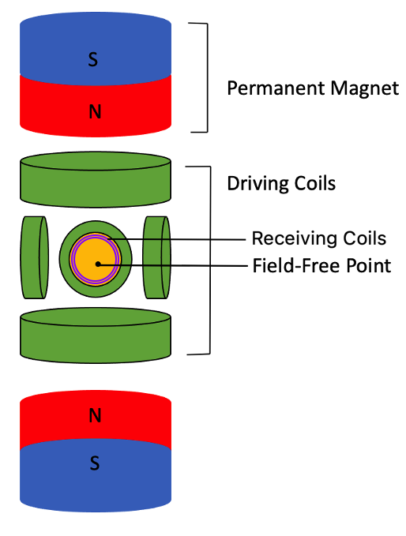
Figure 1: MPI scanner set up. Two permanent magnetics (red/blue) generate the selection field, which is the field-free point (FFP) (yellow). The driving coils (green) move the FFP over the imaging area for receiving coils (purple) to detect tracer signals.

superparamagnetic iron oxide nanoparticles such as maghemite (γ-Fe₂O₃) and magnetite (Fe₃O₄) [27]. Iron based nanoparticles have been shown to offer improved contrast properties and have been used in combination with hyperthermic therapies for accurate tumor treatment.

MRI signals arise from the excitation of low-energy nuclear spins formed in a permanent magnetic field generated from protons in water molecules in the body [28]. The magnetic spins of protons in the body are naturally randomly oriented, but will align with the magnetic field generated from the MRI machine. Once protons are aligned with the magnetic field, radiofrequency pulses are introduced, which cause protons to flip either 90 or 180 degrees within the static magnetic field. Once the radiofrequency pulse is removed, the protons realign with the magnetic field and release electromagnetic energy that the MRI machine will detect. Variations in the water concentration of various areas of the body result in different signal strengths and provide contrasts between tissue, bone, and fat. T1 contrast agents provide a positive contrast by altering the longitudinal relaxation times of water protons [29]. T2 agents provide negative contrast by altering the transverse relaxation times of water protons. Superparamagnetic iron oxide nanoparticles are typically used as T2 contrast agents due to possessing high sensitivity and biocompatibility [30].

High magnetic saturation must be achieved for MRI contrast agents. Bulk iron possesses a magnetic saturation value of 217 emu/g, whereas bulk γ₋Fe₂O₃ and Fe₃O₄ possess around 76 and 90 emu/g respectively, therefore, making iron a more ideal option as an MRI contrast agent compared to iron oxides. Pure iron is one of the best materials to use as an MRI contrast agent due to its biocompatibility and high magnetization at room temperature [31]. However, pure iron is unstable and is easily oxidized when exposed to ambient conditions, so a protective iron oxide shell generally forms when the particles are exposed to air [32]. Due to iron possessing more favorable magnetic properties compared to iron oxides, a pure iron nanoparticle is of interest for MRI contrast applications. Iron nanoparticles possess higher magnetic saturation per unit volume and could allow the administered dosage amount to be decreased, thereby improving patients’ safety and easier removal of the nanoparticles from the body after imaging.

Magnetic Hyperthermia
Magnetic hyperthermia is an alternative approach for targeted treatment of tumors. Magnetic nanoparticles are used to generate heat in the tumor when an alternating magnetic field is applied. Magnetic hyperthermia treatment can deliver therapeutic heating to cancer cells, which leads to more local and homogeneous heating to provide better selectivity and effective treatment [33]. Local temperature within a tumor can range between 43-46 ºC, inducing apoptosis or necrosis of the cancerous cells [34-36]. Among current magnetic nanoparticles, iron oxide nanoparticles are mainly researched as magnetic hyperthermic agents due to their well-known biocompatibility and magnetic properties. However, improvement of magnetic susceptibility to achieve optimal heating properties is still being investigated [37-39].

Pure iron nanoparticles, compared to iron oxides, possess higher magnetic saturation susceptibility at room temperature, which make them favorable for potential magnetic hyperthermic agents. Magnetic hyperthermia is often used in conjunction with MPI and MRI usage to accurately detect and track the nanoparticles’ location within the body and tumor to provide accurate hyperthermic treatment. Therefore, a pure iron nanoparticle has multiple biomedical applications as both MPI tracers, MRI contrast agents, and magnetic hyperthermic agents for cancer treatment.

CHAPTER I
Thermal Decomposition

A version of this chapter will be published by A. G. Williams. A. G. Williams was responsible for researching and writing in this article excerpt as noted: L. Liu assisted in synthesis and characterization, C. E. Johnson assisted in the analysis of Mössbauer spectroscopy, J. A. Johnson provided critical feedback and overall guidance.

Abstract
Iron nanoparticles were synthesized using thermal decomposition of Fe(CO)₅ at 180 ºC reaction temperature. Reaction time and surfactant amounts were modified to investigate possible size, shape, and dispersion variations. Characterizations included TEM, XRD, Mössbauer Spectroscopy, SQUID-VSM, ICP-OES, zeta potential, and cytotoxicity studies. From this method, monodispersed particles around 14 nm in size were produced and displayed good colloidal stability and high magnetic saturation up to 120 emu/g. Iron nanoparticles were coated with a DPSE-mPEG polymer to increase biocompatibility and showed low cytotoxicity. The particles reported display high potential for magnetic imaging and magnetic hyperthermia applications.

Introduction
Magnetic resonance imaging (MRI) has become a powerful tool to accurately diagnose and treat diseases. MRI offers excellent depth penetration and spatial resolution, making it one of the most commonly used diagnostic imaging tools [40-42]. However, current T1 contrast agents continue to show poor sensitivity in molecular imaging, and T2 contrast agents like iron oxides nanoparticles produce negative contrasts that are difficult to distinguish between bone and lung tissues. Therefore, magnetic particle imaging (MPI) was proposed in the early 2000s by Gleich and Weizenecker as a new magnetic imaging modality [14, 16]. Compared to MRI, MPI works by directly detecting the location of magnetic nanoparticle tracers and creates a positive contrast to allow for real time tracking of magnetic nanoparticles. MPI offers increased depth penetration, no radiation, no background signal from tissues, and allows for real-time quantitative analysis of cells [43, 44]. In addition, current FDA approved iron oxide nanoparticles used for MRI applications can be used for MPI applications.

Continued research in creating more favorable magnetic nanoparticles for MPI applications are being performed. Currently, superparamagnetic iron oxide nanoparticles (SPIONs) between 20-30 nm in size coated with a polymer have displayed good MPI results [45, 46], but the magnetic saturation values reach a maximum of 70 emu/g [47]. In order to obtain high signal intensity and spatial resolution in MPI, tracers must possess high saturation magnetization values and be superparamagnetic [48]. Therefore, studies in creating metallic iron nanoparticles have been performed in this research, since iron inherently possesses higher magnetic saturation compared to iron oxides.
Synthesis of monodisperse iron nanoparticles have been previously researched, with thermal decomposition of various metallic precursors being the most favored. Thermal decomposition using organo-metallic precursors such as Fe[N(SiMe₃)₂]₂ [49], metal oleates [50], metal acetonates, [M(acac)_{n}], (M= Fe, Mn, Co, Ni, Cr; n=2 or 3, acac=acetylacetonate) [51], metal cupferronates [M^{x}Cup_{x}] (M= metal ion; Cup= N-nitrosophenylhydroxylamine, C₆H₅N(NO)O-), and carbonyls [52] have previously been studied. However, decomposition of Fe(CO)₅ is among the most common. When compared to other synthetic processes, thermal decomposition of organo-metallic precursors often yields monodispersed, spherical particles with superparamagnetic properties. Therefore, an investigation in the synthesis and characterization of iron nanoparticles using this particular method was performed to obtain iron nanoparticles for magnetic resonance imaging and magnetic particle imaging applications. Variations in the reaction time and initial surfactant ratio amounts were studied to determine if such parameter variations affected the particle size, shape, and distribution.

Materials and Methods

Chemicals
Chemicals included the following. Iron (0) pentacarbonyl [Fe(CO)5, >99.99%], hexadecylamine (HDA, 98%), oleic acid (90%), 1-octadecene (90%), diethylether (anhydrous, ≥99.0%), pentane (anhydrous, ≥99%), tetrahydrofuran (THF, ≥99.9%), hexanes, oleylamine (70%), chloroform 1,2- distearoyl-sn-glycero-3-phosphoethanolamine-N-[methoxy- (polyethylene glycol)-2000] (ammonium salt) (DSPE-mPEG), aqueous hydrochloric acid (HCl, 37%), and dimethyl sulfoxide (DMSO) were purchased from Sigma Aldrich. Anhydrous ethanol was purchased from Decon Labs.

Synthesis and Setup
Synthesis of HDA.HCl surfactant is performed 24 hours before the FeNP synthesis. 0.488 g of HDA is dissolved in 100 mL of pentane and stirred with a magnetic stir bar. A mixture of 250 μl of HCl in 30 mL diethylether is slowly poured into the HDA-pentane solution and stirred for 1 min 30 sec. The resulting white solid precipitate is gravity filtered through Whatman filter paper and washed three times with 20 mL of Tetrahydrofuran by centrifugation at 9000 RPM in a Beckman Coulter C0650 fixed-angle rotor for 5 minutes. The resulting white product is dried in a vacuum oven overnight at 30 °C.

Figure 2 depicts the setup of the FeNP synthesis. 0.2779 g of HDA.HCl was dissolved in 0.084 mL of oleylamine, 0.207 mL oleic acid, and 20 mL of 1-octadecene in a 100 mL four-neck round-bottom flask. The solution was stirred with a magnetic stir bar and vacuumed and purged with Ar 3 times under a
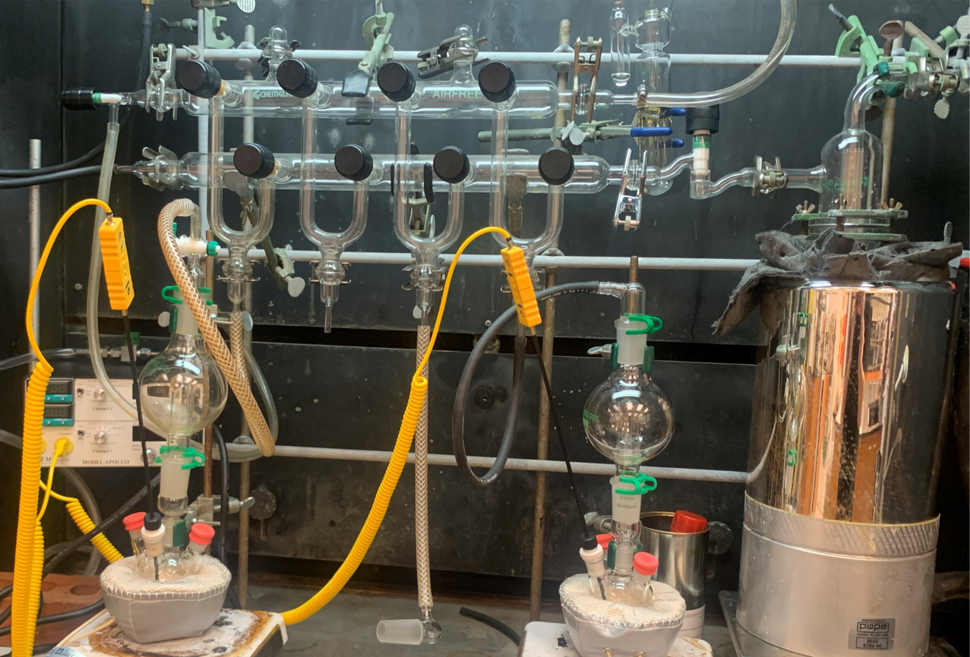
Figure 2: FeNP Synthesis setup

Schlenk line. The solution is heated to 120 °C at a 15 ºC/ min rate and held for 2 hours. Then, the temperature is raised to 180 °C at a 2 ºC/ min rate and 0.7 mL of Fe(CO)₅ was directly injected into the solution. The solution turned black upon injection and a yellowish-green gas formed inside the flask. The solution was stirred for 90 min at 180 °C and then cooled to room temperature. A permanent magnetic was placed at the bottom of the flask and the liquid solution is decanted leaving the collected iron nanoparticles on the magnetic stir bar. The nanoparticles and stir bar were transferred to a polystyrene weigh boat for initial washing. Hexanes was used to collect particles from the magnetic stir bar before particles were washed with 200 proof absolute ethanol. 60 mL of ethanol was used to wash the iron nanoparticles by centrifugation at 8000 rpm for 10 min in a Beckman Coulter C0650 fixed-angle rotor, three times. Half of the total yield was dispersed in 5 mL of chloroform and kept in a refrigerator for subsequent PEG coating; the other half was dried into powder and stored in an argon atmosphere glovebox for further characterization.

Synthesis of Time series
Various reaction times of the initial synthesis were performed to investigate possible effects on particle size or crystallinity. The initial chemical synthesis of HDA∙HCl and FeNPs was the same except for the reaction time after the Fe(CO)₅ was injected. Varying times included 30 min, 60 min, 80 min, 90 min, 24 hrs, and 48 hrs.

Synthesis Varying Surfactant Amounts
Quantities of surfactants, oleic acid, and oleylamine were varied in the first synthesis to determine if size or shape of the particles were affected. Surfactants are added to nanoparticle syntheses to allow for slower nucleation and growth of the particles and assist in stabilization. Therefore, investigation on whether more surfactant added would affect particle growth and size was performed. Varying amounts of oleic acid and oleylamine tested was compared to the initial 1x amount. 1.5x, 2x, 3x, and 4x the original starting amounts of oleylamine and oleic acid (OAm/OA) were used. The reaction time and temperature after Fe(CO)₅ injection was kept consistent with a 90 min reaction time at 180 °C.

DSPE-mPEG Coating
Iron nanoparticles were coated with 1,2- distearoyl-sn-glycero-3-phosphoethanolamine-N-[methoxy- (polyethylene glycol)-2000] (ammonium salt) (DSPE-mPEG) Y-shaped PEG polymer to increase biocompatibility and colloidal stability. 2 mL of chloroform dispersed nanoparticles was mixed with 0.4 mL of DSPE-mPEG and 9.6 mL of chloroform in a 100 mL round bottom flask. The solution was evaporated with a rotary evaporator for 1 hr in a 60 ºC water bath under vacuum. 4 mL of ultrapure water was added to the flask after evaporation and sonicated for 1 minute to evenly disperse particles in water. The solution was pipetted into Vivaspin Turbo 15 filter tubes (Sartorius) and centrifuged at 5000 rpm for 1 hr to remove excess DPSE-mPEG from the solution. Coated particles in the filter tube were pipetted into a storage vial and 1 mL of ultrapure water was added to redisperse the particles into aqueous medium. Particles were stored in a refrigerator for further cytotoxicity testing.

Acid Digestion Process for ICP-OES Measurements
To accurately measure the Fe concentration of the samples prior to cytotoxicity tests, inductively coupled plasma-optical emission spectrometry (ICP-OES) was performed. Acid digestion was performed to prepare samples for ICP-OES analysis. 500 μL of coated FeNPs dispersed in water was mixed with 2 mL of 1M nitric acid and 2 mL of 37% HCl in a 25 mL volumetric flask. The solution was sonicated for 5 minutes before heating in an 80 ºC water bath for 1 hour to allow particles to fully dissolve. Whatman filter paper with a pore size of 0.45 μm was used to gravity filter the solution into a 200 mL volumetric flask. The initial volumetric flasks were rinsed with ultrapure water and poured onto the filter for the solution to drip into the 200 mL volumetric flask. The final solution was brought to the appropriate 200 mL volume with ultrapure water to obtain a 50 mg/L iron concentration. 10 mL of the final solution was used for final ICP-OES measurements.

Results

Transmission Electron Microscopy (TEM)
Transmission electron microscopy (TEM) was performed at the Vanderbilt Institute of Nanoscience and Engineering (VINSE), Vanderbilt University. An FEI Tecnai Osiris TEM system was operated between 80 kV – 200 kV. Diameters were determined using ImageJ processing software.

From the varying time series, average particle size, iron core, and iron oxide shell size are summarized in Table 1. The reaction times of 30 min, 60 min, 80 min, and 90 min displayed similar overall particle sizes as well as iron core and iron oxide shell ratios. In addition, all particles appeared to be spherical and monodispersed. TEM results of the 30 min reaction possessed an average size of 14.3 ± 1.1 nm consisting of a 9.4 nm Fe core and 2.4 iron oxide shell (Figure 3). A 60 min reaction yielded an average particle size of 14.2 ± 2.5 consisting of a 9.1 nm iron core and 2.5 nm iron oxide shell (Figure 4). An 80 min reaction produced 12.7 ± 1.3 nm particles with 8 nm iron core and 2.4 nm iron oxide shell (Figure 5). Particles from a 90 min reaction averaged a 14.4 ± 1.1 nm total size with a 9.4 nm iron core and 2.5 nm iron oxide shell (Figure 6). For the 24-hour and 48-hour reaction times, as shown in Figures 7 and 8 respectively, the particles were more irregularly shaped. The 24-hour reaction time yielded an average particle size of 12.6 ± 1.7 nm, with a 9 nm core and 1.8 nm iron oxide shell. The 48-hour reaction time sample produced around 14.4 ± 1.8 nm sized particles consisting of a 9.8 nm iron core and 2.3 nm iron oxide shell.
Table 1: Varying time series of total particle size, Fe-core size, and iron oxide shell size. A total of 200 particles were measured for each sample to determine averages.
Reaction Time | Average Particle Size (nm) | Fe-Core Size  (nm) | Iron Oxide Shell Size (nm)
30 min | 14.3 ± 1.1 | 9.4 ± 1.0 | 2.4 ± 0.5
60 min | 14.2 ± 2.5 | 9.1 ± 0.9 | 2.5 ± 0.5
80 min | 12.7 ± 1.3 | 8.0 ± 0.9 | 2.4 ± 0.4
90 min | 14.4 ± 1.1 | 9.4 ± 0.9 | 2.5 ± 0.5
24 hr | 12.6 ± 1.7 | 9.0 ± 0.8 | 1.8 ± 0.3
48 hr | 14.4 ± 1.8 | 9.8 ± 1.0 | 2.3 ± 0.4

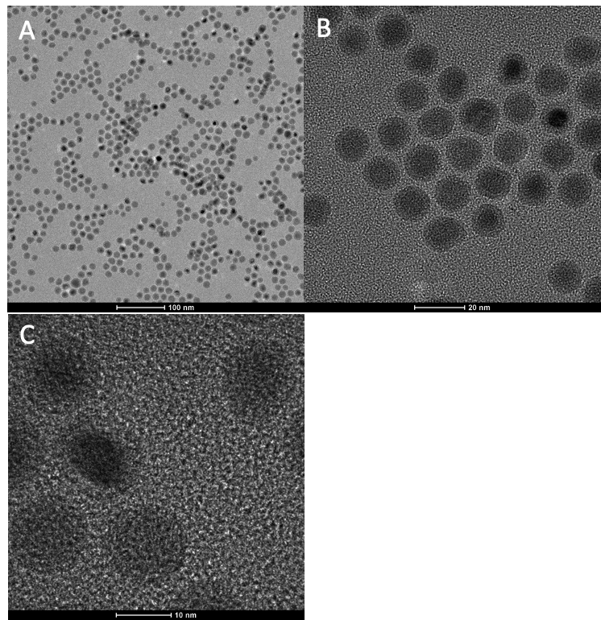
Figure 3: TEM images of 30 min reaction time. Scale bars for A, B, and C are 100 nm, 20 nm, and 10 nm respectively.

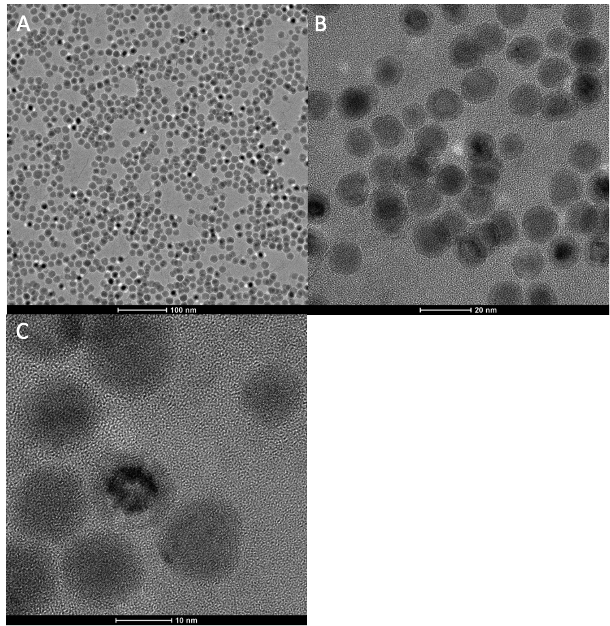
Figure 4: TEM images of 60 min reaction time. Scale bars for A, B, and C are 100 nm, 20 nm, and 10 nm respectively.

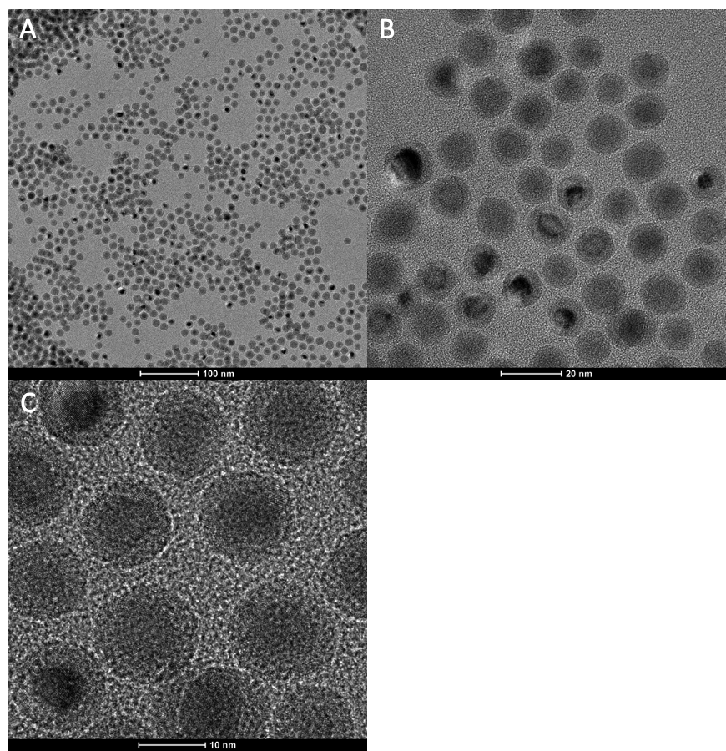
Figure 5: TEM images of 80 min reaction time. Scale bars for A, B, and C are 100 nm, 20 nm, and 10 nm respectively.

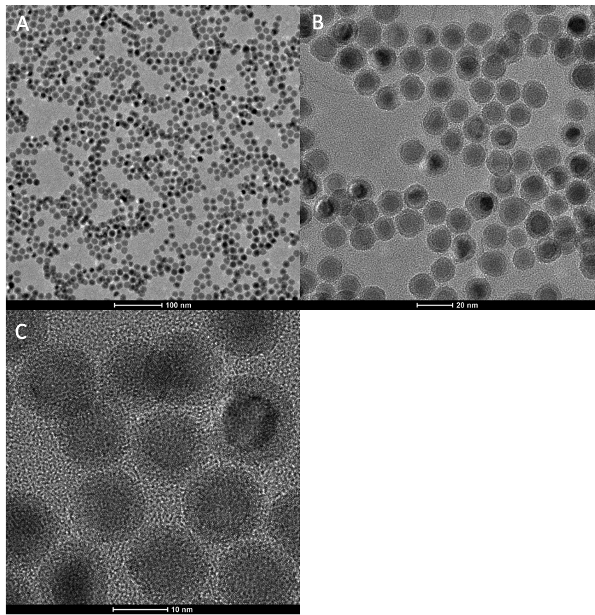
Figure 6: TEM images of 90 min reaction time. Scale bars for A, B, and C are 100 nm, 20 nm, and 10 nm respectively.

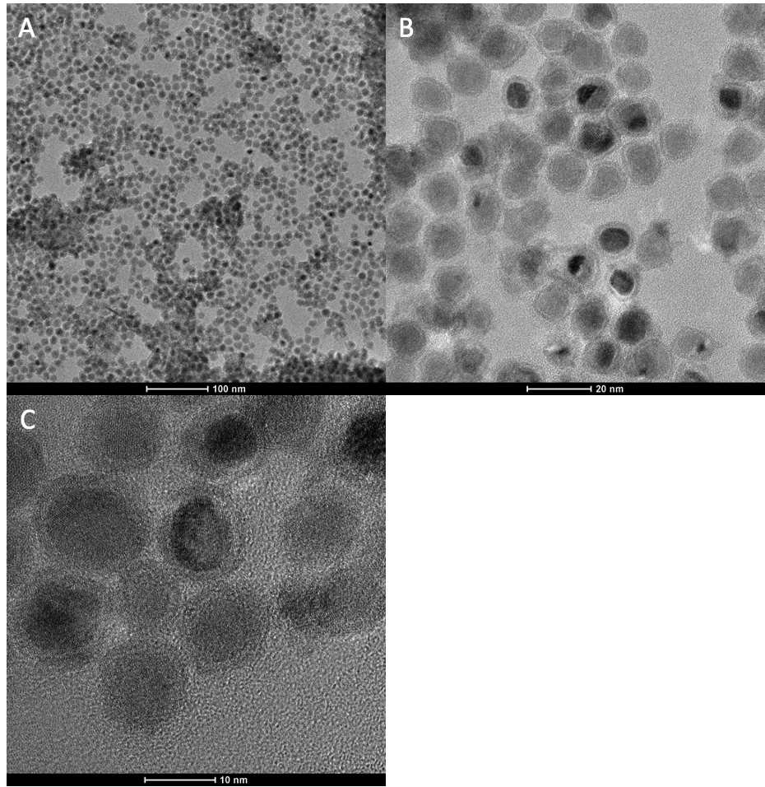
Figure 7: TEM images of 24 hrs reaction time. Scale bars for A, B, and C are 100 nm, 20 nm, and 10 nm respectively.

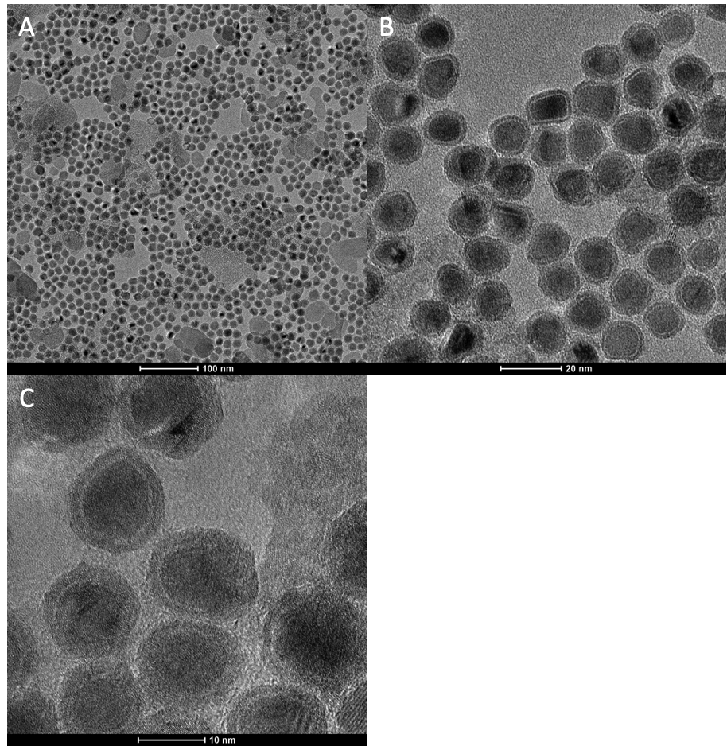
Figure 8: TEM images of 48 hrs reaction time. Scale bars for A, B, and C are 100 nm, 20 nm, and 10 nm respectively.

For the varying OAm/OA surfactant ratio series, average particle size, iron core, and iron oxide shell sizes are summarized in Table 2. Initial equal OAm/OA starting amounts yielded particles with an average size of 14.4 ± 1.1, consisting of a 9.4 nm iron core and 2.5 nm iron oxide shell (Figure 9). The 1.5x OAm/OA amounts produced slightly larger particles with an average size of 15.4 ± 2.6 nm, which consisted of a 10.3 nm iron core and 2.5 nm iron oxide shell (Figure 10). Using 2x OAm/OA amounts yielded an average particle size of 12.8 ± 2.4 nm with an 8 nm iron core and 2.4 nm iron oxide shell (Figure 11). Adding 3 times initial OAm/OA amounts produced an average particle size of 13.7 ± 2.4. nm with an 8.9 nm iron core and 2.4 iron oxide shell (Figure 12). Adding 4 times the initial OAm/OA amounts resulted in polydisperse particles consisting mostly of iron oxide particles (Figure 13). However, an experimental error was introduced during the 4 times surfactant synthesis where the injection temperature was 260 ºC compared to the previous 180 °C. Therefore, consistent comparison is skewed since it is difficult to discern whether the surfactant amount or reaction temperature contributed to the change in particle size, shape, and composition.

X-ray Diffraction (XRD)
Powder XRD measurements were performed using a Rigaku SmartLab3kW X-ray Diffractometer with a Cu Kα X-ray source in a 2θ range of 20º to 80º as shown in Figure 14. Figure 15 displays the varying time series XRD spectra and Figure 16 displays the XRD spectra for the varying surfactant ratio series.

Little difference in XRD spectra of the 30 min, 60 min, 80 min, and 90 min was found as each spectrum displays characteristic α-Fe peaks at 45, 65, and 82 degrees (DB # 1100108). However, the 24-hour spectrum indicated peaks characteristic of ⍺-Fe at 45, 65, and 82 degrees and small peaks attributed to γ-Fe₂O₃ at 35, 37, 43, and 63 degrees (DB # 2108027). The 48 hr sample displayed peaks characteristic of mostly Fe₃O₄ at 30, 35, 43, 57, and 62 degrees (DB # 7228110) with a small α-Fe peak at 45 degrees. One reason all of the samples, except for the 24 and 48 hr samples, displayed only α-Fe peaks could be that the iron oxide layer was not as crystalized when compared to the 24 and 48 hr sample. The longer reaction times may have helped to increase crystalline formation of the oxide layer, and thus displayed more prominent oxide peaks in the spectra.

XRD spectra from varying OAm/OA surfactant amounts were similar with characteristic α-Fe peaks with the exception of the 4x OAm/OA amount. The 4x OAm/OA have sharp peaks indicating Fe₃O₄ at 30, 35, 40, 43, 45, 53, 57, 63, 74, 86, and 90 degrees (DB # 7228110). The formation of Fe₃O₄ in the 4x OAm/OA surfactant sample may be due to the increased temperature reaction at 260 ºC, which is expected as iron oxide nanoparticles commonly form at higher reaction temperatures.
Table 2: Varying initial OAm/OA surfactant ratio series of total particle size, Fe-core size, and iron oxide shell size. A total of 200 particles were measured for each sample to determine averages.
OAm/OA Amounts | Average Particle Size (nm) | Fe-Core Size  (nm) | Iron Oxide Shell Size (nm)
1 | 14.4 ± 1.1 | 9.4 ± 1.0 | 2.5 ± 0.5
1.5 | 15.4 ± 2.6 | 10.3 ± 1.5 | 2.5 ± 0.5
2 | 12.8 ± 2.4 | 8.0 ± 0.9 | 2.4 ± 0.4
3 | 13.7 ± 2.4 | 8.9 ± 1.1 | 2.4 ± 0.4
4 | Polydisperse

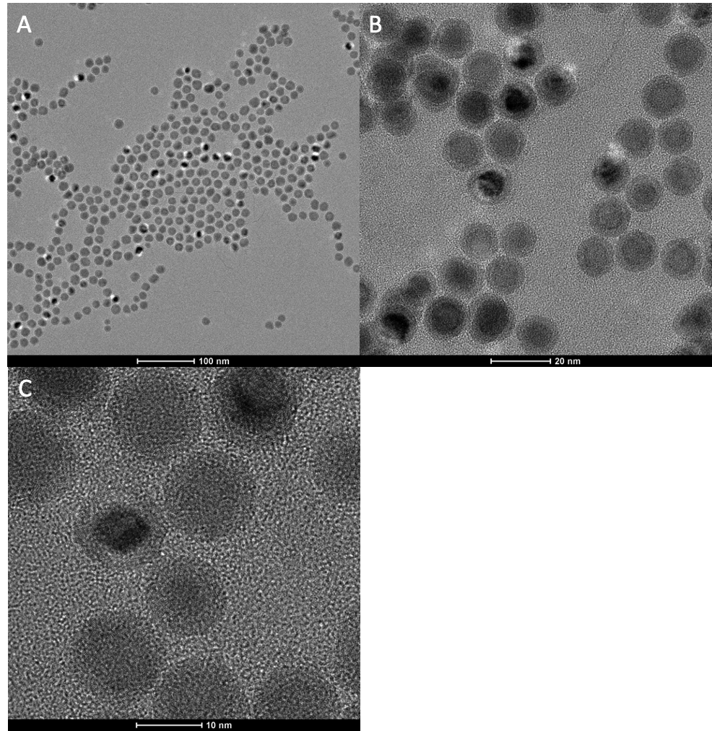
Figure 9: TEM images of 1x OAm/OA surfactant amount. Scale bars for A, B, and C are 100 nm, 20 nm, and 10 nm respectively.

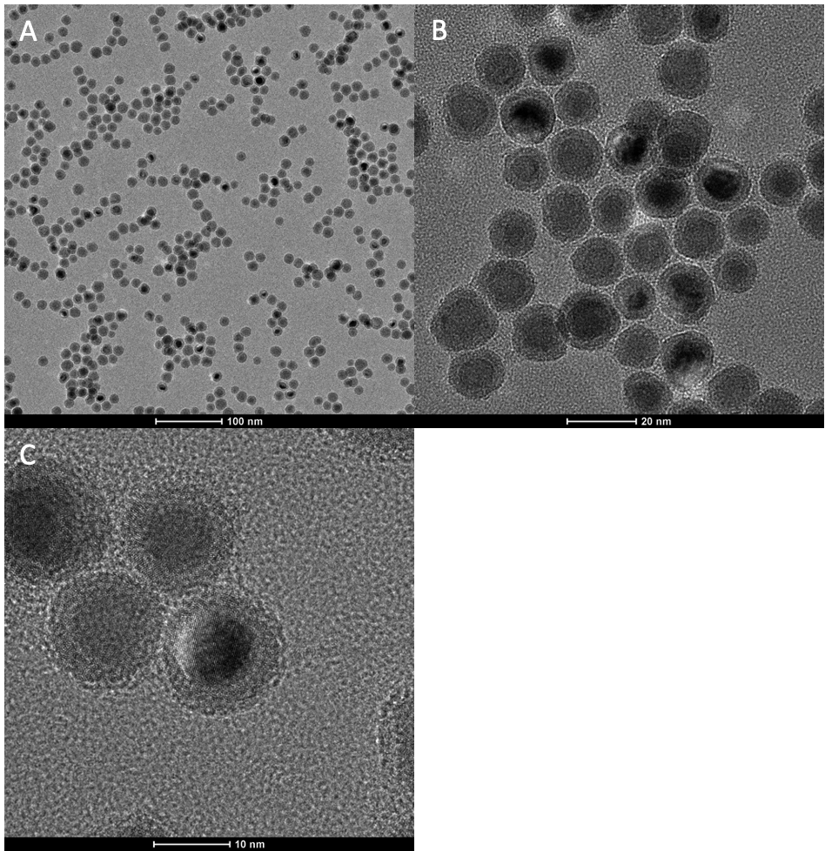
Figure 10: TEM images of 1.5x OAm/OA surfactant amount. Scale bars for A, B, and C are 100 nm, 20 nm, and 10 nm respectively.

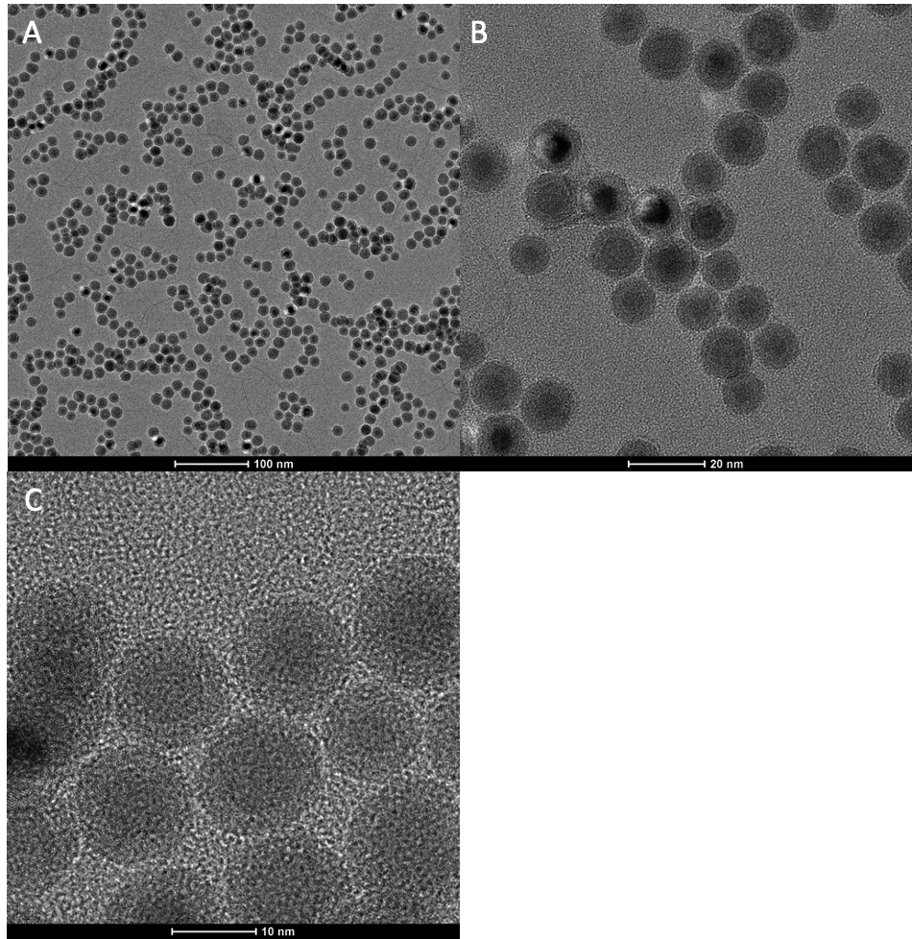
Figure 11: TEM images of 2x OAm/OA surfactant amount. Scale bars for A, B, and C are 100 nm, 20 nm, and 10 nm respectively.

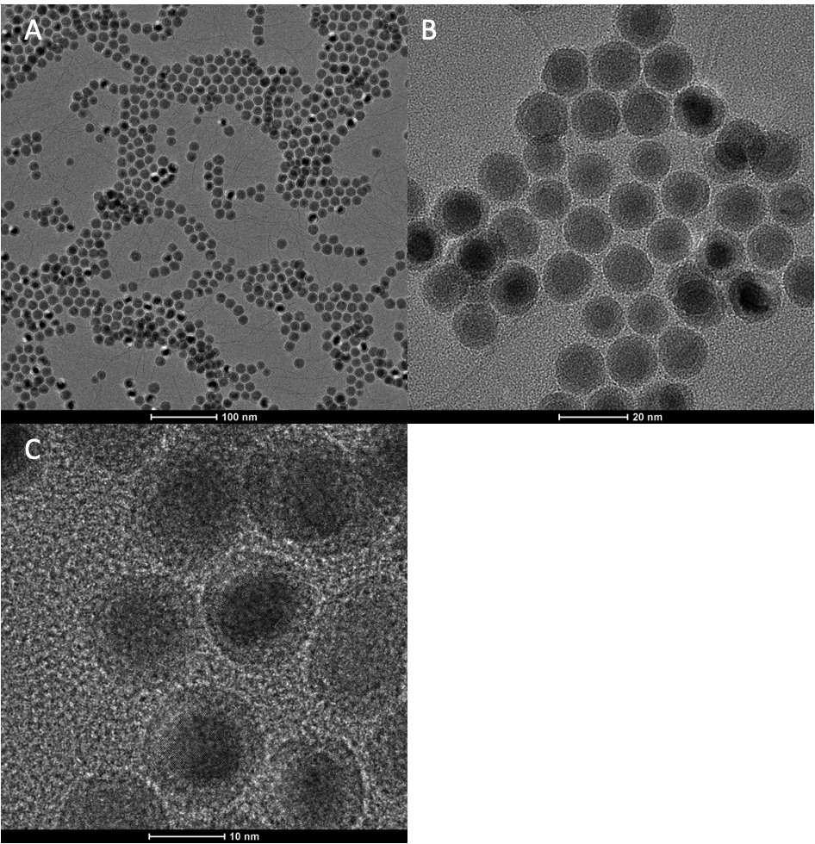
Figure 12: TEM images of 3x OAm/OA surfactant amount. Scale bars for A, B, and C are 100 nm, 20 nm, and 10 nm respectively.

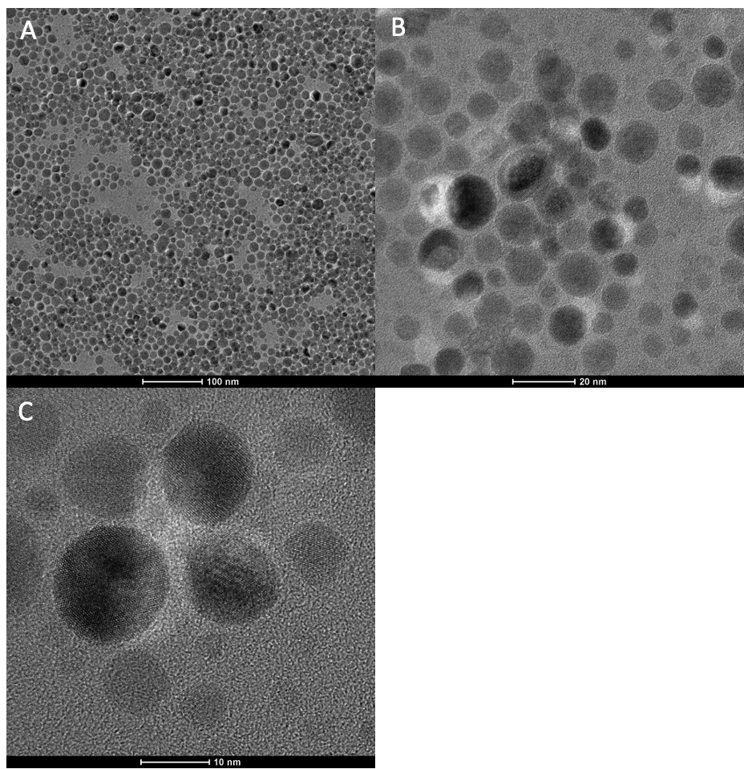
Figure 13: TEM images of 4x OAm/OA surfactant amount. Scale bars for A, B, and C are 100 nm, 20 nm, and 10 nm respectively.

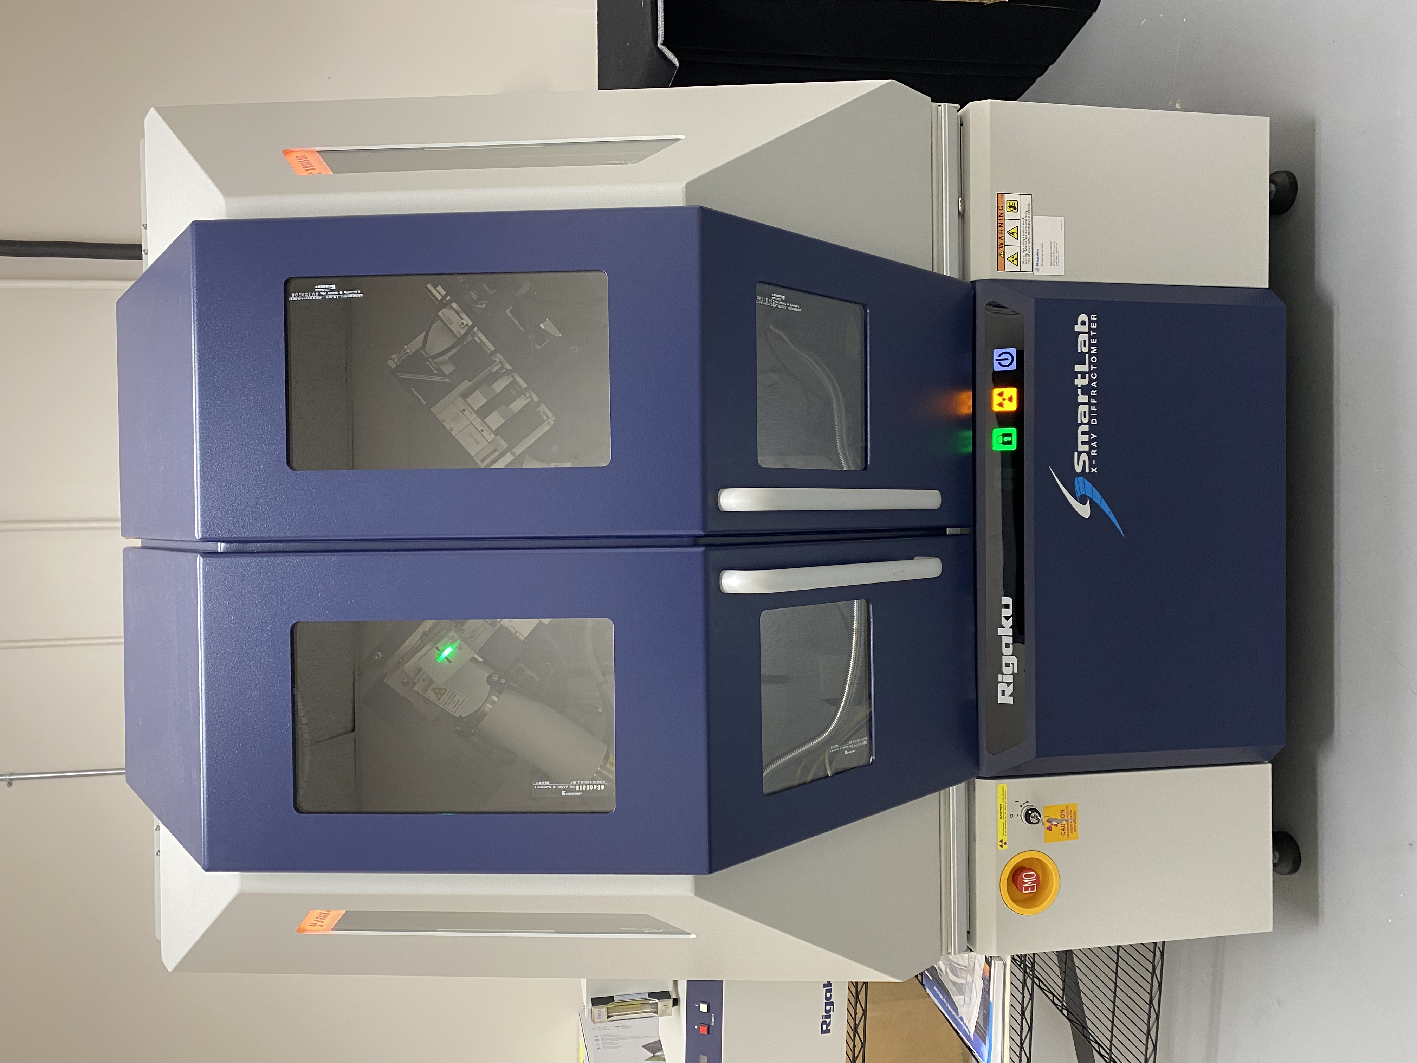
Figure 14: Rigaku SmartLab XRD Machine

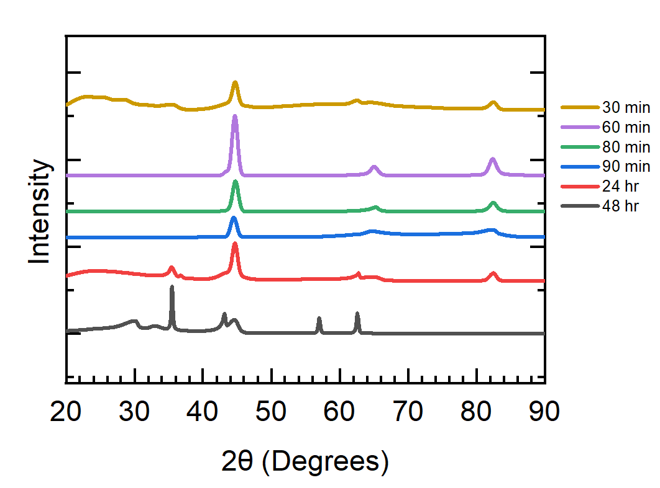
Figure 15: XRD stacked plot of varying reaction time series.

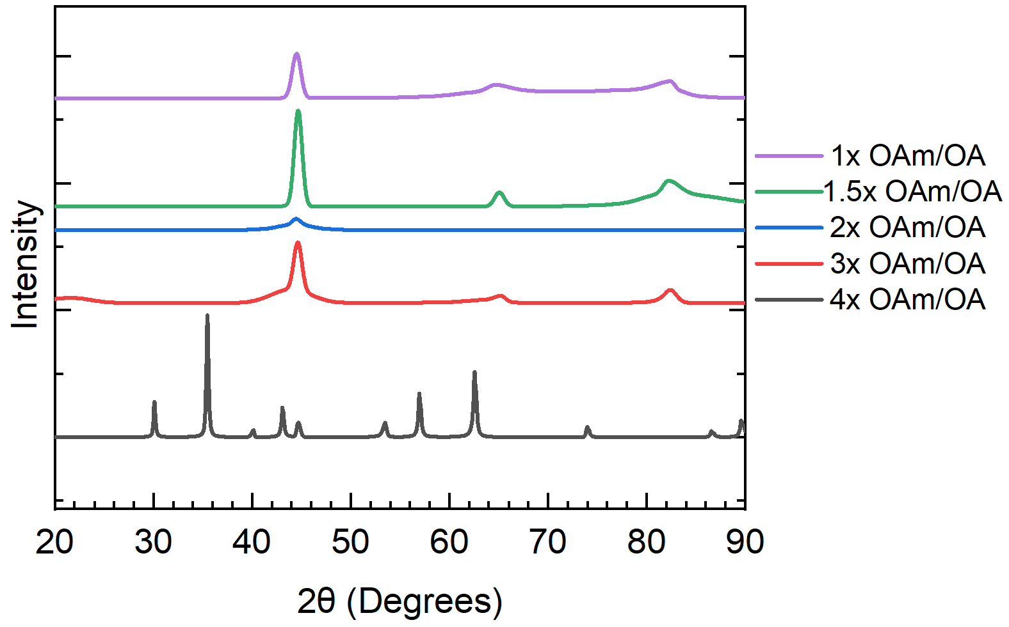
Figure 16: XRD stacked plot of varying OAm/OA surfactant series.

Mössbauer Spectroscopy
Mössbauer Spectroscopy experiments were performed with a ⁵⁷Co source, a Janis SHI-850-5 cryogen-free cryostat, Lakeshore 325 Temperature Controller (Figure 17). A room temperature Mössbauer setup is shown in Figure 18. Hyperfine interaction parameters were analyzed using a least-squares fitting model with Mössbauer GenFit Software (R. S. Preston and D. E. Brown). After synthesis, samples were dried in powders and stored in an Ar glovebox. The powders were loaded and sealed into Mössbauer sample cups (Figure 19) for characterization at 293K and 6K.

The stacked Mössbauer results of varying reaction times measured at 293K are shown in Figure 20, and values from hyperfine fitting parameters are displayed in Table 3. From Mössbauer results, little variation in iron and iron oxide composition was displayed among all time increments with exception of the 48-hour reaction time. The 30 min, 60 min, 80 min, 90 min, and 24 hr spectra consisted of 2 components that includes a narrow sextet and a doublet pattern. Component 1 possessed a narrow sextet pattern with a hyperfine field around 33.7 T, isomer shift of 0.00 mm/s, and quadrupole splitting 0.00 mm/s, characteristic of α-Fe. Component 2 consists of a broad doublet pattern with a hyperfine field of 0.00 T, isomer shift between 0.28 - 0.47 mm/s, and quadrupole splitting around 0.5-1.19 mm/s, which is indicative of γ-Fe₂O₃.

The 48-hour reaction sample consisted of 3 components at 293K with a broad sextet, a broad doublet, and narrow sextet. Component 1 is a broad sextet pattern with a hyperfine field of 45.3T, isomer shift of 0.63 mm/s, and quadrupole splitting of 0.04 mm/s. Component 2 consists of a broad doublet with a hyperfine field of 0.00 mm/s, isomer shift of 0.34 mm/s, and quadrupole splitting of 0.73 mm/s. Component 3 consists of a narrow sextet with a hyperfine field of 48.7 T, isomer shift 0.25 mm/s, and quadrupole splitting of 0.00 mm/s. From the three components, each is characteristic of a mixture of iron oxides attributed to γ-Fe₂O₃ and Fe₃O₄. Component 1 and 3 can be attributed to the B (octahedral) sites and A (tetrahedral) sites characteristic of Fe₃O₄ respectively. Component 2 is characteristic of γ-Fe₂O₃.

Stacked Mössbauer spectra for low temperature measurements at 6K for varied reaction times are shown in Figure 21 and hyperfine fitting parameters are summarized in Table 4. Low temperature measurements were performed on the 30 min, 60 min, 80 min, and 90 min reaction time samples to confirm the magnetic components of the spectrum. All spectra were similar, consisting of 2 sextet components. Component 1 displayed a narrow sextet with a hyperfine field of 34.3 T, isomer shift of 0.12 mm/s and quadrupole splitting 0.00 mm/s, indicative of α-Fe. The second component contained a broad sextet with a hyperfine field between 47.7- 49.6 T, isomer shift between 0.45 – 0.48 mm/s, and quadrupole splitting between 0.00 – 0.04 mm/s, which is associated with γ-Fe₂O_{3.}
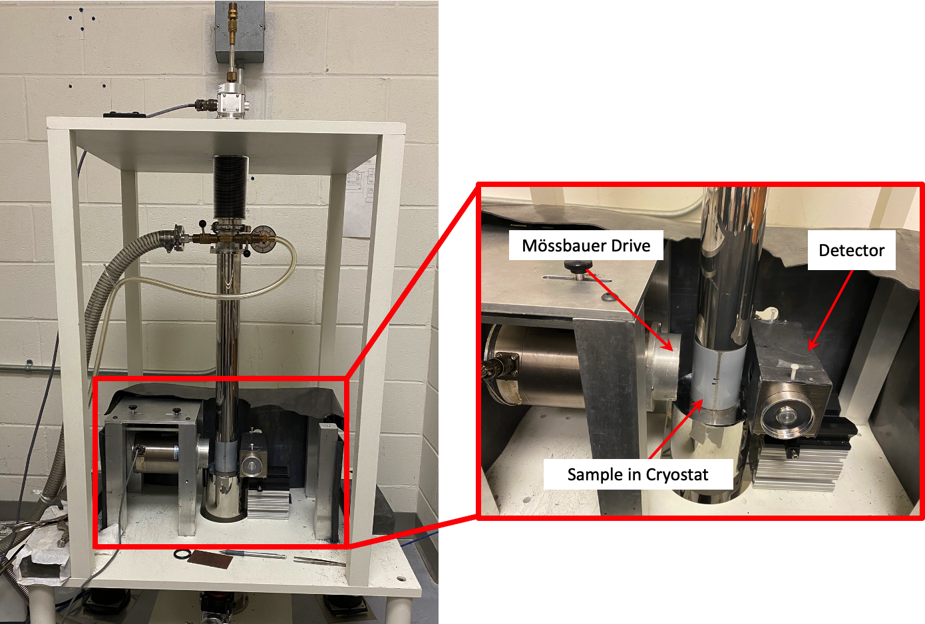
Figure 17: Low temperature Mössbauer apparatus with cryostat for low temperature measurements

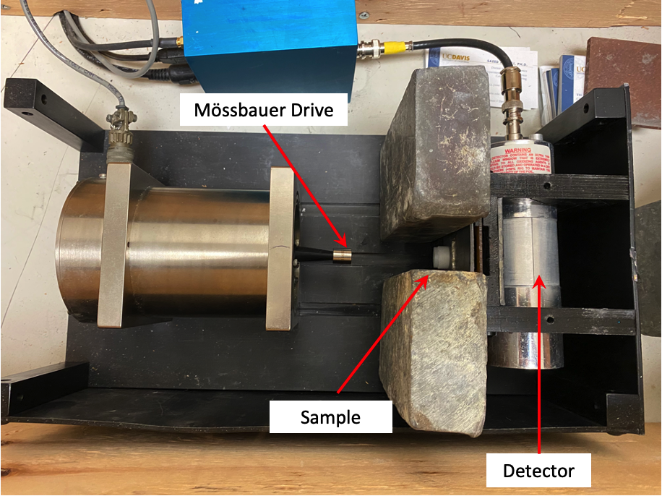
Figure 18: Room temperature Mössbauer apparatus

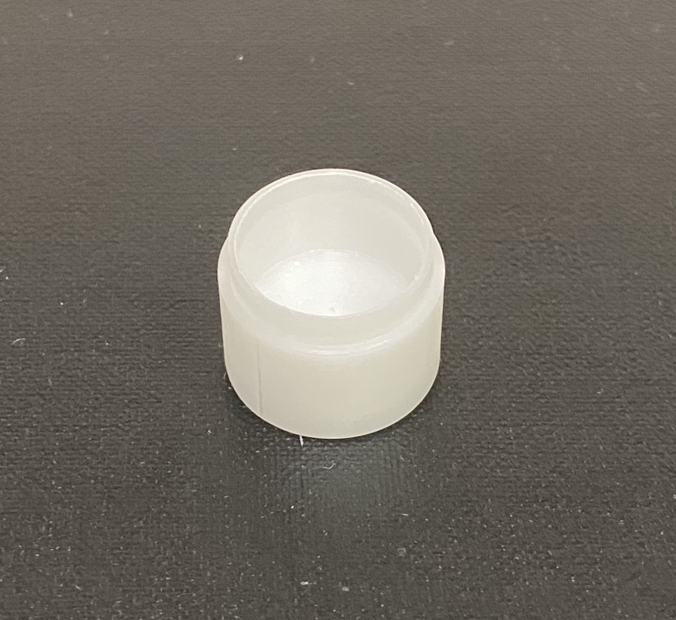
Figure 19: Mössbauer sample holder

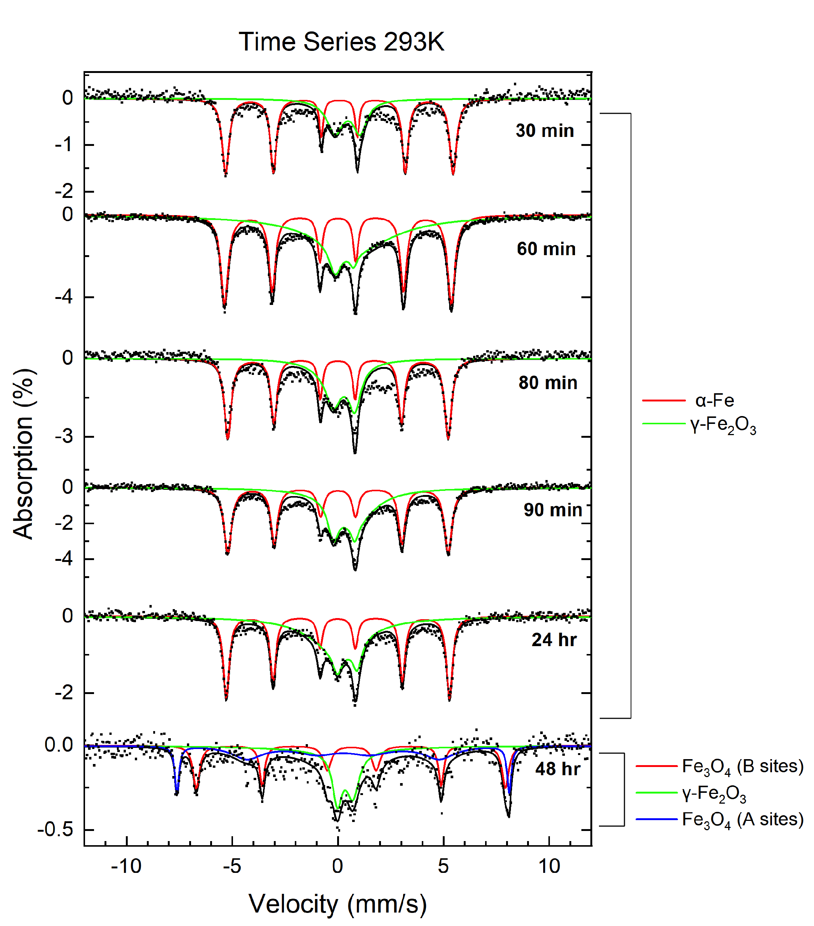
Figure 20: Stacked ⁵⁷Fe Mössbauer spectra of varied reaction time samples at 293K.
Table 3: Values of hyperfine parameters for varied reaction time series at 293K. B_{hf} is the hyperfine magnetic field, δ is the isomer shift, ΔE_{Q} is the quadrupole splitting, and Γ is the linewidth (FWHM). Typical errors are ±0.03 mm/s for B_{hf}, ±0.5 mm/s for δ, ΔE_{Q}, and Γ and ±3% for relative area.

Reaction Time | Component | B_{hf} (T) | δ (mm/s) | ΔE_{Q} (mm/s) | Γ (mm/s) | Relative area (%) | Attribution
 | 1 | 33.4 | 0.07 | 0.00 | 0.39 | 54 | α-Fe
30 min | 2 | 0.00 | 0.45 | 1.19 | 0.77 | 45 | Superparamagnetic γ-Fe₂O₃
 | 1 | 33.2 | 0.00 | 0.00 | 0.40 | 54 | α-Fe
60 min | 2 | 0.00 | 0.45 | 1.10 | 3.32 | 46 | Superparamagnetic γ-Fe₂O₃
 | 1 | 32.3 | 0.00 | 0.00 | 0.39 | 48 | α-Fe
80 min | 2 | 0.00 | 0.28 | 1.02 | 0.70 | 52 | Superparamagnetic γ-Fe₂O₃
 | 1 | 32.3 | 0.00 | 0.00 | 0.43 | 53 | α-Fe
90 min | 2 | 0.00 | 0.28 | 1.01 | 0.60 | 47 | Superparamagnetic γ-Fe₂O₃
 | 1 | 32.7 | 0.00 | 0.00 | 0.34 | 47 | α-Fe
24 hr | 2 | 0.00 | 0.47 | 0.94 | 0.52 | 53 | Superparamagnetic γ-Fe₂O₃
 | 1 | 45.3 | 0.63 | 0.04 | 0.38 | 29 | Fe₃O₄
48 hr | 2 | 0.00 | 0.34 | 0.73 | 0.72 | 34 | Superparamagnetic γ-Fe₂O₃
 | 3 | 48.7 | 0.25 | 0.00 | 0.23 | 37 | Fe₃O₄

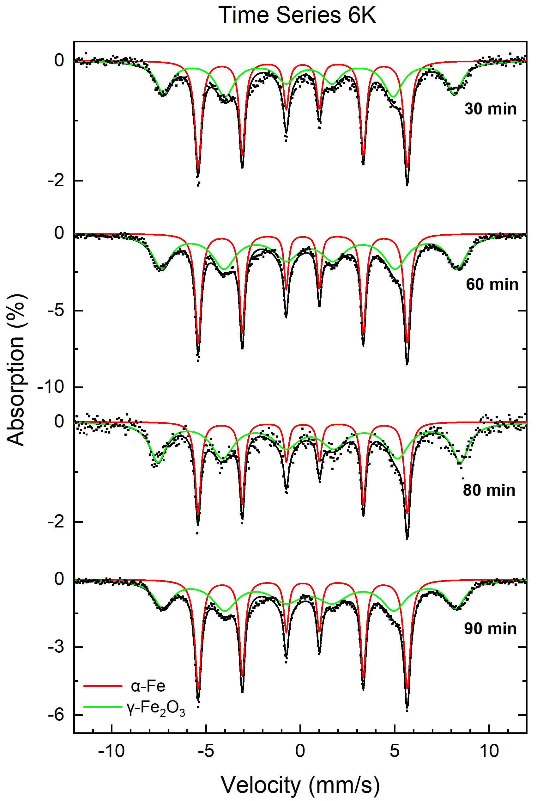
Figure 21: Stacked ⁵⁷Fe Mössbauer spectra of varied reaction time samples at 6K.

Table 4: Values of hyperfine parameters for varied reaction time series at 6K. B_{hf} is the hyperfine magnetic field, δ is the isomer shift, ΔE_{Q} is the quadrupole splitting, and Γ is the linewidth (FWHM). Typical errors are ±0.03 mm/s for B_{hf}, ±0.5 mm/s for δ, ΔE_{Q}, and Γ and ±3% for relative area.

Reaction Time | Component | B_{hf} (T) | δ (mm/s) | ΔE_{Q} (mm/s) | Γ (mm/s) | Relative area (%) | Attribution
 | 1 | 34.3 | 0.12 | 0.00 | 0.42 | 50 | α-Fe
30 min | 2 | 47.7 | 0.45 | 0.00 | 1.00 | 50 | Superparamagnetic γ-Fe₂O₃
 | 1 | 34.3 | 0.12 | 0.00 | 0.38 | 42 | α-Fe
60 min | 2 | 48.5 | 0.48 | 0.01 | 1.18 | 58 | Superparamagnetic γ-Fe₂O₃
 | 1 | 34.4 | 0.12 | 0.01 | 0.36 | 36 | α-Fe
80 min | 2 | 49.6 | 0.48 | 0.04 | 1.04 | 64 | Superparamagnetic γ-Fe₂O₃
 | 1 | 34.3 | 0.12 | 0.00 | 0.42 | 45 | α-Fe
90 min | 2 | 48.0 | 0.47 | 0.00 | 1.17 | 54 | Superparamagnetic γ-Fe₂O₃

Stacked Mössbauer results of varying OAm/OA surfactant amounts measured at 293K are shown in Figure 22, and values from hyperfine fitting parameters are displayed in Table 5. All sample spectra except for the 4x OAm/OA sample consisted of 2 components, a narrow sextet and a broad doublet pattern. The 4x OAm/OA sample included a broad doublet and 2 broad sextet patterns. Component 1 for the 1x, 1.5x, 2x, and 3x OAm/OA samples was a narrow sextet pattern with a hyperfine field between 31.5 – 34.8 T, isomer shift of 0.00 mm/s, and quadrupole splitting 0.00 mm/s, which is attributed to α-Fe. The second component includes a broad doublet pattern with a hyperfine field of 0.00 T, isomer shift between 0.28 - 0.36 mm/s, and quadrupole splitting between 0.98 – 1.09 mm/s, which is indicative of γ-Fe₂O₃. Component 1 for the 4x OAm/OA sample consisted of a broad sextet with a hyperfine field of 45.3 T, isomer shift of 0.63 mm/s, and quadrupole splitting 0.04 mm/s, which is attributed to the B (octahedral) sites of Fe₃O₄. Component 2 included a broad doublet with a hyperfine field of 0.00 T, isomer shift of 0.34 mm/s, and quadrupole splitting of 0.73 mm/s, attributed to γ-Fe₂O₃. Component 3 included a broad sextet pattern with a hyperfine field of 48.7 T, isomer shift of 0.25 mm/s, and quadrupole splitting of 0.00 mm/s, which is associated to the A (tetrahedral) sites of Fe₃O₄.

Stacked Mössbauer results of varying OAm/OA surfactant amounts measured at 6K are displayed in Figure 23 and hyperfine fitting parameters are detailed in Table 6. No low temperature Mössbauer measurement was performed on the 4x OAm/OA sample due to it consisting of large iron oxides from the 293K spectrum. All spectra for the samples were similar, consisting of 2 components, a narrow and broad sextet. Component 1 was comprised of a narrow sextet with a hyperfine field of 34.3 T, isomer shift of 0.12 mm/s and quadrupole splitting of 0.00 mm/s, attributed to α-Fe. Component 2 consisted of a broad sextet with a hyperfine field between 47.5 – 48.0 T, isomer shift between 0.45 – 0.52 mm/s, and quadrupole splitting of 0.00 mm/s, which is indicative of γ-Fe₂O₃. From low temperature measurements, the γ-Fe₂O₃ component displays superparamagnetic properties due to the relaxation from a doublet pattern in 293K spectra, to a sextet at 6K.

Superconducting Quantum Interference Device - Vibrating Magnetometry (SQUID-VSM)
SQUID-VSM measurements were performed at the Joint Institute for Advanced Materials (JIAM) at the University of Tennessee Knoxville. Measurements were performed in a ± 1000 mT field at 300K and 3K.

The varying surfactant OAm/OA series was used for SQUID-VSM tests, which included the 1x, 1.5x, 2x, and 3x OAm/OA samples. The M-H curves of the 1x, 1.5x, 2x, and 3x samples at 300K can be seen in Figures 24, 26, 28, and 30 respectively. Derivation of the point spread function from the M-H curves of the 1x, 1.5x, 2x, and 3x OAm/OA samples are shown in Figures 25, 27, 29, and 31
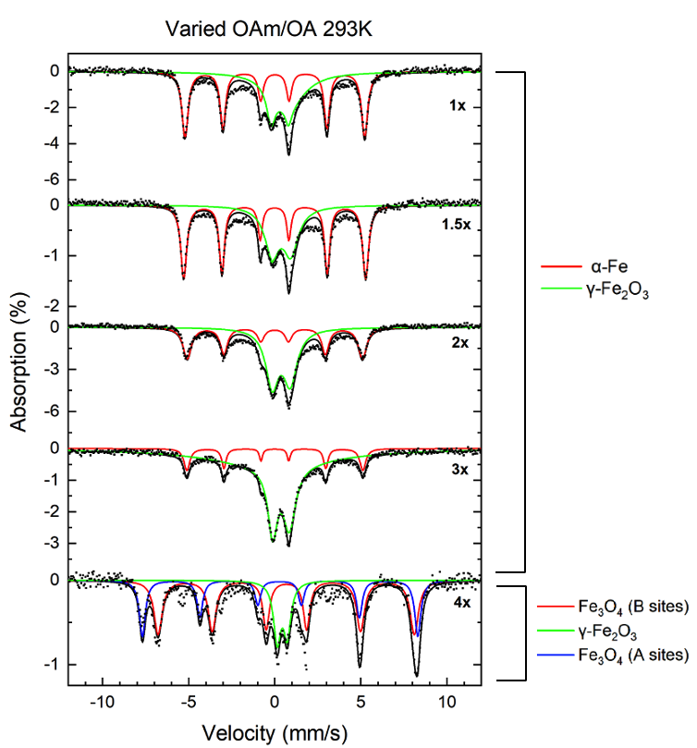
Figure 22: Stacked ⁵⁷Fe Mössbauer spectra of varied OAm/OA samples at 293K.
Table 5: Values of hyperfine parameters for varied OAm/OA amounts at 293K. B_{hf} is the hyperfine magnetic field, δ is the isomer shift, ΔE_{Q} is the quadrupole splitting, and Γ is the linewidth (FWHM). Typical errors are ±0.03 mm/s for B_{hf}, ±0.5 mm/s for δ, ΔE_{Q}, and Γ and ±3% for relative area.

OAm/OA Amount | Component | B_{hf} (T) | δ (mm/s) | ΔE_{Q} (mm/s) | Γ (mm/s) | Relative area (%) | Attribution
 | 1 | 32.3 | 0.00 | 0.00 | 0.43 | 53 | α-Fe
1x | 2 | 0.00 | 0.28 | 1.01 | 0.60 | 47 | Superparamagnetic γ-Fe₂O₃
 | 1 | 32.7 | 0.00 | 0.00 | 0.41 | 58 | α-Fe
1.5x | 2 | 0.00 | 0.39 | 1.09 | 1.06 | 42 | Superparamagnetic γ-Fe₂O₃
 | 1 | 31.5 | 0.00 | 0.00 | 0.58 | 43 | α-Fe
2x | 2 | 0.00 | 0.37 | 1.04 | 0.90 | 57 | Superparamagnetic γ-Fe₂O₃
 | 1 | 31.6 | 0.00 | 0.00 | 0.40 | 13 | α-Fe
3x | 2 | 0.00 | 0.36 | 0.98 | 0.87 | 87 | Superparamagnetic γ-Fe₂O₃
 | 1 | 46.1 | 0.66 | 0.00 | 0.58 | 51 | Fe₃O₄
4x | 2 | 0.00 | 0.43 | 0.58 | 0.50 | 18 | γ-Fe₂O₃
 | 3 | 49.6 | 0.29 | 0.03 | 0.42 | 31 | Fe₃O₄

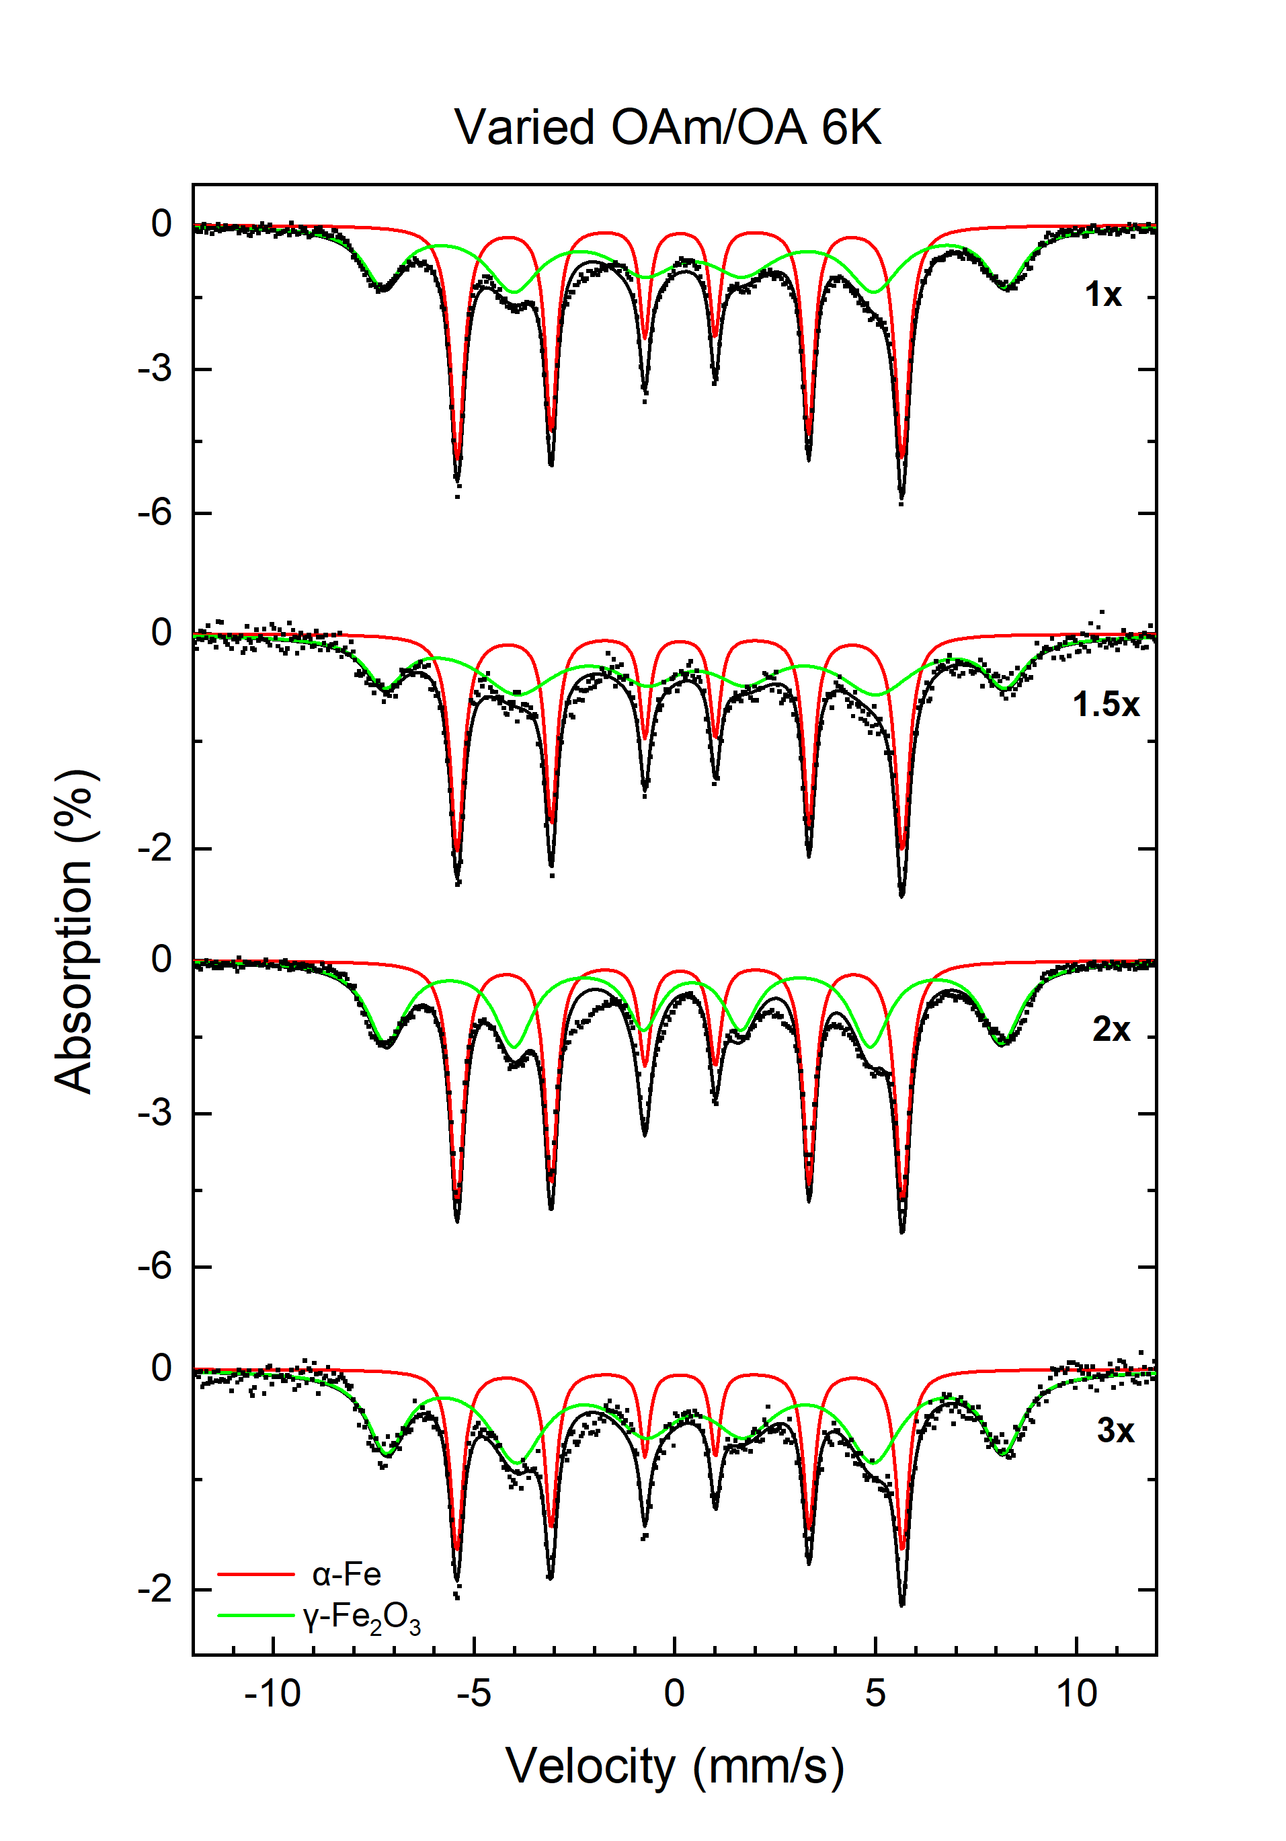
Figure 23: Stacked ⁵⁷Fe Mössbauer spectra of varied OAm/OA samples at 6K.
Table 6: Values of hyperfine parameters for varied OAm/OA amounts at 6K. B_{hf} is the hyperfine magnetic field, δ is the isomer shift, ΔE_{Q} is the quadrupole splitting, and Γ is the linewidth (FWHM). Typical errors are ±0.03 mm/s for B_{hf}, ±0.5 mm/s for δ, ΔE_{Q}, and Γ and ±3% for relative area.

OAm/OA Amount | Component | B_{hf} (T) | δ (mm/s) | ΔE_{Q} (mm/s) | Γ (mm/s) | Relative area (%) | Attribution
 | 1 | 34.3 | 0.12 | 0.00 | 0.42 | 45 | α-Fe
1x | 2 | 48.0 | 0.47 | 0.00 | 1.17 | 54 | Superparamagnetic γ-Fe₂O₃
 | 1 | 34.3 | 0.12 | 0.00 | 0.42 | 42 | α-Fe
1.5x | 2 | 47.8 | 0.52 | 0.04 | 1.19 | 53 | Superparamagnetic γ-Fe₂O₃
 | 1 | 34.4 | 0.12 | 0.00 | 0.42 | 47 | α-Fe
2x | 2 | 47.5 | 0.45 | 0.00 | 1.16 | 53 | Superparamagnetic γ-Fe₂O₃
 | 1 | 34.4 | 0.12 | 0.00 | 0.39 | 32 | α-Fe
3x | 2 | 47.6 | 0.49 | 0.00 | 1.16 | 68 | Superparamagnetic γ-Fe₂O₃

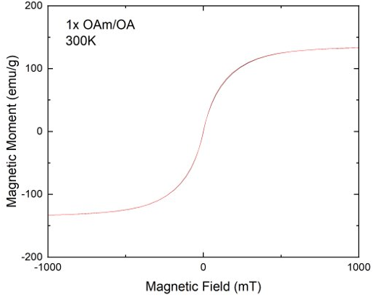
Figure 24: M-H Curve of 1x OAm/OA surfactant ratio sample at 300K.

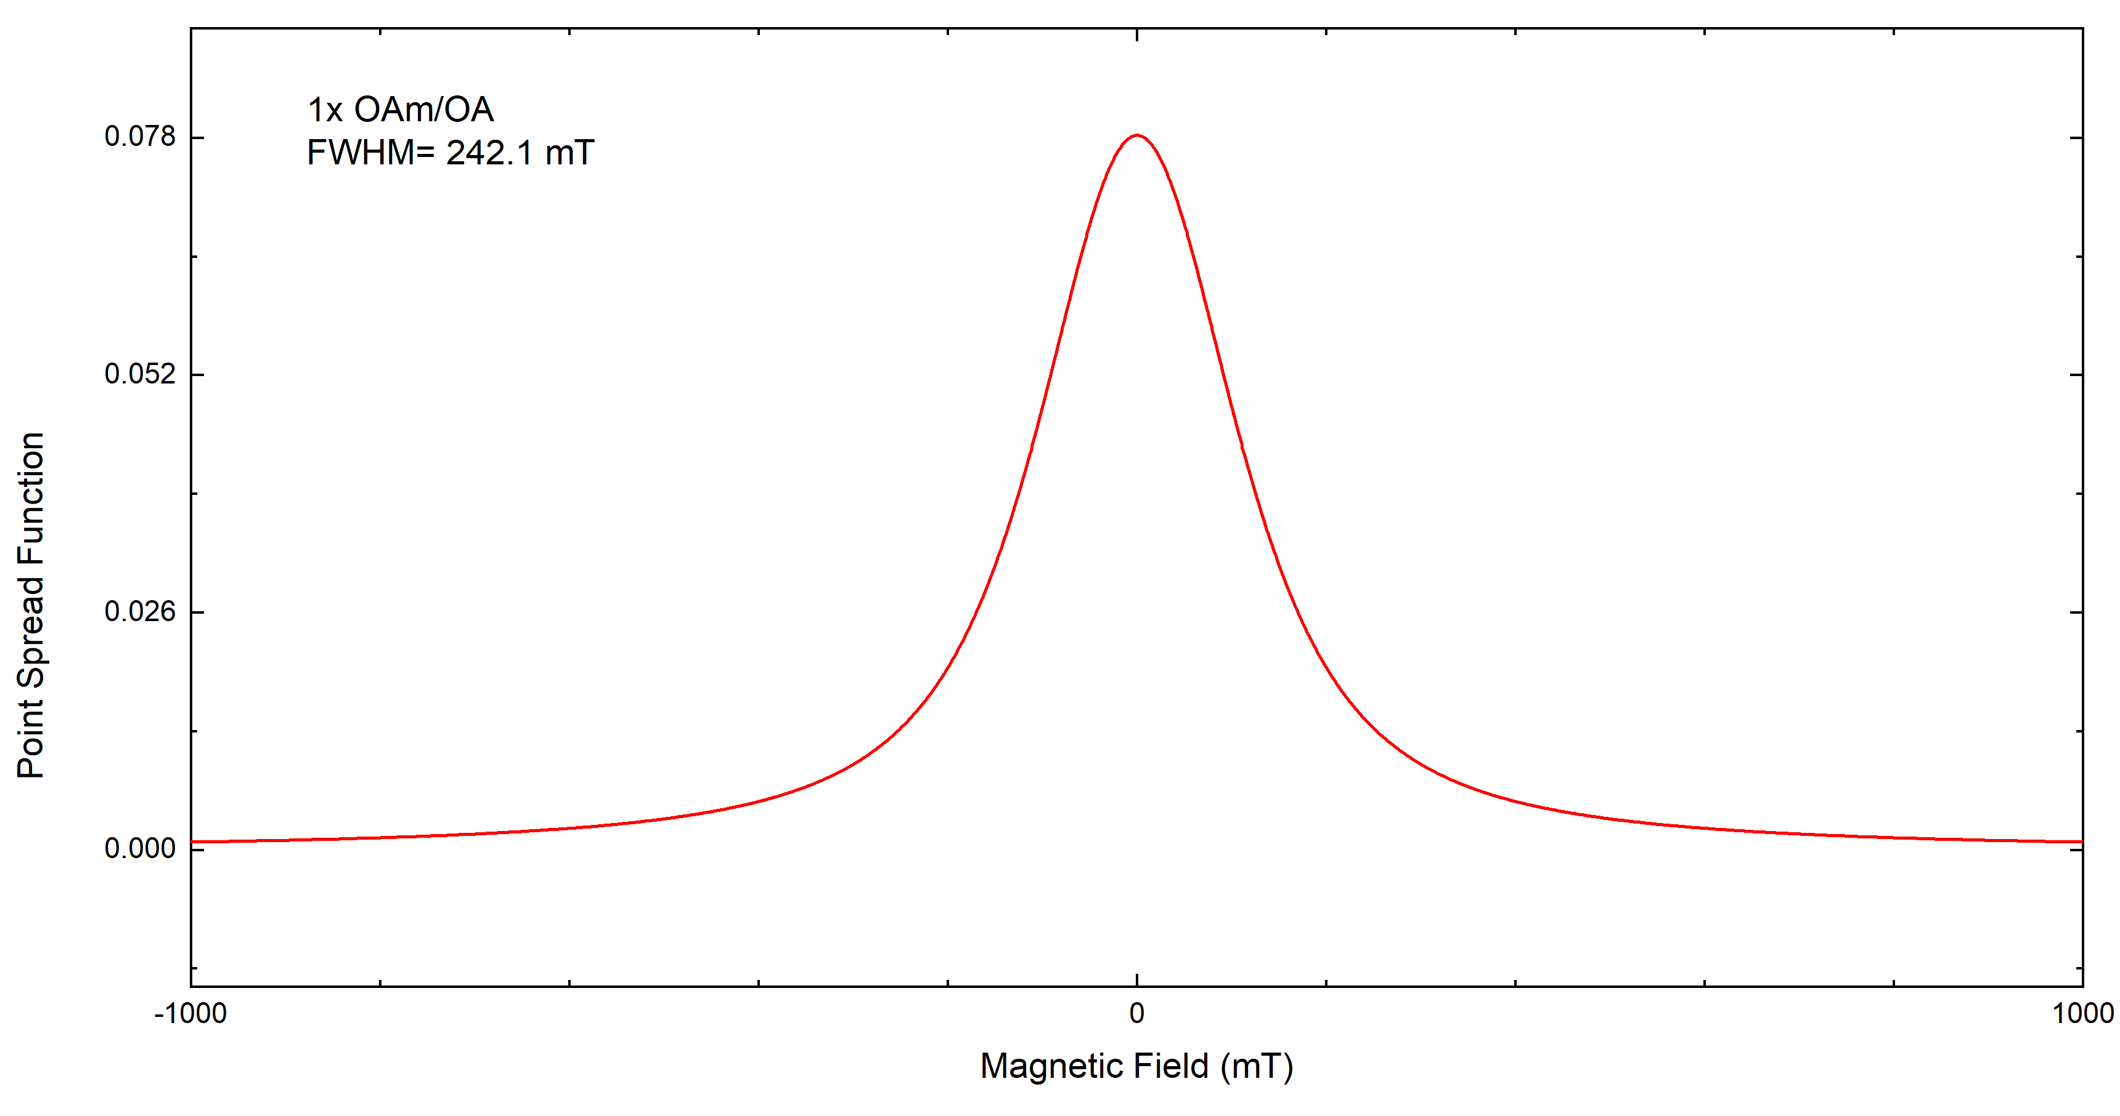
Figure 25: Point spread function of 1x OAm/OA surfactant ratio sample fitted with Lorentzian function to obtain FWHM of 242.1 mT.

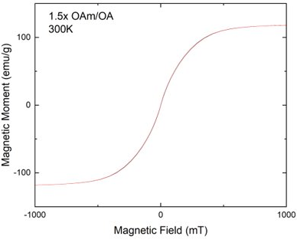
Figure 26: M-H Curve of 1.5x OAm/OA surfactant ratio sample at 300K.

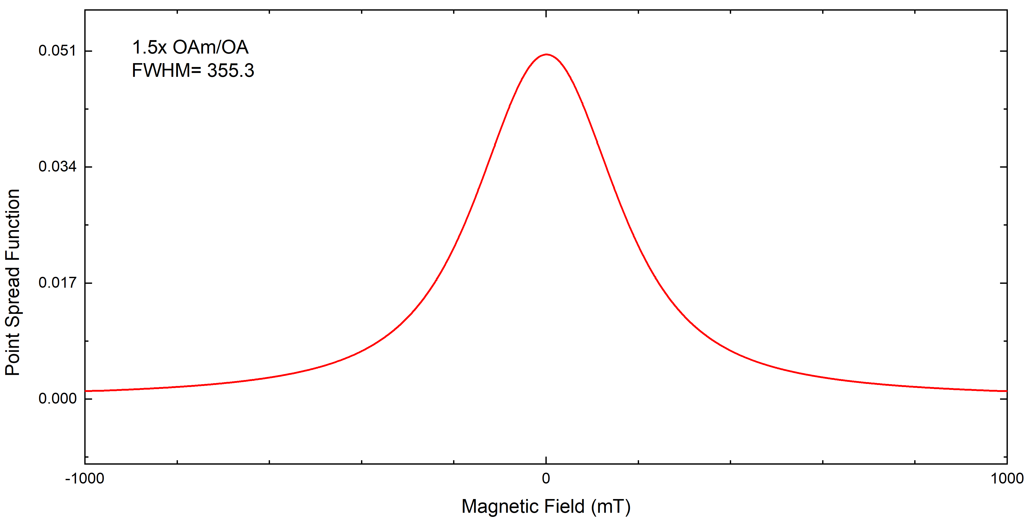
Figure 27: Point spread function of 1.5x OAm/OA surfactant ratio sample fitted with Lorentzian function to obtain FWHM of 355.3 mT.

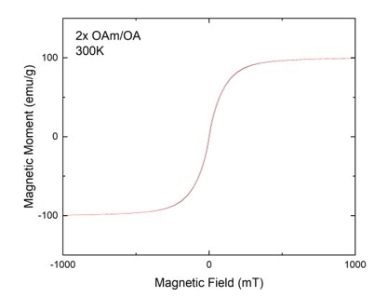
Figure 28: M-H Curve of 2x OAm/OA surfactant ratio sample at 300K.

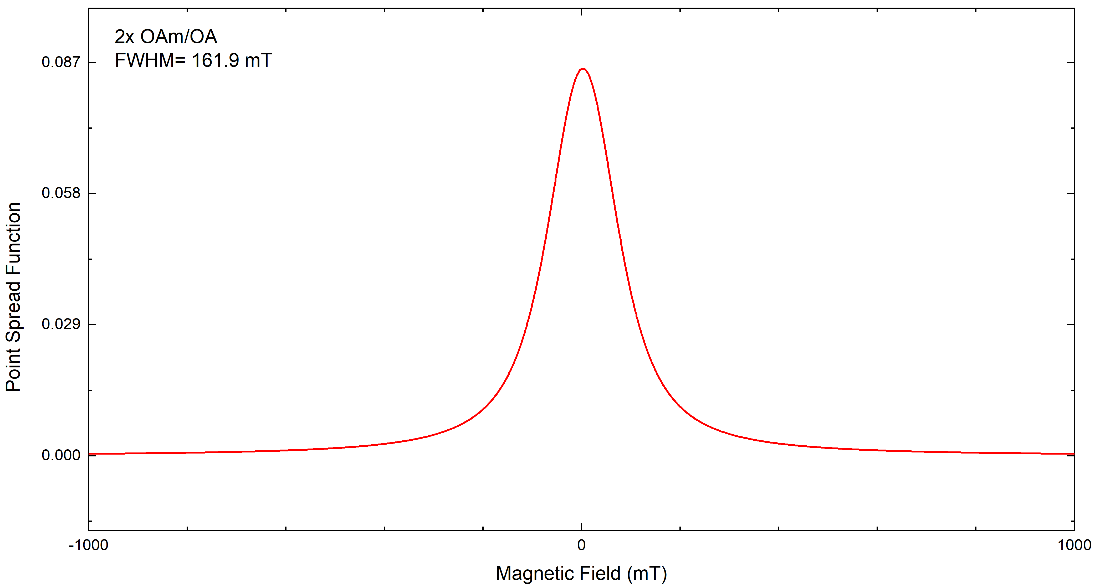
Figure 29: Point spread function of 2x OAm/OA surfactant ratio sample fitted with Lorentzian function to obtain FWHM of 161.9 mT.

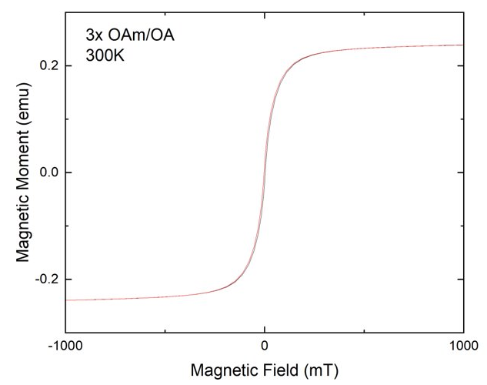
Figure 30: M-H Curve of 3x OAm/OA surfactant ratio sample at 300K.

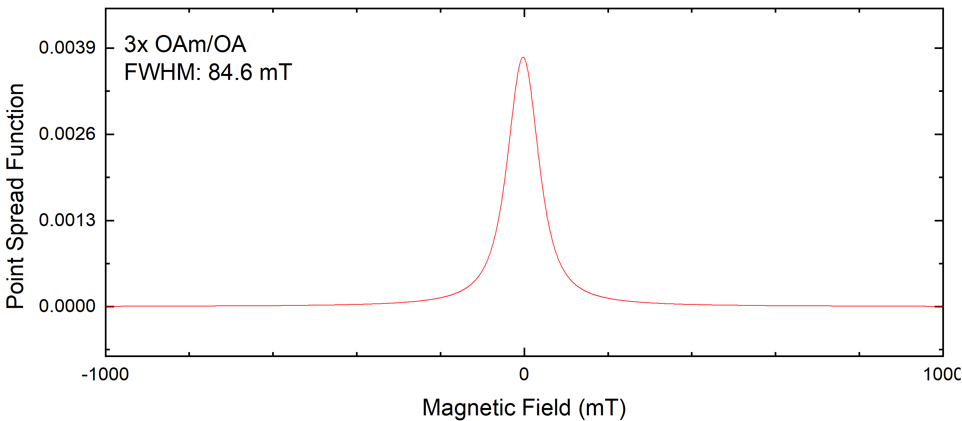
Figure 31: Point spread function of 3x OAm/OA surfactant ratio sample fitted with Lorentzian function to obtain FWHM of 84.6 mT.

respectively. From the M-H curves, all samples displayed superparamagnetic characteristics with little to no hysteresis present and possessed high magnetic saturation between 100 - 120 emu/g. The M-H curve was fitted with a Langevin function in OriginLabs and the derivative was taken to obtain the point spread function (PSF). A Lorentzian function was used to fit the PSF curve to determine the full-width-half maximum (FWHM) to find theoretical resolution the particles could achieve when testing in actual MPI machinery. Currently, good tracers have a FWHM resolution between 6-10 mT. However, the best results achieved were around 84.6 mT from the 3x OAm/OA sample. The FWHM of the 1x OAm/OA sample was 242.1 mT, 1.5x OAm/OA sample was 355.3 mT, and 2x OAm/OA was 161.9 mT.

Zeta Potential
Zeta potential measurements were performed using a Particulate Systems NanoPlus Zeta/Nano Particle Analyzer. Analysis was performed using the NanoPlus software program. Coated nanoparticle samples were prepared so that concentrations were 100 μg/ mL in water. Samples 1x, 2x, and 3x OAm/OA were analyzed prior to biocompatibility tests.

Results of Zeta Potential measurements can be seen in Table 7. Zeta potential for samples were between -21 to -25 mV, suggesting good colloidal stability [53] and are typical values for surfaces coated with PEG polymers to provide effective electrostatic stabilization.

Cytotoxicity
ICP-OES was performed at the Civil and Environmental Engineering building at Vanderbilt University prior to biocompatibility tests to determine DPSE-mPEG coated Fe nanoparticle concentrations in order to calculate proper dose concentrations.

Biocompatibility studies were performed at VINSE using 4T1 murine breast cancer cell lines. 4T1 cells were seeded into a 96-well plate with cell media 24 hours prior to FeNP introduction. 3 samples of coated FeNPs were introduced to the cells that included the 1x OAm/OA, 2x OAm/OA and 3x OAm/OA samples at 4 varying doses. Serial dilutions were performed with cell media to create 4 doses that included 100, 50, 25, and 12.5 μg/mL. Cells incubated for 24 hrs after FeNP doses were introduced, and a Celltiter-Glo assay (Promega) was performed to determine cell viability.

Results of the biocompatibility tests are shown in Figure 32. The highest dose of 100 μg/mL yielded around 95% cell viability for the 1x OAm/OA sample, 88%
Table 7: Zeta Potential of samples used for cytotoxicity studies.
Sample | Zeta Potential (mV)
1x OAm/OA | -21.73 ± 2.17
2x OAm/OA | -24.86 ± 2.48
3x OAm/OA | -23.64 ± 2.36

Figure 32: Cell viability results of coated 1x, 2x and 3x OAm/OA samples at 100, 50, 25, and 12.5 μg/mL doses.
from 2x OAm/OA sample, and 93% from the 3x OAm/OA sample. From these results, low cytotoxicity is concluded from these particles. Little variation in cell viability was found among the varying doses, but from the highest dose of 100 μg/mL, the nanoparticles displayed low cytotoxicity, which confirms they have good potential for further in vivo testing.

Discussion
From TEM results, little variation in size and shape occurred when the reaction time varied from 30 min to 90 min. Alterations in the shape of the particles began to occur after 24 hrs and 48 hrs reaction times. After 24 hours, particles began to form irregular shapes and break apart. For both the 24 hrs and 48 hrs reaction time samples, the presence of oxides increased, but increased crystallinity of the particles was observed after XRD was performed.

Increasing the OAm/OA surfactant amounts had little effect in size and shape of the nanoparticles, with the exception of the 4x OAm/OA sample. The 4x OAm/OA sample displayed irregular and varying sized particles that possessed no core shell structure, thus indicated the particles were composed of iron oxide. The main reason the 4x OAm/OA sample formed iron oxides is because the reaction temperature was 260 °C compared to the previous 180 °C [54]. The temperature difference is a confounding variable when comparing the 4x OAm/OA sample with the previous samples in the series. Although no drastic size and structure changes appeared in the TEM images from the varied OAm/OA series, it was found that after synthesis, increasing the amount of surfactant made the particles more difficult to wash. Therefore, longer washing procedures are needed in order to properly wash all solvents and surfactants from the particles before further coating steps can be performed. However, longer washing is not optimal for the particles as the longer they are exposed to ambient conditions, the higher the likelihood that oxidation could occur.

XRD analysis of the varying reaction time and surfactant ratio series agreed with composition of particles from TEM images. From the varying reaction time series, distinct α-Fe peaks at 44.6, 65, and 82 degrees for all samples were obtained. However, small iron oxide peaks were present in the 24 hr sample with α-Fe peaks. Due to the longer reaction time of 24 hours, crystallinity of the iron oxide outer layer may increase compared to the 30-, 60-, 80-, and 90-min samples, as longer reaction times are known to increase the crystalline structure [55]. In addition, the oxide layer could become slightly thicker to where XRD could begin to detect some presence of iron oxide. The 48 hr sample contained no α-Fe peaks, and, instead, displayed strong iron oxide peaks. From the varying OAm/OA surfactant series, all samples except the 4x OAm/OA sample displayed similar XRD spectra, with distinct α-Fe peaks. From the XRD spectrum of the 4x OAm/OA sample, strong peaks indicated iron oxide with no presence of α-Fe.

Mössbauer studies were performed at 293K and 6K on the samples in order to better characterize the iron oxide shell on the surface of the nanoparticles and to determine if superparamagnetic components are present. Mössbauer studies were consistent with TEM and XRD results for the varying reaction time series. For the 30-, 60-, 80-, and 90-min reaction times, the particles consisted of 2 components, an α-Fe and iron oxide component. After further Mössbauer investigation, the iron oxide present was γ-Fe₂O₃. Compared to XRD evaluations, Mössbauer spectroscopy allows for more distinction between magnetite and maghemite [56]. The 48-hr reaction results from TEM, XRD, and Mössbauer spectroscopy were in agreement, showing the particles were fully oxidized. From XRD studies, peaks characteristic of Fe₃O₄ were present, but further Mössbauer studies showed that γ-Fe₂O₃ was also present within the sample.

From the varied OAm/OA surfactant series, Mössbauer spectroscopy results aligned with XRD and TEM data. Increasing the initial OAm/OA surfactant amounts caused an increase in overall iron oxide percentage and less α-Fe content. Although no apparent XRD peaks for iron oxide are present for samples 1x, 1.5x, 2x, and 3x OAm/OA, obvious increases in γ-Fe₂O₃ content are apparent in the Mössbauer spectra. Oxide peaks may not have appeared in XRD spectra since the crystalline size was too small for XRD to detect [57]. In addition, the 4x OAm/OA sample results from Mössbauer studies were congruent with XRD and TEM data. No obvious α-Fe peaks were present in XRD analysis and lack of core-shell structure was observed in TEM images for the 4x OAm/OA sample. As previously mentioned, the reaction temperature of the sample was 260 ºC compared to 180 ºC, which increases the likelihood of producing iron oxide nanoparticles. Mössbauer measurements assisted in determining the composition of the sample as being a mixture of Fe₃O₄ and γ-Fe₂O_{3.}

From low temperature Mössbauer studies, the γ-Fe₂O₃ oxide shell component displayed superparamagnetic characteristics for all samples in the time series and varying OAm/OA surfactant series, with the exception of the 24-hr, 48-hr, and 4x OAm/OA samples. The doublet component associated with γ-Fe₂O₃ in the 293K spectrum relaxed into a sextet pattern at 6K, which is characteristic of superparamagnetic behavior [58].

From magnetization measurements, all tested samples displayed superparamagnetic behavior due to the lack of magnetic hysteresis from the M-H curves [59]. High magnetic saturation values between 100-120 emu/g were also obtained. From the calculated FWHM of the PSF derived from the M-H curves, the 3x OAm/OA sample displayed the best FWHM of 84.6 mT for potential MPI imaging resolution. However, the FWHM value is still larger than current MPI approved tracers that possess FWHM between 6-10 mT [60]. Although the particles fail to meet current MPI standards, due to the superparamagnetic quality and high magnetic saturation the nanoparticles exhibit, uses in magnetic hyperthermia or magnetic resonance imaging is still attractive.

Finally, from cytotoxicity studies from the varying OAm/OA surfactant series, little variation in cell viability was observed among the different dose concentrations. All DPSE-mPEG coated samples tested with 4T1 cell lines displayed low cell toxicity, with the highest cell viability being around 95% at the highest dose of 100 μg/mL. Due to the low cytotoxicity of the particles, further in vitro and in vivo tests would be viable in the future.

Since the image quality of MPI is dependent on the magnetic nanoparticle tracer, the size and composition of the tracer are important factors to consider. Spatial resolution in MPI is closely linked to the M-H magnetization curve produced from magnetic nanoparticles [61]. A steeper M-H curve results in a narrower X-space point spread function, which leads to better resolution. The 3x OAm/OA sample possessed the best FWHM from the PSF at around 84.6 mT, but the FWHM is still far from optimal compared to MPI tracers currently used. Commercial MPI tracers such as Resovist and Vivotrax have a spatial resolution around 10-12 mT [60], but excellent tracers are within a 6-8 mT resolution range [62].

Previous studies have shown that MPI spatial resolution varies with nanoparticle size and have concluded that larger SPIONs have longer magnetic relaxation times [62, 63]. Optimal core size for iron oxide nanoparticles has been reported to be around 25 nm [64, 65]. However, once iron oxide nanoparticles are above 30 nm, spatial resolution begins to decrease due to the delay between the time-domain MPI signal and the applied field, due to the increased magnetic relaxation [62, 63]. This is attributed to the Brownian relaxation blurring effect [22]. The relaxation of SPIONs is influenced by both the Néel time constant (τ_{Ν}) and the Brownian time constant (τ_{B}), which results in the net relaxation (τ) as shown in Equation 1.

$τ^{-1}=τ_{N}^{-1}+τ_{B}^{-1}$ (1)

The Néel relaxation time constant is attributed to the time the internal magnetic moment of the particle aligns with the external magnetic field and is defined in equation 2, where K is the magnetic anisotropy constant, V_{c} is the particle core volume, and τ₀ is the time characteristic of the material [66].

$τ_{N}=τ_{0}exp⁡(\frac{KV_{c}}{k_{B}T})$ (2)

The Brownian time constant (τ_{B}) is defined as the physical rotation of the hydrodynamic volume of a SPION. The Brownian time constant is dependent on the temperature (T) and viscosity (η) of the surrounding fluid, the hydrodynamic particle volume (V_{H}), and the Boltzmann’s constant (k_{B}) as shown in Equation 3 [22, 66, 67].

$τ_{B}=\frac{3ηV_{H}}{k_{B}T}$ (3)

Therefore, once particles become larger than 30 nm, the Brownian relaxation times increase, and cause delays in the magnetic flipping response time in an applied magnetic field. This delay causes lower induced MPI signals and blurring in overall resolution [61].

Although iron nanoparticles contain higher magnetic saturation compared to iron oxides, more work is needed to increase the size of the particles to achieve better spatial resolution for MPI applications. Previous studies investigating iron nanoparticles have found that increasing core size to around 19 nm improved MPI resolution [68]. A larger iron nanoparticle could achieve faster relaxation to produce steeper M-H curves to obtain better spatial resolution. Since the magnetic saturation is larger than iron oxides, consideration into preventing agglomerations will need to be performed. Although the current particles that were produced in this study did not meet appropriate MPI requirements, they do have potential for improved contrast agents for MRI and magnetic hyperthermia. Further MRI relaxometry studies will need to be performed in order to verify potential MRI contrast usages.

Conclusion
Monodispersed FeNP’s were synthesized by a thermal decomposition of Fe(CO)₅. Two series were performed that included variations in the reaction time and starting OAm/OA surfactant amounts. The results show that very little change occurred when reaction time was varied, but reaction times over 24 hours produced irregularly shaped particles and produced higher iron oxide content. Increasing the OAm/OA surfactant ratio produced an increase in iron oxide content of particles as well. Therefore, from these studies, optimal FeNPs parameters were determined to be equal OAm/OA surfactant amounts with a 90 minute reaction time after injection of Fe(CO)₅. Particle size averaged around 14 nm that consisted of distinct core-shell structures. Samples displayed good magnetic saturation up to 120 emu/g, and possessed superparamagnetic characteristics. From cytotoxicity studies, DPSE-mPEG coated FeNPs displayed good cell viability. Further work is needed to produce larger particles in order to obtain steeper M-H curves and smaller FWHM of the PSF to be optimal tracers in MPI applications. However, other magnetic imaging modalities, such as MRI contrast agent usage could be viable as well as potential in magnetic hyperthermia treatment for cancer.

CHAPTER II
Co-precipitation and Solid-Gas Reduction synthesis

A version of this chapter will be published by A. G. Williams. A. G. Williams was responsible for researching and writing in this article excerpt as noted: L. Liu assisted in synthesis and characterization, C. E. Johnson assisted in the analysis of Mössbauer spectroscopy, J. A. Johnson provided critical feedback and overall guidance.

Abstract
Co-precipitation of iron salts and further solid-gas reduction methods were employed to produce pure iron nanoparticles. Initial co-precipitation with a mixture of FeCl₃ and FeCl₂ salts was used to produced Fe₃O₄ nanoparticles. The Fe₃O₄ nanoparticles were then oxidized in a tube furnace at 500ºC to produce γ-Fe₂O₃ nanoparticles. γ-Fe₂O₃ nanoparticles were subsequently reduced under H₂ gas at 500 °C to obtain pure α-Fe nanoparticles. α-Fe nanoparticles displayed high magnetic saturation around 221 emu/g. Although pure iron was obtained, sintering occurred between the nanoparticles during the reduction and oxidation process. Therefore, silica was added as a coating to prevent large agglomerations during the oxidation and reduction process. Further studies are needed to obtain smaller, less sintered particles for potential magnetic imaging applications.

Introduction
Magnetic nanoparticles have been extensively studied for biomedical applications including theranostics, drug delivery, biomaterial coatings, and tissue engineering. Among magnetic based biomedical applications, magnetic resonance imaging (MRI), magnetic particle imaging (MPI), and magnetic hyperthermia therapy are of particular interest. MRI has become a powerful diagnostic tool and is a standard technique used for differentiating normal and abnormal tissues in the body. MRI is a non-invasive diagnostic technique with high spatial resolution that uses non-ionizing radiation to produce 3D tomographic images [69, 70]. However, it lacks sensitivity to molecular signals [69, 71]. Therefore, magnetic nanoparticles are of interest since they create stronger signals to increase MRI sensitivity during imaging [72]. Superparamagnetic iron oxide nanoparticles (SPIONs) are commonly used as negative MRI contrast agents, since they possess stronger magnetic susceptibility than gadolinium-based contrast agents [73]. SPIONs efficiently shorten T2 relaxation of water protons by inducing strong magnetic susceptibility effects on the water protons around the particles [74].

In contrast to MRI, magnetic particle imaging (MPI) is a magnetic imaging technique proposed in the early 2000s that has the potential to become a leading diagnostic instrument for biomedical imaging [48]. Compared to MRI, MPI is dependent on magnetic nanoparticle tracers to accurately image real-time areas of the body for cell tracking, perfusion imaging, and hyperthermia treatment. MPI tracers produce a positive contrast in images similar to PET or SPECT imaging modalities. Linear quantification and localization of magnetic nanoparticles can be achieved with MPI due to its low signal to noise ratio and lack of tissue depth attenuation [75]. MPI directly detects the location of magnetic nanoparticle tracers by receiving signals generated by the switching of magnetic spins in a field free region created by 2 permanent magnets [16, 76]. Similar to MRI, iron oxide nanoparticles are among the most commonly used tracers that can achieve a 600 μm spatial resolution [47]. However, continuation of research is being performed to further improve MPI tracers to obtain resolutions below 100 μm [68, 76].

To achieve high spatial resolution and signal intensity, MPI tracers must be superparamagnetic and possess high magnetic saturation [48]. Currently, superparamagnetic iron oxide nanoparticles around 25 nm in size have been fabricated and shown to display the best performance [14, 46]. However, potentially smaller magnetic nanoparticles around 20 nm in size could achieve similar, if not better, MPI results. In order to achieve slightly smaller tracers that produce good MPI signal, nanoparticles with metallic iron cores are needed. Therefore, the creation of metallic iron nanoparticles has been proposed, since pure iron possesses higher magnetic saturation values than iron oxide nanoparticles.

Co-precipitation of Fe³⁺ and Fe²⁺ salts is a facile method to produce iron oxide nanoparticles [77]. The shape, size, and composition of nanoparticles produced from this method is dependent on the reaction temperature, pH, and Fe²⁺/Fe³⁺ ratios [6]. This chapter will discuss a co-precipitation reaction of iron salts to produce initial iron oxide particles that are further reduced using solid-gas reactions to obtain iron nanoparticles for uses in magnetic imaging applications. Pure iron nanoparticles are expected to be produced that yield high magnetic saturation values that could have potential for magnetic imaging applications.

Methods and Materials

Chemicals
Ferric chloride (FeCl₃, 99%), Ferrous chloride tetra hydrate (FeCl_{2:} 4H₂O, 98%), hydrochloric acid (HCl, 37%), ammonium hydroxide (NH₄OH, 28-30% of ammonia), tetraethyl orthosilicate (TEOS), ethyl acetate (anhydrous, 99.8%), 2- propanol (reagent grade, ≥99.5%), hexadecyltrimethylammonium bromide (CTAB ≥98%), and de-ionized water were purchased from Sigma Aldrich. Anhydrous ethanol 200 proof was purchased from Decon Labs.

Synthesis and Setup
1M (0.5839 g) FeCl₃: 2M (0.9126 g) FeCl₂: 2M (0.6 mL) HCl ratio was mixed with 22.4 mL of DI H₂O in a 100 mL beaker with a magnetic stir bar. Initial measured pH was around 1-2. Around 2 mL of 28-30% NH₄OH was added dropwise to the solution to raise the pH to 9. Precipitate began forming as the pH increased. Once a pH of 9 was reached, the entire mixture stirred for 40 min at room temperature. After reacting, the mixture was placed on a magnet and the liquid was decanted leaving the magnetic nanoparticles in the beaker. The particles were washed 3-5 times with DI water and 3 times with absolute EtOH. Particles dried in a box furnace at 80 °C overnight to obtain a brown Fe₃O₄ powder.

Around 1 g of Fe₃O₄ nanoparticles was added into ceramic boats and placed into a Mellen tube furnace (Figure 33). The powder was oxidized at 500 °C for 2 hours under ambient conditions. After the furnace was cooled to room temperature, the brown powder had turned red, indicating full oxidation had occurred. XRD analysis further confirmed the red powder to be γ-Fe₂O₃. The red γ-Fe₂O₃ powder was further reduced under H₂ gas at 500 °C for 2 hours to obtain black α-Fe nanoparticles. Images of the original Fe₃O₄ powder, oxidized γ-Fe₂O₃ powder, and α-Fe powder are shown in Figure 34.

Direct reduction of the initial Fe₃O₄ nanoparticles was also performed without prior oxidation to test if the oxidation step was necessary in order to obtain pure iron. 1 g of Fe₃O₄ nanopowder was added into a ceramic boat and reduced under H₂ gas at 500 °C for 2 hrs. After reduction, the powder had turned black.

Porous silica coatings were added to the original Fe₃O₄ nanoparticles produced from co-precipitation to investigate if it could prevent agglomeration of particles during the oxidation and reduction process. 0.025 g of Fe₃O₄ nanoparticles, 40 mL of 2-propoanol, 1.1 g of NH₄OH, 1.42 g of H₂O, and 0.1g of CTAB were added to a Bruker flask and sonicated for 1 hr. The solution was mechanically stirred while a silica solution of 0.5 g TEOS, 0.75 mL 2-propanol, and 0.25 mL EtOAc was injected at 0.4 mL/min with a syringe pump, and was stirred overnight (Figure 35). The next morning, silica coated particles were washed 3 times with absolute EtOH and dried in a crucible at 70 ºC in a box furnace overnight.

Results

Transmission Electron Microscopy (TEM) and Scanning Electron Microscopy (SEM)
Transmission electron microscopy (TEM) and Scanning electron microscopy (SEM) were performed at the Vanderbilt Institute of Nanoscience and Engineering (VINSE) at Vanderbilt University. An FEI Tecnai Osiris TEM system operating between 80 kV – 200 kV was used for TEM imaging. A Zeiss Merlin

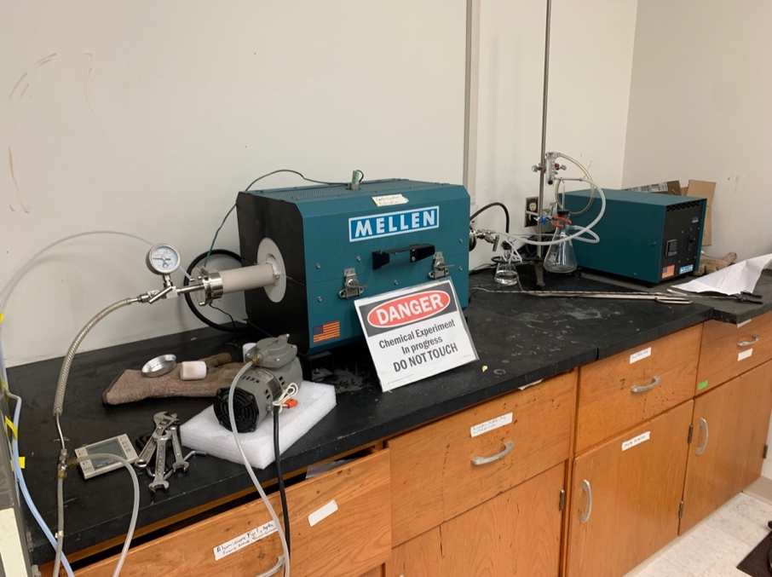
Figure 33: Tube Furnace setup

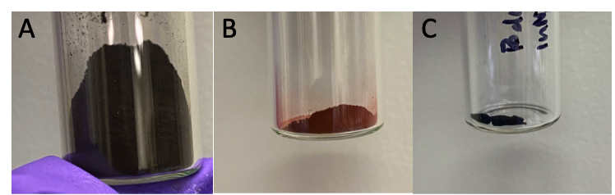
Figure 34: A. Fe₃O₄ nanoparticles from co-precipitation, B. Fe₃O₄ oxidized to γ-Fe₂O₃ C. γ-Fe₂O₃ reduced to pure Fe.

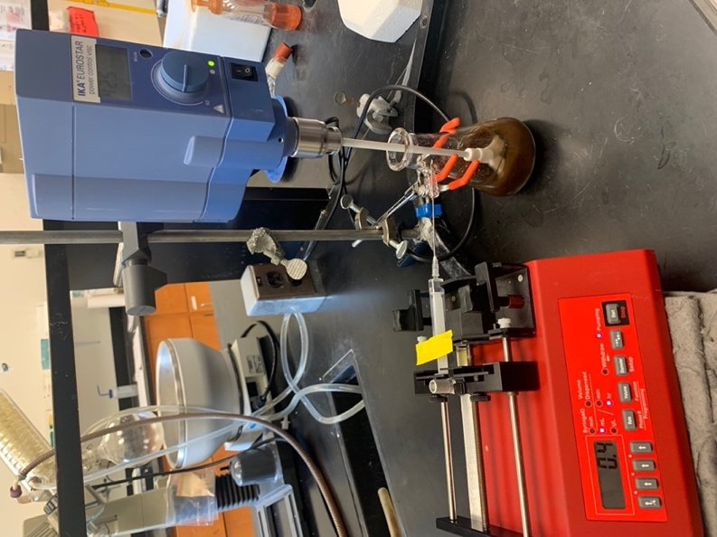
Figure 35: Silica coating setup.

SEM was used at 5 kV for larger powdered samples that appeared to have sintered together. Diameters for TEM images were determined using ImageJ processing software.

From TEM images, initial Fe₃O₄ product diameters ranged between 8-10 nm. Particles were polydisperse with small areas of agglomerations (Figure 36). From SEM images, both the γ-Fe₂O₃ particles (Figure 37) and α-Fe nanoparticles (Figure 38) were similar in shape and size. Small agglomerations are present, most likely from the high temperature required when oxidizing and reducing.

TEM images of the Fe₃O₄ particles directly reduced under H₂ at 500 °C without prior oxidation are shown in Figure 39. Sintering of particles is apparent in the images and particles were irregularly shaped.

Due to the particles sintering together after oxidation and reduction at a high temperature, porous silica coating was added to the initial Fe₃O₄ nanoparticles before oxidation and reduction to prevent agglomeration formation. TEM images of initial Fe₃O₄ silica coated particles are shown in Figure 40. Clear silica coatings around particles are shown as a white outer layer around the particles. Polydisperse particles are present and slightly less agglomerations were formed. Direct reduction of the silica coated Fe₃O₄ nanoparticles was performed without prior oxidation under H₂ gas at 500 °C and TEM images are shown in Figure 41. The particles appeared to be less agglomerated after reduction compared to uncoated Fe₃O₄ nanoparticles. However, slight sintering was still present and irregular shapes of nanoparticles persisted.

X-ray Diffraction (XRD)
Powder XRD measurements were performed using a Rigaku SmartLab3kW X-ray Diffractometer with a Cu Kα X-ray Source in a 2θ range of 20° to 80°.

Stacked XRD spectra of the initial Fe₃O₄ nanoparticles from co-precipitation of iron salts, γ-Fe₂O₃ nanoparticles, and α-Fe nanoparticles are shown in Figure 42. From the results, characteristic peaks with 2θ values of the initial Fe₃O₄ nanoparticles are apparent at 30.3°, 32.6°, 35.5°, 43.2°, 53.6°, 57.2°, 62.8°, and 74.4° (DB # 7228110). The XRD results for the oxidized Fe₃O₄ sample displayed characteristic γ-Fe₂O₃ peaks and suggested good crystalline structure based on the 2θ values at 22.8°, 24.1°, 33.1°, 35.5°, 40.8°, 49.4°, 54°, 57.5°, 62.3°, 64°, 71.9°, 75.4°, 84.9°, and 88.5° (DB # 2108027). The final reduced γ-Fe₂O₃ sample displayed characteristic α-Fe XRD peaks with 2θ values at 44.6°, 65°, and 82.3° (DB # 1100108), and the sample displayed good crystallinity as well.

XRD of the directly reduced Fe₃O₄ sample without prior oxidation is shown in Figure 43. A mixture of α-Fe and iron oxide was present from the spectrum. Distinct α-Fe peaks are present based on 2θ values at 44.6°, 65°, and 82.3°

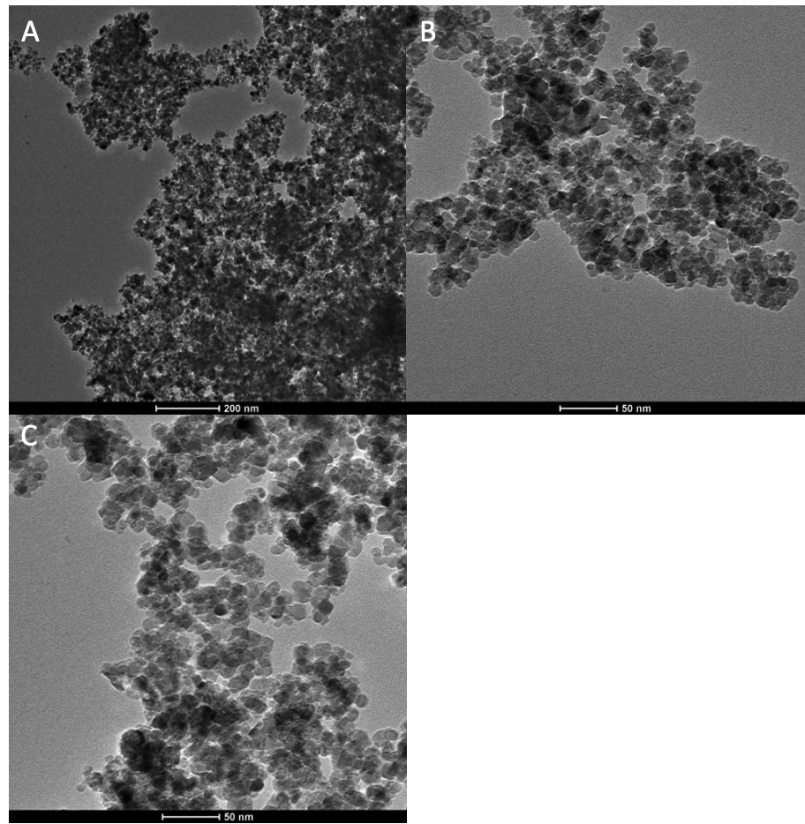
Figure 36: TEM images of initial Fe₃O₄ nanoparticles from a co-precipitation of iron salts. Scale bar for A is 200 nm, and 50 nm for B and C.

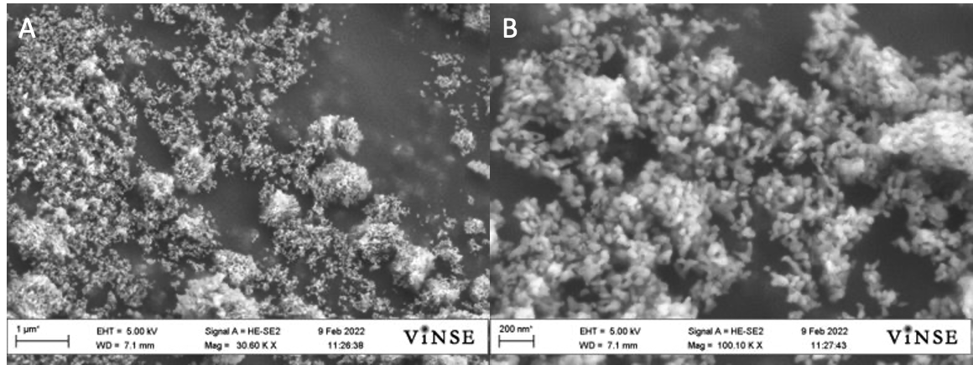
Figure 37: SEM images οf γ-Fe₂O₃ nanoparticles after oxidizing Fe₃O₄. Scale bars for A and B are 1 μm and 200 nm respectively.

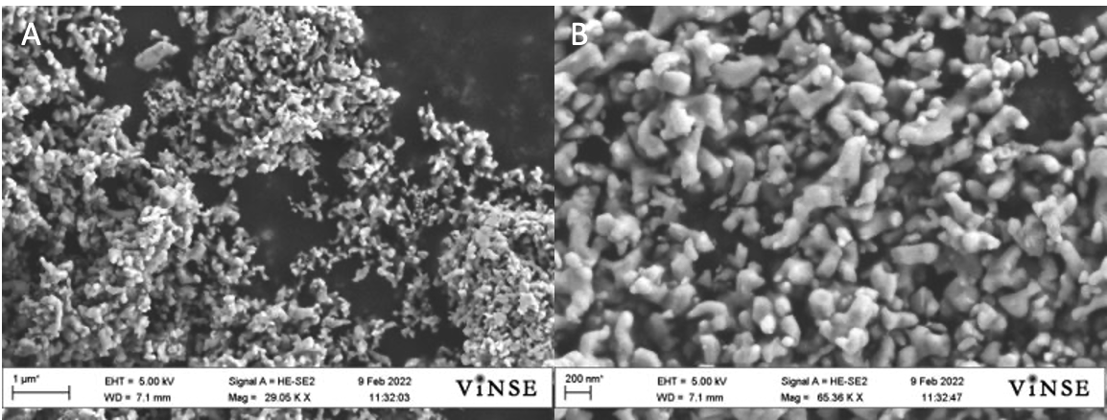
Figure 38: SEM images of α-Fe nanoparticles from H₂ reduction of γ-Fe₂O₃. Scale bars for A and B are 1 μm and 200 nm respectively.
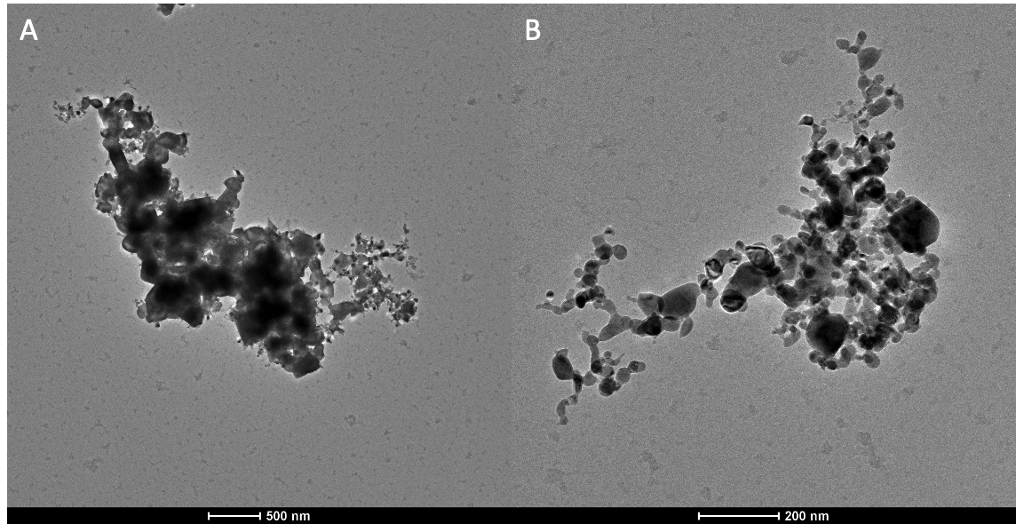
Figure 39: TEM images of uncoated Fe₃O₄ nanoparticles directly reduced without prior oxidation. Scale bars for A and B are 500 nm and 200 nm respectively.

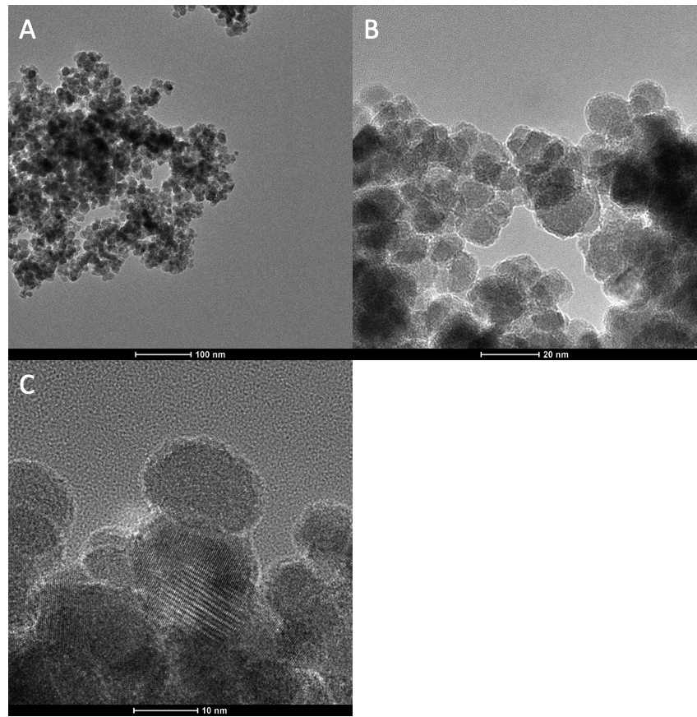
Figure 40: TEM images of Fe₃O₄ nanoparticles coated with silica. Scale bars for A, B, and C are 100, 200 and 10 nm respectively.

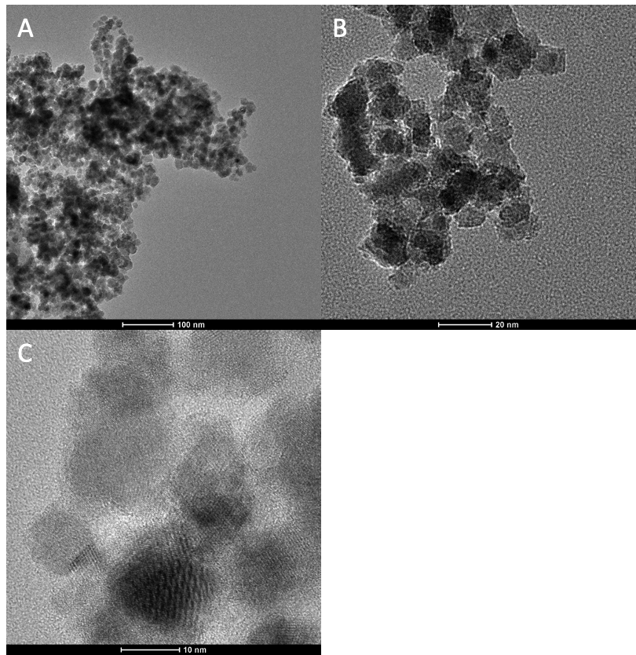
Figure 41: TEM images of Fe₃O₄ nanoparticles coated with silica and reduced under H₂ without prior oxidation. Scale bars for A, B, and C are 100, 20, and 10 nm respectively.
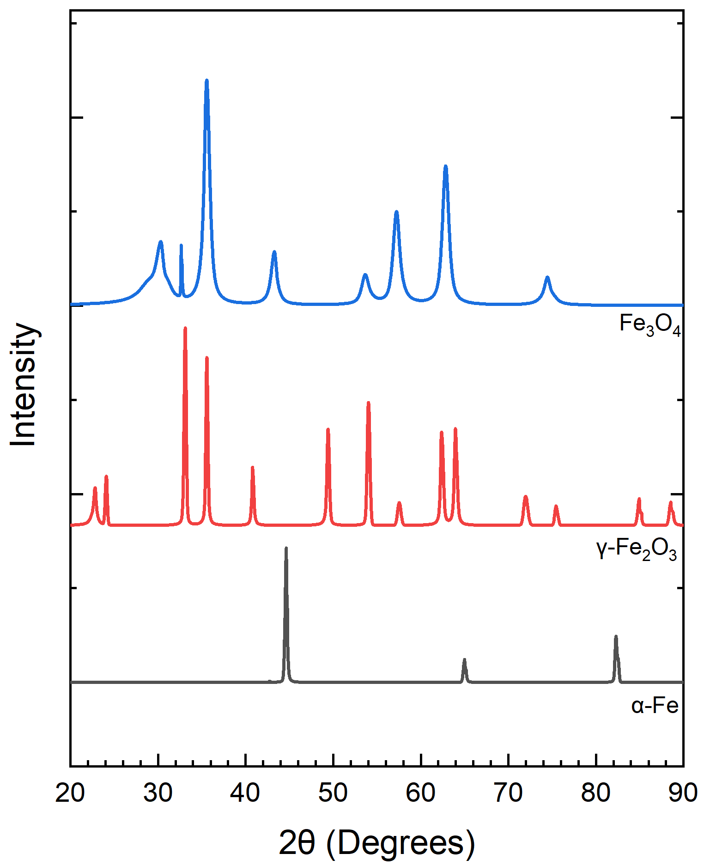
Figure 42: Stacked XRD spectra of initial Fe₃O₄ nanoparticles, oxidation to form γ-Fe₂O₃, and further reduction to form α-Fe.

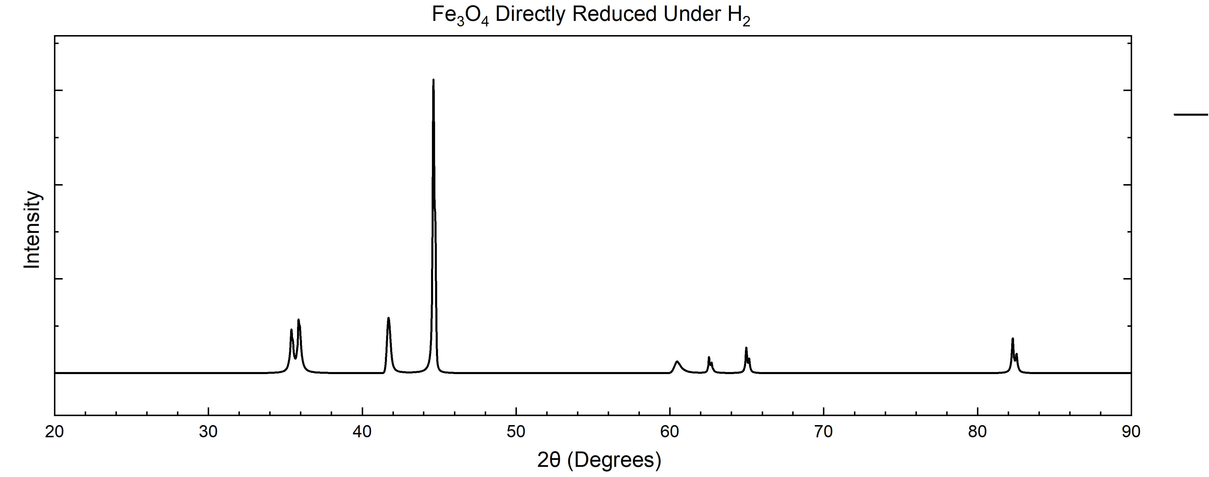
Figure 43: XRD spectrum of Fe₃O₄ nanoparticles directly reduced under H₂ without prior oxidation
(DB# 1100108), and iron oxide peaks were present at 35.3°, 35.8°, 42°, 60.4°, and 62.5° (DB # 2108027).

Stacked XRD spectra of the silica coated Fe₃O₄ sample and directly reduced silica coated Fe₃O₄ sample are shown in Figure 44. XRD analysis confirmed no chemical changes of the Fe₃O₄ nanoparticles occurred after the addition of silica coatings. From the spectrum, silica coating of the original product produced from co-precipitation continued to possess distinct peaks of Fe₃O₄ based on 2θ values at 35.4°, 35.6°, 43.4°, 77°, 60°, 63°, 59°, and 74.3° (DB # 1011032). XRD spectrum of the silica coated sample that was directly reduced under H₂ showed little change in the XRD spectrum, as it still indicated Fe₃O₄ was present.

Mössbauer Spectroscopy
Mössbauer Spectroscopy experiments were performed with a ⁵⁷Co source, a Janis SHI-850-5 cryogen-free cryostat, Lakeshore 325 Temperature Controller. Hyperfine interaction parameters were analyzed using a least-squared fitting model with Mössbauer GenFit Software (R. S. Preston and D. E. Brown). After synthesis, samples were dried into powders and stored in an Ar atmosphere glovebox. The powders were loaded and sealed into Mössbauer sample cups for characterization.

The Mössbauer spectra at 293K of the initial co-precipitated Fe₃O₄ product, oxidized Fe₃O₄ to γ-Fe₂O₃, and reduced γ-Fe₂O₃ to α-Fe sample series is shown in a stacked plot in Figure 45. Values from hyperfine fitting parameters are displayed in Table 8. From Mössbauer spectroscopy, the initial Fe₃O₄ sample consisted of 3 broad sextet patterns. The first component consisted of a
hyperfine field of 41.7 T, isomer shift of 0.45 mm/s, and quadrupole splitting of 0.00 mm/s. The second component consisted of a broad sextet with a hyperfine field of 51.4 T, isomer shift of 0.36 mm/s, and quadrupole splitting of 0.00 mm/s. The third component consisted of a broad sextet with a hyperfine field of 47.6 T, isomer shift of 0.36 mm/s, and quadrupole splitting of 0.00 mm/s. From the spectrum, there appears to be a slight mixture of Fe₃O₄ and γ-Fe₂O₃.

The γ-Fe₂O₃ sample produced from oxidizing Fe₃O₄ nanoparticles consisted of 1 sextet component with a hyperfine field of 50.7 T, isomer shift of 0.37 mm/s, and quadrupole splitting of 0.21 mm/s, which is indicative of γ-Fe₂O₃ [78]. From the Mössbauer spectrum, full oxidation to γ-Fe₂O₃ could be determined.

Finally, the α-Fe sample produced from reducing γ-Fe₂O₃ particles under H₂ gas at 500 °C was measured with Mössbauer spectroscopy at 293K. From the results, pure α-Fe was obtained with the spectrum consisting of 1 sextet component with a hyperfine field of 32.4 T, isomer shift of 0.00 mm/s, and quadrupole splitting of 0.00 mm/s.

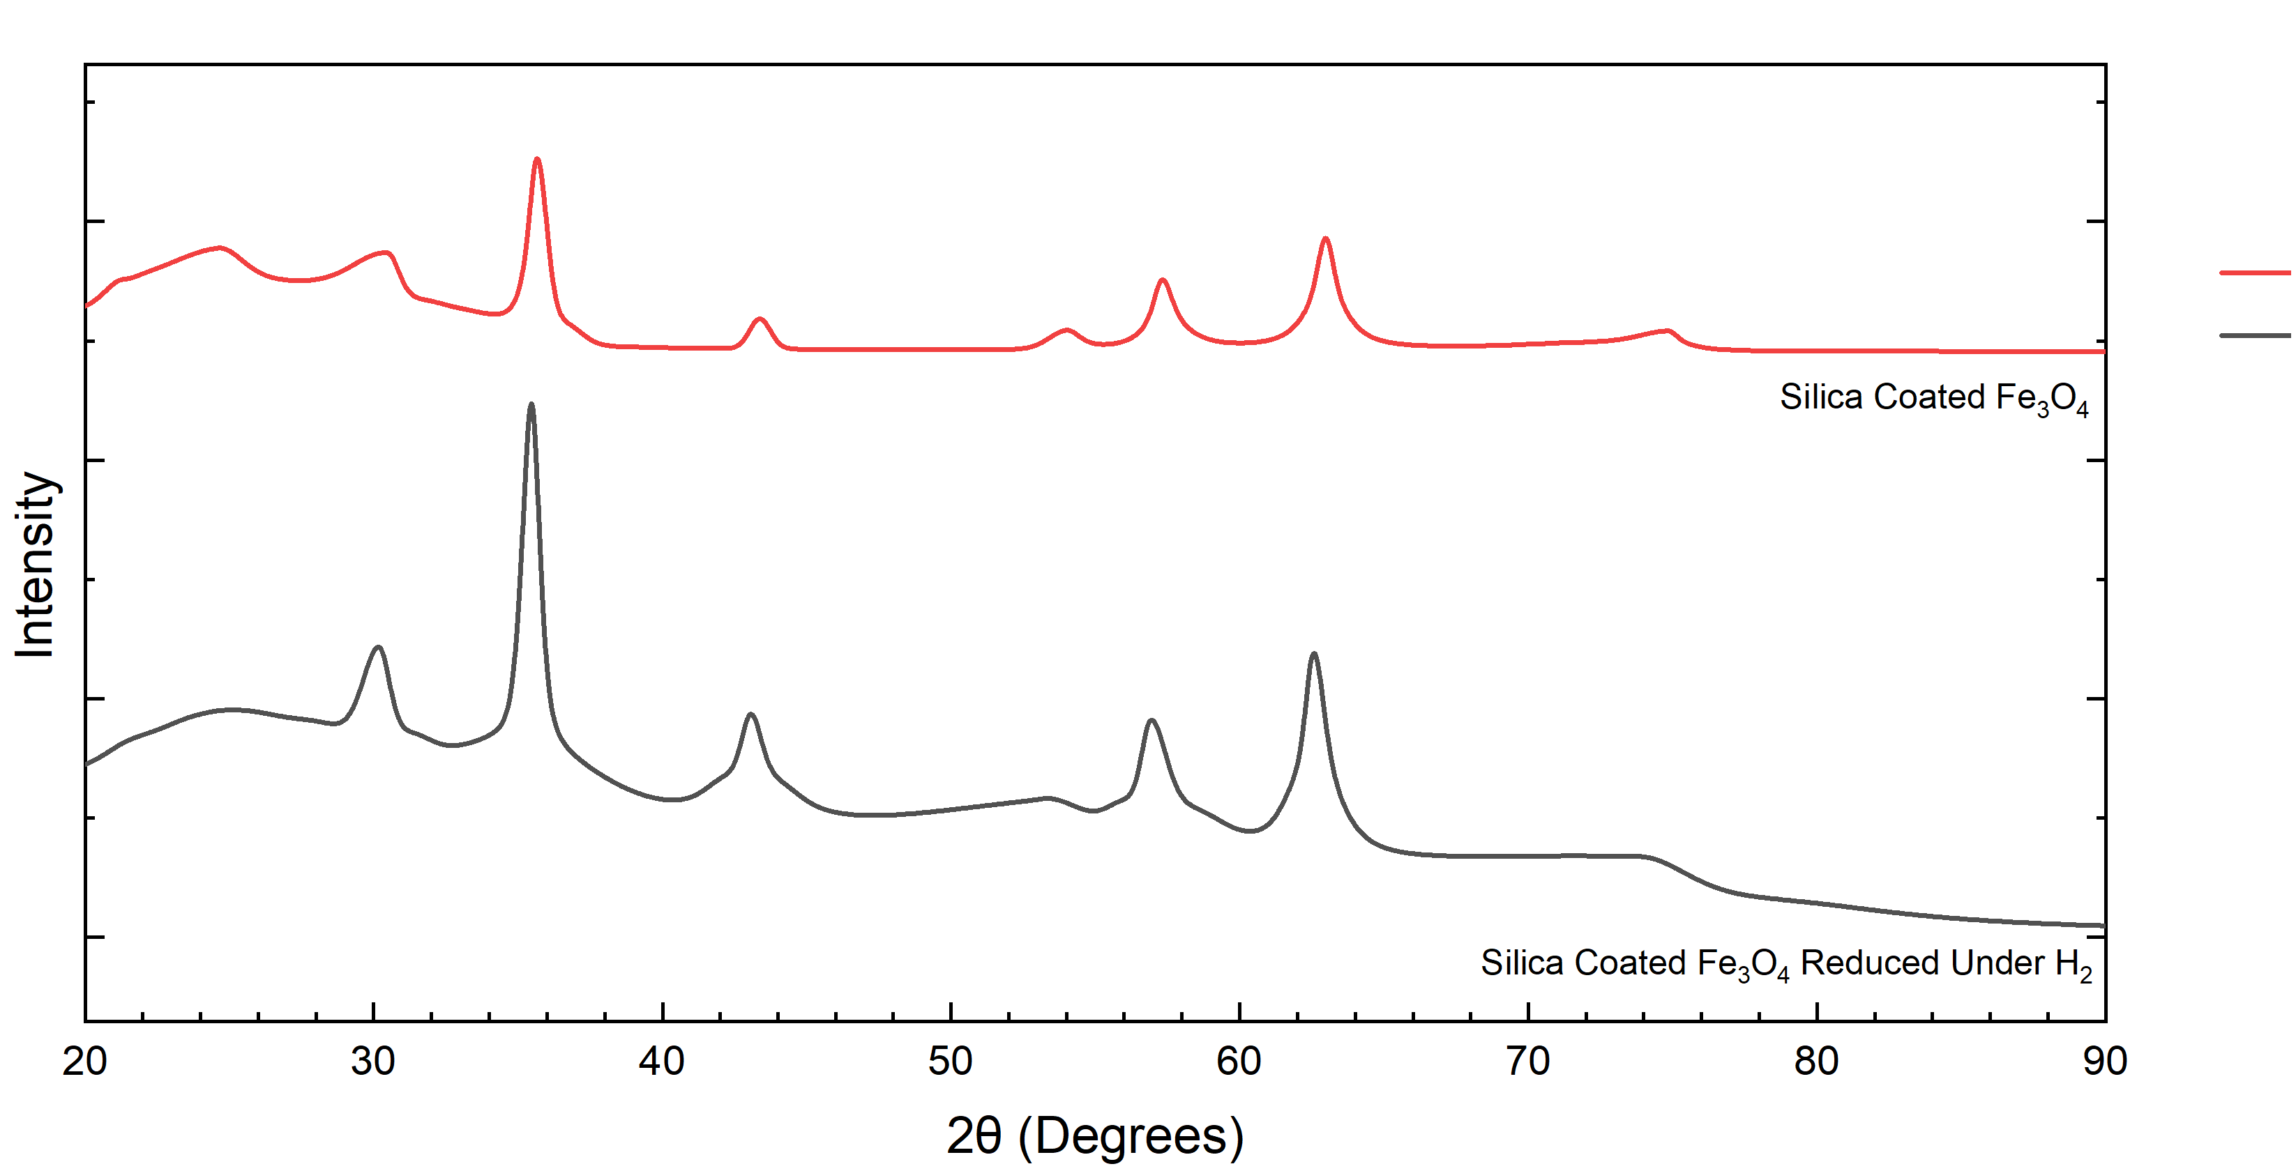
Figure 44: XRD spectra of silica coated Fe₃O₄ and silica coated Fe₃O₄ reduced.

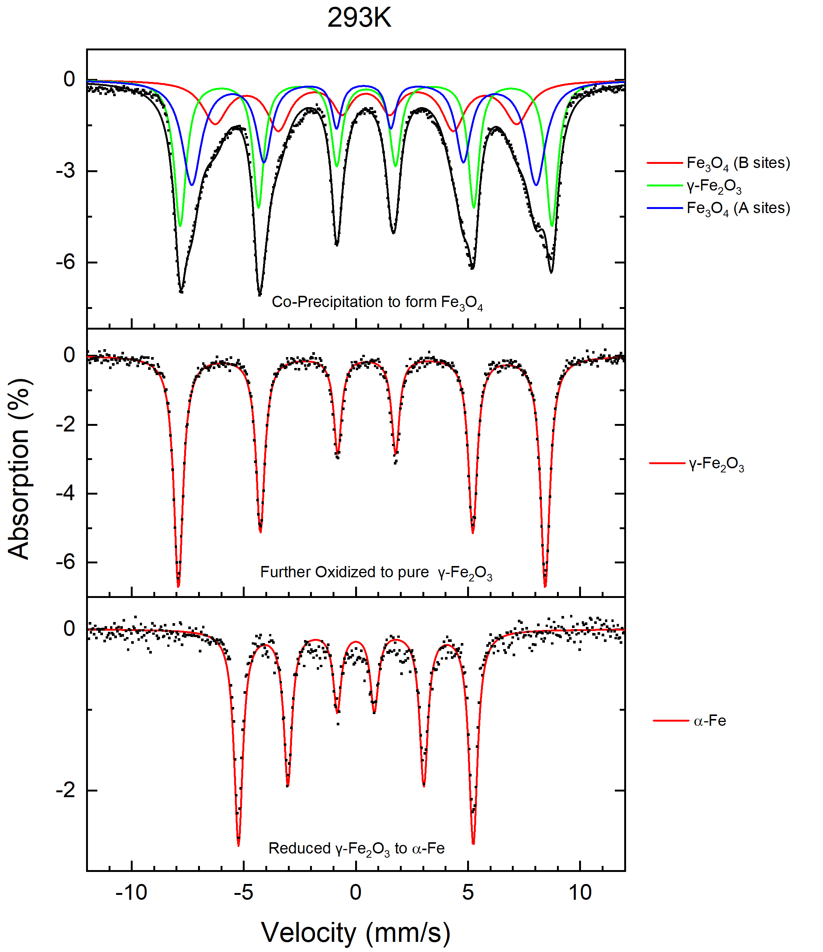
Figure 45: Stacked Mössbauer spectra at 293K for the initial Fe₃O₄ nanoparticles formed from co-precipitation, oxidation to form γ-Fe₂O₃, and further reduction to form α-Fe.
Table 8: Values of hyperfine parameters for Fe₃O₄, γ-Fe₂O₃, and α-Fe at 293K. B_{hf} is the hyperfine magnetic field, δ is the isomer shift, ΔE_{Q} is the quadrupole splitting, and Γ is the linewidth (FWHM). Typical errors are ±0.03 mm/s for B_{hf}, ±0.5 mm/s for δ, ΔE_{Q}, and Γ and ±3% for relative area.
Samples at 293K | Component | B_{hf} (T) | δ (mm/s) | ΔE_{Q} (mm/s) | Γ (mm/s) | Relative area (%) | Attribution
 | 1 | 41.7 | 0.45 | 0.00 | 1.34 | 25 | Fe₃O₄
Initial Fe₃O₄ | 2 | 51.4 | 0.36 | 0.00 | 0.65 | 40 | γ-Fe₂O₃
 | 3 | 47.6 | 0.36 | 0.00 | 1.04 | 35 | Fe₃O₄
Oxidized | 1 | 50.7 | 0.37 | 0.21 | 0.50 | 100 | γ-Fe₂O₃
Reduced | 1 | 32.4 | 0.00 | 0.00 | 0.46 | 100 | α-Fe

Mössbauer measurements of the directly reduced Fe₃O₄ sample without prior
oxidation at 293K is shown in Figure 46, which consists of 2 sextets and a broad doublet. Values from hyperfine fitting parameters are displayed in Table 9. Component 1 consisted of a hyperfine field of 32.4 T, isomer shift of 0.00 mm/s, and quadrupole splitting of 0.00 mm/s, indicative of α-Fe. Component 2 consisted of a hyperfine field of 0.00 T, isomer shift of 0.51 mm/s, and quadrupole splitting of 0.93 mm/s, characteristic of γ-Fe₂O₃. Component 3 consisted of a broad sextet with a hyperfine field of 45.0 T, isomer shift of 0.41 mm/s, and quadrupole splitting of 0.44 mm/s, indicative of Fe₃O₄

The stacked Mössbauer spectra of reduced silica coated Fe₃O₄ samples are shown in Figure 47 at 293K and 6K. Table 10 displays values from hyperfine fitting parameters. From the results, the 293K spectrum consisted of 3 components, which includes 2 broad sextets and a broad singlet. Component 1 possessed a hyperfine field of 44.0 T, isomer shift of 0.48 mm/s, and quadrupole splitting of 0.50 mm/s, which is characteristic of the A sites of Fe₃O₄. Component 2 consisted of a broad sextet with a hyperfine field of 43.0 T, isomer shift of 0.65 mm/s, and quadrupole splitting of 0.40 mm/s characteristics of the B sties of Fe₃O₄ [79]. Component 3 consisted of a singlet with a hyperfine field of 0.00 T, isomer shift of 0.45 mm/s, and quadrupole splitting of 0.29 mm/s, which represents a superparamagnetic γ-Fe₂O₃ component. From the 6K spectrum, the singlet pattern from the 293K spectrum split into a broad sextet magnetic component, with a hyperfine field of 45.7 T, isomer shift of 0.96 mm/s, and quadrupole splitting of 0.54 mm/s. The previous sextet patterns attributed to the A and B sites of Fe₃O₄ remained in the 6K spectrum. The first sextet possessed a hyperfine field of 50.9 T, isomer shift of 0.46 mm/s, and quadrupole splitting of
0.59 mm/s. The second sextet possessed a hyperfine field of 50.9 T, isomer shift of 0.65 mm/s, and quadrupole splitting of 0.47 mm/s, attributing to Fe₃O₄.

Superconducting Quantum Interference Device- Vibrating Sample Magnetometry (SQUID-VSM)
SQUID-VSM measurements were performed at the Joint Institute for Advanced Materials (JIAM) at the University of Tennessee Knoxville. Measurements were performed at 300K and 3K in a ± 1000 mT field. M-H curves and derived point spread functions were plotted in OriginLabs. M-H curve were fitted with a Langevin function. Point spread functions were derived from M-H curves and fitted with Lorentzian functions to determine full-width-half-maximum (FWHM) values.

Three samples were chosen for SQUID-VSM measurements, which included the pure α-Fe sample, directly reduced Fe₃O₄ sample without prior oxidation, and silica coated Fe₃O₄ sample. From SQUID-VSM measurements, all three samples displayed low coercivity, but only the silica coated Fe₃O₄ sample displayed close

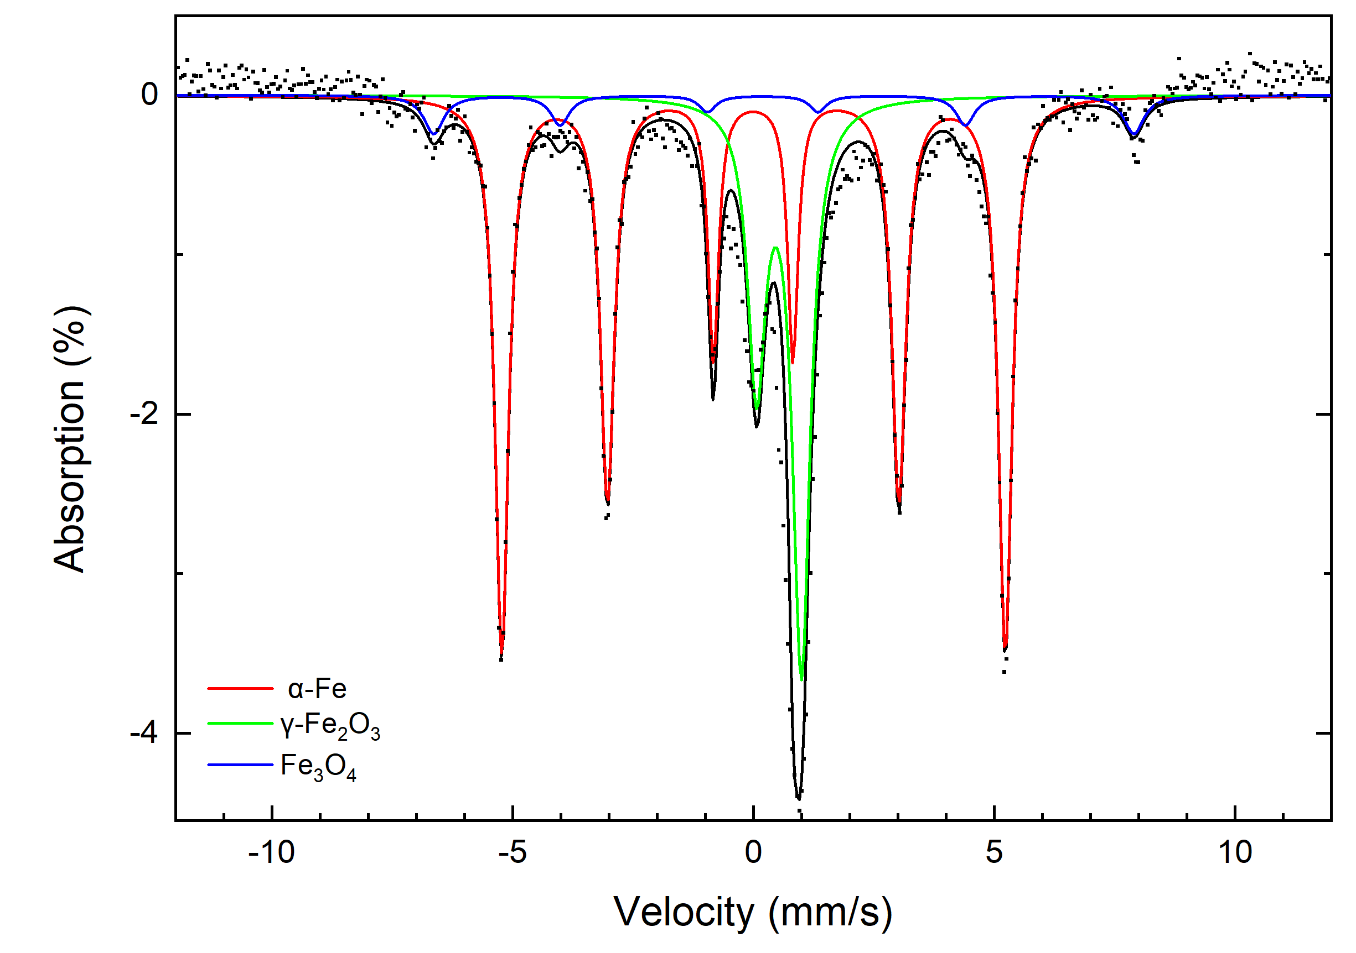
Figure 46: Mössbauer spectrum of reduced Fe₃O₄ nanoparticles without prior oxidation at 293K.

Table 9: Values of hyperfine parameters for reduced Fe₃O₄ nanoparticles without prior oxidation at 293K. B_{hf} is the hyperfine magnetic field, δ is the isomer shift, ΔE_{Q} is the quadrupole splitting, and Γ is the linewidth (FWHM). Typical errors are ±0.03 mm/s for B_{hf}, ±0.5 mm/s for δ, ΔE_{Q}, and Γ and ±3% for relative area.
Directly Reduced Fe₃O₄ | Component | B_{hf} (T) | δ (mm/s) | ΔE_{Q} (mm/s) | Γ (mm/s) | Relative area (%) | Attribution
293K | 1 | 32.4 | 0.00 | 0.00 | 0.34 | 64 | α-Fe
 | 2 | 0.00 | 0.51 | 0.93 | 0.44 | 30 | Superparamagnetic  γ-Fe₂O₃
 | 3 | 45.0 | 0.41 | 0.44 | 0.50 | 6 | Fe₃O₄
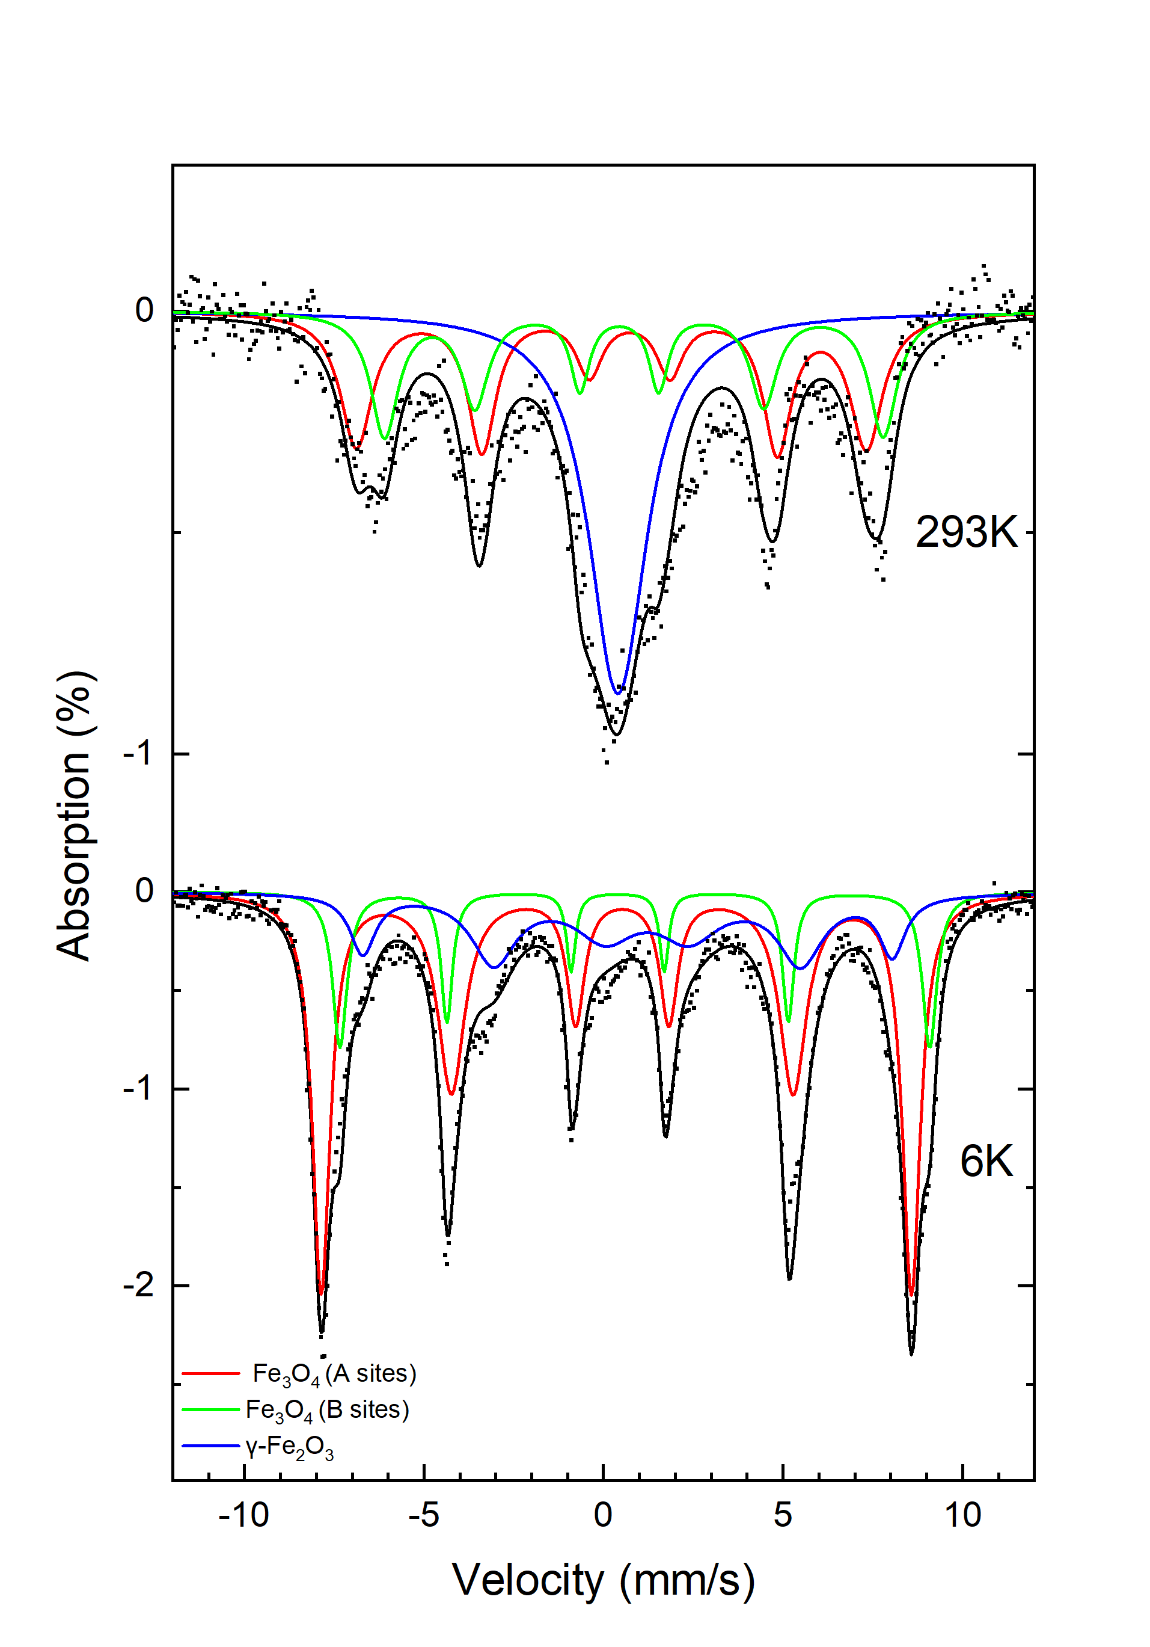
Figure 47: Stacked Mössbauer spectra of silica coated Fe₃O₄ reduced under H₂ gas without prior oxidation at 293K and 6K.

Table 10: Values of hyperfine parameters for reduced silica coated Fe₃O₄ nanoparticles at 293K. B_{hf} is the hyperfine magnetic field, δ is the isomer shift, ΔE_{Q} is the quadrupole splitting, and Γ is the linewidth (FWHM). Typical errors are ±0.03 mm/s for B_{hf}, ±0.5 mm/s for δ, ΔE_{Q}, and Γ and ±3% for relative area.
Temperature | Component | B_{hf} (T) | δ (mm/s) | ΔE_{Q} (mm/s) | Γ (mm/s) | Relative area (%) | Attribution
 | 1 | 44.0 | 0.48 | 0.50 | 1.09 | 35 | Fe₃O₄
293K | 2 | 43.0 | 0.65 | 0.40 | 0.93 | 26 | Fe₃O₄
 | 3 | 0.00 | 0.45 | 0.29 | 1.88 | 39 | Superparamagnetic γ-Fe₂O₃
 | 1 | 50.9 | 0.46 | 0.16 | 0.59 | 56 | Fe₃O₄
6K | 2 | 50.9 | 0.65 | 0.47 | 0.48 | 17 | Fe₃O₄
 | 3 | 45.7 | 0.96 | 0.54 | 0.86 | 27 | Superparamagnetic γ-Fe₂O₃

to zero hysteresis, thus possessing stronger superparamagnetic quality. The α-Fe sample displayed high magnetic saturation around 221 emu/g, which is higher than previously reported average Fe magnetic saturation values of 217 emu/g [80]. Although the magnetic saturation of the α-Fe sample was high, the sample was not entirely superparamagnetic due to an apparent hysteretic remanence from the M-H curve (Figure 48). When determining potential resolution for potential MPI applications, the FWHM of the PSF was around 344.5 mT, making it ineligible for MPI usage since optimal FWHM is around 6 mT [60, 81] (Figure 49).

The reduced sample of Fe₃O₄ without prior oxidation displayed a similar M-H curve to the α-Fe sample (Figure 50). Small presence of magnetic remanence was shown in the measurements, which made it not completely superparamagnetic. From the FWHM of the PSF, 351.5 mT was found to be the FWHM of the sample, which makes it unfavorable for potential MPI usages (Figure 51).

Finally, the reduced silica coated Fe₃O₄ sample displayed superparamagnetic qualities compared to the previously measured samples. The reduced silica coated Fe₃O₄ sample displayed a steeper M-H curve and a lack of magnetic remanence (Figure 52). The FWHM of the PSF was found to be 106.7 mT (Figure 53). Although the FWHM is still high for MPI usage, it was significantly improved compared to the 2 previously measured samples.

Discussion
From TEM images, Fe₃O₄ nanoparticles initially synthesized from a co-precipitation of iron salts formed particles between 8-10 nm. The particles were slightly irregular in shape, but further tuning of the surfactant and pH could allow for more evenly dispersed particles [6]. Little differences in particle shape and size were determined when comparing the γ-Fe₂O₃ nanoparticles with α-Fe nanoparticles produced from further solid-gas reactions. However, clear
aggregations and sintering of particles were observed in the γ-Fe₂O₃ and α-Fe samples, most likely due to the high temperatures used during oxidation and reduction in the tube furnace.

Further confirmation that the higher temperature of 500 °C used during the oxidation and reduction process most likely caused sintering of particles can be seen in the TEM images in Figure 39 of Fe₃O₄ nanoparticles being directly reduced without prior oxidation [82]. Clear agglomerations formed, but areas of iron in the center of the formations can be seen with areas of iron oxide surrounding the masses.

Due to the high potential for aggregation of Fe₃O₄ nanoparticles in solid-gas
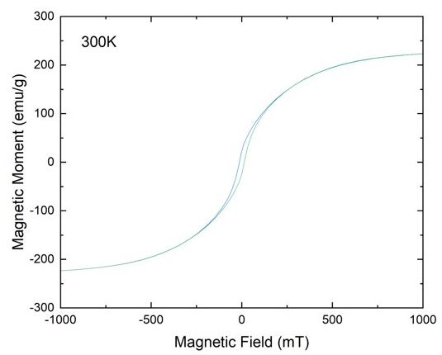

Figure 48: M-H curve of pure α-Fe sample obtained from reducing γ-Fe₂O₃ nanoparticles under H₂ gas.

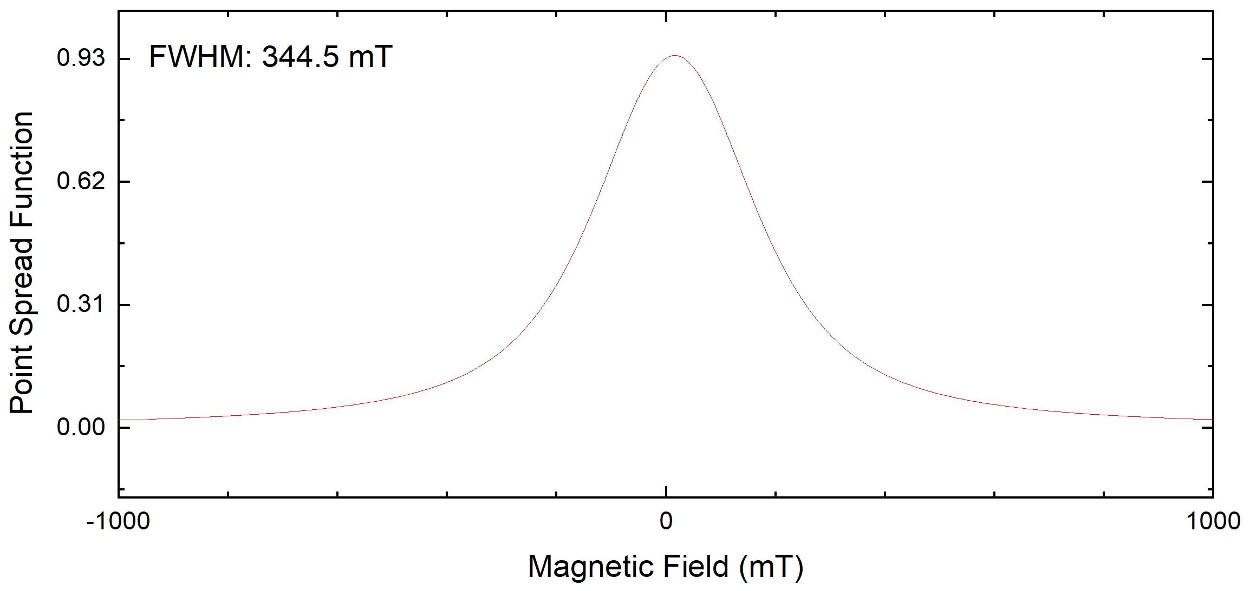
Figure 49: PSF of pure α-Fe sample obtained from reducing γ-Fe₂O₃ nanoparticles under H₂ gas.
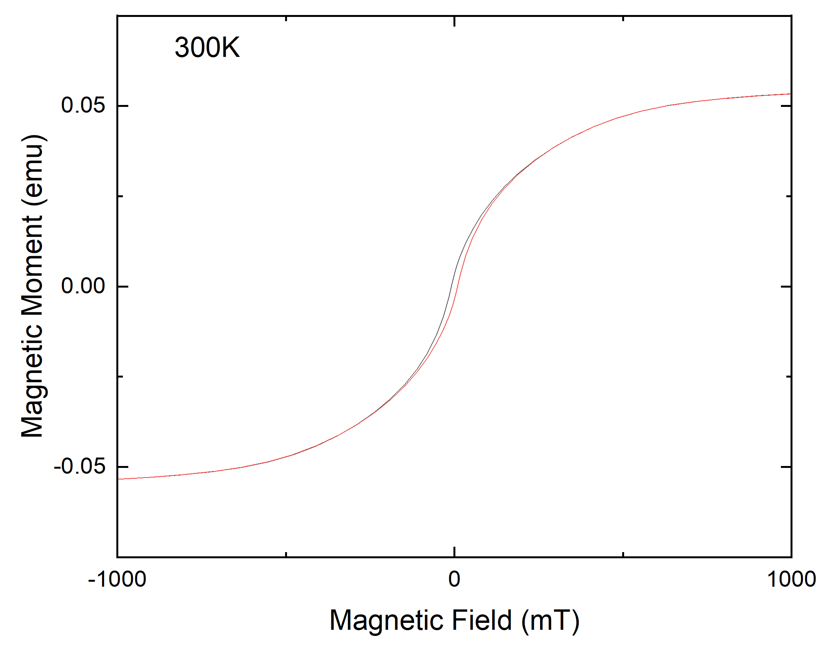
Figure 50: M-H curve of directly reduced Fe₃O₄ nanoparticle without prior oxidation

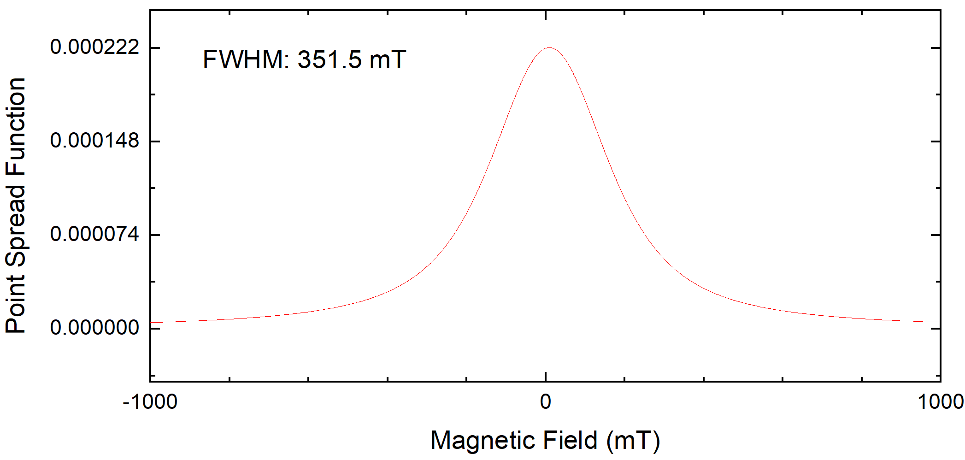
Figure 51: PSF of directly reduced Fe₃O₄ nanoparticles without prior oxidation

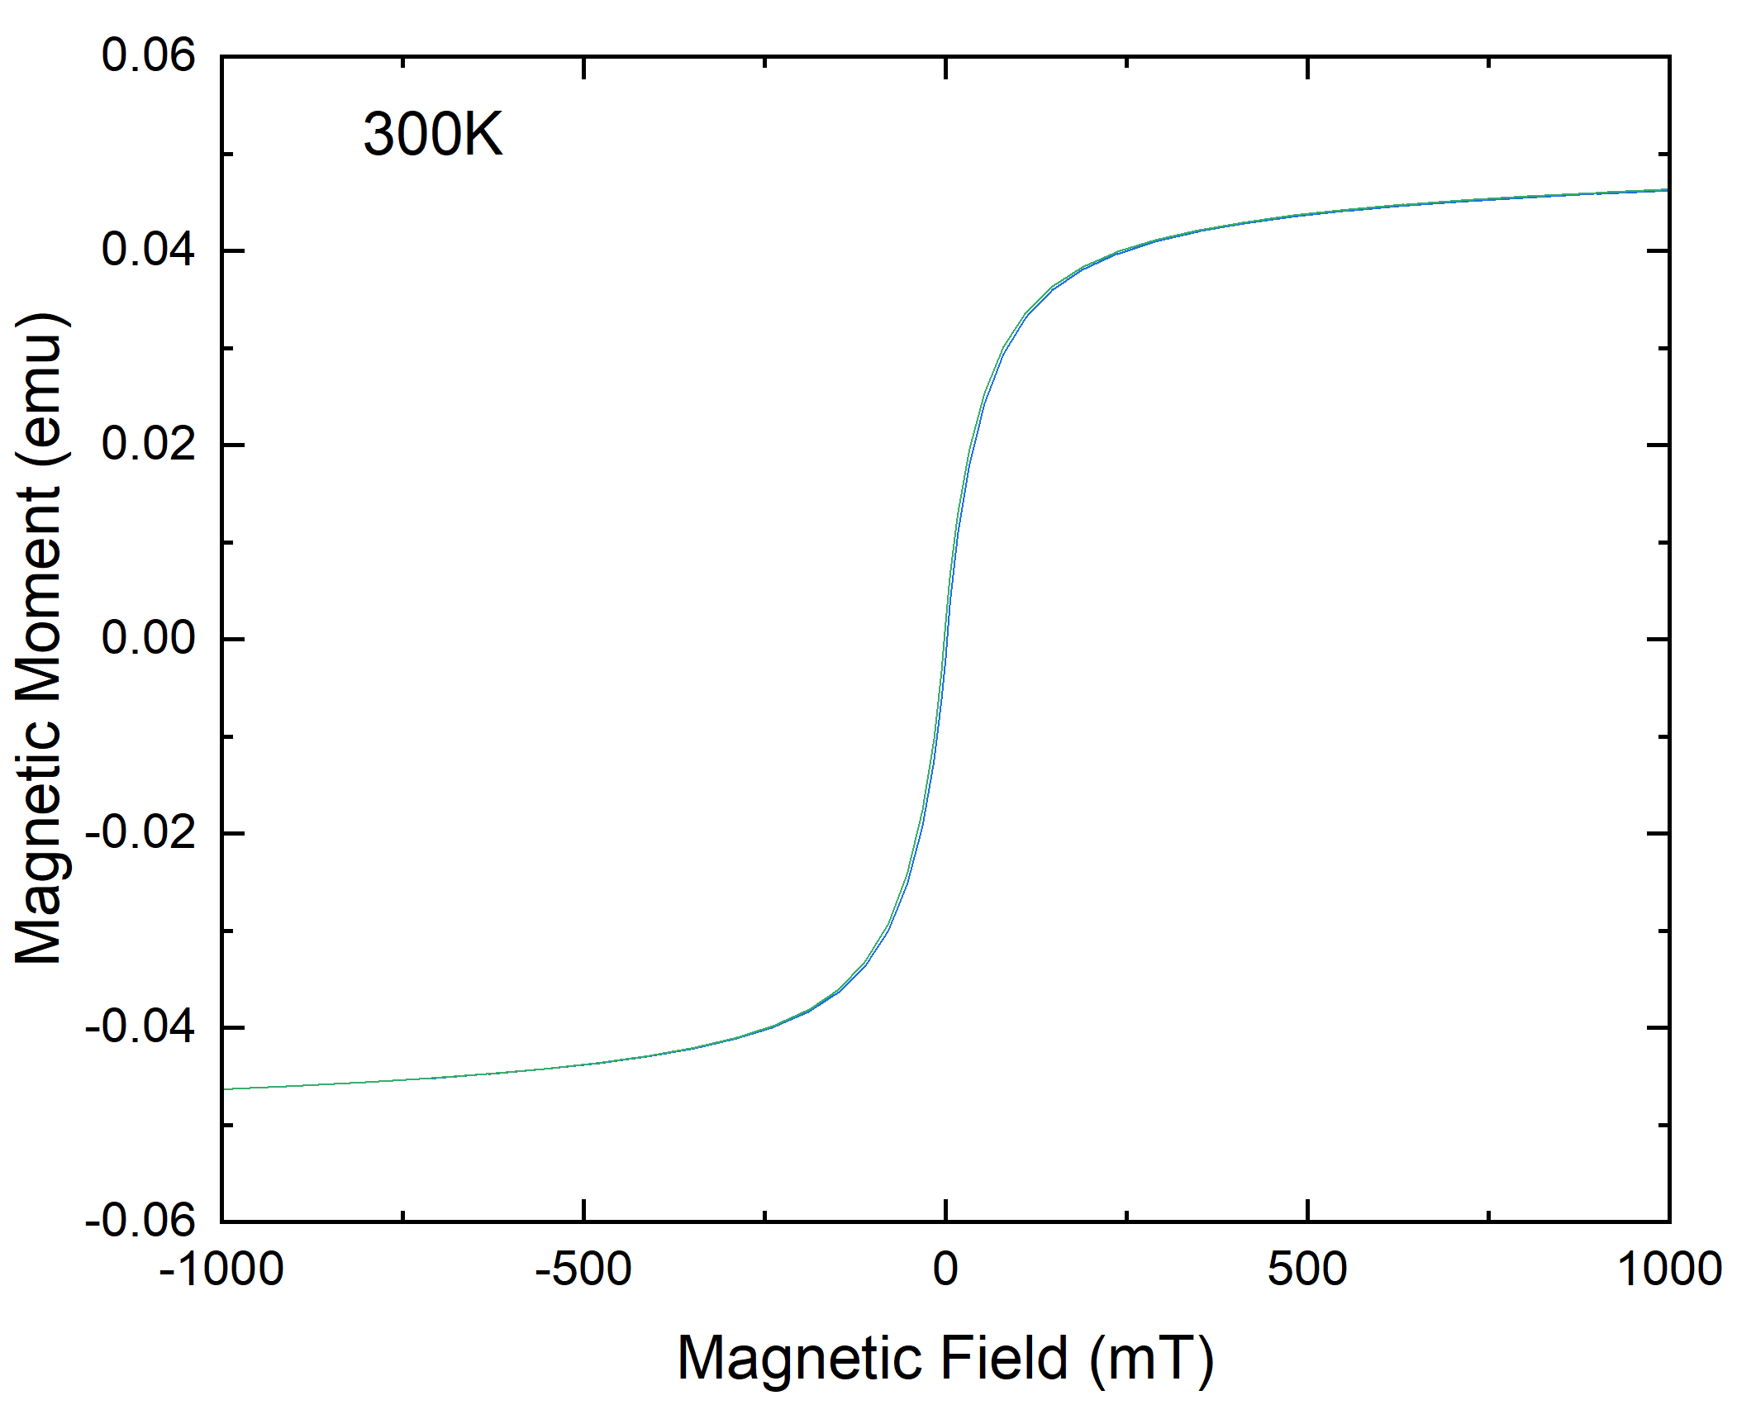
Figure 52: M-H curve of silica coated Fe₃O₄ nanoparticles directly reduced under H₂ gas without prior oxidation.

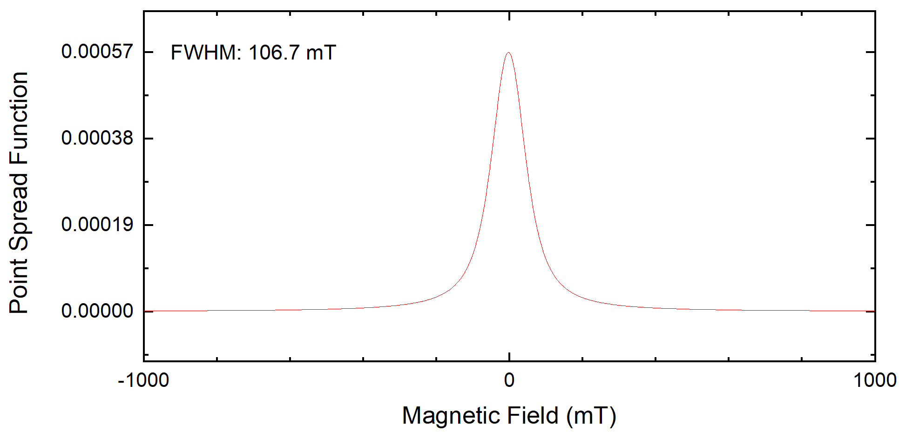
Figure 53: PSF of silica coated Fe₃O₄ nanoparticles directly reduced under H₂ gas without prior oxidation.

reactions, silica coatings were applied to the nanoparticles to act as a barrier in preventing sintering. From TEM images, it was confirmed that the silica coating
aided in reducing sintering of particles after subsequent solid-gas reactions were performed [82].

XRD analysis correlated with Mössbauer spectroscopy measurements. Characteristic XRD peaks were obtained for the initial Fe₃O₄ nanoparticles, oxidized γ-Fe₂O₃, and α-Fe nanoparticles. For initial Fe₃O₄ nanoparticles, Mössbauer studies indicated a mixture of Fe₃O₄ and γ-Fe₂O₃ was present. XRD lacks sensitivity in determining a mixture of magnetite and maghemite in materials [56], so Mössbauer spectra allows for better differentiation of the chemical composition of the nanoparticles.

Sharper XRD peaks were observed in the γ-Fe₂O₃ and α-Fe samples, most likely due to better crystallization from the high temperature reaction or increase in particle size from sintering [83, 84]. When compared to Mössbauer spectroscopy measurements, the chemical compositions are in agreement. After oxidation of the Fe₃O₄ nanoparticles to obtain γ-Fe₂O₃, the Mössbauer spectrum confirmed that pure γ-Fe₂O₃ was achieved. In addition, pure α-Fe nanoparticles were achieved based on Mössbauer spectrum consisting of 1 α-Fe component.

The XRD measurements of the directly reduced Fe₃O₄ nanoparticles without prior oxidation agree with Mössbauer studies. A mixture of sharp α-Fe peaks and iron oxide peaks are present in the XRD spectrum. When compared to the Mössbauer spectrum, a mixture of α-Fe and iron oxides was present in the sample. About 6% of Fe₃O₄ and 30% of γ-Fe₂O₃ was still present in the directly reduced sample, and 64% consisted of α-Fe. The iron oxides present in the directly reduced Fe₃O₄ sample may be due to the impurities the original sample possessed or the particles were too large to fully reduce to α-Fe. In addition, from magnetic measurements, the directly reduced Fe₃O₄ sample displayed a small amount of magnetic remanence, but was very close to being superparamagnetic. The hysteretic remanence present in the M-H curve is most likely attributed to the iron oxides present in the sample, thus decreasing the magnetic coercivity and saturation of the pure iron present [85, 86]. From the data, it is clear that oxidation of the initial uncoated Fe₃O₄ particles produced was necessary in order to obtain pure α-Fe. Since the initial Fe₃O₄ was not completely pure, direct reduction to α-Fe was not possible since a small mixture of iron oxides remained.

The silica coated Fe₃O₄ nanoparticles directly reduced under H₂ gas failed to produce α-Fe and remained as a mixture of Fe₃O₄ and γ-Fe₂O₃ nanoparticles based on the XRD and Mössbauer spectra. Although the silica coating assisted in decreasing sintering of Fe₃O₄ nanoparticles, reduction from the H₂ gas was not achieved. The silica coating could have been too thick or lacked enough porosity for the H₂ gas to fully penetrate during reduction. Further considerations in porous silica coatings and optimal thickness are needed in order to achieve reduced α-Fe nanoparticles by a solid-gas reduction method [87].

Although the silica coated Fe₃O₄ nanoparticles did not reduce under H₂ gas, the sample successfully displayed superparamagnetic qualities from SQUID-VSM measurements compared to the pure α-Fe sample and uncoated Fe₃O₄ nanoparticles directly reduced. One reason the α-Fe sample and reduced Fe₃O₄ sample without prior oxidation could have shown some magnetic remanence could be attributed to the aggregations that formed [88]. Also, the directly reduced uncoated Fe₃O₄ sample without oxidation was a mixture of iron oxides and α-Fe. Since SQUID-VSM is a combined measurement of the material, the lower magnetic susceptibility of the oxides present could have interfered with it possessing complete superparamagnetic qualities [85].

In addition, the reduced silica coated Fe₃O₄ sample may have displayed better magnetic M-H curves due to it being smaller iron oxide nanoparticles. The PSF of the sample was better than the previously measured samples, but it failed to meet typical FWHM MPI standards of around 6-10 mT. This can be attributed to the nanoparticles not being well dispersed and lacking high magnetic saturation.

Conclusion
An investigation into the synthesis and characterization of FeNPs for magnetic imaging applications using a co-precipitation of iron salts with solid-gas reactions has been investigated. A pure iron sample was obtained that displayed high magnetic saturation value of 221 emu/g, which is higher than current reported values. High magnetic saturation is a major factor in MPI and MRI based applications, but the pure α-Fe sample displayed small instances of magnetic remanence and produced a large FWHM from the PSF around 344.5 mT. A potential cause for the large FWHM of the α-Fe sample is that the iron nanoparticles were sintered together. The larger sintered particles affected the Brownian relaxation of the particles to produce steep M-H curves that are need for MPI applications. It is also concluded that unless pure Fe₃O₄ nanoparticles are obtained from a co-precipitation method, prior oxidation steps to obtain γ-Fe₂O₃ are needed to fully reduce to pure α-Fe nanoparticles. Coating particles with silica before high temperature solid-gas reductions are performed is also needed to prevent sintering of particles. However, porous silica and correct thickness is needed in order to properly reduce the particles to pure iron. Further work is needed in order to determine correct silica pore size and thickness on iron oxide nanoparticles in order to obtain pure iron through a solid-gas reduction method. Although the iron nanoparticles produced from a co-precipitation of iron salts is not optimal for MPI uses, the particles could still have potential for MRI or magnetic hyperthermia applications.

CONCLUSION

Iron nanoparticles were successfully synthesized using two synthetic methods including a thermal decomposition of Fe(CO)₅ and co-precipitation of iron chloride salts. From the thermal decomposition method, spherical, monodisperse particles around 14 nm in size were produced with distinct core-shell structures. Little variations in particle size and shape were observed when reaction times and surfactant amounts were varied, with the exception of a 48-hour synthesis. Particles from thermal decomposition synthesis exhibited superparamagnetic qualities from SQUID-VSM measurements and displayed low cytotoxicity. However, despite displaying good superparamagnetic qualities, from the derivation of the PSF, it is concluded the particles are not yet suitable for MPI tracer usages. Future investigation into synthesizing slightly larger particles between 18 - 20 nm in size will be performed in order to obtained steeper MH-curves. Although the particles did not meet MPI standards, they still have potential as MRI contrast agents and magnetic hyperthermia agents.

From a co-precipitation synthesis and further solid-gas reactions, pure α-Fe nanoparticles were obtained. Initial Fe₃O₄ particles were synthesized from co-precipitation, and further oxidized to γ-Fe₂O₃. γ-Fe₂O₃ nanoparticles were successfully reduced under H₂ gas to form pure α-Fe. The particles formed from this method were large and irregularly shaped with more tendency to form agglomerations during the oxidation and reduction process under high temperature. The α-Fe particles produced a high magnetic saturation value of around 221 emu/g. Due to possessing a high magnetic saturation, the particles could have potential for further magnetic imaging usages and be used for magnetic hyperthermia. Further work is needed in order to produce less agglomerated particles. However, from the magnetic measurements, the slope of the M-H curve is not steep enough to produce a good PSF for potential MPI tracer uses. Further silica coating of the original Fe₃O₄ particles was performed in order to mitigate potential sintering of particles at high temperatures. The silica coated particles appeared to be less agglomerated, but full reduction under H₂ gas of the particles was not achieved, which could be due to lack of pores in the silica coating. Further investigation in more porous silica coatings and oxidizing and reducing will need to be performed in order to synthesize proper size nanoparticles for further magnetic imaging uses.

Magnetic particle imaging is a promising imaging technique that can provide better tumor localization and cell tracking for enhanced drug delivery and therapy. The results of this research show promise in creating FeNPs that could provide better magnetic properties compared to commercially available iron oxide nanoparticles. A thermal decomposition synthesis produced the most optimal particles in size, shape, dispersion, and magnetic properties. Therefore, further research will be performed in order to produce larger iron nanoparticles for potential MPI and magnetic imaging applications.

References

[1] A. H. Lu et al., "Nanoengineering of a Magnetically Separable Hydrogenation Catalyst," Angewandte Chemi (International Edition), vol. 43, 2004, doi: https://doi.org/doi: 10.1002/anie.200454222.
[2] S. C. Tsang, V. Caps, I. Paraskevas, D. Chadwick, and D. Thompsett, "Magnetically separable, carbon-supported nanocatalysts for the manufacture of fine chemicals," Angew Chem Int Ed Engl, vol. 43, no. 42, pp. 5645-9, Oct 25 2004, doi: 10.1002/anie.200460552.
[3] T. Hyeon, "Chemical synthesis of magnetic nanoparticles," Chem Commun (Camb), no. 8, pp. 927-34, Apr 21 2003, doi: 10.1039/b207789b.
[4] D. W. Elliott and W. X. Zhang, "Field assessment of nanoscale bimetallic particles for groundwater treatment," Environ Sci Technol, vol. 35, no. 24, pp. 4922-6, Dec 15 2001, doi: 10.1021/es0108584.
[5] D. Yeo, C. Wiraja, Y. J. Chuah, Y. Gao, and C. Xu, "A Nanoparticle-Based Sensor Platform for Cell Tracking and Status/Function Assessment," Nature, 2015, doi: https://doi.org/DOi: 10.1038/srep14768.
[6] A. H. Lu, E. L. Salabas, and F. Schuth, "Magnetic nanoparticles: synthesis, protection, functionalization, and application," Angew Chem Int Ed Engl, vol. 46, no. 8, pp. 1222-44, 2007, doi: 10.1002/anie.200602866.
[7] R. Yuvakkumar, V. Elango, V. Rajendran, N. Kannan, and K. Rangasamy, "Preparation and Characterization of Zero Valent Iron Nanoparticles," Digest Journal of Nanomaterials and Biostructures, vol. 6, 2011.
[8] M. Nazari, N. Ghasemi, H. Maddah, and M. M. Motlagh, "Synthesis and Characterization of Maghemite Nanopowders by Chemical Precipitation Method," Journal of Nanostructure in Chemistry, vol. 4, 2014, doi: DOI 10.1007/s40097-014-0099-9.
[9] M. Unni et al., "Thermal Decomposition Synthesis of Iron Oxide Nanoparticles with Diminished Magnetic Dead Layer by Controlled Addition of Oxygen," (in English), Acs Nano, vol. 11, no. 2, pp. 2284-2303, Feb 2017, doi: 10.1021/acsnano.7b00609.
[10] H. D. Cai et al., "Facile Hydrothermal Synthesis and Surface Functionalization of Polyethyleneimine-Coated Iron Oxide Nanoparticles for Biomedical Applications," (in English), Acs Applied Materials & Interfaces, vol. 5, no. 5, pp. 1722-1731, Mar 13 2013, doi: 10.1021/am302883m.
[11] C. P. Bean and J. D. Livingston, "Superparamagnetism," Journal of Applied Physics, vol. 30, no. 4, 1959, doi: 10.1063/1.2185850.
[12] E. F. Kneller and F. E. Luborsky, "Particle Size Dependence of Coercivity and Remanence of Single Domain Particles," Journal of Applied Physics, vol. 34, no. 3, 1963, doi: https://doi.org/10.1063/1.1729324.
[13] C. G. Hadjipanayis, M. J. Bonder, S. Balakrishnan, X. Wang, H. Mao, and G. C. Hadjipanayis, "Metallic Iron Nanoparticles for MRI Contrast Enhancement and Local Hyperthermia " Small, vol. 4, no. 11, pp. 1925-1929, 2008, doi: https://doi.org/10.1002/smll.200800261.
[14] B. Gleich and R. Weizenecker, "Tomographic imaging using the nonlinear response of magnetic particles," (in English), Nature, vol. 435, no. 7046, pp. 1214-1217, Jun 30 2005, doi: 10.1038/nature03808.
[15] L. C. Wu et al., "A Review of Magnetic Particle Imaging and Perspectives on Neuroimaging," (in English), Am J Neuroradiol, vol. 40, no. 2, pp. 206-212, Feb 2019, doi: 10.3174/ajnr.A5896.
[16] P. W. Goodwill et al., "X-space MPI: magnetic nanoparticles for safe medical imaging," Adv Mater, vol. 24, no. 28, pp. 3870-7, Jul 24 2012, doi: 10.1002/adma.201200221.
[17] J. Rahmer, B. Gleich, J. Weizenecker, and J. Borgert, "3D Real-Time Magnetic Particle Imaging of Cerebral Blood Flow in Living Mice," Proceedings of the International Society for Magnetic Resonance in Medicine, 2010.
[18] P. Ludewig et al., "Magnetic Particle Imaging for Real-Time Perfusion Imaging in Acute Stroke," ACS Nano, vol. 11, no. 10, pp. 10480-10488, Oct 24 2017, doi: 10.1021/acsnano.7b05784.
[19] A. Tomitaka, H. Arami, S. Gandhi, and K. M. Krishnan, "Lactoferrin conjugated iron oxide nanoparticles for targeting brain glioma cells in magnetic particle imaging," (in English), Nanoscale, vol. 7, no. 40, pp. 16890-16898, 2015, doi: 10.1039/c5nr02831k.
[20] G. Song et al., "Janus Iron Oxides @ Semiconducting Polymer Nanoparticle Tracer for Cell Tracking by Magnetic Particle Imaging," Nano Lett, vol. 18, no. 1, pp. 182-189, Jan 10 2018, doi: 10.1021/acs.nanolett.7b03829.
[21] C. Sun, J. S. H. Lee, and M. Q. Zhang, "Magnetic nanoparticles in MR imaging and drug delivery," (in English), Adv Drug Deliver Rev, vol. 60, no. 11, pp. 1252-1265, Aug 17 2008, doi: 10.1016/j.addr.2008.03.018.
[22] P. Chandrasekharan et al., "A perspective on a rapid and radiation-free tracer imaging modality, magnetic particle imaging, with promise for clinical translation," Br J Radiol, vol. 91, no. 1091, p. 20180326, Nov 2018, doi: 10.1259/bjr.20180326.
[23] E. U. Saritas et al., "Magnetic particle imaging (MPI) for NMR and MRI researchers," J Magn Reson, vol. 229, pp. 116-26, Apr 2013, doi: 10.1016/j.jmr.2012.11.029.
[24] J. Wahsner, E. M. Gale, A. Rodriguez-Rodriguez, and P. Caravan, "Chemistry of MRI Contrast Agents: Current Challenges and New Frontiers," Chem Rev, vol. 119, no. 2, pp. 957-1057, Jan 23 2019, doi: 10.1021/acs.chemrev.8b00363.
[25] T. Grobner, "Gadolinium--a specific trigger for the development of nephrogenic fibrosing dermopathy and nephrogenic systemic fibrosis?," Nephrol Dial Transplant, vol. 21, no. 4, pp. 1104-8, Apr 2006, doi: 10.1093/ndt/gfk062.
[26] P. Marckmann et al., "Nephrogenic systemic fibrosis: Suspected causative role of gadodiamide used for contrast-enhanced magnetic resonance imaging," (in English), J Am Soc Nephrol, vol. 17, no. 9, pp. 2359-2362, Sep 2006, doi: Doi 10.1681/Asn.2006060601.
[27] V. I. Shubayev, T. R. Pisanic, 2nd, and S. Jin, "Magnetic nanoparticles for theragnostics," Adv Drug Deliv Rev, vol. 61, no. 6, pp. 467-77, Jun 21 2009, doi: 10.1016/j.addr.2009.03.007.
[28] M. G. Harisinghani et al., "Noninvasive detection of clinically occult lymph-node metastases in prostate cancer," N Engl J Med, vol. 348, no. 25, pp. 2491-9, Jun 19 2003, doi: 10.1056/NEJMoa022749.
[29] L. Li et al., "Superparamagnetic Iron Oxide Nanoparticles as MRI Contrast Agents for Non-invasive Stem Cell Labelling and Tracking," Theranostics, vol. 4, 2012, doi: https://doi.org/10.7150/thno.5366.
[30] C. Y. Yang et al., "Labeling of human mesenchymal stem cell: Comparison between paramagnetic and superparamagnetic agents," (in English), Journal of Applied Physics, vol. 105, no. 7, Apr 1 2009, doi:07b31410.1063/1.3072821.
[31] N. Lee and T. Hyeon, "Designed synthesis of uniformly sized iron oxide nanoparticles for efficient magnetic resonance imaging contrast agents," Chem Soc Rev, vol. 41, no. 7, pp. 2575-89, Apr 7 2012, doi: 10.1039/c1cs15248c.
[32] M. Krajewski et al., "High Temperature Oxidation of Iron-Iron Oxide Core-Shell Nanowires Composed of Iron Nanoparticles," Royal Society of Chemistry, vol. 18, 2016, doi: https://doi.org/10.1039/c5cp07569f.
[33] X. Liu et al., "Comprehensive understanding of magnetic hyperthermia for improving antitumor therapeutic efficacy," Theranostics, vol. 10, no. 8, pp. 3793-3815, 2020, doi: 10.7150/thno.40805.
[34] C. S. S. R. Kumar and F. Mohammad, "Magnetic nanomaterials for hyperthermia-based therapy and controlled drug delivery," (in English), Adv Drug Deliver Rev, vol. 63, no. 9, pp. 789-808, Aug 14 2011, doi: 10.1016/j.addr.2011.03.008.
[35] D. Ho, X. L. Sun, and S. H. Sun, "Monodisperse Magnetic Nanoparticles for Theranostic Applications," (in English), Accounts Chem Res, vol. 44, no. 10, pp. 875-882, Oct 2011, doi: 10.1021/ar200090c.
[36] B. Hildebrandt et al., "The cellular and molecular basis of hyperthermia," Crit Rev Oncol Hematol, vol. 43, no. 1, pp. 33-56, Jul 2002, doi: 10.1016/s1040-8428(01)00179-2.
[37] M. Ma, Y. Wu, H. Zhou, Y. K. Sun, Y. Zhang, and N. Gu, "Size dependence of specific power absorption of Fe3O4 particles in AC magnetic field," (in English), Journal of Magnetism and Magnetic Materials, vol. 268, no. 1-2, pp. 33-39, Jan 2004, doi: 10.1016/S0304-8853(03)00426-8.
[38] M. Jeun et al., "Physical limits of pure superparamagnetic Fe3O4 nanoparticles for a local hyperthermia agent in nanomedicine," (in English), Applied Physics Letters, vol. 100, no. 9, Feb 27 2012, doi:09240610.1063/1.3689751.
[39] R. Hergt, S. Dutz, and M. Roder, "Effects of size distribution on hysteresis losses of magnetic nanoparticles for hyperthermia," (in English), J Phys-Condens Mat, vol. 20, no. 38, Sep 24 2008, doi:10.1088/0953-8984/20/38/385214.
[40] E. T. Ahrens and J. W. Bulte, "Tracking immune cells in vivo using magnetic resonance imaging," Nat Rev Immunol, vol. 13, no. 10, pp. 755-63, Oct 2013, doi: 10.1038/nri3531.
[41] J. W. Bulte, "In vivo MRI cell tracking: clinical studies," AJR Am J Roentgenol, vol. 193, no. 2, pp. 314-25, Aug 2009, doi: 10.2214/AJR.09.3107.
[42] J. F. Zeng et al., "Anchoring Group Effects of Surface Ligands on Magnetic Properties of Fe304 Nanoparticles: Towards High Performance MRI Contrast Agents," (in English), Advanced Materials, vol. 26, no. 17, pp. 2694-2698, May 2014, doi: 10.1002/adma.201304744.
[43] E. Y. Yu et al., "Magnetic Particle Imaging: A Novel in Vivo Imaging Platform for Cancer Detection," Nano Lett, vol. 17, no. 3, pp. 1648-1654, Mar 8 2017, doi: 10.1021/acs.nanolett.6b04865.
[44] B. Zheng et al., "Quantitative Magnetic Particle Imaging Monitors the Transplantation, Biodistribution, and Clearance of Stem Cells In Vivo," (in English), Theranostics, vol. 6, no. 3, pp. 291-301, 2016, doi: 10.7150/thno.13728.
[45] F. Ludwig et al., "Self-consistent magnetic properties of magnetite tracers optimized for magnetic particle imaging measured by ac susceptometry, magnetorelaxometry and magnetic particle spectroscopy," J Magn Magn Mater, vol. 360, pp. 169-173, Jun 1 2014, doi: 10.1016/j.jmmm.2014.02.020.
[46] L. M. Bauer, S. F. Situ, M. A. Griswold, and A. C. S. Samia, "High-performance iron oxide nanoparticles for magnetic particle imaging - guided hyperthermia (hMPI)," (in English), Nanoscale, vol. 8, no. 24, pp. 12162-12169, 2016, doi: 10.1039/c6nr01877g.
[47] H. Arami et al., "Tomographic magnetic particle imaging of cancer targeted nanoparticles," (in English), Nanoscale, vol. 9, no. 47, pp. 18723-18730, Dec 21 2017, doi: 10.1039/c7nr05502a.
[48] L. Gloag et al., "Zero valent iron core-iron oxide shell nanoparticles as small magnetic particle imaging tracers," Chem Commun (Camb), vol. 56, no. 24, pp. 3504-3507, Mar 25 2020, doi: 10.1039/c9cc08972a.
[49] F. Dumestre, B. Chaudret, C. Amiens, P. Renaud, and P. Fejes, "Superlattices of iron nanocubes synthesized from Fe[N(SiMe3)2]2," Science, vol. 303, no. 5659, pp. 821-3, Feb 6 2004, doi: 10.1126/science.1092641.
[50] R. Hao, R. Xing, Z. Xu, Y. Hou, S. Gao, and S. Sun, "Synthesis, functionalization, and biomedical applications of multifunctional magnetic nanoparticles," Adv Mater, vol. 22, no. 25, pp. 2729-42, Jul 6 2010, doi: 10.1002/adma.201000260.
[51] J. Park et al., "Ultra-large-scale syntheses of monodisperse nanocrystals," Nat Mater, vol. 3, no. 12, pp. 891-5, Dec 2004, doi: 10.1038/nmat1251.
[52] D. Farrell, Y. Ding, S. A. Majetich, C. Sanchez-Hanke, and C. C. Kao, "Structural ordering effects in Fe nanoparticle two- and three-dimensional arrays," (in English), Journal of Applied Physics, vol. 95, no. 11, pp. 6636-6638, Jun 1 2004, doi: 10.1063/1.1688644.
[53] L. C. Gonçalves, A. B. Seabra, M. T. Pelegrino, D. R. de Araujo, J. S. Barnardes, and P. S. Haddad, "Superparamagnetic Iron Oxide Nanoparticles Dispersed in Pluronic F127 Hydrogel: Potential Uses in Topical Applications," Royal Society of Chemistry, vol. 7, 2017, doi: Doi:10.1039/C6RA28633J.
[54] W. Wu, Z. H. Wu, T. Yu, C. Z. Jiang, and W. S. Kim, "Recent progress on magnetic iron oxide nanoparticles: synthesis, surface functional strategies and biomedical applications," (in English), Sci Technol Adv Mat, vol. 16, no. 2, Apr 2015, doi:10.1088/1468-6996/16/2/023501.
[55] V. C. Karade et al., "Effect of reaction time on structural and magnetic properties of green-synthesized magnetic nanoparticles," (in English), J Phys Chem Solids, vol. 120, pp. 161-166, Sep 2018, doi: 10.1016/j.jpcs.2018.04.040.
[56] N. Ajinkya, X. Yu, P. Kaithal, H. Luo, P. Somani, and S. Ramakrishna, "Magnetic Iron Oxide Nanoparticle (IONP) Synthesis to Applications: Present and Future," Materials (Basel), vol. 13, no. 20, Oct 18 2020, doi: 10.3390/ma13204644.
[57] C. F. Holder and R. E. Schaak, "Tutorial on Powder X-ray Diffraction for Characterizing Nanoscale Materials," (in English), Acs Nano, vol. 13, no. 7, pp. 7359-7365, Jul 2019, doi: 10.1021/acsnano.9b05157.
[58] I. S. Lyubutin, S. S. Starchikov, C. R. Lin, N. E. Gervits, N. Y. Korotkov, and T. V. Bukreeva, "Structural and Magnetic Properties of Iron Oxide Nanoparticles in Shells of Hollow Microcapsules Designed for Biomedical Applications," (in English), Croat Chem Acta, vol. 88, no. 4, Dec 2015, doi: 10.5562/cca2739.
[59] H. Mamiya and B. Jeyadevan, "Magnetic Hysteresis Loop in a Superparamagnetic State," (in English), Ieee Transactions on Magnetics, vol. 50, no. 1, Jan 2014, doi:10.1109/Tmag.2013.2274072.
[60] Z. W. Tay, D. W. Hensley, P. Chandrasekharan, B. Zheng, and S. M. Conolly, "Optimization of Drive Parameters for Resolution, Sensitivity and Safety in Magnetic Particle Imaging," (in English), Ieee Transactions on Medical Imaging, vol. 39, no. 5, pp. 1724-1734, May 2020, doi: 10.1109/Tmi.2019.2957041.
[61] Z. W. Tay, D. W. Hensley, E. C. Vreeland, B. Zheng, and S. M. Conolly, "The relaxation wall: experimental limits to improving MPI spatial resolution by increasing nanoparticle core size," (in English), Biomed Phys Eng Expr, vol. 3, no. 3, Jun 2017, doi:10.1088/2057-1976/aa6ab6.
[62] L. R. Croft, P. W. Goodwill, and S. M. Conolly, "Relaxation in X-Space Magnetic Particle Imaging," (in English), Ieee Transactions on Medical Imaging, vol. 31, no. 12, pp. 2335-2342, Dec 2012, doi: 10.1109/Tmi.2012.2217979.
[63] L. R. Croft et al., "Low drive field amplitude for improved image resolution in magnetic particle imaging," Med Phys, vol. 43, no. 1, p. 424, Jan 2016, doi: 10.1118/1.4938097.
[64] S. Ziemian, N. Lowa, O. Kosch, D. Bajj, F. Wiekhorst, and G. Schutz, "Optimization of Iron Oxide Tracer Synthesis for Magnetic Particle Imaging," Nanomaterials (Basel), vol. 8, no. 4, Mar 21 2018, doi: 10.3390/nano8040180.
[65] R. M. Ferguson et al., "Magnetic particle imaging with tailored iron oxide nanoparticle tracers," IEEE Trans Med Imaging, vol. 34, no. 5, pp. 1077-84, May 2015, doi: 10.1109/TMI.2014.2375065.
[66] D. B. Reeves and J. B. Weaver, "Simulations of magnetic nanoparticle Brownian motion," J Appl Phys, vol. 112, no. 12, p. 124311, Dec 15 2012, doi: 10.1063/1.4770322.
[67] K. Riahi, M. M. van de Loosdrecht, L. Alic, and B. ten Haken, "Assessment of differential magnetic susceptibility in nanoparticles: Effects of changes in viscosity and immobilisation," (in English), Journal of Magnetism and Magnetic Materials, vol. 514, Nov 15 2020, doi:10.1016/j.jmmm.2020.167238.
[68] R. M. Ferguson, K. R. Minard, and K. M. Krishnan, "Optimization of nanoparticle core size for magnetic particle imaging," (in English), Journal of Magnetism and Magnetic Materials, vol. 321, no. 10, pp. 1548-1551, May 2009, doi: 10.1016/j.jmmm.2009.02.083.
[69] Y. W. Jun, J. H. Lee, and J. Cheon, "Nanoparticle Contrast Agents for Molecular Magnetic Resonance Imaging," 2007, doi: https://doi.org/10.1002/9783527610389.ch17.
[70] A. Ito, M. Shinkai, H. Honda, and T. Kobayashi, "Medical application of functionalized magnetic nanoparticles," (in English), J Biosci Bioeng, vol. 100, no. 1, pp. 1-11, Jul 2005, doi: 10.1263/jbb.100.1.
[71] E. Terreno, D. D. Castelli, A. Viale, and S. Aime, "Challenges for Molecular Magnetic Resonance Imaging," Chemical Reviews, vol. 110, 2010, doi: https://doi.org/10.1021/cr100025t.
[72] J. Lodhia, G. Mandarano, N. J. Ferris, P. Eu, and S. F. Cowell, "Development and Use of Iron Oxide Nanoparticles (Part 1): Synthesis of Iron Oxide Nanoparticles for MRI," Biomedical Imaging INtervention Journal, vol. 2, 2010, doi: https://doi.org/10.2349/biij.6.2.e12.
[73] J. W. Bulte, I. D. Duncan, and J. A. Frank, "In vivo magnetic resonance tracking of magnetically labeled cells after transplantation," J Cereb Blood Flow Metab, vol. 22, no. 8, pp. 899-907, Aug 2002, doi: 10.1097/00004647-200208000-00001.
[74] S. Laurent et al., "Magnetic iron oxide nanoparticles: synthesis, stabilization, vectorization, physicochemical characterizations, and biological applications," Chem Rev, vol. 108, no. 6, pp. 2064-110, Jun 2008, doi: 10.1021/cr068445e.
[75] Z. W. Tay et al., "Magnetic Particle Imaging-Guided Heating in Vivo Using Gradient Fields for Arbitrary Localization of Magnetic Hyperthermia Therapy," ACS Nano, vol. 12, no. 4, pp. 3699-3713, Apr 24 2018, doi: 10.1021/acsnano.8b00893.
[76] L. M. Bauer, S. F. Situ, M. A. Griswold, and A. C. S. Samia, "Magnetic Particle Imaging Tracers: State-of-the-Art and Future Directions," (in English), J Phys Chem Lett, vol. 6, no. 13, pp. 2509-2517, Jul 2 2015, doi: 10.1021/acs.jpclett.5b00610.
[77] Y. S. Kang, S. Risbud, J. F. Rabolt, and P. Stroeve, "Synthesis and characterization of nanometer-size Fe3O4 and gamma-Fe2O3 particles," (in English), Chem Mater, vol. 8, no. 9, pp. 2209-&, Sep 1996, doi: DOI 10.1021/cm960157j.
[78] S. Kamali et al., "Magnetic properties of gamma-Fe2O3 nanoparticles in a porous SiO2 shell for drug delivery," J Phys Condens Matter, vol. 33, no. 6, p. 065301, Nov 24 2020, doi: 10.1088/1361-648X/abc403.
[79] H. Y. Hah et al., "Mössbauer Spectroscopy of Superparamagnetic Fe3O4 nanoparticles," Journal of Magnetism and Magnetic Materials, vol. 539, 2021, doi: https://doi.org/10.1016/j.jmmm.2021.168382.
[80] J. Crangle and G. M. Goodman, "The Magnetization of Pure Iron and Nickel," The Roayl Society A: Mathematical, Physical and Engineering Sciences, vol. 321, 1971, doi: https://doi.org/10.1098/rspa.1971.0044.
[81] J. Weizenecker, B. Gleich, J. Rahmer, H. Dahnke, and J. Borgert, "Three-dimensional real-time in vivo magnetic particle imaging," (in English), Phys Med Biol, vol. 54, no. 5, pp. L1-L10, Mar 7 2009, doi: 10.1088/0031-9155/54/5/L01.
[82] C. Liu, X. W. Wu, T. Klemmer, N. Shukla, and D. Weller, "Reduction of sintering during annealing of FePt nanoparticles coated with iron oxide," (in English), Chem Mater, vol. 17, no. 3, pp. 620-625, Feb 8 2005, doi: 10.1021/cm0403457.
[83] N. Enomoto, S. Hirata, M. Inada, and K. Hayashi, "Crystallization behavior of iron-based amorphous nanoparticles prepared sonochemically," (in English), Ultrason Sonochem, vol. 35, pp. 563-568, Mar 2017, doi: 10.1016/j.ultsonch.2016.04.033.
[84] P. Hu et al., "Heat treatment effects on Fe3O4 nanoparticles structure and magnetic properties prepared by carbothermal reduction," (in English), J Alloy Compd, vol. 509, no. 5, pp. 2316-2319, Feb 3 2011, doi: 10.1016/j.jallcom.2010.10.211.
[85] G. A. Jacob and R. J. Joseyphus, "Magnetic properties of FeCo-iron oxide core-shell nanoparticles investigated through first order reversal studies," (in English), Appl Phys a-Mater, vol. 127, no. 1, Jan 3 2021, doi:10.1007/s00339-020-04176-z.
[86] A. Tomitaka, S. Ota, K. Nishimoto, H. Arami, Y. Takemura, and M. Nair, "Dynamic magnetic characterization and magnetic particle imaging enhancement of magnetic-gold core-shell nanoparticles," (in English), Nanoscale, vol. 11, no. 13, pp. 6489-6496, Apr 7 2019, doi: 10.1039/c9nr00242a.
[87] M. Volokhova et al., "Cubic Iron Core-Shell Nanoparticles Functionalized to Obtain High-Performance MRI Contrast Agents," (in English), Materials, vol. 15, no. 6, Mar 2022, doi:10.3390/ma15062228.
[88] Z. Nemati, J. Alonso, H. Khurshid, M. H. Phan, and H. Srikanth, "Core/shell iron/iron oxide nanoparticles: are they promising for magnetic hyperthermia?," (in English), Rsc Adv, vol. 6, no. 45, pp. 38697-38702, 2016, doi: 10.1039/c6ra05064f.

VITA

Aleia Grace Williams is from Morristown, TN, and graduated from Morristown West High School in 2015. She later graduated from Carson Newman University with a Bachelor of Science Degree in Biochemistry and a minor in Applied Psychology in 2019. Aleia began her graduate studies at the University of Tennessee Space Institute in the Fall of 2020 as a graduate research assistant under Dr. Jacqueline Johnson. She received a Master of Science degree in Biomedical Engineering in the Fall of 2022. She plans to continue her research in the BEAMS group at the University of Tennessee Space Institute toward her PhD.

