Radiation-Induced Radicals in Polyurea-Crosslinked Silica Aerogel

A Thesis Presented for the
Master of Science
Degree
The University of Tennessee, Knoxville

Benjamin Michael Walters
August 2014

Copyright © 2014 by Benjamin Walters
All rights reserved.

Acknowledgements

For the opportunity and help in completion of this master’s degree, I thank my advisor Dr. Rupy Sawhney as well as Dr. Ramon Leon and Dr. Xiaoyan Zhu of the University of Tennessee. For providing aerogel materials, additional guidance and valuable knowledge, as well as facilities to conduct free radical testing, I thank Drs. Firouzeh Sabri and M. Shah Jahan of the University of Memphis.

Abstract
Free radicals are atoms or molecules with an odd number of electrons in an outer shell. Since electrons typically occur in pairs, this leaves one electron that is unpaired. In seek of another electron to pair with, free radicals react with and steal electrons from neighboring molecules, which then become free radicals themselves. This can start a chain reaction, cascading into large scale damage.
Ionizing radiation can tear through molecules, just as bullets can tear through things that we see. If free radicals can be detected, and seen to increase in a material upon radiation exposure, this can indicate molecular damage caused by radiation. While free radicals created in a material may not have immediate large-scale effects, they can eventually alter the material’s ability to function as intended. This will be important in assessing potential aerogel applications which involve radiation exposure.
Aerogels are gels in solid form which contain mostly air (instead of liquid); they can be thought of as an advanced form of styrofoam that can be much stronger, lightweight, and insulating. Aerogels can be made of many different materials, the most common being silica. Typical silica aerogels are very fragile. A modified version, known as polyurea-crosslinked silica aerogel (PCSA), may be more practical, in that it is good for applications requiring more strength and resistance to surroundings.
In this study, PCSA is exposed to several X-irradiation treatments and tested via electron spin resonance (ESR) technique, which has the unique ability to directly detect free radicals. For comparison, all treatments are equally duplicated with a material known to be very radiation-resistant (PEEK (polyether-ether ketone)), and one known to undergo large-scale free radical creation and degradation upon radiation exposure (UHMWPE (ultra-high molecular weight polyethylene). Results show significant quantities of free radicals produced in PCSA due to X-irradiation.

Table of Contents
Chapter 1 Introduction 1
1.1 Background 1
1.2 Problem Statement 2
1.2.1 Free Radicals 2
1.2.2 ESR 2
1.2.3 Ionizing Radiation 3
1.2.4 Problem Statement 4
1.3 Experimentation 5
1.3.1 Summary of Experiment 5
1.3.2 Rationale for Using X-Ray 5
1.3.3 Reference Materials (UHMWPE and PEEK) 6
1.3.4 Hypotheses 7
Chapter 2 Literature Review 8
Chapter 3 Experiment 11
3.1 Materials 11
3.1.1 PCSA 11
3.1.2 UHMWPE 12
3.1.3 PEEK 12
3.2 Exposure 12
3.2.1 X-irradiation Levels 12
3.2.3 X-Irradiation Environments and Equipment 13
3.3 Response: Free Radical Measurements 14
3.4 ESR Evaluation of Treatments 14
3.5 Post-Irradiation Storage Environments and ESR Testing 14
3.6 Summary of Treatments 15
Chapter 4 Results 16
4.1 Overall Guideline 16
4.2 Untreated Materials (Before Irradiation Treatment) 16
4.2.1 Untreated PCSA 17
4.2.2 Untreated UHMWPE and PEEK 19
4.2.3Untreated PCSA vs. PEEK 20
4.3 X-irradiation in Air (10-minute exposure) 21
4.3.1 PCSA 21
4.3.2 UHMWPE and PEEK 22
4.4 X-irradiation in Air (30-minute exposure) 23
4.4.1 PCSA 23
4.4.2 UHMWPE and PEEK 24
4.5 All Treatments 25
4.5.1 PCSA 25
4.5.2 UHMWPE 37
4.5.3 PEEK 43
4.6 Native Silica Aerogel Observations 48
Chapter 5 Conclusion 53
References 56
Appendices 59
Appendix A: Free Radicals and ESR 60
Appendix B: Quantities 63
Appendix C: Better perspective of “spins per gram” 65
Appendix D: g-value 67
Appendix E: Acquisition of ESR spectra and analysis 69
Vita 72

List of Tables
Table 1. Summary of Literature Review Referencs 8
Table 2. PCSA free radical concentrations (*10^14 spins per gram) for all treatments 36
Table 3. UHMWPE free radical concentrations (*10^14 spins per gram) for all treatments 42
Table 4. UHMWPE free radical concentrations (*10^14 spins per gram) for all treatments 47

List of Figures
Figure 1: Electromagnetic spectrum 3
Figure 2. Experimental design for treatments of PCSA 5
Figure 3. Materials used for this study 10
Figure 4. Vacuum and X-ray chamber used in this study 13
Figure 5. Untreated PCSA 18
Figure 6. FRC for all untreated PCSA specimens 18
Figure 7. ESR spectrum of untreated UHMWPE 19
Figure 8. ESR spectrum and corresponding FRC of untreated PEEK 19
Figure 9. FRC for untreated PEEK and PCSA 20
Figure 10. PCSA immediately after 10-minute X-irradiation in air 21
Figure 11. ESR spectra of PEEK and UHMWPE after 10-minute X-irradiation in Air 22
Figure 12. PCSA after 30-minute X-irradiation in air 23
Figure 13. ESR spectra of UHMWPE and PEEK with 10- and 30-minute X-irradiation 24
Figure 14. Summary of all PCSA treatments and testing 25
Figure 15. All PCSA after storage 26
Figure 16. ESR spectra and FRC for all PCSA irradiated in nitrogen for 10 minutes 29
Figure 17. ESR spectra and FRC for all PCSA irradiated in air for 10 and 30 minutes 30
Figure 18. Same data as Figure 17; alternate y-scale 31
Figure 19. One PCSA specimen retested with time immediately after 10-minute X-ray in air 32
Figure 20. ESR spectra and FRC for PCSA involving 30-minute X-irradiation in nitrogen 33
Figure 21. Same data as Figure 20; alternate y-scales 34
Figure 22. PCSA specimen retested with time immediately after 30-minute X-ray in nitrogen 35
Figure 23. Bar graph summary of all UHMWPE testing 39
Figure 24. ESR spectra and FRC for UHMWPE irradiated in air for 10 and 30 minutes 40
Figure 25. ESR spectra and FRC for UHMWPE irradiated in nitrogen for 10 and 30 minutes 41
Figure 26. Bar graph summary of all UHMWPE testing 44
Figure 27. ESR spectra and FRC for PEEK (all conditions) 45
Figure 28. ESR spectra of PEEK and PCSA before and after X-irradiation 46
Figure 29. Pictures of PCSA and native-silica aerogel tested in this study 48
Figure 30. ESR and FRC of native silica aerogel before and after X-irradiation 50
Figure 31. X-irradiated PCSA vs. native silica aerogel: comparison of ESR spectral features 51
Figure 32. UHMWPE behind a piece of 20 mm (about 3/4”) thick native silica aerogel 52
Figure 33. ESR of the UHMWPE which was behind the native aerogel during X-irradiation 52
Figure 34. Box plot and test for unequal variances for irradiated PCSA 53
Figure 35. ESR instrument used for this project 61
Figure 36. ESR x-axis units as either g-value or magnetic field 68
Figure 37. Example ESR spectrum 69
Figure 38. A page from the instruction manual of the ESR instrument used for this study 70
Figure 39. Integration of an ESR spectrum 70
Figure 40. Example ESR spectrum with no detectable signal 71

Chapter 1
Introduction

1.1 Background

Aerogels are highly porous materials known for their low weight, strength, and insulation properties. They are lightweight due to their extreme porosity, with pore sizes of the nanometer scale. Due to this porosity, aerogels are therefore comprised of mostly air and contain large amounts of surface area. Their strength is relative to their weight, in that an aerogel material can withstand compressive forces of many times their weight.

The primary insulating properties of aerogels are related to temperature (thermal insulation), electricity (electrical insulation), and sound (acoustic insulation). These insulating properties are all related to the pores of aerogel being interconnected to form complex networks of tunnels. Such porous network properties prevent heat, electricity, and sound from travelling through. The porosity of aerogels can also be utilized for other applications, such as to serve as a filter to block select gases [1].

Properties of aerogels can be modified depending on intended use [2-4]. For example, some aerogels are more lightweight than others; some are hard and brittle, while others can be more like a blanket. In addition, aerogels can be made to range from very hydrophilic (attract water) to very hydrophobic (repel water).
Aerogels can be made from a variety of materials, with silica having been the most common in the past; often referred to as “native” silica aerogel. One can learn more about the general production methods of silica aerogels in literature [5]. Native silica aerogel is actually very fragile, in that it is quite brittle and has low resistance to liquids such as water or rubbing alcohol. Therefore, aerogels are commonly made with other materials to overcome such fragility.
While native silica aerogel does have many uses, a modified version known as Polyurea-Crosslinked Silica Aerogel (PCSA) is good for applications requiring more strength and resistance to surroundings [6]. PCSA is more practical than native aerogel for many applications, and is therefore the primary focus of this study.
1.2 Problem Statement
1.2.1 Free Radicals
Atoms and molecules contain electrons, which typically occur in pairs of two. Therefore, the total number of electrons that are typically in a “stable” molecule is an even number. Ionizing radiation can knock electrons out from their pairs. This leaves atoms or molecules with unpaired electrons. These atoms or molecules are now “free radicals,” and may be considered “unstable,” or “highly reactive,” in that they may attempt to rip electrons from other nearby molecules, so that they can pair up their unpaired electrons again. This results in the nearby molecules having unpaired electrons, therefore turning them into free radicals. This process can cascade into large scale damage – whether for a human body or for a non-living material like plastic (or perhaps these aerogel materials).
1.2.2 ESR
Free radicals may be detected with a technique known as Electron Spin Resonance (ESR), also known as Electron Paramagnetic Resonance (EPR). This is the testing which this experiment uses, and will be referred to from this point as ESR. The unpaired electrons of free radicals have specific magnetic properties which electron spin resonance can detect, and therefore detect the free radicals. ESR is further explained in Appendix A.
Free radicals detected via ESR can indicate molecular damage caused by radiation exposure. While free radicals created in a material may not have immediate large-scale effects, they can eventually lead to negative results such as accelerated degradation. Products that are exposed to the sun, for example, are exposed to ultraviolet (UV) radiation; this radiation degrades plastic, paint, our skin, and many other things, starting with free radicals created from the UV radiation. Components of medical implants are exposed to x-rays, which are well known to cause damage to individuals and other materials. Applications of aerogels require additional exposure to X-irradiation, such as outer-space applications, which contains much more of X- and other types of radiation.
1.2.3 Ionizing Radiation
UV- and X-irradiation (X-rays) are examples of “ionizing-radiation.” This is because these ionizing forms of radiation have more energy than the visible wavelengths and are able to knock out electrons from atoms or molecules. Ionizing radiation is associated with the negative-impact of radiation on humans and material. There are other types of radiation as well, such as the humanly-visible light that we see which has wavelengths from about 400 to 700 nanometers. The electromagnetic spectrum of Figure 1 summarizes all types of radiation. The basic categories, ranging from low to high energy radiation, are radio waves, micro-waves, infrared, visible, ultraviolet, X-ray, and gamma.
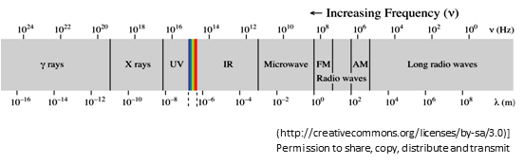
Figure 1. Electromagnetic spectrum.

1.2.4 Statement of Problem
Some free radicals are not reactive and remain stable with their unpaired electrons. These relatively stable radicals do not pose as much of a threat. Usually, though, free radicals are quite reactive with their surroundings. If they are exposed to oxygen, a material can oxidize and degrade at an accelerated rate. This process is commonly referred to as “oxidation” and is a primary mode of breakdown for many materials. Aerogels are very porous, so they have high exposure to air (which contains oxygen). Therefore, aerogel materials will therefore more potential to quickly react with free radicals created via ionizing radiation. As a control for these reactions, one may use an inert gas. Nitrogen is very inert (non-reactive); therefore, radicals would be expected to react less.
Comparison of silica aerogel to radiation exposure has been investigated by Sahu et al. [7], concluding that silica aerogels can be used in high-radiation environments without any fear of radiation damage, based on before-and-after refractive index measurements. However, there are no studies which investigate if free radicals are created by radiation in aerogels, including the PSCA type.
The problem is that without assessing the creation of free radicals, which indicate molecular damage from radiation, one cannot conclude broadly that ionizing radiation does not damage aerogels. Initial exploratory tests, in regard to the current project, to detect free radicals via ESR in PCSA, showed significant differences of free radical content before and after radiation exposure. Since ESR-detected free radicals are indicative of molecular-scale change, and therefore possible precursors to negative subsequent consequences, it is therefore worthwhile to investigate radiation-induced radicals in these aerogels. A primary goal of reliability and maintainability engineering, and of industrial engineering, is to establish the necessary confidence that a system and its components function as required when needed. This project will provides needed information to better determine how PCSA components will function in environments involving radiation.
1.3 Experimentation
1.3.1 Summary of Experiment
A diagram which outlines the experiment for this study is shown in Figure 2. Two levels of X-irradiation were used; one set of testing was performed in air immediately after X-irradiation, while one set of testing was performed in nitrogen (i.e., in the absence of oxygen). Additionally, samples were stored in either air or nitrogen for one week and retested.

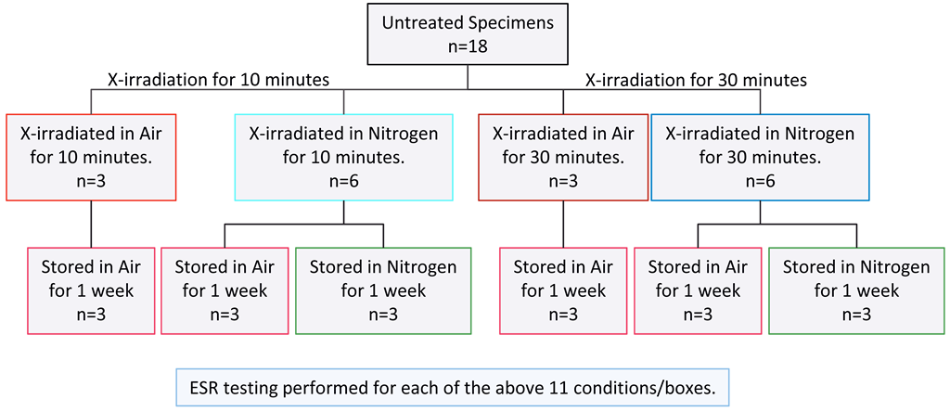
Figure 2. Experimental design for treatments of PCSA

1.3.2 Rationale for Using X-Ray
Indicated in Figure 2, X-ray is what this experiment evaluates. From the primary types of ionizing radiation mentioned earlier (gamma, X-ray, and UV), gamma radiation is quite difficult to access, requiring samples to be mailed back and forth, therefore missing important free radical information shortly after radiation exposure. Highly reactive free radicals would only be observable for a short time after they are created, as their activity would occur more quickly. One unique advantage of using X-ray in this experiment is that the testing includes direct access to an X-ray machine, which enables free radical testing to be performed immediately after radiation exposure. While UV is a type of ionizing radiation that could create free radicals, its energy is low relative to X-ray and gamma. X-ray may therefore serve as the best general assessment, since its energy is in-between gamma and UV and because its accessibility enables testing directly after treatment.
1.3.3 Reference materials (UHMWPE and PEEK)
This type of investigation with aerogels is relatively unknown. Therefore, a reference is created by having treatments also performed on two non-aerogel materials which are more well-known: Polyethylene and Poly-Ether-Ether Ketone (PEEK). Polyethylene is used as a reference for a material known to undergo large-scale free radical creation and degradation upon radiation exposure [8]; the particular type of polyethylene tested here is called Ultra-High Molecular Weight Polyethylene (UHMWPE). PEEK is used as a reference for a material known to be very radiation-resistant [9, 10]. Therefore, in this experiment, PCSA, PEEK, UHMWPE all undergo the same treatments as illustrated Figure 2. This approach should accomplish a better determination as to the existence of radiation damage in aerogel materials, especially of the particular type of aerogels emphasized in this study: PCSA.
1.3.4 Hypotheses
In summary of this experiment, the general hypothesis of the project is:
Hypothesis 1: “If PCSA is exposed to X-irradiation, then free radicals will be created.”
The null hypothesis would then be “There is no difference in quantities of free radicals in PCSA, whether or not it is exposed to X-ray.” As initial testing reveled that there are indeed different amounts of free radicals in PCSA that is subjected to X-ray, then the following additional hypotheses will be tested:
Hypothesis 2: “There will be different quantities of free radicals in PCSA which is irradiated for 30 minutes, vs. that which has is irradiated for 10 minutes.”
Hypothesis 3: “There will be different quantities of free radicals in PCSA which is irradiated in nitrogen, vs. that which is irradiated in air.”
Hypothesis 4: “There will be different quantities of free radicals in PCSA which is stored in nitrogen after irradiation, vs. that which is stored in air.”

Chapter 2

Literature Review
This literature review covers information regarding aerogels which additionally highlight the need for further investigating its interactions with radiation. Found were six significant studies relative to this topic, listed in Table 1.
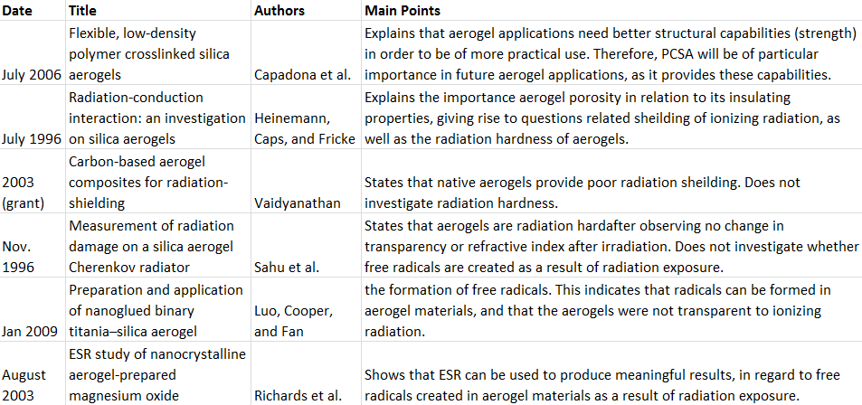
Table 1. Summary of literature review references.

Capadona et al. highlighted proposed uses for aerogel materials, and their need for better structural capabilities to combine with their present properties [11]. The paper mentions that “future space exploration missions as well as advanced aeropropulsion systems demand lighter weight, robust, dual purpose materials for insulation, radiation protection and/or structural elements of habitats, rovers, astronaut suits, and cryotanks.” While PCSA provides structural capabilities, if radiation alters the molecular makeup, then the other properties may be less realized. It is therefore important to assess free radical content as a result of such radiation.
In 1996, Heinemann, Caps, and Fricke [12] investigated heat transfer in native aerogels, explaining that an aerogel’s insulating properties have to do with the structure of their interconnected pores. These very small pores are interconnected to create very tortuous paths through the material, like tunnels that turn many different ways many times in a complicated fashion, so it is difficult for heat to travel through. It may be surprising that any aerogels can be so insulating and prevent heat transfer, since aerogels are mostly air and very porous.
Heat is related to the infrared type of electromagnetic radiation, so it is reasonable to think that the properties which provide thermal shielding may also shield against ionizing electromagnetic radiation such as x-ray. The mass per unit area, or density, of an object is one of the main factors to increase shielding of the ionizing type of radiation such as x-ray, and as aerogels have very low density, they provide poor shielding in this regard [13]. For example, one dense material that provides good radiation shielding is lead.
In contrast to radiation shielding, a “radiation hard” material should not be negatively affected or damaged by a particular type of radiation. For an analogy to heat, a material may melt or be otherwise negatively affected at higher temperatures, which may or may not correlate with its heat-shielding ability. For an analogy to ionizing radiation, a material that is not radiation hard may form many free radicals and undergo molecular damage, which could certainly impact other characteristics. A description of radiation hardness, then, is more synonymous with descriptions of radiation resistance, or of radiation damage, to which this project contributes.
As mentioned in Chapter 1, radiation hardness had been addressed by Sahu et al. [7], who concluded that native silica aerogels were indeed radiation hard after observing no change in transparency or refractive index after irradiation. In January 2009, Luo et al. [14] studied titania (TiO2)–silica (SiO2) aerogels and compared with photocatalytic reactions, which is when one interacts UV-irradiation with titanium dioxide - the same as the “titania” referred to here. Results suggested that the hydroxyl (•OH) radical was formed. While Luo et al. used titanium dioxide (as opposed to native silica aerogel or PCSA), the paper indicates that radicals can be formed in aerogel materials, and that the aerogels were not transparent to ionizing radiation. While the current study focuses on PCSA, a test with native silica aerogel was also performed at the end of Chapter 4 to show similar non-transparency and accumulation of free radicals.
In 2003, Richards et al. [15] conducted an ESR study involving magnesium oxide aerogels. They observed two different ESR signals, reflective of the magnesium oxide used in the manufacture of the aerogels, one of which remained when heating up to 500°C; the other remained up to 300°C. They also produced similar radicals with UV-radiation. This study shows that interactions with radiation can vary depending on the type of aerogel used. Therefore, previous studies related to aerogels and interactions with radiation may have results which differ from that of the present study, which focuses on the PCSA type.
No other literature was found which investigates radiation-induced free radicals in, or ESR studies of, aerogel materials. Initial exploratory tests for the present study, to detect free radicals via ESR in PCS, as well as in native-silica aerogels, showed significant differences of free radical content before and after radiation exposure. Since ESR-detected free radicals are indicative of molecular-scale change, and therefore possible precursors to negative subsequent consequences, it is worthwhile to continue further with this study.

Chapter 3
Experiment
3.1 Materials
As mentioned in Chapter 1, radiation resistance involving PCSA and other aerogels is relatively unknown, so a reference is created by having all treatments also performed with two more well-known materials: UHMWPE and PEEK. Illustrated in the experimental diagram of Figure 2, eighteen specimens of PCSA were used for this study, which enables three representative specimens for each condition. Because PEEK and UHMWPE are used as a general reference (not the subjects of this study) for comparison, each has only one representative specimen for each condition. Representative pictures of PCSA, UHMWPE, and PEEK are shown in Figure 3.
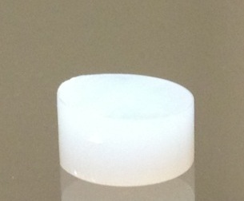
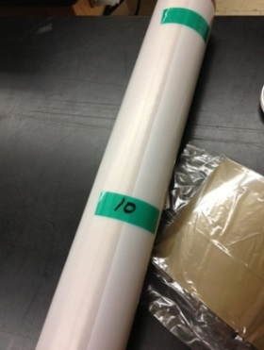
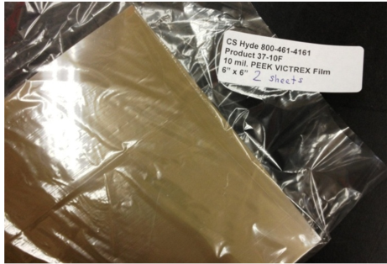
Figure 3. Materials used for this study. Left: PCSA; Center: UHMWPE (the white roll). Right: PEEK (tan material). Photos are of actual materials used in this study.

3.1.1 PCSA
The PCSA used for this study was obtained from the laboratory of Dr. Firouzeh Sabri at the University of Memphis, who synthesized them according to the same method as described her recent publication [6]. The manufacture of aerogels is a complex process. The laboratory of Dr. Sabri has many years’ experience in the synthesis of a wide variety of aerogel materials, and is therefore a reliable source to obtain well- and consistently-made samples for this project.
3.1.2 UHMWPE
UHMWPE is, in essence, a strong form of plastic. It is often used in the medical device industry, where it has faced problems due to free radicals created by ionizing radiation used for sterilization, resulting in problematic oxidative degradation. For example, UHMWPE is often sterilized with gamma irradiation, which has been shown to create free radicals which then react with oxygen, which then results in oxidation and resulting embrittlement and wear particles generated [8].
3.1.3 PEEK
PEEK is very strong relative to its weight. PEEK is also known to be very radiation resistant; it is said that PEEK “has good resistance to beta and X-rays, as well as exceptional resistance to gamma rays” [9]. The present project uses X-rays, so may additionally serve to check this radiation-resistance of PEEK.
3.2 Exposure
3.2.1 X-irradiation levels
All specimens (PCSA, PEEK, and UHMWPE) were X-irradiated (X-rayed) for either 10 minutes or 30 minutes to serve as “low” and “high” levels of radiation. X-irradiation was performed at room temperature using an X-ray source (Scientific America™) operating at 50 kV and 45 mA. The dose rate was approximately 1 kGy per hour, so 30 minutes would be about 0.5 kGy (50 krad). This dose rate had been previously determined for the x-ray source. Since this rate was not personally calibrated/verified at the time of testing, it is preferred for this project to describe these treatments in terms of time (as opposed to dose). That is, the 30-minute treatment is certainly 3x the dose of 10-minute treatment due to a constant dose rate; the exact dose received is undetermined, but is approximately 1 kGy per hour.
3.2.3 X-irradiation Environments and Equipment
An attempt is made to distinguish interactions of free radicals with oxygen by using two different irradiation environments: one set irradiated in air, and one irradiated in nitrogen. As aerogels are porous and therefore exposed internally to air, the samples to be irradiated in nitrogen would need to initially be purged of air. Therefore, it was attempted to first remove as much of this air as possible via vacuum. Figure 4 shows the vacuum setup, X-ray chamber and nitrogen used. Samples were transferred from the vacuum chamber to the nitrogen-purged X-ray chamber, which included exposure to air for about 1 minute. This was therefore a “best effort” to create an air-free X-irradiation environment (to compare with those irradiated in air). Samples which were irradiated in air were done so in a normal room air environment with no nitrogen-purge.
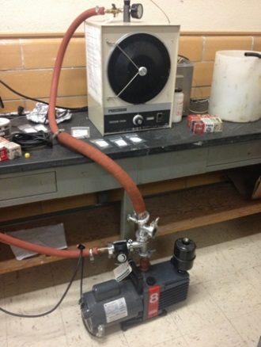
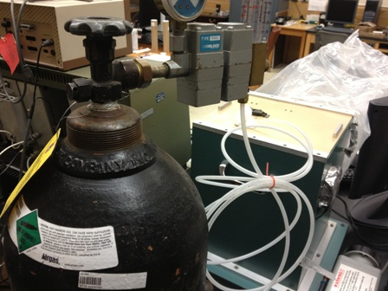
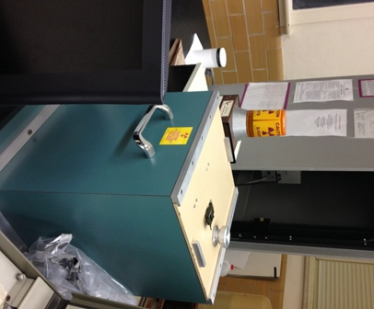
Figure 4. Vacuum and X-ray chamber used in this study. Left: vacuum pump and chamber used in an attempt to remove air/oxygen from the porous aerogel samples. Center: X-ray chamber (blue box) in which samples were irradiated. Right: Nitrogen gas cylinder and hose used to purge the X-ray chamber.

3.3 Response: Free Radical Measurements

As mentioned in the introduction, the goal is to determine whether or not ionizing radiation (in this case, X-irradiation) might create free radicals in these aerogels, and how the radicals may interact with air. The response we would like to see is the creation of free radicals, or lack thereof, and how these responses vary among the different treatments.

3.4 ESR Evaluation of Treatments

Immediately following irradiation, samples were tested for free radical content via ESR. Specimens which were irradiated in nitrogen were tested in nitrogen; specimens which were irradiated in air were tested in air. Measurements were performed using an X-band ESR spectrometer (Bruker EMX) operating at 9.8 GHz microwave frequency and 100 kHz receiver modulation frequency. The X-ray source was adjacent to the ESR spectrometer, allowing these initial tests to commence within 5 minutes following X-irradiation treatment.

For calculations of free radical concentrations in these materials, ESR spectra were obtained with microwave power settings maintained at 1 mW, modulation amplitude at 5 Gauss, time constant at 328 milliseconds for 200 Gauss sweep with a sweep time of 168 seconds. Further details of electron spin resonance (ESR), and its detection and calculation of free radicals, is presented in Appendix A.

3.5 Post-irradiation Storage Environments and ESR Testing

After ESR-testing immediately following X-irradiation treatments, samples were stored for one week in either air or nitrogen (as also illustrated in Figure 2). After storage treatments, samples were again ESR-tested using the same procedure as was employed immediately following X-irradiation. ESR is a non-destructive technique which does not alter the condition of the tested material, so the same specimens were able to be stored and then retested after the one-week storage periods.

Samples which had been treated in air were not stored in nitrogen, as the effects of air exposure would have already begun. Samples which were treated in nitrogen were split into two sets: one to be stored in air for one week and one to be stored in nitrogen. Nitrogen-stored specimens were done so in nitrogen-purged, sealed, gas-impermeable packaging. At the end of the one-week storage period, these packages were checked that they were similarly inflated as they began, assuming this would indicate that no leakage had occurred. Air-stored specimens were stored in air within zip-lock packaging.

3.5 Summary of Treatments

To summarize all initial radiation exposures and the post-irradiation storage environments, the total number of treatments is 10 (as also illustrated by the 10 boxes of Figure 2):
- X-irradiation at low level (10 minutes) in air.
- X-irradiation at low level (10 minutes) in nitrogen.
- X-irradiation at high level (30 minutes) in air.
- X-irradiation at high level (30 minutes) in nitrogen.
- X-irradiated at low level (10 minutes) in air and stored in air
- X-irradiated at high level (30 minutes) in air and stored in air
- X-irradiated at low level (10 minutes) in nitrogen and stored in air
- X-irradiated at low level (10 minutes) in nitrogen and stored in nitrogen
- X-irradiated at high level (30 minutes) in nitrogen and stored in air
- X-irradiated at high level (30 minutes) in nitrogen and stored in nitrogen

Chapter 4
Results
4.1 Overall Guideline
In this chapter, three primary means of presentation will be shown:
- ESR spectra (line graphs), which represented detection of free radicals.
- Numerical values (in tables) representing quantities of free radicals in these samples – referred to as Free Radical Concentrations (FRC).
- Bar-graphs to compare these FRC estimates in a better visual fashion.
Summary of subsequent sections:
- Section 4.2 will show data for untreated (as-received) materials.
- Section 4.3 will show data for Treatment 1 (X-irradiation at low level (10 minutes in air)), as listed at the end of Chapter 3.
- Section 4.4 will show data for X-irradiation at high level (30 minutes) in air, which is Treatment 3, as listed at the end of Chapter 3.
- Section 4.5 will summarize all other treatments, following the three primary means of presentation listed at the beginning of this section.
  - Section 4.5.1 will summarize data for PCSA.
  - Section 4.5.2 will summarize comparative data for UHMWPE.
  - Section 4.5.3 will summarize comparative data for PEEK.
  - Section 4.5.6 will summarize comparative data for native silica aerogel (not PCSA).
- All data will then be considered in support of conclusions, in regard to the four hypotheses stated at the end of Chapter 1.
While results are summarized in this chapter, further explanation of ESR and free radicals, and free radical analysis via ESR, are given in Appendices A-E. Most relative to the specific ESR graphs of this chapter, acquisition of ESR spectra and methods of analysis, are found in Appendix E. While more information of free radicals in a material is possible via analysis of ESR data, these results are primarily concerned with free radical quantification – i.e., the present quantity of free radicals in these materials. Appendices B and C, in particular, provide additional information for quantification and FRC data interpretation.
The following sections show data for PCSA, PEEK, and UHMWPE that has been X-irradiated for 10 minutes and 30 minutes in air (approximately 0.2 and 0.5 kGy, respectively). As summarized in the experimental diagram of Figure 2, both levels (10- and 30-minute) of X-irradiation treatments were also performed in nitrogen. After irradiation for all samples, two sets of storage environments (storage in air, and storage in nitrogen) were implemented, and all samples were retested after one week. These treatments will be displayed in a summarizing fashion, using the three means of presentation listed at the beginning of this section.
4.2 Untreated Materials (Before Irradiation Treatment)
All materials were initially tested in their “as-received” condition before any treatments were applied. The ESR technique is non-destructive, so the same specimens could be retested after treatments. Again, Appendices A-E provide details regarding ESR and FRC.
4.2.1 Untreated PCSA
ESR spectra indicated a presence of free radicals in the PCSA before any radiation treatment. A representative ESR spectrum is shown in Figure 5. All of the non-irradiated PCSA specimens tested (n=18) showed a similar ESR signal. The bars of Figure 6 represent the individual values for each untreated PCSA specimen. There was variation in these results; they averaged about 7.8 x 10¹⁴ spins per gram, with a standard deviation of 2.5.
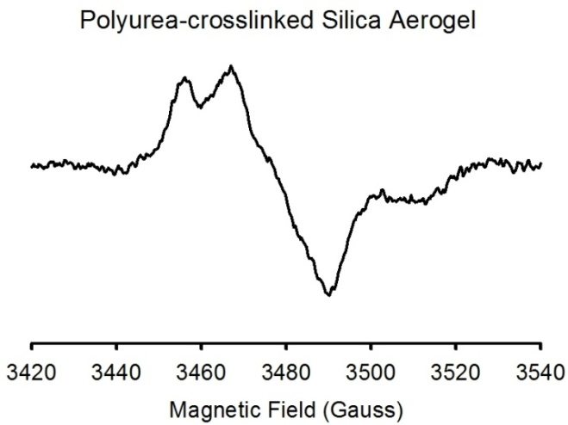
Figure 5. Untreated PCSA. An ESR spectrum acquired before any radiation treatment.

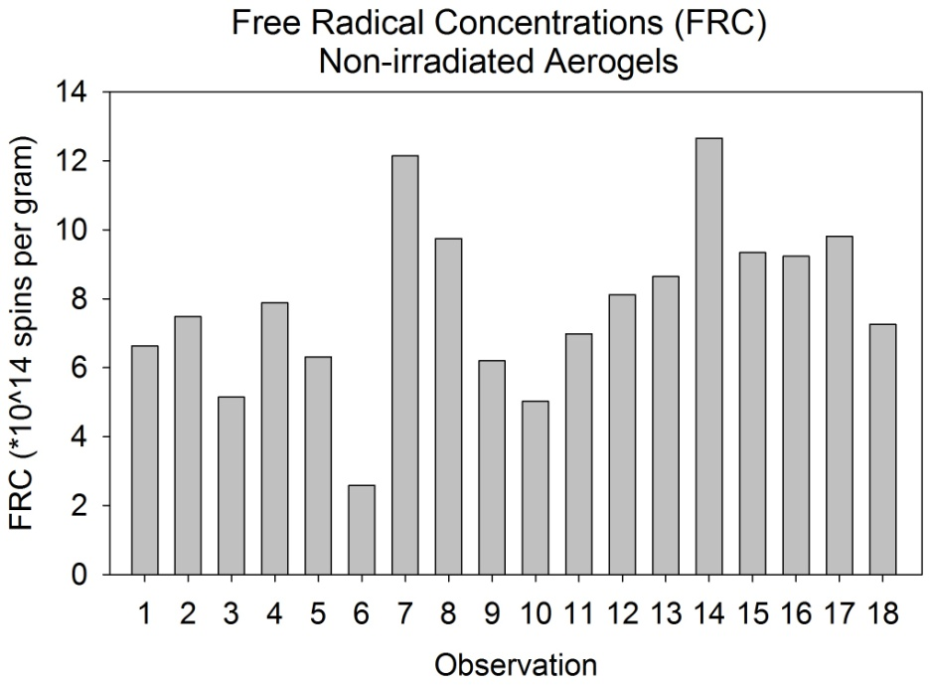
Figure 6. FRC for all untreated PCSA specimens (each “observation” is an individually tested specimen)

4.2.2 Untreated UHMWPE and PEEK
UHMWPE is more likely to produce free radicals up on radiation exposure [8], whereas PEEK is thought to be very radiation resistant [9, 10]. Before irradiation, the UHMWPE did not show a measurable presence of free radicals, as seen in Figure 7. Like the aerogels, the PEEK which was tested did show a measureable presence of free radicals, as seen in Figure 8.

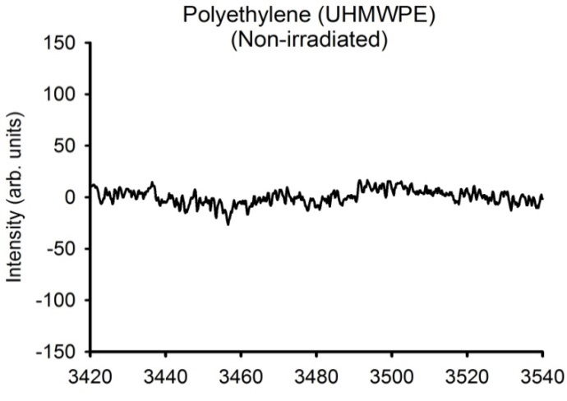
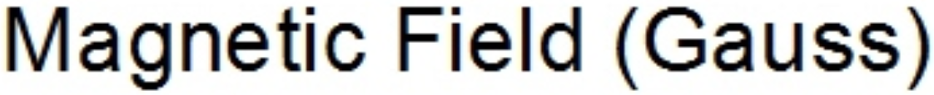
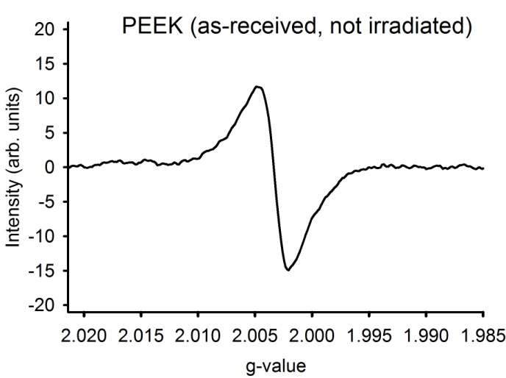
Figure 7. ESR spectrum of untreated UHMWPE.
Figure 8. ESR spectrum and corresponding FRC of untreated PEEK.
FRC (*10^14)
13.8

4.2.3 Untreated PCSA vs. PEEK
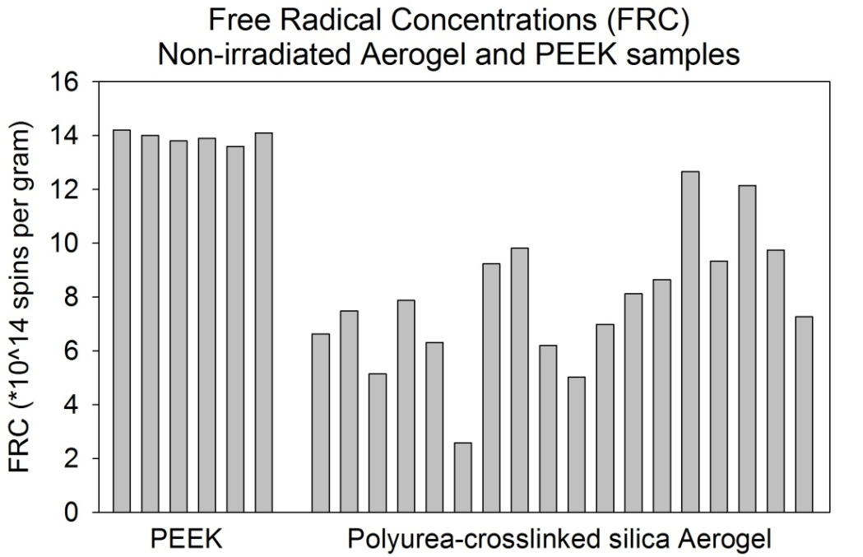
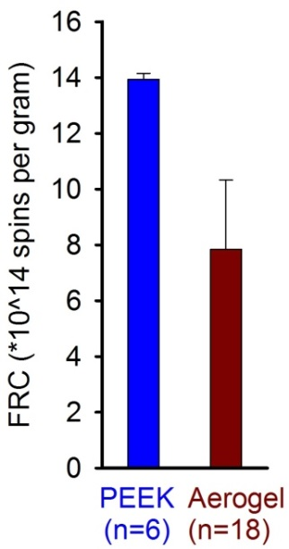
The PEEK samples appeared to have a slightly higher starting quantity of free radicals than PCSA, and exhibited less variation among the specimens tested, as represented by the bar graphs of Figure 9. The more consistent observations of the PEEK samples may be due to it being a commercial product (mass-produced) with more uniformity in its manufacture, whereas the PCSA was made in a laboratory on small scale and may have been slightly less uniform.
Figure 9. FRC for untreated PEEK and PCSA. FRC values for individually tested specimens are represented by the bar heights. The corresponding means are shown on the right, with error bars representing standard deviation. UHMWPE is not shown because it did not have a detectable presence of free radicals before irradiation.
4.3 X-irradiation in Air (10-minute exposure)
4.3.1 PCSA
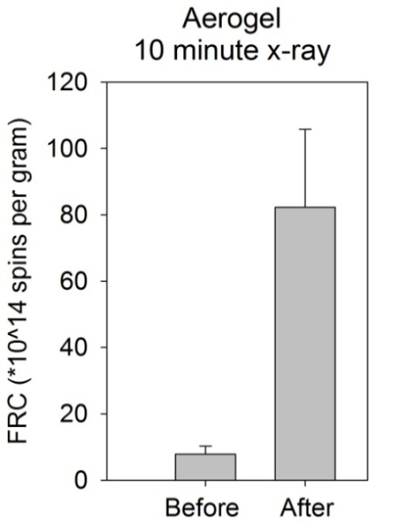
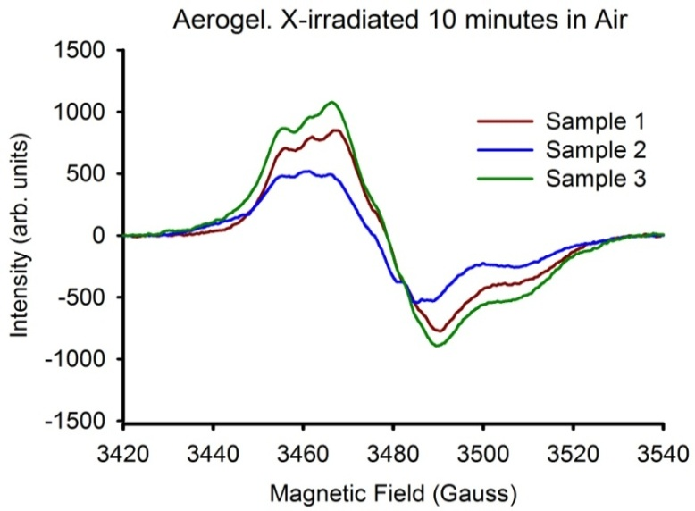
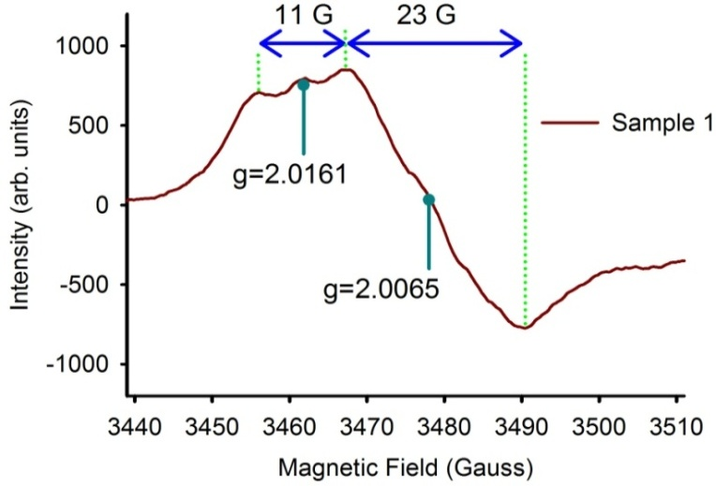
Shown in Figure 10, after 10-minute X-ray exposure in air, there looks to be an approximate 10x increase in free radicals and a new spectral feature is seen around the g-value (g) of 2.0161, indicating that new types of radicals may be present (“g-value” is further discussed in Appendix D).
Figure 10. PCSA immediately after 10-minute X-irradiation in air.
Obs. | FRC (*10^14)
1 | 97.1
2 | 58.8
3 | 98.7
Mean | 84.9
Stdev | 22.5

4.3.2 UHMWPE and PEEK
Two UHMWPE and two PEEK specimens were exposed to the same X-irradiation as the PCSA samples; their resulting ESR spectra are shown in Figure 11. The UHMWPE does show a significant amount of radicals present. The UHMWPE radicals were obviously induced by the radiation, as there were no detectable radicals previously. The PEEK also shows additional radical quantities, including new types of radicals as indicated by the new spectral features such as at g=2.0080.
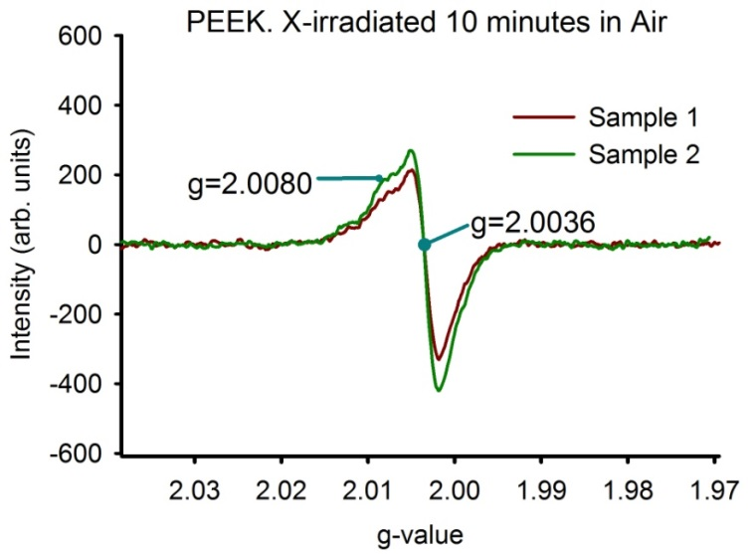
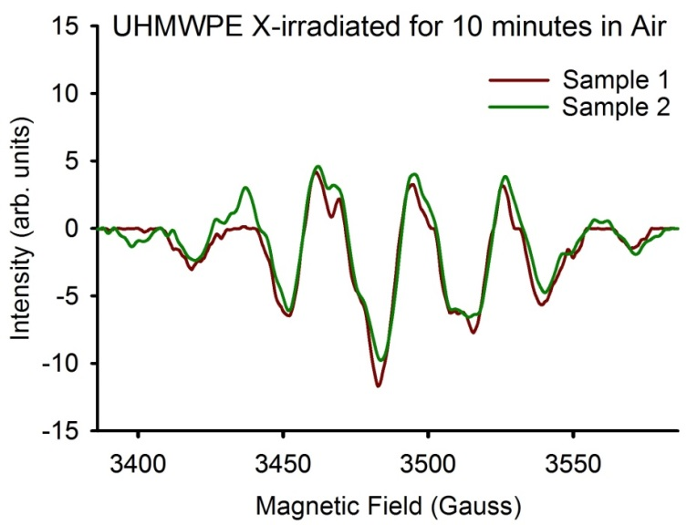
Sample | FRC (*10^14)
1 | 33.8
2 | 34.3
Mean | 34.2
Stdev | 0.5

Figure 11. ESR spectra of PEEK and UHMWPE after 10-minute X-irradiation in Air.
Sample | FRC (*10^14)
1 | 22.6
2 | 24.4
Mean | 23.5
Stdev | 1.27

4.4 X-irradiation in Air (30-minute exposure)
4.4.1 PCSA
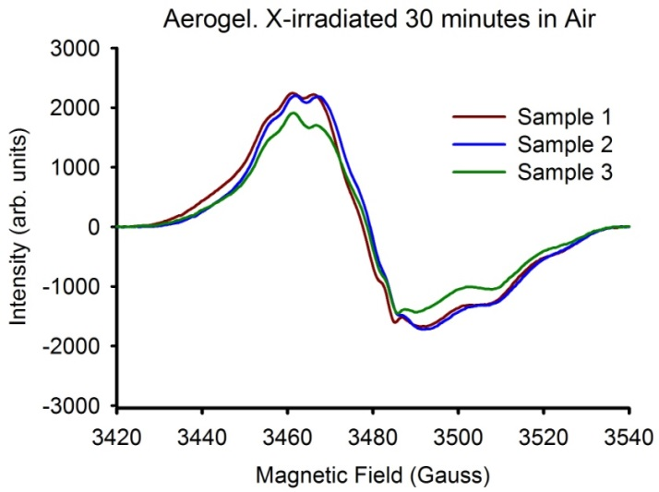
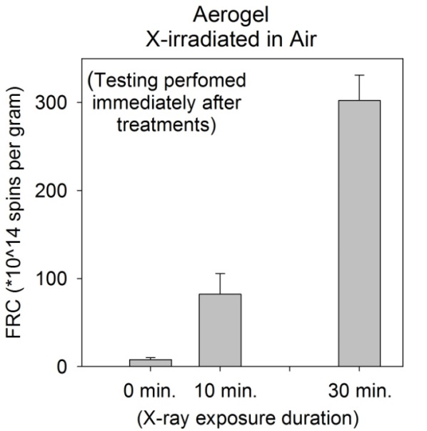
Effects of X-irradiation were further evaluated by applying two different levels were applied (10 minutes and 30 minutes). The dose rate was the same for both levels (approximately 1 kGy per hour, so 30 minutes would be about 0.5 kGy (50 krad)). Figure 12 shows the resulting ESR spectra reflective of three PCSA specimens with radicals induced by the 30-minute X-irradiation in air. More pronounced is the additional feature at about g=2.016, which was seen to a lesser extent in Figure 10 (of the 10-minute treatment). The quantities of radicals look to be about 3x that of the 10 minute treatments, indicating that the rate of free radical production is not slowing down/saturating with this level of dose yet, and that these radicals are likely not reacting immediately with their surroundings or with each other. Also, there is an additional feature near the bottom of the spectra (near 3480 Gauss) that was not as noticeable in the 10-minute spectra.
Figure 12. PCSA after 30-minute X-irradiation in air. Shown to the right are bars representing corresponding FRC values, compared with that of the untreated and 10-minute-irradiated PCSA (error bars represent standard deviation).
4.4.2 UHMWPE and PEEK
As with the 10-minute X-ray treatments, UHMWPE and PEEK specimens were exposed to the same 30-minute X-irradiation as the PCSA. Similar to the PCSA observations, the UHMWPE shows additional free radical accumulation for 10-minute vs. 30-minute treatments in Figure 13. While distinguishing specific radical types is beyond the scope of this paper in general, it is worthy of mention here that these UHWMPE spectra are indicative of one type of radical known as “alkyl” radicals, which react readily with oxygen (such as in air) and could therefore lead to oxidative degradation of the polyethylene.
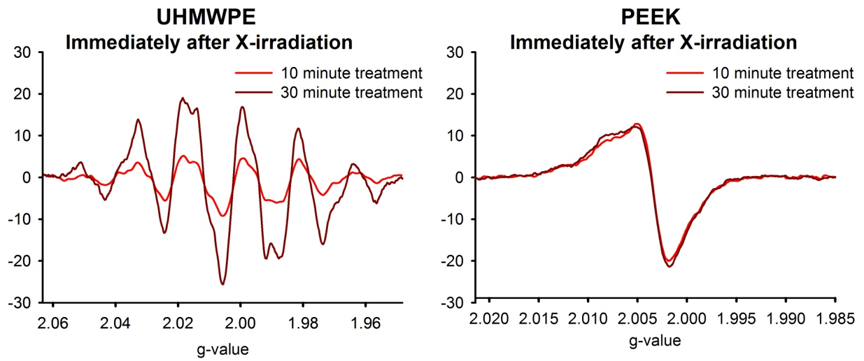
Recall that PEEK was chosen for this project to serve as a reference for something which is radiation resistant. While some new radicals did form in PEEK upon the lower dose of X-irradiation (10 minute treatment), these quantities did not increase much with the higher level (30 minute treatment). ESR spectra for the two irradiation levels (10 and 30 minute treatments) are compared in Figure 13 along with that of UHMWPE; the spectra are normalized and used g-value as described in Appendix D for better visual comparison.
Figure 13. ESR spectra of UHMWPE and PEEK with 10- and 30-minute X-irradiation.
4.5 All Treatments
4.5.1 PCSA
Figure 14 shows a summary of all PCSA treatments and testing. Recall that before irradiation, the quantities of free radicals in PCSA averaged about 7.8 (*10^14) spins per gram. We see that most 10-minute treatments are around 100, while most 30-minute treatments can be described vaguely as being around 300. Since the 30-minute treatment is indeed 3x the dose of the 10-minutes treatment, it seems reasonable that the effect would also be 3x.
There is significant variation in the PCSA irradiated in nitrogen (blue bars). A first impression would be that there is a significant difference between 10- and 30-minute treatments, in general, and that there is little difference in air-vs.-nitrogen.

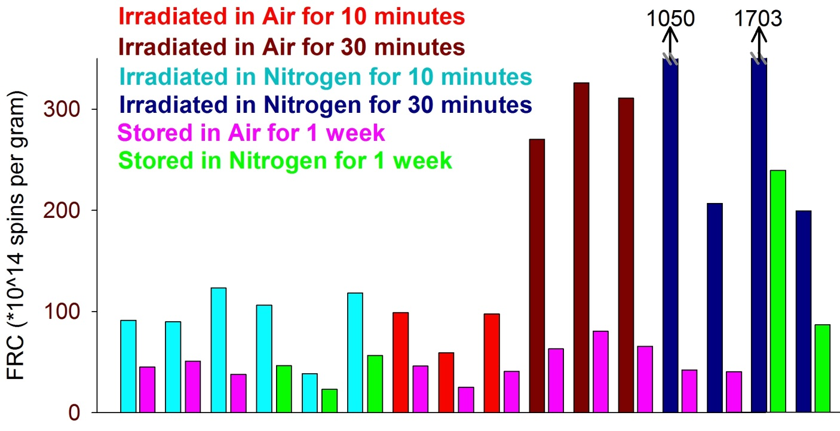
Figure 14. Summary of all PCSA treatments and testing. Color-coded bars correspond to the color-coded font, which identifies each condition. The pink and green bars represent one-week storage, after the acquisition of the data for the bar that they are just to the right of.

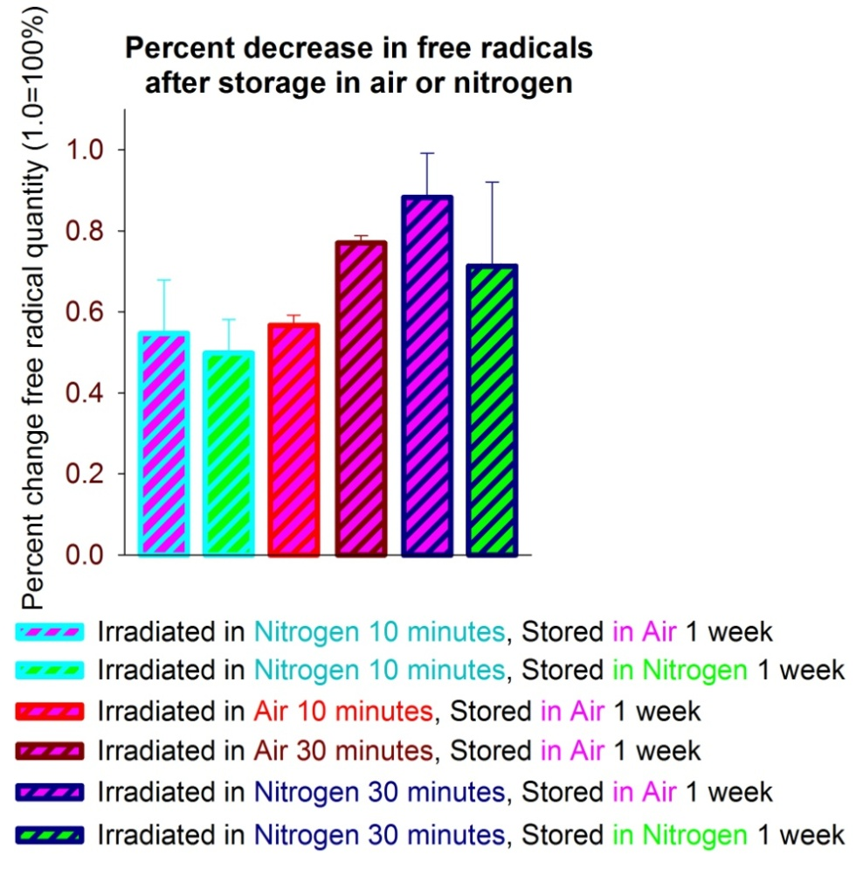
Figure 15 provides a closer look at the responses after storage in air-vs.-nitrogen, following the initial treatments. Upon this preliminary visual inspection, it may be discerned that there is some difference between those that had undergone 30-minute treatments (as opposed to 10-minute treatments). The effects of air exposure appear indistinguishable from nitrogen.
Figure 15. All PCSA after storage.
Pages 29–35 show details of all PCSA treatments via Figures 16-22, whose data is summarized in Table 2 on page 23. These figures and data can be explained as follows:
Figure 16 shows ESR spectra from all PCSA specimens which were irradiated in nitrogen for 10 minutes. Also included are individual free radical concentration (FRC) estimates (All FRC values represent 10^14 spins per gram of material). As with the bar graph of Figure 15, there does not appear to be much difference when stored in nitrogen vs. in air.
Figures 17 and 18 show all of the ESR spectra of the PCSA specimens which were irradiated in air for 10 minutes and for 30 minutes. Also included are individual free radical concentration (FRC) estimates. Again, there are significant differences apparent for the 10-minute vs. 30-minute treatments, but there does not appear to be much difference between treatments in air vs. nitrogen.
To get a better look at the free radical activity immediately after X-ray, one PCSA specimen (more specifically, that of the top left graph from Figures 17 and 18, which was irradiated in air for 10 minutes) was immediately retested with time, as shown in Figure 19. It is noticed that the free radical activity is noticeable immediately following treatment, as it decreases immediately with time. It appears that the overall radical population approaches stability within one day (24 hours), as there is very little difference between 24 hours and one week.
Figure 20 shows ESR spectra and corresponding free radical concentration (FRC) estimates of PCSA with all treatments involving 30-minute X-irradiation in nitrogen. These are on the same scale as those of Figure 16 (for comparison with 10-minute treatments in nitrogen). Most of these initial lines do not fit on this scale, it is therefore quite obvious that there is a large difference between the 10- and 30-minute treatments for X-irradiation in nitrogen. Figure 21 shows the same data as Figure 20, but with y-scales adjusted for the larger 30-minute treatments. Some of these 30-minute treatments vary widely (notice the different scales required). The ESR responses to storage in nitrogen are larger than those of storage in air, but they are individually proportional to the initial measurements, so that the actual effects of the storage environments is not significantly different.
For an additional look at one of the responses of PCSA irradiated in nitrogen for 30 minutes, a specimen (more specifically, that of the top right graph of Figure 20) was immediately retested with time, as shown in Figure 22. It is noticed that the radicals are quite active, as they are significantly decreasing with time. That is, these are not “stable” radicals – they are reacting with things nearby to pair up their previously unpaired electrons, thus becoming not-detectable because they are no longer free radicals. This sample was not tested after one day in air, like that Figure 19, as these data were exploratory asides from the primary plan for the experiment. It is possible that these very large responses were only so disproportionately large for the period of time immediately following treatment. In order to better determine when the radical quantities level off, future work can investigate in more detail free radical activity immediately following radiation treatment.

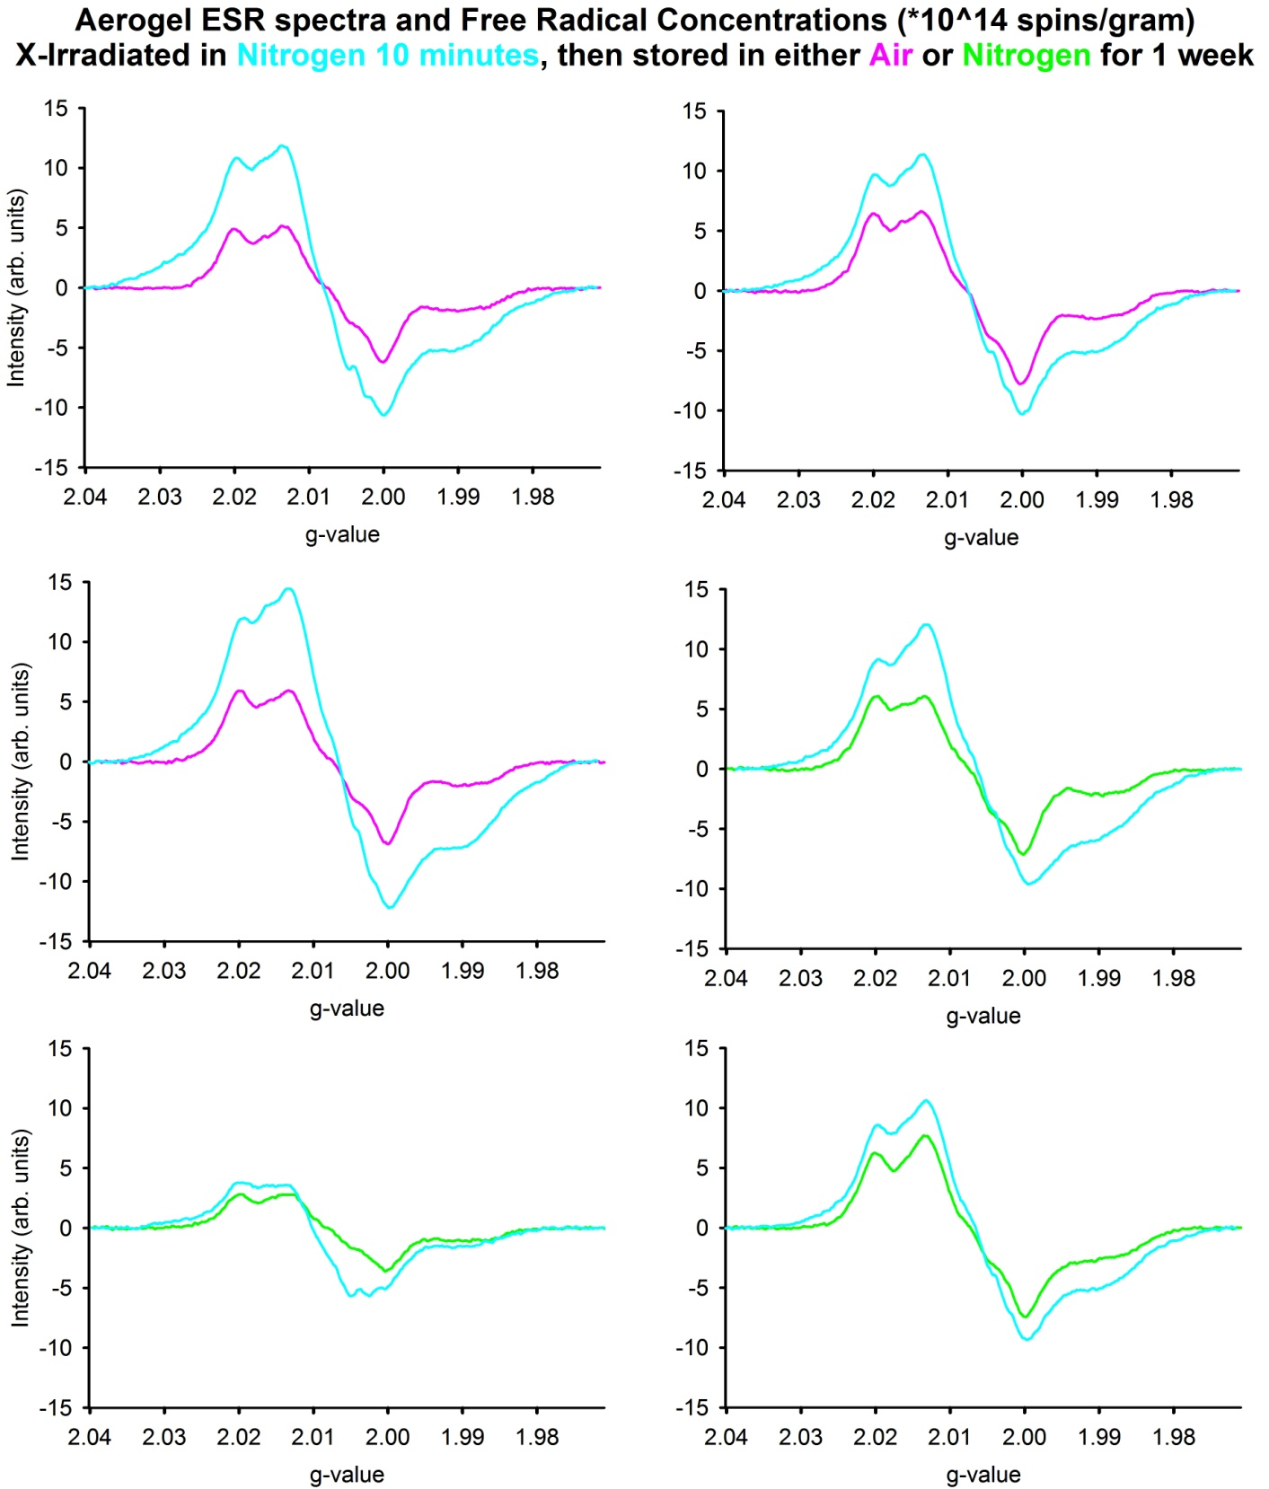
Initial | 89.7
1 week air | 50.6
% change | -44%

Initial | 118.0
1 week N2 | 56.1
% change | -52%

Initial | 38.4
1 week N2 | 22.8
% change | -41%

Initial | 123.0
1 week air | 37.7
% change | -69%

Initial | 106.0
1 week N2 | 46.1
% change | -56%

Initial | 91.4
1 week air | 44.8
% change | -51%

Figure 16. ESR spectra and FRC for all PCSA irradiated in nitrogen for 10 minutes. Shown are ESR spectra and corresponding FRC values. The FRC values represent 10^14 spins per gram of material.
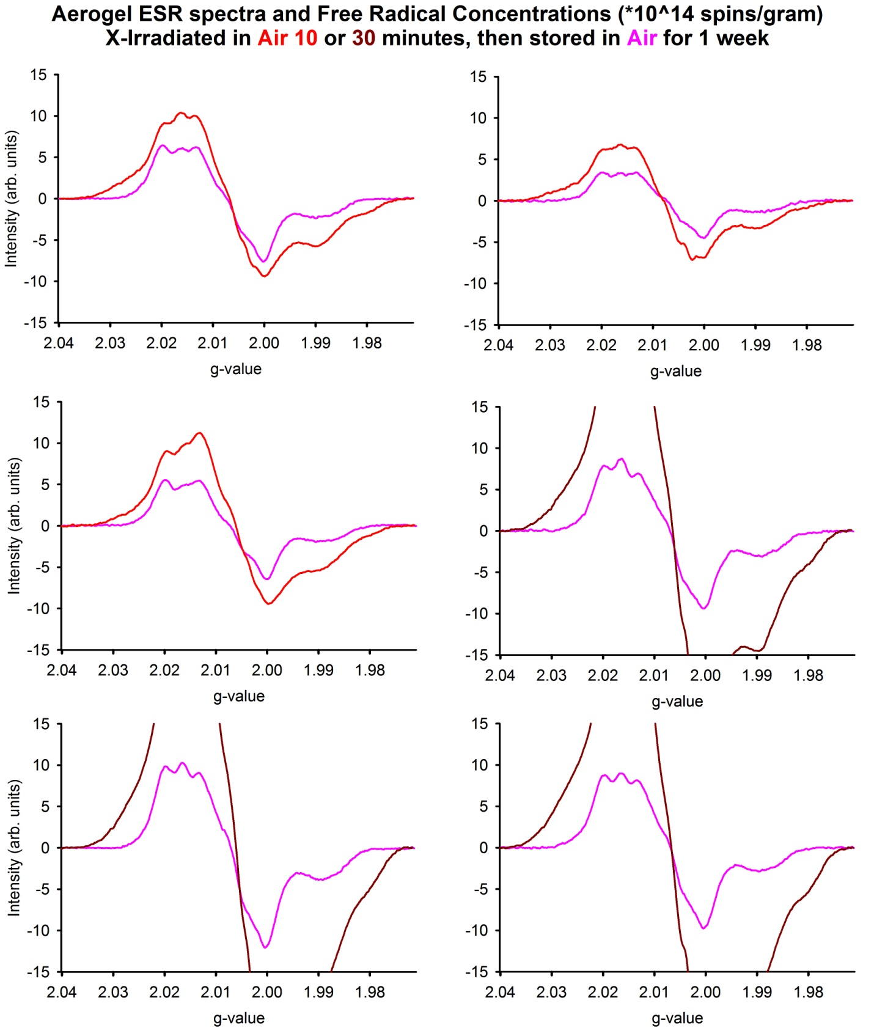
Figure 17. ESR spectra and FRC for all PCSA irradiated in air for 10 and 30 minutes.

Initial | 98.7
1 week air | 45.7
% change | -54%

Initial | 58.8
1 week air | 24.8
% change | -58%

Initial | 97.1
1 week air | 40.4
% change | -58%

Initial | 270.1
1 week air | 63.1
% change | -77%

Initial | 326.0
1 week air | 80.4
% change | -75%

Initial | 310.9
1 week air | 65.6
% change | -79%

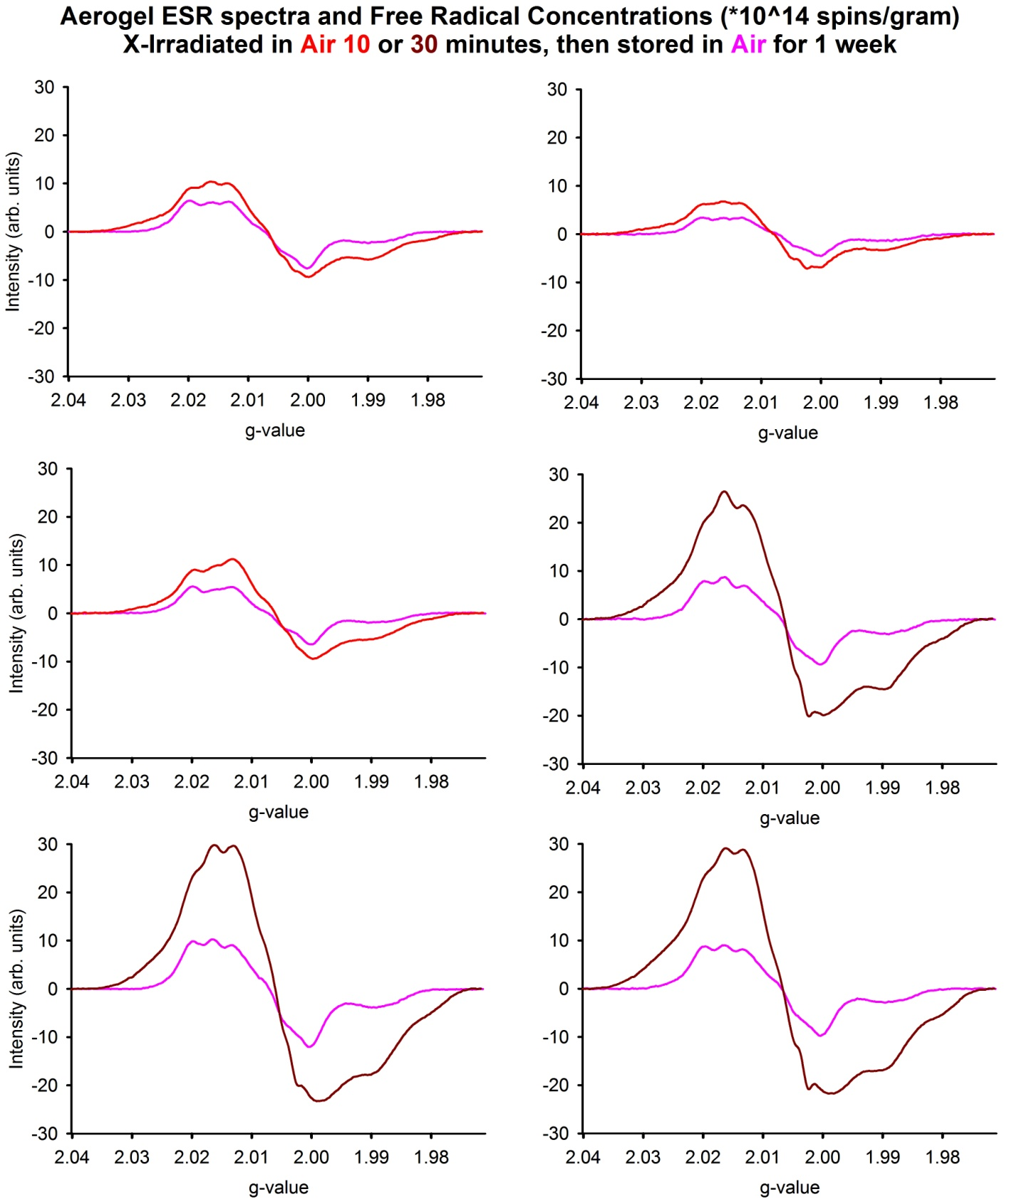
Initial | 98.7
1 week air | 45.7
% change | -54%

Initial | 58.8
1 week air | 24.8
% change | -58%

Initial | 97.1
1 week air | 40.4
% change | -58%

Initial | 270.1
1 week air | 63.1
% change | -77%

Initial | 326.0
1 week air | 80.4
% change | -75%

Initial | 310.9
1 week air | 65.6
% change | -79%

Figure 18. Same data as Figure 17; alternate y-scale. The 30-minute spectra of Figure 17 were too large to fit on the same scale as the others. Figure 18 therefore shows the same data as Figure 17, but y-scales adjusted for all so that the 30-minute treatments can be fully viewed.

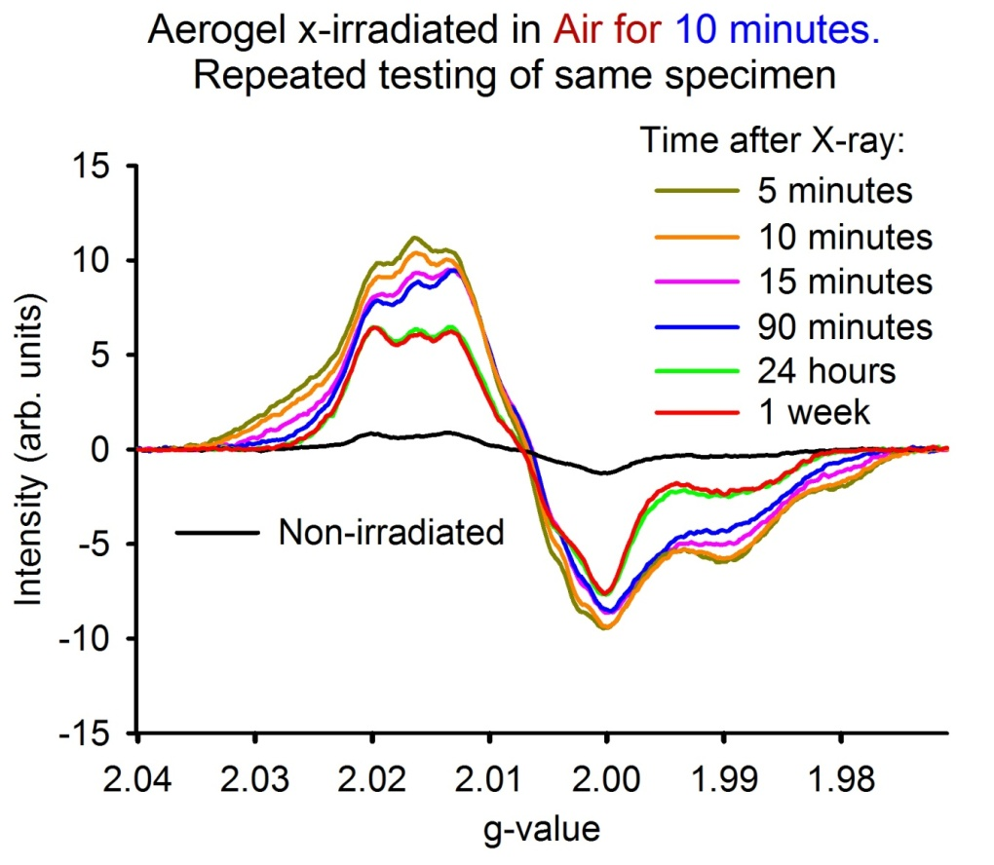
Figure 19. One PCSA specimen retested with time immediately after 10 minute X-ray in air.

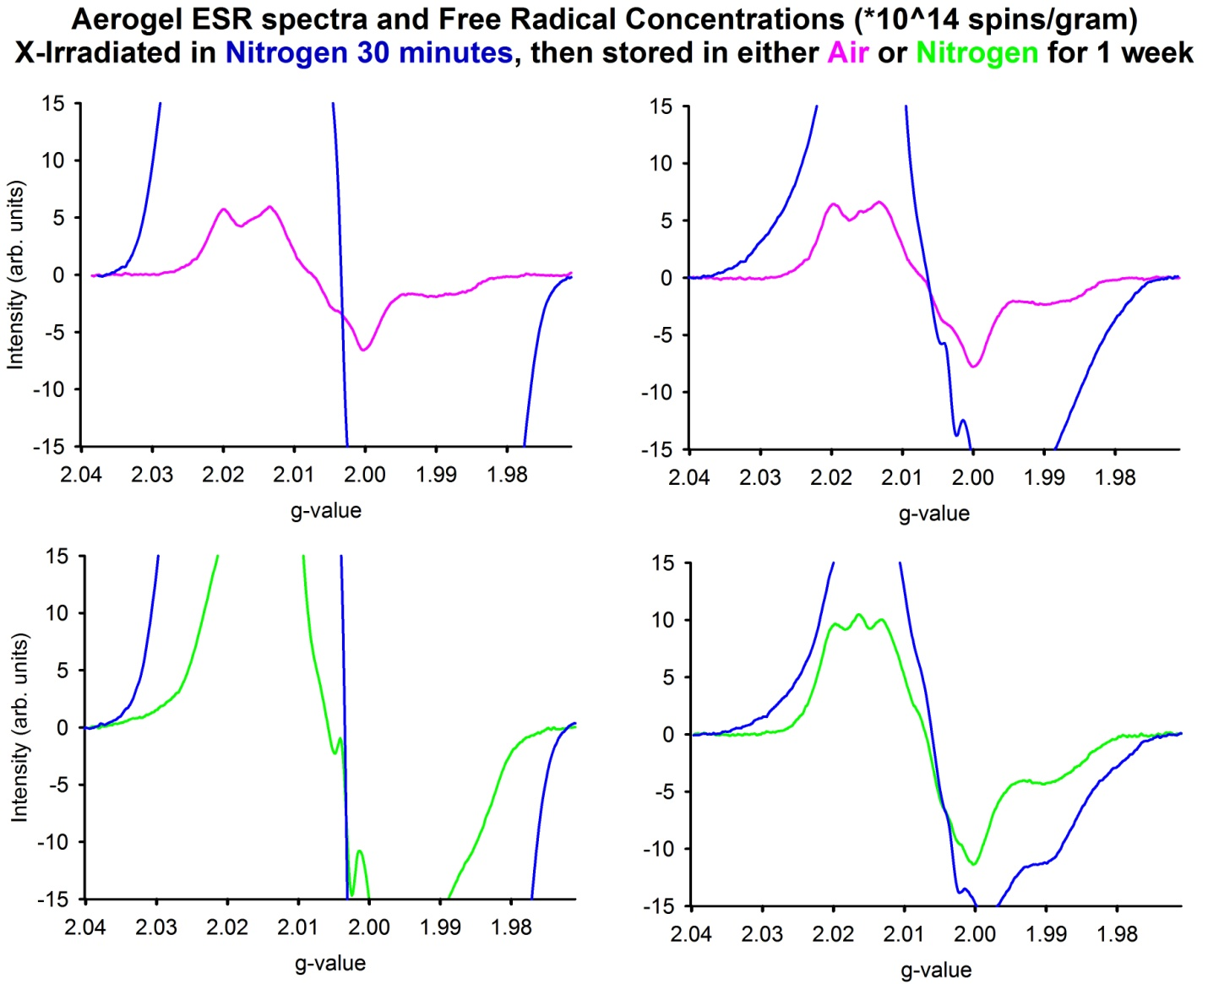
Initial | 199.1
1 week N2 | 86.5
% change | -57%

Initial | 206.7
1 week air | 40.3
% change | -80%

Initial | 1050.9
1 week air | 42.2
% change | -96%

Initial | 1703.5
1 week N2 | 239.1
% change | -86%

Figure 20. ESR spectra and FRC for PCSA involving 30-minute X-irradiation in nitrogen.

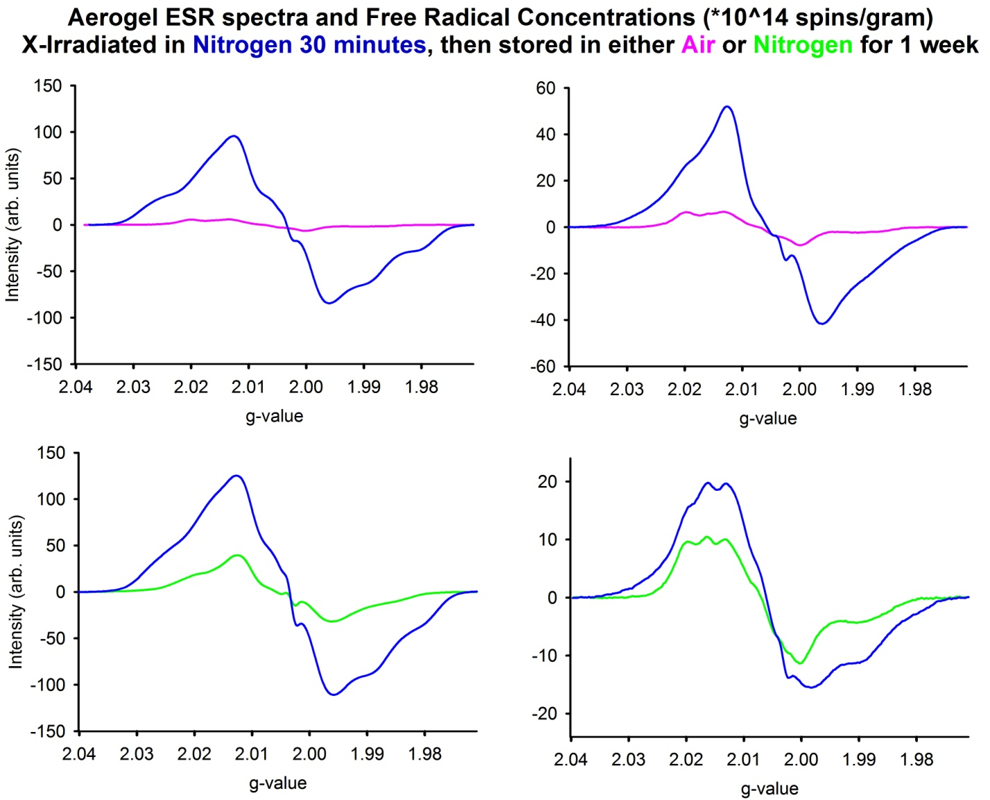
Initial | 1050.9
1 week air | 42.2
% change | -96%

Initial | 206.7
1 week air | 40.3
% change | -80%

Initial | 199.1
1 week N2 | 86.5
% change | -57%

Initial | 1703.5
1 week N2 | 239.1
% change | -86%

Figure 21. Same data as Figure 20; alternate y-scales. The 30-minute spectra of Figure 20 were too large to fit on the same scale as the others. Figure 21 therefore shows the same data as Figure 20, but y-scales adjusted for all so that the 30-minute treatments can be fully viewed.

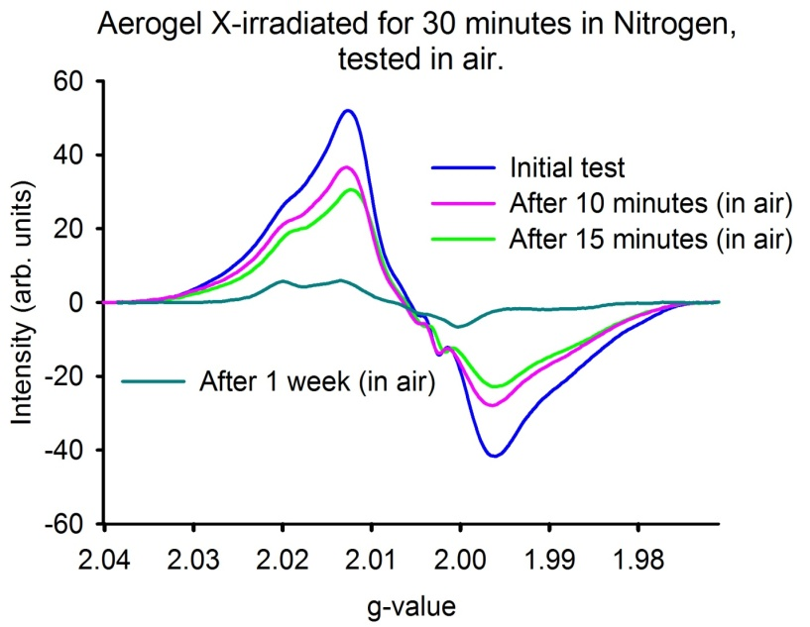
Figure 22. PCSA specimen retested with time immediately after 30-minute X-ray in nitrogen. The same specimen as that of the top right graph in Figure 21.

Aerogel X-irradiated for 10 minutes in Nitrogen, followed by storage in air for 1 week.
 | n=3 | 1 | 2 | 3 | Mean | Stdev
 | Initial | 91.4 | 89.7 | 123.0 | 101.4 | 18.8
 | 1 week air | 44.8 | 50.6 | 37.7 | 44.4 | 6.5
 | % change | -51% | -44% | -69% | -55% | 13%
Aerogel X-irradiated for 10 minutes in Nitrogen, followed by storage in nitrogen for 1 week.
 | n=3 | 1 | 2 | 3 | Mean | Stdev
 | Initial | 106.0 | 38.4 | 118.0 | 87.5 | 42.9
 | 1 week N2 | 46.1 | 22.8 | 56.1 | 41.7 | 17.1
 | % change | -56% | -41% | -52% | -50% | 8%
Aerogel X-irradiated for 10 minutes in Air, followed by storage in air for 1 week.
 | n=3 | 1 | 2 | 3 | Mean | Stdev
 | Initial | 98.7 | 58.8 | 97.1 | 84.9 | 22.5
 | 1 week air | 45.7 | 24.8 | 40.4 | 37.0 | 10.9
 | % change | -54% | -58% | -58% | -57% | 3%
Aerogel X-irradiated for 30 minutes in Air, followed by storage in air for 1 week.
 | n=3 | 1 | 2 | 3 | Mean | Stdev
 | Initial | 270.1 | 326.0 | 310.9 | 302.3 | 28.9
 | 1 week air | 63.1 | 80.4 | 65.6 | 69.7 | 9.4
 | % change | -77% | -75% | -79% | -77% | 2%
Aerogel X-irradiated for 30 minutes in Nitrogen, followed by storage in air for 1 week.
 |  | n=2* | 1 | 2 | Mean | Stdev
 |  | Initial | 1050.9 | 206.7 | 628.8 | 596.9
 |  | 1 week air | 42.2 | 40.3 | 41.3 | 1.3
 |  | % change | -96% | -80% | -88% | 11%
Aerogel X-irradiated for 30 minutes in Nitrogen, followed by storage in nitrogen for 1 week.
 |  | n=2* | 1 | 2 | Mean | Stdev
 |  | Initial | 1703.5 | 199.1 | 951.3 | 1063.7
 |  | 1 week N2 | 239.1 | 86.5 | 162.8 | 107.9
 |  | % change | -86% | -57% | -71% | 21%

Table 2. PCSA free radical concentrations (*10^14 spins per gram) for all treatments. Recall, the mean of untreated PCSA was 7.8.
4.5.2 UHMWPE
Pages 39–41 show details of all UHMWPE treatments via Figures 23-25, whose data is summarized in Table 3 on page 42. These figures and data can be explained as follows:
Recall that the UHMWPE and PEEK are also treated under duplicated conditions as the PCSA, to provide a general reference for comparison. Figure 23 shows a bar graph which represents free radical concentrations for the treatments of UHMWPE. Recall that these UHMWPE samples had no detectable free radicals before irradiation. We see that the 10 minute-treatments are roughly around 40 (*10^14), while the 30-minute treatments can be are around 100. As with the PCSA, the 30-minute treatments’ responses are roughly around 3x those of the 10-minutes treatments. As with the PCSA also, we see wider variation with those irradiated in nitrogen (as indicated by the error bars (standard deviation)). It is difficult to determine whether this is reflective of the absence of air, as intended, or with variation in the nitrogen treatment itself. It is difficult to determine whether these results are actually reflective of the absence of air, as intended. With all tested specimens, including PCSA, there does not appear to be a significant difference between treatments air-vs.-nitrogen.
Figure 24 shows the ESR spectra and corresponding free radical concentrations for UHMWPE specimens which were X-irradiated in air for 10 minutes and 30 minutes. We see that there are the same types of radicals (same line shapes) formed for both levels of X-irradiation, but more of this type is created upon larger radiation exposure (30 minutes). After storage in air for one week, there are no detectable free radicals. This is because the free radicals observed previously are no longer present. The radicals’ unpaired electron sites must have reacted with something – perhaps oxygen in the air - which may lead to subsequent oxidation. It would be good for future work to measure oxidation following these types of treatments to make a better assessment.
When the UHWMPE was irradiated in nitrogen, whose spectra are shown in Figure 25, there were also more radicals formed upon 30 minutes of irradiation than for 10 minutes. After storage in air, none of the samples contained any detectable presence of free radicals. The sample irradiated in nitrogen, and then stored in nitrogen, was the only UHMWPE sample which still showed a presence of free radicals after storage. This may have been due to the radicals having less air to react with, therefore remaining at detectable levels.
Recall that there were no detectable radicals in UHMWPE before irradiation. Compared to the PCSA, the UHMWPE underwent similar changes in quantities of radicals with treatments, except that some of the PCSA samples underwent much larger radical formation, and the PCSA had significantly more radicals than they started with after one week’s storage air or nitrogen.

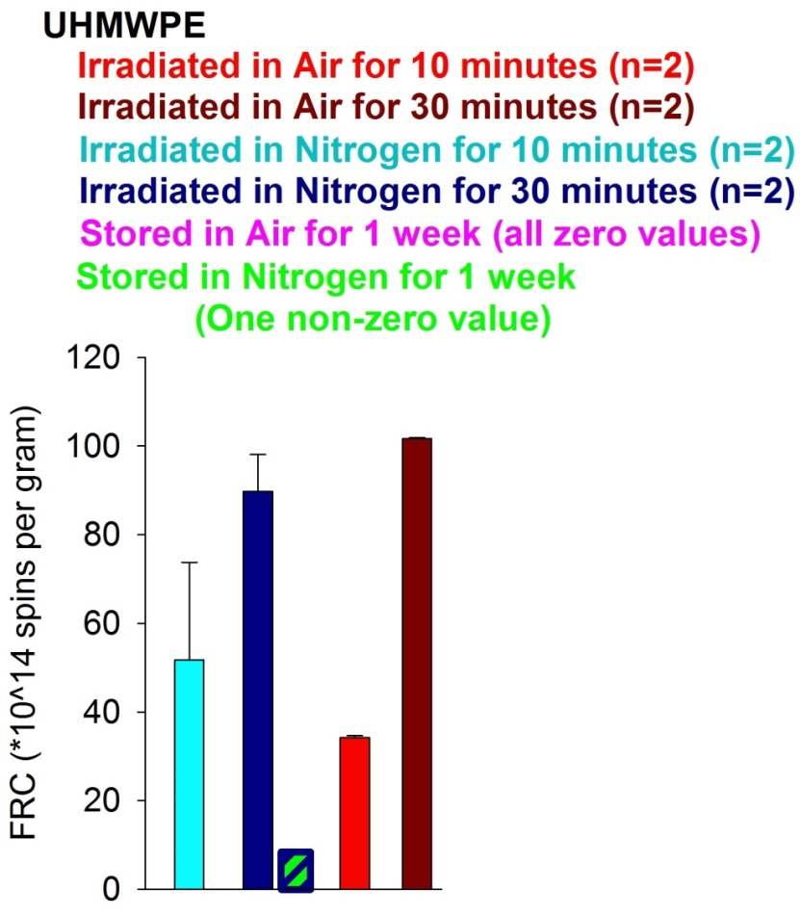
Figure 23. Bar graph summary of all UHMWPE testing. Color-coded bars correspond to the color-coded font, which identifies each condition. The pink (storage in air) are not viewable because there were no detectable radicals after one week’s storage in air. The green/blue bar represents one specimen which was irradiated in nitrogen for 30 minutes and then stored in nitrogen for one week.

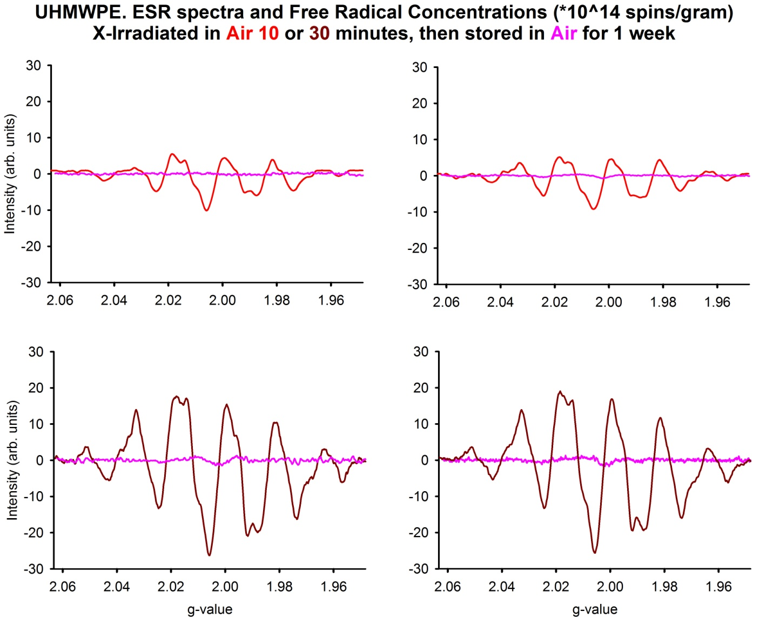
Initial | 101.8
1 week air | 0.0
% change | -100%

Initial | 101.4
1 week air | 0.0
% change | -100%

Initial | 34.5
1 week air | 0.0
% change | -100%

Initial | 33.8
1 week air | 0.0
% change | -100%

Figure 24. ESR spectra and FRC for UHMWPE irradiated in air for 10 and 30 minutes.
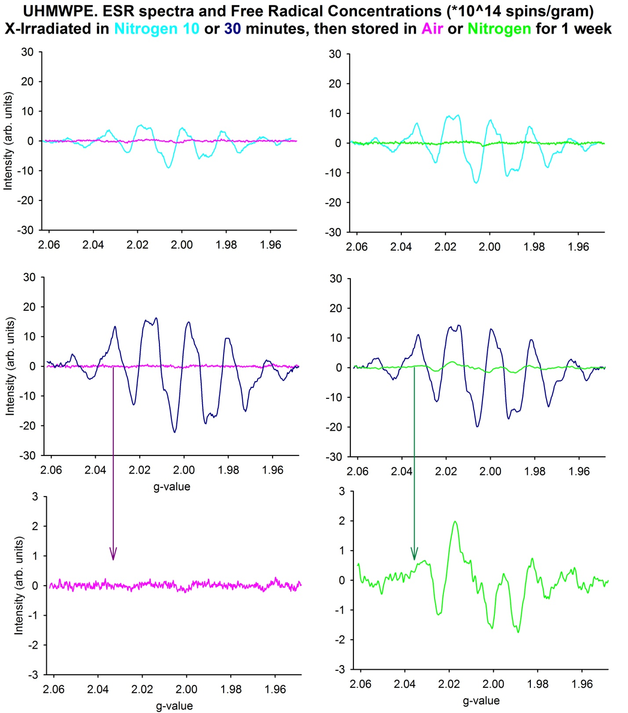
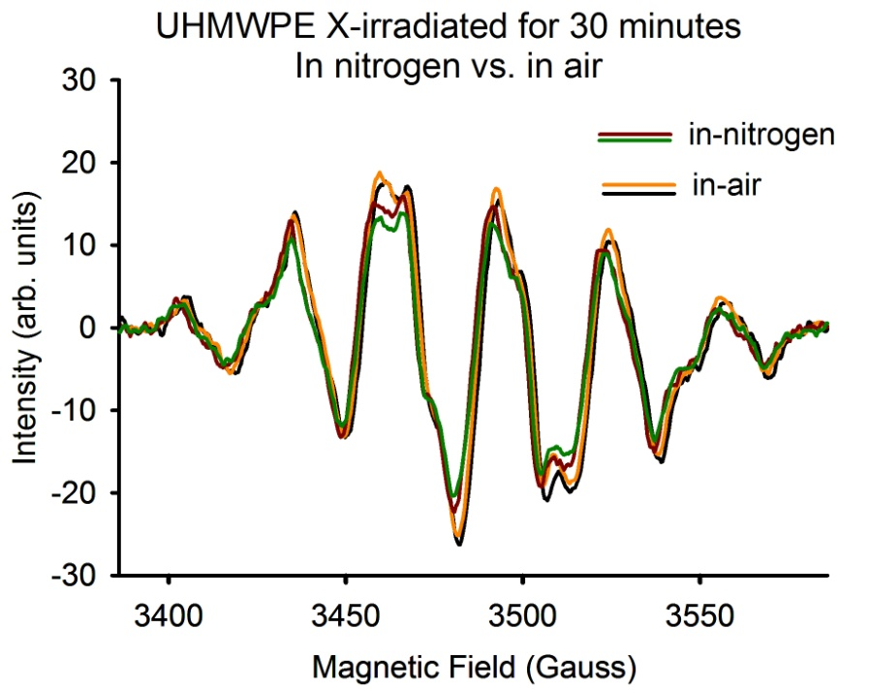
Figure 25. ESR spectra and FRC for UHMWPE irradiated in nitrogen for 10 and 30 minutes.

Initial | 36.1
1 week air | 0.0
% change | -100%

Initial | 67.3
1 week N2 | 0.0
% change | -100%

Initial | 95.6
1 week air | 0.0
% change | -100%

Initial | 83.8
1 week N2 | 8.4
% change | -61%

4.5.3 PEEK
UHMWPE. X-irradiated for 10 minutes in Nitrogen, followed by air and nitrogen storage:
 | n=1 | 1 |  | n=1 | 1
 | Initial | 36.1 |  | Initial | 67.3
 | 1 week air | 0 |  | 1 week N2 | 0.0
 | % change | -100% |  | % change | -100%
UHMWPE. X-irradiated for 10 minutes in Air, followed by storage in air for 1 week.
 | n=2 | 1 | 2 | Mean | Stdev
 | Initial | 33.8 | 34.5 | 34.2 | 0.5
 | 1 week air | 0.0 | 0.0 | 0.0 | 0.0
 | % change | -100% | -100% | -100% | 0%
UHMWPE. X-irradiated for 30 minutes in Air, followed by storage in air for 1 week.
 | n=2 | 1 | 2 | Mean | Stdev
 | Initial | 101.8 | 101.4 | 101.6 | 0.3
 | 1 week air | 0.0 | 0.0 | 0.0 | 0.0
 | % change | -100% | -100% | -100% | 0%
UHMWPE. X-irradiated for 30 minutes in Nitrogen, followed by air and nitrogen storage:
 | n=1 | 1 |  | n=1 | 1
 | Initial | 95.6 |  | Initial | 83.8
 | 1 week air | 0.0 |  | 1 week N2 | 8.4
 | % change | -100% |  | % change | -90%

Table 3. UHMWPE free radical concentrations (*10^14 spins per gram) for all treatments.
Pages 44–46 show details of all PEEK treatments via Figures 26-28, whose data is summarized in Table 4 on page 47. These figures and data can be explained as follows:
Figure 26 shows a bar graph which represents free radical concentrations for the different treatments of PEEK. When comparing with the PSCA and UHMWPE, the free radical quantities of the PEEK samples did not change a lot upon any treatment: The PEEK began with 10 to 15* 10^14 spins per gram before any treatment (non-irradiated), but increased to just about 20 to 25* 10^14 after both the 10- and 30-minute treatments, whether in nitrogen or in air. We do see pretty conclusive evidence of radiation-induced radicals, though – just not to nearly the same extent as for PCSA or the UHMWPE.
Figure 27 shows ESR spectra and corresponding free radical concentrations for all treatments of PEEK. We see the same general radical formation for all treatments, as well as subsequent decline upon one week of storage in either air or nitrogen. The new radical formation upon irradiation of PEEK is of a different type of radical than that present originally before irradiation – i.e., the lines are of a different shape after irradiation (the hump forming between g-values 2.005 and 2.010), as opposed to an enlargement of the non-irradiated PEEK’s signal. This radical formation appears to be identical whether irradiated in air or in nitrogen, as highlighted in Figure 28. On the other hand, in PSCA, most of the radiation-induced radicals appeared to be of the same type as was present before irradiation, as implied by the lines increasing while keeping the same general shape (also shown in Figure 28). Still, some additional radical types did appear in some PCSA samples when irradiated.
As compared to the PCSA, the PEEK underwent far less changes in quantities of radicals with treatments. There is evidence of radiation-induced radicals, just not to nearly the same extent as with the PCSA or the UHMWPE. This is in agreement with the fact that PEEK is known to be a radiation-resistant material.

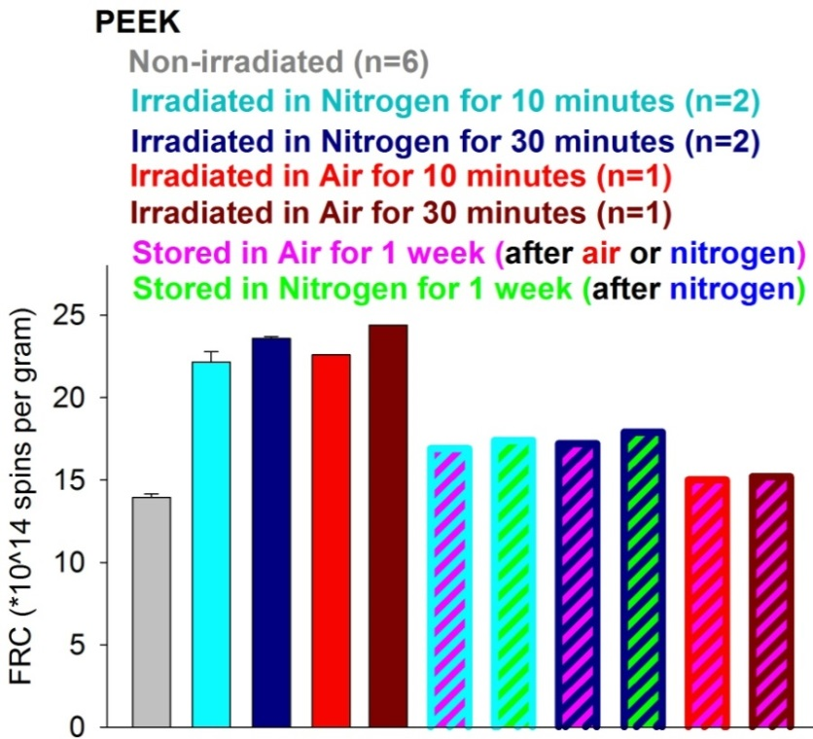
Figure 26. Bar graph summary of all UHMWPE testing. Color-coded bars correspond to the color-coded font, which identifies each condition. Dual-dual colored bars correspond to the irradiation condition and the subsequent storage environment – e.g., the light blue/pink bar represents a specimen which was irradiated in nitrogen for 10 minutes and then stored in air for one week.

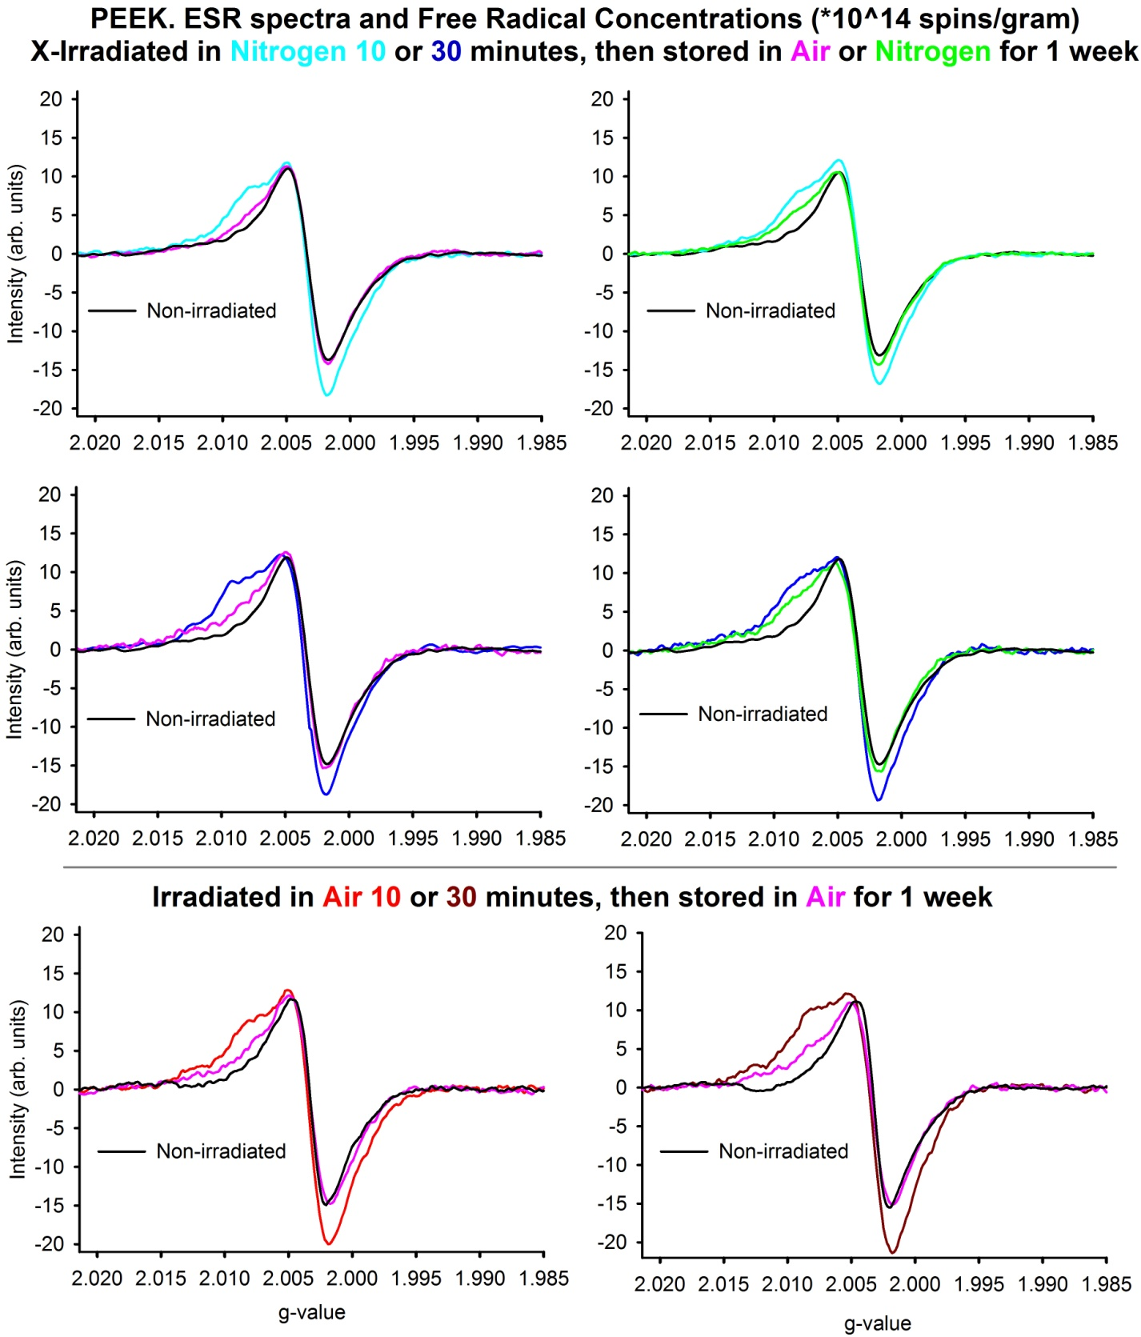
Figure 27. ESR spectra and FRC for PEEK (all conditions).
Initial | 23.6
1 week N2 | 17.9
% change | -24%

Initial | 23.5
1 week air | 17.2
% change | -27%

Initial | 24.4
1 week air | 15.2
% change | -38%

Initial | 22.6
1 week air | 15.0
% change | -34%

Initial | 22.6
1 week air | 16.9
% change | -25%

Initial | 21.7
1 week N2 | 17.4
% change | -20%

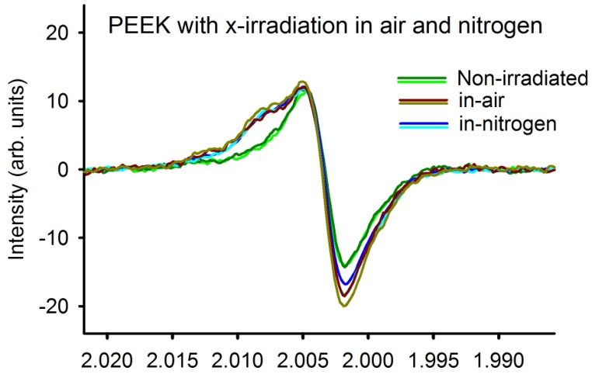
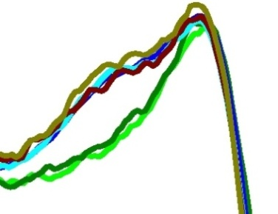
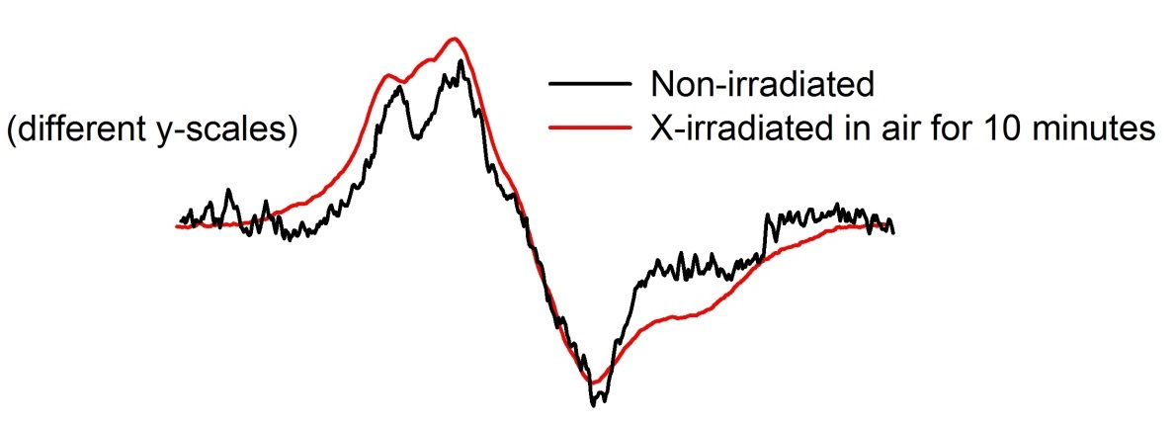
Figure 28. ESR spectra of PEEK and PCSA before and after X-irradiation.

PEEK untreated vs. 10 minute x-ray in nitrogen, and vs. 10 minute x-ray in air:
 | n=2 | 1 | 2 | Mean | Stdev |  |  | n=1 |  |  | 1
 | Untreated | 14.2 | 14.0 | 14.1 | 0.1 |  |  | Untreated |  |  | 13.8
 | 10 min N2 | 22.6 | 21.7 | 22.2 | 0.6 |  |  | 10 min Air |  |  | 22.6
 | % change | 59% | 55% | 57% | 3% |  |  | % change |  |  | 64%
PEEK untreated vs. 30 minute x-ray in nitrogen, and vs. 30 minute x-ray in air:
 | n=2 | 1 | 2 | Mean | Stdev |  |  | n=1 |  |  | 1
 | Untreated | 13.9 | 13.6 | 13.8 | 0.2 |  |  | Untreated |  |  | 14.1
 | 30 min N2 | 23.5 | 23.6 | 23.6 | 0.1 |  |  | 30 min Air |  |  | 24.4
 | % change | 69% | 74% | 71% | 3% |  |  | % change |  |  | 73%
PEEK X-irradiated for 10 minutes in Nitrogen, followed by air and nitrogen storage:
 | n=1 |  |  | n=1
 | Initial | 22.6 |  | Initial |  | 21.7
 | 1 week air | 16.9 |  | 1 week N2 |  | 17.4
 | % change | -25% |  | % change |  | -20%
PEEK X-irradiated for 30 minutes in Nitrogen, followed by air and nitrogen storage:
 | n=1 |  |  | n=1
 | Initial | 23.5 |  | Initial |  | 23.6
 | 1 week air | 17.2 |  | 1 week N2 |  | 17.9
 | % change | -27% |  | % change |  | -24%
PEEK X-irradiated for 10 minutes and 30 minutes in Air, followed by air storage:
 | n=1 |  |  | n=1
 | Initial | 22.6 |  | Initial |  | 24.4
 | 1 week air | 15.0 |  | 1 week air |  | 15.2
 | % change | -34% |  | % change |  | 38%

Table 4. PEEK free radical concentrations (*10^14 spins per gram) for all treatments.
4.6 Native Silica Aerogel Observations
Recall that the typical aerogels which usually turn up upon an internet search for “aerogels” are of the more fragile, native silica aerogel variety, as described in Chapters 1 and 2. As you can see from the picture in Figure 29, the native aerogel material is more transparent than the PSCA type, and can be perceived as looking more interesting. Since native silica aerogels are more well-known, and what many previous works on aerogel have regarded, it is worth a look to test at least one sample of the native aerogel variety to see its response to radiation also.

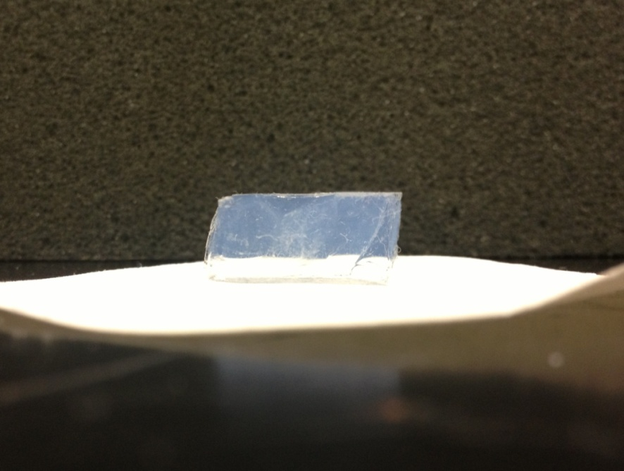
Polyurea-crosslinked
silica aerogel (PCSA)
Native silica aerogel
Figure 29. Pictures of PCSA and native-silica aerogel tested in this study (not stock photos).

As seen in Figure 30, the native silica aerogels did not contain a detectable quantity of radicals before any treatment. However, very large quantities of radicals are created upon X-irradiation for one hour. This leads one to suspect that the radicals present in PCSA before any treatments were from the polyurea-crosslinking component of the aerogel, but it is not the sole region where radicals are formed. Primarily, though, it is clear that native silica aerogel is not “radiation hard,” as it does undergo significant free radical formation upon radiation exposure, seen by the obviously different spectra of X-irradiated vs. Non-irradiated in Figure 30.
In Figure 31, two PCSA samples of this study (X-irradiated for10-minutes in air (red line), and X-irradiated for 30 minutes in nitrogen (blue line)), are compared with an X-irradiated native silica aerogel sample (green line). Both green lines are of the same data, with the one on the bottom enlarged (y-scale). It is visible that the same features in the spectra appear for both the PCSA and the native silica aerogels, but at different intensities.
As a check for the lack of radiation shielding (which should be expected from a low-mass object) a small piece of UHMWPE was placed behind native silica aerogel, as seen in the picture of Figure 32. The aerogel was then X-irradiated. If the aerogel would have shielded the UHMWPE from the radiation, then the resulting ESR spectrum of the UHMWPE would be small or similar to the “no detectable signal” spectrum seen earlier in Figure 7 for non-irradiated UHMWPE. Instead, we see a very obvious and large ESR signal, shown in Figure 33, clearly indicative of X-irradiated UHMWPE, as can be identified now via the previously acquired spectra for X-irradiated UHMWPE in Figure 13. So, it is confirmed that native silica aerogel does not shield well against X-irradiation.

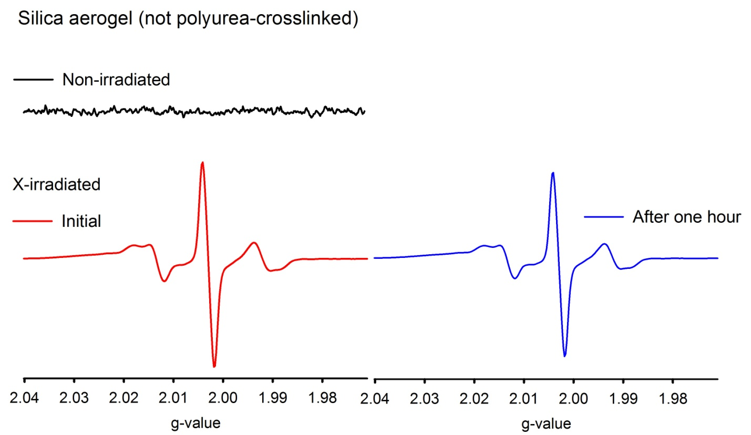
Figure 30. ESR spectra of native silica aerogel before and after X-irradiation. The sample was tested before and after X-irradiation, as well as after one hour in air following irradiation.
 | FRC (*10^14)
Non-irradiated | 0
Initial | 1658
After 1 hour | 1550

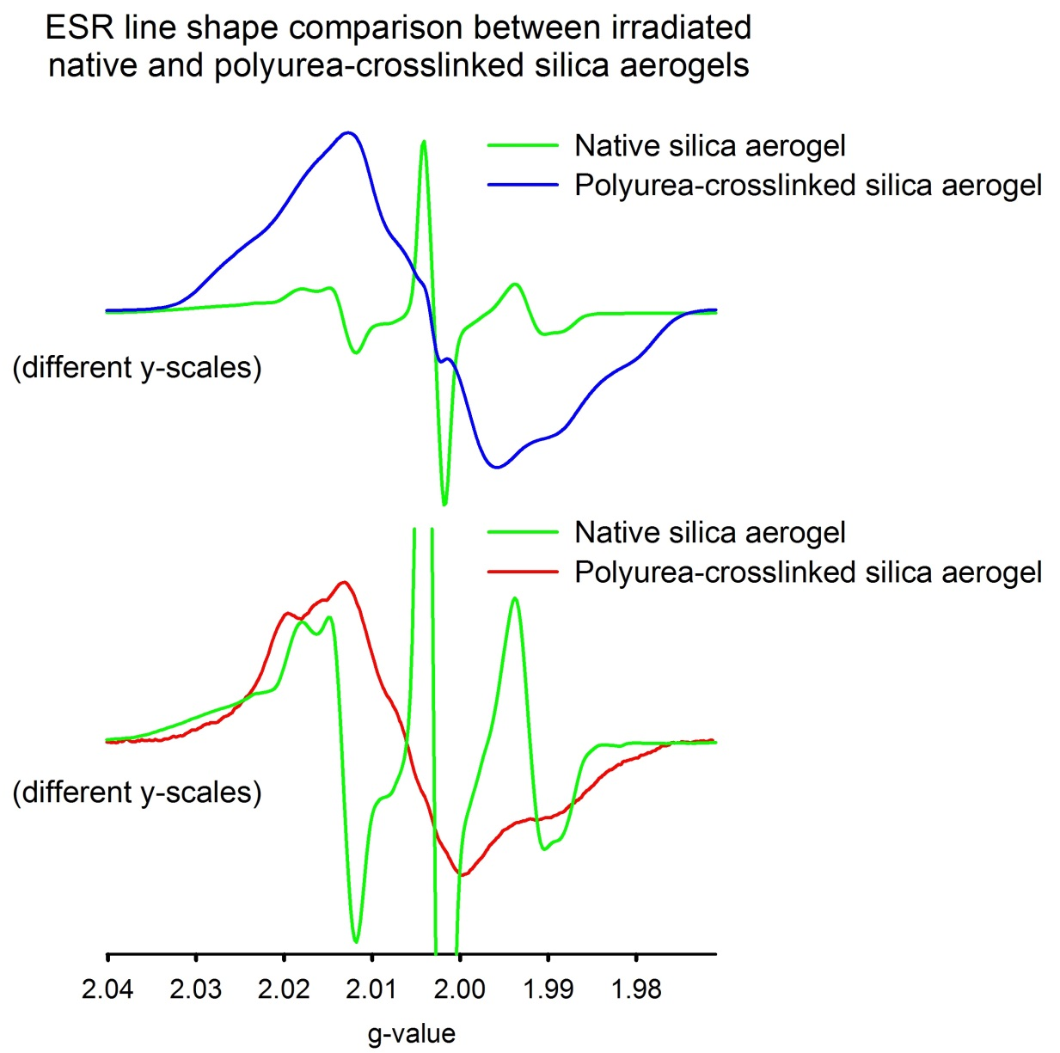
Figure 31. X-irradiated PCSA vs. native silica aerogel: comparison of ESR spectra. It can be seen in the top two spectra that the peak in the middle is present for both, although less obvious in the blue line. It can be seen in the bottom two spectra that similar features to the left and right of center (around g=2.015 and 1.99, respectively) are present for both. Some ESR features of irradiated PCSA are therefore similar to native silica aerogel, while some are not.
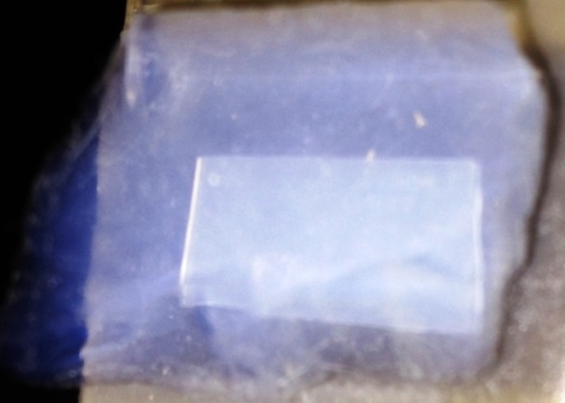
Figure 32. UHMWPE behind a piece of 20 mm (about 3/4”) thick native silica aerogel.

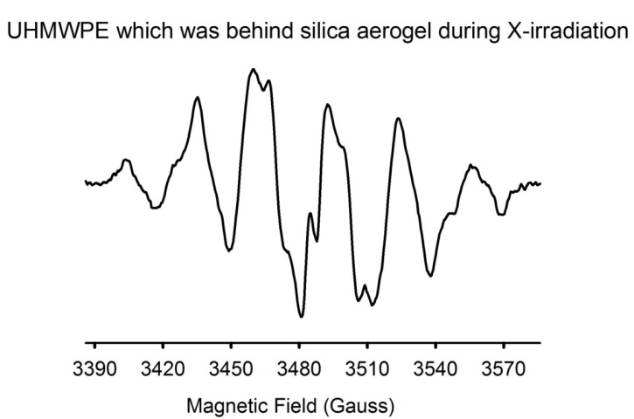
Figure 33. ESR of the UHMWPE which was behind the native aerogel during X-irradiation. The spectrum shows clear indication of radicals resulting from X-rays which were unshielded by the aerogel.
Chapter 5
Conclusion
Figure 34 shows a statistical summary of the primary treatments of PCSA after removing the two outliers of the high (30 min.) treatment data shown in Figure 14. The data of figure 34 represents the quantities of free radicals accumulated upon treatments – i.e., the quantity present after treatment minus the quantity which was present before treatment. It is clear that the specimens irradiated at high doses are statistically different from those irradiated at low dose.
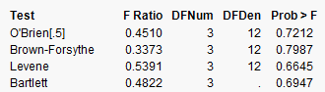
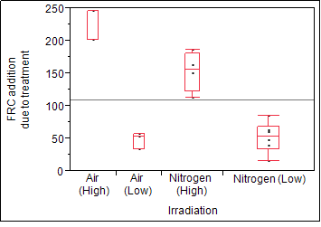
Figure 34. Box plot and test for unequal variances for irradiated PCSA.

The PCSA and PEEK materials did contain smaller free radical quantities before any radiation treatments. These radicals may not have been particularly reactive types of radicals, as they would have already reacted with their surroundings, and would therefore be no longer present. The main aspect, then, would be the new radicals which are induced upon radiation exposure (represented in Figure 34), which have more potential to react with their surroundings, leading to varying molecular changes and therefore altering the material from its original state, which may also alter its intended function of use.
With the PEEK material, which was used as a reference for something considered radiation resistant, it underwent only a small amount of free radical formation when irradiated by X-ray. The UHMWPE and PCSA, on the other hand, underwent significant amounts of radical formation. In addition, the PEEK radical formation looked to have reached its limit at or before 10 minutes of X-irradiation, because there was not a significant increase when irradiating it for the larger time of 30 minutes. The UHMWPE and PCSA did look to still be forming free radicals with additional radiation exposure up to 30 minutes. These observations, as a whole, support the assumption that PEEK is more radiation resistant, while the PCSA undergoes radical formation in quantities similar in proportion to that of UHMWPE, which is known to be not as radiation resistant. So, the evidence leans more toward an overall conclusion that PCSA is less radiation resistant (similar to the UHMWPE).
In summary, the following conclusions are determined from the results, which address the four hypotheses defined in Chapter 1:
- If PCSA is exposed to X-irradiation, then free radicals will be created.
- There will be more free radicals in PCSA which is irradiated for 30 minutes, than that which has been irradiated for 10 minutes.
- There may not always be different quantities of free radicals in PCSA which is irradiated in nitrogen, vs. that which is irradiated in air.
- There may not always be different quantities of free radicals in PCSA which is stored in nitrogen after irradiation, vs. that which is stored in air.

These conclusions arise from the more specific details presented in Chapter 4. In all, it cannot be said that PCSA is not significantly affected by X-ray, and therefore cannot be described as being radiation resistant, or “radiation hard,” unless it is proven that the radiation-induced radicals have no negative consequences on the material. Future work should involve additional materials testing before and after radiation exposure, such as impact strength or insulating capabilities, as well as additional radiation treatments including other types of ionizing radiation such as gamma and UV.

References

[1] M.S. Ahmed, Y.A. Attia, Multi-metal oxide aerogel for capture of pollution gases from air, Applied Thermal Engineering, Volume 18, Issues 9–10, 1 September 1998, Pages 787-797.
[2] M. Alnaief, S. Antonyuk, C.M. Hentzschel, C.S. Leopold, S. Heinrich, I. Smirnova, A novel process for coating of silica aerogel microspheres for controlled drug release applications, Microporous and Mesoporous Materials, Volume 160, 15 September 2012, Pages 167-173.
[3] L. Wang, M. Sánchez-Soto, M. Luisa Maspoch, Polymer/clay aerogel composites with flame retardant agents: Mechanical, thermal and fire behavior, Materials & Design, Volume 52, December 2013, Pages 609-614.
[4] J. Fricke, T. Tillotson, Aerogels: production, characterization, and applications, Thin Solid Films, Volume 297, Issues 1–2, 1 April 1997, Pages 212-223.
[5] T. Błaszczyński, A. Ślosarczyk, M. Morawski, Synthesis of Silica Aerogel by Supercritical Drying Method, Procedia Engineering, Volume 57, 2013, Pages 200-206.
[6] F. Sabri, J. Marchetta, K.M. Smith, Thermal conductivity studies of a polyurea cross-linked silica aerogel-RTV 655 compound for cryogenic propellant tank applications in space, Acta Astronautica, Volume 91, November 2013, Pages 173-179.
[7] S.K. Sahu, M.Z. Wang, R. Suda, R. Enomoto, K.C. Peng, C.H. Wang, I. Adachi, M. Amami, Y.H. Chang, R.S. Guo, K. Hayashi, T. Iijima, T. Sumiyoshi, Y. Yoshida, Measurement of radiation damage on a silica aerogel Cherenkov radiator, Nuclear Instruments and Methods in Physics Research Section A: Accelerators, Spectrometers, Detectors and Associated Equipment, Volume 382, Issue 3, 21 November 1996, Pages 441-446.
[8] V. Premnath, W.H. Harris, M. Jasty, E.W. Merrill, Gamma sterilization of UHMWPE articular implants: an analysis of the oxidation problem, Biomaterials, Volume 17, Issue 18, September 1996, Pages 1741-1753.
[9] Zeus Industrial Products, Inc., Technical Whitepaper: “Focus on: PEEK,” (2005). www.zeusinc.com.

[10] H.M. Li, R.A. Fouracre, M.J. Given, H.M. Banford, S. Wysocki, S. Karolczak, Effects on polyetheretherketone and polyethersulfone of electron and gamma irradiation. Dielectrics and Electrical Insulation, IEEE Transactions 1999;6(3), Pages 295-303.
[11] L. A. Capadona, M. A. Meador, A. Alunni, E. F. Fabrizio, P. Vassilaras, N. Leventis, Flexible, low-density polymer crosslinked silica aerogels, Polymer, Volume 47, Issue 16, 26 July 2006, Pages 5754-5761.
[12] U. Heinemann, R. Caps, J. Fricke. Radiation-conduction interaction: an investigation on silica aerogels. International Journal of Heat and Mass Transfer, Volume 39, Issue 10, July 1996, Pages 2115-2130.
[13] R. Vaidyanathan, Carbon-based aerogel composites for radiation-shielding. NASA/SBIR-Funded Grant to Advanced Ceramics Research, Inc., 2003, Award ID 63267, Contract NAS1-03029.
[14] L. Luo, A.T. Cooper, M. Fan, Preparation and application of nanoglued binary titania–silica aerogel. Journal of Hazardous Materials, Volume 161, Issue 1, 15 January 2009, Pages 175-182.
[15] R. M. Richards, A. M. Volodin, A. F. Bedilo, A. F., K. J. Klabunde, ESR study of nanocrystalline aerogel-prepared magnesium oxide. Physical Chemistry Chemical Physics (Incorporating Faraday Transactions), Volume 5 Issue 19, August 2003, Pages 4299-4305.

Appendices
Appendix A
Free Radicals and ESR
A molecule is two or more atoms bonded together. The breaking of molecular bonds via ionizing radiation is one of the main things that can cause a material to degrade or otherwise change. This is because it can produce highly reactive free radicals in the material as follows: The atoms and molecules contain electrons; these electrons are typically in pairs of two, so the total number of electrons that are typically in a “stable” molecule is an even number. Ionizing radiation can knock electrons out from their pairs, leaving atoms or molecules with unpaired electrons. These atoms or molecules are now “free radicals,” and want their missing electrons back. They may be considered “unstable” and “highly reactive” and may attempt to rip electrons from other nearby molecules so that they can pair up their unpaired electrons again. The nearby molecules now have unpaired electrons, turning them into free radicals, and this process can cascade into large scale damage – whether for your body or for a non-living material like plastic (or perhaps aerogel).
Some free radicals are not very reactive and stably remain with their unpaired electrons: these radicals are not so bad. Typically, though, free radicals react fairly quickly, depending on how reactive/unstable they are. If they are exposed to oxygen, this is one of the main bad things that can lead to degradation of the material. These reactions among radicals and oxygen are what one may typically hear as being associated with “oxidation.”
Spinning electrons act like little magnets (they have a “magnetic moment”). The Electron Spin Resonance (ESR) technique uses microwave energy and large magnets (the round parts in the photo of Figure 35) to create a magnetic field.
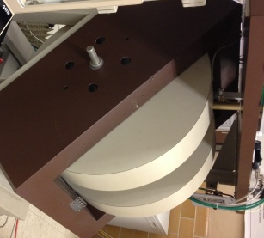
Figure 35. ESR instrument used for this project.

Suppose, for example, that an atom has one single unpaired electron, and you put it into a magnetic field. Its “spin” will then have two possible energy states (for details about this, the reader can look up the “Zeeman” effect). In reference to the microwave energy used by ESR, if the electron absorbs a photon from the microwave field, then it will transition to a higher energy state from a lower energy state. This causes a similar drop in reflected radiation (as the electron has “absorbed” radiation in order to transition from the lower to higher energy state). For a particular molecule, or free radical, this absorption only happens for a particular combination of microwave frequency and magnetic field. In most spectroscopy, the magnetic field is constant, and different frequencies are scanned until the energy required for similar transition/absorption is matched by the equation “Energy = (frequency)*(Planck’s constant).” Most have seen this equation as E=hv, where E is energy, h is Planck’s constant (please look up Planck’s constant if unfamiliar), and v is the frequency (such any frequency of an electromagnetic spectrum region – i.e., radio, infrared, visual, microwave, etc.). For ESR, however, magnetic field strengths (displayed in this paper as “Gauss”) are scanned varied while the frequency is held constant; the particular frequency of the present study is from the microwave region with a frequency of 9.8 GHz.
The ESR magnets alter the magnetic field around the sample, interacting with the spinning unpaired electrons of free radicals. Instead of like more common absorption-type tests that scan frequencies (without changing the magnetic field) until hv matches the required E, the ESR technique instead uses a constant frequency and scans through different magnetic field strengths. This is possible due to the relationship of magnetic field and frequency: hv=gμ_{B}H, where H is the magnetic field (produced by the magnets of the ESR instrument), μ_{B} is a constant called the Bohr magneton (please look up Bohr magneton if unfamiliar), and g is called the “g-factor” or “g-value.” A description of g-value is given in Appendix D, but for now we can just call it a constant (for example, we will say g=2). So, of the equation hv=g*μ_{B}*H, the only non-constants (variables) are v and H (frequency and magnetic field), and since we are holding the frequency constant at 9.8 GHz, the only variable left is the magnetic field (H). So, we can then simply scan the magnetic field until H = (hv)/gμ_{B} and “resonance” occurs (this is sometimes called the “field for resonance”), which will satisfy the same equation E=hv (because hv=gμ_{B}H). This is the basic idea behind how the free radicals are detected with ESR, and now makes more sense of its name: Electron Spin Resonance, also known as Electron Paramagnetic Resonance.

Appendix B
Quantities
The numbers quoted as being representative of quantities of free radicals may seem strangely large, such as 10^14 (100 trillion). Imagine you are asked “What is the quantity of something in one foot (length)?” Well, you would have to define the “thing” that you are talking about. How about: “What is the quantity of centimeters in one foot?” You could look this up and find that 2.54 centimeters are in one inch, and so 12 times 2.54 equals 30.48, and then conclude that there are 30.48 centimeters in one foot. Of course, you would have to first know definitions of a “foot,” an “inch,” and a “centimeter,” but luckily you were familiar with these words and could do it. What about the question “How many eggs are in a dozen eggs?” In this case, you don’t have to know what an “egg” is; all you really have to know is what “a dozen” is, which is “12.” So, you can now answer any question about dozens of things, like “how many comets are in a dozen comets?” You know the answer is twelve comets. Now, you are asked “How many eggs are in a mole of eggs?” This is the same as the question about the “dozen” eggs, except one “mole” is about half of that (12/2=6), times a million, times a million, times a million, times a hundred thousand. More specifically, just like how one dozen is equal to twelve, one mole is equal to 602,214,150,000,000,000,000,000 (about 6.022*10^23). So there are a lot of eggs in a mole of eggs. A bag of that many eggs would be very big indeed. However, if the eggs were as small as an atom, a mole of eggs would fit pretty easily into a hollow regular-sized plastic egg. That is, one “mole” of atoms is about how many atoms it would take to make something of minimum reasonable size to be able see and pick up. A mole of rocks would be as big as the moon, but a mole of atoms would be as big as a rock.
A mole of something microscopic (like atoms) is really just the quantity required to see it in the “macroscopic” world we commonly deal with, and this number happens to be defined as 6.022*10^23. If you wanted enough “Carbon-12” atoms to hold easily in your hand, you could request “one mole” of them – which would weigh exactly 12 grams; if this were a diamond, it would be about two karats, about the size of a little pebble. The number 6.022*10^23 is called “Avagadro’s Number.” The “molecular mass” (a.k.a. “molecular weight”) is how much a mole weighs. A mole of carbon atoms would weigh 12 grams, but the weight of a mole of eggs would be astronomical. The ultra-high molecular weight polyethylene (UHWMPE) used in this project is about three to six million grams per mole (about three to six tons), because it is made up of very long molecules. The point is, numbers like 10^14 aren’t really that strange if you think about them on the molecular scale. The specific quantities of free radicals (as in “spins per gram”) for this project are further explained in Appendix C.

Appendix C
Better Perspective of “spins per gram”
Free radical quantities are often quoted in “spins per gram,” such as to reflect a “concentration” of free radicals in a substance. An example of a free radical concentration (abbreviated as “FRC”) may be 1.00E+15, with would mean 10^15 “spins per gram” – referring to the unpaired electrons of free radicals, which have “spin.” That is, higher values mean there are more free radicals per gram.
If we detect 1E+15 spins per gram, does this mean that there are 1E+15 free radicals? - No. The “spins” are the sites of unpaired electrons (which may be one or many), to make the molecule to be defined as one “free radical.” Spins per gram, therefore, does not equal free radicals per gram, unless each radical is made up of only one spin.
Suppose, for example, our aerogel material is made up of only a bunch of separate silica (SiO₂) molecules, and that one spin equates to one free radical. If we then calculate that there are 1.00E+15 spins (from the unpaired electrons of free radicals) per gram detected, then this sounds like a lot of free radicals. For a better idea, though, we may like to know how many silica molecules there are in one gram in order to find the proportion that are free radicals: If we assume that this aerogel is comprised solely of silica, then we can say that one silica molecule should weigh about 1.01E-22 grams. One gram should therefore contain the inverse: 1/(1.01E-22) = 0.99E+22 molecules – i.e., 0.99E+22 molecules of silica are in one gram of silica. If there are 1E+15 spins per gram, then this would be a proportion of about 1E-7 (as 22 minus 15 is 7), which is 0.0000001, indicating that about one of every ten-million of the silica molecules are perhaps free radicals. There are two ways to look at it: This doesn’t seem to be a lot when compared as a proportion, but 1.00E+15 sure is a big number; this quantity of microscopic radicals could surely lead to macroscopic consequences even though they do not make up a large proportion of the material. Remember, though, that we were considering that these are all just little separate silica molecules, whereas there would realistically be other size molecules which would change the proportion of radicals to stable molecules.
As a reference, if we have a substance with a known quantity of free radicals, then we can compare its spectrum with that of our tested samples (of radical quantities). In this study, that substance was a standard made by NIST (National Institute of Standards and Technology), which has a very consistent and stable quantity of free radicals that does not change over time. In addition, this standard produces an ESR signal very far away on the x-axis (magnetic field) from the signals of our tested samples. We can therefore test this standard right along with our unknown samples, so that each test is well-calibrated, and even slight variations which could modify an ESR signal from test-to-test are accounted for. This is actually a quite valuable component of this whole project, as it greatly improves the reliability of the results.

Appendix D
g-value
As mentioned in Appendix A (Free Radicals and ESR), the procedure is to scan the magnetic field (H), until H equals (hv)/gμ_{B} (that is, H = (hv)/gμ_{B})) at which point “resonance” occurs and an ESR signal is seen. g is called the “g-factor” or “g-value, and can be used to describe particular ESR spectra and types of radicals. In the Appendix A discussion, we had originally considered the value of “g” to be a constant, but this “g-value” can actually vary. For example, if resonance occurs at a magnetic field of 3480 Gauss, and the instrument is operating with a microwave frequency of 9.8 GHz, and h and μ_{B} are known constants, then the only remaining unknown is g, which can be calculated as g=hv/Hμ_{B}. This g-value is therefore specific to the particular combination of frequency (v) and magnetic field (H) at which absorption (resonance) occurs, and can therefore be used to distinguish different types of radicals. As an additional check, a material called DPPH can be used (which it was for this study), which has a known g-value of 2.0036, and can be compared with g-values of the tested samples for accuracy.
Figure 36 shows an example of an ESR spectrum with its x-axis converted to g-value using the same equation described above and in Appendix A (E=hv=gμ_{B}H, where H is magnetic field and g is g-value). The particular spectrum of Figure 36 was acquired while tuned to a frequency of 9.7699 GHz (i.e., about 9.8 GHz).
ESR spectra are typically shown with x-axes displayed as magnetic field (in units of Gauss, or Tesla) but sometimes the location of a specific feature of a spectrum is better described in terms of its g-value location, as this is reflective of the actual specimen being tested, whereas the magnetic field location is reflective factors such as the tuning of the ESR instrument.

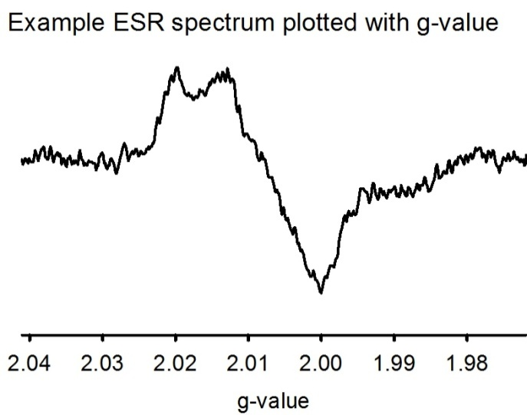
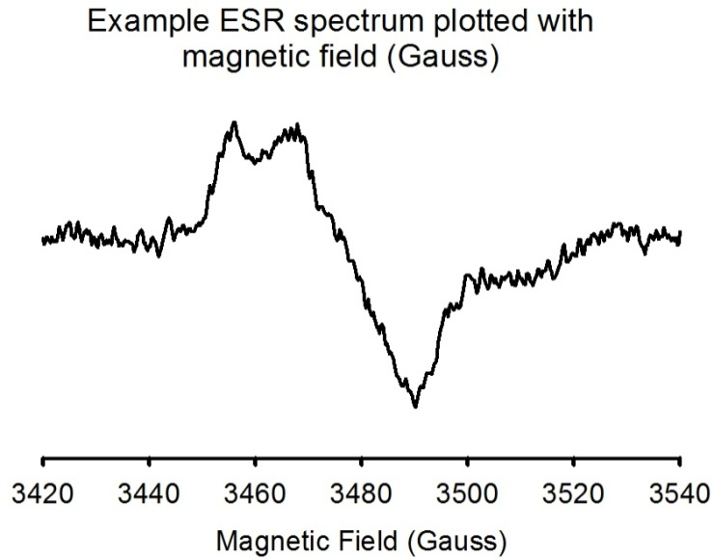
Figure 36. ESR x-axis units as either g-value or magnetic field. The spectra are the same; just the units are called differently. Two spectra of the same radical type may occur at different Gauss locations due to other factors such as tuning frequency, but they will still occur at the same g-value location. For this reason, it is sometimes preferable to compare multiple spectra by plotting according to g-value (as opposed to magnetic field).

Appendix E
Acquisition of ESR spectra and analysis
An example ESR spectrum is shown in Figure 37. A pasted screenshot from the user’s manual is shown in Figure 38, in order to explain how a spectrum can be analyzed, with added underlining of text stating that the quantity of free radicals in a tested sample is proportional to the area under the curve of an ESR signal. This also explains that there are other factors and settings which must be accounted for, such as selecting a particular microwave power for the instrument to use. Therefore, “arbitrary units” is specified for the y-axis because instrument settings, sample volume or mass, temperature, and other factors can impact the resulting ESR signal. Still, the area under the curve is the basic idea for how many free radicals there are in the sample (when calibrated with a known reference as mentioned at the end of Appendix C). Figure 39 shows the integration of the example spectrum of Figure 37.
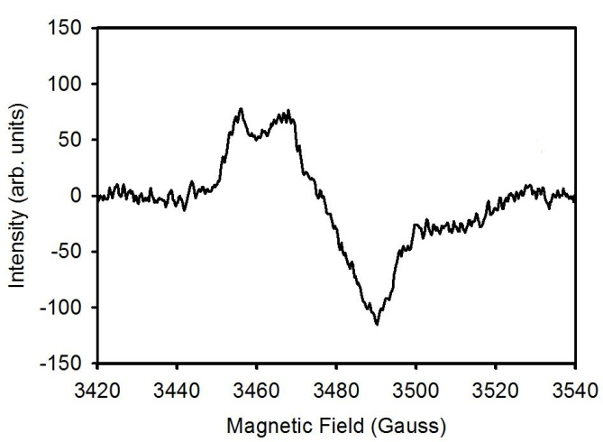
Figure 37. Example ESR spectrum.

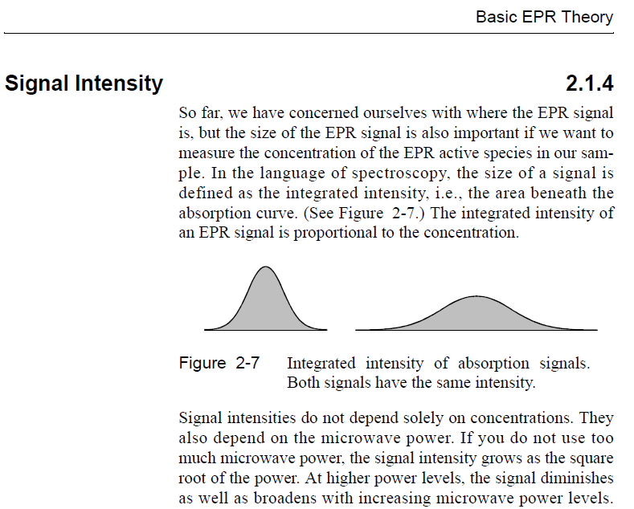

Figure 38. A page from the instruction manual of the ESR instrument used for this study.

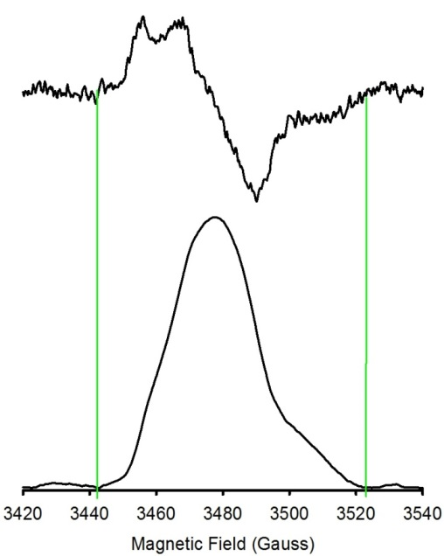
This integrated area is proportional to the number of free radicals (for a given instrument setting and specimen size/mass).
Figure 39. Integration of an ESR spectrum. A default ESR signal (top) is the derivative of the absorption signal below.

Shown in Figure 40 is an example of an ESR spectrum which indicates no free radicals are detectable at the conditions and ESR instrument settings being used at that time. This does not mean that there are no free radicals in the tested sample; it just means that there were no free radicals detected under these conditions. Different types of radicals respond differently to different conditions and ESR settings (operating parameters). For the tested materials of this project, these parameters were determined by trial-and-error before the experiment was conducted and the used consistently for all testing and comparison to eliminate variability of results due to anything other than the treatments.

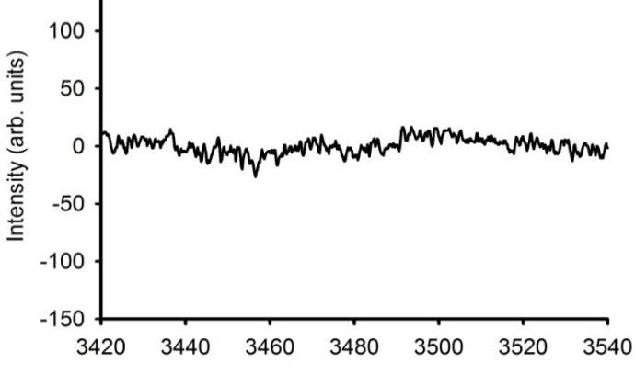
Figure 40. Example ESR spectrum with no detectable signal.

Vita
Ben earned a Bachelor of Science degree in Physics from the University of Memphis in 2008. He can be contacted at benjaminmichaelwalters@gmail.com

