Towards Modeling Projectile Penetration in Dry and Multiphase Granular Materials

A Dissertation Presented for the
Doctor of Philosophy
Degree
The University of Tennessee, Knoxville

Mohmad M. Thakur
December 2021

Copyright © 2021 by Mohmad M. Thakur
All rights reserved.

DEDICATION

I would like to dedicate this dissertation to my grandfather (“Bab”) Haji Ghulam Ahmad Thakur for his selfless love and everlasting memories.

ACKNOWLEDGEMENTS

I would like to express sincere gratitude to my advisor Dr. Dayakar Penumadu for his guidance, support, and encouragement during my Ph.D. studies. Dr. Penumadu provided me multiple opportunities to grow as an independent researcher and offered valuable suggestions.
I would like to thank my committee members: Dr. Khalid Alshibli, Dr. Timothy Truster, and Dr. David Keffer for providing valuable inputs to my dissertation and for teaching me advanced courses as part of my Ph.D. coursework. I am grateful to all the teachers who inspired me to do my best. I would like to thank Dr. Amit Prashant from the Indian Institute of Technology, Gandhinagar for introducing me to the research, my high school and elementary school teachers Mr. Hanief Sofi, Mr. Javaid Ahmad Thakur, and Mrs. Rifat Thakur for raising my curiosity in physics and mathematics.
I am grateful for the financial support provided by Defense Threat Reduction Agency. I would like to thank the Civil and Environmental Engineering department at The University of Tennessee, Knoxville for providing me additional fellowships including the Graduate Top-off fellowship and Jim and Tricia Martin fellowship. I would also like to thank Mr. Jim Martin and Mrs. Tricia Martin for making this scholarship available to graduate students.
I would like to thank the past and the present members of Dr. Penumadu’s research group for their friendship. I would like to thank Dr. Aashish Sharma and Ms. Anne Turner for training me initially when I joined as a new Ph.D. student. Special thanks to Dr. Aashish Sharma for helping me settle in Knoxville.
I would like to thank Dr. Felix Kim from the National Institute of Standard and Technology and Dr. Anna Herring from Australian National University for collaborating with me on Chapter 5 of this dissertation. I am thankful for the help provided by Mr. Andy Baker in fabricating cells for evaluating the moisture retention behavior of granular materials.
I am indebted to my parents, Mr. Mohmad Ashraf Thakur and Mrs. Shafiqa Thakur for their selfless love, care, prayers, and encouragement. I owe my success to them and I hope to carry forward their kindness. I would like to thank my Uncle’s Mr. Abdul Rashid Thakur, Mr. Mushtaq Ahmad Thakur, Mr. Fayaz Ahmad Thakur, and Mr. Zahoor Ahmad Thakur for their love. I would like to thank my brother Mr. Mohmad Yasir Thakur and my sister Mrs. Sehrish Thakur for their love and friendship. I am thankful to Mr. Dilawar Bhat for his friendship and encouragement.
Last but not least, I would like to thank my wife Mrs. Sadaf Fayaz for her love and support. I appreciate her excitement in seeing me succeed. I would like to thank my daughter, Inaya, for bringing happiness into our lives and making this journey all the more enjoyable.
ABSTRACT

The present work aims at developing and validating numerical modeling strategies in granular materials impacted by a projectile. The focus is on two regions: (a) near-field: region near the tip and along the path of a projectile where comminution of grains is significant, (b) intermediate-field: region far from the projectile where grain-scale interactions are important but stresses are not high enough to cause crushing of the grains.
A novel framework has been introduced and validated wherein particle shape captured using X-ray CT imaging was incorporated in FEM simulations using shell elements for simulating triaxial boundary value problems. The results indicate an increase in computational efficiency and usefulness of the approach in modeling sands in the intermediate field of impacting projectiles. The role of grain morphology and inter-granular friction in the shearing of the granular materials was explored since both these parameters significantly affect the mechanical response. It was observed that the influence of particle angularity is less pronounced as the inter-granular friction decreases. Furthermore, the near tip region of the granular material was investigated based on a 1D compression stress path with modeling of grain fragmentation based on damage mechanics. These approaches when applied together represent multiple physical scales associated with multi-physics phenomena.
The latter part of this dissertation focuses on exploring the effect of partial saturation on the strength of granular materials. Direct pore-scale modeling and experiments have been used to predict and validate the Soil Water Retention Curves (SWRC) in the round and angular sands. It was observed that the angular sand exhibited higher capillary suction and a higher void ratio compared to the rounded sand at the same relative density. Furthermore, the spatial distribution of the fluids and pore space was quantified out using a mathematical framework known as persistent homology. FEM and pore-scale modeling approaches were then used concurrently to estimate capillary pressures at different axial strains in a 1D compression loading. These predictions suggest that the effect of partial saturation should be considered in the near field region and can be ignored in the far-field region for simulating penetration in partially saturated sands.

Table of Contents

Chapter One Introduction 1
Motivation 2
Objectives 4
Literature Review 7
Chapter Two Triaxial compression in sands using Finite discrete element method and micro-X-ray computed tomography 14
Abstract 15
Introduction 15
Microstructure Imaging 18
Latex Membrane Characterization 19
Finite Element Method (FEM) 22
Contact Interaction 25
FEM modelling of two identical spheres 25
FEM modelling of assembly of sand grains 26
Volume change measurements 28
Fabric Quantification 28
Results 30
Response of two identical spheres to different loading conditions using shell and solid elements 30
Triaxial response of assembly of sand grains discretized using solid elements 30
Triaxial response of assembly of sand grains discretized using shell elements and comparison with experiments 34
Conclusion 46
Chapter Three Influence of friction and particle morphology on triaxial shearing of granular materials 50
Abstract 51
Introduction 51
Materials and Methods 54
Materials 54
Methods 56
Results 62
Grain shape characterization 62
Effect of Interparticle friction coefficient on the triaxial response of sands 62
Coupled effect of grain shape and size on the triaxial response of sands 71
Conclusions 83
Chapter Four Capillary Suction Measurements in Granular Materials and Direct Numerical Simulations Using X-Ray Computed Tomography Microstructure 87
Abstract 88
Introduction 88
Materials and Methods 90
Materials 90
Experimental Methods 91
Specimen Preparation 94
X-ray Computed Tomography 94
Image Processing 95
Pore Morphology Method 98
Results and Discussion 100
Spatial variation in porosity 100
Sensitivity of X-ray resolution on pore size distribution 100
SWRC measurements 102
Representative Volume Element in SWRC predictions 110
Pore-water / Pore air distribution 110
Comparison of pore fluid distribution from experiments and predictions 116
Conclusions 119
Chapter Five Pore Space and Fluid Phase Characterization in Round and Angular Partially Saturated Sands Using Radiation‑Based Tomography and Persistent Homology 121
Abstract 122
Introduction 122
Materials and Methods 126
Material 126
Image-based flow experiments 126
Pore Morphology Method 130
Persistent Homology Analysis 130
Results 137
Grain morphology 137
Visualization of fluid distribution 137
The microstructure of pore space of randomly packed spherical grains 142
The microstructure of pore space of Ottawa sand and Q-Rok 145
Effect of CT resolution on pore space imaging 147
Microstructural evolution of air phase of Ottawa sand and Q-Rok 147
Comparison of air phase microstructure from experiments PMM based predictions 150
Conclusion 150
Chapter Six Capillary suction predictions in granular materials subjected to 1D compression and triaxial loading with emphasis on projectile penetration in sands 153
Abstract 154
Introduction 154
Materials and Specimen Preparation 158
Finite Discrete Element Method 159
Grain crushing in 1D using Cohesive Interface Modeling 159
Boundary conditions and parameters for modeling 1D compression and triaxial loading 162
Pore Morphology Method 164
Pedotransfer Function from Grain Size distribution 165
Results 167
Mechanical response of 2D assembly to 1D compression loading 167
Evolution of Capillary Suction during 1D compression loading 167
Interpretation of Capillary Suction at the Projectile tip from the Grain Size Distribution 171
Mechanical response of 3D assembly to triaxial loading 175
Conclusions 178
Chapter Seven CONCLUSIONS AND FUTURE WORK 180
Summary of Major Conclusions 180
Future Work 182
Statement of Significance 183
List of References 185
Vita 206

LIST OF TABLES

Table3. 1: Material properties of different components 60
Table3. 2: Contact interaction between different materials 61
Table3. 3: Grain shape and size parameters for Ottawa sand and Q-Rok 64

Table4. 1: P_{10,} P₅₀ and P₉₀ for Ottawa Sand at 5-, 12-, and 15-micron X-ray resolution 104
Table4. 2: SWRC model parameters for Ottawa sand and Q-Rok for experimental and predicted data 107

Table5. 1: Interpretation of features based on persistent homology analysis 136

Table6. 1: Input Material Properties for FDEM simulations 166
Table6. 2: Summary of SWRC parameters of van Genuchten (1980) and GSD parameters during 1-D compression loading 172
Table6. 3: Soil Water Retention Curve parameters of van Genuchten (1980) for different loading stages during the triaxial loading of Ottawa sand 177

LIST OF FIGURES

Fig1. 1: Multiscale approach to model projectile penetration in sands 3
Fig1.2: Cavity formation around the projectile in partially saturated sand (adopted from Kim et al. 2016) 5
Fig1. 3: Variation in Taylor numbers for projectile and target (adopted from Bless et al. 2015) 9
Fig1. 4: Force chains in projectile penetration of sands obtained from mesoscale simulations (adopted from Dwivedi et al. 2008) 13

Fig2. 1: Transformation of CT images of Ottawa sand into discretized 3D numerical model of an assembly of Ottawa sand grains. 20
Fig2. 2: Latex membrane material characterization; (a) miniature universal material testing system (Psylotech µTS), (b) calibration of latex membrane based on uniaxial stress- strain experiment and simulation using FEM 21
Fig2. 3: Triangular S3RS shell element with embedded corotational coordinate system 24
Fig2. 4: Arrangement of two identical spheres in FEM simulation under different loading conditions: (a) normal compression, (b) shear loading, (c) rotational loading, (d) torsional loading (F_{N}=Normal force, F_{S}=Shear force, M_{R}=Moment, M_{T}= Torsion, r= radius) 27
Fig2. 5: (a) shows convex hull computation of set of random points in 2-D Euclidean space, (b) the nodal coordinates in an assembly of sand grains contributing to the convex hull. 29
Fig2. 6: Response of two identical spheres subjected to: (a) normal compression, (b) normal compression followed by shearing, (c) normal compression followed by rotational loading, (d) normal compression followed by torsional loading. 31
Fig2. 7: Ratio of CPU time required by shell and solid elements for different loading conditions for the same meshing ratios 32
Fig2. 8: Response of an assembly of sand grains discretized using solid in terms of deviatoric stress, energy dissipation and volumetric strain with the variation in axial strain. 33
Fig2. 9: Comparison of strength and volume change response of an Ottawa sand assembly obtained from experiments and FEM simulations. 35
Fig2. 10: Displacement in a frictional boundary Ottawa sand assembly during the shearing of the specimen at 140 kPa confining pressure; (a) 2% axial strain, (b) 5% axial strain, (c) 9% axial strain, (d) 15% axial strain. (A cone-shaped wedge of negligible displacement is formed at the bottom of the specimen) (Displacement is in mm). 37
Fig2. 11: Lateral displacement contour in a frictional boundary Ottawa sand assembly during the shearing of the specimen at 140 kPa confining pressure; (a) 2% axial strain, (b) 5% axial strain, (c) 9% axial strain, (d) 15% axial strain. (X shaped shear band is formed due to the bulging of the specimen) (Lateral Displacement is in mm). 39
Fig2. 12: Lateral displacement contour in Ottawa sand assembly at 9% axial strain; (a) frictionless boundary, (b) frictional boundary, (Lateral Displacement is in mm). 40
Fig2. 13: Spatial location of the grains experiencing rotation above mean plus twice standard deviation (μ +2σ) with the variation in axial strain; (a) 2% axial strain, (b) 5% axial strain, (c) 9% axial strain, (d) 15% axial strain (Rotation is radians). 41
Fig2. 14: Incremental change in the mean rotation (δθmean) of the assembly of the sand grains with the variation in axial strain. 42
Fig2. 15: Orientation distribution of overall, strong and weak contact forces normals for: (a) 0% axial strain, (b) 0.5% axial strain, (c) 5% axial strain, (d) 10% axial strain, (d) 15%axial strain. 44
Fig2. 16: Effect of mesh sensitivity on deviatoric stress and volume change response of an Ottawa sand assembly discretized using shell elements. 45
Fig2. 17: Variation in deviatoric stress with the axial strain for an Ottawa sand 47

Fig3. 1: a) Grain size distribution of Ottawa sand and Q-Rok, (b) SEM images of rounded Ottawa sand and angular Q-Rok 55
Fig3. 2: X-ray CT imaging of Ottawa sand and Q-Rok: (a),(d) cross-sectional views; (b),(e): elevation views; (c),(f): 3D views are shown with latex membrane and platens 57
Fig3. 3: 3D Finite Element mesh of an assembly of (a) Ottawa sand, (b) Q-Rok 58
Fig3. 4: Grain shape characterization of Ottawa sand and Q-Rok: (a) Sphericity of grains, (b) Elongation ofgrains, (c) Flatness of grains 63
Fig3. 5: Effect of the interparticle friction coefficient on (a) Deviatoric stress response of Ottawa sand, (b) Volume change response of Ottawa sand 65
Fig3. 6: Evolution of mean coordination number with axial strain for different values of the interparticle friction coefficient 67
Fig3. 7: Percentage rattler for different values of friction coefficient at the end of isotropic consolidation 68
Fig3. 8: Kinematic variables with the variation in axial strain for different values of interparticle frictioncoefficient 70
Fig3. 9: Probability Distribution of the rotation of individual grains normalized with a mean value of rotation for different values of interparticle friction coefficient. 72
Fig3. 10: Variation in anisotropy with the change in axial strain for different values of μ 73
Fig3. 11: Effect of the grain shape for the value of interparticle friction that best approximates with the experiments (a) Deviatoric stress response, (b) Volume change response of rounded Ottawa sand and angular Q-Rok 74
Fig3. 12: Effect of the grain shape for the low value of interparticle friction on (a) Deviatoric stress response, (b) Volume change response of rounded Ottawa sand and angular Q-Rok 76
Fig3. 13: Evolution of mean coordination number with axial strain for rounded Ottawa sand and Q-Rok corresponding to interparticle friction coefficient equal to 0.5 76
Fig3. 14: Evolution of coordination number with the size of grains for rounded Ottawa sand and angular QRok at 15 % axial strain 77
Fig3. 15: Evolution Percentage rattlers in rounded Ottawa sand and Q-Rok during the triaxial shearing stage 78
Fig3. 16: Kinematic variables with the variation in axial strain for rounded Ottawa sand and angular Q-Rok 80
Fig3. 17: Variation in the rotation of individual grains with the size of grains for rounded Ottawa sand and angular Q-Rok at 15 % axial strain. 81
Fig3. 18: Probability Distribution of the rotation of individual grains normalized with the mean value of rotation for rounded Ottawa sand and angular Q-Rok 82
Fig3. 19: Variation in anisotropy with the change in axial strain for rounded Ottawa sand and angular QRok 84
Fig3. 20: Displacement field contours for different μ values and grain shape inside the specimen (Displacement is in mm) 86

Fig4. 1: (a) Grain size Distribution of Ottawa Sand and Q-Rok, (b) SEM image of Ottawa sand, (c) SEM image of Q-Rok 92
Fig4. 2: (a) Schematic representation of an experimental set-up; (b) SWRC cell 93
Fig4. 3: Custom developed CT set-up at The University of Tennessee, Knoxville 96
Fig4. 4: Ottawa sand X-ray CT data, (a) Raw slice; (b) Segmented slice; (c) Histogram 97
Fig4. 5: Illustration of drainage simulation on a representative 2D image, (a) Saturated specimen, (b) Erosion of pore space, (c) Connectivity check, (d) dilation of pore space 99
Fig4. 6: Variation of void ratio along the height of the specimen for Ottawa Sand and Q-Rok 101
Fig4. 7: Density of pore size distribution for different X-ray CT resolution 103
Fig4. 8: SWCC measurements from experiments and numerical predictions for rounded Ottawa sand and angular Q-Rok 105
Fig4. 9: Density of pore size distribution for Ottawa sand and Q-Rok at 5microns X-ray resolution 108
Fig4.10: Representative Volume Element analysis for SWRC predictions of Ottawa sand 111
Fig4. 11: Pore water and pore air distribution in Ottawa sand obtained from numerical predictions 112
Fig4. 12: Pore water and pore air distribution in Q-Rok obtained from numerical predictions 113
Fig4. 13: Advancing pore air front in 3D corresponding to drainage in Q-Rok 114
Fig4. 14: Magnified visualization of pore air front at during drainage; (a), (b): Ottawa sand; (c), (d) Q-Rok 115
Fig4. 15: Variation in degree of saturation along the height of the sample for rounded Ottawa sand and angular Q- Rok; (a) Drainage; (b) Imbibition 117
Fig4. 16: Comparison of spatial fluid distributions from experiments (after Herring et al. 2019) and predictions for Leopard sandstone using Pore Morphology Method 118

Fig5. 1: Material properties of Ottawa sand and Q-Rok: (a) Grain size distribution, (b) Surface roughness, (c),(d) SEM images showing grain morphology 127
Fig5. 2: Flow chamber and detector assembly used for the two-phase flow experiments at HZB Condrad beamline 129
Fig5. 3: Betti numbers and Euler characteristics (χ) of some simple shapes 131
Fig5. 4: Euler characteristics of air phase (blue region indicates air) 132
Fig5. 5: Illustration of persistent homology features, (a) 2D idealized porous medium, pore phase is shown in black and grain phase is shown in grey, (b) β_{o} features, (c) β₁ features, (d) β₂ features 134
Fig5. 6: Variation in normalized frequency of the grains and elongation factor for Ottawa sand and Q-Rok 138
Fig5. 7: Fluid distribution in wetting of Ottawa sand obtained from radiation-based experiments corresponding to (a) Flow step 1 (FS 1), (b) Flow step 2 (FS2). Ht=10.27 mm, Dia= 10.27 mm 139
Fig5. 8: Fluid distribution in wetting of rounded Ottawa sand corresponding to Flow Step 2 (FS2) obtained from (a) radiation-based experiments (Saturation=24.6%), (b) pore morphology-based predictions (Saturation =22.3%). Ht=10.27 mm, Dia= 10.27 mm 140
Fig5. 9: Fluid distribution in wetting of angular Q-Rok corresponding to Flow Step 1 (FS1) obtained from (a) radiation-based experiments (Saturation=13.9%), (b) pore morphology-based predictions (Saturation=12.9%). Ht=10.27 mm, Dia= 10.27 mm 141
Fig5. 10: Persistence diagram of topological features of pore space of randomly packed single sized spheres 143
Fig5. 11: Pore size and pore throat distribution obtained from birth and death values of β_{o} features in the third quadrant of the persistence diagram shown in Fig5. 10 144
Fig5. 12: Persistence diagram of topological features of pore space of rounded Ottawa sand angular and Q-Rok 146
Fig5. 13: Effect of CT resolution on topological features on pore space imaging of Ottawa sand based on persistence diagrams 148
Fig5. 14: Persistence diagram of topological features of air phase from two-phase flow experiments for rounded Ottawa sand and angular Q-Rok 149
Fig5. 15: Comparison of persistence diagram of topological features of air phase from experiments and PMM based predictions 151

Fig6. 1: Cavity formation around the projectile in partially saturated sand (adopted from Kim et al. 2016) 156
Fig6. 2: 2D and 3D assemblies of Ottawa sand for 1D compression and triaxial loading respectively along with the grain size distribution curves 160
Fig6. 3: Traction separation law for cohesive interface elements 163
Fig6. 4: Force-displacement response of 2D assembly of sand grains subjected to 1D compression loading 168
Fig6. 5: Assembly of the sand grains before and after 1D compression loading 169
Fig6. 6: Evolution of Soil Water Retention Curve during 1-D compression loading (Points are labelled in Fig6. 4) 170
Fig6. 7: Evolution of Grain Size Distribution during 1-D compression loading (Points are labelled in Fig6.4) 172
Fig6. 8: Grain Size Distribution of the Euroquartz siligran sand obtained from the tip of the projectile 173
Fig6. 9: Soil Water Retention Curve of the material near the tip of the projectile compared to the material without being subjected to any load. 174
Fig6. 10: Force versus displacement response of the 3D assembly of the sand grains subjected to triaxial shearing 176
Fig6. 11: Evolution of Soil Water Retention Curve during triaxial loading at low confining pressure 177

Introduction

Motivation

Granular materials such as sands represent an important class of geomaterials with widespread applications in different fields of science and engineering. The scientific literature suggests that the research related to projectile penetration in sands is primarily motivated by military interests with implications in other fields such as in geomechanics to construct deep foundations, energy science in the extraction of resources, space science to understand the extraterrestrial mechanics associated with the regolith of mars and other celestial bodies. An improved understanding of physics across different length and time scales associated with projectile penetration lies at the heart of these diverse applications.
The sands as a material and projectile penetration as a phenomenon, both encompass rich physics and present a unique challenge in designing suitable experiments and numerical modeling strategies to augment the scientific understanding of impact penetration in sands. The sand grains are discrete which results in complex mechanical interactions such as non-affine deformations including slippage at grain contacts, force chain buckling, grain fracture, and shear banding. The projectile penetration is a multiphysics and multiscale phenomenon which includes grain fracture, crystallographic phase change at high velocities, effects of strain rate, temperature, and multiphase fluids in pore space. The experimental investigations in projectile penetration are limited due to high cost, special considerations in equipment design, development of novel sensors that can allow continuous measurement of deceleration experienced by a projectile during the impact. The pressing need is to complement limited experimental studies with numerical modeling. A large number of studies rely on continuum scale based constitutive modeling. However, the continued evidence with the lack of suitable predictive models with a reasonable number of parameters to capture phenomenological effects makes this problem too complicated for any continuum-based approach.
The reliable numerical modeling of projectile penetration requires high fidelity input in terms of grain shape, realistic 3D grain and pore microstructure, advanced material models, accurate representation of boundary conditions, realistic distribution of pore fluids in case of multi-phase granular materials, and high-quality experiments for validation. The accurate numerical modeling with reasonable computational cost necessitates adopting a multiscale and multiphysics approach, as shown in Fig1. 1, to capture the associated mechanics comprehensively at the near field, intermediate field, and far-field of the impacting projectile. The near field region around the projectile experiences extreme pressures and a high rate of loading which results in significant comminution. Special attention is required in numerical modeling to account for grain fracture. In the intermediate field region, stresses and strains are not high to cause breakage, however, the grain-scale
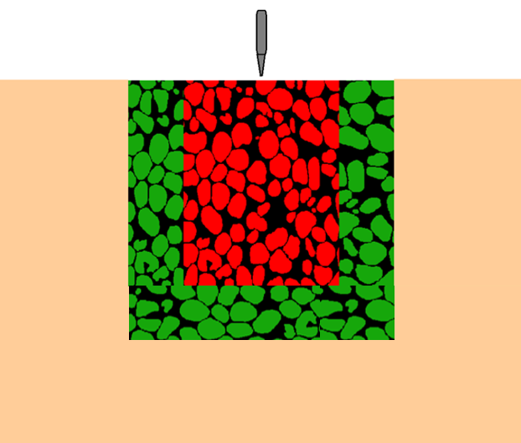

Near Field: 1D-Compression, fracturing of grains

Intermediate Field: Medium confinement,
grain scale interactions are important

Far Field: Low confinement, triaxial state of stress

Fig1. 1: Multiscale approach to model projectile penetration in sands

interaction mechanisms such as force chain buckling and shear banding are dominant. In the far-field region, sand primarily functions as a confining material and can be adequately represented by a continuum-based constitutive model.
The influence of multiphase fluids such as air and water in sands is poorly understood for high strain rate and impact-related problems, even from an experimental standpoint view. A state of partial saturation by multiphase fluids most commonly water/air in sands results in the development of capillary suction which influences the static and dynamic behavior of sands. Although, the effect of capillary suction is evident in the formation of a cavity around the projectile, as shown in Fig1.2, which was demonstrated in a recent experimental study by Kim et al. 2016. However, contrary to the expectations, strength does not increase with partial saturation as reported by Barr et al. 2016. The spatial distribution of the water is heterogeneous and therefore requires special attention in understanding the governing physical mechanisms. In essence, the physics behind the penetration of projectiles in multiphase granular materials is poorly understood.
The present research attempts to explore the numerical modeling strategies to model different stress paths such as 1D compression and triaxial compression in dry granular materials of different morphology. The role of partial saturation in sands will be considered based on experiments and a pore-scale modeling approach. The key idea will be to preserve the discrete nature and morphology of the sand grains in numerical modeling by using X-ray CT imaging. The hope is to overcome the limitations of continuum-based numerical modeling by performing direct simulations on granular microstructure and provide micromechanical insights into the single-phase and multiphase granular materials subjected to different stress paths experienced by a material during a projectile impact.

Objectives

The following objectives have been formulated for this Ph.D. dissertation to further advance the understanding of the projectile penetration in sands:
- Numerically simulate triaxial compression experiments in sands using realistic particle shape captured using attenuation contrast-based X-ray CT imaging. A novel framework will be introduced and validated wherein particle shape is captured in FEM simulations using shell elements based on corotational velocity formulation for simulating triaxial boundary value problems. The shell elements offer a computational advantage since a smaller number of elements are required to discretize grains to capture the morphology in comparison to solid elements. This aspect of the modeling approach will be useful in modeling sands in the intermediate field of impacting projectile wherein grain-scale interactions are important and the fracturing of grains is negligible.

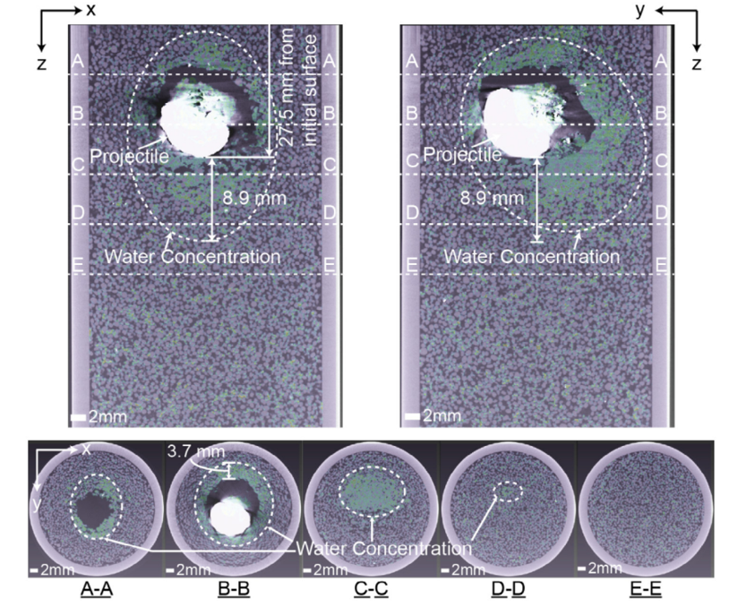
Fig1.2: Cavity formation around the projectile in partially saturated sand (adopted from Kim et al. 2016)

- Explore the role of particle shape and intergranular friction on micro and macro scale response in the sheared granular materials. The realistic particle shape is incorporated in numerical simulations unlike the spherical grains utilized in most discrete element studies. The uncertainties in experiments due to the difficulties in preparing repeatable samples for coarse-grained soils are eliminated in numerical simulations for different values of intergranular friction by using the same initial 3D microstructure for all the simulations. This study intends to enrich macroscale observations with grain-scale kinematics and other important micromechanical quantities of interest.
- Characterize the moisture retention behavior in rounded Ottawa sand and angular Q-Rok based on Soil Water Retention Curve (SWRC) experiments and direct pore-scale modeling approach known as Pore Morphology Method (PMM). Several experimental and numerical studies in the past were carried out independently; there is a need to combine experimental observations with numerical predictions to provide a better theoretical framework to better understand the hydromechanical response. The complex grain and fluid microstructure obtained from predictions can be used as an input in mesoscale simulations using numerical schemes like Finite Element Method, Discrete Element Method, Finite Volume Method to understand interactions of different phases at pore scale in multiphase granular materials subjected to projectile penetration.
- Characterize the spatial distribution of pore space and fluid phases in partially saturated sands obtained from in-situ CT imaging experiments or numerical predictions. The spatial distribution of the multiphase fluids in sands is often analyzed just based on the direct visualization which does quantify the changes in structure comprehensively. In this work, an advanced analysis of the flow data will be carried out using a mathematical framework derived from computational topology known as persistent homology to obtain the topological information from 3D grayscale images. This approach allows quantification of geometry as well as connectivity of pore space and fluid phase directly from the CT images with powerful implications in exploring pore-scale physics of multiphase granular materials. Important features including connected and disconnected pores, pore and throat size distribution, and redundant pathways can be obtained quantitatively.
- Numerically simulate the breakage of granular materials in a 1D compression stress path using FEM. This aspect of the modeling approach will be useful in modeling sands in the near field of impacting projectile wherein sand grains experience extreme crushing. The microstructure from FEM simulations at different axial strains will then be used as an input to PMM based numerical simulations to predict the evolution of capillary suction at different axial strains. The estimated capillary suctions at different levels of breakage in the granular assembly are expected to provide useful insights in considering the role of partial saturation in projectile penetration loading in granular materials. This approach is powerful as it allows us to bypass several time-consuming SWRC experiments.

Literature Review

This section presents a review of the literature relevant to the projectile penetration and high strain rate loading in sands. The literature specific to each of the objectives discussed in the previous section is provided in the subsequent chapters of this dissertation.
Allen et al. 1957 carried out projectile penetration experiments on dry quartz sand by shooting the conical non-rotating projectile at a striking velocity of 700 m/s. They proposed a theory of penetration to account for the change in slope at critical velocity ‘v_{o}’ by expressing deceleration of a projectile based on Eq.1.1 & Eq. 1.2 depending upon the velocity ‘v’ of the projectile. ‘v_{o}’ represents the striking velocity of the projectile and ‘α’, ‘β’, ‘γ’ are positive constants. The penetration in the second velocity range is widely referred to as the Poncelet equation of motion.

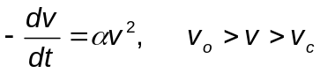
1. 1
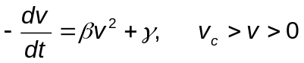
1. 2

Savvateev A.F. et al. 2001 carried out a series of experiments to study the high-speed projectile penetration in sands. The velocity of the impact ranged from 1-4 km/s. They observed that the depth of penetration increases with velocity up to a certain value of velocity known as critical velocity. The penetration depth decreased with the increase in velocity beyond a critical velocity. At velocities higher than critical velocity, projectiles did not follow a straight path due to the wear of the bullet because of the friction caused by sand-bullet interface. The friction generates heat which results in the melting of the bullet. Therefore, melting point and heat of fusion of bullet material are essential for deep penetrations at velocities greater than critical velocity. Also, the aspect ratio of the projectile is critical in ensuring the stability of the projectile during impact. Projectile with an aspect ratio of 5-7 was considered most suitable. The projectile geometry with higher aspect ratios may result in damage and breakage.
Bless et al. 2015 provided a comprehensive review on different aspects of high-speed penetration in granular materials. The impact velocity dictates the physics of the problem and is quantified based on the Taylor numbers defined in Eq.1.3 & Eq.1.4 for the projectile and the target, respectively. The subscripts ‘p’ and ‘t’ denote projectile and target, respectively. ‘ρ’ is the density, ‘v’ is the projectile velocity, ‘u’ represents the velocity at which sand is penetrated, ‘v - u’ is referred to as consumption velocity of the projectile. ‘R’ represents the cavity expansion resistance of the sand which is approximately considered to be equal to twice the shear strength and ‘Y’ represents the unconfined compressive strength of the projectile material.

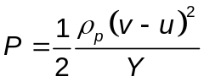
1. 3

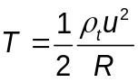
1. 4

The Taylor numbers have a physical significance as they relate inertial stresses and strength.

Fig1. 3 shows the Taylor diagram which relates different types of penetrations to the velocity regimes and strength.
Omidvar et al. 2015 carried out projectile penetration experiments in the low-velocity range (50-100 m/s) and intermediate velocity range (300 m/s). They observed that the projectile penetrates silica-based sand easily compared to the carbonaceous sand. The penetration velocities sufficient to cause fracturing of grains result in the formation of a compacted zone of crushed particles ahead of the projectile known as false cone / false tip. The different shapes of the nose of a
projectile produce similar results if the impact velocity and granular material provide conditions suitable for the formation of the false tip. For instance, Omidvar
et al. 2015 found out that the effect of tip shape had a noticeable effect in Ottawa sand compared to Aragonite sand. They attributed this contrasting response of two
sands to the susceptibility of the grains to fracture. The grains of the Aragonite sand fractured easily compared to the grains of Ottawa sand which resulted in the formation of a false tip in Aragonite sand. The formation of the false tip influenced the penetration depth instead of the projectile nose.
Glößner et al. 2017 measured experimentally the deceleration experienced by a projectile by using an onboard measurement system known as G-Rec. The impact velocity was chosen approximately 380 m/s. They suggested that a ratio of projectile diameter and target diameter equal to 1:8 is sufficient to eliminate the boundary effects. Glößner et al. 2017 identified four phases of deceleration during the penetration of projectile into the sand. Phase 1 was characterized by oscillatory high deceleration peaks. Phase 2 was characterized by oscillatory deceleration peaks of low magnitude compared to phase 1. Phase 3 exhibited constant deceleration for a short period, possibly because the stress experienced by grains

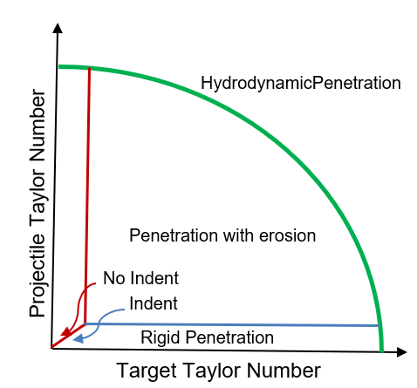

Fig1. 3: Variation in Taylor numbers for projectile and target (adopted from Bless et al. 2015)

was lower than the stress required for fracturing. Phase 4 consists of deceleration due to friction which finally brings the projectile to halt. Another interesting result
reported by Glößner et al. 2017 was the formation of a false tip ahead of the projectile. Farr 1990 investigated the 1-D compression response of sands in a uniaxial strain device capable of producing sub-millisecond rise times. The observed gradual stiffening in constrained modulus with the decrease in time to the peak pressure for the different times to peak ranging from tenths of a millisecond to several minutes. Furthermore, Farr 1990 found out that the ratio of the constrained modulus corresponding to the dynamic and static loading increased approximately by a factor of 2. The initial response of the soil to the 1D compression loading is governed by the elastic deformation at the contact points of individual grains followed by the rearrangement of the grains into a denser configuration. However, if the rate of the loading is high enough to inhibit this rearrangement, the load is absorbed by the grains resulting in a stiffer response of the assembly of grains.
The high strain rate response of sands is characterized using Split-Hopkinson bar set up. Split-Hopkinson bar tests are carried out by considering either of the following two concepts (Omidvar et al. 2012):
- A small soil sample is used to carry out the experiments which provide a uniform stress state throughout the sample to represent stresses imposed by propagating wave front.
- A large soil specimen is utilized to carry out the experiments which allow investigating the wave propagation response in the soil.
Charlie et al. 1990 carried out high strain rate tests on 50/80 silica sand at different water contents using Split-Hopkinson bar set up. They observed that the compression wave velocity increased up to approximately 60 % degree of saturation, the further increase in saturation resulted in a decrease in compression wave velocity. The compression wave velocity was less for the degree of saturation between 80 % -95 % compared to the compression wave velocity in dry sand. Furthermore, quasi-static 1D compression tests indicated that the confined modulus increased from 0 % to 34 % degree of saturation and decreased with an increase in the degree of saturation beyond 34 %.
Martin et al. 2009 investigated the effect of partial saturation on the high strain rate response of silica sand by carrying out Split-Hopkinson bar tests on silica sand at a strain rate of 400 s⁻¹. The experimental setup was designed such that the sample acquired stress equilibrium. The speed of longitudinal wave varies in different media and was reported to be equal to 340 m/s, 1480 m/s, and 243 m/s for air, water, and silica sand, respectively. It is expected that the longitudinal wave speed will change under the applied external stress due to the compaction of the specimen. Martin et al. 2009 observed that the partially saturated specimens were more compliant compared to the dry specimen and the possible reason for such a response was attributed to the lubrication by the pore water at the inter-particle contacts. Furthermore, it was observed that the stiffness of the partially saturated sand decreased with the increase in water content up to 7 %. The increase in water content beyond 7 % increased stiffness, however, the stiffness of all the partially saturated specimens was less than the stiffness of the dry specimen. The increase in stiffness at higher water contents was speculated to be due to the presence of water in pore bodies which didn’t allow pore air to move freely and therefore, inhibits rearrangement of the sand grains. The effect of frictional end boundary in the case of dry sand and the slightly lubricated boundary due to the presence of water in partially saturated sand may also produce such a response. Martin et al. 2009 did not investigate the response of completely saturated specimens to high strain rate loading. These findings were further confirmed in an independent study by Barr et al. 2018.
Luo et al. 2014 carried out Split-Hopkinson bar tests on Eglin sand at approximately 600 s⁻¹ strain rates. They found out that the increase in the degree of saturation for a partially saturated soil inhibited fracturing of the grains and the breakage followed a linear relationship with the moisture content. The crushing of the grains was more significant in dry sand compared to the partially saturated sand. Barr et al. 2016 observed an increase in confined modulus of sands with the increase in strain rate due to the additional confinement provided by the inertial forces and not due to the inherent strain rate dependence. Furthermore, they observed that the moisture had little effect on the stiffness of the material in the dynamic range, however, stiffness decreased with the increase in moisture content in the quasi-static regime. De Cola et al. 2018 investigated the effect of intergranular friction on the uniaxial quasi-static response of sands by coating grains with an epoxy resin thereby enhancing the surface roughness of the material. They observed that the friction enhanced the stiffness of the material only when the material was packed in a loose state. The friction increased the granular locking which did not allow the sand grains to move freely. Kim et al. 2016 investigated the mechanics of projectile penetration in partially saturated sands at mesoscale by visualizing penetration experiments using dual imaging modalities: X-ray and Neutron. They observed the formation of a cavity around the projectile with a higher content in a region where the projectile came to a halt. The stability of the cavity after projectile halt can naturally be attributed to the existence of capillary suction.
The modeling of the projectile penetration in granular materials has evolved considerably over the last five decades. Different approaches have been adopted to model penetration in granular materials ranging from empirical methods (Young 1981), phenomenological methods (Ambroso et al. 2005; Katsuragi and Durian 2007, 2013; Poncelet 1839; Robins 1805), analytical predictions(Forrestal and Luk 1988) and numerical methods (Borg and Vogler 2008; Dwivedi et al. 2008; Scheffler and Zukas 2000; Zukas and Sche 2000). While all the modeling approaches have provided useful insights in advancing our understanding of penetration phenomena in granular materials, numerical modeling provides an enriched description of physics and high fidelity in terms of precise representation of the geometric structure and boundary conditions. The numerical modeling approaches to investigate projectile penetration phenomena can be broadly classified into two categories: (a) Continuum scale methods, and (b) Discrete methods. Continuum scale methods incorporate constitutive relations derived phenomenologically from laboratory experiments. To this end, various advances have been made to capture the breakage and rate-dependent behavior in single-phase granular materials, specifically with the introduction of breakage mechanics by (Einav 2007a; b). Cil et al. 2019a formulated a constitutive model based on breakage mechanics which was later extended to incorporate the rate dependence by Cil et al. 2019b. The concepts of breakage mechanics were extended to partially
saturated soil by (Buscarnera and Einav 2012; Zhang and Buscarnera 2015). Despite these advances, the incorporation of rate-dependent behavior and grain crushing in constitutive modeling of partially saturated soils remains fairly unexplored. Furthermore, the continuum scale models fail to capture complex grain scale and pore-scale interactions such as non-affine deformations including slippage at grain contacts, force chain buckling, and spatial distribution of pore fluids. Discrete Element Method and more recently Finite Discrete Element Method provide opportunities the investigate the role of particle shape, grain breakage, and
force chains in the mechanical response of sands (Imseeh and Alshibli 2018a; Kawamoto et al. 2018; O’Sullivan 2011; Turner et al. 2016). Dwivedi et al. 2008 carried out mesoscale simulations using an explicit finite element code to account for grain-scale interactions and grain-projectile interactions realistically. Although Dwivedi et al. 2008 did not account for the crushing of the grains in their simulations, mesoscale simulations still useful grain-scale insights in terms of force
chain and projectile instability as shown in Fig1. 4. The incorporation of partial saturation and grain crushing in such mesoscale simulations remains a challenge
and has the potential to useful insight to enrich our understanding of projectile penetration phenomena.

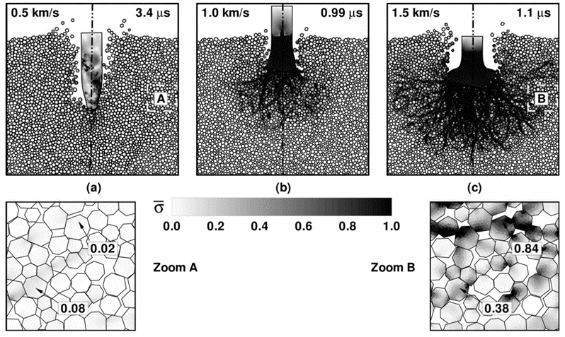
Fig1. 4: Force chains in projectile penetration of sands obtained from mesoscale simulations (adopted from Dwivedi et al. 2008)

Triaxial compression in sands using Finite discrete element method and micro-X-ray computed tomography

A version of this chapter is published as Thakur, M. M., & Penumadu, D. (2020). Triaxial compression in sands using FDEM and micro-X-ray computed tomography. Computers and Geotechnics, 124, 103638.

My contributions to the paper include image processing, performing finite element simulations and experiments, data analysis, and writing of the manuscript.

Abstract

Triaxial compression experiments on a dry Ottawa sand are numerically simulated using the Finite Discrete Element Method (FDEM) in conjunction with X-ray CT imaging. A novel framework is introduced and validated where particle shape is captured in FEM simulations using shell elements for simulating the triaxial boundary value problem. The proposed approach is well suited for load cases with low/intermediate confining pressures where particle breakage is negligible. The numerical model allows for grain deformation as well as robust particle contact fabric evolution for the realistic grain morphology. For this research, the confining latex membrane is modeled as hyper-elastic material to provide flexible boundary condition on the lateral surface of the cylindrical sand specimen. Volume change measurements are obtained directly based on the convex hull of an assembly of sand grains, with no contributions or associated errors from latex membrane effects. In this paper, we attempt to explore the FDEM modeling aspect from different perspectives considering macroscale and microscale responses. The influence of the frictional and frictionless boundary on the strength deformation response and localization in the displacement field is discussed. Furthermore, the sensitivity of mesh refinement, interparticle friction coefficient, and critical shear stress on strength and volume change response is quantified.

Introduction

Granular materials such as sands are ubiquitous with applications in different fields such as construction, agriculture, defense, space science, and energy science (Jarrar et al. 2018, 2020; Kim et al. 2016b; Mukunoki et al. 2016; Ramesh et al. 2015; Randolph et al. 1994). Their constitutive behavior remains largely elusive and poses a unique challenge to the scientific community in arriving at unified constitutive laws. What makes sands interesting is their ability to manifest both fluid and solid like response to external excitation depending upon the initial conditions and stress state. Over the years, large number of studies focused on predicting constitutive behavior of sands in the framework of continuum mechanics (Lade and Kim 1988; Nova and Wood 1979; Taiebat and Dafalias 2008). Geomechanics community largely relies on triaxial testing to obtain material parameters to calibrate such constitutive models. While such models have found wider acceptance in reproducing phenomenological effects, several short comings exist. The assumption that the average stress and boundary strain can characterize material behavior with little/no attention to local measurements is convenient but lacks features to capture complex mechanical interactions such as force chain buckling and non-affine deformations including slippage at grain contacts. The continued evidence with a lack of suitable predictive tools with reasonable number of parameters makes us believe this problem is too complicated for continuum-based approach. The pressing need is to incorporate mesoscale scale effects in the numerical modeling of sands, an important class of geomaterials.
The inherent heterogeneity and particulate nature of sands is often modeled using Discrete Element Method (DEM) (Cundall and Strack 1979; Kozicki and Donzé F.V 2008; O’Sullivan 2011). DEM has provided useful microscale insights in the sheared granular materials. Most of the DEM studies, however, are limited by modelling grains as circular discs in 2D and as spheres in 3D which allows for computationally less involved contact detection. Particle shape is considered as an important parameter influencing strength as well as dilatancy response of sands (Alshibli and Cil 2018). The influence of particle morphology in DEM is implicitly accounted for by introducing rolling resistance in the contact law, and therefore, requires additional material parameters (Iwashita K., Oda 1998a) . Alternatively, particle morphology in some other DEM studies is captured by introducing clumped sphere approach (Cil and Alshibli 2015; Katagiri et al. 2010). Zhou et al. (Zhou et al. 2013) compared the response of rolling resistance model and clumped sphere approach in a 2D DEM study and observed different rotation mechanisms in the two approaches which resulted in different micromechanics in the localization zones. None of these studies, however, capture full scale actual morphology of grains and real fabric of the contact network. Zhou et al. (Zhou et al. 2018) combined X-ray CT imaging and clumped sphere approach to capture realistic particle shape in 3D DEM direct shear tests and reported increase in in interlocking effect in realistic particle shapes. This approach, however, underestimates roundness of particles unless large number of spheres are used to approximate particle shape. In addition, transition from X-ray CT images to DEM models requires additional processing steps such as reconstruction of particle surface by simple harmonic analysis and clump generation using optimized parameters. Andrade et al. (Andrade et al. 2012) introduced Granular Element Method (GEM) to integrate particle shape in DEM studies by using Non-Uniform Rational Basis Splines (NURBS). GEM captures particle shape accurately but is limited by high computational cost due to non-trivial contact detection and large number of control points required for particles of complex morphology. A more realistic framework to incorporate particle shape in DEM is to use level sets (Kawamoto et al. 2016, 2018), however, it requires high computational cost and computer memory which may result in frequent system crashes. Zhao and Zhao (Zhao and Zhao 2019) recently introduced poly-super ellipsoidal approach to approximate particle shape in DEM with less computational cost compared to level set DEM. DEM formulations, however, assume rigid particles with little overlap between the grains and calculates quantities of interest based on predefined contact law.
A combined Finite Discrete Element Method (FDEM) has been used recently to address the limitations of continuum-based approach and DEM (Imseeh and Alshibli 2018b; Ma et al. 2017; Mašín et al. 2006; Nadimi and Fonseca 2018a; Turner et al. 2016, 2019a). The discrete nature of sand grains is captured in 3D using X-ray Computed Tomography. 3D image is transformed into a numerical model to solve continuum-based equations on a discretized domain. The continuum based governing equations allows for grain deformation as well as robust contact fabric evolution in contrast to the limitations imposed by rigid particle assumption in DEM. FDEM approach allows simulation of interaction between the grains of arbitrary morphology without any need for the complicated algorithms for particle shape descriptors such as NURBS or level sets in DEM. In addition, the integration of mesoscale simulations with the boundary value problems posed at macroscale using double scale homogenization approach can be achieved using a single numerical framework : FEM at macroscale and FEM at microscale (Desrues et al. 2019). This eliminates the use of two numerical frameworks: FEM at macroscale and DEM at microscale.
Most of the FDEM studies are limited to 1D compression with a few recent studies exploring other loading conditions. Ma et al. (Ma et al. 2014a, 2016) used FDEM approach to simulate breakage of irregularly shaped rock fill materials in biaxial and triaxial tests. The numerical samples used in their studies were limited to convex shaped polygonal and polyhedral particles in 2D and 3D, respectively. Nadimi et al. (Nadimi et al. 2019), used FDEM approach to investigate response of sands to triaxial loading. They used linear elastic shell elements to numerically represent latex membrane and 3D linear tetrahedral elements to discretize sand grains. However, Nadimi et al. (Nadimi et al. 2019) used the value of modulus of elasticity for latex membrane equal to 125 MPa which is significantly higher than the value proposed by ASTM D7181 (ASTM International 2020). Several studies in the past in the materials science field characterized material response of latex from experiments and observed hyper-elastic material models describe their constitutive behavior comprehensively (Genovese et al. 2006; Machado et al. 2012; Selvadurai 2006; Shahzad et al. 2015). An accurate continuum model for latex membrane with precise material parameters can be useful to the researchers in exploring micromechanics of granular materials.
In present work, triaxial response of Ottawa sand is investigated using high resolution X-ray CT imaging in conjunction with Finite Discrete Element Method (FDEM). X-ray CT imaging allows precise 3D particle scale characterization in an assembly of sand grains. The FEM simulations can therefore be carried out on realistic grain and pore microstructure with grain morphology exhibiting both convex and concave features. The focus of this paper is on evaluating response of sands in triaxial loading conditions at low/intermediate confining pressures such that individual grains do not experience crushing. A novel framework is introduced and validated where particle shape is captured in FEM simulations using shell elements for simulating triaxial boundary value problem. Intuitively, if particle fracture is not a concern, shell elements should be able to predict the response of an assembly of sand grains subjected to triaxial loading at low/intermediate confining pressures. In this paper, we attempt to answer this question from different perspectives including stress-strain response, volume change response and energy dissipation mechanisms. The shell elements offer computational advantage since a smaller number of elements are required to discretize grains to capture the morphology in comparison to solid elements. Before investigating assemblies of the grains, effect of the type of finite element discretization using solid and shell elements is evaluated on two identical spheres subjected to normal loading, tangential loading, rotational loading, and torsional loading. Similar study on two identical spheres was carried out by Nadimi & Fonseca (Nadimi and Fonseca 2018b) using solid linear tetrahedral elements and in this paper similar meshing ratios are used as proposed by (Nadimi and Fonseca 2018b) .The latex membrane is modelled as hyper-elastic material with strain energy potential defined by Mooney-Rivlin form. This ensures membrane no longer deforms in a linear elastic fashion. The incorporation of latex membrane in the numerical model realistically allows modelling of grain-membrane interactions in addition to the confining stress application interface as used often for triaxial testing experiments. The material parameters for latex membrane were obtained from uniaxial tension experiments described in next section. The comparison of the triaxial shearing response on sands is investigated using hyper-elastic and linear elastic model for latex membrane. In addition, sensitivity analysis is carried out to investigate the effect of different parameters on strength deformation response and volume change response of sheared granular materials. Further, microstructural insights are provided in terms of fabric evolution, particle rotations and localized displacements with the progression in shearing. The approach for predictions presented in this paper and some other past studies is powerful as it allows full field measurements of different quantities of interest.

Microstructure Imaging

X-ray CT imaging has been successfully adopted in past studies to explore the mechanics associated with granular materials at micro scale (Amirrahmat et al. 2018b; a; Borja et al. 2013; Cheng and Wang 2018; Mohsin Thakur et al. 2020a; Thakur and Penumadu 2020a; Zhai et al. 2019a). In present paper, 3D microstructure of Ottawa sand, with a nominal particle size of 600 µm, was captured non-invasively using attenuation contrast-based X-ray CT imaging at 11 µm pixel resolution. The detailed review of the principles, procedures and applications of this technique can be found in literature (Cnudde and Boone 2013; Kim et al. 2012; Wildenschild and Sheppard 2013). The sample of Ottawa sand was prepared corresponding to a dense configuration in a cylindrical mold of height and diameter equal to 10.5 mm. The projections (radiographs) obtained from X-ray CT imaging were transformed into 3D assembly of sand grains using cone beam-based image reconstruction algorithm known as Filtered Back Projection method. A series of processing steps were carried out on the reconstructed images using a commercially available software package called Simpleware (https://www.synopsys.com/simpleware.html). A median filter was applied to remove noise and smoothen the reconstructed data. The segmentation of data into sand grains and pore space was carried out using watershed algorithm. The 3D X-ray CT data of an Ottawa sand assembly was transformed into a 3D FEM mesh in Simpleware useful for converting 3D images to models. A high-resolution mesh was generated to discretize assembly of sand grains. Fig2. 1 shows transformation of CT images of Ottawa sand into discretized 3D numerical model of an assembly of Ottawa sand grains.

Latex Membrane Characterization

In present work, latex membrane is modelled as isotropic hyper-elastic material such that it can undergo large elastic non-linear deformations and provide flexible boundary conditions to closely replicate laboratory based triaxial testing conditions. The strain energy potential is described according to the Mooney Rivlin form, as shown in Eq.2.1, where ‘U’ represents strain energy per unit volume in the reference configuration; coefficients C₁₀, C₀₁ and D₁ represent material parameters, I₁’ and I₂’ represent first and second invariants of deviatoric strain tensor, λ’_{i} and J^{el} represent deviatoric stretches and elastic volume ratio, respectively. The first two terms on the right side of Eq. 2.1 represents deviatoric component of the strain energy whereas third term represents hydrostatic/ volumetric component of the strain energy. The choice of using first and second invariants of deviatoric strain tensor in Mooney Rivlin formulation of strain energy is advantageous since the material is assumed isotropic, therefore, results in constitutive model independent of coordinate system.

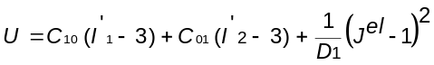 2. 1

The material parameters are obtained by carrying out uniaxial tension experiments on latex membrane using a miniature universal material testing system, known as Psylotech µTS, shown in Fig2. 2 (a). The system consists of 1.6 kN load cell and a 9 mm linear variable displacement transducer. The system can resolve sub-micron displacement and sub-newton force to allow high resolution measurements. A sample of latex membrane of length, width, and thickness equal to 40 mm, 15 mm, and 0.305 mm, respectively was fabricated for the uniaxial tension experiments. Fig2. 2 (b) shows results obtained from uniaxial experiments

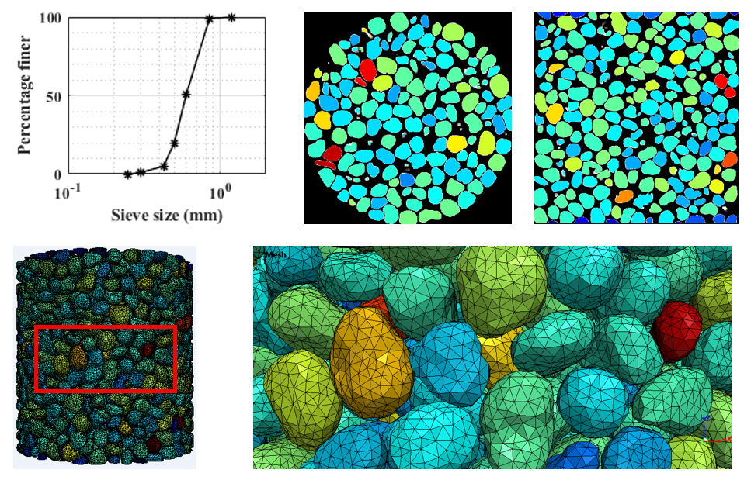
Fig2. 1: Transformation of CT images of Ottawa sand into discretized 3D numerical model of an assembly of Ottawa sand grains.

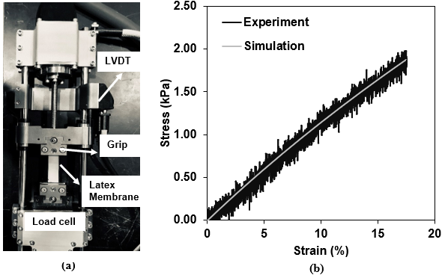
Fig2. 2: Latex membrane material characterization; (a) miniature universal material testing system (Psylotech µTS), (b) calibration of latex membrane based on uniaxial stress- strain experiment and simulation using FEM

and simulations using FEM based on hyper-elastic material model. Mooney Rivlin parameters with values of C₁₀, C₀₁ and D₁ equal to 0.584 MPa, -3.37× 10⁻⁴ MPa and 1.583×10⁻³, respectively were obtained and used in subsequent triaxial simulations of latex membrane in an assembly of sand grains.

Finite Element Method (FEM)

The 3D FEM mesh of an assembly of sand grains was imported to Abaqus 2017 (Abaqus 2017) to perform the finite element analysis based on explicit time integration scheme and diagonal / lumped mass matrices. The explicit central difference rule is employed to integrate equations of motion as shown in Eqs. 2.2 & 2.3 where u, ύ and ϋ represent displacement, velocity, and acceleration respectively; and ‘i' refers to the increment number. The advantage of this approach is that the kinematic state of the system advances to an increment i+1 based on the known values of displacement, velocity, and acceleration from previous increment. The acceleration value at the beginning of each increment ‘i’ is computed based on the Eq.2.4, where M, F’ and I represent diagonal mass matrix, applied load vector and internal force vector. The inversion of diagonal mass matrix in Eq.2.4 is computationally less intensive and therefore enhances the computational efficiency of the analysis. The speed of the analysis is, however, limited by the conditional stability of central difference operation which depends upon the time required for elastic wave to travel through the smallest dimension of the element used in the analysis.

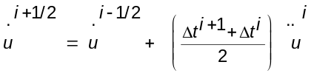
2. 2

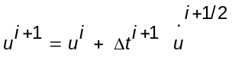
2. 3

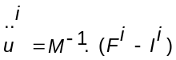
2. 4

The sand grains were discretized into finite elements using small strain triangular shell elements (S3RS). These elements are based on Mindlin-Reissner's flexural theory and corotational velocity strain formulation. The Mindlin-Reisner flexural theory includes transverse shear. The main advantage of S3RS elements is that they are computationally less expensive compared to solid elements and are well suited for problems involving rotation. Using the shell elements requires discretizing only the surface of the grains to capture the grain morphology and not the volume of the grains compared to solid elements, and therefore, reduces the computational cost significantly. However, one needs to be careful in using S3RS elements in problems where grain fracturing is a dominant energy dissipation mechanism. The detailed formulation for S3RS elements can be found in the literature (Belytschko et al. 1984; Ted Belytschko et al. 1992). The corotational velocity formulation embeds a local coordinate system in each element, which reduces the complexity and computational cost, especially in problems involving non-linear mechanics. The local coordinate system remains embedded throughout the deformation of the elements such that it can rotate but not deform with the elements; therefore, it gets the name corotational coordinates. The local coordinate x̂₁ coincides with the edge connecting nodes 1 and 2, as shown in Fig2. 3. The plane of the element coincides with the x̂₁ - x̂₂ plane. These elements have six degrees of freedom at each node, which includes three translational degrees of freedom and three rotational degrees of freedom. There is no resistance to the rotations about the axis perpendicular to the reference plane. The rate forms of strain—displacements or velocity strain are shown in Eqs. 2.5-2.9 and described in Belytschko et al. (1984). d̂_{αβ} denotes velocity strain, v and θ denote velocities and angular velocities, with superscript m indicating midplane. The superposed hat is used to indicate that the quantities are expressed in a corotational coordinate system.

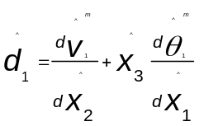

2. 5
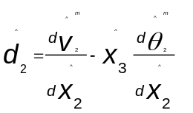
2. 6

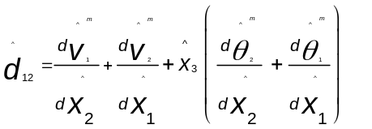
2. 7

Fig2. 3: Triangular S3RS shell element with embedded corotational coordinate system

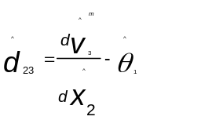
2. 8

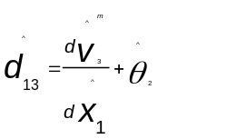
2. 9

Contact Interaction

An important decision in modelling triaxial behavior of granular materials is to incorporate appropriate contact properties to allow different deformation modes such as sliding, rolling and compression. In present work, general contact algorithm in Abaqus 2017 was used to implement contact interaction between sand grains-sand grains, sand grains-platens and sand grains-latex membrane. The interaction in the normal direction was enforced by using hard contact and the interaction in the tangential direction was incorporated by using penalty friction formulation. The non-zero friction coefficient and critical shear stress were used for grain to grain contacts. For all other contacts, the interaction in tangential direction was assumed to be frictional or frictionless depending on the simulation. Penalty contact formulation provides an approximate but relatively simple solution to the contact problems in comparison to the lagrangian multipliers and augmented lagrangian method. The number of geometric contacts in an assembly of sand grains are large, therefore, implementing penalty contact method for the analysis assumes an obvious choice. The particle shape in real sand grains is complex and includes both convexities and concavities. Abaqus Explicit utilizes sophisticated algorithms to track the motion of the surfaces and can be used to detect contact irrespective of the curvature of the surfaces. The contact search algorithm includes dual search approach: global search and local search. The local search tracking is carried out during most of the increments of the simulations whereas global search tracking is carried out at lower frequency. In case of self-contact such as contact between grains, global search tracking is carried out at every four increments. The detailed overview of the contact formulation has been avoided here for brevity and can be found in Abaqus 2017 manual.

FEM modelling of two identical spheres

The ability to exhibit different deformation modes such as normal compression, sliding and rotation/rolling of grains by shell elements was evaluated using two identical grains and compared with the solid elements. The sand grains were assumed as elastic material with the value of modulus of elasticity and poisons ratio equal to 100 MPa and 0.17. It should be noted that the value of modulus of elasticity for two identical spheres simulations was intentionally assigned a low value compared to the grains in an assembly of sand grains. The objective of two identical spheres simulations is to compare the response of solid and shell elements in exhibiting different deformation modes, therefore, a low value of modulus of elasticity ensures less computing time as the value of stable time increment in dynamic analysis decreases with the increase in modulus of elasticity. The friction coefficient equal to 0.3 was used to model interaction between the two spherical grains. The diameter of each sphere was equal to 350 µm. The thickness of the shell elements was assumed equal to one tenth of the diameter of sphere. Fig2. 4 shows arrangement of two identical spheres under normal loading, shear loading, rotational loading, and torsional loading. The top grain was subjected to concentrated normal compressive force before applying shearing, rotational and torsional loading as shown in Fig2. 4. The magnitude of normal compressive load before applying shear force or rotational/ torsional loading was set equal to 0.5 mN and 2 mN, respectively. The magnitude of the normal load was kept low since the low value of modulus of elasticity (100 MPa) was used for two identical sphere simulations.

FEM modelling of assembly of sand grains

The individual sand grains in an assembly were assumed as elastic material with the value of modulus of elasticity and poisons ratio equal to 100 GPa and 0.17, respectively based on the earlier study by (Turner et al. 2019a). The value of specific gravity was assumed equal to 2.65. In addition, two platens of the same material properties as that of grains were provided at the top and bottom of the sand grains assembly.
The analysis was carried out in two steps to replicate conventional triaxial loading condition. Initially, isotropic confining pressure equal to 140 kPa was applied on
outer face of the latex membrane and top platen for 0.001 seconds. Bottom platen was fixed for the entire simulation. Isotropic consolidation was followed by shearing which included applying axial displacement to the top platen to produce 15% axial strain in 0.003 seconds. The deviatoric stress in predictions was obtained based on nodal reactions from the bottom platen and area of the specimen. The global axial strain was obtained based on the applied displacement to the top platen and height of the cylindrical specimen. The choice of the duration of the simulation was based on the exhaustive preliminary simulations to minimize the dynamic effects as well as optimizing the computing resources and wall clock time for the simulation. The simulations were carried out using double precision executable to prevent errors due to large number of increments. Furthermore, results from the FEM simulations are compared qualitatively with results from drained conventional triaxial compression (CTC) experiment and mini triaxial compression experiment.

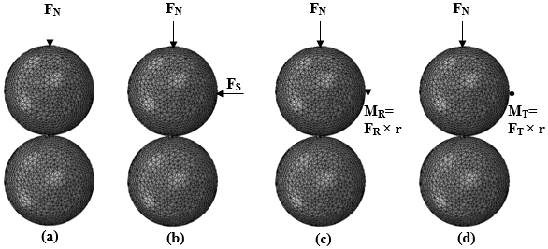
Fig2. 4: Arrangement of two identical spheres in FEM simulation under different loading conditions: (a) normal compression, (b) shear loading, (c) rotational loading, (d) torsional loading (F_{N}=Normal force, F_{S}=Shear force, M_{R}=Moment, M_{T}= Torsion, r= radius)

The height and diameter of the specimens adopted in conventional triaxial testing experiment was 177 mm and 63 mm respectively, while as height and diameter of the specimens adopted in mini-triaxial experiment was 30 mm and 10.6 mm respectively.

Volume change measurements

Volume change measurements for an assembly of sand grains in a finite element framework were carried out by obtaining volume of a convex hull of nodal coordinates of the sand grains with the variation in axial strain. Convex hull of a set of points in n dimensional space is obtained by determining smallest convex set which contains the points (Barber et al. 1996). In present work, convex hull of points in 3D Euclidean space is found out by using ‘Qhull’ library in ‘scipy’ class of python 3. For the sake of simplified demonstration, Fig2. 5 (a), shows convex hull computation of set of random points in 2-D Euclidean space. Fig2. 5 (b) shows the nodal coordinates in an assembly of sand grains contributing to the convex hull. The volume of the convex hull is obtained at different axial strains to obtain variation of volumetric strain with axial strain. This approach of volume change measurement is direct and ensures latex membrane does not contribute to the computations.

Fabric Quantification

The evolution of fabric with the progress of deformation in an assembly of sand grains provides useful insights in the micromechanics of granular materials (Imseeh et al. 2018). In present work, variation in fabric is quantified based on the evolution of 2nd order tensor defined based on contact normals according to Eq. 2.10 (Kanatani 1984; Mital et al. 2019); where ‘F_{ij}’ represents component of a fabric tensor, ‘N’ represents number of contacts, ‘n_{i}^{α}’ and ‘n_{j}^{α}’ represents ith and jth component of normal force at contact α respectively. The anisotropy in the fabric is quantified based on the parameter A defined in Eq. 2.11, where F₁ and F₂ represent maximum and minimum eigen values of a fabric tensor, respectively. In addition, distribution of the orientation of contact normals is obtained based on the distribution function presented in Eq.2.12 (Mital et al. 2019), where ‘θ’ represents orientation of the contact normals and ‘θ₁’ represents orientation of F₁. In this paper, orientations are measured with respect to the downward vertical direction.

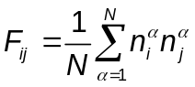
2. 10
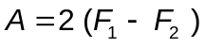
2. 11

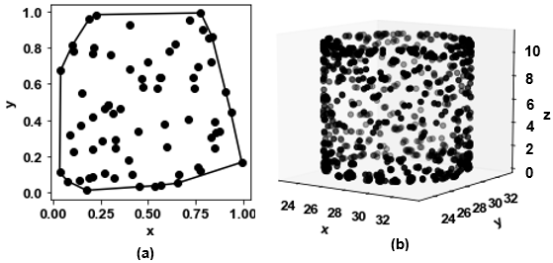
Fig2. 5: (a) shows convex hull computation of set of random points in 2-D Euclidean space, (b) the nodal coordinates in an assembly of sand grains contributing to the convex hull.

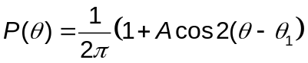
2. 12

Results

Response of two identical spheres to different loading conditions using shell and solid elements

The response of two identical spherical grains subjected to different loading conditions discretized using shell and solid elements in FEM framework is shown in Fig2. 6. It can be observed that response of the shell and solid elements is similar with minor variations when subjected to normal compression, shear loading, rotational and torsional loading. Fig2. 7 shows the ratio of CPU time required by shell and solid elements for different loading conditions for the same meshing ratios. It can be observed that shell elements significantly speed up the simulations approximately by a factor 3 to 5 depending upon the loading conditions. The results shown in Figs. 2. 6 & 2. 7 are promising and provide a useful approach to model assembly of sand grains using shell elements with less intensive computation compared to the solid elements. However, care should be taken not to use shell elements in high strain rate problem to avoid discrepancies in inertial forces generated in shell and solid elements.

Triaxial response of assembly of sand grains discretized using solid elements

The assembly of sand grains obtained from X-ray CT imaging was first discretized into a numerical model using solid linear tetrahedral elements. 8.43× 10 ⁵ tetrahedral elements were used in the simulation. The specimen was initially subjected to isotropic compression by applying confining pressure of 140 kPa on the outer surface of the latex membrane. The isotropic compression was followed by shearing of the assembly of grains. Fig2. 8 shows the response of an assembly of sand grains in terms of deviatoric stress, energy dissipation and volumetric strain with the variation in axial strain. The friction coefficient and critical shear stress between the sand gains was assumed to be equal to 0.5 and 5 MPa, respectively. All other contacts were assumed to be frictionless. It can be observed from Fig2. 8 that the Ottawa sand in dense state exhibits a sharp increase in deviatoric stress as soon as small axial strain is applied. The simulation captures the yielding and dilation of the specimen with the variation in axial strain. Energy dissipation mechanism provides useful microscale insights in the deformation
Fig2. 6: Response of two identical spheres subjected to: (a) normal compression, (b) normal compression followed by shearing, (c) normal compression followed by rotational loading, (d) normal compression followed by torsional loading.

Fig2. 7: Ratio of CPU time required by shell and solid elements for different loading conditions for the same meshing ratios

Fig2. 8: Response of an assembly of sand grains discretized using solid in terms of deviatoric stress, energy dissipation and volumetric strain with the variation in axial strain.

behavior of the sheared granular materials. Fig2. 8shows energy dissipated by friction normalized with respect to the total strain energy. It can be observed that with the increase in axial strain, ratio of the energy dissipated by friction with respect to strain energy increases up to a certain limit, approximately 2.56% axial strain. Beyond this limit, the ratio of energy dissipated by friction and strain energy remains constant with minor fluctuations. The energy dissipated by friction accounts for 97% of total dissipated energy. This result proves to be extremely useful from the modelling perspective since it suggests primary deformation mode in granular materials at low/intermediate confining pressures in triaxial testing conditions turns out to be frictional sliding / rotation / rolling at interparticle contacts rather than elastic compression of the individual grains. Therefore, it makes sense to discretize 3D X-ray CT microstructure of an assembly sands grains using shell elements instead of 3D solid elements.

Triaxial response of assembly of sand grains discretized using shell elements and comparison with experiments

Macroscopic response

The response of an assembly of sand grains discretized using shell elements is investigated and compared with the response obtained from experiments. Two drained triaxial experiments were carried out with different specimen dimensions. 6.64 × 10⁵ shell elements were used to discretize the assembly of grains. A sensitivity study on the effect of the mesh refinement is illustrated in next subsection. The thickness of the shell elements was chosen equal to 0.06 mm which is equal to one tenth of the d₅₀ of assembly of sand grains. The shell element-based discretization concentrates elements on the grain boundary, and is therefore, well suited to capture grain morphology with lesser computational cost. The value of the friction coefficient (µ) and critical shear stress (Τ_{cr}) between the grains was assumed to be equal to 0.5 and 5 MPa, respectively. Two sets of FEM simulations are described here: (a) where the interaction of latex membrane and loading platens with the sand grains was assumed to be frictional with the same interaction parameters as assigned for grain to grain interaction, (b) where the interaction of latex membrane and loading platens with the sand grains was assumed to be frictionless. Fig2. 9 shows the comparison of strength and volume change response of an Ottawa sand assembly obtained from experiments and FEM simulations. The general observation based on the results shown in Fig2. 9 suggests that Ottawa sand in dense state exhibits a sharp increase in deviatoric stress as soon as small axial strain is applied. The simulations capture both yielding of the specimen with the increase in axial strain. The mini-triaxial and CTC experiments suggest that the strength-deformation response is dependent on the specimen dimensions. The small dimension specimen exhibits less noticeable peak and achieves peak strength at a higher axial strain compared to the large

Fig2. 9: Comparison of strength and volume change response of an Ottawa sand assembly obtained from experiments and FEM simulations.

dimension specimen. The frictional and frictionless boundary results in noticeable variation in results obtained from FEM simulations. The frictional boundary results in noticeable peak and increase in peak strength compared to the frictionless boundary. However, both frictional and frictionless boundary simulations of an assembly of Ottawa sand tend to reach the same critical state. The FEM simulations with the frictional end boundary provide a better comparison with the result obtained from the mini-triaxial experiment since both exhibit peak strength followed by a softening response. This is expected since the specimen dimension in the mini triaxial experiment is comparable with the simulations relative to the CTC experiment. The simulation captures stress-strain response reasonably well including the yielding of the specimen. The initial part of the stress-strain response is captured perfectly, however, the yielding of the specimen exhibits some deviations compared to the experimental results. The yielding of the specimen is influenced by the frictional and non-frictional boundary. The volume change response could not be measured using a mini-triaxial setup. Therefore, the volume change response from the simulations is only compared with the CTC experiments. The simulations capture dilative response as expected in dense specimens. The perfect match is not expected since the comparison is not one-to-one, the size of the sample in experiments is larger in comparison to simulations. Furthermore, the volume of the specimen used in the simulations is small in comparison to the experiments. The small specimen volume inhibits the development of the well-defined shear bands. In addition, simulations rely on a single value of friction coefficient which might not reflect complete physics at the sub-micron scale. The authors believe a more advanced constitutive law presented by Dieterich (Dieterich 1978) and Ruina (Ruina 1983) for the evolution of the friction coefficient which includes slip rate as well as contact maturity as the state variables are expected to provide better results. However, this paper intends to demonstrate a methodology and its implications in investigating physics associated with granular materials, rather than focusing on curve fitting of global response from simulations with the experiments.

Microscopic Response

FEM simulations provide microscale insights into the deformation patterns at the grain scale. Fig2. 10 shows the magnitude of the displacement experienced by frictional boundary Ottawa sand assembly during the shearing of the specimen at 140 kPa confining pressure. The section at the center of the specimen along the height is shown for better visualization. The displacement contours are provided at 2%, 5%, 9%, and 15% axial strain. It can be observed that the displacement field translates into a localized zone with the increase in axial strain. At 5% axial strain, which coincides with the peak stress, the specimen deforms along a cone shape wedge formed at the bottom of the specimen as shown in Fig2. 10. The displacement field is negligible in the cone-shaped wedge region and rest of the

Fig2. 10: Displacement in a frictional boundary Ottawa sand assembly during the shearing of the specimen at 140 kPa confining pressure; (a) 2% axial strain, (b) 5% axial strain, (c) 9% axial strain, (d) 15% axial strain. (A cone-shaped wedge of negligible displacement is formed at the bottom of the specimen) (Displacement is in mm).

assembly shears along the wedge. The specimen continues to shear along the wedge region with the further increase in the axial strain as shown in the displacement contours at 9% and 15% axial strain in Fig2. 10 (c), (d). In addition, bulging of the specimen is evident as shown in Fig2. 10. The localized behavior was further analyzed based on the lateral displacement contours. Fig2. 11 shows lateral displacement contours of frictional boundary Ottawa sand assembly during the shearing of the specimen. The lateral displacement contours are provided at 2%, 5%, 9%, and 15% axial strain. The lateral displacement contours do not form localized zone at 2% axial strain as shown in Fig2. 11 (a). At 5% axial strain, localized displacement in the lateral direction is evident, as shown in Fig2. 11 (a). This coincides with the formation of the cone-shaped wedge at the bottom of the specimen. X type of shear band is visible based on the lateral displacement contours and it becomes more prominent with the increase in axial strain. Further, the effect of the frictional and non-frictional boundary on local particle kinematics is investigated. Fig2. 12 shows the comparison of the lateral displacement contours for frictional boundary and frictionless boundary triaxial simulations at 9% axial strain. It can be observed that an X type of shear band is absent in frictionless boundary triaxial simulations. The absence of the peak in deviatoric stress response in frictionless boundary triaxial simulations can therefore be attributed to the absence of shear band formation, therefore, particle scale kinematics providing a direct link to macroscale response.
The rotation of the individual grains in an assembly of the sand grains plays an important role in the macroscale manifestations. The in-situ X-ray CT imaging experiments revealed rotation of the individual sand grains affects the macroscopic response (Alshibli et al. 2017a). The evidence from the experiments shows that the angular grain assembly exhibits higher grain rotations in the middle of the shear band (Desrues and Andò 2015). Although the effect of grain morphologies from different sands is not explicitly examined here, however, the spatial arrangement of the grains experiencing strong rotation in an assembly of Ottawa sand is shown in Fig2. 13. Fig2. 13 shows the spatial location of the grains experiencing rotation values greater than mean plus twice standard deviation (µ +2σ) with the variation in axial strain. The grains experiencing strong rotation change as the axial strain increases from 2% to 5% as shown in Fig2. 13 (c), (d). This can result due to the bucking of the force chains. With the increase in axial strain beyond 5% (peak stress occurs at 5% axial strain), the grains experiencing strong rotation do not change significantly as seen in Fig2. 13 (c), (d). Fig2. 14 shows incremental change in the mean rotation (δθ_{mean}) of the assembly of the sand grains with the variation in axial strain. It can be observed that the incremental change in the mean rotation increases rapidly up to 4.3% axial strain (peak stress occurs at 5% axial strain) and remains fairly constant with minor fluctuations with the further increase in axial strain. This implicitly indicates that the specimen is deforming along a well-defined shear band / shear bands with no new formation of intensive zones of shearing.

Fig2. 11: Lateral displacement contour in a frictional boundary Ottawa sand assembly during the shearing of the specimen at 140 kPa confining pressure; (a) 2% axial strain, (b) 5% axial strain, (c) 9% axial strain, (d) 15% axial strain. (X shaped shear band is formed due to the bulging of the specimen) (Lateral Displacement is in mm).

Fig2. 12: Lateral displacement contour in Ottawa sand assembly at 9% axial strain; (a) frictionless boundary, (b) frictional boundary, (Lateral Displacement is in mm).

Fig2. 13: Spatial location of the grains experiencing rotation above mean plus twice standard deviation (μ +2σ) with the variation in axial strain; (a) 2% axial strain, (b) 5% axial strain, (c) 9% axial strain, (d) 15% axial strain (Rotation is radians).

Fig2. 14: Incremental change in the mean rotation (δθmean) of the assembly of the sand grains with the variation in axial strain.

The micromechanical approach presented in this paper allows quantification of fabric evolution as the loading progresses. The inherent heterogeneity in granular materials results in highly complex and non-uniform structures. The large number
of grains carry weak forces, approximately 60%, and form a weak network (Peters et al. 2005). However, remaining grains carry large forces and form a complex network of strong forces commonly referred to as force chains. In the present work, it was observed that 35% of the contact forces are strong (i.e. greater than average) corresponding to an axial strain of 5%. The fabric evolution is obtained in terms of all the contact forces as well as strong and weak contact forces. In this paper, the contact force is considered as a strong force if its value exceeds the mean value of the contact forces, otherwise, the contact force is classified as a weak force.Fig2. 15 shows the orientation distribution of contact normals for 0%, 0.5%, 5%, 10% and 15% axial strain for overall, strong, and weak contact forces. At 0% axial strain, contact normals exhibit the lowest fabric anisotropy (A) based on all three types of force metrics. As the deviatoric load is increased, the contact normals align more and more in the direction of loading. The fabric anisotropy A increases with the increase in deviatoric stress until the peak in stress response is attained and remains constant afterward with minor fluctuations. For instance, overall contact normals manifest A =0.42, A=0.64 and A=0.63 for 0.5%, 5% and 10% axial strain, respectively. These observations agree with prior experimental (Imseeh et al. 2018) and numerical studies (Nadimi et al. 2019) and provide further support to the anisotropic critical state theory. This trend is similarly observed in strong and weak contacts as well. It is interesting to note that strong contacts exhibit the highest anisotropy and weak contacts manifest the lowest anisotropy. For 0.5% axial strain, A=0.42, 0.67, and 0.29 are observed for overall contacts, strong contacts, and weak contacts, respectively. For 5 % axial strain, A= 0.64, 0.92, and 0.50 are observed for overall contacts, strong contacts, and weak contacts, respectively. Furthermore, it can be observed from Fig2. 15 that strong contacts align most in the direction of loading. Therefore, fabric quantification based on different types of contact forces can provide useful microscale insights in the deformation behavior of granular materials.

Effect of mesh refinement on the triaxial response of sands

The effect of the mesh refinement on the triaxial response of the sands is investigated in terms of strength and volume change response. Fig2. 16 shows deviatoric stress and volume change response of an Ottawa sand assembly subjected to triaxial loading with the assembly of sand grains discretized using 3.16 × 10⁵, 6.64 × 10⁵, and 8.43 × 10⁵ number of shell elements. It can be observed from Fig2. 16 that an assembly of sand grains discretized using 3.16 × 10⁵ elements exhibits a large magnitude of deviatoric stress and volume change response compared to an assembly discretized using 6.64 × 10⁵, and 8.43 × 10⁵ elements. The strength and volumetric response are comparable with small variations for two finer discretization’s. Therefore, in the present work assembly of

Fig2. 15: Orientation distribution of overall, strong and weak contact forces normals for: (a) 0% axial strain, (b) 0.5% axial strain, (c) 5% axial strain, (d) 10% axial strain, (d) 15%axial strain.

Fig2. 16: Effect of mesh sensitivity on deviatoric stress and volume change response of an Ottawa sand assembly discretized using shell elements.

sand grains discretized using 6.64 × 10⁵ was considered optimal and used in performing further FEM simulations.

Effect of a material model for latex membrane on the triaxial response of sands

The comparison of the triaxial shearing response on sands is investigated using a hyper-elastic and linear elastic material model for latex membranes. Fig2. 17 shows the deviatoric stress response of an Ottawa sand assembly subjected to triaxial loading corresponding to a hyper-elastic and linear elastic material model for the latex membrane. The value of modulus of elasticity and Poisson's ratio equal to 2.3 MPa and 0.48 were used for the linear elastic model. The value of modulus of elasticity used for the linear elastic model closely matches the value recommended by ASTM D7181 (ASTM International 2020). It can be observed the stress response is similar for the two material models. Similarly, the volume change response was observed to be similar, therefore, is not shown here for brevity. The computational time for the simulations using hyper-elastic and linear elastic material models was also similar. The ratio of the CPU time for simulations with hyper-elastic and linear elasticity models was 1.07. Therefore, the hyper-elastic model was adopted for latex membrane for all the simulations discussed earlier due to its generality and robustness in tackling large strain problems. However, both hyper-elastic and linear elastic models for latex membranes provided similar performance for the boundary value problems presented in this paper.

Conclusion

The constitutive behavior of granular materials such as sands is largely affected by the meso and microscale features including morphology and fabric of the grains and voids. The geomechanics community largely relies on triaxial testing to evaluate material parameters for continuum-based constitutive models. In this work, triaxial testing experiments on dry sand are simulated numerically in a finite discrete element method (FDEM) using actual microstructure from X-ray CT imaging. The following observations were concluded to facilitate understanding of the granular materials
- A novel framework is introduced in which particle shape is captured using shell elements in FDEM. The proposed framework is validated with experiments and provides a unique opportunity in exploring micromechanics of granular materials numerically at low/intermediate confining pressures using actual grain morphology and complement laboratory-based in-situ X-ray experimental studies.

Fig2. 17: Variation in deviatoric stress with the axial strain for an Ottawa sand
assembly corresponding to hyper-elastic and linear elastic material model for Latex membrane.

- A novel framework is introduced in which particle shape is captured using shell elements in FDEM. The proposed framework is validated with experiments and provides a unique opportunity in exploring micromechanics of granular materials numerically at low/intermediate confining pressures using actual grain morphology and complement laboratory-based in-situ X-ray experimental studies.
- The energy dissipation mechanism suggests friction dissipates 97% of the total energy and therefore implies primary deformation mode at low confining pressures is frictional sliding at interparticle contacts rather than elastic compression of grains. This result is powerful from a modeling perspective since it suggests 3D X-ray CT microstructure of an assembly sands grains could be approximated numerically using shell elements instead of 3D solid elements in the FEM framework.
- The computation time for shell elements decreased by a factor of 3 to 5 depending upon the loading conditions in two identical spheres simulation in comparison to solid tetrahedral elements for the same meshing ratios.
- The latex membrane conventionally utilized in triaxial testing is modeled in the numerical simulations as an isotropic hyper-elastic material to provide flexible boundary conditions to closely replicate laboratory-based triaxial testing conditions. The linear elastic material model with appropriate parameters for latex membrane provided a response similar to the hyper-elastic material model. The hyper-elastic material model is used in simulations for its generality and robustness in tackling large strain problems.
- The volume change is measured in the simulations based on the convex hull of the nodal points of the sand grains. This ensures volume change is measured based on the volume change of an assembly of sand grains with no contribution from the latex membrane.
- The triaxial simulations capture variation in deviatoric stress with the axial strain including the yielding of the specimen and exhibit promising agreements with the experiments. In addition, the dilation of the specimen with the variation in axial strain is captured reasonably well.
- The frictional and frictionless boundary in triaxial simulations affects the macroscale and microscale response. The frictional boundary resulted in a noticeable peak and increase in peak strength compared to the frictionless boundary. Higher localization is observed in frictional boundary triaxial simulations. A noticeable cone shape wedge of negligible displacement and X-shaped shear band is observed in frictional boundary triaxial simulations.
- The incremental change in the mean rotation increases rapidly approximately up to peak stress and remains fairly constant with minor fluctuations with the further increase in axial strain.
- The fabric tensor is obtained for overall, strong normal, and weak normal contact forces from the 3D numerical microstructure of Ottawa sand. Fabric anisotropy increases with the increase in axial strain up to peak stress and remains constant afterward with minor fluctuations. Strong forces and weak forces exhibit the highest and lowest fabric anisotropy, respectively.

Influence of friction and particle morphology on triaxial shearing of granular materials

A version of this chapter is published as Thakur, M. M., & Penumadu, D. (2021). Influence of friction and particle morphology on triaxial shearing of granular materials. Journal of Geotechnical and Geoenvironmental Engineering,

My contributions to the paper include image processing, performing finite element simulations, developing grain kinematics tools in python, and writing of the manuscript.

Abstract

The present paper addresses the influence of shape, size, and frictional characteristics of granular materials by utilizing X-ray CT imaging and FEM. High-fidelity triaxial shearing simulations are conducted on a realistic assembly of sand grains. Applicable boundary conditions are represented, including the latex membrane for applying confining pressure. For this research, two poorly graded clean sands (SP) with distinct grain morphologies of round and angular particle shapes are considered. The effect of the particle size is naturally embedded in two materials with a difference of small size fraction grains present in angular sand. The deviatoric stress and volume change response increase up to the value of friction coefficient (μ) equal to 0.5 for rounded sand, and the strength-deformation response is unaffected by a further increase in friction. The axial strain, corresponding to peak deviatoric stress, did not depend on the friction value for identical initial microstructure and boundary conditions. The microscale investigation suggests a similar mean coordination number and percentage of grains with a coordination number less than two for friction values producing similar responses. The angular sand resulted in higher strength and low dilation compared to the rounded sand for friction value that best reproduces experimental results. The strength increase due to the particle shape effect becomes less pronounced for smooth grains. The grain-scale analysis indicates angular sand exhibits less dilation in contrast to the general observation in literature due to smaller grain fractions absent in rounded sand, highlighting the need to introduce additional sub-classifiers in classifying SP sands. The localized deformation pattern remains unchanged with friction and varies with grain shape. An attempt is made to link micromechanical insights to the macroscale response.

Introduction

Granular materials, such as sands, represent an important class of geomaterials with widespread applications in different fields of science and engineering, including pharmaceuticals, geomechanics, and powder technology (Faqih et al. 2007; Randolph et al. 1994; Sirota and Kushch 2013). In recent years, interest in granular materials has extended to space science to understand the extraterrestrial mechanics associated with the regolith of Mars and other celestial bodies (Golombek et al. 2018, 2020). An improved understanding of physics associated with granular materials across different length and time scales lies at the heart of these diverse applications. The complexity and challenges in developing a unified theory in understanding the constitutive response of these materials present a unique opportunity to the scientific community in augmenting the understanding of these fascinating materials.
The geological history of the soil deposits influences the shape, size, and frictional characteristics of the individual grains, which manifest variations in the microscale and macroscale response of these materials corresponding to different boundary value problems. The sands are primarily formed by the mechanical disintegration of the rocks, with older sands exhibiting a round particle shape due to abrasion despite the particle size (Cho et al. 2006). It is well established in the literature that the strength and deformation response of granular materials depends on several factors, including the size, shape, and roughness of the individual grains (Alshibli and Alsaleh 2004; Cho et al. 2006; Guo and Su 2007; Koerner 1970; Miura et al. 1998).
Several experimental studies have been conducted to understand the role of grain shape on the strength and dilatancy of sands. Santamarina and Cho (2004) observed that an irregular grain shape promotes looser packing, which results in higher minimum and maximum void ratios. This initial microstructural manifestation results in a decrease in coordination number, with implications in both microscale and macroscale response. Guo and Su (2007) conducted triaxial tests on rounded Ottawa sand and crushed angular limestone and concluded that the increase in angularity results in an increase in shear strength and dilation due to the increase in interlocking in angular sands. Although both the sands were uniformly graded, the particle sizes were noticeably different. D₅₀ for the Ottawa sand and crushed limestone used in a study by Guo and Su (2007) was 0.376 mm and 1.640 mm, respectively. Therefore, an increase in shear strength and dilation reported by Guo and Su (2007) may not be attributed to particle shape. Alshibli and Cil (2018) proposed simple statistical relationships to predict peak friction angle, critical state friction angle, and dilation angle based on triaxial experiments conducted on sands of different morphology with similar gradation. Xiao et al. (2019) investigated the response of sand mixtures consisting of round and angular particle shapes by conducting carefully designed triaxial experiments. They reported a decrease in the peak friction angle and the critical state friction angle as the particle angularity decreased. However, they observed that the maximum dilation angle increased with a decrease in angularity. All these studies explored the effect of particle shape on macroscale response and hypothesized the grain scale interaction mechanisms with no proof to substantiate their claims.
The recent advancements in laboratory-scale experiments in granular materials allow for local and global strain field measurements in 3D. Leib et al. (2020) utilized the 3D digital image correlation technique in triaxial testing of round Ottawa sand and angular Q-Rok. They observed similar pre-peak strain localization profiles despite the particle shape. However, the post-peak strain localization profiles were influenced by the particle shape. Further sophistication in the experimental mechanics of granular materials can be achieved by utilizing X-ray CT imaging concurrently with laboratory experiments (Alshibli et al. 2003; Desrues et al. 1996; Hall et al. 2010). The grain-scale kinematics available from image-based CT experiments provide unprecedented information in exploring the micromechanics of granular materials. Desrues and Andò (2015) obtained rotation of the individual grains in an image-based triaxial test and observed that the angular grain rotated less compared to spherical grains due to the interlocking effect. This important observation was further substantiated by Alshibli et al. (2017) in an independent study on different sands of distinct grain morphology and similar gradation. Zhai et al. (2019) combined X-ray CT imaging and X-ray diffraction to obtain grain-scale kinematics and interparticle forces in a spherical assembly of ruby spheres. The urgent need is to complement these high-quality experimental studies with numerical simulations considering the discrete nature of granular materials.
Another popular approach widely utilized in the geomechanics community involves the use of the Discrete Element Method (DEM) to explore the micromechanics of granular materials. The majority of DEM investigations consider grains as circular and spherical in 2D and 3D, respectively (Iwashita K., Oda 1998b; Jiang et al. 2020; Zhou et al. 2017). However, relatively recently, significant advances have been made to capture the particle shape realistically in DEM simulations using different approaches, such as the poly super ellipsoidal approach (Zhao and Zhao 2019), clumped sphere approach (Zhou et al. 2018), and the level set approach (Kawamoto et al. 2016, 2018). The level of fidelity in capturing particle shape depends on the problem of interest and the availability of computing resources. Zhou et al. (2018) incorporated realistic particle shapes in a direct shear test using DEM and observed that realistic morphology results in higher interlocking. The effect of interparticle friction on the macroscopic and microscopic response of granular materials has been considered in several DEM studies (Gong et al. 2019; Mollon et al. 2020; Yang et al. 2012). Huang et al. (2014) conducted triaxial shearing simulations with periodic boundary conditions on spherical grains for different values of interparticle friction coefficients. They observed that the increase in interparticle friction coefficient beyond a certain point does not increase the resistance of force chains, which manifests a negligible change in deviatoric stress response and volume change response. Barreto and O’Sullivan (2012) conducted triaxial compression of spherical assembly of sand grains and observed the non-linear relation of interparticle coefficient with peak friction angle and dilation. However, Barreto and O’Sullivan (2012) set the value of the interparticle friction coefficient equal to zero during isotropic compression to achieve the same void ratio for all cases before shearing. Although such a strategy is useful if the objective is to have the same void ratio and fabric before shearing, however, it does not represent the true internal stress state experienced by a representative soil element, wherein isotropic consolidation with actual values of interparticle friction is followed by a shearing stage. Zhang et al. (2020) investigated the role of interparticle friction and grain sphericity on the isotropic compression of sands and observed that both variables result in higher mobilized friction during compression. While DEM studies have provided useful microscale insights into granular materials, DEM formulations assume rigid particles with a small overlap between the grains. This assumption simplifies the evolution of deformation at the contact region.
The present study utilizes FEM and X-ray CT imaging to conduct high-fidelity numerical simulations on the assembly of real shaped sand grains. This framework, known as the Finite Discrete Element Method (FDEM), solves continuum-based governing equations to allow the deformation of individual grains and robust contact evolution in granular assembly. The FDEM approach precisely captures the shape of the grains using X-ray CT imaging and models deformation and contact evolution of the grains using finite elements (Imseeh et al. 2020; Imseeh and Alshibli 2018a; Ma et al. 2014a, 2016; Turner et al. 2016, 2019a). The triaxial shearing of an assembly of sand grains using FDEM was modeled by Nadimi et al. (2019); Thakur and Penumadu (2019). This approach is, however, computationally demanding. Thakur and Penumadu (2020) recently introduced a new variant of FDEM by discretizing each grain using shell elements to improve computational efficiency. They showed that the approach is well suited to model triaxial shearing of granular materials with no particle breakage.
The present work utilizes the FDEM variant proposed by Thakur and Penumadu (2020) to investigate the effect of interparticle friction and the coupled effect of shape and size on triaxial shearing of poorly graded sands. The main objective is to investigate the effects of friction and particle shape. The influence of size is only considered based on the premise that the geological formation history of sands may produce different shapes of grains with the same soil classification based on gradation but with subtle variation in size. The assembly of the real shaped sand grains of round and angular particle shapes is obtained using X-ray CT imaging. The latex membrane is incorporated in the numerical simulations to apply the confining pressure on the flexible boundary to mimic laboratory-based triaxial tests. The emphasis is laid on replicating initial conditions, boundary conditions, and granular microstructure with high-fidelity. This study intends to enrich macroscale observations with grain-scale kinematics and other important micromechanical quantities of interest.

Materials and Methods

Materials

The present study utilized rounded Ottawa sand and angular Q-Rok to study the effect of shape and friction on the triaxial shearing of realistic granular materials. The grain size distribution of the two sands is shown in Fig3. 1 (a). Both the sands
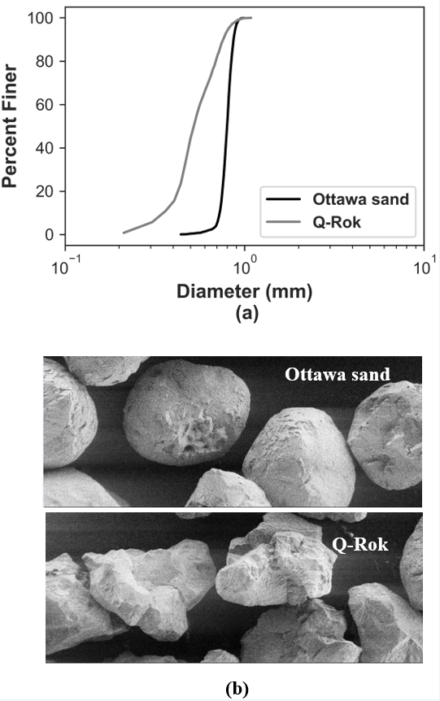
Fig3. 1: a) Grain size distribution of Ottawa sand and Q-Rok, (b) SEM images of rounded Ottawa sand and angular Q-Rok

can be classified as poorly graded sands (SP) according to the Unified Soil Classification System (USCS). The variations in grain size distributions are noticeable, as shown in Fig3. 1 (a), although both the sands are classified as SP. Q-Rok contains smaller size fraction grains, which are absent in Ottawa sand. The mean size of the grains, represented by D₅₀, is equal to 0.8 mm and 0.53 mm for Ottawa sand and Q-Rok, respectively. The SEM image of the two sands is shown in Fig3. 1 (b). Ottawa sand consists of round grains, and Q-Rok consists of angular grains. Both the sands have the same chemical composition, containing over 99.5 % SiO₂. The specific gravity of the grains is 2.65.

Methods

X-ray CT Imaging of the Sand Specimen

X-ray CT imaging of the sand specimen was carried out in the same fashion as discussed in Chapter 2 of this dissertation. Fig3. 2 shows slices along the cross-section, elevation, and 3D view of Ottawa sand and Q-Rok obtained from X-ray CT imaging. The void ratio for Ottawa sand and Q-Rok obtained from images is 0.54 and 0.70, respectively, which represent the dense state for both sands.

Finite Element Method

X-ray CT images of Ottawa sand and Q-Rok were transformed into a finite element mesh by an image processing program known as Simpleware (https://www.synopsys.com/simpleware.html). The 3D mesh of an assembly of rounded Ottawa sand and angular Q-Rok, as shown in
Fig3. 3 was then imported to the FEM software Abaqus 2017 for analysis using an explicit time integration scheme and diagonal/lumped mass matrices. The sand grains were discretized into finite elements using small strain triangular shell elements (S3RS). The detailed formulation and discussion on shell elements based on corotational velocity formulation is avoided here and has been provided in Chapter 2. The sand grains were modeled as linear elastic material with the value of modulus of elasticity and Poisson's ratio equal to 100 GPa and 0.17, respectively. These values were determined from single grain compression studies from prior studies (Sharma et al. 2020; Turner et al. 2019a). The top and the bottom platen were modeled with the same material properties. The latex membrane was modeled as a linear elastic material with a value of modulus of elasticity and Poisson's ratio equal to 2 MPa and 0.48, respectively. Thakur and Penumadu (2020) showed that modeling of latex membrane as elastic material or hyperelastic material provided comparable results for triaxial simulations. The contact interaction in the normal

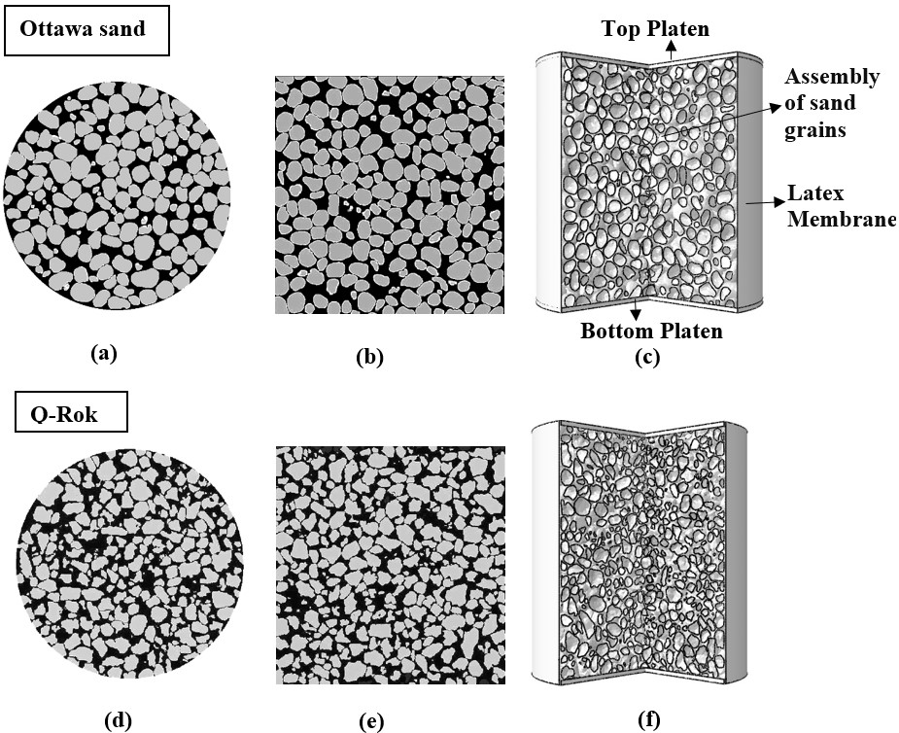

Fig3. 2: X-ray CT imaging of Ottawa sand and Q-Rok: (a),(d) cross-sectional views; (b),(e): elevation views; (c),(f): 3D views are shown with latex membrane and platens

Fig3. 3: 3D Finite Element mesh of an assembly of (a) Ottawa sand, (b) Q-Rok

direction and tangential direction were modeled using the hard contact and penalty friction formulation, respectively. The interaction between the sand grains and platens was assumed to be frictionless to replicate the lubricating boundary triaxial test. The interaction of the sand grains with the latex membrane was also assumed to be frictionless to ensure the basic assumption in triaxial tests that the confining pressure acts as minor principal stress holds true. The summary of the material properties and frictional interactions are shown in Table3. 1 and Table3. 2, respectively. Much of the computational cost occurs in tracking the relative motion of the contacting surfaces. The contact search algorithm in Abaqus Explicit is robust and computationally efficient. Abaqus Explicit utilizes dual contact search algorithms: global search and local search. A global search algorithm checks for the nearest master surface facet for each slave node in a contact pair. In the local search algorithm, the slave node tracks only the facets of the master surface attached to the previous master surface node. The time increments in Abaqus Explicit are small; therefore, incremental relative tangential motions between surfaces do not exceed the dimensions of the master surface facet. However, there is no restriction on overall relative motion between the surfaces. Local tracking is conducted at each increment, whereas global tracking is conducted at every four increments for self-contact, such as grain-grain interaction. A detailed overview can be found in the Abaqus manual (Abaqus 2017).
The simulations were conducted in two stages: (a) isotropic consolidation and (b) shearing stage to replicate triaxial experiments. The bottom platen was fixed for the entire simulation. An isotropic confining pressure equal to 140 kPa was applied on the outer surface of the latex membrane and the top platen for 0.001 s during the consolidation stage. During the shearing stage, axial displacement was applied to the top platen to produce a 15% axial strain in 0.003 s. The duration of the simulation was selected to optimize computing resources and dynamic effects in the material response. Further information related to the simulation setup can be found in Thakur and Penumadu (2020).

Grain Shape Measurements

The shape of individual grains in an assembly of sand was obtained from X-ray CT data. The watershed algorithm in Simpleware software was used to separate each grain to obtain the quantitative measurements related to the shape of the grains directly from images. In the present work, three shape descriptors, namely True Sphericity, Elongation, and Flatness, were utilized to quantify the morphology of Ottawa sand and Q-Rok. True sphericity indicates the closeness of an object to a sphere. Mathematically, True Sphericity (ψ) can be expressed according to Eq. 3.1, where V and A represent the volume and surface area of the grain, respectively. A spherical grain will have a value of True Sphericity equal to 1 (Rorato et al. 2019). Elongation of a grain indicates how elongated or cigar-shaped a grain is. Elongation (E_{L}) is computed according to Eq.3.2 and is defined as the ratio of the medial edge length (d_{M}) to the major edge length (d_{L}) of the oriented

Table3. 1: Material properties of different components
Component | Elastic Modulus | Poissons ratio
Sand Grains | 100 GPa | 0.17
Latex Membrane | 2 MPa | 0.48
Platens | 100 GPa | 0.17

Table3. 2: Contact interaction between different materials
Interaction | Type
Grain-Grain | Frictional
Grain-Membrane | Frictionless
Grain-Platen | Frictionless
Platen-Membrane | Rough

bounding box. Elongation varies from 0 to 1, with the zero value of elongation indicating highly elongated grain. The flatness of a grain indicates the extent to which the grain is planar. Flatness (F) is computed according to Eq.3.3 and is defined as the ratio of the smallest edge length (ds) to the medial edge length (d_{M}) of the oriented bounding box. A value of flatness equal to zero indicates a flat grain, and a value of flatness equal to one indicates a non-flat grain.

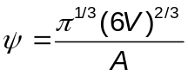
3. 1

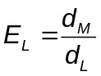
3. 2

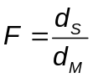
3. 3

Results

Grain shape characterization

The grain shape characterization of Ottawa sand and Q-Rok via shape descriptors True Sphericity, Elongation, and Flatness are shown in Fig3. 4. The grains of Ottawa sand are more spherical/rounded compared to the grains of Q-Rok. The Q-Rok consists of more elongated and flatter grains compared to the Ottawa sand. Besides the variations in grain morphological features for Ottawa sand and Q-Rok, Q-Rok contains smaller size fraction grains that are absent in Ottawa sand. The morphological features besides grain size variation are expected to influence the emergent micromechanical response for Ottawa sand and Q-Rok. Table3. 3: summarizes the grain shape and size features for Ottawa sand and Q-Rok.

Effect of Interparticle friction coefficient on the triaxial response of sands

Macroscale Response

The effect of the interparticle friction coefficient (μ) on triaxial shearing of the sands is investigated by conducting systematic simulations on an Ottawa sand assembly by keeping all the input features and parameters the same in the simulations except the values of μ. Fig3. 5 shows the variation in deviatoric stress and

Fig3. 4: Grain shape characterization of Ottawa sand and Q-Rok: (a) Sphericity of grains, (b) Elongation ofgrains, (c) Flatness of grains

Table3. 3: Grain shape and size parameters for Ottawa sand and Q-Rok
Material | Mean Sphericity | Mean Elongation | Mean Flatness | Nominal Size (D₅₀) mm | Coef.of uniformity (C_{u}) | Coef.of curvature (C_{c})
Ottawa sand | 0.87 | 0.83 | 0.8 | 0.80 | 1.14 | 1.03
Q-Rok | 0.73 | 0.8 | 0.77 | 0.53 | 1.55 | 1.05

Fig3. 5: Effect of the interparticle friction coefficient on (a) Deviatoric stress response of Ottawa sand, (b) Volume change response of Ottawa sand

volumetric strain response with the change in axial strain for different values of the μ. The peak friction angle increases with the increase in the value of μ up to 0.5; further, increase in the value of μ does not noticeably increase the peak friction angle. It is interesting to note that the peak stress occurs at the same axial strain (5%) despite the values of μ. This observation suggests that for the same boundary conditions, the peak state axial strain depends on the initial microstructure of the specimen and does not depend on the value of μ. The dilation of the specimen increases up to the value of μ equal to 0.5; further increase in the value of μ does not increase the dilative response, as shown in Fig3. 5 (b).

Microscale Response

The emergent macroscale response in granular materials inherently depends on microscale interactions. Fig3. 6 shows the evolution of the mean coordination number with the increase in axial strain during the shearing stage for different values of μ. It is interesting to note that the evolution of the mean coordination number is similar for values of μ ≥ 0.5. This similarity has a direct consequence to the saturation in deviatoric stress and the volume change response for μ ≥ 0.5 inFig3. 5. The similarity in coordination number and saturation in strength after a certain value of μ was also observed by Binaree et al. (2020) in 2D contact dynamics simulations on polygonal particles. At 0% axial strain (i.e., at the end of the isotropic consolidation), the mean values of the coordination number increase for lower values of μ. This suggests that the isotropic consolidation of the specimen allows more rearrangement of the grains for low values of μ, which manifests different microstructures for the shearing stage corresponding to simulations conducted for different values of μ. Fig3. 7 shows the percentage of rattlers (i.e., grains with coordination number less than 2) at the end of isotropic consolidation for different values of μ. It can be observed from Fig3. 7 that the percentage of rattlers increases with the increase in μ. This suggests that the force chains self-sustain for higher values of μ and do not require lateral support from the surrounding grains for stability. This was also demonstrated by Huang et al. (2014) for the periodic boundary triaxial simulations on spherical grains. The rattlers do not actively transmit stresses and, therefore, Huang et al. (2014) suggested that rattlers can be a component of pore space. Such a proposition can be useful for critical state-based constitutive modeling.

Fig3. 6: Evolution of mean coordination number with axial strain for different values of the interparticle friction coefficient

Fig3. 7: Percentage rattler for different values of friction coefficient at the end of isotropic consolidation

The kinematic variables were obtained from FEM simulations. The displacement of the individual grain was obtained as the mean of the magnitude of the displacements experienced by the nodes belonging to the specific grain. The mean displacement was obtained as the mean of the displacements of the individual grains. Similarly, the rotation of the individual grain was obtained as the mean of the magnitude of the rotations experienced by the nodes belonging to the specific grain. The mean rotation was obtained as the mean of the rotations of the individual grains. The S3RS elements consist of rotational degrees of freedom besides the translational degrees of freedom. Therefore, extracting kinematic variables from simulations is convenient. Fig3. 8 shows the mean values of kinematic variables obtained by considering the kinematic response of individual grains to the external loading. The increase in μ results in a decrease in mean rotation and mean incremental rotation. However, the increase in μ also increases mean displacement and mean incremental displacement. This suggests that the increase in rotation values for low values of μ does not contribute to the rolling of grains since the rotation of grains does not increase mean displacement and volume change response. This proposition is supported by the increase in the mean coordination number for low values of μ, as shown in Fig3. 6. The higher coordination number does not allow grains to move freely, which results in frustration of the grains during attempted rearrangement and, therefore, results in the localized rotation rather than rolling of the grains.
Fig3. 9 shows the probability distribution of rotation values of individual grains normalized with mean rotation for different values of μ. The probability distribution of the rotation converges for different values of μ beyond peak state axial strain (approximately 5% axial strain in Fig3. 5). However, below the axial strain corresponding to peak stress, the probability distribution of the rotation values differs for different values of μ. Since the area under the probability distribution curve is 1, it can be inferred from Fig3. 9 that the granular assembly with lower values of μ consists of many grains with rotation values less than the mean values compared to the assemblies with high μ values. However, this variation only exists up to peak stress (at approximately 5% axial strain). The distribution of the rotation of grains follows power-law and exponential distribution below and above the peak frequency values, respectively. A similar conclusion on the distribution was established by Zhai et al. (2019) in a triaxial experimental study on spherical grains.
The stress-induced anisotropy in granular materials is ubiquitous and has received a lot of attention with the introduction of the Anisotropic Critical State Soil Mechanics by Li and Dafalias (2012). The anisotropic nature of particulate materials is often quantified based on the second-order fabric tensor, as defined in Chapter 2. The non-zero normal contact forces along with their nodal coordinates were obtained from simulation results for each grain in an assembly. The non-zero normal contact forces in a specific grain were isolated to different clusters/contact regions using the mean shift clustering approach (Pedregosa et al. 2011) based on their nodal coordinates. The mean shift clustering approach

Fig3. 8: Kinematic variables with the variation in axial strain for different values of interparticle frictioncoefficient

does not require specifying the number of clusters in contrast to the K-means clustering approach. The mean shift clustering approach is a centroid-based approach in which the candidates of the centroids are updated to be the mean of the points in a specific region. This approach is suitable for uneven cluster sizes with non-flat geometry / non-convex shapes. The algorithm requires a single parameter known as bandwidth which determines the size of the sliding window. For each cluster/contact region in a grain, contact forces for different nodes were added vectorially to obtain the components of a resultant unit normal contact force vector. The components of resultant unit normal contact forces vectors for each contact region in all the grains were used second-order fabric tensor. Fig3. 10 shows the variation in fabric anisotropy as the specimen deforms in a triaxial loading condition for different values of μ. The variation in anisotropy with the change in axial strain follows a trend like the variation in deviatoric stress and axial strain. The anisotropy increases with the increase in μ up to a certain value and then is saturated with the further increase in μ. Also, the fabric anisotropy reaches the peak value at the same axial strain despite the value of μ. It is imperative to note that the axial strain corresponding to the peak deviatoric stress did not also depend on the value of μ. The axial strain corresponding to peak deviatoric stress and peak anisotropy coincide approximately. The distribution of the contact normal force also follows power-law and exponential distribution below and above the peak frequency values, respectively. However, I acknowledge that the contact normals determined from the finite element simulations and mean clustering approach which are used to obtain fabric and coordination number may result in some deviations when compared to the corresponding values obtained from the images.

Coupled effect of grain shape and size on the triaxial response of sands

Macroscale Response

The effect of grain shape and size is investigated by conducting triaxial shearing simulations on dense Ottawa sand and dense Q-Rok. The void ratios corresponding to the dense state were measured as 0.54 and 0.70 for Ottawa sand and Q-Rok, respectively. Q-Rok consists of elongated, flatter, and less spherical grains compared to Ottawa sand. Both soils are classified as poorly graded sands; however, Q-Rok contains smaller fraction grains that are absent in Ottawa sand. Fig3. 11 shows the variation in deviatoric stress and volume change response with the change in axial strain for Ottawa sand and Q-Rok with the value of μ equal to 0.5. The value of μ equal to 0.5 was found to closely match the experimental results by Thakur and Penumadu 2020. The angular Q-Rok exhibits a higher peak friction angle compared to the rounded Ottawa sand. Both the sands exhibit a post-peak softening response; however, angular Q-Rok has higher post-peak softening compared to rounded Ottawa sand. The peak state axial strain is higher for the

Fig3. 9: Probability Distribution of the rotation of individual grains normalized with a mean value of rotation for different values of interparticle friction coefficient.

Fig3. 10: Variation in anisotropy with the change in axial strain for different values of μ

Fig3. 11: Effect of the grain shape for the value of interparticle friction that best approximates with the experiments (a) Deviatoric stress response, (b) Volume change response of rounded Ottawa sand and angular Q-Rok

angular Q-Rok compared to the rounded Ottawa sand. It can be observed from Fig3. 11 that the Ottawa sand exhibits higher dilation compared to the Q-Rok. This result represents a contradiction to what is reported in the literature that the angular sands exhibit higher dilation compared to the round sands (Zhang et al. 2013). However, Leib (2015) carried out conventional triaxial compression experiments on Ottawa sand and Q-Rok consisting of similar gradation as used in the present study. Leib (2015) observed that rounded Ottawa sand exhibited a higher dilation angle compared to angular Q-Rok, and, therefore, supports the volume change results obtained in this study for similar materials. The present study allows probing of microstructural details, as discussed in the next subsection, to understand the
discrepancy in dilation response compared to the general observations in the literature.
The effect of grain shape was further investigated for smooth granular materials by adopting a low value of μ in the simulations. Fig3. 12 shows deviatoric stress and volume change response of Ottawa sand and Q-Rok for μ equal to 0.2. The effect of grain shape is less pronounced for smooth sands. The ratio of peak deviatoric stress for angular Q-Rok and rounded Ottawa sand is 1.05 and 1.20, corresponding to μ equal to 0.2 and 0.5, respectively.
The microscale response related to grain shape and size will be discussed in the next subsection for μ equal to 0.5 since it replicates experimental observations as demonstrated by Thakur and Penumadu (2020).

Microscale Response

The microscale response provides useful insights into understanding the effects of the grain shape on the macroscale. Fig3. 13 shows the evolution of the mean coordination number with the variation in axial strain for Ottawa sand and Q-Rok. The mean coordination number does not change significantly with axial strain. It can be observed from Fig3. 13 that the mean coordination number for rounded Ottawa sand is higher than angular Q-Rok. This suggests that the larger void ratio in angular sand promotes a lower coordination number compared to rounded sand. Small grains in Q-Rok are expected to influence the coordination number. Fig3. 14 shows the coordination number of the individual grains of Ottawa sand and Q-Rok with variation in the size of individual grains at 15% axial strain. The size of the individual grain is represented by the diameter of the sphere of equivalent volume. It can be observed from Fig3. 14 that the smaller size fraction grains in Q-Rok exhibit a low coordination number. This result is important since the gradation of both the sands is the same based on the USCS soil classification system; however, the subtle difference in sizes manifests a change in coordination number.
Fig3. 15 shows the evolution of percentage rattlers (grains with coordination number less than 2) with the axial strain for Ottawa sand and Q-Rok. The angular Q-Rok consists of a significant percentage of rattlers compared to rounded Ottawa sands (Fig3. 15). The difference in the percentage of rattlers at 0% axial strain is large, equal to 17.6%. The isotropic consolidation, therefore, results in significant

Fig3. 12: Effect of the grain shape for the low value of interparticle friction on (a) Deviatoric stress response, (b) Volume change response of rounded Ottawa sand and angular Q-Rok

Fig3. 13: Evolution of mean coordination number with axial strain for rounded Ottawa sand and Q-Rok corresponding to interparticle friction coefficient equal to 0.5

Fig3. 14: Evolution of coordination number with the size of grains for rounded Ottawa sand and angular QRok at 15 % axial strain

Fig3. 15: Evolution Percentage rattlers in rounded Ottawa sand and Q-Rok during the triaxial shearing stage

microstructural variations that influence the response in the shearing stage. The higher percentage of rattlers in Q-Rok compared to the Ottawa sand can be attributed to particle angularity and fine particles that do not actively transmit stresses. Liu et al. (2021) recently concluded that the proportion of fine particles may not transmit stresses, which further supports the observations made in this study.
Particle kinematics influences the macroscale response of granular materials. Particle rotations have been used in enhanced continuum theories to predict localization effects, such as the thickness of shear bands (Mühlhaus and Vardoulakis 1987). Fig3. 16 shows the change in kinematic variables with the variation in axial strain for rounded Ottawa sand and angular Q-Rok. The angular Q-Rok exhibits higher mean rotation and incremental mean rotation compared to Ottawa sand. However, Q-Rok exhibits lower mean displacement and mean incremental displacement compared to Ottawa sand. This suggests that the rotation of the grains of the Q-Rok does not exhibit higher rolling despite experiencing higher rotation. This can be attributed to the interlocking effect of the angular sand, where grains cannot move freely, resulting in frustration of the grains to rearrange and, therefore, rotate locally rather than roll.
Remark: The mechanism for the lower mean displacements and mean incremental displacements for particle shape and friction are different. The lower values of the μ produced lower mean displacement values due to a higher coordination number
compared to high values of μ for the same initial microstructure and boundary. The angular Q-Rok exhibited low values of mean displacement due to the combined effect of interlocking of the grains and fine particles, which resulted in a higher coordination number for the coarser angular particles manifesting restricted movement of the larger grains of angular Q-Rok. The current soil classification systems do not classify poorly graded sands; therefore, there is a need to introduce additional sub-classifiers for poorly graded sands to predict their mechanical response.
The influence of the size difference for two poorly graded sands of distinct morphology may influence the rotation of the grains. Fig3. 17 shows the rotation of individual grains for assorted sizes of grains of Ottawa sand and Q-Rok. The smaller grains in Q-Rok absent in Ottawa sand exhibit high rotation values. However, rounded Ottawa sand exhibits higher rotation of the grains when compared with the equivalent size grains of angular Q-Rok. This conforms with the observations in the literature that the angular sands rotate less compared to rounded sands (Desrues and Andò 2015). The interesting finding here is that a minor change in grain size may alter general trends observed related to particle shape despite the same grain size classification of sands.
The probability distributions of the rotation values of individual grains normalized with the mean rotation for rounded Ottawa sand and angular Q-Rok are shown in Fig3. 18. Many grains of the Q-Rok exhibit low normalized rotation compared to the Ottawa sand. The peak of the probability distribution curve for Q-Rok occurs

Fig3. 16: Kinematic variables with the variation in axial strain for rounded Ottawa sand and angular Q-Rok

Fig3. 17: Variation in the rotation of individual grains with the size of grains for rounded Ottawa sand and angular Q-Rok at 15 % axial strain.

Fig3. 18: Probability Distribution of the rotation of individual grains normalized with the mean value of rotation for rounded Ottawa sand and angular Q-Rok

at lower values of rotation compared to Ottawa sand, specifically for low values of axial strain. At higher axial strain, the rotation values at which the peak of the probability distribution curve occurs converge. The probability distribution curves follow power-law and exponential law below and above the peak, respectively, as was observed for granular assemblies with different μ values.
The variation in fabric anisotropy for the rounded Ottawa sand and angular Q-Rok is shown in Fig3. 19. The rounded Ottawa sand exhibits higher anisotropy before the peak compared to the angular Q-Rok. The post-peak anisotropy of the angular Q-Rok was observed to be higher than rounded Ottawa sand. The distribution of the contact normal force follows power-law and exponential distribution below and above the peak frequency values, respectively (not shown here for brevity).
The triaxial shearing of the sands does not manifest a homogeneous deformation field. The micromechanical interactions result in non-affine deformations. Fig3. 20 shows displacement field contours corresponding to different μ values for rounded Ottawa sand and angular Q-Rok. It can be observed from Fig3. 20 that the localized deformations are the same for different values of μ for the same initial microstructure and boundary conditions. The localized deformation, however, changes with the variation in grain shape for the same boundary conditions. The angular Q-Rok exhibits a conical dead zone of grains with negligible displacements at the bottom of the specimen, whereas the rounded Ottawa sand shows significant bulging along with the formation of the localized deformation zone inside the specimen.

Conclusions

The formation history of granular materials influences the shape, size, and frictional characteristics of individual grains. In the present work, we study how these parameters influence the material response to triaxial loading from a micro-and macroscale perspective. Two poorly graded sands of distinct grain morphology with subtle variations in size are used in this study to reflect realistic geological formation history. X-ray CT imaging and FEM are leveraged concurrently to represent the granular microstructure and boundary conditions faithfully. These observations were concluded to facilitate a fundamental understanding of the mechanical response of granular materials:
- The peak friction angle and dilation increase with the increase in interparticle friction coefficient (μ) up to a certain limit, and then the response saturates with a further increase in μ. The grain-scale analysis suggests that the evolution of the mean coordination number and fabric anisotropy with the axial strain is similar for the values of μ producing similar strength and volume change response.
- The isotropic consolidation before shearing results in microstructural changes in the granular assembly for different values of μ. The percentage of rattlers (i.e., the grains with a coordination number less than 2) after isotropic consolidation increases non-linearly with μ. The increase in rattlers

Fig3. 19: Variation in anisotropy with the change in axial strain for rounded Ottawa sand and angular QRok

after isotropic consolidation indicates the existence of stable force chains with less requirement of later support from surrounding grains. This results in an increase in peak strength with the increase in values of μ until saturation in strength is observed.
- The peak state axial strain does not depend on the value of μ for the same boundary conditions and initial microstructure.
- The probability distribution of the rotation of individual grains converges after peak stress for different values of μ for the same boundary conditions and initial microstructure. Below the peak stress, granular assemblies with
lower values of μ consist of many grains with rotation values less than the mean values compared to the assemblies with high μ values.
- The angular sand exhibits a higher peak friction angle and post-peak softening compared to the rounded sand. The percentage of rattlers for angular sand is higher than for rounded sand.
- The mean coordination number for angular sand is lower than the mean coordination number for rounded sand. Angular sand exhibits a higher void ratio compared to rounded sand at a similar relative density.
- The angular sand exhibited low dilation compared to the rounded sand. This contrasts with the findings in the literature. Upon further investigation, we discovered that the smaller size fraction grains present in angular sand rotated more and exhibited a low coordination number. This finding is crucial since both soils were classified as poorly grained sands based on their gradation, yet the subtle differences in sizes produced different microscale features. Poorly graded sand classification (SP) cannot predict the relative behavior of soils, and there is a need to introduce additional sub-classifiers in classifying poorly graded sands.
- The probability distribution of the rotation of individual grains did not converge for rounded and angular grains in contrast to what was observed in the interparticle friction effect. The peak of the probability distribution curve for Q-Rok occurs at lower values of rotation compared to Ottawa sand, specifically for values of axial strain. At higher axial strain, the rotation values at which the peak of the probability distribution curve occurs converge.
- The influence of particle shape is less pronounced for smooth granular assemblies. The ratio of peak deviatoric stress for angular Q-Rok and rounded Ottawa sand was 1.05 and 1.20, corresponding to μ equal to 0.2 and 0.5, respectively.
- A similar localized deformation response was observed for different values of μ. However, the localized deformation pattern changed with the variation in grain shape. The direct simulations on realistic granular materials capture heterogeneity in grain and pore microstructure, which allows for realistic prediction of failure compared to continuum mechanics-based phenomenological constitutive modeling.

Fig3. 20: Displacement field contours for different μ values and grain shape inside the specimen (Displacement is in mm)

Capillary Suction Measurements in Granular Materials and Direct Numerical Simulations Using X-Ray Computed Tomography Microstructure

A version of this chapter is published as Mohsin Thakur, M., Penumadu, D., & Bauer, C. (2020). Capillary suction measurements in granular materials and direct numerical simulations using x-ray computed tomography microstructure. Journal of Geotechnical and Geoenvironmental Engineering, 146(1), 04019121.
My contributions to the paper include developing an experimental setup, performing experiments, image processing, numerical simulations, data analysis, and writing the manuscript.

Abstract

Due to the recent advancements in hardware and reconstruction algorithms, the multiphase flow modeling in porous media is experiencing a shift towards using advanced imaging techniques such as X-ray Computed Tomography in conjunction with Direct Numerical Simulations. This approach captures heterogeneities in soil samples utilized in laboratory testing and results in quick and less tedious predictions compared to the existing methods. In this paper, an experimental setup is developed specifically to validate numerical predictions of Soil Water Retention Curve (SWRC) for two types of sands with identical size but distinct grain morphology of round (Ottawa sand) and angular particle shape (Q-Rok). The complex 3D pore network is captured non-invasively using high-resolution attenuation-based X-ray Computed Tomography. The numerical predictions are carried out by solving the Young Laplace equation using the Pore Morphology Method. The experimental results and numerical predictions match well including the effect of hysteresis in SWRC measurements. The spatial distribution of pore water and pore air corresponding to different capillary suctions are obtained from numerical predictions providing greater insights into the hydro-mechanical behavior of partially saturated soils. The sensitivity of the voxel size on simulations is quantified by predicting the pore size distribution of Ottawa sand at three different tomography resolutions.

Introduction

The importance of moisture retention behavior in porous media transcends different fields of science with implications in oil recovery, the hydro-mechanical response of partially saturated soils, drug delivery, and CO₂ sequestration (Iglauer et al. 2012; Kim et al. 2012; Lipinski et al. 1997; Andrew et al. 2014). The response of partially saturated sands subjected to static and impact loadings is governed by multiphase physics at different length and time scales. Such studies in granular materials are gaining importance owing to its applications in infrastructure development to safeguard human lives by providing resistance to complex loading conditions such as blast and impact loadings including projectile penetration, rainfall-induced slope instabilities, and cyclic vibrations triggered by earthquakes (Kim et al. 2016; Ng and Shi 1998; Stewart et al. 2001). A state of partial saturation by water/air in granular materials (such as sand) results in the development of capillary suction which influences the static and dynamic behavior of sands (Gan et al. 1988; Martin et al. 2009). Integration of multiphase (liquid, gas, solid) contributions to deformation behavior of an assemblage of partially saturated particles and the development of related mathematical description commonly called the constitutive model framework is critically important.
The discrete nature of granular materials such as sands coupled with distinct grain morphology results in highly intricate grain and pore microstructure. The advancements in imaging techniques in recent years, specifically attenuation-based X-ray Computed Tomography (CT), has made it possible to extract a complex 3D pore network of sand specimens in a laboratory setting (Willson et al. 2012; Manahiloh and Muhunthan 2012; Mukunoki et al. 2016, Khaddour et al. 2018). The voids in sands consist of relatively wide regions called pores which are linked together by narrow regions called throats. It is important to acquire X-ray CT scans at a suitable resolution to capture pore throat dimensions accurately since they offer maximum resistance to the displacement of pore water by pore air during drainage or imbibition. Furthermore, X-ray CT imaging provides a means to enhance the understanding of effective stress formulations in partially saturated sands which has been a subject of debate for past many years (Manahiloh et al. 2016).
Several experimental studies have been carried out in the past to determine the Soil Water Retention Curve (SWRC) of soils using different techniques (Houston et al. 1994; Vanapalli et al. 2009; Manahiloh and Meehan 2017; Likos et al. 2014; Sahin et al. 2014). The choice of each technique is dictated by the range of the suction required to describe moisture retention behavior comprehensively. In the present work, the axis translation technique is used to obtain SWRC for Ottawa sand and Q-Rok, the detailed description of this technique can be found in the literature (Fredlund and Rahardjo 2012, Tripathy et al. 2012). The experimental investigations in partially saturated soils are, however, inhibited by the significant duration required to complete the tests. For instance, Perez-Garcia et al. 2008 found out that Yuma sand equilibrated in nine days corresponding to a suction of 3.19 kPa when 100kPa (1Bar) High Air Entry Value (HAEV) ceramic disk was used in an axis translation set up. Nishiumura et al. 2012 replaced the HAEV disk with a microporous membrane to accelerate the SWRC measurements and observed that the equilibration time decreased from 3,000 minutes to 2 minutes for the similar test conditions, therefore, proving it to be a significant advantage to overcome the limitations associated with the using of HAEV disks in the laboratory testing. The experimental setup used in the present study adopted microporous membranes in place of HAEV discs to leverage the research results.
Several direct pore-scale modeling approaches have been adopted in past studies to predict multiphase flow properties wherein essentially modified form of Navier Stokes equation is directly solved on 3D pore representations (Hilpert and Miller 2001; Blunt 2001; Bultreys et al. 2016; Sweijen et al. 2017). In the present work, Pore Morphology Method (PMM) is used to predict drainage as well as imbibition in Ottawa sand and Q-Rok. PMM relies on actual 3D pore space as input configuration in comparison to Pore Network Models (PNM) wherein a simplified pore representation is used as an input. A detailed discussion on PMM is provided in the next section. The quality of predictions is largely dependent upon the resolution of the input data, therefore, X-ray CT data for Ottawa sand is acquired at 5-micron, 12-micron, and 15-micron resolutions. The effect of the X-ray resolution on predictions is investigated by obtaining pore size distribution based on granulometry from the images acquired at three different resolutions. The underlying physics behind multiphase flow in sands is not entirely captured by SWRC measurements, it is important to address spatial variability of pore water and pore air distributions at different capillary suctions. In the present research, spatial distributions of pore fluids predicted by PMM can be incorporated in mesoscale simulations to develop an integrated multiscale/ multi-physics modeling approach to provide better insights into the multiphase contributions in the deformation behavior of sands.
The geomechanics community largely relies on continuum-based approaches to simulate hydro-mechanical coupling in fully and partially saturated geomaterials (Hu et al. 2014; Mukherjee et al. 2016a; Mukherjee et al. 2016b). However, the lack of suitable predictive models with a reasonable number of parameters to capture phenomenological effects makes this research problem too complicated for any continuum-based approach. The urgent need is to incorporate mesoscale effects which are discrete and non-repeating in the numerical modeling and transfer these effects to macroscale using homogenization techniques. The main objective of the present work is to validate SWRC predictions from the direct pore-scale modeling approach with the experiments and obtain spatial variation in pore-scale displacement patterns at different capillary pressures such that the observations and results can be used in mesoscale simulations employing different numerical schemes, (e.g. Finite Element Method (FEM), Finite Volume Method (FVM), Discrete Element Method (DEM)). Some of the work on mesoscale simulations on dry sands using FEM can be found here (Turner et al. 2016; Imseeh and Alshibli 2018; Turner et al. 2019). Present work can however extend the scope of these simulations to partially saturated sands by providing solid as well as pore fluid microstructure corresponding to different saturations as input data in numerical analysis. Several experimental and numerical studies in the past were carried out independently, there is a need to combine experimental observations with numerical predictions to provide a better theoretical framework to better understand the material response to different loading conditions.

Materials and Methods

Materials

In this work, Ottawa sand and Q-Rok were used to investigate the moisture retention behavior of sands of distinct morphology. The grain size distribution of sands is shown in Fig4. 1 (a) and both sands can be classified as poorly graded sands as per the Unified Soil Classification System (USCS). Ottawa sand has nearly round grains whereas the Q-Rok has angular grains as can be observed in Scanning Electron Microscope (SEM) images of the sands as shown in Fig4. 1 (b) &(c). The chemical composition of both sands is similar consisting of more than 99.5% SiO₂. The maximum void ratio for Ottawa sand and Q-Rok are 0.746 and 1.013 respectively, whereas the minimum void ratio for the same materials is 0.512 and 0.604 respectively. The specific gravity of the grains is 2.65.

Experimental Methods

The experimental setup developed in this research uses the axis translation technique to measure SWRC. The schematic representation of the setup and a picture of the cell is shown in Fig4. 2. The height and diameter of the sample were chosen as 38.1 mm (1.5 inch) and 25.4 mm (1 inch), respectively, to ensure that the volume of water that drains out/ fills in corresponding to each suction increment/decrement is adequately determined by the water reservoir/burette. The matric suction is controlled by applying air pressure increments/decrements from the top of the sample while ensuring that the bottom of the sample remains connected to the water reservoir. HAEV disk was replaced by a microporous membrane placed on a coarse-porous stone to accelerate equilibrium. The microporous membrane used in this research is an acrylic copolymer of thickness 94 µm manufactured by Pall Corporation ( https://pall.com/ ). The coarse-grained soils such as sands are characterized by low air entry value, therefore, it is important to make an appropriate choice of microporous membrane based on its air entry value. The microporous membrane of an air entry value equal to 110 kPa was used in this study.
The experimental setup used in the present research offers several advantages compared to the arrangement used in the conventional axis translation technique. The inlet at the bottom and outlet near the top of the cell ensures better initial saturation of the soil sample by providing a better path to flush the air out repeatedly by de-aired distilled water. It is expected that the pore size distribution of the sample is not altered much during initial saturation in comparison to the cutting ring arrangement wherein a sample is placed on a coarse-porous stone during saturation and needs to be transferred on HAEV disc before conducting SWRC experiments. Such types of disturbances can be significant in cohesionless soils such as sands. Furthermore, the contribution to the porewater pressure due to the water in reservoir/burettes cannot be neglected for sands characterized by low air entry value. An adjustable Z-stand is provided to ensure that the top of the specimen is in level with the water level in the burette. Additionally, it is easy to saturate microporous membrane due to its small thickness in comparison to HAEV disc. The saturation of the HAEV disc or microporous membrane is critical to avoid diffusion of air which leads to erroneous volume change measurements. An extra

Fig4. 1: (a) Grain size Distribution of Ottawa Sand and Q-Rok, (b) SEM image of Ottawa sand, (c) SEM image of Q-Rok

Fig4. 2: (a) Schematic representation of an experimental set-up; (b) SWRC cell

free board is provided between the top of the sample and the top porous stone to ensure that they are not in contact with each other. This arrangement provides more reliable results since the top porous stone always stays dry and does not interfere in SWRC measurements.

Specimen Preparation

It is important to ensure that all the tubing’s and fixtures in an experimental set up are completely saturated before depositing any soil sample in the cell. Any trapped air in the tubing’s can delay equilibration as well as result in erroneous volume change measurements. The cell was assembled except the top platen. The specimens of Ottawa sand and Q-Rok were prepared corresponding to the dense configuration. The dry sand was deposited slowly from a funnel in five layers. Each layer was tapped lightly twenty-four times in total, six times on diametrically opposite ends. The sample was then saturated slowly to ensure around 95% saturation which was determined by oven drying of soil sample after the completion of the test. A dry porous stone was placed on the soil sample during saturation to prevent any upward displacement of the soil grains. The porous stone was then removed carefully using clippers and the top platen was fixed to the cell.

X-ray Computed Tomography

X -ray Computed Tomography is a powerful tool to capture the pore network of sands in 3D non-invasively. The use of X-ray CT imaging to characterize the geomaterials has increased rapidly with the improvements in computing power, availability of the laboratory based micro CT scanners and the advancements in segmentation algorithms (Manahiloh et al. 2012, Abera et al. 2017, Manahiloh et al. 2018). The technique is based on the attenuation of the X-rays based on the Beer Lamberts law as shown in Eq.4.1, where ‘I’ is the intensity of radiation transmitted through the material, ‘I_{o}’ is the intensity of the incident radiation and µ(x) is the attenuation coefficient along the radiation path x. The rule of thumb is to target 20-30% transmission of the incident radiation through the thickness of the sample for a successful microstructure imaging (Kim et al. 2016).

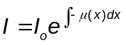
4. 1

Computed Tomography in a laboratory micro CT set up is performed by acquiring multiple radiographs of a sample by rotating it slowly in small increments between the source and the detector over a cumulative angular reach of 180º or 360º. The key step in acquiring a better-quality data for a specific X-ray resolution is to find an appropriate combination of X-ray energy and the current corresponding to a

specific material of interest. One must be careful to not to use too high energy as it can result in less contrast in the data. The detailed review of the application of X-ray Computed Tomography in geoscience can be found in in the literature (Cnudde and Boone 2013; Wildenschild and Sheppard 2013).
In present work, data acquired from X-ray CT imaging was used as an input for numerical predictions. The size of the cell to capture the pore network for numerical predictions was smaller than the one used in experiments. The idea was to preserve the boundary effects and use high resolution data in numerical predictions appropriate for routinely available computing resources. This approach is superior compared to the one wherein a small volume is extracted from the center of a larger specimen which does not capture inhomogeneities in pore network due to potential boundary effects. The height and the diameter of the cylindrical mold for CT scans were 8.9 mm (0.35 inch) and 12.7 mm (0.50 inch), respectively. The dry specimen was prepared in a fashion similar to the experiments with less tapping effort to produce a specimen of same relative density as used in experiments. Fig4. 3 shows schematic representation of custom developed X-ray CT set up used in this research at the University of Tennessee, Knoxville, which consists of a 150kV micro focus X-ray source of variable spot size ranging from 5 µm to 50 µm with a cone beam geometry. The setup includes GOS (Gadolinium oxysulphide) flat panel Hamamatsu detector of 50 µm pixel size with total number of active pixels equal to 2316×2316. The source to object distance (SO) and object to detector distance (OD) can be varied to achieve a specific resolution. A total of 1525 projections (radiographs) were taken over an angular reach of 183º at 5-micron resolution. The X-ray energy and current were chosen as 130 keV and 120 µA after few initial iterations to obtain better contrast in the images.

Image Processing

The radiographs acquired at different angular orientations provide information only through the thickness of the sample. In present work, Filtered Back Projection method was used to reconstruct slices along the height of the sample in Octopus software to provide a 3D visualization of the pore and grain microstructure. The reconstructed raw data from Octopus was then imported to GeoDict software (Math2Market GmbH, GeoDict 2018, https://www.geodict.com/) for image processing and numerical predictions. A series of image processing steps were followed to remove noise and segment CT data into grains and pores. Fig4. 4 shows segmentation of a reconstructed slice of Ottawa sand along with the histogram of the data. A median filter was applied to the reconstructed data set for smoothening and noise reduction. The two-phase particle and pore-based data for a dry sand sample was then segmented by Otsu segmentation followed by manual thresholding to adjust for local inhomogeneities. The detailed description of Otsu segmentation can be found in references (Otsu 1979; Zhang et al. 2017).

Fig4. 3: Custom developed CT set-up at The University of Tennessee, Knoxville

Fig4. 4: Ottawa sand X-ray CT data, (a) Raw slice; (b) Segmented slice; (c) Histogram

Pore Morphology Method
The classical work by Hilpert and Miller, 2001 to simulate drainage in a completely wetting digital porous media based on the principles of mathematical morphology led to the development of the Pore Morphology Method (PMM). The effect of variation in wettability was incorporated by (Schulz et al. 2007; Becker et al. 2008; Wargo et al. 2013; Schulz et al. 2015) by including contact angle of the solid with the wetting and non-wetting phase interface in the governing equation. The pore space accessible to the non-wetting phase for the two-phase system with negligible gravity effects and well-defined contact angle for a spherical interface is given the Young Laplace equation as presented in Eq. 4.2, where ‘r’ is the radius of the probe to determine the pore space accessible to non-wetting phase (air in sands), ‘σ’ is the interfacial tension, ‘α’ is the contact angle and ‘Pc’ is the capillary pressure. Therefore, for a given interfacial tension and contact angle, the problem becomes purely geometrical in nature. This reduces the computational requirements significantly and makes it possible to make predictions on large volumes of CT data.

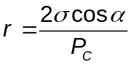
4. 2

The mathematical description of morphological operations to obtain the distribution of wetting and non-wetting phase in a porous media was first provided by (Hilpert and Miller 2001). In PMM, two morphological operations, erosion and dilation are used which can also be expressed in terms of Minkowski subtraction and addition, respectively. The morphological erosion and dilation of a pore space ‘O’ by a spherical structuring ‘B’ can be expressed by Eq.4.3 and Eq.4.4, respectively. In case of erosion, ‘r’ is the locus of the center of spherical structuring elements which are inside pore space ‘O’ whereas in case of dilation, ‘r’ is the locus of the center of spherical elements which hit pore space ‘O’.

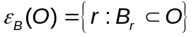
4. 3

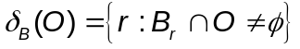
4. 4

The implementation of PMM in GeoDict software includes several steps as summarized below with a pictorial representation for a drainage process shown in Fig4. 5:
1. The location of the wetting and non-wetting phase reservoir needs to be specified. To replicate experimental boundary conditions, the wetting phase / water

Fig4. 5: Illustration of drainage simulation on a representative 2D image, (a) Saturated specimen, (b) Erosion of pore space, (c) Connectivity check, (d) dilation of pore space

reservoir and non-wetting phase/air reservoir location in the present work was specified at the bottom and the top of the sample, respectively.
2. The spherical structuring element of radius ‘r’ obtained from Young Laplace equation (Eq.4.2) is used to erode the pore space by non-wetting phase starting with the maximum radius for drainage and minimum radius for imbibition.
3. The pore space connectivity to the non-wetting phase is accessed and the disconnected regions of pore space are removed from the results of erosion. The rest of the pore space is subjected to morphological dilation followed by computation of degree of saturation based on the volume fractions of each component.
4. The entire process is repeated from step 2 with decrease in radius of spherical structuring element for drainage and vice-versa for imbibition.

Results and Discussion

Spatial variation in porosity

Conventional geotechnical testing requires the computation of the global porosity/global void ratio of the sample. The variation in the void ratio is unavoidable due to several reasons such as distinct grain morphology, gravitational effects, interaction between the specimen and mold, imperfect sample preparation. This results in localized inhomogeneities which are responsible for many interesting phenomena including failure and variable wetting/non-wetting phase displacements. The local variation in void ratio can be obtained non-destructively from X-ray CT images. Fig4. 6 shows variation in void ratio along the height of the sample for Ottawa Sand and Q-Rok. The volume of the voids and volume of sand grains was obtained for each of the horizontal slice along the height of the sample. The lower and upper bounds of the void ratio for the Ottawa sand were obtained as 0.53 and 0.64, respectively, with the mean/global value of void ratio equal to 0.57. Similarly, for the Q-Rok the lower and upper bounds of the void ratio were obtained as 0.60 and 0.73, respectively, with the mean/global value of void ratio equal to 0.66. The void ratio of the Ottawa sand and Q-Rok in SWRC experiments were calculated as 0.52 and 0.61, respectively.

Sensitivity of X-ray resolution on pore size distribution

Most of the studies related to the prediction of multiphase flow properties from X-ray images did not consider the effect of resolution on predictions. In past studies, the X-ray resolution used to image sands varies from as high as 7-microns to as

Fig4. 6: Variation of void ratio along the height of the specimen for Ottawa Sand and Q-Rok

low as 30-microns (Khaddour et al. 2018; Manahiloh and Meehan 2017). In present work, X-ray CT data was acquired for Ottawa sand corresponding to 5-micron, 12-
micron and 15-micron resolution. The pore size distribution was obtained in GeoDict based on the principles of granulometry in which spheres are fitted in the
pore volume to determine the size of the pore. Fig4. 7 shows the density of pore size distribution for Ottawa sand corresponding to different X-ray resolutions. The density of pore size is defined as the fraction of pores in a specified bin interval divided by bin size. The bin size in present work was chosen as 9.28-microns. It can be observed from Fig4. 7 that the density of pore size distribution obtained from 15-microns resolution varies significantly in comparison to 5-microns and 12-microns resolution. The X-ray data corresponding to 12-microns and 15-microns resolution did not capture any pores of size less than 18.5-microns and 27.8-microns, respectively. However, the X-ray data at 5-microns resolution even captured pores of size less than 9.3-microns. The pores of size less than 9.3-microns, 18.5-microns and 27.8-microns consisted of only 0.07 %, 0.385 % and 1.97 % of the total pores based on 5-micron X-ray data, this does not, however, imply that multiphase prediction will not be affected. It is important to note that the smallest pores offer maximum resistance to the displacement of pore water by pore air during drainage. P₁₀, P₅₀ and P₉₀ for Ottawa sand for three different X-ray resolutions are summarized in Table4. 1 and suggest increase in discrepancies in pore network extraction with decrease X-ray resolution. P₁₀ in this work means that 10% of the pores are smaller than the value of P₁₀. The data captured at higher resolution, however, requires high computational resources for data processing as well as in performing numerical predictions. Therefore, it becomes imperative to acquire X-ray CT data at adequate resolution, one way to quantify that would be to obtain adequate number of voxels representing D₁₀ of a specific granular system. D₁₀ value for Ottawa sand was obtained as 465 µm. The number of voxels representing D₁₀ for Ottawa sand at 5-micron, 12-micron and 15-micron resolution are 93, 38 and 31, respectively. Therefore, it can be inferred that 38 voxels would be adequate to image Ottawa sand since the density of the pore size distribution as shown in Fig4. 7 does not vary significantly for 5-micron and 12-micron X-ray data.

SWRC measurements

SWRC measurements in coarse grained soils are generally presented as variation of capillary suction with the change in degree of saturation. Fig4. 8 shows SWRC plot of Ottawa sand and Q-Rok obtained from experiments and numerical predictions for drainage as well as imbibition. SWRC consists of three distinct parts: (a) the flat region in low suction range completely saturated called capillary regime, (b) large slope region in intermediate suction and intermediate saturation range called funicular regime, (c) approximately flat region in high suction range with residual water content called pendular regime. The behavior of partially

Fig4. 7: Density of pore size distribution for different X-ray CT resolution

Table4. 1: P_{10,} P₅₀ and P₉₀ for Ottawa Sand at 5-, 12-, and 15-micron X-ray resolution
Resolution (microns) | P₁₀ (microns) | P₅₀ (microns) | P₉₀ (microns)
5 | 52 | 125 | 200
12 | 56 | 137 | 222
15 | 88 | 162 | 249
Note: P₁₀ =10% of the pores are smaller than the value of P₁₀

Fig4. 8: SWCC measurements from experiments and numerical predictions for rounded Ottawa sand and angular Q-Rok

saturated soils in funicular and pendular regimes is complex due to the formation of liquid bridges and saturated pockets of water. It can be observed from Fig4. 8 that the experimental results and numerical predictions for Ottawa Sand and Q-Rok match reasonably well. The quantitative comparison is provided in Table4. 2 by fitting Van Genuchten (1980) SWRC model to the predicted and measured SWRC data points as shown in Eq. 4.5 where S_{e} is the effective degree of saturation, Pc is the capillary pressure, α and n are the Van Genuchten parameters. ‘α’ is inversely related to the air entry pressure and n is related to the pore size distribution.

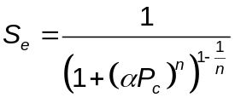
4. 5

The value of the interfacial tension for water and air phase in numerical predictions was chosen as 72 mN/m. The contact angles for drainage and imbibition were chosen as 55º and 75º based on the calibration with respect to experimental results. However, it is important to understand that the contact angle for an assembly of sand grains will not be a single valued quantity, rather a range of contact angles is expected. The variation in contact angle of soil-water-air interface is expected due to several reasons. The surface of sand grains is rough due to the various physical and chemical changes occurring over the years (Alshibli and Alsaleh, 2004). The curvature of the grains increases the complexity in contact angle estimation. The contact angle for a soil agglomerate is significantly different from the contact angle of a smooth plane solid surface of the same material. Furthermore, variation in rate of the flow results in the variation in the velocity of the contact line between sand, air and water (Thompson and Robbins, 1989). Therefore, for accurate predictions, authors recommend carrying out at least one SWRC experiment for the materials of similar chemical composition to obtain an averaged value of contact angle to be used in PMM based predictions.
The onset of drainage is characterized by the air entry value which is the capillary pressure at which the widest pores begin to desaturate. The air entry value of Ottawa sand and Q-Rok are low, less than 2 kPa, which is the characteristics of sands. However, it is interesting to observe from Fig4. 8 that the capillary suction in Q-Rok at different saturations is noticeably larger than the capillary suction in Ottawa sand, even though the global void ratio in dense configuration for Q-Rok is much larger than Ottawa sand, clearly indicating the impact of grain morphology in hydromechanical behavior of partially saturated soils. Fig4. 9 shows comparison of the density of the pore size distribution of Ottawa sand and Q-Rok, highlighting the small size of pore throats in Q-Rok in comparison to the Ottawa sand, therefore further leveraging SWRC observations based on particle morphology in Fig4. 8.

Table4. 2: SWRC model parameters for Ottawa sand and Q-Rok for experimental and predicted data

Material | Method | Path | α (kPa⁻¹) | n | R²
Ottawa | Experiment | Drainage | 0.62 | 8.3 | 0.99
Ottawa | Prediction | Drainage | 0.64 | 7.9 | 0.99
Ottawa | Experiment | Imbibition | 2.0 | 3.3 | 0.96
Ottawa | Prediction | Imbibition | 1.96 | 4.3 | 0.99
Q-Rok | Experiment | Drainage | 0.54 | 5.6 | 0.97
Q-Rok | Prediction | Drainage | 0.52 | 7.7 | 0.99
Q-Rok | Experiment | Imbibition | 1.78 | 2.84 | 0.98
Q-Rok | Prediction | Imbibition | 1.53 | 4.03 | 0.99
Note: SWRC model parameters are from van Genuchten (1980).

Fig4. 9: Density of pore size distribution for Ottawa sand and Q-Rok at 5microns X-ray resolution

Such observations serve as prelude into the advantages of using X-ray CT imaging in understanding pore scale physics associated with multiphase flow in partially saturated sands. It is pertinent to mention here that the equilibration time in SWRC experiments was larger for Q-Rok in comparison to the Ottawa sand and equilibration time increased with the decrease in degree of saturation. This indicates the dependence of permeability on particle morphology and suction, which will be explored in detail by the authors in future work. It can be observed from Fig4. 8 that simulations over predict saturation in pendular regime for both Ottawa sand and Q-Rok. This is primarily due to the spherical structuring element assumption in predictions. The interface between air and water can be curved with different values of curvature. The minimum and maximum values of radii of curvature of a surface are called principal radii of curvature (r_{1,} r₂) and can be used to represent an interface. It is worth mentioning here that in pendular regime one of the principal radii of curvature can be negative (concave/inwards) and other positive (convex/bulging out). Therefore, a general form of Young Laplace equation (Eq.4.6) without spherical structuring element assumption is expected to give better results.

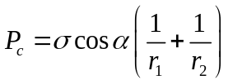
4. 6

The SWRC is not a unique relationship but depends upon the direction of flow, i.e., drying/wetting path as well as number of drying and wetting cycles. This results in hysteretic behavior which is captured well in experiments and predictions for both Ottawa sand and Q-Rok as shown in Fig4. 8. Hysteresis in the SWRC can be attributed to number of reasons such as variation in wettability of sand grains during drying and wetting, local heterogeneity in chemical composition of sand grains, surface roughness which might result in trapping water in crevices during drainage, highly irregular non-uniform pore size distribution. Another approach to explain hysteresis in SWRC measurements is based on the energy considerations of the system (Blunt 2017). In the case of drainage, the limiting step for the displacement of pore water by pore air requires maximum pore air pressure (therefore maximum capillary pressure) at a location where maximum resistance is offered for the displacement of the pore water, i.e., pore throat. This is favorable when the contact angle is small as can be observed from Young Laplace equation (Eq.4.2) which is a manifestation of the energy balance. Similarly, for imbibition, the limiting step requires maximum pore water pressure (therefore minimum capillary pressure) which is favorable when the contact angle is as large as possible. This explains why the receding contact angle is less than the advancing contact angle.

Representative Volume Element in SWRC predictions

The concept of Representative Volume Element (RVE) provides an efficient way for reliable material characterization in granular materials. One to one comparison of direct numerical simulations with experimental results can be challenging due to limitations in imaging capabilities and high computational requirements in modelling large size specimens. In such a scenario, a practical and efficient approach is to find RVE of the heterogenous material system to provide statistically equivalent microstructure large enough to describe the macroscopic behavior (De Cola et al. 2016). In present work, SWRC predictions of Ottawa sand were carried out on cubical volumes of different sizes to access the effect of computational domain on SWRC results. Fig4.10 shows the variation in SWRC predictions of Ottawa sand corresponding to cubical volumes of dimensions 2 mm, 4 mm and 6 mm. It can be observed that cubical volume of Ottawa sand of size 2 mm does not capture air entry value accurately, however, convergence in numerical predictions is achieved for cubical volumes of size 4 mm and 6 mm. Therefore, based on RVE analysis, the use of cylindrical specimen of height and diameter equal to 8.9 mm and 12.7 mm, respectively, for numerical predictions can be considered suitable for comparison with experimental obtained on a specimen with larger size.

Pore-water / Pore air distribution

The displacement of pore water and pore air is controlled by local energy balance. The hydromechanical behavior of partially saturated soils is significantly affected by the distribution of pore water and pore air. Fig4. 11 & Fig4. 12 shows the distribution of pore water and pore air in the central slice along vertical direction in Ottawa sand and Q-Rok, respectively, obtained from numerical predictions. In case of drainage, air starts invading pore space by replacing pore water along the interface between the sand and the mold as can be observed in Fig4. 11 (a). The interface effect is not well observed in 2D slice for Q-Rok as shown in Fig4. 12. However, 3D visualization of the air invading pore space of Q-Rok as shown in Fig4. 13 reveals that the air preferentially starts invading pore space of Q-Rok along the boundary between mold and sand grains, like the Ottawa sand. This highlights the importance of capturing interface accurately to make a reliable comparison between the experiments and numerical predictions. The hysteresis in SWRC can also be observed in pore scale distribution of water and air as shown in Fig4. 11 & Fig4. 12. The distribution of water and air for drainage and imbibition is different with a significant variation in capillary pressure corresponding to the same degree of saturation. The displacements at the pore scale lead to the formation of complex fluid front morphologies including formation of air/water pockets and entrapment of air/ water in pore space. Fig4. 11 (e) and Fig4. 12 (e) show air pockets in Ottawa sand and Q-Rok during imbibition which is a result of the swelling of the water in corners and crevices leading to the snap-off. The

Fig4.10: Representative Volume Element analysis for SWRC predictions of Ottawa sand

Fig4. 11: Pore water and pore air distribution in Ottawa sand obtained from numerical predictions

Fig4. 12: Pore water and pore air distribution in Q-Rok obtained from numerical predictions

Fig4. 13: Advancing pore air front in 3D corresponding to drainage in Q-Rok

Fig4. 14: Magnified visualization of pore air front at during drainage; (a), (b): Ottawa sand; (c), (d) Q-Rok

magnified visualization of the pore air front for Ottawa sand and Q-Rok is shown in Fig4. 14, such complex fluid front morphologies along with grain microstructure
at different fluid saturations can be used as an input to mesoscale simulations in FEM, FVM, DEM framework. The variation in degree of saturation along the height of the specimen at different capillary pressures corresponding to drainage and imbibition for both Ottawa sand and Q-Rok is presented in Fig4. 15. The volume fraction of water and air was extracted corresponding to each horizontal slice in vertical direction from the result files in GeoDict software with the help of a python script. The spatial variation in degree of saturation along with void ratio necessitates questioning theoretical formulations based on macroscale parameters such as global porosity and global degree of saturation. The spatial distribution of pore water/pore air provides a link to answer complex hydromechanical interactions in sands which go beyond SWRC measurements. For instance, capillary pressures are large at lower degree saturation but most of water is concentrated near the particle contacts as shown Fig4. 11(c), (g) and Fig4. 12 (d), (h). This results in lubrication near the particle contacts causing a decrease in friction angle, therefore, provides a contrasting effect to strength in comparison to capillary suction (Martin et al. 2009, Barr et al. 2016, Luo et al. 2014). Similarly, distribution of pore water/ pore air can clarify the mechanics involved in impact-based loadings such as in split Hopkinson bar test (Martin et al. 2009). The velocity of the longitudinal compression wave is different in air and water, therefore, phase distributions at pore scale along with SWRC measurements can provide better understanding in correlating strength and partial saturation.

Comparison of pore fluid distribution from experiments and predictions

The comparison of spatial distribution of pore fluids from experiments and PMM based predictions was demonstrated by leveraging in-situ drainage experimental CT imaging data for Leopard sandstone available for public use at Digital Rocks Portal (DRP). DRP is an open repository for preserving CT imaging data for porous materials at Texas Advanced Computing Centre (Masa et al. 2015). The details of the experimental investigation for the Leopard sandstone can be found here (Herring et al. 2019).
PMM based predictions were carried out on a pore space of Leopard sandstone and the resulting spatial distribution of pore fluids was compared with the experimental data by Herring et al. 2019 as shown in Fig4. 16. The comparison of spatial distribution of pore fluids shows promise and demonstrates the scope of predictive simulations in investigating multi-physics problems. The variations in pore fluid distributions from experiments and predictions can be partly attributed to difference in global degree of saturation (55% nonwetting phase saturation in experiments and 50% non-wetting phase saturation in predictions).

Fig4. 15: Variation in degree of saturation along the height of the sample for rounded Ottawa sand and angular Q- Rok; (a) Drainage; (b) Imbibition

Fig4. 16: Comparison of spatial fluid distributions from experiments (after Herring et al. 2019) and predictions for Leopard sandstone using Pore Morphology Method

Conclusions

The response of the partially saturated sands is complex and requires proper investigation at the pore scale. In present work, X -ray computed tomography was used to capture pore network in 3D for Ottawa sand Q-Rok, characterized by distinct grain morphology, to predict drainage and imbibition directly on pore space based on pore morphology method. A special cell was fabricated to measure SWRC experimentally based on axis translation technique to validate numerical predictions. The following observations were concluded to facilitate multiphase understanding in partially saturated sands:
- The comparison of SWRC measurements including the effect of hysteresis from experiments and numerical predictions using pore morphology method for rounded Ottawa sand and angular Q-Rok is successfully demonstrated and the agreements with predictive simulations is promising. The experimental research in partially saturated soils is inhibited by the long duration of experiments, the equilibration time can vary from days in coarse-grained soils to months in fine grained soils such as silts and clays. Therefore, in present work HAEV ceramic disc, conventionally used in axis translation technique, was replaced by microporous membrane to accelerate equilibration.
- It is important to use X-ray Computed Tomography at adequate resolution to capture pore networks effectively, specifically pore throats, which determine the displacement of pore water by pore air during drainage. The role of resolution in capturing pore space was quantified by obtaining the density of pore size distribution of rounded Ottawa sand for X-ray CT data acquired at 5-micron, 12-micron and 15-micron resolution. It was observed that some fraction of pore throats were not captured with the decrease in X-ray resolution. Furthermore, number of voxels required to represent D₁₀ adequately were obtained.
- It is difficult to prepare repeatable and field representative sand samples, specifically, for coarse grained soils at lower relative density as they are sensitive to small disturbances during specimen preparation and assembly. X-ray CT imaging provides a non-invasive way to capture heterogeneities in pore and grain microstructure for measurement conditions accurately, thus providing the effect of given microstructure represented in the sample state prior to testing. In present work, it was observed that the pores desaturated first along the interface between the soil and the mold due to the heterogeneities which wouldn’t have been possible to predict if exact microstructure was not captured.
- The higher capillary suction was obtained for angular Q-Rok in comparison to the rounded Ottawa sand, even though, the global void ratio in Q-Rok is larger than the Ottawa sand corresponding to the dense configuration. Highly angular Q-Rok contains smaller dimension pore throats in comparison to the rounded Ottawa Sand. This highlights the importance of grain morphology in hydromechanical behavior of partially saturated soils,
- The distribution of pore water and pore air was obtained for drainage and imbibition in numerical predictions. It was observed that at low saturations, pore water concentrates near the particle contacts which might be responsible for decrease in friction angle due to the lubrication of the sand grains near contacts. The distribution of fluid front morphologies shows formation of saturated air/water pockets and therefore such complex grain and fluid microstructure can be used an input in mesoscale simulations using numerical schemes like Finite Element Method, Discrete Element Method.
- The spatial variation in porosity and degree of saturation obtained from X-ray tomography and numerical predictions raises questions on formulations based on continuum approach and necessitates implementation of multiscale physics in hydromechanical behavior of partially saturated sands.

Pore Space and Fluid Phase Characterization in Round and Angular Partially Saturated Sands Using Radiation‑Based Tomography and Persistent Homology
A version of this chapter is published as Thakur, M. M., Kim, F., Penumadu, D., & Herring, A. (2021). Pore Space and Fluid Phase Characterization in Round and Angular Partially Saturated Sands Using Radiation-Based Tomography and Persistent Homology. Transport in Porous Media, 137(1), 131-155.
My contributions to the paper include, image processing, performing numerical simulations, carrying out persistent homology analysis and writing of the manuscript.

Abstract

The multiphase flow transport properties find ubiquitous applications in partially saturated granular media, particularly in the vadose zone due to alternate drying and wetting cycles. The spatial heterogeneity in the degree of saturation at the pore scale has a significant impact on the transport properties of the porous materials. In the present work, three dimensional (3D) computed tomography (CT) images of the two-phase flow experiments are used to visualize and investigate the pore space and fluid phase microstructure of sands with rounded and angular grain morphology. The dual image modality utilizing X-rays and neutrons is used to obtain 3D information on the arrangement of solids and water in a sand sample. Advanced analysis of the experimental data is carried out using a mathematical framework known as persistent homology. This approach allows quantification of geometry as well as connectivity of pore space and fluid phase directly from the CT images with powerful implications in exploring pore-scale physics of multiphase granular materials. Persistent homology predicted percolation length of 52.5 µm and 41.86 µm consistent with the hydraulic conductivity measurements for rounded sand and angular sand whereas the value of global void ratio equal to 0.512 and 0.69, respectively suggests the contrasting response. The fluid distributions obtained from numerical predictions using the Pore Morphology Method (PMM) are compared with results from experiments utilizing persistent homology. These results demonstrate the need for incorporating pore-scale physics in boundary value problems related to multiphase flow in granular materials.

Introduction

Granular materials are ubiquitous with implications in different fields such as enhanced oil recovery, CO₂ sequestration, agriculture, construction industry, and energy science (Andrew et al. 2014; Iglauer et al. 2012; Mukunoki et al. 2016; Randolph et al. 1994; Jarrar et al. 2018, 2020). In nature, granular materials such as sand rarely exist in a completely saturated or dry state. The commonly present phases in naturally occurring sands include the solid phase (grains), wetting phase (water), and non-wetting phase (air). The existence of different phases in an assemblage of partially saturated sand results in complex hydromechanical interactions with manifestations in constitutive response across different length and time scales. Several previous studies indicate that the presence of moisture in pore space affects mechanical response in applications such as rainfall-induced slope instabilities, projectile penetration, and cyclic vibrations triggered by earthquakes (Kim et al. 2016c; Ng and Shi 1998; Stewart et al. 2001). Similarly, the effect of partial saturation on transport properties such as hydraulic conductivity, thermal conductivity, and matric suction is demonstrated in the literature (Likos 2015; Wayllace and Lu 2012). The presence of multiphase fluids in soils results in complex interactions when subjected to external loads. These interactions are not well understood, for instance, partial saturation does not increase the strength in sands up to a certain water content when subjected to high strain rate loading (Martin et al. 2009b). This is not expected since partial saturation results in the development of capillary pressure. Therefore, the pressing need is to understand the underlying physics at pore scale in partially saturated soils.
The principles of partially saturated soils in problems related to geotechnical engineering design are generally incorporated based on continuum-based effective stress formulation, Soil Water Retention Curve (SWRC), and relative permeability measurements. For instance, in seepage analysis, relative permeability is considered as a fundamental soil property (Huang and Jia 2009). At the macroscale, the fundamental physics of multiphase flow is incorporated in terms of mass balance equations for fluids and Darcy’s law for relative permeability. The macroscale response is dependent on the pore-scale physics. An important area of research is to understand the interactions of different phases at the pore scale in multiphase granular materials to establish fundamental mechanisms that govern the emergent response of the material system. One such area of research which gained prominence in the scientific community includes the use of X-ray Computed Tomography (CT) imaging in capturing pore-scale heterogeneities and understanding dynamics of the multiphase fluid flow (Andrew et al. 2015; Singh et al. 2017b). Singh et al. 2017a used fast synchrotron-based X-ray CT imaging in Ketton limestone to understand pore filling mechanisms using time-resolved pore-scale analysis. Cheng and Wang 2020 proposed an improved algorithm for the segmentation of three-phase granular materials. Manahiloh and Meehan 2017 obtained contact angle from X-ray CT images of partially saturated glass bead samples. Willson et al. 2012 and Khaddour et al. 2018 characterized the water retention behavior of Ottawa (F-75) and Houston sand, respectively from X-ray CT images. Thakur et al. 2020; Thakur and Penumadu 2020a combined laboratory-based X-ray CT imaging, SWRC experiments, and numerical predictions in revealing heterogeneities in pore space and spatial distribution of fluids in sands of different morphology. However, most of the X-ray CT-based studies use doping agents, typically salts, such as CsCl and KI to enhance the contrast between the water phase and air phase. The use of doping agents may change interfacial properties such as contact angle and surface tension. Besides, the use of doping agents may not always be an option, for instance, in the visualization of fluid distribution in a sample of partially saturated natural sand samples extracted from the ground for X-ray CT imaging. This problem was solved by (Kim et al. 2013, 2016c) who successfully used dual-modality radiation using both X-ray and Neutron imaging on the same samples to provide 3D visualization of an assembly of grains, water phase, and air phase. The dual-modality imaging provides complementary information, X-rays provide high contrast to the grain phase (silica) and air, whereas neutrons provide high contrast to the water phase. Kim et al. 2015 further developed a novel image registration procedure to combine data from X-rays and Neutrons typically obtained at different resolutions due to differences in radiation flux possible at X-ray and Neutron sources. In the present work, data based on dual-modal imaging (X-rays and Neutrons) is used to conduct the microstructural analysis of pore space and fluid phase on 3-D data obtained from quasi-static flow experiments in wetting (imbibition) of sands of different grain morphology. The variation in grain morphology manifests alteration in the complex 3-D network of the pore space which results in variation in multiphase flow properties such as SWRC and relative permeability. The spatial distribution of fluids at pore scale in a capillary dominated flow regime can also be obtained from numerical predictions on dry X-ray CT images using the Pore Morphology Method (PMM) (Mohsin Thakur et al. 2020b). A comprehensive review of the pore-scale modeling approaches can be found in the literature (Bultreys et al. 2016; Golparvar et al. 2018). The predictive approach can be a useful and important alternative in the absence of the image-based quasi-static flow experiments.
The infiltration of water in partially saturated sands results in the displacement of the non-wetting phase (air) by the wetting phase (water). The primary displacement mechanisms include piston-like displacement of air by water and snap off due to the merging of water films at the pore throats resulting in isolated air phase ganglia. The trapping of the non-wetting phase affects the connectivity of fluid phases which can be an advantage in different applications such as landfill design and CO₂ sequestration. Arrangement of solids and pore-scale distribution of fluids in porous materials can be quantified in terms of topological invariants such as the Euler characteristic (Armstrong et al. 2016; Herring et al. 2013, 2015; McClure et al. 2016; Rücker et al. 2015; Schlüter et al. 2016). This approach provides information related to the connectivity of phases but ignores the shape and size of the features. Persistent homology has been recently used in porous materials to quantify the distribution of fluid and pore space based on the metrics related to topology and geometry of the features (Delgado-Friedrichs et al. 2015; Herring et al. 2019; Robins et al. 2016). Persistent homology is a powerful approach for deriving useful metrics from CT imaging-based flow experiments and will be discussed in detail in the next section. Robins et al. 2011 presented an algorithm to represent 2D and 3D grayscale images based on a simplified complex that can be used to compute the persistent homology of the digital images. Robins et al. 2016 studied the connection between percolation threshold and topological persistence of different types of rocks based on Euclidean distance transform function obtained from binarized CT data. Saadatfar et al. 2017 combined persistent homology and CT imaging to study the granular crystallization mechanisms and crystallization dynamics in a 3D spherical packing. Jiang et al. 2018 proposed a parameter to estimate the effective elastic modulus and characterize the heterogeneity in rocks using persistent homology by transforming digital images into a sphere cloud data. Moon et al. 2019 transformed persistence homology data from digital images into image vectors to fit the statistical models to estimate permeability. Kramár et al. 2014 used discrete element simulations and persistent homology to quantify the force chains in a granular material subjected to slow compression. Suzuki et al. 2020 used persistent homology to detect the fracture pattern in rocks and inferred the similarities and differences in natural rocks and simulations.
In the present work, persistent homology is applied to dry microstructure and partially saturated microstructure obtained from the flow experiments in sand assemblies with widely varying particle shape and texture. It should be noted that in a partially saturated sample, only the air phase is analyzed for microstructural evolution using persistent homology. The water phase / wetting phase is not analyzed because it forms thin films on the surface of the grains which cannot be resolved based on the limited spatial resolution possible even from the most advanced state of art CT imaging setups given the thin fluid / solid interfaces. Also, the effect of the CT resolution in capturing pore size precisely is investigated in the framework of the persistent homology analysis. The distribution of fluids obtained from experiments and PMM based predictions is compared.
The main objective of this work is to demonstrate the measurements and structural details associated with single-phase / multiphase granular materials. The approach presented in this work leverages advanced radiation based in situ experiments with high-level statistical analysis of data. Conventionally, the mechanical and hydraulic characteristics are obtained based on phenomenological models using state parameters. For instance, permeability is often predicted based on the void ratio, however, it is expected that the global void ratio may provide misleading results. Permeability and other transport / thermal properties such as SWRC / thermal conductivity not only depend on the void ratio but also the connectivity of the void space. Similarly, for multiphase flow, the presence of bubbles of one fluid phase may block the flow path of another fluid phase, however, the presence of another alternate flow path (loop) may allow the transfer of the fluid phase. The pore-scale approach coupled with the topological data analysis technique presented in this work opens new avenues in re-analyzing engineering problems encountered in multiphase granular materials. Some of the applications where the present approach can be beneficial include characterization of packing in granular materials, state of partial saturation in sands and determination of corresponding functional properties, crystallization in granular materials, bio-cementation in soils, gas production from methane hydrate sediments, and CO₂ sequestration, etc. The pressing need is to incorporate the following two objectives in single and multiphase granular materials for further advancements in the fundamental understanding of the granular materials
1. Observe and quantify the changes in the structure of the pore space and fluids in multiphase granular materials using high fidelity experimental and numerical modeling approaches
2. Relate these changes in structure with the functional properties of the porous media.
In the present work, authors primarily focus on the first objective, i.e., obtain and quantify the 3D geometric structure of pore space and fluid phase with varying degrees of saturation by utilizing radiation-based imaging experiments and statistical mechanics using the framework of persistent homology. For this purpose, we use sands of similar particle size distributions but very different morphology and attempt to address some of the drawbacks in using a global state parameter like global void ratio in comprehensively predicting the transport properties of partially saturated sands.

Materials and Methods

Material

Commercially available 20-40 Ottawa sand and angular Q-Rok were used in the present work. Both sands consist of the same mineralogical composition containing more than 99.5% quartz (SiO₂). Fig5. 1 shows grain size distribution, SEM images, and roughness of the Ottawa sand and Q-Rok. The grain size distribution of sands is identical and can be classified as poorly graded sand according to the Unified Soil Classification System (USCS). The grain morphology is distinct, Ottawa sand consists of rounded grains whereas Q-Rok consists of angular grains. Both sands have been used in several studies in the past to investigate the role of particle morphology and moisture content on the high rate response of granular materials (De Cola et al. 2018; Glößner et al. 2017; Sharma et al. 2020). The roughness of the sand grains was obtained using a confocal laser microscope based on 3D surface profile measurements on the sand grains. The average roughness of Ottawa sand and Q-Rok was found to be approximately 0.43 µm and 0.52 µm, respectively. In the present work, the samples used for microstructural investigation were prepared to achieve 100% relative density with a minimum void ratio equal to 0.512 and 0.69 for Ottawa sand and Q-Rok, respectively. These samples were prepared in a cylindrical aluminum chamber in three layers and each layer was compacted 25 times using a tamping rod with a mass of 480 grams. The heights and diameter of the sample were kept the same, equal to 10.27 mm. The thickness of the aluminum chamber was equal to 1.3 mm.

Image-based flow experiments

The different interaction mechanisms of the neutrons and X-rays with condensed matter provide complementary information in visualizing three phases in partially saturated sand. X-rays interact with the electron cloud of the atoms whereas neutrons interact with the nuclei of the atoms. The quartz sand grains exhibit high contrast to the X-rays whereas water provides high contrast to the neutrons in CT imaging. In the present work, data obtained from the dual-modal imaging technique was used to analyze the microstructure evolution in a two-phase flow experiment. The data used in the present work was obtained at Conrad, a cold neutron imaging

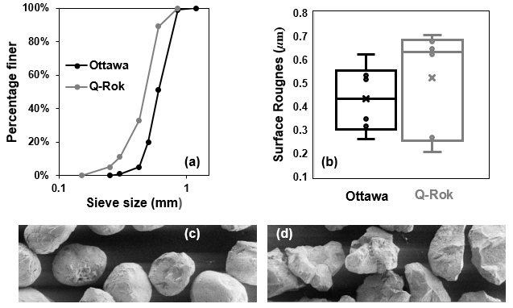
Fig5. 1: Material properties of Ottawa sand and Q-Rok: (a) Grain size distribution, (b) Surface roughness, (c),(d) SEM images showing grain morphology

beamline at Helmholtz Center Berlin (HZB) (Kardjilov et al. 2016). The data obtained from the experiments were reconstructed using a filtered back-projection algorithm (Kak and Slaney 2001) to provide the 3D information of fluid distributions in an assembly of sand. X-ray CT data and Neutron CT data were obtained at slightly different voxel size, 6.9 µm and 6.5 µm, respectively. Therefore, image resampling was performed on X-ray CT data to match the voxel size of Neutron CT data. Both X-ray and Neutron CT imaging data were processed to reduce noise. A median filter with a neighborhood value of 3 voxels was applied separately to both Neutron and X-ray CT images to smooth the data. The dual image registration methodology described in (Kim et al. 2015) was used subsequently in this work to align the two data sets. The final registered data was sampled to an effective voxel resolution of 7µm. The segmentation of final registered data was carried out using an automatic thresholding algorithm (Otsu 1979). The focus of this paper is on the analysis of the reconstructed data for evaluating microstructural evolution from these novel multimodal imaging-based techniques.
Water was injected into the sample slowly from bottom to top at a flow rate equal to 0.033 µm/s. The rate of flow was controlled using a syringe pump operated remotely using a computer. Fig5. 2 shows a pictorial representation of the flow chamber used for the two-phase flow experiments at the HZB Condrad beamline. The slow rate of flow ensures that capillary forces dominate the viscous forces, conventionally ascertained based on the magnitude of the capillary number. The capillary number determines the relative magnitude of the viscous forces to the forces exerted due to the surface tension. The capillary number for wetting of sands was obtained according to Eq. 5.1, where ‘C_{a}’ represents the capillary number, ‘µ’ represents dynamic viscosity of water, ‘v’ represents the superficial velocity of water determined from the ratio of Darcy velocity and porosity, ‘σ’ represents interfacial tension between air and water. The capillary number for both Ottawa sand and Q-Rok was determined to be less than 10⁻⁸ for the measurement conditions which indicates that the flow is dominated by the capillary forces.

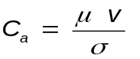
5. 1

The water was injected into the Ottawa sand sample in two flow steps (FS 1 and FS 2), with 0.065 mL and 0.058 mL of water injected in the first and second steps, respectively. For the Q-Rok, water was injected only in one flow step (FS 1) with the injected volume of water equal to 0.065 mL. Only one flow step was used for Q-Rok due to the limited time at the neutron beamline. After each flow step, the flow was allowed to equilibrate for 2 hours before acquiring CT images.

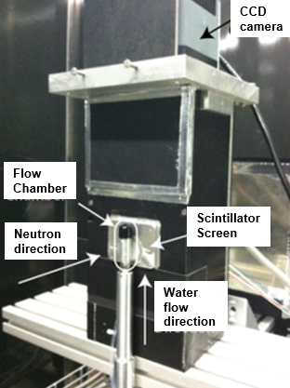
Fig5. 2: Flow chamber and detector assembly used for the two-phase flow experiments at HZB Condrad beamline

Pore Morphology Method

The seminal work of (Hilpert and Miller 2001) resulted in the development of the Pore Morphology Method (PMM). PMM works on the principles of mathematical
morphology and determines the quasi-static distribution of fluids in a porous media based on the Young Laplace equation. The detailed description of PMM is provided in Chapter 4 of this dissertation.

Persistent Homology Analysis

The topology of the pore space and non-wetting phase (air) in partially saturated soils can provide useful information related to transport properties. Previously, the Euler characteristic (χ) has been used to describe the topology of the pore space and non-wetting phase. The Euler characteristic (χ) is equivalent to the alternating sum of Betti numbers as shown in Eq.5.2.

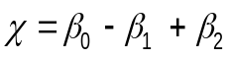
5. 2

For the Euler characteristic of pore space, ‘β_{o}’ represents the number of distinct pore space regions not connected to each other, ‘β₁’ represents the number of redundant connections / loops through which the pore space is connected (indicates the number of connections which can be broken while still maintaining the connectivity of the pore space), ‘β₂’ represents solids floating in the pore space. For the topology of the air phase in partially saturated soil, ‘β_{o}’ represents the number of isolated air bubbles / ganglia, ‘β₁’ represents the number of redundant connections / loops through which the air phase is connected in the pore space (indicates the number of connections which can be broken while still maintaining the connectivity of the air phase), and ‘β₂’ represents solid and water phase floating in air phase (therefore not relevant for the topology of air phase). Fig5. 3 shows examples of the Betti numbers and the Euler characteristics of simple objects. For instance, a cubical frame in Fig5. 3 consists of a single object (β_{o} =1) with 5 redundant loops (β₁ =5), i.e., 5 connections can be broken in the cubical frame while still maintaining the connectivity. β₂ =0 for all the examples in Fig5. 3 since none of the objects are floating in a region of a different phase (since only one phase is shown for these simplified examples). Fig5. 4 shows the simplified 3D example of ‘β_{o}’ and ‘β₁’ features for the air phase topology characterization. Two isolated clusters of air phase labeled as ‘β_{o}’ features’ can be observed in Fig5. 4. Also, a redundant loop indicating a ‘β₁’ feature is shown in Fig5. 4. The value of the Euler characteristics (‘χ’) measured with respect to the air phase for a partially saturated sand specimen with a high saturation of water would be positive since the air phase would exist only as isolated bubbles resulting in large ‘β_{o}’ values
Fig5. 3: Betti numbers and Euler characteristics (χ) of some simple shapes

Fig5. 4: Euler characteristics of air phase (blue region indicates air)

and, therefore, manifests positive value of ‘χ’ value according to the Eq.5.2. Conversely, for a partially saturated sand specimen with a high saturation of air
phase, the value of ‘χ’ measured with respect to air phase would be a negative value according to Eq.5.2 due to the formation of a larger number of redundant loops formed by air phase resulting in large ‘β₁’ values and negative ‘χ’ value. Therefore, as the drying progresses in a granular material, the value of ‘χ’ will become more and more negative. However, as the wetting progresses, the value of ‘χ’ will become more and more positive. It should be noted that the Euler characteristics provide information on the connectivity of the structure, however, they do not provide any information on the geometry of the features. This limitation is addressed using Persistent homology.
Persistent homology is a mathematical framework derived from computational topology to obtain the topological information from 2D or 3D grayscale images. In the present work, the open-source software package Diamorse (Delgado-Friedrichs 2015) was used for the analysis. Persistent homology analysis is performed on two-phase images, therefore, for pore phase characterization CT images are segmented into pore phase and grain phase; and for air phase characterization in partially saturated sand, CT images are segmented into air phase and solid plus water phase. Herring et al. 2019 described the persistent homology approach vividly; the description is briefly repeated here for the sake of completeness. The approach here is described for the characterization of the pore space for the sake of simplicity, therefore, the binary image includes the pore phase and grain phase. The approach is similar for air phase characterization in partially saturated sand, except that the binary image consists of air phase and solid plus water phase. The first step is to compute the Signed Euclidean Distance Transform (SEDT) of the binary image. The Euclidean Distance Transform (EDT) computes the radius of the largest sphere at each point which can fit the pore space / solid phase. SEDT computes the EDT of each voxel from the pore grain boundary and arbitrarily assigns a negative sign to the pore phase EDT and a positive to the grain phase EDT. The face adjacent voxels at the interface of the two phases are assumed to be at 0.5 units. Once SEDT is computed, changes in the topology of the level sets are identified for each value in the SEDT, starting with the largest negative value which represents the largest pore body center with the incremental increase to the largest positive value which represents the largest grain size. The appearance of a new topological feature is called birth whereas the disappearance of a feature is called death. The difference between the birth and death value is termed as the persistence of a feature. The features with a low value
of persistence are considered as noise whereas the feature with a high value of persistence is considered important. The birth and death values of topological features β_{o}, β₁, and β₂ are obtained and plotted as histograms referred to as the persistence diagram.
The interpretation of the persistence diagram provides useful insights related to the connectivity and geometry of the pore space and non-wetting phase. For the analysis in the present paper, assume birth and death values are represented

Fig5. 5: Illustration of persistent homology features, (a) 2D idealized porous medium, pore phase is shown in black and grain phase is shown in grey, (b) β_{o} features, (c) β₁ features, (d) β₂ features

along abscissa and ordinate of the persistence diagram, respectively. Fig5. 5 shows the interpretation of the features of the persistence diagram for a simple
porous material. The birth value of the β_{o} feature is always negative since it represents the pore space or air phase and the magnitude of the birth value provides an estimate of the size of the pore body. The death values of the β_{o} feature can be positive or negative. The positive death value of the β_{o} feature indicates disconnected pore when characterizing pore space topology and isolated air bubbles/ ganglia when characterizing air phase topology. The negative death value indicates connected pore body and connected air phase corresponding to pore space topology and air phase topology, respectively. The disconnected pore bodies are represented in the second quadrant of the persistence diagram and the connected pore features are represented in the third quadrant of the persistence diagram. Therefore, both size as well as connectivity information, is extracted from the CT images. The connectivity of the pore space and air phase is further evaluated based on the persistence diagram of β₁ features. A redundant loop like the shape of a doughnut has a negative birth value and positive death value. A redundant loop is represented in the second quadrant of the persistence diagram of β₁ features and its birth value represents the size of the narrowest constriction contributing to the loop. A loop with a negative birth and death value, i.e., originates and dies in the pore space/ air phase is not a true redundant loop and is represented in the third quadrant of the β₁ persistence diagram. A loop with positive birth and death value represents grain features, therefore, are neglected in pore space and air phase topology characterization. β₂ features have positive birth and death values, therefore represented in the first quadrant of the persistence diagram for β₂ features. The death value of the β₂ features provides an estimate of the individual size of grains when characterizing pore space topology. Table5. 1 provides a summary of the interpretation of features obtained from the persistence diagram.
Persistent homology analysis provides an efficient way to characterize heterogeneous porous media compared to the empirical approaches using a state parameter such as global porosity or a stochastic approach where lower-order probability functions provide incomplete information and higher-order probability function require higher computational cost without significant improvement in porous media characterization (Jiao et al. 2009). The advantage of the persistence homology over other topological data analysis techniques such as the Euler characteristic is its robustness in capturing both size and connectivity information. Persistence homology provides useful information related to the structure and morphology of the porous material and has the potential to provide a sound link to the functional properties of partially saturated soils. Persistence homology is robust and stable with respect to the small changes in the segmentation of the fluid-solid interface. However, the limitation of topological data analysis is that the isolated inclusions of one phase in another phase due to the noise in data result in errors (Armstrong et al. 2019). Also, analysis of air phase and not water phase can be carried out in a partially saturated sand specimen due to the hydrophilic nature of
Table5. 1: Interpretation of features based on persistent homology analysis
Features | Description | Position in the Persistence diagram | Relevance
β_{o} | Disconnected pore/air phase in partially saturated sand  Connected pore /air phase in partially saturated sand | Second quadrant (negative birth value, positive death value)  Third quadrant (negative birth value, negative death value) | Birth value: estimates size of disconnected pores  Death value indicates pore is disconnected  Birth value: estimates size of connected pores  Death value: indicates pore is connected and estimates pore throat radius
β₁ | Solid loops (not of interest in this study)  Redundant pore/air pathways around solid features  e.g. like the shape of a doughnut or handle of a coffee mug  Non-convex pore:  Pore/air loops where spherical grains nearly touch each other but remain separated | First quadrant (positive birth value, positive death value)  Second quadrant (negative birth value, positive death value)  Third quadrant (negative birth value, negative death value) | Formed by non-spherical platelet-shaped grains  Birth value: estimates size of narrowest pore throat contributing to the loop.  Death value: estimates grain contact radius  Provides additional information on pore/air connectivity  Birth value: estimates size of narrowest pore throat contributing to the loop.  Death value: estimates non-convex pore throat radius
β₂ | Grains | First quadrant (positive birth value, positive death value) | Death value provides an estimate of grain size

the sand grains which results in the formation of thin films not resolved by the CT imaging instruments.

Results

Grain morphology

The grain morphology of Ottawa sand and Q-Rok is quantified from X-ray CT images. Particle shape characteristic is obtained based on elongation factor which is determined from the ratio of the medial edge length and major edge length of the oriented bounding box of the grain. The value of the elongation factor closer to zero indicates very elongated grains and the value closer to one indicates nearly spherical grains. Fig5. 6 shows the normalized frequency of the grains and elongation factor for Ottawa sand and Q-Rok. Normalized frequency here represents the ratio of frequency to the total number of grains. It can be observed from Fig5. 6that Q-Rok exhibits a more angular shape compared to the Ottawa sand. The average elongation factor for the Ottawa sand and Q-Rok are 0.83 and 0.79, respectively. Some of the grains of Q-Rok have an elongation factor of less than 0.5, while none of the grains of Ottawa sand have an elongation factor of less than 0.5. The angularity of the grains has implications in pore size distribution and therefore affects the single as well as multiphase flow behavior in partially saturated sands.

Visualization of fluid distribution

The fluid distribution in a complex 3D pore space provides valuable information for microstructural analysis. The displacement of the air phase by water phase in imbibition and the subsequent rearrangement of the fluid phases occurs to obtain a configuration of minimum energy at the pore scale. Fig5. 7 shows air and water distribution in Ottawa sand corresponding to Flow Step (FS1) and Flow Step 2 (FS2) obtained from dual-modal CT imaging. It can be observed from Fig5. 7 that water invades the pore space non-uniformly, dictated by the local size and connectivity of pore space. Water continues to invade the pore space in a preferential direction as the degree of saturation increases from FS1 to FS2. Fig5. 8 & Fig5. 9 shows a comparison of the spatial distribution of fluids in Ottawa sand and Q-Rok respectively, based on experiments and PMM based predictions. The comparison of the fluid distributions obtained from experiments and PMM based predictions is promising. However, one cannot comment on the accuracy just based on the visualization. The comparison between the experiments and PMM based prediction based on persistent homology is discussed in the later subsections of the paper. The spatial distribution of fluids can be useful in carrying
Fig5. 6: Variation in normalized frequency of the grains and elongation factor for Ottawa sand and Q-Rok

Fig5. 7: Fluid distribution in wetting of Ottawa sand obtained from radiation-based experiments corresponding to (a) Flow step 1 (FS 1), (b) Flow step 2 (FS2). Ht=10.27 mm, Dia= 10.27 mm

Fig5. 8: Fluid distribution in wetting of rounded Ottawa sand corresponding to Flow Step 2 (FS2) obtained from (a) radiation-based experiments (Saturation=24.6%), (b) pore morphology-based predictions (Saturation =22.3%). Ht=10.27 mm, Dia= 10.27 mm

Fig5. 9: Fluid distribution in wetting of angular Q-Rok corresponding to Flow Step 1 (FS1) obtained from (a) radiation-based experiments (Saturation=13.9%), (b) pore morphology-based predictions (Saturation=12.9%). Ht=10.27 mm, Dia= 10.27 mm

out multi-physics analysis such as investigating coupled thermal, acoustic, and hydromechanical characteristics of the partially saturated system. One approach to utilize the fluid distributions from CT images is to solve the coupled boundary value problems directly on CT images using the discrete element method, finite volume method, finite element method, or a hybrid approach using these numerical schemes. This approach has been used on dry microstructure by (Imseeh and Alshibli 2018b; Turner et al. 2016) with recent advancements by (Thakur and Penumadu 2020c) in improving the computational efficiency of the predictions. Present work can, however, extend the scope of such simulations to multiphase granular materials. Another approach would be to utilize the information from persistence homology in predicting the functional properties of the porous materials using machine learning. A recent paper by Moon et al. 2019 used persistent homology and machine learning in predicting permeability and tortuosity of the porous material. Similarly, new approaches are expected to materialize with future research on persistence homology in developing useful metrics that can correlate functional properties with the structure of the porous materials. At present, the approach is still in infancy and useful insights and quantifications are expected in future research.

The microstructure of pore space of randomly packed spherical grains

The pore space of periodic randomly packed single sized spheres was investigated using persistent homology. The dataset was obtained from an online repository Digital Rocks Portal (Mcclure 2016) and is freely available for public use. In the present work, the voxel size for the dataset was considered as 7 µm. The data was
segmented into two phases: pore phase and grain phase, therefore, persistent homology analysis was carried out for single-phase saturated porous media. Fig5. 10 shows the persistence diagram of topological features of pore space of randomly packed single sized spheres. The color bar represents the number of data points belonging to each feature. It can be observed from Fig5. 10 that the death value of β₂ features is constant which indicates the values of the maximally inscribed sphere in a grain. The constant death values of β₂ features indicate mono-disperse granular material. The value of the death of β₂ features as shown in Fig5. 10is approximately equal to 287 µm, i.e., 41 voxels which matches well with the input data of spherical beads of radius 42 voxels. It can be observed from Fig5. 10 that most of the β_{o} features lie in the third quadrant of the persistence diagram, therefore, exhibit negative birth and death values. The features in the third quadrant of the persistence diagram of β_{o} features indicate connected pores with birth and death values providing estimates of pore size and throat sizes in the sample, respectively. Fig5. 10 shows a small number of β_{o} features in the second quadrant of the persistence diagram which indicates disconnected pores with the size of the pore estimated by the death value of the β_{o} feature. Additional information related to the connectivity including the redundant pathways and loops
Fig5. 10: Persistence diagram of topological features of pore space of randomly packed single sized spheres

Fig5. 11: Pore size and pore throat distribution obtained from birth and death values of β_{o} features in the third quadrant of the persistence diagram shown in Fig5. 10

formed by pore space of spherical beads assembly is shown in β₁ features of Fig5. 10 with interpretation provided in Table5. 1. Fig5. 11 shows pore size and pore throat distribution obtained from birth and death values of β_{o} features in the third quadrant of the persistence diagram shown in Fig5. 10, both the results are equivalent, the intention of Fig5. 11 is to present results in the conventional approach to provide intuition to the reader regarding the results presented in a persistence diagram. However, the persistence diagram contains a wealth of information compared to the results presented in Fig5. 11.

The microstructure of pore space of Ottawa sand and Q-Rok

The persistence diagram of the β_{o}, β₁, β₂ features for pore space of an Ottawa sand and Q-Rok are shown in Fig5. 12. It can be observed that the pore space of both Ottawa sand and Q-Rok contain low numbers of disconnected pores as shown in the second quadrant of the persistence diagram of the βo feature. The connected pores, shown in the third quadrant of the persistence diagram of the β_{o} feature, indicate that Ottawa sand exhibits a wider distribution of pore sizes compared to Q-Rok. Ottawa sand contains some pore of dimensions larger than Q-Rok. The size of throats indicated by the death value in the quadrant of the β_{o} feature suggests Ottawa sand has some large size connections compared to Q-Rok. The percolating length can be estimated based on the death value of the maximum persistence β_{o} feature as suggested by Robins et al. 2016. In the case of Ottawa sand, the percolating length is estimated as 52.5 µm with a persistence value of -141.12 µm. In the case of Q-Rok, the percolating length is estimated as 41.86 µm with a persistence value of -111.16 µm. The percolating length of Ottawa sand is higher than Q-Rok and therefore, is an interesting observation since the global void ratio of Ottawa sand is smaller compared to the global void ratio of Q-Rok. Such microscale insights have direct implications on transport properties such as permeability. To substantiate microstructural observation related to percolating length, the saturated hydraulic conductivities of Ottawa sand and Q-Rok were obtained experimentally and found out to be equal to 1.5 × 10⁻³ m/s and 4.1 × 10⁻⁴ m/s. The hydraulic conductivity measurements support the validity of percolating length estimation based on CT measurements using persistent homology analysis. The information related to the connectivity of redundant pore throats is provided in the second quadrant of the β₁ feature. The birth value in the second quadrant provides information related to the size of the smallest throats which are part of the redundant loops. It can be observed from Fig5. 12 that Q-Rok has a large number of smaller dimension pore throats forming redundant loops as can be observed by the bright yellow hot spot in the persistence diagram of the β1 feature of Q-Rok. Also, the persistence diagram of the β₂ feature provides an estimate of the grain size distribution based on the maximally inscribed sphere in a grain. The grain size is estimated based on the death values of the β₂ feature.

Fig5. 12: Persistence diagram of topological features of pore space of rounded Ottawa sand angular and Q-Rok

Effect of CT resolution on pore space imaging

The prediction of multiphase flow properties in porous materials such as sands depends on the accuracy of the captured CT microstructure.
Fig5. 13 shows the persistence diagram for topological features of pore space of Ottawa sand captured at 5 µm and 15 µm voxel size. It should be noted that datasets for investigating the effect of the resolution were different from the flow-based experimental datasets. The volume analyzed here is smaller compared to the rest of the analysis in this paper, since the objective here is only to demonstrate the effect of CT resolution on pore-scale imaging. It can be observed from
Fig5. 13 that CT resolution has noticeable effects on the persistence diagrams of the topological features. The disconnected pores observed in the second quadrant of the β_{o} feature are higher in number for the data obtained at 5 µm voxel size compared to the data obtained at 15 µm voxel size. Also, the pore size distribution of the connected pores is narrower for data obtained at 5 µm voxel size compared to data obtained at 15 µm voxel size. The percolating length values were estimated as 43.85 µm and 48.6 µm for 5 µm voxel size and 15 µm voxel size, respectively. The variation in β₁ and β₂ features is also noticeable in the persistence diagram. Therefore, it is imperative to use an appropriate resolution of CT imaging to extract accurate microscale features from the data.

Microstructural evolution of air phase of Ottawa sand and Q-Rok

The water was injected into the Ottawa sand assembly in two flow steps, FS1 and FS2, and in one flow step for Q-Rok (FS1). The persistence diagram of the topological features of the air phase is shown in Fig5. 14. It can be observed that the disconnected air phase / ganglia increase with the increase in the saturation of the water phase for Ottawa sand. The small, bright yellow region in the second quadrant of the persistence diagram of the β_{o} feature shows an increase in the number of isolated air bubbles. Furthermore, the number of redundant loops through which air remains connected decreases with an increase in saturation with respect to the water phase. β₂ feature for a partially saturated sand sample indicates solids plus water phase, therefore, does not have much relevance in present work. The comparison of the β₁ feature for Ottawa sand and Q-Rok for FS1 shows redundant loops (second quadrant of β₁ persistence diagram) in Q-Rok are more concentrated compared to the Ottawa sand, therefore, the size of the smallest throats forming these loops is less distributed in Q-Rok compared to Ottawa. The changes in topological features are expected to be more noticeable with the increase in flow steps / degree of saturation.

Fig5. 13: Effect of CT resolution on topological features on pore space imaging of Ottawa sand based on persistence diagrams

Fig5. 14: Persistence diagram of topological features of air phase from two-phase flow experiments for rounded Ottawa sand and angular Q-Rok

Comparison of air phase microstructure from experiments PMM based predictions

The visualization of different phases in partially saturated Ottawa sand from experiment and prediction can be seen in Fig5. 8. The comparison between the experiment and prediction just based on the visualization seems promising but not
comprehensive. In this subsection, the comparison of the air phase distribution in Ottawa sand corresponding to FS2 is obtained based on the persistent homology analysis. Fig5. 15 shows the persistence diagram of partially saturated Ottawa sand samples corresponding to flow step 2 (FS2) with the degree of saturation of the water phase equal to 24.6 %. It can be observed that the size of isolated air bubbles/ ganglia is more distributed in prediction compared to the experiment. This is evident from the birth values of the β_{o} feature in the second quadrant. The connected air phase exhibits similarity to a larger extent for both experiment and prediction as shown in the third quadrant of the β_{o} feature. Also, the narrowest throat size of the air phase redundant loops indicated by the birth value of the β₁ features in the second quadrant exhibit similarity, however, the death value of these features shows the difference. The death value of the β₁ feature in the second quadrant can be thought of as the constriction in the grain + water phase, which is not highly relevant for air phase microstructure evolution. Overall, the similarities between the experiments and predictions are promising, however, the noticeable difference is evident which could not be extracted just from the visualization of the three phases as shown in Fig5. 8.

Conclusion

- Dual modal imaging technique utilizing X-rays and Neutrons is a promising approach to visualize two-phase flow experiments consisting of water and air as fluid phases. The two modalities provide complementary information, X-rays provide high contrast in visualizing sand/quartz grains whereas Neutrons provide high contrast to the water phase.
- Persistent homology provides a robust methodology in characterizing pore space and air phase distribution directly from CT images with the variation in the degree of saturation. Important features including connected and disconnected pores, pore and throat size distribution, and redundant pathways in single and multiphase granular materials can be obtained quantitatively.
Global void ratio/ porosity can provide misleading results in predicting multiphase flow properties of partially saturated sands. It was observed that rounded Ottawa sand with a lower global void ratio (e=0.512) exhibited higher percolation length and higher hydraulic conductivity compared to the angular Q-Rok (e=0.69) with a higher global void ratio. The percolating length value of Ottawa sand and Q-Rok were estimated as 52.5 µm and

Fig5. 15: Comparison of persistence diagram of topological features of air phase from experiments and PMM based predictions

41.86 µm, respectively. The persistent homology analysis, therefore, provides a better indication of hydraulic conductivity/permeability compared to the global void ratio.
- Angular Q-Rok consists of a large number of smaller dimension pore throats forming redundant loops compared to the rounded Ottawa sand. Such quantifications are useful in the prediction of transport properties of multiphase granular materials as the presence of bubbles of one fluid phase may block the flow path of another fluid phase, however, the presence of another alternate flow path (loop) may allow the transfer of fluid phase.
- The disconnected air phase/ganglia increase with the increase in the degree of saturation of the water phase for partially saturated sand. The size and number of disconnected features are obtained from the second quadrant β_{o} features of the persistence diagram.
- It is important to use optimal CT resolution in imaging granular materials. It was observed that lower CT resolution may influence the connectivity and size of the pores. The percolation length value for the data acquired at 5 µm voxel size and 15 µm voxel size was estimated as 43.85 µm and 48.6 µm, respectively. Therefore, it can be concluded that the CT imaging 15 µm voxel size was unable to resolve small fractions of the pore throats compared to data acquired at 5 µm voxel size.
- The spatial distribution of fluids obtained from experiments and PMM based predictions shows a promising match if evaluated only based on visualization of a few slices of data. Persistence homology, in addition to similarities, also reveals differences. The connected air phase shows similarity for experiments and predictions. The disconnected air phase, however, shows the variation in size distribution for experiments and predictions.
- The future scope of the present work is to relate the information from persistent homology to the functional properties of the porous media. One such promising avenue but not limited to is to combine persistent homology and machine learning to provide accurate predictions of different physical properties in granular materials.

Capillary suction predictions in granular materials subjected to 1D compression and triaxial loading with emphasis on projectile penetration in sands

Abstract

The role of partial saturation in penetration resistance of projectiles in granular materials is not clear due to experimental constraints imposed by high cost and special considerations in equipment design. In this work, granular material near the tip and far-field of the projectile is numerically simulated based on 1-D compression and triaxial stress paths, respectively, using the Finite Discrete Element Method. 1-D compression simulations include fracturing of the grains by pre-inserting cohesive interface elements in the regular finite element mesh. The capillary suction is numerically predicted by extracting deformed granular assembly microstructure at different loading steps as an input to the Pore Morphology Method. The results demonstrate the development of high capillary suction in 1-D compression loading due to significant crushing of the grains. The capillary suction is negligible during triaxial loading compared to the 1-D compression loading. This suggests that the future simulations related to the projectile penetration in sands should account for the coupled hydromechanical effects near the tip whereas partially saturated sand in the far-field can be approximated as a dry material. Finally, capillary suction is estimated from the grain size distribution of a material obtained from the tip of the projectile in an experiment.

Introduction

The granular materials are multiphase materials with widespread occurrence in nature in the form of partially saturated sands. The presence of multiphase components, e.g., soil solids, water, and air phase result in complex hydromechanical interactions. The state of partial saturation in granular materials subjected to quasi-static loading conditions increases effective stress as postulated and demonstrated in several past studies (Gan et al. 1988; Gao et al. 2018; Lu and Likos 2006). The partial saturation, however, does not always increase effective stress in dynamic loading conditions as observed in Split-Hopkinson Pressure Bar experiments (Barr et al. 2018; Luo et al. 2014b; Martin et al. 2009a). The continued evidence suggests that the complex hydromechanical interactions exist during the dynamic loading of granular materials and, therefore, necessitates an improved understanding of physics across different length and time scales.
Several experimental studies have been carried out to investigate the penetration resistance of dry geomaterials (Allen et al. 1957; Bless et al. 2015; Omidvar et al. 2015, 2016; Savvateev A.F. et al. 2001). Bless et al. (2015) provided a comprehensive review of different aspects of high-speed penetration in granular materials. Omidvar et al. (2016) investigated in-situ kinematics of the granular assembly during low-velocity penetration by utilizing transparent soils and a high-speed camera. Glößner et al. (2017) measured experimentally the deceleration experienced by a projectile by using an onboard measurement system known as G-Rec. The crushing of the grains plays a major role in the deceleration of a projectile. Glößner et al. (2017) observed the formation of a false tip ahead of the projectile which consists of extremely crushed grains forming approximately a conical-shaped tip. The crushing of the grains stiffens the response of the sands to the external loading and represents an important energy dissipation mechanism near the tip region of the projectile.
The influence of partial saturation in projectile penetration has not been investigated thoroughly. Relatively recently, Kim et al. (2016) utilized X-ray and Neutron dual imaging modalities to investigate the mesoscale response of projectile penetration in partially saturated sands. They observed the formation of a cavity near the region where the projectile came to a complete halt as shown in Fig6. 1. The microstructure around the cavity consisted of highly fractured grains with a large concentration of water in the corresponding pore space. The large distribution of water near the cavity suggests the existence of large capillary pressures. A foremost question that needs to be answered is, “How large are the capillary pressures in granular materials near and far away from the tip of the projectile”. The main objective of the present work is to answer this question by considering the discrete microstructure of the granular materials.
The experimental investigations in projectile penetration are limited due to high cost, special considerations in equipment design, development of novel sensors that can allow continuous measurement of deceleration experienced by a projectile during the impact. The pressing need is to complement limited experimental studies with numerical modeling. The numerical modeling of the projectile penetration in granular materials can be extremely complicated in terms of both physics and computational resources requirements. It is important to adopt a Multiphysics-Multiscale approach to capture the enriched physics and fine microstructure details wherever necessary. The near tip region of the granular material experiences a 1-D compression stress path. It is imperative to incorporate grain crushing in numerical modeling in the near tip region of the projectile. The far-field region of the granular material experiences a triaxial stress state with low confinement. Therefore, a relaxed description of material constitutive response such as ignoring grain crushing in the far-field is adequate.
The macroscopic response of the granular materials is governed by localized non-affine deformations such as force chain buckling and shear banding (Amirrahmat et al. 2018b; Andò et al. 2012; Zhai et al. 2019b). It is important to incorporate the discrete nature of the granular materials in numerical simulations. The Finite Discrete Element Method (FDEM) has emerged as a promising approach to simulate the complex constitutive response of the discrete granular materials (Imseeh et al. 2020; Ma et al. 2014b, 2019; Turner et al. 2016, 2019b). Ma et al. (2017) used FDEM to model breakage of the rock-fill materials in biaxial loading

Fig6. 1: Cavity formation around the projectile in partially saturated sand (adopted from Kim et al. 2016)

conditions. They used cohesive interface elements (CIE’s) along with the damage model to simulate the breakage of grains. This approach allows arbitrary crack propagation with constraints imposed by mesh topology. The FDEM approach along with CIE’s gained immense popularity in recent years and has been successfully extended to study single grain crushing in 3D (Zhou et al. 2020), 1D compression, and triaxial compression on coarsely meshed grains in 3D (Ma et al. 2016, 2019). The simulation of triaxial loading at low confining pressures with no grain crushing using FDEM was successfully demonstrated by (Nadimi et al. 2019; Thakur and Penumadu 2019). Recently, Thakur and Penumadu (2020a) proposed a new variant of FDEM to simulate triaxial compression in sands using shell elements based on co-rotational velocity formulation to reduce the computational cost.
Capillary suction predictions in granular materials can be carried out directly on the 2D / 3D pore space using the Pore Morphology Method (PMM). PMM was originally introduced by Hilpert and Miller (2001) to simulate drainage on digital porous media. Schulz et al. (2015) incorporated the local variation in wettability of the porous media in PMM based predictions. Mohsin Thakur et al. (2020) demonstrated the agreement of the PMM predictions for drainage and imbibition with the experiments. The main advantage of the PMM over other methods such as the Finite Volume Method and Lattice Boltzmann Method is that PMM is computational far less expensive. A brief description of PMM has been provided in the Methods section and the detailed description can be found in Mohsin Thakur et al. (2020).
The following three objectives are considered in this chapter to further advance the role of capillary suction in projectile penetration:
- Numerically simulate the breakage of dry granular material in a 1D compression stress path using FDEM. This aspect of the modeling approach will be useful in modeling sands in the near field of impacting projectile wherein sand grains experience extreme crushing. The microstructure from FDEM simulations at different axial strains will then be used as an input to PMM based numerical simulations to predict the evolution of capillary suction at different axial strains. The estimated capillary suctions at different levels of breakage in the granular assembly are expected to provide useful insights in considering the role of partial saturation in projectile penetration loading in granular materials.
- Numerically simulate the triaxial compression stress path in dry granular material using Finite Discrete Element Method. This aspect of the modeling approach will be useful in modeling sands in the far-field of impacting projectile wherein sand grains do not experience crushing. The microstructure from FDEM simulations at different axial strains will then be used as an input to PMM based numerical simulations to predict the evolution of capillary suction in the far-field region
- Estimate the capillary suction at the tip of the projectile based on the grain size distribution from the projectile penetration experiment performed by Glößner et al. (2017). This can be achieved by relating the evolution of grain size distribution to the evolution of capillary suction in 1-D compression loading using a pedo-transfer function. A pedo-transfer function relates basic soil properties such as grain size distribution to the functional property such as Soil Water Retention Curve (Fredlund et al. 2002). The parameters of the pedo-transfer function will be estimated based on simulations proposed in objective 1 of this chapter.
In the present work, 1-D compression will be simulated on a high-resolution mesh of an assembly of sand grains in 2D using FDEM and CIE’S. The reason for choosing 2D simulations for 1D compression is two-fold: (a) 2D grains can be discretized finely which allows crushing of the grains to small fragments at a reasonable computational cost, (b) the end goal is to predict capillary suction on the deformed microstructure based on Pore Morphology Method which requires high-resolution pore space image (approximately 1 μm pixel size) as input due to the crushing of the grains to provide reliable predictions. Such computations require large computer memory and lead to a system crash if performed on 3D pore space. The triaxial simulations on the other hand are not computationally as expensive since the fracturing of the grains is not considered and the input pore space resolution can be low (approximately 5 μm voxel size) for PMM predictions. Therefore, in the present work triaxial simulation on an assembly of sand grains will be carried in 3D based on the microstructure obtained from X-Ray CT imaging.

Materials and Specimen Preparation

The numerical simulations are carried out on an assembly of Ottawa sand. The grains of the Ottawa sand are sub-rounded in shape. The 2D assembly for 1D compression simulations is obtained based on the Fourier Voronoi tessellation approach using an open-source software Packing 2D (Mollon and Zhao 2012). For 2D simulations, the microstructure cannot be obtained directly from a single slice of a CT image as it does not represent the microstructure realistically. The grain size distribution and particle morphology from a 2D CT slice may not represent the corresponding 3D features. Therefore, it is important to consider the stochastic nature of the granular materials in 2D simulations with insights from the 3D microstructure. The 2D assembly was obtained by incorporating the particle shape and other statistical properties such as grain size distribution of the target material, which was Ottawa sand for the simulations presented in this chapter. The assembly of the sand grains was discretized into triangular plane strain elements (CPE3) to represent the bulk material. The cohesive interface elements were embedded into the triangular mesh to replicate the fracturing of the grains. A four-node two-dimensional cohesive interface element (COH2D4) is used in the present work. The cohesive elements were inserted into the triangular mesh using a Matlab program known as Discontinuous Element Insertion Program developed at The University of Tennessee, Knoxville by Truster and co-workers (Aduloju and Truster 2019; Truster 2018). The sample was compressed to the initial dense configuration using FDEM by setting the value of inter-particle friction equal to zero. The 3D assembly of the dense Ottawa sand for triaxial loading simulations was obtained from X-Ray CT imaging. The assembly of the sand grains was meshed into a co-rotational velocity formulation based on triangular shell elements (S3RS).
Fig6. 2 shows the 2D and 3D assemblies of Ottawa sand for 1D compression and triaxial loading respectively along with the grain size distribution curves. Ottawa sand is poorly graded sand and has been used extensively in granular materials research. The height to the diameter (H/D) ratio for the 2D sample, input to the1D compression loading, is 1:2 which is similar to the aspect ratio followed in 1-D compression experiments. The height to the diameter (H/D) ratio for the 3D sample, input to the triaxial loading, is 1:1 which is similar to the aspect ratio followed in triaxial compressions experiments with frictionless ends.

Finite Discrete Element Method

Finite Discrete Element Method (FDEM) combines the principles of Finite Element Method and Discrete Element Method (DEM) to solve the boundary value problem. The main advantage of FDEM over DEM is that FDEM allows deformation of the grains based on a constitutive model in comparison to the rigid particle assumption in DEM. In the present work, commercial Finite Element software Abaqus 2020 is used to solve the governing equations based on the explicit time integration scheme. The detailed description is avoided here and can be found in several references in the literature (Ma et al. 2014a, 2019; Thakur and Penumadu 2020e)
The 1D compression loading results in the crushing of the grains due to the large stresses. The cohesive interface modeling is utilized to simulate the crushing of the grains. The detailed description is provided in the subsection below. The triaxial loading at low confining pressures does not result in the crushing of the grains. Therefore, cohesive interface elements are not utilized in triaxial loading simulations.

Grain crushing in 1D using Cohesive Interface Modeling

The crushing of the individual grains in a granular assembly is simulated by pre-inserting cohesive interface elements (CIE’s) in a regular finite element mesh. It is assumed that the thickness of the CIE’s is negligible compared to the length of the regular finite elements. The constitutive response of CIE’s is defined in terms of traction separation law which initially assumes linear elastic response. The initiation and evolution of the damage follow the linear elastic response.
The linear elastic response in CIE’s is expressed in Eq. 6.1 in terms of nominal stresses and nominal strains in local element directions. ‘t_{n}’, ‘t_{s}’, ‘t_{t}’ represent the normal and shear components of traction stress, respectively. ‘ε_{n}’, ‘ε_{s}’, ‘ε_{t}’ represent the normal and shear components of nominal strain, respectively. Eq. 6.1 is valid

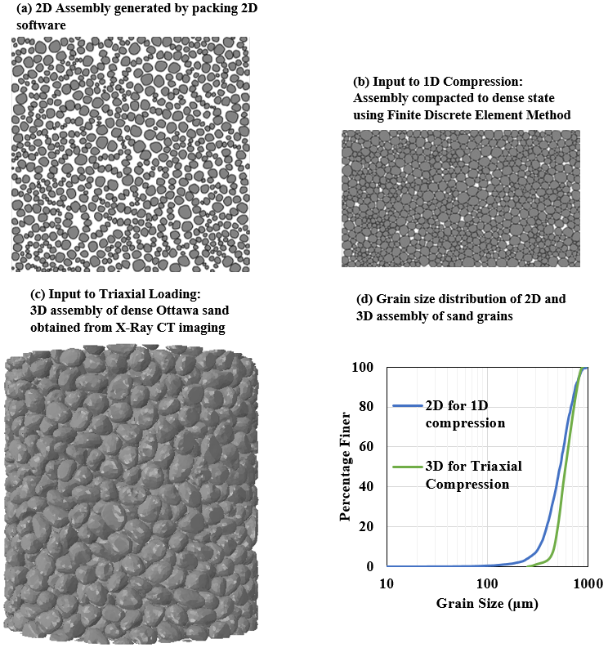

Fig6. 2: 2D and 3D assemblies of Ottawa sand for 1D compression and triaxial loading respectively along with the grain size distribution curves

for 3D problems. For 2D problems, ‘t_{t}’ and ‘ε_{t}’ are ignored and the constitutive matrix is adjusted accordingly. The response between the shear and normal components is uncoupled as shown in Eq. 6.1, however, Abaqus allows the coupled response by considering non-diagonal terms as non-zero.

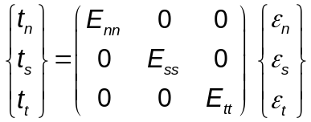 6.1

The damage of the cohesive interface elements consists of two components: damage initiation and damage evolution. The damage initiation component includes a criterion that specifies the start of the degradation of the material. Several damage initiation criteria are available in Abaqus Explicit. In the present work, the maximum nominal stress criterion is adopted to initiate damage in a cohesive interface element. The maximum nominal stress criterion states that the damage initiates in a material when the maximum nominal stress ratio reaches 1, as expressed in Eq. 6.2. The Macaulay brackets indicate that compressive stresses do not initiate damage. ‘t_{n}º’, ‘t_{s}º’ and ‘t_{t}º’ indicate the peak values of the normal stress when the deformation of the interface is purely normal or shear in the first or second direction, respectively.

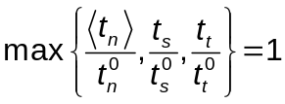 6.2

Once the damage initiation criterion is met, the damage evolution law dictates the rate at which the material degradation occurs. A scalar variable ‘D’ quantifies the damage in cohesive layers. The value of the damage variable ‘D’ is initially 0 and evolves monotonically from 0 to1 after the damage initiation criterion is reached. The components of the stress in CIE’S change according to Eqs. 6.3-6.5. The components of the stress with a bar ‘ˉ’ are computed based on the traction separation law without any damage. The compressive stresses do not result in any damage.

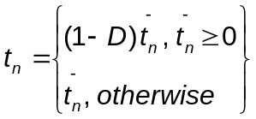 6.3

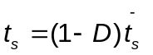 6.4

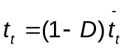 6.5

The displacement-based or energy-based damage evolution law can be adapted to simulate the failure of CIE’S. In the present work, energy-based damage evolution law is adopted which works on the principle of energy dissipated due to the failure. Furthermore, the nature of the damage evolution law needs to be specified, for instance, if the damage variable follows a linear or exponential softening. A linear softening law is adopted here for simplicity as shown in Fig6. 3. It has been observed that the nature of softening law has less effect on results compared to the other parameters (Alfano 2006), therefore, linear softening law is expected to provide results with reasonable accuracy. The energy dissipated due to the fracture is known as fracture energy and is equal to the area under the traction separation curve for single-mode damage. The fracture energy is considered a material property and is specified as an input to the simulations. The relative contributions of the different modes of fracture can be considered by adopting the Benzeggagh-Kenane criterion (Ma et al. 2014b). However, for simplicity, model-independent damage evolution was adopted in which a single parameter determines the fracture energy. The damage variable ‘D’ for linear softening can be expressed according to Eqs. 6.6 and 6.7. ‘δ_{m}^{max}’ represents maximum effective displacement attained during loading history, ‘δ_{m}^{f}’ and ‘δ_{m}º’ represent the effective displacement at failure and initiation of damage, respectively, ‘Tº_{eff}’ represents the effective traction at the damage, ‘G^{c}’ represents the fracture energy. The cohesive elements are removed from the simulation when the value of the damage variable ‘D’ reaches 1. This allows modeling of complete fracture of the single grains of sand. The crack propagation can be arbitrary with only constraint imposed by mesh topology.

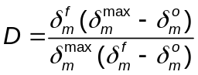 6.6

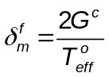 6.7

Boundary conditions and parameters for modeling 1D compression and triaxial loading

1-D compression simulations are carried out by applying the vertical displacement to the top and the bottom rigid platens while restraining the other degrees of freedom of the platens. The lateral platens are fixed in all directions to replicate 1D compression loading. The 1-D compression simulations are carried out for 0.001

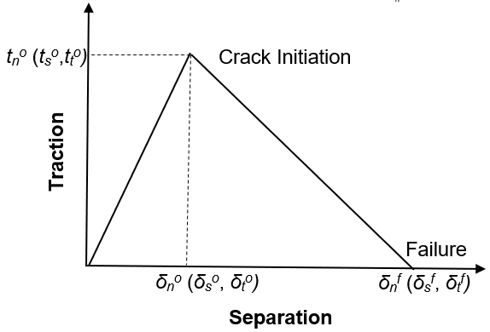
Fig6. 3: Traction separation law for cohesive interface elements

seconds to minimize the inertial effects and optimize the computational requirements.
The triaxial simulations are carried out in two steps: (a) Isotropic consolidation, (b) Shearing. The isotropic consolidation requires applying the same confining pressure all around the sample. This requires including a latex membrane in the simulations to provide a flexible lateral boundary to apply confining pressure,
similar to the procedure followed in triaxial experiments. At the end of the isotropic consolidation, vertical displacement is applied on the platens to apply shear loading. The isotropic consolidation and shearing were carried out in 0.001 seconds and 0.003 seconds, respectively to minimize the inertial effects and optimize the computational requirements.
The input parameters for the numerical simulation of 1D compression and triaxial compression are summarized in Table 6.1. Some of the material parameters such as modulus of elasticity, Poisson's ratio, and strength are obtained from the single grain experimental tests by Sharma et al. 2020. The rest of the material parameters are chosen arbitrarily to reproduce the force-displacement response qualitatively. The end goal of the present work is not to demonstrate the capability of FDEM in matching mechanical response corresponding 1D compression and triaxial loading. The focus rather is on to numerically investigate the evolution of capillary suction on deformed microstructure corresponding to 1-D compression and triaxial loading.

Pore Morphology Method

Pore Morphology Method (PMM) works on the principle of the Young Laplace Equation and mathematical morphology. The pore space accessible to the non-wetting phase (air phase) is given by Young Laplace Equation (Eq. 6.8). ‘σ’, ‘α’, ‘P_{c}’ refers to the surface tension, contact angle, and the capillary pressure, respectively. ‘r’ represents the minimum radius of the accessible pores. Eq. 6.8 is a geometrical problem for given surface tension and contact angle, therefore, reduces the computational requirements significantly.

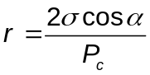 6.8

In the present work, the SatuDict module of the commercial software GeoDict, distributed by math2market (GeoDict Startpage (math2market.com) is utilized to carry out the capillary suction predictions on the digital microstructure of Ottawa sand. Mohsin Thakur et al. (2020) demonstrated the robustness of the approach by comparing the predictions with the experiments. The capillary suction predictions are carried out corresponding to the imbibition path, i.e., when the water phase replaces the air phase in the pore space. There are several options to model imbibition in GeoDict including the waterflooding and capillary condensation of water on the surface of grains. To adequately resolve connectivity of the pore space of crushed grains, specifically at grain contacts, may require sub-micron resolution which requires large computing resources. The capillary condensation approach does not require information on the connectivity of the pore space and is, therefore, used in the present work to predict the capillary suction.
The minimum radius (r_{min}) and maximum radius (r_{max}) are chosen initially for imbibition predictions. Starting with the radius r=r_{min} , spheres are used to probe the pore space and the corresponding capillary suction is determined from Eq. 6.8. The procedure is repeated for different values of radius until r= r_{max}.

Pedotransfer Function from Grain Size distribution

The discrete data points of the soil water retention curve can be fitted to a function to obtain a relationship between the capillary suction and degree of saturation. The widely used model to fit soil water retention data was proposed by van Genuchten 1980 as expressed in Eq. 6.9, where ‘ψ’ is the capillary suction equal to P_{c}, ‘S_{e}’ is the effective degree of saturation, ‘α’ and ‘n’ are the parameters related to the air entry value and slope of the SWRC.

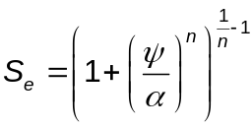 6.9

A pedotransfer function relates the soil water retention curve to basic soil properties such as grain size distribution. Wang et al. 2017 proposed two pedotransfer functions to relate the parameters ‘α’ and ‘n’ of the van Genuchten’s SWRC model to the grain size distribution parameters, according to Eqs. 6.10 & 6.11, respectively. ‘C₁’ and ‘C₂’ are the fitting parameters that will be obtained in the present work from numerical predictions. ‘C_{u}’ is the coefficient of uniformity that can be obtained from the grain size distribution curve as d₆₀/d₁₀. ‘d₆₀’ and ‘d₁₀’ represent the size corresponding to 60 % and 10% material passing, respectively.

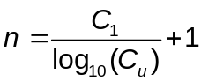 6.10

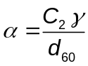 6.11

Table6. 1: Input Material Properties for FDEM simulations

1D Compression | Value
Bulk Elements
Modulus of Elasticity (E) | 100 GPa
Poisson’s ratio (ν) | 0.15
Mass Density (ρ) | 2.65 kg/m³
Cohesive Interface Elements
Tensile Strength (t_{n}º) | 100 MPa
Shear Strength (t_{s}º, t_{t}º) | 400 MPa
Critical Fracture Energy (G^{c}) | 2 N/mm
Ratio of Elastic Moduli of bulk and Cohesive Elements (E/E_{nn}) | 20000
Ratio of Shear Moduli of bulk and Cohesive Elements (G/G_{ss}, G/G_{tt}) | 8000
Friction Coefficient (μ) | 0.2
Triaxial Compression

Bulk Elements
Modulus of Elasticity (E) | 100 GPa
Poisson’s ratio (ν) | 0.15
Mass Density (ρ) | 2.65 kg/m³
Friction Coefficient (μ) | 0.2
Latex Membrane

Modulus of Elasticity (E) | 2 MPa
Poisson’s ratio (ν) | 0.48

Results

Mechanical response of 2D assembly to 1D compression loading

The force-displacement response of an assembly of sand grains subjected to 1D compression loading is shown in Fig6. 4. The response matches qualitatively well with the results published in the literature (Omidvar et al. 2012). Three zones can be identified in Fig6. 4 based on the change in the stiffness. Zone 1 characterizes the initial response, dictated primarily by the elastic response of the assembly of grains. In Zone 2, yielding and a decrease in stiffness are observed. The stresses in zone 2 are high enough to overcome the frictional resistance resulting in the rearrangement of the grains and the pore space. There is also evidence of fracturing of grains in zone 2. In zone 3, an increase in the stiffness is observed due to the coupled effect of the grain rearrangements and grain fracturing resulting in the denser configuration which produces a locked-up response. The boundary of the three zones is demarcated by points A, B, C, and D. The microstructure at these four points will be investigated further to predict the SWRC.
Fig6. 5 shows the assembly of the sand grains before and after 1D compression loading. It can be observed that the sand grains experience significant crushing in the 1D compression stress path. The enlarged view in Fig6. 5(c) shows different modes of crushing including diametrical splitting and chipping of the grains. The crushing event leads to the formation of progenies which can vary in number depending upon the mode of the crushing. The crushed sand is expected to alter the pore size distribution which has direct implications in the evolution of the capillary suction. The comminution of sand grains occurs along the path of the impacting projectile, therefore, microstructure predicted from mesoscale simulations corresponding 1D compression loading in sands can provide useful insights into the capillary pressures generated during penetration event.

Evolution of Capillary Suction during 1D compression loading

The Soil Water Retention Curves (SWRC’s) are obtained from the Pore Morphology Method (PMM) for the points A, B, C, D which represent the boundaries of different zones exhibited by force-displacement curve corresponding to 1D compression loading as shown in Fig6. 4. SWRC’s for coarse-grained soils such as sands are plotted as the variation in the degree of saturation with the change in capillary suction. The SWRC’s for points A, B, C, and D are shown in Fig6. 6. It can be observed that the capillary suction increases as the sand sample is subjected to 1D compression loading. The air entry value increases significantly from point A to point D. Furthermore, the slope of the SWRC’s in the partially saturated condition decreases during the 1D compression loading which is an indication of the increased moisture retention capacity of the granular material. The grain crushing and rearrangement alters the pore microstructure

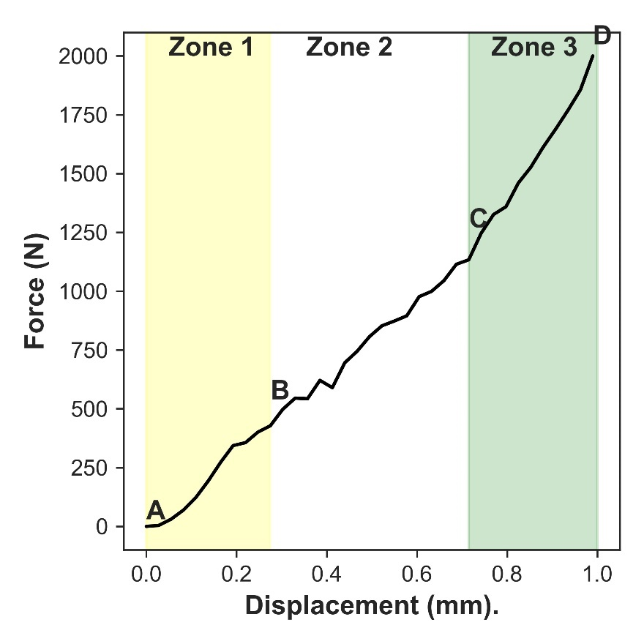
Fig6. 4: Force-displacement response of 2D assembly of sand grains subjected to 1D compression loading

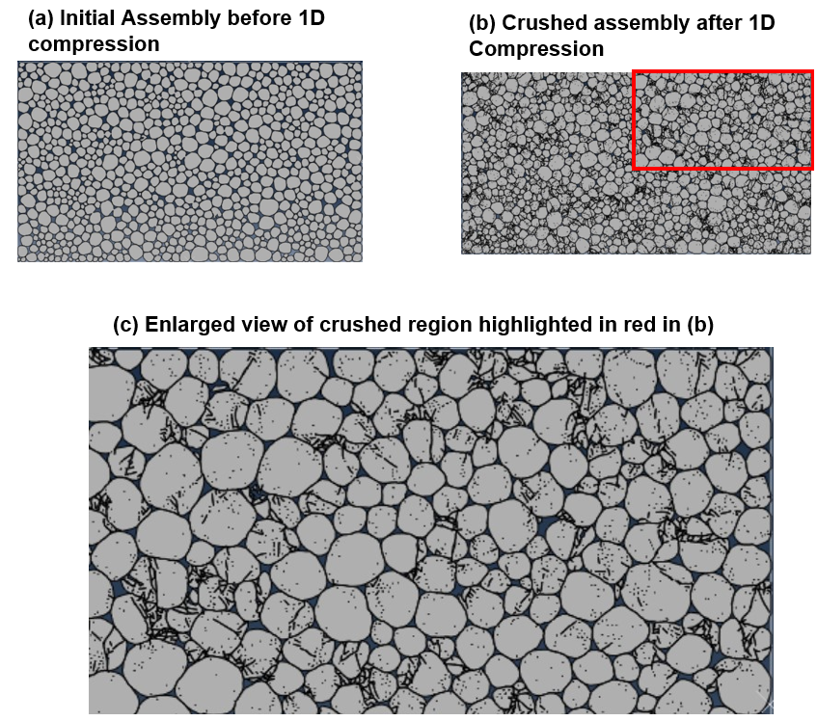
Fig6. 5: Assembly of the sand grains before and after 1D compression loading

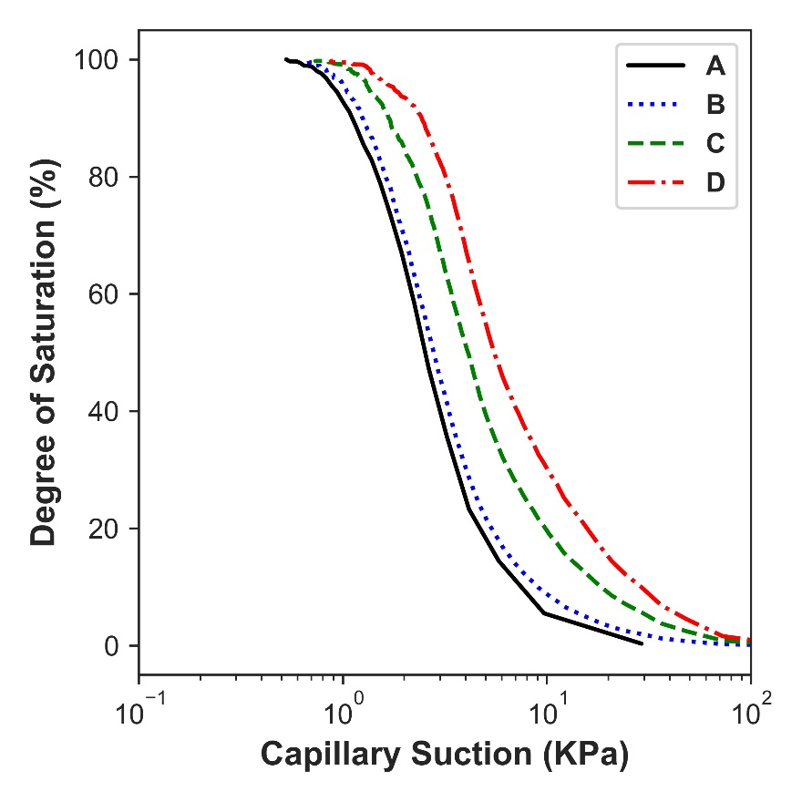
Fig6. 6: Evolution of Soil Water Retention Curve during 1-D compression loading (Points are labelled in Fig6. 4)

which increases capillary suction. The grain crushing can be indirectly quantified at a specific loading stage by obtaining the grain size distribution (GSD) from the crushed assembly. The probing of the granular microstructure to determine the GSD and other parameters is a significant advantage of the numerical simulations over the experiments. Fig6. 7 shows the evolution of the GSD as the specimen undergoes 1D compression. It can be observed that significant grain crushing occurs during 1D compression. Table6. 2 summarizes the SWRC parameters of van Genuchten (1980) and GSD parameters. It can be observed that the parameter, ‘α’, which is related to the air entry value increases during the 1D -compression loading. The parameter, ‘n’, which is related to the slope of the SWRC decreases as specimens deform and fracture under 1D compression loading. Furthermore, GSD parameters such as ‘C_{u}’ and ‘C_{c}’ suggest that the assembly of sand tends to transition from a poorly graded sand to well-graded sand during 1D compression due to the crushing of the grains.

Interpretation of Capillary Suction at the Projectile tip from the Grain Size Distribution

The comminution of sand grains occurs at the tip of the impacting projectile. Glößner et al. (2017) performed projectile penetration experiments on a Euroquartz siligran sand which has a chemical composition and relative density similar to the Ottawa sand. Fig6. 8 shows the grain size distribution of the Euroquartz siligran sand obtained from the tip of the projectile after being impacted by a projectile at an initial velocity of 380 m/s. The experiments are described in detail in Glößner et al. (2017). The idea here is to utilize the grain size distribution at the tip of the projectile to estimate the soil water retention curve. This can be achieved by using two pedotransfer functions, expressed in Eqs. 6.10 & 6.11, to estimate the parameters of the van Genuchten (1980) SWRC model presented in Eq. 6.9. The sand grains near the tip experience significant crushing, therefore, the tip material should lie in the Zone 3 of force-displacement response. Therefore, it is appropriate to calibrate parameters ‘C₁’ and ‘C₂’ of the pedotransfer functions based on the SWRC and GSD predictions corresponding to material states in Zone 3. The parameter ‘C₁’ is obtained based on values of ‘n’ and ‘C_{u}’ obtained from 1D compression predictions in Zone 3, according to Eq. 6.10, for point ‘D’ in Zone 3. Likewise, the parameter ‘C₂’ is obtained according to Eq. 6.11, for point ‘D’ in Zone 3. The value of parameter ‘C₁’ and ‘C₂’ was obtained equal to 0.54 and 23.90, respectively. The values of the SWRC parameters ‘n’ and ‘α’ were then obtained for the material near the tip of the projectile based on the pedotransfer functions, expressed in Eqs. 6.10 and 6.11. Table 6.3 summarizes parameters of GSD, pedotransfer functions, and SWRC for the material near the tip of the projectile. SWRC can be obtained based on the values of ‘n’ and ‘α’ according to van Genuchten 1980 as expressed in Eq. 6.9. Fig6. 9 shows the SWRC plot of the material near the tip of the projectile in addition to the SWRC of the material without

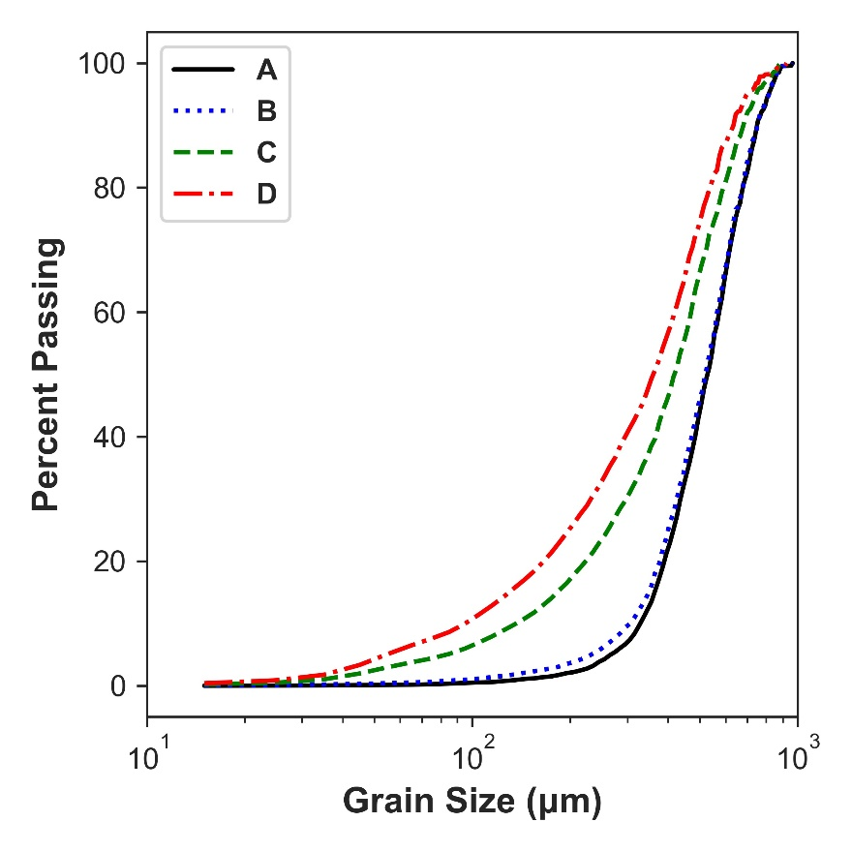
Fig6. 7: Evolution of Grain Size Distribution during 1-D compression loading (Points are labelled in Fig6.4)

Table6. 2: Summary of SWRC parameters of van Genuchten (1980) and GSD parameters during 1-D compression loading

Point | α (kPa) | n | d₆₀ (mm) | C_{u} | C_{c}
A | 2.06 | 2.94 | 0.58 | 1.75 | 1.02
B | 2.26 | 2.89 | 0.57 | 1.85 | 1.05
C | 3.19 | 2.59 | 0.47 | 3.44 | 1.37
D | 4.10 | 2.41 | 0.42 | 4.38 | 1.33

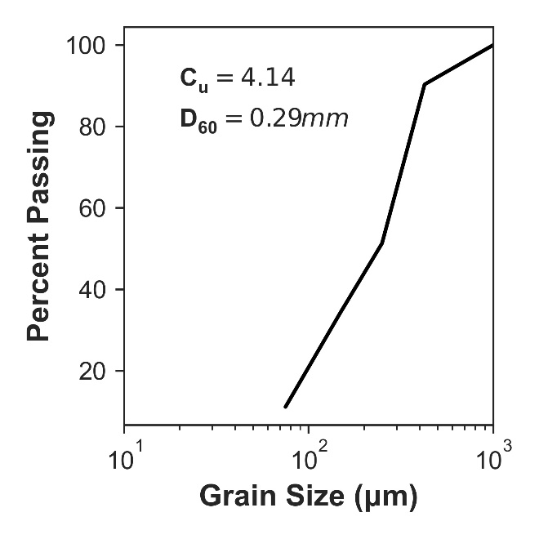
Fig6. 8: Grain Size Distribution of the Euroquartz siligran sand obtained from the tip of the projectile

Table6. 3: Parameters of Grain Size Distribution, Pedotransfer functions, and Soil Water Retention Curves for the material near the tip of the projectile
C_{u} | D₆₀ (mm) | C₁ | C₂ | n | α  (kPa)
4.14 | 0.29 | 0.54 | 23.90 | 1.88 | 5.93

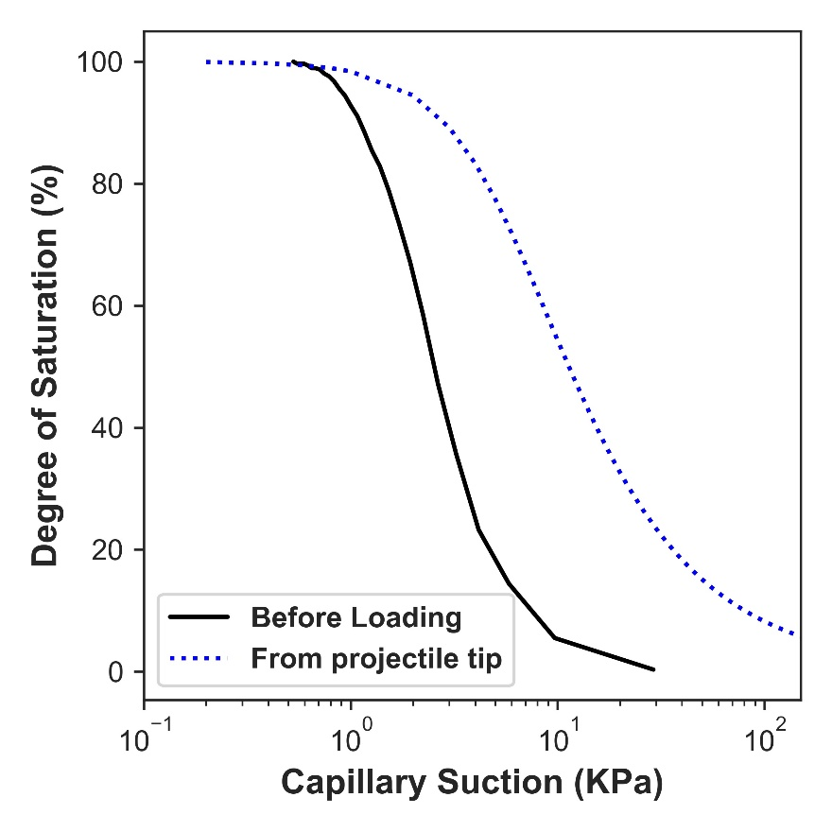
Fig6. 9: Soil Water Retention Curve of the material near the tip of the projectile compared to the material without being subjected to any load.

being subjected to any load. It can be observed that the capillary suction increases significantly near the projectile. The high capillary suction provides additional strength which provides stability to the cavity formed by a projectile as shown in
Fig6. 1. The air entry value for material near the tip is 3kPa. The capillary suction at 50 % and 10 % degree of saturation is 11 kPa and 80 kPa, respectively. The results suggest the importance of incorporating capillary suction component in mechanical response for the projectile penetration studies in partially saturated granular materials.

Mechanical response of 3D assembly to triaxial loading

The 3D assembly of the sand grains is initially subjected to an isotropic confining pressure of 140 kPa. At the end of the consolidation, the specimen is subjected to shearing in the vertical direction. Fig6. 10 shows the force versus displacement response of the 3D assembly of the sand grains subjected to triaxial shearing. The force-displacement response captures important features such as yielding, peak, and post-peak softening. The response is obtained in Fig6. 10 is typical for dense sands. Three different points are identified in Fig6. 10 to predict the capillary suction evolution during triaxial loading. ‘After Consolidation’ point represents the sample after isotropic consolidation and before shear loading, ‘Peak’ point represents the sample at peak force or peak stress sate, ‘Post-Peak’ point represents the sample at the end of the shear loading where strength has reduced compared to the peak condition. An additional state of the sample, ‘Before Consolidation’ is considered for predicting SWRC.
Fig6. 11 shows the evolution of SWRC’s during triaxial loading of dry Ottawa sand at low confining pressure (140 kPa). It can be observed that the capillary suction does not change significantly during the triaxial loading as compared to the 1D compression loading. This can be primarily attributed to the absence of grain crushing, and the ability of the specimen to dilate in a dense state at low confining pressure during the triaxial loading. It can be observed that the capillary suction increases as the specimen undergoes isotropic consolidation, i.e., ‘Before Consolidation’ to ‘After Consolidation’ in Fig6. 11. The capillary suction at the peak stress state decreases compared to the capillary suction of a sample after isotropic consolidation but is still higher than the capillary suction of the sample corresponding to the ‘Before Consolidation’ state. The capillary suction corresponding to the ‘Post Peak’ condition is minimum compared to all other points considered in Fig6. 11. The summary of SWRC parameters of van Genuchten (1980) as expressed in Eq. 6.9, for different loading stages during the triaxial loading is provides in Table6. 3.
The far-field of the impacting projectile experiences a triaxial state of stress at low confining pressure. The capillary suction is low and does not evolve significantly during triaxial loading. Therefore, from the perspective of modeling projectile

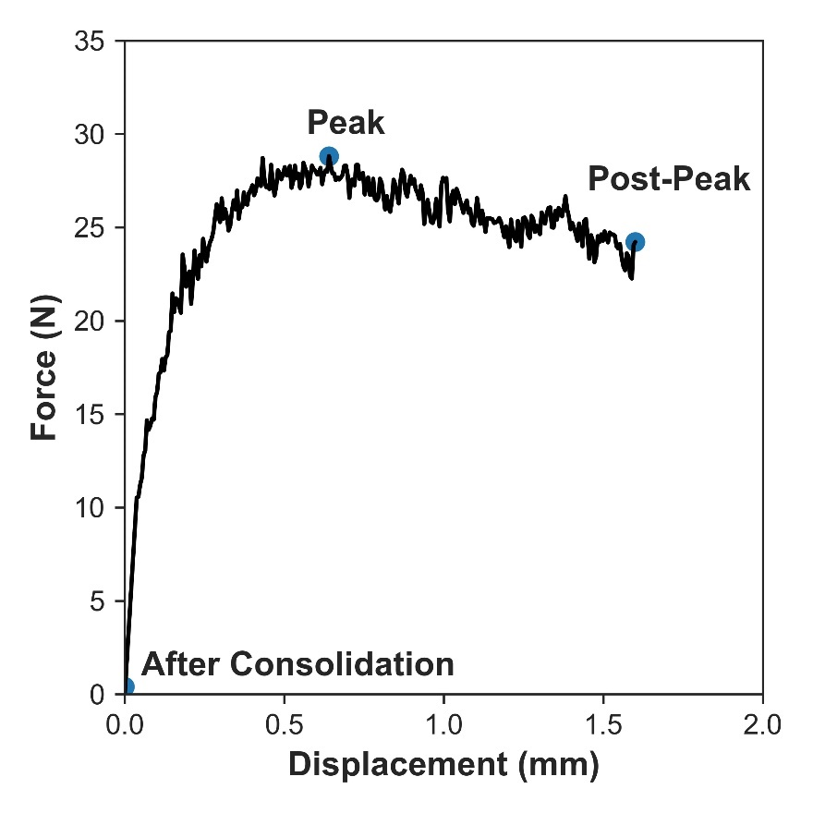
Fig6. 10: Force versus displacement response of the 3D assembly of the sand grains subjected to triaxial shearing

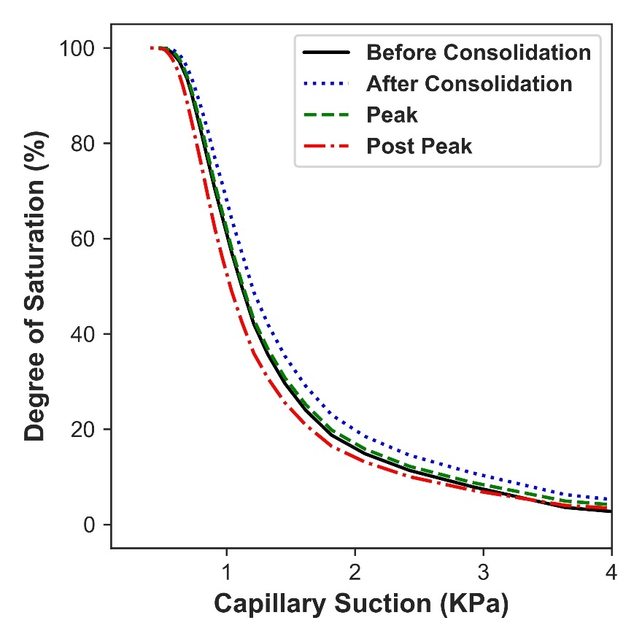
Fig6. 11: Evolution of Soil Water Retention Curve during triaxial loading at low confining pressure

Table6. 3: Soil Water Retention Curve parameters of van Genuchten (1980) for different loading stages during the triaxial loading of Ottawa sand

Point | α (kPa) | n
Before Consolidation | 1.06 | 4.43
After Consolidation | 1.14 | 4.23
Peak | 1.08 | 4.38
Post-Peak | 0.99 | 4.45

penetration in sands, it should be adequate to model partially saturated sand as dry material in the far-field. However, in the near field, the effect of the partial saturation should be considered in the numerical modeling as the sand experiences significant comminution due to the 1D compression stress path which results in high capillary suction.

Conclusions

The influence of partial saturation in the projectile penetration of granular materials is relatively unknown. A projectile penetration experiment performed by Kim et al. (2016) showed the existence of a cavity around the projectile in partially saturated sand. The present work attempted to predict the capillary suction by performing mesoscale simulations on dry granular materials with subsequent extraction of the deformed and crushed granular microstructure at different loading stages for capillary suction predictions. The following conclusions have been made to facilitate the understanding of projectile penetration in sands.
- The near-field region of the sand subjected to a projectile loading experiences a 1D compression stress path. The mesoscale simulation of 1D compression in dry sand using Finite Discrete Element Method (FDEM) was successfully demonstrated qualitatively including the crushing of the grains and different zones in the force-displacement response.
- The Soil Water Retention Curve (SWRC) was predicted directly from the pore and grain microstructure based on the Pore Morphology Method (PMM). SWRC’s evolves significantly as the specimen deforms in 1D compression loading. The capillary suction increases during 1D compression loading due to the crushing of the grains as indicated by the SWRC and the Grain Size Distribution (GSD) curves at different loading stages. It is, therefore, important to incorporate the crushing of the grains near the tip of the projectile in numerical simulation of the projectile penetration boundary value problem.
- The GSD from the projectile penetration experiment was utilized to estimate the capillary suction based on the two pedotransfer functions. It was observed that capillary suction increases significantly near the tip of the projectile. The air entry value for material near the tip was 3kPa. The capillary suction at 50 % and 10 % degree of saturation was 11 kPa and 80 kPa, respectively.
- The far-field region of sand subjected to a projectile loading experiences triaxial loading at low confinement. The mesoscale simulation of triaxial loading in dry sand was successfully simulated using FDEM. Important features including yielding, peak stress, and post-peak softening were captured in simulations.
- SWRC’s did not change significantly as the specimen deformed under triaxial loading. The capillary suction increased to some extent after undergoing isotropic consolidation. However, capillary suction decreased correspondingly to peak and post-peak stress state.
- An important recommendation for numerically simulating projectile penetration boundary value problem in partially saturated granular materials is to consider hydromechanical coupling near the tip region. In the far-field region, capillary suctions are negligible as observed in triaxial loading predictions, therefore, partially saturated sand can be modeled as dry material in the far-field region for simplicity and computational efficiency.

CONCLUSIONS AND FUTURE WORK

Summary of Major Conclusions

Projectile penetration in granular materials is a multiscale and multiphysics phenomenon that requires high-quality experiments and advanced numerical modeling techniques for improved understanding. In this dissertation, the focus has been on modeling granular materials near the tip region and intermediate field of the impacting projectile. X-Ray CT imaging has been utilized extensively in this work. The near tip region has been modeled corresponding to 1D compression loading with the incorporation of grain crushing in the constitutive model. The intermediate field has been modeled corresponding to the triaxial loading condition with an accurate representation of the boundary conditions including the confining latex membrane. Furthermore, the role of partial saturation is quantified based on the Soil Water Retention Curves (SWRC’S) from experiments and numerical predictions. The Topological Data Analysis technique known as persistence homology is used to quantify the 3D pore space and spatial distribution of fluid in partially saturated sand. Furthermore, the evolution of capillary suction is predicted as the granular material deforms and crushes.
The major conclusions are summarized below to facilitate the understanding of the mechanics of single and multiphase granular materials:

- A novel framework is introduced in which particle shape is captured using corotational velocity formulation-based shell elements in the Finite Discrete Element Method (FDEM). The proposed framework is validated with experiments and provides a unique opportunity in exploring micromechanics of granular materials numerically at low/intermediate confining pressures using actual grain morphology and complement laboratory-based in-situ X-ray experimental studies. The computation time for shell elements decreased by a factor of 3 to 5 depending upon the loading conditions in comparison to solid tetrahedral elements for the same meshing ratios.
- The frictional and frictionless boundary in triaxial simulations affects the macroscale and microscale response. The frictional boundary resulted in a noticeable peak and increase in peak strength compared to the frictionless boundary. Higher localization is observed in frictional boundary triaxial simulations. A noticeable cone shape wedge of negligible displacement and X-shaped shear band is observed in frictional boundary triaxial simulations.
- The fabric tensor is obtained for overall, strong normal, and weak normal contact forces from the 3D numerical microstructure of Ottawa sand. Fabric anisotropy increases with the increase in axial strain up to peak stress and remains constant afterward with minor fluctuations. Strong forces and weak forces exhibit the highest and lowest fabric anisotropy, respectively.
- The peak friction angle and dilation increase with the increase in interparticle friction coefficient (μ) up to a certain limit, and then the response saturates with a further increase in μ. The grain-scale analysis suggests that the evolution of the mean coordination number and fabric anisotropy with the axial strain is similar for the values of μ producing similar strength and volume change response. Furthermore, the peak state axial strain does not depend on the value of μ for the same boundary conditions and initial microstructure.
- The angular sand exhibited low dilation compared to the rounded sand. This contrasts with the findings in the literature. Upon further investigation, we discovered that the smaller size fraction grains present in angular sand rotated more and exhibited a low coordination number. This finding is crucial since both soils were classified as poorly grained sands based on their gradation, yet the subtle differences in sizes produced different microscale features. Poorly graded sand classification (SP) cannot predict the relative behavior of soils, and there is a need to introduce additional sub-classifiers in classifying poorly graded sands.
- The influence of particle shape is less pronounced for smooth granular assemblies. The ratio of peak deviatoric stress for angular Q-Rok and rounded Ottawa sand was 1.05 and 1.20, corresponding to μ equal to 0.2 and 0.5, respectively.
- The comparison of SWRC measurements including the effect of hysteresis from experiments and numerical predictions using the pore morphology method for rounded Ottawa sand and angular Q-Rok is successfully demonstrated and the agreements with predictive simulations are promising. The experimental research in partially saturated soils is inhibited by the long duration of experiments, the equilibration time can vary from days in coarse-grained soils to months in fine-grained soils such as silts and clays. Therefore, in the present work HAEV ceramic disc, conventionally used in the axis translation technique, was replaced by a microporous membrane to accelerate equilibration.
- The higher capillary suction was obtained for angular Q-Rok in comparison to the rounded Ottawa sand, even though, the global void ratio in Q-Rok is larger than the Ottawa sand corresponding to the dense configuration. Highly angular Q-Rok contains smaller dimension pore throats in comparison to the rounded Ottawa Sand. This highlights the importance of grain morphology in the hydromechanical behavior of partially saturated soils,
- The spatial variation in porosity and degree of saturation obtained from X-ray tomography and numerical predictions raises questions on formulations based on continuum approach and necessitates the implementation of multiscale physics in hydromechanical behavior of partially saturated sands.
- Persistent homology provides a robust methodology in characterizing pore space and air phase distribution directly from CT images with the variation in the degree of saturation. Important features including connected and disconnected pores, pore and throat size distribution, and redundant pathways in single and multiphase granular materials can be obtained quantitatively.
- Angular Q-Rok consists of a large number of smaller dimension pore throats forming redundant loops compared to the rounded Ottawa sand. Such quantifications are useful in the prediction of transport properties of multiphase granular materials as the presence of bubbles of one fluid phase may block the flow path of another fluid phase, however, the presence of another alternate flow path (loop) may allow the transfer of fluid phase.
- The GSD from the projectile penetration experiment was utilized to estimate the capillary suction based on the two pedotransfer functions calibrated using numerical simulations. It was observed that capillary suction increases significantly near the tip of the projectile. The air entry value for material near the tip was 3kPa. The capillary suction at 50 % and 10 % degree of saturation was 11 kPa and 80 kPa, respectively.
- The capillary suction increases during 1D compression loading due to the crushing of the grains whereas capillary suction did not change significantly as the specimen deformed under triaxial loading. An important recommendation for numerically simulating projectile penetration boundary value problem in partially saturated granular materials is to consider hydromechanical coupling near the tip region. In the far-field region, capillary suctions are negligible as observed in triaxial loading predictions, therefore, partially saturated sand can be modeled as dry material in the far-field region for simplicity and computational efficiency.

Future Work

The following recommendations are made for future work based on the findings of this dissertation:

- A multiscale and multiphysics modeling approach adopted in this work to model 1D compression and triaxial compression should be combined to numerically solve the projectile penetration boundary value problem in granular materials
- A controlled experimental data of projectile penetration in partially saturated sands at different moisture contents is missing in the literature. Such an experimental investigation can provide useful insights and reliable data for validation of the numerical predictions
- Soil Water Retention Curve experiments performed in this dissertation should be extended to the granular material along the path and the tip of the projectile.
- The persistent homology analysis on the pore space and fluid phase should be related to the functional properties of the porous media. One such promising avenue but not limited to is to combine persistent homology and machine learning to provide accurate predictions of different physical properties in granular materials.
- The spatial distribution of the wetting and non-wetting phase along with the grain microstructure from Pore Morphology predictions should be used as an input in mesoscale simulations using numerical schemes like Finite Element Method (FEM) and Finite Volume Method (FVM). A hybrid numerical approach should be adopted, FEM for solid phase and FVM for fluid phase. to solve the coupled mesoscale hydromechanical boundary value problem

Statement of Significance

The work presented in this dissertation is aimed at developing modeling strategies to explore the phenomena of projectile penetration in dry and multiphase granular materials. The focus of the work has been on capturing the discrete nature of the granular materials in simulations as the evidence suggests that the projectile penetration problem is complicated for a continuum-based approach with a reasonable number of material parameters.
The modeling strategies developed in this work can be useful in solving the projectile penetration boundary value problem. The mesoscale modeling can provide useful insights to unravel the underlying physics in penetration resistance of geomaterials. The implications of the present work, however, are not limited to projectile penetration phenomena. For instance, the mesoscale modeling approach developed in this work to simulate triaxial compression experiments can be useful in exploring geotechnical engineering problems such as in soil-structure interaction and the development of advanced constitutive models. Similarly, the role of partial saturation explored via X-Ray CT imaging, experiments, and numerical modeling has applications in ground water infiltration, CO₂ sequestration, and enhanced oil recovery.
I hope the work presented in this thesis provides a foundation to increment the research in solving coupled hydromechanical problems in the projectile penetration of sands. There is still a lot that needs to be done to address this extremely complicated problem governed by multiphysics spanning multiple lengths and time scales.

List of References
Abaqus, F. E. A. (2017). “Abaqus inc.” Providence, Rhode Island, United States.
Aduloju, S. C., and Truster, T. J. (2019). “On topology-based cohesive interface element insertion along periodic boundary surfaces.” Engineering Fracture Mechanics, Elsevier, 205(October 2018), 10–13.
Alfano, G. (2006). “On the influence of the shape of the interface law on the application of cohesive-zone models.” Composites Science and Technology, Elsevier, 66(6), 723–730.
Allen, W. A., Mayfield, E. B., and Morrison, H. L. (1957). “Dynamics of a Projectile Penetrating Sand.” Journal of Applied Physics, 28(3), 370–376.
Alshibli, K. A., and Alsaleh, M. I. (2004). “Characterizing Surface Roughness and Shape of Sands Using Digital Microscopy.” Journal of Computing in Civil Engineering, 18(1), 36–45.
Alshibli, K. A., Batiste, S. N., and Sture, S. (2003). “Strain localization in sand: Plane strain versus triaxial compression.” Journal of Geotechnical and Geoenvironmental Engineering, 129(6), 483–494.
Alshibli, K. A., and Cil, M. B. (2018). “Influence of particle morphology on the friction and dilatancy of sand.” Journal of Geotechnical and Geoenvironmental Engineering, 144(3), 1–12.
Alshibli, K. A., Jarrar, M. F., Druckrey, A. M., and Al-Raoush, R. I. (2017a). “Influence of Particle Morphology on 3D Kinematic Behavior and Strain Localization of Sheared Sand.” Journal of Geotechnical and Geoenvironmental Engineering, 143(2), 04016097.
Alshibli, K. A., Jarrar, M. F., Druckrey, A. M., and Al-Raoush, R. I. (2017b). “Influence of particle morphology on 3D kinematic behavior and strain localization of sheared sand.” Journal of Geotechnical and Geoenvironmental Engineering, 143(2).
Ambroso, M. A., Santore, C. R., Abate, A. R., and Durian, D. J. (2005). “Penetration depth for shallow impact cratering.” Physical Review E - Statistical, Nonlinear, and Soft Matter Physics, 71(5), 1–7.
Amirrahmat, S., Alshibli, K. A., Jarrar, M. F., Zhang, B., and Regueiro, R. A. (2018a). “Equivalent continuum strain calculations based on 3D particle kinematic measurements of sand.” International Journal for Numerical and Analytical Methods in Geomechanics, 42(8), 999–1015.
Amirrahmat, S., Druckrey, A. M., Alshibli, K. A., and Al-Raoush, R. I. (2018b). “Micro Shear Bands: Precursor for Strain Localization in Sheared Granular Materials.” Journal of Geotechnical and Geoenvironmental Engineering, 145(2), 04018104.
Andò, E., Hall, S. A., Viggiani, G., Desrues, J., and Bésuelle, P. (2012). “Grain-scale experimental investigation of localised deformation in sand: A discrete particle tracking approach.” Acta Geotechnica, 7(1), 1–13.
Andrade, J. E., Lim, K. W., Avila, C. F., and Vlahinić, I. (2012). “Granular element method for computational particle mechanics.” Computer Methods in Applied Mechanics and Engineering, 241–244, 262–274.
Andrew, M., Bijeljic, B., and Blunt, M. J. (2014). “Advances in Water Resources Pore-scale contact angle measurements at reservoir conditions using X-ray microtomography.” Advances in Water Resources, Elsevier Ltd, 68, 24–31.
Andrew, M., Menke, H., Blunt, M. J., and Bijeljic, B. (2015). “The Imaging of Dynamic Multiphase Fluid Flow Using Synchrotron-Based X-ray Microtomography at Reservoir Conditions.” Transport in Porous Media, Springer Netherlands, 110(1), 1–24.
Armstrong, R. T., McClure, J. E., Berrill, M. A., Rücker, M., Schlüter, S., and Berg, S. (2016). “Beyond Darcy’s law: The role of phase topology and ganglion dynamics for two-fluid flow.” Physical Review E, 94(4), 1–10.
Armstrong, R. T., McClure, J. E., Robins, V., Liu, Z., Arns, C. H., Schlüter, S., and Berg, S. (2019). “Porous Media Characterization Using Minkowski Functionals: Theories, Applications and Future Directions.” Transport in Porous Media, Springer Netherlands, 130(1), 305–335.
ASTM International. (2020). “D7181-20 Standard Test Method for Consolidated Drained Triaxial Compression Test for Soils.” ASTM International, West Conshohocken, PA.
Barber, C. B., Dobkin, D. P., and Huhdanpaa, H. (1996). “The Quickhull Algorithm for Convex Hulls.” ACM Transactions on Mathematical Software, 22(4), 469–483.
Barr, A. D., Clarke, S. D., Petkovski, M., Tyas, A., Rigby, S. E., Warren, J., and Kerr, S. (2016). “Effects of strain rate and moisture content on the behaviour of sand under one-dimensional compression.” Experimental Mechanics, Experimental Mechanics, 56(9), 1625–1639.
Barr, A. D., Clarke, S. D., Tyas, A., and Warren, J. A. (2018). “Effect of Moisture Content on High Strain Rate Compressibility and Particle Breakage in Loose Sand.” Experimental Mechanics, Experimental Mechanics, 58(8), 1331–1334.
Barreto, D., and O’Sullivan, C. (2012). “The influence of inter-particle friction and the intermediate stress ratio on soil response under generalised stress conditions.” Granular Matter, 14(4), 505–521.
Belytschko, T., Lin, J. I., and Chen-Shyh, T. (1984). “Explicit algorithms for the nonlinear dynamics of shells.” Computer Methods in Applied Mechanics and Engineering, 43(2), 251–276.
Binaree, T., Azéma, E., Estrada, N., Renouf, M., and Preechawuttipong, I. (2020). “Combined effects of contact friction and particle shape on strength properties and microstructure of sheared granular media.” Physical Review E, American Physical Society, 102(2), 22901.
Bless, S., Omidvar, M., and Iskander, M. (2015). High-Speed Penetration of Granular Geomaterials. Rapid Penetration into Granular Media: Visualizing the Fundamental Physics of Rapid Earth Penetration.
Borg, J. P., and Vogler, T. J. (2008). “Mesoscale simulations of a dart penetrating sand.” International Journal of Impact Engineering, Elsevier Ltd, 35(12), 1435–1440.
Borja, R. I., Song, X., Rechenmacher, A. L., Abedi, S., and Wu, W. (2013). “Shear band in sand with spatially varying density.” Journal of the Mechanics and Physics of Solids, Elsevier, 61(1), 219–234.
Bultreys, T., De Boever, W., and Cnudde, V. (2016). “Imaging and image-based fluid transport modeling at the pore scale in geological materials: A practical introduction to the current state-of-the-art.” Earth-Science Reviews, Elsevier B.V., 155, 93–128.
Buscarnera, G., and Einav, I. (2012). “The yielding of brittle unsaturated granular soils.” Geotechnique, 62(2), 147–160.
Charlie, W. A., Ross, C. A., and Pierce, S. J. (1990). “Split-Hopkinson pressure bar testing of unsaturated sand.” Geotechnical Testing Journal, 13(4), 291–300.
Cheng, Z., and Wang, J. (2018). “Experimental investigation of inter-particle contact evolution of sheared granular materials using X-ray micro-tomography.” Soils and Foundations, Japanese Geotechnical Society, 58(6), 1492–1510.
Cheng, Z., and Wang, J. (2020). “Improved region growing method for image segmentation of three-phase materials.” Powder Technology, 368(April), 80–89.
Cho, G.-C., Dodds, J., and Santamarina, J. C. (2006). “Particle Shape Effects on Packing Density, Stiffness, and Strength: Natural and Crushed Sands.” Journal of Geotechnical and Geoenvironmental Engineering, 132(5), 591–602.
Cil, M. B., and Alshibli, K. A. (2015). “Modeling the influence of particle morphology on the fracture behavior of silica sand using a 3D discrete element method.” Comptes Rendus - Mecanique, Elsevier Masson SAS, 343(2), 133–142.
Cil, M. B., Hurley, R. C., and Graham-Brady, L. (2019a). “A constitutive model for brittle granular materials considering the competition between breakage and dilation.” arXiv, 146(1), 1–12.
Cil, M. B., Hurley, R. C., and Graham-Brady, L. (2019b). “A rate-dependent constitutive model for brittle granular materials based on breakage mechanics.” Journal of the American Ceramic Society, 102(9), 5524–5534.
Cnudde, V., and Boone, M. N. (2013). “High-resolution X-ray computed tomography in geosciences: A review of the current technology and applications.” Earth-Science Reviews, Elsevier B.V., 123, 1–17.
De Cola, F., Pellegrino, A., Barbieri, E., Penumadu, D., and Petrinic, N. (2016). “Void ratio based representative volume element for modelling the high strain rate behaviour of granular materials.” International Journal of Impact Engineering, Elsevier Ltd, 91, 46–55.
De Cola, F., Pellegrino, A., Gloessner, C., Penumadu, D., and Petrinic, N. (2018). “Effect of Particle Morphology, Compaction, and Confinement on the High Strain Rate Behavior of Sand.” EXPERIMENTAL MECHANICS, SPRINGER, 233 SPRING ST, NEW YORK, NY 10013 USA, 58(2), 223–242.
Cundall, P. A., and Strack, O. D. L. (1979). “A discrete numerical model for granular assemblies.” Géotechnique, 29(1), 47–65.
Delgado-Friedrichs, O. (2015). “Diamorse: Digital image analysis using discrete Morse theory and persistent homology,.”
Delgado-Friedrichs, O., Robins, V., and Sheppard, A. (2015). “Skeletonization and partitioning of digital images using discrete morse theory.” IEEE Transactions on Pattern Analysis and Machine Intelligence, IEEE, 37(3), 654–666.
Desrues, J., and Andò, E. (2015). “Strain localisation in granular media.” Comptes Rendus Physique, Elsevier Masson SAS, 16(1), 26–36.
Desrues, J., Argilaga, A., Caillerie, D., Combe, G., Nguyen, T. K., Richefeu, V., and Dal Pont, S. (2019). “From discrete to continuum modelling of boundary value problems in geomechanics: An integrated FEM-DEM approach.” International Journal for Numerical and Analytical Methods in Geomechanics, 43(5), 919–955.
Desrues, J., Chambon, R., Mokni, M., and Mazerolle, F. (1996). “Void ratio evolution inside shear bands in triaxial sand specimens studied by computed tomography.” Géotechnique, 46(3), 529–546.
Dieterich, J. H. (1978). “Time dependent friction and the mechanics of stick slip.” 116, 790–806.
Dwivedi, S. K., Teeter, R. D., Felice, C. W., and Gupta, Y. M. (2008). “Two dimensional mesoscale simulations of projectile instability during penetration in dry sand.” Journal of Applied Physics, 104(8).
Einav, I. (2007a). “Breakage mechanics-Part I: Theory.” Journal of the Mechanics and Physics of Solids, 55(6), 1274–1297.
Einav, I. (2007b). “Breakage mechanics-Part II: Modelling granular materials.” Journal of the Mechanics and Physics of Solids, 55(6), 1298–1320.
Faqih, A. M. N., Mehrotra, A., Hammond, S. V, and Muzzio, F. J. (2007). “Effect of moisture and magnesium stearate concentration on flow properties of cohesive granular materials.” International Journal of Pharmaceutics, 336(2), 338–345.
Farr, B. J. V. (1990). “ONE-DIMENSIONAL LOADING-RATE EFFECTS.” J. Geotech. Engrg.Div., ASCE, 116(1), 119–135.
Forrestal, M. J., and Luk, V. K. (1988). “Dynamic spherical cavity-expansion in a compressible elastic-plastic solid.”
Fredlund, M. D., Wilson, G. W., and Fredlund, D. G. (2002). “Use of the grain-size distribution for estimation of the soil-water characteristic curve.” Canadian Geotechnical Journal, 39(5), 1103–1117.
Gan, J. K. M., Fredlund, D. G., and Rahardjo, H. (1988). “Determination of the shear strength parameters of an unsaturated soil using the direct shear test.” Canadian Geotechnical Journal, 25(3), 500–510.
Gao, Y., Sun, D., Zhou, A., and Li, J. (2018). “Effect of stress state on soil-water retention and its application on the strength prediction.” Geotechnique Letters, 8(4), 324–329.
Genovese, K., Lamberti, L., and Pappalettere, C. (2006). “Mechanical characterization of hyperelastic materials with fringe projection and optimization techniques.” Optics and Lasers in Engineering, 44(5), 423–442.
van Genuchten, M. T. (1980). “A Closed-form Equation for Predicting the Hydraulic Conductivity of Unsaturated Soils.” Soil Science Society of America Journal.
Glößner, C., Moser, S., Külls, R., Heß, S., Nau, S., Salk, M., Penumadu, D., and Petrinic, N. (2017). “Instrumented Projectile Penetration Testing of Granular Materials.” Experimental Mechanics, Experimental Mechanics, 57(2), 261–272.
Golombek, M., Grott, M., Kargl, G., Andrade, J., Marshall, J., Warner, N., Teanby, N. A., Ansan, V., Hauber, E., Voigt, J., Lichtenheldt, R., Knapmeyer-Endrun, B., Daubar, I. J., Kipp, D., Muller, N., Lognonné, P., Schmelzbach, C., Banfield, D., Trebi-Ollennu, A., Maki, J., Kedar, S., Mimoun, D., Murdoch, N., Piqueux, S., Delage, P., Pike, W. T., Charalambous, C., Lorenz, R., Fayon, L., Lucas, A., Rodriguez, S., Morgan, P., Spiga, A., Panning, M., Spohn, T., Smrekar, S., Gudkova, T., Garcia, R., Giardini, D., Christensen, U., Nicollier, T., Sollberger, D., Robertsson, J., Ali, K., Kenda, B., and Banerdt, W. B. (2018). Geology and Physical Properties Investigations by the InSight Lander. Space Science Reviews, Springer Nature B.V.
Golombek, M., Warner, N. H., Grant, J. A., Hauber, E., Ansan, V., Weitz, C. M., Williams, N., Charalambous, C., Wilson, S. A., DeMott, A., Kopp, M., Lethcoe-Wilson, H., Berger, L., Hausmann, R., Marteau, E., Vrettos, C., Trussell, A., Folkner, W., Le Maistre, S., Mueller, N., Grott, M., Spohn, T., Piqueux, S., Millour, E., Forget, F., Daubar, I., Murdoch, N., Lognonné, P., Perrin, C., Rodriguez, S., Pike, W. T., Parker, T., Maki, J., Abarca, H., Deen, R., Hall, J., Andres, P., Ruoff, N., Calef, F., Smrekar, S., Baker, M. M., Banks, M., Spiga, A., Banfield, D., Garvin, J., Newman, C. E., and Banerdt, W. B. (2020). “Geology of the InSight landing site on Mars.” Nature Communications, 11(1), 1–11.
Golparvar, A., Zhou, Y., Wu, K., Ma, J., and Yu, Z. (2018). “A comprehensive review of pore scale modeling methodologies for multiphase flow in porous media.” Advances in Geo-Energy Research, 2(4), 418–440.
Gong, J., Zou, J., Zhao, L., Li, L., and Nie, Z. (2019). “New insights into the effect of interparticle friction on the critical state friction angle of granular materials.” Computers and Geotechnics, Elsevier, 113(March), 103105.
Guo, P., and Su, X. (2007). “Shear strength, interparticle locking, and dilatancy of granular materials.” Canadian Geotechnical Journal, 44(5), 579–591.
Hall, S. A., Bornert, M., Desrues, J., Pannier, Y., Lenoir, N., Viggiani, G., and Bésuelle, P. (2010). “Discrete and continuum analysis of localised deformation in sand using X-ray μCT and volumetric digital image correlation.” Geotechnique, 60(5), 315–322.
Herring, A. L., Andersson, L., Schlüter, S., Sheppard, A., and Wildenschild, D. (2015). “Efficiently engineering pore-scale processes: The role of force dominance and topology during nonwetting phase trapping in porous media.” Advances in Water Resources, Elsevier Ltd, 79, 91–102.
Herring, A. L., Harper, E. J., Andersson, L., Sheppard, A., Bay, B. K., and Wildenschild, D. (2013). “Effect of fluid topology on residual nonwetting phase trapping: Implications for geologic CO2 sequestration.” Advances in Water Resources, Elsevier Ltd, 62, 47–58.
Herring, A. L., Robins, V., and Sheppard, A. P. (2018). “Topological Persistence for Relating Microstructure and Capillary Fluid Trapping in Sandstones.”
Herring, A. L., Robins, V., and Sheppard, A. P. (2019). “Topological Persistence for Relating Microstructure and Capillary Fluid Trapping in Sandstones.” Water Resources Research, 55(1), 555–573.
Hilpert, M., and Miller, C. T. (2001). “Pore-morphology-based simulation of drainage in totally wetting porous media.” Advances in Water Resources, 24(3–4), 243–255.
Huang, M., and Jia, C. Q. (2009). “Strength reduction FEM in stability analysis of soil slopes subjected to transient unsaturated seepage.” Computers and Geotechnics, Elsevier Ltd, 36(1–2), 93–101.
Huang, X., Hanley, K. J., O’Sullivan, C., and Kwok, C. Y. (2014). “Exploring the influence of interparticle friction on critical state behaviour using DEM.” International Journal for Numerical and Analytical Methods in Geomechanics, 38, 1276–1297.
Iglauer, S., Fernø, M. A., Shearing, P., and Blunt, M. J. (2012). “Comparison of residual oil cluster size distribution, morphology and saturation in oil-wet and water-wet sandstone.” Journal of Colloid and Interface Science, Elsevier Inc., 375(1), 187–192.
Imseeh, W. H., and Alshibli, K. A. (2018a). “3D finite element modelling of force transmission and particle fracture of sand.” Computers and Geotechnics, Elsevier, 94(June 2017), 184–195.
Imseeh, W. H., and Alshibli, K. A. (2018b). “3D finite element modelling of force transmission and particle fracture of sand.” Computers and Geotechnics, Elsevier, 94(September 2017), 184–195.
Imseeh, W. H., Alshibli, K. A., Moslehy, A., Kenesei, P., and Sharma, H. (2020). “Influence of crystal structure on constitutive anisotropy of silica sand at particle-scale.” Computers and Geotechnics, 126, 103718.
Imseeh, W. H., Druckrey, A. M., and Alshibli, K. A. (2018). “3D experimental quantification of fabric and fabric evolution of sheared granular materials using synchrotron micro-computed tomography.” Granular Matter, Springer Berlin Heidelberg, 20(2).
Iwashita K., Oda, M. (1998a). “Rolling Resistance At Contacts in Simulation of Shear Band.” Asce, 124(March), 285–292.
Iwashita K., Oda, M. (1998b). “Rolling Resistance at Contacts in Simulation of Shear Band Development by DEM.” Journal of Engineering Mechanics, American Society of Civil Engineers, 124(3), 285–292.
Jarrar, Z. A., Al-Raoush, R. I., Hannun, J. A., Alshibli, K. A., and Jung, J. (2018). “3D synchrotron computed tomography study on the influence of fines on gas driven fractures in Sandy Sediments.” Geomechanics for Energy and the Environment, Elsevier Ltd, (xxxx), 100105.
Jarrar, Z. A., Alshibli, K. A., Al-Raoush, R. I., and Jung, J. (2020). “3D measurements of hydrate surface area during hydrate dissociation in porous media using dynamic 3D imaging.” Fuel, Elsevier, 265(October 2019), 116978.
Jiang, F., Tsuji, T., and Shirai, T. (2018). “Pore Geometry Characterization by Persistent Homology Theory.” Water Resources Research, 54(6), 4150–4163.
Jiang, K., Han, Q., Bai, Y., and Du, X. (2020). “Data-driven ultimate conditions prediction and stress-strain model for FRP-confined concrete.” Composite Structures, Elsevier, 242(October 2019), 112094.
Jiao, Y., Stillinger, F. H., and Torquato, S. (2009). “A superior descriptor of random textures and its predictive capacity.” Proceedings of the National Academy of Sciences of the United States of America, 106(42), 17634–17639.
Kak, A. C., and Slaney, M. (2001). Principles of Computerized Tomographic Imaging. Classics in Applied Mathematics, Society for Industrial and Applied Mathematics.
Kanatani, K. (1984). “Distribution of directional data and fabric tensors.” 22(2), 149–164.
Kardjilov, N., Hilger, A., Manke, I., Woracek, R., and Banhart, J. (2016). “CONRAD-2: The new neutron imaging instrument at the Helmholtz-Zentrum Berlin.” Journal of Applied Crystallography, 49, 195–202.
Katagiri, J., Matsushima, T., and Yamada, Y. (2010). “Simple shear simulation of 3D irregularly-shaped particles by image-based DEM.” Granular Matter, 12(5), 491–497.
Katsuragi, H., and Durian, D. J. (2007). “Unified force law for granular impact cratering.” Nature Physics, 3(6), 420–423.
Katsuragi, H., and Durian, D. J. (2013). “Drag force scaling for penetration into granular media.” Physical Review E - Statistical, Nonlinear, and Soft Matter Physics, 87(5), 2–6.
Kawamoto, R., Andò, E., Viggiani, G., and Andrade, J. E. (2016). “Level set discrete element method for three-dimensional computations with triaxial case study.” Journal of the Mechanics and Physics of Solids, Elsevier, 91, 1–13.
Kawamoto, R., Andò, E., Viggiani, G., and Andrade, J. E. (2018). “All you need is shape: Predicting shear banding in sand with LS-DEM.” Journal of the Mechanics and Physics of Solids, Elsevier Ltd, 111, 375–392.
Khaddour, G., Riedel, I., Andò, E., Charrier, P., Bésuelle, P., Desrues, J., Viggiani, G., and Salager, S. (2018). “Grain-scale characterization of water retention behaviour of sand using X-ray CT.” Acta Geotechnica, 13(3), 497–512.
Kim, F. H., Penumadu, D., Gregor, J., Kardjilov, N., and Manke, I. (2013). “High-resolution neutron and X-ray imaging of granular materials.” Journal of Geotechnical and Geoenvironmental Engineering, 139(5), 715–723.
Kim, F. H., Penumadu, D., Gregor, J., Marsh, M., Kardjilov, N., and Manke, I. (2015). “Characterizing Partially Saturated Compacted-Sand Specimen Using 3D Image Registration of High-Resolution Neutron and X-Ray Tomography.” Journal of Computing in Civil Engineering, 29(6), 1–11.
Kim, F. H., Penumadu, D., and Hussey, D. S. (2012). “Water distribution variation in partially saturated granular materials using neutron imaging.” Journal of Geotechnical and Geoenvironmental engineering, 138(2), 147–154.
Kim, F. H., Penumadu, D., Kardjilov, N., and Manke, I. (2016a). “High-resolution X-ray and neutron computed tomography of partially saturated granular materials subjected to projectile penetration.” International Journal of Impact Engineering, Elsevier Ltd, 89, 72–82.
Kim, F. H., Penumadu, D., Kardjilov, N., and Manke, I. (2016b). “High-resolution X-ray and neutron computed tomography of partially saturated granular materials subjected to projectile penetration.” International Journal of Impact Engineering, Elsevier Ltd, 89, 72–82.
Kim, F. H., Penumadu, D., Kardjilov, N., and Manke, I. (2016c). “High-resolution X-ray and neutron computed tomography of partially saturated granular materials subjected to projectile penetration.” International Journal of Impact Engineering, Elsevier Ltd, 89, 72–82.
Koerner, R. M. (1970). “Effect of particle characteristics on soil strength.” Journal of Soil Mechanics & Foundations Div, 96(SM4), 1221–1234.
Kozicki, J., and Donzé F.V. (2008). “A new open-source software developed for numerical simulations using discrete modeling methods.” Computer Methods in Applied Mechanics and Engineering, 197(49–50), 4424–4443.
Kramár, M., Goullet, A., Kondic, L., and Mischaikow, K. (2014). “Quantifying force networks in particulate systems.” Physica D: Nonlinear Phenomena, Elsevier B.V., 283, 37–55.
Lade, P. V., and Kim, M. K. (1988). “Single hardening constitutive model for frictional materials II. Yield critirion and plastic work contours.” Computers and Geotechnics, 6(1), 13–29.
Leib, A. R. (2015). “Effect of Particle Morphology on the Deformation Behavior of Sand under Monotonic Loading Conditions.” Master’s Thesis, University of Tennessee.
Leib, A. R., Sharma, A., and Penumadu, D. (2020). “Visualization of localized deformations of sand in drained triaxial compression using digital image correlation.” Geotechnical Testing Journal, 44(3).
Li, X. S., and Dafalias, Y. F. (2012). “Anisotropic Critical State Theory: Role of Fabric.” Journal of Engineering Mechanics, 138(3), 263–275.
Likos, W. J. (2015). “Pore-Scale Model for Thermal Conductivity of Unsaturated Sand.” Geotechnical and Geological Engineering, 33, 179–192.
Liu, D., O’Sullivan, C., and Carraro, J. A. H. (2021). “Influence of Particle Size Distribution on the Proportion of Stress-Transmitting Particles and Implications for Measures of Soil State.” Journal of Geotechnical and Geoenvironmental Engineering, 147(3), 04020182.
Lu, N., and Likos, W. J. (2006). “Suction Stress Characteristic Curve for Unsaturated Soil.” Journal of Geotechnical and Geoenvironmental Engineering, 132(2), 131–142.
Luo, H., Cooper, W. L., and Lu, H. (2014a). “Effects of particle size and moisture on the compressive behavior of dense Eglin sand under confinement at high strain rates.” International Journal of Impact Engineering, Elsevier Ltd, 65, 40–55.
Luo, H., Cooper, W. L., and Lu, H. (2014b). “Effects of particle size and moisture on the compressive behavior of dense Eglin sand under confinement at high strain rates.” International Journal of Impact Engineering, Pergamon, 65, 40–55.
Ma, G., Chen, Y., Yao, F., Zhou, W., and Wang, Q. (2019). “Evolution of particle size and shape towards a steady state: Insights from FDEM simulations of crushable granular materials.” Computers and Geotechnics, Elsevier, 112(November 2018), 147–158.
Ma, G., Zhou, W., and Chang, X. L. (2014a). “Modeling the particle breakage of rockfill materials with the cohesive crack model.” Computers and Geotechnics, Elsevier Ltd, 61, 132–143.
Ma, G., Zhou, W., Chang, X. L., and Chen, M. X. (2016). “A hybrid approach for modeling of breakable granular materials using combined finite-discrete element method.” Granular Matter, Springer Berlin Heidelberg, 18(1), 1–17.
Ma, G., Zhou, W., Chang, X. L., and Yuan, W. (2014b). “Combined FEM/DEM modeling of triaxial compression tests for rockfills with polyhedral particles.” International Journal of Geomechanics, 14(4), 1–12.
Ma, G., Zhou, W., Regueiro, R. A., Wang, Q., and Chang, X. (2017). “Modeling the fragmentation of rock grains using computed tomography and combined FDEM.” Powder Technology, Elsevier B.V., 308, 388–397.
Machado, G., Favier, D., and Chagnon, G. (2012). “Membrane Curvatures and Stress-strain Full Fields of Axisymmetric Bulge Tests from 3D-DIC Measurements. Theory and Validation on Virtual and Experimental results.” Experimental Mechanics, 52(7), 865–880.
Manahiloh, K. N., and Meehan, C. L. (2017). “Determining the Soil Water Characteristic Curve and Interfacial Contact Angle from Microstructural Analysis of X-Ray CT Images.” Journal of Geotechnical and Geoenvironmental Engineering, American Society of Civil Engineers, 143(8), 4017034.
Martin, B. E., Chen, W., Song, B., and Akers, S. A. (2009a). “Moisture effects on the high strain-rate behavior of sand.” Mechanics of Materials, Elsevier Ltd, 41(6), 786–798.
Martin, B. E., Chen, W., Song, B., and Akers, S. A. (2009b). “Mechanics of Materials Moisture effects on the high strain-rate behavior of sand.” Mechanics of Materials, Elsevier Ltd, 41(6), 786–798.
Mašín, D., Tamagnini, C., Viggiani, G., and Costanzo, D. (2006). “Directional response of a reconstituted fine-grained soil - Part II : Performance of different constitutive models.” International Journal for Numerical and Analytical Methods in Geomechanics, 30(13), 1303–1336.
Mcclure, J. (2016). “Fluid Configurations in a Random Sphere Packing.” Digital Rocks Portal.
McClure, J. E., Berrill, M. A., Gray, W. G., and Miller, C. T. (2016). “Influence of phase connectivity on the relationship among capillary pressure, fluid saturation, and interfacial area in two-fluid-phase porous medium systems.” Physical Review E, 94(3), 1–12.
Mital, U., Kawamoto, R., and Andrade, J. E. (2019). “Effect of fabric on shear wave velocity in granular soils.” Acta Geotechnica, (January).
Miura, K., Maeda, K., Furukawa, M., and Toki, S. (1998). “Mechanical characteristics of sands with different primary properties.” Soils and Foundations, The Japanese Geotechnical Society, 38(4), 159–172.
Mohsin Thakur, M., Penumadu, D., and Bauer, C. (2020a). “Capillary Suction Measurements in Granular Materials and Direct Numerical Simulations Using X-Ray Computed Tomography Microstructure.” Journal of Geotechnical and Geoenvironmental Engineering, 146(1), 1–13.
Mohsin Thakur, M., Penumadu, D., and Bauer, C. (2020b). “Capillary Suction Measurements in Granular Materials and Direct Numerical Simulations Using X-Ray Computed Tomography Microstructure.” Journal of Geotechnical and Geoenvironmental Engineering, American Society of Civil Engineers (ASCE), 146(1), 04019121.
Mollon, G., Quacquarelli, A., Andò, E., and Viggiani, G. (2020). “Can friction replace roughness in the numerical simulation of granular materials?” Granular Matter, 22(2).
Mollon, G., and Zhao, J. (2012). “Fourier-Voronoi-based generation of realistic samples for discrete modelling of granular materials.” Granular Matter, 14(5), 621–638.
Moon, C., Mitchell, S. A., Heath, J. E., and Andrew, M. (2019). “Statistical Inference Over Persistent Homology Predicts Fluid Flow in Porous Media.” Water Resources Research, 55(11), 9592–9603.
Mühlhaus, H. B., and Vardoulakis, I. (1987). “The thickness of shear bands in granular materials.” Géotechnique, 37(3), 271–283.
Mukunoki, T., Miyata, Y., Mikami, K., and Shiota, E. (2016). “X-ray CT analysis of pore structure in sand.” Solid Earth, 7(3), 929–942.
Nadimi, S., and Fonseca, J. (2018a). “Image based simulation of one-dimensional compression tests on carbonate sand.” Meccanica, Springer Netherlands, 2.
Nadimi, S., and Fonseca, J. (2018b). “A micro finite-element model for soil behaviour: Numerical validation.” Geotechnique, 68(4), 364–369.
Nadimi, S., Fonseca, J., Andò, E., and Viggiani, G. (2019). “A micro finite-element model for soil behaviour: experimental evaluation for sand under triaxial compression.” Géotechnique, 1–6.
Ng, C. W. W., and Shi, Q. (1998). “A Numerical Investigation of the Stability of Unsaturated Soil Slopes Subjected to Transient Seepage.” Computers and Geotechnics, 22(1), 1–28.
Nova, R., and Wood, D. M. (1979). “A constitutive model for sand in triaxial compression.” International Journal for Numerical and Analytical Methods in Geomechanics, 3(3), 255–278.
O’Sullivan, C. (2011). “Particle-Based Discrete Element Modeling: Geomechanics Perspective.” International Journal of Geomechanics, 11(6), 449–464.
Omidvar, M., Bless, S., and Iskander, M. (2015). Global Observations & Post Mortem Analysis of Penetration in Sand. Rapid Penetration into Granular Media: Visualizing the Fundamental Physics of Rapid Earth Penetration.
Omidvar, M., Iskander, M., and Bless, S. (2012). “Stress-strain behavior of sand at high strain rates.” International Journal of Impact Engineering, Elsevier Ltd, 49, 192–213.
Omidvar, M., Iskander, M., and Bless, S. (2016). “Soil-projectile interactions during low velocity penetration.” International Journal of Impact Engineering, Elsevier Ltd, 93, 211–221.
Otsu, N. (1979). “A Threshold Selection Method from Gray-Level Histograms.” IEEE Transactions on Systems, Man, and Cybernetics, 9(1), 62–66.
Pedregosa, F., Varoquaux, G., Gramfort, A., Michel, V., Thirion, B., Grisel, O., Blondel, M., Prettenhofer, P., Weiss, R., Dubourg, V., Vanderplas, J., Passos, A., Cournapeau, D., Brucher, M., Perrot, M., and Duchesnay, E. (2011). “Scikit-learn: Machine Learning in Python.” Journal of Machine Learning Research, 12(85), 2825–2830.
Peters, J. F., Muthuswamy, M., Wibowo, J., and Tordesillas, A. (2005). “Characterization of force chains in granular material.” Physical Review E - Statistical, Nonlinear, and Soft Matter Physics, 72(4), 1–8.
Poncelet, J. V. (1839). Introduction à la mécanique industrielle, physique ou expérimentale. Thiel.
Ramesh, K. T., Hogan, J. D., Kimberley, J., and Stickle, A. (2015). “A review of mechanisms and models for dynamic failure, strength, and fragmentation.” Planetary and Space Science, Elsevier, 10–23.
Randolph, M. F., Dolwin, J., and Beck, R. (1994). “Design of driven piles in sand.” Geotechnique, 44(3), 427–448.
Robins, B. (1805). New Principles of Gunnery: Containing the Determination of the Force of Gunpowder, and Investigation of the Difference in the Resisting Power of the Air to Swift Ad Slow Motions.... By Benjamin Robins,... with an Account of His Life and Writings, by James. F. Wingrave, in the Strand.
Robins, V., Saadatfar, M., Delgado-Friedrichs, O., and Sheppard, A. (2016). “Percolating length scales from topological persistence analysis of micro-CT images of porous materials.” Water Resources Research, 2498–2514.
Robins, V., Wood, P. J., and Sheppard, A. P. (2011). “Theory and algorithms for constructing discrete morse complexes from grayscale digital images.” IEEE Transactions on Pattern Analysis and Machine Intelligence, IEEE, 33(8), 1646–1658.
Rorato, R., Arroyo, M., Andò, E., and Gens, A. (2019). “Sphericity measures of sand grains.” Engineering Geology, 254(January), 43–53.
Rücker, M., Berg, S., Armstrong, R. T., Georgiadis, A., Ott, H., Schwing, A., Neiteler, R., Brussee, N., Makurat, A., Leu, L., Wolf, M., Khan, F., Enzmann, F., and Kersten, M. (2015). “From connected pathway flow to ganglion dynamics.” Geophysical Research Letters, 42(10), 3888–3894.
Ruina, A. (1983). “Slip instability and state variable friction laws.” Journal of Geophysical Research, 88(B12), 10359–10370.
Saadatfar, M., Takeuchi, H., Robins, V., Francois, N., and Hiraoka, Y. (2017). “Pore configuration landscape of granular crystallization.” Nature Communications, Nature Publishing Group, 8(May), 1–11.
Santamarina, J. C., and Cho, G. C. (2004). “Soil behaviour: The role of particle shape.” Advances in Geotechnical Engineering: The Skempton Conference - Proceedings of a Three Day Conference on Advances in Geotechnical Engineering, organised by the Institution of Civil Engineers, 1, 604–617.
Savvateev A.F., V.A., B., V.A., K., and PH.G., R. (2001). “High-Speed Penetration Into Sand.” International Journal of Impact Engineering, 26, 675–681.
Scheffler, D. R., and Zukas, J. A. (2000). “Practical aspects of numerical simulations of dynamic events: material interfaces.” International Journal of Impact Engineering, 24(9), 821–842.
Schlüter, S., Berg, S., Rücker, M., Armstrong, R. T., Vogel, H. J., Hilfer, R., and Wildenschild, D. (2016). “Pore-scale displacement mechanisms as a source of hysteresis for two-phase flow in porous media.” Water Resources Research, 52(3), 2194–2205.
Schulz, V. P., Wargo, E. A., and Kumbur, E. C. (2015). “Pore-Morphology-Based Simulation of Drainage in Porous Media Featuring a Locally Variable Contact Angle.” Transport in Porous Media, 107(1), 13–25.
Selvadurai, A. P. S. (2006). “Deflections of a rubber membrane.” Journal of the Mechanics and Physics of Solids, 54(6), 1093–1119.
Shahzad, M., Kamran, A., Siddiqui, M. Z., and Farhan, M. (2015). “Mechanical Characterization and FE Modelling of a Hyperelastic Material.” Materials Research, 18(5), 918–924.
Sharma, A., Penumadu, D., and Peebles, F. N. (2020). “Role of particle shape in determining tensile strength and energy release in diametrical compression of natural silica grains.” Soils and Foundations, The Japanese Geotechnical Society, (xxxx).
Singh, K., Menke, H., Andrew, M., Lin, Q., Rau, C., Blunt, M. J., and Bijeljic, B. (2017a). “Dynamics of snap-off and pore-filling events during two-phase fluid flow in permeable media.” Scientific Reports, 7(1), 1–13.
Singh, K., Scholl, H., Brinkmann, M., Michiel, M. Di, Scheel, M., Herminghaus, S., and Seemann, R. (2017b). “The Role of Local Instabilities in Fluid Invasion into Permeable Media.” Scientific Reports, 7(1).
Sirota, Y. V, and Kushch, V. I. (2013). “Statistical analysis of compression strength of single grains of SHM powders and improvement of the strength assessment procedure.” Journal of Superhard Materials, 35(5), 316–326.
Stewart, J. P., Bray, J. D., McMahon, D. J., Smith, P. M., and Kropp, A. L. (2001). “Seismic Performance of Hillside Fills.” Journal of Geotechnical and Geoenvironmental Engineering, 127(November), 905–919.
Suzuki, A., Miyazawa, M., Okamoto, A., Shimizu, H., Obayashi, I., Hiraoka, Y., Tsuji, T., Kang, P. K., and Ito, T. (2020). “Inferring fracture forming processes by characterizing fracture network patterns with persistent homology.” Computers and Geosciences, Elsevier Ltd, 143(July), 104550.
Taiebat, M., and Dafalias, Y. F. (2008). “SANISAND: Simple anisotropic sand plasticity model.” International Journal for Numerical and Analytical Methods in Geomechanics, 32(August 2007), 915–948.
Ted Belytschko, Bak Leong Wong, and Huai-Yang Chiang. (1992). “Advances in one-point quadrature shell elements.” Computer Methods in Applied Mechanics and Engineering, 96(1), 93–107.
Thakur, M. M., and Penumadu, D. (2019). “Micromechanical approach to model deformation response of granular materials using FEM considering meso-structure from X-ray computed tomography.” Bulletin of the American Physical Society, APS, 64.
Thakur, M. M., and Penumadu, D. (2020a). “Sensitivity Analysis of Pore Morphology Method and X-Ray CT Imaging in SWCC Predictions for Ottawa Sand.” Advances in Computer Methods and Geomechanics, A. Prashant, A. Sachan, and C. S. Desai, eds., Springer Singapore, Singapore, 105–119.
Thakur, M. M., and Penumadu, D. (2020b). “Sensitivity Analysis of Pore Morphology Method and X-Ray CT Imaging in SWCC Predictions for Ottawa Sand.” Lecture Notes in Civil Engineering, Springer, 105–119.
Thakur, M. M., and Penumadu, D. (2020c). “Triaxial compression in sands using FDEM and micro-X-ray computed tomography.” Computers and Geotechnics, Elsevier, 124(August), 103638.
Thakur, M. M., and Penumadu, D. (2020d). “Triaxial compression in sands using FDEM and micro-X-ray computed tomography.” Computers and Geotechnics, 124(August 2020), 103638.
Thakur, M. M., and Penumadu, D. (2020e). “Triaxial compression in sands using FDEM and micro-X-ray computed tomography.” Computers and Geotechnics, Elsevier Ltd, 124.
Truster, T. J. (2018). “DEIP, discontinuous element insertion Program — Mesh generation for interfacial finite element modeling.” SoftwareX, Elsevier B.V., 7, 162–170.
Turner, A. K., Kim, F. H., Penumadu, D., and Herbold, E. B. (2016). “Meso-scale framework for modeling granular material using computed tomography.” Computers and Geotechnics, Elsevier Ltd, 76, 140–146.
Turner, A. K., Sharma, A., Penumadu, D., and Herbold, E. B. (2019a). “Finite element analyses of single particle crushing tests incorporating computed tomography imaging and damage mechanics.” Computers and Geotechnics, Elsevier, 115(November), 103158.
Turner, A. K., Sharma, A., Penumadu, D., and Herbold, E. B. (2019b). “Finite element analyses of single particle crushing tests incorporating computed tomography imaging and damage mechanics.” COMPUTERS AND GEOTECHNICS, ELSEVIER SCI LTD, THE BOULEVARD, LANGFORD LANE, KIDLINGTON, OXFORD OX5 1GB, OXON, ENGLAND, 115.
Wang, J.-P., Hu, N., Françoise, B., and Lambert, P. (2017). “Estimating water retention curves and strength properties of unsaturated sandy soils from basic soil gradation parameters.” Water Resources Research, 53, 6069–6088.
Wayllace, A., and Lu, N. (2012). “Atransient water release and imbibitions method for rapidly measuring wetting and drying soil water retention and hydraulic conductivity functions.” Geotechnical Testing Journal, 35(1), 103–117.
Wildenschild, D., and Sheppard, A. P. (2013). “X-ray imaging and analysis techniques for quantifying pore-scale structure and processes in subsurface porous medium systems.” Advances in Water Resources, Elsevier Ltd, 51, 217–246.
Willson, C. S., Lu, N., and Likos, W. J. (2012). “Quantification of grain, pore, and fluid microstructure of unsaturated sand from X-ray computed tomography images.” Geotechnical Testing Journal, 35(6), 911–923.
Xiao, Y., Long, L., Evans, T. M., Zhou, H., Liu, H., and Stuedlein, A. W. (2019). “Effect of Particle Shape on Stress-Dilatancy Responses of Medium-Dense Sands.” Journal of Geotechnical and Geoenvironmental Engineering, 145(2), 1–15.
Yang, Z. X., Yang, J., and Wang, L. Z. (2012). “On the influence of inter-particle friction and dilatancy in granular materials: A numerical analysis.” Granular Matter, 14(3), 433–447.
Young, C. (1981). “An empirical equation for predicting penetration depth into soft sediments.” OCEANS 81, 674–677.
Zhai, C., Herbold, E. B., Hall, S. A., and Hurley, R. C. (2019a). “Particle rotations and energy dissipation during mechanical compression of granular materials.” Journal of the Mechanics and Physics of Solids, Elsevier Ltd, 129(April), 19–38.
Zhai, C., Herbold, E. B., Hall, S. A., and Hurley, R. C. (2019b). “Particle rotations and energy dissipation during mechanical compression of granular materials.” Journal of the Mechanics and Physics of Solids, Elsevier Ltd, 129, 19–38.
Zhang, T., Zhang, C., Yang, Q., and Fu, R. (2020). “Inter-particle friction and particle sphericity effects on isotropic compression behavior in real-shaped sand assemblies.” Computers and Geotechnics, Elsevier, 126(April), 103741.
Zhang, W., Wang, J., and Jiang, M. (2013). “DEM-Aided Discovery of the Relationship between Energy Dissipation and Shear Band Formation Considering the Effects of Particle Rolling Resistance.” Journal of Geotechnical and Geoenvironmental Engineering, 139(9), 1512–1527.
Zhang, Y. D., and Buscarnera, G. (2015). “Prediction of breakage-induced couplings in unsaturated granular soils.” Geotechnique, 65(2), 135–140.
Zhao, S., and Zhao, J. (2019). “A poly-superellipsoid-based approach on particle morphology for DEM modeling of granular media.” International Journal for Numerical and Analytical Methods in Geomechanics, (August), 2147–2169.
Zhou, B., Huang, R., Wang, H., and Wang, J. (2013). “DEM investigation of particle anti-rotation effects on the micromechanical response of granular materials.” Granular Matter, 15(3), 315–326.
Zhou, B., Wei, D., Ku, Q., Wang, J., and Zhang, A. (2020). “Study on the effect of particle morphology on single particle breakage using a combined finite-discrete element method.” Computers and Geotechnics, Elsevier, 122(March), 103532.
Zhou, W., Liu, J., Ma, G., and Chang, X. (2017). “Three-dimensional DEM investigation of critical state and dilatancy behaviors of granular materials.” Acta Geotechnica, Springer Berlin Heidelberg, 12(3), 527–540.
Zhou, Y., Wang, H., Zhou, B., and Li, J. (2018). “DEM-aided direct shear testing of granular sands incorporating realistic particle shape.” Granular Matter, Springer Berlin Heidelberg, 20(3), 1–12.
Zukas, J. A., and Sche, D. R. (2000). “Practical aspects of numerical simulations of dynamic events : e ! ects of meshing.” 24, 925–945.

Vita

Mohmad Mohsin Thakur was born in 1990. He completed his undergraduate degree in Civil Engineering from the National Institute of Technology, Srinagar, India. Immediately, after finishing his undergraduate degree, he joined the Master’s program in Civil Engineering at the Indian Institute of Technology, Gandhinagar, where he worked with Dr. Amit Prashant on Ground Penetrating Radar for his Master’s thesis. He joined the Ph.D. program in August 2016 with a focus on geotechnical engineering at The University of Tennessee, Knoxville. His research work focused on experimental and computational geomechanics with an emphasis on projectile penetration in single and multiphase granular materials. He was advised by Dr. Dayakar Penumadu for his Ph.D. work. He graduated in July 2021.

