Effect of Herbicide Concentration on
Atrazine, Pyroxasulfone, and Saflufenacil Dissipation
Under Field and Lab Conditions

A Dissertation Presented for the
Doctor of Philosophy
Degree
The University of Tennessee, Knoxville

Randall Lee Landry
May 2022
DEDICATION
This manuscript is dedicated to my family, who I love with all my heart. Dana, my wife, who selflessly kept encouraging me to pursue this degree. Ruby, my daughter, the sweetest soul, who always thought she needed to ‘work just like daddy’. Leo, my son, whose laugh and relentless courage kept me going each day. I will work and strive each day to give you all the opportunities you deserve.
ACKNOWLEDGEMENTS
First and foremost, I wish to thank my Lord and Savior, Jesus Christ. Without His love, grace, and sacrifice, I would not be who I am today.
My wife, Dana, for her love, patience, support, and encouragement through life and all endeavors we have taken on. She means so much more and deserves much more than I could ever attempt to put into words. My kids, Leo and Ruby, who have taught me to take on every day fearlessly and with a smile on my face. I am thankful for my parents, sister, and family for their love and support in everything I have pursued. My friends, co-workers, and neighbors for their camaraderie in life and work.
Lastly, I would like to thank Dr Thomas Mueller and his family. That fateful day back in 2014 when he tried on convince me to be mentored for a PhD, I had politely declined as I was not quite ready. Fast forward to 2019, I contacted him about the possibility of the degree and he accepted. He and his family accepted my family with open arms. They were instrumental in helping us find housing, a pediatrician for our kids, a dentist, and the list continues to grow. We will forever be grateful for him and his family. His guidance and mentorship will forever be engrained in my approach to life and work that I come across in my career. Finally, I am grateful for the friendship, guidance, and knowledge that each one of my committee members has offered. Dr Mark Radosevich, Dr Dustin Lewis, and Dr Lawrence Steckel have truly enriched my experience at The University of Tennessee.

ABSTRACT
Widespread herbicide resistant weeds over the last several years have fueled a renewed interest in the utility of soil-applied residual herbicides. Residual activity of a herbicide is based on a myriad of factors within and among environments. A common assumption used in simulation models examining herbicide persistence is that herbicide degradation is independent of application rate. These studies compared herbicide concentration on dissipation with three commonly used residual herbicides under field and lab conditions. Atrazine, pyroxasulfone, and saflufenacil represent herbicides with a relative field persistence of medium, high, and low, respectively. Field studies were conducted over two years where herbicides and rates were assembled in a factorial arrangement of treatments and herbicides were applied at rates of 100, 1000, and 10000 g ai ha⁻¹. These application rates are quite divergent from labeled rates, and were used to elucidate the effect of herbicide dose on subsequent dissipation. Soil samples were collected on selected intervals over the course of 365 days to detect dissipation of the herbicides. The field study indicated that persistence is affected by herbicide concentration. Generally, higher herbicide concentrations exhibited slower dissipation rates while lower herbicide concentrations exhibited more rapid dissipation. Lab studies used a factorial arrangement of treatments where the three herbicides were combined with high and low rates based on water solubility. Soils were placed in an incubator set for ambient temperature conditions. Lab studies generally agreed with the field studies, and indicated higher herbicide concentrations showed slower herbicide dissipation compared with the lower herbicide concentrations. These studies suggest that herbicide concentration has an effect on the dissipation of atrazine and pyroxasulfone in field and lab conditions. Pyroxasulfone dissipated slower at higher rates where lower rates were correlated with faster dissipation. This finding would be important for those using herbicide degradation rates in simulation modeling, since herbicide degradation is often assumed to be independent of rate applied.

TABLE OF CONTENTS

INTRODUCTION 1
Objectives and Hypotheses 3
Materials and Methods 4
Literature Cited 9
CHAPTER I EFFECT OF HERBICIDE CONCENTRATION ON ATRAZINE, PYROXASULFONE, AND SAFLUFENACIL DISSIPATION UNDER FIELD AND LAB CONDITIONS 14
Abstract 15
Introduction 17
Materials and Methods 22
Results and Discussion 27
Literature Cited 37
CONCLUSIONS 63
VITA 67

LIST OF TABLES

Table 1. Pertinent properties of soils used in dissipation experimentsª 49
Table 2. Liquid chromatography - mass spectrometry methods for atrazine, pyroxasulfone, and saflufenacil 50
Table 3. 2019-2020 Field study regression coefficients, r² values, and DT50 for atrazine, pyroxasulfone, and saflufenacil 51
Table 4. TN lab studies regression coefficients, r² values, and DT50 for atrazine, pyroxasulfone, and saflufenacil 52
Table 5. Soil lab studies regression coefficients, r² values, and DT50 for atrazine, pyroxasulfone, and saflufenacil 54

LIST OF FIGURES
Figure 1. 2019 Field study average, minimum, and maximum weekly temperature and precipitation 56
Figure 2. 2020 Field study average, minimum, and maximum weekly temperature and precipitation 57
Figure 3. 2020 Atrazine dissipation in field TN soil as a function of initial herbicide concentration and days after treatment. 58
Figure 4. 2020 Pyroxasulfone dissipation in field TN soil as a function of initial herbicide concentration and days after treatment. 59
Figure 5. 2020 Saflufenacil dissipation in field TN soil as a function of initial herbicide concentration and days after treatment. 60
Figure 6. 2019-2020 Field studies dissipation of pyroxasulfone, atrazine, and saflufenacil as a function of initial herbicide concentration and the DT50. 61
Figure 7. TN lab studies data degradation of pyroxasulfone, atrazine, and saflufenacil as a function of initial herbicide concentration and the DT50. 62
Figure 8. All lab studies data degradation of pyroxasulfone, atrazine, and saflufenacil as a function of initial herbicide concentration and the DT50. 63

INTRODUCTION

Tennessee growers have had to adapt, over the past several years, to changes in production practices to manage herbicide resistant weeds. Currently, there are twenty (20) confirmed resistant weeds in Tennessee due to continual use of herbicides with the same mode of action (Heap 2021). Furthermore, corn, cotton, and soybean production in Tennessee contributed more than $1.5 billion dollars to the state’s economy in 2020, adding more pressure to incorporate residual herbicides to weed control programs (USDA-NASS 2020).
Residual herbicides should be in high enough concentration in the soil to provide effective weed control, but also in low enough concentration to have minimal impacts on the environment (Walker 1987). The U.S. Environmental Protection Agency (EPA) regulates herbicide registrations and suggests that products be tested in regions where it will be used in significant acreage (U.S. EPA 1998). Moreover, registration guidelines suggest only one (1) test per distinct geographic region for efficacy and environmental impacts (U.S. EPA 1998). These data generated could vary widely in field persistence depending on breadth of applicability in crop production regions. As more residual herbicides are used, increased research is needed to accurately depict field persistence of molecules in different soils and local environmental conditions. This could help alleviate problems that could be associated with herbicide carryover in production systems, especially ones that use cover crops (Palhano et al. 2018).
Herbicides are labeled for weed control in many types of environments. The EPA assesses herbicides for use in such environments as they can behave and move differently. Terrestrial field dissipation (TFD) studies are one type of assessment to study pesticide fate in soils (U.S. EPA 2008). Data generated by TFDs and other studies are used to compare and refine the models to assess ecological risk (U.S. EPA 2008). Herbicide data can be modeled with either Pesticide Root Zone Model (PRZM) and/or Exposure Analysis Modeling System (EXAMS). PRZM modeling looks to assess ecological risk of pesticides due to runoff and erosion, whereas EXAMS explore the possibility of pesticide movement in surface waters (U.S. EPA 2000). These models are not used exclusively for assessment of herbicide movement and persistence, but will give a general idea of each, respectively.
Mitigating weed resistance issues in Tennessee has brought about increased use of residual herbicides. Saflufenacil (Sharpen®) is a group 14 herbicide that inhibits protoporphyrinogen IX oxidase (PPO) for use as preplant burndown and preemergence weed control in several crops (Grossmann et al. 2010). Saflufenacil molecular weight is 500.6 g/mole, melting point 189.9 C, water solubility of 0.21 g/100 mL at pH 7 (Grossman et al. 2010 and 2011, Shaner 2014). Atrazine (AAtrex®) is a group 5 herbicide that acts as a photosystem II inhibitor for use as preplant, preemergence, and postemergence in many crops (Shaner 2014). Atrazine molecular weight is 215.69 g/mole, melting point ⁓176 C, water solubility of 33 mg/L (pH 7, 22 C) (Andreu and Picó 2004, Dean et al. 1996, Garcinuño et al. 2003, Shaner 2014). Pyroxasulfone (Zidua SC®) is a group 15 herbicide that inhibits the production of very long chain fatty acids (VLCFA) and can be used preplant, preemergence, and postemergence in several crops (Shaner 2014). Pyroxasulfone molecular weight is 391.3 g/mol, melting point 130.7 C, and water solubility of 3.49 mg/L (20 C) (Shaner 2014, Tanetani et al. 2009 and 2013). These herbicides play a major role in weed control and weed resistance management.
Following application, herbicides are exposed to many factors and conditions, such as differing soil texture, pH, organic matter, moisture fluctuation, microbial populations, and tillage just to name a few. These all have potential impacts on degradation of pesticides in soils as suggested by Kah et. al. 2007 (Burnside et al. 1969, Barriuso et al. 1997, Curran 2016, Dyson et al. 2002, Jones et al. 1990, Kah et al. 2006, Kells et al. 1980, Radosevich et al. 1996). Mueller and Steckel reported differences in weed control and degradation rate of pyroxasulfone and chloroacetamide herbicides in 2007 and 2008 due to differences in rainfall accumulation. Camargo et al. 2013 reported differences in dissipation of saflufenacil depending on soil moisture and soil type. These factors can fluctuate erratically or mildly depending on the time frame and react together to influence field persistence of a herbicide.
The return of more diverse weed control practices following the wake of weed resistance, herbicide degradation and field persistence should get more attention as producers increase use of residuals to control problematic weeds.

Objectives and Hypotheses

These studies are designed to investigate the possible change of field dissipation rates based on herbicide concentration in field conditions. More specifically to understand the change in calculated first order rate constants (K) and its effects on modeling herbicide rate decline over time. The field study will offer insights on residual herbicides commonly used in Tennessee that are considered short, medium and long residual with application rates classified as low, medium, and high. This study could help with the understanding of how herbicides degrade over time with respect to applied rates and environmental persistence of the molecule.
The lab research will examine microbial degradation rate when soils are not subject to varying environmental influences as temperature, moisture, and sunlight. This lab study could offer more evidence of biological degradation changes when influenced by rate and molecule environmental persistence. Furthermore, the tank-mix of all three herbicides (all three molecules present) could influence persistence when compared to the herbicides applied alone.
We hypothesize that the higher concentrations of some herbicides could dissipate at slower rates as compared to the lower concentrations. Mueller and Steckel (2011) suggested a similar hypothesis, that 5X pyroxasulfone rate could dissipate slower than a lower concentration of the same herbicide. Also, we postulate that the herbicides in the lab study, will dissipate more rapidly as adequate moisture will be available and the temperatures will be stable for maximum biological degradation, but we also theorize that higher herbicide concentrations will slow degradation and prolong persistence similarly as the field study.

Materials and Methods

Field experiments will be conducted at the East Tennessee Research and Extension Center (ETREC) - Holston Unit in Knoxville, Tennessee. Laboratory experiments will be conducted in the Weed Science Lab and TVA Greenhouse at University of Tennessee, Knoxville. Data generated in these studies will be subject to analysis using Statistical Analysis System (SAS) version 9.4 and Sigma Plot v.14.
Experimental design for field studies are a factorial arrangement of treatments in a randomized complete block with three (3) replications, also, there will be an additional treatment with all herbicides co-applied. A major challenge of conducting herbicide dissipation in field research is accurately and uniformly applying the herbicides. Day 0 sampling errors have widely been an issue on these types of studies (McAllister 1994, Blumhorst and Mueller 1997). To facilitate uniform application, especially of the higher mixture loads, the herbicides will be mixed at one half (1/2) the applied rate and applied to each plot twice, spraying in opposite directions. The application technique of two (2) applications per plot will result in a more uniform distribution of test material and continuity of spray solution by thorough agitation of each mix.
The first factor will be herbicide rates of 100, 1,000, and 10,000 g ai/ha⁻¹ which will be referred to as low, medium, and high, respectively. The second factor will be herbicides of saflufenacil (Sharpen®), atrazine (AAtrex®), and pyroxasulfone (Zidua®) which have a relative field persistence of short (1-36 days) (Grossman et al. 2010 and 2011, Shaner 2014, Mueller et al. 2014), medium (avg 60 days) (Andreu and Picó 2004), and long (47-134 days) (Westra et al. 2017), respectively. Classification of atrazine as a medium field persistence herbicide in this study is based on the phenomena that soils exposed to atrazine previously could exhibit enhanced microbial degradation as discussed by Mueller et al. 2017. Soils where this study is conducted has been previously exposed to atrazine (TC Mueller personal communication), but residues will be analyzed before the start of the study to ensure non-detection.
Plot sizes measure 3 m wide by 12 m in length with 1 m buffer between treated areas. All field treatments will be applied using a CO₂ compressed backpack sprayer calibrated to deliver 187 L/ ha⁻¹ at 276 kPa. The spray boom is 305 cm wide and equipped with Tee Jet 8002 Flat Fan nozzles on 51 cm centers. Sprayer nozzles will be approximately 76 cm above soil surface during application. Application timing will coincide with typical preemergent (PRE) herbicide timings in Tennessee. Test plots will be tilled to ensure no plant residue prior to trial initiation. Plots will be maintained weed free via applying nonselective herbicides (excluding glyphosate) with no residual activity during the course of the study. Weed free test plots allow for uniformity in all plots and for soil sample collection. EPA terrestrial field studies usually use bare ground. Sample collections will be made at approximately 0, 3, 7, 14, 21, 28, 42, 56, 79, 84, 98, 112, 140, 168, 196, 224, 280, and 365 days after treatment (DAT), similarly described by Mueller and Senseman, 2015. More samples collected early in the interval will be made to more accurately define the steep initial herbicide dissipation that many herbicides exhibit in field settings.
Soil samples will be collected using a golf cup cutter (Par Aide Products Company St. Paul, MN) and will sample soil to 8 cm depth and 10 cm width resulting in an approximate soil sample of 800 cm³, or about 1.2 kg. Soil samples will be labeled with date and plot number and immediately placed in a cooler to slow degradation and limit herbicide exposure to UV light. Soils will be placed in freezer within one (1) hour of collection to minimize degradation processes and samples will remain frozen at -20 C until analysis.
For extraction, collected samples will be removed from freezer and allowed to come to room temperature. Samples will be thoroughly homogenized several times to ensure herbicide/soil mix is equally distributed. Then a portion (⁓15 g) will be weighed into 50 mL conical centrifuge tube (NuncTM Thermo Fisher Scientific Waltham, MA) for extraction. Methanol (30 mL) will be added to the conical tube, placed on shaker (⁓1 hr) (Harrison et al. 2013), filtered and analyzed via LC-MS. Mobile phase will be acetonitrile + 0.1% formic acid + water + 0.1% formic acid and utilize phenyl-hexyl analytical column (Agilent Santa Clara, California). Concentrations will then be regressed by days after treatment (DAT) using first-order kinetics by Sigmaplot v14. First order rate constant will be determined and chemical half-life (t_{1/2}) will be calculated using the equation t_{1/2}= 0.693/K. Herbicide dissipation rates will be compared between herbicide application rates and within herbicides.
A lab study will utilize soil from same location as the field study, similarly with no detectable residues of atrazine, saflufenacil, and pyroxasulfone. Soil will be sieved using 2.0 mm sieve to remove rocks and large debris; soils will be saturated and allowed to drain overnight. A portion of soil (⁓5g moist soil) will be added to 20 mL vials and fortified with analytical herbicides of each dissolved in water (warm heating overnight as needed), filtered to remove any undissolved particles and 500 µL added to the soil in each vial (250 µL in the 3-way mix). Atrazine and salfufenacil with 30 mg/L (high) and 3 mg/L (low). Also, 4 mg/L (high) and 400 µg/L (low) of pyroxasulfone will be added to vials. A lower rate of pyroxasulfone is used in this study due to lower solubility in water (Shaner 2014, Tanetani et al. 2009 and 2013). Furthermore, a mix of all 3 herbicides (low-3 mg/L atrazine and saflufenacil, + 400 µg/L pyroxasulfone, high-30 mg/L atrazine and saflufenacil + 4 mg/L of pyroxasulfone) will be added to vials. Vials will then be allowed to equilibrate. Samples will be placed in incubator at 22.0 C for the duration of the study. Vials will be opened and allowed to vent for a short time at approximately 56 DAT, then again at 126 DAT. Vials will be removed from incubator at -1, 0, 3, 7, 14, 21, 28, 42, 56, 70, 84, 98, 126, 154, 182 DAT and placed in freezer until extraction. Soil processing of lab samples will be similar to field collected samples. Methanol (⁓14 mL) will be added to vials, placed on shaker (⁓1 hr), filtered and analyzed via LC-MS.
Furthermore, another lab study will utilize soils collected from Georgia, Illinois, and Tennessee that have low, high, and medium organic matter, respectively. These soils will be tested similarly as previous studies for detectable residues of atrazine, saflufenacil, and pyroxasulfone. Soil will be sieved using 2.0 mm sieve to remove rocks and large debris; soils will be saturated and allowed to drain overnight. A portion of soil (⁓5g moist soil) will be added to 20 mL vials and fortified with analytical herbicides of each dissolved in water (warm heating overnight as needed), filtered to remove any undissolved particles and 500 µL added to the soil in each vial (250 µL in the 3-way mix). All vials will receive the same rate of herbicide (3 mg/L). Furthermore, a mix of all 3 herbicides (3 mg/L atrazine, saflufenacil, and pyroxasulfone) will be added to vials. Vials will then be allowed to equilibrate. Samples will be placed in incubator at 22.0 C for the duration of the study. Vials will be opened and allowed to vent for a short time at approximately 56 DAT, then again at 112 DAT. Vials will be removed from incubator at -1, 0, 3, 7, 14, 21, 28, 42, 56, 84, 112, 140, 154 DAT and placed in freezer until extraction. Methanol (⁓14 mL) will be added to vials, placed on shaker (⁓1 hr), filtered and analyzed via LC-MS.
Concentrations will then be regressed as previously described for field sample data. Herbicide dissipation rates will be compared between low and high rates and within herbicides. The lab assay should offer insight on dissipation of the herbicides by rate while keeping the temperature and moisture constant. Furthermore, the soil will be void of sunlight to prevent photolysis of the herbicide molecules and negatively impacting the microbial populations via UVA and UVB light (Jordan et al. 1965).

Literature Cited

Andreu V and Picó Y (2004) Determination of pesticides and their degradation products in soil: critical review and comparison of methods. TrAC Trends in Analytical Chemistry 23:772-789.
Barriuso E, Houot S, Serra-Wittling C (1997) Influence of compost addition to soil on the behavior of herbicides. Pesticide Science 49:65-75.
Blumhorst MR, Mueller TC (1997) Quality control procedures in herbicide field dissipation studies. Weed Technology 11:832-837.
Burnside OC, Fenster CR, Wicks GA, Drew JV (1969) Effect of soil and climate on herbicide dissipation. Weed Science 17:241-245.
Camargo ER, Senseman SA, Haney RL, Guice JB, McCauley GN (2013) Soil residue analysis and degradation of saflufenacil as affected by moisture content and soil characteristics. Pest Management Science 69:1291-1297.
Curran WS (2016) Persistence of herbicides in soil. Crops and Soils 49:16-21. https://doi.org/10.2134/cs2016-49-0504.
Dean JR, Wade G, Barnabas J (1996) Determination of triazine herbicides in environmental samples. J Chromatography A 733:295-335.
Dyson JS, Beulke S, Brown CD, Lane MCG (2002) Adsorption and degradation of the weak acid mesotrione in soil and environmental fate implications. J. Environ. Qual. 31:613-618.
Garcinuño RM, Fernández-Hernando P, Cámara C (2003) Evaluation of pesticide uptake by Lupinus seeds. Water Research 37:3481-3489.
Grossman K, Niggeweg R, Christiansen N, Looser R, Ehrhardt T (2010) The herbicide saflufenacil (Kixor™) is a new inhibitor of protoporphyrinogen IX oxidase activity. Weed Science 58:1-9.
Grossman K, Hutzler J, Caspar G, Kwiatkowski J, Brommer C (2011) Saflufenacil (Kixor™): biokinetic properties and mechanism of selectivity of a new protoporphyrinogen IX oxidase inhibiting herbicide. Weed Science 59:290-298.
Harrison R, Bull I, Michaelides K (2013) A method for the simultaneous extraction of seven pesticides from soil and sediment. Anal. Methods 5:2053.
Heap I (2021) The international herbicide-resistant weed databases. Online. Thursday, March 4, 2021. Available www.weedscience.org.
Jones RE, Banks PA, Radcliffe DE (1990) Alachlor and metribuzin movement through the soil profile as influenced by soil surface conditions Weed Science 38:589-597.
Jordan LS, Mann JD, Day BE (1965) Effects of ultraviolet light on herbicides. Weeds 13:43-46.
Kah M, Beulke S, Brown C (2007) Factors influencing degradation of pesticides in soil. J. Agric. Food Chem. 55:4487-4492.
Kah M, Brown CD (2006) Adsorption of ionizable pesticides in soils. Rev. Environmental Contamination Toxicology 188:149-218.
Kells JJ, Rieck CE, Blevins RL, Muir WM (1980) Atrazine dissipation as affected by surface pH and tillage. Weed Science 28:101-104.
McAllister RS (1994) Memorandum to NACA principal contacts concerning: 1) field dissipation studies-zero-time recovery; and 2) a request for participation in research project. Washington, DC: American Crop Protection Association (formerly NACA).
Mueller TC, Boswell BW, Mueller SS, Steckel LE (2014) Dissipation of fomesafen, saflufenacil, sulfentrazone, and flumioxazin from a Tennessee soil under field conditions. Weed Science 62:664-671.
Mueller TC, Parker ET, Steckel L, Clay SA, Owen MDK, Curran WS, Currie R, Scott R, Sprague C, Stephenson DO, Miller DK, Prostko EP, Grichar WJ, Martin J, Kruz LJ, Bradley K, Bernards ML, Dotray P, Knezevic S, Davis V, Klein R. (2017) Enhanced atrazine degradation is widespread across the United States. Pest Manag Sci 73:1953-1961.
Mueller TC, Senseman SA (2015) Methods related to herbicide dissipation or degradation under field or laboratory conditions. Weed Science Special Issue:133-139.
Mueller TC, Steckel LE (2011) Efficacy and dissipation of pyroxasulfone and three chloroacetamides in a Tennessee field soil. Weed Science 59:574-579.
Palhano MG, Norsworthy JK, Barber T (2018) Sensitivity and likelihood of residual carryover to cover crops. Weed Technology 32:236-243. Doi: 10.1017/wet.2018.7
Radosevich M, Traina SJ, Tuovinen OH (1996) Biodegradation of atrazine in surface soils and subsurface sediments collected from an agricultural research farm. Biodegradation 7:137-149.
Shaner DL (2014) Herbicide handbook. 10th Edition, Weed Science Society of America, Champaign, 513.
Tanetani Y, Kaku K, Kawai K, Fujioka T, Shimizu T (2009) Action mechanism of a novel herbicide, pyroxasulfone. Pesticide Biochem. Physio. 95:47-55.
Tanetani Y, Ikeda M, Kaku K, Shimizu T, Matsumoto H (2013) Role of metabolism in the selectivity of a herbicide, pyroxasulfone, between wheat and rigid ryegrass seedlings. J. Pestic. Sci. 38:152-156.
USDA National Agricultural Statistics Service (2020) 2020 State agriculture overview - Tennessee. Online. Thursday March 4, 2020. www.nass.usda.gov/Quick_Stats/Ag_Overview/stateOverview.php?state=TENNESSEE
US EPA Prevention, Pesticides and Toxic Substances (1998) Product performance test guidelines OPPTS 810.1000 overview, definitions, and general considerations Online. Thursday, March 4, 2020. www.regulations.gov/document/EPA-HQ-OPPT-2009-0150-0002.
US EPA National Exposure Research Laboratory Burns LA (2004) Exposure analysis modeling system (EXAMS): user manual and system documentation. Online. Friday, March 12, 2021. www.epa.gov/ceam/exposure-analysis-modeling-system-exams-user-manual-and-system-documentation.
US EPA Prevention, Pesticides and Toxic Substances (2008) Fate, transport and transformation test guidelines OPPTS 835.6100 terrestrial field dissipation. Online. Friday, March 12, 2021. www.regulations.gov/document/EPA-HQ-OPPT-2009-0152-0040.
Walker A (1987) Herbicide persistence in soil. Rev. Weed Science 3:1.
Westra EP, Shaner DL, Westra PH, Chapman PL (2017) Dissipation and leaching of pyroxasulfone and s-metolachlor. Weed Technology 28:72-81.

CHAPTER I EFFECT OF HERBICIDE CONCENTRATION ON ATRAZINE, PYROXASULFONE, AND SAFLUFENACIL DISSIPATION UNDER FIELD AND LAB CONDITIONS

This chapter to be submitted for publication by Randall L. Landry, Thomas C. Mueller, and Lawrence E. Steckel in Weed Technology

Running title: herbicide dissipation in soil
Effect of herbicide concentration of atrazine, pyroxasulfone, and saflufenacil dissipation under field and lab conditions
Randall L. Landry¹, Lawrence E. Steckel², and Thomas C. Mueller³
¹Research Assistant, Department of Plant Sciences, University of Tennessee, Knoxville, TN, USA; ²Professor, University of Tennessee, Knoxville, TN, USA, ³Professor, University of Tennessee, Knoxville, TN, USA
Corresponding author: Thomas C. Mueller, Department of Plant Sciences, University of Tennessee, Knoxville, TN 37996.
Email: tmueller@utk.edu

Abstract

Widespread herbicide resistant weeds over the last several years have fueled a renewed interest in the utility of soil-applied residual herbicides. Residual activity of a herbicide is based on a myriad of factors within and among environments. A common assumption used in simulation models examining herbicide persistence is that herbicide degradation is independent of application rate. These studies compared herbicide concentration on dissipation with three commonly used residual herbicides under field and lab conditions. Atrazine, pyroxasulfone, and saflufenacil represent herbicides with a relative field persistence of medium, high, and low, respectively. Field studies were conducted over two years where herbicides and rates were assembled in a factorial arrangement of treatments and herbicides were applied at rates of 100, 1000, and 10000 g ai ha⁻¹. These application rates are quite divergent from labeled rates, and were used to elucidate the effect of herbicide dose on subsequent dissipation. Soil samples were collected on selected intervals over the course of 365 days to detect dissipation of the herbicides. The field study indicated that persistence is affected by herbicide concentration. Generally, higher herbicide concentrations exhibited slower dissipation rates while lower herbicide concentrations exhibited more rapid dissipation. Lab studies used a factorial arrangement of treatments where the three herbicides were combined with varying concentration rates based on water solubility. Soils were placed in an incubator set for ambient temperature conditions. Lab studies generally agreed with the field studies, and indicated higher herbicide concentrations showed slower herbicide dissipation compared with the lower herbicide concentrations. These studies suggest that herbicide concentration has an effect on the dissipation of atrazine and pyroxasulfone in field and lab conditions. This finding would be important for those using herbicide degradation rates in simulation modeling, since herbicide degradation is often assumed to be independent of rate applied.
Nomenclature: herbicide, dissipation, saflufenacil, pyroxasulfone, atrazine, concentration
Keywords: degradation

Introduction

Utilizing residual herbicides remains a best management practice to manage weeds and growers have again started to incorporate them into weed management programs (Norsworthy et al. 2012). Residual herbicides can be characterized as being in high enough concentration in soil solution to inhibit weed germination and emergence, but low enough concentration to minimize impacts on the environment (Walker 1987).
Mitigating weed resistance issues has brought about increased use of residual herbicides with varying degrees of field persistence. Saflufenacil has a relatively short field persistence (1-36 days) (Grossman et al. 2010 and 2011, Shaner 2014, Mueller et al. 2014) and is used in many cropping systems (Anonymous 2021). Saflufenacil is a group 14 herbicide that inhibits protoporphyrinogen IX oxidase (PPO) and is used as a preplant burndown and preemergence weed control in several crops (Grossmann et al. 2010). In addition to being an effective herbicide, saflufenacil also has a favorable environmental profile where field dissipation has been reported to be fairly rapid. (Mueller et al. 2014, Papiernik et al. 2012, Camargo et al. 2013).
Saflufenacil has been reported to dissipate quickly in most soils, however, many environmental factors can influence that rate (Anonymous 2008). For instance, researchers in Canada reported saflufenacil carryover that negatively impacted cabbage, carrot, cucumber, onion, pepper, and sugar beets planted a year later if applied at rates up to 200 g ai ha⁻¹ (Robinson and McNaughton 2012). Furthermore, Canadian researchers also reported one of the three saflufenacil metabolites lasted until >200 days, markedly longer than previously reported (Gauthier and Mabury 2020). These data suggest saflufenacil can dissipate mores slowly if the environment is not optimum for degradation.
Atrazine has a medium field persistence (avg 60 days) and has many uses in cropping systems, turf, and forestry (Andreu and Picó 2004, Anonymous 2013, Krutz et al. 2010, Shaner 2014). Atrazine is a group 5 herbicide that acts as a photosystem II inhibitor for use as preplant, preemergence, and postemergence in many crops (1.1 to 2.2 kg ai ha⁻¹) (Shaner 2014). Atrazine molecular weight is 215.69 g/mole, melting point ⁓176º C, water solubility of 33 mg/L (pH 7, 22º C) (Andreu and Picó 2004, Dean et al. 1996, Garcinuño et al. 2003, Shaner 2014). Atrazine has traditionally been classified as having a long persistence in field studies, but more recent data suggests enhanced degradation could be prevalent if soils are repeatedly exposed to atrazine (Krutz et al. 2006, Mueller et al. 2017, Shaner and Henry 2007, Shaner et al. 2007, Shaner 2010). Atrazine has a lengthy history of controlling weeds in corn, grain sorghum (Sorghum bicolor (L.) Moench.), sugarcane (Saccharum officinarum), and turf (Armel et al. 2003, Grichar et al. 2005, Griffin and Wilson 2009, Coats et al. 2008). Atrazine and other triazines has been scrutinized for its environmental fate and effects on nontarget species (Debrowski et al. 2014, Hayes et al. 2002, Hayes et al. 2010), but continues to control difficult herbicide resistant weeds (Norsworthy et al. 2008).
Atrazine degradation and dissipation has been well documented and several dissipation routes were reported. Armstrong et al. (1967) reported hydrolysis of atrazine as an important pathway of degradation. Radosevich et al. (1995) reported a soil bacterium that was able to degrade atrazine. Furthermore, Rhine et al. (2003) reported that soil bacteria communities exposed to atrazine could develop an enhanced degradation. Mueller et al. (2017), reported enhanced degradation in soils where atrazine was previously used. Atrazine dissipated slower when in soils with lower pH (Mueller 2010).
Pyroxasulfone is characterized as having a long relative field persistence (16-134 days) (Shaner 2014 and Westra et al. 2017) and has a diverse use strategy for many crops and cropping scenarios (Anonymous 2021). Pyroxasulfone is a group 15 herbicide that inhibits the production of VLCFA and can be used preplant, preemergence, and postemergence in several crops at 48 – 72 g ai ha⁻¹ (Anonymous 2021, Shaner 2014). Pyroxasulfone molecular weight is 391.3 g/mol, melting point 130.7º C, and water solubility of 3.49 mg/L (20º C) (Shaner 2014, Tanetani et al. 2009 and 2013). Residual weed control has been reported in several crops alone and in mixtures (Mahoney et al. 2014, Mueller and Steckel 2011, Olsen et al. 2011, Yamaji et al. 2014). Crop safety has also been reported in several major row crops (Reddy et al. 2012, Stephenson et al. 2017a, Stephenson et al. 2017b, Williams et al. 2017). The environmental profile of pyroxasulfone is favorable for extended weed control during the growing season, but not to persist to be detrimental to rotational crops (Mueller 2017, Mueller and Steckel 2011, Westra et al. 2014).
Pyroxasulfone dissipation is well documented, as well. Mueller (2017) reported pyroxasulfone dissipated similarly even when using different formulated products. Mueller and Steckel (2011) reported longer dissipation times of pyroxasulfone as compared to acetochlor, dimethenamid-p, and s-metolachlor in a Tennessee soil. Westra and others (2014) noticed pyroxasulfone dissipation was highly variable in a Colorado soil, but could be due to movement out of the sampling zone.
Atrazine, pyroxasulfone, and saflufenacil play a major role in weed control and weed resistance management. The herbicides selected for these studies encompass a wide range of details to include: common usage in agriculture, belonging to distinctly different chemical classes, thoroughly researched molecules, and they depict a spectrum of short to long field persistence. These herbicides represent a core of residual herbicides used to manage troublesome weeds in cropping systems.
All herbicides used in the United States are required to follow an extensive registration process with the Environmental Protection Agency (EPA) (U.S. EPA 1998). Support data for herbicide registration include Terrestrial Field Dissipation (TFD) studies that provide insight for herbicide fate once it is applied to the environment. Data generated from TFDs can vary widely depending on local environmental conditions and applicability in crop production systems. Study data are often modeled to assess herbicide movement in surface and ground water. Traditionally, Pesticide Root Zone Model (PRZM) and Exposure Analysis Modeling System (EXAMS) looked to explore ecological risk from runoff and erosion, and surface water movement, respectively (U.S. EPA 2008b). Now, more hybrid models that include PRZM and EXAMS, (PRZM5 and Pesticide in Water Calculator (PWC), are being used to assess ecological risk from herbicide movement in the environment. These models can use input parameters generated from TFD studies, but errors could be introduced based on assumptions within the models. Differential results have been reported when using parameters from lab and field studies where PRZM modeling predicted herbicide dissipation (Ma et al. 2000).
Herbicide dissipation is commonly described by single first order kinetics, but can be erroneous if other major factors on degradation are not accounted for (Baer and Calvet 1999, Cheng 1990, Diez and Barrado 2010). Most herbicides typically exhibit a dissipation pattern that is biphasic in nature with a sharp initial decline then followed by slower dissipation (Nash 1988 and Helling 2005). Half-life is used as a description of herbicide dissipation and is calculated (t_{1/2}=0.693/k) where k is first order rate constant. The half-life calculation assumes that dissipation is independent of initial herbicide concentration. Making this assumption could input errors into herbicide fate modeling and field persistence forecasts could be misleading.
Some concentration effects on dissipation have been reported previously, for instance, some sulfonylurea herbicides half-lives were influenced by initial herbicide concentration that was applied at 2+ times the normal field use rate (Menne and Berger 2000). M. Sonia Rodrígues-Crus et al. (2019) reported dissipation rates of pethoxamid had decreased with rate applied. Gan et al. (1996) reported persistence of atrazine to be longer when higher rates were applied in the field. Finally, Gupta and Gajbhiye (2002) reported flufenacet persisted longer at higher than lower rates and dissipation was faster with the lower rate.
Pesticide fate models have been increasing in popularity since their introduction in the latter part of 20th century. There have been many attempts to validate herbicide fate models with field data. Some validations have been fairly accurate while others would over/under predict certain parameters. For instance, Carsel et al. (1985) reported PRZM model was successful at predicting aldicarb fate using field site data from three states. Pesticide runoff models could be fairly accurate and in good use when applying in arid regions where sprinkler irrigation is the main water source, but could be inaccurate when predicting where flood irrigation is used (Zhang and Goh 2015). Conversely, different herbicide concentrations and later model predictions seemed to be problematic when trying to predict herbicide soil profile movement (Mueller et al. 1992, William et al. 1999). Furthermore, even trying to change parameters to match field settings, some herbicides still could not be accurately modeled where bentazon field data would agree, but dichlorprop field data disagreed, as reported by Mueller (1994). Lastly, calculated DT50s are commonly used as inputs for modeling, but there is no standard to derive these values. Initial concentrations and data transformations can manipulate DT50s which will affect the model (Beulke and Brown 2001). Jackson (2003) reported different DT50s derived from the same data can vary in the PRZM-3 model and overall, the shortest DT50 fit the model best.

Materials and Methods

Field Dissipation
Field experiments were conducted over 2019, 2020, and 2021 at the East Tennessee Research and Extension Center in Knoxville, Tennessee. Locations had no previous residual herbicide use for several years and were previously planted to soybean (TC Mueller, personal communication). A tandem disk harrow was used to ensure soil surface uniformity of trial area prior to initiation. Field plots were in a Shady-Whitwell complex with a pH of 5.3, CEC of 10.7 meq/100g, and OM content of 2.7% (NRCS 2021). Paraquat (Gramoxone® SL 2.0, Syngenta Crop Protection, LLC) was applied as a burndown to desiccate any plant material, and was also used to maintain vegetation free plots throughout study duration. Plots were maintained with no vegetation to inhibit interference with sample collection as previously suggested (Mueller and Senseman 2015, Gallaher and Mueller 1996). Soils were analyzed before the start of the studies to ensure no previous herbicide residue was detected.
Individual plot sizes measured 3 m wide x 12 m in length with 1 m buffer between treated areas. Treatments were applied in May on both studies to coincide with normal preemergent application timings in cropping systems for this region. All treatments were applied using a CO₂ pressurized backpack sprayer calibrated to deliver 187 L/ha⁻¹ at 276 kPa. The spray boom was 3 m wide and equipped with Tee Jet 8002 Flat Fan nozzles on 0.5 m centers. Sprayer nozzles were approximately 0.75 m above and vertically orientated to the soil surface to ensure proper overlap of spray pattern. Additionally, to further facilitate uniform application, herbicides were mixed at (½) one half the applied rate and broadcast on each plot twice, spraying in opposite directions. The application technique of two (2) applications per plot encouraged uniform distribution of test material and continuity of spray solution by thorough agitation of each mix. Considering that some treatment concentrations were high, mixing a fraction of the concentration encouraged more application uniformity. This technique directly addresses Day 0 sampling error, a major hinderance posed by herbicide dissipation field research. Day 0 sampling errors are a common occurrence on these types of studies and lay the baseline for the dissipation curve (McAllister 1994; Blumhorst and Mueller 1997, Graham et al. 2003).
The study design was a 3 x 3 factorial arrangement of treatments in a randomized complete block. The first factor are the commercially formulated herbicides of atrazine, pyroxasulfone, and saflufenacil. The second factor, were the herbicide rates of 100, 1000, and 10,000 g ai/ha which will be referred to as low, medium, and high, respectively. Additionally, a tank-mix treatment of all herbicides was added at the medium rate. The herbicide treatment rates used in the field studies are orders of magnitude higher than normal use rates as previously discussed. These broad range of herbicide rates were used to discern differences in dissipation and possibly degradation based on initial herbicide concentration.
Others have reported that day 0 sampling is the most important during these type studies as this sampling time lays the starting point for the dissipation curve (McAllister 1994, Blumhorst and Mueller 1997). These studies were designed so day 0 samplings would be different in initial herbicide concentration. Furthermore, higher herbicide concentrations were used in this study based on the analytical instrument that was used to quantify the data over time. The longer quantification allowed for a more accurate representation of the complete dissipation curve. A similar technique was used by Camargo et al. 2013, where 15 times the normal use rate of saflufenacil was applied for a field dissipation study.
Field Sample Collection and Analysis
Field soil sample collection intervals were approximately 0, 3, 7, 14, 21, 28, 42, 56, 79, 84, 98, 112, 140, 168, 196, 224, 280, and 365 days after treatment (DAT), similarly described by Mueller and Senseman 2015. Soil samples were collected using a golf cup cutter (Par Aide Products Company St Paul, MN) and were 8 cm in depth and 10 cm in width resulting in a soil sample of ~800 cm³ (Mueller and Senseman 2015). Soils were placed in freezer storage within 30 minutes of collection to minimize dissipation processes and samples remained frozen at -20° C until analysis. Soil sampling depth in these studies are limited to surface sampling, there was the possibility that some herbicides can leach below the sampling zone during the duration of the studies.
For extraction, collected samples were removed from freezer and allowed to come to room temperature. Samples were thoroughly homogenized several times to ensure herbicide/soil mix was equally distributed. Then a portion (⁓15 g) was weighed into a 50 mL conical centrifuge tube (NuncTM Thermo Fisher Scientific Waltham, MA) for extraction. Methanol (30 mL) was added to the conical tube, placed on shaker (⁓1 hr) (Harrison et al. 2013), filtered using 0.45 µl polytetrafluoroethylene (PTFE) filters and analyzed via liquid chromatography-mass spectrometry (LC-MS) (6470 Triple Quadrupole, Agilent Santa Clara, California). Mobile phase was acetonitrile + 0.1% formic acid and water + 0.1% formic acid and utilized a phenyl-hexyl analytical column (Agilent Santa Clara, California) (Table 2). LC-MS peaks were converted to herbicide concentrations ng g⁻¹ of soil. Means were regressed as ng g⁻¹ against days after treatment (DAT) using first order kinetics by Sigmaplot version 14.0 (Systat Software Inc.). The herbicide concentration data was empirically fit to the equation:
f = a*e^{(-b*x)}
where a is the Y intercept, and represents the hypothetical initial herbicide concentration, and b represents the first-order rate constant (k) empirically fitting the data of herbicide decline over time. This two parameter, single exponential decay model fit most of the data curves relatively well with some notable exceptions. Half-life (t_{1/2}) was determined using first order rate constant t_{1/2 =} 0.693/k (Table 3).
Lab Degradation
Lab studies were conducted in 2020 and 2021 at The University of Tennessee in Knoxville. Comprehensively, there were 4 studies with 2 studies utilizing Tennessee soils (LS1 and LS2), and 2 studies utilizing soils from Georgia, Illinois, and Tennessee (LS3 and LS4). LS1 and LS2 used Tennessee soils fortified with multiple herbicide concentrations and duplicate samples. LS3 and LS4 used soils from Georgia, Illinois, and Tennessee fortified with the same herbicide concentration with duplicate samples. Soils were collected from a similar location as previously described and also from Worth County, Georgia near N 31.50583, W -83.65611 and Warren County, Illinois near N 40.66669, W -90.751497 (Table 1). Surface soils (0-15 cm) from Georgia and Illinois were collected from areas with no history of herbicide use in at least 20 years by Eric Prostko from the University of Georgia and Mark Bernards from Western Illinois University, respectively. Soil from Georgia (0-15 cm), collected from a pecan orchard, was a Tifton sandy loam with a pH of 5.4, CEC of 4.6 meq/100g, and OM content of 0.9% (NRCS 2021). Soil from Illinois, collected from an organic farm, was a Sable silty clay loam with a pH of 6.6, CEC of 28 meq/100g, and OM content of 6.8% (NRCS 2021). Soils from Georgia, Tennessee, and Illinois were classified as very low, medium, and very high in organic matter, respectively (Table 1). Soils were stored at ambient temperature and containers opened periodically to ensure the soil's aerobic processes were not prohibited. Soils were analyzed to ensure no detectable residues of atrazine, saflufenacil, and pyroxasulfone before lab study initiation.
Fortifying solutions were prepared for each herbicide from an analytical standard for atrazine (98.1% purity), pyroxasulfone (99.5% purity), and saflufenacil (98.3% purity) from ChemService, Inc (West Chester, Pennsylvania). Solutions were mixed by dissolving the standard in Optima® LC/MS Water (Thermo Fisher Scientific, Waltham, Massachusetts) stirring overnight and using gentle heat when needed. Solutions were filtered to remove any undissolved particles. Final solutions were acquired by removing aliquots from the stock solution and diluting to the desired concentrations. Organic solvents have been reported to allow higher concentrations of herbicides to be dissolved (Shaner 2014), but were not used in these experiments as to not negatively impact microbial communities of soils (Dyrda et al. 2019).
Moist soils were sieved using 2.0 mm sieve (Gilson Company Lewis Center, Ohio) to remove rocks and large debris; soils were then saturated to field capacity and allowed to drain overnight. Vials for each soil type were prepared similarly, where 20 mL liquid scintillation vials (Wheaton Millville, New Jersey) were prepared in pairs for each sampling interval and a portion of soil (⁓5g moist soil) was added to each 20 mL vial. Each vial was fortified via Eppendorf pipette with a single analytical herbicide dissolved in water, filtered to remove any undissolved particles, and 500 µL added to the soil in each vial (250 µL each, in the 3-way mix). Lesser amounts were added to the vials for the 3-way mixes to mimic the same amount of liquid to each fortified vial, as moisture differences can have an effect on herbicide dissipation (Beestman and Deming 1974, Hill et al. 1998, Savage 1978, Taylor-Lovell et al. 2002).
Herbicide rates for lab studies were designed for a range of concentrations. Arrangement of concentrations were examined by changing the strength of the fortifying solutions. Atrazine and saflufenacil concentration ranges were typically higher than pyroxasulfone due to its lower solubility in water (Shaner 2014, Tanetani et al. 2009 and 2013). A mix of all 3 herbicides were added to discern differences in dissipation with tank-mix applications, similar to the field studies. Once soil and herbicide solutions were added, vials were then allowed to equilibrate. Samples were placed in incubator at 22.0 C for the duration of the study (U.S. EPA 2008a). Vials were opened and allowed to vent for a short time at approximately 56 DAT, then again at 126 DAT.
Lab Sample Collection and Analysis
Vials were removed from incubator at -1 (prior to fortification), 0, 3, 7, 14, 21, 28, 42, 56, 70, 84, 98, 126, 154, 182 DAT for lab studies 1 and 2 and removed from incubator similarly in lab studies 3 and 4, then placed in freezer at -20° C until extraction. Soil processing of lab samples was similar to field collected samples. Methanol (12 mL) was added to vials, placed on shaker (⁓1 hr.), filtered using 0.45 µl PTFE filters and analyzed via LC-MS. LC-MS methods were the same as the field trials (Table 2).

Results and Discussion

Field Dissipation
Weekly precipitation, high, low and average temperature for the duration of the field studies is presented in Figures 1 and 2. Both studies received rainfall soon after application (1 week), but overall rainfall patterns were different between years with 2019 having several dry periods late in the growing season. Total precipitation for 2019 field study measured 177.4 cm which was markedly higher than 2020 field study at 133.6 cm. Measured precipitation was above the 10-year avg for Knoxville, Tennessee in 2019 field study, but was avg for the 2020 field study (data not shown). 2019 and 2020 precipitation measured #2 and #3 wettest years on record for the city of Knoxville, respectively (City of Knoxville 2022). Overall, observed temperature patterns for the year were similar for the duration of the studies.
At the end of the sampling period for the field studies, > 95% of the applied parent molecule had dissipated, which exceeds the EPA guidance for the duration of a TFD study (U.S. EPA 2008b). Tennessee soil properties of field studies are presented in Table 1. As data for the field studies for 2019 and 2020 generally agree, only 2020 figures are presented (Figures 3, 4, 5). Field study regression coefficients, r² values, and DT50 are presented in Table 3. Overall, herbicides dissipated in similar patterns as expected, with characteristic biphasic curve (Figure 3, 4, 5).
Atrazine dissipation was initially rapid then gradually slowed as the study progressed (Figure 3). Atrazine dissipation DT50 was 9.3, 12.1, and 12.9 days after treatment (DAT) for low, medium, and high rates, respectively (Figure 3). These half-lives are lower than previously reported for atrazine (60 days), but are comparable to soils that have an atrazine use history (Shaner et al 2010, Krutz et al. 2006 and 2010, Mueller et al. 2017). These field data suggest enhanced degradation of atrazine could explain the lower half-lives. Furthermore, reported soil pH can have an effect on atrazine dissipation as reported by Mueller et al. 2010 and Shaner 2014. Lower pH (<5.5) can disfavor bacterial degradation, but a reported major contributor to dissipation is hydrolysis when at lower pH. Soils used in this study were pH of 5.3 (Table 1) which suggests an effect of enhanced degradation due to atrazine use history coupled with increased hydrolysis of the atrazine parent molecule contributing to shorter half-lives. Although, bacteria can be inhibited at lower pH and hydrolysis increased, it is unclear of the contribution of each route in these studies. Calculated half-lives appear to be different based on initial concentration, plotting half-lives of each concentration suggests there is no relationship (r² = 0.080) (Figure 6). Considering enhanced degradation of atrazine is likely in these studies, concentration effects on dissipation might not be apparent.
Pyroxasulfone dissipation was initially rapid at low and middle application rates, less rapid at the higher rate with gradual slowing of dissipation as the intervals progressed (Figure 4). Pyroxasulfone DT50 was 23.8, 25.8, and 54.1 DAT for low, medium, and high rates, respectively (Figure 4). These half-lives are comparable to previous reports for pyroxasulfone (16-143 days) (Mueller and Steckel 2011, Westra et al 2017, and Shaner 2014). Dissipation of pyroxasulfone is highly variable with the major environmental contributor reported to be soil moisture and the major degradation pathway to be microbial (Mueller and Steckel 2011, Westra et al. 2014). Calculated half-lives of pyroxasulfone appear to be different based on initial concentrations, plotting half-lives of each concentration suggests there is a relationship (r² = 0.92) and an increase in pyroxasulfone herbicide concentration correlates to an increase DT50 (Figure 6).
Saflufenacil dissipation was initially rapid, then gradual slowing as the interval progressed (Figure 5). Saflufenacil DT50 was 7.2, 8.7, and 9.2 DAT for low, medium, and high rates, respectively (Figure 5). These half-lives are comparable to the reported half-lives of 1-36 days (Grossman et al. 2010 and 2011, Shaner 2014, Mueller et al. 2014). Although, our half-lives are markedly lower than reported from Canada of >200 days (Gauthier and Mabury 2020, Robinson and McNaughton 2012). These differences can be attributed to the effects of environmental conditions on saflufenacil dissipation. Calculated half-lives of saflufenacil in the field studies appear to be similar based on initial concentrations, plotting half-lives of each concentration suggests there is no relationship (R² = 0.0038) (Figure 6).
Understand that in the application rates in this research far exceed label recommendations, the field studies indicated half-lives for atrazine, pyroxasulfone, and saflufenacil that were comparable to previous reports. Data suggested atrazine and saflufenacil dissipation were unaffected by herbicide concentration (r² = 0.080, and 0.0038). However, pyroxasulfone dissipation was positively correlated with herbicide concentrations (r² = 0.92). These data indicate that herbicide concentration can have an effect on rate of dissipation under field conditions. Furthermore, these data indicate using a single rate constant to calculate half-life, since it is assumed to be independent of concentration, can induce errors in herbicide modeling. Many herbicide models used by the EPA include assumptions that herbicide dissipation is a first order reaction rate (PRZM5 and PWC). First order reaction rates assume that half-life calculations are independent of concentration.
Lab Degradation
Atrazine degradation DT50 in TN soil ranged from 9-39 DAT (Tables 4 and 5). These DT50s are comparable where enhanced atrazine degradation has been reported. Higher DT50 can be observed for lab experiments where some environmental parameters are kept constant and some dissipation processes are kept minimal, as these are designed to observe predominantly microbial degradation (Mueller and Senseman 2015). Pyroxasulfone DT50 ranged from 18-55 DAT (Tables 4 and 5). These lab data are comparable to the pyroxasulfone field studies half-lives (Mueller 2017, Shaner 2014). These comparisons of pyroxasulfone in field and lab could suggest that microbial degradation is the main dissipation pathway as reported previously (Shaner 2014). Saflufenacil degradation DT50s ranged from 15-70 DAT (Tables 4 and 5).
Regressing initial saflufenacil herbicide concentration and calculated half-life in the lab studies suggested no correlation (r² = 0.02) (Figure 7). Pyroxasulfone initial concentration regressed against DT50s suggests a correlation (r² = 0.40) where an increase in initial concentration results in an increase of DT50 (Figure 7). Interestingly, when atrazine herbicide initial concentration is regressed against DT50s there is a correlation (r² = 0.50) (Figure 7). However, a visual inspection of the data suggests a curvilinear regression would fit the data better (r² = 0.86). Atrazine data suggested that an increase in concentration would result in a shorter DT50, or that higher initial concentrations of atrazine decreases dissipation time. This finding contradicts the initial thoughts that an increase in concentration would increase the rate of dissipation. Soils with known or suspected enhanced herbicide degradation should be noted in TFD studies as dissipation calculations could be altered compared to a soil without enhanced degradation.
Data from field studies and lab studies generally agree, suggesting that calculating half-life using single first order kinetics could cause input errors into models used in herbicide environmental fate. DT50 is a common parameter to describe herbicide persistence and is sometimes used in modelling systems for herbicide fate. Single first order reactions are used extensively in current modelling regimes. These data suggest using caution when assuming herbicide concentration is independent in DT50 calculations. These data suggest some herbicides could follow single first order kinetics, whereas others might not, depending on concentration. Residual herbicides have gained renewed interest in the last couple decades to combat herbicide resistant weeds and their field persistence is of particular interest to not injury rotational or cover crops. Care should be taken to ensure the most appropriate inputs are used in environmental fate modelling.
In field and lab studies, herbicide mixes were also included as treatments. However, the data indicated that mixes and individual herbicides dissipated similarly (data not shown). Confidence intervals were compared around first order rate constants and since confidence intervals overlapped, there was no significant difference in the dissipation rates of mixes vs individual herbicides. Data in the herbicide mix was pooled with the individual herbicide data in the regression analysis (Figure 7).
Although not observed in our studies, understanding herbicide degradation can be influenced positively or negatively in soils when mixed with other pesticides is possible. For instance, pendimethalin soil degradation was affected when mixed with mancozeb (ethylenebisdithiocarbamate class fungicide) and/or thiamethoxam (neonicotinoid insecticide), but degradation was similar when tank-mixed with metribuzin (Swarcewicz and Gregorczyk 2012). Swarcewicz and Gregorczyk 2012 reported that pendimethalin dissipation DT50 almost doubled when tank mixed versus when applied alone. It is common practice for an applicator to tank mix several different products together for similar and/or completely different control measures (i.e. herbicide and fungicide, herbicide and herbicide, herbicide and insecticide, etc.) in the same crop. It is important to remember that residual herbicides applied alone might dissipate differently than when applied in mixtures as dissipation pathways could be affected. Furthermore, microbial populations and diversity could be affected that, in turn, changes dissipation rates. For instance, Haney et al. 2000 reported that glyphosate stimulated soil microbial activity even at high rates. Stimulated microbial activity could cause shorter DT50s than previously observed if applied as a tank mix.
Herbicide rates used in the field studies differed by 10x between low, medium, and high calculated initial concentrations of the herbicides were consistent with application rates (Table 3). During early sampling, herbicide variations on the soil surface could affect initial concentration. Homogeneity of soil samples is paramount during the duration of the study as samples can exhibit lower or higher concentrations than preceding samples and affect dissipation curves. As previously described, early sampling errors are common in these types of studies (McAllister 1994, Blumhorst and Mueller 1997). Extra care should be taken with early initial samplings.
Atrazine dissipation in the lab studies generally agree with other reported DT50s (16-38 days) (Table 5). Georgia (GA) and Illinois (IL) soils had higher DT50s than Tennessee (TN). These >DT50 for atrazine in GA and IL are expected as TN soils are suspected to have enhanced degradation due to previous atrazine exposure (Mueller et al. 2017). IL and GA soils have no history of atrazine exposure, so longer dissipation times for atrazine were expected.
Pyroxasulfone DT50 ranged from 30-89 days (Table 5) and agree with previous reports (Shaner 2014 and Westra et al. 2017). GA and IL DT50s for pyroxasulfone were higher than TN soils. TN soils had >2.5% organic matter, CEC of 10.7, and moderate nutrient availability which suggests moderate microbial activity. Pyroxasulfone dissipated faster in soils from TN which suggests a more optimal environment for microbial activity than IL or GA in this study. TN soil pH measured 5.3, which is lower than the other soils and could inhibit dissipation as previously reported by Mueller et al (2010) on atrazine. GA soils were markedly lower in % OM (<1%) which could negatively influence microbial population diversity and numbers. Pyroxasulfone dissipation has been reported to be dominantly microbial, and herbicide persistence could be longer in GA soil due to lower microbial presence. Furthermore, GA soils had the lowest CEC of any of the soils sampled. Low CEC and nutrient availability could suggest lower microbial activity as well, as bacteria have been reported to be active in nutrient cycling. GA soil pH was 5.4 which is just under the pH reported (<5.5) to slow the dissipation of atrazine in TN soils (Mueller et al. 2010). Pyroxasulfone has been reported to be stable at pH of 5 (Shaner 2014). Pyroxasulfone dissipation could be slowed if degrading bacteria are inhibited due to this reported pH. In addition, soil moisture can affect degradation. GA soil was 82% sand and very low in organic matter which suggests the water holding capacity to be lower. Low moisture availability can inhibit bacterial activity. IL soils were high in organic matter (>6.5%), which would explain the larger CEC and the higher nutrients extracted compared to the other soils (Table 1), IL soil has a higher capacity to retain nutrients and harbor microbial diversity, but herbicides could adsorb to organic matter surfaces and prevent them from being available for microbial degradation. IL soils pH was 6.6 and close to neutral which suggests microbial activity was not negatively impacted. Pyroxasulfone has been reported to be moderately adsorbed to soils with organic matter being highly correlated with sorption coefficient values (Westra et al. 2015). IL soils organic matter concentration and texture also allows for increased water holding capacity compared to the other soils. IL soils had higher moisture content during the study duration which could negatively impact degradation as soil could have tended to be more anaerobic (Table 5).
Saflufenacil in the lab studies had DT50s of 33-90 days and were higher than previously reported (Shaner 2014, U.S. EPA 2009). Saflufenacil DT50s were 33-69 days in TN soil. Saflufenacil has a reported solubility that is pH dependent where solubility decreases as pH decreases (acidic) (Shaner 2014). TN soil pH was 5.3, that could indicate less saflufenacil in the soil solution that was available for degradation. Furthermore, having a moderate organic matter content (2.7%) and CEC (10.7), some herbicide could adsorb to soil constituents causing less availability. A strong correlation between organic matter/clay content with saflufenacil adsorption has been reported previously (Hixson 2008). The culmination of factors could inhibit degradation of saflufenacil that could explain the longer dissipation times that we observed in TN soil.
GA dissipation DT50s were 49-67 days and higher than previously reported for saflufenacil. GA soil pH was similar to TN soil at 5.4 and could further indicate that lower saflufenacil solubility could mean less available for degradation. Longer persistence of saflufenacil in acidic soils has been previously reported (Pest Management Regulatory Agency 2009). Conversely, GA soil is lower in organic matter (0.9%) and available nutrients than TN soil, which suggests lower microbial presence and activity. These factors could compound to explain the longer dissipation patterns observed in GA soil.
IL saflufenacil DT50s were generally higher than the other soils (55-90 days) and could be attributed to higher organic matter content and water holding capacity. Organic matter has been widely reported to help with water holding capacity of soils (Libohova et al. 2018). Saturated soils can decrease saflufenacil microbial activity due to anaerobic conditions (Camargo et al. 2013). IL soil pH was 6.6 suggesting more solubility of saflufenacil, but CEC of 28.0 could indicate more herbicide adsorbed to soil constituents making them less available for degradation. A combination of these factors could explain the longer dissipation duration observed in IL soil.
These data suggest that care should be taken when using DT50s in simulation models, as initial concentration could influence dissipation rates for some herbicides. The EPA has increasingly used modeling for herbicide environmental fate and for some computer models, dissipation is assumed to be independent of rate applied (Gustafson and Holden 1990). This assumption could input errors into models which could mislead regulators when considering a herbicide label. A second finding is that this research could potentially examine >1 herbicide per dissipation study. Currently, typical TFD studies are 2-3 plots of a single active ingredient with at least a 1-year duration (>95% dissipation). Benefits to these study arrangements include cost savings as compared to current TFD parameters and a possible reduction in study variability encountered.
Acknowledgements
The authors appreciate the technical assistance by Trey Clark, Joseph Beeler, Dave Kincer, and Shelby Lanz. Soil collections by Dr Mark Bernards, Western Illinois University and Dr Eric Prostko, University of Georgia are appreciated. These soils projects were funded by the Tennessee Agricultural Experiment Station. No conflicts of interest are stated or declared.

Literature Cited

Anonymous (2008) Kixor® Herbicide Technical Brochure. Research Triangle Park, NC: BASF Corporation. 16 p.
Anonymous (2013) AAtrex® 4L Herbicide. SCP 497A-L38TT 1112. Greensboro, NC. Syngenta Crop Protection. 24 p.
Anonymous (2021) Sharpen® Powered by Kixor® Herbicide. NVA 2021-04-322-0130. Research Triangle Park, NC. BASF. 30 p.
Anonymous (2021) Zidua® SC Herbicide. NVA 2021-04-489-0112. Research Triangle Park, NC. BASF. 25 p.
Andreu V and Picó Y (2004) Determination of pesticides and their degradation products in soil: critical review and comparison of methods. TrAC Trends in Analytical Chemistry 23:772-789.
Armel, GR, Wilson HP, Richardson RJ, Hines TE (2003) Mesotrione, Acetochlor, and Atrazine for Weed Management in Corn (Zea mays). Weed Technology 17:284–290.
Armstrong DE, Chesters G, Harris RF (1967) Atrazine hydrolysis in soil. Soil Science Society of America Journal 31:61-66. https://doi.org/10.2136/sssaj1967.03615995003100010019x.
Baer U, Calvet R (1999) Fate of soil applied herbicides: experimental data and prediction of dissipation kinetics. Journal of Environmental Quality 28:1765-1777.
Blumhorst MR, Mueller TC (1997) Quality control procedures in herbicide field dissipation studies. Weed Technology 11:832-837.
Beestman GB, Deming JM (1974) Dissipation of acetanilide herbicides from soils. Agronomy Journal 66:308-311. https://doi.org/10.2134/agronj1974.00021962006600020035x.
Buelke S, Brown, CS (2001) Evaluation of methods to derive pesticide degradation parameters for regulatory modeling. Biol Fertil Soils 33:558-564.
Camargo ER, Senseman SA, Haney RL, Guice JB, McCauley GN (2013) Soil residue analysis and degradation of saflufenacil as affected by moisture content and soil characteristics. Pest Management Science 69: 1291-1297.
Camargo ER, Senseman SA, McCauley GN, Guice JB (2012) Rice (Oryza sativa L.) response and weed control from tank-mix applications of saflufenacil and imazethapyr. Crop Protection 31:94-98.
Carsel RF, Mulkey LA, Lorber MN, Baskin LB (1985) The pesticide root zone model (PRZM): a procedure for evaluating pesticide leaching threats to groundwater. Ecological Modeling 30:49-69.
Cheng HH (1990) Pesticides in the Soil Environment – An Overview. Pages 1-5 in Cheng HH, ed. Pesticides in the Soil Environment: Processes, Impacts, and Modeling, Volume 2. Madison, Wisconsin: Soil Science Society of America.
City of Knoxville Rainfall Data (2022) https://knoxvilletn.gov/government/city_departments _offices/engineering/stormwater_engineering_division/rainfall_data. Accessed March 15, 2022.
Coats GE, Taylor JM, Kelly ST (2008) Benefits of triazine herbicides in turf. Pages 235-242 in LeBaron HM, McFarland JE, Burnside OC eds. The Triazine Herbicides 50 Years Revolutionizing Agriculture. San Diego: Elsevier.
Dabrowski JM, Shadung JM, Wepener V (2014) Prioritizing agricultural pesticides used in South
Africa based on their environmental mobility and potential human health effects.
Environment International 62:31-40.
Dean JR, Wade G, Barnabas J (1996) Determination of triazine herbicides in environmental samples. J Chromatography A 733:295-335.
Diez C, Barrado E (2010) Soil-dissipation kinetics of twelve herbicides used on a rain-fed barley crop in Spain. Anal Bioanal Chem 397:1617-1626.
Dyrda G, Boniewska-Bernacka E, Man D, Barchiewicz K, Slota R (2019) The effect of organic solvents on selected microorganisms and model liposome membrane. Molecular Biology Reports 46:3225-3232.
Gallaher K, Mueller TC (1996) Effect of crop presence on persistence of atrazine, metribuzin, and clomazone in surface soil. Weed Sci 44:698–703.
Gan J, Becker RL, Koskinen WC, Buhler DD (1996) Degradation of atrazine in two soils as a function of concentration. Journal of Environmental Quality 25:1064-1072.
Garcinuño RM, Fernández-Hernando P, Cámara C (2003) Evaluation of pesticide uptake by Lupinus seeds. Water Research 37:3481-3489.
Gauthier JR, Mabury SA (2020) The environmental degradation and distribution of saflufenacil, a fluorinated protoporphyrinogen IX oxidase-inhibiting herbicide, on a Canadian winter wheat field. Environmental Toxicology and Chemistry 39:1918-1928.
Graham DG, Clay V, Jackson SH, Jones R (2003) Field Dissipation Studies: The measurement of zero-time residues. Pages 54-72 in Arthur EL, Barefoot AC, Clay VE, eds. Terrestrial Field Dissipation Studies – Purpose, design, and interpretation. American Chemical Society. Washington D.C.: Oxford University Press.
Grichar, WJ, Besler BA, Brewer KD (2005) Weed Control and Grain Sorghum (Sorghum bicolor) Response to Postemergence Applications of Atrazine, Pendimethalin, and Trifluralin. Weed Technology 19:999–1003.
Griffin JL, Judice WA (2009) Winter weed control in sugarcane. Journal of the American Society of Sugar Cane Technologists 29: 128-136.
Grossman K, Niggeweg R, Christiansen N, Looser R, Ehrhardt T (2010) The herbicide saflufenacil (Kixor™) is a new inhibitor of protoporphyrinogen IX oxidase activity. Weed Science 58:1-9.
Grossman K, Hutzler J, Caspar G, Kwiatkowski J, Brommer C (2011) Saflufenacil (Kixor™): biokinetic properties and mechanism of selectivity of a new protoporphyrinogen IX oxidase inhibiting herbicide. Weed Science 59:290-298.
Gupta S, Gajbhiye VT (2002) Effect of concentration, moisture and soil type on the dissipation of flufenacet from soil. Chemosphere 47:901-906.
Gustafson DI, Holden LR (1990) Nonlinear dissipation in soil: a new model based on spatial variability. Environmental Science Technology 24:1032-1038.
Haney RL, Senseman SA, Hons FM, Zuberer DA (2000) Effect of glyphosate on soil microbial activity and biomass. Weed Science 48:89-93.
Harrison R, Bull I, Michaelides K (2013) A method for the simultaneous extraction of seven pesticides from soil and sediment. Anal. Methods 5:2053.
Hayes T, Haston K, Tsui M, Hoang A, Haeffele C, Vonk A (2002) Atrazine-Induced
Hermaphroditism at 0.1 ppb in American Leopard Frogs (Rana pipiens): Laboratory and
Field Evidence. Environmental Health Perspectives 111:568-575.
Hayes TB, Khoury V, Narayan A, Nazir M, Park A, Brown T, Adame L, Chan E, Buchholz D,
Stueve T, Gallipeau S (2010) Atrazine induces complete feminization and chemical
castration in male African clawed frogs (Xenopus laevis). Proceedings of the National
Academy of Sciences 107:4612-4617.
Helling CS (2005) The science of soil residual herbicides. Pages 14-33 in Van Acker RC, ed. Soil Residual Herbicides: Science and Management. Topics in Canadian Weed Science, Volume 3. Sainte-Anne-de Bellevue, Québec: Canadian Weed Science Society – Société Canadienne de malherbologie.
Hill BD, Moyer JR, Inaba DJ, Doram R (1998) Effect of moisture on quinclorac dissipation in Lethbridge soil. Can. J. of Plant Sci. 78:697-702.
Hixon AD (2008) Soil Properties Affect Simazine and Saflufenacil Fate, Behavior, and Performance. Ph.D. dissertation. Raleigh, NC: North Carolina State University, http://repository.lib.ncsu.edu/ir/bitstream/1840.16/3956/1/etd.pdf. Accessed: March 31, 2022.
Jackson SH (2003) Use of PRZM-3 to validate a laboratory to field degradation conceptual model. Pest Management Science 60:8-16.
Krutz LJ, Zablotowicz RM, Reddy KN, Koger III CH, Weaver MA (2006) Enhanced degradation of atrazine under field conditions correlates with a loss of weed control in the glasshouse Pest Management Science 63:23-31.
Krutz LJ, Shaner DL, Weaver MA, Webb RMT, Zablotowicz RM, Reddy KN, Huang Y, Thomson SJ (2010) Agronomic and environmental implications of enhanced s-triazine degradation. Pest Manag. Sci. 66: 461-481.
Libohova Z, Seybold C, Wysocki D, Wills S, Schoeneberger P, Williams C, Lindbo D, Stott D, Owens PR (2018) Reevaluating the effects of soil organic matter and other properties on available water-holding capacity using the National Cooperative Soil Survey Characterization database. Journal of Soil and Water Conservation 73:411-421.
Ma QL, Holland PT, James TK, McNaughton DE, Rahman A (2000) Persistence and leaching of the herbicides acetochlor and terbuthylazine in an allophanic soil: comparisons of field results with PRZM-3 predictions. Pest Management Science 56:159-167
Mahoney KJ, Shropshire C, Sikkema PH (2014) Weed Management in Conventional- and No-Till Soybean Using Flumioxazin/Pyroxasulfone. Weed Technology 28:298–306
McAllister RS (1994) Memorandum to NACA principal contacts concerning: 1) field dissipation studies-zero-time recovery; and 2) a request for participation in research project. Washington, DC: American Crop Protection Association (formerly NACA).
Menne HJ, Berger BM (2000) Influence of straw management, nitrogen fertilization and dosage rates on the dissipation of five sulfonylureas in soil. Weed Research 41:229-244.
Mueller TC, Jones RE, Bush PB, Banks PA (1992) Comparison of PZRM and GLEAMS computer-model predictions with field data for alachlor, metribuzin and norflurazon leaching. Environmental Toxicology and Chemistry 11:427-436.
Mueller TC (1994) Comparison of PRZM computer-model predictions with field lysimeter data for dichlorprop and bentazon leaching. Journal of Environmental Science and Health 29:1183-1195.
Mueller TC, Steckel LE, Radosevich M (2010) Effect of Soil pH and Previous Atrazine Use History on Atrazine Degradation in a Tennessee Field Soil. Weed Science 58:478–483.
Mueller TC, Steckel LE (2011) Efficacy and Dissipation of Pyroxasulfone and Three Chloroacetamides in a Tennessee Field Soil. Weed Science 59:574–579.
Mueller TC, Boswell BW, Mueller SS, Steckel LE (2014) Dissipation of fomesafen, saflufenacil, sulfentrazone, and flumioxazin from a Tennessee soil under field conditions. Weed Science 62:664-671.
Mueller TC, Senseman SA (2015) Methods related to herbicide dissipation or degradation under field or laboratory conditions. Weed Science Special Issue:133-139.
Mueller, TC (2017) Effect of Pyroxasulfone Formulation on Dissipation from a Winter Wheat Field in Tennessee. Weed Technology 31:822–827.
Mueller TC, Parker ET, Steckel L, Clay SA, Owen MDK, Curran WS, Currie R, Scott R, Sprague C, Stephenson DO, Miller DK, Prostko EP, Grichar WJ, Martin J, Kruz LJ, Bradley K, Bernards ML, Dotray P, Knezevic S, Davis V, Klein R. (2017) Enhanced atrazine degradation is widespread across the United States. Pest Manag Sci 73:1953-1961.
Nash RG (1988) Dissipation from soil. Pages 131-170 in R. Grover, ed. Environmental Chemistry of Herbicides, Vol. I. CRC Press, Inc. Boca Raton, FL.
Norsworthy JK, Griffith GM, Scott RC, Smith KL, Oliver LR (2008) Confirmation and Control
of Glyphosate-Resistant Palmer Amaranth (Amaranthus palmeri) in Arkansas. Weed
Technology 22:108-113.
Norsworthy JK, Ward SM, Shaw DR, Llewellyn RS, Nichols RL, Webster TM, Bradley KW, Frisvold G, Powles SB, Burgos NR, Witt WW, Barrett M (2012) Reducing the risks of herbicide resistance: best management practices and recommendations. Weed Science Special Issue: 31-62.
Olson BLS, Zollinger RK, Thompson CR, Peterson DE, Jenks B, Moechnig M, Stahlman PW (2011) Pyroxasulfone with and without Sulfentrazone in Sunflower (Helianthus annuus). Weed Technology 25:217–221.
Papiernik SK, Koskinen WC, Barber BL (2012) Low sorption and fast dissipation of the herbicide saflufenacil in surface soils and subsoils of an eroded prairie landscape. J. Agric. Food Chem. 60:10936-10941. doi: 10.1021/jf303271p.
Pest Management Regulatory Agency (2009) Proposed registration decision PRD-2009-18: Saflufenacil. Ottawa, ON, Canada: Health Canada. 125 p.
Radosevich M, Traina SJ, Hao YL, Tuovinen OH (1995) Degradation and mineralization of atrazine by a soil bacterial isolate. Applied and Environmental Microbiology 61:297-302 https://doi.org/10.1128/aem.61.1.297-302.1995.
Reddy SS, Stahlman PW, Geier PW, Thompson CR (2012) Weed control and crop safety with premixed s-metolachlor and sulfentrazone in sunflower. American Journal of Plant Sciences 3:1625-1631.
Rhine ED, Fuhrmann JJ, Radosevich M (2003) Microbial community responses to atrazine exposure and nutrient availability: linking degradation capacity to community structure. Microbial Ecology 46:145-160. https://doi.org/10.1007/s00248-002-1048-6.
Robinson DE, McNaughton KE (2012) Saflufenacil carryover injury varies among rotational crops. Weed Technology 26:177-182. doi: 10.1614/WT-D-11-00080.1.
Rodríguez-Cruz MS, Pose-Juan E, Marín-Benito JM, Igual JM, Sanchez-Martin MJ (2019) Pethoxamid dissipation and microbial activity and structure in an agricultural soil: Effect of herbicide rate and organic residues. Applied Soil Ecology 140:135-143.
Savage KE (1978) Persistence of several dinitroaniline herbicides as affected by soil moisture. Weed Science 26:465-471.
Shaner DL, Henry WB (2007) Field history and dissipation of atrazine and metolachlor in
Colorado. Journal of Environment Quality 36:1-5.
Shaner DL, Henry WB, Krutz LJ, Hanson B (2007) Rapid Assay for Detecting Enhanced Atrazine Degradation in Soil. Weed Science 55:528-535.
Shaner DL, Krutz LJ, Henry WB, Hanson BD, Poteet MD, Rainbolt CR (2010) Sugarcane soils exhibit enhanced atrazine degradation and cross adaptation to other s-triazines. Journal American Society of Sugar Cane Technologists 30:1-10.
Shaner DL (2014) Herbicide handbook. 10th Edition, Weed Science Society of America, Champaign, 513.
Soil Survey Staff, Natural Resources Conservation Service, United States Department of Agriculture. Web Soil Survey. Available online at the following link: http://websoilsurvey.sc.egov.usda.gov/. Accessed December 3, 2021.
Stephenson, IV DO, Bond JA, Griffin JL, Landry RL, Woolam BC, Edwards HM, Hardwick JM (2017a) Weed management programs with pyroxasulfone in field corn (Zea mays). Weed Technology 31:496-502.
Stephenson, IV DO, Blouin DC, Griffin JL, Landry RL, Woolam BC, Hardwick JM (2017b) Effect of pyroxasulfone application timing and rate on soybean. Weed Technology 31:202-206.
Swarcewicz MK, Gregorczyk A (2012) The effects of pesticide mixtures on degradation of pendimethalin in soils. Environmental Monitoring and Assessment 184:3077-3084.
Tanetani Y, Kaku K, Kawai K, Fujioka T, Shimizu T (2009) Action mechanism of a novel herbicide, pyroxasulfone. Pesticide Biochemistry and Physiology 95: 47-55.
Tanetani Y, Ikeda M, Kaku K, Shimizu T, Matsumoto H (2013) Role of metabolism in the selectivity of a herbicide, pyroxasulfone, between wheat and rigid ryegrass seedlings. J. Pestic. Sci. 38:152-156.
Taylor-Lovell S, Sims GK, Wax LM (2002) Effects of moisture, temperature, and biological activity on the degradation of isoxaflutole in soil. J. Agric. Food Chem. 50:5626-5633.
US EPA Office of Prevention, Pesticides and Toxic Substances (1998) Product performance test guidelines OPPTS 810.1000 overview, definitions, and general considerations Online. Thursday, February 16, 2022. www.regulations.gov/document/EPA-HQ-OPPT-2009-0150-0002.
US EPA Office of Prevention, Pesticides and Toxic Substances (2008a) Fate, transport and transformation test guidelines OPPTS 835.4100 aerobic soil metabolism. Online. March 8, 2022. https://www.regulations.gov/document/EPA-HQ-OPPT-2009-0152-0038.
US EPA Office of Prevention, Pesticides and Toxic Substances (2008b) Fate, transport and transformation test guidelines OPPTS 835.6100 terrestrial field dissipation. Online. February 16, 2022. www.regulations.gov/document/EPA-HQ-OPPT-2009-0152-0040.
US EPA Office of Prevention Pesticides, and Toxic Substances (2009) Pesticide Fact Sheet: Saflufenacil: New Chemical Tolerances Established. Online. March 31, 2022. https://nepis.epa.gov/Exe/ZyPDF.cgi?Dockey=P1008R8C.pdf.
Walker A (1987) Herbicide persistence in soil. Rev. Weed Science 3:1.
Westra, EP, Shaner DL, Westra PH, Chapman PL (2014) Dissipation and Leaching of Pyroxasulfone and S-Metolachlor. Weed Technology 28:72–81.
Westra EP, Shaner DL, Barbarick KA, Khosla R (2015) Evaluation of sorption coefficients for pyroxasulfone, s-metolachlor, and dimethenamid-p. Air, Soil and Water Research 8:9-15. https://doi.org/10.4137/ASWR.S19682.
Westra EP, Shaner DL, Westra PH, Chapman PL (2017) Dissipation and leaching of pyroxasulfone and s-metolachlor. Weed Technology 28:72-81.
William WT, Mueller TC, Hayes RM, Bridges DC, Snipes CE (1999) Comparison of PRZM and GLEAMS computer model predictions with field data for fluometuron and norflurazon behavior in soil. Weed Technology 13:561-570.
Williams MM, Hausman NE, Moody JL (2017) Vegetable soybean tolerance to pyroxasulfone. Weed Technology 31:416-420.
Yamaji Y, Honda H, Kobayashi M, Hanai R, Inoue J (2014) Weed control efficacy of a novel herbicide, pyroxasulfone. J. Pestic. Sci. 39:165-169.
Zhang X, Goh KS (2015) Evaluation of three models for simulating pesticide runoff from irrigated agricultural fields. Journal of Environmental Quality 44:1809-1820.
Appendix
Table 1. Pertinent properties of soils used in dissipation experimentsª
 |  |  |  | OM | Sand | Silt | Clay |  | P | K | Mg | Ca | % Base Saturation
Soil | Coordinates | pH | CEC  (meq 100 g) | (%) |  |  |  | Soil Texture | (ppm) |  |  |  | K | Mg | Ca
Tennessee | 35.97567 N,  -83.85548 W | 5.3 | 10.7 | 2.7 | 32 | 36 | 32 | Clay Loam | 50 | 194 | 148 | 1137 | 4.6 | 11.5 | 53.1
Georgia | 31.50583 N,  -83.65611 W | 5.4 | 4.6 | 0.9 | 82 | 6 | 12 | Sandy Loam | 62 | 140 | 36 | 530 | 7.8 | 6.5 | 57.6
Illinois | 40.66668 N,  -90.75149 W | 6.6 | 28.0 | 6.8 | 10 | 52 | 38 | Silty Clay Loam | 80 | 270 | 626 | 4081 | 2.5 | 18.6 | 72.9
ª Soil analysis performed by Midwest Laboratories, Omaha, NE (https://midwestlabs.com).
Abbreviations: CEC, cation exchange capacity; OM, organic matter content; P, phosphorus; K, potassium; Mg, magnesium; Ca, calcium; meq, milliequivalents

Table 2. Liquid chromatography - mass spectrometry methods for atrazine, pyroxasulfone, and saflufenacil
Parameters |  | Atrazine | Pyroxasulfone | Saflufenacil
Mobile phase flow | 0.3 mL min⁻¹ |  | 0.3 mL min⁻¹ | 0.3 mL min⁻¹
Mode of operation |  | positive | positive | positive
Gas temp |  | 250 C | 350 C | 350 C
Gas flow |  | 8 L/min | 13 L/min | 11 L/min
Nebulizer pressure |  | 276 kPa | 207 kPa | 241 kPa
Sheath gas heater |  | 370 C | 300 C | 200 C
Capillary voltage |  | 2750 | 6000 | 6000
Charging voltage |  | 150 | 2000 | 2000
Limit of detection |  | 0.5 µg kg⁻¹ | 1.0 µg kg⁻¹ | 1.0 µg kg⁻¹
Retention time (min) |  | 8.3 | 2.5 | 2.4
Parent ions (m/z) |  | 216 | 392.1 | 501.1
Confirmation ions (m/z) |  | 174, 146 | 229, 179.1 | 459, 349, 198, 197.9
1.8-µm particle size ZORBAX Eclipse Plus RRHD Phenyl-Hexyl column (2.1 x 100 mm)
Atrazine - 80:20 Water: Acetonitrile with 0.1% formic acid
Pyroxasulfone and Saflufenacil – 45:55 Water: Acetonitrile with 0.1% formic acid

Table 3. 2019-2020 Field study regression coefficients, r² values, and DT50 for atrazine, pyroxasulfone, and saflufenacil
Year | Herbicide | Herbicide Concentration | Calculated initial herbicide concentration (ng g⁻¹ soil) | SE | 1st order rate constant  (per day) | SE | r² | DT50 (days)
2019 | Atrazine | Low | 56.7 | 2.8 | 0.046 | 0.004 | 0.96 | 15.0
 |  | Medium | 410 | 9.1 | 0.047 | 0.002 | 0.99 | 14.7
 |  | High | 6164 | 574 | 0.069 | 0.012 | 0.88 | 10.1
 | Pyroxasulfone | Low | 85.6 | 4.4 | 0.030 | 0.003 | 0.95 | 22.8
 |  | Medium | 835 | 44 | 0.020 | 0.002 | 0.94 | 34.0
 |  | High | 11280 | 772 | 0.011 | 0.002 | 0.84 | 61.3
 | Saflufenacil | Low | 70 | 1.9 | 0.123 | 0.007 | 0.98 | 5.6
 |  | Medium | 869 | 33 | 0.189 | 0.182 | 0.97 | 3.7
 |  | High | 9965 | 406 | 0.180 | 0.018 | 0.97 | 3.8
2020 | Atrazine | Low | 114 | 4.16 | 0.0748 | 0.0057 | 0.97 | 9.3
 |  | Medium | 1352 | 21.8 | 0.0572 | 0.0075 | 0.94 | 12.1
 |  | High | 15358 | 1351 | 0.0536 | 0.01 | 0.89 | 12.9
 | Pyroxasulfone | Low | 64.7 | 3.1 | 0.0291 | 0.003 | 0.95 | 23.8
 |  | Medium | 686 | 42 | 0.0269 | 0.0036 | 0.92 | 25.8
 |  | High | 10782 | 699 | 0.0128 | 0.0018 | 0.87 | 54.1
 | Saflufenacil | Low | 63.8 | 1.78 | 0.0967 | 0.0056 | 0.98 | 7.2
 |  | Medium | 682 | 23 | 0.0797 | 0.0056 | 0.98 | 8.7
 |  | High | 10851 | 497 | 0.075 | 0.0072 | 0.96 | 9.2
Abbreviations: SE, standard error; r², coefficient of determination

Table 4. TN lab studies regression coefficients, r² values, and DT50 for atrazine, pyroxasulfone, and saflufenacil
Study | Herbicide |  | Dose | Mixed | Initial herbicide concentration (ng g⁻¹ soil) | SE | 1st order rate constant (per day) | SE | r² | DT50 (days)
LS1 |  | Atrazine | 81 | no | 79.2 | 2.24 | 0.018 | 0.0012 | 0.97 | 38.5
LS1 |  | Atrazine | 3200 | no | 3608 | 246 | 0.0726 | 0.0107 | 0.94 | 9.5
LS1 |  | Pyroxasulfone | 20 | no | 20.4 | 1.08 | 0.0287 | 0.0034 | 0.94 | 24.1
LS1 |  | Pyroxasulfone | 1900 | no | 1798 | 48.5 | 0.0134 | 0.0009 | 0.97 | 51.7
LS1 |  | Saflufenacil | 82 | no | 77.4 | 6.5 | 0.0439 | 0.008 | 0.86 | 15.8
LS1 |  | Saflufenacil | 8400 | no | 7980 | 383 | 0.0302 | 0.0032 | 0.95 | 22.9
LS1 |  | Atrazine | 49 | yes | 43.7 | 1.3 | 0.0176 | 0.0012 | 0.97 | 39.4
LS1 |  | Atrazine | 2041 | yes | 2235 | 112 | 0.0694 | 0.0075 | 0.96 | 10.0
LS1 |  | Pyroxasulfone | 13 | yes | 11.3 | 0.86 | 0.0226 | 0.0039 | 0.85 | 30.7
LS1 |  | Pyroxasulfone | 889 | yes | 847 | 22.1 | 0.017 | 0.001 | 0.98 | 40.8
LS1 |  | Saflufenacil | 41 | yes | 37.5 | 2.3 | 0.0462 | 0.0061 | 0.93 | 15.0
LS1 |  | Saflufenacil | 4169 | yes | 3999 | 174 | 0.0363 | 0.0035 | 0.96 | 19.1
LS2 |  | Atrazine | 1016 | no | 1040 | 20 | 0.0357 | 0.0015 | 0.99 | 19.4
LS2 |  | Atrazine | 8157 | no | 9137 | 577 | 0.0804 | 0.0111 | 0.95 | 8.6
LS2 |  | Pyroxasulfone | 135 | no | 133 | 7.6 | 0.0379 | 0.0048 | 0.93 | 18.3
LS2 |  | Pyroxasulfone | 1319 | no | 1328 | 29 | 0.018 | 0.0009 | 0.98 | 38.5
LS2 |  | Saflufenacil | 691 | no | 665 | 24 | 0.027 | 0.0022 | 0.97 | 25.7
LS2 |  | Saflufenacil | 7560 | no | 7483 | 214 | 0.0209 | 0.0013 | 0.98 | 33.2
LS2 |  | Atrazine | 536 | yes | 541 | 6.9 | 0.026 | 0.0007 | 0.99 | 26.7
LS2 |  | Atrazine | 4697 | yes | 5253 | 294 | 0.0721 | 0.0088 | 0.96 | 9.6

Table 4. Continued
Study | Herbicide | Dose | Mixed | Initial herbicide  concentration (ng g⁻¹ soil) | SE | 1st order rate constant  (per day) | SE | r² | DT50  (days)
LS2 | Pyroxasulfone | 79 | yes | 73 | 7.1 | 0.034 | 0.0073 | 0.79 | 20.4
LS2 | Pyroxasulfone | 681 | yes | 671 | 24.9 | 0.0193 | 0.0016 | 0.96 | 35.9
LS2 | Saflufenacil | 315 | yes | 290 | 20.9 | 0.0292 | 0.0047 | 0.88 | 23.7
LS2 | Saflufenacil | 3414 | yes | 3098 | 190 | 0.0157 | 0.0022 | 0.88 | 44.1
Abbreviations: SE, standard error; r², coefficient of determination

Table 5. Soil lab studies regression coefficients, r² values, and DT50 for atrazine, pyroxasulfone, and saflufenacil
Study | Soil | Herbicide | Dose | Mixed | Initial herbicide  concentration (ng g⁻¹ soil) | SE | 1st order rate constant (per day) | SE | r² | DT50  (days)
LS3 | GA | Atrazine | 1425 | no | 1416 | 28 | 0.0261 | 0.0012 | 0.99 | 26.6
LS3 | IL | Atrazine | 1425 | no | 1421 | 13 | 0.0214 | 0.0005 | 0.99 | 32.4
LS3 | TN | Atrazine | 1380 | no | 1483 | 54 | 0.0446 | 0.0036 | 0.98 | 15.5
LS3 | GA | Pyroxasulfone | 779 | no | 770 | 13 | 0.0083 | 0.0004 | 0.98 | 83.5
LS3 | IL | Pyroxasulfone | 758 | no | 691 | 28 | 0.0109 | 0.0012 | 0.92 | 63.6
LS3 | TN | Pyroxasulfone | 751 | no | 736 | 14 | 0.0127 | 0.0006 | 0.98 | 54.6
LS3 | GA | Saflufenacil | 1716 | no | 1591 | 56 | 0.0137 | 0.0013 | 0.95 | 50.6
LS3 | IL | Saflufenacil | 1683 | no | 1590 | 45 | 0.0127 | 0.0009 | 0.97 | 54.6
LS3 | TN | Saflufenacil | 1504 | no | 1505 | 50 | 0.013 | 0.0011 | 0.96 | 53.3
LS3 | GA | Atrazine | 833 | yes | 812 | 18 | 0.0225 | 0.0012 | 0.99 | 30.8
LS3 | IL | Atrazine | 787 | yes | 817 | 14 | 0.0227 | 0.001 | 0.99 | 30.5
LS3 | TN | Atrazine | 814 | yes | 886 | 14 | 0.0286 | 0.0011 | 0.99 | 24.2
LS3 | GA | Pyroxasulfone | 390 | yes | 374 | 6 | 0.0078 | 0.0004 | 0.98 | 88.8
LS3 | IL | Pyroxasulfone | 360 | yes | 337 | 15 | 0.0102 | 0.0013 | 0.9 | 67.9
LS3 | TN | Pyroxasulfone | 361 | yes | 341 | 12 | 0.0143 | 0.0013 | 0.95 | 48.5
LS3 | GA | Saflufenacil | 875 | yes | 871 | 14 | 0.0104 | 0.0005 | 0.98 | 66.6
LS3 | IL | Saflufenacil | 821 | yes | 758 | 33 | 0.0087 | 0.0011 | 0.89 | 79.7
LS3 | TN | Saflufenacil | 837 | yes | 779 | 35 | 0.0101 | 0.0013 | 0.9 | 68.6
LS4 | GA | Atrazine | 1087 | no | 1041 | 26 | 0.03 | 0.0018 | 0.98 | 23.1
LS4 | IL | Atrazine | 1052 | no | 1059 | 15 | 0.0211 | 0.0007 | 0.99 | 32.8
LS4 | TN | Atrazine | 1039 | no | 1092 | 31 | 0.042 | 0.0026 | 0.98 | 16.5
LS4 | GA | Pyroxasulfone | 453 | no | 405 | 25 | 0.0085 | 0.0015 | 0.81 | 81.5
Table 5. Continued
Study | Soil | Herbicide | Dose | Mixed | Initial herbicide  concentration (ng g⁻¹ soil) | SE | 1st order rate constant (per day) | SE | r² | DT50  (days)
LS4 | IL | Pyroxasulfone | 441 | no | 410 | 14 | 0.0113 | 0.001 | 0.95 | 61.3
LS4 | TN | Pyroxasulfone | 446 | no | 422 | 13 | 0.0142 | 0.0011 | 0.96 | 48.8
LS4 | GA | Saflufenacil | 1145 | no | 1092 | 30 | 0.0142 | 0.001 | 0.97 | 48.8
LS4 | IL | Saflufenacil | 957 | no | 916 | 36 | 0.0087 | 0.0011 | 0.92 | 79.7
LS4 | TN | Saflufenacil | 1099 | no | 1024 | 53 | 0.0209 | 0.0026 | 0.93 | 33.2
LS4 | GA | Atrazine | 538 | yes | 512 | 17 | 0.0287 | 0.0022 | 0.98 | 24.1
LS4 | IL | Atrazine | 515 | yes | 518 | 7 | 0.0183 | 0.0006 | 0.99 | 37.9
LS4 | TN | Atrazine | 515 | yes | 508 | 7 | 0.0276 | 0.0009 | 0.99 | 25.1
LS4 | GA | Pyroxasulfone | 237 | yes | 234 | 5 | 0.0116 | 0.0006 | 0.98 | 59.7
LS4 | IL | Pyroxasulfone | 226 | yes | 213 | 12 | 0.0167 | 0.0023 | 0.91 | 41.5
LS4 | TN | Pyroxasulfone | 225 | yes | 219 | 11 | 0.0229 | 0.0027 | 0.94 | 30.3
LS4 | GA | Saflufenacil | 818 | yes | 779 | 20 | 0.014 | 0.001 | 0.97 | 49.5
LS4 | IL | Saflufenacil | 621 | yes | 660 | 28 | 0.0077 | 0.001 | 0.88 | 90.0
LS4 | TN | Saflufenacil | 626 | yes | 550 | 38 | 0.0129 | 0.0023 | 0.83 | 53.7
Abbreviations: SE, standard error; r², coefficient of determination

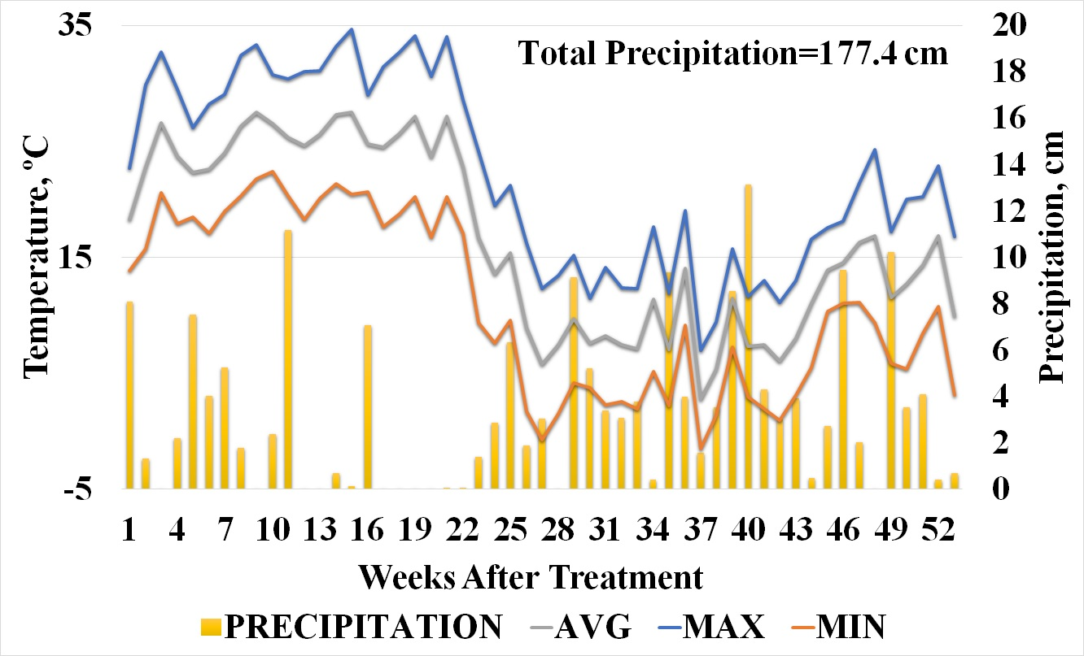

Figure 1. 2019 Field study average, minimum, and maximum weekly temperature and precipitation

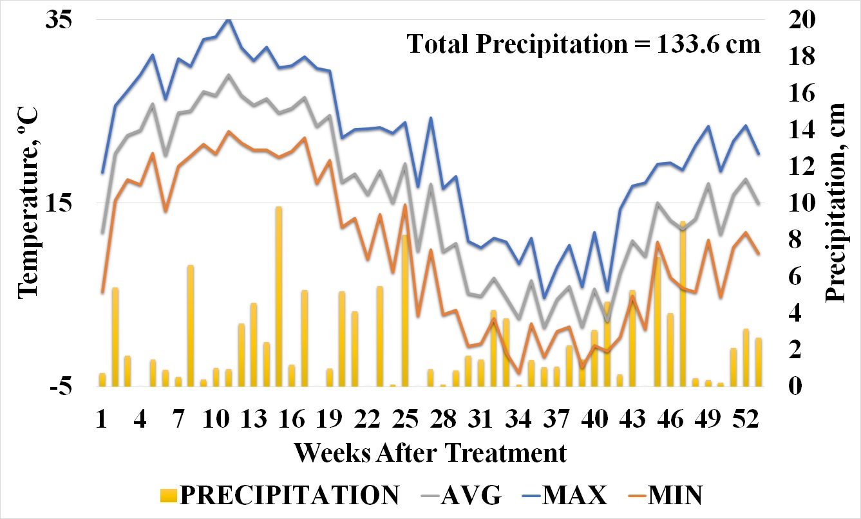

Figure 2. 2020 Field study average, minimum, and maximum weekly temperature and precipitation

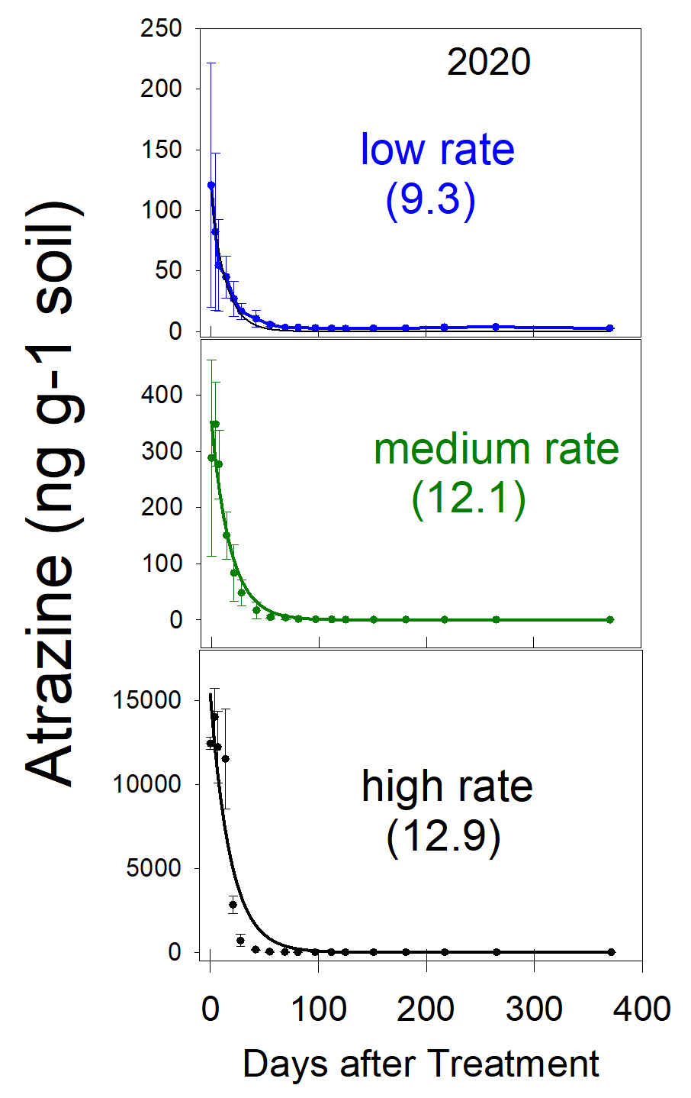

Figure 3. 2020 Atrazine dissipation in field TN soil as a function of initial herbicide concentration and days after treatment.

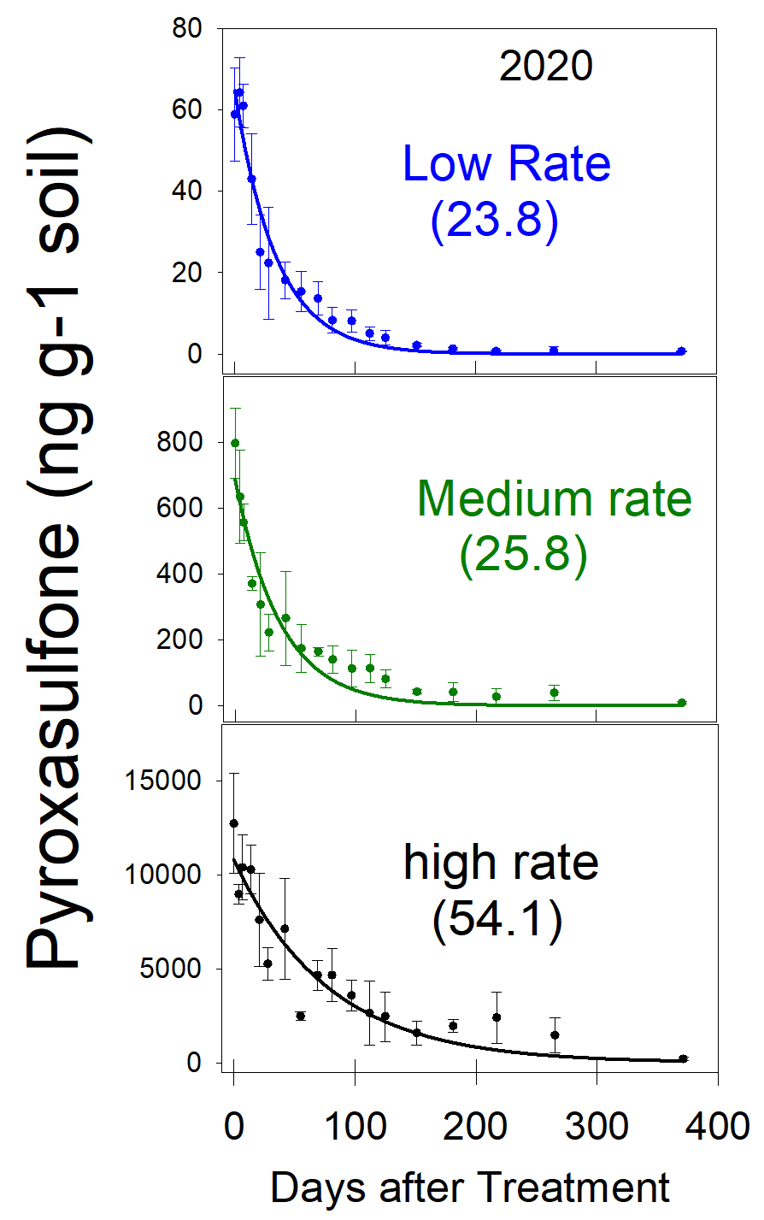

Figure 4. 2020 Pyroxasulfone dissipation in field TN soil as a function of initial herbicide concentration and days after treatment.

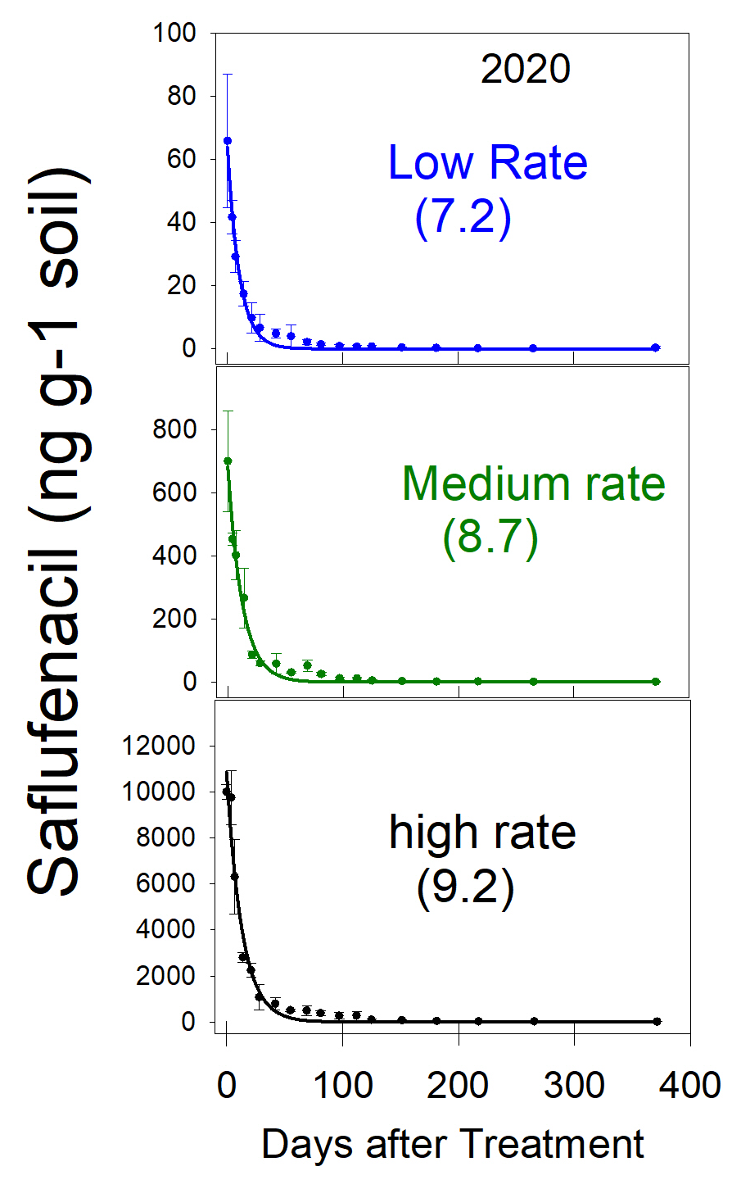

Figure 5. 2020 Saflufenacil dissipation in field TN soil as a function of initial herbicide concentration and days after treatment.

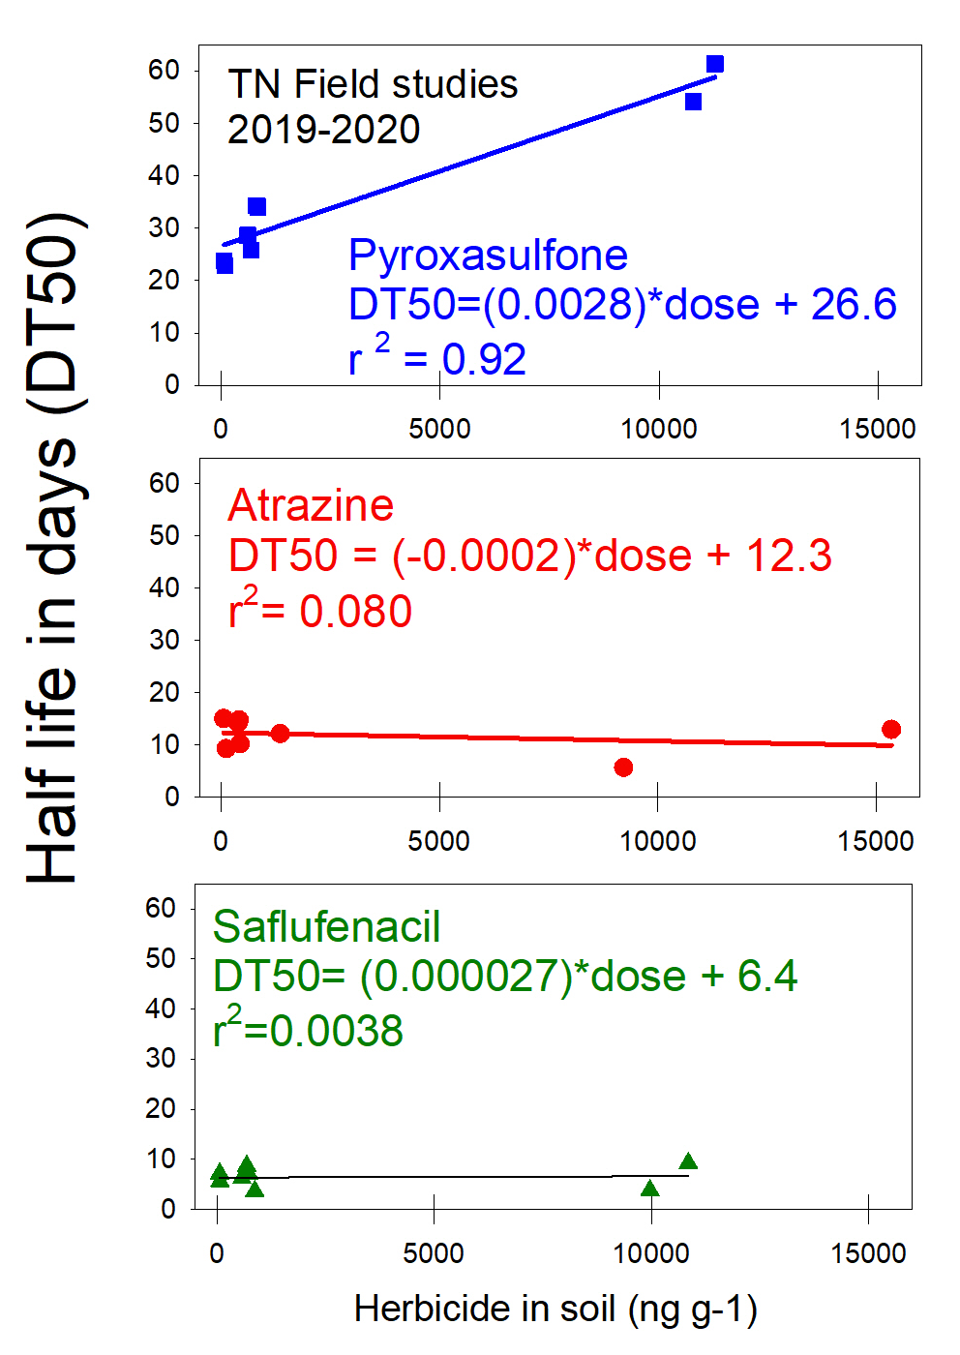

Figure 6. 2019-2020 Field studies dissipation of pyroxasulfone, atrazine, and saflufenacil as a function of initial herbicide concentration and the DT50.

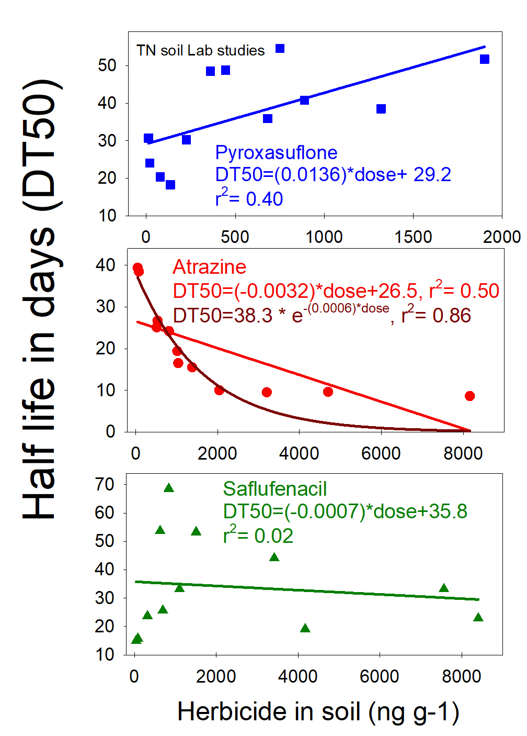

Figure 7. TN lab studies data degradation of pyroxasulfone, atrazine, and saflufenacil as a function of initial herbicide concentration and the DT50.
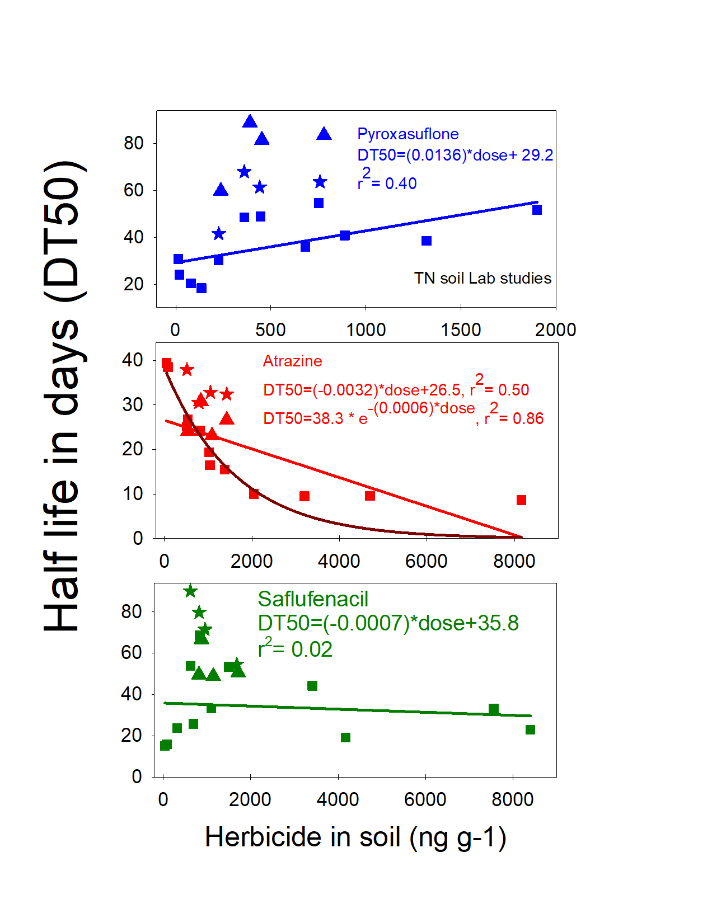
Figure 8. All lab studies data degradation of pyroxasulfone, atrazine, and saflufenacil as a function of initial herbicide concentration and the DT50.
stars = IL, triangles = GA, squares = TN

CONCLUSIONS

Residual herbicide use is an integral part of an integrated approach to weed management in agriculture. Understanding their fate once introduced into the environment is paramount in developing weed control programs that are sustainable and effective. Atrazine, pyroxasulfone, and saflufenacil represent commonly used herbicides from distinct herbicide classes that have varying field persistence. The EPA authorizes pesticide labels and has increasingly relied on herbicide fate modeling to determine herbicide environmental fate. These models can be erroneous when assumptions of the inputs are not realized. DT50s are a common descriptor of herbicide fate and are typically calculated using first order kinetics models. First order kinetics can input errors in models as degradation is assumed independent of rate applied.
Atrazine field dissipation DT50s were 9-13 DAT depending on concentration, which were lower than previously reported. Suspected enhanced degradation due to previous field history could explain the lower DT50’s. Lab studies indicated DT50s of 9-39 DAT which are comparable where enhanced degradation has been documented. Field and lab studies generally agree on dissipation of atrazine. Comparing initial atrazine concentrations and DT50s in the field studies suggests no correlation. On the other hand, lab studies reveal a negative correlation when comparing DT50s and initial concentrations. These data suggest a higher atrazine dose could prompt enhanced degradation as increased herbicide concentrations dissipated sooner than lower concentrations. Considering enhanced degradation is likely in these studies, concentration effects on dissipation might not be clear.
Pyroxasulfone field dissipation DT50s were 24-54 DAT and lab studies were 30-89 DAT depending on concentration. These field study DT50s are comparable to previous research and the data suggests increased concentrations correlate with increased dissipation time. DT50s in the lab studies regressed against initial concentrations suggest a positive correlation. These findings suggest pyroxasulfone initial concentration will have an effect on DT50.
Saflufenacil field dissipation DT50s were 4-9 DAT depending on concentration which were comparable to previous reports. Saflufenacil lab degradation DT50s were 15-90 DAT which are comparable and higher. The longer DT50s calculated in these studies are likely due to lower pH soils, differential organic matter content, and moist soil conditions. Larger DT50s have been reported in high moisture soils where aerobic degradation could be inhibited. The field studies and lab studies suggest no correlation to initial herbicide concentration and calculated DT50s.
These data suggest that extra care should be taken when calculating DT50s, as initial concentration could influence dissipation rates for some herbicides. Initial concentrations are the most important points on the dissipation curve as they set the starting point, however they also tend to be the most erroneous. The EPA has increasingly used modeling for herbicide environmental fate and for some input parameters dissipation is assumed to be independent of rate applied. This assumption could input errors into models which could mislead regulators when considering a herbicide label. In these studies, pyroxasulfone and atrazine dissipations were affected by initial herbicide concentrations. Furthermore, these projects suggest that companies could look at >1 herbicide per dissipation study. Currently, typical TFD studies are 2-3 plots with at least a 1-year duration observing one molecule (>DT95). Many companies, when applying for herbicide registration, tend to look into marketing premixes with 2+ different herbicides. As stated earlier, dissipation could be affected when different molecules are coapplied. Dissipation studies could include the new herbicide and the proposed premixes in the same study. Benefits to these study parameters include cost savings as compared to current TFD parameters and a possible reduction in study data variability.

VITA

Randall Lee Landry grew up in a small town in western Louisiana. Following graduation from Pitkin High School he pursued his Bachelors at Louisiana State University in Alexandria. Randall was hired after graduation in 2008 at Louisiana State University Agricultural Center as a Research Associate in Weed Science working with corn, cotton, grain sorghum, soybean, and wheat. Eventually enrolling in graduate school during his work tenure, Randall received his Master of Science in Soil, Plant, and Environmental Sciences (Agronomy - Weed Science) from Louisiana State University in December of 2014. Following graduation, he accepted a position with a Contract Research Organization (CRO).
Randall worked for five years with Pest Management Enterprises, an agricultural contract research organization (CRO), as a Research (Weed) Scientist. He was responsible for research relating to efficacy on weeds, diseases, insects, varieties, regulated – USDA-APHIS and/or EPA-EUP in multiple crops that can be grown in the central Louisiana lower Red River valley. He is a current member of the National Alliance of Independent Crop Consultants (NAICC), Louisiana Agricultural Consultant’s Association (LACA), and a member of Southern Weed Science Society (SWSS).
Randall decided to pursue his PhD at the University of Tennessee in Knoxville working with Dr. Thomas C. Mueller in Weed Science conducting research in herbicide efficacy, environmental fate, and weed resistance mitigation. Upon completion of his PhD, he plans to pursue a career in agriculture industry.

