Conventional vs. slow-growing broilers: developmental pathways associated with differential muscle and adipose growth.

A Thesis Presented for the
Master of Science
Degree
The University of Tennessee, Knoxville

Lindsey Eppinger
August 2024
Copyright © 2024 by Lindsey Eppinger
All rights reserved.

ACKNOWLEDGEMENTS
I would like to express my deepest appreciation to everyone that has been a part of my journey throughout graduate school. I would not be where I am today without the support and encouragement from my family, friends, mentors, lab mates, and anyone else I have had the pleasure of getting to know and work with the past 2 years.
First and foremost, I would like to thank my mentor Dr. Brynn Voy for providing me the opportunity to pursue a graduate degree in her lab. I will forever be grateful for everything she has to done to encourage my growth and success during my graduate school career through her guidance, understanding, and unwavering support. Her passion for her work and overall zest for life is truly inspiring and something I will always strive for. I truly am lucky to have been a part of her lab and will always be thankful for everything I have learned from her inside and outside the lab.
I would also like to express my gratitude to my committee members, Dr. Ahmed Bettaieb, Dr. Daniel Mathew, and Dr. Tom Tabler, for dedicating their time to provide their assistance and expertise to ensure my success. Each have taught me so much and inspired deeper thinking and understanding.
I would like to thank everyone that I have had the pleasure of being a part of the Voy lab with, Minjeong Kim, Usuk Jung, Dr. Elizabeth Shepherd, and Sophia Ascolese. Each have provided invaluable assistance and guidance that I cannot thank them enough for. I would not be where I am today without their help and support.
I am extremely grateful for the friendships I have formed with my fellow graduate students. I will be forever grateful for each of them as they have supported and helped me in more ways than they could ever imagine. I would like to extend a special thanks to Kinsley Frady, Landon Whitehead, and Sophie Ascolese for being some of the best friends I could have during this time of my life, I truly do not know where I would be without their friendship.
Last but not least, I would like to thank my family and Gavin for their constant support and encouragement to accomplish anything and everything I set my mind to.

ABSTRACT

Chapter 1 of this thesis introduces the modern broiler chicken and the current issues the broiler industry is facing. The chapter discusses muscle and adipose growth in broiler chickens, introduces the increasing use of slow-growing broilers to mitigate problems with production, and how the microbiome can be harnessed to improve the health and, therefore, welfare of broiler chickens. Chapter 2 investigates developmental pathways regarding early life muscle and adipose development through the use of broiler lines that have been differentially selected for growth. Chapter 3 provides a concise summary of key findings from this study. Overall, this thesis furthers our understanding of pathways that regulate muscle and adipose development in the embryo and post-hatch broiler chick. The findings of this study provide an opportunity to further investigate the highlighted results and pathways that may be key to improving efficiency through reducing adiposity, increasing breast muscle quality, and improving welfare of both conventional and slow-growing broiler chickens.

TABLE OF CONTENTS
CHAPTER 1 INTRODUCTION …………………………………………………………………………..1
Current State of the Industry ………………………………………………………………………2
Slow-growing Broilers ………………………………………………………………………….....5
Lipid Uptake from the Yolk Sac in Poultry ………………………………………………………..7
Muscle Development in Broilers ……………………………………………………………….....8
Adipose Tissue Development in Broilers …………………………………………………………9
Impact of the Microbiome on Broiler Health ……………………………………………………10
Conclusion ……………………………………………………………………………………….13
CHAPTER 2 DEVELOPMENTAL PATHWAYS ASSOCIATED WITH DIFFERENTIAL MUSCLE AND ADIPOSE GROWTH ………………………………………………………………………………14
Abstract …………………………………………………………………………………………..15
Introduction ………………………………………………………………………………………15
Materials and Methods …………………………………………………………………………...17
Animal Husbandry ………………………………………………………………………17
Tissue Collection ………………………………………………………………………...17
Fatty Acid Methyl Ester Quantification …………………………………………………18
Cecal Bacterial Community Analysis …………………………………………………...18
Adipose Histology ………………………………………………………………………18
RNA Isolation …………………………………………………………………………...19
Data Analysis ……………………………………………………………………………19
Results ……………………………………………………………………………………………20
Overall Growth Performance ……………………………………………………………20
Breast Muscle and Adipose Tissue Development ……………………………………….21
Adipocyte Size …………………………………………………………………………..21
Fatty Acid Methyl Ester Analysis ……………………………………………………….22
Differential Gene Expression ……………………………………………………………22
Cecal Bacterial Communities ……………………………………………..…………….25
Discussion ………………………………………………………………………………………..26
Conclusion ……………………………………………………………………………………….31
Appendix …………………………………………………………………………………………32
CHAPTER 3 CONCLUSION …………………………………………………………………………….66
REFERENCES ……………………………………………………………………………………………68
VITA ………………………………………………………………………………………………………77

LIST OF TABLES
Table 1: Fatty acid composition of adipose depots. ………………………………………………………45
Table 2: Genetic line differences of fatty acid composition of developing adipose tissue depots. ……….46
Table 3: Summary of differentially expressed genes. …………………………………………………….50
Table 4: Enriched pathways across tissue and age according to DAVID. ………………..……………….53
Table 5: Alpha-diversity indices of cecum samples. ……………………………………………………...58
Table 6: Alpha-diversity indices for each chick. ………………………………………………………….59
Table 7: Analysis of similarity between the cecal bacterial communities. ……………………………….62

LIST OF FIGURES
Figure 1: Developmental changes in egg and yolk weight. ………………………………………………33
Figure 2: Developmental changes in body weight. ……………………………………………………….34
Figure 3: Developmental changes in body temperature. ………………………………………………….35
Figure 4: Developmental changes in breast muscle weight. ……………………………………………...36
Figure 5: Developmental changes in subcutaneous adipose weight. ……………………………………..37
Figure 6: Developmental changes in heart size. ………………………………………………………….38
Figure 7: Developmental changes in abdominal adipose weight. ……………………...…………………39
Figure 8: Developmental changes in neck adipose weight. ………………………………………………40
Figure 9: Frequency distribution of abdominal adipocyte size. …………………………………………..41
Figure 10: Frequency distribution of neck adipocyte size. ……………………………………………….42
Figure 11: Frequency distribution of E17 subcutaneous adipocyte size. …………………………………43
Figure 12: Frequency distribution of D10 subcutaneous adipocyte size. ………………………………...44
Figure 13: Line-dependent changes in gene expression of breast muscle. ……………………………….48
Figure 14: Line-dependent changes in gene expression of subcutaneous adipose tissue.………………...49
Figure 15: Differential gene expression of developing breast muscle. …………………………………...51
Figure 16: Differential gene expression of developing SQ adipose tissue. ………………………………52
Figure 17: ShinyGO pathway enrichment of embryonic breast muscle. …………………………………54
Figure 18: ShinyGO pathway enrichment of embryonic subcutaneous adipose tissue. ………………….55
Figure 19: ShinyGO pathway enrichment of embryonic post-hatch breast muscle. ……………………..56
Figure 20: Top 10 genera of the cecal bacterial communities. ……………………………...…….………57
Figure 21: β-diversity of the cecal bacterial communities between chick genetic lines. ………...……….60
Figure 22: β-diversity between chick lines measured by NMDS. ………………………………………..61
Figure 23: Differences in bacterial taxa between genetic lines. …………………………………...……..63
Figure 24: MetagenomeSeq analysis of differences in bacterial community taxa. ………………………64
Figure 25: Pathway enrichment from bacterial communities present in the cecum. ……………………..65
CHAPTER 1 INTRODUCTION

Current State of the Industry
In 1948, the “Chicken of Tomorrow” contest, held by the United States Department of Agriculture and A&P Food Stores, aimed to create a bigger, meatier, and more efficient chicken capable of passing these traits down to future generations (McKenna 2018). This contest laid the framework for the commercial broilers used today. Since this contest, these birds have been selected for highly heritable, easy to measure traits which include feed conversion ratio, body weight, feed consumption, and yield. Selection for these traits over the years has led to a chicken that, today, is around 4.5 times larger than birds of the same age and genetic lineage in 1978 with less feed (Zuidhof et al. 2014).
Production of modern broiler chickens is environmentally and economically favored. There is a relatively low resource utilization because they reach market weight faster and convert feed into muscle more efficiently than any other livestock species while also being raised in smaller spaces (Tallentire et al. 2018). This makes broiler production easier and more affordable, which is especially important in developing countries. Due to these benefits of broiler production compared to production of other livestock species, poultry has become the most consumed and imported livestock commodity in the world in the past two decades and is expected to remain number one for at least the next 10 years (Miller et al. 2022). From 2013 to 2022, broiler chickens averaged 67% of all poultry sector sales in the U.S. with broiler sales increasing 60% from 2021 to 2022 (Grossen 2023). Since 2001, imports of poultry products have increased 4% each year.
Along with this increase in production and sales, poultry meat consumption has continuously been on an upward trend and has surpassed, or almost surpassed, red meat consumption. This is primarily due to its affordability and health recommendations with poultry providing an affordable protein source that is more readily available than other meat (Miller et al. 2022, Grossen 2023). Since 1960, Americans have gone from consuming an average of 23.6 pounds of chicken per capita to 98.9 pounds per capita in 2022, with an average of 68.1 pounds per person available for consumption (National Chicken Council 2021, Blazejczyk and Kantor 2023). Meanwhile, red meat consumption has gone from 133 pounds per capita in 1960 to 111.6 pounds per capita in 2022 (National Chicken Council 2021). The upward trend of poultry products available for consumption began in the 1940s and has since surpassed that of pork and beef products with available poultry products being double that of 1980 in 2021 (Blazejczyk and Kantor 2023). The discrepancy between production and consumption has experienced an 86% increase with production of 69 million metric tons in 2001 to 128 million metric tons in 2021 (Miller et al. 2022).
Selection for increased efficiency of conventional broilers and broiler production systems has proven to be successful. However, limitations continue to become increasingly apparent from both a biological and consumer preference standpoint as welfare issues and impaired meat quality implications continue to rise. One default of this selection is that the feed conversion ratio has decreased by 50% since 1950, while growth rate has increased 400% (Zuidhof et al. 2014, Huang et al. 2021). Although this statistic can be viewed as a great feat in the broiler industry, the intense selection that occurred to accomplish this brought along traits that are not beneficial and, in some ways, has caused selection to reach a maximum. In commercial broiler production systems, broilers are designed to consume as much feed as possible in order to maximize metabolizable energy to stimulate growth, particularly of the pectoralis major muscle, with birds reaching a market weight of about 2.2 kg in 34 to 35 days. Intense selection for maximal efficiency poses many biological challenges to the bird and its digestive system as broilers have been selected for breast muscle growth rather than development of the digestive system, which is currently thought to have little room for improvement in efficiency of this system. This means that broilers will not continue to have maximal growth of the breast muscle as they cannot physically consume more feed (Tallentire et al. 2018).
Another major inadvertent consequence of genetic selection for increased growth of the economically favored p. major muscle, is that broilers still experience an overaccumulation of abdominal fat. Genetic selection has attempted to reverse this issue and even though the percentage of abdominal fat accumulation has decreased slightly, there is still more accumulation than physiologically necessary (Zuidhof et al. 2014). This is seen as an issue in the broiler industry because feed is wasted when it is allocated towards fat accumulation rather than muscle growth. In modern broilers, the abdominal fat pad accounts for around two percent of body weight. Biologically, it is possible for this value to decrease to zero percent which would allow for more metabolizable energy to be allocated towards continued growth of the p. major muscle (Tallentire et al. 2018). This overaccumulation is due to the high heritability of the abdominal fat pad and its genetic correlation with body weight when compared to other components such as protein and water at different ages, with heritability being .82 for the fat pad compared to .55 for body weight (Cahaner and Nitsan 1985). It has been shown that selecting for increased body weight at certain ages can be linked to increased abdominal fat accumulation. Birds selected for exponential growth rate at day 14 showed increased body weight but not fat weight, while those selected for exponential growth at day 42 showed an increase in both body weight and fat pad weight (Sizemore and Barbato 2002). Growth of abdominal fat is largest on the linear portion of the growth curve, representing a disproportionate abdominal fat growth rate compared to overall growth rate (Cahaner and Nitsan 1985, E. Decuypere 2003).
Other biological problems in modern broilers include musculoskeletal disorders, myopathies, and organ failures (Tallentire et al. 2018). The increased growth rate and body weight of broilers has been shown to have positive correlations with prevalence of leg problems such as angular bone deformities, tibial dyschondroplasia, and foot pad burns. It has been estimated that about 75% of broilers raised in conventional system have an impaired walking ability with a gait score greater than zero and 42% have foot pad burns (Sanotra et al. 2001). Another study by Knowles et al. (2008) has shown a 27.6% prevalence in leg problems with 3.3% of birds being unable to walk. This study showed that despite the strong genetic component to the prevalence of leg disorders, the condition was worsened by increased growth rate. In this case, it was seen that flocks fed a whole wheat diet had a decreased prevalence of leg problems, being attributed to the decreased rate of digestion of the feedstuff leading to a decrease in growth weight of the birds. It was also shown to be beneficial when periods of darkness were longer as this also decreased feed intake (Knowles et al. 2008).
One major problem in broilers is ascites, which is the accumulation of fluid within the abdomen. Broiler ascites syndrome is typically associated with right ventricular failure and pulmonary hypertension (Kalmar et al. 2013). A study examining causes of mortality in broilers close to market weight reported that 24% of on farm deaths was caused by ascites (Kittelsen et al. 2015). This syndrome is thought to be caused by hypoxemia, or the lack of oxygen in the blood. The increased prevalence of ascites is thought to be due to the intense metabolic demands required of broilers, particularly during juvenile development when demands are even greater. During this time, maximum oxygen delivery capacity to the respiratory and cardiovascular systems is likely exceeded when anabolic processes and metabolizable energy are being coupled, likely being the trigger for ascites (E. Decuypere 2003). Other causes include the increased selection for muscle growth without a proportionate increase in the size of the respiratory and cardiovascular system, causing a lack of necessary amounts of oxygen being delivered to tissues which leads to increased incidence of ascites and even pale, soft, and exudative meat and other myopathies (E. Decuypere 2003, Zhu et al. 2012).
An increasingly common problem in broiler production is the prevalence of breast muscle myopathies. Studies have estimated that up to 90% of broilers are affected by these types of myopathies (Huang and Ahn 2018). The most common myopathies affecting broilers include white striping, wooden breast, and spaghetti meat. White striping is characterized as white striations in the breast and thigh meat of large broilers (Kuttappan et al. 2012). This myopathy is thought to be caused by the intense selection pressures on broilers and is associated with increasing weight and thickness of the breast muscle, particularly when fed high energy diets necessary for the growth rates seen today (Kuttappan et al. 2012, Kuttappan et al. 2013). Wooden breast, often accompanied by white striping, is characterized by hard, outward bulging, and pale portions of the breast muscle with muscle necrosis and fibrosis (Sihvo et al. 2013, Velleman 2023). Although the exact cause of wooden breast is unclear, it is thought to be caused by hypoxia and oxidative stress (Velleman, 2023). Spaghetti meat, a more recent discovery, is caused by a diminished integrity of the breast muscle and results in soft and mushy bundles of muscle resembling spaghetti, hence the name (Baldi et al. 2021). These myopathies, due to the intense selection of broilers, cause an economic loss to producers as consumers become increasingly aware of these conditions.

Slow-Growing Broilers
To combat these issues and improve welfare in broiler production systems, there has been a push for a slower-growing broiler chicken. While there is not clear definition of slow growth in broilers, it is generally referred to as growth of 50 grams or less per day. These broilers are typically derived from heritage breeds or are crossed with conventional broiler chickens. In some countries, policies have been implemented to produce welfare-friendly birds that have a reduced growth rate and must be reared for a minimum of 56 days before going to slaughter (Tallentire et al. 2018). As of 2013, slow-growing broilers have been steadily entering markets, with 90% of chicken available in Dutch supermarkets in 2016 being from slow-growing chickens (Thornton 2016, Swormink 2017). With the growing popularity of slow-growing broilers, there has been a rise in the number of certifications and labels defining their production. These certifications include Label Rouge which was lauched by the French Government in 1961, Free Range and Traditional Free Range which is similar to Label Rouge in European markets, the RSPCA’s Freedom Food in the United Kingdom’s markets, Beter Leven’s One Star/Two Star program in the Netherlands, and many others (Hubbard LLC 2023).
In order to be fit the criteria for these certifications and labels, producers must adhere to set standards in terms of breed type, stocking density, housing type, type of lighting, diet, maximum farm and barn size, and a minimum age they should be raised to. To meet the Label Rogue criteria, specifically, farms can have no more than 4 buildings with each having a maximum size of 4,304 sq. ft. and must be a least 98 ft apart, a stocking density of 0.98 sq. ft. and 2.2 lbs of litter per bird, birds must have outdoor access, feed rations must be at least 75% cereals, birds must be grown out to a minimum of 81 days, and cannot travel more than 2 hours or 64 miles to processing plants (Fanatico 2002). Standards such as those listed have not only improved welfare but have also improved health. When comparing conventional and slow-growing lines of broilers in varying production settings, it was found that slower-growing birds typically exhibit an increased health status. The slow-growing broilers had improved gait scores, decreased incidence of hock burns and pododermatitis, and exhibited behaviors associated with increased welfare, such as wing flapping, running, jumping, ground scratching, and perching (Rayner et al. 2020). Slow-growing birds are also found to have lower mortality with fewer culls and less carcass abnormalities than conventional broilers (Baxter et al. 2021).

Lipid Uptake from the Yolk Sac in Poultry

The increased efficiency of modern broilers has led to a shortened growing phase, making the embryonic growth and development of the broiler a more critical phase of the total growing period than before. During the embryonic phase, avians receive the necessary nutrients for growth and development from the yolk. The yolk is made up of approximately 49% water, 33% fat, and 17% protein with the other 1% being carbohydrates and minerals (Romanoff 1949, van der Wagt et al. 2020). These nutrients are transported from the yolk to the embryo mainly via the yolk sac membrane, a highly vascularized structure that encompasses the entire embryo by day 5 of embryonic development, by transporting nutrients through its capillaries and into the portal system of the developing embryo, and to a lesser extent may be absorbed directly into the intestine through the yolk stalk (Noble and Cocchi 1990, Sulaiman et al. 1996). During the last half of embryo development, the most rapid phase development, the embryo relies on lipids from the yolk for about 90% of its energy production (Speake et al. 1998, van der Wagt et al. 2020). This rapid absorption of lipids, with up to 1 gram of lipid absorbed from the yolk during the last two days of incubation, is associated with accumulating lipid in embryonic tissue and a high lipid oxidation (Noble and Cocchi 1990). During the last few days of incubation as the hatching phase begins, oxygen levels are low while energy demands remain high meaning that fatty acids cannot be oxidized and used for energy (Tazawa et al. 1983, Uni et al. 2012). This causes a shift towards the catabolism of glucose, which has been suggested is derived from the yolk sac during the last week of incubation, to provide energy for hatch (Yadgary and Uni 2012). As the hatching process is beginning, the residual yolk sac is internalized into the abdominal cavity and provides nutrients to the new chick during the first few days post-hatch (Romanoff 1960). Due to genetic selection of rapid growth post-hatch, it has been suggested that the metabolic rate of the embryo has increased as well, which would lead to greater yolk utilization and a smaller residual yolk sac (van der Wagt et al. 2020).
Muscle Development in Broilers
Selection for increased yield through an increase in muscle mass has proven to be successful for the broiler industry. Development of this skeletal muscle begins early on in embryonic development after the gastrulation period when the embryo forms three germ layers – the ectoderm, mesoderm, and endoderm. The mesoderm gives rise to a group of mesodermal stem cells that eventually form skeletal muscle (Halevy and Velleman 2022). As these mesodermal cells proliferate on either side of the elongating notochord, somites are formed with the sclerotome of the somite being made of cells located closest to the notochord, the dermatome being comprised of cells on the dorsal surface of the somite, and a group of cells located between the sclerotome and dermatome which form the myotome. The cells of the myotome, called myoblasts, give rise to future skeletal muscle by migrating out of the somite and proliferating to form myotubes with immature myofibrils in a process known as myogenesis. These primary immature myofibers continue to differentiate until secondary myofibers are formed and aligned with the primary myofibers. At this point, which is at the time of hatch, the muscle fibers are fully formed with any growth after this being attributed to hypertrophy, or increasing size, of the muscle fibers (Smith 1963, Velleman 2019).
Increased muscle mass post-hatch is a result of increased size in myofibers, rather than an increase in the number of myofibers. Hypertrophy of muscle fibers is associated with satellite cells, which are named after their proximity to muscle fibers (Mauro 1961). Satellite cells increase muscle fiber DNA by binding to adjacent muscle fibers which in turn increases muscle fiber diameter (Moss 1968, Moss and Leblond 1971). These satellite cells are formed from Pax3- and Pax7-expressing muscle precursor cells and allow their survival, proliferation, and participation in myogenesis (Relaix et al. 2005, Relaix et al. 2006, von Maltzahn et al. 2013). Myogenesis, the process of stem cell differentiation to form contractile muscle fibers, requires expression of muscle regulatory factors (MRFs). MRFs, such as MyoD, Myf5, and MRF4, are a family of transcription factors that are expressed in a specific order that allows for activation of muscle-specific genes and the commitment of stem cells to skeletal muscle lineage (Rudnicki et al. 1993, Buckingham 1994, Kassar-Duchossoy et al. 2004). These MRFs work with Pax3 during embryonic development and with Pax7 during post-hatch development to form skeletal muscle. During embryonic growth, Pax3 acts prior to MyoD to allow migration of muscle progenitor cells from the somite to the limb buds in the formation of limb muscles while Pax7 is required for the proliferation of quiescent and activated satellite cells during post-hatch muscle growth (Halevy et al. 2004, Relaix et al. 2005, Halevy and Velleman 2022). After proliferation and subsequent differentiation, myocytes fuse to form primary muscle fibers.
Adipose Tissue Development in Broilers
Selection for rapid growth and increased muscle mass in broilers has inadvertently led to a tendency to accumulate more adipose tissue than physiologically necessary. This becomes a problem in the broiler chicken industry as feed, which is the most expensive portion of production, is allocated to towards fat accretion rather than muscle growth. Adipose tissue is comprised of many cell populations with the primary cell type being adipocytes that are derived from mesenchymal stem cells. These stem cells first commit to the adipocyte lineage by developing into pre-adipocytes in a process known as determination before becoming mature adipocytes during the terminal differentiation phase (Speake et al. 1993, Speake et al. 1998, Rosen and MacDougald 2006). While both hyperplasia, or an increase in cell number, and hypertrophy, an increase in cell size, are both active during this stage, growth of the subcutaneous fat pad is primarily due to increased hyperplasia (Cartwright 1991, Chen et al. 2014, Wang et al. 2017). By day 4 post-hatch, growing chicks begin to rely on nutrients from the diet as the yolk has been reabsorbed at this point (Moran 2007). With the transition to reliance on the diet for growth comes changes in adipose tissue development. Aside from dietary fatty acid intake, avians acquire fatty acids through de novo lipogenesis in the liver when glucose is catabolized to acetyl CoA and further to fatty acids and cholesterol before being packaged into VLDL molecules that are transported to adipose tissue (Leveille et al. 1975, Wang et al. 2017). Incoming dietary lipids are hydrolyzed into free fatty acids which are absorbed by mucosa cells before being esterified with glycerol to form triacylglycerol (TAGs). These TAGs are assembled into lipoproteins called portomicrons that enter the portal vein (Bensadoun and Rothfeld 1972, Buyse and Decuypere 2015). These portomicrons, along with nonesterified fatty acids that have been bound to albumin, are delivered to the liver where they are partially hydrolyzed by lipoprotein lipase or are taken up by the liver to once again be synthesized into TAG-rich lipoproteins (Buyse and Decuypere 2015). Once these portomicrons and VLDLs reach adipose tissue, they are stored in the adipocytes as lipid droplets.
Impact of the Microbiome on Broiler Health
There are many methods of improving the health and welfare status of livestock species. One method that has been increasing in popularity is understanding and manipulating the microbiome of the gastrointestinal tract. The composition of the gastrointestinal tract microbiome of livestock species has become extensively researched in recent years, particularly in cattle as they rely heavily on fermentation from microbiota in the rumen to obtain energy from otherwise low-quality feedstuffs. The impact of the microbiome has become attractive to the livestock industry due to its impact on animal health and performance parameters (Forcina et al. 2022). In the past few years, there has been an increase in studies examining the microbiome of broilers to better understand its impact on overall health, immunity, and growth performance. Many of these studies aim to characterize and compare the microbiome of pathogen-free birds and infected birds in hopes of understanding the effect of antimicrobials and antibiotics on overall performance and health or to understand how the microbiome can be utilized to defend against disease without the use of antibiotics (Forcina et al. 2022, Kayal et al. 2022).
The cecum is the proximal portion of the large intestine and functions to absorb water and electrolytes as well as to breakdown feed particles that are indigestible in the small intestine via fermentation to obtain energy from carbohydrates through production of short-chain fatty acids (Mazzucchelli and Maurer 2004, Stumpff et al. 2019). In avians, the cecum is becoming extensively researched to determine its functions and how its adaptability can be utilized as some avians, such as chickens, possess a pair of ceca while it is completely lacking in other avian species (Svihus et al. 2013). Due to its adaptability, the cecum and its microbiome can be targeted as a method for improving health and efficiency of broiler chickens.
Numerous studies have examined the microbial composition of broilers and how the microbiome differs when considering factors such as varying production systems, degree of feed efficiency, diet, and age. Complexity of the cecal microbiome changes as the bird matures (Mohd Shaufi et al., 2015). One study suggests that the microbiome of the cecum is a subset of the ileal microbiome until 14 days post hatch at which point the cecum developed its own unique microbial composition (Lu et al. 2003). Many agree that the dominant phyla in the cecum of broilers consists of anerobic bacteria, such as Firmicutes and Bacteroidetes, with Firmicutes being dominant even at a young age (Mohd Shaufi et al. 2015). A study comparing the cecal microbiome of high and low feed efficiency broilers found a potential link between feed efficiency and cecal microbial composition. In this study, Firmicutes, Bacteroidetes, and Actinobacteria represented 90% of microbial flora. In both feed efficiency groups, Firmicutes were the most dominant phylum, accounting for 83.5% of the high feed efficiency group and 85.7% in the low feed efficiency group. The genus Bacteroides had a higher abundance in the high feed efficiency group and a negative feed conversion ratio associated correlation suggesting its potential as a biomarker for feed efficiency due to its association with metabolism of starch and sucrose and amino acid biosynthesis (Huang et al. 2021). In other studies, Lactobacillus is dominant at young ages but is quickly outnumbered as the bird ages, suggesting that Clostridiaceae species become the most abundant in the cecum, followed by Fusobacterium, Lactobacillus, and then Bacteroides when fed a vegetarian corn-soy diet without growth additives (Lu et al. 2003).
The microbiome is important to the overall health and performance of broilers as it protects against pathogenic organisms and elicits an immune response (Dittoe et al. 2022). One study has shown that along with high percentages of Bacteroides, was also high percentages of pathogenic Clostridium with lower percentages of Lactobacillus, which is a common beneficial microbe. This demonstrates the need of the microbiome to regulate gut health (Mohd Shaufi et al. 2015). One study directly challenged broilers and their microbiome with pathogenic microbes, specifically pathogenic Campylobacter jejuni. This revealed that the microbiome of challenged birds demonstrated greater diversity and evenness with a distribution of more Firmicutes at the expense of Bacteroidetes, suggesting that pathogenic challenges to the microbiome shift the community structure away from the dominant taxa (Qu et al. 2008).
Despite research demonstrating that the microbiome is altered based on housing, diet, and other management systems, there is still little known about how selection for the highly efficient modern broiler has altered the microbiome compared to slower-growing or unselected lines (Shterzer et al. 2023). Of the few studies, one examined a conventional Ross line and a slower-growing Hubbard line raised in the same facility during the growing period. The results of this study revealed that there was not a significant difference between the two lines and that they showed a similar microbiota development with similar profiles at the genus level (Montoro-Dasi et al. 2020). However, some studies have shown that there is a difference in the microbial composition of the cecum between lines. A study comparing a conventional line of broilers with an unselected line utilized broiler breeders raised in the same facility and grown out to 37 weeks. This timeframe ensured sufficient time for microbial exchange between the birds, minimizing differences arising from initial exposure. Additionally, it helped ensure that discrepancies weren’t attributed to variation in physiological age caused by the rapid growth rate typical of conventional broilers. The results of this study aligned with previous studies and demonstrated that Bacteroidales and Clostridiales were the most abundant. However, this study did reveal a member of the Verrucomicrobiales order, Akkermansia, represented five percent of the microbiota in conventional birds but was completely absent in the unselected line except for one individual. The unselected line also showed high levels of Clostridiales, Lactobacillales, and Aeromonadales. Further investigation revealed some cases where Akkermansia was present in the microbiome of adult modern broilers but not younger modern broilers. The authors of this study hypothesize that these findings could suggest selection for modern broilers could be selecting, or not selecting, for specific microbes found in the cecum (Shterzer et al. 2023).
Other areas of broiler microbiome research have started to investigate the relationship between the microbial composition of the cecum and the growth and development of various tissues. Tissues of interest include the abdominal fat as this fat pad still over accumulates despite intense selection for growth of p. major. A study examining this relationship sampled abdominal fat and cecum contents from chickens from three to 42 days in one-week intervals starting at day seven. The results revealed that Coprobacillus, Shigella, and Butyricicoccus was negatively correlated with propionic acid, butyric acid, and abdominal fat weight but positively correlated with isobutyric acid. Isobutyric acid was found to have a negative association with abdominal fat weight. These results suggest that with an increase in the abundance of these microbes, there is an increase in isobutyric acid produced by the cecum and a decrease in abdominal fat pad weight with these results being most profound at day 14 (Liu et al. 2023). Further investigation would need to be done to validate these results and determine commercial application to reduce abdominal fat pad size.
Conclusion
Intense selection for growth in modern broilers has led to a myriad of unintended consequences that have compromised their health and welfare. With the push for a healthier slower-growing bird, determining ways to improve the efficiency and health of these broilers could allow them to grow to the target weight while decreasing inputs such as feed cost. One way to target increased feed efficiency is to target the microbiome of the cecum. Finding successful techniques to improve and alter the microbiome could act as a way to reduce disease, further improve welfare, and increase efficiency of these newer broilers. Understanding developmental pathways that regulate muscle and adipose growth and how these pathways may differ between conventional and slow-growing broilers can help optimize performance.

CHAPTER 2
DEVELOPMENTAL PATHWAYS ASSOCIATED WITH DIFFERENTIAL MUSCLE AND ADIPOSE GROWTH

Abstract

Genetic selection of conventional broiler chickens has created a modern-day broiler that is characterized by rapid growth and high feed efficiency. This rapid growth has allowed chicken to be the most readily available and most consumed meat in the United States. However, the selection for rapid growth has led to an increase in unintended consequences that diminish meat quality and decrease welfare status. The rise of these consequences has put pressure on the broiler industry to create production practices and genetic lines that support slow growth. These slow-growing lines provide the opportunity to study lines that are differentially selected for growth as a means of better understanding pathways that underlie early life development of muscle and adipose tissue. To accomplish this, eggs from the conventional Cobb 500 and the slow-growing Redbro broiler lines were incubated until hatch and raised to 14 days with samples of the breast muscle (BM), the subcutaneous (SQ), abdominal (ABD), and neck fat pads, and the cecum being collected to determine phenotypic, genetic, and microbiome differences that may be contributing to differences in growth. The results of this study reveal differences in phenotypic characteristics such as tissue weight, adipocyte size, fatty acid composition of adipose depots, differential gene expression, and bacterial microbiome differences that may be accounting for differences in growth.
Introduction
Modern day conventional broiler chickens are incredibly efficient in terms of feed efficiency and growth of the breast muscle, but this has come alongside an array of issues leading to diminished meat quality, excess fat deposition, and decreased welfare status. The efficiency of these broilers can be attributed to the intense genetic selection that the modern-day broiler has undergone to more than quadruple its size since this selection began in the 1940s (Zuidhof et al. 2014). While genetic selection has been successful in terms of muscle growth and feed efficiency, broilers still accumulate an excess of adipose tissue, experience breast muscle myopathies such as wooden breast and white stripping that diminish the quality of the meat, and experience health consequences such as ascites syndrome leading to right ventricular failure and fluid retention in the abdomen. In an effort to combat these unintended consequences of selection for rapid growth, there has been a push to produce genetic lines that exhibit slower growth.
Slow growth in broilers is achieved using genetic lines, such as heritage breeds, that have not been selected for traits associated with rapid growth and is typically accompanied by stricter production practices such as lower stocking densities and more opportunity for enrichment (Better Chicken Commitment 2023). While there is no set definition of slow growth in broilers, it is generally referred to as less than 50 g/day (0.1 lbs/day) of growth as compared to conventional broilers which reach market age at around 47 days of age, weighing about 6.5 lbs (~60 g/day) with a feed to gain ratio of 1.75 (National Chicken Council 2022). Some certifications, such as Label Rouge in France, require broilers to be raised to 5 lbs in 12 weeks compared to 5 lbs in 6-7 weeks for conventional broilers through the use of genetic lines that support slower growth (Fanatico 2002). Due to their reduced growth rate, slow-growing broiler lines experience an increase in positive welfare-associated behaviors such as perching, standing, and locomotion (Dixon 2020). Broilers with rapid growth rates, or similar growth rates to slow-growing broilers but with higher breast yield, exhibit an increased prevalence of wooden breast and white stripping as compared to their slower-growing counterparts (Dixon 2020, Santos et al. 2021). Genetic lines exhibiting slow growth also show a decreased prevalence of ascites syndrome when compared to conventional broilers (Forseth et al. 2023). Slow-growing broilers also have a decreased overall mortality rate compared to conventional broilers for on-farm death, culls, and death during transport (Dixon 2020, Forseth et al. 2024). Aside from the health and welfare benefits of slow-growing broilers, there is also an opportunity to use these genetic lines as a model for studying developmental pathways in broiler chickens. Understanding these pathways can provide the broiler industry with methods of production and genetic selection that aim to alleviate their most prevalent issues.
In order to identify ways to mitigate health and welfare implications associated with conventional broilers while maintaining optimal growth of both conventional and slow-growing broilers, it is important to understand the pathways that control development. Slow-growing broilers provide an ideal model for this as they have been selected for multiple characteristics other than just rapid growth, providing more robust genetic information to identify key pathways that control growth and development. The objective of this study was to determine fundamental differences in between genetic lines differentially selected for growth to better understand pathways that control muscle and adipose tissue development in post-hatch broilers. To accomplish this, the Cobb 700, a conventional broiler line selected for feed efficiency and breast muscle yield, and the Hubbard Redbro, a slow-growing broiler line derived from a conventional male parent and a female parent selected for welfare, production, and feed efficiency, were used to determine differences in phenotypic traits as well as to identify genetic information, fatty acid profiles, and intestinal bacterial communities that may be contributing to differences in growth.
Materials and Methods
Animal Husbandry
Animal care and experimental procedures were done in accordance with the Institutional Animal Care and Use Committee at the University of Tennessee, Knoxville. Eggs (n=60/line) from Cobb 700 broiler line (Tyson Foods, Springdale, AR) and Redbro broilers (Hubbard LLC, Pikeville, TN) were incubated at the Johnson Animal and Research Teaching Unit at the University of Tennessee, Knoxville under standard incubation protocols until embryonic day 17 using OVA-Easy Cabinet Incubators (Brinsea, Titusville, FL). At this stage, eggs were either moved to the hatcher under standard protocols or the embryo (n=10) was euthanized via cervical dislocation for sampling. Once hatched, chicks were moved to pens and were raised until 5, 10, or 14 days post hatch under standard commercial protocols, including 23:1 light:dark cycle and ad libitum starter feed and water. On sampling days, chicks were euthanized via cervical dislocation. Each day, chick weight was measured and recorded along with rectal body temperature using an infant thermometer (Safety 1st, Tampa, FL) as an indirect measure of index of metabolic rate and thermogenesis.
Tissue Collection
Upon euthanasia, chicks were weighed before dissecting to isolate tissue samples. All tissue samples were immediately weighed after dissection. On embryonic day 17 (E17) and day 5 (D5), the pectoralis major, or the breast muscle (BM), and the subcutaneous (SQ) fat pad were collected (n=10). On days 10 (D10) and 14 (D14), the BM and SQ fat pad were collected along with the abdominal (ABD) and neck fat pads (n=10). The cecum was collected from each chick on D10 (n=10). The left SQ fat pad and BM were snap frozen in liquid nitrogen and stored at -80 °C prior to RNA isolation. Fat pad (SQ) and BM from the right side of the chick were preserved in 4% paraformaldehyde and stored at 4°C prior to histological analysis. When collected, ABD and neck fat pads were cut into two pieces, with one snap frozen and one fixed for histology.
Fatty Acid Methyl Ester Quantification
Fatty acid methyl ester (FAME) analysis was performed using tissue samples from D10 SQ, ABD, and neck fat pads of both broiler lines (n=6). Approximately 30 mg of tissue from each sample was pulverized in liquid nitrogen using a mortar and pestle. After pulverization, samples were transferred to the Biological and Small Molecule Mass Spectrometry Core at the University of Tennessee, Knoxville for analysis using gas chromatography mass spectrometry (GC-MS). The fatty acid content of the adipose depots was determined using the retention time of their methyl esters and was expressed as a percentage of total FAMEs in each sample.
Cecal Bacterial Community Analysis
Cecum samples collected on D10 were thawed to room temperature before collecting fluid cecal contents in a microcentrifuge tube. Bacterial DNA was extracted from cecal contents using the Qiagen QIAamp PowerFecal Pro DNA Kit (Qiagen, Germantown, Maryland). Briefly, cells were lysed by being vortexed in a bead tube before microbial DNA was isolated from the sample using the kit’s solutions. Isolated DNA quantity was measured using a spectrophotometer. Purified samples were sent to Novogene for sequencing and analysis. The V3-V4 hypervariable region of the bacterial 16S rRNA gene was targeted for PCR amplification. Pooled libraries were sequenced using a paired-end Illumina platform to generate raw reads of 250 base pairs and data was filtered using DADA2.
Adipose Histology
Fixed adipose depot samples from E17 and D10 (n=5 line/age) were sectioned into 5 μm sections and stained with hematoxylin and eosin (H&E) to measure adipocyte size. Stained slides were imaged at 20X magnification using EVOS XL Core Imaging System (Thermo Fisher Scientific, Waltham, MA). Adipocyte size was measured as previously described by our lab, with minor modifications, using ImageJ’s Fiji (version 2.15.1) Adiposoft plugin (version 1.16) (Ji et al. 2014, Torchon et al. 2017). Measurements were taken from five chicks per line and from two independent slides per chick. Four fields per slide were imaged for a total of 40 images per chick line.
RNA Isolation
RNA was isolated from the BM and the SQ, ABD, and neck fat pads from each sample day (n=5/tissue/line/age). Approximately 50-100 mg of sample was homogenized in 1 mL of Trizol. Once homogenized, RNA was isolated from each sample using the Direct-zol RNA Miniprep Plus Kit (Zymo Research, Orange, CA). Briefly, samples were centrifuged to pass through a filter column and treated with DNase to digest DNA with the resulting RNA captured on the filter before being eluted into DNase/RNase free water. RNA quantity and purity was measured using a spectrophotometer before using automated gel electrophoresis via the Tapestation (Agilent, Santa Clara, CA) to assess the quality of isolated RNA. Following RNA isolation, cDNA libraries were prepped using the SMART-Seq v4 3’ DE Kit and protocol (Takara Bio, San Jose, CA). Libraries were pooled and prepared for 3’ RNAseq at the University of Tennessee, Knoxville Genomics Core using NovaSeq 6000 s4 flow cell (Illumina, San Diego, CA) to target 25 million reads and mapped to the chicken (Gallus gallus) reference genome (bGalGal1.mat.broiler.GRCg7b). FastQC was used to assess the quality of the raw read counts and subsequent trimming was performed using TrimOMatic.
Data Analysis
All data were normalized using Shapiro-Wilks test with subsequent log transformation, if necessary, and analyzed using t-test to compare tissue differences between each line at the specified age with P < 0.05. In addition to comparing the average of each fatty acid between the two lines, the sum of the saturated fatty acids, mono-unsaturated fatty acids, poly-unsaturated fatty acids, omega-3 and omega-6 fatty acids, and the ratio of the sum of omega-6 to omega-3 fatty acids were also compared. Bacterial community data were analyzed using QIIME2 to determine amplicon sequence variants (ASVs) which were annotated to determine abundance distribution as previously described (Callahan et al. 2017). Differences in the composition of the bacterial communities present in the cecum were measured using α-diversity indices such as chao1 which estimates the number of operational taxonomic units (OTUs) in a sample, the Shannon index which estimates the species diversity within a sample, and the Simpson index which estimates the concentration of each species within a sample. LEfSe analysis (linear discriminant analysis effect size) was used to determine features that most likely explain differences between the two lines. Adipocyte size data were compared based on frequency after dividing cells into 8 bins of arbitrary sizes. The frequency of adipocytes in each bin at each age and in each depot were compared between lines using t-test.
3’ RNAseq counts were analyzed to compare differences in tissues between each line and age using the limma package (Ritchie et al. 2015) using a linear model as previously described (Phipson et al. 2016) to detect differentially expressed genes (DEGs, FDR-adjusted P<0.05). In order to reduce noise while maintaining power, the function voomWithQuailtyWeights was used within the limma package (Liu et al. 2015). DEGs (FDR-adjusted P < 0.1) for each comparison were analyzed for their functional annotation using the Database for Annotation, Visualization, and Integrated Discovery (DAVID, v2024q1), specifically Kyoto Encyclopedia for Gene and Genomes (KEGG) and Gene Ontology (GO) analysis. ShinyGO (version 0.80) was used for additional KEGG and GO pathway analysis using the same DEG list (Ge et al. 2019). Changes across development were also analyzed following the same procedure with DEGs (FDR-adjusted P < 0.05) used to identify pathways of enrichment using DAVID.
Results
Overall Growth Performance
Overall growth performance of the Cobb and Redbro lines was examined throughout the duration of the study with egg weight being recorded at E0 and E17, yolk weight being measured at E17, and body weight being recorded at each age. Egg weight did not differ between lines at either age. Nutrient utilization from the yolk to the chick was indirectly measured through yolk weight with the remaining unutilized yolk at E17 being significantly heavier in the Redbro line (P = 0.005) (Figure 1). Chick weight differed significantly between lines at all ages examined, with Cobb being heavier than Redbro at each time point (Figure 2). Chicks from the Cobb lines exhibited a higher body temperature at D5 (P = 0.001) and D10 (P < 0.001), but these differences did not persist at D14 (Figure 3). Development of the heart between the lines was determined by dissecting and weighing the heart and normalizing to chick body weight at D5, D10, and D14. No significant difference was observed at any of these ages (Figure 6).
Breast Muscle and Adipose Tissue Development
Developmental differences in body composition were assessed by comparing the relative weights of BM (pectoralis major) and adipose tissue (SQ fat pad) in the embryo (E17) and post-hatch chick (D5, D10, and D14). Significant differences in BM weight between lines was detected only at D10 (P = 0.016) with heavier breast weight found in Cobb chicks (Figure 4). At all other sampling days, no significant difference was observed for BM weight between the conventional and slow-growing lines. At days E17 (P = 0.028) and D5 (P = 0.016), the SQ fat pad was significantly heavier in the Cobb line (Figure 5). Relative weights of ABD and neck fat pads were also compared at D10 and D14, when these two depots could be reliably dissected. Weights of these two depots did not differ between lines at either age (Figures 7 and 8).
Adipocyte Size
Adipocyte size was compared between lines to assess fat storage at the cellular level during early life development. In the embryo (E17), Cobb tended to have a higher frequency of larger adipocytes in the SQ depot, with significant differences between the two lines in a medium sized bin and the two largest bins (10,250 - 12,000 µm² [P = 0.04], 17,000 - 19,250 µm² [P = 0.05], and >19,250 µm² [P = 0.02]; Figure 11). Similar differences were seen at D10, with Redbro having significantly higher frequencies of adipocytes in bins representing smaller size ranges as compared to the overall larger adipocyte size at this age (<8,000 µm² [P = 0.03], 12,500 – 17,000 µm² [P = 0.01], and 17,000 – 21,500 µm² [P = 0.01]; Figure 12). Distributions of adipocyte size were also compared in ABD and Neck at D10 as a comparison of line differences between depots. No differences in frequency between lines were detected in ABD, the primary depot for fat storage at market age. However, in contrast to SQ fat, Redbro chicks exhibited a trend (P = 0.1) towards larger adipocytes in the Neck depot (22,000-30,000 µm²; Figure 10) in comparison to Cobb, with Cobb chicks having significantly more adipocytes in the smallest bin sizes (<6,000 µm² [P = 0.04] and 6,000-10,000 µm² [P = 0.03]; Figure 10).
Fatty Acid Methyl Ester Analysis
Fatty acid profiles of the three adipose depots were assessed at D10 to determine if line influences uptake and metabolism of specific fatty acids. Differences between lines were primarily observed in the ABD depot, with abundance of 12 species differing significantly between Cobb and Redbro (P < 0.05; Table 2). Of these 12, five medium-chain fatty acids (caprylic acid [C8:0], capric acid [C10:0], lauric acid [C12:0], myristoleic acid [C14:1 (n-5)], and myristic acid [C14:0]) were more abundant in the conventional Cobb line. The remaining seven showed enrichment in the slow-growing Redbro line. The majority of these were very long-chain species (arachidonic acid [C20:4 (n-6)]), dihomo-gamma-linoleic (DGLA) acid [C20:3 (n-6)], arachidic acid [C20:0], heniecosanic acid [C21:0], docosahexaenoic acid [C22:6 (n-3)], and docosapentaenoic acid [C22:5 (n-3)]), with undecanoic acid (C11:0) also higher in Redbro. Fewer differences were observed in neck which, had 5 fatty acids differing in abundance, and SQ, which had 2 fatty acids differing in abundance between lines. Those that differed significantly in neck (butyric acid [C4:0], tridecanoic acid [C13:0], pentadecanoic acid [C15:1 (n-5)], behenic acid [C22:0], and lignoceric acid [C24:0]) were all more abundant in the Redbro line (P < 0.05). Of the two fatty acids that differed in the SQ depot, tridecanoic acid (C13:0) was found at higher levels and gamma-linoleic acid (C18:3 (n-6)) at lower levels in Redbro vs. Cobb (P < 0.05).
Differential Gene Expression
Gene expression levels were compared across development to identify developmental changes in the beginning in the embryo. In the SQ adipose depot from E17 to D5, a total of 5,655 were identified which largely related to protein metabolic processes and macromolecule modification. Less DEGs were identified post-hatch with a total of 1,112 DEGs from D5 to D10 which were related to pathways associated with cellular respiration and, more specifically, oxidative phosphorylation and the electron transport chain. From D10 to D14, 1,359 DEGs were identified and were related to pathways involving cellular localization and blood vessel development. In the BM, 1,831 genes were differentially expressed from E17 to D5 which were associated with metabolic processes, specifically protein metabolic processes, cytoskeleton development, and thermogenesis. From D5 to D10, a total of 4,219 DEGs were identified and were associated with metabolic process, specifically nucleic acid metabolic processes, and the cell cycle. Fewer differences were found from D10 to D14, with 76 DEGs identified and associated with metabolic processes, angiogenesis, and mitophagy.
The transcriptomes of adipose and muscle were compared across development to identify molecular differences that precede overt differences in growth and body composition that manifest closer to market age. Gene Ontology and KEGG pathway annotations were used to evaluate functional roles of DEGs. A likelihood ratio test was used to identify genes that exhibited line-dependent changes in expression across this window of development. Despite the number of differentially expressed genes across development, few genes were identified as a result of chick line. A total of 117 and 37 DEGs (FDR P-value ≤ 0.05) were identified in BM and SQ, respectively (Figures 13 and 14). In both tissues, these DEGs were related to the cell cycle and mitosis, likely reflecting line-dependent differences in cell proliferation. In addition, this set of DEGs in breast muscle was enriched in functions related to formation of the extracellular matrix.
Expression levels were compared between lines in each tissue and age to further characterize molecular differences during growth. The total numbers of DEGs (FDR P ≤ 0.05) between lines in each tissue are shown in Table 3 with functional roles shown in Table 4. Differences in gene expression between lines were apparent in BM and SQ in the embryo. In BM, a total of 276 genes differed significantly between lines, with an almost even split between those higher in Redbro (123 genes) and those higher in Cobb (153 genes). At the same age, 79 DEGs were identified in SQ, with the majority expressed at higher levels in Redbro vs. Cobb. Genes differentially expressed in BM of embryos of the two lines were enriched in functions related to the cell cycle/cell division and microtubule binding, and in KEGG pathways for focal adhesion (FDR-P = 0.048) according to DAVID. ShinyGO KEGG pathway analysis also revealed enrichment of cell cycle pathways and organization of the cytoskeleton (Figure 17). The set of DEGs identified in embryonic adipose tissue was enriched in functions relating to mitosis/cell division and the nucleus, and in GO terms representing protein transport (FDR-P = 0.038) according to DAVID. In terms of ShinyGO KEGG pathway enrichment analysis, embryonic adipose tissue was enriched with pathways relating to metabolic processes (Figure 18).
At the first post-hatch sample date, D5, few differences were found in BM, with the 1 DEG being locus gene LOC112532872. In SQ at this same age, a total of 32 DEGs were identified with 11 being higher in Redbro and 21 higher in Cobb. The DEGs input into DAVID were enriched in functions related to mitosis and cell division as well as the cytoskeleton and microtubule binding, and in GO terms related to protein ubiquitination (P = 0.049). Differences in expression were apparent in D10 BM but less apparent in all other tissues at this age. A total of 39 DEGs were identified in BM with the majority being more highly expressed in Cobb. These genes were enriched in functions relating to actin binding pathways according to DAVID input. In D10 SQ, 2 DEGs were identified with one, Carboxypeptidase N (CPN1), being more highly expressed in Redbro and the other, histone cluster 1 H4-VI germinal H4 (HIST1H46), more highly expressed in Cobb. In the Neck depot, 2 DEGs (chloride voltage gated channel 1 [CLCN4] and asparagine-linked glycosylation 13 homolog [ALG13]) were more highly expressed in Redbro and 3 DEGs (checkpoint for forkhead and ring finger domains [CHFR], histone cluster 1 H2B family member A [HIST1H2B5], and NEDD4-binding protein 1 [N4BP1]) were more highly expressed in Cobb (FDR-P < 0.05). One DEG, HIST1H46, was identified in the ABD depot and was more highly expressed in Cobb. By D14, differences in gene expression became apparent again in all tissues except ABD. A total of 94 DEGs were identified in BM with 62 being more highly expressed in the Cobb line and 32 more highly expressed in the Redbro line. According to ShinyGO pathway analysis, these DEGs were related to apoptotic processes and cytoskeleton organization (Figure 19). In the SQ depot, 35 genes were differentially expressed with 24 genes being more highly expressed in Redbro and 11 more highly expressed in Cobb. In the Neck depot, 29 DEGs were identified with an almost even split between genes with higher expression in Redbro and those with higher expression in Cobb. In ABD, 2 DEGs (HIST1H2B5 and secretory carrier-associated membrane protein 1 [SCAMP1]) were identified, both of which were more highly expressed in Cobb.
Cecal Bacterial Communities
Fluid cecal contents from D10 samples were analyzed to determine differences in bacterial communities between the two chick lines as these chicks were reared in the same facility and under the same conditions. Bacterial community analysis revealed no differences in the α-diversity, a greater number of taxa and their abundance, between the lines (Tables 5 and 6). However, β-diversity plots demonstrate the variability between bacterial communities present in the cecum of both lines with each having unique taxa (Figures 21 and 22). An analysis of similarity test was conducted to determine if this variation is greater between the lines or within the two lines. The result of this test (R = 0.49067, P = 0.001) indicates that the variation of bacterial communities between the two line is greater than within the two groups (Table 7).
Bacterial community differences between the two groups can be seen beginning at the phylum level. The predominant phyla present in both lines is Firmicutes and Proteobacteria with the Cobb line appearing to have a greater abundance of Proteobacteria and the Redbro line having a greater abundance of Firmicutes as seen by LEfSe analysis (Figure 23). At the class level, the Redbro line had a greater abundance of Bacilli while the Cobb line has a higher abundance of Gammaproteobacteria (Figure 23). The Lachnospiraceae family was present in a greater abundance in the Cobb line while the Lactobacillaceae, Defluviitaleaceae (P = 0.001), and Anaerofustaceae (P = 0.03) families were greater in the Redbro line (Figures 23 and 24). Greater variation between the two lines can be seen at the genus level with Faecalibacterium and Intestinimonas being present in the Redbro line but absent in the top 10 genera of the Cobb line (Figure 20). The Redbro line had a greater abundance of Pediococcus (P = 0.02), Lachnospiraceae_UCG-010 (P < 0.001), a Defluviitaleaceae group (P = 0.02), a Christensenellaceae group (P = 0.049), and Gordonibacter (P = 0.01) while the Cobb line had a greater abundance of Lachnospiraceae_FCS020 (P < 0.001; Figure 24). These differences in abundance of bacterial communities are associated with 193 KEGG Orthology pathways unique to the Cobb line and 124 pathways unique to the Redbro line (Figure 25). These pathways are related to sucrose 6 phosphatase which is higher in Redbro (P = 0.003), ribose transport system substrate-binding protein which is higher in Cobb (P = 0.002), and protein-tyrosine phosphatase which is higher in Redbro (P = 0.006).
Discussion
The objective of this study was to identify fundamental differences in lines of broiler chickens differentially selected for growth to gain insight into pathways that control adipose and muscle development in post-hatch chicks. Understanding pathways that determine and influence muscle and adipose growth is vital to the industry through increased meat quality and efficiency in terms of muscle growth and decreased fat accretion. Not only will this benefit the conventional broiler sector of the industry, but it will also benefit the emerging slow-growing broiler industry. Although the goal of this sector is to create a healthier broiler with a higher welfare status through slower growth than a conventional broiler chicken, there is still opportunity to increase the efficiency of these broilers without increasing the growth rate. This study identified differences between the two lines that may impact post-hatch development including potential yolk sac utilization differences, enrichment of pathways relating to the cell cycle in embryonic adipose and muscle as well as pathways that may be affecting the structural integrity of the cytoskeleton in both adipose and muscle, and differences in the composition of the bacterial communities present in the cecum that may affect growth.
In the growing chick embryo, the yolk sac provides the embryo with the necessary nutrients for growth and development. The composition of the yolk, particularly the fatty acid profile, can influence adiposity throughout development until at least 14 days of age (Beckford et al. 2017). In our study, the Redbro line utilized less of their yolk up to E17 as seen by the increased yolk weight compared to the Cobb line, even though egg weight did not differ. Egg weight did not differ between lines, however we did not measure yolk weight prior to incubation. Assuming that it did not differ, the lower yolk weight in Redbro vs. Cobb at E17 may reflect a difference in utilization of the energy stored in yolk to support embryo growth. More specifically, it may indicate that less efficient extraction of fatty acids from the yolk could be contributing to the smaller body weight that manifests in the embryo of the Redbro. This possibility is consistent with less nutrient utilization as previously suggested (van der Wagt et al. 2020), and that this begins early in life, even though selection has occurred on adult birds rather than the embryo to develop the Redbro line. This may provide an opportunity for the yolk of slow-growing broilers to be manipulated through the diet of the hen to allow for optimal post-hatch development. The difference in yolk weight at E17, with a lower weight in Cobb, may be indicative of a higher metabolic rate in the embryo when compared to the Redbro line. The increased body temperature at D5 and D10 in the Cobb line may be a reflection of this increased metabolic rate continuing post-hatch rather than thermogenesis from skeletal muscle, the main site of thermogenesis in avians, as there is no difference in breast muscle size until D10.
Apart from the total amount of adipose tissue, the size of adipocytes themselves can be an indicator of energy utilization and fat storage. Adipose tissue increases in size through hyperplasia (an increase the number of cells), hypertrophy (an increase in the size of the cell), or a combination of the two, with hypertrophy preceding hyperplasia in the progression towards excess energy storage and obesity (Faust et al. 1978, Jo et al. 2009). Smaller adipocyte size increases the efficiency of lipolysis, as it provides a larger overall surface area in adipose tissue for lipases to bind to the surface of lipid droplets and break down TAGs into fatty acids and glycerol. At the embryo stage, the Redbro line had a lower frequency of large adipocytes in the SQ depot with a lower tissue weight than the Cobb line. This increased adiposity in the Cobb line combined with the heavier fat pad weight indicates an increase in lipid deposition in adipocytes. The decreased tissue weight of the SQ depot in the Redbro line continuing to D5 but not past D10 may suggest that increased fat storage in the embryo and early post-hatch in the Cobb line might be important to promoting its increased growth after hatch as compared to the Redbro line. By D10, the Redbro line had a much higher frequency of medium adipocytes with tissue weight exceeding that of the Cobb line which, although not significant, represents a shift towards increased adiposity after hatch. There is also a possibility that the Cobb line has smaller adipocytes as a result of increased metabolic rate to accommodate their rapid growth. While adipocyte size distributions and tissue weight did not differ between the lines in the ABD depot, the Redbro line exhibited a much lower frequency of small adipocytes in the Neck depot with a tendency for larger adipocytes than the Cobb line even though weight did not differ, suggesting increased hypertrophy rather than hyperplasia at this stage.
The fatty acid composition of the ABD depot, the depot of greatest concern related to obesity and feed waste in broilers, had the most differences between the lines. Medium-chain fatty acids were present at a higher amount in the Cobb line than the Redbro line. This may suggest increased lipolysis in the ABD depot of Cobbs as supplementation of caprylic, capric, and lauric acid have been shown to increase lipolysis and improve lipid metabolic disorders in obese rats (Xia et al. 2022). The Redbro line had an increased amount of DHA, an omega-3 fatty acid, compared to the Cobb line. Previous studies in our lab suggest that enriching the diet with n-3 fatty acids, such as DHA, reduces adiposity (Beckford et al. 2017, Torchon et al. 2017). Our lab has also shown that enriching the hen diet with DHA specifically reduces adiposity in the embryo of broiler chicks (unpublished data).
The period from E17 to D14 is one of incredibly rapid development of adipose and muscle, therefore growth-dependent changes in gene expression are to be expected. In E17 BM, DEGs between the two lines were associated with pathways relating to the cell cycle, microtubule binding, and focal adhesion were enriched. The enrichment of these pathways demonstrates the rapid development of muscle in the embryo stage. Microtubule binding is vital for proper development of myofibers by providing a structural basis for the nuclear positioning of the cell periphery and internal positioning of the sarcomere (Lucas and Cooper 2023). Focal adhesions provide structural support for the linking of the cytoskeleton and extracellular matrix and transmit signals between the cell and the matrix (Burridge and Chrzanowska-Wodnicka 1996). It has been shown that changes in focal adhesion may be associated with wooden breast by altering intracellular signaling pathways (Wang et al. 2023). DEGs between the two lines in D10 BM was shown to be associated with actin binding pathways. Actin provides structural support to cells and is vital for muscle contraction, along with myosin. Enrichment of these pathways could potentially suggest predisposition to breast muscle myopathies even during embryo and early post-hatch development. At D14 the DEGs between the lines were associated with pathways related to apoptosis. Specifically, B-cell leukemia/lymphoma 2 protein (BCL2) and solute carrier family 39 member 10 (SCL39A10) which are antiapoptotic (Vaux et al. 1988, Miyai et al. 2014). The decrease in expression of these genes in the Cobb line may point to an impaired ability to repair damaged muscle tissue through apoptotic mechanisms.
In embryonic and D5 SQ adipose tissue DEGs between the two genetic lines were associated with pathways relating to the cell cycle and cell division, which may explain the increased size of the fat pad in the Cobb line at this age if hyperplasia is occurring at a faster rate. At D5 DEGs between the two lines impacted the enrichment of pathways relating to the cytoskeleton and microtubule binding as well as protein ubiquitination, demonstrating the differences in differentiation of preadipocytes to mature adipocytes at this stage. In order for preadipocytes to differentiate into adipocytes and for adipogenesis to occur, the cytoskeleton must be disassembled and reorganized to allow for cell-rounding and the accumulation of lipids within the cell (Feng et al. 2010). Protein ubiquitination is a vital component to many cellular processes as it aids in the control of DNA repair, cell signaling, apoptosis, and protein trafficking and recycling (Damgaard 2021). Ubiquitination is also important in adipogenesis and the knockout of ubiquitin proteins, such as Ubiquitin D, which has been shown to inhibit preadipocyte differentiation and adipogenesis in the SQ and IM fat of pigs (Zhao et al. 2018). Although there were not many DEGs between the lines in D14 Neck adipose tissue, these DEGs were related to the enrichment of fatty acid metabolism and hydrolase activity. Although there is not much known about the role of the neck adipose depot in avians, differentially expressed genes at this age suggests that the neck depot may be an important metabolically active depot at this stage of growth and development.
Composition of the gut microbiome is important for overall health, including digestion of nutrients, its impact on the immune system, and its role in animal productivity. In avians, the cecum is vital for microbial fermentation of feed and production of short chain fatty acids. Variation in the microbial composition of the cecum can influence nutrient metabolism, fat metabolism and deposition, and growth rate (Deryabin et al. 2024). In our study, at D10 post-hatch, each line had unique bacterial taxa present in the cecum, contributing to differences in β-diversity.
The greater abundance of the Bacilli family in the Redbro line may point to more stable bacterial communities with improved immune response, better nutrient absorption, and may be a contributing factor to the increased abundance of the Lactobacillaceae family present in the cecum (Mohamed et al. 2021). Presence of Lactobacillus spp has been shown to increase the production of the lactate and the volatile fatty acids propionate and butyrate while also exhibiting the ability to establish the proper microbial balance during in vitro studies (Meimandipour et al. 2009). Along with Lactobacillus, Faecalibacterium genera is also found at a greater abundance on the Redbro line. Faecalibacterium is another bacterium that favors butyrate production which is important in growing broilers as it provides energy to developing intestinal cells with abundance decreasing with age (Polansky et al. 2016, Novoa Rama et al. 2023). Studies have found a positive correlation between butyrate producing bacteria and abdominal fat weight at D14 (Liu et al. 2023). Given the increased abundance of butyrate producing bacteria present in the cecum of the slow-growing broilers and the correlation with these bacteria and abdominal fat weight, the Redbro line may have had an increased abdominal fat pad weight if provided the opportunity to grow past D14 in our study. This would align with past research that shows slow-growing broiler lines have the highest proportion of abdominal fat at harvest compared to conventional and dual-purpose breeds (Mueller et al. 2018). The faster-growing Cobb line had a greater abundance of the Lachnospiraceae family which has been previously associated with growth in broilers through the production of SCFAs and providing energy to colonocytes allowing for growth promotion and antimicrobial benefits (Lundberg et al. 2021). Specifically, Lachnospiraceae_FCS020 has been positively correlated with ADG and ADFI by regulating sugar and amino acid metabolism (Li et al. 2022).
The abundance of these bacterial communities are related to various KEGG Orthology functions. Most notably, was sucrose 6 phosphatase, which was increased in the Redbro line, and is active in starch and sucrose metabolism. This suggests that the Redbro line may be able to more efficiently digest starch, the main source of energy in poultry diets, than the Cobb line. This is especially important as the starch digestibility can vary depending on granule size and shape (Zaefarian et al. 2015). This could indicate that the Redbro line may have greater feed efficiency in terms of starch digestion. However, feed efficiency and nutrient digestibility was not determined in this study so further studies are necessary to determine how slow-growing lines differ from conventional lines in terms of starch metabolism.
Conclusion
In summary, developmental pathways differ between broiler lines differentially selected for growth. In BM, pathways that may be related to the structural integrity of muscle fibers were shown to be enriched which may point towards genetic predisposition for breast muscle myopathies in the embryo and early post-hatch. In adipose tissue, notable differences were found in terms of fat pad weight, adipocyte size, fatty acid composition, and bacterial communities present in the cecum that are linked to fat accretion. These findings warrant further research in terms of both the physiological impact of these pathways on each genetic line and how these pathways persist throughout the growing period. Efficiency of both slow-growing and conventional broilers could be improved through a decrease in fat accretion and improvement of breast muscle myopathies could be impacted by further investigation into these findings.

APPENDIX

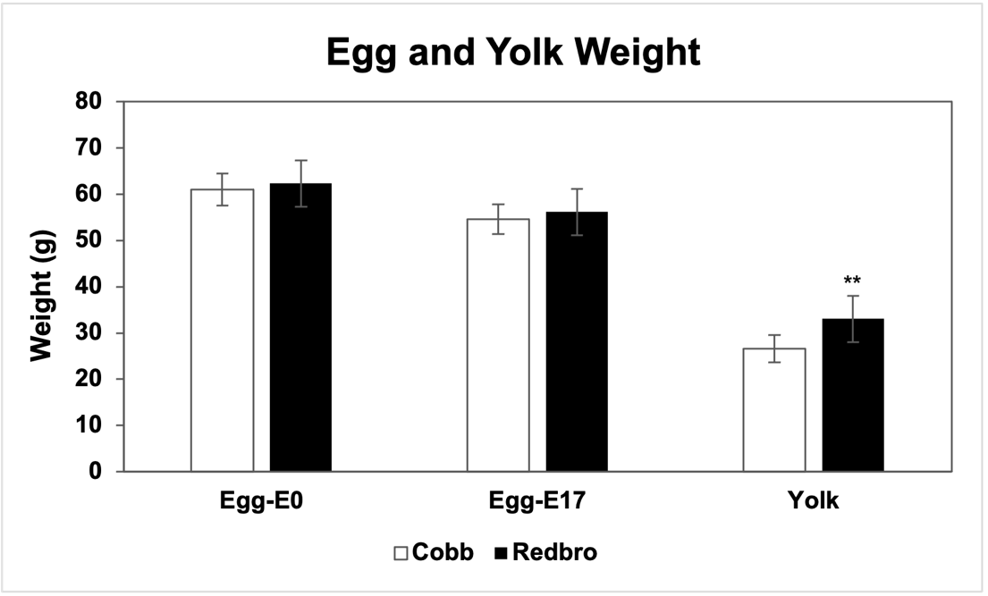
Figure 1: Developmental changes in egg and yolk weight.
Comparison of starting egg weight and egg and yolk weight at embryonic day 17 (E17) between conventional (Cobb) and slow-growing (Redbro) lines. Avg ± std. dev. *P < 0.05, **P < 0.01, by Student’s t-test; E0 (n=60), E17 (n= 9).

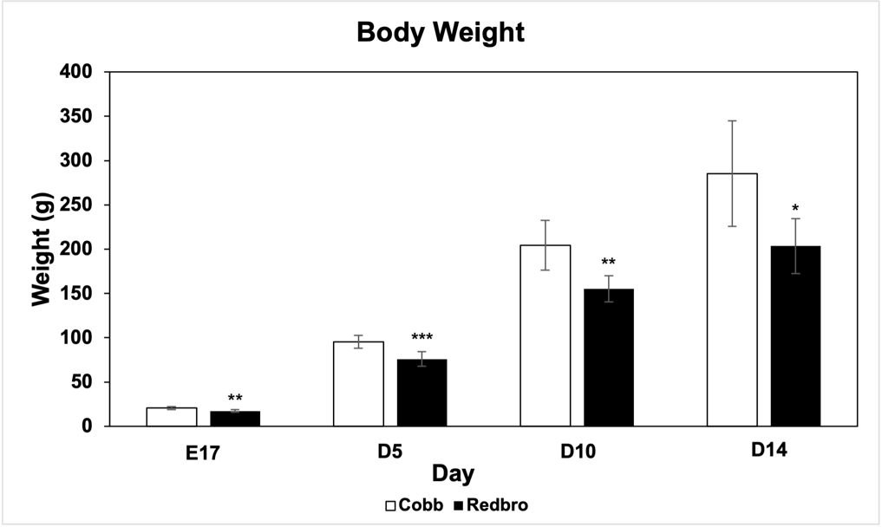
Figure 2: Developmental changes in body weight.
Comparison of body weight between conventional lines (Cobb) and slow-growing (Redbro) broiler lines at embryonic day 17 (E17), day 5 (D5), day 10 (D10), and day 14 (D14) post-hatch. Avg ± std. dev. *P < 0.05, **P < 0.01, ***P < 0.001 by Student’s t-test; E17 (n=9), D5 (n= 33 (Cobb), 27 (Redbro)), D10 (n=23 (Cobb), 16 (Redbro)), D14 (n=6).

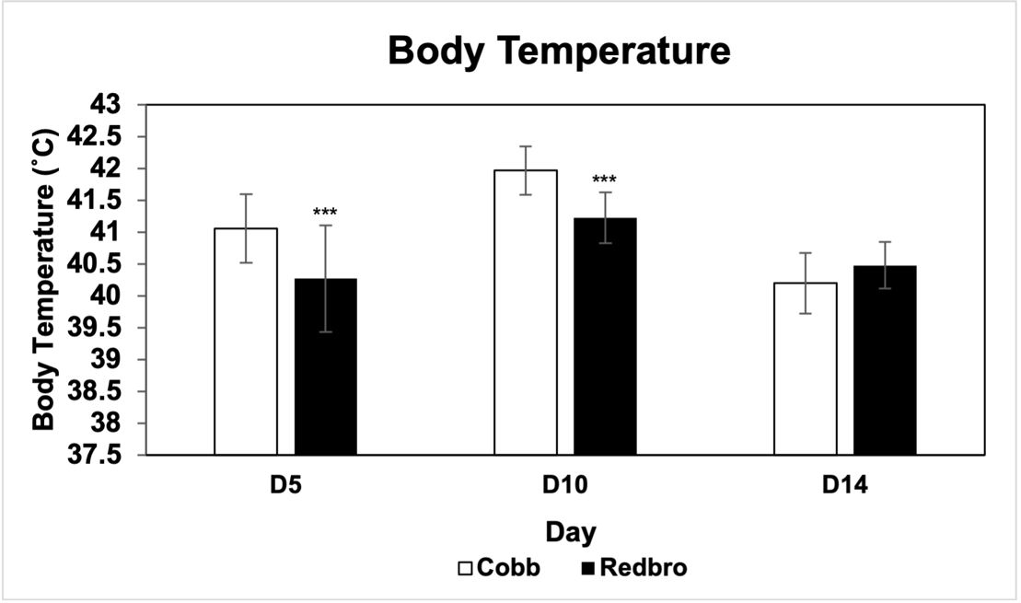

Figure 3: Developmental changes on body temperature.
Comparison of rectal body temperature on post-hatch sampling days (D5, D10, and D14) between conventional (Cobb) and slow-growing (Redbro) broiler lines. Core temperatures were taken using a rectal thermometer. Avg ± std. dev. *P < 0.05, **P < 0.01, ***P < 0.001 by Student’s t-test; D5 (n= 23 (Cobb), 17 (Redbro)), D10 (n= 23 (Cobb), 16 (Redbro)), D14 (n=6).

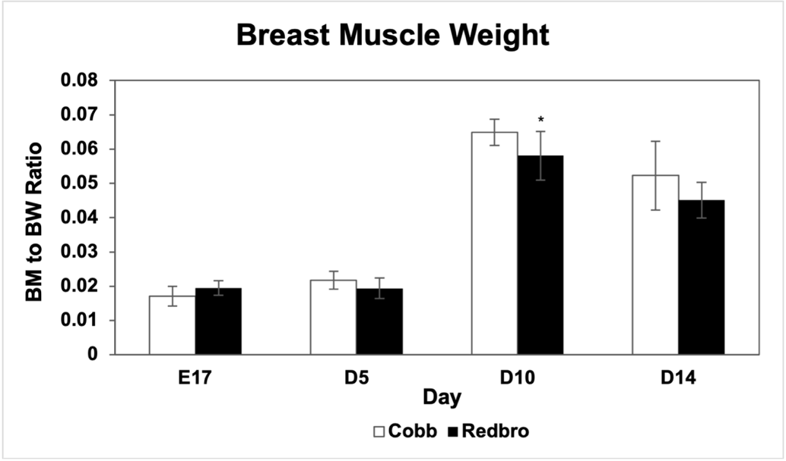
Figure 4: Developmental changes in breast muscle weight.
Comparison of breast muscle (BM) weight relative to body weight (BW) at embryonic day 17 (E17) and 3 post-hatch sampling days (D5, D10, and D14). The pectoralis major was dissected, weighed, and normalized to body weight. Avg ± std. dev. *P < 0.05, by Student’s t-test; E17 (n=9), D5 (n=10), D10 (n=10), D14 (n=6).

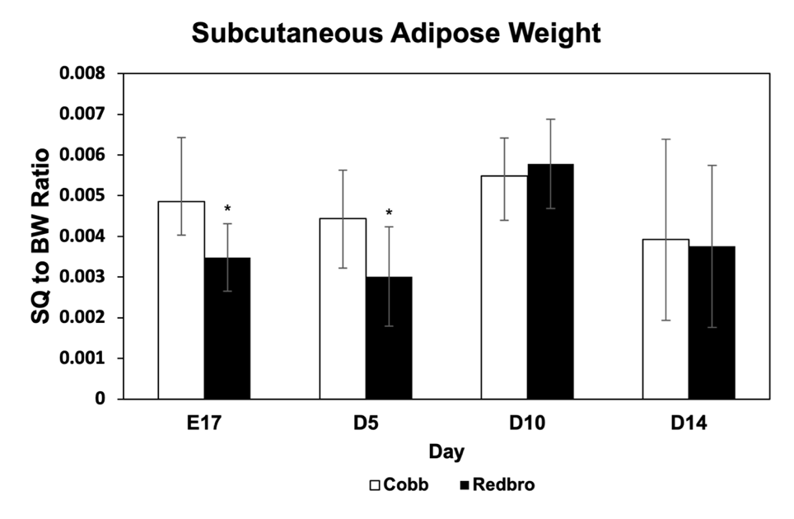
Figure 5: Developmental changes in subcutaneous adipose weight.
Comparison of subcutaneous (SQ) adipose weight relative to body weight (BW) in a conventional broiler line (Cobb) and a slow-growing broilers line (Redbro) at embryonic day 17 (E17) and 3 post-hatch sampling days (D5, D10, and D14). The subcutaneous fat pads were dissected, weighed, and normalized to body weight. Avg ± std. dev. *P < 0.05, by Student’s t-test; E17 (n=9), D5 (n=10), D10 (n=10), D14 (n=6).

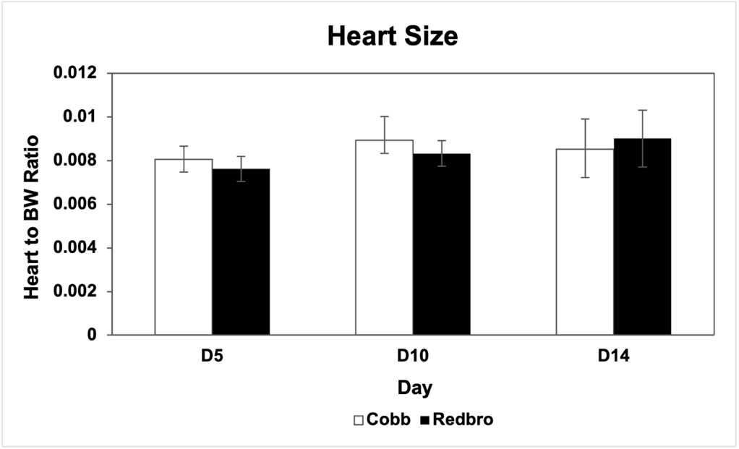
Figure 6: Developmental changes in heart size.
Comparison of heart weight relative to body weight (BW) in a conventional broiler line (Cobb) and a slow-growing broilers line (Redbro) at 3 post-hatch sampling days (D5, D10, and D14). The heart was dissected, weighed, and normalized to body weight. Avg ± std. dev.; D5 (n=10), D10 (n=10), D14 (n=6).

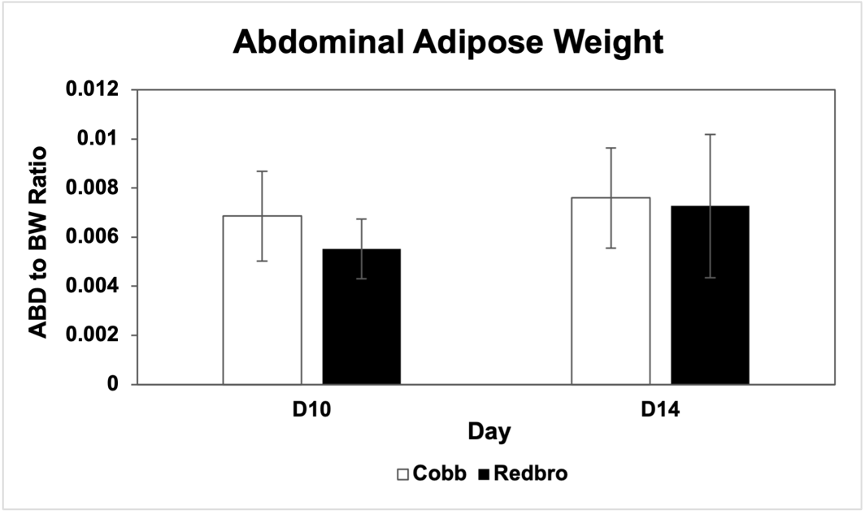
Figure 7: Developmental changes in abdominal adipose tissue.
Comparison of abdominal adipose weight relative to body weight (BW) in a conventional broiler line (Cobb) and a slow-growing broilers line (Redbro) at 2 post-hatch sampling days (D5 and D10). The abdominal fat pad was dissected, weighed, and normalized to body weight. Avg ± std. dev.; D10 (n=10), D14 (n=6).

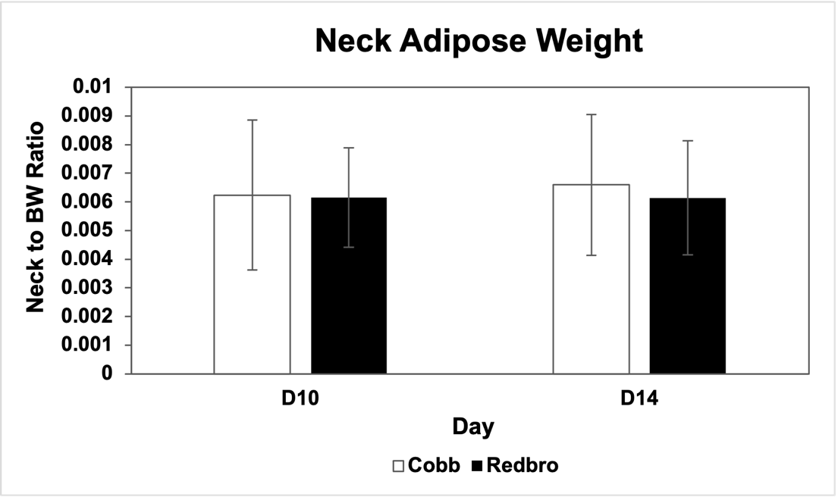
Figure 8: Developmental changes in neck adipose tissue.
Comparison of neck adipose weight relative to body weight (BW) in a conventional broiler line (Cobb) and a slow-growing broilers line (Redbro) at 2 post-hatch sampling days (D5 and D10). The neck fat pad was dissected, weighed, and normalized to body weight. Avg ± std. dev.; D10 (n=10), D14 (n=6).

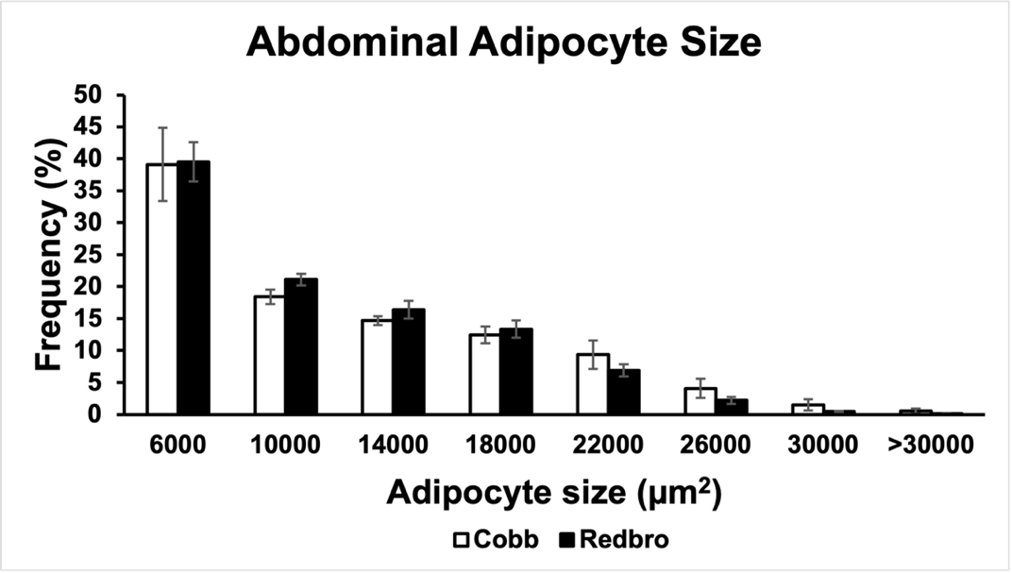
Figure 9: Frequency distribution of abdominal adipocyte size.
Comparison of the frequency distribution of post-hatch sampling day 10 (D10) abdominal adipocyte size between conventional (Cobb) and slow-growing (Redbro) broiler lines. Values are expressed as mean ± SEM (n = 5).

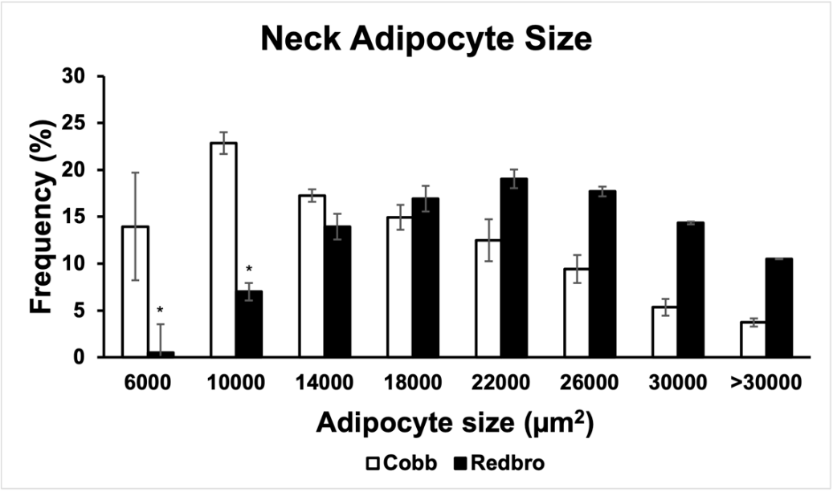
Figure 10: Frequency distribution of neck adipocyte size.
Comparison of the frequency distribution of post-hatch sampling day 10 (D10) neck adipocyte size between conventional (Cobb) and slow-growing (Redbro) broiler lines. Values are expressed as mean ± SEM (n = 5). *P < 0.05, by Student’s t-test.

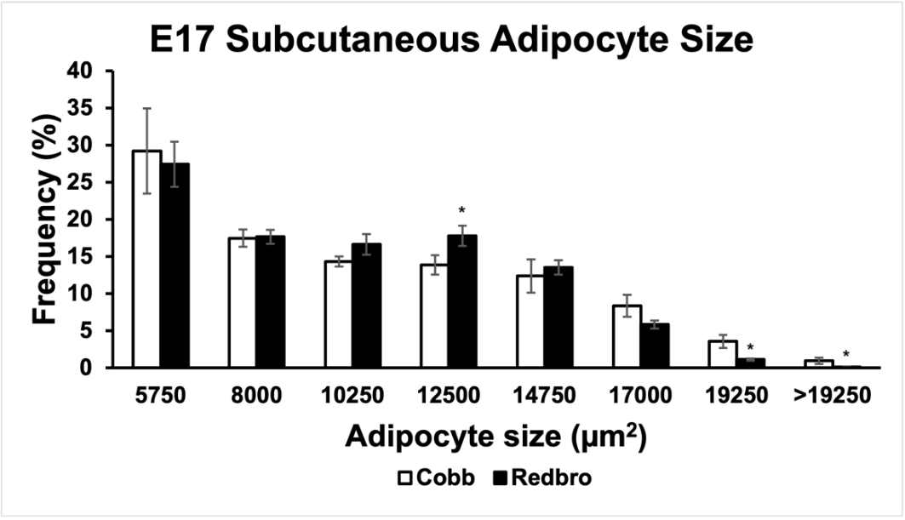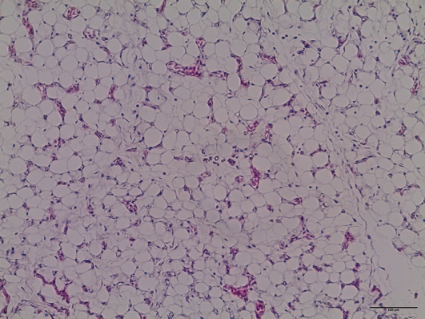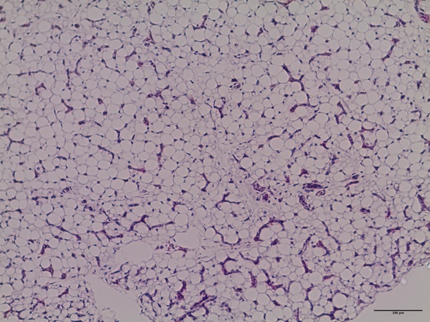
Figure 11: Embryonic day 17 subcutaneous adipocyte size.
Comparison of the frequency distribution of embryonic day 17 (E17) subcutaneous adipocyte size between conventional (Cobb) and slow-growing (Redbro) broiler lines (top). Values are expressed as mean ± SEM (n = 5). *P < 0.05, by Student’s t-test. H&E-stained cross section of Cobb E17 adipose tissue depot (left) and Redbro E17 adipose tissue (right). Scale bar = 100 µm
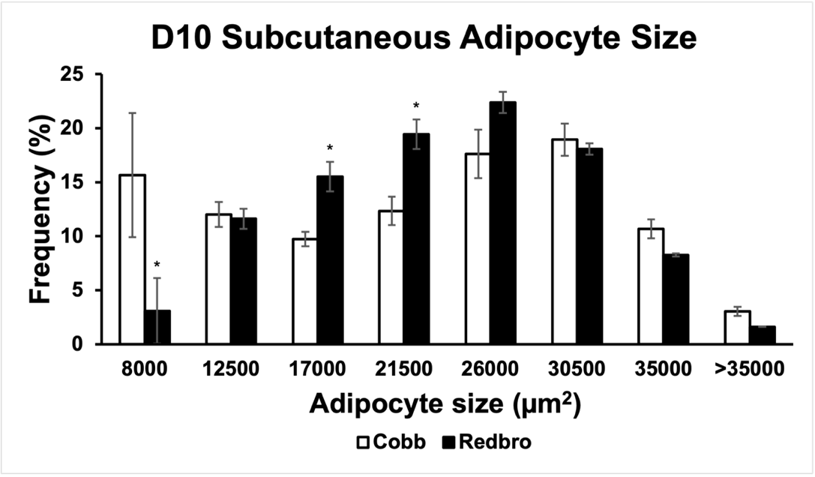
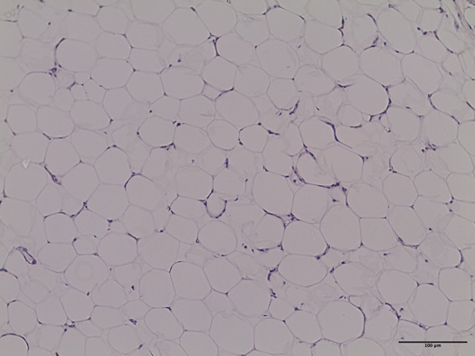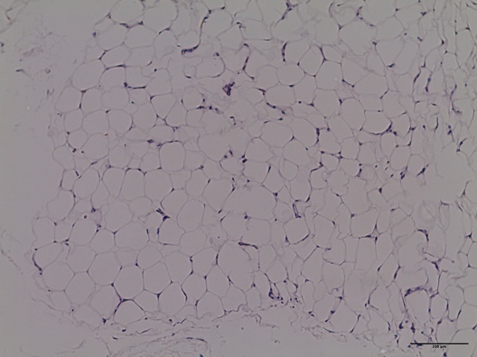
Figure 12: Post-hatch day 10 subcutaneous adipocyte size.
Comparison of the frequency distribution of post-hatch sampling day 10 (D10) subcutaneous adipocyte size between conventional (Cobb) and slow-growing (Redbro) broiler lines (top). Values are expressed as mean ± SEM (n = 5). *P < 0.05 by Student’s t-test. H&E-stained cross section of Cobb D10 adipose tissue depot (left) and Redbro D10 adipose tissue (right). Scale bar = 100 µm.

Table 1: Fatty acid composition of adipose depots.
Fatty Acid | ABD | Neck | SQ
C4:0 | 0.009 | 0.007 | 0.004
C6:0 | 0.010 | 0.013 | 0.010
C8:0 | 0.018 | 0.018 | 0.011
C10:0 | 0.039 | 0.037 | 0.032
C11:0 | 0.003 | 0.002 | 0.002
C12:0 | 0.096 | 0.102 | 0.105
C13:0 | 0.004 | 0.004 | 0.005
C14:1 (n-5) | 0.275 | 0.256 | 0.251
C14:0 | 1.246 | 1.346 | 1.362
C15:1 (n-5) | 0.013 | 0.013 | 0.013
C15:0 | 0.102 | 0.106 | 0.098
C16:1 (n-7) | 8.203 | 8.053 | 7.811
C16:0 | 39.524 | 38.599 | 38.106
C17:1 (n-7) | 0.074 | 0.070 | 0.071
C17:0 | 0.107 | 0.117 | 0.117
C18:3 (n-6) | 0.120 | 0.112 | 0.118
C18:3 (n-3) | 0.720 | 0.804 | 0.862
C18:2 (n-6) | 9.796 | 11.029 | 11.543
C18:1 (n-9) | 27.218 | 28.977 | 28.792
C18:0 | 10.274 | 9.101 | 9.028
C20:5 (n-3) | 0.053 | 0.022 | 0.026
C20:4 (n-6) | 1.234 | 0.598 | 0.909
C20:3 (n-6) | 0.205 | 0.094 | 0.130
C20:3 (n-3) | 0.069 | 0.038 | 0.044
C20:2 (n-6) | 0.081 | 0.062 | 0.078
C20:1 (n-9) | 0.217 | 0.221 | 0.223
C20:0 | 0.100 | 0.085 | 0.082
C21:0 | 0.005 | 0.005 | 0.004
C22:6 (n-3) | 0.029 | 0.016 | 0.026
C22:5 (n-3) | 0.058 | 0.023 | 0.038
C22:5 (n-6) | 0.033 | 0.019 | 0.032
C22:2 (n-6) | 0.003 | 0.002 | 0.002
C22:1 (n-9) | 0.018 | 0.012 | 0.015
C22:0 | 0.033 | 0.028 | 0.035
C23:0 | 0.003 | 0.003 | 0.004
C24:1 (n-9) | 0.005 | 0.003 | 0.007
C24:0 | 0.003 | 0.003 | 0.006
Comparison of the average fatty acid composition in each D10 abdominal (ABD), neck, and subcutaneous (SQ) adipose tissue depot samples. Values are expressed as relative percentage of the total fatty acid methyl ester measured in each sample (n=12).
Table 2: Genetic line differences of fatty acid composition of developing adipose tissue depots.
 | ABD |  |  | Neck |  |  | SQ
Fatty Acid | Cobb | Redbro | P-value | Cobb | Redbro | P-value | Cobb | Redbro | P-value
C4:0 | 0.008 ± 0.00009 | 0.011 ± 0.00009 | 0.536 | 0.005 ± 0.00003 | 0.010 ± 0.00004 | 0.050* | 0.004 ± 0.00001 | 0.004 ± 0.00005 | 0.947
C6:0 | 0.010 ± 0.00006 | 0.011 ± 0.00005 | 0.746 | 0.009 ± 0.00007 | 0.016 ± 0.0001 | 0.266 | 0.008 ± 0.00003 | 0.012 ± 0.0002 | 0.632
C8:0 | 0.024 ± 0.00007 | 0.013 ± 0.00004 | 0.016* | 0.016 ± 0.00004 | 0.019 ± 0.00006 | 0.325 | 0.011 ± 0.00002 | 0.011 ± 0.00009 | 0.938
C10:0 | 0.045 ± 0.00008 | 0.033 ± 0.00008 | 0.025* | 0.038 ± 0.00003 | 0.036 ± 0.00005 | 0.280 | 0.034 ± 0.00005 | 0.030 ± 0.00007 | 0.249
C11:0 | 0.002 ± 0.000004 | 0.003 ± 0.000004 | 0.021* | 0.002 ± 0.000005 | 0.002 ± 0.000006 | 0.366 | 0.002 ± 0.000004 | 0.003 ± 0.000003 | 0.496
C12:0 | 0.105 ± 0.00009 | 0.086 ± 0.0001 | 0.009* | 0.102 ± 0.00010 | 0.101 ± 0.0001 | 0.962 | 0.107 ± 0.0001 | 0.103 ± 0.0001 | 0.565
C13:0 | 0.004 ± 0.000008 | 0.004 ± 0.000007 | 0.487 | 0.004 ± 0.000005 | 0.005 ± 0.000006 | 0.011* | 0.004 ± 0.000006 | 0.005 ± 0.000005 | 0.013*
C14:1 (n-5) | 0.316 ± 0.0003 | 0.234 ± 0.0005 | 0.007* | 0.257 ± 0.0003 | 0.255 ± 0.0005 | 0.948 | 0.247 ± 0.0003 | 0.256 ± 0.0007 | 0.767
C14:0 | 1.399 ± 0.001 | 1.092 ± 0.002 | 0.007* | 1.386 ± 0.002 | 1.307 ± 0.003 | 0.538 | 1.395 ± 0.0009 | 1.330 ± 0.001 | 0.347
C15:1 (n-5) | 0.013 ± 0.00002 | 0.013 ± 0.00003 | 0.727 | 0.011 ± 0.00002 | 0.014 ± 0.00002 | 0.011* | 0.012 ± 0.00001 | 0.013 ± 0.00002 | 0.235
C15:0 | 0.106 ± 0.0001 | 0.097 ± 0.0002 | 0.345 | 0.101 ± 0.00008 | 0.111 ± 0.0002 | 0.230 | 0.100 ± 0.00008 | 0.096 ± 0.0001 | 0.545
C16:1 (n-7) | 8.870 ± 0.010 | 7.535 ± 0.017 | 0.129 | 8.462 ± 0.011 | 7.644 ± 0.014 | 0.287 | 8.096 ± 0.010 | 7.525 ± 0.012 | 0.390
C16:0 | 39.857 ± 0.017 | 39.191 ± 0.028 | 0.624 | 38.036 ± 0.022 | 39.163 ± 0.019 | 0.368 | 36.763 ± 0.019 | 39.448 ± 0.028 | 0.081
C17:1 (n-7) | 0.074 ± 0.00008 | 0.074 ± 0.00009 | 0.989 | 0.070 ± 0.00008 | 0.071 ± 0.00005 | 0.711 | 0.070 ± 0.00007 | 0.072 ± 0.00005 | 0.641
C17:0 | 0.103 ± 0.0001 | 0.111 ± 0.0001 | 0.363 | 0.110 ± 0.0002 | 0.125 ± 0.0001 | 0.116 | 0.118 ± 0.0001 | 0.115 ± 0.0001 | 0.741
C18:3 (n-6) | 0.122 ± 0.0001 | 0.118 ± 0.00008 | 0.636 | 0.115 ± 0.00006 | 0.108 ± 0.0001 | 0.192 | 0.127 ± 0.0002 | 0.109 ± 0.00005 | 0.020*
C18:3 (n-3) | 0.786 ± 0.001 | 0.653 ± 0.001 | 0.076 | 0.800 ± 0.001 | 0.808 ± 0.0007 | 0.893 | 0.861 ± 0.0012 | 0.862 ± 0.002 | 0.992
C18:2 (n-6) | 10.077 ± 0.009 | 9.515 ± 0.006 | 0.239 | 11.215 ± 0.009 | 10.843 ± 0.011 | 0.535 | 11.550 ± 0.010 | 11.536 ± 0.007 | 0.980
C18:1 (n-9) | 27.129 ± 0.028 | 27.308 ± 0.014 | 0.891 | 29.190 ± 0.012 | 28.764 ± 0.020 | 0.661 | 29.605 ± 0.009 | 27.979 ± 0.031 | 0.242
C18:0 | 9.231 ± 0.016 | 11.317 ± 0.018 | 0.062 | 8.960 ± 0.014 | 9.242 ± 0.011 | 0.698 | 9.157 ± 0.010 | 8.899 ± 0.004 | 0.560
C20:5 (n-3) | 0.044 ± 0.0002 | 0.062 ± 0.0002 | 0.181 | 0.020 ± 0.00007 | 0.024 ± 0.00007 | 0.411 | 0.026 ± 0.0001 | 0.025 ± 0.00006 | 0.812
C20:4 (n-6) | 0.939 ± 0.004 | 1.530 ± 0.004 | 0.028* | 0.527 ± 0.002 | 0.669 ± 0.002 | 0.271 | 0.948 ± 0.005 | 0.871 ± 0.003 | 0.742
C20:3 (n-6) | 0.164 ± 0.0006 | 0.247 ± 0.0006 | 0.039* | 0.092 ± 0.0002 | 0.096 ± 0.0003 | 0.756 | 0.144 ± 0.0005 | 0.115 ± 0.0003 | 0.241
C20:3 (n-3) | 0.057 ± 0.0002 | 0.081 ± 0.0002 | 0.072 | 0.035 ± 0.00007 | 0.042 ± 0.0001 | 0.269 | 0.049 ± 0.0002 | 0.039 ± 0.00008 | 0.233
C20:2 (n-6) | 0.068 ± 0.0002 | 0.093 ± 0.0003 | 0.081 | 0.056 ± 0.00010 | 0.067 ± 0.0001 | 0.080 | 0.083 ± 0.0002 | 0.073 ± 0.0001 | 0.379
C20:1 (n-9) | 0.212 ± 0.0001 | 0.223 ± 0.0004 | 0.525 | 0.214 ± 0.0002 | 0.228 ± 0.0003 | 0.336 | 0.224 ± 0.0004 | 0.221 ± 0.0004 | 0.891
C20:0 | 0.082 ± 0.0002 | 0.118 ± 0.0002 | 0.013* | 0.074 ± 0.0002 | 0.096 ± 0.0002 | 0.070 | 0.082 ± 0.0002 | 0.081 ± 0.0001 | 0.906
C21:0 | 0.004 ± 0.00001 | 0.007 ± 0.00002 | 0.045* | 0.004 ± 0.000009 | 0.006 ± 0.00003 | 0.078 | 0.005 ± 0.00002 | 0.004 ± 0.00001 | 0.811
C22:6 (n-3) | 0.020 ± 0.0001 | 0.037 ± 0.0001 | 0.033* | 0.011 ± 0.00004 | 0.020 ± 0.0001 | 0.096 | 0.024 ± 0.0002 | 0.028 ± 0.00010 | 0.663
C22:5 (n-3) | 0.045 ± 0.0001 | 0.071 ± 0.0002 | 0.050* | 0.021 ± 0.00007 | 0.025 ± 0.0001 | 0.462 | 0.039 ± 0.0003 | 0.038 ± 0.0001 | 0.894

Table 2 continued
C22:5 (n-6) | 0.026 ± 0.00009 | 0.041 ± 0.0002 | 0.109 | 0.017 ± 0.00005 | 0.022 ± 0.0001 | 0.424 | 0.034 ± 0.0002 | 0.030 ± 0.0001 | 0.725
C22:2 (n-6) | 0.003 ± 0.000009 | 0.004 ± 0.00002 | 0.191 | 0.002 ± 0.000004 | 0.002 ± 0.000005 | 0.315 | 0.002 ± 0.000010 | 0.002 ± 0.000008 | 0.375
C22:1 (n-9) | 0.015 ± 0.00003 | 0.021 ± 0.00009 | 0.186 | 0.010 ± 0.00003 | 0.014 ± 0.00001 | 0.149 | 0.015 ± 0.00006 | 0.014 ± 0.00006 | 0.758
C22:0 | 0.030 ± 0.0001 | 0.036 ± 0.0001 | 0.341 | 0.023 ± 0.00004 | 0.034 ± 0.0001 | 0.043* | 0.035 ± 0.0002 | 0.035 ± 0.0002 | 0.962
C23:0 | 0.003 ± 0.00001 | 0.003 ± 0.000009 | 0.528 | 0.002 ± 0.000006 | 0.003 ± 0.00001 | 0.066 | 0.004 ± 0.00002 | 0.004 ± 0.00002 | 0.822
C24:1 (n-9) | 0.006 ± 0.00004 | 0.004 ± 0.000006 | 0.332 | 0.003 ± 0.000006 | 0.003 ± 0.00005 | 0.530 | 0.008 ± 0.00005 | 0.006 ± 0.00005 | 0.652
C24:0 | 0.003 ± 0.00002 | 0.002 ± 0.00001 | 0.315 | 0.002 ± 0.000004 | 0.003 ± 0.000009 | 0.049* | 0.006 ± 0.00004 | 0.006 ± 0.00004 | 0.982
∑SFA | 51.016 ± 0.028 | 52.136 ± 0.026 | 0.489 | 48.872 ± 0.023 | 50.280 ± 0.015 | 0.236 | 47.834 ± 0.016 | 50.186 ± 0.026 | 0.092
∑MUFA | 36.634 ± 0.036 | 35.412 ± 0.028 | 0.526 | 38.217 ± 0.014 | 36.995 ± 0.017 | 0.212 | 38.278 ± 0.014 | 36.078 ± 0.027 | 0.111
∑PUFA | 12.350 ± 0.012 | 12.453 ± 0.009 | 0.871 | 12.911 ± 0.009 | 12.726 ± 0.012 | 0.766 | 13.889 ± 0.014 | 13.728 ± 0.006 | 0.803
∑n-6 | 11.397 ± 0.012 | 11.548 ± 0.009 | 0.810 | 12.024 ± 0.009 | 11.807 ± 0.012 | 0.718 | 12.889 ± 0.013 | 12.735 ± 0.006 | 0.793
∑n-3 | 0.953 ± 0.0008 | 0.905 ± 0.0009 | 0.370 | 0.888 ± 0.001 | 0.919 ± 0.0005 | 0.546 | 1.000 ± 0.002 | 0.992 ± 0.002 | 0.934
∑n-6/n-3 | 12.017 ± 1.417 | 12.875 ± 1.597 | 0.348 | 13.682 ± 1.451 | 12.828 ± 1.240 | 0.315 | 12.999 ± 0.959 | 13.070 ± 1.938 | 0.938

Comparison of fatty acid composition between a conventional (Cobb) and slow-growing (Redbro) broiler line in post-hatch sampling day 10 abdominal (ABD), neck, and subcutaneous (SQ) adipose depot samples. Values are expressed as relative percentage of the total fatty acid methyl ester measured in each sample. Avg ± std. dev. * P <0.05 by Student’s t-test (n=6).
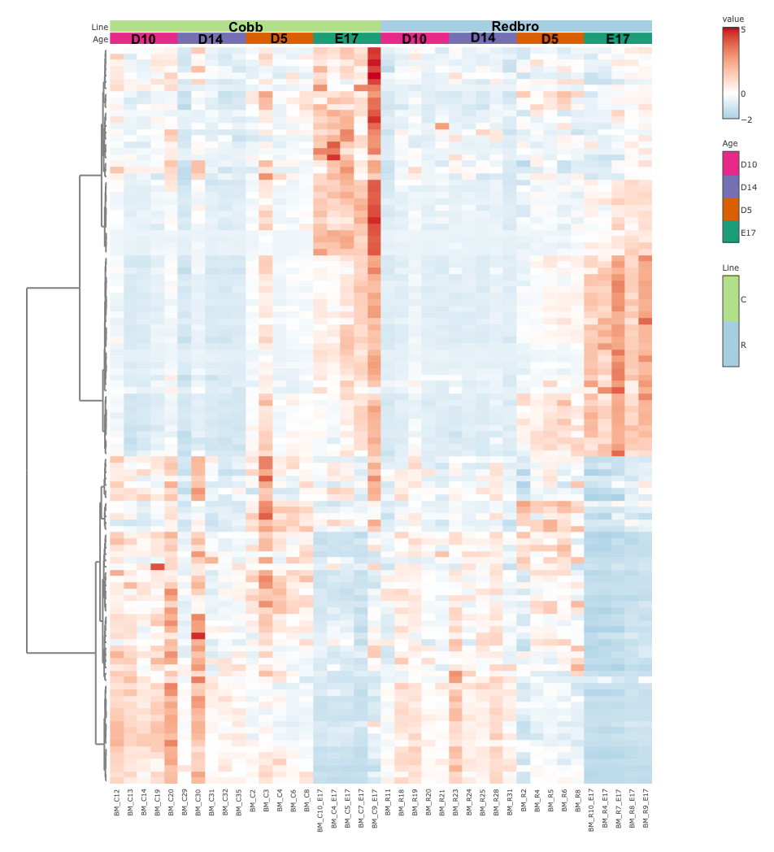
Figure 13: Line-dependent changes in gene expression of breast muscle. Heatmap of differentially expressed genes (FDR P < 0.05) using a likelihood ratio test in breast muscle (BM) samples at embryonic day 17 (E17), and post-hatch days 5 (D5), 10 (D10, and 14 (D14) from a conventional (Cobb) and slow-growing (Redbro) broiler line (n=5).

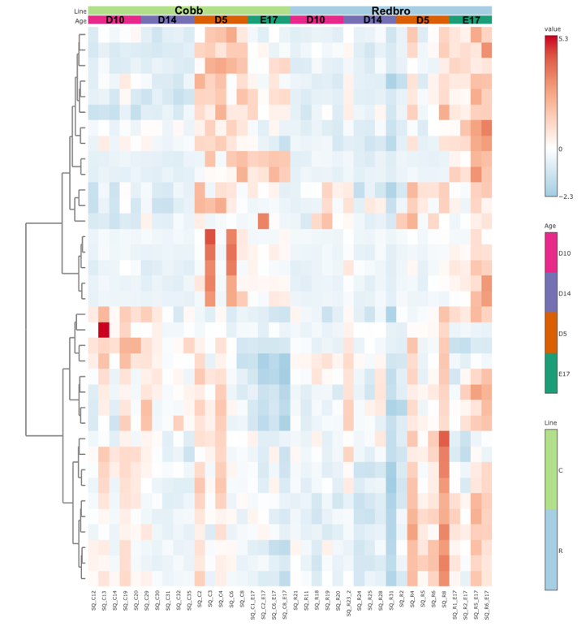
Figure 14: Line-dependent changes in gene expression of subcutaneous adipose tissue. Heatmap of differentially expressed genes (FDR P < 0.05) using a likelihood ratio test in subcutaneous (SQ) adipose samples at embryonic day 17 (E17), and post-hatch days 5 (D5), 10 (D10, and 14 (D14) from a conventional (Cobb) and slow-growing (Redbro) broiler line (n=5).

Table 3: Summary of differentially expressed genes.
Tissue | Age | Total DEGs | Higher in Redbro | Higher in Cobb
BM
 | E17 | 276 | 123 | 153
 | D5 | 1 | 1 | 0
 | D10 | 39 | 10 | 29
 | D14 | 94 | 32 | 62
SQ
 | E17 | 79 | 63 | 16
 | D5 | 32 | 11 | 21
 | D10 | 2 | 1 | 1
 | D14 | 35 | 24 | 11
ABD
 | D10 | 1 | 0 | 1
 | D14 | 2 | 0 | 2
Neck
 | D10 | 5 | 2 | 3
 | D14 | 29 | 16 | 13
Count of total number of differentially expressed genes (DEGs) in breast muscle (BM) and subcutaneous (SQ), abdominal (ABD), and neck adipose depots at embryonic day 17 (E17) and post-hatch sampling days 5 (D5), 10 (D10), and 14 (D14) between a conventional (Cobb) and slow-growing (Redbro) broiler line (n=5; FDR P < 0.05).
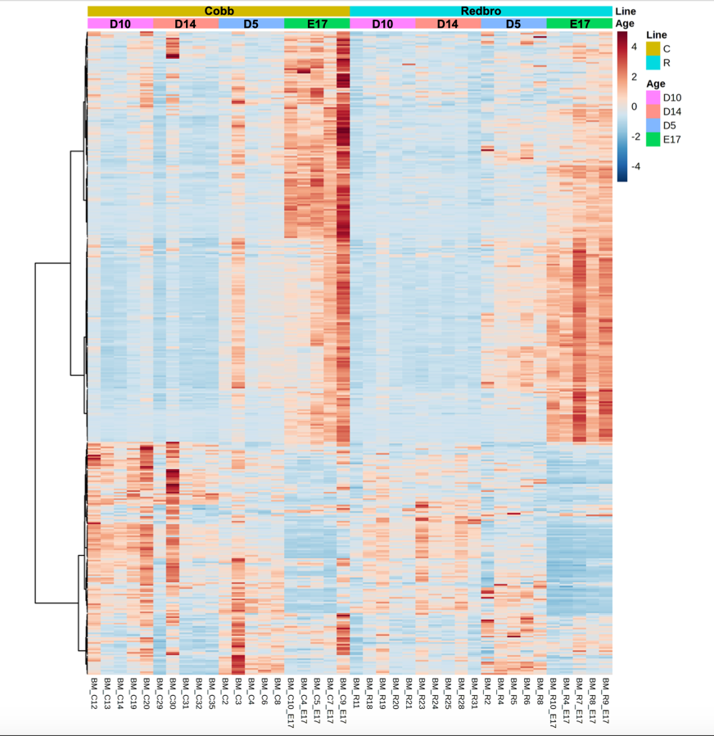
Figure 15: Differential gene expression of developing breast muscle. Heatmap of differentially expressed genes (FDR P < 0.05) in breast muscle (BM) samples at embryonic day 17 (E17), and post-hatch days 5 (D5), 10 (D10, and 14 (D14) from a conventional (Cobb) and slow-growing (Redbro) broiler line (n=5).
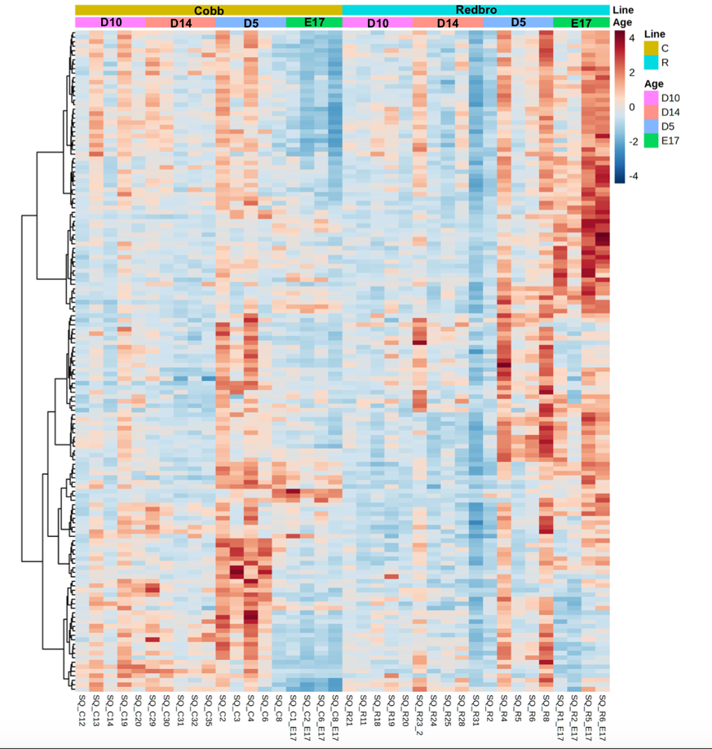
Figure 16: Differential gene expression of developing SQ adipose tissue. Heatmap of differentially expressed genes (FDR P < 0.05) in subcutaneous (SQ) adipose samples at embryonic day 17 (E17), and post-hatch days 5 (D5), 10 (D10), and 14 (D14) from a conventional (Cobb) and slow-growing (Redbro) broiler line (n=5).

Table 4: Enriched pathways across tissue and age according to DAVID.
Tissue | Age | Pathway | Number of Genes | FDR P-value
BM | E17 | Cell Division/Cell Cycle  Microtubule Binding  Focal Adhesion | 58  23  14 | 5.3x10⁻¹⁸  1.6x10⁻⁵  4.8x10⁻²
SQ | E17 | Protein/Peptide Transport  Nucleus  Mitosis/Cell Division | 27  54  8 | 3.8x10⁻²  9.1x10⁻⁴  8.3x10⁻²
SQ | D5 | Mitosis/Cell Division  Cytoskeleton & Microtubule Binding  Protein Ubiquitination | 16  18  7 | 1.8x10⁻¹¹  7.7x10⁻⁶  4.9x10⁻²
BM* | D10 | Actin Binding | 6 | 3.8x10⁻²
Pathway enrichment using differentially expressed genes (FDR P < 0.1) from breast muscle (BM) and the subcutaneous (SQ) adipose depot at embryonic day 17 (E17) and post-hatch sampling days 5 (D5) and 10 (D10). Abdominal and neck adipose depot not included due to lack of significantly enriched pathways. *Not enough DEGs for multiple pathways of enrichment.

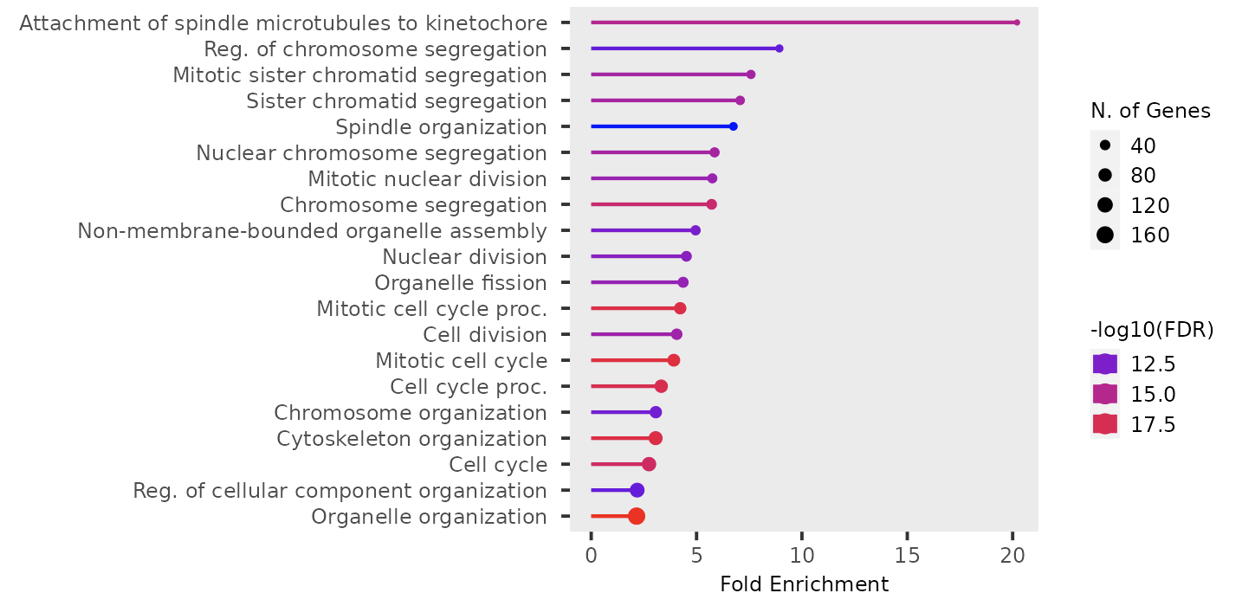
Figure 17: ShinyGO pathway enrichment of embryonic breast muscle. Gene ontology pathway enrichment using differentially expressed genes (FDR P < 0.1) from embryonic day 17 (E17) breast muscle (BM) of conventional (Cobb) and slow-growing (Redbro) broiler lines (n=5).

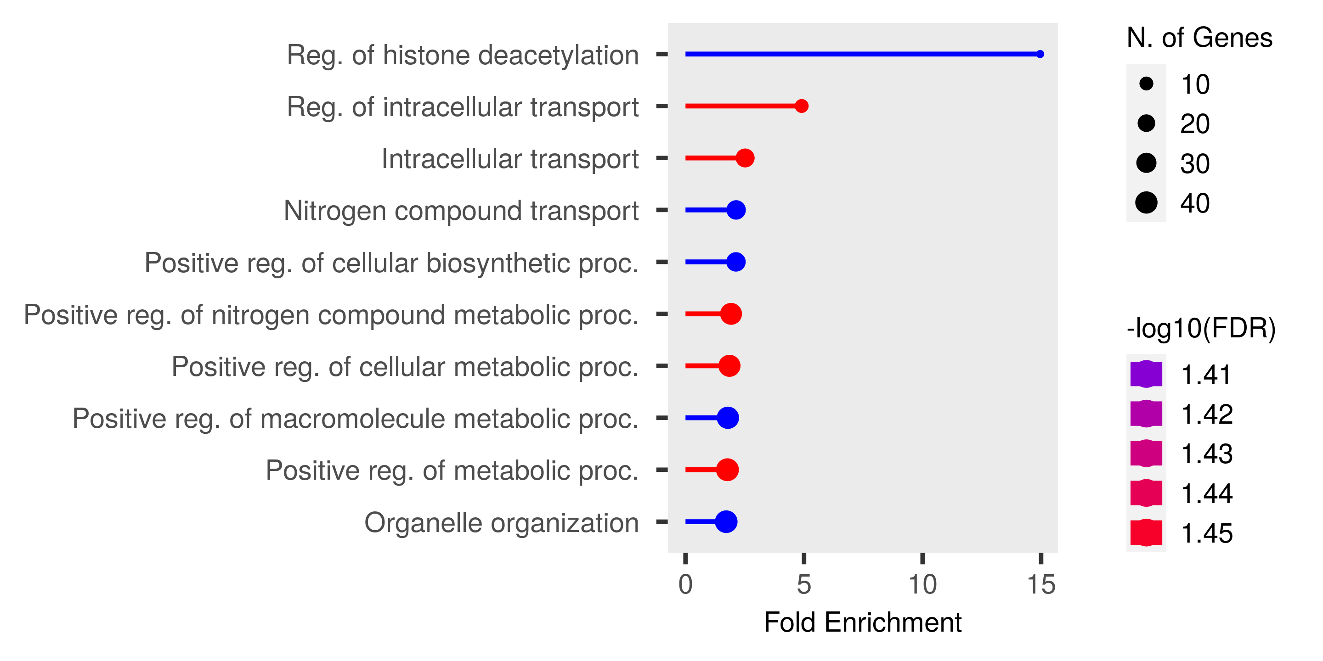
Figure 18: ShinyGO pathway enrichment of embryonic subcutaneous adipose tissue. Gene ontology pathway enrichment using differentially expressed genes (FDR P < 0.1) from embryonic day 17 (E17) subcutaneous (SQ) adipose tissue of conventional (Cobb) and slow-growing (Redbro) broiler lines (n=5).

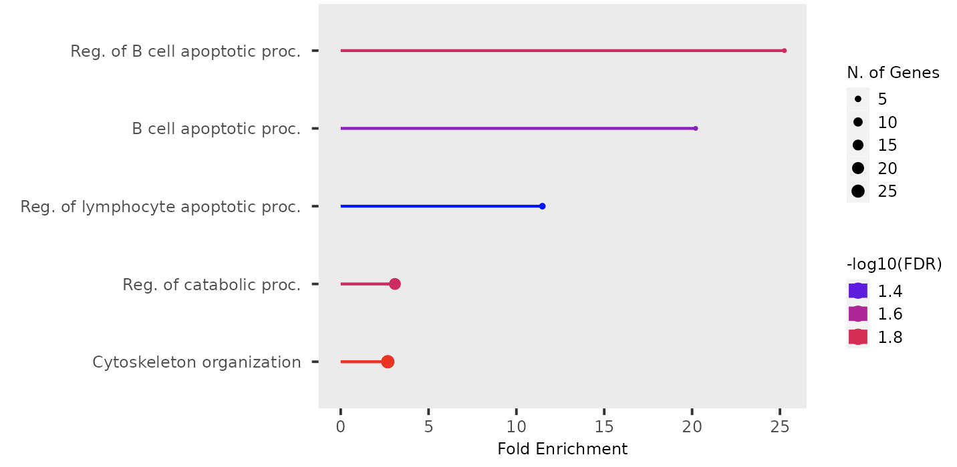
Figure 19: ShinyGO pathway enrichment of post-hatch breast muscle. Gene ontology pathway enrichment using differentially expressed genes (FDR P < 0.1) from post-hatch day 14 (D14) breast muscle (BM) of conventional (Cobb) and slow-growing (Redbro) broiler lines (n=5).

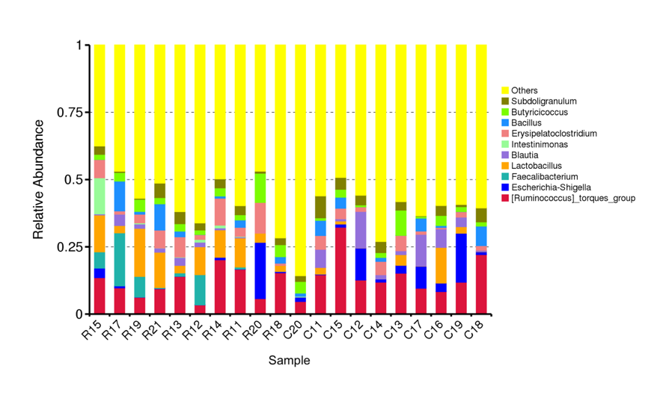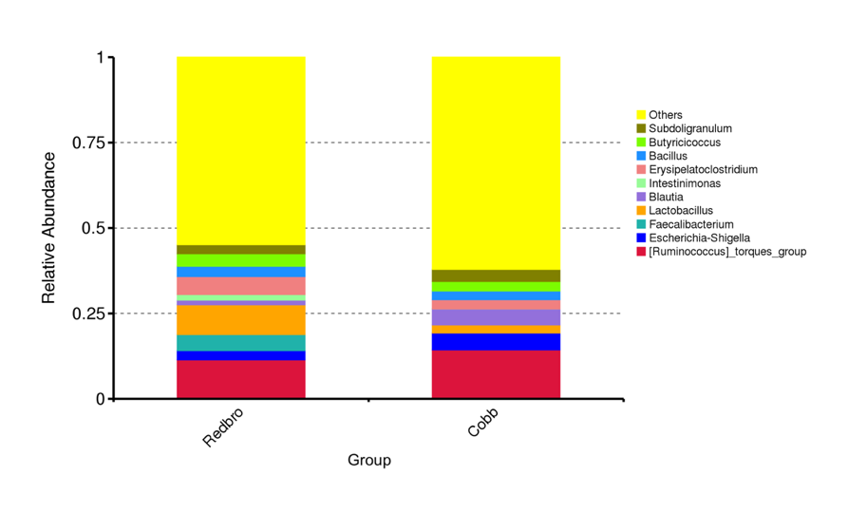

Figure 20: Top 10 genera of the cecal bacterial communities. Differences in the top 10 genera of the bacterial communities from the cecum of 10-day old chicks from a conventional (Cobb) and slow-growing (Redbro) broiler line (n=10). Differences in each sample (top) and in each chick line (bottom) are shown.

Table 5: Alpha-diversity indices of cecum samples.

Sample | observed_features | chao1 | simpson | shannon | pielou_e | dominance | goods_coverage
R15 | 211 | 215.231 | 0.937 | 5.020 | 0.650 | 0.063 | 1.000
R17 | 229 | 230.000 | 0.962 | 5.601 | 0.714 | 0.038 | 1.000
R19 | 231 | 231.083 | 0.952 | 5.752 | 0.733 | 0.048 | 1.000
R21 | 249 | 251.000 | 0.959 | 5.750 | 0.722 | 0.041 | 1.000
R13 | 325 | 328.000 | 0.970 | 5.988 | 0.718 | 0.030 | 1.000
R12 | 259 | 260.071 | 0.961 | 5.704 | 0.712 | 0.039 | 1.000
R14 | 166 | 167.071 | 0.882 | 4.251 | 0.576 | 0.118 | 1.000
R11 | 237 | 240.235 | 0.961 | 5.719 | 0.725 | 0.039 | 1.000
R20 | 89 | 92.000 | 0.923 | 4.423 | 0.683 | 0.077 | 1.000
R18 | 161 | 166.250 | 0.958 | 5.289 | 0.721 | 0.042 | 1.000
C20 | 98 | 98.750 | 0.819 | 3.960 | 0.599 | 0.181 | 1.000
C11 | 231 | 236.000 | 0.975 | 6.052 | 0.771 | 0.025 | 1.000
C15 | 169 | 169.250 | 0.948 | 5.461 | 0.738 | 0.052 | 1.000
C12 | 117 | 124.500 | 0.915 | 4.399 | 0.640 | 0.085 | 1.000
C14 | 198 | 198.909 | 0.963 | 5.635 | 0.739 | 0.037 | 1.000
C13 | 173 | 173.000 | 0.963 | 5.514 | 0.742 | 0.037 | 1.000
C17 | 244 | 248.000 | 0.963 | 5.741 | 0.724 | 0.037 | 1.000
C16 | 188 | 189.667 | 0.961 | 5.589 | 0.740 | 0.039 | 1.000
C19 | 151 | 152.429 | 0.953 | 5.361 | 0.741 | 0.047 | 1.000
C18 | 168 | 173.000 | 0.947 | 5.356 | 0.725 | 0.053 | 1.000

α-diversity indices for each bacterial community sample from the cecum of 10-day old chicks as a measure of diversity (n=10) in a conventional (Cobb) and slow-growing (Redbro) broiler line.

Table 6: Alpha-diversity indices for each chick line.
Group | observed_features | chao1 | simpson | shannon | pielou_e | dominance | goods_coverage
Redbro | 824 | 847.361 | 0.978 | 6.532 | 0.674 | 0.022 | 1.000
Cobb | 650 | 663.904 | 0.980 | 6.455 | 0.691 | 0.020 | 1.000

α-diversity indices for a conventional (Cobb) and slow-growing (Redbro) broiler line as a measure of diversity of the bacterial communities from the cecum of 10-day old chicks (n=10).

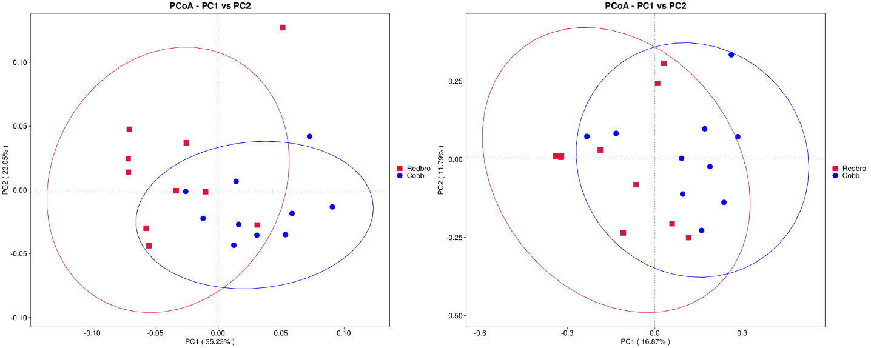
Figure 21: β-diversity of the cecal bacterial communities between chick genetic lines. PCoA plot based on Weighted Unifrac distance (left) and Unweighted Unifrac distance (right) of the β-diversity between the bacterial communities from the cecum of 10-day old chicks from a conventional (Cobb) and slow-growing (Redbro) broiler line (n=10).

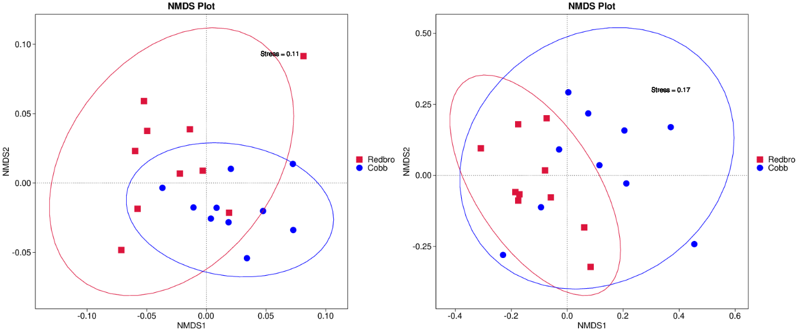
Figure 22: β-diversity between genetic lines measured by NMDS. NMDS plot representing the non-linear model for β-diversity of the bacterial communities from the cecum of 10-day old chicks between a conventional (Cobb) and slow-growing (Redbro) line of broiler chickens. The Weighted Unifrac distance is represented on the left and Unweighted Unifrac distance is represented on the right (n=10).

Table 7: Analysis of similarity between the cecal bacterial communities.
Group | R-value | P-value
Redbro-Cobb | 0.49067 | 0.001
Evaluation of inter- and inner-group variation of the bacterial communities from the cecum of 10-day old chicks from a conventional (Cobb) and slow-growing (Redbro) line of broiler chicks. A positive R-value represents significant inter-group variation.

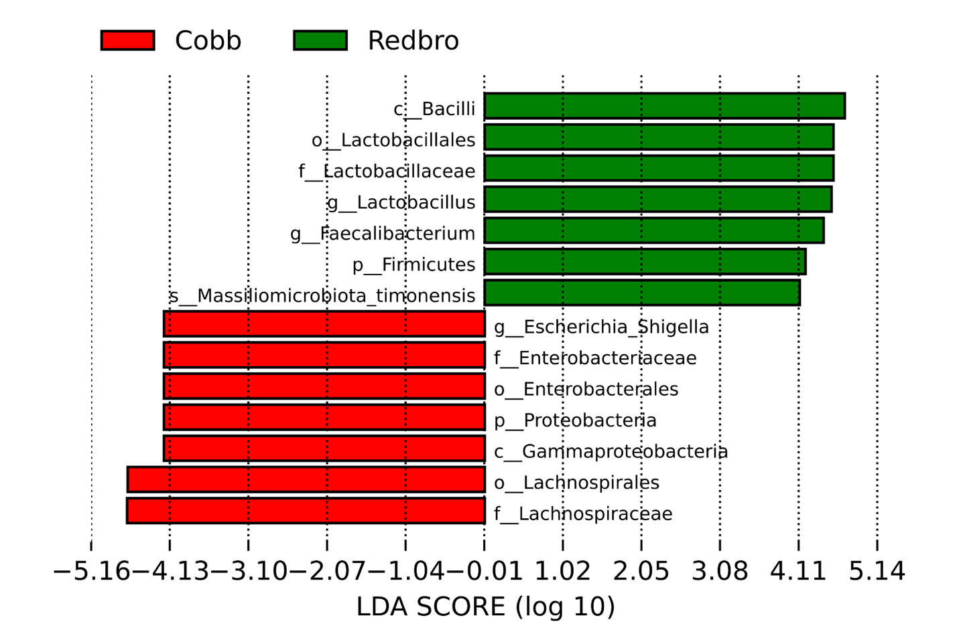
Figure 23: Differences in bacterial taxa between genetic lines by LEfSe analysis. Taxonomic differences in the bacterial communities from the cecum of 10d old chicks from a conventional (Cobb) and slow-growing (Redbro) broiler line using a linear discriminant (LDA) effect size (LEfSe).

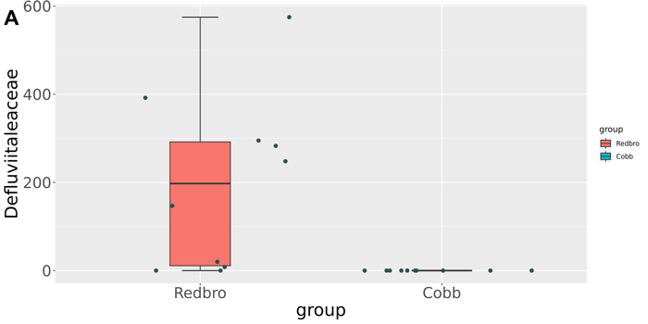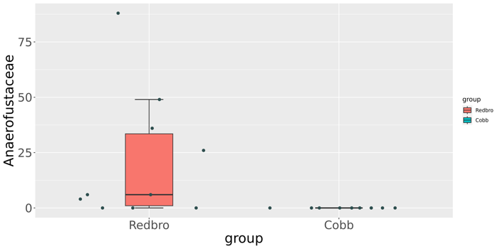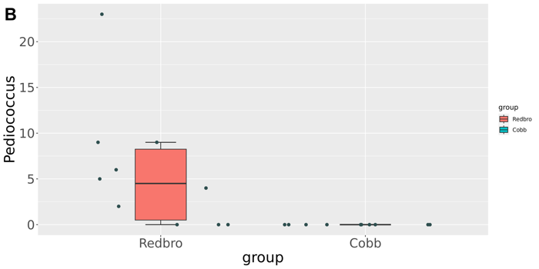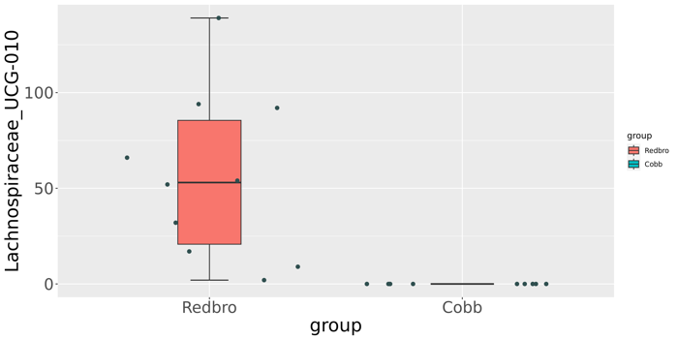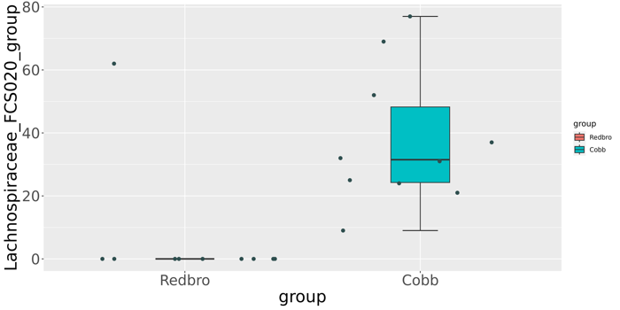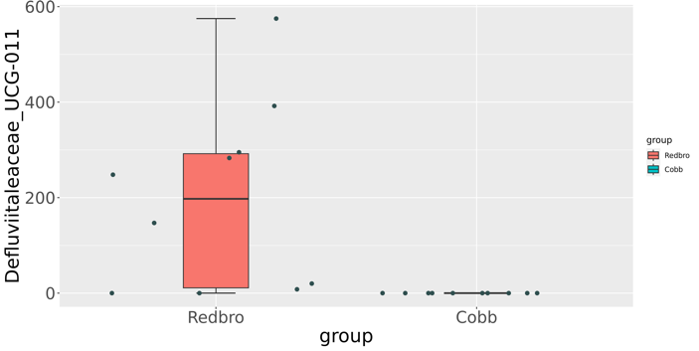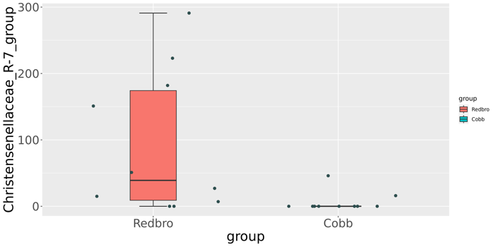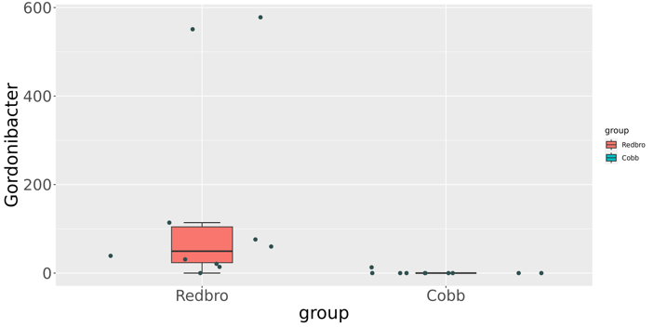
Figure 24: MetagenomeSeq analysis of differences in bacterial community taxa. Taxonomic differences of the bacterial communities in the cecum of 10d old chicks from a conventional (Cobb) and slow-growing (Redbro) line of broiler chicks (n=10). A) Familial differences between the two genetic lines. B) Genera differences between the genetic lines (P < 0.05).
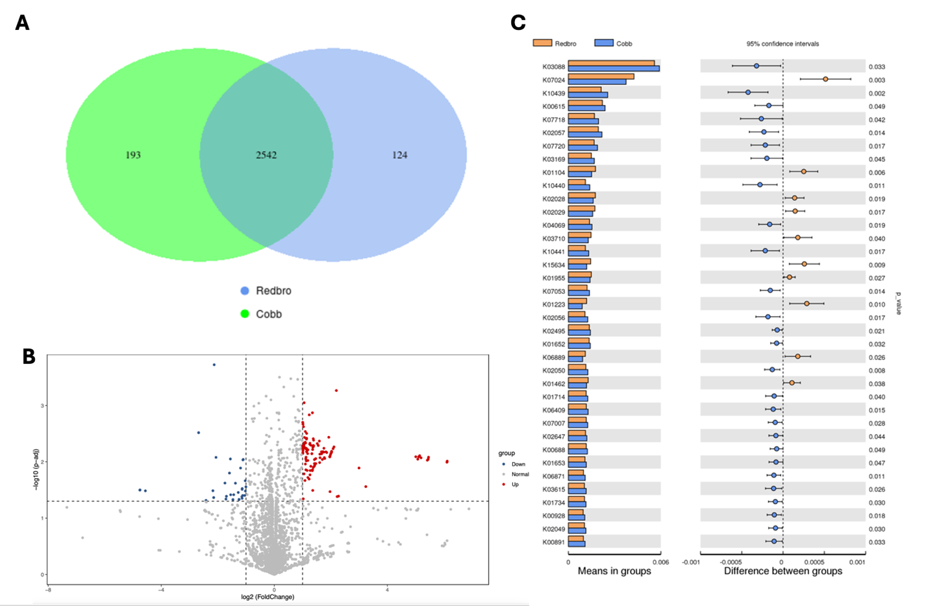
Figure 25: Pathway enrichment from bacterial communities present in the cecum. Enriched pathways from differential abundance of bacterial communities present in the cecum of 10d old chicks from a conventional (Cobb) and slow-growing (Redbro) broiler line. A) Venn diagram representing functions unique to each genetic line. B) Volcano map depicting up and down regulated functions. C) T-test of the KEGG functional differences between the genetic lines.

CHAPTER 3 CONCLUSION

Over the years, the modern broiler chicken has become incredibly efficient in terms of both feed efficiency and growth of the breast muscle. Along with this efficiency, there has been a rise in breast muscle myopathies, overaccumulation of adipose tissue, and other health and welfare consequences. With the growing consumer concern over meat quality and welfare, there has been a push towards slower growing broiler chickens that have enhanced welfare, meat quality, and overall health. These slow-growing lines provide the opportunity to study pathways related to muscle and adipose growth and development in post-hatch broilers as they have been differentially selected for growth as well as numerous traits other than growth. This study used a conventional line of broiler chickens, Cobb 700, and a slow-growing line, Hubbard Redbro, to determine differences found in phenotypic traits, genetic pathways, fatty acids present in the adipose tissue, and bacterial communities in the cecum. We identified notable differences in yolk utilization, adipose tissue weight and adipocyte size, DEGs and their associated pathways in both SQ adipose tissue and BM, and bacterial communities. These findings suggest that there are differences present in the two genetic lines and may underline growth and development of adipose tissue and breast muscle in broiler chickens. Further research is required to more specifically determine how these differences may be impacting growth and development in broiler chickens as well as other livestock species.

REFERENCES
Baldi, G., et al. (2021). "Spaghetti Meat Abnormality in Broilers: Current Understanding and Future Research Directions." Front Physiol 12: 684497.
Baxter, M., et al. (2021). "A comparison of fast growing broiler chickens with a slower-growing breed type reared on Higher Welfare commercial farms." PLoS One 16(11): e0259333.
Beckford, R. C., et al. (2017). "Maternal consumption of fish oil programs reduced adiposity in broiler chicks." Sci Rep 7(1): 13129.
Bensadoun, A. and A. Rothfeld (1972). "The Form of Absorption of Lipids in the Chicken, Gallus domesticus." Proceedings of the Society for Experimental Biology and Medicine 141(3): 814-817.
Better Chicken Commitment (2023). "The Policy." from https://betterchickencommitment.com/us/policy/.
Blazejczyk, A. and L. Kantor (2023). Food Availablility and Comsumption. U. S. D. o. A. E. R. Service. Amber Waves.
Buckingham, M. (1994). "Muscle differentiation. Which myogenic factors make muscle?" Curr Biol 4(1): 61-63.
Burridge, K. and M. Chrzanowska-Wodnicka (1996). "Focal adhesions, contractility, and signaling." Annu Rev Cell Dev Biol 12: 463-518.
Buyse, J. and E. Decuypere (2015). Chapter 19 - Adipose Tissue and Lipid Metabolism. Sturkie's Avian Physiology (Sixth Edition). C. G. Scanes. San Diego, Academic Press: 443-453.
Cahaner, A. and Z. Nitsan (1985). "Evaluation of simultaneous selection for live body weight and against abdominal fat in broilers." Poult Sci 64(7): 1257-1263.
Callahan, B. J., et al. (2017). "Exact sequence variants should replace operational taxonomic units in marker-gene data analysis." The ISME Journal 11(12): 2639-2643.
Cartwright, A. L. (1991). "Adipose cellularity in Gallus domesticus: investigations to control body composition in growing chickens." J Nutr 121(9): 1486-1497.
Chen, P., et al. (2014). "Developmental regulation of adipose tissue growth through hyperplasia and hypertrophy in the embryonic Leghorn and broiler." Poultry Science 93(7): 1809-1817.
Damgaard, R. B. (2021). "The ubiquitin system: from cell signalling to disease biology and new therapeutic opportunities." Cell Death & Differentiation 28(2): 423-426.
Deryabin, D., et al. (2024). "Broiler Chicken Cecal Microbiome and Poultry Farming Productivity: A Meta-Analysis." Microorganisms 12(4): 747.
Dittoe, D. K., et al. (2022). "Impact of the gastrointestinal microbiome and fermentation metabolites on broiler performance." Poult Sci 101(5): 101786.
Dixon, L. M. (2020). "Slow and steady wins the race: The behaviour and welfare of commercial faster growing broiler breeds compared to a commercial slower growing breed." PLoS One 15(4): e0231006.
E. Decuypere, V. B., G. F. Barbato, J. Buyse (2003). Growth and reproduction problems associated with selection for increased broiler meat production. Poultry genetics, breeding and biotechnology: 13-28.
Fanatico, A. B., Holly (2002). "Label Rouge: Pasture-Based Poultry Production in France." from https://livestockconservancy.org/wp-content/uploads/2021/01/LaRouge.pdf.
Faust, I. M., et al. (1978). "Diet-induced adipocyte number increase in adult rats: a new model of obesity." Am J Physiol 235(3): E279-286.
Feng, T., et al. (2010). "Cytoskeletal Disassembly and Cell Rounding Promotes Adipogenesis from ES Cells." Stem Cell Reviews and Reports 6(1): 74-85.
Forcina, G., et al. (2022). "Gut Microbiome Studies in Livestock: Achievements, Challenges, and Perspectives." Animals (Basel) 12(23).
Forseth, M., et al. (2023). "Comparison of carcass condemnation causes in two broiler hybrids differing in growth rates." Sci Rep 13(1): 4195.
Forseth, M., et al. (2024). "Mortality risk on farm and during transport: a comparison of 2 broiler hybrids with different growth rates." Poult Sci 103(3): 103395.
Ge, S. X., et al. (2019). "ShinyGO: a graphical gene-set enrichment tool for animals and plants." Bioinformatics 36(8): 2628-2629.
Grossen, G. (2023). Poultry Sector at a Glance U. S. D. o. A. E. R. Service. Amber Waves.
Halevy, O., et al. (2004). "Pattern of Pax7 expression during myogenesis in the posthatch chicken establishes a model for satellite cell differentiation and renewal." Developmental Dynamics 231(3): 489-502.
Halevy, O. and S. G. Velleman (2022). Chapter 23 - Skeletal muscle. Sturkie's Avian Physiology (Seventh Edition). C. G. Scanes and S. Dridi. San Diego, Academic Press: 565-589.
Huang, X. and D. U. Ahn (2018). "The Incidence of Muscle Abnormalities in Broiler Breast Meat - A Review." Korean J Food Sci Anim Resour 38(5): 835-850.
Huang, Y., et al. (2021). "Community composition of cecal microbiota in commercial yellow broilers with high and low feed efficiencies." Poult Sci 100(4): 100996.
Hubbard LLC (2023). "Hubbard in Line with Labels and Markets." 2024, from https://www.hubbardbreeders.com/premium/specific-labels-markets/.
Ji, B., et al. (2014). "Molecular and metabolic profiles suggest that increased lipid catabolism in adipose tissue contributes to leanness in domestic chickens." Physiological Genomics 46(9): 315-327.
Jo, J., et al. (2009). "Hypertrophy and/or Hyperplasia: Dynamics of Adipose Tissue Growth." PLoS Comput Biol 5(3): e1000324.
Kalmar, I. D., et al. (2013). "Broiler ascites syndrome: Collateral damage from efficient feed to meat conversion." The Veterinary Journal 197(2): 169-174.
Kassar-Duchossoy, L., et al. (2004). "Mrf4 determines skeletal muscle identity in Myf5:Myod double-mutant mice." Nature 431(7007): 466-471.
Kayal, A., et al. (2022). "Controlled Intestinal Microbiota Colonisation in Broilers under the Industrial Production System." Animals (Basel) 12(23).
Kittelsen, K. E., et al. (2015). "A comparison of post-mortem findings in broilers dead-on-farm and broilers dead-on-arrival at the abattoir." Poultry Science 94(11): 2622-2629.
Knowles, T. G., et al. (2008). "Leg disorders in broiler chickens: prevalence, risk factors and prevention." PLoS One 3(2): e1545.
Kuttappan, V. A., et al. (2012). "Influence of growth rate on the occurrence of white striping in broiler breast fillets." Poultry Science 91(10): 2677-2685.
Kuttappan, V. A., et al. (2013). "Estimation of factors associated with the occurrence of white striping in broiler breast fillets." Poultry Science 92(3): 811-819.
Leveille, G. A., et al. (1975). "Lipid biosynthesis in the chick. A consideration of site of synthesis, influence of diet and possible regulatory mechanisms." Poult Sci 54(4): 1075-1093.
Li, J., et al. (2022). "Dietary Bacitracin Methylene Disalicylate Improves Growth Performance by Mediating the Gut Microbiota in Broilers." Antibiotics (Basel) 11(6).
Liu, R., et al. (2015). "Why weight? Modelling sample and observational level variability improves power in RNA-seq analyses." Nucleic Acids Res 43(15): e97.
Liu, X., et al. (2023). "Age-associated changes in the growth development of abdominal fat and their correlations with cecal gut microbiota in broiler chickens." Poult Sci 102(9): 102900.
Lu, J., et al. (2003). "Diversity and succession of the intestinal bacterial community of the maturing broiler chicken." Appl Environ Microbiol 69(11): 6816-6824.
Lucas, L. and T. A. Cooper (2023). "Insights into Cell-Specific Functions of Microtubules in Skeletal Muscle Development and Homeostasis." Int J Mol Sci 24(3).
Lundberg, R., et al. (2021). "The link between broiler flock heterogeneity and cecal microbiome composition." Anim Microbiome 3(1): 54.
Mauro , A. (1961). "SATELLITE CELL OF SKELETAL MUSCLE FIBERS." The Journal of Biophysical and Biochemical Cytology 9(2): 493-495.
Mazzucchelli, L. and C. Maurer (2004). Colon, Anatomy. Encyclopedia of Gastroenterology. L. R. Johnson. New York, Elsevier: 408-412.
McKenna, M. (2018). "How the 'chicken of tomorrow' contest in 1948 created the bird we eat Today." Retrieved November 8, 2023, from https://www.nationalgeographic.com/environment/article/poultry-food-production-agriculture-mckenna.
Meimandipour, A., et al. (2009). "In vitro fermentation of broiler cecal content: the role of lactobacilli and pH value on the composition of microbiota and end products fermentation." Letters in Applied Microbiology 49(4): 415-420.
Miller, M., et al. (2022). Poultry Expected To Continue Leading Global Meat Imports as Demand Rises. U. S. D. o. A. E. R. Service. Amber Waves.
Miyai, T., et al. (2014). "Zinc transporter SLC39A10/ZIP10 facilitates antiapoptotic signaling during early B-cell development." Proceedings of the National Academy of Sciences 111(32): 11780-11785.
Mohamed, T. M., et al. (2021). "Feeding Bacillus subtilis ATCC19659 to Broiler Chickens Enhances Growth Performance and Immune Function by Modulating Intestinal Morphology and Cecum Microbiota." Front Microbiol 12: 798350.
Mohd Shaufi, M. A., et al. (2015). "Deciphering chicken gut microbial dynamics based on high-throughput 16S rRNA metagenomics analyses." Gut Pathog 7: 4.
Montoro-Dasi, L., et al. (2020). "Fast and Slow-Growing Management Systems: Characterisation of Broiler Caecal Microbiota Development throughout the Growing Period." Animals (Basel) 10(8).
Moran, E. T. (2007). "Nutrition of the Developing Embryo and Hatchling1." Poultry Science 86(5): 1043-1049.
Moss, F. P. (1968). "The relationship between the dimensions of the fibres and the number of nuclei during normal growth of skeletal muscle in the domestic fowl." American Journal of Anatomy 122(3): 555-563.
Moss, F. P. and C. P. Leblond (1971). "Satellite cells as the source of nuclei in muscles of growing rats." The Anatomical Record 170(4): 421-435.
Mueller, S., et al. (2018). "Carcass and meat quality of dual-purpose chickens (Lohmann Dual, Belgian Malines, Schweizerhuhn) in comparison to broiler and layer chicken types." Poultry Science 97(9): 3325-3336.
National Chicken Council (2021). "Per Capita Consumption of Poultry and Livestock, 1965 to Forecast 2022, in Pounds."
National Chicken Council (2022). "U.S. Broiler Performance." from https://www.nationalchickencouncil.org/about-the-industry/statistics/u-s-broiler-performance/.
Noble, R. C. and M. Cocchi (1990). "Lipid metabolism and the neonatal chicken." Prog Lipid Res 29(2): 107-140.
Novoa Rama, E., et al. (2023). "Characterizing the gut microbiome of broilers raised under conventional and no antibiotics ever practices." Poultry Science 102(8): 102832.
Phipson, B., et al. (2016). "ROBUST HYPERPARAMETER ESTIMATION PROTECTS AGAINST HYPERVARIABLE GENES AND IMPROVES POWER TO DETECT DIFFERENTIAL EXPRESSION." Ann Appl Stat 10(2): 946-963.
Polansky, O., et al. (2016). "Important Metabolic Pathways and Biological Processes Expressed by Chicken Cecal Microbiota." Applied and Environmental Microbiology 82(5): 1569-1576.
Qu, A., et al. (2008). "Comparative metagenomics reveals host specific metavirulomes and horizontal gene transfer elements in the chicken cecum microbiome." PLoS One 3(8): e2945.
Rayner, A. C., et al. (2020). "Slow-growing broilers are healthier and express more behavioural indicators of positive welfare." Sci Rep 10(1): 15151.
Relaix, F., et al. (2006). "Pax3 and Pax7 have distinct and overlapping functions in adult muscle progenitor cells." J Cell Biol 172(1): 91-102.
Relaix, F., et al. (2005). "A Pax3/Pax7-dependent population of skeletal muscle progenitor cells." Nature 435(7044): 948-953.
Ritchie, M. E., et al. (2015). "limma powers differential expression analyses for RNA-sequencing and microarray studies." Nucleic Acids Res 43(7): e47.
Romanoff, A. L. (1960). The avian embryo, structural and functional development. New York, Macmillan.
Romanoff, A. L. R. A. J. (1949). "The Avian Egg." John Wiley and Sons.
Rosen, E. D. and O. A. MacDougald (2006). "Adipocyte differentiation from the inside out." Nature Reviews Molecular Cell Biology 7(12): 885-896.
Rudnicki, M. A., et al. (1993). "MyoD or Myf-5 is required for the formation of skeletal muscle." Cell 75(7): 1351-1359.
Sanotra, G. S., et al. (2001). "Monitoring leg problems in broilers: a survey of commercial broiler production in Denmark." World's Poultry Science Journal 57(1): 55-69.
Santos, M. N., et al. (2021). "In pursuit of a better broiler: carcass traits and muscle myopathies in conventional and slower-growing strains of broiler chickens." Poult Sci 100(9): 101309.
Shterzer, N., et al. (2023). "Differences in gut bacterial community composition between modern and slower-growing broiler breeder lines: Implications of growth selection on microbiome composition." Frontiers in Physiology 14.
Sihvo, H. K., et al. (2013). "Myodegeneration With Fibrosis and Regeneration in the Pectoralis Major Muscle of Broilers." Veterinary Pathology 51(3): 619-623.
Sizemore, F. G. and G. F. Barbato (2002). "Correlated responses in body composition to divergent selection for exponential growth rate to 14 or 42 days of age in chickens." Poult Sci 81(7): 932-938.
Smith, J. (1963). "Relation of Body Size to Muscle Cell Size and Number in the Chicken." Poultry Science 42: 283-290.
Speake, B. K., et al. (1998). "Transport and transformations of yolk lipids during development of the avian embryo." Progress in Lipid Research 37(1): 1-32.
Speake, B. K., et al. (1993). "Tissue-specific changes in lipid composition and lipoprotein lipase activity during the development of the chick embryo." Biochimica et Biophysica Acta (BBA) - Lipids and Lipid Metabolism 1165(3): 263-270.
Stumpff, F., et al. (2019). "Unravelling the secrets of the caecum." Pflügers Archiv - European Journal of Physiology 471(7): 925-926.
Sulaiman, A., et al. (1996). "Histological evidence for a role of the yolk stalk in gut absorption of yolk in the post-hatch broiler chick." Poultry Science 75(Suppl 1): 48.
Svihus, B., et al. (2013). "Function and nutritional roles of the avian caeca: a review." World's Poultry Science Journal 69(2): 249-264.
Swormink, B. K. (2017). "Chicken of Tomorrow is here today." Poultry World No. 2: 6 - 8.
Tallentire, C. W., et al. (2018). "Artificial selection for improved energy efficiency is reaching its limits in broiler chickens." Sci Rep 8(1): 1168.
Tazawa, H., et al. (1983). "Gas exchange, blood gases and acid-base status in the chick before, during and after hatching." Respiration Physiology 53(2): 173-185.
Thornton, G. (2016). "The expanding market for slow-growing broilers." WATTPoultry: 22 - 27.
Torchon, E. T., et al. (2017). "Enriching the Starter Diet in n-3 Polyunsaturated Fatty Acids Reduces Adipocyte Size in Broiler Chicks." Curr Dev Nutr 1(11): e001644.
Uni, Z., et al. (2012). "Nutritional limitations during poultry embryonic development1 1Papers from the Informal Nutrition Symposium, “Exploring Maximum Animal Responses,” were presented at the Poultry Science Association and American Association of Avian Pathologists 2011 Annual Meeting in St. Louis, Missouri, on July 16, 2011." Journal of Applied Poultry Research 21(1): 175-184.
van der Wagt, I., et al. (2020). "A review on yolk sac utilization in poultry." Poultry Science 99(4): 2162-2175.
Vaux, D. L., et al. (1988). "Bcl-2 gene promotes haemopoietic cell survival and cooperates with c-myc to immortalize pre-B cells." Nature 335(6189): 440-442.
Velleman, S. G. (2019). "Recent Developments in Breast Muscle Myopathies Associated with Growth in Poultry." Annual Review of Animal Biosciences 7(Volume 7, 2019): 289-308.
Velleman, S. G. (2023). "Broiler breast muscle myopathies: association with satellite cells." Poultry Science 102(10): 102917.
von Maltzahn, J., et al. (2013). "Pax7 is critical for the normal function of satellite cells in adult skeletal muscle." Proc Natl Acad Sci U S A 110(41): 16474-16479.
Wang, G., et al. (2017). "Factors affecting adipose tissue development in chickens: A review." Poultry Science 96(10): 3687-3699.
Wang, Z., et al. (2023). "Integrative transcriptomic and metabolomic analysis reveals alterations in energy metabolism and mitochondrial functionality in broiler chickens with wooden breast." Sci Rep 13(1): 4747.
Xia, J., et al. (2022). "Medium-chain triglycerides improve lipid metabolism in obese rats through increasing the browning of adipose tissue via sympathetic regulation." Food & Function 13(15): 8068-8080.
Yadgary, L. and Z. Uni (2012). "Yolk sac carbohydrate levels and gene expression of key gluconeogenic and glycogenic enzymes during chick embryonic development." Poultry Science 91(2): 444-453.
Zaefarian, F., et al. (2015). "Starch digestion in broiler chickens fed cereal diets." Animal Feed Science and Technology 209: 16-29.
Zhao, C., et al. (2018). "Knockdown of ubiquitin D inhibits adipogenesis during the differentiation of porcine intramuscular and subcutaneous preadipocytes." Cell Proliferation 51(2): e12401.
Zhu, X.-s., et al. (2012). "Occurrence and Characterization of Pale, Soft, Exudative-Like Broiler Muscle Commercially Produced in China." Journal of Integrative Agriculture 11(8): 1384-1390.
Zuidhof, M. J., et al. (2014). "Growth, efficiency, and yield of commercial broilers from 1957, 1978, and 2005." Poult Sci 93(12): 2970-2982.

VITA
Lindsey Eppinger was born on March 13th, 2000 in Vermilion, OH. Lindsey graduated high school from Vermilion High School in May 2018. She received her Bachelor of Science in Animal Science from The Ohio State University in May 2022. Lindsey began her Master of Science in Animal Science degree at the University of Tennessee, Knoxville in August 2022 where she worked in Dr. Brynn Voy’s lab in the Department of Animal Science and graduated in August 2024.

