Accelerator Shielding for a Bee Hive Irradiator

Spring Report 2016

Group Members: Ali Buhamad, Victoria Martin, Danielle McFall, Matthew O’Neil, Saya Rutherford, and Robert Turner

Group Photograph

From left to right: Matthew O’Neil, Robby Turner, Ali Buhamad, Saya Rutherford, Victoria Martin, and Danielle McFall

Objectives:
The objective of the project is to design a shielded facility for irradiating bee hives and bee hive equipment in order to eradicate pesticides, fungicides, and antibiotic-resistant bacteria such as the American Foul Brood Disease (AFB) that are contributing to the decline of bee populations. The shielded facility will minimize the dose received by the general public to less than 2 mrem/week. A 9 megavolt linear accelerator (linac) capable of producing 30 Gy/min will sufficiently provide the irradiation requirement of 15 kGy of total uniform dose to each bee hive pallet in 8.33 hours. The 9 megavolt linac capable of producing 30 Gy/min takes too long to irradiate the beehive pallet to be economically feasible. Resulting from further study of other linac designs, the facility is modeled after the Canadian Iotron company and their design of a 10 megavolt linac. A uniform dose of 15 kGy to each beehive pallet can be provided in 36 minutes. The design will also incorporate an effective method of workflow using a conveyer belt and forklift technique to ensure efficient and adequate irradiation of each pallet. Economics will also be considered in order to minimize capital and operation costs. Routine irradiation treatments of bee hives have the potential to increase the health of the industry.
Background:
The Western Honey Bee or Apis Mellifera was introduced to the United States in the 17th century and is currently responsible for pollinating approximately one third of all American crops consumed and over 250,000 species of flowering flora that require pollination [1]. The pollination of crops via honey bees in the United States accounts for over $15 billion of added American crop values. These industrial insects reside as a colony inside a bee hive which consists of female worker bees, male drone bees, and a single queen bee [2]. The female workers are responsible for protecting the colony, pollinating, and rearing brood, while male honey bees are accountable for mating with a fertile queen bee that reproduces on behalf of the colony [1].
Unfortunately in the United States, over twenty percent of all Apis Mellifera bee hives are lost each year due to a phenomenon recognized by the USDA as Colony Collapse Disorder (CCD) [3]. CCD is characterized by a lack of healthy bee larvae to replenish the colony population of adult bees. Over time, the adult honey bee population reduces to such a level that the adult honey bees are incapable of driving necessary beehive activities and the beehive will ‘collapse’. A lack of healthy bee larvae can be attributed to various hive ailments including the presence of harmful bacteria, fungi, pesticides, and parasites [3].
A common bacterium found in Western Honey Bee hives that causes CCD is the American Foul Brood Disease [4]. The American Foul Brood Disease, or AFB, is caused by the spore-forming bacterium of Paenibaccillus Larvae which can infect and kill honey bee larvae before complete metamorphosis. AFB is considered a serious threat to honey bee hives as the spores formed can be retained on honey bee equipment indefinitely after causing CCD. Regrettably, there is no immediate cure for AFB and the contemporary method for destroying the disease is by burning the affected hive and equipment [4].
In addition to AFB, various fungicides and pesticides found in chemicals used to protect crops can also exacerbate CCD. These chemicals can accumulate to sub-lethal doses within the beehives through the transfer of pollen [4]. The chronic consumption of these pesticides and fungicides are considered toxic and can result in inadequate nutrition or direct poisoning of honeybee larvae stunting healthy growth. In addition to its toxicity, these chemicals have been found in multiple studies as synergistic with other pathogens to cause hive mortalities [4][7].
In addition to the fungicides and pesticides that cause CCD, parasites are a major concern to beekeepers as uncontrolled infestations will quickly kill any beehive. Several parasites include Varroa Mites and the Nosema fungi [4]. The Varroa mite will feed on the bee equivalent of human blood, the hemolymph, to transfer diseases such as Sacbrood, Deformed Wing Virus (DWV) and Acute or Chronic Bee Paralysis Virus (ABPV and CBPV) [5]. Sacbrood is a disease that causes infected larvae to shed their final skin before complete metamorphosis, which causes early death. DWV causes wing deformities and premature aging of bees that live through metamorphosis, and the ABPV and CBPV viruses cause paralysis and death of any bee infected. On the other hand, Nosema mites will infect honey bee gut tissue to create lesions that will allow viruses like the Black Queen Cell Virus (BQCV) to enter the hemolymph of the honey bee [4]. BQCV is a serious disease that causes honey bee queen larvae to discolor and die. As the Apis Mellifera’s queen bee is a necessary component of reproducing adult bees to work for the hive, complete colony collapses will occur in the event that the virus is contracted [4].
Overall, there are many pathogens that could potentially cause the colony collapse of a honey bee hive. One of the few ways to combat CCD appears to be sanitation of the equipment that honey bees utilize [9]. Sanitation of beehives through irradiation has been suggested as a successful sanitation method by multiple international sources [9][10]. In these articles, various radiation doses to the beehive via gamma rays have been found to be an advantageous sanitation method as it does not affect honey or beeswax composition. As result of these studies and the importance of honey bees to the American agricultural community, the viability and development of a facility to irradiate beehives is discussed further in this document.
Bee pollination is a 15 billion dollar business per year in the United States, which constitutes 93 percent of all bee industrial activity in the U.S. and 6 percent of honey production [8]. Bees are responsible for one of every three food items we eat. In 1940, the United States had five million honey bee colonies; the population of honey bees today stands at 2.5 to 2.7 million colonies [6] with 50,000 bees per colony [11]. Honey bees have always gone through periods of recycle among the population. The average lifespan of honey bees in the summer is a few weeks, while they can survive longer, up to several months, in the winter. Currently, the overall bee population in the winter months is down. This significant drop is as expected during the winter time; however, the bee industry has seen a rate of decline of almost 50% of bee population during the summer time [11].
Currently in the United States the international irradiation service company Sterigenics provides the service of irradiating bee hive equipment of American Foul Brood Disease using a cobalt-60 source [21]. The company’s facility in New Jersey services regional bee hive owners in the northeast. Sterigenics has a multifunctional facility that irradiates multiple items, such as medical equipment and foods. Sterigenics expects the bee hive owner to handle the transportation of the bee hive equipment to the facility. The bee hive equipment and hives are to be contained within a pallet, which is irradiated at the facility. Each pallet is 40 by 48 inches and can stack equipment up to 75 inches high, costing bee hive owners $164.38 per pallet [21].
A Canadian company called Iotron, with locations in British Columbia and Indiana, uses a 10 MeV electron beam accelerator to treat bee hives among other commercial products [14]. Iotron’s e-beam penetrates through materials in a similar manner to an x-ray from cobalt-60 but without the environmental and safety concerns. Like Sterigenics, Iotron expects the beehive owner to properly package and transport the beehive equipment to the facility. A treatment of 2 passes at 10 kGy is used to treat the hive. Each piece of beehive equipment has a different unit cost. In general, one super, with or without frames, costs $5.25; typical hives have 4 supers with an average height of 6.5 inches per hive. 36 supers can fit on a pallet coming to a price of $189.00 per pallet [14].
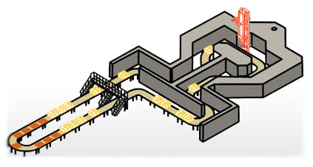
Figure 1: Iotron facility using conveyer belt system [14]
One benefit of a linear accelerator is that when the linac shuts down, the radiation also stops with no residual radiation or lingering chemical hazard. There is no need to store, transport, or dispose of any radioactive isotopes [13]. Furthermore, an accelerator is much more efficient in product turnaround, and there is more flexibility in the products served. Linacs also have better irradiation efficiencies, and the dose is controlled to a high degree of precision with a high penetration capacity [13].
The initial investment of a linac is higher until the radiation source requirements reach the equivalent of about 1 million curies of cobalt-60 [15]. The unit cost of irradiation is similar for both. Finally, the resources tied up in a linac sitting idle must be weighed against replacing the 12 percent of cobalt-60 lost yearly to decay [15]. When considering the degree of safety and efficiency we chose for the beehive irradiator facility, a linear accelerator fits the design’s needs. The facility will include a conveyer belt that moves at varying speed to move the beehives through a maze design to then be irradiated by the linear accelerator.
Regulatory Concerns:
For the use of a linear accelerator to irradiate beehive equipment, the facility and accelerator need to be in accordance with Tennessee State Regulations. Since this project is not using the Linear Accelerator for medical patients, there are two main state regulations the facility needs to adhere too and one application for registration. The two state regulations are from the Rules of the Tennessee Department of Environment and Conservation, rules 0400-20-05 and 0400-20-09. The application is from X-Ray Registration form RHS 8-8CN-1449 titled Application for Certified Registration, Non-Medical Uses. Rule 0400-20-09 is the main rule for the use of a linear accelerator.
Rule 0400-20-09-.05 states that, to receive a certified registration, the applicant must have personnel to use the accelerator, proposed equipment, facilities, and procedures that will protect the public and a method of retraining and testing of personnel annually [23]. Rule 0400-20-09-.06 states that, to use the accelerator for the modification of materials, the applicant must have staff with experience in the modification of materials and an appointed radiological safety officer. Rule 0400-20-09-.17 states the registrant shall provide personnel monitoring devices that are properly calibrated. The primary and secondary barriers should comply with Rules 0400-20-05-.50, 0400-20-05-.55, 0400-20- 05-.56 and 0400-20-05-.60 [22]. The operator at the control panel can create a radiation field in any area where an individual can receive a dose that does not exceed 2 millirem per hour. All entrances to places of high radiation should have interlocks. The interlock system and emergency cut-off should be separate from the electrical circuits and/or mechanical systems. If the interlock is tripped, the accelerator will shut off, and the room will be reduced to an average of 2 millirem per hour and a maximum of 10 millirem per hour at a distance of 1 meter from the accelerator. Interlocks should only be used to shut off the accelerator in an emergency or testing. Emergency shut off switches are located in high radiation areas and shall have postings identifying them. The emergency switch should also be able to accomplish the same goals as when the interlocks are tripped. High radiation areas should have visual flashing or rotating warning lights when radiation is produced. The high radiation areas should also have audible warning device. The accelerator control panel should also have security in place to prevent use by unauthorized individuals. The facility should also have available portable radiation monitoring equipment that must be tested every three months; the control panel and entrances to high radiation areas must have a device that continuously identifies radiation levels. High radiation areas should give individuals within area time to escape. The registrant should also have operating and emergency procedures [22].
Rule 0400-20-05-.50 gives the occupational dose to individual adults; the annual limit must be less than a total effective dose equivalent of 5 rem and must be less than annual limits to the lens of the eyes of 15 rem and 50 rem to the skin of the body [22]. Rule 0400-20-05-.55 says the annual occupational dose limits for minors should be 10 percent of the annual dose to adult workers. Rule 0400-20-05-.56 states that the dose equivalent to an embryo/fetus during an occupational exposure to a declared pregnant woman does not exceed 0.5 rem. Rule 0400-04-.60 states the dose limits for individual members of the public The total effective dose equivalent to an individual of the public does not exceed 0.1 rem in a year. A visitor is permitted to receive no more than 0.5 rem [22].
RHS 8-8 CN-1449 is the registration form for a linear accelerator with the state of Tennessee [24]. The form lists five points to adhere too: (1) identify whom is legally responsible for the use of the accelerator and organizational structure of applicant, (2) identify if it is a renewal, (3) list all locations at which the accelerator will be used and the address of the facility, and (4) list associated information of the accelerator to be used. The fifth point is the longest with many sub points. Some of these sub points require describing the following facility, detailing radiation detection instrumentation, detailing calibration of radiation survey instruments, providing organization that will supply film badges and pocket dosimeters, outlining operating and emergency procedures, including employee training methods, describing the internal inspection system, and describing the overall organizational structure. Finally, the form states that the facility will have to pay a yearly fee of $5,975 [24].
Additional Irradiator Facility Uses:
One of the avenues to pursue when opening up the design of the facility to irradiate more than beehives for economical purposes is food irradiation. The main foods that receive irradiation currently are spices, fruits, and vegetables. The reasons to irradiate foods according to the FDA are to prevent foodborne illness (i.e. salmonellae), to preserve food, to control insects, to delay ripening of fruit, and to sterilize food [2]. According to a study by the University of Wisconsin, irradiation of food does not activate the food, and the nutritional value remains close to the same [4]. The drawbacks of irradiation of food can be seen when irradiation increases the prices of the food and when the public perception is changed. A CDC study shows that 50% of people surveyed would purchase irradiated food over non-irradiated food if given the option, and it goes up to 80% if the people are educated on irradiation of food [3]. The FDA has several categories of foods approved for irradiation and the maximum allowable dose to irradiate the food. The table below from the CDC’s website on the irradiation of food provides the year of approval, the maximum dose, and reasons why to irradiate [3].
TABLE I
CDC Food Irradiation Information [3]
Approval Year | Food | Dose | Purpose
1963 | Wheat flour | 0.2-0.5 kGy | Control of mold
1964 | White potatoes | 0.05-0.15 kGy | Inhibit sprouting
1986 | Pork | 0.3-1.0 kGy | Kill Trichina parasites
1986 | Fruit and vegetables | 1.0 kGy | Insect control, increase shelf life
1986 | Herbs and spices | 30 kGy | Sterilization
1990 - FDA | Poultry | 3 kGy | Bacterial pathogen reduction
1992 - USDA | Poultry | 1.5-3 kGy | Bacterial pathogen reduction
1997 - FDA | Meat | 4.5 kGy | Bacterial pathogen reduction
1999 - USDA (pending) | Meat | 4.5 kGy | Bacterial pathogen reduction

From the above table, the maximum dose for spices is 30 kGy, but The Institute of Food Science and Technology provides recommended doses need to irradiate spices at 10 kGy [1]. Adding the irradiation of food will provide our facility with another avenue to add revenue stream within our design.
In addition to the revenue stream of food irradiation, irradiation of medical devices and pharmaceutical products for sterilization are other industries that could be tapped into. Currently companies such as Sterigenics are using gamma irradiation to sterilize single-use medical supplies. These supplies include syringes, implants, and catheters [21]. Radiation sterilization of both medical and pharmaceutical products once required a minimum dose of 25 kGy, but the International Organization for Standardization (ISO) set new requirements that do not set one dose [25]. These new requirements state that sterilization dose must be determined for individual products depending on their bioburden. The determination of the sterilization dose does not fall under the irradiation facility’s responsibilities; rather it is a responsibility of the medical or pharmaceutical product manufacturer [25].
There are two primary ISO standards currently regulating radiation sterilization. ISO 1137 parts 1, 2, and 3 outline what is expected in complete sterilization. The standards would only set the dose that the facility needed in order to ensure complete reduction of the bioburden on the products [25]. As such, each product’s sterilization dose would be dependent on what bioburden species were discovered on the product at the time of manufacture. The responsibility of validating sterilization, however, falls into the hands of the manufacturer, not the irradiation facility [25].
The facility would be responsible for making sure processing equipment and procedures followed ISO standards, recording all procedures, methods, and measurements, performing dose mapping, and monitoring and controlling process parameters. The International Atomic Energy Agency (IAEA) states that these responsibilities, however, would also need to be established and routinely executed for irradiation of bee-hives and other materials, so there is no extra financial burden on the facility.
Shielding Calculation Methods:
The National Council on Radiation Protection and Measurements (NCRP) published reports that help to design shielding facilities. The NCRP’s methods in the reports are carefully studied and validated in shielding facilities [12]. According to NCRP report 151, “the shielding design goals (P) are levels of dose equivalent (H) used in the design calculations and evaluation of barriers constructed for the protection of workers or members of the public” [12].
The shielding design goals (P) are represented in dose equivalent. The recommended dose equivalent in controlled areas, the areas where the licensee can limit access, is 0.1 mSv week^{–1} (5 mSv y^{–1}), and the recommended dose equivalent in uncontrolled areas is 0.02 mSv week^{–1} (1 mSv y^{–1}) [12].
The shielding design method is divided into primary and secondary barriers. The primary barrier is the barrier that is positioned perpendicularly to the primary beam to shield personnel and the public from the primary beam. Therefore, the primary barrier is supposed to have the thickest thickness in the facility that is calculated via NCRP methods. The width of the primary barrier is about 30 cm longer than the primary beam on each side.
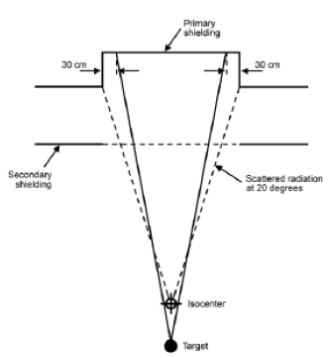
Figure 2. Primary barrier width [12]

Secondary barriers are used to shield personnel from leakage radiation and scattered radiation, and the barrier is generally positioned parallel to the primary beam. Also, during the facility layout design, mazes are created to reduce the paths of radiation and help to shield secondary radiation.

Shielding design calculations discussed in NCRP reports required certain assumptions such as negligible neutron yields for beam energy less than 10 Mev, Shultis and Faw – (λ,n) cross section increases with photon energy by several orders of magnitude to a broad maximum at photon energies, primary barrier is directly irradiated by photons from the target or source, controlled area of shielding, and scattered and leakage radiation is emitted in all directions and covers all of the treatment room surfaces [12]. The tenth-value layer (TVL) workload, occupancy factor, dose rate, transmission factor, use factor, and other variables are derived from NCRP reports [12].
The TVL is the average amount of material needed to absorb 90% of all radiation, or to reduce the energy to a tenth of the original intensity [12]. Workload is the emitted particles that contribute to the absorbed dose delivered at 1 meter from the emitting target per week in Gy/week. Occupancy factor is the fraction of time that an area will be occupied per week. Dose rate represents the quantity of radiation absorbed per unit of time. The transmission factor is the calculated value that will reduce the radiation field to an acceptable level. The use factor is the fraction of workload that the primary beam directs at the given barrier [12].
$B_{pri}= \frac{P{d^{2}}_{pri}}{WUT}$
(1)
In Equation 1 [12]:
P = shielding design goal, in dose equivalent, beyond the barrier and is usually given for a weekly time frame (Sv/week).
d_{pri} = distance from the x-ray target to the point protected (meters).
W = workload or photon absorbed dose delivered at 1 m from the x-ray target per week (Gy/week).
U = use factor of fraction of the workload that the primary beam directs at the barrier in question.
T = occupancy factor for the protected location or fraction of the work week that a person is present beyond the barrier. This location is usually assumed to be 0.3 m beyond the barrier in question.
As discussed above, the primary barrier thickness should be calculated for the perpendicularly incident beam and held constant over the whole barrier width [12]. First, transmission factor, B_{pri}, is calculated using Equation 1 from NCRP report 151.

Second, after obtaining the transmission factor, the required number of tenth-value layer is obtained using Equation 2 below [20].
$n= -log⁡(B_{pri})$ (2)
Third, the primary barrier thickness is determined using tenth-value layers based on the energy of the accelerator and type of shielding material.
$t_{barrier}={TVL}_{1}+\left(n-1\right){TVL}_{e}$ (3)
In order to obtain the primary barrier thickness, we assumed that the workload of our facility is 1000 Gy/week. NCRP report No. 49 recommended using W = 1,000 Gy/week for accelerators up to 10 MV and NCRP Report No. 51 recommended W = 500 Gy/week for higher energy accelerators. Also, we assumed the occupancy factor to be 50%, which means that people or facility will be in our facility 50% of the time. Since our facility is considered to be a controlled area of radiation, NCRP report No. 151 suggested using dose equivalent of 0.1 mSv/week [12].
After solving for the equations above, the primary barrier thickness was obtained and was approximately 6.5 ft.

Secondary barrier thicknesses are calculated based on leakage radiation, scattered radiation from the irradiated object, scattered radiation from the walls, and secondary radiations [12]. We assumed our area of secondary radiation to be an uncontrolled area with dose equivalent of 0.02 mSv/week. Also, our occupancy factor varied in each different part of the facility. Scattering radiation has different energy, dose equivalent, and occupancy factor; therefore, we needed to recalculate the transmission factor, the required number of tenth-value layer, and the secondary barrier thickness.
Figure 3: Secondary Barrier [12]
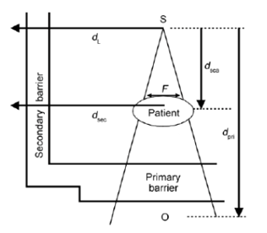
Figure 3: Secondary barrier [12]

After solving for the transmission factor, we repeat the same steps for primary barrier in order to obtain the thickness.
$B_{ps}= \frac{P}{aWT}{d^{2}}_{sca}{d^{2}}_{sec}\frac{400}{F}$
(4)

In Equation 4, the symbols P, W, and T are defined earlier in Equation 1:
d_{sca} = distance from the x-ray target to the patient (meters).
d_{sec} = distance from the scattering object to the point protected (meters).
α = scatter fraction or fraction of the primary-beam absorbed dose that scatters from the patient at a particular angle.
F = field area at mid-depth of the patient at 1 m (cm ²) [12].
“In most high-energy accelerator facilities, a secondary barrier that is adequately designed for the leakage radiation component will be more than adequate for the scattered radiation with the possible exception of zones adjacent to the primary barrier intercepted by small angle scatter” [12].
Secondary barrier leakage shielding protects the public from the leakage radiation that is emitted from the linear accelerator.
The transmission factor for leakage radiation is given in Equation 5 below:
$B_{L}= \frac{Pd_{L}^{2}}{{10}^{-3}WT}$ (5)
After solving for the leakage transmission factor, we repeated the same steps for primary barrier in order to obtain the thickness. Table 2 shows the results for different sections of the facility.
TABLE II
calculated Shielding thicknesses Based on NCRP 151
Facility Component | Thickness (ft.)
Primary shielding | 6.50
Secondary shielding | 3.50
Hallway | 3.15
Ceiling | 4.50

Shielding Simulation Methods and Facility Design:
The Thriving Hive Beehive Irradiation Facility was designed with a main purpose of effectively irradiating beehive materials while providing enough shielding to the public that no transmissible radiation can penetrate and cause biological damage. The physical shielding portion of the irradiation facility was based on the National Council on Radiation Protection and Measurement’s NCRP Reports 49,144, and 151. These reports detail protection necessary to shield both the public and workers of the facility. From these reports, thicknesses of shielding walls were calculated and implemented in the final physical facility design. More specifically, the primary shielding barrier was determined to require a concrete material thickness of 6.5 ft (198 cm), the secondary shielding barrier was determined to require a concrete material thickness of 3.5 ft (106.68 cm), any hallway shielding was concluded to require a concrete material thickness of 3.15 ft (96.012 cm), and the ceiling shielding was found to require a concrete material thickness of 4.5 ft (137.16 cm). Using these values, a facility design was proposed.
The beehive irradiation facility design was initially suggested to include a conveyor belt that transports any beehive materials from a shipping/loading dock to the irradiation room. Through these conveyor belts, all material continuously travels through a maze-like hallway into the irradiation room and back through another maze-like hallway to return to the shipping/loading dock to be prepared for shipment. The maze-like hallway features were included to promote transportation continuity of the beehive materials on the conveyor belt and eliminate the need for large shielded doors to the irradiation room. The beehive irradiation facility boasts several varying rooms including an irradiation control room, a maintenance room, a formal office, and a shipping/loading dock with connected hallways into an irradiation room. The rooms excluding the irradiation room were determined that no shielding was required and simple drywall worthy of such a facility could be utilized during construction. However, the irradiation room that requires shielding also required differing construction materials. Several materials including steel, concrete, and lead were examined and subsequent cost optimizations found that concrete provided the best shielding per price. As a result, the material, concrete, was further examined in the context of the NCRP reports to find varying thicknesses of different shielding levels discussed previously. These thicknesses were also calculated using the knowledge that a 9 MeV linear accelerator would be employed to irradiate the beehive materials. The 9 MeV linac was suggested during the facility design process due to its ability to change to lower nominal photon energies (5 and 6 MeV photons) to irradiate other varying materials at a necessary yet sustainable rate. All of these elements provided the basis for the following facility design pictured in Figure 4. In Figure 4, the area shaded light blue in color is the shipping/loading room and connected conveyor belt into the irradiation room, while the blue area is the irradiation control room. The orange area is the office, and the green area is the maintenance room. The light purple area defines the secondary barrier and hallway walls that shield individuals from the irradiation room. The medium purple area of Figure 4 defines the secondary barrier walls, and the dark purple area defines the primary barrier walls in the irradiation room. Using the dimensions given in Figure 4, the irradiation room and its shielding walls were then modeled in Monte-Carlo N Particle Transport Code to verify that no dose described by the NCRP reports will be obtained by the public and the facility’s workers during normal operations.
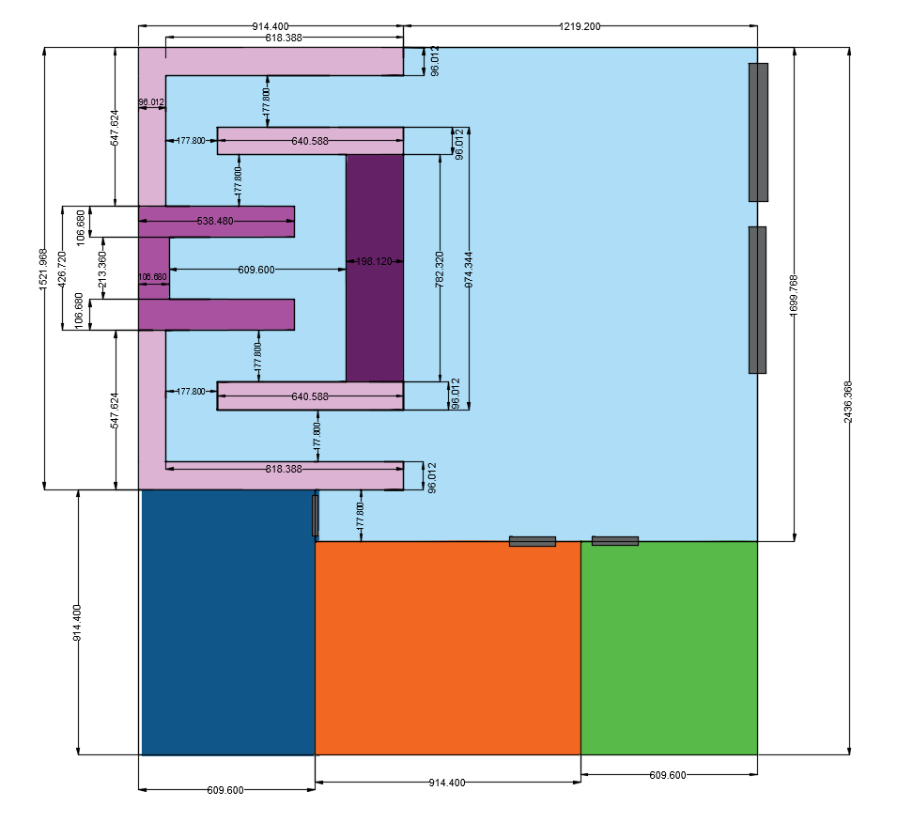
Figure 4: Physical beehive irradiation facility design

Monte Carlo N-Particle Code (MCNP) was utilized to optimize the shielding design and to ensure proper minimization of dose received by the public. MCNP is a statistical simulation used to track radiation transport through a given geometry. MCNP can calculate the energy and flux across surfaces and volumes and dose rates throughout the shield room and facility. Our team used MCNP6 to create the shielding geometry and then modeled the radiation produced by the linear accelerator using a mesh tally and dose map. The MCNP6 code input is located in Appendix A.
It was first required to build the irradiation room geometry in MCNP, which includes the primary and secondary barriers. Using the dimensions shown in Figure 4, the geometry was formed using planes for the walls, ceiling, and ground. A rectangular parallelepiped macrobody was used for the bee hive box using the standard dimension of 40 x 48 x 75 inches. The cells were properly defined and materials were coded in the data card. Materials used were dry air (0.001205 g/cm³), concrete (2.3 g/cm³), earth (2.52 g/cm³) for the ground, and wood (0.64 g/cm³) for the bee hive box. The code for the geometry was then executed and found to contain no errors. Figures 6, 8, and 10 are the plots produced by the MCPLOT tally plotter where the colors show the different materials used. The purple is the dry air, blue is the concrete shielding, yellow is the earth below the facility, and green is the wooden bee hive box.
With the MCNP geometry complete, the next step was to accurately construct the SDEF card. The SDEF card is located within the data card of the MCNP code and simulates the radiation source, which in this case, is the linear accelerator. The location, initial gamma ray energy of 9 MeV, and the direction of the particles emitted were identified to represent our linac. With the source term defined, the final step was to create a mesh tally in order to plot the flux throughout the irradiation room.
FMESH is an MCNP tally that allows you to specify the number of points you want to examine in the x, y, and z directions. This allows us to generate dose maps that visualize the radiation transport in all three dimensions and is superimposed on the irradiation room geometry. The FMESH covers the entire shielded area of the facility and has 440 data points in the x direction, 260 in the y, and 200 in the z to show fine detail. The completed code was then executed for 10 million particles.
Typing “PLOT” in the command window opens the MCNP plotter that displays the dose maps in each dimension view of the irradiation room. This is repeated for code without the bee hive box to confirm the shielding is sufficient when there is no irradiation material present. This code is located in Appendix B.
Results – Simulation:
Examining the flux map without the beehive, it was found that the primary shielding with a thickness of 198.12 cm was not to the level required by regulations. To ensure safety, our team added 2 feet to the primary wall, making a new thickness of 259.08 cm concrete. The following figures show the facility geometry, final flux maps, and final dose maps created through Monte Carlo N particle transport code simulations.

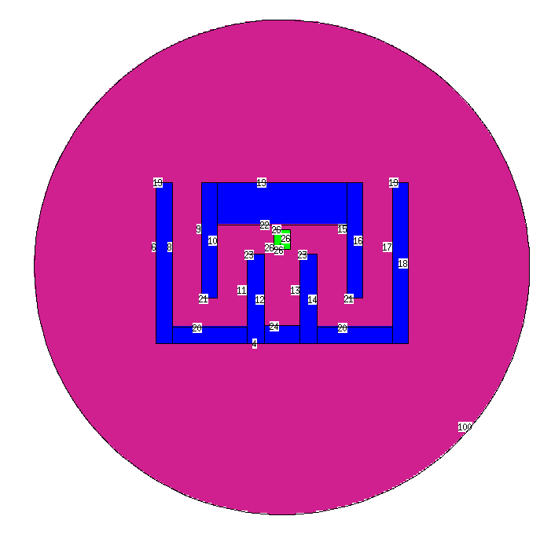 | 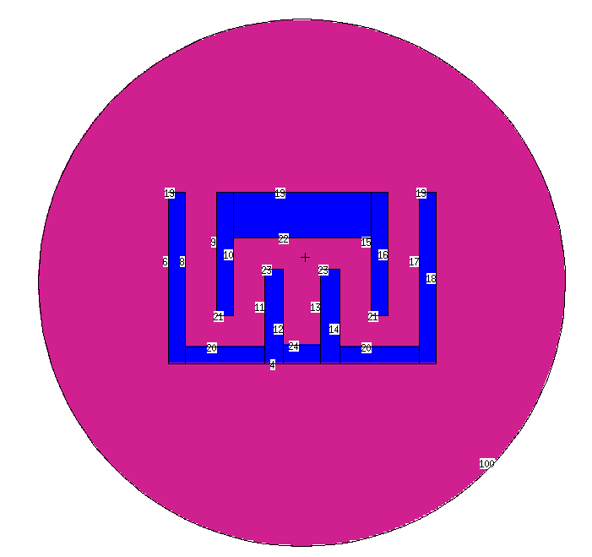
Figure 5: MCNP Simulation in the XY View of a Beehive Irradiation Facility including a Beehive | Figure 6: MCNP Simulation in the XY View of a Beehive Irradiation Facility excluding a Beehive
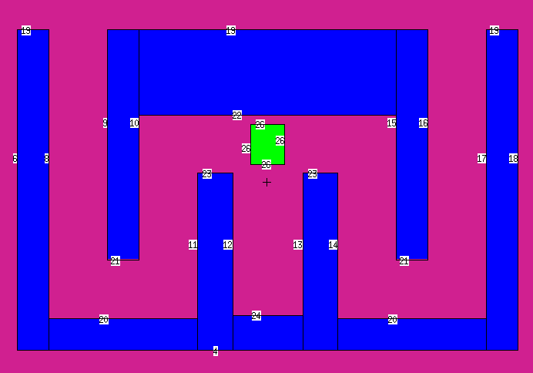 | 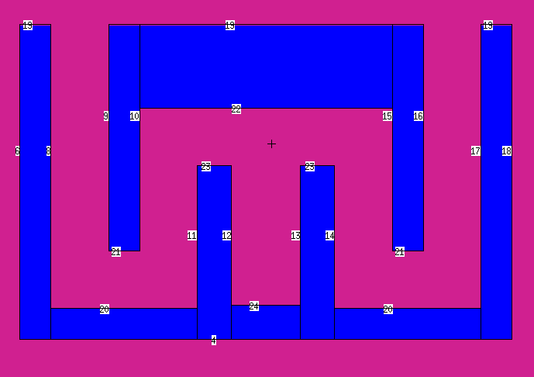
Figure 7: XY View of Geometry with Beehive (surface 26) | Figure 8: XY View of Geometry without Beehive

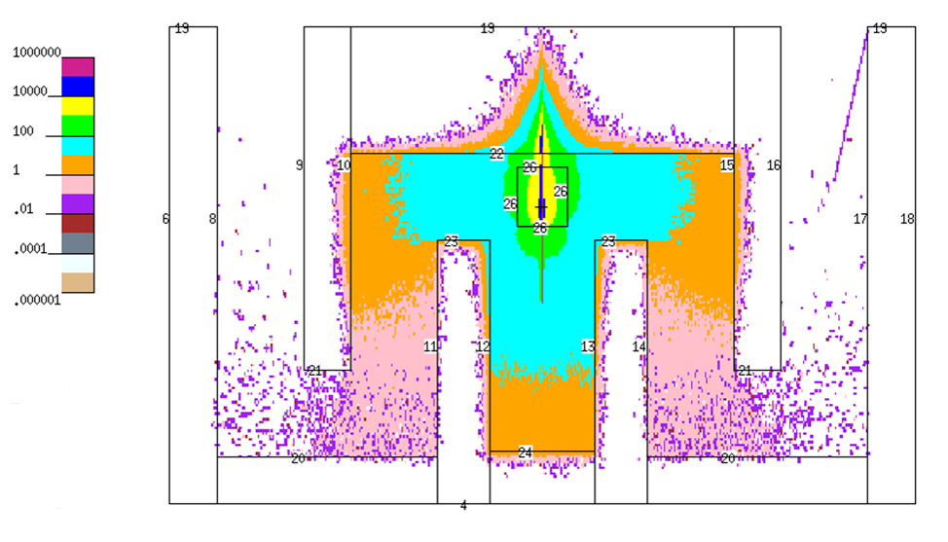 | 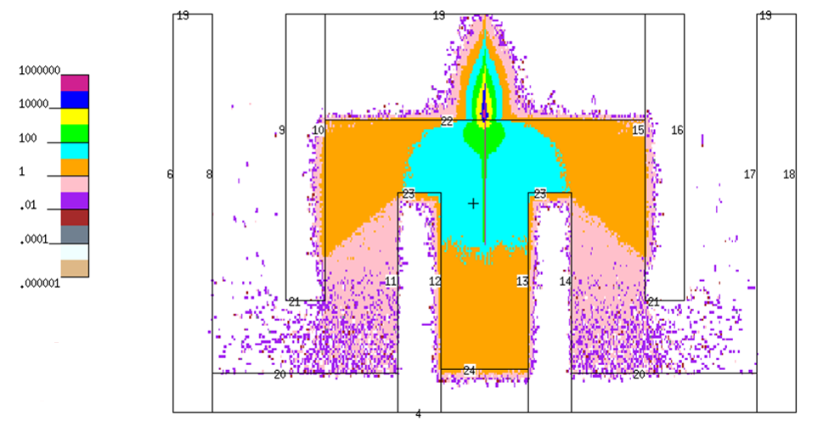
Figure 9: XY View of Flux Map [particles/cm²/sec] with Beehive | Figure 10: XY View of Flux Map [particles/cm²/sec] without Beehive

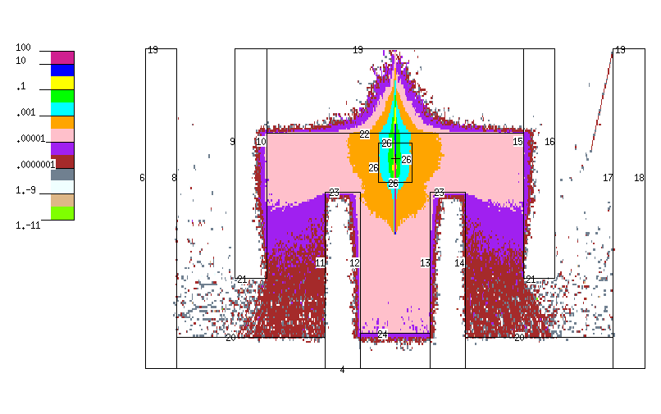 | 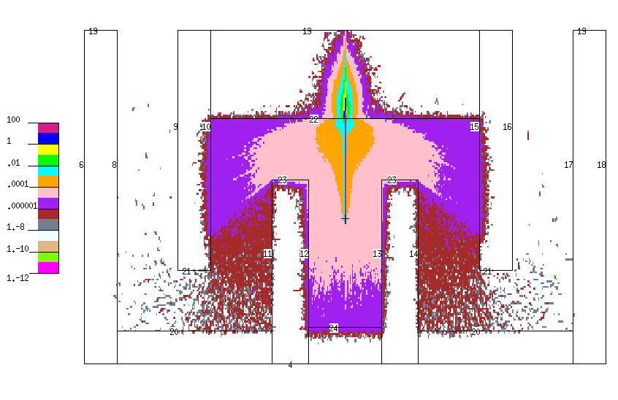
Figure 11: XY View Dose Map [Gy/min] with Beehive,  Maximum Beamline Dose of 30Gy/min | Figure 12: XY View Dose Map [Gy/min] with No Beehive,  Maximum Beamline Dose of 30Gy/min

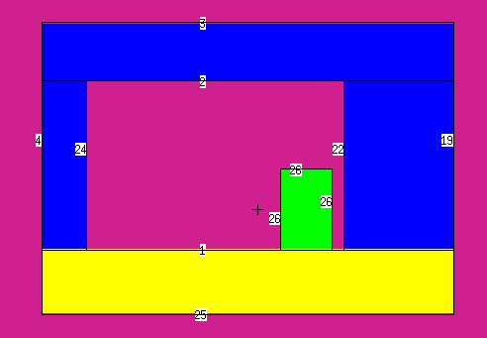 | 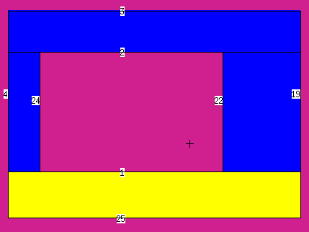
Figure 13: YZ View of Geometry with Beehive | Figure 14: YZ View of Geometry without Beehive

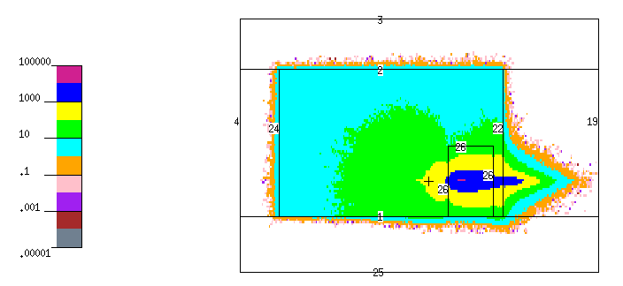 | 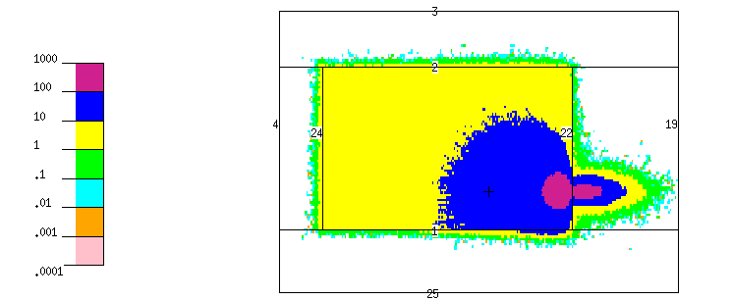
Figure 15: YZ View of Flux Map [particles/cm²/sec] with Beehive | Figure 16: YZ View of Flux Map [particles/cm²/sec] without Beehive
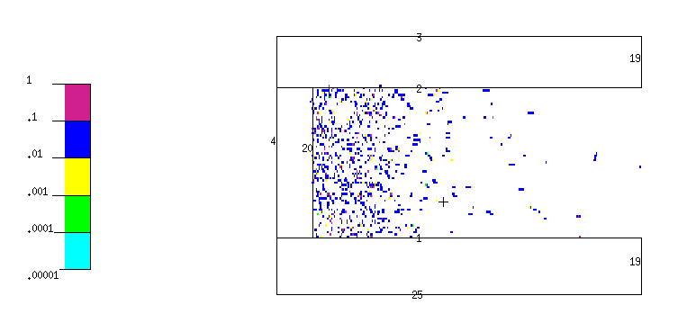 |  |  | 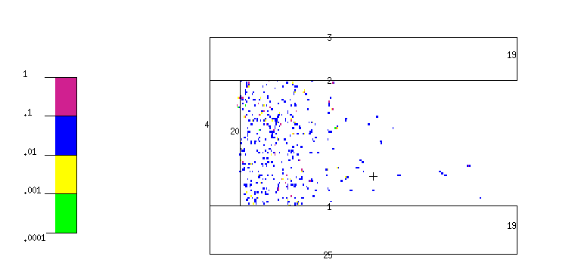
Figure 17: YZ View of Hallway Flux Map [particles/cm²/sec]  with Beehive |  |  | Figure 18: YZ View of Hallway Flux Map [particles/cm²/sec] without Beehive
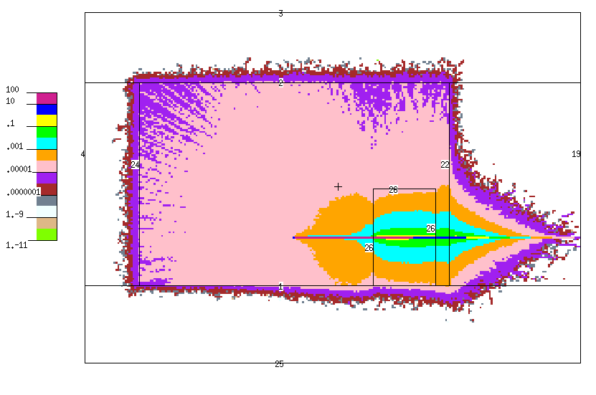 |  | 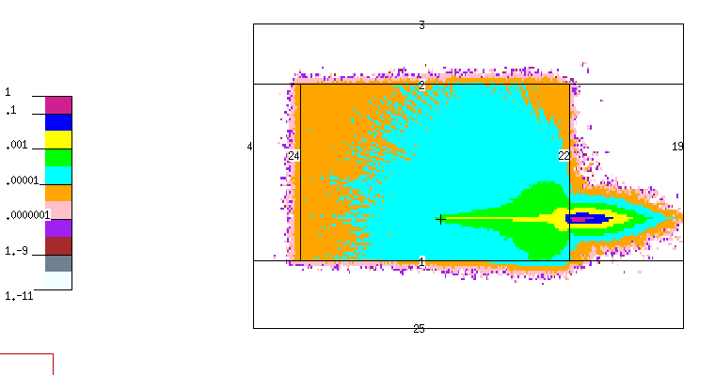
Figure 19: YZ View Dose Map [Gy/min] with Beehive,  Maximum Beamline Dose of 30Gy/min |  | Figure 20: YZ View Dose Map [Gy/min] with no Beehive,  Maximum Beamline Dose of 30Gy/min

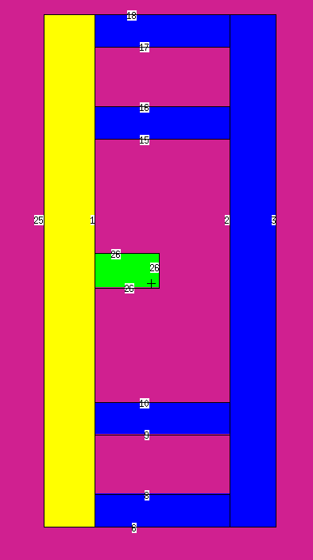 | 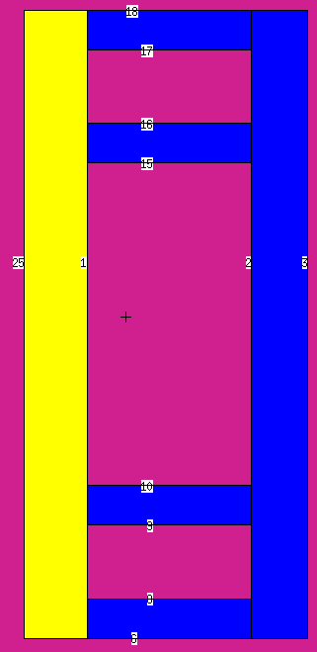
Figure 21: ZX View of Geometry with Beehive | Figure 22: ZX View of Geometry Without Beehive

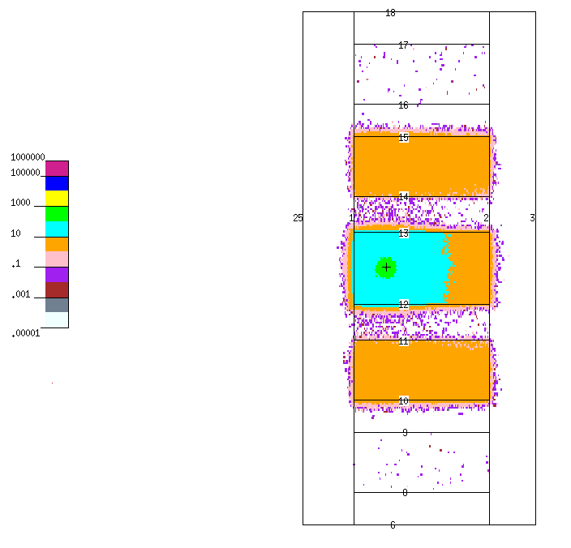 | 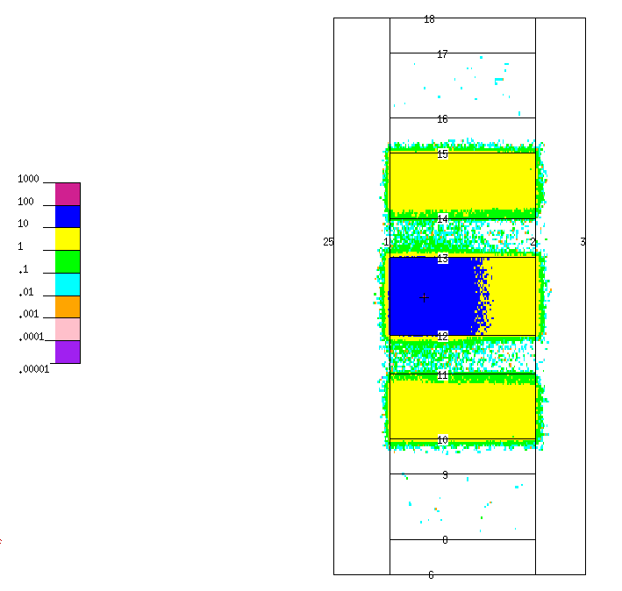
Figure 23: ZX View of Flux Map [particles/cm²/sec] with Beehive | Figure 24: ZX View of Flux Map [particles/cm²/sec] without Beehive

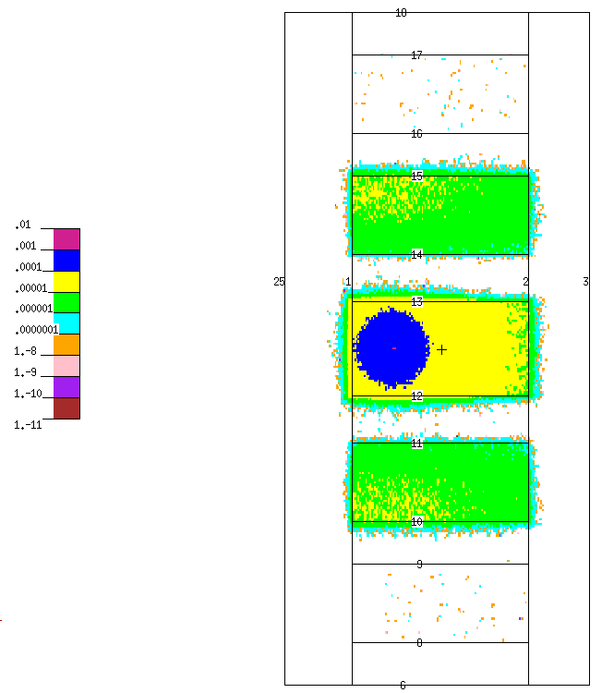 | 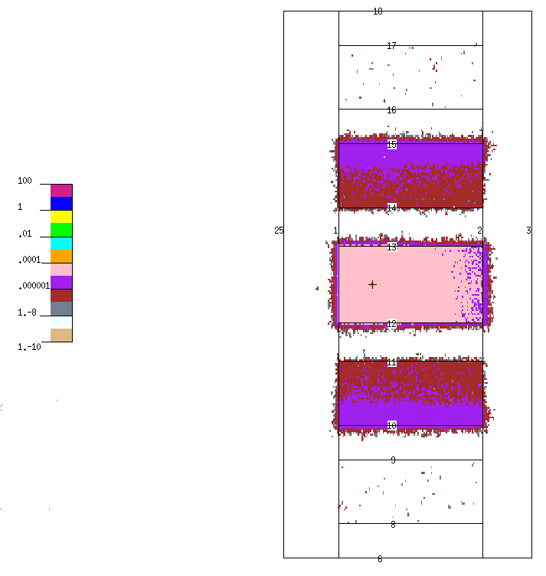
Figure 25: ZX View Dose Map [Gy/min] with Beehive,  Maximum Beamline Dose of 30Gy/min | Figure 26: ZX View Dose Map [Gy/min] without Beehive,  Maximum Beamline Dose of 30Gy/min

A separate analysis was completed to compare the NCRP calculation results of the primary wall to an actual attenuation calculation performed in MCNP. Code was written for a large concrete box with a 9 MeV gamma source beam placed at one end of the box. A MESH was used in conjunction with an F4 tally to get the flux at each depth. The figure below shows the results of this study. The code is found in Appendix C.
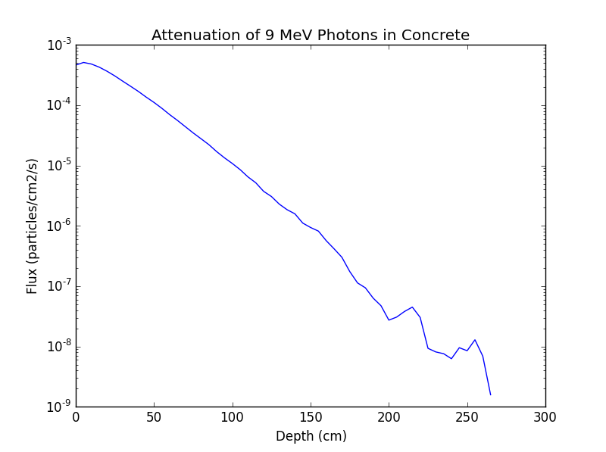
Figure 27: Semilog Plot of the Attenuation of 9 MeV Photons in Concrete
The results indicate the expected attenuation curve. The NCRP 151 calculations obtained a required thickness of 6.5 ft (198 cm), for the primary wall. However, Figure 27 shows the flux at 198 cm is on the order of 10⁻⁸ particles/cm²/s. At 8.5 ft (259 cm), flux is absent, which is reinforced by the dose maps that show 0 Gy/min penetrating the primary wall. This thorough shielding supports our decision to increase the primary wall thickness to 8.5 ft.
Furthermore, using data sheets provided by Linatron, it was found that the Linatron M9 linear accelerator provides a maximum dose of 30 Gy/hr [26]. In 8.33 hours, 15 kGy of dose could be delivered to a beehive pallet using the Linatron M9 linear accelerator. A rather large irradiation time compelled our team to examine various other linear accelerators that better meets our irradiation facility demands. With further research, we found the Impela Electron Beam Accelerator, an accelerator used by the Canadian irradiation company, Iotron. The Impela uses an accelerating beam of electrons formed from an oscillating magnetic field to sweep electrons back and forth across the product [19]. The electron beam can also be converted into an x-ray generator. The x-ray convertor transforms part of the electron’s energies into bremsstrahlung x-rays, an electromagnetic radiation produced when a charged particle decelerates as it is deflected by another electron or atomic nucleus. These bremsstrahlung particles can then be directed towards beehive pallets to irradiate and deliver dose. The Impela electron beam accelerator itself is a L-band, on-axis-coupled, standing-wave cavity system that provides an electron beam energy of 10 MeV at a beam power of 60 kW and a peak beam current of 115 mA [19]. Using the Impela accelerator data provided by Iotron, the irradiation time to provide a dose of 15kGy to our beehive pallets was estimated. This estimation was completed by finding the fluence of electrons emitted from the accelerator, accounting for radiative yields and geometric efficiency, and finally, calculating the dose rate from these values.

The average fraction of energy that a beta particle radiates as bremsstrahlung is called the radiation yield. This can be easily calculated using Equation 5, where Z is the atomic number of the tungsten target and T is the kinetic energy of the electron beam which is 10 MeV.
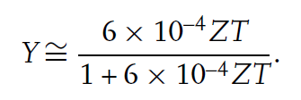
Equation 6: Radiative Yield [20]
Once the radiation yield is determined, the solid angle of the bee hive box is needed to find the fraction of bremsstrahlung x-rays that hit the target. This is calculated using Equation 7. Because the beam is centered on the face of the beehive box, the solid angle will be the sum of four solid angles formed by rectangles, where a is the half the width of the bee hive box, b is half the height, and d is the distance from the point source to the bee hive box.
$$Ω=\frac{1}{4π}arctan⁡(\frac{ab}{d\sqrt{a^{2}+b^{2}+d^{2}}})$$
Equation 7: Solid Angle of a Rectangular Aperture
$$Ω_{Beehive Pallet}=\frac{1}{π}arctan⁡(\frac{ab}{d\sqrt{a^{2}+b^{2}+d^{2}}})$$
Equation 8: Solid Angle of a Beehive Pallet
Finally, using the mass attenuation coefficient for x-rays, the dose rate can be found. Using this method, the dose rate of the Impela accelerator was found to be 25 kGy/hr. With the new dose rate, the irradiation time computed for one bee hive box to be a total irradiation time of 36 minutes. Using the newly found Iotron linear accelerator, MCNP simulations were ran again to provide XY view dose maps of the facility with primary wall thicknesses of 6.5 ft and 8.5 ft with an initial beamline of 25kGy/hr. Using the values gathered from these dose maps, the dose from bremsstrahlung x-rays fully penetrating both the 6.5ft wall and 8.5ft wall were examined.

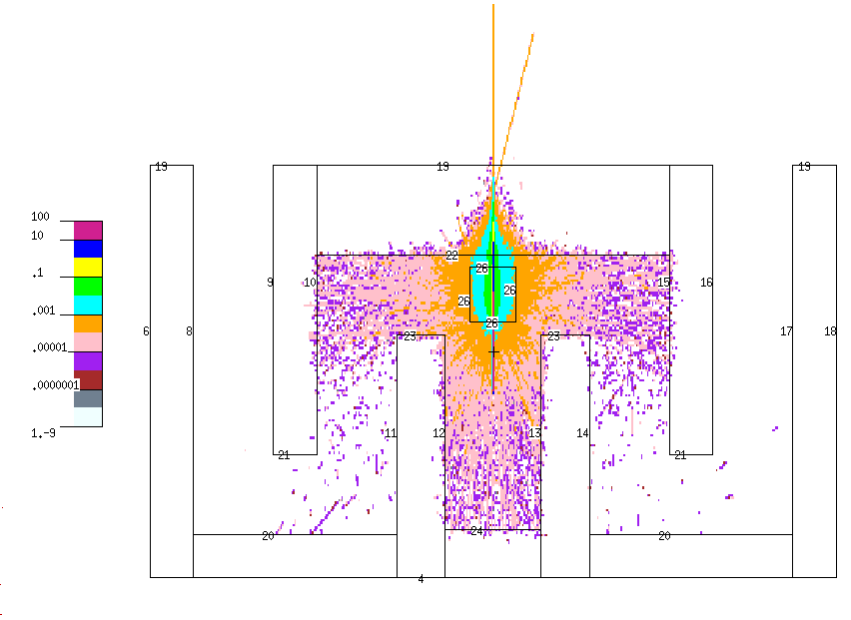
Figure 28: XY View Dose Map [kGy/hr] with Beehive, Maximum Beamline Dose of 25kGy/hr and Primary Wall Thickness of 6.5 ft

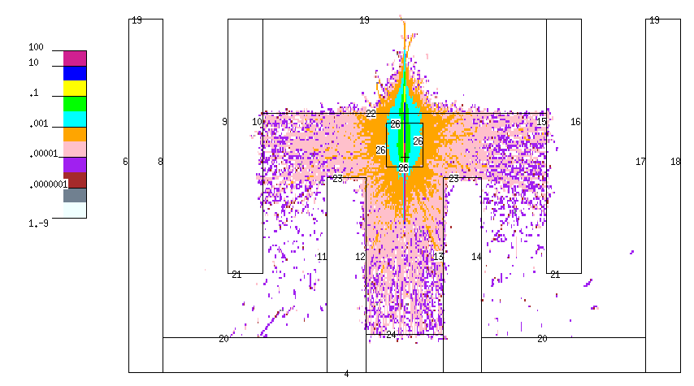
Figure 29: XY View Dose Map [kGy/hr] with Beehive, Maximum Beamline Dose of 25kGy/hr and Primary Wall Thickness of 8.5 ft

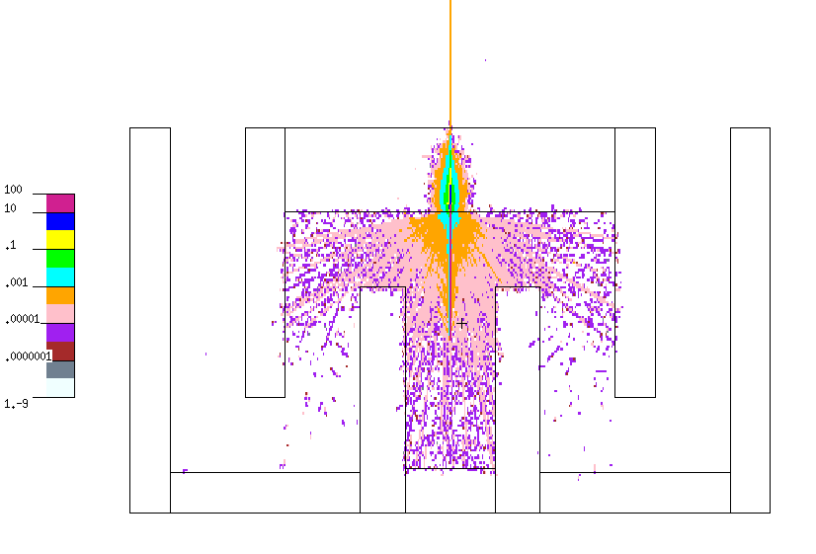
Figure 30: XY View Dose Map [kGy/hr] without Beehive, Maximum Beamline Dose of 25kGy/hr and Primary Wall Thickness of 6.5 ft

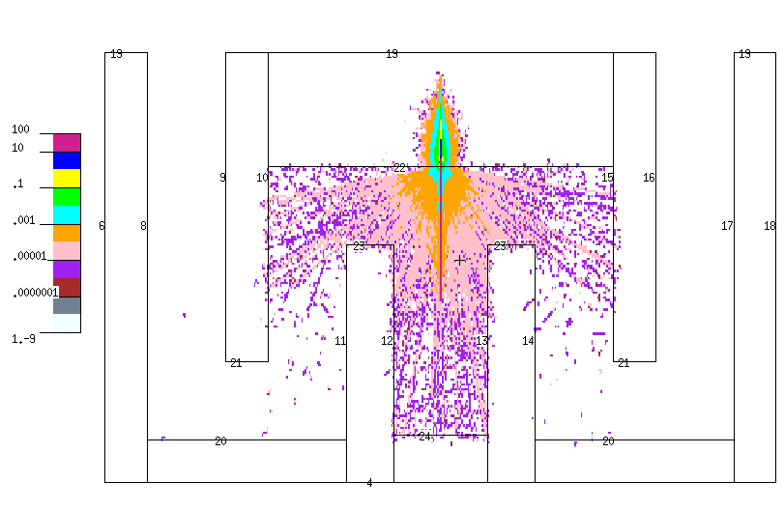

Figure 31: XY View Dose Map [kGy/hr] without Beehive, Maximum Beamline Dose of 25kGy/hr and Primary Wall Thickness of 8.5 ft

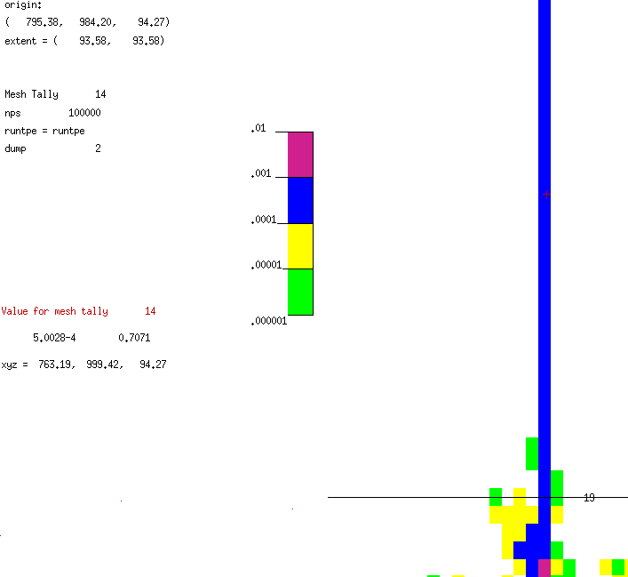
Figure 32: Zoomed XY View Dose Map [kGy/hr] without Beehive, Maximum Beamline Dose of 25kGy/hr and Primary Wall Thickness of 6.5 ft

From these dose maps, it is clear that a primary wall thickness of 8.5 ft effectively eliminates substantial doses to both the staff and public. The 6.5 ft thick concrete primary barrier did not eliminate the dose completely and leaked a dose rate of approximately 5.002E-4 kGy/hr as visualized in Figure 34. This dose rate when converted to mSv/wk provides the substantial dose of 84,047 mSv/wk inside the facility or controlled area. This dose rate is above the 0.1 mSv/wk requirement given by the NCRP 151 [12]. As a result, it is clear that 6.5 ft thick concrete primary barrier wall is too thin to attenuate the amount of dose necessary and an 8.5 ft thick concrete primary barrier should instead be used. This thickness has repeatedly shown its capability to limit doses and remove all dose and meet the 0.1 mSv/wk for controlled areas and 0.02 mSv/wk for uncontrolled areas. As consequence of these simulations, the final facility design shall implement a primary wall thickness of 8.5 ft of concrete.

Results - Cost Analysis:
To accurately perform a cost analysis of our irradiation facility, several assumptions were made. First, our total facility cost will only be significant to the hundreds of thousands of dollars, as certain cost variables are impossible to determine with certainty at our present location on the timeline of facility creation. Secondly, our cost estimate assumes that the facility operates continuously year round, or for 800 hours per year. Lastly, because expense information is highly protected, our efforts to glean some of this information from the irradiation company Sterigenics were rejected. So, we used the values given in Radiation Sterilization for Health Care Products: X-Ray, Gamma, and Electron Beam as a guide for our cost analysis [16]. Our cost values are presented in dollars valued in 2015.
The two main categories that our facilities expenses fall into are capital costs and recurring costs. These are presented in Tables 3 and 4, respectively. The first and most intuitive capital costs are the land on which the facility will be built and the building that houses the accelerator. Radiation Sterilization for Health Care Products: X-Ray, Gamma, and Electron Beam provides the values for Tables 3 and 4. This was used for cost analysis of everything but the cost of the linear accelerator and the land and building cost. The price of the linear accelerator was found using a somewhat recent article published in 2013 to estimate a more accurate price that reflects the recent rise in expense of linear accelerators [17]. The price from modernhealthcare.com was confirmed by a contact from Iotron that informed the team that a linear accelerator used to irradiate would cost between $2-3 million [17]. The building cost was estimated from an analysis of a standard cost per square foot of an industrial building [18]. Most likely, our facility would not require as much land or as large of a building, so our cost value would be less. Inside the facility, an electron shield must be purchased and implemented to protect the facility staff and general public from radiation exposure. Most irradiation facilities employ conveyor systems to transport the material to be irradiated into and out of the target beam from the accelerator. This value shown in Table 3 includes the cost of a forklift used to place the beehives, the associated equipment, and possibly food and medical devices onto the conveyor system. To ensure the accelerator functions correctly, the accelerator must be properly designed and engineered. This work may need to be contracted, which adds to the capital costs. Finally, the electron beam must be commissioned, which includes verifying that the beam is performing correctly based on the function of the inner machinery of the accelerator.
TABLE III
Capital Costs [16]
Cost Item | Expense
Accelerator and associated equipment | $2- $3 million [17]
Land and building | $6.4-7.23 million [18]
Radiation shield | $500,000 - $660,000
Conveyor system | $330,000
Design and engineering | $300,000 - $400,000
Commissioning | $300,000 - $400,000
Total | $9.83 - $12.02 million

In terms of recurring costs, the debt service on the loan taken out to fund the facility is the largest. This cost is based on an amortization period of ten years at an interest rate of 7 percent. The labor costs of staffing the facility are the next most expensive. The value presented in Table 4 for labor costs assumes a labor force of eight people and a six-person management staff comprised of a plant manager, an office manager, a quality assurance manager, a maintenance person, a shipping and receiving manager, and a production supervisor. Our labor force consists of four work crews of two people each that work 12 hour shifts seven out of every fourteen days. The next recurring costs unavoidable to an irradiation facility consist of the electricity purchased to power the accelerator and the maintenance that must be performed on the accelerator to ensure proper functionality. Miscellaneous expenses like insurance payments, taxes, and facility utilities also contribute to the recurring costs. Finally, dosimetry must be included in these costs, as radiation detectors both housed in the facility and worn on the labor and management staffs must be analyzed and replaced over time.
TABLE IV
Annually Recurring Costs [16]
Cost Item | Expense
Debt service | $1.2 million
Labor | $660,000
Electricity | $74,000
Maintenance | $400,000
Administrative/insurance/tax/utilities | $132,000
Dosimetry | $33,000
Total | $2.5 million

For our facility to make a profit, it is not possible to be only a facility that irradiates beehives. Mark Antunes of a local beehive association uses Sterigenics services and communicated to the group that his association holds a once a year irradiation event where hive keepers from Pennsylvania, Delaware, New Jersey, and Maryland come and load up about 10 to 15 trucks full of beehive equipment to take to Sterigenics. He communicated that it is too expensive for an individual farmer to take their individual equipment up. Assuming a truck can fit two pallets worth of beehive equipment, this event at a price of $164.38 per pallet would have generated $4,931.40 for Sterigenics. A pallet fits 36 supers. The results show the facility cannot survive on irradiation of beehives alone. Sterigenics revealed in a 2013 press release they made 300 million dollars in revenue in the past year, and 90% of that came from the irradiation of medical equipment, pharmaceuticals, and food [21]. The facility has the capability of irradiating all three of those. If broken down by facility, of which Sterigenics had 39 at the time, Sterigenics makes 6.923 million dollars per facility per year. If our facility follows the same business practices as Sterigenics, this gives our facility a profit of 4.423 million dollars a year.
Conclusions:
A facility design for the irradiation of beehives was investigated using licensing calculations and dose simulations. Using NCRP 151, an initial facility design was drafted in CAD and the irradiation room shielding was tested in MCNP. As a direct result of calculations and simulations discussed previously, our facility design will utilize an 8.5 ft thick concrete primary barrier to attenuate a 10 MeV photon beam that provides a maximum dose rate of 25kGy/hr. It is expected that this set up will effectively irradiate all beehive equipment and can be potentially used to irradiate medical equipment and food for consumption. We can expect that our facility can fully irradiate a beehive pallet with maximum dimensions of 101.6 cm x 121.92 cm x 190.5 cm in 36 minutes, providing a final dose of 15kGy. With the facility design finalized, the total cost of the facility was calculated. The projected revenue from solely irradiating beehives was discovered to be insufficient to support the facility, and other methods of revenue such as food irradiation and medical and pharmaceutical product sterilization were researched. The construction of such a facility has been shown to be not only profitable but also in demand internationally, as seen by Sterigenics’ growth in the past decade.

Future Work to Improve the Design:
If the team were to begin the project with the knowledge and experience of the past two semesters, the first and foremost improvement to the design would be to research the optimal concrete material based on cost and shielding. Furthermore, the team would look into using the facility for research purposes, similar to “beam time” at the national laboratories. If the accelerator was not in use for commercial purposes it could be used to further nuclear research.
Gantt Chart:
Project management of a project of this magnitude is of the utmost importance to ensure project completion and verification. The first semester of the project was composed mostly of project research and future planning, and a future-planning component was the creation of a Gantt chart. Gantt charts are useful in project management, as they present information on deadlines, workload, and work divisions in a graphical format. The Gantt chart for the second semester is presented in Figure 33.
The Gantt chart was designed with the following under consideration: member strengths, member preferences, time constraints, efficient project workflow, and project review. Member strengths ensured that members were not only given portions of the project that they were good at, but that the project would possibly benefit from subject expertise. The member preferences, combined with member strengths, ensured that the members would not bore of their work and would be passionate about returning a project they held pride in. Time constraints were considered for obvious reasons: much must be done in a short amount of time, and the work that is completed must be reviewed before final submission. Finally, efficient project workflow was considered so that the cart was not placed before the horse, so to speak. It is important to have shielding simulations completed before materials are chosen, and materials must be chosen before final cost can be calculated. The workflow was chosen in an attempt to achieve a cohesive project that moved between goals in an appropriate amount of time.
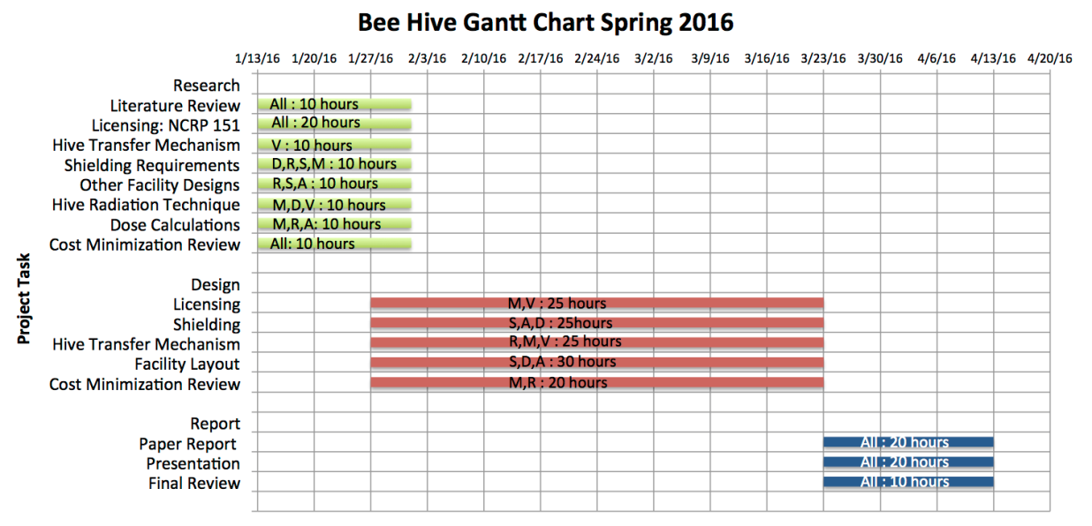
Figure 33: Gantt chart for spring 2016

Description of Effort by Each Team Member:
Ali Buhamad
Ali focused on the facility design, floor plan requirements and shielding, and dose calculations, which included both the dose received by the irradiated objects and the dose inside the accelerator shielded room. He also researched NCRP 151 analytical calculations, and worked with the team on both the presentation and the report.

Victoria Martin
Victoria accepted the responsibilities of creation of the Gantt chart, research of the hive transfer mechanism, research on licensing constraints, researching medical and pharmaceutical product sterilization, and compiling the final report.

Danielle McFall
Danielle reviewed literature regarding honey bee diseases, complications with pesticides, fungicides, bacteria, and parasites. She has also supported the research regarding shipping methods that could be employed to send beehives to an irradiator facility. Danielle’s responsibilities and tasks also included creating a facility design and corresponding facility MCNP input code. The MCNP input code provided a map of photon fluxes in photons/cm² and dose in Gy/min throughout the facility through the use of MCNP Plotter. During the facility design phase, Danielle helped establish the shielding materials utilized and thicknesses of the shielding materials that adhere to the NCRP 151 regulations.
Matthew O’Neil
Matthew was the group leader and was in charge of organizing meetings and pulling together weekly reports. Matthew performed the cost analysis of the business side of the facility along with Robby and Victoria. Based on results, the bee hive irradiation business is not profitable on its own. As a result, Matthew made a revenue model for the facility based off of Sterigenics by irradiating food, medical equipment, and pharmaceuticals. Matthew Specifically researched irradiating food. Matthew along with Victoria researched Tennessee State Regulations for the facility.
Saya Rutherford
Saya is part of the shielding team that determined the specific requirements necessary for the irradiation of the bees and the safety of the public. With this and the shielding design established, she began working on the code for the irradiation facility MCNP model. Once that was completed, she assisted in coding the data card, which includes the source term and mesh tally, in order to create the flux maps of the facility.
Robby Turner
Robby Turner was in charge of compiling the final cost analysis based on new details like the number of workers at the facility, the amount of concrete needed for shielding, and the debt on the loan taken out to begin construction on the facility. These figures were adjusted for inflation and detailed in two organized tables. Finally, the final cost analysis was included in the final report, and Robby will present the findings of the cost analysis during the final presentation.

References:
- Helping Agriculture's Helpful Honey Bees. U.S. Food and Drug Administration, 13 Jan. 2015.
- Behrens, Dieter, Eva Forsgren, Ingemar Fries, and Robin F. A. Moritz. "Lethal Infection Thresholds of Paenibacillus Larvae for Honeybee Drone and Worker Larvae (Apis Mellifera)." Environmental Microbiology (2010): n. pag. Web. http://onlinelibrary.wiley.com/doi/10.1111/j.1462-2920.2010.02257.x/full
- Cornman, R. Scott, David R. Tarpy, Yanping Chen, Lacey Jeffreys, Dawn Lopez, Jeffery S. Pettis, Dennis Vanengelsdorp, and Jay D. Evans. "Pathogen Webs in Collapsing Honey Bee Colonies." PLoS ONE 7.8 (2012): n. pag. Web. http://journals.plos.org/plosone/article?id=10.1371/journal.pone.0043562
- Doublet, Vincent, Maureen Labarussias, Joachim R. De Miranda, Robin F. A. Moritz, and Robert J. Paxton. "Bees under Stress: Sublethal Doses of a Neonicotinoid Pesticide and Pathogens Interact to Elevate Honey Bee Mortality across the Life Cycle." Environ Microbiol Environmental Microbiology17.4 (2014): 969-83. Web. http://onlinelibrary.wiley.com/doi/10.1111/1462-2920.12426/abstract
- Honey Bee Diseases and Pests: A Practical Guide. Tech. no. 4. N.p.: FAO, n.d. Print.
- Honey Bee Health and Colony Collapse Disorder. United States Department of Agriculuture, 5 Nov. 2015. Web. 25 Oct. 2015. http://www.ars.usda.gov/News/docs.htm?docid=15572
- Zhu, Wanyi, Daniel R. Schmehl, Christopher A. Mullin, and James L. Frazier. "Four Common Pesticides, Their Mixtures and a Formulation Solvent in the Hive Environment Have High Oral Toxicity to Honey Bee Larvae." PLoS ONE 9.1 (2014): n. pag. Web. http://journals.plos.org/plosone/article?id=10.1371/journal.pone.0077547
- Ingraham, Christopher. "Call off the Bee-pocalypse: U.S. Honeybee Colonies Hit a 20-year High." Washington Post. The Washington Post, 23 July 2015. Web. 18 Nov. 2015. https://www.washingtonpost.com/news/wonk/wp/2015/07/23/call-off-the-bee-pocalypse-u-s-honeybee-colonies-hit-a-20-year-high/
- Zenaida M. De Guzman, Cleofas R. Cervancia, Kris Genelyn B. Dimasuay, Mitos M. Tolentino, Gina B. Abrera, Ma. Lucia C. Cobar, Alejandro C. Fajardo Jr., Noel G. Sabino, Analinda C. Manila-Fajardo, Chitho P. Feliciano. Radiation inactivation of Paenibacillus larvae and sterilization of American Foul Brood (AFB) infected hives using Co-60 gamma rays, Applied Radiation and Isotopes, Volume 69, Issue 10, October 2011, Pages 1374-1379, ISSN 0969-8043, http://dx.doi.org/10.1016/j.apradiso.2011.05.032
- Alessandra Baggio, Albino Gallina, Nicoletta Dainese, Chiara Manzinello, Franco Mutinelli, Giorgia Serra, Roberto Colombo, Emanuele Carpana, Anna Gloria Sabatini, Klaus Wallner, Roberto Piro, Emanuele Sangiorgi. Gamma radiation: a sanitating treatment of AFB- contaminated beekeeping equipment, Gamma Radiation Sanitation in Beekeeping Management, Apiacta Journal, Pages 22-27. Web. http://www.apimondia.com/apiacta/articles/2005/baggio_1.pdf
- "Frequently Asked Questions." IBRA. International Bee Research Association, 2014. Web. 18 Nov. 2015. http://www.ibrabee.org.uk/index.php/information-services/faq
- “Structural Shielding Design and Evaluation for Megavoltage X-and Gamma-Ray Radiotherapy Facilities”, Print, NCRP Report 151.
- “Accelerators for America’s Future”, U.S. Department of Energy, http://science.energy.gov/~/media/hep/pdf/accelerator-rd-stewardship/Report.pdf
- “Iotron Sterilization”, The Richmond Beekeepers Association of British Columbia, Canada, https://richmondbeekeepersca.wordpress.com/club-activities/iotron/
- “An Economic Analysis of Electron Accelerators and Cobalt-60 for Irradiating Food”, Rosanna Mentzer Morrison, USDA, 1989.
- Fairand, Barry P. Radiation Sterilization for Health Care Products: X-Ray, Gamma, and Electron Beam. Boca Raton: CRC Press LLC, 2002. Print
- Lee, Jaimy. "Price of Radiation Technology Jumps 20%." Modern Healthcare. Modern Healthcare, 24 July 2013. Web. 20 Apr. 2016. http://www.modernhealthcare.com/article/20130724/NEWS/307249943
- DCD. "DCD Sq. Ft. Cost Analysis Office Building (Shell Only) LEED® Platinum." Design Cost Data, Nov.-Dec. 2013. Web. 20 Apr. 2016. http://www.dcd.com/pdf_files/1311analysis.pdf
- “Impela Accelerators”. Iotron Industries. N.p., n.d. Web. 25 Apr. 2016.

- Turner, James E. Atoms, radiation, and radiation protection. John Wiley & Sons, 2008.

- Sterigenics. "Sterigenics, the Global Leader in Sterilization Services, Inaugurated Its High-tech Facility in Costa Rica." (n.d.): n. pag.Sterigenics.com. Sterigenics, 11 Feb. 2013. Web. 8 Apr. 2016. http://www.sterigenics.com/library/Costa%20Rica%20Press%20Release.pdf

- "CHAPTER 0400-20-05 STANDARDS FOR PROTECTION AGAINST RADIATION." Division of Radiological Health. Rules of the Tennessee Department of Environment and Conservation, July 2015. Web. 30 Mar. 2016. http://share.tn.gov/sos/rules/0400/0400-20/0400-20.htm

- "CHAPTER 0400-20-09 STANDARDS FOR PROTECTION AGAINST RADIATION." Division of Radiological Health. Rules of the Tennessee Department of Environment and Conservation, May 2012. Web. 30 Mar. 2016. http://share.tn.gov/sos/rules/0400/0400-20/0400-20.htm

- "X-Ray Registration." X-Ray Registration. Tennessee Department of Environment and Conservation, n.d. Web. 30 Mar. 2016. https://tn.gov/environment/article/permit-rh-x-ray-registration

- “ISO 1137.” International Organization for Standardization. Web. 30 Mar. 2016. https://www.google.com/webhp?sourceid=chrome-instant&ion=1&espv=2&ie=UTF-8#q=international%20organization%20for%20standardization%201137

- “Linatron-M9 & M9A Modular high-energy X-ray source”. Varian Medical Systems, Inc. 2012. Web. 30 Mar. 2016. https://www.varian.com/sites/default/files/resource_attachments/LinatronM9.pdf

Appendix A
Beehive Irradiation Facility
c Cell Card
c --------------------------------------------
1 2 -2.3 (6 -8)(4 -19)(1 -2) imp:p 1
2 2 -2.3 (8 -11)(4 -20)(1 -2) imp:p 1
3 2 -2.3 (11 -12)(4 -23)(1 -2) imp:p 1
4 2 -2.3 (12 -13)(4 -24)(1 -2) imp:p 1
5 2 -2.3 (13 -14)(4 -23)(1 -2) imp:p 1
6 2 -2.3 (14 -17)(4 -20)(1 -2) imp:p 1
7 2 -2.3 (17 -18)(4 -19)(1 -2) imp:p 1
8 2 -2.3 (9 -10)(21 -19)(1 -2) imp:p 1
9 2 -2.3 (10 -15)(22 -19)(1 -2) imp:p 1
10 2 -2.3 (15 -16)(21 -19)(1 -2) imp:p 1
11 2 -2.3 (6 -18)(4 -19) (2 -3) imp:p 1
12 3 -2.52 (6 -18)(4 -19)(25 -1) imp:p 1 $ground
13 4 -0.64 -26 imp:p 1 $beehive box
100 1 -0.001205 -100 ((((-6:8):(-4:19):(-1:2))
((-8:11):(-4:20):(-1:2))
((-11:12):(-4:23):(-1:2))
((-12:13):(-4:24):(-1:2))
((-13:14):(-4:23):(-1:2))
((-14:17):(-4:20):(-1:2))
((-17:18):(-4:19):(-1:2))
((-9:10):(-21:19):(-1:2))
((-10:15):(-22:19):(-1:2))
((-15:16):(-21:19):(-1:2)))
((-6:18):(-4:19):(-2:3))
((-6:18):(-4:19):(-25:1))26) imp:p 1
1000 0 100 imp:p 0
c --------------------------------------------

c Surface Card (origin at top left corner of picture)
c ----------------------------------
1 pz 0 $floor
2 pz 400.05 $13.125ft ceiling
3 pz 537.21 $4.5ft concrete
c
c outer walls of facility
4 py 0
6 px 0
c
c primary inner walls
8 px 96.012
9 px 273.812
10 px 369.824
11 px 547.624
12 px 654.304
13 px 867.664
14 px 974.344
15 px 1152.144
16 px 1248.156
17 px 1425.956
18 px 1521.968
c
19 py 974.4
20 py 96.012
21 py 273.812
22 py 716.28
23 py 538.48
24 py 106.68
c
c ground, 5ft depth
25 pz -152.4
c
c beehive box, 40x48x75 in.
26 rpp 710.184 811.784 566.42 688.34 0 190.5
c Environment
100 SPH 760 460 0 1500
c ---------------------------------

c Data Card
c ---------------------------------
nps 10000000
mode p
sdef par 2 erg 9 pos 760.984 411.48 95.25 vec 0 1 0 dir 1
fmesh14:p origin 0 0 -152.4 imesh 1521.968 jmesh 974.4 kmesh 537.21
iints 440 jints 260 kints 200 out=none
c Dose Conversion (flux(photons/cm2) to (rem/hr))
de14 .01 .03 .05 .07 .1 .15 .2 .25 .3 .35 .4 .45 .5 .55 .6 .65 .7
.8 1 1.4 1.8 2.2 2.6 2.8 3.25 3.75 4.25 4.75 5 5.25 5.75
6.25 6.75 7.5 9. 11. 13. 15.
df14 3.96e-6 5.82e-6 2.90e-7 2.58e-7 2.83e-7 3.79e-7 5.01e-7
6.31e-7 7.59e-7 8.78e-7 9.85e-7 1.08e-6 1.17e-6 1.27e-6
1.36e-7 1.44e-6 1.52e-6 1.68e-6 1.98e-6 2.51e-6 2.99e-6
3.42e-6 3.82e-6 4.01e-6 4.41e-6 4.83e-6 5.23e-6 5.60e-6
5.80e-6 6.01e-6 6.37e-6 6.74e-6 7.11e-6 7.66e-6 8.77e-6
1.03e-5 1.18e-5 1.33e-5
c Dose Conversion Conti. (rem/hr to Gy/min to 30Gy/min Beam)
fm14 4
c Dry air
c Density = 0.001205 g/cm3
M1 7014 0.78
8016 0.21
18000 0.01
c Concrete
c Density = 2.300000 g/cm3
M2 1001 0.168038
8016 0.563183
11023 0.021365
13027 0.021343
14000 0.203231
20000 0.018595
26000 0.004246
c Earth
c Density = 2.52 g/cm3
M3 1001 0.316855
8016 0.501581
13027 0.039951
14000 0.141613
c Wood
c Density = 0.64 g/cm3
M4 1001 0.462423
6000 0.323389
7014 0.002773
8016 0.208779
12000 0.000639
16000 0.001211
19000 0.000397
20000 0.000388
c ----------------------------------

Appendix B

Beehive Irradiation Facility
c Cell Card
c --------------------------------------------
1 2 -2.3 (6 -8)(4 -19)(1 -2) imp:p 1
2 2 -2.3 (8 -11)(4 -20)(1 -2) imp:p 1
3 2 -2.3 (11 -12)(4 -23)(1 -2) imp:p 1
4 2 -2.3 (12 -13)(4 -24)(1 -2) imp:p 1
5 2 -2.3 (13 -14)(4 -23)(1 -2) imp:p 1
6 2 -2.3 (14 -17)(4 -20)(1 -2) imp:p 1
7 2 -2.3 (17 -18)(4 -19)(1 -2) imp:p 1
8 2 -2.3 (9 -10)(21 -19)(1 -2) imp:p 1
9 2 -2.3 (10 -15)(22 -19)(1 -2) imp:p 1
10 2 -2.3 (15 -16)(21 -19)(1 -2) imp:p 1
11 2 -2.3 (6 -18)(4 -19) (2 -3) imp:p 1
12 3 -2.52 (6 -18)(4 -19)(25 -1) imp:p 1 $ground
100 1 -0.001205 -100 ((((-6:8):(-4:19):(-1:2))
((-8:11):(-4:20):(-1:2))
((-11:12):(-4:23):(-1:2))
((-12:13):(-4:24):(-1:2))
((-13:14):(-4:23):(-1:2))
((-14:17):(-4:20):(-1:2))
((-17:18):(-4:19):(-1:2))
((-9:10):(-21:19):(-1:2))
((-10:15):(-22:19):(-1:2))
((-15:16):(-21:19):(-1:2)))
((-6:18):(-4:19):(-2:3))
((-6:18):(-4:19):(-25:1))) imp:p 1
1000 0 100 imp:p 0
c --------------------------------------------

c Surface Card (origin at top left corner of picture)
c ----------------------------------
1 pz 0 $floor
2 pz 400.05 $13.125ft ceiling
3 pz 537.21 $4.5ft concrete
c
c outer walls of facility
4 py 0
6 px 0
c
c primary inner walls
8 px 96.012
9 px 273.812
10 px 369.824
11 px 547.624
12 px 654.304
13 px 867.664
14 px 974.344
15 px 1152.144
16 px 1248.156
17 px 1425.956
18 px 1521.968
c
19 py 974.4
20 py 96.012
21 py 273.812
22 py 716.28
23 py 538.48
24 py 106.68
c
c ground, 5ft depth
25 pz -152.4
c
c Environment
100 SPH 760 460 0 1500
c ---------------------------------

c Data Card
c ---------------------------------
nps 10000000
mode p
sdef par 2 erg 9 pos 760.984 411.48 95.25 vec 0 1 0 dir 1
fmesh14:p origin 0 0 -152.4 imesh 1521.968 jmesh 974.4 kmesh 537.21
iints 440 jints 260 kints 200 out=none
c Dose Conversion (flux(photons/cm2) to (rem/hr))
de14 .01 .03 .05 .07 .1 .15 .2 .25 .3 .35 .4 .45 .5 .55 .6 .65 .7
.8 1 1.4 1.8 2.2 2.6 2.8 3.25 3.75 4.25 4.75 5 5.25 5.75
6.25 6.75 7.5 9. 11. 13. 15.
df14 3.96e-6 5.82e-6 2.90e-7 2.58e-7 2.83e-7 3.79e-7 5.01e-7
6.31e-7 7.59e-7 8.78e-7 9.85e-7 1.08e-6 1.17e-6 1.27e-6
1.36e-7 1.44e-6 1.52e-6 1.68e-6 1.98e-6 2.51e-6 2.99e-6
3.42e-6 3.82e-6 4.01e-6 4.41e-6 4.83e-6 5.23e-6 5.60e-6
5.80e-6 6.01e-6 6.37e-6 6.74e-6 7.11e-6 7.66e-6 8.77e-6
1.03e-5 1.18e-5 1.33e-5
c Dose Conversion Conti. (rem/hr to Gy/min to 30Gy/min Beam)
fm14 4
c Dry air
c Density = 0.001205 g/cm3
M1 7014 0.78
8016 0.21
18000 0.01
c Concrete
c Density = 2.300000 g/cm3
M2 1001 0.168038
8016 0.563183
11023 0.021365
13027 0.021343
14000 0.203231
20000 0.018595
26000 0.004246
c Earth
c Density = 2.52 g/cm3
M3 1001 0.316855
8016 0.501581
13027 0.039951
14000 0.141613
c ----------------------------------

Appendix C
NCRP Method Validation
c Cell Card
1 1 -2.3 -1 imp:p 1
2 0 1 -100 imp:p 0
3 0 100 imp:p 0

c Surface Card
c 2 x 2 x 10 ft concrete
1 rpp -30.48 30.48 -152.4 152.4 -30.48 30.48
100 so 1000

c Data Card
mode p
nps 100000
sdef par 2 erg 9 pos 0 -152.4 0 vec 0 1 0 dir 1
fmesh14:p origin -30.48 -152.4 -30.48 imesh 30.48 jmesh 152.4 kmesh 30.48
iints 1 jints 60 kints 1 out col
c Concrete
c Density = 2.300000 g/cm3
M1 1001 0.168038
8016 0.563183
11023 0.021365
13027 0.021343
14000 0.203231
20000 0.018595
26000 0.004246

