ANALYSIS OF LARGE-SCALE INTEGRATED DATA ON CONNECTIVITY AND AUTOMATION TECHNOLOGY TO ADVANCE MULTIMODAL SAFETY:
APPLICATION OF BASIC SAFETY MESSAGES, ALERTS, AND CRASH DATA

A Dissertation Presented for the
Doctor of Philosophy
Degree
The University of Tennessee, Knoxville

Antora Mohsena Haque
December 2022

Copyright © 2022 by Antora Mohsena Haque
All rights reserved.

This dissertation is dedicated to my parents, my husband, my sister, my friends, and family who inspired me every day to achieve my dreams and complete my dissertation.

ACKNOWLEDGMENT
At first, I want to thank almighty for his blessings upon me in every aspect of life. I believe, I have come this far and now that I am being able to achieve the doctoral degree are being possible for his continuous blessings and miracles.

I want to thank everyone I have come across in life who encouraged and supported my endeavors to pursue higher studies abroad. I want to convey my most profound gratitude to Dr. Asad J. Khattak without whose support my dream of earning a doctoral degree in Civil Engineering would be impossible. I wish to express my profound appreciation to him for his knowledge, mentorship, and guidance in the completion of my research work. A debt of gratitude is extended to my dissertation committee members, Dr. Christopher Cherry, Dr. Anahita Khojandi, and Dr. Russel Zaretzki who helped me strengthen my dissertation’s research work. I want to acknowledge my co-authors, Dr. Asad J. Khattak, Dr. Candace Brakewood, Dr. Christopher Cherry, Dr. Anahita Khojandi, Dr. Ramin Arvin, Dr. Iman Mahdinia, Shahrbanoo Rezaei, Jing Guo, and A Latif Patwary for their valuable knowledge and insight into my research. I wish to thank the Department of Civil and Environmental Engineering faculty and staff and the Collaborative Sciences Center for Road Safety (CSCRS) for their assistance and support.

Thank you to my lab mates, especially Steve Lee, Nitesh Raj Shah, Kinzee Clark, Abubakr Salah, and Yi Wen whose friendship and support made my PhD life memorable.

ABSTRACT

Transportation Engineers and Planners are working towards improving transportation safety by researching Connected and Automated vehicles, which are anticipated to address human error factor in crash studies. This dissertation investigates various safety features of both Connected Vehicles (CVs) and Automated Vehicles (AVs) to understand their performance at this stage which can be insightful for CAV researchers. First, safety features of Connected buses were studied to determine association of pedestrian and bus-based alerts with crashes that can aid safety of vulnerable road users. This was followed by literature review of Automated shuttles to identify potential location of AV shuttle’s deployment at early stage. Later, safety features of AVs were used to compare lower-level automated vehicles to understand which AVs are performing better in terms of safety at different road types, weather and lighting conditions, and driver behaviors. Long term scientific value of these research is that they harness big data from cutting edge intelligent infrastructures and combine them with conventional crash and road geometry data to perform analysis that can aid in advancing multimodal safety. Finally, research implications and future works are discussed to provide comprehensive understanding of these emerging vehicles.

Table of Contents
ACKNOWLEDGMENT iv
ABSTRACT v
INTRODUCTION 1
Chapter One ENHANCING THE SAFETY OF TRANSIT USERS AND PEDESTRIANS IN URBAN AREAS: THE ROLE OF CONNECTED VEHICLES AND SMART INFRASTRUCTURE TO PROACTIVELY IDENTIFY HIGH-RISK HAZARDOUS LOCATIONS 7
Abstract 8
Introduction 8
Literature Review 9
Prior Research on Basic Safety Messages 10
Prior Research on Transit Bus-involved crashes 11
Prior Research on Hazardous locations 12
Methodology 12
Data 13
Data Processing 16
Data Analysis 18
Results 21
Hazardous locations for transit bus-involved crashes using ArcGIS 21
Grids with ≥ 1 alert 23
Discussion 31
Comparison of hazardous and non-hazardous areas based on Alert/Grid and Crash/Grid 31
Bus-involved crash reduction by EPCW 31
Limitations 32
Conclusions 33
New Section of the work 34
Acknowledgments 34
Chapter Two EVALUATING PEDESTRIAN SAFETY IN BUS-PEDESTRIAN INTERACTIONS WITH THE APPLICATION OF ENHANCED PEDESTRIAN COLLISION WARNING SYSTEMS: ANALYSIS OF LARGE-SCALE BASIC SAFETY MESSAGE DATA 35
Abstract 36
Introduction 36
Literature Review 37
Methodology 39
Data 39
Data preparation 40
Contingency tables 42
Alert Zone identification 43
Mean Time Difference to Intersection 43
Study Area 43
Results 44
Frequency Distribution of Alerts 44
Comparison of three intersections 47
Identification of Alert Zones for buses 48
Discussion 53
Performance of EPCW 53
Land Use 53
Temporal Distribution of EPCW 55
Limitations 56
Conclusion 57
Acknowledgments 58
Chapter Three A SYNTHESIS AND COMPARISON OF AMERICAN AUTOMATED SHUTTLE PILOT PROJECTS 59
Abstract 60
Introduction 60
Prior Research 61
European research on automated shuttles 61
American research on automated shuttles 61
Gaps in research on automated shuttles 62
Objectives 62
Methodology 62
Results 63
Identification of pilot projects 63
Selection of cases 64
Summary of the selected cases 64
Synthesis of the state of the practice 67
Areas for improvement and future research 68
Conclusions 73
Chapter Four INVESTIGATING CRASHES INVOLVING TESLA CRASHES-THE ROLE OF AUTOMATION 75
Abstract 76
Introduction 76
Literature Review 77
Methods 78
Data 78
Ordered Logistic Regression Model 81
Marginal Effect 82
Results 82
Frequency Distribution of variables 82
Ordered Logistic Regression Model Results 83
Discussion 87
Limitations 89
Conclusions 89
New Section of the work 90
Acknowledgments 90
Chapter Five UNDERSTANDING THE SURVIVABILITY OF DRIVERS FROM AUTOMATED VEHICLE-INVOLVED FATAL CRASHES: A CASE STUDY OF TESLA-INVOLVED FATAL CRASHES 91
Abstract 92
Introduction 92
Literature Review 93
Data 94
Methods 97
Human Crash Contributing Factors 97
Correlation Analysis: Somers’ D Test 97
Results and Discussion 98
Descriptive Statistics 98
Cross Tabulation: Tesla Driver Survivability versus Key Factors 100
Correlation analysis through Somers’ D Tests 101
Comparison of Tesla of Luxury Electric Vehicles 103
Limitations 104
Conclusions 104
New Section of the work 105
Acknowledgments 105
CONCLUSION 106
List of References 107

LIST OF TABLES
Table 1.1. Number of observations in grids with ≥ 1 alert-based datasets 24
Table 1.2. Descriptive Statistics of grids with ≥ 1 alert. 26
Table 1.3. Descriptive Frequencies of Key Variables. 27
Table 1.4. Regression Models for alerts on grids with ≥ 1 alert. 29
Table 2.1. Frequency of Alerts by “EventCodeType” and “AppMessageType” 46
Table 2.2. Contingency Table of Alerts under all “AppMessageType,” only EPCW Application, and Pedestrian Based “EventCodeType” 48
Table 3.1. Timeline of automated shuttle deployments 65
Table 3.2. Summary of six case studies 70
Table 3.3. Typology based on locations 71
Table 3.4. Typical service characteristics 72
Table 4.1. Frequency Distribution of variables 84
Table 4.2. Ordered Logistic Regression Model 85
Table 4.3. Marginal Effect of Ordered Logistic Regression Model 86
Table 5.1. Overview of Literature Review 96
Table 5.2. Driving Errors and Violations by Tesla Driver in Single-Vehicle (Tesla) Crashes (N = 71) 97
Table 5.3. Distribution of Injury Severity in Single Vehicle Crashes (N=71) 99
Table 5.4. Cross Tabulation of Fatality of Tesla Driver Versus Human Factors 102
Table 5.5. Results of Correlational Analysis: Tesla Driver Survivability versus Key Factors 103

LIST OF FIGURES
Figure 0.1. Conceptual Framework of the Study 5
Figure 0.2. Outline of the Proposal 6
Figure 1.1. Technology packages relevant to transit buses. 11
Figure 1.2. Methodological Framework. 13
Figure 1.3. Onboard Subsystem (left), Infrastructure Subsystem-Roadside units (right). 14
Figure 1.4. EPCW WarnAlert to Bus Driver (left) & EVTRW Inform Alert to Bus Driver (right). 15
Figure 1.5. Percentage of usable alerts after merging Alert and BSM datasets. 16
Figure 1.6. Map of hazardous locations for bus-involved crashes in Cuyahoga County 22
Figure 1.7. Hazardous locations vs. grids with ≥ 1 alert (Both EPCW & EVTRW). 23
Figure 1.8. (a) Crash/Grid and (b) Alert/Grid in grids that include ≥ 1 alert using Both EPCW & EVTRW Dataset 31
Figure 1.9. Bus-involved crashes from 1999-to 2019 in the US. 32
Figure 1.10. Reduction of bus-involved crashes by EPCW 32
Figure 2.1. On-board Subsystem (top), Infrastructure Subsystem (middle), and EPCW “WarnAlert” (bottom) (13) 41
Figure 2.2. Percentage of alerts after merging Alert and BSM datasets 42
Figure 2.3. Three selected intersections in Cleveland, Ohio 45
Figure 2.4. Percentage of “Info, “InformAlert” and “WarnAlert” at (a) all three intersections, (b) Signalized, (c) Unsignalized, and (d) Midblock crossing 47
Figure 2.5. Categories of bus stops based on their curbside location 49
Figure 2.6. (a) All, (b) “FarsidePed,” (c) “NearsidePed,” (d) “LeftsidePed,” and (e) “RightsidePed” alerts at Signalized Intersection 50
Figure 2.7. (a) All, (b) “FarsidePed,” (c) “NearsidePed,” (d) “LeftsidePed,” and (e) “RightsidePed” alerts at Unsignalized Intersection 51
Figure 2.8. Pedestrian based alerts at Midblock Crossing 52
Figure 2.9. Trendline of MTDIs at intersections 54
Figure 2.10. Land Use around the three intersections of the study area 55
Figure 2.11. Timeseries heatmap of Alerts at intersections 56
Figure 3.1. Methodology 63
Figure 3.2. Three key dimensions of automated shuttle deployments 69
Figure 3.3. Typical stakeholders in automated shuttle projects 73
Figure 4.1. TESLA-involved crashes in Tennessee 79
Figure 4.2. Crash severity in different TESLA models 80
Figure 4.3. Crash severity and ACC 81
Figure 4.4. Marginsplot of the probability of crashes-based on (A) ACC, (B) Tesla Models, (C) Light Condition, (D) Maneuver, (E) Driver Actions, and (F) Road Class 88
Figure 5.1. Conceptual Framework (Single Vehicle Crashes “N = 71”) 93
Figure 5.2. Countrywise Distribution of Fatal Crashes involving Tesla Vehicle 99
Figure 5.3. Statewise Distribution of Single Vehicle Fatal Crashes involving Tesla Vehicle in the US 100
Figure 5.4. Year to Date Sales of Luxury Electric Vehicles (204) 104

INTRODUCTION
People need to travel for various needs almost daily, and these inevitable trips can become fatal due to human error, vehicle error, faulty infrastructure, environment, and bad weather. In these hazardous conditions, along with the drivers and passengers of the vehicles, vulnerable road users like pedestrians are also at high risk. While some issues are unavoidable, scientists are working their way to eradicate human error by developing connectivity and automation technology in the big picture. Connected Vehicles (CV) use vehicle to vehicle (V2V) or vehicle to infrastructure (V2I) technology to exchange Basic Safety Messages (BSM) between each other and infrastructures to alert drivers to ensure the safety of vehicles and road users. On the other hand, automated vehicles use Lidar, Radar, and cameras to acquire images of their surroundings and use their artificial intelligence-based algorithms to enable various automation features to ensure safety. The emergence of these technologies has brought a ray of hope for carefree and safe traveling opportunities. But before fully deploying connected and automated vehicles (CAV), these technologies need to be evaluated and improved to yield the best possible benefit they can offer.
Although numerous CAV pilot projects are occurring, almost all focus on automobiles. Simultaneously, there are very few applications of connectivity and automation in alternative modes like public transit buses. Whereas 11.5% of workers in the largest cities of US metro areas and 5% of all workers in the US choose transit to commute to work every day, transit is not a vehicle that can be ignored in any safety analysis. Existing literature lacks investigation of V2V and V2I technologies’ utility in transit buses. Automation has not been applied to large transit buses, but it is being tested in some automated shuttles, which are smaller versions of these large transit buses. Therefore, the application of connectivity and automation should also be studied for transit buses to ensure safety. For now, automation features in automobile needs more rigorous analysis, which can later help in its application in other modes like transit buses. Hence, this dissertation will focus on large-scale data on connectivity and automation technology in transit buses and automobiles. Through rigorous analytical methods, this dissertation will analyze how V2V, V2I, and various automation safety features can be utilized to advance multimodal safety.
Chapter 1 utilizes data from the “Enhanced Transit Safety Retrofit Package (E-TRP)” project, which contains big data on Basic Safety Message (BSM) and Alerts generated in 24 Connected transit buses in Cuyahoga County, Cleveland, Ohio. This publicly available data will be combined with five years of transit-involved crashes to explore two safety features of connectivity technology: Enhanced Pedestrian in Crossing Warning (EPCW) and Enhanced Vehicle Turning Right in Front of Bus Warning (EVTRW). Association between pedestrian and bus-based alerts and historic crash locations will be analyzed only for areas where at least one alert was generated using Panel Poisson Regression and hotspot analysis. The Panel model will help to control unobserved variables and understand individual heterogeneity. This study will contribute a framework for harnessing and utilizing unique data from Connected Vehicles (CV) to gain critical knowledge on pedestrians and transit safety that provides long-term scientific value. Another section of the chapter will study both the locations containing alerts and locations not containing alerts for analysis. This study will apply Decision tree algorithms like Random Forest/XGBoost to predict bus-involved crashes. The results and implications will be discussed to illustrate the potential of basic safety messages and alerts to predict crash-prone hazardous locations.
Chapter 2 uses only the Enhanced Pedestrian in Crossing Warning (EPCW) portion of the “Enhanced Transit Safety Retrofit Package (E-TRP)” project that was generated at three different intersections of Cuyahoga County, Cleveland, Ohio. The study will observe the pattern of different types of EPCW alerts at a Signalized, unsignalized, and midblock intersection. Safety surrogate measures and the radius of the alerts from each intersection will be measured. Land use and timeseries heatmaps will be produced to understand EPCW’s pattern better. The results and implications will be discussed to realize the potential of EPCW alerts to improve pedestrian safety at intersections.
Chapter 3 will synthesize the state of the practice of automated shuttle pilot projects in the US. The case study method will identify shuttle deployment patterns by studying ongoing and completed projects open to the broader public since 2016, as the deployment of automated shuttle pilot projects began in 2016 in the United States. The pilot projects will be identified manually from online news articles and websites. The case studies will be synthesized along three dimensions: locations, service characteristics, and stakeholders. The results will assist cities that are considering future deployments of automated shuttles in their locality.
Chapter 4 uses Tesla Crash data of Tennessee from Tennessee’s Integrated Traffic Analysis Network (TITAN) database. The Advanced Driver Assistant System (ADAS) studied in this paper is Adaptive Cruise Control (ACC). This study will provide an in-depth understanding of the role of ACC, driver behavior, roadway, and vehicle features on crash severity of automated vehicles, considering Tesla as an example. An Ordered logistic regression model, which uses a proportional odds assumption, is applied to observe their relationship. Next, the Generalized Ordered Logit model (Gologit) will be applied to this data to use the partial proportional odds assumption to investigate the presence of some covariates that do not meet the proportional odds assumption.
Chapter 5 uses Fatal crashes of Tesla cars that have happened worldwide since its deployment. One of the safety features of automation technology, Tesla Autopilot Engagement, and human behaviors will be studied for these fatal crashes. The study will provide a deeper understanding of the role of driver behavior, roadway and vehicular features, and automation features in automated cars, considering Tesla as an example. Due to the smaller sample size, Somers’ D statistics are used to investigate the association between Tesla driver survivability and other independent variables. Next, a rigorous statistical model like the Bayesian Logit model can be applied to the data to identify the associations.
Overall, the chapters’ main themes are as follows:
- Chapter 1: understanding the potential of connectivity in transit buses to improve pedestrian safety at intersections
- Chapter 2: addressing the research gap of connectivity in transit buses
- Chapter 3: state of the practice of automation in transit shuttles.
- Chapter 4: studying the impact of driver behavior, vehicle, roadway, and geometric features on crash severity of vehicles with automation
- Chapter 5: studying ADAS technology in vehicles with lower-level automation
In summary, the dissertation's main contribution is exploring the association of various Advanced Driver Assistance Systems (ADAS) in terms of safety features at different levels in Connected and Automated Vehicles by harnessing big data generated under-real world conditions. The research will integrate unstructured raw data on V2V and V2I communication technology from CAVs with geometric features of the roads, driver behavior, and crash data to develop unique and insightful datasets about transit, pedestrian, and automobile safety. Real-world crashes, crash severity, safety warnings, and performance of safety features can help predict hazardous locations and conditions that can assist drivers from potential crashes. The research will be done at three levels: The microscopic level (probability of crash severity), mesoscopic (intersection), and macro level (crashes at road network). The study will show how BSMs like EPCW and EVTRW exchanged via V2V and V2I can be utilized for the safety improvement of transit buses and pedestrians. The research will observe and identify locations where the automated shuttles can be deployed immediately. The research will also examine the autopilot and ACC features in lower-level automated vehicles to understand the association between automation features and crashes.
It is expected that under this dissertation, six chapters in reputed transportation journals be published:
- Haque, A.M., Khattak, A.J. (2022). Evaluating Pedestrian Safety in Bus-Pedestrian Interactions with the Application of Enhanced Pedestrian Collision Warning Systems: Analysis of Large-Scale Basic Safety Message Data.
- Under review in Transportation Research Record
- Peer-reviewed conference paper: Presented in the Transportation Research Board 101st Annual Meeting in 2022
- Haque, A.M., Arvin, R., Khattak, A.J. (2022) Enhancing the safety of transit users and pedestrians in urban areas: The Role of Connected Vehicles and Smart Infrastructure to Proactively Identify High-Risk Hazardous Locations.
- Under review in Transportation Research Part C: Emerging Technologies
- Haque, A.M., Khattak, A.J. (2022). Application of classification methods to predict hazardous locations based on big data from connected vehicles
- Will be submitted to a peer-reviewed journal
- Haque, A.M., Brakewood, C. A Synthesis and Comparison of American Automated Shuttle Pilot Projects
- Journal article: Case Studies on Transport Policy
- Peer-reviewed conference paper: Presented in the Transportation Research Board 98th Annual Meeting in 2019
- Haque, A.M., Ahmad, N., King, M., Khattak, A.J. Understanding the Survivability of Drivers from Automated Vehicle-Involved Fatal Crashes: A Case Study of Tesla-Involved Fatal Crashes
- Submitted for presentation in the Transportation Research Board 102nd Annual Meeting in 2023
- Haque, A.M., Mahdinia, I., Safaitaherkhani, M., Khattak, A.J.Investigating Crashes Involving Tesla Vehicles-The Role of Automation
- Submitted for presentation in the Transportation Research Board 102nd Annual Meeting in 2023
This research is important because it will assist the development of transportation systems in smart cities. Knowledge gained from this dissertation can assist policymakers in decision-making regarding deploying these emerging technologies and improving the safety of vulnerable road users. Methodological frameworks and a novel safety surrogate measure introduced in this dissertation would expand the knowledge body of CAVs, assisting researchers investigating these technologies. Furthermore, the results of this study can help agencies and manufacturers of these technologies in improving the safety features’ performances. The overall framework of the study and the outline of the proposal are shown in Figure 0.1 and Figure 0.2, respectively.

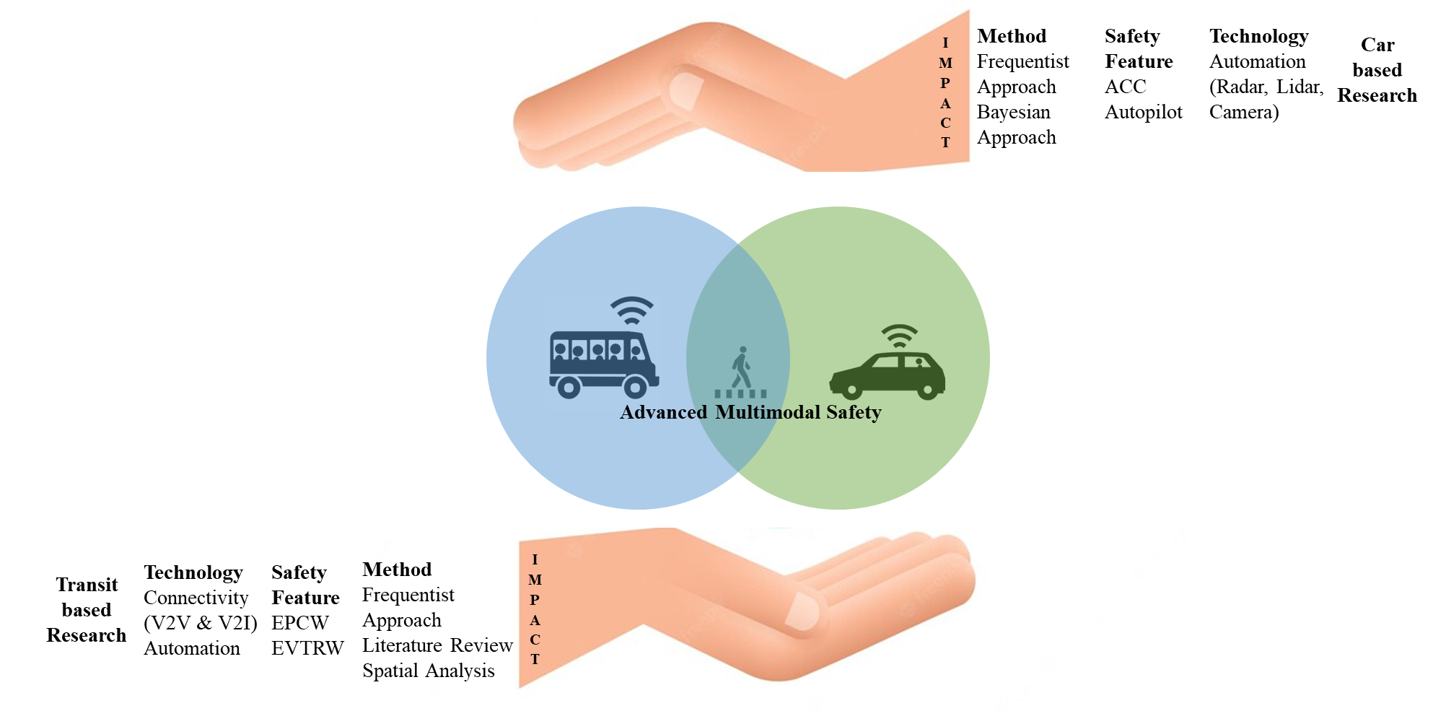
Figure 0.1. Conceptual Framework of the Study

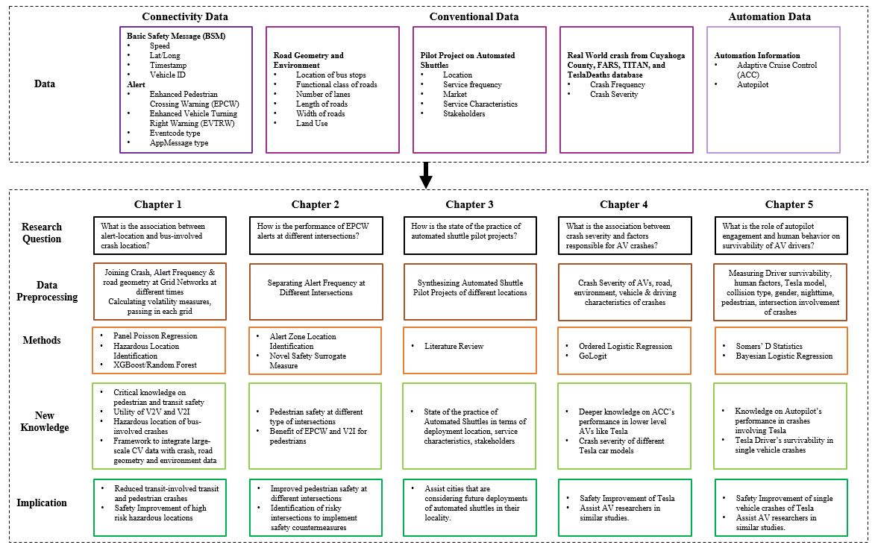

Figure 0.2. Outline of the Proposal

ENHANCING THE SAFETY OF TRANSIT USERS AND PEDESTRIANS IN URBAN AREAS: THE ROLE OF CONNECTED VEHICLES AND SMART INFRASTRUCTURE TO PROACTIVELY IDENTIFY HIGH-RISK HAZARDOUS LOCATIONS

Abstract
With automation and connectivity technologies, new possibilities are emerging for improving the safety of all road users, including the safety of alternative travel modes and vulnerable road users, in line with vision zero plans. This study explores the safety of transit users, especially focusing on interactions and crashes with vulnerable pedestrians. This study uses large-scale smart infrastructure and vehicle communication data for novel applications in personal and transit vehicles from recently deployed connected buses in the US. Smart vehicle and infrastructure technologies can improve public transit safety, e.g., by detecting pedestrians to enhance the safety of all road users in the future. The study analyzes Basic Safety Message (BSM) and alerts to help bus drivers avoid crashes, including crashes with pedestrians. This paper aims to enhance transit safety by exploring two Advanced Driver-Assistance Systems: Enhanced Pedestrian in Crossing Warning (EPCW) and Vehicle Turning Right in Front of Bus Warning (EVTRW). A publicly available five months of BSM data and alerts received by 24 connected buses, local crash statistics, and geometric features of the roads in Cuyahoga County, Ohio, are used for the analysis. The study area is divided into a grid network. Four speed volatility measures that quantify variations in driving behavior are calculated. Datasets are developed based on EPCW and EVTRW alerts. Panel Poisson regression models suggest that a 1% increase in EPCW alerts is associated with a 0.239% reduction in bus-involved crashes and a 1% increase in bus-driving volatility correlates with a 0.041 unit increase in the average number of bus-involved crashes if all else remains equal. Hazardous location identification maps show that alerts help identify high-risk hazardous locations for bus-involved crashes. EPCW systems can clearly reduce bus crashes with pedestrians. The analysis provides support for policymaker decisions about the value of smart infrastructure, transit-based CV technologies, and vulnerable road user safety.

Introduction
Automation and connectivity technologies are increasingly diffusing through the personal vehicle market and are potentially substantial contributors to the vision zero goal. However, their use for alternative modes and vulnerable road users is limited. New possibilities are emerging for improving the safety of transit users and vulnerable road users, including pedestrians. This study aims to enhance transit safety by exploring the role of two advanced driver-assistance systems (ADAS)—the Enhanced Pedestrian in Crossing Warning (EPCW) and Vehicle Turning Right in Front of Bus Warning (EVTRW). These are based on smart vehicle and infrastructure technologies that can benefit public transit and detect pedestrians to enhance safety for all road users in the future.
Connected Vehicle’s (CV) Basic Safety Message (BSM) data are state-of-the-art technology that many American cities are recently testing to examine their potential for helping avoid collisions or crashes. According to Federal Highway Administration (FHWA), BSMs are the “minimum transmitted data package exchanged between CVs which include information about the vehicle’s current location, speed, heading, acceleration, braking status, and vehicle size” (1). CV’s BSM data can be used to understand contributing factors in crashes that can directly impact safety.
Recent research on road safety and contributing factors to crashes has started using BSMs and alert messages received by CVs in various pilot projects. Due to the high confidentiality of CV projects, these data are not disclosed publicly and the research on them is limited. Among the few conducted studies, the focus was on all vehicles or cars, but not on public transport like buses. Generally, the number of cars is much higher than the number of buses on any route in US cities. However, the number of passengers carried by bus is much higher than the number of passengers carried by car. Hence, fatal bus-involved crashes cause more casualties than fatal car crashes. Therefore, measures for bus crash reduction are vital.
Deployment of connected buses allows researchers to investigate the potential of BSMs and alerts to help develop bus crash countermeasures. This research hypothesizes that alerts and BSM data can help identify high-risk hazardous locations for bus-involved crashes. This paper aims to enhance transit safety based on which the objectives are formulated. The objectives of this study are:
- To develop a framework for extracting useful information from connected bus pilot projects (BSMs and alerts) and bus-involved crash data;
- To investigate associations between alert locations and bus-involved crash locations in a road network;
- To develop a random-effect Panel Poisson Regression model to consider spatial and temporal effect in the CV alerts and crash data.
Initially, hazardous locations for bus-involved crashes will be identified using ArcGIS. Five years of bus crash statistics will be used to create a layer of hazardous and non-hazardous locations. This layer will be overlaid with the location of alerts received by CVs to see whether the alerts also appear in those crash-prone locations or not. Later, a Panel Poisson regression model will be used to identify if the number of bus-involved crashes changes with changes in alerts at different times for specific locations.
The intellectual merit and contribution of this paper are broad. The study harnesses publicly available big data on connected transit buses to explore the safety benefits of two ADAS such as EPCW and EVTRW. These are emerging technologies that have the potential to be adopted in the future. The study develops a framework for combining big data with data from other sources (four different sources) to develop a master database for safety studies that future researchers can follow. BSMs, EPCW alerts, and EVTRW alerts are unique, and they are structured to gain critical knowledge on pedestrians and transit safety that provides long-term scientific value. Historic crash statistics are used to identify real-world hazardous locations for bus-involved crashes. The study highlights the impact of CV technology on transit and pedestrian safety.

Literature Review
This literature review provides an overview of recent studies on three topics relevant to transit bus safety:
- Analysis of Basic Safety Message data as a tool to reduce bus-involved crashes
- Frequency and types of transit bus-involved crashes
- Analysis of hazardous locations for transit buses
By synthesizing these three separate areas of study, this review will highlight opportunities for new research to improve transit bus safety.

Prior Research on Basic Safety Messages
Road users are considered the main contributors to all types of crashes. Transportation experts have started taking the initiative to control human factors indirectly by introducing connectivity and automation in vehicles and roadway infrastructure. Recently, transportation agencies have been testing automation and connectivity in various environmental conditions. Connectivity is part of the Intelligent Transportation System (ITS), where BSMs are shared between vehicles and infrastructures to avoid potential crashes. Instantaneous driving behavior, maneuvers, trajectory, individual origin and destination, and traffic data can be acquired from the connected vehicles (2). A handful of studies have been conducted to explore the relationship between crash frequencies and drivers’ volatile behavior or volatility (3-6).
Because untreated or raw BSM data are complex to understand, data analytics methods should be used to extract critical information from them (3). When longitudinal accelerations are used to find drivers’ volatility’s effect on crash frequency, braking shows substantial volatility (4). One study showed that with a one percent increase in volatility at intersections, crash frequencies could increase by 1.25%, 0.25%, and 0.35% for acceleration/deceleration, passing level volatility captured through coeﬃcient of variation of speed, and mean absolute deviance of vehicular jerk respectively (5). Although various measures derive driving volatility, none have used lateral swipe crash or crash severity to measure volatility (6). Intersections with high variations in the longitudinal movement are prone to higher rear-end crashes, and intersections with lateral volatility have a higher risk of a head-on collision (2). These studies were conducted using overall crash data. However, they did not specify how the results could be generalized for transit bus-related crashes.
In a step towards the future of public transit, many cities and transit agencies introduced the “Smart Bus.” These transit buses use the Internet of Things (IoT) technology to exchange information between buses and waiting passengers’ smartphones. The information may include the real-time location information, arrival time, waiting time, and passenger count of buses (7; 8). The Smart Buses are equipped with GPS devices to track their positions and share this information with a central server periodically from where the location information of the transit buses is accessed and displayed on the computer screens of the bus stops and smartphone apps of the passengers (9; 10). USDOT’s ITS Architecture website reports several service packages related to public transit buses that generate and use BSM data. Among those packages, “Transit Pedestrian Indication,” “Transit Vehicle at Station/Stop Warnings,” and “Vehicle Turning Right in Front of a Transit Vehicle” package involves the exchange of BSMs between onboard equipment (OBE)’s of connected transit and other CVs, roadside units (RSU), and pedestrians with connected personal information devices. Besides BSMs, there is also an exchange of other information like vehicle location in three dimensions, motion information with other vehicles in the vicinity, transit vehicle’s route and stops, and location of the pedestrian wearing the personal information device. Other interesting service packages involve exchanging information with the Transit Management Center, Traffic Management Center, RSUs, and other CVs for improved mobility and ridership. For instance, the “transit signal priority” package uses V2I communications to access one or a series of intersections to save time spent at the red light. The “transit vehicle tracking package” monitors transit buses’ location via an automated vehicle location system to update the transit system’s schedule in real-time. The “transit passenger counting package” uses sensors to count the number of passengers entering and exiting the buses, which gives an idea of ridership and passenger load at bus stops. The “transit fare collection management” package uses traveler fare cards or electronic devices like smartphones to collect transit fare passengers either from onboard or infrastructures. The “transit traveler information” package enables travelers to have access to transit information like real-time transit schedule, stop annunciation, display of arrival sign, and transit trip itineraries. Information from these packages can be used for expanding ITS-based transit safety analysis (11).
Despite all these efforts, research on transit-based ITS is limited. In 2018, FTA published “Strategic Transit Automation Research Plan,” which summarizes transit-based service packages and their use cases from the perspective of SAE automation levels. It is observed from Figure 1.1 that the “Transit Bus Advanced Driver Assistance System (ADAS)” uses automation of SAE levels 1 and 2 to increase the safety of bus operations (12).
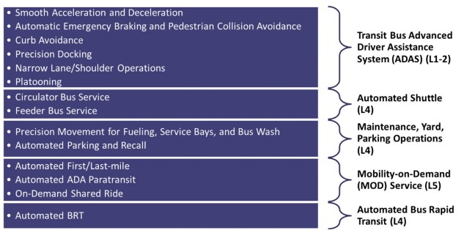
Figure 1.1. Technology packages relevant to transit buses.
Source: US Department of Transportation (12)
Recently, FTA conducted another research report on a pilot project undertaken in an urban bus operational safety platform in Cuyahoga county. It was reported that over the time of six months study period, connected bus drivers’ response to Pedestrian in Crossing Warning (PCW) situation increased by 16% and average drivers’ reaction time to PCW warning situation decreased by 18% (13). This paper will expand on the data of this research.

Prior Research on Transit Bus-involved crashes
Transit buses mostly ride on designated routes at a decent speed, yet they fall into many road accidents and crashes. Buses are typically large and have many blind spots, which increases the chances of a crash (14). According to the United States Department of Transportation’s (USDOT) Commercial Motor vehicle-related crash report, 12% of the fatal crashes in 2016 involved exclusively large trucks and buses. It was also reported that 51% of fatal crashes involved at least one large truck or transit bus and 50% of the fatalities resulted from the involvement of at least one large truck or bus (15). Existing research on transit bus-involved crashes has focused on identifying factors (driver, vehicle, or environment) responsible for the crashes, examining the characteristics of bus-involved crashes, and the impacts of several traffic measures on bus-involved crashes. The studies report that transit buses can be unsafe and are more prone to sideswipe crashes than rear-end crashes (16). However, the probability of bus-involved crash frequency is lower in bus priority lanes as they are located in the slowest traffic lane (17). Various statistical regression models like Poisson, Negative Binomial, Pearson, Linear, and Logistic models have been used to understand the relationship between bus-involved crash frequency and causal factors of the crashes (18). Machine learning techniques like Neural Networking and Random Forest can also be used to acquire better results. The biggest challenge is data in this kind of analysis, and Intelligent Transportation System (ITS) is a good source of data useful for transit safety (19). Transit officials aim to reduce bus-involved crashes by addressing all aspects within their control. Transit experts cannot control drivers’ behavior. However, by identifying hazardous crash locations, they can allocate resources for improving road conditions as countermeasures for crash risks.

Prior Research on Hazardous locations
High-frequency crash locations that are deemed to be hazardous are identified using crash locations and road design information. One study has defined high-risk crash locations as locations having a higher number of crashes than other similar locations considering local risk factors (20). High-risk crash locations are also known as hazardous road locations, accident-prone locations, and black spots. Some researchers have defined them as priority investigation locations (21) and the priority is given based on crash patterns, contributing factors, and countermeasures as the first step of the highway safety management process (22). High-risk crash locations are statistically analyzed using a negative binomial regression model with the help of crash frequency data. This modeling technique has been used by many researchers (23-27). Lately, the Empirical Bayes estimate (EB) of the total crash frequency method has been found to better identify high-risk crash locations (21). Recently, depth functions in multivariate depth-based Full Bayes is found to be a superior method for such analysis compared to other analogous methods. All these studies used crash statistics based on cars, and none of them used crash statistics of transit buses. Therefore, specific research on bus-involved crashes should be undertaken to improve their safety.
This literature review identifies opportunities to improve transit bus safety. For instance, identifying hazardous locations proactively for transit buses has not been explored to the best of the authors’ knowledge. Transit bus-related crash analysis is also rather limited in the literature, and it is still unknown whether connectivity is helping reduce the number of bus-involved crashes or not, specifically in hazardous locations. Hence, attention should be given to these gaps to improve transit bus safety.

Methodology
The methodological framework of this paper is shown in Figure 1.2. Data collection involved acquiring BSMs, alerts, crashes, and geographic information about the study area. As this paper involves the analysis of big data, R studio, STATA, and ArcGIS software are used for data mining and hazardous location analysis. The steps of the research are explained sequentially in the following section.

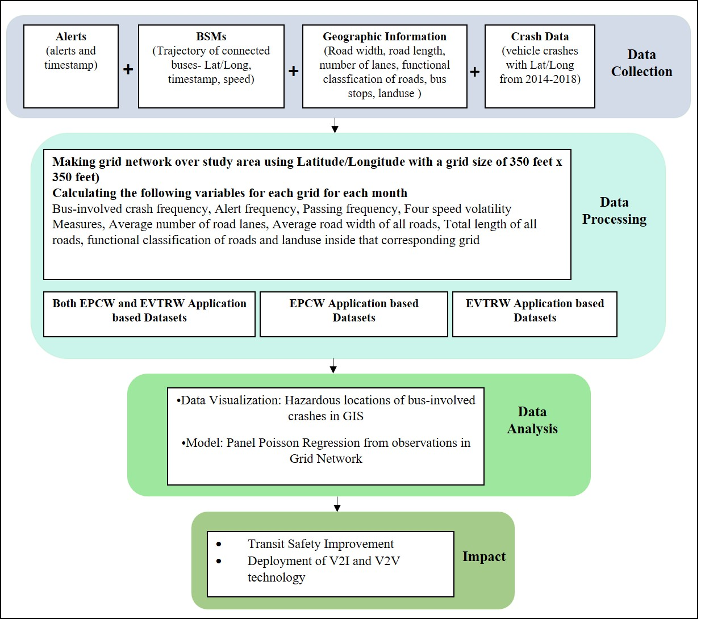
Figure 1.2. Methodological Framework.

Data
Four types of data are used for this research: Alerts received by connected buses, BSM data of those connected transit buses, crash data, and geographic information of the road network. The data are described briefly in this section.
The alerts and BSM dataset are from the “Enhanced Transit Safety Retrofit Package (E-TRP)” project and the project data package is collected from the USDOT’s ITS Joint Program Office’s Website (28). The project is from Cuyahoga County, Cleveland, Ohio. From February to August 2018, the buses collected 239,453 BSM alerts. Cutting-edge technological equipment is used in a transit environment to test the impact of connectivity on pedestrian and transit safety. There are three key technologies used for this unique dataset. First, a Dedicated Short Range Communications (DSRC) system is used for both vehicle-to-vehicle (V2V) and vehicle-to-infrastructure (V2I) communication. Second, a High-precision Global Navigation Satellite System (GNSS) is used for tracking connected vehicles. Third, Forward-Looking Infrared (FLIR) cameras are used for detecting pedestrians. E-TRP features are installed on 24 transit buses and three intersections. These buses are from Greater Cleveland Regional Transit Authority (GCRTA) and they are of different makes and models. Equipment installed on the transit buses is termed onboard (OBUs) transit vehicle-based subsystems. Equipment installed at the pedestrian crossings is termed infrastructure-based subsystems (Roadside Equipment – RSUs), as shown in Figure 1.3 (13).

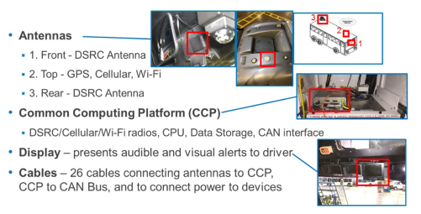
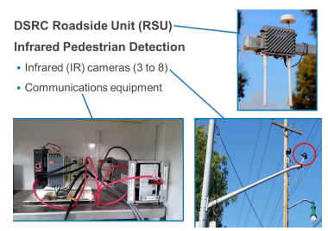

Figure 1.3. Onboard Subsystem (left), Infrastructure Subsystem-Roadside units (right).
Source: E-TRP Pilot Project (13)

Two CV applications are used: EPCW and EVTRW.
- “EPCW is a V2I application that alerts the driver of the connected bus about pedestrians whenever a pedestrian enters or is in an E-TRP equipped crosswalk or is in a curbside of the potential path of that connected bus. This application generates three types of alerts:
  - “Info” - When the bus enters, is inside, or exits the geofenced area;
  - “InformAlert”-When a pedestrian is on the curb in the potential path of the connected bus;
  - “WarnAlert” – When pedestrians are in the crosswalk in the path of the bus.
“InformAlert” and “WarnAlert” are generated only when the traffic signal red light does not protect the pedestrian. EPCW application also obtains information about the position (lat/long), timestamp, heading, speed, and elevation information of the connected buses. Geometric intersection information is received as Map Data Message (MAP). Signal Phase and Timing (SPaT Message) and status of crosswalks (pedestrians detected and zones affected) are received from the roadside infrastructure DSRC broadcast. Vehicle information like turn signal status information is also obtained.” (13)
- “EVTRW is a V2V application that alerts the driver of the connected bus whenever a CV, in this case, a connected bus, tries to make an illegal right turn in front of another connected bus that is departing from a near-side bus stop. This application also generates three types of alerts. However, “Info” is generated when the door of the connected bus is open and then closed when it is at the bus stop.
“InformAlert” is generated when a connected bus moves from behind to beside the connected bus;
“WarnAlert” is generated when the other connected bus starts to turn right in front of the connected bus;
“InformAlert” and “WarnAlert” are generated only when the doors of the connected bus open and close in a cycle and the bus is in the forward gear without the foot brake applied. EVTRW obtains similar position and time information to the EPCW application. This application also obtains vehicle information like door status, gear position, and brake status (13).” An example of an EPCW Warn alert and EVTRW Inform Alert is shown below in Figure 1.4.
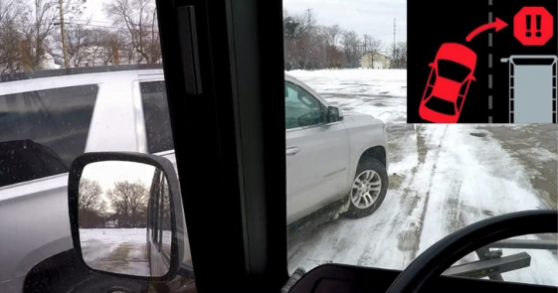
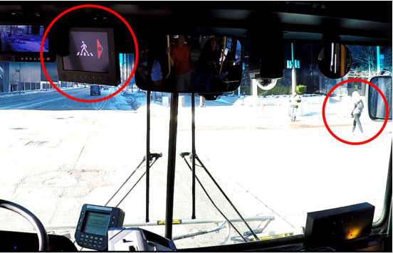

Figure 1.4. EPCW WarnAlert to Bus Driver (left) & EVTRW Inform Alert to Bus Driver (right).
Source: E-TRP Report (13)
The E-TRP package has seven types of dataset files, among which only alerts and BSM dataset files are used in this paper. All the datasets used in developing the master data of this study are described below:

Alert Dataset
This dataset contains the EventCode Type, AppMessage Type, and timestamp of those alerts, alert id, device id, and vehicle id. Each transit bus has a unique vehicle id, and the devices used in the buses to send or receive messages have unique device ids.

BSM Dataset
This log file contains the Global Positioning System (GPS) locations of the connected buses, timestamp, speed, and heading at a rate of 5 Hz. Speed is in kilometers per hour (KPH). February’s data is excluded from this paper intentionally, as this was only the trial period to install and test the devices.

Crash Dataset
The crash data of Cuyahoga county, Ohio, is collected from 2014 to 2018 from the Ohio Department of Public Safety’s (DPS) website (29). The Crash data is collected for five years because the number of transit bus-involved crashes is relatively small per year, and five years is deemed a reasonable period to understand the crash pattern. The dataset contains four types of files. Among those, only crash statistics and unit statistics files are merged by the local report number and timestamp to get the GPS location of the transit bus-involved crashes.

Geographic Information of the Road Network Dataset
The information about the width of the road, number of road lanes, length of the road segments, and functional classification of road information is collected in GIS shapefile format from the Northeast Ohio Areawide Coordinating Agency’s website from the year 2016 (30). The GIS shapefile of Cuyahoga county’s Land use information was collected from Cuyahoga County Open Data website (31). The bus stop locations are acquired from the General Transit Feed Specification (GTFS) dataset for GCRTA (32). These are then converted into a GIS shapefile to extract this information spatially.

Data Processing

Merging Crash Statistics and Unit Statistics
Crash statistics from each year are merged with unit statistics of that year based on the Local report number and timestamp to acquire the GPS locations of bus-related crashes. This was done for each of the five year’s data. The files for five years are combined, and only bus-involved crashes are kept. The total number of bus-involved crashes was 1,411 in Cuyahoga County.

Merging Alert Dataset and BSM Dataset
To get the geographic location of each alert, Alert and BSM datasets needed to be merged. Both datasets had vehicle id and timestamp as common variables, but the alert dataset’s timestamp had a rounded value for seconds. The BSM dataset had a vehicle trajectory for every 0.2 seconds. Hence, it was never possible to get the exact fraction of seconds when the alerts occurred from this dataset. For the convenience of merging, the BSM dataset’s values for seconds were rounded up. By doing this, every second had five observations. While merging, from every five observations for each second from the BSM dataset, one observation was selected randomly and merged with the alert dataset’s observation of the same time and vehicle id. After merging, it was discovered that the BSM dataset was missing observations for some times when the alerts occurred. Therefore, the merged file missed some alerts. The device to generate and store the alerts could have failed to operate properly at that time. The percentage of usable alerts after merging the two datasets is shown in Figure 1.5, which illustrates that not many alerts were lost due to this matter.

33637
46942
40630
193696
40732
31755

Figure 1.5. Percentage of usable alerts after merging Alert and BSM datasets.
After the merging process, samples containing irrelevant applications like RCI and TSPW are removed from the dataset. Two samples also had missing values under application; those were also removed. After the cleaning process, other information is added to the merged dataset.

Adding geographic information with the merged dataset
With the help of spatial joining in ArcGIS, road and land use information are connected to the merged dataset of alerts and BSMs.

Making a grid network of the study area
Previous studies have considered road intersections as their unit of analysis. However, this leaves out many other locations of the road network where crashes occur. A grid network consisting of grids with each grid having a dimension of 350’x 350’ is developed in R. The grids are considered the location unit for the analysis to cover the entire study area. 350’ is equivalent to approximately 100 meters (106.68 meters). Some prior research regarding pedestrian crashes near bus stops used 100 meters buffer area (33) for their analysis. The E-TRP data involves BSMs that convey alerts about pedestrians and other connected buses to the drivers, considering the 350’x 350’ grid deemed reasonable for analysis.
In the developed grid network, there were grids where alerts were generated. There were also many more grids where alerts were not generated (0 alerts), but the BSMs of connected buses had their trajectory information. For this paper, grids with a minimum of one alert (Grids with ≥ 1 alert) were considered because the aim is to observe whether an association remains between crashes and alerts. In this way, 334 unique grids were identified over five months, containing a minimum of one alert. Next, the total frequency of BSM alerts, crashes, and passing frequency for each grid are computed using the Latitude-Longitude information. As the unit of study was shrunk down to these selected grids, the total number of usable alerts, BSMs, and bus-involved crashes also reduced in frequency. Four volatility measures, the average number of lanes, average road width, total length of all roads per grid, and the number of bus stops per grid, are calculated. Later, a dummy variable indicating the presence of bus stops per grid is developed. This paper’s follow-up study will incorporate the grids with zero alerts for further investigation.

Dividing the master dataset into three datasets based on CV Applications
After the development of the grid network and the required variables, the master dataset is divided into three datasets, as shown below:
- Both EPCW & EVTRW dataset: This is the cleaned dataset that contains both EPCW and EVTRW based alerts. From March-July, 170,065 alerts were generated in the grids.
- EPCW dataset: This dataset contains only EPCW-based alerts. From March-July, 119,744 EPCW-based alerts were generated in the grids.
- EVTRW dataset: This dataset contains only EVTRW based alerts. From March-July, 50,321 EVTRW-based alerts were generated in the grids.

Data Analysis

Panel Poisson Regression Model
Panel data is longitudinal or cross-sectional time-series data that helps to observe the behavior of entities across time. For this paper, each grid is an entity. Panel data is used to control unobserved variables and helps understand individual heterogeneity (34).
General Poisson Regression Model (35) is used to predict count data when the dependent variable is discrete and there is a preponderance of zeros and small values in the dependent variable. According to Poisson distribution, the probability of n crashes in a grid i is as follows:
P(n_{i}) = λ_{i} ^{ni}exp(-λ_{i})/ n_{i}! (1)
Here, λ_{i} is the expected number of crashes in grid i. The Poisson parameter is laid out in the following form to fit the regression model.
ln (λ_{i}) = βX_{i} (2)
Here, X_{i} is the matrix independent variable and β is a vector of the coefficients.
Poisson Regression model (36) for one-way Panel data can be written as follows:

$y_{it}$ ~ Poisson ($u_{it }$) (3)
Here, $u_{it }$= $α_{i}$ λ_{it} = $α_{i}$ $e^{{βX}_{it}^{'}}$ (4)
Where, i = 1,…..,N; t = 1,…..,T
$α_{i}$ denote the individual effects. $α_{i}$ need to be independent and identically distributed (iid) random variables for the model to be a random effect model. The model is estimated by assuming a distribution for $α_{i}$.
Random effects Panel Poisson Regression model is conditional of λ_{it} and parameter $α_{i}$. $y_{it}$ is iid Poisson distributed with parameter $u_{it }$= $α_{i}$ λ_{it} = $α_{i}$ $e^{{βX}_{it}^{'}}$ , with the individual effects $α_{i}$ considered as an iid random variable. The joint density for observations in all time periods for the ith individual is as follows:
P[y_{i1} , …….., y_{it} | λ_{i1} ,……….., λ_{iTi}] (5)
Density g(α) of $α_{i}$ needs to be specified to achieve equation (5).
Let,
$α_{i}$ ~ iid gamma (θ, θ) (6)
E($α_{i}$) = 1 and V($α_{i}$) = $\frac{1}{θ}$
g($α_{i})$ = $\frac{θ^{θ}}{Γ(θ)}α_{i}^{θ-1}$ $e^{-θα_{i}}$ (7)

Location-based volatility measure calculation
Volatility measures potentially represent instantaneous driving behaviors or decisions of drivers that increase crash risk and severity while passing through a location in the study area (5). Volatility indices can identify locations where driving behavior differs from the other locations. Recently, researchers have started examining volatility indices to measure abnormal and extreme driving behaviors so that crash risks can be mitigated when a driver maneuvers in an unsafe manner (4). As speed directly influences safety outcomes and is related to the risk of being involved in a crash, this paper uses speed profiles to measure volatility. Four types of speed volatility measures (2) are identified from prior studies and their formulas are as follows:

Standard Deviation of Speed: SpeedSD_{i} = $\sqrt{\frac{1 }{\left(n-1\right)} \sum_{i=1}^{n}{{(x_{i}- \overline{x})}^{2}} }$ (8)

Coefficient of variation of Speed: SpeedVol_{i} = $\frac{{SD}_{i}}{\overline{x}}*100$ (9)

Mean Absolute Deviation of Speed: SpeedMAD_{i} = $\frac{1}{n}$ $\sum_{i=1}^{n}{\left|x_{i}- \overline{x}\right|}$ (10)

Quartile Coefficient of Variation of Speed: QuartCOV_{i} = $\frac{{Q3}_{i}- {Q1}_{i}}{{Q3}_{i}+ {Q1}_{i}}$ *100 (11)
In equations (8) through (11), subscript i indicates the index number of the grids, j indicates the index number of BSM alerts in the grid “i,” n indicates the number of BSM alerts in grid “i,” x_{i} indicates the speed in the grid “i,” $\overline{x}$ indicates the mean speed in the grid “i,” SD_{i} indicates the standard deviation of speed in the grid “i.” For instance, SpeedSD indicates the extent of deviation present in a set of speed values. In equation (8), the Mean Speed of a grid “i” is subtracted from all the speed values located inside grid “i,” and the subtracted value is squared and then summed for that grid “i.” Hence, the SpeedSD of each corresponding grid is calculated.
Similarly, SpeedVol_{i} indicates the degree of dispersion of all speed values in the grid “i” from the mean speed in the grid “i.” SpeedVol is presented as a percentage and it compares the speed volatility across different sets of speed values. SpeedMAD_{i} indicates the average distance between each speed value in the grid “i” and the mean of all speeds in the grid “i.” In equation 11, Q1_{i} and Q3_{i} indicate 25th and 75th percentile speed in the grid “i,” respectively. QuartCOV_{i} indicates the relative dispersion of all speed values in the grid “i” based on the interquartile range of all speed values in the grid “i.”
All four of these speed volatility measures are unitless. Volatility measures with high numeric values indicate the volatile behavior of drivers in that grid, which can be indicative of incidents like near-miss situations when a driver brakes hard to avoid a collision with a pedestrian or a vehicle. Volatility measures with low numeric values indicate less volatile behavior of a driver in that grid, which can indicate incidents when a driver makes a gradual stop at a bus stop. When the buses stop at bus stops, their speed goes down to zero. In such situations, buses are maneuvered steadily by the drivers to make a gradual stop. When driving volatility is measured around bus stops, volatility would have some numeric value, but it is expected to be on the low side.

Hazardous Location Analysis in ArcGIS
An analysis tool in ArcGIS is used to proactively identify hazardous locations for buses. The tool uses a spatial clustering process that identifies statistically significant spatial clusters using Getis-Ord Gi* statistic. Getis-Ord_Gi* (Gi* statistic) is an indicator of local autocorrelation as it evaluates the degree to which spatial auto-correlation varies locally over the study area. In this statistical method, a neighborhood of a specified geographic distance is considered around each feature and then the degree to which features surround this feature with similarly high or low values is measured (37). A statistically significant cluster of features with high values are hazardous locations and a statistically significant cluster of features with low values are non-hazardous locations. The Gi* statistic that ArcGIS uses is a version of Gi* in which the Gi* index is combined with the z-score into one index (37). However, the analysis produces a new output feature class where each location or feature has a z-score, p-value, and confidence level bin (Gi_Bin) value (38). Gi_Bin field identifies the hazardous and non-hazardous locations. If the values of the features fall in the +/-3 bins, the location is statistically significant with a 99% confidence level. If the values fall in the +/-2 bins, the location is significant with a 95% confidence level. If the feature’s values fall inside +/-1 bins, that reflects a 90% confidence level. The clusters of features in bin 0 is not statistically significant. The formula for Gi* statistic is as follows (37):
G_{i}* (d) = $\frac{\sum_{j}{w_{ij} \left(d\right) x_{j} - \overline{X} \sum_{j}{w_{ij}} (d)}}{S \sqrt{\frac{n \sum_{j}{w_{ij}^{2}-{(\sum_{j}{w_{ij }(d)})}^{2}}}{n-1}}}$ (12)
Here,
$\overline{X}= \frac{\sum_{i}{x_{j}}}{n}$ and
S = $\sqrt{\frac{\sum_{j}{x_{j}^{2}}}{n}- {(\overline{x})}^{2}}$
In equation 12, G_{i}* (d) is the statistic computed for a feature i, at a distance d, standardized as a z-score. x_{j} denotes the attribute value of each neighbor, w_{ij} denotes the spatial weight for the target-neighbor i-j pair, and n denotes the sample size of the dataset. The geographic distance between each i-j pair is measured following the Euclidean distance method. The spatial weight is calculated from a spatial weight matrix. This matrix is an n x n table, which surrounds each feature, and all the values in the matrix are a weight representing the association between a pair of features in the dataset. The weights are assigned based on the Inverse Distance Weighted (IDW) method. IDW method identifies the cell values that do not have any value by using a linearly weighted combination of a set of sample points. The weight is an inverse function of a distance fixed before running the operation (39). The general formula for IDW (40) is as follows:
$\hat{Z} \left(s_{0}\right)= \sum_{i=1}^{N}{λ_{i }Z(s_{i})}$ (13)

Here,
$\hat{Z} \left(s_{0}\right)$denotes the value for the location $s_{0}$
N denotes the number of sample points surrounding the prediction location that will be used in the prediction
$λ_{i }$ denotes the weights assigned to each measured point. This weight decreases as weight increases
$Z(s_{i})$ is the observed value at the location $s_{i}$

The formula to determine the weights is as follows:
$λ_{i }=\frac{\frac{1}{\sum_{i=1}^{N}{d_{i0}^{p}}}}{d_{i0}^{p}}$ (14)
As the distance d becomes larger, the weight reduces by a factor of p. The value d_{i0} indicates the distance between the prediction location s₀ and the measured locations, s_{i}.
The Inverse Distance Weighted (IDW) interpolation method is applied to this new output feature class to map the hazardous locations over the study area. The distance used for this research is 10,000 meters.

Results
Results from both spatial and statistical analysis are described here. In section 4.1, hazardous locations for bus-involved crashes are identified in ArcGIS. Then grids that contain BSM alerts and vehicle trajectories are overlaid on the hazardous location map to visually understand whether BSM alerts can spatially indicate hazardous locations for bus-involved crashes or not. In section 4.2, Random Effect Panel Poisson regression model results for grids ≥ 1 alert are described.

Hazardous locations for transit bus-involved crashes using ArcGIS
Figure 1.6 shows the hazardous locations for transit bus-involved crashes in Cuyahoga County using ArcGIS. ArcGIS identifies 800 hazardous locations in Cuyahoga County based on the location of five years of bus crash data. The Gi_bin shown as red and orange circles (205/800 areas) are considered more hazardous for bus-involved crashes and they are concentrated mainly within 3 miles (approximately) radius of the downtown area. After that, there are still many locations where crashes happened. However, those locations are very dispersed and bus-involved crashes happening there are low in frequency. As a result, those locations (594/800 areas) are found as non-hazardous areas (Gi_Bin shown as green and blue circles). However, identifying the scale of hazardousness in the areas between these hazardous locations needed to be determined. IDW interpolation method was applied, which uses the Gi_Bin based areas and interpolates to distribute more and less crash-prone areas across the region. Thus, hazardous areas for bus-involved crashes in Cuyahoga County were developed, which are represented as the red to yellow areas in Figure 1.6. The non-hazardous areas are represented as the green shaded areas.
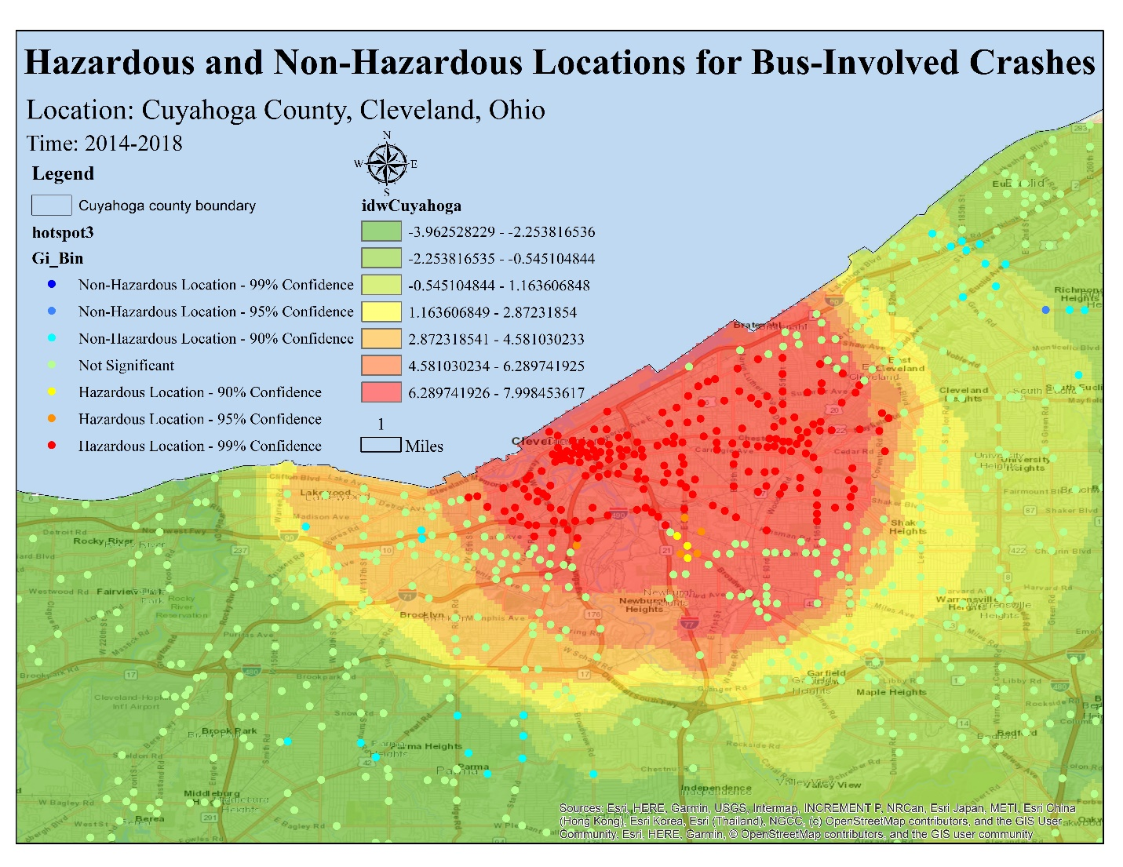
Figure 1.6. Map of hazardous locations for bus-involved crashes in Cuyahoga County
Figure 1.7 shows the locations of the 352 grids of the network (a total of 200,998 grids) that have a minimum of one BSM alert (either EPCW or EVTRW). This map is also prepared using ArcGIS. Understandably, BSM alerts are concentrated in the downtown and near the three selected intersections, and BSMs are also seen along routes where the connected buses drove as part of the E-TRP pilot project. It is visible from Figure 1.7 that grids with a minimum of one BSM alert are more concentrated in the hazard-prone locations of bus-involved crashes.

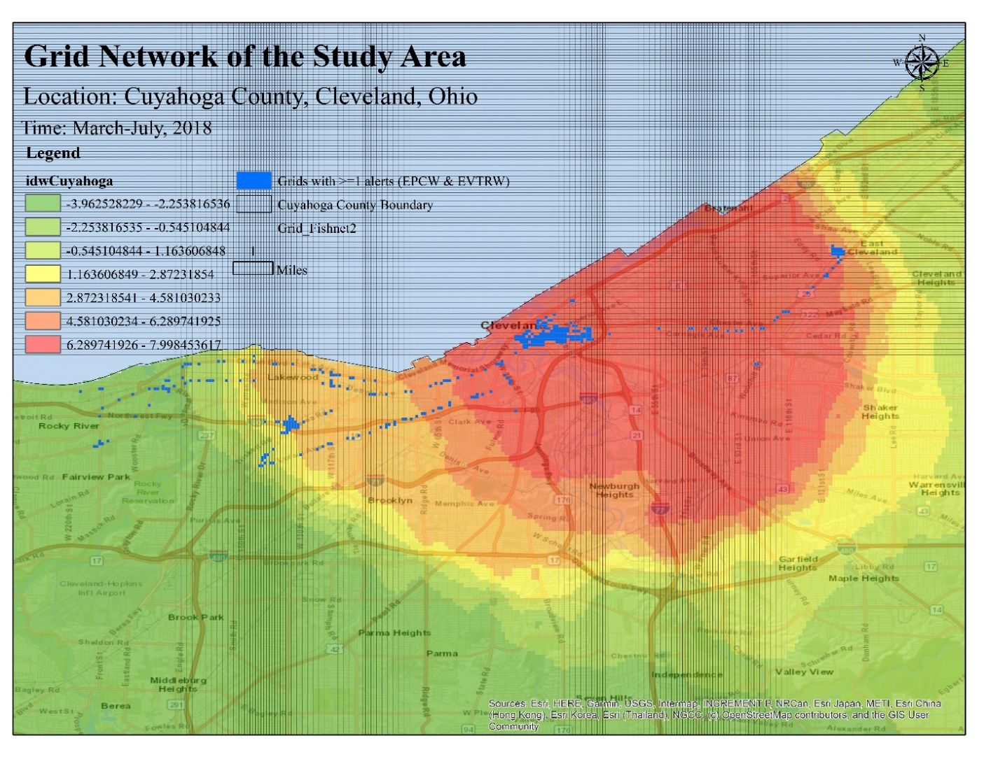
Figure 1.7. Hazardous locations vs. grids with ≥ 1 alert (Both EPCW & EVTRW).

Grids with ≥ 1 alert
Table 1.1 shows the number of observations or grids in the datasets that contain grids with ≥ 1 BSM alert. As the datasets are developed as panel data for five months, each unique grid can have up to five observations (forming a group) depending on whether the connected transit bus received any alert in that grid in those five months. It is clear from Table 1.1 that, in the “Both EPCW & EVTRW” dataset, there are 807 observations or information about 807 grids, among which 334 are unique. The “EPCW” dataset has only 24 unique grids and 85 observations in 5 months. The “EVTRW” dataset has 326 unique grids and 782 observations in five months. In the “Both EPCW & EVTRW,” “EPCW,” and “EVTRW” datasets, the average number of observations per group is 2.4, 3.5, and 2.4, respectively. This indicates that some groups did not have observations in all five months and are unbalanced panel data.

Table 1.1. Number of observations in grids with ≥ 1 alert-based datasets
Dataset based on application type | Both EPCW & EVTRW | EPCW | EVTRW
Total number of grids (Observations) | 807 | 85 | 782
Total number of unique grids (groups) | 334 | 24 | 326
Observations per group
Minimum | 1.00 | 1.00 | 1.00
Average | 2.40 | 3.50 | 2.40
Maximum | 5.00 | 5.00 | 5.00

Descriptive Statistics on grids with ≥ 1 BSM alert
Table 1.2 shows the descriptive statistics of the three datasets. In the “Both EPCW & EVTRW” alert-based dataset, the dependent variable Crash Frequency represents a total 5-years crash in each of the 334 unique grids. It has a minimum value of zero, a maximum value of 10, and an average of 0.98. This indicates that there are grids that do not have crashes and grids that have high crash frequencies. 221 crashes happened in the 334 unique grids (794 crashes in 807 observations) in five years. Hence, crash frequency per unique grid is 0.98 in 5 years, which is very low. This is expected because the number of bus-involved crashes is generally low and Cuyahoga county is no different in this matter.
As the values of independent variables are available for five months, their descriptive statistics are measured based on all 807 grids in five months for the “Both EPCW & EVTRW” dataset. Among the independent variables, alerts are important because the primary goal of this research is to find if there exists an association between the location of crashes and alerts. Number of Alerts provided to bus drivers in the grids in five months has a minimum value of 1 and a maximum value of 10,449. This indicates that in the study period, the highest number of alerts a grid received in a month was 10,449. Its mean value is 220.74, which indicates that, on average, the grids received 220.74 alerts in a month. It implies that many grids have a higher frequency of alerts. The histogram of this variable is right-skewed. So the log of this variable has been developed for use. Log of Alerts has a minimum value of 0, maximum of 9.25, and mean of 2.58.
Among the volatility measures, SpeedVol, SpeedSd, SpeedMAD, and QuartCOV have mean values of 1.43, 3.14, 2.61, and 83.69, respectively. Driver behavior is considered volatile if the volatility measures have a value higher than one. The minimum values of all four volatility measures indicate that there are locations where drivers showed very little or no volatile behavior, but some locations showed high volatile behavior. Drivers should be concerned about those locations. The variable Number of passings has a minimum value of seven, a maximum value of 8,036, a mean of 1,716.43, and a standard deviation of 1,400.08. This indicates that the connected buses passed these grids a minimum of seven times and 1,716.43 times in a month on average. It implies that the buses have passed many times on their routes, but alerts were sometimes generated on those journeys. There can be some places where a very high number of alerts have occurred. Log of passing has a minimum, maximum, and mean values of 1.95, 8.99, and 7.02. The geographic variables are constant over time. The variable Average number of lanes has a minimum value of one, a maximum value of eight, and a mean value of 4.39. This means this grid network has some grids with eight-lane roads, but on average, these grids have four-lane roads. The variable Average road width (feet) has a minimum value of 10, a maximum value of 96, and a mean value of 59.63. The Total length of roads (feet) variable has a mean of 446.33 feet, indicating that the roads falling inside the grids totals 446.33 feet on average. The variable Number of bus stops has a minimum value of zero and a mean value of 1.24. This indicates that although some grids do not have any bus stops, these grids have at least one bus stop on average.
In the “EPCW” alert-based dataset, Crash Frequency has minimum, maximum, and mean values of zero, 10, and 0.91, respectively. Only 24 transit crashes (77 crashes in five panels) happened in these 24 grids over the 5-years. So, it can be said that, on average, 0.91 transit crashes have occurred in five years per unique grid. Among the dependent variables, Log of Alerts has minimum and maximum values similar to the previous dataset but has a mean of 5.38. This indicates that the frequency of alerts is very high in the EPCW dataset’s grids. The mean values of the four volatility measures are similar to the “Both EPCW & EVTRW” alert-based dataset. The variable Number of passings has a minimum value of 15, a maximum value of 5,583, mean of 2,588.66. This indicates that the connected buses have passed through “EPCW” alert-based grids on an average more times than “Both EPCW & EVTRW” grids. It can be assumed that buses have visited the three intersections more frequently than the rest of the routes of this project. The Total length of roads (feet) variable has a mean of 446.87, similar to the previous dataset.
In the “EVTRW” alert-based dataset, the dependent variable Crash Frequency has almost identical minimum and maximum values as the “Both EPCW & EVTRW” dataset. This is expected because most grids of the “Both EPCW & EVTRW” dataset are from the EVTRW dataset (782 of 807 = 96.9%). Among the dependent variables, the Log of Alerts has a mean of 2.29. This clearly indicates that the frequency of EVTRW alerts is very low in this dataset’s grids. This dataset’s mean values of all the volatility measures are higher than those observed in the “EPCW” dataset. This indicates that drivers have been more volatile when driving in these “EVTRW” alert-based grids. The variable Number of passings has a mean of 1,724.93, indicating that the connected buses have passed through “EVTRW” alert-based grids fewer times than “EPCW” alert-based grids.

Table 1.3 shows the descriptive frequency of key variables of the three datasets, namely the Presence of bus stops, Functional classification of roads, and Land use. The Presence of bus stops is a categorical variable that has two attributes. In the “Both EPCW & EVTRW” dataset, No bus stops (0) have a frequency of 284 grids (35.19%) and ≥ 1 bus stop (1) has a frequency of 528 grids (64.81%). This indicates that most of the grids contain ≥ 1 bus stop. In the “EPCW” dataset, 58 out of 85 grids (68.24%) grids have ≥ 1 bus stops which is higher in percentage than the grids found in the previous dataset. In the “EVTRW” dataset, the variable Presence of bus stops indicates that along the trajectory of the connected buses over five months, 521 of 782 (66.62%) grids had bus stops. The variable Functional classification of roads has four levels: Arterials, Collectors, Interstate, and Mixed. The Mixed level represents the presence of more than one type of road in the grid. It is observed that, among the four types, Arterial roads were found in the majority of the grids in all three datasets, followed by Collectors and Mixed roads. The variable Land use has six levels: Commercial, Green Space, Industrial, Institutional, Residential, and Utility. The frequency distribution of the land use in the “EPCW” dataset indicates that most grids are Commercial, followed by Green Space, Institutional, and Residential. In the “EVTRW” dataset, most grids are Commercial, followed by Residential, Institutional, and Industrial.

Table 1.2. Descriptive Statistics of grids with ≥ 1 alert.
Application Type | Both EPCW & EVTRW |  |  |  | EPCW |  |  |  | EVTRW
 | N (number of grids = 807) |  |  |  | N (number of grids = 85) |  |  |  | N (number of grids = 782)
Variables | Mean | Std. dev. | Min | Max | Mean | Std. dev. | Min | Max | Mean | Std. dev. | Min | Max
Dependent (5 yrs. total)
Total Crash Frequency (5 yrs.total) | 0.98 | 1.72 | 0.00 | 10.00 | 0.91 | 1.41 | 0.00 | 10.00 | 1.02 | 1.74 | 0.00 | 10.00
Independent (5 months)
Number of Alerts provided to bus drivers | 210.74 | 792.35 | 1.00 | 10449.00 | 1408.75 | 1664.97 | 1.00 | 7374.00 | 64.35 | 401.89 | 1.00 | 10449.00
Log of Alerts | 2.58 | 2.07 | 0.00 | 9.25 | 5.38 | 2.99 | 0.00 | 8.91 | 2.29 | 1.63 | 0.00 | 9.25
Vehicle Kinematics
SpeedVol | 1.43 | 1.09 | 0.13 | 12.87 | 1.08 | 0.92 | 0.19 | 8.04 | 1.46 | 1.10 | 0.13 | 12.87
SpeedSd | 3.14 | 1.27 | 0.28 | 11.09 | 3.01 | 0.78 | 1.20 | 4.59 | 3.16 | 1.28 | 0.28 | 11.09
SpeedMad | 2.61 | 1.22 | 0.03 | 10.76 | 2.54 | 0.84 | 0.26 | 4.08 | 2.61 | 1.23 | 0.03 | 10.76
QuartCOV | 83.69 | 24.62 | 7.85 | 99.92 | 80.72 | 31.98 | 8.58 | 99.46 | 84.91 | 23.12 | 7.85 | 99.72
Number of passings | 1716.43 | 1400.08 | 7.00 | 8036.00 | 2588.66 | 1356.79 | 15.00 | 5583.00 | 1724.93 | 1405.94 | 7.00 | 8036.00
Log of passing | 7.02 | 1.08 | 1.95 | 8.99 | 7.46 | 1.38 | 2.71 | 8.63 | 7.05 | 1.03 | 1.95 | 8.99
Geographic Information
Average number of lanes | 4.39 | 1.20 | 1.00 | 8.00 | 3.74 | 1.39 | 2.00 | 8.00 | 4.42 | 1.19 | 1.00 | 8.00
Average road width (feet) | 59.63 | 12.49 | 10.00 | 96.00 | 58.03 | 17.38 | 30.00 | 96.00 | 59.84 | 14.34 | 10.00 | 96.00
Total length of roads (feet) | 446.33 | 213.39 | 8.33 | 1243.27 | 446.87 | 196.29 | 48.16 | 869.44 | 447.09 | 215.63 | 8.33 | 1243.27
Number of bus stops | 1.24 | 1.37 | 0.00 | 9.00 | 1.24 | 1.10 | 0.00 | 4.00 | 1.27 | 1.37 | 0.00 | 9.00

Table 1.3. Descriptive Frequencies of Key Variables.
Variable | Levels | Both EPCW & EVTRW |  | EPCW |  | EVTRW
Variable | Levels | N (number of grids = 807) |  | N (number of grids = 85) |  | N (number of grids = 782)
Variable | Levels | Freq. | Percent | Freq. | Percent | Freq. | Percent
Presence of bus stop | ≥ 1 bus stop | 523.00 | 64.81 | 58.00 | 68.24 | 521 | 66.62
 | No bus stops | 284.00 | 35.19 | 27.00 | 31.76 | 261 | 33.38
Functional classification of roads | Arterials | 416.00 | 51.55 | 53.00 | 62.35 | 401 | 51.28
 | Collectors | 225.00 | 27.88 | 15.00 | 17.65 | 216 | 27.62
 | Interstate | 21.00 | 2.60 | - | - | 21 | 2.69
 | Mixed | 145.00 | 17.97 | 17.00 | 20.00 | 144 | 18.41
Land use | Commercial | 405.00 | 50.19 | 44.00 | 51.76 | 395 | 50.51
 | Green Space | 33.00 | 4.09 | 15.00 | 17.65 | 33 | 4.22
 | Industrial | 81.00 | 10.04 | 1.00 | 1.18 | 81 | 10.36
 | Institutional | 105.00 | 13.01 | 15.00 | 17.65 | 95 | 12.15
 | Residential | 149.00 | 18.46 | 10 | 11.76 | 144 | 18.41
 | Utility | 34.00 | 4.21 | - | - | 34 | 4.35

Models on grids with ≥ 1 alert
Random effects Panel Poisson regression model is applied to the three types of datasets to investigate the association between Crash Frequency and other independent variables. The initial models (not shown in Table 1.4) gave some unexpected results as the association between crashes and the three volatility measures like, SpeedSd, SpeedVol, and SpeedMAD, were negative. These variables are omitted from the presented models, and only the variables with correct signs are kept. The models that proved that the panel estimator is better than pooled estimator are kept (with the help of the likelihood ratio test of $α$ = 0). Table 1.4 shows the panel Poisson models on grids with a minimum of one BSM alert. Alpha ($α$) value > 0 indicates the presence of overdispersion over time in panel datasets. The panel models express the effects of time on the dependent variable. Average Marginal Effects (AME) are also presented to explain the association between crash frequency and other independent variables.
In model 1, the variable Log of Alerts has a coefficient of -0.090, indicating that a 1% increase in either EPCW or EVTRW alert is associated with a 0.090% decrease in bus-involved crashes if all else remains constant. This implies that an increased number of alerts can lead to a decrease in crash frequency. It can be deduced that bus drivers will get more cautious and drive safely to avoid a potential crash if a location has high alert frequencies. However, this coefficient is not statistically significant in model 1 (p > 0.1). In this model, the variables QuartCOV, Log of passing, Presence of bus stops, Industrial, Residential, and Utility have a coefficient of 0.015, 0.329, 0.764, -2.086, -1.491, and -1.571. They are all statistically significant (p-value <0.05). One unit increase of QuartCOV is associated with a 0.015 unit increase in the log count of Crash Frequency if all else remains constant. From the values of AME, it can be said that a 1% increase of QuartCOV is associated with a 0.015 unit increase in the average number of bus-involved crashes if all else remains constant. More volatile driving behavior may cause more probability of crashes. The coefficient of Log of passing indicates that a 1% increase in passing is associated with a 0.329% increase in bus-involved crashes if all else remains constant. The AME of the Presence of bus stops indicates that the grids with bus stops are associated with 0.764 units more crashes than grids without bus stops. The Land use variable’s base is Commercial. The AME of Industrial indicates that industrial land use-based grids are associated with 2.086 units less crashes than commercial land use-based grids on average if all else remains constant. Likewise, Residential land use-based grids are associated with 1.491 units less crashes than commercial land use-based grids on average if all else remains constant. Utility land use-based grids are associated with 1.571 units less crashes than commercial land use-based grids on average if all else remains constant. This model also contains an interaction term, Presence of bus stops*Log of Alerts (1) and the explanation of its coefficient is complex. This term’s AME of 0.173 indicates that a 1% increase of the Log of Alerts in grids with bus stops is associated with 0.173 units more bus-involved crashes on average than the grids without bus stops. It can be deduced that the presence of bus stops increases the probability of bus-involved crashes even with the increasing number of alerts. Hence, bus drivers should be careful near bus stops.
In model 2, the variable Log of Alerts is statistically significant (p-value <0.01) with a coefficient of -0.239. This indicates that a 1% increase in EPCW alert is associated with a 0.239% decrease in bus-involved crashes if all else remains constant. Log of passing has a coefficient of 0.996 (p-value <0.1), which indicates that a 1% increase in the number of passings in a grid is associated with a 0.996% increase in bus-involved crashes if all else remains constant. From the values of AME, it can be said that a 1% increase of QuartCOV is associated with a 0.041 unit increase in the average number of bus-involved crashes if all else remains constant. The Functional classification of roads variable has Arterials as the base. Among all the levels of this variable, only Mixed has a statistically significant coefficient. The AME of Mixed indicates that grids with Mixed roads are associated with 1.127 units less crashes than grids with only Arterial roads on average if all else remains constant. In model 2, only Green Space is statistically significant among the levels of Land use variable. The AME of Green Space indicates that grids with Green Space land use are associated with 0.746 units (p < 0.05) less crashes than grids with Commercial land use if all else remains constant.
In model 3, the Log of Alerts has a negative coefficient of 0.054, which indicates that a 1% increase in EVTRW alert is associated with a 0.054% decrease in bus-involved crashes when all else remains constant. Nevertheless, this value is not statistically significant, similar to model 1’s results. QuartCOV, Log of passing, Presence of bus stops, Industrial, Residential, and Utility have statistically significant coefficients. Between EPCW and EVTRW systems, EPCW has shown to decrease more crashes considering their coefficients in the models.

Table 1.4. Regression Models for alerts on grids with ≥ 1 alert.
Dataset based on application type | Both (EPCW & EVTRW) |  |  | EPCW |  |  | EVTRW
 | Model 1 |  |  | Model 2 |  |  | Model 3
Variables | Coef. | z-stat. | AME | Coef. | z-stat. | AME | Coef. | z-stat. | AME
Dependent (5 yrs. total) | Crash Frequency |  |  | Crash Frequency |  |  | Crash Frequency
Independent (5 months)
Constant | -4.425*** | -4.700 |  | -9.725*** | -2.300 |  | -4.226*** | -4.480
Log of alert | -0.090 | -0.660 | 0.022 | -0.239*** | -5.280 | -0.239 | -0.054 | -0.380 | 0.046
Vehicle Kinematics
QuartCOV | 0.015*** | 2.640 | 0.015 | 0.041*** | 3.270 | 0.041 | 0.014** | 2.460 | 0.014
Log of Passing | 0.329*** | 2.710 | 0.329 | 0.996* | 1.950 | 0.996 | 0.309** | 2.520 | -0.309
Geographic Information
Presence of bus stops | 0.764** | 1.950 | 1.211 |  |  |  | 0.772* | 1.930 | 1.114
Presence of bus stops*Log of alert | 0.173 | 1.230 | 0.173 |  |  |  | 0.149 | 1.010
Functional classification of roads
Arterials (base)
Collectors |  |  |  | -28.975 | -0.000 | -28.975
Mixed |  |  |  | -1.127*** | -2.680 | -1.127
Land use
Commercial (base)
Green Space | -0.688 | -1.190 | -0.688 | -0.746** | -2.170 | -0.746 | -0.653 | -1.170 | -0.653
Industrial | -2.086*** | -3.300 | -2.086 | 1.425 | 0.000 | 1.425 | -2.149*** | -3.430 | -2.149
Institutional | -0.381 | -1.240 | -0.381 | -27.766 | -0.000 | -27.766 | -0.361 | -1.18 | -0.361
Residential | -1.491*** | -4.750 | -1.491 | 0.378 | 0.800 | 0.378 | -1.461*** | -4.760 | -1.461
Utility | -1.571** | -2.080 | -1.571 |  |  |  | -1.615** | -2.150 | -1.615
Lnalpha | 0.735 |  |  | -15.831 |  |  | 0.695
alpha | 2.086 |  |  | 0.000 |  |  | 2.003
Wald $χ^{2}$ (Prob > $χ^{2}$ = 0.000) | 102.610 |  |  | 47.190 |  |  | 100.460
LR test of α =0: ${\overline{χ}}^{2}$(01) | 506.460 |  |  | 0.000 |  |  | 438.130
Prob ≥ ${\overline{χ}}^{2}$ | 0.000 |  |  | 0.500 |  |  | 0.000
Log-likelihood at constant (C) | -735.531 |  |  | -60.964 |  |  | -731.672
Log-likelihood at convergence (B) | -684.909 |  |  | -79.799 |  |  | -682.291
McFadden’s $ρ^{2}$ | 0.069 |  |  | 0.236 |  |  | 0.067
df | 12 |  |  | 11 |  |  | 12
AIC | 1393.817 |  |  | 143.929 |  |  | 1388.581
BIC | 1450.137 |  |  | 170.798 |  |  | 1444.524
N (Number of observations) | 807 |  |  | 85 |  |  | 782
***p-value<.01, **p-value<.05, *p-value<.1

Discussion

Comparison of hazardous and non-hazardous areas based on Alert/Grid and Crash/Grid
As the hazardous and non-hazardous locations are developed based on the number and location of crashes, it is expected that number of crashes per grid will be higher in hazardous areas and lower in non-hazardous areas, as shown in Figure 1.8 (a). However, it would be interesting to see whether the number of alerts per grid is also higher in hazardous areas or not. Figure 1.8 shows that the grids falling inside the hazardous areas also have higher alerts/grid than non-hazardous areas. This implies that alerts can indicate high-risk hazardous locations for bus-involved crashes. Nevertheless, it also implies that even though the Log of Alerts is negatively associated with the crashes according to the Panel Poisson models, the number of alerts/grid can be high in crash-prone hazardous areas. This indicates that their locations do not entirely determine their association; there can be other factors causing this negative association that need further investigation.

Figure 1.8. (a) Crash/Grid and (b) Alert/Grid in grids that include ≥ 1 alert using Both EPCW & EVTRW Dataset

Bus-involved crash reduction by EPCW
According to bus-involved crash data provided by Federal Motor Carrier Safety Administration (FMCSA) website (41), there have been more than 60,000 bus-involved crashes in the US since 2013 (as shown in Figure 1.9). Most of these are Property Damage Only (PDO) crashes (approximately 50000/year on average between 2009-2019), followed by Injury crashes (approximately 14000/year on average between 2009-2019). Bus-involved fatal crashes are comparatively low (244/year on average between 2009-2019).

Figure 1.9. Bus-involved crashes from 1999-to 2019 in the US.
The association between alerts and bus-involved crashes was negative in all three models shown in Table 1.4, but only the association between EPCW alerts and bus-involved crashes was statistically significant. Hence, only the impact of deploying EPCW (V2I) in transit buses has been examined. Crash reduction values are calculated for hypothetical numbers of bus-involved crashes using the coefficient values from model 2. Figure 1.10 shows the number of bus-involved crashes that EPCW can potentially reduce upon deployment. It is observed that EPCW can reduce 143 bus-involved crashes if the total number of bus-involved crashes is 60,000. This number may appear small, but it is significant if these were severe injuries or fatal crashes. Therefore, the deployment of EPCW systems could be beneficial for road users.

Figure 1.10. Reduction of bus-involved crashes by EPCW

Limitations
There are some limitations of this E-TRP pilot project’s dataset. The first issue is the unavailability of vehicle trajectory data for the many unique alerts. Although those alerts are valid, they could not be used, as their GPS locations could not be traced. The second issue is that the alert and BSM files’ timestamp has different values of seconds with different decimal places. So, while merging the two datasets, many alerts were lost. The third issue is that some GPS locations fell outside the county boundary and some on the waterbody beside Cuyahoga County. Those alerts also had to be excluded from the main dataset. The fourth issue is a common issue of the absence of driver information in the BSM dataset. Researchers and CV companies can consider resolving these issues to achieve more accurate BSMs and improved CV technologies. Geometric feature data could not be acquired for some of the grids along the trajectory of the connected buses. These grids had to be dropped while conducting analysis, but their inclusion could have provided more insight into the associations. Many of the grids covered more than one land use and selecting a specific land use for such grids was complex. The land use that occupied the majority of a grid was considered that grid’s land use. The road network shapefile did not contain all roads in many grids. Therefore, the total length of roads in a grid was manually calculated using ArcGIS for those grids. This made the data collection process time-consuming and tedious. Moreover, the data used in this study is a product of averaging five years of transit bus-involved crashes and five months of BSM data. A short period of volatility measures and BSM alerts are used to examine the correlation with 5-year average bus-involved crashes. However, to make the analysis as valid as possible, the authors used all available data despite the difficulty of processing such large-scale data. Another critical issue is that grids with zero alerts were not analyzed, and their frequency is enormous compared to the number of grids with ≥ 1 alert. The inclusion of those grids could have yielded more insights.

Conclusions
This study has explored the role of smart vehicle and infrastructure technologies in improving public transit safety, especially focusing on the detection of pedestrians to enhance safety for all road users in the future. By harnessing the big data from newly available connected buses that provide drivers with alerts, this study uses alerts and BSMs to identify high-risk bus-involved crash locations. The key findings of the paper are as follows:
- Panel Poisson regression models find that bus-involved crash locations are negatively associated with alert locations. In grids containing ≥ 1 alert, a 1% increase in EPCW alerts is associated with a 0.239% decrease in bus-involved crashes when all else remains constant. A negative association was observed between EVTRW alerts and bus-involved crashes, but it was not statistically significant.
- Bus-involved crash locations are also negatively associated with Mixed roads and Green Space land use. EPCW dataset-based model showed that grids with Mixed roads (grid contains more than one type of road) are associated with 1.127 units less bus-involved crashes on average than Arterial road-based grids when all else remains constant. Green Space land use-based grids are associated with 0.764 units less bus-involved crashes on average than Commercial land use-based grids when all else remains constant.
- The models also suggest that bus-involved crashes are positively associated with bus drivers’ volatility, passing, and presence of bus stops. “EPCW” dataset-based model showed that a 1% increase of QuartCOV is associated with a 0.041 unit increase in the average number of bus-involved crashes if all else remains constant.
- “EVTRW” and “Both EPCW and EVTRW” dataset-based models also showed a significant positive association between Crash Frequency and QuartCOV, Log of passing, and Presence of bus stops.
- Valid Panel Poisson models indicate that these associations are affected by time along with space.
- Hazardous location identification maps show that alerts help identify high hazardous locations that need the attention of transit agencies and bus drivers.
This research contributes to the knowledge area concerned with smart infrastructure and new transit technologies that enhance safety. The models developed in this research are based on new and emerging data that can transform transit buses’ increased safety. The analysis of ADAS technologies and volatility provides rich insights. Although the models are not generalizable as they are only for bus-involved crashes in a small county, the models can be improved by including more volatility measures and the geographic and socio-economic information of the locations. The next step of this study can be incorporating locations with BSMS but without alerts in the model and analyzing causality. Future research work can apply the model to busy metropolitan cities and rural areas to develop generalizable models for these CV technologies. The results will be valuable for transit agencies to undertake countermeasures to reduce bus-involved crashes. Future endeavors can also investigate the association of crash severity with alerts and BSMs. The validity of these associations can also be studied at different locations, such as near bus stops or at intersections. For now, the key findings of this research can help Cuyahoga county’s transit authority become aware of their area’s hazardous locations for bus-involved crashes. They can analyze the geographic conditions and design of the roads in these locations to find the underlying reasons which may be causing these crashes. Based on this research, countermeasures can be deployed to increase transit safety. Before undertaking any significant infrastructural changes, bus drivers could be made aware of these hazardous locations by installing roadside alert signs at the entrances to these locations. Finally, CV technologies are in the test phase. When fully deployed, the effectiveness of BSMs and alerts in identifying high-risk hazardous locations might need to be studied again.

New Section of the work
Next, it will be observed whether the BSMs can identify hazardous locations or not by using supervised classification models like Random Forest or XGBoost. At first, the hazardous location information, based on five years of crash data, will be added to each grid of the network. It will be a binary variable (Yes/1= hazardous location for bus-involved crashes, No/0 = not hazardous for bus-involved crashes). This will be the dependent variable. The independent variables can be the number of alerts generated, volatility measures, land use, proximity to bus stops, type of roads, and the speed limit of the location (depending on which data could be retrieved). Then a model will be developed that can predict if that grid is a hazardous location or not based on BSMs, alerts, and historical crashes.

Acknowledgments
The authors would like to thank the Civil, Environmental, Industrial & Systems Engineering (CEE) Information Technology service providers of the University of Tennessee, Knoxville, for their constant IT support and advice. The authors thank Dr. Iman Mahdinia for proofreading the paper.

EVALUATING PEDESTRIAN SAFETY IN BUS-PEDESTRIAN INTERACTIONS WITH THE APPLICATION OF ENHANCED PEDESTRIAN COLLISION WARNING SYSTEMS: ANALYSIS OF LARGE-SCALE BASIC SAFETY MESSAGE DATA

Abstract
Intersections are one of the most hazardous locations for vehicles and pedestrians due to the abundance of conflicts. Connected Vehicle (CV) technologies can potentially reduce some of these conflicts. In this regard, a lightly researched area is the use of CV technologies in public transportation. This study explores the safety benefits of an Advanced Driver-Assistance Systems called Enhanced Pedestrian Collision Warning (EPCW) by harnessing a large-scale data from a pilot project of 24 connected buses that traversed three intersections in Cleveland, Ohio, US. For each intersection, a novel safety surrogate measure “Mean Time Difference to Intersection (MTDI)” and Alert zone radii were measured. MTDI, which denotes the mean time a CV would take to reach the center of the intersection from the moment of receiving “WarnAlert” traveling at the speed at which “WarnAlert” was received, showed that the EPCW alerts have potential to improve safety at the unsignalized and midblock intersections. Alert zone, which indicates the mean distance (radii) of receiving EPCW alerts near an intersection, will be helpful for drivers to identify pedestrians and drive safely at or near intersections if the radii is large. Analysis showed that the midblock crossing had the largest alert zone radii (169.78 feet), followed by the signalized (142.09 feet) and unsignalized (102.13 feet) intersections. The results are relevant for the policymakers who aim to promote safe roadways by using new safety technologies for all users. The paper suggests further investigation of EPCW to improve safety at intersections.

Introduction
Pedestrians are the most vulnerable of road users as they are exposed and are difficult to observe while driving, irrespective of the time of the day (42). According to the National Highway Traffic Safety Administration (NHTSA), “6283 pedestrians were killed in traffic crashes in 2018, which is 17% of the total traffic fatalities of that year. Among those pedestrian fatalities, 17% occurred at intersections (43).” Hence, increasing the safety of pedestrians at intersections is of utmost importance. According to the American Association of State Highway and Transportation Officials (AASHTO), an intersection is a joining or crossing of two or more highways, and the highways that radiate from an intersection are called intersection legs (44). Addressing safety challenges at intersections requires an in-depth understanding of the factors contributing to the crashes like the geometry and traffic signal phasing of that intersection, road type, land use, weather, time, visibility, and vehicle, driver, and other road user errors, etc. (45). The United States Department of Transportation’s (USDOT) Federal Highway Administration (FHWA) has published a manual that provides countermeasures to improve intersection safety (46), but collisions at intersections are still prevailing.
A handful of research (45; 47-49) has been conducted to identify which type of intersection has more scope for safety improvements, but there has not been any concrete affirmation about one. Studies have reported that drivers are 33% more likely to make errors at intersections than at midblock crossings (45) and found more crashes per million conflict at signalized intersections compared to unsignalized intersections (47). Pedestrians are found to avoid most of the contingent collisions in the unsignalized intersections, but not in the signalized ones (48). Safety of signalized intersections was positively associated with design speed, but the safety of unsignalized intersection was negatively associated with design speed (49). Therefore, for the safety of pedestrians from bus-involved pedestrian crashes, it is important to understand which intersection needs more pedestrian safety improvements and where transit bus drivers should be more careful to avoid collision with pedestrians.
With the emergence of connectivity and automation technology in vehicles, overall crash risks might be reduced (50).Connected Vehicle’s (CV) Basic Safety Message (BSM) data is state-of-the-art technology that many U.S. cities are testing to examine its potential for helping avoid collisions. According to FHWA, BSMs are the “minimum transmitted data package exchanged between CVs and infrastructures (Vehicle to infrastructure –V2I), which include information about the vehicle’s current location, speed, heading, acceleration, braking status, and vehicle size (1).” Some CVs also have Advanced Driver’s Assistance Systems (ADAS), such as Pedestrian Collision Warning (PCW) system that detects pedestrians and warns drivers about potential pedestrian-involved collisions. BSMs and PCWs from CV pilot projects can be used to study pedestrian crashes at intersections to increase pedestrian safety and contribute to the ongoing experiments of CVs. Therefore, it is important to harness the data from the pilot projects on Connected and Automated Vehicles (CAVs) and explore how these can be beneficial to the drivers and road users at intersections.
Research on pedestrian safety at intersections using BSM data has commenced, but it is hampered by the confidentiality of CV projects. BSM data is not disclosed publicly and the research on it is limited. Among the few publicly available CV pilots, big data from the “Enhanced Transit Safety Retrofit Package (E-TRP)” project is harnessed for this study. The data contains BSMs, and Enhanced Pedestrian Collision Warning (EPCW) alerts generated for 24 connected buses that traversed three intersections in Cuyahoga County, Cleveland, Ohio from March-August 2018. The objectives of this study are as follows:
- Harness data from connected transit buses to understand the vulnerability of the pedestrians at intersections.
- Explore the trend of EPCW alerts at different types of intersections; and
- Identify alert zones within the intersections where bus drivers should be more careful to avoid bus-involved pedestrian crashes.
The scope and potential impact of the work is broad despite a limited size of the dataset (data on only three intersections). The work explores EPCW, an innovative technology that is likely to be adopted in the future. The microscopic BSM and EPCW alerts data are unique and rare which are structured to gain critical knowledge that provides long-term scientific value. A novel safety surrogate measure (SSM) is developed that future studies can use. The work highlights the benefit of ADAS and Roadside Infrastructure (V2I) for pedestrians.

Literature Review
Text-mining on the current literature revealed the following topics discussed. Based on the frequency of appearance, it was discovered that the content of the studies could be categorized as turning in lanes, crash severity, traffic signal, Pedestrian Collision Warning (PCW) application, sight distance and alignment, and time series analysis. A key focus of this study is the PCW system (51). This literature review covers CAVs, BSMs, and SSMs to highlight opportunities for new research on PCW systems to improve pedestrian safety.
Transportation agencies are testing automation and connectivity in various environmental conditions. Connectivity is part of the Intelligent Transportation System (ITS), where basic safety messages (BSMs) are shared between vehicles and infrastructure to avoid potential crashes. Data on traffic, individual origin and destination, instantaneous driving behavior, maneuvers, and trajectory can be acquired from the connected vehicles (2). Because untreated or raw BSM data are complex to understand, data analytics are used to extract critical information from them (3). For instance, a handful of studies have developed frameworks to explore BSM data and advance crash investigations at roadways (52) and intersections (3-5; 53; 54) using CAV data.
Many of these CAV based studies used a safety performance measure called volatility and its different versions to represent instantaneous driving behavior (5) at intersections. One percent increase in acceleration/deceleration based volatility has been found to increase crash frequency by 1.25%, while a vehicular jerk based volatility measure has been found to increase crash frequency by 0.35%. (5). Intersections with high variations in the longitudinal movement showed tendency to have higher rear-end crashes, and intersections with lateral volatility have been identified to possess a higher risk of a head-on collision (2). Higher crash frequencies are also found to be associated with time-varying stochastic volatility of vehicle speeds when vehicles pass through intersections (54). Therefore, countermeasures that can improve safety of intersections are necessary and deployment of CAV technologies can be one of them. It was observed that with 50% CAV penetration rate, the number of conflicts at both signalized and unsignalized intersections can decrease substantially (55). In terms of their benefits, CAV technologies like Forward Collision Warning, Cooperative Adaptive Cruise Control, and Cooperative Intersection Collision Avoidance Systems could save $76 billion per year in the US (56).
Since CAV pilot projects generate BSM data, researchers are developing and applying various safety surrogate measures (SSMs) to evaluate the safety performances of CAVs. SSMs are used to analyze near crash events, which is also effective in safety improvement initiatives as historic crash data are limited. Some of the widely used SSM in CAV studies are time-to-collision (TTC), time exposed time-to-collision (TET), time integral time-to-collision (TIT), rear-end collision risk index (RCRI), time to accident (TA), deceleration rate to avoid the crash (DRAC), maximum speed, and standard deviation of speed (57). There are some other relevant SSMs that can be used in CAV based studies. Such SSMs include time difference to the point of intersection (TDPI), distance between stop position and pedestrian (DSPP), and vehicle-pedestrian speed-distance profile (58). Researchers are developing SSMs for evaluating driver’s compliance to various ADAS. For instance, Deceleration-based SSM (DSSM), which reflects driver’s perception of collision risks in the car-following situation, showed the potential to enhance the driver’s compliance to the ADAS (59).
Notably, a vital topic in the ITS community (60) is pedestrian protection. Since its innovation, the ADAS has been playing an important role in the ITS’s mission of protecting pedestrians, and for this reason, it is researched often (61; 62). A noteworthy ADAS is the PCW system. This technology is initially being tested either in driving simulators or test environments like parking lots. Tests in real world settings found that the PCW system can improve the reaction time of transit bus drivers by 26% (63) and can reduce vehicle-pedestrian crash risks by 70% (64). Tests in driving simulator-based scenarios found that PCWS has the potential to avoid a pedestrian collision (65) and has the potential to increase drivers’ levels of perception, vigilance, and anticipation of pedestrians if PCW system is combined with Augmented Reality (AR) that contains Head-UP Display (HUD) interfaces (51). Some limitations of the system include possessing the risk of rear-end collision in cases where drivers brake aggressively (65), producing false alarms when there is no potential risk of collision (66) and failing to generate alerts in some risky scenarios. The risky scenarios include situations where pedestrians enter from two sides of the vision field; pedestrians cross in the right-hand half of the driver's vision when the subject vehicle is about to finish a left-turning maneuver; pedestrians are obstructed by buildings or vehicles; and when the mean speed of the subject vehicle is below 6 km/h, between 18 km/h and 24 km/h and beyond 30 km/h (67). As the PCW system is still in the development stage it has scope for improvements. Besides testing the technology in regular cars, researchers are also working concurrently to improve pedestrian collision prediction algorithms in mobile phones, autonomous vehicles (68), and connected vehicles. For example, a study on Smartphone-based Distracted Pedestrian Localization developed a system utilizing low energy (BLE) Bluetooth beacons to track distracted pedestrians within 26.25 feet (eight meters) of the main beacon as alert zone near intersections(69).
While many studies cover CAV data and performance, no study (to the authors’ knowledge) has attempted to identify vehicle alert zones based on the location of receiving PCW alerts to prevent collisions. Recently, FTA researched a pilot project undertaken in an urban bus operational safety platform in Cuyahoga county (13). This paper will expand on the data of this research. Since transit bus and pedestrian conflicts often occur at intersections, and it is unknown which type of intersection needs more safety improvement to prevent potential collision, it is worthwhile to examine intersections microscopically to understand them at a deeper level. Existing literature has not utilized BSM and alerts data for studying diverse intersection users. Hence, this approach is unique and is expected to reveal new information that may help enhance pedestrian safety.

Methodology
The framework of this study is developed based on the objectives. RStudio and ArcGIS software were used to conduct all the analyses.

Data
The data is from the “Enhanced Transit Safety Retrofit Package (E-TRP)” project and it is collected from the USDOT’s ITE Joint Program Office’s Website (28). The project is from Cuyahoga County, Cleveland, Ohio. From February to August 2018, 24 buses of Greater Cleveland Regional Transit Authority (GCRTA) collected 239453 BSM alerts. Cutting-edge technological equipment is used in a transit environment to test the impact of connectivity on pedestrian and transit safety. There are three key technologies used for this unique dataset. First, a Dedicated Short-Range Communications (DSRC) system is used for both vehicle-to-vehicle (V2V) and vehicle-to-infrastructure (V2I) communication. Second, a High-precision Global Navigation Satellite System (GNSS) is used for tracking the connected vehicles. Third, Forward-Looking Infrared (FLIR) cameras are used for detecting pedestrians. E-TRP features are installed on 24 transit buses and three intersections. The installations on the transit buses are called on-board transit vehicle-based subsystems, and the installations at the pedestrian crossings are called infrastructure-based subsystems (13).
Two types of CV applications are used: Enhanced Pedestrian in Crossing Warning (EPCW) and Vehicle Turning Right in Front of Bus Warning (EVTRW). As this study is related to pedestrian safety and bus-pedestrian collisions, only EPCW application-based alerts will be applied. EPCW is a V2I application that alerts the driver of the connected bus about pedestrians. This application generates three types of app messages:
  - “Info” - When the bus enters, is inside, or exits the geo-fenced area.
  - “InformAlert”-When a pedestrian is on the curb in the potential path of the connected bus.
  - “WarnAlert” – When pedestrians are in the crosswalk in the path of the bus.
EPCW application also obtains position (latitude/longitude), timestamp, heading, speed, and elevation information of the connected buses. (13).” The subsystems and EPCW “WarnAlert” are shown in Figure 2.1. On-board Subsystem (top), Infrastructure Subsystem (middle), and EPCW “WarnAlert” (bottom) (13)
Alerts are also classified under event types and are stored under the “EventCodeType” variable. An event is an incident for which an alert is either stored or informed to the driver. The events under AppMessage Type “Info” are: “NOEVENTID,” “ApplicationActive,” “ApplicationInactive,” “EnteredArea,” “ExitedArea,” “DetectedArea,” “EventComplete,” and “InArea.” The EventCodeType under “InformAlert” and “WarnAlert” are: “NearsidePed,” “FarsidePed,” “LeftsidePed,” and “RightsidePed.”
The package has seven types of datasets, among which only alerts and BSM datasets are used in this paper.

Alert Dataset
This dataset contains the EventCode Type, AppMessage Type, and timestamp of those alerts, alert id, device id, and vehicle id. Each transit bus has a unique vehicle id. The devices used in the buses to send or receive messages have unique device ids.

BSM Dataset
This log file contains the Global Positioning System (GPS) locations of the connected buses, timestamp, speed, and heading at a rate of 5 Hz. Speed is in kilometers per hour (KPH) which was later converted to miles per hour (mph). February’s data is excluded from this paper intentionally, as this was only the trial period to install and test the devices.

Data preparation
To get the geographic location of each alert, Alert and BSM datasets needed to be merged. Both datasets had vehicle id and timestamp as common variables, but the alert dataset’s timestamp had a rounded value for seconds. The BSM dataset had a vehicle trajectory for every 0.2 seconds. Hence, it was never possible to get the exact fraction of seconds when the alerts occurred from this dataset. For the convenience of merging, the BSM dataset’s values for seconds were rounded up. By doing this, every second had five observations. While merging, from every five observations for each second from the BSM dataset, one observation was selected randomly and merged with the alert dataset’s observation of the same time and vehicle id. After merging, it was discovered that the BSM dataset was missing observations for some times when the alerts occurred. Therefore, the merged file missed some alerts.

Figure 2.1. On-board Subsystem (top), Infrastructure Subsystem (middle), and EPCW “WarnAlert” (bottom) (13)
The device to generate and store the alerts could have failed to operate properly at that time. The number of alerts after merging the two datasets is shown in Figure 2.2, which illustrates that not many alerts were lost due to this matter.
The successfully merged alerts are taken as the final dataset. After error-checking through descriptive statistics, the data seemed reasonable. No outliers were found. As the data came from credible sources such as USDOT and Ohio DPS websites, the data was valid and reliable.

Figure 2.2. Percentage of alerts after merging Alert and BSM datasets

Contingency tables
A contingency table shows the counts from various combinations of categories for a cross-classification of two or more categorical variables. If one categorical variable is denoted as X and another one is denoted as Y, and their categories are denoted as I and J, respectively, then the rectangular table of I rows and J columns is a contingency table, which has cells that display the IJ possible combination of outcomes (70; 71). For this study, two categorical variables are considered: type of EventCodes and type of intersections, which are denoted as X and Y, respectively. The number of categories in X and Y are 14 and 3, respectively. The contingency table for these two categorical variables will be 14 rows by 3 columns.
If the null hypothesis ($H_{0}$) considers certain fixed values ($Π_{ij})$ as cell probabilities, it will mean that the categorical variables are not associated. When the sample size is n, and the cell count is $n_{ij}$, the expected frequencies will be $μ_{ij}$= ${nΠ}_{ij}$. To test the null hypothesis, the Pearson chi-square statistic ($χ^{2}$) is calculated, and its formula is as follows:
$χ^{2}$ = $\sum{\frac{{(n_{ij} - μ_{ij})}^{2}}{μ_{ij}}}$ (1)
Here, larger $χ^{2}$ indicates more contradiction to $H_{0}$. The P-value represents the probability that the chi-squared right tail value is above the observed $χ^{2}$ (70).

Alert Zone identification
One limitation of GPS data is that the reported locations are not always accurate. Using the alerts that fell outside the road boundary to calculate the average distance of alerts from the center of intersections would have given erroneous results. This matter was resolved by shifting these alerts inside of the road. Near tool from GIS was used to relocate the alerts. A spatial join tool was used to measure the distance of each type of pedestrian-based alert from the center of the intersection. The projection system of the Intersection and Alerts used in GIS was “NAD 1983 (2011) StatePlane Ohio North FIPS 3401 (Meters)” which gave the measured distances in meters. Later the distances were converted from meter to feet for convenience. The average distance of all types of pedestrian alerts was considered as the radius of the alert zones.

Mean Time Difference to Intersection
A unique safety surrogate measure (SSM) was developed to examine the performance of the EPCW system. This SSM is named “Mean Time Difference to Intersection” (MTDI) which denotes the mean time a connected bus would take to reach the intersection from the moment of receiving “WarnAlert” at an intersection, considering that the bus would be moving at the speed at which “WarnAlert” was received. Only “WarnAlerts” are considered, as these are generated when pedestrians are at the crosswalks. The equation to calculate MTDI is as follows:
MTDI = $\frac{T}{F}$ (2)
Here,
T = time to reach intersection from the moment of receiving the “WarnAlert”
F = frequency of “WarnAlerts” in the intersection
Shorter values of MTDI will be more dangerous and unsafe for pedestrians than longer MTDIs. If the time taken for buses to reach the intersection increases, pedestrians will have more time to cross the intersection.

Study Area
The study area consists of three intersections in downtown Cleveland, Ohio. Figure 2.3 shows the location of the intersections in Google Maps along with their geometric features. Alerts and BSMs have been collected for only 100-meter (328.08 feet) buffer zones surrounding these intersections. All three intersections are located approximately within a half-mile distance from each other.
- The signalized intersection is an intersection of Superior Avenue, which is a six-lane principal arterial, and East 12th St, which is a two-lane major collector. The width of Superior Avenue is 76 ft., its crosswalks are marked with white lines, and left turns are restricted. It has a bus-only lane going in the east-west direction. The East 12th St has lanes for left turns and red-painted crosswalks.
- The unsignalized intersection is an intersection of East Roadway and Rockwell Avenue, both of which are 2-lane principal arterials. Left turns are not restricted on both roads. Both are one-way roads, but the East roadway has a bus-only lane. The crosswalks are marked with white hatched lines.
- The mid-block crossing is in the middle of the block of Euclid Road, which is a minor arterial of four lanes, and East. 19th Street. Euclid Avenue is a two-way road, and it has two bus-only lanes going in opposite directions on the south side of the median.

Results
Alerts that are located inside a 100-meter (328.08 feet) buffer area around the three intersections were considered first (124,060 alerts). Next, among all types of applications, only alerts that fell under the EPCW application (122,260) were included in this study.

Frequency Distribution of Alerts
Categorical variables used for the analysis are types of intersections, event codes, and app messages. The frequency distribution of alerts under these categories is shown in Table 2.1. Most alerts were generated at the signalized intersection, followed by the unsignalized intersection and the midblock crossing. This could be because more people were crossing roads at the signalized intersections compared to the other two intersections. Only pedestrian-related alerts were “FarsidePed,” “LeftsidePed,” “NearsidePed,” and “RightsidePed.” Most pedestrian-related alerts were “WarnAlert,” followed by “InformAlert,” and none were “Info” alerts. Conversely, only information type alerts were “EnteredArea,” “EventComplete,” “ExitedArea,” and “InArea.” These alerts did not have any “InformAlert” or “WarnAlert” type alerts.
Figure 2.4 (a) shows that in the entire dataset, 76% of alerts were “Info” alerts, and these were irrelevant to the research. Only 15% of the total alerts were “WarnAlerts” and useful for the analysis. Figure 2.4 also shows the percentage of alerts under different “AppMessageTypes.” It is clear that “Info” message types are dominant in all three intersections. “WarnAlerts” are the least dominant and are the lowest at the Midblock crossing (3% of all alerts are at Midblock). Signalized intersection received the highest percentage (20%) of “WarnAlert.” The ratio of “WarnAlert” vs. the other two alerts is lowest at the Midblock and highest at the signalized intersection.

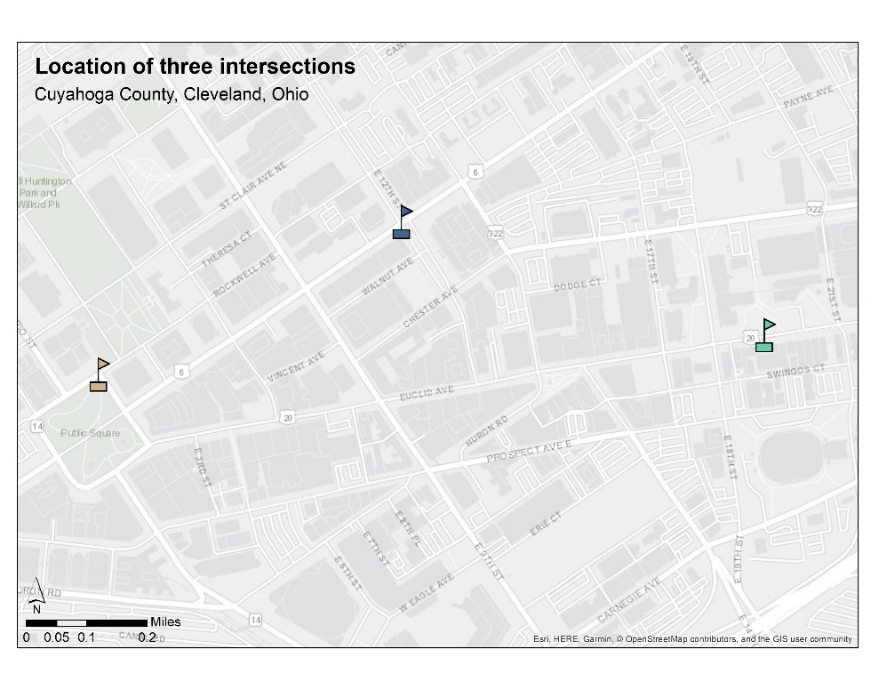
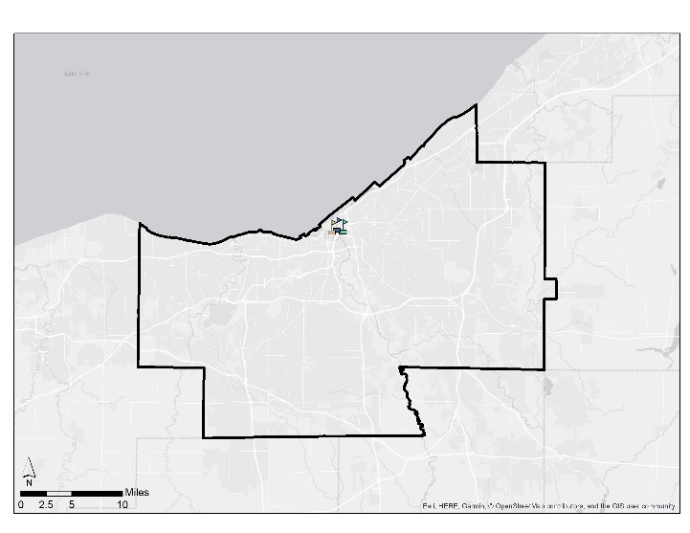
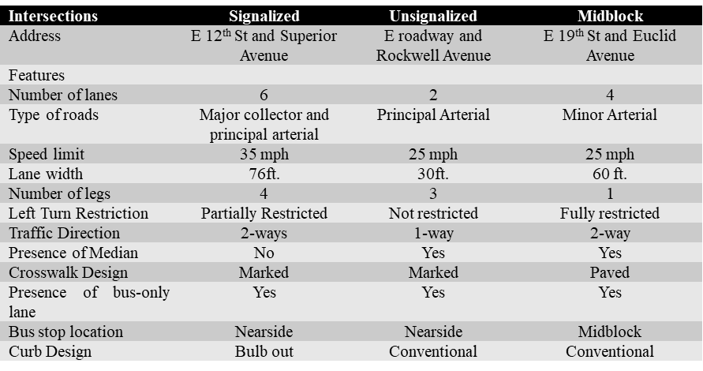
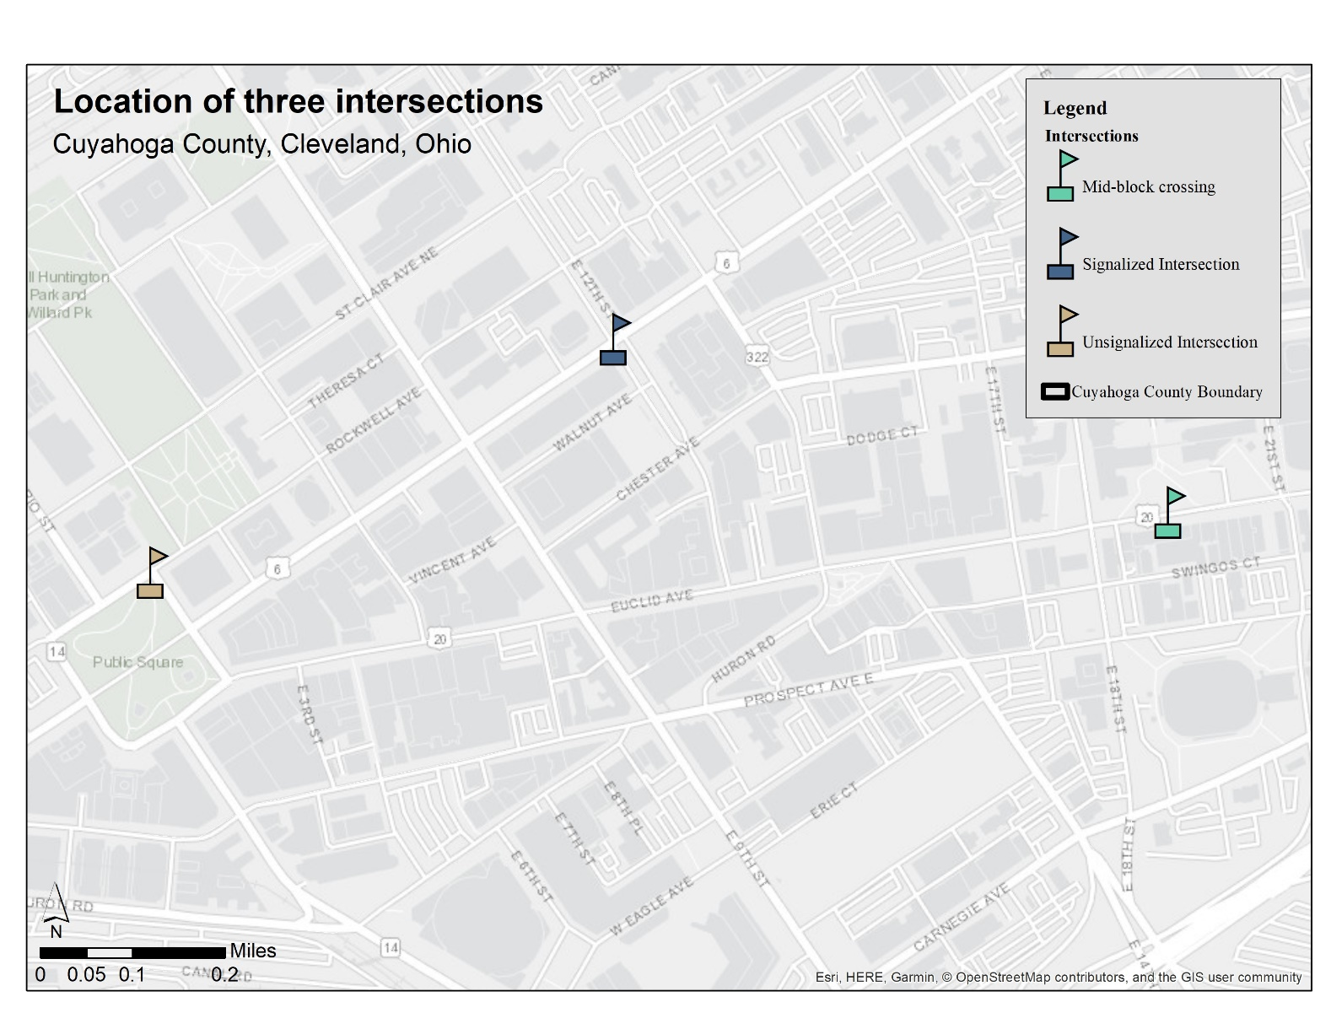
Figure 2.3. Three selected intersections in Cleveland, Ohio
Cuyahoga County
Source: Google Maps and (72)

Table 2.1. Frequency of Alerts by “EventCodeType” and “AppMessageType”

EventCodeType | AppMessage | Intersection
EventCodeType | AppMessage | Signalized | Unsignalized | Midblock | Total Alerts
EnteredArea | Info | 5737  (11%) | 5104  (14%) | 9624  (27%) | 20465  (17%)
 | InformAlert | 0 | 0 | 0 | 0
 | WarnAlert | 0 | 0 | 0 | 0
EventComplete | Info | 17409  (34%) | 11281  (31%) | 3734  (10%) | 32424  (27%)
 | InformAlert | 0 | 0 | 0 | 0
 | WarnAlert | 0 | 0 | 0 | 0
ExitedArea | Info | 5930  (12%) | 5097  (14%) | 9706  (27%) | 20733  (17%)
 | InformAlert | 0 | 0 | 0 | 0
 | WarnAlert | 0 | 0 | 0 | 0
InArea | Info | 5506  (11%) | 4160  (12%) | 9159  (26%) | 18825  (15%)
 | InformAlert | 0 | 0 | 0 | 0
 | WarnAlert | 0 | 0 | 0 | 0
FarsidePed | Info | 0 | 0 | 0 | 0
 | InformAlert | 1385  (3%) | 33  (0%) | 1283  (4%) | 2701  (2%)
 | WarnAlert | 1431  (3%) | 44  (0%) | 381  (1%) | 1856  (2%)
LeftsidePed | Info | 0 | 0 | 0 | 0
 | InformAlert | 716  (1%) | 1982  (6%) | 0  (0%) | 2698  (2%)
 | WarnAlert | 2851  (6%) | 2503  (7%) | 0  (0%) | 5354  (4%)
NearsidePed | Info | 0 | 0 | 0 | 0
 | InformAlert | 2844  (6%) | 1165  (3%) | 1238  (3%) | 5247  (4%)
 | WarnAlert | 4059  (8%) | 3432  (10%) | 597  (2%) | 8088  (7%)
RightsidePed | Info | 0 | 0 | 0 | 0
 | InformAlert | 723  (1%) | 347  (1%) | 0  (0%) | 1070  (1%)
 | WarnAlert | 1956  (4%) | 843  (2%) | 0  (0%) | 2799  (2%)
Total |  | 50547  (100%) | 35991  (100%) | 35722  (100%) | 122260  (100%)
It is noteworthy that the percentages of “WarnAlert” are very similar between the signalized (20%) and unsignalized intersection (19%). The ratios of “WarnAlert” vs. other alerts are also close for these two intersections (25.57% and 23.39%). The percentage of “WarnAlert” is low in the midblock crossing (3%) and hence, the ratio of “WarnAlert” vs. other alerts (2.81%) is also low for this midblock crossing. The differences in exposure of bus activity and pedestrian activity likely is responsible for differences in alerts-as would be geometry, surrounding land use and presence of other vehicular traffic. The three intersections represent three unique situations, and they are not comparable. Therefore, each of them is examined with equal importance in this study.
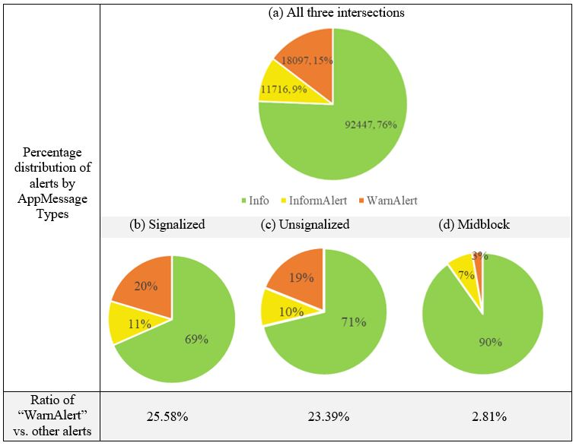
Figure 2.4. Percentage of “Info, “InformAlert” and “WarnAlert” at (a) all three intersections, (b) Signalized, (c) Unsignalized, and (d) Midblock crossing
The dataset contained other relevant variables that were considered for analysis. For instance, the speed at the time of the EPCW alert generation (N=29813) ranged from 0 to 10.48 mph. This indicates that some buses were stopped when they received the alert. Lower speed values indicate that the buses were either decelerating or accelerating at that moment. The distance between the bus and intersections ranged from 0.36 to 327 feet, indicating that alerts were received from 327 feet away from the intersection.

Comparison of three intersections
Table 2.2 shows that among the all pedestrian-based alerts (29813 alerts) at the three intersections, “NearsidePed” alerts were mostly observed, followed by “LeftsidePed,” “FarsidePed,” and “RightsidePed.” The signalized intersection received the highest number of pedestrian-based alerts among the three intersections. It mostly received “NearsidePed” alerts, followed by “LeftsidePed,” “FarsidePed,” and “RightsidePed.” The unsignalized intersection received the second-highest number of alerts. Like the signalized intersection, it also received mostly the “NearsidePed” alerts. The unsignalized intersection received the lowest “FarsidePed” alert among the three intersections. The Midblock crossing received the lowest number of alerts among the three intersections. It is noticeable that Midblock did not receive any “LeftsidePed” or “RightsidePed” alerts in the entire study period, whereas the bus stop is in the middle lane of the road and pedestrians come to the bus stop from both sides. It can be deduced that pedestrians were not crossing the road from the left or right when the connected buses came to the midblock crossing. But some “FarsidePed” and “NearsidePed” alerts were received here.

Table 2.2. Contingency Table of Alerts under all “AppMessageType,” only EPCW Application, and Pedestrian Based “EventCodeType”

 |  |  | Intersection |  |  | Total
 |  |  | Signalized | Unsignalized | Midblock | Total
EventCodeType | FarsidePed | Count | 2816 | 77 | 1664 | 4557
EventCodeType | FarsidePed | % Within Intersection | 18% | 1% | 48% | 15%
EventCodeType | LeftsidePed | Count | 3567 | 4485 | 0 | 8052
EventCodeType | LeftsidePed | % Within Intersection | 22% | 43% | 0% | 27%
EventCodeType | NearsidePed | Count | 6903 | 4597 | 1835 | 13335
EventCodeType | NearsidePed | % Within Intersection | 43% | 44% | 52% | 45%
EventCodeType | RightsidePed | Count | 2679 | 1190 | 0 | 3869
EventCodeType | RightsidePed | % Within Intersection | 17% | 12% | 0% | 13%
Total |  | Count | 15965 | 10349 | 3499 | 29813
 |  | % Within Intersection | 100% | 100% | 100% | 100%
Pearson Chi-Square: 6672ª , df = 6, Asymptotic Significance (2-sided): 0.000
Likelihood Ratio: 8148.446, df = 6, Asymptotic Significance (2-sided): 0.000
N= 29813
a. an expected count of <5 was seen in 0 cells (0.0%). 454.08 is the expected minimum count for cells
It is also critical to know if there is any statistically significant association between the types of intersections and types of event codes. Data for only the EPCW application type were considered to evaluate the association between categories of intersections and event codes, as shown in Table 2.2. The null hypothesis was that there is no correlation between the type of intersections and event codes. The calculated Chi-square value for this dataset was 6672, which is larger than the critical Chi-square value for degrees of freedom (df) = 6. The p-value is also less than 0.01. Hence, the null hypothesis was rejected, and it was concluded that there is a significant relation between “EventCodeTypes” and intersections.

Identification of Alert Zones for buses
According to the Transit Capacity and Quality of Service Manual (TCQSM 3rd Ed.), bus stops are categorized into three types: farside, midblock, and nearside, as shown by Figure 2.5. The three intersections selected for this study and the alerts received by connected buses are discussed further in the next section.
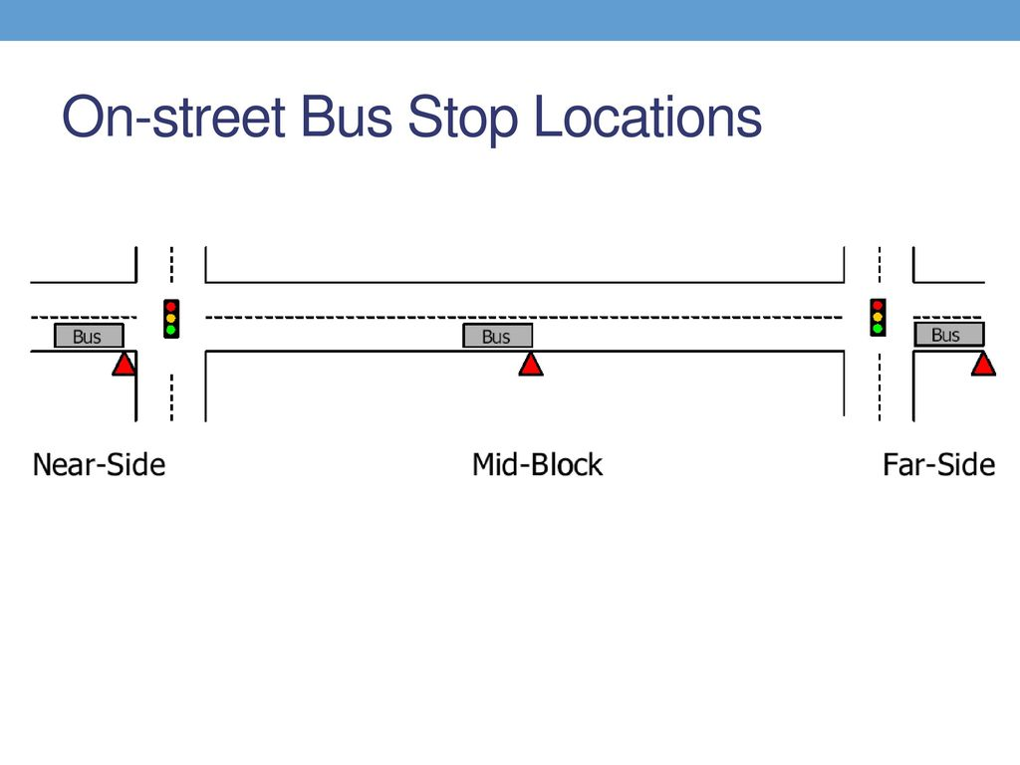
Figure 2.5. Categories of bus stops based on their curbside location
Source: TCQSM 3rd Ed. (73)

Alerts at the Signalized Intersection
The connected buses received all pedestrian-based alerts at the signalized intersection, as shown in Figure 2.6. This was the most complex intersection. It had three nearside bus stops, traffic running both ways, and it was a junction of four north-south direction lanes and two east-west direction lanes. All the alerts were generated in all four directions. Most of the alerts were along Superior Avenue (east-west). The “NearsidePed” alerts were generated when pedestrians were on the crosswalks of nearside stops. Logically, the number of these alerts was the highest at this intersection. The “LeftsidePed” alerts are more prominent at the southwest corner of this intersection. This might be because there were more pedestrians along East 12th Street and on the crosswalk across East 12th Street going from southwest to southeast. Another reason for getting this “LeftsidePed” alert could be the left turn lane, which exposes pedestrians to left-turning vehicles. The “RightsidePed” alert was the lowest in number at this intersection. Probably, not many pedestrians were walking across East 12th Street from the east to the west side through the crosswalk. The average distance between the CenterPoint of this intersection and the “FarsidePed” alerts, the “NearsidePed” alerts, the “Leftsideped” alerts, and the “RightsidePed” alerts was 135.66 feet, 168.57 feet, 101.94 feet, and 134.19 feet, respectively. So, it can be said that the alert zone for this signalized intersection is situated within a radius of 142.09 feet from the center of this intersection.
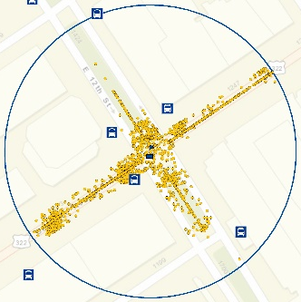
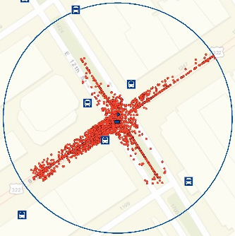
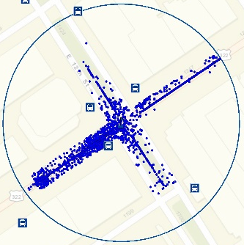
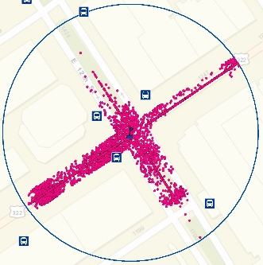
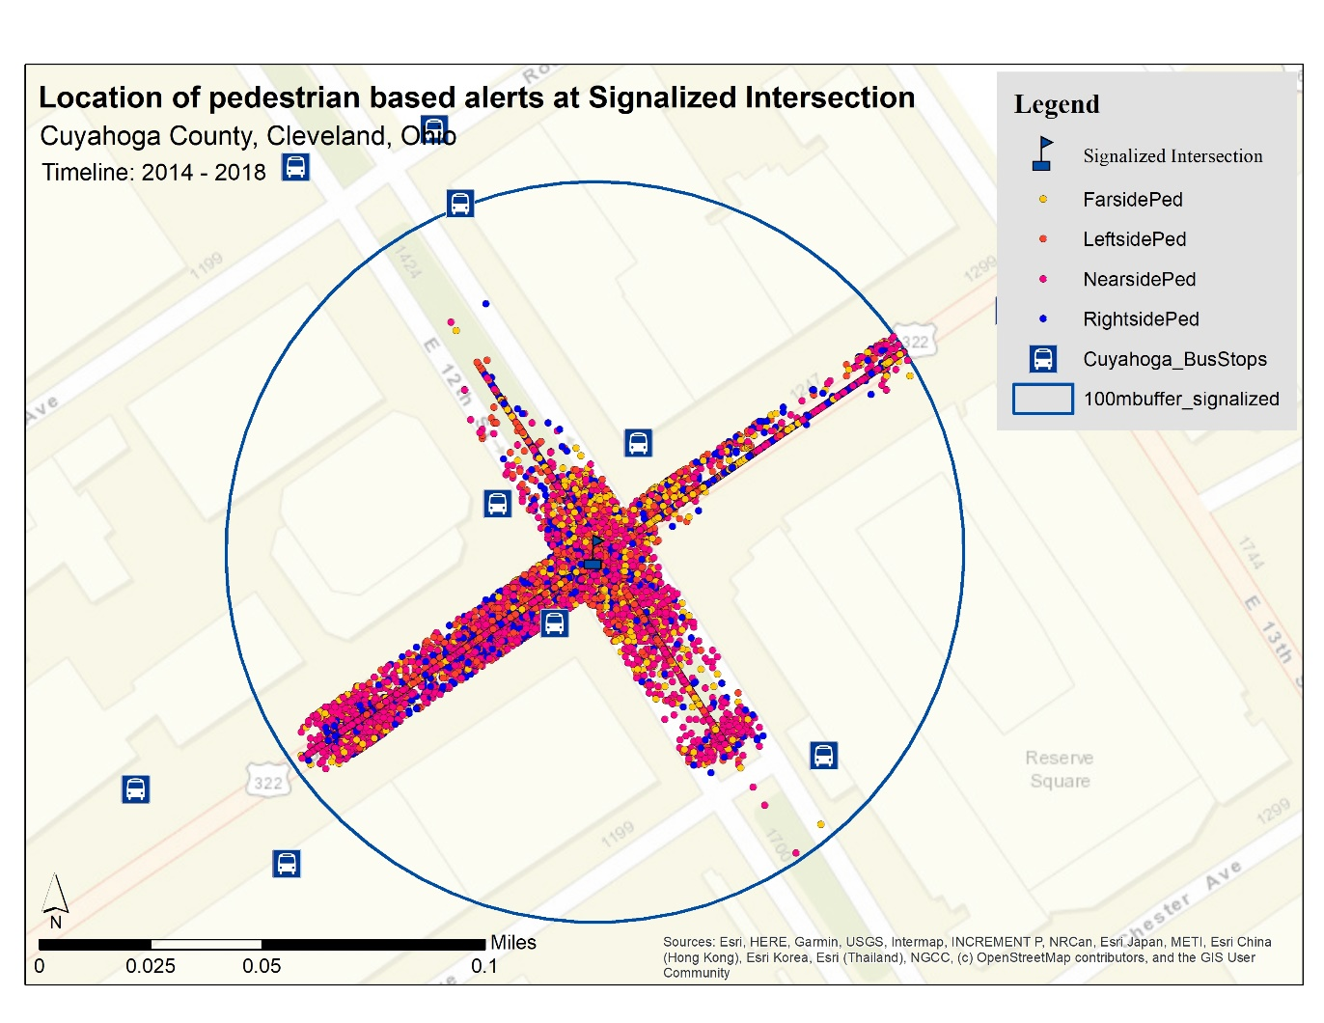
(a)
(b)
(c)
(d)
(e)
Figure 2.6. (a) All, (b) “FarsidePed,” (c) “NearsidePed,” (d) “LeftsidePed,” and (e) “RightsidePed” alerts at Signalized Intersection

Alerts at the Unsignalized Intersection
Similar to the signalized intersection, the connected buses also received all the pedestrian-based alerts at the unsignalized intersection, as shown in Figure 2.7. This intersection was a T-intersection with one-way roads and a nearside bus stop. “FarsidePed” alerts were generated when the buses were passing through Rockwell Avenue from east to west, but these alerts were not high in number. The majority of the “NearsidePed” alerts were generated along the East roadway when the buses were approaching the intersection. Many pedestrians may have been on the crosswalk of Rockwell Avenue that connects the public square and Key Tower.
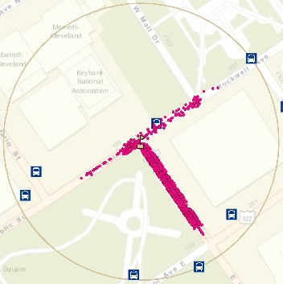
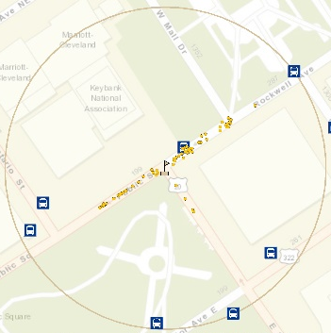
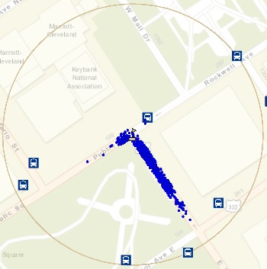
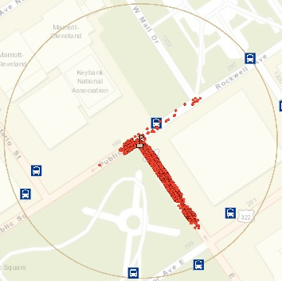
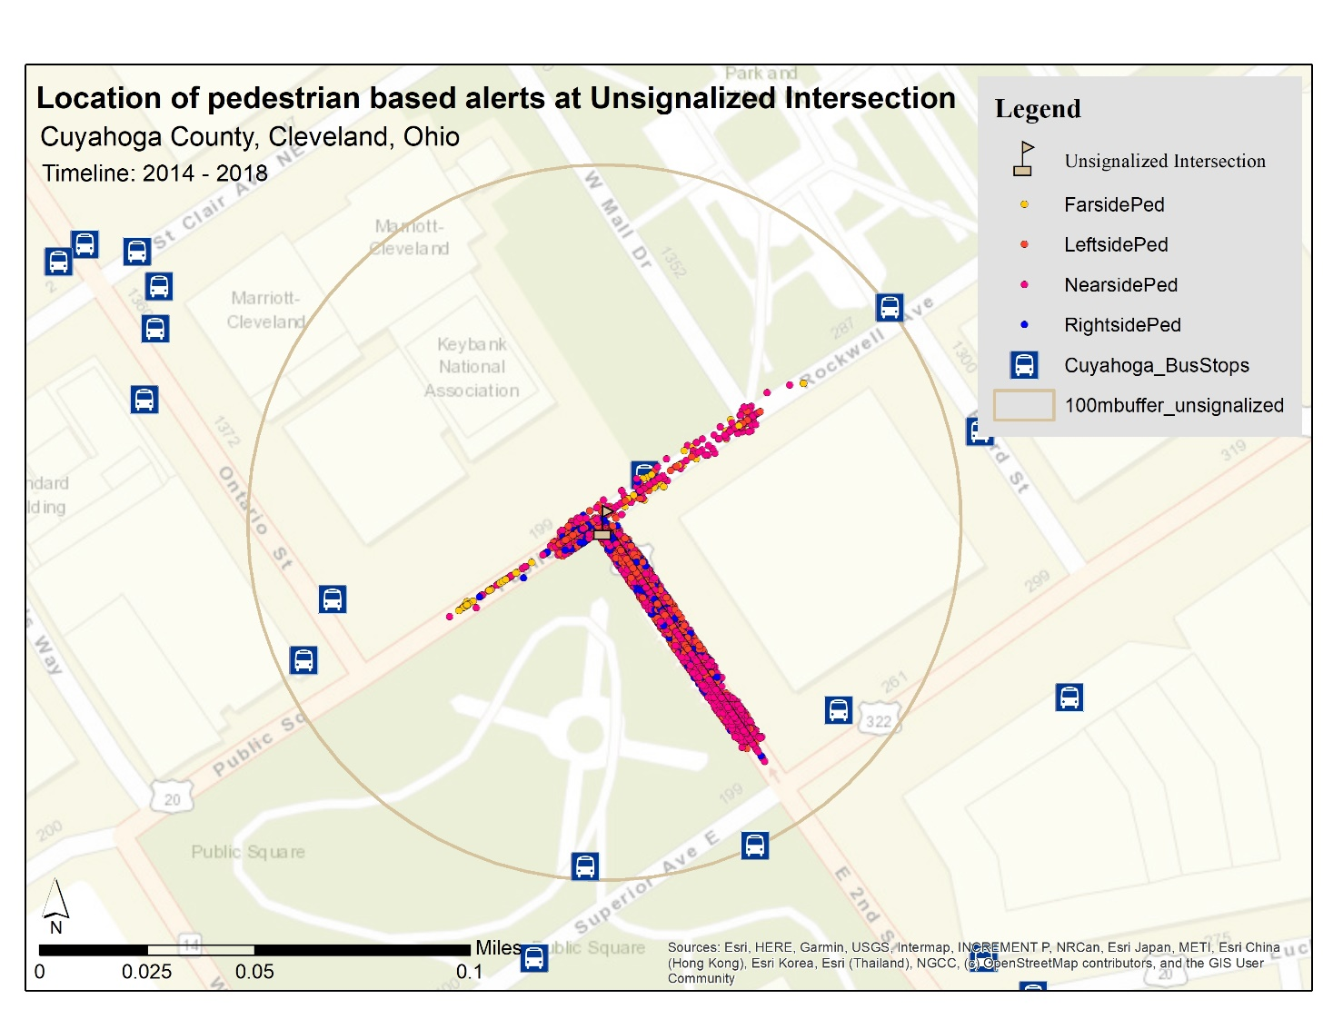
(a)
(b)
(c)
(d)
(e)
Figure 2.7. (a) All, (b) “FarsidePed,” (c) “NearsidePed,” (d) “LeftsidePed,” and (e) “RightsidePed” alerts at Unsignalized Intersection
The “Leftsideped” alerts were likely generated when pedestrians were along the west side of the East roadway or on the crosswalk of the East roadway connecting the public square and the courthouse. The “RightsidePed” alerts were likely generated when pedestrians were along the east side of the East roadway or on the crosswalk of the East roadway connecting the public square and the courthouse. The most numerous alerts were “NearsidePed” and “LeftsidePed.” So, from the magnitude of the frequency, it can be inferred that at this unsignalized intersection, pedestrians on the near side, left side, and right side are more at risk from upcoming buses than those on the far side. The average distance between the center point of this intersection and “FarsidePed” alerts, the “NearsidePed” alerts, the “LeftsidePed” alerts, and the “RightsidePed” alerts was 97.90 feet, 122.64 feet, 84.48 feet, and 89.86 feet, respectively. So, it can be said that the alert zone for this unsignalized intersection is situated within a radius of 102.13 feet from the center of this intersection.

Alerts at the Midblock Crossing
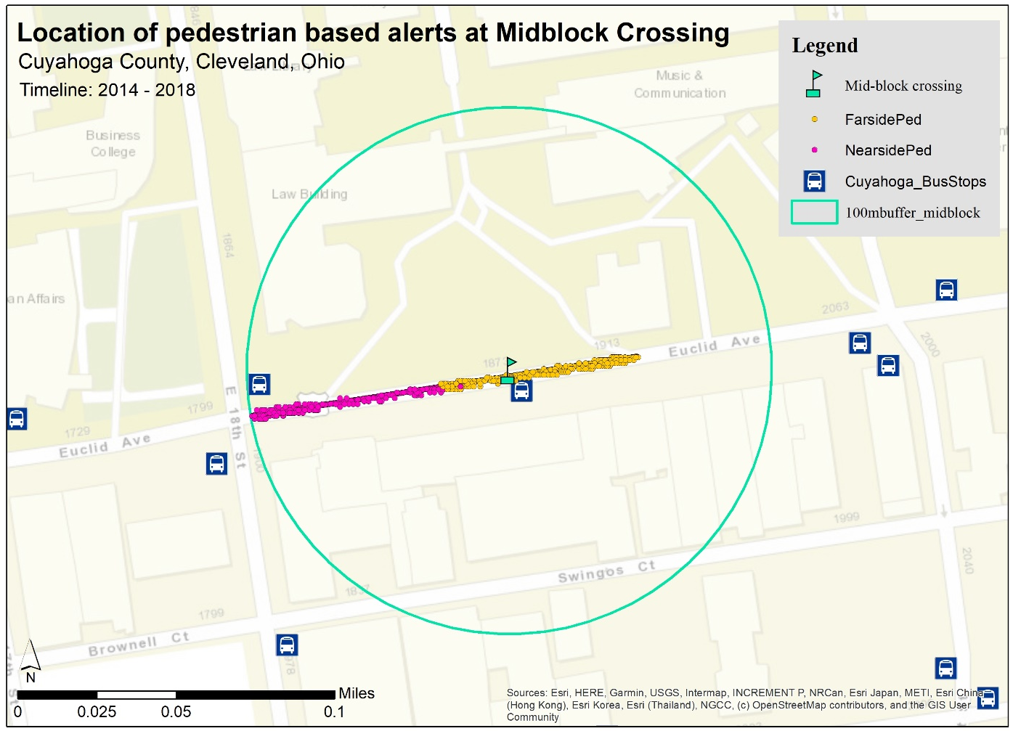
Figure 2.8. Pedestrian based alerts at Midblock Crossing

The midblock crossing had one midblock bus stop. Only “FarsidePed” and “NearsidePed” alerts were received by the connected buses at this midblock crossing, as shown in Figure 2.8. The “FarsidePed” alerts were received more towards the east as the buses were approaching the far side of the following block. The “NearsidePed” alerts were received more towards the west as buses were approaching another nearside bus stop. It appears that in this midblock intersection, there were more pedestrians in the farside and nearside areas for whom these alerts were generated compared to the left and right sides. It can be inferred from this data that when a bus stop is in the middle of the block, pedestrians at the crosswalks or curbs of nearside or farside bus stops would be at the risk of collision. The average distance between the midblock crossing and “FarsidePed” alerts was 85.20 feet, and between the midblock crossing and “NearsidePed,” it was 246.49 feet. So, it can be said that the alert zone for this midblock crossing is situated within a radius of 169.78 feet from the center of this intersection.

As this study does not have a large enough sample size to conclude these claims in general for all signalized, unsignalized, or midblock intersections, further study is needed.

Discussion

Performance of EPCW
To understand the performance of EPCW, pedestrian crash frequencies were observed. But the frequency of pedestrian crashes for three intersections was negligible from 2014-2018. The research report on the E-TRP pilot project found that over the six-month study period, connected bus drivers’ response to PCW alerts increased by 16%, and average drivers’ reaction time to the PCW warning situation decreased by 18% (13). These SSMs indicated that connectivity can help bus drivers to react more quickly over time and increase pedestrian safety. In this study, a unique SSM called MTDI was developed to quantify the efficacy of EPCWs at different intersections. Figure 2.9 shows the MTDI values for three intersections for six months and their trendlines. The trendline for signalized intersection is downward sloping, indicating that MTDI decreased over the period. It can be inferred that EPCW alerts were not as effective as expected at this intersection. MTDI at the unsignalized intersection showed an upward sloping trendline, indicating that the mean time difference of connected buses to reach this intersection increased with time. Hence, EPCW alerts were effective at the unsignalized intersection. MTDI for midblock crossing excludes August, as it had only three “WarnAlerts.” From March to July, MTDI at midblock crossing also had an increasing slope, which indicated that EPCW was also effective at the midblock intersection. Considering all SSMs and the dataset, it was evident that EPCW has the potential to improve pedestrian safety at intersections. With connectivity in transit, the unsignalized intersection and the midblock crossing intersection of the study area had higher potential for improvement, based on analysis of the data. However, this is the observation from the data, which can change based on further evidence. The area needs further investigation to understand which intersection has more potential for improvement than the others with CV technologies.

Land Use
Land use around the three intersections is shown in Figure 2.10. All three intersections are located downtown, which is mainly a commercial area. The area also has some plots that are used for green space, industrial, institutional, residential, and utility purposes. The signalized intersection is surrounded by three commercial buildings (various restaurants, offices, and banks) and one residential building (commercial spaces and some apartments). The unsignalized intersection is surrounded by a green space (Public Square), one institutional building (Court House), and a commercial building. The midblock crossing is surrounded by institutional buildings (Marshall College of Law) and commercial buildings. Apparently, commercial areas remain busy during office hours on weekdays and remain quiet during the weekends. It is predictable that there will be more pedestrians at these intersections during the rush hours and office hours on the weekdays compared to the other times of the days and weekends. Therefore, the frequency of alerts at these intersections is also expected to follow a peaking pattern.

Figure 2.9. Trendline of MTDIs at intersections

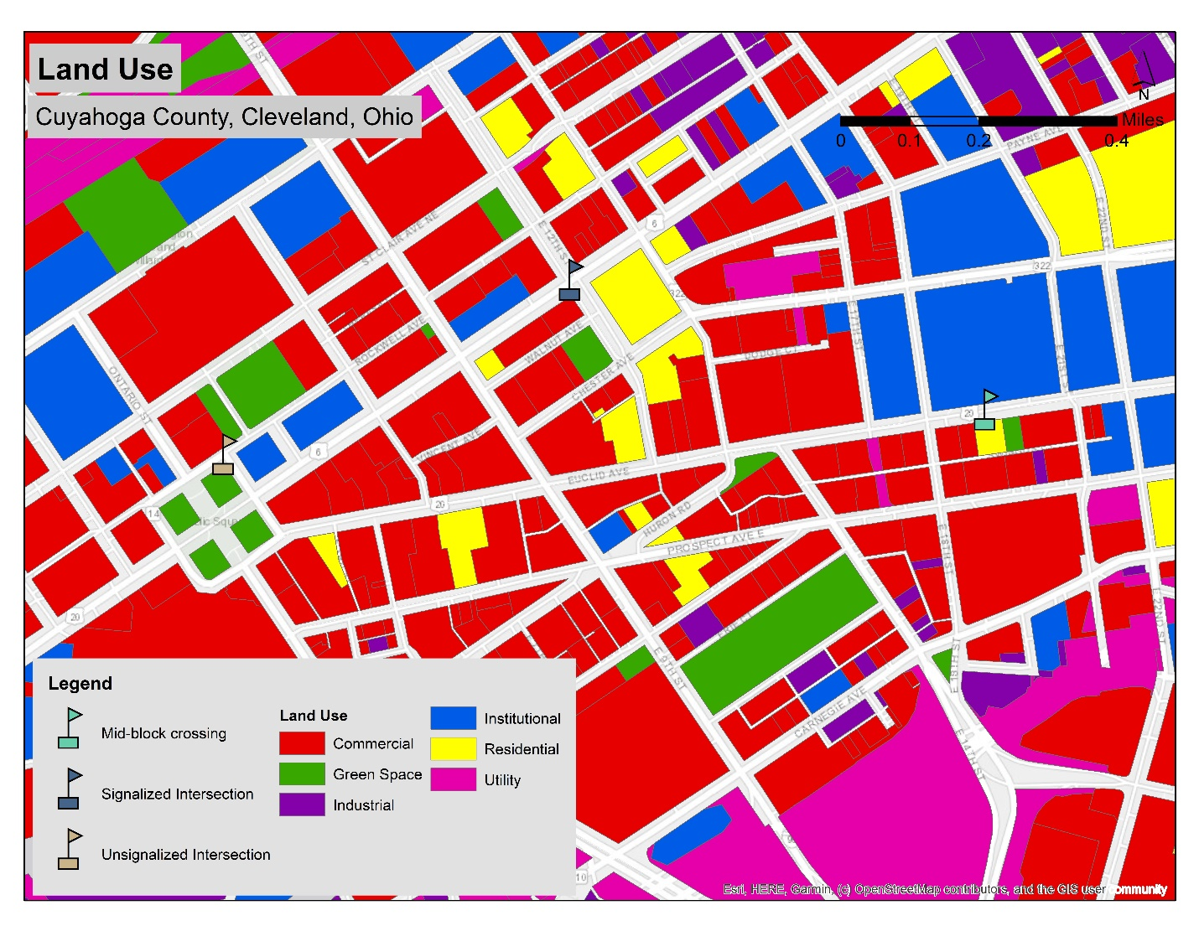
Figure 2.10. Land Use around the three intersections of the study area

Temporal Distribution of EPCW
The time series analysis has been conducted to see underlying patterns of how the alerts are distributed over time, as shown in Figure 2.11. For all three intersections, higher frequency (100-200+) of alerts is mainly observed from 10 am to 11 pm and some lower frequency (<100) of alerts are observed between 12 am to 9 am. The signalized intersection has more alerts between 12 am – 3 am compared to the other two intersections. Overall, alerts are negligible to low on weekends and moderate to high on weekdays for all intersections in all months. Some of the highest frequency of alerts (around 200s) has been observed on the Fridays of June and 1st Monday and last Wednesday of July at the signalized intersection. Overall, the temporal distribution of the alerts resonates with the busy hours of the surrounding land uses.
Notably, the signalized intersection has no alerts on most days in March and April because the project’s connected buses did not take that route on those days. Similarly, the connected buses also had fewer operational days in March and April compared to the other three months along the route of the unsignalized intersection. Although the alert frequency is lesser in the midblock crossing compared to the other two intersections, the midblock intersection has a similar pattern of alert distribution for all five months.

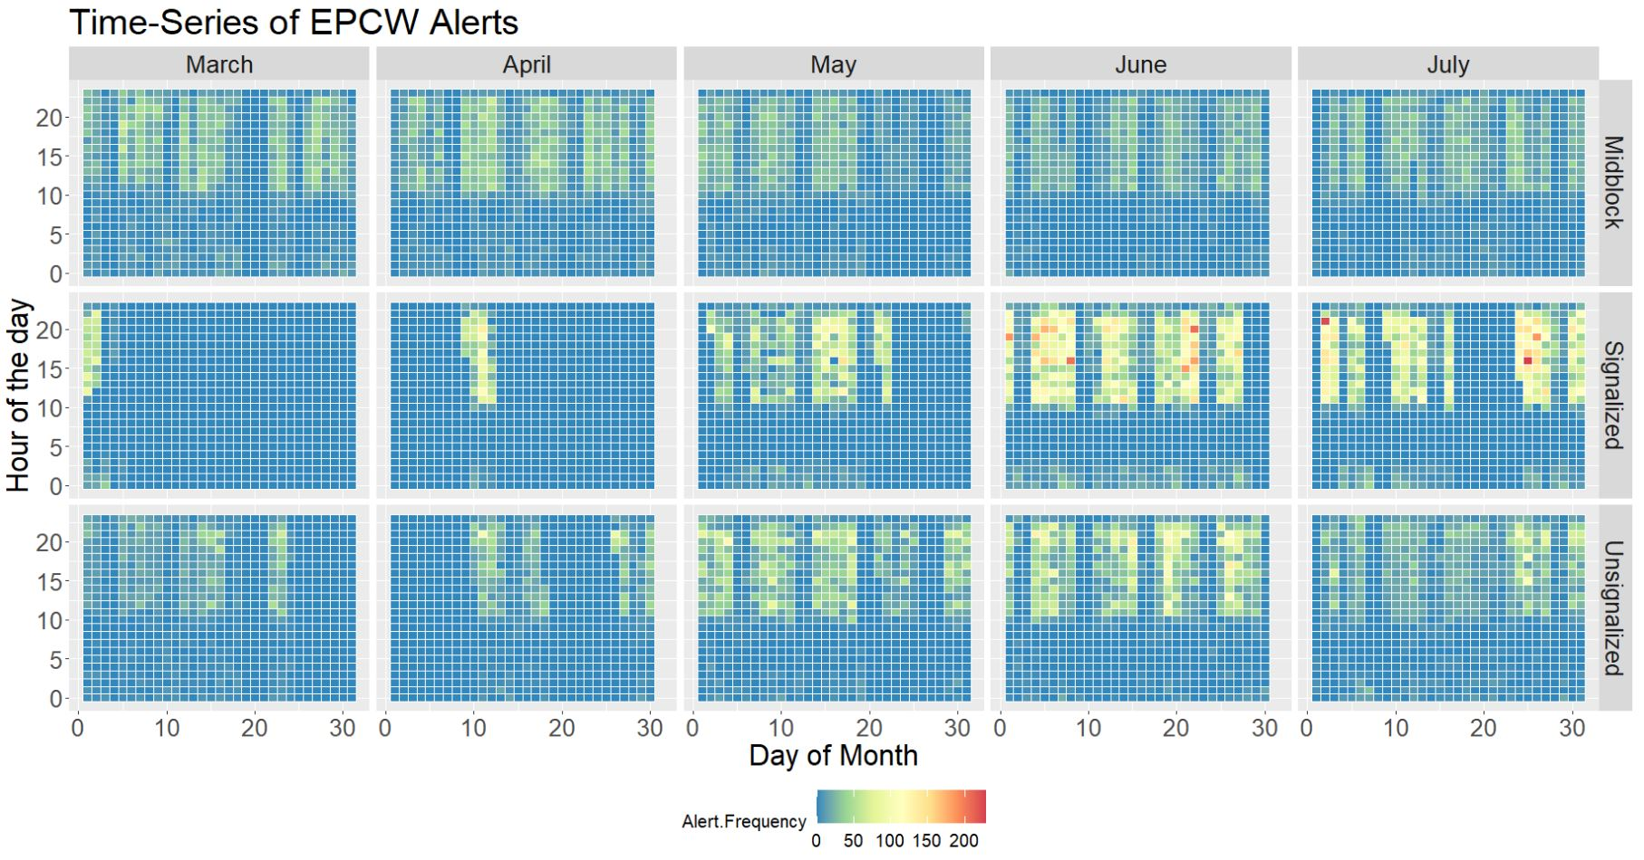
Figure 2.11. Timeseries heatmap of Alerts at intersections

Limitations
This study could only analyze the alerts through descriptive statistics and some spatial analyses because of the few sample intersections. Robust statistical models could not be run to show the associations between types of alerts and characteristics of intersections. As the number of bus-involved pedestrian crashes was not significantly high in the study period, it was irrational to draw any conclusion from them. Utilizing GPS data for spatial analysis at a microscopic level held the possibility of error in the calculation as GPS locations do not always fall in the correct position. This study developed a framework for exploiting BSM data to identify alert zones for transit buses and pedestrians. But the results might not be generalizable for other cities because of differences in pedestrian and vehicle density, geometric design of the intersections, and weather. Another issue was the unavailability of vehicle trajectory data for the many unique alerts. Those alerts could not be used as their GPS locations could not be traced.
Lastly, false alerts in the data could not be identified and removed because of the unavailability of video footage of the test runs and no mention of false alerts in the published dataset. The research report published by FTA indicates that along with false alerts, incorrect alerts were present in this dataset. False alerts were those alerts that the detector generated when no pedestrian was present at the bus stop. On the other hand, incorrect alerts were generated when the detector identified an incorrect location of the pedestrian. Specifically, false alerts occurred due to lighting and environmental conditions, and incorrect alerts occurred due to the proximity of the zones in this project. To detect the rate of acceptable alerts, 15% of the EPCW alerts were used as samples. Among the sample analyzed, 81% were correct, 10% were incorrect, and 9% were false alerts (13). As the majority of the alerts of the sample were correct, the authors of this paper have decided to proceed with the analysis of the data.

Conclusion
Addressing safety challenges at intersections can be accomplished through the use of innovative technologies and the application of data science. The emergence of CAVs has introduced a new branch of unique datasets that can be harnessed for such safety studies. Examining data from the CAV pilot projects at a microscopic level can yield benefits for drivers and pedestrians at intersections. This study aims to understand the nature of pedestrian-based alerts received by connected buses at three different types of intersections. Of interest was the type and frequency of pedestrian-based alerts and how they differed across different intersections. Another matter of interest was to see if these alerts can assist in identifying alert zones where bus drivers should be careful to avoid potential pedestrian bus collisions. Alert zones were identified spatially in GIS. Since the data was a unique BSM dataset, collected from credible sources and error-checked through descriptive statistics, the data seems valid and contributed to the findings.
Key findings are worth mentioning. First, the location of receiving pedestrian-based alerts might depend on the type of bus stop location. The midblock crossing received only “FarsidePed” and “NearsidePed” alerts, whereas the other two intersections received all four types of pedestrian-based alerts. Second, based on the data collected in this pilot project, the signalized intersections received the most EPCW alerts, followed by the unsignalized and the midblock intersections. However, this finding does not confirm which intersection has more potential for improvement, and further studies are needed in this area. With the full deployment of CV transit, researchers may recognize which intersections have greater potential for pedestrian safety improvements. Third, “NearsidePed” was the most generated alert type in all three intersections. The next most generated alert was “LeftsidePed,” although midblock didn’t have any “LeftsidePed” alert. Fourth, Alert zones were identified within a radius of 142.09 feet, 102.13 feet, and 169.78 feet from the center of the signalized, unsignalized, and midblock crossing intersections, respectively. Presumably, if transit drivers are more vigilant when entering and driving through these alert zones, then they may be able to avoid collisions with pedestrians. Finally, based on the data in hand, the novel SSM MTDI metric showed that the unsignalized and midblock crossing intersections in the study area had more time to reach the middle of the intersection than the signalized intersections for pedestrians after applying connectivity.
This study highlights the importance of connectivity technology by traversing the usefulness of BSM alerts in enhancing pedestrian safety. As the findings are based on the unique CV transit bus data, they contribute to the analysis of ongoing experiments on connected vehicles. During the test, alerts were successfully provided to drivers. This shows that the system can successfully sense pedestrians and provide alerts to bus drivers. Overall, this paper provides early evidence about the performance of EPCW technologies, which is relevant to policy makers who aim to promote safe roads for all users. Notably, EPCW deployment can be considered as an option in other contexts, given their successful implementation at intersections in this case study. The paper will also be useful for transportation analysts as it contributes a methodology that harnesses BSM data generated by new sensors to improve the safety of transit and pedestrians. The methods used in this paper to identify alert zones and calculate MTDI can be applied immediately. Transit agencies might install these connectivity systems in their buses and intersections along their route to collect BSMs and analyze the BSMs to identify alert zones for each intersection. Transit agencies can share this information with the transit drivers so that they can be more cautious about the presence of pedestrians and drive more safely in and around intersections. By checking the MTDI of the intersections over time, transit managers can identify dangerous intersections and implement safety countermeasures.
Conversely, it is evident from the FTA report (13) that although GCRTA highly valued the EPCW system and expressed their keen interest to deploy the system in the future, they did not continue to use the technology (OBUs and DSRC RSUs) after the pilot ended. This is because the transit agency’s current budgets fell short to cover the full deployment of the EPCW infrastructure across their transit network. Such outcomes are a common phenomenon in similar pilot projects. To accelerate the diffusion and deployment of promising technologies, agencies can undertake a phased deployment of successful transit technology and install the systems at their most vulnerable intersections initially, where the technology is likely to have a substantial and high impact. In this instance, GCRTA could continue investing in the technology instead of removing it from the network’s study area and later expand deployment to other vulnerable areas. Similarly, other transit agencies that conduct such tests should consider continued investment from testing to technology deployment (if sufficient benefits were found) rather than removing the transit technology at the conclusion of the technology pilot. The issue of maintenance cost of the technology would need to be addressed by the transit agency as well.
Finally, the success of EPCW in this case study provides the motivation for further investigation of the technology. Future studies can investigate the creation and impacts of different types of alerts and warnings temporally and in diverse spatial settings. Investigating the frequency of alerts, precisely “WarnAlert,” at unique intersections such as midblock crossings and roundabouts would be an interesting topic for future research. By including more intersections, factors contributing to different types of alerts at different intersections can be identified through robust statistical models. Future efforts should focus on associating BSM alerts with variables such as crashes, road geometry, traffic signal design, exposure data like pedestrian and vehicle flow at intersections, bus driver characteristics, speed, acceleration, reaction time, stopping sight distance of CVs, socio-economic characteristics of the area, and surrounding land uses to further the understanding on bus-involved pedestrian crash studies.

Acknowledgments
The Collaborative Sciences Center for Road Safety, CSCRS, a U.S. DOT-funded National Transportation Center, partially supported this study under Grant No.
69A3551747113. The authors would like to thank the Civil, Environmental, Industrial & Systems Engineering Information Technology service providers of the University of Tennessee, Knoxville, for their constant IT support and advice. The authors would also like to thank Ms. Meredith King for proofreading the paper.

A SYNTHESIS AND COMPARISON OF AMERICAN AUTOMATED SHUTTLE PILOT PROJECTS

Abstract
Automated shuttles are an emerging mode of transportation in many American cities, but it is not yet well understood where they should be deployed. Therefore, the study aims to synthesize the state of the practice of automated shuttle pilot projects to identify patterns of shuttle deployments in the United States. The case study approach is used as the method. Nineteen ongoing or completed automated shuttle pilot projects are initially identified. Among them, automated shuttle projects in Ann Arbor, Michigan; Arlington, Texas; San Ramon, California; Denver, Colorado; Las Vegas, Nevada; and Minneapolis, Minnesota are chosen to study in detail to identify patterns. The key findings are used to develop a synthesis of the state of the practice, which is formulated along three dimensions: deployment locations, service characteristics, and stakeholders. The dimensions suggest that university campuses, stadiums, office parks, transit stations, entertainment areas, and downtowns are well-suited locations for automated shuttle operations. Common service characteristics are low speeds (10-15 mph), vehicle capacities of 6-12 passengers, short routes (less than a mile) with few stops, and free fares. Stakeholders are divided into four groups: public organizations, partner organizations, shuttle manufacturers, and private operators. Deployment locations influence the types of service characteristics and stakeholder combinations of each deployment project. These findings will assist cities that are considering future deployments of automated shuttles in their locality.

Introduction
The introduction of automated vehicles (AV) is expected to bring about momentous change in the transportation industry. As part of this movement toward AVs, automated shuttles have recently been deployed in many American cities. According to the Federal Transit Administration’s (FTA) Strategic Transit Automation Research Plan of 2018, automated shuttles are small, low speed (generally less than 25 mph) vehicles that “do not require a human operator, although early demonstrations all have included an on-board human attendant to observe passengers, record data, answer questions, and serve as a safety operator if needed” (74). These shuttles typically meet the Society of Automotive Engineers (SAE)’s definition of Level 4 automation, which is a high automation mode in which the system uses an automated driving system that involves the driver’s assistance in some situations. Additionally, the shuttles are typically “limited to operating in certain environments such as parking lots, busways, campuses, downtown districts, and retirement communities” (74).
To prepare for the future of the transportation system, the United States Department of Transportation (USDOT) has outlined guiding principles for automated vehicles (75); however, this policy document does not have specific guidance for automated shuttles. To guide the transit industry, particularly in the case of automated shuttles, the FTA has initiated a five-year-long research plan to communicate deployment decisions; this is currently underway and will continue through 2022 (74). As this initiative is still underway, it would be helpful to provide planners and policymakers an opportunity to learn about the initial similarities, differences, and key findings of early automated shuttle projects. Therefore, this paper aims to create an initial synthesis and comparison of the state of the practice of automated shuttle pilot projects, which can be insightful for American cities that are interested in deploying automated shuttles.
The paper is organized as follows: first, prior research on automated shuttles is reviewed, and the objectives of this research are set forth. Then, the case study method is used; this includes identifying ongoing or successfully completed deployments in the United States and selecting six unique cases to study in detail. The case study results are then used to formulate the state of the practice along three key dimensions: deployment locations, service characteristics of the shuttles, and stakeholders who are involved in the project. This is followed by areas for future research and the conclusions.

Prior Research
Research on automated shuttles is being undertaken by many countries. European research is arguably the most advanced. Thus, this brief literature review will focus on European research as well as American research. For a more comprehensive literature review, readers are referred to (76).

European research on automated shuttles
Many deployment projects have taken place in the form of demonstrations, pilots and showcases in Europe, among which Citymobil2, WEpod, and CarPostal are noteworthy (77-80). The Citymobil2 project analyzed twelve automated shuttle deployments and classified their deployment locations into four types: city centers, within a “major facility,” from a public transport node to a major facility, and from a public transport node to a residential area.
Other studies have analyzed automated shuttles from the perspective of users, including travel behavior, demographics, and user perceptions of safety (81-83). One study conducted a stated preference survey to understand the user perspective of shared AVs as a potential solution for last mile trips from transit stations and found that first class train travelers are more likely to choose shared AVs as their egress mode (84). Another study surveyed actual users of automated mini buses and found that regular users tended to be younger people; additionally, passengers generally did not have concerns about safety or security onboard (83). A third study conducted surveys of the passenger experience after travelling in a driverless shuttle bus and concluded that passengers perceived driverless shuttle bus safety to be better than that of conventional buses, whereas personal in-vehicle security was weaker than that of conventional buses (82).
The economics and cost effectiveness of automated shuttles have been discussed by many authors (85-87). One early study used simulation techniques to develop automated demand responsive transport service (ADRTS) scenarios and found that operational costs are likely to be similar to current bus systems but less than traditional demand responsive services, primarily because ADRTS eliminates driver costs and scheduling constraints (88). Another noteworthy study concluded that deployment of automated shuttles will be competitive if demand is sufficient when deployed in dense urban areas (89).

American research on automated shuttles
The United States is arguably lagging behind European countries in terms of automated shuttle deployment and research, even though there has been some background research (76). Most American studies on the user perspective were done prior to automated shuttle deployment (90; 91). Two of these studies have revealed some skepticism about shuttle safety. For example, one study reported that parents may be unwilling to send their children to school in automated shuttles (91). Another study of transit riders found that their willingness to ride in a driverless shuttle increases significantly with the presence of onboard safety staff (90). However, it is likely that attitudes will change after more Americans have experienced riding in an automated shuttle in the future. A limited amount of research has been undertaken on the economic aspects of the automated shuttle deployments in the United States; one noteworthy study showed the cost efficiency of automated shuttles over paratransit services (92).
The next segment of prior work includes the studies that were undertaken since American cities started deploying automated shuttle pilot projects. To date very few relevant academic works have been published on automated shuttles because the shuttles are still in their test phases. The Eno Center for Transportation published a report titled “Beyond Speculation 2.0: Automated Vehicles and Public Policy”, which contains policy recommendations for testing automated vehicles on public roads (93); however, the report is for automated vehicles, it is not specific for automated shuttles. The most relevant reference for this paper is a report by Volpe National Transportation Systems Center of the United States Department of Transportation that analyzed the state of the practice of automated shuttle projects in 2018. The report analyzed a few national and international pilot projects, and it summarized the vehicle and service characteristics of the automated shuttles, identified the parties involved in development, elaborated on the issues related to the shuttles’ deployment, and provided mitigation strategies for resolving those issues (94). This synthesis paper will build upon this report.

Gaps in research on automated shuttles
The prior research mentioned in the previous sections has studied automated shuttle deployments up until 2018. However, this is a rapidly changing area and many new pilot projects have launched after 2018, particularly in the United States. Patterns of pilot project likely exist, but there has been limited effort to document them. This synthesis paper seeks to address this research gap.

Objectives
Given the rapid advancements in automated shuttle pilots in the United States, the objective of this study is to synthesize the current state of the practice of automated shuttle pilot projects in the United States along three dimensions: locations, service characteristics, and stakeholders. The first dimension, locations, examines areas where shuttles have been deployed. The second dimension refers to the service characteristics such as fares, the presence of onboard staff, right-of-way, route length, speed, stops, and vehicle capacity. The third dimension considers the stakeholder organizations that are involved in the deployment, operation, and manufacturing of these automated shuttles. The methodology used for this study is discussed next.

Methodology
The case study method was chosen to conduct this research for two reasons: (1) deployment of automated shuttle is a contemporary event and (2) the researchers do not have any control over the events relevant to the research. According to Yin, the case study method is appropriate for this kind of research (95). To conduct the case study analysis, a four-step process was used in this paper as shown in Figure 3.1.

Figure 3.1. Methodology
The first step was to identify as many automated shuttle pilot projects as possible in the United States to make a comprehensive list. The pilots were identified by searching online. This study considered only active or completed project; any planned, postponed, or cancelled projects were excluded from the study. It should also be noted that only pilot projects open to the broader public were considered; exclusive/internal projects like one for the United States Army at Fort Bragg were excluded from this study (96).
In the second step, a smaller number of pilot projects from the comprehensive list were selected for further study. This selection was based on (1) different location types and (2) the amount of publicly available information. Each of these cases also involved an automated vehicle with a capacity of six to twelve passengers serving the general public along a fixed route.
In the third step, each case was summarized. The summary of each case included the project’s deployment location, launch time, speed, route length, number of stops, vehicle capacity, ridership market, the presence of onboard staff, project’s aim, project completion time, and key findings if it was a completed project.
In the last step, a synthesis of the key findings of the case studies was created along three dimensions: type of location, service characteristics, and key stakeholders.

Results

Identification of pilot projects
Deployment of automated shuttle pilot projects began in 2016 in the United States. Initial pilots were typically deployed in research centers to test shuttle technology. Gradually, deployment locations were expanded to include different types of roads and environmental conditions in different cities. This list contains all of the automated shuttle cases that were deployed up until 1st June, 2019, to the best of authors’ knowledge. As can be seen in
Table 3.1, there were six pilot cases on university campuses, three cases in entertainment areas, three cases near transit stations, two cases in the vicinity of stadiums, one case in an office park area, and one in a downtown area. At least three cases serve multiple locations: Detroit, Columbus, and Providence.

Selection of cases
Six unique cases were selected from Table 3.1. These case studies are intended to be representative of their general location type. Each of these cases were either ongoing or completed and served the general public. The selected cases were the automated shuttle projects in Ann Arbor, Michigan (MI); Arlington, Texas (TX); San Ramon, California (CA); Denver, Colorado (CO); Las Vegas, Nevada (NV); and Minneapolis, Minnesota (MN). A brief summary of each case is provided in the next section and Table 3.2.

Summary of the selected cases

Case Study 1: Ann Arbor, Michigan
The University of Michigan (U-M) ran two automated shuttles on Mcity’s test ground from June 2018 to December 2019. The shuttles ran on U-M’s North Campus research complex’s Plymouth Road. The route was one mile long and had two stops. Speeds were approximately 12 mph, and the shuttles had a capacity of 11 passengers. The primary riders of these shuttles were U-M’s students, faculty and staff and their escorted guests. An onboard staff person stayed inside the shuttles to handle emergency situations. Through this pilot project, Mcity was observing the reaction of other vehicles, pedestrians, and riders with the shuttle’s exterior and interior cameras. The project aimed to understand user acceptability of automated shuttles (97-99).

Case Study 2: Arlington, Texas
In the one-year pilot project “Milo”, the City of Arlington tested Easymile’s automated shuttle on an off-street trail from August 2017 to August 2018. Milo had three routes inside Arlington’s entertainment district: the AT&T Stadium Events route (0.44 mile), the Globe Life Park Events route (0.285 mile), and the Public Demo route (0.47 mile). Each route had two stops. The shuttles ran at a speed of approximately 15 mph. Vehicle capacity of the shuttles were 12 passengers, or 10 passengers when a one wheelchair was inside. The shuttle had an onboard staff member for safety reasons. Project Milo held 17 public demos and 18 special interest group demos, in addition to serving 78 events such as football games, baseball games, and concerts. It gave free rides to visitors on event days, such as sports games (111; 132).

Case Study 3: San Ramon, California
In San Ramon’s pilot project, the Contra Costa Transportation Authority (CCTA) led a test of manufacturer EasyMile’s automated shuttle. The first phase occurred in 2017 inside Bishop Ranch’s office park; in the next phase, the project has plans to test the shuttles on a public street that bisects Bishop Ranch. The shuttles ran at approximately 12 mph, and the vehicle capacity was 12 passengers. Initially, the shuttles were being ridden only by shuttle operators, but newer phases will allow selected employees of Bishop Ranch to ride. An onboard staff person was always present to stop the shuttle in emergency situations. The ultimate plan is to extend the shuttles’ service route to a Bay Area Rapid Transit station and San Ramon city center (102-107).

Table 3.1. Timeline of automated shuttle deployments
# | Place/City, State | Deploying Organization | Shuttle Manufacturer | Launch Date | Deployment Location | References
1 | National Harbor,  Maryland | Local Motors, IBM | Local Motors | 16th June, 2016 | Entertainment Area | (100; 101)
2 | San Ramon, California | Contra Costa Transportation Authority (CCTA), Bishop Ranch Office Park | EasyMile | 6th March, 2017 | Office Park | (102-107)
3 | Jacksonville, Florida | Jacksonville Transportation Authority (JTA) | EasyMile | One-day demonstration on 8th March, 2017; 2nd phase began on 27th March, 2018 | Stadium | (108; 109)
4 | Greenville, South Carolina | Greenville County | Cushman | August 2017 | University Campus | (94; 110)
5 | Arlington, Texas | City of Arlington | EasyMile | 26th August 2017 | Stadium | (111)(108)
6 | Las Vegas, Nevada | American Automobile Association (AAA) | Navya | 8th November 2017 | Entertainment Area | (112; 113)
7 | Weymouth, MA | LStar Ventures | Optimus Ride | 2018 | Transit Station | (94)
8 | Minneapolis, Minnesota | Minnesota Department of Transportation (MnDOT) | EasyMile | 26th to 28th January, 2018 | Downtown | (114)
9 | Gainesville, Florida | Gainesville Regional Transit System; Florida Department of Transportation; University of Florida | EasyMile | May 2018 | University Campus | (115-117)
10 | Ann Arbor, Michigan | University of Michigan, Mcity | Navya | 4th June, 2018 | University Campus | (97-99)
11 | Dublin, California | Livermore Amador Valley Transit Authority (LAVTA) | EasyMile | 22nd June, 2018 | Transit Station | (118)
12 | Detroit, Michigan | Bedrock, a property management company | MayMobility | 27th June, 2018 | Downtown /Office Park | (119; 120)
13 | Lincoln, Nebraska | City of Lincoln Nebraska | Navya | 28th June, 2018 | University Campus | (121; 122)
14 | Columbus,  Ohio | City of Columbus | MayMobility | 10th December, 2018 | Entertainment/  Downtown | (119; 123)
15 | Denver, Colorado | Denver Regional Transportation District (RTD), City of Denver | EasyMile | 29th January, 2019 | Transit Station | (124; 125)
16 | Tampa, Florida | University of South Florida’s (USF) Center for Urban Transportation Research | Coast Automated | 11th – 15th February, 2019 | University Campus | (126)
17 | Sacramento, California | Sacramento State University | Local Motors | 21st February, 2019 | University Campus | (127)
18 | Park City, Utah | Utah Department of Transportation, Utah Transit Authority | EasyMile | 20th – 23rd May, 2019 | Entertainment Area | (128; 129)
19 | Providence, Rhode Island | Rhode Island Department of Transportation | MayMobility | 15th May, 2019 | Downtown/ Transit Station | (130; 131)
This list of automated shuttle projects was compiled by the authors to include any pilot project launched in the United States that was open to the public prior to June 1, 2019. This list was compiled using publicly available online resources; it is possible that additional pilot projects were launched during this timeframe, particularly those with limited or no online references.

Case Study 4: Denver, Colorado
Denver’s automated shuttle pilot project – Route 61AV – ran from January to August 2019 and was led by the local transit agency, the Regional Transit District (RTD), and the City of Denver. The shuttle served a one-mile circulatory loop that started at the 61st and Peña commuter rail station and continued past the companies Panasonic and EasyMile’s offices. The shuttle ran at an average speed of 12-15 mph, and it stopped at four stops every 15 minutes. The shuttle had a vehicle capacity of 12 passengers. An onboard staff person was present to answer questions and ensure the safety of passengers. The project ended after giving free rides to almost 600 people (124; 125; 133).

Case Study 5: Las Vegas, Nevada
In the automated shuttle pilot in Las Vegas, the American Automobile Association (AAA) led a pilot of manufacturer Navya’s shuttle from November 2017 to October 2018. The shuttle ran on Fremont Street in mixed traffic, which was the first pilot project where an automated shuttle operated in mixed traffic in the United States. Despite having a minor crash on its launch day, the project continued. The shuttle ran at approximately 15 mph on a 0.6-mile-long loop that had three stops. This shuttle had a vehicle capacity of eight people. It gave free rides to 32,827 people, who were typically tourists, residents, and local business people. An onboard staff person was present who could take action if an emergency occurred. AAA surveyed riders and found that 30% of shuttle riders agreed that they have more positive attitudes towards AV technology after riding on the automated shuttle. Similarly, 98% of riders said they would recommend a shuttle ride to their friends and family (112; 113).

Case Study 6: Minneapolis, Minnesota
In the initial phase of an automated shuttle demonstration in downtown Minneapolis, the Minnesota Department of Transportation (MnDOT) led a three-day demonstration of an automated shuttle from January 26th to January 28th 2018 during the Super Bowl weekend. A street in front of the Minneapolis Central Library called Nicolett Mall between 3rd and 4th Street South was blocked off from other vehicles and pedestrians to make way for the demonstration. The shuttle ran at approximately 12-15 mph, had two stops, and had a vehicle capacity of 12 passengers. Onboard staff members were present inside the shuttle to talk to the riders and survey them during the demonstration (114). Additional demonstrations were held that spring in other locations, including one on the University of Minnesota’s campus. Key characteristics of these cases are shown in Figure 3.2.

Synthesis of the state of the practice
The synthesis of the state of the practice was developed along three dimensions, which are interrelated. The following sections will describe the dimensions and their relationship with each other (Figure 3.2).

Dimension 1: Locations
Six types of deployment locations were identified from the initial list of existing pilots shown in Table 3.1, which were university campuses, stadiums, office parks, transit stations, entertainment areas, and downtowns. Based on the six in-depth case studies, it can be concluded that all of these location types were in populated areas within a metropolitan region that requires good transportation facilities to reduce congestion and/or increase accessibility. However, the six case studies revealed that the different location types had unique characteristics pertaining to circulation patterns, service frequencies, and ridership markets, as described briefly below.
The university campus shuttle circulated in a loop between the different buildings of the campus, whereas the stadium shuttle operated on a linear route between nearby parking lots and the stadium. The office park shuttle circulated between parking lots and office buildings, while the transit station shuttle served transit stations and nearby destinations. The entertainment area shuttle circulated in a tourist area, whereas the downtown shuttle different locations in a dense downtown area.
The results of the six case studies also revealed that service frequencies varied, which may have been influenced by the type of deployment location. For example, the stadium shuttle ran more frequently on game days, whereas the university campus shuttle likely operated most frequently during the academic semester.
The ridership market appears to have varied from location to location. For example, the university campus shuttle was intended to transport students, faculty members, staff, and campus visitors. The stadium shuttle primarily transported fans and visitors on game days, whereas the office park shuttle presumably served employees coming from nearby parking lots. The transit station shuttle aimed to address the first mile-last mile problem of transit riders, whereas the entertainment area shuttle appears to have been deployed to serve tourists.
In summary, it can be concluded that the circulation patterns, service frequencies, and ridership markets vary depending on the deployment location. Based on these case studies, a typology of automated shuttle deployment locations was developed. This is shown in Table 3.3, and it reflects important choices amongst the six different location types for future deployments.

Dimension 2: Service Characteristics
Analysis of the case studies helped to identify common service characteristics of the automated shuttles; this includes fares, onboard staff, right-of-way, route length, route shape, speed, stop spacing, and vehicle capacity. All of the pilots were found to run for free during the pilot phase. Additionally, all of the automated shuttle pilot projects had at least one onboard staff member to ensure safety of the riders. The shuttles typically ran in three types of right-of-way, namely on roads with mixed traffic, on off-street trails, and in designated lanes. The route lengths of the pilot projects were typically short, ranging from 0.5 mile to 2 miles. The route shapes were either linear or circular. The speeds of these shuttles typically ranged between 10-15 mph. The stop spacing for the automated shuttles were generally 1/10th of a mile or more, and each route had at least 2 two stops. Vehicle capacity of the pilot projects ranged between from 6 to 12 passengers. Table 3.4 summarizes these characteristics briefly.

Dimension 3: Stakeholders
Four types of stakeholder organizations were identified for these pilot projects, namely public organizations, partner organizations, shuttle manufacturers, and private operators. First, public organizations usually included the city government where the pilot was launched, the Department of Transportation (DOT), and/or the local transit agencies. Examples included the Minnesota Department of Transportation (in Minneapolis) and the RTD transit agency in Denver. Second, partner organizations often included universities, research centers, office parks, and/or other organizations. This group has significant variation; for example, the pilot in Las Vegas included AAA whereas the Ann Arbor pilot included the University of Michigan’s Office of Research. Third, shuttle manufacturers were typically private companies that manufactured, sold or leased their shuttles for these pilot projects. Examples included Navya, EasyMile, MayMobility, Local Motors, Auro (134), Coast Autonomous (135), and Continental USA (136). Last, operators were responsible for the operation and maintenance of the shuttles during the project duration. For example, Denver had TransDev; Minneapolis, San Ramon, and Arlington’s automated shuttles had First Transit (137; 138); Las Vegas had Keolis North America, and U-M had U-M Logistics, Transportation, and Parking as their shuttle operator. Typically, these four types of stakeholders worked in partnership in each pilot project. The main stakeholders of automated shuttle pilots are shown in Figure 3.3.

Areas for improvement and future research
There are numerous areas for improvement and future research that emerged from this study. First, this project did not explicitly consider data sharing during the automated shuttle deployments; however, to the best of the author’s knowledge, none of the automated shuttle deployments examined in this study openly provide data about ridership or operations. This type of data is important to conduct project evaluation and should be made publicly available and/or requested by academic partners for future research.
Second, this research relied primarily on publicly available documents and online resources to gather information; however, future research should interview or survey shuttle riders, operators, and other stakeholder organizations. Their opinions will be valuable for identifying other potential locations and service requirements of automated shuttles. Another related avenue for future research is potential equity issues, which should also be considered in automated shuttle projects. Opinions of minority groups can be assessed in a similar way to prior research for evaluating barriers to equity in smart mobility systems (139).
Some information was available about shuttle technology, but further analysis should be done for a deeper understanding of the technology used in each case and its associated costs. For instance, all of the shuttles had Level 4 automation and had onboard staff. The newest technology could offer fully automated modes (Level 5) and may not involve an onboard staff person. Elimination of onboard staff will likely save substantial operating costs. Thus, cost-benefit analysis should be performed to evaluate different fully autonomous shuttle scenarios, in a similar manner to prior research for automated driving (140).
Last, future research should consider operations on longer routes, at different speeds, and for different headways to better understand the potential of automated shuttle system performance. Similarly, other types of automated shuttles, such as smaller sized on-demand vehicles, should be considered in future research.
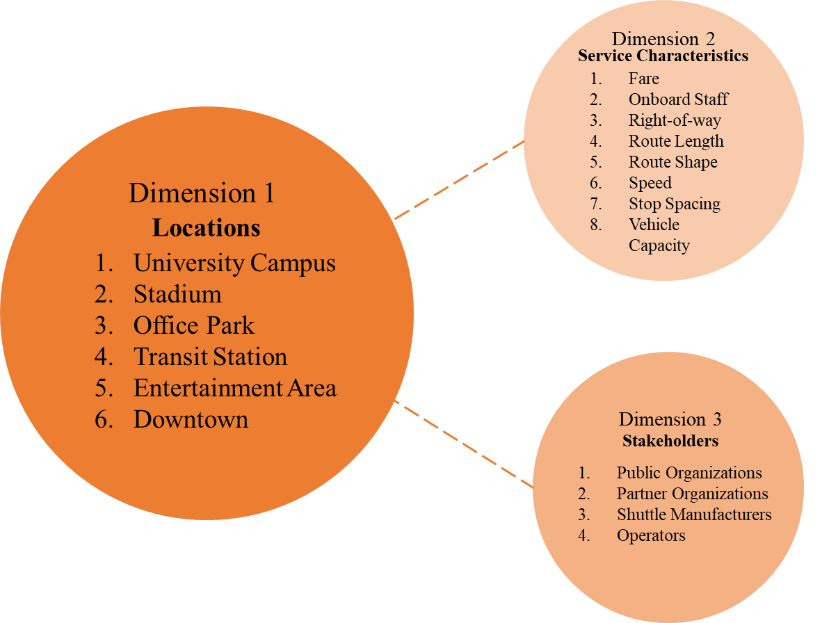
Figure 3.2. Three key dimensions of automated shuttle deployments

Table 3.2. Summary of six case studies
Case | Ann Arbor, MI | Arlington, TX | San Ramon, CA | Denver, CO | Las Vegas, NV | Minneapolis, MN
Locations of Deployment
Location Type | University Campus | Stadium | Office Park | Transit Station | Entertainment Area | Downtown
Service Characteristics
Fare | Free | Free | Free | Free | Free | Free
Onboard Staff | Available | Available | Available | Available | Available | Available
Right-of-way | U-M campus roadway shared with other vehicles | Off street trails near Arlington’s entertainment district | Parking lots and streets of Bishop Ranch office park | Regular bus route - RTD's newest route 61AV | Downtown mixed traffic road | The road along Nicolett Mall between 3rd and 4th Street South
Route Length | 1 mile | 3 routes in miles:  AT&T Stadium route = 0.44;  Globe Life Park Events = 0.285;  Public demo route = 0.47 | Not available | 1 mile circulator route | 0.6 mile loop | Approximately 380 feet*
Shuttles | 2 | 2 | 2 | 1 | 1 | 1
Speed (approximate) | 12 mph | 12 mph | 15 mph | 12-15 mph | 15 mph | 12-15 mph
Stops | 2 | 6 | Not available | 4 | 3 | 2
Vehicle Capacity | 11 | 12 or 10+1 wheelchair | 12 | 12 | 8 | 12
Stakeholders
Primary Stakeholders | U-M | City of Arlington | CCTA; Bishop Ranch Office Park | RTD; City of Denver | AAA | MnDOT
Partner Organizations | Ann Arbor Public Schools and First Responders, NHTSA, Navya | Arlington Convention and Visitors Bureau, EasyMile | GoMentum Station, EasyMile | Panasonic, and L.C. Fulenwider, Inc., EasyMile | City of Las Vegas, The Regional Transportation Commission of Southern Nevada (RTC); Zappos.com,  Navya | WSB and Associates, Inc., AECOM, 3M, Colorado Department of Transportation, EasyMile
Operator | U-M Logistics, Transportation and Parking (LTP) | First Transit | First Transit | Transdev | Keolis North America | First Transit
*Estimated by the authors using Google Maps

Table 3.3. Typology based on locations
Type of Locations |   University Campus | 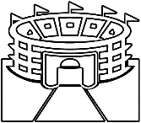  Stadium | Office Park   | Transit Station     | Entertainment Area   | Downtown  
Description | Circulation between various campus buildings, libraries, food courts, and gym | Circulation between stadium complex’s “outside vehicle prohibited” zone on game days | Circulation between different office buildings and parking lots | Circulation between transit station and nearby destinations and parking areas | Circulation between different tourist spots | Circulation between different buildings in dense downtown areas
Service Frequency | - Seasonal (Semester)  -Less frequent (Weekends)  -Frequent (Weekdays) | -Seasonal (On game days)  -Frequent | -Regular  -Frequent (Weekdays)  -Less frequent (Weekends) | -Regular  -Frequent (Weekdays)  -Less frequent (Weekends) | -Regular  -Frequent (Tourist season)  -Less Frequent (Off season) | -Regular  -Frequent (Weekdays)  -Less Frequent (Weekends)
Market | -Students  -Faculty & staff  -Commuters | -Fans  -Attendees  -Stadium employees | -Office employees  -Commuters | -Transit riders  -Commuters | -Tourists  -Commuters | -Commuters  -Some Tourists
Examples | -U-M Ann Arbor, MI  -University of South Florida. FL | -AT&T stadium, TX | -Bishop Ranch, CA  -Bedrock, MI | -Denver, CO  -Providence, RI | -Las Vegas, NV  -Columbus, OH | -Minneapolis, MN  -Detroit, MI

Table 3.4. Typical service characteristics
Service Characteristics |  | Description
 | Fare | - Usually free  - Fare might be introduced when market is established
 | Onboard Staff | - No driver  - Onboard staff member for safety
 | Right-of-way | - Roadway (in mixed traffic)  - Off-street trails  - Designated lanes (exclusive)
 | Route Length | - Typically short (0.5 – 2 miles)
 | Route Shape | - Circular  - Linear
 | Speed | - Typically low speed (10-15 mph)
 | Stop Spacing | - 1/10th of a mile or more  - Minimum of 2 stops
 | Vehicle Capacity | - Low capacity (6-12 passengers)

Figure 3.3. Typical stakeholders in automated shuttle projects

Conclusions
This paper presents a synthesis of the state of the practice of automated shuttles in the United States in order to identify early trends in automated shuttle deployments. The case study approach was undertaken as the method. Initially, 19 pilot projects were identified, and six case studies were then selected for more detailed study, including automated shuttle projects in Ann Arbor, Arlington, San Ramon, Denver, Las Vegas, and Minneapolis. The synthesis was formulated along three key dimensions.
The first dimension was the type of deployment location. Automated shuttle projects were typically deployed in relatedly dense urban areas, like downtowns, entertainment areas, stadiums, office parks, university campuses, and transit stations. Depending on the type of location, the service frequency and the ridership market varied. For example, service frequency was higher on game days at stadiums. Similarly, tourists were likely a primary market of riders in entertainment areas, while employees were more likely the target market in office parks.
The second dimension was service characteristics. Typically, the shuttles were running at low speeds (10-15 mph) and carried six to 12 passengers for free. The routes were up to two miles in length and had stop spacing as low as one stop per tenth of a mile. Right-of-way was either a designated lane, in mixed traffic or an off-street trail, depending on the deployment.
The third dimension was stakeholders involved in the shuttle project. Government agencies, such as state DOTS, city governments, or local transit agencies, often worked in partnership with other organizations, such as universities or office parks, to deploy automated shuttles. Additionally, each project typically involved a private company that manufactured the shuttle, as well as a private operator to manage operations.
In summary, this research identified three key characteristics of automated shuttle deployments in the United States that can help to shed light on early trends and guide other localities who are considering deployment of automated shuttles in the future.

INVESTIGATING CRASHES INVOLVING TESLA CRASHES-THE ROLE OF AUTOMATION

Abstract
While the market penetration of vehicle automation technologies, including advanced driver assistance systems, has increased, many vehicles equipped with such technologies have been involved in traffic accidents. Hence, it is becoming a prime concern for the transportation safety industry to understand the safety of automated vehicles (AVs). This paper contributes to AV (Society of Automotive Engineers Levels 2 or lower) safety by conducting a case study on Tesla’s automated features. The objective of this study is to explore the association between crash severity and various factors responsible for crashes in AVs. To this end, real-world crash data from Tennessee’s Integrated Traffic Analysis Network database are harnessed and Tesla vehicle crashes are selected as a growing automated vehicle manufacturer company in the US. After preprocessing the data, 320 Tesla crashes from 2014 to January 2021 were finalized for analysis. An ordered logistic model is developed to estimate the severity of Tesla crashes to investigate the association of various factors. Statistics indicate that among 320 Tesla crashes, 71% are property damage, 26% are minor damage, and 3% are fatal or serious injury crashes. The results show that Tesla vehicles with activated adaptive cruise control (ACC) system have less likelihood of being involved in severe crashes. This indicates that ACC can help reduce the severity of crashes, given a crash. Noticeably, Tesla vehicles had a higher chance of getting into severe crashes in dark conditions compared with daylight conditions. The findings can help AV manufacturers and safety practitioners enhance the safety of AVs.

Introduction
Today, traffic accidents, injuries, and fatalities are the major concern of the transportation industry. An increasing number of severe traffic accidents is one of the adverse impacts of increasing transportation demand. In recent years, traffic fatality has been rising significantly. According to the United States National Highway Transportation Safety Administration (NHTSA), 42,915 people were killed in traffic accidents in 2021 (141), while there were 38,824 fatalities in 2020 and 36,096 fatalities in 2019 (142). This statistic raises concern about the safety of road transportation.
With the increase in emerging vehicle technologies, improvement in transportation safety is highly expected. In recent years, many on-road vehicles have been equipped with low levels of automation technologies (SAE Level 2 or lower), including Advanced Driver Assistance Systems (ADAS), to improve their safety performance. One of these technologies is Adaptive Cruise Control (ACC) which can substantially improve traffic safety and prevent crashes (143) or lower their severity. Among these vehicles, the market penetration of Tesla, one of the growing automated vehicle manufacturer companies in the US, has considerably increased. Hence, in recent years, the number of Tesla vehicles involved in crashes has risen. Investigating such crashes can provide helpful information about the performance of ADAS technologies. To this end, this study explores the association between crash severity and various factors responsible for crashes in AVs. This paper contributes to the knowledge body of automated vehicle safety by conducting a case study on Tesla’s automated vehicles. The study uses real-world crash data from Tennessee’s Integrated Traffic Analysis Network (TITAN) database regarding Tesla. This study explores the association of crash severity with ACC technology in Tesla vehicles which will help gain a deeper knowledge of ACC’s performance. An ordered logistic regression is developed to investigate the factors associated with the severity of crashes involving Tesla vehicles. The model for Tesla crashes can estimate the chance of various levels of crashes in different Tesla models, which might be interesting and useful for both the manufacturers and safety practitioners. The model can be immediately adopted by automated vehicle safety researchers for similar studies.

Literature Review
As AV technology is emerging, it is becoming a prime concern for the transportation safety industry. The Society of Automotive Engineers (SAE) has defined six driving automation levels: level zero indicates no driving automation and level five indicates full driving automation in motor vehicles (144). The manufacturers are either technology giants like Google, Uber, and Baidu (145) or traditional vehicle manufacturing companies like Toyota, Nissan, and General Motors (146), who are improving their vehicles constantly to achieve the highest level of automation and deploy fully autonomous vehicles. Currently, SAE level three and level four automation are being tested on public roads (146) and SAE levels one and two are deployed on US roads (147). However, only the California Department of Motor Vehicles has recently launched reports on SAE high-level AV crashes in California. This is one of the most recognized datasets for AV crashes which is utilized by a few studies (146; 148-152). Hence, the existing literature is limited in the safety analysis of lower-level AVs and their crash severities.
The most frequent type of crash happening to AVs is rear-ended collision in mixed-land use areas (150). Crash severity is reported to increase significantly when the AV is responsible and crashes are affected if the AV is in the automated mode, the crashes involve Vulnerable Road Users (VRU) and the roadway environment (146). The analysis of VRU-involved AV crashes revealed that pedestrians and bicyclists are indirectly and directly involved in AV crashes, respectively. It also found that direct VRU-involved AV crashes are more likely to occur when an autonomous mode is engaged than indirectly VRU-involved AV crashes (149). Besides, weather, degree of vehicle damage, crash location, and collision type were also found as contributing factors for AV crash severity (148).
AV crash severity-based studies have utilized various automation factors like ACC, autopilot mode, vehicle characteristics, driver characteristics, road geometry, and environment to realize their impact on crash types and severity. One study on driver’s cognitive workload found that the self-reported workload for manual driving is 43.5%, for ACC driving is 38.6%, and for highly automated driving (HAD) is 22.7%. This indicates that drivers of higher level automation are more likely to be disengaged while drivers remain more attentive in vehicles with ACC (153). Another study found that, among different types of maneuvering, stopping at the intersection with having the autonomous mode on has caused more rear-end AV crashes (154). Lane change collision was found to be the second type of pre-crash scenario that mostly happens in AV crashes. The main reasons behind these AV crashes are the gap between AV and human driver’s perception-reaction time (PRT), AV’s failure to identify the intent of other drivers to change lanes, and miscalculation of time and space in AV path planning (155). Among the road types, arterials were found to have a higher likelihood of injury involved in AV crashes, but collector roads were not found to have a statistically significant association with crash severity in fixed parameter Bayesian models (150). Studies have shown that AVs can better detect pedestrians in daylight compared to poor lighting conditions (156-158). AVs have been compared to conventional vehicles using pre-crash scenarios and AVs were found to be rear-ended by conventional vehicles 1.6 times more than the times the conventional vehicles are rear-ended (155).
The key gap in the literature is that previous studies have not explored the impact of different models (year and make) of the same manufacturer company’s automated vehicles on their crash severities. Existing AV crash severity studies are conducted only on California’s AV crash data. TITAN is a rich dataset that allows one to study the crash severity of Tesla vehicles which comes with level 2 automation in Tennessee. This study will help to draw a clear picture of the association of factors in different Tesla models and the severity of their crashes. The study will also assist researchers in understanding the performance of ADAS in level 2 or lower automation level vehicles. The similarities and differences between all AV and only Tesla crash severities will be clear from this study.

Methods
In this section, the used methodology of this study is presented. First, the collection of the data and data preprocessing and aggregation are discussed. Second, the cleaned database and the ordered logistic regression to obtain the crash severity likelihood for each category as the modeling approach is presented.

Data
The crash data of an automated vehicle, Tesla, are collected from TITAN where all traffic safety-related data of Tennessee are electronically collected, submitted, and stored. This data is a repository managed by the Department of Safety and Homeland Security (159). The data is valid because TITAN only contains information provided by the law enforcement agencies and only statistically valid information is kept for use.
Initially, data from the last 10 years were collected, and there were missing values in numerous variables in the data. After cleaning and preprocessing the data, 320 Tesla crashes from 2014 to January 2021 were finalized for analysis. This robust dataset contains the date, time, and location (latitude/longitude) of crashes, crash severity, adaptive cruise control (ACC) activation information, fatality and injury information, various geometric features and functional classification of the road, traffic information, driving characteristics, vehicle characteristics, environmental condition, terrain, and land use of the crash area. The crash locations were overlaid on a map to verify they were inside Tennessee, as shown in Figure 4.1. Most of the Tesla-involved crash occurred in Davidson County (Nashville), followed by Shelby (Memphis), Hamilton (Chattanooga), and Knox (Knoxville) county. These are the big cities of Tennessee. Some crashes also happened in Dyer, Henderson, Dickson, Cheatham, Montgomery, Robertson, Sumner, Maury, Bedford, Rutherford, Wilson, Trousdale, Smith, Putnam, Cumberland, Franklin, Bradley, Polk, Roane, Sevier, Jefferson, Hambden, Sullivan, and Washington counties. Most of these are more rural parts of Tennessee.
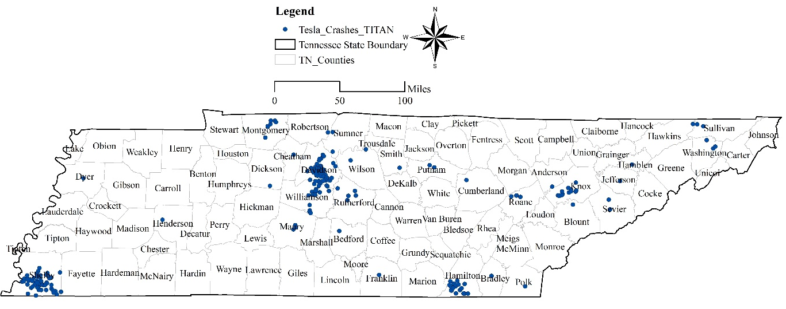
Figure 4.1. TESLA-involved crashes in Tennessee

Recoding of variables
Many of the variables are categorical. Some variables were recoded into some aggregated relevant category for the convenience of the analysis. These variables are explained briefly below:
- Crash Severity: There are four categories of crash severity: Property Damage (under), Property Damage (over), Suspected Minor Injury, and Fatal or Serious Injury. Due to fewer data in the Fatal category, Fatal and Severe injury crashes are combined into one category called “Fatal or Serious Injury.” Property Damage (over) is indicated when property damage is in excess of $400 in case of State or Local property and over $1500 in case of people’s property. Property Damage (under) is indicated when property damage is below $400 in case of State or Local property and $1500 in case of people’s property in Tennessee (160).
- In ACC, Full ACC means that the vehicle was in adaptive cruise control mode, and No ACC category means either the vehicle was in cruise control or no cruise control mode.
- In “Tesla Models,” the “Unknown” category refers to all codes that could not be identified as one of the four Tesla models. “MOD,” “MODE,” “TESL,” “ROA,” and some others fell into this category.
- In the initial dataset, Driver Actions had 18 categories. Later they were combined into six categories. “Aggressive driving” indicates “Aggressive Driving Road Rage,” “Careless Erratic Driving,” and “Reckless Negligent Driving.” “Failure to obey traffic rules” indicates “Failure to Obey Traffic Controls,” “Failure to observe Warnings or Instructions,” and “Failure to Yield Right-of-Way.” “Improper driving” indicates “Following Improperly,” “Improper Passing,” “Improper Turn,” and “Inattentive (Eating, Reading, Talking, etc.). “Lane changing or departure” includes “Lane Departure” and “Improper Lane Changing.” The “Other” category indicates other categories like “Other (Narrative),” “Unknown Action,” “Swerved or Avoided,” “Speed too fast for conditions,” and “Vision obstructed.”
- The variable “Maneuver” initially had 13 categories, later combined into seven categories. For example, “Slowing or starting in a traffic lane” means either “Slowing in a traffic lane” or “Starting in a traffic lane.” “Turning Left or Right” means either the vehicle was “Turning Left” or “Turning Right.” The “Other” category contains maneuvers that are “Unknown,” “Other,” “Entering a parked position,” “Controlled maneuver,” and “Not Applicable.”
- The variable “Road Class” contains self-explanatory categories. However, it is worth mentioning that all categories combine rural and urban roads.
- The variable “Lighting” contains a category “Dark,” which indicates a Dark condition irrespective of whether the area had lights installed.
- The variable “Landuse” initially had six categories, which are later combined into four categories. Here, “Commercial” indicates both “CBD” and “Commercial” areas. “Residential” contains “Residential” and “Fringe” (Mixed Residential and Commercial) areas. ‘Others” indicate “Industrial (Factory, Warehouses)” areas.

Crash Severity in Tesla Vehicles
Figure 4.2 shows four Tesla models and numbers of crashes of different severity levels related to these models in the dataset. It is visible that most crashes involve model S, followed by model 3, model X, and the least crashes involve model Y. This almost matches the launching time of these models. For example, model S was launched in 2012, model X in 2015, model 3 in 2017, and model Y in 2020 (161). The Tesla models that are launched earlier also have a higher frequency of crashes. Although model X was launched before model 3, the latter is involved in more crashes in Tennessee. Most of the crashes are Property Damage type crashes for all the models. Fatal or serious injury is observed in all three models but not in model Y. However, this is only based on the usable data and reveal of the unknown or unidentifiable models may alter this finding.


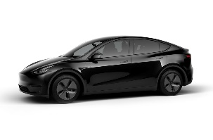
Figure 4.2. Crash severity in different TESLA models

Crash Severity and ACC in Tesla Vehicles
Figure 4.3 illustrates ACC modes when different types of crashes have happened. For example, it is evident that there is a higher frequency of No ACC (ACC not activated or partially activated) in all types of crashes. However, when the vehicles are in full ACC mode, more property damage (over) type of crashes have occurred, followed by Suspected Minor Injury type crashes. This makes sense because the ACC might have lowered the severity of rear-end crashes when the vehicle was in ACC mode.

Figure 4.3. Crash severity and ACC

Ordered Logistic Regression Model
The response variable to be applied in the model needs to be ordered since the nature of the injury severity (dependent variable) in our dataset is ordinal. One of the generalized linear model cases that can account for the ordinal nature of the data is the ordered logistic regression (162). This model is also known as proportional odds logistic regression. This model provides an exponential relationship between a set of k predictors, X = (x₁, …, x_{k}) and P = (p₁, …, p_{n}) and our response variable Y = (y₁, …., y_{n}) The relationship is as follows:
$y_{i}|p_{i} \sim Bernoulli\left(p_{i}\right), i=1, …, n$ (1)
$Logit \left(p_{i}\right)=\log\left(\frac{p_{i}}{1-p_{i}}\right)= β_{0}+ β_{1}x_{1i}+…+β_{k}x_{ki}$ (2)
The probability of crash severity occurrence for each level i in the model can be estimated, denoted by $p_{i}$, by using the maximum likelihood method and solving for $β=\left(β_{1}, …,β_{k}\right)$ (163).
$p_{i}=\frac{\exp{\{β_{0}+ β_{1}x_{1i}+…+β_{k}x_{ki} \}}}{1+ \exp{\{β_{0}+ β_{1}x_{1i}+…+β_{k}x_{ki} \}}}$ (3)
The crash severity can be estimated after calculating the $p_{i}$ based on the above formula. This logistic regression can be either binomial regression or multinomial regression. When the response variables are multi-class, multinomial regression can be used. The multiple predictor variables and multinomial response variable in the multinomial regression model have C-1 non-overlapping logit models. The c^{th} level of the crash severity occurrence probability, $p_{ic}$, can be estimated (1).
$p_{ic}=P(y_{i}=c|X)=\frac{\exp{\{β_{0}+ β_{1}x_{1i}+…+β_{k}x_{ki} \}}}{\sum_{c=1}^{c-1}{1+ \exp{\{β_{0}+ β_{1}x_{1i}+…+β_{k}x_{ki} \}}}}$, p, c < C (4)
The Stata/SE 17.0 is used in this study to analyze the data, and the crash severity is predicted based on the estimated probability, $p_{ic}$.

Marginal Effect
The results table also highlights the marginal effects of the variables. There are different methods to obtain the marginal effects of the variables. The Average Marginal Effect (AME) method is used in this study. Calculating the marginal effect enables analysts to obtain how much a change in a variable is associated with the expected probability of the response variable.

Results

Frequency Distribution of variables
Table 4.1 shows the frequency distribution of the variables used in the study. The dependent variable is Crash Severity which contains four levels of severity. Among 320 Tesla crashes, 62.81% are property damage (over) and only 3% are fatal or serious injury crashes. Independent variables are broadly categorized under Vehicle Characteristics, Driver and Driving, and Road and Environment categories.
Under Vehicle Characteristics, ACC, Tesla Models, and vehicle’s Model Year are used. The frequency distribution shows that only 17.50% of the vehicles were in ACC mode. Among the crashes, 27.81% involved model S, 21.56% involved model 3, and only 2.81% involved model Y. 34.28% of the crashes involved Tesla vehicles whose model was not reported appropriately. So, most crashes in this dataset involve model S, followed by model 3, X, and Y. Distribution of Model Year indicates that most of the crashes involve vehicles whose model year is between 2016 to 2020 (80%). This makes sense because by this time Tesla was popular, its exposure increased, and more people were driving Tesla on the roads compared to the earlier years. The year 2021 only had 3.31% crashes because the data is only up to January. Under Driver and Driving, Driver Actions and Maneuver are used. Driver Actions variable indicates that in 65.94% of crashes, drivers had “No contributing actions” towards the crash, 10.63% failed to obey traffic rules, 8.44% drove improperly, and 5.16% drove aggressively. Of 320 crashes, the vehicles were going straight in 50.63% of the cases. The vehicles were stopped in a traffic lane, slowing or staring in a traffic lane, turning left or right, and changing lanes or merging in 18.13%, 10.94%, 10%, and 1.88% of cases, respectively.
Under Road and Environment, Road Class, Lighting, and Landuse are utilized. Distribution of Road Class shows that, among the 32 crashes, 72.81% occurred on Arterial roads, 18.75% occurred on Interstates or Expressways, and 8.44% occurred on Collectors. This makes sense because vehicles drive at high speed on Arterials, Interstates, and Expressways and have a higher chance of severe crashes. The distribution of the Lighting variable shows that most crashes occurred during Daylight (73.75%), followed by dark conditions (22.81%). The variable Landuse indicates that most crashes occurred in the commercial areas (47.81%), followed by Residential (28.44%) and Rural (21.56%) areas. However, this distribution could be biased because of the study area, study time, and sample selection.

Ordered Logistic Regression Model Results
Table 4.2 shows the result of the Ordered Logistic Regression (OLR) model. The likelihood ratio test shows that the OLR model is meaningful and better than the null model (LR chi² = 73.11, Prob>chi²=0.00). Pseudo R² =0.12 indicates that the model fits the data. The AIC and BIC values were used as model selection criteria to compare models with different variables and select the best one. The OLR represents the relationship between the contributing factors and severity of Tesla-involved crashes. The variables that have a minimum of one statistically significant category (p-value <0.05) with acceptable signs and magnitude are kept in the model. Marginal effects (ME) are calculated on the model estimates for all categories of crash severity and shown in Table 4.3 to interpret the results in a more intuitive way than the coefficients of the OLR model. The marginal effect will indicate the percentage point change in the probability of a certain level of injury if an explanatory variable is changed by one unit or moved to the target level from the base level (164).
For example, among the vehicle characteristics, Full ACC has a coefficient of -2.59 at p=0.01. This indicates that if the Tesla is in ACC mode, it is less likely to be associated with a fatal or serious injury. The marginal effects of Full ACC indicate that if Tesla changes to ACC mode from a No ACC mode, the chance of property damage (under) type of crash increase by 32% points, but the chance of property damage (over) decrease by 4% points, the chance of suspected minor injury decreases by 21.2% points, and the chance of fatal or serious injury decreases by 6.8% points. This indicates that ACC can help lower the severity of crashes, given a crash. Tesla X model’s coefficient is highly significant, and its marginal effect indicates that if the vehicle is a Tesla model X compared to Tesla model 3, the chance of its Fatal or Serious Injury crash decreases by 2.4% points and the chance of Suspected Minor Injury decreases by 14% points. According to this analysis, model X is safer than model 3.
Among the Driver and Driving-based variables, three levels of Driver Actions have highly significant positive coefficients. The marginal effects indicate that if a driver fails to obey traffic rules compared to if he has no contributing actions, the chance of falling into fatal or serious injury increases by 4.8% points and suspected minor injury increases by 19.5% points. If a driver tries to change lanes or depart from a lane in Tesla compared to not making any contributing action, the chance of falling into fatal or serious injury increases by 4.7% points and suspected minor injury increases by 19.1% points. These are almost similar to conventional vehicles’ where drivers’ wrong actions cause fatal crashes or injuries. Other actions of drivers like speeding or obstructed vision also cause severe injuries compared to minor injury or property damages. Two categories of Maneuver have highly significant negative coefficients. If a Tesla attempts to change lanes or merge instead of driving straight, its chance of falling into a fatal crash or severe injury decreases by 2.9% points and the chance of falling into a minor injury decreases 21.3% points. This also makes sense because driving straight has been the cause of the highest number of fatal injuries in 2019 in the US and it has the risk of rear-end and head-on collisions, which are often fatal (165).
Among Road and Environment-based variables, Road class has one highly significant coefficient. Based on that, if a Tesla is on an Interstate or Expressway compared to being on an arterial road, it has a 32.4% point higher chance of falling in a fatal crash or serious injury, 24.8% points higher chance of being in a suspected minor injury, and 40.5% points lower chance of being in a property damage (over) crash. This is understandable as the speed limit of interstate or expressways is higher and has more chances of getting into severe crashes. Marginal effects also show that Tesla is more likely to get into severe crashes in dark conditions than in daylight. Only the Residential category of Landuse variable has a significant positive coefficient. The marginal effect of residential land use indicates that compared to Commercial areas, there are 2.8% points higher chance of fatal or serious injury crashes in residential areas for Tesla. Here, the only matter that makes sense is that commercial areas are generally congested and have low speed (even lesser than residential areas sometimes). Therefore, there might be more chance of severe crashes in residential areas compared to commercial areas.

Table 4.1. Frequency Distribution of variables
Variables |  | Categories | Frequency | Percentage
 | Crash Severity | Property Damage (under) | 26 | 8.13
 |  | Property Damage (over) | 201 | 62.81
 |  | Suspected Minor Injury | 83 | 25.94
 |  | Fatal or Serious Injury | 10 | 3.13
Vehicle Characteristics | ACC | No ACC (Base) | 264 | 82.50
 |  | Full ACC | 56 | 17.50
 | Tesla Models | 3 (Base) | 69 | 21.56
 |  | S | 89 | 27.81
 |  | Unknown | 110 | 34.38
 |  | X | 43 | 13.44
 |  | Y | 9 | 2.81
 | Model Year | 2011 to 2015 (Base) | 52 | 16.25
 |  | 2008 to 2010 | 2 | 0.63
 |  | 2016 to 2020 | 256 | 80.00
 |  | 2021 | 10 | 3.13
Driver and Driving | Driver Actions | No contributing actions (Base) | 211 | 65.94
 |  | Aggressive driving | 5 | 1.56
 |  | Failure to obey traffic rules | 34 | 10.63
 |  | Improper driving | 27 | 8.44
 |  | Lane changing or departure | 14 | 4.38
 |  | Other | 29 | 9.06
 | Maneuver | Going Straight (Base) | 162 | 50.63
 |  | Stopped in traffic lane | 58 | 18.13
 |  | Changing lanes or merging | 6 | 1.88
 |  | Negotiating a curve | 6 | 1.88
 |  | Other | 21 | 6.56
 |  | Slowing or starting in traffic lane | 35 | 10.94
 |  | Turning left or right | 32 | 10.00
Road and Environment | Road Class | Arterial (Base) | 233 | 72.81
 |  | Collector | 27 | 8.44
 |  | Interstate or Expressway | 60 | 18.75
 | Lighting | Daylight (Base) | 236 | 73.75
 |  | Dark | 73 | 22.81
 |  | Dusk or Dawn | 11 | 3.44
 | Landuse | Commercial (Base) | 153 | 47.81
 |  | Others | 7 | 2.19
 |  | Residential | 91 | 28.44
 |  | Rural | 69 | 21.56
N (Observations)=320

Table 4.2. Ordered Logistic Regression Model
Variables |  | Categories | Coeff. | Std.err. | z | p|z|
Crash Severity
Vehicle Characteristics | ACC | No ACC (Base)
 |  | Full ACC | -2.59 | 1.00 | -2.59 | 0.01
 | Tesla Models | 3 (Base)
 |  | S | -0.29 | 0.38 | -0.77 | 0.44
 |  | Unknown | -0.07 | 0.34 | -0.21 | 0.83
 |  | X | -1.07 | 0.44 | -2.42 | 0.02
 |  | Y | 0.60 | 1.42 | 0.42 | 0.67
 | Model Year | 2011 to 2015 (Base)
 |  | 2008 to 2010 | -3.26 | 1.70 | -1.95 | 0.05
 |  | 2016 to 2020 | -0.68 | 0.37 | -1.83 | 0.07
 |  | 2021 | -2.31 | 1.36 | -1.70 | 0.09
Driver and Driving | Driver Actions | No contributing actions (Base)
 |  | Aggressive driving | -0.36 | 1.20 | -0.30 | 0.76
 |  | Failure to obey traffic rules | 1.33 | 0.44 | 2.99 | 0.00
 |  | Improper and Inattentive driving | 0.72 | 0.49 | 1.47 | 0.14
 |  | Lane changing or departure | 1.30 | 0.63 | 2.08 | 0.04
 |  | Other | 1.66 | 0.45 | 3.68 | 0.00
 | Maneuver | Going Straight (Base)
 |  | Stopped in traffic lane | 0.37 | 0.35 | 1.05 | 0.30
 |  | Changing lanes or merging | -2.23 | 0.97 | -2.29 | 0.02
 |  | Negotiating a curve | -1.62 | 0.97 | -1.67 | 0.09
 |  | Other | -1.37 | 0.54 | -2.55 | 0.01
 |  | Slowing or starting in traffic lane | 0.26 | 0.41 | 0.62 | 0.54
 |  | Turning left or right | -0.20 | 0.50 | -0.39 | 0.70
Road and Environment | Road Class | Arterial (Base)
 |  | Collector | 0.12 | 0.45 | 0.27 | 0.79
 |  | Interstate or Expressway | 3.66 | 1.02 | 3.60 | 0.00
 | Lighting | Daylight (base)
 |  | Dark | 0.98 | 0.32 | 3.05 | 0.00
 |  | Dusk or Dawn | -1.49 | 0.71 | -2.09 | 0.04
 | Landuse | Commercial (Base)
 |  | Others | 1.06 | 0.99 | 1.07 | 0.28
 |  | Residential | 0.81 | 0.31 | 2.59 | 0.01
 |  | Rural | -0.33 | 0.38 | -0.88 | 0.38
 |  | /cut1 | -2.80 | 0.54
 |  | /cut2 | 1.15 | 0.50
 |  | /cut3 | 4.00 | 0.59
N (Observations) = 320, DF = 29
LR chi² (26) = 73.11, Prob>chi²=0.00
LL (null) = -305.40, LL(Model) = -268.84
Pseudo R² = 0.12, AIC = 595.68, BIC=704.97

Table 4.3. Marginal Effect of Ordered Logistic Regression Model
Variables | Crash Severity | Categories | Property Damage (under) | Property Damage (over) | Suspected Minor Injury | Fatal or Serious Injury
Vehicle Characteristics | ACC full | No ACC (Base)
 |  | Full ACC | 0.320 | -0.040 | -0.212 | -0.068
 | Tesla Models | 3 (Base)
 |  | S | 0.019 | 0.033 | -0.043 | -0.009
 |  | Unknown | 0.004 | 0.009 | -0.011 | -0.002
 |  | X | 0.091 | 0.073 | -0.140 | -0.024
 |  | Y | -0.027 | -0.090 | 0.090 | 0.027
 | Model Year | 2011 to 2015 (Base)
 |  | 2008 to 2010 | 0.411 | -0.044 | -0.315 | -0.052
 |  | 2016 to 2020 | 0.038 | 0.088 | -0.101 | -0.025
 |  | 2021 | 0.230 | 0.088 | -0.270 | -0.048
Driver and Driving | Driver Actions | No contributing actions (Base)
 |  | Aggressive driving | 0.035 | 0.014 | -0.043 | -0.006
 |  | Failure to obey traffic rules | -0.075 | -0.168 | 0.195 | 0.048
 |  | Improper driving | -0.049 | -0.072 | 0.102 | 0.019
 |  | Lane changing or departure | -0.074 | -0.164 | 0.191 | 0.047
 |  | Other | -0.084 | -0.226 | 0.241 | 0.069
 | Maneuver | Going Straight (Base)
 |  | Stopped in traffic lane | -0.020 | -0.048 | 0.055 | 0.013
 |  | Changing lanes or merging | 0.289 | -0.047 | -0.213 | -0.029
 |  | Negotiating a curve | 0.178 | 0.025 | -0.177 | -0.026
 |  | Other | 0.140 | 0.042 | -0.159 | -0.024
 |  | Slowing or starting in traffic lane | -0.015 | -0.032 | 0.038 | 0.009
 |  | Turning left or right | 0.013 | 0.020 | -0.028 | -0.005
Road and Environment | Road Class | Arterial (Base)
 |  | Collector | -0.012 | -0.006 | 0.015 | 0.003
 |  | Interstate or Expressway | -0.167 | -0.405 | 0.248 | 0.324
 | Lighting | Daylight (Base)
 |  | Dark | -0.052 | -0.131 | 0.148 | 0.036
 |  | Dusk or Dawn | 0.179 | -0.008 | -0.153 | -0.019
 | Landuse | Commercial (Base)
 |  | Others | -0.056 | -0.142 | 0.157 | 0.041
 |  | Residential | -0.047 | -0.100 | 0.119 | 0.028
 |  | Rural | 0.028 | 0.022 | -0.042 | -0.007

Discussion
Automated vehicles are expected to improve safety that conventional vehicles cannot provide. It can be expected fully when vehicles reach the entire level of automation. However, it is still important to know where the low-level automated vehicles stand to achieve road safety. Marginsplots in Figure 4.4 gives a graphical representation of the probability of different levels of crash severity for an automated vehicle, Tesla. It is observed that Tesla vehicles have a lower chance of minor or severe injury than when they are in an ACC mode compared to a no ACC mode, which is like a conventional vehicle. This matches with a previous study stating that 7.5% of fatal and severe crashes can be avoided using ACC systems (166). Among the four models of Tesla, the chance of a fatal crash or minor injury is less in model X compared to other models. Model X is followed by Model S. Model Y and 3 showed a lower chance of property damage type crashes. No study has compared different Tesla models’ crash severity. Searching various websites found that all tesla models are planned to come with a standard autopilot feature. Model 3 and Y are supposed to use camera-based Tesla Vision and neural net processing systems to achieve autopilot, whereas other models are equipped with radar. Autopilot indicates traffic-aware cruise control (adjustment of vehicle speed based on surrounding traffic) and autosteer (assistance to drive within clearly marked lane) features. If people do not buy a Tesla with autopilot initially, they can purchase and install enhanced autopilot or full self-driving capability depending on the timeline of buying the vehicle (167). From the information, it can be assumed that there might be a discrepancy in the availability of autopilot features in the same Tesla model.
Therefore, inferring any conclusion about the models’ capability for safety improvement need in-depth analysis. Figure 4.4 (C) indicates that Tesla performs worse in Dark conditions than in daylight conditions, which is similar to how conventional vehicles perform. Daylight conditions are much better for vision, and dusk and dawn are better than dark but worse than daylight. Changing lanes or merging has been found to have a lower chance of severe injuries or fatal crashes in Tesla. This matches the performance of conventional vehicles, as a simulation-based study found that less than 1% of lane-changing-based crashes cause fatalities (168). For Tesla vehicles, more severe crashes occur when the driver does speeding, when vision is obstructed, or when a driver tries to avoid or swerve. In conventional vehicles, common driving behaviors that cause fatal crashes are impaired driving, inattentive driving, speeding, drowsy driving, and not wearing seatbelts, according to NHTSA website (169). Tesla vehicles had more serious or fatal crashes on the interstates or expressways, but it was found in a previous study that severe AV crashes occur on highways (146). However, all highways are not interstates or expressways. So, a deeper analysis of this issue is needed. Overall, the crash severity results are similar to the results reported by existing literature on AV crashes, except more severe crashes are also highly likely in residential areas along with mixed land use areas for Tesla, and ACC in Tesla models are likely to reduce the severity of crashes. Also, previous models did not differentiate between crash severity on interstates and arterials and utilized only highways.

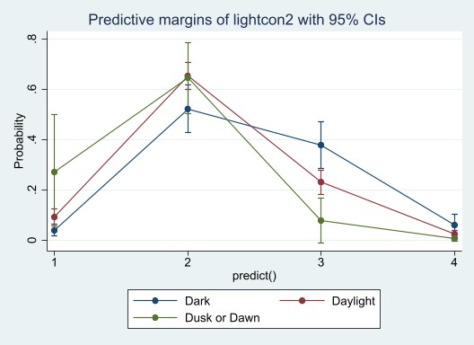
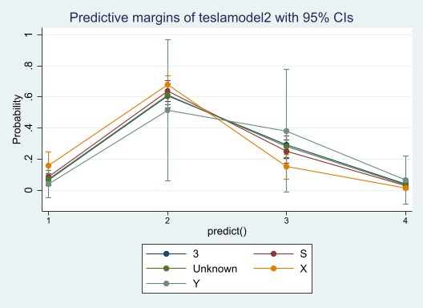
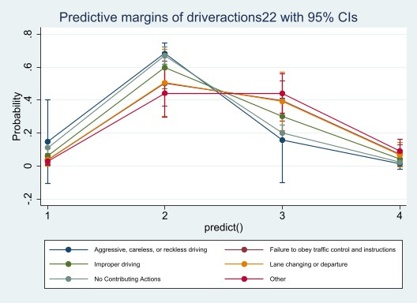
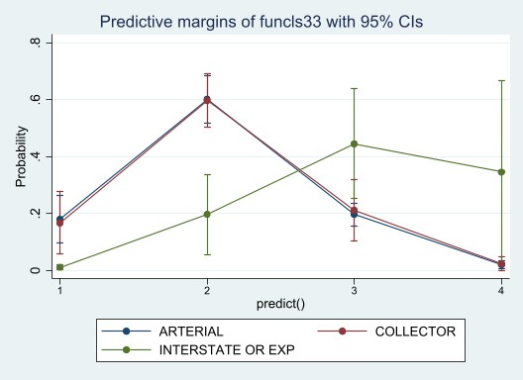
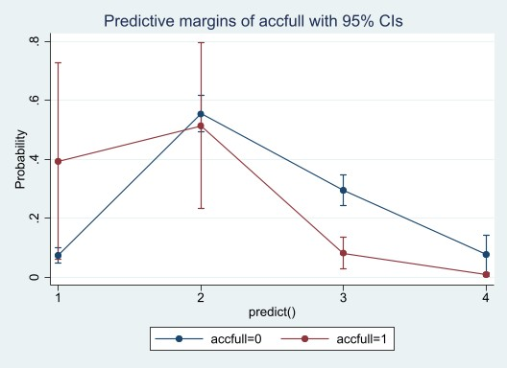
(A)
(B)
(C)
(D)
(E)
(F)
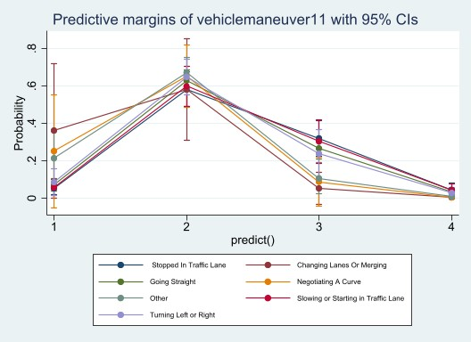
Figure 4.4. Marginsplot of the probability of crashes-based on (A) ACC, (B) Tesla Models, (C) Light Condition, (D) Maneuver, (E) Driver Actions, and (F) Road Class

Limitations
The dataset did not contain any variable that would confirm whether the vehicle was in autopilot mode or not. This could have allowed exploring the role of Autopilot in automated vehicle-involved crashes. Also, the dataset is only on crashes of one automated vehicle company, Tesla. The results generated will mainly apply to Tesla and may not be generalized for all AV crashes. However, the method can be reapplied in similar studies. The data is only for crashes that occurred in one state, Tennessee. The main limitation of AV safety studies is the unavailability of publicly available data on automated vehicle tests. Like Tennessee’s TITAN database, other states of the US can develop a crash database and mention the vehicle's model name and the automation level of those vehicles if they are automated. Many variables had “Null” or “N/A” data. Many observations and variables had to be discarded to get a complete dataset with all variables. The frequency distribution of the variables initially showed that many categories of some variables had a very low frequency compared to the other categories of those variables. Researchers had to rationalize combining some categories to get an acceptable result.
One challenging variable was the vehicle model of Tesla, which had numerous categories for each model. Those models were searched from various websites regarding TESLA. To simplify, models like 90, 85D, 90D, MDS, MOS, P85, P85D, P90D, S SE, S70, SE, SP, and TS were combined as Model S as they are its different trim levels. There were also many unidentified categories like “MOD,” “MODE,” “TTESL,” “ROA,” and some others. Those were combined as “Unknown” categories. Many Tesla models had to be categorized as “Unknown,” but their availability could have improved the analysis. Such analysis can be correct if this data can be collected with more precision and accuracy.

Conclusions
While the market penetration of vehicle automation technologies (SAE Levels 1, 2, and 3) has increased, many vehicles equipped with such technologies have been involved in traffic accidents. Hence, it is becoming a prime concern for the transportation safety industry to understand AVs' safety clearly. Among these vehicles, the market penetration level of Tesla, which is one of the growing automated vehicle manufacturer companies in the US, has considerably increased. Hence, in recent years, the number of Tesla vehicles involved in crashes has risen. Investigating such crashes can provide helpful information about the performance of ADAS technologies. To this end, this study explores the association between crash severity and various factors responsible for crashes in AVs. The study uses real-world crash data from the TITAN database, including 320 Tesla crashes from 2014 to January 2021 and explores the association of crash severity with ACC technology in Tesla vehicles. The key findings of the study are as follows:
- The marginal effects of the Full ACC variable indicate that if Tesla changes to a full ACC mode from a No ACC mode, the chance of suspected minor injury decreases by 21.2%, and the chance of fatal or serious injury decreases by 6.8%. This indicates that ACC helps lower the severity of crashes.
- The model indicates that Tesla model X is safer than Tesla model 3 because its coefficient is highly significant and its marginal effect indicates that if the vehicle is a Tesla model X compared to Tesla model 3, the chance of its Fatal or Serious Injury crash decreases by 2.4% points and the chance of Suspected Minor Injury decreases by 14% points.
- If Tesla driver fails to obey traffic rules compared to if he has no contributing actions, the chance of falling into fatal or serious injury increases by 4.8% points and suspected minor injury increases by 19.5% points.
- If a Tesla attempts to change lanes or merge instead of driving straight, its chance of falling into a fatal crash or severe injury decreases by 2.9% points and the chance of falling into a minor injury decreases by 21.3% points.
- If a Tesla vehicle is on an Interstate or Expressway compared to being on an arterial road, it has a 32.4% point higher chance of falling in a fatal crash or serious injury, 24.8% point higher chance of being in a suspected minor injury, and 40.5% points lower chance of being in a property damage (over) crash.
- The crash severity results found in existing literature are similar to the Tesla OLR model, except more severe crashes are also highly likely in residential areas and mixed land use areas for Tesla. Also, previous models did not differentiate between crash severity on interstates and arterials and utilized only highways.
Future research can include more information such as temporal information of the crashes, driver behavior information, and other vehicle automation and connectivity technologies-based information for better predict crash severity. The findings from the paper might be interesting and insightful for both the manufacturers and users of Tesla as they are constantly attempting to achieve a higher automation level. The model can be adopted by automated vehicle safety researchers immediately for similar studies. This paper can be helpful for traffic safety practitioners, engineers, policymakers, and city planners who work to prepare their cities for autonomous vehicles.

New Section of the work
Next, a Generalized Ordered Logit model (Gologit) will be applied to this data. The aim will be to investigate the presence of some covariates that do not meet the proportional odds assumption. Gologit enables the use of partial proportional odds assumption. Additionally, exposure data like sales of various Tesla models will be included as independent variables in the model.

Acknowledgments
The authors would like to thank the following financial support for the research, authorship, and/or presentation/publication of this article: The research was partially supported by the Collaborative Sciences Center for Road Safety, a US Department of Transportation National University Transportation Center promoting safety.

UNDERSTANDING THE SURVIVABILITY OF DRIVERS FROM AUTOMATED VEHICLE-INVOLVED FATAL CRASHES: A CASE STUDY OF TESLA-INVOLVED FATAL CRASHES

Abstract
As on-road automated vehicles (AV) are on the rise, evaluating their safe operation becomes critical. Generally, AVs can be relatively safer than human-driven vehicles because they do not get distracted, violate laws, and make errors. Conversely, AVs can malfunction for various reasons and cause crashes. This study investigates the role of Tesla Autopilot engagement and human behaviors on the survivability of the Tesla driver. A unique database was created from a Tesla fatal crash data source (tesladeaths.com). Using links to the news narratives for each fatal crash, several new variables were coded. The descriptive analysis provides insights into the survivability of the Tesla driver in 71 single-vehicle crashes (some involving pedestrians) that occurred worldwide. Results show that 12.68% of the Teslas in single-vehicle crashes were using the Autopilot feature. When the Autopilot was claimed, the Tesla driver was killed and survived in 55.56% (N = 5) and 44.44% (N = 4) of the crashes, respectively. Speeding was one of the key violations by Tesla drivers, which has contributed to 19.72% of the overall single-vehicle crashes. In 26% of the crashes, Tesla caught fire and drivers did not survive. 20.33% of crashes involved pedestrians, where drivers survived. Future research can investigate the change in Tesla driver behaviors in more complex multi-vehicle crashes and the role of Autopilot. This paper will be helpful for AV manufacturers, notably Tesla, who are working to improve the safety features of their vehicles.

Introduction
Human factors, including driving errors and violations, contribute to more than 90% of road crashes (170-172). Due to technological advancements, automated vehicles will significantly change the driver-vehicle interaction in the future (173). The automated vehicles include safety features such as one or more driver assistance systems, which have the potential to reduce a significant percentage of crashes while eliminating or reducing human control (174-177). Some of the driver assistance features include adaptive cruise control (178; 179), a forward-collision warning system (180; 181), a dilemma zone mitigation system (178), a blind-spot assistance system (182-184), a lateral vehicle detection system (185; 186), and a low-speed automatic brake system (187). One of the key advantages of automated vehicles with driver assistance technologies is that these vehicles promise to significantly reduce both crash risk and severity by eliminating or reducing a significant portion of one or more driving errors and/or violations (188-190). Tesla has become largely popular partly for their integration of “Autopilot” features in each of its vehicle models. The baseline level of Autopilot that is included with each model includes the ability of the Tesla vehicle to steer, accelerate, and brake autonomously and automatically within its lane. This feature is a bit of a misnomer, as Tesla’s Autopilot system requires driver supervision during operation, meaning that the vehicle is not fully autonomous. Vehicle automation is predicted to increase road safety by removing human errors. However, new driving technology can also present safety risks since drivers may need time to learn how to properly use the systems. It is considered that more safety benefits could be achieved if the automated vehicles are deployed on a large scale (170). For instance, many vehicles in the existing transportation system are still human-controlled, meaning that automated vehicles may not fully achieve the safety benefits. Furthermore, most of the automated vehicles in the market are level 1 or 2, which shows that human control still exists in these vehicles and could contribute to crashes. Introducing these automated vehicles onto the roadways (where most of the vehicles are conventional or human-controlled) necessitates an analysis of crashes involving Tesla to identify interesting data trends that may help assess the safety of Tesla vehicles. While the small number of previous studies related to Automated Vehicles (AV) crashes provide useful insights, there is a need for further research on the topic, which could generate new knowledge about AV safety. The role of the Autopilot system, driver behavior, vehicle, and other roadway and environmental factors in AV crashes has been lightly addressed due to the limited AV crash data (146). This study contributes to the limited research by exploring how the Autopilot performance and behaviors of Tesla drivers relate to survivability (killed versus survived) of Tesla drivers involved in a fatal crash that involves only Tesla vehicles-single-vehicle crashes. Investigating the relationship of Autopilot performance, behaviors of Tesla drivers, and other key roadway and vehicular factors with the chance of Tesla driver survivability is considered to provide a deeper and clearer picture of the role of these factors in single-vehicle crashes, especially when another vehicle or driver is not involved.
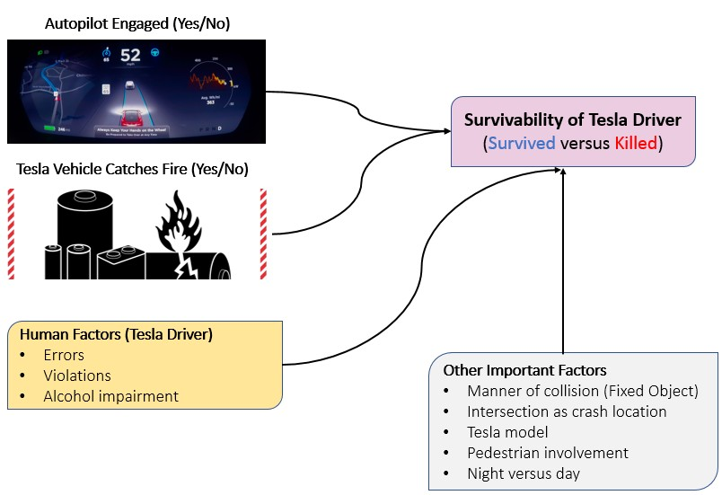
The conceptual framework of this study is shown in Figure 5.1. This study aims to understand how autopilot performance, errors, and violations by Tesla drivers (in single-vehicle crashes), and other environmental and vehicle attributes relate to the survivability of Tesla drivers. To meet the study objectives, Tesla driver fatality is coded as 0 and 1, where 1 indicates crashes in which the Tesla driver was killed. To quantify the effect of a specific explanatory variable on the Tesla driver fatality, a directional (asymmetric) Somers’ Delta (D) test is used, which is briefly explained in the next section.
Figure 5.1. Conceptual Framework (Single Vehicle Crashes “N = 71”)

Literature Review
There is a limited amount of research that investigates the contributing factors in AV crashes (148; 191). These studies generally have low sample sizes due to the relative novelty of AV technology. Like this study, many researchers have pulled data from narrative sources such as crash reports (146; 148; 192; 193). Of the few studies investigating the impact of human behavior in autonomous vehicle crashes, the consensus is that drivers must remain alert behind the wheel while Autopilot is in use, as automation has not yet reached the capacity for fully autonomous driving and human errors and violations are still plausible (194; 195). Other investigated contributing factors include weather conditions, roadway infrastructure, crash type, and autopilot engagement. It is found that many of these factors are also at play during autonomous vehicle crashes (146; 148; 193; 195). Due to the impacts of roadway infrastructure on crash severity, the importance of timely roadway maintenance and management is critical as the number of AVs on the roadways increases (195). CAV driving mode, i.e., whether Autopilot is engaged, is also found to be a contributing factor in AV crashes (193). There is a need to further investigate AV crashes, especially concerning the roles of human behavior and Autopilot engagement. Table 5.1 gives an overview of the literature review.

Data
One of the reasons for the limited research related to the safety of AVs is that sufficient field data about AV crashes is not available (146). This study takes advantage of the unique crash data source (196), which includes details about Tesla-involved Fatal crashes. This website was developed privately by some people interested in Tesla car technology and Tesla crashes or incidents. They collect information on Tesla crashes or incidents from local news archives and government databases that are in the English language. The dataset undercounts total deaths involving Tesla because it mainly does not obtain information from non-English speaking geographies. However, this dataset was mentioned in a published paper and a Doctoral Dissertation as a source of Tesla death or fatal crash reports (197; 198). The records for a total of 225 fatal Tesla crashes were available on the website (till June 2022). The website provides information about the year, date, location, model of Tesla, whether or not (and how many) drivers and occupants (in Tesla or other vehicles) were killed in each crash, details about the involvement and injury to pedestrians, and information on whether the Autopilot was claimed at the time of the crash. While the website provides useful information, the number of the above-mentioned factors could be limited for a comprehensive analysis. A key resource on the website provides links to the news articles for each crash, which could be used to code new variables embedded in the news articles.
To check the credibility of the website (tesladeaths.com), the available coded variables on the website (year, date, country or state in the U.S., model of Tesla vehicle, and death records) have been verified and compared for all the crashes with the news articles from which the variables were coded. The available information about the coded variables on the website matched with the narratives in the corresponding news articles for each crash, justifying the credibility of the website. A unique and comprehensive database was created by utilizing the website. Additional variables were coded manually via visiting the news article weblink for each crash. Some of the links to the news articles were missing or inaccessible. Therefore, the cleaned dataset had a total of 173 crashes, which include 71 single-vehicle crashes. An additional 29 new variables were developed for each of the 173 crashes. In this paper, single-vehicle crashes are studied in depth alongside other types of crashes.

- Dichotomous variables: Variables in this category were coded on a Yes/No scale. These new variables include speeding by Tesla driver, speeding by other drivers, Tesla driver impaired (driving under the influence), other driver impaired (driving under the influence), intersection-related crash, Tesla struck other vehicles, other vehicle struck Tesla, gender of Tesla driver, gender of Tesla occupant, gender of other vehicle drivers, Tesla vehicle caught fire, other vehicle caught fire, and time of a crash (AM/PM). While most variable names are self-explanatory, some need explanation. For example, speeding by a Tesla driver and speeding by other drivers are coded as “Yes” if news articles reported that the crash involved drivers exceeding the speed limit of the corresponding road while driving. The variable Tesla driver impaired and other driver impaired are coded as “Yes” if the news articles reported that the drivers were driving under the influence of drugs or alcohol for which the drivers became incapable of driving the cars. There are four models of Tesla: S, X, Y, and 3. All these have various trim levels, but for convenience, models are considered by their basic model names. A dummy variable is made for each model where one indicates that the observation is on that car model, and zero (0) indicates that the observation is not about that respective car model.

- Continuous variables: These variables include the number of vehicles involved, age of tesla driver, age of tesla occupants, age of other drivers, age of other vehicle occupants, and pedestrian age. Note that age information was not available in the articles for all observations.

- Categorical variables: These variables include route type (e.g., local route, state route, highway, and expressway), maneuver by Tesla driver, maneuver by other drivers, type of other vehicles, type of crash (e.g., rear-end, head-on), and day of the week on which crash have occurred.

- Ordinal variables: Note that all Tesla crashes reported on the website were fatal. However, the injury severity for drivers and occupants (both in Tesla and other vehicles) has been coded on a four-level ordinal scale using the information in the articles. These new levels are no injury, minor injury, moderate or serious injury, and fatality for each driver and occupant involved in Tesla crashes.
Table 5.1. Overview of Literature Review
Ref. | Relevance | Sample Size | Findings | Method | Gap/limitation
(148) | Effect of different factors on AV crash severity | 94 | 1. Weather conditions are found to be the most critical factor.  2. Chance of severe injury increases if AV crashes occur at an intersection in extreme weather conditions (fog and snow) and highly diverse land use pattern locations.  3. Type of collision significantly contribute to AV crash severity | Crash reports from California DMV, XGBoost model | Did not collect data on speed/driver characteristics,  limited sample
(146) | Mechanism and contributing factors of AV-related crashes | 113 | 1. Chances of more severe injury increase if a vehicle is on autonomous driving mode and is a major party responsible for a crash.  2. Highway is where severe injuries are most likely to occur.  3. Collision types of AV-related crashes are dependent upon the driving mode, location, and whether crashes are associated with yielding to pedestrians/ cyclists. | Crash reports from California DMV, ordinal logistic regression modeling, CART modeling | Limited sample size
(194) | Tesla-specific human factors leading to crashes | 1 | - Schema theory and PCM can help explain driver actions.  - Human error is inescapable, and humans are unreliable for monitoring automated systems, therefore efforts should be focused on level 4 and 5 automation.  - The underlying cause of a tragic accident could be a design error because of an unclear perception of responsibility included in the design. | Use Schema theory and Perceptual Cycle Model (PCM) to explain driver actions | Case study, not generalized
(195) | Tesla-specific human factors leading to crashes | 1 | - Tesla driver could have survived if the attenuator was functional.  - Roadway management and timely maintenance are critical. | Public info from NTSB evaluation was used to evaluate severity, vehicle crash data from EDRs compared with test data for the crash attenuator. Idealized triangular  crash pulse to estimate peak impact acceleration and energy | Case study, not generalized
(192) | Driver behaviors operating AVs | 20 | 1. Drivers who are among the early adopters of partial automation systems (PAS) have a positive attitude toward the PAS systems.  2. Drivers universally engaged in secondary tasks under safe usage conditions.  3. Some self-regulatory behaviors to avoid risky situations. | Data from interviews | Response and sampling bias, low sample size
(193) | Characteristics and patterns of CAV involved crashes | 72 | 1. CAV driving mode, collision location, roadside parking, rear-end collision, and one-way road are main factors contributing to severity level.  2. CAV driving mode, CAV stopped or not, CAV turning or not, other vehicle turning or not, and normal vehicle overtaking or not affect the type of crash. | Data collected from CA DMV, descriptive stats analysis

Methods

Human Crash Contributing Factors
Investigating the relationship between Autopilot performance, driver behaviors, and other factors with the survivability of Tesla drivers can provide a clearer picture of automation. The study classifies behaviors into two broader categories, which include driving errors and violations. Driving errors are mistakes that drivers make while driving. The driving errors are not classified into subcategories (e.g., recognition errors, decision errors, and performance errors) due to the lower sample size. However, if drivers disobey some traffic rules, regulations or law that is considered violations. It is found that errors and violations by Tesla drivers have collectively contributed to 36.62% (N = 9+17) of the overall single-vehicle Tesla crashes (N = 71). Speeding was one of the key violations by Tesla drivers, which has contributed to 19.72% (14 out of 71) of the overall single-vehicle crashes. For details about errors and violations by Tesla drivers, please refer to Table 5.2.

Table 5.2. Driving Errors and Violations by Tesla Driver in Single-Vehicle (Tesla) Crashes (N = 71)
Human Factors (Tesla Driver) | Frequency | Percentage
Errors by Driver
Driver lost control | 6 | 66.67
Failed to negotiate curve | 1 | 11.11
Swerved into crosswalk | 2 | 22.22
Total | 9 | 100.00
Violations
Driver did not take action as per warning | 1 | 5.88
Failed to stop at T-intersection | 1 | 5.88
Hit and run | 1 | 5.88
Tesla Driver Speeding | 14 | 82.35
Total | 17 | 100.00
Single Vehicle Crashes (N) =71

Correlation Analysis: Somers’ D Test
Numerous statistical measures, including gamma, Kendall’s Tau b, Stuart’s Tau c, Spearman correlation, and Spearman rank correlation coefficient, can be used to understand the association between two ordinal (also applicable to dichotomous) variables (199). While the above tests provide useful insights into the potential association between two variables, these tests are symmetrical where no distinction between the dependent and independent variables can be made (199). On the other hand, in the Somers’ D test, one of the variables can be specified as a dependent variable that provides a coefficient indicating the association of a particular independent variable with the dependent variable (199; 200). Given two variables, including Y and X:
• Two pairs (Xi, Yi) and (Xj, Yj) are said to be concordant if ranks of both the elements agree
• Two pairs (Xi, Yi) and (Xj, Yj) are said to be discordant if the ranks of both elements do not agree
For Somers’ D, the two subsamples from the parent data including are considered, where X is a dichotomous independent variable which equals 1 and 0 for observations in subsamples A and B, respectively. Y is also a dichotomous variable that equals 1 and 0 if a Tesla driver was killed and survived, respectively. Based on the values of an independent variable, the probability of a Tesla driver being killed in subsample A and subsample B can be computed as (201).
𝑝𝐴 = 𝑃𝑟 (𝑌 = 1|𝑋 = 1) (1)
𝑝𝐵 = 𝑃𝑟 (𝑌 = 1|𝑋 = 0) (2)
After computing the probabilities of the Tesla driver being killed in subsample A and subsample B based on the values of a particular independent variable, Somers’ D coefficient can be computed as below (30; 31).
𝐷(𝑌|𝑋) = 𝑝𝐴 − 𝑝𝐵 (3)
The values of Somers’ D range from -1 to 1, which indicates if all the pairs of the variables disagree and agree, respectively. Smaller values of Somers’ D (approaching 0) in either direction (+/-) show a lower association of a variable with the response outcome. To conclude, Somers’ D coefficient is the difference between the proportion of concordant and discordant pairs of the response and a particular independent variable where both variables are binary (201).

Results and Discussion

Descriptive Statistics
The distribution of injury severity for drivers and occupants in the single-vehicle fatal Tesla crashes is shown in Table 5.3. In 73.24% (N = 52) of the single-vehicle crashes, the Tesla driver was killed, whereas Tesla occupants and pedestrians were killed in 28.17% (N = 20) and 14.08% (N = 10) of crashes, respectively. Due to the small sample, a new variable was created to represent Tesla driver fatality which is coded as 1 if the Tesla driver was killed and 0 if the driver survived. Cross-tabulation and correlational analysis is then conducted for the Tesla driver survivability in a single-vehicle fatal Tesla crash. The survivability of the Tesla driver is used as the dependent variable in the correlational analysis in this paper. The analysis reveals that the Tesla driver was killed in 73.24% (N = 52) and survived in 26.76% (N = 19) of the single-vehicle fatal crashes. Figure 5.2 shows that the highest percentage (64.79%) of these single-vehicle Tesla crashes have occurred in the US, followed by Germany (5.63%) and China (4.23%). Figure 5.3 shows that the highest portion (39%) of the single-vehicle fatal Tesla crashes have occurred in California, followed by Florida (19.57%) in the US. This was expected due to the higher affordability of such expensive vehicles in the US (compared to other countries) and in California and Florida (across the US).

Table 5.3. Distribution of Injury Severity in Single Vehicle Crashes (N=71)
Injury Severity | Single Vehicle Crashes (71)
Injury Severity | Tesla Vehicles |  |  |  | Pedestrian
Injury Severity | Driver |  | Occupants
Injury Severity | Frequency | Percentage | Frequency | Percentage | Frequency | Percentage
Not Applicable | 0 | 0 | 44 | 61.97 | 59 | 83.1
No Injury | 16 | 22.54 | 1 | 1.41 | 0 | 0
Minor Injury | 1 | 1.41 | 3 | 4.23 | 2 | 2.82
Moderate or Serious Injury | 2 | 2.81 | 3 | 4.22 | 0 | 0
Fatality | 52 | 73.24 | 20 | 28.17 | 10 | 14.08
Total | 71 | 100 | 71 | 100 | 71 | 100

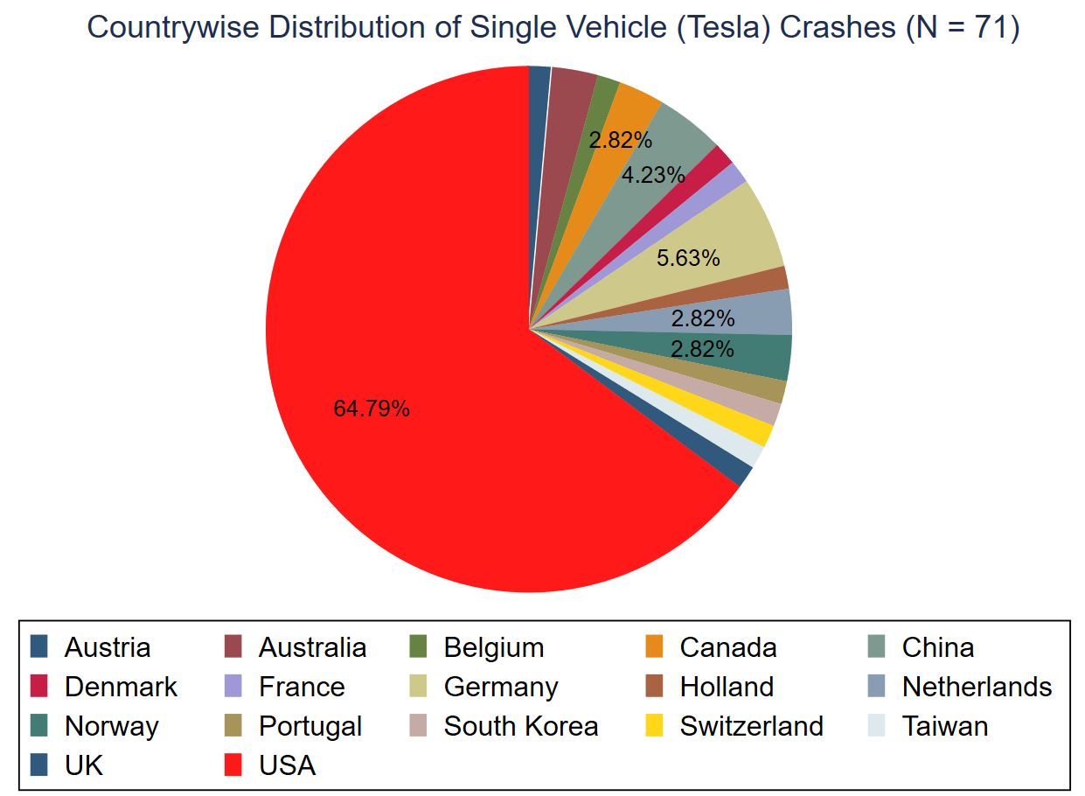
Figure 5.2. Countrywise Distribution of Fatal Crashes involving Tesla Vehicle

Figure 5.3. Statewise Distribution of Single Vehicle Fatal Crashes involving Tesla Vehicle in the US

Cross Tabulation: Tesla Driver Survivability versus Key Factors
To understand the association of Autopilot use, Tesla driver behavior, and other important factors with Tesla driver survivability in single-vehicle (Tesla) fatal crashes, Table 5.4 presents a cross-tabulation that can provide useful insights (170). For instance, statistics reveal that Autopilot was claimed and not claimed at the time of the crash in 12.68% (N = 9) and 87.32% (N = 62) of the crashes, respectively. The cross-tabulation shows that when the Autopilot was claimed, the Tesla driver was killed and survived in 55.56% (N = 5) and 44.44% (N = 4) of the crashes, respectively. However, crashes where the Autopilot was not claimed resulted in 75.81% (N = 47) of the Tesla driver fatality, which is significantly greater than the corresponding percentage of Tesla driver fatalities when the system was claimed, indicating higher chances of fatality when autopilot is not engaged. There are several possible explanations for these Autopilot failures; some of these reasons are listed below.
1. Radars and cameras on the vehicle may have failed.
2. The automated system did not detect well stationary or moving objects; the logic/algorithm that detects objects and pedestrians (using image processing) may have failed, or the actuators (brakes) failed.
3. Decisions were not made promptly by the driving algorithm.
4. The illumination range of the headlights may be too low (if dark).
5. The vehicle warned the driver of the complex situation, who failed to disengage.
6. Presence of pedestrian in the vehicle's Right of Way (pedestrian at fault).
A deeper analysis and reconstruction of the crash and performance of the Autopilot vision system and vehicle control system will be needed to fully understand and remedy the factors contributing to these crashes.
In 36.62% (N = 26) of the single-vehicle (Tesla) crashes, the Tesla vehicle caught fire, and all these crashes resulted in death for the Tesla driver. This is high compared with Fatality Analysis Reporting System (FARS) data on sedans (202). The FARS data reveals that in 2019, a total of 33,244 fatal crashes involving 51,247 vehicles occurred across the US (202). Note that only 3.3% (N = 1,689) of these vehicles caught fire (202). This is significantly higher than the corresponding percentage (26%) of vehicles in single-vehicle (Tesla) fatal crashes. This may need further investigation. In contrast, Tesla drivers survived in 42.44% (N = 19) of the crashes (N = 45) where the Tesla vehicle has not caught fire.
For errors by Tesla drivers, Tesla drivers have made an error in 12.68% (N = 9) of the crashes. The driver was killed in 55.56% (N = 5 out of 9) of these crashes, which is significantly greater than the percentage “75.81% (N = 47 out of 62)” of crashes where the Tesla driver has not made any error.
Interestingly, the percentage of Tesla driver deaths is lower in crashes where the Tesla driver has made a violation or was impaired with alcohol than in crashes where the driver was neither impaired nor making violations. Furthermore, the percentage (22.22%) of Tesla driver deaths in crashes occurring at an intersection is significantly lower than their corresponding percentage (80.65%) on roadway segments. Similarly, the survivability of Tesla drivers is higher in crashes when a pedestrian is involved but not when it is nighttime. Furthermore, Tesla drivers are less likely to survive if a Tesla vehicle collides with a fixed object.
Figure 5.4 conveys that, of the 71 observations, 11 are Tesla Model 3, four are Model X, one is Model Y, thirteen are Model S, and 34 observations do not have any model name. Of the Tesla Model 3 involved crashes (11), Tesla driver was killed 63.64% times. Of the Tesla Model X involved crashes (four), Tesla driver was killed 75.00% times. Of the Tesla Model Y involved crashes (1), Tesla driver was not killed. Of the Tesla Model S involved crashes (13), Tesla driver was killed 61.54% times.

Correlation analysis through Somers’ D Tests
Besides the mean coefficient of Somers’ D, its confidence interval can also be obtained, which shows the range of association of a specific independent variable with the response outcome. The coefficients for both symmetric (similar to gamma and tau tests where no distinction between the dependent and independent variable is made) and asymmetric Somers’ D (an asymmetric extension of gamma and tau tests) are presented. The latter one is more relevant for this study. Due to the lower sample (N = 71), most of the key variables do not show a statistically significant correlation with the Tesla driver fatality in single-vehicle crashes. Still, the direction of association of all such insignificant variables is intuitive.

Table 5.4. Cross Tabulation of Fatality of Tesla Driver Versus Human Factors
Key Variables | Categorical | Tesla Driver Killed |  | Total
 |  | No (N=19) | Yes (N=52) | 71
 |  | Freq. (%) | Freq. (%) | Freq. (%)
Autopilot Claimed | No (0) | 15 (24.19) | 47 (75.81) | 62 (100.00)
 | Yes (1) | 4 (44.44) | 5 (55.56) | 9 (100.00)
Tesla vehicle caught Fire | No (0) | 19 (42.22) | 26 (57.78) | 45 (100)
 | Yes (1) | 0 (0.00) | 26 (100.00) | 26 (100.00)
Human Factors
Errors by Tesla Driver | No (0) | 15 (24.19) | 47 (75.81) | 62 (100)
 | Yes (1) | 4 (44.44) | 5 (55.56) | 9 (100)
Violations by Tesla Driver | No (0) | 12 (23.53) | 39 (76.47) | 51 (100)
 | Yes (1) | 7 (35.00) | 13 (65.00) | 20 (100)
Tesla Driver being Impaired with Alcohol | No (0) | 17 (24.64) | 52 (75.36) | 69 (100.00)
 | Yes (1) | 2 (100.00) | 0 (0.00) | 2 (100.00)
Model of Tesla Vehicle
Tesla Model 3 | No (0) | 15 (25.00) | 45 (75.00) | 60 (100.00)
 | Yes (1) | 4 (36.36) | 7 (63.64) | 11 (100.00)
Tesla Model X | No (0) | 18 (26.87) | 49 (73.13) | 67 (100.00)
 | Yes (1) | 1 (25.00) | 3 (75.00) | 4 (100.00)
Tesla Model Y | No (0) | 18 (25.71) | 52 (74.29) | 70 (100.00)
 | Yes (1) | 1 (100.00) | 0 (0.00) | 1 (100.00)
Tesla Model S | No (0) | 14 (24.14) | 44 (75.86) | 58 (100.00)
 | Yes (1) | 5 (38.46) | 8 (61.54) | 13 (100.00)
Model not reported | No (0) | 13 (35.14) | 24 (64.86) | 37 (100.00)
 | Yes (1) | 6 (17.65) | 28 (82.35) | 34 (100.00)
Collision Type
Fixed Object | No (0) | 14 (43.75) | 18 (56.25) | 32 (100.00)
 | Yes (1) | 5 (12.82) | 34 (87.18) | 39 (100.00)
Other Key Factors
Tesla Driver Male | No (0) | 10 (40.00) | 15 (60.00) | 25 (100.00)
 | Yes (1) | 9 (19.57) | 37 (80.43) | 46 (100.00)
Night time indicator | No (0) | 10 (25.00) | 30 (75.00) | 40 (100.00)
 | Yes (1) | 9 (29.03) | 22 (70.97) | 31 (100.00)
Pedestrian Involved | No (0) | 9 (15.25) | 50 (84.75) | 59 (100.00)
 | Yes (1) | 10 (83.33) | 2 (16.67) | 12 (100.00)
Crash occurred at intersection | No (0) | 12 (19.35) | 50 (80.65) | 62 (100.00)
 | Yes (1) | 7 (77.78) | 2 (22.22) | 9 (100.00)

In the single-vehicle crashes, the intersection indicator shows a statistically significant and negative association (t-stat = -2.63) with Tesla driver fatality with a mean asymmetric Somers’ D coefficient of -0.33 (Table 5.5). This finding suggests that the chance of a Tesla driver fatality is 33% (with a range of 8% to 54%) lower compared to crashes that occur at non-intersection locations. Importantly, the Autopilot use did not show statistical significance with Tesla driver fatality; however, its direction of association was intuitive, and its statistical significance may improve with a larger sample size. Referring to the effect of Autopilot use on Tesla driver fatality in single-vehicle crashes, it is observed that there is a 11.0% lower chance of a Tesla driver fatality if the Autopilot was engaged compared to crashes where autopilot was disengaged. Moreover, results indicate that the Tesla driver is less likely to survive in a crash with fixed objects.

Table 5.5. Results of Correlational Analysis: Tesla Driver Survivability versus Key Factors
Key Variables | Single Vehicle Crashes (N=71)
Key Variables | Symmetric Somers’ D |  |  | Asymmetric Somers’ D
Key Variables | Coeff. | t | P> |t| | Coefficient | Min. | Max.
Autopilot Claimed (1/0) | -0.11 | -1.09 | 0.28 | -0.11 | -0.31 | 0.10
Tesla vehicle caught Fire (1/0) | 0.55 | 5.82 | 0.00 | 0.50 | 0.35 | 0.63
Human Factors
Errors by Tesla Driver (1/0) | -0.11 | -1.09 | 0.28 | -0.11 | -0.31 | 0.10
Violations by Tesla Driver (1/0) | -0.12 | -0.91 | 0.37 | -0.12 | -0.36 | 0.14
Tesla Driver being Impaired with Alcohol (1/0) | -0.11 | -1.45 | 0.15 | -0.11 | -0.25 | 0.04
Model of Tesla Vehicle
Tesla Model 3 (1/0) | -0.08 | -0.71 | 0.48 | -0.08 | -0.28 | 0.14
Tesla Model X (1/0) | 0.01 | 0.08 | 0.94 | 0.01 | -0.12 | 0.13
Tesla Model Y (1/0) | -0.05 | -1.00 | 0.32 | -0.05 | -0.16 | 0.05
Tesla Model S (1/0) | -0.11 | -0.94 | 0.35 | -0.11 | -0.33 | 0.12
Collision Type
Fixed Object (1/0) | 0.41 | 2.84 | 0.01 | 0.39 | 0.12 | 0.61
Other Key Factors
Tesla Driver Male (1/0) | 0.24 | 1.71 | 0.09 | 0.24 | -0.04 | 0.48
Night time indicator (1/0) | -0.05 | -0.37 | 0.71 | -0.05 | -0.31 | 0.22
Pedestrian Involved (1/0) | -0.53 | -3.38 | 0.00 | -0.49 | -0.69 | -0.22
Crash occurred at intersection (1/0) | -0.34 | -2.63 | 0.01 | -0.33 | -0.54 | -0.08

Comparison of Tesla of Luxury Electric Vehicles
Table 5.3 showed that there was a higher percentage of fatal crashes (driver died) in model X, followed by model 3 and model S among the Single vehicle crashes. However, higher number of crashes were in model S, followed by Model 3, and model X. from Table 5.5’s Somers’ D test, it appeared that the chances of fatality in Tesla model S and model Y are 11% and 5% lower compared to other models. However, this does not give the clear picture. Figure 5.4 shows the yearly sales figures of three Tesla models along with some other similar luxury electric cars in the US. It is observed that Tesla has higher sales than any other similar car manufacturer brand, indicating that their exposure is higher. Therefore, the higher fatality rates of Tesla would be because of higher exposure and does not mean that Tesla is any worse or superior than similar cars. To understand the complexity of the situation, FARS data were checked for validity. In 2019 FARS database, 40 fatal crashes involving Tesla was found. The fatal crash for BMW i3 was one, and Nissan Leaf was six in 2019 in the US (203). These numbers do not signal less chance of fatality for Tesla crashes compared to other similar cars. But, the sales figures indicate that Tesla simply has more exposure and therefore more cars have chances of crashes as they are more in number on the roads. These critical issues should be studied in depth.

Figure 5.4. Year to Date Sales of Luxury Electric Vehicles (204)

Limitations
The study may add useful knowledge to the existing literature on the safety of AVs like Tesla. However, the main limitation of this study is that the results are based on fatal crashes that involved only Tesla. Hence, the results cannot be generalized to all AVs. Another critical issue is the lower sample size of AVs field crashes which is also highlighted in the existing literature. Although the data source reported more than 200 Tesla-involved fatal crashes but only 71 of them were single vehicle crashes and it is still not large enough to do robust statistical analysis. The website only reports Tesla involved Fatal crashes, but there might be Tesla involved other crashes and a study of autopilot with those crashes would provide more insight. Fatal crashes from other countries might have been underreported as any news other than the English language is excluded from the website. Therefore, fewer fatal crashes in other countries need to be collected carefully. The frequency of driver errors and, violations, and crashes at intersections are very low in number and it is difficult to infer a conclusion from their analysis. Another limitation of AV data is also observed in the FARS dataset, where Tesla is coded as “Other Domestic manufacturer-Tesla.” Better coding of this model is necessary like other vehicle manufacturers.

Conclusions
In general, automated vehicles can be relatively safer than human-driven vehicles because artificial intelligence offers the possibility of a driving experience free of distractions, errors, and traffic violations. On the other hand, AVs can malfunction for various reasons, causing crashes. This study contributes to the existing body of AV-based literature by evaluating the safety of Tesla cars. A unique database was created from Tesla fatal crash data (tesladeaths.com). Using links to the news narratives for each fatal crash, several new variables were coded. Several interesting insights are found focusing on 71 single-vehicle crashes (some involving pedestrians) which have occurred throughout the world.
The results reveal that about 12.68% of the Teslas in single-vehicle crashes used the Autopilot feature. When the Autopilot was claimed, the Tesla driver was killed and survived 55.56% (N = 5) and 44.44% (N = 4) of the crashes, respectively. Referring to the Somers’ D test to observe the relationship of the Autopilot with Tesla driver survivability, Autopilot engagement does not seem to correlate with Tesla driver survivability. Strangely, 26% of the Tesla vehicles caught fire. This is high compared with Fatality Analysis Reporting System (FARS) data on sedans (202). The FARS data reveals that in 2019, only 3.3% (N = 1,689) of the vehicles (N=51,247) involved in fatal crashes (N=33,244) caught fire (32). This is significantly higher than the corresponding percentage (26%) of vehicles in single-vehicle (Tesla) fatal crashes. This may need further investigation. Furthermore, the findings indicate that 20.33% of the fatal crashes were Pedestrian-involved, where the Tesla drivers survived.
In the paper, the relationship of Autopilot engagement and Tesla driver behaviors with the survivability of Tesla drivers is investigated. It would be interesting to see how the role of Autopilot and Tesla driver behaviors change in more complex multi-vehicle crashes. Future studies can further investigate the pedestrian identification system in the Autopilot feature. As a lower sample size is an issue in this analysis, one way to overcome this could be to use Bayesian models while investigating the survivability of Tesla drivers. Furthermore, note that the website (tesladeaths.com) has not reported the non-fatality involved Tesla crashes and it would be interesting in the future to see the role of Autopilot engagement and Tesla driver behavior in crashes that resulted in serious injuries and minor injuries. In the future, the availability of larger sample sizes may overcome some of the limitations. Although the results are not generalizable, future studies on AV can be benefitted from the method, results, and insights of this paper. This paper will be useful for AV manufacturers, particularly Tesla, who are working to improve the safety features of their vehicles.

New Section of the work
Next, a rigorous statistical model like the Bayesian Logit model can be applied to the data to identify the associations between Tesla drivers’ survivability and autopilot engagement to get a deeper insight into this automation technology.

Acknowledgments
This study was partially supported by the Collaborative Sciences Center for Road Safety, CSCRS, a US. DOT-funded National Transportation Center.

CONCLUSION
Connected and Automated Vehicles are still at their early stage of test and deployment. Therefore, their safety performance analysis is crucial for improvement of the technology and ensuring people’s safety.

This dissertation is intended to examine both connectivity and automation technology to gain a comprehensive knowledge on their safety performances. Existing literature showed that application of connectivity is new in transit buses and there exists a scarcity of research in this area. Existing literature was limited in examining automation technology as AV data was only from simulation-based studies and test-bed data were not publicly available. As automation technology is still in the early stage and manufacturers are able to achieve lower level automation in personal vehicles. This dissertation addresses these gaps and analyzes both technology at their early stage of deployment which can be helpful in their advancement and eventually assure multimodal safety.

A summary of the findings of this dissertation are provided below. This will be followed by research implications and directions for future research.

Chapter 1 found that EPCW alerts are negatively associated with bus-involved crashes.

Chapter 2 showed that Alert Zone and MTDI measures can be useful for analyzing performance of basic safety message based alerts.

Chapter 3 identified that smart cities can consider University Campuses, Downtowns, Office Parks, Stadiums, Transit Stations, and Entertainment Areas for early deployment of automated shuttles.

Chapter 4 shows how effective are the AV safety features of Tesla in preventing severity of crashes.

Chapter 5 studies single vehicle Fatal crashes of Tesla to identify which factors are associated with these fatal crashes.

Future research works can examine Basic Safety Messages and Alerts at various intersections and bigger cities so that the results can be generalizable. Future studies can compare Tesla to other conventional vehicles and consider all types of crashes.

List of References

[1] FHWA. Multiple Sources of Safety Information From V2V and V2I: Redundancy, Decision Making, and Trust - Safety Message Design Report
CHAPTER 2. OVERVIEW OF CV APPLICATIONS.In, 2015.
[2] Arvin, R., M. Kamrani, and A. J. Khattak. How instantaneous driving behavior contributes to crashes at intersections: extracting useful information from connected vehicle message data. Accident Analysis & Prevention, Vol. 127, 2019, pp. 118-133.
[3] Liu, J., and A. J. Khattak. Delivering improved alerts, warnings, and control assistance using basic safety messages transmitted between connected vehicles. Transportation research part C: emerging technologies, Vol. 68, 2016, pp. 83-100.
[4] Khattak, A. J., and B. Wali. Analysis of volatility in driving regimes extracted from basic safety messages transmitted between connected vehicles. Transportation research part C: emerging technologies, Vol. 84, 2017, pp. 48-73.
[5] Wali, B., A. J. Khattak, H. Bozdogan, and M. Kamrani. How is driving volatility related to intersection safety? A Bayesian heterogeneity-based analysis of instrumented vehicles data. Transportation Research Part C: Emerging Technologies, Vol. 92, 2018, pp. 504-524.
[6] Kamrani, M., R. Arvin, and A. J. Khattak. Extracting useful information from Basic Safety Message Data: an empirical study of driving volatility measures and crash frequency at intersections. Transportation Research Record, 2018, p. 0361198118773869.
[7] Kadam, A. J., V. Patil, K. Kaith, and D. Patil. Developing a Smart Bus for Smart City using IOT Technology.In 2018 Second International Conference on Electronics, Communication and Aerospace Technology (ICECA), IEEE, 2018. pp. 1138-1143.
[8] Tostado, R., A. Rovirosa, J. Velázquez, E. Castillo, and O. Cervantes. A first experience with a Smart bus for improving public transportation. ISPRS Annals of Photogrammetry, Remote Sensing & Spatial Information Sciences, Vol. 4, 2017.
[9] Sungur, C., I. Babaoglu, and A. Sungur. Smart bus station-passenger information system.In 2015 2nd International Conference on Information Science and Control Engineering, IEEE, 2015. pp. 921-925.
[10] Sridevi, K., A. Jeevitha, K. Kavitha, K. Sathya, and K. Narmadha. Smart bus tracking and management system using IoT. Asian Journal of Applied Science and Technology (AJAST) Volume, Vol. 1, 2017.
[11] USDOT. Arc-IT Service Packages. https://www.arc-it.net/html/servicepackages/servicepackages-areaspsort.html. Accessed 1/4/2022.
[12] Machek, E., E. Burkman, T. Crayton, J. Cregger, D. Diggs, S. Fischer, S. Mortensen, S. Peirce, H. Richardson, and A. Thomas. Strategic Transit Automation Research Plan.In, United States. Federal Transit Administration. Office of Research …, 2018.
[13] Valentine, D., A. Polinori, M. Windholtz, W. Gibbs, D. Neumeister, G. Baumgardner, and B. Paselsky. Connected Vehicle (CV) Infrastructure–Urban Bus Operational Safety Platform Project Report.In, United States. Federal Transit Administration. Office of Research, Demonstration, and Innovation, 2019.
[14] Song, Z. Transition to a transit city: case of Beijing. Transportation Research Record, Vol. 2394, No. 1, 2013, pp. 38-44.
[15] USDOT-FMCSA. Commercial Motor Vehicle Traffic Safety Facts.In, 2017.
[16] Chimba, D., T. Sando, and V. Kwigizile. Effect of bus size and operation to crash occurrences. Accident Analysis and Prevention, Vol. 42, No. 6, 2010, pp. 2063-2067.
[17] Goh, K. C. K., G. Currie, M. Sarvi, and D. Logan. Bus accident analysis of routes with/without bus priority. Accident Analysis & Prevention, Vol. 65, 2014, pp. 18-27.
[18] Huting, J., J. Reid, U. Nwoke, E. Bacarella, and K. E. Ky. Identifying factors that increase bus accident risk by using random forests and trip-level data. Transportation Research Record, Vol. 2539, No. 1, 2016, pp. 149-158.
[19] Strathman, J. G., P. Wachana, and S. Callas. Analysis of bus collision and non-collision incidents using transit ITS and other archived operations data. Journal of safety research, Vol. 41, No. 2, 2010, pp. 137-144.
[20] Elvik, R. State-of-the-art approaches to road accident black spot management and safety analysis of road networks. Transportøkonomisk institutt Oslo, 2007.
[21] Montella, A. A comparative analysis of hotspot identification methods. Accident Analysis & Prevention, Vol. 42, No. 2, 2010, pp. 571-581.
[22] Hauer, E., J. Kononov, B. Allery, and M. S. Griffith. Screening the road network for sites with promise. Transportation Research Record, Vol. 1784, No. 1, 2002, pp. 27-32.
[23] Hauer, E., and B. Persaud. How to estimate the safety of rail-highway grade crossings and the safety effects of warning devices. Transportation Research Record, Vol. 1114, 1987, pp. 131-140.
[24] Miaou, S.-P. The relationship between truck accidents and geometric design of road sections: Poisson versus negative binomial regressions. Accident Analysis & Prevention, Vol. 26, No. 4, 1994, pp. 471-482.
[25] Shankar, V., F. Mannering, and W. Barfield. Effect of roadway geometrics and environmental factors on rural freeway accident frequencies. Accident Analysis & Prevention, Vol. 27, No. 3, 1995, pp. 371-389.
[26] Maher, M. J., and I. Summersgill. A comprehensive methodology for the fitting of predictive accident models. Accident Analysis & Prevention, Vol. 28, No. 3, 1996, pp. 281-296.
[27] Abdel-Aty, M. A., and A. E. Radwan. Modeling traffic accident occurrence and involvement. Accident Analysis & Prevention, Vol. 32, No. 5, 2000, pp. 633-642.
[28] USDOT. Enhanced Transit Safety Retrofit Package (E-TRP).In, U.S. Department of Transportation Intelligent Transportation Systems Joint Program Office, 2018.
[29] DeWine, M., and T. J. Stickrath. Welcome to the Crash Statistics System. Ohio Department of Public Safety. https://services.dps.ohio.gov/CrashOnline/CrashStatistics/Home. Accessed 4/26/2019, 2019.
[30] NOACA. Northeast Ohio Areawide Coordinating Agency GIS Portal, Ohio. https://gis.noaca.org/portal/. Accessed 7/15/2020.
[31] Cuyahoga County Open Data. Land Use 2014 WGS84. ArcGIS.com. https://data-cuyahoga.opendata.arcgis.com/datasets/cuyahoga::land-use-2014-wgs84/about. Accessed 1.20.2022, 2022.
[32] Transitfeeds. GCRTA GTFS. https://transitfeeds.com/p/greater-cleveland-regional-transit-authority/214?p=5. Accessed 6.9.2020.
[33] Kim, K., I. Brunner, E. Y. Yamashita, G. Nagamine, and J. Burke. Guilty by Association: A Spatial Analysis of Bus Stop Locations and Pedestrian Accidents.In, 2010.
[34] Torres-Reyna, O. Panel Data Analysis Fixed and random Effects using Stata.In, 2007.
[35] Greene, W. H. Econometric analysis. Pearson Education India, 2003.
[36] SAS Institute Inc. The COUNTREG Procedure Panel Data Analysis. https://documentation.sas.com/doc/en/pgmsascdc/9.4_3.4/etsug/etsug_countreg_details34.htm#etsug_countreg008815. Accessed 1/4/2022.
[37] Peeters, A., M. Zude, J. Käthner, M. Ünlü, R. Kanber, A. Hetzroni, R. Gebbers, and A. Ben-Gal. Getis–Ord’s hot-and cold-spot statistics as a basis for multivariate spatial clustering of orchard tree data. Computers and Electronics in Agriculture, Vol. 111, 2015, pp. 140-150.
[38] ESRI. Hot Spot Analysis (Getis-Ord Gi*). https://desktop.arcgis.com/en/arcmap/10.3/tools/spatial-statistics-toolbox/hot-spot-analysis.htm#. Accessed 1.10.2022, 2022.
[39] ---. How IDW Works. https://pro.arcgis.com/en/pro-app/2.8/tool-reference/3d-analyst/how-idw-works.htm. Accessed 2.26.2022, 2022.
[40] Johnston, K., J. M. V. Hoef, K. Krivouruchko, and N. Lucas. Using ArcGIS Geostatistical Analyst.In, ESRI, Redlands, CA, 2001.
[41] Federal Motor Carrier Safety Administration. Large Truck and Bus Crash Facts 2019. USDOT. https://www.fmcsa.dot.gov/safety/data-and-statistics/large-truck-and-bus-crash-facts-2019. Accessed 5.26.2022, 2022.
[42] World Health Organization. Global status report on road safety 2013: supporting a decade of action: summary.In, World Health Organization, 2013.
[43] NHTSA. Traffic Safety Facts 2018 Data.In, USDOT, Washington DC, 2018.
[44] AASHTO. A Policy on Geometric Design of Highways and Streets. 2018.
[45] Young, K. L., P. M. Salmon, and M. G. Lenné. At the cross-roads: An on-road examination of driving errors at intersections. Accident Analysis & Prevention, Vol. 58, 2013, pp. 226-234.
[46] Chandler, B. E., M. Myers, J. E. Atkinson, T. Bryer, R. Retting, J. Smithline, J. Trim, P. Wojtkiewicz, G. B. Thomas, and S. P. Venglar. Signalized intersections informational guide.In, United States. Federal Highway Administration. Office of Safety, 2013.
[47] Van Maren, P. A. Correlation of design and control characteristics with accidents at rural multi-lane highway intersections. 1977.
[48] de Lavalette, B. C., C. Tijus, S. Poitrenaud, C. Leproux, J. Bergeron, and J.-P. Thouez. Pedestrian crossing decision-making: A situational and behavioral approach. Safety science, Vol. 47, No. 9, 2009, pp. 1248-1253.
[49] Schorr, J. P., and S. H. Hamdar. Safety propensity index for signalized and unsignalized intersections: Exploration and assessment. Accident Analysis & Prevention, Vol. 71, 2014, pp. 93-105.
[50] Litman, T. Autonomous Vehicle Implementation Predictions: Implications for Transport Planning.In, Victoria Transport Policy Institute, 2021.
[51] Phan, M. T., I. Thouvenin, and V. Frémont. Enhancing the driver awareness of pedestrian using augmented reality cues.In 2016 IEEE 19th International Conference on Intelligent Transportation Systems (ITSC), IEEE, 2016. pp. 1298-1304.
[52] Fu, X., Q. Nie, J. Liu, A. Khattak, A. Hainen, and S. Nambisan. Constructing spatiotemporal driving volatility profiles for connected and automated vehicles in existing highway networks. Journal of Intelligent Transportation Systems, 2021, pp. 1-14.
[53] Clark, K., M. P. Clamann, and A. J. Khattak. Advancing Crash Investigation with Connected and Automated Vehicle Data.In, 2021.
[54] Kamrani, M., R. Arvin, and A. J. Khattak. Extracting useful information from basic safety message data: An empirical study of driving volatility measures and crash frequency at intersections. Transportation research record, Vol. 2672, No. 38, 2018, pp. 290-301.
[55] Karbasi, A., and S. O’Hern. Investigating the impact of connected and automated vehicles on signalized and unsignalized intersections safety in mixed traffic. Future transportation, Vol. 2, No. 1, 2022, pp. 24-40.
[56] Li, T., and K. M. Kockelman. Valuing the safety benefits of connected and automated vehicle technologies.In Transportation Research Board 95th Annual Meeting, No. 1, 2016.
[57] Wang, C., Y. Xie, H. Huang, and P. Liu. A review of surrogate safety measures and their applications in connected and automated vehicles safety modeling. Accident Analysis & Prevention, Vol. 157, 2021, p. 106157.
[58] Wu, J., H. Xu, Y. Zheng, and Z. Tian. A novel method of vehicle-pedestrian near-crash identification with roadside LiDAR data. Accident Analysis & Prevention, Vol. 121, 2018, pp. 238-249.
[59] Tak, S., S. Kim, D. Lee, and H. Yeo. A comparison analysis of surrogate safety measures with car-following perspectives for advanced driver assistance system. Journal of Advanced Transportation, Vol. 2018, 2018.
[60] Monreal, C. O., M. Pichler, G. Krizek, and S. Naumann. Shadow as route quality parameter in a pedestrian-tailored mobile application. IEEE Intelligent Transportation Systems Magazine, Vol. 8, No. 4, 2016, pp. 15-27.
[61] Tsuji, T., H. Hattori, M. Watanabe, and N. Nagaoka. Development of night-vision system. IEEE Transactions on Intelligent Transportation Systems, Vol. 3, No. 3, 2002, pp. 203-209.
[62] Keller, C. G., T. Dang, H. Fritz, A. Joos, C. Rabe, and D. M. Gavrila. Active pedestrian safety by automatic braking and evasive steering. IEEE Transactions on Intelligent Transportation Systems, Vol. 12, No. 4, 2011, pp. 1292-1304.
[63] Hadi, M., M. A. Islam, S. Afreen, and T. Wang. Evaluation of an advanced driver-assistance system to reduce pedestrian and rear-end crashes of transit vehicles. Transportation research record, Vol. 2675, No. 11, 2021, pp. 1301-1309.
[64] Matsuo, K., N. Chigai, M. I. Chattha, and N. Sugiki. Vulnerable road user safety evaluation using probe vehicle data with collision warning information. Accident Analysis & Prevention, Vol. 165, 2022, p. 106528.
[65] Banerjee, S., M. Jeihani, N. K. Khadem, and M. Kabir. Influence of Pedestrian Collision Warning Systems on Driver Behavior: A Driving Simulator Study. arXiv preprint arXiv:2112.09074, 2021.
[66] Jung, H., M.-K. Choi, K. Soon, and W. Y. Jung. End-to-end pedestrian collision warning system based on a convolutional neural network with semantic segmentation.In 2018 IEEE International Conference on Consumer Electronics (ICCE), IEEE, 2018. pp. 1-3.
[67] Zhou, Q., and X. Wang. Vehicle-Pedestrian Conflict Scenarios Easily Missed by Pedestrian Collision Warning System.In, 2019.
[68] Hussein, A., F. Garcia, J. M. Armingol, and C. Olaverri-Monreal. P2V and V2P communication for pedestrian warning on the basis of autonomous vehicles.In 2016 IEEE 19th International Conference on Intelligent Transportation Systems (ITSC), IEEE, 2016. pp. 2034-2039.
[69] Hasan, R., M. A. Hoque, Y. Karim, R. Griffin, D. Schwebel, and R. Hasan. Smartphone-based Distracted Pedestrian Localization using Bluetooth Low Energy Beacons.In 2020 SoutheastCon, IEEE, 2020. pp. 1-2.
[70] Agresti, A. An Introduction to Categorical Data Analysis. John Wiley & Sons, 2007.
[71] Howell, D. C. Chi-Square Test: Analysis of Contingency Tables.In International Encyclopedia of Statistical Science, Springer Berlin Heidelberg, Berlin, Heidelberg, 2011. pp. 250-252.
[72] NOACA. Northeast Ohio Areawide Coordinating gency GIS Portal. https://gis.noaca.org/portal/. Accessed 7/15/2020.
[73] Arroyo, V. A., S. E. Bennett, W. A. V. Clark, J. M. Crites, M. Dougherty, J. S. Halikowski, M. W. Hancock, S. Hanson, S. Heminger, C. T. Hendrickson, J. D. Holt, G. P. Lagrange, M. P. Lewis, J. McDonald, D. A. Osterberg, S. Palmer, S. Rosenbloom, H. G. Schwartz Jr, K. C. Sinha, D. Sperling, G. C. Thomas, and P. A. Washington. TCRP Report 165: Transit Capacity and Quality of Service Manual.In, Washington DC, 2013.
[74] Valdes, V., G. W. Torn, S. Mortensen, and D. Diggs. Strategic Transit Automation Research Plan.In, Federal Transit Administration (FTA), 2018.
[75] USDOT. Preparing for the Future of Transportation: Automated Vehicle 3.0. USDOT. https://www.transportation.gov/av/3. Accessed Nov. 20, 2018.
[76] Azad, M., N. Hoseinzadeh, C. Brakewood, C. R. Cherry, and L. D. Han. Fully Autonomous Buses: A Literature Review and Future Research Directions. Journal of Advanced Transportation, Vol. 2019, 2019.
[77] Alessandrini, A., R. Alfonsi, P. Delle Site, and D. Stam. Users’ preferences towards automated road public transport: results from European surveys. Transportation research procedia, Vol. 3, 2014, pp. 139-144.
[78] Pessaro, B. Evaluation of Automated Vehicle Technology for Transit. 2015.
[79] Weele, M. V. WEpods project. DAVI on the road. http://davi.connekt.nl/wepods-project/. Accessed May 21, 2019, 2019.
[80] Navya. Carpostal and the city of Sion extend the Autonom shuttle experimentation. Navya. https://navya.tech/en/carpostal-and-the-city-of-sion-extend-the-navya-shuttle-experimentation/. Accessed May 21, 2019, 2019.
[81] Nordhoff, S., B. V. Arem, N. Merat, R. Madigan, L. Ruhrort, A. Knie, and R. Happee. User acceptance of driverless shuttles running in an open and mixed traffic environment.In Proceedings of the 12th ITS European Congress, Strasbourg, France, 2017. pp. 19-22.
[82] Salonen, A. O. Passenger's subjective traffic safety, in-vehicle security and emergency management in the driverless shuttle bus in Finland. Transport policy, Vol. 61, 2018, pp. 106-110.
[83] Portouli, E., G. Karaseitanidis, P. Lytrivis, A. Amditis, O. Raptis, and C. Karaberi. Public attitudes towards autonomous mini buses operating in real conditions in a Hellenic city.In 2017 IEEE Intelligent Vehicles Symposium (IV), IEEE, 2017. pp. 571-576.
[84] Yap, M. D., G. Correia, and B. Van Arem. Preferences of travellers for using automated vehicles as last mile public transport of multimodal train trips. Transportation research part a: policy and practice
Vol. 94, 2016, pp. 1-16.
[85] Piao, J., M. McDonald, N. Hounsell, M. Graindorge, T. Graindorge, and N. Malhene. Public views towards implementation of automated vehicles in urban areas. Transportation research procedia, Vol. 14, 2016, pp. 2168-2177.
[86] Sinner, M., S. Brawand, and U. Weidmann. Networking planning with autonomous buses.In 97th Annual Meeting of the Transportation Research Board (TRB 2018), TRB Annual Meeting, 2018.
[87] Cedera, A. A., T. Liu, A. Baravian, E. Purguette, and V. Bouthiere. Shared and Individual Autonomous Public-Transport Vehicles to Serve Air Passengers: A Comparison.In, 2018.
[88] Winter, K., O. Cats, G. Correia, and B. van Arem. Performance analysis and fleet requirements of automated demand-responsive transport systems as an urban public transport service. International journal of transportation science and technology
Vol. 7, No. 2, 2018, pp. 151-167.
[89] Bösch, P. M., F. Becker, H. Becker, and K. W. Axhausen. Cost-based analysis of autonomous mobility services. Transport policy, Vol. 64, 2018, pp. 76-91.
[90] Dong, X., M. DiScenna, and E. Guerra. Transit user perceptions of driverless buses. Transportation, Vol. 46, No. 1, 2019, pp. 35-50.
[91] Anania, E., S. Rice, S. Winter, M. Milner, N. Walters, and M. Pierce. Why People Are Not Willing to Let Their Children Ride in Driverless School Buses: A Gender and Nationality Comparison. Social Sciences, Vol. 7, No. 3, 2018, p. 34.
[92] Lutin, J. M. Not If, but When: Autonomous Driving and the Future of Transit. Journal of Public Transportation, Vol. 21, No. 1, 2018, p. 10.
[93] Lewis, P., and A. Grossman. Beyond Speculation 2.0: Automated Vehicles and Public Policy.In, 2019.
[94] Cregger, J., M. Dawes, S. Fischer, C. Lowenthal, E. Machek, and D. Perlman. Low-Speed Automated Shuttles: State of the Practice Final Report.In, United States. Joint Program Office for Intelligent Transportation Systems, 2018.
[95] Yin, R. K. Case Study Research: Design and Methods. California: Sage Publications, Newbury Park, 1989.
[96] Brooks, D. Driverless shuttle at Fort Bragg is ‘Army’s future’.In The Fayetteville Observer, 2017.
[97] Mcity. Mcity Driverless Shuttle: A Case Study.In, University of Michigan, Ann Arbor, MI, 2018.
[98] Moore, N. C. Mcity Driverless Shuttle launches on U-M’s North Campus. Michigan News. https://news.umich.edu/mcity-driverless-shuttle-launches-on-u-ms-north-campus/. Accessed Oct. 21, 2018, 2018.
[99] Carney, S. Mcity Driverless Shuttle launches on U-M’s North Campus. The Michigan Engineer News Center, The University of Michigan Ann Arbor, MI https://news.engin.umich.edu/2018/06/mcity-driverless-shuttle-launches-on-u-ms-north-campus/. Accessed Feb. 4, 2019, 2019.
[100] IBM. Local Motors Debuts "Olli", the First Self-driving Vehicle to Tap the Power of IBM Watson. IBM. https://www-03.ibm.com/press/us/en/pressrelease/49957.wss. Accessed June 25, 2019, 2019.
[101] Local Motors. National Harbor. Local Motors. https://localmotors.com/national-harbor/. Accessed June 25, 2019, 2019.
[102] Berger, N. Autonomous vehicles to hit the road in Bishop Ranch.In The Press, thepress.net, 2018.
[103] Green, A. Self-driving corporate shuttles hit the road in the East Bay.In San Francisco Business Times, 2018.
[104] Willis, L. Testing of first autonomous shuttle on public roads in California begins.In, Contra Costa Transportation Authority, Contra Costa, California, 2018.
[105] Said, C. San Ramon office park testing 2 self-driving shuttles. SFGATE. https://www.sfgate.com/news/article/San-Ramon-office-park-testing-2-self-driving-10981577.php. Accessed May 17, 2019, 2019.
[106] Noebel, A. California’s First Driverless Bus Hits the Road in San Ramon.In, Bishop Ranch, San Ramon, California, 2018.
[107] Descant, S. Driverless Shuttle Pilot Enters Final-Phase Testing in California. https://www.govtech.com/fs/automation/Driverless-Shuttle-Pilot-Enters-Final-Phase-Testing-in-California.html. Accessed Feb. 10, 2019, 2019.
[108] JTA. JTA Holds Autonomous Vehicle Demonstration. Jacksonville Transportation Authority. https://www.jtafla.com/media-center/press-releases/jta-holds-autonomous-vehicle-demonstration/. Accessed May 20, 2019, 2019.
[109] Transdev. Autonomous Mobility. https://www.transdev.com/en/our-innovations/shared-autonomous-mobility/. Accessed May 10, 2019, 2019.
[110] Ban, C. Autonomous vehicles hitting Greenville County, S.C. roads. National Association of Counties. https://www.naco.org/articles/autonomous-vehicles-hitting-greenville-county-sc-roads. Accessed June 26, 2019, 2019.
[111] The city of Arlington. Milo Pilot Program Closeout Report.In, Arlington, Texas, n.d.
[112] AAA. AAA Free Self-Driving Shuttle Pilot Program. http://www.aaahoponlasvegas.com/. Accessed Feb. 19, 2019, 2019.
[113] Akers, M. How does downtown’s autonomous bus work?In Las Vegas Sun, Las Vegas, 2018.
[114] WSB, and AECOM. MnDOT Autonomous Bus Pilot Project Testing and Demonstration Summary In, Minnesota, 2018.
[115] Transdev. Transdev Launches Third AV Operation in Florida. Transdev. https://www.transdevna.com/news/2018/05/21/transdev-launches-third-av-operation-in-florida/?fbclid=IwAR2wwqxLXBEJeGRy-oSURRWPrbTp85Hwp_7MoohGQOTL68ktaYF9tAdHixg. Accessed May 21, 2019, 2019.
[116] Caplan, A. Self-driving shuttle hits the streets. Gainsville.com. https://www.gainesville.com/news/20180503/self-driving-shuttle-hits-streets. Accessed May 21, 2019, 2019.
[117] Mcloud, D. Driverless shuttles planned for Gainesville, Fla. Equipment World.com. https://www.equipmentworld.com/driverless-shuttles-planned-for-gainesville-fla/. Accessed May 21, 2019, 2019.
[118] Degan, R. J. Local BART station celebrates first autonomous vehicle. Pleasanton Weekly. https://pleasantonweekly.com/news/2018/06/26/dublin-bart-receives-first-autonomous-vehicle. Accessed June 28, 2019, 2019.
[119] Wiggers, K. May Mobility raises $22 million to deploy autonomous shuttles in cities across the U.S. https://venturebeat.com/2019/02/12/may-mobility-raises-22-million-to-deploy-autonomous-shuttles-in-cities-across-the-u-s/. Accessed April 19, 2019, 2019.
[120] Noble, B. Self-driving shuttles begin running in downtown Detroit.In The Detroit News, 2018.
[121] Insurance Journal. Lincoln, Nebraska, to Test All-Electric, Driverless Shuttle Technology. Insurance Journal. https://www.insurancejournal.com/news/midwest/2018/06/27/493424.htm. Accessed Feb. 3, 2019, 2019.
[122] City of Lincoln Nebraska. Autonomous Shuttle Project. https://lincoln.ne.gov/city/ltu/shuttle/. Accessed Oct. 10, 2018, 2018.
[123] Musulin, K. Columbus, OH launches first self-driving shuttle service Smart Circuit. Smartcitiesdive. https://www.smartcitiesdive.com/news/self-driving-shuttles-columbus-ohio-may-mobility/532664/. Accessed May 6, 2019, 2019.
[124] Easymile. RTD Launches the First Autonomous Shuttle in Denver, Denver, Colorado. https://easymile.com/rtd-launches-the-first-on-road-deployment-of-an-autonomous-shuttle-ez10-in-denver/. Accessed May 7, 2019, 2019.
[125] Murray, J. Self-driving shuttle offers Denver a glimpse of its future — but will riders jump on board? https://www.denverpost.com/2019/01/31/denver-airport-self-driving-shuttle-easymile/. Accessed May 7, 2019, 2019.
[126] Nghiem, A. USF Hosts Its First Ever Autonomous Vehicle Demonstration. Globe Newswire. https://www.globenewswire.com/news-release/2019/02/13/1724305/0/en/USF-Hosts-Its-First-Ever-Autonomous-Vehicle-Demonstration.html. Accessed May 8, 2019, 2019.
[127] Moleski, V. Meet Olli: Sacramento State unveils new 3D-printed, electric-powered autonomous shuttles. The Sacramento Bee. https://www.sacbee.com/news/local/transportation/article226544445.html. Accessed May 8, 2019, 2019.
[128] UDOT. 2019 Tour Schedule. UDOT
UTA, Utah. http://www.avshuttleutah.com/locations.aspx. Accessed May 8, 2019, 2019.
[129] Giardinelli, C. Driverless shuttle debuts at Station Park. KSL. https://www.ksl.com/article/46576021/driverless-shuttle-debuts-at-station-park?fbclid=IwAR2iESpQWIl24N-ZNphsFjSgtt9frBxAZQTlEDvOdMNQQNZbj17Dpz1hwcE. Accessed June 24, 2019, 2019.
[130] Bigelow, P. May Mobility to deploy self-driving shuttles in Rhode Island. Automotive News. https://www.autonews.com/mobility-report/may-mobility-deploy-self-driving-shuttles-rhode-island. Accessed May 20, 2019, 2019.
[131] O'Brien, M. Self-Driving Shuttle Pulled Over in Rhode Island. Transport Topics News. https://www.ttnews.com/articles/self-driving-shuttle-pulled-over-rhode-island. Accessed May 21, 2019, 2019.
[132] Schrock, S. Schedule your free ride on Milo, Arlington’s Autonomous Shuttle. City of Arlington, Texas, Arlington, Texas. https://www.arlingtontx.gov/news/my_arlington_t_x/news_archive/2017_archived_news/august_2017/schedule_your_free_ride_on_milo. Accessed Oct. 5, 2018, 2018.
[133] Genova, D. Route 61AV: What RTD has learned. RTD. https://www.rtd-denver.com/news-stop/blogs/route-61av-what-rtd-has-learned. Accessed 12/18/2019, 2019.
[134] CB Insights. 5 Companies Working On Driverless Shuttles And Buses. CBINSIGHTS. https://www.cbinsights.com/research/driverless-shuttle-companies/. Accessed May 20, 2019, 2019.
[135] Coast Autonomous. Coast Autonomous. https://coastautonomous.com/press. Accessed May 20, 2019, 2019.
[136] Continental. Driverless Mobility. Continental USA. https://www.continental-automotive.com/Landing-Pages/CAD/CUbE/Driverless-Mobility/Driverless-Mobility. Accessed May 20, 2019, 2019.
[137] First Transit. Shared Autonomous Vehicle (SAV) Mobility Solutions. First Transit. https://www.firsttransit.com/services/shared-autonomous-vehicle-(sav). Accessed June 10, 2019, 2019.
[138] Haque, A. M., and A. J. Khattak. Evaluating Pedestrian Safety in Bus-Pedestrian Interactions with the Application of Enhanced Pedestrian Collision Warning Systems: Analysis of Large-Scale Basic Safety Message Data. Presented at 2022 TRB Annual Meeting, Washington DC, 2021.
[139] Golub, A., V. Satterfield, M. Serritella, J. Singh, and S. Phillips. Assessing the barriers to equity in smart mobility systems: A case study of Portland, Oregon. Case Studies on Transport Policy, 2019.
[140] Madadi, B., R. van Nes, M. Snelder, and B. van Arem. Assessing the travel impacts of subnetworks for automated driving: An exploratory study. Case Studies on Transport Policy, Vol. 7, No. 1, 2019, pp. 48-56.
[141] NHTSA. Early Estimates of Motor Vehicle Traffic Fatalities And Fatality Rate by Sub-Categories in 2021.In, 2022.
[142] ---. Overview of Motor Vehicle Crashes in 2020.In, Washington DC, 2022.
[143] Mahdinia, I., R. Arvin, A. J. Khattak, and A. Ghiasi. Safety, energy, and emissions impacts of adaptive cruise control and cooperative adaptive cruise control. Transportation research record, Vol. 2674, No. 6, 2020, pp. 253-267.
[144] International, S. SAE Levels of Driving Automation™ Refined for Clarity and International Audience. SAE. https://www.sae.org/blog/sae-j3016-update. Accessed 7.29.2022.
[145] Clements, L. M., and K. M. Kockelman. Economic effects of automated vehicles. Transportation research record, Vol. 2606, No. 1, 2017, pp. 106-114.
[146] Wang, S., and Z. Li. Exploring the mechanism of crashes with automated vehicles using statistical modeling approaches. PloS one, Vol. 14, No. 3, 2019, p. e0214550.
[147] FHWA, U. Impacts of Automated Vehicles on Highway Infrastructure.In, 2020.
[148] Chen, H., H. Chen, Z. Liu, X. Sun, and R. Zhou. Analysis of factors affecting the severity of automated vehicle crashes using XGBoost model combining POI data. Journal of Advanced Transportation, Vol. 2020, 2020.
[149] Kutela, B., S. Das, and B. Dadashova. Mining patterns of autonomous vehicle crashes involving vulnerable road users to understand the associated factors. Accident Analysis & Prevention, Vol. 165, 2022, p. 106473.
[150] Boggs, A. M., B. Wali, and A. J. Khattak. Exploratory analysis of automated vehicle crashes in California: A text analytics & hierarchical Bayesian heterogeneity-based approach. Accident Analysis & Prevention, Vol. 135, 2020, p. 105354.
[151] Sinha, A., V. Vu, S. Chand, K. Wijayaratna, and V. Dixit. A crash injury model involving autonomous vehicle: Investigating of crash and disengagement reports. Sustainability, Vol. 13, No. 14, 2021, p. 7938.
[152] Boggs, A. M., R. Arvin, and A. J. Khattak. Exploring the who, what, when, where, and why of automated vehicle disengagements. Accident Analysis & Prevention, Vol. 136, 2020, p. 105406.
[153] De Winter, J. C., R. Happee, M. H. Martens, and N. A. Stanton. Effects of adaptive cruise control and highly automated driving on workload and situation awareness: A review of the empirical evidence. Transportation research part F: traffic psychology and behaviour, Vol. 27, 2014, pp. 196-217.
[154] Ashraf, M. T., K. Dey, S. Mishra, and M. T. Rahman. Extracting rules from autonomous-vehicle-involved crashes by applying decision tree and association rule methods. Transportation research record, Vol. 2675, No. 11, 2021, pp. 522-533.
[155] Liu, Q., X. Wang, X. Wu, Y. Glaser, and L. He. Crash comparison of autonomous and conventional vehicles using pre-crash scenario typology. Accident Analysis & Prevention, Vol. 159, 2021, p. 106281.
[156] Tarmizi, I. A., and A. Abd Aziz. Vehicle detection using convolutional neural network for autonomous vehicles.In 2018 international conference on intelligent and advanced system (ICIAS), IEEE, 2018. pp. 1-5.
[157] Wiseman, S., S. Adler-Golden, E. Ientilucci, and T. Perkins. Enhanced Target Detection Under Poorly Illuminated Conditions.In 2021 IEEE International Geoscience and Remote Sensing Symposium IGARSS, IEEE, 2021. pp. 1425-1428.
[158] Wang, H., Y. Yu, Y. Cai, X. Chen, L. Chen, and Q. Liu. A comparative study of state-of-the-art deep learning algorithms for vehicle detection. IEEE Intelligent Transportation Systems Magazine, Vol. 11, No. 2, 2019, pp. 82-95.
[159] TN.gov. TITAN. TN Department of Safety and Homeland Security. https://www.tn.gov/safety/stats/titan.html. Accessed 8.2.2021.
[160] Harwell, B., R. Mcnally, and R. Haslam. Tennessee SB1694.In, Tennessee, 2018.
[161] Britannica. Tesla Inc. American Company. https://www.britannica.com/topic/Tesla-Motors/Tesla-under-Musk-Model-S-Model-3-and-Model-Y. Accessed 7.29.2022.
[162] Jeong, H., Y. Jang, P. J. Bowman, and N. Masoud. Classification of motor vehicle crash injury severity: A hybrid approach for imbalanced data. Accident Analysis & Prevention, Vol. 120, 2018, pp. 250-261.
[163] Dobson, A. J., and A. G. Barnett. An introduction to generalized linear models. Chapman and Hall/CRC, 2018.
[164] Liu, J., A. Hainen, X. Li, Q. Nie, and S. Nambisan. Pedestrian injury severity in motor vehicle crashes: an integrated spatio-temporal modeling approach. Accident Analysis & Prevention, Vol. 132, 2019, p. 105272.
[165] Associates, P. a. What Are the Most Common Types of Car Accidents? Nationwide Statistic Overview. https://www.prnewswire.com/. https://www.prnewswire.com/news-releases/what-are-the-most-common-types-of-car-accidents-nationwide-statistic-overview-301391422.html#:~:text=The%20most%20common%20type%20of%20maneuver%20that%20led%20to%20a,times%20are%20driving%20straight%20ahead. Accessed 7.29.2022.
[166] Chira-Chavala, T., and S. Yoo. Potential safety benefits of intelligent cruise control systems. Accident Analysis & Prevention, Vol. 26, No. 2, 1994, pp. 135-146.
[167] Tesla.com. Autopilot and Full Self-Driving Capability. https://www.tesla.com/en_AE/support/autopilot-and-full-self-driving-capability#capability-features. Accessed 7.28.2022.
[168] Sen, B., J. D. Smith, and W. G. Najm. Analysis of lane change crashes.In, United States. National Highway Traffic Safety Administration, 2003.
[169] NHTSA. Risky Driving. USDOT. https://www.nhtsa.gov/risky-driving.
[170] Khattak, A. J., N. Ahmad, B. Wali, and E. Dumbaugh. A taxonomy of driving errors and violations: Evidence from the naturalistic driving study. Accident Analysis & Prevention, Vol. 151, 2021, p. 105873.
[171] Treat, J. R., N. S. Tumbas, S. T. McDonald, D. Shinar, R. D. Hume, R. Mayer, R. Stansifer, and N. J. Castellan. Tri-level study of the causes of traffic accidents: final report. Executive summary.In, Indiana University, Bloomington, Institute for Research in Public Safety, 1979.
[172] Singh, S. Critical reasons for crashes investigated in the national motor vehicle crash causation survey.In, 2015.
[173] Administration, N. H. T. S. Preliminary statement of policy concerning automated vehicles. Washington, DC, Vol. 1, 2013, p. 14.
[174] Tideman, M., M. C. van der Voort, B. van Arem, and F. Tillema. A review of lateral driver support systems.In 2007 IEEE Intelligent Transportation Systems Conference, IEEE, 2007. pp. 992-999.
[175] McKeever, B. B. Estimating the potential safety benefits of intelligent transportation systems. 1998.
[176] Ervin, R., J. Sayer, D. LeBlanc, S. Bogard, M. Mefford, M. Hagan, Z. Bareket, and C. Winkler. Automotive collision avoidance system field operational test report: methodology and results.In, 2005.
[177] Lee, D., S. Oh, S. Heo, and M. Hahn. Drowsy driving detection based on the driver's head movement using infrared sensors.In 2008 Second International Symposium on Universal Communication, IEEE, 2008. pp. 231-236.
[178] Rakha, H. Feasibility of using in-vehicle video data to explore how to modify driver behavior that causes nonrecurring congestion. Transportation Research Board, 2011.
[179] Kummetha, V. C., A. Kondyli, and S. D. Schrock. Analysis of the effects of adaptive cruise control on driver behavior and awareness using a driving simulator. Journal of Transportation Safety & Security, Vol. 12, No. 5, 2020, pp. 587-610.
[180] Gaspar, J. G., C. W. Schwarz, T. L. Brown, and J. Kang. Gaze position modulates the effectiveness of forward collision warnings for drowsy drivers. Accident Analysis & Prevention, Vol. 126, 2019, pp. 25-30.
[181] Regan, M. A., E. Mitsopoulos, N. Haworth, and K. Young. Acceptability of in-vehicle intelligent transport systems to Victorian car drivers. Monash University Accident Research Centre, 2002.
[182] Cicchino, J. B. Effects of blind spot monitoring systems on police-reported lane-change crashes. Traffic injury prevention, Vol. 19, No. 6, 2018, pp. 615-622.
[183] Farmer, C. M. Crash avoidance potential of five vehicle technologies. Insurance Institute for Highway Safety, 2008.
[184] Jermakian, J. S. Crash avoidance potential of four passenger vehicle technologies. Accident Analysis & Prevention, Vol. 43, No. 3, 2011, pp. 732-740.
[185] Blanco, M., J. S. Hickman, R. L. Olson, J. L. Bocanegra, M. Greening, P. Madison, G. T. Holbrook, R. J. Hanowski, A. Nakata, and D. S. Bowman. Investigating critical incidents, driver restart period, sleep quantity, and crash countermeasures in commercial vehicle operations using naturalistic data collection.In, United States. Department of Transportation. Federal Motor Carrier Safety …, 2016.
[186] Lee, S. E., E. C. Olsen, and W. W. Wierwille. A comprehensive examination of naturalistic lane-changes.In, United States. National Highway Traffic Safety Administration, 2004.
[187] Watanabe, Y., and S. Ito. Influence of vehicle properties and human attributes on neck injuries in rear-end collisions.In Proceedings of the 20th International Technical Conference on the Enhanced Safety of Vehicles (CD-ROM). Washington, DC: National Highway Traffic Safety Administration, 2007.
[188] Litman, T. Autonomous vehicle implementation predictions. Victoria Transport Policy Institute Victoria, BC, Canada, 2017.
[189] Hayes, B. Leave the driving to it. American Scientist, Vol. 99, No. 5, 2011, p. 362.
[190] Fagnant, D. J., and K. Kockelman. Preparing a nation for autonomous vehicles: opportunities, barriers and policy recommendations. Transportation Research Part A: Policy and Practice, Vol. 77, 2015, pp. 167-181.
[191] Favarò, F. M., N. Nader, S. O. Eurich, M. Tripp, and N. Varadaraju. Examining accident reports involving autonomous vehicles in California. PloS one, Vol. 12, No. 9, 2017, p. e0184952.
[192] Lin, R., L. Ma, and W. Zhang. An interview study exploring Tesla drivers' behavioural adaptation. Applied ergonomics, Vol. 72, 2018, pp. 37-47.
[193] Xu, C., Z. Ding, C. Wang, and Z. Li. Statistical analysis of the patterns and characteristics of connected and autonomous vehicle involved crashes. Journal of safety research, Vol. 71, 2019, pp. 41-47.
[194] Banks, V. A., K. L. Plant, and N. A. Stanton. Driver error or designer error: Using the Perceptual Cycle Model to explore the circumstances surrounding the fatal Tesla crash on 7th May 2016. Safety science, Vol. 108, 2018, pp. 278-285.
[195] Barth, T., M. P. McKay, and R. Smith. Survivability of a Tesla collision into a non-operational crash attenuator in Mountain View, CA. Traffic injury prevention, Vol. 21, No. sup1, 2020, pp. S154-S156.
[196] tesladeaths.com. Tesla Deaths. https://www.tesladeaths.com/#totals. Accessed 5.10.2021.
[197] Horel, J.-B., C. Laugier, L. Marsso, R. Mateescu, L. Muller, A. Paigwar, A. Renzaglia, and W. Serwe. Using formal conformance testing to generate scenarios for autonomous vehicles.In 2022 Design, Automation & Test in Europe Conference & Exhibition (DATE), IEEE, 2022. pp. 532-537.
[198] Ma, W. Next Generation Mutation Testing: Continuous, Predictive, and ML-enabled.In, University of Luxembourg,​ Luxembourg,​​ Luxembourg, 2022.
[199] Göktaş, A., and Ö. İşçi. A comparison of the most commonly used measures of association for doubly ordered square contingency tables via simulation. Advances in Methodology and Statistics, Vol. 8, No. 1, 2011, pp. 17–37-17–37.
[200] Newson, R. Parameters behind “nonparametric” statistics: Kendall's tau, Somers’ D and median differences. The Stata Journal, Vol. 2, No. 1, 2002, pp. 45-64.
[201] Newson, R. B. Interpretation of Somers’ D under four simple models.In, 2014.
[202] FARS. Vehicles Involved in Fatal Crashes by Vehicle Type and Fire Occurrence. nhtsa. https://www-fars.nhtsa.dot.gov/vehicles/vehiclesallvehicles.aspx. Accessed 1.30.2021.
[203] NHTSA. Fatality Analysis Reporting System (FARS). https://www.nhtsa.gov/research-data/fatality-analysis-reporting-system-fars. Accessed 6.1.2022.
[204] GOODCARBADCAR. 2019 US Auto Sales by Model Analysis. https://www.goodcarbadcar.net/2019-us-vehicle-sales-figures-by-model/. Accessed 30.7.2022.

