Developing Predictive Models or Upper Extremity Post–Stroke Motion Quality Estimation Using Decision Trees and Bagging Forests

A Thesis Presented for the

Master of Mechanical Engineering Science Degree

The University of Tennessee, Knoxville

Sarvenaz Chaeibakhsh

Summer 2016

ABSTRACT

Stroke is one of the leading causes of long–term disability. Approximately two thirds of stroke survivors require some kind of long term rehabilitation, which suggests the importance of understanding the recovery process of the stroke survivor during his activities of daily living. This problem is formulated as quantifying and estimating the post-stroke movement quality in real world settings. To address this need, we have developed an approach that quantifies physical activity and also evaluates performance quality. Wearable accelerometer and gyroscope sensor data are used to measure upper extremity movements and to develop a mathematical framework to relate objective sensor data to clinical performance metrics. In this article we employ two approaches to extract clinically meaningful quality measures from individuals post stroke; we then compare the resulting predictive ability of the two methods. Our findings indicate that Bootstrap Aggregating forest approaches may be superior to the computationally simpler decision trees for unstable data sets including those derived from individuals post stroke.

Table of Content
Chapter One Introduction and Motivation 1
Introduction 1
The Effect of Stroke on Brain and Body 2
Stroke Recovery and Rehabilitation 4
Chapter two Background 8
Chapter three post stroke quality of upper extremity motion estimation 15
Project Description 15
Data Collection Experimental Procedure 17
Participants 17
Apparatus and Measures 18
Data Preparation 21
Kinematic Data Segmentation 22
Kinematic Data Measurement Feature Extraction 23
Classification and Prediction 27
Decision Tree 28
Bootstrap Aggregating Forest 30
Predictive Model Validation 31
Chapter four Results and Discussion 33
Decision Tree 34
Bagging Forest Approach 36
Study Limitations 37
Chapter Scientific Significance and Broader Impact: 38
References 39
n 43

LIST OF TABLES

Table 1. APDM Sensor Characteristics 19
Table 2. Demographics of Study Participants 21
Table 3. Information extracted from the experiment’s recorded video 22
Table 4. Fugl-Meyer Scoring form for two different tasks 26

LIST OF FIGURES

Figure 1. VICON Optical System 9
Figure 2. CODAmotion Optical System 9
Figure 3. Flowchart of the proposed algorithm to analyze accelerometer data and derive estimates of the FMA score 17
Figure 4. APDM Motion Monitor 18
Figure 5. Motion Monitors on the Subject's Body 20
Figure 6. a) Raw kinematic data, b) Kinematic data after segmentation, c) An isolated task 23
Figure 7. Generated Decision Tree for Participant No. 2 31
Figure 8. FDR Prediction Error for the DT and Bagging Forest Methods 34
Figure 9. Representation of Measured Features in Two Primary Nodes 35
Figure 10. Summarized FM Score for each participant 37

Chapter One
Introduction and Motivation

Introduction
Stroke outcomes adversely affect almost every aspect of an individual’s life, particularly the ability to work and earn a living. Unemployment combined with extensive medical bills can pose additional financial difficulty. According to the World Health Organization, 15 million people suffer stroke worldwide each year. Of these, five million die and another five million are permanently disabled. In developed countries, although the incidence of stroke is decreasing due to efforts to lower blood pressure and reduce smoking, the overall rate of stroke remains high due to the aging of the population [1].
The fourth leading cause of death and one of the top causes of preventable disability in the United States. Stroke is one of the leading causes of death and one of the top causes of preventable long-term disabilities in the United States. Stroke kills almost 130,000 of 800,000 Americans who die from
cardiovascular diseases each year. That means brain stroke is responsible for 1 among every 19 deaths from all causes in America [2]. It is the fifth leading causes of deaths in the America. On average, one American dies from stroke every 4 minutes. Stroke costs the United States an estimation of $71 billion each year. This total includes the cost of health care services, medications to treat stroke and missed days of work [3, 4]. The stroke treatment expanses are projected to become more than double in 2030 since the number of people having strokes is increasing and is projected to incerease by 20 percent by according to the American Heart Association/American Stroke Association [4].
Currently about 4% of adault Americans experience stroke. The increasing number of stroke occurance can lead to 3.4 billion stroke incidences in 2030 and $183,13 billion treatment cost [4]. The hight caring cost of stroke survivor is mainly because of post-stroke long-term disabilities.
About half of Americans (49%) have at least one of the main stroke risk factors: daily smoking, physical inactivity and being overweight, self-reported high blood pressure, or diabetes. Several other medical conditions and unhealthy lifestyle choices can increase the risk of stroke [5].

The Effect of Stroke on Brain and Body
Stroke is a brain attack. Strokes were previously called cerebral vascular accidents, which meant there was damage to brain cells due to a problem with a blood vessel in head or neck. Stroke occurs when a blood flow that carries oxygen and nutrients to an area of the brain is either blocked by a clots, bursts or ruptures. About 80 percent of strokes are caused by the blockage of an artery in the neck or brain. A hemorrhagic stroke is caused by a burst blood vessel in the brain that causes bleeding into or around the brain.

When the blood flow to the brain is cut off, part of the brain cannot get the oxygen in needs, so the brain cells that are deprived of the oxygen begin to die. When brain cells die during a stroke, abilities controlled by that area of the brain such as memory, cognitive abilities and the power to control the muscles are lost. How a person is affected by a stroke depends on the region of the brain where stroke occurs and how much the brain cortex is damaged. A stroke survivor may experience temporary or permanent physical, emotional or cognition deficits. That includes sudden weakness, loss of sensation, or difficulty with speaking, seeing, or walking [6]. Lost of physical abilities, which is the primary concern of this project, can be experienced in different parts of the body with various symptoms. The most common symptoms are: a) inability to move one side of the body (paralysis), b) weakness on one side of the body (hemiparesis), c) deficient and limited coordination (ataxia), d) difficulty in swallowing (dysphagia), e) fatigue, f) numbness or strange sensations, g) pain in the hands and feet that worsens with movement and temperature changes, h) lack of ability in picking up the front part of the foot (foot drop), i) difficulty to control the bladder (incontinence), j) seizure and epilepsy, k) sleep disorder and l) deficient vision [6-8].
In this project, the most common post-stroke physical disabilities are under study. These categories are: paralysis, hemiparesis and spasticity which are explained in more details in the following paragraphs.
Paralysis and hemiparesis are one of the most common disabilities that people experience after the stroke. Paralysis usually happens on the side of body opposite to the side of brain damaged by stroke. Hemiparesis is a one-sided weakness that affects 8 out of 10 stroke survivors. Hemiplegia is the most severe form of hemiparesis, which is the complete paralysis of half of the body. Paralysis and hemiparesis may affect the face, an arm, a leg, or the entire side of the body. This one-sided paralysis is called hemiplegia. Stroke patients with hemiplegia may have difficulties with their Activities of Daily Living (ADL). Depended on the severity of the stroke and how much of the body is involved in, the physical impairment can affect the ability to walk, to rise from a chair, to feed oneself, to write, to grasp different objects, and many other activities. Physical therapy can help stroke survivors suffering from paralysis regain strength, coordination, balance and control of movement.
As it was discussed earlier, stroke damages brain cell. In some cases, this damage blocks sending and receiving messages from muscles to the brain and vice versa. Dysfunction of parts of the nervous system that coordinate movement following stroke is called Ataxia. Ataxia caused by stroke usually limits to one side of the body, which is referred to as Hemiataxia [9]. Ataxia puts limitations on coordination of muscles. This symptom usually appears when a group of muscles should work together. It can cause motion patterns to be awkward and jerky. Ataxia potentially can cause spasticity during time which leads to spasm and muscle cramps [10].

Stroke Recovery and Rehabilitation
Rehabilitation helps stroke survivors regain all or part of their lost abilities due to brain damage. It also helps the survivors to learn new ways of performing tasks to circumvent their permanent disabilities. Approximately two-third of stroke survivors require some kind of long-term rehabilitation. Recovery from a stroke may take months or years. Many people who have experienced stroke may never fully recover. Stroke recovery process has three phases: 1) emergency treatment, 2) preventing another stroke and 3) rehabilitation. The first two items are applied to the patient at the very first hours after stroke occurrence. Many stroke survivors recover functional independence after a stroke, but 25% are left with a minor disability and 40% experience moderate-to-severe impairments [7, 8]. Rehabilitation therapy begins after the patient’s overall condition has been stabilized, which is usually within 24-48 hours after the stroke [11].
The goal of rehabilitation is to help survivors become as independent as possible and to gain the best possible quality of life. The first rehabiltation practices after stroke improving independent motions since many survivors are seriously weakend of not paralyzed. They are asked to change their positions frequently eben when they are lying in bed. They are also encouraged to get involved in passive or active range of excersicesto impove their paretic limb [11]. In passive range of motion excersices, the therapist asses the patient to move his paretic limb repeatedly. In active range of motion excersices, the patient performs the excersice receiving no physical help from the therapist [11]. Different patients may show progress differently due to different factors such as the sevierity of the initial brain injury. As the patient’s physical conditions improve, the therapist ask the patient to perform more demanding and complex tasks, such as using a toilet or bathing. The therapist encourage the patient to resort his paretic limb during limb during conducting different tasks. As the patient starts to regain the ability to conduct these basic tasks, he steps into the first stage if returning to an independent life.
Even though rehabilitation does not completely cure the effects of stroke, since it can not reverse brain damage, it is shown that rehabilitation can substantially help people achieve the best possible long-term outcome [10]. Rehabilitation experts believe that carefully directed, well-focused and repetitive practice are the most important elements of any rehabilitation program. Several types of therapies can help a stroke survivor regain some or all of his functionalities damaged by the stroke. The primary post-stroke therapies include: a) physical therapy, b) occupational therapy and c) speech therapy [7, 8, 12].
The first step in physical therapy is promoting independent movement. Many individuals are paralyzed or severely weakened after stroke. Rehabilitation begins in the hospital after the person’s overall condition has been stabilized. Patients are engaged in passive or active range of motion exercises to strengthen their stroke-impaired limbs. Rehabilitation therapists help patients to perform more complex and demanding tasks progressively. The implicit goal of rehabilitation exercises is engaging the stroke-impaired limb in doing tasks. Regaining the ability to perform basic activities of daily living represents the first stage in a stroke survivor’s returning to independence. For many stroke survivors, rehabilitation will be an ongoing process to maintain and refine skills. It usually involves working with specialists for months or years after the stroke which costs a massive amount of time and money.
Monitoring and evaluating the quality of performance of the patient after stroke in his activities of daily living and his use of his paretic limb are critical since they yield significant information about the recovery progress and the occurrence of the non-use phenomenon. The non-use phenomenon is a learning phenomenon in which the role of paretic limb motion is suppressed due to an adverse reaction or inability of conducting the task. If the stroke survivor continues surpassing the impaired limb, he may never learn that his former paretic limb has become potentially useful [12]. Additionally, by monitoring the patient’s during his activities of daily living, significant information about neuroplasticity can be obtained. After a stroke, functions compromised when a specific part of the brain is damaged by stroke. Functions can sometimes be taken over by other regions of the brain. This ability to adapt and change is known as neuroplasticity.
Currently, therapists get insight into individuals’ activities of daily living mostly through self-reported log sheets and questionnaires. However, it has been shown that patients overestimate their physical activities and abilities [13]. Hence, the researchers and clinicians cannot obtain accurate information of the post-stroke recovery process. This issue makes questionnaire an unreliable substitute for physical examination and does not let the physicians plan the appropriate therapies optimally [9]. Moreover, false or not accurate self-report questionnaires deprive the specialist of getting any information if the patient is learning non-use of the paretic arm [14]. The use of a sensor-based system to monitor post-stroke activities of daily living is a promising approach to improve the clinical management of patients after leaving the clinics and getting back to normal life environment. Among all body worn sensors, accelerometers have been used as an effective, non-invasive motion measurement systems. Accelerometers are portable, affordable and can be accurate enough for the purpose of recording body movements [15]. These body worn sensors provide information about the subject’s physical activities pattern. The accelerometers’ ability to automatically and continuously recording physical activities, gives the therapist an insight into the activities that the subject has carried out throughout the day. This feature can be used for monitoring movements’ disorders as well [16].
To address the clinical needs of an autonomous system for monitoring physical activities of people who had stroke during their activities of daily living and in real world setting, a system should be developed which not only tracks the subjects’ amount of physical activities but also gives an evaluation of the quality of the patient improvement. In this project, we go a step further and estimate which kind of post-stroke physical disabilities is the patient’s main drawback in reaching an independent life. The remainder of this article is structured as follows: In Section 2 we take a brief look at the studies that have been done in the post-stroke activity classification research area. Section 3 demonstrates our general research plan and discusses the tasks that are to be dealt in order to achieve our goals. In section 4, we apply what is described in section 3 to our first research objective and preliminary results are discussed. Section 5 depicts our research design roadmap to our second research objective. Finally, in chapters 6 and 7 we discussed the current study limitations and broader impact, respectively.

Chapter two
Background
As it was described in the previous chapter, stroke is one of the leading causes of serious long-term disabilities in the United States. Due to the commonness of stroke and the large population affected by stroke, stroke has drawn the attention of many researchers to itself during history [6, 13]. A significant number of people experience motor activity limitation after stroke [2, 3]. Post-stroke observations contain important information about the patient’s recovery process and motor function [13]. It has been shown that the adverse reaction of impaired limb makes patient surpass his paretic arm and consequently learn the non-use [13, 14, 17-19]. Non-use phenomenon is a learning process in which the motion is surpassed by the paretic limb due to adverse reactions or failure in conducting the task. Continuing surpassing the impaired limb may not let the user know that his former paretic limb has become potentially useful [20, 21]. To track patients’ use of paretic limb and his post stroke recovery process during his activities of daily living, questionnaires and diaries are commonly used [22, 23]. There are several problems with these self-reported schedules; People usually overestimate their activities and recovery process and sometimes they forget what they have done [13]. Also, the subject should be able to read and write which is not the case in many stroke survivors. Therefore, the reliability of these questionnaires is highly depended on the subjects’ functioning, honesty and recall. However, the patient’s ability to perform specific tasks, defined in different questionnaires and functional assessments, not only help the patients to improve their ability be more physically independent but also give the therapists and researchers a standard framework for describing the patients’ post-stroke condition severity and improvement [13, 24, 25]. Although these clinical tests are helpful in describing the ability of the patient in performing specific tasks, they do not give any information about the amount of physical activities the patient was involved in his activities of daily living out of laboratory and clinic and his use of paretic limb. They also do not yield any information about learning the non-use phenomenon.
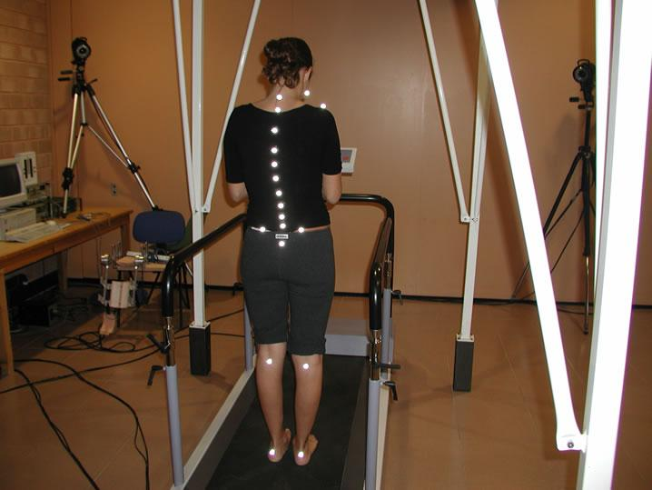
Figure 1. VICON Optical System
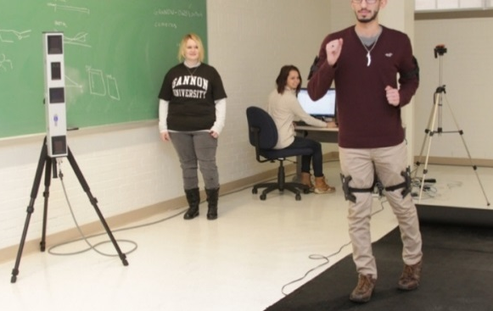
Figure 2. CODAmotion Optical System
Optical and visual systems such as VICON (Vicon Industries, Inc., NY, USA) or CODAmotion (Charnwood Dynamics Ltd., Leicestershire, UK) are widely used in research and clinical setting. Typical optical systems use markers to track the motion. Different markers are placed on different part of the subject’s body. Oftentimes, the software coming with the optical system can recognize the markers and simulate the subject’s body movements accordingly. Some motion trackers such as OptiTrack (NaturalPoint, Inc., OR, US) have the capability of simulating the subject’s motion in virtual space with so low latency that is close to real time. Also, increasing the complexity or length of the performance does not add any cumbersome tasks to the procedure. Moreover, if something goes wrong during the experiment, the examiner can reshoot the scene; It is much easier than manipulating the data. However, this is likely to happen in systems which have real time analysis. So the examiner is able to see the data as the experiment goes on [26-28].
Despite of the optical motion trackers’ accurate movement capturing result, they are not a proper choice for at home setting usages. Specific hardware and setup is needed for the operation. The relatively complex setting up procedure of the optical motion trackers requires personnel which makes prohibitive for small businesses. Depended on the camera field of view of magnetic distortion the capturing system may require specific definition of the space that it can operate in. Also, the experiment should be only done in camera range. Since these systems use their own software for simulation, not all the motions can be captured [27, 28].
Body-worn sensors are introduced as a reliable alternative for measuring physical activities. Wearable sensors have opened an avenue for non-invasive and accurate observation of patients’ body movement during research and clinical rehabilitation process and in real world setting [29, 30]. Among all body worn sensors, accelerometers have been used as an effective, non-invasive motion measurement system [30]. In comparison with other motion monitor devices, accelerometers have many advantages; Accelerometer based motion tracking systems are typically affordable, portable and easy to use [31]. They usually do not need manipulation when they are in use [29] and their small size and light weight have made it possible for any human subject to wear it during the day while having real world activities outside laboratories and in real world setting. Additionally, accelerometers are sensitive enough to detect even small motions [13, 29]. Comparing to other motion recognition systems such as commonly used VICON cameras, accelerometers offers a non-privacy-invasion system of motion recognition which makes them a more suitable choice for home monitoring [16].
Nowadays researchers widely use wearable accelerometers to get insight to the post-stroke patients’ activities of daily living [16]. However, there are still some drawbacks in using accelerometers as body motion detectors. It is challenging to separate the gravitational component from the inertial data without having additional data describing the accelerometer data. There are also some difficulties related to representing all the information at a single global frame since typically each accelerometer has its own moving frame, and the data are recorded on that frame of reference. Moreover, the location and orientation of the accelerometer on the subject’s body can influence the collected data. This issue usually arises when the examiner has no or limited experience in using accelerometers, or different examiners conduct the experiment. Yet, these drawbacks have the potential to compromise the quality of the recorded data [13, 15, 16, 32].
In several studies, participants were asked to keep a diary describing their everyday activities in addition to putting on wearable accelerometers during their activities of daily living. The first problem with this approach is using self-reported log sheets, which has many disadvantages as were mentioned in the previous section. Moreover, the subject should be able to read and write, which is not the case in many stroke survivors. Additionally, the extra effort and time that researchers and participants should put into keeping the diary in addition to the accelerometers, put some limits on recruitment procedure [33].
Evaluation of physical functioning has become increasingly important in stroke clinical research and rehabilitation therapy planning. Several performance assessments have been developed that correlate with other measures of health status and predict need for long-term care. There is evidence showing self-evaluation of ability and recovery improvement have low validity and high variability when are compared with measures of performance [34].
Stroke assessment scales can be categorized in five groups: (1) Prehospital stroke assessment, (2) Acute assessment, (3) Functional assessment (4) Outcome assessment and, (5) Other diagnostic and screening tests [35, 36]. The Fugl-Meyer Assessment was developed as the first quantitative evaluative instrument for measuring sensorimotor stroke recovery, based on sequential stages of motor return in the stroke patient. The Fugl-Meyer is a well-designed, feasible and efficient clinical examination method that has been tested widely in the stroke population [37]. Its primary value is the 100-point motor domain, which has received the most extensive evaluation. Based on available literature, the Fugl-Meyer Assessment is highly recommended as a clinical and research tool for evaluating changes in motor impairment following stroke [25, 37, 38].
Standardizing clinical motor assessments can be done using data based experiments; Quantitative data could be obtained by simultaneously recording data from accelerometers mounted on different parts of the body. The validation of the accelerometry data has been tested through various approaches and in different test conditions [16, 31, 32, 39]. Analyzing the recorded data can lead the researchers to identify some pre-defined activities. These pre-defined motions can later be decomposed into motion components to determine the movement patterns related to motor impairments and limitations [40]. Many researchers have focused on accurate post-stroke observation and data quantification. The development of miniature body-worn sensors, more specifically accelerometers, have opened countless possibilities of post-stroke monitoring in the field over extended periods of time [13, 41]. The ultimate goal of rehabilitation is sending back the patient to his real life environment. Wearable sensors allow clinicians and researchers to get insight into the patient’s recovery process where it matters the most, in the home and community settings.
The possibility of studying different clinometric variables and their properties using accelerometers have been investigated through literature [13]. In order to study the collected data, different properties have been measured [13, 31]. Many studies have been conducted regarding classifying post-stroke activities using body worn accelerometers. The focus of the majority of these works is on lower extremity [24]. Due to the complexity and higher degrees of freedom of upper extremity, fewer studies have been done in this regard. Studies have shown that accelerometry data can be used for measuring overall upper extremity activities [15]. Wearable accelerometers have been widely used for recording the amount of activity or inactivity of the upper extremity impaired limb over a time period [42]. The information obtained from the accelerometer is limited to speed and direction. However, a significant number of patients benefit if this data can be interpreted with clinical features in the hospital and home setting [43]. It has been shown that accelerometry data can be properly correlated with most clinical assessments such as Fugl-Meyer Assessment subscale for upper extremity [15, 42]. In 2012, Rand et al. [44] claimed that the gap between the expected recovery that is estimated by clinical measurements and the real performance improvement in the daily use of the impaired limb according to accelerometer data, suggests that present clinical measurement systems are not sufficient. Interpreting the accelerometry data with clinical assessments allows researchers and clinicians to get a deeper insight into the patients’ recovery improvement in their daily functioning [33, 45].
In this document, we propose an approach for estimating not only the amount of activity and inactivity of the impaired upper extremity limb but also the quality of the impaired limb physical functioning. This approach suggests that by analyzing accelerometry data, we can automatically obtain an evaluation of the patient’s recovery process. Automating the post-stroke physical monitoring opens an avenue to post-stroke home monitoring. By virtualizing the patient’s therapist, the patient has his/her therapist by his side all the time during his activities of daily living, where rehabilitation matters most. Health Centers and hospitals will benefit from this research as well the patient. Using the proposed system, they will have access to accurate information about the patient’s physical improvement during his activities of daily living. For health centers and hospitals, the system functions as if they have the patient tested all the time, without the physical presence of the patient. Thus, health centers and hospitals can spend more time, space and personnel to take care of other patients who cannot leave the hospital.
The National Institute of Neurological Disorders and Stroke (NINDS) is a component of the U.S. National Institute of Health (NIH) [46]. The NINDS is the main research sposnser of disorders of the brain and nervouse system [11]. These studies include the acute phase of stroke and recovering the brain abilities after the stroke damage. The Eunice Kennedy ShriverNational Institute of Child Health and Human Development is a part of the NIH which through its National Center for Medical Rehabilitation Research, invests in studies related to the mechanisms of post-stroke recovery and repair, as well as introducing and development of new approaches to rehabilitation and evaluation of results. The NIH’s National Institute on Deafness and Other Communication Disorders is interested and financialy helps studies on diagnosis and treatment of dysphagia [46]. From the Biomedical aspect, the National Institute of Biomedical Imaging and Bioengineering collaborates with NINDS and NICHD to develop new instrumentation for post-stroke treatment and rehabilitation. Also, the National Eye Institute financially asists work related to post stroke vision recovery and rehabilitation for individuals with impaired or low vision [11].
The NINDS funds work on approaches to enhance repair and recovery of the central nervous system (CNS). Scientists funded by the NINDS usually study the brain responds to experience or its adaption to stroke injury by reorganizing its functions (plasticity). Other NINDS funded researchers study brain’s post-stroke reorganization. They also look into the brain’s response to specific rehabilitative techniques, such as constraint-induced movement therapy (CIMT). They are interested in determining if methods such as CIMT and transcranial magnetic stimulation, can stimulate brain plasticity. By simulating the plasticity, the motor function will be improved and consequently, the post-stroke disability will be decreased. Other researched are dedicated to determination of the effect of experimenting with implantation of neural stem cells, on the probability of replacing the post-stroke damaged or died brain cells [11].[5]

Chapter three
post stroke quality of upper extremity motion estimation

Project Description
This project aims at estimating the post-stroke physical improvement in real world setting. In order to do so, the performance of the non-paretic limb was set as our reference as an un-faulty performance. Then, we investigated the patient’s overall post-stroke physical capabilities by asking them to perform some tasks according to the well-known Fugl-Meyer clinical assessment. The motion of both impaired and non impaired limbs were recorded using tri-axial motion monitors. In order to have an estimation of the paretic limb quality of motion, the kinematic data of the non-impaired limb was compared to the one of the paretic limb. In order to relate the kinematic data to the Fugl-Meyer score, which is our initial criteria for quality of motion, mathematical features representing the kinematic attributes of human limbs’ motion such as smoothness and coordination should be extracted and examined in contrast.
In this thesis, the quality of the post-stroke kinematic motion is formulated as a classification problem. In the designed classification model, we classify different performed tasks according to their Fugl-Meyer score which in turn, is a scale of the performed motion quality. This score is estimated visiually by the examiner therapist and will be explained in more details in following sections.
In order to collect the kinematic data required for our analysis, and the data presenting the quality of the performed motion task, an experiment was designed and held at the UT Medical center. During the experiment, the subject with post-stroke physical impairment was asked to wear motion monitors. Then the examiner therapist asked the patient to perform tasks according to the Fugl-Meyer assesment subscale for the upper extremity. The patient’s quality of motion estimation is expressed as the Fugl- Meyer score and was recorded by the examiner therapist. During the experiment, the patient’s motions kinametic data were collected and recorded by the installded motion monitors.
After collecting the kinematic data, data segmentation is applied. In data segmentation, each segment of the kinematic data corresponding to performing each of the Fugl-Meyer tasks is isolated for further analysis.
In favor of interpreting the kinematic data collected from the motion monitors with the Fugl-Meyer scores that were recorded by the examiner therapist, one or more measurement features should be explored in kinematic data that are sensitive to the quality of motion’s characteristics. In this research, we care about motion characteristics such as accuracy, speed, coordination and smoothness.
Machine learning supervised classification methods were used in this thesis to classify our kinematic data according to their obtained Fugl-Meyer score. As it was mentioned earlier, these scores give an estimation of the patient’s capabilities of performing the required tasks.
A prediction framework can be developed using the classification results. This prediction framework categorizes the new set of kinematic data set according to its estimated Fugl-Mayer score. In other words, our classification model categorizes different tasks according to their obtained Fugl-Meyer score and the prediction model, uses the classification model results to classify the new set of data and label it with the most probable Fugl-Meyer score that the new kinematic data would gain. Figure 1 shows a flowchart of the proposed algorithm.
Data Collection (Experiment)

Measurement Feature Extraction
Developing the Prediction Model and Estimating the Quality of Motion

Data Segmentation
Classification
Figure 3. Flowchart of the proposed algorithm to analyze accelerometer data and derive estimates of the FMA score
In what follows, each of the steps shown in Fig. 1 is explained in more depth and details.

Data Collection
Experimental Procedure

Participants
The subject recruitment was done at the UT Medical Center, and the experiment procedure is approved by the University of Tennessee Institutional Review Board. All participants are provided with informed consent before the experiment. Eight participants were recruited. In order to satisfy the inclusion criteria, each participant should: (1) have a positive stroke on their head CT or MRI; (2) exhibit resulting unilateral weakness of the upper extremity; (3) have cognition sufficient to follow simple commands; (4) have fair vision, and (5) have sufficient activity tolerance to sit upright and participate in the experiment. People with the following conditions were excluded from testing: (1) completely flaccid upper extremity; (2) poor cognition (leading to inability to follow commands); (3) severe vision deficits and blindness; and (4) residual weakness from a previous stroke. Pregnant women, prisoners and people less than 18 years old were excluded as well.

Apparatus and Measures
Each participant wears five APDM Opal motion monitoring sensors (APDM Inc., OR, USA).
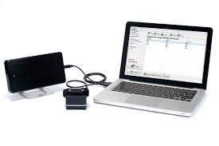 | 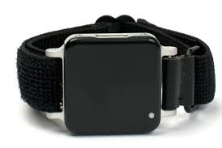
(a) APDM Docking Station and Access Point | (b) Wrist APDM motion
Figure 4. APDM Motion Monitor
These motion sensors contain a tri–axial accelerometer, rate gyroscope, and magnetometer (the latter was not used in our analysis). They can record 12-16 hours of data, depended on their different recording modes. Table II shows this sensors specifications.
Four of these motion monitors were placed on the participants’ wrists and bilateral upper arms near the elbow in favor of capturing motion data resulting from upper extremity movement. The fifth sensor was placed on the subject’s chest in order to record trunk kinematic data. Sensors were attached to the subject’s limbs using latex–free bandages for sanitary purposes and to minimize noise due to soft tissue motion. Figure 3.a shows the sensors’ position and orientation on the subject’s body. Figure 3.b depicts a participant during the experiment in a clinical setting.
Table 1. APDM Sensor Characteristics
 | Accelerometer | Gyroscope | Magnetometer
Axes | $$3 axes$$ | $$3 axes$$ | $$3 axes$$
Ranges | $$±6g$$ | $$±2000 {deg}/s$$ | $$± 6 Gauss$$
Noises | $$0.0012 m/s²/√Hz$$ | $$0.05 deg/s/√Hz$$ | $$0.5 mGauss/√Hz$$
Sample Rate | $$128 Hz$$ | $$128 Hz$$ | $$128 Hz$$
Bandwidth | $$50 Hz$$ | $$50 Hz$$ | $$50 Hz$$
Resolution | $$14 bits$$ | $$14 bits$$ | $$14 bits$$

Data from the two wrist–worn sensors are used for the first this research objective. The examiner therapist instructs each participant to perform a subset of tasks according to the upper extremity motor function Fugl-Meyer assessment and kinematic signals resulted from the patient’s movement are recorded using motion monitors. Fugl-Meyer assessment is a stroke-specific, performance-based impairment index with a three-point (0-2) scale. Score of 0 indicates the patient’s disability to conduct the task where a score of 2 means that the patient was able to conduct the task flawlessly. This well-known stroke clinical index is designed to assess motor functioning, balance, sensation and joint functioning in patients with post-stroke hemiplegia. Fugl-Meyer is specifically designed to assess the functional mobility of stroke survivors during their activities of daily living. Depended on the stroke survivor’s severity of brain damage it may takes about 6-30 minutes for the subject to go through the assessment. The Fugl-Meyer assessment is designed for the hemiplegic patients of all ages. It is also known as one of the most reliable assessment in test-retest scenario [35-37].
The performed subscale of Fugl-Meyer upper extremity motor function tasks in this project include synergy, out of synergy, combination of synergies, wrist/hand function, and fine motor coordination. According to the Fugl-Meyer procedure, the clinician scored the participant according to the three point (0–2) scale [8], [9]. A sample form of FMA used for the experiment is attached to this document. Participants repeats each task three times according to the instructor therapist, and the best attempt is scored. Scores are then totaled to give a resulted score of 66 possible points with lower scores representing greater impairment. In addition to collecting kinematic data and the Fugl-Meyer scores, the whole experiment is video recorded. Table II shows the participants demographic.
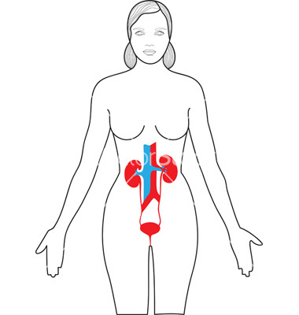
x-axis

y-axis
 | 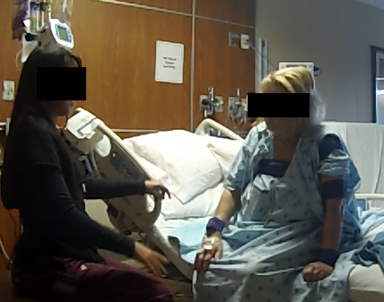
(a): Schematic representation of the motion monitor sensors location on the subject’s body during the experiment | (b): APDM motion monitors positioned on the participant during  administration of the FMA
Figure 5. Motion Monitors on the Subject's Body

Table 2. Demographics of Study Participants
Participant | Sex | Age | Lesion Side | Dominant Side | FMA Score
1 | F | 32 | R | L | 17
2 | F | 68 | R | R | 48
3 | F | 69 | L | L | 53
4 | M | 87 | R | R | 36
5 | F | 44 | L | R | 45
6 | F | 78 | L | R | 4
7 | F | 87 | R | R | 30
8 | M | 65 | R | R | 27

Data Preparation
After data collection, the kinematic data and patients’ IDs should be matched. To do so, first, we match the recorded videos to the subjects’ IDs. The order of the recorded videos is consistent with the order of the performed tests. Hence, the order of recorded videos is compatible with the order of different patients’ IDs. Using the videos, the length of each participant’s experiment is extractable. The paper documents from the hospital show the date that the test was conducted for each participant. Having the date and length of each experiment, the dataset related to each experiment can be matched. Having all of this information, the kinematic datasets, videos and paper documents, which also contain each patient’s Fugl-Meyer score, can be matched.

Kinematic Data Segmentation
Since each task is scored separately during the experiment, the raw kinematic data associated with each task should be isolated. Data segmentation is performed using synchronized video and the information that were extracted from the video. In this project, data segmentation is done manually. The start time and finish time of each task for each subject are extractable using the corresponding recorded video. The difference between the start time and finish time of each task shows the time duration of each task. Table III shows a sample of the extracted information from the experiment recorded video.

Table 3. Information extracted from the experiment’s recorded video
 | Left Wrist |  |  |  | Right Wrist
Motor Function | Start |  | Finish |  | Start |  | Finish
Motor Function | Time | Frame | Time | Frame | Time | Frame | Time | Frame
Sensor Tapping | 0:16 | 464 | 0:17 | 494
Reflexes biceps | 5:27 | 9483 | 5:30 | 9571 | 6:09 | 10705 | 6:13 | 10817
Reflexes triceps | 5:53 | 10237 | 5:59 | 10411 | 6:25 | 11165 | 6:35 | 11455

Having the time duration for each task, the segmentation windows can be produced. The isolated data for each task is demonstrated by the green and black lines in Fig. 4.b., respectively representing the start and stop times. In other words segmentation converts Fig. 4.a to 4.b. In Fig 4.c, the flexor synergy task’s kinematic data is isolated to show more details. This flexor synergy is the task that shows itself as fluctuations in figure 6.a happening between time 777 and 786 that is magnified in figure 3.c.
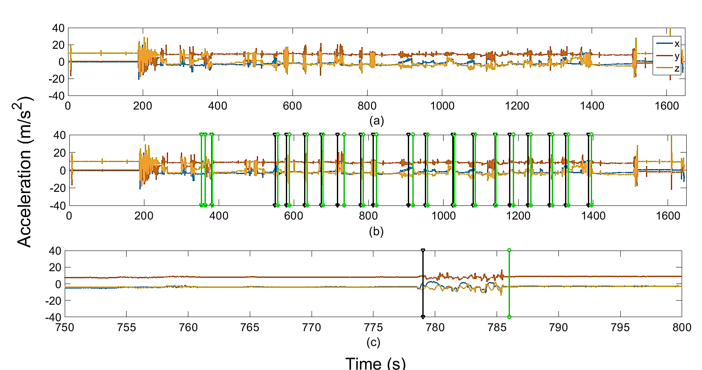
Figure 6. a) Raw kinematic data, b) Kinematic data after segmentation, c) An isolated task

Kinematic Data Measurement Feature Extraction
In order to interpret the kinematic data with meaningful clinical qualities, specific measurement features of the data should be extracted which are sensitive to mechanisms of human movement such as smoothness, speed, and coordination. In this study, we use four measurement features that are the most commonly used features in studies investigating the relation between the clinical assessments evaluating the quality of motion and kinematic data. These measured features are derived for each single tasks and for three time series data: acceleration, gyro, and jerk. Acceleration and rate of gyro values can be read directly from the sensors. Jerk, which gives a sense of smoothness of motion, is driven by getting the first derivation of acceleration. It is calculated for the whole acceleration signal and separately for each axis.
$$\vec{j}\left(t\right)=\frac{d\vec{a}\left(t\right)}{dt}=\dot{\vec{a}}(t)$$ | (1)
Then we calculate the measurement attributes for each axis separately. Participants performed a total of 23 scored tasks. For each task $n$, we computed the gesture matrix$D_{j}$ as follow:
$$D_{n}=\left[\left[{F_{1}}_{1×3}\right] [{F_{2}}_{1×3}] […] [{F_{n}}_{1×3}]\right]$$ | (2)
Where ${F_{i}}_{1×3}$ shows the derived measured feature and $n$ is the number of extracted features for each research objective. The subscript $1×3$ indicates that each component of the matrix $D_{j}$ in Eq. (2) is computed separately for each axis of data ($\hat{x}, \hat{y}$, and$\hat{z}$). Matrices $D_{j}$ are calculated for acceleration ($ẍ$), angular rate of change ($q̇$), and jerk$x^{(3)}$. In this study we used four post-stroke kinematic measurements that are the most commonly used features in the literature: Root Mean Square (RMS), mean value, entropy and dominant frequency. The root mean square also known as quadratic mean, is defined as the square root of mean of squares of a set of number. The root mean square or RMS of a set of n values as $\left\{x_{1},x_{2},⋯, x_{n}\right\}$ is defined as:
$$x_{rms}=\sqrt{\frac{1}{n}(x_{1}^{2}+x_{2}^{2}+⋯+x_{n}^{2})}$$ | (3)

The mean value has a similar definition to the RMS. In problems with discrete values, mean value is defined as the sum of the variables over every possible value weighted by the probability of that value. In simple cases, where the probability weight of all variables is the same, the mean value will be defined as:
$$\overline{x}=\frac{x_{1}+x_{2}+⋯+x_{n}}{n}$$ | (4)
In this project, by entropy, we are referring to Shannon entropy. Shannon entropy is a measure of random variables in a continuous probability distribution. In this project, we used Matlab (MathWorks, Inc., MA, USA) function wentropy() to calculate our signal’s entropy using following equation:
$$E\left(s\right)=\sum_{i}{E(s_{i})}$$ | (5)
Where $s$ is the signal and ${\left(s_{i}\right)}_{i}$ is the coefficient of $s$ in an orthonormal basis [47]. Entropy and dominant frequency are frequency domain features. I order to calculate them, the signal should be transferred from time domain to frequency domain using Fourier transform function. In order to transform the discrete time series of $x_{0},x_{1},⋯,x_{n}$ to an N-periodic sequence of complex numbers we use equation (6).
$$X_{k}=\sum_{n=0}^{N-1}{x_{n}.e^{-2πikn/N}}$$ | (6)
Equation above can be interpreted to the discrete-time Fourier transform (DTFT) as follow:
$$X\left(ω\right)=\sum_{n=-∞}^{∞}{x[n]e^{-iωn}}$$ | (7)
Dominant frequency is the frequency that occurs most often in a signal. In this project, we obtained the dominant frequency correlated with the isolated signal of each task.
After calculating all attributes, the gesture matrices $D_{n}$s are developed according to Eq. 1:
$$D_{n}=\left[\left[RMS_{1×3}\right] [Mean_{1×3}] [Enrtopy_{1×3}] [Dominant frequenc_{1×3}]\right]$$ | (8)
Where $n$ is the number of the task. For each task, four measurement features are calculated for three axis of three time series acceleration, gyro and jerk. Hence, the number of attributes for each task will be$4×3×3=36$. Each person performs a total number of $23$ tasks according to Fugl-Meyer upper extremity subscale. We recruited eight subjects. Therefore, the total number of attributes for our study will be: $8×23×\left(4×3×3\right)=6624$ .
In order to normalize the Fugl-Meyer score between all participants, we calculated the measured features, RMS, mean value, entropy and dominant frequency, for the impaired limb and divided each attributes to its corresponding of the non-impaired limb’s, and create a matrix of the ratio of our measurements. The resulting feature matrix for participant $i$ was then obtainable as:
$$P_{i}=\left[\begin{matrix}\begin{matrix}\begin{matrix}D_{T_{1}}(ẍ) \\ D_{T_{2}}(ẍ) \end{matrix} & \begin{matrix}\begin{matrix}D_{T_{1}}(\dot{θ}) \\ D_{T_{2}}(\dot{θ})\end{matrix} & \begin{matrix}\begin{matrix}D_{T_{1}}(x^{(3)}) \\ D_{T_{2}}(x^{(3)})\end{matrix}\end{matrix}\end{matrix}\end{matrix} \\ \begin{matrix}⋮ \\ \begin{matrix}\begin{matrix}D_{T_{23}}(ẍ) & D_{T_{23}}(\dot{θ})\end{matrix} & \begin{matrix}D_{T_{23}}(x^{(3)})\end{matrix}\end{matrix}\end{matrix}\end{matrix}\right]$$ | (9)

Fugl-Meyer scores need to be normalized as well. It should be noted that instead of using the FMA scores in our analysis, we used a normalized or summarized value derived from the Fugl-Meyer scores. The reason for this normalization is the scoring criteria variety over different tasks. For example, movement synergy tasks are scored three times between 0-2 (for hand, shoulder flexion, and forearm pronation) while wrist rotation was scored once. So the maximum obtainable score for movement synergy is 6 ($3(scoring criteria)×2(maximum score for each scoring criteria)$) while the maximum achievable wrist rotation score will be 2. In order to normalize our scores, we used a summarized scores which were calculated as the sum of all obtained scores divided by the maximum obtainable value. Table III shows an example of two performed tasks with different number of scoring criteria.

Table 4. Fugl-Meyer Scoring form for two different tasks
Task | Criteria | score
Extensor Synergy | Shoulder add./int rot |  | 0-Cannot be performed  1-Performed partly  2-Performed faultlessly
Extensor Synergy | Elbow Extension
Extensor Synergy | Forearm pronation
Wrist | Circumduction |  | 0-Cannot be performed  1-performed partly  2-Performed faultlessly

Classification and Prediction
The estimation of quality of the impaired limb motion is formulated as a classification problem. Our classification model will classify our tasks according to their obtained Fugl-Meyer score. Therefore, all tasks receiving the same Fugl-Meyer score are categorized in one class.
Then, we use a supervised machine learning method to find the most important attributes in our classification. In machine learning supervised learning is referred to inferring a function from labeled training data [48]. In this kind of learning, each input object has an output. Supervised Leaning methods try to find an interfering function which can map the training data to the desire labels. In an optimal case the function will be able to map the new set of data to its potential label flawlessly. In order to use supervised learning algorithm, first we need to define our training set. In this project all the extracted attributes for each task were passed to out machine learning classification model as the training set. Then the summarized Fugl-Meyer scores were passed to the supervised learning model as the labels. In designing our classification model, all attributes corresponding to one task are fed to the model with the obtained Fugl-Meyer score which is the classification labels.
Equations (10-11) show the input training set and label matrices.
$$input matrix=$$ | (10)
$$\left[\begin{matrix}RMS(P_{1},T_{1}) & Mean(P_{1},T_{1}) & Entropy(P_{1},T_{1}) & Dominant Frequency(P_{1},T_{1}) \\ RMS(P_{1},T_{2}) & Mean(P_{1},T_{2}) & Entropy(P_{1},T_{2}) & Dominant Frequency(P_{1},T_{2}) \\ ⋮ & ⋮ & ⋮ & ⋮ \\ RMS(P_{1},T_{23}) & Mean(P_{1},T_{23}) & Entropy(P_{1},T_{23}) & Dominant Frequency(P_{1},T_{23}) \\ RMS(P_{2},T_{1}) & Mean(P_{2},T_{1}) & Entropy(P_{2},T_{1}) & Dominant Frequency(P_{2},T_{1}) \\ RMS(P_{2},T_{2}) & Mean(P_{2},T_{2}) & Entropy(P_{2},T_{2}) & Dominant Frequency(P_{2},T_{2}) \\ ⋮ & ⋮ & ⋮ & ⋮ \\ RMS(P_{8},T_{23}) & Mean(P_{8},T_{23}) & Entropy(P_{8},T_{23}) & Dominant Frequency(P_{8},T_{23})\end{matrix}\right]$$

$$Labels=\left[\begin{matrix}FMS(P_{1},T_{1}) \\ FMS(P_{1},T_{2}) \\ ⋮ \\ FMS(P_{1},T_{23}) \\ FMS(P_{2},T_{1}) \\ FMS(P_{2},T_{2}) \\ ⋮ \\ FMS(P_{8},T_{23})\end{matrix}\right]$$ | (11)
In equations (10, 11), $Q(P_{m}, T_{n})$ shows that value $Q$ is calculated for the task $n$ that patient number $m$ did. In equation (11), $FMS$ stands for the Fugl-Meyer score; $FMS(P_{m}, T_{n})$ shows the summarized score that the patient number $m$ obtained for performing task number$n$. Calculating the summarized score is described in the previous section.
Two supervised machine learning methods are used in this paper and their results are compared. These two algorithms are: 1) Decision tree and, 2) Bootstrap Aggregating Forest

Decision Tree
The Decision Tree (DT) algorithm is one of the commonly used supervised learning classification methods in post-stroke kinematic data analysis. They are widely used in operations research especially in decision analysis. They are commonly used to find the strategy that is the most probable path to reach a goal. Moreover, they are also a well-known tool in machine learning classification problems.
Decision tree is a flowchart-like structure in which each internal node represents a test on an attribute, each branch represents the outcome of the test, and each leaf accounts for a class label (decision taken after computing all attributes). The paths from the root to a leaf represents classification rules. It does a good job in depicting an algorithm. One of the advantages of DT is its visual representation of data which allows observing all possible classes, as well as the likelihood of each label. Each node of a DT shows features automatically selected by the algorithm from equations (1-4,). Consequently, one of the strength points of DTs over other classification algorithms is its ability to automatically prioritize the significance of the measured features. When decision trees are used for classifying a set of data, the top few nodes are the most important variables within the data set and the lowest nodes are less significant. Other attributes that are not presented in the decision tree are unlikely to have any role in classifying the dataset in hand. Finally, DTs require relatively little effort from users for data preparation when compared to other machine learning approaches. For these reasons, we chose DTs as a classification approach. Figure 7 shows the grown DT for participant number 4 resulted from attributes measured for the first research objective of the project.
Decision tree learning resorts decision trees as a predictive model to map the input training data set to the desired labels. This predictive model is commonly used in statistics, data mining and machine learning. Decision trees learn by splitting the training data into subsets based on an attribute value. Then the same splitting process is repeated for each derived subset of data and new subsets will be derived based on independent attributes. This process is called Recursive Partitioning. It is known as a recursive process since the splitting process may continue infinitely until a stopping criteria terminates the process. In an ideal case, the splitting is completed when all the subset presented at a node have the same label. However, due to the danger of overfitting, the splitting process in terminated at a certain degree of impurity. Impurity can be defined as the maximum percentage of the training data samples in a node that do not have the same target label value as the other subset of data at the same node. This process is an instance of a greedy algorithm and is the most common algorithm used by learning decision trees. Greedy algorithms are algorithms that use problem solving heuristic model to make the optimal local choice with the hope of finding the best global model. In general, there are two types of decision trees: Classification tree and, Regression tree. Classification trees are used when the outcome of the analysis is a class of data. On the other hand, regression trees labels are real numbers. The main difference in classification tree and regression tree procedure is determining where to split the data [49].
In a decision tree, assume that the learning data set $L$ is in the form of$\left\{\left(y_{n}, x_{n}\right), n=1,⋯,N\right\}$; In which $y_{i}$s are the class labels corresponding to data set $x_{i}$. The developed prediction function is $Φ(x,L)$. If data set $x$ is fed to $Φ$, label $y$ is the predicted label.

Bootstrap Aggregating Forest
Bootstrap Aggregating Forest, a.k.a. Bagging Forest is an ensemble machine learning approach. Ensemble methods use multiple algorithms or models to build a superior predictive model comparing to those that were individually obtained. Bagging was first introduced by Breiman [50] in1994. Forests grow a number of DTs. To classify a new object, the input vector is fed to each tree within the forest. The forest turns the output label with the most votes as the result. The Bagging Forest capability of classifying unstable data can be pointed out as one of its most significant advantages [50].
Continuing the technical math discussion from the decision tree section, assume that there is a sequence of learning sub-sets $L_{k}$ every of which has $N$ independent observation from the original data set$L$. We replace $Φ(x,L)$ by $Φ(x,L_{k})$. Assume that $Φ(x,L)$ predicts a class$j∈ \left\{1,⋯, J\right\}$, and $N_{j}=nr\left\{k;Φ\left(x,L_{k}\right)=j\right\}.$Then $Φ_{A}=argmax_{j}N_{j}$ where, subscript $A$ shows aggregating. So in the case of the classification, and not regression, the algorithm returns the most voted label as the predicted label for the fed data set. For more technical details, the reader is referred to [50, 51].
As the number of trees ($L_{k}$) in a forest grows, the cost of calculation and the probability of over–fitting increases. To the best of the author’s knowledge, there no straight forward analytical method of determining and estimating the optimal number of trees in a given forest is introduced so far. In general, the number of grown trees in a forest is a compromise between data over–fitting and classification error. Considering the number of data sets in this study, seven trees were grown for each Bagging Forest. Similar to the DTs, we used the summary scores as class labels.
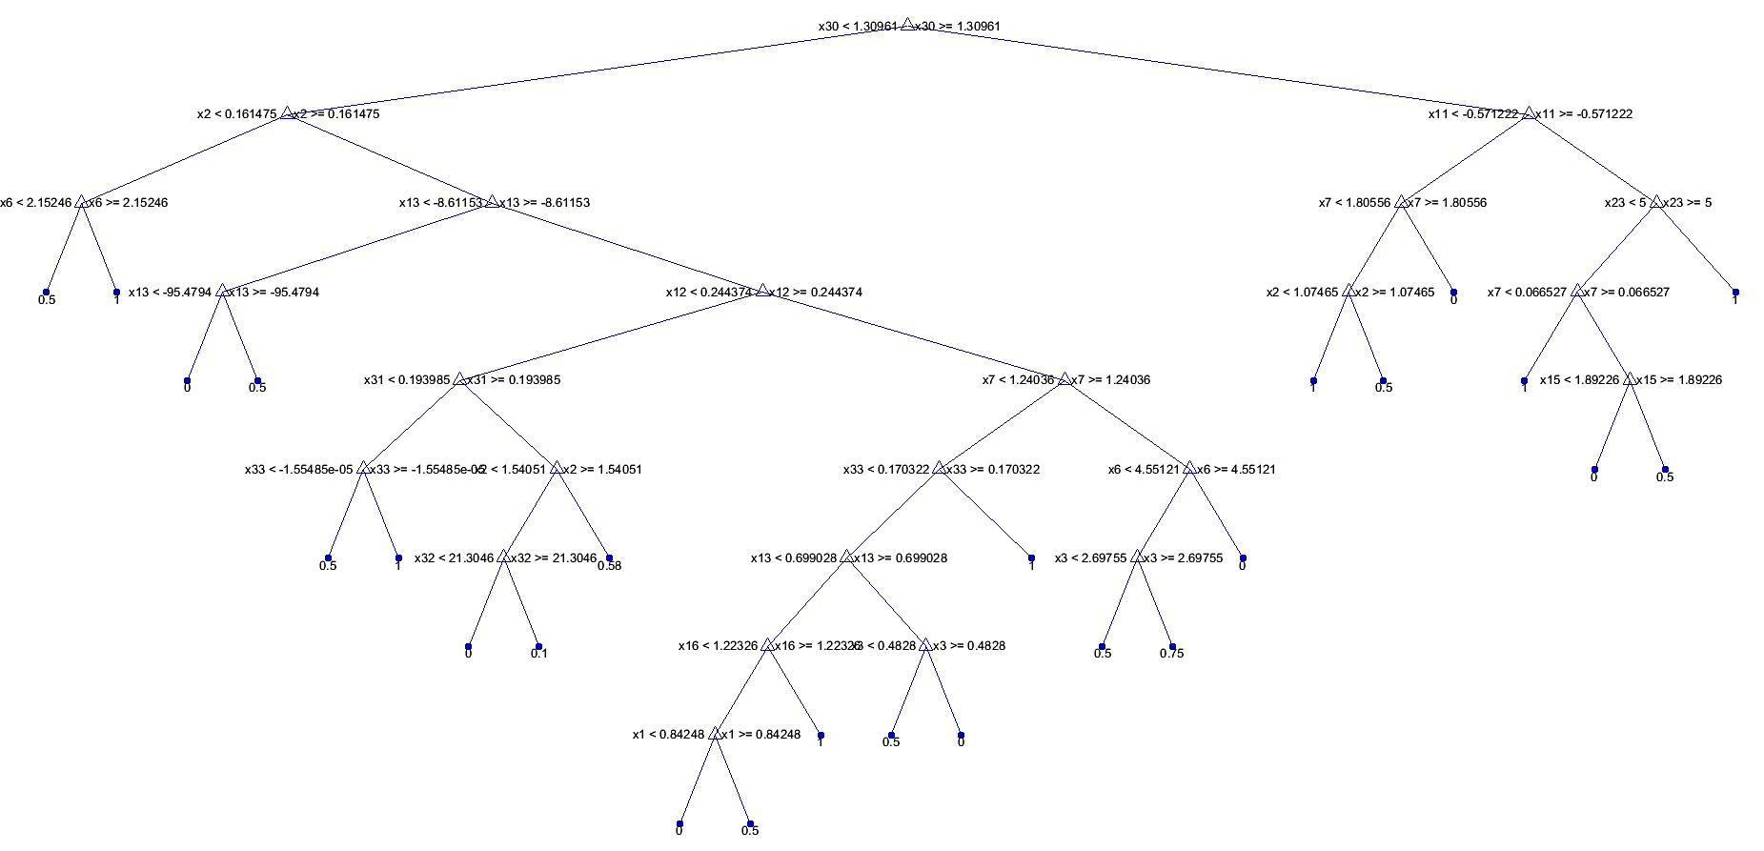
Figure 7. Generated Decision Tree for Participant No. 2

Predictive Model Validation
In order to evaluate the classification accuracy of the two resorted approaches, the Leave One Out (LOO) cross-validation method is used [52]. LOO is widely used in problems where the goal is predication. It is also known as Jackknife. LOO cross-validation is one of the comprehensive cross-validation methods that breaks down the original data set into a learning data set and a test data set; this is done by leaving one data set out as the test data to estimate the prediction accuracy [52], [53]. LOO cross-validation performs dividing the initial data sets into learning and validation $C_{n}^{1}=n$ times, where $n$ is equal to the number of data sets. For this reason, LOO cross validation is recommended for relatively small data sets [52].
Confusion matrices are utilized to visualize the performance of each classification methods. Each row of a confusion matrix shows the instances belonging to an actual class while each column shows predicted values [54]. Various metrics may be utilized to evaluate the accuracy of model prediction based on the confusion matrix [54]. The Rate of False Discovery (FDR) is used in this project to find the relaying error of prediction, which can be expressed as:
$$FDR=\frac{FP}{FP+TP}$$ | (12)
Where $FP$ is the number of false positives and $TP$ stands for the number of true positives. Equation (13) shows an example of confusion matrix calculations for participant 8 using methods DT, Eq. 13.a, and Bagging Forest, Eq. 13.b.
$$C_{DT}=\left[\begin{matrix}0 & 0 & 0 & 0 & 0 \\ 1 & 2 & 0 & 0 & 0 \\ 2 & 0 & 0 & 0 & 0 \\ 0 & 0 & 0 & 1 & 0 \\ 0 & 1 & 0 & 0 & 12\end{matrix}\right]$$ | (13.a)
$$C_{Bagging}=\left[\begin{matrix}3 & 0 & 0 & 0 \\ 0 & 2 & 0 & 0 \\ 0 & 0 & 1 & 0 \\ 0 & 0 & 0 & 13\end{matrix}\right]$$ | (13.b)

The corresponding FDR errors can then be calculated as:
$${FDR}_{DT}=\left(\frac{(1+2+1)}{(1+2+1)+(2+1+12)}\right)×100=21\%$$ | (14.a)
$${FDR}_{Bagging}=\left(\frac{0}{(3+2+1+13)}\right)×100=0\%$$ | (14.b)
The mean FDR value for all LOO cross-validation attempts trials was calculated.
$$FDR_{mean}=\frac{FDR_{1}+FDR_{2}+⋯+FDR_{8}}{8}$$
The result value was used to define the total error for each approach. The resulting $FDR_{mean}$ for the DT and Bagging Forest approaches (for$n$ trials, $n=8$) were compared using the paired t-test at the 5% significance level. Statistical test t-test is a commonly used method to determine if two data sets are significantly different. It is a test of null hypothesis that indicates if the difference of the mean value of two data sets, which were measured with the same units, is zero.

Chapter four
Results and Discussion
Data collection and preparation is done according to what was explained in chapter three. In order to interpret the post-stroke kinematic data with clinical features, some attributes of the data should be extracted which are capable of representing the characteristics of the nature of human upper extremity movements such as speed, smoothness and accuracy.
After data collection and data preparation, gesture matrices were produced according to equations (8, 9). These gesture matrices are used along with the summarized Fugl-Meyer score obtained for each task in the form of equations (10, 11) to develop a classification model. The classification model then were used to generate our predictive model to estimate the quality of the new set of kinematic data according to the Fugl-Meyer standard. We used both DT and Bagging forest methods to create our prediction system. LOO cross validation method was then resorted to evaluate the accuracy of our predictive frameworks as described in chapter three.
Figure 8 depicts a summary of the proposed frameworks outcomes. The Bagging Forest approach results show statistically significantly lower FDR error than the DT ($t\left(7\right)=5.6756, p<0.001$, Figure 5). The mean value of error for the Bagging Forest approach ($2.5±2.5\%$) was lower than that of the DT method ($18.2±9.5\%$).
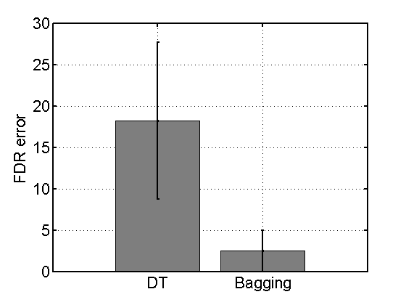
Figure 8. FDR Prediction Error for the DT and Bagging Forest Methods

Decision Tree
The DT approach has many advantages that make it a suitable choice for classification of post-stroke kinematic data. The visual representation of data in DTs provides the opportunity to observe all alternatives for a solution and the associated possibility of each label’s occurrence. When decision trees are used for classifying a set of data, the proximal (primary and secondary) nodes are the most sensitive features within the data set measured features while the furthest nodes show the least sensitive features. Since we had eight subjects in this study, the LOO cross-validation algorithm was performed $C_{8}^{1}=8$ times. In every LOO attempt, one of the patient’s data set is left out as the test data set. The prediction model developed using DT results showed that the entropy of acceleration (of all three axes) was the primary node in all trees. The entropy of $x-$axis acceleration was the most important variable in our data classification, appearing as the primary node for 75% of all DTs that were generated by the LOO cross validation approach. In the remaining 25% of DTs, the $y-$ and $z-$ axis of entropy of acceleration were the primary nodes. Figure 9 shows all the measured features that appeared in the first two nodes of our DTs in eight LOO trials. Additionally, about 75% of the secondary nodes of all DTs were frequency domain features. The combined $83.3\%$ representation of frequency domain features in the primary and secondary nodes of the DTs shows the high sensitivity of frequency domain features to post stroke kinematic motion quality which is consistent with the literature [55, 56]. Additionally, some Fugl-Meyer tasks (such as those requiring motion synergy) may be similar in the frequency domain but not the time domain. This conclusion is consistent with the existing literature [57].
Furthermore, features extracted from acceleration and jerk appeared in approximately 80% of all primary and secondary nodes, and gyro rates showed up is approximately 20%. This finding emphasizes on the significance of acceleration and acceleration–derived features relative to gyro data in our classification method. Acceleration and jerk are known to be representors of the motion smoothness, while gyro can be a good criteria for coordination. The obtained results demonstrate and explain the ability of the DT approach in providing rich information from exploratory analyzes.
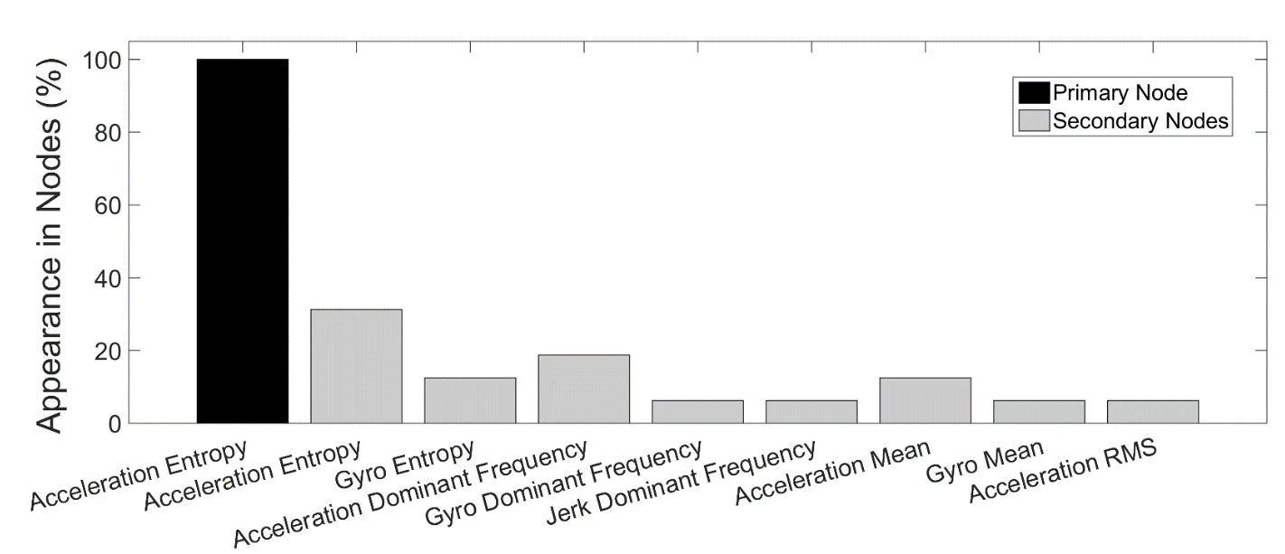
Figure 9. Representation of Measured Features in Two Primary Nodes

Bagging Forest Approach
Despite the informative results that we obtained using DT method, the mean value of FDR error of $18.2\%$ for the DT approach may be unsatisfactory for analyzes of motion outside of the clinical setting considering unpredicted disturbances that our system will experience in real world. As shown in figure 10, Participants 1 and 6 have significantly lower FMA scores relative to other subjects. This instability of data set resulted in prediction accuracy variability across the different LOO cross-validation attempts. A data set is considered unstable if small changes in the training set results in large changes of the predicted value [58]. The instability of data suggested the use of machine learning ensemble methods which are known to excel in analyzes dealing with unstable data [50],[58, 59]. Unlike the more commonly used Random Forest approach which searches through a specific number of features to find the best features for growing trees, the Bagging Forest algorithm searches at each node of a tree for the attributes that best splits the data at that node. We chose a set of features known to be relevant to post-stroke kinematic data classification for our analyses. Considering this and the capability of Bagging Forest over Random Forest in classifying unstable data, Bagging Forest was chosen for our further analysis [13].
The thorough search algorithm of the Bagging Forest for growing the best trees for classification and its privilege in classifying the unstable data sets resulted in a low error rate for our data. The 2.5% FDR error of our Bagging Forest model confirms that this approach can be used as a reliable classification algorithm in the presence of unstable data.
Despite the Bagging Forest accurate estimation of the FMA scores, there are certain drawbacks in using this classification method. The Bagging Forest is a machine learning black box approach, which makes an intuitive interpretation of the results almost impossible [51]. Hence, we are unable to hypothesize readily why the performance of one forest differed from the others. However, a post hoc investigation of our results indicates that that the maximum error of 5% (the highest error in Bagging Forest) occurred when Participant number 6’s data (one of the two unstable data sets) were left out as the test data set. This finding indicates although the Bagging Forest approach is less sensitive to this instability when compared to the DT method, the instability of data still affects the result and remains apparent.
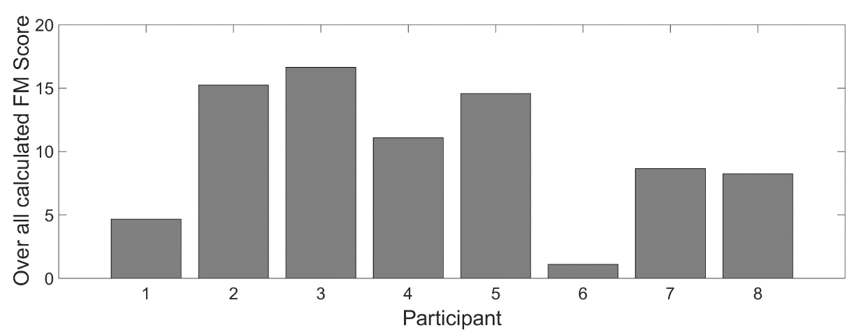
Figure 10. Summarized FM Score for each participant

Study Limitations
It is important to point out certain limitations of the current research. First, the sample size is limited. Further validation of this method requires evaluation on a larger more diverse population of participants. Further, the FMA was administered in an active rehabilitation inpatient center. Therefore, there were certain environmental distractions during testing. Additionally, the acuity of illness of our participants resulted in the need for frequent rests or broken–up sessions. Finally, the use of 2 examiner therapists may have increased variance in clinician scoring on the FMA. In future work, we will collect data from additional participants in order to improve the model through the investigation of other clinically meaningful features. Also, we will investigate a wider range of activities of daily living inspired tasks performed outside of traditional laboratory or clinical settings in order to investigate the ecological validity of ambient activity measurement.

Chapter
Scientific Significance and Broader Impact:
The increasing rate of daily smoking, physical inactivity, being overweight, having high blood pressure, and diabetes suggests an increasing rate of stroke occurrence probability in near future. A large share of the average $100,000 post-stroke treatment costs goes to the hospitals. This massive cost can be reduced by discharging the patient for the hospital and still have him/her under the virtualized therapist’s monitor. This study opens an avenue to evaluating the post-stroke physical improvement in real world setting. Using accelerometry-based sensors for human motion monitoring, suggest an accurate post-stroke motion tracking without interrupting the patients during his/her activities of daily living or invasion of his/her privacy. In the big picture, our system helps the patient to return to his activities of daily living and still be under the monitor and receives feedbacks for the best rehabilitation results. This project helps to virtualize the physical and occupational therapists while allowing the patient to have their support and feedback all the time at a significantly lower cost.
The methodology used in this research can be developed to be used in other clinical studies. In future explorations, the accurate kinematic data quality predictor formulated in this project can be resorted to estimate patients’ scale of pain, strength, soreness, muscle contraction, etc. The developed method along with task recognition frameworks will be a complete at home post-stroke monitoring system.

References

1. Organization, W.H., Global tuberculosis control: WHO report 2010. 2010: World Health Organization.
2. Go, A.S., et al., Heart disease and stroke statistics--2013 update: a report from the American Heart Association. Circulation, 2013. 127(1): p. e6.
3. Mozaffarian, D., et al., Heart Disease and Stroke Statistics-2015 Update A Report From the American Heart Association. Circulation, 2015. 131(4): p. E29-E322.
4. Heidenreich, P.A., et al., Forecasting the future of cardiovascular disease in the United States a policy statement from the American heart association. Circulation, 2011. 123(8): p. 933-944.
5. Control, C.f.D. and Prevention, Vital signs: awareness and treatment of uncontrolled hypertension among adults--United States, 2003-2010. MMWR. Morbidity and mortality weekly report, 2012. 61: p. 703.
6. Gorelick, P.B., et al., Prevention of a first stroke: a review of guidelines and a multidisciplinary consensus statement from the National Stroke Association. Jama, 1999. 281(12): p. 1112-1120.
7. Schwartz, S.H. and M. Wild, Traumatic brain injury. Medical, psychosocial, and vocational aspects of disability, 2009: p. 209-221.
8. Juliah, M.M., Experiences and coping strategies 3 months post-stroke of patients in Harare and Chitungwiza: 3 months follow-up prospective study. 2014.
9. Boivie, J., G. Leijon, and I. Johansson, Central post-stroke pain—a study of the mechanisms through analyses of the sensory abnormalities. Pain, 1989. 37(2): p. 173-185.
10. Gresham, G.E., P.W. Duncan, and W.B. Stason, Post-stroke rehabilitation. Vol. 95. 1997: DIANE Publishing.
11. Hachinski, V., et al., National Institute of Neurological Disorders and Stroke–Canadian stroke network vascular cognitive impairment harmonization standards. Stroke, 2006. 37(9): p. 2220-2241.
12. Kleim, J.A. and T.A. Jones, Principles of experience-dependent neural plasticity: implications for rehabilitation after brain damage. Journal of speech, language, and hearing research, 2008. 51(1): p. S225-S239.
13. Gebruers, N., et al., Monitoring of physical activity after stroke: a systematic review of accelerometry-based measures. Archives of physical medicine and rehabilitation, 2010. 91(2): p. 288-297.
14. Wolf, S.L., et al., Forced use of hemiplegic upper extremities to reverse the effect of learned nonuse among chronic stroke and head-injured patients. Experimental neurology, 1989. 104(2): p. 125-132.
15. Noorkõiv, M., H. Rodgers, and C.I. Price, Accelerometer measurement of upper extremity movement after stroke: a systematic review of clinical studies. Journal of neuroengineering and rehabilitation, 2014. 11(1): p. 144.
16. Plasqui, G., A. Bonomi, and K. Westerterp, Daily physical activity assessment with accelerometers: new insights and validation studies. Obesity Reviews, 2013. 14(6): p. 451-462.
17. Van Middelkoop, M., et al., A systematic review on the effectiveness of physical and rehabilitation interventions for chronic non-specific low back pain. European Spine Journal, 2011. 20(1): p. 19-39.
18. Taub, E., et al., An operant approach to rehabilitation medicine: overcoming learned nonuse by shaping. Journal of the experimental analysis of behavior, 1994. 61(2): p. 281.
19. Taub, E., et al., The learl1ed nonuse phenomenon: implications for rehabilitation. Eura Medicophys, 2006. 42: p. 241-55.
20. Taub, E., G. Uswatte, and R. Pidikiti, Constraint-Induced Movement Therapy: a new family of techniques with broad application to physical rehabilitation--a clinical review. Journal of rehabilitation research and development, 1999. 36(3): p. 237.
21. Kunkel, A., et al., Constraint-induced movement therapy for motor recovery in chronic stroke patients. Archives of physical medicine and rehabilitation, 1999. 80(6): p. 624-628.
22. Hartman-Maeir, A., et al., Activities, participation and satisfaction one-year post stroke. Disability and rehabilitation, 2007. 29(7): p. 559-566.
23. Niemi, M.-L., et al., Quality of life 4 years after stroke. Stroke, 1988. 19(9): p. 1101-1107.
24. Belda-Lois, J.-M., et al., Rehabilitation of gait after stroke: a review towards a top-down approach. Journal of neuroengineering and rehabilitation, 2011. 8(1): p. 66.
25. Duncan, P.W., et al., Measurement of motor recovery after stroke. Outcome assessment and sample size requirements. Stroke, 1992. 23(8): p. 1084-1089.
26. Noonan, D.P., et al. A stereoscopic fibroscope for camera motion and 3D depth recovery during minimally invasive surgery. in Robotics and Automation, 2009. ICRA'09. IEEE International Conference on. 2009. IEEE.
27. Roetenberg, D., H. Luinge, and P. Slycke, Xsens MVN: full 6DOF human motion tracking using miniature inertial sensors. Xsens Motion Technologies BV, Tech. Rep, 2009.
28. Sigal, L. and M.J. Black, Humaneva: Synchronized video and motion capture dataset for evaluation of articulated human motion. Brown Univertsity TR, 2006. 120.
29. Mizuike, C., S. Ohgi, and S. Morita, Analysis of stroke patient walking dynamics using a tri-axial accelerometer. Gait & posture, 2009. 30(1): p. 60-64.
30. Bergmann, J. and A. McGregor, Body-worn sensor design: what do patients and clinicians want? Annals of biomedical engineering, 2011. 39(9): p. 2299-2312.
31. Kavanagh, J.J., et al., Reliability of segmental accelerations measured using a new wireless gait analysis system. Journal of biomechanics, 2006. 39(15): p. 2863-2872.
32. Rowlands, A.V., et al., Validation of the RT3 triaxial accelerometer for the assessment of physical activity. Medicine and science in sports and exercise, 2004. 36(3): p. 518-524.
33. van der Pas, S.C., et al., Assessment of arm activity using triaxial accelerometry in patients with a stroke. Archives of physical medicine and rehabilitation, 2011. 92(9): p. 1437-1442.
34. Mabe, P.A. and S.G. West, Validity of self-evaluation of ability: A review and meta-analysis. Journal of applied Psychology, 1982. 67(3): p. 280.
35. McConnell, J., et al., Benign Prostatic Hyperplasia: Diagnosis and Treatment, Clinical Practice Guideline No. 8, Ahcpr Publication No. 94-0582. Rockville, Maryland: Agency for Healthcare Policy and Research. Public Health Service, US Department of Health and Human Services, 1994. 225.
36. Harrison, J.K., K.S. McArthur, and T.J. Quinn, Assessment scales in stroke: clinimetric and clinical considerations. 2013.
37. Gladstone, D.J., C.J. Danells, and S.E. Black, The Fugl-Meyer assessment of motor recovery after stroke: a critical review of its measurement properties. Neurorehabilitation and neural repair, 2002. 16(3): p. 232-240.
38. Kwakkel, G., et al., Predicting disability in stroke—a critical review of the literature. Age and ageing, 1996. 25(6): p. 479-489.
39. Aminian, K., et al., Physical activity monitoring based on accelerometry: validation and comparison with video observation. Medical & biological engineering & computing, 1999. 37(3): p. 304-308.
40. Knorr, B., et al. Quantitative measures of functional upper limb movement in persons after stroke. in Neural Engineering, 2005. Conference Proceedings. 2nd International IEEE EMBS Conference on. 2005. IEEE.
41. Bonato, P., Advances in wearable technology and applications in physical medicine and rehabilitation. Journal of NeuroEngineering and Rehabilitation, 2005. 2(1): p. 2.
42. Lang, C.E., et al., Upper extremity use in people with hemiparesis in the first few weeks after stroke. Journal of Neurologic Physical Therapy, 2007. 31(2): p. 56-63.
43. Uswatte, G., et al., Validity of accelerometry for monitoring real-world arm activity in patients with subacute stroke: evidence from the extremity constraint-induced therapy evaluation trial. Archives of physical medicine and rehabilitation, 2006. 87(10): p. 1340-1345.
44. Rand, D. and J.J. Eng, Disparity between functional recovery and daily use of the upper and lower extremities during subacute stroke rehabilitation. Neurorehabilitation and neural repair, 2012. 26(1): p. 76-84.
45. Liao, W.-w., et al., Effects of robot-assisted upper limb rehabilitation on daily function and real-world arm activity in patients with chronic stroke: a randomized controlled trial. Clinical rehabilitation, 2012. 26(2): p. 111-120.
46. Robins, L.N., et al., National Institute of Mental Health diagnostic interview schedule: Its history, characteristics, and validity. Archives of general psychiatry, 1981. 38(4): p. 381-389.
47. Coifman, R.R. and M.V. Wickerhauser, Entropy-based algorithms for best basis selection. Information Theory, IEEE Transactions on, 1992. 38(2): p. 713-718.
48. Mohri, M., A. Rostamizadeh, and A. Talwalkar, Foundations of machine learning. 2012: MIT press.
49. Pandian, S. and K. Narayan Arya, Relation between the upper extremity synergistic movement components and its implication for motor recovery in poststroke hemiparesis. Topics in stroke rehabilitation, 2012. 19(6): p. 545-555.
50. Breiman, L., Bagging predictors. Machine learning, 1996. 24(2): p. 123-140.
51. Su, X., Bagging and random forests. Lecture Notes, Department of Statistics and Actuarial science, University of Central Florida (Fall 2009), 2007.
52. Kohavi, R. A study of cross-validation and bootstrap for accuracy estimation and model selection. in Ijcai. 1995.
53. Geisser, S., Predictive inference, vol. 55. 1993, Chapman and Hall, New York, NY, USA.
54. Stehman, S.V., Selecting and interpreting measures of thematic classification accuracy. Remote sensing of Environment, 1997. 62(1): p. 77-89.
55. Giakas, G., et al., Comparison of gait patterns between healthy and scoliotic patients using time and frequency domain analysis of ground reaction forces. Spine, 1996. 21(19): p. 2235-2242.
56. Angeloni, C., P.O. Riley, and D.E. Krebs, Frequency content of whole body gait kinematic data. Rehabilitation Engineering, IEEE Transactions on, 1994. 2(1): p. 40-46.
57. Garrison, B. and E. Wade. Relative accuracy of time and frequency domain features to quantify upper extremity coordination. in Engineering in Medicine and Biology Society (EMBC), 2015 37th Annual International Conference of the IEEE. 2015. IEEE.
58. Breiman, L., Heuristics of instability in model selection. Technique Report. Statistics Department. University of California at Berkeley, 1994.
59. Breiman, L., Heuristics of instability and stabilization in model selection. The annals of statistics, 1996. 24(6): p. 2350-2383.

n

