THE FACTORS INFLUENCING THE LEADER’S PERCEPTIONS OF SUCCESS OF DAIRY COOPERATIVES: THE CASE OF CUMBAL NARIÑO’S DAIRY ASSOCIATIONS

A Thesis Presented for the
Master of Science
Degree
The University of Tennessee, Knoxville

Omar Efren Aza Fuelantala
December 2021

Copyright © 2021 by Omar Aza.
All rights reserved.

ACKNOWLEDGEMENTS

The successful completion of this research would not be possible without the support of my supervisor, Dr. Upendram; thus, I would like to acknowledge his support, encouragement, and advice in overcoming academic challenges, but most importantly, the opportunity of being his friend.
I would like to give special recognition to the members of my committee. First, Dr. Velandia for all her advice regarding success in the program, for always being willing to support, and for making my stay at the university more pleasant. And Dr. Trejo for his invaluable advice.
Furthermore, I would like to show my deepest gratitude to the Fulbright Program for having trusted me and allowing me to accomplish my dream, to study a master's program in economics in the United States.
Additionally, I would like to thank my uncle, Orlando Fuelantala, for his unconditional help in carrying out the survey, and the leaders of the 42 dairy associations of the municipality of Cumbal that supported us in answering the surveys used for this study. Similarly, I would recognize my gratitude to the Global Catalyst International Travel Grant for funding this research.
Finally, I would like to thank my wife, Janneth, and my son, William, for their love, patience, encouragement, and sacrifice during these years of study.
ABSTRACT

During the last few decades, Colombia’s dairy sector has been affected by economic, social, and political conditions, not only endangering it but also putting at risk the long-term sustainability of the dairy industry. To mitigate these conditions, the dairy farmers have joined cooperatives, which enabled them to gain some strategic advantages and reduce the adverse effects of the economic, political, and social conditions. This study evaluates the influence of economic, financial, membership, management and operational characteristics on the presidents’ perceptions of success of the dairy associations in Cumbal-Nariño. To accomplish this objective, we surveyed the presidents of dairy associations in the municipality of Cumbal.
The basic statistical analysis reveals that, on average, the monthly revenue in Colombia pesos of the dairy associations of the municipality of Cumbal is 59.17 million (equivalent to $ 16,000 USD). Almost half of the associations (45%) conducted business with non-members. More than one-third (35%) of the associations sold milk to more than one buyer. Around 29% of the presidents have previous experience in similar leadership positions and almost 35% have a high school or higher education.
We used a logit model, which is commonly used to analyzed binary outcomes, to evaluate the factors that are correlated with the presidents’ level of confidence in the success of dairy associations. We found that the variable monthly revenue is positively correlated with the president’s level of confidence in the success of the dairy associations. On the other hand, variables such as number of buyers that purchase milk from the dairy associations, member satisfaction, years in business, and education are negatively correlated with the president’s level of confidence in the success of the dairy co-operatives.

TABLE OF Contents
CHAPTER 1. Introduction 1
1.1 Statement of Problem 5
1.2 Objective 10
1.3 Implications of the Study 10
CHAPTER 2. Literature Review 12
2.1 Definition of Cooperative 13
2.2 Purpose of a Cooperative 14
2.3 Empirical Studies Evaluating Factors Determining Cooperative’s Success 18
2.3.1 Economic Factors 18
2.3.2 Financial Factors 19
2.3.3 Membership Factors 19
2.3.4 Management and Operational Factors 20
2.3.5 Studies Evaluating Success Factors of Cooperatives in Colombia 22
2.3.6 Definition of success of co-operatives from previous studies 24
2.3.7 Measurements of cooperatives success 25
CHAPTER 3. Materials and Methods 27
3.1 Empirical model 27
3.2 Conceptual Framework 28
3.3 Description of the Study Area and Sample Size. 36
3.4 Description of Questionnaire 39
3.5 Data Collection 42
3.6 Hypotheses 43
3.7 Econometric Model 44
3.6.1 Logit Model 44
3.6.2 Diagnostic Tests 45
3.6.3 Selection of Variables Used in Econometric Modelling 46
CHAPTER 4. Results and Discussion 55
4.1 Descriptive Statistics from Survey 55
4.1.1 Statistics that Describe the Characteristics of the Associations of the Municipality of Cumbal 55
4.2 Dairy Associations Characteristics of the President’s Level of Confidence about Success 56
4.3 Logit Regression 59
CHAPTER 5. Summary, Conclusions, and Recommendations 65
5.1 Conclusions 65
5.3 Limitations 66
References 67
APPENDIX A. Dairy Survey 74
APPENDIX B. Survey in Spanish 78
APPENDIX C. Additional Survey Responses 82
Vita 92

LIST OF TABLES

Table 1. Structure of Cooperatives 15
Table 2. Price and output solutions for a marketing dairy association under various objectives 32
Table 3. Descriptions and expected sign of explanatory variables used in econometric model 54
Table 4. Summary statistics, variables that describe the dairy associations of the municipality of Cumbal (N=42 approx.) 57
Table 5. Summary Statistics of Variables by level of confidence 58
Table 6. Estimated logit model for president’s level of confidence in success of dairy associations 64

LIST OF FIGURES

Figure 1. Colombia, Milk Production, 1961 to 2017. Source: Cadena, Reina, and Rivera (2019). 2
Figure 2. Geographic location of the municipality of Cumbal-Nariño 4
Figure 3. Colombia’s Milk and Dairy Product Imports in million tons (1990-2019). Source: Colombia's Agriculture Ministry. 7
Figure 4. Schematic of factors influencing the perception of the presidents of the dairy associations about success 29
Figure 5. Price and output solutions for a marketing dairy association under various objectives 32
Figure 6. Strategies for increasing the raw milk price. 35
Figure 7. Location of the municipality of Cumbal. 37
Figure 8. Dairy industry supply chain of the municipality of Cumbal-Colombia considering only milk that is produced by members of dairy associations. 38

CHAPTER 1. Introduction
Dairy is one of the most regulated agricultural sector worldwide, where developing and developed countries use tariff and non-tariff barriers to preserve their local market from foreign competition (Knips, 2005). A preferred method by developed countries to promote production includes providing government subsidies to local producers in order to export surplus milk to other countries (Knips, 2005). Despite these barriers, the dairy sector improves the general conditions of local communities involved in it because milk production increases food security, improves nutrition, raises income, and empowers women to earn income for their families (Ward, 2017). The dairy sector is universally important as communities in almost every country have dairy cattle. It is an essential segment of the entire food system, and it contributes to the sustainability of rural areas (International Dairy Federation, 2013). Furthermore, dairy cows are considered assets in rural communities where they can be used as means of exchange of goods. Not only are dairy cows a source of food and cash, but the dairy sector also supports jobs and reduces poverty (FAO, 2016). Between 1961 and 1999, Colombia’s milk production experienced steady growth from 5 million liters per day to almost 20 million liters per day (Cadena, Reina, and Rivera, 2019), as shown in Figure 1. During the late 1990s and until 2008, Colombian milk production exceeded the local demand and Colombia started expanding the industry by exporting milk to Venezuela and other countries. However, since 2008, milk production and exports have declined mainly due to currency devaluation and political issues with Venezuela (the main importer of Colombian milk and dairy products). The effects of the restrictions imposed by Venezuela on the exports of milk and dairy from Colombia started in 2009 (Cortés, Bonilla, Rojas y Barreto, 2015).
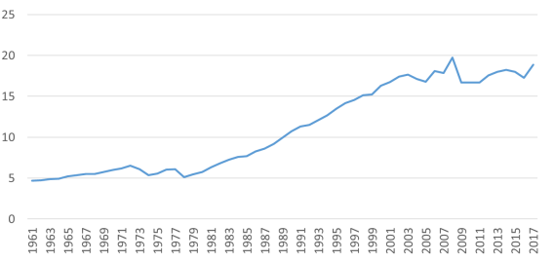
Figure 1. Colombia, Milk Production, 1961 to 2017. Source: Cadena, Reina, and Rivera (2019).
Local production met local demand
Millions of liters per day
Expansion and Exports
Economic and political issues

According to the Bogota Chamber of Commerce, the dairy sector represented 24.3% of the country’s livestock Gross Domestic Product in 2018 (Sectorial, 2018). Furthermore, the dairy sector supported around 736,000 jobs, with more than 319,402 families producing milk in Colombia in 2018 and the dairy industry accounting for 19% of the agricultural sector employment in this same year (FEDEGAN, 2018). Additionally, there are 512,000 farms dedicated to dairy cattle in Colombia, with 43% of these farms owning less than ten cattle with limited use of technological advancements. In 2019, Colombia produced 7,301 million liters of milk (Fedegan, 2020). Finally, Colombian residents consume an estimated 145 liters per person annually, which is less than the Food and Agricultural Organization’s (FAO) recommendation of 180 liters per person annually (FEDEGAN, 2018).
Cumbal is part of the department of Nariño, Colombia, and is in the Southwest region of Colombia (Figure 2). Cumbal is divided into four indigenous territories: Panan, Chiles, Mayasquer and Cumbal. The average temperature ranges between 44⁰F and 62⁰F (7⁰C and 17⁰C), which is favorable for dairy cattle production. Cumbal is part of one of the highest dairy production regions in Colombia in terms of liters of milk produced (Jaramillo and Areiza, 2013 and Carulla, 2016). Most of the producers in the municipality of Cumbal are associated with small dairy associations, in terms of production volume and number of members. In Cumbal, there are 50 dairy associations with varying membership rates. Moreover, the Cumbal dairy market operates as an oligopsony, where a few large companies buy milk from a few associations.

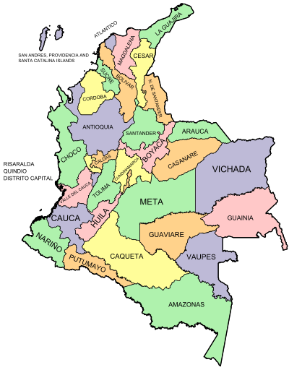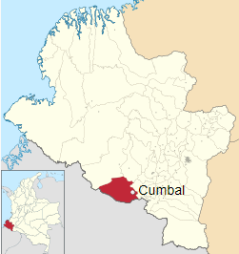
Figure 2. Geographic location of the municipality of Cumbal-Nariño

These few companies set the market conditions, i.e., price, volume, and quality, while the dairy associations act as price-takers.

1.1 Statement of Problem

The dairy sector is important for Colombia’s economy. However, in the last three decades, the dairy sector has been affected by social, economic, and political factors that challenge the economic sustainability of this sector and put at risk its resiliency and feasibility. The main factor negatively affecting the dairy sector is the increased imports of milk products (Mora-Delgado, 2018), especially milk powder from the United States and the European Union. The import of dairy products between 1990 and 2019 increased almost 25 times from 2.5 million tons to 62 million tons (Agricultural Ministry of Colombia, 2020).
One of the factors that influenced this increase in dairy products imports is the free trade agreements that the Colombian government signed with countries such as the United States, Mexico, Canada, and members of the European Union (Restrepo, 2018), including Germany, France, Netherlands, Italy, and Poland. These agreements allow these countries to export dairy products to Colombia under certain restrictions such as import quotas (Foreign Trade Information System, 2006). The quotas limit the quantity of dairy products such as powdered milk, butter, yogurt, whey, and cheese that these countries can export without tariffs, and for amounts beyond the quotas, the Colombian government applies tariffs to limit the import of milk products.
The quotas to import milk products increase every year. For example, the quota applied to U.S. milk powder imports was 9,744 tons in 2018, and it rose to 10,718 tons in 2019 (Contextoganadero, 2019b). Similarly, the quota to import milk powder from the European Union (E.U.) increased from 6,000 tons in 2018 to 6,400 tons in 2019 (Contextoganadero, 2020b). With these quotas, imports have increased annually, as shown in Figure 3.
The year 2019 was a record year for milk imports in Colombia, with a total of 61,643 tons of dairy products imported, including 41,900 tons of milk powder, 13,706 tons of whey, and the rest being cheese and other milk products. The U.S exported 34,791 tons of milk products to Colombia, including 25,700 tons of milk powder. Similarly, the E.U. exported 10,100 tons of dairy products to Colombia, including 7,200 tons of milk powder (Contextoganadero, 2020a).
The entirety (100%) of Colombia’s 2020 milk powder import quota from the U.S. was fulfilled in the first 13 days of the year, and similarly, the E.U. exhausted 48% of their quota for the same product in the first 45 days (FEDEGAN, 2020). These quotas will be terminated in 2026 for the U.S. and in 2028 for the E.U., lifting all restrictions for these countries to export milk products to Colombia. These trade agreements pose a serious challenge to the local dairy producers as imported milk could flood the market, and local producers will likely be unable to compete and stay profitable.
The lack of industrialization is another important challenge that hinders the development of the sector. For example, in 2019, only 43.4% of all milk production was collected through the organized dairy sector, which is subject to taxes and monitored by the government, and where milk is transformed into value-added products. The other 56.6% of the milk produced is consumed in the informal markets not monitored by the government authorities, with low-value addition (FEDEGAN, 2020).

Figure 3. Colombia’s Milk and Dairy Product Imports in million tons (1990-2019). Source: Colombia's Agriculture Ministry.

Because milk is a highly perishable commodity, there is a lack of refrigerated transportation facilities in Colombia; therefore, it must be consumed in a short time locally (MADR, 2005). With these challenges, the local markets cannot sell all the milk produced, and farmers are forced to sell milk at reduced prices locally. Another challenge for farmers is that only a few companies buy milk from dairy producers. In Colombia, five companies control 56% of the market share, and ten companies control 80% of the total market share (Contextoganadero, 2019a). This oligopsony market condition puts farmers in an adverse situation because they have little bargaining power and operate as price takers. For example, during the COVID-19 pandemic, some dairy farmers of the Cundinamarca Region in central Colombia were negatively affected because the milk processing companies reduced the market price for milk and the collection volume with little notice (Sectorial, 2020).
Another threat that affects the income of dairy producers is high production costs because the price they receive is disproportionately lower than the increase in production costs. During the last decade (2010-2020), the costs of production had increased by 60.3%, while the selling price for the producers had increased only 44%, indicating a mismatch between prices and costs (Contextoganadero, 2020c). Moreover, the increase in production costs obliterates the gains from small increases in productivity (Contextoganadero, 2019a). Finally, the fragmentation of the land on small farms represents a barrier in establishing competitive levels of productivity (Saavedra, 2008). In Colombia, around 78% of the population that is dedicated to agricultural activities own less than 10 hectares or 25 acres, which represents only 5.9% of all land under cultivation. These small farms do not allow a family to make a livable income (National Center for Historical Memory, 2018).
In 2016, there were 512,000 livestock farms in Colombia, with 43% of these farms owning less than ten cows; the same trend is observed in Cumbal. With a small number of farms, the use of technology and equipment in the dairy sector is not feasible because small dairy farmers do not have the capital to make investments, and regions with high land fragmentation are where the informal dairy markets prevail in Colombia (Superintendence of Industry and Commerce, 2012).
Dairy farmers of Cumbal countered these challenges by organizing into associations, which have allowed them to obtain strategic advantages. Advantages gained through dairy associations include bargaining power, increased access to machinery, ability to sell milk directly to handlers/processors, improving quality as well as hygiene of milk, access to inputs at a lower cost, and access to loans. The integration among producers is particularly important in Colombia because a large percentage of the dairy farms are small (Cortés, Bonilla, Rojas, and Barreto, 2015). However, it is yet to be determined if the sole action of organizing farmers in associations guarantees their success.
This study evaluates the factors influencing Cumbal dairy associations presidents’ perception of success. According to Nyoro and Ngugi (2007), Sexton and Iskow (1988), and Garnevska, Liu and Shadbolt (2011), the critical factors that determine the success of a cooperative are vertical integration, high-quality products, appropriate skills as well as education of management committee and staff members. Additionally, other factors that determine success of a cooperative include timely and appropriate information provided to its members, diversification of the cooperative in terms of products and services offered to members, large quantity of products marketed through cooperatives, and proper record keeping.

1.2 Objective

The objective of this study is:
To evaluate the influence of economic, financial, membership, management and operational characteristics on the presidents’ perceptions of success of the dairy associations in Cumbal-Nariño.

1.3 Implications of the Study

Despite the importance of the dairy sector in the Colombian agricultural economy, the sector has been affected in the last three decades by different factors, such as increased milk imports (Mora-Delgado, 2018), low industrialization (FEDEGAN, 2020), high production costs (Contextoganadero, 2019a), and land fragmentation (Superintendence of Industry and Commerce, 2012). No studies have examined the association presidents’ or leaders’ levels of confidence in the success of their dairy associations, considering the particular characteristics of their associations and the economic, social, and political conditions that currently challenge the dairy sector in the municipality of Cumbal.
A survey of 42 dairy associations’ presidents in Cumbal was conducted to understand the presidents’ perceptions that may correlate with economic, financial, membership, management and operational factors of the dairy associations. Additionally, this study uses this survey data to evaluate the factors influencing presidents’ level of confidence in the success of their associations using a logit model. Results from this study will provide dairy industry representatives and policymakers information that could help develop strategies to increase resilience and economic sustainability of Colombian dairy associations.

CHAPTER 2. Literature Review
A thorough review of literature indicated no previous studies have evaluated the key factors correlated with leader’s confidence about the success of dairy associations in Colombia and specifically in Cumbal. However, there are several studies around the world that focus on the factors that determine the success of cooperatives. Monzon (2006) explained the similarities between cooperatives and associations by indicating that these organizations have the same associative motivation. Vulnerable communities, which is defined by the Food and Agricultural Organization (FAO) as homogenous communities whose physical or financial access to food is precarious, organize in cooperatives and associations in response to a lack of market power, indifferent government policies, and lack of opportunities to promote and market their businesses (Monzon, 2006). The key principles ruling agricultural associations in Colombia, such as voluntary membership, democratic member control, member participation, autonomy and independence, and concern for the community, are similar to cooperatives’ principles. The main difference between a cooperative and an association is that an association cannot return its financial profits as dividends to its members at the end of the fiscal year, and it cannot return the capital to its members in bankruptcy (Arango, 2005). Other aspects that distinguish an association from a cooperative, as pointed out by Corzo and Sarmiento (2019), are: establishing an association does not require a minimum or a maximum number of members, associations are classified as a non-profit organization, associations are regulated by its own statutes. Also, the formalities to establishing associations are simpler, and they have lower establishment costs compared to cooperatives or other types of organizations.
Before analyzing the different studies that focus on the success factors of cooperatives, we provide a broad overview of the theory of cooperatives.

Definition of Cooperative

There are several definitions for cooperatives, but in general, these definitions cover the same ideas. For example, Barton (1989) suggested that “a cooperative is a user-owned and user-controlled business that distributes benefits on the basis of use.” The International Cooperative Alliance (ICA) defines cooperatives as “an autonomous association of persons united voluntarily to meet their common economic, social, and cultural needs and aspirations through a jointly-owned and democratically-controlled enterprise.” Another definition, suggested by Dulfer (1974), is a cooperative as a set of people who pursue a common supreme objective through mutual economic activities. Finally, a cooperative is an institution in which its members join and democratically manage it as a business where members have a common goal, and they join to achieve their economic, social, and cultural needs (Onyilo and Adong, 2019).
Cooperatives can be categorized by groups served, size, area served, functions performed, types of memberships, legal status, and financial status (Abrahamsen, 1976).
According to the United States Department of Agriculture (USDA), cooperatives can be categorized based on the characteristics delineated in Table1.
Furthermore, there is a unique type of cooperative that can be formed for legal purposes (Abrahamsen, 1976). Abrahamsen also mentions several factors that determine the types of cooperatives, among these factors are: need or when individuals through a cooperative can accomplish their objectives, capital requirements, management, education, institutional factors, services desired, and special problems of worker's cooperatives.
Finally, cooperatives differentiate from other businesses by three concepts. First, the user’s own principle, which states that the people who own and finance the cooperative are those that use it. Second, the user control principle, where the control of the cooperative is by those who use the cooperative through the election of the board of directors. Third, the user benefits principle, which states that the benefits of the cooperative are distributed to its users according to their level of participation (Barton, 1989).

Purpose of a Cooperative
According to the National Council of Farmer Cooperatives (NCFC), the purposes of the cooperatives are to strengthen bargaining power, maintain access to competitive markets, capitalize on the new market opportunities, obtain needed products and services on a competitive basis, improve income opportunities, reduce cost, and manage risk. The primary incentive to get involved in a cooperative is to improve farmers’ well-being (Schrader, 1989). Other purposes of cooperatives are in terms of commercial and nonprofit activities, mutual interests and economic needs of members, member control, voluntary participation in the cooperative, and the principle of proportionality which refers to financial obligations and benefits according to the level of participation of the member (Abrahamsen, 1976). From the cooperative perspective, one of the key determinants of a cooperative success is its members, who are the source of equity capital. Cooperatives require investments from members to carry out many activities, such as pay bills, make investments in assets, and have reserves for risk management (Peterson, 2019).
Table 1. Structure of Cooperatives
Characteristic | Definition
Geographic Territory Served | This property relies on the size of the area served, local or regional. Local cooperatives are usually run in one or two counties. On the other hand, regional cooperatives serve a group of counties, an entire state, or many states, and some might have international operations.
Governance or Control Structures | Cooperatives can be classified based on their membership composition as centralized, federated, or mixed.  Centralized: a centralized cooperative can be local or regional, and there is only one central office, manager, and board of directors who control operations.  Federated: a federated cooperative is a cooperative of cooperatives. The members of federal cooperatives are local cooperatives, each is operated by a manager, and each is a distinct business unit that owns a member share that allows them the right to vote in the federated cooperative.  Mixed: these cooperatives are a mix of centralized and federated where their members could be individuals or local cooperatives.  In the U.S., centralized cooperatives are the most common. In 2018, there were 1,704 cooperatives of this type, followed by 70 mixed cooperatives and 32 federated cooperatives.
Functions Performed | Cooperatives might accomplish the following functions:  Marketing products: Marketing Cooperatives (MC) provide a variety of off-farm processing and marketing services; also, they help farmers to produce and to process quality products according to specific market requirements. MC includes grain elevators, milk plants, wool pools, cotton gins, livestock markets, etc. Some MCs are called bargaining associations because they act as a selling agent on behalf of members.  Purchasing supplies: Cooperatives are used as an economic tool to get benefits from farm production inputs; for example, feed, fuel, fertilizer, and seeds, to reduce costs and gain purchasing power. Many purchasing cooperatives work along with other cooperatives through regional and interregional cooperatives.  Providing services: some agricultural cooperatives focus their services on the production and marketing of farm commodities. For example, they provide advice on the application of inputs, such as fertilizers, pesticides, animal feed processing, and crop harvesting. General service cooperative provides specialized services, such as credit, electricity, and telephone service.
Table 1. Continued
Financial | Cooperatives can be embraced as stock or nonstock. When members of a cooperative get stock certificates as proof of their ownership, we refer to them as capital stock organizations. Regarding nonstock organizations, they issue a certificate in which a capital contribution of its members is shown.
Subsidiary | A parent cooperative owns and controls a corporation that has the goal of assuming certain duties and functions for the parent cooperative.
Marketing Agency-in-Common | This type of cooperative is designed to market products or to provide services for members, and it is organized as two or more cooperatives. The only responsibility of these cooperatives is to arrange for member sales.
Joint Venture | This association is established to perform a specific economic operation, enterprise, or venture, and it is organized for two or more participants, partnerships, corporations, or cooperatives.
Holding Company | This is an organization with controlling ownership in one or more operating companies. The level of ownership can change extensively so long as the holding firm can exercise control through the operating companies’ board of directors.
Contract Agent | A cooperative may contract an agent to handle the goods and keep patronage records. Then, the cooperative makes refunds based on the agent's records.
Private Dealers | The job is keeping records when the cooperative makes money and pays patronage refunds, these go to the dealers' customers, and the dealer gains a commission.

Another important element for the success of a cooperative is strategic planning, which refers to a process of accomplishing the mission, vision, objectives, and goals of a cooperative. Other factors that enhance the growth of a cooperative are member participation and human capital (Aini et al., 2012). Von Pischke and John G. Rouse (2004) suggested that adaptation and innovation are the key strategy elements for a cooperative to be successful; also, they pointed out that the reason for the large success of cooperatives in developed countries is their focus on strategies to allow more people to participate.
Other benefits for cooperatives come from their structure, as is the case of centralizing cooperatives where they can obtain lower operational costs than other structures. When centralized cooperatives are regional and focus on marketing, they can obtain better bargaining power due to their centralized control. A possible setback of this structure is related to membership problems, such as difficulties of communication among its members and loyalty (Gropp and Ingalsbe, 1989, pg 44-46). Furthermore, membership growth can benefit cooperatives by allowing the use of new technologies; for example, new members represent more capital, which might be used to invest in new technology, and lead others to adopt the new technology. Also, cooperatives can benefit from volume discounts in transportation and advertising, training programs, marketing and bargaining power, political power, and financial strength (Vilstrup, Cobia, Ingalsbe, 1989, pg 364).

Empirical Studies Evaluating Factors Determining Cooperative’s Success

2.3.1 Economic Factors
Previous studies have found that various economic factors determine the success of cooperatives. Nyoro and Komo (2005) found that vertical integration and high-quality products are factors that determine the success of a cooperative. Moreover, Anania and Rwekaza (2016) found that business volume in terms of sales, diversification, high-quality products, skills to manage risks, and storages to handle inputs and outputs are factors that impact the success of cooperatives. Similarly, Bruynis et al. (2001) found that an appropriate business volume is an important factor in the success of emerging marketing cooperatives. Also, Azadi et al. (2011) found that the earned income of the cooperative is another determinant that influences the success of a cooperative. A study that emphasized non-agricultural cooperatives conducted by Bhuyan and Leistritz (2001) used a logit model to investigate how economic, finance, management, and organization factors influence the success of cooperatives. They found that variables such as provider, referring to the unique or essential product or service provided by the cooperative, and operating cost are the variables that increase the probability of success. Furthermore, a study developed in Spain by Garrido (2007) suggested that one important factor that influences the success of cooperatives was many members who owned a moderate-sized farm in terms of acres. Finally, a study by Carlberg, Ward, and Holcomb (2006) focusing on new generation cooperatives in the U.S., found that product quality is essential for the success of a cooperative.

2.3.2 Financial Factors

Regarding financial factors influencing cooperative’s success, Anania and Rwekaza (2016) found that financial stability, good accounting practices, and the existence of financial reports are important for the success of a cooperative. Similarly, Bhuyan and Leistritz (2001) found that easy access to debt is another factor that increases the likelihood of cooperatives’ success. For value-added cooperatives, Carlberg, Ward, and Holcomb (2006) found that low operational cost and member capital base are key determinants of success. Additionally, (Carlberg et al., 2003) found that low operating cost is one of the most important factors for success. Moreover, for cooperatives that operate in an international environment, access to capital is one of the most significant aspects determining success (Macdonald and Rowarth, 2013). In a study that attempted to compare the characteristics of cooperatives involved in different economic sectors, Carr, Kariyawasam, and Casile (2008) found that cooperatives with financial stability have more chances to succeed. Finally, Nyoro and Komo (2005) found that credit availability is an important determinant of success while aspects such as credit burden and debtors and investment in non-income generating activities are factors that are related to the failure of cooperatives.

2.3.3 Membership Factors

Individual member factors, such as commitment, entrepreneurship skills, managerial skills, partnership skills, network cooperation, information, communication, and technology, are essential determinants for the success of cooperatives in an entrepreneurship environment (Lucky, Rahman, and Minai, 2015). Anania and Rwekaza (2016) stated that member participation is essential in achieving cooperative success in business and social aspects as well as education about the rights and responsibilities of the members within the cooperative, loyalty, and increase in membership guarantees the success and sustainability of the cooperative. Garnevska, Liu, and Shadbolt (2011) also found that cooperative member participation in meetings and training with knowledge about the cooperative is critical in developing successful cooperatives. Furthermore, Rajaratnam et al. (2010) argued that member participation is a core factor for the survival and success of cooperatives. Similarly, in non-agricultural cooperatives, Bhuyan and Leistritz (2001) found that cooperatives that can retain their members and create a loyal environment have higher chances of success. However, a study focused on animal husbandry cooperatives conducted by Azadi et al. (2011) found that some membership factors, such as the number of members and member relationships, are not considered important for the cooperatives’ success. In contrast, Garnevska, Liu, and Shadbolt (2011) and Bhuyan and Leistritz (2001) found that the number of members and member relationships are very important for the success of a cooperative. A study carried out in the United States also showed that cooperative member loyalty influences the success of dairy cooperatives, particularly when cooperatives face hostile competition (Zeuli and Bentancor, 2005). Finally, a study carried out by Banaszak (2008) to identify why some agricultural cooperatives are successful while others are not, found that the number of members is one of the factors that have a positive impact on the probability of success of a cooperative.

2.3.4 Management and Operational Factors

Dedicated initiators with vision, business, and management capacity, with good education, enthusiasm for innovation, and communication skills, are critical for the successful development of a cooperative (Garnevska, Liu, and Shadbolt, 2011). Anania and Rwekaza (2016) found that a skilled leader and management determine the success of agricultural cooperatives in Tanzania. Another study that highlights the importance of management in the success of agricultural cooperatives is the study conducted by Bhuyan and Leistritz (2001), in which they found that cooperatives that consider management as their main strength have an 11% higher probability of being successful than those that do not. By using a multivariable linear regression model, Azadi et al. (2011) studied the factors influencing the success of animal husbandry cooperatives in Southwest Iran. In their study, success, the response variable, was explained by evaluating three different goals: cooperative income, participation, and equity. Individual factors such as understanding the concept of a cooperative, interest of the manager in the different activities that are taking place within the cooperative, and technical knowledge such as education level have a notable correlation with success, but experience of the managing directors was not correlated to success. These findings differ from the findings of Nyoro and Ngugi (2007) that analyzed the success and failure determinants of agricultural cooperatives in Kenya. They found that the education level of the management is one key aspect that determines the success of a cooperative. Also, Carlberg, Ward, and Holcomb (2006), in their study about the success factors of new generation cooperatives, found that management experience is essential for the success of a cooperative. The findings of Carr, Kariyawasam, and Casile (2008) showed that management factors such as manager expertise and management team training in a specific field impact the success of a cooperative. However, Zeuli and Bentancor (2005), in their study conducted in the U.S., found that management aspects, such as a clear plan for the future, the use of professional consultants, and professional management, were not related to the success of cooperatives. Finally, Nyoro and Komo (2005) found that the adoption of a strategic plan is an important factor related to success while non-skilled board members, poor or lack of communication between board members and farmers, competition, dishonesty by staff and representatives are factors influencing cooperative’s failure. The study conducted by Anania and Rwekaza (2016) found that selecting a good location for the cooperative's facilities, having storage and other facilities are important determinants of success. Similarly, Carr, Kariyawasam, and Casile (2008) found that selecting a good location for the cooperative's facilities affects the success of a cooperative. While the study addressed by Azadi et al. (2011) found that having facilities, years of operation, and the number of workers are not important in the success of a cooperative.

2.3.5 Studies Evaluating Success Factors of Cooperatives in Colombia

In Colombia, some studies have been conducted in different sectors of the economy that analyzed the factors that determine the cooperatives’ success. For example, Pabon and Herrera (2015) studied the success factors of three non-agricultural cooperatives. They found that the success factors for these cooperatives were social balance related to integral and sustainable human development, trust, equality, social profitability. Social profitability is defined as the capacity of generating economic benefits for cooperatives’ members resulting in improvement of member’s and members’ families quality of life, labor force development, technology innovation, product and services development, and marketing. In the agricultural sector, Pérez and López (2015) studied the factors that made Colanta, a Colombian dairy cooperative, successful by focusing on management aspects. They found that management skills and knowledge, management leadership, sales volume, market access, good relations with financial institutions, and improving the welfare of their members were the determinants of this cooperative success. Finally, Vinasco (2012) studied the success factors of a transportation cooperative. The author aimed to identify the successful practices in social, economic, organizational, and environmental aspects by using a mixed methodology, quantitative and qualitative, and by using the cooperative principles as the success determinants. Over the course of six years, it was observed that at first, the cooperative loosely followed the success principles, leading to a low economic and management performance of the cooperative, but later, when the principles were better adopted, performance increased.
Findings from the previous studies presented above confirm that studies focusing on success factors of cooperatives have been carried out by many researchers in different countries, and different economic sectors. We observed that the success factors depend on the location, economic sector, or activity in which a cooperative is involved. Thus, there is a large heterogeneity of the success factors. Lastly, there are no studies that address the success factors of agricultural cooperatives or associations from the perspectives of the association or cooperative presidents in Colombia and particularly in Cumbal. Therefore, this study attempts to fill this gap in the literature by studying the factors likely to be correlated with cooperative presidents’ confidence in the success of dairy associations in Cumbal Nariño, Colombia.

2.3.6 Definition of success of co-operatives from previous studies
Success can be measured in different ways, such as profitability, member satisfaction, longevity of the cooperative, etc. Based on a review of literature, success is defined and measured based on:
- Objective: Success is defined by Bruynis et al. (2001) as the satisfactory completion or the attainment of a desired objective or end.
- Competition: Zeuli and Bentancor, (2005) measure success in terms of competition by pointing out that the success of agricultural cooperatives in the US means that cooperatives compete with other cooperatives in several industries and markets.
- Member Income: A successful cooperative can be defined as one that increases the income of their members, promotes participation of members, and improves the equity among members (Azadi et al., 2011).
- Longevity: Other studies define success in terms of the longevity of the business. For example, Carr, Kariyawasam, and Casile (2008, pg 79) define success as the continued survival and growth in membership of the cooperative over a period.
- Participation of members: In another study that focuses on successful farmer cooperatives, success is defined in terms of the participation of members in meetings organized by the cooperative, members access to the cooperative' financial reports. Additionally, success is defined based on cooperatives providing standard services, and technical training to members. Finally, success is defined based on cooperatives' ability to generate a minimum level of income, having a close business relationship with local farmers, and playing a leading role in improving the local agricultural sector (Garnevska, Liu, and Shadbolt, 2011).
- Exchange of goods: Banaszak (2008) defines success of producer groups/cooperatives based on their ability to coordinate the exchange of goods between farmers and purchasers and operate a per-unit cost lower than the per-unit cost of alternative ways of transactions.
- Financial aspects: Nyoro and Ngugi (2007) define a successful agricultural cooperative as one that pays its members high prices on a timely matter, facilitates credit to their members, and does not experience conflicts within the cooperative.

2.3.7 Measurements of cooperatives success
Sexton and Iskow (1988) used a two-stage approach. In stage one, they classified the factors that impact success in four categories: economic, organizational, financial, or production. Then, they estimated separate equations using logit regressions that have the same dependent variable measuring success, but different independent variables associated with the four categories described above (i.e., one model for economic, one for organizational, one for financial, and one for production factors). Only the most significant variables from the first stage estimations were included in the second stage estimated model.
Similarly, Bruynis et al. (2001) used a two-stage approach to determine the relationship between a dependent variable measuring cooperative success and independent variables related to economic/marketing, financial, management, and organizational factors. Bhuyan and Leistritz (2001) also used a two-stage approach model using economic, financial, management, and organizational as independent variables that contribute to the success of cooperatives. Finally, Azadi et al. (2011) used four categories, individual (age, education, interest, etc. of the managers), economic, structural (number of members, number of workers and facilities) and external factors (market access), that influence the success of cooperatives using a multivariate linear regression model.

CHAPTER 3. Materials and Methods

Empirical model

The purpose of this section is to identify potential factors associated with the presidents’ level of confidence about the success of their dairy associations. In other words, what specific characteristics of a dairy association lead to presidents’ perceptions of their association’s success. A president's perception of success is determined by various factors influencing the performance of dairy associations, such as economic, financial, membership, management, and operation factors.
Previous studies use different methods to analyze factors that determine the success of a cooperative. For example, Noordin et al. (2011) surveyed 567 board members from 89 cooperatives and used three aspects to gauge the success of a cooperative: managerial competency, effective leadership, and support. Bruynis et al. (2001) set up four key factors to determine success: longevity, member business growth, profitability, and member satisfaction. Another study by Banaszak (2008) analyzed the critical factors that determine the success of cooperatives with the main objective of organizing joint sales of output produced individually by members of cooperatives. This study identified four factors influencing association success: leadership strength, number of members, the existence of business relationships among members before becoming part of the cooperative, and the existence of a selection process for members.
Moreover, Sexton and Iskow (1988) used a method that includes a two stage-approach. In the first stage, they classified the determinants of success in four categories (economic, organizational, financial or operational/management), and estimated four logit models with the same dependent variable measuring success and a different set of independent variables corresponding to the abovementioned categories. Finally, the most significant determinants in stage one equations were included in the stage two model. This approach was also used in later studies by Bhuyan and Leistritz (2001) and Zeuli and Bentancor (2005). In our study, we classified potential determinants of association president’s perceptions of success in four categories (see Figure 4).

3.2 Conceptual Framework

In this section, we discuss the economic theory behind the marketing cooperatives that market farm goods produced by their members. The theory explained in this section supports the definition of cooperatives' objectives and assessment of performance. Since the objectives of cooperatives are similar to those of associations, this theory might also support dairy associations' objectives and evaluation of their performance. This study focuses on the dairy associations of the municipality of Cumbal, which are dedicated to marketing raw milk collected from their members. The associations incur costs related to transportation, some fixed costs such as utilities, labor, and costs of marketing the raw milk. For simplicity, all the costs incurred by the dairy associations will be called marketing costs.
We analyzed the decision about how much an association pays its members per liter of raw milk, i.e., price (p), and the volume of milk an association collects, i.e., quantity (q). For this analysis, we used the net average revenue product curve (NARP), defined as net revenue product (NRP) divided by the quantity of product. It is analogous to the price received by the association less its average marketing cost. NARP represents the amount per unit that is available for raw milk payment and profits.

Financial factors

Economic factors

Success of a dairy association
Sustainability in the long term
Membership factors

Management and operational factors

Figure 4. Schematic of factors influencing the perception of the presidents of the dairy associations about success

The net marginal revenue product (NMRP) curve represents the change in NRP from marketing an additional unit of raw milk, and it is analogous to marginal revenue without the marginal processing cost. Now let’s analyze the different economic objectives for a dairy association that might determine its success considering price and output, which are represented in Table 2. Figure 5 shows the price (in Colombia pesos) and output solutions for these objectives. To develop this conceptual framework, we followed Royer (2014) approach, and we adapted it to the functioning of the dairy associations of the municipality of Cumbal. For a marketing dairy association, NMRP and NARP in figure 5 are exhibited with the raw milk supply curve facing the association ($S$). We assume that a dairy association cannot purchase unlimited quantity of raw milk at a fixed price level. The maximum amount of milk a dairy association can purchase is Q4, where the supply meets the NARP and the dairy association pays a price, P4 to its members. Dairy associations might operate under a monopsonistic or oligopsony competition, where one or few associations might enjoy market power. Thus, they might face an upward-sloping supply curve.
The geographical distribution of the dairy associations might explain their market power. For example, if a dairy association sets a lower price for the raw milk, it might tend to receive milk only from nearby producers, while farther producers might tend to change their association. Similarly, higher prices might tend to attract producers from farther regions. The marginal factor cost curve represents the cost of each additional unit of raw milk an association purchases. In figure 5, we observe that an association faces an upward-sloping supply curve, in this case, the marginal factor cost curve (MFC) will lie above the supply curve since an association will have to pay a higher price to purchase additional units of raw milk. The first economic objective that an association might choose is maximizing its net earnings. To achieve this goal, an association might pay $P_{1}$ for a liter of raw milk and collect $Q_{1}$ liters of raw milk, which is the quantity where NARP and MFC curves intersect each other. In this scenario, the association´s net earnings will be $\left(N_{1}-P_{1}\right) x Q_{1}$. The value of NARP at $Q_{1}$ is represented by $N_{1}$. The earnings will be refunded to members as a patronage refund, and the net price paid to members $N_{1}$ comes from adding the per unit refund $(N_{1}-P_{1})$ to the cash price (the price that member receive per liter of raw milk sold to the association).
The second economic objective of a dairy association might be maximizing the price it pays its members. Under this objective, an association would collect $Q_{2}$ corresponding to the maximum of NARP curve, the point where NARP and NMRP intersect each other. The cash price paid to its members for a liter of raw milk will be $P_{2}$, which is lower compared to the previous objective. Nonetheless, after adding the per unit patronage refund $N_{2}-P_{2}$, the net price is $N_{2}$, which represents the maximum price that can be paid. The third economic objective might be the maximization of member’s returns including any earning of the association. This scenario occurs when the association collected $Q_{3}$ liters of raw milk, which is determined by the crossing of the NMRP and the supply curves. In this case, the association will pay its members $P_{3}$ for each liter of raw milk. The net earnings of the association are $\left(N_{3}-P_{3}\right) x Q_{3}$, which later might be returned to its members as patronage or additions to the association’s capital. This objective allows members to get the highest returns compared to other objectives.

Table 2. Price and output solutions for a marketing dairy association under various objectives
Objective | Criteria | Quantity | Price | Patronage refund | Net price
Maximization of association net earnings | NMRP=MFC | $$Q_{1}$$ | $$P_{1}$$ | $$N_{1}-P_{1}$$ | $$N_{1}$$
Maximization of net price | NMRP=NARP | $$Q_{2}$$ | $$P_{2}$$ | $$N_{2}-P_{2}$$ | $$N_{2}$$
Maximization of member returns | NMRP=S | $$Q_{3}$$ | $$P_{3}$$ | $$N_{3}-P_{3}$$ | $$N_{3}$$
Maximization of quantity | NARP=S | $$Q_{4}$$ | $$P_{4}$$ | 0 | $$N_{4}$$

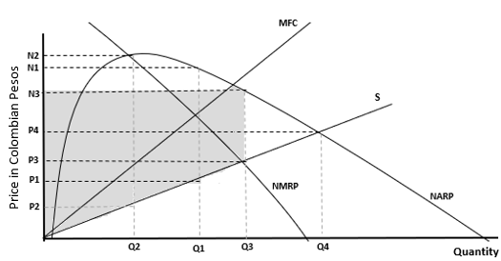
Figure 5. Price and output solutions for a marketing dairy association under various objectives

Members’ returns include the association’s net earnings and farm profits that members earn by producing raw milk. Farm profits are not shown directly in the graph, it is part of the producer surplus, which is represented by the area above the supply curve ($S$) and below the market price $P_{3}$. Therefore, the area of ${P_{3} xQ}_{3}$ represents the revenue members receive from selling raw milk.
The triangle area below the supply curve represents the total variable cost to market raw milk, and the triangular area above the supply curve represents members’ profits on the farm and fixed costs. In both cases, we assumed that the supply curve portrays the marginal cost of producing raw milk. Finally, we assumed that fixed costs are constant with respect to change in quantity. Thus, maximization of associations’ net earnings and producer’s surplus (both are maximized at $Q_{3}$) is analogous to maximize member returns represented by the rectangular area $\left(N_{3}-P_{3}\right) xQ_{3}$, and the triangular area above the supply curve represents the producer’s surplus.
The last economic objective could be maximizing the volume of raw milk collected at $Q_{3}$, which is represented by the crossing of the NARP and supply curves. In this setting, the maximization of output might represent a unique equilibrium solution. At this level, the price of the collected milk equals the sum of the raw milk and the per-unit cost of marketing raw milk. Therefore, the patronage refund is zero and members no longer have incentives to increase supply.
The association’s members desire higher prices per liter of raw milk delivered. In Figure 6, we assume that the association establishes a net price $P_{1}$ per liter of raw milk to pay its members. At this point, an association faces supply $S_{1}$ and markets $Q_{1}$ liters of milk. Since the association is operating in the upward-sloping section of its NARP curve, it could improve price by shifting the supply curve to the right. For example, the association could shift the supply curve to $S_{2}$ where supply intersects NARP at its maximum, increasing its net price to $P_{3}$. On the other hand, when an association is operating in the downward-sloping region of its NARP, the association might increase the price by shifting the supply curve to the left. For example, if the association shifts its supply curve $S_{3}$ to $S_{2}$, it will allow increasing its net price from $P_{3}$ to $P_{2}$.
The success of a dairy association might be measured by different economic goals such as maximization of cooperative net earnings, maximization of net price, maximization of member returns, or maximization of quantity (profitability, production volume, market share, etc.). However, there are other non-economic goals that might be used to measure an association’s success, such as member’s satisfaction and commitment. In this study, we assume a measure of success is captured by a latent or unobserved variable S*. Although we cannot observe S*, we observe the president’s perceptions of association success (Y_{s}),
$y_{s}=\left\{\begin{matrix}1 if S^{*}≥\overline{S} \\ 0 if S^{*}<\overline{S} \end{matrix}\right.$,

where $\overline{S}$ is a relative level of success that allows presidents to evaluate president’s confidence in the success of the associations they represent. If the success measure presidents use to determine their confidence in their association success is above $\overline{S}$, then presidents are highly confident about the success of their association, and therefore $y_{s}=1$ . While if the success measure is below $\overline{S}$ presidents are just confident about their association's success, and therefore $y_{s}=0$.

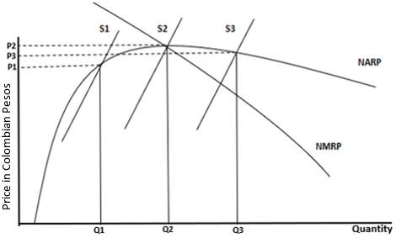
Figure 6. Strategies for increasing the raw milk price.

3.3 Description of the Study Area and Sample Size.

Colombia borders two oceans, the Pacific and the Atlantic oceans. This location allows the country to be connected with Central and North America, European, and Southeast Asian countries.
Colombia has a diverse climate, ranging from tropical to cold, enabling the country to cultivate various agricultural products. Colombia has eight highly productive dairy regions; one of these regions is the Southwest dairy region that includes the departments of Cauca, Putumayo and Nariño (Jaramillo and Areiza, 2013; Carulla, 2016). This study focuses on the municipality of Cumbal, which is part of the Nariño department. Cumbal is divided into four indigenous territories: Panan, Chiles, Mayasquer and Cumbal, as seen in Figure 7. The average temperature ranges between 44⁰F and 62⁰F (i.e., 7⁰C and 17⁰C), which is favorable for dairy cattle production.
Figure 8 summarizes the dairy supply chain of Cumbal, considering only milk that is produced by members of the local dairy associations. Considering the dairy supply chain developed by the National Dairy Council (2010), the informal market is represented by the local cheese producers or the cottage industry, which mostly captures low-grade milk that does not meet the standards of quality required by the formal industry, represented by the dairy processing companies.

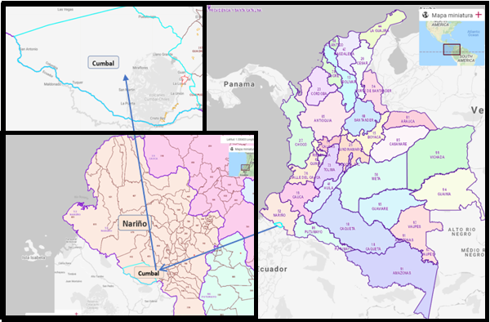
.
Figure 7. Location of the municipality of Cumbal.
(Source: National Administrative Department of Statistics)

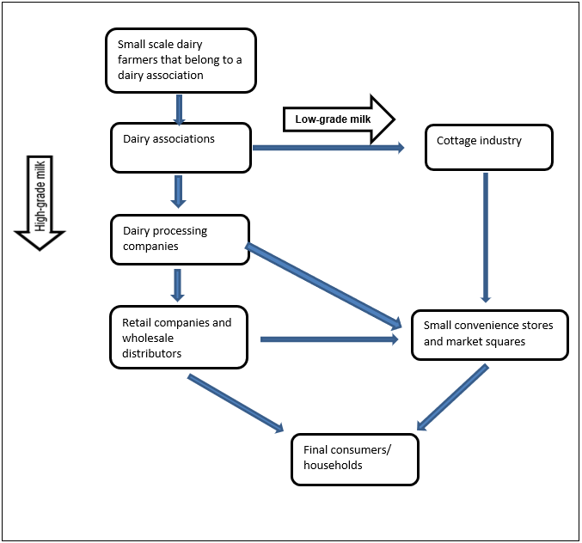
Figure 8. Dairy industry supply chain of the municipality of Cumbal-Colombia considering only milk that is produced by members of dairy associations.

For this study, we used results from a paper-based survey of the 50 dairy associations’ presidents in the municipality of Cumbal. A total of 42 out of the 50 dairy association presidents (i.e., 84% response rate) completed the survey. The English and Spanish versions of the survey instruments are presented in Appendix A and Appendix B, respectively.
Due to the COVID-19 pandemic, we could not travel to Colombia to collect the data. The lack of reliable internet access and telephone service in the area prevented us from using online or telephone surveys. Therefore, we hired a local enumerator who had extensive knowledge of the study region, was well known by the members of these associations, and formerly held a managerial position in a dairy association to collect survey data. We initially contacted the participants by phone to explain the purpose of the survey, then we asked the participants to participate, following an Institutional Review Board (IRB) approved protocol. Once they provided consent to participate, a paper copy of the survey was delivered by the enumerator. Upon receiving confirmation from the participants that the survey was completed, the enumerator collected it. The role of the enumerator was to first print the surveys, then deliver the surveys to each president, pick up the surveys, scan and send us a copy of each survey via email.

Description of Questionnaire

The purpose of the survey was to collect data from the dairy associations of the municipality of Cumbal and, through statistical data analysis, gain insights into the factors affecting the success of the Cumbal dairy associations. To identify the factors associated with associations’ success, we split the survey questions into five different categories: economic, financial, membership, management and operational, and basic information. Each of these categories included questions that capture the different factors that could be correlated with the president’s perceptions associations’ success.
The first category included questions related to economic factors that might be related with the president’s perceptions about success of their dairy associations. Economic factors are important because they impact the profitability of the associations and their members. If the associations do not provide appropriate selling price, premium prices for high-quality products, and guaranteed purchase of milk, then members will not have an incentive to continue their membership and may likely leave the association.
The second section covered elements related to financial factors. In this section, we collected information about some basic financial factors that could be correlated with the associations’ success, including methods used to acquire capital, assets, access to loans, and financial support to members. This information is important because it demonstrates the financial health of the association to face the challenges that the dairy sector demands. Associations with different ways to acquire capital, experience with access to loans, or that are transparent when reporting financial information to their members might have a higher probability of being successful.
The third section deals with membership factors. This section was pivotal as members are the core component of the associations; without members, the associations cannot exist. This section includes factors that might be correlated with association success, such as the number of members and changes in the number of members over time. Also, this section helps to evaluate the level of commitment of members to their associations. This section covers topics related to accepting new members and the different requirements or barriers the associations impose when making decision about accepting new members, and some perceptions from the presidents regarding the process of accepting new members.
The fourth section deals with management and operational factors. It includes different questions related to the management of the associations, such as leadership, cooperation with other institutions, perceptions about the future of the dairy sector, and strengths and weaknesses of the dairy associations. Previous literature pointed out that association management is a determinant factor for the success of cooperatives; thus, we hypothesized that management is likely to be correlated with dairy associations’ success.
Finally, the last section covers questions related to specific characteristics of the associations and their presidents. This section is important because it describes specific attributes of the dairy associations that could be linked to cooperative success. This section also covers topics such as location, years in business and information about the presidents such as gender, education, and experience. Some variables, such as production volume, the price per liter, the number of members, and revenue, were divided into three categories for a better understanding of the size of the cooperative: small, medium, and large.

Data Collection

We contacted two associations’ leaders, who have been working with their associations for more than ten years, to get an idea of the number of existing associations in the municipality of Cumbal. Then, we confirmed this number with information available in the Municipal Technical Assistance Units (UMATA) of Cumbal. Both sources provided the same number of associations, so we worked with this contact list. Next, we secured approval for the survey instrument from the Institutional Review Board (IRB) from the University of Tennessee, Knoxville.
First, the presidents of each dairy association were contacted to ask for consent to participate in this study. After their agreement, a survey was delivered to the most convenient location for them. Since this survey was carried out during the COVID-19 pandemic, we followed the Center for Disease Control’s (CDC) guidance to prevent any possible risk of infection that could happen from the physical interaction between people. Therefore, we left each survey for a few days in the most convenient location for the participants. The participants filled out the survey alone and without any physical interaction with other people. Once the surveys were completed, a participant contacted us by text message, and the enumerator picked up the survey.
We started contacting the participants who live in the farther regions from the urban area of the Municipality of Cumbal, and then we approached the participants who live closer to the urban area of Cumbal. We sent the surveys to 50 presidents but were unable to contact eight presidents, which represents 16% of the total population. Our response rate was 84%. Some presidents live far away with no access to phone services; others changed the phone number, or the contact we had in the list did not work. Others dropped out; when we contacted them the first time, they agreed to participate, but later they decided not to participate. All the surveys were answered in Spanish. Four follow-up phone calls were conducted to ensure survey completion. Our collaborator used his motorcycle to deliver each survey. The survey data collection process took three weeks, from the last week of November to the second week of December 2020. We paid the enumerator a flat fee of $20 per day for a total of 13 days (approximately 1,050,000 Colombian pesos). We also covered expenses for paper, printing, scanning, internet, and telephone charges.

Hypotheses

The hypothesis is that the leaders’ perceptions of success can be explained by differences in association characteristics which include economic, financial, membership, management and operational factors. This is related to the objective of this study. A logit model is used to evaluate the five factors correlated with association president's perceptions of success.
Hypothesis I:
- H₀: The economic, financial, membership, management and operational characteristics are unlikely to influence the presidents’ perception of success of the dairy associations.
- H_{1:} The economic, financial, membership, management and operational characteristics are likely to influence the presidents’ perception of success of the dairy associations.

Econometric Model

3.6.1 Logit Model

A logit model was used to evaluate the correlation between president perceptions of association’s success and association characteristics. Note that, as explained in the conceptual framework section, a single measure of success is not observed ($S^{*}$), but rather we observed presidents’ perceptions of association success ($y_{s}$) such that
$y_{s}=\left\{\begin{matrix}1 if S^{*}≥\overline{S} \\ 0 if S^{*}<\overline{S} \end{matrix}\right.$, (2)
where $\overline{S}$ is a relative level of success that allows presidents to evaluate president’s confidence in the success of the associations they represent. If the success measure presidents use to determine their confidence in their association success is above $\overline{S}$, then presidents are highly confident about the success of their association, and therefore $y_{s}=1$ . While if the success measure is below $\overline{S}$ presidents are just confident about their association's success, and therefore $y_{s}=0$. For simplicity in describing the econometric models used in this study, we assumed $\overline{S}$=0.
We are interested in modeling the probability ($p$) that a president is highly confident in the success of the association they represent as a function of the association and its characteristics ($x$). A regression model is formed by parameterizing $p$ to depend on an index function $x'β$where $x$ is a vector of variables capturing president and association characteristics and $β$ is a vector of unknown parameters capturing the correlation between $x$ and $y_{s}$ (Cameron and Trivedi, 2010). The conditional probability associated with $y_{s}$ can be expressed as:
$p= Pr\left(y_{s}=1|x\right)= Pr\left(x^{'}β+ ε>0\right)$, (3)
= $\operatorname{Pr}\left( ε>-x^{'}β\right)$
= 1 - $F\left(-x'β \right)$= $F\left(x'β \right)$
= $\frac{1}{1+e^{\left(x'β \right)}}$
where $F$ is the logistic cumulative distribution function.
Marginal effects associated with (3) for continuous variables can be described as

$\frac{∂\operatorname{Pr}\left(y_{s}=1|x\right)}{∂(x_{k})}= \frac{β_{k}e^{\left(-x'β \right)}}{{(1+e^{\left(-x^{'}β \right)})}^{2}}$ (4)

3.6.2 Diagnostic Tests

3.5.2.1 Multicollinearity test

Multicollinearity is a situation that results from the existence of strong linear relationships among the predictor that increases the variance of the estimated coefficients. The existence of multicollinearity will result in regression estimates that are inefficient (Chatterjee and Hadi, 1991).
There are two test to detect multicollinearity: variance inflation factor (VIF) and condition index (CI). The VIF is estimated using the value of R² that results from regressing each independent variable against all other independent variables.
R² tends to be close to one when there is strong linear relationships among independent variables (Chatterjee and Hadi, 1991). Values of VIF greater than 10 indicate collinearity which might cause issues with the estimation. An alternative method to assess multicollinearity is the condition index (CI). Condition indexes between 30 and 100 indicate that the explanatory variables have moderate to strong association with each other. A condition index accompanied by a proportion of variation above 0.5 indicates potential collinearity problems (Belsley, Kuh, and Welsch 1980).

3.6.3 Selection of Variables Used in Econometric Modelling
Selection of the Dependent Variable
The selection of independent variables is based on a literature review and the particular characteristics, such as economic, political, and social factors that affect the performance and the success of the dairy associations. Dairy associations of the municipality of Cumbal are going through a difficult time that put their survival at risk. It is important to determine which are the characteristics of the dairy associations that are correlated with the leader's confidence in the success of their dairy associations. We could point out that those association where their leaders are highly confident in the success are associations that are more organized and prepared to face the current and future challenges of the dairy sector. Thus, these associations might be more resilient and have more chances to survive.
We adapted previous studies that focused on the success factors of cooperatives, with the aim of determining factors or particular characteristics of the Cumbal dairy associations correlated with the presidents’ perception of success. To measure success, in Question 1, we used a Likert scale and asked whether the presidents of the associations strongly agree, agree, disagree, or strongly disagree with a statement related to the success of their associations. In the same question, we asked those who consider their associations to be successful to report how they measured success in their own words. Then we transformed these four scales into two options to create our dependent variable as a dichotomous variable. These two options indicate whether the participants of this study are highly confident of the success of their dairy associations or are not highly confident. When the presidents are highly confident in the success (strongly agree) are assigned a value of 1 (success = 1), otherwise (agree, disagree, and strongly disagree), a value of 0 (success = 0).
3.5.3.1 Explanatory Variables
In this research, many characteristics are hypothesized to have a direct effect on the president’s perceptions of association success. For example, there are several economic and non-economic factors that might be correlated with the president’s perceptions about success, such as cooperative net earnings, net price, member returns, quantity bought, member satisfaction, commitment, among others. All the explanatory variables included in the analysis, along with their expected signs are presented in Table 3. Each of the variables are discussed in detail in the results and discussion section.
Among the economic factors, the first variable is revenue. It is hypothesized that this variable might have a positive correlation with the presidents' perception of the associations’ success. High volumes of production that result in increased revenue, reduced fixed costs, and increase bargaining power (Nyoro and Ngugi, 2007). Carlberg et al. (2003) found that business volume of production is positively correlated with the success of a cooperative; similarly, Ward (2003); and Bruynis et al. (2001) found that business production volume is one of the core factors that determine the success of marketing agricultural cooperatives. Sexton and Iskow (1988) also stated that one of the principal reasons for the failure of a cooperative is insufficient business production volume. Therefore, as the revenue increases, the likelihood of presidents’ confidence about success is also expected to increase.
The second explanatory variable included in the model is a variable that captures whether and association is doing business with non-members or not. This variable is expected to be positively correlated with the president’s perception about the success of their dairy associations. This variable was coded as a dummy. This variable takes the value of zero when an association does not do business with non-members, and it takes the value of one when the association does business with non-members. Non-member business allows associations to be more flexible with the fulfillment of the market demands and the needs of their members. As Sexton and Julie (1988) stated, during periods of high demand and price, cooperatives can do business with non-members allowing efficient use of the facilities. Whereas during times of lower demand, cooperatives can stop doing business with non-members without affecting the welfare of their members. Lopez and Spreen (1985) and Royer and Matthey (1999) also pointed out the benefits of higher economic returns of doing business with non-members. Finally, Lopez and Spreen (1985) suggested that the conditions for doing business with non-members depend on the price of the good, so the cooperatives can either buy or sell products.
The third explanatory variable included in the model is the number of dairy processor companies that buy milk from the dairy associations. This question was coded as a dummy variable. Associations that only sell milk to one buyer company are represented with zero, and associations that sell milk to more than one company are assigned a value of one. Sexton and Iskow (1988) suggested that the smaller the number of buyers a cooperative has, the lower the price they will be paid. Thus, buyers are not forced to pay higher prices because they do not have to compete with others for a given product. Farmers will benefit if more firms enter the market, improving competition, as a result, the price for farm products will go up. Moreover, Zeuli and Bentancor (2005) pointed out that when buyer companies are competing for suppliers, cooperatives that produce higher volumes will have better deals. However, in the absence of competition, they might receive the same price as the cooperatives that produce lower volumes. On the other hand, a few buyers (milk processors/handlers) may have a strong relationship with dairy associations which may result in better market conditions for them. For example, Carroll et al. (1988) pointed out that selling to a single buyer reduces transactions costs and time as well as facilities the achievement of economies of scale. Therefore, it is expected that the associations’ presidents that sell milk to more than one buyer may or may not have a higher probability of showing strong confidence in the success of their associations.
Similarly, we expect that the presidents of dairy associations that own two or more long-term assets may have a higher probability of indicating confidence in the success of their associations. This variable is a dummy variable that takes the value of one if the association has more than two assets, and zero otherwise. Having long-term assets facilitates access to financial loans (Mateos and Guzmán, 2018). Cooperatives that own assets could appear more attractive and reliable to prospective members. Li, Jacobs, and Artz (2015) concluded that to keep a competitive level in the agricultural industry, investment in fixed assets and technology is required. Finally, Grau, Hockmann, and Levkovych (2015) pointed out that one of the challenges that dairy associations face is that they operate in an industry where their assets are highly specific to the industry. Hence, it is challenging to sell these assets if they decide to exit the market. Another challenge associated with assets is related to the time horizon, some of these assets are projected in the long-term, and benefits in the short-term are not seen by members, thus, members do not see a benefit in investing in assets (Cook, 1995).
Member satisfaction is another explanatory variable included in this model. We hypothesized that the probability of the president's level of confidence of success decreases if members have mentioned their intention to leave the association. This variable is a dummy variable. For instance, when at least one of the members had mentioned leaving the association, the variable takes the value of one, and zero if none of the members has intentions of leaving the association. We established that only one member’s opinion might affect the president’s perceptions about success because a single member might represent other members that might want to make the same decision, or other members might want to make the same decision, but they might have some difficulties expressing their opinions with the leaders. Thus, dairy associations where no members express their intent to leave may enjoy a strong commitment of and trust between members and board members. This might be related to member satisfaction, and there could be many reasons that affect membership satisfaction. Hansen, Morrow, and Batista (2002) found that some factors that affect whether a member stays or leaves a cooperative are the trust among members (of a distinct group) and the trust between members (of the same type) and the management of the cooperative. Similarly, Verhees, Sergaki, and Dijk (2015) suggested that trust is a factor that creates active membership that positively affects cooperative success and the general well-being of members. Hansen, Morrow, and Batista (2002) also pointed out that a cause for membership dissatisfaction within cooperatives is when cooperatives do not meet the financial or non-financial needs of their members. Furthermore, Nilsson et al. (2012) explained the adverse effects that can occur when cooperatives do not meet the members’ needs anymore, including members intentions to leave the cooperative. Not only does a reduction in the number of members impacts the business volume, when members leave cooperatives, they ask for the redemption of their capital, weakening the cooperative capital structure. These adverse situations create a vicious cycle because as more members leave a cooperative, the conditions for the remaining members get worse.
Also, we expect that the probability of the president's level of confidence of success may or may not increase when the associations that have been in operation for more than 11.19 years. As Sexton and Iskow (1988) pointed out, in ten years, cooperatives might be able to repay their capital loans, own adequate equipment, have a good volume of production, have members that produce quality products, and are highly committed to the cooperative. Thus, the president might be more confident in the success of their associations when they have been in business for more than ten years. This variable is coded as a dummy. We split the data into two categories, dairy associations that have ten or fewer years in business are coded zero, and associations that have more than ten years in business are coded one. The study conducted by Bhuyan and Leistritz (2001) found that a higher percentage of cooperatives were rated as successful when they were in business for more than ten years compared to cooperatives in business for less than 10 years. Similarly, Carlberg et al. (2003) suggested that older cooperatives might have better connections with suppliers and consumers, and the staff might have more experience in solving problems compare to cooperatives that only have few years in the market. Finally, Sebhatu et al. (2020) found that a cooperative’s age is positively correlated to the probability of trust among members of the association. However, it is also related to fraud incidents. However, as Nilsson et al. (2012) pointed out across the years, members trust decreases in the cooperatives and in each other affecting the perpetuity of the of organization.
Furthermore, previous literature pointed out that the experience of cooperative managers is positively correlated with the success of the cooperatives (Carlberg et al., 2003; Bruynis et al., 2001; Henehan and Pelsue, 1986). As Adrian and Green (2001) pointed out, the more experienced a manager is, the better the manager is to face the responsibilities and functions. Also, more years of experience will give a manager more opportunities to learn from formal training and previous experiences. On the other hand, presidents who manage their dairy associations efficiently with fewer years of experience could also be successful. Therefore, we predict that there may or may not be a higher probability of a president’s level of confidence about success when that president has previous experience in similar positions. This variable is a dummy variable that takes the value of one when a president does have previous similar experiences and zero otherwise.
Finally, previous studies suggested that cooperative managers’ education has a positive correlation with the success of dairy associations (Bruynis et al., 2001; Nyoro and Ngugi, 2007). A higher level of manager’s education may positively impact the ability of a manager to understand and address issues related to the business environment (Adrian and Green, 2001). On the other hand, education may not be positively correlated with the success of dairy associations since education by itself might not guarantee success. For example, Zeuli and Bentancor (2005) pointed out that general education should be replaced by education about cooperative's specific benefits to achieve success. In this direction, Noordin et al. (2011) stated that education and training programs about aspects such as principles and values of cooperatives should be implemented to increase the probability of success. Therefore, we hypothesized that as the level of education increases, the probability of the president’s perception of their dairy association’s success may increase or decrease. This variable is recorded as a dummy variable that takes the value of one for presidents who indicated they have finished high school or have a higher education degree and zero for presidents who indicating having less than high school education.

Table 3. Descriptions and expected sign of explanatory variables used in econometric model
Variables | Descriptions | Exp. Sign
Revenue | Monthly revenue in millions of Colombian pesos | +
Business with non-members | =1, if the association collects milk from non-members, 0 otherwise | +
Number of buyers | =1 if the association has more than one buyer, 0 otherwise | +/-
Long term-assets | =1, if the association possesses more than one type of long-term asset, 0 otherwise | +
Member satisfaction | =1 if members have indicated to leave the association,0 otherwise | -
Years in business | =1 if the association has more than 11.19 years in business, 0 otherwise | +/-
Experience | =1, if the manager/president has experience with this position, 0 otherwise | +
Education | =1, if the manager/president has a high school education or above | +/-

CHAPTER 4. Results and Discussion

Descriptive Statistics from Survey

4.1.1 Statistics that Describe the Characteristics of the Associations of the Municipality of Cumbal

The summary statistics of the Cumbal dairy associations are presented in Table 4. Additional survey statistics are presented as charts in Appendix C. The monthly average association’s revenue is 59.17 million Colombian pesos ($16,021 USD). The revenue ranges from a minimum of 15.75 million Colombian pesos to a maximum of 140.4 million Colombian pesos (i.e., $4,264 to $38,014 USD). The large difference between the minimum and maximum in revenue is explained by the marked differences between the collection volume among the dairy associations.
About 45% of the presidents reported that their associations do business with dairy farmers that are not part of their associations. Almost one third of the presidents, 35%, that participated in this survey reported that the associations sell milk to more than one buyer company. About 69% of the presidents reported that their associations have two or more assets. Around 38% of the participants reported that at least one member had mentioned an intent to leave the association.
The presidents reported that the average age of an association is 11.2 years, ranging from a minimum of 1 to a maximum of 22 years. It is noteworthy that only two associations had five or fewer years in business, which represents 4.76%, 69.5% had ten years or more, and 16.67% had 15 years or more in operation. Only 28% of the presidents reported having previous experience in similar positions. Finally, regarding education, which is shown in Figure C-19 in Appendix C, 57% have elementary school (primary school) or fewer years of education, 35% have a high school degree or higher, and only about 14% have completed a college degree.

4.2 Dairy Associations Characteristics of the President’s Level of Confidence about Success

We categorized the dairy associations into two groups: one, in which a president was highly confident in their association’s success, and two, in which a president was less confident in their association’s success. Table 5 presents the group means of the presidents that are highly confident and not highly confident with the success of their associations. Because we are working with a small sample, we used a nonparametric test, the Wilcoxon Rank Sum Test, to evaluate the significance of the differences between association characteristics by presidents’ perceptions of success (i.e., highly confident vs. confident).
In Table 5, we observe that associations’ presidents that are highly confident in their success tend to sell their milk to only one company. Presidents that are highly confident in their association’s success tend to have a relatively low level of education. Both variables are statistically significant at the 5% and 10% levels, respectively.

Table 4. Summary statistics, variables that describe the dairy associations of the municipality of Cumbal (N=42 approx.)
Variable | Description | Mean | Std. Dev | Min | Max
Revenue | Monthly revenue in millions of Colombian pesos | 59.17 | 33.07 | 15.75 | 140.4
Business with non-members | =1, if the association collects milk from non-members, 0 otherwise | 0.45 | 0.5 | 0 | 1
Number of buyers | =1 if the association has more than one buyer, 0 otherwise | 0.35 | 0.48 | 0 | 1
Long term-assets | =1, if the association possesses more than one type of long-term asset, 0 otherwise | 0.69 | 0.46 | 0 | 1
Member satisfaction | =1 if members have indicated to leave the association,0 otherwise | 0.38 | 0.49 | 0 | 1
Years in business | =1 if the association has more than 11.19 years in business, 0 otherwise | 11.19 | 4.03 | 1 | 22
Experience | =1, if the manager/president has experience with this position, 0 otherwise | 0.29 | 0.46 | 0 | 1
Education | =1, if the manager/president has high school education or above | 0.35 | 0.48 | 0 | 1

Table 5. Summary Statistics of Variables by level of confidence
Variable | Highly confident=1 | Not highly confident =0
Revenue | 62.78 | 52.5
Business with non-members | 0.42 | 0.46
Number of buyers | 0.23 | 0.60**
Long term-assets | 0.77 | 0.53
Member satisfaction | 0.38 | 0.49
Years in business | 11 | 11.2
Experience | 0.36 | 0.20
Education | 0.46 | 0.73*
*, **, *** Significant at P ≤ 0.10, 0.05, or 0.01, respectively

Logit Regression

First, the test for multicollinearity shows that there is no collinearity among all independent variables included in the regression, given that the condition index was less than 30. Table 6 presents the results of the estimated logit regression. The p-value associated with the likelihood ratio chi-square test suggest that the overall model is statistically significant.
We used the robust option in STATA for estimating the standard errors. This option uses the Huber-White sandwich estimators. These robust standard errors deal with the potential violation of various assumptions, such as error normality, heteroscedasticity, among others.
The presidents of dairy associations who reported that their associations are successful or highly successful were asked about their methods to assess association success. The most common answer to measure success was higher prices (27%), followed by the number of members (15%) and member satisfaction (10%). The remaining presidents of dairy associations considered success in terms of member commitment, quality of milk, and member satisfaction. We created dummy variables that takes the value of one if the respondent is highly confident in their association’s success and zero if the respondent indicated they are confident in their association’s success.
Four of eight independent variables included in this study turned out to be statistically significant. The first statistically significant variable at the 5% level is monthly revenue. The sign of the estimated coefficient associated with this variable is consistent with the hypothesized sign, which suggests that for every additional million in revenue (in Colombian Pesos), the presidents of the dairy associations are more likely to be highly confident in success. Dairy associations that experienced high levels of revenue might also enjoy bargaining power, better prices per liter of raw milk, and low fixed costs. These aspects would allow the associations to have better economic performance and be more successful.
The second statistically significant variable is the one capturing whether an association sells milk to more than one company or not. The sign of the estimated coefficient associated with these variables is negative, which indicates that the presidents of dairy associations that sell milk to more than one company are less likely to be highly confident in the success of their dairy associations. This could reflect that there is instability and uncertainty with respect to the companies that buy their milk, as some of the participants of this study mentioned that the fact that they sell to more than one company is due to the low milk quality. Some dairy associations that have a relationship with a primary company that buys their milk are challenged when the quality does not meet the minimum requirements. Then the associations are forced to sell their milk to the local cheese producers, the most common second option. According to some participants, these companies pay lower prices than the primary company. This variable is statistically significant at the 1% level.
The third statistically significant variable at the 5% level is member satisfaction. This variable captures whether a member intends to leave an association because it does not meet his/her expectations. The estimated coefficient associated with this variable is negative, which suggests that presidents of associations in which one or more members have mentioned that they want to leave the associations are less likely to be highly confident in the success of their dairy associations. There might be several reasons for members wish to leave their associations. For example, when the association is not meeting members’ economic needs, or when conflicts exist among association members or between members and the board of directors, members might have a motivation to leave the association. This type of factor might negatively impact the economic performance of the associations. For example, if members leave their associations, then sales might decrease, and fixed costs might increase. The most common reason was that the associations impose many requirements to treat the raw milk on the farm to meet the minimum standards of quality and hygiene. These requirements impose additional costs for members, and the benefits that farmers receive in terms of price and premium prices per liter of milk are lower than the costs incurred.
The fourth statistically significant variable at the 5% level is years in business. The estimated coefficient associated with this variable is negative. The interpretation for this variable is that the presidents of dairy associations that are in operation for ten or more years are less likely to be highly confident in the success of their dairy associations. One of the possible explanations for the coefficient sign is that associations that were in business for more than 11.19 years, have not had important advancements in terms of collection volume, number of members, investments in assets, or value-added products. In general, these associations are doing the same activities as the activities they were doing when they started doing business, which is just marketing raw milk. Another interpretation for the negative sign of this variable would be that ten or more years ago when older associations started doing business, the dairy sector in Colombia had a better performance; for example, the imports of milk were low, Colombia exported milk products, and there was no strong competition from foreign markets then compared to the present day. Thus, these presidents might perceive that, in general, the dairy sector is facing greater challenges for the producers than ten years ago.
Finally, the last statistically significant variable at the 5% level is education. The estimated coefficient associated with this variable is negative. The presidents that have a high school education or more are less likely to be highly confident in the success of their dairy associations. A possible explanation would be that presidents with a certain level of education have more access to knowledge and information through the internet or television. Therefore, these leaders might be better informed and concerned about the current challenges that the dairy sector is facing, such as the increase in imports of milk, low consumption of milk, or low productivity. Additionally, by the year 2026, the countries of the European Union and by the year 2028, the United States will be able to export milk with minimal restriction will put the sustainability of the dairy sector at risk. Therefore, these presidents might be less optimistic about the dairy sector in general and less likely to be highly confident in the success of their associations. On the other hand, presidents with lower educational attainment might have less access to the information or knowledge of the current conditions of the dairy activity and therefore, be more optimistic.
Table 6 also shows the marginal effects of the statistically significant independent variables. The interpretation of the revenue variable is that for each additional million in revenue, the presidents of the dairy associations are 1.4% more likely to be highly confident in the success of their association. Regarding the number of buyer’s variable, presidents of associations that sell milk to more than one company are 58% less likely to be highly confident in the success of their associations compared to the presidents of associations that sell their milk to only one company. The next variable that we interpreted is member satisfaction. The presidents from dairy associations where one or more members have expressed their willingness to leave the association are 41% less likely to be highly confident about their associations’ success compared to the presidents from associations where no members have express interest in leaving their association. Presidents of associations that have been in business for 11.19 or more years are around 56% less likely to be highly confident in the success of their associations compare to the presidents of associations that have less than ten years in operation.
Finally, presidents that have a high school or higher education are around 93% less likely to be highly confident in the success of their associations compared to the presidents that have not completed high school or have less education.

Table 6. Estimated logit model for president’s level of confidence in success of dairy associations
Variable | Coefficients | Marginal effects
Revenue | 0.0687 ** (0.0342) | 0.0142
Business with non-members | 0.2306  (1.2165)
Number of buyers  Long-term assets | -3.4474*** (1.0937)  3.2047  (2.0096) | -0.5846
Member satisfaction | -1.9214** (0.9080) | -0.4102
Years in business | -40594** (1.7259) | -0.5571
Experience | -1.9265  (1.5261)
Education | -6.6337** (2.9542) | -0.9297
Number of observations | 40
Log-likelihood  $X^{2}$ (8) | -12.76  21.37***
*, **, *** Significant at P ≤ 0.10, 0.05, or 0.01, respectively. Standard errors are presented in parentheses

CHAPTER 5. SUMMARY, CONCLUSIONS, AND RECOMMENDATIONS

5.1 Conclusions

Given the current and future challenges impacting the dairy associations of the municipality of Cumbal, understanding the factors correlated with their success could help assess the factors that could influence the survival of dairy associations in this region.
Unlike other types of organizations where success can be measured by evaluating the profitability of the firm, in dairy associations, the measurement of success is more complex because it covers not only economic aspects but also non-economic aspects that are difficult to measure because they depend on subjective considerations. This study evaluates which characteristics are correlated with association presidents’ perceptions of success. It is important to note that this analysis is based on the subjective opinions of the presidents. Therefore, success might be considered differently among the presidents. For example, for some presidents, success might be considered based on economic aspects, but for others, success might be considered based on non-encomia aspects such as members' satisfaction, the impact of the association in the community, engagement of the members, participation of the members, among others.
Primary data was collected through a survey from 42 of the 50 presidents of the dairy associations in Cumbal. The primary objective of this study is to evaluate the factors correlated with dairy association’s success in this region. We categorized the potential factors correlated with association success in five categories: economic, financial, membership, management, and general association characteristics.
Results from the logit regression used to evaluate the factors correlated with association presidents’ perceptions of success suggest that revenue is positively correlated with the president’s perception of success. The number of buyers, member satisfaction in terms of the members that want to leave the associations, years in business, and education are negative correlated with the president’s perception of success.

5.3 Limitations
The scope of this research was restricted by time, the COVID-19 pandemic, and monetary factors. We could only focus our study in one Municipality of the department of Nariño (i.e., Cumbal). In this study, the definition of success of the dairy associations was based on the individual interpretation of the presidents of each dairy association, there was no standard definition provided to them prior to the survey; thus, success may be determined in terms of economic and non-economic factors.
Also, this study only evaluates the characteristics of the dairy associations and perceptions and characteristics of the presidents, without considering the members of the associations and associations of other municipalities or regions of the country. Future studies should evaluate member’s perceptions of association’s success. Also, future studies could expand the analysis to other dairy regions in Colombia.
One of the important factors to evaluate the performance of associations is financial information. Unfortunately, in this study, we could not collect this type of data due to time constraints. Hence, future studies should evaluate the correlation between association success and association financial factors.
.

                - References
Abrahamsen, M. A. (1976). Nature and Place in the Economy. Cooperative Business Enterprise. New York: McGraw-Hill, 3-5.
Adrian, L.A.J., and T.W. Green (2001). Agricultural Cooperative Managers and the Business Environment. Journal of Agribusiness, 19(1), 17–33.
Aini, Y. M., H.A.K. Hafizah, & Y. Zuraini, (2012). Factors Affecting Cooperatives’ Performance in Relation to Strategic Planning and Members’ Participation. Procedia - Social and Behavioral Sciences, 65, 100–105. https://doi.org/10.1016/j.sbspro.2012.11.098
Anania, P., & G.C. Rwekaza, (2016). The Determinants of Success in Agricultural Marketing Co-operatives in Tanzania: The Experience from Mweka Sungu, Mruwia And Uru North Njari Agricultural Marketing Co- operatives in Moshi District. 4(3), 15.
Arango, J., M. (2005). Cooperativism and Solidarity Economy Manual / Manual de Cooperativismo y Economía Solidaria. Medellín, Colombia. Universidad Cooperativa de Colombia.
Azadi, H., Hosseininia, G., Zarafshani, K., Heydari, A., & Witlox, F. (2011). Factors influencing the Success of Animal Husbandry Cooperatives: A Case Study in Southwest Iran. Journal of Agriculture and Rural Development in the Tropics and Subtropics (JARTS), 111(2), 89-99. Retrieved. from https://www.jarts.info/index.php/jarts/article/view/2010091334568/129
Banaszak, I. (2008). Determinants of Successful Cooperation in Agricultural Markets: Evidence from Producer Groups in Poland. In: G. Hendrikse et al. (eds.), Strategy and Governance of Networks. Cooperatives, Franchising and Strategic Alliances. Heidelberg: Phyisca Verlag, pp. 27-46.
Barton, D. G. (1989). What is a Cooperative? In Cobia, D. W. (ed.), Cooperatives in Agriculture. New Jersey: Prentice-Hall, Inc., 1-20.
Belsley, D. A.E. Kuh, & R.H. Welsch (1980). Regression diagnostics: Identifying influential data and sources of collinearity. New York: John Wiley & Sons.
Bhuyan, S; F.L. Leistritz. (2001). An Examination of Characteristics and Determinants of Success of Cooperatives in the Non-Agricultural Sectors. Journal of Cooperatives 16: 45–62
Bogota Chamber of Commerce (2018). How is the Dairy Sector Doing? https://www.ccb.org.co/Clusters/Cluster-Lacteo-de-Bogota-Region/Noticias/2018/Julio-2018/Como-va-el-sector-Lacteo
Bondarenko, P. (2017). Gross Domestic Product. Encyclopedia Britannica. https://www.britannica.com/topic/gross-domestic-product
Bruynis, C., P.D. Goldsmith, D.E. Hahn, and W. J. Taylor. (2001). Critical Success Factors for Emerging Agricultural Marketing Cooperatives. Journal of Cooperation. 16: 14-24.
Cadena, X., Reina, M., Rivera, A. (2019). Regulated Milk Price: Inefficiencies, Costs, and Alternatives / Precio Regulado de la Leche: Ineficiencias, Costos y Alternativas. Economic and Social Research Center /. Centro de Investigación Económica y Social Fedesarrollo/
Cameron, A. C., and P. K. Trivedi. (2010). Microeconometrics Using Stata. Rev. ed. College Station, TX: Stata Press.
Carlberg, J., C. Ward, & R. Holcomb, R. (2006). Success Factors for New Generation Cooperatives. International Food and Agribusiness Management Review, 09.
Carlberg, J. G. & R.B. Holcomb & C.E. Ward. (2003). Success Factors for Value Added New Generation Cooperatives, Southern Agricultural Economics Association Annual Meeting.
Carr, A., A. Kariyawasam,, & M. Casil (2008). A Study of the Organizational Characteristics of Successful Cooperatives. Organization Development Journal, 26(1), 79-87.
Carroll, G., J. Goodstein, & A. Gyenes. (1988). Organizations and the State: Effects of the Institutional Environment on Agricultural Cooperatives in Hungary. Administrative Science Quarterly, 33(2), 233-256. doi:10.2307/2393057
Carulla, J. (2016). Dairy Production Systems in Colombia: Challenges and Opportunities. Latinoamerica Files of Animal Production 24.
Colombian Agricultural Institute/Instituto Colombiano Agropecuario Retrieved January 30, 2021, from https://www.ica.gov.co/el-ica
Colombian Federation of Breeders (FEDEGAN), (2018). Colombian Cattle, Agenda 2018-2022. ISBN: 978-958-8498-80-5 http://static.fedegan.org.co.s3.amazonaws.com/publicaciones/Hoja_de_ruta_Fedegan.pdf
Colombian Federation of Breeders (FEDEGAN), (2020). Balance and Perspective of the Colombian Cattle Sector (2019-2020), Economic Studies and Planning Office.
Contextoganadero (2019a). Five Structural Imperfections of the Colombian Dairy Chain. https://www.contextoganadero.com/economia/5-imperfecciones-estructurales-de-la-cadena-lactea-colombiana
Contextoganadero (2019b). In January More than 10,000 Tons of Milk Powder Were Imported Without Paying Tariffs. https://www.contextoganadero.com/economia/en-enero-entraron-mas-de-10-mil-toneladas-de-leche-en-polvo-sin-pagar-arancel
Contextoganadero (2020a). Imports of Dairy Products in 2019 Were the Highest of the History. https://www.contextoganadero.com/economia/importaciones-de-lacteos-en-2019-fueron-las-mas-altas-de-toda-la-historia
Contextoganadero (2020b). More than 4000 Tons of Milk Powder from the European Union Already Entered. https://www.contextoganadero.com/economia/ya-entraron-mas-de-4000-toneladas-de-leche-en-polvo-de-la-union-europea
Contextoganadero (2020c). Milk Price: High in Statistics, Low in Profits for Dairy Farmers. https://www.contextoganadero.com/economia/precio-de-leche-alto-en-estadisticas-bajo-en-ganancias-para-ganaderos
Cook, M. (1995). The Future of U.S. Agricultural Cooperatives: A Neo-Institutional Approach. American Journal of Agricultural Economics, Vol. (77): 1153-1159.
Cook, M. & M. Burress (2009). A Cooperative Life Cycle Framework.
Cortés, G., N. Bonilla, F. Rojas and J. A. Barreto, (2015). Associativity: National Development Strategy. Bogotá, Colombia: Piloto University of Colombia.
Corzo Gutiérrez, N. and B. U. Sarmiento (2019). Characterization of the Active Solidarity Organizations of the Guanenta-Santander Province (Graduate Thesis) / Caracterización de las Organizaciones Solidarias Activas de la Provincia de Guanentá-Santander (Tesis de posgrado). Universidad Cooperativa de Colombia, Bucaramanga.
Dulfer, E. (1974). Operational Efficiency of Agricultural Cooperatives in Developing Countries. Rome: FAO Agricultural Development Paper no. 96
Food and Agriculture Organization (FAO) of the United Nations. (2016). The Global Dairy Sector: Facts, https://www.fil-idf.org/wp-content/uploads/2016/12/FAO-Global-Facts-1.pdf
Food and Agriculture Organization of the United Nations Rome (2000). Handbook for Defining and Setting up a Food Security Information and Early Warning System
Foreign Trade Information System (2006). Summary Trade Agreement, Colombia-United States. http://www.sice.oas.org/TPD/AND_USA/Studies/COLResumen_s.pdf
Garnevska, E., G. Liu, and N. Shadbolt. (2011) Factors for Successful Development of Farmer Cooperatives in Northwest China. International Food and Agribusiness Management Review 14.
Garrido, S. (2007). Why Did Most Cooperatives Fail? Spanish Agricultural Cooperation in the Early Twentieth Century. Rural History 18:183–200.
Grau, A., Hockmann, H. and Levkovych, I. (2015), Dairy Cooperatives at the Crossroads, British Food Journal, Vol. 117 No. 10, pp. 2515-2531. https://doi.org/10.1108/BFJ-12-2014-0399
Greene, W. (2003). Econometric Analysis, fifth ed. Prentice Hall, Englewood Cliffs, forthcoming
Gropp Robert, and Ingalsbe Gene. (1989). Structure and Scope of Agricultural Cooperatives, Cooperatives in Agriculture. New Jersey: Prentice-Hall, Inc., 44-46
Hansen, Mark H. & J.L. Morrow, Jr. & J.C. Batista. (2002). The Impact of Trust on Cooperative Membership Retention, Performance, And Satisfaction: An Exploratory Study, International Food and Agribusiness Management Review, International Food and Agribusiness Management Association, vol. 5(1), pages 1-19.
Henehan, Brian M. & N.H. Pelsue, Jr., (1986). The Use of Discriminant Analysis in Measuring Cooperative Growth Factors, Northeastern Journal of Agricultural and Resource Economics, Northeastern Agricultural and Resource Economics Association, vol. 15(2), pages 1-7, October.
International Cooperative Alliance Retrieved May 15, 2020, What is a Cooperative? from https://www.ica.coop/en/cooperatives/what-is-a-cooperative
International Dairy Federation (2013). The Economic Importance of Dairying, IDF Factsheet. http://www.milkproduction.com/Global/PDFs/The-economic-importance-of-dairying.pdf
Jaramillo, A. and A. Areiza (2013). Dairy Market Analysis and Dairy Products in Colombia (2008-2012)/ Análisis del Mercado de la Leche y Derivados Lácteos en Colombia (2008-2012) URL: https://www.sic.gov.co/recursos_user/documentos/promocion_competencia/Estudios_Economicos/Estudios_Economicos/Estudio_Sectorial_Leche1.pdf
Kakani, R.K., B. Saha, & V.N. Reddy (2001). Determinants of Financial Performance of Indian Corporate Sector in the Post-liberalization Era: An Exploratory Study. NSE Research Initiative.
Lerman, Z. and C. Parliament. (1990), Comparative Performance of Cooperatives and Investor‐owned Firms in US Food Industries. Agribusiness, 6: 527-540. https://doi.org/10.1002/1520-6297(199011)6:6<527:AID-AGR2720060602>3.0.CO;2-R
Li, Z., K.L. Jacobs, and G. M. Artz. (2015). The Cooperative Capital Constraint Revisited, Agricultural Finance Review, Vol. 75 No. 2, pp. 253-266. https://doi.org/10.1108/AFR-11-2014-0034
Lopez, R.A. and T. H. Spreen. (1985). Co‐Ordination Strategies and Non‐Members' Trade in Processing Co‐Operatives. Journal of Agricultural Economics, 36: 385-396. https://doi.org/10.1111/j.1477-9552.1985.tb00186.x
Lucky, E.O., H.D. Rahman, & M.S. Minai, (2015). A Conceptual Framework for a Successful Cooperative Entrepreneurship Development.
Macdonald, T. O. R., & J.S. Rowarth (2013). Critical Success Factors When Going Global: Agribusiness Co-operative Growth. Proceedings of the New Zealand Grassland Association, 55–60. https://doi.org/10.33584/jnzg.2013.75.2923
Mateos–Ronco, A. and S. Guzmán–Asunción (2018), Determinants of Financing Decisions and Management Implications: Evidence from Spanish Agricultural Cooperatives, The International Food and Agribusiness Management Review, Vol. 21 No. 6, pp. 701-721.
Ministry of Commerce, Industry and Tourism of Colombia (Minicomercio) (2020). ABC of Trade Agreement with the European Union | TLC. (n.d.). Retrieved May 23, 2020, from http://www.tlc.gov.co/acuerdos/vigente/union-europea/contenido/acuerdo-comercial/texto-final-del-acuerdo-comercial/abc-del-acuerdo-comercial-con-la-union-europea
Ministry of Agriculture and Rural Development/Ministerio de Agricultura y Desarrollo Rural, MADR (2005). The Dairy Chain in Colombia. A Global Look at its Structure and Dynamics/La Cadena de Lácteos en Colombia: Una Mirada Global de su Estructura y Dinámica 1991-2005, Work Document No. 74. Bogotá: MADR. Available in http://www.agronet.gov.co/www/docs_agronet/2005112162250_caracterizacion_lacteos.pdf
Ministry of Agriculture and Rural Development/Ministerio de Agricultura y Desarrollo Rural, MADR (2020). Colombian Dairy Chain, Situational Analysis. Milk Chain / Cadena Láctea Colombiana, Análisis Situacional. Cadena Láctea
Minagro, Chemical Industry (2017). ¿What is and What is for a UMATA / Qué es y Para Qué Sirve Una UMATA? https://www.minagroindustry.com/que_es_una_umata/
Monzon J.L. (2006), Social Economy and Related Concepts: Blurred Borders and Conceptual Ambiguities in the Third Sector’, Ciriec-España, Revista de Economía Pública, Social y Cooperativa, 56, 9– 24.
Mora-Delgado, J (2018). Chronicle of an Announced Throes. The Crisis of Coffee with Milk n.d.7, 3-4 p. URL. http://www.asfamevez.org/wp-content/uploads/2018/03/ArticuloAsfamevez.pdf
Mude, A. G. (2007). Institutional Incompatibility and Deregulation: Explaining the Dismal Performance of Kenya’s Coffee Cooperatives. In C. Barrett, A. G. Mude, & J. Omiti (Eds.), Decentralization and the Social Economics of Development: Lessons from Kenya (pp. 33–63). Oxfordshire: CAB International
National Administrative Department of Statistics (2020). 32 Administrative Departments (States) in Colombia. https://geoportal.dane.gov.co/geovisores/territorio/consulta-divipola-division-politico-administrativa-de-colombia/
National Center for Historical Memory Lands (2018). Contribution Balance of the CNMH to the History Clarification, CNMH, Bogotá.
National Council of Farmer Cooperatives (NCFC) Why Are Cooperatives Organized? Retrieved May 16, 2020, from http://ncfc.org/about-ncfc/
National Dairy Council. Dairy Policy – CNL. (2010). Competitive Agreement of the Colombia's Dairy Chain/ Acuerdo de Competitividad de la Cadena Láctea Colombiana (n.d.). Retrieved July 28, 2020, from http://www.cnl.org.co/politica-lactea/
Nilsson, J., G.L. Svendsen and G. T. Svendsen (2012). Are Large and Complex Agricultural Cooperatives Losing Their Social Capital? Agribusiness, 28: 187-204. https://doi.org/10.1002/agr.21285
Noordin, N., S.D. Rajaratnam, M.S. Said, R. Juhan, & F.M. Hanif (2011). Attributes and Perceived Success Factors of Performing Cooperatives in Malaysia. Petaling Jaya: Cooperative College of Malaysia
Nyoro, J.K., and I. Komo. (2005). An Analysis of Success, Failure and Demand Factors of Agricultural Cooperatives in Kenya. Strategies and Analysis from Growth and Access, Policy Brief, Cornell University.
Nyoro J.K. and I.K. Ngugi (2007). Decentralization and the Social Economics of Development, Lessons from Kenya. A Qualitative Analysis of Success and Failure Factors of Agricultural Cooperatives in Central Kenya' pp 20-30
Onyilo, F., & A. Adong (2019). Agricultural Cooperative Marketing and Credit Policy Reform in Uganda: An Opportunity for Poverty Reduction. African Journal of Food, Agriculture, Nutrition and Development, 19(1), 14156-. Gale Academic OneFile. https://link.gale.com/apps/doc/A581989856/AONE?u=tel_main&sid=zotero&xid=c3902ae6
Pabon, H. and H. Alberto (2015). History and Factors of Success in Three Bogota's Cooperatives / Historia y Factores de Exito en Tres Cooperativas Bogotanas. IX Rulescoop International Congress http://sedici.unlp.edu.ar/bitstream/handle/10915/50258/Documento_completo.pdf?sequence=1&isAllowed=y
Pérez, F.and F. Lopez (2015). Colanta: A Success of the Cooperative Model / Colanta: un éxito del modelo cooperativo 25. https://core.ac.uk/download/pdf/47251950.pdf
Peterson, C. (2019). Why Cooperatives Need Money and Why Members Need to Invest Money. Michigan State University, https://cooperatives.extension.org/why-cooperatives-need-money-and-why-members-need-to-invest-money/

Pischke, J. D. V., & J.G. Rouse (2004). New Strategies for Mobilizing Capital in Agricultural Cooperatives. 19. http://www.fao.org/3/a-y5469e.pdf
Pro-Colombia, Strategic Ally of the Dairy Sector / Aliado Estratégico del el Sector Lácteos (2018), https://www.idhsustainabletrade.com/uploaded/2018/02/ProColombia-Perfil-l%C3%A1cteos-2018.pdf
Rajaratnam, S. D., N. Noordin, M.S. Said, R. Juhan, R., & F.M. Hanif. (2010). Success Factors of Cooperatives in Malaysia: An Exploratory Investigation. Malaysian Journal of Cooperative Studies, 3-4.
Rankin, M. and I. Russell. (2006). Emerging Structures of Farmer Cooperatives in Vietnam: Case Studies from the Mekong Delta. Acta Hort. 699:365-371
Restrepo, J D, (2018) Trades, ¿a Sour Taste for the Dairy Sector/ Tratados, ¿un Sabor Agrio Para el Sector Lácteo? University of Antioquia.
Royer, J.S. (2014). The theory of Agricultural Cooperatives: A Neoclassical Primer. University of Nebraska Lincoln, Lincoln, NE, USA.
Royer, J.S., H. Matthey. (1999). Optimal Strategies of Marketing Cooperatives Regarding Nonmembers Business. Working Paper. In: Selected for the 1999 Annual Meeting by the American Agricultural Economics Association, Nashville, TN, August 8–11.
Saavedra, E.E. (2008), The Impact of International Cooperation on Rural Producer Organizations: Case Study of a Dairy Association in Bolivia. Humbolth University, Berlin, Germany
S. Chatterjee, B. Price (1991), Regression Analysis by Example, John Wiley & Sons,
Schrader Lee F. (1989). Why a Cooperative? Economic Justification, Cooperatives in Agriculture. Cooperatives in Agriculture. New Jersey: Prentice-Hall, Inc., 121-136
Segrelles Serrano, J.A. (2018). The Inequality in the Distribution of the Land in Colombia: Main Obstacles to Reach a Durable and Democratic Peace /La Desigualdad en el Peparto de la Tierra en Colombia: Obstáculo Principal Para una Paz Duradera y Democrática. Anales de Geografía, 38(2), 409- 433
Sebhatu, K. T., T.W. Gezahegn, T. Berhanu, M. Maertens, S. Van Passel, & M. D’Haese. (2020). Conflict, Fraud, and Distrust in Ethiopian Agricultural Cooperatives. Journal of Co-Operative Organization and Management, 8(1). https://doi.org/10.1016/j.jcom.2020.100106
Sectorial (2018). Why if the Dairy Production is Increasing, the Sector is Having a Difficult Time. https://www.sectorial.co/articulos-especiales/item/178493-%C2%BFpor-qu%C3%A9-si-la-producci%C3%B3n-de-leche-aumenta,-el-sector-no-pasa-por-su-mejor-momento
Servicio Nacional de Aprendizaje (SENA)—National Learning Service | Devex. (n.d.). Retrieved February 14, 2021, from https://www.devex.com/organizations/servicio-nacional-de-aprendizaje-sena-national-learning-service-49223
Sectorial: Sector Analysis, Monitoring, and Evaluation (2020). More than 100.000 liters of milk are not picking up in Cundinamarca. https://www.sectorial.co/informativa-lacteo/item/338679-m%C3%A1s-de-100-000-litros-de-leche-diarios-se-est%C3%A1n-dejando-de-recoger-el-cundinamarca
Sexton, R. J. & J. Iskow, (1988). Factors Critical to the Success or Failure of Emerging Agricultural Cooperatives, Information Series 11921, University of California, Davis, Giannini Foundation.
Superintendence of Industry and Commerce. (2012). Dairy Milk Analysis and Dairy Products in Colombia 2008-2012. Competition Protection Delegatura's Study. https://www.sic.gov.co/recursos_user/documentos/promocion_competencia/Estudios_Economicos/Estudios_Economicos/Estudio_Sectorial_Leche1.pdf
United States Department of Agriculture Rural Development (1994). Understanding Cooperatives: The Structure of Cooperatives Cooperative Information Report 45, Section 3. United States Department of Agriculture Rural Development. From https://www.rd.usda.gov/files/CIR45_3.pdf
Verardi., C, C. (2009). Robust regression in Stata. Stata J. 9 (3), 439–453.
Verhees, F., P. Sergaki, & G.V. Dijk (2015). Building up Active Membership in Cooperatives. New Medit, 14, 42-52.
Vilstrup, R. H., D. W. Cobia, and G. Ingalsbe. (1989). Structural Dynamics, Cooperatives in Agriculture. New Jersey: Prentice-Hall, Inc., 364
Vinasco Guzmán, M. C. (2012). Transport Cooperatives' Success Factors Analysis. Cootranslaboyana Ltda Case of Study / Análisis de los Factores del Exito de las Cooperativas de Transporte. Estudio del Caso de Cootranslaboyana Ltda. Organizational Strategy magazine, 1(1), 75-84. https://doi.org/10.22490/25392786.1214
Knips, V. (2005). Developing Countries and the Global Dairy Sector Part I Global Overview. PPLPI Working Paper No. 30
Ward K., (2017). 3 Reasons Why Dairy Farming is Empowering. https://www.usadf.gov/blog/2017/6/3-reasons-why-dairy-farming-is-empowering\
Zeuli, K. A. & A. Bentancor (2005). The Effects of Cooperative Competition on Member Loyalty, Annual Meeting, November 8-9 31823, NCERA-194 Research on Cooperatives.
Zivkovic, S., Hudson, D., Johnson, P., & Park, J. (2015). Impact of the Relationship Between Managers and Board of Directors on Performance of Agricultural Cooperatives. Paper Presented at the Southern Agricultural Economics Association (SAEA) Annual Meeting, Atlanta, Georgia.

                - Appendix A. Dairy Survey
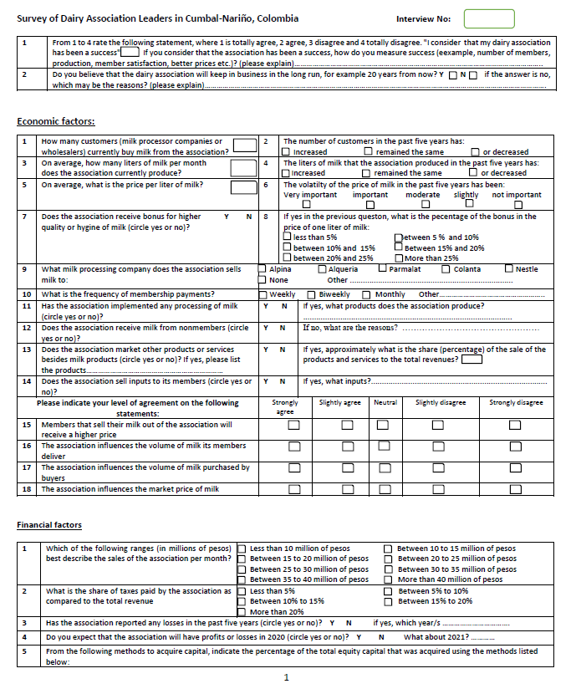

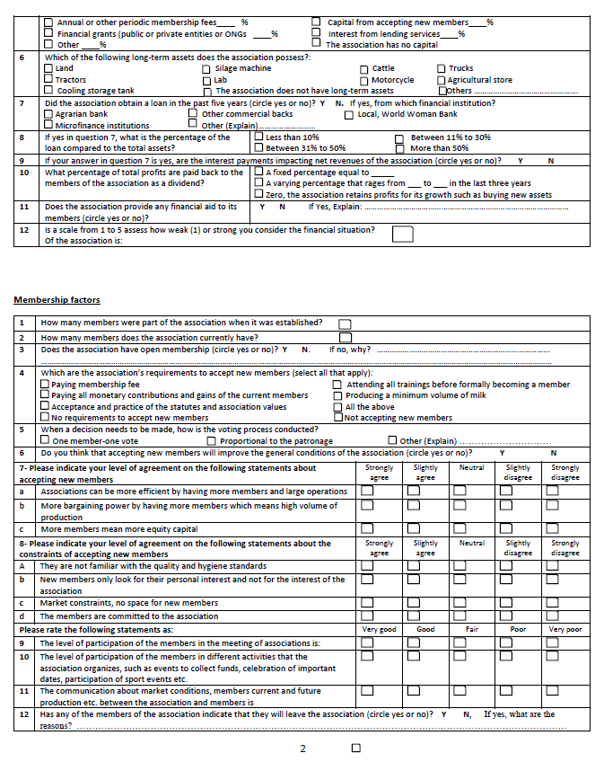

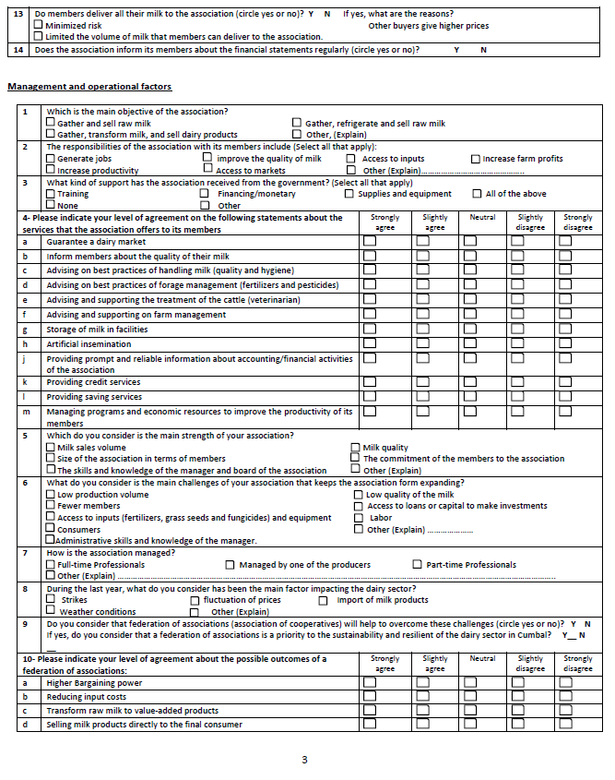

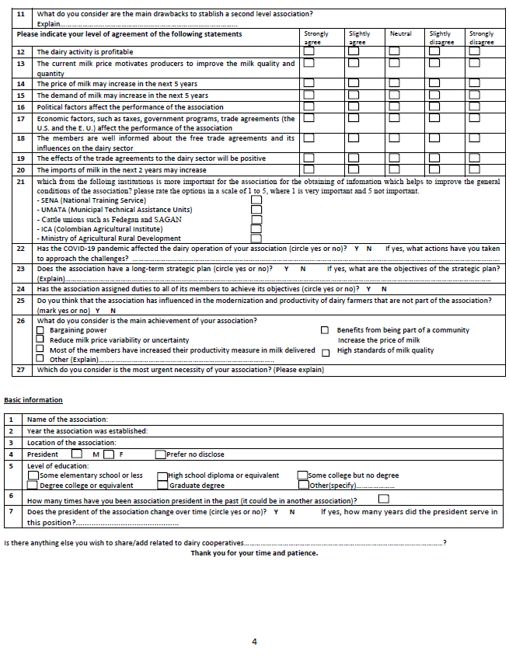

                - APPENDIX B. Survey in Spanish
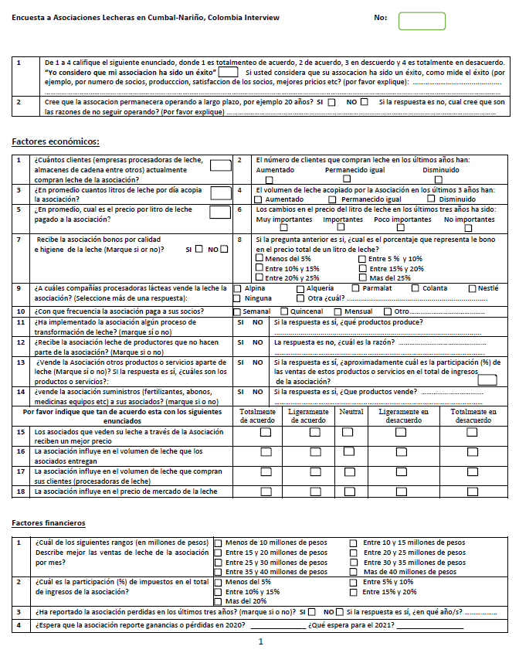

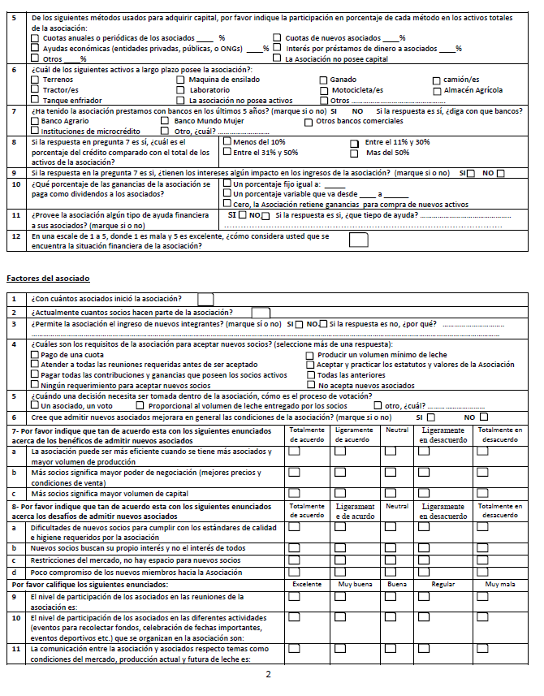

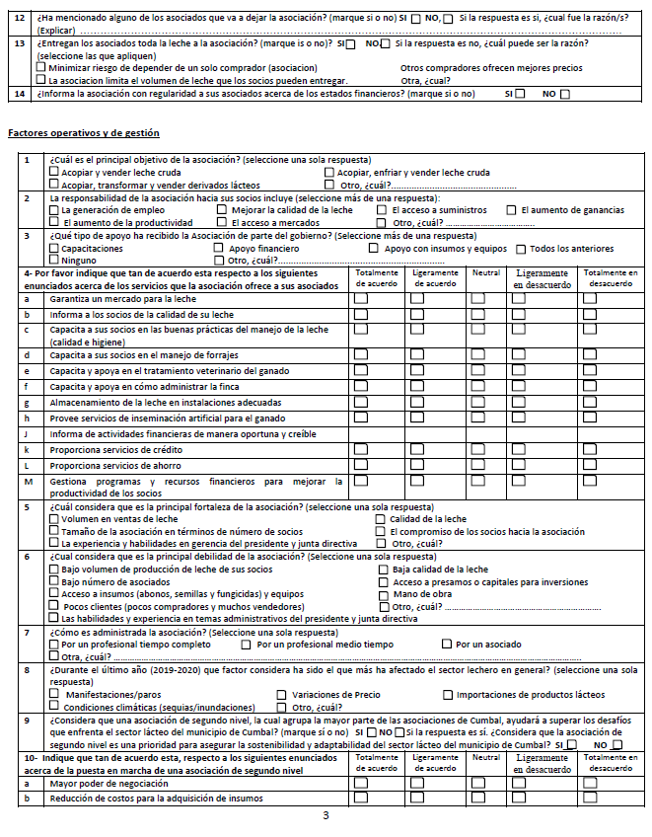
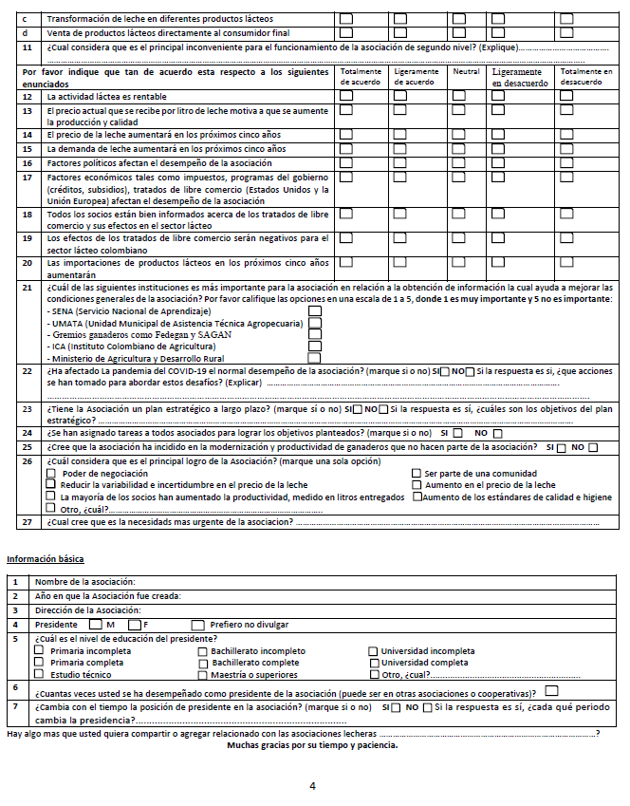

                - APPENDIX C. ADDITIONAL SURVEY RESPONSES

- The liters of milk that the association produced in the past five years has:

Figure C- 1. Change in collection volume during the last three years (n=40)

- The volatilty of the price of milk in the past five years has been:

Figure C- 2. Impact of the changes in the price of milk during the past five years (n=40)
.

- What milk processing company does the association sells milk to:

Figure C- 3. Percentage of Milk purchased by Dairy processing companies (n=42)

- Which of the following long-term assets does the association possess?

Figure C- 4. Assets owned by dairy associations (n=42)

- What are the association’s requirements to accept new members (select all that apply):

Figure C-5. Requirements to accept new members (n=42)

- Please indicate your level of agreement on the following statements about the services that the association offers
to its members

Figure C-6. Dairy associations services offered to members

- Please indicate your level of agreement on the following statements:

Figure C-7. Respondent perceptions of the influence of dairy associations in the market

- Please indicate your level of agreement on the following statements about accepting new members

Figure C-8. Respondent positive perceptions about accepting new members

- Please indicate your level of agreement on the following statements about the constraints of accepting new members

Figure C-9. Respondent challenge perceptions about accepting new members

- Please rate the following statements as:

Figure C-10. Respondent perceptions about member’s engagement

- Please indicate your level of agreement about the possible outcomes of a federation of associations:

Figure C-11. Respondent perceptions about the implementation of a federation of associations

- Which do you consider is the main strength of your association?

Figure C-12. Percentage of the strength of the dairy associations (n=42)

- What do you consider is the main challenges of your association that keeps the association from expanding?

Figure C-13. Percentage of the challenges of the dairy associations (n=42)

- During the last year, what do you consider has been the main factor impacting the dairy sector?

Figure C-14. Percentage of the factors that have affected the dairy sector (n=41)

- What do you consider is the main achievement of your association?

Figure C-15. The most important achievement of the dairy association

- Please indicate your perception of factors that affect dairy activity

Figure C-16. Respondent perceptions about the dairy activity in general

- Obtaining of information from the institutions improve the general conditions of the association Please rate the options
in a scale of 1 to 5, where 1 is very important and 5 not important.

Figure C-17. Institutional Information that improves the general conditions of the dairy association (n=41)

18) Year the association was established:

Figure C-18. Percentage distribution of the age of dairy associations of the
municipality of Cumbal (n=42)

19) Level of education of the president of the dairy associations in Cumbal.

Figure C-19. Level of education of the presidents of the dairy associations of the municipality of Cumbal (n=42)
                - Vita
Omar Aza Fuelantala is from the Municipality of Cumbal-Nariño, Colombia. He completed his Bachelor’s degree in International Trade at the University of Valle, Colombia in 2013 and after 2013, he has worked in the logistic international transportation industry in the private sector. He joined Department of Agricultural and Resource Economics at the University of Tennessee to pursue a Master’s Degree in Agricultural Economics in Fall 2019 and will graduate in Summer 2021. Upon graduation, he will return to his country, Colombia, and work in matters related with agricultural with institutions of the private or public sector.

The conversion to US Dollars was estimated considering the average rate of exchange of Colombian pesos to US Dollars in the year 2020, which was $ 3,693.36 Colombian pesos per one US Dollar. https://dolar.wilkinsonpc.com.co/dolar-historico/dolar-historico-2020.html
Bondarenko, P. (2017) defined Gross domestic product (GDP) as the total market value of the goods and services produced by a country’s economy during a specified period of time. It includes all final goods and services—that is, those that are produced by the economic agents located in that country regardless of their ownership and that are not resold in any form. It is used throughout the world as the main measure of output and economic activity.
In Colombia 80% of the small farmer own less than one Family Agricultural Unit (FAU). (Serrano, 2018). According to the Colombia 135 Law of 1961 a FAU can be defined as the land that allows a family to earn an appropriate income and have a decent quality of life. The law does not specify the extension of land that make up a FAU due to the heterogeneity of the land such as quality and access to services that support agriculture.
On the other hand, the costs for members of being part of an association are: Members are required to actively participate in meetings and events organized by the association, if they cannot attend, members pay a penalty. Members abide by the decisions taken by the majority of members through vote. The participation and effort among members are not the same, some take advantage of the efforts of others. When a member decides to leave the association, the member cannot sell their membership as one would do in case of a Limited Liability Company.
The conversion to US Dollars was estimated considering the average rate of exchange of Colombian pesos to US Dollars in the year 2020, which was $ 3,693.36 Colombian pesos per one US Dollar. https://dolar.wilkinsonpc.com.co/dolar-historico/dolar-historico-2020.html

