Testing a Model Based Approach to Selective and Flexible Attention
Anastasia N Kerr-German
Masters Thesis
University of Tennessee, Knoxville

Acknowledgements
I would like to first thank my husband for constantly supporting me through this process. My family has had a huge influence on my success and have always encouraged me to be the best I can be. I also want to thank my mentor, Dr. Aaron Buss, for the many emails and meetings that have shaped my time here at UTK. I am excited for what is to come and at the prospects of obtaining my PhD in a few short years.

Table of Contents
Abstract …………………………………………………………………………………… . 6
Introduction ………………………………………………………………………………… 7
Simulation Methods ………………………………………………………………………. 24
Simulation Results ………………………………………………………………………... 25
Summary …………………………………………………………………………………... 27
Hypothesis ……………………………………………………………………………….... 28
Experimental Methods ……………………………………………………………………...29
Results ………………………………………………………………………………………33
Conclusion ………………………………………………………………………………….44
References …………………………………………………………………………………..47
Vita ………………………………………………………………………………………….61

List of Figures
Figure 1 ……………………………………………………………………………………11
Figure 2 ……………………………………………………………………………………18
Figure 3 ……………………………………………………………………………………21
Figure 4 ……………………………………………………………………………………22
Figure 5 ……………………………………………………………………………………25
Figure 6 ……………………………………………………………………………………28
Figure 7 ……………………………………………………………………………………29
Figure 8 ……………………………………………………………………………………30
Figure 9 ……………………………………………………………………………………31
Figure 10 ..…………………………………………………………………………………34
Figure 11 …………………………………………………………………………………..37
Figure 12 .…………………………………………………………………………………39
Figure 13 …………………………………………………………………………………..40
Figure 14 …………………………………………………………………………………..44

List of Tables
Table 1 …………………………………………………………………………………….32
Table 2a …………………………………………………………………………………....35
Table 2b ……………………………………………………………………………………36

Abstract
Keywords: selective attention, flexible attention, Triad-Classification, DCCS
A recent neural-process approach using dynamic field theory (DFT), put forth by Buss and Spencer (2014), demonstrated how a simple dimensional attention mechanism can explain the behavioral and neural data associated with the development of flexible attention and performance in the Dimensional Change Card Sorting task (DCCS). Taking a dynamical systems approach to the development of attention in executive functioning is critical as it allows us to further probe the underlying processes and mechanisms that give rise to later life success.
The goal of the current proposal is to generalize DFT in order to explain the development of selective attention in the context of the Triad-Classification task (TC) and to test these assumptions by collecting behavioral and hemodynamic data. The aforementioned model predicts that both selective and flexible attention develop through a common dimensional attention mechanism in the context of the DCCS and TC tasks respectably. Despite this common mechanism, the model also predicts divergence in hemodynamic activation between these tasks at different points in development, suggesting certain aspects of the proposed frontal-temporal-parietal network may be involved uniquely when engaging in selectivity verses flexibility. The purpose of this paper is to highlight the specific data used to test this theory, so minimal time will be spent on the predictive power of such a model; rather the emphasis will be on how the model and data together can inform the literature concerning the development of these two types of attention.

Introduction
Executive Functioning: Past Perspectives
Executive functioning (EF) is a term used to refer to various aspects of cognitive control, autonomy, and mental flexibility (Buss, Wifall & Hazeltine, 2013). EF undergoes rapid changes in early childhood and continues to develop through adolescence (Best & Miller, 2010; Blair, Zelazo, & Greenberg, 2010; Huisinga, Dolan, & van der Molen, 2006). Measures of EF in early childhood are predictive of later physical health, substance dependency, personal finances, as well as criminal offending outcomes (Moffitt et al., 2011). EF deficits are associated with various clinical disorders such as Autism Spectrum Disorders (ASD) and Attention Deficit Hyperactivity Disorder (ADHD) (Banaschewshi et al., 2005; Brown, 2013; Hill, 2004; Lemon, Gargaro, Enticott & Rinehart, 2011; Zelazo, 2013). Further, interventions for EF during the preschool years and in early to late childhood have been shown to be beneficial for overall cognitive functioning, executive control, and social/emotional development during specific tasks (Diamond & Lee, 2011; Moffitt et al., 2010; Thorell et al., 2009; Weibe et al., 2011). One limitation of such interventions is they lack generalizability beyond the task used in the intervention. In order to have a better understanding of EF to both improve interventions and prolong their effects, a aa systems approach to these developmental outcomes is needed. To achieve this, new studies need to focus on unearthing both the mechanisms and neural processes underlying the developmental changes involved in EF abilities (i.e., attention, working memory, planning, etc.).
Traditionally, EF has been considered part of the ‘central executive’, a homunculus or supervisory attention system. Under this framework, a centralized controller is informed of the task goals and is thereby able to select the appropriate actions given different stimuli or contexts. This view of EF sidesteps the question of how control is achieved and instead focuses on what is controlled. The central executive is then seen as been neurally localized to the frontal cortex from which it controls processes in other brain regions. This approach seems to be challenged in light of recent work demonstrating that EF is reliant not only upon frontal cortex activity, but upon networks of brain regions with which the frontal cortex interacts (Stuss & Alexander, 2000).
An alternative perspective of EF applies a latent variable approach to differentiate specific functions of control that are involved across different tasks or contexts. Based on this approach, three core executive functions or components have been proposed; updating, shifting, and inhibition. According to the latent variable approach set forth by Miyake and Friedman (2012), research can target EF more directly by using the shared variance (i.e. the uniqueness and overlap of variance in various components of executive functioning) between multiple tasks, involved in a specific EF component (e.g. inhibition). Miyake and Friedman (2012) proposed the idea that shared variance could be largely task dependent; meaning the battery of tasks used in each study could yield diverse results concerning the uniqueness of and unity within of each of the defined component. To test this idea, Thorell et al. (2009) investigated training effects associated with interventions aimed to increase EF and found that these effects transferred across components of EF, suggesting there is more to EF than that which can be parceled out by a shared variance perspective. Although the results of Thorell et al. (2009) provide evidence for overlapping EF processes, shared variance approaches to EF primarily focus on descriptions of executive control rather than explaining the processes or mechanisms involved in obtaining control. Based on this, a neural network approach to each component or aspect may be better suited to address mechanisms involved in these processes. That is, a network approach would be unique as it focuses less on single-cause explanations and more on incorporating findings from various types of manipulations. These aspects of executive functioning do not seem to be under a single controller but rather control is distributed, thus multiple causes can be inferred.
To be able to explain the underlying mechanisms of EF, a deeper understanding of the dynamics involved in different types of EF is needed (Morton, 2010; Buss & Spencer, 2014).
Current Directions
As the key interest of this study is the development of executive functioning is important to highlight the theoretical disposition towards development influencing this interest. Dynamic systems approaches to development provide a rich avenue to explore the aforementioned questions concerning the development of EF. From this disposition, development is viewed as being non-linear, self-organizing, embodied, and indivudally variant (Miller, 2002; Spencer et al., 2006). A recent dynamic systems theory explains EF as an emergent outcome of neurocognitive processes. Rather than focusing on components of control, this theoretical stance on EF provides greater insight to how control is achieved. For example, Buss and Spencer (2014) identified a key process that gives rise to various aspects of control: dimensional attention. Using a simple dimensional attention mechanism, Buss and Spencer (2014) were able to explain a wide array of data relating to the development of attentional flexibility. Both selectivity and flexibility are important skills of EF, yet the processes and mechanisms associated with these attentional functions are still somewhat convoluted in the literature. The focus of this paper is to generalize the dimensional attention mechanism to determine if it can also explain the development of selective attention.
The Role of Attention
Attention is a key function of executive functions and can be measured neurologically, behaviorally, and physiologically (Ruff & Rothbart, 1996). Previous research on attention development focused on anatomical regions in the brain corresponding to the anterior and posterior attention networks (Posner, 1992; Posner & Peterson, 1989) and the sub-networks of these systems: orienting, alerting, and executive attention (Peterson & Posner, 2012). These networks give rise to general attention processes including the selection of a target, the engagement of attention, and the controls needed to shift and maintain attention necessary for the current situation or task (Ruff & Rothbart, 1996). Previous research has shown that general attentional ability is facilitated by the processes involved in selectivity, state of engagement, and higher-level control (Ruff & Rothbart, 1996). Attention is complex, multidimensional, and involves many different regions of the brain. A recent review on the development of attention in early childhood focused on the similarities and distinctions between flexibility and selectivity, outlining a need to better understand these attentional functions as they relate to one another (Hanania & Smith, 2010).
Flexible Attention
Flexible attention, also called attention shifting, is the ability to voluntarily disengage from one stimulus and then engage another based on task demands or what is appropriate in a specific situation. The Dimensional Change Card Sorting task (DCCS) is a measure of flexible attention that demonstrates robust developmental difference in performance between 3- and 4-year-olds. In this task, children are asked to first sort cards by one dimension (i.e. shape or color) for a set amount of trials in a pre-switch phase. In the second phase of the task, denoted as the post-switch phase, children are asked to switch rules and sort by the other dimension (e.g. to sort by shape in the post-switch if they sorted by color in the pre-switch phase). In pre-switch trials, 3-year-olds perform similarly to 4-year-olds and are able to appropriately sort test cards to the matching target cards. In post-switch trials, when the rules change, 3-year olds perseverate (e.g. do not switch rules) and continue to sort by the primed color/shape rule from the pre-switch phase. In contrast, 4-year-olds are able to flexibly switch attention to sort by the new rules, switching attention to the new relevant dimension, in the post-switch phase. Switching rules in the DCCS is a complex process that requires not only switching, but also working memory (i.e. to maintain a representation of the new rules) and inhibition (i.e. to suppress the irrelevant dimensions) during post-switch trials (Garon, Bryson, & Smith, 2008). Thus, flexible attention in this task taps into multiple components of EF.
Selective Attention
Selective attention is the preferential allocation of limited processing resources to events that have become behaviorally relevant (Booth et al., 2003). This attentional mechanism involves the enhanced processing of specific aspects of incoming stimuli that are task relevant, such as those necessary for orienting, filtering, searching, and expecting (Driver, 2001; Plude, Enns & Brodeur, 1994). Previous research has explored selective attention in the context of different learning tasks (e.g. discrimination learning tasks) and focused primarily on visual cognition (Kendler, 1963; Triesman, 1969). A recent review of Feature Integration Theory (FIT), first proposed by Triesman and colleagues (1977), summarizes how features that share the same spatial location automatically bind to that location/object in space, unless the presentation of the object is too brief (e.g. a small fraction of a second) in which case some features may not be processed and consequently bound to that location in space. This is one critical aspect of both flexbile and selective attention tasks that tap into dimensional attention.
The Triad Classification task (TC) is a widely used measure of selective attention performance (Shepp & Barrett, 1991; Smith, 1989; Smith & Kelmer, 1977; Smith & Nelson, 1984; Thompson, 1994; Thompson & Markson, 1998; Ward, 1980). The structure of the TC is outlined in Figure 1, taken from Perry and Samuelson’s (2013) recent adaptation of the original task (Smith & Kelmer, 1977).
Dimension 2
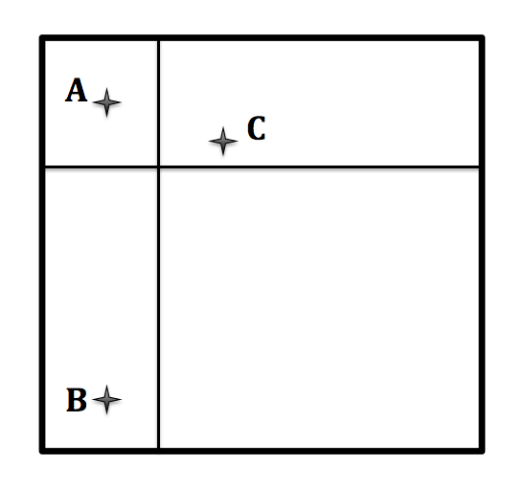
Dimension 1
Figure 1. The above schematic represents the basic layout of the Triad Classification task where A is the reference object, B is the identity match choice, and C is the holistic match choice.

In the TC task participants are shown a reference object (A in Figure 1) and must pick between two choice objects, based on which choice (B or C in Figure 1) ‘goes most with’ the reference object. One property of this task making it unique when compared to the DCCS is the absence of rules that cue the participant to a specific dimension. There is an identity match choice (B in Figure 1) that matches the reference object (A in Figure 1) along one dimension but is very different along the other. The holistic match choice (C in Figure 1) is more similar across both dimensions (e.g., feature values for both the shape and color dimension are close in value to that of the reference object) but does not match exactly along either. In this task, 3-year-olds and some 4-year-olds match holistically and some 4-year-olds and all 5-year-olds choose the identity match (Smith, 1989). Smith (1989) used stimuli that varied based on complexity, number of relevant dimensions, and metric similarity, and found that holistic categorizations may only be depended on one dimension being similar over-all as opposed to both dimensions. This study also brings support for the identity match choice being maximally different along the irrelevant dimension in the TC task and further explored the differentiation of identity and weights of dimensions developmentally. According to pilot data collected in our lab, adults typically perform between 80% accuracy to ceiling during this task.
Mash (2006) suggested that metrics such as shape, position, and color may matter more for younger children (i.e. 5-year-olds) than older children (i.e. 8-year-olds) and adults in a modified version of the TC in which curvature and position of object were manipulated. During the standard TC, overall similarity of the choice objects to the reference object had less effect on proportion of classifications as age increased. However, dimensional identity had a significant effect on the proportion of classifications as participants’ age increased. Finally, dimensional similarity had an effect that is similar to that of overall similarity of the choice objects until the age of 8-years-old, after which it became less relevant for the adult comparison. These findings suggest that a fairly narrow range of information is used by young children when determining similarity of objects in the test array.
Sheep and Barrett (1991) found that object perception is often categorized as holistic or ‘unitary’ at earlier stages of development and older children integrate more analytical processing lending towards more identity choices in the TC. Milton and colleagues (2008) conducted a study with adults where cognitive load and time pressure were assessed as a factor of performance. Within the low time pressure condition, individuals in the overall similarity sort group took longer to sort than those in the one-dimension sort group. That is the group that only had to sort on one dimension were faster when compared to the group that had to integrate both dimensions on overall similarity. This study supports the notion that a rule based system will be slower than an association based system when time constraints are imposed. Thus, time and processing speed is one important aspect of selective attention. In addition, the ‘complexity’ of the rules produced by the verbal system is influenced by the amount of time allowed to process the stimuli and respond. Results suggest that adults may use selectivity flexibly depending on the amount of time available to processing incoming visual stimuli. Perry and Samuelson (2013) found that holistic labelers who label the objects according to their dimension were faster at categorizing once labels were given in children 5- to 8-years-old, suggesting that early world learning and consequently label learning may strengthen associations between labels and dimensional categories resulting in better selective attention to dimensions that are supported by both these associations and increasing linguistic support for them.
Other work utilizes a differential-sensitivity theory to support their conclusion that holistic and identity rule use is not as relevant as dimensional rule use in the TC (Raijmakers et al., 2004; Thompson, 1994; Thompson & Markson, 1998). In this conclusion, children similarly to adults have a biased preference or generally focus on a ‘distinct dimension’. Rather, what is important in this theory is that sensitivity to value differences in various dimensions (i.e. metric differences) develops along with sensitivity to things like hierarchal salience distinctions within a dimensionality. In addition, consistency of behavior in the task develops with increased rule use and experience. This explanation is largely perceptual but is not grounded in neural processes and mechanisms.
Interactions between Selective and Flexible Attention
Currently there is a debate in the literature regarding how selective and flexible attention can be parsed (Hanania & Smith, 2010). In particular, some have argued that flexible attention requires selective attention (Habrick, Lickliter, & Flom, 2004). There is evidence from the DCCS task that suggests the level of demand placed on selective attention can influence flexible attention. It is still somewhat unclear whether this influence of selectivity on flexibility is due to the co-development of these abilities or the need for one ability in order to engage in the process of the other.
For example, when the demands on selectivity in the DCCS are decreased or altered, children are able to switch attention and flexibly focus attention to the relevant dimension during post-switch trials. For instance, if the post-switch features are more distinct or perceptually ‘salient’ than the pre-switch features, the demands on selective attention during the post-switch phase are reduced and 3-year-olds have less difficulty switching rules (Fisher, 2011). Additionally, Brooks and colleagues (2003) showed that when unidimensional black and white test cards are used, 3-year-olds have little difficulty switching in a “silly” version of the DCCS in which the responses are reversed (i.e. stimuli that ‘won’ before in pre-switch trials now ‘loose’) for the post-switch phase. In this task, children only need to attend to a single dimension. Three-year-olds had difficulty in this silly version of the DCCS (i.e. modified to mimic the reversal and non-reversal tasks of Kendler and colleagues (1960)) when the stimuli contained multiple dimensions (i.e., shape and color). Based on this finding, the authors attribute errors in post-switch trials of the DCCS to a deficit in selective attention (Brooks et al., 2003). That is the inability to selectively focus on the relevant dimensions rather than being distracted by multiple dimensions led to better performance on this task. This perspective on the DCCS tasks emphasizes both memory for the rules and inhibition of previous responses in post-switch trials (e.g. traditional challenges of the DCCS) while adding in complexity of the stimuli as an additional challenge.
Brace, Morton, and Munakata (2006) showed that reducing the demands on selective attention by using an intermediate phase in the DCCS (i.e. the opposite of the aforementioned ‘silly’ DCCS) where only the post-switch feature is present facilitates post-switch performance of 3-year-olds. In this case, the intermediate phase removed the demands imposed on selective attention by post-switch rules, thus facilitating 3-year-old performance during the post-switch phase.
These findings together demonstrate the complexities of distinguishing flexible and selective attention. The current study aims to delineate the similarities and differences in selective and flexible attention at the behavioral and neural levels in the context of the traditional DCCS and TC tasks, in hopes to generalize these properties of attentional functioning to other attention grounded EF tasks. In addition, providing a neural framework in which to situate these findings where selectivity and flexibility are manipulated will allow for a richer understanding of how these attentional processes work together across various contexts.
Dynamic Field Theory
DFT simulates cognition using neural population dynamics within fields of simulated neurons that are ‘tuned’ to specific perceptuomotor information (i.e. dimensions color and shape). More complex representations, such as those underlying objects or labels can be produce through combinations of these basis perceptuomotor representations. Neurons within these fields operate based on a local-excitation surround-inhibition interaction profile. The fundamental units of cognition in this framework are peaks of activation for neural units tuned to particular information. A peak of activation can correspond to processes such as working-memory, attention, or selection of a stimulus or response. Hebbian learning operates within these field representations to boost baseline levels of activation for previously activated neural units.
Recently, Buss and Spencer (2014) put forth a neurocomputational framework, utilizing using Dynamic Field Theory (DFT) that was able to provide traction for the study of EF development. DFT explains the development of EF as being emergent from interactions between neural systems involved in perception and action. Buss and Spencer (2014) proposed a dimensional label learning hypothesis to explain the development of attentional control in the DCCS, thus providing a deeper theoretical understanding of 3- and 4-year-olds’ performance in the task. This hypothesis states that attentional development is driven by the learning of dimensional labels which leads to greater frontal-posterior connectivity in the brain. This is in contrast to more traditional viewpoints of frontal lobe maturation driving better control and more mature EF (Moriguchi & Hiraki, 2009).
The Dimensional Attention Account of the DCCS
The architecture used to simulate the DCCS is based on general properties of information (i.e. in this task dimensions and features of objects) represented in cortex (see Figure 2). The Dynamic Neural Field (DNF) model proposed by Buss and Spencer (2014) explains why 3-year-olds perseverate in the DCCS task and 4-year-olds successfully switch in post-switch trials. The model is based on a network consisting of frontal, parietal, and temporal regions. Within the proposed network, the parietal component represented spatial information in the task (in purple), two feature-space mappings in temporal regions initially representing the target card inputs (denoted by yellow and green), and the frontal component where dimensional label representations were formed to make decisions based on the task rules (in blue). The parietal component provides an anchor for the spatial representations and, ultimately, serves as a proxy for the response generated from the model (i.e. the model will ‘select’ or activate a spatial location that corresponds with a response option- left or right target card). The temporal component is composed of bi-dimensional neurons that are tuned to a combination of spatial and visual features for shape and color information (e.g. red, blue, square, and circle). The frontal component is composed of a label system that forms representations by generating reciprocal connections between labels (e.g. “red” or “blue”) and feature information about dimensions (e.g. the colors red or blue) in the posterior component. Through these frontal-posterior and posterior-posterior connections, label representations can lead to the activation of feature representations reciprocally. In the context of the DCCS, activating a label for ‘blue’ (i.e. frontal-posterior connections) can prime activation for that feature in the object representation system (i.e. connections between the parietal and temporal areas) allowing the model form decisions based on this feature (i.e. frontal-posterior and posterior-posterior connections). Parietal and temporal connectivity implement an object representational system that functions by binding features to spatial locations. The frontal lobe modulates this spatial binding process by biasing particular visual dimensional fields.
Buss and Spencer (2014) implemented two hypotheses in this model to explain development in the DCCS task. The first is that frontal-temporal connectivity strengthens through a process of associating labels with visual features. With stronger connectivity, the frontal component is able to have greater influence on the posterior feature binding system. The second is stronger local interactions within the frontal components will give rise to stronger and more selective activation of the dimensional attention system.
Figure 2. The above schematic presentation of the model is based on Buss and Spencer (2014).

Buss and Spencer (2014) created two variations within the model, to represent developmental time points of ‘young’ and ‘old’ that had different strengths of connectivity (i.e. parameters) for connections between frontal and temporal areas. For simplicity, the ‘young’ group will be referred to as perseverators and the ‘old’ group will be referred to as switchers. Switchers were defined by strong connectivity between the frontal and temporal components along with strong local interactions within the frontal component. Perseverators however, had weak connectivity between frontal and temporal components and weak local connectivity within the frontal component. In this framework, rule representations are distributed between frontal and temporal components. The frontal component represents what dimension is relevant, but does not ‘know’ which features go where. The temporal component, on the other hand, ‘knows’ which features go where, but does not ‘know’ which dimension is relevant. Thus, to succeed in this task, cooperation between multiple regions of the brain is necessary. Buss and Spencer (2014) demonstrated that this model architecture was able to explain performance and development for 14 different versions of the DCCS.
The left column of Figure 2 shows the model at rest with the task inputs. The task inputs correspond to the location of the features on the target cards. The model first is given inputs to the temporal component for the features ‘blue’ on the left and ‘red’ on the right in the color field, and inputs for ‘circle’ on the left and ‘star’ on the right in the shape field based on the spatial locations of the target cards. During pre-switch trials, given the test card above (i.e. red circle) during the color game, the model will sort to the right. This test card is implemented as a sub-threshold input to the ‘color’ neuron based on the rules provided for the color game. It is important to note that the test card input does not contain spatial information. Instead, the test card is provided a ridge of activation for the relevant features at all spatial locations (i.e. the bar running across the field for both shape and color). The model needs to make a spatial decision about visual features based on the rules of the game. In column three a decision has emerged based on spatial coupling and the bias provided by the activation of the color dimensional neuron. The model has a peak for red on the right and a peak for circle on the right (i.e. the third column), the decision is based on the overlap of the target card input (i.e. the first column) and the test card ridge (i.e. the second column). Importantly, the irrelevant feature is also activated based on spatial coupling—even though the model is ‘seeing’ circle on the left in the task space, it builds a peak for this feature on the right as the relevant dimension ‘wins’. Inhibition of the irrelevant dimension is necessary once conflict emerges in post-switch trials. Before this conflict in presented in the task during post-switch trials, both developmental groups perform generally the same.
In the post-switch trials the rules change, meaning the researcher then tells the child “okay we finished the color game, now we are going to play the shape game. In the shape game stars go on the right and circles go on the left”. In column 4 (see Figure 2), the pattern of Hebbian memories that formed from sorting during the pre-switch phase overlap with and support the target inputs in the pre-switch field but are adjacent to and in competition with the target inputs for the post-switch field. This is where conflict creates challenge for the model, and performance for the group that perseverates deviates from that of the group that switches. Perseverators’ post-switch performance is driven by the aforementioned Hebbian memories (i.e. fifth column). Even though the model is ‘told’ to sort by shape, the perseverators fail to switch rules, and continue sorting by color similar to the performance of 3-year-olds. Switchers are able to overcome the memories and flexibly switch rules due to the extra input from dimensional attention system (i.e. stronger connectivity between frontal-posterior regions). The variation of the model representing the developmental group that perseverates is dominated by bottom up processing due to weak dimensional attention. In contrast, the model representing the group that successfully switches has stronger dimensional attention and utilizes top down processing.
The Dimensional Attention Account of the TC
The dynamic neural field (DNF) model elucidates why switching rules in the DCCS is challenging. The TC task on the contrary does not have explicit rules. One leading question is whether performance and the development of selective attention in early childhood as it pertains to the TC task can be explained by this dimensional attention mechanism. Using the same model architecture discussed above, Figure 3 shows the sequence of events that unfold on TC after being implemented into the existing model by Buss and Spencer (2014). Similar to the test card in the DCCS, a reference object provides task inputs (i.e. ridges for the color and shape of the reference item) at the start of a trial. In the second column (i.e. a few seconds into the trial) two choice objects appear and localized inputs specifying both feature and spatial information are activated. The instructions given to the model, reflective of those given to children in this task, are to select the object that best matches the reference object based on the configuration of the ridges and spatially localized object inputs. Inputs for the holistic-object’s features are close to the reference object ridge in both feature fields (i.e. shape and color dimensions have corresponding fields with ‘all possible’ feature values). In contrast, the inputs for the identity-object’s features perfectly overlap in one field but are maximally different in the other field. This is similar to the DCCS in that only one dimension is relevant in order to make the correct sorting choice (i.e. choosing the identity match object), and weak dimensional attention may provoke an incorrect sorting choice (i.e. choosing the holistic match object) based on the proposed model.
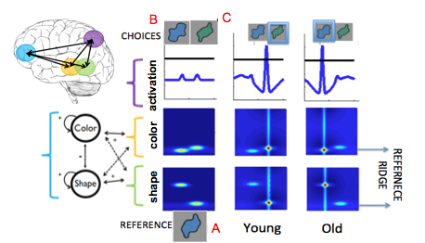
Figure 3. This figure is based on the TC configuration used in Perry and Samuelson (2013). Object A is the reference object, object B is the indentiy match and object C is the holistic match.

In a purely-feed forward network, the default choice would be the holistic match due to greater overall neural energy at the spatial location of that object compared to the identity object. However, considering the coupling of these feature fields to the dimensional attention system, the field with the identity matching feature ends up with greater neural energy when compared to the holistic matching field. The field dynamics outlined above can provide a signal capable of selecting a relevant dimension for enhanced processing, despite greater activation due to proximity of choice item inputs and reference ridge location within the feature fields. This explanation offers one possible basis for the development of selective attention in early childhood.
The developmental dynamics involved in the frontal system can be seen in Figure 4. Node activation is plotted for the dimensional attention neurons in the same two developmental groups used in the DCCS (i.e. perseverators and switchers). Switchers have stronger activation of the relevant dimensional neuron as well as stronger suppression, or inhibition, of the irrelevant dimension.
Figure 4. The figure represents the developmental differences between the young (left) and old (right) model for irrelevant and relevant dimensional field activation in the two tasks. Here time is on the x axis and 1 timestep=2 ms.

Interestingly, the variation of the model that represents perseverators always activates the relevant dimensional neuron (i.e. node) even though it fails to successfully ‘attend’ to that dimension in these tasks. Figure 4 also shows an interesting deviation in time course between the two tasks. For the TC in the switchers model, the posterior/frontal interaction corresponding with node activation make in fact take longer due in to the absence of explicit rules in the task. For the DCCS in the switchers model, the frontal component already ‘knows’ what to do, thus responds more quickly. In contrast, the model that perseverates there is less processing resulting in faster processing in the DCCS compared to the TC. Due to weaker connectivity between frontal and posterior components, the model that perseverates takes longer overall to respond in relation to the model that switches. The following questions are motivated from running a batch of perseverator and switcher variations of the models to determine if these activation dynamics produce an association between the selective and flexible attention tasks: Does the ‘young’ model that perseverates in the DCCS pick the holistic match in the TC? Conversely, does the ‘old’ model that switches in the DCCS task pick the identity match in the TC?
Simulation Methods
Procedure
Simulations were conducted in MatLab 7.5.0 (Mathworks, Inc., Natick, MA) on a Mac with an Intel i7 with a 2.6 GHz processor and a PC with an Intel i7 3.33 GHz quad-core processor. The model was given the standard DCCS and original TC as described by Buss and Spencer (2014) and Perry and Samuelson (2013). Each session of the DCCS had 12 trials (i.e. 6 pre-switch and 6 post-switch) and of the TC had 12 trials (i.e. randomized between participants for the dimension of the identity match). Responses were coded based on the spatial location selected in the DCCS task or the object selected in the TC task.
Hemodynamics were simulated by tracking the synaptic activity for each component of the model and convolving this time course with an impulse response function (Buss & Spencer, 2012). The convolved hemodynamics were then normalized across models and tasks by dividing by the maximum signal amplitude for each component, subtracting the initial value of the hemodynamic response from each trial, and averaging across trials.
Simulation Results
For the remainder of the paper, the ‘young’ model is referring to the perseverators and the ‘old’ model is referring to the switchers. The current model replicates the DCCS models by Buss and Spencer (2014): the ‘young’ model perseverated and the ‘old’ model switched rules. In addition to this, the current model demonstrates that the ‘young’ model picks the holistic choice on every trial but the ‘old’ model picks the identity choice 80% of the time.
Based on the behavioral results from this batch of simulations, the DCCS and TC tasks were highly correlated regardless of age (r²= .141, p=.046). The grouping of simulated individuals was somewhat challenging as specific attention profiles emerged for each task. For example, in the triad classification task three clusters of data were apparent (i.e. high, average, and low performers). The same groups emerged in the DCCS, suggesting previous groupings of “pass” or “fail” may not suffice when linking the complexity of behaviors with hemodynamic data.
Hemodynamic simulation results are plotted in Figure 5, in which results for the DCCS also replicated from previous findings: stronger hemodynamic responses were observed for the ‘old’ model relative to the ‘young’ model in all components (Buss& Spencer, 2014). Novel predictions were made for the TC task, in that stronger hemodynamic responses were observed for the ‘old’ model relative to the ‘young’ model in all components, the most prominent difference demonstrated by the temporal component.
Figure 5. This figure shows hemodynamic predictions made by the model from simulations for both tasks.

The frontal component shows differences between tasks for the ‘young’ model with a stronger responses seen in the DCCS compared to the TC task. Finally, the temporal component showed a stronger response in the TC task relative to the DCCS task for the ‘old’ model. The difference in activation of the frontal component between tasks for the ‘young’ model could be driven the absence of explicit rules, and thus less input from that frontal component on the decision-making process. Figure 4 showed the activation of the dimensional nodes in the DCCS and TC tasks, exhibiting a late and weak activation of these nodes for the ‘young’ model in comparison to the ‘old’ model. The difference in activation in the temporal component for the old model, however, is likely due to the stronger reverberation between frontal and temporal components. This allows the dimensional signal in the TC tasks to be amplified in order enhance processing of the task relevant feature. This might also reflect the stronger inhibitory interaction within the task-relevant field which is needed in order to suppress activation of the feature for the holistic choice. What this might suggest is that switchers have both feature to feature and dimensional node to dimension node competition while perservators primarily have feature to feature competition.
Summary
The behavioral simulations suggest that selective and flexible attention in the context of both the TC and DCCS may fall along the same continuum, on which attention in these tasks slides from selectivity to flexibility and then back to selectivity for the later developmental group (i.e. switchers) and may be less functional in this way for the earlier developmental group. Selectivity and flexibility, together as one function of attention may utilize the same attentional mechanism of dimensional attention for both of these tasks and their variations. Although the same anatomical brain network and attention mechanism were used to simulate selective and flexible attention, there were dissociations at the level of neural activation. The model predicts differences between tasks in the frontal component of the ‘young’ model but differences between tasks in the temporal component of the ‘old’ model, suggesting the processes involved in these types of attention may differ and require a different amount of involvement from each of the components represented in the model. Meaning different patterns of activation may be associated with selectivity and flexibility at these two developmental time points, while still utilizing the same mechanism and consequently network of brain regions.
Hypothesis
From the model it can be inferred that the processes of selectivity and flexibility are both produced by the same mechanism of dimensional attention in these tasks and that perhaps, due to the ambiguity between these types of attention as well as the weak support for them as separate entities in the literature, they function along the same continuum of attentional control. Flexible and selective attention have similar but distinct processing demands—overcoming biases from habit verses overcoming strong bottom-up stimulus activation. The same dimensional attention mechanism implemented by DFT can explain developmental changes in both of these contexts.
The current study aims to propose that flexible and selective attention may possibly fall along a continuum as appose to being two separate pieces based on the current interpretations of the model (see Figure 6). Consequently, performance on in these tasks should be highly correlated within an individual and reflect the hemodynamic activation predicted by the model.
In addition to how these types of attention develop in the preschool years, specifically in light of these tasks, dimensional attention could be dependent on dimensional label learning and this language related manipulations are discussed. Functional Near-Infrared spectroscopy (fNIRS) data will be collected to test this frontal-temporal-parietal network of dimensional attention in which developmental differences will be representative of the task demands on these two mechanisms of attention in a systematic way. On prediction is that frontal regions will show greater activation over-all in both tasks for the ‘old’ model. Another prediction is that activation during the TC will show greater developmental differences when compared to the DCCS for the parietal region, suggesting that there are greater spatial demands in the TC than the DCCS because of the nature of the tasks. A final prediction is for the temporal region there will be a robust developmental difference for the TC in comparison to the developmental differences in the DCCS because the task requires both selective and flexible attention, thus greater demands on spatial couplings to labels in the task.
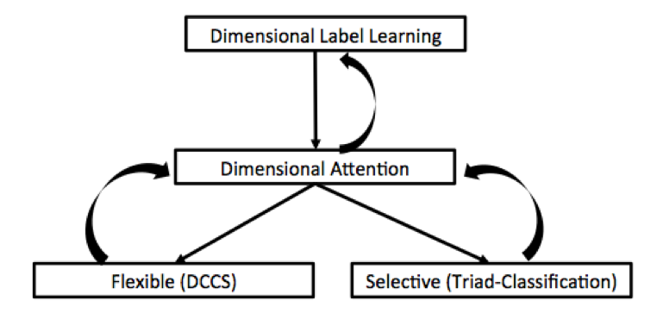
Figure 6. In the above figure, attention is reorganized to fit the demands of selective and flexible attention tasks. Here Dimensional label learning facilitates the development of dimensional attention while dimensional attention reciprocally feedbacks on dimensional label learning. Dimension attention can be looked at through the lens of flexible and selective attention in lights of tasks probing these attentional abilities.

Experimental Methods
Stimuli
Stimuli in the TC will consists of metrically differentiated shapes and colors using (see Figure 7) and presented on a gray background to account for any confound associated with color of the stimuli (Drucker & Aguirre, 2009). In addition, the NIH Toolbox version of the DCCS will be used (see Figure 8).



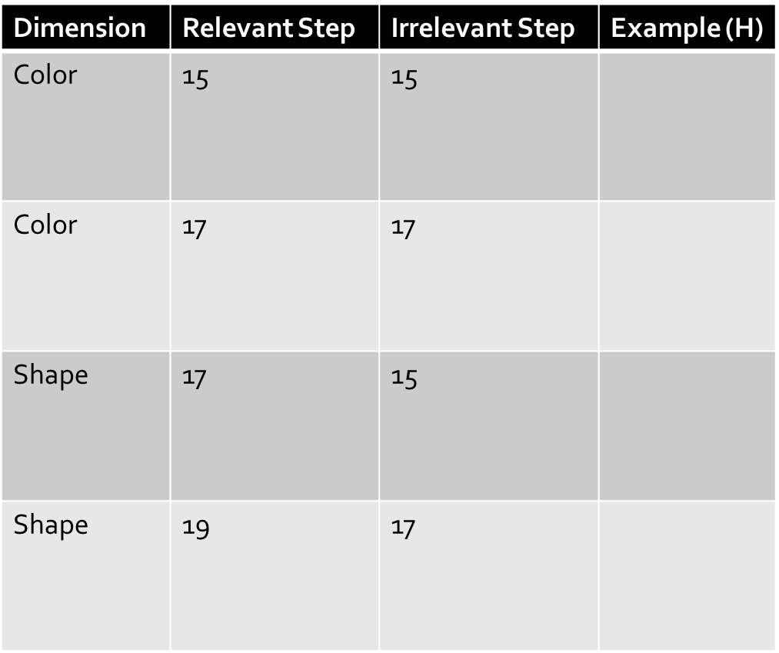



(B)

(A)

Figure 7. (A) is an example of one trial in the TC, where the reference item is at the bottom of the screen and the two choice objects are at the top of the screen. (B) Fourier space generated stimuli that are systematically changed along the dimensions of shape and color to match the task parameters based on the above ‘steps’ for the relevant and irrelevant dimension. The column titled Example (H) denoted all possible holistic matches for the reference object in (A).

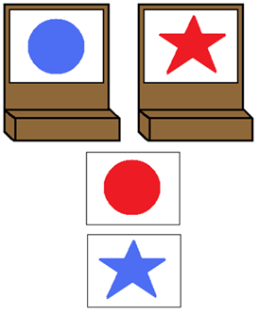 |  | 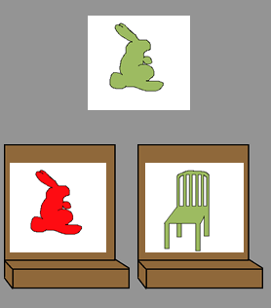
(A) | (B) | (C)

Figure 8. (A) Children practice with cards before beginning the NIH Toolbox version of DCCS.
(B) Children are given this for pre- and post-switch trials of standard DCCS, followed by a mixed block (C) where the target cards are changed and the rules change at random from ‘shape’ to ‘color’.
Procedure
Thirty-two children ages 3.5- and 4.5-year-olds were tested with a mean age of 42.9 months for the 3-year-olds and 53.6 months for the 4-year-olds. There were 8 females and 8 males in the 3-year-old group and 6 females and 10 males in the 4-year-old group. In each age group children were assigned to one of two conditions. Conditions were counterbalanced for order (i.e. receiving the DCCS and TC) and randomly assigned based on the age of the child. Within the NIH Toolbox for the DCCS, pre- and post- switch dimensions were counterbalanced by shape then color (i.e. SC) or color then shape (i.e. CS) for order, such that four children in each age group received the following conditions: TC then SC DCCS, TC then CS DCCS, CS DCCS then TC, and SC DCCS then TC. The children were not diverse in their ethnicity, but were representative of the local population (i.e. 4 of 32 children were from minority populations). In the DCCS, children were either told to play the color or shape game and then given the rules for that game (e.g. for the color game, purple ones go here and yellow ones go here, so in the color game where would this one go [pointing to indicate all of these locations]). Children were given reminders of the rules through the task. In the TC task, children were given two practice were used (see Figure 9).
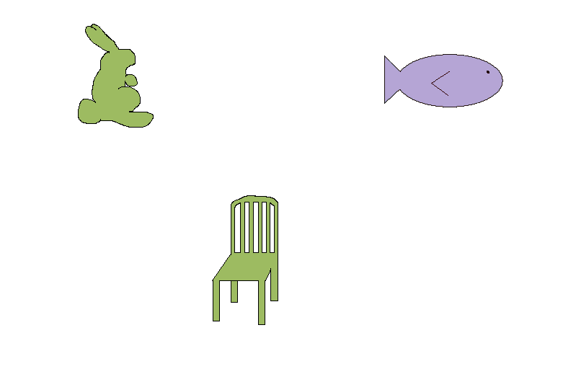 | 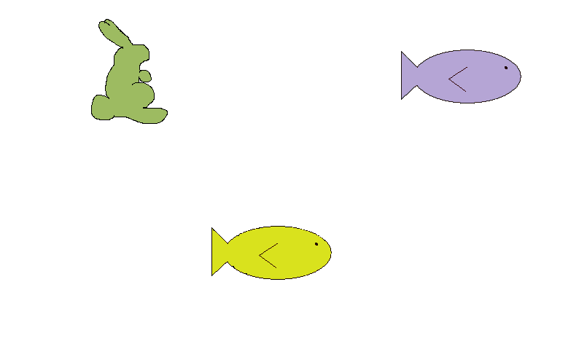
(A) | (B)
Figure 9. Left (A) depicts a practice trail for color before the beginning of the TC, and right (B) depicts a practice trial for shape before the beginning of the TC.

Children were given the following instructions at the beginning of the TC: “You are going to see one picture appear on the screen and then two more picture just above it here (pointing). I want you to tell me which one of these two (pointing) goes most with (sub “most like” as needed) this one (pointing to reference object).” Children were then reminded of the instructions, as needed, throughout the task.
Functional near infrared spectroscopy (fNIRS) was collected at 25 Hz using a 12-channel Techen CW6 system with wavelengths of 830nm and 690 nm. Light was delivered via fiber optic cables that terminated in a customized cap placed on the head with sources and detectors secured within six flexible plastic arrays (see Figure 10).
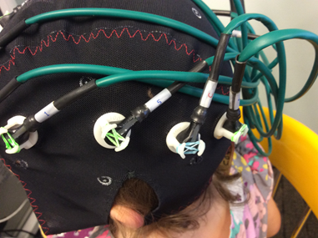 | 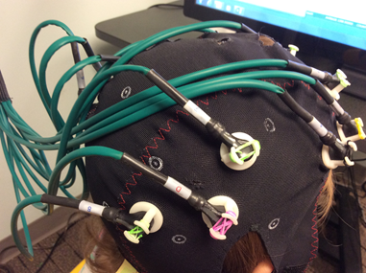
(A) | (B)
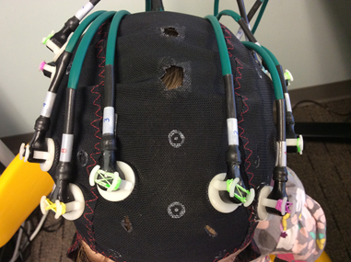 | 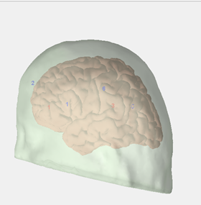  3  5  2  1  6  1
(C) | (D)
Figure 10. An example of a polhemus digitization mapped on to a brain atlas depicting probe placement, where lights are in red, and detectors are in blue in comparison to actual images of probe placement (A) is left hemisphere, (B) is right hemisphere, (C) is from the front, and (D) is an example of the left hemisphere digitalization.

An array was compiled of 2 sources and 4 detectors placed approximately 3 cm apart. Placement of sources were relative to the 10-20 system, which is standard. The arrays were placed on the head over left and right frontal cortex (F3-F5; F4-F6), left and right parietal cortex (P3-P5; P4-P6), and left and right temporal cortex (T3-T5; T4-T6). Specifically, the right side was more parietal-central whereas the left was more temporal. The locations of the sources and detectors were digitized using a Polhemus motion tracking system and marked in relation to landmarks (nasion, inion, left ear, right ear, and vertex) to map probe placements (see also figure 10).
Results
Statistical Analysi for Hemodynamics for the TC
The fNIRS data was analyzed using repeated ANOVAS for each channel (i.e. light to detector) for participants in each age group. Levels of deoxygenated and oxygenated hemoglobin were compared per channel to test for a significant difference in values across conditions. These results were then tested against the model’s hemodynamic predictions (see Figure 5). Certain channels were excluded for not meeting motion criteria or for having less than 4 trials per condition (see Figure 13a and 13b).
 |  | Groups
 |  | High Triad Criteria | Low Triad Criteria
 | 1 |  | Oxy, F(1,17)=5.291, p=.034
 | 2 | Oxy, F(1,17)=5.284, p=.034 | Oxy, F(1,16)=4.260, p=.056
 | 3 | Oxy, F(1,16)=6.630, p=.020
Channels | 4 |  | Dim, F(1,18)=6.340, p=.021
 | 5 |  | Oxy, F(1,18)=6.340, p=.021
 | 6 |  | Dim, F(1,15)=8.016, p=.013
 | 7 |  | Dim, F(1,15)=4.429, p=.053
 | 8 |  | Oxy, F(1,16)=3.955, p=.064

Table 1. MotionPro set at .3 and outliers set at 2 standard deviations in which averages were taken over a set time window.

When you collapse across groups, there were no main effects or interactions between-subjects for hemoglobin levels or condition. Within groups there were main effects of oxy and dimension but no interactions between the two. In Figure 12 you can see the oxy and dimensional effects graphed for the significant channels.

1 | 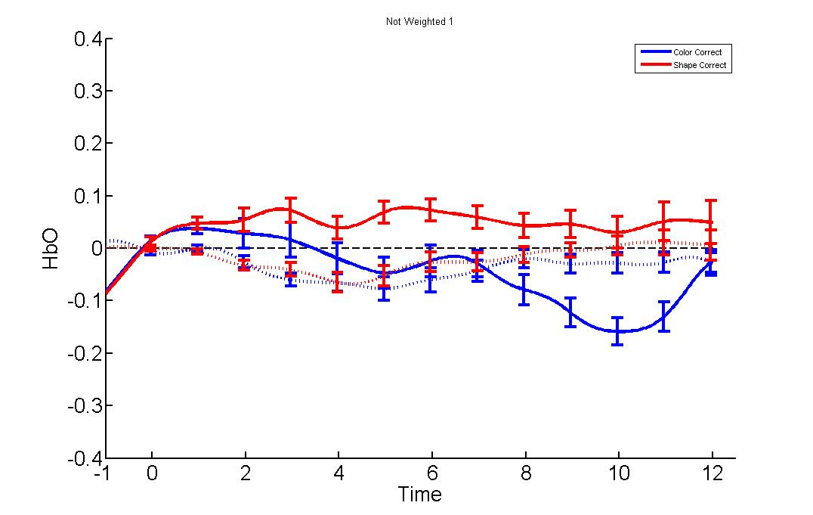  * | 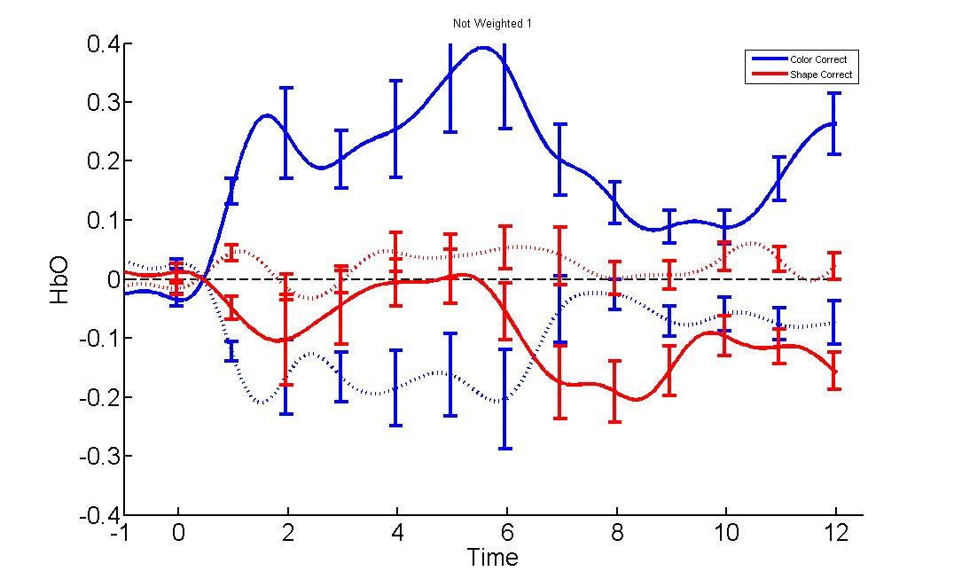
2 | 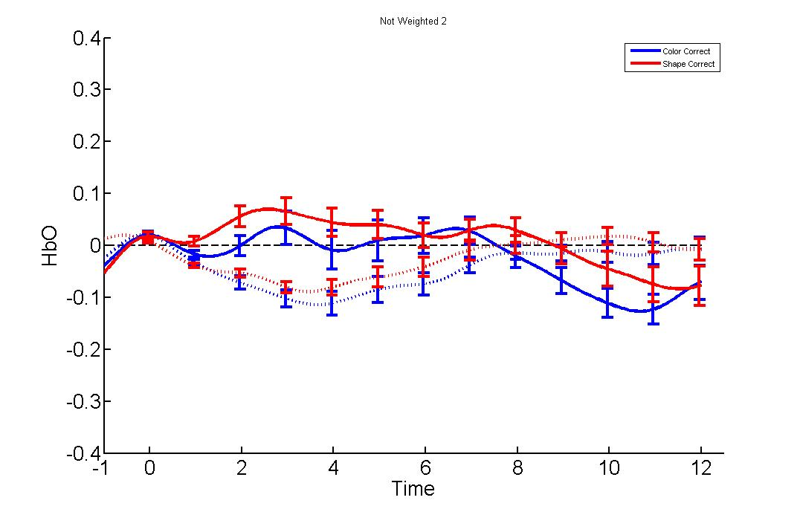  * | 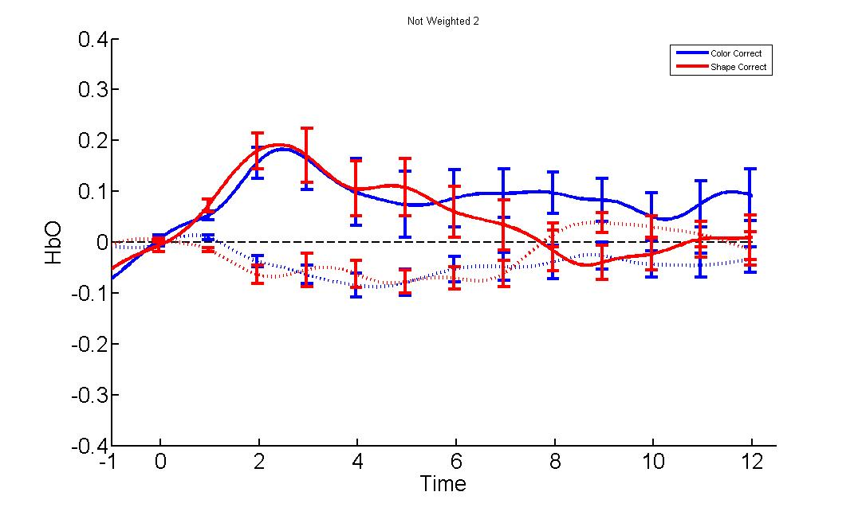  *
3 | 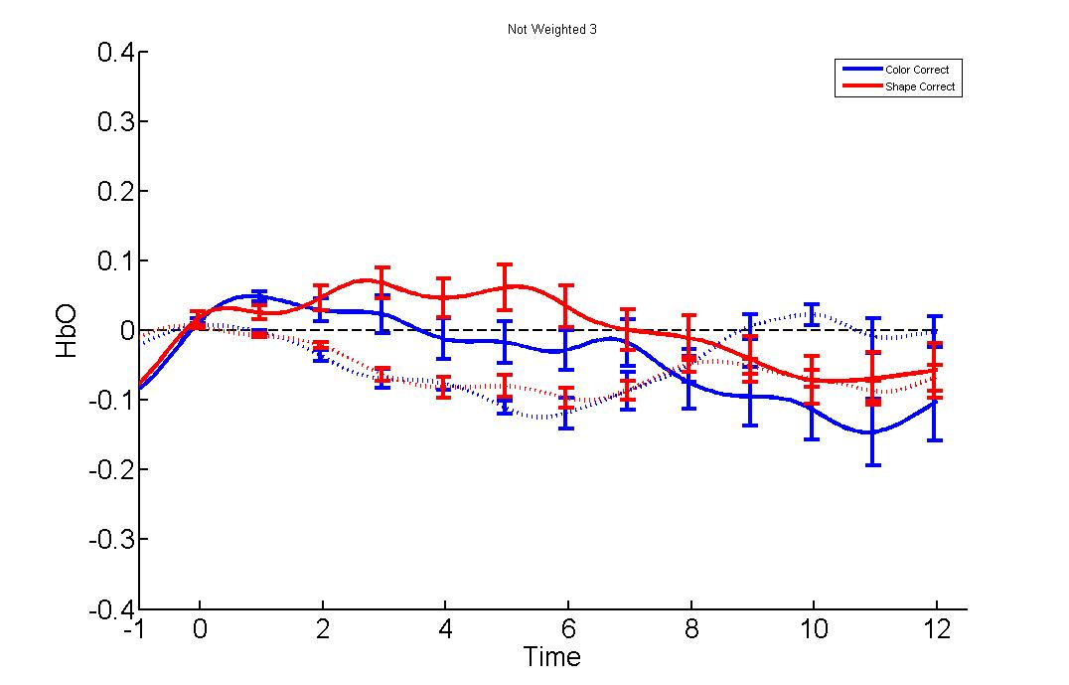  * | 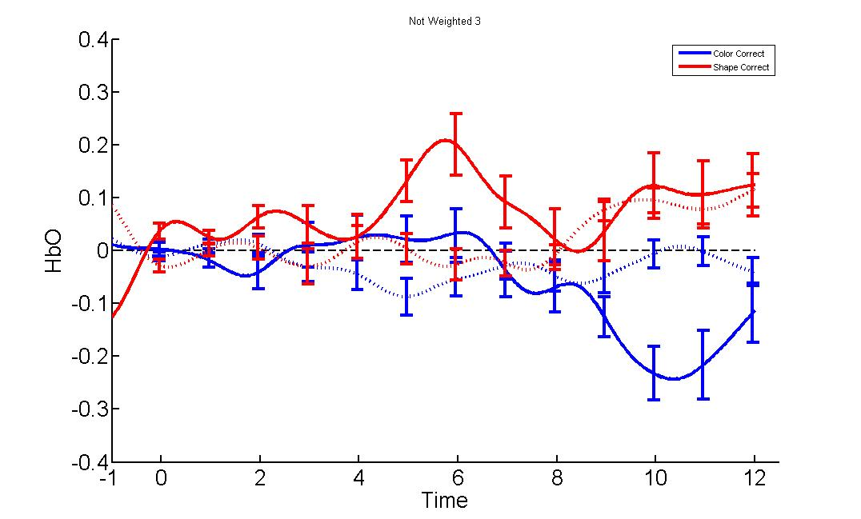
4 | 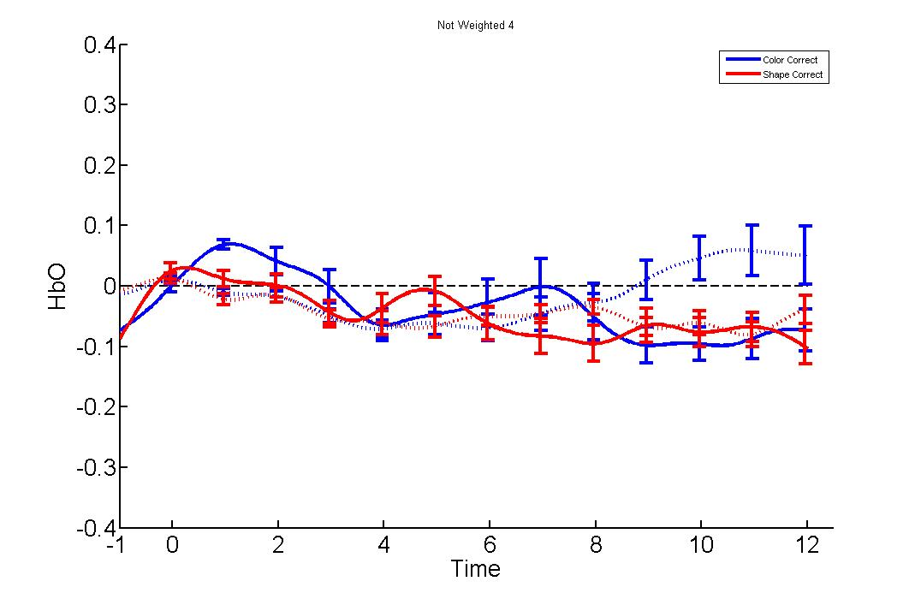 | 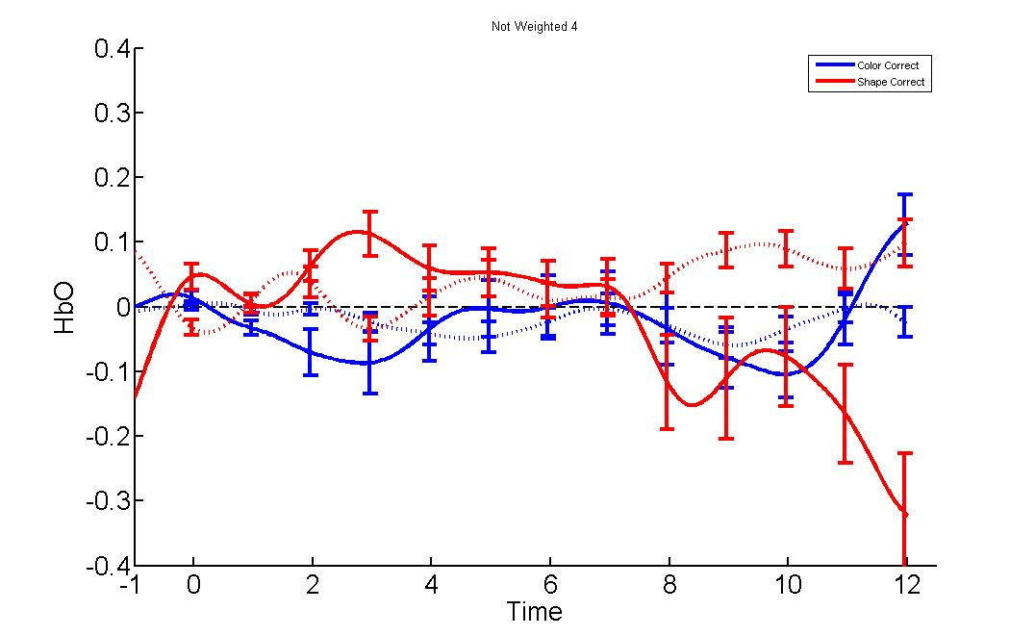  *
5 | 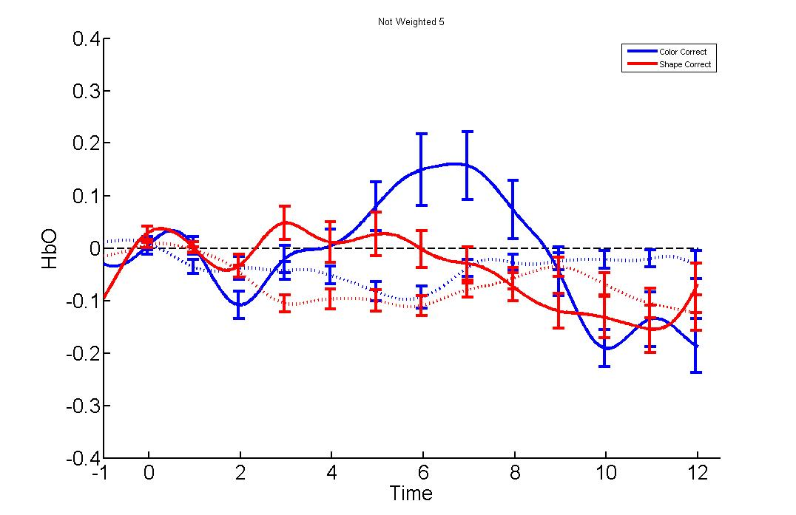 | 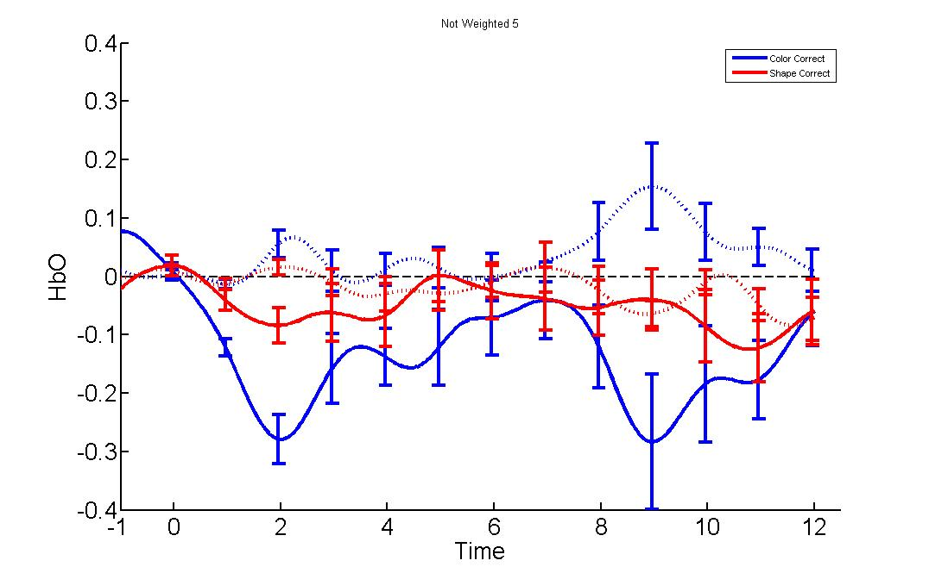  *
6 | 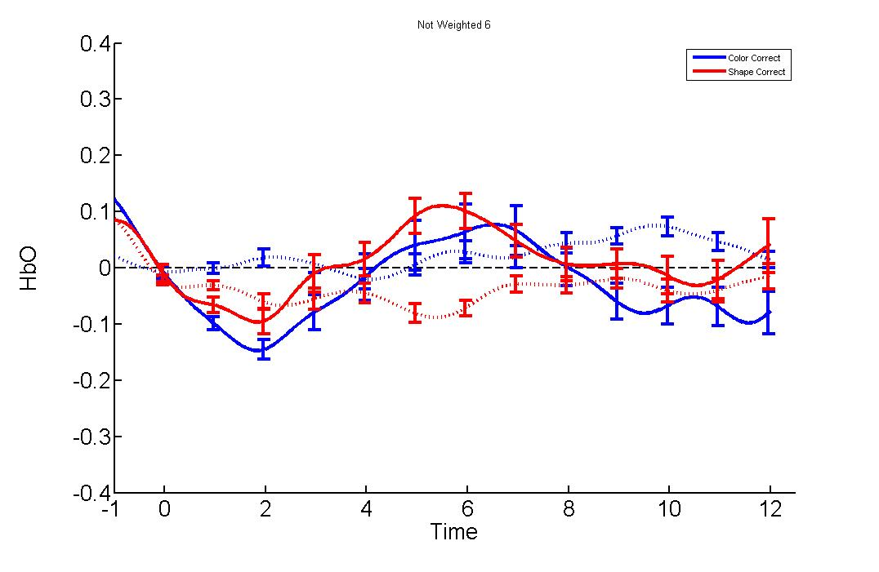 | 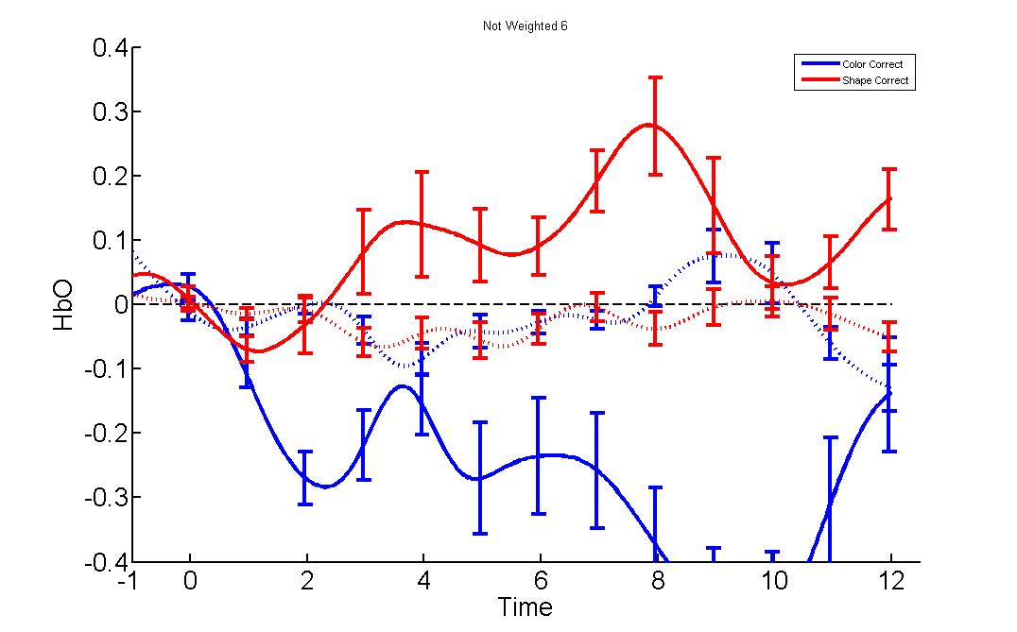  *
7 | 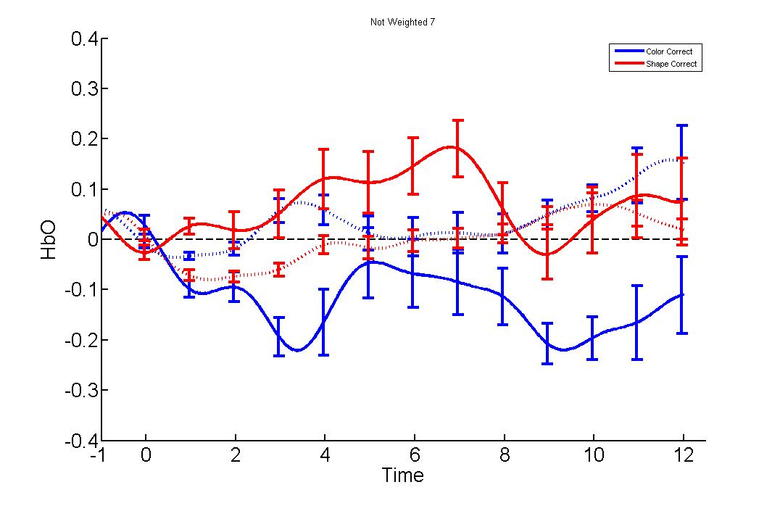 | 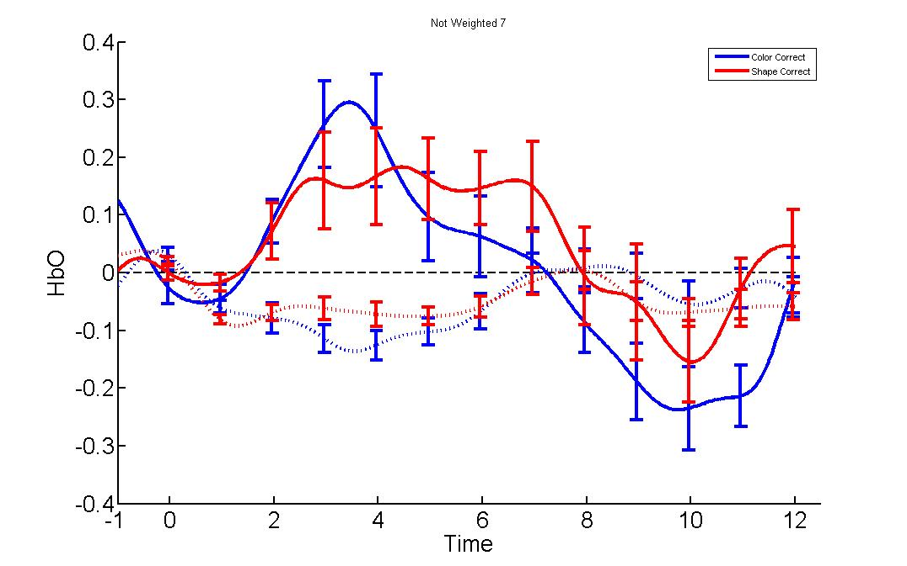  *
8 | 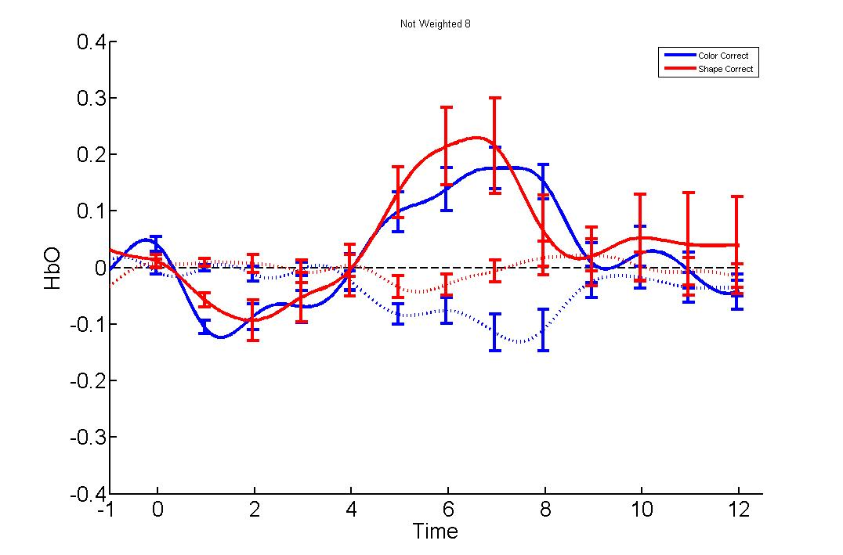 | 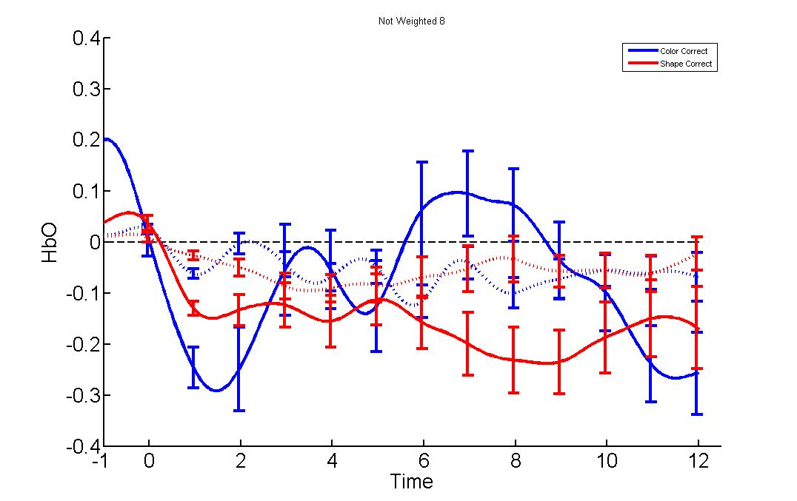  *
 | (A) | (B)

Figure 11. Where (A) is high triad criteria and (B) is low triad criteria. The column on the left denotes channels in which significance was found by either oxy or dimension/condition. Red lines mean oxyHbO for color correct trials, where dashed red lines mean deHbo. Blue lines mean oxyHbO for shape correct trials, where dashed blue lines mean deHbo.

 |  | Channels
 |  | 1 | 2 | 3 | 4 | 5 | 6 | 7 | 8
 | 2008
 | 2010 |  |  |  |  |  | X | X | X
 | 2011
 | 2016
 | 2017 |  |  |  |  |  |  |  | X
Participants | 2018
 | 2019
 | 2021
 | 2022
 | 2031
 | 2032 |  |  |  |  |  |  |  | X
 | 2037
 | 2038
 | 2041 |  |  | X |  | X | X | X | X
 | 2042
 | 2044
 | 2045
 | 2047 |  |  |  |  |  |  | X | X

Table 2a. High Triad excluded channels; the same were excluded for the DCCS old group.

 |  | Channels
 |  | 1 | 2 | 3 | 4 | 5 | 6 | 7 | 8
 | 2004
 | 2012
 | 2015
 | 2020 |  |  |  |  |  | X | X | X
 | 2023
 | 2024
 | 2025
 | 2026
 | 2027
Participants | 2028 |  |  |  |  | X | X | X | X
 | 2029
 | 2030
 | 2033
 | 2034
 | 2036
 | 2039
 | 2043 |  | X
 | 2046 | X | X |  |  | X | X |  | X
 | 2048

Table 2b. Low Triad excluded channels; The same were exclude for the DCCS young groups.

Statistical Analysis: Hemodynamics for the DCCS
 |  | Groups by Performance
 |  | High DCCS | Average DCCS | Low DCCS
Channels | 1 | CondXOxy (F(1,10)=10.152, p=.004) | Oxy (F(1,10)=8.173, p=.019)
Channels | 2 |  |  | Oxy(F(1,10)=6.903, p=.025)
Channels | 3 |  | Oxy (F(1,10)=9.090, p=.020)
Channels | 4 |  | Oxy (F(1,10)=5.926, p=.041)
Channels | 5
Channels | 6 |  |  | CondXOxy(F(1,10)=5.717, p=.034)
Channels | 7
Channels | 8
Figure 12. The same MotionPro criteria for the TC were also used for the DCCS.
Interestingly, when you collapse across groups, there was a significant main effect of oxygenated hemoglobin for channel 4 and an interaction between oxygenated hemoglobin and condition for both channel 6 and 8 (F(2,30)=4.888, p=.024; F(2,30)=3.279, p=.041; F(2,30)=4.444, p=.043). One individual from the high group was excluded because they did not have data for the last three channels (See Figure 14).

1 | 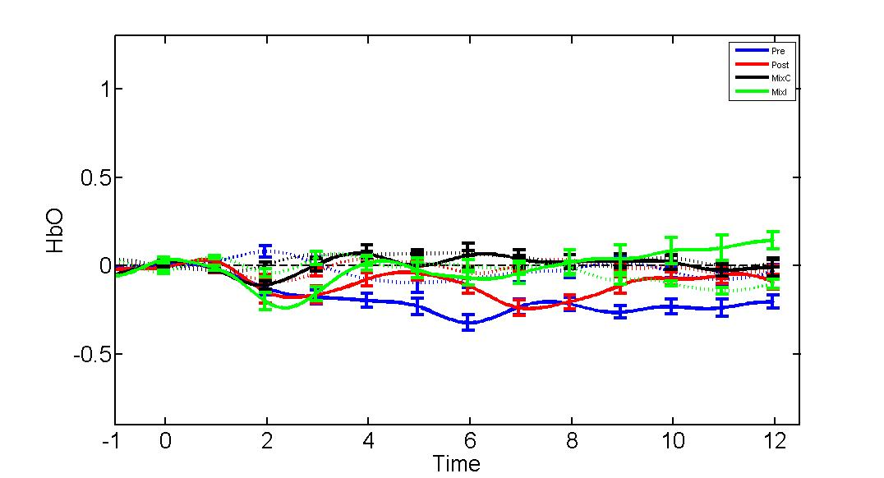 | 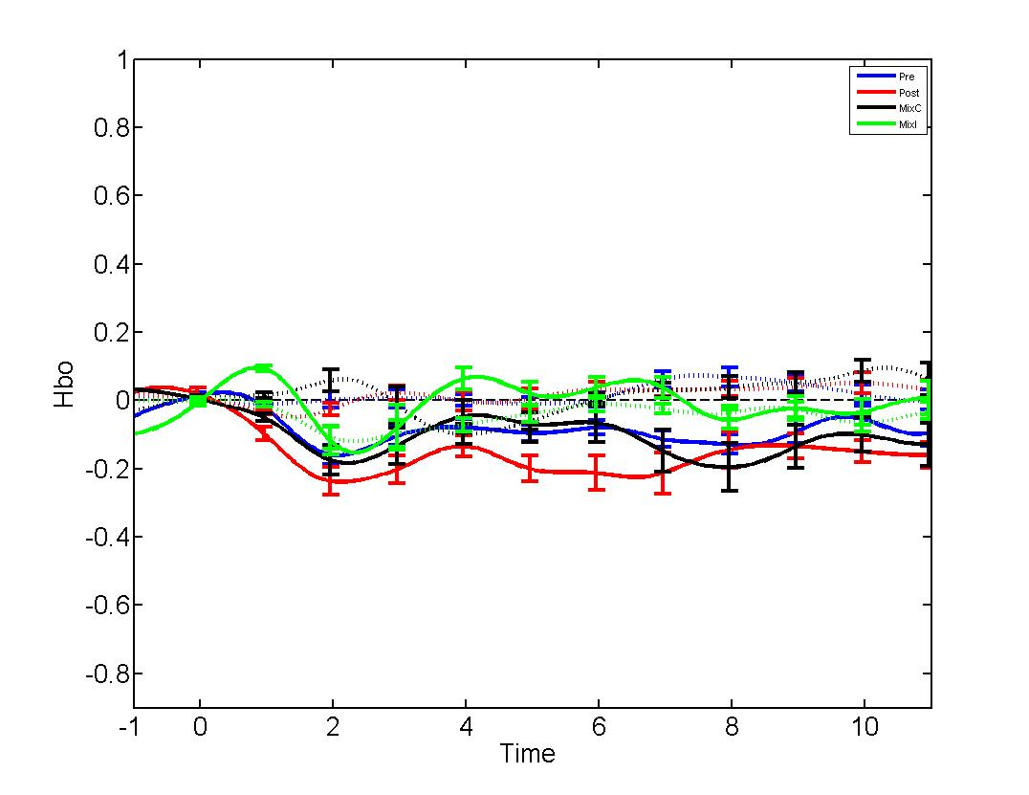 | 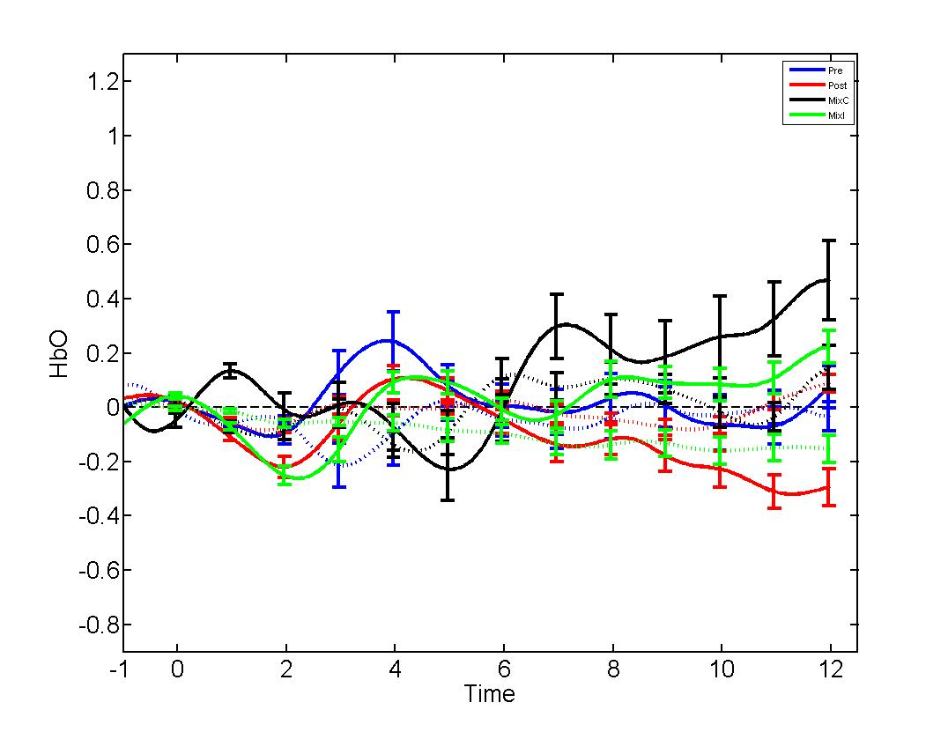
2 | 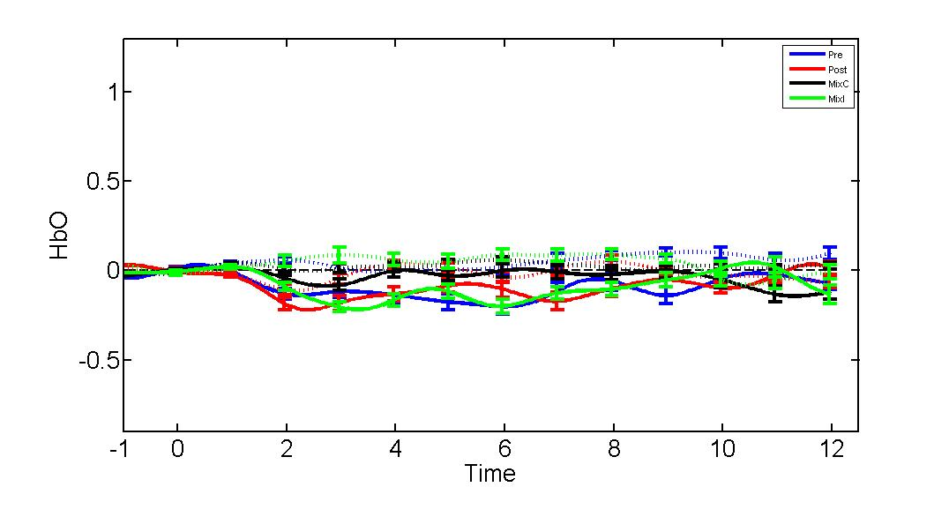 | 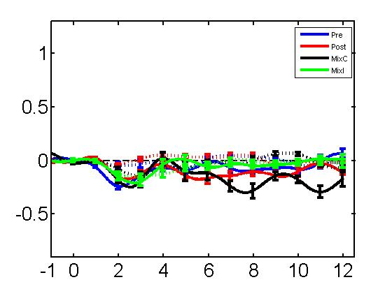 | 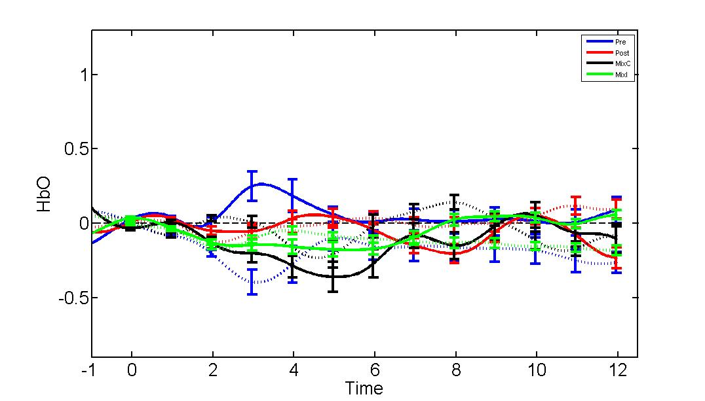
3 | 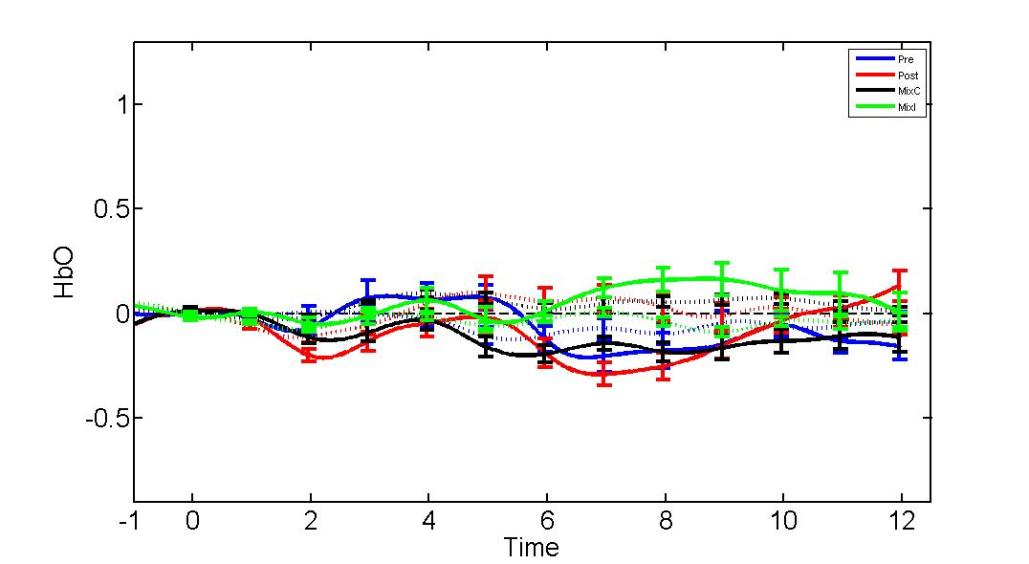 | 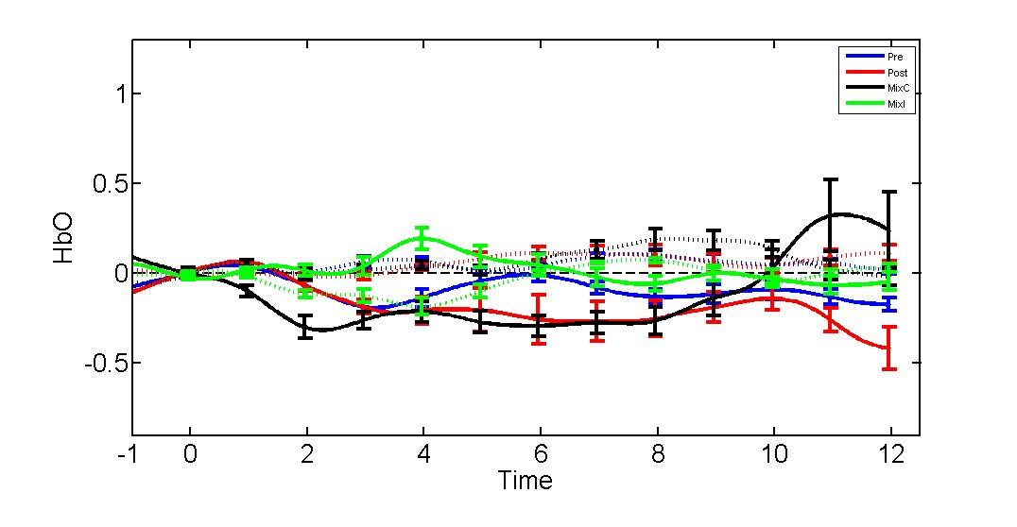 | 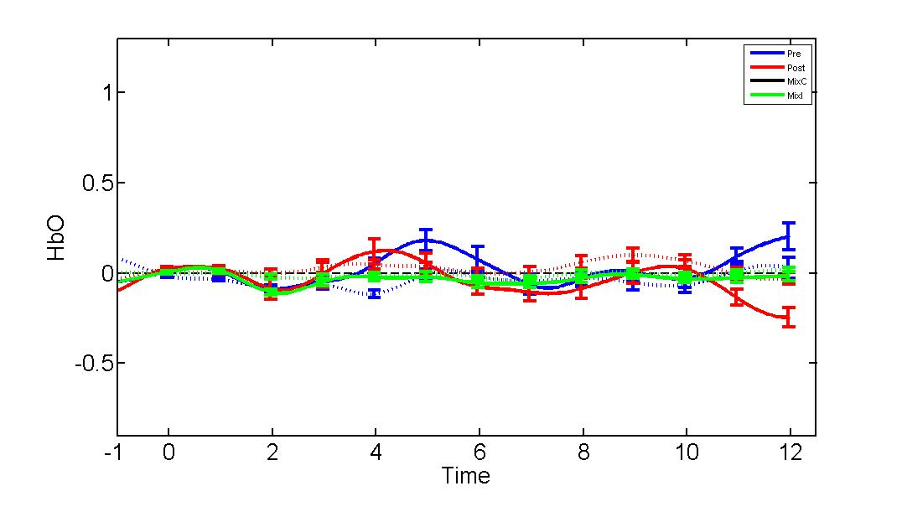
4 | 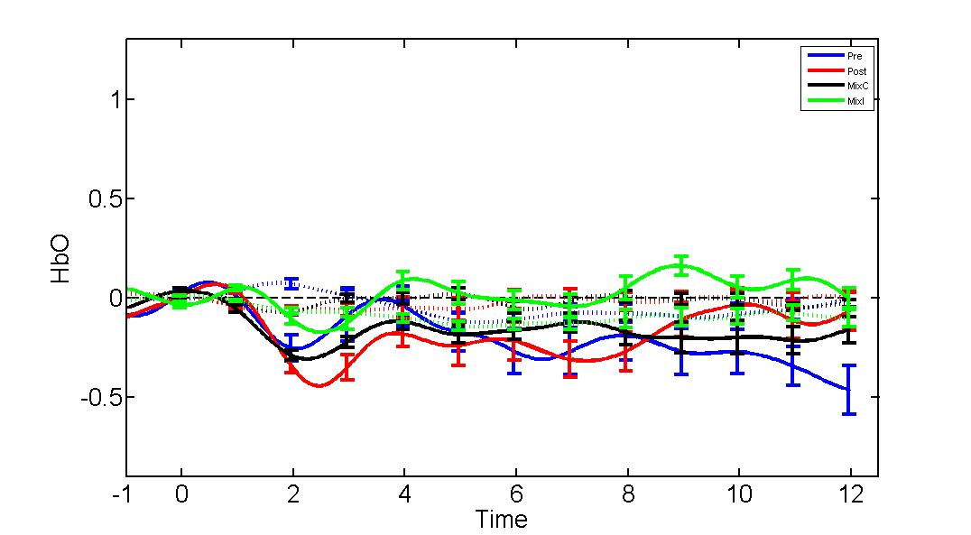 | 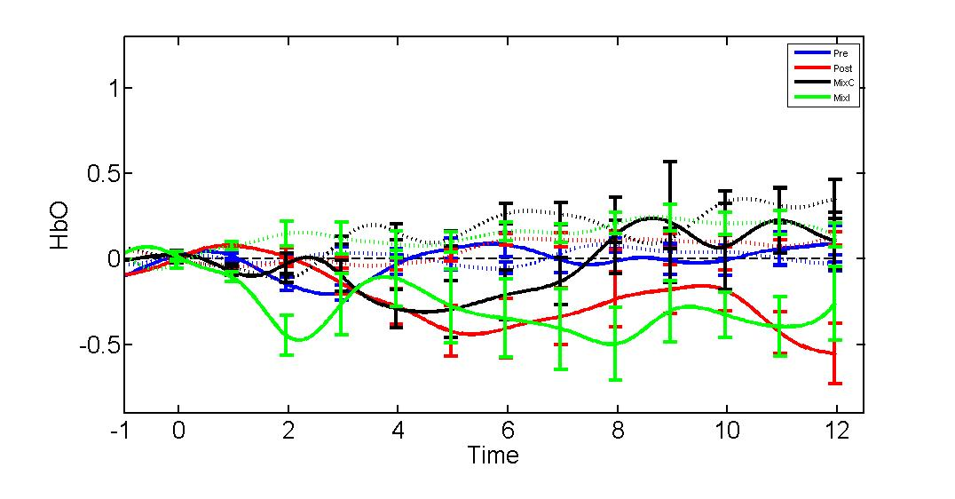 | 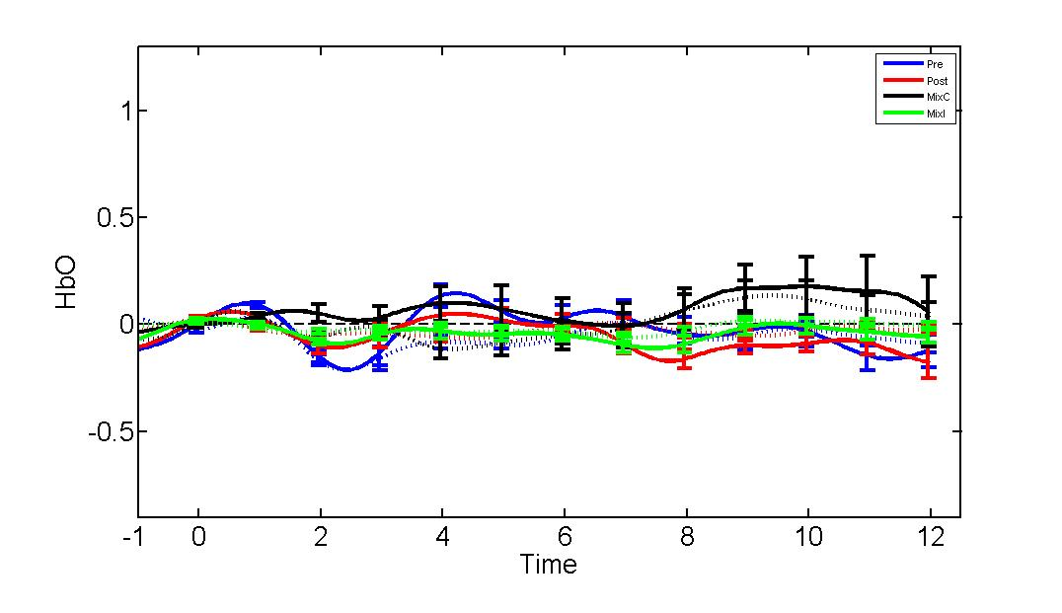
5 | 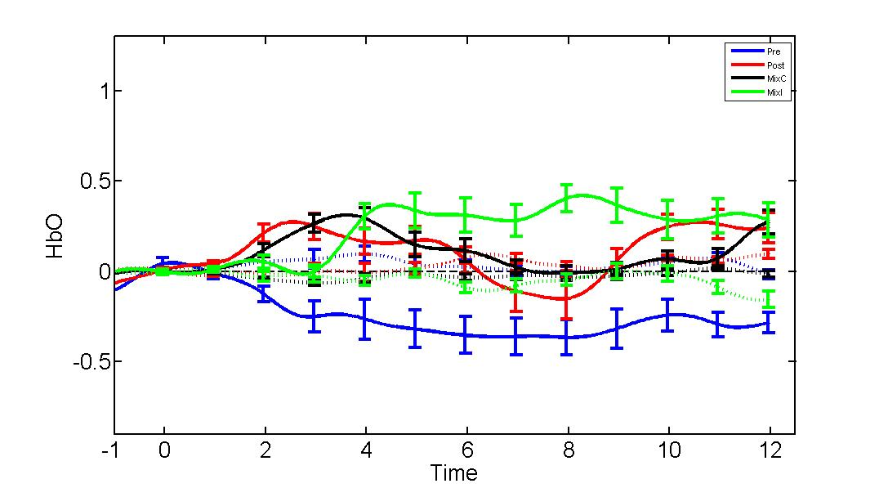 | 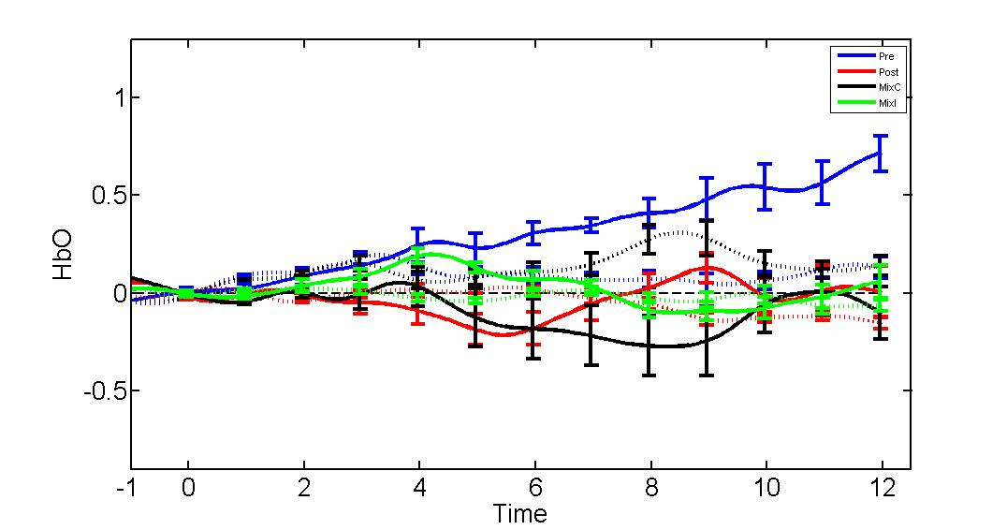 | 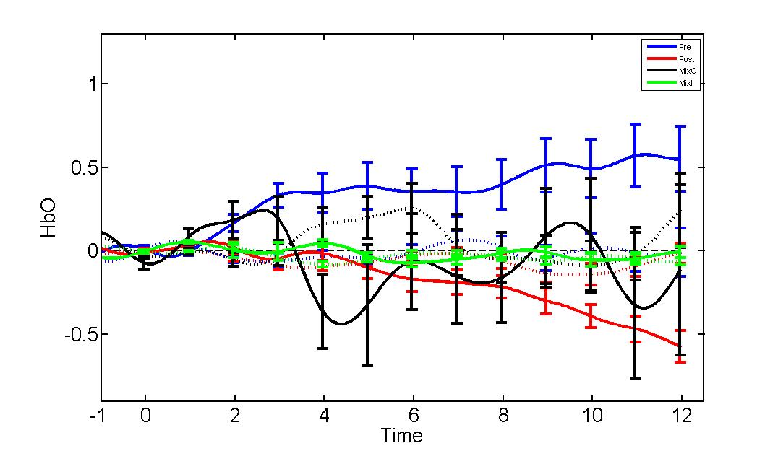
6 | 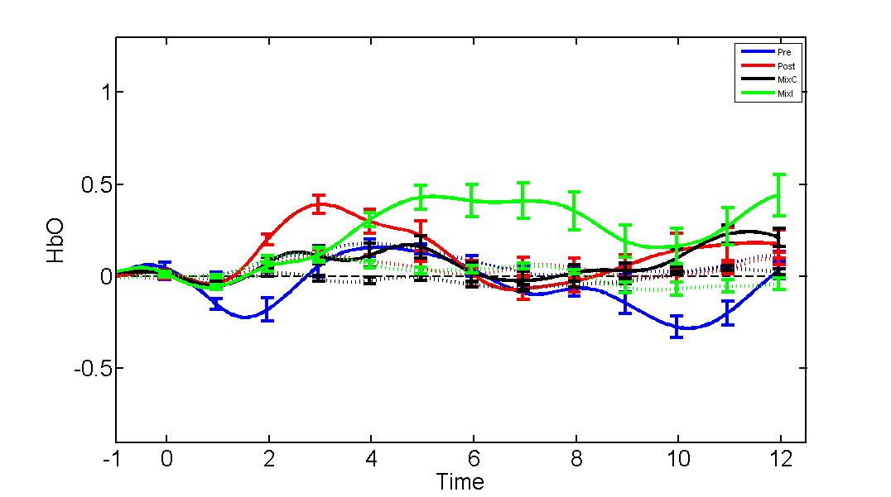 | 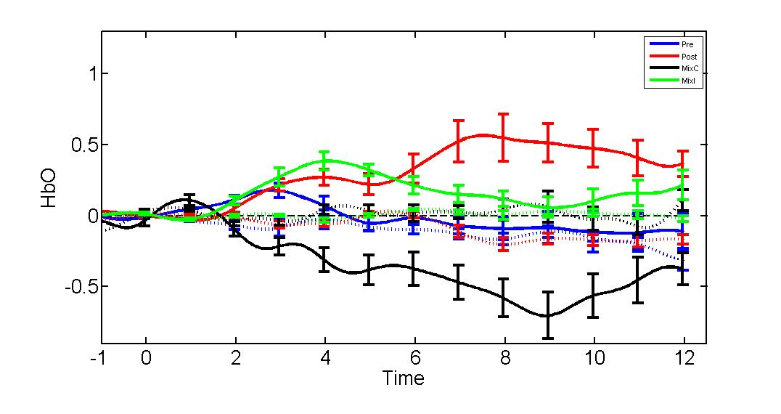 | 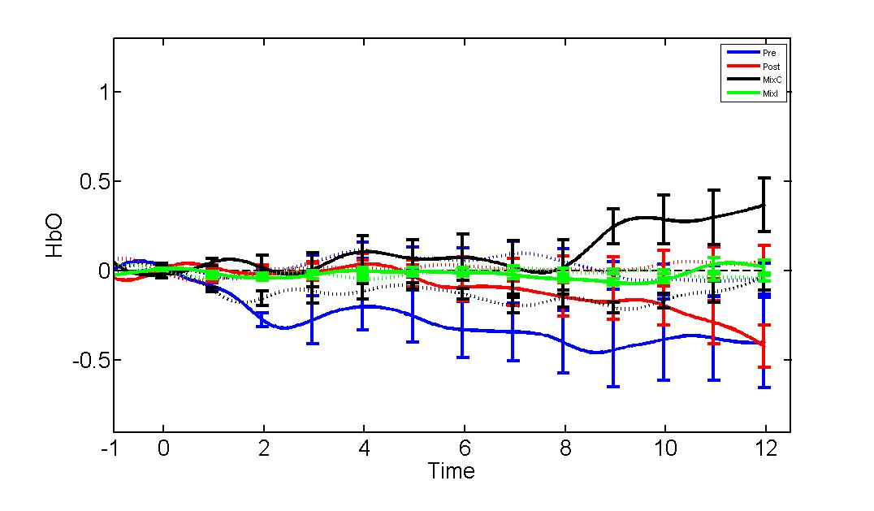
7 | 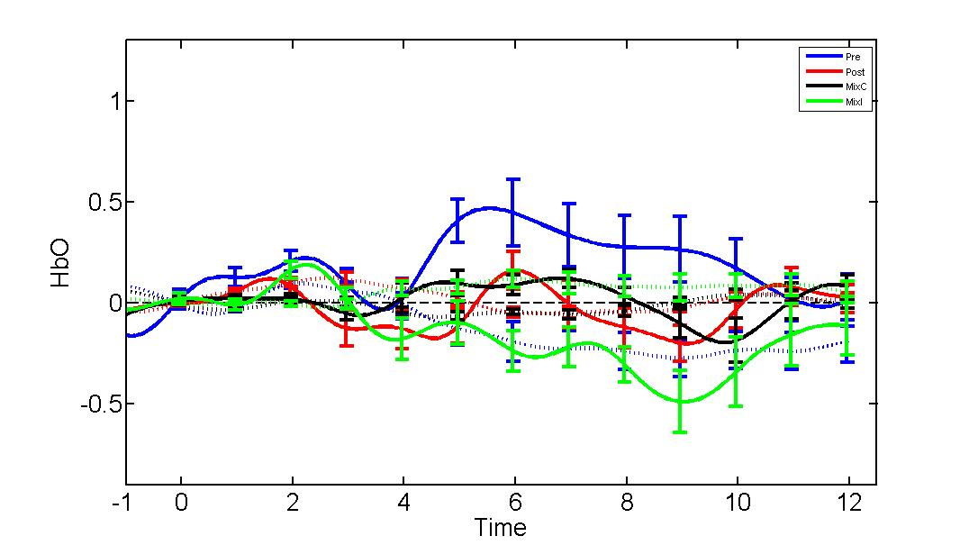 | 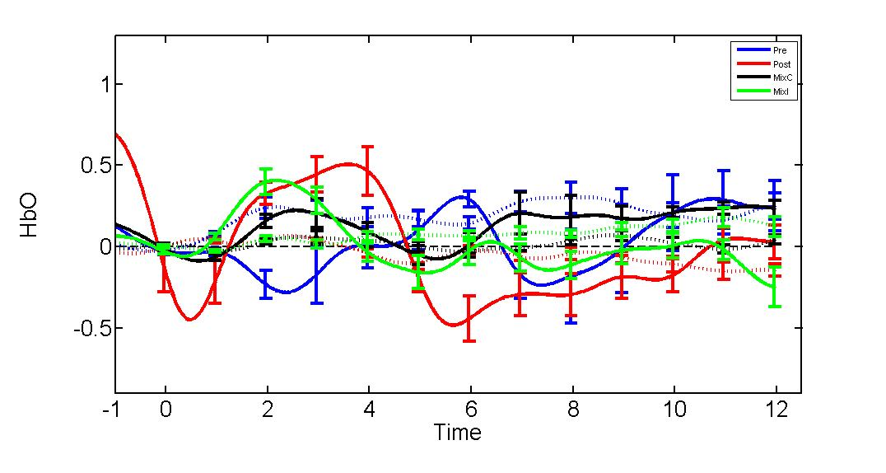 | 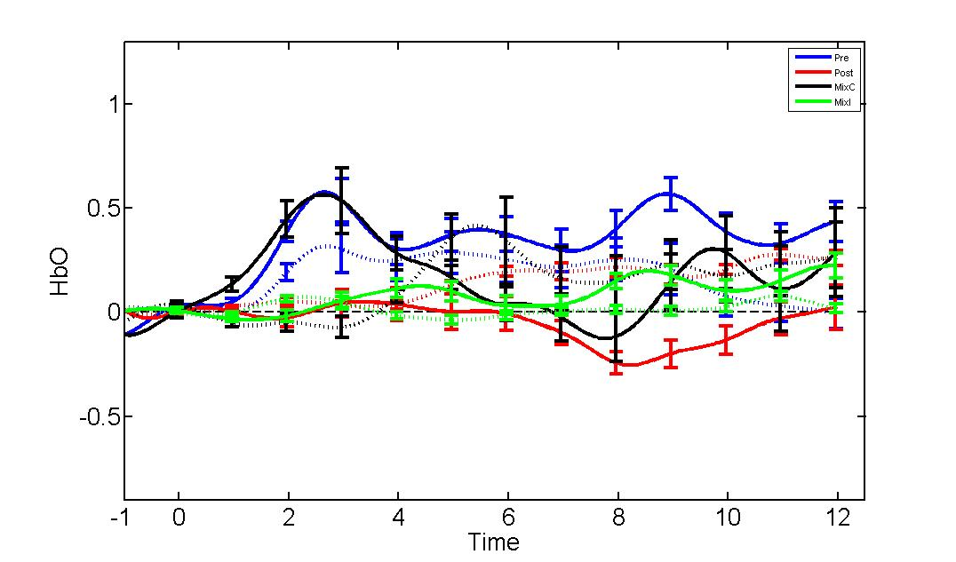
8 | 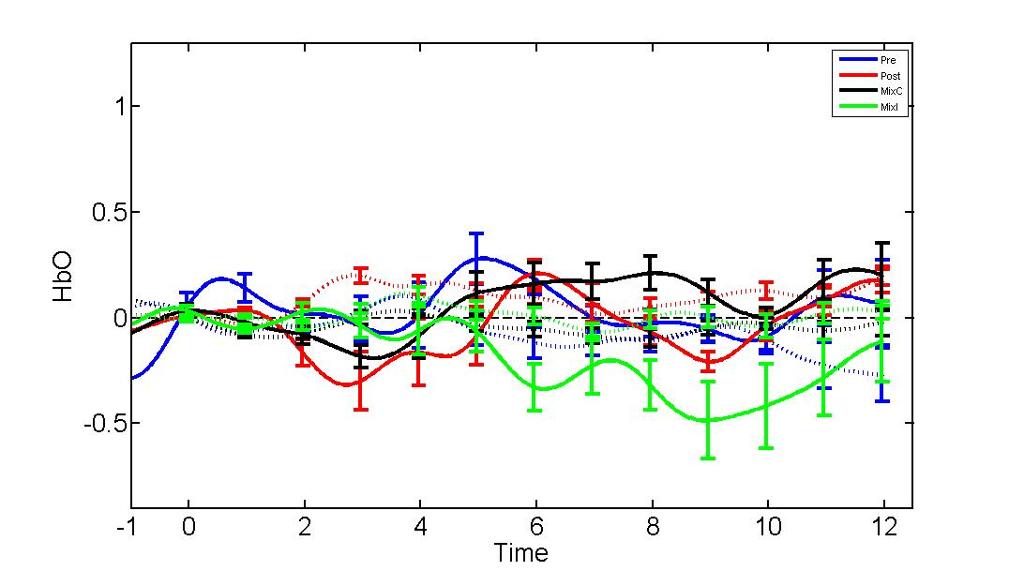 | 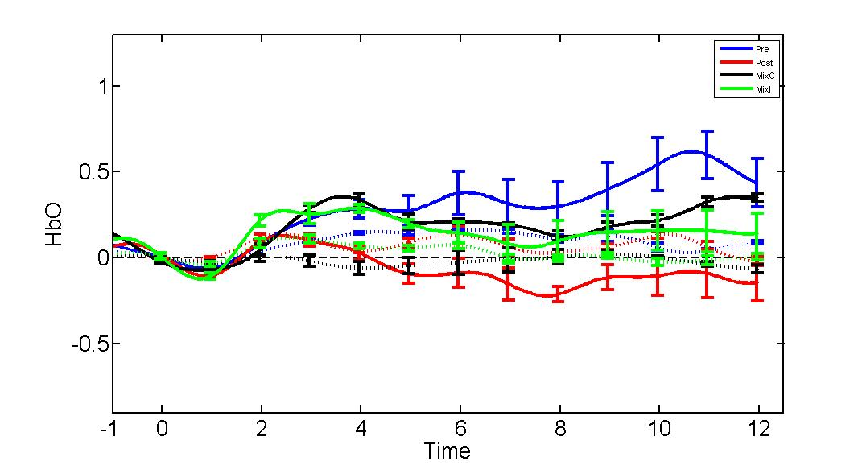 | 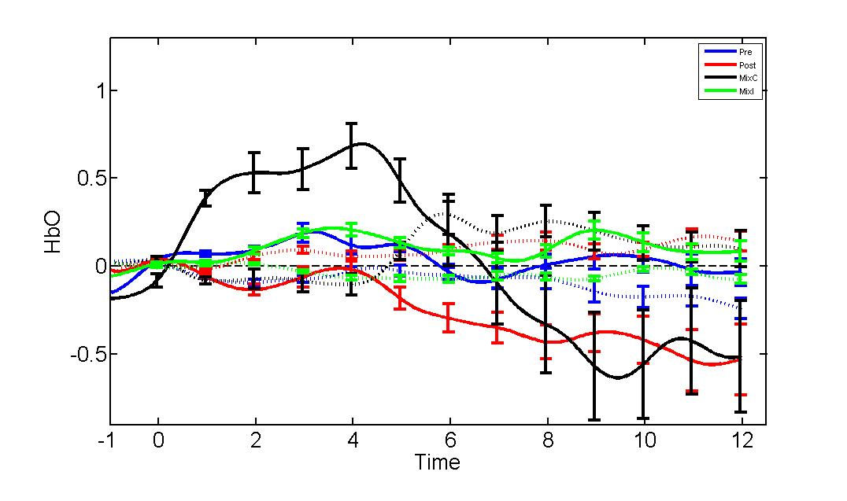
 | (A) | (B) | (C)
Figure 13. (A) low performing DCCS, (B) average performing DCCS, and (C) high performing DCCS. Conditions are depicted for both oxyHbO (e.g. solid lines) and deHbO (e.g. dashed lines) for the following: Pre-Switch trials (i.e. blue), Post-Switch Trials (i.e. red), Mixed correct trials (i.e. black), and mixed incorrect trials (i.e. green).

This figure demonstrates that each region of the dimensional attention network is being utilized differentially in response to the task demands of rule switching regarding the relevant dimension. The groups for the DCCS were based on behavioral scores in the pre and post-switch phases. That is, those that passed pre-switch and not post-switch were low, those that passed pre-switch and made some correct post-switch responses were average, and those that passed the pre-switch and made all correct post-switch choices were high performers.
Statistical Analysis: Behavioral Data for the TC and DCCS
Figure 14. Over-all correlation between scores on the DCCS and the TC were significant (r²=.532, p=.002).

The behavioral data was analyzed by conducting a correlation for DCCS and TC scores, a partial correlation to test collinearity of these scores with age, and a multivariate multiple regression in order to draw conclusions about shared variance as one task predicts performance on the other as well as age. TC performance during color identity trials was related to the overall performance on the DCCS (r²=.339, p=.030) and incorrect color trials (r²=-.331, p=.034) but not for the shape dimension (r²=.284, p=.072). Both shape and color performance on the TC were related to mixed block performance during the DCCS (r²=.368, p=.027; r².357, p=.014). Post-switch dimension was not related to either shape or color performance in the TC.
Actual age in months was highly correlated with performance on both the TC (r²=.402, p=.009) and the DCCS (r²=.559, p=.000). Performance by dimension on the TC was also correlated with age, that is the number of correct color identity matches was positively correlated with actually age in months (r²=.494, p=.005) while shape identity matches were not correlated with age in months (r²=.178, p=.339). For the DCCS, only shape correct trials during the mixed block were positively associated with actual age in months (r²=.420, p=.019). This provides some evidence for neurons being tuned during development to these specific dimensions but used differentially when flexibly or selectively attending depending on that tuning.
Linking Brain and Behavior
Deoxygenated hemoglobin levels were positively correlated with color incorrect trials on during the TC on channel 3 (r²=.610, p=.027), whereas they were negatively correlated with oxygenated hemoglobin during shape incorrect trials on channel 4 (r²=-.644, p=.013). Shape correct trial performance on channel 5 was negatively correlated with deoxygenated hemoglobin levels (r²=.374, p=.046).
Oxygenated hemoglobin levels during shape correct trials in the TC task on channel 1 were negatively correlated with overall performance on the DCCS (r²=-.376, p=.037). Oxygenated hemoglobin levels during shape incorrect trials in the TC task on channel 1 were negatively correlated with overall performance on the DCCS (r²=-.685, p=.003). This trend continues for shape correct on channel 2 (r²=-.312, p=.044). Deoxygenated hemoglobin levels during shape incorrect is positively associated with performance on the DCCS (r²=.465, p=.047). Oxygenated hemoglobin levels of color incorrect trials on channel 4 are also positively correlated with DCCS performance (r²=.540, p=.028). In contrast, oxygenated hemoglobin levels during color incorrect trials on channels 7 and 8 are negatively correlated with DCCS performance (r²=-.547, p=.033; r²=-.731, p=.003).
TC performance, however, was not correlated with either oxygenated or deoxygenated hemoglobin levels on any channels during any of the three conditions of the DCCS task. This suggest that while dimensional attention abilities explains how flexibility can be predictive of selectivity, the nature of how selectivity may facilitate flexibility is unclear. When these same correlations were ran with DCCS performance as a factor, those that were unstable in their responses during the post-switch phase showed a negative correlation between deoxygenated hemoglobin on channel 7 and overall TC performance (r²=-.734, p=.038). In contrast, this same group showed a positive correlation between deoxygenated hemoglobin levels on channel 8 during and performance on the DCCS (r²=.805, p=.029). For the perseverative group, deoxygenated hemoglobin levels on channel 1 during the Pre-switch were positively associated with performance on the TC task (r²=.718, p=.013). For channel 1 the same relationship emerged for deoxygenated hemoglobin during mixed block incorrect trials (r²=.734, p=.010). For channel 2, TC performance was negatively correlated with oxygenated hemoglobin during mixed incorrect trials while deoxygenated hemoglobin during those same trials was positively associated with performance (r²=-.704, p=.016; r²=.724, p=.012). Deoxygenated hemoglobin during pre-switch trials was positively associated with performance on channel 2 (r²=.814, p=.002). Oxygenated hemoglobin levels on post-switch trials on channel 4 were negatively correlated with performance on the TC (r²=-.768, p=.006).
Finally, the group that switched successfully during post-switch trials on the DCCS had correlations in the more posterior regions. Deoxygenated hemoglobin levels on channel 6 during the post-switch were negatively correlated with overall performance on the TC (r²=-.734, p=.034) whereas deoxygenated hemoglobin levels on channel 8 were positively associated with performance during these same trials (r²=.805, p=.029).
In the complexity of these results a trend emerges in favor of selectivity and flexibility co-developing and dimensionally specific tuning of neurons is one processing driving the development of the dimensional attention mechanism. The complexity of these brain-behavior relationships is revealed via these correlations. The way in which the dimensional attention system is developing during early childhood is seemingly complex.
Conclusion
The current study aimed to assess the processes of flexible and selective attention under the proposed common mechanism of dimensional attention. Utilizing a DFT framework, a model was proposed and used to make predictions about behavior and neural outcomes during the Triad Classification and Dimensional Change Card Sorting task. Although the model is still being refined, it provides a unified framework in which to conceptualize and predict the functioning of these attention abilities in early childhood (see also Figure 17).
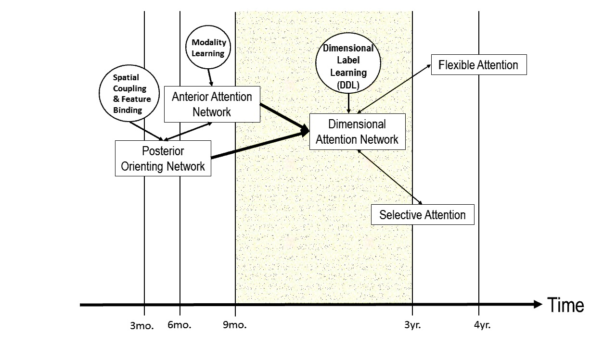
Figure 15. This figure is a proposed developmental timeline of attention development from infancy to early childhood.

Some limitations do apply to this. One potential explanation for the null findings for the older children during the DCCS task. One reason for this task being inappropriate is this version of the DCCS has very few trial types and is too condensed. Other versions have shown better promise with being applicable to neuroimaging studies as well as showing better hemodynamic results (see also Buss & Spencer, under review). The current study shows a robust behavioral result and interesting correlations between hemodynamics and behavior but lacks real clarity in how they might be connected. Further work is needed to probe the intricacies of these relationships.
Future directions
The highlighted area in figure 17 emphasizes the age range on which the current study focused. Future studies should aim to assess the roots of these attention abilities, specifically those in infancy. In addition, clinical populations with attention deficits, specifically those with ADHD should also be studies. Currently, there are few diagnostic tools to assess ADHD before the age of seven. Research focused on quantitative differences in attention abilities in early childhood may be one potential avenue for developing new assessments for early diagnosis.
The current study also rises many new questions concerning the relationship between brain and behavior during selective and flexible attentional processing. Future work should look at other measures in relation to these tasks such as a battery of attention tasks that includes low level sensory tasks with other types of stimuli (i.e. social and nonsocial) as well as redundancy information.

References
Akshoomoff, N. (2002). Selective attention and active engagement in young children. Dev Neuropsychol, 22(3), 625-642. doi: 10.1207/S15326942DN2203_4
Badre, D. (2008). Cognitive control, hierarchy, and the rostro-caudal organization of the frontal lobes. Trends Cogn Sci, 12(5), 193-200. doi: 10.1016/j.tics.2008.02.004
Baez, S., Herrera, E., Gershanik, O., Garcia, A. M., Bocanegra, Y., Kargieman, L., . . . Ibanez, A. (2015). Impairments in negative emotion recognition and empathy for pain in Huntington's disease families. Neuropsychologia, 68, 158-167. doi: 10.1016/j.neuropsychologia.2015.01.012
Banaschewski, T., Hollis, C., Oosterlaan, J., Roeyers, H., Rubia, K., Willcutt, E., & Taylor, E. (2005). Towards an understanding of unique and shared pathways in the psychopathophysiology of ADHD. Dev Sci, 8(2), 132-140.
Barkley, R. A. (1997). Behavioral Inhibition, Sustained A ttention, and Executive Functions: Constructing a Unifying Theory of ADHD. Psychol Bull, 121(1), 65-94.
Best, J. R. M., P.H. (2010). A Developmental Perspective on Executive Function. Child Dev, 81(6), 1641-1660.
Blair, C., Zelazo, P. D., & Greenberg, M. T. (2005). The measurement of executive function in early childhood. Dev Neuropsychol, 28(2), 561-571. doi: 10.1207/s15326942dn2802_1
Blaye, A., & Chevalier, N. (2011). The role of goal representation in preschoolers' flexibility and inhibition. J Exp Child Psychol, 108(3), 469-483. doi: 10.1016/j.jecp.2010.09.006
Bohlmann, N. L., & Fenson, L. (2005). The Effects of Feedback on Perseverative Errors in Preschool Aged Children. Journal of Cognition and Development, 6(1), 119-131. doi: 10.1207/s15327647jcd0601_7
Booth, J. R., Burman, D. D., Meyer, J. R., Lei, Z., Trommer, B. L., Davenport, N. D., . . . Mesulam, M. M. (2003). Neural development of selective attention and response inhibition. NeuroImage, 20(2), 737-751. doi: 10.1016/s1053-8119(03)00404-x
Botvinick, M. M. (2007). Conflict monitoring and decision making: Reconciling two perspectives on anterior cingulate function. Cognitive, Affective, & Behavioral Neuroscience, 7(4), 356-366.
Brooks, P. J., Hanauer, J. B., Padowska, B., & Rosman, H. (2003). The role of selective attention in preschoolers’ rule use in a novel dimensional card sort. Cognitive Development, 18(2), 195-215. doi: 10.1016/s0885-2014(03)00020-0
Brown, T. (2013). Updated Understandings of ADHD in Children and Adults: Explaining Inadequate Executive Functions Executive Function Impairments. New York, NY: Routledge.
Bull, R., Espy, K. A., & Wiebe, S. A. (2008). Short-term memory, working memory, and executive functioning in preschoolers: longitudinal predictors of mathematical achievement at age 7 years. Dev Neuropsychol, 33(3), 205-228. doi: 10.1080/87565640801982312
Bull, R., & Scerif, G. (2010). Executive functioning as a predictor of children's mathematics ability: inhibition, switching, and working memory. Dev Neuropsychol, 19(3), 273-293. doi: 10.1207/S15326942DN1903_3
Bunge, S. A., Dudukovic, N. M., Thomason, M. E., Vaidya, C. J., & J.D.E., G. (2002). Immature Frontal Lobe Contributions to Cognitive Control in Children: Evidence from fMRI. 33, 301-311.
Bunge, S. A. Z., P.D. (2006). A Brain-Based Account of the Development of Rule Use in Childhood Current Directions in Psychological Science, 15(3), 118-121.
Buschman, T. J., & Miller, E. K. (2007). Top-down versus bottom-up control of attention in the prefrontal and posterior parietal cortices. Science, 315(5820), 1860-1862. doi: 10.1126/science.1138071
Buss, A. T., & Spencer, J. P. (2012). When seeing is knowing: the role of visual cues in the dissociation between children's rule knowledge and rule use. J Exp Child Psychol, 111(3), 561-569. doi: 10.1016/j.jecp.2011.11.005
Buss, A.T., Spencer, J.P. (2014). The emergent executive: a dynamic field theory of the development of executive function. Monogr Soc Res Child Dev. 79(2), 1-1-3. 10.1002/mono.12096.
Buss, A. T., Spencer, J.P. (2016, under review). Changes in fronto-posterior connectivity
underlie the development of executive function.
Buss, A. T., Wifall, T., Hazeltine, E., & Spencer, J. P. (2014). Integrating the behavioral and neural dynamics of response selection in a dual-task paradigm: a dynamic neural field model of Dux et al. (2009). J Cogn Neurosci, 26(2), 334-351. doi: 10.1162/jocn_a_00496
Buss, A. T., Wifall, T. & Hazeltine, E. (2015). The behavioral and neural dynamics of
cognitive flexibility. In J. P. Spencer and G. S. Schöner (Eds.), Dynamic Thinking—A Primer on Dynamic Field Theory. Oxford University Press: New York, NY.
Calbet, J. A., Lundby, C., Koskolou, M., & Boushel, R. (2006). Importance of hemoglobin concentration to exercise: acute manipulations. Respir Physiol Neurobiol, 151(2-3), 132-140. doi: 10.1016/j.resp.2006.01.014
Carlson, S. M. (2005a). Developmentally Sensitive Measures of Executive Function in Preschool Children. Dev Neuropsychol, 28(2), 595-616.
Carlson, S. M. (2005b). Developmentally sensitive measures of executive function in preschool children. Dev Neuropsychol, 28(2), 595-616. doi: 10.1207/s15326942dn2802_3
Carlson, S. M., Moses, L. J., & Claxton, L. J. (2004). Individual differences in executive functioning and theory of mind: An investigation of inhibitory control and planning ability. J Exp Child Psychol, 87(4), 299-319. doi: 10.1016/j.jecp.2004.01.002
Caspi, A., McClay, J., Moffitt, T. E., Mill, J., Martin, J., Craig, I. W., . . . Poulton, R. (2002). Role of genotype in the cycle of violence in maltreated children. Science, 297(5582), 851-854. doi: 10.1126/science.1072290
Cuevas, K., & Bell, M. A. (2014a). Infant attention and early childhood executive function. Child Dev, 85(2), 397-404. doi: 10.1111/cdev.12126
Cuevas, K., & Bell, M. A. (2014b). Infant Attention and Early Childhood Executive Function Child Dev, 85, 397-404.
Curtis, C. E., & Lee, D. (2010). Beyond working memory: the role of persistent activity in decision making. Trends Cogn Sci, 14(5), 216-222. doi: 10.1016/j.tics.2010.03.006
De Fockert, J. W. R., G.; Frith, C.D.; Lavie, N. (2001). The Role of Working Memory in Visual Selective Attention. American Association for the Advancement of Science, 291(5509), 1803-1806.
Diamond, A., & Lee, K. (2011). Interventions Shown to Aid Executive Function Development in Children 4 to 12 Years Old. Science, 333, 959-964. doi: 0.1126/science.1204529
Driver, J. (2001). A selective review of selective attention research from the past century. British Journal of Psychology, 92(1), 53.
Durston, S. T., K.M.; Yang, Y.; Ulug, A.M.; Zimmerman, R.D.; Casey, B.J. (2002). A neural basis for the development of inhibitory control. Dev Sci, 5(4), F9-F16.
Espy, K. A., Kaufmann, P. M., & Glisky, M. L. (2001). New procedures to assess executive functions in preschool children. Clin Neuropsychol, 15(1), 46-58. doi: 10.1076/clin.15.1.46.1908
Ezekiel, F., Bosma, R., & Morton, J. B. (2013). Dimensional change card sort performance associated with age-related differences in functional connectivity of lateral prefrontal cortex. Dev Cogn Neurosci, 5, 40-50. doi: 10.1016/j.dcn.2012.12.001
Fair, D. A., Dosenbach, N. U., Church, J. A., Cohen, A. L., Brahmbhatt, S., Miezin, F. M., . . . Schlaggar, B. L. (2007). Development of distinct control networks through segregation and integration. Proc Natl Acad Sci U S A, 104(33), 13507-13512. doi: 10.1073/pnas.0705843104
Fisher, A. V. (2011). Automatic shifts of attention in the Dimensional Change Card Sort task: subtle changes in task materials lead to flexible switching. J Exp Child Psychol, 108(1), 211-219. doi: 10.1016/j.jecp.2010.07.001
Friedman, N. P., & Miyake, A. (2004). The relations among inhibition and interference control functions: a latent-variable analysis. J Exp Psychol Gen, 133(1), 101-135. doi: 10.1037/0096-3445.133.1.101
Frye, D. Z., P.D.; Burack, J.A. (1998). Cognitive Complexity and Control: I. Theory of Mind in Typical and Atypical Development Current Directions in Psychological Science, 7(4), 116-121.
Funahashi, S. (2001). Review Article Neuronal mechanisms of executive control by the prefrontal cortex. Neuroscience Research, 39, 147-165.
Garon, N., Bryson, S. E., & Smith, I. M. (2008). Executive function in preschoolers: a review using an integrative framework. Psychol Bull, 134(1), 31-60. doi: 10.1037/0033-2909.134.1.31
Garon, N., Smith, I. M., & Bryson, S. E. (2014). A novel executive function battery for preschoolers: Sensitivity to age differences. Child Neuropsychol, 20(6), 713-736. doi: 10.1080/09297049.2013.857650
Gentner, D. M., A.B. (1997). Structure mapping in analogy and similarity. American Psychologist, 52(1), 45-56.
Hall, M., Chaudhary, U., Rey, G., & Godavarty, A. (2013). Fronto-temporal mapping and connectivity using NIRS for language-related paradigms. Journal of Neurolinguistics, 26(1), 178-194. doi: 10.1016/j.jneuroling.2012.06.002
Hanania, R. (2010). Two types of perseveration in the Dimension Change Card Sort task. J Exp Child Psychol, 107(3), 325-336. doi: 10.1016/j.jecp.2010.05.002
Hanania, R., & Smith, L. B. (2010). Selective attention and attention switching: towards a unified developmental approach. Dev Sci, 13(4), 622-635. doi: 10.1111/j.1467-7687.2009.00921.x
Hanscombe, K. B., Trzaskowski, M., Haworth, C. M., Davis, O. S., Dale, P. S., & Plomin, R. (2012). Socioeconomic status (SES) and children's intelligence (IQ): in a UK-representative sample SES moderates the environmental, not genetic, effect on IQ. PLoS One, 7(2), e30320. doi: 10.1371/journal.pone.0030320
Hill, E. L. (2004). Executive dysfunction in autism☆. Trends Cogn Sci, 8(1), 26-32. doi: 10.1016/j.tics.2003.11.003
Honomichl, R. D., & Chen, Z. (2011). Relations as rules: the role of attention in the Dimensional Change Card Sort task. Dev Psychol, 47(1), 50-60. doi: 10.1037/a0021025
Jansen, B. R., van Duijvenvoorde, A. C., & Huizenga, H. M. (2012). Development of decision making: sequential versus integrative rules. J Exp Child Psychol, 111(1), 87-100. doi: 10.1016/j.jecp.2011.07.006
Jilk, D. J., Lebiere, C., O’Reilly, R. C., & Anderson, J. R. (2008). SAL: an explicitly pluralistic cognitive architecture. Journal of Experimental & Theoretical Artificial Intelligence, 20(3), 197-218. doi: 10.1080/09528130802319128
Kerns, J. G., Cohen, J. D., MacDonald, A. W., 3rd, Cho, R. Y., Stenger, V. A., & Carter, C. S. (2004). Anterior cingulate conflict monitoring and adjustments in control. Science, 303(5660), 1023-1026. doi: 10.1126/science.1089910
Kharitonova, M., Chien, S., Colunga, E., & Munakata, Y. (2009). More than a matter of getting 'unstuck': flexible thinkers use more abstract representations than perseverators. Dev Sci, 12(4), 662-669. doi: 10.1111/j.1467-7687.2008.00799.x
Koenigs, M., Young, L., Adolphs, R., Tranel, D., Cushman, F., Hauser, M., & Damasio, A. (2007). Damage to the prefrontal cortex increases utilitarian moral judgements. Nature, 446(7138), 908-911. doi: 10.1038/nature05631
Lavie, N. (2005). Distracted and confused?: selective attention under load. Trends Cogn Sci, 9(2), 75-82. doi: 10.1016/j.tics.2004.12.004
Leber, A. B. (2010). Neural predictors of within-subject fluctuations in attentional control. J Neurosci, 30(34), 11458-11465. doi: 10.1523/JNEUROSCI.0809-10.2010
Lehto, J. E. J., P.; Kooistra, L.; Pulkkinen, L. (2003a). Demensions of Executive Function: Evidence from Children British Journal of Developmental Psychology, 1(21), 59-80.
Lehto, J. E. J., P.; Kooistra, L.; Pulkkinen, L. (2003b). Dimensions of executive functioning: Evidence from children. British Journal of Developmental Psychology, 21, 59-80.
Lemon, J. M., Garargo, B., Enticott, P. G., & Rinchart, N. J. (2011). Brief report: executive functioning in autism spectrum disorders: a gender comparison of response inhibiton Journal of Austism Developmental Disorders, 41, 352-356.
Logan, G. D. Executive Control of Thought and Action: In Search of the
Wild Homunculus. Current Directions in Psychological Science, 45-48.
Mash, C. (2006). Multidimensional shape similarity in the development of visual object classification. J Exp Child Psychol, 95(2), 128-152. doi: 10.1016/j.jecp.2006.04.002
McAuley, T., & White, D. A. (2011). A latent variables examination of processing speed, response inhibition, and working memory during typical development. J Exp Child Psychol, 108(3), 453-468. doi: 10.1016/j.jecp.2010.08.009
McDermott, J. M. P.-E., K.; Fox, N.A. (2007). Variations of the flanker paradigm: Assessing selective attention in young children. Behavior Research Methods, 39(1), 62-70.
McMurray, B. S., L.K.; Horst, J.S. (2012). Supplemental Material for Word Learning Emerges From the Interaction of Online Referent Selection and Slow Associative Learning. Psychological Review, 119(4), 831-877. doi: 10.1037/a0029872.supp
Miller, E. K., & Cohen, J. D. (2001). An integrative thoery of prefrontal cortex function Annual Review of Neuroscience, 24, 167-202.
Miller, E. K. C., J.D. (2001). AN INTEGRATIVE THEORY OF PREFRONTAL CORTEX FUNCTION. Annual Review of Neuroscience, 24(1), 167-202.
Milton, F., Longmore, C. A., & Wills, A. J. (2008). Processes of overall similarity sorting in free classification. J Exp Psychol Hum Percept Perform, 34(3), 676-692. doi: 10.1037/0096-1523.34.3.676
Miyake, A., & Friedman, N. P. (2012). The Nature and Organization of Individual Differences in Executive Functions: Four General Conclusions. Current Directions in Psychological Science, 21(1), 8-14.
Moffitt, T. E., Arseneault, L. B., D., Dickson, N., Hancox, R. J., Harrington, H., Houts, R., . . . Caspi, A. (2011). A gradient of childhood self-control predicts health, wealth, and public safety. PNAS, 108(7), 2693-2698.
Munakata, Y. Y., B.E. (2001). ALL TOGETHER NOW:When Dissociations Between Knowledge and Action Disappear. Psychological Science, 12(4), 335-337.
O'Reilly, R. C. (2010). The What and How of prefrontal cortical organization. Trends Neurosci, 33(8), 355-361. doi: 10.1016/j.tins.2010.05.002
Perone, S., Molitor, S. J., Buss, A. T., Spencer, J. P., & Samuelson, L. K. (2014). Enhancing the Executive Functions of 3-Year-Olds in the Dimensional Change Card Sort Task. Child Dev. doi: 10.1111/cdev.12330
Perone, S., Simmering, V. R., & Spencer, J. P. (2011). Stronger neural dynamics capture changes in infants' visual working memory capacity over development. Dev Sci, 14(6), 1379-1392. doi: 10.1111/j.1467-7687.2011.01083.x
Perone, S. M., S.; Buss, A.T.; Spencer, J.P.; Samuelson, L.K. Enhancing the executive functions of 3-year-olds in the dimensional change card sort task.
Perry, L. K. S., L.K. (2013 ). The role of verbal labels in attention to dimensional similarity. In Proceedings of the thirty-fifth annual conference of the Cognitive Science Society, 3217-3222.
Plude, D. J. E., J.T.; Brodeur, D. (1994). The development of selective attention: a life-span overview Acta Psychologica, 227-272.
Posner, M.I. (1992). Attention as a cognitive and neural system. Current Direction in Psychological Sciences. 1(1), 11-14.
Raaijmakers, M. A., Smidts, D. P., Sergeant, J. A., Maassen, G. H., Posthumus, J. A., van Engeland, H., & Matthys, W. (2008). Executive functions in preschool children with aggressive behavior: impairments in inhibitory control. J Abnorm Child Psychol, 36(7), 1097-1107. doi: 10.1007/s10802-008-9235-7
Rabi, R., Miles, S. J., & Minda, J. P. (2015). Learning categories via rules and similarity: comparing adults and children. J Exp Child Psychol, 131, 149-169. doi: 10.1016/j.jecp.2014.10.007
Raijmakers, M. E. J., Jansen, B. R. J., & van der Maas, H. L. J. (2004). Rules and development in triad classification task performance. Developmental Review, 24(3), 289-321. doi: 10.1016/j.dr.2004.06.002
Raver, C. C. Z., E.F. (1997). Social Competence: An Untapped Dimension Evaluating Head Start's Success Early Childhood Research Quarterly, 12(1), 363-385.
Rennie, D. A., Bull, R., & Diamond, A. (2004). Executive functioning in preschoolers: reducing the inhibitory demands of the dimensional change card sort task. Dev Neuropsychol, 26(1), 423-443. doi: 10.1207/s15326942dn2601_4
Riggs, N. R., Jahromi, L. B., Razza, R. P., Dillworth-Bart, J. E., & Mueller, U. (2006). Executive function and the promotion of social–emotional competence. Journal of Applied Developmental Psychology, 27(4), 300-309. doi: 10.1016/j.appdev.2006.04.002
Rogers, R. D. M., S. (1995). Costs of Predictable Switch Between Simple Cognitive Tasks Journal of Experimental Psychology, 124(2), 207-231.
Rueda, M. R., Fan, J., McCandliss, B. D., Halparin, J. D., Gruber, D. B., Lercari, L. P., & Posner, M. I. (2004). Development of attentional networks in childhood. Neuropsychologia, 42(8), 1029-1040. doi: 10.1016/j.neuropsychologia.2003.12.012
Rushworth, M. F., & Behrens, T. E. (2008). Choice, uncertainty and value in prefrontal and cingulate cortex. Nat Neurosci, 11(4), 389-397. doi: 10.1038/nn2066
Sabbagh, M. A. X., F.; Carlson, S.M.; Moses, L.J.; Lee, K. (2006). The Development of Executive Functioning and Theory of Mind A Comparison of Chinese and U.S. Preschoolers. Association for Psychological Sciences, 17(1), 71-81.
Samuelson, L. K., Smith, L. B., Perry, L. K., & Spencer, J. P. (2011). Grounding word learning in space. PLoS One, 6(12), e28095. doi: 10.1371/journal.pone.0028095
Sandhofer, C. M. S., L.B. (1999a). Learning Color Words Involves Learning a System of Mappings Developmental Psychology, 35(3), 668-679.
Sandhofer, C. M. S., L.B. (1999b). Learning Color Words Involves Learning a System of Mappings Developmental Psychology, 35(3).
Segalowitz, S. J., & Davies, P. L. (2004). Charting the maturation of the frontal lobe: An electrophysiological strategy. Brain and Cognition, 55(1), 116-133. doi: 10.1016/s0278-2626(03)00283-5
Shepp, B. E. B., S.E. (1991). The Development of Percieved Structure and Attention: Evidence from Divided and Selective Attention Tasks J Exp Child Psychol, 51(1), 434-458.
Sijtsma, K. (2009). Correcting Fallacies in Validity, Reliability, and Classification. International Journal of Testing, 9(3), 167-194. doi: 10.1080/15305050903106883
Simmering, V. R., & Patterson, R. (2012). Models provide specificity: Testing a proposed mechanism of visual working memory capacity development. Cognitive Development, 27(4), 419-439. doi: 10.1016/j.cogdev.2012.08.001
Simmering, V. R., & Perone, S. (2012). Working memory capacity as a dynamic process. Front Psychol, 3, 567. doi: 10.3389/fpsyg.2012.00567
Simmering, V. R., Schutte, A. R., & Spencer, J. P. (2008). Generalizing the dynamic field theory of spatial cognition across real and developmental time scales. Brain Res, 1202, 68-86. doi: 10.1016/j.brainres.2007.06.081
Simmering, V. R. T., J.; Deak, G.O.; Spencer, J.P. (2010). A Dialogue on the Role of Computational Modeling in Developmental Science. Child Development Prospectives, 4(2), 152-158.
Smith, J. D. K. N., D.G. (1984). Overall Similarity in Adults' Classification: The Child in All of Us. Journal of Experiemental Psychology, 113(1), 137-159.
Smith, L. B. (1983). Development of Classification: The Use of Similarity and Dimensional Relations J Exp Child Psychol, 36(1), 150-178.
Smith, L. B. (1989). A Model of Perceptual Classification in Children and Adults Psychological Review, 96(1), 125-144.
Smith, L. B. K., D.G. (1977). Developmental Trends in Free Classification: Evidence for a New Conceptualization of Perceptual Development J Exp Child Psychol, 24(1), 279-298.
Stelzel, C., Schumacher, E. H., Schubert, T., & D'Esposito, M. (2006). The neural effect of stimulus-response modality compatibility on dual-task performance: an fMRI study. Psychol Res, 70(6), 514-525. doi: 10.1007/s00426-005-0013-7
Stevens, C., & Bavelier, D. (2012). The role of selective attention on academic foundations: a cognitive neuroscience perspective. Dev Cogn Neurosci, 2 Suppl 1, S30-48. doi: 10.1016/j.dcn.2011.11.001
Sweller, J., & Chandler, P. (1991). Evidence for Cognitive Load Theory Cognition and Instruction, 8(4), 351-362.
Thompson, L. A. (1994). Dimensional Strategies Dominate Perceptual Classification Child Devellopment, 65(6), 1627-1645.
Thompson-Schill, S. L., Bedny, M., & Goldberg, R. F. (2005). The frontal lobes and the regulation of mental activity. Curr Opin Neurobiol, 15(2), 219-224. doi: 10.1016/j.conb.2005.03.006
Thorell, L. B., Lindqvist, S., Bergman Nutley, S., Bohlin, G., & Klingberg, T. (2009). Training and transfer effects of executive functions in preschool children. Dev Sci, 12(1), 106-113. doi: 10.1111/j.1467-7687.2008.00745.x
Triesman, A.M. (1969). Strategies and models of selective attention. Psychological Review.
76(3), 282-299.
Ward, T. B. (1980). Seperable and Integral Responding by Children and Adults to the Dimensions of Length and Density. Society for Research in Child Development, 51(3), 676-684.
Wiebe, S. A., Sheffield, T., Nelson, J. M., Clark, C. A., Chevalier, N., & Espy, K. A. (2011). The structure of executive function in 3-year-olds. J Exp Child Psychol, 108(3), 436-452. doi: 10.1016/j.jecp.2010.08.008
Willoughby, M. T., Wirth, R. J., & Blair, C. B. (2011). Contributions of modern measurement theory to measuring executive function in early childhood: An empirical demonstration. J Exp Child Psychol, 108(3), 414-435. doi: 10.1016/j.jecp.2010.04.007
Wilson, C. R., Gaffan, D., Browning, P. G., & Baxter, M. G. (2010). Functional localization within the prefrontal cortex: missing the forest for the trees? Trends Neurosci, 33(12), 533-540. doi: 10.1016/j.tins.2010.08.001
Yerys, B.E., Munakata, Y. (2006). When Labels Hurt but Novelty Helps: Children's Perseveration and Flexibility in a Card-Sorting Task. Child Development. 77(6), 1589-1607.
Zelazo, P. D., & ;Frye, D. (1998). Cognitive Complexity and Control: II. The Development of Executive Function in Childhood. Current Directions in Psychological Science, 7(4), 121-126.
Zelazo, P. (2013). Minnesota Symposia on Child Psychology Developing Cognitive Control Processes: Mechanisms, Implications, and Interventions. Hoboken, N.J.: Wiley.

Anastasia Nicole Kerr-German

Department of Psychology
University of Tennessee
Knoxville, TN 37996
Phone: +1.678. 943. 9019
Email: akerr2@vols.utk.edu
Skype: anastasia.kerr16

Education and Professional History
Education
Ph.D. University of Tennessee
Experimental Psychology
Developmental training area (expected completion 2019)

B.S. Georgia College & State University
Psychology cum laude, 2014
Thesis Title: Electrodermal Activity in Relation to Mindfulness and Cognition

Research Positions

2014- Graduate Research Assistant; Attention, Brain, and Cognition (ABC) Lab
Faculty Supervisor: Dr. Aaron Buss
2013 Research Assistant; Social Psychology and Wellness Research Team
Faculty mentor: Dr. Whitney Heppner
2012-2014 Research Assistant; Psychophysiology Research Team
Faculty mentor: Dr. Noland White
2013-2014 Research Assistant; Child Research Team
Faculty mentor: Dr. Tsu Ming Chung

Honors and Award

2016 UTK, Departmental Award-Outstanding Graduate Student Instructor
2016 UTK, NeuroNet Travel Award for DFT Conference in the UK
2016 UTK, Departmental Travel Award for DFT conference
2015 UTK, Departmental Travel Award for CDS
2014 GC&SU, Travel Award/URACE Grant for Undergraduate Research & Creative Endeavors
2014 Betty Boyd Love Leadership Scholarship Recipient for service and academic excellence
2014 GC&SU, Lowe Scholarship Recipient
2013 GC&SU, Outstanding Junior Award for the Psychological Sciences Department
2012 GC&SU, Founder of Girl Power Women’s Conference
2011-2014 Member of the National Society of Collegiate Scholars
2010-2014 Hope Scholarship for academics
2010 Gwinnett County Kiwanis Leadership Scholarship Recipient

Professional Organizations

Graduate Student Affiliate Member of the Cognitive Developmental Society
Graduate Student Affiliate Member of the The Society for Functional Near Infrared Spectroscopy
Graduate Student Affiliate Member of The Jean Piaget Society
Graduate Student Affiliate Member of the Society for Research in Child Development
Graduate Student Member of Division II APA Society for Teaching
Graduate Student Member, NeuroNET, University of Tennessee

Professional Service
University of Tennessee, Department of Psychology Diversity Council-Student Member 2014-16
University of Tennessee, Psychology Graduate Student Association-Student Member 2014-15
University of Tennessee, Psychology Graduate Student Association-Executive Office 2015-16

RESEARCH

Manuscripts in Preparation
Buss, A.T., Kerr-German, A.N. (in preparation). A model based approach to selective flexible attention and dimensional priming.

Kerr-German, A.N., & Buss, A.T. (in preparation) Hemodynamics and behavior during selective flexible attention for 3.5 and 4.5-year-olds
.
Kerr-German, A.N., & Buss, A.T. (in preparation) Hemodynamic profiles of attentional abilities in 3- and 4-year-olds.

Kerr-German, A.N., & Buss, A.T. (in preparation). A model based approach to chunking in VWM: From infancy through early childhood

Kerr-German, A.N., & Buss, A.T. (in preparation). A model based approach to intercessory redundancy in early childhood: a case study of the IPEP.

Conference Presentations

Kerr-German, A.N. & Buss, A.T. (2016, October). Hemodynamic profiles of attentional abilities in 3- and 4-year-olds. Poster presented at the 2016 Biennial Meeting of The Society for Functional Near Infrared Spectroscopy, Paris, France.
Buss, A.T. & Kerr-German, A.N. (2016, July). Exploring the neural basis of dimensional label learning with fNIRS. Talk presented at the 46th Annual Meeting of The Jean Piaget Society, Chicago, IL.
Kerr-German, A.N. (2016, April). Flexibility, selectivity, and priming: a model based approach to attention development in early childhood. Oral Presentation given at the 2nd Annual Women in STEM Symposium, Knoxville, Tennessee.
Kerr-German, A.N. & Buss, A.T. (2015, October). A model-based approach to selective and flexible attention. Poster presented at the 16th Annual Meeting of the Cognitive Development Society, Columbus, OH.
Buss, A.T., & Kerr-German, A.N. (2015, October). Exploring the neural basis of dimensional label learning. Poster presented at the 16th Annual Meeting of the Cognitive Development Society, Columbus, OH.
Kerr-German, A.N ., Gay, C., Heppner, W.L. (2015, February). Electrodermal Activity in Relation to Mindfulness and Cognition. Poster presentation at the Society of Personality and Social Psychology Conference, Long Beach, CA.
Kerr, A.N., Flowers, S.N., Chung, T.M. (2014, March). The Influence of Single-Parenting on Head Start Children’s Social Emotional Competence. Poster presented at the National Youth at Risk Conference, Savannah, GA.
Kerr, A.N., Kraich, E.A., Heppner, W.L. (2014, February). The effects of trait and state mindfulness on emotional processing and emotional experience. Poster presented at the Society of Personality and Social Psychology Conference, Austin, TX.

