We're all friends here: Examining Transparasocial Interaction on Twitch and its Effects on Strategic Communications

A Dissertation Presented for the
Doctor of Philosophy
Degree
The University of Tennessee, Knoxville

Alexander E. Carter
August 2022

Dedication:
This dissertation is dedicated to my wife Esther Reynolds. Whenever I have needed support, you have been there for me. There is no doubt in my mind that all of this is possible because of having you by my side. Thank you.

Acknowledgments:
There are many people I have to thank for all of their support in my journey.
First, I would like to thank my family, for standing by me always and helping me grow to be a better person. I’d especially like to thank my amazing wife Esther for always being there for me whenever I have needed support whether I have known it or not. My mom for working so hard to get me an amazing education, and pushing me to be the best person I can be, inside the classroom and outside of it. My brother, for always challenging me to think differently and push myself. And my dogs, Artemis, Athena, and especially Ares, whose constant demands to go on walks have led to some of the best ideas I’ve had, and solutions to the many problems I have run into.
I would like to thank my instructors throughout my entire academic career at St. Dominic’s, Sulphur Springs, University High, ETSU, and UTK. I’d especially like to thank my committee Dr. Courtney Childers, Dr. Eric Haley, Dr. Chris Elledge, and my advisor and mentor Dr. Mariea Hoy. And huge thanks to the amazing Tombras School of Advertising and Public Relations and College of Communication and Information. You all have made me feel so respected and empowered since I have been here. I cannot ask for better teachers, mentors, colleagues, and friends.
I would finally like to thank my friends, who have pushed me to be the best person I can be, to remember to take a night off and chill, and for their help in this dissertation. To “The Family” and “The D&D Crew” you all have been some of the best friends I could ever ask for, and I do not know where I would be without you all.

Abstract:
In this paper, the author examines advertising on the video game live streaming platform, Twitch. Using a 2 (presence/absence of Transparasocial Interaction) x 2 (presence/absence of self-disclosure by the streamer), this study seeks to gain a better understanding of community perceptions of influencers, and advertising on the Twitch platform, a subject that is only recently becoming a topic of interest for advertising scholars.

Table of Contents:
CHAPTER I: INTRODUCTION 1
CHAPTER II: LITERATURE REVIEW 6
CHAPTER III: METHODOLOGY 27
CHAPTER IV: RESULTS 40
CHAPTER V: DISCUSSION 60
REFERENCES 67
APPENDICES 79
VITA 100

CHAPTER I: INTRODUCTION
Since the 2020-2021 COVID-19 pandemic, the world's leading video game live streaming platform Twitch.TV has undergone exponential growth in popularity (Streamlabs, 2021). Twitch is a platform that prides itself on the relationship between Twitch's content creators (streamers) and their viewers, a relationship that holds much promise for advertisers (Statista, 2021; Statista Global Consumer Survey, 2021). A theoretical perspective gaining the attention of influencer researchers is that of parasocial interactions/relationships (Lou & Yuan, 2019; Kim, 2020; Yuan & Lou, 2020; Breves et al. 2021), which is an instance wherein individuals watching media see constructed media figures, or personas, as like themselves or their friend-group, and identify these personas as friends of theirs. A recent development in parasocial interaction literature is transparasocial interaction (TPSI), a form of parasocial interaction in which the persona reciprocates in the parasocial interaction with the viewer, identifying them as a friend in the same way that they identify with the persona (Lou, 2021). Twitch as a platform is built on a technological foundation that fosters interactivity and engagement and may lend itself strongly towards transparasocial relationships (Carter & Hoy, Manuscript in Progress). However, these relationships may lead to potential issues such as the self-disclosure of information by the persona, or constructed character, to foster openness to engage with their audience (Rubin & Perse, 1987; Labrecque, 2014; Kim & Song, 2016). To date and to the knowledge of this author, no studies have examined transparasocial interaction on Twitch and the self-disclosure of information by streamers.

Twitch as an Advertising Platform
Online video game live streaming has grown as an industry over the past decade since the founding of Twitch.TV (then known as Justin.TV) in 2011. In 2020, over 18 billion hours of Twitch content was consumed compared to 11 billion in 2019 (Streamlabs, 2021), and advertising spending grew as well, more than doubling, growing from $310 million to $750 million during the same period (Iqbal, 2021). With this increased attention has come an examination of Twitch's most valuable commodity, its streamers, who Twitch lauds as the epitome of influencer marketing (Twitch, 2021). Twitch may be correct. Its viewers lean younger and more open to influencer advertising than users of other social media platforms (Statista Consumer Survey, 2021).
Twitch's chat functionality which allows for instant communication between its streamers and viewers provides a level of access to influencers that is different than other social platforms. Streamers understand the importance of engaging with their audience in order to keep them participating in the stream (Carter & Hoy, Manuscript in Progress). As advertisers continue examining the platform, it is important for advertisers to understand the streamer-viewer dynamic and how to leverage this dynamic appropriately to maximize the impact of their messaging.
It is not just the streamers who utilize the instant communication of Twitch, viewers are an active part of the Twitch content creation process. They can talk directly with the streamer, offering advice in the game, and fleshing out the streamer's online persona by asking them about themselves. They also build up the community by interacting with other viewers both on the platform and in off-site communities such as Twitter and Discord. The viewer aspect is of special interest to practitioners as the viewers are the ones who are influenced by the streamers.
Furthermore, this instant communication lends itself to potential privacy problems. As the viewers and streamer converse with one another, they are at risk of revealing personal information to the public eye. This has lead to issues in the past of leaked information resulting in targeted harassment, stalking, and even outright physical violence (D'Anastasio, 2017; Montgomery, 2021).

Parasocial Interaction
Parasocial interaction provides a means through which influencer advertising has been examined recently is that of parsocial interaction, the perceived social interaction between a viewer of content and a persona, (Horton & Wohl, 1956). Parasocial interaction has been examined through the means of television news (Levy, 1979; Palmgreen, Wenner, & Rayburn, 1980; Houlberg, 1984; Rubin, Perse, & Powell, 1985), audience participation shows (Horton and Strauss, 1957), at-home shopping (Lim & Kim, 2011), and social media platforms (Thorson & Rodgers, 2006; Labrecque, 2014; Xiang, Zheng, Lee, & Zhao, 2016; Lueck, 2015; Kim & Song, 2016).
Parasocial interaction researchers have turned their attention to Twitch as a platform to examine the complex relationships between streamers and viewers (Hu, Zhang, & Wang, 2017; Lim, Choe, & Zhang, 2020; Wulf, Shneider, & Beckert, 2020; Lieth, 2021; Wulf et al. 2021). Parasocial interactions can lead to increase in viewer identification with streamers (Hu, Zhang, & Wang, 2017), increased loyalty (Lim, Choe, & Zhang, 2020), and commitment to community norms Wulf et al. 2021). Research in other social platforms shows that parasocial interaction with influencers can increase purchase intent (Kim, 2020), trust with the influencer (Lou & Yuan, 2019; Breves et al. 2020; Yuan & Lou, 2020), and brand opinion (Labrecque, 2014).
As media has evolved, and audience engagement with influencers has become more instantaneous and normalized, the novel idea of transparasocial interaction has been proposed (Lou, 2021). Transparasocial interaction is a form of parasocial interaction where the persona is perceived to engage in a reciprocal parasocial relationship with their audience (Lou, 2021). This reciprocal interaction can be engaged in through Twitch's chat feature where the viewers can interact directly with the streamer, who can in turn respond to them (Carter & Hoy, Manuscript in Progress). As this relationship forms through multiple interactions, streamers may utilize disclosures of personal information to their audience in order to help strengthen their relationship.

Self-Disclosures on Twitch
Parasocial interactions with a persona can manifest the self-disclosure of information between the audience and the persona (Kim & Song, 2016). Twitch's culture, one in which the company refers to streamer interactions with their viewers as interactions with "friends" (Twitch, 2021) and in which the streamer engages with their viewers and vice-versa in the co-creation of content (Carter & Hoy, Manuscript in Progress), may lead to a perception of privacy context in which the sharing of information is deemed normal (Nissenbaum, 2004).
These self-disclosures of information, however, may be putting streamers at risk. Issues from the leaking of personal information such as stalking and assault have been problems on Twitch (D'Anastasio, 2017; Montgomery, 2021). It is possible that in an effort to engage their community, and even if prompted by marketers, that streamers are actively putting themselves and their community at risk. The relationship between advertisers, streamers as influencers, and viewers as an advertising audience warrants further consideration, especially in the context of self-disclosures as a form of content co-creation.

The Objectives of the Study
The objective of this study is to examine how viewers respond to expressions of transparasocial interaction and self disclosures of information from streamers to their viewers. To accomplish this study utilized a 2 (Streamer engages in Transparasocial Interaction; Streamer does not engage in Transparasocial Interaction) x 2 (Streamer Self-Discloses PII; Streamer does not Self-Disclose PII) between subjects factorial design. The study then measures the outcomes of this relationship including viewer opinion of the ad and brand advertised. In doing so this study provides a model of streamer-viewer interactions on Twitch through the means of strategic communication. The study included a sample size of 316 participants in an online Centiment panel wherein the participants were shown a video designed to mimic a Twitch stream and asked questions about the relationship between the streamer and their viewers as well as information regarding outcomes within the participant themselves.

CHAPTER II: LITERATURE REVIEW
This chapter serves to provide a foundation on research concerning video game live streaming as a whole with a specific lens on Twitch.TV. General background on what Twitch is, how it works, and how its streamers are categorized will be covered to provide a knowledge foundation. A brief history of academic research on Twitch will be presented and the evolution of that research to its current status will be discussed. Advertising on Twitch as a practice and advertising on Twitch as a research area will be discussed.
Parasocial interaction as a theory and how it has been researched on Twitch as well as how it could potentially explain happenings on Twitch will be covered. The emerging theory of transparasocial interaction will be discussed, and how it may be a lens through which influencer advertising on Twitch should be discussed.
Hypotheses and Research Questions will be discussed.

Video Game Live Streaming

Twitch.TV History
Twitch.TV was launched as "Justin.tv" in 2011 as a live streaming video platform focused on allowing content creators known commonly as "streamers" to stream themselves and interact with viewers in real-time (Business Wire, 2011). Twitch as a platform grew steadily in popularity from its inception, eventually being purchased for $970 million by Amazon in 2014 (Kim E. , 2014). Amazon continued to invest in Twitch's growth adding the new "Twitch Prime" program to their Amazon Prime family two years later (Fontaine, 2016). Twitch's popularity has exploded in recent years spurred on by the COVID-19 pandemic. Worldwide viewing hours on Twitch increased over 63% just from Q1 2020 to Q2 2020, coinciding with COVID-19 social distancing measures increasing worldwide. The growth has remained above expectations, in Q1 2021 worldwide viewing hours had increased to over 6.34 billion hours, more than doubling the hours of content viewed in Q1 2020 (Streamlabs, 2021). This increase in viewership included the attraction of new viewers to the platform. The user base of Twitch in just the United States increased by 8.6 million viewers from 2019 to 2020 (eMarketer, 2020).
Over time, Twitch has evolved into a multimedia platform, featuring events such as the NFL's Thursday Night Football (Amazon Staff, 2020), Newscasts and podcasts, music performances, and even programmatic television (Peterson, 2020), however video game streaming remains its main attraction to audiences. Video game live streaming on Twitch revolves around three main categories: eSports, casual streams, and affiliate/partner streams.

eSports
eSports streaming refers to the streaming of organized leagues, tournaments and exhibitions in which players compete against one-another individually or in teams through structured competition, much like the organized physical sporting events popular today. These events and leagues have become lucrative avenues of employment for the best players in various video games, in 2021 it is estimated that the worldwide prize pool will break $400 million, a massive growth from the estimated $115 million prize pool in 2017 (Statista, 2020). Revenue for eSports has likewise increased exponentially, with 2021 being the year where it is estimated that eSports revenue worldwide broke $1 billion (Statista, 2020). Viewership has already surpassed some of the most watched traditional sporting events, in 2019, the League of Legends World Championship finals had over 100 million unique viewers, beating the 98 million viewers of that year's Super Bowl (Pei, 2019). eSports as a whole is still growing, as of 2021, 175 colleges and universities are part of the National Associate of Collegiate eSports (NACE), eSports' equivalent to the NCAA (NCSA, n.d.).
Twitch has become key to the growth of eSports; it serves as a platform through which events can be brought to a live audience. Twitch serves not only as the broadcaster of the sports, but as a means of identifying talent, and providing extra revenue to athletes. Popular League of Legends players such as Sneaky and Bjergstrom stream practices and scrimmages on Twitch where they break down their plays, the equivalent of watching Patrick Mahomes or LeBron James practice and explain how they read defenses at the same time.

Casual Streamers
Not all viewership on Twitch revolves around eSports though. Casual streamers make up the majority of Twitch streamers. Their streaming is not based around monetary gain. Casual streamers stream more for fun or interaction, usually catering to a smaller and more dedicated audience, sometimes including friends they know in real life or through online games, they treat Twitch less as an entertainment platform, and more as a social media platform (Carter & Hoy, Working Paper). Almost all streamers who seek to make a career or second job out of streaming start off as casual streamers as they build an audience and seek to gain access to Twitch's affiliate and partner programs.

Affiliate and Partnered Streamers
Affiliate and partner streamers are Twitch streamers who are part of Twitch's monetary programs. They stream for monetary gain with income ranging from enough money to pay for their games and equipment, to full blown careers with streamers such as Tyler "Ninja" Blevis and Ali "Myth" Kabbani being paid over $10 million to stream on a platform exclusively, and even being paid around $1 million to stream a specific game (Morris, 2019). Affiliate and Partner streamers are usually paid through four forms of income: subscriptions, donations, advertising revenue, and sponsor revenue.
Subscription revenue includes revenue through Twitch's built-in subscription feature. Through this feature, loyal viewers can pay a monthly subscription to support the streamer and gain access to exclusive emotes, message highlights, and access to subscriber only chat. Amazon Prime subscribers gain access to Twitch Prime which includes one subscription a month to a streamer. Donations include monetary donations to streamers through Twitch's built-in cheer/bits function, through which viewers may purchase a virtual currency (bits) and "cheer" for their streamer, usually including a vocalized message that the streamer and chat can hear. Streamers will often utilize donation or subscriber goals to encourage more income, usually with the community getting a reward such as a special stream or giveaway. Twitch also builds in a gaming aspect in which viewers can start "hype trains" in which anyone who subscribes or donates during the specific window receives a reward from Twitch.
Outside of viewer-focused revenue, advertising revenue includes money paid to streamers for viewers watching ads during their streams. Advertising on Twitch includes pre-roll and mid-roll video ads (Twitch, 2021). These ads are placed by Twitch for advertisers, without input from the streamers, though streamers can prompt the start of an "ad break" in order to monetize their current viewership or to guarantee that a mid-roll ad will not appear during an important part of their game. Sponsorship revenue represents all revenue gained from brand-streamer relationships and deals. Sponsorships can include banner overlays on their stream, product placement, ad reads during stream, chat links, streams sponsored by the brand, and paying streamers to stream a specific game. Outside of streaming, partnerships can include product creation such as G-Fuel and their line of shaker-bottles and flavors inspired by sponsored streamers (G Fuel, 2021), social media influencer posts outside of Twitch, and other forms of usual influencer-brand collaborations and relationships. It is common for streamers to join a "streamer team" or an organization of streamers under a single banner wherein the team helps to amplify their streams through collaboration and help to negotiate sponsorship opportunities (Twitch, 2021). Many eSports teams have Affiliate/Partner dedicated teams where the individuals may not be eSports pros, but instead are part of the team to help with team branding and to help the streamer to gain access to sponsorship opportunities. Twitch has created a renowned focus on advertising and sponsorship opportunities due to the massive growth of the platform, and the important audience that makes up the bulk of Twitch's community.

Twitch.TV Advertising
Twitch represents a potential goldmine for advertisers and marketers. Its audience skews younger, 82% of the adults on Twitch are between 18 and 39 years old, this being much younger than the average social media platform (Statista, 2021). The Twitch audience does skew male with 75% of viewers being men, and 25% women (Statista, 2021). The Twitch audience is advertiser-friendly, with Twitch users being much less likely to consider advertisements annoying or invasive than users of other social media platforms (Statista Global Consumer Survey, 2021). Twitch viewers also have a generally higher recall rate when it comes to online advertising as well (Statista Global Consumer Survey, 2021). Figure 1 shows a typical Twitch Partner stream and the various forms of promotion/advertising found during the stream.
When it comes to influencer marketing, Twitch users tend to support influencers; 35% of Twitch users are likely to purchase products based on recommendations by influencers, much higher than the 15% rate of most social media platforms' users (Statista Global Consumer Survey, 2021). Twitch viewers are specifically open to advertising of innovative and new technology, 39% of the platform's users are first adopters, and the tech aspect of PC gaming makes for an easy fit in the usual streaming content (Statista Global Consumer Survey, 2021).
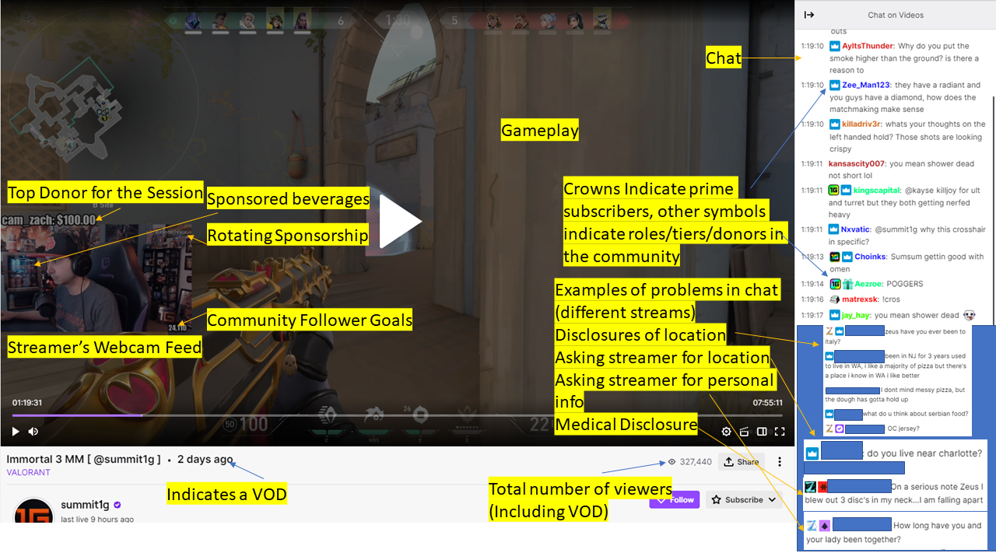
Figure 1: Typical Twitch Stream and problematic chat messages

Twitch considers their streamers to be influencers, as a company Twitch labels its platform as "The ultimate influencer marketing based service" (Twitch, 2021) focusing on the high engagement rates with its content creators, the existing drive of viewers to support the content creators monetarily, and the aforementioned affinity to purchase based on content creator recommendations (Twitch, 2021). Twitch's partner streaming program provides a curated list of streamers that Twitch endorses for brands and works to connect them with one-another. Beyond that, Twitch provides advertising support beyond just pre- and mid-roll advertising including banner advertising, page takeovers, and full Twitch partnerships. Brand sponsorship is currently the driving force behind revenue for eSports, with stream advertising expected to become a central pillar by 2023 (Statista, 2020). The role of brands in the continued growth of video game live streaming cannot be denied.

Twitch.TV Research
Advertisers are quickly realizing the value in Twitch as a platform, from 2019 to 2020, Twitch's estimated advertising revenue more than doubled from $310 million to $750 million (Iqbal, 2012), even with this recent increase in revenue, Twitch has only recently drawn attention from academic researchers.

Early Research
Early research in Twitch focused on descriptions of the platform as well as the technology, usually through a computer-human interaction aspect. One of the first published journal articles examining live streaming sought to map out viewership trends on the platform and how there are predictors such as time, content, and events within the stream (Kaytoue, Silva, Loic, Meira Jr., & Raissi, 2012). Research then moved towards streamer and viewer behaviors. Analyses included digital ethnographies and found that micro communities on Twitch built around viewer participation build up social identities within those communities built around shared experiences (Hamilton, Garretson, & Kerne, 2014). Researchers utilized chat data in Twitch to craft a technology model built around viewer and streamer behavior related to starting and ending a stream and the viewership numbers therein. This research was mainly explanatory, while aspects such as advertising were touched upon, the focus was on detailing the platform that was only a few years old and had not yet reached the mainstream.

Uses and Gratifications
The first major communication theory commonly applied to video game live streaming was Uses & Gratifications theory, a theory that examines how people's intended uses of media dictates their feelings of satisfaction with the experience (Katz & Lazarsfeld, 1955). Researchers utilized this theory to explain why people watch Twitch streams (Sjöblom & Hamari, 2017; Gros, Wagner, Hackenholt, Zawadzki, & Knautz, 2017; Hu, Zhang, & Wang, 2017; Sjöblom, Törhönen, Hamari, & Macey, 2017), why people watch eSports streams (Hamari & Sjöblom, 2017), why people comment and engage on Twitch (Hilvert-Bruce, Neill, Sjöblom, & Hamari, 2018), and why people stream (Törhönen, Sjöblom, Hassan, & Hamari, 2020). This research showed that entertainment aspects, game genres, social/community engagement and information seeking were key aspects in using Twitch.

More Areas
As more research has been conducted, various aspects of streaming and viewing streams have been examined. Burroughs and Rama (2015) examined the blurring of virtual and physical space through streaming. Wohn and Freeman (2019) examined the reasons behind why viewers gave money to eSports streamers, finding that emotional investment was a key factor. Researchers have examined the presentation of gender and sexuality by streamers (Freeman & Wohn, 2020) as well as the experiences of streamers with disabilities and mental issues (Johnson, 2019). Cai examined how Twitch moderation features could affect chatbots in the future (Cai, 2019). Finally, utilizing over 100 interviews with streamers at live streaming conventions researchers have examined the experiences of streamers in regards to monetizing their streams (Johnson & Woodcock, 2019), the labor of streaming (Johnson, 2021; Woodcock & Johnson, 2019), and their views on the future of live streaming and the video game industry (Johnson & Woodcock, 2019; Johnson & Woodcock, 2019).
Though there has been research examining Twitch viewers, there has been little to no research examining viewers of Twitch content as an advertising audience, especially one that has a ready-made influencer platform available.

Streamers as Influencers
While there has been research in community building and motivations behind donations, there has been little to no research into advertising on live streaming platforms. A growing area of research on the platform, however, examines streamers as influencers. Research has shown that streamers have taken it upon themselves to prepare themselves to become influencers both purposefully and coincidentally due to the nature of live streaming (Woodcock & Johnson, 2019). eSports and streamers can even impact the games that people play (Macey, Tyrväinen, Pirkkalainen, & Hamari, 2020; Johnson & Woodcock, 2019). The nature of streaming includes the promotion of products, the games they play, the platforms and pc builds used to run the games, and the peripherals such as headsets and microphones used in the streams are all front and center in their gameplay. Video game companies have utilized streams to serve as trailers and advertising for their new games. Companies like Amazon have launched games with Twitch streamer-exclusive betas in which the first players were only streamers, and then access was provided to viewers who watched the streams of the game (Thier, 2020). Consumer brands such as Hyper-X gaming headsets (HyperX, 2021) Secret Labs chairs (Secretlab.co, 2021) and G-Fuel energy drinks (G Fuel, 2021) have recognized this aspect and utilized streamer influencers to promote their products.
It is important to touch upon the nature of a streamer’s influence. Twitch is very individual-focused, oftentimes, viewers will find a streamer through browsing or recommendations. They will find them based on the game they are playing, or a clip on other platforms like Reddit, Twitter, or YouTube. However, the reason the viewer stays around, engages with the community, subscribes, and donates is because of the streamer and the perceived relationship they have with said streamer. This is a key aspect of why streamers make for strong influencers, even those with smaller communities, they have developed a following that supports them as an individual to the point that they will give them money on a monthly basis, and even pay for other people to have subscriber status in the community through gift subs.
One important feature pertaining to streamer influencers is that of their multi-platform reach. The portability of an audience following an influencer is key in the digital age (Brooks, Drenten, & Piskorsi, 2021), and Twitch viewers have shown they will follow their favorite streamers across platforms, with social media platforms like YouTube and Twitter, and even communities dedicated to the streamer themselves through platforms like Reddit and Discord being key elements for streamers to build their community (Carter & Hoy, Working Paper). The communities that streamers develop with their communities allow them to not only boost the signal of their stream, but provide an audience that seeks out the content the streamer creates across platforms.
Advertising agency executives are concerned with extending their reach to new audiences, especially in a world of cable cutting (Childers, Lemon, & Hoy, 2019). Twitch's audience is primed for advertiser accessibility with fewer than 40% of viewers watching television on a weekly basis (Gera, 2018). There are five levels of influencer in terms of marketing, starting with the "nano-influencer" with fewer than 10,000 followers all the way to the well-known "celebrity influencer" with over 1 million followers (Campbell & Farrel, 2020). All levels of influencer are found on Twitch with, to gain "affiliate" status a streamer needs 50 followers, and streamers such as Ninja, Myth, Pokimane, Shroud, and others have well over 1 million paid subscribers much less followers (Statista, 2021).
While advertising scholars have examined various aspects of influencer marketing including trust and authenticity (Schouten, Janssen, & Verspaget, 2020; Lou & Yuan, 2019), the type of endorser (Schouten, Janssen, & Verspaget, 2020; Zhu, Kim, & Choi, 2021), and the popularity of the endorser (De Veirman, Cauberghe, & Hudders, 2017), and the effects of influence on individuals (De Veirman & Hudders, 2020; Evans, Hoy, & Childers, 2018; Lou, Tan, & Chen, 2019). There remains, however, a gap when examining Twitch streamers and their interactions with their viewers, a potential theoretical perspective through which to fill this gap may be one that has been used in influencer research before, that of Parasocial Interaction.

Parasocial Interactions and Relationships

Parasocial Interaction History
Parasocial interaction is a term that was first coined to describe a “simulacrum of conversational give and take” (Horton & Wohl, 1956, p. 215). In creating an entertainment program, whether on television, radio, or on stage, the producers, writers, and actors all create a fictional character, dubbed a persona, that unlike in books, can provide visual and audio cues to the viewer that the viewer responds to. Parasocial interaction, thus, refers to instances in which viewers of entertainment programming experience an "illusion of a face-to-face relationship with the performer" and may "develop a sense of intimacy, perceived friendship, and identification with the [persona]" (Chung & Cho, 2017, p. 482).
For a while, the most prominent area of application for parasocial interaction was in local TV news (Levy, 1979; Palmgreen, Wenner, & Rayburn, 1980; Houlberg, 1984; Rubin, Perse, & Powell, 1985). Through this early research, parasocial interaction was heavily associated with uses and gratifications, focusing on aspects such as loneliness as reasons that individuals experience parasocial interactions. Over time, researchers examined the idea of prolonged effects of parasocial interactions leading to what was called parasocial relationships (Rubin & McHugh, 1987). The idea of a perceived friendship is important in developing a parasocial relationship, the viewer must see the persona as someone they may view as a friend for the various parasocial interactions to develop into a lasting parasocial relationship (Rubin & McHugh, 1987).
Through the course of research in parasocial interaction researchers developed a scale to measure feelings of parasocial interaction (Rubin, Perse, & Powell, 1985), which was modified to fit the ideas of a parasocial relationship (Rubin & Perse, 1987). Perceptions of realism and attraction to the persona were found by researchers to be key aspects in the cultivation of parasocial interaction (Rubin, Perse, & Powell, 1985; Rubin & McHugh, 1987; Rubin & Perse, 1987). Further research into parasocial interaction examined the phenomenon as a predictor for television viewing, finding that parasocial interaction was one of the most important factors in watching television, on par with show content (Conway & Rubin, 1991).
Parasocial relationships are often one-sided, the viewer is aware of the persona, knows about them, and is familiar with their history, however the persona is not directly aware of the viewer (Horton & Wohl, 1956). There have been various conceptual ideas of how to develop parasocial interactions. Hartmann and Goldhoorn (Hartmann & Goldhoorn, 2011) broke down the curation of a parasocial interaction down to the idea of how the person addresses the audience whether verbally or bodily and the perceived attractiveness of the persona. Labrecque (2014) examined the predecessors of parasocial interaction as interactivity and openness. Kim and Song (2016) identified self-disclosure as a predecessor to parasocial interaction.
As the research in parasocial interactions continued to evolve, applications moved from television and radio to online and social media platforms (Thorson & Rodgers, 2006; Labrecque, 2014; Xiang, Zheng, Lee, & Zhao, 2016; Lueck, 2015; Kim & Song, 2016). Through the development of parasocial interaction research, the consumer effects related to the increase in impulse purchase tendencies (Xiang, Zheng, Lee, & Zhao, 2016; Park & Lennon, 2004) and increased brand loyalty (Labrecque, 2014) have clear implications for advertising scholars.
Advertising scholars have examined communication aspects of parasocial interactions and relationships to examine areas such as influencer advertising. Influencers, even when using their own social media accounts, can construct a persona that they utilize to create a buffer between their public identify and personal identity. Researchers have examined how parasocial interaction can be a mediator in a consumer’s purchase intent and self-efficacy of influencer posts (Kim H. , 2020). Parasocial Interactions can increase the sense of trust in an influencer and brand (Yuan & Lou, 2020; Breves, Amhren, Heidenreich, Liebers, & Schramm, 2021; Lou & Yuan, 2019). Beyond influencers, parasocial interaction can occur with a brand as the public persona crafted by the brand when posting on social media can add a personality and construct a form of persona (Labrecque, 2014).
The value of developing meaningful interactions and relationships with a brand or product through association with a celebrity source is a key aspect of why advertisers utilize influencer marketing. As mentioned earlier, Twitch as a platform is a potential goldmine for influencer marketing, and it has interesting interactive elements which can support the development of parasocial and even transparasocial interactions and relationships.

Parasocial Interactions on Twitch
Parasocial interaction has only recently started to become a lens through which researchers examine Twitch. Twitch brands itself as a social medium, inviting streamers to connect with thousands of “friends” through their platform. Social interaction is a key element that separates Twitch from other entertainment platforms. The audience is participatory in the creation of content as the streamer’s responses to viewers chatting creates the very content that is being consumed. Researchers have explored how the social aspects of Twitch viewer to viewer, viewer to streamer and streamer to viewer all play a role in increasing enjoyment in viewing Twitch content (Wulf, Schneider, & Beckert, 2020). Further research has identified how parasocial interaction precedes an increase in viewer identification with streamers (Hu, Zhang, & Wang, 2017), and can lead to increased viewer loyalty with streamers (Lim, Choe, Zhang, & Noh, 2020). Twitch’s live chat facilitates an easy path to developing parasocial interactions (Lieth, 2021). Researchers have examined Twitch’s chat feature for written cues of parasocial interactions and utilized those cues to predict commitments to social norms such as leaving streams early and violating chat rules (Wulf, Scheider, & Queck, 2021). This research also found that verbally addressing viewers can prompt parasocial interaction indications from chat.
The foundational aspects of Twitch such as its audience participation and co-creation process have been examined regarding parasocial interaction. In a follow-up to Horton and Wohl’s piece defining parasocial interaction, Horton, and Strauss (1957) examined audience participation shows in which the audience works with the “master of ceremonies” to co-create the content of the show. This is like the nature of interaction on Twitch, wherein the streamer responds to their chat in a way that adds content to the stream. This can take form in Q&A sessions, “story times” wherein the streamer tells life stories about themselves, rapport, and involving chat in discussions and in the game itself. Horton and Strauss (1957) identify an important distinction in the difference between audience participation shows as parasocial versus personal interaction. Personal interaction relies on both parties utilizing transparent identities in which both parties know the other. Parasocial interaction, however, relies on one party utilizing a constructed persona. Carter and Hoy (Working Paper) found that oftentimes streamers will put on an act of sorts to be entertaining, and on some occasions to maintain a fictional narrative wherein the streamer’s identity on stream is separated from their personal identity. Twitch’s culture revolves around “handles” instead of real names Tyler “Ninja” Blevins goes by Ninja, Herschel Beahm goes by “Dr Disrespect,” Timothy Betar goes by “Tim the Tatman.” These streamers often utilize an outlandish personality seeking to provide entertainment in over-the-top responses to events and a cockiness to assure the audience of their skill.
One avenue of Twitch that coincides with an area of parasocial interaction research is that of at-home shopping networks. These channels focus on capitalizing on aspects such as loneliness and convenience to appeal to older audiences unable to leave the home, as their inability to go shopping themselves developed a sense of loneliness, the appeal of the perceived convenience of at-home shopping and the content itself facilitated the development of parasocial relationships (Lim & Kim, 2011). This is especially important given the nature of social distancing measures in 2020 and 2021, periods of rapid growth in the consumption of online streaming content. The convenience of interacting through Twitch during a period of intense social isolation may serve as an explanation for the popularity of the platform during this time.
A common theme across all levels of community size on Twitch is that of the streamer-centric nature of the community. Viewers may watch a stream for different reasons, but the streamer is who they willingly give money to support. The parasocial relationships they build with the streamer explain a willingness to provide that monetary support (Johnson & Woodcock, 2019). Furthermore, as individuals see the streamers as their friends and develop stronger feelings of a parasocial relationship, they may feel as if they “know” the streamer as a person (Hu, Zhang, & Wang, 2017), and would be able to determine their authenticity. Authenticity, in turn, is a main component of influencer success, especially at the micro-influencer level often found on Twitch (Park, Lee, Xiong, Septiano, & Seo, 2021).
Still, there exists an area of Twitch that separates it from most forms of media. The ability to talk to the persona and receive a response, as well as the persona’s ability to form relationships and interact with anonymous viewers on the internet. The ability to have two-way parasocial interactions is an aspect of the technology that needs further exploration.

Transparasocial Interactions
One novel idea of the parasocial relationship that has developed due to the blurring of social boundaries through digital media advancement is that of transparasocial interaction (TPSI) (Lou, 2021). Lou’s (2021) study examined how influencers online, while portraying themselves in influencer posts, will engage in two-way interactions with their viewers that blurs the line between a parasocial and personal relationship. A transparasocial relationships is one in which the audience and persona engage in a "collectively reciprocal, (a)synchronously interactive, and co-created" relationship (Lou, 2021, p. 8). In this relationship openness and interactivity lead to two-way interactions that develop over time. Twitch itself is uniquely set up to facilitate these sorts of relationships.
Twitch as a whole conforms well in terms of developing a sense of perceived interactivity in users. In line with McMillan and Hwang’s (2002) operationalization of perceived interactivity, Twitch offers real-time two-way conversations, with little delay, and engaging and varied content. This interactive nature lends itself well to the development of social relationships between users. While the interactive nature of Twitch is worthy of study, in regard to the community building aspect, transparasocial interaction may provide a more descriptive lens. Perceived interactivity, after all, has been shown to be a precedent to parasocial interaction (Labrecque, 2014).
Twitch’s interactivity, though lends itself directly to the development of transparasocial interactions. Both the streamer (persona) and viewer (audience) can engage in conversation with one another. This conversation is near instantaneous and is often used by streamers as a means of assistance when playing games on stream. The audience can provide streamers with immediate reactions to their plays as well as advice on upcoming challenges. The audience, in turn often seeks often to know the streamer and learn about them as a person. Engaging with the audience is a key aspect of Twitch, an aspect that streamers understand and seek to utilize to enhance their experiences on the platform (Carter & Hoy, Working Paper).
Lou (2021) identifies four key pillars of transparasocial interaction, the online/social media aspect, collective reciprocation, asynchronously interactive, and co-created content. Twitch as a platform employs all four. Twitch is an online platform used not only for media creation, but for social aspects. Conversation is collectively reciprocal as the streamer and viewer can talk back and forth interacting with one-another and developing relationships. It is synchronously interactive, as outlined above allowing for near instant responses from both parties. And the content is co-created as the viewer takes an active part in the creation of the media by interacting with the streamer.
Transparasocial interaction has interesting consequences for advertisers as they seek to find more engaging influencers and word-of-mouth marketers. Twitch lends itself well to influencer marketing as well as transparasocial interaction, necessitating an examination of the effect of transparasocial interaction on the platform and its impact on advertising. Because transparasocial interaction with proper advertising disclosures can lead to positive outcomes to the influencer and brand, the following hypothesis is presented.
H1: A streamer who attempts to engage in transparasocial interactions between themselves and their community will increase the effect of word-of-mouth endorsements from the streamer leading to positive brand (H1a), purchase (H1b), and loyalty (H1c) perceptions

Privacy
Parasocial relationships with influencers can lead to the self-disclosure of information between the persona and audience (Kim & Song, 2016). Openness is an important aspect in the developing of a parasocial interaction and relationship (Rubin & Perse, 1987; Labrecque, 2014; Kim & Song, 2016). Accordingly, explorations into parasocial interactions benefit from examining aspects of privacy. Self-disclosures by influencers are common methods to develop bonds with their audience, leading to feelings of social presence and thus parasocial interactions (Kim & Song, 2016).
Privacy Context theory involves the idea that context is important when examining whether an individual shares information in certain settings (Nissenbaum, 2004). Twitch brands itself as a platform to connect “friends” and the development of transparasocial interaction is founded in the idea of viewing their relationship as reciprocally friendly. Nissenbaum states "In friendship, generally, information is either shared at the discretion of the subject in a bidirectional flow-friends choose to tell each other about themselves- or is inferred by one friend of another based on what the other has done, said, experienced, etc." (Nissenbaum, 2004, p. 141). Thus, it stands to reason that a platform like Twitch may be one in which the sharing of information is expected.
The idea of having an influencer self-disclose information is one utilized by marketers in many areas. One of the first examinations of social media privacy involved examining church bulletin board websites wherein it was found that individuals were sharing information about themselves, prompted by the church to gather information for personal prayers (Hoy & Phelps, 2003). Today, brands on social media will ask individuals to share information about themselves and even their children online (Fox, Hoy, & Carter, 2022) for the purpose of co-creation (Fox & Hoy, 2019).

Privacy on Twitch
Twitch as a platform has a troubled history when it comes to privacy aspects, forms of harassment such as doxing, swatting, and stalking of streamers have led to safety concerns among streamers (Carter & Hoy, Working Paper). The instantaneous communication that lends itself so well to relationship and community building provides a problematic aspect regarding privacy violations, especially combined with the issues of online anonymity. Doxing, the act of acquiring and publicly disseminating personal private information (Meriam-Webster, 2021), is a common form of social control, punishment, and “trolling” on Twitch. As streamers disseminate information about themselves in conversations with viewers, they put the privacy of their personal lives at risk. Even guarded streamers can fall prey, webcam streams, an important aspect of the Twitch experience, can show personal areas of streamers such as home interiors and bedrooms, which can in turn leak information that can lead to doxing. This invasion of personal privacy has led to more violent outcomes putting streamers at risk. Stalking, especially of female streamers and streamers who stream outside their home, is an ongoing problem that Twitch has faced (D’Anastasio, 2017). This can be spurred on by illusory relationships and interactions, a central tenant of parasocial interactions. In line with stalking are attacks on streamers. Streamers have been attacked by stalkers in the past, including a publicized sexual assault that occurred live on stream (Montgomery, 2021). An important event in the mind of many Twitch streamers is the shooting of famous streamer Dr. Disrespect’s home (Carter & Hoy, Working Paper). Swatting is another issue that is important to the issue of Twitch privacy issues. Swatting is the act of calling police on an individual and providing information to the police to weaponize them, encouraging a show of force to break into the person’s home and arrest them, usually while live on stream. Swatting has led to the arrests of dozens of innocent streamers, and even the death of at least on victim.
While these aspects are not unique to Twitch, the same interactive elements that can facilitate transparasocial relationships are what make these problems issues on the platform. Advertisers must be knowledgeable when it comes to privacy aspects on Twitch when prompting streamers to self-disclose information to their audience in endorsements. Streamers are an influencer audience that rely on their relationships with viewers for their primary job, content creation, and advertisers prompts for self-disclosures must consider this element. Thus, it is important for knowing how self-disclosures by the streamer relate to the relationship and community building aspects on Twitch. Thus, the following hypothesis is posed:
H2: Streamers who self-disclose PII about themselves to their community will increase the effect of word-of-mouth endorsements from the streamer leading to positive brand (H2a), purchase (H2b), and loyalty (H2c) perceptions.
Finally, it is important to understand how TPSI and Self-disclosure can interact alongside PSI to affect advertising messages. Thus, the following research question is posed:
RQ1: What is the modeled relationship between perceptions of TPSI of a streamer and perceptions that a streamer shared PII about themselves with their viewers interact with parasocial interaction and advertising outcomes within viewers?

CHAPTER III: METHODOLOGY

Design and Sample
This study utilized a 2 (Streamer engages in TPSI; Streamer does not engage in TPSI) x 2 (Streamer Self-Discloses PII; Streamer does not Self-Disclose PII) between subjects factorial design. 316 adults in the United States who have watched at least one hour of Twitch content in the past week were recruited to participate in an online experiment. In order to properly examine the broad range of Twitch viewing behaviors, and possible issues with estimating watch-time, one hour was decided as sufficient to allow someone to be knowledgeable about Twitch, while also allowing for hours watched to be a possible confounding variable.
The study utilized a Centiment panel to administer the online experiment, and the Qualtrics survey platform to administer the questionnaire. Before gathering data in this main study, the principal investigator conducted pretesting to evaluate manipulation checks and test products to feature in the ad, the details of which are outlined below starting on page 37.
To qualify for the study, participants had to be adults 18 years of age and older who live in the United States and included men, women, and people who identify as non-binary or other genders. The total estimated time for participation and completion of the experiment was approximately 10-15 minutes. Participants were compensated for their time through Centiment.

Data Collection
Centiment panel members who qualified for the survey were sent an email invitation or push notification with information about the length of the survey and the compensation as determined by Centiment. 316 qualified individuals took part in the online experiment. Demographic data was collected including gender identity, age, race/ethnicity, and education level, though data remained anonymous with Centiment handling the distribution of funds. Table 1 shows the demographic profile of the participants.

Procedure
Before beginning the online experiment, participants were presented with an informed consent statement. The informed consent statement indicated to participants that they will be included in an online experiment which seeks to understand viewer attitudes towards advertising on Twitch.
Participants that consented to take part in the study, were then directed to a separate page containing study directions outlining that they will be watching a Twitch Video on Demand (VOD) showcasing an up-and-coming streamer, that researchers want to understand more about their interactions with their community, and that they will be asked questions about the stream after a few minutes. After reading the directions the participant continued to the next page, where the embedded stimuli video was ready to play. There were four videos, one for each cell of the 2x2 experiment as expressed in Figure 2. Using Qualtrics, participants were randomly assigned one of the four videos to ensure that all participants have an equal chance of receiving each experimental treatment combination. The video was created to mimic a normal Twitch stream, and the participants had to watch the entire video before moving on. Each participant watched their full video, lasting from around 115-173 seconds depending on their assigned condition. Following completion of the video, participants were directed to a questionnaire page containing all dependent measures, manipulation checks, attention checks, and demographics.

Table 1: Demographic Profile
Variable |  | Percent
Gender
 | Male | 62.1%
 | Female | 36.3%
 | Non-Binary/Third Gender | <1%
 | Other | <1%
Race/Ethnicity
 | Hispanic | 15.1%
 | American Indian or Alaska Native | <1%
 | Asian | 1.9%
 | Black or African American | 15.5%
 | Native Hawaiian or Pacific Islander | <1%
 | Other | 5%
 | White | 76%
Highest Education Level Completed
 | Associate Degree | 14.8%
 | Bachelor’s Degree | 22.1%
 | Graduate Degree | 8.5%
 | High School Diploma or Equivalent | 26.5%
 | Some College (No Degree) | 24.9%
 | Some High School (No Degree) | 2.8%

Variable | Mean | STD Dev
Hours Viewed | 10.27 | 9.094
Age | 35.35 | 8.839

 | Self-Disclosure Manipulation
TPSI Manipulation | Treatment 1:  Presence of Self Disclosure + Presence of TPSI | Treatment 2:  Absence of Self Disclosure + Presence of TPSI
TPSI Manipulation | Treatment 3:  Absence of TPSI + Presence of Self Disclosure | Treatment 4: Absence of TPSI + Absence of Self Disclosure (Control)
Figure 2: Explanation of Experimental Conditions

Stimuli
The streaming stimuli for this study were designed to reflect a typical clip from Twitch. Like the design of Wulf, Schneider, and Queck’s (2021) parasocial interaction on Twitch experiment, an individual familiar with Twitch streaming was recruited to participate in the creation of the stimuli. The streamer was instructed to simulate a typical stream of the popular game “Minecraft” speaking as they naturally would when streaming. Minecraft serves as the game of choice because it is a simple concept, is rated E, and is the 4th most streamed game on Twitch, and the only game in the top 10 most streamed games on Twitch that does not involve killing or fighting besides FIFA 2022. Events in the game, chat messages, and the streamer setting will remain the same between conditions. The streams lasted from 115-173 seconds, the first 45 seconds were normal gameplay followed by the Transparasocial Interaction manipulation, where the streamer refers to their viewer as friends, then another 45 seconds followed by the ad read which included the self-disclosure manipulations. For the ad read, a brand was selected based on pretesting as outlined below after discussion of measures.

Experimental Treatments
After 45 seconds, a subscription popup notification was overlaid on the stream in which a user has subscribed to the streamer and made an expression that the streamer is like a friend to them, a normal occurrence in streams, and a similar divider used in Wulf, et al’s (2021) Twitch study. It is very common for streamers to have special animations that play when people donate money or subscribe to their account, these animations include messages for the streamer from the viewer, usually as a way for the viewer to directly talk to the streamer, these animations are also usually a prompt for the streamer to respond with thanks. The animation in this instance provided the streamer with a reason to express reciprocal feelings of parasocial interaction (TPSI) and also served as a natural cut in order for participants to remain unaware of the conditions. This notification served as a cut through which the TPSI; no-TPSI manipulation was split. To see a storyboard of how the experimental treatments were conducted, please see Appendix 1.

Transparasocial Interaction
When the notification occurred, the streamer thanked the subscriber and proceeded to express how they view their community members are their friends, that they have grown close to them despite not meeting them outside of the stream, and that they look forward to the future with the community.
After the expression, a second subscription notification was used as a cut to stitch together the two manipulations.

No Reciprocal Parasocial Interaction
When the notification occurs, the same clip of the streamer thanking the subscriber was used, however, before they went into their expression of TPSI expressions the second subscription notification was used as a cut to stitch together the two manipulations.
After the TPSI manipulation, the streamer streamed again for about 45 seconds before the streamer announced that it was time for an ad read. Within this next segment, the manipulation of streamer self-disclosure; no streamer self-disclosure was conducted.
Transparasocial Interaction Manipulation Check
In line with Lou’s (2021) exploration of transparasocial interaction, three 7-point Likert scale items were used to ensure that viewers were aware of the streamer’s reciprocation of parasocial interaction. These scales, anchored by “Strongly disagree” (1) and “Strongly agree” (7) included measures such as: “[streamer’s] community sees them as a friend.”; “[streamer] involves their community in the creation of their content.”; and “[streamer] sees their community as their friends.”
The first and third measure are designed to see if the streamer reciprocates the parasocial interaction with their viewers, what Lou (2021) refers to as “Collectively Reciprocal” and the second is designed to see if the stream includes the co-creation of content, another of Lou’s examination of transparasocial interaction.
These measures are designed to test the participant’s perceptions of transparasocial interaction vicariously experienced through the streamer’s community.

Streamer Self-Disclosure
After announcing that it is time for an ad read, the streamer’s webcam took the full focus of the stream. The streamer proceeded to go through an ad read for the product, in this case Doritos 3D Crunch wherein they told a personal story disclosing fictional personal identifiable information to relate to the use of the product, in this read they disclosed the name of their wife and daughter, the city where they live, hobbies of their daughter, and their wife’s job. The streamer then provided a short lead-in before showing an image of the product and describing its benefits in line with how it is described on its website. The streamer then concluded the stream by thanking their viewers.

No Streamer Self-Disclosure
Without the personal story the streamer provided a short lead-in before showing an image of the product and describing its benefits in line with how it is described on its website. The streamer then concluded the stream by thanking their viewers.

Self-Disclosure Manipulation Check
To ensure that viewers were aware of the streamer’s self-disclosure or not, a single 7-point Likert scale item was asked. This item was anchored by “Strongly Disagree” (1) and “Strongly Agree” (7) and is “[streamer] shared personal identifiable information about themselves with their community in the stream.” Furthermore, to ensure that the individual was thinking about PII, the participant was asked to describe what PII was shared in the clip.

Attention Checks
Attention checks were used to ensure that the participant is engaged and not an automated algorithm. In line with recommendations of working with online surveys (Kees, Berry, Burton, & SHeehan, 2017), these attention checks were placed throughout the survey, optimizing the study to lead towards stronger validity, data quality, and lack of bot interference. Attention checks included an explicit call to select an option, furthermore, the qualitative request for the PII shared in the clip served as a form of attention check, as individuals who did not answer the question with a comprehensible response of some sort did not count towards the data collected.

Dependent Measures

Parasocial Interaction
Parasocial interaction was operationally defined as the experience of a “simulacrum of conversational give and take” (Horton & Wohl, 1956, p. 215). Parasocial interaction was measured by adapting Rubin, Perse, and Powell’s (1985) parasocial interaction scale. The scale is a 7-point Likert scale, anchored by “Strongly Disagree” (1) and “Strongly Agree” (7) includes measures such as “[streamer] makes me feel comfortable, as if I am with a friend.”; “When I interact with [streamer], I feel included.”; “I can relate to [streamer].”; “I care about what happens to [streamer].”; and “I hope [streamer] can achieve their goals.” In the case of this study, participants will be exposed to the idea that the streamer is attempting to pursue partnerships with brands, thus presenting a clear goal participants will have in mind. Furthermore, the streamer used a promo code in their ad read, providing a second possible goal for the participants to see as a goal the streamer wants to succeed at.
The items are intended to measure the simulated friendship and conversation that the participant feels from their vicarious interaction with the streamer and their community. This scale has been used to measure parasocial interaction for decades on television viewing as well as on social media (Labrecque, 2014). The items have previously been shown to be reliable when examining parasocial interactions on social platforms (α = .83).

Advertising Effectiveness
Advertising effectiveness was operationally defined as “the positive outcomes on the viewer towards the advertised brand, product, and influencer.” This was measured using adapted scales from Evans et al’s (2017) study on advergaming and Labrecque’s (2014) study on parasocial interaction on social media. The scales are in the categories of “Attitude toward the brand” “Purchase intent” and “Loyalty”.

Attitude toward the brand
This measurement includes six items on a 7-point semantic differential scale as used by Evans et al. (2017). The prompt for the semantic differential evaluation was “How did you feel about the brand advertised?” The items include “Unappealing/Appealing” “Unpleasant/Pleasant” “Boring/Interesting” “Dislike/Like” Negative/Positive” and “Bad/Good.” The items have previously been shown to be reliable when examining brand attitude on digital platforms (α = .953).

Purchase Intention
This measurement includes four items on a 7-point Likert scale as developed by Evans et al. (2017) anchored by “Strongly Disagree” (1) and “Strongly Agree” (7). The items include “I would like to try this brand”; “I would buy other products of this brand”; “I would buy this product if I happened to see the brand”; and “I would actively seek out this product in a store to purchase it.” The items have previously been shown to be reliable when examining purchase intentions on digital platforms (α = .902). Furthermore, the following measures have been added to coincide with the online nature of Twitch interactivity: “I would be interested in learning more about this brand online”; and “I would like to check out this brand’s social media pages.” Finally, because each ad includes a call to action to use a promo code, the following measure was included “I would be interested in using the promo code [streamer] shared.”

Loyalty Intentions
This measurement includes three items on a 7-point Likert scale adapted from items developed by Labrecque (2014) anchored by “Strongly Disagree” (1) and “Strongly Agree” (7). The items include “I’m willing to say positive things about [brand] to others.”; “I’m willing to encourage close friends to purchase [brand]”; and “I plan to purchase [brand] in the next few weeks.” The items are adapted from a scale that has previously been shown to be reliable when examining brand loyalty on digital platforms (α = .75).

Confounding Variables
Possible confounding variables that were tested for includes how many hours the user spends on Twitch, the willingness of the participant engage in chat on Twitch and influencer credibility.
The time the user spends on Twitch was measured using self-report data of how many hours they spend watching Twitch content in a typical week. How often the participant engages in chat on Twitch was measured by a 7-point likert scale anchored by “strongly disagree” and “Strongly Agree” to the statement “I regularly participate in chat when watching streams on Twitch.”
Influencer Credibility used a 7-point Likert scale developed by Munnukka, Uusitalo, and Tolvonen (2016), this scale was anchored by “Strongly Disagree” (1) and “Strongly Agree” (7) and will include four items including “I consider the endorser to be honest”; “I consider the endorser trustworthy”; “I consider the endorser to be truthful”; and “I consider the endorser earnest.” The items have previously been found to be reliable in measuring online influencer credibility (α = .89). Furthermore, the item “I would watch this stream again if I saw it on my feed.” Was included to provide more context for the Twitch viewing experience.

Pretesting
Two pretests were conducted prior to the main study, a pretest of product fit, and a pretest of experimental treatment manipulation.

Pretest 1 – Product Fit
The influencer-product cohesiveness is a key aspect in the effectiveness of influencer advertising (Brooks, Drenten, & Piskorsi, 2021; Park, Lee, Xiong, Septiano, & Seo, 2021). On Twitch, especially, a fit between the streamer-influencer and the product they are promoting may be more important, as the platform’s culture is built heavily on aspects such as authenticity, this authenticity may, in turn, effect how willing a viewer may be to engage in a parasocial relationship with the streamer (Lou & Yuan, 2019; Lou, 2021). There is no existing literature on product advertising on Twitch.
Because of these aspects, it is important to ensure that the product that is being advertised in the main study is seen as a fit, not only with the influencer, but with the platform itself. Thus, a pretest was conducted examining four products within the snack-food product category for fit on the platform, fit with the streamer, and the authenticity of the ad read itself. The product category was “Snacks” and the four products were Doritos 3D Crunch, Reese’s Pieces, Oreos Double Stuf, and Red Bull Coconut Edition. All four products are lower cost and found in typical shopping trips. Furthermore, the products have all been previously advertised on Twitch, or have sponsored Twitch events, making it more likely they are seen as “typical” on the platform.
The pretest sample screening matched the main study sample, adults in the United States who have watched one or more hours of Twitch in the past week. The sampling method used was snowball sampling, with participants recruited from social media as well as personal contacts of the Principal Investigator. In totally, 36 participants took part in the first pretest.
The pretest procedure involved the participants being prompted that they are about to see ads from a streamer who is trying to find the best fit for his channel. They were then shown four videos, each an ad read for the brands that mostly matched the ad read in the main study. After each respective video, they filled out a questionnaire measuring the product fit and typicality of the ad read. This questionnaire included questions on the likelihood of the viewer to purchase products from the product category, whether the ad was typical of a Twitch stream, whether they are familiar with the product, and whether the product/ad was a good fit for the streamer. Demographic information was also collected.

Pretest 2 – Experimental Treatment Manipulation
As a novel theoretical lens as of the writing of this document, transparasocial interaction has not been experimentally manipulated before, much less on the Twitch platform. Furthermore, streamer self-disclosures have not been manipulated on the Twitch platform either. The unique aspect of Twitch’s interactivity points to a need to ensure that the treatment conditions manipulate the perceptions they are intended to. Thus, the second pretest needed to be conducted.
In the second pretest, 104 adults who watched at least 1 hour of Twitch content in the past week were recruited through Centiment. Participants were told that they will be watching a clip from a Twitch streamer who is starting to become popular, and that researchers are trying to understand more about their interactions with their viewers. Each individual was then randomly assigned to one of the four treatment conditions through Qualtrics, with the corresponding clip of that condition then being shown. After each clip, the participants completed a questionnaire in which they completed the manipulation check for TPSI and streamer self-disclosure. Then, they also answered questions about influencer credibility and questions about the fit of the game for the study. Demographic data was then collected.

CHAPTER IV: RESULTS

Pretest One
Pretest one examined the fit of the products for the streamer and study along with the realism of the advertising read. Using a Friedman’s test in SPSS each of the following product attributes were examined: Whether they purchase each product currently, whether the ad read was typical for the product, whether they have seen ads on Twitch for the products, whether the products were a fit for the streamer, whether the product was a fit for spokespeople on Twitch, and whether they rely on recommendations when purchasing the products. Table 1 shows the results of the Friedman’s Tests.
Whether they purchase this product category was statistically significantly different across the four product ad reads in the study, χ2(3) = 22.332, p = .000. Pairwise comparisons were performed (SPSS Statistics, 2012) with a Bonferroni correction for multiple comparisons. Whether the participant purchased this product category when shopping was statistically significantly different between energy drinks and Cookies/Chips (p > .05), and between Chips and all other product categories (p>.05). Of these products, the mean rating for Chips was highest M=4.56.
Whether the ad read was typical for a Twitch stream was not statistically significantly different across the four product ad reads in the study, χ2(3) = 1.979, p = .577.
Whether they had seen ads for this product category on Twitch was statistically significantly different across the four product ad reads in the study, χ2(3) = 31.422, p = .000. Pairwise comparisons were performed (SPSS Statistics, 2012) with a Bonferroni correction for multiple comparisons. Whether the participant had seen an ad for this product category on Twitch was statistically significantly different between all product categories and Energy Drinks (p < .05). Of the products, the mean rating for Energy Drinks was highest M= 5.73.
Whether the product was a fit for the streamer was not statistically significantly different across the four product ad reads in the study, χ2(3) = 3.589, p = .309.
Whether the ad read was a fit for spokespeople on Twitch was not statistically significantly different across the four product ad reads in the study, χ2(3) = 5.217, p = .157.
Whether they rely on recommendations when purchasing this product category was statistically significantly different across the four product ad reads in the study, χ2(3) = 9.147, p = .027. Pairwise comparisons were performed (SPSS Statistics, 2012) with a Bonferroni correction for multiple comparisons. Reliance on recommendations was statistically significantly different between energy drinks and chips (p = .012). Of these products, the mean rating for Chips was highest M=4.21.
Based on the differences in product outcomes, chips were decided on as the product to use in the study. Though Energy Drinks were seen as more typical for Twitch, they were not often purchased by participants nor were they a product that recommendations were important for as chips are.
Within Pretest one, participants were asked to rate the extant to which they found the ad read as typical for a Twitch stream. The Mean rating was 4.08 with a Standard Deviation of 1.836 within a 7-point scale. This means the rating was, on average, in the “neither agree nor disagree” rating. Participants were asked to provide more information, and a common theme was that the streamer was “stiff” and “not organic” in their ad read. Because of this, the streamer used in Pretest two and the Main study was portrayed by a different individual who the investigator felt was more organic in their presentation.
Table 2: Product Testing Outcomes
Variable | Significant? | Best Product
Purchase? | Yes | Chips
Typical for Twitch? | No | N/A
Seen ads on Twitch? | Yes | Energy Drinks
Fit for Streamer? | No | N/A
Fit for Spokespeople? | No | N/A
Rely on Recommendations? | Yes | Chips

Pretest Two
Pretest two served to test the manipulations of the experiment. The first tests, though, were to examine the differences between pretest one and two with the change in streamer. Product fit and the extent to which the ad read was “typical” were measured.
A Mann-Whitney U test was run to determine if there were differences in perceptions of the ad read being typical between pretest one and pretest two. Distributions of the engagement scores for both groups were similar, as assessed by visual inspection. Mean engagement score was statistically significantly different between Pretest one (M= 4.08; SD = 1.836) and Pretest two (M=5.47; SD = 1.336), U = 2841, z = 4.083, p = .000.
A Mann-Whitney U test was run to determine if there were differences in perceptions of the fit for the brand (Doritos) between pretest one and two. Distributions of the engagement scores for both groups were similar, as assessed by visual inspection. Mean engagement score was statistically significantly different between Pretest one (M=5.24 SD = 1.195) and Pretest two (M=5.64; SD = 1.222), U = 2349, z = 1.994, p = .046.
A Mann-Whitney U test was run to determine if there were differences in perceptions of the fit for the product (Doritos 3D Crunch) between pretest one and two. Distributions of the engagement scores for both groups were similar, as assessed by visual inspection. Mean engagement score was statistically significantly different between Pretest one (M=4.87; SD = 1.695) and Pretest two (M = 5.54; SD = 1.400), U = 2431, z = 2.156, p = .031.
The differences between the pretests showed a more typical ad read with better product fit, this was determined to be a positive benefit for the study, and no further changes to the ad read were needed.
To examine the experimental conditions, the perceptions of TPSI variables were tested across the four experimental conditions.
A Kruskal-Wallis H test was run to determine if there were differences in perceptions of CWard involving his community in his streams between four conditions. Distributions of perception scores were not similar for all groups, as assessed by visual inspection of a boxplot. The mean rank of perceptions was not statistically significantly different between groups, χ2(3) = 1.241, p = .743
A Kruskal-Wallis H test was run to determine if there were differences in perceptions of CWard seeing his community as friends between four conditions. Distributions of perception scores were not similar for all groups, as assessed by visual inspection of a boxplot. The mean rank of perceptions was not statistically significantly different between groups, χ2(3) = .526, p = .913
A Kruskal-Wallis H test was run to determine if there were differences in perceptions of CWard’s Community seeing him as a friend in his streams between four conditions. Distributions of perception scores were not similar for all groups, as assessed by visual inspection of a boxplot. The mean rank of perceptions was not statistically significantly different between groups, χ2(3) = 2.583, p = .460
A Kruskal-Wallis H test was run to determine if there were differences in perceptions of CWard’s Community being one the participant wants to be a part of between four conditions. Distributions of perception scores were not similar for all groups, as assessed by visual inspection of a boxplot. The mean rank of perceptions was not statistically significantly different between groups, χ2(3) = 1.299, p = .729
A Kruskal-Wallis H test was run to determine if there were differences in perceptions of CWard having shared personal information about himself between four conditions. Distributions of perception scores were not similar for all groups, as assessed by visual inspection of a boxplot. The mean rank of perceptions was not statistically significantly different between groups, χ2(3) = 5.754, p = .124
Though the four conditions as a whole did not reveal significant differences, the two manipulations of TPSI and Self Disclosure were examined independently.
A Mann-Whitney U test was run to determine if there were differences in perceptions of CWard involving his community in his streams between conditions when TPSI was present and not present. Distributions of the engagement scores for both groups were similar, as assessed by visual inspection. The mean engagement score was not statistically significantly different between TPSI and No-TPSI groups, U = 1465, z = -0.775, p = .438, using an exact sampling distribution for U.
A Mann-Whitney U test was run to determine if there were differences in perceptions of CWard seeing his community as friends between conditions when TPSI was present and not present. Distributions of the engagement scores for both groups were similar, as assessed by visual inspection. The mean engagement score was not statistically significantly different between TPSI and No-TPSI groups, U = 1445, z = 0.643, p = .520, using an exact sampling distribution for U.
A Mann-Whitney U test was run to determine if there were differences in perceptions of CWard’s Community seeing him as a friend in his streams between conditions when TPSI was present and not present. Distributions of the engagement scores for both groups were similar, as assessed by visual inspection. The mean engagement score was not statistically significantly different between TPSI and No-TPSI groups, U = 1391, z = 0.276, p = .783, using an exact sampling distribution for U.
A Mann-Whitney U test was run to determine if there were differences in perceptions of CWard’s Community being one the participant wants to be a part of between conditions when TPSI was present and not present. Distributions of the engagement scores for both groups were similar, as assessed by visual inspection. The mean engagement score was not statistically significantly different between TPSI and No-TPSI groups, U = 1280, z = -0.466, p = .641, using an exact sampling distribution for U.
A Mann-Whitney U test was run to determine if there were differences in perceptions of CWard having shared personal information across conditions when the Self-Disclosure was present and not present. Distributions of the engagement scores for both groups were similar, as assessed by visual inspection. The mean engagement score was statistically significantly different between Self-Disclosure and No-Self-Disclosure groups, U = 1649, z = 2.274, p = .023, using an exact sampling distribution for U.
To ensure that self-disclosure was not affecting the perceptions of transparasocial interaction within the community, Mann-Whitney U tests were run with self-disclosure as the independent variable, none of the community perceptions were significant.
To ensure that the game Minecraft was a good fit for the study, and that the stimuli was typical of a Minecraft stream, the mean scores were examined. Recognition that the game being played was Minecraft (M= 5.73; SD = 1.6), the viewer’s enjoyment of Minecraft (M = 5.94; SD = 1.378), Minecraft being a good fit for Twitch (M = 5.75; SD = 1.4), the viewer’s familiarity with Minecraft (M = 5.7; SD = 1.434), and the stimuli being typical of a Minecraft stream (M = 5.61; SD = 1.504) were all determined as sufficient, and that Minecraft was a good fit for the main study.
Though the results of the pretest were not significant, the researcher decided to move forward with the main study to examine the possible effect of confounding variables on the TPSI perceptions. The pretest served only to examine the study manipulations with some demographic data and stimuli checks. In order to see what does actually effect perceptions of TPSI, the main study included various other measures of possible confounding variables that explain the relationship between viewer and streamer.

Main Study
The main study examined Hypotheses one and two and Research Question one. First, a retest of experimental manipulations was conducted.

Test of TPSI Conditions
A Mann-Whitney U test was run to determine if there were differences in perceptions of CWard involving his community in his streams between conditions when TPSI was present and not present. Distributions of the engagement scores for both groups were similar, as assessed by visual inspection. The mean engagement score was statistically significantly different between TPSI and No-TPSI groups, U = 14224, z = 2.265, p = .024, using an exact sampling distribution for U. Supporting the successful manipulation of TPSI perceptions.
A Mann-Whitney U test was run to determine if there were differences in perceptions of CWard seeing his community as friends between conditions when TPSI was present and not present. Distributions of the engagement scores for both groups were similar, as assessed by visual inspection. The mean engagement score was statistically significantly different between TPSI and No-TPSI groups, U = 14879, z = 3.143, p = .002, using an exact sampling distribution for U. Supporting the successful manipulation of TPSI perceptions.
A Mann-Whitney U test was run to determine if there were differences in perceptions of CWard’s Community seeing him as a friend in his streams between conditions when TPSI was present and not present. Distributions of the engagement scores for both groups were similar, as assessed by visual inspection. The mean engagement score was statistically significantly different between TPSI and No-TPSI groups, U = 14241, z = 2.312, p = .021, using an exact sampling distribution for U. Supporting the successful manipulation of TPSI perceptions.
A Mann-Whitney U test was run to determine if there were differences in perceptions of CWard’s Community being one the participant wants to be a part of between conditions when TPSI was present and not present. Distributions of the engagement scores for both groups were similar, as assessed by visual inspection. The mean engagement score was statistically significantly different between TPSI and No-TPSI groups, U = 14250, z = 2.288, p = .022, using an exact sampling distribution for U. Supporting the successful manipulation of TPSI perceptions.

Comparison of Pretest two and Main Study Participants
The change from non-significant to significant across pretest two and the main study was examined. An examination of the sample was conducted to determine if there were any differences between the pretest two sample and main study sample that could result in this change.
A chi-square test for homogeneity was conducted between gender and the two samples. All expected cell frequencies were greater than five. There was not a statistically significant association between gender and the two samples, χ2(3) = 1.171, p = .760.
A chi-square test for homogeneity was conducted between Hispanic/LatinX ethnicity and the two samples. All expected cell frequencies were greater than five. There was not a statistically significant association between Hispanic/LatinX Ethnicity and the two samples, χ2(1) = .553, p = .457.
A chi-square test for homogeneity was conducted between Race and the two samples. There was a statistically significant association between Race and the two samples, χ2(5) = 32.098, p = .000. Upon further examination, the percent of respondents in the second pretest had a sizeable Asian population (15.4% of participants) compared to the main study (1.9% of participants. The Black or African American (14.4% and 15.5%) was similar between the studies, while the White population (66.3% and 76.3%) was different. There lies a possibility that the differences in the racial makeup of the two samples led to the differences in the perceptions of TPSI, this could be due to cultural differences, or even perceptions in similarity between he participant and streamer.
When examining the ages of the two samples, an independent samples T-test was conducted. Data are mean ± standard deviation, unless otherwise stated. The age of the main study group was younger (35.38 ± 8.839) than the second pretest (37.43 ± 9.288). The assumption of homogeneity of variances was violated, as assessed by Levene's test for equality of variances (p = .292). There was not a statistically significant difference in the mean ages t = -1.975, p = .05). There is a possibility that the differences in age between the two samples led to the differences in perceptions of TPSI due to perceived similarities between the participant and the viewer being closer in age.
When examining the hours of Twitch viewed by the two samples, an independent samples T-test was conducted. The hours viewed in the main study were higher (10.27 38 ± 9.094) than in the second pretest (8.11 38 ± 5.961). The assumption of homogeneity of variance was violated, as assessed by Levene’s test for equality of variances (p= .086). There was a statistically significant difference in the mean hours viewed t = 2.789, p = .006. There is a possibility that the differences in hours viewed led to differences in TPSI perceptions due to the participants who watch more often being more in tune with what to look for in streamer-viewer relationships.
The populations between the study had minor differences in the races that were represented and the hours of Twitch that the participants watched each week which may explain why the manipulations had different outcomes.

Self-Disclosure Condition
A Mann-Whitney U test was run to determine if there were differences in perceptions of the streamer disclosing personally identifiable information when Self-Disclosure in the ad read was present and not present. Distributions of the engagement scores for both groups were similar, as assessed by visual inspection. The mean engagement score was statistically significantly different between SD and No-SD groups, U = 18424, z = 7.566, p = .000, using an exact sampling distribution for U.

Test of Hypothesis 1
Hypothesis 1 stated that a streamer who attempts to engage in transparasocial interactions between themselves and their community will increase the effect of word-of-mouth endorsements from the streamer leading to positive brand (H1a), purchase (H1b), and loyalty (H1c) perceptions.
To test this, a Mann-Whitney U test was run to determine if there were differences in brand, purchase, and loyalty outcomes across the TPSI and non-TPSI conditions. The results of this test are in Table 3.
Because the TPSI condition had no statistically significant effect on any of the outcomes, the study fails to reject the null hypothesis for H1a, H1b, and H1c, though willingness to use the promo code approached significance.

Test of Hypothesis 2
Hypothesis 2 stated that a streamer who self-discloses personal information about themselves in their ad reads will increase the effect of word-of-mouth endorsements from the streamer leading to positive brand (H1a), purchase (H1b), and loyalty (H1c) perceptions.
To test this, a Mann-Whitney U test was run to determine if there were differences in brand, purchase, and loyalty outcomes across the SD and non-SD conditions. The results of this test are in Table 4.
Because the Self-Disclosure condition had no statistically significant effect on any of the outcomes, the study fails to reject the null hypothesis for H2a, H2b, and H2c. Though perceived interest and positive feelings towards the brand closely approached significance.

Table 3: Brand, Purchase, and Loyalty Outcomes across TPSI Conditions
Category | Variable | Non-TPSI Mean Rank | TPSI Mean Rank | U | Z | P
Brand | Appealing | 157.05 | 159.84 | 12,684.5 | .284 | .776
 | Pleasant | 151.71 | 164.79 | 13,495.5 | 1.330 | .183
 | Interest | 148.66 | 167.62 | 13,959 | 1.908 | .056
 | Like | 156.82 | 160.06 | 12,719.5 | .329 | .742
 | Positive | 151.05 | 165.4 | 13,596 | 1.456 | .145
 | Good | 153.72 | 162.93 | 13,191 | .940 | .347
Product | Would Try 3D Crunch | 153.54 | 163.1 | 13,218.5 | .981 | .327
 | Would Purchase Doritos | 158.23 | 158.75 | 12,505.5 | .055 | .956
 | Would Purchase 3D Crunch | 155.83 | 160.98 | 12,870 | .526 | .599
 | Would seek out 3D Crunch | 155.09 | 161.66 | 12,982 | .654 | .513
 | Would be interested in learning more about 3D Crunch | 155.78 | 161.02 | 12,878 | .523 | .601
 | Would check out Doritos Social Media | 160.85 | 156.33 | 12,107.5 | -.447 | .655
 | Would use the Promo Code | 167.19 | 150.45 | 11,143.5 | -1.686 | .092
Loyalty | Would talk positively about Doritos | 163.11 | 154.23 | 11,763 | -.898 | .369
 | Would encourage friends to try 3D Crunch | 154.32 | 162.37 | 13,099 | .806 | .420
 | Plan to purchase 3D Crunch in the next month | 158.58 | 158.43 | 12,452 | -.015 | .988

Table 4: Brand, Purchase and Loyalty Outcomes across SD Conditions
Category | Variable | SD Mean Rank | Non-SD Mean Rank | U | Z | P
Brand | Appealing | 151.10 | 164.86 | 13,491 | 1.397 | .162
 | Pleasant | 150.05 | 165.76 | 13,643 | 1.594 | .111
 | Interest | 148.15 | 167.39 | 13,920.5 | 1.932 | .053
 | Like | 153.63 | 162.68 | 13,121 | .919 | .358
 | Positive | 148.11 | 167.42 | 13,926.5 | 1.955 | .051
 | Good | 152.28 | 163.84 | 13,318 | 1.178 | .239
Product | Would Try 3D Crunch | 153.76 | 162.57 | 13,101.5 | .901 | .368
 | Would Purchase Doritos | 151.64 | 164.39 | 13,412 | 1.326 | .185
 | Would Purchase 3D Crunch | 154.69 | 161.77 | 12,966 | .722 | .470
 | Would seek out 3D Crunch | 153.84 | 162.5 | 13,090 | .860 | .390
 | Would be interested in learning more about 3D Crunch | 156.49 | 160.23 | 12,703.5 | .371 | .710
 | Would check out Doritos Social Media | 155.74 | 160.87 | 12,813 | .507 | .612
 | Would use the Promo Code | 151.06 | 164.89 | 13,496.5 | 1.390 | .164
Loyalty | Would talk positively about Doritos | 152.91 | 163.3 | 13,226.5 | 1.048 | .294
 | Would encourage friends to try 3D Crunch | 155.32 | 161.23 | 12,874.5 | .591 | .555
 | Plan to purchase 3D Crunch in the next month | 151.52 | 164.49 | 13,429 | 1.34 | .18

RQ1
Research Question one explored the model of relationships between perceptions of transparasocial interaction, self-disclosure, parasocial interaction, and advertising outcomes. To test the potential model, the study utilized structural equation modeling (SEM) with maximum likelihood estimation in Mplus. First, a measurement model was estimated to examine whether the observed variables provided a reliable reflection of the latent variables. Then, an estimated structural model was estimated using feelings of parasocial interaction as a potential mediator for advertising outcomes. In order to simplify the model, the variables “Would purchase Doritos,” “Would purchase 3D Crunch,” “Would use the Promo Code,” and “Plan to Purchase 3D Crunch in the next month” were used to measure the advertising outcomes. These variables were selected because they were most directly associated with purchasing 3D Crunch, the product in the advertisement.

Structural Model
The initial measurement model provided a good fit to the data χ2(74) = 177.680, p = .000; RMSEA = 0.067_{(.054-.079)}; CFI = .955 TLI = .944. Though the Chi-Square Test of the model fit was not a strong fit, the RMSEA, CFI, and TLI all indicated a strong model fit. One thing that did stand out was that self-disclosure perceptions did not regress strongly on feelings of PSI (r² = .09), thus it was removed from the final model. This provided a stronger model fit χ2(62) = 135.093, p = .000; RMSEA = 0.061_{(.047-.075)}; CFI = .968 TLI = .959. The final model with factor loadings is outlined in figure 3.
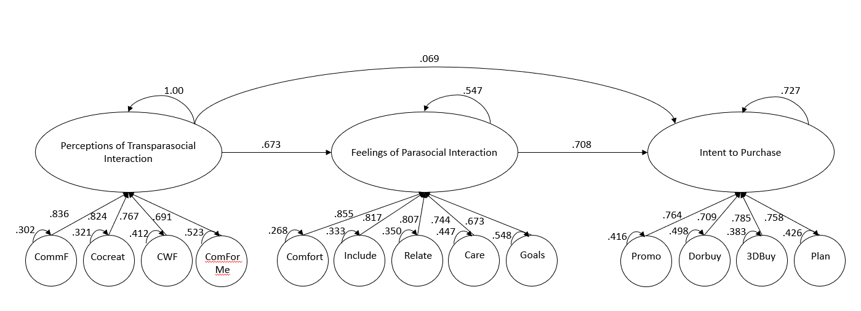 Figure 3: Structural Model of Perceptions of TPSI, Feelings of PSI and Intent to Purchase

Bootstrapping (1000) mediation analysis showed the total indirect effect of perceptions of TPSI to purchase intent mediated by feelings of Parasocial Interaction to be 0.477_{(.369 - .654)} p <.001. Figure 4 shows the mediating relationship model between the three constructs.

Possible Confounding Variables
In order to ensure that the effect on purchase intent are associated with the model outlined above, this study examines various confounding variables. The first group of variables that were examined were influencer variables including perceptions that the streamer was: Honest, Trustworthy, Truthful, Earnest, and that they would watch the stream if they saw it again. Ordinal Regression using a Wald confidence interval were used to examine the impact of these variables on the purchase intent variables. The results are shown in table 5.
Next, Hours of Twitch watched and willingness to participate in Twitch chat were examined as possible confounding variables. Table 6 shows the results of the ordinal regression using a Wald confidence interval.

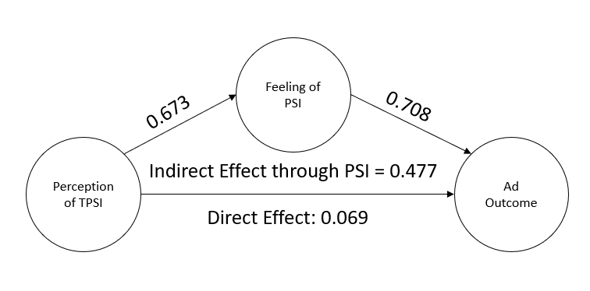
Figure 4: Structural Model of mediation of TPSI and Intent to Purchase by Feelings of PSI

Table 5: Purchase intent across Influencer Variables
Purchase Intent Variable | Influencer Variable | B | Significance
Buy Doritos
 | Honest | -.140 | .437
 | Trustworthy | .106 | .543
 | Truthful | .131 | .409
 | Earnest | .164 | .247
 | Would Watch | .621 | .000
Buy 3D Crunch
 | Honest | .243 | .150
 | Trustworthy | .108 | .517
 | Truthful | .111 | .470
 | Earnest | .019 | .886
 | Would Watch | .547 | .000
Use Promo Code
 | Honest | -.155 | .349
 | Trustworthy | .273 | .096
 | Truthful | .428 | .005
 | Earnest | .106 | .403
 | Would Watch | .418 | .000
Plan to Purchase 3D Crunch
 | Honest | .468 | .008
 | Trustworthy | -.130 | .450
 | Truthful | .041 | .797
 | Earnest | .062 | .645
 | Would Watch | .370 | .000

Table 6: Purchase intent across Viewership variables
Purchase Intent Variable | Confounding Variable | B | Significance
Buy Doritos
 | Chat | .218 | .001
 | Hours | .008 | .524
Buy 3D Crunch
 | Chat | .337 | .000
 | Hours | .024 | .043
Use Promo Code
 | Chat | .310 | .000
 | Hours | .016 | .163
Plan to Purchase 3D Crunch
 | Chat | .233 | .000
 | Hours | .021 | .084

CHAPTER V: DISCUSSION
This study makes contributions to the theories of transparasocial interaction and parasocial interaction by providing the first quantitative examination of transparasocial interaction to the best of the researcher’s knowledge and modelling the interaction between the two interactions in the context of advertising effectiveness. It provided a framework of how perceptions of transparasocial interaction can impact feelings of parasocial interaction which in turn can increase advertising effectiveness. It also provided a successful manipulation of transparasocial interaction perceptions, the first in this study in this researcher’s knowledge to do so. This study has implications for TPSI and PSI researchers, influencer researchers, advertising practitioners, and streamers.

Transparasocial Interaction and Self-Disclosure Implications
Hypothesis One stated that a streamer who attempts to engage in transparasocial interactions between themselves and their community will increase the effect of word-of-mouth endorsements from the streamer leading to positive brand (H1a), purchase (H1b), and loyalty (H1c) perceptions. Hypothesis two stated that streamers who disclosed information about themselves to their community will increase the effect of word-of-mouth endorsements from the streamer leading to positive brand (H2a), purchase (H2b), and loyalty (H2c) perceptions. Both Hypotheses 1 and 2 were not supported by the results of the study. The results of the Research Question do provide an explanation for this, however. While the streamer expressing a possible transparasocial relationship with their viewers did not directly effect brand, purchase, or loyalty perceptions, the perceptions of a transparasocial relationship between the streamer and their viewers did impact feelings of parasocial interaction, which, in turn, impacted purchase intentions. While the hypothesis was not supported, there are still avenues of research to expand on these findings.
This study is the first to this author’s knowledge to successfully manipulate Transparasocial Interaction perceptions. In doing so, this study also possibly revealed that exposure to content may have a significant impact on the perceptions of TPSI. The main study had a higher average hours/week among participants and had statistically significant manipulation of TPSI perceptions. Future research would benefit from examining the possible implications of viewing habits on perceptions of TPSI. It is possible that people who watch more Twitch content will be more likely to perceive the expressions as genuine, or even notice the expressions in general. Another possible follow up for researchers would be to examine similarity as another variable that may effect TPSI outcomes. Parasocial Interaction research has shown that perceived similarity is an important aspect in determining feelings of parasocial interaction (Rubin, Perse, & Powell, 1985). It is possible that similarity plays a role in perceptions of TPSI as well, outside of hours of Twitch viewed a week, race was the only other significant difference between the main study and pretest two populations, this could be another possible reason for the differences in the two studies.
This study also expands the current TPSI literature by providing the first study to examine the construct of perceptions of TPSI and their association with parasocial interaction and advertising outcomes. This study contributes to the theory of both TPSI and PSI by showing a relationship between the two concepts. The examination of the construct of perceptions of TPSI could provide a foundation for future refinement of a scale of perceived TPSI as well as an exploration into actual feelings of TPSI between a streamer and viewer-participant.
As for the relationship between TPSI and PSI, it stands to reason that perceptions TPSI alone would not have strong impact on advertising outcomes without feelings of PSI. This study measured perceptions instead of feelings of TPSI. Whereas feelings of PSI were measured. Future researchers would benefit from expanding the analysis of TPSI to measure someone’s feelings of a reciprocal parasocial interaction in order to more closely analyze the interactions between a viewer and influencer as opposed to an outside observer.
Influencer researchers should take note of how perceptions of TPSI may be closely related to an individual's knowledge or familiarity with the platform. TPSI was found to be more prevalent in communities of nano and micro-influencers (Lou, 2021), it is possible that individuals in those communities may perceive the TPSI due to their familiarity with the smaller group.
When it comes to Self-Disclosure of information, there was not a fit for self-disclosure within the model, furthermore, there was not a significant impact of self-disclosure on the outcomes. One area to examine in the future would be whether individuals are able to accurately identify PII self-disclosed by a streamer. Individuals still reported feeling that the streamer disclosed PII about themselves even in the non-SD conditions. Furthermore, there is a possibility that individuals exposed to the SD condition were not able to realize information was being disclosed because the culture of Twitch involves sharing information about oneself to the community. It is possible that people are not aware of what PII really is, especially in the context of Twitch. This could, in turn, explain the lack of fit within the model, and the condition having no impact on the advertising outcomes.
Practitioners should note that forming the bond with a viewer is as important as ever, and just perceiving an influencer has a Transparasocial relationship with their followers alone will not affect advertising outcomes. The parasocial bond must still be formed. TPSI, though, still provides an avenue for forming this bond. Perceiving a TPSI does explain some of the variance in one’s feelings of parasocial interaction, and thus could provide an avenue for attracting new followers.
Furthermore, practitioners should note the interactive nature of Twitch which allows these parasocial and transparasocial bonds to occur. The finding of willingness to chat as a statistically significant precursor to the effect of the study shows that Twitch’s chat feature and its users may be an important feature to keep up with. This could indicate a strong measure to coincide with viewership. As with other social platforms, engagement, in the case of Twitch how often people chat, could be a more robust measure of influencer impact than impression/reach of the streamer.
Twitch streamers should note that self-disclosure of PII did not have an impact on advertising outcomes. Instead, it is the feeling that the individual knows them. While this can be hard to do without sharing information about oneself, it is still possible to protect one’s privacy when building these communities. Finally, advertisers should note the interactive nature of Twitch, and how it may provide a perfect platform on which to grow and expand communities, worthy of influencer investment.

Limitations
No study is without limitations, and this is no exception. The first limitation to note is that this study used a “streamer” that was not a real, active streamer. The participants did not have a previous relationship with the streamer. This is a limitation in that parasocial relationships take time to develop, furthermore, it may take time to truly believe a streamer is engaging in a TPSI with their community. The short length of the clip, and it taking place at the “end” of a stream may also have an impact on the perceptions and feelings of the participant. The auspices bias of being in a study, combined with only seeing a small fraction of the stream could lead to some validity error. Future researchers may consider to instead have their participants write about a streamer they already watch regularly, or a streamer they think of that has a TPSI with their viewers. This could strengthen the power of the study as well as address possible validity issues. Finally, it could address the limitation of the streamer’s limited perceived similarity. Because there is only one streamer in this study, there is a limit on who may feel that the streamer is similar to themselves. Allowing the participant to instead think of a streamer they watch can mitigate this error.
Another limitation is not examining more aspects of privacy, just as the relationship between perceptions of TPSI and advertising outcomes was mediated by feelings of PSI, it is possible that the relationship between perceptions of Self-disclosure and advertising outcomes may be mediated by privacy constructs such as the participant’s willingness to provide information. Future researchers may consider measuring these constructs and the overall relationship. Another possible area to examine for future researchers would be to ask the viewers to think of a time when a streamer disclosed PII about themselves. This would ensure that the participant is truly thinking of a streamer sharing PII, allowing for a more consistent manipulation of the variable.
Another limitation of this study is that this study only examined Twitch viewers. There are other livestreaming services outside of Twitch, and limiting to this platform limits how generalizable this study can be. There are differences between Twitch and the other platforms that may help or hinder perceptions of TPSI and feelings of PSI. These platforms have different streamers and viewer bases that may change how people interact.
Furthermore, this study’s participants had an average age of 35.38 years old. This skews older for Twitch, with 67% of Twitch users being 18-34 years old (Statista Global Consumer Survey, 2021). This provides a possible limitation as the older audience may not fully represent the views of a large portion of Twitch’s younger audience. Future research would benefit from a sample that skewed closer to the younger Twitch audience.
Another area of limitation is that of the possible biases brought in by the participants to the model stimuli. Doritos, Minecraft, the Twitch platform, and their personal streamer interactions all could have played a role in their responses to experiment. Doritos is a known brand, and with a strong popularity in the United States, it is highly likely that most of the participants have eaten Doritos in the past, and have opinions on the brand. This could in turn effect how they respond to the advertisement, those who already favor the brand would bring that bias in, as would those who do not favor the brand. While pretest one addressed their familiarity with the brand and its advertising on Twitch to ensure it was a good fit for the study, future researchers may benefit from utilizing a fictional product with no inherent biases. Furthermore, the game Minecraft could provide biases from participants, Minecraft is an incredibly popular game, that pretest two showed participants were familiar with. This could bring in bias to the stream, future researchers may want to examine game familiarity as a possible confounding variable. Finally, streamer familiarity is a factor that should be examined more thoroughly. As the streamer in our study was not a streamer in real life, none of the participants had a preexisting relationship with them, this could in turn lead to a focus more on the new streamer, and not on their relationship with their viewers. Future researchers may want to examine streamers that their community is already familiar with.
Finally, this study examined TPSI quantitatively, when TPSI had previously been only studied, to this author’s knowledge, qualitatively. As more qualitative, and quantitative, research is conducted, it will become more clear how to fit TPSI into our studies, being the first quantitative TPSI piece means there are limits to how to measure and evaluate the theory of TPSI. Future research should continue building on the theory, and continue incorporating qualitative and quantitative research to refine and develop measures surrounding TPSI.

Conclusion
This study helps to build the foundation of TPSI research and research into strategic communication on live streaming platforms. Platforms like Twitch are deserving of extensive evaluation and investment by practitioners, and in turn, extensive research by the academy. While the two hypotheses were not supported, the results of the research question show important relationships between TPSI, PSI, and advertising outcomes that warrant further study. As a study of a topic with little research around it in TPSI, on a platform with little advertising research on it in Twitch, the failure to reject the null hypotheses provides reasons to explore the theory more on the platform. Twitch is unique in many ways, and as it becomes a more popular avenue for strategic communication investment, practitioners will need more research informing their decisions.

REFERENCES
Amazon Staff. (2020, November 30). Just announced: the 2020 NFL schedule for Prime Video and Twitch. Retrieved from Amazon News: https://www.aboutamazon.com/news/entertainment/just-announced-the-2020-nfl-schedule-for-prime-video-and-twitch
Auter, P. J., & Palgreen, P. (2000). Development and validation of a parasocial interaction measure: The audience‐persona interaction scale. Communication Research Reports, 79-89.
Breves, P., Amhren, J., Heidenreich, A., Liebers, N., & Schramm, H. (2021). Blind trust? The importance and interplay of parasocial relationships and advertising disclosures in explaining influencers’ persuasive effects on their followers. International Journal of Advertising, 1-20.
Brooks, G., Drenten, J., & Piskorsi, M. J. (2021). Influencer Celebrification: How Social Media Influencers Acquire Celebrity Capital. Journal of Advertising, 528-547.
Burroughs, B., & Rama, P. (2015). The eSports Trojan Horse: Twitch and Streaming Futures. Journal of Virtual Worlds Research.
Business Wire. (2011, June 6). Justin.tv Launches TwitchTV, the World’s Largest Competitive Video Gaming Network. Retrieved from businesswire.com: https://www.businesswire.com/news/home/20110606005437/en/Justin.tv-Launches-TwitchTV-the-World%E2%80%99s-Largest-Competitive-Video-Gaming-Network
Cai, J. (2019). Categorizing Live Stream Moderation Tools: An Analysis of Twitch. International Journal of Interactive Communication Systems and Technologies, 36-50.
Campbell, C., & Farrel, J. (2020). More than meets the eye: The functional components underlying influencer marketing. Business Horizons, 469-479.
Carter, A. E., & Hoy, M. G. (Working Paper). Twitch Streamers and Their Viewers: Marketer Paradise or Threat to Consumer Privacy?
Childers, C., Lemon, L. L., & Hoy, M. G. (2019). # Sponsored# Ad: Agency perspective on influencer marketing campaigns. Journal of Current Issues and Research in Advertising, 258-274.
Chung, S., & Cho, H. (2017). Fostering parasocial relationships with celebrities on social media: Implications for celebrity endorsement. Psychology and Marketing, 481-495.
Conway, J. C., & Rubin, A. M. (1991). Psychological predictors of television viewing motivation. Communication Research, 443-463.
Davis, J. D. (1976). Self-disclosure in an acquaintance exercise: Responsibility for level of intimacy. Journal of Personality and Social Psychology.
De Veirman, M., & Hudders, L. (2020). Disclosing sponsored Instagram posts: the role of material connection with the brand and message-sidedness when disclosing covert advertising. International Journal of Advertising, 94-130.
De Veirman, M., Cauberghe, V., & Hudders, L. (2017). Marketing through Instagram influencers: the impact of number of followers and product divergence on brand attitude. International Journal of Advertising, 798-828.
eMarketer. (2020, September 3). US Twitch Usage Accelerates amid Lockdowns. Retrieved from emarketer.com: https://www.emarketer.com/content/us-twitch-usage-accelerates-amid-lockdowns
Evans, N. J., Hoy, M. G., & Childers, C. C. (2018). Parenting “YouTube natives”: the impact of pre-roll advertising and text disclosures on parental responses to sponsored child influencer videos. Journal of Advertising, 326-346.
Evans, N. J., Phua, J., Lim, J., & Jun, H. (2017). Disclosing Instagram influencer advertising: The effects of disclosure language on advertising recognition, attitudes, and behavioral intent. Journal of Interactive Advertising, 138-149.
Fontaine, R. (2016, September 30). Be a boss on Twitch with Twitch Prime. Retrieved from Twitch Blog: https://blog.twitch.tv/en/2016/09/30/be-a-boss-on-twitch-with-twitch-prime-458a537a3ae1/
Fox, A. K., & Hoy, M. G. (2019). Smart devices, smart decisions? Implications of parents’ sharenting for children’s online privacy: An investigation of mothers. Journal of Public Policy & Marketing, 414-432.
Fox, A. K., Hoy, M. G., & Carter, A. E. (Working Paper). An Exploration of First-Time Dads’ sharenting with Social Media Marketers: Implications for Children’s Privacy. Journal of Marketing Theory and Practice.
Freeman, G., & Wohn, D. (2020). Streaming your Identity: Navigating the Presentation of Gender and Sexuality through Live Streaming. Computer Supported Cooperative Work, 795-825.
G Fuel. (2021, November). Official Roster Page. Retrieved from Gfuel.com: https://gfuel.com/pages/team-gamma
Gera, E. (2018, December 13). Esports Fans on Twitch Aren't Into Watching Television, Says Nielsen Study. Retrieved from Variety.com: https://variety.com/2018/gaming/news/nielson-esports-1203089283/
Geyser, W. (2022, January 31). 42 Useful Twitch Stats for Influencer Marketing Managers. Retrieved from Influencer Marketing Hub: https://influencermarketinghub.com/twitch-stats/#toc-32
Gros, D., Wagner, B., Hackenholt, A., Zawadzki, P., & Knautz, K. (2017). World of Streaming. Motivation and Gratification on Twitch. International Conference on Social Computing and Social Media, 44-57.
Hamari, J., & Sjöblom, M. (2017). What is eSports and why do people watch it? Internet Research, 211-232.
Hamilton, W. A., Garretson, O., & Kerne, A. (2014). Streaming on Twitch: Fostering Participatory Communities of Play within Live Mixed Media. Proceedings of the SIGCHI Conference on Human Factors in Computing Systems, (pp. 1315-1324).
Hartmann, T., & Goldhoorn, C. (2011). Horton and Wohl revisited: Exploring viewers' experience of parasocial interaction. Journal of Communication, 1104-1121.
Hilvert-Bruce, Z., Neill, J. T., Sjöblom, M., & Hamari, J. (2018). Social motivations of live-streaming viewer engagement on Twitch. Computers in Human Behavior, 58-67.
Horton, D., & Strauss, A. (1957). Interaction in Audience-Particiation Shows. American Journal of Socialogy, 579-587.
Horton, D., & Wohl, R. (1956). Mass Communication and Para-Social Interaction Observations on Intimacy at a Distance. Psychiatry, 215-229.
Houlberg, R. (1984). Local television news audience and the para‐social interaction. Journal of Broadcasting & Electronic Media, 423-429.
Hoy, M. G., & Phelps, J. (2003). Consumer privacy and security protection on church web sites: Reasons for concern. Journal of Public Policy & Marketing, 58-70.
Hu, M., Zhang, M., & Wang, Y. (2017). Why do audiences choose to keep watching on live video streaming platforms? An explanation of dual identification framework. Computers in Human Behavior, 594-606.
HyperX. (2021). HyperX Partner Program. Retrieved November 25, 2021, from https://www.hyperxgaming.com/unitedstates/us/influencer
Iqbal, M. (2012, September 16). Twitch Revenue and Usage Statistics (2021). Retrieved from Business of Apps: https://www.businessofapps.com/data/twitch-statistics/
Johnson, M. R. (2019). Inclusion and exclusion in the digital economy: disability and mental health as a live streamer on Twitch.tv. INFORMATION, COMMUNICATION & SOCIETY, 506-520.
Johnson, M. R. (2021). Behind the Streams: The Off-Camera Labour of Game Live Streaming. Games and Culture, 1-20.
Johnson, M. R., & Woodcock, J. (2019). ‘It’s like the gold rush’: the lives and careers of professional video game streamers on Twitch.tv. Information, Communication, and Socity, 336-351.
Johnson, M. R., & Woodcock, J. (2019). “And Today’s Top Donator is”: How Live Streamers on Twitch.tv Monetize and Gamify Their Broadcasts. Social Media + Society, 1-11.
Johnson, M. R., & Woodcock, J. (2019). The impacts of live streaming and Twitch.TV on the video game industry. Media Culture & Society, 670-688.
Katz, E., & Lazarsfeld, P. F. (1955). Personal Influence The Part Played by People in the Flow of Mass Communications. Free Press.
Kaytoue, M., Silva, A., Loic, C., Meira Jr., W., & Raissi, C. (2012). Watch me playing, I am a professional: a first study on video game live streaming. Proceedings of the 21st International Conference on the World Wide Web, (pp. 1181-1188).
Kees, J., Berry, C., Burton, S., & SHeehan, K. (2017). An analysis of data quality: Professional panels, student subject pools, and Amazon's Mechanical Turk. Journal of Advertising, 141-155.
Kim, E. (2014, August 25). Amazon Buys Twitch For $970 Million In Cash. Retrieved from Business Insider: https://www.businessinsider.com/amazon-buys-twitch-2014-8
Kim, H. (2020). Unpacking unboxing video-viewing motivations: The uses and gratifications perspective and the mediating role of parasocial interaction on purchase intent. Journal of Interactive Advertising, 196-208.
Kim, J., & Song, K. (2016). Celebrity's self-disclosure on Twitter and parasocial relationships: A mediating role of social presence. Computers in Human Behavior, 570-577.
Labrecque, L. I. (2014). Fostering consumer–brand relationships in social media environments: The role of parasocial interaction. Journal of Interactive Marketing, 134-148.
Levy, M. R. (1979). Watching TV news as para‐social interaction. Journal of Broadcasting & Electronic Media, 69-80.
Lieth, A. P. (2021). Parasocial cues: The ubiquity of parasocial relationships on Twitch. Communication Monographs, 111-129.
Lim, C., & Kim, Y.-K. (2011). Older consumers' TV home shopping: Loneliness, parasocial interaction, and perceived convenience. Psychology & Marketing, 763-780.
Lim, J., Choe, M.-J., Zhang, J., & Noh, G.-Y. (2020). The role of wishful identification, emotional engagement, and parasocial relationships in repeated viewing of live-streaming games: A social cognitive theory perspective. Computers in Human Behavior.
Logitech. (2021). Logitech Affiliate Program. Retrieved from logitech.com: https://www.logitech.com/en-us/promo/affiliate-program.html
Lou, C. (2021). Social Media Influencers and Followers: Theorization of a Trans-Parasocial Relation and Explication of Its Implications for Influencer Advertising. Journal of Advertising, 1-18.
Lou, C. (2021). Social Media Influencers and Followers: Theorization of a Trans-Parasocial Relation and Explication of Its Implications for Influencer Advertising. Journal of Advertising, 1-18.
Lou, C., & Yuan, S. (2019). Influencer marketing: how message value and credibility affect consumer trust of branded content on social media. Journal of Interactive Advertising, 58-73.
Lou, C., Tan, S.-S., & Chen, X. (2019). "Investigating consumer engagement with influencer-vs. brand-promoted ads: The roles of source and disclosure. Journal of Interactive Advertising, 169-186.
Lueck, J. A. (2015). Friend-zone with benefits: The parasocial advertising of Kim Kardashian. Journal of Marketing Communications, 91-109.
Lynn, S. J. (1978). Three theories of self-disclosure exchange. Journal of Experimental Social Psychology, 466-479.
Macey, J., Tyrväinen, V., Pirkkalainen, H., & Hamari, J. (2020). Does esports spectating influence game consumption? Behaviour & Information Technolgy.
McMillan, S. J., & Hwang, J.-S. (2002). Measures of perceived interactivity: An exploration of the role of direction of communication, user control, and time in shaping perceptions of interactivity. Journal of Advertising, 29-42.
Montgomery, H. (2021, March 2). She Was Groped While Livestreaming in Japan, and Blamed for It . Retrieved from Vice: https://www.vice.com/en/article/z3v9gx/japan-groping-twitch-streamer
Morris, C. (2019, January 2). Twitch’s Top Streamer Made $10 Million in 2018. Retrieved from Forbes.com: https://fortune.com/2019/01/02/ninja-fortnite-10-million/
Munnukka, J., Uusitalo, O., & Toivonen, H. (2016). Credibility of a peer endorser and advertising effectiveness. Journal of Consumer Marketing.
Murray, T. (2020, April 21). Doritos Signs on as Official Marketing Partner of Twitch Rivals. Retrieved from The eSports Observer: https://archive.esportsobserver.com/doritos-twitch-rivals/
NCSA. (n.d.). List of Colleges with Varsity Esports Programs. Retrieved from NCSA: https://www.ncsasports.org/college-esports-scholarships/varsity-esports
Nissenbaum, H. (2004). Privacy as contextual integrity. Washington Law Review.
Palmgreen, P., Wenner, L., & Rayburn, J. D. (1980). Relations between gratifications sought and obtained: A study of television news. Communication research, 161-192.
Park, J., & Lennon, S. J. (2004). Television apparel shopping: Impulse buying and parasocial interaction. Clothing and Textiles Research Journal, 135-144.
Park, J., Lee, J., Xiong, V. Y., Septiano, F., & Seo, Y. (2021). David and Goliath: When and Why Micro-Influencers Are More Persuasive Than Mega-Influencers. Journal of Advertising, 1-19.
Pei, A. (2019, April 14). This esports giant draws in more viewers than the Super Bowl, and it’s expected to get even bigger. Retrieved from CNBC: https://www.cnbc.com/2019/04/14/league-of-legends-gets-more-viewers-than-super-bowlwhats-coming-next.html
Peterson, T. (2020, June 22). Twitch moves deeper into TV-like programming (with interactivity). Retrieved from Digiday: http://ec2-34-225-151-148.compute-1.amazonaws.com/future-of-tv/a-show-you-can-play-twitch-moves-deeper-into-producing-live-interactive-shows/amp/
Rubin, A. M., & Perse, E. M. (1987). Audience activity and soap opera involvement a uses and effects investigation." . Human communication research, 246-268.
Rubin, A. M., Perse, E. M., & Powell, R. A. (1985). Loneliness, parasocial interaction, and local television news viewing. Human communication research, 155-180.
Rubin, R., & McHugh, M. P. (1987). Development of parasocial interaction relationships. Journal of Broadcasting and Electronic Media, 279-292.
Schoenbachler, D. D., & Gordon, G. L. (2002). Trust and customer willingness to provide information in database-driven relationship marketing. Journal of Interactive Marketing, 2-16.
Schouten, A. P., Janssen, L., & Verspaget, M. (2020). Celebrity vs. Influencer endorsements in advertising: the role of identification, credibility, and Product-Endorser fit. International Journal of Advertising, 258-281.
Secretlab.co. (2021, November). The Secret Lab Affiliate Program. Retrieved November 27, 2021, from https://secretlab.co/pages/affiliates
Sjöblom, M., & Hamari, J. (2017). Why do people watch others play video games? An empirical study on the motivations of Twitch users. Computers in Human Behavior, 985-996.
Sjöblom, M., Törhönen, M., Hamari, J., & Macey, J. (2017). Content structure is king: An empirical study on gratifications, game genres and content type on Twitch. Computers in Human Behavior, 161-171.
Statista. (2020). eSports Market Worldwide. Retrieved from Statista: https://www-statista-com.utk.idm.oclc.org/study/34163/esports-market-worldwide-statista-dossier/
Statista. (2021). Twitch Statista Dossier. Retrieved from Statista: https://www-statista-com.utk.idm.oclc.org/study/81657/twitch/
Statista Global Consumer Survey. (2021, June). Social Networks: Twitch in the United States 2021 Brand Report. Retrieved from Statista: https://www-statista-com.utk.idm.oclc.org/study/94998/social-networks-twitch-in-the-united-states-brand-report/
Streamlabs. (2021, April 9). Twitch hits all-time peak for hours watched, Facebook Gaming closing in on YouTube Gaming, according to Streamlabs’ Q1 report. Retrieved from dotesports.com: https://dotesports.com/streaming/news/twitch-all-time-peak-hours-watched-facebook-closing-in-on-youtube-streamlabs-q1-report
Taylor, D. A., Gould, R. J., & Brounstein, P. J. (1981). Effects of personalistic self-disclosure. Personality and Social Psychology Bulletin, 487-492.
Thier, D. (2020, April 11). ‘Valorant’ Closed Beta: What To Know About Streamers Dropping Codes. Retrieved from Forbes: https://www.forbes.com/sites/davidthier/2020/04/11/access-valorant-closed-beta-what-to-know-about-streamers-dropping-codes/?sh=46587cbb62a1
Thorson, K. S., & Rodgers, S. (2006). Relationships between blogs as eWOM and interactivity, perceived interactivity, and parasocial interaction. Journal of Interactive Advertising, 5-44.
Törhönen, M., Sjöblom, M., Hassan, L., & Hamari, J. (2020). Fame and fortune, or just fun? A study on why people create content on video platforms. Internet Research, 165-190.
Twitch. (2021). Twitch Advertising. Retrieved from Twitch Advertising: https://twitchadvertising.tv/
Twitch. (2021). Twitch Teams. Retrieved from help.twitch.com: https://help.twitch.tv/s/article/twitch-teams?language=en_US
Wohl, J. (2019, June 4). HERSHEY'S HEAD OF MEDIA DISHES ON TWITCH AND OTHER DIGITAL PLAYS. Retrieved from AdAge: https://adage.com/article/podcast-marketers-brief/hersheys-head-media-dishes-twitch-and-other-digital-plays/2174911
Wohn, D., & Freeman, G. (2019). Live Streaming, Playing, and Money Spending Behaviors in eSports. Games and Culture, 73-88.
Woodcock, J., & Johnson, M. R. (2019). Live Streamers on Twitch.tv as Social Media Influencers: Chances and Challenges for Strategic Communication. INTERNATIONAL JOURNAL OF STRATEGIC COMMUNICATION, 321-335.
Woodcock, J., & Johnson, M. R. (2019). The Affective Labor and Performance of Live Streaming on Twitch.tv. Television and New Media, 813-823.
Wulf, T., Scheider, F. M., & Queck, J. (2021). Wulf, Tim, Frank M. Schneider, and Juliane Queck. "Exploring viewers' experiences of parasocial interactions with videogame streamers on Twitch. Cyberpsychology, Behavior, and Social Networking.
Wulf, T., Schneider, F. M., & Beckert, S. (2020). Watching Players: An Exporation of Media Enjoyment on Twitch. Games and culture, 328-346.
Wulf, T., Schneider, F. M., & Queck, J. (2021). Exploring viewers' experiences of parasocial interactions with videogame streamers on Twitch. Cyberpsychology, Behavior, and Social Networking.
Xiang, L., Zheng, X., Lee, M. K., & Zhao, D. (2016). Exploring consumers’ impulse buying behavior on social commerce platform: The role of parasocial interaction. International journal of information management, 337-347.
Yuan, S., & Lou, C. (2020). How social media influencers foster relationships with followers: the roles of source credibility and fairness in parasocial relationship and product interest. Journal of Interactive Advertising, 133-147.
Zhu, H., Kim, M., & Choi, Y. (2021). Social media advertising endorsement: the role of endorser type, message appeal and brand familiarity. International Journal of Advertising, 1-22.

APPENDICES

APPENDIX I: STUDY STORYBOARD
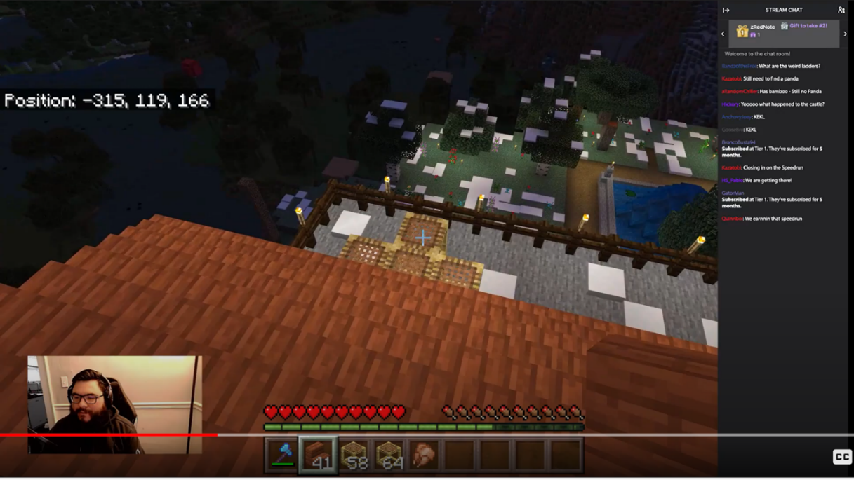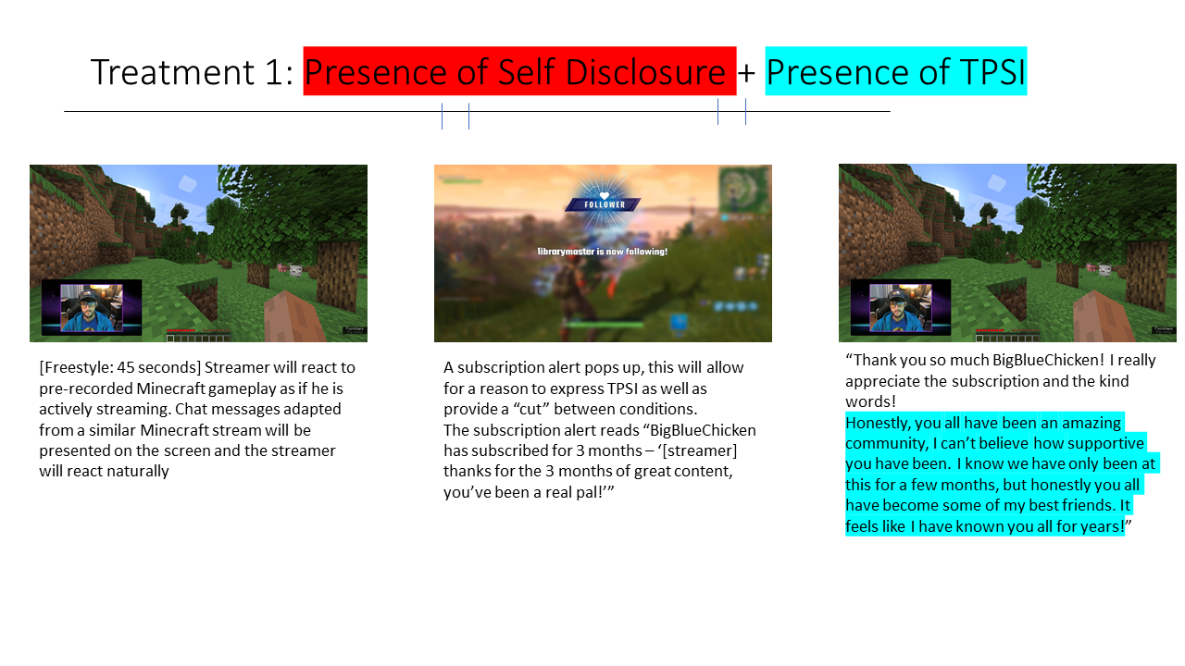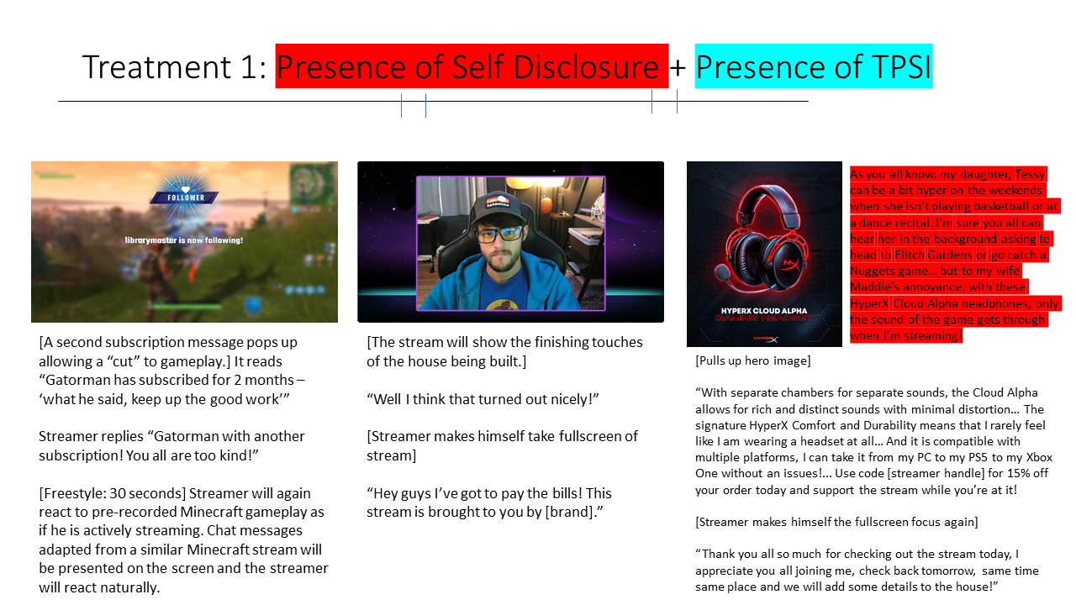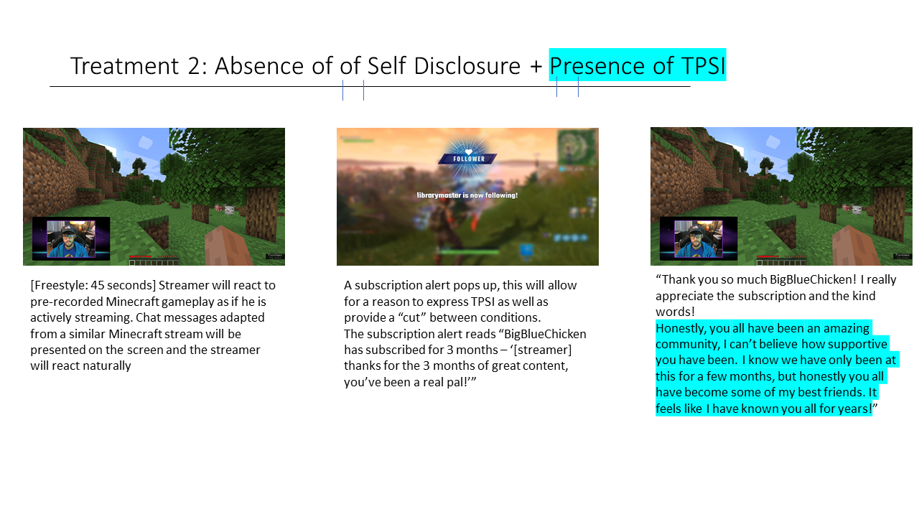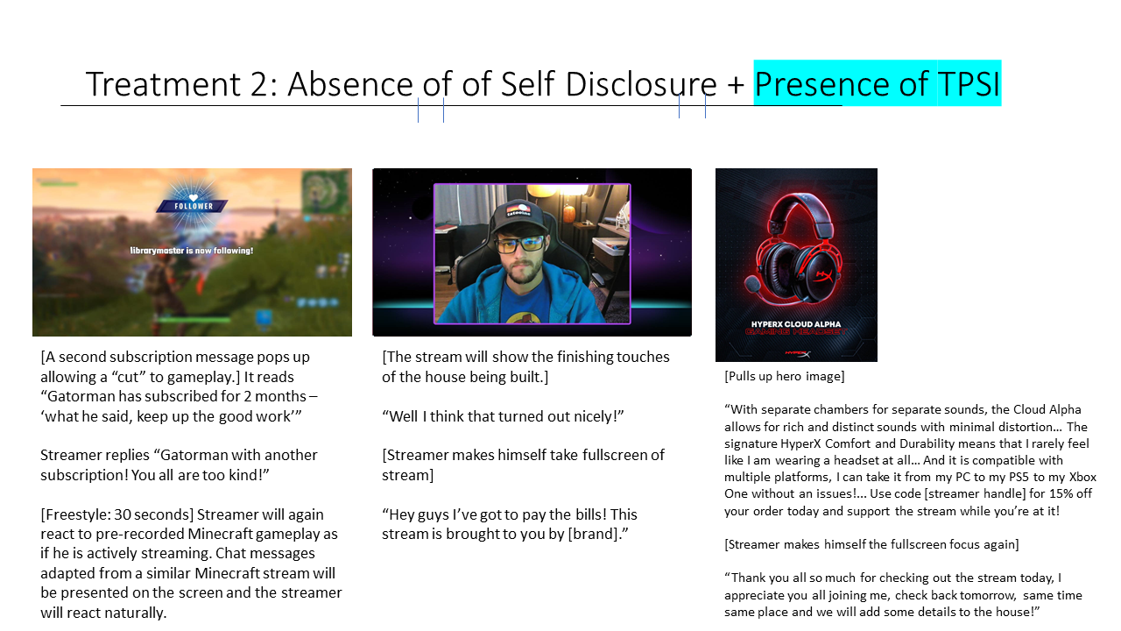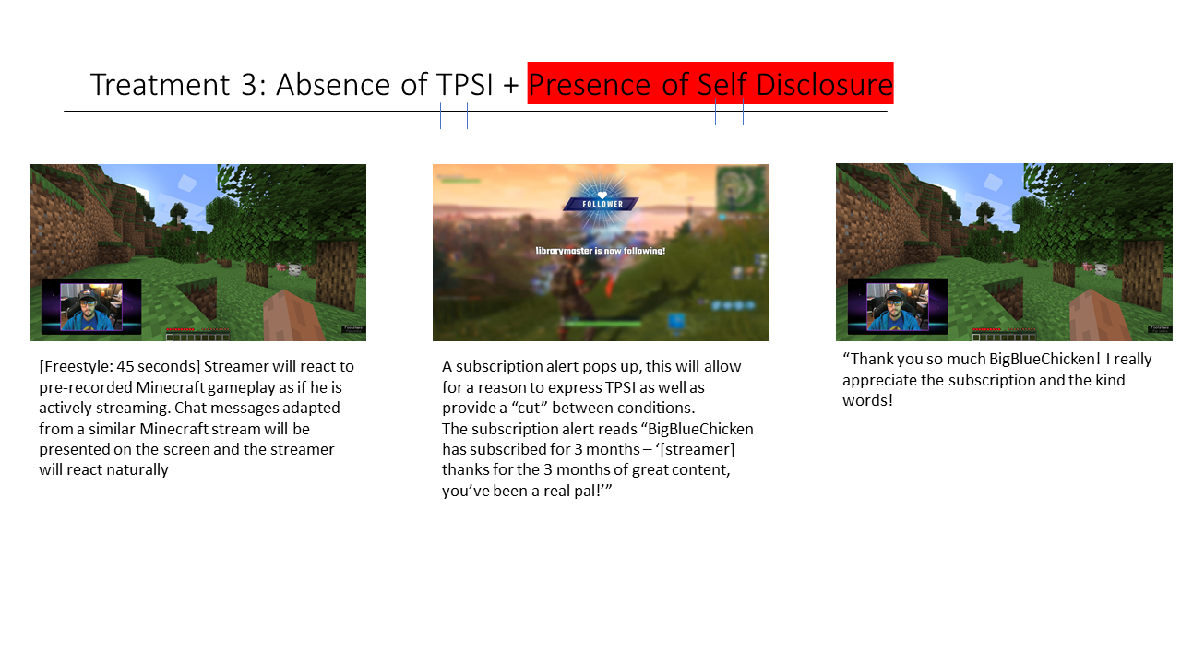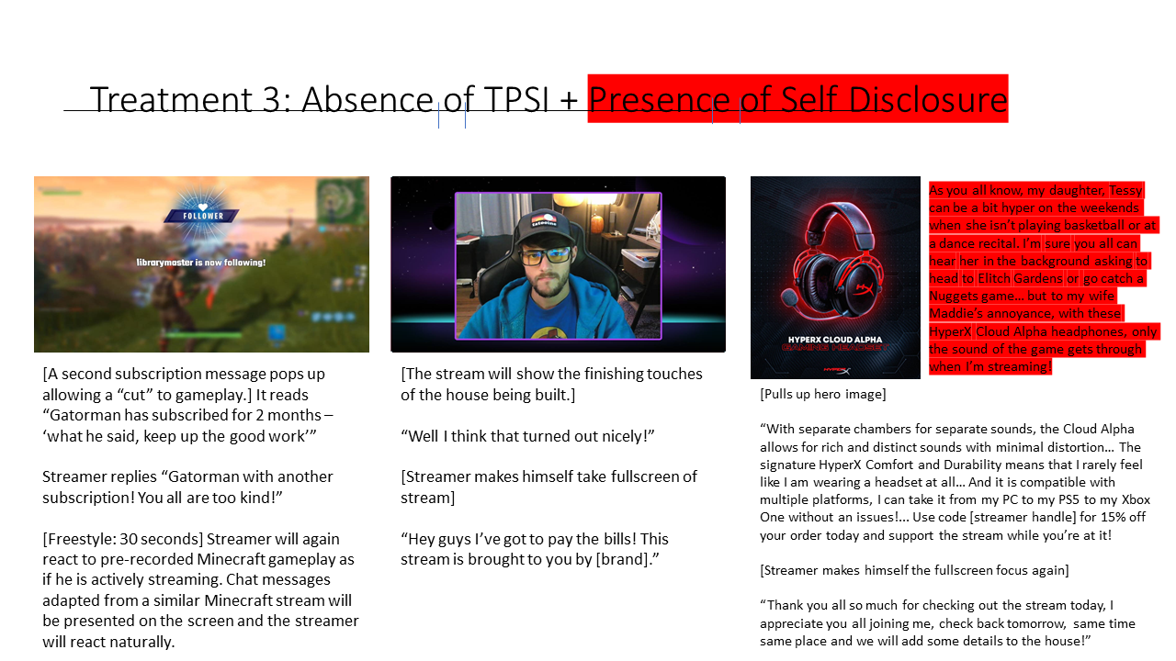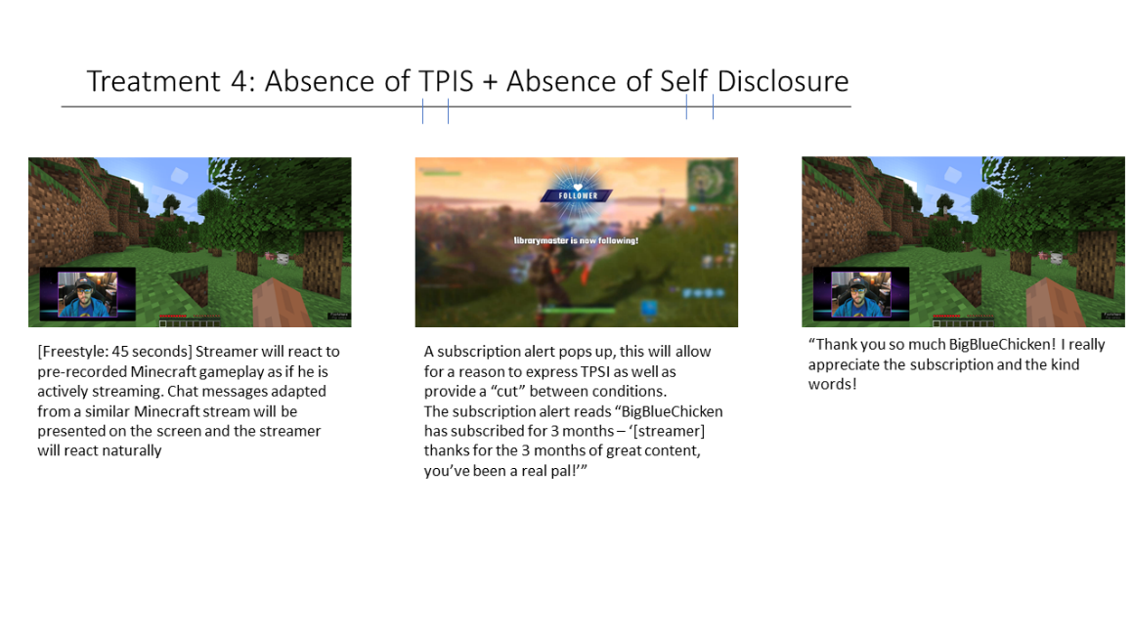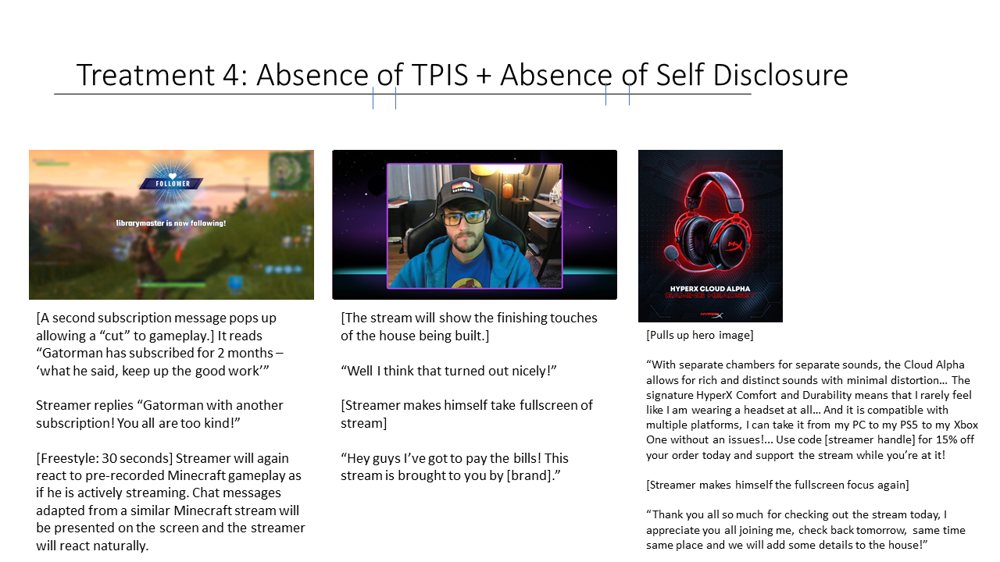

APPENDIX II PRETEST I QUESTIONNAIRE
Sample, Individuals who have watched at least 5 hours of Twitch within the past week.
Collected via snowball Sample.
Intro
CWard streams games such as Minecraft and FIFA on Twitch. He has recently grown his audience and has caught the attention of some brands that are looking to him as a potential influencer. CWard wants to ensure that the products he promotes are of interest to the Twitch audience, and that people think he’s a good fit for the brands. We have sent this survey in order to gauge interest from Twitch viewers.
(Step 1)
First we will ask about their likelihood to purchase in each product category.
 | Strongly Disagree | Disagree | Somewhat Disagree | Neither Agree nor Disagree | Somewhat Agree | Agree | Strongly Agree
When shopping for groceries, I buy [product category] regularly.
I will purchase [product category] in the next month
When purchasing a [product category], I am likely to take into account recommendations from other users
[product category] seems like a product category where companies would benefit from advertising on Twitch.

(Step 2)
For each of the following brands, we will show the sponsored ad read from Clark for that product. Followed by the questions. Each participant will do this for each brand presented in random order.
- Brand: Dorito’s
  - Product: Dorito’s 3D
  - Product Category: Chips
- Brand: Hershey’s
  - Product: Reese’s Pieces
  - Product Category: Candy
- Brand: Oreo
  - Product: Oreo Cookies
  - Product Category: Cookies
- Brand: Red Bull
  - Product Red Bull Energy Drink
  - Product Category: Energy Drink

To what extent do you agree with the following statements?
 | Strongly Disagree | Disagree | Somewhat Disagree | Neither Agree nor Disagree | Somewhat Agree | Agree | Strongly Agree
CWard’s ad read seemed typical of what you would see in a Twitch stream.
I purchase [Brand & Product] when I go to the grocery store
I am knowledgeable about the [company name] Brand
I am knowledgeable of [Brand’s] [product]
I have seen an ad for [Brand] on Twitch
I could see a streamer like CWard partnering with a brand like [brand]
I think streamers like CWard would be a good fit as spokespeople for [brand and product]

(Step 3)
Thank you for participating in this study. Is there anything else you would like to share with us that you believe we will find helpful?
[Open Ended]
(Step 4)
- How old are you?
  - Open Ended
- What gender do you most identify with?
  - Male
  - Female
  - Nonbinary
  - Other
- Are you of Hispanic, Latino, or Spanish origin?
  - No
  - Yes
- What is your race?
  - White
  - Black or African American
  - American Indian or Alaska Native
  - Asian
  - Pacific Islander
  - Other
- What is your highest education level?
  - Some High School, No diploma
  - High school graduate, diploma or the equivalent (for example: GED)
  - Some College (No Degree)
  - Associate Degree
  - Bachelor’s Degree
  - Graduate Degree

APPENDIX III PRETEST II QUESTIONNAIRE
Pretest 2
After determining the best product fit for the study, we will conduct manipulation checks.
Sample: Individuals who have watched at least 1 hours of Twitch within the past week.
Collected via Centiment.
Intro
We are trying to learn more about how streamers interact with their viewers on Twitch, you will be presented with a video showing a clip from the end of a streamer’s Twitch stream. Afterwards, we will ask you questions about the streamer and their viewers.
(Step 1)
Show Video – participant will be randomly assigned to one of 4 videos.
(Step 2)
TPSI Manipulation Check
For the following Questions think back to the clip you just watched. To what extent do you agree with the following statements?
 | Strongly Disagree | Disagree | Somewhat Disagree | Neither Agree nor Disagree | Somewhat Agree | Agree | Strongly Agree
CWard’s community sees him as a friend
CWard involves his community in the creation of his content
CWard sees his community as his friends
CWard’s community looks like one that I would get along with.

Self-Disclosure Manipulation Check – Will be part of the above matrix
 | Strongly Disagree | Disagree | Somewhat Disagree | Neither Agree nor Disagree | Somewhat Agree | Agree | Strongly Agree
CWard shared personal information about himself or his family with his community in the stream
In the video you just watched what personal identifiable information, if any, about CWard or his family/household was shared about himself to his community in the stream?
[open-ended]
Game pretesting
In order to make sure the game was a good fit for the study, a game pretest will be conducted.
To what extend do you agree with the following statements?
 | Strongly Disagree | Disagree | Somewhat Disagree | Neither Agree nor Disagree | Somewhat Agree | Agree | Strongly Agree
I could tell that CWard was playing Minecraft
CWard seems to enjoy playing Minecraft
Minecraft is a game someone would typically find being streamed on Twitch
I am familiar with how Minecraft is played
CWard’s Minecraft stream was typical of what you would find on Twitch

Influencer Credibility Confounding Variable
When thinking about CWard, the streamer in the clip you just viewed, to what extent do you agree with the following statements?
 | Strongly Disagree | Disagree | Somewhat Disagree | Neither Agree nor Disagree | Somewhat Agree | Agree | Strongly Agree
I consider CWard to be honest
I consider CWard to be trustworthy
I consider Cward to be truthful
I consider CWard to be earnest
If I saw CWard while browsing Twitch in the future, I would be interested in checking out his stream.
CWard’s ad read seemed typical of what you would see in a Twitch stream.

(Step 3)
Thank you for participating in this study. Is there anything else you would like to share with us that you believe we will find helpful?
[Open Ended]
(Step 4)
- How old are you?
  - Open Ended
- What gender do you most identify with?
  - Male
  - Female
  - Nonbinary
  - Other
- Are you of Hispanic, Latino, or Spanish origin?
  - No
  - Yes
- What is your race?
  - White
  - Black or African American
  - American Indian or Alaska Native
  - Asian
  - Pacific Islander
  - Other
- What is your highest education level?
  - Some High School, No diploma
  - High school graduate, diploma or the equivalent (for example: GED)
  - Some College (No Degree)
  - Associate Degree
  - Bachelor’s Degree
  - Graduate Degree

APPENDIX IV MAIN STUDY QUESTIONNAIRE
- Informed Consent
  - Attached to submission.
  - By clicking yes, you consent to continue forward with this study, and certify you are over 18 years old, are a United States Citizen, and have watched at least 5 hours of content on Twitch within the past week.
    - If yes, continue to study
    - If no, Thank them but they will not participate.
- Short Intro
  - [Picture of Fictional Streamer in a streaming setup]
  - CWard streams games such as Minecraft and FIFA on Twitch. He has recently grown his audience and has caught the attention of some brands that are looking to him as a potential influencer. On the next page there is a clip from the end of one of CWard’s streams. We are wanting participants to watch his stream and answer some questions about his stream from the perspective of a Twitch viewer. We ask that you closely watch this clip then answer some questions about your experience.
    - Yes or no question to continue.
- Treatment Assignment
  - Qualtrics will randomly assign participants to one of the 4 experimental treatment groups.
- Video
  - The clip will be embedded into the survey for them to watch. They must finish the full video before they can move to the next page.
  - The storyboards and scripts are attached to the submission.
- Questionnaire

Section 1
When thinking about Cward, the streamer in the clip you just watched, to what extent do you agree or disagree with the following statements?
 | Strongly Disagree | Disagree | Somewhat Disagree | Neither Agree nor Disagree | Somewhat Agree | Agree | Strongly Agree
CWard makes me feel comfortable, as if I am with a friend
If I were to interact with CWard I would feel Included
I can relate to CWard
Please select “Strongly Disagree”
I care about what happens to CWard
I hope CWard can achieve his goals

Section 3
How did you feel about [brand], the brand advertised in the stream clip you just viewed?
Unappealing |  |  |  |  |  |  |  | Appealing
Unpleasant |  |  |  |  |  |  |  | Pleasant
Boring |  |  |  |  |  |  |  | Interesting
Dislike |  |  |  |  |  |  |  | Like
Negative |  |  |  |  |  |  |  | Positive
Bad |  |  |  |  |  |  |  | Good

Section 4
When thinking about [Brand], the brand advertised in the stream clip you just viewed, to what extent do you agree or disagree with the following statements?
 | Strongly Disagree | Disagree | Somewhat Disagree | Neither Agree nor Disagree | Somewhat Agree | Agree | Strongly Agree
I would like to try this brand
I would buy other products of this brand
I would buy this product if I happened to see the brand
I would actively seek out this product in a store in order to purchase it
I would be interested in learning more about this brand online
I would like to check out this brand’s social media pages
I would be interested in using the promo code CWard shared

 | Strongly Disagree | Disagree | Somewhat Disagree | Neither Agree nor Disagree | Somewhat Agree | Agree | Strongly Agree
I’m willing to say positive things about [Brand] to others
I’m willing to encourage close friends to purchase [Brand]
I plan to purchase [Brand] in the next few years.

Section 5
For the following Questions think back to the clip you just watched. To what extent do you agree or disagree with the following statements?
 | Strongly Disagree | Disagree | Somewhat Disagree | Neither Agree nor Disagree | Somewhat Agree | Agree | Strongly Agree
CWard’s community sees him as a friend
CWard involves his community in the creation of his content
CWard sees his community as his friends
CWard’s community looks like one that I would get along with.

 | Strongly Disagree | Disagree | Somewhat Disagree | Neither Agree nor Disagree | Somewhat Agree | Agree | Strongly Agree
CWard shared personal information about himself or his family with his community in the stream

In the video you just watched what personal identifiable information, if any, about CWard or his family/household was shared about himself to his community in the stream?
[open-ended]

Section 6
When thinking about CWard, the streamer in the clip you just viewed, to what extent do you agree or disagree with the following statements?
 | Strongly Disagree | Disagree | Somewhat Disagree | Neither Agree nor Disagree | Somewhat Agree | Agree | Strongly Agree
I consider CWard to be honest
I consider CWard to betrustworthy
I consider Cward to be truthful
I consider CWard to be earnest
If I saw CWard while browsing Twitch in the future, I would be interested in checking out his stream.
CWard’s ad read seemed typical of what you would see in a Twitch stream.

Section 7
- In a typical week, how many hours of Twitch content do you watch?
  - 1 to 4 hours
  - 5 to 9 hours
  - 10 to 14 hours
  - 15 to 20 hours
  - More than 20 hours
- To what extent do you agree or disagree with the following statement? “I regularly participate in chat when watching streams on Twitch
  - Strongly Disagree
  - Disagree
  - Somewhat Disagree
  - Neither Agree nor Disagree
  - Somewhat Agree
  - Agree
  - Strongly Agree
- Have you ever donated directly to a streamer on Twitch?
  - Yes
  - No
- Have you ever subscribed to a streamer on Twitch using a Twitch Prime free subscription?
  - Yes
  - No
- Have you ever subscribed to a streamer on Twitch aside from using a Twitch Prime free subscription?
  - Yes
  - No
- Have you ever streamed on Twitch before?
  - Yes
  - No
Section 8
- How old are you?
  - Open Ended
- What gender do you most identify with?
  - Male
  - Female
  - Nonbinary
  - Other
- Are you of Hispanic, Latino, or Spanish origin?
  - No
  - Yes
- What is your race?
  - White
  - Black or African American
  - American Indian or Alaska Native
  - Asian
  - Pacific Islander
  - Other
- What is your highest education level?
  - Some High School, No diploma
  - High school graduate, diploma or the equivalent (for example: GED)
  - Some College (No Degree)
  - Associate Degree
  - Bachelor’s Degree
  - Graduate Degree

Section 9
Thank you for participating in this study. Is there anything else you would like to share with us that you believe we will find helpful?

APPENDIX V GLOSSARY OF TWITCH TERMS
Twitch is a unique media platform in its structure. Over the last decade Twitch has been around, slang and terms specific to Twitch (or co-opted by Twitch) have been crafted to refer to various aspects of the platform. Below are a few of the most prominent terms that are related to aspects of my research and their meanings.

Term | Definition
Affiliate | A status obtained by Streamers through Twitch after establishing a consistent viewer base and streaming habits. This is the first stage of allowing monetization, allowing for streamers to receive donations, subscriptions, and advertising revenue.
Admin | A global moderator of Twitch, an employee of the company who resolves disputes within streams and between streamers
Banning/Timeout | Twitch streamers and mods can utilize bans, both permanent and temporary to punish individuals who do not adhere to Twitch or Stream-specific rules. Being banned is commonly referred to being “put in timeout”
Bits/Cheers | A form of virtual currency that viewers can purchase and then later use to “cheer” for streamers, effectively donating to the streamer.
Bots | A reference to chatbots within Twitch’s chat feature. Within twitch chat there are “good” bots such as auto moderators, and “bad” bots such as spammers.
Brigading | Antithesis of a host/raid wherein a streamer sends their viewers to another stream to harass the streamer and their chat.
Broadcaster/Caster/Shoutcaster | Some old literature may refer to a streamer as a “broadcaster” in modern usage it refers to an individual who is streaming an event such as an eSports event and providing commentary like a traditional sporting event. Sometimes referred to as a “Shoutcaster” in reference to an old website where eSports events were covered like sports radio broadcasts.
Channel | A streamer’s profile is referred to as a channel like a television channel.
Chat | Chat is used as a term to refer to the chat feature of Twitch which allows for viewers to communicate with each other and the streamer. Chat is also a general term that streamers use to refer to all their viewers. Due to issues such as spam, trolling, and quantity of chat, streamers can limit chat to followers-only and Subscriber-only chat wherein only viewers with that status may take part in making chat messages.
Clip | Refers to the ability of viewers to use Twitch to extract a portion of the recent stream as a stand-alone video. Used as a noun to refer to the video and a verb to refer to the process of pulling the video.
Concurrent Viewers | Refers to the number of viewers watching the stream at the same time. Concurrent can refer to the maximum concurrent viewers as well as the number of viewers at a certain time. Note that the number of viewers of a stream can fluctuate.
Discord | A Community management/Chat/Message Board platform. Discord is popular with Twitch as a means of community outreach adding a new layer of interaction with the streamer and other viewers. Discord is used often as a means of making announcements and for gathering information from viewers.
Dox/Doxing | The public sharing of personal information about a streamer or viewer with the intent to troll or punish the individual.
Emotes | Twitch and streamer-specific emojis used to convey messages quickly. Twitch’s global emotes represent global inside jokes and slang whereas a streamer’s emotes (accessible to subscribers) represent stream specific events and inside jokes.
Follow | Like other social media platforms, a viewer may follow a streamer to know when they are live, and to easily access their channel.
Host/Raids | When a streamer is finished broadcasting, common courtesy is to host or raid another streamer. This refers to forwarding their current viewers to the other streamer, a friendly gesture to facilitate community growth.
IRL | References to “In Real Life.” Utilized to explain life outside of stream such as an IRL job, friend, significant other, or neighborhood.
Lurker | A viewer who does not engage in chat.
Moderator/Mod | A Moderator (Mod) is an individual who serves as enforcer of rules within chat. This allows the streamer to focus on playing the game instead of ensuring a safe chat. Moderators can ban or mute individuals, take care of common questions, and highlight messages for the streamer to see.
Overlay | Refers to any design of the stream laid over the game. The gameplay is usually the basis of all stream design, the overlay can include banners with information such as ads, subscriber goals, and tech information – The streamer’s webcam feed, a chat mirror that shows when the streamer can see the chat messages (time delays can be set up in competitive settings), subscriber and follower notifications, and other visual aspects of the stream.
Partner | A status attained by Twitch above affiliate. This status is awarded based on consistently strong viewer base, streaming habits, and good behavior. Partners are more likely to receive advertising revenue as brands can select to protect themselves by only advertising with partners. Partners also have access to extra revenue sources as well as partner contracts.
Partner Contracts | Contracts signing streamers to stream exclusively on Twitch instead of competitors such as YouTube and Facebook.
Subscription/Subs | Twitch allows for viewers to subscribe to their favorite streamers, dedicating a recurring $5 donation to that streamer. In exchange subscribers (called “subs” collectively) receive perks such as special badges, access to emojis, and access to subscriber-only chat. Subs can also be presented as gifts from viewers and the streamer to members of the community, referred to as “gift subs”
Swatting | Calling the police with a false report and providing details designed to elicit a show of force to the victim’s location.
Tag | Twitch allows for specific tags attached to streams to indicate the game they are playing as well as elements of the stream such as the category of the stream, the general rules of the stream, and warnings like ESRB ratings.
Verified | Like other platforms, a verified check represents that the streamer is who they claim to be in real life (IRL).
VODs | VODs refer to the Video on Demand feature of Twitch in which streams and their chats are automatically archived on the streamer’s page.
Views | The total lifetime viewers of that VOD or channel.
Whisper | A Whisper refers to a Direct message sent through Twitch.

VITA
Born and raised in East Tennessee, Alex Carter attended St. Dominic’s Elementary School, Sulphur Springs Middle School, ETSU University School, and East Tennessee State University before coming to the University of Tennessee to pursue a Doctor of Philosophy degree in Communications with a concentration in Advertising. A lifelong learner, Alex has always dreamed of being a scientist, his curiosity of all things and love of reading, writing, and solving problems led him on a long and winding path to Rocky Top. His research interest includes understanding Strategic Communications effects on community development online. After graduation, he will begin his new position as an Assistant Professor of Strategic Communication at Butler University. He is incredibly grateful for all the support from his wife, family, friends, and mentors as he begins this exciting new phase in his career.

