The Brush is Mightier than the Bayonet:
The Role of Cooperation with the Art and Media Communities of Japan During the American Occupation

William Brandon Carpenter
History 408: Senior Honors Thesis

From December 7th, 1941 to August 15th, 1945 the United States and Japan fought a bloody, total war against each other on land, at sea, and in the air. In Japan, industrial areas with large populations were targeted in massive bombing campaigns, resulting in an unprecedented number of civilian deaths. Each side represented the other as inhuman, racially inferior, and evil, bent on conquest of the world. Today, Japan and the United States stand out among the nations of the world in terms of political, economic, and military cooperation. The close bond of these two nations persists despite historic animosity and warfare, with over a hundred thousand personnel from American units currently stationed on Japanese soil as part of an at times controversial unilateral defense agreement. Japan, brutalized by years of intense ground and naval warfare, fire bombings that set Tokyo ablaze, the only nation to ever endure atomic attacks, has been a fast friend for over fifty years to the country which brought them to the brink of collapse.
This paper examines the critical factors of the development of these relations, specifically analyzing the efforts of General Headquarters’ (GHQ) and Supreme Commander Allied Powers (SCAP) General Douglas MacArthur’s staff to win the battle for the Japanese citizenry’s (and major government and economic forces) opinion of American national character and intent. By examining the extent and effectiveness of the debate and public opinion efforts surrounding such projects as the 1946 Constitution of Japan, and the many publications surrounding it, we can gain a deeper understanding of the interplay of military domination and political cooperation during the years from the beginning of the Occupation in 1945 to the beginning of the reverse course in U.S. policy towards Japan in 1949. I contend that the diplomatic and materiel investments of America working in cooperation with the liberal Japanese government and various Japanese art and media institutions during the first few years of the occupation were more critical to the success of GHQ plans in fostering positive sentiments towards America and democracy than the presence of a large American occupation force, shows of force, and the encroaching threat of communism during the initial course of the occupation. The reverse course, beginning in late 1948 and coming into full course in 1949 would mark the return of previously deposed conservative elements within politics, business, and even the arts, as anti-communist sentiment fueled a U.S. shift towards establishing Japan as a bulwark against the spread of the “Red Menace” in Asia. Repression and censorship were greatly intensified, counteracting much of the liberal progress and good will established during the early years. However the groundwork laid by more forward thinking influences in GHQ during the early years provided a bright chapter to look back on, and allowed Japanese art and media to flourish even through the reverse course and beyond the end of the occupation in 1952.
Much of the narrative surrounding the occupation of Japan states that America succeeded in its objectives of pacifying the Japanese nation through overwhelming displays of military superiority such as the atomic bombings at Hiroshima and Nagasaki, and flyovers conducted by American bombers at the signing of the Instrument of Surrender. American policing and military exercises conducted throughout the country during the occupation are cited as examples of the pervasive repression experienced by the Japanese, with little to no regard to the beneficial intercultural exchange which occurred in many instance. There is a strong effort to minimize the contributions of more liberal reforms instituted by SCAP which some historians characterize as an extension of imperialism arising from “a strong sense of the ‘white man's burden’ in their efforts to modernize and civilize the Japanese.” Contrary to the arguments of Melissa Willard-Foster in Planning the Peace and Enforcing the Surrender: Deterrence in the Allied Occupations of Germany and Japan, the threat of violence, while present throughout the occupation and especially in the initial months, was not the primary or most solvent factor in securing Japanese cooperation after the occupation began. Certainly, American military command and Congress directed that violent action to subdue insurgent forces within the populace be included in the orders of occupying soldiers and commanders as options, however the policies most outwardly expressed to the Japanese at large were of aid, reformation, and reconciliation, even from before the occupation started. Despite the unprecedented damage to civilian populations brought on by U.S. forces during the war, a consistent theme expressed throughout war propaganda and GHQ’s publications was the condemnation of violence and war as a means of political redress. This theme was inculcated into official policy by those in between Congress and the occupying GI soldier, the State Department’s “Japan Crowd”, a group of scholars and diplomats with ties to the country. The actions of GHQ, while backed by expressions of military power, were resolutely focused on building a peaceful Japan, and avoided the hypocrisy of being spread by the tip of the bayonet (at least up until the reversal in U.S. policy towards Japan in 1949 and the reintroduction of conservative officials and policies into the government).
The “Japan Crowd” may have had their work revised by Congress to be more focused on harsh methods of pacification, however those revisions remained largely subdued in execution due to the efforts of a GHQ focused on liberalizing Japan during the initial phase of the occupation. Members of GHQ were directed to ignore the official August of 1945 “Operation Blacklist” directives that encouraged a “disregard for civilian property located near the military target”, and even within that document were calls for discernment between the peaceful population and insurgent forces. The Japanese government, military, and people had no illusions about the totality of their defeat as the occupation began, having suffered from deep supply deficits and dislocation, and witnessing the humiliation of the Emperor as the previously holy figure was forced to admit his mortality. The large demonstrations of air power which continued into the first month of occupation were scaled back and eventually discontinued except in special instances. The Japanese military was subjected to an exacting deconstruction, with effectively all military personnel dismissed immediately or after a relatively brief period of imprisonment, and nearly all combat materiel destroyed. However, these symbols of total defeat were overlaid with an explicit message of peace and democracy, delivered in various forms. The efforts of GHQ were directed at counteracting the perception of disgrace with a positive message of the renewal of the Japanese nation as a peaceful member of the international community.
Perhaps the most significant undertaking of GHQ and SCAP personnel took place almost immediately after the occupation began, as a new constitution began to be drafted. The 1946 Constitution of Japan was written primarily by U.S. officials working for the office of the Supreme Commander of Allied Powers (SCAP), General Douglas MacArthur, at GHQ. These men and women were given the task of replacing the 1890 Imperial Constitution of Japan, which had under the Meiji government established the Emperor of Japan as the supreme power of the land and the people as subjects with rights only “within the limits of law,” with a constitution that would bring Japan into the fold of democracy, ensuring individual rights and liberties that would remain inviolable. The post-war Japanese government, led by Prime Minister Shidehara Kijiro and State Minister Matsumoto Joji, lobbied tirelessly to maintain as much of the imperial power structure as they could, successfully preventing the implementation of many of the more liberal provisions of the original GHQ draft, although in the end whether by skillful negotiation or blunt insistence SCAP achieved their main objectives in the ratified Constitution.
The importance of the negotiations and cooperation between GHQ and the remaining Japanese governmental power structure in the development of American and Japanese attitudes toward each other during the occupation years and beyond cannot be overstated. As recorded in the memoir of Beate Gordon, the debates surrounding the revisions of the Constitution were a critical moment in establishing not only the course of democracy in Japan for the next three years (until the reverse course of 1949), but also the tone of cooperation in traversing that course. Gordon, a young translator for SCAP who had previously lived in Japan while her father worked as a professor at the Imperial Academy of Music in Tokyo, was especially attuned to the importance of cooperation and respect for Japanese culture, however she maintained a disciplined and optimistic outlook in her work when she was assigned to draft equal and civil rights legislation for the new constitution. Gordon was personally involved in debate with senior Japanese politicians and managed to persuade them to adopt certain highly controversial portions (particularly regarding women’s rights) by utilizing the close relationship she had established with Japanese officials as a translator. By allowing certain concessions, SCAP and GHQ reaffirmed to the Japanese public and remaining economic and political power groups that the intention of the United States was the creation of a democratic Japan, rather than the annihilation of the nation’s identity. In point of fact, the State Department’s Committee on Post War Programs (PWC) strongly criticized the Far Eastern Unit of the Subcommittee on Territorial Problems’ (FEU) initial plan for the execution of the occupation of Japan as too lenient, despite multiple revisions to increase stringency. American public opinion on the national character of Japan was strongly derogatory, influenced by years of propaganda, so much so that George Blakeslee, head of the FEU and a professor of Clark University specializing in Japan, had an extremely difficult time persuading Congress and the White House that a less authoritarian approach was necessary to ensure American interests were met. His work, begun in 1943 and culminating in the initiation of the Initial Post-Defeat Policy Relating to Japan at the end of WWII, was instrumental in preventing retribution by a vengeful public and United States military.
However, with their insistence on the removal of the emperor as anything but a figurehead, as exemplified by the retraction of his divinity as established by the imperial constitution, SCAP made clear to Japan’s remaining elite that the reborn nation would be a democracy on American terms. One of those terms would be Article 9 of the new constitution, in which Japan renounced “war as a sovereign right of the nation and the threat or use of force as means of settling international disputes.” The complete dismantling of Japan’s capacity to resist American military intervention (to the point that even police officers were denied sidearms) served vividly to reinforce the reality of Japan’s reliance on the U.S.’s support and protection, as did the collection and destruction of thousands of katana, the swords which symbolized Japanese martial spirit.
In order to counteract this image of sheer domination, GHQ worked with the Japanese government and several quasi-independent organizations (chiefly the Constitution Popularization Society) to present simplified forms of the new constitution to the Japanese people. In addition to newspaper placements and articles, radio and television broadcasts, and other modern techniques, GHQ relied on a method based in time-honored Japanese information dissemination traditions. The CPS spread a series of illustrations (see Figure 1), collected in pamphlets, newspapers, and educational books throughout Japan, explaining the basic principles of the new democracy in a simple and quickly digestible format. This figure is the first of the series of explanatory illustrations of the Constitution of 1946. The banner at the top left reads “New Constitution,” while the monument holding the Flag of Japan reads “Every Citizens Constitution,” emphasizing the importance of the document to the entire public, rather than to the ruling elite. The panels at the bottom detail various articles of the Constitution, specifically the rights and responsibilities of the Japanese public and government under the new system, prefacing the later illustrations. This format harkened to the woodblock print, which had been used in Japan to spread information for centuries and was easily relatable to a broad audience. Themes such as "The rights and duties of the people," "The rights of the individual," and "Equality of the people" were represented with beautiful colors and humorous illustrations, giving an approachable alternative to the legalistic and bureaucratic documentation and debates surrounding formal political publications of the constitution. The illustrations pointed the blame for the war to the militaristic government, and posited as its replacement a nation controlled and supported by the efforts of its citizenry, who would succeed with dedicated effort and help from occupation forces.
One pamphlet alone would not be sufficient to counteract decades of governmental indoctrination of the people, however. In order to combat the imperialist fervor that had propelled Japan into World War II, SCAP, GHQ, and the CPS turned to another tool used by Imperial Japan to ensure patriotism: educational indoctrination. Much censorship took place during the occupation regarding school textbooks, but it was necessary to replace many of the textbooks used by primary schools with alternative material in order to rid them of ever present imperial propaganda. CPS again answered the call to action, producing a series of books which explained the new constitution, as well as the basic principles of democracy, to children from elementary to high school age. Messages of peaceful civic responsibilities replaced the emphatic call to military service that had preceded them. Art education especially was changed from Imperial patriotic textbooks assigned directly by the Cabinet since 1937, which promoted Yamatoe and other traditional Japanese art forms as part of the “national way” along with military and patriotic themes, to an originally western program. Ironically, this meant a return to older methods of art instruction used to train Japanese artists rather than the forced adoption of western ideas, as the methods used by Japanese educators in the years from 1902 to 1936 heavily emphasized freedom in creativity and individual expression, drawing from theories established by prominent American art authorities such as William H. Kilpatrick and Arthur Wesley Dow.
Adult Japanese of all walks of life also craved knowledge and information, as well as entertainment in the harrowing years following defeat. The publishing industry in Japan soared into life and was encouraged by the often lenient enforcement of the significant censorship laws handed down through SCAP. Filmmakers, while banned from producing most violent films, were free to create pictures with a variety of other themes. Under the imperial wartime government censors they had either been directly censored for lack of solidarity or functionally unable to pursue other avenues of creativity, as the war effort centered crucial state funds on propaganda films. Classical forms of art such as Kabuki theatre were revived after damning repression by the imperial government, and American enthusiasts amongst GHQ personnel encouraged their further development by downplaying their often blatantly political messages and overtones, occasionally even standing up to MacArthur’s directives. New sources of material, previously banned by the hyper-nationalistic regulations of imperial censors, began to flood in from all over the world. All of these endeavors, renewed by the influx of materials and at times light censoring established by the occupiers, found ready consumers in the Japanese citizenry. Hitherto exposed to an unending barrage of war propaganda and moralistic art centered on spiritual purity, people from every walk of life were eager for as much recreational and artistic media as the reinvigorated press and artists could produce.
The Initial Postwar Policy, 1946 Constitution, and other diplomatic and popular efforts executed by GHQ set not only the framework for Japan’s new government, but also the basis of the popular notions of American character for the Japanese people. Simultaneously, the Japanese governmental and popular adoption of such policies helped to reform American opinions of the Japanese after years of bitter warfare, and was essential to future efforts and cooperation as Japan was rebuilt. Certainly, large scale riots took place during the signing of the mutual defense agreements which guaranteed American military presence in Japan after the signing of the San Francisco Treaty, and there was significant popular disapproval of such policies, but the popular appeals initiated by GHQ during the first course of SCAP policy served as a buttress against such forces in the public eye. The more brutal occupation actions taken by American military forces in Germany after WWII seem to influence Willard-Foster’s perception of American occupation forces in Japan. While Americans in occupied West Germany routinely conducted artillery shellings of civilian villages and towns, mass arrests, firing squad executions (which were filmed and shown to the public), Japan saw few instances of such methods and none of the same magnitude. This paper will now analyze in detail the remarkably more lenient policies and campaigns implemented in Japan, after a brief discussion of the state of Japan’s official and public opinions of America.

Propaganda
War propaganda was a powerful tool in the Second World War. The dual aim of propaganda was to paint a picture of friendly forces as virtuous heroes banding together, while portraying the enemy as evil, traitorous, subhuman monsters. Inevitably, propaganda will draw on the preconceived associations held by one public against the other. World War II stands as the source of an immense amount of such propaganda, in forms ranging from radio broadcasts and movies to posters and political cartoons. Propaganda from either side of the Pacific relied on the preconceived notions of the opposite side, stereotypes which accounted for the political, racial, and moral inferiority of the enemy. The Japanese were taught to see the Americans as hypocritical and amoral, with no honor or respect for humanity. Newspaper comics presented Westerners as hypocrites and opportunists, bent on seizing Japan and the rest of Asia, playing on memories of the exploitation of China by European powers as well as the unequal treaties of the late nineteenth century which explicitly treated Japanese subjects within their own territory as inferior to westerners by law. Anglo-American leadership in particular was portrayed as beguiling, with President Franklin Delano Roosevelt and Prime Minister Winston Churchill shown in one comic to be reaching to the very heartland of Japan while doffing their caps in friendship (see Figure 2). Published in the Osaka Puck in 1942 immediately after Pearl Harbor, this cartoon portrays Japan as an innocent and friendly member of the international community, while the United States and Great Britain are hiding their evil ambitions (and demonic nature) behind friendly faces and doffed caps. Roosevelt was of course a favorite target of Japanese mangaka (cartoonists), portrayed as delivering his fireside chats or playing a song of peace while astride a giant cannon to indicate his militaristic intentions (See Figures 3 & 4). Such images portrayed America as a hypocritical nation as early as 1937, with massive cannons dwarfing Roosevelt and his violin, dominating the context of the cartoon. Figure 4 specifically shows Roosevelt condemning the militaristic actions of the Axis powers in 1940, despite America’s own military actions in the region. Only through the eradication of the foreign aggressors could true peace be brought to the world (See Figures 5 & 6). Published in 1942 by the Osaka Puck, Figure 5 depicts the impalement of Churchill and Roosevelt as they held chains meant for East Asia and her peoples and carried the exhortation: “Bring Swift Death to Those Who Meddle with World Peace!” Figure 6, also from Osaka Puck in 1942, similarly showed Roosevelt as a demonic half man, half beast, skewered by a bayonet bearing the Japanese flag, and stated that world peace would be born with the death of the foreign devils.
If their leadership were painted to be smiling devils, the American soldiers, sailors, and marines were shown as demons to be exterminated. The Americans, and the Western powers in general, were tremendous threats to the peace and independence of Japan and Asia, which under the protection of the Greater East Asia Co-Prosperity Sphere must be defended from any colonialist influence (See Figures 7 & 8). Figure 7 portrays a Japanese soldier in their signature cap, standing watch as a watery specter of Uncle Sam rises to attack the Pacific. Figure 8, an official government poster from 1943 aimed at foreign audiences and written in English depicts a Japanese soldier breaking the chains (representing America, Great Britain, the Dutch, and Chinese resistors as “A, B, C, [&] D”) of oppression which hold the Pacific down, as he stands over the corpses of various caricatures of western soldiers. Naturally the Japanese citizens, especially those with no experience with foreigners outside of the radio broadcasts and cartoons depicting their savagery, were extremely anxious as surrender approached. Tonari-gumi, or neighborhood organizations, got together to published declarations prescribing behavior in anticipation of the arrival of American troops in their vicinity. Such lists encouraged shutting down shops, hiding indoors, storing valuables in hidden places and being especially mindful of the behavior of children. Women were warned to never go alone, grab something to identify an attacker if assaulted, and to replace their normal clothes with mompe, an unflattering outfit meant for work. Japanese propaganda had shown its people to be uncompromisingly virtuous and of wholesome spirit, while the American was an undisciplined, individualistic barbarian with no self-control, so naturally promises of leniency and friendly behavior on the part of the conquerors brought little relief to a terrified populace.
Americans gave as good as they got, however. The Japanese militarist media portrayed the subjects of Emperor Hirohito as devoted to a national spirit, ready to die for a higher cause; the Americans said they were fanatical, suicidal tyrants bent on world conquest. While Japanese leadership presented their expansion into Korea, China, Manchuria, the Philippines and elsewhere as efforts toward their “Greater East Asia Co-Prosperity Sphere”, the U.S. government portrayed them as a great red stain moving across the Pacific. The red color of the national flag and imperial markings was represented as an indication of the fearsome, bloody nature of the Japanese aggressors. The use of color would prove to be a common technique in U.S. propaganda, with yellow especially exemplifying the racism which tainted most American images of the Japanese. Yellow saturated western caricatures of the Japanese soldiers, who were portrayed uniformly as a diminutive, bucktoothed savage, when they were depicted as human at all. A prominent trend in American was to represent the Japanese race as monkeys, chimpanzees, or “jaundiced baboons,” ready to be preyed upon by the able hunters of the Army and Marines. While the European fascist states were identified by caricatures of Hitler or Mussolini, the Japanese were either a stereotypical “little yellow belly” with the face of Prime Minister Tojo, or a simian. Even when unable to use color, American propagandists were able convey their message clearly, as seen in “Tokio Jokio”, a black and white Looney Tunes cartoon which presented Japanese technological inferiority in all capacities, as well as the ever present Tojo and animal characters, in unabashedly bigoted terms.
Such blatantly racist imagery (and the internment of Japanese-Americans during the conflict) was justified partly by the overwhelming hatred felt towards the Japanese for the undeclared “surprise” attack on Pearl Harbor and other American bases, and partly by appealing to the Japanese propaganda which itself depicted the Japanese as a single, racially homogenous entity, united in superior blood and spirituality. Americans, through their exposure to carefully selected material from Japanese culture, such as excerpts from the Kabuki theatre classic of The 47 Ronin featured in a 1943 issue of Life magazine, came to view the enemy as a unitarily feudalistic and violent people capable of justifying any atrocity by appealing to loyalty. The play was the perfect choice to reflect an image of the Japanese as suicidally devoted to their cause and steeped in acts of subterfuge, as it recounted the true, 18th century story of nearly four dozen samurai who separated and went into hiding for several years after the seppuku (ritualistic suicide) of their master as ordered by the Shogun. Only after having thoroughly removed suspicion by pretending to be drunkards, gamblers, and sell-swords (the typical profile of a ronin, a samurai who had no master to serve) for years did the ever loyal “vigilantes” spring a trap to kill the rival lord who had instigated their master’s dishonor. Then, rather than ride into the sunset as an American cowboy might have done, the men presented themselves to the authorities for punishment, and for having followed the precepts of Bushido (“the way of the warrior”) were given the right to commit seppuku themselves (a means of regaining or maintaining their honor). Such a display of ritualistic fervor was anathema to the heavily Christian and liberal America of the 1940s. The animosity felt by either public for the other was extreme, mired as it was by so many prejudices, but understandable given the decidedly foreign view each side had of the other. Culturally, politically, and racially, propaganda had created an almost unbridgeable gap between either nation’s official portrayal of the other’s national character and reality.
The Use of Art and Media
These hatreds make it all the more surprising, then, that the Japanese public and media institutions, as well as the government, would be able to work so well with occupation forces. One of the many liberal Allied policies which contributed most significantly to the relatively smooth success of the occupation was the attempt by SCAP personnel to work with and encourage Japanese production and publication of news, opinion, and art. Radio waves from all over the world beamed in, and the printing presses were unshackled from the oppressive Meiji censorship, only to have the irons clapped on once again by General Douglas MacArthur and the Information Division of the Civil Information and Education Section (CI&E) and the Press, Pictorial and Broadcast Division (PPB) of the Civil Censorship Detachment. The labyrinthine bureaucratic formation that made up SCAP’s censorship effort had to contend with two contradictory missions: ensure that criticism of the occupational authorities was silenced and violent or nationalistic material was scourged, while simultaneously ensuring that “there shall be an absolute minimum of restrictions on freedom of speech”. Furthermore, it was almost impossible to keep up with the sheer volume of materials being published, performances being staged, and broadcasts being sent. The CI&E and PPB were staffed by thousands of personnel, mostly Japanese translators who would deliver summaries of materials to their American counterparts who would then check for any material which violated the official proscriptions.
In wielding their blue pens to excise offending remarks and banning works outright the personnel of the PPB were particularly zealous. However, the pre-publish edits used by censors were remarkably lenient (even in their commanding scope) when compared to wartime measures exercised by their wartime counterparts, who not only condemned any anti-war sentiment, but actually pressed many producers and publishers into service. This is not to say that there were not any Japanese artists who leapt at the chance to join the war effort as propagandists; far from it. Filmmaker Itami Mansaku eloquently described the eagerness of his countrymen, and especially pre-war liberals, to convert to war fervor as contrasting to the supposedly spiritually pure nature extolled by nationalists:
“In more peaceful times, most of this 100 million nation of ours were pacifists. However, I cannot find the strong will and form of spiritual life of a ‘selected people’ in the nation with such a simplistic and opportunistic attitude. As if dyed by chemicals, this nation of 100 million converted from pacifists to prowar activists without exception”
Itami did not exclude himself from criticism, insisting that he had wanted his country to win the war, however his continual insistence that Japan was doomed to defeat and his general criticisms of the Japanese government, artistic establishment, and populace during the war, coupled with his immediate insistence upon defeat that the Japanese people accept responsibility both for their actions during the war and in the coming years belie his dour guilt. Itami’s exhortation that the Japanese citizenry as a people change their national character from a servile, passive one to a form that resisted authoritarian abuse and misdirection serves as an important point to note, as it was published post-war. The occupiers were operating on specific instructions to allow the expression of hope for the future, of independence (when it was bereft of calls for throwing off MacArthur), and of atonement. This meant that an important creative outlet for producers of content was left open, and a new form of nationalism, centered on peaceful progress could emerge.
The many liberals in the intelligentsia who had gone dark to avoid arrest or worse during the war had an opportunity to return to the fore, and to restate their case in the court of public opinion. While the exhausting censorship in general cannot be considered liberal in itself (the PPB was known more for its arbitrary decisions than its discretion), the fact that SCAP did not simply issue a complete moratorium on production and import or create its own material through existing channels, but ensured that scarce resources such as printing paper and film were imported, coupled with the explicit command to avoid destroying entire works when specific sections could be edited, is an example of restraint. American forces certainly possessed the material and artistic capacities to produce content, and could have imported translated works of American and West European provenance in order to drown out the Japanese voice, substituting the cowboy for the samurai. Generally, even publishers who repeatedly ran afoul of CI&E or PPB were not shut down, including significantly the communist Akahata (Red Flag). Often, papers and magazines which had transformed themselves to survive (or thrive) during the war, rebranding with names suitable to the Kokutai (national spirit/essence) being pushed by imperialists, simply returned to their old names and habits after the war, enjoying a starved consumer base and, compared to their previous masters, functionally light censorship. Entire magazines had been crushed by imperial suppression, either by direct government takeover or the mass arrests of nearly the entire staff of even moderately leftist productions, such as the magazine Liberty. Virtually any writer who spoke critically of the government was subject not only to censorship but also to being accused of taking “directions from the Comintern [the Soviet sponsored international communist organization]” or attempting to organize a “popular front”, and subsequently jailed or worse. Even permitting that American relations with the USSR were still lukewarm from wartime cooperation, the fact that explicitly communist messages could pass through PPB censors virtually untouched shows the tremendous impetus on allowing free expression whenever possible, up until the 1949 overhauls of the system.
This is part of another important trend to note. The SCAP purges of conservative figures certainly took an initial toll on the artistic and media communities, especially among the financiers, editors, and directors who were responsible for war propaganda films. However, all of these individuals were returned to their positions within three years, and only 31 had been removed in the first place. This also came in 1947, more than a year after lists from the Association of Free Film People and Zen Nippon Eiga Engeki Jugyoin Kumiai Domei, the two major Japanese film trade unions, had released their categorized list of dozens of officials they denounced as full war criminals. The full list of “men of letters” purged from public office totaled 286 writers, artists, cartoonists, filmmakers, and playwrights, while the rest were left to experience another conversion. Again, many of these men and women were restored by GHQ within a few months or at most a handful of years. The “double conversion” of writers and artists was actively encouraged by SCAP’s policies which placed blame away from the “victims” of the imperial bigwigs and reinforced by the selective distribution of limited resources to liberal presses. While initially intended to be employed only until the security of American forces was assured (primarily as a safeguard against mass-uprisings inspired by inflammatory rhetoric), the most intrusive censoring did extend for nearly two years, but by August of 1947 pre-publishing censorship was being replaced by post-publication censorship review, and by the end of the year most individual magazines, newspapers, and other publishers were put on surveillance status.
Kabuki Theatre
Also important to note are certain broad, key exceptions to censorship and banning which specifically recognized the danger posed to Japanese forms of cultural expression, and there was perhaps no more symbolically important example than Kabuki. A highly expressive form of traditional Japanese theatre, over three centuries old at the time of the occupation, Kabuki represented a locus of culture, history, and identity for its many Japanese viewer, often commoners drawn to its popular themes of violence, intrigue, and loyalty. Kabuki had been used as a way to present stories on current events that were formally taboo since the Tokugawa Shogunate (1600-1868), predating the Meiji restoration of 1868 and the modern Japanese empire. For example, the Kabuki iteration Tale of the 47 Ronin, mentioned previously in the derisive Life article, was titled The Treasury of Loyal Retainers during its initial production to shake bakufu (the ruling shogunate government) proscriptions on discussing current events. By setting the play in the turbulent period of frequent wars which occurred prior to the Tokugawa Shogunate’s reign, changing the names of important figures, and confounding other details, the playwrights skirted official proclamations against representing current events, which might be viewed as casting the government in a negative light. Kabuki then thrived by skating the lines between acceptable and banned content, providing Japanese audiences with the ability to experience the forbidden. However, by the time SCAP began reviewing Kabuki, it was severely devastated. The imperial Japanese government had never been warm to any potential challenge to its power, and during the war it increased repression of Kabuki especially, banning plays, arresting actors, writers, and directors. In 1944 under the direct orders of Prime Minister Tojo Hideki the imperial government shut down over a dozen of Kabuki’s largest venues. When SCAP began its assessment of Kabuki for post-war reform, the art form was on its last legs.
Enter a young American officer whose first question to Japanese reporters during his 1945 arrival at Atsugi Airbase was “Is Uzaemon [a classic Japanese Kabuki play] still alive?” Major Faubion Bowers, known by some theatre historians as the savior of Kabuki, was an immensely important figure in the fight to keep Kabuki from the dreaded blue pens of PBB. Bowers first fell in love with the exacting techniques of the peculiarly Japanese form of theatre accidently while on a layover as a piano student on his way to Bali in 1940. Working his way through the ranks as a translator and cultural expert once war broke out, Bowers was initially attached to SCAP as military personnel in a translator and interpreter position outside the chain of command of the PPB. However, through overt and incessant praise to Kabuki producers, condemnation of PBB’s “stifling” censorship of Kabuki, and a series of articles for the Nippon Times Magazine, he raised enough ruckus to reinvigorate Kabuki’s prospects in the eyes of the occupational command.
In January 1947 Bowers formally joined NPP after separating from the Army and made the transition from loud mouthed fanatic to knowledgeable expert in the eyes of his colleagues, greatly expanding the number of plays on the unsuppressed list. This was only made possible, however, by the groundwork laid by Lt. Earl Ernst, the head theater censor of the PBB and Elizabethan drama specialist, who had formed the initial policies allowing for close cooperation with Japanese producers to determine which plays were to be suppressed. Lt. Ernst relied heavily on Japanese producers to self-moderate and form an appropriate balance between old plays with potentially upsetting themes and new creations, allowing Japanese Kabuki playwrights to flourish, not simply persist. Ernst in turn benefited from General Elliot Thorpe’s support as head of the Office of Counterintelligence, who gave him the support he needed from higher in the ranks to allow for such integration of the American reviewers and Kabuki establishment. CI&E had their own champion of Kabuki in Lt. John P. Boruff Jr. The president of the Yale Drama Club during his undergraduate career, Boruff knew relatively little about Kabuki but quickly embraced it as a form of artistic expression, downplaying its inflammatory potential and political undertones in his official report which stated:
“…kabuki plays are harmless from a propaganda point of view. The audiences pay no attention to the ideas expressed in them, viewing everything as fairy tales”
Despite later anger when playwrights staged plays which featured material that glorified suicide and sacrifice in the name of loyalty or the inferiority of women, Boruff consistently strove to work with Japanese playwrights and producers rather than using his powers to ban plays, even as MacArthur himself removed over 200 wartime films from circulation. This spirit of cooperation paved the way for Boruff’s appreciation of Kabuki’s cultural value and from there the appreciation of his superiors.
While the 47 Ronin remained unapproved by CI&E (for two years, before being allowed back into the portfolio of unsuppressed plays), along with many classical Japanese Kabuki plays, new plays were being produced at a remarkable rate, especially given the wartime hardships endured by the institution. Supported by not only by Bowers, Ernst, and Boruff, but a large portion of the censorship community, new creations within the Kabuki stable helped to revitalize interest amongst rising Japanese officials while the tremendous body of classic works saved from banning ensured the continued patronage of longtime fans. However, one of the most important lessons to be drawn from the widespread acceptance of Kabuki among SCAP censorship agencies is the impact it had in combatting the systematized racism and bigotry among the occupiers. Boruff’s evolving attitudes mirrored those of many of his peers, who through close cooperation with Japanese art and media producers became exposed to a wide selection of Japanese cultural masterpieces. The Japan Crowd and prior visitors like Bowers had remained largely immune to the immense wartime propaganda effort to portray the Japanese as sub-human, but most of the occupiers had little exposure to the Japanese as anything but the enemy. Even after the war, and after several rounds of revision to bring informational pamphlets and movies into a less racist light, briefings often included movies like Our Job in Japan, which characterized the Japanese people as obedient slaves, who, while biologically basically the same as Americans, were essentially programmable. Our Job in Japan, while still egregious by today’s standards, was far and away more respectful of the Japanese citizenry as human beings than Tokio Jokio and other productions of the wartime years, even if it did ignore their agency and responsibility for the war. By introducing new efforts to popularize a uniquely Japanese art form and defying attempts from higher command to reduce the censorship of such an art form to a slash and burn policy, the CI&E and PPB censor community simultaneously helped to secure the future of soon to be internationally recognized treasure of theatre and took a step in the direction of real liberal change. This meant a great deal in softening the American’s mission as colonizers into liberators and reformers:
“’Does any colonizer… understand the people he tries to colonize? You can only be a successful colonist if you believe that your civilization, culture, religion, way of life –anything—are superior.” --Major Faubion Bowers
Revitalization and Understanding
The revitalization of Kabuki due to the efforts of SCAP administration and personnel was not unique. Many other art forms, both those traditional to Japan and heavily influenced by foreign artistic trends, were given new life. The elimination of restrictions on wartime paintings and prints allowed for the invigoration of themes of individualism and un-idealized depictions of life as it happened, in addition to the rise of abstractionism and surrealism. Yōga (western style) paintings saw a remarkable resurgence with the flood of new materials made available through international publishers and sponsored exhibitions, until post-1949 reverse course policies heightened censorship and reduced the amount of foreign material available for consumption. Traditional folk art production saw a comeback, having been suppressed by Meiji-era modernization efforts and hampered by wartime industrial development despite imperial attempts at support. Sculpture and ceramics centers in small localities across the country rushed to fill the void left by the destruction of major production facilities hit during bombing runs which targeted big cities. Japanese citizens looked to find some semblance of cultural meaning in the wake of the destruction of the empire, which had constructed much of their self-conception, and older crafts served to fill the need for identity.
Occupation authorities directly spurred on such efforts in the immediate post-war years. SCAP brought together multiple exhibitions of Japanese art from 1945-1948, which allowed for the revival of art associations and societies. The purge of conservative officials from the Ministry of Education and its corresponding liberalization allowed art styles beyond the rigid realism of the kind that imperial administration had made mandatory. The use of abstract or interpretive art styles in painting, prints, literature, or any other avenue of expression posed a threat to the imperial government’s portrayal of events and was vigorously policed. The occupation’s disruption of the Japanese government’s control over artistic organizations allowed for a dramatic increase in exhibitions, as the Bunten (“Ministry of Education Art Exhibition”) changed its name to Nitten (“Japan Art Exhibition”) in 1946 for example. The development of new organizations and the retitling of existing ones continued well into 1947 and 1948, as the Mingei-za (Popular Art Theater) was formed and the “Imperial Household Museum” became the Tokyo National Museum. Many of the artists, writers, and craftsmen who found their feet in these emerging organizations would go on to become some of Japan’s and the world’s most celebrated figures in their field, such as Shinsui Ito, Saburo Miyamoto, Kazuo Kikuchi, and Koshiro Onchi. The reverse course did claim its casualties, however, as many artists who found themselves attracted to the communist Akahata’s message and similar groups were limited in their expression by either SCAP censors or the reappointed Japanese conservatives in the National Diet.
The medium of print serves as another excellent microcosm to examine the effects of specific SCAP directives and individual personnel on the Japanese art and media communities, as well as the interaction of occupation forces with Japanese civilians. During the war, Japanese print makers, like most other artists, had either lost their jobs and been forced to find work elsewhere (often as farmers or laborers), or been pressed into service for the military. Sent along with imperial forces to occupied territories across Asia, printmakers produced picturesque scenes of life in the Greater East Asia Co-Prosperity Sphere and glorified works depicting the loyal and undefeated Japanese soldier or sailor. Forced to work within the confines dictated by their propaganda associations, the artists had little creative freedom. All print societies were reorganized under the direction of the “Nihon Hanga Hoko-kai” (Japanese Public Service Print Association), be they from the Creative Print woodblock movement or Etching Society. Onchi Koshiro, a lead official in the association, was forced to work closely with the Naval Ministry and other government offices to maintain his income, nevertheless he used his influence to bring together a few young print artists into the “First Thursday Society,” a group where more liberal works could be produced and discussed, if not distributed to the public at large. Regardless of a particular individual’s enthusiasm or disdain for Japan’s wartime activities, everyday survival was dependent on their access to government assignments and increasingly scarce art supplies.
With the occupation, print artists such as Onchi were able to form independent associations and spread their influence. While materials were not always immediately available, a wider market (consisting of Japanese citizens, American and European collectors, and GI’s and SCAP officials looking for souvenirs) supported such organizations. Simultaneously, the lifting of both official and practical restrictions against creative expression allowed both traditional Japanese techniques and western style abstractionism to grow and thrive. Enter Ernst Hacker, an Austro-Hungarian Jew who had escaped Nazi persecution to America in 1938 and entered U.S. military service in 1945 as he became a citizen. A talented photographer, painter, and German-style printmaker, Hacker and two other American personnel formed the liaison between SCAP and the Japanese print community. Hacker quickly absorbed Japanese artistic culture, and formed a fast friendship with Onchi as the two shared the ability to speak German.
The friendship between Hacker and Onchi paralleled the cooperation between occupational administration and the Japanese print industry. The First Thursday Society was one of a few small print organizations which survived imperial censorship and wartime shortages of goods, but during the initial occupation it grew in membership to include dozens of artists, as did many of the print and other artistic organizations which spawned to fill a creative vacuum. The organizations were eager to cooperate with American authorities and their call for self-censorship, as has been detailed earlier in the paper. However, the degree to which Japanese authorities cooperated despite later relaxation of GHQ censorship requirements is telling. For example, the University of Tokyo rejected Shin Hongo’s Hear the Sea God’s Voice installation as too politically volatile.
Furthermore, professional collaboration blossomed alongside personal interaction, as Hacker and his two coworkers (Alonzo Freeman, director of a food company, and John Sheppard, a cartoonist) were invited to join the First Thursday Society and produce prints together during their meetings. The prints resulting from this gatherings were blends of Japanese and Western styles, and in some instances were exhibited publically at small gatherings (see Figure 9) as well as formal showings like the Fourteenth Japanese Print Association exhibition in the Tokyo Metropolitan Art Museum in April of 1946. Figure 10 shows a photograph taken by Hacker of Sheppard with the Onchi family at their home in Tokyo, and Figure 11 shows a print exhibition at the Tanrokudo Gallery in 1946, where English and Japanese script as well as Western and Japanese styles can be seen in the displayed works; both pictures reveal the bonds forged by professionals on both sides of the occupation. The close personal and professional relationships established by American occupational authorities and Japanese art and media community members such as Hacker and Onchi were important for the development of cooperation between American and Japanese authorities in the field, which helped smooth potentially contentious relations and were only possible thanks to liberal SCAP policies which encouraged working with, rather than domination of, the Japanese they encountered.
The materiel which allowed such groups as the First Thursday Society to flourish came from large (relative to wartime) allotments of paper and other materials provided by SCAP, which also frequently sponsored or cosponsored events and exhibitions to promote intercultural exchange. Such events, like those which took place at the “Ernie Pyle Newsreel Theatre” (formerly the Takarazuka Theatre) in Ginza, Tokyo, served to fulfill a “public-works project for unemployed Japanese theater people” and artists whose venues were largely destroyed or underfunded. These liberal intercultural exchanges served not only to provide unemployed Japanese professionals work and introduce American servicemen to Japanese culture and media, but brought Japanese citizens together with their occupiers in a relaxed atmosphere (see Figure 12). Such interaction was instrumental in changing the perception of the American military and people, helping to relieve tensions built up by the years of wartime propaganda which had characterized Americans as savage. Furthermore, the Japanese public consumption of materials which maintained the momentum allowed by Allied contributions shows how the spread of such organizations found a reception among the Japanese public, increasing their exposure to GHQ’s liberal policies in action and helping to reform their image of the occupiers.
The Constitution and Liberal Political Reform
Another development spurred by the cooperation of American officials appreciative of Japanese culture and history was the creation of a series of documents spread throughout Japan by newspapers, magazines, and books which aimed to explain the complexities of the new Japanese national system and America’s role within it. For millennia those not belonging to nobility or ruling military clans were considered subjects, either of a local daimyo, or domain lord, or the emperor; it would take great effort and creative thinking to engender the notion of a truly democratic citizenship to the rank and file of Japan, as opposed to the emperor’s domination of the populace as a deified regent during the years following the Meiji Restoration. Turning to another familiar medium, SCAP, in cooperation with Constitution Popularization Society and other such organizations propped up in response to the GHQ call for cooperation with Japanese elites, politicians, and artists, developed a series of explanatory illustrations designed to render the new Constitution decipherable. More to the point, it detailed the solvency of the various articles in response to the horrible effects of militarism. By laying blame squarely on the shoulders of the heads of the Diet and the Emperor’s war cabinet, as well as General Tojo, MacArthur had skillfully directed the focus of responsibility away from the Emperor, but more importantly Japanese soldiers, lower level bureaucrats, and civilians. Reinforcing this position, the illustrations showed that the newly minted citizenry of Japan had an option to redeem themselves and their nation: by working hard, voting, and avoiding the kind of sword-rattling nationalism that had brought them to their knees, they could rebuild and prosper (See Figure 13).
Hope is a powerful tool, and the reassurance that ordinary citizens and even soldiers were not entirely culpable for the horrors of the war in the Pacific is a remarkable and stark contrast to, say, the behavior of the Allies toward the German people at the end of World War I. The explanatory illustrations utilized some imagery that to a close observer who knew of American propaganda’s favorite mammalian depiction of the Japanese people (See Figure 14), however this imagery came from Japan’s own culture and history of portraying key figures as animals, such as the “Catfish Prints” utilized to depict the catfish avatar of a kami (deity) responsible for controlling earthquakes in times of disaster and uncertainty. The use of Japanese artists to produce these illustrations was indicative of a genuine attempt on the part of the occupational forces to include the Japanese people in the formation and implementation of their new government. While certainly many of General MacArthur’s prescriptions might resemble a colonial dictators’ in their overwhelming insistence on obedience, the many instances of allowing the cooperation of Japanese officials shows SCAPS’ dedication to their lofty ideals. Even if the imposition of American values and government onto the Japanese was ultimately colonialist in nature, the attempts made by the governing authorities to use Japanese artists represent a defining characteristic of the early occupation and is certainly due tremendous credit for garnering popular support for American propositions and demands.

Conclusion
This paper has argued that the liberal policies of SCAP between 1945 and 1949, and the cooperation with the art and media realms helped to define the relationship between America and Japan during the initial years of the occupation. While racism, imperialism, religious proselytization, censorship, and political repression all made their way into SCAP actions and policy throughout the occupation, the first three years of action were characterized by a serious effort to curb these negative attitudes and promote a positive image of the American occupiers. Furthermore, the Japanese government and people themselves were not simply helpless prisoners, defeated and dejected, waiting for the gift of democracy to be graced to them (despite the commentary of certain Japanese filmmakers). Japanese citizens from all stripes of life, and in particular creators of content, rose up to have their say in how the new nation would be shaped. The early efforts of those members of SCAP offices who did strive for liberal policies that reflected Japanese culture, who worked with the Japanese officials, artists, writers, and public to create a new relationship between the two nations, put forth efforts that were extraordinary in design and effect, for any age. As the nearly radical policy of the immediate post-war period and prior acceptance of communist sympathies engendered by cooperation with the Soviet Union died down, and SCAP took a conservative hardline while communism arose as the greatest threat to the world, Japanese citizens staged more large-scale anti-American protests. The oppression of liberals and the reinstatement of conservative officials betrayed the promises SCAP had made to Japan, as China’s fall to communist forces in 1949 drove anti-red paranoia to its height. America was beginning to look more and more like the conqueror, and the image it had built for itself as a friend to the people of Japan suffered as a result. Narratives will continue to label the Americans of SCAP alternatively as beneficent reformers and imperialist dictators, and likewise the Japanese will be painted as heroic survivors and disingenuous “victims” by their apologists and critics, however the friendship enjoyed today by America and Japan was born of the of the liberal post-war reform activities of 1945-1948. The inculcation of the values of peace, democracy, and liberalism in those critical first moments after the fires of war had been extinguished were essential to the development of contemporary Japan as an international advocate for peace and reconciliation.

Appendix
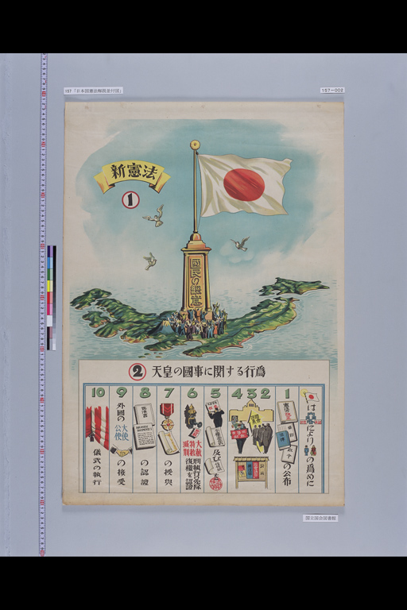
Figure 1
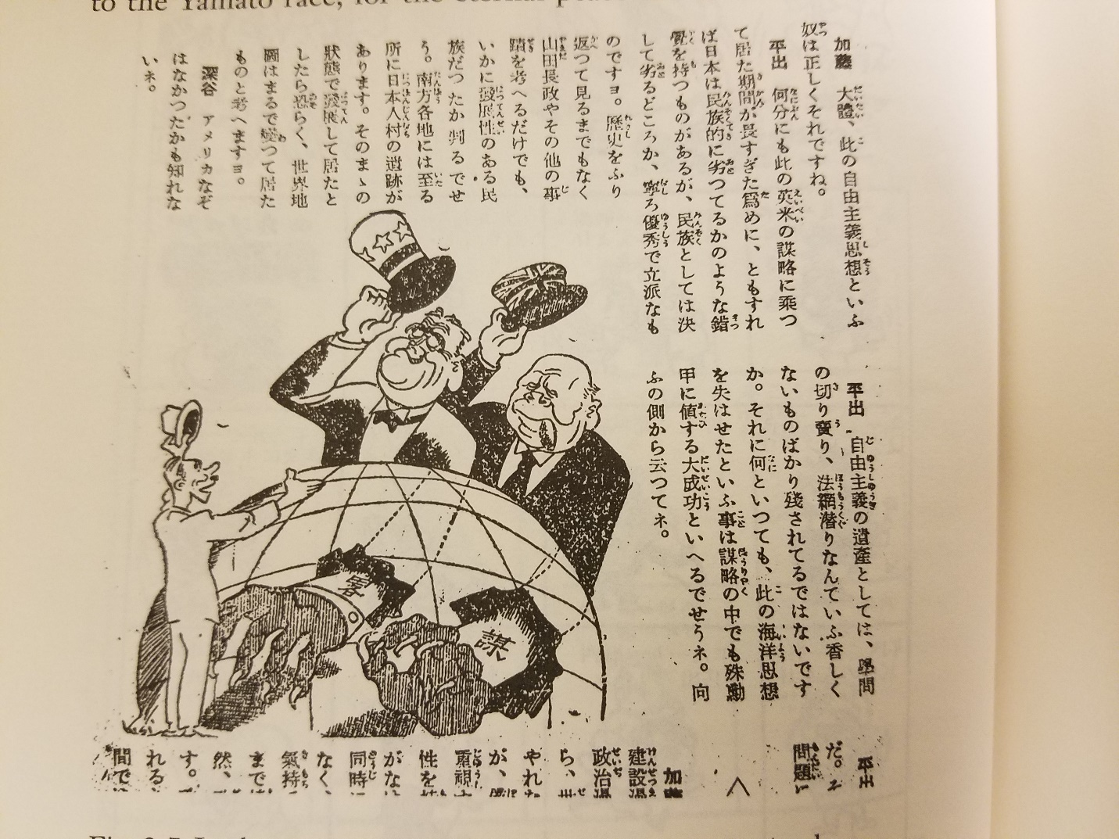
Figure 2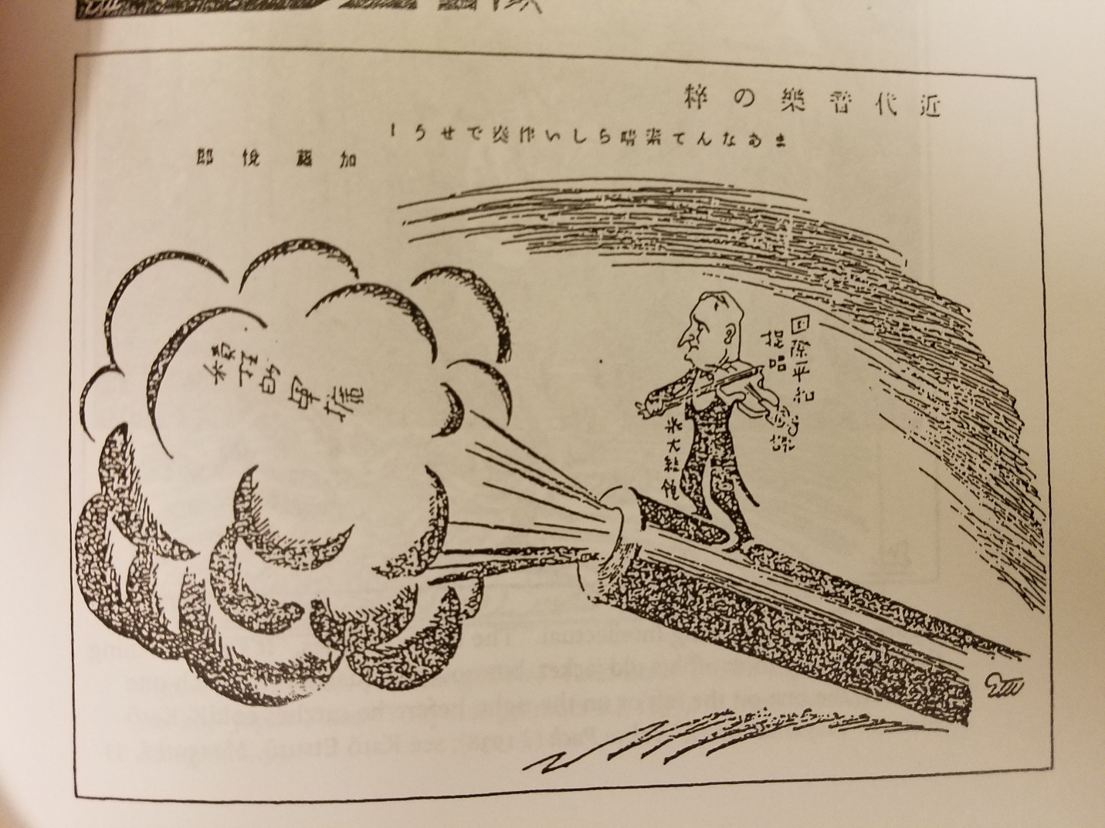
Figure 3
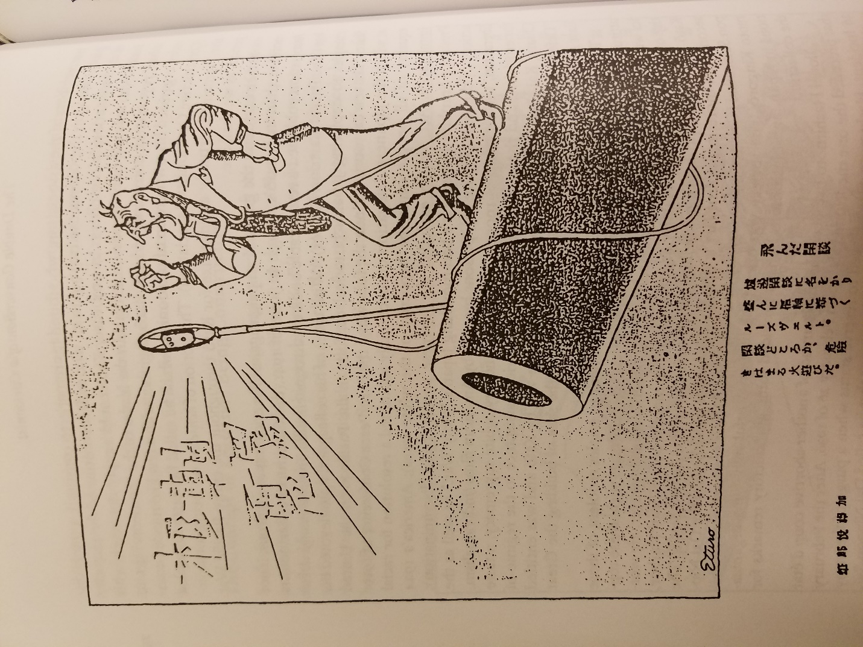
Figure 4

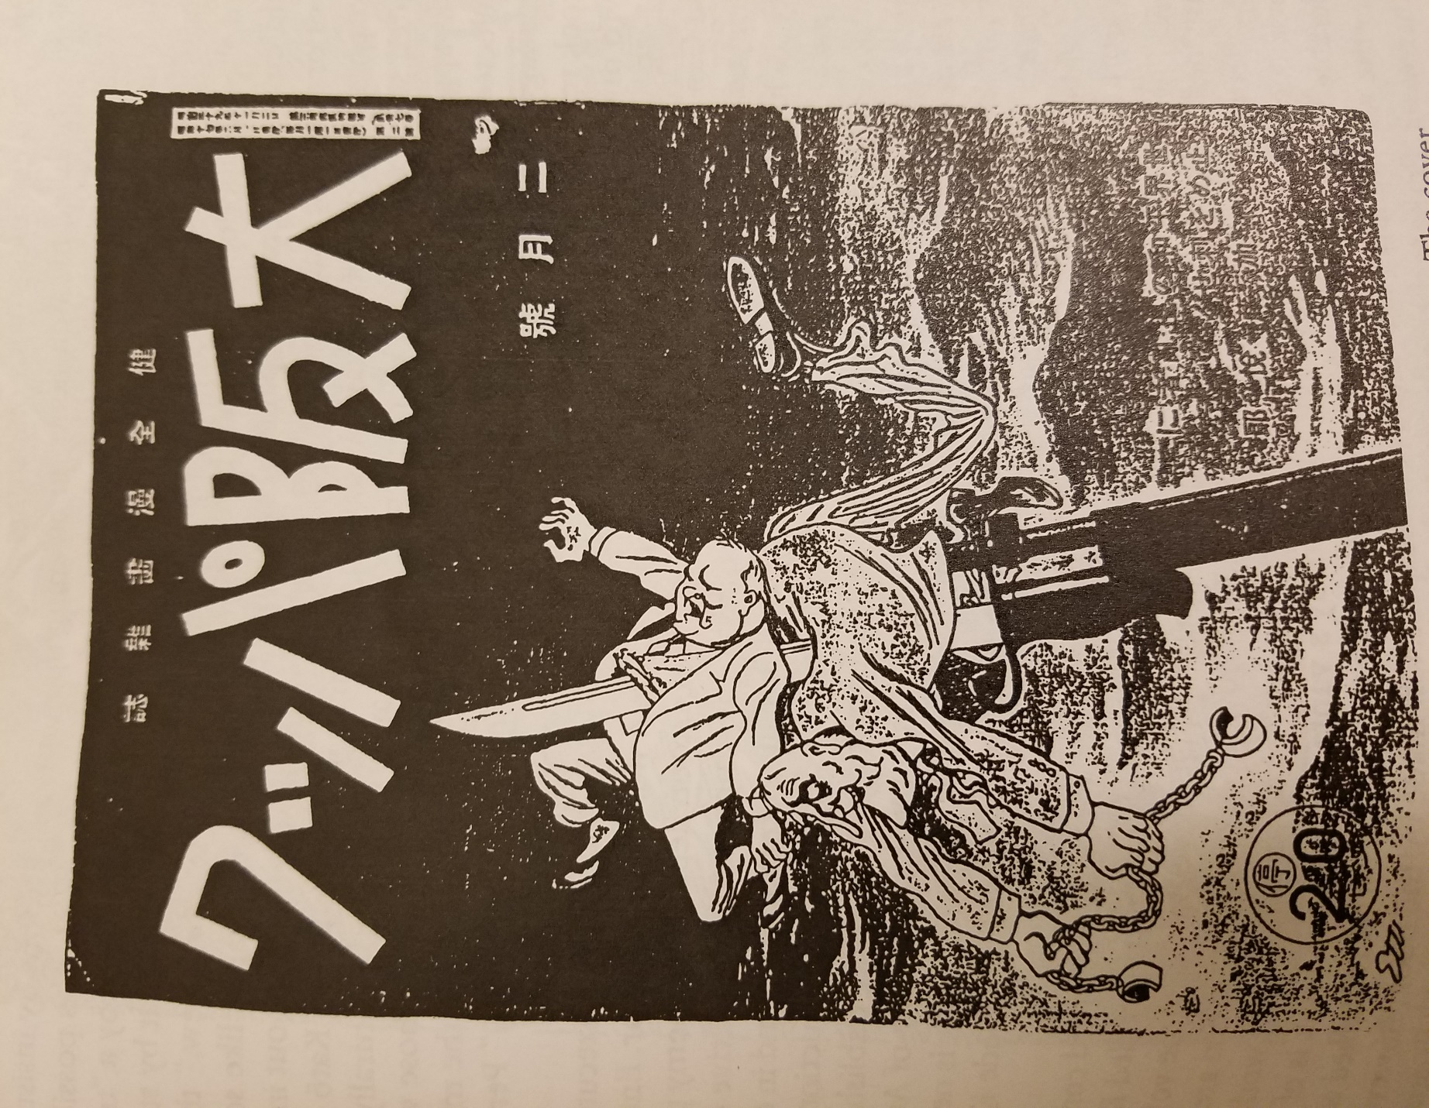
Figure 5
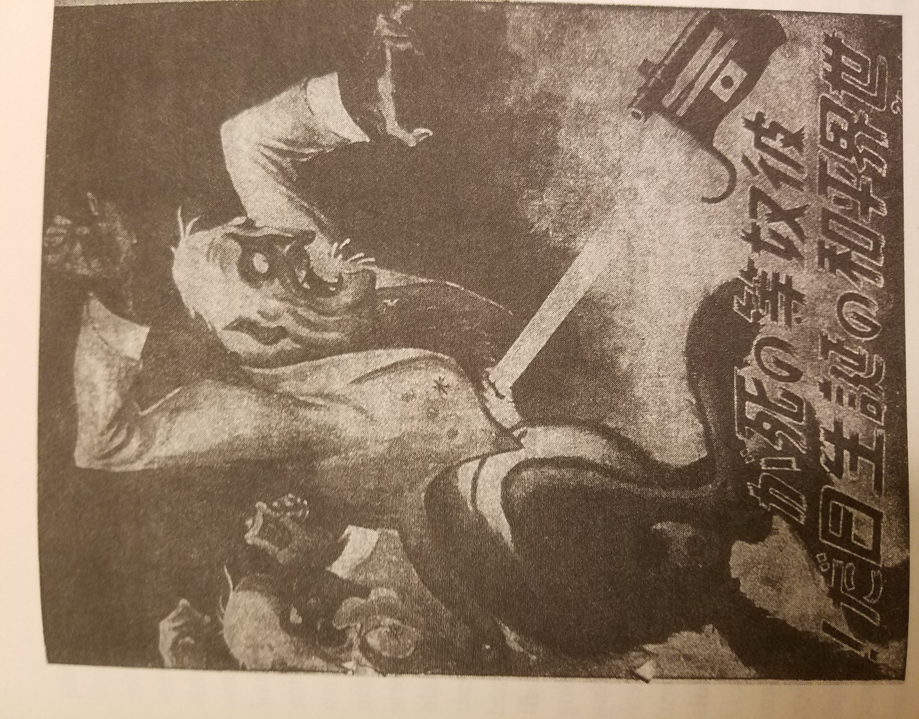
Figure 6
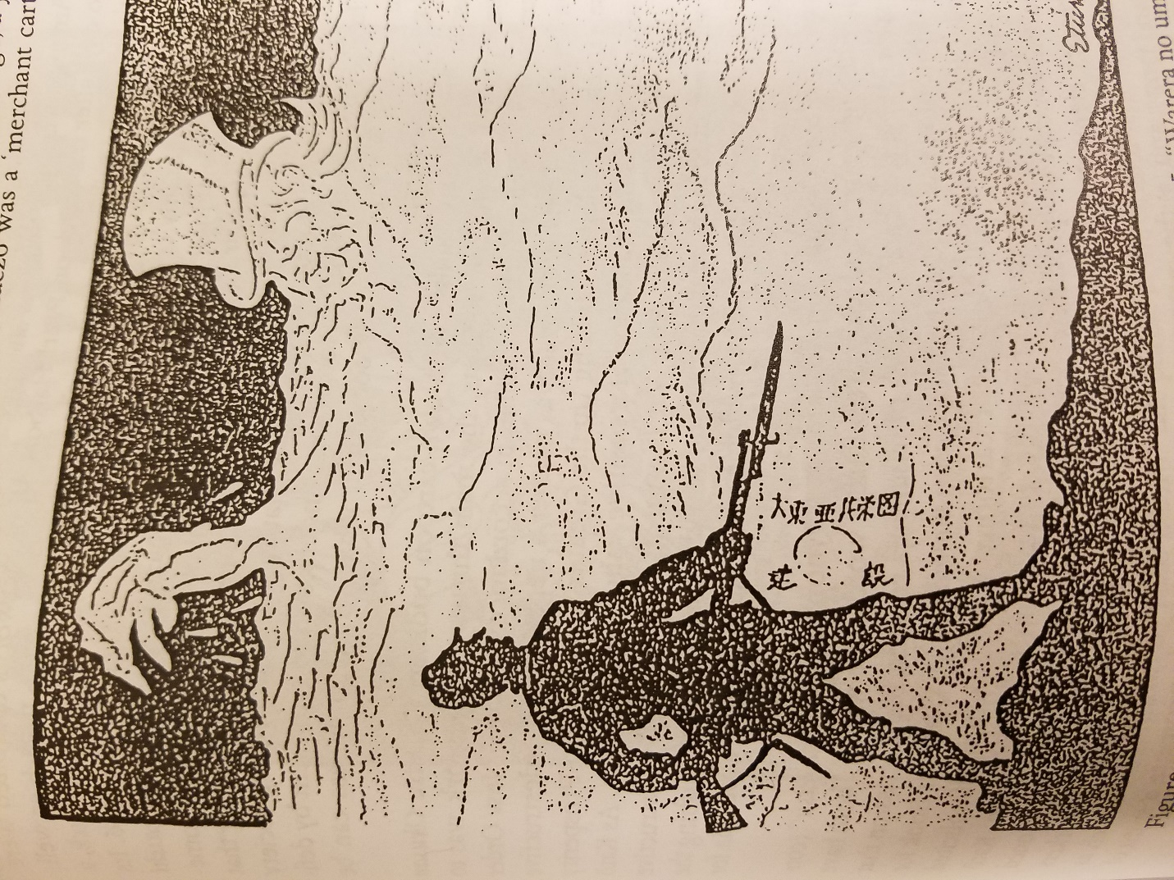
Figure 7
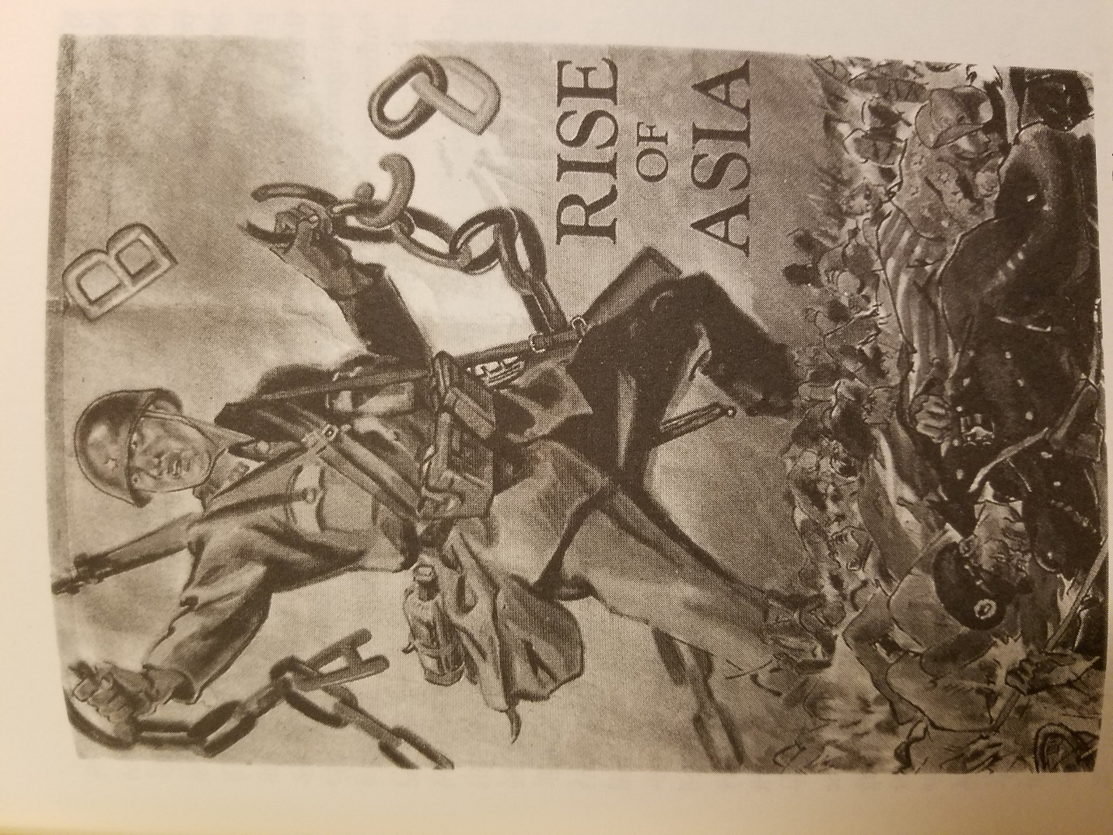
Figure 8
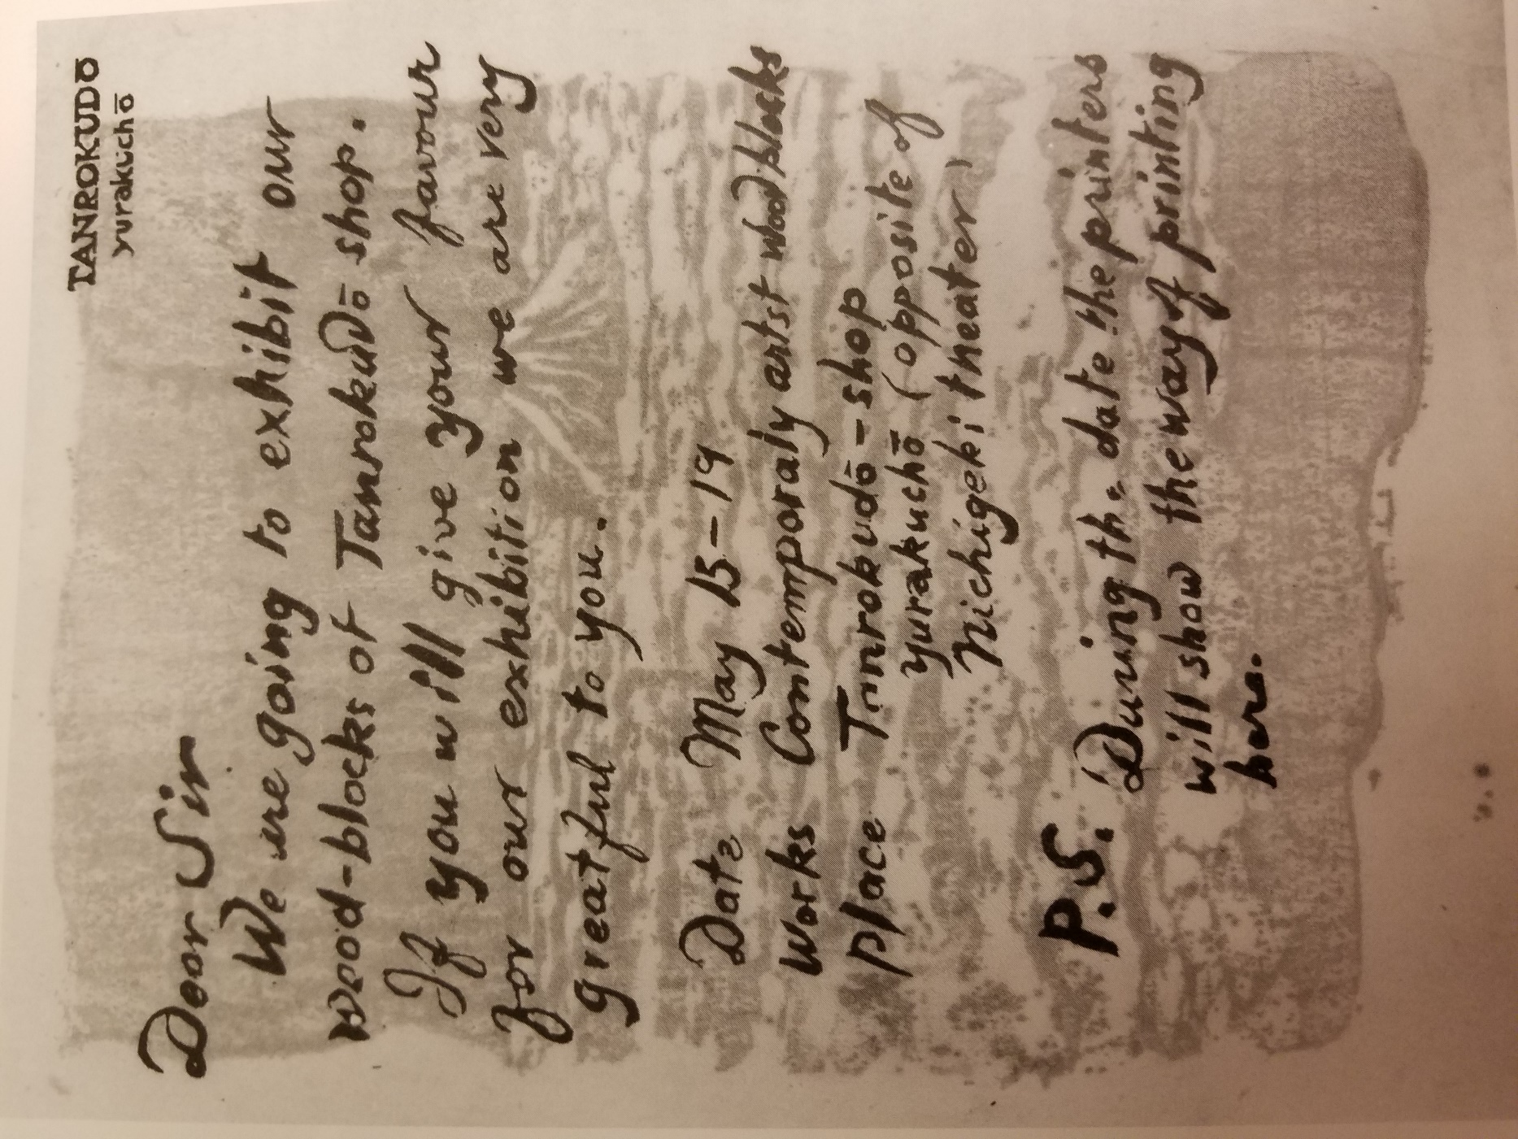
Figure 9
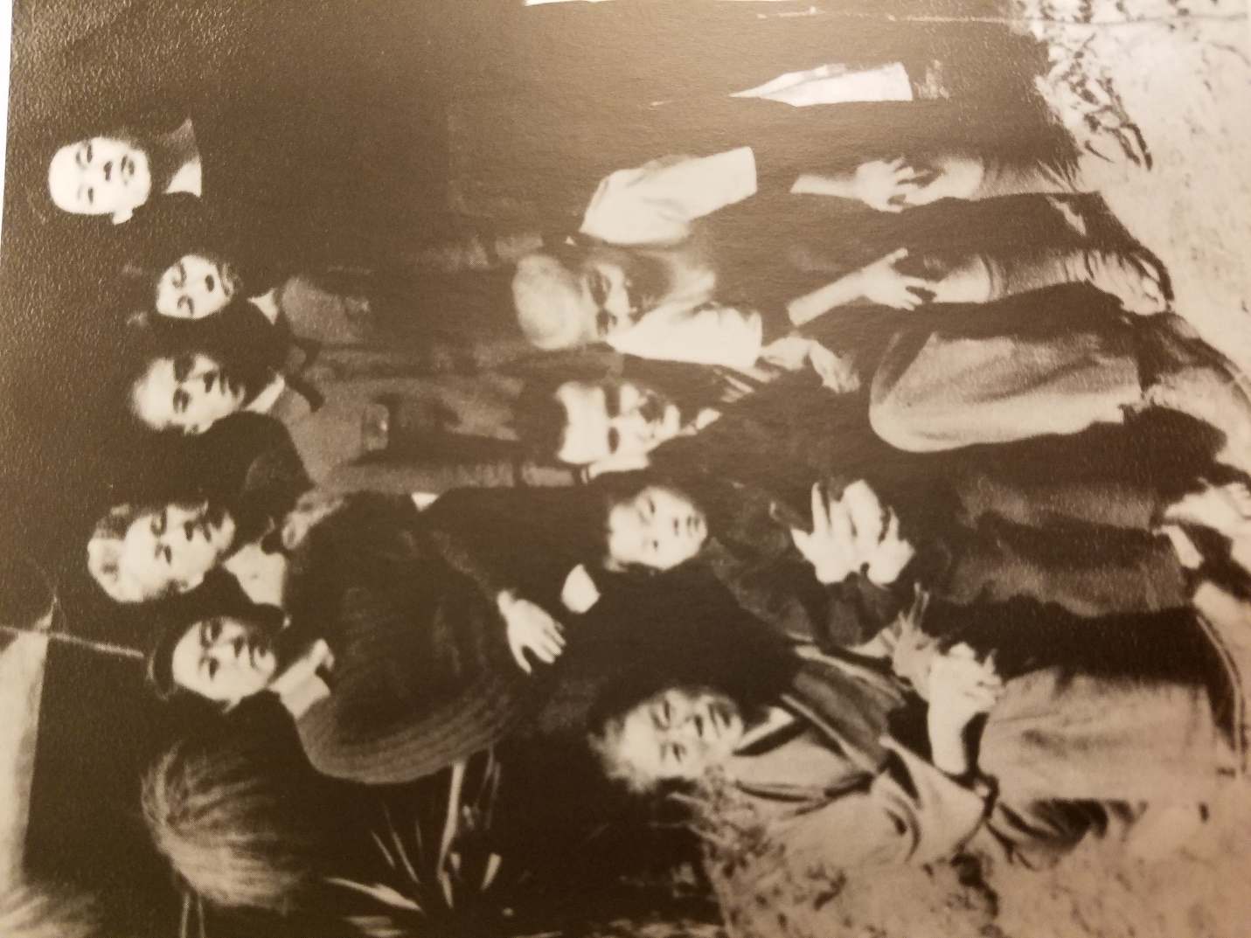
Figure 10
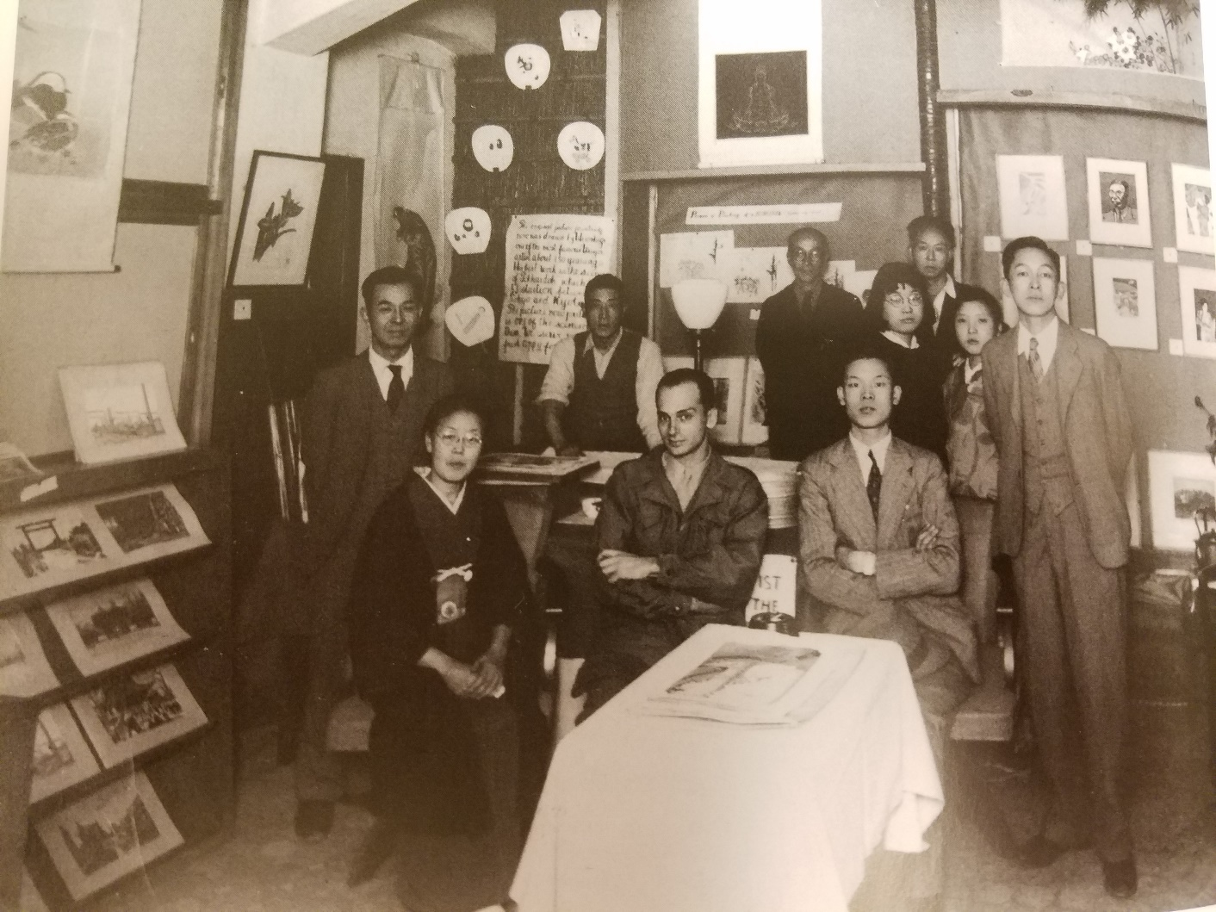
Figure 11
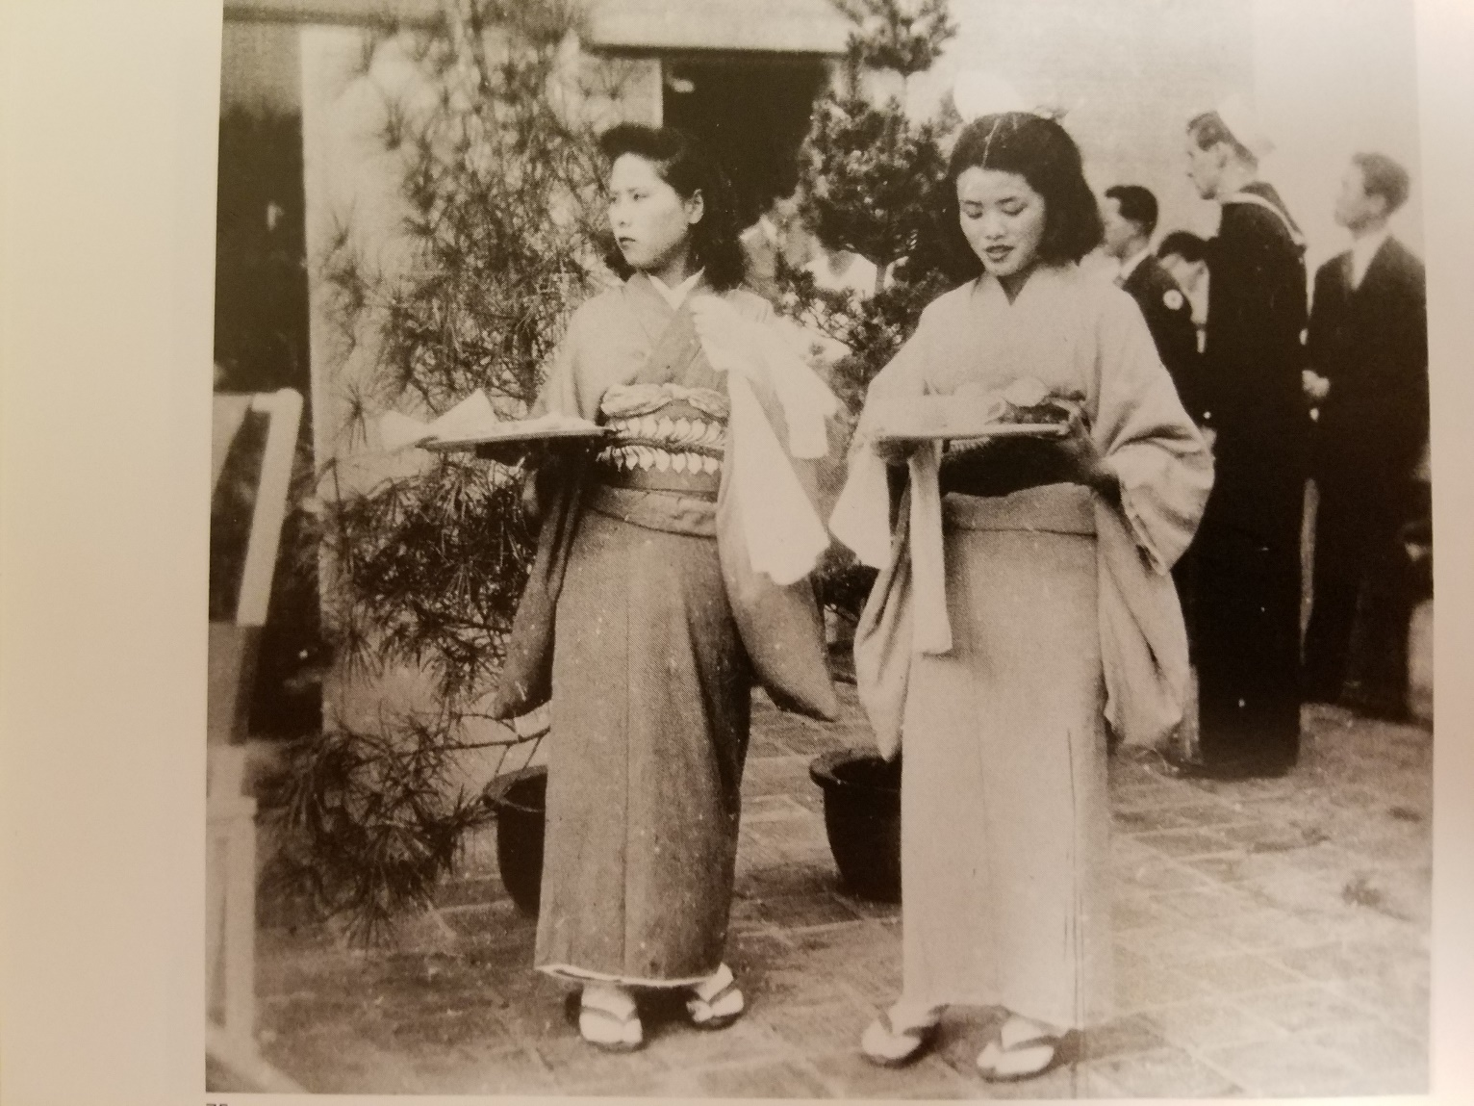
Figure 12
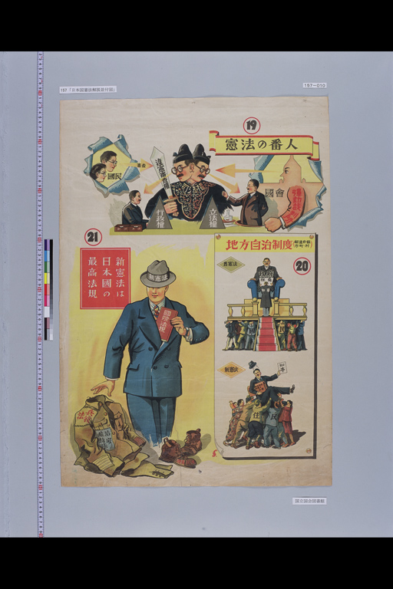
Figure 13
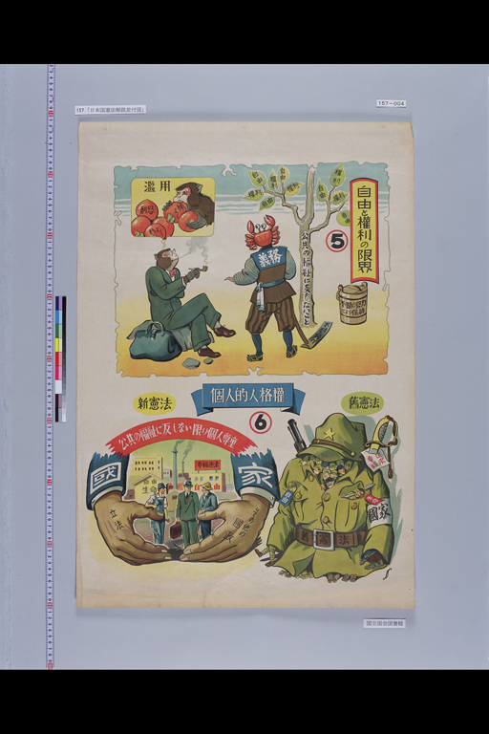
Figure 14
Bibliography
“1-20 Conference Between Prime Minister Shidehara and General MacArthur, October 11,
1945”, 1945,
http://www.ndl.go.jp/constitution/e/shiryo/01/033shoshi.html.
“A Message to the People of Japan from President of the United States of America Harry S.
Truman, May 8, 1945” 1945,
http://www.ndl.go.jp/constitution/e/shiryo/01/008shoshi.html.
Brandon, James R. “Myth and Reality: A Story of ‘Kabuki’ during American Censorship, 1945-
1949,” Asian Theatre Journal 23 (2006): accessed November 19th, 2015.
Dower, John. Embracing Defeat: Japan in the Wake of World War II. New York: W. W. Norton
& Company, 2000.
Dower, John. Ways of Forgetting, Ways of Remembering: Japan in the Modern World. New
York: The New Press, 2012.
“Explanatory Illustrations of the Constitution of Japan”, 1947.
http://www.ndl.go.jp/constitution/e/shiryo/05/157shoshi.html
Gordon, Beate. “The Equal Rights Clause”, in The Only Woman in the Room: a Memoir,
Chicago: University of Chicago Press, 1997
Goto, Yumi. Those Days in Muramatsu: One Woman’s Memoir of Occupied Japan. Singapore:
Ridge Books, 2014.
Hirano, Kyoko. “Japanese Filmmakers and the Responsibility for War: The Case of Itami
Mansaku,” in War, Occupation, and Creativity: Japan and East Asia 1920-1960, edited
by Marlene J. Mayo and J. Thomas Rimer with H. Eleanor Kerkham, 212-232.
Honolulu: University of Hawaii Press, 2001.
“Imperial Rescript Denying His Divinity (Professing His Humanity)”, 1946.
http://www.ndl.go.jp/constitution/e/shiryo/03/056shoshi.html
“Japan: General Principles Applicable to the Post-War Settlement with Japan (T-357)”, 1943,
http://www.ndl.go.jp/constitution/e/shiryo/01/001shoshi.html
“Juvenile Books and Publications on the New Constitution”, 1947-1949.
http://www.ndl.go.jp/constitution/e/shiryo/05/154shoshi.html
Koikari, Mire. “Exporting Democracy?: American Women, ‘Feminist Reforms,’ and Politics of
Imperialism in the U.S. Occupation of Japan, 1945-1952”, Frontiers: A Journal of
Women Studies, Vol. 23, No. 1 (2002): 23-45
Louis Edmonds, Richard et al. "Japan." Grove Art Online. Oxford Art Online. Oxford University
Press, accessed March 17, 2016,
http://www.oxfordartonline.com/subscriber/article/grove/art/T043440pg45.
Matsumoto, Joji. ""Four-Point Principle for Constitutional Reform,"" December 8, 1945.
www.ndl.go.jp/constitution/e/shiryo/02/047shoshi.html.
Mayo, Marlene J. “To Be or Not To Be: Kabuki and Cultural Politics in Occupied Japan,” in
War, Occupation, and Creativity: Japan and East Asia 1920-1960, edited by Marlene J.
Mayo and J. Thomas Rimer with H. Eleanor Kerkham, 269-307. Honolulu: University of
Hawaii Press, 2001.
Phelps, James, “Policing after the golden hour: Lessons in democratizing police from post-
conflict stability operations in West Germany and Japan” (PhD diss., Sam Houston State
University, 2008).
Rinjiro, Sodei. Dear General MacArthur: Letters from the Japanese during the American
Occupation. Lanham: Rowman & Littlefield Publishers, 2001.
Smith, Lawrence. Japanese Prints During the Allied Occupation 1945-1952: Onchi Koshiro,
Ernst Hacker, and the First Thursday Society. London: The British Museum Press, 2002.
Sodei, Rinjiro. “The Double Conversion of a Cartoonist: The Case of Kato Etsuro,” in War,
Occupation, and Creativity: Japan and East Asia 1920-1960, edited by Marlene J. Mayo
and J. Thomas Rimer with H. Eleanor Kerkham, 235-267. Honolulu: University of
Hawaii Press, 2001.
Terada, Toru. Japanese Art in World Perspective. New York: Weatherhill/Heibonsha, 1976.
“The Constitution of Japan”, 1946, http://www.ndl.go.jp/constitution/e/etc/c01.html.
“The Constitution of the Empire of Japan”, 1890, http://www.ndl.go.jp/constitution/e/etc/c02.html.
“Tokio Jokio,” Warner Bros. Pictures, 1943.
Willard-Foster, Melissa. “Planning the Peace and Enforcing the Surrender: Deterrence in the
Allied Occupations of Germany and Japan”, The Journal of Interdisciplinary History 40
(2009): 33-56

Maslow, S. "A Blueprint for a Strong Japan? Abe Shinzo and Japan's Evolving Security System." Asian Survey, 2015, 739-65.
"U.S. Forces, Japan." About USFJ. Accessed November 8, 2015. http://www.usfj.mil/AboutUSFJ.aspx.
Yumi Goto. Those Days in Muramatsu: One Woman’s Memoir of Occupied Japan. Singapore: Ridge Books, 2014: vii-xiv
Mire Koikari, “Exporting Democracy?: American Women, ‘Feminist Reforms,’ and Politics of Imperialism in the U.S. Occupation of Japan, 1945-1952”, Frontiers: A Journal of Women Studies, Vol. 23, No. 1 (2002): 24
Melissa Willard-Foster, “Planning the Peace and Enforcing the Surrender: Deterrence in the Allied Occupations of Germany and Japan”, The Journal of Interdisciplinary History 40 (2009): 33-56
“A Message to the People of Japan from President of the United States of America Harry S. Truman, May 8, 1945” 1945, http://www.ndl.go.jp/constitution/e/shiryo/01/008shoshi.html
Willard-Foster,“Planning the Peace and Enforcing the Surrender”, 39.
Willard-Foster,“Planning the Peace and Enforcing the Surrender”, 41.
“Imperial Rescript Denying His Divinity (Professing His Humanity)”, 1946. http://www.ndl.go.jp/constitution/e/shiryo/03/056shoshi.html
“The Constitution of Japan”, 1946, http://www.ndl.go.jp/constitution/e/etc/c01.html ; “The Constitution of the Empire of Japan”, 1890, http://www.ndl.go.jp/constitution/e/etc/c02.html
Matsumoto, Joji. ""Four-Point Principle for Constitutional Reform,"" December 8, 1945. www.ndl.go.jp/constitution/e/shiryo/02/047shoshi.html ; “1-20 Conference Between Prime Minister Shidehara and General MacArthur, October 11, 1945”, 1945, http://www.ndl.go.jp/constitution/e/shiryo/01/033shoshi.html
Beate Gordon, “The Equal Rights Clause”, in The Only Woman in the Room: a Memoir, (Chicago: University of Chicago Press, 1997), 115-118
“A Message to the People of Japan from President of the United States of America Harry S. Truman, May 8, 1945”, 1945, http://www.ndl.go.jp/constitution/e/shiryo/01/008shoshi.html
“Japan: General Principles Applicable to the Post-War Settlement with Japan (T-357)”, 1943, http://www.ndl.go.jp/constitution/e/shiryo/01/001shoshi.html
“Imperial Rescript Denying His Divinity (Professing His Humanity)”
Phelps, James, “Policing after the golden hour: Lessons in democratizing police from post-conflict stability operations in West Germany and Japan” (PhD diss., Sam Houston State University, 2008).
“Explanatory Illustrations of the Constitution of Japan”, 1947. http://www.ndl.go.jp/constitution/e/shiryo/05/157shoshi.html
“Juvenile Books and Publications on the New Constitution”, 1947-1949. http://www.ndl.go.jp/constitution/e/shiryo/05/154shoshi.html
Richard Louis Edmonds, et al. "Japan." Grove Art Online. Oxford Art Online. Oxford University Press, accessed March 17, 2016, http://www.oxfordartonline.com/subscriber/article/grove/art/T043440pg45.
John Dower, Embracing Defeat: Japan in the Wake of World War II. New York: W. W. Norton & Company, 2000. 180-186
Willard-Foster,“Planning the Peace and Enforcing the Surrender”, 46-48.
John Dower, Ways of Forgetting, Ways of Remembering: Japan in the Modern World. New York: The New Press, 2012. 56
Rinjiro Sodei. “The Double Conversion of a Cartoonist: The Case of Kato Etsuro,” in War, Occupation, and Creativity: Japan and East Asia 1920-1960, ed. Marlene J. Mayo et al. (Honolulu: University of Hawaii Press, 2001), 235-268.
Ibid, 255
Dower, “Ways of Forgetting, Ways of Remembering,” 57
Ibid, 57
Sodei, “The Double Conversion of a Cartoonist,” 253
Dower, “Ways of Forgetting, Ways of Remembering.” 79.
Goto. “Those Days in Muramatsu” 17-18.
Dower, “Ways of Forgetting, Ways of Remembering,” 28-46
“Tokio Jokio,” Warner Bros. Pictures, 1943.
Marlene J. Mayo. “To Be or Not to Be: Kabuki and Cultural Politics in Occupied Japan,” in War, Occupation, and Creativity: Japan and East Asia 1920-1960, ed. Marlene J. Mayo et al. (Honolulu: University of Hawaii Press, 2001), 269
Sodei. “To Be or Not to Be”, 271.
Dower, “Embracing Defeat”, 405-409
Kyoko Hirano. “Japanese Filmmakers and Responsibility for War: The Case of Itami Mansaku,” in War, Occupation, and Creativity: Japan and East Asia 1920-1960, ed. Marlene J. Mayo et al. (Honolulu: University of Hawaii Press, 2001), 218
Sodei, “The Double Conversion of a Cartoonist”, 263-265
Hirano, “Japanese Filmakers and Responsibilities for War”, 223
Sodei, “The Double Conversion of a Cartoonist”, 235-236
James R. Brandon, “Myth and Reality: A Story of ‘Kabuki’ during American Censorship, 1945-1949,” Asian Theatre Journal 23 (2006): 3, accessed November 19th, 2015, doi: 216.96.197.197
Mayo. “To Be or Not to Be,” 283
Mayo. “To Be or Not to Be,” 280-288
Mayo, “To Be or Not to Be,” 276
Brandon, “Myth and Reality,” 2-6
Dower, “Embracing Defeat” 214-216
Mayo, “To Be or Not to Be”, 284
Toru Terada, Japanese Art in World Perspective. New York: Weatherhill/Heibonsha, 1976. 9-31
Edmonds et al, “Japan”
Terada, Japanese Art in World Perspective, 109-112
Ibid, pg 156
Ibid 157
Lawrence Smith, Japanese Prints During the Allied Occupation 1945-1952: Onchi Koshiro, Ernst Hacker, and the First Thursday Society. London: The British Museum Press, 2002, 20
Ibid, pg 27-30
Terada, Japanese Art in World Perspective, 157
Lawrence Smith, Japanese Prints During the Allied Occupation 1945-1952, 107
Ibid, 57-58
Ibid, 107
Sodei Rinjiro, Dear General MacArthur: Letters from the Japanese during the American Occupation. Lanham: Rowman & Littlefield Publishers, 2001, 21-23
Hirano, “Japanese Filmmakers and Responsibility for War”, 221-213.

