Chemical Vapor Deposition of Heteroepitaxial Boron Phosphide Thin Films

A Dissertation Presented for
the Doctor of Philosophy
Degree
The University of Tennessee, Knoxville

J. Daniel Brasfield
December 2013

Copyright© 2013 by J. Daniel Brasfield
All Rights Reserved

Dedication

To my Family,
Chase, Macie, and Hadley. For support and encouragement throughout this process…

Acknowledgements
This dissertation would not have been possible without a number of individuals each contributing in their own unique way. First, I would like to thank Dr. Feigerle for your patience, guidance and tutelage throughout the process. Your calm approach to problem solving has taught me that success takes time and is worth the wait. I would also like to thank Dr. Rack for taking me under your wing and forcing me to apply myself in all aspects of research. I would like to acknowledge my committee members, Dr. Xue and Dr. Vogt for taking time to be a part of this research. In addition, deserving thanks are the supportive members of my research group. I would like to thank Dr. Julia Abbott for toiling away in the lab and the invaluable XRD analysis that shaped the project, Eric Barrowclough for his work with Auto cad and never ending encouragement, Stephen Gibson for his Mass Spectroscopy of weirdness for the process and Alexis dale for her dedication and courage to take on the this project.
I would like to thank my project collaborators in the Materials Science and Engineering Department for their research support. Many thanks to Dr. Gerd Duscher and Guloinag Li for their spectacular TEM analysis. Without out you, progress would not have been possible. Acknowledgements go to Dr. Joo Hyon Noh for fabrication of the heterostructures and Dr. Eric Lukosi for radiation tests.
From Y-12 thanks goes to Jonathan Morrell for support and encouragement to pursue this degree. Many thanks to the rest of the members from Compatibility and Surveillance section for their kindness and willingness to help when needed. Thanks to the Y-12 PDRD program for financial support of this project.
My family played an integral role in my willingness to pursue a Ph.D. Thanks to my wife Chase for pushing me to work and get this done. Without you by my side, this would not have been possible. Thanks to my parents Robert and Judy Brasfield for teaching me the value of hard work and fostering a lifetime love of learning, to you I am forever grateful.
I would like to thank David Beach for his scientific guidance throughout this process. You were always there to answer the tough questions and point me in the direction I needed. Thanks for the support and believing in me that I could succeed in novel materials research.
Finally, I would like to thank the DOE office of Nonproliferation Verification and Research for funding my research at Y-12 and the University of Tennessee for the past five years.

ABSTRACT
Boron Monophosphide (BP) is a group III-V compound semiconductor with a wide band gap of 2.3 ev. Its unique electrical properties make it a promising material for use as a room temperature thermal neutron detector and thermoelectric device in high temperature and radiation fields. A thin film of BP enriched in the ¹⁰B isotope can yield 2.8MeV of energy, which in solid-state BP can yield ∼0.5 million electron-hole pairs that would be detectable with minimal amplification in a device. The high carrier concentration, wide band gap, inertness and refractory nature make it an attractive material for use in the extreme environments of nuclear reactors. The main drawback to BP is the difficulty in synthesizing high quality material. The majority of the current work on BP was performed on Si substrates. This high lattice mismatch between Si and BP incorporates strain in the BP film which causes varying defects and charge traps to be introduced, adversely affecting electrical performance It is the purpose of this work to identify the parameters necessary to deposit oriented zincblende boron phosphide (BP) thin films on 4° off-axis C-face 4H-SiC(0001) substrates by chemical vapor deposition.
SiC only has a 4% lattice mismatch from BP, which could greatly reduce the inherent strain from heteroepitaxial growth. Ultra high purity B₂H₆ and PH₃are used as reactive precursors, with hydrogen as the carrier gas. Conditions necessary for high quality BP thin films will be explored. Parameters such as temperature, PH₃ to B₂H₆ flow rate ratios, SiC wafer termination and wafer surface preparation are examined in controlled experiments to elucidate optimum BP thin films for eventual device fabrication.

Table of Contents

List of Tables

List of Figures

List of Abbreviations and Symbols

1.0 Introduction

Technical curiosity into new materials and new material properties is well established in the history of science, and persists today. More often than not, these newly identified material or properties become responsible for fundamental advances in technology. One example of this was the discovery of semiconducting behavior in 1833 by Michael Faraday¹. By definition, semiconductors are material with electrical conductivity between insulators and metals² In. his experiment, Faraday observed the resistance of silver sulfide changed with temperature. This spurned a more comprehensive investigation by Hittorf in 1851 that quantitatively documented the conductivity of metal sulfides as a function of temperature^{1,3}. The next groundbreaking discovery for semiconductor material came in 1878 by way of Edwin Hall. Hall discovered that charge carriers in solids are deflected in magnetic fields. This, together with the similarly timed discovery of the electron promoted electron conduction theory in solids⁴. In 1914, the modern interpretation of band theory of solids was developed by Alan Wilson and Werner Heisenberg. Wilson theorized that electrons flowed through filled and empty energy bands
And Heisenberg proposed the concept of an electron hole³⁻⁵. Band theory predominates modern semiconductor research². Identification of band gaps has revolutionized the semiconductor device industry to the point that semiconductors have been broken down in to sub categories based on material characteristics. Pure element semiconductors do exist such as silicon and germanium, but most of the current research is focused on compound semiconductors, or bonded elements that elucidate semiconducting properties⁶.

1.1 Group III-V Semiconductors
The focus of this manuscript is on the subgroup III-V semiconductors. Group III-V semiconductors refer to groups III and V of the periodic table. More specifically, the boron group and the pnictogens

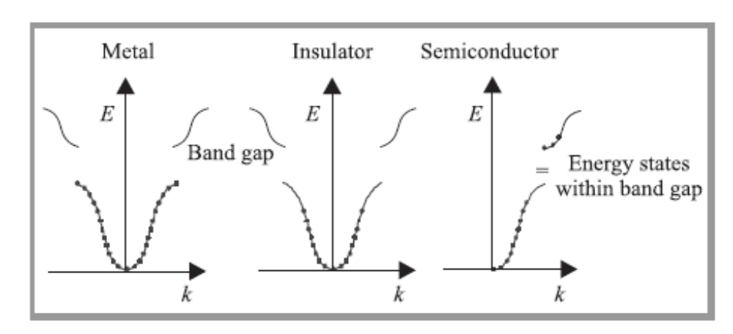
Figure 1-Early Band Theory of Solids

Group III (IUPAC 13) | GROUP V (IUPAC 15)
Boron | Nitrogen
Aluminum | Phosphorus
Gallium | Arsenic
Indium | Antimony
Thallium | Bismuth

Table 1. List of Elements comprising group III-V Compound Semiconductors
Group III-V compound have unique properties hat make them attractive for device fabrication and other specific applications. First, these semiconductors tend to be cubic the zincblende structure. This structure , shown below, is a face centered lattice type with space group F43m and tetrahederal coordination of the constituent atoms⁷. The zinc blende is very similar to the diamond cubic lattice, but with alternating type of atoms rather than just carbon as in the diamond lattice.
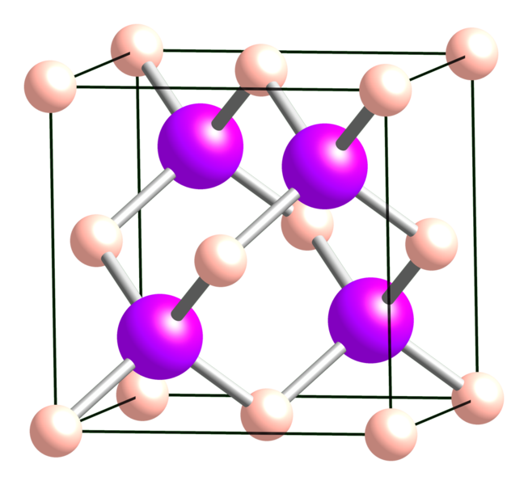
Figure 2. Crystal lattice of Zinc Sulfide, representing the zincblende crystal structure

In addition to cubic structure group III-V semiconductors exhibit unique bonding characteristics ⁶⁻⁷ . Bonding in these semiconductors is a mix of both partial ionic and covalent⁸. The partial ionic and covalent bonding instills high melting temperatures, but low thermal decomposition temperatures for some III-V’s. One of the most important aspects of the group III-V semiconductors is there band gap. The band gap refers to the distance between the top of the valence band of electrons and the lowest level of the conduction band, a theory predicated on the aforementioned Wilson’s band theory of solids. Group III-V typically has band gaps around 3 ev which allows room temperature operation for most processes of interest in these materials⁹.
Electronically, the group III-V semiconductors contain both direct and indirect semiconductors. In direct semiconductors, the top of the valence band and the bottom of the conduction band occur at the same magnitude of momentum. A pot of the energy vs. the momentum shown in figure 3 depicts the narrow
region where an incoming energy, most commonly in the form of a photon can easily promote an electron to the conduction band an examples of direct III-V semiconductor are indium phosphide and gallium arsenide ⁹⁻¹¹. Conversely, in indirect semiconductors, the top of the valence band and the bottom of the conduction bands are offset and occur at varying energies (fig. 4).

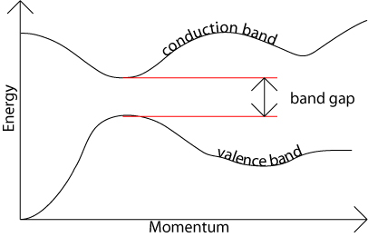
Figure 3. Plot of Energy verses momentum showing the coordination of the valence and conduction bands-Indicative of a direct semiconductor.

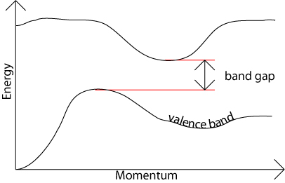
Figure 4. Plot of energy verses momentum showing the disjunction between the valence and conduction band. -indicative of indirect semiconductors

Operationally, indirect semiconductors are typically slower from the requirement that an in order for an incident photon to promote an electron to the conduction band, an additional momentum to the electron must be imparted. This typically involves electron interacting with inherent phonons¹¹. Another interesting electronic property of III-V semiconductors is the mobility of the electron holes. The unique bonding character influences electron mobility in III-V’s. It is thought that the partial ionic bonding found in III-V’s leads to a more tightly bound lattice, this has an inverse effect on the charge carriers and therefore the net result is a higher mobility in III-V semiconductors¹⁰.
A side from their attractive electronic properties, group III-V semiconductors can be chemically favorable to synthesis⁹. This comes from the observation that these semiconductors tend to maintain stoichiometry even under excess reactant conditions.
The evolution of semiconductors has had a profound impact on the development of modern electronic devices. Applications of expanded at a rapid pace and the usefulness of tradition semiconductors such as silicon and germanium are waning. This is here the significance of group iii-V semiconductors begin to significantly contribute to technology. Their peculiar electronic and stoichiometric behavior unlocks possibilities previously not thought possible.

1.2 Boron Phosphide

1.2.1 Structure Boron phosphide, a compound between the element of boron and phosphorous, can exist in two common allotropes, the cubic monophosphide, (BP) shown below in figure 1 and the tetragonal subphosphide (B₆P) shown in figure 2. Both forms have been successfully grown and characterized in the literature, but only the monophosphide has demonstrated potential success in eventual device fabrication and will be the primary focus of this manuscript. For simplicity in nomenclature, the term “boron phosphide” will refer to the monophosphide form of BP. As previously stated, the crystal structure of BP is zincblende. X-ray diffraction reported by numerous investigators has confirmed a room temperature lattice constant of 0.45383 nm¹³⁻¹⁵.
1.2.2 Physical Characteristics
The physical appearance of boron phosphide is typically reported to be red-orange in color with the slight presence of brown overtones. This observation is consistent with a band gap of boron phosphide measured to be 2.1-2.3 ev. At these energies light incident in BP is absorbed at magnitudes above the bandgap. With a medium bandgap of 2.3 ev ,BP absorbs violet light blue light and green light with a wavelengths of 400-425, 425-492 nm 492-575nm and bandgaps of 3.10-2.92 ev 2.92-2.52 ev and 2.52-2.15 ev respectively. Leaving yellow orange and reds¹⁶. Physical characteristics for BP include a density of 2.9 g/cc and a molar mass of 41.1588 g/mol. Unlike most of the other metal phosphides, BP has a low thermal decomposition temperature at atmospheric pressure of 1100 C. At pressures approaching 100 GPa it has been reported that BP melts close to the phosphorus temperature of 3000 C¹⁷.
1.2.3 Chemical Characteristics
The chemical characteristics of boron phosphide are not well reported¹⁸. Most of the published literature focuses on the physical and electronic properties of characteristics of rather than the chemical characteristics of the material. What is known, that BP by itself is reasonably inert. It does not readily react with most common substances¹⁹ .Bartnitskaya ²⁰et al conducted experiments to examine the reactivity of BP with ammonia and nitrogen. No observable reaction was identified at varying temperatures and concentrations. BP is refractory and the only known way to etch is to use molten

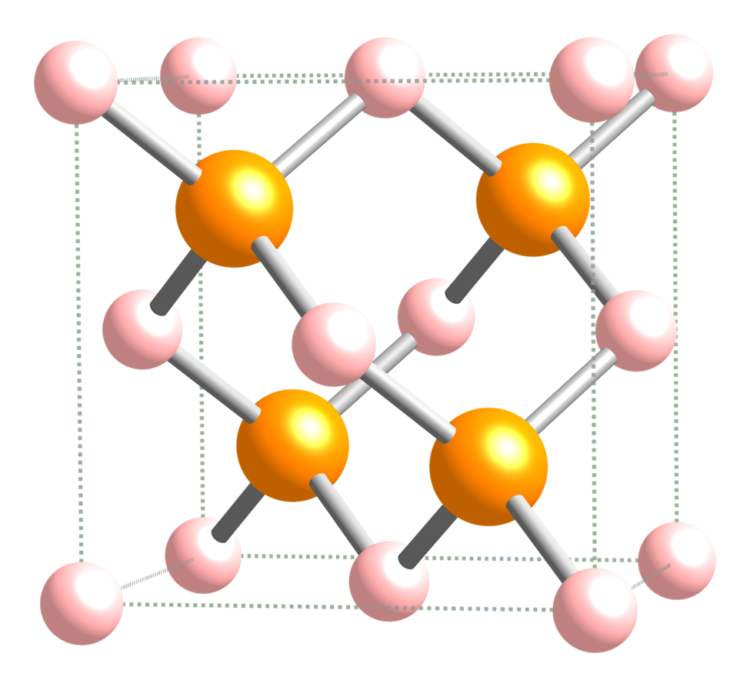
Figure 1-boron monophosphide

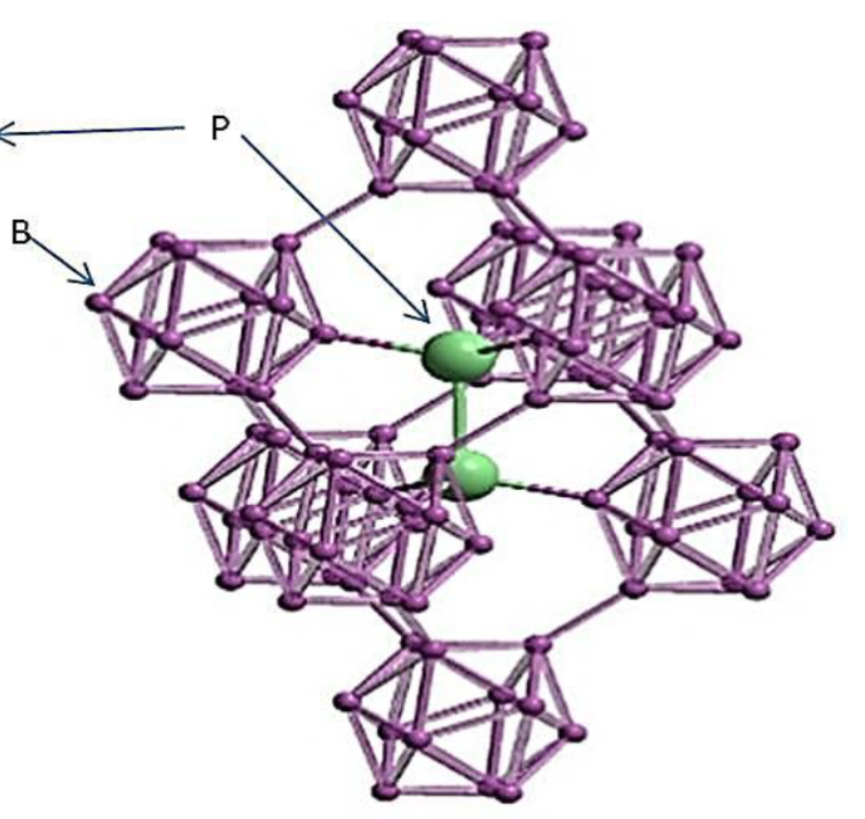

Figure 2 graphic Representation of boron subhosphide B₁₂P₂

alkali salts at temperatures above 300 C. The hardness of BP has been noted several times in literature and a moderate microhardness of 32 Gpa has been reported²¹.
1.2.4 Semiconductor Behavior
Electrically, boron phosphide is a wide band gap semiconductor with an experimental and calculated band gap range of 2.1 to 2.3 ev^{14,21-22} The semiconducting behavior of boron phosphide is complex from the standpoint that BP can be either a p-type semiconductor or n-type semiconductor depending on the specific stoichiometric ratios of B to P formed during synthesis²³. Boron rich films tend to be p-type semiconductors and Phosphorus rich BP tends to be n-type semiconductors. Takigawa²⁴ reported that P-type on n-type behavior in BP can be a function of synthesis temperature, in his experiments, he noted that at lower temperatures of 950-1050 C resultant films were predominately n-type. At higher syntheses temperatures of 1050 and above, P-type material was preferred. The study is somewhat inconclusive however, as the team did not attempt to isolate the variables of flow rate and temperature. The flow rate of the gaseous precursors of diborane and phosphine was varied in each experiment rather than kept constant. Therefore it is unclear from these experiments that temperature has a true effect on semiconductor type in BP since an excess phosphine was used in the n-type material and a lower ratio was used for predominately p-type BP. Shohno¹³ reported similar results to Takigawa, but once again the temperature was dependence is not clear since the flow rate of phosphine was altered in the each of the experiments. BP is considered an indirect semiconductor as the magnitudes of the conduction band and the valence band do not correspond. In addition to band gap, the charge carrier mobility and lifetime are important electrical characteristics to be considered in boron phosphide, as they dictate the types of devices that can be fabricated. For semiconductors, the charge carrier concentration is simply the number of electrons per unit volume²⁵. Carrier concentration is typically measured in cm⁻³ and can be measured by a variety of techniques including photoluminescence spectroscopy, Hall effect measurements the number of Charge carrier concentrations for BP are on the order of 10¹⁸-10²¹ cm⁻³. In the same experiments previously discussed by Shohno, p-type BP had higher charge carrier concentrations at 10¹⁹ cm⁻³ than the reported n-type material. In similar thin film evaluations, Kumashiro measured the intrinsic charge carrier concentration of 4.7 X10 ¹⁸ cm⁻³ , thus supporting Shohno’s measurements. Carrier mobility is another important parameter in semiconductors because it allows the prediction of the temporal response of the material to a stimulus²⁶. The term carrier mobility is a collective term, and refers to both the hole mobility as well as the electron mobility. The mobility is usually given in units of cm²/V∙ S.

1.3 History of Boron Phosphide

1.3.1 Early Synthesis
Early attempts at BP synthesis were simple mixtures of boron and phosphorous containing compounds and the application of heat. BP was first synthesized by Moissan in 1891²⁸; Moissan was reacting boron-halogen compounds with phosphorous. Boron phosphide was identified as the product of the reaction and a brief description of the physical properties including red-brown color was noted. Following the work of Moissan, Besson²⁹ published a similar paper on BP the same year as Moissan. The work was similar in nature and also included reacting boron and phosphorus containing compounds in the presence of heat. The seminal difference between Moissan’s work, was phosphorous. Besson used the hydride of phosphorous, phosphine, in the reaction with boron triiodide. Following the 1891 experiments, no other work was published on the topic until 1957. A paper by Popper and Ingels²⁹ in the journal Nature, outlined the first alternative synthesis of BP. Details of the experiment were few, but included the reaction of boron with red phosphorous in a sealed quartz tube at 1100 °C. The resultant powder was characterized by X-ray diffraction methods and the cubic zincblende crystal unit cell was observed. Room temperature lattice constant was determined to be 4.55 Å. Popper and Ingels were also the first to note the abrasive nature of BP and likened the hardness to diamond and the newly identified borazon^{tm} or cubic boron nitride.

1.3.2 Modern Synthesis
The dawn of the modern synthesis efforts of BP began in 1964 with the first report of boron monophosphide³⁰. The term modern synthesis is used here as a delineator to indicate a change in the approach of boron phosphide synthesis methodologies from simple elemental mixes to advanced methods that include chemical precursors instead of elements and new heating strategies, and to identify the seminal approach that influences much of the current BP work. In the mid 1970’s the interest in BP shifted from understanding the fundamental properties of the material to applications of the material. Much of the scientific focus of the time was to identify novel materials for advanced device fabrication³. Efforts were placed into reviving and improving the quality of early materials synthesis work in order to identify useful properties. Advances in the understanding of boron phosphide began to emerge after the advent of chemical vapor deposition technology in the early 1960’s.
Vickery³² was the first to publish an alternative to element synthesis of boron phosphide and the formation of a BP thin film. His article in the 1959 article of nature describes the using the chlorides of both boron and phosphorus mixed in specific ratios and placed in tube reactor. The evacuated tube was heated to 300 C. The result was a dark film on the interior of the tube. Vickery noted that the dark film floated on water when rinsed freely from the tube. Testing of the resultant film showed chemical stability in ambient air to 1000 C.
The next year, two works on BP were published by Williams and Ruehrwein¹⁹ and Stone and Hill²¹. In both works, halogens of boron and phosphorus were employed as well as reactions from the elements. The goal was to compare the halogen reaction pathway to simple elemental synthesis. Williams’experiments varied slightly from the work of Stone and Hill in what Williams used AlP as the precursor to phosphorus as well as the chloride of boron and phosphine. Williams. Table 1 list the reactions and the results of Williams experiments.

Sequence | Reaction | Result of Experiment
1 | 4B + P4 4BP (1000C) | Slow
2 | AlP + BCl₃BP +AlCl₃ (1000 C) | Contaminated
3 | BCl₃ + PH₃ BP + 3HCl (1000 C) | Translucent red films
Table 2 Reactions of BP from Williams and Ruehrwein
All of the reactions were conducted at temperatures of 1000 C. Reaction 1 was noted to be slow , taking days to complete. Reaction 2 showed percent level contamination of Al₂O₃, a common product of AlP synthesis. Reaction three was the most successful, resulting in shiny red films in several attempts. XRD of the resultant films showed cubic structure. Williams is also the first to note the formation of the boron subphosphide, B₆P. This was obtained by heating BP in air at 1000 C. Thermogravimetric analysis showed the evolution of phosphorus from the compound leaving boron subphosphide. Chemical compatibility experiments performed by Williams confirms the inertness of BP, as it could not be dissolved by boiling concentrated mineral acids.
In the laboratory as Williams, Stone and Hill conducted a parallel study, but albeit more comprehensive study of the electrical properties of BP. The same vapor growth methodology carried out by Williams was used. The result was 1-2 mm dark red needle shaped crystals and of BP. XRD analysis confirm cubic BP. The electrical characterization performed by Stone and Hill was Hall Effect measurements on the samples grown by the elemental approach of Williams. A diode to BP was fashioned from silver paint, tungsten and platinum electrodes. The BP samples were identified as p-type semiconductors with 10¹⁸ carriers/cc. Special attention was given in paper to address the energy gap reported by Williams of nearly 6 ev. Williams used optical transmission techniques to measure the energy gap of BP, which with a nearly 6 ev bandgap , should be colorless. Stone and Hill, noted that the due to the reddish brown color of their BP samples, the forbidden energy gap was a much more accurate 2.0 ev.
One decade later, a significant development in BP synthesis was reported in the literature. Chu²³ et al released a paper outlining the synthesis and characterization of crystals and epitaxial layers. Fundamentally, theses paper is not too far in scope from the previously discussed work, but with one major difference, Chu note the first use of hydride precursors for BP epitaxial layers. Chu notes that developments in chemical vapor deposition have made alternate syntheses attractive; furthermore, CVD offers lower reaction temperatures and composition of the reactant mixture is more adjustable. In his experiments, SiC platelets were chosen for BP deposition because of chemical inertness, crystal symmetry and lattice parameters akin to BP. A hydride system was used that included thermal decomposition of diborane and phosphine in a hydrogen atmosphere and the thermal reduction of boron tribromide-phosphorous trichloride mixture. Temperatures were lower for the hydride system at 850 C where temperatures for the halogen system were 1050-1150C. Wafers were prepped using a molten sodium hydroxide sodium peroxide that acted to smooth the Si side of the platelet. Heating was achieved by induction of a BP coated graphite susceptor. Active cooling was applied to the apparatus to minimize gas phase nucleations. Reaction parameters of both the hydride and halogen systems were varied over a wide range and the resultant BP was studied. Generally, the hydride reactions were carried out below 900C whereas the halogen reactions varied from 850 to 1150 C. The film thickness was determined by cross sectioning and optical analysis of the wafers. Electrical characterization was performed on the samples. To carry out tests, ohmic contact were formed to BP using aluminum or gold The Pyrolysis of the boron and phosphorous hydrides was also examined in this paper. SiC substrates were leveraged in this work at temperatures of 900 C, with .01% and .04% diborane and phosphine concentration in hydrogen . Mass flow rates of 0.89 mol/min if precursors resulted in 8-10 micron/hr deposition rates at 850 C. The resulting films were largely polycrystalline with no discernible surface features. with respective annealing temperatures of 600 C and 800C.
This work is considered the serial work in BP experiments because of the novel use of hydrides which have distinct advantages over the halogens and metal phosphides in terms of cleanliness. Much of the current BP emulates the process developed by Chu. For the next decade, investigations into BP continue with moderate intensity. Researchers such as Takigawa³² and Nishinaga³³ report similar results and syntheses methodologies to those previously discussed. In addition to the CVD methods, several solution growth methods are reported , but with little follow on research. However, in 1983 workers at Sandia National Lab^{p} report a method for growing BP freestanding films on metal substrates. This is the only known reference to growing BP on refractory metals.
In 1984, the most significant contributor to the science of boron phosphide makes his initial publication Yokinobu Kumashiro³⁴⁻⁵⁶ has over 24 first author publications on boron phosphide studying all aspects of the materials including synthesis , electrical characterization, thermoelectric power, applications of , and radiation effects. The majority of Kumashiro’s work is focused on the electrical properties of BP for development as an alternative semiconductor for Si in extreme environments. Although alternative syntheses methodologies are described including high pressure flux and other solution growth approaches, the majority of his work uses the hydride precursors first used by Chu.
All of Kumashiro’s CVD work with BP was performed on Si substrates. Despite the large lattice mismatch of BP and Si, Kumashiro acknowleged this a potential drawback, but ultimately elected to only pursue BP grown on Si. He cites the advantage of being able to etch the Si from the BP as the main driver for this decision, in order to electrical characterization easier. Kumashiro continues to publish, with his last work on BP being published in 2011.

1.4 Applications of Boron Phosphide
1.4.1 Neutron Detectors
Despite the formidable amount of research that has been conducted on boron phosphide, attractive industrial applications remain elusive. The unique properties of boron phosphide previously discussed limit the applicable options for use. To date, there have been three primary areas boron phosphide offers distinct advantages to existing materials. They are neutron detectors, protective coatings for IR optics, and thermoelectric devices.
The radiation detection community has shown considerable interest in boron phosphide for quite some time. Kumashiro et al worked with BP in the late 1980’s to investigate its usefulness for neutron detection. Los Alamos National Laboratory⁵⁷ conducted a project about 15 years later to investigate BP for thermal neutron detection. The interest in BP comes from the fact that few elements on the periodic table have large probabilities of neutron absorption. This probability is a property measured for each element. Fundamentally, it is the fraction of the reacting nuclei consumed by the reaction per unit time per unit flux ⁵⁸. Experimentally, neutron cross sections can be determined by considering a high energy particle beam, typically generated by a linear accelerator, on to a prepared thin target of the material of interest. The neutron cross section can be determined by the time of flight method (TOF) for neutron cross section determination. Here, the known neutron flux given in neutrons per seconds (n/s) is compared to the detected fluxes at the sample and after a specified travel distance in the flight tube (see figure 3). The resultant cross sections are given in terms of cm² and range from a maxima at 10⁻¹⁸ cm² to a minimum detectable quantity of 10⁻²⁸ cm². It is convenient to establish convention to avoid using such large negative exponents. Therefore the unit of barn was created. The abbreviation for barn is b and is defined as 10⁻²⁴ cm² ⁵⁸.
The importance of neutron cross section becomes apparent when a cursory evaluation of the elements with respect to neutron cross section is performed. Only a select few elements are amenable for neutron absorption. Furthermore, of the elements such as boron, lithium, gadolinium, and helium, that
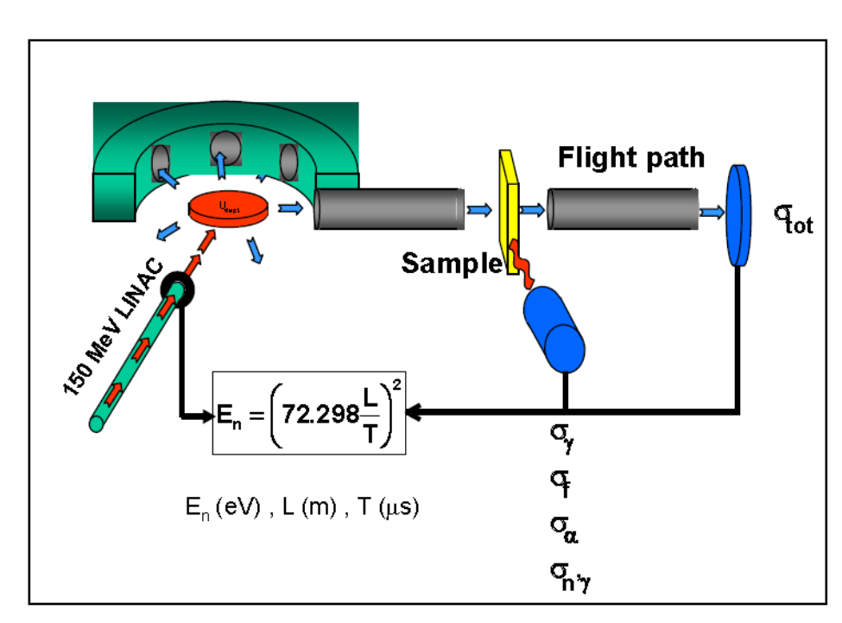
Figure 3-linac

can support neutron absorption, it is the natural abundance of specific isotopes from the aforementioned elements that that are the source for large neutron cross sections. Although not to be considered an all-inclusive list, table 2 provides a number of the common isotopes and cross sections used in neutron detection devices. Associated natural abundances are given for reference purposes to indicate the applicable availability of each isotope. The more rare the isotope, the more resources must be used in order to separate the desired isotope.
Isotope | Natural Abundance (Percent) | Neutron Cross Section (Barns)
Boron-10 | 19.9 | 3.8 X 10³
Lithium-6 | 7.59 | 9.4 X 10²
Gadolinium-157 | 15.65 | 2.5 X 10⁵
Helum-3 | 1.4 X 10⁻⁴ | 5.3 X10³
Table 2-List of common isotopes and cross sections employed in neutron detection with associated natural abundances

At 19% abundance with a cross section of nearly 4000 barns ¹⁰B is at the forefront of neutron choices for cost effective neutron detection devices. A BP based device would operate on the following reaction:
¹⁰B + n → ⁷Li + α + 2.8 MeV
The result of a reaction of a thermal neutron with a ¹⁰B enriched nucleus is a ⁷Li nucleus and 2.8 MeV of energy. The resultant energy is paramount in this process, as it would be used to create electron hole pairs in the boron phosphide. The energy need to form an electron hole pair is approximately three times the band gap a BP detector would create 10⁵ electrons hole pairs per incident neutron⁵⁷. These events can be detected as current pulses by applying a bias voltage to the BP. A semiconductor detector would offer advantages over current neutron detectors, such as higher efficiency, room temperature operation and lower amplification. To date, utilization of boron phosphide as a neutron detector has not materialized due to specific challenges regarding overall BP quality and electrical properties that must be overcome to in order to achieve success in neutron detection.

1.4.2 IR Coatings
The use of born phosphide is not constrained to the field of nuclear detection. Recent experiments conducted by the British military identify boron phosphide as a potential coating material for infrared optics. Materials such as ZnS and Ge transmit in the 8-12 μm wavelength band. These materials are subject to severe corrosion from moisture and particles encountered in flight and naval applications. Boron phosphide can be used to address these problems due to its minimal absorption in the band of interest, high hardness and extreme abrasion resistance. Experiments were conducted by Gibson⁵⁹ et al and demonstrated BP coatings on ZnS and Ge optics greatly reduced or completely eliminated the effects of moisture corrosion and particle erosion. Tests of BP films with a 0.8mm water jets at velocities from 150- 400m/s to simulate water droplets encounter in flight showed high resistance to damage in normalized tests of the damage threshold velocity (DTV). The DTV is the maximum velocity of a water droplet can impact a given material without causing noticeable damage. Similar experiments of DTV were carried out on BP films with sand jets to measure particle erosion resistance. Again results were exceedingly positive. The conclusion of the set of experiments was similar to the conclusion in the neutron detector application was that although BP provides significant advantages to existing technology for delicate optical coatings, current process difficulties make it a less attractive option than less advantageous materials.

1.4.3 Thermoelectric Devices

In addition to identified applications of neutron detecting devices and coverings for delicate IR optics, BP has one more well documented potential application. Placing electronic devices in extreme environments has become more important than ever before. The quest for energy and the increased reliance on electronic devices has created a need to quantify nearly all measurable characteristics processes . One of the most pertinent examples of this is measuring temperature or radiation inside of an operating reactor. Modern demands of reactor safety necessitate the need for sensors and measuring devices inside the reactor core to feed data to operators in real time. The problem is that few materials are applicable to this problem. Traditional electronic devices operating in nuclear reactors fail prematurely from high temperatures or very high ionizing radiation fields⁶⁰. Furthermore, Si based devices suffer from nonlinearity in high dose environments and can lead to abnormal reading if active compensation is not employed⁶⁰.
In order to address this problem new materials are constantly being synthesized and evaluated to eliminate these problems. Boron phosphide has shown promise as a thermoelectric device for several reasons. Like in neutron detectors, the wide band gap of BP at > 2.0 ev is positive for operation at high temperature as less electrons will be promoted to the conduction band at high temperatures. Secondly, BP is stable at temperatures to 1200 K. Finally, BP is regarded to be chemically inert, thus eliminating the possible undesirable reactions taking place at high temperature. BP is naturally resistant to gamma and X-ray fields from its low mass. Since electromagnetic interaction probability scales with Z, BP is expected be transparent in fields approaching 1 R/hr¹⁷.
Thus far, the thermoelectric attributes of BP have been purely intrinsic; however, the fabrication of BP can induce attractive properties for thermoelectric properties. Consider the hydride decomposition process of synthesizing BP. This will be address in detail in chapter 2. In this process hydride precursors are thermally decomposed in a hydrogen atmosphere. From previous treatment, the resultant BP films can be either p-type or n-type semiconductors depending on the predominance of boron or phosphorus in the films. Yugo⁶¹ and Kumashiro published numerous works on the thermoelectric properties of BP crystals and films. In particular, Kumashiro’s effort’s on the work span two decades in order to solidify the high temperature electric properties of boron phosphide. In his experiments Kumashiro chose to focus on the thermoelectric properties of BP as a function of synthesis type. BP grown via low- pressure chemical vapor deposition (LPCVD) were directly compared to BP grown via photo-assisted thermal CVD methods. The results are shown in figure 4. It is clear from the graph that BP grown with different methodologies show stark similarities in charge carrier concentration and mobility. For LPCVD grown materials, at the initial temperature of 700 C, the carrier concentration from both LPCVD and photo assisted materials is in the 10¹⁵ cm⁻³ range. Increasing the temperature to a maximum of 950 shown a decrease in the number of charge carries to the 10¹³ cm⁻³ range. This is expected behavior, for band theory predicts that as the temperature increases, the number of electrons in the valence band which are available to carry charge decrease as more and more are prompted to the conduction band. The opposite is true for mobility, and BP is no exception. Initial measure meets at 700 c show a minimum at a couple of cm²/V·S with an exponential increase to a maximum of 30 cm²/V·S at 900 C.
Yugo took a slightly different approach to his thermoelectric experiment. Rather than comparing method verses temperature, Yugo chose to analyze p-type or n-type BP as a function of temperature. The thermal decomposition of hydride precursor was once again used to make both p-type and n-type materials. To do this, Yugo varied the flow rates of the boron and phosphorous precursors in addition to elevating or lowering the temperature to elucidate p-type or n-type characteristics. A head to head comparison of the samples shows remarkable differences thermoelectric behavior. A graph of thermoelectric power verses temperature for n-type BP can be seen in figure 5. The thermoelectric power ( TEP) was determined by measuring the thermoelectric motive force (TEF) in voltage as a function of increasing temperature read by strategic placement of thermocouples. N-type BP shows a steady increase in TEP to 600 c then saturation tracked to 1200 K. In contrast, p-type BP shows a maximum at room temperature and sharp decline at 500 K. to a minimum in TEP of 150 µV/K.

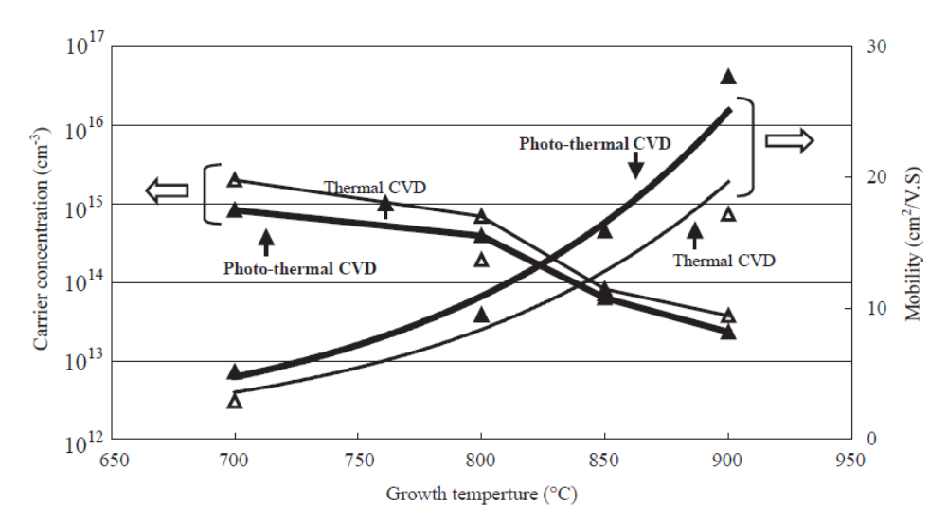
Figure 2-Direct comparison of Electric properties as a function of temperature of BP samples
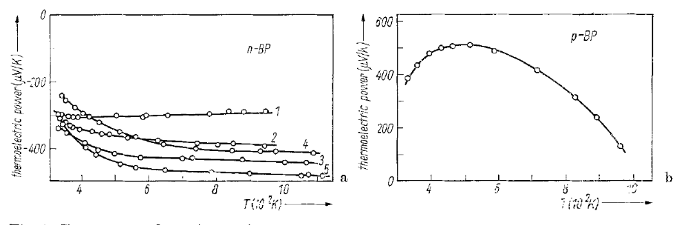
Figure 3- Thermoelectric comparison of p-type and n-type BP
The body of work encompassing boron phosphide varies widely. From early synthesis attempts that include a simple mixing of the elements to more modern synthesis using high purity precursors majority of the science of boron phosphide has yet to be discovered. The fundamental pieces of the puzzle are there: cubic structure, chemical inertness and wide band gap. The unique ability to be both p-type and n-type semiconductors without external dopants creates the possibility of a vast array of options for applications. To date, only three viable applications exist. And only one of this has shown overwhelming success. The science of BP needs to catch up with the material in order for the potential to be realized. The common problem with BP echoed in nearly all articles is the difficulty in preparation. From toxic and hazardous gases, to extreme hardness and inertness, what makes BP so attractive is also what makes so difficult to work with.
1.5 Boron Phosphide Characterization Techniques
Success in boron phosphide deposition relies on the comprehensive characterization of the deposited thin films. Analytical characterization provides useful information in confirming the presence of boron phosphide and the stoichiometric ratio. As previously discussed, other allotropes of BP are possible. Morphological characterization is useful, in that it can provide information on thin film nucleation and growth. This providing a mechanism of tailoring future experiments to achieve the desired crystal form. In orer to address the aspects of comprehensive characterization, several analytical tools and techniques were employed in this work provide feedback to enhance future experiments.
1.5.1 Raman Spectroscopy
As a screening tool RAMAN spectroscopy provides useful information regarding the presence of BP on a sample. The technique of Raman spectroscopy was developed in the late 1920’s when C.V. Raman wrote a letter describing the Raman effect. The Raman effect, is akin to other types of light scattering such as Rayleigh and Tyndall . Raman scattering is an inelastic type of light scattering where the molecule is changed by incident photon by a prescribed amount. The incident photon, typically a collimated monochromatic source most commonly a laser imparts energy to the target molecule. The molecule reacts to this energy influx by changing both its vibrational and rotational energy. Energy is conserved in this process , thus establishing that he energy of the incident photon must be different from the energy of the molecule. Quantitatively this relationship can be expressed by the equation
$${hv}_{i}-{hv}_{s}={ΔE}_{m}$$
Where ${hv}_{i}$and ${hv}_{s}$are the energy of the incident photon and energy of the scattered photon respectively. This equation forms the basis of the dual stokes and anti -stokes scattering common to Raman spectroscopy. If the sample molecule gains energy, then ${ΔE}_{m}$ is positive and stoke scattering predominates. In contrast, if the molecule loses energy, ${ΔE}_{m}$ is negative giving rise to anti-stokes scattering. Due to thermal dependency and inherently weaker signals, anti-stokes scattering is rarely measured. Selection rules for Raman differ from infrared spectroscopy in that a raman spectrum is generated from a polarizabilty process rather than a dipole moment shift. To examine this further, consider a molecule of interest placed in a electromagnetic field. The physical forces will align the electrons and the protons in a fixed relationship relative to the applied field. This induces a dipole moment shift in proportion to the strength of the applied field in the molecule. The equation below simplifies the relationship.
$$μ=αE$$
The dipole moment ($μ$) is the product of the polarizability of molecule multiplied by the electromagnetic field magnitude. Rearranging for polarizability gives the equation:
$$α=μ/E$$
or the dipole moment divided by the applied field magnitude. Therefore the polarizability can be described as the transient misshaping of the molecule’s electron cloud by the applied field. A molecule must have this polarizabiltiy change to be raman active. This leds to one of the advantages of Raman over infrared. Water weak signatures in raman bands compared to the infrared where it predominatres the spectrum.
Raman spectroscopy instrumentation is straightforward. The typical se up involves a laser source in a specified wavelength. The most commonly used excitation wavelengths broad applications include the 488 and 514.5 nm argon–ion lines. With the advent of solid state lasers, other wavelengths are much easier to be achieved are currently being explored. One disadvantage to Raman spectroscopy is the scattering is dependent on the excitation wavelength. Raman scattering decreases to the fourth power of the excitation wavelength. Therefore, an inherent lower scattering is observed in the shorter wavelength lasers. Of course this is a generalization and special sample configurations and matrices may necessitate going longer wavelength lasers. Aside from the source, other notable aspects of Raman instrument design include the a 90 degree orientation of sample from the source and specialized optics to further refine the incident light, and final y detector of some type. This can be a CCD or

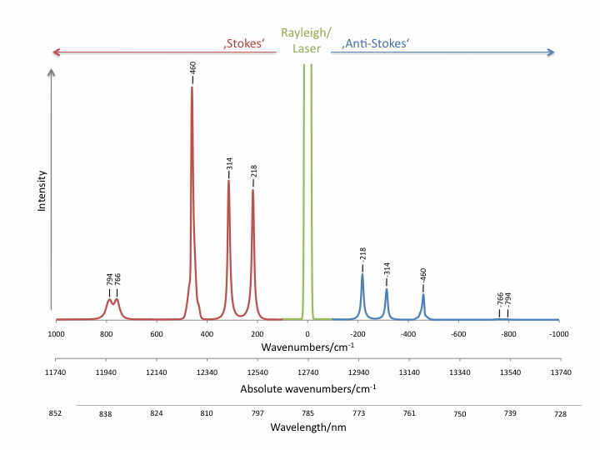
Figure 4. sample Raman spectrum showing stokes and anti-stokes scattering

photomultiplier tube. Figure 5 shows a schematic triple monochrometer Raman spectrometer utilized in this work. The key difference in the triple monochrometer from a more typical single monchrometer is resolution and range. The cost of a triple stage instrument is analysis time. However, for normal material analysis, analysis time is a non-issue. Raman spectroscopy is applicable to a variety of sample matrices. Solids, liquids, and high pressure gases can all be probed via Raman spectroscopy. When analyzing bulk samples, Raman spectra can provide useful information in the area of fingerprinting. By taking advantage of the sharp bands typically y associated with pure samples, Raman spectroscopy can be used to identify unknowns by direst comparison to cataloged spectra of known compounds. Additional aspects of bulk Raman techniques apply to crystallography. Bulk Raman analysis can be used to determine crystal vibrational modes as well as provide insight into crystal order and phase transitions. Crystal defects can also be probed via Raman by comparing spectra results to known ordered systems. More specific to materials analysis, Raman spectroscopy can be coupled to a microscope to achieve higher resolving power on the order of a few microns. This microscope coupling allows much more focused analysis in solids and thin films which can be used to understand individual grains and grin boundaries in solids. microfocus Raman can even be sued to gauge inherent strain in materials by small shifts in the peaks coupled with line broadening. With analysis capability at both the bulk and microscale, Raman spectroscopy can be a powerful tool for materials analysis.

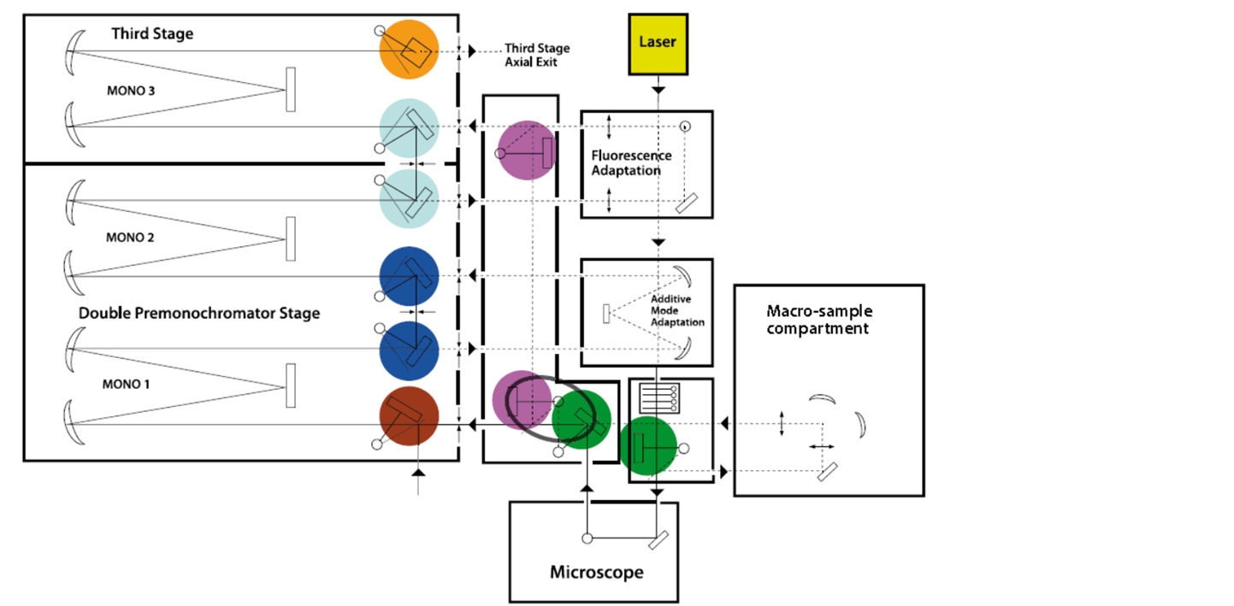
Figure 5. Sample schematic of a triple monochrometer Raman spectrometer

1.5.2 X-Ray Diffraction
The structural information obtainable from Raman spectroscopy is somewhat limited in depth. Strictly controlled analyses must be performed in order to properly interpret he subtle signatures associated with probing crystal structure with Raman spectroscopy. It is often necessary to use a much more definitive technique to examine crystal morphology. One of the most widely used tools in this area is X-Ray diffraction (XRD). One of the big advantage XRD offers over other techniques aimed at examining crystallinty is that is nondestructive. XRD can be used form most materials, but sensitivity scales with Z. low atomic number materials can be problematic in terms of low intensity. The type of information from XRD tends to vary, based on the material and matrix of the sample being evaluated. Generally, XRD probes crystal phase in materials and XRD spectra can be used to garner information regarding grain size, epitaxial relationship, preferred orientation, and defect propagation.
XRD works on the concept of x-rays interacting with an array of atoms. In an orderd crystalline solid, the diffraction of the X-rays will differ in alternate directions as a function of the ordered arrangement of the atoms. This interaction leads to a relationship between the wavelength of the x-rays the empty space between the crystal lattice planes and the angle of the impinging x-ay. This is known as Bragg’s law and is defined by the following equation:
$$λ=2dsinθ$$
Therefore, diffraction is only observed when the detector is positioned at the diffraction angle of 2θ. Refer to figure 6 to see an example of XRD in ordered solids. The sample must be positioned such that the a defined crystal plane is coplanar with the X-rays in order that the angle between the incident X-rays and the diffracted x-rays is equal to the Bragg angle which

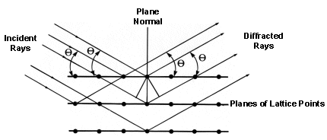
Figure 6. Figure showing the position for the incident and diffracted X-rays in XRD as well as the interaction angel of an ordered crystal

can be determined by the equation above. Consider the simplest crystal structure, a single face centered cubic structure. In this system there is only one set of conditions equal to the Bragg angle. However, in more complex systems such as polycrystalline films or amorphous solids, there is a distribution of orientation possible. As crystal systems are more ordered, the number of possibilities that satisfy the Bragg condition lessens and more information on sample crystal phase, strain and preferred orientation can be gleaned from the spectra.
Thus far, the previously described methods of materials analysis have been purely spectroscopic in nature. The information available from spectroscopy is rich, there is no substitute for visual analysis in material synthesis. Visual analysis allows one to quickly see the fine structure of a crystal or thin film and to qualitatively determine its pedigree. Some of the most powerful materials analysis techniques combine aspects of visual analysis and spectroscopy, a brief mention of some of these techniques will follow later in this chapter. The term visual analysis can mean a variety of different things. Bulk visualization with the naked eye is not sufficient for meaningful analysis. The information critical to material characteristics exists only at the microscale and below.

1.5.3 Scanning Electron Microscopy

Electron microscopy is a valuable tool for materials characterization because of the depth of information available in one tool. Modern scanning electron microscopes (SEM) can achieve magnifications of 30,000X, which can allow visualization of particles in a massive 1cm to 50 nm range². SEM’s also have a high depth of field, allowing a wide area to be in focus at one time, and high resolution that allows information rich areas to be magnified.
Generally speaking, scanning electron microscopy works by rastering the surface of interest with a beam of high energy electrons. The beam originates from a source called a gun and passes through a set of optics and coils designed to condense and focus the beam on the sample^{2.} Once the electron beam impinges on the sample surface, a number of interactions take place that can be detected and an image produced. While high-energy electrons can pass through thin samples with little or no interaction, SEM analysis relies on the elastic or inelastically scattered electrons and radiation produced by inelastic scattering to produce the desired information

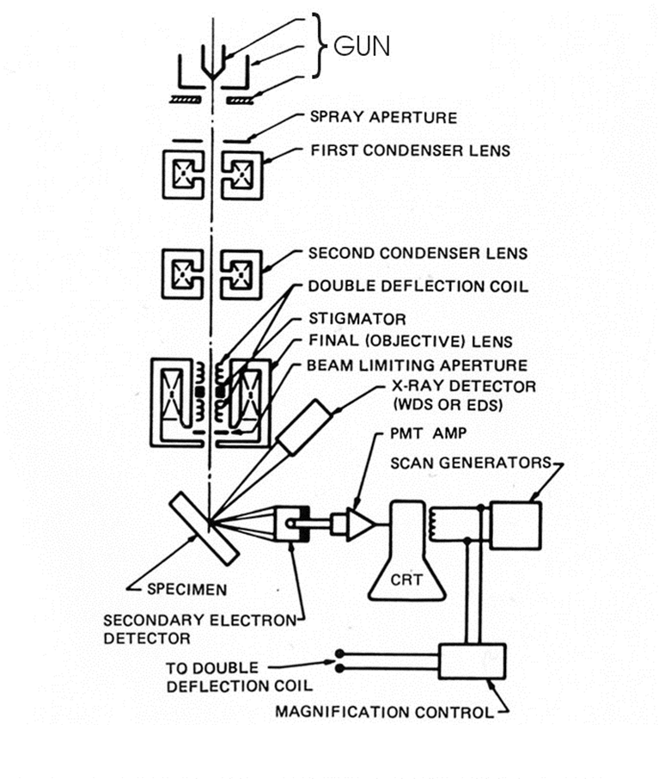
Figure 7. Schematic of a SEM's major components

The interactions typically used in image creation can be seen in figure 8 in. Bremsstrahlung X-rays are not specific but a form an energy continuum from very low energy to the energy of the incident beam. This creates a characteristic background radiation that can mask some of the characteristic X-rays. The beam quality is dependent on the energy of the incident beam, the interaction volume in the sample and the orientation of the volume with respect to the incident beam. Asymmetry in the interaction volume will produce an askew image. To produce an image, each of the aforementioned interactions are detected independently and have specific resolution with Auger and secondary electrons producing the highest resolution followed by backscattered electrons, cathodeluminescence, and lastly Bremsstrahlung2.

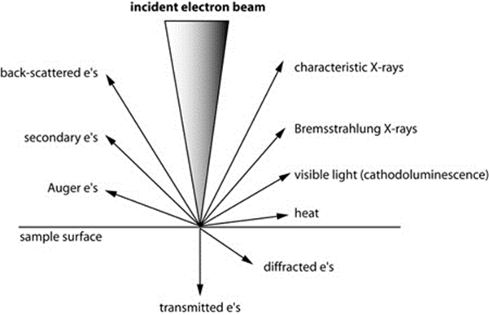
Figure 8. Cartoon depicting likely interaction from an electron beam in SEM

1.5.4 Transmission Electron Microscopy
Transmission electron microscopy (TEM) is another powerful technique used for materials analysis. It is similar to SEM in that both techniques utilize electron beam to probe the sample. The primary difference of TEM is that the beam energy is not terminated on the sample surface, but rather passed through or transmitted to the sample. A series of complex magnetic (see figure 9) lenses direct the resultant energy relaxing processes and direct them to a centralized detector. TEM provides excellent spatial resolution, and this s one of primary advantages of the technique. The high spatial resolution is achieved in TEM by the highly focused electron beam used to probe the sample. The wavelength of the incident electrons is exceedingly small and the beam is only directed at a micrometer spot on the sample. The result is a probing electron beam much smaller than other techniques including visible light or X-rays. With a smaller probe, the space between the atoms becomes much more apparent. High spatial resolution of TEM also comes about by only examine extremely thin samples. Typical sample thickness for TEM investigation is on the order of a hundreds of microns. The thin samples reduce beam dilution thus retaining a more coherent probing beam. In addition to providing visual imaging at the nanometer scale, the focused electron beam of TEM can be used for a variety of scattering techniques that can provide more detail in terms of chemical composition and crystal quality.
1.5.4.1 EELS Electron energy loss spectroscopy is a tool affixed to a high number of TEM’s; it can provide chemical composition information interactions with the electron clouds of atoms. When the electron beam scans across an atom, it experiences elastic scattering with heavy species such as atomic nuclei and an inelastic process with the tightly bound inner shells or more loosely bound outer electron shells. The energy in these reaction is sufficient to promote the electrons to the next higher level or completely eject from the atom.
For clarification, consider the spectrum in figure 10. Here electron intensity is graphed a s a function of energy loss in units of electron volts. The tall peak at zero is appropriately named the zero loss peak and refer to the electrons that have not experienced a degradation in their original intensity as a result of an interaction. The region of the spectrum from 1 to 50 ev contains a series of broad lines that correspond to inelastic collisions with the valence electrons of the sample. In regions above this chemical composition can be determined as ionization on the inner shells. The vacancies created by the ionization corresponds to the binding energy of the respective shell. The binding energies of the electrons is known therefore the identity if the element can be deduced. In this manner EELS is similar to other techniques that rely on creation of vacancies like Auger electron spectroscopy (AES) and energy dispersive spectroscopy (EDS).

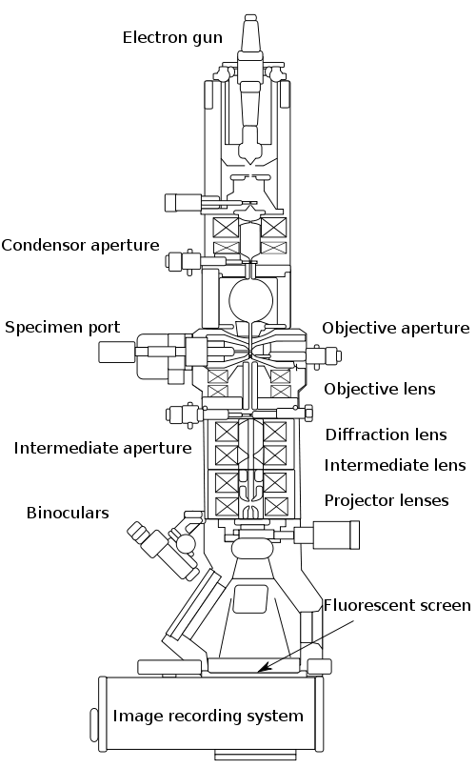

Figure 9. Schematic diagram of a typical TEM

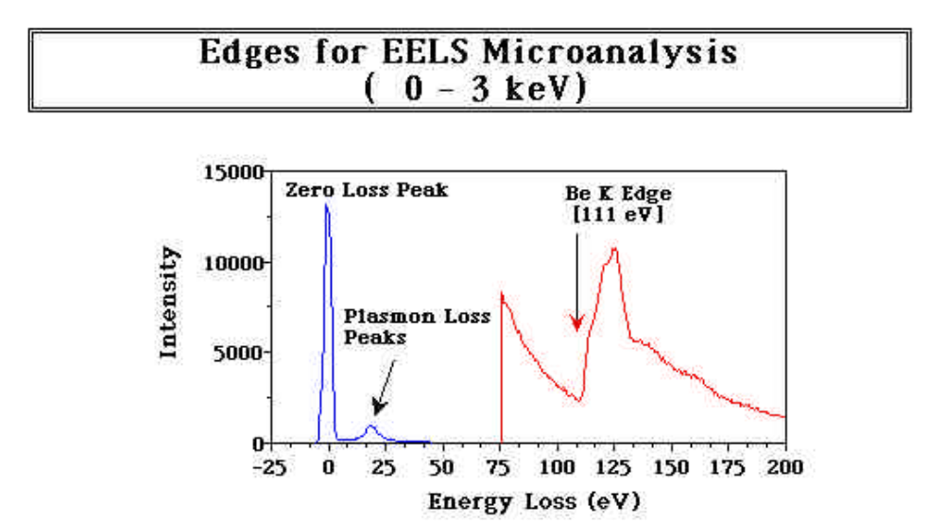
Figure 10. Sample EELS spectrum of Be depicting low and high loss regions

Modern TEM; typically operate in two modes: diffraction and image. Image mode is self-explanatory in that pictures of the sample characteristics are displayed on the screen. However, TEM operation in diffraction mode can be useful in determining crystal quality.
1.5.4.2 SAD
By realigning the objective lenses post sample and defocusing them to produce illumination at the sample and a series of spots is created on the screen. This pattern of spots is referred to as the selected area diffraction (SAD) pattern and is representative of the primary electron beam interacting with crystallites in the small area of interest. Image 11 shows a SAD pattern from a BP sample. The SAD pattern depicts the interface of the BP with the SiC substrate. Analyzing The alignment of the spots indicates the crystalline nature of the sample. In this case the BP diffraction pattern overlaps the BP diffraction pattern indicating an epitaxial relationship. SAD is also used to determine Bravais lattice and lattice parameters of crystalline systems.

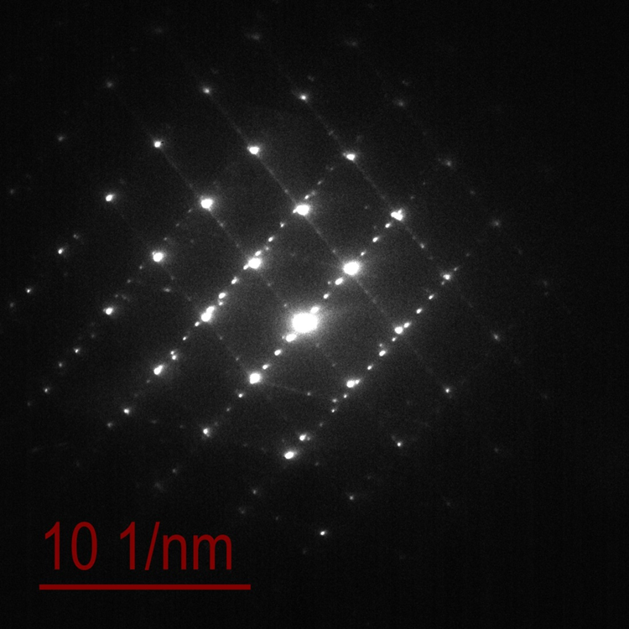
BP(111) & SiC(0004)
Interface diffraction
Figure 11. SAD diffraction pattern of BP on SIC. Showing epitaxial relationship

2.0 Growth of Boron Phosphide

2.1 Substrate Selection
One of the most important aspects of semiconductor deposition and growth is the reduction or elimination of growth induced defects. Defects are inherent to all materials and each specific material has its own unique set of characteristic defects. For clarity, it is important to note, that is impossible to grow a material in an epitaxial arrangement devoid of defects^{z}. There are two common types of vapor phase epitaxy (VPE): homo and hetero. Homo epitaxy is simply the growth of identical materials on top of each other. An example would be growth of 3C SiC on 4H Sic substrates. Despite being a different polytype of SiC, this is still considered homoepitaxy. The more common type of VPE, hetero epitaxy, refers to growing one material on top of another differing material. An example of this would be gallium arsenide (GaAs) deposited on Si.
2.2Epitaxy
For BP grown from the vapor phase, heteroepitaxy is the only suitable method, due to the lack of suitable BP substrates. One of the primary problems caused from heteroepitaxial growth is induced strain from ^{z} crystal lattice mismatch. The resulting strain relief processes often induce defects in the grown materials which can lead to deleterious device performance. Heteroepitaxial induce strain evolves in the grown films from two origins^{c}. The first, lattice mismatch has already been briefly discusses, the additional source for strain comes from differences in thermal expansion coefficients of the two materials. For most materials, differences in thermal expansions are secondary from lattice mismatch considerations^{z}. It is helpful in evaluations of strain differences to quantify percent lattice mismatch. This can be achieved by considering the unrestrained room temperature lattice constants of the two materials according to the equation:
$$ε_{o}=\frac{a_{e}-a_{s}}{a_{s}}$$
The sign of $ε_{o}$ defines whether the strain is compressive (a_{e} > a_{s}) or tensile (a_{e} < a_{s}). The above equation is meant as a guide to understanding the formidable technical challenges associated with heteroepitaxial deposition. There is not a set limit on the limitations of percent lattice mismatch. There can be epitaxial growth on material that exceed 14%^{z}. Epitaxy is a complex process affected specific materials characteristics as well as process parameters. Other factors that must be considered along with lattice mismatch in heteroepitaxial deposition include chemical compatibility, electrical characteristics if a device is being fabricated, and coefficient of thermal expansion.
Boron phosphide deposition is no exception to this. BP have been grown on a few substrates with the most predominate being Si. Kumashiro exclusively conducted depositions on Si substrates, believing that chemical compatibility surpassed lattice mismatch in growth of BP. Silicon is element 14 on the periodic table with a mass of 28.09 grams/mol, density of 2.32 g/cc. and melting temperature of 1414 C. Si forms a cubic diamond lattice shown in figure 1, is tetravalent in the ground state and an intrinsic semiconductor with a band gap of 1.12 ev .The room temperature lattice constant of Si is 5.43 A. A comparison of the lattice constants between BP and Si is considered using the equation shown above. Given the lattice constant of BP as 4.54 A, the computed percent lattice mismatch between Si and BP is -16.4% with the negative sign indicating tensile strain.

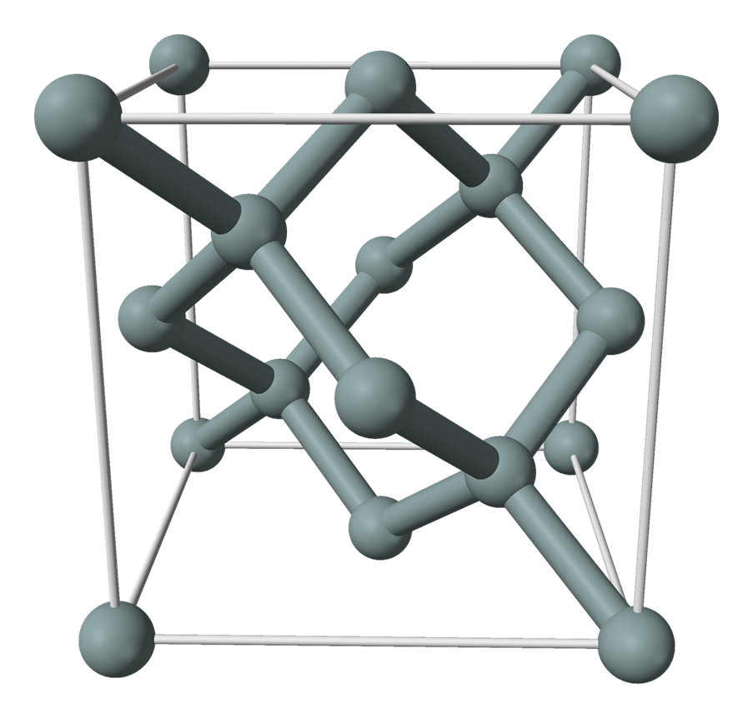
Figure 1. Silicon crystal structure

Using the lattice mismatch minimization approach to heteroepitaxy, Si very quickly becomes a less than ideal candidate for BP deposition . A more closely matched crystal lattice to BP is required. One material that satisfies these requirements is silicon carbide. Silicon carbide is a binary refractory semiconductor comprised of silicon and carbon. SiC has a density of 3.21 g/cc a molar mass of 40.11 g/mol and a melting point of 2,730 C. SiC is one of the hardest compounds second only to diamond with a hardness of 9.5 on the Mohs scale. The crystalline structure of SiC is complex as it forms numerous polytypes. The most predominate crystal representations of SiC are the cubic SiC often called β –SiC and hexagonal SiC commonly refer to as α-SiC. Figure 2-4 depict common SiC polytypes . The problem with this classical notation, is that it does not distinguish between the hexagonal polytypes of SiC. In order to do this, another convention must be used. The Ramsdell notation is a system developed to accurately describe the polytypes of SiC. It consists of a number followed by a letter (3C). The number refers to the number of atomic planes stacked before a repeat is formed and the letter designates the crystal structure. Therefore the 3C example would be 3 repeating layers and cubic structure. Although there are approximately 250 known polytypes of SiC only a few are common^{z}. The most common for research and industrial applications are 4H and 6H with 3C relegated to research settings. Other polytypes include 2H, 8H, 9R (rhombohederal), 10H, 14H, 15R, 19R, 20H, 21H and 24R.
Revisiting the notion of lattice constants, the room temperature lattice consent for 3C SiC is 4.36 A. Using equation 1, the percent lattice mismatch between BP and cubic SiC is therefore 4.1%. Lattice mismatch minimization is not limited identical crystal lattice types. For some systems, it is possible to have a small difference between hexagonal and cubic systems. One such example of this is the BP and SiC systems. Despite having a cubic polytype, 3C SiC is difficult to obtain in quality suitable for device fabrication. Most often, the 3C SiC that is available is grown homoepitaxially on 4H SiC or 6H SiC. Using the 4.36 A lattice parameter of 3C Sic previously reported multiplying this value by $\frac{\sqrt{2}}{2}$ in order to compensate for the differing aligning planes gives a value of 3.08 A. returning to equation 1 computes a percent lattice mismatch between cubic and hexagonal SiC at 3.25%. Crystallographic orientations play an important role in defining the success of high quality growth. Consider the hexagonal systems of SiC shown in figure 5. The three most commonly referenced planes and directions are shown for reference. The system is comprised of four primary axes designated a1, a2, a3 and a perpendicular axis called c. The a axes are exactly 120° apart. The (0001) plane or commonly called the basal plane of the SiC system is the focus of this discussion. The (1100) plane and direction as well as the (1120) and direction are shown for informational purposes only. The basal plane of SiC corresponds well the (111) direction of BP. His is shown in figure 6. Applying the same logic and using equation 1 to calculate the percent mismatch. The percent t lattice mismatch between 4H SiC and BP is 3.4%. Figure 7 shows the (111) direction in a cubic system for clarification.
2.2 Substrate Selection
The need to utilize custom substrates is not necessary as there are suitable options currently commercially available. By using commercial substrates, potential abnormalities associated with processing can be greatly reduced, minimizing additional variables in the process. Existing quality assurance methodologies minimize batch differences and differences in individual substrates and batches are minimized. The substrates leveraged in this work were Si and SiC wafers commonly employed in the semiconductor industry for patterning of integrated circuits.

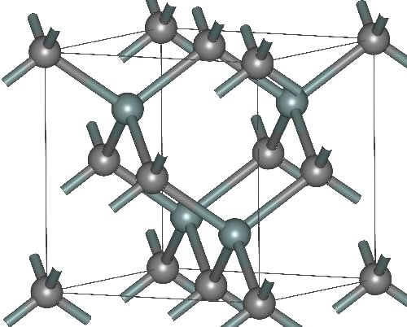
Figure 2. Crystal structure of 3C (β) SiC

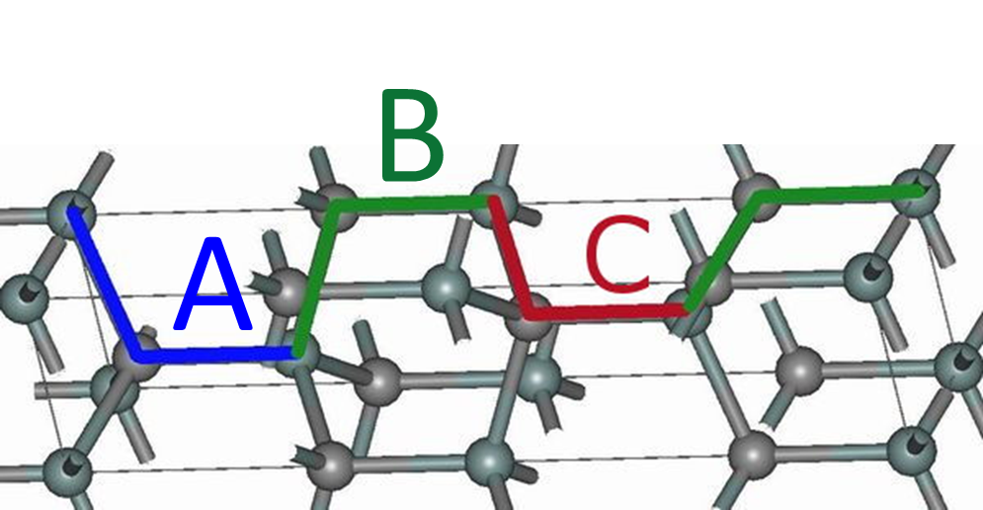
Figure 3. Structure of 4H SiC with stacking sequence

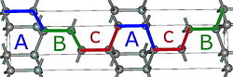
Figure 4. Structure of 6H SiC showing stacking sequence

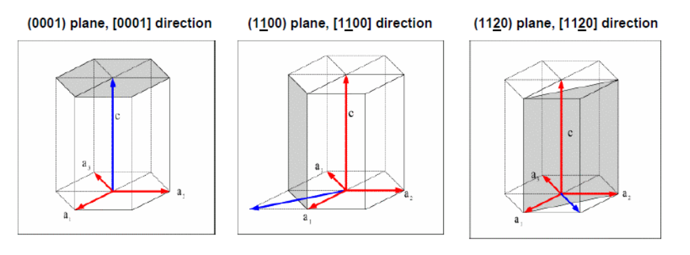
Figure 5. Hexagonal crystal structure of SiC. Showing the most commonly referenced planes and directions

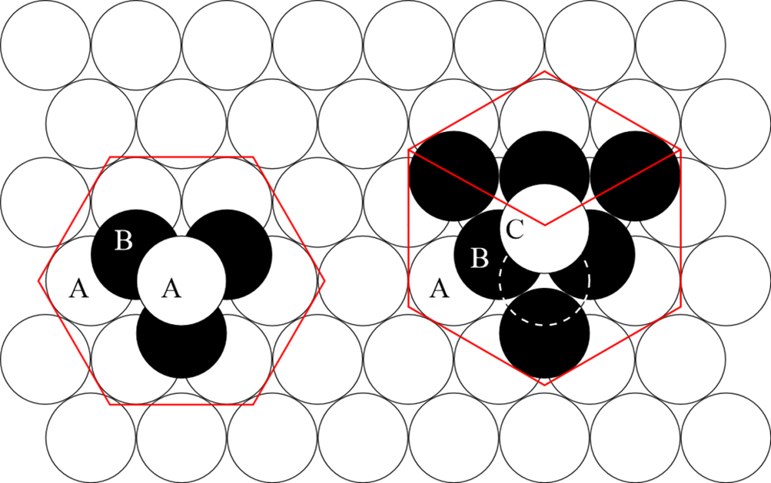
Figure 6. Image depicitng the basal plane of 4H SiC. With atom arrangement of a cubic crystal lattice

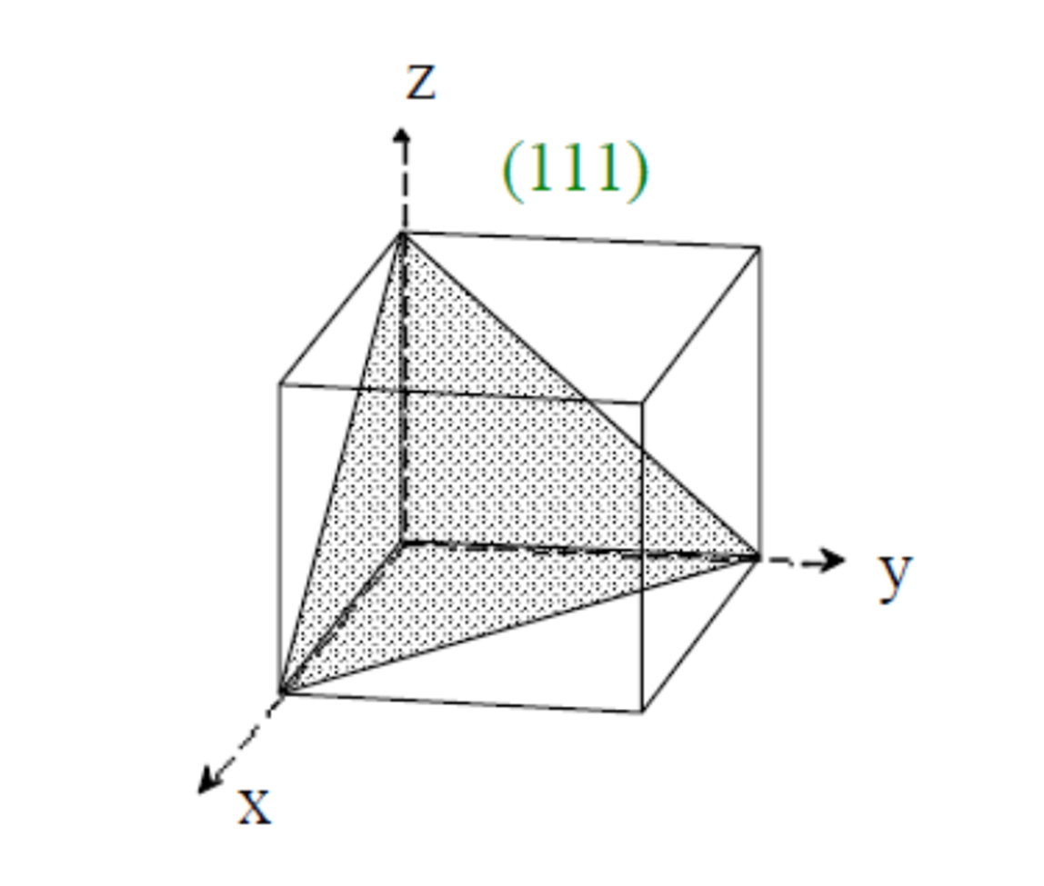

Figure 7. cartoon Depicting the (111) direction in a cubic system

2.2.1 Silicon Silicon wafers are available in a variety of different options. The most common end user specified parameters include diameter, dopant concentration and surface orientation. Each category has its own set of commonly available options. Silicon wafer diameter varies from1’’- 3’’ ideal for most research and development applications; to 18’’ for larger scale industrial processes. Dopant concentration in silicon wafers depends on the intended use of the wafer and whether or not a p-type wafer or n-type wafer is required. Typical dopants for Si wafers include boron, phosphorus, arsenic, antimony and gallium. Typical dopant concentrations in Si wafers range from 10¹³ to 10¹⁸ atoms/cm³ and can be introduced to the Si in a variety of techniques including but not limited to vapor phase epitaxy (VPE), photolithography, diffusion, or ion implantation.
Crystallographic orientation is the last commonly specified parameters of Si wafers. It refers to the order of the crystal planes on the wafer surface. This is typically specified by Miller indices. A brief description of miller indices is provided earlier in this chapter. The most common surface crystallographic orientations for Si wafers are [100] or [111]. Communicating crystallographic orientation to the end user is extremely important in wafer since surface characteristics often partly define the processing steps necessary for device fabrication. In order to address this, a convention was created to establish reference points on the wafer and guide the end user in the direction of ordered planes. To do this, flat areas are cut into the wafers at two places. Figure 8 below shows an example of a wafer orientation system. The flats are different sizes delineated the major and minor flat or the primary and secondary terms are often encountered in literature.
The silicon wafers leveraged in this work are 4’’ diameter wafers from Wacker Siltronic Corporation. The specified resistivity is .009-.020 Ω-cm and are doped with phosphorus and boron. Thickness of the wafers is given in micrometers and ranges from 375-425 µm. Crystallographic orientation in [100] Figure 9 shows an image of the Si wafers. Note that these wafers are supplied with a primary flat only this is a result of the [100] orientation shown in figure 10.
2.2.2 Silicon Carbide The primary subject of this work is the use of SiC substrates to minimize the lattice mismatch between the BP film and SiC substrate, the use of Si wafers will be expounded upon in the section addressing w deposition on Si. Similar to the Si wafers, high quality SiC wafers were used supplied from Cree Inc. and Aymont Technologies. In order to identify the best wafer or BP deposition, several different orientations were used. A description of each will be provided. The other parameters of the SiC were held constant. The as received Cree Inc wafers were all 3’’ nitrogen doped 4H wafers with resistivity’s of 0.024 Ω-cm. Small variations in thickness were observed but ranged from 348-372 µm. Surface preparation of the SiC wafers were varied as a result of experimental observation. Surface preparation was alternated between Si terminated polished and carbon terminated polished. The Aymont wafers used were 6H on axis wafers Si terminated polished. Resistivity was not specified for the 6H wafers.

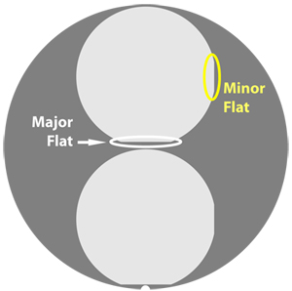
Figure 8. Picture of Si wafer showing primary and secondary flats

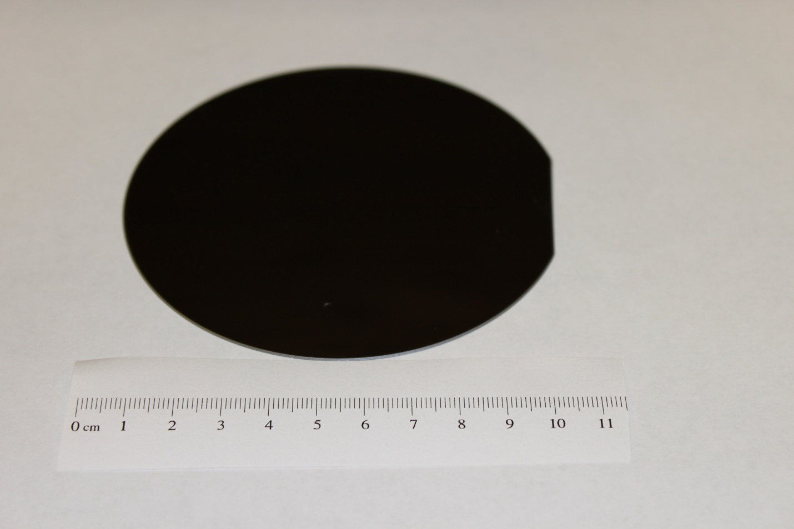
Figure 9. 100 mm Si wafer leveraged in this work showing primary flat

[001]
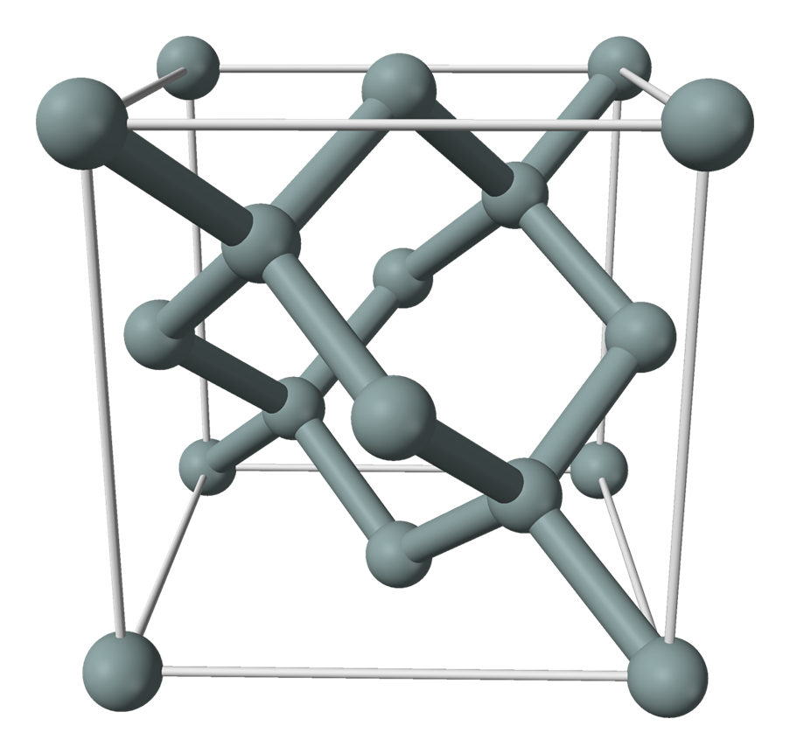
[010]
[100]

Figure 10 Si cubic unit cell shown with labeled planes and shaded (100) plane

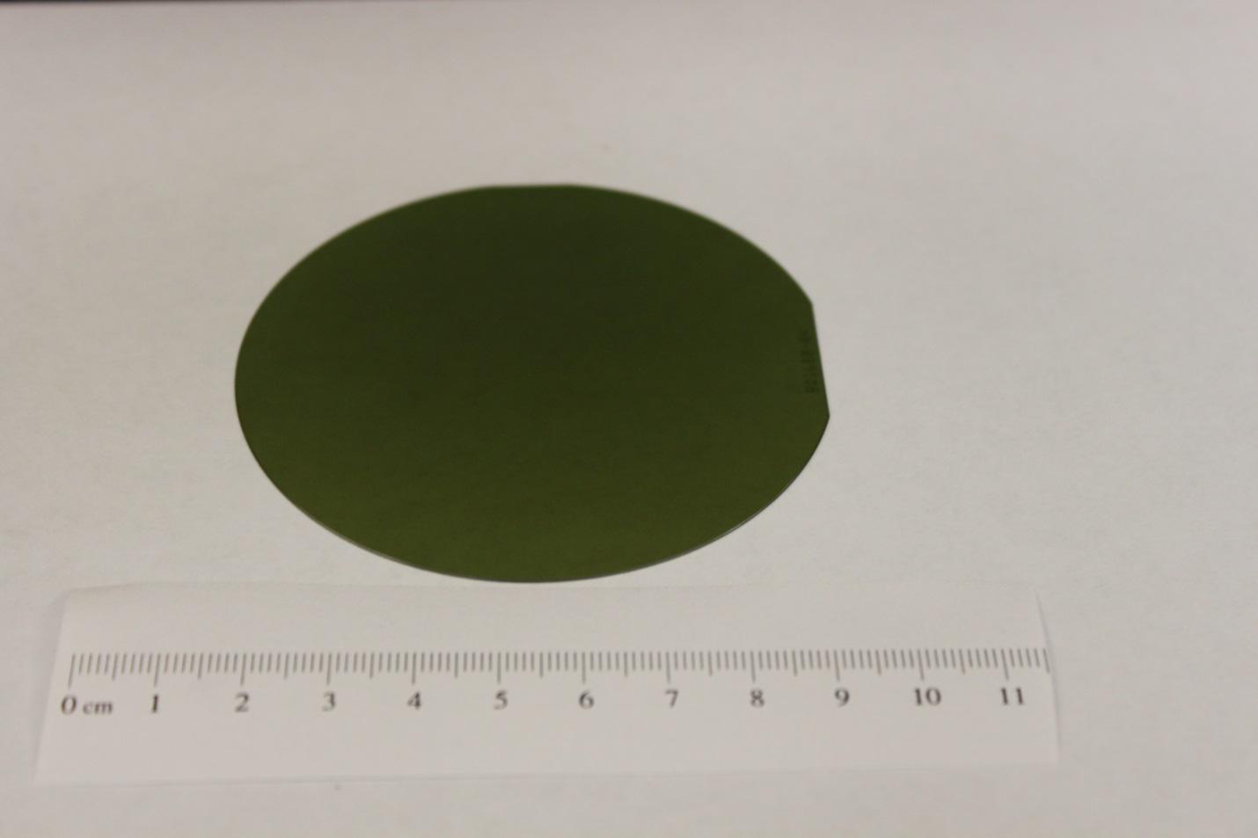
Figure 11 Image of 3'' SiC wafer from Cree inc.

As said before, wafer crystallographic orientation is an important aspect to consider in epitaxial growth. More often than not, the varying the orientation can allow one to tailor the growth in a specific direction, assuming all other variables is ideal. In addition to on axis (0001) orientation intentional offcuts were tried. Refer to figure 5. Intentional offcuts of 4° and 8° from the (0001) plane from the parallel of the [110] direction were used in targeted experiments to elucidate ideal thin films.

2.3 CVD of Boron Phosphide Thin films.
Boron phosphide tin films can be grown from a variety of different processes. Synthesis techniques applicable to this include chemical vapor deposition (CVD), physical vapor deposition (PVD), plasma assisted chemical vapor deposition (PACVD) and molecular beam epitaxy (MBE). Each process has its specific advantages and disadvantages and each of these must be considered prior to use. For applications involving thicker films over 5 μm, CVD is most advantageous, in that it can provide higher and more controllable growth rates compared to PVD and MBE. Higher growth rates become an Important factor when considering BP thin films for neutron detectors. Using the boron reaction presented in chapter 1, the Q value associated with that reaction is an average of 2.5 ev. This comes from the branch reaction of 10B shown in figure 12. The value for the most abundant reaction is 2.31 MeV. The Q value is the energy output from the reaction of the nuclide with an incident thermal neutron. The higher the Q value, the more energetic the resultant species are and the ability to discriminate from background gamma energies and x-ray is greater. To achieve a high thermal neutron detection efficiency, a thick film of BP will be required. A film of 200 μm should provide sufficient absorber to convert 95% of incident thermal neutrons to electron hole pairs. In order to supplement these results, a Monte Carlo simulation algorithm MCPNX was used to theoretical examine an ideal detector of BP. A model was constructed, shown in figure 12. A 1 cm X 1cm planar arrangement of BP was constructed. Thickness of the BP layer was varied while keeping all the variables static. The results of the simulation are shown in figure 13 on a plot of intrinsic efficiency verses thickness. The results shown in in figure 13 are consistent with the idea of hundreds of microns will be required to achieve a high intrinsic efficiency. The results of this model dictate the methodology employed to deposit the BP thin films. In order to achieve hundreds of microns of high quality BP, a technology must be used to that allows for moderately high deposition rates. This requirement eliminates most thin film deposition techniques such as sputtering and PLD.
With moderate throughputs, excellent throwing power and conformality, chemical vapor deposition is the most advantageous technique in growing thick high quality films of BP. A brif discussion of the basics of chemical vapor deposition will be provided in this section. For a more complete discussion, please refer to Appendix A.
As its name implies, CVD is a process to deposit substance on a substrate via a chemical reaction on the substrate surface. For most CVD processes, a volatile chemical typically in the form of a gas, but liquids with high vapor pressure can also be used, is used to deposit a nonvolatile substance on the substrate. CVD has become popular in industry because of the advantages it offers over other techniques. In addition to superior conformality and throwing power, CVD is a highly adaptive technique that can be easily customized to fit a variety of different precursors and deposition rates. This is evidenced by the

α+ ⁷Li + 2.310 MeV
¹⁰B + n_{th} (0.025 eV) [ ¹¹B*]
α+ ⁷Li + 2.792 MeV
6%

94%

Figure 12 Figure showing boron 10 branching ration and abundances with reaction of thermal neutron

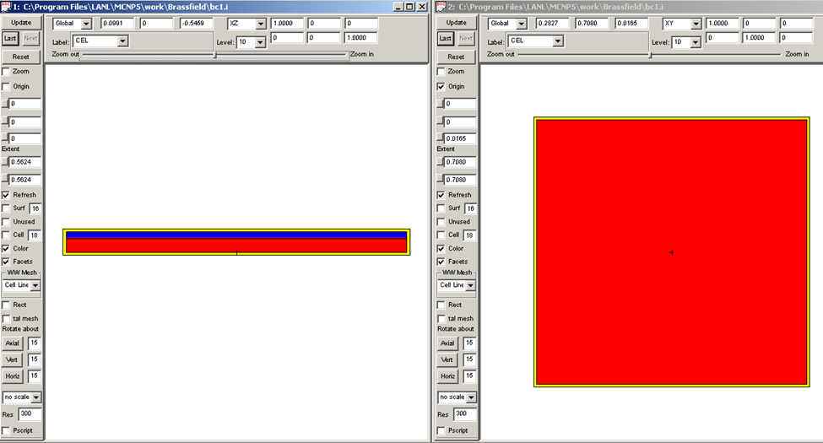
Figure 13. MCPNX simulation model of a 1X1 cm planar BP (blue) layer on a SiC (red) substrate.

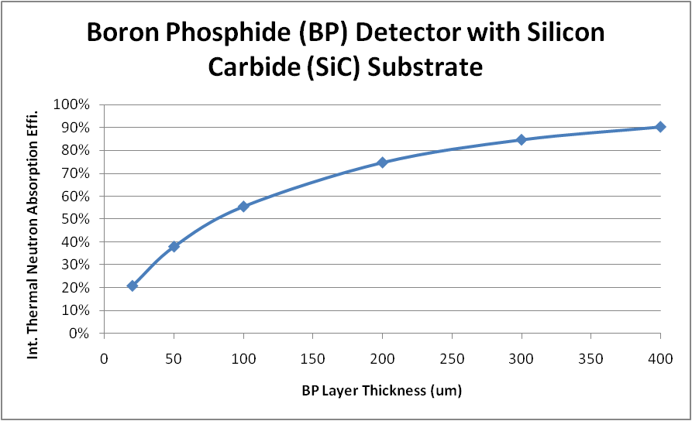
Figure 14. Results from MCPNX BP detector simulation. Showing intrinsic efficiency verses BP layer thickness.

variants of CVD that have become popular in science and industry. Some of the more common variants include low pressure CVD (LPCVD), atmospheric pressure CVD (APCVD), both of these highlight the ability of CVD to best used over a wide range of pressures. In addition to pressure modulated CVD, other common variants include plasma assisted CVD (PACVD) and laser enhanced CVD (LECVD). These CVD variants are truly hybrid techniques where the primary pyrolysis method which is usually some form of thermal degradation is augmented with a plasma arc or laser. These techniques are most useful in CVD processes where elevated temperatures can have deleterious effects the substrate of choice. Fundamentally, CVD is the flow of gas over a heated substrate to break down the constituents of the gas and allow them to react to form the desired compound. A diagram summarizing CVD process can be seen in figure 15.
Figure 15 illustrates the complex nature of CVD and the many aspects of the process that need to that need to be individually considered in order to achieve success Some of these global concepts include: mass transport of precursor to the substrate, thermodynamics of desired reactions, and surface science of precursor on the substrate surface.
Concepts of mass transport in CVD primarily address the transports of gas or vapor from the source to the point of deposition. Concepts of laminar flow, viscous flow and diffusion become important in supplying sufficient material for reactions to transpire. Reaction thermodynamics directly address the feasibility of the proposed process and is often the first step in a CVD experiment. Closely related to thermodynamics is reaction kinetics, which plays a role in the time scale of the reaction which is proportional to the growth rate uniformity of the resultant film. Surface science considerations in CD vary widely and can refer to substrate temperature and surface energy, substrate orientation and surface preparation.
As expected, CVD of boron phosphide thin films adheres to the same specific set of considerations outlined above.

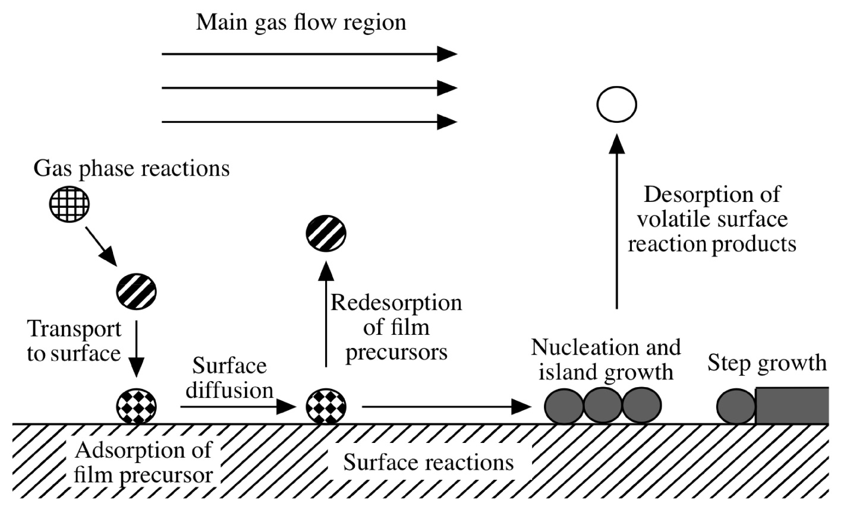

Success in CVD necessitated the proper design and construction of a CVD reactor. A well designed reactor balances precursor gas flow, temperature, pressure and sample orientation to achieve a high quality product. For the most part, CVD reactors tend to be customized to for the application. An example of this is the differences between CVD reactors for research and those intended for high throughput. The most obvious difference is size. Research CVD reactors are small with small sample sizes. Industrial reactors are large and can hold hundreds of wafers. Research reactors tend to be much more adaptable and configurable to accommodate changes to process parameters, where industrial reactors are very controlled to perform one function. With that said, there is one far-reaching design in CVD reactors that is widely used. That is the tube design. Since the early days of CVD process development, a tubular design has been the foundation for much of the CVD research today. The reason is simplicity. Unlike more complex designs, the gas flow dynamics associated with simple tubes is strait forward. With a few simple calculations it is possible to gain a reliable approximation of the nature and behavior of the gases in the reactor. For a more through treatment of the specifics mass transport in CVD refer to Appendix A.
2.4 CVD Reactor Design
2.4.1 General Design Considerations
A custom chemical vapor deposition reactor was constructed for III-V semiconductor deposition. A conceptual drawing of the proposed reactor is shown in figure X, followed by a photograph of the actual system in figure X. Some discrepancies can be noted, but the major most of the major elements are present. The reactor is a medium scale modified quartz tube reactor with a differentially pumped mass spectrometer. Careful consideration was paid to the following topics in CVD reactor design: gas purity, process automation and control, material compatibility and life safety. The following descriptions will detail the individual components of the CVD reactor.

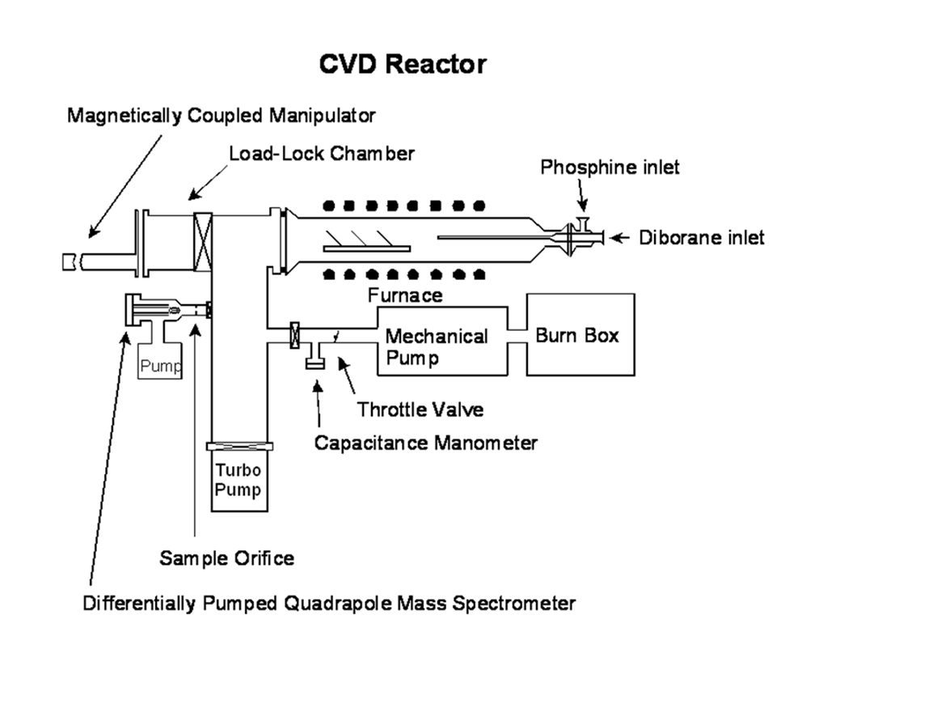
Figure 1. Conceptual design of CVD reactor for BP deposition. Showing major system components.

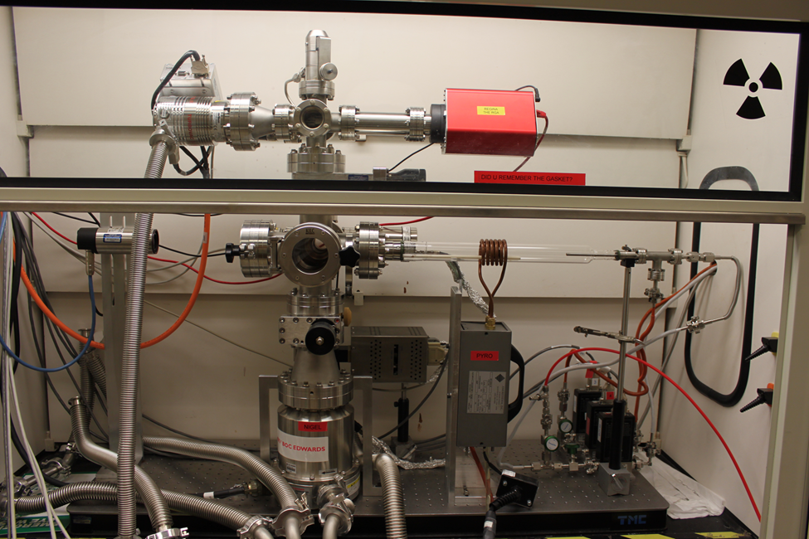
Figure 2. photograph of entire CVD reactor

The tube used in the BP reactor was a 21’’ inch long quartz tube with high vacuum flanges on both ends. The left end of the tube was comprised of a 2 ¾ SS Conflat flange. The 1 ¾’’ quartz section extended
from the conflat flange for approximately 21’’. On the extreme right side of the quartz tube is a 1.33’’ conflate flange. The tube narrows from a 1 3/4’’ ID to a ¾’’ ID. Please see figure X for an image of the quartz tube.
The quartz tube bolts to the housing. The housing consists of one 4.5’’ conflat six way cross which serves as the main pumping chamber. Directly attached to the main housing are two 2 ¾’’ conflat 6 way crosses. The first 2 ¾’’ cross is attached to the backside of the main housing as seen in in figure 3. This cross serves as the primary service ports. Attachments to this cross include a Huntington KF 40 manually operated all metal bellows seal valve. Which acts as the primary communication between the primary housing and the throttle valve. The throttle valve will be discussed under the section on pressure control. Also attached to this secondary cross included the MKS heated capacitance manometer. This gauge is the primary pressure gauge in the feedback loop associated with pressure control.
Directly on top of the main pumping housing, sits another 2 ¾’’ six way cross (See figure X). This cross creates a small pumping chamber for the differentially pumped mass spectrometer. Connected to this six way cross includes a Pfeiffer Prisma plus quadrupole mass spectrometer (MS). The MS is capable of measuring masses from 0-200 amu. Gas is introduced to the chamber via a Varian high vacuum leak

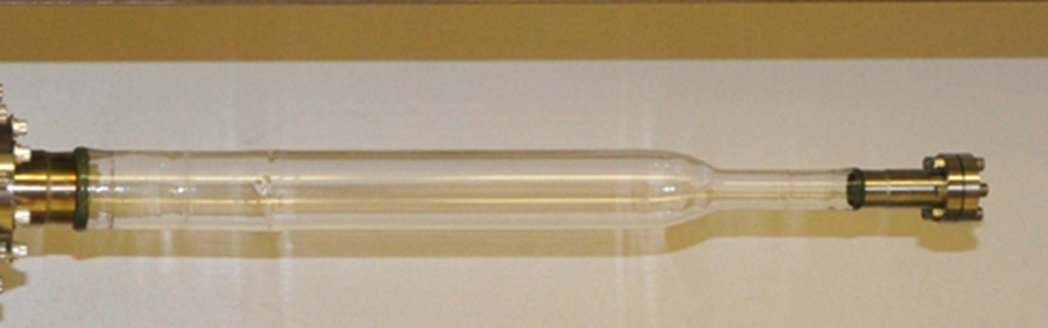
Figure 3. Photograph of quarts reactor tube.

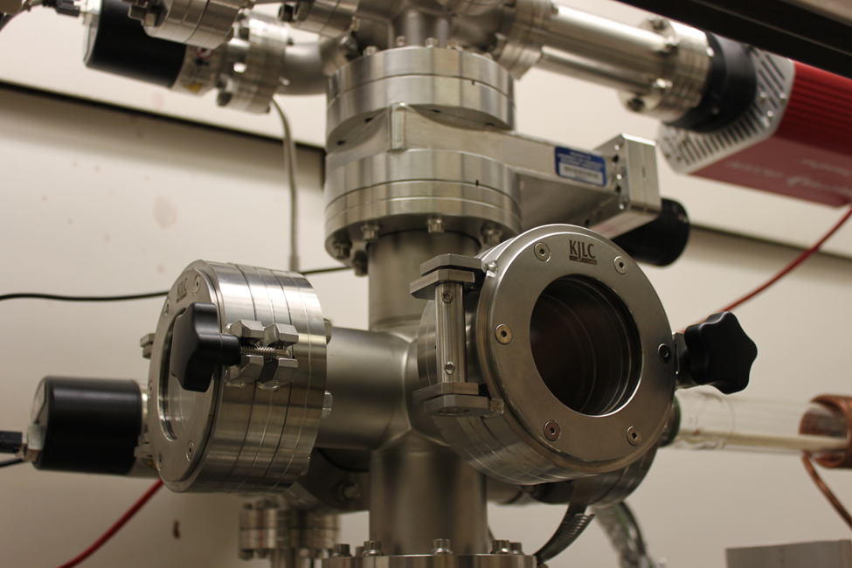
Figure 4. Zoomed in shot of the main pumping housing. Note Quartz tube placement in lower left of phot

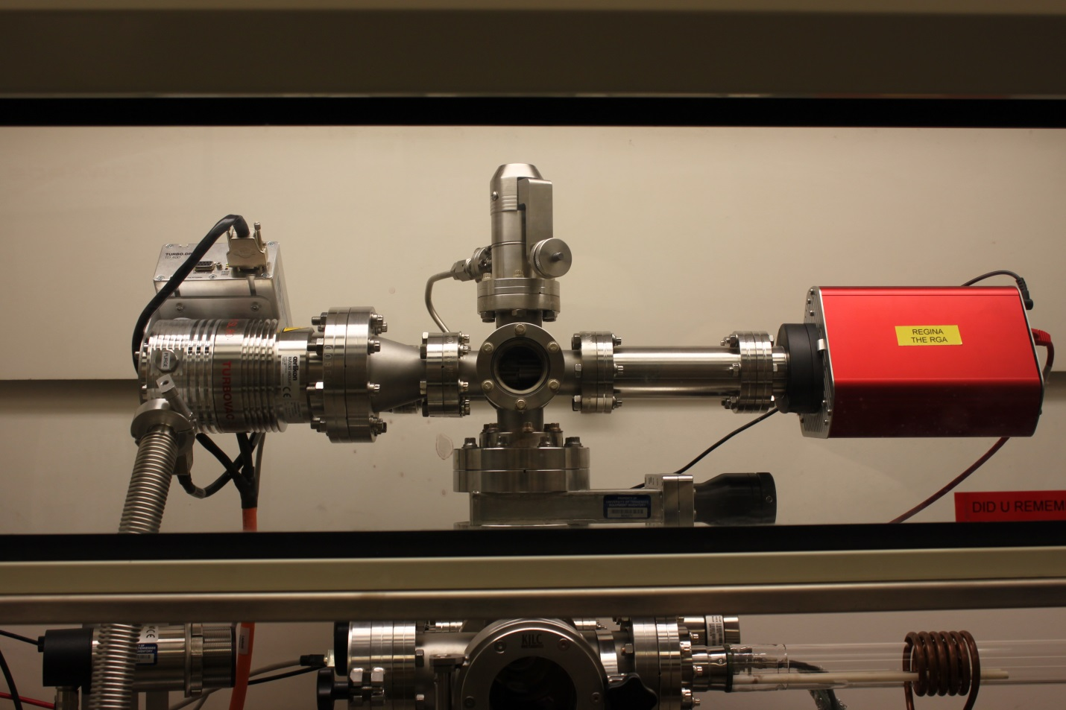
Figure 5. Photograph of differentially pumped MS chamber. Prisma plus in red on right and SL 80 Turbo pump on the left and leak valve on top

valve. This valve is the primary pressure regulator between the main pumping chamber and the MS chamber. The small volume allows the sample gas stream to be introduced but maintain the MS chamber pressure at approximately 10⁻⁶ torr. The chamber vacuum is supplied by an Oerlikon Leybold SL 80 turbo molecular pump. Vacuum level in the MS chamber is measured by a Leybold Penningvac PTR 90. The PTR 90 is a wide range gauge capable of measuring pressure from atmospheric pressure to 3.75 x 10⁻⁹ torr. Nominal vacuum in the MS chamber without the introduction of a sample gas stream is 3 x 10⁻⁸ torr.

2.4.2 Gas Flow
In approaching the design of the CVD reactor used in BP thin film deposition simplicity in was the underlying scheme A literature search showed that the most popular reactions for BP CVD was the pyrolysis of phosphine and diborane in a reducing atmosphere. The decision was made to emulate this proven reaction. A 1% solution of diborane in hydrogen and a 5% phosphine solution in hydrogen was selected as the gaseous precursors. The gases were balanced with high purity hydrogen for a carrier gas. The semiconductor gases supplied form Matheson Tri-gas are 99.999% pure UF cylinders with 7.6 L internal volume. In order to maintain high purity, all components wetted by the gases were made of cleaned 304 stainless steel. In areas where metals were not feasible such a valve seals, compatible polymers such as Kalrez and Viton were used. All fittings used in the process piping of the gaseous precursors are high purity face seal fittings. Swagelok VCR components were used to connect process lines. Connections to gas cylinders were also high purity face seal type. CGA 632 fittings were specified on the phosphine and diborane cylinders. Figure 6 shows example position of both sets of high purity fittings. In addition to high purity fittings additional equipment was used to ensure process cleanliness. All process gas supply lines were outfitted with cross purge assemblies; a specific configuration of valves

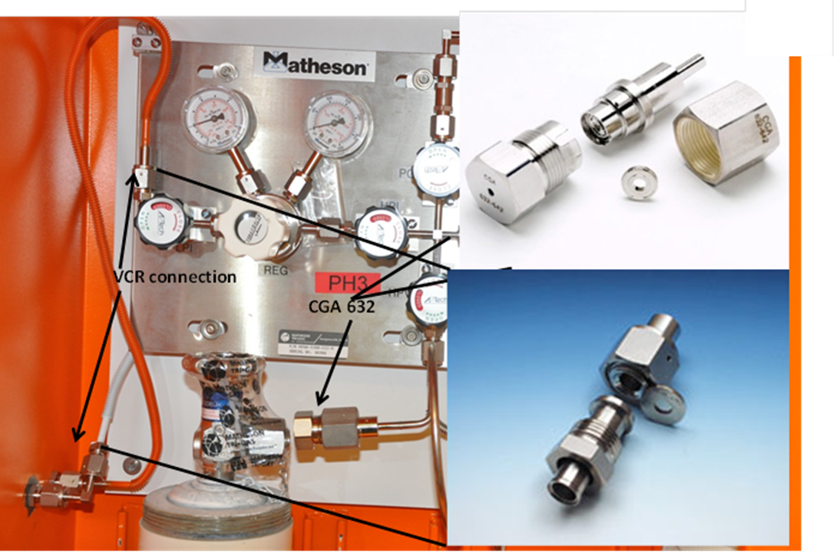
Figure 6. Precursor gas handling system. Showing high purity fittings position and components

and piping that allows atmospheric contaminants to be purged from the supply line one a connection has been made. Refer to figure X for an image of a standard cross purge assembly.
Maintaining purity is a major challenge in CVD processes. Most often atmospheric constituents such as moisture and oxygen are deleterious to CVD in that these products will react with the precursor gas and form unwanted oxide layers on the substrates. In order to effectively eliminate these species, an effective vacuum pumping system must be established. The main chamber and associated sub- chambers are all constructed from vacuum tight components such as Conflat flanges and Kwik flange vacuum tight fittings Figure 8 shows renderings of both types of vacuum flanges. The gas tight chamber must be cleansed of its atmosphere prior to the introduction of the reactive gases. This is done by a series of vacuum pumps.

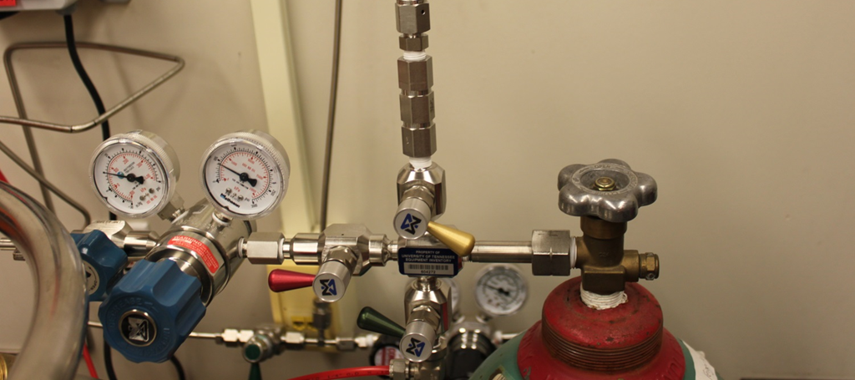
Figure 7. Photograph of Cross purge assembly with attached high purity regulator

.
2.4.3 Pumping
Dry pumping was chosen to help maintain system purity. Dry pumping is an attractive alternative vacuum pump design that does not rely on oil to entrap the gas and eliminate from the chamber. One of the most common designs of dry vacuum pump is the scroll pump. These pumps are roughing vacuum pumps capable of an ultimate pressure of 10-3 torr and work by entrapping gas between a fixed and orbiting scroll. As the gas is entrained in the pump, it is compressed and squeezed out the pumps’ exhaust line. Refer to figure X for a typical scroll pump mechanism. The CVD system employs one other type of roughing pump and that is a roots blower. These pumps use a series of precision mounted rotating lobes to pump gas. The lobes vary in size from small to large and are referred to as stages. A conceptual rendering of a roots type pump is shown in figure 4.The roughing pumps used in this work consist of an Edwards XDS 35i, Edwards nXDS10i Adixen

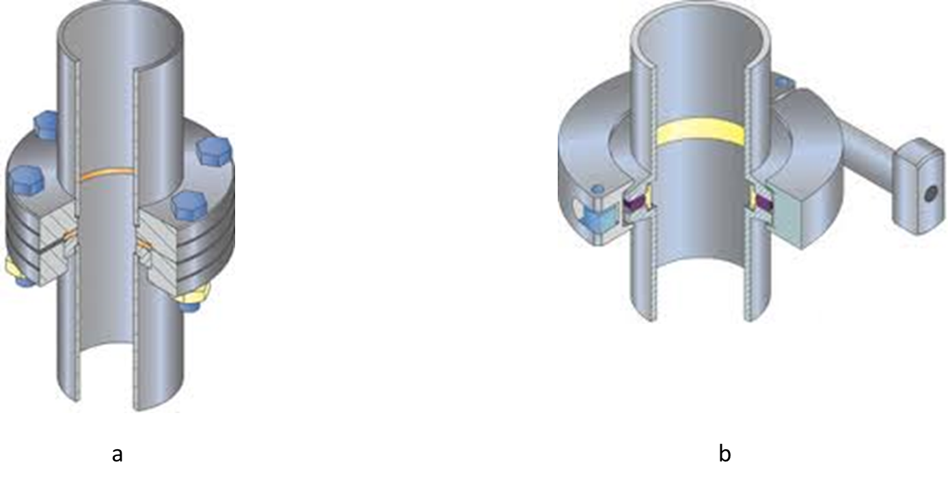
Figure 8. Renderings of Conflat (a) and Kwikflange (b)

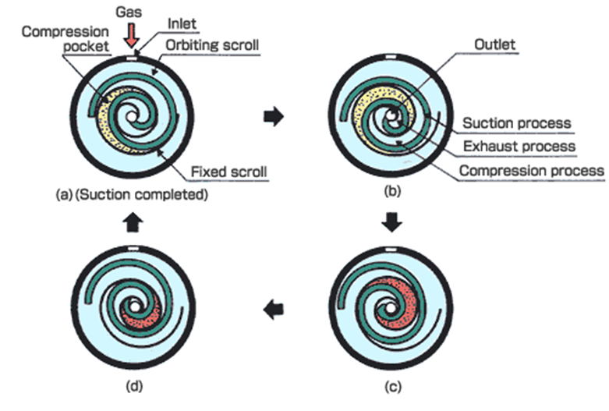
Figure 9. Images of scroll pump concept

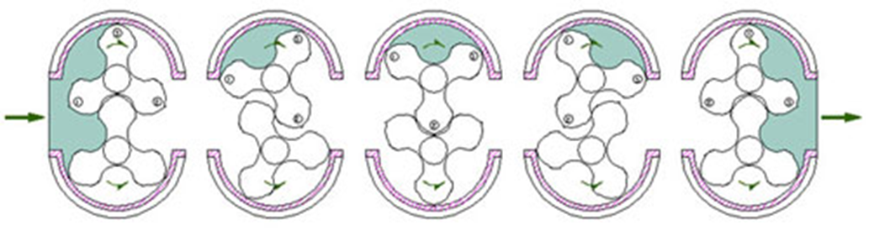
Inlet
Exhaust

Figure 10. Figure showing roots pumping system

ACP 15. The Edwards XDS35i serves as the main pump on the system and communicates directly to the main housing via a 1’’ diameter SS bellows. The XDS 35i is capable of pumping speeds to 21 ft³/min and an ultimate pressure of 8 X10-3 torr. This pump is equipped with a gas ballast adapter which allows the introduction of an argon purge at 3 SLPM. The nXDS10i is a smaller updated version of the 35i. It is capable of a maximum pumping speed of 6.7 ft³/min and an ultimate pressure of 5 x 10-3 torr. This nxds pumps serves in dual capacity as the roughing pump on the MS chamber as well as the backing pump on the SL 80 turbo molecular pump serving the MS chamber. The Adixen acp 15 serves in a limited capacity on the CVD system. Its primary goal is to back the main chamber turbo molecular pump which will be discussed in detail below. The acp 15 is capable of a maximum pumping speed of 8.2 ft³/min and an ultimate pressure of 2.2 x 10⁻² torr. Photographs of the Edwards and Adixen roughing pumps are shown in figure X.
Rouging pressures of approximately 10⁻³ torr are not sufficient to adequately eliminate the atmospheric contaminates from the chamber. Another type of pump is required to eliminate the majority of water and oxygen from the chamber. There are a number of options suitable for this purpose, including diffusion pumps, cryogenic pumps and sorption pumps. Keeping purity as a priority, the pump style chosen was a turbo molecular pump. This style of pump operates under the principal of momentum transfer from a rotor turning at high speed to present gas molecules. The rotors knock the gas molecules through a series of stators keep the gas from coming back up toward the chamber. This is a concern because at pressure above 10⁻³ torr molecular flow predominates. Gas interactions between other gas molecules become the primary flow mechanism. In order to provide sufficient compression rotor speeds on turbo pumps range from 20,000-80,000 RPM with speed inversely proportional to pump size. Figure X shows the mechanism of typical turbo pump. The Edwards vacuum STP-301 (figure X) is a

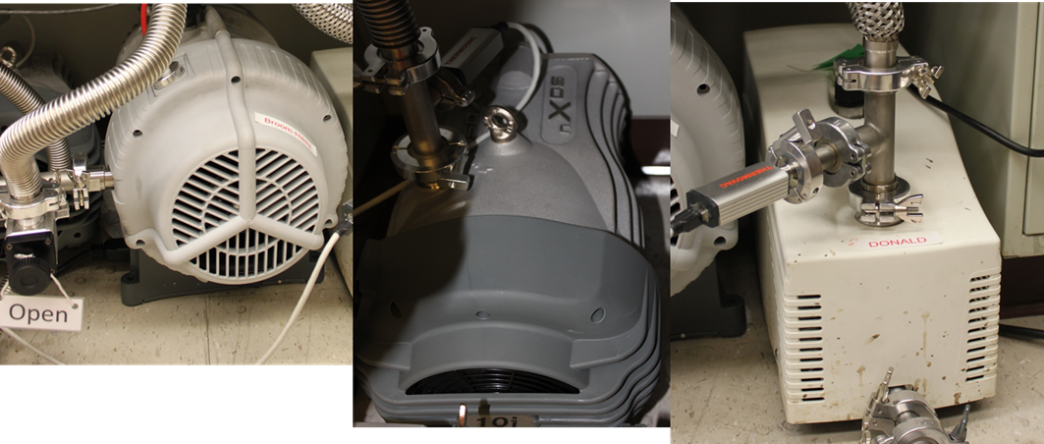

Figure 11. Photographs of Roughing vacuum pumps Edwards XDS 35i (left) Edwards nXDS10i (middle) and Adixen ACP 15 (right)

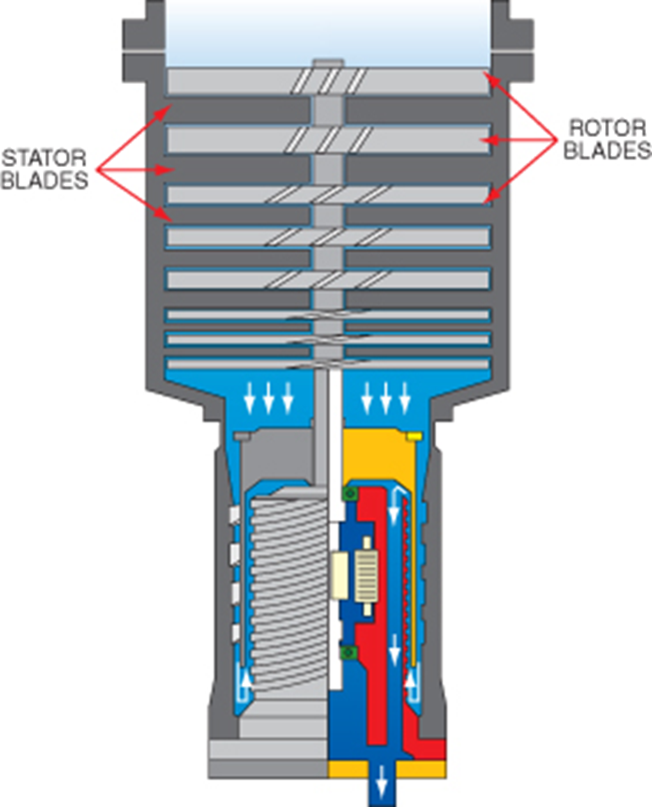
Inlet
Exhaust
Figure 12. Turbo molecular pumping mechanism

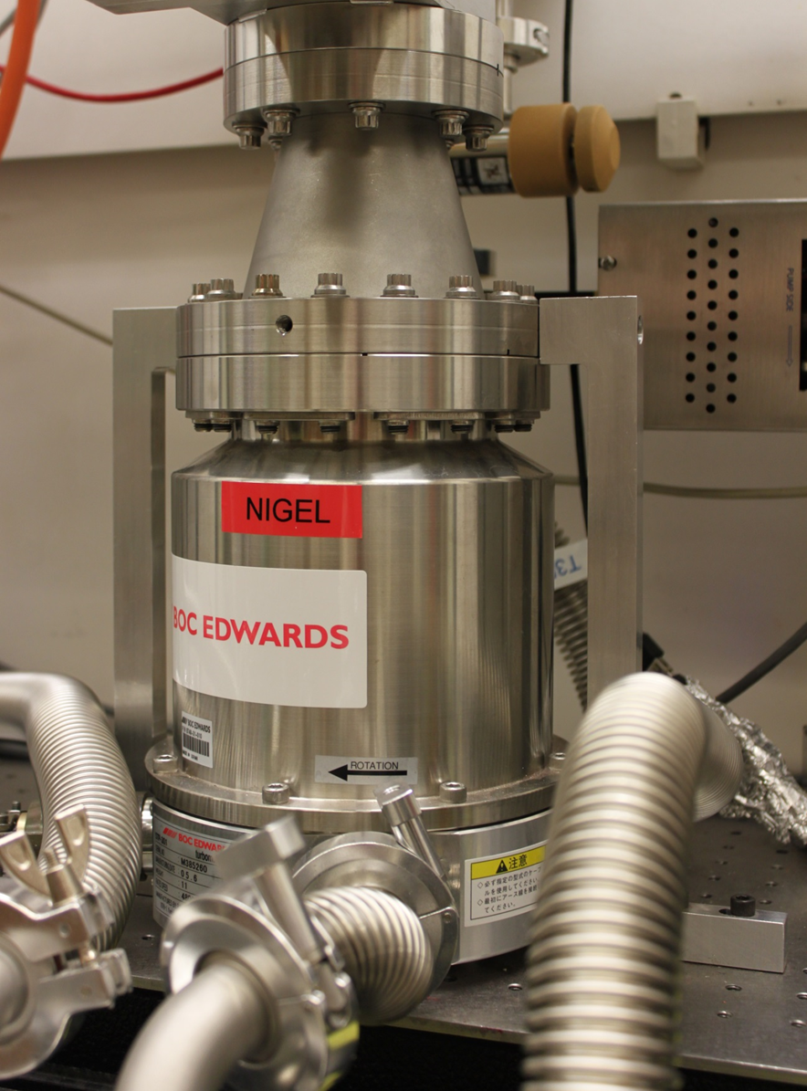
Figure 13. Photograph of Edwards STP 301 Turbo pump

magnetically levitated turbo molecular pump was selected to provide the vacuum for the main chamber and reactor tube. The pump has a 6’’ diameter conflat inlet. Pumping speed is rated at 300 liters/sec and ultimate pressure is rated at 1 X 10⁻¹⁰ torr. This pump rotates at 48,000 rpm and maintains pressure in the chamber during idle periods at 3.X10⁻⁸ torr.
2.4.4 Pressure Control
An important aspect to CVD accurate and reliable pressure control. As previously mentioned, CVD process tend to be defined by the pressure level at which takes place. One of the primary contributing factors to total system pressure is the flow of the gaseous, for this purpose, the pressure control and flow control mechanism will be treated together. In order to establish a steady deposition pressure, an equilibrium (steady state) condition must be established between the gas entering the reactor and being pumped out by the vacuum pump. This is accomplished by a feedback loop between a pressure gauge and a throttle valve. The MKS T3BI throttle gauge is positioned shown in figure X is positioned between the main service pump and the central housing. The T3bi operates by opening and closing at high speed to maintain a set point pressure. The pressure in the main housing is measured by a MKS 628B capacitance monometer with a heated diagram to prevent unwanted condensation from interfering with pressure measuring ability. On the supply side, the gaseous precursors are metered in to the reaction chamber via three MKS 1479A mass flow controllers each dedicated to a specific gas and calibrated in a specific flow range (see figures X-Y). The Diborane mass flow controller allows gas flow set

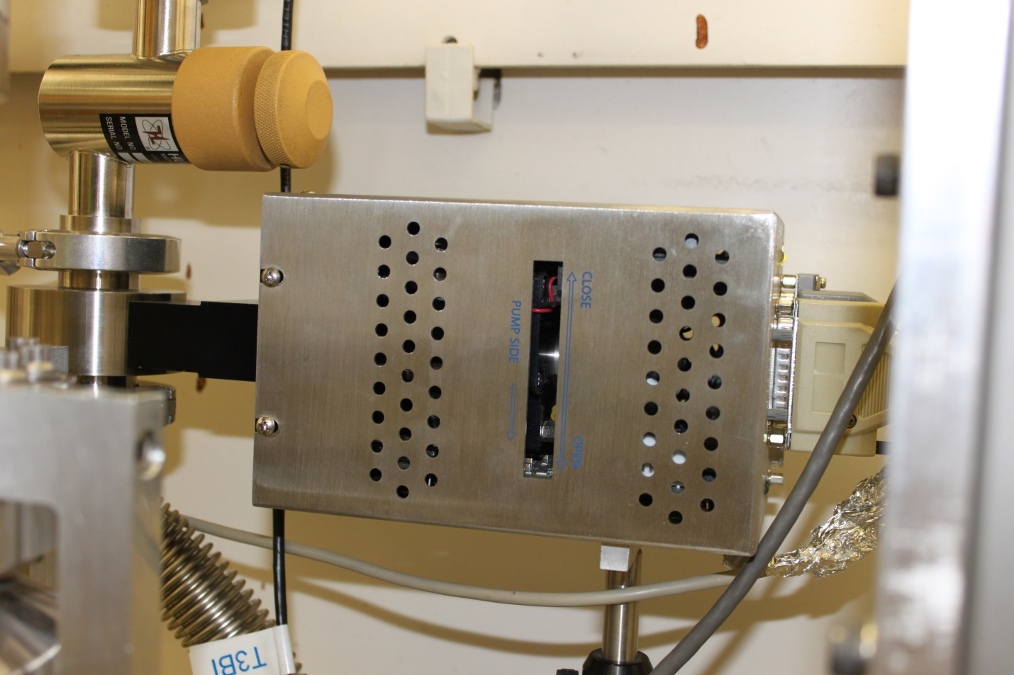
Figure 14. Photograph of MKS T3Bi Throttle valve

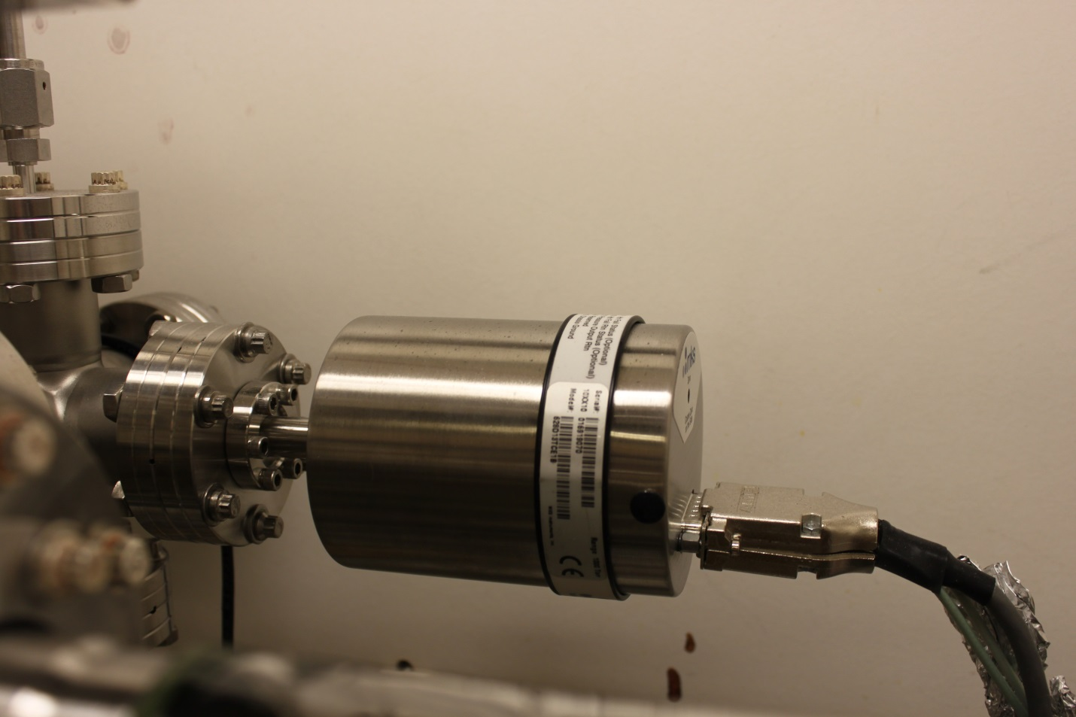
Figure 15. Photograph of MKS 628B Capicatance manometer

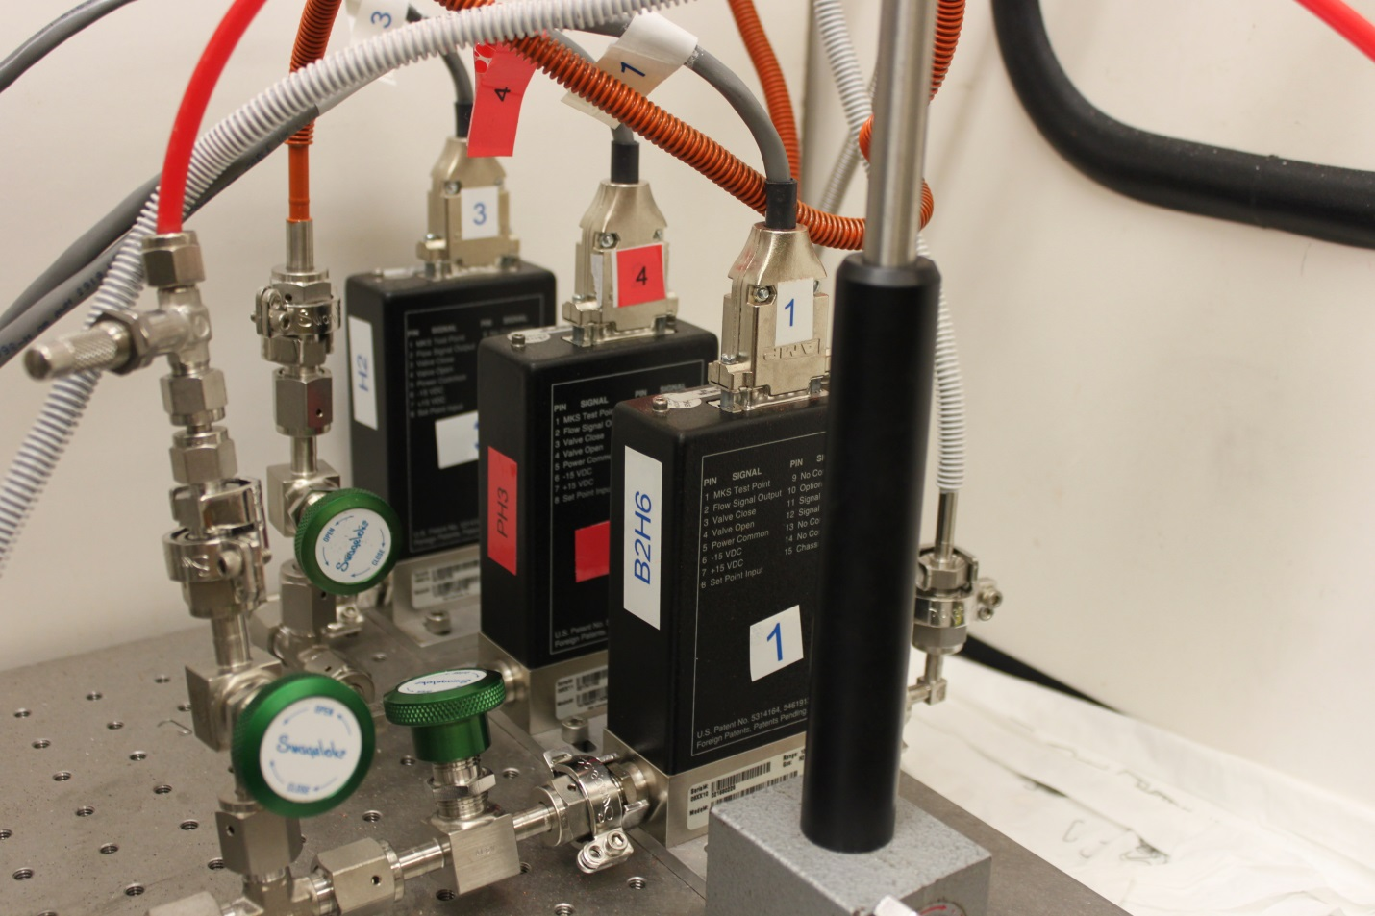
Figure 16. Photograph of MKS 1479A Mas flow controllers for diborane (front) Phosphine (middle) and Hydrogen (rear)

point in a range of 1-100 sccm. The phosphine mass flow controller allows flows from 1-1000 sccm. The third mass flow controller range is the highest with a flow range from 1-10,000 sccm. Since hydrogen is used as balance gas and carrier gas, all mass flow controllers are calibrated with hydrogen.
The CVD is remotely controlled via a Labview graphical user interface (gui) The gui communicates the a national instruments data acquisition hub docking port that receives data from the T3Bi throttle valve, 6288B capacitance manometer and a MKS 247D power supply and signal conditioner which controls the 1479A mass flow controllers (figure X). The labview gui automates flow and pressure set points as well as emergency shutdown. Refer to figure X for a screenshot of the gui.
In addition to pressure and flow, one of the most important aspects of CVD is the heat source. One of the most common approaches, and the one leveraged in the work is pyrolysis. In Pyrolysis, the gaseous precursors are passed through a heat affected zone. As the gas enters the heart affected zone, it disassociates into individual component. Using diborane as an example, the pyrolysis equation would be
B₂H₆ + Δ 2B +6H
In order to efficiently crack hydrides, the temperature must be above 500 C but to remove native oxides from the surface of Si and SiC wafers temperatures need to exceed 1000 C. Therefore the heating method must be capable of high temperatures and be capable of maintaining a set temperature for extended periods of time. The heating method that met these criteria was radio frequency (RF) induction. Induction heating is a proven method for CVD. Here a susceptor, or material that couples well in the RF is placed in the reactor. A chilled water cooled copper coil, which serves as the RF source is placed around the exterior of the reactor tube (see figure X). Voltage is supplied via a power supply thus heating the susceptor (figure X). The RF heater is the Ameritherm Easyheat 0224. This heater has a maximum power output of 2.4 kw over a range of 150-400 hz. The susceptor material chosen for the BP deposition was graphite. The susceptor a machined to sit flush on a custom rail mount system.

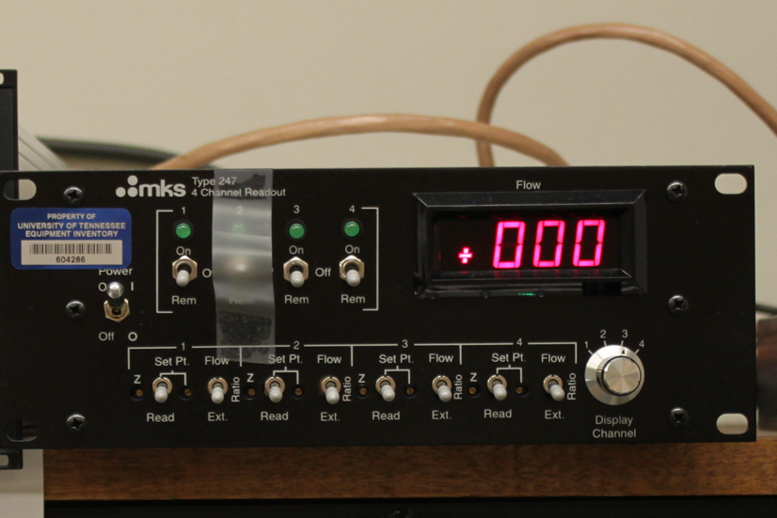
Figure 17. MKS 247d Signal conditioner and power supply

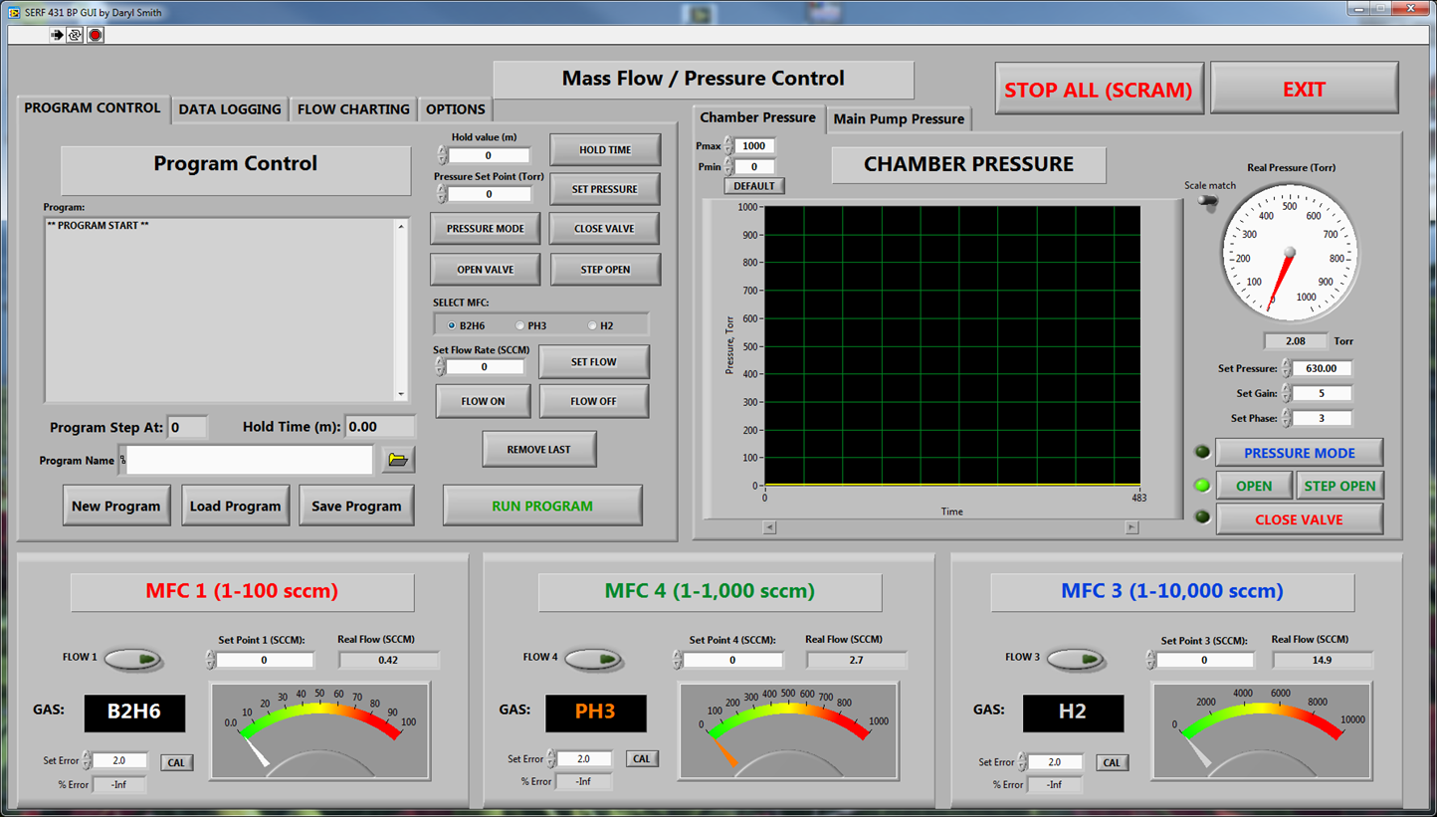
Figure 18. Screenshot showing Labview graphical user interface for
CVD reactor control

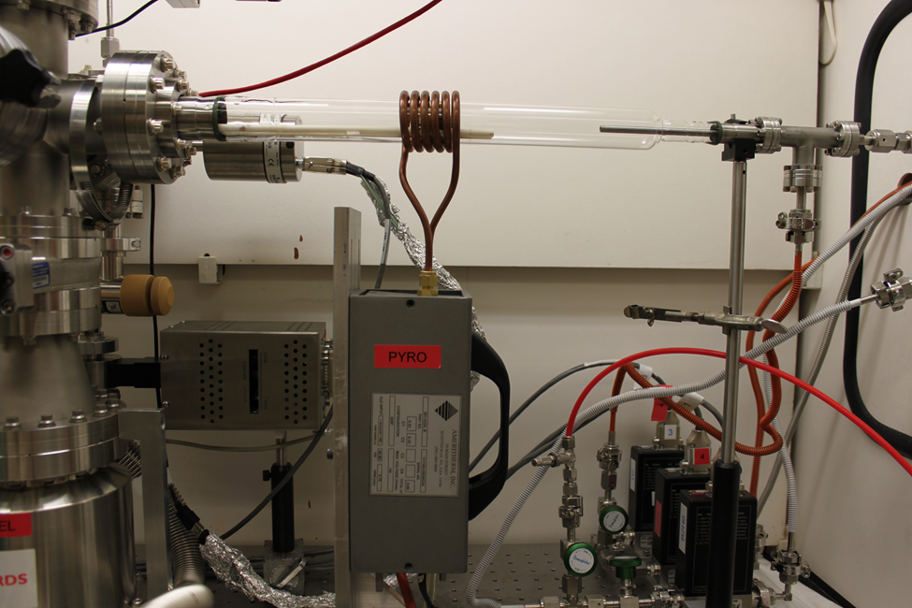
Figure 19. Photograph of RF induction heater coil around quartz reactor tube

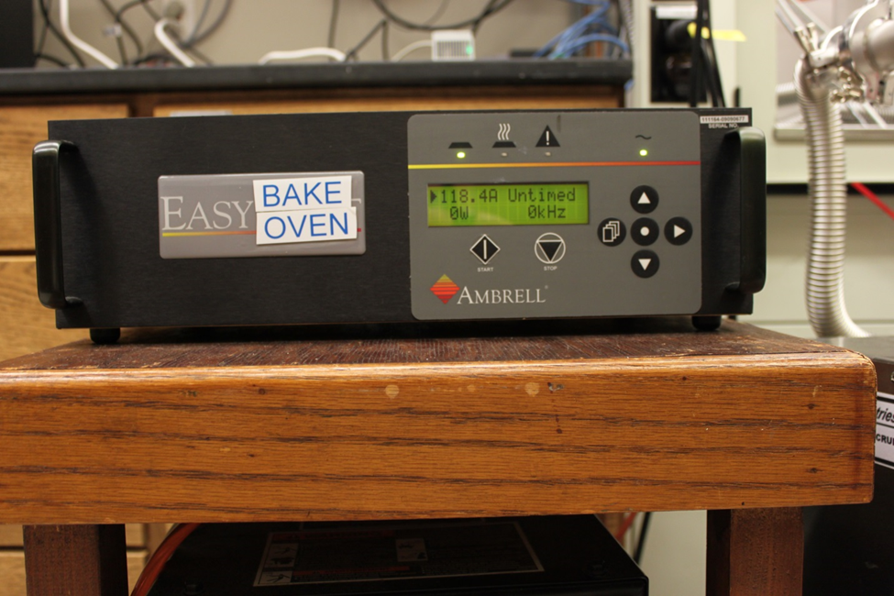
Figure 20. Power supply form RF induction heater

Figure 21 shows the rail mount system and figure 22 shows the custom graphite susceptors. The alumina rods are inert in the RF field and work to keep the susceptor suspended in the reactor tube. This serves a dual purpose in keeping the susceptor from having direct contact with them quartz tube and eliminating a localized sources of heat. It also provides much needed gas flow around the susceptor, reducing the magnitude of gas turbulences at the susceptor surface.
Temperature measurement in the CVD reactor is challenging. Noncontact temperature measurements were selected over standard thermocouple for a more simplicity in reactor tube design as well as gas flow dynamics. Non-contact methods of heat measurements include techniques that look at radiative heat transfer, such as optical pyrometers and IR thermometry both of which were used in this work. The disappearing filament optical pyrometer (shown in figure 23) was used to measure the temperature of the graphite susceptor. Ideally, in CVD it is more advantageous to measure the substrate temperature. However, in the specific configuration, it was impossible to focus optical on the substrate due to interference from the copper coils. Also, the changing substrate materials from Si to SiC complicated noncontact measurements because one instrument was not able to measure both Si and SiC because of the differences in emission wavelength. The decision was made to use the temperature of the graphite susceptor as the indication of substrate temperature. At this time there is no data to correlate the two measurements, an assumption is made that the difference in temperature of the graphite to the substrate is small enough to negate a significant variable. Therefore the temperature of the susceptor and substrate are used interchangeably in these experiments.
2.4.5 Temperature
The disappearing optical pyrometer works by the user visually comparing the color of a filament with the color being emitted from the heated object. The filament is adjusted by the user dialing a rheostat. Once the color of the filament matches the color of the heated object, the temperature can be inferred if the

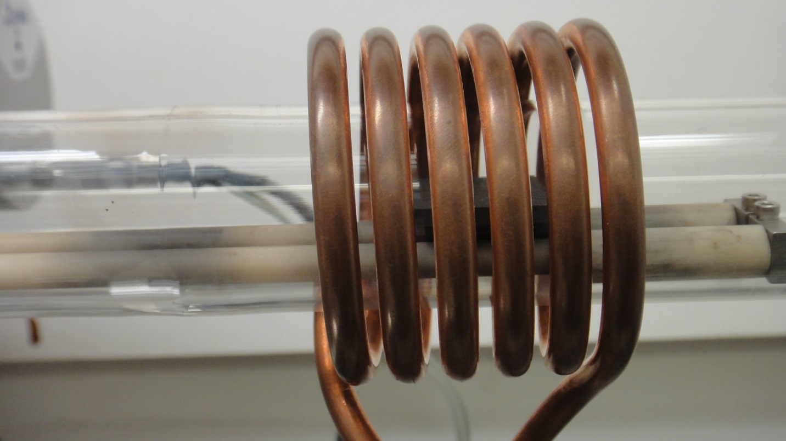
Figure 21. Photograph of Alumina rod rail mount system. Graphite susceptor in shown in the background in the middle of copper coil.

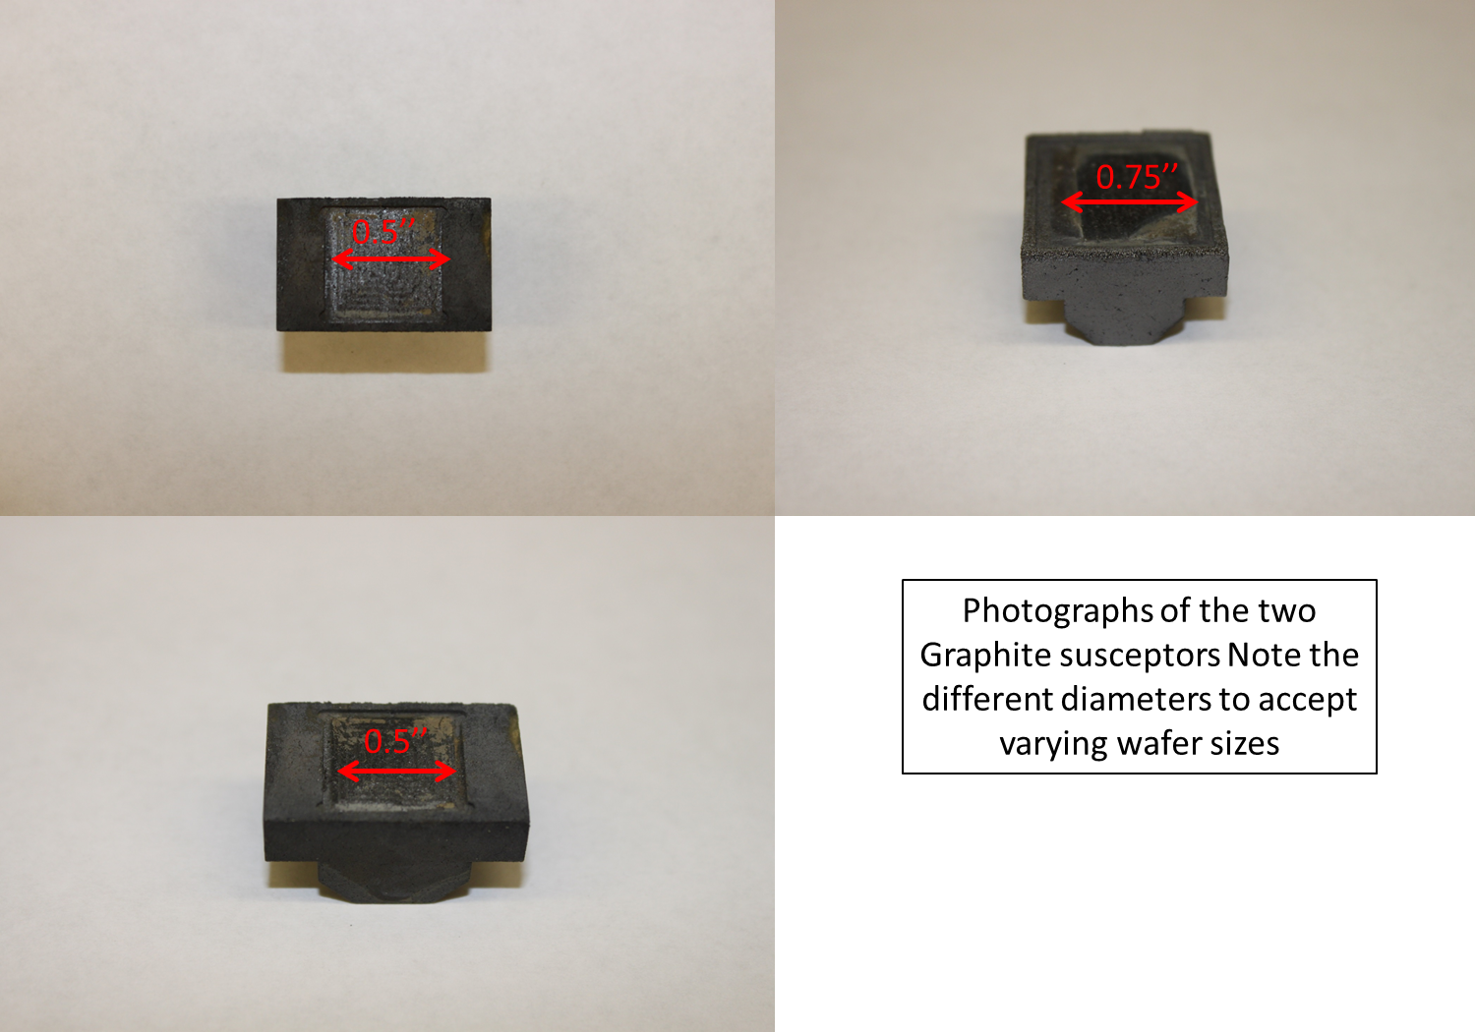
Figure 22. Photo series showing custom graphite susceptors

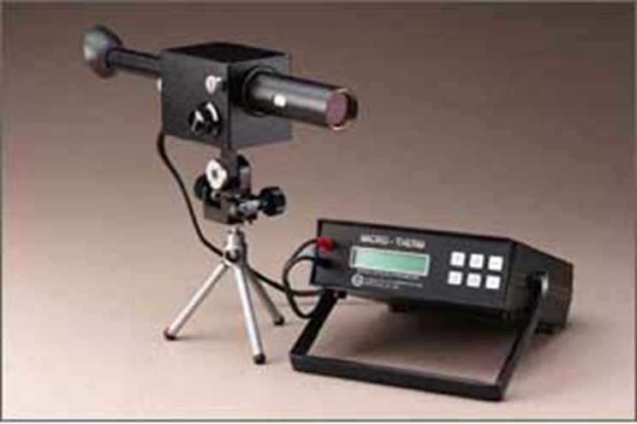
Figure 23. Showing optical disappearing filament optical pyrometer

emissivity of the heated material is known. The other method of temperature measurement used is infrared (IR).
The Raytek Marathon 2MH IR pyrometer (figure 24) has a temperature measurement range of 450° C to 2250° C with a spectral response of 1.6 μm. The IR camera has an integrated target that allows the sensor to be accurately placed. User input consist only of materials emissivity and focal length. Since this method relies less on visual comparisons, it is considered slightly more accurate. A correlation study was conducted between the disappearing filament optical pyrometer and the IR pyrometer by comparing simultaneous measurements of the graphite susceptor. Numerical agreement was within 15 degrees.
2.4.5 Safety Design
A common problem with research in CVD is safety. For most materials commonly mad via CVD processes the gaseous or liquid precursors required to make these materials are dangerous. Chemical hazards can vary widely, but some of the attributes include corrosivity, acutely toxic, explosive, and reactive. BP deposition with hydride precursors is no exception to this. Both diborane and phosphine present significant chemical and health hazards to the user and CVD reactor design must include engineered solution to mitigate these hazards. Material safety data sheets for both diborane and phosphine can be found in appendix B. Some of the passive safety considerations built into this reactor design have been previously mentioned. Material compatibility of components was the first safety aspect considered. This applies from both a safety and purity perspective in that if a material in compatibility is present, it will lead to a reaction that ultimately introduces contaminants into the system. The CVD system was designed and constructed of all metal components where ever possible. Metal components, namely 300 series stainless tell are inert with the concentrations of diborane and phosphine used in thee experiments. Where metal was not an option due to a performance issue, high purity compatible polymers were selected to minimize a reaction.

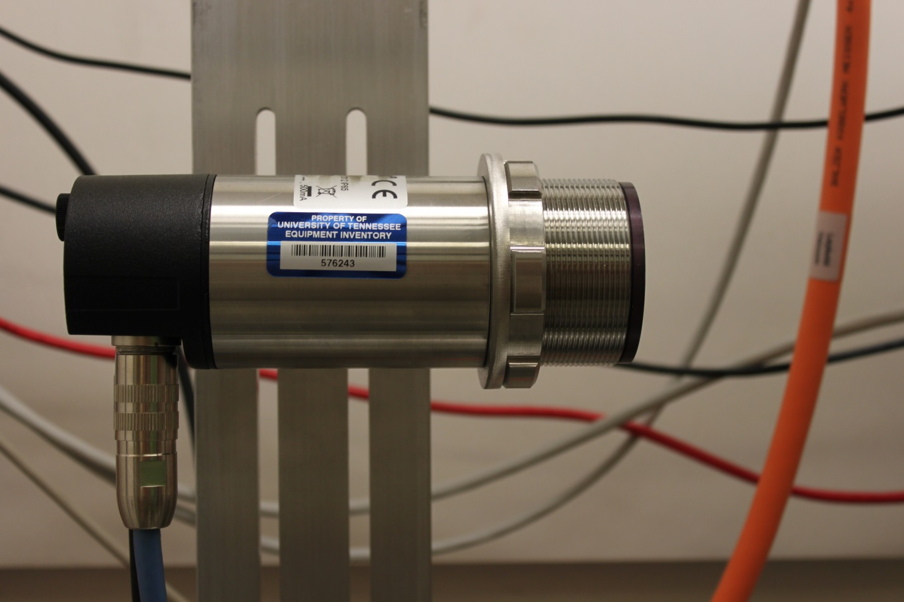
Figure 24. Photo showing Raytek IR pyrometer

Similar rigor was applied to designing systems to safely abatement any free gas and to properly handle system effluent. The CVD reactor was designed to fit inside of a large fume hood. The hood with reactor inside for scale is shown in figure X. When experiments are conducted, the hood is set to emergency flow mode. This keeps the concentration of any gas that may leak from the reactor an absolute minimum. In order to safely store the diborane and phosphine cylinders, a gas cylinder cabinet was procured to provide a local constant ventilation of the cabinet surrounding the cylinders. The cabinet shown in figure X is all metal and provides cylinders straps to stores the cylinder. Mounting racks are also provided to support the gas supply panels for each gas. Equally important is the process exhaust. During pyrolysis, it is expected as the majority of precursor will be sufficiently disassociated and or reacted to inert species. However, in the unlikely event of a scenario of gas flowing through the system unreacted, a scrubber was placed to capture any unreacted precursor. The scrubber consists of a gas tight right cylinder tank filled with a 50% solution of potassium permanganate (KMnO₄). Being a strong oxidizer, the KMnO4 oxidizes the diborane and phosphine into borates and phosphates respectively. A photo of the scrubber is shown in figure X although less toxic that diborane and phosphine, hydrogen makes up the balance of the gas constituents in the system. Hydrogen will not react with and must be addressed another way. The most common way to neutralize combustible gases is to burn them in a controlled atmosphere. An example would be a burnbox. Unfortunately, the total hydrogen flow through the reactor was too high for a burnbox scalable to the laboratory.

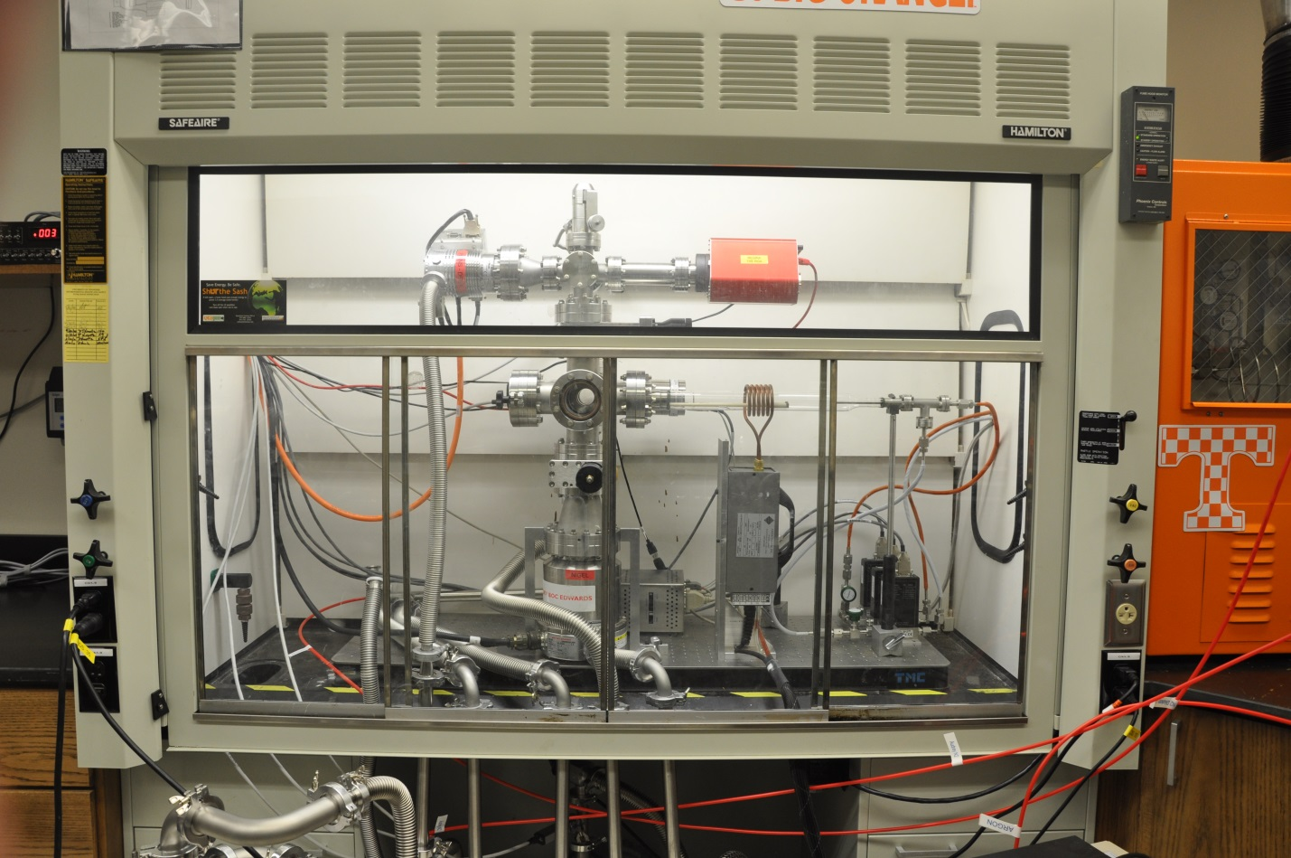
Figure 25. Photograph of reactor in fume hood with sash closed

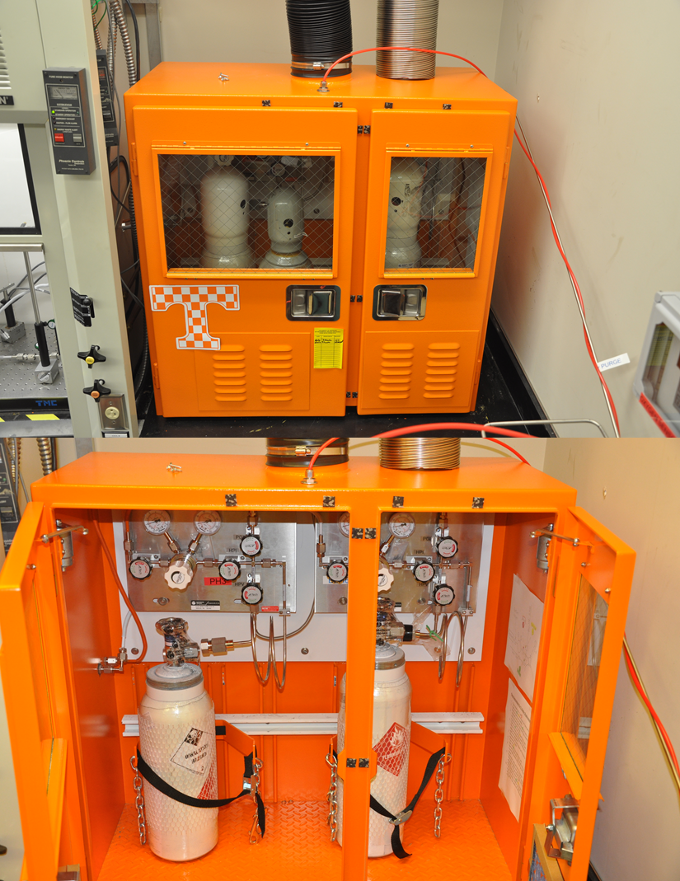
Figure 26. Photos of Hazardous gas cabinet Exterior (top) and Interior (bottom)

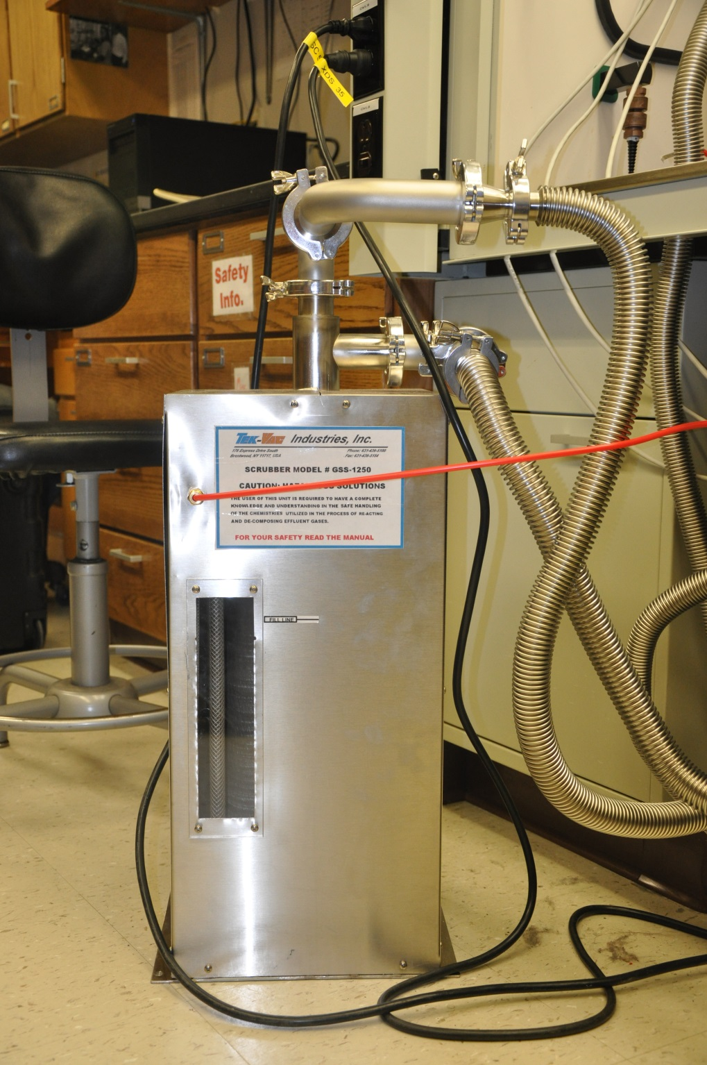
Figure 27. Photograph of potassium permanganate scrubber Showing Inlet and exhaust lines

In lieu of burning the hydrogen, the hydrogen effluent is diluted with nitrogen in a ratio of 10:1. The nitrogen is supplied via 240 L liquid nitrogen Dewar. A flowmeter is attached to the gas service port on the Dewar which connects to the scrubber exhaust line. Hydrogen abatement is also required for the primary scroll pump. Light gases tend to entrain in scroll pumps and need to be purged to ensure an explosive mixture is not created. In order to provide an Argon purge to the primary scroll pump, a gas ballast adapter was acquired which allows the introduction of up to 3 SLM/min of argon inside the scrolls. This prevents any hydrogen from accumulating as well as eliminating an explosive mixture from building inside the pump.
An additional layer life safety is provided in the form of active detection of the hydride gases. A phosphine gas sensor is present in the vicinity where an amount of phosphine may accumulate if the system failed to function properly. The sensor is a hydride sensor will also detector the presence of diborane. However, it is not calibrated or diborane and the response range for diborane is not predicted thus no credit for safety is taken for diborane crosstalk. The sensor inserts into the is the Drager Polytron 7000 detector (figure X). This detectors capable of continous gas monitoring and is calibrated with dual alarm set points of 1 ppm and 10 ppm. The sensor is connected to the Drager SC04135 remote alarm station. The remote alarm station shown in figure X has an audio alarm and a red and amber strobe. The strobes are wired to the action levels set points from the Polytron 7000. The amber strobe activates at the 1ppm threshhold. The audible alarm and red strobe activate at the 10 ppm threshsold. In order to ensure proper responcse to alarms, an industriol hygiene plan was developed that outlines the personnel action required upon the acticvation of the alarm set points.

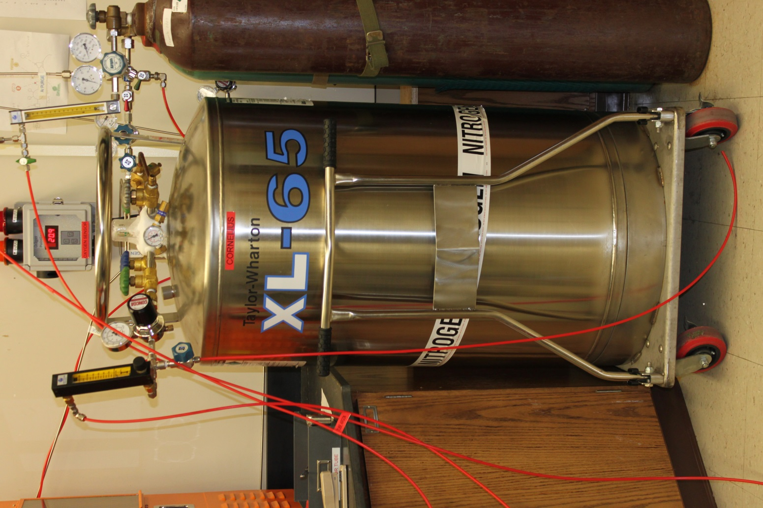
Figure 28. Photograph of 240 L liquid nitrogen Dewar used to supply dliuent gas. Shown with attached regulator and flowmeter

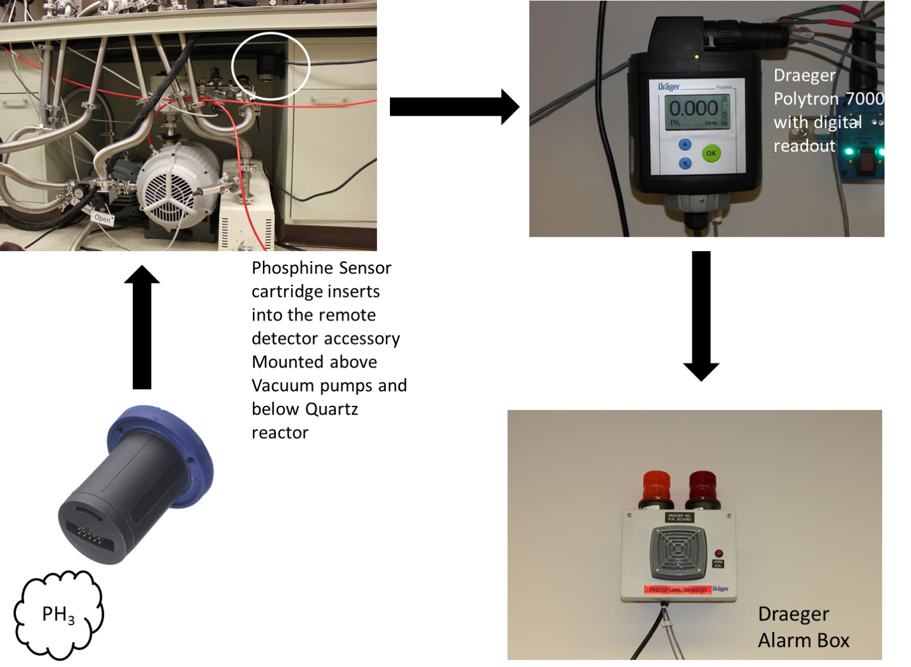

Figure 29. Figure showing components of the active gas detector system. The arrows denote signal flow

A systematic approach centered on simplicity was used to address the numerous areas required for custom CVD reactor design. Topics including fluid flow, purity, process automation, material compatibility and safety were individually approached in a series of efforts to develop a functioning system. Overall, experiments have proven that the reactor design presented here is successful. As knowledge of BP deposition fosters, so will CVD reactor design.

3.0 Deposition on Si Substrates

At the conclusion of the construction phase of the CVD reactor, experiments were conducted to verify successful operation of the rector and establish confidence in the reactors ability to consistently perform. A series of functionality tests were performed, intended to confirm the operation of the reactor systems and verify the functionality of the graphical user interface. Once these tests proved successful. A design of experiments was conducted to examine the reactors ability to grow boron phosphide. In order to establish confidence in the reactor, initial growth experiments were performed on Si substrates. As previously described, the bulk of the prior BP work present in the literature has been conducted on Si. Therefore a direct comparison of deposition could be performed.

3.1 Parametric Study

Experiment one was intended to verify the operation of the reactor by emulating Kumashiro’s previously published parameter setting from his work on Si. The flow rates of the 1% diborane and 5% phosphine and the hydrogen gas were 20 sccm, 300 sccm and 2500 sccm respectively. A system pressure of 630 torr was used for the initial experiment as well as all subsequent experiments. Initial substrate temperature used in this experiment was 786° C. Experiment duration was 90 minutes. The resultant sample can be seen in figure 1. The first sample was 0.75” X 0.75’’. The photograph in figure 1 shows non uniform coloration, indicating partial coverage of the substrate or a substantial thickness gradient. Follow on optical microscopy images of sample 1 shown in figure 2-5 are inconclusive. A continuous film is observed in the images, but the breadth of field is narrow. SEM images of sample 1 are more informative. Surface SEM images (figures 6-7) depict a rough texture to the film with islands of density dispersed throughout. Cross sectional SEM of sample 1 (figures 8-9) show a thickness a measured thickness gradient of 650 nm. Cross section was taken on two axes of sample Raman spectroscopy was performed on sample 1 for comparison to the published literature values.
Sample one serves as the baseline of the experimental design. The presence of a thin film is confirmed. The resultant film morphology was varying with a thickness gradient. The shown Raman spectra

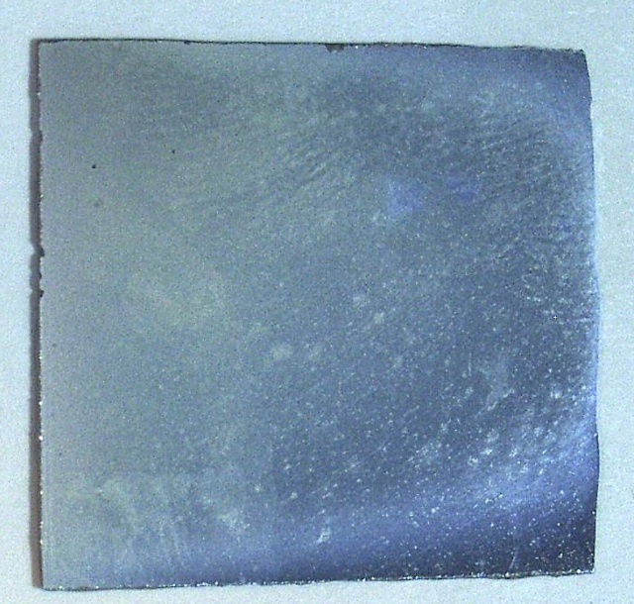
Figure 1.Photograph of Sample 1 immediately following deposition. Note the non-uniform deposition evidenced by the varying coloration in the film

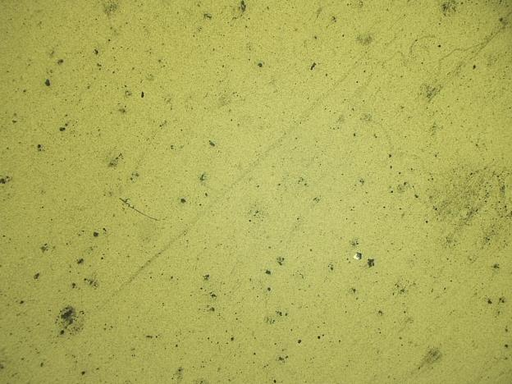
Figure 2. Optical microscope image of thin film surface. 100X magnification

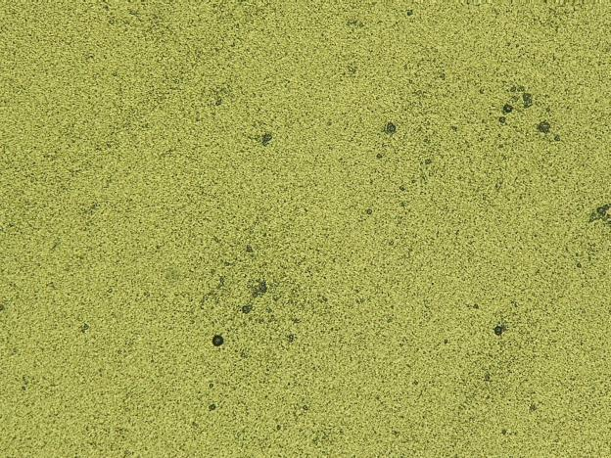
Figure 3. Subsequent image from figure 2 of BP thin film surface at 500X magnification

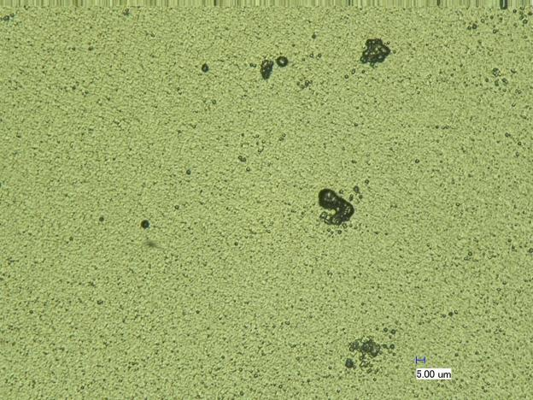
Figure 4. Image of the surface of sample 1. 1000X magnification

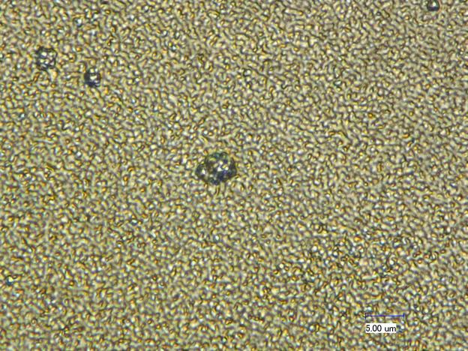
Figure 5. Optical microscope image of sample 1 surface at 300X magnification

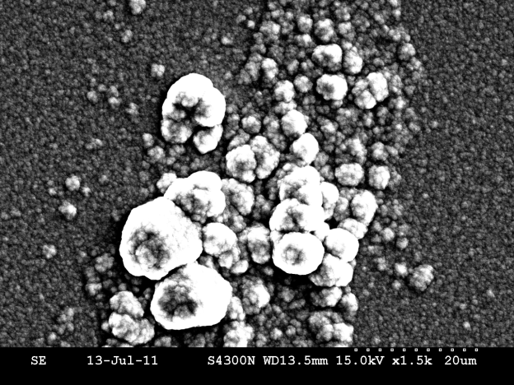
Figure 6. SEM image of surace of sample 1. Showing BP group clusters

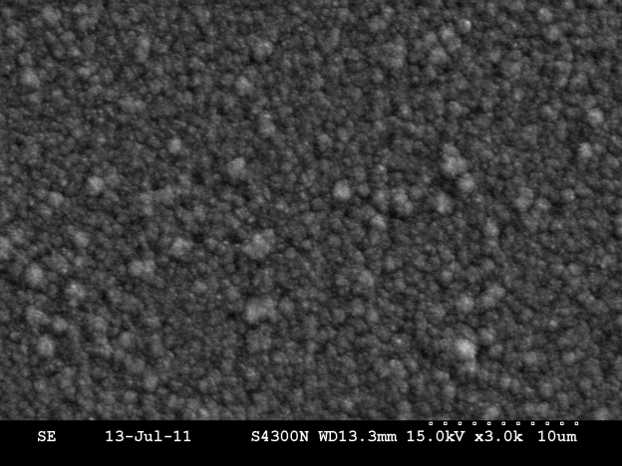
Figure 7. SEM image of BP sample 1. Showing rough continuous film

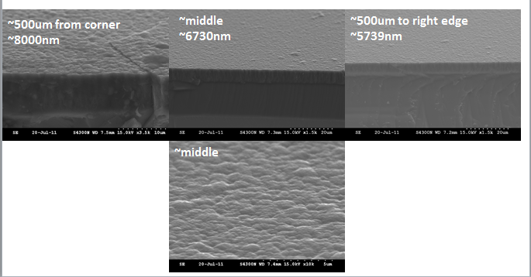
Flow
Sample
Figure 8. Cross section SEM of BP sample 1. Red squares indicate approximate location of corresponding image

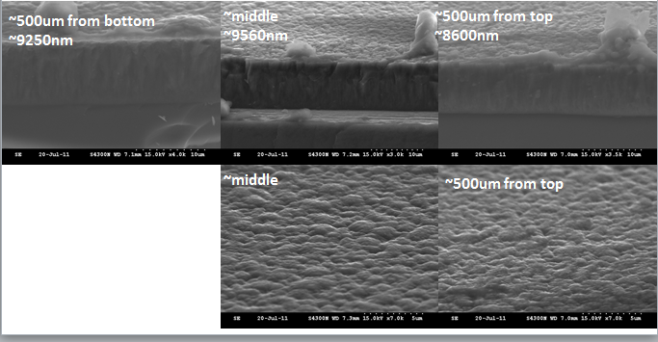
Sample
Flow
Figure 9. Additional cross sectional SEM images of sample 1. Samples taken 90 deg off from thos shown in figure 8

demonstrated a peak at 822 cm⁻¹, where literature values for peaks natural abundance BP occur at 828 cm^{-1.} A total of 30 experiments were performed on Si substrates. Table 1 shows the experiment parameters used in each experiment. Row one denotes the sequential order a sample was performed. Row 2, entitled pressure , lists the system pressure setting in the CVD reactor throughout the deposition experiment. Temperature refers to the observed temperature of the graphite susceptor measured by either disappearing filament optical pyrometer ( fig X) or IR pyrometry (fig y). Row 4 entitled H_{2,} lists the flow settings on the mass flow controller for the balance of high purity hydrogen flowing in the reactor during an experiment. The next two rows, PH₃ and B₂H₆ respectively list the individual mass flow controller setting for the duration of an experiment. In interests of quality, there were not altered during an experiment. The units for all flow settings are standard cubic centimeters per minute or sccm. Time of run , lists the duration of deposition taking place during reaction. This does not include time for substrate preparation or cool down. The substrate row denotes the substrate material used in the experiment, either Si or SiC. Mass gain is determined by weighing the samples with a mass balance in a series of three sequential weighings. The average of the three weights is calculated and reported on the table. The next row, Predicted mass gain is a metric to provide an estimate of the expected film thickness upon the completion of the run. This value helps in reducing sample preparation time for

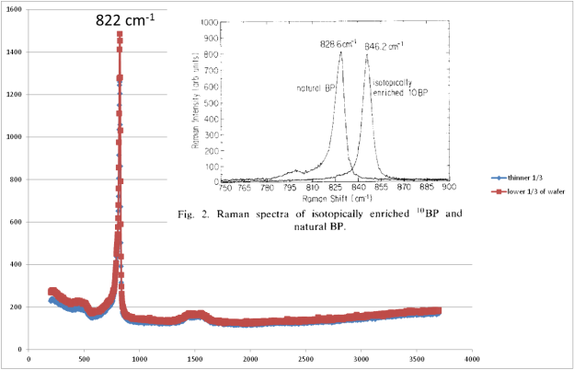
Figure 10. Graph of Raman spectrum on Sample 1. Note inlay of literature values. Published Raman spectrum peak is 828 cm-1. measured valued of sample 1 is 822 cm-1

Table 1. Layout of selected sample parameters for samples 1-20
Sample # | 1 | 2 | 3 | 4 | 5 | 6 | 7 | 8 | 9 | 10 | 11 | 12 | 13 | 14 | 15 | 16 | 17 | 18 | 19 | 20
Pressure (torr) | 630 | 630 | 630 | 650 | 650 | 650 | 630 | 630 | 630 | 630 | 630 | 630 | 630 | 630 | 630 | 630 | 315 | 315 | 630 | 150
Temp (°C) | 810 | >743 | 798 | 840 | 800 | 915 | 816 | 830 | 815 | 815 | 820 | 800 | 806 | 825 | 854 | 845 | 803 | 811 | 813 | 800
H₂ (sccm) | 2500 | 2500 | 1250 | 1250 | 2500 | 2500 | 2500 | 2500 | 2500 | 2500 | 2500 | 2500 | 2500 | 2500 | 2500 | 2500 | 2500 | 1250 | 2500 | 1000
PH₃ (sccm) | 300 | 300 | 150 | 150 | 300 | 300 | 300 | 300 | 300 | 300 | 300 | 300 | 300 | 300 | 300 | 300 | 300 | 150 | 300 | 100
B₂H₆ (sccm) | 20 | 30 | 30 | 15 | 30 | 30 | 30 | 30 | 30 | 30 | 50 | 60 | 60 | 30 | 30 | 30 | 30 | 15 | 30 | 10
Time of run (hrs) | 1.5 | 2 | 0.5 | 2.25 | 2.25 | 2 | 2 | 2 | 2 | 2 | 2 | 2 | 2 | 2 | 0.5 | 0.5 | 0.5 | 0.5 | 0.5 | 0.5
Substrate | Si | Si | Si | Si | Si | Si | Si | Si | Si | Si | Si | Si | Si | Si | Si | Si | Si | Si | Si | Si
Mass Gain | ? | 14.40 | 0.00 | 1.40 | 5.00 | 0.40 | 8.60 | 5.20 | 9.00 | 2.94 | 13.37 | 17.06 | 20.51 | 11.52 | 3.48 | 3.02 | 5.06 | 1.90 | 3.20 | 0.90
Predicted Film Thickness | N/A | 11.8227 | 0 | 1.14943 | 4.10509 | 0.32841 | 7.06076 | 4.2693 | 7.38916 | 2.41379 | 10.977 | 14.0066 | 16.8391 | 9.45813 | 2.85714 | 2.47947 | 4.15435 | 1.55993 | 2.62726 | 0.73892
PH3/B2H6 | 15 | 10 | 5 | 10 | 10 | 10 | 10 | 10 | 10 | 10 | 6 | 5 | 5 | 10 | 10 | 10 | 10 | 10 | 10 | 10

electron microscopy investigations. The predicted film thickness is calculated from the following formula:
Predicted film thickness (μm) = mass of wafer (g) / [wafer area (cm²)] x [density of BP (g/cm³)]
The last row on the table is labeled PH₃/B₂H₆. This row lists the ratio of the BP precursors. This is calculated by dividing the respective flow rates reported in the PH₃ and B₂H₆ rows of the table. The flow rate ratio metric is a convenient way to report the relationship between the gas flow rates and the resultant film.
Samples are independent and each represents an attempt to gain knowledge about the reactor and process. Although BP thin films were grown and characterized in, samples 2- 20, these samples were primarily focused on understanding the behavior of the CVD reactor and establishing confidence and reliability metrics for future experiments. Upon the achievement of those goals, samples 21-27 were conducted and constitute a focused effort to extract the optimum conditions for BP morphology on Si substrate. Therefore, these seven experiments will be the focus of this discussion on deposition of BP on Si substrates.
Sample 21
Sample 21 is the first sample in the series of experiments to elucidate the optimum morphology of BP on Si substrates using the as built reactor. Refer to table 2 for a complete list of parameter data in organized fashion. Experimental run conditions were as follows. The System pressure was 630 torr, temperature of the susceptor was measured at 800 C, hydrogen flow rate was set to 2500 sccm, phosphine flow rate was 10sccm, diborane flow was set at 10 sccm and the run time was 0.5 hours. An important note in strategy manifests hers in that run time is significantly reduced because the focus of the experiments changed. Experiments designed to elucidate reactor function were conducted at the

Table 2. Table of experimental parameter settings for samples 21-27
Sample # | 21 | 22 | 23 | 24 | 25 | 26 | 27
Pressure (torr) | 630 | 630 | 630 | 630 | 630 | 630 | 630
Temp (°C) | 800 | 803 | 805 | 805 | 798 | 811 | 855
H₂ (sccm) | 2500 | 2500 | 2500 | 2500 | 2500 | 2500 | 2500
PH₃ (sccm) | 100 | 300 | 100 | 300 | 300 | 150 | 300
B₂H₆ (sccm) | 10 | 30 | 10 | 30 | 10 | 30 | 30
Time of run (hrs) | 0.5 | 0.5 | 0.5 | 0.5 | 0.5 | 0.5 | 0.5
Substrate Matrerial | Si | Si | Si | Si | Si | Si | Si
Mass Gain (mg) | 1.24 | 3.31 | 1.17 | 3.25 | 1.03 | 3.24 | 3.09
Predicted film thickness (µm) | 1.0180624 | 2.71757 | 0.960591 | 2.6683087 | 0.8456486 | 2.6600985 | 2.5369458
PH3/B2H6 | 10 | 10 | 10 | 10 | 30 | 5 | 10

bulk scale. These experiments, designed to determine optimum morphology on Si were focused on the substrate-film interface. Run time was subsequently reduced in order to allow for easier sample preparation for electron microscopic analysis. Results of the experiment showed a mass gain of 1.24 mg with a predicted film thickness of 1.02 μm. Additionally, the phosphine-diborane ratio was 10.
A photograph of the casual observation immediate following deposition can be seen in figure 11. Note, all photos post deposition are shown with the gas flow direction proceeding from right to left. Blue fringes can be seen on the top of the sample indicating variations in film thickness. Optical microscopy was not performed on these samples because they provide little useful information on film morphology. In lieu of optical microscopy, SEM and cross-sectional SEM microscopy was performed on the sample. Figure 12 shown a 5000X imagination of the surface of the BP thin film. This image is taken distal to the flow orientation. A diagram showing image location on the sample is also shown in figure 12 in the lower right corner. The red square indicates the area where the corresponding image is taken. BP particles are seen, but a contiguous film is not observed. The distance between particle grouping ranges from 0 to approximately 12 microns. Moving to the center of the sample, as shown in figure 13 the coverage is much denser. Distance between particle groups is less than one micron. The area of the substrate nearest proximal to the gas flow shows a rough contiguous thin film despite the higher magnification of 10,000X. Each image considered individually only tells us the spot coverage in those particular areas however, the images considered collectively indicate that wafer coverage does vary as function of distance from the gas flow. Furthermore, the Volmer–Weber growth mode is suggested. In this mode, the thin film does not form a monolayer on the substrate surface due to the fact that adatom-adatom interactions are preferred over adatom-surface interactions. Islands of growth are formed initially and as growth progresses, the islands begin to coalesce forming a contiguous film. Cross sectional SEM

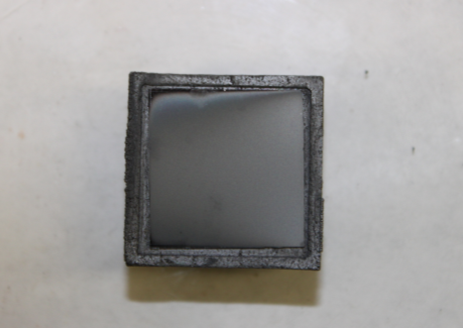
Figure 11. Photograph of sample 21 post deposition.

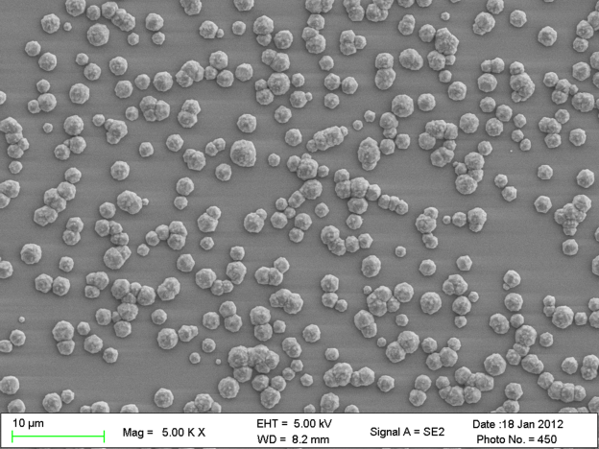
S

Sample
Figure 12. SEM image of sample 21, Si substrate surface. Showing BP particles dispersed on substrate.

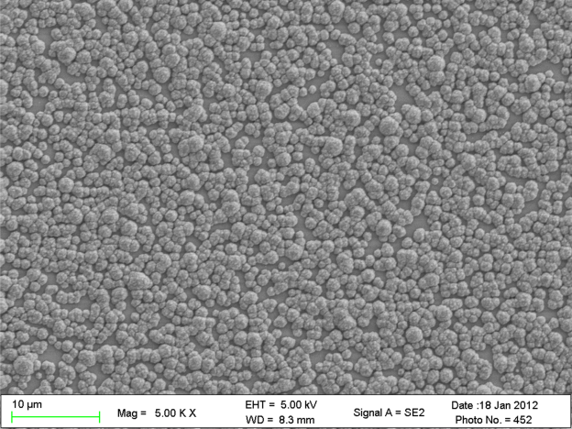

Sample

Figure 13. SEM micrograph of sample 21, showing BP particles with increasing density. Sample taken from middle of wafer with flow direction from right to left

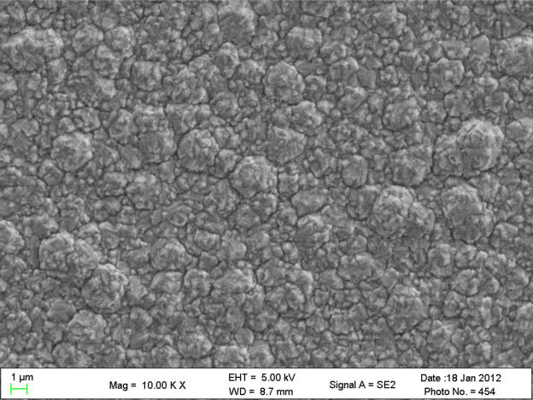

Sample

Figure 14.Sem micrograph of sample 21. Showing contiguous BP film. Sample taken on edge nearest to flow

images of sample 21 show the thickness of the resultant film and columnar growth is indicated from the long veins perpendicular to the interface.
For the sake of completeness, the results of the Raman spectrum for samples 21-27 is shown in figure 17. The technique is used in these experiments as a confirmation technique indicating the presence of a material consistent with reported values for BP. Acquired Raman spectrums are uniform across the data set. Raman peaks for BP were observed at 828 cm⁻¹. The additional peak appearing at approximately 521 cm-1 is the peak for Si. IT is included to substantiate that the reported samples were grown on Si substrates.

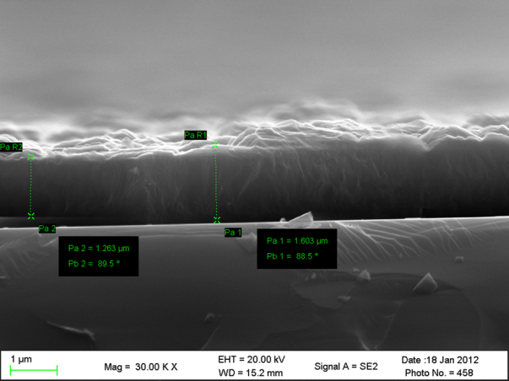
Figure 15.Cross- sectional SEM of sample 21. Showing a BP thin film of 1.6 um in thickness on Si

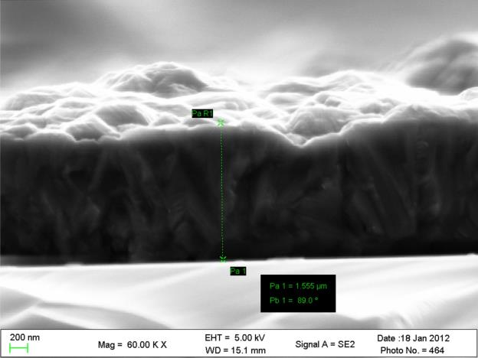
Figure 16. Cross- sectional SEM micrograph of sample 21. Suggesting columnar growth

Figure 17. Overlay of Raman Spectrum for samples 21-27. BP peak appears at 828 cm-1. The 522 cm-1 peak is consistent with Si

Sample 22
Sample 22 is the second sample in a 7 sample series of samples designed to determine the optimum BP on a Si substrate. Experimental parameters are shown on table 2 and are identical to sample 21 with the exception of flow rates of diborane and phosphine. In this sample, the respective flow rates were increased from 10 and 100 in sample 21 to 30 and 300. The result was an increased in mass gain to 3.31 mg compared to a mass gain of 1.24 mg in sample 21. This is a percentage change of 231% and is expected due to the increased amount of gas flowing through the reactor. The predicted film thickness increased from 1.02 um to 2.72 um a percent change of 171%. The flow rate ratio was unchanged from sample 21 . Figure 18 shows photographs immediately post deposition. Film coverage appears complete across the entire surface of the wafer and no thickness gradients were observed. Cross sectional SEM micrographs shown in figure 19 depict a columnar BP film with a maximum thickness of 4 um. Overall morphology appears similar under SEM to sample 21.
Samples 23 and 24
Samples 23 and 24 are treated simultaneously because they are iterations of the previous two samples. Experimental conditions were identical. The iterations of sample condition was necessary to examine repeatability in successive experiments to verify reactor performance was not waning. The resultant metrics for samples 23 and 24 were within expected limits to assume no variance. Mass gain for sample 23 was 1.17 mg compared to a mass gain of 1.24 mg for its cohort sample 21. Mass gain for sample 24 was 3.25 mg. Predicted film thickness was also within normal limits, with 0.96 μm for sample 23 and 2.67 μm for sample 24. Figure 21 compares the morphology of the two samples as seen by cross sectional SEM. Although at different magnifications due to clarity, similar crystalline structure is present in both samples with the major difference being the film thickness. This difference is the result of

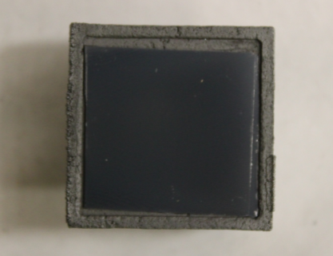
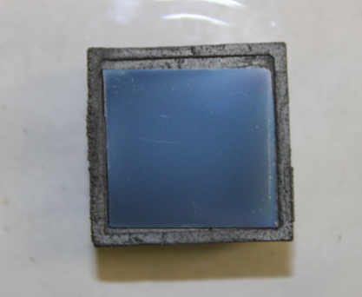
Figure 18. Photographs of sample 22 post deposition

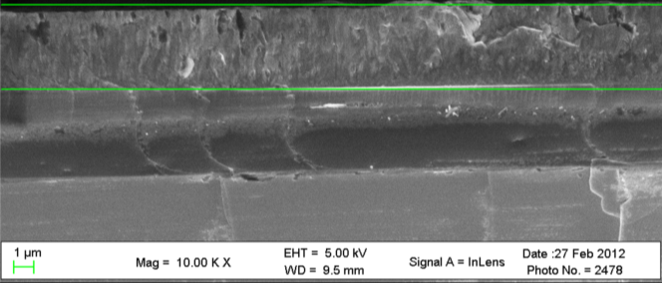
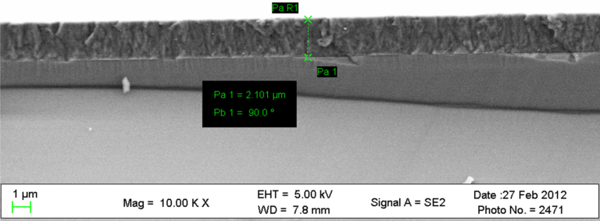
Figure 19. Cross sectional SEM images of sample 22. Showing columnar film of BP with a maximum thickness of 4 um
4.234 μm

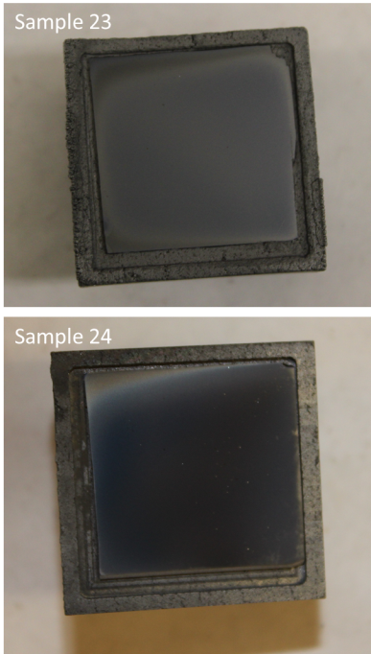
Figure 20. Photographs of sample 23 24 immediately post deposition

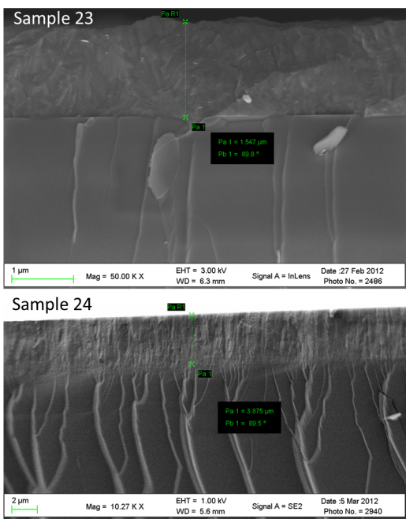
Figure 21. Cross sectional SEM microgrpahs of samples 23 and 24 at different magnifications.

increasing the flow rates by a factor of 3. Predicted film thickness compares well with measured thickness in SEM with sample 23 having a measured thickness of 1.54 um and a predicted 0.96 um. Sample 24 is similar with a measured thickness of 3.87 um and a predicted thickness of 3.25 um.
Sample 25
Sample 25 is the fifth sample in the parametric study and is the first sample to represent a significant departure in settings from the previous four samples. For sample 25, parameter settings for pressure, temperature, and hydrogen balance flow rate remain unchanged from the previous experiments. The phosphine flow rate was set to 300 sccm and the diborane flow rate was set to 10 sccm. This represents a PH3/B2H6 ratio of 30, a factor of three over all previously conducted experiments in this study. Mass gain for sample 25 was 1.03 mg with a corresponding thin film thickness prediction of 0.84 um. The photograph of sample 25 post deposition can be seen in figure 22. Note the conical appearance of the film. This has not been previously observed. Surface SEM imagery shows a rough contiguous film. Island growth is suggested is this image the presence of well-formed particle like structures labeled A-D in figure 23. Despite sub optimal clarity, cross sectional SEM images of sample 25 shown in figure 24 records an average film thickness of .891 um. This agrees with the predicted thickness of 0.84 um. Morphology in tis sample is comparable to the previous samples probed by SEM. The low mass gain is remarkable in this sample.

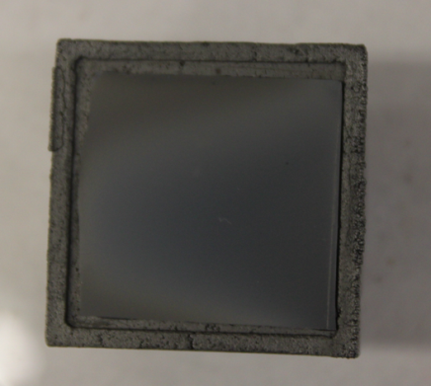
Figure 22. Photograph of sample 25post deposition. Note the conical appearance to the film.

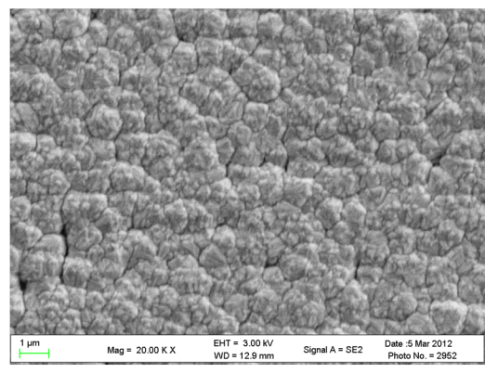
DA
CA
B
A
Figure 23. Surface SEM image of sample 25. Showing well-formed particle structures labeled A-D, suggesting Volmer-Weber growth mode.

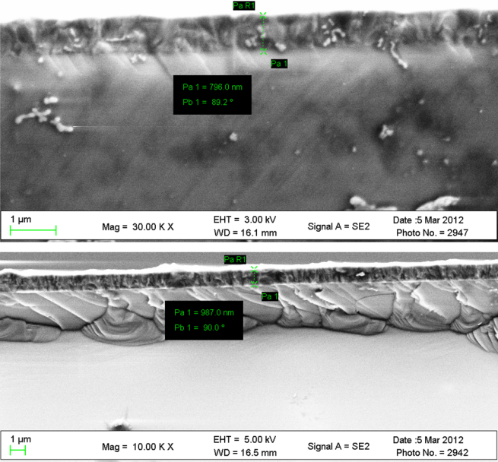
Figure 24. Cross sectional images of sample 24 showing measured film thickness

Sample 25 used identical flow rates as those in 22 and 24 of 300 sccm; however, the flow rate of diborane was lowered to 10 sccm, thus representing a factor of 3 difference between phosphine and diborane flow. The resultant mass gain of just 1.03 mg suggests that concentration of diborane in the reactor is critical to thin film growth.
Sample 26
The penultimate sample in the parametric study retains settings fork pressure system pressure, temperature and hydrogen balance flow rate. Phosphine flow rate setting was 150 sccm, while the diborane flow rate was 30 sccm. This corresponds to a flow rate ration for phosphine and diborane of 5. Measured mass gain for sample 26 was 3.24 mg with a predicted thin film thickness of 2.66 um. The photograph of sample 26 is shown in figure 24. Even film coverage is observed with a thickness gradient indicate in the top left of the substrate. This sample is the antithesis of sample 25 and was selected to isolate the importance of diborane concentration and thin film growth. By halving the phosphine flow rate from the previous experiment and increasing the diborane flow by a factor of three, the mass gain was significantly increased from sample 25. Cross sectional SEM images of sample 26 shown in figure 25 show an average thin film thickness of 3.22 um, slightly above the predicted thickness previously reported. Morphology of sample 26 is consistent with the earlier samples in this study as shown by SEM microscopy. A relationship between ass gain and diborane is indicated from the results of this sample. Increasing diborane seems to increase the observed film thickness. Phosphine concentration does not seem to directly correlate with observed film thickness.

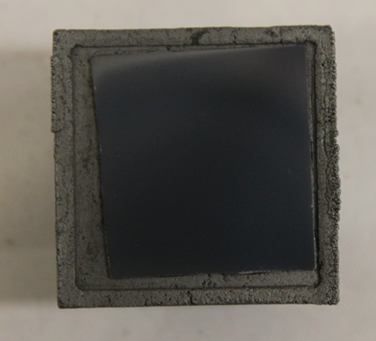
Figure 25. Photograph of sample 26 post deposition. Film shows even coverage with exception to the top left corner. A thickness gradient is apparent.

Sample 27
The last sample is an examination into the effect of temperature on a specified set of conditions. Sample 27 pressure and hydrogen balance flow rates remain unchanged from the setting in all prior samples. The temperature of the susceptor raised slightly from approximately 800 C to 855 C. Phosphine and diborane flow rates return to settings used in samples 22 and 24 of 300 and 30 respectively; yielding a flow rate ratio of 10. Results from the experiment include a mass gain of 3.09 mg with a predicted film thickness of 2.54 um. Photograph of sample 27 post deposition (figure 26) shows a varying coloration on the top left corner similar to that observed in sample 25. Film thickness decreases in this area. Cross sectional SEM images show an average thickness of 2.49 um. This compares well with the predicted thickness of 2.53 um. Columnar structures are observed in this sample, and are consistent with all previous samples in this study. The top image in figure 27 at 30KX magnification shows a thin light colored area at the interface of the BP and Si substrate. Although not observed in any of the previous micrographs, the light colored area (figure 28) running the span of the sample resembles an amorphous layer. This could be a consequence of the previously observed Volmer-Weber growth mode, where islands of particles coalesce to a certain critical length at which the growth mode changes and columnar growth begins. The currently used SEM is not sufficient in magnification and resolution to accurately probe the BP-Si interface. TEM will have to be used to examine the interfacial region. Overall, the results of the parametric study identified a relationship between thin film formation and diborane flow rate. A direct proportionality is suggested, as the higher the diborane, the more thin film is present. The same is not true with phosphine concentration. Higher phosphine with steady diborane concentrations produced less BP is present.

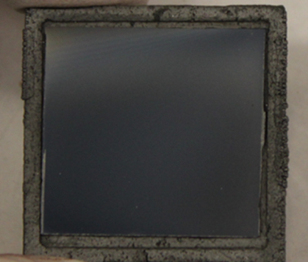
Figure 26. Sample 27 immediately post deposition

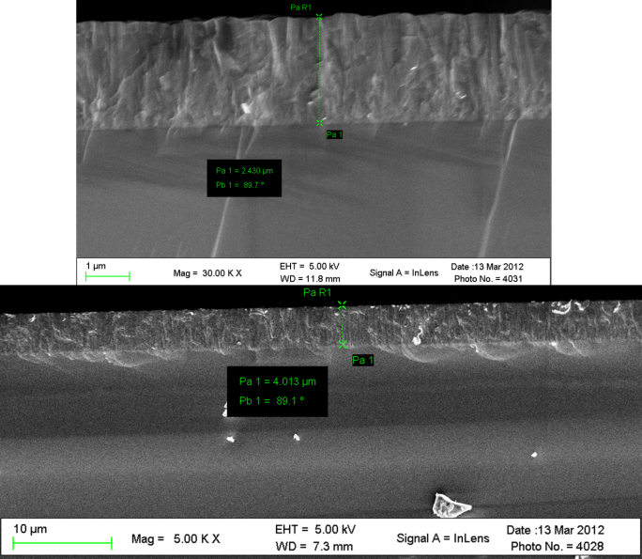
Figure 27. Cross sectional SEM Images of sample 26. Top image shows fin film thickness of 2.43 um. Bottom shows a thickness of 4.01 um

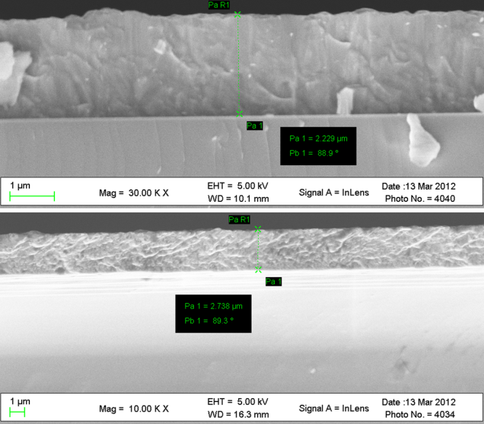
Interface line. Suspected amorphous BP
Figure 28. SEM micrographs of sample 27.

3.2 BP-Si interface Morphology and Fine Structure

In heteroepitaxial grown processed, the interface region between the substrate and thin film serves as the foundation for future growth morphology. Morphology at thin film interface is subject to intrinsic stress and observations of resultant morphology of this stress is useful in understanding future growth. As previously shown, SEM micrographs and even cross sectional SEM images are not sensitive enough to probe interface with significant resolution in order to properly observe interface morphology. TEM must be employed for this purpose. In order to examine the interface between BP and (001) Si substrates an experiments was conducted to grown BP on intrinsic Si, with a measured resistivity of approximately 3.2 X 10⁵ Ω·cm. Reactor parameters were selected from data collected in the parametric study. Diborane flow rate was set to 20 sccm, phosphine, 100 sccm, to give and flow rate ration of 5. Substrate temperature was measured at 812 C and system pressure and hydrogen balance flow rate were unchanged from all previous experiments at 630 torr and 2500 sccm respectively. Figure 29 shows a photograph of the sample post deposition. The photo depicts even coverage with a slight discoloration on the right side of the sample. This is the side nearest to gas flow introduction. It appears that the BP film does is thinner in this area. Raman spectroscopy of this area confirmed the presence of BP. Because this sample was selected for TEM analysis prior to deposition, only surface SEM micrographs were obtained. The surface SEM images shown in figure 30 indicate a contiguous rough film. SEM of this sample is similar morphology to samples shown in the parametric study. Higher magnification images shown in photos C and D of figure 30 still suggest a coalescing island growth mode, not ideal for smooth highly ordered films.
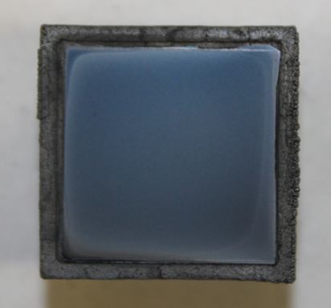
Figure 29. BP depostion on Intrinsic Si.

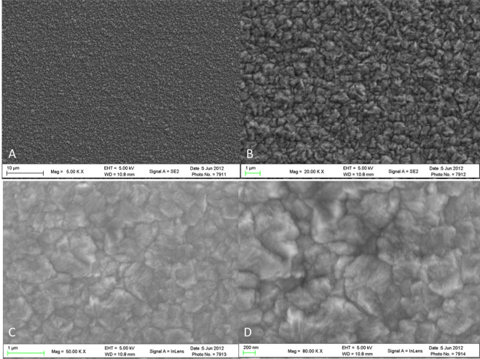
Figure 30. Surface SEM micrographs of BP on intrinsic Si. Magnifications range from 5K X to 80K X. Surface morphology is indicative of Volmer-Weber growth mode

The intrinsic sample was prepared for TEM analysis: an area of the sample is selected with an SEM with attached focused ion beam (FIB). A protection layer comprised of a noble metal is applied. In the BP work Pt was used. Next, a lamella is extracted from the selected area. A cross sectional is extracted using a nano-manipulator. The sample is transferred to a copper grid where it is permanently affixed using Pt metal. Once the sample is attached to the grid, an ion beam is used to polish the sample until it becomes electron transparent. This thickness varies for different materials, but in the case of BP it is less than 80 nm is sufficient for electron transparency. Cross sectional TEM images of the BP-Si interface shown in figures 31-33 show a distinct amorphous region approximately of approximately 50 nm in height proceeding toward the surface of the film. After 50 nm of film growth, small grain polycrystalline BP begins to form and propagates for approximately 1.25 um before large grain polycrystalline BP is formed and propagates for an additional 1.5 um. This is confirmed in the selected area diffraction (SAD) studies of the sample. Specific regions of the sample were identified based on their appearance in the cross sectional TEM images. SAD images were obtained at the interface, small crystalline region and the large crystalline region. The images shown in figure 34 depict the SAD patterns from the approximate areas demarked by the yellow circles. The circles, labeled A,B, and C correspond to the SAD pattern with the same letter. The cluster of bright spots emanating from the middle of the image are consistent with small numbers of BP crystals with varying orientation. Furthermore, progressing from pattern A to

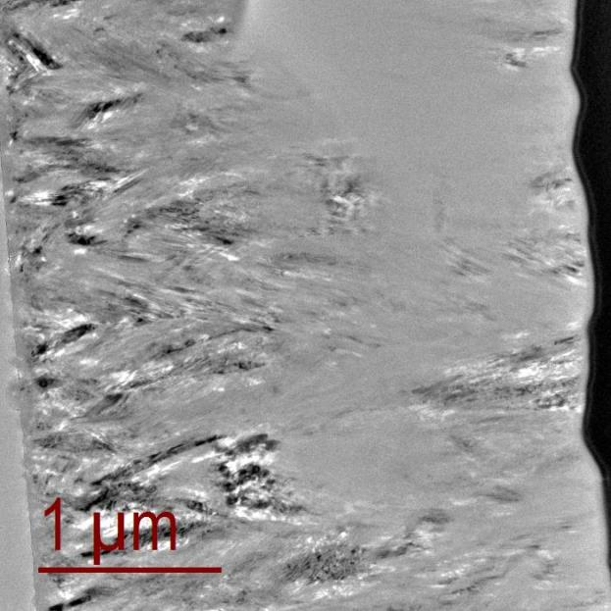
Figure 31. Cross sectional TEM of BP-Si interface at 10KX magnification. Identifiable regions are labeled on the photo for reference. Showing the Si substrate in the lower left. Followed by the amorphous region shown between the yellow lines flowed by varying sizes of polycrystalline BP

Si
Pt
Polycrystalline BP,
Large grains
Polycrystalline BP,
Small grains
Amorphous BP,
about 50nm

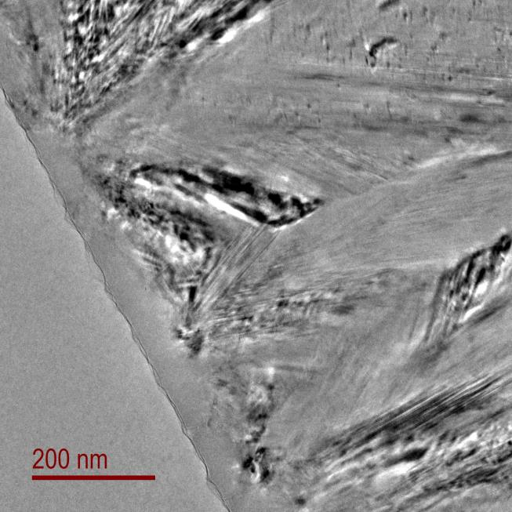
Interface

Figure 32. 31.5 KX magnification image of BP-Si interface. Showing amorphous layer followed by small grain polycrystalline BP
Silicon Substrate
Polycrystalline BP,
small grains
Amorphous BP,
50nm

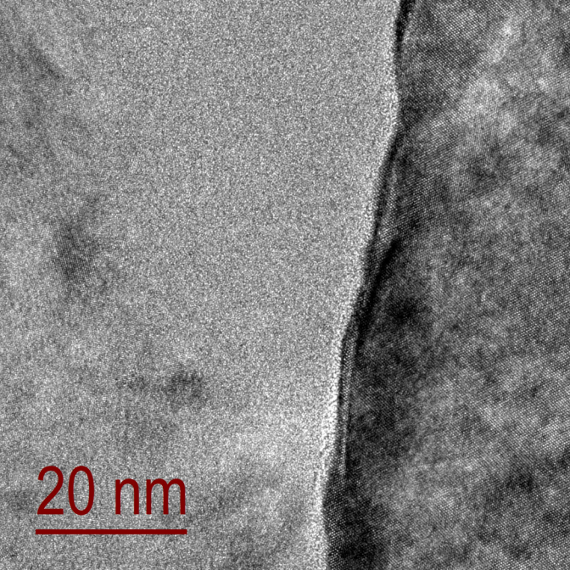
Silicon
Zone axis (110)
Interface
Amorphous BP,
about 50nm
Figure 33. TEM cross section of BP-Si interface at 315 KX magnification.

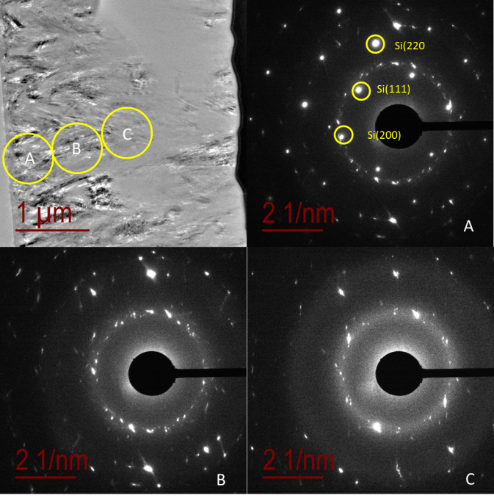
Figure 34. Figure showing the SAD pater for specific regions with in the Bp-Si thin film. Each SAD pattern corresponds to the region with the corresponding letter shown in the top left

pattern C shows a decrease in the number of observed diffraction conditions, indicating the number of satisfied conditions is decreasing, an observation consistent with the cross sectional TEM image indicating the in growth of larger BP polycrystals. A comparative analysis of the images in figure34 to those shown in figure 33 further show the presence of larger crystal BP near the surface of the film. The TEM image shown in the upper left corner of figure 34 shows the approximate sample location of the following SAD pattern. The space between the satisfied diffraction conditions is greater from the patterns observed in figure 33 the reduction in Bragg reflections indicates larger BP crystals are present in the near-surface region of the film.

3.3Chemical analysis of BP thin Films on Si Substrates

In addition to providing critical information regarding the interface morphology of the BP-Si, TEM can also be used to provide much needed chemical composition data via EELS. For a brief treatment of EELS fundamentals refer to chapter 3. An experiment was conducted and sent for TEM morphological and chemical analysis. Both of which will be presented and discussed here.
Table 3 shows the experimental conditions for sample 7.
Table 3. Experimental parameter settings for Sample7
Sample | Pressure (torr) | Temp  (°C) | H₂  (sccm) | PH₃  (sccm) | B₂H₆  (sccm) | Duration  (hrs) | Mass Gain (mg) | Pred. Film Thickness (µm) | PH₃/ B₂H₆
7 | 630 | 816 | 2500 | 30 | 30 | 2 | 8.60 | 7.06 | 10

The primary difference between this sample and the parametric study is duration. At the time this experiment was conducted, experiments were not yet focused on interface morphology but rather film growth rate. Therefore the mass gain and predicted and actual film thickness are higher than the metrics used in the parametric study. Actual film thickness for this sample was measured at 9.4 um The fact that this sample is thicker is a benefit from a chemical composition standpoint inn that the longer duration of the experiment can provide indication of any deviations from stoichiometry throughout the run. From a TEM microscopy, the sample thickness created challenges and required more preparation time than the thinner samples. Figure 35 shows a photograph of the sample immediately after deposition. The coverage looks even. Some artifacts are observed on the surface of the sample and are circled for easier identification. These artifacts were determined to be debris from the CVD and were not part of the sample. They were removed from the sample surface with a sweep of dry nitrogen prior to analysis being conducted. Surface and cross sectional SEM images were obtained on sample prior to submittal for TEM. Surface SEM images shown in figure 36 are consistent with prior observations. A rough contiguous film is observed. Surface images were captured with relatively low magnification; therefore, it is not possible comment further on the surface images. Cross sectional images shown in

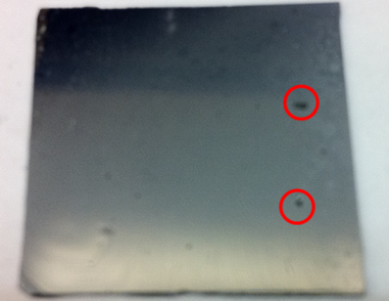
Figure 35. Photograph of sample 7 post deposition. Image shows even covering. Variations in colors are caused by shadows. Artifacts from CVD reactor are circled in red for easy identification. These were removed prior to deposition
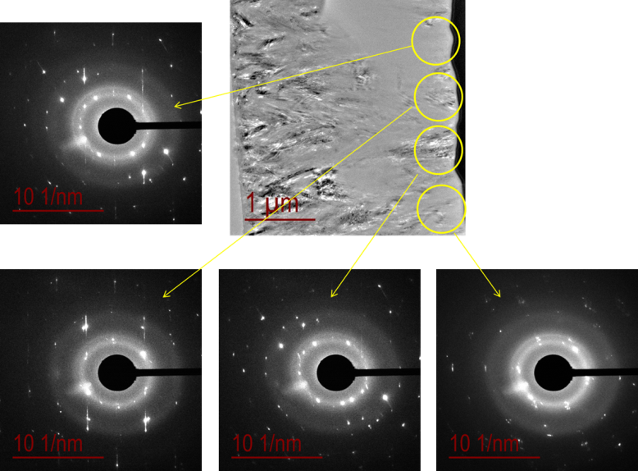
D
C
B
A
D
C
B
A
Figure 36. Cross sectional TEM image and corresponding SAD patterns of the near-surface region of the BP film on intrinsic Si

Figure 37 are also consistent with prior cross sectional images in that longitudinal columnar morphology is prevalent in this sample cross section.
From the thickness of the sample, TEM images appear differently from those previously shown. In attempt to retain sufficient material for meaningful analysis, the samples were not overly thinned. In this manner, TEM images will be shown in pairs, overlayed for easy viewing. Generally, the background image depicts the area where the foreground image was captured. Some exceptions to his will appear. A detailed description of the image will be provided in the caption. Figure 38 shows a TEM micrograph of the entire film from interface to surface. Due to the narrow field of view on the instrument the images must be taken individually and stitched to provide the entire 9.4 um film. The unique thickness of this sample provided some key information regarding preferred growth directions of BP. It is clear from previously presented TEM images that BP growth on SI substrates creates an amorphous region at the interface and then small polycrystalline grains followed by large polycrystalline grains. A revealing aspect of this sample is the polydsipersity of the varying crystalline phases observed in the large polycrystalline region. Figure 39 shows a TEM image taken from the middle of the BP film. The varying dark and light colors represent different the different crystalline phases in the sample area highlighted by the blue box on the right. Figure 40 is a TEM micrograph taken near the BP –Si interface. It shows the amorphous region in the bottom left of the image. Adjacent to the amorphous region are localized dark species that are randomly distributed in the area just above the amorphous region. These dark areas are BP nano crystals. Figure 40 shows crystals in a specific orientation as well as a blow up of one of the crystals. These images suggest a hierarchy of order in the BP –Si system. As the film begins to initially deposit on the surface, it is completely amorphous and continues that way for about 50 nm. Under the given conditions the amorphous layer would be deposited in under one minute. As deposition progresses, random BP nanocrystals begin to form from the amorphous region and can be observed throughout the film. The random nanocrystals are the key to understanding the preferred growth mode of BP. As the BP

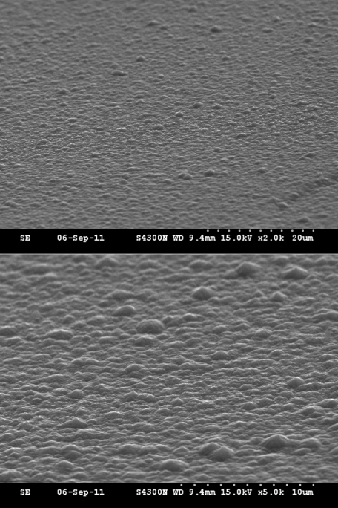
Figure 37. Surface SEM images of Sample 7

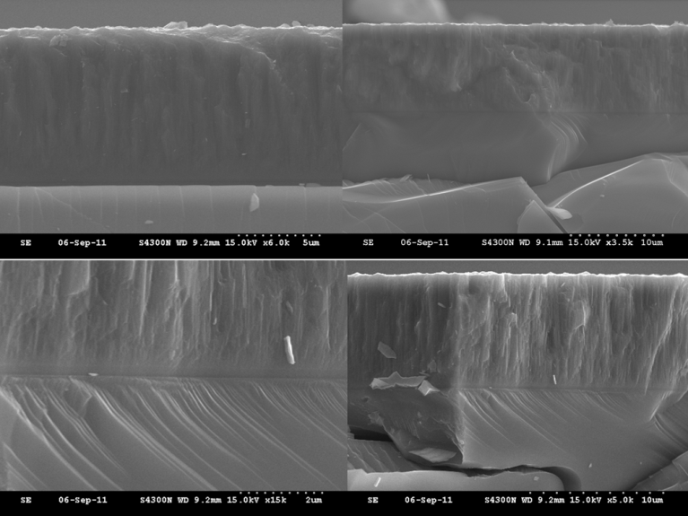
Figure 38. Cross sectional SEM images of Sample 7. Showing columnar grains
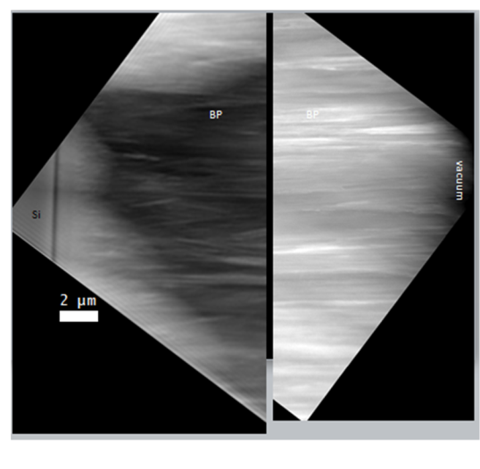
Figure 39. TEM micrograph of BP film on SI.

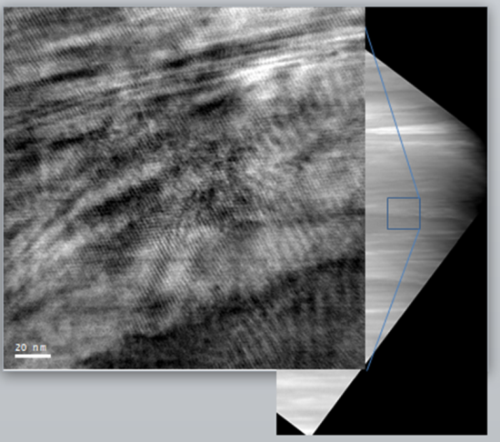
Figure 40. TEM micrograph from bulk BP film. The variations in light and dark represent different crystallographic orientations of BP

film increase in thickness, a threshold is reached where the nanocrystalline orientation becomes locked in the (220) direction. This is evidenced by XRD sans of the resultant crystalline orientation of the film. Successive XRD scans show the gradual disappearance of other crystalline phases and the strong predominance of the (220) peak. As the film grows, all other orientation are suppresses by the (220) dominance. Figure 41 shows XRDS scans of sample 7 and the dominance of the (220) peak.
Stoichiometric data for sample 7 was obtained by scanning the EELS probe across the Si-BP interface. Figure 43 shows the location of the spectrum highlighted in the colored box and the resultant spectrum below the image. The EELS spectrum is a graph of atom % verses distance. The blue line is the Si line and is shown at unity suggesting the presence of pure Si. The Si signal decreases as a function of distance and the ingrowth of B and P are represented by green line and red line respectively. 30 nm from the origin of the scan, the B and P lines overlap indicating equal distribution or 1:1 ratio of both B and phosphorus in the film; confirming the presence of boron monophosphide. EELS can also be used to identify the difference between amorphous and crystalline BP. Using the same sample location shown in figure 42, a graph of intensity verses energy loss shows (figure 44) a clear difference in the fine features of the spectrum. The green line is the intensity vs. loss plot of the amorphous region of the sample. There is little detail in the spectrum and no observable resolution of feature. In contrast, the blue line is the intensity vs. energy loss plot of the columnar crystal region, closer to the surface of the film. The peaks from L shell electrons from P and the K shell electrons from B are clearly resolved.

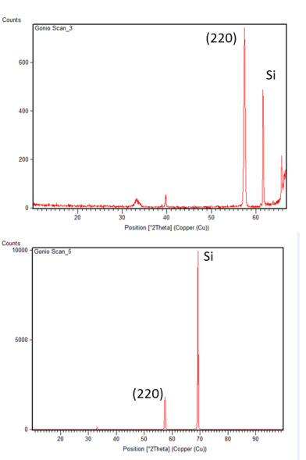
Figure 41. XRD scans of sample 7, BP on Si.
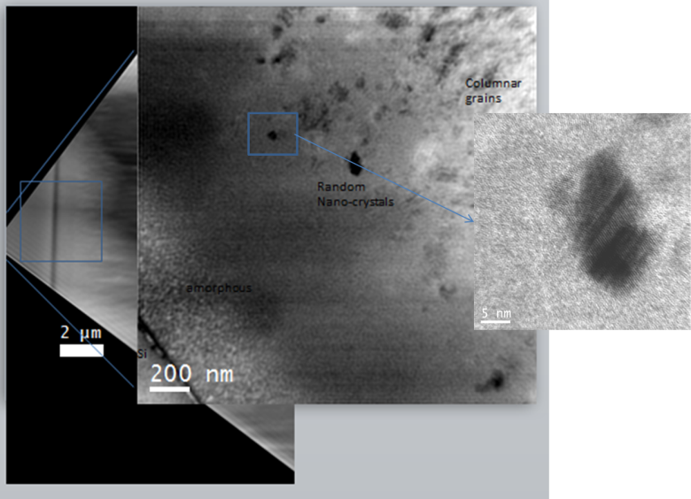
Figure 42. TEM image of BP-Si system in the near- interface region. Showing the presence of a BP nanocrystal

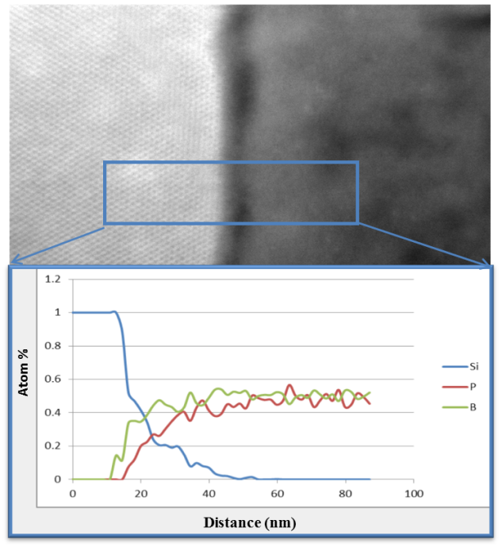
Figure 43. TEM-EELs spectrum of Sample 7. Spectrum acquired by scanning across Si-BP interface

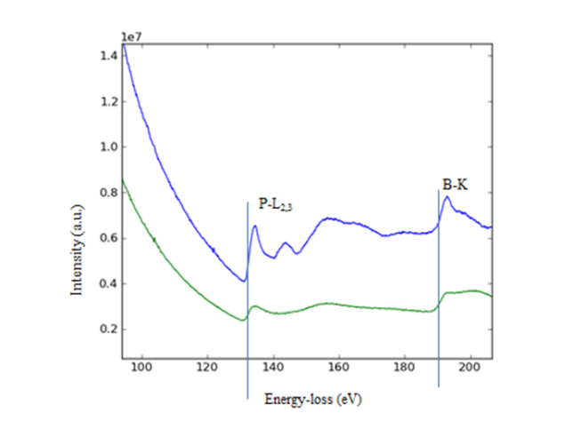
Figure 44. TEM EELS plot of Intensity Vs. energy loss for amorphous and polycrystalline BP

The body of work on Si set out to determine the optimum parameter setting for BP deposition growth on Si. This was determined through a series of controlled experiments. Data obtained during the parametric study indicate the best conditions for BP deposition Si to be a flow rate ratio of 10 with a substrate temperature of approximately 800 degrees. Metrics such as mass gain visual observation, Raman spectroscopy along with surface and cross sectional SEM techniques were used to characterize the depositions in the parametric study. Suggest a probably growth mod e for BP on (100) Si. Surface SEM showed the consistent rough films. Higher magnification of the Si surface shows large numbers of discontinuous particles followed by the gradual aggregation of the particles to from a continuous. Although this growth mode is suggested, it is not possible to decisively say that All BP growth on Si would exhibit this particular growth mode. Growth modes area function of temperature, so higher substrate temperatures could influence the growth mode significantly. SEM imaging is not adequate to accurately characterize the BP-SI interface; therefore, TEM was employed to probe the interface and provide detail into the bulk composition of the BP thin film. Characterization results provided by TEM confirmed the presence of anamorphous BP layer that extends for approximately 50 nm at the start of deposition. This is most likely the result of a strain between the substrate and BP layer from the 14% lattice mismatch. As deposition progresses strain is reduced as BP begins to grow in its preferred growth direction and small grain polycrystals can be observed followed by large grain polycrystals. As expected, a high number of crystalline phases are observed in the near surface region of the film. The presence of localized BP nanocrystals is seen at the juncture of the amorphous and small polycrystalline region. These auto terminating nanocrystals are thought to be seeds for the observed columnar since they auto terminate the (110) direction as growth progresses; matching the direction of the columnar growth. TEM-EELS analysis confirmed the presence of stoichiometric BP by measuring the atom percent of B and P at 0.5%. Furthermore, EELS confirmed the observations of the varying crystalline phases present in the BP film by thee resolution of the energy loss peaks from the L and K shells of P and B.
The presence of the amorphous region at eh interface combined with the polycrystalline morphology of exclude this system from being considered a viable candidate for device fabrication. The varying morphology and numerous grains will serve as charge traps and adversely affect electrical performance of the film. These findings necessitate the investigation into alternative substrate materials that can reduce intrinsic stress to eliminate the amorphous interface and reduce the polycrystalline morphology of the BP.

4.0 Deposition On SiC Substrates

The topic of this chapter is to describe the body of work regarding BP deposition on SiC substrates. In order to address the unfavorable conditions observed with BP deposition on Si, a series of experiments was conducted to elucidate the optimum conditions for BP deposition on SiC. Initial depositions conducted on SiC substrates were low information yield experiments designed to establish confidence that reliable deposition SiC was possible. Follow on experiments included a quasi-parametric study similar to that described in the Si chapter as well as more focused experimental sets designed to closely examine a specific condition observed in a prior experiment.
Given the small lattice mismatch between BP and SIC compared, the notion of being able to grow epitaxial BP on SiC was thought possible. Therefore, the immediate focus of the BP depositions on SiC was to demonstrate epitaxial growth of BP on SiC and determine through a series of controlled experiments the growth conditions of which this occurs. The growth parameters demonstrated in Si deposition were used as the starting point for SiC deposition. Table 4 on the following page, shows a list of applicable experiments and associated parameters performed on 4H 4 ° off cut SiC. The bulk of SiC work was performed on this substrate. BP depositions on alternative SiC orientations will be discussed separately.

Sample 31

Initial system parameters for SiC deposition identical to the last depositions performed on Si. System pressure was set to 630 torr, hydrogen balance flow rate was maintained at 2500 sccm throughout the experiment. Set point for the diborane and phosphine were 20 sccm and 100 sccm respectively for a flow rate ratio of 5. Susceptor temperature was maintained close to 800° C as possible. The duration of the experiment was kept to 0.5 hours in order to facilitate TEM analysis of the interface. Predicted film thickness was 2.65 µm, using calculated using the same formula presented in the chapter on Si. The

Table 1. List of applicable depositions and associated system parameters performed on SiC substrates
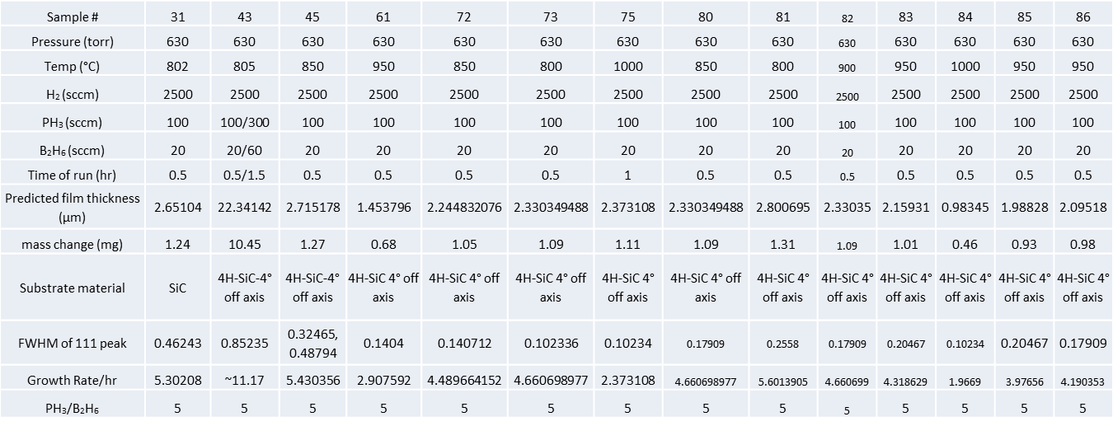

resultant film, shown in figure 1, had a mass gain of 1.24 mg. Coverage of the film appears uniform with some variation along the outer edges of the right side wafer. Like the Si substrate samples, Raman Spectroscopy was also performed. As expected the resultant Raman spectra were remarkably consistent throughout the experimental set shown on table 1. Figure 2 shows an overlay of the measured Raman spectra for selected samples the entire experimental set. Raman data is not available on all samples because of its consistency, the technique was discontinued in favor more informative analysis methods such as XRD. Nevertheless, the observed peaks at 824 cm⁻¹ are consistent with BP and match nicely to the spectra shown from depositions on Si. This gives high confidence that changing the substrate from SiC to SiC had no deleterious effect in the Raman signature of the grown BP and thus is largely unchanged from a molecular standpoint. A surface SEM image of sample 31 (figure3) shows a continuous film with a slight less rough appearance in the film as compared to the experiments performed on Si. Cross sectional SEM shows an average measured thickness of 2.803 µm. slightly more than predicted. The morphology of the resultant film is different to the observations on Si. The long columnar crystals are not present in the SiC and replaced with what looks to be multi-faceted polycrystalline grains. Cross sectional TEM images show a much improved interface from those observed on Si. Figure 5 shows an overview of the film and substrate. The BP thin film is comprised of heterogeneous polycrystalline grains of varying size. The far right portion of the image shows the interface region. At this magnification it is possible to see crystalline structure at the interface rather than amorphous material. Figure 6 shows a zoomed image focused on the interface. In this image the substrate is to the left. Moving from left to right on the image shows the transition from the SiC to the BP film. The regular pattern visible in the single crystalline SiC is matched in the BP film.

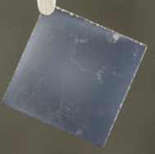
Figure 1. Photograph of BP deposition on SiC immediately post deposition

Figure 2. Overlay of Raman Spectra of BP on SiC of selected samples

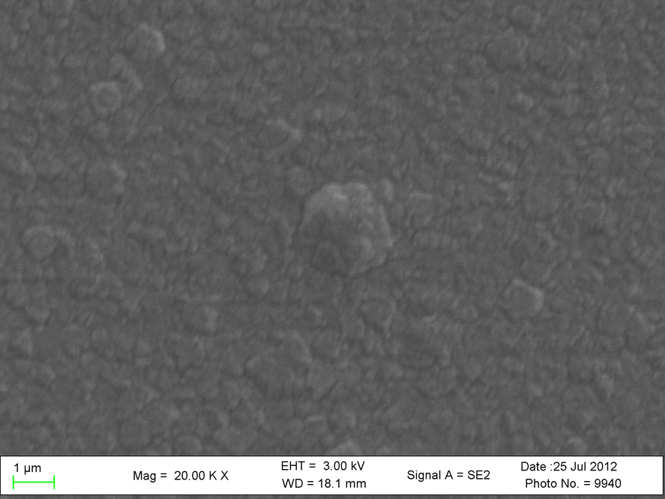
Figure 3. Surace SEM of BP on SiC. Shows continuous film with rough appearance

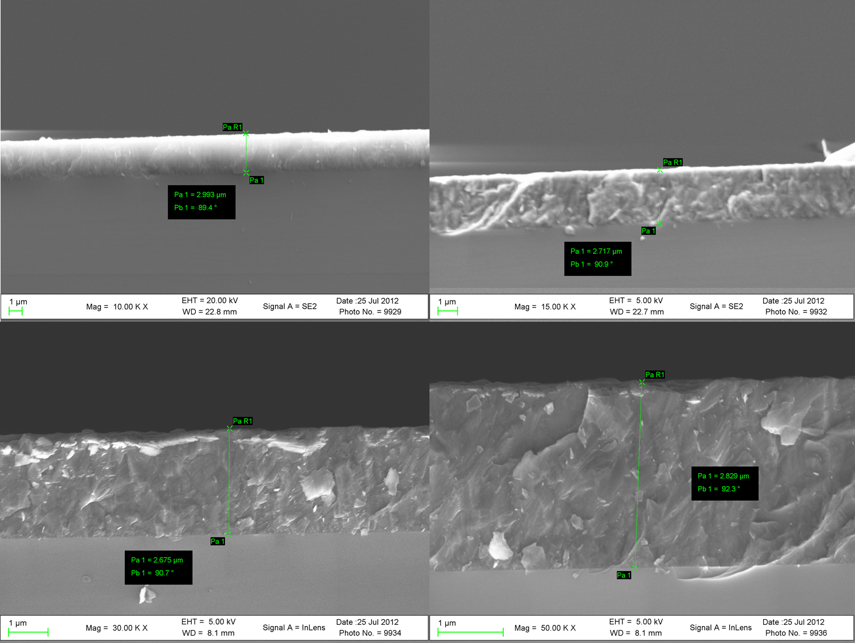
Figure 4. Cross sectional SEM of BP on SIC showing measured film thickness taken in 4 locations

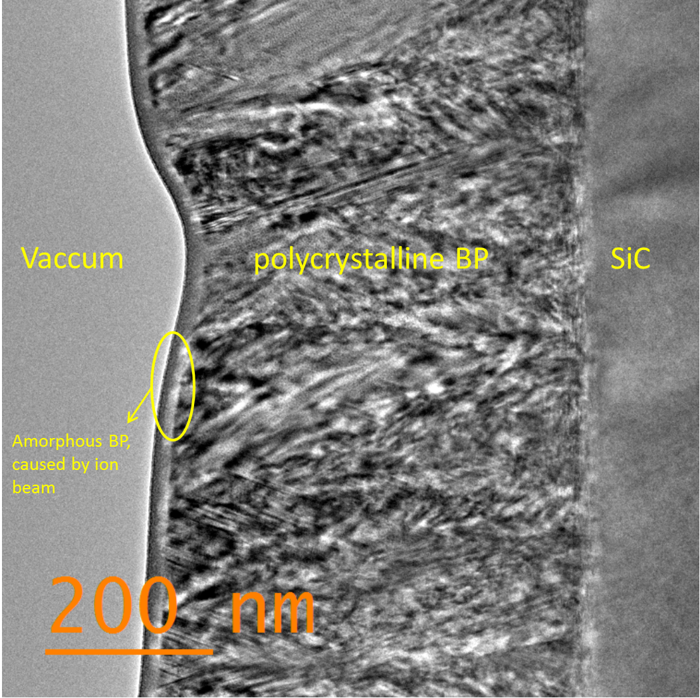
Figure 5. Cross-sectional TEM of BP on SiC. Showing polycrystalline grains and morphology at the film-substrate interface

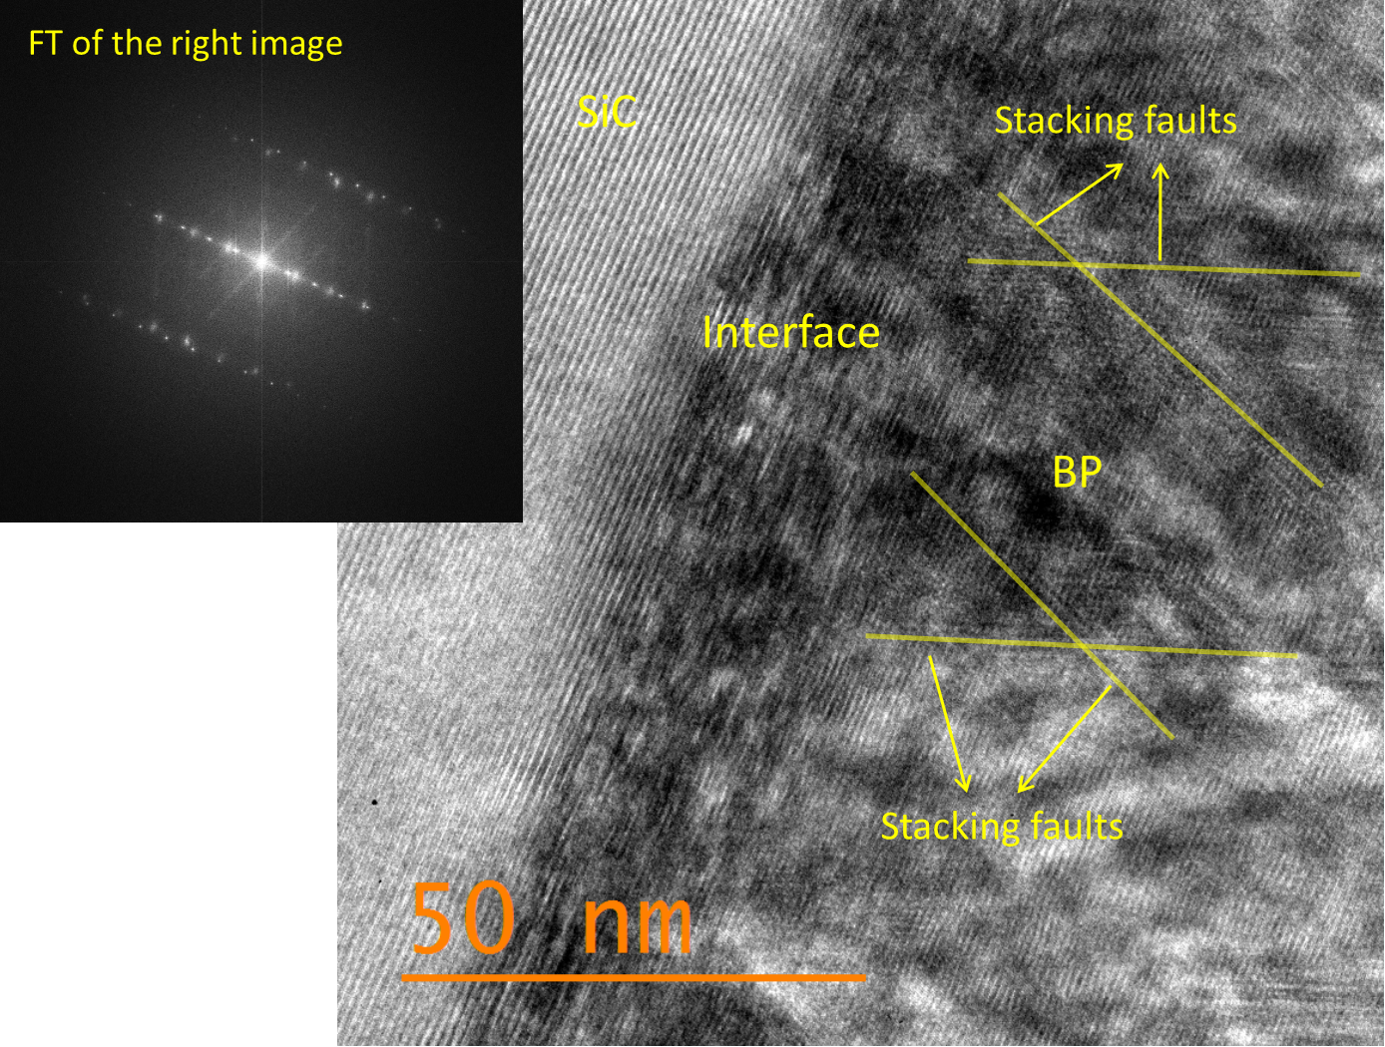
Figure 6. Zoomed TEM image of the BP-SiC interface. Showing Heteroepitaxy. The inset image is the Fourier Transfom of the image on the right confirming epitaxial growth

the poly -crystalline nature of the film is more evident in this image; in that as the film progress in thickness, deviations in the epitaxy become more prevalent. The inset image in the top right is the Fourier Transform of the image on the left. The linear arrangements of the bright spots indicate direct alignment or epitaxy. The corresponding SAD patterns (figure 7) indicate there is strain at the interface evidenced by the contrast in size of the satisfied diffraction conditions of BP and SiC.

Sample 45

Despite confirming the presence of epitaxial BP on SiC, the as grown films began to deviate from epitaxial relationship tens on nanometers into growth. The bulk polycrystalline nature of the film is not ideal for signal conduction, so the next experiment was designed to improve the bulk morphology of the BP film. In order to minimize variability in the system parameters, the growth condition of sample 45 were held constant from sample 31 with exception of temperature. The susceptor temperature was raised from 800° to 850°C. Theoretically, a higher temperature corresponds to an increase in the surface energy of substrate. This increased surface energy allows higher surface mobility for the B and P atoms on the SiC hopefully leading to a higher order arrangement. Predicted film thickness was 2.72 um. The resultant parameters of sample 45 show a total mass gain of 1.27 mg. A photograph of sample 45 is shown in figure 8. The film covers the entire substrate and color variations can be observed in the middle of the film with several dark colored areas present. Figure 9 shows a series of surface SEM images labeled A-D. Image A is the lowest magnification and image D is the highest magnification. Higher magnification images depict a rough surface which has been consistently observed throughout the experiments conducted. TEM analysis of the BP-SiC interface shows higher order crystal quality and epitaxial growth. Figure 10 shows bot he Image and the resultant FT of the image. Some twinning is observed in the near interface region, but analysis of the d spacing from the atom arrangement show approximately 2-3% lattice distortion. This is slightly better than the 4% calculated mismatch between

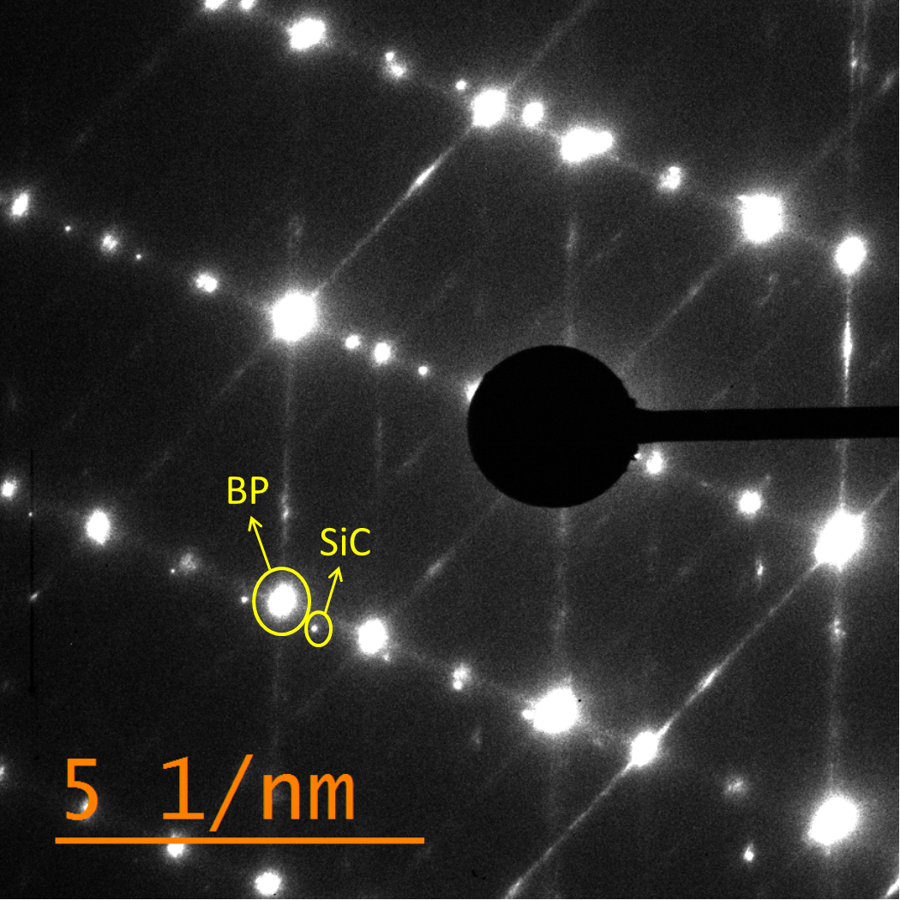
Figure 7. SAD pattern of BP on SiC. Indicating strain in the epitaxial fil

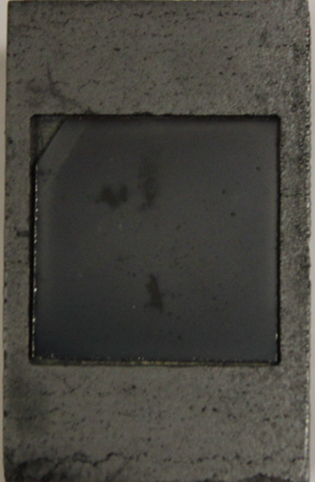
Figure 8. Photograph of sample 45, BP on SiC immediately post deposition. Sample shown in graphite susceptor

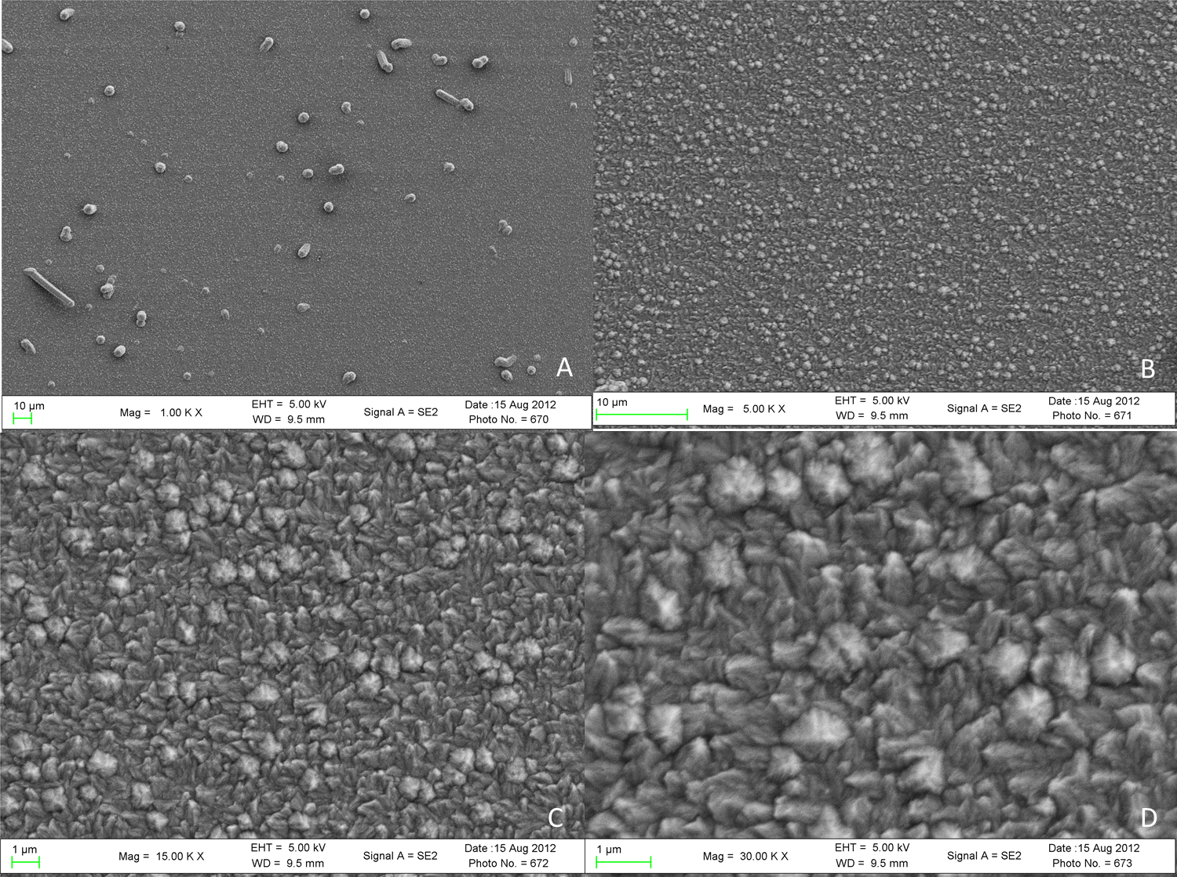
Figure 9. Series of Surface SEM images of BP on SiC. Showing increases in magnification from 1KX (image A) to 30 KX (image D)
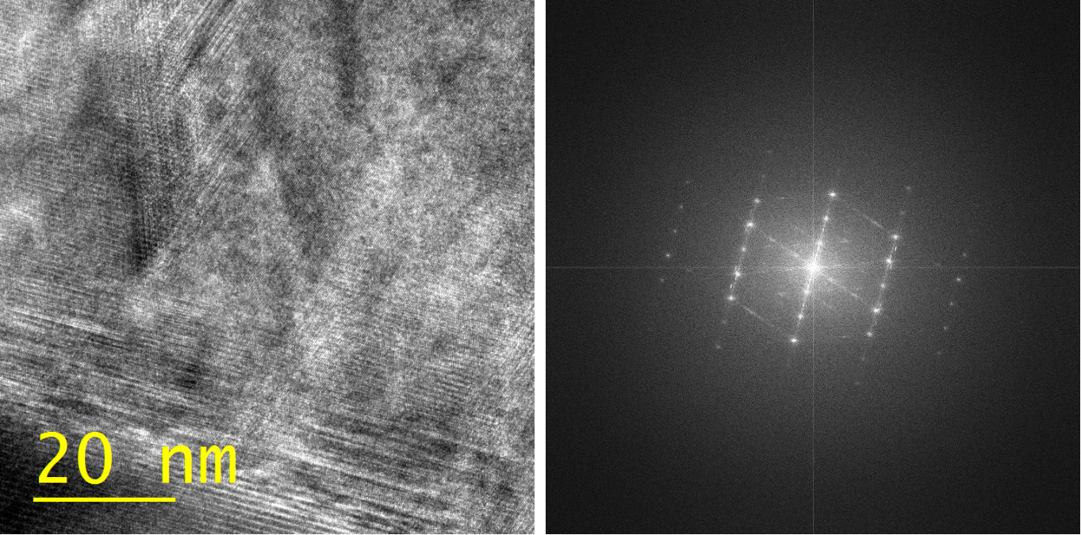
Figure 10.TEM image and FT of the interface of BP-SiC interfae of sample 45.

BP and SiC. Based on the positive results of the interface analysis, additional images were obtained in the middle of the film as well as the surface. Observations made from the middle of the film show a pure single crystalline morphology. The TEM image as well as the corresponding FT can be seen in figure 11. Although not shown in the image, there is an approximate 7% distortion along the [100] but less than a 2% lattice distortion along the [110] and the [111] directions. Similar analysis methods of the surface of the film showed pure face centered cubic crystals with observable no lattice distortions. This is shown in figure 12. Some artifact can be observed in this subsample. The amorphous film at the very surface is not a result of the deposition, but rather consequences of the FIB and resulting Pt protection layer applied during sample preparation procedures.
The compartmentalized nature of the TEM analysis tends to belie the possible strain relief processes apparent. Up to this point, the concept of strain in the BP film has been passively noted. But sample 45 makes clear that the films morphology is changing as a function of film thickness. At the interface, epitaxial arrangement is observed with an approximately 2-3% lattice distortion along the [110]. The middle of the film shows FCC crystal structure with a slightly exaggerated distortion along the [100]. The surface of the film showed pure FCC with no appreciable distortions in the observed lattice. This variation in film crystal structure suggests that the induced strain from the inherent lattice mismatch is being slowly relived throughout the thickness of this film. As the BP thickens, the strain is lessened and the [111] preferential growth direction is allowed to dominate. This observation is atypical in semiconductor heteroepitaxy. The critical layer thickness can be determined to provide the approximate length of the epilayer to relive the induced strain from the lattice mismatch, In order to approximate the strain, the lattice mismatch strain must first be determined. The lattice mismatch stain (f) is determined by the relationship of the relaxed lattice constants of both the epilayer and substrate according to the equation

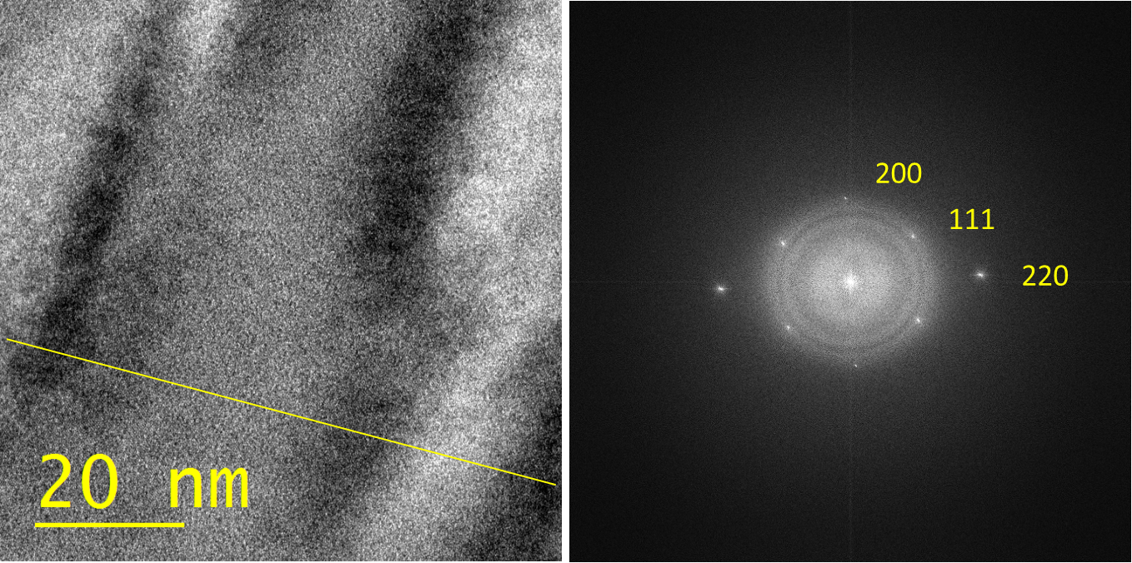
Figure 11. TEM image and corresponding FT from the middle portion of BP thin film sample 45. Showing single crystalline morphology
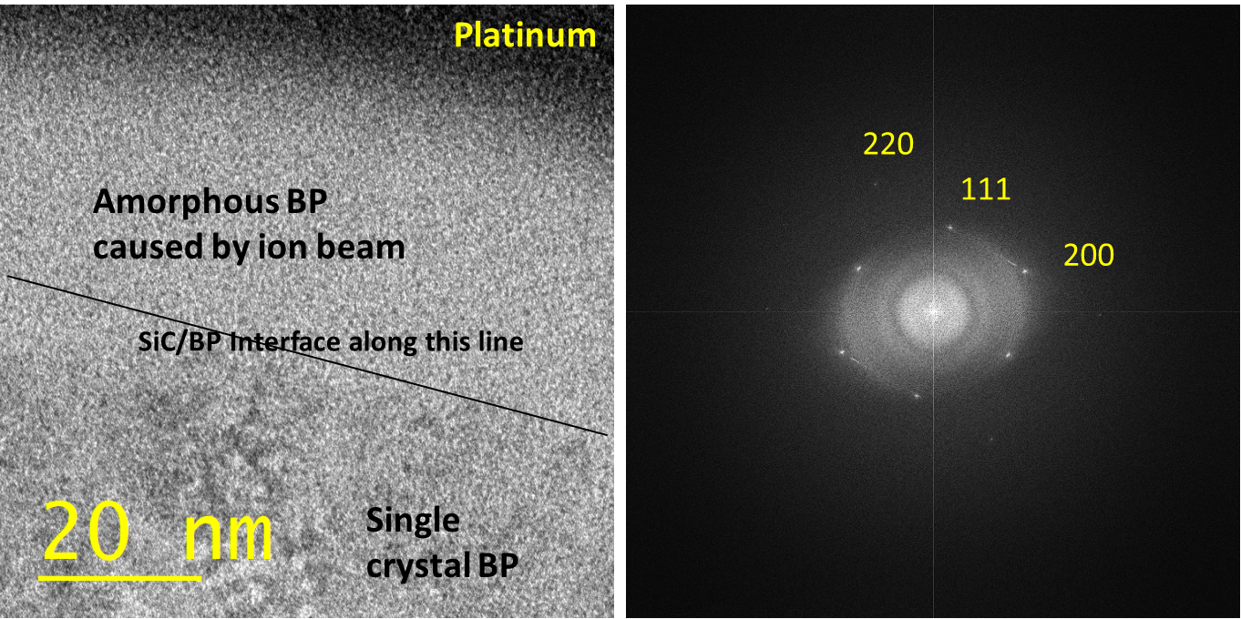
Figure 12. TEM and corresponding FT of the surface of BP sample 45
$$f≡\frac{a_{s}-a_{e}}{a_{e}}$$

Where $a_{s}$ and $a_{e}$ are the relaxed lattice constants for the substrate and epitaxial layer respectively. Substituting the values for the BP-SiC system into the above equation, the lattice mismatch strain is between BP and 4H SiC is approximately -3.9%. Note, in order to compensate for the hexagonal structure of the substrate, the а lattice parameter was multiplied by the$\sqrt{2}$. Using this information, the critical layer thickness ($h_{c)}$ can now be accurately calculated using the equation below:
$$h_{c}=\frac{a_{e}\left(1-\frac{v_{pr}}{4}\right)[\ln\left(\frac{\sqrt{2}h_{c}}{a_{e}}\right)+1]}{2\sqrt{2}π|f|(1+v_{pr})}$$
Where $v_{pr}$ is Poisson’s ratio and $a_{e}$is the relaxed lattice constant of the epitaxial layer or in this case lattice constant of BP. For the sake of this discussion, a numerical approximation will suffice; therefore In lieu of calculation, the critical layer thickness ($h_{c})$ can be approximated according to the equation below and will be used in further discussion.
$$h_{c}≈\frac{a}{2f}$$
Where a is the relaxed lattice constant of BP and f is the calculated mismatch strain. Using this approximation, the critical layer thickness of a BP layer on SiC is 0.88 nm. This is the thickness expected to resolve the induced strain. Based on the TEM images shown previously for sample 45, strain relief through misfit dislocations is being observed at orders of magnitude greater thickness. This phenomenon is not completely understood, but the gradual release of induced strain over the total thickness of the film reduces the number of areas with high concentrations of strain induced defects thus giving a higher quality film.

4.2Temperature Study

A series of successive experiments was performed in order that the most ideal substrate temperature for high quality deposition could be identified. In the study, all system parameters with the exception of temperature were held constant. % depositions were performed beginning at 800° C and increasing in 50 degree increments to a final temperature of 1000° C. Table 3 shows the total system parameters for samples 80 through 84 comprising the temperature study.
Table 2. Total system parameter settings for experiments comprising the temperature study
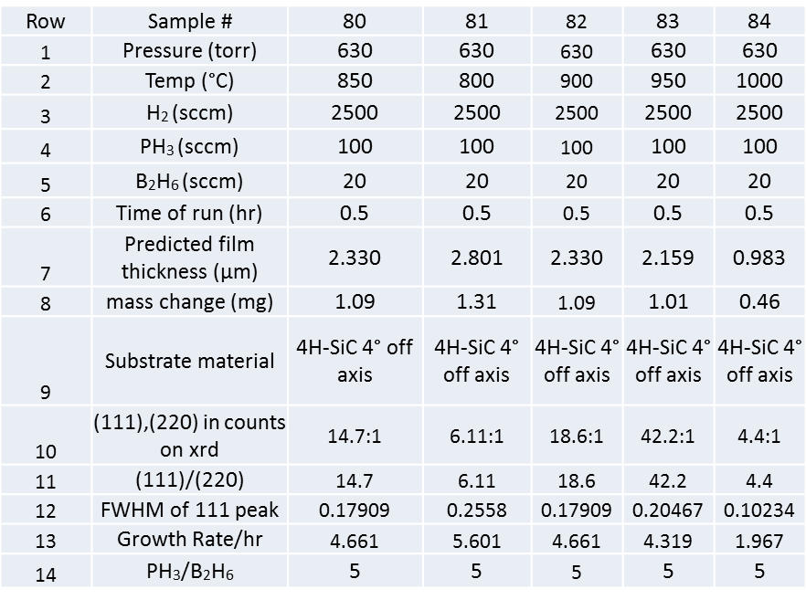
This table is similar to those previously presented, but with one exception, rows 10, 11, and 12 address XRD analysis on this sample set. The details of XRD analyses performed on these samples will be discussed later in this chapter. Resultant data descriptions and discussions f the samples comprising the temperature study will included photographs of samples post deposition XRD and TEM images and SAD patterns is applicable. Surface SEM images and cross sectional images will only be included where applicable because of the narrow focus of this experimental set and the limited value SEM images can provide in interface characterization.
Although it is the first sample in the temperature study, it is not the lowest temperature. The system parameters were controlled enough that the individual experiments are not interdependent so the experiments need not be performed in any particular order. Complete system parameter settings can be seen in table 3. The predicted film thickness in microns was 2.33 with a corresponding mass change of 1.09 mg. Figure 13 shows the photograph of sample 80 post deposition. The sample appears to have a variety of surface features. There are three dark spots in the center of the sample surrounded by this circular feature surrounding the middle of the film. This area of the wafer is generally the portion with the highest deposition. The exact cause of these visual features of sample 80 is unknown, as no unusual conditions were noted in the conduction of the experiment. Raman spectra were obtained on all samples in the temperature. Figure 14 shows an overlay of the Raman spectra obtained. The BP peak is the most predominate peak shown at 828 cm⁻¹ the small peak appearing at approximately 777 cm⁻¹ is the peak of 4H SiC. As expected, the Raman spectra remain consistent. Peaks for all of the temperature study samples align well and indicate from a molecular standpoint the as grown BP is very similar.
Throughout the course of the experimental set, XRD has been use to determine the crystalline nature of the films. The XRD is discussed here because of its high correlation to the data being presented. It has been stated that the (111) surface of BP is a good lattice match with the (0001) surface of 4H- and 6H-SiC. By observing the preferred orientation of films grown on Si, parameters for future growths on SiC could be assembled to give desired results. In most of the XRD patterns, two planes are observed; (111) and (220). Earlier focused studies involved varying the concentration of B₂H_{6.} Data analysis from the early studies suggest the change in diborane concentration appears to alter the preferred growth

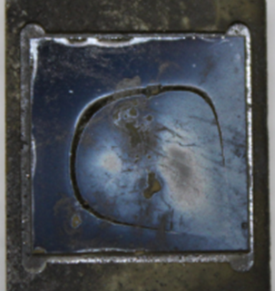
Figure 13. Photograph of Sample 80 post deposition

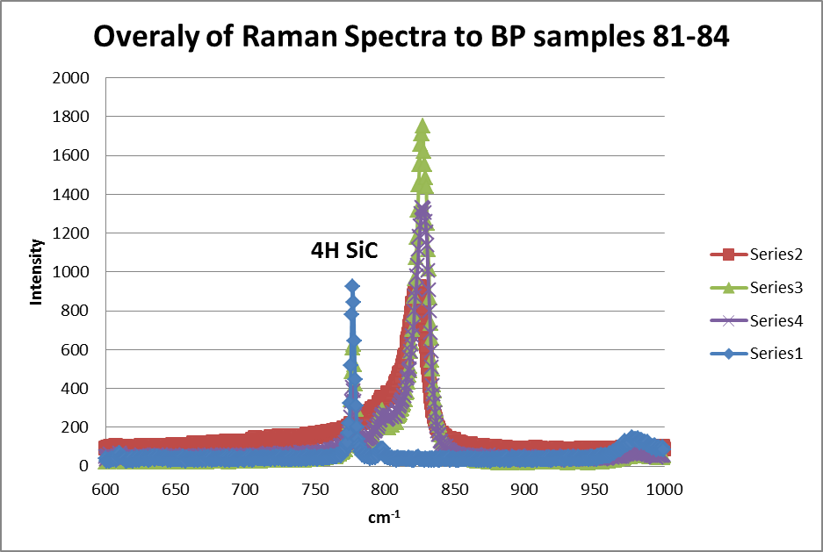
BP
Figure 14. Raman Spectra of Temperature study samples

direction of the BP film as can be seen from comparison of data on samples 7, 13 and 21 shown in figure 15. From the patterns it can be concluded that increased B₂H₆ concentration favors the (220) plane (indicative of growth in the <110> direction), while decreased B₂H₆ concentration favors the (111) plane.
Now that a relationship has been established between the film growth parameters and the XRD patterns, XRD patterns can be used to serve as a screening tool for crystalline order in the films. The manner that the XRD was used in the temperature. BP films that exhibit high counts in the (111) are considered better films that those with high counts in the (220). A simple metric developed to easily screen for this, was determination of the ratio of the (111) peak to the (220) peak of BP. As previously stated, Growth in the (111) direction for BP is indicative of high quality growth, while growth in the (220) direction has been found to grow out of amorphous material The XRD spectrum of sample 80 is shown in figure X, the peaks are labeled according to direction of growth. Corresponding ratio of 111 to 220 is 14.7 indicating epitaxial growth.
Tem images taken on sample 80 confirm interfacial epitaxy. Figure 17 shows the cross sectional
TEM of the BP-SiC interface. Identical repeating patterns are visible in both the BP and SiC.
The Sample 81 is the second sample in the temperature study and was conducted at the lowest temperature of 800° C. Figure 18 shows the photograph of sample 81. Overall, the sample shows even coverage of the film with two discolorations in the lower left corner. Predicted film thickness was 2.80 um. The mass change of the sample was 1.31 mg.

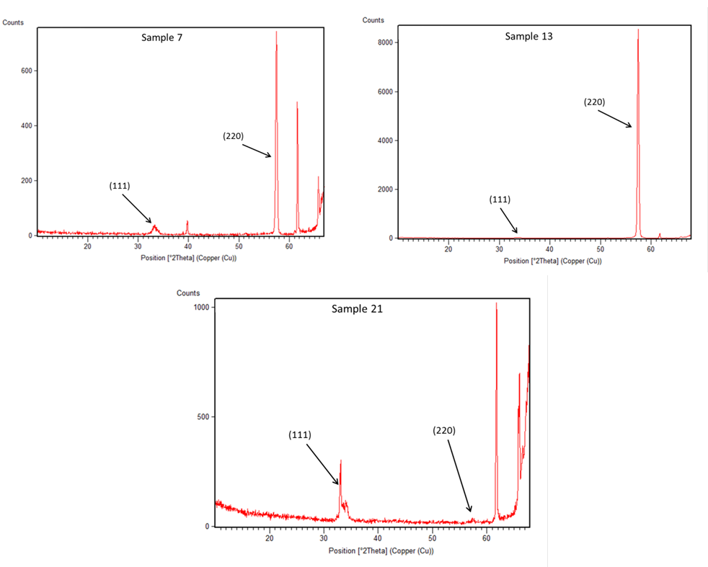
Figure 15. XRD spectra of early samples showing the relationship of the (111) and (220) peaks as a function of diborane concentration

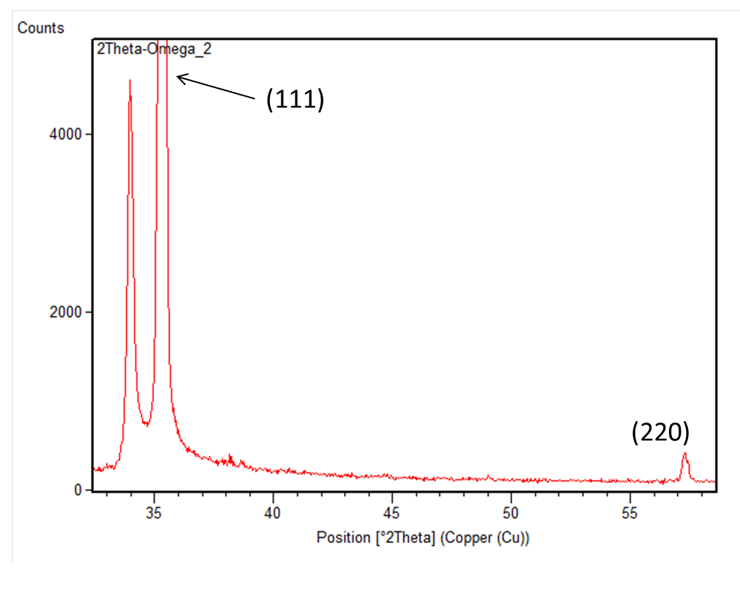
Figure 16.XRD spectrum of sample 80

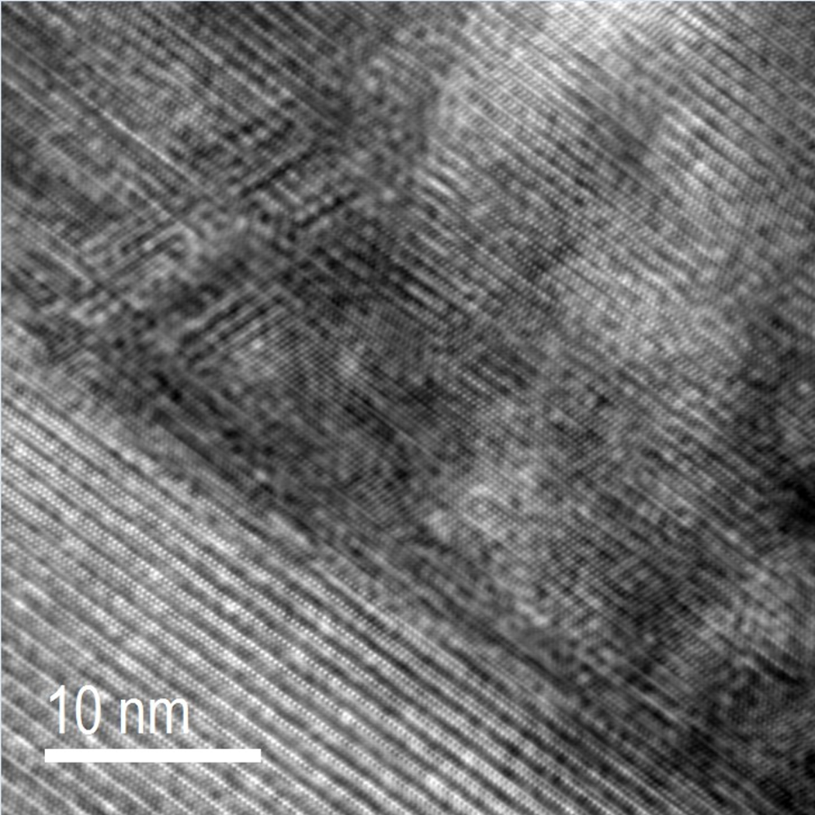
Figure 17. Cross sectional TEM image of BP sample 80. Showing epitaxial BP

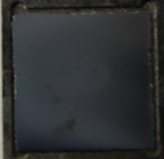
Figure 18. Photograph of sample 81 post deposition

the XRD spectrum of sample 81 is shown in figure 19. The peaks are labeled for ease in identification of the peaks. A ratio of 6.11:1 (111):(220) is reported for this sample. Epitaxy is expected in this sample. TEM images confirm this; figure 20 shows the cross sectional TEM image of sample 81. Epitaxy is shown in the middle of the image from the matching pattern of the grown BP to the SiC wafer.
The next sample in the temperature study is sample 82; performed at 900 C. Figure 21 shows the photograph of sample 82 immediately post deposition Notable visual features include the dark spot in the middle of the sample surrounded by the lighter pink area. This could be a sign thin film thickness variations. Figure 22 shows the obtained XRD spectrum of sample 82. The ratio of the 111 to 220 is 18.6 A trend is beginning to emerge that the (111):(220) scales with temperature as 18.6 at 900 C is the highest so far. Cross sectional TEM of the interface shows an unexpected result. Figure 23 shows an epitaxial relationship between BP and SIC, but small amorphous region is shown adjacent to the crystalline area. The presence of an amorphous BP is atypical and does not follow the trend in the increasing temperature increase order model that was being established. Nevertheless, the presence of the amorphous is localized and epitaxy is observed. A possible explanation for the presence of the amorphous region is that to some degree amorphous regions may be present and just not have been identified in previous examinations. The small sample size and smaller depth of field make total examination of samples of this size impossible. SAD patterns were not obtained on this so comments on the order of the bulk field cannot be made. Despite the lack of XRD data, one can assume that based on the XRD spectrum, the bulk of the film is presumed to be high order.
Sample 83 is the next to last sample in the temperature study and represents one of the highest depositions for BP on SIC. Following the same trend, the 950 temperature should have high (111) rations and epitaxy. Predicted film thickness of this sample is 2.16 um. The resultant mass gain was 1.01 mg, slightly lower than the previous sample. Film coverage looks acceptable, due to the darkness of the

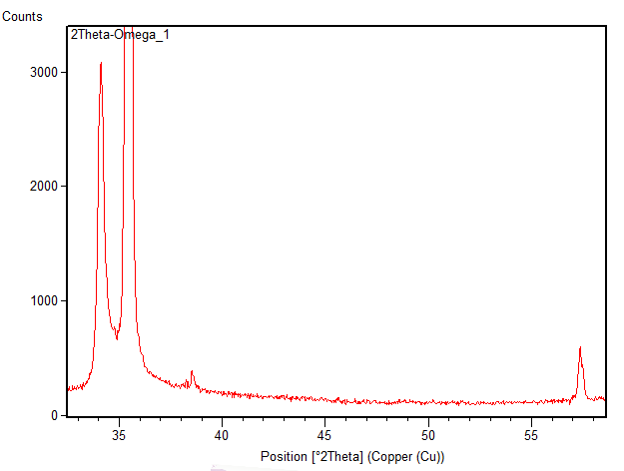
(111)
(220)
Figure 19. XRD spectrum of sample 81. showing labeled peaks for (111) and (220) directions.

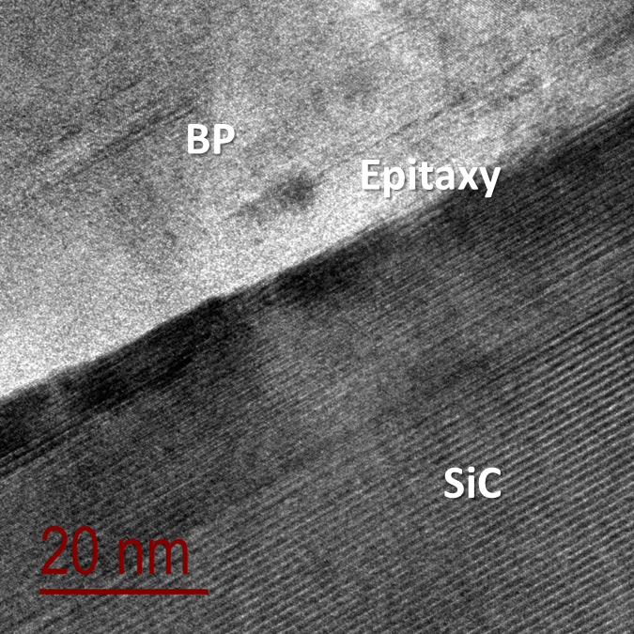
Figure 20. Cross sectional; TEM image of BP sample 81 film substrate interface. Showing epitaxial relationship

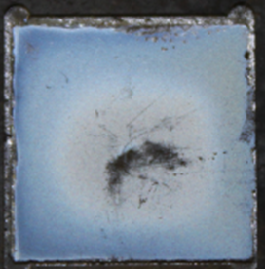
Figure 21. Photograph of sample 82 post deposition

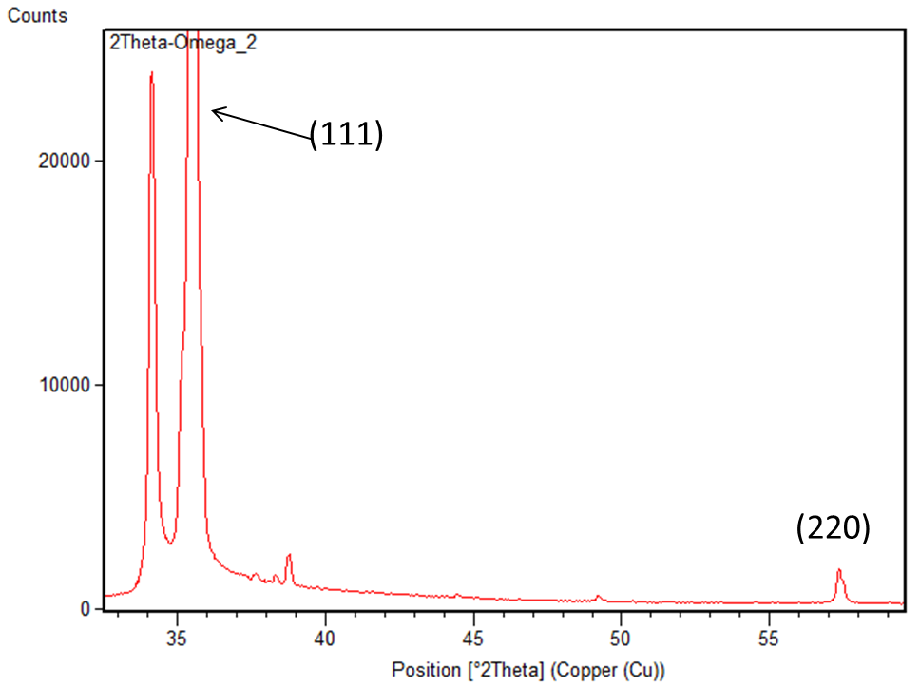
Figure 22. XRD spectrum of sample 82

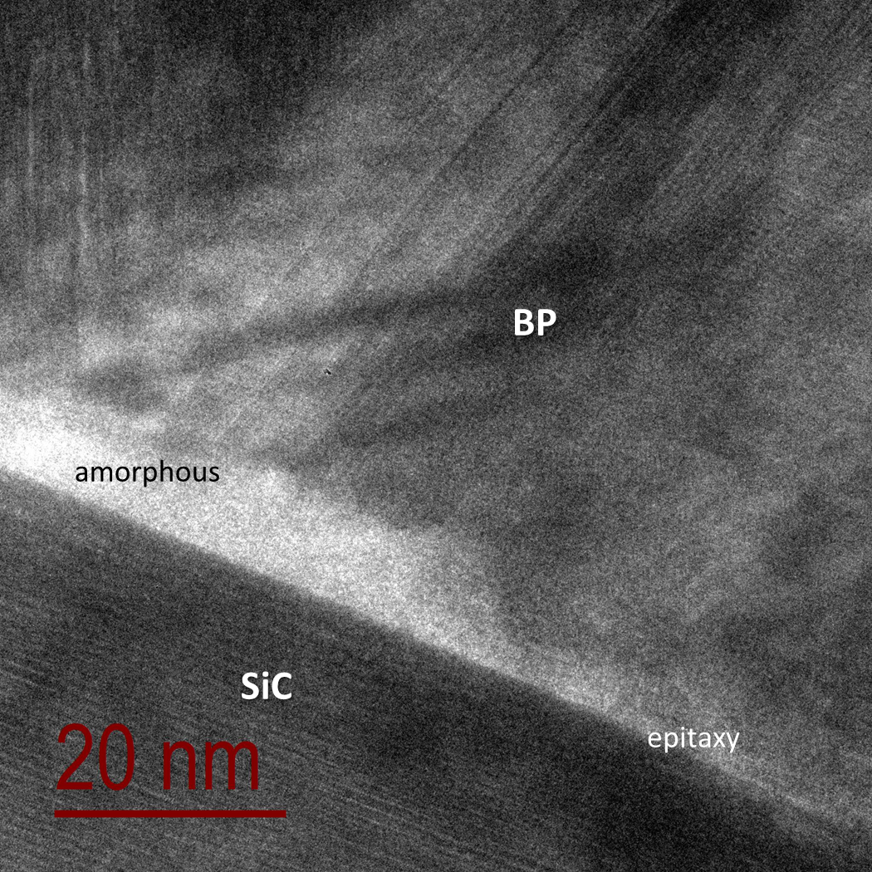
Figure 23. Cross sectional TEM of sample 82. Showing BP epitaxy with localized adjacent amorphous region.

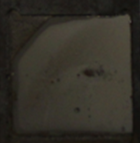
Figure 24. Photograph of sample 83 post deposition

It is difficult to make out all of the features. There are observable dark areas in the film So far, relationship has been established from the visual appearance of the film and the visual appearance. Observable features in the as grown films widely vary from sample to sample without any impact to the corresponding morphology or interface characteristics. This is not unusual due the difference in scale, but photographs of each sample are intentionally included to support this conclusion.
The resultant XRD spectrum of sample 83 is shown in figure 25. The measure (111) ratio for this sample is 42, more than double than all previous experiments in the temperature study. Cross-sectional TEM images of sample 83 shown in figure 25 show both epitaxial BP and localized amorphous areas similar to sample 82. The corresponding SAD pattern, visible in figure 26 shows good crystalline quality despite the amorphous area being present. This conclusion is definitely support by the XRD in the high (111) ratio. Corresponding SAD patterns indicate the crystal quality is intact.
The last sample in the temperature study is sample 84. It was conducted at 1000 C. Recall from the chapter on BP that the decomposition temperature of BP is 1030 C. The visual appearance of sample 84 is shown in figure 28 is not unlike observations from previous samples. Discolorations have been present on the very best of samples. The gray structures, (circled) are new observations that have not been seen before. This could be a manifestation from the film growth process or foreign matter that fell on to the wafer from the reactor tube walls. Mass gain on this sample was exceedingly low at 0.46 mg. Predicted film thickness was 0.983 um. The corresponding XRD pattern of tis sample is remarkably different from the previous experiments in the temperature study. The obtained spectrum (figure 28) shows higher counts for the (220) direction. Additionally, the (111) ratio for this sample was the lowest to date at 4.3:1.

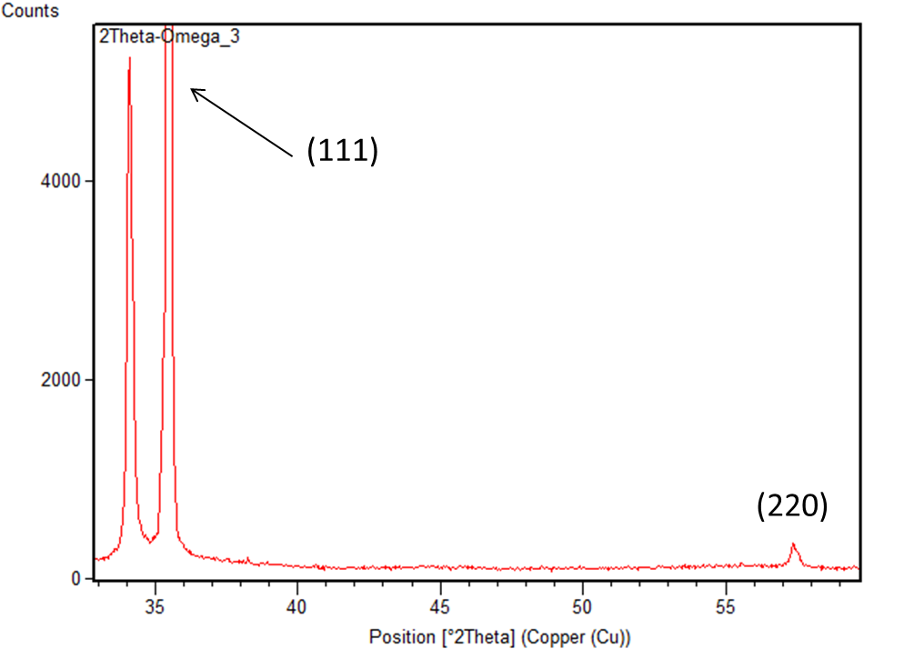
Figure 25.XRD spectrum of BP sample 83
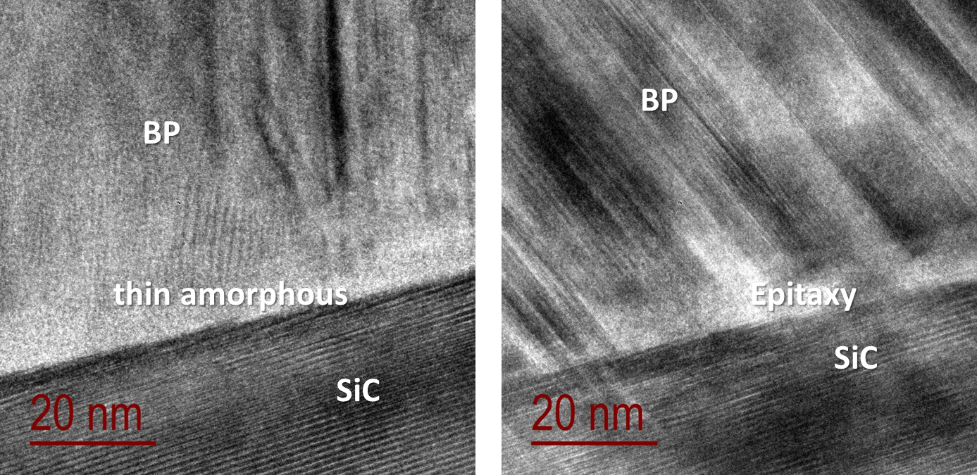
Figure 26. Cross sectional TEM images of BP sample 83. Showing epitaxy and amorphous areas present at the interface

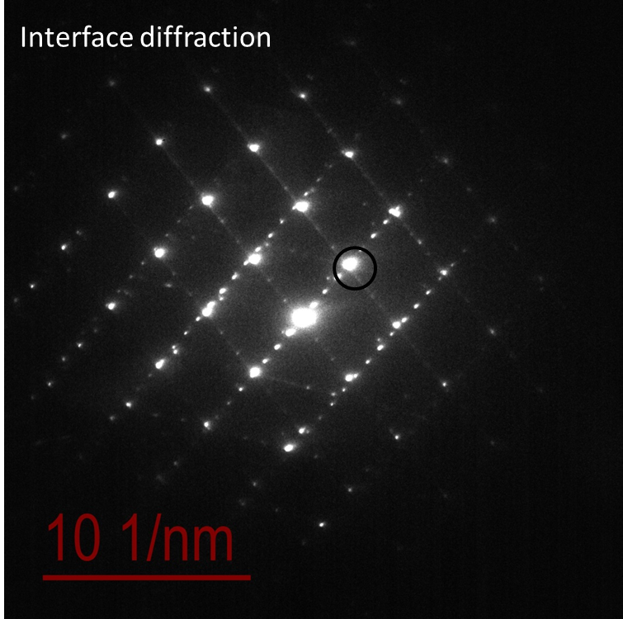
BP (111) & SiC (0004)
Figure 27. SAD pattern of BP sample 83. Despite amorphous BP at the interface, epitaxial relationship is unaffected

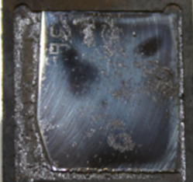

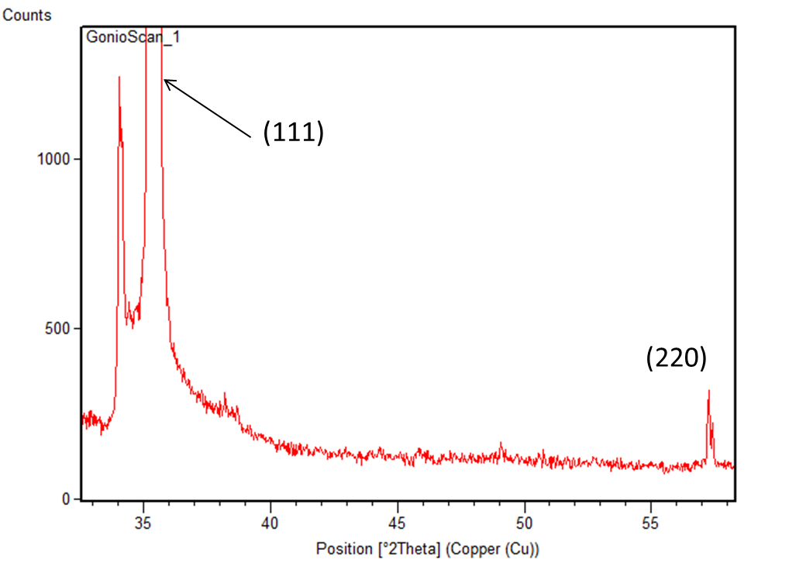
Figure 28. XRD spectrum of sample 84

The low preferred growth ration does not suggest the presence of a high quality film. This is confirmed by the SEM images of sample 84. The SEM images in figure 29 show a noncontiguous film with widely varying BP particle sizes. For this reason, TEM was not performed. Increasing the temperature by 50 degrees has a profound effect on BP quality. At 950 C, XRD and TEM suggest the material is the best to date, but 1000 C, no film is observed. A graph of the ratio of the (111):(220) ratio as a function of temperature (figure 30) summarizes the result of the temperature study. The graph shows a steady upward trend to 900 Ct hen a sharp rise in the ratio from 900 C to 950 C. This suggests the ideal temperature for deposition is around 950 C. The temperate increments of 50 degrees were intentionally large, so that clear observations from temperature effects could be made. Clearly, for the current conditions, 950 C is the temperature at which depositions should be performed to expect the highest peak ratios and corresponding crystal quality. It may be useful to narrow the temperature increments in future experiments to obtain the absolute maximum at which BP could be deposited as an even higher peak ratio could be possible. Regarding the results of the 1000 C experiment; although the deposition temperature is close to the decomposition temperature of BP, the metric show almost no mass gain on the wafer. This implies that the majority of the gaseous precursors reacted in the gas phase and were pumped out of the system. This scenario seems likely because the current reactor design does not employ any active cooling system. Researchers such as Kumashiro and Shohno employed water cooling in their respective systems and reported successful depositions at temperatures exceeding 1005 C. It is not clear from the current data if achieving higher temperature depositions will yield higher quality films than already observed, but work to actively cool the current reactor needs to be undertaken test this theory.

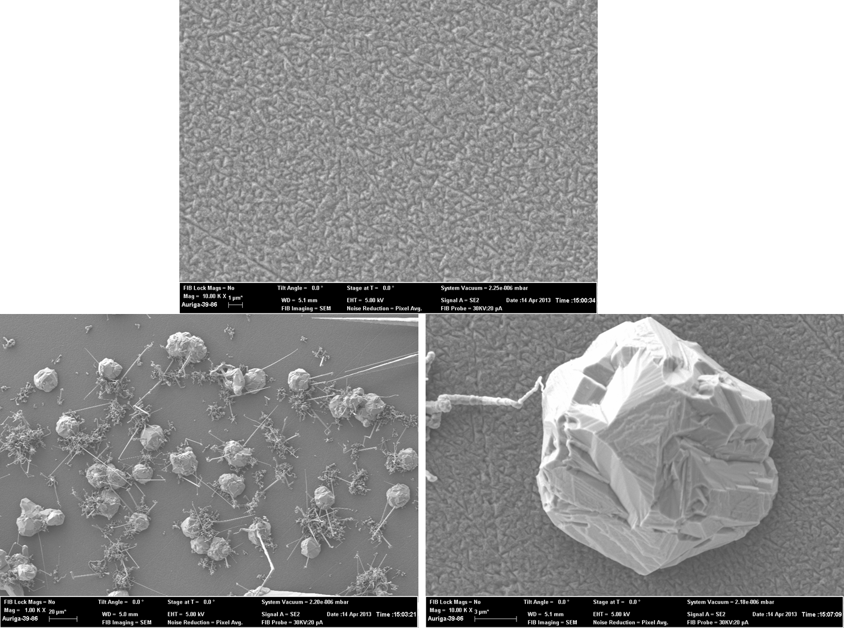
Figure 29. Surface SEM images of BP sample 84 Showing noncontiguous film

4.3Wafer Study

To date, the body of work presented has been on the same side of the SiC wafer. Recall wafers intended for device fabrication have two sides. One polished side intended for deposition and one side not polished. Additionally, the wafer sides have differing terminating bonds. For SiC wafers, one side of the wafer is carbon terminated meaning the C is the bond closest to the surface and Si terminated where the Si is nearest the surface. Without a viable explanation, the experiments conducted to date have been deposited on the Carbon side of a Si epi ready wafer, or more clearly, the deposition to date have been performed on the side of the after not intended for deposition. To address the natural question associated with this finding, a focused study was conducted. In this study, polished carbon side epi ready wafers were obtained from Cree Inc. Depositions were performed on the polished carbon side epi ready and the unpolished Si side. The only remaining variable was a Si epi ready experiment. This configuration had been historically performed and data obtained in the analysis of that sample will be discussed here. Deposition on non epi ready C have already been presented and additional commentary on those depositions will not be repeated here. Sample 60 was grown on Si epi ready sides of the SiC wafer. Unfortunately no TEM data is available for this sample, but despite this, a plausible argument can be made on this sample via the obtained XRD spectrum. Table 3 shows the complete experimental run conditions for sample 60. A standard configuration with flow rate ratio of phosphine to diborane at 5 Mass gain was 1.21 mg with a predicted film thickness of 2.59 um. Figure 29 shows a photograph of sample 60. The BP film covers the entire wafer and some darkening can be seen in the lower portion of the wafer. The corresponding XRD spectrum shown in figure shows significant (220) contribution and a ratio of just 2.6 this is less than the value observed in sample 84 of the temperature study. Epitaxial BP is not indicated. No further experiments were conducted on the Si epi ready side of the SiC wafers.

Table 3.Run parameters for sample 60
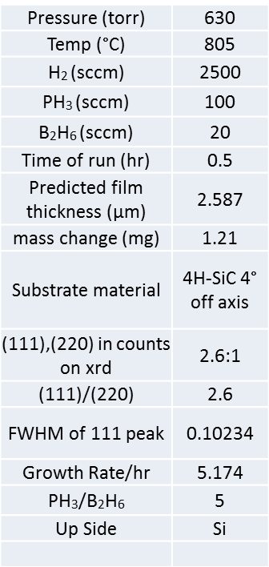

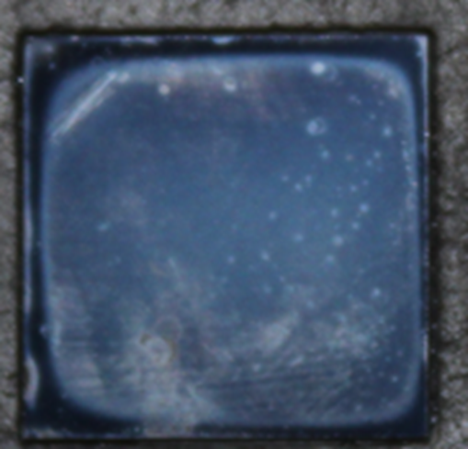
Figure 30. Photograph of sample 6o post deposition

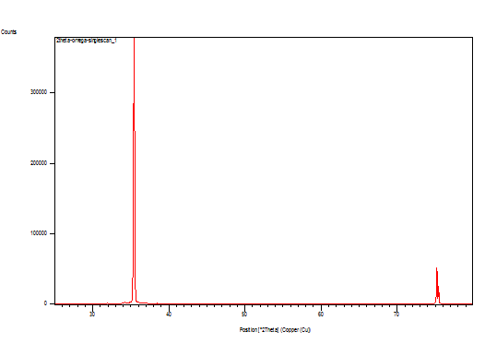
(111)
(220)
Figure 31. XRD spectrum of BP sample 60 BP on Si terminated side of wafer

In contrast to BP sample 60, sample 86 was performed on non epi ready Si terminated SiC wafers. Table 4 shows the complete parameter settings for sample 86.

Table 4. Complete parameter settings sample 86
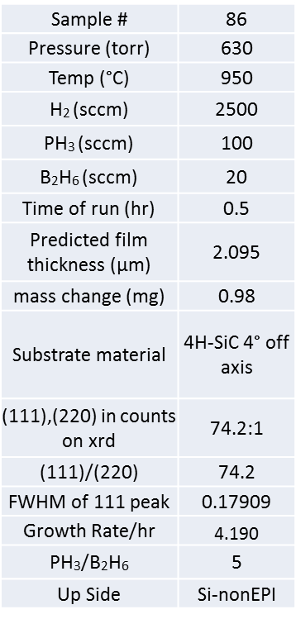

Metrics worth noting are the mass gain, at 0.98 mg with a corresponding predicted film thickness of 2.095 um. A photograph of sample 86 post deposition is shown in figure 32

5.0 Discussion and Future Work
The current body of work regarding the chemical vapor deposition has encompasses both establishing capability to deposit BP thin films and addressing some of the key issues surrounding BP as a viable materials for device fabrication. A custom reactor was designed and fabricated for the chemical vapor deposition of semiconductor thin films. Particular attention was paid to ensuring thin film quality by the selection and use of high purity components and gases. Additionally, significant resources were invested into state of the art safety systems including the design and implementation of process automation tools and active sensors for the detection of hazardous gases outside of normal containment processes.
Initial experiments were centered on determining and establishing confidence in reactor design and operating procedures. For this reason, experiments were deposited on (001) Si substrates, in order to leverage the plethora of literature of BP depositions on SI. Published literature results were compared to performed experiments to gauge agreement and provide reference for modifications to the reactor and operating procedures if necessary. Depositions on Si substrates were invaluable in preparing for future work with SiC substrates, as the Si work allowed the stoichiometric ratio of BP in the as grown films to be determined by EELS. TEM analysis and XRD analysis of BP films on Si substrate identified the preferential growth direction of BP shaped the design of experiments on SiC.
BP depositions SiC showed that the reduce lattice mismatch between BP and SiC is sufficient to allow heteroepitaxial growth evidenced by TEM analysis of the BP-SiC interface. Upon the repeated demonstration of heteroepitaxial films of BP on SiC, focused studies were performed to investigate film quality as a function of temperature. The criteria used to determine film quality was the combination of XRD and a high (111) to (220) ratio as well as TEM images and corresponding SAD patterns where applicable. The ideal temperature given a set of prescribed system parameters was found to 950° C. At this temperature a high (111) to (220) was observed via XRD analysis and TEM images showed predominately bulk single crystalline BP and a heteroepitaxial interface. Some localized amorphous material was observed a the interface in these experiments, but its presence had no effect on the heteroepitaxial arrangement at the interface BP-SiC interface. Additional focused studies we carried out to clarify the specific substrate conditions in order to optimized the quality of the deposited BP films. Two kinds of wafers were used in the surface study, a Si terminated epitaxial ready wafer and a carbon terminated epitaxial –ready wafer. Depositions were carried out on both sides of each wafer, resulting in 4 total samples to complete the data set. Recall from the materials chapter, that SiC wafers the non-epitaxial ready side of the wafer is terminated opposite from the epitaxial side. Thus, the Si epi ready wafer’s opposite side is a carbon terminated non polished surface and the carbon terminated epi-ready wafer has a Si terminate non polished surface. The majority of successful experiments were performed on the non epi-ready side of the Si epi-ready wafers; therefore no additional experiments were performed to examine this configuration. Experiments on the other three wafer configurations did not result in high film quality.
Despite notable success is BP thin film growth on SiC substrates, more work is needed to leverage boron phosphide tin films as future candidates for device fabrication. The current work being described focused solely on morphological characteristics of the BP thin film. Success was defined as the observation of the epitaxial BP and single crystalline films. But the decision to focus on morphology was at the cost of perhaps equally important data, namely chemical composition. This work was not completely devoid of chemical compositional analysis, in that EELS was useful in determination of BP stoichiometry and the presented Raman spectra were used in confirmation of the presence of the BP molecule. However, a more in depth examination would be helpful to identify the potential trace contaminates in the as grown films understood. Techniques such as Auger electron spectroscopy (AES) and secondary ion mass spectrometry (SIMS) provide the resolution and sensitivity necessary to identify PPB level contaminates in the film. AES uses an electron beam to impinge on the surface of the sample. The key difference in Auger and from other techniques is the detected species. AES detects the emitted Auger electron and not an X-Ray like the bulk of material characterization techniques. Advantages to AES of are significant and include high surface specificity, probing depths between 5 and 100Å, high lateral spatial resolution compared to EDS which can approach 300Å. Most importantly, the detection level for AES is in the ppm range. Like EDS, AES cannot detect hydrogen or helium. The Auger process works by the production of an inner atomic shell vacancy created by the primary electron beam. This vacancy, typically created in the K shell, is filled by an electron from an outer shell which is accompanied by release of excess energy by emission of a valence electron. The electron transitions and the binding energy give way to an elemental specific electron energy emission. Application of AES sensitivity factors allows quantitative AES to be performed.
SIMS is a mass spectrometry based technique where an ion (Ar+, Cs+, O-) beam is rastered over the surface of a sample. As a result of the interaction between the ion beam and the sample, secondary ions from the sample surface and near surface region are ejected from the sample matrix. These ejected species are transported to the mass analyzer where their mass to charge ratio is ascertained. SIMS is not limited in the elements it can detect and magnetic sector instruments can resolve individual isotopes from hydrogen to uranium. Detection limits for SIMS is in the sub ppb range, making it an excellent choice for trace detection and dopant quantification.
The most probable source of contamination in the reactor would be carbon from emanating from the graphite susceptor used to heat the substrate. To minimize this, the graphite susceptor was coated with BP prior to depositions to reduce the likelihood of free carbon; however, frequent experiments with the same susceptor cause visible degradation (Figure 1) which must be lost to the system during deposition

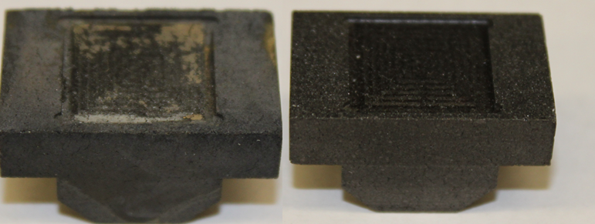
Figure 1. Photographs of used (left) and unused graphite suscepotrs

experiments. The advantage to understanding the trace contaminates in the film can aid in understanding the electrical properties of the grown films. Trace impurities can serve as charge carriers that can influence the BP film to be p-type or n-type. Knowing the trace impurities together with a comprehensive electrical characterization, obtained by can lead to a focused set of growth experiments designed to exacerbate desired electrical characteristic for device fabrication.
One of the fundamental analysis techniques used in this research effort is TEM. This method has been invaluable in examining the morphology of the BP film. One of the few concerns with this technique is sample size. Because TEM is able to resolve sub nanometer features in material, its sample area is very small. Therefore it is difficult to ascertain bulk defect density. Bulk defect density is important to know from a device fabrication standpoint, in that e defects can cause a decrease in electron mobility. A probable solution to quantifying bulk defects is to employ defect selective etching (DSE). This techniques is used is used to identify defects like edge and screw dislocations, and to estimate defect densities in samples. Areas with defects are more reactive with etchants than those without, causing pits to form over defects. The pits created for different defects are materials specific and have different shapes. In silicon carbide, large hexagonal pits represent micropipes, and medium sized hexagonal pits represent screw dislocations and small hexagonal pits represent threading edge dislocations⁶⁹. Furthermore, differences in strain energies and surface energies create different etch rates, thus causing different types of pits to form. At completion of the etch, the defects can be easily observed and counted. A density can then be determined by dividing by the sample area. There are some notable disadvantages to this technique, DSE is a destructive technique and the samples analyzed by this method are no longer suitable for future analysis. Also, in the case of BP, DSE requires the use of molten alkali salts which present unique challenges in preparation and handling. Despites these concerns, DSE can help provide a clearer picture of the bulk defect density and guide future deposition experiments to reduce or eliminate defects from the as grown films
Boron phosphide is a challenging material to investigate, its specific material characteristics combined with the difficult syntheses required to produce high quality material has limited its use as a group IIV-V semiconductor. However, with the knowledge gained under the series of experiments presented here and future investigations into chemical composition analysis and defect selective etching, BP can hold its own in the field of advanced materials

Reference List
Jenkins, T. A Brief History of Semiconductors. J. Physics Education. 2005, 40, 430-439.
Hook, J.R. Hall; H.E. Solid State Physics. 1st ed.; Wiley: Hoboken, 1991.
Lukasiak, L.;Jakubowski, A. History of semiconductors. J. Telecommunications and Information Technology. 2010. 1,3-9.
Orton, J.W. The story of Semiconductors; Oxford University Press: USA, 2009.
Lojek, B. History of Semiconductor Engineering; Springer: Berlin, 2006.
Berger, L. Semiconductor Materials; CRC: New York 1997.
Sealy, B.J. Review of III-V Semiconductor Materials and Devices. J. Institution of Electronic and Radio Engineers. 1987. 57, S3-S12.
Garg, S. PhD. Dissertation, University of Cinicinatti, 1981.
Wilmesen, C.W. Physics and Chemistry of III-V Semiconductor Interfaces; Plenum: New York, 1985.
Hoddeson, L . Out of the Crystal Maze. Chapters from the History of Solid State Physics; Braun, E., Teichman, J. Weart, Spencer; Oxford: New York, 1992
Adachi, S. Properties of Semiconductor Alloys; Wiley: London, 2009
13. Shohno, K.; Ohtake, H. Crystal growth of Boron Monophosphide Using A B2H6-PH3-H2 System. Journal of Crystal Growth 1978, 45(4), 187-191.
14. Schroten, E.; Goossens, A.; Schoonman, J., Photo- and electroreflectance of cubic boron phosphide. Journal of Applied Physics 1998, 83 (3), 1660-1663.
15. Schmitt, J. O.; Edgar, L. J. H.; Liu, L.; Nagarajan, R.; Szyszko, T.; Podsiadlo, S.; Wojciech, G., Close-spaced crystal growth and characterization of BP crystals. In E-MRS 2004 Fall Meeting Symposia C and F, Stutzmann, M., Ed. 2005; Vol. 2, pp 1077-1080.
16. Kasap, S.O. Optoelectronics and Photonics. 2nd ed.; Prentice Hall: Hoboken, 2012.
17. Kumashiro Y., Electric Refractory Materials.; Marcel Dekker: New York, 2000.
18. Chu, T. L.; Gill, M.; Chu, S. S., ELECTROLYTIC ETCHING OF BORON PHOSPHIDE. Journal of the Electrochemical Society 1976, 123 (2), 259-262.
19. Williams, F. V.; Ruehrwein, R. A., THE PREPARATION AND PROPERTIES OF BORON PHOSPHIDES AND ARSENIDES. Journal of the American Chemical Society 1960, 82 (6), 1330-1332.
20. Bartnitskaya, T. S.; Muchnik, S. V.; Lynchak, K. A.; Ivanchenko, L. A.; Timofeeva, II; Chernogorenko, V. B., REACTIONS OF BORON PHOSPHIDE WITH AMMONIA AND NITROGEN. Inorganic Materials 1978, 14 (2), 149-152.
21. Stone, B.; Hill, D., SEMICONDUCTING PROPERTIES OF CUBIC BORON PHOSPHIDE. Physical Review Letters 1960, 4 (6), 282-284.
22. Fomichev, V. A.; Zhukova, II; Polushin.Ik, INVESTIGATION OF ENERGY BAND STRUCTURE OF BORON PHOSPHIDE BY ULTRA-SOFT X-RAY SPECTROSCOPY. Journal of Physics and Chemistry of Solids 1968, 29 (6), 1025-&.
23. Chu, T. L.; Jackson, J. M.; Hyslop, A. E.; Chu, S. C., CRYSTALS AND EPITAXIAL LAYERS OF BORON PHOSPHIDE. Journal of Applied Physics 1971, 42 (1), 420-&.
24. Takigawa, M.; Hirayama, M.; Shohno, K., HETEROEPITAXIAL GROWTH OF LOWER BORON PHOSPHIDE ON SILICON SUBSTRATE USING PH3-B2H6-H2 SYSTEM. Japanese Journal of Applied Physics 1973, 12 (10), 1504-1509.
25. Iniewski, K., Semiconductor radiation detection systems. CRC Press/Taylor & Francis: Boca Raton, FL, 2010; p xii, 388 p.
26. Lutz, G., Semiconductor radiation detectors : device physics. Springer: Berlin ; New York, 1999; p xi, 353 p.
27. H. Moissan, Compt. r m d . , 113, 624 (1891).
28. M. Besson, ibid., 113, 78 (1891).
29. Popper, P.; Ingles, T. A., BORON PHOSPHIDE, A III-V COMPOUND OF ZINC-BLENDE STRUCTURE. Nature 1957, 179 (4569), 1075-1075
30. Wang, C. C.; Cardona, M.; Fischer, A. G., Preparation, Optical Properties, and Band Structure of Boron Monophosphide. Rca Rev 1964, 25 (2), 159-167.
31. Vickery, R. C., SYNTHESIS OF BORON PHOSPHIDE AND NITRIDE. Nature 1959, 184 (4682), 268-268.
32. Takigawa, M.; Hirayama, M.; Shohno, K., HETEROEPITAXIAL GROWTH OF LOWER BORON PHOSPHIDE ON SILICON SUBSTRATE USING PH3-B2H6-H2 SYSTEM. Japanese Journal of Applied Physics 1973, 12 (10), 1504-1509.
33. Nishinaga, T.; Ogawa, H.; Watanabe,H.; Tetsyuya, A. VAPOR GROWTH OF BORON MONOPHOSPHIDE USING OPEN AND CLOSED TUBE PROCESSES. J. Crystal Growth., 13/14, 346-349.
34. Kumashiro, Y.; Okada, Y.; Gonda, S., CRYSTAL-GROWTH OF THICK WAFERS OF BORON PHOSPHIDE. Journal of Crystal Growth 1984, 70 (1-2), 507-514.
35. Kumashiro, Y.; Yao, T.; Gonda, S., CRYSTAL-GROWTH OF BORON PHOSPHIDE BY HIGH-PRESSURE FLUX METHOD. Journal of Crystal Growth 1984, 70 (1-2), 515-518.
36. Kumashiro, Y.; Okada, Y., SCHOTTKY-BARRIER DIODES USING THICK, WELL-CHARACTERIZED BORON PHOSPHIDE WAFERS. Applied Physics Letters 1985, 47 (1), 64-66.
37. Kumashiro, Y.; Hirabayashi, M.; Koshiro, T.; Okada, Y., THERMOELECTRIC PROPERTIES OF BORON PHOSPHIDE. Journal of the Less-Common Metals 1988, 143 (1-2), 159-165.
38. Kumashiro, Y.; Mitsuhashi, T.; Okaya, S.; Muta, F.; Koshiro, T.; Takahashi, Y.; Mirabayashi, M., THERMAL-CONDUCTIVITY OF A BORON PHOSPHIDE SINGLE-CRYSTAL WAFER UP TO HIGH-TEMPERATURE. Journal of Applied Physics 1989, 65 (5), 2147-2148.
39. Kumashiro, Y., REFRACTORY SEMICONDUCTOR OF BORON PHOSPHIDE. Journal of Materials Research 1990, 5 (12), 2933-2947.
40. Kumashiro, Y.; Hirabayashi, M.; Takagi, S., BORON PHOSPHIDE AS A REFRACTORY SEMICONDUCTOR. 1990; Vol. 162, p 585-594.
41. Kumashiro, Y.; Yokoyama, T.; Nakamura, J.; Matsuda, K.; Yoshida, H.; Takahashi, J., THERMOELECTRIC PROPERTIES OF BORON AND BORON PHOSPHIDE FILM. 1992; Vol. 242, p 629-635.
41. Kumashiro, Y.; Okada, Y.; Okumura, H., ISOTOPE EFFECTS ON BORON PHOSPHIDE SINGLE-CRYSTAL WAFERS. Journal of Crystal Growth 1993, 132 (3-4), 611-613.
42. Kumashiro, Y.; Matsumoto, M.; Yoshizawa, H., HETEROEPITAXIAL GROWTH OF BORON PHOSPHIDE SINGLE CRYSTAL ON SAPPHIRE SINGLE CRYSTAL. In Proceedings of the 11th International Symposium on Boron, Borides and Related Compounds, Uno, R.; Higashi, I., Eds. 1994; Vol. 10, pp 160-163.
43. Kumashiro, Y.; Yokoyama, T.; Nakamura, J.; Takahashi, J., SEMICONDUCTING PROPERTIES OF BORON PHOSPHIDE THIN FILMS BY MBD PROCESS. In Proceedings of the 11th International Symposium on Boron, Borides and Related Compounds, Uno, R.; Higashi, I., Eds. 1994; Vol. 10, pp 168-169.
44. Kumashiro, Y.; Yoshizawa, H.; Shirai, K., PREPARATION OF RHOMBOHEDRAL BORON PHOSPHIDE WAFER BY CVD PROCESS. In Proceedings of the 11th International Symposium on Boron, Borides and Related Compounds, Uno, R.; Higashi, I., Eds. 1994; Vol. 10, pp 166-167.
45. Kumashiro, Y.; Yokoyama, T.; Sakamoto, T.; Fujita, T., Preparation and electrical properties of boron and boron phosphide films obtained by gas source molecular beam deposition. Journal of Solid State Chemistry 1997, 133 (1), 269-272.
46. Kumashiro, Y.; Yokoyama, T.; Sato, A.; Ando, Y., Thermoelectric properties of boron and boron phosphide CVD wafers. Journal of Solid State Chemistry 1997, 133 (1), 314-321.
47. Kumashiro, Y.; Yoshizawa, H.; Yokoyama, T., Epitaxial growth of rhombohedral boron phosphide single crystalline films by chemical vapor deposition. Journal of Solid State Chemistry 1997, 133 (1), 104-112.
48. Kumashiro, Y.; Yokoyama, T.; Ando, Y.; Ieee; Ieee, Thermoelectric properties of boron and boron phosphide CVD wafers. 1998; p 591-594.
49. Kumashiro, K.; Hirata, K.; Sato, K.; Yokoyama, T.; Aisu, T.; Ikeda, T.; Minaguchi, M., Thermoelectric properties of boron and boron phosphide films. Journal of Solid State Chemistry 2000, 154 (1), 26-32.
50. Kumashiro, Y.; Sato, K.; Chiba, S.; Yamada, S.; Tanaka, D.; Hyodo, K.; Yokoyama, T.; Hirata, K., Preparation of boron and boron phosphide films by photo- and thermal chemical vapor deposition processes. Journal of Solid State Chemistry 2000, 154 (1), 39-44.
51. Kumashiro, Y.; Yokoyama, T.; Sato, K.; Ando, Y.; Nagatani, S.; Kajiyama, K., Electrical and thermal properties of B12P2 wafers. Journal of Solid State Chemistry 2000, 154 (1), 33-38.
52. Kumashiro, Y.; Nakamura, K.; Doi, Y.; Hirata, K.; Yokoyama, T.; Sato, K., The preparation of B-Sb thin films by molecular flow region PVD process. Journal of Crystal Growth 2002, 237, 1531-1535.
53. Kumashiro, Y.; Enomoto, T.; Sato, K.; Abe, Y.; Hirata, K.; Yokoyama, T., Thermoelectric properties of photo- and thermal CVD boron and boron phosphide films. Journal of Solid State Chemistry 2004, 177 (2), 529-532.
54. Kumashiro, Y.; Nakamura, K.; Sato, K.; Ohtsuka, M.; Ohishi, Y.; Nakano, M.; Doi, Y., The properties of B-Sb thin films prepared by molecular flow region PVD process. Journal of Solid State Chemistry 2004, 177 (2), 533-536.
55. Kumashiro, Y.; Ozaki, S.; Sato, K.; Kataoka, Y.; Hirata, K.; Yokoyama, T.; Nagatani, S.; Kajiyama, K., The preparation and thermoelectric properties of molten salt electrodeposited boron wafers. Journal of Solid State Chemistry 2004, 177 (2), 537-541.
56. Kumashiro, Y.; Nakamura, K.; Enomoto, T.; Tanaka, M., Preparation and thermoelectric properties of BP films on SOI and sapphire substrates. Journal of Materials Science-Materials in Electronics 2011, 22 (8), 966-973.
57. Fitzsimmons, M., Pynn,R . Fabrication of boron-phosphide neutron detectors ; LA-UR--97-1228; NTIS: Los Alamos NM, 1997.
58. Benedict, M.; Pigford, T. H.; Levi, H. W., Nuclear chemical engineering. 2d ed.; McGraw-Hill: New York, 1981; p xv, 1008 p.
59. Gibson, D. R.; Waddell, E. M.; Wilson, S. A. D.; Lewis, K. L., ULTRADURABLE PHOSPHIDE-BASED ANTIREFLECTION COATINGS FOR SAND AND RAIN EROSION PROTECTION. Optical Engineering 1994, 33 (3), 957-966.
60. Boland, J. F.; American Nuclear Society.; U.S. Atomic Energy Commission., Nuclear reactor instrumentation (in-core). Gordon and Breach: New York,, 1970; p xiii, 229 p.
61. Yugo, S.; Kimura, T., THERMOELECTRIC-POWER OF BORON PHOSPHIDE AT HIGH-TEMPERATURES. Physica Status Solidi a-Applied Research 1980, 59 (1), 363-370.

Appendix A

Introduction
Advances in science often pave the way for significant advances in technology. The advent of modern integrated circuits in the electronic devices widely adopted by our digitally obsessed society would not have been possible without the development of the science of thin films. The dawn of the thin solid films have made available the portability of the devices we covet. However, the age of the thin film would not have come to pass without the advent of the chemical vapor deposition process (CVD) process. At the most basic level, CVD is the deposition of a solid on a heated surface from a chemical reaction in the gas phase³.
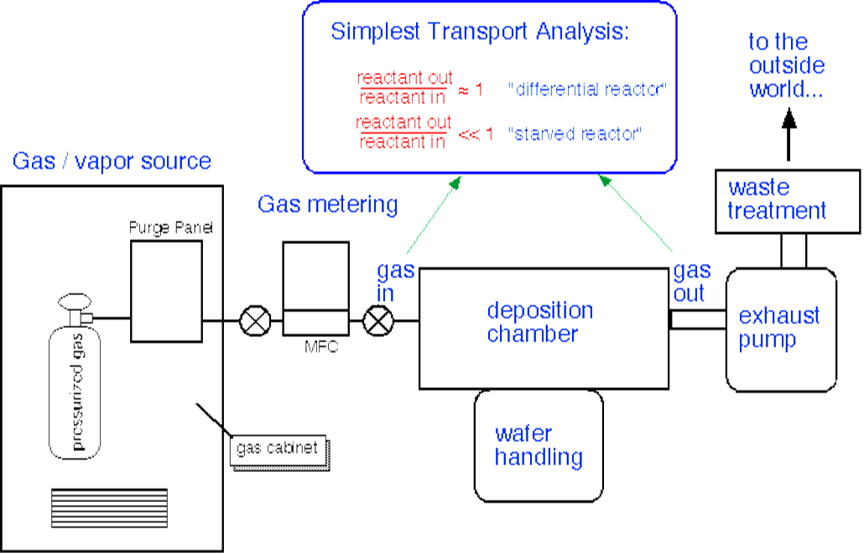
Figure 1-Depiction of a generic CVD reactor showing major system level components¹⁶.

Generally, CVD falls into a category of material transfer process that tends to be atomistic in constitution. Other common vapor transport techniques include physical vapor deposition and atomic layer deposition, with each process continuing unique advantages and disadvantages^{3, 10}. The reason chemical vapor deposition is the focus of this paper is to outline the distinct advantages of CVD over other techniques and briefly summarize the fundamental concepts essential to its employment in scientific and industrial settings.
Background
CVD is often the method of choice in semiconductor fabrication and material coating processes. This is due to the high throwing power or conformality CVD offers over other vapor transport techniques. Throwing power refers to the ability of a process to coat surfaces orthogonal to the direction of gas flow. Complex surface topographies and detailed three-dimensional structures can often be evenly covered with CVD where other methods of vapor transport are strictly limited to line of sight deposition. An example of the superior conformality of CVD, involves tungsten deposition on integrated circuits. The circuits often contain deep holes with aspects ratios approaching 10:1. Another positive attribute of CVD is the high deposition rate and thick coatings obtained. Hundreds of microns or in extreme cases centimeter thick coating can be achieved using CVD. In contrast, PVD films are generally limited to much thinner layers and require considerably longer deposition times ^{3,9,10} .
Versatility is unique to CVD, in that it can be performed over a variety of pressure regimes. Most treatments are application specific, but CVD is common at both low and atmospheric pressures. Low pressure CVD (LPCVD) can loosely defined as deposition below atmospheric pressure to 10⁻⁷ mbar³. Deposition below 10-7 mbar is referred to as ultra-high vacuum CVD (UHVCVD) and is much more specific in application. Atmospheric pressure, (APCVD), and LPCVD predominate in most applications. This broad range in pressure is an advantage from the standpoint of required equipment. In most cases, Ultra –high vacuum equipment and methodologies are not required. This is not the case in PVD and ALD, as both of these techniques require pressures below 10⁻⁷ mbar to achieve desired results. Fundamentally, the advantages of CVD translate to cost savings in industry. If high quality coating can be performed at a variety of pressures in a short time, the more productivity and throughput can be achieved.
With that said, there are advantages of CVD that need to be addressed in order to fully appreciate the process. Perhaps the biggest problem with CVD is the requirement to have precursors in the gas phase¹⁰. This somewhat limits what can be deposited using this method, as not all desired semiconductors or metals have suitable gas or high vapor pressure liquid precursors. To compound the problem, most of the gases and liquids that meet the criteria for good CVD precursors are hazardous, corrosive and toxic. Furthermore, the byproduct of the reactions inherent to CVD is also hazardous which can lead to high operating costs to address the nature these materials.³ Secondly, effective CVD employs some form heating method to break down the precursors into the desired components. Therefore, CVD is essentially most effective at temperatures above 600 °C. The resultant problem is that not all substrate materials are stable at elevated temperatures⁵.

Preliminary Considerations
The first step in any chemical vapor deposition should begin with an appropriate theoretical investigation into the reaction being considered ¹⁰. This analysis will help establish boundary conditions for the proposed reaction, identify reactive intermediate and potential by-products, determine a viable reaction mechanism, expected stoichiometry and the resultant deposition structure ⁹. The intention of the analysis is to narrow the scope of the process and save a great deal of time and cost later in the process. The hallmark of a good theoretical analysis begins with a brief treatment of the fundamental thermodynamics applicable to the desired reaction. The Gibbs free energy of formation (ΔG_{f}) is a perfect starting point in that it predicts whether or not a chemical reaction will occur. The Gibbs free energy of formation is defined as the ΔG of the products minus the reactants:
$$ΣΔGr°=ΣΔGf °products-ΣΔGf °reactants$$
The Gibbs number is not a fixed value, but depends on a number of parameters including the reactant types the molar ratio, temperature and pressure. The Ellingham diagram is a useful tool for CVD because it graphically depicts the thermodynamic feasibility of a reaction³. This allows the user to determine quickly if the considered reaction is plausible in a set of prior determined boundary conditions.
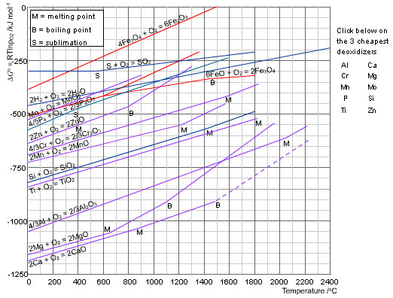

Figure 2-Image of Ellingham diagram of ΔG formation of metal oxides verses temperature¹⁷
So far, the thermodynamics as they apply to CVD have been simplified. For a compete treatment of the thermodynamics of proposed reaction, a Gibbs free energy equilibrium calculation is often required to yield the most data about possible intermediates and phases possible in the reaction. These calculations scale with system parameters and become lengthy and arduous depending on the number of species involved. Computer simulation is often employed to simply this process. These computer codes work by determining chemical equilibrium by minimizing the Gibbs free energy ^{5,10.} Variables such as temperature, volume and pressure are constants in these calculations. The resultant data garnered from the calculation is useful in CVD as it can provide insight into the chemical composition and expected amounts of deposited material under the user established boundary conditions, the existence of gas species formed during the reaction, the likelihood of additional reactions or phase transitions. Lastly, theoretical analysis can predict compatibility of the proposed substrate material with gaseous species in the reactor. These considerations are important from a planning perspective in that they provide insight into overall reactor design and necessary chemical safety systems. Despite the increased reliance modeling and simulation over the years, theoretical data is not viable substitute for experimental observation, and a thorough literature search should be conducted on the topic of interest further plan the proposed CVD process.
Transport
An integral part aspect of chemical or physical vapor deposition processes involves transport of species from one place to another. In the case of CVD, this more specifically refers to the movement of the precursors from the inlet to the substrate surface where deposition can take place. This mass transport becomes a primary consideration in the early stages of CVD process development because the dynamics of mass transport govern the rate at which deposition can proceed. There are two common regimes to CVD in terms of transport phenomenon. The first describes a scenario commonly encountered in smaller lower throughput reactors and yields a deposition rate proportional to the surface reaction rate. This regime is referred to as surface limited regime and is met when reactor scale is biased in the favor of gas flow. In the opposite mass transport limited scenario, the reactor is load limited and the limiting step is the process of applying enough precursors to adequately cover the substrates being deposited. It becomes obvious why the latter is often experienced in commercial CVD reactors, where throughput is a primary concern.
Transport is all encompassing term and a better understanding can be gained when looking at the individual quantitative components of transport. The first topic to be addressed under transport is the concept of flux. Flux is the product of the velocity of a fluid and the density with respect to time⁴. Mathematically, flux is represented by the equation below:
$$J=nu$$
where n is molecular concentration and U is velocity. The velocity portion of the equation is a vector quantity and therefore flux is also a vector. These quantities can be expressed in a variety of units; kg/m² sec, moles/m² sec are both equally valid if used consistently in calculations. Simple integration of the flux over a known area allows one to determine the total amount of material transferred across said surface. This is useful in allowing a quick determination of the amount of material across the substrate and can help with identification of transport limited scenarios ^{5,10}.
Like the molecular flux, convection and diffusion play important roles in understanding general transport in CVD processes. Convection is a type of flux, and refers to the overall movement of the fluid in the system. A more specific method of transport is diffusion and is more narrowly defined. Diffusion specifically refers to the motion of the fluid from thermal sources, internal or external. Drastic differences in the movement of fluid in the system can result from diffusion processes. Differences in temperature as well as concentration can move the fluid in the system toward an equilibrium condition. The flux as it relates to concentration gradient is given by:
$$J=-D\frac{d_{n}}{d_{x}}$$
The quantity $\frac{d_{n}}{d_{x}}$ is the gradient in concentration of the fluid species and D is the diffusion constant. The negative value on the diffusion constant indicates the diffusion always occurs down the gradient or areas from higher to lower concentration. In this expression, the units of D are given in units of length²/time. The value of D, can be estimated by:
$$D\sim \sqrt{\frac{k^{3}}{π^{3}m} }\frac{T^{3/2}}{{Pa}^{2}}$$
where k is Boltzmann’s constant, T is the absolute temperature, m is the mass, P is the system pressure, and a is the radius of the atom or molecule. This approximation is commonly referred to as the hard sphere approximation and assumes that the fluid is comprised of hard spheres of equal size and mass. For most commonly countered CVD problems, this approximation is an adequate representation of process transport in a binary mixture¹².
Expanding on the idea of diffusion, the diffusion length is a useful tool in understanding the overall fluid transport. The diffusion length (dl) refers to the specific length scale for system diffusion. The dl scales with the square root of time. For practical CVD design considerations, if the dl is considerably longer than the reactor size, the profile concentrations will be linear and time independent; thus transport is diffusion dominated. However, if the calculated diffusion length is much shorter than system size, fluid concentrations can significantly vary in specific regions of the system. This can lead to large concentration gradients that are time dependent. This can lead to a starved situation if the given system length is short enough ⁸.
One useful tool in the CVD handbook is to calculate the Peclet number for the system¹². The Peclet number is the ratio of system length and the diffusion length as a function of the residence time of the fluid being examined. In this case, the residence time of is simply the average time the precursors spend in the reactor ¹⁰. This notion is important because a laconic residence time will not allow sufficient time for deposition to transpire, thus leading to a starved reactor scenario. The Peclet number is dimensionless number defined by the following equation:
$$P_{e}=\frac{LU}{D}$$
V is the velocity of the fluid, L is the characteristic length of the system and D is mass diffusion coefficient.
Another dimensionless number that is also of use in chemical vapor deposition is the Reynolds number. The Reynolds number describes the flow behavior of the fluid in the chamber. The two types of flow commonly encountered in CVD are laminar and turbulent flow. In the case of laminar flow, the gas velocity on the inner wall of the CVD reactor is zero. For simplicity, this is assumed a tube. This leads to the formation-defined boundaries in the total flow. The boundary formation begins at the fluid entrance at the tube and increases in thickness until the fluid is stabilized by system parameters⁸.

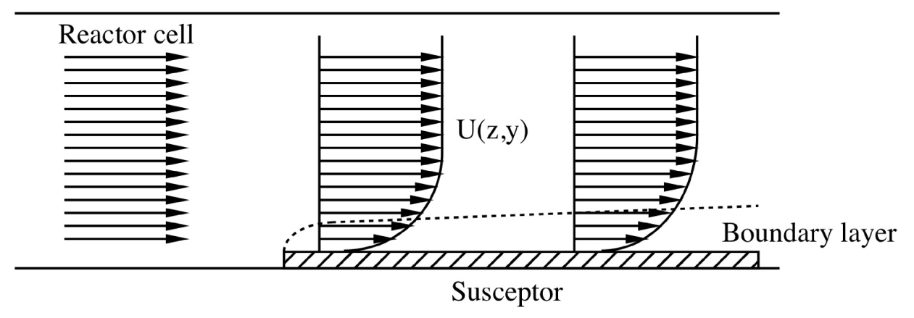
Figure 3-Image of a tube reactor showing laminar flow and boundary layer formation⁸
Mathematically, the Reynolds (R_{e}) number is the mass density times the flow density divided by the viscosity of the fluid.
$$R_{e}=\frac{ρµ_{x}}{µ}$$
Reynolds number values allow the user to describe the relative amount of gas flow. For R_{e} values > 2200, the flow is always turbulent and R_{e} values < 1200 indicate viscous flow⁸. When the R_{e} is above 1200, but below 2200, either regime can exist, but is defined by specific system configuration, such as the placement of inlet and respective outlets as well as piping complexities. One can assume that the boundary layer thickness increases with lower gas-flow velocity and with increased distance from the tube inlet. Additionally, the thickness of the boundary layer (Δ) can be determined by the square root of the distance from the inlet in the direction of flow divided by the Reynolds number.
$$Δ=\sqrt{\frac{x}{R_{e}}}$$
This is helpful in determining applicable flows based on system dimensions.
The last dimensionless number helpful to the depositioner is the Knudsen number (Kn). In order to utilize the Knudsen relationship, the mean free path (λ) must be known or approximated ⁸. The mean free path refers to the distance the respective gas particles travel in a system before encountering another particle. It is defined in the kinetic theory of gases as:
$λ=\frac{1}{2^{1/2}{πd}_{o }^{2}n}$,
where d_{o} is the molecular diameter in meters and n is the gas density in molecules per cubic meter. The mean free path (λ) is both gas density and pressure dependent at a given constant temperature. The Knudsen number,
$$Kn=\frac{λ}{d}$$
is simply the mean free path divided by a characteristic length (d). In the simplified tubular reactor model currently being employed, this would simply be the tube diameter.
In contrast to the Reynolds number that describes relative flow, the Knudsen number characterizes the nature of the gas in a system. Together, the Knudsen and Reynold’s numbers can be used to characterize the constitution of the gases and the type of flow in the system. Three common natures of gases in a system are viscous, molecular and transitional. A viscous gas is characterized by a Kn < 0.01 which also marks the continuum flow regime. At Kn < 0.01, the diameter of the tube is much greater than the mean free path for collisions, and gas flow is determined by gas-gas collisions. At high pressures, the viscous region predominates. Continuum flow can be either turbulent or laminar viscous as determined by the Reynolds number. A good example of turbulent gas flow would be smoke billowing from a stack. In laminar flow, the behavior of the gas is ordered, and resembles a defined stream⁸. See figure four for a visual comparison of both turbulent and laminar flow. At Kn > 10, the mean free path between gas-gas collisions is much greater than the tube diameter and here gas molecules move freely until they interact with the wall. Under these conditions, the gas begins to behave less like a collective fluid and more like individual molecules; thus, giving the term molecular flow. In this region, the mean free path has increased to the point that the dominant interaction of the gas is not particle-particle collisions, but rather particle- wall collisions. For Knudsen values >>1, the gas will exhibit viscous behavior and gross approximations are valid. At Knudsen values << 1, it becomes necessary to model individual molecular trajectories in the system via Monte Carlo techniques^{8, 10}.
The concept of fluid flow can become increasingly complex when system design includes flow spanning several pressure regions. The area between viscous flow and molecular flow is known as the transition flow region. It typically dominates from pressures 1 mbar to 10⁻³ mbar. At this flow, the mean free path approximates the diameter of the system. A common trait of most CVD system is to operate a variety of pressures and therefore one can assume different flow regimes. Ideally, chemical vapor deposition is preferred in the viscous flow regime with Re values < 1200 and Kn values < 0.01⁶.

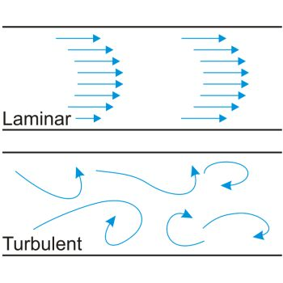
Figure 4-Image comparison of turbulent and laminar flow¹⁸

To this point, the discussion of transport in CVD has focused on methods and ideas of mass transport of fluids. This is by no means an exhaustive treatment on this topic but provides an overview of some of the tools for effective CVD. However, heat transport is also paramount in understanding the CVD process. Heat transport is so fundamental in CVD that it often defines the term for the type of CVD being employed. In CVD processes where the sample is the only object being heated, these are referred to cold-wall reactors. ¹⁰ In contrast, experiments where the whole chamber is heated are called hot-wall ¹⁰. Each process has its own distinct advantages and disadvantages. The decision really comes down to the specific chemistry involved in the CVD, which will be discussed later.
There are three primary modes of heat transport in CVD that need to be considered. The first is conduction. Heat conduction is the motion of heat through a media (solid, liquid, gas). In a CVD reactor this happens by mass transport ⁵. Diffusion can be an important mechanism of heat conduction and can be treated with the same rigor as seen in diffusion of fluids. Another method of heat transport is convection. Here, heat is transferred to the substrate by the physical movement of gases or liquids. Convection, like conduction, can still be approximated using the diffusion formulas by assuming the diffusion is bounded to streamlines like those observed in laminar fluid flow ^{5,12}. The last method of heat transport is radiative transport. This method dominates in vacuum and occurs via the movement of photons from a source to an object. Radiative transport is surprisingly effective, particularly at high temperatures, but even the smallest amount of gas between the source and the object can induce conduction, which can lead to unanticipated spikes in temperature which are potentially catastrophic to CVD processes.
Like fluids, heat transport can be accurately described in terms of a flux³. For heat bounded by conduction, the heat flux is
$$q=-k\frac{ԁT}{ԁx}$$
where T is the temperature and k is the thermal conductivity, a material specific quantity describing the rate at which heat flows within a body. The units of k are W/(m•K). Heat flow follows a gradient; the negative sign indicates it flows from areas of higher temperature to lower. Thermal conductivity can vary widely in differing materials and the conductivity of materials in the reaction zone need to be carefully considered to achieve optimum results.
One useful tool in heat transport calculations that can be employed is the Rayleigh number. This dimensionless quantity, similar to the dimensionless numbers used to characterize fluid flow will indicate the presence and magnitude of natural convection in a system. Systems dominated by natural convection can have significant deleterious effects. Gas recirculation, excessive powder formations from increased residence times are all possible with natural convection dominated systems. Ideally, the forced convection from flow injectors is sufficiently high to negate natural convection processes. Since natural convection is influenced by system length, a good rule of design is keep the reactor distance from the fluid injectors as short as possible.
In stark contrast to conduction and convection, radiative heat transfer has no correlative in mass transport since it solely depends on the movement of photons. Thermal radiation is an important topic to consider in CVD since many system employ it has the source of heat in the reactor. Radiation offers distinct advantages to both convection and conduction in that it offers a non- contact method to heat a substrate. This is often the best-case scenario in device fabrication and detailed CVD processes because the reduced potential from interference in precursor flow and deposition. At a high level, thermal radiation can be quantitatively described using the Stefan-Boltzmann law, which relates the energy from a blackbody to the fourth power of the temperature. since it solely depends on the movement of photons. In order to estimate the impact of temperature from photon impingement, a relationship must be established.
$$e_{b}=σT^{4}$$
In the above equation, the σ term is the Stefan-Boltzmann constant with a value of 5.669 X 10⁻⁸ W/(m^{2∙•} K⁴). As stated before, the above equation is only valid for ideal radiators. This is rarely the case in CVD as only small number of materials behave as blackbodies under a set of prescribed conditions, both of which are under flux in typical processes. Therefore, it is necessary to modify the Stefan-Boltazmann law to incorporate these non-ideal radiators. The energy from a real material is the product of the emissivity (є) the Stefan- Boltzmann constant and the temperature to the fourth power.
$$e=єσT^{4}$$
The material specific emissivity is a surface property and has values between 0.01 and 1, with 1 being a blackbody. Empirically, the emissivity is the ratio of the radiation emitted from a real surface and a blackbody surface at the same temperature.
$$є={Φ_{r}}/{Φ_{b}}$$
A full treatment of the behavior of radiation in a system can become extremely complex and is out of the scope of this manuscript. However, in most cases of CVD, the heated object is a flat substrate sitting on a heated mass ¹². With relatively simple approximations, the heat can be estimated thus eliminating the need for in depth modeling to perform good chemical vapor deposition.
CVD Chemistry
Understanding and controlling the chemistry is fundamental to successful film growth by CVD. Similarly, fundamentals of fluid and heat flow have been addressed because these considerations tend to dominate early planning in reactor design. At a minimum, a cursory knowledge of the chemistry involved is needed to complete a fluid flow analysis. Perhaps the most important aspect in the chemistry of CVD is a thorough understanding of the possible chemical reactions that can occur in the system. Knowledge of the possible chemistry is the key to product quality and guides the selection of critical system parameters such as temperature. A convenient way to examine CVD chemistry and the way which will be employed here is to describe the most common reaction types employed in CVD reactors to deposit films and coatings.
One of the most widely used reactions in industry is pyrolysis; it is simple, effective, and versatile. In this process, thermal energy is used to split a molecule into its compositional elements. Species such as hydrocarbons, hydrides, halogens, carbonyls and organometallics can all be broken down in this manner to from films and coatings on substrates. Common pyrolysis reactions are shown below ^{10,11}.
CH₄(g) C(s) + 2H₂(g) (765°C)
SiH₄(g) Si(s) + 2H₂(g) (650°C)
WF₆(g) W(s) + 3F₆(g) (800°C)
Ni(CO)₄(g) Ni(s) + 4CO(g) (180°C)

Reduction is another chemical reaction commonly employed in CVD. It typically involves the introduction of hydrogen to reduce halides, carbonyl halides, or oxyhalides to the desired element. Of all of the possible reactions, the reduction of silicon tetrachloride to single crystal Si is one of the most employed.
SiCl₄(g) + 2H₂(g) Si(s) + 4HCl(g)
Another reduction reaction common to major production is the reduction of tungsten hexafluoride with hydrogen according to the reaction below:
WF₆(g) + 3H₂(g) W(s) + 6HF(g) (300°C)
One of the big advantages to the reduction reactions over pyrolysis is that the reactions can typically carried out at lower temperatures ¹⁰. An important note for CVD is reduction does not have to be the primary reaction. Hydrogen can take on a supplementary role in reactions where the prevention of carbides or oxides is desirable. In these reactions, hydrogen will serve as a scarfing agent to preferentially form hydride species that can be more easily removed from the reaction chamber and lessen the impact on film or coating quality⁹.
In some reactions critical to the electronics industry the formation of oxides is the primary goal of the reaction. The reaction of silane with oxygen is a classic example of this reaction, which leads to the formation of high purity silicon dioxide¹⁰.
SiH₄(g) + O₂(g) SiO₂ (s) + 2H₂(g) (450°C)
Elemental oxygen is not the sole source of oxygen in the formation of oxides. Hydrolysis or the introduction of water, can also serve a powerful oxidizer. Hydrolysis is used less frequently because in most CVD chemistry, water is not compatible with the desired end product and vigorous steps are used to eliminate water from the reactor. However, in the case of aluminum oxide coating on tool steels, hydrolysis is the preferred method according the reaction:
2AlCl₃(g) + 3H₂O(g) Al₂O₃(s) + 6HCl(g)
A more general grouping of CVD reactions is compound formation. In this group, a variety of chemistries is employed to deposit different species. Some of the more common reactions falling into this category are carbidization and nitridation reactions where the introductions of carbon or nitrogen respectively form carbides and nitrides. The deposition of borides also falls into this group. These reactions are normally used more in the coatings industry rather than thin film growth. . In thin film CVD, product quality is paramount in that the end goal is most likely, a desired electrical property. Electrical properties are adversely affected by morphology; therefore CVD processes need to be more stringently controlled to maintain high quality. In contrast to thin film deposition, the coating industry is mainly focused on bulk properties of the coating and therefore crystal quality is of less importance. A good example of this is the carbide coatings on tool steel for wear resistance.
The deposition of carbides usually involves the reaction of a halide with a hydrocarbon. Because of its ubiquitous nature and relatively low decomposition temperature, methane is the precursor of choice for most carbide depositions. Take the reaction of titanium tetrachloride with methane for instance. TiCl₄ will react with CH₄ at 1000 degrees C to form TiC according to the reaction below:
TiCl₄(g) + CH₄(g) TiC(s) + 4HCl(g) (1000 °C)

The previously presented reaction types represent some of the most common reactions to the electronics and coatings industry. Therefore, these reactions are well studied and the thermodynamics and kinetics are straightforward. For the sake of completeness, there are a couple of reactions types are that are far less common, but nonetheless worth a brief treatment. Ohring⁹ discusses these reactions in the CVD chapter of his thin films text and will be briefly summarized here. The first reaction takes place under a strict set of conditions and only occurs when a nonvolatile metal can form volatile compounds with varying degrees of stability as a function of temperature. This phenomenon is most common to halide chemistries when the metal can exist in two valence states. The high electronegativity of the halides allows this. In most cases, the lower valent metal is more stable with respect to temperature. As a result, the lower valent halide can be transported in the vapor phase to reaction with its respective metal to form the higher valent halide. This has been demonstrated in the halides of Al, B, Ga, In, Si, Ti, Zr, Be, and Cr. An example of this is the disproportionation reaction of germanium diiodide to form germanium tetraiodide and germanium:
300°C
2GeI₂(g) Ge(s) + GeI₄(g)
600°C
The other type of reaction similar to disproportionation is reversible transfer. In reversible transfer, the reaction is characterized by the reversal in the chemical equilibrium at both the source and deposition side of the reactions at different temperatures in the reactor. Consider the formation of GaAs from the chloride as a simplified example of this process.
750°C
As₄(g) + As₂(g) + 6GaCl(g) + 3H₂(g) 6GaAs(s) + 6HCl(g)
850°C
In this reaction the AsCl₃ serves as the carrier and transports molten Ga toward the substrates in the form of the metal chloride vapor. This in turn reacts with the arsenic to form GaAs at the lower temperature. At the higher temperature, the reverse reaction occurs and the film is etched leading to net removal of gallium⁹.
Now that the most common reaction types in CVD have been addressed, the focus will shift to examine the precursors themselves. An important aspect to high quality CVD is the selection of the proper chemistry to maximize the end product. In the reactions above, the physical state of all of the precursors is a gas. Although not a requirement for CVD, gas phase precursors are preferred because of the ease of which they can be handled in the reactor and metered to control concentration. Like the names of the most common reactions, precursors can be easily categorized according to the chemical group they exploit. Hydrides, halides, and carbonyls are the most traditional precursors. Relatively new to the process of CVD are a new batch of precursors call metal-organic CVD (MOCVD). These precursors use a myriad of complex organic ligands to bind the desired metal ion and transport it to the substrate in the vapor phase. Characteristics common to MOCVD precursors are high vapor pressure and low thermal decomposition temperature⁶. Because of the extreme variability in the organic chemistry associated with these precursors, MOCVD is essentially treated as a separate sub type of CVD with practitioners solely specializing in the use of complex metal –organic precursors. A full treatment of MOCVD is outside of the scope of this writing, but the major talking points of MOCVD will be mentioned. The simplicity of the more traditional precursors naturally tends toward a more comprehensive appreciation and such will be the case here.
Taking into consideration elemental complexity, the first group of traditional precursors is the hydrides. Hydrides are most often used in the electronic industry for the fabrication of semiconductors. Here, hydride compounds are commonly employed to deposit single element such as boron or silicon. Most elements important to CVD process from hydrides, but only a select few are utilized as CVD precursors. Table one, below lists the hydrides most commonly

Element | Name | Formula | Boiling Point (°C)
As | Arsine | AsH₃ | -55
B | Diborane | B₂H₆ | -92
Ge | Germane | GeH₄ | -88
N | Ammonia | NH₃ | -33
P | Phosphine | PH₃ | -87
S | Hydrogen Sulfide | H₂S | -60
Sb | Stibine | SbH₃ | -17
Se | Hydrogen Selenide | H₂Se | 3
Si | Silane | SiH₄ | -111
Te | Hydrogen Telluride | H₂Te | -2
Table 1-List of Hydrides common to CVD. Reproduced from Handbook of CVD¹⁰

employed as CVD precursors. The primary advantage of hydride chemistry is the cleanliness from thermal decomposition reaction where the only byproduct is hydrogen. A good example of hydride chemistry is the pyrolysis of diborane and phosphine to form boron monophosphide according to the reaction:
B2H6(g) + 2PH3(g) 2BP(s) + 6H2(g)
The largest disadvantage to hydride is that most of the compounds listed in Table 1 are extremely toxic as well as flammable. Extreme caution must be taken when working with these gases.
Halogens are the second class of precursors commonly employed in CVD. As a group, they are considered reactive and all of the available halogens have been used in reaction chemistry. Halogens are all diatomic gases, an advantage for CVD and can bind to most metals in a variety of different valent states³. The aspects of this have been previously discussed in the reversible transfer and disproportionation reactions. Table 2 lists the halogens and their properties.

Element | Molecular Formula | Electronegativity (KJ g-atom) | Boiling point (°C) | Melting Point  (°C)
Fluorine | F₂ | 339 | -118 | -233
Chlorine | Cl₂ | 355 | -35 | -103
Bromine | Br₂ | 331 | 59 | -7
Iodine | I₂ | 302 | 184 | 114
Table 2-List of Halogens used as precursors in CVD. Adapted from Handbook of CVD Pierson¹⁰
Like the hydrides, the halogens are toxic and require caution when working with them. In addition to toxicity, the reactivity of the halogens can prematurely corrode pieces and components of the reactor system. Material compatibility must be examined prior to the introduction of halogens into the system. Monel and Teflon are examples of materials that can be safely used with halogens ¹⁰. Halogens react to form halides. The resultant halides can be gases, liquids or solids at room temperature. Less common than gas precursors, liquid precursors can rather easily be metered in most CVD arrangements. The solid halides however, require heating to place them in the gas phase prior to introduction into the reactions zone of the reactor. The chemistry of metal halides is well established and most of the compounds of interest to the CVD practitioner are commercially available.
The last group of traditional gas precursors is the carbonyls, or more specifically the metal carbonyls. The metal carbonyls are not to be confused with MOCVD. The distinction relates to overall complexity. Metal carbonyls are basic compounds and really consist of just two components: the carbonyl functional group (CO) and a transition metal. Most common are those found in group d of the periodic table¹¹. Some important characteristics of metal carbonyls compounds are that they are hydrophobic and soluble in non-polar solvents such low molecular weight hydrocarbons. Metal carbonyls vary in complexity, with the most simple compound being a mononuclear metal carbonyl with the formula : M(CO)_{x} . More elaborate complexes are common and a few quardrernary metal carbonyls have been identified. Table 3 lists some of the more common metal carbonyls.
Compound | Color and Form | Trait
Ni(CO)₄ | Clear Liquid | Highly Toxic
W(CO)₆ | White Crystal | Volatile
Ir₂(CO)₈ | Yellow Crystal | Sublimes in CO₂@ 160°C
Fe(CO)₅ | Yellow Liquid | Volatile
Fe₂(CO)₉ | Yellow Crystal | Volatile
Table 3-List of Selected mononuclear and dinuclear metal carbonyl complexes. Adapted from Handbook of CVD Pierson¹⁰.
To this point, all of the gaseous precursors discussed to this point have been readily commercially available. Most of the hydride and all of the halogen precursors are available from vendors in sufficient purity that no further filtration is required prior to introduction into the reactor. The metal carbonyls are no exception this, but a two special cases apply where it may prove more practical to synthesize the desired precursor. The compounds in question are nickel [Ni(CO)₄]and iron carbonyl [Fe(CO)₅]. In the case of these two compounds the direct reaction of the metal with CO readily produces the desired precursor making this a quick and money saving option for the CVD practitioner ^{3,5,10}.
Chemical synthesis is often required for this next of CVD. Metal-organic CVD is relativity new to the CVD scene and only began being widely used in the first half of the twentieth century¹⁰. It is characterized by the desired metal being bound one more carbon atoms of complex organic hydrocarbon group commonly called a ligand. Experiments in the 1960’s showed that reactions with these metal organic precursors could be carried out at lower temperature than traditional methodologies and that the results were epitaxial films-a requirement for the semiconductor industry. It is the combination of these traits that led to broad adoption of MOCVD in the electronic industry. Most of the MOCVD reactions can be carried out well below 1000°C making them attractive for processes with integrated circuits that cannot tolerate elevated temperatures⁸. In terms of process equipment, MOCVD is very similar to a traditional CVD apparatus. The main difference is the ability to heat and meter liquid precursors.
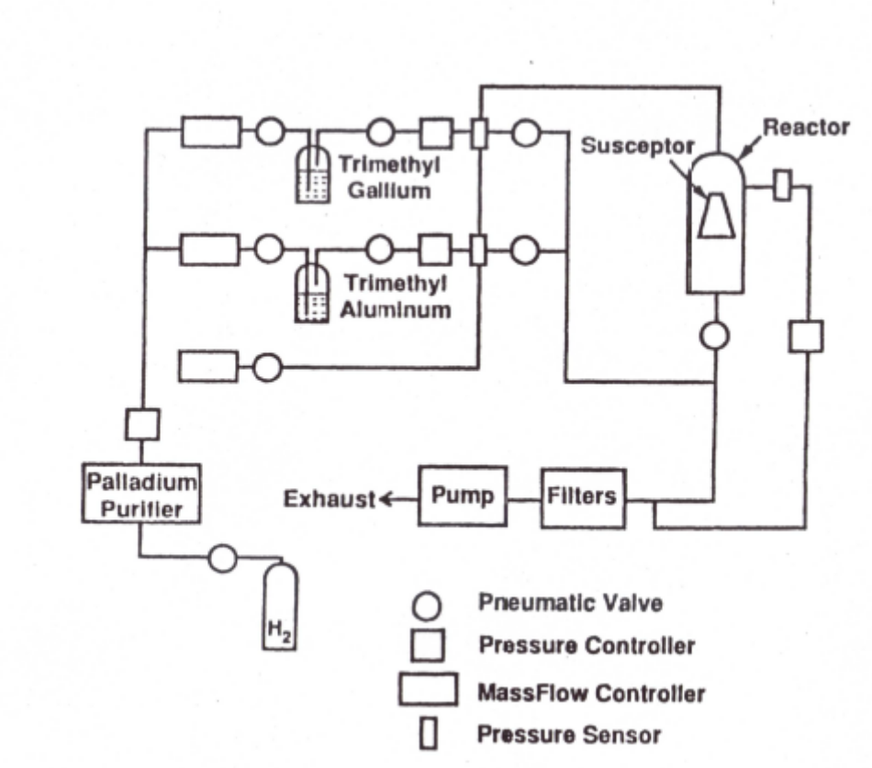
Figure 5-Schematic of generic MOCVD System¹⁰
The high cost of MOCVD precursors and equipment relegate it to processes where the rate on return is high. This means MOCVD is mainly employed in production processes that require high quality is and materials are in high demand such as compound semiconductor applications.
One of the big advantages to MOCVD is the wide selection of precursors available to deposit any number of desired species. Although the term metal is used in MOCVD this can be a misnomer because materials that are not considered metallic such as boron and beryllium are deposited using MOCVD precursors. There are too many to cover in detail, but a significant number of the precursors can be organized according to group. The first major group of MOCVD precursors is the Alkyls. Alkyl ligands are formed from the reaction of aliphatic hydrocarbon or an alkyl halide with a metal¹⁰. A characteristic of alkyl important to CVD is they are generally nonpolar, moderate volatile, a general requirement or CVD and have a low decomposition temperature. Other major groups of MOCVD precursors include large coordinated ring systems such as alicyclic compounds and aryl compounds. Examples of each are below.
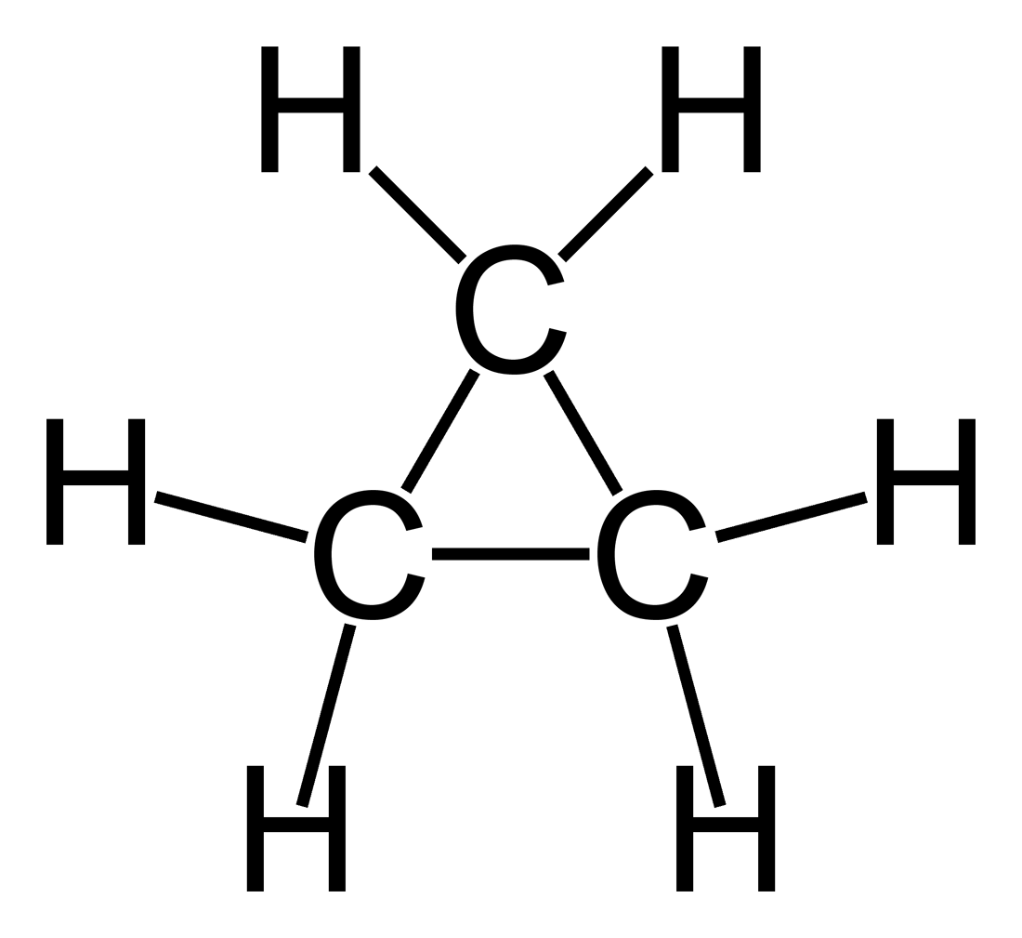
cyclopropane

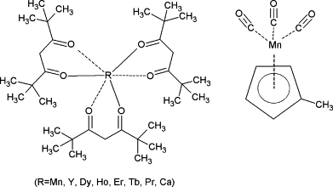

Figure 6-Images depicting examples acyclic (top) and aryl MOCVD precursors
Both acyclic and aryl compounds possess moderate vapor pressures and decomposition temperatures below 500°C.
The last group of MOCVD precursors is the Acetylacetonate compounds. These are more commonly known as metal acetonates and are produced by a reaction between a metal and the ligand acetylacetone. Acetylacetonates, unlike alkyl and alkyoxides are air stable, making
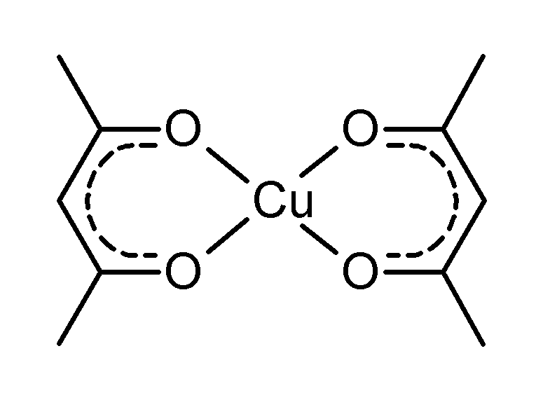
Figure 7-Lewis structure of copper acetylacetone

handling much easier¹⁰. There is some sacrifice in solubility with these compounds, but all have sufficient volatility to the vapor phase.
The major groups of MOCVD precursors previously described are suitable for the deposition of numerous metal ions. There is a substantial body of work dedicated to specific ligands. By varying the ligand density, specific ligands have been developed for most metals, carbides, nitrides and even oxides. Each has its own specific advantages and disadvantages and unique industry application. MOCVD is still a growing field in CVD and new highly complex precursors are being developed every day. Precursor complexity typically scales with atomic number. Denser metal require larger ligands to achieve the required characteristics for precursors. A commonly employed practice in MOCVD is auto synthesis of precursors. Most of these highly complex compounds are not needed in sufficient quantity to justify large scale production. Therefore, the CVD practitioner will often synthesize precursors prior to deposition. This has led to a boon in metal-organic chemistry and many research groups working in this area conduct dual phase programs into ligand synthesis and MOCVD.
Characterization and Deposition
While transport and chemistry are critical aspects of the CVD process, characterizing the films produced and interpreting the results of the deposition process is equally important. Successful film growth by CVD is not often confirmed until after deposition. Most important film characteristics are not visibly evident by the naked eye. Comprehensive materials characterization often takes a three-pronged approach depending on the specific application. Microscopy in general has become synonymous with materials characterization. The term microscopy here is intended to be all encompassing and include optical as well as the highly touted electron microscope techniques now available. Electron microscopy is a valuable tool for CVD characterization because of the depth of information available in one tool. Modern scanning electron microscopes (SEM) can achieve magnifications of 30,000X, which can allow visualization of particles in a massive 1cm to 50 nm range². SEM’s also have a high depth of field, allowing a wide area to be in focus at one time, and high resolution that allows information rich areas to be magnified.
Generally speaking, scanning electron microscopy works by rastering the surface of interest with a beam of high energy electrons. The beam originates from a source called a gun and passes through a set of optics and coils designed to condense and focus the beam on the sample².
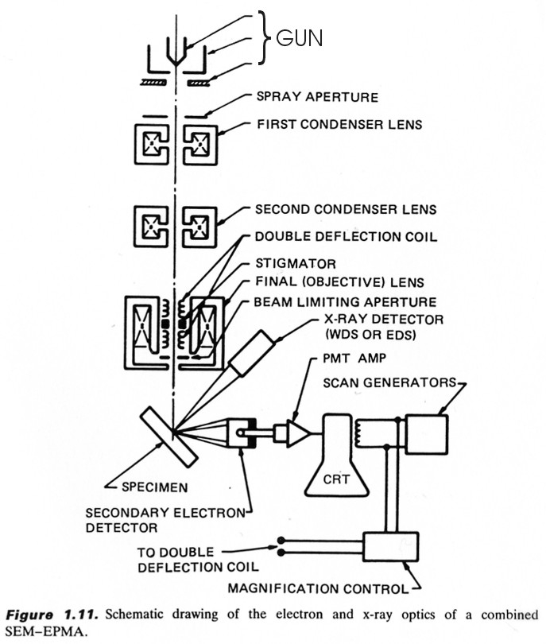

Figure 8-Schematic of SEM¹⁴

Once the electron beam impinges on the sample surface, a number of interactions take place that can be detected and an image produced. While high-energy electrons can pass through thin samples with little or no interaction, SEM analysis relies on the elastic or inelastically scattered electrons and radiation produced by inelastic scattering to produce the desired information.
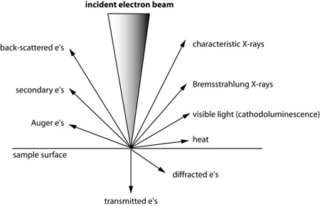
Figure 9-Diagram of possible electron interaction from SEM probing¹⁴
The interactions typically used in image creation are circled in red. Bremsstrahlung X-rays are not specific but a form an energy continuum from very low energy to the energy of the incident beam. This creates a characteristic background radiation that can mask some of the characteristic X-rays. The beam quality is dependent on the energy of the incident beam, the interaction volume in the sample and the orientation of the volume with respect to the incident beam. Asymmetry in the interaction volume will produce an askew image. To produce an image, each of the aforementioned interactions are detected independently and have specific resolution with Auger and secondary electrons producing the highest resolution followed by backscattered electrons, cathodeluminescence, and lastly Bremsstrahlung².
Aspects of Transmission Electron Microscopy (TEM) and Scanning Transmission Electron Microscopy (STEM) are similar, but these also have distinct differences that provide advantages in materials investigation. Like SEM, TEM and STEM use a high-energy electron beam and a series of focusing electron optics to place the beam on the sample. The key difference from SEM is that TEM and STEM do not rely on a series of scattering interactions to produce an image. In lieu of scattered electrons, TEM and STEM rely on electrons transmitted through the sample for imaging. This reliance on transmission electrons brings with it a series of rigorous sample preparation requirements that are often difficult to perform and time consuming. The payoff for the difficult sample preparation can be large, in that TEM and STEM offer tens of millions X magnification and down to 0.5 angstroms resolution. This magnification and resolution provide the ability to observe fine crystal structures and material interfaces.
In addition to providing high magnification of sample surfaces (SEM) and bulk morphology (STEM, TEM), each instrument typically has additional analytical capabilities based on the inherent electron interactions. Common to most SEM’s is an Energy-Dispersive X-ray (EDS) or Electron Backscatter Diffraction Analysis (EBSD). EDS analyzers are more common than EBSD and use the characteristic X-rays emitted from the bombardment of the compositional elements of the sample from the electron beam. Light elements below atomic number 4 cannot be detected using EDS.
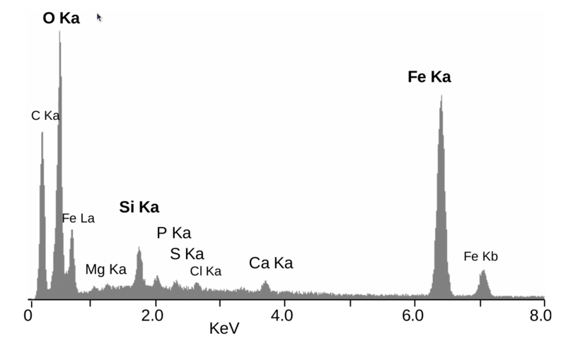
Figure 10-Example EDS Spectrum showing elemental peaks
Unlike EDS which is a compositional analysis tool, EBSD is a morphological tool designed to show crystallographic orientation of the surface of the sample being probed. It works by the principal of fluorescence. A prepared sample is placed in the SEM chamber at a high angle. The sample is then juxtaposed to a phosphor screen already in the chamber and part of the EBSD detector system. The sample is then irradiated with the high energy electron beam. The backscattered electrons that exit the sample at the Bragg condition are detected by the phosphor and fluoresce. The resultant image is the backscatter diffraction pattern that can be further processed with the Miller indices of the diffracting plane to form the surface crystallographic orientation.
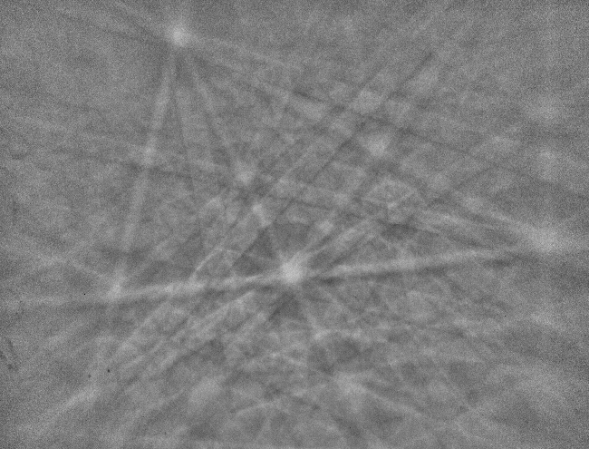
Figure 11-EBSP pattern of quartz

Another material characterization tools associated with TEM is electron energy loss spectroscopy (EELS). EELS is a valuable technique for bulk compositional analysis. The inherent problem with compositional analysis tools on electron microscopes is sensitivity. EDS and EELS are generally limited to the percent level in terms of elemental composition. This is fine for a number of causal material investigations, but semiconductor device manufactures are often concerned with dopant or contaminations in much lower elemental concentration. Silicon wafers are often doped with boron or phosphorous to create P-type or N-type semiconductors and to tailor the resistivity of the wafer. Typical dopant levels are sub ppm, which are far out of the range of compositional X-ray and high level electron interaction techniques. Two techniques are considered the standard in high sensitivity for elemental composition. They are secondary ion mass spectrometry (SIMS) and Auger electron spectroscopy (AES). SIMS is a mass spectrometry based technique where an ion (Ar+, Cs+, O-) beam is rastered over the surface of a sample. As a result of the interaction between the ion beam and the sample, secondary ions from the sample surface and near surface region are ejected from the sample matrix. These ejected species are transported to the mass analyzer where their mass to charge ratio is ascertained. SIMS is not limited in the elements it can detect and magnetic sector instruments can resolve individual isotopes from hydrogen to uranium. Detection limits for SIMS is in the sub ppb range, making it an excellent choice for trace detection and dopant quantification. The downside to SIMS is the incident particle beam tends to be destructive to the sample if power levels are not closely examined. Availability can be a concern as well with typical cost of a SIMS now exceeding $1M².
Another viable compositional method for material characterizations is Auger Electron spectroscopy (AES). Similar to the tools associated with electron microscopes, AES uses an electron beam to impinge on the surface of the sample. The key difference in Auger and EDS is the detected species. AES detects the emitted Auger electron and not an X-Ray. Advantages to AES compared with EDS are significant and include high surface specificity, probing depths between 5 and 100Å, high lateral spatial resolution compared to EDS which can approach 300Å. Most importantly, the detection level for AES is in the ppm range. Like EDS, AES cannot detect hydrogen or helium. The Auger process works by the production of an inner atomic shell vacancy created by the primary electron beam. This vacancy, typically created in the K shell, is filled by an electron from an outer shell which is accompanied by release of excess energy by emission of a valence electron. The electron transitions and the binding energy give way to an elemental specific electron energy emission. Application of AES sensitivity factors allows quantitative AES to be performed.
Although electron microscopy and compositional techniques do not encompass all of the applicable approaches for material characterization, they do provide key information on morphology, structure and composition. The third prong in comprehensive characterization is electrical property measurement. These techniques are more application driven since not all material investigations necessitate the probing of the electrical properties. The coatings industry is a good example of this, vacuum coaters seldom care about the ability of tool wear coatings to conduct a signal. Therefore, electrical property characterization is more specific to the semiconductor industry for eventual device fabrication. Since electrical property measurements are more of a niche they will not be explained in detail. Techniques can vary widely in complexity and required equipment. One of the most basic electrical parameters to measure is sheet resistivity. More applicable to thin film samples, a known current and voltage is applied to the surface of a sample and resistance is calculated from the plot of current vs. voltage. More involved measurements involve photoluminescence spectroscopy which can probe the band gap of a material, identify impurity levels and even locate certain kinds of growth defects. Lastly, Hall effects measurement can be employed to determine the charge carrier concentration and hole mobility. This powerful technique is applicable to conductors and semiconductors. It uses the application of magnetic fields and current with respect to the applied field to determine the distribution of electron flow in the sample.
The objective of chemical vapor deposition is to ultimately establish a link between system growth parameters and sample composition, morphology, and electrical properties. The method to establish this correlation is experiment. Samples are grown with documented parameters (pressure, flow, temperature, etc…) and then characterized using some or all of the methods described above. Repetition is necessary to establish a cause and effect relationship. There can be many subtleties to how process parameters can affect the outcome. Small variations in temperature, perturbation in flow from a slight variation in surface roughness can affect deposition quality. That is why industries that rely on CVD spend millions of dollars engineering out as many process variations as possible. This is often not possible on smaller lower throughput systems. Despite these conditions, there does exist a set of common objectives that all CVD practitioners aspire to: high quality. Quality by its very nature is hard to quantify. Many have attempted through countless experiments tried to establish criteria for what is considered high quality. The problem with this methodology, is quality is highly relative. Intended application of the material tends to dominate arguments on product quality. Some might consider amorphous material suitable for their needs while others consider it total failure.
One example of this is epitaxy. There are two main types of epitaxy: homo and hetero. Homoepitaxy takes place when the deposited material and the substrate match. An example of this would be deposition of Si on Si wafers. In contrast, heteroepeitaxy occurs when the
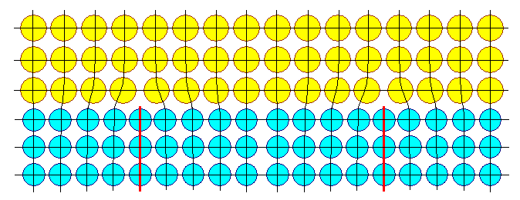

Z
Figure 12-Simplified diagram showing heteroepitaxy. Note the direct relationship between the positions of the atoms in the yellow depiosited layer and the blue substrate¹⁵
deposited material and the substrate differ. Heteroepitaxy is somewhat more challenging in that maintaining high quality epitaxy in differing materials is not straightforward, Inherent barriers exist and include induces strain, defect creation, stacking faults, etc.. Some of these problems exist in homoepitaxy, but not often to the degree in heteroepitaxy. One strategy to minimize defects in heteroepitaxy is to employ lattice mismatch minimization. This process involves selecting materials for CVD that have similar crystal lattice structures. This is not always possible, based on application, but the more similar the materials, the less likely growth defects will proliferate. A convenient way to express relationships in lattice mismatch minimization is to report percent lattice mismatch between the materials. Percent lattice mismatch is related to the mismatch strain and is based on the room temperature material specific lattice constants and can be easily determined from the following formula¹.
$$f≡\frac{a_{s}-a_{e}}{a_{e}}$$
Where a_{s} and a_{e} are the relaxed (room temperature) lattice constants of the substrate and epitaxial layer respectively. Typical values for practical lattice mismatches are below 10%. In some unique circumstances epitaxy can be achieved with values up to 14% and higher. However, these instances are exceedingly rare and success is usually based some specific material behavior.
There are numerous defects common to materials deposited by CVD and detailed treatment will not be addressed here. Basically, there are three types of defect common to solids: Point defects, line defects and surface imperfections. Point defects are localized imperfections and are often formed when an atom is missing (vacancy) or is out of place in the crystal lattice⁷. The connotation of out of place atoms is broad enough to incorporate extra atoms as well. Interstitial impurities are also considered point defects in solids. Figure 13 shows the most frequently observed point defect in solids.
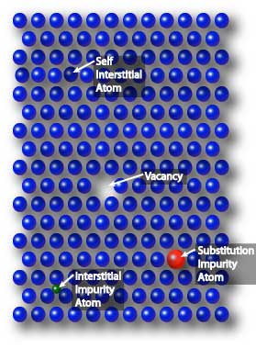
Figure 13- Diagram showing examples of common point defects in solids¹⁵

Line defects in solids by definition more pervasive in deposited solids and extend along one line of atoms in the lattice. The most common type of linear defect is the dislocation. The term dislocation refers to the scenario when atoms are out of place in the lattice, thus causing a distortion of the lattice. Stress induction during growth is responsible for most dislocations. The two subtypes of dislocation are edge and screw⁷. Edge dislocations are gross defects that are easy to observe. They exist as an extra half plane of atoms in the lattice. Figure 14 depicts an edge dislocation

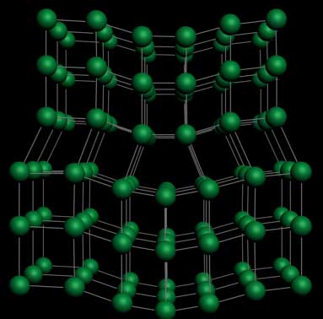
Figure 14-Diagram of edge dislocation solid. The red arrows pointing to the extra row and resultant lattice distortion ¹⁵

Unlike line edge dislocations which propagate parallel to the defect, screw dislocations form perpendicular to the location of the stress in the film. They are typically associated with the presence of shear stress in the film and are for this reason more difficult to observe⁷.
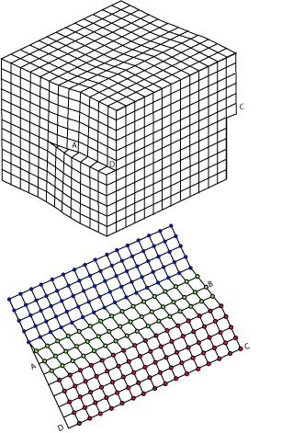
Figure 15-Image of screw dislocation. The blue lattice depicts atoms in their correct orientation. The red atoms are those that have been shifted to a new location within the lattice. The green atoms are in the process of shifting¹⁵
Line defects that extend to additional planes are called planar defects. The most common cases of planar defects are stacking faults and twin boundaries⁴. Stacking faults occur when there is a disruption of the stacking sequence in the atomic planes. See below for an example of a stacking fault in a hexagonal system.
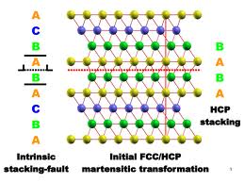
Figure 16-Diagram of intrinsic stacking fault in a hexagonal closed pack lattice
The last planar defect worth discussing is twin boundary formation. Twin boundary defects possess a key difference in comparison to the previously discussed defects. Twin boundary formation occurs at the junction of two basic crystal units rather forming entirely in one crystal like the aforementioned line and point defects⁶. Solids are generally formed from the interconnection of crystals called grains. The point in space where these crystals unite is referred to as a grain boundary. Grains are typically characterized by size and can range from nanometers to millimeters in magnitude. Research into metallurgy has established a link between grain boundary size and cooling rate. Rapid cooling is associated with smaller grains where slow cooling creates larger grains ¹². Grain boundary implication on materials is highly application dependent; however, grain surface area with in a layers correlates to higher strength.
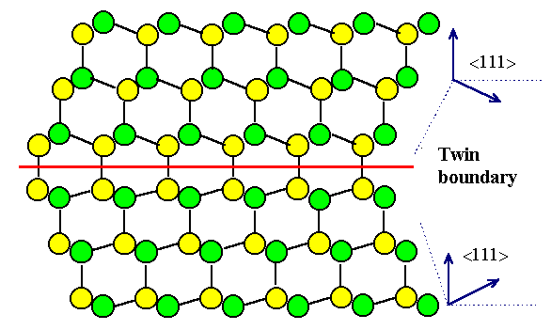
Figure 17-Image of twin boundary formation in the <111> plane²⁰

Surface defects incorporate the final group of defects in solids. As their name implies they exist solely on the outer surface of the solid and are not necessary directly related to the point and line defects discussed prior. Undoubtedly however, if a point or line defect was to from near the surface of a solid, it would have some visible impact of surface orientation. A common attribute to a surface defect will be an unsatisfied or dangling bond. The increase in free electrons can readily form hydrides and oxides and induce line and point defects on the crystalline surface.
In order to understand how defects form in solids, it is necessary to relate the growth process to gross structure formation. As a result of this, there are group of structure growth modes that can help explain the origin of crystal and bulk morphology. In CVD processes, resultant structure formation begins in the gas phase, not in the solid as commonly thought. Particle nucleation of the gas whether on or above the substrate is the fundamental precursor to structure formation. Nucleation is the term used to describe the process from which the gas transforms into a solid. Thermodynamically, nucleation results in an overall reduction of ΔG for the system⁸. This is an important aspect to note in that recalling the discussion on modeling CVD, ΔG minimization is the primary tool used to predict product formation. The direct correlation to solid -gas formation adds validity to the model. In order to better describe the concept of nucleation, it is helpful to introduce the idea of surface energy⁹. Surface energy is created from intermolecular attraction from reduced proximity in the solid phase. The surface energy, γ in solids is dependent on an entropy factor, which in turn, relates to the overall surface disorder of the surface. During the growth process, both the surface energy and the entropy factor are in flux. Structure formation proceeds because the ordered arrangement of the atoms of a solid phase minimizes the Gibbs free energy in that respecting phase¹². The magnitude of the Gibbs free energy varies with different crystal structures. Some of the most stable are body-centered cubic (bcc) face-centered cubic (fcc) and hexagonal closed pack (hcp). In ideal conditions, the now nucleated solid particles from the gas phase impinge on the surface and spread out evenly because this is the most energetically favorable condition. This layer –by-layer growth is called Frank-van der Merwe growth and is coveted in thin films because it typically gives rise to the most ordered arrangements ^{9,12}. Layered growth is achieved by a balance in the bonding between the film and substrate. Another growth mechanism where film and substrate bonding is insufficient and three-dimensional islands are formed. This is referred to as Volmer-Weber growth. A hybrid case does exist when an initial monolayer is deposited on the substrate and then the growth mode changes to form islands. This is called Stranski-Krastanov growth ^{9,12}.
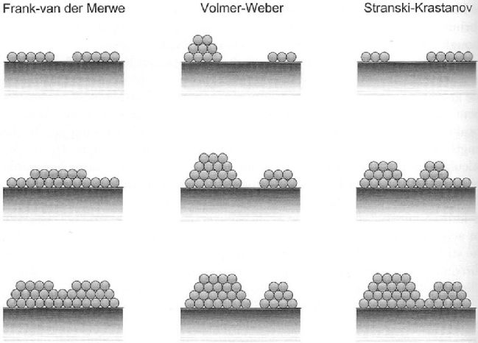
Figure 18-Ball and stick model of three common growth modes¹⁹
In terms of desirability, layered growth is the most coveted because is generally associated with the least propagation of defects. The two island growth modes are less desired because of the increased tendency to form grains at the junction of the islands. With that said, preferred growth modes, like many other aspects of CVD is application specific and the individual advantages and disadvantages must be thoroughly considered to maximize success.

Conclusion
Chemical vapor deposition, by its very nature, is a complex blend of several disciplines. Concepts more thoroughly discussed in the fields of physics, chemistry and materials science are required to adequately understand CVD. The intention of this manuscript was to briefly summarize the essential concepts related to success in CVD. The layout of content in this work is designed to treat sujects in order s in relation to the phase of the CVD project. Topics of fluid flow, heat flow and modeling are typically entertained during the very early phases of a project. Notions of process chemistry encompass both the early stages and construction phase of a reactor for a set of CVD experiments. Characterization and deposition were covered last because they are important only in post deposition. Despite being heavy in theory which can be considered at any point in the process, deposition modes are only evident after some sort of material characterization has been performed. There is an abundance of resources for less concise treatments of the subject. They include texts solely focused on CVD and texts direct at more specific topics such crystal defects, fluid dynamics and electron microscopy. All of the mentioned above was employed in the creation of this manuscript. The author would like to acknowledge the contribution of Professors Chuck Feigerle and Phillip Rack for their support and encouragement throughout the process.

List of Figures
Figure 1-Depiction of a generic CVD reactor showing major system level components. 1
Figure 2-Image of Ellingham diagram of ΔG formation of metal oxides verses temperature 3
Figure 3-Image of a tube reactor showing laminar flow and boundary layer formation 6
Figure 4-Image comparison of turbulent and laminar flow 8
Figure 5-Schematic of generic MOCVD System 16
Figure 6-Images depicting examples acyclic (top) and aryl MOCVD precursors 17
Figure 7-Lewis structure of copper acetylacetone 18
Figure 8-Schematic of SEM 19
Figure 9-Diagram of possible electron interaction from SEM probing 20
Figure 10-Example EDS Spectrum showing elemental peaks 21
Figure 11-EBSP pattern of quartz 22
Figure 12-Simplified diagram showing heteroepitaxy. Note the direct relationship between the positons of the atoms in the yellow depiosited layer and the blue substrate. 24
Figure 13- Diagram showing examples of common point defects in solids 25
Figure 14-Diagram of edge dislocation solid. The red arrows pointing to the extra row and resultant lattice distortion 26
Figure 15-Image of screw dislocation. The blue lattice depicts atoms in their correct orientation. The red atoms are those that have been shifted to a new location within the lattice. The green atoms are in the process of shifting 27
Figure 16-Diagram of intrinsic stacking fault in a hexagonal closed pack lattice 28
Figure 17-Image of twin boundary formation in the <111> plane 29
Figure 18-Ball and stick model of three common growth modes 30

List of Tables
Table 1-List of Hydrides common to CVD. Reproduced from Handbook of CVD⁹ 14
Table 2-List of Halogens used as precursors in CVD. Adapted from Handbook of CVD Pierson⁹ 14
Table 3-List of Selected mononuclear and dinuclear metal carbonyl complexes. Adapted from Handbook of CVD Pierson⁹. 15

List of References
- Ayers, J. Heteroepitaxy of Semiconductors, CRC Press; Boca Raton, 2007.
- Brundle,C et al. Encyclopedia of Materials Characterization; Butterworth-Heinemann; Boston,1992.
- Dobkin, D., Zuraw. M. Principals of Chemical Vapor Deposition, Kluwer; Boston, 2003.
- Freund,L., Suresh,S. Thin Film Materials, Cambridge Press; New York, 2003
- Harris,N. Modern Vacuum Practice, 3rd ed; Bell and Bain Ltd: Glasgow, 2007.
- Jones,A., O’Brien, P. CVD of Compound Semiconductors, VCH; Germany 1997.
- Mccluskey, M., Haller, E. Dopants and Defects in Semiconductors, CRC Press; Boca Raton, 2012.
- O’Hanlon, J. A User’s Guide to Vacuum Technology, 3rd ed; Wiley Interscience: Hoboken, 2003.
- Ohring, M. Materials Science of Thin Films, 2nd ed; Academic Press: San Diego, 2002.
- Pierson,H. Handbook of Chemical Vapor Deposition, 2nd ed: Noyes Pub: Norwich, 1999.
- Rees, W. CVD of Nonmetals, VCH; Germany 1996.
- Smith, D. Thin-Film Deposition, Mcgraw Hill; Boston, 1995.
- Tilley, R. Crystals and Crystal Structures, Wiley Interscience; Hoboken, 2003.
- Geochemical Instrumentation and Analysis. http://serc.carleton.edu/research_education/geochemsheets/techniques/SEM.html
(accessed Jan 29, 2013)
- NDT Resource Center. http://www.ndt-ed.org/index_flash.htm
(accessed, Jan 29, 2013)
- Time Domain CVD. http://www.timedomaincvd.com/
(accessed Jan 15, 2013)
- Secondary Steel making: Overview. http://www.emt-india.net/process/iron_steel/sec_steel.htm
(accessed Jan 22, 2013)
- Croation-English Chemistry Dictionary and Glossary. http://glossary.periodni.com/glossary.php?en=laminar+flow
(accessed Jan 15, 2013)
- Surfaces, Growth and Strain Relaxation. http://www2.warwick.ac.uk/fac/sci/physics/current/postgraduate/regs/mpags/ex5/strainedlayer/surfgrwth/
(accessed Jan 22, 2013)
- Grain Boundaries. http://www.tf.uni-kiel.de/matwis/amat/def_en/kap_7/backbone/r7_1_1.html
(accessed Jan 29, 2013)

VITA

John Daniel Brasfield was born on March 14th 1979 in Kingsport, Tennessee; the second child of Robert and Judy Brasfield. After graduating from Kingsport Christian School in 1997 as Valedictorian, Daniel attended East Tennessee State University in Johnson City, Tennessee where he received a Bachelor of Science with a major of Chemistry in 2001. Upon completion of his degree to 2006 Daniel worked jobs in the nuclear industry focusing on health physics and radiation protection. In the spring 2006 he accepted a position at the Y-12 National Security Complex as a Research and Development Chemist. In the summer of 2008 Daniel entered graduate school at the University of Tennessee- Knoxville and received his Ph.D. in December of 2013.

