COMPATIBILITY OF ESSENTIAL OILS WITH THE BIOCONTROL FUNGUS, BEAUVERIA BASSIANA

A Thesis Presented for the
Master of Science
Degree
The University of Tennessee, Knoxville

Wanjing Liu
December 2012
ACKNOWLEDGEMENTS
I wish to express my sincerely appreciation to my major professor, Dr. Kimberly D. Gwinn, for her support, patience, and encouragement, and for giving me the opportunity to pursue this degree. I also thank my committee members, Dr. Ernest Bernard, Dr. Arnold Saxton and Dr. Bonnie Ownley for their advice, support and guidance. I thank Mary Dee and David Trently for helping me whenever I need them. And I thank the entire Entomology and Plant Pathology department for all of their help and much of what I learned from this experience.
I must thank all of the graduate students, for their friendships and support which I will remember forever. Special appreciation is expressed to Marei Abdelkarim, Oluseyi Fajolu, Andrea Vu, Jonathon Mixon, Sandesh Shrestha, Haley Smith, Qunkang Chen and Jonathan Black for their tireless assistance and the friendships which I will remember forever.
I would also like to express gratitude to my family for their support, encouragement, and love. I feel extremely blessed to have you in my life.

ABSTRACT
The tomato seedling damping-off pathogens Rhizoctonia and Pythium have the potential to cause severe loss in greenhouse and field. Both seed application of Beauveria bassiana and soil amendment with bioactive monarda herbages are sustainable approaches that can play a role in suppressing damping-off of tomato seedlings. The objectives of this research were to determine the compatibility of essential oils and B. bassiana, and to determine the impact of the two when used together as a seed treatment in greenhouse experiments.
Different concentrations of five essential oils that were active against damping-off pathogens (cymene, carvacrol, thymol, borneol, and geraniol) were tested. Germ tube emergence was monitored every four after germination began. Germ tube lengths of B. bassiana conidia treated with each oil concentration were determined. Cymene had a stimulatory effect on germ tube development of B. bassiana at low concentrations but inhibited germ tube development at high concentrations. Thymol was the least inhibitory of all tested oils. All oils reduced germ tub length at the highest concentration at 24 h. In a separate study spore germination of B. bassiana treated with oils for 24 h was also determined. Germination percentage was decreased across concentration in all five oils treatment. Germ tube development trends with fresher spores (used in second study) were similar to the aged conidia (used in first study) but at 24 h, aged spores had a shorter average tube length.
In the second study, five bioactive monarda herbage (‘Trinity Purple’, ‘Rose-scented’, ‘Violet Queen’, ‘Cerise’, and Monarda clinopodia) representing five chemotypes (cymene, geraniol, carvacrol, borneol, and thymol, respectively) were selected based on the GC-MS analyses. Colonization by B. bassiana of seedlings grown in media amended with the five cultivars was determined. All five cultivars had a slight negative impact on the ability of B. bassiana to colonize tomato. Treatment with Monarda clinopodia (thymol chemotype) was resulted in very low germination of tomato seeds. Four other monarda cultivars had no negative impact on tomato seed germination and so have the potential to be used with B. bassiana as biological control agents.

TABLE OF CONTENTS

PART I
LITERATURE REVIEW 1
Introduction: 2
1.1 Essential oils 3
1.2 Bioactive monarda herbage 10
1.3 Beauveria bassiana 11
1.4 Spore germination of B. bassiana 12
1.5 Compatibility of B. bassiana with fungicides and herbicides 13
1.6 Biological control activity of B. bassiana 14
Objectives 16
Hypotheses 16
PART II
IMPACT OF FIVE ESSENTIAL OILS (THYMOL, CARVACROL, GERANIOL, BORNEOL, AND CYMENE) ON SPORE GERMINATION AND GERM TUBE DEVELOPMENT OF BEAUVERIA BASSIANA 18
Abstract 19
Introduction 20
Materials and Methods 21
Results 25
Discussion 36
PART III
EFFECTS OF BEAUVERIA BASSIANA (USED AS A SEED TREATMENT) AND BIOACTIVE MONARDA HERBAGES (USED AS A GREENHOUSE GROWING MEDIA AMENDMENT) ON B. BASSIANA COLONIZATION, SEED GERMINATION, AND GROWTH OF TOMATO 38
Abstract 39
Introduction 40
Materials and Methods 40
Results 45
Discussion 52
SUMMARY 54
REFERENCES 56
APPENDIX 63
VITA 69

LIST OF TABLES

Table 2.1. Preparation of the 500mM essential oil treatments 23

Table 2.2. Calculated EC₅₀ Values at the 24 hour Observation Time. 31

Table 2.3. Percentage germination of Beauveria bassiana treated with six different concentrations of five essential oils (Chi-Square, p<0.0001) 33

Table 2.4. Weighted* germination of B. bassiana spores in six different concentrations of five essential oils (Method=Chi-Square, p<0.0001) 34

Table 3.1. Design for experiment testing the effects of Beauveria bassiana (used as a seed treatment) and bioactive Monarda herbages (used as a greenhouse growing media amendment) on B. bassiana colonization, seed germination, and growth of tomato 43

Table 3.2. Monarda species selection. Concentration of each essential oil representative of a chemotypes in 13 herbages 46

Table 3.3. Concentrations of essential oil constituents in five Monarda species and varieties used in this study (µM) 47

Table 3.4. Final percent germination for tomato seeds in the present of different Monarda herbages that represent different essential oils (Method=LSD, P<0.05) 48

Table 3.5. Days to germination for tomato seeds planted in greenhouse growing medium containing Monarda herbages that represent different essential oils chemotypes (Method=LSD, P<0.05) 49

Table 3.6. Days to germination for tomato seeds coated with B. bassiana suspended in methylcellulose and those seeds that were coated with methylcellulose only (Method=LSD, P<0.05) 50

Table A1.1. Length of germination tubes of Beauveria bassiana treated with borneol at different time periods (Method=LSD, P<0.05) 64

Table A1.2. Length of germination tubes of Beauveria bassiana treated with different concentration of borneol (Method=LSD, P<0.05) 64

Table A1.3. Estimate of intercepts and slopes of the linear regression predicting the relationship between the logarithm transformation of germination tube-length of Beauveria bassiana (dependent variable y) and logarithm transformation of concentration of borneol (explanatory variable x) at each time period (equation: log10(y)=a+b×log10(x), P =0.05) 64

Table A1.4. Length of germination tubes of Beauveria bassiana treated with geraniol at different time periods (µm) (Method=LSD, P<0.05) 65

Table A1.5. Length of germination tubes of Beauveria bassiana treated with different concentration of geraniol (µm) (Method=LSD, P<0.05) 65

Table A1.6. Estimate of intercepts and slopes of the linear regression predicting the relationship between the logarithm transformation of germination tube-length of Beauveria bassiana (dependent variable y) and logarithm transformation of concentration of geraniol (explanatory variable x) at each time period 65

Table A1.7. Length of germination tubes of Beauveria bassiana treated with carvacrol at different time periods (Method=LSD, P<0.05) 66

Table A1.8. Length of germination tubes of Beauveria bassiana treated with different concentration of carvacrol (µm) (Method=LSD, P<0.05) 66

Table A1.9. Estimate of intercepts and slopes of the linear regression predicting the relationship between the logarithm transformation of germination tube-length of Beauveria bassiana (dependent variable y) and logarithm transformation of concentration of carvacrol (explanatory variable x) at each time period (equation: log10(y)=a+b×log10(x), P =0.05) 66

Table A1.10. Length of germination tubes of Beauveria bassiana treated with thymol at different time periods (Method=LSD, P<0.05) 67

Table A1.11. Length of germination tubes of Beauveria bassiana treated with different concentration of thymol (Method=LSD, P<0.05) 67

Table A1.12. Estimate of intercepts and slopes of the linear regression predicting the relationship between the logarithm transformation of germination tube-length of Beauveria bassiana (dependent variable y) and logarithm transformation of concentration of thymol (explanatory variable x) at each time period (equation: log10(y)=a+b×log10(x), P =0.05) 67

Table A1.13. Length of germination tubes of Beauveria bassiana treated with cymene at different time periods (µm) (Method=LSD, P<0.05) 68

Table A1.14. Length of germination tubes of Beauveria bassiana treated with different concentration of cymene (µm) (Method=LSD, P<0.05) 68

Table A1.15. Estimate of intercepts and slopes of the linear regression predicting the relationship between the logarithm transformation of germination tube-length of Beauveria bassiana (dependent variable y) and logarithm transformation of concentration of cymene (explanatory variable x) at each time period (equation: log10(y)=a+b×log10(x), P =0.05) 68

LIST OF FIGURES
Figure 2.1. Effects of borneol on germ tube elongation of Beauveria bassiana 26
Figure 2.2. Effects of geraniol on germ tube elongation of B. bassiana 27
Figure 2.3. Effects of carvacrol on germ tube elongation of B. bassiana 28
Figure 2.4. Effects of thymol on germ tube elongation of B. bassiana 29
Figure 2.5. Effects of cymene on germ tube elongation of B. bassiana 30
Figure 2.6. Response surface plot of effect of time and concentration of five essential oils (monoterpenes) that are found in monarda herbage and are arranged by oxidation state on germ tube length of B. bassiana 32
Figure 2.7. Effect of five concentrations of five essential oils on germ tube development of B. bassiana at 24 hour 35
Figure 3.1. Effects of essential oils on tomato seeds germination 49
Figure 3.2. Effects of essential oils on ability of B. bassiana to colonize tomato seeds 51

PART I

LITERATURE REVIEW

Introduction:
Pathogenic microorganisms and pests of plants can eliminate profits in crop production systems. Effective environmentally-friendly tools for the management of diseases and noxious insect pests are needed for improving economic and environmental performance in sustainable agriculture. Both microbial pesticide such as Beauveria bassiana and bioactive herbage including monarda can provide pest and disease control and have less potential for causing damage to the environment or to non-target organisms than chemical interventions.
Essential oils are well known natural pesticides and our laboratory has shown that bioactive herbage (dried, ground leaves of Monarda spp.) can protect against damping-off diseases in tomato seedling production. We have also developed technology for seed treatment with Beauveria bassiana and have showed that plants derived from treated seed are protected from seedling diseases and insects because they are colonized with the fungus. However, there is little data on the compatibility of natural products and entomopathogenic fungi, and no data on the impact of the two when used as a seed treatment in greenhouse experiments. Demonstration that the two technologies are compatible is needed in a pest management system.
Our research will be used to produce models that will predict the effect of bioactive natural products on B. bassiana; this will allow selection of bioactive natural products that are compatible with B. bassiana. This is the first step in the development of systems that increase sustainability, productivity, and farm profits. Since our data is applicable to conventional and organic systems, both groups will be targeted in subsequent pest management programs.

1.1 Essential oils
Essential oils are mixtures of different terpenoid compounds and their oxygenated derivatives. They are highly volatile substances synthesized and stored in glandular trichomes of odiferous plants. These oils are known for their broad spectrum antimicrobial activity against both human and plant pathogens. The antimicrobial action of essential oils generally depends upon their hydrophilic or lipophilic character. Also, some terpenoids affect the activities of membrane enzymes and interfere with respiratory pathways. Certain components of essential oils can even interrupt ADP phosphorylation (primary energy metabolism) and inhibit the synthesis of DNA, RNA, proteins and polysaccharides in fungal and bacterial cells (Knobloch et al.1989). The type of microorganism, its cell wall structure and outer membrane arrangement may determine the mode of action of antimicrobial agents. For instance, Pseudomonas aeruginosa, an opportunistic bacteria associated with hospital-acquired infections of humans, is resistant to a wide variety of essential oils, because the hydrophobic macromolecules of essential oils constituents are unable to penetrate the hydrophilic surface of bacterial outer membrane (Hiroshi 1994).
Antifungal essential oils reduce hyphal growth and also induce lysis and cytoplasmic evacuation in fungi. Growth inhibition by essential oils often involves induction of changes in cell wall composition, plasma membrane disruption, mitochondrial structure disorganization, and interference with enzymatic reactions of the mitochondrial membrane, such as respiratory electron transport, proton transport, and coupled phosphorylation steps (Kishore et al. 2007). The essential oils of some plants and their constituents are effective as antifungal agents against plant pathogenic fungi.
Many plants with oils that inhibit the growth of phytopathogenic fungi belong to the Laminaceae family. Those containing the phenolic components, thymol or carvacrol, as the main constituent, have high antifungal activity. The antifungal activity and the chemical composition of the essential oil isolated from Origanum acutidens (87.0% carvacrol as main constituent) completely inhibited mycelia growth of seventeen species of Botrytis, Fusarium and Alternaria (Kordali et al. 2008). Also, oils collected by steam distillation from Thymbra spicata, Satureja thymbra and Origanum minutiflorum that contained more than 234.8mg/mL of thymol and/or carvacrol inhibited in vitro mycelia growth of several soil-borne plant pathogenic fungi (Fusarium moniliforme, Rhizoctonia solani, Sclerotinia sclerotiorum, and Phytophthora capsici) (Muller-Riebau et al. 1995). Furthermore, essential oils of Thymus vulgaris and Mentha piperita (50.06% thymol as the main component) reduced in vitro growth of the pathogenic fungi, R. solani, Pythium ultimum var. ultimum, Fusarium solani and Colletotrichum lindemuthianum. These oils also caused degeneration of fungal hyphae; hyphae appeared empty of cytoplasmic content materials. When C. lindemuthianum and F. solani were treated with thyme oil, several changes in fungal growth and reproduction occurred (e.g., alterations in the morphology of the hyphae, reductions of conidia number, reductions in the hyphal diameter) (Zambonelli et al., 1996).
In addition to thymol and carvacrol, essential oils from mints that have high concentrations of other constituents reduce growth and reproduction of phytopathogenic fungi. The essential oil compounds of the aerial parts of Rosmarinus officinalis (44.02% ρ-cymene; 20.5% linalool as main components) inhibited in vitro growth of Alternaria alternata, Botrytis cinerea, Fusarium oxysporum (Ozcan and Chalchat 2008). In addition, some other essential constituents that potentially can be used as fungicides have been studied as well. Oils from the aerial parts of Salvia rosifolia [α-pinene (15.7-34.8%) and 1,8-cineole (16.6-25.1%) identified as major constituents] strongly inhibited growth of strawberry anthracnose-causing fungal plant pathogens C. acutatum, C. fragariae, and C. gloeosporioides (Ozek et al. 2010). Essential oil of S. fruticosa (main components - 1,8-cineole and camphor) effectively inhibited mycelia growth and reduced the radial growth of phytopathogenic fungi, R. solani, Sclerotinia sclerotiorum and F. solani, in vitro (Pitarokili et al.,2003). The essential oil of Ocimum sanctum (56.07% eugenol - main component) completely inhibited growth of Aspergillus niger and A. flavus (Pandey et al., 2010). Essential oil extracted from the leaves of Mentha arvensis (43.45% menthol - main component) was evaluated in vitro, and it caused complete inhibition in growth of two pathogenic filamentous fungi A. niger and A. flavus (Pandey et al. 2010).
Fungicidal properties of the plants belonged to other families have also been tested. Piperitone and trans-ethyl cinnamate, which are two essential oil compounds extracted from Artemisia judaica (Asteraceae), inhibit the mycelia growth of Botrytis fabae, F. oxysporum, Pythium debaryanum, and R. solani. The antifungal activity of the two isolated compounds against F. oxysporum and R. solani was greater than borneol and cineole but weaker than thymol, carvacrol, and geraniol (Abdelgaleil et al.,2008). The leaf essential oil and its constituents from Calocedrus macrolepis var. formosana (Cupressaceae) [α-pinene (44.2%); limonene (21.6%) - main components] strongly inhibited the growth of damping-off pathogens, R. solani and F. oxysporum. in vitro, and also efficiently inhibited the mycelial growth of leaf pathogens (C. gloeosporioides, Pestalotiopsis funereal) and root rot pathogens (Ganoderma austral and F. solani) (Chang et al. 2008). The essential oils of Syzygium aromaticum (Myrtaceae) and Foeniculum vulgare (Apiaceae) were active against Botrytis cinerea (Peighami-Ashnaei et al., 2009). Eugenol [the primary constituent of essential oil isolated from Syzygium aromaticum (Myrtaceae)] completely inhibited mycelial growth of four apple pathogens (B. cinerea, Monilinia fructigena, Penicillium expansum and Phlyctema vagabunda) at a concentration of 150µl/l but was ineffective in reducing disease incidence after mixed with soy lecithin (Amiri et al., 2008). Essential oils extracted from Star anise (Schisandraceae) that contained 89.5% trans-anethole strongly inhibited mycelial growth of plant pathogenic fungi (Alternaria solani, Bipolaris maydis, F. graminearum, Pythium aphanidermatum and R. solani) in the in vitro direct contact assay (also called the mycelial radial growth inhibition assay) (Huang et al. 2010). The efficacy of the essential oil and extracts derived from the flower and leaves of Magnolia liliflora against plant pathogenic fungi were evaluated in vitro and in vivo. The oil inhibited radial growth of B. cinerea, C. capsici, F. oxysporum, F. solani, Phytophthora capsici, R. solani and Sclerotinia sclerotiorum by 38 to 65.6%, and had strong detrimental effects on spore germination of all tested plant pathogens (Bajpai and Kang 2009). Essential oil compounds of asafoetida (Ferula assafoetida) (Apiaceae) and black cumin seed (Nigella sativa) (Ranunculaceae) were effective at controlling colony growth of eight seed borne fungi including A. niger, A. flavus, F. oxysporum, F. moniliforme, F. nivale, F. semitectum, Drechslera hawiinesis and Alternaria alternata (Sitara et al. 2008). The essential oil extracted from eucalyptus (Eucalyptus camaldulensis) (Myrtaceae) completely inhibited mycelial growth of Pythium ultimum and R. solani (Katooli et al. 2011).
Essential oils also reduced growth of other fungi (e.g., dermatophytes, various molds and yeasts). The main components β-bisabolene (17.6-51.0%) and 11-α-(H)-himachal-4-en-1-β-ol (9.0-21.6%) of extracts from both flowers and mature umbels with seeds of wild Daucus carota subsp. carota (Apiaceae) reduced growth of five dermatophytes (Epidermophyton floccosum, Microsporum canis, M. gypseum, Trichophyton mentagrophytes and T. rubrum) (Maxia et al. 2009). The essential oil of Achillea millefolium (Asteraceae) containing 42.15% chamazulene suppressed the development of Aspergillus nidulans spores and increased number of yellow and white mitotic recombinants of the diploid strain (De Sant’anna et al. 2009). Many essential oils from genera of the Laminaceae family including several species of Thymus (T. numidicus, T. vulgaris, Thymus x viciosoi, T. algeriensis) and Origanum (O. vulgare, O. majorana) that had thymol, carvacrol, cymene, linalool or α-pinene as the main constituent, effectively inhibited growth of yeast (e.g., Saccharomyces cerevisiae, Cryptococcus neoformans or Candida albicans) (Giordani et al., 2008; Pozzatti et al., 2010; Van Vuuren et al., 2009).
Essential oils also inhibit growth of phytopathogenic bacteria, drug-resistant bacteria, food-related bacteria and diverse bacterial human pathogens. Essential oils are effective as plant or seed disinfectants for the prevention of infections caused by phytopathogenic bacteria. Thymus fallax (Lamiaceae) and Satureja spicigera (Lamiaceae), both which have a high content of thymol, carvacrol, ρ-cymene and γ-terpinene, inhibited growth of a wide range of agricultural bacterial pathogens such as Erwinia, Pseudomonas and Xanthomonas (Kotan et al. 2010). Essential oils also inhibit drug-resistant bacteria. Laminaceae species including Lavandula sp., Salvia rosifolia, Thymus vulgaris, Zataria multiflor, L. angustifolia, L. latifolia Medik, L. luisieri (Muller-Riebau et al. 1995; Ozek et al. 2010; Tohidpour et al. 2010; M Mahboubi & Bidgoli, 2010; Roller et al. 2009) and Myrtaceae species including Cleistocalyx operculatus and Eucalyptus globules (Dung et al.,, 2008; Tohidpour et al., 2010) effectively inhibited the growth of drug-resistant bacterium strains. Essential oils from Helichrysum italicum (Asteraceae) that contained high concentrations of geraniol had inhibitory activity against Acinetobacter baumannii, Enterobacter aerogenes, Escherichia coli, and Pseudomonas aeruginosa (Lorenzi et al. 2009). Oil of Melaleuca alternifolia (Myrtaceae) that primarily contained terpinen-4-ol was active against coagulase-negative staphylococci (Loughlin et al., 2008).
Essential oils added to food products may extend their shelf life due to their activity against food-borne bacteria. The essential oils of Artemisia incana, Chaerophyllum operculatus, Laurus nobilis, Mentha pulegium and Nandina domestica (Bajpai, et al., 2008; Cetin et al., 2009; Dung et al., 2008; Erkmen & Ozcan, 2008; Mohaddese et al., 2008) were active against a wide range of the most important food-borne microorganisms including Listeria monocytogenes, Enterobacter aerogenes, Enterobacter cloacea, Escherichia coli, Enterococcus faecalis, Salmonella typhimurium and S. enteritidis.
Essential oils have also been used for the treatment of diverse human pathogens. Limonene, the primary component in Abies koreana, various citrus species, and Fortunella japonica was active against Propionibacterium acnes and Staphylococcus epidermidis, which are linked to the occurrence of skin infections (Kim et al., 2008; Yang et al., 2010; Yoon et al., 2009). Oils from Apium nodifloru, Plinia cerrocampanensis, and Thymus caramanicus inhibit growth of the stomach bacterium, Helicobacter pylori (Eftekhar et al., 2009; Menghini et al., 2010; Vila et al., 2010). Essential oils of Achillea ligustica, Mentha longifolia and Hyptis pectinata inhibit growth of two dental bacteria, Streptococcus mutans and S. pyogenes (Nascimento et al. 2008; Al-Bayati 2009; Maggi et al. 2009). A high antibacterial activity of essential oil of Cuminum cyminum (Apiaceae) was observed against human pathogens Staphylococcus aureus, Streptococcus faecalis, Brochothrix thermosphacta, Pseudomonas fragi and Escherichia coli (Derakhshan et al., 2008).

1.2 Bioactive monarda herbage
The genus Monarda is limited to the North American continent in its present natural distribution. The numerous species occupy a large geographical area, from the Canadian prairies in the north to Michoacán in the south and throughout the breadth of the North American continent. In most parts of their range, species of this genus have been utilized by man as garden plants, food and flavoring additives, and for medicinal purposes (Scora 1967).
Damping-off of seedlings caused by species of Pythium and Rhizoctonia can reduce number and quality of tomato seedlings. Plants in the genus Monarda produce complex essential oils that contain antifungal compounds. Selections of bioactive monarda herbage (ground dried leaves harvested from selected Monarda cultivars) were grouped into five chemotypes based on essential oil composition and antifungal activity; seedling survival in Rhizoctonia solani-infested media was increased from 10 % (no herbage) up to 80% (‘Croftway Pink’) when bioactive monarda herbage was added to the medium (Gwinn et al. 2010). Losses due to Pythium myriotylum were reduced when selected bioactive monarda herbage were added to greenhouse growing medium (Clark et al., 2006). Cymene was the major essential oil component of ‘Trinity Purple’, geraniol was the major essential oil component of ‘Rose-scented’, carvacrol was the major essential oil component of ‘Violet Queen’, borneol was the major essential oil component of ‘Cerise’, and thymol was the major essential oil component of M. clinopodia.

1.3 Beauveria bassiana
The fungus, Beauveria bassiana, was discovered and named by the research scientist Agostino Bassi de Lodi in 1835 while he was studying the white muscadine disease in silkworms. It was formerly known as Tritirachium shiotae.
Beauveria bassiana is the anamorph of Cordyceps bassiana. It lives in soils throughout the world, where it grows as multicellar mycelia by absorbing nutrients from the decaying matter (Germain and Summerbell 1996). In culture, mycelia grew best on Potato Dextrose Agar (PDA) media and Sabouraud Dextrose Agar (SDA) media (Senthamizhlselvan et al., 2010).
Although sexual reproduction occurs at a low frequency (Meyling et al., 2009), B. bassiana produces copious asexual non-pigmented spores (conidia) which are wind dispersed. The conidia are single-celled, haploid, and hydrophobic, they measure 2 μm to 4 μm. On most common culture media, conidia appear in dry, powdery white spore balls. Conidia are generally considered relatively more resistant to unfavorable environmental conditions than other cells. When released into the environment, they remain dormant or in a non-vegetative state until appropriate environmental conditions activate germination. When favorable environmental conditions exist, water molecules enter the spore, and the spore starts to swell; its size increases until it reaches a critical volume when a small protrusion (germ tube) starts to form on one side of the spore. This protrusion will develop into a branching germination tube that will then develop into the fungal hyphae. There are three different germination types for conidia of B. bassiana on Sabouraud Dextrose Agar: unidirectional, bidirectional and multidirectional (Talaei-Hassanloui et al., 2007). Spore germination is the most vulnerable part of the B. bassiana lifecycle and is therefore a good candidate for monitoring the effect of essential oils on the growth. There is a general consensus that spore germination and mycelial growth in vitro are useful criteria for testing the side effects of fungicides on beneficial entomopathogenic fungi (Gatarayiha et al., 2010)

1.4 Spore germination of B. bassiana
Spore germination of B. bassiana occurs when a spore is exposed to a conductive environment (free water, optimal temperature range, and nutrients). Temperature is a major factor in activation of conidial germination independent of a host (Boucias et al., 1988). The temperature range for germ tube development of most entomogenous fungi is 20℃ to 30℃. At 25℃ to 30℃, 95 % of conidia of most B. bassiana strains germinated in 14-25 h (Hywel-Jones and Gillespie 1990; Tefera and Pringle 2003).
Availability of water (high humidity) is another major factor in the germination of spores and conidia. Freely available water (relative humidity of 100%) is most favorable for spore germination and mycelial growth, but in laboratory tests, germination of spores of certain strains of B. bassiana will occur at relative humidity as low as 56.8% (Teng 1962).
Although temperature and water availability have major impacts upon the conidial germination in B. bassiana, other environmental factors also influence germination and mycelial growth. Radial mycelial growth of B. bassiana is increased in the light, but density of the mycelium is reduced (Teng 1962). Germination capacity of spores of B. bassiana was not lost after accumulative exposure to direct sunlight for about 150 hours (Teng 1962). Spore germination was positively correlated with oxygen concentration (Teng 1962). Mycelial growth under adequate oxygen supply was increased, but spore formation was decreased (Teng 1962). Optimum mycelial growth occurs from pH 4.0 to 5.0. The pH range for spore germination is pH 3.0 – 9.4; the range for growth pH 2.4 and 10.0. The optimum pH for spore germination is about pH 4.4. There is no specific nitrogen requirement for the germination of B. bassiana. Among the inorganic sources, nitrate nitrogen is more utilizable than ammonium nitrogen. Organic nitrogen increases spore production in the light but not in the dark (Teng 1962; Roberts and Campbell 1977).

1.5 Compatibility of B. bassiana with fungicides and herbicides
Besides environmental and nutritional factors, conidial survival and germination can also be affected by interactions with agrochemicals or bio-pesticides, and therefore, these agents may disrupt natural epizootics of B. bassiana. In in vitro studies, conidial germination of B. bassiana was inhibited by nine fungicides and 14 insecticides (Olmert and Kenneth 1974). Conidial germination is an effective criteria to evaluate compatibility of B. bassiana with insecticides since those fungal structures are responsible the occurrence of the first disease foci in the field (Neves et al., 2001). Many traditional pesticides are compatible with B. bassiana. Activity of fungicides on B. bassiana has been reported to vary from strong to non-inhibitory depending on the chemistry of the fungicide (Gatarayiha et al. 2010).
Unlike traditional pesticides, there are few studies on the impact of pest management strategies with natural products and B. bassiana. The plant growth regulators Silaid, paclobutrazol, and flurprimidol significantly inhibited germination and growth of B. bassiana in vitro (Storey and Gardner 1986). Neem oil was compatible with B. bassiana (Islam et al. 2010). High concentrations of azoxystrobin (a natural product fungicide) inhibited spore germination and growth of B. bassiana but did not reduce B. bassiana activity against two-spotted spider mites (Gatarayiha et al. 2010). When B. bassiana-coated seed were planted into a water-soaked greenhouse growing medium used to stimulate disease losses due to P. myriotylum, there were no statistical interactions between B. bassiana and monarda herbage treatments (Clark et al. 2006).

1.6 Biological control activity of endophytic B. bassiana
Beauveria bassiana has been reported as an endophytic colonist for many plant species including maize, potatoes, cotton, common cocklebur, jimsonweed, tomato, ironwood, western white pine, opium poppy, date palm, banana and cocoa (Vega 2008). Presence of B. bassiana in plant tissues causes feeding deterrence or antibiosis and may produce metabolites that protect plants against some soilborne plant pathogens (Ownley et al., 2008; Ownley et al., 2010). Application of its conidia mixed in methylcellulose solution to tomato seed results in endophytic and epiphytic colonization of seedlings and suppressed plant losses, caused by the damping-off pathogen, R. solani (Ownley et al., 2004). The initial population density of Beauveria conidia established on seed influenced the subsequent extent of endophytic colonization of tomato - rates that were most effective in disease control also resulted in the greatest degree of plant colonization. In tomato, all plants grown from seed treated with 1×10⁷ conidia per seed were colonized by B. bassiana. Endophytic colonization can be detected with standard plating techniques onto selective medium, PCR of colonized plant tissues, and scanning electron microscope (Ownley et al. 2008). Viable B. bassiana was detected in root, stem, and leaf sections of surface-sterilized 18-week old tomato seedlings produced from treated seeds (Ownley et al. 2008).
Competition and induced systemic resistance are likely mechanisms of B. bassiana in suppression of plant disease. Competition for space and resources is a possible mechanism of its biological control activity against R. solani and other plant pathogens, since the fungus is a plant colonist, and will actively compete against plant pathogens for niche/infection sites, carbon, nitrogen, and various microelements within the plant. Induced systemic resistance is another possibility. Plants colonized by B. bassiana reduce or alleviate disease by triggering a rapid expression of defense-related genes. Numerous secondary metabolites produced by isolates of B. bassiana also likely have activity in suppression of plant disease (Ownley et al. 2004, 2010).

Objectives
The overall objective of this research was to evaluate compatibility of Beauveria bassiana both with monarda herbages that reduce plant disease incidence and severity and with the essential oils that represent the major chemotypes of these monarda herbages. The first objective of this research was to determine the impact of five essential oils (thymol, carvacrol, geraniol, borneol, and cymene) on spore germination and germ tube development of Beauveria bassiana at various concentrations and times. The second objective was to determine effects of the B. bassiana (used as a seed treatment) and bioactive monarda herbage (used as a greenhouse growing media amendment) on B. bassiana colonization, seed germination, and growth of tomato.

Hypotheses
The null hypothesis of the first objective was that essential oils active against damping-off pathogens have no impact on the spore germination and germ tube development of Beauveria bassiana. Alternative hypothesis was essential oils that are active against damping-off pathogens have impact on the spore germination and germ tube development of Beauveria bassiana. The null hypotheses of the second objective were that B. bassiana does not have the ability to colonize tomato in the presence of bioactive monarda herbage from each of the five chemotypes (thymol, carvacrol, geraniol, borneol, and cymene) and that these two biological control methods cannot be used together as a tomato seed treatment. Alternative hypotheses were that the fungus B. bassiana has the ability to colonize tomato in the presence of bioactive monarda herbage from each of the five chemotypes (thymol, carvacrol, geraniol, borneol, and cymene) and that these two biological control methods can be used together as a tomato seed treatment.

PART II

IMPACT OF FIVE ESSENTIAL OILS (THYMOL, CARVACROL, GERANIOL, BORNEOL, AND CYMENE) ON SPORE GERMINATION AND GERM TUBE DEVELOPMENT OF BEAUVERIA BASSIANA

Abstract
Losses due to seedling damping-off caused by Rhizoctonia and Pythium can be reduced both by seed treatment with Beauveria bassiana isolate TN11-98 (Bb) and by use of essential oils within bioactive monarda herbages. Five concentrations of cymene, carvacrol, or thymol ranging from 0 to 500 µM, and six concentrations of borneol or geraniol ranging from 0 to 50 µM were tested. Ethanol was used as the control. Spore suspensions of B. bassiana were placed on water agar in the presence or absence of an essential oil. Spore germination and germ tube development were observed up to 24 h. Germ tube lengths (including the diameter of the spore) were determined. Each oil was tested as a separate experiment that was designed as a factorial experiment; with varied numbers of concentrations (5-6) x four time periods x 10 -20 microscope views. Each experiment was repeated twice. In all experiments, germ tube length was greatest in control treatment at 24 h. The ρ-cymene had a stimulatory effect on germ tube development of B. bassiana at low concentrations but inhibited germ tube development at high concentrations. Germ tube length was reduced by approximately 50% at 24 hours for spores exposed to a 50 µM cymene. No spores germinated in treatments with borneol (50 µM), carvacrol (50 µM and 500 µM) or cymene (500 µM). Thymol was the least inhibitory of all tested oils. A second study with all oils at all concentrations but observed at only one time period (24 h) was also performed with spores collected from 6-8 week cultures. Germination percentage was decreased across concentration in all five oils treatment. Germ tube development trends were similar to the first time course study, with the average tube length lower than the aged conidia used in the first study. Results indicated that five essential oils that were active against damping-off pathogens had a negative impact on the spore germination and germ tube development of Beauveria bassiana, but at low concentrations, the essential oils have the potential to be used together with B. bassiana as biological control agents. Further studies are necessary to identify the effects of bioactive monarda herbage containing essential oils on the B. bassiana in the greenhouse and field studies.

Introduction
The various risk factors associated with the use of conventional chemical fungicides such as development of resistance, adverse effects on non-target organisms, accumulation of pesticidal residues in food chain, environmental pollution, health risks and high costs have driven scientists to develop alternative eco-friendly techniques for disease management. The entomogenous fungus, Beauveria bassiana, and monarda bioactive herbage are potential biological control agents that will help in crop protection and in producing agricultural commodities free from pesticide residues. Disease management will be enhanced if these two biological control strategies are compatible and can be combined together.
The literature provides many examples of essential oils that have effects on the development of fungi, inhibitory or stimulatory. The essential oil isolated from Origanum acutidens that contains the phenolic component, carvacrol, as the main constituent completely inhibited mycelia growth of seventeen species of Botrytis, Fusarium and Alternaria (Kordali et al. 2008). Essential oils of Thymus vulgaris and Mentha piperita which contains 50% thymol as the main component reduced in vitro growth of the pathogenic fungi, R. solani and F. solani and caused degeneration of the fungal hyphae (Zambonelli et al. 1996). The essential oil compounds extracted from the aerial parts of Rosmarinus officinalis that contained 44% ρ-cymene inhibited in vitro growth of Alternaria alternata, Botrytis cinerea, Fusarium oxysporum (Ozcan and Chalchat 2008). The purpose of this study was to evaluate the impact of essential oils (ρ-cymene, borneol, geraniol, carvacrol, and thymol) on the spore germination and germ tube development of B. bassiana.

Materials and Methods
Time Course Study
Materials. Beauveria bassiana 11-98 was isolated from a click beetle (Coleoptera: Elateridae) and characterized at University of Tennessee, Knoxville (strain TN11-98) by Roberto Pereira and is maintained by Bonnie H. Ownley. To produce sporulating cultures, spores of B. bassiana were placed on Difco Sabouraud Dextrose Agar, spread evenly using an autoclaved spreading rod, and grown for 60 days at room temperature.
Five essential oils, including cymene, carvacrol, borneol, geraniol and thymol, were purchased from Sigma-Aldrich Co. (St. Louis. Mo). Tween-20 and 95% ethanol were purchased from Fisher Scientific (Fair Lawn, NJ).
Spore Suspension Preparation. Spores of B. bassiana from cultures up to 6 months old were transferred into a 15 mL test tube with water (ca. 3mL) and vortexed. Since spores tend to cling together in water, two drops of diluted Tween-20 (0.006 %) were added to the suspension. The suspension was sonicated for ten minutes.
Essential oils Preparation. Five essential oils that define the monarda herbage chemotypes (thymol, carvacrol, geraniol, borneol, and cymene) were each combined with ethanol to produce different concentrations. A 500 mM solution of each essential oil was prepared as described in Table 2.1, and the final amount of essential oil in each dish was 5.0 μmoles/dish. A dilution series of the 500 mM solution was used for additional treatments. Five concentrations (0, 0.5, 5.0, 50, and 500 mM) of cymene, carvacrol, and thymol, and six concentrations of borneol and geraniol (0, 0.005, 0.05, 0.5, 5.0, and 50 mM) were tested. Tubes were shaken until mixture was homogeneous, and pipette tips were changed between dilutions.

Table 2.1. Preparation of the 500mM essential oil treatments.
Essential Oil | Molecular Weight** | Specific Density** | Oil  (μL) | Ethanol  (μL) | Solid (g) | Total solution  (μL)
Borneol | 154.24 | 1.011 | 10 | 121 | NA | 131
Carvacrol | 150.21 | 0.976 | 10 | 120 | NA | 130
ρ-cymene | 134.21 | 0.860 | 10 | 118 | NA | 128
Geraniol | 154.24 | 0.889 | 10 | 105 | NA | 115
Thymol***  (stock) | 150.21 | - | NA | 1000 | 751 | 1000
Control (ethanol) | - | - | NA | 100 | NA | 100

* In experiments, antibiotic discs (1/plate) were treated with 10μL essential oils, which results in a final treatment concentration of 5.0 μmoles per dish. Other treatments were dilution series of the original solution. The amounts showed here result in 500 mM concentrations.
**Data from Sigma-Aldrich
***Solution shown is a 5.0 M stock solution. Treatments were performed with a 1:10 dilution of this stock.
Experimental design. Agar blocks (1.5% water-agar) were used to provide the water that is essential for fungal spores to germinate and grow. Molten agar was poured into a plastic form (12.5cm × 8.4cm), and after solidification, the agar was cut into blocks; blocks were placed on a clean microscope slide in a 100 x 15 mm Petri dish. The suspension of B. bassiana spores (10 µL) was placed on the agar blocks. A 10 µL drop of essential oil solution (0 – 500 mM) (Table 2.1) was added to an antibiotic testing disc located beside the glass slide in the dish. Petri dishes were closed and incubated on wet sponges at 25℃. Separate dishes were used for each concentration at each time period since sampling destroyed the micro-atmosphere inside the Petri dish.
Based on previous experiments, germ tube initiation was expected to first be detectable at 12 hour or 16 hour, and the length of germ tube in controls was expected to exceed the microscope field after 24 h. Under 1000× magnification of the light microscope - Nikon Alphaphot YS (Nikon Instruments Inc. Melville, NY), the spore germination and germ tube length were observed at 12, 16 , 20, and 24 h (cymene, carvacrol, thymol) or 16, 20, 22, and 24h, ((borneol or geraniol). Microscope views were photographed with the camera – Nikon Coolpix P5100 (Nikon Instruments Inc. Melville, NY). Photographs of a stage micrometer were taken prior to viewing of slides of each concentration and at each periods of time. At least ten microscope fields that contained 10 or more spores were photographed for each field.
Photographs were printed, and the diameters of the spore and germ tube length were determined for each spore by using Scale Master Pro XE (Calculated Industries, Carson City, NV). Measurements included both the spore and the germination tube. Actual size was determined by calibration with the micrometer. There were one to ten observations (spore length) per treatment due to the low germination rate of spores in some treatments. Each experiment was performed three times.
Data Collection and Analysis. All data were recorded in Microsoft Excel and analyzed using PROC MIXED (SAS Institute, Inc., Cary, NC). Log₁₀ of essential oil concentrations were used in analyses.

Twenty-four hour study
In order to determine the percent germination of fresh spores stored at room temperature under the condition of different essential oils, a second study was performed in the same manner as the first except that only one time period was tested, and spores from 6-8 week old cultures were used. After incubation for 24 h, spore germination and germ tube development were observed, recorded, and analyzed as described above.
The experiment was a 5 x 5 factorial design with five concentrations (control, 0.5M, 5M, 50M, 500 mM) of five essential oils (cymene, carvacrol, borneol, thymol, and geraniol) at one time period (24 h). There were one to ten observations (length) per treatment due to the low germination rate of spores in some treatments. The experiment was performed three times.
Data Collection and Analysis. All data were recorded in Microsoft Excel and analyzed using PROC MIXED (SAS Institute, Inc., Cary, NC). The simple linear regression was used to model the relationship between the length of germinated tubes (including the diameter of spores) of Beauveria bassiana (dependent variable y) and the different concentration of essential oils (explanatory variable x) at each time period. Values for concentrations were logarithm transformed. Unknown model parameters, including intercepts (a) and slopes (b) are estimated from the data using SAS (Appendix 1).

Results
Time and concentration of the five essential oils have significant effect on the germ tube development of Beauveria bassiana (P<0.0001). For all oils, germ tube length increased with time and decreased with concentration (Appendix 1- Tables A.1 – A.15).
Time course studies were performed over a 6-month time period and during this time, spores of B. bassiana aged, and percentage of germination decreased (data not shown).
Time Course Study.
Borneol. Treatment with borneol reduced spore germ tube elongation (Fig. 2.1); no germination was observed in the 50 mM treatment. Length of germ tubes in controls was greater than treatments for all borneol treatments. At 16 h, mean germ tube length was not different among treatments with low concentrations (0.05 mM to 5 mM), but by 24 h, all treatments were significantly different.
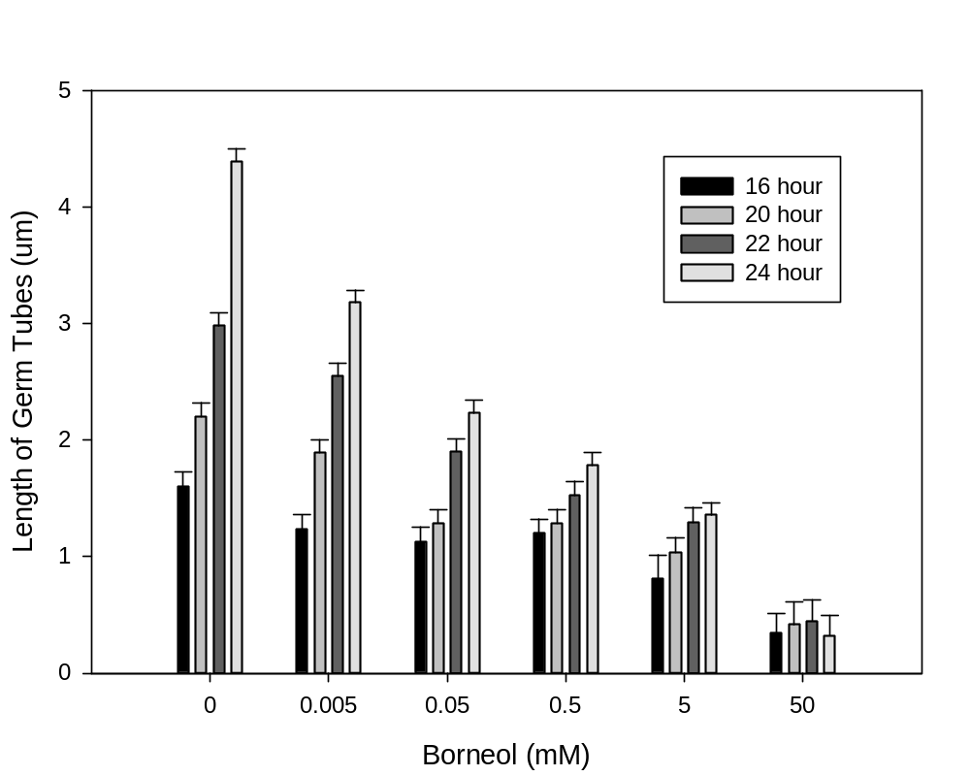
FG
D
B
A
HIJK
E
C
B
IJK
HIJ
E
D
IJK
HIJ
FGH
EF
KLA
JK
HIJ
GHI
LA
LA
L
L
Figure 2.1. Effects of borneol on germ tube elongation of Beauveria bassiana
Conidia were exposed to a micro-atmosphere of varying concentrations of borneol, and germ tube lengths were measured at 4 h intervals. Bars with the same letter are not significantly different according to an F-protected least significant difference at P = 0.05.

Geraniol. There were no statistical significant differences in mean germ tube length among five different concentrations and control at 16 hour, and few differences observed at 20 hour (Fig. 2.2). At 22 hour and 24 hour, germ tube lengths were greatest in control and the least in 50 mM treatments. Geraniol did not inhibit the germ tube development at 16 hour and 20 hour significantly but had a negative effect at 22 hour and 24 hour.
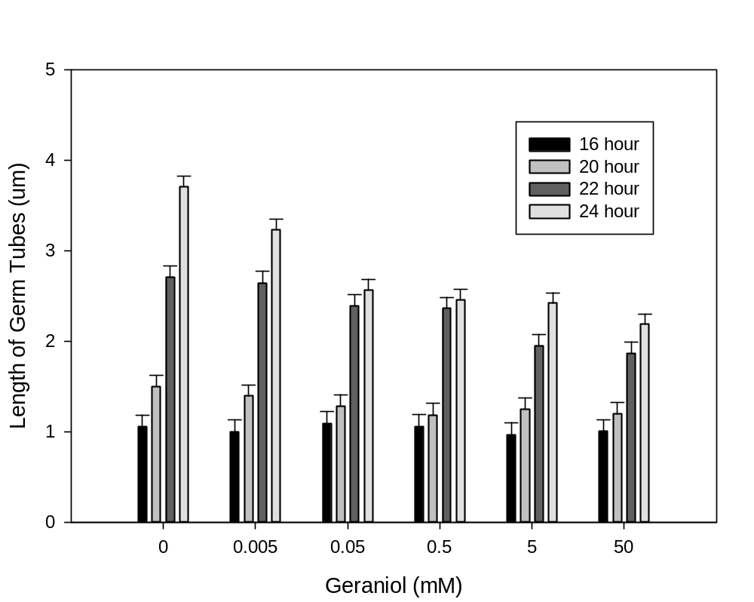
JKL
H
C
A
B
CD
KL
HI
JKL
HIJ
DEF
CDE
JKL
IJKL
EF
DE
L
IJK
G
DE
KL
IJKL
G
F
Figure 2.2. Effects of geraniol on germ tube elongation of B. bassiana
Conidia were exposed to a micro-atmosphere of varying concentrations of borneol, and germ tube lengths were measured at 4 h intervals. Bars with the same letter are not significantly different according to an F-protected least significant difference at P = 0.05.

Carvacrol. Germ tube length was smaller than control in the 0.5 mM treatment at 24 h. In the 5 mM treatment, germ tube length was reduced at 16 h, 20 h and 24 h. There was no germination at either 50 mM or 500 mM.
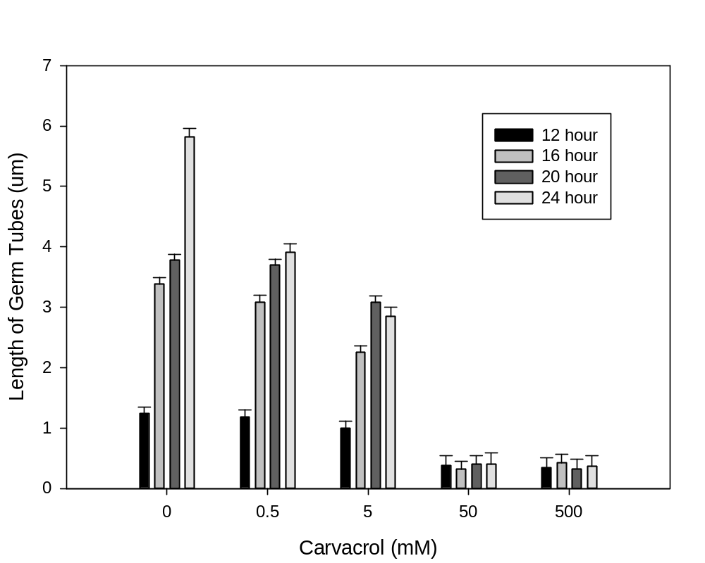
GF
GF
F
C
B
A
F
CD
B
B
F
E
D
DF
GF
GF
GF
GF
GF
GF
Figure 2.3. Effects of carvacrol on germ tube elongation of B. bassiana
Conidia were exposed to a micro-atmosphere of varying concentrations of borneol, and germ tube lengths were measured at 4 h intervals. Bars with the same letter are not significantly different according to an F-protected least significant difference at P = 0.05.

Thymol. Exposure to thymol slowed germ tube development but did not kill spores at any of the six concentrations from 0 to 500 mM (Fig.2.4). Germ tube length in the highest treatment (500 mM) was not different from length in the 10-fold dilution (50 mM) at any sampling time.
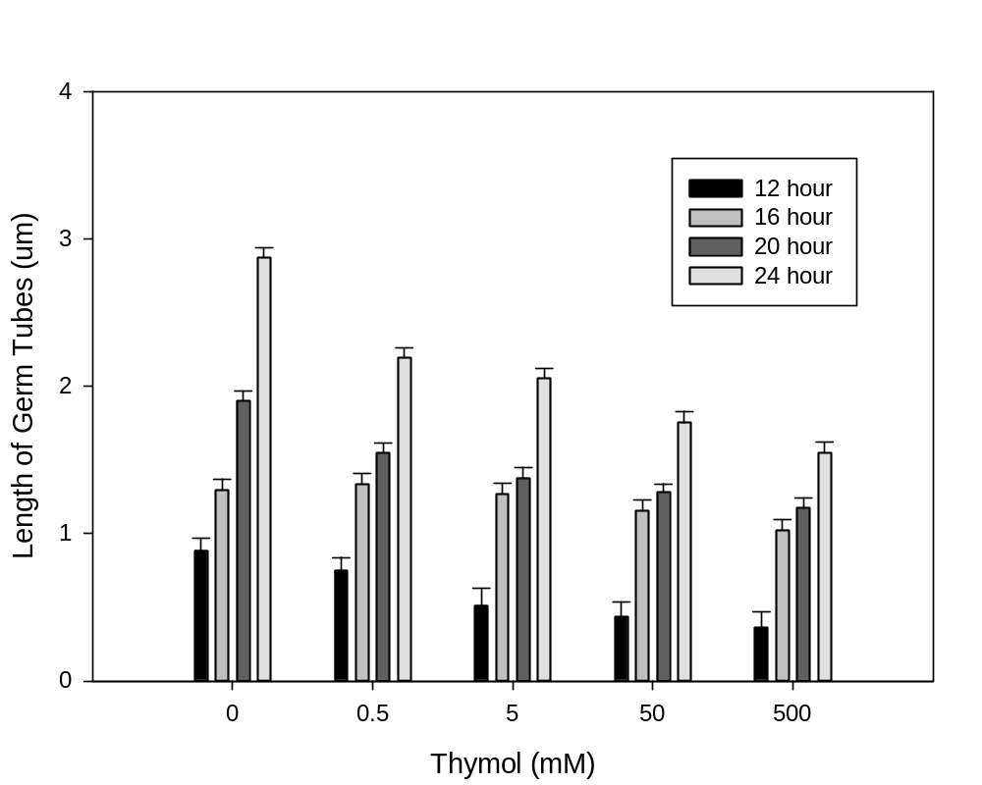
JK
CD
GH
A
KL
GH
F
B
LM
GH
FG
BC
M
HI
GH
DE
M
IJ
HI
EF
Figure 2.4. Effects of thymol on germ tube elongation of B. bassiana
Conidia were exposed to a micro-atmosphere of varying concentrations of borneol, and germ tube lengths were measured at 4 h intervals. Bars with the same letter are not significantly different according to an F-protected least significant difference at P = 0.05.

Cymene. Cymene had a stimulatory effect on germ tube development of B. bassiana at low concentrations but inhibited germ tube development at high concentrations (Fig. 2.5). At 12 hour, germ tube length was approximately 30 percent greater in 5 mM treatments than in controls. At 16, 20 and 24 h, germ tube length was greater in the 0.5 µM treatment than in the control. Length of germ tubes at all other concentrations was lower than the control. In the 50 mM treatment, germ tube lengths were reduced slightly, and almost no germination was observed at 500 µM.
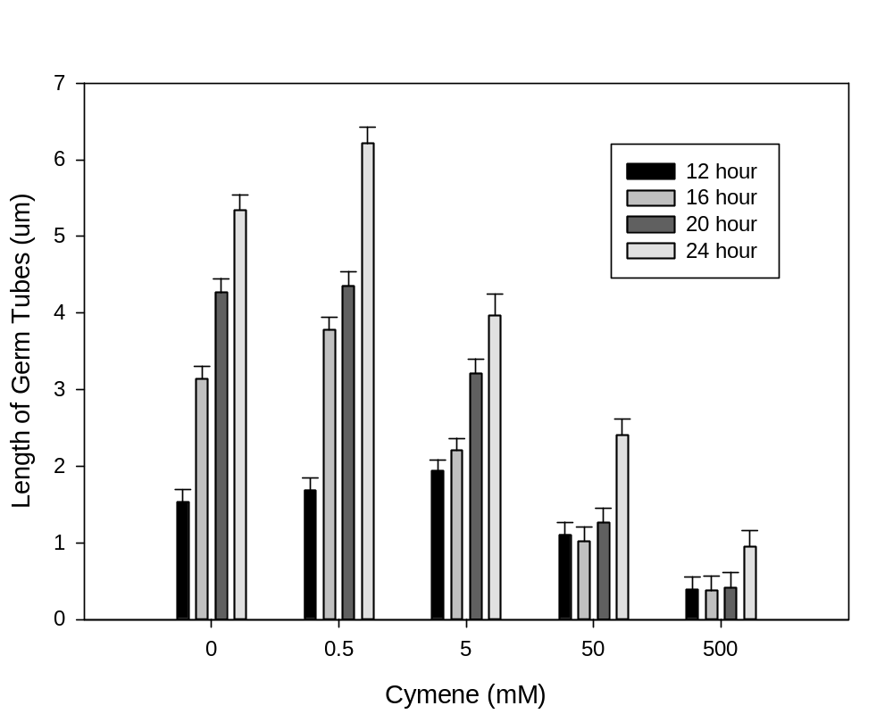
GHI
E
C
B
GH
D
C
A
FG
F
E
CD
IJ
J
HIJ
F
K
K
K
J
Figure 2.5. Effects of cymene on germ tube elongation of B. bassiana
Conidia were exposed to a microatmosphere of varying concentrations of borneol, and germ tube lengths were measured at 4 h intervals. Bars with the same letter are not significantly different according to an F-protected least significant difference at P = 0.05.

Comparison of oils. At 24 h, spore germ tube elongation is inhibited by carvacrol and borneol at all sample times (fungicidal), but in the presence of the highest concentration of thymol, geraniol, and cymene are fungistatic (Fig. 2.6). Regression models that best fit each oil at the 24 hour sample time were used to calculate E-50 values (Table 2.2). The y-intercepts were mean length of spore germ tubes in control, and line slopes were negative in slopes (i.e., length would decreased with increases in concentration).

Table 2.2. Calculated EC₅₀ Values at the 24 hour Observation Time.
Essential Oils | EC-50
borneol |  | 0.64mM
carvacrol |  | 2.88mM
cymene |  | 374.30mM
geraniol |  | >500mM
thymol |  | >500mM

Figure 2.6. Response surface plot of effect of time and concentration of five essential oils (monoterpenes) that are found in monarda herbage and are arranged by oxidation state on germ tube length of B. bassiana - carvacrol and thymol (phenolic alcohols); borneol (secondary alcohol); geraniol (allylic primary alcohol); cymene (hydrocarbon). Because there no differences between the 50 and 500 mM treatments in the carvacrol and thymol treatments, and few in the cymene, the values for 500 mM are not shown.

Twenty-four hour study
Percentage germination and germ tube length of fresh spores among five oils on Beauveria bassiana were not significant at 24 h (P=0.6375).
Percentage spore germination. Percentage germination of fresh spores ranged from 35-45% (Table 2.3). In general, percentage germination of spores decreased across concentration. There was no germination in treatments with 50 mM cymene or 500 mM cymene, geraniol, or carvacrol. High concentration of cymene, geraniol and carvacrol inhibited the spore germination.
Table 2.3. Percentage germination of Beauveria bassiana treated with six different concentrations of five essential oils (Chi-Square, p<0.0001).
Concentration (mM) |  | Borneol |  |  |  | Cymene | Thymol | Geraniol | Carvacrol
 |  | % germination
0 |  | 44.0 |  | 39.1 |  |  | 35.8 | 35.2 | 35.3
0.5 |  | 32.5 | 28.8 |  |  |  | 33.2 | 36.1 | 35.3
5 |  | 35.0 | 25.5 |  |  |  | 35.7 | 27.8 | 25.6
50 |  | 27.5 | 25.5 |  |  |  | 32.2 | 0 | 30.5
500 |  | 28.8 | 0 |  |  |  | 24.5 | 0 | 0
 |  | % control
0 | 100 |  |  |  | 100 |  | 100 | 100 | 100
0.5 | 70 |  |  |  | 70 |  | 90 | 100 | 100
5 | 80 |  |  |  | 70 |  | 100 | 80 | 70
50 | 60 |  |  |  | 70 |  | 90 | 0 | 90
500 | 70 |  |  |  | 0 |  | 70 | 0 | 0

Percent weight of germinated spores. An estimated weight for accumulated lengths of germinated spores in each treatment was examined using SAS. The percent weight of the lengths for germinated spores decreased across concentration (Table 2.4).
Table 2.4. Weighted* germination of B. bassiana spores in six different concentrations of five essential oils (Method=Chi-Square, p<0.0001).
Concentration (mM) | Borneol | Cymene | Thymol | Geraniol | Carvacrol
 | % germination
0 | 84.6 | 82.5 | 80.1 | 79.5 | 79.4
0.5 | 75.3 | 75.9 | 77.7 | 78.3 | 78.1
5 | 73.7 | 68.3 | 75.3 | 69.4 | 69.5
50 | 65.0 | 57.9 | 67.9 | 0 | 63.2
500 | 63.9 | 0 | 57.2 | 0 | 0
 | % control
0 |  | 100 | 100 | 100 | 100
  100
0.5 | 90 | 90 | 100 | 100 | 100
5 | 90 | 80 | 90 | 90 | 90
50 | 80 | 70 | 90 | 0 | 80
500 | 80 | 0 | 70 | 0 | 0

*Each numeric value provides an estimated weight for each observation in the data. PROC FREQ statement in SAS assumes that an observation represents n observations, where n is the value of variable. The value is not required to be an integer.

Germ tube length. Germ tube length of the spores in the five oil treatments was similar; the lengths were all decreased across the concentrations (Fig. 2.7). In the control, the greatest length was ca. 11μm. In the 0.5 mM treatments, spore length was not significantly decreased by borneol, geraniol, carvacrol and cymene; whereas, in 5 mM treatment, only spores in the geraniol treatment did not have decreased germ tube length compared to other treatments. Almost no germination was observed in treatments with 500 mM cymene, 50 mM and 500 mM geraniol, and 500 mM carvacrol.

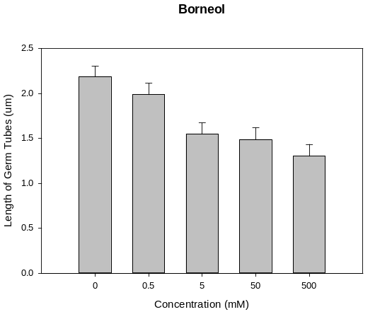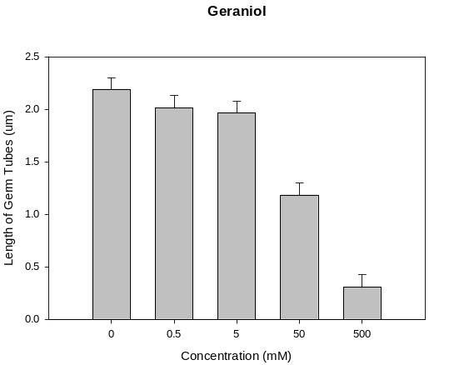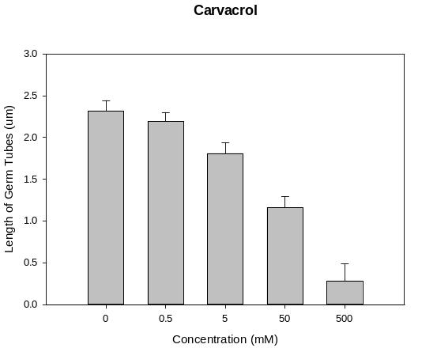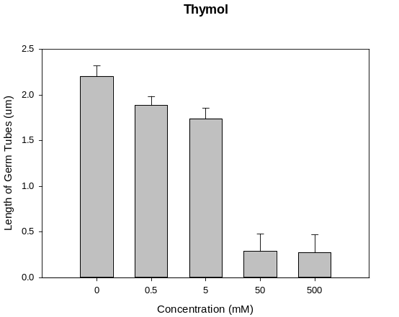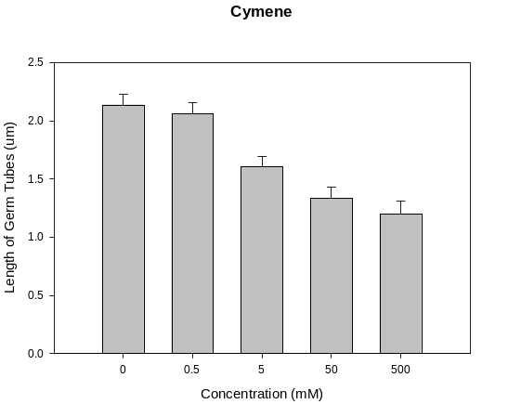
A
A
B
C
C
C
C
B
B
A
D
C
B
A
A
A
A
A
B
C
B
B
A
A
B
Figure 2.7. Effect of five concentrations of five essential oils on germ tube length of B. bassiana at 24 hour

Discussion
Sensitivity of the conidia of the biocontrol fungus Beauveria bassiana to several chemical pesticides has been reported (Olmert and Kenneth 1974; Neves et al. 2001; Gatarayiha et al. 2010). Essential oils extracted from natural products commonly used in disease management have various effects on spore germination and replication of B. bassiana (Storey and Gardner 1986; Islam et al. 2010; Gatarayiha et al. 2010). Compatibility of biocontrol pathogens with natural products additives is necessary for optimal use of the agent in disease management programs.
Spore germination and mycelial growth were used as criteria for testing the effects of essential oils on the B. bassiana (Gatarayiha et al., 2010). Spores were considered germinated when the germ tube length reached at least double the size of the spore (0.5µm). All essential oils tested in this research except for cymene have an inhibitory effect on germ tube development of B. bassiana across time. High concentration of carvacrol and cymene were considered harmful for the spores of B. bassiana. Some of the spores observed had bidirectional germination at 24 hour, and only one tube was measured for those spores. Control (no essential oil) was the most favorable treatment for the spores, but germination was very low even under control conditions. The main reason for that is the spores had aged past ideal germination percentages. In the first experiment, each individual spore is an observation, so only germ tube length was tested. To test the effect of different concentration of five essential oils on the percent germination of spores, another experiment was done. Fresher spores were used this time to achieve higher percentage germination. The longest testing time, 24 hour, was determined to be the best time to examine the effect of oils on the fungal growth. Both the percent spore germination and the percent weight germination for all oils decreased across concentration. The germ tube development trends of fresh spores were similar to the aged ones used in the time course study. Of the five oils tested, only geraniol and thymol did not completely inhibit the conidial germination at both low and high concentrations; cymene oil even stimulated the germination at low concentration.
Application of essential oils possessing fungicidal properties should be carefully monitored to avoid disruption of the field efficacy of B. bassiana conidia. Low concentrations of the essential oils have the potential to be used together with B. bassiana as biological control agents. Further studies are necessary to evaluate this combination on plants in the greenhouse and field studies.

PART III

EFFECTS OF BEAUVERIA BASSIANA (USED AS A SEED TREATMENT) AND BIOACTIVE MONARDA HERBAGES (USED AS A GREENHOUSE GROWING MEDIA AMENDMENT) ON B. BASSIANA COLONIZATION, SEED GERMINATION, AND GROWTH OF TOMATO

Abstract
Plant-based natural products and fungi such as Beauveria bassiana are more sustainable than insecticides due to their lower risk of resistance, reduced environmental impact, and longer control time. The second objective of this research was to determine the compatibility of essential oils and B. bassiana and the impact of the two when used as a seed treatment in greenhouse experiments. Bioactive monarda herbage (ground dried leaves harvested from selected cultivars of Monarda spp.) representing five chemotypes (thymol, carvacrol, geraniol, borneol, and cymene), were used in this study. Tomato seeds coated with methylcellulose or with B. bassiana spores embedded in methylcellulose were planted into greenhouse growing medium that contained either no herbage or 10% of bioactive herbage. Germination was delayed in all monarda herbages. At four weeks, seedlings were harvested, surface-sterilized, and plated on selective media. Since seed planted in media amended with Monarda clinopodia (thymol chemotype) had very low germination (5.56%), plants from this treatment were not tested on the selective media. Levels of colonization by B. bassiana of seedlings grown in media amended with ‘Trinity Purple’ (cymene chemotype), ‘Rose-scented’ (geraniol chemotype), and ‘Violet Queen’ (carvacrol chemotype) were not different (ca. 40%) from the no-herbage control; colonization levels of seedlings grown in media amended with ‘Cerise’ (borneol chemotype) was less than all other treatments (22.22%).

Introduction
Plant diseases need to be controlled in order to maintain the quality of crops produced by growers around the world. Growers often rely heavily on chemical pesticides and fungicides; however, problems with agrochemicals (e.g., environmental pollution) have led researchers to focus efforts on developing alternatives for controlling plant diseases. Both plant-based natural products including Monarda spp. and microbial organisms such as B. bassiana can play a significant role in sustainable crop production due to their lower risk of resistance.
Monarda spp. have been utilized by man as garden plants, food and flavoring additives, and for medicinal purposes (Scora 1967). Damping-off of seedlings caused by species of Pythium and Rhizoctonia can reduce number and quality of tomato seedlings. Plants in the genus Monarda produce complex essential oils that contain antifungal compounds. Significant inhibition of seedling disease caused by Rhizoctonia solani was observed when adding herbage (dried and ground leaves and flowers) of Monarda sp. to greenhouse growing medium in greenhouse and laboratory studies (Gwinn et al. 2010).
This research is undertaken to determine the ability of B. bassiana to colonize tomato in the presence of bioactive monarda herbages from each of the five chemotypes: cymene, borneol, geraniol, carvacrol, and thymol.

Materials and Methods
GC-MS analysis of herbage
Thirteen varieties of Monarda sp. (‘Puerto Purification’, Monarda clinopodia, ‘Mohawk’, ‘Mahogany’, ‘Croftway Pink’, ‘Lavender’, ‘Violet Queen’, ‘Rose Geranium’, ‘Rose-scented’, ‘Prairie Night’, ‘Mixed Purple’, ‘Cerise’, and ‘Trinity Purple’) were grown in the UT Gardens, Knoxville, TN, harvested, dried and grounded to pass a 5-mm mesh sieve, and then stored in sealed Mason jars (Ball Corporation, Broomfield, CO). Prior to experiments, 5 mg of each herbage variety was shaken in 5 ml hexane for 24 h. The liquid was filtered through a 0.45-μm nylon membrane, 4-mm syringe filter (Fisher Scientific, Fair Lawn, NJ) into a glass vial for analysis. Concentrations of essential oil components were determined by gas chromatography-mass spectrometry (GC-MS) analysis. One microliter of hexane eluent was introduced with an automatic sample injector (Model 7683, Agilent Technologies, Palo Alto, CA) into a Agilent 6850 series GC system with quadrupole MS Detector (Model 5973) coupled through a HP-5MS column (J & W Scientific, Agilent Technologies Palo Alto, CA) 30-m long, 0.25-mm internal diameter, and 0.25-μm film thickness. The starting temperature of 60°C was held for 1 min and then increased by 4°C every min until reaching 90°C. After 3 min at 90°C, the temperature was increased by 2°C per min up to 121°C. The temperature was held for 2 min at 121°C, followed by a third increase of 6°C per min until it reached 182°C. The final temperature was held for 1 min to complete the program (Gwinn et al., 2010).

Growth chamber study
Seed Treatments. Spores from 60-day-old cultures of Beauveria bassiana isolate 11-98 (Bb 11-98) grown on Sabouraud dextrose agar were used in these experiments.
Tomato hybrid seeds ‘Mountain Spring’ were purchased from Park Seed Wholesale, Inc. Greenwood, SC. The germination level determined by the producer was 88%. Methylcelluose (Sigma-Aldrich Co., St. Louis, MO) suspensions [2 % (wt/v)] were stirred at room temperature until viscous, then transferred to an ice bath and stirred until clear. Half of the methylcellulose solution was mixed with Beauveria conidia and 250 tomato seeds in a Petri dish and stirred until seeds were uniformly coated. Seed were then allowed to air dry for approximately 8 h then separated carefully with a wood stick. The other aliquot of the methylcellulose solution was mixed with 250 seeds and treated as the B. bassiana treatment above. All seeds were stored in refrigerator at 4°C until use. Prior to use, Mary Dee (University of Tennessee) determined the numbers of viable conidia per seed from seed washings. Conidia from the seed were estimated to be at a concentration of 10⁷ based on serial dilutions of seed washings plated on Sabouraud dextrose agar.
Soil amendment preparation. Greenhouse growing medium was moistened with DI water and autoclaved for 90 min each on two consecutive days. Monarda plants with high content of each essential oil (thymol, carvacrol, geraniol, borneol, and cymene) were selected to represent each herbage chemotypes were used. Each monarda herbage was mixed into sterile greenhouse growing medium [10% (v/v)]. Controls were greenhouse growing medium alone. Containers (47 mm diameter) were filled with 100 ml of growing medium or growing medium amended with herbage, and placed in green house trays.
Experimental design. The experiment was a 6 x 2 (5 Monarda/none × Beauveria/no Beauveria) factorial with a randomized complete block (RCB) design. One block consisted of 12 randomized treatments (Table 3.1). The experiment was repeated twice.

Table 3.1. Design for experiment testing the effects of Beauveria bassiana (used as a seed treatment) and bioactive Monarda herbages (used as a greenhouse growing media amendment) on B. bassiana colonization, seed germination, and growth of tomato.
Treatment number | Monarda sp. variety | Herbage code | Essential oil represented | Seed treatment
1 | Monarda clinopodia | Mon 54 | Thymol | B. bassiana
2 | Violet Queen | Mon 44 | Carvacrol | B. bassiana
3 | Rose-scented | Mon 50 | Geraniol | B. bassiana
4 | Cerise | Mon 10 | Borneol | B. bassiana
5 | Trinity Purple | Mon 52 | Cymene | B. bassiana
6 | No herbage | None | None | B. bassiana
7 | Monarda clinopodia | Mon 54 | Thymol | No Beauveria
8 | Violet Queen | Mon 44 | Carvacrol | No Beauveria
9 | Rose-scented | Mon 50 | Geraniol | No Beauveria
10 | Cerise | Mon 10 | Borneol | No Beauveria
11 | Trinity Purple | Mon 52 | Cymene | No Beauveria
12 | No herbage | None | None | No Beauveria

In order to ensure that six seedlings would be available for colonization analyses, eight seeds (1/container) were planted for each treatment. In each container, one tomato seed was planted into growing medium or growing medium amended with herbage at the same depth; deionized H₂O (75 ml) was added. A plastic cover was placed on top of each container. Treatments were color coded. All trays were placed in growth chamber at 24°C with 12h light/12h dark. The plastic cover was removed when seedlings emerged, then plants were watered every day and fertilized with All Purpose Plant Food (Scott Miracle-Gro Products, Inc., Marysville, OH) every two weeks. Some of the seedlings died in a fertilizer overdose accident, but at least six seedlings for each treatment were survived. The experiment was performed three times.
To identify Beauveria from the seedlings, surface-sterilized seedlings were plated on Beauveria selective medium. To a liter of DI water, 32 g glucose, 8 g neopeptone (Difco), 12 g agar, and 800 ml water were added, and after stirring, 0.008 g crystal violet was added. The solution was sterilized in an autoclave for 40 minutes, then after the solution was cooled to around 50℃, 0.2 g cycloheximide and 0.4 g chloramphenicol were added. The medium was poured into large (150mm×15mm) polystyrene Petri dishes (Fisher Scientific Co LLC, Suwanee, GA) and stored at room temperature in the dark.
Data collection and analysis.
Seedling emergence was recorded every day once the first seedlings emerged. At the end of six weeks, seedlings were harvested; potting mixed was washed from roots with DI water. Seedlings were surface-sterilized in 95% ethanol for 1 min, 20% bleach (Clorox, Clorox Company, Oakland, CA) for 3 min, 95% ethanol for 1 min. Surface-sterilized seedlings were placed on selective media; plates were incubated at room temperature in the dark for 2-4 weeks. Growth of B. bassiana on the plate was considered positive for colonization. All data were analyzed using PROC MIXED (SAS Institute, Inc., Cary, NC).

Results
GC – MS analysis of herbage
Five Monarda herbages were selected from thirteen herbages based on the concentration of essential oils (Tables 3.2 and 3.3) and chemotype (Gwinn et al., 2010). Monarda clinopodia was selected because it had a higher thymol concentration than other tested thymol chemotypes (Table 3.2). Carvacrol concentration in the carvacrol chemotypes (‘Violet Queen’ and ‘Lavender’) differed slightly; ‘Violet Queen’ was selected. Geraniol concentration in the geraniol chemotype, ‘Rose-scented’ was 17-fold greater than the other variety in this chemotype (‘Rose Geranium’). Concentration of borneol in ‘Cerise’ was 33 and 8 times greater, respectively, than the concentration found in the two other borneol chemotypes (‘Prairie Night’ and ‘Mixed Purple’, respectively). The lone member of the Trinity Purple chemotype had a high concentration of cymene. Complete essential oil profile for the selected monarda herbages is shown in Table 3.3.
Table 3.2. Monarda species selection. Concentration of each essential oil representative of a chemotypes in 13 herbages.
Essential oil represented | Monarda species | Concentration (µM)
Thymol | Puerto Purification | 2646.4
Thymol | Monarda clinopodia | 19078.0
Thymol | Mohawk | 4916.3
Thymol | Mahogany | 1866.1
Thymol | Croftway Pink | 4916.8
Carvacrol | Lavender | 193.6
Carvacrol | Violet Queen | 226.8
Geraniol | Rose Geranium | 1.6
Geraniol | Rose-scented | 27.8
Borneol | Prairie Night | 33.1
Borneol | Mixed Purple | 130.5
Borneol | Cerise | 1107.0
Cymene | Trinity Purple | 10.1

Table 3.3. Concentrations of essential oil constituents in five Monarda species and varieties used in this study (µM).
Essential oils | Monarda clinopodia | Violet Queen | Rose- scented | Cerise | Trinity Purple
Borneol | 24.23 | 7.41 | 0.3 | 1107.02 | 0.09
Bornyl acetate | 0.37 | 2.86 | 0.36 | 0.19 | 0.36
Camphene | 0.26 | 1.71 | 0.21 | 4.98 | 0.19
2-Carene | 36.12 | 0.43 | 0.27 | 0.11 | 0.58
3-Carene | 1.27 | 0.45 | 6.69 | 0.77 | 0.68
Carvacrol | 132.29 | 226.8 | 0.04 | 0.08 | 0.08
Carvone | 1.04 | 1.13 | 7.02 | 1.89 | 0.49
α-Caryophyllene | 0.89 | 1.1 | 0.4 | 0.63 | 0.63
β-Caryophyllene | 0.77 | 0.17 | 0.18 | 0.39 | 0.5
Cineole | 0.4 | 0.04 | 0.15 | 0.25 | 0.16
Cymene | 39.24 | 26.57 | 0.34 | 4.49 | 10.14
Fenchone | 0.87 | 4.13 | 3.13 | 0.55 | 0.35
Geraniol | 0.09 | 0.21 | 27.82 | 0.15 | 0.09
Isoborneol | 0.04 | 0.03 | 0.04 | 292.86 | 0.03
Limonene | 3 | 2.02 | 1.58 | 3.07 | 1.05
Linalool | 4.08 | 0.11 | 44.63 | 0.23 | 0.07
β-Myrcene | 49.55 | 2.29 | 0.45 | 0.25 | 0.99
3-Octanol | 0.2 | 0.51 | 0.35 | 0.93 | 0.51
1-Octen-3-ol | 1021.27 | 115.6 | 209.07 | 36.77 | 0.92
α-Phellandrene | 57.16 | 5.64 | 6.23 | 10.14 | 3.95
α-Pinene | 0.25 | 0.34 | 0.28 | 0.25 | 0.08
β-Pinene | 19.53 | 0.7 | 1.96 | 3.17 | 0.62
ϒ-Terpinene | 0.17 | 0.31 | 0.53 | 0.14 | 0.1
α-Terpineol | 0.16 | 0.01 | 0.36 | 0.66 | 0.02
Thujone | 0.37 | 0.27 | 0.54 | 0.5 | 0.44
Thymol | 19077.97 | 68.86 | 0.08 | 1.19 | 0.51
Thymoquinone | 0.86 | 1.19 | 0.07 | 0.91 | 0.47

Growth chamber study
Tomato seeds treated with M. clinopodia (thymol chemotype) had very low germination (8.33%) so the thymol treatment was removed from the study. Percentage germination was greater than 90% for all other treatments (Table 3.4).
Table 3.4. Final percent germination for tomato seeds in the present of different Monarda herbages that represent different essential oils (Method=LSD, P<0.05).
Monarda Herbages | Essential Oils | Percent Germination (%)
Violet Queen | Carvacrol | 93.75
Cerise | Borneol | 97.92
Rose-scented | Geraniol | 91.67
Trinity Purple | Cymene | 100.00
Monarda clinopodia | Thymol | 8.33
No herbage | None | 95.83

Seeds germination time. Germination was delayed in all monarda herbages (Table 3.5, Fig. 3.1). Seeds that were planted in the ‘Violet Queen’ (carvacrol chemotype) treatment had a seedling emergence delay of four days. Days to emergence for seeds planted in media amended with ‘Cerise’ (borneol chemotype) and Rose-scented (geraniol chemotype) were not different, but fewer than ‘Violet Queen’. Seeds planted in Trinity Purple (cymene chemotype) required the shortest time to germinate. Germination was accelerated by B. bassiana (Table 3.6, Fig. 3.1). Seeds that were coated with B. bassiana required one sixth less time to germinate than those that were not.
Table 3.5. Days to germination for tomato seeds planted in greenhouse growing medium containing Monarda herbages that represent different essential oils chemotypes (Method=LSD, P<0.05).
Monarda Herbages | Chemotype | Days to Germination | Standard Error | Letter Group
Violet Queen | Carvacrol | 5.59 | 0.17 | A
Cerise | Borneol | 4.25 | 0.16 | B
Rose-scented | Geraniol | 4.11 | 0.16 | B
Trinity Purple | Cymene | 2.81 | 0.16 | C
No herbage | None | 1.03 | 0.16 | D
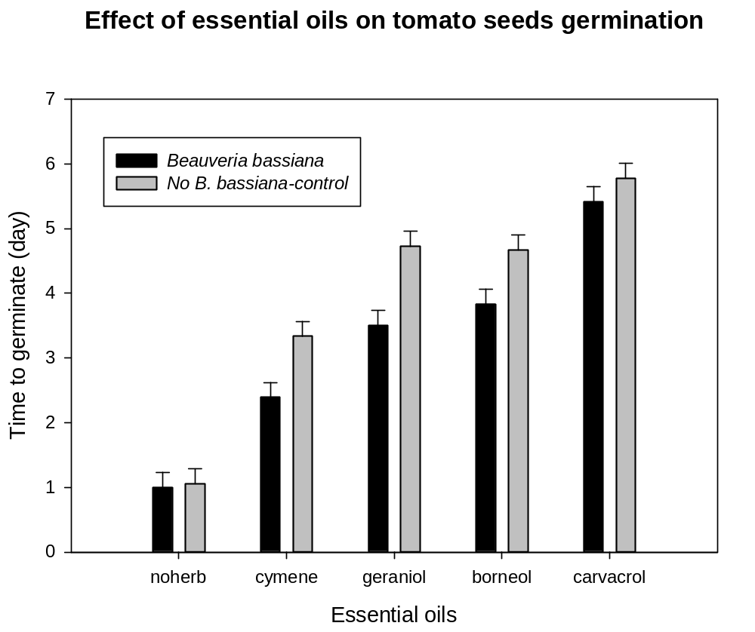
Days to germinate
E
E
D
C
C
B
C
B
A
A

Figure 3.1. Effects of essential oils on tomato seeds germination
Two groups of tomato seeds coated with and without B. bassiana were were planted in greenhouse growing medium amended with one of four monarda herbages. Each herbage represented a chemotype of monarda bioactive herbage (cymene, geraniol, borneol and carvacrol).Seedling emergence was recorded every day for six weeks. Bars with the same letter are not significantly different according to an F-protected least significant difference at P = 0.05.

Table 3.6. Days to germination for tomato seeds coated with B. bassiana suspended in methylcellulose and those seeds that were coated with methylcellulose only (Method=LSD, P<0.05).
Treatment | Days to Germination | Standard Error | Letter Group
Methylcellulose | 3.91  3.23 | 0.10 | A
Beauveria bassiana | 3.91  3.23 | 0.10 | B

Colonization of tomato seedlings by Beauveria bassiana. Percentage colonization of tomato seedlings by B. bassiana in treatments of ‘Violet Queen’ (carvacrol chemotype), ‘Trinity Purple’ (cymene chemotype) or ‘Rose-scented’ (geraniol chemotype) was not different from the control, but treatment with ‘Cerise’ (borneol chemotype) reduced the colonization of seeds by B. bassiana compared to the control group (Fig. 3.2). Only one plant in the no-Beauveria controls (‘Cerise’ - borneol chemotype) was positive for B. bassiana colonization.
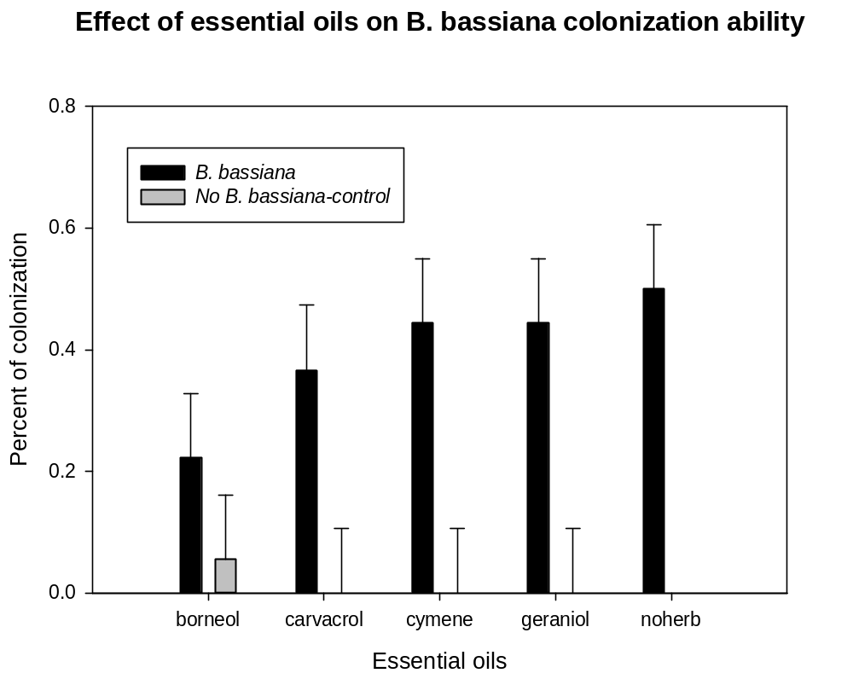
BC
CD
AB
D
A
A
A
D
D
D

Figure 3.2. Effects of essential oils on ability of B. bassiana to colonize tomato seeds
Two groups of tomato seeds (with and without B. bassiana) were planted in greenhouse growing medium amended with one of four monarda herbages. Each herbage represented a chemotype of monarda bioactive herbage (cymene, geraniol, borneol and carvacrol). Surface-sterilized seedlings were plated onto selective media were considered positive if at least one B. bassiana colony grew from the seedling. Percentage colonization of tomato seeds was percentage of positive seedlings. Bars with the same letter are not significantly different according to an F-protected least significant difference at P = 0.05.

Discussion
Chemical composition diversity of Monarda resulted in different herbage treatments effect on Beauveria bassiana. ‘Trinity Purple’, the variety with the highest cymene content, is the most favorable greenhouse growing media amendment for tomato seeds germination compared to the other four monarda cultivars (Table 3.4, Table 3.5, Fig. 3.1). Carvacrol and thymol had inhibitory effect on seed germination and growth of some plants (Kordali et al. 2008). In this study, Monarda clinopodia (thymol chemotype) is the most unfavorable one since it results in very low germination rate of tomato seeds (Table 3.3, Table 3.4). Of the remaining herbage treatments, seeds planted in ‘Violet Queen’ (carvacrol chemotype) had the greates delay to emergence.
Colonization was rarely observed in the controls-no Beauveria; plant-to-plant spread rarely occurred in the growth chamber study. ‘Trinity Purple’ and ‘Rose-scented’ (geraniol chemotype) showed the best capability with B. bassiana based on the percentage of colonization data, but if both the germination time (2.81±0.16 day) and rate of tomato seeds (100 percent) are considered, it is evident that ‘Trinity Purple’ is slightly more favorable to be used in combination with B. bassiana seed treatment.
In previous studies, herbages classified as carvacrol and thymol chemotypes were demonstrated to be highly active against Rhizoctonia and Pythium, and protected tomato seedings from damping-off disease. These herbages inhibited mycelial growth of P. myriotylum at both low and high concentrations (5 and 50 μl, respectively) (Clark et al. 2006), and reduced growth of R. solani by more than 65% when tested at 50 to 65µmoles/dish (Gwinn et al. 2010). Development of these monarda bioactive herbage products for commercial use requires consideration of their antifungal activity to the beneficial fungus and toxic effects of essential oil constituents to the plants. Results from this research provide the knowledge of the sensitivity of the biocontrol fungus and crop plant to the bioactive monarda herbage which is needed before this technology to be practical.
In the growth chamber study, the soil construction within each container was not the same, so the essential oils in herbages that evaporated each day were not consistent. As a result, the exact concentration of essential oils that seeds exposed to is not clearly known, which might has some influence on the result.

SUMMARY
Results from this research indicated the potential of combining two biological control methods, Monarda-based products and the endomopathogenic fungus, B. bassiana together as a tomato seed treatment. Further development of this plant disease control methods will benefit the organic or sustainable agriculture system where alternative of synthetic fungicides is in need.
The result of this research is based on one fungus isolate and five monarda herbages. Future studies should further investigate other monarda varieties that might be more suitable considering the diversity of constituent concentrations among Monarda varieties. For instance, the monarda cultivar “Monarda clinopodia”,which has thymol as the main compound, could be replaced by ‘Puerto Purification’ (also high in thymol), which was not toxic to the tomato plant in the previous studies (Clark et al. 2006). Another approach is adjusting the rate (10 %v/v in this study) of monarda in the greenhouse growing media or mixed different varieties to maximize compatibility with the beneficial fungus.

REFERENCES
Abdelgaleil SA, Abbassy MA, Belal A-SH, Abdel Rasoul M, 2008. Bioactivity of two major constituents isolated from the essential oil of Artemisia judaica L. Bioresource Technology 99: 5947–5950.
Al-Bayati FA, 2009. Isolation and identification of antimicrobial compound from Mentha longifolia L. leaves grown wild in Iraq. Annals of Clinical Microbiology and Antimicrobials 8: 20.
Amiri A, Dugas R, Pichot AL, Bompeix G, 2008. In vitro and in vivo [corrected] activity of eugenol oil (Eugenia caryophylata) against four important postharvest apple pathogens. International Journal of Food Microbiology 126: 13–19.
Bajpai VK, Kang SC, 2009. Antifungal activity of leaf essential oil and extracts of Metasequoia glyptostroboides Miki ex Hu. Journal of the American Oil Chemists Society 87: 327–336.
Bajpai VK, Rahman A, Kang SC, 2008. Chemical composition and inhibitory parameters of essential oil and extracts of Nandina domestica Thunb. to control food-borne pathogenic and spoilage bacteria. International Journal of Food Microbiology 125: 117–122.
Boucias DG, Pendland JC, Latge JP, 1988. Nonspecific factors involved in attachment of entomopathogenic deuteromycetes to host insect cuticle. Applied and Environmental Microbiology 54: 1795–1805.
Cetin B, Ozer H, Cakir A, Mete E, Tosun M, Oztürk E, Polat T, Kandemir A, 2009. Chemical composition of hydrodistilled essential oil of Artemisia incana (L.) Druce and antimicrobial activity against foodborne microorganisms. Chemistry Biodiversity 6: 2302–2310.
Chang H-T, Cheng Y-H, Wu C-L, Chang S-T, Chang T-T, Su Y-C, 2008. Antifungal activity of essential oil and its constituents from Calocedrus macrolepis var. formosana Florin leaf against plant pathogenic fungi. Bioresource Technology 99: 6266–6270.
Clark MM, Gwinn KD, Ownley BH, 2006. Biological control of Pythium myriotylum. Phytopathology 96: S25.
Derakhshan S, Sattari M, Bigdeli M, 2008. Effect of subinhibitory concentrations of cumin (Cuminum cyminum L.) seed essential oil and alcoholic extract on the morphology , capsule expression and urease activity of Klebsiella pneumoniae. International Journal of Antimicrobial Agents 32: 432–436.
Dung NT, Kim JM, Kang SC, 2008. Chemical composition, antimicrobial and antioxidant activities of the essential oil and the ethanol extract of Cleistocalyx operculatus (Roxb.) Merr and Perry buds. Food and Chemical Toxicology 46: 3632–3639.
Eftekhar F, Nariman F, Yousefzadi M, Hadiand J, Ebrahimi SN, 2009. Anti-Helicobacter pylori activity and essential oil composition of Thymus caramanicus from Iran. Natural Product Communications 4: 1139–1142.
Erkmen O, Ozcan MM, 2008. Antimicrobial effects of Turkish propolis, pollen, and laurel on spoilage and pathogenic food-related microorganisms. Journal Of Medicinal Food 11: 587–592.
Gatarayiha MC, Laing MD, Miller RM, 2010. In vitro effects of flutriafol and azoxystrobin on Beauvaria bassiana and its efficacy against Tetranychus urticae. Pest Management Science 66: 773–778.
Germain GS, Summerbell R, 1996. Identifying filamentous fungi - a clinical laboratory handbook. Star Publishing Company, Belmont, California: 288 p.
Giordani R, Hadef Y, Kaloustian J, 2008. Compositions and antifungal activities of essential oils of some Algerian aromatic plants. Fitoterapia 79: 199–203.
Gwinn KD, Ownley BH, Greene SE, Clark MM, Taylor CL, Springfield TN, Trently DJ, Green JF, Reed A, Hamilton SL, 2010. Role of essential oils in control of Rhizoctonia damping-off in tomato with bioactive monarda herbage. Phytopathology 100: 493–501.
Hiroshi N, 1994. Prevention of drug access to bacterial targets: permeability barriers and active efflux. Science 264: 382–388.
Huang Y, Zhao J, Zhou L, Wang J, Gong Y, Chen X, Guo Z, Wang Q, Jiang W, 2010. Antifungal activity of the essential oil of Illicium verum fruit and its main component trans-anethole. Molecules Basel Switzerland 15: 7558–7569.
Hywel-Jones NL, Gillespie a. T, 1990. Effect of temperature on spore germination in Metarhizium anisopliae and Beauveria bassiana. Mycological Research 94: 389–392.
Islam M, Olleka A, Ren S, 2010. Influence of neem on susceptibility of Beauveria bassiana and investigation of their combined efficacy against sweet potato whitefly, Bemisia tabaci on eggplant. Pesticide Biochemistry and Physiology 98: 45–49.
Katooli N, Maghsodlo R, Razavi SE, 2011. Evaluation of eucalyptus essential oil against some plant pathogenic fungi. Journal of Plant Breeding and Crop Science 3: 41–43.
Kim S-S, Baik JS, Oh T-H, Yoon W-J, Lee NH, Hyun C-G, 2008. Biological activities of Korean Citrus obovoides and Citrus natsudaidai essential oils against acne-inducing bacteria. Bioscience biotechnology and biochemistry 72: 2507–2513.
Kishore GK, Pande S, Harish S, 2007. Evaluation of essential oils and their components for broad-spectrum antifungal activity and control of late leaf spot and crown rot diseases in peanut. Plant Disease 91: 375–379.
Knobloch K, Pauli A, Iberl N, Weigand N, Weis HM, 1989. Antibacterial and antifungal properties of essential oil components. Journal of Essential Oil Research 1: 119–128.
Kordali S, Cakir A, Ozer H, Cakmakci R, Kesdek M, Mete E, 2008. Antifungal, phytotoxic and insecticidal properties of essential oil isolated from Turkish Origanum acutidens and its three components, carvacrol, thymol and p-cymene. Bioresource Technology 99: 8788–8795.
Kotan R, Cakir A, Dadasoglu F, Aydin T, Cakmakci R, Ozer H, Kordali S, Mete E, Dikbas N, 2010. Antibacterial activities of essential oils and extracts of Turkish Achillea, Satureja and Thymus species against plant pathogenic bacteria. Journal of the Science of Food and Agriculture 90: 145–160.
Lorenzi V, Muselli A, Bernardini AF, Berti L, Pagès J-M, Amaral L, Bolla J-M, 2009. Geraniol restores antibiotic activities against multidrug-resistant isolates from gram-negative Species. Antimicrobial Agents and Chemotherapy 53: 2209–2211.
Loughlin R, Gilmore BF, McCarron PA, Tunney MM, 2008. Comparison of the cidal activity of tea tree oil and terpinen-4-ol against clinical bacterial skin isolates and human fibroblast cells. Letters in Applied Microbiology 46: 428–433.
Maggi F, Bramucci M, Cecchini C, Coman MM, Cresci A, Cristalli G, Lupidi G, Papa F, Quassinti L, Sagratini G, Vittori S, 2009. Composition and biological activity of essential oil of Achillea ligustica All. (Asteraceae) naturalized in central Italy: ideal candidate for anti-cariogenic formulations. Fitoterapia 80: 313–319.
Mahboubi M, Bidgoli FG, 2010. Antistaphylococcal activity of Zataria multiflora essential oil and its synergy with vancomycin. Phytomedicine 17: 548–550.
Mahboubi M, Haghi G, 2008. Antimicrobial activity and chemical composition of Mentha pulegium L. essential oil. Journal of Ethnopharmacology 119: 325–327.
Maxia A, Marongiu B, Piras A, Porcedda S, Tuveri E, Gonçalves MJ, Cavaleiro C, Salgueiro L, 2009. Chemical characterization and biological activity of essential oils from Daucus carota L. subsp. carota growing wild on the Mediterranean coast and on the Atlantic coast. Fitoterapia 80: 57–61.
Menghini L, Leporini L, Tirillini B, Epifano F, Genovese S, 2010. Chemical composition and inhibitory activity against Helicobacter pylori of the essential oil of Apium nodiflorum (Apiaceae). Journal of Medicinal Food 13: 228–230.
Meyling NV, Lübeck M, Buckley EP, Eilenberg J, Rehner SA, 2009. Community composition, host range and genetic structure of the fungal entomopathogen Beauveria in adjoining agricultural and seminatural habitats. Molecular Ecology 18: 1282–1293.
Muller-Riebau F, Berger B, Yeged O, Antalya K, 1995. Chemical composition and fungitoxic properties to phytopathogenic fungi of essential oils of selected aromatic plants growing wild in Turkey. Journal of Agricultural and Food Chemistry 43: 2262–2266.
Nascimento PFC, Alviano WS, Nascimento ALC, Santos PO, Arrigoni-Blank MF, Jesus RA De, Azevedo VG, Alviano DS, Bolognese AM, Trindade RC, 2008. Hyptis pectinata essential oil: chemical composition and anti-Streptococcus mutans activity. Oral Diseases 14: 485–489.
Neves PMO., Hirose E, Tchujo PT, Moino A, 2001. Compatibility of entomopathogenic fungi with neonicotinoid insecticides. Neotropical Entomology 30: 263–268.
Olmert I, Kenneth RG, 1974. Sensitivity of the entomopathogenic fungi, Beauveria bassiana, Verticillium lecanii, and Verticillium sp. to fungicides and insecticides. Environmental Entomology 3: 33–38.
Ownley BH, Griffin MR, Klingeman WE, Gwinn KD, Moulton JK, Pereira RM, 2008. Beauveria bassiana: endophytic colonization and plant disease control. Journal of iIvertebrate Pathology 98: 267–270.
Ownley BH, Gwinn KD, Vega FE, 2010. Endophytic fungal entomopathogens with activity against plant pathogens: ecology and evolution. BioControl 55: 113–128.
Ownley BH, Pereira RM, Klingeman WE, Quigley NB, Leckie BM, 2004. Beauveria bassiana, a dual purpose biocontrol organism, with activity against insect pests and plant pathogens. In: Lartey RT, Caesar A (eds) Emerging Concepts in Plant Health Management. Research Signpost, Kerala: 255–269.
Ozcan MM, Chalchat J-C, 2008. Chemical composition and antifungal activity of rosemary (Rosmarinus officinalis L.) oil from Turkey. International Journal of Food Sciences and Nutrition 59: 691–698.
Ozek G, Demirci F, Ozek T, Tabanca N, Wedge DE, Khan SI, Başer KHC, Duran A, Hamzaoglu E, 2010. Gas chromatographic-mass spectrometric analysis of volatiles obtained by four different techniques from Salvia rosifolia Sm., and evaluation for biological activity. Journal of Chromatography 1217: 741–748.
Pandey RR, Dubey RC, Saini S, 2010. Phytochemical and antimicrobial studies on essential oils of some aromatic plants. African Journal of Biotechnology 9: 4364–4368.
Peighami-Ashnaei S, Farzaneh M, Sharifi-Tehrani A, Behboudi K, 2009. Effect of essential oils in control of plant diseases. Communications in Agricultural and Applied Biological Sciences 74: 843–847.
Pitarokili D, Tzakou O, Loukis A, Harvala C, 2003. Volatile metabolites from Salvia fruticosa as antifungal agents in soilborne pathogens. Journal of Agricultural and Food Chemistry 51: 3294–3301.
Pozzatti P, Loreto ES, Lopes PGM, Athayde ML, Santurio JM, Alves SH, 2010. Comparison of the susceptibilities of clinical isolates of Candida albicans and Candida dubliniensis to essential oils. Mycoses 53: 12–15.
Roberts DW, Campbell AS, 1977. Stability of entomopathogenic fungi. Miscellaneous Publications of the Entomological Society of America 10: 19–76.
Roller S, Ernest N, Buckle J, 2009. The antimicrobial activity of high-necrodane and other lavender oils on methicillin-sensitive and -resistant Staphylococcus aureus (MSSA and MRSA). Journal of Alternative and Complementary Medicine 15: 275–279.
Sant’anna JR De, Franco CCDS, Miyamoto CT, Cunico MM, Miguel OG, Côcco LC, Yamamoto CI, Junior CC, Castro-Prado MAA De, 2009. Genotoxicity of Achillea millefolium essential oil in diploid cells of Aspergillus nidulans. Phytotherapy Research 23: 231–235.
Scora RW, 1967. Study of the essential leaf oils of the genus Monarda (Labiatae). American Journal of Botany 54: 446–452.
Senthamizhlselvan P, Sujeetha JARP, Jeyalakshmi C, 2010. Growth, sporulation and biomass production of native entomopathogenic fungal isolates on a suitable medium. Journal of Biopesticides 3: 466–469.
Sitara U, Niaz I, Naseem J, Sultana N, 2008. Antifungal effect of essential oils on in vitro growth of pathogenic fungi. Pakistan Journal of Botany 40: 409–414.
Storey GK, Gardner WA, 1986. Sensitivity of the entomogenous fungus Beauveria bassiana to selected plant growth regulators and spray additives sensitivity of the entomogenous fungus Beauveria bassiana to selected plant growth regulators and spray additives. Applied and environmental microbiology 52: 1–3.
Talaei-Hassanloui R, Kharazi-pakdel A, Goettel MS, Little S, Mozaffari J, 2007. Germination polarity of Beauveria bassiana conidia and its possible correlation with virulence. Journal of Invertebrate Pathology 94: 102–107.
Tefera T, Pringle K, 2003. Germination, radial growth, and sporulation of Beauveria bassiana and Metarhizium anisopliae isolates and their virulence to Chilo partellus (Lepidoptera: Pyralidae) at different temperatures. Biocontrol Science and Technology 13: 699–704.
Teng C, 1962. Studies on the biology of Beauveria bassiana (Bals.) Vuill. with the reference to microbial control of insects. Acta Botanica Sinica 10: 210–232.
Tohidpour A, Sattari M, Omidbaigi R, Yadegar A, Nazemi J, 2010. Antibacterial effect of essential oils from two medicinal plants against Methicillin-resistant Staphylococcus aureus (MRSA). Phytomedicine 17: 142–145.
Vega FE, 2008. Insect pathology and fungal endophytes. Journal of Invertebrate Pathology 98: 277–279.
Vila R, Santana AI, Pérez-Rosés R, Valderrama A, Castelli MV, Mendonca S, Zacchino S, Gupta MP, Cañigueral S, 2010. Composition and biological activity of the essential oil from leaves of Plinia cerrocampanensis, a new source of alpha-bisabolol. Bioresource Technology 101: 2510–2514.
Vuuren SF Van, Suliman S, Viljoen AM, 2009. The antimicrobial activity of four commercial essential oils in combination with conventional antimicrobials. Letters in Applied Microbiology 48: 440–446.
Yang E-J, Kim SS, Moon J-Y, Oh T-H, Baik JS, Lee NH, Hyun C-G, 2010. Inhibitory effects of Fortunella japonica var. margarita and Citrus sunki essential oils on nitric oxide production and skin pathogens. Acta Microbiologica et Immunologica Hungarica 57: 15–27.
Yoon W-J, Kim S-S, Oh T-H, Lee NH, Hyun C-G, 2009. Cryptomeria japonica essential oil inhibits the growth of drug-resistant skin pathogens and LPS-induced nitric oxide and pro-inflammatory cytokine production. Polish Journal of Microbiology 58: 61–68.
Zambonelli A, Aulerio AD, Bianchi A, Albasini A, 1996. Effects of essential oils on phytopathogenic fungi in vitro. Journal of Phytopathology 94: 491–495.

APPENDIX
Time Course Studies
Borneol
Table A1.1. Length of germination tubes of Beauveria bassiana treated with borneol at different time periods (Method=LSD, P<0.05).
Time (h) | Length Estimate (µm) | Standard Error | Letter Group
16 | 1.05 | 0.08 | A
20 | 1.35 | 0.08 | B
22 | 1.78 | 0.08 | C
24 | 2.21 | 0.07 | D

Table A1.2. Length of germination tubes of Beauveria bassiana treated with different concentration of borneol (Method=LSD, P<0.05).
Concentration (µM) | Length Estimate (µm) | Standard Error | Letter Group
0 | 2.79 | 0.08 | A
0.005 | 2.21 | 0.08 | B
0.05 | 1.64 | 0.08 | C
0.5 | 1.45 | 0.08 | D
5 | 1.12 | 0.09 | E
50 | 0.38 | 0.1 | F

Table A1.3. Estimate of intercepts and slopes of the linear regression predicting the relationship between the logarithm transformation of germination tube-length of Beauveria bassiana (dependent variable y) and logarithm transformation of concentration of borneol (explanatory variable x) at each time period (equation: log10(y)=a+b×log10(x), P =0.05).
Time (h) | Intercept (µm) | Slope | R-Square
16 | -0.24±0.07 | -0.30±0.04 | 0.76
20 | -0.03±0.06 | -0.34±0.03 | 0.85
22 | 0.13±0.07 | -0.42±0.04 | 0.85
24 | 0.24±0.08 | -0.50±0.05 | 0.87

Geraniol
Table A1.4. Length of germination tubes of Beauveria bassiana treated with geraniol at different time periods (µm) (Method=LSD, P<0.05).
Time (h) | Length Estimate (µm) | Standard Error | Letter Group
16 | 1.03 | 0.09 | A
20 | 1.30 | 0.09 | B
22 | 2.32 | 0.09 | C
24 | 2.76 | 0.09 | D

Table A1.5. Length of germination tubes of Beauveria bassiana treated with different concentration of geraniol (µm) (Method=LSD, P<0.05).
Concentration (µM) | Length Estimate (µm) | Standard Error | Letter Group
0 | 2.25 | 0.09 | A
0.005 | 2.07 | 0.10 | B
0.05 | 1.83 | 0.10 | C
0.5 | 1.77 | 0.10 | CD
5 | 1.65 | 0.10 | DE
50 | 1.56 | 0.10 | F

Table A1.6. Estimate of intercepts and slopes of the linear regression predicting the relationship between the logarithm transformation of germination tube-length of Beauveria bassiana (dependent variable y) and logarithm transformation of concentration of geraniol (explanatory variable x) at each time period (equation: log10(y)=a+b×log10(x), P =0.05).
Time (h) | Intercept (µm) | Slope | R-Square
16 | 0.02±0.03 | -0.00±0.02 | 0.01
20 | 0.24±0.02 | -0.04±0.01 | 0.43
22 | 0.79±0.02 | -0.09±0.01 | 0.68
24 | 0.92±0.04 | -0.11±0.02 | 0.55

Carvacrol
Table A1.7. Length of germination tubes of Beauveria bassiana treated with carvacrol at different time periods (Method=LSD, P<0.05).
Time (h) | Length Estimate (µm) | Standard Error | Letter Group
12 | 0.83 | 0.06 | A
16 | 1.89 | 0.05 | B
20 | 2.26 | 0.05 | C
24 | 2.67 | 0.07 | D

Table A1.8. Length of germination tubes of Beauveria bassiana treated with different concentration of carvacrol (µm) (Method=LSD, P<0.05).
Concentration (µM) | Length Estimate (µm) | Standard Error | Letter Group
0 | 3.56 | 0.06 | A
0.5 | 2.97 | 0.06 | B
5 | 2.29 | 0.06 | C
50 | 0.38 | 0.08 | D
500 | 0.36 | 0.08 | D
0 | 3.56 | 0.06 | A

Table A1.9. Estimate of intercepts and slopes of the linear regression predicting the relationship between the logarithm transformation of germination tube-length of Beauveria bassiana (dependent variable y) and logarithm transformation of concentration of carvacrol (explanatory variable x) at each time period (equation: log10(y)=a+b×log10(x), P =0.05).
Time (h) | Intercept (µm) | Slope | R-Square
12 | -0.19±0.08 | -0.29±0.05 | 0.75
16 | 0.47±0.16 | -0.51±0.09 | 0.71
20 | 0.62±0.18 | -0.55±0.10 | 0.71
24 | 0.77±0.19 | -0.62 ±0.11 | 0.80

Thymol
Table A1.10. Length of germination tubes of Beauveria bassiana treated with thymol at different time periods (Method=LSD, P<0.05).
Time (h) | Length Estimate (µm) | Standard Error | Letter Group
12 | 0.59 | 0.04 | A
16 | 1.22 | 0.03 | B
20 | 1.45 | 0.03 | C
24 | 2.08 | 0.03 | D

Table A1.11. Length of germination tubes of Beauveria bassiana treated with different concentration of thymol (Method=LSD, P<0.05).
Concentration (µM) | Length Estimate (µm) | Standard Error | Letter Group
0 | 1.74 | 0.04 | A
0.5 | 1.46 | 0.04 | B
5 | 1.30 | 0.04 | C
50 | 1.15 | 0.04 | D
500 | 1.03 | 0.04 | E
0 | 1.74 | 0.04 | A

Table A1.12. Estimate of intercepts and slopes of the linear regression predicting the relationship between the logarithm transformation of germination tube-length of Beauveria bassiana (dependent variable y) and logarithm transformation of concentration of thymol (explanatory variable x) at each time period (equation: log10(y)=a+b×log10(x), P =0.05).
Time (h) | Intercept (µm) | Slope | R-Square
12 | -0.49±0.04 | -0.19±0.02 | 0.87
16 | 0.21±0.02 | -0.05±0.01 | 0.57
20 | 0.41±0.01 | -0.09±0.01 | 0.93
24 | 0.77±0.02 | -0.12±0.01 | 0.94

Cymene
Table A1.13. Length of germination tubes of Beauveria bassiana treated with cymene at different time periods (µm) (Method=LSD, P<0.05).
Time (h) | Length Estimate (µm) | Standard Error | Letter Group
12 | 1.33 | 0.07 | A
16 | 2.10 | 0.08 | B
20 | 2.70 | 0.08 | C
24 | 3.78 | 0.10 | D

Table A1.14. Length of germination tubes of Beauveria bassiana treated with different concentration of cymene (µm) (Method=LSD, P<0.05).
Concentration (µM) | Length Estimate (µm) | Standard Error | Letter Group
0 | 4.01 | 0.14 | A
0.5 | 3.57 | 0.14 | B
5 | 2.83 | 0.15 | C
50 | 1.45 | 0.14 | D
500 | 0.53 | 0.14 | E
0 | 4.01 | 0.14 | A

Table A1.15. Estimate of intercepts and slopes of the linear regression predicting the relationship between the logarithm transformation of germination tube-length of Beauveria bassiana (dependent variable y) and logarithm transformation of concentration of cymene (explanatory variable x) at each time period (equation: log10(y)=a+b×log10(x), P =0.05).
Time (h) | Intercept (µm) | Slope | R-Square
12 | 0.26±0.13 | -0.23±0.07 | 0.46
16 | 0.67±0.13 | -0.43±0.07 | 0.73
20 | 0.89±0.14 | -0.44±0.08 | 0.71
24 | 1.28±0.11 | -0.34±0.06 | 0.72

VITA

Wanjing Liu was born in Nanchang, Jiangxi province, China in October 24, 1988. She received her Bachelor of Science in Agriculture degree from Northeast Forestry University in Harbin in 2010. Her major of study was Forestry Resources Conservation and Recreation. After that, she started her graduate studies majoring in Plant Pathology and worked as a graduate research assistant in the Department of Entomology and Plant Pathology at the University of Tennessee at Knoxville under the direction of Dr. Kimberly D. Gwinn.

