Radiation Effects on Lithium Indium Diselenide Semiconductors as Neutron Imaging Detectors

A Thesis Presented for the
Master of Science
Degree
The University of Tennessee, Knoxville

Robert Michael Golduber
December 2021

Copyright © 2021 by Robert Michael Golduber
All rights reserved.

ACKNOWLEDGEMENTS

I am grateful to my advisor, Dr. Eric Lukosi, for his support throughout my work on this project and for giving me the opportunity to develop as a scientist. I thank the members of my committee, Dr. Jason Hayward and Dr. Chuck Melcher, for their time and consideration in support of this research. I truly appreciate the time I have spent with the people in my research group, as colleagues and as friends.

Thank you to my family, for more than I can ever write about.
ABSTRACT

The studies presented in this work aim to improve upon the knowledge base of lithium indium diselenide (LISe) semiconductors to understand how the material behaves in high radiation environments and refine the process of turning it into a neutron detector. LISe has great potential as neutron imaging detector because of the high neutron absorption efficiency of its enriched ⁶Li component and its ability to discriminate between gamma-rays and neutrons. Its ability to remain functional after being irradiated with large amounts of neutron fluence has been tested and the change in its electro-optical properties with relation to fluence has been documented. The characterization methods employed in this study include: UV-Vis, Fourier Transform – Infrared Red characterization, radioluminescence, Raman shift, photoluminescence, time resolved photoluminescence, gamma-ray radiation response, and neutron radiation response. These methods have been applied to a set of 10 LISe samples, of which 5 were irradiated to 1 × 10¹² neutrons/cm², 1 × 10¹³ neutrons/cm², 1 × 10¹⁴ neutrons/cm², 1 × 10¹⁵ neutrons/cm², and 1 × 10¹⁶ neutrons/cm². The properties of the samples and their radiation response did not change linearly with respect to fluence and seem to be sensitive to neutrons up through fluences of 1 × 10¹⁴ neutrons/cm². Several characteristics of LISe that appeared in the literature were identified here as well as several that were expected to appear based on theoretical analyses. The LISe samples processed for use as neutron imaging detectors during the course of this work have not been tested at the time of writing but the refined procedure has achieved more consistent results. Overall, this effort has contributed to a better understanding of how LISe would function in real world high radiation environments and assisted in processing more samples for proto-type detector testing.

Table of Contents

Chapter 1 Introduction 1
1.1 Work Objectives and Motivation 1
1.2 Neutron Interaction 2
1.3 Radiation Detection 3
Chapter 2 Applications for Neutron Imaging and Neutron Detector Designs 4
2.1 Theory 4
2.1.1 Basics of Semiconductors 4
2.1.2 Electrical Signals 5
2.2 Non-Semiconductor Types of Detectors 7
2.2.1 Basics of Scintillators 7
2.2.2 Micro-channel Plates (MCPs) 8
2.3 Applications for LISe in Radiation Detection 8
2.3.1 Early Work in Non-Linear Optics 9
2.3.2 Semiconductor Operation 9
2.3.3 Scintillator Operation 11
Chapter 3 Materials Processing and Cleanroom Operations 12
3.1 LISe Sample Preparation 12
3.2 Flip Chip Bump Bonding 18
Chapter 4 Irradiation Tolerance Analysis 20
4.1 UV-VIS-IR Characterization 20
4.2 Luminescence Characterization 25
4.3 Raman Shift Characterization 32
Chapter 5 Radiation Characterization 44
5.1 Gamma Particle Response 44
5.2 Neutron Response and Analysis 49
Chapter 6 Conclusions and Future Work 53
References 55
Appendices 58
Appendix A 58
Appendix B 67
VITA 68

LIST OF TABLES

Table 4.1 LISe Sample Thickness …………………………………………...... | 22
Table 4.1.1 LISe Sample Band Gap Energies ……………………………….. | 24
LIST OF FIGURES

Figure 3.1.1 Photolithography Diagram ……………………………………….. | 13
Figure 3.1.2 Photolithography and Readout Electronics ……………………. | 16
Figure 3.1.3 Double-Sided Strip Design Photolithography ………………….. | 17
Figure 3.2.1 Flip chip bump bonding Diagram ……………………………….. | 18
Figure 4.1.1 LISe UV-Vis Transmission Spectra …………………………….. | 22
Figure 4.1.2 LISe Absorbance Tauc Plot Evaluation ………………………… | 23
Figure 4.1.3 Pre-Irradation and Post-Irradiation Images ……………………. | 26
Figure 4.1.4 LISe FTIR Transmission Spectra ……………………………….. | 28
Figure 4.2.1 Radioluminescence Experiment Diagram ……………………… | 29
Figure 4.2.2 LISe Radioluminescence Emission Spectra …………………… | 30
Figure 4.2.3 Irradiated LISe Photoluminescence Spectrum ………………… | 34
Figure 4.2.4 Irradiated LISe Time-Resolved Profile PL ……………………… | 35
Figure 4.3.1 LISe Raman Spectra from Previous Literature ……………....... | 38
Figure 4.3.2 All Post-Irradiation LISe Raman Spectra ………………………. | 39
Figure 4.3.3 Comparison of LISe Raman Spectra …………………………… | 40
Figure 4.3.4 TRIM Simulations of Alpha and Triton in LISe ………………… | 43
Figure 5.1.1 Pre-Irradiation LISe Radiation Response to Co-60 …………… | 45
Figure 5.1.2 IV Curve of Pre- and Post-Irradiation LISe …………………….. | 47
Figure 5.1.3 Post-Irradiation LISe Radiation Response to Co-60 ………...... | 48
Figure 5.2.1 Pre-Irradiation LISe Radiation Response to PuBe ……………. | 50
Figure 5.2.2 Post-Irradiation LISe Radiation Response to PuBe ………....... | 52

Chapter 1
Introduction

1.1 Work Objectives and Motivation

The overall objective of this body of work and my contributions especially was to further analyze the characteristics of lithium indium diselenide (LISe), a semiconductor crystal, as they apply to using the material as a neutron detector. The main question that this work stems from is, “How would LISe perform in the field to detect neutrons?” Neutron detectors have been commonly used for identification of fissile material and in neutron beamlines for conducting research, which would be the possible applications for this semiconductor as well. Therefore, in order to develop this technology for such application, we seek to have a good understanding of the properties of the material, have a method for processing the material from growth to integration as a usable radiation sensor, and have tests of prototype designs of the system. With sufficient progress in these fields, this technology will be able to contribute to research and solving real-world problems.

Some of the primary benefactors for improved neutron imaging detectors are in research and measurements of organic and neutron-interactive materials. LISe is compatible with imaging technology that allows tomographic image reconstruction and with sufficient development it may also be capable of micron-scale spatial resolution. It is also more portable and efficient at detecting neutrons than some of the common existing neutron detection technologies, such as ZnS:⁶LiF scintillators that rely on charge-coupled devices (CCDs) to construct images, due to the size and lithium content of each grown crystal. The combination of these features makes a LISe neutron detector more comparable to a technology like micro-channel plates (MCPs). MCPs doped with boron are capable of spatial resolutions on the order of tens of microns with timing resolution limited to the electronics readout they use. The main limiting factors of these MCPs are that they have poor count rate in high flux environments and their preference for thin materials limits maximum possible detection efficiency [1]. Electrode/plate designs and their coupling electronics also play a large role in improving MCPs’ spatial resolution and timing resolution, which are also compatible with LISe crystals to improve their capabilities [2]. Further developing and refining the process of applying such electrode designs on LISe crystals has the potential to improve their capabilities as imagers as well as similar neutron-sensitive semiconductors that may develop in the future.

Previous work in developing a working prototype LISe neutron imager has been successful but being able to improve upon the previous results and creating a more consistent procedure to commercialize such a detector is the next milestone. Reaching such a level of technological maturity is critical to meeting the needs of neutron science research and paving the way for other types of semiconductor neutron detectors to develop. The knowledge developed from improving LISe detectors can be used as a reference for similar materials, such as optimizing electrode patterns and readout electronics designs that work best for neutron imaging. Evaluating and optimizing the quality of crystal growths is an important step on this path. This work contributes to that particular thrust to help understand the properties of LISe and help reach its full potential as a neutron imager.

1.2 Neutron Interaction

The fundamental challenge in measuring the quantity and energy of neutrons accurately comes from the fact that they are non-ionizing and massive particles. The main ways they produce electrons are through head-on collisions and the collisions of particles they produce. Directly ionizing particles tend to have a much shorter path length in materials than neutrons because electromagnetic forces do not affect their trajectory. These characteristics make the indirect detection of neutrons through the charges they produce an attractive option. Therefore, this indirect neutron detection method becomes more effective as the chance of neutron interaction and the charge production per neutron go up. There are a few elements/isotopes that are well disposed for this purpose, besides ³He, including: ⁶Li, ¹⁰B, ¹¹³Cd, and Gd. They posses the largest neutron absorption cross sections of all the elements and tend to produce high energy resultant particles from those interactions and have been successfully incorporated in existing commercial detectors for neutron detection too. The main elements that have been used in semiconductor-based methods of neutron detection are the former two, ⁶Li and ¹⁰B. The products of the former absorbing a neutron are a triton, an alpha particle, and a total Q-value of 4.78 MeV. The ¹⁰B absorption reaction produces a ⁷Li atom, an alpha particle, and a total Q-value of either 2.792 MeV or 2.310 MeV depending on the excitation state of the ⁷Li. The electrons generated by the resultant ionizing radiation could be used to measure neutron response in semiconductors while and resultant photons produced in those interactions could also be used for scintillating response detectors. These are the main neutron interactions that this work is concerned with and will be discussed in more detail in later sections.

1.3 Radiation Detection

Radiation detection, as a subject of interest in physics, truly gained a spotlight with the discovery of the X-ray in 1895 by Wilhelm Conrad Roentgen. The photographic plates he used to image dense material such as bones were only the beginning of the rapid adoption of the concept for use in medicine. Soon after that, James Chadwick discovered the existence of the neutron in 1932. The detection of protons coming out of various targets, such as paraffin wax, helium, nitrogen, and lithium, when the neutrons hit them led to that discovery. Even now, helium and lithium are critical materials used to detect neutrons due to the interactions they have with the particle.

The mechanisms for neutron interaction make it intrinsically challenging in ways unique from other types of particles. One of the earliest workhorses in the field of neutron detection was the BF₃ gas chamber, which relied on its ¹⁰B component to capture neutrons and produce charged particles with several MeV of energy. The charged particles generated electron-hole pairs in the gas as they deposited their energy into the gas and the biased electrodes of the gas chamber would collect the charge carriers to produce an electrical signal. This instrument was eventually replaced with the ³He gas chamber, which also made use of the neutron absorption properties of ³He, since BF₃ was extremely toxic and difficult to work with. Another mode of detection, that intended to supplement or replace ³He gas proportional counter detectors, was the LiF scintillator film. Since ⁶Li also has great neutron absorption properties, it is made into a film material as LiF and paired with ZnS(Ag) powder so that the absorption products ionize the powder to produce photons. Those photons are detected with photomultiplier tubes to produce electrical signals. These are only a few of the most mature technologies used for neutron radiation detection with many others available commercially and being developed. The main similarity between some of the most popular modes of detection is the reliance on the neutron absorption reaction with ¹⁰B, ⁶Li, and ³He. These isotopes have some of the largest neutron absorption cross sections out of all the elements but more importantly the absorption reactions produce ionizing radiation, which is more straightforward to detect than neutrons directly.

Chapter 2
Applications for Neutron Imaging and Neutron Detector Designs

This chapter is dedicated to reviewing the prior work analyzing LISe as a material and how it has progressed to being investigated as a neutron imaging detector. The latter is discussed by reviewing radiation detection in general, with a focus on providing background for concepts and techniques used to study neutron detection.

2.1 Theory

2.1.1 Basics of Semiconductors

Semiconductors are a unique type of material that have properties of conductors and insulators. They do not usually permit electrical charge to flow through them unless a voltage is placed upon it, which is an attractive property for certain applications in the field of electrical engineering. This property has also proven to be a useful property in radiation detection, where radiation can be detected by measuring the amount of electrical charge ionizing particles generate within the semiconductor material. There are two types of charge carriers, electrons and holes, that can be used to detect these signals based on the polarity of the applied bias. The concentration of electrons in the conduction band and holes in the valence band are partially responsible for how different semiconductor materials behave. These properties also influence the band gap energy of semiconductors, shown in equation 2.1.1.
(2.1.1)
$$n_{i}^{2}=N_{c}N_{v}exp\left[\frac{-(E_{c}-E_{v})}{kT}\right]=N_{c}N_{v}exp\left[\frac{-(E_{g})}{kT}\right]$$

where N_{c} is the density of electrons in the conduction band, N_{v} is the density of holes in the valence band, n_{i} is the intrinsic electron/hole concentration, E_{g} is the band gap energy, k is the Boltzmann constant, and T is the temperature. One of the most commonly used semiconductor materials, silicon, can also be used as a radiation detector. It has relatively low room temperature band gap energy at 1.12 eV [3], compared to other common radiation detectors, with the potential for becoming n-typed, electron majority carrier, or p-typed, hole majority carrier, depending on the dopant. This typing refers to which charge carrier has a greater density and also relates to how effectively they move through the material. Adding a dopant to a material such as silicon creates an impurity in the lattice structure that allows charge carriers to take a shorter path to the conduction/valence band by using the charges of the dopant atom. This reduces the energy needed to excite an electron into the conduction band, or ionization energy, and if the dopant is chosen appropriately the result can be a more sensitive radiation detector. A dopant like phosphorous or boron is used to change the charge carrier properties within silicon but using enriched lithium can give silicon neutron-sensing capabilities, where neutrons absorbed by the lithium produce ionizing alpha and tritium that produce charge carriers in the silicon. These types of reactions are explained in more detail in later sections. The case of simple lattice structures, such as silicon with a dopant, is very useful to understand various concepts important to semiconductors but there are also many semiconductors used in the field of radiation semiconductors that are much more complicated. The principles of semiconductors are explained more rigorously in various texts, with the information in this work only providing minimal background, but even the basic concepts indispensable for understanding the more complicated cases.

2.1.2 Electrical Signals

The mechanism by which semiconductors indicate radiation interactions is by converting the charges produced in the semiconductors into current that electronics can measure. However, since the quantities of electrons that are produced from radiation alone are usually too small to measure directly, they require amplification and eventually digitization to analyze as data. The main two types of amplification are voltage-sensitive and current-sensitive, where a combination of both is common in more complex instrumentation. Converting back and forth between voltage and current is also necessary in many cases, though one of the goals for radiation detectors is to ensure that the quantity of radiation is proportional to the final signal output. For the voltage-sensitive case, it is best to use amplifiers that have a much larger input resistance than the source resistance of the signal and for the charge-sensitive case it is best to use ones with much lower input resistance. Since these amplifiers vary in properties, it is critical to use ones that work well with the properties of the detector they are amplifying.

Semiconductor detectors can be thought of as a capacitor and current source for circuit design, but they also have properties like resistance that must be considered. Scintillator signal comes from their coupled photomultiplier tube (PMT), discussed in more detail in later sections, so it is more relevant to consider the PMT’s output load resistance and decoupling capacitors in that scenario. Another factor in semiconductor detectors is that they need to be biased to measure current. Applying a bias, usually from a high voltage power supply going through a low-pass filter to maintain stability, creates a p-n junction in the material. A p-n junction is essentially a state where mobile charge carriers align with the electrical potentials, such as electrodes, placed on the ends of the semiconductor and a space called the depletion region with immobile charge carriers remain between them. When radiation deposits energy in this region to excite immobile charge carriers, they proceed to move toward their respective potentials to generate current, as a moving charge in an electric field generates current. The amount of current produced also depends on the path of the charge carrier in the electric field, which can be manipulated with different electrode patterns to produce certain desired effects. Realistically, there is also some diffusion of charges not caused by radiation, such as thermal non-equilibrium, that causes charges to create unwanted current. Mobility and lifetime are used to characterize how easily the charge carriers move through the material and how long they can move before getting captured by a trap state or recombining, respectively.

The current output by the semiconductor can be amplified by operational amplifiers combined with feedback components, which effect the signal that is output. It is possible for the amplified signal to follow the detector current pulse as closely as possible when the feedback resistance and feedback capacitance have a sufficiently low product. When the resistance-capacitance product is sufficiently large the amplifier still preserves the total integrated charge, but the maximum amplitude decreases and the duration of signal increases. This configuration is usually obtained by making the feedback resistor orders of magnitude larger than the source resistance so that all the current bleeds off through the feedback capacitor. Also, it is important to note that changing the values of the feedback resistor and capacitor effects the gain and stability of the signal so there are fundamental limitations on how much and how accurately signals can be amplified in only one stage. Another realistic factor to consider is noise mixed into the current produced by radiation, which can be filtered by various methods. Since the noise may occupy a frequency range different from the signal, limiting the gain to certain frequency ranges, referred to as the bandwidth, can improve the signal-to-noise ratio. This type of pulse conditioning, or pulse shaping, tends to deform the actual shape of the current pulse into one that makes it easier to measure with electronics. In simple cases where the current amplitude does not change per pulse, a broader pulse that reaches its peak amplitude over a longer time than the true pulse is a good option that is still able to preserve information about the energy of the detected information. That of course comes at the trade-off of not preserving timing information. Pulse shaping is also helpful for cases where these amplified signals follow each other closely, causing pile-up. A common method of shaping is a combination of low-pass and high-pass filters, where the latter is able to block much of the long decay time of charge-integrating amplifier and the former can block the low frequency rise of the signal so that the rise time effectively increases. One of the results of properly selecting these filters is reducing the pile-up of multiple current pulses, which more accurately counts radiation interactions and preserves some of their proportional energy. The most notable drawback of pulse shaping in this way is that the actual amplitude of the current pulse is not preserved. More complex methods of shaping are possible that would preserve more information about the original pulse, but it is rare to not make any compromises at all. A suitably conditioned signal can be digitized, though it is also possible to digitize it at any point prior, to be analyzed. In this case, digitization refers to the conversion of analog signal into one that computers can interpret. Some of the main concerns about digitization are how accurately, quickly, consistently, and proportionally the analog-to-digital converter (ADC) can measure the input pulse. These characteristics are also difficult to achieve which is why amplification that somewhat distorts the original current pulse can be worth making digitization easier. After digitization, many other forms of conditioning and analysis are possible to extract useful information from the data which are beyond the scope of this work. This summary of some of the aspects of electronics is relevant to the other material presented in this work but is not a thorough explanation of all concepts involved.

2.2 Non-Semiconductor Types of Detectors

2.2.1 Basics of Scintillators

Scintillation-based radiation detection is an important and useful technology that is valuable to attaining a deeper understanding of radiation detection in general. The final output of scintillation is, similar to semiconductor detectors, an electrical pulse that can be analyzed to characterize the radiation the material reacts to. Scintillation is the mechanism of materials producing photons in reaction to different forms of charge injection, in this case by energy deposition from radiation [4]. The electron-hole pairs can be produced by ionizing radiation interaction or by the various methods of photon interaction, including photoelectric effect, Compton scattering, and electron-positron pair production. Since high energy neutrons usually require many more collisions than ionizing radiation at the same energy to deposit all of their energy into a material, they are more commonly detected by scintillators through absorption reactions that indirectly produce electron-hole pairs. The charges relax and thermalize after excitation, moving to recombine at various energy states within the material. These energy states vary based on the structure of the material and the difference in the initial energy state of an electron and the final energy state is the energy of the photon that would be emitted. Wide-band-gap materials tend to output light in the visible to near infrared range [4]. The key component in turning these photons into electrical signals is the photomultiplier tube (PMT), which include a photocathode that emits an electron upon interaction with a photon. The electron is amplified in multiple dynode stages that produce exponentially more electrons per incoming electron, which are output as a current proportional to the number of photons emitted by the scintillator. PMTs have varying efficiencies with relation to wavelength and amplification so they are also an important factor in optimizing the output signal of a scintillator detector. More complicated detector designs that also incorporate imaging capability make use of multiple PMTs that couple to smaller portions of a scintillator’s area to essentially form pixels of an image. The signal obtained from each pixel can be used to reconstruct images to obtain positional information of a radiation source. The full range of the applications of this technology as well as the mechanics of it is beyond the scope of this work but it is important understand how it differs from semiconductor-based imaging on a basic level.

2.2.2 Micro-channel Plates (MCPs)

A mode of neutron detection, which is based on scintillation reactions, that has been developed extensively in recent years is the micro-channel plate (MCP) detector. MCPs have been used for decades as UV light detectors but by doping their usual glass structure with boron, they become sensitive to neutrons. The detection mechanism they use consists of a borosilicate glass substrate that has pores coupled to it, which amplify the charges that pass through them like a photocathode [5, 6]. Each pore can only amplify electrons produced in the area it is coupled to, but more complex readout systems such as the cross-strip design [1, 5, 7] can still reconstruct the origin of the electron-producing event by considering the signal produced by neighboring pores. Some of the weaknesses of MCPs for neutron imaging have been their low efficiency, which comes from the need for the coupled substrate to be thin enough for the electron-producing products to reach the pores, and their sensitivity to high energy gammas and neutrons cause them to overwhelm the detector. Recent advancements in Timepix ASICs, which have been used to couple substrates to readout electronics, are expected to expand the maximum size of MCP detectors as well. The main advantages of the modality, in contrast, are excellent time and spatial resolution along with high count rate.

2.3 Applications for LISe in Radiation Detection

The focus of this section is to review some of the important literature available on LISe. The work included here covers its investigation as a material in non-linear optics and how it has been studied more recently for neutron detection applications. The goal of this literature review is to provide some background on this material’s history and draw connections between observations made by different research groups to provide a bigger picture on LISe’s most important characteristics.

2.3.1 Early Work in Non-Linear Optics

Most of the early investigations into LISe as a material came from an interest in its non-linear optical behavior to produce mid-infrared (MIR) light. The basic concept of non-linear optics is that high intensity lasers at lower energies can excite molecules enough that they de-excite to emit a higher energy light. The main properties of LISe that made it attractive for this application were its excellent transmission in the infrared range and large thermal conductivity compared to GaSe and ZnGeP₂ [8]. Several of the early studies grew LISe by the vertical Bridgman-Stockbarger technique and observed both yellow and deep-red variations of the material but showed that both had the same lattice structure [8, 9]. Other experiments showed that it is possible to change a yellow sample into a red one by annealing in a Se-rich environment and change from red to yellow by illumination in blue light, therefore associating these changes with point defects. Several comparative studies also provided useful information about refractive and birefringent properties of LISe and other ternary chalcogenides materials [8, 10-13]. Although those analyses were focused on which material would be useful for non-linear optics, the Raman shift, photoluminescence, and transmission/absorption measurements are important for understanding how the material is arranged on a fundamental level. Some of the significant findings were that there should be 11 vibrational modes in the material (via Raman shift), there are absorption bands near 500 nm and 640 nm wavelengths, and there is a red luminescent peak shared by yellow and red LISe samples. It is also significant that a phase diagram was developed for the material that found a new ternary structure formed if the majority of molecular % was In₂Se₃, with the other portion being Li₂Se [14]. Overall, there has been limited success in producing a MIR using LISe [15] though that effort provided key information for further applications in radiation detection.

2.3.2 Semiconductor Operation

The assessment of the electrical properties of LISe crystals apply most directly to how it is used as a semiconductor for radiation detection. Some of the earliest publications testing LISe as a semiconductor were produced by Kamijou and Kuriyama. They initially assigned Li and In both to be electron donors and Se to be the main acceptor, which would be elaborated on in more recent and detailed analyses using techniques like photoinduced current transient spectroscopy (PICTS) [9, 16, 17]. Another significant note was that Kamijou and Kuriyama reported that standard IV measurements to calculate resistivity were not successful using LiInS₂, due to its wide band gap, which was a competitor material for non-linear optical applications. LISe has received more attention in recent years due to a recent effort to develop neutron detectors that can replace He-3 proportional counters. The ⁶Li in a LISe sample has been shown to produce enough charge carriers to measure a neutron spectrum [18-21]. The expansion into radiation sensing applications has also led to new types of experiments being used to assess LISe’s properties. Radiation measurements with alpha particle sources were used to approximate the charge collection efficiency (CCE) and the approximate mobility and lifetime. The single charge carrier approximation of the Hecht relation was used to obtain these quantities from the electrical signal generated by alpha particles interacting in LISe samples, shown in Equation 2.3.1
(2.3.1)
$$CCE= \frac{\left(μτ\right)E}{d}(1-exp⁡(-\frac{d}{\left(μτ\right)E}))$$

where $μ$ is the mobility, $τ$ is the lifetime, E is the electric field, and d is the detector thickness. These experiments have shown that LISe has better electron collection efficiency than hole collection efficiency. Electron collection setups show clear peaks in the alpha measurement spectrum at lower electric field values than what have been observed in hole collection testing [22]. These results substantiate past work that showed the samples were n-type. Since LISe was studied for its neutron response, its performance was tested in a neutron beamline which resulted in a noticeable improvement in the mobility-lifetime product of holes. There had been another case of LISe becoming more p-type in past work after annealing, though the mechanisms of the two cases may be different. PICTS experiments have also provided more information about the types of defects most prevalent in yellow LISe. The main findings were that many shallow Se vacancies and Li-In antisites are likely to exist in the samples. There are also likely many very shallow Li interstitials and In vacancies. Accompanying photoluminescence (PL) measurements show that these defects form 2 different luminescent donor-acceptor pairs. Understanding the mechanisms of these defects is also helpful for learning how to improve the method of LISe growths with respect to their mobility-lifetime properties. For example, as-grown yellow and red LISe samples have been shown to have different resistivities and different PL spectra [10, 16, 23]. The red variant has also been linked to having more deep traps and defects that may play a role in making it less suitable for neutron measurements than the yellow variant [2, 24]. This progress has also led to successfully testing this material as a neutron imaging detector, capable of not only measuring a spectrum but also producing an image from neutron exposure [2, 21]. Overall, the interest in LISe as a semiconductor radiation detector has led more and a wider variety of experiments being performed to obtain a deeper understanding of the material.

2.3.3 Scintillator Operation

There has been a significant focus on using LISe under bias as a semiconductor radiation detector, but it has also shown scintillating properties that have also been evaluated. In this mode, radiation is measured by the light emitted from LISe samples interacting with radiation while not biased. Instead, the electrical signal comes from the photomultiplier tube (PMT) coupled to the sample that detects the photon emissions. Previous PL measurements showed that there are luminescent donor-acceptor pairs (DAPs) in LISe, both yellow and red varieties, and those modes are triggered by x-rays as well. These types of luminescence experiments have been referred to as radioluminescence and X-ray Excited Optical Luminescence (XEOL) and trigger the luminescent DAPs by creating electron-hole pairs by excitation with x-rays. The neutron absorption reaction creates ionizing radiation that excite electron-hole pairs as well and cause the same type of reaction. Different wavelengths of light are emitted depending on the DAPs that are present in the material, and experiments have shown that yellow LISe samples emissions are dominated by green light peaked in range of 510 – 520 nm [25, 26]. However, based on XEOL and PL tests, red LISe samples seem to emit mostly red light in the range of 600 – 680 nm [17, 25]. The red LISe samples may not be devoid of the DAPs that emit the green wavelength however, since many absorption measurements show that the bulk material does not transmit that wavelength well. Two-photon photoluminescence has shown that even a red LISe sample can contain regions that exhibit either green or red types of luminescent modes [27]. These experiments point to Li-In antisites being responsible for both energies of photon emission. A prototype LISe scintillating detector has been developed and loaded into a CubeSat satellite for data collection but the results have not been published at this time [26]. Overall, these scintillation-focused experiments have helped corroborate several observations from past publications on LISe characterization and are valuable in identifying characteristics that some electrical characterization experiments are not able to on their own.

Chapter 3
Materials Processing and Cleanroom Operations
One of the main objectives of my Master’s Thesis was to contribute to the production of new neutron imaging detectors using LISe semiconductors as a neutron converter. A LISe-based neutron imaging detector using the Timepix2 ASIC has been previously demonstrated [2], but the active imaging area was small and the sensor’s response uniformity was poor. Therefore, we sought to make another Timepix2-coupled LISe neutron imager. We also sought to make a LISe-based double sided strop detector (DSSD) to overcome the intrinsic spatial resolution of the Timepix AISC, which is limited by the 55 µm pixel pitch. The details of my contributions to these two neutron imager designs are discussed in the following sections.

3.1 LISe Sample Preparation

The LISe substrates were grown by RMD Inc. and of these, one was diced to a size of 1.6×1.5×0.094 cm³ to utilize the full area of the Timepix2 ASIC. After being diced, the LISe substrates were mechanically polished. The polishing procedure consisted of bonding a sample to an MTI polishing fixture with wax and polishing with diamond lapping pads of progressively finer grit (see Appendix A for more detail). The main concerns throughout the polishing were to minimize surface bowing, to make to faces of the sample parallel, and to minimize any scratches or surface features. These objectives help to maximize the number of successful indium bump bonds to the Timepix2 ASIC, make the sample easier to process in later steps, and prevent large surface defects from deforming the electrodes, respectively. After successful polishing, the electrodes were deposited using photolithography.

A diagram of the basic process of photolithography conducted at UT is provided in Figure 3.1.1. The LISe sample is first bonded flatly to the center of a metal planchet using Apiezon wax. This allowed us to manipulate the small wafer more easily without damaging it. Negative photolithography chemicals are used with a Karl Suss MA-6 contact printer for liftoff procedures as described in this section. Then we sputtered 250 nm thick gold electrodes using an AJA International ORION-5 3-stage sputtering system. Adhesion is one of the most important factors for creating stable wire bonds between the PCB and readout electronics that will not remove the electrodes from the LISe wafer. In the case of the Timepix pixelated design, adhesion was less of a concern due to the ASIC’s pads having indium bumps, which adhere well to LISe. The full sample preparation procedure is provided in the list below:
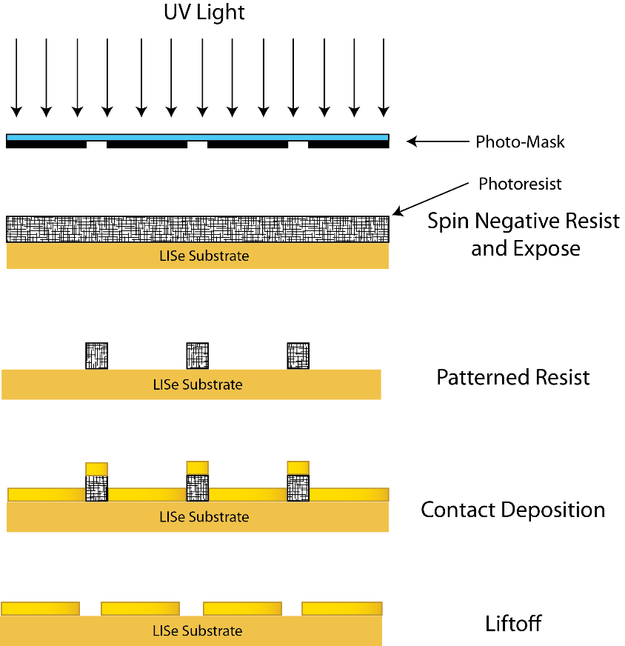
Figure 3.1.1: This is a graphical representation of the exposure, development, deposition, and liftoff process. The photomask determines the electrode pattern, and subsequently the spatial resolution. Our photomask patterns include pixels with diameters ranging from 500 µm down to 30 µm. More variations are possible with the correct photomask.

- Mount the LISe sample to a polishing jig with wax, ensuring flatness during the polishing stage.
- Wet the MTI diamond lapping/polishing pads with Allied High Tech RedLube Polishing Lubricant and begin polishing. This is repeated with diamond pads with grit size of 9 µm, 3 µm, 1 µm, 0.5 µm, and 0.1 µm in decreasing order, to create a mirror surface.
- Chemical cleaning to remove oxide layers on the surface by submerged in mixture of 20 mL of methanol and about 1 mL of bromine for 30 seconds. The sample is also polished with a cloth wetted with methanol to create a final mirror finish.
- Repeat Steps 2 and 3 for the other side of the sample. Clean with acetone, methanol, and deionized water.
- Place a thin layer of Apiezon wax on a metal planchet, heated to about 150 ºC, and place LISe sample in the center. The LISe sample bonds to the wax upon cooling.
- Rinse in methanol and store for transport to the clean room.
- In the clean room, a rinse in IPA and then methanol and pressurized nitrogen was conducted right before patterning.
- Mount the metal planchet with the sample in the SCS 6800 spin coater and covered with Futurrex negative resist NR9-1000PY, which will spin coat to reach 1 μm-thick. The specific spin coating recipe is provided below.
  - A 10 second ramp up to reach 500 rpm and dwell at that speed for 5 seconds.
  - A 15 second ramp to 3000 rpm with a dwell time of 40 seconds.
  - A 5 second ramp down to 1000 rpm with a dwell time of 10 seconds.
  - A 5 second ramp down to zero rpm.
  - Soft bake for 60 seconds at 150ºC.
- Contact print using the MA-6 at a wavelength of 365 nm and an exposure time of 15 seconds. The mask was in hard contact with the surface during exposure.
- Post-exposure bake at 100ºC for 1 minute 45 seconds.
- Develop the resist with Futurrex resist developer RD6 for ten seconds using a spray method followed by a rinse in deionized water.
- Inspect the pattern using a reflected-light microscope. If untenable defects are found, strip the negative resist and repeat steps 7-11 with minor adjustments as needed.
  - Strip the negative resist by spraying directly with resist remover RR41, then rinse with deionized water (rinse again with acetone, isopropanol (IPA), and methanol if needed).
- Protect the sides of the LISe sample from metal deposition using single-sided Kapton tape.
- Mount the LISe sample in the AJA international sputtering system for contact formation.
- Remove the sample from the sputtering system and immerse in Futurrex resist remover RR41 at 100ºC for 20-60 minutes.
- Rinse the sample in acetone, IPA, and methanol to remove contaminants and dry with pressurized nitrogen.
- Remove the sample from the metal planchet by spraying and/or immersing the Apiezon wax in toluene until washed away.
- Flip the sample over and mount the sample on a glass slide while masking its edges with single sided Kapton tape for broad face contact formation.
- Mount the sample in the AJA international sputtering system for contact formation.
- Remove the sample from the glass slide.
- Rinse the sample in IPA and methanol.
- Store the patterned sample in a membrane case with desiccant until ready to mount the substrate to electronic package.

The photolithography procedure has been optimized specifically for pixelated patterns, ensuring that at least 99.5% of pixels formed and had an appropriate undercut for resist lift-off. Overlapping undercut indicates that there is a chance of the deposited metal linking together, and insufficient undercut may result in the sputtered metal electrodes sticking to the photoresist instead of only the sample surface. The second case can also lead to removing pixels along with photoresist during the resist removal stage. Figure 3.1.2 shows how an example of successful and optimized photolithography to include all features of the photomask. This electrode pattern is a 256 × 256 square grid of 30 μm diameter circles with a pixel pitch of 55 μm. The pixelated pattern is one of the highest spatial resolution patterns available to us, which is designed to be coupled to commercial Timepix ASICs, but other patterns have been implemented with the same technique. Generally, larger structure patterns are easier to implement in the photolithography stage and have been successful, as shown in Figure 3.1.3, for the DSSD pattern.

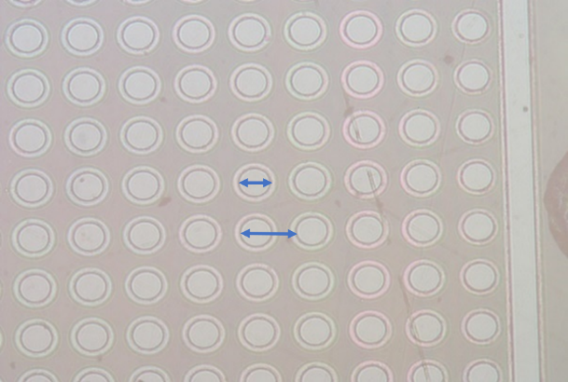  30 µm  55 µm  b)  a) | 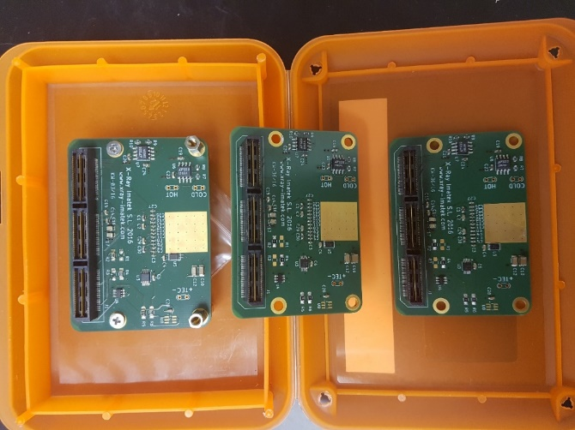  c)
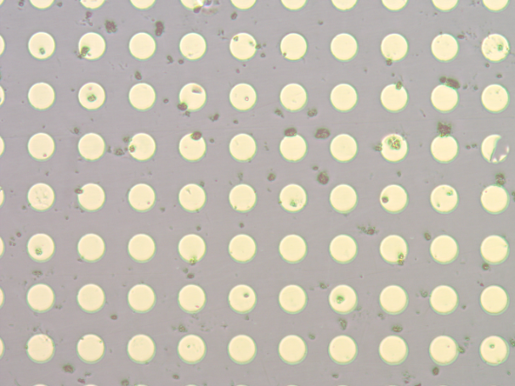 | d)
Figure 3.1.2:
a) Image of the LISe substrate after UV exposure and development, where the lighter outlines are the undercuts of the exposed and developed photoresist. The line to the right is the pattern of the guard ring which also has an undercut.
b) Image of a pixelated LISe substrate with gold deposited electrodes. These electrodes are 30 µm in diameter with a 55 µm pitch.
c) Image shows the printed circuit board that is inside a metal housing in Figure 3.1.2d. The gold square is meant to bond to the processed detector.
d) Image shows the X-ray Imatek eX Series Timepix camera. It is connected via a ribbon cable to the FPGA and PC interface board on the left side. This commercially available setup is intended for this pattern specifically, but other patterns are possible with different readout setup.

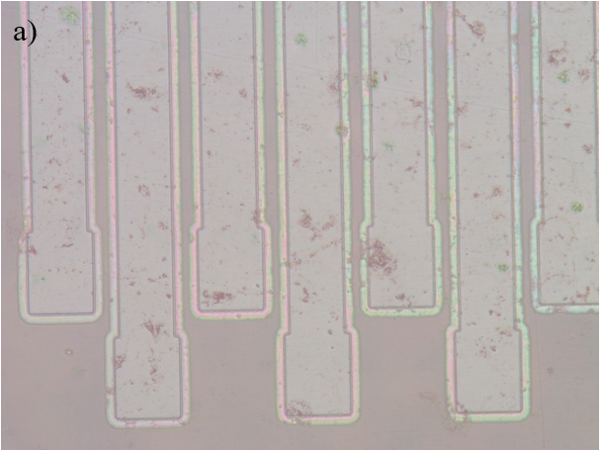 | 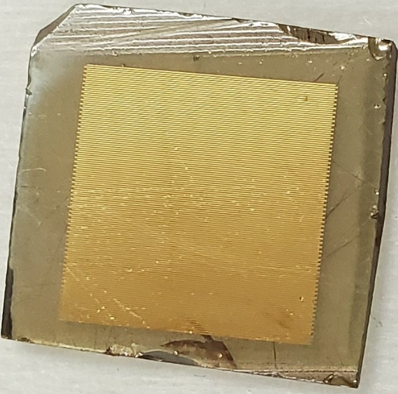  c)
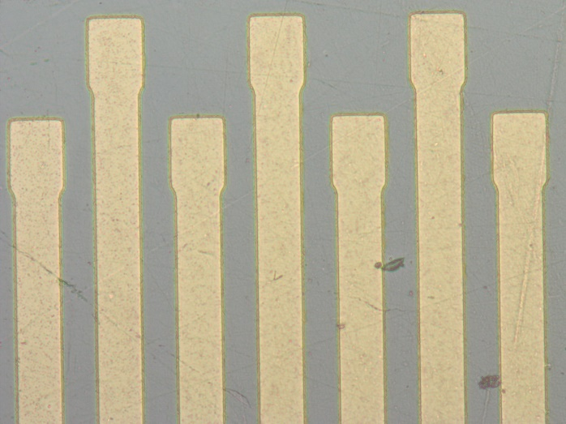
b)
Figure 3.1.3: Images of the top of the DSSD pattern in the photoresist stage and post-gold deposition are provided in a) and b) respectively. Image c) shows how the strips appear zoomed out.

3.2 Flip Chip Bump Bonding

The Timepix2 is an ASIC developed by CERN in 2018 to read out pixelated tracking detectors that can operate at the envisioned pulse repetition rate of the LHC of 40 MHz [28]. It was part of a series of such ASICs developed by CERN which is being improved upon but has proven to be versatile for other applications as well. It is capable of providing time and charge information simultaneously from each pixel, which is what allows it to work well for real time neutron imaging. Each pixel has a 30 × 30 µm² area, with our model having a spherical indium bump at the end, and they are arranged in a 256 × 256 grid (1.408 × 1.408 cm²). Preamplifiers were integrated into the ASIC for each pixel individually that are AC-coupled and allow a signal to pass based on a threshold [29]. The LISe neutron imager used a Category A Timepix2 ASIC, which is a classification from the manufacturer that means there are less than 30 bad pixels distributed across the chip [29].

The flip-chip procedure was required to bond the LISe sample to the pixelated Timepix2 ASIC. Flip chip bump bonding is a specialized procedure that efficiently bonds the electrode pattern on the sensor to a chip that connects to other electronics. Heat is required to melt the indium bumps on the Timepix2 chip and the LISe samples are too brittle to not fracture under more forceful bonding processes, therefore we used thermocompression flip chip bonding. This process is visually depicted in Figure 3.2.1. Heat was applied on the side of the ASIC since to begin to melt the indium bumps. Since indium melts at approximately 160 °C, high temperatures that would damage the LISe wafer are avoided. Pressure is applied to compress the bumps onto the electrodes and they are allowed to cool, bonding the ASIC to the electrodes. The flip-chip bump bonding process was completed using a Karl Suss FC 150 flip chip bonder operated by ArcNano. ArcNano also bonded the ASIC to the PCB and wire bonded the ASIC to the PCB control pads leading to the readout.

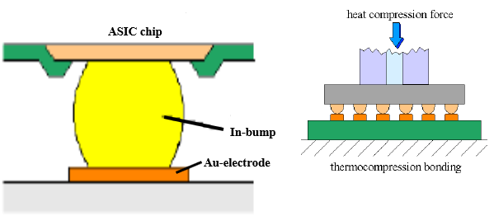
a)
b)
Figure 3.2.1:
a) Depiction of how each electrode on the LISe sample is bonded to the Timepix2 ASIC, based on an example from [30].
b) Depiction of the flip chip bump bonding process, specifically thermocompression bonding [30]. This involves heating the ASIC (top) which also heats up the indium bumps so that they can compress on the sample’s electrodes and form a solid bond upon cooling.

Chapter 4
Irradiation Tolerance Analysis
The focus of this work is to characterize a set of LISe crystals grown from the same boule by their optical (Chapter 4), electrical, and radiation response (Chapter 5) properties and better understand how neutron damage changes those properties. The samples were grown by Radiation Monitoring Devices, Inc. (RMD) and were diced into two sets of 5 samples. After dicing, they were polished, as described in Chapter 3, and etched in a 5% bromine and 95% methanol solution. Their final thicknesses are shown in Table 4.1. One set was arbitrarily assigned to be the “pre-irradiation” set, which were not exposed to any large fluences of neutron radiation over the course of characterization with several techniques. The other set, referred to as “post-irradiation” was characterized using the same techniques but after being dosed with a large fluence of neutrons which were mostly in the thermal energy range. This fluence was delivered at Ohio State University’s Rabbit and CIF facilities, whose neutron spectra are shown in Appendix A, after polishing and etching. Also, each sample in the post-irradiation set was given a different total fluence to compare how characteristics would change with increasing damage. Samples 1, 2, 3, and 4 were irradiated at the Rabbit facility to fluences of 1×10¹², 1×10¹³, 1×10¹⁴, and 1×10¹⁵ neutrons/cm² respectively. Sample 6 was irradiated at the CIF facility to a fluence of 1×10¹⁶ neutrons/cm².

4.1 UV-VIS-IR Characterization

The measurement of the optical properties of semiconductors has been used in the past as an effective “quality control” tool that can identify dopants and other crystallographic structures [31, 32]. UV-Vis relies on measuring the transmission (absorption) or reflection of light in the ultraviolet and visible wavelength bands and primarily provides an estimate of the band gap of the semiconductor, although the reflection-based technique has been considered the standard for this [32, 33]. Fourier transform infrared transmission spectroscopy (FT-IR) differs from UV-Vis spectroscopy because FT-IR measures the transmission of mid to deep infrared light that primarily interacts with the vibrational modes of the bonds rather than the electron-hole transitions of the sample being tested. A sample’s UV-Vis spectrum reflectivity has been proven to yield good measurements of band gap energy under certain conditions and although the absorbance spectra has been used the same way, there have been discrepancies in the results it produces [32, 33]. The more commonly accepted method to measure band gap energy is by the Fresnel and Kubelka-Munk derivations, which use reflectivity. Fresnel reflectance refers to the radiation that is reflected by the surface/particles that are parallel to the macroscopic sample surface and those that are not parallel. Kubelka-Munk (K-M) reflection is referred to the light that is reflected after penetrating through the sample surface [32, 34]. It should be noted that this methodology has limited applicability and has a large dependence on sample preparation. The equation describing this K-M reflectance is shown in equation 4.1.1
(4.1.1)
$$α ∝ F\left(R\right)= \frac{{(1-R)}^{2}}{2R}$$

where R is the reflectance of an infinitely thick sample, which usually overlaps with Fresnel reflectance, and F(R) is proportional to the extinction coefficient, α. Then the extinction coefficient is also considered proportional to the band gap energy by equation 4.1.2
(4.1.2)
$$α\left(hυ\right)≈B{(hν- E_{g})}^{n}$$

where h is the Plank constant, $ν$ is the light frequency, B is the absorption constant, E_{g} is the band gap energy, and n is a constant whose value is set based on the type of transition is being measured (n=2 for indirect band gap, n=3 for indirect forbidden transition, n=0.5 for direct band gap, n=1.5 for direct forbidden transition). The final equation that is plotted is shown in equation 4.1.3, where the left-hand side is the y-axis, the light wavelength or energy is on the x-axis, and the x-intercept of slope of the line is the actual band gap energy. In the absorbance treatment of this methodology, $α(hν)$ is replaced with the absorbance [33].
(4.1.3)
$$F\left(R\right)⋅hν=B{(hν - E_{g})}^{n}$$

A set of 10 LISe samples were evaluated using UV-Vis transmission and absorbance experiments, 5 of which were dosed with different fluences of thermal neutrons. The unirradiated and irradiated samples were mounted into a Varian Cary UV Vis 5000 and evaluated in the range of 200-800 nm. The transmission spectra obtained are shown in Figure 4.1.1. These transmission spectra show that the pre-irradiation samples are all similar in that they do not transmit any light at wavelengths less than approximately 440 nm. The post-irradiation transmission spectra show a similar convergence for fluences less than 1 × 10¹⁵ neutrons/cm². However, there are some changes in the 1 × 10¹⁵ neutrons/cm² fluence case and a large shift in the 1 × 10¹⁶ neutrons/cm² fluence case. These differences are better represented in absorbance plots using the methodology of N. Ghobadi [33], shown in Figure 4.1.2, which also derive a band gap energy for each sample. A table containing a comparison of the UV-Vis transmission and absorbance results is shown in Table 4.1.1. The samples irradiated with fluences from 1 × 10¹² – 1 × 10¹⁵ neutrons/cm² have a bandgap energy about 0.1 – 0.2 eV lower than their pre-irradiation bandgap values.
Table 4.1: The thickness of each LISe sample was measured with a micrometer after polishing and etching. The results are shown in this table and are helpful for comparing the electric field applied to each sample during radiation response testing (Chapter 5).
 | Thickness of Pre-Irradiation Sample (µm) | Thickness of Post-Irradiation Sample (µm)
Sample 1 | 1143 | 1175
Sample 2 | 1175 | 1175
Sample 3 | 1080 | 1080
Sample 4 | 1127 | 1111
Sample 6 | 1175 | 1175

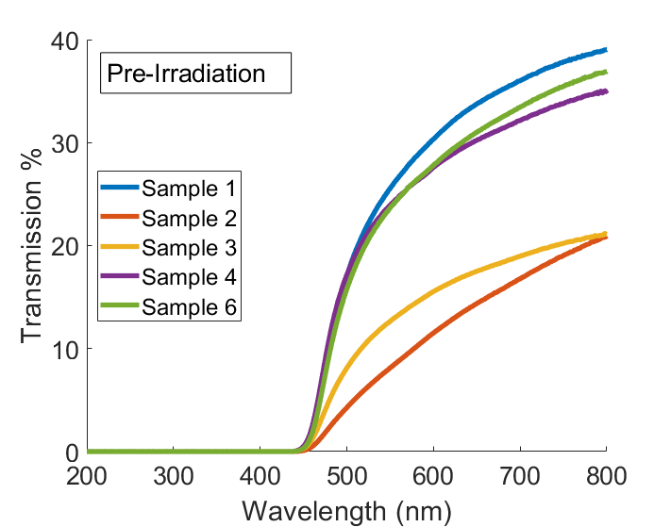
a)
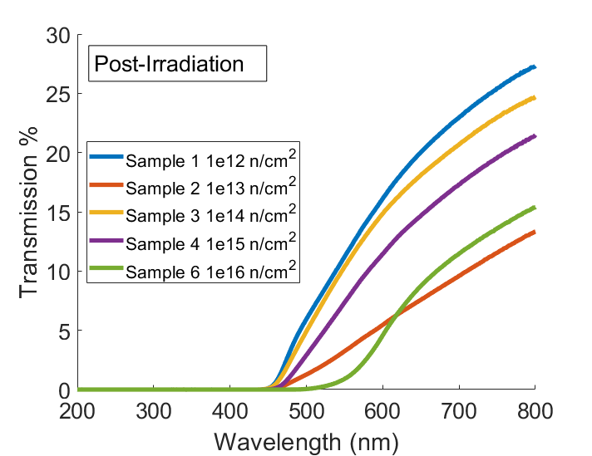
b)
Figure 4.1.1: UV-VIS transmission spectra of the LISe samples before a) and after b) irradiation. The highest irradiated sample shows a significant shift to a lower energy, accompanied by a physical color change from yellow/brown to dark red.

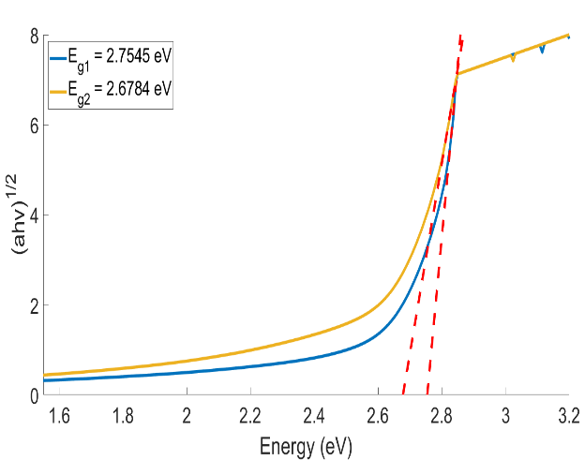  a) | 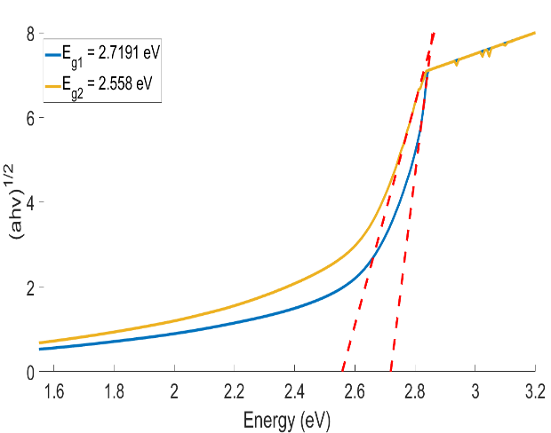  b)
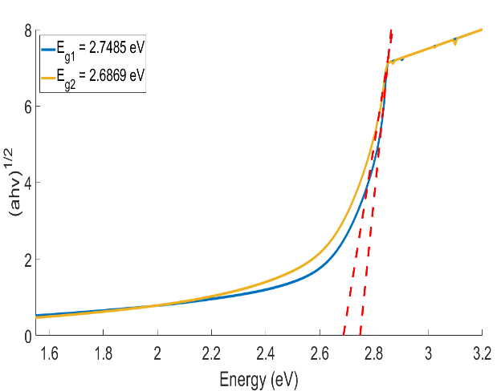  c) | 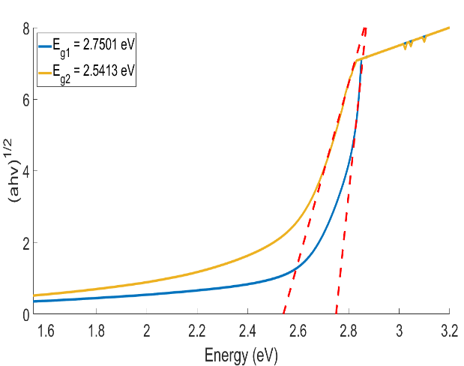  d)
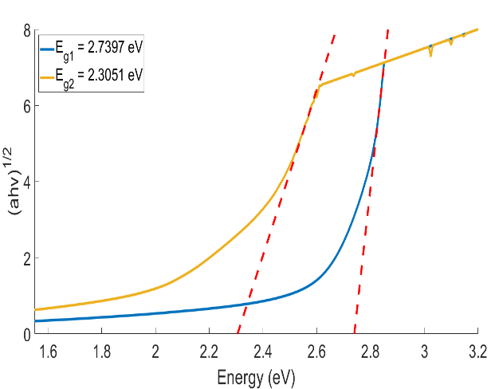
e)
Figure 4.1.2: These plots are based on the modified Tauc plots from [33]. The y-axis represents the square root of the absorbance spectrum multiplied by the x-axis energy. The x-intercept of the red dashed lines, which fit the pre-irradiation (blue) line and post-irradiation (yellow) line, is the band gap energy of the associated spectrum. Each plot represents a neutron fluence of a) 1 × 10¹², b) 1 × 10¹³, c) 1 × 10¹⁴, d) 1 × 10¹⁵, and e) 1 × 10¹⁶ neutrons/cm².

Table 4.1.1: This table shows the band gap energy measured by UV-Vis absorbance Tauc plots, shown in Figure 4.1.2, before and after irradiation. They are reproduced here for convenience.

Sample (fluence in neutrons/cm²) | Pre-Irradiation Band Gap (eV) | Post-Irradiation Band Gap (eV)
Sample 1 (1×10¹²) | 2.7545 | 2.6784
Sample 2 (1×10¹³) | 2.7191 | 2.5580
Sample 3 (1×10¹⁴) | 2.7485 | 2.6869
Sample 4 (1×10¹⁵) | 2.7501 | 2.5413
Sample 6 (1×10¹⁶) | 2.7397 | 2.3051

However, the sample irradiated to 1 × 10¹⁶ neutrons/cm² has a significant drop in bandgap energy from about 2.74 eV to 2.31 eV after irradiation. This change is accompanied with a visually noticeable change in color from yellow to dark red. Since these values were not obtained with reflectivity measurements their values should not reflect the actual band gap changing, but the changes do show that the most irradiated sample experienced a large change in defect structure, which plays a large role in determining the band gap. All the other irradiated samples seem to be significantly different from the dark red sample and the unirradiated samples are different from all the irradiated samples. Images of the samples that portray this change are shown in Figure 4.1.3.

FTIR spectra are commonly used to help identify shallow features, such as organic bonds on the surface of samples, as well as bulk crystallinity and IR-active defects (citation here). The FTIR spectra measured for the pre- and post-irradiated samples are shown in Figure 4.1.4. One of the relevant features of LISe is the “shoulder” observed in the 750-1100 cm⁻¹ range because it has been the most prominent feature in prior studies of the optical properties of LISe [35, 36]. The sample irradiated to 1 × 10¹⁶ neutrons/cm² was the only one to have this feature significantly changed. Visual inspection with a microscope showed that a dark dot was present on only one side of that sample, shown in Figure 4.1.3, and the change in the shoulder feature in the 750-1100 cm⁻¹ range remained consistent no matter which side was measured. The consistency of the feature indicates that the change may not relate to surface defects. Two peaks were also present across all samples no matter the neutron fluence at 590 and 530 cm⁻¹. These peaks were not identified in past measurements on LISe. Since they did not change dramatically despite irradiation, it is possible that they are associated with IR-active vibrational modes or defects in the samples. Other smaller peaks appear in the FTIR spectra, such as those around 2350 cm⁻¹, but they are artifacts from the instrument and are not related to the LISe samples.

4.2 Luminescence Characterization

The phenomenon of semiconductor luminescence has been used to identify details about their structural properties. In this work, the main forms of luminescence of interest were photon-induced luminescence, or photoluminescence, and radiation-induced luminescence, or radioluminescence. The former involves the excitation of electrons in the lattice structure from the valance shell to the conduction shell, which then emit photons as they de-excite. Exciting photons reliably into the conduction band requires using light with energy greater than the band gap energy of the semiconductor. This procedure has been used to measure the band gap energy of direct band gap semiconductors, assumed to be equal to the mean energy of the shortest wavelength emitted light.
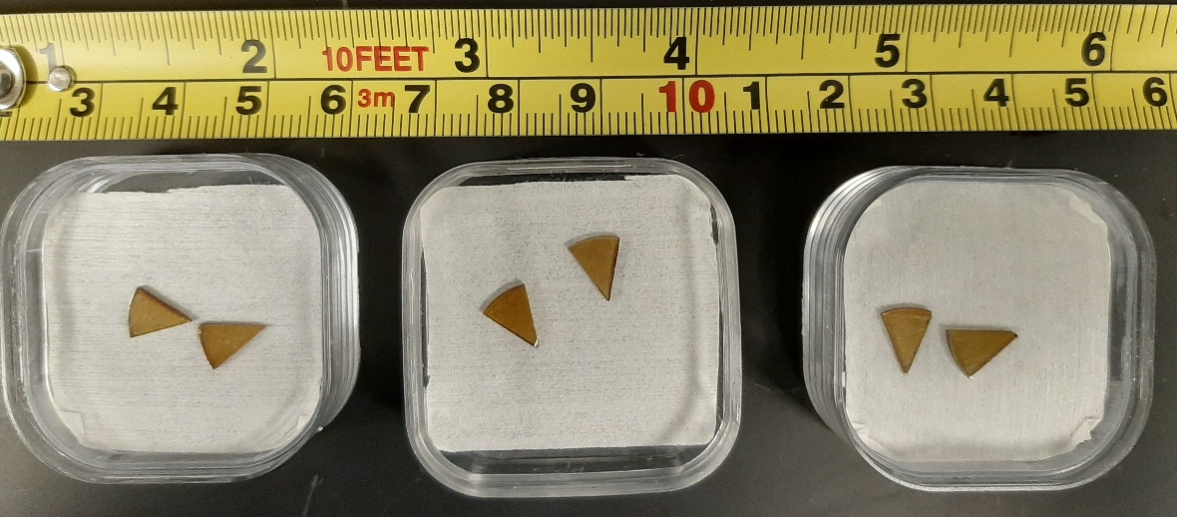
a)
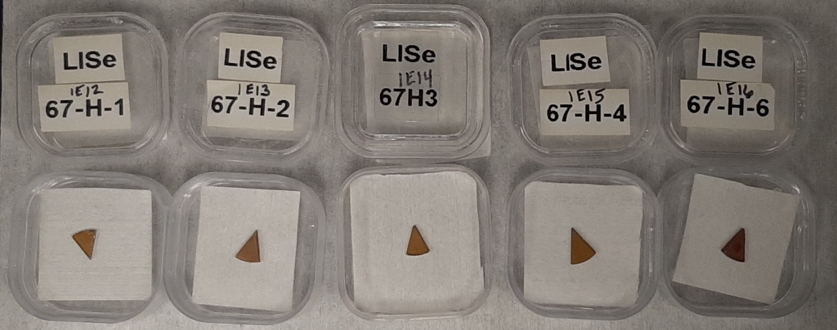
b)
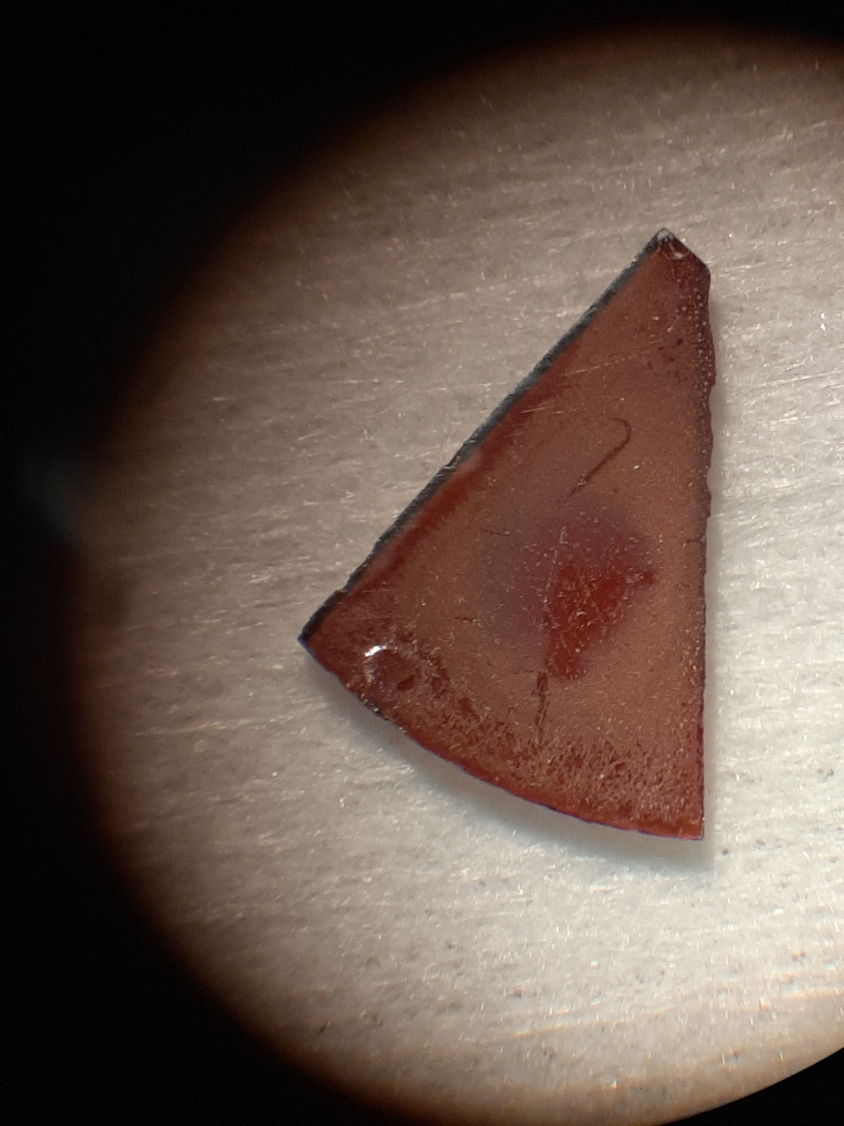  c) | 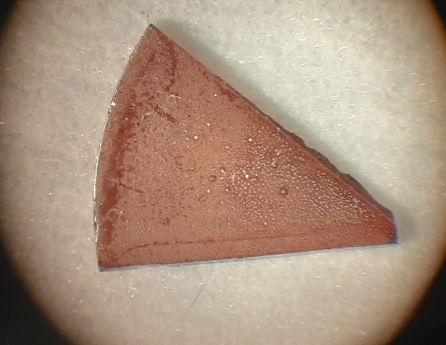  d)
Figure 4.1.3: Images of several samples from before and after the neutron irradiation are shown here. Image a) shows the samples just after they were diced with a tape measure included for scale. Image b) shows all of the samples post-irradiated in order from least fluence on the left to greatest fluence on the right with labels given in units of neutrons/cm². Image c) and d) show the front and back of Sample 6 (LISe 67-H-6) after being irradiated with 1 × 10¹⁶ neutrons/cm² to better show the change in color and the red spot formed due to neutrons.

However, in realistic scenarios, there are likely impurities that act as sources of luminescence that emit below the band gap energy. Donor-acceptor pairs are a type of impurity that can cause such luminescence and have been identified in LISe crystals [17]. However, radioluminescence, as tested in this work, refers to the emission of photons via electron-hole pair recombination at luminescent centers and/or directly in the case of direct band gap semiconductors. This property has also been referred to as X-ray excited optical luminescence (XEOL) in the literature. These pairs would be created due to the X-ray colliding with valence electrons, producing electron-hole pairs. The electrons and holes seek to relax their excess energy in the system, and to do that, may move to luminescent recombination centers, quenching centers, or traps [37, 38]. Their excess energy, determined by the properties of the center, may get emitted as photons in the case of a luminescent center or direct recombination. Since these centers can also come from defects in the lattice structure, they can help provide some detail on how the defects behave and, in this case, which were formed due to neutron irradiation.

The radioluminescent properties of the LISe samples were evaluated by measuring their light emission spectra during X-ray irradiation. Since LISe has exhibited both effective semiconducting [21] and scintillating properties [25, 27], its luminescence mechanisms also give insight to its structure. All LISe samples pre- and post-irradiation were hit with X-rays of 35 keV energy with a CMX003 X-ray gun set to a current of 0.1 mA. The luminescent spectrum was measured with a 150-mm focal length Action SpectraPro-2150i monochromator using a R928 PMT attachment. The diagram in Figure 4.2.1 depicts the setup. The resulting spectra for each sample before and after neutron irradiation are provided in Figure 4.2.2. All pre-irradiation spectra share distinct peaks at 517 nm and approximately 630 nm, with the former being dominant. Similar peaks have been detected in previous work [25, 27], which suggested that both peaks were mainly produced from the LISe material’s antisite defects involving lithium and indium. The same peaks have been assigned as luminescent donor-acceptor pairs (DAP) as well [25], where there appears to be a weak 630 nm peak in the yellow LISe sample’s spectrum though it was not identified as such. A smaller 410 nm peak was also observed in pre-irradiated samples that was not found in past literature measuring X-ray luminescnece. It is not present in all samples and it is much smaller than the other peaks. The samples that did produce this type of luminescence only did so when X-rays hit one side but not the other, though it was reproducible with multiple trials. This implies that the defect is related to surface defect recombination and not present throughout the sample. The neutron-irradiated samples showed some relation between neutron fluence and the 517 nm peak. The peak became less prominent relative to the 630 nm peak at higher neutron fluences, especially noticeable in Figure 4.2.2d at 1 × 10¹⁵ n/cm².

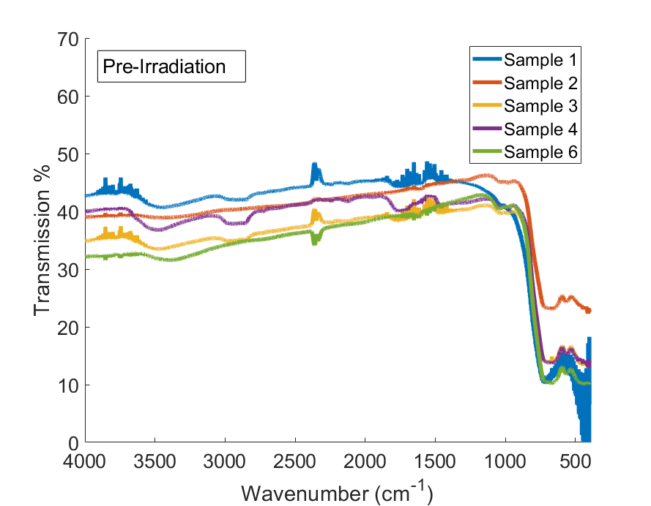
a)
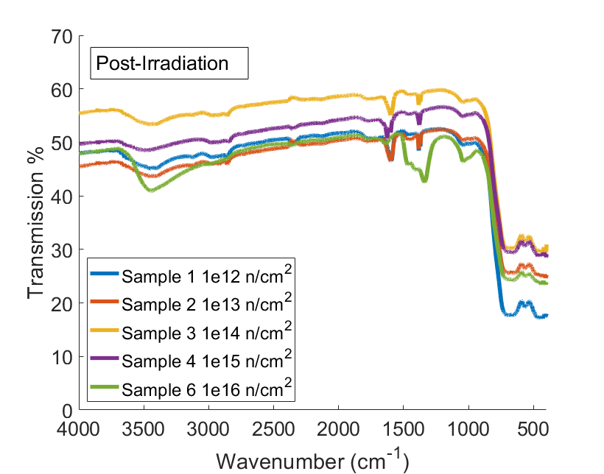
b)
Figure 4.1.4: These plots show the FTIR spectra of the LISe samples before a) and after b) irradiation. A common feature in these spectra are the shoulder in the 750-1100 cm⁻¹ range, which only significantly changes at 1 × 10¹⁶ neutrons/cm² fluence. The two peaks in the 500-750 cm⁻¹ are always present and may be IR active vibrational modes or defects. It should be noted that FTIR was measured on both sides of Sample 6 and there were no differences.

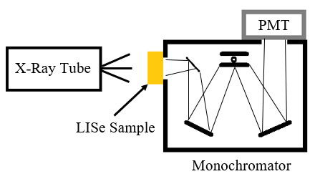
Figure 4.2.1: This diagram shows a block diagram of the setup for the radioluminescence experiment conducted with LISe samples (yellow block). The sizes of the diagram are not to scale. The light emitted from the LISe sample is focused by the mirrors in the monochromator where the gratings let only certain wavelengths at a time to reach the PMT, which measures the counts.

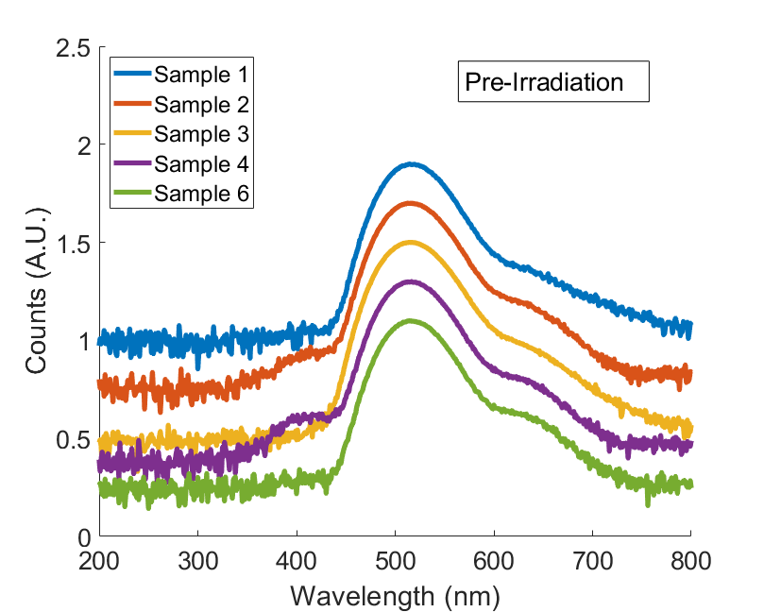
a)
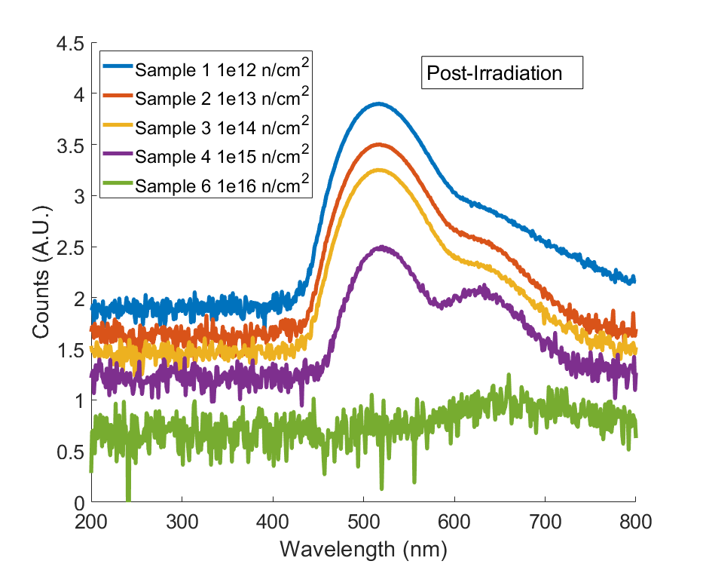
b)
Figure 4.2.2: X-ray luminescence spectra for the LISe samples before a) and after b) neutron irradiation. The base 10 logarithm of the counts in each measurement were normalized and arbitrarily offset for clarity. All pre-irradiated samples share luminescent peaks at 517 nm and an overlapping peak likely centered around 630 nm, green and red respectively. Two of the five samples also showed a much smaller but distinct blue peak at 410 nm. The two highest irradiated samples, Sample 4 and 6, show a drop in green luminescence with the later almost completely losing the red luminescence, too.

Neutron irradiation also seemed to remove the 410 nm peak in all cases. The sample irradiated to 1 × 10¹⁶ neutrons/cm² showed an almost complete loss of all luminescent properties, with only a small peak visible in the 600 – 650 nm range (more clearly shown in Appendix A). Since these peaks are likely related to lithium and indium defects that act as DAPs, it is reasonable to assume that the loss of lithium through neutron absorption reactions removed some of the electron acceptors in the DAP system, which caused the loss in luminescence. However, further investigation is required to bolster this observation.

The photoluminescent (PL) properties of an irradiated LISe sample were evaluated by measuring the light emissions of the sample as a result of being illuminated with an above-band gap laser. The LISe sample exposed to a fluence of 1 × 10¹⁶ n/cm² was placed in a cryostat and cooled to 6 K. The measurements were taken at 6 K and once again after the sample heated up to 70 K. The laser had a wavelength of 343 nm and was 0.2 mW. The emission spectrum and the time-resolved spectrum was measured with a Fluorolog Horiba TCSPC spectrometer. The PL spectra observed are shown in Figure 4.2.3. The data in the plots were smoothed in post-processing with a Savitzky-Golay filter due to significant noise in the data caused by the weak photoluminescence of the sample. Multiple accumulations and 1 second integration times per 0.5 nm were used to compensate for the poor luminescent properties of the most neutron irradiated LISe sample. After filtering, three prominent peaks appear in the PL spectra at both temperatures: 410 nm, 430 nm, and 460 nm. The highest energy peak, 410 nm or 3.02 eV, seems to correspond to the band gap energy of the sample, which has been found to be approximately the same for red and yellow LISe samples [17]. The next largest peak at 430 nm, or 2.88 eV, has not been assigned as a DAP or observed in PL spectra in prior literature on LISe. However, its energy is nearly equal to the pre-irradiated samples’ band gap energy found by this work’s UV-Vis measurements at room temperature (see section 5.3). Some LISe samples studied in this work had a radioluminescent emission peak around this energy as well. This indicates that there may be shallow traps involved in recombination and in luminescence, though it is not clear whether the same type of trap is involved in both types of emission. It had been hypothesized that a low energy defect caused by lithium interstitials is expected to appear in the PL spectrum at low temperatures [17], though it was not found experimentally. Its activation energy is expected to be less than 0.22 eV. Also, a wide and low intensity peak was present near 2.88 eV in their spectrum, though it was not explicitly identified as such, but both the band gap peak and this 2.88 eV peak appeared much more prominently in this irradiated LISe sample than the samples measured by Cui. So, the peaks are likely related to this defect. The lowest energy peak at 460 nm or 2.69 eV has also not been identified in the literature, but it is possible that the peak is too convoluted with the previous peaks that this assigned energy is incorrect. Another DAP was identified by Cui et al. 2013 [17] at 2.513 eV in both yellow and red LISe samples which had a larger intensity than their band gap peak. Their overlap with different intensities may be causing what appears to be a peak at 2.69 eV. If the peak is in fact real but simply was not prominent in the literature, it may have been overshadowed by the green scintillation centers. Another explanation is that it formed due to neutron activated products but that would require much more rigorous irradiation studies and other investigations to prove with certainty.

Each of the PL peaks were also evaluated for the decay lifetime of minority carriers by measuring the intensity of the wavelength emission over time, known as time-resolved photoluminescence (TRPL). All time-resolved profiles were measured at about 30 K, normalized to their maximum intensity, and fitted with a double exponential fit, shown in Figure 4.2.4. Semiconductors have been known to have fast and slow decay components, which is why a double exponential is appropriate. The lifetime was also shown in Figure 4.2.4 based on the definition that the time when intensity is at 1/e or 37% of the maximum value is the decay lifetime. Based on the 37% lifetime, all of the peaks had about the same lifetime, 1.53 ns, 1.53 ns, and 1.56 ns from the greatest energy to lowest energy peak, respectively. These lifetimes are too similar to notice any differences between the peaks’ decay time constants. The exponential fits also showed similar lifetimes for the peaks. From greatest to lowest peak energy the long decay times were 7.63 ns, 6.94 ns, 6.85 ns and the short decay times were 1.31 ns, 1.28 ns, and 1.25 ns. These relatively short lifetimes, compared to similar semiconductors but still much slower than scintillators like LaBr₃ [39-41], further indicate that the minority charge carriers in LISe, holes, may have extremely poor lifetime [2]. It should be noted that this time scale for the lifetime is short enough that the results could be affected by the response time of the instrument, so the actual decay times may be shorter. Although these measured quantities of the lifetimes should not be taken as the exact lifetime of holes in all LISe semiconductors, the TRPL results show that the holes remain extremely poor in highly irradiated LISe samples.

4.3 Raman Shift Characterization

Raman spectroscopy is an optical technique that identifies vibrational modes in the structure of the sample material in question. The technique involves illuminating the sample with light in the visible spectrum that is absorbed by the sample. A portion of the incoming light would be absorbed and reemitted through Rayleigh or Raman scattering. The main difference between the two types of scattering is that the former is elastic scattering, resulting in nearly the same energy as the incoming light, while the latter will produce scattered photons of lower or higher energy due to interactions between the incident photons and phonons (vibrational modes). The difference in frequency between the outgoing Raman scattered photons and the outgoing Rayleigh scattered photons is the Raman shift (measured in cm⁻¹). In the Raman spectrum, the scattered photons can be categorized as either Stokes or Anti-Stokes shifted, where the former refers to photons with a net loss of energy and the latter indicated a net gain due to the interactions with vibrational modes. These two have complimentary features around the zero-shift line on the abscissa, but the intensities will be different depending on the population of each vibrational state (ground or upper) in its thermodynamic condition. In thermodynamic equilibrium, the Stokes shift (down scattered energy) will dominate the observed intensity of paired peaks around the zero-shift line.

Due to LISe having an orthorhombic structure, with point symmetry group C_{2v} (mm2) chemical structure [42], it should have 3N – 6 vibrational modes, where N refers to the number of elements. Figure 4.3.1 shows diagrams of the Raman spectrum obtained in the literature, which have been reproduced from the literature for comparison and clarity [13, 24, 43]. In these past works, the samples in Figure 4.3.1a had a change in the proportion of Raman peaks, mainly the 70 cm⁻¹ and 161 cm⁻¹ peaks, due to neutron irradiation at 1 × 10¹² n/cm² fluence where L2 was the irradiated sample, L3 was an unirradiated red LISe sample, and L4 was an unirradiated yellow LISe sample. The spectra in Figure 4.3.1a were obtained with a 785 nm wavelength laser. The other spectra in Figure 4.3.1b were obtained with a 514.5 nm wavelength laser. The Raman spectrum in Figure 4.3.1c was obtained with a 632.8 nm wavelength He-Ne laser. All of these and the data obtained with the new RMD-grown LISe crystals show a positive shift value and therefore are Stokes shifts, as expected.

Raman spectra were measured for 5 LISe samples before and after neutron irradiation using 532 nm laser excitation on a XplorRA PLUS RAMAN microscope. There are 11 expected optical vibrational modes [13, 43] for the LISe Raman spectrum. Previous literature [13] has assigned the 3 largest peaks to the left of 161 cm⁻¹ to the Li-Se bonds and the 3 peaks largest to the right of 161 cm⁻¹ to the In-Se bonds. The large peak at 161 cm⁻¹ is the A₁ symmetry peak. This past study also implied that 3 vibrational modes should be expected at frequencies greater 250 cm⁻¹. The inset graphs in Figures 4.3.2 and 4.3.3 show what seems to be two or three convoluted peaks at 360 cm⁻¹, which seem to overlap more after irradiation. Another peak becomes prominent after irradiation near 480 cm⁻¹, though it may be due to new impurities created as a result of neutron capture reactions. The low frequency range, referred to as less than 150 cm⁻¹, should contain only 5 modes based on the literature. However, 6 modes were present for all irradiated samples and 7 modes were present in almost all non-irradiated samples. All of these low frequency peaks were previously identified in past literature [43] with a 632.8 nm excitation wavelength, though without assigning a bond. These low frequency modes underwent the greatest change as a result of neutron irradiation. The 65 cm⁻¹ peak disappeared, though it was not present even pre-irradiation for the sample in Figure 4.3.3d, and all other peaks broadened.

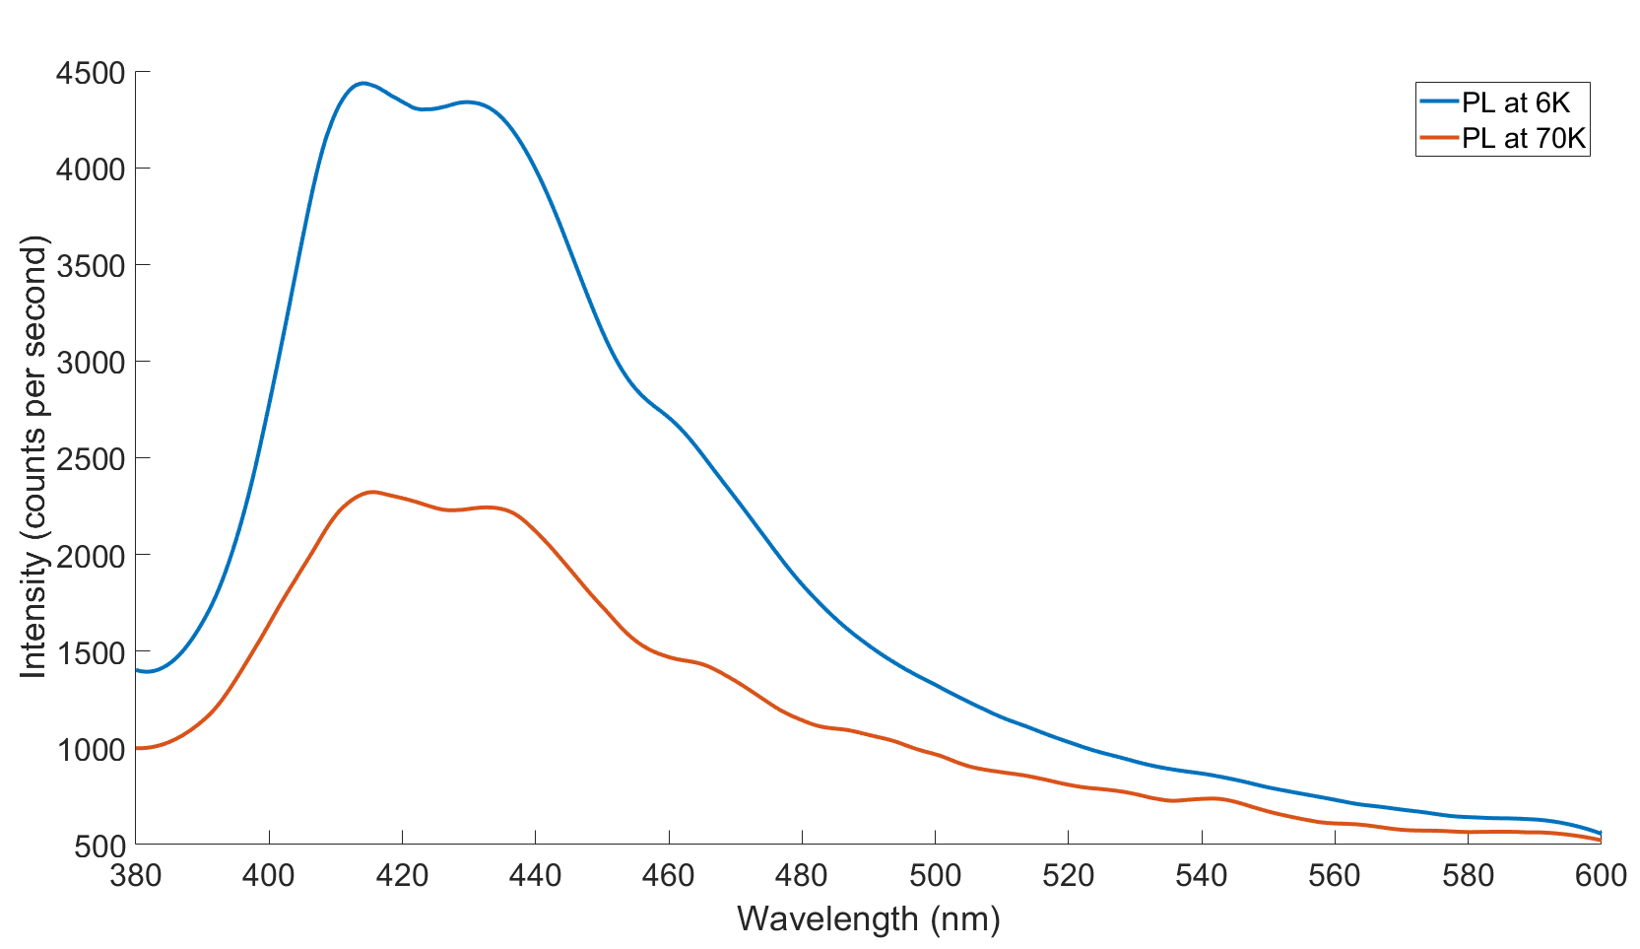
Figure 4.2.3: This plot shows the photoluminescence spectrum of the 1 × 10¹⁶ neutrons/cm² irradiated LISe sample at temperatures of 70K and 6K. The most promiment peaks visible in the Savitzky-Golay filter smoothed data are located at 410 nm, 430 nm, and 460 nm.

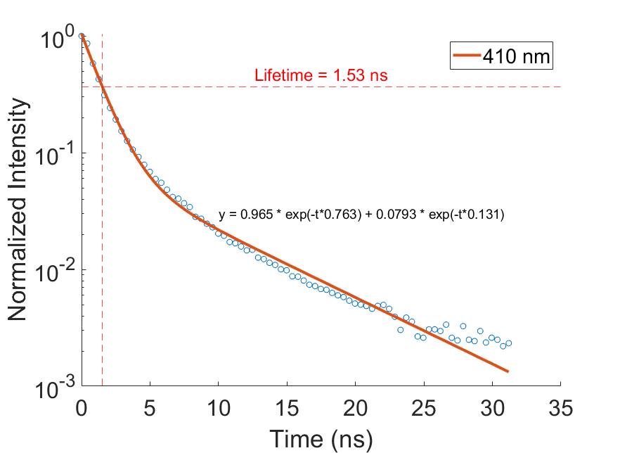
a)
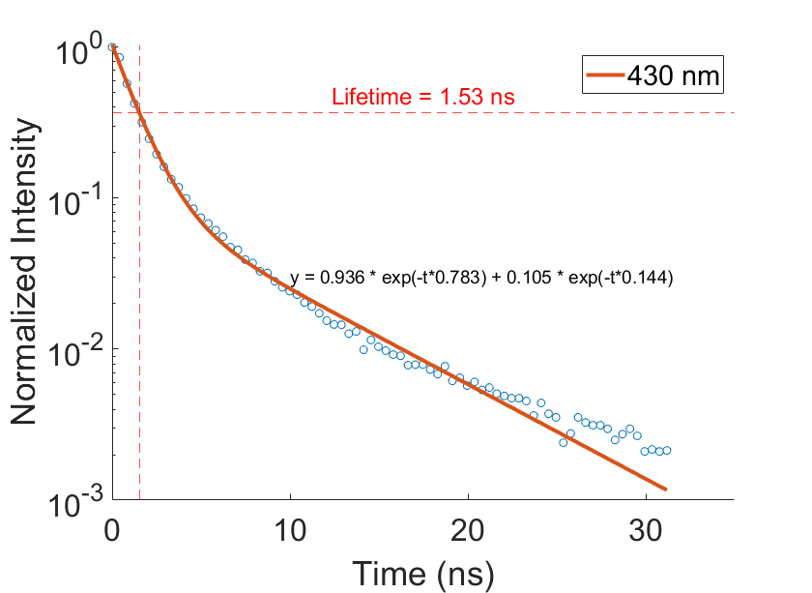
b)
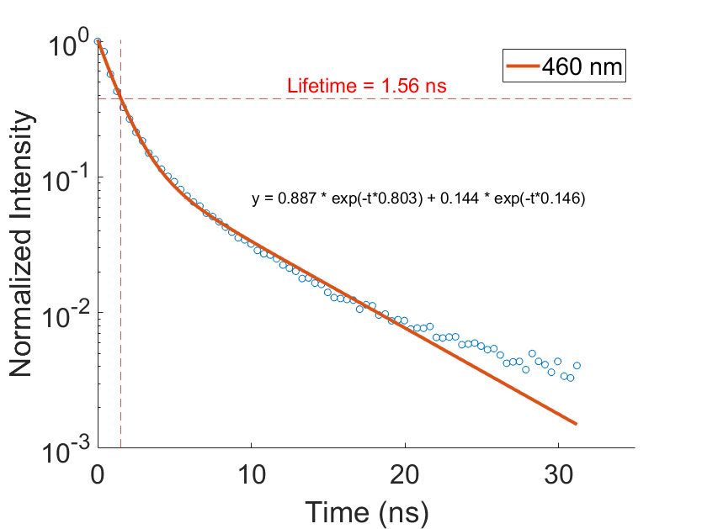
c)
Figure 4.2.4: These plots show the time-resolved photoluminescence spectra for the irradiated LISe sample at its three most prominent peaks. The lifetime in these plots also relates to the minority charge carrier lifetime, holes in this case. The value near the red dashed line is the lifetime measured at 37% of the maximum intensity while the fit line is a double exponential of the form A*exp(-t*λ₁) + B*exp(-t*λ₂).

The relative intensity of the peaks at 70 cm⁻¹ and 89 cm⁻¹ decreased by about 50% in from pre- to post-irradiation in all cases except the fourth sample (Figure 4.3.3d). The 70 cm⁻¹ peak also did not converge to the same relative intensity like the other peaks after irradiation, instead having a significant range in intensity that did not have a clear linear dependence on neutron irradiation. The relative intensity is largest for the most highly irradiated sample but the other samples’ intensities appear to decrease as neutron fluence increases. The 78 cm⁻¹ peak decreased significantly after any irradiation but not as much as the largest low frequency peaks. This change is reasonable as the quantity of Li atoms in the samples would decrease significantly due to neutron capture, reducing the number of Li-Se bonds. Another significant change due to neutron irradiation was the shift of many peaks to higher wavenumbers (lower energy), increasing by small amounts for the Li-Se and symmetry peaks but by a larger amount for the In-Se bonds in the 200 – 250 cm⁻¹ range. This shift, combined with the peak broadening, implies that the crystal structure became more compressed and less crystalline than before. However, compared to the In-Se peaks range in Figure 4.3.1, the unirradiated LISe samples’ Raman spectra are shifted to the right significantly which may imply lattice structure differences. Also, the intensity ratio of the Li-Se peaks to the A₁ symmetry peak (161 cm⁻¹) of each spectrum in Figure 4.3.1a was much smaller for the irradiated and red samples compared to as-grown yellow samples. This relation was observed for the RMD-grown samples irradiated in this study, too. It should also be noted that the LISe sample irradiated in prior work had a Raman spectrum where one of the Li-Se peaks grew larger than the symmetry peak (sample L2 in Figure 4.3.1a), while the opposite occurred for all samples irradiated in this study.

A TRIM simulation transporting tritons and alpha particles at the appropriate energy for the ⁶Li(n,³H)⁴He reaction was conducted to how much of the damage was expected to come from each particle (see Appendix B for input values). The simulations considered the transport of both the original resultant particles as well as the recoiling particles from the LISe lattice structure. The results are provided in Figure 4.3.4, where 50,000 ions were run for the alpha particle results and 35,000 ions were run for the triton particle results. The number of vacancies or ionizations per ion was calculated by taking the integral of the TRIM data over the total depth. The number of vacancies due to triton collisions and recoils was 113 Vacancies/Triton and the amount due to alpha particles was 210 Vacancies/Alpha. Although the exact values obtained from these simulations are not realistic representatives of the radiation damage, they are comparable to each other, as the damage may be overestimated according to past literature [44]. The simulations show that the main form of interaction that the triton and alpha particles have in LISe are ionizations, which make up about 99% of all ion interactions according to the data. This is reasonable because charged particles tend to lose most of their energy via Coulombic interaction rather than knock-on collisions. It is difficult to account for any mechanisms of annealing or recovery in LISe that would heal the defects created by these ionizing particles, so the true number of vacancies is unclear. However, it is clear that every neutron absorption interaction leads to removing a ⁶Li atom and likely displacing at least some other atoms, which could include the indium and selenium atoms, by the resulting ions. The Raman spectra of samples after irradiation in Figure 4.3.2 show that the changes in the peaks as the neutron fluence increased were not as dramatic as changes from the pre-irradiated to 1 × 10¹² n/cm² fluence in Figure 4.3.3a despite the fluence increasing by orders of magnitude from Sample 1 to 6. This may suggest that there is in fact some type of recovery mechanism or self-annealing happening in the sample or that some more complex behavior is present. An older study by Negran and Kasper 1973 [11] shows LISe has thermal conductive properties comparable to CdS, a material that is commonly used as a photodetector, but due to the changes in growth techniques more rigorous measurements would be necessary to understand this behavior.

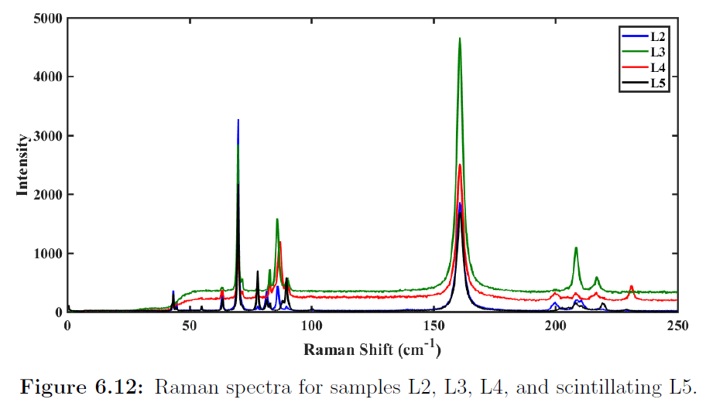
a)
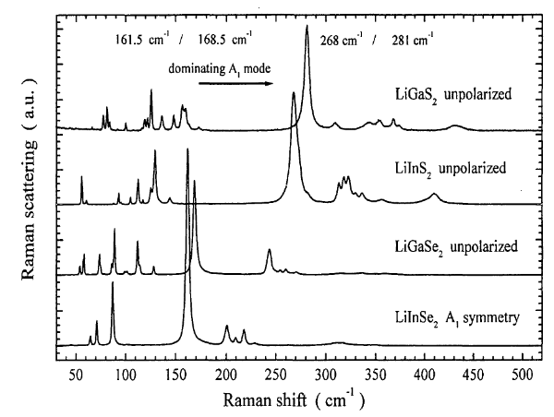
b)
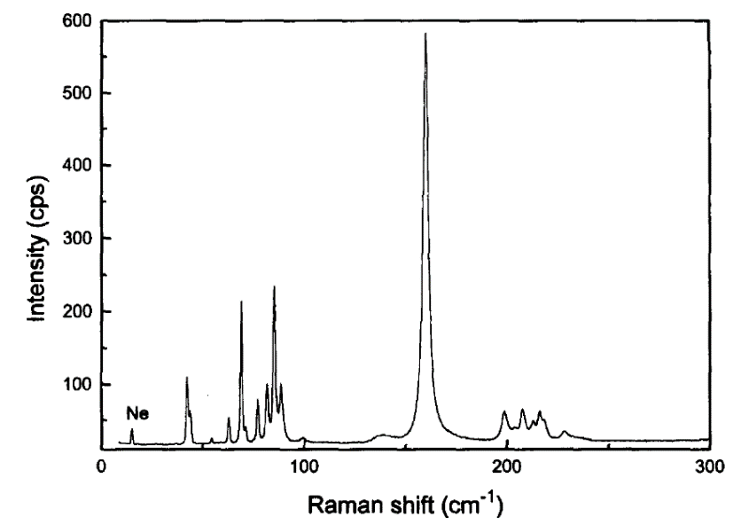
c)
Figure 4.3.1: The Raman spectra measured on LISe materials in previous literature are shown in a) [24], b) [13], and c) [43].

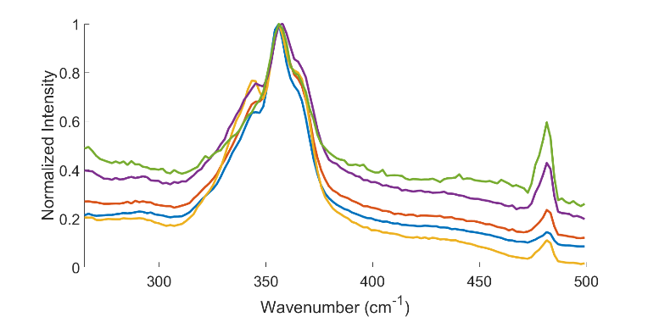
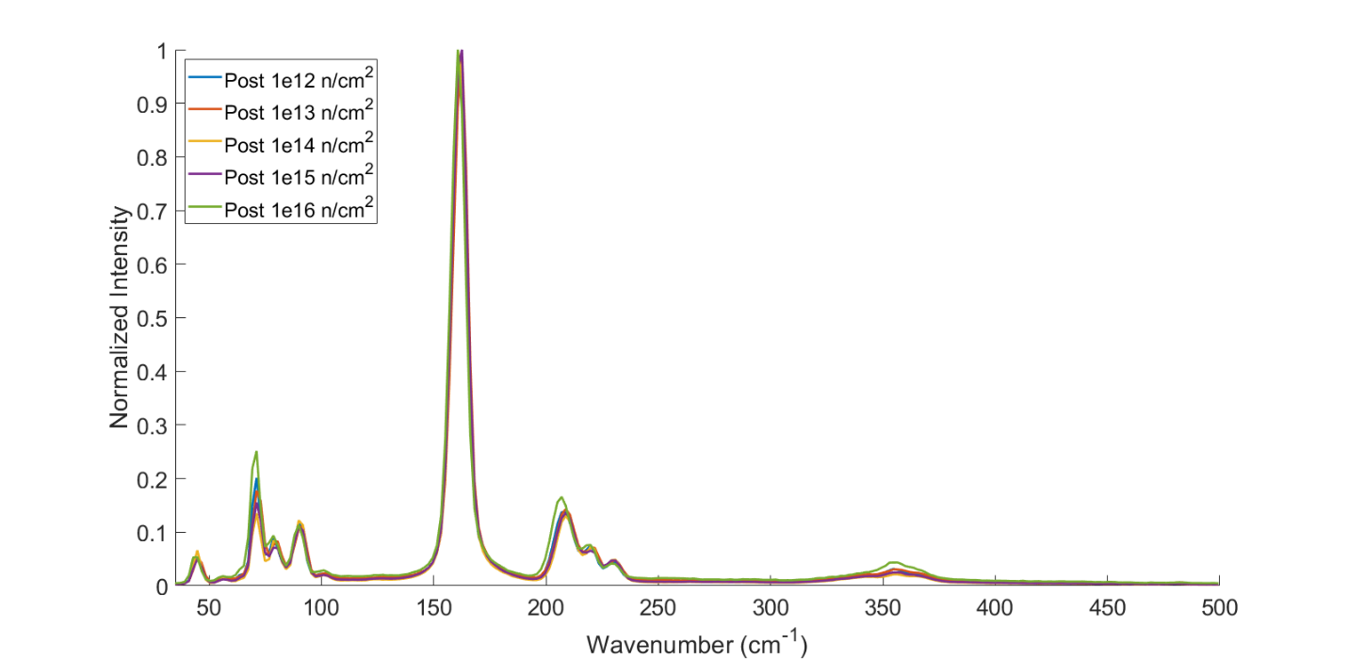
Figure 4.3.2: The Raman spectra for all irradiated LISe samples normalized to their maximum intensity. The measurements were repeated for the 250 – 500 cm⁻¹ range and normalized, shown inset, to better represent the features.

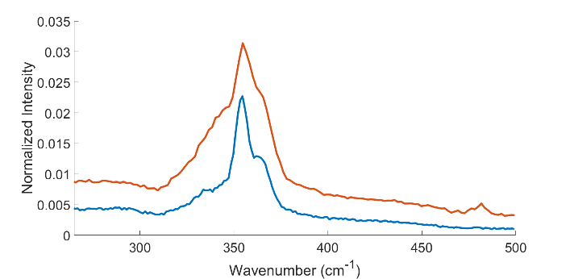
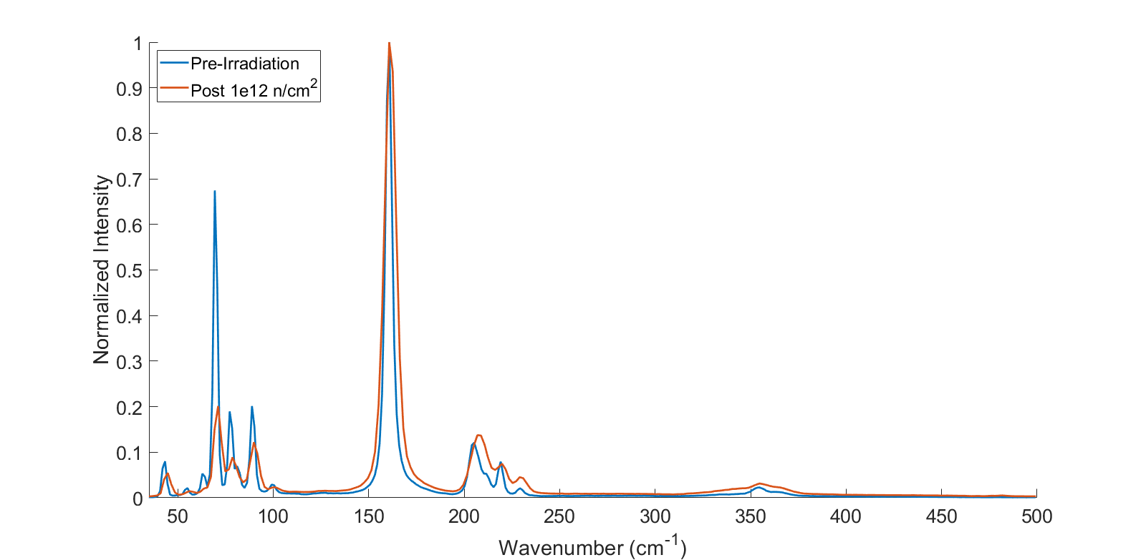
a)
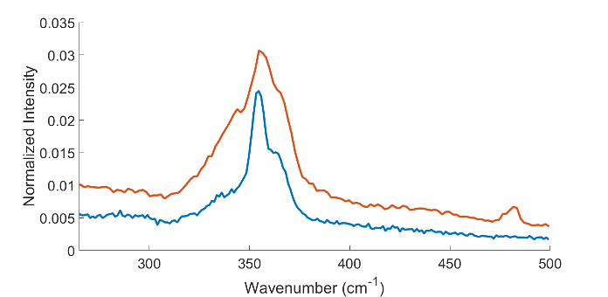
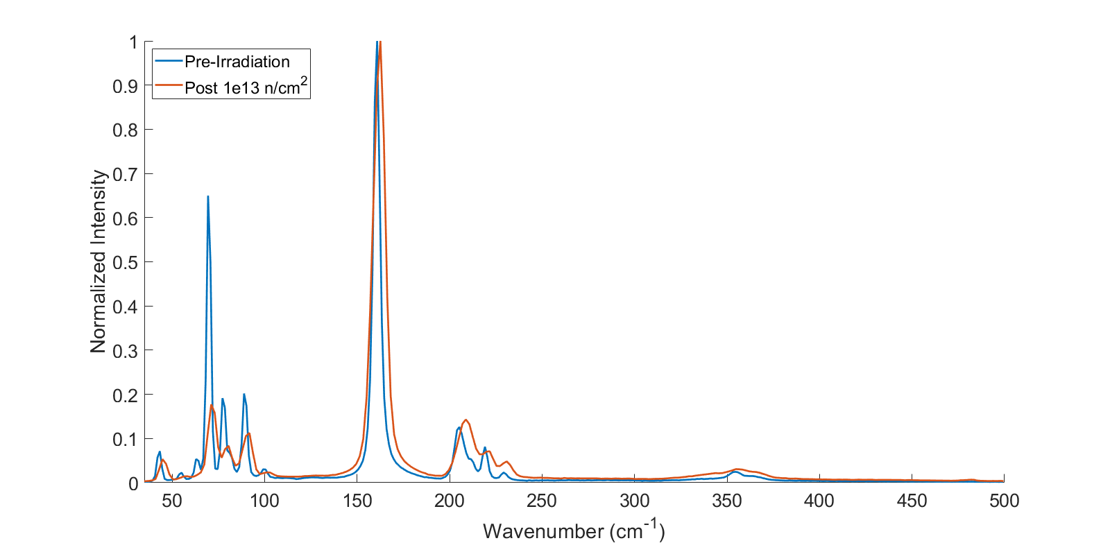
b)
Figure 4.3.3: These show the pre- and post-irradiation Raman spectra for each LISe sample, including an enlarged plot of the Raman spectra in the 250-300 cm⁻¹ to better display the smaller peaks. The pre-irradiation spectra of all samples except the one in Fig. 4.3.3d are similar. The 70 and 79 cm⁻¹ peaks in Fig. 4.3.3d have a significantly smaller amplitude than the other samples pre-irradiation samples, along with less convolution in the peaks in the 300-400 cm⁻¹ range.

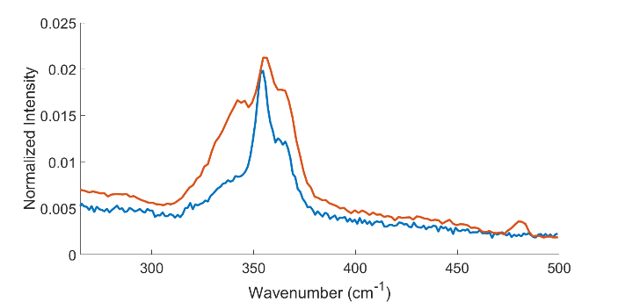
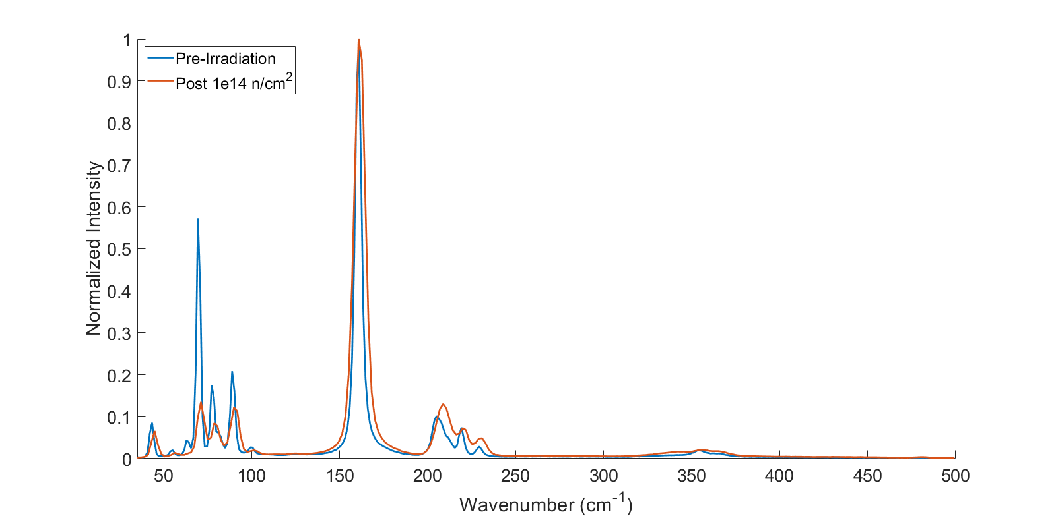
c)
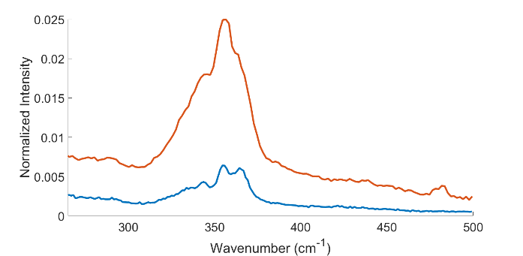
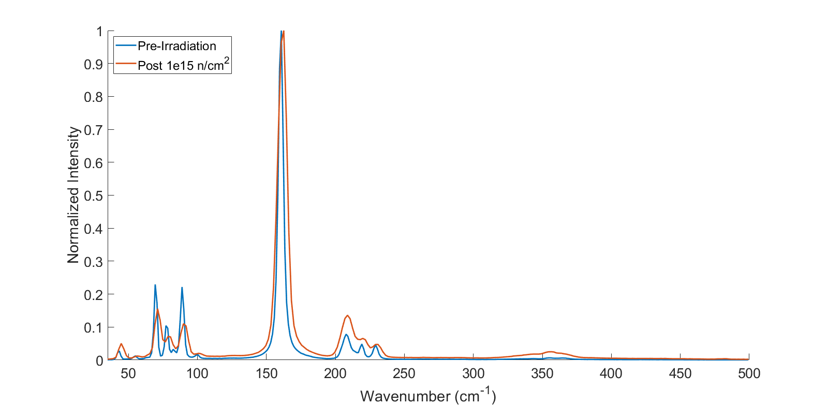
d)
Figure 4.3.3 (continued)

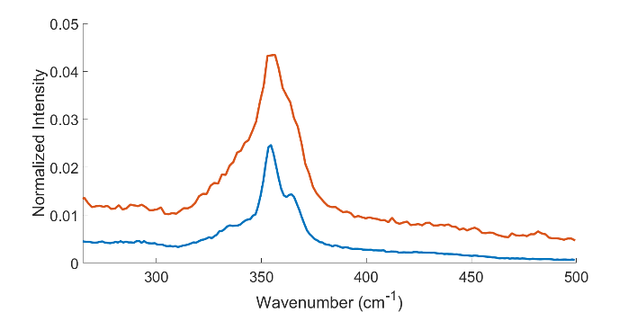
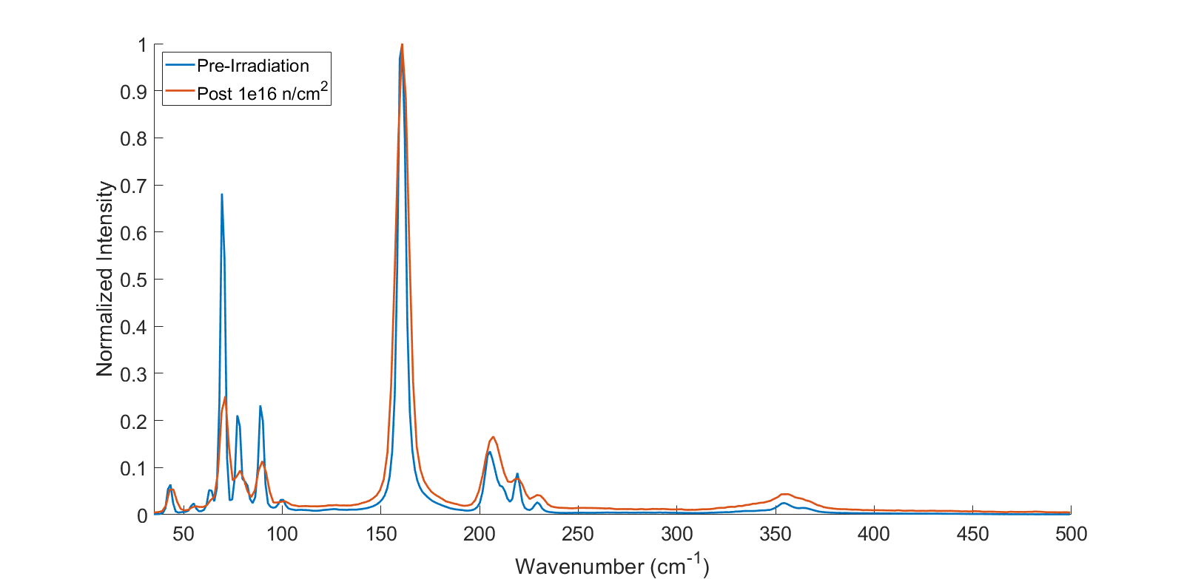
e)
Figure 4.3.3 (continued)

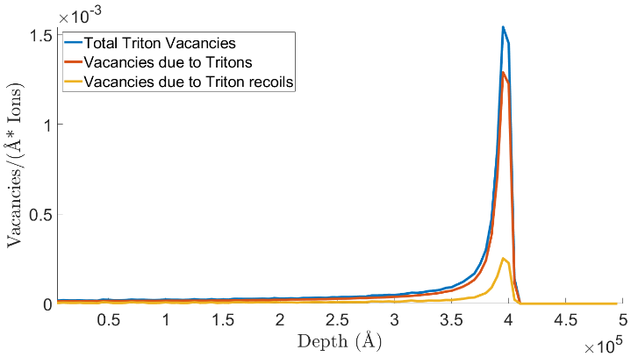
a)
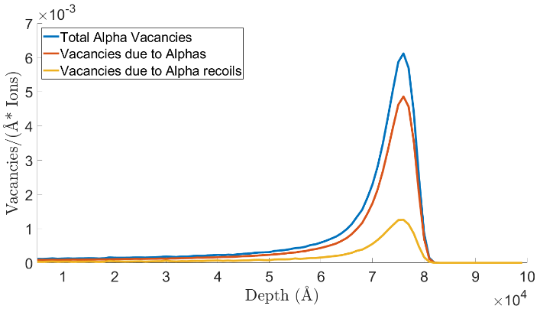
b)
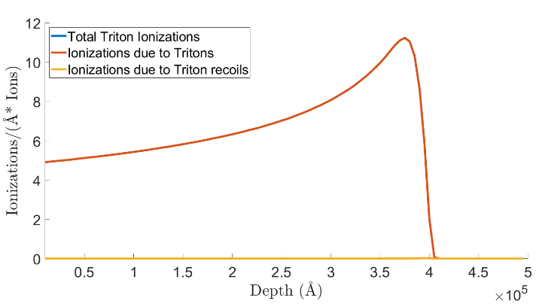
c)
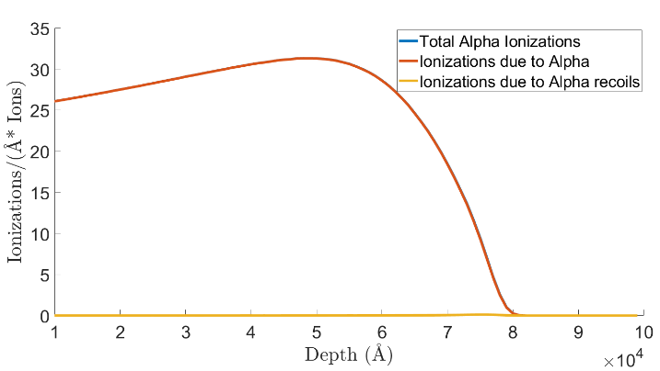
d)
Figure 4.3.4: The plots of the vacancies created by triton and alpha ions in LISe are shown in a) and b) respectively while the ionizations created by them are shown in c) and d) respectively. The ionizations represent more than 99% of both ions’ interactions.

Chapter 5
Radiation Characterization

The radiation response of the LISe samples was measured in a similar way for both gamma-rays and neutrons. The LISe sample was placed inside a metal enclosure to block RF noise and connected to a CREMAT CR-110 pre-amplifier, which was biased using an NHQ 213M high voltage power supply. The output of the pre-amplifier was amplified and shaped by an Ortec 572A bin module using a 2 µs shaping time and various linear amplification factors, which are listed in the corresponding figure. Since the samples’ best collection properties are electrons, the measurements used a positive bias and the Ortec 572A was set to a positive unipolar setting for all tests. The Gamma Vision software was used to record the data and control the collection settings. It should be noted that the conversion gain for all measurements was 1024. These parameters proved to be one of the best combinations for these experiments and were maintained across all response measurements. In order to have comparable results across all the samples, the same 50 Ω impedance BNC cables were used in all cases and the tests took place in the same room, which contained a moderated PuBe neutron source. Also, each measurement, background and radiation response, had a duration of 1 hour.

5.1 Gamma Particle Response

The gamma response of the LISe samples was measured by using a 1.00 µCi Co-60 button test source from Spectrum Techniques. Each sample was set to collect a background spectrum without the source and then a response spectrum with the source present, with the sample placed in the same location. During the latter, the source was positioned directly underneath the sample on its grounded side during each measurement. The resulting spectra for the pre-irradiated LISe samples are shown in Figure 5.1.1.

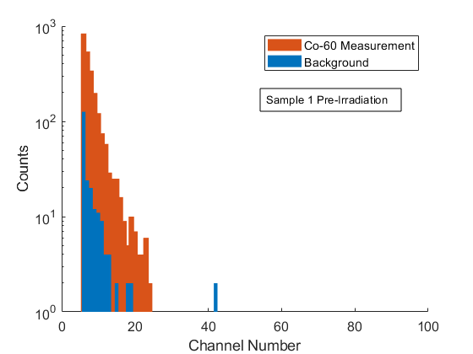  a) | 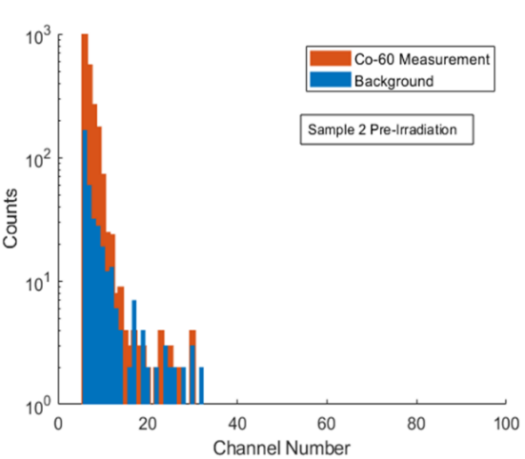  b)
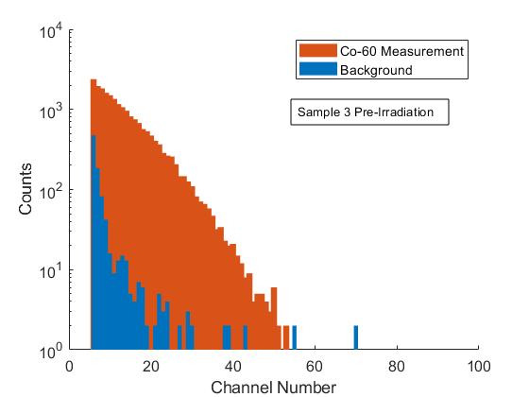  c) | 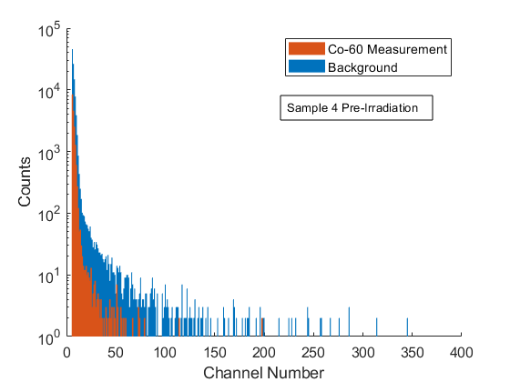  d)
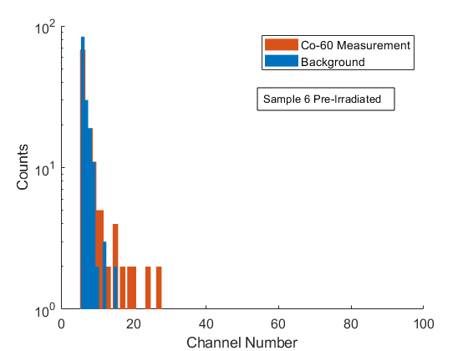
e)
Figure 5.1.1: These spectra show the response that each pre-irradiated LISe sample had to a 1 µCi Co-60 source along with their background for comparison. Each spectrum was collected for 1 hour each. The plots show a) Sample 1, b) Sample 2, c) Sample 3, d) Sample 4, and e) Sample 6. Samples 1 and 3 show the greatest gamma-ray response while Samples 2 and 6’s responses mostly overlap with their background. Sample 4 was not very electronically stable under bias and had a strange response. Below are the bias and gain for each sample:
a) 300V, 200x b) 350V, 200x c) 400V, 200x d) 15V, 100x e) 300V, 200x

Out of the pre-irradiated samples, Sample 3 showed the strongest response to gamma-rays with Sample 1 having much fewer counts above background and the others being concealed by the background. Although the bias voltage on Sample 3 was 100 V higher than that of Sample 1, it does not seem to be the only factor that influenced the better response. Sample 2 had a 350 V bias and Sample 6 had a 300 V but had a much worse gamma response than Sample 1 at 300 V. So, despite being from the same growth, there is significant variation in the response of the samples. This is most clear with Sample 4, which was unstable at higher bias voltages and was measured at 15 V. Specifically, the baseline voltage output by the pre-amplifier showed variation of up to hundreds of millivolts at higher biases. The differences in the stability of the LISe samples are better represented by their IV curves in Figure 5.1.2. The IV sweeps were obtained using a Keithley 6487 picoammeter and the same metal enclosure used in the radiation response measurements.

Due to these differences in properties, the same bias and amplification parameters were used for the samples’ post-irradiation counterpart. The gamma-ray response of those irradiated detectors is shown in Figure 5.1.3. The irradiated Samples 1 and 3 both show a decrease in gamma-ray response compared to their counterparts, with the total number of counts above background and the maximum channel number decreasing significantly. Samples 2 and 6 did not have a significant change in response. The total number of counts in the response spectrum was larger than the background spectrum but there were not more than 10 counts in any channel above background. Sample 4 showed some improved stability since it was able to reach a 40 V bias. It also showed somewhat of an increase in counts above channel 40 but the channels lower than that were lower than the background. This may indicate that the gamma response improved but also that the background itself is not consistent due to some instability. The gamma-ray response data seems to show that even a fluence of 1 × 10¹² neutrons/cm² reduce LISe’s responsiveness. Sample 3 especially shows that even a more sensitive sample can be severely affected by large fluences. Sample 4 is an outlier but the difference between it and the other samples is not clear and requires further investigation.

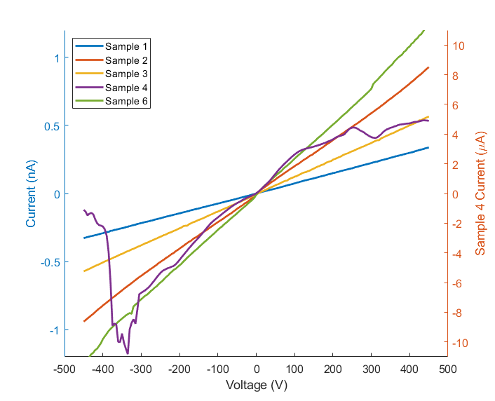
a)
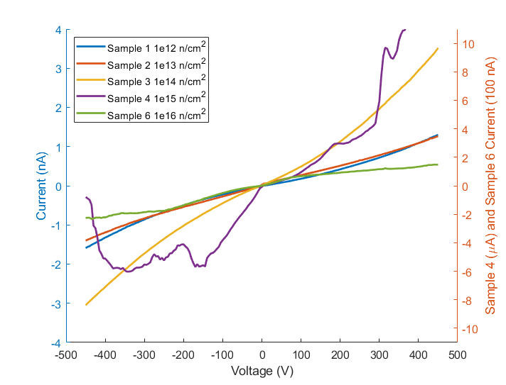
b)
Figure 5.1.2: These plots show the IV curves generated by each sample, both pre-irradiated in 5.1.2a and post-irradiated in 5.1.2b. The pre-irradiated curves were all consistent, despite the irregularity in Sample 4’s curve. Also, since Sample 4 had a much larger range than the others, its current values are represented on the right-hand side of the plot. The post-irradiated curves were also consistent except for Samples 4 and 6 at voltages higher than ±50 V.

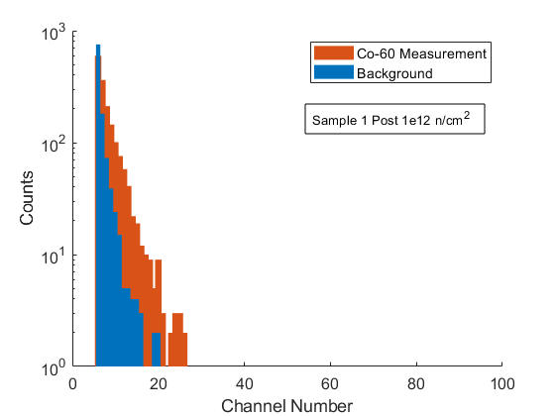  a) | 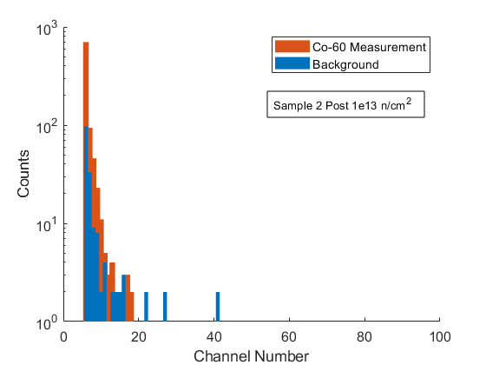  b)
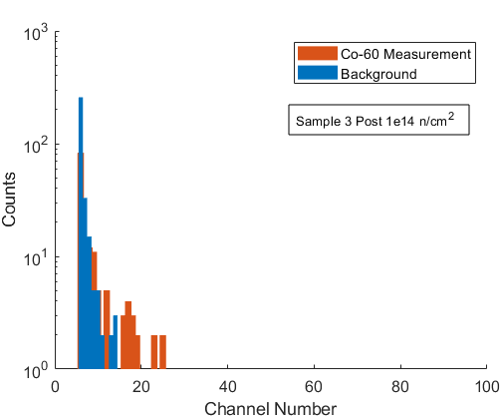  c) | 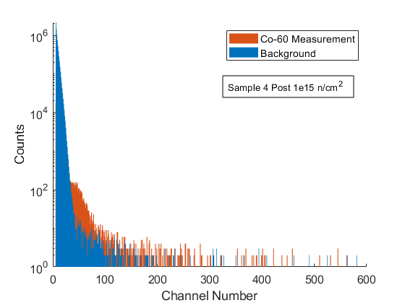  d)
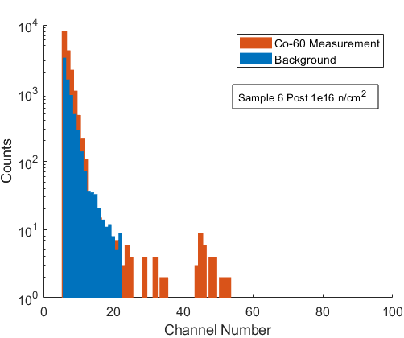
e)
Figure 5.1.3: These spectra show the response that each post-irradiated LISe sample had to a 1 µCi Co-60 source along with their background for comparison. Each spectrum was collected for 1 hour each. The gamma response is much lower in all samples compared to their pre-irradiated counterparts and only Samples 1, 2, and 6 seem to have a significant number of counts above the background. Sample 4 is an outlier and unstable, shown by the varying background, but may have real gamma response above channel 40. Below are the bias and gain for each sample:
a) 300V, 200x b) 350V, 200x c) 400V, 200x d) 40V, 150x e) 25V, 200x

5.2 Neutron Response and Analysis

The neutron response of the LISe samples was measured by using a moderated PuBe source whose spectrum included neutrons and gamma-rays. The source itself is located within a drawer of high density polyethylene (HDPE) and surrounded by several more layers of lead and HDPE. Those moderators are located within a lead safe and the safe is surrounded on all sides with borated polyethylene and paraffin wax. The background collection for all the LISe samples took place within the same room as that shielded source separated by another layer of lead shields and several meters away such that there was little chance of any neutron or gamma-ray being detected. Each neutron spectrum was collected by removing all the borated polyethylene shielding on one side of the safe and placing the enclosed sample less than 3 inches away from safe with the grounded side of the sample facing the PuBe. It is expected that some gamma-rays and neutrons would still get through the shield, despite the extensive shielding placed around the PuBe source, so two of the LISe samples were tested near the source with the shields mentioned above and a layer of cadmium.

All the pre-irradiated LISe samples showed a significant response to neutrons beyond the maximum channel number of the background spectrum. The results are shown in Figure 5.2.1. Sample 1 was also used to take a measurement of the shielded PuBe source, which should mostly be emitting gamma-rays past the moderators, and showed a response similar to that of its Co-60 test source measurement (seen in Section 5.1). The majority of the counts recorded from shielded source were in channels within or close to the background while the unshielded measurement showed many counts spread over a wider range of channels. The difference between the maximum channel number of the Co-60 response and neutron response for all of the other samples is also significant. This difference shows that neutron-gamma discrimination is possible for LISe. Sample 4 is an outlier in these measurements as well since it was able to record counts higher than channel 900. However, it is not clear whether these higher channel counts come from instability or actual sensitivity to neutrons.

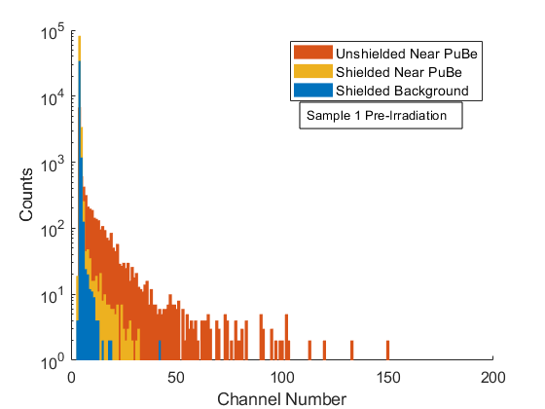  a) | 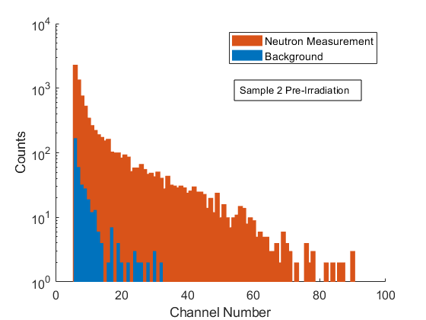  b)
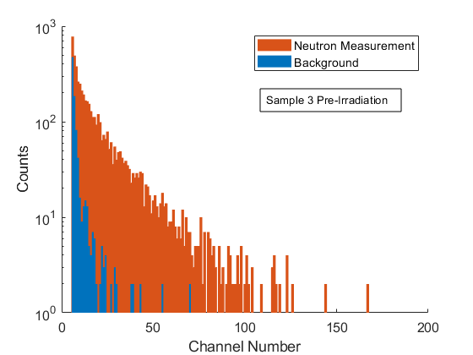  c) | 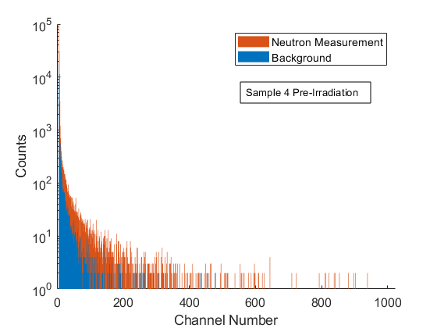  d)
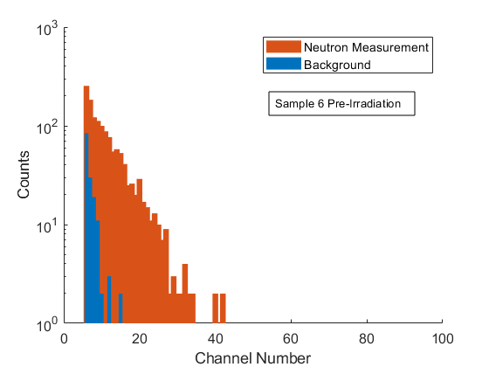
e)
Figure 5.2.1: These spectra show the response that each pre-irradiated LISe sample had to a moderated PuBe source. Each spectrum was collected for 1 hour each. The plots show a) Sample 1, b) Sample 2, c) Sample 3, d) Sample 4, and e) Sample 6. The number of counts recorded for each sample exceeded the background and the maximum channel number exceeded that of the background as well. Sample 1 was also measured near the fully shielded PuBe source with a Cd sheet to block out all neutrons and shows significant gamma response. The response shown here is similar to that of the Co-60 source in Section 5.1. Below are the bias and gain for each sample:
a) 300V, 200x b) 350V, 200x c) 400V, 200x d) 15V, 100x e) 300V, 200x

The same bias voltage and linear amplification settings were used in the irradiated samples’ measurements except in the case of Samples 4 and 6, which are shown in Figure 5.2.2. The neutron response spectra of Samples 1, 2, 3, and 6 all experienced a shift to lower channels after irradiation. Also, the irradiated Sample 6 became unstable in a manner similar to Sample 4 at higher bias voltages so it was measured under 25 V. The amount the first three samples shifted does not seem directly correlated to the fluence they received since the differences between them are too small, in terms of counts above background and maximum channel number. The exceptions were in Samples 4 and 6, where the former increased in counts and maximum channel number and the latter’s measured spectra are all within the first 20 channels. Although Sample 4’s response appears to be noise or instability, repeated shorter measurements showed consistent response. The reason why the neutron fluence improved its response while it only reduced it for the other samples is not clear. The neutron response in Sample 6 decreases in terms of maximum channel number but the total number of counts above background appears to increase by several orders of magnitude for both the shielded and unshielded PuBe tests. It should be noted that the neutron spectrum is larger than the gamma one in both criteria mentioned above.

Overall, it appears that the standard effect of large neutron fluences on LISe is a general degradation of charge collection properties. In samples excluding number 4, both gamma-ray and neutron response decreased after irradiation but only became difficult to separate, based on channel number, at 1 × 10¹⁶ neutrons/cm². Sample 4’s stability appears to be its main issue since it is difficult to analyze without more samples that behave similar to it and is otherwise an outlier within the growth. Based on these samples alone, LISe appears to still have a useful response to neutrons up through 1 × 10¹⁴ neutrons/cm². However, due to the variation in responses between these samples, it is likely the useful lifetime of any sample will vary significantly based on its as-grown electronic properties.

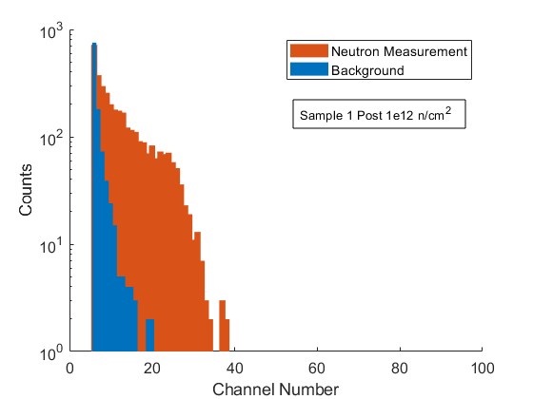  a) | 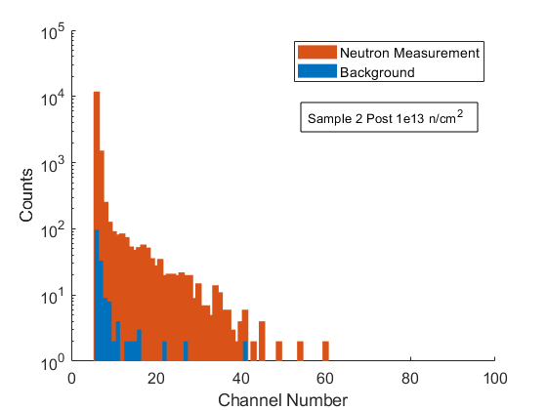  b)
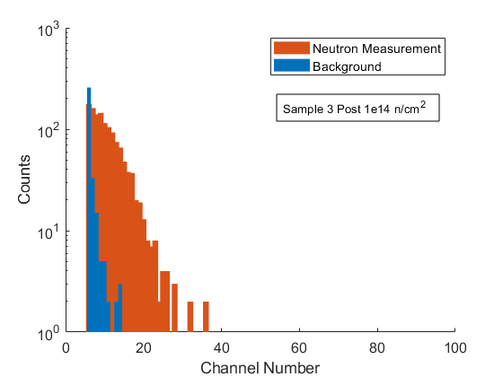  c) | 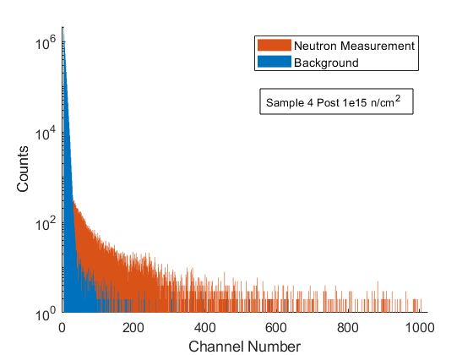  d)
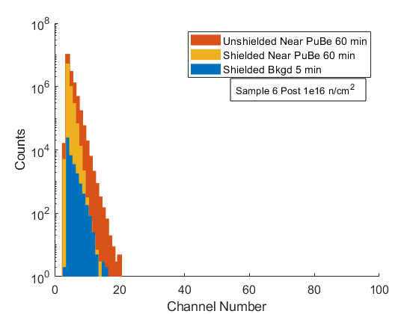
e)
Figure 5.2.2: These spectra show the response that each post-irradiated LISe sample had to a moderated PuBe source. Each spectrum was collected for 1 hour each. The plots show a) Sample 1, b) Sample 2, c) Sample 3, d) Sample 4, and e) Sample 6. The number of counts recorded for each sample has decreased compared to the pre-irradiation measurements and their maximum channel number has lowered except for Sample 4. Sample 6 was also measured near the fully shielded PuBe source with a Cd sheet to block out all neutrons and shows some gamma response, though it is in the channel range of the background. Sample 4 is the only one that might have become more sensitive to neutrons and more stable after irradiation. Below are the bias and gain for each sample:
a) 300V, 200x b) 350V, 200x c) 400V, 200x d) 40V, 150x e) 25V, 200x

Chapter 6
Conclusions and Future Work
A wide range of optical-electrical and radiation experiments have been completed for a group of LISe samples in order to better understand the effects of neutron irradiation. The UV-Vis and FTIR measurements showed that a major change in optical properties occurred at a fluence of 1 × 10¹⁶ neutrons/cm² but lower fluences did not cause dramatic changes compared to their pre-irradiated state. The sample dosed with that amount of radiation also experienced a visually noticeable change to a deep red color, though it is not known whether this change extends throughout the bulk of the sample. Radioluminescence experiments showed that three X-ray luminescent centers are possible in pre-irradiated LISe: 410 nm, 517 nm, and 630 nm. The former center is not found in irradiated samples and the latter two decrease in intensity at high enough fluence, disappearing entirely after 1 × 10¹⁶ n/cm². All the energies scintillated likely correspond to a DAP but the 410 nm trap state had only been suspected to exist and had not been detected before. The PL spectrum of the highly irradiated sample showed 430 nm and 460 nm peaks which were not identified in the spectra of as-grown yellow or red LISe samples. However, the former seemed to appear as a low intensity wide peak. The change in relative intensities, possibly due to neutron irradiation, shows that an irradiated sample could have significantly different luminescent trap states from the as-grown LISe. The TRPL measurements conducted for the same sample show that the minority carrier lifetime is likely approximately 1.2 ns for all of the detected PL peaks, not accounting for possible contributions from the measuring instrument. Raman shift measurements of all the samples showed that all neutron irradiation fluences changed the relative ratio of Li-Se vibrational modes to the A₁ symmetry peak, indicating a significant change in lithium-selenide bonds. The Raman spectra of the post-irradiated samples seem to be similar. This makes Sample 4 an oddity because its Li-Se vibrational modes were less intense than those of all the other pre-irradiated samples yet it changed to nearly the same spectrum after receiving its neutron dose. The samples’ Raman peaks also widened after exposure, which indicates that their crystal structure had changed, likely due to the loss of many lithium atoms to neutron absorption and formation of vacancies from the resulting triton and alpha collisions. Sample 4 continued to have outlier behavior in radiation response experiments but more testing with other LISe samples with Raman spectra similar to it in order to understand where these differences come from. Radiation response measurements showed that LISe is able to detect gamma-rays, though not consistent across all samples and not sufficiently to produce identifiable peaks in a spectrum. After any neutron fluence of 1 × 10¹² n/cm² or above, gamma response was barely above background if at all detectable. The neutron response was much better for the pre-irradiated samples but also decreased for all applied fluences, becoming nearly undetectable at 1 × 10¹⁶ n/cm². The similar decrease in both gamma and neutron response indicates that neutron irradiation damages the charge collection properties of the samples overall, causing the poorer performance. Despite that, neutron response appears to be well above background and the gamma spectrum for at least 1 × 10¹⁴ n/cm². The as-grown properties of the LISe samples, which vary significantly within the same growth, still have a large effect on the actual lifetime of the detector in a high flux environment.

Further work is still required to verify the results found in this body of work with certainty. Ideally, a larger set of samples from various growths of LISe should undergo various neutron irradiation fluences, keeping some for pre-irradiation testing, and repeat radiation response measurements. A few optical-electrical experiments should be used to better inform the differences between the growths and within growths, the most helpful of which would likely be Raman shift, radioluminescence, and PL measurements. Identifying the optimal growth conditions to improve the charge collection properties of LISe will likely also correspond to longer operational lifetime.

                - References

1. Tremsin, A. and J. Vallerga, Unique capabilities and applications of Microchannel Plate (MCP) detectors with Medipix/Timepix readout. Radiation Measurements, 2020. 130: p. 106228.
2. Herrera, E.H., Neutron Detection and Imaging Development of Lithium Indium Diselenide for Applications in Solid-State Devices. 2018.
3. Neamen, D.A., Semiconductor physics and devices. 1992.
4. Yacobi, B. and D. Holt, Luminescence Phenomena, in Cathodoluminescence Microscopy of Inorganic Solids. 1990, Springer. p. 21-54.
5. Siegmund, O., et al., Large area event counting detectors with high spatial and temporal resolution. Journal of Instrumentation, 2014. 9(04): p. C04002.
6. Tremsin, A., et al., Detection efficiency, spatial and timing resolution of thermal and cold neutron counting MCP detectors. Nuclear Instruments and Methods in Physics Research Section A: Accelerators, Spectrometers, Detectors and Associated Equipment, 2009. 604(1-2): p. 140-143.
7. Spieler, H., Semiconductor detector systems. Vol. 12. 2005: Oxford university press.
8. Isaenko, L., et al., LiInSe 2: A biaxial ternary chalcogenide crystal for nonlinear optical applications in the midinfrared. Journal of Applied Physics, 2002. 91(12): p. 9475-9480.
9. Isaenko, L., et al., Characterization of LiInS2 and LiInSe2 single crystals for nonlinear optical applications. MRS Online Proceedings Library (OPL), 2001. 692.
10. Kamijoh, T., T. Nozaki, and K. Kuriyama, A photoluminescence study on lithium ternary compounds. Il Nuovo Cimento D, 1983. 2(6): p. 2029-2033.
11. Negran, T., H. Kasper, and A. Glass, Pyroelectric and electrooptic effects in LiInS2 and LiInSe2. Materials Research Bulletin, 1973. 8(6): p. 743-748.
12. Kong, F., et al., Density functional theory calculations insight to the effect of anion on the nonlinear optical properties of LiInX 2 (X= S, Se). Journal of molecular modeling, 2014. 20(12): p. 1-8.
13. Eifler, A., et al., Band gap energies and lattice vibrations of the lithium ternary compounds LiInSe2, LiInS2, LiGaSe2 and LiGaS2. Japanese Journal of Applied Physics, 2000. 39(S1): p. 279.
14. Weise, S. and V. Krämer, Phase study of the system Li2Se-In2Se3. Journal of thermal analysis and calorimetry, 2003. 71(3): p. 1035-1038.
15. Zondy, J.-J., et al., LiInSe 2 nanosecond optical parametric oscillator. Optics letters, 2005. 30(18): p. 2460-2462.
16. Kamijoh, T., T. Nozaki, and K. Kuriyama, Dielectric constants and bond parameters of LiInSe2 and LiGaSe2. Journal of Applied Physics, 1982. 53(1): p. 761-763.
17. Cui, Y., et al., Defects in 6LiInSe2 neutron detector investigated by photo-induced current transient spectroscopy and photoluminescence. Applied Physics Letters, 2013. 103(9): p. 092104.
18. Tupitsyn, E., et al., Single crystal of LiInSe2 semiconductor for neutron detector. Applied Physics Letters, 2012. 101(20): p. 202101.
19. Tupitsyn, E., et al., Lithium containing chalcogenide single crystals for neutron detection. Journal of crystal growth, 2014. 393: p. 23-27.
20. Bell, Z.W., et al. Neutron detection with LiInSe2. in Hard X-Ray, Gamma-Ray, and Neutron Detector Physics XVII. 2015. International Society for Optics and Photonics.
21. Herrera, E., et al., Neutron imaging with timepix coupled lithium indium diselenide. Journal of Imaging, 2018. 4(1): p. 10.
22. Hamm, D.S., et al., Semiconducting lithium indium diselenide: Charge-carrier properties and the impacts of high flux thermal neutron irradiation. Applied Physics Letters, 2018. 112(24): p. 242104.
23. Kamijoh, T. and K. Kuriyama, Annealing effects on electrical properties of LiInSe2. Journal of Applied Physics, 1981. 52(2): p. 1102-1103.
24. Hamm, D.S., Development and Characterization of Lithium Indium Diselenide for Neutron Detection and Imaging Applications. 2018.
25. Wiggins, B., et al., Scintillation properties of semiconducting 6LiInSe2 crystals to ionizing radiation. Nuclear Instruments and Methods in Physics Research Section A: Accelerators, Spectrometers, Detectors and Associated Equipment, 2015. 801: p. 73-77.
26. Egner, J.C., et al., Integration of a 6 LilnSe 2 thermal neutron detector into a CubeSat instrument. Journal of Astronomical Telescopes, Instruments, and Systems, 2016. 2(4): p. 046001.
27. Lukosi, E., et al., Intrinsic lithium indium diselenide: Scintillation properties and defect states. Journal of Luminescence, 2019. 205: p. 346-350.
28. Heijne, E.H., History and future of radiation imaging with single quantum processing pixel detectors. Radiation Measurements, 2021. 140: p. 106436.
29. Collaboration, M., et al., The timepix3 chip. tech. rep., 2014. https://indico. cern. ch/event/267425/attachments/477859 ….
30. Vähäkangas, J., et al., The Nordic Electronics Packaging Guideline. Internet: http://extra. ivf. se/ngl/B-Flip-Chip/ChapterB. htm, 2000.
31. Makuła, P., M. Pacia, and W. Macyk, How to correctly determine the band gap energy of modified semiconductor photocatalysts based on UV–Vis spectra. 2018, ACS Publications.
32. López, R. and R. Gómez, Band-gap energy estimation from diffuse reflectance measurements on sol–gel and commercial TiO 2: a comparative study. Journal of sol-gel science and technology, 2012. 61(1): p. 1-7.
33. Ghobadi, N., Band gap determination using absorption spectrum fitting procedure. International Nano Letters, 2013. 3(1): p. 1-4.
34. Mirabella, F.M., Modern techniques in applied molecular spectroscopy. Vol. 14. 1998: John Wiley & Sons.
35. Badikov, V., et al., Optical properties of lithium indium selenide. Optical Materials, 2003. 23(3-4): p. 575-581.
36. Ma, T., et al., Preparation and optical properties of LiInSe2 crystals. Journal of Crystal growth, 2016. 448: p. 122-127.
37. Wojtowicz, A.J., et al., Radioluminescence and recombination processes in BaF2: Ce. Journal of Physics: Condensed Matter, 2000. 12(17): p. 4097.
38. Klein, J.S., C. Sun, and G. Pratx, Radioluminescence in biomedicine: physics, applications, and models. Physics in Medicine & Biology, 2019. 64(4): p. 04TR01.
39. Metzger, W., et al., Time-resolved photoluminescence studies of CdTe solar cells. Journal of Applied Physics, 2003. 94(5): p. 3549-3555.
40. Johnston, S., et al., Simultaneous measurement of minority-carrier lifetime in single-crystal CdTe using three transient decay techniques. IEEE Journal of Photovoltaics, 2014. 4(5): p. 1295-1300.
41. Pustovarov, V., et al., Time-resolved photoluminescence of LaBr 3: Ce scintillation crystals under ultrasoft X-ray excitation. Technical Physics Letters, 2012. 38(9): p. 784-788.
42. Zondy, J.-J., et al., Orthorhombic crystals of lithium thioindate and selenoindate for nonlinear optics in the mid-IR, in Mid-Infrared Coherent Sources and Applications. 2008, Springer. p. 67-104.
43. Lorenz, B., High pressure Raman investigation of LiInSe2 in the β-NaFeO2 structure. Journal of Physics and Chemistry of Solids, 1997. 58(3): p. 399-402.
44. Stoller, R.E., et al., On the use of SRIM for computing radiation damage exposure. Nuclear instruments and methods in physics research section B: beam interactions with materials and atoms, 2013. 310: p. 75-80.

                - Appendices

Appendix A
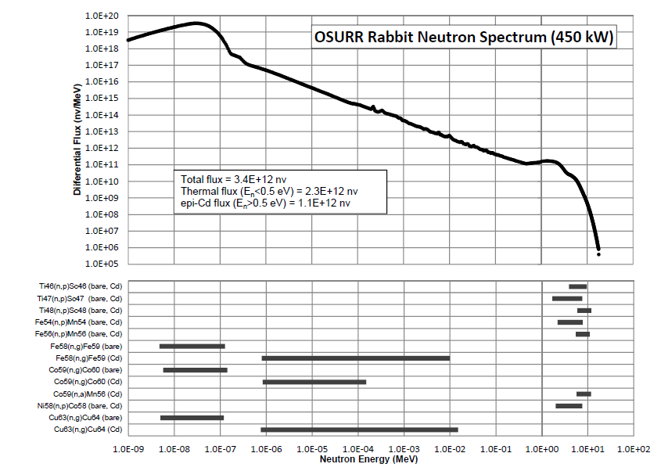
a)
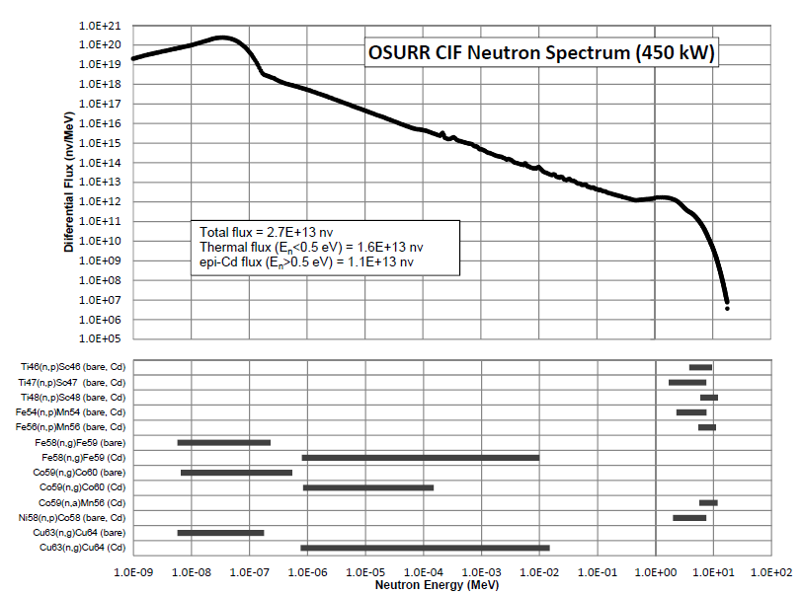
b)
Figure A.1: The plots shown here are the neutron spectra at Ohio State University’s Rabbit (a) and CIF (b) irradiation facilities. Samples 1-4 were irradiated at the former while Sample 6 was irradiated at the latter.

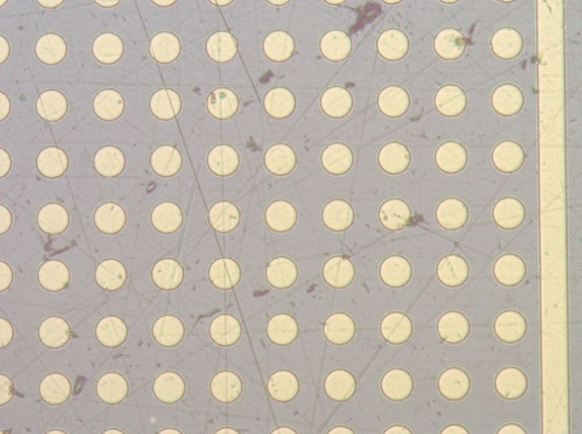
Figure A.2: This image shows how a sputtered gold electrode pattern looks on a LISe sample. The guard ring is visible on the right as in Figure 4.1.2a.

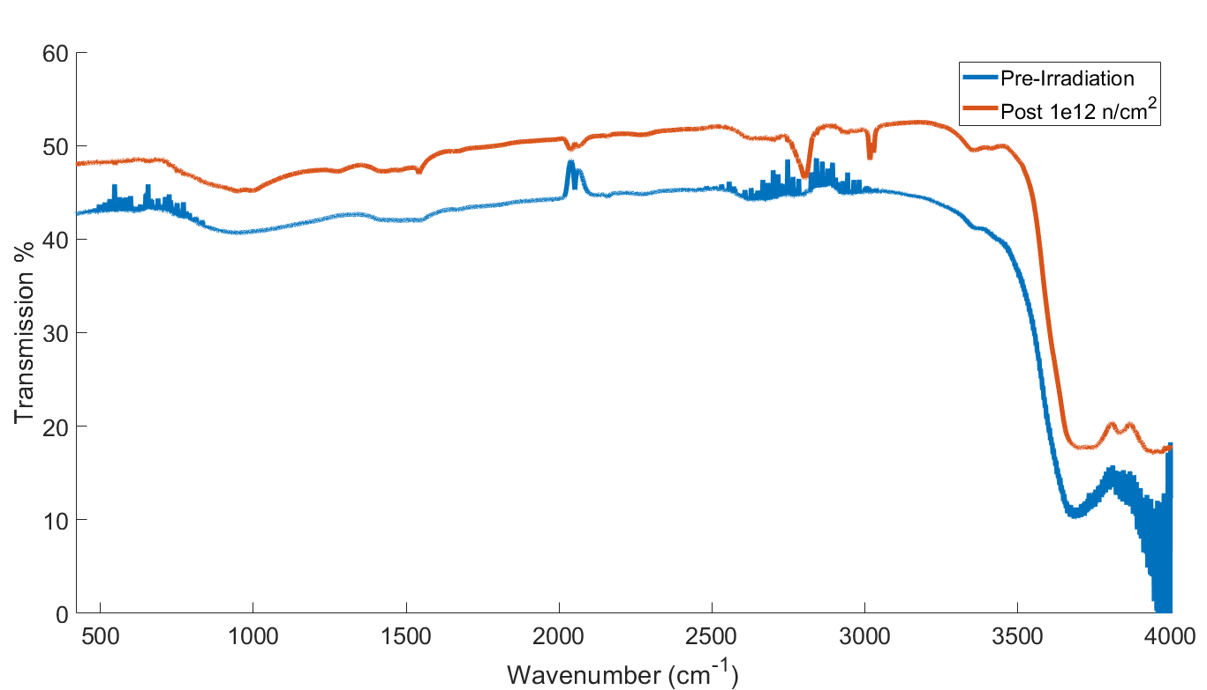
a)
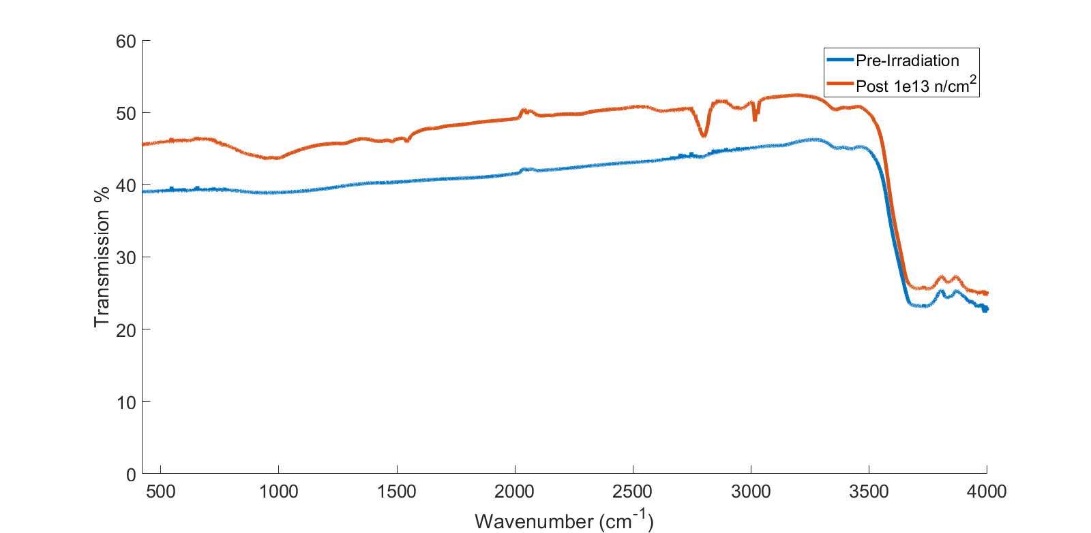
b)
Figure A.3: These plots show the FTIR spectra of the LISe samples before and after irradiation. A common feature in these spectra are the shoulder in the 3200-3600 cm⁻¹ range, which only significantly changes at 1 × 10¹⁶ neutrons/cm² fluence. The two peaks in the 3700-4000 cm⁻¹ are always present and may be IR active vibrational modes or defects.

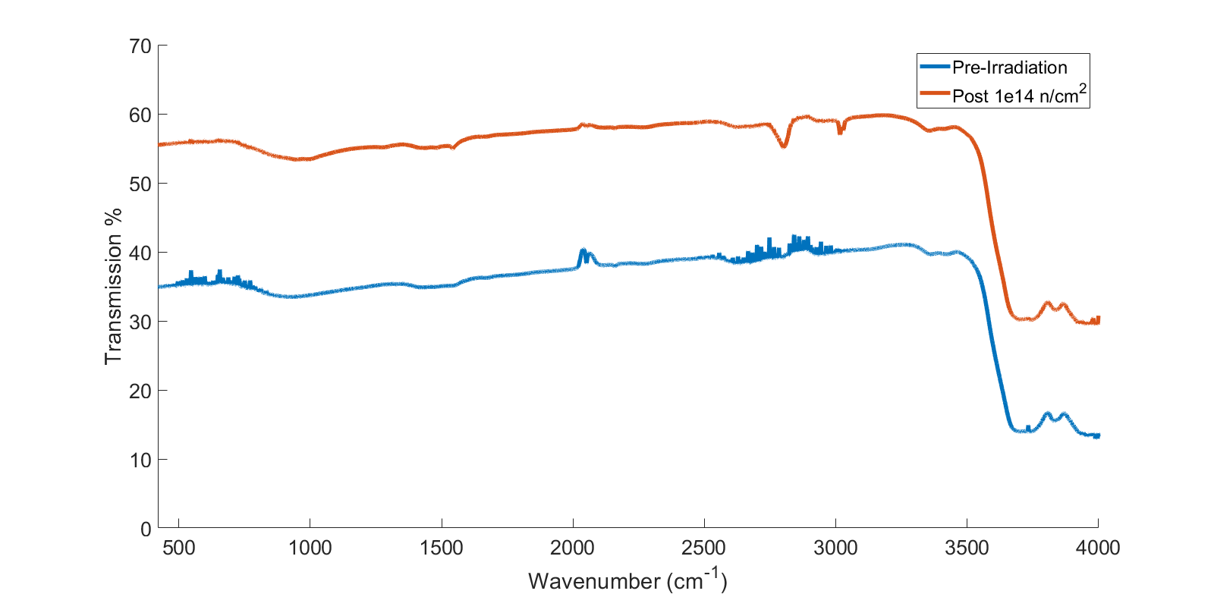
c)
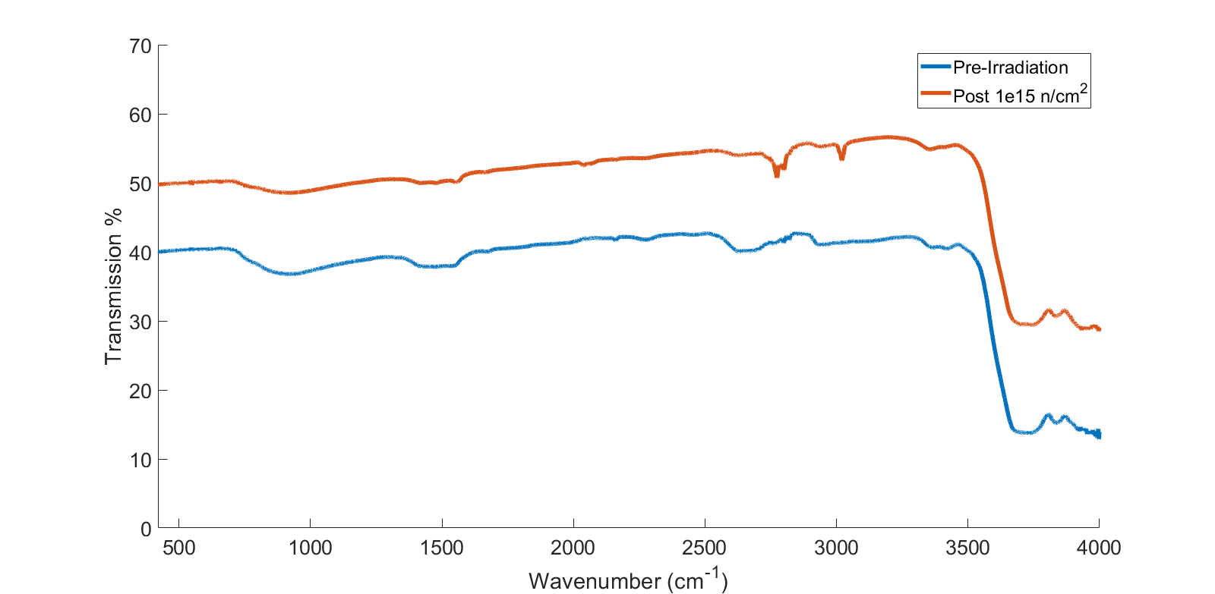
d)
Figure A.3 (continued)

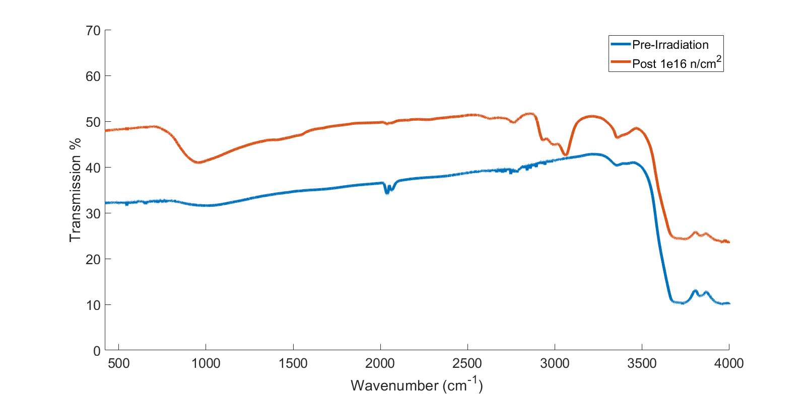
e)
Figure A.3 (continued)

a)
b)
Figure A.4: These plots show the FTIR spectra of the LISe samples before and after irradiation. A common feature in these spectra are the shoulder in the 3200-3600 cm⁻¹ range, which only significantly changes at 1 × 10¹⁶ neutrons/cm² fluence. The two peaks in the 3700-4000 cm⁻¹ are always present and may be IR active vibrational modes or defects.

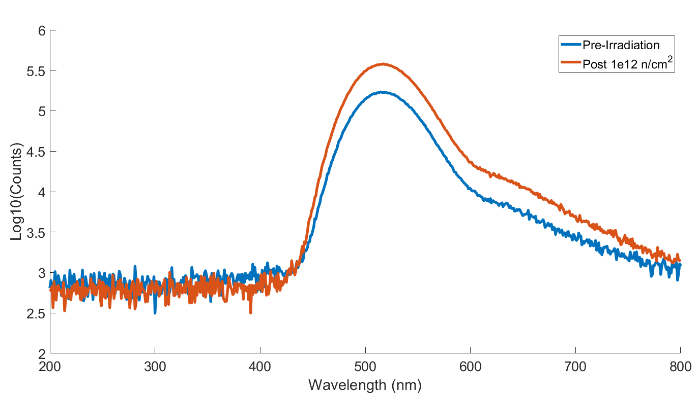
a)
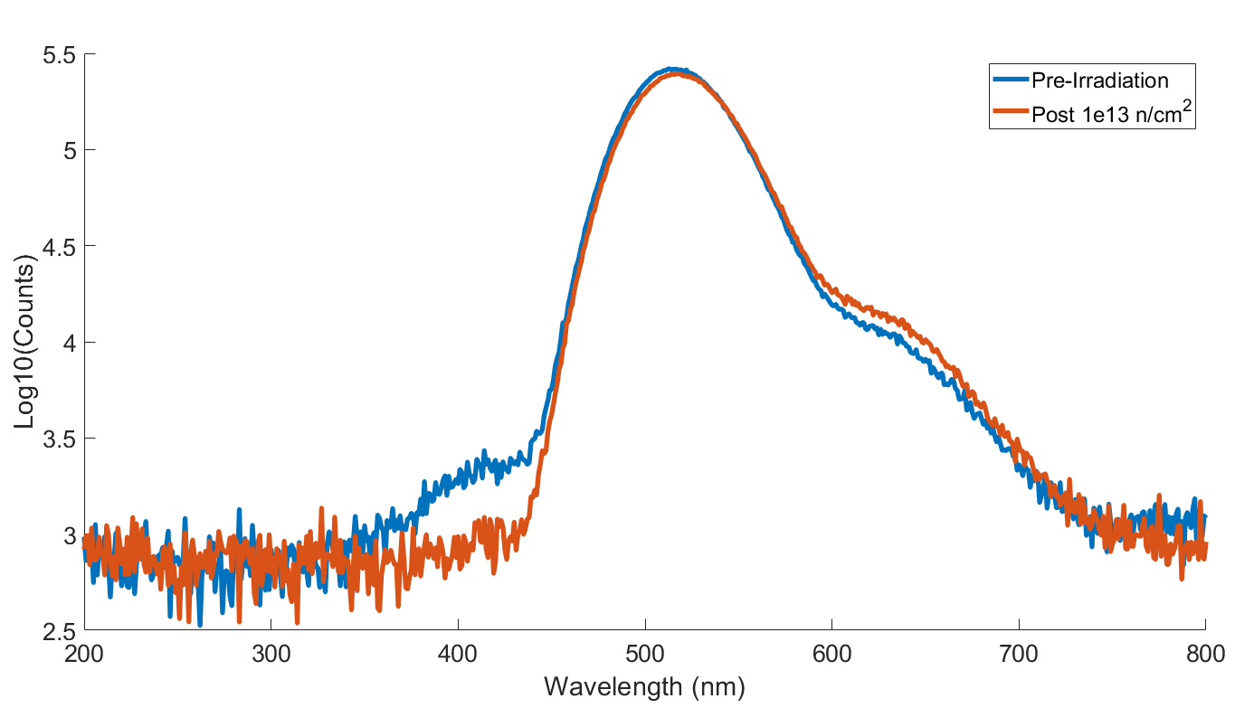
b)
Figure A.5: These plots show the x-ray luminescence spectra for the LISe samples before and after neutron irradiation. All pre-irradiated samples share luminescent peaks at 517 nm and an overlapping peak likely centered around 630 nm, green and red respectively. Two of the five samples also showed a much smaller but distinct blue peak at 410 nm. The two highest irradiated samples, Sample 4 and Sample 6 in A.5d and A.5e respectively, show a drop in green luminescence where the latter almost completely loses the red luminescence, too.

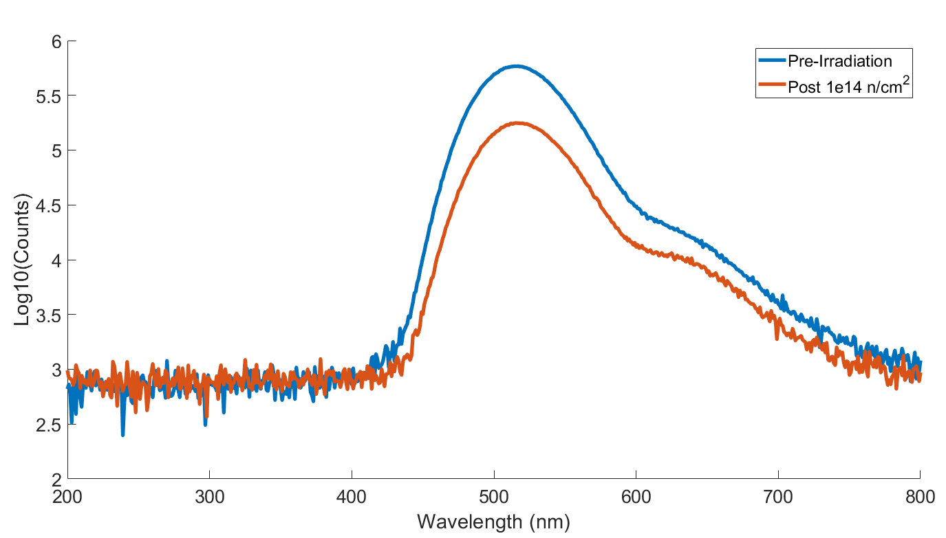
c)
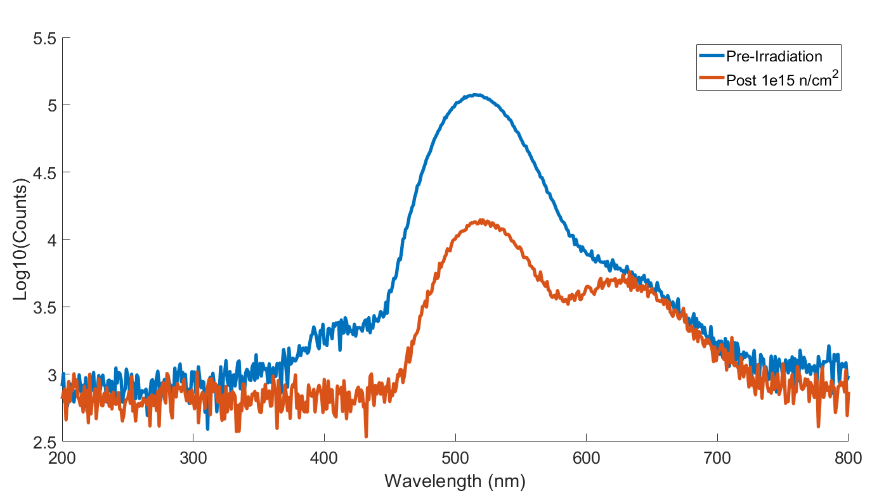
d)
Figure A.5 (continued)

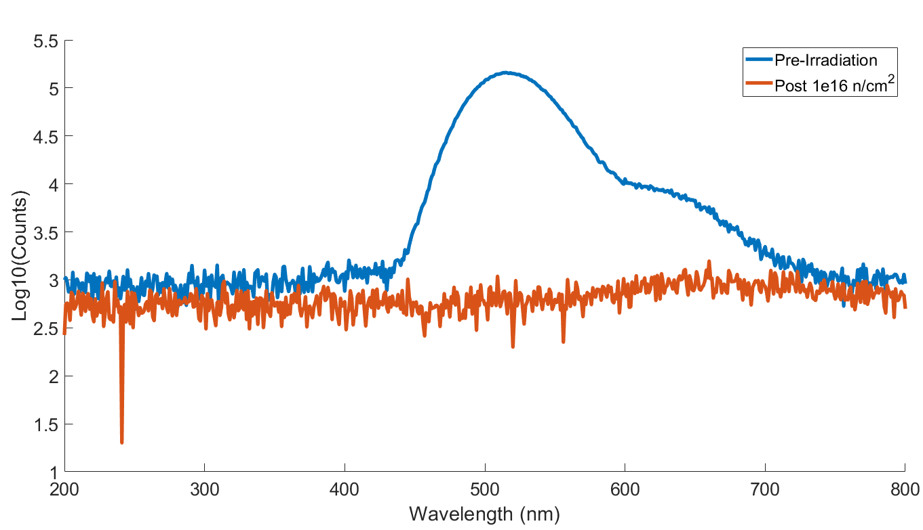
e)
Figure A.5 (continued)

Appendix B
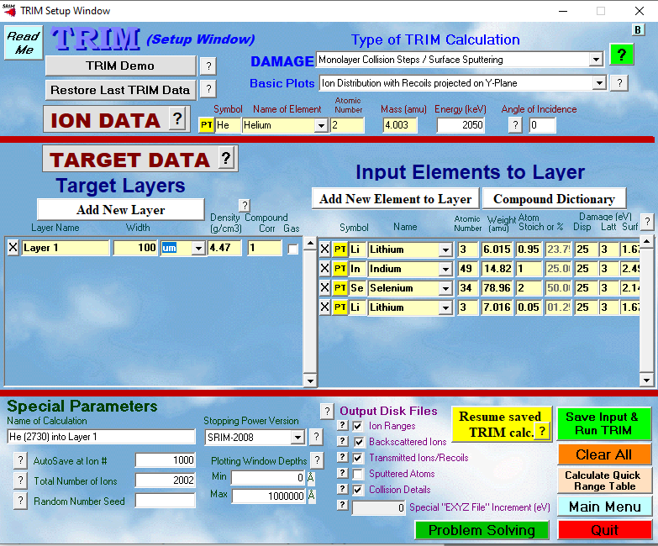
a)
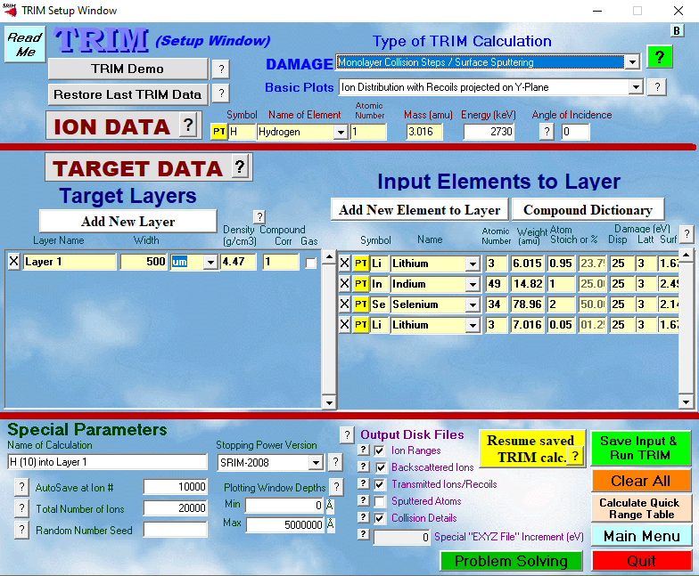
b)
Figure B.1: These images show the input values used to simulate the interactions of the alpha (a) and triton (b) particles produced by a ⁶Li neutron absorption reaction in a LISe sample. The program used for the simulation is TRIM. Although the actual simulation parameters or program may not be accurate, they are helpful for considering what type of interactions may happen during neutron irradiation.

VITA
Robert Michael Golduber was born and raised in Brooklyn, NY. He graduated from Brooklyn Technical High School. He went to Ann Arbor, MI where he graduated with a Bachelor’s in Nuclear Engineering from the University of Michigan in 2019. He also assisted with research under Dr. Kimberlee Kearfott. During his time at the University of Michigan, he interned at the Michigan Hospital, TerraPower, and the Naval Nuclear Laboratory. He moved to Knoxville, TN to obtain a Master’s Degree in Nuclear Engineering from the University of Tennessee working under Dr. Eric Lukosi. He graduated with his degree in Fall 2021.

