Plants and People: Foraging to Farming Foodway Transition from Late Archaic to Early Woodland in Western North Carolina, U.S.A.

A Thesis Presented for the
Master of Arts
Degree
The University of Tennessee, Knoxville

Catherine L. Herring
August 2022

Copyright © 2022 by Catherine Linn Herring
All rights reserved.

ACKNOWLEDGEMENTS
I would like to thank Tasha Benyshek from TRC and Courtney Page from the North Carolina Office State of Archaeology (NCOSA) for their assistance. Thanks also to the Eastern Band of Cherokee Indians and United Keetoowah Band for their communication and time. As this project was completed on your ancestral land, your approval of this research is extremely important to me. Your footprint should never be forgotten, and you deserve the utmost respect when studying your ancestors and their environment.
I am so grateful for the support of so many other wonderful individuals. My adviser, Dr. Kandace Hollenbach, always encourages my ideas and offers help whenever needed. I am a much better writer, thanks to your guidance. Thank you to both Dr. David Anderson and Dr. Sally Horn for their comments and support as my thesis committee members. Thanks to peers Katherine, Jordan, Elizabeth, and Nate for amazing conversation to push ideas forward and help create a more well-rounded theoretical background. Thank you for your challenges, whether you realized you were setting them. James, your editing skills are paramount to my success, and your laughter keeps me alive. Also, I appreciate my family, who are continuously supportive.

ABSTRACT
During the Late Archaic to Early Woodland transition, circa 3,200 years B.P. [before present], some gathering communities in the Eastern Woodlands began to increase their cultivation of plants. While archaeologists have located several sites in the Upper Tennessee River Valley and near the Great Smoky Mountains National Park in Tennessee that explicitly show an increase in plant cultivation, less research has focused on the North Carolina Appalachian Summit Region. This paper uses paleoethnobotanical data and spatial analysis of site locations to explore cultivation and settlement patterns during the Late Archaic/Early Woodland transition in Jackson and Swain Counties, North Carolina. I use site locational data obtained from the North Carolina Office of State Archaeology to spatially analyze the preference of site locations from 149 Late Archaic and 66 Early Woodland sites. I combine this with my analysis of paleoethnobotanical remains from one Late Archaic site (31JK291) in Jackson County and an Early Woodland site (31SW596) in Swain County, in addition to plant data from previously analyzed sites. Focusing on plant cultivation as a means of change highlights this predominately female economic and social activity, giving insight into the transfer of knowledge and cultural shifts within foodways. This research provides more evidence to better understand the possible motivations and results of the cultural changes from the Late Archaic to Early Woodland periods in the Appalachian Summit by looking through the lens of both landscapes and human-plant relationships.

Table of Contents
Chapter One Introduction 1
Chapter Two Background 6
Ecological Setting 6
Cultural Setting 9
Late Archaic (5,800-3,200 cal BP) 9
Early Woodland (3,200-2,100 cal BP) 9
Project Sites 12
Site 31JK291, Magic Waters 13
Site 31SW596, CES Site 14
Previous Paleoethnobotanical Research 15
Relevant Paleoethnobotany in North Carolina Appalachian Summit 15
Relevant Paleoethnobotany in Eastern Tennessee 21
Chapter Three Theoretical Perspective: Plants and the Place Beyond Western Thought 33
Chapter Four Paleoethnobotany 42
Introduction 42
Methods 42
Results 43
Nuts. 45
Fruits 52
Cultigens/Edible Seeds 52
Miscellaneous 52
Discussion 54
Comparison to Other Appalachian Summit Sites 56
Eastern Tennessee Comparison 57
Chapter Five Geospatial Analysis 65
Results 67
Discussion 80
Chapter Six Conclusions 83
List of References 87
Appendix 94
Appendix A: Provenience Information: Late Archaic 94
Appendix B: Provenience information: Early Woodland 98
Appendix C: Late Archaic ArcPro Data 103
Appendix D: Early Woodland ArcPro Data 112
Appendix E: Late Archaic Land Use and Landforms 116
Appendix F: Early Woodland Land Use and Landforms 120
Vita 124

LIST OF TABLES

Table 1.1: Date Ranges of the Southeastern Cultural Periods (Anderson and Sassaman 2012). 5
Table 2.6. Plant Remains Recovered from Late Archaic and Early Woodland Sites in East Tennessee (Hollenbach 2022). 29
Table 4.1. Floatation Samples Analyzed from 31JK291 (n=8) and 31SW591 (n=8). 46
Table 4.2. Late Archaic Taxa and Seasonality from Magic Waters Site (31JK291). 49
Table 4.3. Early Woodland Taxa and Seasonality from OES Site (31SW596). 50
Table 5.1. Counts and Percentages of Late Archaic and Early Woodland Sites by Forest Types in Jackson and Swain Counties. 79

LIST OF FIGURES

Figure 2.1. Level 4 Ecoregions in Swain and Jackson Counties. 66d: Southern Metasedimentary Mountains (medium green); 66g: Southern Crystalline Ridges and Mountains (light green); 66i: High Mountains (dark green). 7
Figure 2.3. Boxplot comparing plant remains relative density of eastern Tennessee sites (plant weight/sample volume) by period. Note the y-axis is log transformed. 27
Figure 2.4. Boxplot comparing wood relative of eastern Tennessee sites (wood weight/plant weight) by period. Note the y-axis is log transformed 28
Figure 4.1: Boxplot comparing hickory relative density (hickory count/plant weight) by period. Note the y-axis is log transformed. 60
Figure 4.2: Boxplot comparing Fleshy Fruits relative density (Fleshy Fruit count/plant weight) by period. Note the y-axis is log transformed. 61
Figure 4.3: Boxplot comparing cultigens relative density (cultigens count/plant weight) by period. Note the y-axis is log transformed. 62
Figure 4.4: Boxplot comparing weedy seeds relative density (weedy seed count/plant weight) by period. Note the y-axis is log transformed. 63
Figure 4.5: Boxplot comparing wood relative density (wood weight/plant weight) by period. Note the y-axis is log transformed. 64
Figure 5.1. Elevations of Late Archaic and Early Woodland sites in Swain and Jackson counties. 68
Figure 5.2. Comparison between stream distances in the Late Archaic and Early Woodland sites. 69
Figure 5.3. Distance in meters from streams of Late Archaic and Early Woodland sites in Swain and Jackson counties. 70
Figure 5.4. Clustering of Early Woodland Sites in Swain and Jackson counties. A: Tuckasegee River cluster; drainage of the Oconaluftee River and Deep Creek into the Tuckasegee. 72
Figure 5.5. Clustering of Late Archaic Sites in Swain and Jackson counties. A: Fontana Lake B: Tuckasegee and West Fork of Tuckasegee convergence. 73
Figure 5.6. Histogram comparing frost-free days per for Late Archaic and Early Woodland sites in Jackson and Swain counties. 74
Figure 5.7. Zones of frost-free days and Late Archaic and Early Woodland sites in Swain and Jackson counties. 75
Figure 5.8. Forest types in Swain and Jackson counties. 77
Figure 5.9. Histogram comparing forest types associated with Late Archaic and Early Woodland sites in Jackson and Swain counties. 78

Introduction
One of the more notable cultural shifts of the Late Archaic period to the Early Woodland period in the Eastern Woodlands of North America is the incorporation and intensification of farming practices in Woodland period people’s lifeways. People first domesticated plants within the Eastern Woodlands between ca. 5,000 and 3,500 years ago (Anderson 2001:161-162; Scarry 2008:393). Some of the first plants that the indigenous groups domesticated were gourds and squashes (Cucurbita pepo ssp. ovifera), used for fishing floats and water containers (Fritz 1999; Scarry 2008:394). Within the next 2,000 years, they also domesticated sunflowers (Helianthus annuus), sumpweed (Iva annua), erect knotweed (Polygonum erectum), and chenopod (Chenopodium berlanderi) (Scarry 2008:394). Although evidence of domestication has not yet been found for little barley (Hordeum pussilum) and maygrass (Phalaris caroliniana), they are considered part of the suite of farmed plants given that they are found in areas outside of their natural habitats (in the case of maygrass) and are found in quantity alongside the other domesticated plants (in the case of little barley) (Hollenbach and Carmody 2019; Mueller et al. 2017; Scarry 2008:394; Smith and Cowan 2003).
This group of plants is known as the Eastern Agriculture Complex, largely established from Ohio to Missouri and into Alabama. These river valleys of the Eastern Woodlands are understood to be one of the ten places in the world where people independently established agriculture without outside influences (Smith 2011). The first evidence of domestication nearly ca. 5,000 yr ago occurred within the Late Archaic period that spans from 5800-3200 cal BP (Table 1.1; Anderson and Sassaman 2012:66; Mueller et al. 2017). These plant species listed above show traits of domestication (thinner seed coat and larger seed size) during this cultural period; however, there is less evidence for larger changes in the hunter-gatherer lifestyles of these groups as compared to earlier Archaic period peoples (Scarry 2008:393). Generally, Late Archaic peoples continued to use large trading networks to exchange soapstone vessels, and there is little evidence for what would be considered long-term dwellings like post holes (Anderson 2001:163; Sassaman 2010; Scarry 2008:393). The Late Archaic period does see a change in landscape perception, however, with the rise of burial mounds and cultural centers like Poverty Point, most likely tied to the trading networks of the people at this time (Anderson 2001:161).
The Early Woodland period starts around 3200 and ends around 2100 cal BP (Table 1.1; Anderson and Sassaman 2012:113). During this cultural period, many groups across the Southeast began to develop and use ceramic vessels (Scarry 2008:393-394). This expansion of pottery use is most likely tied to the production and storage (and probably cooking) of the crops they grew (Hollenbach et al. 2018; Scarry 2008:393). Early Woodland people in the Eastern Woodlands began to settle into or stay in one location longer as there is an increase in post holes of more permanent structures found on sites associated with the cultural period (Sassaman 2010; Scarry 2008:393-394).
In its early forms, Eastern Woodland agriculture is indicated to be a specifically feminine activity, as ethnohistorical evidence and archaeological iconography depict farming and the gathering of plants as the domain of women (Fritz 2019; Hill 1997:11-16; Scarry 2008:397, 400; Watson and Kennedy 1991). In this previously male-dominated discipline, southeastern archaeology has not prioritized gender within the archaeological record and has considered feminine activities as passive activities (Watson and Kennedy 1991). Early research on the Eastern Woodlands focused on heteronormative male-centric interpretations and models driven by stone tools and faunal assemblages (i.e., hunting). The prevalence of these models is specifically true of the Appalachian Highlands. In recent decades, research has begun to focus on the plant materials found on archaeological sites, expanding knowledge of these lifeways, and developing models and ideas that are more inclusive of humanity and resource collection (Hollenbach and Carmody 2019), but to date, very little paleoethnobotanical research has been conducted in the Appalachian Highland region.
In the North Carolinian Appalachian Highlands, also known as the Appalachian Summit, the Late Archaic to Early Woodland shift is relatively under-researched. The most extensive surveys that contribute to the knowledge of the people of this region were conducted in the 1970s. More recent cultural resource management (CRM) surveys have located many sites in this area. However, many CRM companies do not proceed with research beyond Phase I surveys or Phase II investigations due to the limited scope, funding, and logistical constraints of CRM contracting. In this regard, the plant resources from these sites are often not collected or not considered when investigating and understanding the sites. This creates a relatively simplistic and reduced understanding of who these people were, making it more challenging to define their social and economic practices.
With this project, I explore possible motivations for the lifeway changes from the Late Archaic to the Early Woodland through site location selection and the presence of cultigens. I examine plant material from a Late Archaic site (31JK291) in Jackson County and an Early Woodland site (31SW596) in Swain County located in the Appalachian Summit region, as well as compile plant data from previously analyzed sites. I then contextualize changes in plant use by examining Late Archaic and Early Woodland site location data through spatial analysis for these two counties provided by the North Carolina Office of State Archaeology.
More specifically, using these datasets, I aim to achieve the following objectives:
- Define how these peoples’ foodways changed and to what extent they began cultivating foods in Western North Carolina during the Late Archaic and Early Woodland periods. Furthermore, I explore how these groups might have conceptualized and held relationships with their food sources as another way to understand how people were motivated to move across the landscape.
- Identify patterns in landscape use during the transition from a Late Archaic way of life to what we identify as an Early Woodland one in the Appalachian Summit, specifically considering how these patterns relate to farming and foraging.
- Compare these groups’ patterns to contemporaneous groups in the Tennessee River Valley to establish to what extent agricultural events from the Tennessee River Valley are paralleled in the Appalachian Summit, identifying possible communication or knowledge transfer.
This research aims to fill gaps in the understanding of the region, re-place women and children in its narrative, and explore human-plant relationships as a form of identity.

Table 1.1: Date Ranges of the Southeastern Cultural Periods (Anderson and Sassaman 2012).
Cultural Period | Date Ranges (cal. Years Before Present)
Archaic | 11,500-3200
Early Archaic | 11,500-8900
Middle Archaic | 8900-5800
Late Archaic* | 5800-3200
Woodland | 3200-1000
Early Woodland* | 3200-2100
Middle Woodland | 2100-1500
Late Woodland | 1500-1000
*Cultural periods within this project

Background

Ecological Setting
Jackson and Swain counties are in the Blue Ridge physiographic region. The Blue Ridge region in North Carolina is the location of the highest peaks east of the Rocky Mountains. There are three different ecoregions within these two counties: the Southern Crystalline Ridges and Mountains, Southern Metasedimentary Mountains, and High Mountains (Figure 2.1). These ecoregions include low to high mountains ranging from 1,000-6,800 feet in elevation. These regions host a variety of flora but are primarily characterized by Appalachian Oak forests.
The Southern Crystalline Ridges range from roughly 990-5500 feet in elevation. These low to high mountains receive approximately 45-60 inches of rain in the northern sections and 50-100 inches in the southern portions of the region (Griffith et al. 2002). Swain and Jackson are in the southern parts of the Southern Crystalline Ridges region. Generally this region is frost-free from 145-180 days, with an average low of 19 degrees Fahrenheit during January and around 83 degrees Fahrenheit average in the summer months (July) (Griffith et al. 2002).
The Southern Metasedimentary Mountain ecoregion ranges from 1200-5400 feet in elevation, characterized primarily by mountains with rounded and steep slopes, including narrow valleys. The region experiences a mean rainfall of 40-50 inches of precipitation per year, the temperature (F) average ranges from 20-47 degrees in the winters (January), and the summers averages are relatively mild, ranging from 56-82 degrees in the summertime (July) (Griffith et al. 2002). The frost-free days range from 150-190 days. This region comprises most of Swain County, while the Southern Crystalline Ridges make up most of Jackson County.
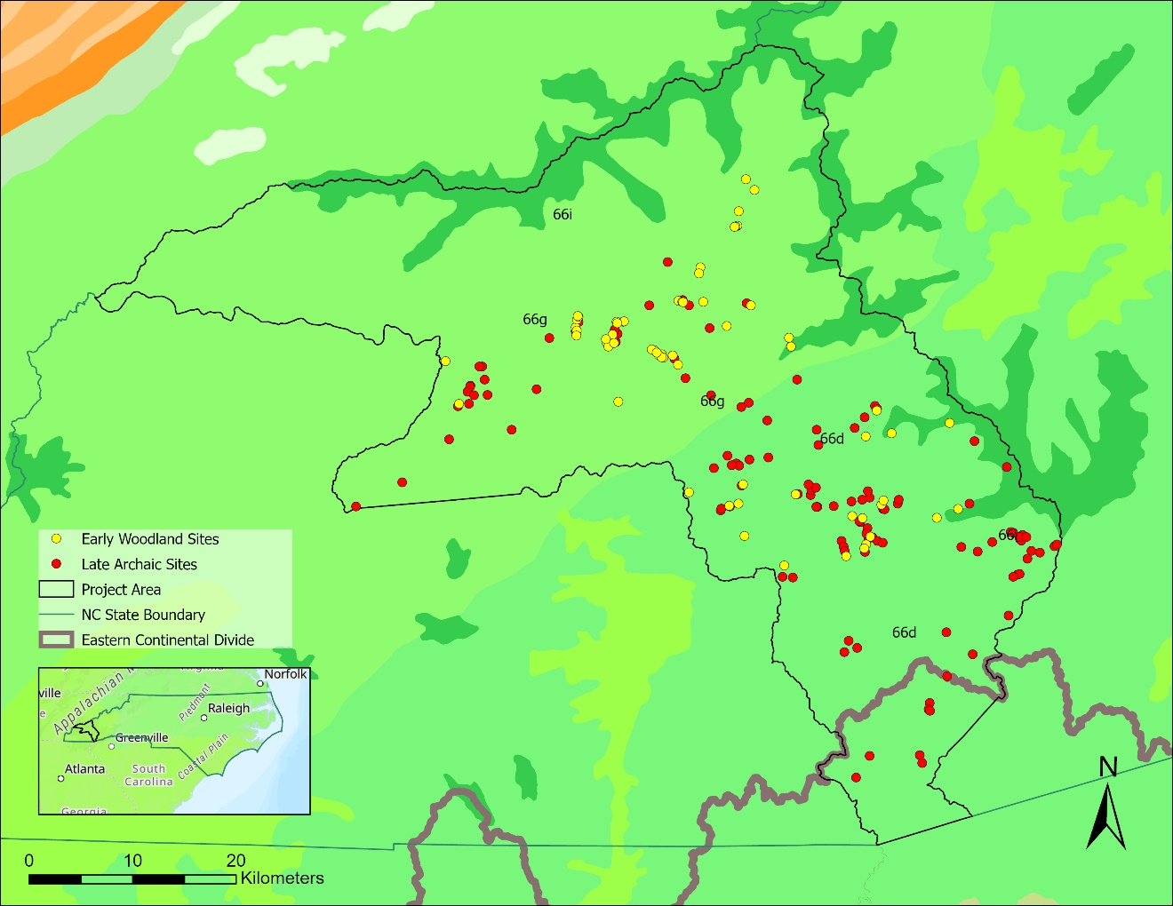
Figure 2.1. Level 4 Ecoregions in Swain and Jackson Counties. 66d: Southern Metasedimentary Mountains (medium green); 66g: Southern Crystalline Ridges and Mountains (light green); 66i: High Mountains (dark green).

A small amount of Swain also consists of the High Mountains ecoregion. The High Mountain ecoregion is the location of the tallest mountains in the Blue Ridge. The elevation of this region ranges from 4500-6684 feet. These are typically tall mountain ridges with steep slopes. The precipitation for this region is much greater than the two other regions in these counties, ranging from 75 to over 100 inches a year (Griffith et al. 2002). The temperatures at these elevations are also generally lower, ranging from the average winter (January) low of 18 degrees (F) to the average summer (July) high of 69 degrees (F) (Griffith et al. 2002). This region’s frost-free range is roughly 130-140 days.
The Southern Crystalline Ridges and Southern Metasedimentary ecoregions are primarily Appalachian Oak forests comprising northern red oak (Quercus rubra), white oak (Quercus alba), and chestnut (Castanea dentata) forests. These ecoregions also include Montane oak-hickory (Carya spp.) forests; pine-oak/heath woodlands that include Virginia pine (Pinus virginiana), table-mountain pine (Pinus pungens), pitch pine (Pinus rigida), and scarlet oak (Quercus coccinea); and cove forests which include tulip poplar (Liriodendron tulipifera), basswood (Tilia americana var. caroliniana), buckeye (Aesculus spp.), yellow birch (Betula alleghaniensis), beech (Fagus spp.), hemlock (Tsuga caroliniana), and northern red oak (Quercus rubra) (Griffith et al. 2002). The High Mountain flora comprises more cold-hardy forests, including southeastern spruce-fir forests and northern hardwood forests. The southeastern spruce-fir forest is composed of Fraser fir (Abies fraseri), red spruce (Picea rubens), yellow birch (Betula alleghaniensis), and rhododendron (Rhododendron spp.) (Griffith et al. 2002). Northern hardwood forests are composed of beech, yellow birch (Betula alleghaniensis), yellow buckeye (Aesculus flava), and maples (Acer spp.). The High Mountains also have grass and heath balds vegetation. The balds are regions in which trees are not present; instead, mountain oat grass (Danthonia compressa; grass balds) and rhododendron (Rhododendron; heath balds) thrive in these regions (Griffith et al. 2002).
Swain County and most of Jackson County are located just to the west of the Eastern Continental Divide, meaning that all streams in these two counties flow into the Tennessee watershed, specifically into the Tennessee River. In Jackson County, most of this water drains through the Tuckasegee River; however, other large waterways, including the Oconaluftee River, West Fork of the Tuskasegee River, Savannah Creek, Shoal Creek, Cullowhee Creek, and Soco Creek, flow through these regions (Benyshek et. al. 2018). These river channels join the Tennessee River around Lenoir City, Tennessee, southwest of Knoxville, Tennessee.

Cultural Setting
North Carolina’s Appalachian Summit refers to the cultural region of the Appalachian Mountains; this includes land from the border of North Carolina and Tennessee to the edge of the North Carolina foothills. Before the 1950s, archaeologists considered the Appalachian area a place that was not conducive to habitation in the past, and people who lived there only did so with no other choice (Purrington 1983). As archaeologists and collectors (looters) continued to survey the area, more evidence showed that these Highlands were an excellent location for occupation. However, most research on this region focused on cultural periods other than the Late Archaic and Early Woodland. The two most extensive surveys to record occupation patterns in the area were conducted by Quinten Bass in 1977, which covered the Great Smoky Mountains, and by Purrington in 1976, surveying the Watauga Valley. These two surveys still provide much of our understanding of settlement patterns in this region during these periods.

Late Archaic (5,800-3,200 cal BP)
The Late Archaic in the Eastern Woodlands spanned from 5800-3200 cal BP (Table 1.1; Anderson and Sassaman 2012:66). Large shell mounds and structures define the Late Archaic in coastal regions in the Southeast (Sassaman 2010). While mounds and structures were not constructed everywhere, these high-effort structures and longer-term places became important on the landscape. Along with shell mounds, Poverty Point emerged as one of the important cultural centers of this cultural phase (Anderson and Sassaman 2012:74-86). This large earthwork in Louisiana symbolized significant changes in human and landscape relationships during this period.
The Late Archaic is understood to be a time with relatively moderate climate conditions with increased precipitation and expansion of wetlands and floodplains (Anderson and Sassaman 2012:74). The people who lived in the Eastern Woodlands were proficient in the environment they inhabited. Their tool assemblages were fully adapted to hunt and gather the flora and fauna that existed in the climate regime of the Holocene. The combination of proficiency and climate stability led to an overall increase in sites, with various site types located in numerous physiographic settings (Ward and Davis 1999).
Generally, in the Late Archaic, people slowly shifted their lifestyles to accommodate agricultural landscapes (Hollenbach 2022; Scarry 2008). The growing wetlands and floodplains made cultivation possible and prosperous (Anderson and Sassaman 2012:74). The Eastern Woodland people domesticated several crops, including sumpweed (Iva annua var. macroparpa) (4,400 cal BP), chenopod (Chenopodium berlandieri var. jonesianum) (3,800 cal BP), sunflower (Helianthus annuus var. macrocarpa) (4,850 cal BP), and squashes (Cucurbita pepo ssp. ovifera) (5,400 cal BP) (Mueller et al. 2017). There is also evidence of agricultural use of maygrass (Phalaris caroliniana) and little barley (Hordeum pusillum) dating to at least 3,300 cal BP, although there is no morphological evidence for their domestication yet (Gremillion 2002; Hollenbach and Carmody 2019; Smith and Cowan 2003).
The Late Archaic people using these early agricultural practices had domesticated these plants, but the plants were yet to domesticate them (Hollenbach 2022). People still relied on many foraged foods; hickory, walnut, and other tree nuts were dietary staples, as shown in archaeological assemblages in western North Carolina (Anderson 2001; Crites 2016; VanDerwarker and Alvardo 2013). These patterns of food use were mirrored in many other areas in the Eastern Woodlands, including the Ridge and Valley region of Tennessee (Hollenbach 2022).
The Late Archaic period in the Appalachian Summit is fairly under-researched compared to other regions. Many of the mobility patterns that are understood are based on the surveys of Bass (1977) and Purrington (1983). Interpretations of site use then and today still rely heavily on the representation of lithic materials and tools. The Savannah River point is used to identify Late Archaic sites (Ward and Davis 1999). The Savannah River projectile point is most often made of quartz and quartzite sourced from the region (Purrington 1983; Ward and Davis 1999). Soapstone vessels, “bar gorgets, groundstone grooved axes, large elbow pipes, notched stones, pitted and pebbled hammerstones, large crude bifaces, and flake scrapers” are also stone tools associated with this period (Purrington 1983:125).
In the Great Smoky Mountain National Park, Bass (1977) showed evidence that Late Archaic sites were reduced in number from the Middle Archaic period (2100-1500 cal BP). He reported that the Late Archaic sites were predominantly located in valley areas (Bass 1977:69). He considered the sites located in upper elevations to be only hunting and processing sites (Bass 1977:77). Purrington (1983) established that the Late Archaic patterns in the Watauga Valley are more similar to the general trends of the Late Archaic throughout the Eastern Woodlands. Population size seemed to climb with increased site locations and site diversity (Purrington 1983; Ward and Davis 1999). Purrington (1983) located sites primarily in the upland and lowland areas of the valley. He identified various activity types at the sites, including butchery, processing, and cooking based on stone tool assemblages (Purrington 1983).

Early Woodland (3,200-2,100 cal BP)
The transition to the Early Woodland from the Late Archaic is defined by the widespread adoption of ceramic vessels and the reduction of large trade networks (Scarry 2008). The Early Woodland period ranges from 3200 to 2100 cal BP (Anderson and Sassaman 2012:115). The Woodland period in the Eastern Woodlands is the beginning of what some people consider a period of complex cultural development. Ritual practices continued to take a more physical shape on the landscape, and burial rituals can be more clearly seen in the archaeological record (Cobb and Nassaney 2002). By the Middle Woodland, mound-building is seen in many places across the Eastern Woodlands. People explicitly invested in farming the suite of cultigens established during the Late Archaic in Ohio, Kentucky, Tennessee, and Alabama (Gremillion 2002). The widespread adoption of ceramic vessels correlates with this more intensive agriculture in the Early Woodlands (Scarry 2008). The incorporation of agricultural practices is interpreted as a shift in peoples’ relationships with the landscape (Cobb and Nassaney 2002:525; Hollenbach 2022). Cobb and Nassaney (2002) described how the idea of ownership and belonging changed the way groups took care of the land.
The Appalachian Summit has produced little information regarding the adoption of farming. In Bass’s survey, there was little evidence of people moving towards agricultural lifestyles (Bass 1977). Bass found that people in the Smoky Mountains had lifestyles like those seen in the Middle Archaic with more variable and numerous site locations, settling predominantly in upland coves and “benches” and returning to riverine floodplains; there is also an increase in diversity of site types compared to the Late Archaic (Bass 1977). Purrington’s (1983) Watauga survey again contradicts the information found by Bass (1977). The number of people in the Watauga Valley decreased based on site size and site numbers (Purrington 1983). Early Woodland people located themselves around ridge tops and upland valleys, although there could be some biases in river valley locations due to the depth of the sites (Purrington 1983; Ward and Davis 1999).
Swannanoa stemmed points and Swannanoa phase ceramics define this cultural group and time period in the Appalachian Summit (Ward and Davis 1999). Swannanoa pottery is characterized by its thick walls and crushed quartz temper (Ward and Davis 1999). Ceramics are often decorated with cord-marking or fabric impressions (Holden 1966). Later in the Swannanoa phase, check-stamped, simple-stamped, and plain surface decorations are common in ceramic assemblages (Keel 1976). The Swannanoa point decreased in size, notably compared to the Savannah River point of the Late Archaic, yet it still holds the anatomy of previous stemmed points that began to phase out as the bow and arrow developed in the region (Keel 1976). Whyte (2007) argues that the change in material culture in the Appalachian Summit reflects the migration of cultural groups, which he identifies as a proto-Cherokee group with linguistic patterns associated with the Iroquoians. According to Whyte (2007), this transition in power from the Late Archaic people to the early Cherokees is identified in the shift in lithic point styles, settlement patterns, and increased warfare. Other researchers see the cultural shift as a general transfer of knowledge between outside groups and those that had occupied the Appalachian Summit. Researchers who study the ceramic assemblages attribute ceramic development to either the peoples living in the region during the Late Archaic or interaction with groups in the North Carolina piedmont region (Coe 1964; Holden 1966:61; Wetmore 2002:257).
Peer-reviewed articles and book chapters run slim on this region; however, research and surveys from more recent cultural resource management projects and data on site location and site use can be added to this discussion. Also, more considerable botanical data will add to the discussion of the motivation of groups in their site choice and mobility patterns beyond the acquisition of stone material.

Project Sites
To examine changes in plant use in western North Carolina, I analyzed flotation samples from two sites. One is Magic Waters (31JK291), located in Jackson County. From this project, I analyzed the Late Archaic component. The other is the CES Site (31SW596) in Swain County near the Qualla Boundary. From this site, I analyzed the Early Woodland component. Both were obtained from recent CRM projects where analysis of the Phase III materials is ongoing, so limited contextual data are available. There are also a limited number of samples available. Ideally, I would have analyzed many more samples, but I could not locate additional available samples from other Late Archaic and Early Woodland sites in the region at this point in time.

Site 31JK291, Magic Waters
Site 31JK291, Magic Waters, is a multi-component site located in Jackson County. People occupied this site during the Middle Archaic, Late Archaic, Middle Woodland, and Late Woodland cultural periods. These periods were identified through the lithic materials (Benyshek, personal communication 2021); paleoethnobotanical data from the Late Archaic component was used for this project .
The site was first visited by archaeologists 20 years ago, then revisited and excavated in 2017-2018 by TRC Companies (Benyshek et al. 2018). The excavation of this site was overseen by the Tribal Historic Preservation Office (THPO) of the Eastern Band of Cherokee Indians (EBCI). Magic Waters is located north of Soco Creek, on one of the higher terraces in the region (Benyshek et. al. 2018). Soco Creek then drains into the Oconaluftee River. This site is currently categorized as a field camp, although analysis of the site is still limited (Tasha Benyshek, personal communication 2022). Eight floatation samples were analyzed. Feature 3503 is a relatively shallow, small pit identified by burnt soil and small clustering of rocks. Feature 1812 was much more extensive. It consisted of five pits interconnected in a backward-L shape. There was thermal staining and a small built rock back wall (Tasha Benyshek, personal communication 2021).

Site 31SW596, OES Site
Site 31SW596, the ECBI Cherokee Elementary School Site, is located in Swain County and within the Qualla Boundary. Excavation for this site began in 2012 contracted by the Eastern Band of Cherokee Indians in North Carolina; the excavations were conducted by TRC Companies (Tasha Benyshek 2021, personal communication). Site 31SW596 is located on the lower terraces and alluvial fans west of the Oconaluftee River. Several occupations were located through excavation, with artifacts dating to the Archaic, Early Woodland, Qualla, and Historic periods. The Early Woodland occupation of this site was analyzed for this project. Locus A and B are part of an arbitrary site division to accommodate excavation; the Early Woodland occupation was located primarily within the eastern edge of locus A (Nelson and Benyshek 2013). The paleoethnobotanical samples were removed from several features identified through the Swannanoa lithic and ceramic assemblages (Nelson and Benyshek 2013). The material analyzed from site 31SW596 was collected from seven different features, four large pits and three small pits. Due to the lack of deep storage pits and no evidence of Swannanoa structures, this site is currently perceived as a short-term residential camp (Tasha Benyshek 2021, personal communication).

Previous Paleoethnobotanical Research

Relevant Paleoethnobotany in North Carolina Appalachian Summit
As part of this project, I reached out to the North Carolina Office of State Archaeology (NCOSA) for access to site files and reports from Jackson and Swain counties to locate additional paleoethnobotanical analyses. As a result, I found one other paleoethnobotanical analysis outside of the two already known to me. There may be another analysis of paleoethnobotanical data from a Late Archaic and Early Woodland site that have yet to be submitted to the NCOSA. In Jackson and Swain counties, three site-level paleoethnobotanical reports are accessible: Cold Canyon (Crites 2016), Ravensford (VanDerwarker and Alvarado 2013), and 31JK12 (Tippett et al. 2014). Within the broader Appalachian region, previous paleoethnobotanical research has been conducted at the Warren Wilson site in Buncombe County (Simpkins 1984) and Iotla in Macon County (Benyshek 2020). Macon County is just south of Jackson and Swain, and Buncombe is two counties to the northeast. Using these studies, I can better understand the trends in plant use that exist in the region.
The Louis Berger Group excavated site 31JK12 in 2014; their excavations investigated Late Archaic occupations on the north bank of the Tuckaseegee River in Jackson County (Tippett et al. 2014). Much of the Archaic representation was surface deposits, but they did identify one feature (Feature 53): a cluster of grinding stones identified as Late Archaic (Tippett et al. 2014). A two-liter sample was collected and analyzed for plant remains. Only 0.43 g of plant materials were identified, with just over half of the sample being wood remains (0.27 g) (Tippett et al. 2014). The only nut taxon identified was hickory, with 21 fragments (0.12 g) (Tippett et al. 2014). Due to the lack of other plant remains, this study focused on the types of wood identified in the carbonized material. Hickory, pine, and deciduous wood charcoal fragments were identified.
The Cold Canyon site analysis produced similar results for Late Archaic occupations. Roughly 247 liters were floated from Late Archaic contexts at the site in 2016 (Crites 2016:181). Once floated and sorted, wood and hickory nutshell were identified: hickory nutshell is represented by 23,045 fragments (290.41 g) and wood by 8,487 fragments (133.66 g) (Crites 2016). Interestingly, hickory nutshell greatly outnumbers the wood. With the number of hickory nutshells present at this site, it is likely that the occupants were processing hickory nuts, perhaps to make ku-nu-che, or hickory nut soup (Fritz et al. 2001). Once the meat is removed from hickory nuts, the shells make excellent fire fodder, keeping fires burning hot. As Crites (2016) mentioned, it is impossible to attribute the nutshell specifically to the practice of making ku-nu-che.
Late Archaic samples were also analyzed as part of the investigation of the Ravensford site. The flotation samples included 141 liters from Late Archaic contexts (VanDerwarker and Alvarado 2013). This analysis focused less on wood types and concentrated more heavily on food materials since there was a more significant presence of food taxa. While acorn was found on this site, hickory nutshell was still the overwhelming percentage of food remains with 13,146 fragments. VanDerwarker and Alvarado also identified one chenopod seed (Chenopodium sp.) in this analysis, which cannot be conclusively linked to farming or cultivating at this point. However, chenopod is identified as a cultigen in the Woodland period in North Carolina (Table 2.1; VanDerwarker and Alvarado 2013). These three analyses emphasize the importance of hickory nuts for Late Archaic peoples in the Appalachian Mountains of North Carolina.
Daniel Simpkins conducted the earliest comprehensive paleoethnobotanical analysis in this region in 1984 of the Warren Wilson site. Located outside of Asheville, North Carolina, it is a multicomponent site, including Late Archaic and Early Woodland occupations. Simpkins (1984:57, 171) sampled 48 Late Archaic features for this project. The features sampled were rock clusters (presumed to be hearths), pit hearths, charcoal pits, and one possible burial (no bones were located; Simpkins 1984:171). Simpkins’ specific focus was to look for food plants, primarily seeds. In his analysis, he did mention that, in retrospect, it was very difficult for him to identify carbonized chenopod seeds in his sample and feared he might have thrown some out with the residues (Simpkins 1984:73). This potential bias might have led to an underrepresentation of seeds in the Late Archaic samples.
A large percentage of the remains from the Late Archaic samples were wood (644.64 g) (Table 2.2; Simpkins 1984). Unfortunately for the comparison to other studies, Simpkins did not count all his plant materials: seeds were counted, but the nutshells were not. Although we do not have the number
Table 2.1. Late Archaic Plant Remains from Ravensford (n=3 soil samples; VanDerwarker and Alvarado 2013).
Plant Remains | Count | Weight (g)
Nuts
Acorn cap | 8 | 0.04
Hickory | 13146 | 180.34
Cultigens
Chenopod | 1 | 0.00
Miscellaneous
Copperleaf | 1 | 0.00
Unidentified seed | 33 | 0.12
Unidentifiable | 3 | 0.01

Table 2.2. Late Archaic Plant Remains from Warren Wilson (n=48 soil samples; Simpkins 1984).
Taxon | Hearths (n=11) | Pit Hearth (n=34) | Charcoal Concentration (n=2) | Burial (?) (n=1) | Total
Wood (g) | 218.65 | 419.71 | 6.27 | 0.01 | 644.64
Hickory (g) | 0.63 | 4.89 | 2.57 | - | 8.09
Walnut (g) | 2.52 | 4.4 | 0.04 | - | 6.96
Butternut (g) | 0.04 | 0.3 | - | - | 0.34
Acorn (g) | - | 0.13 | 0 | - | 0.13
Seeds (g) | - | 0.07 | - | - | 0.07
Total Plant Remains | 221.89 | 429.52 | 9.08 | 0.01 | 660.5
Food Plant Remains | 3.19 | 9.52 | 2.61 | - | 15.32
Categories of Food Plants | 5 | 11 | 2 | - | 11

of hickory nutshell fragments, they are well represented compared to the other nuts by weight. Since these are only listed in weights, for context, the 13,146 hickory nutshell fragments from the Ravensford site weigh 180.34 g (VanDerwarker and Alvarado 2013:11). Hickory nutshells are quite dense and can have significant mass, but walnut (Juglans nigra) and butternut (Juglans cinerea) have similar densities and are also present in this assemblage (Table 2.2). Interestingly, this is the only assemblage of these four Late Archaic sites that notes the presence of walnut and butternut. Walnut and butternut trees are less likely to grow in groves like the hickories or oaks. The presence of Juglans species in this assemblage
might be the result of a particular group’s preference for these tasty nuts, dyeing activities related to the nut hulls, and/or some sort of convenience factor in relation to the site.
Several seeds are also present in the Warren Wilson analysis assemblage (Table 2.3). Simpkins (1984) identified fruits (grape and plum/cherry) and potential cultigens (chenopod and knotweed), pointing to possibly hybrid efforts of cultivating and foraging. Bedstraw is often identified at archaeological sites as a sign of ground disturbance, fire kindling, or stuffing material; as there are only two seeds, conclusions are hard to draw.
The Early Woodland component of the Warren Wilson site is less extensive; 13 hearth features and six pit features were used for the analysis (Simpkins 1984:61). Wood continues to be prominent in the samples; in this assemblage, cane, hickory, walnut, and acorn are represented in similar weights (Table 2.4). Acorn shell is typically found in small fragments and is significantly less dense than hickory or walnut shell. The 4.43 g of acorn is thus significant in this assemblage and suggests signs of a subsistence shift in the Appalachian Summit during the Early Woodland period (Simpkins 1984). The increase of acorn suggests changes in foodways; however, the seed count from Simpkins’ sample does not explicitly reflect an increase in disturbance for the Early Woodland occupation, as only one bedstraw seed was found in the selected features.

Table 2.3. Late Archaic Seeds from Warren Wilson (n=48 soil samples; Simpkins 1984).
Seed Taxon | Count
Grape (Vitus sp.) | 2
Plum or Cherry (Prunus sp.) | 1
Chenopod (Chenopodium sp.) | 2
Knotweed (Polygonum sp.) | 1
Bedstraw (Galium sp.) | 2
Unidentified | 8

Table 2.4. Early Woodland Plant Remains Warren Wilson (n=19 soil samples; Simpkins 1984).
Plant Remains | Hearth (n=13) | Pit Hearth (n=6) | Total
Wood (g) | 189.64 | 39.24 | 228.88
Cane (g) | - | 0.07 | 0.07
Hickory (g) | 2.68 | 0.20 | 2.88
Walnut (g) | 1.90 | 0.65 | 2.55
Acorn (g) | 4.23 | 0.20 | 4.43
Seeds (count) | - | 0 | 0
Total Plant Remains | 198.50 | 18 | 216.50
Food Plant Remains | 8.81 | 0.47 | 9.28
Categories of Food Plants | 4 | 3 | 4

VanDerwarker and Alvarado analyzed the paleoethnobotanical remains from the Iotla site in Macon County (Benyshek 2020). The Iotla site was also a multi-component site with an Early Woodland occupation. VanDerwarker and Alvarado found a significant decrease in hickory representation and an increase in acorn shells compared to Late Archaic assemblages in the region (Table 2.5; Benyshek 2020). Most notable about this assemblage in the context of the Appalachian Summit is that there is an increased representation of other plants (Table 2.5). They identified one maygrass seed; as mentioned previously, maygrass does not grow in this region of North Carolina without the assistance of humans (Benyshek 2020; Cowan 1978). There are also squash/gourd rind and sunflower seeds, both known cultigens in the Southeast. With the presence of these cultigens and plants that are typically associated with disturbance (namely bedstraw and pokeweed), the evidence suggests a turn to more agricultural choices among these groups during the Early Woodland period.

Relevant Paleoethnobotany in Eastern Tennessee
To better understand the trends that exist around foodways from the Late Archaic to the Early Woodland periods, I compare the data from western North Carolina to previous paleoethnobotanical research of sites located in eastern Tennessee (Figure 2.2). Due to damming of the rivers by the Tennessee Valley Authority, eastern Tennessee archaeological sites from these periods have been researched in greater depth and give us a better understanding of the transition towards a more extensive agricultural foodway. There are also similarities in material culture between the Appalachian Summit and eastern Tennessee peoples. Late Archaic Savannah River points are found at several sites, including Bacon Bend (40MR25), Birdwell (40GN228), and Neas (40GN229) (Chapman 1981; Driskell et al. 2013; Hollenbach 2022). The Early Woodland occupations at the Phipps Bend (40HW44 and 40HW55), Birdwell, and Neas sites all have artifacts and points associated with the Swannanoa phase we see in the Appalachian Summit in North Carolina. This is especially significant because Swain and Jackson
Table 2.5. Early Woodland Plant Remains from Iotla (n=13 soil samples; Benyshek 2020).
Plant Remains | Count | Ubiquity
Nuts
Acorn | 29 | 58%
Hazelnut | 1 | 7%
Hickory | 250 | 92%
Hickory cf. | 9 | n/a
Cultigens
Maize Kernel cf. | 4 | n/a
Squash/Gourd rind | 2 | 7%
Maygrass | 1 | 7%
Miscellaneous
Bedstraw | 2 | 15%
Dogwood | 2 | 7%
Nightshade family cf. | 7 | 7%
Pokeweed | 1 | 7%
Skull cap | 1 | 7%
Spike rush cf. | 1 | 7%
Sunflower | 1 | 7%
Sunflower cf. | 1 | 7%
Unidentifiable | 90 | n/a
Unidentifiable seed | 1 | n/a

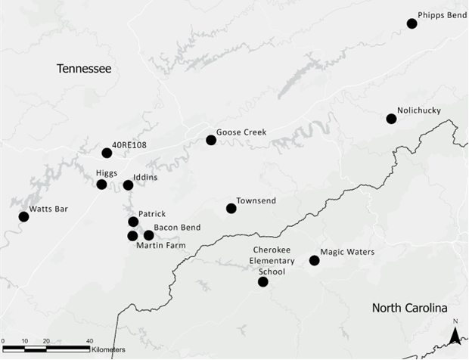
Figure 2.2. Map of Sites in Tennessee (Hollenbach 2022) and North Carolina.

counties are located at the headwaters of the Little Tennessee River that flows into the Tennessee River; many of the comparative sites are located in the Little Tennessee Valley. Examining the relationship between these sites in western North Carolina and eastern Tennessee may give insight into patterns of movement or interaction based on waterways.
The sites utilized for this comparative analysis are 40RE108, Bacon Bend (40MR25), Iddins (40LD38), Rose Island (40MR44), Calloway Island (40MR41), Townsend sites (40BT89, 40BT90), Phipps Bend (40HW44, 40HW45), Neas (40GN229), Birdwell (40GN228), and Goose Creek (40KN317) (Figure 2.2). These sites represent a range from upper to lower eastern Tennessee and are distributed between the two time periods (Hollenbach 2022). Neas, Birdwell, and Townsend 40BT90 are multicomponent sites with both time periods represented. Bacon Bend and Iddins samples derive from features and middens that represent the Late Archaic use of the locations, while the Phipps Bend, Rose Island, Calloway Island, Townsend 40BT89, and Goose Creek assemblages are associated with Early Woodland habitations at these sites. However, the Rose Island and Calloway Island assemblages date very close to the transition between the two periods and represent a very early time in the Early Woodland (Hollenbach 2022).
The samples from these sites were excavated from either midden or feature contexts. The excavated features include rock concentrations, pits (large and small), basins, cooking pits, hearths, post molds, charcoal concentrations, and a burial. In total, 235 samples were analyzed from feature and midden contexts; 149 of the feature/midden samples are associated with the Late Archaic, and 86 are associated with the Early Woodland.
The techniques by which these plant remains were recovered and analyzed vary from site to site since several different groups excavated these sites and analyzed these samples over the last 50 years. Most of these samples were processed through flotation, but the light and heavy fraction mesh sizes vary or were not provided in site reports. An example of these differences is that the same flotation system was used for Townsend and Goose Creek, but the collection size differs. The Townsend samples were floated using a 0.25-mm sieve for the light fraction and 1-mm mesh for the heavy fraction, while the Goose Creek samples were processed with fabric with 0.05-mm openings, and the heavy fraction was collected with window screen (1.3 mm mesh) (Hollenbach 2022). How the samples were analyzed varies since some researchers both counted and weighed the different plant remains while others either only weighed (for example, nut taxa) or only counted (for example, seeds) the different plant taxa. In total, about 4404. 57 g of plant remains, including 2598.77 g of wood, were analyzed.
As part of the Fall 2020 Paleoethnobotany course in the Department of Anthropology at the University of Tennessee, Knoxville, students entered the previously analyzed plant data from these eastern Tennessee sites into a database. Quantitative comparisons show that the plant densities (plant weight/sample volume) of both the Late Archaic and the Early Woodland are statistically similar (Figure 2.3). The wood densities (wood weight/plant weight) of the sites’ assemblages also show similar spreads (Figure 2.4). The overlap in the densities suggests that the preservation and depositional processes of these sites are similar enough to be comparable, removing some possible errors from our plant comparisons between sites.
The plant taxa directly associated with the Eastern Agricultural Complex–namely chenopod, squash/gourd, sunflower, amaranth, knotweed, little barley, and maygrass–are identified in both Late Archaic and Early Woodland assemblages (Table 2.6; Hollenbach 2022). A few unidentified seeds or edible seeds were also found in these assemblages that could be associated with some cultivation. The 130 maygrass seeds found in the Savannah River phase of Bacon Bend are also notable (Hollenbach 2022).
Both the Late Archaic and Early Woodland groups in eastern Tennessee maintained some relationship with the native cultigens of the Eastern Agricultural Complex. Lifestyles show signs of more extended stays in one location with the greater presence of storage pits and postholes for structures in the Early Woodland components (Hollenbach 2022). There is also a continued presence at these sites of nuts, including hickory and acorn, and chestnuts. Hazelnuts were found in Late Archaic samples at Iddins and in the Early Woodland contexts at the Townsend sites (Hollenbach 2022). Fruits and other edible, useful plants were found in both cultural contexts. The most common fruits in these samples were grape and persimmon (Table 2.6; Hollenbach 2022). The recovery rate for these fruits is generally higher due to their larger seed sizes. Weedy seeds like pokeweed, bedstraw, wild bean, grass family, and purslane were also found. Some of these seeds represent edible plants, but more significantly they reflect ground disturbances at these sites, possibly representing more evidence of cultivation practices (Table 2.6; Hollenbach 2022).

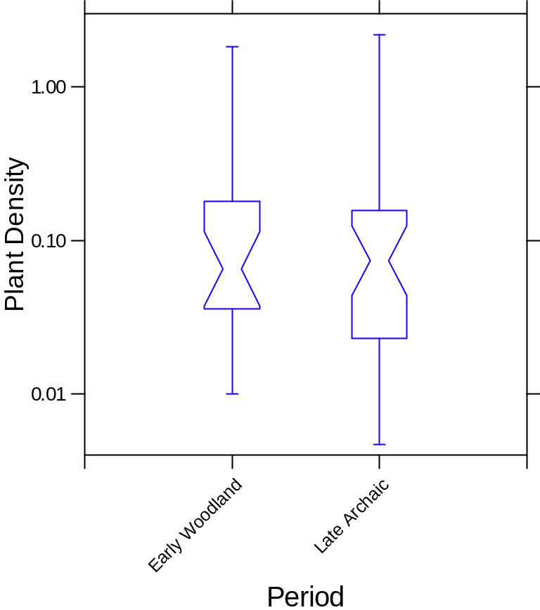
Figure 2.3. Boxplot comparing plant remains relative density of eastern Tennessee sites (plant weight/sample volume) by period. Note the y-axis is log transformed.

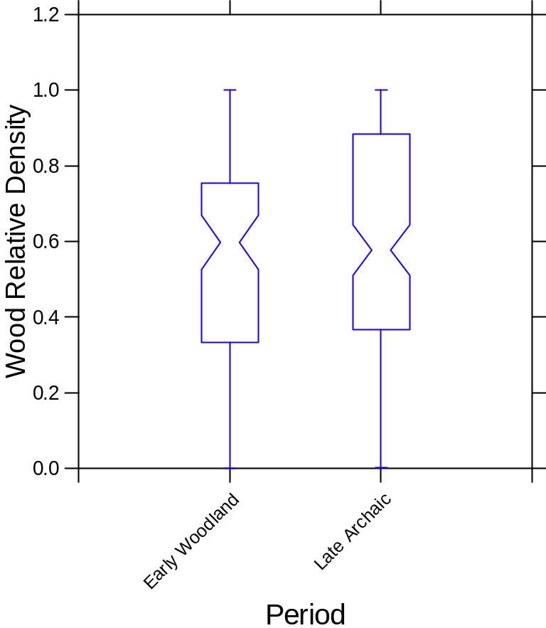
Figure 2.4. Boxplot comparing wood relative of eastern Tennessee sites (wood weight/plant weight) by period. Note the y-axis is log transformed

Table 2.6. Plant Remains Recovered from Late Archaic and Early Woodland Sites in East Tennessee (Hollenbach 2022).
 |  | Late Archaic
 |  | Bacon Bend | Patrick | Iddins | Higgs | Townsend | Nolichucky
 |  | float | waterscreen | float | float  (LF only?) | float | float
Common Name | Taxonomic Name | n=43 | n=2? | n=72 | n=2 | n=23 | n=12
Nuts:
Acorn | Quercus spp. | 10.18 |  | 10.77 | 60 | 201 | 69
Black walnut | Juglans nigra | 73.94 | 53.13 | 747.83 |  | 185 | 14
Chestnut | Castanea dentata |  |  | 0.69
Hazelnut | Corylus sp. |  |  | 0.06
Hickory nut | Carya spp. | 170.22 |  | 85.26 |  | 972 | 181
Fruits:
Blackberry/raspberry | Rubus spp. |  |  | 3 |  |  | 1
Black gum | Nyssa sylvatica
Grape | Vitis spp. | 13 |  | 519 |  |  | 3
Honey locust | Gleditsia triacanthos
Maypop | Passiflora incarnata |  |  |  |  | 1
Mulberry | Morus sp.
Pawpaw | Asimina triloba
Persimmon | Diospyros virginiana | 3 |  |  |  | 1
Sumac | Rhus sp. | 1
Edible Seeds:
Amaranth | Amaranthus sp. |  |  | 1
Bearsfoot | Smallanthus uvedalia |  |  | 1 |  | 8 | 1
Bottle gourd | Lagenaria siceraria |  |  | 8
Chenopod | Chenopodium spp. | 1 |  | 47 | 360 | 2 (cf.)
Cucurbit seed | Cucurbita sp. | 14
Cucurbit rind | Cucurbitacaea | 2 |  | 35 |  | 3 (cf.) | 1
Knotweed | Polygonum spp. |  |  | 4
Table 2.6. continued
Little barley | Hordeum pusillum |  |  |  |  | 120
Maygrass | Phalaris caroliniana | 130 |  | 1 |  |  | 2 (cf.)
Sunflower | Helianthus annuus |  |  | 1 | 110
Wild bean | Phaseolus polystachios |  |  | 1
Wild rice | Zizania aquatica | 3 cf. |  | 1
Miscellaneous:
Bedstraw | Galium spp. | 10 | 1 | 18 |  | 26
Cane | Arundinaria sp.
Carpetweed | Molluga sp.
Grass family | Poaceae | 120
Pokeweed | Phytolacca americana | 7 |  | 3
Purslane | Portulaca sp. |  |  | 11 |  | 2
Weedy legume | Fabaceae |  |  | 1

 |  | Early Woodland
 |  | Townsend | 40RE108 | 40HW44 | 40HW45 | Nolichucky | Goose Creek
 |  | float | waterscreen & float | float | float | float | float
Common Name | Taxonomic Name | n=17 | n=? | n=8 | n=19 | n=5 | n=9
Nuts:
Acorn | Quercus spp. | 157 | 2.37 | 10.4 | 24.40 | 12 | 132
Black walnut | Juglans nigra | 25 | 5.30 | 50.85 | 4.95 | 9 | 16
Chestnut | Castanea dentata
Hazelnut | Corylus sp. | 4
Hickory nut | Carya spp. | 1470 | 34.14 | 31.3 | 29.5 | 42 | 308
Fruits:
Blackberry/raspberry | Rubus spp.
Black gum | Nyssa sylvatica |  |  |  |  |  | 1
Table 2.6. continued
Grape | Vitis spp. | 3 | 1 | 5 | 9 |  | 3
Honey locust | Gleditsia triacanthos |  |  | 4
Maypop | Passiflora incarnata
Mulberry | Morus sp. |  |  |  |  | 15
Pawpaw | Asimina triloba |  |  | 22
Persimmon | Diospyros virginiana | 11 |  | 34 |  | 1 (cf.)
Sumac | Rhus sp. |  |  |  |  |  | 5
Edible Seeds:
Amaranth | Amaranthus sp. |  |  | 1 | 3
Bearsfoot | Smallanthus uvedalia |  |  |  |  | 25 | 1
Bottle gourd | Lagenaria siceraria
Chenopod | Chenopodium spp. | 5 |  | 20 | 129 | 5 | 8
Cucurbit seed | Cucurbita sp.
Cucurbit rind | Cucurbitacaea | 1 |  |  |  |  | 1
Knotweed | Polygonum spp. |  |  |  |  | 1 (cf.)
Little barley | Hordeum pusillum |  |  |  |  | 10
Maygrass | Phalaris caroliniana | 80 |  |  |  | 25 | 45
Sunflower | Helianthus annuus
Wild bean | Phaseolus polystachios
Wild rice | Zizania aquatica |  |  |  |  |  | 1 (cf.)
Miscellaneous:
Bedstraw | Galium spp. |  |  |  |  | 1 | 5
Cane | Arundinaria sp. |  |  |  |  |  | 4
Carpetweed | Molluga sp. |  |  |  |  |  | 2
Grass family | Poaceae |  |  | 4 | 49 | 8 | 1
Pokeweed | Phytolacca americana | 1 |  |  | 1
Purslane | Portulaca sp. | 3 |  |  |  | 2 | 29
Weedy legume | Fabaceae |  |  | 3 | 8

Theoretical Perspective: Plants and the Place Beyond Western Thought
The domestication of plants and the establishment of farming is almost universally assumed to have been accomplished by women in the Southeast United States, and indeed everywhere in the world (Fritz 2019; contra Prentice 1986; Scarry 2008:397, 400; Watson and Kennedy 1991). There is a long history of association between plant resources and women, as women were the primary gatherers for foraging groups, along with children and elders, the latter of whom would have passed down previous knowledge of and relationships with edible plants (Fritz 1999:436, 2019). The knowledge of an edible plant, where to find it, and how to tend it for a promise of harvest is what likely led to the domestication of plants that were foraged yearly by women, children, and elders.
The early plants farmed in the Eastern Woodlands differed from the corn, beans, and squash crops, known as the Three Sisters, grown later in the Mississippian period (beginning ca. 1000 BP) through today. These earlier native crops were planted by using a method called broadcasting (Smith and Cowan 2003). The broadcasting method of planting is where farmers spread seeds on a plot of land in no distinct rows or patterns, similar to the way we plant cover crops today. These plots were generally very dense and did not require much tending. The weedy plant varieties of chenopod (Chenopodium berlandieri), little barley (Hordeum pusillum), and maygrass (Phalaris caroliniana) grow well crowded together; the only initial care would be the thinning of newly sprouted plants. Women and children likely would have spent relatively little time tending the plants until it was time to harvest (Scarry 2008:397). During these cultural periods, group movement would need be timed so they would be present at plots when the plants needed to be seeded and then later for harvesting.
Another key difference is that the Three Sisters enter the ground simultaneously in the spring; the earlier indigenous crops of the Eastern Woodlands required different timing for proper growth (Scarry 2008:395; Smith and Cowan 2003). The wild maygrass and little barley are planted in the late fall and ripen in early spring, while chenopod ripens in the fall (Asch and Asch 1985; Scarry 2008:397). Chenopod, which flowers in mid-summer, would also need to be seeded in late summer/early fall, since the wild variety of chenopod seed requires cold to germinate. Thus, chenopod could not be planted in early spring until its full domestication (Scarry 2008:397). Women’s understanding of the timing would have been critical to cultivating a decent crop yield.
While sunflower, squash, and sumpweed were likely broadcast initially, the domestication result of larger seed sizes led to row planting (Scarry 2008:397; Wilson 1987). With rowed crop techniques being utilized in the Eastern Woodlands, corn and bean agriculture was readily incorporated into farms when these crops arrived from Central America (Gremillion 1998; Scarry 2008:397). The Late Archaic crops in the Eastern Woodlands were cultivated in smaller plots that could be left seasonally as other food resources were gathered, then would be returned to during harvest, likely fall (Scary 2008:398). Throughout the Early Woodland period, people began to increase their reliance on cultivated plants as part of their diets and developed larger agricultural fields, still cultivated by women (Hollenbach 2022; Scarry 2008). Methods such as slash and burn, through which large areas would be burned as a method of clearing, were likely implemented to establish larger farming areas quickly (Scarry 2008:398).
These cultural periods saw changes outside of gathering subsistence strategies. During these years, the landscape and environment stabilized into conditions similar to our modern climate (Anderson 2001:161). In the Early Woodland,Late Archaic cultural centers and larger sites seem to have been abandoned, and group sizes decreased into smaller units that spread across the landscape (Anderson 2001:161; Anderson and Sassaman 2012). As the size of groups decreased and reliance on cultivated crops grew, there was still a large reliance on foraged crops. Women who tended cultivated land still collected and managed food staples like walnuts, acorns, and hickory nuts, as well as berries, tubers, mushrooms, ramps, and many other food resources found in the Eastern Woodlands (Anderson 2001:162; Hollenbach and Carmody 2019). The cultural landscape underwent a significant transition motivated by a shift in people’s daily behaviors. It did not remain static, for in the Middle Woodland and again during the Mississippian period (and in some parts of the region during the Late Woodland), there is a return of monumentality on the landscape and the development of significant cultural centers (Cobb and Nassaney 2002:531-532).

Indigenous Plants and Agency
Andrew Gardner (2008:103) defines agency as the active involvement of “being human and as a process of relationships of engagement with the social and material worlds.” People have active roles in their lifeways. Rather than a passive coincidence, the people, namely women, who domesticated the Eastern Agricultural Complex were actively making the decisions to collect certain plants and cultivate others from established relationships (Fritz 2019; Watson and Kennedy 1991).
Human-plant relationships can be assessed through observations made through archaeological data and ethnographic means. The domestication of the Eastern Agricultural Complex (EAC) was not the result of a single day or even a month of experiences; rather domestication was the accumulation of individuals (primarily women) creating patterns and practicing activities that evolved into learned relationships passed down from mother to daughter over generations (Gardner 2008:103; Hill 1987; Watson and Kennedy 1991). The plants domesticated in the Eastern Woodlands were local crops involved in close relationships with the same groups of people whose descendants grew them throughout history. The relationships developed in the process gave women/children greater agency within the plants’ world than men had.
The shift toward agriculture and the trend of lessened reliance on foraged foods also gave plants more agency within the lives of people (Robb 2010:499). The effects of plant agency would be defined differently for the Archaic and the Woodland cultures. When people primarily foraged plants, they would have followed seasonal patterns established by the plants, based on locations and times that the plants were sprouting, fruiting, or seeding. Once people began maintaining, and later domesticating, culturally familiar crops in specific places, their relationships with the plants would have changed, leading to a foodways-based sedentism (Robb 2010:499). The plants gained a different agency in the daily lives of Late Archaic and Early Woodland peoples as people developed specialized tasks associated with domesticated plants (Fuller et al. 2014:182-186). The cycles of farmers’ lives synced with patterns of planting, harvesting, and processing, creating different social groups and labor organizations (Fuller et al. 2014:182-186). Again, it is important to emphasize these cultural developments were centered on the roles and responsibilities of women.
Seasonal and communal patterns shifted due to changes in human and plant relationships, landscape use, and perception shifts. The relationships of land, humans, and plants began to manifest in different places on the landscape (Cobb and Nassaney 2002:525). When people began farming and became more sedentary, their relationship with the landscape they lived on was redefined. The influence of the lived landscape on people changed and impacted domestication, just as the agency of plants and people and relationships with them had influenced domestication (Thomas 2012:173). These shifts in landscape use due to farming changed how people would have identified themselves; as places became more permanent and private-like properties manifested, places held new and different means of cultural identification.
The landscape and the non-humans that populated the Eastern Woodland landscapes are not meaningless; the landscape was imbued with meaning from the accumulation of experiences, generations, and non-human relationships that people held with them (Thomas 2012:173). These braided relationships are elaborated on further in the study of entanglement (Hodder 2011:155). The relationships that are cultivated have evolved as one generation learns from the next, deepening the connections with the landscape that are meaningful to people. In archaeology, these meaningful relationships between people, non-humans, and landscapes should be interpreted as such. Hodder (2011) wrote thoroughly on this connection in Human-thing Entanglement; his examples derive from how use of clay drove daily life from the creation and maintenance of everyday items to the perpetuation of social memory (Hodder 2011:156).
Similarly, the generational knowledge and memory of plants was expressed in society through new activities and belief systems, establishing new cultural norms in growing EAC crops (Crothers 2008:129). The increased social complexity and knowledge people cultivated around and with these plants led to the development of a type of ownership (Crothers 2008:137). People’s relationships with these cultivated plants established a particular perception of how farmed plants and plant spaces should be treated; the plant-centered properties would have also included a spiritual aspect that would need to be respected (Crothers 2008:137). If other group members violated a particular space or the relationship between plants and people, that could be grounds for disagreement, leading to violence or other disciplinary actions (Crothers 2008:137). Beyond the development of ownership around plant/land relationships, other cultural activities surrounding these connections also manifested (Crothers 2008:138). Activities and ceremonies like birthing, naming, marriage, visiting, and entertainment introduced new cultural attributes through the agency of plants (Crothers 2008:138). Plant domestication in the Eastern Woodlands went beyond obtaining new subsistence strategies, creating new cultural and societal norms among people.

In Place-Thought
As agency is used to interpret the archaeological record and social patterns, Vanessa Watts (2013:20) calls on archaeologists to further remove our thought processes from western epistemologies and asks us to reaffirm the sacred connections between people, places, and non-human objects. Achieving these connections comes through communicating and considering indigenous people’s beliefs and histories (Watts 2013:20). For Watts, a woman of Haudenosaunee and Anishinaabe heritage, her histories of the world’s foundations are both spiritual and feminine (Watts 2013:21). The associated non-colonial mindset allows for archaeological interpretations to consider a female perspective as well as the beliefs and ideas of the histories of the people who lived and are still living on the landscape (Watts 2013:21). For Watts, the world is animate; people live in a landscape created by Sky Woman that is dedicated to and managed by non-humans (Watts 2013:21-22). When Watts thinks of the objects and their agency, it is not strictly from the point of view of a human because the spirit and life of a place and objects are not dictated by humans; they exist on their own (Watts 2013:25-28). This is the Place-thought that Watts implores us to consider in our archaeological interpretations. The relationships of people, plants, and places are not removable: their spirits are intertwined and exist together (Watts 2013:25-28). While it is proper to tread lightly when using one culture’s beliefs in interpreting another’s, these intrinsic ideas of a living landscape are perpetuated throughout many different cultures on North America continent. In California, the indigenous Timbisha Shoshone had a symbiotic relationship with the forests they maintained. The U.S. Forest Service now restricts this behavior; the Timbisha Shoshone see this as a disservice to the plants as they crave human attention (Fowler 2008:54). The animism of these non-human objects seems universal for the indigenous groups in the United States, although the plants express themselves in different ways.
For plant histories closer to the Southern Appalachian region, archaeologists can look to the stories and current practices of the Cherokees for the expression of the spirit in plants. The Cherokees’ oral histories can give insight to the place-thought of the region where the Eastern Agricultural Complex developed. For the Cherokee people, corn and beans originated in Southern Appalachian region as a gift from the ancestral mother Selu, rather than the result of traded plants that originated in Mesoamerica (Mooney 2006: 242-249; Perdue 1998:13). The history of this gift, as given recorded by James Mooney (2006), originated when the Wild boys decided to kill Selu. When they found her producing corn and beans from her belly and armpits, she was able to understand their thoughts. In this version of the oral history, she advised the boys to honor her body once they killed her. However, the boys did not follow her directions as she had told them; this disobedience resulted in the growth and harvest patterns of corn and beans observed today (Mooney 2006:242-249; Perdue 1998:14). The boys only cleared a few areas of the land, hence corn only grows in particular places in the world. The boys did not drag her body seven times around the circle, they stopped at two rotations, so now corn can only be cultivated twice a year and the crops must be tended for half the year to achieve a harvest (Mooney 2006:242-249; Perdue 1998:14). We must acknowledge this history was recorded by a Euro-American (James Mooney) for the “preservation” of the story for other Europeans. But this version of the history of Cherokee foodways gives the corn and beans limits for its role in society and connects them to the feminine as they are a gift from Selu, not her male partner Kana’ti (Perdue 1998:13).
In other stories of plants and people, Cherokee women have great power and knowledge regarding the plants used in food medicine and tool making (Hill 1997:11-16). According to Hill (1997:13), Cherokee people also believe that the plants in the region agreed to be a resource for the people; the women did not create or establish this knowledge alone. The Cherokee history of plants agreeing to make medicine is similar to that of the Haudenosaunee and the Three Sisters’ (corn, bean, squash) discussion of how they will grow together (Hill 1997:13; Watts 2013:26-27). These stories are essential to the people that tell them, and they have established their lives around the past actions of their histories; therefore, that cannot be removed from the interpretations of the archaeological contexts (Watts 2013:27).
While many of the plant and farming oral stories and histories of these first Eastern Woodland crops have been lost, this should not be a reason to remove the place-thought from our interpretations. If all the current histories involve plants and landscape as extensions of the community and ancestors, the stories that came before contemporary oral histories cannot be assumed to be devoid of spirit and meaning. All the examples mentioned above show that women were crucial in the cultivation and collection of plants, and that plants also play essential roles in contributing to society. These traditions are even present in the recent past as we see shared spaces among plants and Cherokee women (VanDerwarker and Detwiler 2002). The plants’ agency/spirit existed before and without humans; they do not exist to drive humans, but they are beings too (Kimmerer 2013:55-56; Watts 2013:27).
Kimmerer connects these ideas to language in her book Braiding Sweetgrass (2013); in one section of the book, she discusses how she is learning the language Bodewadmimwin, or Potawatomi, an Anishinaabe language (Kimmerer 2013:49). She finds many words challenging to string together and communicate effectively with; she finds herself frustrated with the massive number of verbs in the language, verbs that “should” be nouns for proper English communication (Kimmerer 2013:54). Then in her frustration, she realizes that bays or hills are only nouns if the water or land is dead; by being a bay or being a hill, the word releases the place “from bondage and lets it live” (Kimmerer 2013:55). Even in the languages of indigenous peoples, the landscape and non-human objects are alive. In archaeology, it would be right to treat them as such. However, there are challenges to using these ideas in the English language in ways that will be accepted in science (Kimmerer 2013:56-58). Attempting to give objects animistic properties in English does not translate as well as the native languages do, yet as archaeologists, we can make active attempts in our writing to make statements about these truths and emphasize the current relationships of land, plants, and people by using active voices in the context of material culture (Kimmerer 2013:56-58).
As Kimmerer explores her world through botanical and indigenous roots, she finds both people and plants as mentors and companions, nourishing both the understanding of her world and her physical body. While modern science continues to ignore or invalidate the centuries of the knowledge kept by indigenous women of plants and their complex relations with humans and the landscape, movements within these groups continue to validate these experiences. Kimmerer (2013) herself faces challenges with this; when mentoring a student who wanted to analyze the connections between gathering and the growth of sweetgrass, the other men of the graduate panel were skeptical of this as legitimate testable science. Yet as the experiment was conducted, the sweetgrass that was cared for and collected showed better growth rates that those left untended (Kimmerer 2013). This pattern can also be seen in birch trees used for basket weaving (Kimmerer 2013). As we hear of other foraged plants disappearing or going extinct across taken landscapes, the forced reduction of plant-human relationships comes into question (Fowler 2008).
If you take a moment to watch the network Osiyo TV on YouTube, you will find many different segments exploring the traditions of harvesting and gathering in Cherokee communities. You can listen to the language used by these community members, primarily women, as they engage in relationships with the plants they are gathering in Oklahoma and the Appalachians. References to the importance of gathering the foods and the recollection of their grandmothers’ actions and stories reaffirm the connection and agency of the plant world in the lives of these people. As archaeologists, we do not need to know the connection or the specific place a plant holds within the lifeways of the Cherokees’, or any other indigenous groups, but we do need to continue to acknowledge that plants of all kinds hold a repertoire and significance within non-colonial cultural groups, and this relationship likely extends deep into history.

Paleoethnobotany

Introduction
Environmental and depositional biases affect the remains that are recovered from archaeological sites. After being discarded, the environment plays a significant role in what is preserved for us to recover. The best preservation of plant remains can be found in anaerobic conditions like bogs, dry environments like deserts and caves, and very cold conditions like the Arctic or glaciers (Miksicek 1987). The soils and climate in the North Carolina Appalachian Summit are most often warm and humid, resulting in acidic soils. These conditions are not specifically conducive to the preservation of organic materials. In this analysis, only carbonized remains are used to understand the foodways of these peoples (Reitz and Scarry 1985). When a plant is introduced to fire and burned, but not entirely reduced to ash, the organic materials are burned away, leaving almost entirely elemental carbon. Without organic material, the burnt plant is not eaten by the soil’s biome. Due to carbonization, we can recover plant remains in conditions that would typically be unconducive to plant preservation.
Depositional biases in the paleoethnobotanical assemblage depend on how messy the cook was and how many food waste products might have been used as kindling or fuel. The plant materials that are most likely to be carbonized are the ones that were burned for fuel, such as nutshell, but other foodstuffs and weedy species fall into the fire as well. The most represented plant remains are those that were removed prior to being eaten, like nutshells. Plants eaten whole/raw or that have no waste are not often found. The thickness and size of the plant/seed also determine its survival in the archaeological record. Tiny seed or plant parts are less likely to be preserved than thicker, larger plant fragments; when they enter the fire, they have to be burned to avoid decomposition but not land so close to the coals that they incinerate completely (specifically difficult for the tiny seeds). Leafy greens, mushrooms, tubers, and other small fruits are usually not represented.

Methods
Soil samples were collected from features of two sites (31JK291 and 31SW596) and were processed using water floatation by TRC to recover the carbonized remains. Using water and agitation either by hand or air, the soil in these samples washes away from the plant remains. Some plants will float to the top of the floatation tank and are collected in fine mesh or small sieves (roughly 0.1 mm – 0.5 mm mesh); this is referred to as the light fraction (Pearsall 2000; White and Shelton 2014). A very small mesh is used to collect even the smallest seeds floating in the sample. Denser items are caught in the bottom of the tank in a 1.0-mm or window screen (0.06-in or 1.6-mm) mesh (White and Shelton 2014). This denser portion often holds other small artifacts alongside the plant materials, including burnt bone, ceramic, and lithics; nonarchaeological materials like coarse sand grains and small rocks will sometimes be caught. This is all referred to as the heavy fraction (White and Shelton 2014). Once the heavy and light fractions of the sample are dry, they are processed using standard paleoethnobotanical techniques (Pearsall 2000).
The samples for analysis for this project were sorted by myself, Catherine Herring, at the University of Tennessee Archaeology Laboratory under the direction and supervision of Dr. Kandace Hollenbach. For each feature, the light fraction and heavy fraction were sorted separately from one another. Each dry sample was weighed and then passed first through geological sieves. These sieves divided the samples into four size groups: 2 mm, 1.4 mm, 0.71 mm, and the materials less than 0.71 mm that were caught in the bottom pan. These groups were then analyzed using a stereoscopic microscope at 6x-20x magnification.
The standard procedure for sorting the 2-mm plant remains is to remove all uncarbonized plant material (contaminants) and other non-flora archaeological remains. Then carbonized plant remains are sorted by plant classification. The materials that are recovered in the smaller pans are scanned for seeds and any plant taxa not present in the 2-mm sieve. The remains that are not pulled are considered residues. Here acorn shell was pulled from the 1.4-mm sieve, even if found in the 2-mm sieve, to account for acorn nutshells' smaller size and fragility.
These plant remains were identified using Martin and Barkley’s (1961) Seed Identification Manual and other internet seed resources, including the PLANTS database (U.S. Department of Agriculture – Natural Resources Conservation Service [USDA-NRCS 2022]). Comparative collections from the Paleoethnobotany Lab at the McClung Museum of Natural History and Culture and the Department of Anthropology at the University of Tennessee were also used to assist in the identification of plants. After the plants were identified, they were weighed by taxa and recorded.
To quantitatively compare the results from the analysis, I am using density and relative density. I use density to compare charred plant remains weight to the overall soil volume of the sample taken; the plant weight includes wood weights. Using this metric, we can estimate how long or intensively groups used a particular context, assuming that the more charcoal there is, the longer or more frequently a group used a particular site. Alternatively, greater densities of charcoal may indicate that groups conducted more activities related to burning, such as earth-oven cooking, in a particular feature (Hollenbach 2009). I also use relative density to compare the plant assemblages from one site to another. Dividing the count of a specific taxon over the total plant weight in grams in each sample normalizes the data to enable comparison. The results can indicate the importance of each taxon relative to other plant resources in each context, taking into account possible differences in sample volume and depositional factors among contexts and sites (Hollenbach 2009).
Furthermore, I use box plots as a visual aid, as they can efficiently represent the comparative data. The ends of the boxes represent the 25th and 75th quartiles of the data, and the “waist” marks the median of the data. Outliers are marked as circles or asterisks. The notches represent the 95% confidence interval in the data so that it is easy to see if the densities of plants from different contexts overlap. If the data fall outside of the other sets' 95% confidence interval – if the notches do not overlap – there is a statistically significant difference between them, showing an increase or decrease in the importance of the plant to a particular group (Hollenbach 2009).

Results
Fifteen flotations samples were analyzed, eight from the Late Archaic site 31JK291 (Magic Waters) and seven from the Early Woodland site 31SW594 (CES Elementary School). These samples totaled 77.03 grams of plant weight, 28.45 grams being wood (37%) (Table 4.1). One of these samples fell onto another in the lab during sorting, resulting in the #491.222 sample in the Early Woodland results (Table 4.1).
Nuts.
Several nut taxa were identified in the Late Archaic and Early Woodland contexts (Table 4.2 and Table 4.3). In total, 3,125 hickory nutshells fragments were identified from both samples. Hickory nutshell was found in greater quantities in the Late Archaic samples but was recovered in some capacity in every sample regardless of the cultural period (Figure 4.1). Black walnut and acorn were also recovered in the samples. Black walnut was found in three of seven Late Archaic samples and seven of eight Early Woodland samples (Table 4.2 and Table 4.3), although in relatively few numbers compared to hickory and acorn. Acorn counts often seem relatively low compared to hickory counts but may have composed much of the diet. Acorn nutshells are very fragile and can be underrepresented in site assemblages. Therefore, Yarnell and Black (1985:97-98) have recommended multiplying acorn counts by 50 to better understand their importance. This takes the overall count of acorns from 89 to 4,450. While carrying no statistical weight, this multiplication does imply the significance the food resources would have held to the people in the Appalachian Summit region. Comparing the relative densities of acorn in both assemblages, it is observed that the Early Woodland groups seemed to prefer this resource more than the Late Archaic groups (Figure 4.1).
Table 4.1. Floatation Samples Analyzed from 31JK291 (n=8) and 31SW591 (n=8).
 |  | Bag# | Fea# | Feature Type | Zone | Sample Weight (g) |  | Contaminant Weight (g) | Residue Weight (g)
Late Archaic
31JK291 |  | 823 | 1812 A | Other | A | 48.646 |  | 34.31 | 12.77
 |  | 824 | 1812 A | Other | B | 210.05 |  | 141.247 | 53.156
 |  | 825 | 1812 B | Other | A | 10.147 |  | 7.186 | 2.856
 |  | 826 | 1812 B | Other | B | 180.812 |  | 135.114 | 35.48
 |  | 827 | 1812 C | Other | B | 143.45 |  | 110.765 | 26.89
 |  | 828 | 1812 D | Other | B | 45.84 |  | 34.52 | 9.859
 |  | 829 | 1812 E | Other | A | 24.985 |  | 17.06 | 7.464
 |  | 1704 | 3503 | Rock cluster |  | 133.099 |  | 80.791 | 27.341
Early Woodland
31SW594 |  | 222 | 291 | Pit, Small |  | 33.908 |  | 14.809 | 12.199
 |  | 230 | 320 | Pit, Small |  | 12.154 |  | 4.498 | 7.28
 |  | 489 | 296 | Pit, Small |  | 62.59 |  | 36.938 | 19.029
 |  | 490 | 301 | Pit, Large | A | 62.81 |  | 12.847 | 19.705
 |  | 491 | 301 | Pit, Large | B | 51.3 |  | 40.657 | 7.837
 |  | 491.222 | 301.291 | Other |  | 38.897 |  | 14.43 | 11.213
 |  | 492 | 302 | Pit, Large | B | 83.606 |  | 36.69 | 28.15
 |  | 493 | 313 | Pit, Large |  | 42.806 |  | 22.717 | 17.109

Hazelnut and possible chestnut were also identified. The only possible chestnut shell was found in an Early Woodland sample. Chestnut trees used to populate many of the woodland spaces in the Southeast, particularly in the Appalachian Mountains; however, they have now gone all but extinct in the region due to blight. Due to their very thin shell coats, chestnuts are also very unlikely to be preserved in the archaeological record. Hazelnut was only found in two samples, one from the Late Archaic and one from the Early Woodland samples.
All these nuts would have been gathered during the late summer/fall months to be processed or stored for use through the cold season until spring when more plant resources would be available. Acorn and hickory nuts are often found on sites all over the Southeast, representing a substantial proportion of people’s diets (Scarry 2003; Hollenbach and Carmody 2019). Once the nuts began to fall, there would have been large gathering groups sent out to collect them. These groups would have been headed by women but consisted of children and able-bodied elderly. Men would have likely joined the parties during the peak collection periods (Fuller et al. 2014; Hill 1997:10). Having these stores of nuts would have been important for these people as hickory nuts contain high fat contents and some proteins, and acorns are a good source of carbohydrates (Gardner 1997; Scarry 2003).
Hickory nuts were likely processed in a manner similar to ku-nu-che or kanuchi balls (Fritz et al. 2001). Ku-nu-che is a traditional Cherokee food that is still made and eaten today. The process of creating ku-nu-che starts with hickory nuts being cracked into smaller pieces and then being ground in a type of large mortar and pestle called a kanon and alstostodi (Graham 2015; Fritz et al. 2001). The ground nuts and shell are then formed into balls for storing; when used they are added to boiling water, and the remaining nutshells sink to the bottom and the nutmeats can be skimmed or strained from the top (YouTube: OsiyoTV 2016; Fritz et al. 2001). This process uses less effort on the part of the nut processors as the nutmeats would not need to be picked from every cranny of the nutshells. There is also ethnographic evidence of people eating these nuts raw, making nut milk, and decanting the oils that float to the top when cooking (Carr 1895:171; Hill 1997:10; Scarry 2003:61; Swanton 1946:365).
Acorns are typically processed in a way more like wheat and other grains. People used white and red oak acorns to make flours. The white oak acorns generally are sweeter and less bitter, taking one year to mature, while the red oak acorns contain more tannins that make them bitter unless leached; these red acorns take roughly two years to mature (Scarry 203:65-66). Once dropped, white acorns need to be harvested quickly as their sweeter nature make them an enjoyable meal to insects and other animals, so people would need to be available to collect these nuts (Petruso and Wickens 1984; Scarry 2003:66). The bitterness of the red acorns would increase the people’s time available to collect them but require more processing (Scarry 2003). The red acorns could be boiled, soaked, or placed in a stream until the tannins are reduced. Once the acorns were collected, drying was necessary for storage and avoiding mold and possible sprouting (Scarry 2003:66). After leaching and drying were complete, the acorns were used for flour for bread or ground for meal or mash. While only one possible chestnut fragment was found on these sites, they were also documented to have been used similarly to the acorn meats, although they have no tannins and therefore do not require leaching (Scarry 2003:66).
Unlike the oak and hickory trees, black walnuts do not grow in groves but rather alone. Their roots put out chemical signals to keep other trees from taking root nearby. Black walnuts have very nutritional nutmeats, with high fat and protein like hickory nuts, and would be desired. However, the nuts cannot be mass processed like hickory nuts; if these nuts were crushed and then boiled, the tannins from the shells and adhering husks would make all of the product inedible (Gardner 1997). The effort required to pick the nutmeats by hand is represented in the low numbers of these nutshells; the Late Archaic samples had roughly six confirmed black walnuts fragments, and Early Woodland samples had 19 fragments (Table 4.2 and Table 4.3). The outer husks of walnuts can be used to dye cane, bodies, or other materials; even when removing them from the black walnut shells, they leave hands stained.
Table 4.2. Late Archaic Taxa and Seasonality from Magic Waters Site (31JK291).
Common Name | Taxonomic Name | Seasonality | Count | Weight (g)
Nuts
Acorn | Quercus sp. | fall | 5 | 0.01
Acorn cf. | Quercus sp. cf. | fall | 16 | 0.03
Acorn meat cf. | Quercus sp. cf. | fall | 15 | 0.10
Black walnut | Juglans nigra | fall | 6 | 0.13
Black walnut cf. | Juglans nigra cf. | fall | 8 | 0.10
Hazelnut | Corylus sp. | fall | 2 | 0.02
Hazelnut cf. | Corylus sp. cf. | fall | 2 | 0.01
Hickory | Carya sp. | fall | 2190 | 26.34
Hickory cf. | Carya sp. cf. | fall | 36 | 0.21
Walnut family | Juglandaceae | fall | 36 | 0.32
Fruits
Cherry cf. | Prunus sp. cf. | summer | 1 | 0.00
Mulberry cf. | Morus sp. cf. | summer | 1 | 0.00
Persimmon seed | Diospyros virginiana | fall | 1 | 0.00
Persimmon seed cf. | Diospyros virginiana cf. | fall | 2 | 0.01
Cultigens
Maygrass | Phalaris caroliniana | spring/early summer | 2 | 0.00
Miscellaneous
Aster seed head cf. | Asteraceae cf. |  | 1 | 0.00
Bark |  |  | 33 | 0.33
Bedstraw cf. | Galium sp. cf. |  | 1 | 0.00
Bud |  |  | 1 | 0.00
Catkin |  |  | 5 | 0.35
Gall |  |  | 1 | 0.01
Grass seed | Poaceae |  | 1 | 0.00
Little stems |  |  | 4 | 0.00
Monocot stem | Poaceae |  | 1 | 0.00
Pine cone | Pinus sp. |  | 5 | 0.01
Pine cone cf. | Pinus sp. cf. |  | 2 | 0.00
Pine needle base | Pinus sp. |  | 1 | 0.00
Pitch |  |  | 96 | 0.82
Seed coat cf. |  |  | 1 | 0.00
Seed meat cf. |  |  | 1 | 0.00
Stem |  |  | 20 | 0.32
Stem/bud |  |  | 1 | 0.02
Tuber cf. |  |  | 4 | 0.03
Unidentifiable | Unidentifiable |  | 15 | 0.07
Unidentifiable fruit/tuber | Unidentifiable |  | 1 | 0.01
Unidentifiable seed | Unidentifiable |  | 23 | 0.01
Table 4.2. continued
Wild bean | Strophostyles sp. | late summer/fall | 1 | 0.00

Table 4.3. Early Woodland Taxa and Seasonality from OES Site (31SW596).
Common Name | Taxonomic Name | Seasonality | Count | Weight (g)
Nuts
Acorn | Quercus sp. | fall | 107 | 0.16
Acorn cf. | Quercus sp. cf. | fall | 22 | 0.02
Acorn cap | Quercus sp. | fall | 1 | 0.00
Acorn cap cf. | Quercus sp. cf. | fall | 2 | 0.01
Acorn meat cf. | Quercus sp. cf. | fall | 14 | 0.05
Black walnut | Juglans nigra | fall | 19 | 0.39
Black Walnut cf. | Juglans nigra cf. | fall | 1 | 0.00
Chestnut cf. | Castanea dentata cf. | fall | 6 | 0.01
Chestnut/acorn cf. | Castanea dentata cf. | fall | 1 | 0.00
Hazelnut | Corylus sp. | fall | 1 | 0.00
Hickory | Carya sp. | fall | 935 | 14.42
Hickory cf. | Carya sp. cf. | fall | 20 | 0.10
Walnut family | Juglandaceae | fall | 19 | 0.17
Fruits
Blackberry/raspberry | Rubus sp. | summer | 1 | 0.00
Grape | Vitis sp. | summer | 3 | 0.01
Mulberry | Morus sp. | summer | 2 | 0.01
Persimmon seed cf. | Diospyros virginiana cf. | fall | 6 | 0.01
Plum/cherry cf. | Prunus sp. cf. | summer | 7 | 0.04
Cultigens
Chenopod | Chenopodium berlandieri | late summer/fall | 4 | 0.00
Chenopod perisperm cf. | Chenopodium berlandieri cf. | late summer/fall | 2 | 0.00
Maygrass cf. | Phalaris caroliniana cf. | spring/early summer | 1 | 0.00
Sumpweed | Iva annua | late summer/fall | 4 | 0.01
Sumpweed cf. | Iva annua cf. | late summer/fall | 4 | 0.01
Miscellaneous
Anthers |  |  | 1 | 0.00
Aster seed head cf. | Asteraceae cf. |  | 1 | 0.00
Bark |  |  | 97 | 0.78
Bark cf. |  |  | 11 | 0.10
Bedstraw | Galium sp. |  | 1 | 0.00
Cane | Arundinaria sp. |  | 2 | 0.01
Table 4.3. continued
Cane cf. | Arundinaria sp. cf. |  | 1 | 0.00
Coal/pitch |  |  | 4 | 0.04
Gall |  |  | 6 | 0.02
Grass seed cf. | Poaceae cf. |  | 3 | 0.00
Monocot stem | Poaceae |  | 1 | 0.00
Pine cone | Pinus sp. |  | 268 | 2.44
Pitch |  |  | 1 | 0.01
Pocket Gall cf. |  |  | 10 | 0.03
Pointy base seed |  |  | 2 | 0.00
Pokeweed | Phytolacca americana | summer/fall | 1 | 0.00
Seed meat cf. |  |  | 8 | 0.00
St. Johns-wort cf. | Hypericum sp. cf. |  | 3 | 0.02
Starch |  |  | 2 | 0.02
Stem |  |  | 2 | 0.01
Unidentifiable | Unidentifiable |  | 14 | 0.08
Unidentifiable seed | Unidentifiable |  | 14 | 0.03
Unidentifiable starch | Unidentifiable |  | 3 | 0.01
Unidentified seed | Unidentifiable |  | 63 | 0.47
Unidentified starch | Unidentifiable |  | 1 | 0.00
Wild bean | Strophostyles sp. | late summer/fall | 1 | 0.00

Very little representation of hazelnut was found in these samples. This nut differs from those previously mentioned as it grows on a bush rather than from a tree and must be picked rather than collected in mass from the ground (Gardner 1997). The hazelnuts become ripe in the late summer before the other nuts, and because they are more shrub-like they are often found at the edge of forests (Radford et al. 1964).

Fruits
Several fruits were found within these samples. In the Late Archaic samples, one fruit seed was represented, persimmon, although a possible cherry and possible mulberry seed were also found (Table 4.2). The Early Woodland samples had significantly more fruits represented (Figure 4.2). Blackberry/raspberry, grape, and mulberry were found as well as possible persimmon seed and possible plum/cherry pit (Table 4.3). Fruits are typically considered supplemental foods eaten raw or dried, and often added to other dishes for flavor (Scarry 2003:68; Swanton 1946).
Most of the fruits are available during the summer months and benefit from disturbances from human activity. Persimmon fruits are not available until the first frost. When picked from the tree, persimmons are nearly inedible; eating a persimmon too early will leave one’s mouth dry and with the taste of most intense bitterness. Once persimmons fall onto the ground, they are very sweet and soft. These fruits, when ripe, can be smelled for a short distance, aiding in the location of the trees. Persimmons, grapes, and plums can all be dried to be saved for the winter months. Especially with persimmons, whose crop almost seems to fall simultaneously, the fruits can be mashed with their seeds removed and made into cakes to dry (Swanton 1946). Persimmons are also known ethnographically to be used as medicines for many different ailments (Moerman 2004).

Cultigens/Edible Seeds
Several taxa of the EAC were found in these samples. In the Late Archaic samples, two maygrass seeds were identified. The Early Woodland samples did not have any definitive maygrass but there were four chenopod seeds and four sumpweed seeds. These samples show an increase in use of these cultigens as resources in the Early Woodland period.
The identification of maygrass in the Late Archaic samples represents the transport of this seed to the Appalachian Summit, as it is not native to this region (Smith and Cowan 2003). While not defined as domesticated, maygrass was an important source of protein, rivaling hickory nuts, and used widely throughout the southeast (Fritz 2019). Chenopod and sumpweed are associated with the domesticated species found in many other locations in the Southeast. However, no effort was made to identify if the specimens recovered here were domesticated. The typical characteristics of domestication are larger seed sizes and thinner seed coats. These seeds could be eaten raw, boiled, or roasted; for the starchier seeds like maygrass, they could be ground into flour (Kuhnlein and Turner 1991; Moerman 2004). Maygrass seeds and stems have been found to also have fermentation associations, and ritual ties (Fritz 2014:30-31). Evidence found in Mammoth Cave suggests there was fermentation of these grains and the dregs of the beer used during certain shamanic practices (Fritz 2014:31).

Miscellaneous
This category includes plants that have several other uses, beyond dietary use. Plants burned intentionally as kindle, weedy seeds that made their way into burning fires, and materials used for building or crafts are included in this grouping.
Cane is ethnographically used for weaving/basket-making by indigenous women, including the Cherokees (Hill 1997:40; King 2017). Cane stems can also be made into mats, used to create structures or furniture, and in famine cases, can be made into flour (Hill 1997:39-40, 71). Grasses, present here as seeds and monocot stems, can represent the introduction of weeds into fires from winds but can also be used as weaving materials and cording (Hollenbach and Purcell 2013:116). Two cane pieces were identified in the Late Archaic samples. Both sets of samples had monocot stems and one grass seed was present in the Late Archaic assemblage.
Food items or food-associated items were also represented in the miscellaneous plant remains: both the Late Archaic and Early Woodland samples each had one wild bean. The Late Archaic samples included a fruit or tuber fragment. The Early Woodland samples contained pokeweed and a starchy substance. The starchy or tuber fragments found in these contexts could represent roots and tubers that grow in this region. When these plants are burned, their starches bubble and become extremely hard to identify as any specific taxon. Tubers and other roots would have served as starchy carbohydrates for people during these periods. Tubers have good storage life when stored in darker, drier spaces and could also be found in winter or early spring when food was scarcer (Scarry 2003).
Only one pokeweed seed was found in the Early Woodland samples. For most of its lifespan, pokeweed is a highly toxic plant; during the first month of its growth, it has edible green shoots when processed correctly (Scarry 2003:73). Poke salad is still eaten today by the Cherokees and many other Appalachian people, though it requires three rounds of boiling to ensure that all toxins are removed. Pokeweed, when mature, turns a bright purple/red color and produces purple berries. While toxic, it can be used for dyeing materials, including the cane for baskets (Hill 1997:62).
There were eight possible St. Johns-wort seeds found in the Early Woodland samples. These seeds were of a very similar size and had the dimpled surface features of these seeds. These plants are currently associated with anti-depressant treatments and the reduction of body bloating from water. The varieties of this plant in the Appalachian region cannot be dosed accurately since the anti-depressant properties do not occur evenly throughout the plants. These plants are also said to be able to treat nose bleeds or applied to snakebites after being chewed (Purcell 2013).
There were also many pointy-based seeds identified in the Early Woodland samples. Although all references were looked through and other specialists were sent images or shown the seeds, we have not yet identified this group of seeds. Due to the seeds’ flattish bottoms, they could be associated with plants that produce multiple flowers clustered on a peduncle on a single stem (head inflorescence) like members of the Aster Family, similar to sunflowers.

Discussion
Overall, the relative density of plant materials in the Early Woodland samples is less than that of the Late Archaic. However, more plant varieties are found in the Early Woodland assemblage (Figure 4.5). The Late Archaic samples show a predominant use of hickory nuts within the archaeological record (Figure 4.1). The resulting seasonality of these Late Archaic sites assemblages also tends toward the fall months when the gathering of the nuts would be fruitful (Table 4.2). An Early Woodland shift is identified in the increase of the acorn density, and the inclusion of more taxa, which could signify a more extended stay at the site location.
The maygrass found at the Late Archaic site (31JK291) could be a sign of multiple visits by the same group. The maygrass would require planting and harvesting at different times, planted in the fall and winter and harvested in the spring/early summer. The seeds harvested in the spring could also be kept or stored for planting and eating through the summer or later months, possibly contributing to the seed being found on this predominantly fall-seasonality site.
The Early Woodland site is also primarily a fall site. Still, with more diversity and more summer or late summer resources, the occupants likely spent more time in this location than in the previous cultural period. The cultigens found at this site are both plants that, if not fully domesticated, would need to be planted during or before winter came; if the chenopod and sumpweed are domesticated varieties, they would require seeding during the spring after the last frost to prevent the seeds and the embryos inside from dying. The Early Woodland samples (31SW596) also have greater numbers of crafting taxa, cane and other monocots, contributing to the hypothesis that they spent more time on the site working with these materials. This could be assessed further by analyzing the other archaeological materials from this site.
As noted above, acorn increases in the assemblages during the Early Woodland period. This might imply an interesting shift in the relationship between humans and food plants in this region. The Late Archaic groups depended on hickory nuts heavily, and hickory nuts did not disappear during the Early Woodland period. In Sample 492 from the Early Woodland site, there are still a large number of hickory nutshells found (562 fragments), but the other samples from this site average around 54 fragments. These groups of people apparently began to prefer the collection of acorn nuts. If groups used this site for a more prolonged occupation, the processing of red acorns especially would be less labor-intensive as the acorns could be placed in a basket in a creek rather than boiling or digging a pit for them to soak.

Comparison to Other Appalachian Summit Sites
Based on the other Late Archaic and Early Woodland sites with paleoethnobotanical analyses, the general trend of hickory dominance giving way to an increase in acorn is widespread. This is a universal increase based on the reports. The overwhelming numbers of hickory nutshell on these sites during the Late Archaic suggests an investment in a cultivated relationship between these groups and hickories, an investment so significant that we might hypothesize it should continue through time. However, sometime during the Early Woodland, women began collecting more acorns during their foraging.
The Iotla site has a pattern similar to the Early Woodland OES Elementary site (31SW596) in that the diversity of taxa increases as compared to the other North Carolina Late Archaic assemblages. Warren Wilson differs from this trend. Simpkins (1984) identified a greater variety of plant remains in the Late Archaic samples, including grape, plum/cherry, bedstraw, and two known cultigens, chenopod and knotweed, although still in low numbers. The reduction in variety could also be attributed the reduction in the number of sample Simpkins (1984) analyzed from the Early Woodland (LA n=48 and EW n=19).
Based on what we can infer from these people’s foodways in the Appalachian Summit, the relationships of plants and people changed in the Late Archaic through the Early Woodland periods. Cultigens became more prevalent, signifying more intensive care of certain edible plants, and acorns were used more as a resource. These transitions resulted in other changes in movement on the landscape.

Eastern Tennessee Comparison
The most notable difference between the North Carolina paleoethnobotanical remains and eastern Tennessee is the number of cultigens present. Eastern Tennessee site assemblages represent a far greater number of taxa and the number of seeds found per taxon. In the Late Archaic, amaranth (Amaranthus sp.), bearsfoot (Smallanthus uvedalia), bottle gourd (Lageneria siceraria), chenopod, knotweed, cucurbits, little barley, maygrass, and sunflower are all represented (Hollenbach 2022). Seeds with specifically high counts in the Late Archaic are chenopod (n=360 at the Higgs site), little barley (n=120 at the Townsend site), maygrass (n=130 at Bacon Bend), and sunflower (n=110 at the Higgs site) (Hollenbach 2022). The presence of so many cultigens is stark in contrast to the North Carolina assemblages, from which there were only small numbers of chenopod, maygrass, and sumpweed recovered.
The nut assemblages in the North Carolina Summit and eastern Tennessee are relatively congruent. Both groups still used nuts as a steady food source, specifically hickory nuts and acorns. The shift from hickory to acorn in the Early Woodland period seen in the North Carolina Summit is not as evident in the eastern Tennessee samples. Based on the number of acorn shells found, groups were already using acorns quite regularly in the Late Archaic period, thought there was still an overall increase in use in the Early Woodland (Hollenbach 2022). Black walnuts have higher weights in the eastern Tennessee assemblages, especially at the Late Archaic sites; the Iddins sample has 747.83 grams of black walnut shells (Hollenbach 2022).
The geography does differ from the Appalachian Summit to many of these sites. Most of these sites are located in Tennessee’s Ridge and Valley physiographic region. One site that has similar geography and ecoregion to the Appalachian Summit is the Townsend site (Hollenbach et al. 2018). The Late Archaic component of the Townsend site includes 23 samples, so it should be noted that this is a much larger assemblage, which is more likely to include rarer taxa. There are slightly different representations between the Townsend site and the Magic Waters site. Acorns and black walnuts are better represented at Townsend than the Magic Waters site in North Carolina Appalachian Summit. Hickory nutshell from the Magic Waters site is at least double that of the Townsend site in count: comparing density Magic Waters has a density (count of hickory/total plant weight) of 63.4/g and Townsend’s hickory density is 22.09/g (Hollenbach et al. 2018; Hollenbach 2022). These high densities of hickory suggest that occupants of the Magic Waters might have had a higher utilization of hickory nuts compared to Townsend sites.
In the Early Woodland, the sites’ nut usages are relatively similar to each other. The 17 Townsend samples have a similar plant weight to the seven samples from the OES site. The Townsend plant weight is 46.08 g and OES plant weight is 42.58 g. Acorn, black walnut, and hickory are represented in similar densities (taxa count/plant density). The hickory nutshell still outnumbers the acorn; the acorn in North Carolina rises in density (.04/g to 2.53/g) while the Townsend acorn density decreases from the Late Archaic (4.56/g to 3.4/g) (Hollenbach et al. 2018; Hollenbach 2022). The Early

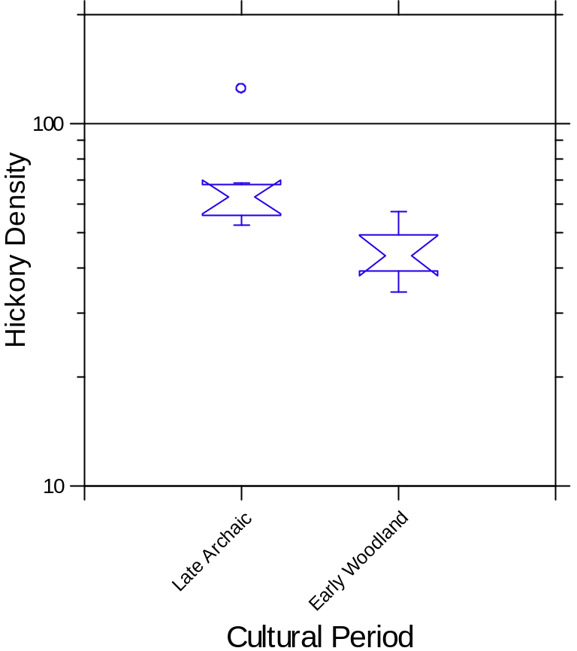
Figure 4.1: Boxplot comparing hickory relative density (hickory count/plant weight) by period. Note the y-axis is log transformed.

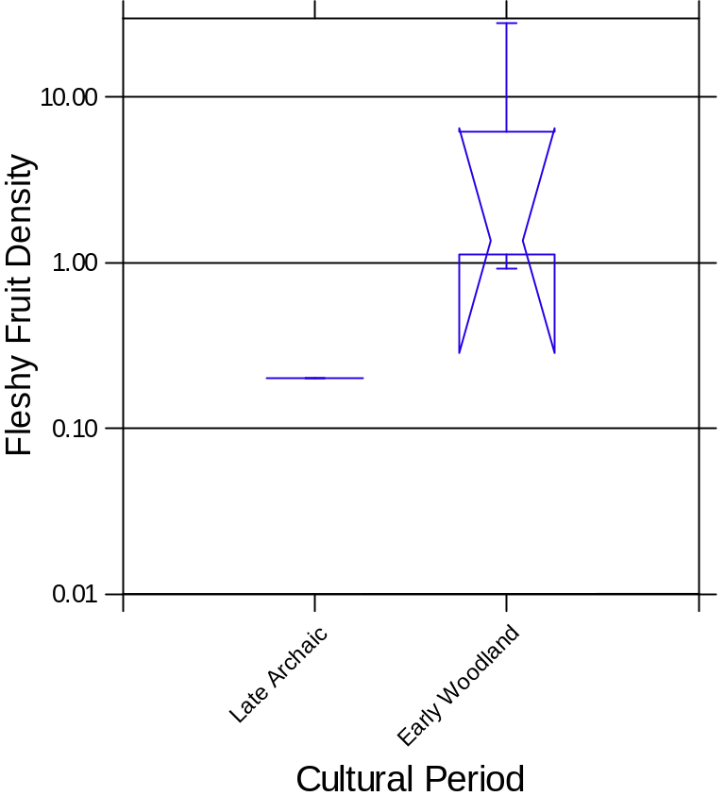
Figure 4.2: Boxplot comparing Fleshy Fruits relative density (Fleshy Fruit count/plant weight) by period. Note the y-axis is log transformed.

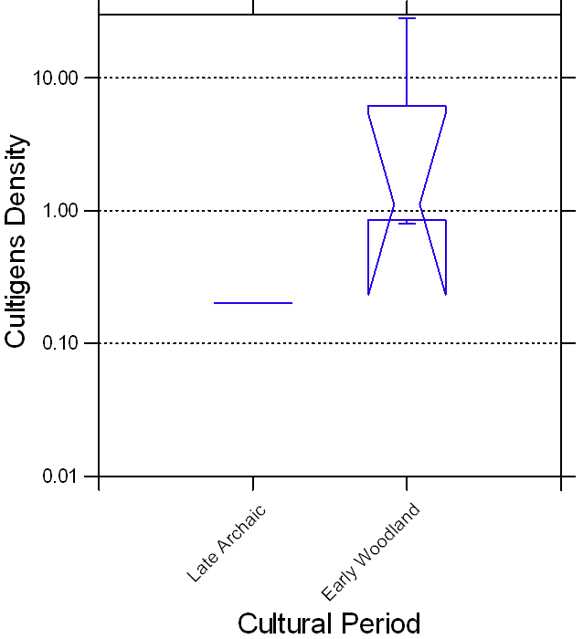
Figure 4.3: Boxplot comparing cultigens relative density (cultigens count/plant weight) by period. Note the y-axis is log transformed.

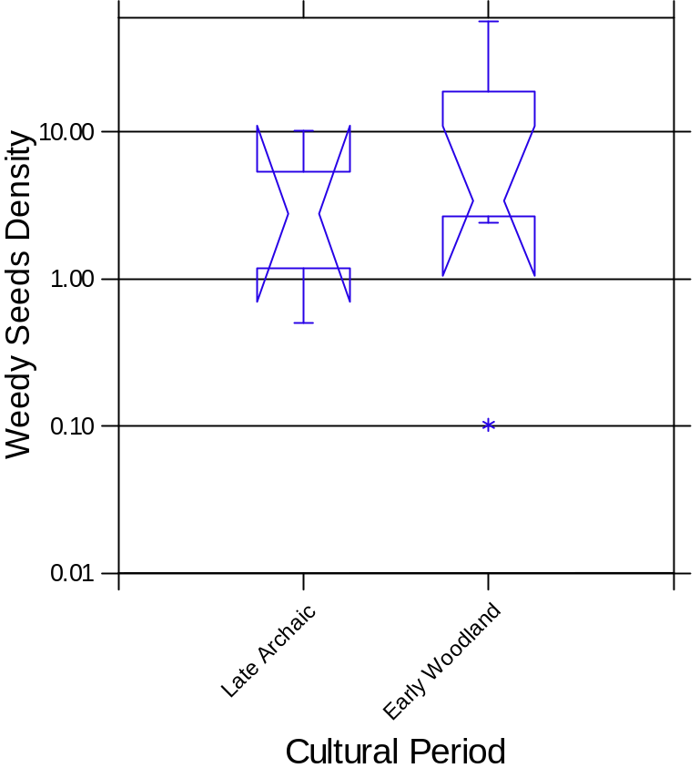
Figure 4.4: Boxplot comparing weedy seeds relative density (weedy seed count/plant weight) by period. Note the y-axis is log transformed.

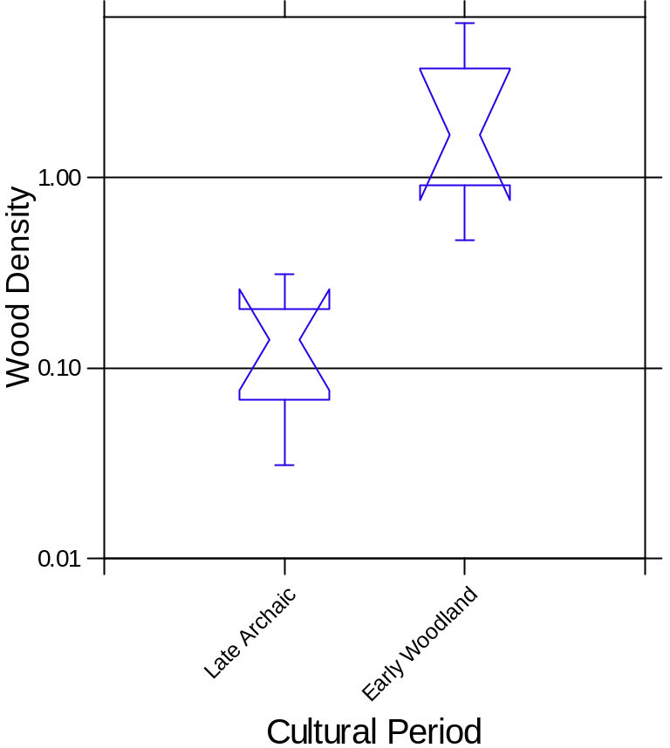
Figure 4.5: Boxplot comparing wood relative density (wood weight/plant weight) by period. Note the y-axis is log transformed.

Geospatial Analysis
I obtained site locations from the North Carolina Office of State Archaeology (NCOSA) as part of this study. Of the data given to me, 149 sites were identified as Late Archaic, and 66 were identified as Early Woodland sites. These sites have been located through Phase I, II, and III surveys and investigations. Locations have been assigned from data recorded from maps and UTM coordinates and drawn from geo-referenced scans of US Geological Survey (USGS) topographic quadrangle maps (Samuel Franklin, personal communication 2021). I used ESRI’s ArcPro platform to explore geospatial differences between the Late Archaic and Early Woodland sites. Within ArcPro, I assessed if there were differences in location on the landscape by first obtaining a digital elevation map from the USGS websites. To begin my analysis, I used the digital elevation map to create raster layers for aspect (the degree to which the site faces north, south, east, or west) and slope (the incline at which the site is located). Using the site location data, I generated cluster maps to measure the extent to which these sites were established in similar locations. I explored these geospatial data to examine the trends in groups’ site selection and discover if those trends reflected their foodways patterns.
To further explore possible differences between these sites, I used raster files from the Natural Resources Conservation Service (NRCS) to assign specific map values and categories to the site locations. Raster layers used from the NRCS database included soil water storage, frost-free days, and soil hydrologic group. These maps were updated in 2022 and derived from 30-meter raster squares (Living Atlas 2022). Soil water storage was based on the water that could be stored in the upper 150 cm and is available to plants (Living Atlas 2022). Frost-free days are based on the expected annual days between the last freezing temperatures in the spring and the first freezing temperatures in the fall. The frost-free days map was created in 2017 and last updated in 2022 (Living Atlas 2022). The soil hydrologic group maps the rainfall that runs into stream channels or infiltrates into the soil based on the physical properties of the soils (Living Atlas 2022). These are categorized into four groups: A: soils that are deep and well-drained with low runoff and high infiltration; B: soils that are well-drained but with a moderate rate of infiltration and runoff; C: soils that have layers that do not allow for infiltration or have a slow rate of infiltration; and D: soils that have very slow infiltration and have high runoff (Living Atlas 2022). These categories can also be combined into A/D, B/D, and C/D (Living Atlas 2022). In these combinations, the D represents a naturally slow infiltration rate from a high water table, with attributes from A, B, or C categories.
Raster files mapping soil and forest types were also used to see shifts in site location over time. The forest type raster was accessed through the Living Atlas, created by a collaboration of the US Forest Service (USFS) forest inventory and Analysis and Forest Health Monitoring programs and the USFS Remote Sensing Application Center (Living Atlas 2022). This map included 141 forest types identified during the growing season, created in 250-m raster squares. This map was last updated in September 2019 (Living Atlas 2022). The soil type map was obtained from the World Soil Group world reference base (WRB). This map was published in 2020 from SoilGrids and is based on 250-m cells (Living Atlas 2022). Once all the layer values and categories had been associated with the site location points, the data were downloaded into Excel, where I organized it and placed it into MYSTAT software for further processing.
In addition to the geospatial analysis available through the ESRI ArcPro software, the site terrace locations and land conditions/uses were collected via the original site forms. I used this to explore if the land is considered farmable today and if there is a correlation in terrace location between the Late Archaic and Early Woodland sites. While terrace or landscape location was not recorded for every site, there was a large enough data set to understand the general trends. I hypothesize that Early Woodland sites will be more likely to be in locations with characteristics favorable to farming, including on lower terraces, closer to water, better soil drainage, and more frost-free days.

Results
Overall, the data suggest a shift in site locations from the Late Archaic to the Early Woodland periods. The reduction in numbers from 149 Late Archaic sites to 66 Early Woodland sites seen in these two counties matches assessments from other regions in the Eastern Woodlands (Anderson and Sassaman 2012; Purrington 1983). Early Woodland groups chose different site locations from their Late Archaic predecessors; only 23 (15%) of the Late Archaic site were reoccupied by groups during the Early Woodland. The initial analysis of the location preferences found a difference in the elevation on average, with the Early Woodland sites found more often in lower elevations (Figure 5.1). Early Woodland sites are still located within higher elevations, but 95% of the site are between 550 and 1000 meters. Late Archaic sites are also found within the same range of elevation yet are less associated with the lower elevations, staying relatively common as elevation increases. In comparison, only 75% of sites are located between 500 and 1050 meters (Figure 5.1).
The slope and aspect analyses both produced inconclusive results. Groups in both cultural periods preferred reasonable slopes with southern or eastern aspects. Slope selection for Late Archaic and Early Woodland sites is important; it is easier to conduct daily activities and sleep on a surface with a limited slope. The region of the Appalachian Summit in Jackson and Swain counties is most often a slope facing east, south, or southeast in some capacity. The sites’ relative distance to a stream was not statistically significant from this sample, as the mean for this sample did not differ to any extreme (Figure 5.2 and Figure 5.3). The Late Archaic mean was 166.4 m, and the mean distance was 138.26 m during the Early Woodland (Figure 5.3). Running the stream data through the K-S test resulted in a maximum deviation (D) of 0.124 and a p-value of 0.47899. Water was essential for daily activities, and limited distance would be preferred in most cases. If data were available for this region that specifically
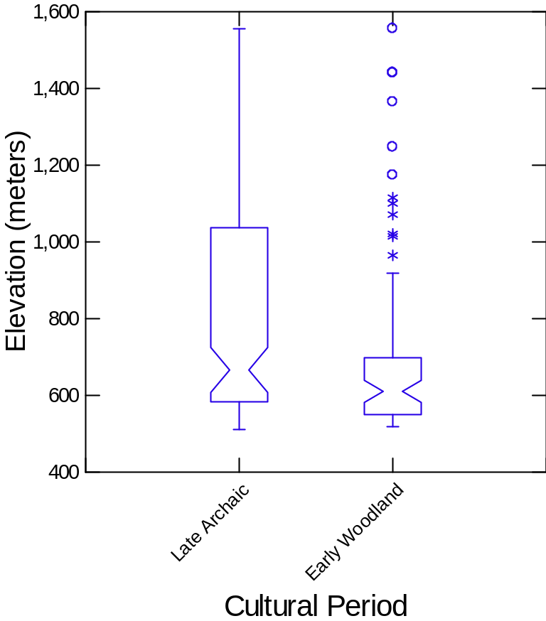
Figure 5.1. Elevations of Late Archaic and Early Woodland sites in Swain and Jackson counties.

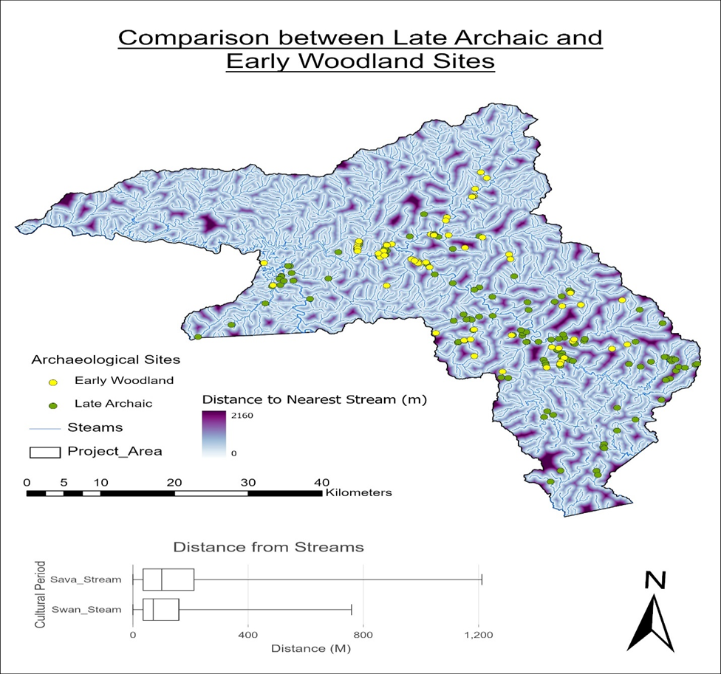

Figure 5.2. Comparison between stream distances in the Late Archaic and Early Woodland sites.
Streams
Project Area

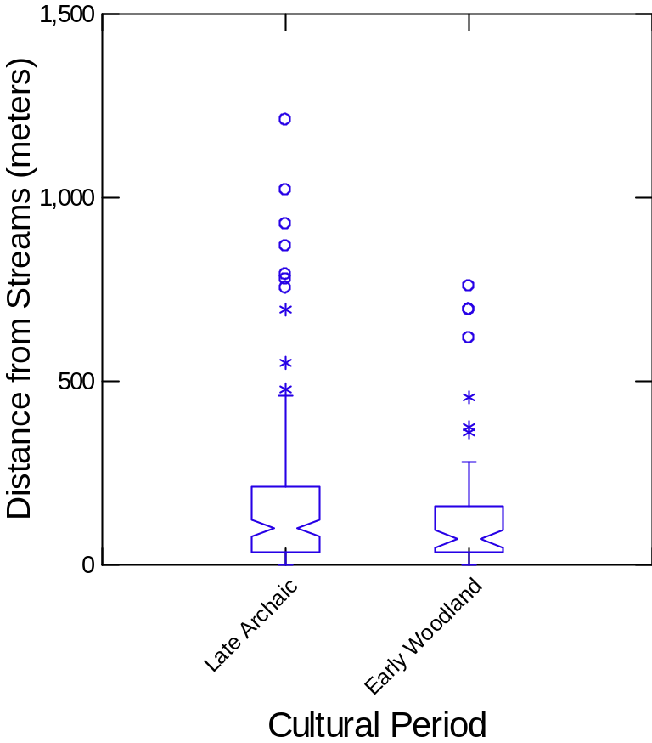
Figure 5.3. Distance in meters from streams of Late Archaic and Early Woodland sites in Swain and Jackson counties.

located site distance from a larger body of water (e.g., higher order streams rather than including smaller creeks), it would be interesting to see if a shift is apparent between the two periods.
I also created cluster maps to identify possible changes in clustering of sites between these two periods. To obtain more distinct observations, I made cluster maps of the Late Archaic and Early Woodland locations, and then tested them against random point cluster maps made in ArcPro. The site maps showed significant clustering compared to the random point sampling. Late Archaic sites show their greatest density towards the headwaters of the Tuckasegee River, near the convergence of the Tuskegee and the west fork of the Tuckasegee (Figure 5.4). There is also a small clustering of Late Archaic sites around Fontana Dam in North Carolina. This dam was established in November 1944, raising water levels and creating a lake roughly 17 miles long. The Late Archaic sites identified are above this modern waterline; there are two sites from the Early Woodland period located here as well (Figure 5.4 and Figure 5.5). The area around the Fontana Dam was surveyed after its creation, it is possible that there are additional sites located below the modern waterline, as it is near the convergence of many smaller tributaries and relatively close to the confluence of the Tuckasegee River and the Little Tennessee River (Figure 5.4). The clustering of the Early Woodland sites was located along the lower part of the Tuckasegee River before it runs into the Little Tennessee River (Figure 5.5).
Frost-free days, soils, soil hydrologic groups, and water storage layers were used as metrics for farming selection, as they are often used today. These results came back inconclusive in the attempt to tie specific periods to these attributes. The results that were the most ambiguous were soils, hydrology, and water storage: the sites either have even portions in each category, or the region does not have much diversity. Frost-free days did not demonstrate any significant selection changes (p-value of 0.419) but showed that most sites were in locations with 143 frost-free days (Figure 5.6). The frost-free days also show some sites located in areas with fewer than 140 frost-free days (Figure 5.6 and Figure 5.7).

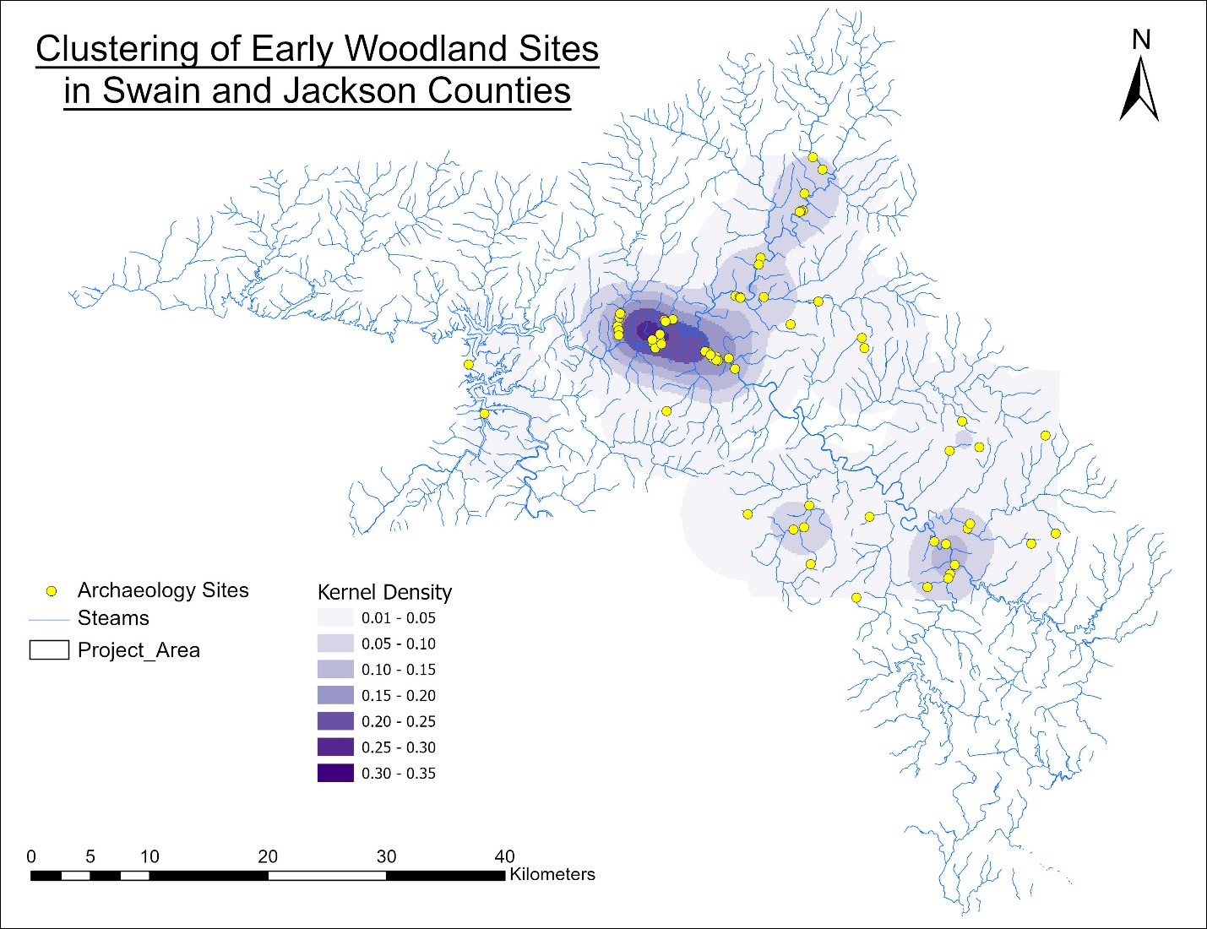
Figure 5.4. Clustering of Early Woodland Sites in Swain and Jackson counties. A: Tuckasegee River cluster; drainage of the Oconaluftee River and Deep Creek into the Tuckasegee.
A
Project Area
Streams

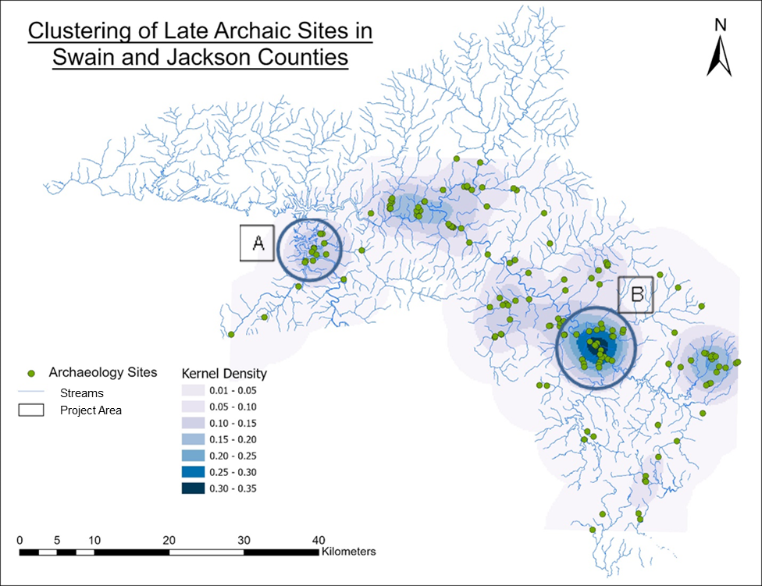Figure 5.5. Clustering of Late Archaic Sites in Swain and Jackson counties. A: Fontana Lake B: Tuckasegee and West Fork of Tuckasegee convergence.

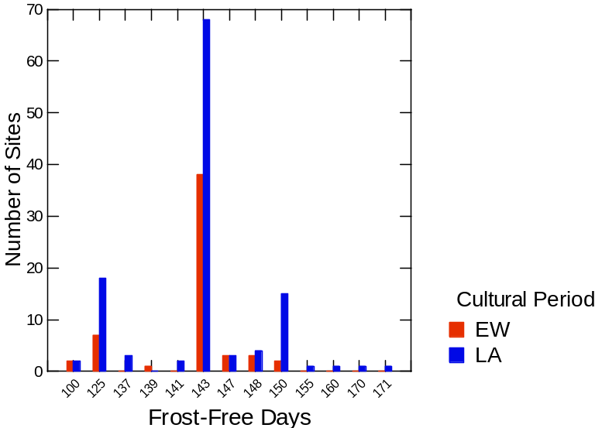
Figure 5.6. Histogram comparing frost-free days per for Late Archaic and Early Woodland sites in Jackson and Swain counties.

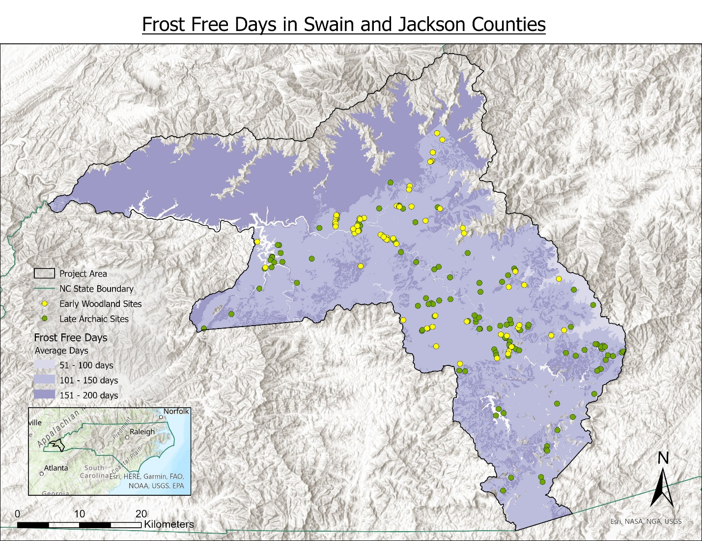Figure 5.7. Zones of frost-free days and Late Archaic and Early Woodland sites in Swain and Jackson counties.

The sites with the most frost-free days are 31JK106 (171 days), 31JK51 (170 days), and 31JK96 (160 days), all Late Archaic sites located in the southern half of Jackson County. I hypothesized that the Early Woodland sites would show trends towards more extended potential growing periods. However, 143 days without frost is within the threshold for successful crop growth, roughly 90-100 days for most crops.
The most significant classification of site selection was forest type. The most common forest types in Jackson and Swain counties are (from most popular to less popular): yellow-poplar/white oak/northern red oak (26%), chestnut oak (20%), mixed upland hardwoods (18%), white oak/red oak/hickory (16%), and sugar maple/beech/yellow birch (15%). Other forest types represent 1% or less of forests in Jackson and Swain counties (Figure 5.8). The site locations do not mirror these percentages. This suggests that forest type was considered during site selection; these sites also do not represent every forest type that grows in the project area (Figure 5.8 and Figure 5.9; Table 5.1). The Late Archaic locations correspond more closely with the forest representation of the counties (Table 5.1). All four of the most common forest types in Jackson and Swain are represented in large distributions; however, large percentages of sites are in forest types that are not significant in the project area, for example, northern red oak forests and sweetgum/yellow-poplar forests (Table 5.1). The Early Woodland sites have representation in both Bur Oak and White Oak Forest locations, which are not well represented in either the Late Archaic or county forestry types (Table 5.1). A Pearson Chi-square test confirms this significant difference between cultural period site location and forest types with a p-value of 0.000.
The NCOSA forms from the documented Late Archaic and Early Woodland sites contribute details about the geographic locations beyond what could be easily obtained from ArcPro. Most archaeological site forms ask for information about the current land conditions and the type of landform the site is located on. Of the Late Archaic sites, 109 listed current land use and 105 listed landforms. Of
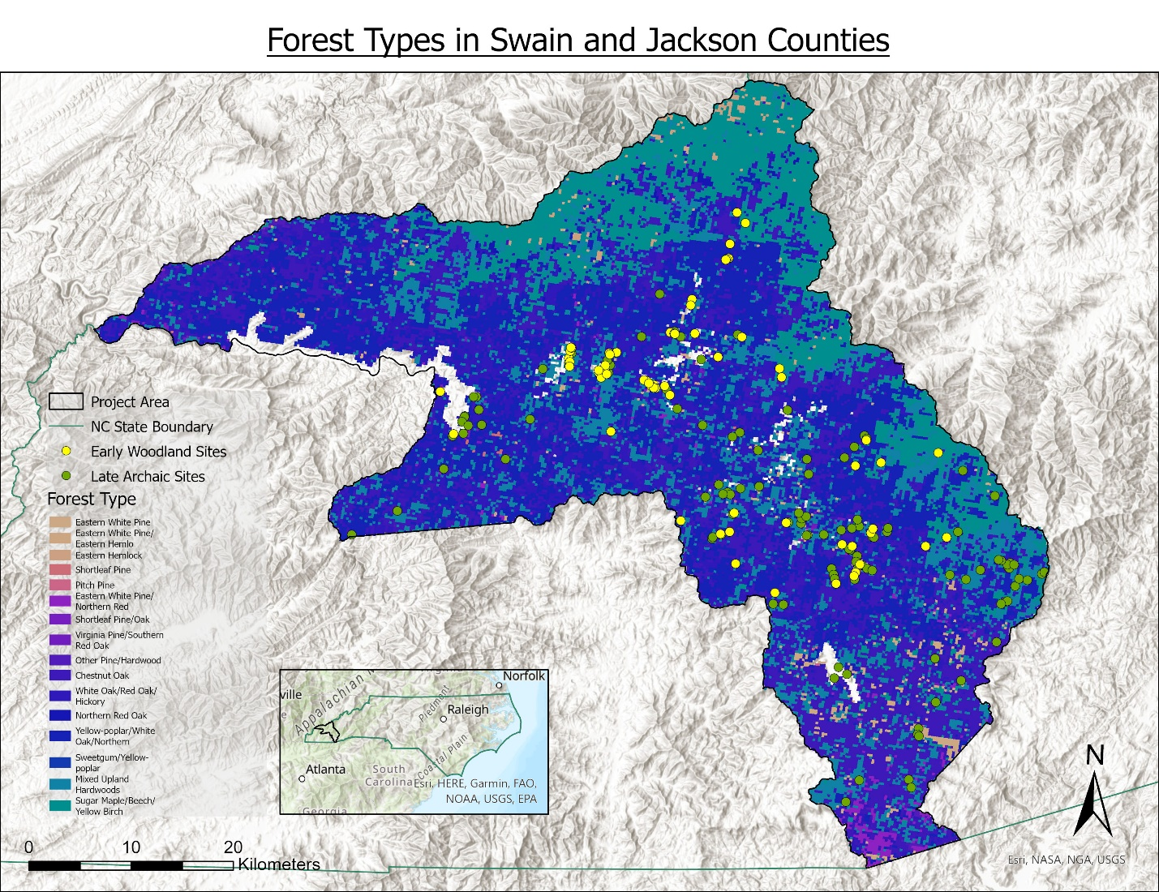Figure 5.8. Forest types in Swain and Jackson counties.

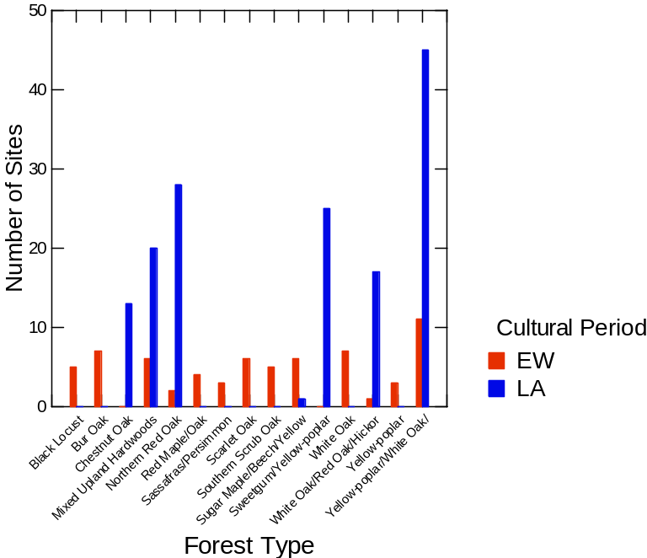
Figure 5.9. Histogram comparing forest types associated with Late Archaic and Early Woodland sites in Jackson and Swain counties.

Table 5.1. Counts and Percentages of Late Archaic and Early Woodland Sites by Forest Types in Jackson and Swain Counties.
Forest Type | LA Counts | LA% | EW Counts | EW% | Area%
Black Locust | 0 | 0% | 5 | 8% | 0%
Bur Oak | 0 | 0% | 7 | 11% | 0%
Chestnut Oak | 13 | 9% | 0 | 0% | 20%
Mixed Upland Hardwoods | 20 | 13% | 6 | 9% | 18%
Northern Red Oak | 28 | 19% | 2 | 3% | 0%
Red Maple/Oak | 0 | 0% | 4 | 6% | 0%
Sassafras/Persimmon | 0 | 0% | 3 | 5% | 0%
Scarlet Oak | 0 | 0% | 6 | 9% | 0%
Southern Scrub Oak | 0 | 0% | 5 | 8% | 0%
Sugar Maple/Beech/Yellow Birch | 1 | 1% | 6 | 9% | 15%
Sweetgum/Yellow-Poplar | 25 | 17% | 0 | 0% | 0%
White Oak | 0 | 0% | 7 | 11% | 0%
White Oak/Red Oak/Hickory | 17 | 11% | 1 | 2% | 16%
Yellow-poplar | 0 | 0% | 3 | 5% | 0%
Yellow-poplar/White Oak/Northern Red Oak | 45 | 30% | 11 | 17% | 26%

the Early Woodland site forms, 56 documented land use and 53 listed landforms. There was no difference in the current land use; most land was either forested or cultivated when surveys occurred. Landform was less diverse among the Early Woodland sites; 19 landforms are represented among the Late Archaic sites. A more significant portion of the Early Woodland sites (45%) were located in the floodplain than Late Archaic sites (25%). The Late Archaic has 16% of its sites listed on slopes and the Early Woodland only 4%. The Late Archaic also has more representation on hills, knolls, saddles, upland flats, and upland terraces. These results reinforce Purrington’s (1983) observations in his 1976 survey of the Watauga Valley, with more Late Archaic sites in highland locations and an increase in lower river valley site locations during the Early Woodland period.

Discussion
Using modern maps to analyze the locations of these sites is challenging. The selection of a place to live is personal, whether it is due to resource collection or another cultural norm or preference; therefore it is difficult to know whether our modern geographical categories would have been meaningful to these groups. The shift seen through this analysis must be viewed through a critical eye, but also should create ways to engage with the information we do have about site location. By engaging with maps in this process, I aimed to tease out possible indigenous knowledge and preferences of these groups in the past.
Of the attributes and resources compared with site locations, forest type displayed the most significant shift. The Late Archaic sites sit within forest spaces that today are more associated with yellow poplar and northern red oak (Table 5.1). The Early Woodland sites are still commonly associated with these forest types but have greater association with white oak forests and fruiting forests than the Late Archaic sites (Table 5.1). The association with more white oak forest could be another reason acorns become more prevalent in the Early Woodland paleoethnobotanical assemblages, as white oak acorns are more palatable and easier to process. If the women who were gathering preferred the use of these acorns, they may have established camps closer to these groves. The association of the Early Woodland sites with persimmon and sassafras forests is also notable: these trees thrive in disturbed areas; which would have been created by longer term occupations and farming activities. If Early Woodland peoples in the region changed their relationship with the land and the intensified their care of plants, it is possible this care extended not only to cultivated seed plants but also to fruiting and other useful trees.
The shift in site clusters and the limited reuse of sites during the Early Woodland is another sign of a shift in landscape perspective. If their understanding of and relation to space in the Appalachian Summit remained the same, it is unlikely that people relocate themselves to new places. These include places at different stream confluences and on average lower elevations. The reduction of site numbers and the change in location could be related to changes in privacy and property as well. If these Early Woodland groups began farming more intensively, their ties to the land would have intensified and changed the way that these groups defined their space (Crothers 2008).
The association between site locations and characteristics considered to be conducive to farming today, such as soil types or water resources, did not reveal any significant results. This region is known to be fairly sustainable in terms of agricultural land; many people actively farm the land today with corn and rye. Also, the Cherokee people have farmed the Three Sisters and other crops for much longer. While there was no strong correlation to current farmland attributes, the requirements for these early crops would be relatively low. Chenopod, maygrass, and the other cultigens thrive in disturbed grounds with occasional flooding.
Mapping did prove to be a useful resource for exploring changes in landscape use related to changes in use of food resources and general foodways. Broadening this study throughout the rest of the Appalachian Summit and among other early farming regions, such as easter Tennessee for comparison, would further develop our understanding of associations between changes in foodways and landscape use.

Conclusions
Foodways can define the traits of a group of people. Our food traditions are established by our roots, and our food preferences establish our worldliness. As part of this project, I aimed to explore how foodways could be applied to understand the past by using paleoethnobotanical remains from the Appalachian Summit region, specifically Swain and Jackson counties. I also compared my analysis and other North Carolina paleoethnobotanical assemblages to those of eastern Tennessee to see if group ties could be inferred around plant resource use. Then, I used spatial technologies to see how changes in relationships with plant resources would manifest in the locations of sites on the landscape.
The paleoethnobotany of Swain, Jackson, and surrounding counties showed that plant resource use shifted from the Late Archaic to the Early Woodland. The Late Archaic gatherers from this region apparently focused on collecting hickory nuts (Crites 2016; VanDerwarker and Alvarado 2013). The analyses of the Warren Wilson site’s Late Archaic component and the Magic Waters site did find a few maygrass and chenopod seeds. Still, the hickory counts and densities greatly outnumbered these early cultigens (Simpkins 1984). The Early Woodland samples yielded a greater variety of early cultigens, including maygrass, chenopod, and sumpweed (Benyshek 2020; Simpkins 1984), but the most notable shift in these plants remains appears to be greater acorn use.
Cultigens are less present in Jackson and Swain assemblages than in the eastern Tennessee sites. The sites in Tennessee yielded hundreds of cultigens in some of the samples (Hollenbach 2022). Most of these Tennessee sites are in regions near a major river, such as the Tennessee, Little Tennessee, and Clinch rivers, and within the Ridge and Valley ecoregion, which might have changed the domestication factors and cultivated a stronger relationship between these plants and people. Though maygrass, chenopod, and sumpweed are present in the Appalachian Summit sites, relaying that some relationship exists within these communities, the association with these plant resources might vary.
Based on geography, there might have also been an existing relationship between the eastern Tennessee peoples and the Swain and Jackson peoples. During the Late Archaic, there was a significant presence of maygrass seeds at the site of Bacon Bend (Hollenbach 2022). Bacon Bend is located where the Little Tennessee River enters the Tennessee River; the Little Tennessee headwaters are in Jackson County. Based on our knowledge of transportation and people’s movement patterns along waterways, it would not be surprising if these groups were in contact with one another, at least indirectly. This could have motivated the adoption (albeit slow) of maygrass in this region.
Trade could be assumed; however, considering that these people were in multigeneration relationships with the plants and potentially viewed the plants as beings themselves (Kimmerer 2013; Watts 2013), the exchange of maygrass for other goods might not be the best-assumed method by which these groups obtained the seeds. The relationship was more likely cultivated through communication and fellowship with the other Late Archaic Tennessee groups that were already starting to encourage these cultivated plants to be larger parts of their communities. Marriage, seasonal aggregations among neighboring groups, and observation may have been more likely routes to this way of life, especially from the female’s perspective.
The Late Archaic to Early Woodland shift was evident physically on the landscape. Both a change in the cluster of sites and the preferences associated with forest types were identified through ArcPro. Early Woodland groups began to locate sites in new spaces different from their Late Archaic predecessors. The Early Woodland sites are, on average, in lower elevations, on lower terraces, and fewer in number. These people also more often placed sites in forest types associated with white oaks and fruit trees than was seen in the Late Archaic.
The shifts in trees and other plant resources are evidence of a group shift in plant relationships. As women are the head gatherers of these groups, these shifts were guided by their practices, curiosities, and wisdom (Watson and Kennedy 1991). Whatever challenges or opportunities time had given them, these women consulted with plants and found new uses and patterns for the continuation of life in the Appalachian Summit.
As archaeology moves forward, especially in this region, research around plants can continue to complicate and inform what we know about these past people and landscapes. In the Appalachian Summit of North Carolina, there should be greater pushes to collect samples for paleoethnobotanical analysis when sites are subjected to Phase II and III investigations. Some sites could have little footprint in terms of stone tool assemblages but could inform us about additional uses of plant taxa and the extent to which people utilized these resources.
Overall, my analysis confirmed our current knowledge of settlement trends from the Late Archaic to the Early Woodland and explored the foodways habits of people in this region. I also elaborated further on women’s active effects on the region and their relationships with plants. Moving forward with this research and other projects, interaction and use of indigenous understandings and histories will also challenge and contribute to our perspectives of the past as archaeologists. Domestication of plants can be viewed as the domestication of self, a choice to change a lifeway to accommodate plants (Cobb and Nassaney 2002; sensu Hollenbach 2022). Plant resources should be considered a much more significant influence on lifeways, likely beyond just acquiring resources. Viewing the archaeological record through the lens of plant foods makes room for children, the elderly, and women in the archaeological past; plants are intertwined with the narratives of women and children, who were considerable gatherers in their own right. Food is part of our identity just as much as our material culture, if not more; therefore foodways are essential to our understanding of these archaeological groups. My thesis contributes details to a significant gap in the history of the Appalachian Mountains, helping to grow our understanding of the settlement patterns and cultural identity of people living in this region roughly 4000 -2200 years ago.

List of References
Anderson, David G.
2001 Climate and Culture Change in Prehistoric and Early Historic Eastern North America. Archaeology of Eastern North America 29:143-186. Electronic document, https://www.jstor.org/stable/40914449, accessed January 15, 2022.

Anderson, David G., and Kenneth E. Sassaman
2012 Recent Developments in Southeastern Archaeology: From Colonization to Complexity. Society for American Archaeology Press, Washington, D.C.

Asch, David L., and Nancy B. Asch
1985 Prehistoric Plant Cultivation in West-Central Illinois. In Prehistoric Food Production in North America, edited by Richard Ford, pp 149-203. Anthropological Papers No. 75. Museum of Anthropology, University of Michigan, Ann Arbor.

Bass, Quentin R.
1977 “Prehistoric Settlement and Subsistence Patterns in the Great Smoky Mountains.” Master’s thesis, Department of Anthropology, University of Tennessee, Knoxville.

Benyshek, Tasha
2020 Data Recovery Excavations at the Iotla Site (31MA77) at the Macon County Airport, Macon County, North Carolina. Draft Report submitted to Macon County Airport Authority, Franklin, North Carolina.

Benyshek, Tasha, Michael Nelson, and John Kesler
2018 The Magic Waters Site at Harrahs Cherokee Casino Resort. Paper presented at the Cherokee Archaeological Conference, September 6-7, Cherokee, North Carolina

Carr, Lucien
1895 The Food of Certain American Indians and Their Methods of Preparing It. Proceedings of the American Antiquarian Society 10:155-90.

Chapman, Jefferson
1981 The Bacon Bend and Iddins Sites. Report of Investigations No. 31. Department of Anthropology, The University of Tennessee, Knoxville. Tennessee Valley Authority, Publications in Anthropology 25, Norris.

Cobb, Charles R., and Michael S. Nassaney
2002 Domesticating Self and Society in the Woodland Southeast. The Woodland Southeast, edited by D. G. Anderson and R. C. Mainfort, Jr., pp. 525-539. University of Alabama Press, Tuscaloosa.

Coe, Joffre L.
1964 The Formative Cultures of the Carolina Piedmont. Transactions of the American Philosophical Society 54(5): 1-130. American Philosophical Society, Philadelphia.

Cowan, C. Wesley
1978 The Prehistoric Use and Distribution of Maygrass in Eastern North America: Cultural and Phyto-geographical Implications.In The Nature and Status of Ethnobotany, edited by Richard I. Ford, pp. 263–288. Anthropological Paper 67. Museum of Anthropology, University of Michigan, Ann Arbor.

Crites, Gary
2016 Section 9: Cold Canyon Paleoethnobotany, In Archaeological Investigations at Cold Canyon Sites (31SW265), Swain County, North Carolina. Report submitted to Larry R. Kimball, Appalachian State University, Boone, North Carolina.

Crothers, George M.
2008 From Foraging to Farming: The Emergence of Exclusive Property Rights in Kentucky Prehistory. In Economies and the Transformation of Landscape, edited by L. Cliggett and C. Pool, pp. 127-147. Altamira Press, Lanham, Maryland.

Driskell, Boyce N., Matthew D. Gage, and Jessie L. Johanson
2013 Archaeological Investigations at the Birdwell (40GN228) and Neas (40GN229) Sites, Greene County, Tennessee. Submitted to Tennessee Department of Transportation, Nashville. Archaeological Research Laboratory, University of Tennessee, Knoxville

Fowler, Catherine S.
2008 Historical Perspectives on Timbisha Shoshone Land Management Practices, Death Valley, California. In Case Studies in Environmental Archaeology, 2nd edition, edited by E. Reitz, C. Margaret Scarry, and S. Scudder, pp. 43-57. Springer, New York.

Fritz, Gayle
1999 Gender and the Early Cultivation of Gourds in Eastern North America. In American Antiquity, 64(3), 417-430. https://doi.org/10.2307/2694142
2014 Maygrass (Phalaris caroliniana Walt.). In New Lives for Ancient and Extinct Crops, edited by Paul E. Minnis, pp. 12-43. University of Arizona Press, Tucson.
2019 Feeding Cahokia: Early Agriculture in the North American Heartland. University of Alabama Press, Tuscaloosa.

Fritz, Gayle, Virginia Whitekiller and James McIntosh
2001 Ethnobotany of Ku-Nu-Che: Cherokee Hickory Nut Soup. Journal of Ethnobiology 21(2):1-27.

Fuller, Dorian Q., Chris Stephens, and Meriel McClatchie
2014 Routine Activities, Tertiary Refuse, and Labor Organizations: Social Inferences from Everyday Archeobotany. In Ancient Plants and People: Contemporary Trends in Archaeobotany, edited by Marco Madella, Carla Lancelotti, and Manon Savard, pp. 174-217. Arizona Press, Tucson.

Gardner, Andrew
2008 Agency. In Handbook of Archaeological Theories, edited by R. Alexander Bentley, Herbert D. G. Maschner, and Christopher Chippindale, pp. 95–108. AltaMira Press, Lanham, Maryland.

Gardner, Paul S.
1997 The Ecological Structure and Behavioral Implications of Mast Exploration Strategies. In People, Plants and Landscapes: Studies in Paleoethnobotany, edited by Kristen J. Gremillion, pp. 161-178. University of Alabama Press, Tuscaloosa.

Graham, Rodger
2015 Cherokee Treasure excels at making Kanuchi. Cherokee Phoenix December 11, 2015. Electronic document, https://www.cherokeephoenix.org/culture/cherokee-treasure-excels-at-making-kanuchi/article_424e5eb0-871d-5c73-8544-c9458d819d99.html, accessed February 2022.

Gremillion, Kristen J.
2002 The Development and Dispersal of Agricultural Systems in the Woodland Period Southeast. In The Woodland Southeast, edited by David G. Anderson and Robert C. Mainfort, Jr., pp. 483–501. University of Alabama Press, Tuscaloosa.

Griffith, G.E., J.M. Omernik, J.A. Comstock, M.P. Schafale, W.H. McNab, D.R. Lenat, T.F.
MacPherson, J.B. Glover, and V.B. Shelburne
2002 Ecoregions of North Carolina and South Carolina. Map scale 1:1,500,000. U.S. Geological Survey, Reston, Virginia.

Hill, Sarah H.
1997 Weaving New Worlds: Southeastern Cherokee Women and Their Basketry. The University of North Carolina Press, Chapel Hill.

Hodder, Ian
2011 Human–thing Entanglement: Towards an Integrated Archaeological Perspective. Journal of the Royal Anthropological Institute 17: 154–177.

Holden, Patricia
1966 An Archaeological Survey of Transylvania County, North Carolina. Master’s Thesis, Department of Anthropology University of North Carolina, Chapel Hill.

Hollenbach, K.D.
2009 Foraging in the Tennessee River Valley, 12,500-8,000 Years Ago. University of Alabama Press, Tuscaloosa.
(2022) From Foraging to Farming in East Tennessee. Manuscript in Groundbreaking Archaeology in the Interior Southeast: Tributes to the Career of Jefferson Chapman, edited by Thomas Whyte and C. Clifford Boyd, submitted to University of Tennessee Press, Knoxville.

Hollenbach, Kandace D., and Stephen B. Carmody
2019 Agricultural Innovation and Dispersal in Eastern North America. In Oxford Research Encyclopedia of Environmental Science. Oxford University Press, Oxford. https://doi.org/10.1093/acrefore/9780199389414.013.309

Hollenbach, Kandace D., Judith A. Sichler, and Jessica L. Vavrasek
2018 Late Archaic and Woodland Foodways in Tuckaleechee Cove. In Archaic and Woodland Occupations in Tuckaleechee Cove, Blount County, Tennessee, by K. D. Hollenbach and S. J. Yerka, pp. 354-393. Submitted to Tennessee Department of Transportation, Project No. 05006-1238-04. Archaeological Research Laboratory, University of Tennessee, Knoxville.

Keel, Bennie
1976 Cherokee Archaeology: A Study of the Appalachian Summit. University of Tennessee Press, Knoxville.

Kimmerer, Robin
2013 Braiding Sweetgrass: Indigenous Wisdom, Scientific Knowledge and the Teachings of Plants. Milkweed Editions, Minneapolis.

King, Megan H.
2017 Gender, Lithics, and Perishable Technology: Searching for Evidence of Split-Cane Technology at the Mussel Beach (40MI70). Doctoral dissertation, Department of Anthropology, University of Tennessee. Knoxville.

Kuhnlein, Harriet V., and Nancy J. Turner
1991 Traditional Plant Foods of Canadian Indigenous Peoples: Nutrition, Botany and Use. Gordon and Breach Science Publishers, Philadelphia.

Living Atlas, ESRI
2022 Living Atlas.Electronic document, https://livingatlas.arcgis.com/en/home/, accessed February 2022.

Martin, Alexander C., and William D. Barkley
1961 Seed Identification Manual. University of California Press, Berkley.

Miksicek, Charles H.
1987 Formation Processes of the Archaeobotanical Record. In Advances in Archaeological Method and Theory, edited by M. Schiffer, 10, 211–247. Academic Press, New York.

Moerman, Dan
2004 Native American Ethnobotany: A Database of Foods, Drugs, Dyes and Fibers of Native American Peoples, Derived from Plants. Electronic document, http://naeb.brit.org/, accessed February 2022.

Mooney, James
2006 [1900] Cherokee History, Myths and Sacred Formulas. Cherokee Publications, The Museum of the Cherokee Indian and Qualla Arts and Crafts Mutual, Cherokee, North Carolina.
Mueller, Natalie G., Gayle Fritz, Paul Patton, Stephen Carmody and Elizabeth Horton
2017 Growing the Lost Crops of Eastern North America’s Original Agricultural System. Nature Plants 3:17092.

Nelson, Michael and Tasha Benyshek
2013 Archaeological Investigations at the Former EBCI Elementary School Site, Swain County, Qualla Boundary, North Carolina. Draft report submitted to Eastern Band of Cherokee Indians Office of Planning and Development, Cherokee, North Carolina.

Osiyo TV
2016 Cooking Kanuchi, A Cherokee Tradition. Osiyo TV Youtube Channel. Electronic document, https://youtu.be/GSBBEYtMPNU, accessed February 2022.

Pearsall, Deborah M.
2000 Paleoethnobotany: A Handbook of Procedures, Second Edition. Academic Press, San Diego.

Perdue, Theda
1998 Cherokee Women: Gender and Cultural Change, 1700-1835. University of Nebraska Press, Lincoln.

Prentice, Guy
1986 Origins of Plant Domestication in the Eastern United States: Promoting the Individual in Archaeological Theory. Southeastern Archaeology 5(2):103-119.

Purcell, Gabrielle Casio
2013 Plant Remains from the Smokemont Site in the Appalachian Mountains of North Carolina. Master's Thesis, University of Tennessee, Knoxville. Electronic document, https://trace.tennessee.edu/utk_gradthes/2447.

Purrington, Burton L.
1983 Ancient Mountaineers: An Overview of the Prehistoric Archaeology of North Carolina’s Western Mountain Region. In The Prehistory of North Carolina: An Archaeological Symposium, edited by Mark A. Mathis and Jeffery J. Crow, pp. 83-158. North Carolina Division of Archives and History, Department of Cultural Resources, Raleigh.

Radford, Albert E., Harry E. Ahles, and C. Ritchie Bell
1964 Manual of the Vascular Flora of the Carolinas. University of North Carolina Press, Chapel Hill.

Reitz, Elizabeth J., and C. Margaret Scarry
1985 Reconstructing Historic Spanish Subsistence with an Example from Sixteenth Century Spanish Florida. Society for Historical Archaeology, Special Publications Series 3.

Robb, John E.
2010 Beyond Agency. World Archaeology 42(4):493–520. https://doi.org/10.1080/00438243.2010.520856
Santana, Kelly, Catherine Herring, and Kandace D. Hollenbach
2022 Analysis of Plant Remains from The Middle Archaic, Late Archaic, Middle and Late Woodland Features at Magic Waters (31JK291) in Cherokee, North Carolina. Draft report submitted to TRC Environmental Corporation, Asheville, North Carolina.

Sassaman, Kenneth E.
2010 Getting from the Late Archaic to Early Woodland in Three Middle Valleys. In Trend, Tradition, and Turmoil: What Happened to the Southeastern Archaic?, edited by David Hurst Thomas and Matthew C. Sanger, pp. 229-236. Anthropological Papers of the American Museum of Natural History, No. 93. American Museum of Natural History, New York.

Scarry, C. Margaret
2003 Pattern of Wild Plant Utilization in the Prehistoric Eastern Woodlands. In People and Plants in Ancient Eastern North America, edited by Paul E. Minnis, pp. 50–104. Smithsonian Books, Washington, D.C.
2008 Crop Husbandry Practices in North America’s Eastern Woodlands. In Case Studies in Environmental Archaeology, 2nd edition, edited by Elizabeth Reitz, C. Margret Scary and Sylvia J. Scudder, pp. 391-404. Springer, New York.

Simpkins, Daniel
1984 A Biocultural Approach an Ethnobotanical Study of Plant Food Remains from the Warren Wilson Site (31BN29), North Carolina: a Biocultural Approach. Master’s Thesis, Department of Anthropology, University of North Carolina, Chapel Hill.

Smith, Bruce D.
2011 The Cultural Context of Plant Domestication in Eastern North America. Current Anthropology 52(S4): S471–S484.

Smith, Bruce D., and C. Wesley Cowan
2003 Domesticated Crop Plants and the Evolution of Food Production Economies in Eastern North America. In People and Plants in Ancient Eastern North America, edited by Paul E. Minnis, pp. 105–125. Smithsonian Books, Washington, D.C.

Swanton, John R.
1946 The Indians of the Southeastern United States. Bulletin No. 137, Bureau of American Ethnology, Smithsonian Institution, Washington, D.C.

Thomas, Julian
2012 Archaeologies of Place and Landscape. In Archaeological Theory Today, 2nd edition, edited by Ian Hodder, pp. 167–187. Polity Press, Malden.

Tippett, Joseph L., Stuart Fiedel, Tracey Jones, Katherine Kosalko, Gregory LaBuddle and Eric Voigt
2014 Archaeological Data Recovery at Site 31JK12 (Tuskasegee) and National Register Evaluation of Site 31JK13 Volume II – Appendices. Report submitted to The Archaeology Group North Carolina Department of Transportation, Raleigh, North Carolina.

U.S. Department of Agriculture – Natural Resources Conservation Service
2022 The PLANTS Database. National Plant Data Team, Greensboro, North Carolina. Electronic document, http://plants.usda.gov, accessed 2022.

VanDerwarker, Amber M., and Jennifer V. Alvarado
2013 Analysis of Plant Remains from the Ravensford Site. Report submitted to TCR Garrow Associates, Inc., Chapel Hill, North Carolina. Department of Anthropology ,University of California, Santa Barbara.

VanDerwarker, Amber M., and Kandace R. Detwiler
2002 Gendered Practice in Cherokee Foodways: A Spatial Analysis of Plant Remains from the Coweeta Creek Site. Southeastern Archaeology 21(1):21-28.

Ward, H. Trawick, and R.P. Stephen Davis Jr.
1999 Time before History: The Archaeology of North Carolina. University of North Carolina, Chapel Hill.

Watson, Patty Jo and Mary Kennedy
1991 The Development of Horticulture in the Eastern Woodlands of North America: Women’s Role. In Engendering Archaeology: Women and Prehistory, edited by Joan M. Gero and Margaret W. Conkey pp. 255-269. B. Blackwell, Oxford, UK.

Watts, Vanessa
2013 Indigenous Place-Thought and Agency amongst Humans and Non-Humans (First Woman and Sky Woman Go On a European World Tour!). Decolonization: Indigeneity, Education, and Society 2(1):20-34.

Wetmore, Ruth Y.
2002 The Woodland Period in the Appalachian Summit of Western North Carolina and the Ridge and Valley Province of Eastern Tennessee. In The Woodland Southeast, edited by David Anderson and Robert C. Mainfoft Jr., pp.249-269. The University of Alabama Press, Tuscaloosa.

White, Chantel E., and China P. Shelton
2014 Recovering Macrobotanical Remains: Current Methods and Techniques. In Methods and Theory in Paleoethnobotany, edited by John M. Marston, Jade D’Alpoim Guedes, and Christina Warinner, pp.95-114. University Press of Colorado, Boulder, Colorado.

Whyte, Thomas R.
2007 Proto-Iroquoian Divergence in the Late Archaic-Early Woodland Period Transition of the Appalachian Highlands. Southeastern Archaeology 26:134-144.

Wilson, Gilbert Livingstone
1987 Buffalo Bird Woman’s Garden. Minnesota Historical Society Press, St. Paul, Minnesota.

Yarnell, Richard A., and M. Jean Black
1985 Temporal Trends Indicated by a Survey of Archaic and Woodland Plant Food Remains from Southeastern North America. Southeastern Archaeology 4:93–106

Appendix

Appendix A: Provenience Information: Late Archaic
Bag# | Sample Volume (L) | Sample Weight (g) | Plant Weight (g) | Wood Weight (g) | Common Name | Count | Weight (g)
823 | 2.00 | 48.65 | 1.49 | 0.20 | Acorn | 1 | 0.00
 |  |  |  |  | Acorn cf. | 2 | 0.00
 |  |  |  |  | Gall | 1 | 0.01
 |  |  |  |  | Hazelnut | 1 | 0.01
 |  |  |  |  | Hickory | 94 | 1.09
 |  |  |  |  | Pine cone | 1 | 0.00
 |  |  |  |  | Pitch | 8 | 0.06
 |  |  |  |  | Seed meat cf. | 1 | 0.00
 |  |  |  |  | Stem | 11 | 0.12
 |  |  |  |  | Unidentifiable seed | 2 | 0.00
824 | 12.00 | 210.05 | 12.02 | 1.77 | Acorn cf. | 1 | 0.01
 |  |  |  |  | Acorn meat cf. | 6 | 0.07
 |  |  |  |  | Aster seed head cf. | 1 | 0.00
 |  |  |  |  | Bark | 1 | 0.00
 |  |  |  |  | Black walnut | 4 | 0.09
 |  |  |  |  | Catkin | 5 | 0.35
 |  |  |  |  | Hickory | 807 | 8.92
 |  |  |  |  | Hickory cf. | 28 | 0.16
 |  |  |  |  | Persimmon cf. | 1 | 0.00
 |  |  |  |  | Pine needle base | 1 | 0.00
 |  |  |  |  | Pitch | 36 | 0.30
 |  |  |  |  | Stem | 2 | 0.00
 |  |  |  |  | Stem/bud | 1 | 0.02
 |  |  |  |  | Unidentified seed | 3 | 0.00
 |  |  |  |  | Unidentifiable | 1 | 0.00
 |  |  |  |  | Unidentifiable fruit/tuber | 1 | 0.01
 |  |  |  |  | Unidentifiable seed | 3 | 0.00
 |  |  |  |  | Walnut family | 35 | 0.30
825 | 1.00 | 10.15 | 0.08 | 0.01 | Hazelnut cf. | 1 | 0.00
 |  |  |  |  | Hickory | 10 | 0.06
 |  |  |  |  | Hickory cf. | 1 | 0.01
826 | 6.00 | 180.81 | 9.96 | 0.37 | Acorn cf. | 2 | 0.01
 |  |  |  |  | Acorn meat cf. | 3 | 0.00
 |  |  |  |  | Bark | 1 | 0.00
 |  |  |  |  | Black walnut cf. | 6 | 0.06
 |  |  |  |  | Bud | 1 | 0.00
 |  |  |  |  | Hazelnut cf. | 1 | 0.01
 |  |  |  |  | Hickory | 682 | 9.22
 |  |  |  |  | Little stems | 4 | 0.00
 |  |  |  |  | Maygrass | 2 | 0.00
 |  |  |  |  | Mulberry cf. | 1 | 0.00
 |  |  |  |  | Persimmon cf. | 1 | 0.00
 |  |  |  |  | Pine cone | 1 | 0.01
 |  |  |  |  | Pitch | 6 | 0.06
 |  |  |  |  | Stem | 7 | 0.20
 |  |  |  |  | Unidentifiable seed | 7 | 0.00
 |  |  |  |  | Unidentifiable starch | 1 | 0.01
 |  |  |  |  | Wild bean | 1 | 0.00
827 | 5.00 | 143.45 | 4.19 | 1.14 | Acorn meat cf. | 2 | 0.01
 |  |  |  |  | Bark | 6 | 0.09
 |  |  |  |  | Bedstraw cf. | 1 | 0.00
 |  |  |  |  | Black walnut | 2 | 0.04
 |  |  |  |  | Hickory | 220 | 2.76
 |  |  |  |  | Hickory cf. | 7 | 0.04
 |  |  |  |  | Pine cone | 1 | 0.00
 |  |  |  |  | Pitch | 6 | 0.06
 |  |  |  |  | Seed coat cf. | 1 | 0.00
 |  |  |  |  | Unidentifiable | 4 | 0.02
 |  |  |  |  | Walnut family | 1 | 0.02
828 | 3.00 | 45.84 | 1.44 | 0.22 | Acorn cf. | 1 | 0.00
 |  |  |  |  | Acorn meat cf. | 4 | 0.02
 |  |  |  |  | Bark | 1 | 0.01
 |  |  |  |  | Hickory | 90 | 1.19
 |  |  |  |  | Pitch | 1 | 0.00
 |  |  |  |  | Grass seed (Poaceae) | 1 | 0.00
 |  |  |  |  | Unidentifiable seed | 3 | 0.00
 |  |  |  |  | Unidentifiable seed fragment | 1 | 0.00
829 | 2.00 | 24.99 | 0.39 | 0.01 | Acorn cf. | 1 | 0.00
 |  |  |  |  | Hickory | 23 | 0.24
 |  |  |  |  | Pine cone | 2 | 0.00
 |  |  |  |  | Pine cone cf. | 2 | 0.00
 |  |  |  |  | Pitch | 15 | 0.12
 |  |  |  |  | Unidentifiable | 3 | 0.01
 |  |  |  |  | Unidentifiable seed | 4 | 0.00
1704 | 10.00 | 133.10 | 4.97 | 1.55 | Acorn | 4 | 0.01
 |  |  |  |  | Acorn cf. | 9 | 0.01
 |  |  |  |  | Bark | 24 | 0.22
 |  |  |  |  | Black walnut cf. | 2 | 0.04
 |  |  |  |  | Cherry cf. | 1 | 0.00
 |  |  |  |  | Hazelnut | 1 | 0.01
 |  |  |  |  | Hickory | 264 | 2.85
 |  |  |  |  | Hickory cf. | 0 | 0.01
 |  |  |  |  | Monocot stem | 1 | 0.00
 |  |  |  |  | Persimmon | 1 | 0.00
 |  |  |  |  | Pitch | 24 | 0.21
 |  |  |  |  | Tuber cf. | 4 | 0.03
 |  |  |  |  | Unidentifiable | 6 | 0.03

Appendix B: Provenience information: Early Woodland
Bag# | Sample Volume (L) | Sample Weight (g) | Plant Weight (g) | Wood Weight (g) | Common Name | Count | Weight (g)
222 | 7.00 | 33.91 | 2.29 | 1.61 | Acorn | 4 | 0.01
 |  |  |  |  | Acorn cf. | 5 | 0.00
 |  |  |  |  | Bark | 11 | 0.02
 |  |  |  |  | Black walnut | 8 | 0.13
 |  |  |  |  | Cane | 1 | 0.00
 |  |  |  |  | Hickory | 30 | 0.25
 |  |  |  |  | Pitch | 33 | 0.17
 |  |  |  |  | Starch | 2 | 0.01
 |  |  |  |  | Sumpweed cf. | 1 | 0.00
 |  |  |  |  | Unidentifiable | 21 | 0.08
 |  |  |  |  | Unidentifiable seed | 1 | 0.00
 |  |  |  |  | Unidentified seed | 1 | 0.00
230 | 6.00 | 12.15 | 0.34 | 0.27 | Acorn | 3 | 0.00
 |  |  |  |  | Acorn cap cf. | 1 | 0.00
 |  |  |  |  | Anthers | 1 | 0.00
 |  |  |  |  | Bark | 1 | 0.00
 |  |  |  |  | Black walnut | 1 | 0.01
 |  |  |  |  | Black walnut cf. | 1 | 0.00
 |  |  |  |  | Chenopod | 2 | 0.00
 |  |  |  |  | Chestnut cf. | 2 | 0.00
 |  |  |  |  | Grape | 2 | 0.01
 |  |  |  |  | Hickory | 3 | 0.02
 |  |  |  |  | Persimmon cf. | 1 | 0.01
 |  |  |  |  | Pine cone | 1 | 0.00
 |  |  |  |  | Pitch | 3 | 0.02
 |  |  |  |  | Unidentified seed | 3 | 0.00
 |  |  |  |  | Unidentifiable | 3 | 0.01
 |  |  |  |  | Unidentifiable seed | 1 | 0.00
 |  |  |  |  | Wild bean | 1 | 0.00
489 | 8.00 | 62.59 | 6.89 | 5.42 | Acorn | 14 | 0.03
 |  |  |  |  | Acorn meat cf. | 6 | 0.02
 |  |  |  |  | Bark | 12 | 0.07
 |  |  |  |  | Black walnut | 3 | 0.04
 |  |  |  |  | Cane cf. | 1 | 0.00
 |  |  |  |  | Chenopod | 1 | 0.00
 |  |  |  |  | Hickory | 54 | 0.70
 |  |  |  |  | Hickory cf. | 1 | 0.00
 |  |  |  |  | Monocot stem | 1 | 0.00
 |  |  |  |  | Mulberry | 1 | 0.00
 |  |  |  |  | Pine cone | 1 | 0.00
 |  |  |  |  | Pitch | 50 | 0.50
 |  |  |  |  | Pokeweed | 2 | 0.00
 |  |  |  |  | Blackberry/Raspberry | 1 | 0.00
 |  |  |  |  | Seed meat cf. | 1 | 0.00
 |  |  |  |  | Sumpweed | 1 | 0.00
 |  |  |  |  | Unidentifiable seed | 1 | 0.00
 |  |  |  |  | Unidentifiable | 2 | 0.08
 |  |  |  |  | Unidentified seed | 2 | 0.00
 |  |  |  |  | Unidentified starch | 1 | 0.00
 |  |  |  |  | Walnut family | 3 | 0.03
490 | 10.00 | 62.81 | 2.18 | 1.02 | Acorn | 10 | 0.01
 |  |  |  |  | Acorn cf. | 4 | 0.00
 |  |  |  |  | Aster seed head cf. | 1 | 0.00
 |  |  |  |  | Bark | 8 | 0.07
 |  |  |  |  | Bedstraw | 1 | 0.00
 |  |  |  |  | Black walnut | 1 | 0.01
 |  |  |  |  | Chestnut cf. | 4 | 0.00
 |  |  |  |  | Chestnut/acorn cf. | 1 | 0.00
 |  |  |  |  | Coal/pitch | 3 | 0.04
 |  |  |  |  | Grape | 1 | 0.00
 |  |  |  |  | Hickory | 57 | 0.66
 |  |  |  |  | Hickory cf. | 2 | 0.01
 |  |  |  |  | Sumpweed | 1 | 0.00
 |  |  |  |  | Sumpweed cf. | 3 | 0.01
 |  |  |  |  | Maygrass cf. | 1 | 0.00
 |  |  |  |  | Pitch | 30 | 0.31
 |  |  |  |  | Grass seed (Poaceae) cf. | 3 | 0.00
 |  |  |  |  | Pointy-base seed | 10 | 0.03
 |  |  |  |  | St. Johnswort cf. | 8 | 0.00
 |  |  |  |  | Unidentified seed | 2 | 0.00
 |  |  |  |  | Unidentifiable | 2 | 0.00
 |  |  |  |  | Unidentifiable seed | 6 | 0.00
491 | 5.00 | 51.30 | 2.88 | 2.50 | Acorn | 13 | 0.05
 |  |  |  |  | Acorn cf. | 6 | 0.00
 |  |  |  |  | Bark | 14 | 0.03
 |  |  |  |  | Gall | 3 | 0.00
 |  |  |  |  | Hickory | 16 | 0.15
 |  |  |  |  | Hickory cf. | 5 | 0.02
 |  |  |  |  | Pine cone | 3 | 0.00
 |  |  |  |  | Pitch | 17 | 0.02
 |  |  |  |  | Unidentifiable | 4 | 0.10
 |  |  |  |  | Unidentified seed | 5 | 0.02
491.222* | n/a | 38.897 | 6.645 | 2.12 | Acorn | 23 | 0.03
 |  |  |  |  | Acorn cap cf. | 1 | 0.01
 |  |  |  |  | Bark | 11 | 0.1
 |  |  |  |  | Bark cf. | 11 | 0
 |  |  |  |  | Hickory | 155 | 3.39
 |  |  |  |  | Pitch | 70 | 0.88
 |  |  |  |  | Stem | 1 | 0.01
 |  |  |  |  | Unidentifiable | 9 | 0.03
 |  |  |  |  | Unidentifiable seed | 1 | 0
 |  |  |  |  | Walnut family | 5 | 0.07
492 | 7.00 | 83.61 | 18.59 | 8.77 | Acorn | 26 | 0.05
 |  |  |  |  | Acorn cap | 1 | 0.00
 |  |  |  |  | Acorn cf. | 2 | 0.00
 |  |  |  |  | Acorn meat cf. | 7 | 0.02
 |  |  |  |  | Bark | 20 | 0.13
 |  |  |  |  | Black walnut | 5 | 0.17
 |  |  |  |  | Coal/pitch | 1 | 0.01
 |  |  |  |  | Hickory | 562 | 8.68
 |  |  |  |  | Hickory cf. | 9 | 0.06
 |  |  |  |  | Persimmon cf. | 1 | 0.00
 |  |  |  |  | Pitch | 46 | 0.40
 |  |  |  |  | Plum/cherry cf. | 1 | 0.01
 |  |  |  |  | Pocket gall cf. | 7 | 0.04
 |  |  |  |  | Stem | 1 | 0.01
 |  |  |  |  | Unidentifiable seed coat | 1 | 0.00
 |  |  |  |  | Unidentifiable | 17 | 0.13
 |  |  |  |  | Unidentifiable seed | 1 | 0.08
 |  |  |  |  | Walnut family | 6 | 0.03
493 | 5.00 | 42.81 | 2.77 | 1.49 | Acorn | 14 | 0.02
 |  |  |  |  | Acorn cf. | 5 | 0.01
 |  |  |  |  | Acorn meat cf. | 1 | 0.00
 |  |  |  |  | Bark | 20 | 0.37
 |  |  |  |  | Black walnut | 1 | 0.04
 |  |  |  |  | Cane | 1 | 0.01
 |  |  |  |  | Chenopod perisperm cf. | 2 | 0.00
 |  |  |  |  | Chenopod | 1 | 0.00
 |  |  |  |  | Hazelnut | 1 | 0.00
 |  |  |  |  | Hickory | 58 | 0.59
 |  |  |  |  | Hickory cf. | 3 | 0.02
 |  |  |  |  | Pine cone | 1 | 0.00
 |  |  |  |  | Pitch | 19 | 0.15
 |  |  |  |  | Starch | 1 | 0.01
 |  |  |  |  | Unidentifiable | 5 | 0.03
 |  |  |  |  | Unidentifiable seed | 3 | 0.00
 |  |  |  |  | Unidentifiable starch | 3 | 0.01
 |  |  |  |  | Walnut family | 5 | 0.03

Appendix C: Late Archaic ArcPro Data
Site Number | Elevation (m) | Slope | Distance from Streams (m) | Soil Type | Frost-free Days | Forest Type | Hydrologic Group | Soil Water Storage (cm)
JK10 | 711.09 | 0.507 | 50.00 | Cambisols | 143 | White Oak/Red Oak/Hickory | Group B | 12.20
JK101 | 1446.43 | 14.721 | 158.11 | Cambisols | 100 | Yellow-poplar/White Oak/Northern | Group B | 10.20
JK105 | 1338.20 |  | 1211.66 | Cambisols | 166 | Yellow-poplar/White Oak/Northern | Group B | 17.40
JK106 | 1182.16 |  | 301.04 | Cambisols | 171 | Yellow-poplar/White Oak/Northern | Group B | 17.30
JK107 | 655.79 |  | 125.00 | Cambisols | 125 | Mixed Upland Hardwoods | Group A | 16.20
JK113 | 650.83 | 2.851 | 213.60 | Cambisols | 143 | Mixed Upland Hardwoods | Group C | 18.00
JK115 | 829.81 |  | 25.00 | Cambisols | 135 | Mixed Upland Hardwoods | Group A | 22.50
JK118 | 1120.68 | 5.460 | 777.82 | Cambisols | 147 | Mixed Upland Hardwoods | Group A
JK12 | 655.08 | 1.486 | 103.08 | Cambisols | 143 | White Oak/Red Oak/Hickory | Group A | 21.00
JK121 | 1127.76 | 12.724 | 867.83 | Cambisols | 150 | Sweetgum/Yellow-poplar | Group A | 17.40
JK128 | 1073.75 | 3.824 | 427.93 | Cambisols | 125 | Yellow-poplar/White Oak/Northern | Group A | 23.20
JK129 | 639.47 |  | 100.00 | Cambisols | 143 | Northern Red Oak | Group B | 21.00
JK131 | 1262.32 | 23.038 | 25.00 | Cambisols | 125 | Sweetgum/Yellow-poplar | Group A | 17.00
JK142 | 627.87 |  | 25.00 | Andosols | 143 | Yellow-poplar/White Oak/Northern | Group C | 18.00
JK148 | 648.65 |  | 190.39 | Cambisols | 143 | White Oak/Red Oak/Hickory | Group C | 18.00
JK15 | 561.11 | 0.308 | 176.78 | Cambisols | 143 | Yellow-poplar/White Oak/Northern | Group A/D | 23.20
JK152 | 646.93 |  | 25.00 | Cambisols | 143 | Northern Red Oak | Group C | 18.00
JK164 | 657.33 | 3.832 | 125.00 | Cambisols | 143 | Mixed Upland Hardwoods | Group C | 22.50
JK168 | 668.74 | 4.138 | 55.90 | Cambisols | 143 | Mixed Upland Hardwoods | Group C
JK169 | 659.22 |  | 55.90 | Cambisols | 143 | Mixed Upland Hardwoods | Group B | 17.60
JK172 | 644.05 |  | 251.25 | Cambisols | 143 | Northern Red Oak | Group C | 18.00
JK176 | 562.39 |  | 55.90 | Cambisols | 143 | Mixed Upland Hardwoods
JK177 | 561.55 |  | 141.42 | Cambisols | 143 | Mixed Upland Hardwoods | Group C/D | 25.40
JK179 | 1110.57 | 2.968 | 0.00 | Cambisols | 143 | Sweetgum/Yellow-poplar | Group A/D | 14.60
JK184 | 714.35 |  | 35.36 | Cambisols | 143 | Northern Red Oak | Group A/D | 14.60
JK185 | 715.33 |  | 25.00 | Cambisols | 143 | Northern Red Oak | Group C | 18.00
JK186 | 702.02 |  | 111.80 | Andosols | 143 | Northern Red Oak | Group C | 17.90
JK187 | 698.96 |  | 215.06 | Albeluvisols | 143 | Northern Red Oak | Group B | 17.60
JK188 | 666.21 |  | 50.00 | Cambisols | 150 | Northern Red Oak | Group B | 17.90
JK2 | 655.05 |  | 550.00 | Cambisols | 143 | Sweetgum/Yellow-poplar | Group B | 22.00
JK201 | 562.00 |  | 90.14 | Cambisols | 143 | Northern Red Oak | Group A
JK202 | 559.72 |  | 160.08 | Cambisols | 143 | Northern Red Oak | Group C | 20.80
JK203 | 645.52 | 2.197 | 0.00 | Cambisols | 143 | Northern Red Oak | Group A/D | 12.20
JK204 | 688.33 | 6.580 | 212.13 | Acrisols | 148 | Northern Red Oak | Group B | 18.80
JK205 | 689.75 | 8.321 | 215.06 | Calcisols | 147 | Northern Red Oak | Group B | 19.30
JK207 | 697.72 | 3.930 | 25.00 | Andosols | 143 | Northern Red Oak | Group A/D | 12.20
JK208 | 703.07 | 2.665 | 25.00 | Alisols | 143 | Sweetgum/Yellow-poplar | Group B | 27.90
JK21 | 568.64 | 0.714 | 125.00 | Cambisols | 143 | Mixed Upland Hardwoods | Group B | 27.90
JK22 | 563.78 | 1.599 | 90.14 | Cambisols | 143 | Yellow-poplar/White Oak/Northern | Group A | 18.80
JK23 | 576.77 | 0.938 | 25.00 | Cambisols | 143 | Mixed Upland Hardwoods | Group A | 18.80
JK254 | 1148.59 |  | 176.78 | Cambisols | 135 | Northern Red Oak | Group A
JK255 | 665.46 |  | 75.00 | Acrisols | 126 | Northern Red Oak | Group A
JK26 | 633.92 |  | 55.90 | Cambisols | 143 | Northern Red Oak | Group B | 27.20
JK27 | 618.61 |  | 50.00 | Cambisols | 143 | Northern Red Oak | Group A/D | 12.20
JK276 | 1289.20 |  | 213.60 | Cambisols | 137 | Northern Red Oak | Group B | 17.80
JK281 | 970.26 | 5.771 | 380.79 | Cambisols | 135 | Sweetgum/Yellow-poplar | Group C | 18.00
JK281 | 970.26 | 5.771 | 380.79 | Cambisols | 135 | Sweetgum/Yellow-poplar | Group C | 18.00
JK282 | 765.96 | 5.383 | 70.71 | Acrisols | 125 | Sweetgum/Yellow-poplar | Group A | 16.20
JK285 | 918.11 | 2.914 | 25.00 | Cambisols | 125 | Mixed Upland Hardwoods | Group B | 18.20
JK29 | 653.61 |  | 55.90 | Andosols | 143 | Northern Red Oak | Group C | 20.50
JK291 | 608.98 | 1.827 | 70.71 | Cambisols | 143 | Sweetgum/Yellow-poplar | Group A | 18.80
JK292 | 672.32 | 6.579 | 111.80 | Albeluvisols | 155 | Sweetgum/Yellow-poplar | Group C | 17.50
JK3 | 697.36 | 25.279 | 90.14 | Cambisols | 148 | Northern Red Oak | Group B | 18.30
JK315 | 692.99 | 3.657 | 25.00 | Cambisols | 125 | Sweetgum/Yellow-poplar | Group A | 23.80
JK317 | 622.85 | 4.936 | 35.36 | Acrisols | 143 | Sweetgum/Yellow-poplar | Group C | 20.80
JK32 | 647.49 |  | 125.00 | Cambisols | 143 | Northern Red Oak | Group A/D | 26.20
JK328 | 1232.86 |  | 282.84 | Cambisols | 156 | Chestnut Oak | Group A | 17.30
JK35 | 657.01 |  | 167.71 | Cambisols | 143 | Chestnut Oak | Group B | 22.50
JK36 | 650.81 |  | 50.00 | Cambisols | 143 | Chestnut Oak | Group A
JK364 | 1036.94 |  | 400.78 | Cambisols | 125 | White Oak/Red Oak/Hickory | Group A | 16.20
JK366 | 1020.79 | 10.781 | 35.36 | Cambisols | 125 | Yellow-poplar/White Oak/Northern | Group A | 16.20
JK381 | 1018.94 |  | 55.90 | Cambisols | 147 | White Oak/Red Oak/Hickory | Group B | 18.30
JK39 | 672.06 | 3.556 | 167.71 | Acrisols | 143 | White Oak/Red Oak/Hickory | Group B | 22.50
JK398 | 1068.69 |  | 25.00 | Cambisols |  | White Oak/Red Oak/Hickory
JK40 | 657.80 | 2.869 | 25.00 | Cambisols | 143 | White Oak/Red Oak/Hickory | Group A | 20.80
JK401 | 1062.00 |  | 0.00 | Cambisols |  | White Oak/Red Oak/Hickory
JK402 | 1062.27 |  | 0.00 | Cambisols |  | White Oak/Red Oak/Hickory
JK407 | 995.71 | 9.217 | 103.08 | Cambisols | 125 | Yellow-poplar/White Oak/Northern | Group A | 16.10
JK41 | 665.09 | 1.674 | 125.00 | Albeluvisols | 142 | Mixed Upland Hardwoods | Group B
JK42 | 654.06 | 0.440 | 79.06 | Cambisols | 143 | White Oak/Red Oak/Hickory | Group A
JK420 | 1365.12 | 11.585 | 456.21 | Cambisols |  | Mixed Upland Hardwoods | Group A | 15.20
JK429 | 1104.75 |  | 90.14 | Cambisols | 125 | Yellow-poplar/White Oak/Northern | Group A | 16.00
JK43 | 657.73 |  | 79.06 | Cambisols | 143 | Mixed Upland Hardwoods | Group A
JK44 | 703.78 |  | 25.00 | Cambisols | 143 | Mixed Upland Hardwoods | Group B
JK443 | 693.00 |  | 35.36 | Cambisols | 141 | Yellow-poplar/White Oak/Northern | Group B | 14.70
JK463 | 1190.61 |  | 150.00 | Cambisols | 150 | Yellow-poplar/White Oak/Northern | Group A | 19.40
JK465 | 678.05 |  | 70.71 | Cambisols | 143 | Northern Red Oak | Group B | 18.40
JK477 | 665.64 |  | 25.00 | Cambisols | 143 | Northern Red Oak | Group A/D | 12.70
JK478 | 665.24 | 2.707 | 125.00 | Cambisols | 143 | Sweetgum/Yellow-poplar | Group D
JK48 | 647.25 | 0.666 | 35.36 | Cambisols | 143 | Mixed Upland Hardwoods | Group A | 18.80
JK487 | 649.50 | 3.093 | 50.00 | Cambisols | 143 | Mixed Upland Hardwoods | Group B | 27.90
JK49 | 1019.27 |  | 182.00 | Cambisols | 144 | Chestnut Oak | Group B | 17.70
JK50 | 1244.25 |  | 790.57 | Cambisols | 125 | Chestnut Oak | Group A | 16.00
JK508 | 1086.00 |  | 167.71 | Cambisols | 148 | Yellow-poplar/White Oak/Northern | Group B | 18.30
JK51 | 1143.02 |  | 347.31 | Cambisols | 170 | Chestnut Oak | Group B | 17.30
JK519 | 1070.80 |  | 375.00 | Cambisols | 138 | Chestnut Oak | Group B | 18.30
JK52 | 1127.49 |  | 25.00 | Cambisols | 125 | Chestnut Oak | Group A | 16.10
JK53 | 1208.14 |  | 134.63 | Cambisols | 150 | Chestnut Oak | Group A | 16.00
JK543 | 1556.21 | 10.966 | 695.07 | Cambisols | 100 | Sweetgum/Yellow-poplar | Group A | 16.50
JK55 | 1212.42 |  | 100.00 | Cambisols | 135 | Chestnut Oak | Group A | 21.40
JK553 | 691.76 | 6.771 | 50.00 | Cambisols | 132 | Sweetgum/Yellow-poplar | Group A
JK57 | 966.54 | 5.668 | 200.00 | Cambisols | 150 | Sweetgum/Yellow-poplar | Group A | 16.10
JK58 | 1063.54 | 10.603 | 79.06 | Cambisols | 150 | Chestnut Oak | Group A | 19.40
JK59 | 1049.58 | 0.390 | 70.71 | Cambisols | 125 | Chestnut Oak | Group A/D | 25.20
JK595 | 1093.91 |  | 477.62 | Cambisols | 125 | Mixed Upland Hardwoods | Group A | 16.00
JK596 | 1044.71 |  | 301.04 | Cambisols | 137 | White Oak/Red Oak/Hickory | Group B | 17.80
JK62 | 913.19 | 3.417 | 753.74 | Cambisols | 150 | Mixed Upland Hardwoods | Group A | 16.00
JK68 | 965.91 | 4.943 | 360.56 | Cambisols | 143 | Sweetgum/Yellow-poplar | Group B | 18.40
JK69 | 971.32 | 15.457 | 388.91 | Cambisols | 160 | Sweetgum/Yellow-poplar | Group A | 17.50
JK71 | 1136.88 | 5.033 | 927.70 | Cambisols | 125 | Sweetgum/Yellow-poplar | Group A | 23.20
JK73 | 1134.29 |  | 190.39 | Cambisols | 125 | Chestnut Oak | Group A | 16.00
JK74 | 1140.06 |  | 460.98 | Cambisols | 167 | Yellow-poplar/White Oak/Northern | Group B | 17.40
JK75 | 1143.50 |  | 50.00 | Cambisols | 125 | Yellow-poplar/White Oak/Northern | Group A | 16.00
JK8 | 667.95 | 1.876 | 158.11 | Cambisols | 143 | Sweetgum/Yellow-poplar
JK9 | 707.54 | 0.517 | 100.00 | Cambisols | 143 | Northern Red Oak | Group B | 12.20
JK90 | 1245.23 | 2.410 | 215.06 | Cambisols | 150 | Yellow-poplar/White Oak/Northern | Group A | 19.40
JK91 | 1090.76 |  | 0.00 | Cambisols | 143 | Yellow-poplar/White Oak/Northern | Group B | 7.90
JK93 | 1170.35 | 2.808 | 1020.42 | Cambisols | 129 | Sugar Maple/Beech/Yellow Birch | Group A
JK96 | 678.43 |  | 50.00 | Andosols | 143 | Yellow-poplar/White Oak/Northern | Group A/D | 12.20
JK97 | 674.85 | 2.782 | 127.48 | Cambisols | 143 | Sweetgum/Yellow-poplar | Group B | 27.90
JK99 | 653.08 |  | 35.36 | Cambisols | 143 | Yellow-poplar/White Oak/Northern | Group B
SW1 | 539.35 | 0.620 | 250.00 | Cambisols | 143 | Yellow-poplar/White Oak/Northern | Group C | 20.80
SW1 | 542.46 |  | 279.51 | Albeluvisols | 150 | Sweetgum/Yellow-poplar | Group A | 21.00
SW124 | 1075.44 |  | 275.00 | Cambisols | 144 | Yellow-poplar/White Oak/Northern | Group B
SW15 | 584.12 | 0.251 | 75.00 | Cambisols | 143 | Yellow-poplar/White Oak/Northern | Group A | 18.80
SW151 | 534.76 |  | 35.36 | Cambisols | 143 | White Oak/Red Oak/Hickory | Group A | 18.80
SW153 | 541.27 |  | 25.00 | Cambisols | 143 | Yellow-poplar/White Oak/Northern | Group B | 11.40
SW160 | 612.99 |  | 254.95 | Cambisols | 148 | Yellow-poplar/White Oak/Northern | Group B
SW164 | 546.52 |  | 70.71 | Cambisols | 143 | Yellow-poplar/White Oak/Northern | Group A | 18.80
SW17 | 579.70 | 2.679 | 35.36 | Cambisols | 143 | Yellow-poplar/White Oak/Northern | Group A | 17.50
SW19 | 539.99 |  | 79.06 | Cambisols | 150 | Northern Red Oak | Group A | 21.00
SW20 | 541.82 |  | 75.00 | Cambisols | 143 | Sweetgum/Yellow-poplar | Group B | 27.90
SW22 | 534.32 |  | 106.07 | Calcisols | 143 | Yellow-poplar/White Oak/Northern | Group A | 18.80
SW23 | 537.50 |  | 100.00 | Cambisols | 143 | Yellow-poplar/White Oak/Northern | Group A/D | 13.00
SW245 | 549.49 |  | 225.00 | Cambisols | 137 | White Oak/Red Oak/Hickory | Group B | 15.20
SW26 | 580.26 |  | 103.08 | Cambisols | 144 | Yellow-poplar/White Oak/Northern | Group A/D
SW265 | 526.30 |  | 55.90 | Cambisols | 150 | Sweetgum/Yellow-poplar | Group C | 11.10
SW273 | 589.07 |  | 447.21 | Cambisols | 150 | Northern Red Oak | Group C | 11.00
SW299 | 511.99 |  | 25.00 | Cambisols |  | Yellow-poplar/White Oak/Northern
SW300 | 511.91 |  | 125.00 | Cambisols |  | Yellow-poplar/White Oak/Northern
SW305 | 511.52 |  | 35.36 | Cambisols |  | White Oak/Red Oak/Hickory
SW321 | 541.13 | 0.332 | 111.80 | Cambisols | 143 | Yellow-poplar/White Oak/Northern | Group A | 20.30
SW321 | 543.09 |  | 79.06 | Cambisols | 144 | Yellow-poplar/White Oak/Northern | Group A | 20.40
SW34 | 541.04 | 1.365 | 230.49 | Cambisols | 143 | Yellow-poplar/White Oak/Northern | Group B
SW363 | 687.94 |  | 25.00 | Cambisols | 125 | Yellow-poplar/White Oak/Northern | Group A | 18.50
SW37 | 546.76 |  | 25.00 | Andosols | 143 | Yellow-poplar/White Oak/Northern | Group B | 17.60
SW38 | 588.14 |  | 213.60 | Cambisols | 143 | White Oak/Red Oak/Hickory | Group A/D | 13.00
SW390 | 595.05 |  | 25.00 | Cambisols | 141 | Yellow-poplar/White Oak/Northern | Group B | 12.70
SW494 | 611.66 | 5.116 | 100.00 | Alisols | 150 | Yellow-poplar/White Oak/Northern | Group A | 21.00
SW495 | 599.54 | 3.240 | 125.00 | Cambisols | 150 | Yellow-poplar/White Oak/Northern | Group A | 20.80
SW5 | 545.12 | 1.094 | 35.36 | Cambisols | 143 | Yellow-poplar/White Oak/Northern | Group A | 18.80
SW5 | 545.31 |  | 106.07 | Cambisols | 143 | Sweetgum/Yellow-poplar | Group A
SW554 | 511.51 | 0.000 | 35.36 | Cambisols |  | Yellow-poplar/White Oak/Northern
SW555 | 515.80 | 7.192 | 25.00 | Cambisols |  | Yellow-poplar/White Oak/Northern
SW567 | 517.53 | 4.633 | 0.00 | Cambisols | 150 | Yellow-poplar/White Oak/Northern | Group C | 11.10
SW569 | 520.18 | 2.160 | 0.00 | Cambisols |  | Yellow-poplar/White Oak/Northern
SW571 | 512.34 | 10.795 | 25.00 | Cambisols |  | White Oak/Red Oak/Hickory
SW581 | 516.75 |  | 25.00 | Cambisols |  | Yellow-poplar/White Oak/Northern
SW591 | 520.49 |  | 50.00 | Cambisols |  | Northern Red Oak

Appendix D: Early Woodland ArcPro Data
Site Number | Elevation (m) | Slope | Distance from Streams (m) | Soil Type | Frost-free Days | Forest Type | Hydrologic Group | Soil Water Storage (cm)
JK107 | 655.79 | 3.383 | 125.00 | Cambisols | 125 | Mixed Upland Hardwoods | Group A | 16.20
JK12 | 655.08 | 1.486 | 103.08 | Cambisols | 143 | Northern Red Oak | Group A | 21.00
JK15 | 561.11 | 0.308 | 176.78 | Cambisols | 143 | Scarlet Oak | Group A/D | 23.20
JK16 | 560.41 | 0.469 | 55.90 | Cambisols | 143 | Scarlet Oak | Group A
JK164 | 657.33 | 3.832 | 125.00 | Cambisols | 143 | Sassafras/Persimmon | Group C | 22.50
JK169 | 659.22 | 3.462 | 55.90 | Cambisols | 143 | Mixed Upland Hardwoods | Group B | 17.60
JK176 | 562.39 | 1.237 | 55.90 | Cambisols | 143 | Bur Oak
JK177 | 561.55 | 0.806 | 141.42 | Cambisols | 143 | Bur Oak | Group C/D | 25.40
JK18 | 563.85 | 1.247 | 145.77 | Cambisols | 143 | Bur Oak | Group A | 21.70
JK180 | 657.96 | 7.295 | 50.00 | Cambisols | 143 | Bur Oak | Group A/D | 14.60
JK187 | 698.96 | 4.936 | 215.06 | Albeluvisols | 143 | Southern Scrub Oak | Group B | 17.60
JK189 | 677.04 | 4.057 | 50.00 | Arenosols | 139 | Sassafras/Persimmon | Group D | 13.70
JK202 | 559.72 | 2.784 | 160.08 | Cambisols | 143 | Sassafras/Persimmon | Group C | 20.80
JK238 | 1014.43 | 9.452 | 103.08 | Cambisols | 148 | Bur Oak | Group B | 18.30
JK258 | 1115.33 | 22.567 | 152.07 | Cambisols | 147 | Bur Oak | Group B | 19.50
JK285 | 918.11 | 2.914 | 25.00 | Cambisols | 125 | Yellow-poplar | Group B | 18.20
JK291 | 608.98 | 1.827 | 70.71 | Cambisols | 143 | Scarlet Oak | Group A | 18.80
JK3 | 697.36 | 25.279 | 90.14 | Cambisols | 148 | Northern Red Oak | Group B | 18.30
JK331 | 669.94 | 15.832 | 617.45 | Cambisols | 148 | Black Locust | Group B | 18.30
JK334 | 1100.12 | 16.774 | 50.00 | Cambisols | 143 | Mixed Upland Hardwoods | Group B | 17.70
JK366 | 1020.79 | 10.781 | 35.36 | Cambisols | 125 | Southern Scrub Oak | Group A | 16.20
JK383 | 563.57 | 8.249 | 25.00 | Cambisols | 143 | Yellow-poplar/White Oak/Northern | Group A/D | 12.20
JK384 | 560.40 | 0.541 | 55.90 | Cambisols | 143 | Scarlet Oak | Group A | 18.80
JK4 | 564.76 | 2.994 | 55.90 | Cambisols | 143 | Scarlet Oak | Group A/D | 23.00
JK420 | 1365.12 | 11.585 | 456.21 | Cambisols |  | Bur Oak | Group A | 15.20
JK432 | 1441.30 | 4.061 | 695.07 | Cambisols |  | Yellow-poplar | Group C
JK465 | 678.05 | 9.622 | 70.71 | Cambisols | 143 | Red Maple/Oak | Group B | 18.40
JK469 | 1247.13 | 15.069 | 759.11 | Cambisols | 125 | Southern Scrub Oak | Group A | 16.00
JK487 | 649.50 | 3.093 | 50.00 | Cambisols | 143 | Red Maple/Oak | Group B | 27.90
JK534 | 965.00 | 11.245 | 206.16 | Cambisols |  | Yellow-poplar/White Oak/Northern | Group B | 17.70
JK543 | 1556.21 | 10.966 | 695.07 | Cambisols | 100 | Southern Scrub Oak | Group A | 16.50
JK550 | 1440.30 | 5.380 | 50.00 | Cambisols | 100 | Sugar Maple/Beech/Yellow Birch | Group A | 16.70
JK552 | 685.18 | 3.039 | 75.00 | Cambisols | 143 | Yellow-poplar | Group B
JK591 | 1174.30 | 4.278 | 375.00 | Cambisols |  | White Oak | Group A
JK8 | 667.95 | 1.876 | 158.11 | Cambisols | 143 | Scarlet Oak
SW1 | 539.35 | 0.620 | 250.00 | Cambisols | 143 | Yellow-poplar/White Oak/Northern | Group C | 20.80
SW1 | 542.46 | 2.466 | 279.51 | Albeluvisols | 150 | White Oak | Group A | 21.00
SW148 | 1071.13 | 14.076 | 0.00 | Cambisols | 125 | Mixed Upland Hardwoods | Group A | 17.90
SW151 | 534.76 | 1.181 | 35.36 | Cambisols | 143 | White Oak | Group A | 18.80
SW152 | 531.80 | 0.258 | 70.71 | Cambisols | 143 | Southern Scrub Oak | Group A | 18.80
SW153 | 541.27 | 4.439 | 25.00 | Cambisols | 143 | Sugar Maple/Beech/Yellow Birch | Group B | 11.40
SW156 | 790.25 | 2.898 | 55.90 | Cambisols | 143 | White Oak/Red Oak/Hickory | Group B | 8.20
SW158 | 701.93 | 3.106 | 35.36 | Cambisols | 125 | Yellow-poplar/White Oak/Northern | Group A | 15.00
SW161 | 585.19 | 19.957 | 70.71 | Cambisols | 147 | Yellow-poplar/White Oak/Northern | Group C
SW162 | 593.78 | 23.937 | 50.00 | Cambisols | 147 | Yellow-poplar/White Oak/Northern | Group B | 18.30
SW163 | 539.22 | 1.995 | 25.00 | Cambisols |  | Sugar Maple/Beech/Yellow Birch
SW164 | 546.52 | 3.083 | 70.71 | Cambisols | 143 | Sugar Maple/Beech/Yellow Birch | Group A | 18.80
SW165 | 543.42 | 1.144 | 25.00 | Cambisols | 143 | Sugar Maple/Beech/Yellow Birch
SW166 | 569.76 | 18.061 | 167.71 | Cambisols | 143 | Mixed Upland Hardwoods | Group B | 22.50
SW167 | 544.29 | 7.445 | 25.00 | Cambisols | 143 | Mixed Upland Hardwoods | Group B | 11.40
SW17 | 579.70 | 2.679 | 35.36 | Cambisols | 143 | Yellow-poplar/White Oak/Northern | Group A | 17.50
SW23 | 537.50 | 1.155 | 100.00 | Cambisols | 143 | Red Maple/Oak | Group A/D | 13.00
SW281 | 517.78 | 17.274 | 0.00 | Cambisols |  | White Oak
SW287 | 550.69 | 0.841 | 360.56 | Cambisols | 143 | Black Locust | Group C | 22.50
SW287 | 553.23 | 2.153 | 250.00 | Cambisols | 143 | White Oak | Group C | 22.50
SW3 | 602.86 | 4.297 | 75.00 | Cambisols | 143 | Yellow-poplar/White Oak/Northern | Group A | 18.80
SW317 | 537.91 | 0.356 | 160.08 | Cambisols | 143 | Black Locust | Group A | 20.30
SW318 | 541.55 | 2.313 | 265.75 | Cambisols | 143 | Black Locust | Group C | 22.50
SW347 | 763.61 | 4.515 | 25.00 | Cambisols |  | Sugar Maple/Beech/Yellow Birch | Group A | 15.20
SW353 | 681.80 | 0.549 | 35.36 | Cambisols |  | White Oak | Group B
SW355 | 681.56 | 2.665 | 35.36 | Cambisols |  | Black Locust | Group A | 14.80
SW356 | 680.11 | 5.485 | 25.00 | Cambisols | 125 | Red Maple/Oak | Group A
SW494 | 611.66 | 5.116 | 100.00 | Alisols | 150 | Yellow-poplar/White Oak/Northern | Group A | 21.00
SW5 | 545.12 | 1.094 | 35.36 | Cambisols | 143 | Yellow-poplar/White Oak/Northern | Group A | 18.80
SW5 | 545.31 | 4.497 | 106.07 | Cambisols | 143 | White Oak | Group A
SW569 | 520.18 | 2.160 | 0.00 | Cambisols |  | Yellow-poplar/White Oak/Northern

Appendix E: Late Archaic Land Use and Landforms
Site Number | Land Use | Landform
JK10 | Cultivated | Floodplain
JK101
JK105
JK106
JK113 | Cultivated | Floodplain
JK115
JK118
JK121
JK128
JK129 | Forested | Hill
JK131 | Cultivated
JK142 | Forested
JK148 | Pasture | 2nd terrace
JK152 | Cultivated | Floodplain
JK168 | Cultivated | Floodplain
JK172 |  | Lowrise
JK179
JK184 |  | Slope
JK185 |  | Slope
JK186 | Cultivated
JK188 | Cultivated | Slope
JK2 |  | Saddle
JK201 | Cultivated | Near confluence
JK203 | Cultivated | Floodplain
JK204 | Pasture | Slope
JK205 | Pasture | Ridge
JK207 | Cultivated | Slope
JK208 | Cultivated | Floodplain
JK21 | Cultivated | Floodplain
JK22 | Disturbed | Floodplain
JK23 | Cultivated | 1st terrace
JK254 | No Veg | Cove
JK255 | Cultivated | Slope
JK26 | Cultivated | Near confluence
JK27 | Cultivated | Floodplain
JK276 | Forested | Saddle
JK282 | Cultivated
JK29 | Cultivated | Floodplain
JK292 | Cultivated | Hill
JK315
JK317 | Pasture | Floodplain
JK32 | Cultivated | Knoll
JK328 | Forested | Slope
JK35 |  | Knoll
JK36 |  | Near confluence
JK364 | Forested
JK381 | Forested
JK39 | Cultivated | Knoll
JK398 | No Veg | Slope
JK40 | Cultivated | Floodplain
JK401 | No Veg | Slope
JK402 | No Veg | Slope
JK407 | Lawn
JK41 | Cultivated | Knoll
JK42 | Cultivated | Near confluence
JK429 | Forested | Slope
JK43 | Cultivated | 1st terrace
JK44 | Cultivated
JK443 | Pasture | 1st terrace
JK463 | Pasture | Saddle
JK477 | Forested | Slope
JK478 | Pasture | 1st terrace
JK48 | Cultivated | Floodplain
JK49 | Forested | Hill
JK50 | Forested | Saddle
JK508 | Forested | Hill
JK51 | Forested | Saddle
JK519 | Forested | 1st terrace
JK52 | Cultivated | 1st terrace
JK53 | Cultivated
JK55 | Lawn
JK553 | Lawn | 1st terrace
JK57 | Forested
JK58 | Lawn
JK59 | Lawn
JK595 | Forested | Slope
JK596 | Forested | Bench
JK62 | Road
JK68 | Road
JK69 |  | Hill
JK71 | Cultivated
JK73
JK74 |  | Hill
JK75 |  | Hill
JK9 | Cultivated | Floodplain
JK90
JK91 | Forested | Slope
JK93 |  | Slope
JK96
JK97
JK99 |  | Near confluence
SW124 | Forested | Valley
SW15 |  | Floodplain
SW160 | Cultivated | Hill
SW19 | Cultivated
SW20 | Cultivated | Floodplain
SW22 | Cultivated
SW245 |  | Hill
SW26 | Cultivated | Slope
SW265 | Forested | Upland terrace
SW273 | Forested | Cove
SW299 | No Veg | 2nd terrace
SW300 | No Veg | 1st terrace
SW305 | Marsh grass | Hill
SW321
SW321 | Cultivated | 1st terrace
SW34 | Cultivated | 1st terrace
SW363 | Cultivated | 1st terrace
SW37 | Cultivated | Slope
SW38 |  | Floodplain
SW390 | No Veg | Floodplain
SW495 | Forested | Upland flats
SW554 | Forested | Floodplain
SW555 | Forested | Rivershore
SW567 | Forested | Near confluence
SW571 | Forested | Near confluence
SW581 | Forested | Rivershore
SW591 | Cultivated | Near confluence
JK107 | Cultivated | Floodplain
JK12 | Cultivated | 2nd terrace
JK15 | Cultivated | Floodplain
JK164 | Forested | 1st terrace
JK169 | Cultivated | Floodplain
JK176 | Cultivated | Floodplain
JK177 | Cultivated | Levee
JK187 | Cultivated | Ridge
JK202 | Cultivated | Levee
JK281
JK285 | Forested | Cove
JK291
JK3 | No Veg
JK366 | Forested | Terrace hollow
JK420 | Forested | Saddle
JK465 | Forested | Colluvial fan
JK487 | Cultivated | 1st terrace
JK543 | Other | Upland flats
JK8 | No Veg | Floodplain
SW1 | Cultivated | 1st terrace
SW1
SW151 | Cultivated | Floodplain
SW153 | Cultivated | Floodplain
SW164 | Cultivated | Floodplain
SW17 | Cultivated | Floodplain
SW23 | Cultivated | Floodplain
SW494
SW5
SW5
SW569
SW596

Appendix F: Early Woodland Land Use and Landforms
Site Number | Land Use | Landform
JK10 | Cultivated | Floodplain
JK101
JK105
JK106
JK113 | Cultivated | Floodplain
JK115
JK118
JK121
JK128
JK129 | Forested | Hill
JK131 | Cultivated
JK142 | Forested
JK148 | Pasture | 2nd terrace
JK152 | Cultivated | Floodplain
JK168 | Cultivated | Floodplain
JK172 |  | Lowrise
JK179
JK184 |  | Slope
JK185 |  | Slope
JK186 | Cultivated
JK188 | Cultivated | Slope
JK2 |  | Saddle
JK201 | Cultivated | Near confluence
JK203 | Cultivated | Floodplain
JK204 | Pasture | Slope
JK205 | Pasture | Ridge
JK207 | Cultivated | Slope
JK208 | Cultivated | Floodplain
JK21 | Cultivated | Floodplain
JK22 | Disturbed | Floodplain
JK23 | Cultivated | 1st terrace
JK254 | No Veg | Cove
JK255 | Cultivated | Slope
JK26 | Cultivated | Near confluence
JK27 | Cultivated | Floodplain
JK276 | Forested | Saddle
JK282 | Cultivated
JK29 | Cultivated | Floodplain
JK292 | Cultivated | Hill
JK315
JK317 | Pasture | Floodplain
JK32 | Cultivated | Knoll
JK328 | Forested | Slope
JK35 |  | Knoll
JK36 |  | Near confluence
JK364 | Forested
JK381 | Forested
JK39 | Cultivated | Knoll
JK398 | No Veg | Slope
JK40 | Cultivated | Floodplain
JK401 | No Veg | Slope
JK402 | No Veg | Slope
JK407 | Lawn
JK41 | Cultivated | Knoll
JK42 | Cultivated | Near confluence
JK429 | Forested | Slope
JK43 | Cultivated | 1st terrace
JK44 | Cultivated
JK443 | Pasture | 1st terrace
JK463 | Pasture | Saddle
JK477 | Forested | Slope
JK478 | Pasture | 1st terrace
JK48 | Cultivated | Floodplain
JK49 | Forested | Hill
JK50 | Forested | Saddle
JK508 | Forested | Hill
JK51 | Forested | Saddle
JK519 | Forested | 1st terrace
JK52 | Cultivated | 1st terrace
JK53 | Cultivated
JK55 | Lawn
JK553 | Lawn | 1st terrace
JK57 | Forested
JK58 | Lawn
JK59 | Lawn
JK595 | Forested | Slope
JK596 | Forested | Bench
JK62 | Road
JK68 | Road
JK69 |  | Hill
JK71 | Cultivated
JK73
JK74 |  | Hill
JK75 |  | Hill
JK9 | Cultivated | Floodplain
JK90
JK91 | Forested | Slope
JK93 |  | Slope
JK96
JK97
JK99 |  | Near confluence
SW124 | Forested | Valley
SW15 |  | Floodplain
SW160 | Cultivated | Hill
SW19 | Cultivated
SW20 | Cultivated | Floodplain
SW22 | Cultivated
SW245 |  | Hill
SW26 | Cultivated | Slope
SW265 | Forested | Upland terrace
SW273 | Forested | Cove
SW299 | No Veg | 2nd terrace
SW300 | No Veg | 1st terrace
SW305 | Marsh grass | Hill
SW321
SW321 | Cultivated | 1st terrace
SW34 | Cultivated | 1st terrace
SW363 | Cultivated | 1st terrace
SW37 | Cultivated | Slope
SW38 |  | Floodplain
SW390 | No Veg | Floodplain
SW495 | Forested | Upland flats
SW554 | Forested | Floodplain
SW555 | Forested | Rivershore
SW567 | Forested | Near confluence
SW571 | Forested | Near confluence
SW581 | Forested | Rivershore
SW591 | Cultivated | Near confluence
JK107 | Cultivated | Floodplain
JK12 | Cultivated | 2nd terrace
JK15 | Cultivated | Floodplain
JK164 | Forested | 1st terrace
JK169 | Cultivated | Floodplain
JK176 | Cultivated | Floodplain
JK177 | Cultivated | Levee
JK187 | Cultivated | Ridge
JK202 | Cultivated | Levee
JK281
JK285 | Forested | Cove
JK291
JK3 | No Veg
JK366 | Forested | Terrace hollow
JK420 | Forested | Saddle
JK465 | Forested | Colluvial fan
JK487 | Cultivated | 1st terrace
JK543 | Other | Upland flats
JK8 | No Veg | Floodplain
SW1 | Cultivated | 1st terrace
SW1
SW151 | Cultivated | Floodplain
SW153 | Cultivated | Floodplain
SW164 | Cultivated | Floodplain
SW17 | Cultivated | Floodplain
SW23 | Cultivated | Floodplain
SW494
SW5
SW5
SW569
SW596

Vita
Catherine Linn Herring was born in 1996 in Wilmington North Carolina. In 2014 she moved to Boone, North Carolina, to attend Appalachian State University; in 2018 she graduated with a Bachelor of Science in Archaeology. Recently after graduation, she began to work at the Archaeological and Historical Conservancy in Davie, Florida. After working under contract for three months she moved to Marshall, Virginia, to work as an Archaeological Technician for Thunderbird Archaeology until June of 2019. In May of 2020, she began working for the United States Forest Service as a GS 5 Archaeological Technician in Helena, Montana, working for Helena-Lewis and Clark for two field seasons (2020 and 2021). In the fall of 2020, Catherine Linn Herring began attending the anthropology graduate program at the University of Tennessee, Knoxville. She completed her thesis and graduated in May 2022. She is a member of Southeastern Archaeology Conference, the UTK Graduate Student Association, and Lambda Alpha.

